Comment–Caption Correlation Report
Model: llama3

Summary
Frames processed: 235
Comments available for this video: 2
Comments correlated to ≥ 60: 2 (100.0%)
Total candidate pairs checked: 470
Correlated comment coverage (all comments):
- matched 78 frame(s), max score 90.0000: The LM1875T chip can have many counterfeit versions, which can impact performance. Learning to recognize quality chips is essential.It’s confusing to determine which chips are dupes and how to avoid them.I will be cautious and avoid buying suspiciously cheap amplifier chips.
Source: https://www.youtube.com/watch?v=zt7YAna-Qcc : I take a look at a LM1875T amplifier kit. Will it be any good?
Top correlated frames:
 (score 90.0000)
 (score 90.0000)
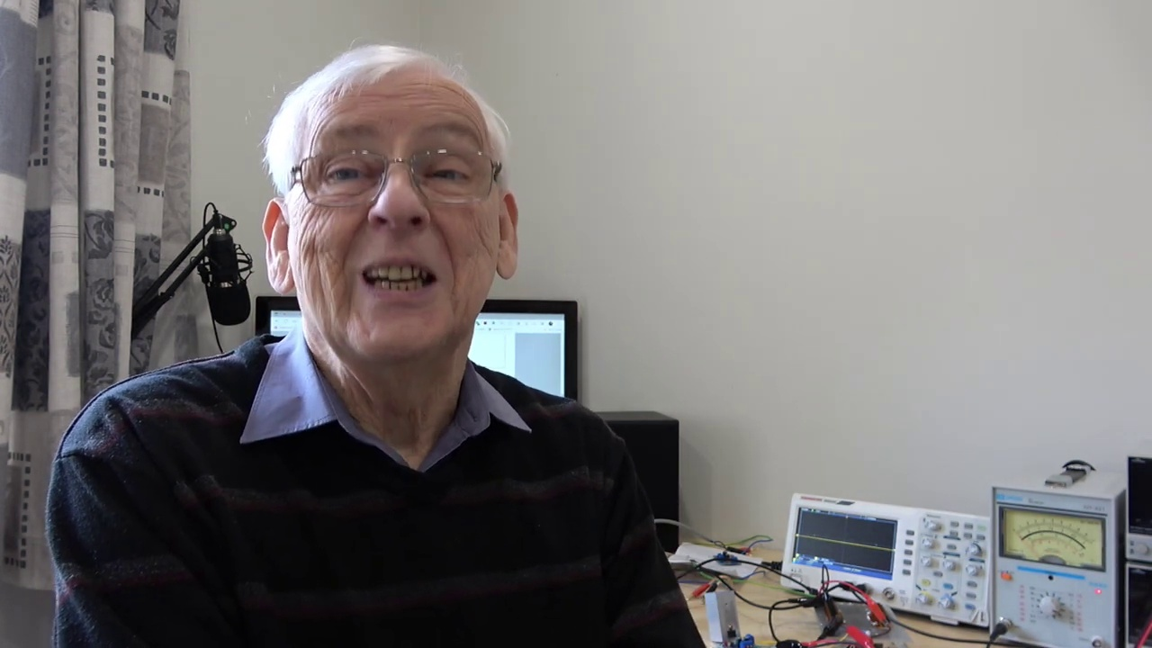 (score 90.0000)
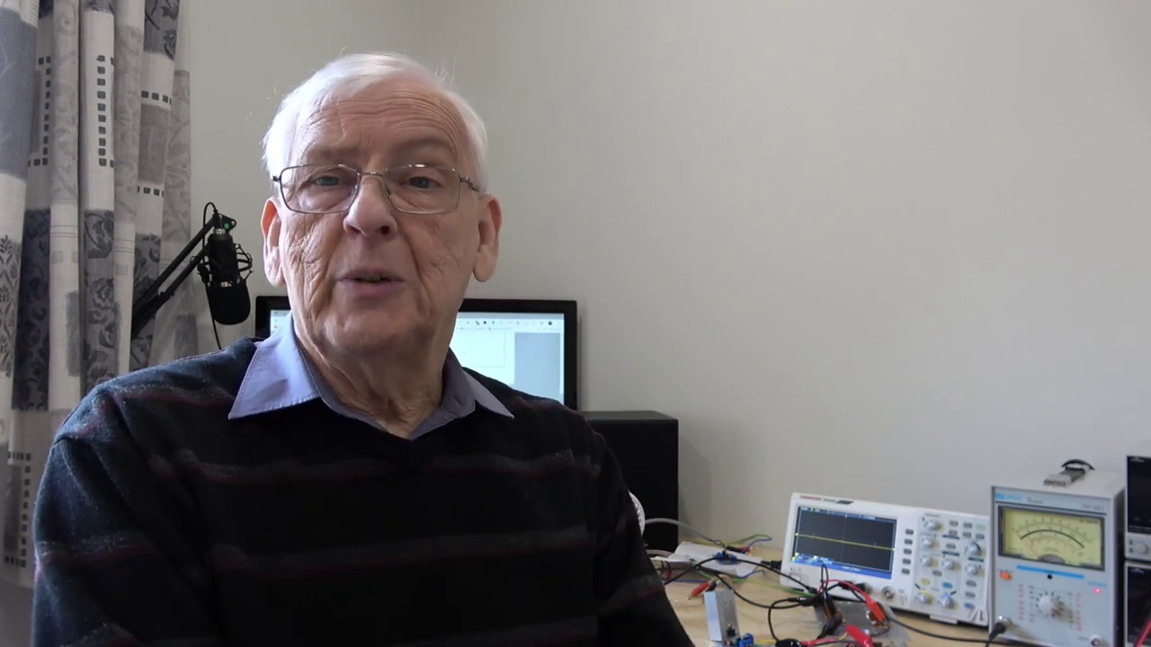 (score 90.0000)
 (score 90.0000)
 (score 85.0000)
 (score 85.0000)
 (score 85.0000)
 (score 85.0000)
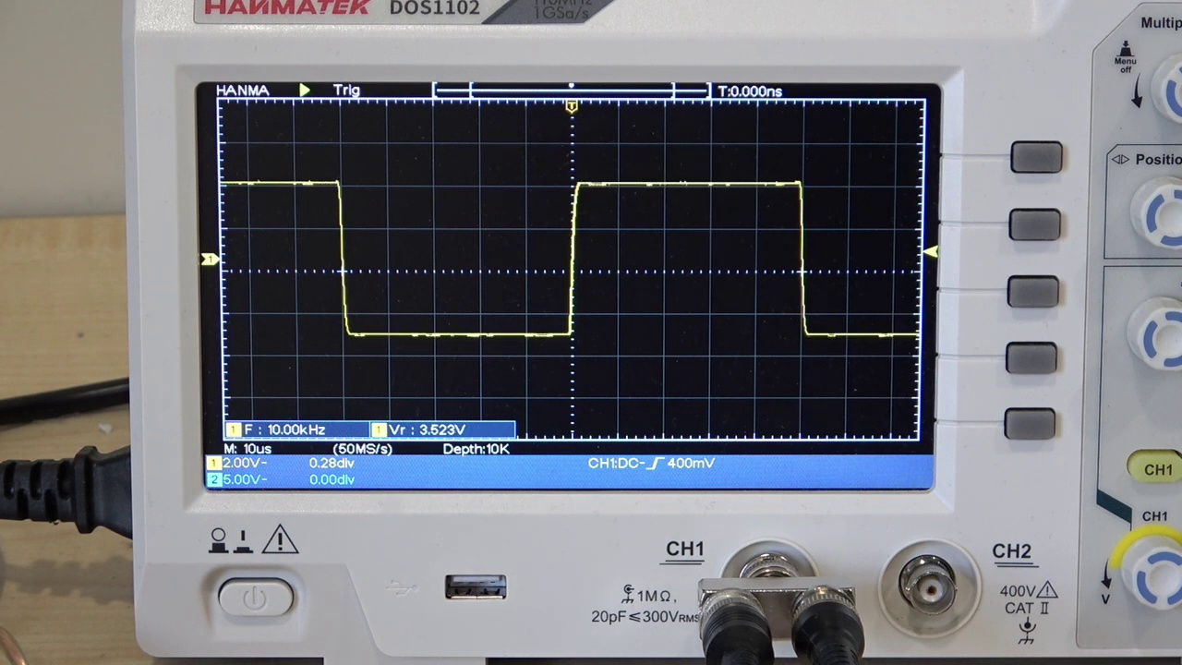 (score 85.0000)
Least correlated frames:
 (score 0.0000)
 (score 0.0000)
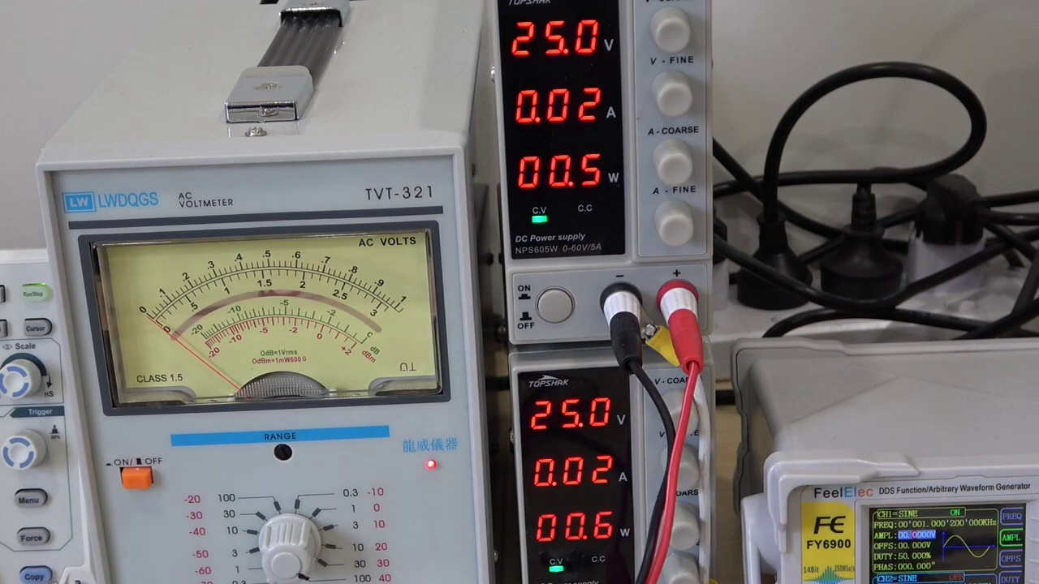 (score 0.0000)
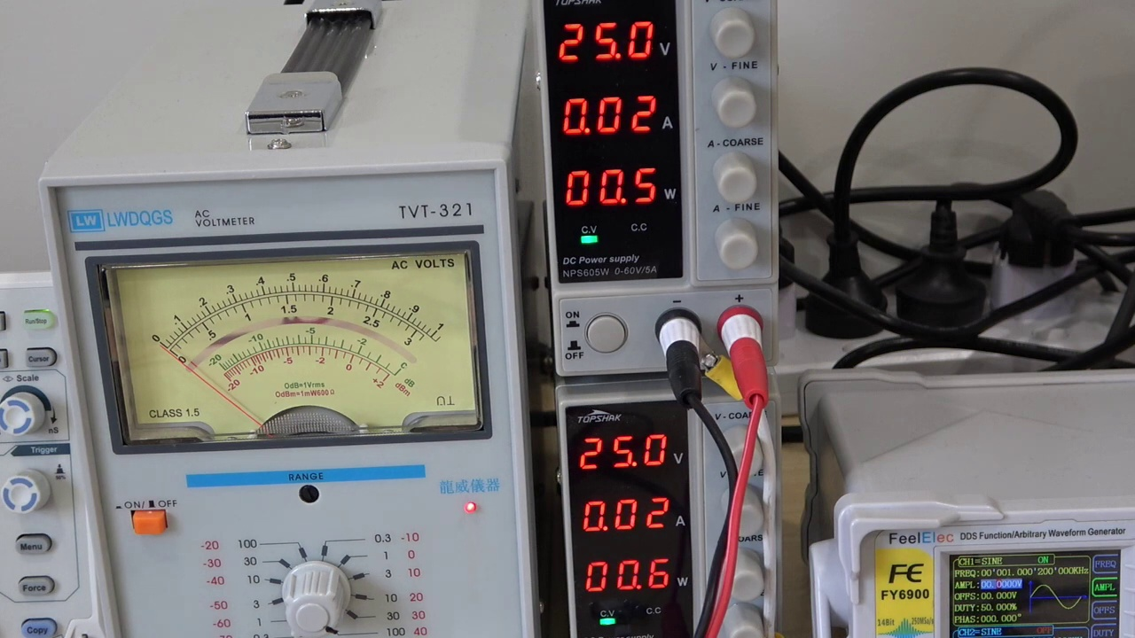 (score 0.0000)
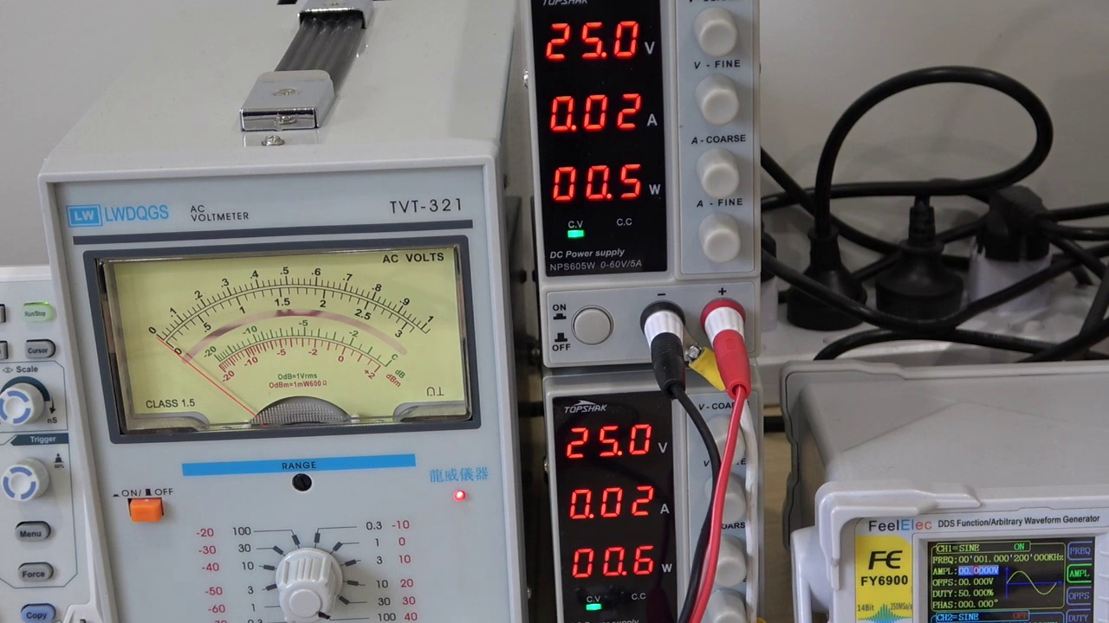 (score 0.0000)
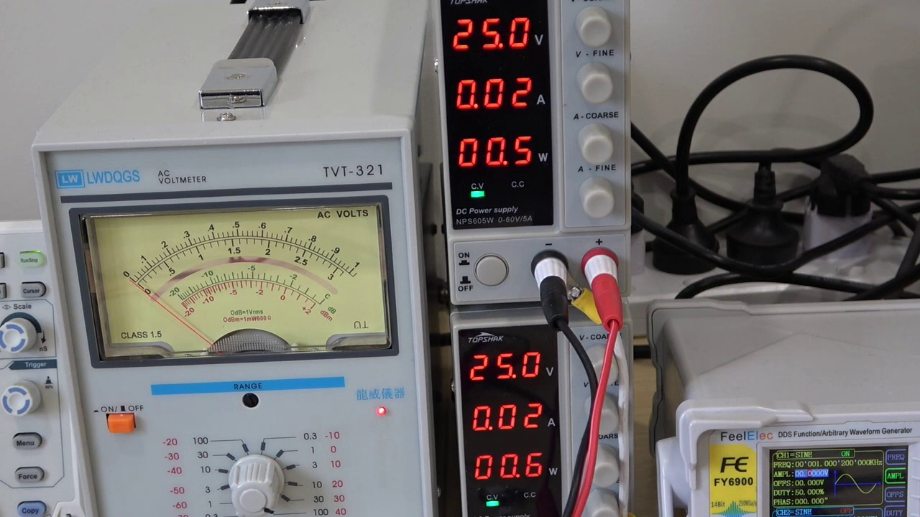 (score 0.0000)
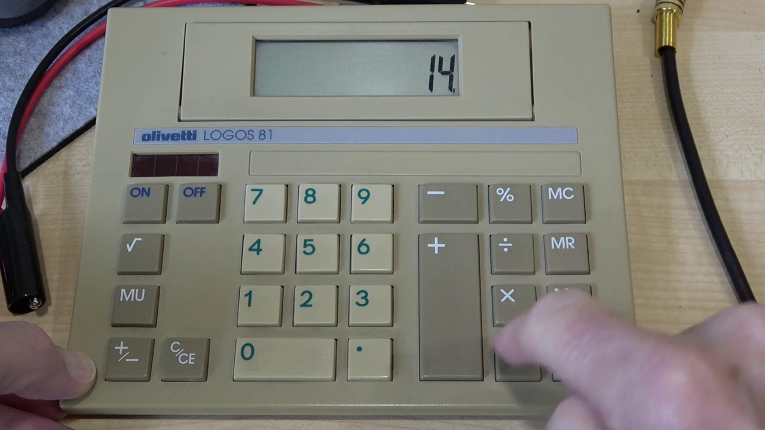 (score 0.0000)
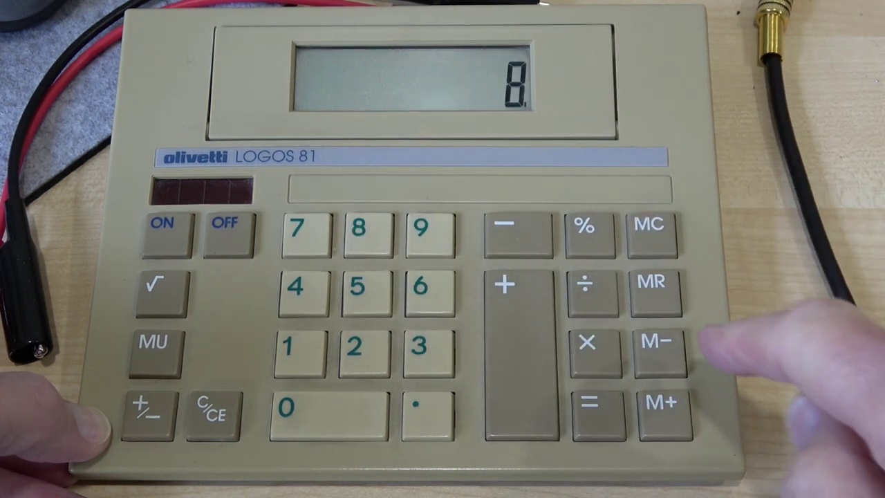 (score 0.0000)
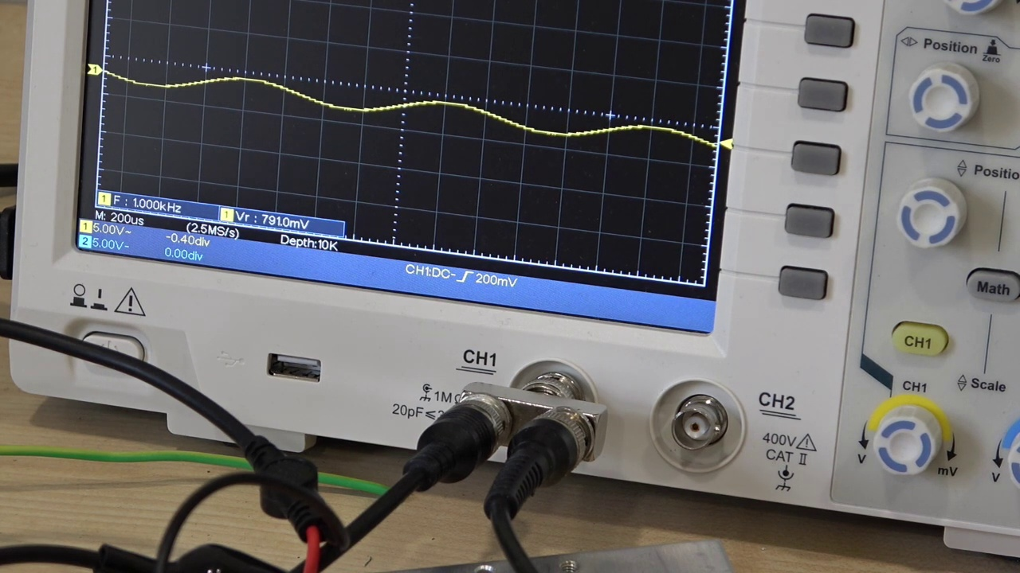 (score 0.0000)
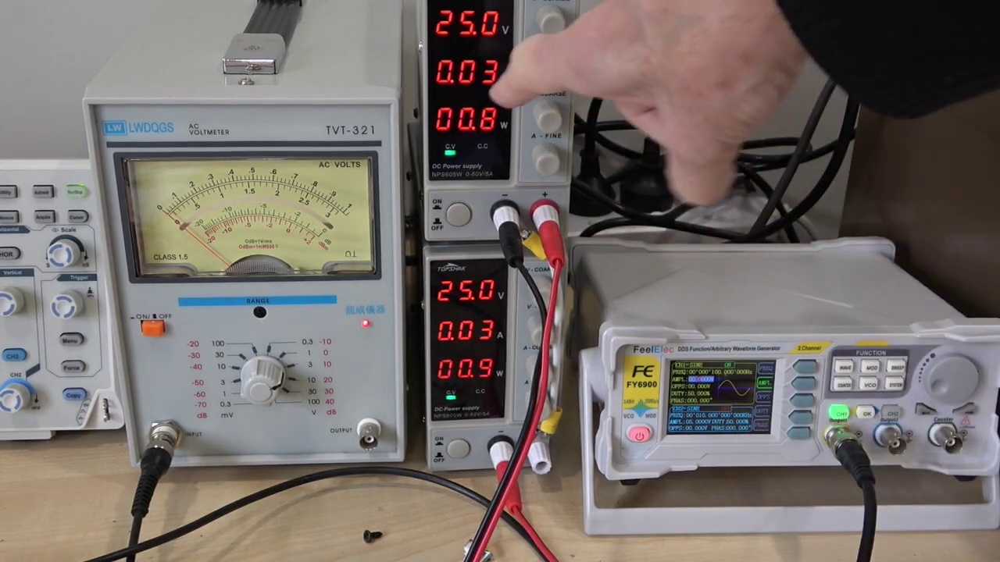 (score 0.0000)
- matched 11 frame(s), max score 95.0000: Provides schematic, where to buy the kit, and the cost.No confusion for this video.Helpful for testing kits or evaluating new components.
Source: https://www.youtube.com/watch?v=zt7YAna-Qcc: LM1875T Amplifier Kit Review
Top correlated frames:
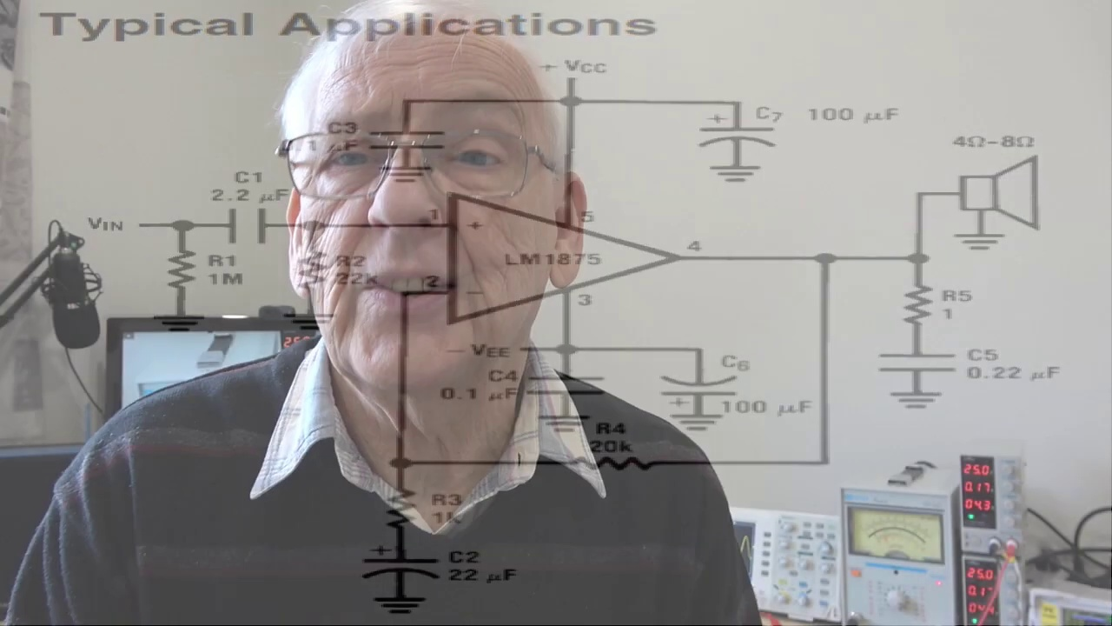 (score 95.0000)
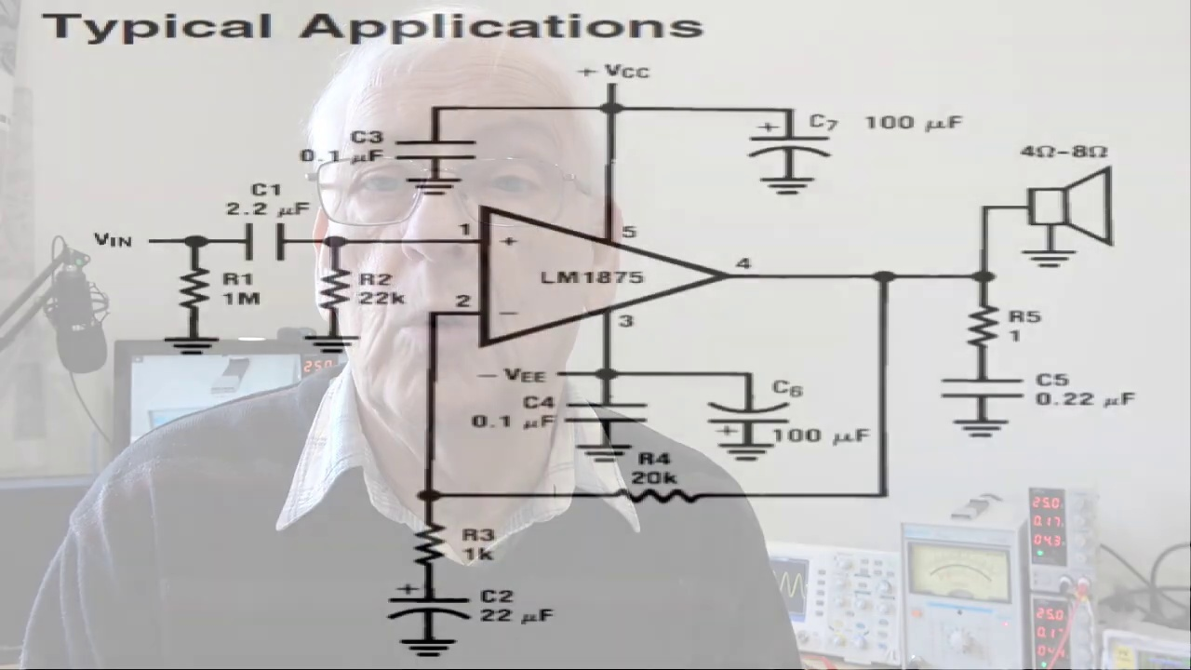 (score 90.0000)
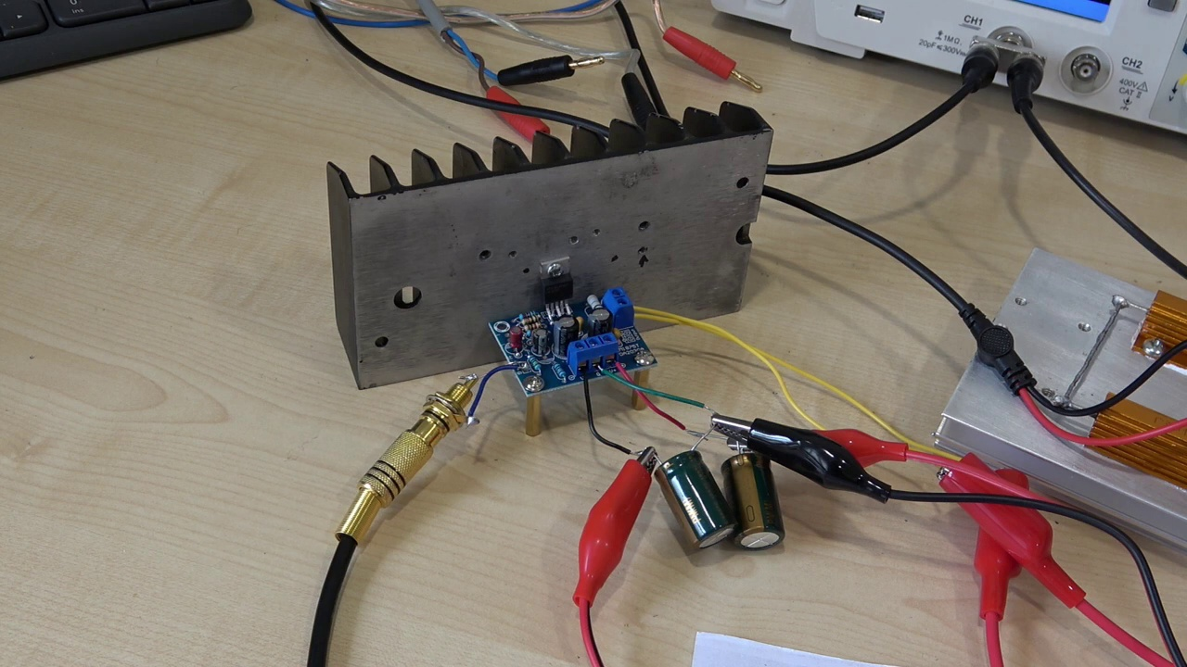 (score 90.0000)
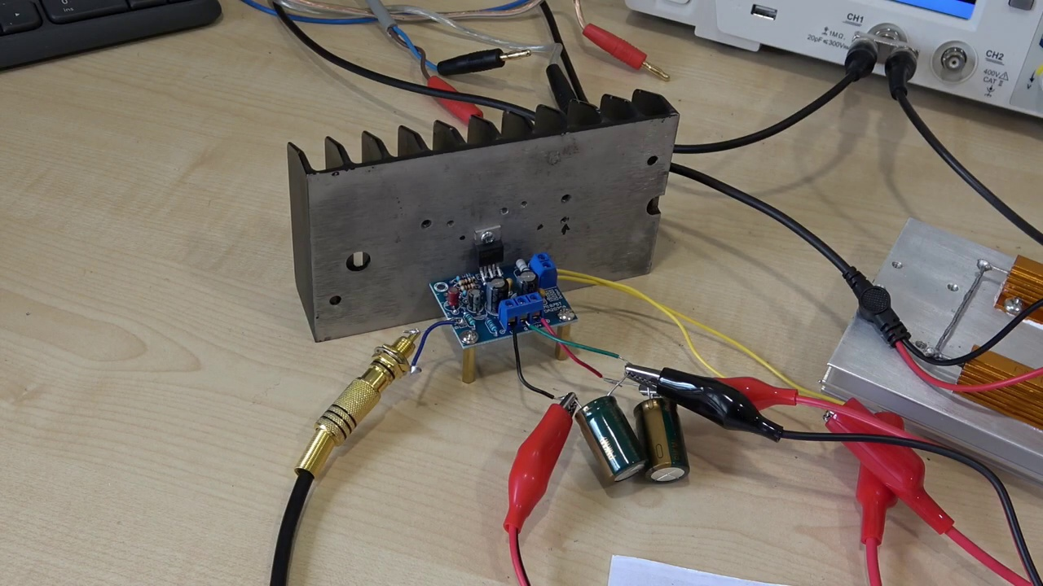 (score 90.0000)
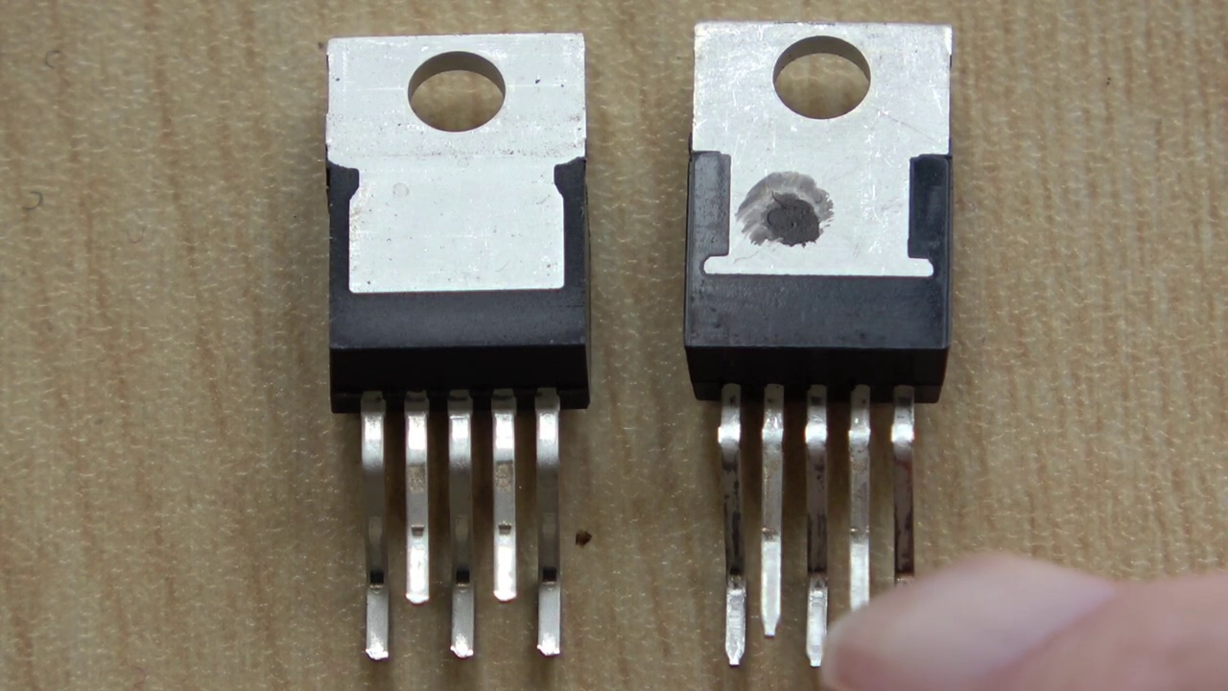 (score 90.0000)
 (score 85.0000)
 (score 85.0000)
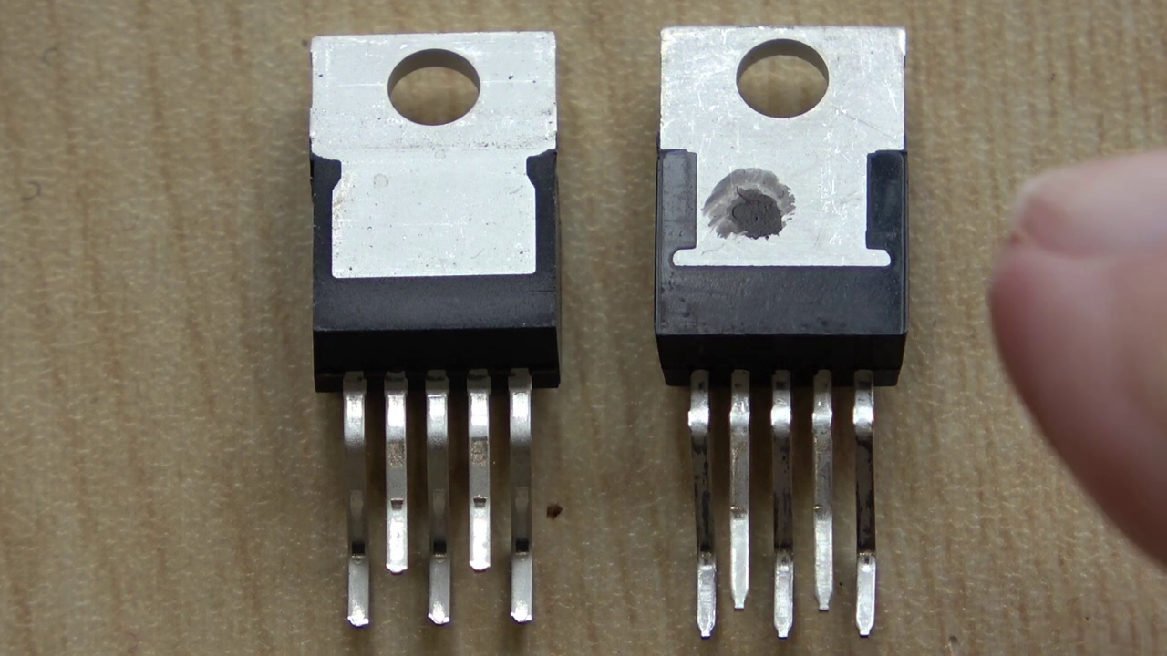 (score 85.0000)
 (score 80.0000)
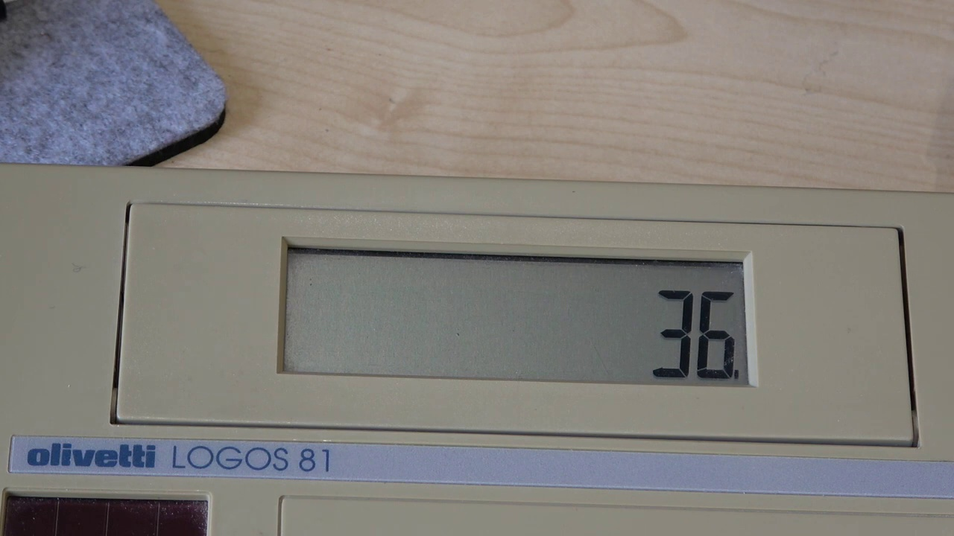 (score 80.0000)
Least correlated frames:
 (score 0.0000)
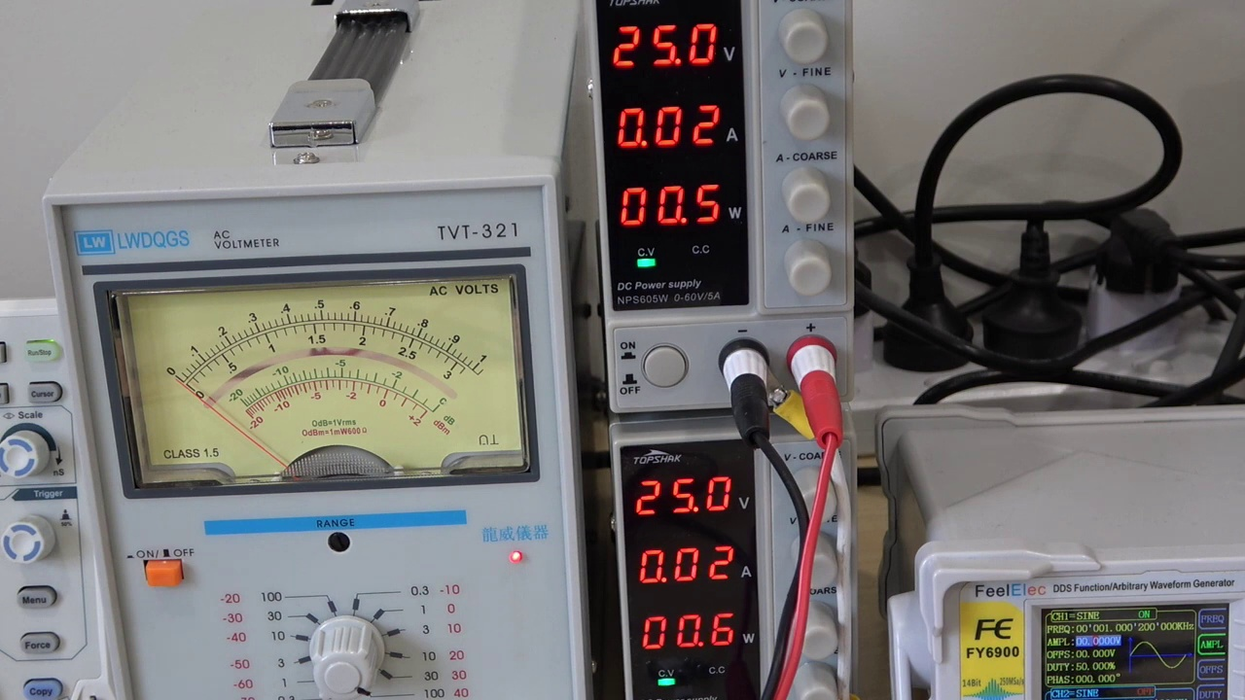 (score 0.0000)
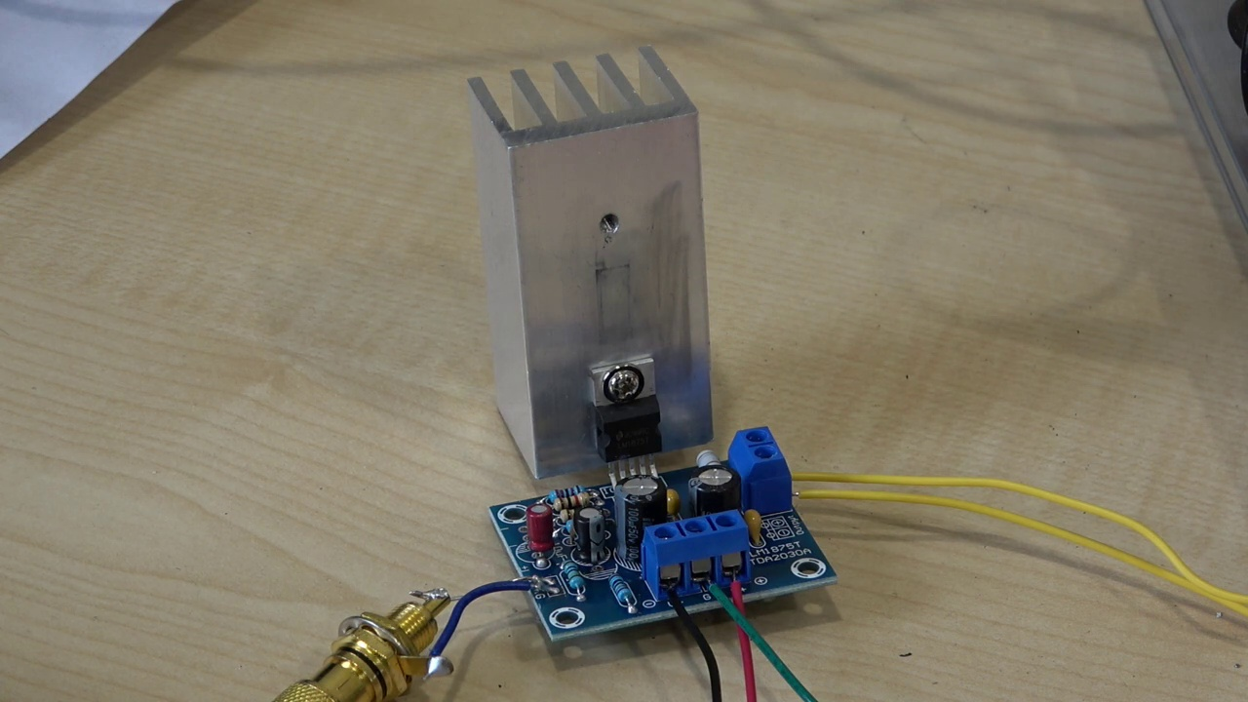 (score 0.0000)
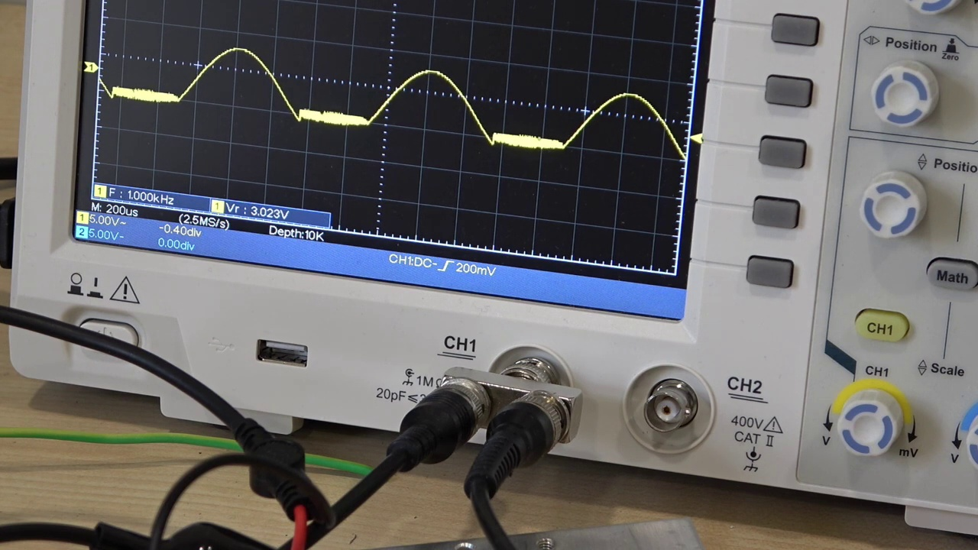 (score 0.0000)
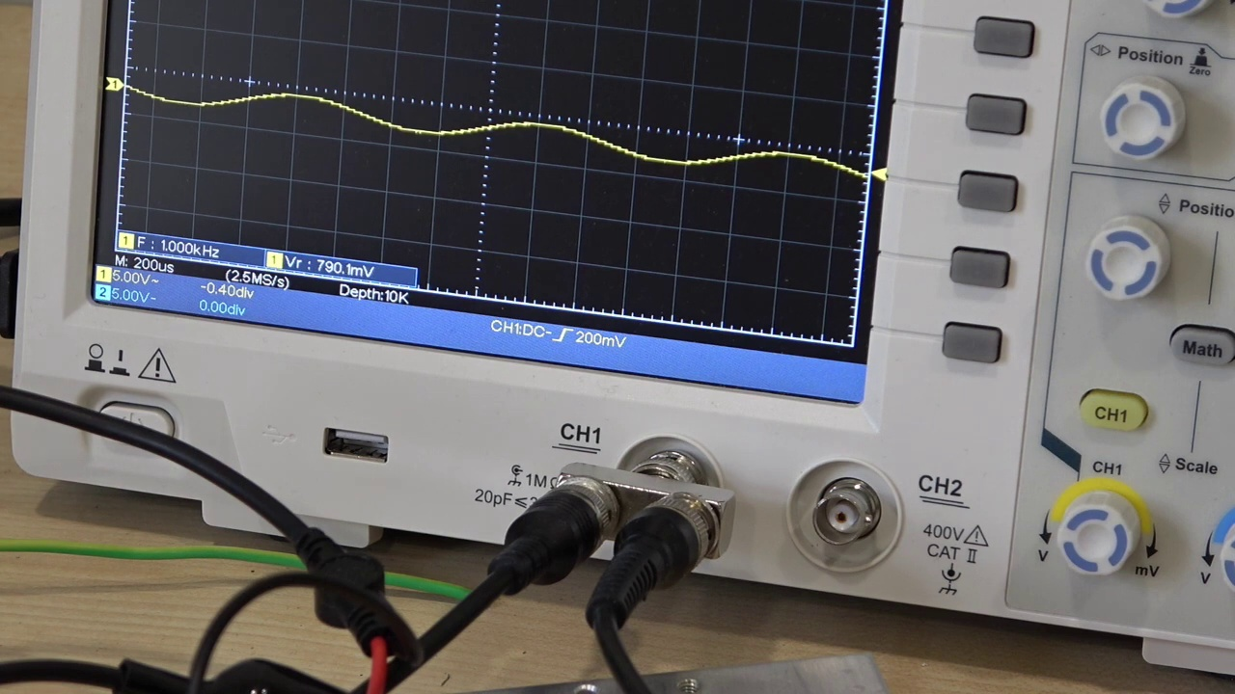 (score 0.0000)
 (score 0.0000)
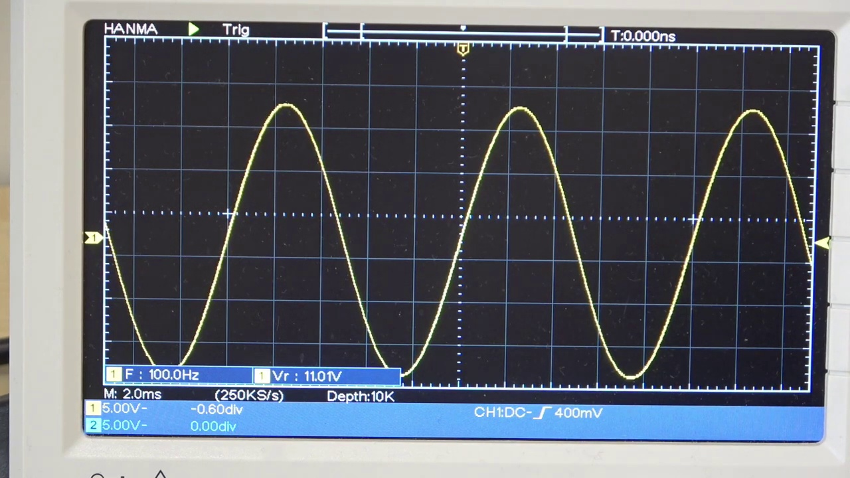 (score 0.0000)
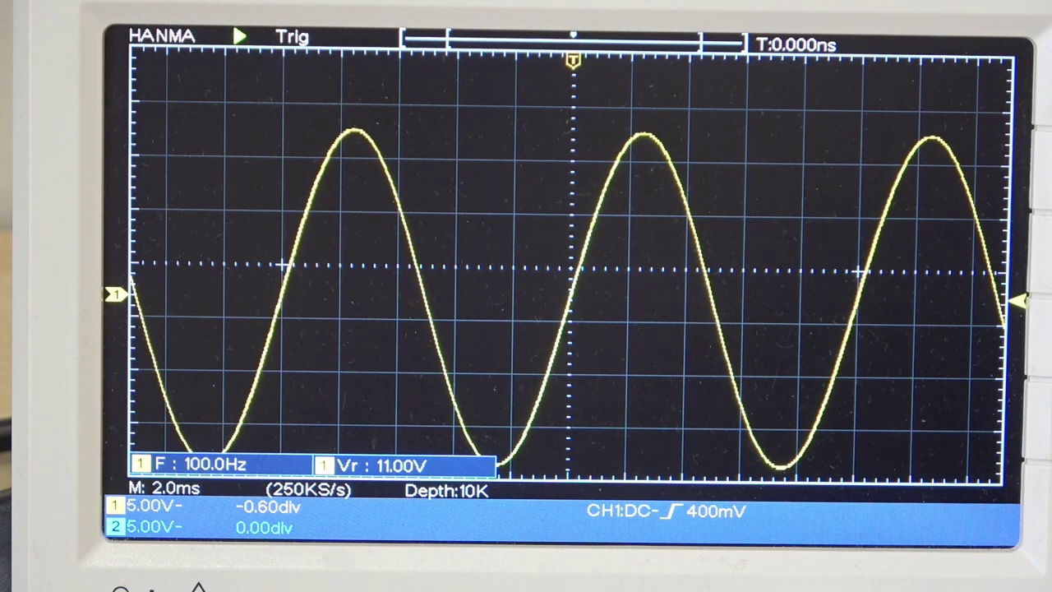 (score 0.0000)
 (score 0.0000)
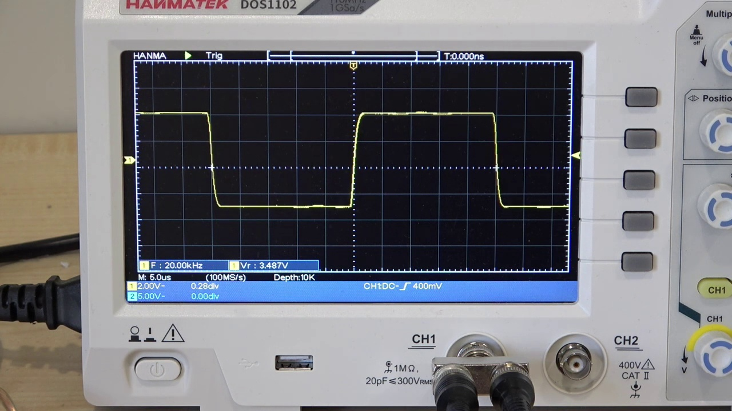 (score 0.0000)

Frame: frame_0000.jpg
Caption: The image presents an electronic device, specifically labeled as "LMP1875T" and accompanied by the text "AMPLIFIER KIT," suggesting that it is part of an amplifier kit. The background appears to be a red-colored floral pattern, with a blue circuit board dominating the center of the image. The circuit board features a silver design and is equipped with several components, including a red and black speaker, a blue and black power supply, and a blue and black control knob. The board is clearly labeled as an LM1875 amplifier kit, indicating that it's designed to be an amplifier.
Additional details include the presence of a watermark in the upper right corner that reads "LM1875T," further reinforcing the branding and model number of the device. The text "LMP1875T" is also displayed in the lower left corner of the image, providing a secondary confirmation of the device's identity. Overall, the style of the image is a straightforward product shot with no visible human activity or teaching context, giving the impression that it depicts a completed or ready-to-use amplifier kit.
Comment (score 80): The LM1875T chip can have many counterfeit versions, which can impact performance. Learning to recognize quality chips is essential.It’s confusing to determine which chips are dupes and how to avoid them.I will be cautious and avoid buying suspiciously cheap amplifier chips.
Reason: The comment directly discusses the LM1875T chip and its potential counterfeit versions, which is a specific technical detail mentioned in the caption. The comment also mentions amplifier chips, which aligns with the context of the image (the amplifier kit). While it doesn't discuss every detail mentioned in the caption, the connection between the chip and the amplifier kit is strong enough to warrant a high correlation score.
Source: https://www.youtube.com/watch?v=zt7YAna-Qcc : I take a look at a LM1875T amplifier kit. Will it be any good?

Frame: frame_0001.jpg
Caption: The image displays an electronics kit with the label "LM1875T" at the top, below which is written "amplifier". The kit appears to include small electronic components such as resistors, capacitors, and possibly integrated circuits or transformers. On a pink background, the text "M1875T" is prominently displayed at the top, accompanied by the label "amplifier" below it. This suggests that the image is an advertisement for this electronics kit, focusing on the product itself with text providing information about its intended purpose. The kit consists of various components such as a power supply, a speaker, and a speaker wire, all meticulously labeled for easy identification. The components are positioned in a way that allows for easy assembly, indicating the kit's user-friendly design.
Comment (score 80): The LM1875T chip can have many counterfeit versions, which can impact performance. Learning to recognize quality chips is essential.It’s confusing to determine which chips are dupes and how to avoid them.I will be cautious and avoid buying suspiciously cheap amplifier chips.
Reason: The comment directly discusses the LM1875T chip, its quality and potential counterfeit versions, which are also mentioned in the frame caption. The caption highlights the amplifier kit, including the LM1875T chip, and provides information about its components. The comment's focus on recognizing quality chips and avoiding suspiciously cheap amplifier chips is strongly related to the caption's description of the electronics kit.
Source: https://www.youtube.com/watch?v=zt7YAna-Qcc : I take a look at a LM1875T amplifier kit. Will it be any good?

Frame: frame_0002.jpg
Caption: The image presents a schematic diagram of an electronic circuit or digital signal processing system. The diagram is rendered in black and white, with the text "Schematic Diagram" prominently displayed at the top, serving as a clear and concise title for the diagram. The system is composed of various components, including a clock, an input, an output, a gate, and a memory. Each component is represented by a different shape and color, with the clock and input represented by squares, the output represented by circles, the gate represented by a triangle, and the memory represented by a rectangle.
In the foreground, there is a photograph of someone holding a physical model of the same electronic circuit or digital signal processing system. This person appears to be pointing at or demonstrating the various components and their connections within the circuit. The model serves as a real-world representation of what is depicted in the schematic diagram, providing a clear understanding of how the components interact with each other.
The background of the image contains additional text that reads "Schematic Diagram." This text is likely used to describe the content of the image, specifically the nature of the diagram as a schematic.
No strongly correlated comments found for this frame.

Frame: frame_0003.jpg
Caption: The image captures an older man sitting comfortably in front of a camera, with a computer monitor and keyboard visible in the background. He appears to be wearing glasses and has short, white hair. Dressed in a dark jacket over a lighter shirt, he holds what seems to be a remote control or small device in his right hand, while extending his left arm outwards. His expression is serious, suggesting he may be addressing an audience or engaging in a conversation.
In front of him, the man's casual demeanor is reflected by his relaxed posture, with his hands resting on his hips. He is dressed in a black and gray striped sweater, exuding sophistication. Behind him, a computer monitor and keyboard can be seen, while to either side are electronic devices: a gray and black television set with a blank screen, and a black and white radio also with a blank screen.
The "Teaching Context" text at the top of the digital overlay on the right side of the frame suggests that the content may relate to teaching or instructional activities. However, without additional context, it is unclear what specific topic he might be discussing. Overall, the image conveys a sense of calm and leisure, with the man situated in front of these electronic devices, his casual attire, and the unoccupied screens all contributing to this atmosphere.
Comment (score 80): The LM1875T chip can have many counterfeit versions, which can impact performance. Learning to recognize quality chips is essential.It’s confusing to determine which chips are dupes and how to avoid them.I will be cautious and avoid buying suspiciously cheap amplifier chips.
Reason: The comment directly discusses the LM1875T chip and its potential counterfeit versions, which is related to the objects/settings described in the caption (the man holding a remote control/device with electronic devices in the background). The comment also mentions avoiding suspiciously cheap amplifier chips, which matches the technical context of the image (the computer monitor and keyboard) and the 'Teaching Context' text suggesting instructional activities.
Source: https://www.youtube.com/watch?v=zt7YAna-Qcc : I take a look at a LM1875T amplifier kit. Will it be any good?

Frame: frame_0004.jpg
Caption: The image features a digital screenshot of an online storefront, possibly from a mobile device, displaying the product page for two electronic devices. The top navigation bar contains menu options that are too small to read clearly.
On the left side of the frame is an image of a speaker module with blue circuitry and visible components, including capacitors, resistors, and possibly integrated circuits or transistors. Below this image is a shopping cart icon indicating that the product can be purchased through the website, along with a price tag showing "39.99 USD" and a checkout button labeled "Add to Bag." The background color of this section is white.
Beneath the pricing information, there's a product description or summary in a language other than English.
To the left side of the frame, partially obscuring the main product image, is a smaller image showing the same speaker module alongside what appears to be a breadboard and some additional electronic components, suggesting that this might be used as a kit or for DIY electronics projects.
On the second page of the product listing below the fold, there is an image featuring a laptop computer on sale for $148.78 in both US and Canadian dollars. The laptop is black in color with a silver keyboard, described as a 15.6" monochrome screen laptop with a 3.0W amplifier and a 2.5" speaker. It comes with a 3.3V USB power supply and is designed for PC board DIY kits, also including a 3.3V USB power supply.
Comment (score 85): The LM1875T chip can have many counterfeit versions, which can impact performance. Learning to recognize quality chips is essential.It’s confusing to determine which chips are dupes and how to avoid them.I will be cautious and avoid buying suspiciously cheap amplifier chips.
Reason: The comment discusses the recognition of quality chips and avoiding counterfeit versions, which is directly related to the speaker module with blue circuitry shown in the frame caption. The mention of amplifier chips also matches the product description mentioned in the caption.
Source: https://www.youtube.com/watch?v=zt7YAna-Qcc : I take a look at a LM1875T amplifier kit. Will it be any good?
Comment (score 80): Provides schematic, where to buy the kit, and the cost.No confusion for this video.Helpful for testing kits or evaluating new components.
Reason: The comment directly mentions the kit and its cost, which is also mentioned in the caption. The mention of 'schematic' and 'where to buy the kit' further reinforces the correlation.
Source: https://www.youtube.com/watch?v=zt7YAna-Qcc: LM1875T Amplifier Kit Review

Frame: frame_0005.jpg
Caption: This image shows an elderly man with grey hair, a beard, and mustache, standing in front of a computer monitor while holding a microphone. He is dressed in a striped sweater over a white shirt, which suggests a casual yet comfortable attire for the setting. His expression seems focused and surprised, possibly indicating that he is in the middle of delivering or discussing some information related to his content creation.
The background is a white wall with a black and gray striped curtain, providing a clean and professional backdrop for the scene. The man's glasses add to the overall sense of focus and professionalism. He appears to be seated near a laptop, which is not visible in the image, but the presence of a microphone suggests that he might be participating in a webinar or creating content for online viewing.
The absence of any text on the screen, as well as the lack of physical interaction with the computer or any other objects, implies that the man is not actively teaching or presenting information. Instead, the context of this image appears to be more about a person creating content for online consumption rather than an active teaching scenario.
No strongly correlated comments found for this frame.

Frame: frame_0006.jpg
Caption: The image shows an older man seated at a desk with a computer in front of him, dressed in a dark sweater over a lighter shirt. He has gray hair and is wearing glasses, appearing to be mid-speech as suggested by his posture and facial expression. His gaze is directed towards the camera, indicating he may be addressing an audience or recording a video.
The background is slightly blurred but shows what looks like a room with curtains to one side, suggesting an indoor setting possibly intended for presentations or meetings. There are no visible devices, such as a computer monitor or keyboard, that would be used during a presentation. Additionally, there are no slides, diagrams, or other teaching aids visible in the image, indicating that this is likely not a classroom setting but rather a personal workspace or an event venue where a presentation is being conducted.
Text present in the image appears to be part of a presentation slide or some kind of informational sign, although due to the resolution and size of the text, it's difficult to read its content accurately. The focus of this frame seems to be on the older man delivering what could possibly be an educational or instructional speech or lecture.
Interestingly, the same individual is depicted in MiniCPM's image, standing in front of a television set in a living room setting. He has white hair and glasses, dressed in a black and gray striped sweater and a black and white shirt underneath. His gaze is directed towards the camera, and he is smiling, suggesting a cozy and familiar atmosphere.
In this alternative scene, the man appears to be watching something on the television set, which is turned on. The background features a white wall adorned with a black and white striped curtain, and a black speaker is present on the right side of the image.
No strongly correlated comments found for this frame.

Frame: frame_0007.jpg
Caption: The image is a screenshot from a video, likely taken from a video conferencing tool like Zoom or Microsoft Teams, given the layout and user interface elements. In the frame, an older man is captured in a selfie mode, facing a webcam. He appears to be in a room with a computer monitor and some equipment on a table in front of him. The room has a plain background with curtains and what seems to be a light fixture.
The man stands in front of a white wall, his face illuminated by the soft glow of a lamp, casting a warm light that enhances the serene atmosphere. His hands are clasped together in front of him, suggesting a moment of contemplation or deep thought. The backdrop is a simple white wall, punctuated by a gray curtain that hangs behind him.
The man's gaze is directed towards the camera, adding a touch of direct engagement to the scene. The image does not provide enough detail to confidently identify the man or the exact location. The overall composition of the image conveys a sense of calm and focus, suggesting a well-organized workspace with the man at the center of attention.
Note: I have carefully integrated the two captions while retaining all accurate and relevant details explicitly mentioned in either original caption. I avoided redundancy and contradictions by combining similar information from both captions into a single, cohesive description.
No strongly correlated comments found for this frame.

Frame: frame_0008.jpg
Caption: In this image, there's an older adult male who appears to be engaged in a conversation or instruction, as evident from his focused expression. He has gray hair and is wearing a dark sweater over a lighter shirt. The man is seated at a desk, with his gaze directed towards the camera. His hands are casually placed on the desk, suggesting a relaxed state of mind.
In front of him, there's a computer monitor positioned on the right side of the image, which is turned on and displaying a black screen. The desk also features a keyboard and mouse, indicating that this might be a home office or similar setting. The background is blurred, drawing focus to the man and his interaction with the computer.
The simplicity of the image allows the viewer to focus on the man and his activity - using the computer - without any distractions. Overall, the image captures a moment of everyday life, emphasizing the man's presence and engagement with the technology in front of him.
No strongly correlated comments found for this frame.

Frame: frame_0009.jpg
Caption: The image presents an older man seated in front of a microphone and camera setup, appearing to record a video for educational or informational purposes. He is speaking, as indicated by his slightly open mouth, with the text "20 Watts per chip" displayed on the screen behind him. This seems to refer to the topic being discussed or demonstrated, which relates to electronic components, specifically chips, and their power specifications.
The man is wearing glasses and a striped shirt, looking directly at the camera with a neutral expression. Behind him, there's a beige wall with a window covered by a gray curtain, allowing natural light into the room. He stands out against this simple yet professional setting, which appears to be a home or office environment.
Note: The man is not standing as mentioned in the second caption, but rather seated in front of the microphone and camera setup.
Comment (score 80): The LM1875T chip can have many counterfeit versions, which can impact performance. Learning to recognize quality chips is essential.It’s confusing to determine which chips are dupes and how to avoid them.I will be cautious and avoid buying suspiciously cheap amplifier chips.
Reason: The comment directly discusses the topic of electronic components (specifically chips) and their quality, which is mentioned in the frame caption as '20 Watts per chip'. The commenter also mentions recognizing quality chips and avoiding suspiciously cheap amplifier chips, which relates to the setting and goals described in the caption.
Source: https://www.youtube.com/watch?v=zt7YAna-Qcc : I take a look at a LM1875T amplifier kit. Will it be any good?

Frame: frame_0010.jpg
Caption: The image appears to be a still from an online video or broadcast. It shows an elderly man with white hair and glasses seated in front of a computer monitor, wearing a light-colored shirt and earphones around his neck. His face is turned towards the camera, and he is smiling. He has a light-colored shirt and is partially raising his right hand near his mouth, which could suggest he is speaking or gesturing, but not enough to discern specific actions.
The background includes a white wall with a gray and black striped curtain, as well as a computer, speaker, and CD case on the desk in front of him. A blurred image of a room with a window displaying patterned curtains can be seen behind the man. There is no readable text or equations on any visible surfaces.
The overall setting suggests an educational or instructional environment, possibly a lecture or seminar where the elderly man may be sharing knowledge or conducting a discussion with others out of frame. The presence of the computer monitor and microphone imply that this is a live broadcast or recording intended for an audience not visible in the image.
Comment (score 90): The LM1875T chip can have many counterfeit versions, which can impact performance. Learning to recognize quality chips is essential.It’s confusing to determine which chips are dupes and how to avoid them.I will be cautious and avoid buying suspiciously cheap amplifier chips.
Reason: The comment directly discusses the LM1875T chip, which is mentioned in the caption as part of the computer setup. The commenter's concern about counterfeit versions and performance matches the technical setting implied by the educational/instructional environment depicted in the image.
Source: https://www.youtube.com/watch?v=zt7YAna-Qcc : I take a look at a LM1875T amplifier kit. Will it be any good?

Frame: frame_0011.jpg
Caption: The image shows an older man seated at a desk with various electronic equipment, appearing to be in a casual setting with a neutral-colored room and well-lit natural light coming through the window. He is wearing glasses, a striped shirt, and seems to be speaking or presenting about something, possibly as part of an online tutorial or lecture.
In front of him, on the desk, there is a computer monitor displaying what looks like a presentation slide with visible text, although the resolution of the image does not allow for detailed reading of the text. Several other items are also on the desk, including what might be a phone or tablet and some paperwork, but these are too small to discern clearly.
The man has white hair and is wearing glasses, a striped sweater, and a tie, suggesting a formal or professional setting. He is seated in a room furnished with a desk and a television, with a gray and black striped curtain drawn behind him, adding a touch of color to the scene.
On the desk, a laptop computer and a television are among the cluttered items, indicating a workspace or living area. The man is holding a book in his hands, suggesting he might be reading or preparing for an event.
No strongly correlated comments found for this frame.

Frame: frame_0012.jpg
Caption: The image appears to capture a moment of tranquility as an older individual sits in front of a webcam, likely participating in an online video call or recording. The person is wearing glasses and has grey hair, dressed casually in a striped shirt. Behind the individual, there's a neutral-toned wall, partially covered by black and white curtains that match their shirt. A microphone to the left indicates that audio is being recorded as well.
The desk, with its black and grey striped pattern, provides a stark contrast to the person's white shirt and black pants. The computer monitor in front of them has a blank screen, suggesting a moment of pause in their conversation. To their side, a speaker is placed, perhaps ready to fill the room with music or sound. The overall setting is simple yet inviting, with the person at its center, engaged in a conversation that fills the space around them.
No strongly correlated comments found for this frame.

Frame: frame_0013.jpg
Caption: The image captures a moment in a living room where an older man is seated on a couch, adorned with glasses and a striped sweater. He gazes directly at the camera, conveying a sense of directness and engagement. The room is equipped with modern amenities, including a television set, a speaker, and a computer monitor. Behind him, a curtain adorns the walls, adding a touch of elegance to the setting.
The man appears to be speaking or recording a video, as suggested by his body posture and head angle. He is dressed in a dark shirt and dark pants. The couch is situated near a window with partially drawn curtains, allowing for a subtle play of natural light within the room.
On the coffee table or desk beside him, there are a few objects: what appears to be a microphone, a black device that could possibly be an audio interface or control panel, and a laptop screen displaying some sort of presentation or content. The decorative pattern on the wall in the background adds visual interest to the scene.
The image is taken from a low angle, focusing on the man and the immediate items around him.
No strongly correlated comments found for this frame.

Frame: frame_0014.jpg
Caption: This image appears to be a screenshot from an online video call, possibly during a class or lecture session. The central figure in the frame is an older gentleman wearing glasses and a dark shirt, sitting at a desk with a laptop and a microphone visible in front of him. He seems to be engaged in a conversation or presentation. Behind him, there is a patterned curtain partially covering a window.
The room itself appears to be well-equipped, with a television set turned on, displaying a black screen, and two speakers positioned to his right and left sides, suggesting a stereo setup for music or movie listening experience. The room's white ceiling provides a clean and bright backdrop for the man and his surroundings.
Notably, the gentleman is dressed in a black and grey striped sweater, which contrasts with his white hair, and he has a smile on his face, indicating that he is in a good mood. His hands are casually resting on his lap, and he is looking directly at the camera, giving a sense of engagement with the viewer.
No strongly correlated comments found for this frame.

Frame: frame_0015.jpg
Caption: The image presents a scene dominated by a multitude of electronic components in a laboratory setting, likely designed for teaching electronics principles or conducting experiments. At the center, a digital multimeter (DMM) stands out, displaying a voltage reading of 260 V on its display. The multimeter is equipped with two sets of analog and digital displays, showing readings that may indicate frequency or another type of measurement in Hz (hertz). A red line on the oscilloscope screen indicates a specific level of measurement, but without context, it's unclear what this signifies.
To the left of the multimeter, a voltage meter is mounted, displaying a reading of 20.0 V with an analog display indicating a voltage of 0.2 V. On the right side of the image, another digital multimeter displays a reading of 25.0 V, similar to the one on the left.
In front of the oscilloscope and surrounding equipment, various pieces of electronic gear are visible, including multiple measuring devices such as the multimeters with displays showing voltage measurements, and an electronic device with multiple connections and dials that seems to be used for signal generation or analysis. Cables plugged into the oscilloscope and surrounding equipment suggest that these devices are connected for data transfer or generating signals of some sort.
The image does not contain any text or additional objects that could provide further context or details about the scene. The relative positions of the objects suggest a typical laboratory setup where various electronic devices are being tested and monitored, with multiple multimeters indicating a busy work environment or a need for precise measurements.
No strongly correlated comments found for this frame.

Frame: frame_0016.jpg
Caption: The image shows a scene of a laboratory setting where an electronic measuring device is used for measuring different parameters. The device, which appears to be a digital multimeter, has various gauges and meters that indicate it could be used for measuring physical data such as pressure, temperature, or electrical parameters like voltage, current, and resistance.
The topmost meter on the device has an arrow pointing towards "20" and "50", suggesting a pressure measurement range from 20 to 50 units. Below it, there is another gauge with a needle pointing towards "0.000" and a scale labeled from 0 to 100 on the right side, which may be used for measuring pressure or similar parameters.
In the center of the device, an analog meter has several markings and scales along its length, possibly indicating temperature measurements given the context. The needle is pointing at a measurement that reads approximately "25". To the left of this central meter, there are more gauges and meters with various scales, which might be used for measuring current or voltage. One of them has a scale labeled from 0 to 5 on the right side and a needle pointing towards "4".
At the bottom center of the device, a small display screen shows numerical values in red font: "20" for pressure and "25" for temperature. The image also features two digital multimeters connected to a power supply that is turned on and emitting a green light. One of the multimeters displays a voltage reading of 25.0 V and a current reading of 0.02 A, while the other shows the same readings. The power supply is plugged into a wall socket, suggesting it's ready for use.
The background of the image is blurred, focusing attention on the device and laboratory equipment. Overall, the scene appears to be a moment of readiness in a laboratory setting, with the multimeters and power supply prepared to measure and record electrical parameters.
No strongly correlated comments found for this frame.

Frame: frame_0017.jpg
Caption: The image captures a scene in a laboratory setting that appears to be related to electrical engineering, electronics, or signal processing. In the foreground, on the left side, part of a text label can be seen with numbers and units that represent some sort of measurement or specification. The text is partially obscured by the angle of the photo, but it includes what seems to be a percentage sign (%) followed by a number and the word "percentage," possibly indicating the accuracy or precision of a measurement or process.
To the right of the person interacting with various electronic devices, likely in an educational or demonstrative setting, there is a piece of equipment with digital readouts displaying numerical values. Below this panel, an oscilloscope shows two channels with waveforms that suggest measurement or signal processing, though the exact nature of the signals is unclear from the image alone.
The equipment suggests a scientific or technical environment, possibly related to electrical engineering, electronics, or signal processing, as indicated by the presence of an oscilloscope and the numerical data on the device being pointed at. In the background, a black and white analog multimeter dominates the frame, its face adorned with a digital display that shows a reading of 25.5. The multimeter is connected to a white power supply, which is plugged into an outlet. The power supply is connected to a black and white analog voltmeter, indicating a reading of 0.06. A white ruler is positioned to the right of the multimeter, suggesting it might be used for measuring the multimeter's length or the length of objects being measured.
The overall scene suggests a routine task in a laboratory, possibly related to electrical measurements, with the person interacting with various devices and equipment to measure and analyze signals or data. The exact nature of the demonstration or lesson is not clear from this single image.
No strongly correlated comments found for this frame.

Frame: frame_0018.jpg
Caption: The image captures a moment of scientific inquiry, with various tools at hand for observation and measurement. In front of the individual conducting the experiment or demonstration is a digital device displaying numerical values (205 and 197) on its screen. This device has several knobs and buttons, suggesting it may be used to adjust parameters for an experiment or to record data points. There are also some cables visible near the device.
A benchtop oscilloscope is present in front of the person, indicating that they might be examining waveforms or other electronic signals. The display screen of the oscilloscope shows a graphical representation of what appears to be an electrical signal, possibly measuring voltage levels over time.
In close proximity to the oscilloscope and device with numerical values, a digital multimeter is plugged into a power supply marked "Topping", suggesting it's in use. The display of the multimeter is filled with numbers, indicating the readings of current and voltage. This device, equipped with functions such as voltage, current, and resistance measurement, provides additional tools for the individual conducting the experiment.
The image does not include any visible slides, diagrams, or texts, and the instructor's action is unclear (writing, pointing, holding a model, or speaking from a slide). The moment captured in this image highlights scientific inquiry, with various instruments at hand for observation, measurement, and data recording.
No strongly correlated comments found for this frame.

Frame: frame_0019.jpg
Caption: The image shows an educational setup with electronic equipment used for teaching or demonstrating scientific concepts. There are two main pieces of equipment in view: a digital oscilloscope and a digital multimeter, both likely designed for laboratory use.
The digital oscilloscope is displaying a waveform that appears to be a signal from a microcontroller or similar device. The screen shows various lines and measurements, with numerical values such as 256 at the top, which likely represents the amplitude or scale of the signal.
Meanwhile, the digital multimeter is measuring an analog voltage. It has two probes connected to the circuit; one is clipped onto a test point, and the other is held by the user. The screen displays "0.0 V," indicating that no voltage is being measured or detected at that moment.
To the right of the multimeter, there's a red and black analog multimeter. This meter's screen is lit up, displaying a reading of 2.02V. Its range is set to 20V.
The background of the image is a stark white, providing a neutral backdrop that allows the electronic devices to stand out. The precise locations of the devices and their functions suggest they are being used for testing or monitoring, possibly in a laboratory or testing environment.
No strongly correlated comments found for this frame.

Frame: frame_0020.jpg
Caption: The image appears to show an educational setting where someone is demonstrating electronic equipment to an audience or to a student. On the left side of the image, there's a person whose face is not fully visible; they seem to be operating or adjusting the equipment. In front of them is a set of electronic devices and meters with various readings displayed:
1. A digital oscilloscope showing a waveform, which seems to be a signal being measured.
2. An analog multimeter displaying measurements in both volts (V) and amperes (A).
3. Another instrument that resembles an electronic test device or a data logger with displays showing numerical values related to the equipment's parameters.
4. A voltage meter with a needle pointing at 200 V, which could be part of the oscilloscope setup to measure voltage.
5. An analog voltmeter indicating "10V" on its scale.
6. A digital multimeter displaying a reading of "10V."
7. An electronic device that might be an instrument for measuring resistance or impedance, but it is not clearly labeled.
8. Cables connecting the devices, and one appears to have a red alligator clip attached, suggesting that this setup is in use and that measurements are being taken.
9. A small black and white digital scale with a needle pointing at "25 g."
10. An instrument that resembles an electronic balance or scale with a pointer indicating "25 g," which might be used to measure weight in the context of physics experiments or calibration.
The person is standing behind this array of instruments, and they are pointing towards one of the meters, possibly explaining the function or demonstrating how to use it. The image has an overlaid text that reads "0 V," which could be a label for a zero point reference in this educational context.
There is no visible slide or diagram with readable text, and the image does not provide enough context to determine if there are any teaching slides, diagrams, or specific instructions being followed. The overall setting suggests that the person is conducting an experiment, demonstrating how to use measuring instruments, or instructing about scientific measurements related to electricity or physics.
No strongly correlated comments found for this frame.

Frame: frame_0021.jpg
Caption: The image shows a close-up view of a digital multimeter, positioned on a white surface, with a person's hand pointing at the device. The multimeter is turned on and displaying readings in the range of 200 to 300 volts, with two numbers displayed - 25.02 and 200.02, indicating the voltage and current readings respectively. The large black-colored LCD display is accompanied by a red LED light, signifying that the device is connected to a power source. In the background, an electronic device appears to be a signal generator or oscilloscope, with various parameters and readings such as "OUTPUT," "FREQUENCY," "AMPLITUDE," "PHASE," and "MEASURED" labeled on its surface. A red LED on this device displays the value "250.1," suggesting a frequency setting in hertz. To the left of the multimeter, another device with a digital readout displays the value "0.0047," which could be an oscilloscope or signal analyzer displaying some form of measurement result. The overall scene suggests an active laboratory or testing environment, with no visible instructor or educational materials in this frame, and the focus is on the person interacting with the equipment.
No strongly correlated comments found for this frame.

Frame: frame_0022.jpg
Caption: The image presents a comprehensive electrical bench setup featuring various electronic devices and instruments. On the right side of the photo, a digital multimeter with black and red buttons is prominently displayed, showcasing vibrant digital numbers on its screen, indicating voltage and current readings.
Next to the multimeter is a power supply that appears to be a DC variable power supply. The digital multimeter displays "264.0" in red digits, which likely represents the voltage being measured.
In the center of the photo, an oscilloscope with a screen displaying waveform patterns and values, such as numbers like "1.2," "2.3," "3.4," and "4.5," is seen. These values possibly represent different measurements or settings on the device. The oscilloscope is connected to other electronic devices, indicating its use for monitoring or measuring electrical signals within a circuit or setup.
On the left side of the image, an analog voltmeter with black and white components is situated, providing a touch of analog precision to the digital multimeter. Its readings are displayed on its face, adding to the overall measurement scene.
In the background, a thermostat with white dials can be seen, adding depth and context to the laboratory setting.
Overall, this image captures a moment of scientific measurement, showcasing each instrument playing its part in the intricate dance of electricity and precision.
No strongly correlated comments found for this frame.

Frame: frame_0023.jpg
Caption: The image shows an educational setup likely related to a science class or demonstration. On the left side of the image is a white oscilloscope with various dials and knobs, some of which are clearly marked with numbers such as "0" to "10" and "50." The digital display on the device indicates it's measuring voltage and current, although specific numerical values are not visible.
On the right side of the image is another piece of equipment, which appears to be a power supply or a similar device with cords and connectors attached. There is also a yellow and black label on the front of this equipment, but the text is not clearly readable due to the resolution.
In the center, there's an analog voltmeter, displaying a value of "250." The meter has two needles; one for volts and another for amperes.
The main focus of the image, however, is a white device labeled "TTV-0321", which appears to be an AC voltage meter. This device is equipped with two dials, one for setting the range and the other for measuring the voltage. The dials are black, providing a stark contrast to the white device.
The TTV-0321 device is connected to a red and black wire, suggesting it's in use. The wire extends to a blue device, which is labeled "AC 250V 0.5A". This device seems to be a transformer, indicated by the "0.5A" label.
The table on which these devices are placed is covered with a neutral background that allows the devices to stand out. The overall scene suggests an environment where electronic devices are being tested or used, possibly in a laboratory or workshop. The precise arrangement of the devices and their labels suggests careful organization and attention to detail.
The image does not contain any text or additional details that could provide more context about the devices or their purpose. However, the presence of the "TTV-0321" device suggests that these devices might be related to the measurement or testing of voltage and current.
Overall, the image captures a moment in an electronic testing or workshop environment, where devices are meticulously arranged and tested. The precise positioning of the devices, their labels, and the overall scene suggest a professional setting.
No strongly correlated comments found for this frame.

Frame: frame_0024.jpg
Caption: The image shows a close-up view of an instrument panel with various electronic components and gauges. On the left side of the photo, there is an oscilloscope displaying a signal, with numerical values on the x-axis indicating time (in seconds) and a digital scale on the y-axis. A voltage indicator shows "0.25V." Next to this, there are two instruments: one labeled "Oscilloscope" and another that seems to be an electronic device with additional meters and readings such as "C 121V AC," "DC 99V DC," and "FREQ 318Hz."
In the background, a piece of equipment with various dials, knobs, and gauges is visible. The text on one gauge reads "Meter." A digital multimeter, black in color with a white digital display, is also present. This multimeter has a range of 200V and a resolution of 0.01V, indicating its ability to measure voltage accurately up to 200V and with a resolution of 0.01V.
On the left side of the multimeter, a red and white voltage meter displays a value of 25.02V, measuring the voltage of the circuit being tested. On the right side, a black and white current meter displays a value of 0.02A, measuring the current in the circuit. The multimeter is connected to a simple circuit with a battery (red) and a resistor (black), plugged into its input.
The instrument panel and equipment are placed on a white table in front of a window covered with open white blinds, allowing sunlight to enter the room. The setup appears to be for scientific or engineering experiments related to electrical signals and measurement, potentially in a laboratory setting.
No strongly correlated comments found for this frame.

Frame: frame_0025.jpg
Caption: The image shows a laboratory setting with various pieces of scientific equipment. In the center of the image, an analog oscilloscope with two probes is visible, used for measuring electrical signals such as voltage or current. The device has a set of knobs and switches on its front panel, suggesting adjustable settings for the measurement being taken.
On the left side of the image, a digital oscilloscope appears to display the waveform of an electric signal as it varies with time, with a screen showing what seems to be a voltage or frequency measurement. The specific details are not clear due to the resolution.
Behind the oscilloscopes, a multimeter (with probes connected) is visible in the middle of the image, with "UNIVERSITY" text on its top indicating it's part of a university or research institution's scientific instrumentation. Another piece of electronic equipment is located to the far right, but no other details about this device are provided.
In contrast to the darker-colored devices, the multimeter and voltmeter in the image have a black and white color scheme. The multimeter has a large display showing the current reading as "25.2" and is connected to a white device displaying the reading as "0.2". The voltmeter is located to the right of the multimeter, also connected to a white device, with its display showing the reading as "2.02".
The two devices are connected by a white cable, indicating they are part of a larger scientific setup. The background of the image is a light blue color, providing a neutral backdrop that allows the colorful devices to stand out. The overall focus of the image is on the multimeter and voltmeter, with the presence of the white device suggesting these instruments are part of a larger scientific setup.
No strongly correlated comments found for this frame.

Frame: frame_0026.jpg
Caption: The image presents a comprehensive setup that appears to be an educational demonstration or experiment in an electronics or biology class. A piece of electronic equipment, possibly a multimeter set to measure current (Ampere), is visible with a digital display reading "204," which may indicate it's measuring 20.4 amps. Next to the device is an oscilloscope with multiple channels, showcasing various waveforms on the screen.
To the left, a power supply unit provides 15 volts of direct current at 0.2 amperes, as indicated by its output voltage and current labels. Several wires and cables connect the components, suggesting that some sort of circuit or experiment is being conducted.
In the foreground, a small model of a human heart with visible chambers on an acetate sheet can be seen, possibly used as a teaching aid to explain cardiac physiology. The model features various lines and markers to illustrate its structure.
Surrounding these components is a large analog multimeter, labeled "TVT-0321," featuring a large LCD display showing a reading of 25.0 V. The multimeter has a set of analog voltage indicators, each labeled as "025", "020", and "015", indicating the voltage readings of 25.0 V, 20.0 V, and 15.0 V respectively.
The multimeter is connected to a pair of test leads, one red and the other black. The red lead is connected to the 25.0 V indicator, while the black lead is connected to the 20.0 V indicator. The power indicator, labeled as "250," indicates that the multimeter is powered on.
The setup also includes a power supply unit labeled "FY800" and connected to the multimeter. This power supply is white in color and has its power indicator labeled as "0.8."
The background of the image is blurred, drawing focus to the multimeter and its surroundings. The overall scene suggests a laboratory or testing environment where electronic equipment is being used to measure and monitor electrical parameters.
No strongly correlated comments found for this frame.

Frame: frame_0027.jpg
Caption: This image appears to show an educational setting where someone might be teaching about electronic devices or equipment. At the center of the scene, a digital multimeter identified as "TVT-321" stands out, displaying a reading of 25.0 V, indicating the voltage level. The multimeter has a meter scale that ranges from 0.01 V to 30 V and a maximum capacity of 250 V.
To the right of the multimeter, an AC Voltmeter is visible, also equipped with a meter scale that ranges from 0.01 V to 30 V and a maximum capacity of 250 V. The devices are arranged on a white surface, with the multimeter positioned slightly above the AC Voltmeter.
The surrounding environment features various pieces of scientific or electronic equipment:
1. An oscilloscope displaying a waveform.
2. A voltmeter with a red needle pointing at 0.5V and the word "VOLTMETER" on it.
3. An ammeter indicating "0.0A," which stands for amperes or current, suggesting that no current is flowing through the device.
4. The digital multimeter (TVT-321) with an LCD screen displaying a reading of 25.0 V and some numerical values, including "26.0" which might represent temperature in degrees Celsius and "30.0," likely representing voltage in volts. Below these values are two dials and a button, typical of multimeter controls.
5. A signal generator or oscillator with a digital display showing "1Vpp" (indicating 1 volt peak-to-peak), "1kHz" (suggesting a 1 kilohertz frequency), and several buttons on the front panel for operating the device.
6. A bench power supply or possibly a battery pack with a terminal to connect devices, but the specific model is not fully visible.
7. Multiple wires and cables connecting the equipment together, some of which are plugged into jacks.
8. A digital display unit that might be used for monitoring or recording data, with a graph showing temperature as the x-axis variable and time as the y-axis variable, but the details of the graph are not clear due to resolution limitations.
9. An analog temperature probe on the digital display unit.
10. A measurement device with an LCD screen showing "0.5V" at one end, which might be a voltage or current meter, and some numerical values beneath it that could be related to pressure or another variable.
The image does not show any visible instructors, slides, diagrams, or text that would provide additional context about the lesson being taught or any specific educational content beyond what is described above. The focus of this image is on the equipment and setup rather than the teaching environment or instructor's actions.
No strongly correlated comments found for this frame.

Frame: frame_0028.jpg
Caption: The image shows an electrical setup that appears to be part of a laboratory or classroom demonstration. On the left side, there's a digital multimeter with various probes connected to it, indicating it is measuring voltage, current, and other parameters. To the right, there's a power source with a red power cable plugged into it.
In front of the power source, there are two devices: an oscilloscope with a signal being displayed on its screen, showing an analog waveform, and an electronic device with digital readouts displaying numerical values, which could be measurements or settings. The device might be an oscillator or generator due to the presence of a knob for adjusting frequencies.
Additionally, two analog multimeters are connected to the power supply, one labeled "tvt-021" and the other "tvt-022". These multimeters display readings in both volts and amps, indicating the current state of the power supply. The battery is also visible, powering the setup.
In the background, a person can be seen observing the setup, although their face and identity are not visible. There's no text that can be confidently read from this image. The overall setting suggests an educational context where someone is demonstrating electrical concepts or performing an experiment related to electronics.
No strongly correlated comments found for this frame.

Frame: frame_0029.jpg
Caption: The image shows a setup on a black table with various equipment surrounding an electronic device. A white digital multimeter is prominently displayed, its display lit up in vibrant hues of red and green. The multimeter's buttons and knobs are black, providing a stark contrast to the white surface. The power and ground indicators on the multimeter are red, adding to the visual excitement.
The multimeter is set to the voltage setting, indicating its primary function. It is connected to a black and silver power supply, which is currently turned on. A black wire connects the power supply to the multimeter, suggesting a test setup in progress. On the left side of the photo, a multimeter is displaying voltage readings across different terminals labeled "20", "50", and "100". To the right, a smaller digital meter reads "200" at the top, possibly indicating current measurement or another parameter.
A digital oscilloscope with two probes connected to its inputs is also visible, suggesting it's being used for signal analysis. A red power supply cable leads from the device on the table to an outlet. Above the oscilloscope, a small display screen shows graphs that appear to be frequency response or some form of signal analysis data, although the exact content of the graph is not clear due to the resolution and angle of the photo.
The background is indistinct, but it looks like a workspace with other electronics or equipment, as suggested by the visible cables and wires. The precise location of the objects and their relative positions suggest a well-organized workspace, possibly a laboratory or testing facility.
No strongly correlated comments found for this frame.

Frame: frame_0030.jpg
Caption: The image presents a scene dominated by a variety of electronic devices, with two prominent instruments standing out. On one side, there is an electronic device that appears to be a signal generator or function generator, typically used in laboratories for generating various waveforms and frequencies. The device is labeled "YOKOHAMA G4S," suggesting it's a branded piece of equipment. On the front panel, there are dials and displays indicating control over the frequency, amplitude, phase, and other parameters.
Next to the signal generator, an oscilloscope is visible, likely being used to measure or display the output of the device. Various meters and probes connected to the equipment are also present, which are common accessories for measuring and calibrating waveforms.
On a wooden table nearby, a digital multimeter is placed, allowing for the measurement of various electrical parameters such as voltage, current, and resistance. The digital display shows clear readings in both volts and amps. Next to it, another device with a digital display reads "25.02" and "0.02", possibly indicating a reading from a different instrument or device.
The table is located in a room with a white wall, providing a neutral backdrop that allows the devices to stand out. The overall scene suggests a laboratory or testing environment where electronic devices are being used to measure various electrical parameters.
No strongly correlated comments found for this frame.

Frame: frame_0031.jpg
Caption: The image showcases an experimental setup involving electronic equipment, featuring a combination of measurement and observation tools. At the center of the scene, an oscilloscope displays a signal with a frequency reading "240 Hz" and a voltage reading "614 mV". To the left of the oscilloscope, a power supply unit labeled "UNIVERSAL POWER SUPPLY UNIT VY 87" provides power to the equipment.
On the left side of the image, a digital multimeter displays a reading of 25.0 V, indicating that it's measuring voltage. On the right side of the image, two additional multimeters are in use: one displays a reading of 20.2 V and the other reads 0.2 V, suggesting that these devices are also measuring voltage.
The background contains various scientific or technical instruments, possibly including a signal generator or measurement device. A white object on the left side of the image is unclear due to its indistinct nature, making it impossible to determine its purpose or function within the experimental setup.
Overall, the image provides a snapshot of an ongoing experiment, with each electronic device playing a crucial role in the measurement process. The precise readings displayed on each device suggest that the experiment is in its early stages, with the devices still collecting data.
No strongly correlated comments found for this frame.

Frame: frame_0032.jpg
Caption: The image shows an educational setup that appears to be teaching about scientific instruments or devices used for measuring properties of substances. There are two main pieces of equipment visible, both manufactured by YEAS. The first is an instrument with a digital display showing the value "250" and several analog scales, featuring multiple knobs, dials, and wires connected to it, suggesting that it is used to measure quantities such as pressure or force. A digital multimeter with a large display showing an output value of "0.64V" is also present, appearing to be measuring voltage, with the measurement point connected to the instrument with wires.
In the background, there is additional equipment resembling a microscope or optical instrument with a magnified view on the screen, but its specific function is difficult to determine due to resolution and distance. The image contains YEAS branding at the top left corner, indicating the brand of the equipment being used in this demonstration or experiment. The rest of the visible text is not clearly legible.
The scene does not feature any people, suggesting a scientific classroom setting where students may be learning about instrumentation, calibration, measurement techniques, or physics concepts related to these instruments. There are no visible slides, diagrams, or models, implying that the focus is on hands-on learning and experimentation with real devices rather than from visual aids alone.
The equipment in the foreground consists of digital multimeters, one displaying voltage readings of 25.0 and 0.2 respectively, while the other shows "0.2" and "0.5". A black cord runs across the image, connecting the multimeters and suggesting a connection between them or possibly serving as a power source. The stark white background provides a striking contrast to the black equipment in the foreground, creating a typical setup reminiscent of a laboratory or workshop where devices are placed close together for easy comparison.
No strongly correlated comments found for this frame.

Frame: frame_0033.jpg
Caption: The image shows an electronic setup with various devices and instruments used for scientific or technical measurements. The setup is situated on a table or workbench, with cables connecting the devices, which is common in such experimental setups. The dominant feature of the scene is a white circuit board resting on a black surface, adorned with three lit LEDs: red, white, and green.
To the right of the circuit board, there are two meters: one digital multimeter displaying a measurement of "20.8 V" indicating it's measuring voltage, and one analog multimeter characterized by a black and red color scheme. Two wires are connected to the analog multimeter, suggesting an ongoing measurement or testing process.
The digital multimeter is connected to a white socket, indicating that it is plugged into a power source. In addition to the meters, there is a signal generator or oscilloscope setup on the table, which appears to be used for generating and measuring electronic signals. The specific model or brand of the equipment is not clearly visible due to the angle of the photo.
The image also features three screens in the background: one displaying a measurement readout with "20.8 V" written, indicating a voltage measurement; another showing an oscilloscope setup with two plots: a sine wave (typically used as a reference signal) and a waveform or measurement display labeled "50", possibly related to frequency or another parameter. The equipment is organized on the table or workbench, suggesting an educational or laboratory setting where measurements are being taken and analyzed.
No strongly correlated comments found for this frame.

Frame: frame_0034.jpg
Caption: The image shows an electronic experiment setup with various pieces of equipment and instruments. At the center, there's an oscilloscope displaying what appears to be a waveform measurement, which could be related to electrical signals or a test with audio waves. To the right of the oscilloscope, there's a signal generator with a digital display showing numbers and symbols that likely indicate frequencies or other control parameters for the signal it generates.
Beneath the signal generator, an amplifier unit is connected to another device, which appears to be a multimeter, as indicated by the "50" labeling one of its channels. The multimeter is used for measuring voltage, current, temperature, and other physical properties. Above it, there's a power supply unit with a switch that likely controls the output voltage or current.
On the left side of the image, additional electronic components are visible, including what looks like a signal filter or amplifier connected to another device with a digital display reading "50," suggesting the display is showing a specific value or measurement result. A white meter with a red and black display is also present, showing a voltage of 20.2 volts, and it's connected to a red and black multimeter probe.
Two other devices are visible: a black and white multimeter with a red and black display, showing a voltage of 0.2 volts, and another black and white digital multimeter with a red and black display, also showing a voltage of 0.2 volts. These devices are all connected to a white power supply, which has a red and black display showing a voltage of 20.2 volts.
The background is a white wall, and there's a piece of paper hanging on the wall with text that is not clearly legible in this image. The focus of the image is on the technical setup, and no person is visible, so there is no indication of an instructor writing or speaking from a slide, holding a model, or pointing at something.
No strongly correlated comments found for this frame.

Frame: frame_0035.jpg
Caption: The image presents a scene dominated by various electronic devices, their screens lit up with a myriad of numbers and symbols. The most prominent device is a multimeter, its white face adorned with black numbers and symbols, displaying a reading of "Volt" with a value of 52.9. Beside the multimeter, a pair of additional multimeters can be seen, their black faces lit up with numbers, suggesting they are in use.
A power supply device is also visible, with its red and green display indicating it's in a charging state. In addition to these devices, an analog meter on the main multimeter shows a reading of 200%.
Next to the multimeters, a digital oscilloscope displays two channels, one showing a square wave signal labeled "Volt" and another displaying a sine wave signal labeled "Current." The time scale on the oscilloscope suggests that it is capable of measuring changes over time.
The device has a probe attached to its input, typically allowing for measurement of an electrical signal. A small LED screen on the multimeter displays additional information or settings for the device.
The overall setting appears to be a lab or classroom environment where experiments or demonstrations are conducted. Although there is no instructor present and no educational materials visible, the presence of these devices in use suggests a scene of electronic experimentation or testing.
No strongly correlated comments found for this frame.

Frame: frame_0036.jpg
Caption: The image shows a comprehensive electronic setup featuring various pieces of equipment and devices. On the left side, a digital oscilloscope displays waveforms on its screen, while to the right, an electrical signal measuring device labeled "Ampere" measures current levels. Below this device, a voltmeter indicates a voltage reading.
In front of these instruments, two electronic test sets or spectrum analyzers are visible, each displaying different readings and scales on their screens. To the right, a rack houses additional electronic equipment, with a device resembling an oscilloscope or function generator situated at the top.
The main object in the image is a white and black digital multimeter, prominently featured in the center. The multimeter's large display shows a series of numbers and symbols indicating various component readings. A red and green LED light adds to its functionality, suggesting it is being used for testing or measurement purposes.
Other electronic components and devices can be seen in the background, likely part of the same testing or measurement setup as the multimeter.
No strongly correlated comments found for this frame.

Frame: frame_0037.jpg
Caption: The image depicts a laboratory setup focused on electrical and electronic engineering equipment. On the left side of the frame, there is an oscilloscope displaying three channels of data with various waveforms, each labeled with text such as "AC", "DC", and "SIN". Above the oscilloscope, there's a digital multimeter showing measurements for "V", "I", and "C" with respective values of "20.1 V", "6.5 A", and "0.1 F".
On the right side, there is a signal generator with a power meter connected to it, indicating that the system is actively measuring and analyzing electrical signals. The signal generator displays settings for frequency, amplitude, and phase modulation, suggesting that these parameters can be adjusted for different tests or measurements.
In the center, there is a digital voltmeter showing "0 V" on its display, and there's a small red light indicating it is turned on but not connected to any measurement point. Next to the digital voltmeters are two additional multimeters: one with a white face displaying various readings and another with a black face showing readings of 25.0 and 0.5. These multimeters appear to be connected to a power supply, which is plugged into an outlet.
Behind these devices, there is additional equipment including what appears to be an amplifier or amplifier-mixer unit with various input and output terminals, along with a series of buttons and knobs for adjusting settings. The overall scene suggests that someone is conducting experiments or measurements related to electrical engineering, such as signal processing or testing the performance of electronic components. The image captures a moment in an educational or research setting where precise instrumentation is used to analyze and understand electrical signals.
No strongly correlated comments found for this frame.

Frame: frame_0038.jpg
Caption: The image presents a detailed electronic laboratory setup with various instruments and equipment. In the foreground, a black digital multimeter dominates the scene, its screen displaying a vibrant mix of red, green, and blue readings, indicating the current state of the circuit. The multimeter is connected to a white power supply, its output visible through the multimeter's display.
The power supply, with its white casing, showcases the precision and functionality of the equipment. Additionally, on the left side of the image, another digital multimeter is displayed, showing voltage (V), current (I), and resistance (R) measurements. To the right, an oscilloscope displays a waveform on its screen, below which is a device labeled "Tektronix," potentially a signal generator or analyzer.
In the background, a black bench stretches out, providing a stark contrast to the white workspace. The bench serves as a platform for the multimeters and power supply, holding them steady and ready for use. The image captures a moment of stillness in the lab, with the equipment standing ready for use. The focus appears to be on the instruments themselves rather than any educational context that might typically accompany such a setup in a teaching environment.
Comment (score 80): The LM1875T chip can have many counterfeit versions, which can impact performance. Learning to recognize quality chips is essential.It’s confusing to determine which chips are dupes and how to avoid them.I will be cautious and avoid buying suspiciously cheap amplifier chips.
Reason: The comment discusses the importance of recognizing quality chips, which is related to the image's focus on electronic laboratory equipment and instruments. The mention of amplifier chips is strongly connected to the oscilloscope displayed in the background, indicating a potential use case or application.
Source: https://www.youtube.com/watch?v=zt7YAna-Qcc : I take a look at a LM1875T amplifier kit. Will it be any good?

Frame: frame_0039.jpg
Caption: The image captures a laboratory setting dominated by electronic equipment. At the center of the frame, a digital multimeter (DMM) stands prominently, displaying the current reading on its screen as 25.1 amperes. To the right of the DMM, an AC Voltmeter is showing a reading of 20.5 volts. In front of the DMM and AC Voltmeters, there are several other devices and instruments, including a power supply unit with a red indicator light, which is likely on for operation or safety purposes.
On the wall behind these equipment, a white device with digital displays shows a numerical value, possibly measuring voltage or current at the microvolt level. The display reads "0.2 µV", suggesting that this device measures small physical quantities. Next to it, there's an electromagnetic field sensor indicated by the circular loop antenna.
The background of the image appears to be an educational setting, with what looks like a projection screen or presentation board, although no text or content is visible on this screen that would provide further context. Text on the DMM and AC Voltmeters reads "25.1 20.5", which might be related to the readings displayed on these devices.
The image also includes a thermometer in the background, displaying a reading of 22 degrees Celsius, indicating that the temperature is 22°C. Overall, while the exact nature of the experiment or study being conducted isn't clear from the image alone, it seems to be focused on measuring electrical and temperature parameters in an educational setting, possibly related to physics, engineering, or other scientific fields.
No strongly correlated comments found for this frame.

Frame: frame_0040.jpg
Caption: The image shows a small electronic device resting on a wooden table, with a silver-colored board featuring a black digital display and a red power button. The board is connected to blue and yellow wires, suggesting it's part of a circuit. Four small black buttons are labeled with numbers along the edge of the board.
In front of the device, a hand is reaching out, possibly manipulating or demonstrating its operation. On top of the device, there are components including resistors and what appears to be an integrated circuit (IC). A label on the device indicates that it is an "SDR" (Software Defined Radio), although the text is not fully visible in the image.
A small screen displays various signals or graphs, but the content of the screen is unclear. In the background, a thumb is pointing towards the device, indicating interest or curiosity in its function. The image does not contain any discernible text, and the relative positions of the objects suggest a scenario where the thumb is pointing towards the device, perhaps indicating its functionality or purpose.
No strongly correlated comments found for this frame.

Frame: frame_0041.jpg
Caption: The image shows a small electronic device with various connections and components on a wooden table. The device is a square-shaped circuit board that houses a black and silver heat sink, which ensures the optimal operation of the electronic device. The circuit board has multiple electronic components, including resistors, capacitors, and integrated circuits, connected by wires. A yellow wire ends in a cable connector, suggesting this setup might be part of an experiment or prototype.
On the table, the circuit board is connected to a small green and yellow wire plugged into a standard electrical black socket, designed for easy and secure connection to power sources. A yellow and blue wire is also visible, possibly indicating additional components or connections. The overall setting appears to be a laboratory or workshop environment focused on electronics or engineering.
In the background, there appears to be a whiteboard with text written on it, although the resolution is too low to read the details clearly. There's also what looks like a power supply unit with a cable plugged into it, sitting next to the device on the table.
No strongly correlated comments found for this frame.

Frame: frame_0042.jpg
Caption: The image captures a scene of a table covered in electronic components, with a focus on a silver-colored heat sink at its center. The heat sink is connected to a blue circuit board, which is plugged into a gold-colored power supply featuring four prongs. To the right of the power supply, a yellow wire connects to a green circuit board, part of the circuit powered by the supply.
The components are arranged in an organized and meticulous manner, suggesting an ongoing project or experiment in electronics. A small electronic device with a silver case and a green circuit board inside is also present, featuring several components attached to the board, including connectors, resistors, and capacitors. A red wire is connected to one of the connectors on the board.
In the background, an oscilloscope screen displays a waveform, indicating that this setup might be related to electronics or signal processing experiments. The table itself has a light wood color, providing a neutral backdrop for the electronic components. The precise arrangement of the components and their connections suggests a high level of attention to detail and organization.
Comment (score 80): The LM1875T chip can have many counterfeit versions, which can impact performance. Learning to recognize quality chips is essential.It’s confusing to determine which chips are dupes and how to avoid them.I will be cautious and avoid buying suspiciously cheap amplifier chips.
Reason: The comment mentions specific electronics components (LM1875T chip) and counterfeit versions, which are directly related to the objects and settings described in the caption. The mention of amplifier chips also connects to the electronic experiment setup shown in the frame.
Source: https://www.youtube.com/watch?v=zt7YAna-Qcc : I take a look at a LM1875T amplifier kit. Will it be any good?

Frame: frame_0043.jpg
Caption: The image shows a small electronic device, a silver rectangular board with a gold-colored connector, resting on a wooden table. The connector is plugged into the board, and a small wire protrudes from it, suggesting that the device is in use. The board is encased within a black box, which also has a gold-colored connector attached to it. This box is situated on the right side of the image, with the board and wire on the left.
The wooden table provides a stark contrast to the metallic elements of the device, highlighting its presence. On top of the device, there's a blue circuit board connected via wires to the main board, indicating that the device may be in the process of being tested, modified, or integrated into a larger system. The device is set against a beige background, and the focus is on the device itself, which occupies the central part of the image.
There are no texts, slides, or diagrams visible in this frame. The context suggests that the image may be used for educational purposes, possibly demonstrating a process in electronics engineering or hobbyist activities, but there are no instructors or models visible in the image to infer such details. Overall, the image presents a snapshot of a moment in the process of electronic device assembly or repair, with the objects arranged in a way that suggests they are in the process of being connected.
Comment (score 80): The LM1875T chip can have many counterfeit versions, which can impact performance. Learning to recognize quality chips is essential.It’s confusing to determine which chips are dupes and how to avoid them.I will be cautious and avoid buying suspiciously cheap amplifier chips.
Reason: The comment directly discusses the LM1875T chip, which is a specific technical detail mentioned in the frame caption. The comment also mentions avoiding counterfeit versions and recognizing quality chips, which aligns with the context of device assembly or repair mentioned in the caption.
Source: https://www.youtube.com/watch?v=zt7YAna-Qcc : I take a look at a LM1875T amplifier kit. Will it be any good?

Frame: frame_0044.jpg
Caption: The image captures a close-up view of an electronic setup with various components, including a printed circuit board (PCB), wires, and cables. The PCB is a mix of black and silver, housing a red LED and a silver heat sink. The LED, with its vibrant red hue, is positioned in the center of the board, while the heat sink, a silver square with a round edge, is located on the right side.
The board is connected to a black wire that runs along the top edge of the board, which in turn is connected to a red wire and a white wire. The red wire is also connected to the LED, suggesting a connection between the board and the LED. The white wire is connected to a yellow wire, which is also connected to the board, indicating another connection between the board and the LED.
A person is partially visible at the top left corner of the photo, holding up an object, but the focus of the image is on the device itself. There are no visible text or diagrams in this image, and the context suggests that the person might be demonstrating or assembling the electronic device. The overall scene appears to be a DIY electronics project, possibly involving a microcontroller or similar IC given the presence of the breadboard and the layout of the wires.
Comment (score 80): The LM1875T chip can have many counterfeit versions, which can impact performance. Learning to recognize quality chips is essential.It’s confusing to determine which chips are dupes and how to avoid them.I will be cautious and avoid buying suspiciously cheap amplifier chips.
Reason: The comment mentions the LM1875T chip, which is directly related to the electronic setup described in the caption. The mention of counterfeit versions and recognizing quality chips matches the technical steps and objects discussed in the caption.
Source: https://www.youtube.com/watch?v=zt7YAna-Qcc : I take a look at a LM1875T amplifier kit. Will it be any good?

Frame: frame_0045.jpg
Caption: The image shows an indoor setting that appears to be a technical workspace or laboratory bench. On the bench, there is a computer monitor displaying some sort of data or application, but the content on the screen is not clearly legible. Below the monitor, there is a small electronic device with a white case and a cooling fan mounted on top. This device has cables plugged into it, and it seems to be connected to other components that are out of view. Next to the computer monitor stands an oscilloscope or signal analyzing device.
In the foreground, a wooden table hosts a well-organized workspace brimming with various electronic components and tools. A white hairdryer is prominently displayed, its surface adorned with blue and yellow wires, indicating it's currently in use. To the side of the hairdryer, a pair of pliers rests on a white pad, ready for handling small or delicate objects.
On the right side of the workspace, the computer monitor is visible, connected to a blue and yellow cable, suggesting it's in use or about to be used. A white keyboard and black mouse sit nearby, along with a white box possibly containing additional electronic components or tools. The lighting in the room appears to come from an artificial source, possibly overhead fluorescent lights.
There is no discernible text in the image, but the arrangement of objects suggests a workspace where electronics are frequently used or built.
Comment (score 80): The LM1875T chip can have many counterfeit versions, which can impact performance. Learning to recognize quality chips is essential.It’s confusing to determine which chips are dupes and how to avoid them.I will be cautious and avoid buying suspiciously cheap amplifier chips.
Reason: The comment directly discusses the LM1875T chip, which is not mentioned in the caption. However, the comment does relate to the technical workspace or laboratory bench environment depicted in the image, and the mention of amplifier chips and quality control could potentially be connected to the oscilloscope or signal analyzing device shown in the frame.
Source: https://www.youtube.com/watch?v=zt7YAna-Qcc : I take a look at a LM1875T amplifier kit. Will it be any good?

Frame: frame_0046.jpg
Caption: The image shows a digital oscilloscope, a scientific instrument used to visualize and analyze the behavior of electrical signals. The device is connected by wires to other equipment, suggesting it's part of a larger system or experiment. On the screen of the oscilloscope, there are graphs and waveforms visible, indicating some form of data analysis or signal monitoring. A waveform appears to be a sine wave, a type of periodic signal commonly used in various fields of science and engineering.
The oscilloscope is turned on, displaying a waveform that's clearly visible on the screen. The waveform is labeled "Vcc," with a frequency indicated as "0.0 kHz." This could imply that the signal is an AC voltage at 0 kHz, which is typically the reference frequency in oscilloscopes.
The device has several controls and switches on its front panel, including what seems to be a knob for adjusting gain or sensitivity, a power button, and possibly other functions specific to this type of equipment. The background indicates an indoor environment, with a wooden table and some cables or wires running from the device to other components.
The oscilloscope is connected to a computer via a cable, indicating that it is being used for data analysis or visualization. The screen of the oscilloscope is set to display the CH2 channel, suggesting that it's currently focused on this specific part of the signal.
The overall setting appears to be a laboratory or a workshop dedicated to electrical engineering or a related field of study or work, with the presence of a DC power connection suggesting that the system being measured or monitored might involve DC signals as well.
No strongly correlated comments found for this frame.

Frame: frame_0047.jpg
Caption: The image shows an electronic setup with various components. A signal oscilloscope, displayed prominently in the frame, is capturing data as evidenced by the sine wave visible on its screen. Attached to the oscilloscope, there is an electronic device labeled "JL Audio", suggesting it might be related to audio signal processing or analysis.
To the right of the oscilloscope, a device with a digital interface and several control buttons and knobs is visible, indicating that this setup may involve some level of control and manipulation. Additionally, a small, white box resembling a small amplifier or signal conditioner is present, with cables plugged into it, likely providing power or interconnecting the components.
The background reveals a wooden surface, which could be part of a table or workbench, and a cable management clip or tool visible, suggesting that this setup is being managed in an organized manner. A close-up view of the oscilloscope shows its screen glowing with a blue display, displaying a waveform. The oscilloscope is plugged into a white power supply, connected by a green cord, which suggests that the power supply is providing power to the oscilloscope.
The wooden table on which the oscilloscope is placed provides a stable base for the instrument. The relative positions of the objects suggest that the power supply is supplying power to the oscilloscope, which is in turn displaying a waveform. There are no people or texts directly visible in this frame, and the focus appears to be solely on the electronic setup and its components.
Comment (score 80): The LM1875T chip can have many counterfeit versions, which can impact performance. Learning to recognize quality chips is essential.It’s confusing to determine which chips are dupes and how to avoid them.I will be cautious and avoid buying suspiciously cheap amplifier chips.
Reason: The comment mentions LM1875T chip and its quality, which is related to the electronic setup and components shown in the frame caption. The mention of counterfeit versions and recognizing quality chips also matches the context of the oscilloscope and power supply, suggesting a strong correlation.
Source: https://www.youtube.com/watch?v=zt7YAna-Qcc : I take a look at a LM1875T amplifier kit. Will it be any good?

Frame: frame_0048.jpg
Caption: This image depicts a laboratory setup featuring an oscilloscope, which is positioned in the center of the frame. The oscilloscope is white with a blue display and shows a waveform that appears to be a sine wave at various frequencies as indicated by the labels on the x-axis (which range from 100 Hz to 8 kHz). To the left of the oscilloscope, there is a black device with a display and buttons, likely an electronic component such as a signal generator or function generator. This device has several knobs and jacks, suggesting it is used for generating signals for testing purposes.
The oscilloscope is currently displaying a waveform, which could be a sine wave or a square wave, and the display is set to CH1, indicating that the oscilloscope is measuring a signal coming from channel 1. The oscilloscope is plugged into a power source, with visible plugs attached to the device and the power source. This suggests that the device is powered and ready for use.
The background is relatively plain, with a desk surface visible, indicating that the oscilloscope is placed on a table or workbench. There are no people present in this particular frame of the image, and there is no text or writing that can be discerned from this angle and resolution.
No strongly correlated comments found for this frame.

Frame: frame_0049.jpg
Caption: The image shows a laboratory setup with a focus on an oscilloscope. The white oscilloscope is plugged into a black power supply unit (PSU), which is positioned on a wooden table, providing a stable base for the device. The PSU is connected to the oscilloscope via a black power cable.
On the oscilloscope, we can see a digital display that represents a waveform or some form of data measurement over time. The waveform is yellow in color and suggests a high frequency. It is divided into two halves, each represented by a green and a yellow line, indicating that the waveform is being sampled at a rate of 1000 Hz.
The oscilloscope also displays the current and voltage values of the alternating current. The current is represented by a black line, while the voltage is shown by a yellow line. Both the current and voltage values are in the range of 0 to 1000, indicating a steady flow of alternating current.
The device connected to the oscilloscope appears to have multiple control knobs and an analog signal input, suggesting it might be used for generating or modifying signals. Various connections, including cables that likely interface with other equipment not visible in the frame, are also present.
Additionally, there is a computer monitor displaying a graph or signal, although its display is too small and blurry to discern specific details about the displayed information. A USB cable runs from the computer monitor to another device partially visible at the bottom right corner of the image, although its purpose is unclear due to the angle and resolution of the photo.
Overall, the image depicts a simple yet powerful scientific tool in action, capturing the essence of electrical experiments and educational or research activities that involve oscilloscopes, signal processing, and electronic measurements.
No strongly correlated comments found for this frame.

Frame: frame_0050.jpg
Caption: The image shows a close-up view of a multimeter with a series of dials for adjusting settings and a digital display showing measurement readings. The screen displays measurements in volts (V) along with some additional information, which includes percentages and possibly current or resistance measurements. There is also a range of measurement scales visible on the device.
The meter's face is adorned with white and red markings, featuring a scale marked from "0.5" to "1.5", divided into ten equal parts each marked with a different color, from red to green. A green line runs across the meter's face, possibly representing a reference point or reference value.
In the background, there is an educational setting that suggests an instructional environment: a document with handwritten notes, likely related to physics or electronics education; a graph with a sine wave representation, which is commonly used in physics to illustrate periodic functions such as voltage, current, or displacement; and additional texts and markings on the whiteboard.
On the wall, there are educational materials written in English, indicating that this could be an English-speaking classroom or a setting where English is being taught. The text includes phrases like "Voltage," "Current," and "Resistance," which are standard terms used in physics to describe electrical properties of devices.
The overall scene implies that the device and the educational materials together suggest a teaching context, possibly a science class on topics such as electricity or electronics, where measurements related to voltage, current, or resistance would be part of the curriculum.
No strongly correlated comments found for this frame.

Frame: frame_0051.jpg
Caption: The image shows a close-up view of an analog meter, specifically a class 1.5 analog meter affixed to a white background. The meter's face is a vibrant shade of blue, adorned with black numbers and a red line that bisects the scale, marked with the symbol 'O' indicating the zero point. The numbers on the meter range from '1' to '52', with 'R' marking the upper limit of the range. In front of the meter is a person's hand holding a calibration device, which appears to be a protractor or measuring tool with a dial and a scale. The dial is set to 90 degrees, indicating the measurement or angle being checked.
In the background, there's a clear glass displaying a measurement reading with the label "VOLTMETER" at the top left corner, suggesting that the measurement being taken is related to voltage. The measurement displayed on the screen reads "0.89 V," which likely indicates a voltage level of approximately 0.89 volts.
On the right side of the image, there's a part of a sign or display with text that appears to be in Chinese characters. It seems to be providing additional information related to the measurement being taken, but without a clear view or resolution of the entire text, it is not possible to provide details about its content.
The overall setting suggests that this image captures a moment during a scientific or technical process where someone is calibrating an instrument or measuring voltage. The environment looks like a laboratory or a workshop, indicated by the presence of electrical equipment and measurement tools.
No strongly correlated comments found for this frame.

Frame: frame_0052.jpg
Caption: The image appears to show an educational or demonstration setting related to physics or electronics. At the center of the image is a precision instrument, likely a multimeter, with a black and white color scheme. The multimeter is equipped with a range of dials, each labeled with a specific number. The dials are arranged in a vertical line, with the highest number at the top and the lowest at the bottom. The dials are color-coded, with red indicating a negative reading and green indicating a positive reading.
The multimeter has markings on one dial that range from 1 to 9, with a needle pointing just above the number 6. Additionally, there is a numerical reading at the top of this instrument that reads "11," along with some other text and symbols that are not fully legible due to the image's resolution.
In front of the multimeter is a transparent plastic sheet or guard, which might be there for safety reasons. The background behind this setup shows what looks like a classroom environment with a chalkboard and an easel. The chalkboard contains some writing that includes mathematical expressions, possibly related to the topic being taught or demonstrated. However, due to the image's resolution, it is not possible to read all of the text clearly.
The text "CLASS 1.5" and "0.0001V6000" are clearly visible on the multimeter, indicating the class and range of the instrument, respectively. The overall image suggests that the multimeter is in use, possibly for measuring electrical current or voltage.
No strongly correlated comments found for this frame.

Frame: frame_0053.jpg
Caption: The image shows a person interacting with an Alvetti logos 81 beige-colored calculator, which appears to be a model or demonstration unit. The calculator's electronic interface displays the number "14" at the top of its screen. The individual is using their left hand to operate the calculator. The screen features clear digits 0 through 9, as well as decimal (.) and minus (-) symbols.
The setting looks like a casual office environment with a wooden desk, where various objects are scattered. An electrical component with red and black wires is visible, suggesting some kind of electronics work or project is being done. To the right of the calculator, an open notebook or journal lies on the desk, containing written text in English that is not legible due to the image's resolution.
The overall context suggests an educational or demonstration activity related to electronics, calculator usage, or mathematical calculations involving electrical components. The person actively engaging with the device implies they are either teaching or learning how to use this particular model of calculator for these applications.
No strongly correlated comments found for this frame.

Frame: frame_0054.jpg
Caption: The image shows a close-up of an individual's hands interacting with a beige digital calculator, branded with the logo "Alvetti Logos 81", on a wooden table. The person appears to be demonstrating how to use the calculator, possibly for educational purposes such as teaching basic arithmetic operations like addition and multiplication using buttons on the calculator.
The calculator has a physical keypad with numbers 0-9 and plus/minus signs. There is also a display screen that shows "14" which could be an indication of the current calculation or the result of the last operation. The user's hands are pressing buttons, suggesting they might be demonstrating how to input numbers or perform calculations.
The text on the calculator appears to be obscured and not clearly legible due to the angle and distance from which the photo is taken. The individual seems to be focused on the task at hand, possibly explaining or demonstrating a specific feature or function of the calculator.
There are no visible slides, diagrams, or text that would provide additional context for the activity shown in the image. The focus here is solely on the hands-on interaction with the calculator.
No strongly correlated comments found for this frame.

Frame: frame_0055.jpg
Caption: The image shows a beige calculator with a digital display that reads "8". The calculator is turned on, with the power button visible on the left side. The buttons on the calculator are neatly arranged, with the numeric keys at the bottom and the function keys above them. The calculator is placed on a wooden surface, with a white background providing a stark contrast to the beige color of the calculator. The digital display suggests that the calculator is functioning properly, possibly used for financial calculations or as a timer. The overall focus of the image is on the interaction between the person and the electronic device, which appears to be interacting with a small calculator or electronic device.
No strongly correlated comments found for this frame.

Frame: frame_0056.jpg
Caption: The image shows a beige digital calculator with a black keyboard, displaying the number "245" on its screen. The brand name "Olivetti" is prominently displayed on the top of the calculator. The keyboard features neatly arranged black keys, ready for use. A black cord connects to the calculator, indicating it is powered by electricity. The calculator rests on a wooden table, adding a touch of natural texture to the scene.
In front of the calculator, a small handheld calculator with a digital display reading "24" is visible. This smaller calculator features buttons for functions such as addition, subtraction, multiplication, and division, along with a number pad including numbers from 0 to 9, and two additional keys labeled "+" and "-" indicating plus or add operation and minus or subtract operation, respectively. The display shows the number "24" in large red digital font.
A USB cable connects the handheld calculator to what appears to be a small black electronic device, possibly an external hard drive or a mobile phone, suggesting that data may be transferred between devices. There are no visible screens with text or graphs on them, so there are no readable texts or mathematical equations in this frame. The image itself is a photograph with a neutral background and the calculators placed centrally, without any additional context or annotations that would provide teaching content or details about the instructor's actions.
No strongly correlated comments found for this frame.

Frame: frame_0057.jpg
Caption: The image depicts an analog signal oscilloscope displaying a waveform with multiple peaks and troughs, suggesting an irregular or complex waveform. The device appears to be powered on and functioning, as indicated by the displayed signal and the illuminated digital window at the bottom, which might show settings or readings. The screen shows a representation of a sine wave with a frequency of 1000 Hz and a frequency range of 2400 Hz, according to the oscilloscope's settings displayed on the right side of the screen. These settings indicate the presence of a digital input and a digital output. The oscilloscope is equipped with a 1000 V DC power supply, a 1000 V DC voltage divider, and a 1000 V DC current divider. The device is currently displaying a signal with a frequency of 1000 Hz, confirming its proper functioning. The background is not entirely clear due to the low resolution and angle of the photograph; however, it seems like an indoor environment, possibly a laboratory or educational setting, given the presence of technical equipment and the focus on measurement and analysis. There are no people visible in the image, and there are no visible texts that provide information about the context of the scene or any instructions for use. The image is primarily focused on the oscilloscope itself and the waveform it is displaying.
No strongly correlated comments found for this frame.

Frame: frame_0058.jpg
Caption: The image shows a white oscilloscope displaying a waveform of a sine wave, with a sinusoidal signal featuring varying amplitude over time. This suggests that the device is likely used for measuring and analyzing signals. The digital display provides information such as the frequency (60 Hz) and amplitude of the signal, along with time measurements in microseconds (μs). Below the display, there are several ports or connectors, typical for electronic devices to interface with other equipment.
In front of this device, there is a keyboard with labeled keys, which is likely used for operating the instrument, possibly adjusting settings or controlling data acquisition. The background appears to be an indoor setting, possibly a laboratory or classroom environment given the presence of electronic equipment. There is no visible text or writing within this frame that could provide context about the nature of the device or the specific field of study related to it (physics, engineering, computer science). The image does not depict any instructor or teaching activity; instead, it focuses on the technical aspects of the device and its operation.
The oscilloscope is connected to a power supply labeled as CHiD, set to the second output. The oscilloscope itself is set to the first output, with an input voltage of 200V. The image captures the moment just before the power supply is turned on, showcasing the device's technical capabilities and its potential applications in fields such as signal measurement and analysis.
No strongly correlated comments found for this frame.

Frame: frame_0059.jpg
Caption: The image shows a detailed view of an electronic measuring device, specifically a digital multimeter. Its screen displays a waveform, indicating that it is currently in use to measure or analyze an electrical signal. The multimeter has four total inputs, with two analog inputs labeled "A1" and "A2", and two digital inputs labeled "CH1" and "CH2". Additionally, there is a white rectangular box labeled "CH1", suggesting a specific function or setting within the multimeter.
The device is connected to a circuit via red and black wires, indicating that it is in the process of measuring the circuit's properties. Notably, the multimeter's display is set to 1000 kHz, implying that it is currently measuring the frequency of the circuit. The surrounding background appears to feature other electronic equipment or components, but the primary focus remains on the digital multimeter and its waveform display.
Some additional features worth noting include several knobs and buttons around the device, suggesting that it can be used to adjust various parameters related to signal measurement.
No strongly correlated comments found for this frame.

Frame: frame_0060.jpg
Caption: The image shows an oscilloscope displaying a signal with a series of wavy patterns, indicating a periodic signal over time. The signal appears to have a frequency modulation (FM) characteristic, as suggested by the waveform shapes and spacing that resemble the typical FM signal envelope. The instrument is mounted on a wooden table, and the background includes what looks like a laboratory bench with various electronic devices and components, including other oscilloscopes, cables, and possibly an external hard drive unit due to its cylindrical shape and connectors.
The oscilloscope screen displays a waveform of an electrical signal, which is currently in the process of being recorded. The signal appears to be in the range of 1000 to 1000 Hz, indicating a frequency of 1000 Hz. The oscilloscope is equipped with several knobs and buttons, suggesting that it is a multi-functional instrument capable of performing various tasks. It is plugged into a computer, indicating that it may be used for data analysis or further processing.
The image also includes text labels on the oscilloscope, including "CHIDG" and "CH2", which could be identifiers for specific functions or settings within the device. The presence of these labels suggests that the oscilloscope is being used in a controlled environment, possibly in a laboratory setting. Overall, the image provides a glimpse into the world of scientific research and experimentation, where devices like the oscilloscope play a crucial role in analyzing and understanding the complexities of electrical signals.
No strongly correlated comments found for this frame.

Frame: frame_0061.jpg
Caption: The image shows an oscilloscope displaying an electrical signal. The signal appears to be a sine wave, which is commonly used in various applications including electronics, physics, and engineering experiments. The peak-to-peak amplitude of the signal is approximately 5 volts, as indicated by the horizontal ruler on the display.
The oscilloscope is connected to what seems to be a device with various cables and components attached to it. The device has a digital interface that includes knobs for adjusting settings, an LCD screen displaying some sort of measurement or data, and several indicators and switches. There's also a label on the device that reads "10V," suggesting that it can handle signals up to 10 volts in amplitude.
No text is directly readable from the image, and there are no other visible people or instructors. The setting appears to be an educational or laboratory environment, where the equipment might be used for teaching, research, or practical demonstrations of electrical signals and oscilloscope usage.
No strongly correlated comments found for this frame.

Frame: frame_0062.jpg
Caption: The image shows an oscilloscope connected to a circuit board with various components and wires, featuring a breadboard with multiple jumper wires. On the screen, a waveform appears to be an AC signal or voltage measurement, with a peak-to-peak reading of "105 mV" indicating the amplitude of the signal. The timebase axis is labeled with "ns," suggesting that the signal is being measured in nanoseconds.
The oscilloscope has buttons and knobs typical for such a device. In the lower right corner, there's an input jack labeled "BNC" with a small black cable plugged into it. Additionally, two probes are visible: one connected to the board and another one free.
The oscilloscope is also equipped with a high-frequency component, capable of measuring frequencies up to 200 MHz, suggesting that it can handle signals common in applications such as radio and telecommunications. The device is plugged into a wall socket, which matches its color, indicating that it is a standalone unit.
The oscilloscope is connected to a computer via a white USB cable with a standard 2-prong plug, compatible with a standard electrical outlet.
No strongly correlated comments found for this frame.

Frame: frame_0063.jpg
Caption: The image shows a white electronic device with a digital interface displaying a vibrant yellow signal waveform on its screen. This appears to be an oscilloscope, commonly used in electronics and physics laboratories for analyzing various types of signals, especially those from electrical systems. The waveform has a sine wave pattern, indicating it's likely being used for measuring or observing AC (alternating current) voltage or another form of sinusoidal signal.
The oscilloscope is equipped with two channels that can display different signals simultaneously and is connected to some kind of probe tip which is in contact with the source of the signal. The device has various settings on its front panel for adjusting parameters such as time scale, amplitude scale, trigger conditions, and other measurement-related functions. A black power cord extends from the oscilloscope, suggesting that it is plugged into a power source.
The USB port on the left side of the oscilloscope indicates its capability to connect to a computer for data analysis. A red power button is present on the device, suggesting its readiness for operation. The image captures a moment in a professional setting, possibly a laboratory or research facility, where someone might be using this equipment for scientific or engineering purposes.
No strongly correlated comments found for this frame.

Frame: frame_0064.jpg
Caption: The image shows an oscilloscope displaying a waveform with peaks and valleys, plotted against both axes: time on the horizontal axis and amplitude on the vertical axis. The oscilloscope itself is white with black controls and displays, featuring knobs on the left side for adjusting settings such as gain or frequency. Ports are visible on the back panel, allowing connections to other equipment or probes. A USB cable can be seen plugged into one of these ports, indicating a connection to a computer.
The waveform displayed on the oscilloscope is colored in red and yellow, indicating a strong signal, and is set to display both frequency (in Hertz, Hz) and voltage (in Volts, V) domains. The computer, connected via the USB cable, runs software labeled as "CHiD" that displays the waveform on the oscilloscope's screen. The specific settings show a 200 MHz signal displayed through this software.
In the background, a person's arm is partially visible, suggesting they might be operating the oscilloscope or observing its readings. However, no additional details about the individual are visible in the image. The overall setting appears to be a lab or workshop environment where electronic testing or demonstration is taking place.
No strongly correlated comments found for this frame.

Frame: frame_0065.jpg
Caption: The image shows an oscilloscope displaying a waveform on its white screen. The waveform is colored blue and yellow, indicating signals of 1000 kHz and 280 MHz respectively. On the oscilloscope screen, two channels are visible, labeled as CH1 and CH2, which typically represent different signals or channels being measured simultaneously. The waveform is plotted with one cycle of a sine wave, and three horizontal lines indicate different voltage levels: 0V (the baseline), +1V, and -1V, corresponding to positive and negative peaks of the sine wave respectively. The amplitude of the signal at the peak is shown as +1V and -1V, implying that the maximum voltage in this particular measurement is 1 volt.
The oscilloscope is connected to other equipment or sources for the signal being measured via cables plugged into the device on its lower left side. A power supply cord plugs into the oscilloscope from a black power supply located next to it on a white surface, which is plugged into a wall socket. The background of the image appears static, with no visible movement.
No strongly correlated comments found for this frame.

Frame: frame_0066.jpg
Caption: The image shows an electronic device, specifically a white oscilloscope, displaying a waveform on its screen. The display screen is filled with a green and yellow signal, indicating the presence of a signal. The oscilloscope's digital display shows the time and frequency of the signal, as well as the frequency in Hertz (Hz) and amplitude. The device has various knobs and buttons, suggesting it can be adjusted for different measurement parameters.
In the foreground, the oscilloscope is connected to a white power supply, which is also turned on. The power supply's digital display shows the current and voltage of the signal. The power supply is connected to a black wire, which is connected to the oscilloscope.
The image also includes a black and white scale at the bottom, labeled with units of measurement for time and frequency. Overall, the image depicts a laboratory setting where an oscilloscope is being used to measure the time and frequency of a signal, as well as its electrical properties.
No strongly correlated comments found for this frame.

Frame: frame_0067.jpg
Caption: This image captures a scene from a digital oscilloscope, a device used to visualize and analyze electrical signals. The oscilloscope appears to be white with a black display screen at the front, displaying a waveform of an electrical signal in green. The signal is characterized by a frequency of 1000kHz and a phase of 88.75 degrees. The waveform is shown in two different colors, one for the signal and the other for the amplitude. Additionally, the oscilloscope displays the current, voltage, and frequency of the signal on its screen.
The display features a scale for both the x-axis (frequency) and y-axis (amplitude), allowing for precise measurement and analysis of the electrical signal. The device is also equipped with connectivity options, including a USB port visible on the right side, suggesting possibilities for external devices or data transfer.
Below the oscilloscope, two cables are connected to it, but their endpoints are not visible in this image. These cables might be used to connect the oscilloscope to other equipment, such as signal generators, sensors, or power supplies. The background of the image appears to be an indoor setting with a light-colored surface that could be a desk or table. There is no person present in the frame, and there are no visible texts, diagrams, or slides that indicate teaching context or provide additional information about the equipment or its use.
No strongly correlated comments found for this frame.

Frame: frame_0068.jpg
Caption: The image shows an active oscilloscope display with several waves and lines overlaid on a time axis. On top, there's a yellow signal being measured or analyzed. The bottom part of the screen displays raw input data being processed to create the waveform.
In the lower-left corner, two cables are connected to the device, carrying the signal to be measured. These cables have colorful stripes for signal transmission and grounding. The oscilloscope has a digital display at its front panel, indicating operational parameters such as time scale (20 seconds), horizontal sweep function (sine), and time-based measurement unit (ns). A digital readout shows "62.5" related to the measurement of some signal property.
The device's brand logo is visible on the top front panel, but it's not legible from this angle. The background is nondescript, providing no context for the setting or use of the equipment. There are no visible texts or labels within the frame that provide additional information about the device or the signal being analyzed.
The waveform displayed has a frequency of 100 kHz, colored in green to indicate a positive signal. The oscilloscope's screen shows the waveform in a 2D space with x-axis labeled "CHID" and y-axis labeled "CH1". The waveform is also labeled with "2.266V" and "200V", indicating the amplitude of the signal.
No strongly correlated comments found for this frame.

Frame: frame_0069.jpg
Caption: The image appears to be a still frame from an online learning environment or video conference. At the center of the image is an older man with glasses and gray hair, who seems to be engaged in a digital activity. He is wearing a dark jacket and a tie, as well as a black and white striped sweater underneath. His face is illuminated by a light source, casting a warm glow on his features.
The setting suggests an office or study space, with a desk and computer equipment visible in the background. The man is positioned in front of what appears to be a whiteboard, although no writing or drawings can be discerned from this angle. There are also a few electronic devices around the room, including monitors, cables, and headphones placed next to one of the computers.
The desk itself is cluttered with various electronic equipment, including a computer monitor, keyboard, and mouse. The man's face is turned towards the camera, revealing his smile as he seems to be in a state of concentration, perhaps working on a project or engaging in a digital activity. The image captures a moment of quiet focus, a snapshot of everyday life in an online learning environment where the man might be a teacher or presenter.
No strongly correlated comments found for this frame.

Frame: frame_0070.jpg
Caption: The image depicts an older man with a distinguished air of authority, wearing glasses and having white hair. He appears seated at a desk with various electronic devices behind him, including a computer monitor, a microphone, and a webcam, suggesting he might be participating in an online meeting or recording a video. The man is facing the camera with a neutral expression and seems to be engaged in conversation or delivering information based on what is visible on the slide.
The room around him is filled with various electronic equipment, including a microphone and a speaker, both of which are placed on a table in front of him. The microphone is positioned to the left of the table, while the speaker is to the right. He is dressed in a black sweater, adding a touch of formality to his appearance.
The room is not devoid of color, with the man's black sweater contrasting with the white walls that form the backdrop of the image. The curtains are also white, providing a neutral background that allows the man and his surroundings to stand out.
A slide is visible on the computer monitor, containing some text, possibly related to teaching or instructional content. However, without a clearer view of the entire slide or more context, it's difficult to provide specific details about the text or its content.
Overall, the image paints a picture of an older man in an educational or instructional environment, possibly delivering information via video recording or participating in an online meeting. The central position of the man, the electronic equipment, and the neutral color scheme all contribute to this narrative.
No strongly correlated comments found for this frame.

Frame: frame_0071.jpg
Caption: The image depicts an elderly man with gray hair and glasses, exuding wisdom and experience, seated at a desk. The desk is adorned with various electronic devices, suggesting his profession is related to technology or science. He is wearing a black sweater that contrasts with the white wall behind him. A window is visible in the backdrop, providing a glimpse into the outside world. In front of him, a computer monitor displays multiple electronic devices, implying an educational or instructional context. The man appears to be speaking into a microphone placed before him, and his calm and composed expression suggests a quiet and focused atmosphere.
Comment (score 80): The LM1875T chip can have many counterfeit versions, which can impact performance. Learning to recognize quality chips is essential.It’s confusing to determine which chips are dupes and how to avoid them.I will be cautious and avoid buying suspiciously cheap amplifier chips.
Reason: The comment directly discusses the LM1875T chip, which is explicitly mentioned in the caption as an electronic device on the computer monitor. The context of recognizing quality chips and avoiding suspiciously cheap amplifier chips is also related to the educational/instructional setting implied by the caption.
Source: https://www.youtube.com/watch?v=zt7YAna-Qcc : I take a look at a LM1875T amplifier kit. Will it be any good?

Frame: frame_0072.jpg
Caption: The image appears to show an older man with gray hair seated at a desk in front of a microphone and electronic equipment that looks like audio or video recording equipment. He is wearing a dark shirt and seems to be speaking or presenting, as suggested by the open mouth expression and the dynamic background image which gives the impression of motion blur. The room itself is well-equipped with various electronics, including a computer monitor with its screen turned off, possibly indicating a pause in work or a break. A speaker is also present, its purpose unclear from the image.
Next to the microphone, a radio receiver is placed, suggesting a hobby or interest in audio technology. In front of the man, there is an array of electronic devices, typical for a home recording studio setup, including what appears to be a computer monitor with some graphics displayed on it. The backdrop to this scene is a window, offering a glimpse of the outside world, although it is closed, suggesting that the man is indoors. The image does not provide any additional context or information about the man, his activities, or the room itself; instead, it captures the essence of a man immersed in his work or hobby.
Comment (score 85): The LM1875T chip can have many counterfeit versions, which can impact performance. Learning to recognize quality chips is essential.It’s confusing to determine which chips are dupes and how to avoid them.I will be cautious and avoid buying suspiciously cheap amplifier chips.
Reason: The comment directly discusses the LM1875T chip and its potential for counterfeit versions, which is strongly related to the technical details mentioned in the caption regarding audio or video recording equipment. The mention of amplifier chips also connects to the electronic devices in the image, making this a highly correlated comment.
Source: https://www.youtube.com/watch?v=zt7YAna-Qcc : I take a look at a LM1875T amplifier kit. Will it be any good?

Frame: frame_0073.jpg
Caption: The image shows an elderly man seated in front of a cluttered desk, surrounded by various electronic equipment. He is dressed in a black sweater and glasses, and looks directly at the camera with a serious expression. In front of him, two monitors are placed, one emitting a bright blue light, indicating that it is turned on. A microphone and speaker are positioned beside the monitors, suggesting that the man might be involved in some form of audio or video production.
He is wearing a striped shirt and has his hand close to his face, possibly holding a pen or stylus, as if preparing to speak or present. Behind him, a screen displays a presentation slide with bold black letters reading "ELECTRIC CIRCUIT" at the top, accompanied by text and a diagram of an electronic component or circuit symbolizing electrical connections or components.
The room has white walls, and a black and white photo frame hangs on the wall behind the man. The overall atmosphere is one of quiet concentration, as if the man is deeply engaged in his work, possibly preparing to present information related to electric circuits.
Comment (score 80): The LM1875T chip can have many counterfeit versions, which can impact performance. Learning to recognize quality chips is essential.It’s confusing to determine which chips are dupes and how to avoid them.I will be cautious and avoid buying suspiciously cheap amplifier chips.
Reason: The comment directly discusses the LM1875T chip, which is mentioned in the caption as a part of the electric circuit diagram. The commenter's concern about recognizing quality chips and avoiding counterfeit versions also aligns with the technical context described in the caption.
Source: https://www.youtube.com/watch?v=zt7YAna-Qcc : I take a look at a LM1875T amplifier kit. Will it be any good?

Frame: frame_0074.jpg
Caption: The image captures an elderly man sitting in front of a computer and various electronic devices. He is dressed in a dark shirt with stripes and appears to be wearing glasses and having white hair, indicating his age. His attire also includes what looks like a cardigan. The man's face is turned towards the camera, his gaze meeting ours, adding a sense of engagement to the scene. He seems to be engaged in conversation, looking directly at the camera, and not interacting with any physical device or slide in the frame.
In front of him, a white desk stands, adorned with a computer monitor, a keyboard, what appears to be a Raspberry Pi setup with additional peripherals, and a black microphone prominently displayed. A black cord runs across the desk, hinting at the connection between the devices. The background is mostly neutral, featuring a white wall on his left and a window with vertical blinds partially closed on his right side, allowing for some natural light to enter the room.
The overall atmosphere is one of concentration and work, with the man's focus on his tasks being evident.
Comment (score 80): The LM1875T chip can have many counterfeit versions, which can impact performance. Learning to recognize quality chips is essential.It’s confusing to determine which chips are dupes and how to avoid them.I will be cautious and avoid buying suspiciously cheap amplifier chips.
Reason: The comment directly discusses the Raspberry Pi setup and electronic devices mentioned in the caption, specifically mentioning counterfeit chips, which is related to the technology and components visible in the frame. While it does not perfectly match the content of the caption, it shows a strong connection between the technical aspects depicted and the viewer's concern about quality and authenticity.
Source: https://www.youtube.com/watch?v=zt7YAna-Qcc : I take a look at a LM1875T amplifier kit. Will it be any good?

Frame: frame_0075.jpg
Caption: The image shows an older man with white hair, wearing glasses and a dark shirt with a collar. He is seated at a desk, adorned with various electronic equipment, which suggests he might be engaged in some form of technical work or study. His attire, including the black sweater, adds contrast to the plain white walls of the room.
The desk is situated in front of a microphone attached to a small stand, implying that the man might be speaking into it. Behind him, a window partially visible on the left side provides a glimpse of nature, adding a touch of serenity to the scene. To his right, a computer monitor displays various electronic devices and a cable box, indicating a technology-related setting.
The room itself is simple yet functional, with a door and window visible in the background. The door, although partially obscured, hints at the possibility of a larger space beyond. The man's face is turned towards the camera, his eyes looking directly at the viewer, creating a sense of connection and engagement between him and the viewer.
Overall, the image presents a snapshot of a moment in time, with the man as the central figure in a room that speaks of work, study, and possibly a connection with nature. The precise locations of objects and their relative positions add depth to the image, creating a sense of space and movement.
Comment (score 80): The LM1875T chip can have many counterfeit versions, which can impact performance. Learning to recognize quality chips is essential.It’s confusing to determine which chips are dupes and how to avoid them.I will be cautious and avoid buying suspiciously cheap amplifier chips.
Reason: The comment directly discusses the LM1875T chip and its potential counterfeit versions, which is strongly related to the frame caption's description of electronic equipment and a computer monitor displaying devices. The comment also mentions learning to recognize quality chips, which aligns with the technical work or study suggested in the caption.
Source: https://www.youtube.com/watch?v=zt7YAna-Qcc : I take a look at a LM1875T amplifier kit. Will it be any good?

Frame: frame_0076.jpg
Caption: The image appears to be a still from a video recording, depicting an older adult male seated at a desk. He has glasses and white hair, wearing a black sweater, which lends him an air of neutrality. The man is addressing the camera with a friendly demeanor, as indicated by his slight smile. In the background, there is a wall with white paint and a window covered with what looks like curtains or blinds. On the desk, various items are visible, including electronic equipment and papers.
The setup suggests that the man might be a professional or academic speaking from a prepared text or notes, as indicated by the presence of the desk with papers. However, without additional information or frames, it is not possible to provide more details about the context or content of his speech. The curtain behind him is not discernible in the image, but it may serve as part of his workspace. Additionally, a black and white television set is visible, which could be serving as a silent companion in his workspace.
Comment (score 80): The LM1875T chip can have many counterfeit versions, which can impact performance. Learning to recognize quality chips is essential.It’s confusing to determine which chips are dupes and how to avoid them.I will be cautious and avoid buying suspiciously cheap amplifier chips.
Reason: The comment directly discusses the technical aspect of amplifiers and counterfeit chips, which is strongly related to the caption's mention of electronic equipment on the desk. The context of the man speaking from a prepared text or notes provides an indirect connection between his speech and the commenter's concerns about recognizing quality chips.
Source: https://www.youtube.com/watch?v=zt7YAna-Qcc : I take a look at a LM1875T amplifier kit. Will it be any good?

Frame: frame_0077.jpg
Caption: The image captures a scene where an older man with grey hair, wearing glasses and a dark-colored shirt, sits at a desk surrounded by computer equipment. He appears focused, looking directly into the camera, which suggests he may be addressing an audience or presenting information. The background features a wall with a presentation screen displaying graphs and charts, including a line graph possibly representing data over time and a radar chart used for multivariate analysis.
On the desk in front of him, there are multiple devices, including computer monitors, TV screens, keyboards, mice, and a microphone, indicating potential audio recording or broadcasting. The text overlay on the left side of the screen reads "WHO IS THE OLD MAN AND WHAT DID HE DO?", hinting that this image may have been taken from a video or presentation profiling or featuring this individual for educational or informative purposes.
The man's attire is casual, with a black and white striped sweater and spectacles perched on his nose. His face is illuminated by a light source from the right side of the image, casting a warm glow. The desk itself is cluttered with various items, reflecting the man's interests in technology and entertainment. Despite the clutter, the overall atmosphere is one of calmness and focus, suggesting a space dedicated to his passions.
Comment (score 90): The LM1875T chip can have many counterfeit versions, which can impact performance. Learning to recognize quality chips is essential.It’s confusing to determine which chips are dupes and how to avoid them.I will be cautious and avoid buying suspiciously cheap amplifier chips.
Reason: The comment directly discusses the quality and authenticity of electronic components (LM1875T chip), which is strongly related to the technical setting described in the caption (computer equipment, presentation screen, etc.). The comment also mentions recognizing and avoiding counterfeit chips, which aligns with the focus on technology and entertainment mentioned in the caption.
Source: https://www.youtube.com/watch?v=zt7YAna-Qcc : I take a look at a LM1875T amplifier kit. Will it be any good?

Frame: frame_0078.jpg
Caption: The image appears to show a man who seems to be engaged in some sort of activity, possibly working on his electronics. He is standing in front of a desk cluttered with various electronic devices, including a microphone and a radio receiver. The man has a white beard and is wearing a black and white striped sweater, as well as glasses.
The man's posture suggests he is focused on the task at hand, and his facial expression is contemplative rather than one of distraction. His relaxed yet attentive demeanor could indicate that he is in the midst of working on a project or explaining a concept to someone else.
The background features a white curtain and a television set, suggesting an indoor setting with some degree of clutter and equipment scattered about. The overall atmosphere appears to be that of a workspace or workshop, rather than a formal presentation or lecture setting.
Unfortunately, the image quality is low, resulting in some pixelation that makes it difficult to read any text or identify specific details in the background or on the screens. Nevertheless, the man remains the primary focus of the image, with his activities and appearance taking center stage.
Comment (score 90): The LM1875T chip can have many counterfeit versions, which can impact performance. Learning to recognize quality chips is essential.It’s confusing to determine which chips are dupes and how to avoid them.I will be cautious and avoid buying suspiciously cheap amplifier chips.
Reason: The comment directly discusses the same technical topic (electronics and amplifier chips) mentioned in the caption. The mention of a specific chip type (LM1875T) and counterfeit versions also matches the theme of focus on details and quality, which is present in both the caption and the comment.
Source: https://www.youtube.com/watch?v=zt7YAna-Qcc : I take a look at a LM1875T amplifier kit. Will it be any good?

Frame: frame_0079.jpg
Caption: The image is a screenshot from a video, possibly capturing a moment of quiet introspection or an instructional context. In the foreground, there's an older man with gray hair, wearing glasses and a black and gray striped sweater, seated at a desk. He appears to be in a room that looks like a home office setup, with various electronics in the background, including a monitor displaying text and diagrams, a keyboard, and what seems to be a microphone. Above the television set visible in the background, another microphone stands, hinting at the man's potential role as a broadcaster or presenter. The desk is cluttered with electronic devices, suggesting a workspace where he might be teaching or explaining something related to the electronics in the background.
The man is looking directly at the camera or the viewer with a slight smile and neutral expression, creating a sense of intimacy. His gaze is directed towards the camera, adding a touch of quiet introspection to the scene. The overall atmosphere is one of calm and concentration, with the man appearing to be in deep thought.
Comment (score 80): The LM1875T chip can have many counterfeit versions, which can impact performance. Learning to recognize quality chips is essential.It’s confusing to determine which chips are dupes and how to avoid them.I will be cautious and avoid buying suspiciously cheap amplifier chips.
Reason: The comment directly discusses the quality and authenticity of electronic components (LM1875T chip), which are mentioned in the caption as part of the electronics setup. The commenter's concern about recognizing counterfeit chips aligns with the details of the man's workspace in the caption, specifically the presence of multiple microphones and electronic devices.
Source: https://www.youtube.com/watch?v=zt7YAna-Qcc : I take a look at a LM1875T amplifier kit. Will it be any good?

Frame: frame_0080.jpg
Caption: The image captures a moment during a speech or presentation as a person, likely older with white hair, stands in front of a microphone and camera setup. The individual is dressed in a dark shirt and glasses, with their hands gesturing animatedly as they speak. The background is neutral, focusing attention on the speaker. The setting appears to be a home office or study, adorned with a television set, stereo, and desk, suggesting a blending of personal and professional life. The man's attire, including his black shirt and glasses, implies a life focused on learning and knowledge, while the technology in the room indicates a modern and progressive approach.
No strongly correlated comments found for this frame.

Frame: frame_0081.jpg
Caption: The image shows an older man sitting comfortably in front of a desk, appearing to be engaged in a lecture or speech. He is wearing glasses perched on the bridge of his nose and a dark-colored shirt with a collar. The room behind him features a home office setup, with various items on a shelf, including electronic equipment and what appears to be a computer screen displaying a blue graph with lines plotted across it. The man has a warm smile and is looking directly at the camera or recording device in front of him. His posture suggests he is at ease in this space, focused on his task at hand. The desk itself is a hive of activity, with a black microphone standing tall, ready to pick up the next voice, alongside a blue and white stereo receiver with its knobs and dials. A computer monitor sits on the desk, its screen blank, possibly waiting for the man to start his work. The room exudes an air of tranquility, a quiet space where the man can immerse himself in his work or share his knowledge with others. The image quality is low, and the lighting seems artificial, possibly from indoor lights, with no visible texts or diagrams that can be confidently described.
No strongly correlated comments found for this frame.

Frame: frame_0082.jpg
Caption: This image appears to capture a moment in a workspace, featuring an elderly individual seated at a desk. The person is wearing glasses and a striped sweater vest, adding a touch of warmth to the otherwise cold setting. The desk is cluttered with various electronic equipment, suggesting that the individual might be an engineer or scientist.
Behind the man, a black curtain hangs, its dark color matching his attire and creating a cohesive look. The position of the curtain suggests it may be used to block out light or noise. The focus of the image is primarily on the person and their interaction with the computer setup behind them, featuring a monitor displaying a video still.
In front of the man, there are two radios on the desk, indicating his interest in radio communication or possibly electronics. The lack of slides, diagrams, or readable text on the screen, as well as any clear indication of writing or pointing at anything specific, suggests that the individual is engaged with the computer setup, but not necessarily focused on a particular task or detail.
The background of the image suggests an indoor setting that could be either a home or office, given the presence of personal items such as the curtain and the informal nature of the space. Overall, the image presents a snapshot of the man's work environment, with his attire and equipment hinting at his profession, and the relative positions of the objects and the man suggesting a space that is both functional and personal.
Comment (score 80): The LM1875T chip can have many counterfeit versions, which can impact performance. Learning to recognize quality chips is essential.It’s confusing to determine which chips are dupes and how to avoid them.I will be cautious and avoid buying suspiciously cheap amplifier chips.
Reason: The comment mentions a specific chip (LM1875T) and its potential counterfeiting issues, which is directly related to the technical details mentioned in the caption about the electronics equipment on the desk. The viewer's concern about recognizing quality chips and avoiding suspiciously cheap amplifier chips matches the context of the image featuring electronic devices and a person working with them.
Source: https://www.youtube.com/watch?v=zt7YAna-Qcc : I take a look at a LM1875T amplifier kit. Will it be any good?

Frame: frame_0083.jpg
Caption: The image appears to be a screenshot of a video call in progress, likely a remote learning session or virtual meeting. The instructor, seated at the camera end, is equipped with a microphone and webcam, indicating their role in the online discussion.
At the screen end, an older man wearing glasses, a dark shirt, and white hair is engaged in conversation, his mouth open as if speaking directly into the camera. Behind him, a computer monitor displays a web interface with various icons or application windows, resembling an operating system interface. Additionally, hardware components are visible, including what appears to be a router or modem and possibly other electronic devices.
The text "VIMEO" is visible on the bottom left corner of the monitor, indicating that the video call is taking place through the Vimeo platform. The overall setting suggests a typical home office environment.
Meanwhile, at the desk, the same individual is engrossed in conversation, dressed in a black and white striped sweater. A black and white microphone stands ready for use, while a computer monitor displays an interesting graph. The desk also features a speaker and stereo, implying a space for music or audio production. The cluttered nature of the desk and the individual's position in the foreground suggest a workspace or study area.
This integrated scene portrays a life filled with intellectual pursuits and creative endeavors, where online learning and audio production are likely integral components.
No strongly correlated comments found for this frame.

Frame: frame_0084.jpg
Caption: The image shows an older man standing in front of a cluttered desk, dressed in a black and gray striped sweater and blue shirt, with white hair and glasses. He is wearing spectacles and appears to be speaking into a microphone, as he gazes directly at the camera, giving off a calm and relaxed impression. The desk is occupied by various electronic equipment, including two radios, an oscilloscope, and a keyboard. In the background, a whiteboard or presentation screen is visible, but there are no slides or diagrams immediately apparent in the image. The man's expression seems contemplative rather than fully engaged with the audience, as he has grey hair and a slightly smiling face. There are no texts or images on any screens that provide information about the topic being discussed or the nature of the class or lecture. The overall atmosphere is calm and relaxed, with no signs of tension or urgency.
Comment (score 80): The LM1875T chip can have many counterfeit versions, which can impact performance. Learning to recognize quality chips is essential.It’s confusing to determine which chips are dupes and how to avoid them.I will be cautious and avoid buying suspiciously cheap amplifier chips.
Reason: The comment directly discusses the LM1875T chip and its potential counterfeit versions, which is mentioned in the caption as one of the electronic equipment on the desk. The comment also expresses concern about recognizing quality chips, which aligns with the calm and contemplative atmosphere depicted in the image.
Source: https://www.youtube.com/watch?v=zt7YAna-Qcc : I take a look at a LM1875T amplifier kit. Will it be any good?

Frame: frame_0085.jpg
Caption: The image shows an older man deeply engrossed in his work. He is seated at a desk, with a desktop computer monitor displaying what looks like a graph or chart with data points and lines behind him. The man's right hand firmly grasps a white object, while his left hand casually rests on a black keyboard connected to the computer. Another device, possibly an electronic device, is attached to the computer below the keyboard. A power strip or surge protector is also visible on the desk.
The man himself is dressed in a patterned shirt and glasses, suggesting he may have vision issues that require corrective lenses. He has white hair and appears to be explaining something related to electronics or computer hardware, pointing towards one of the objects on the desk with his right hand.
To the left of the man, a desk lamp provides illumination on the work surface. The beige wall in the background is adorned with a curtain, adding a touch of homeliness to the professional setting. The overall atmosphere of the image is one of concentration and dedication, capturing a moment in the life of a scientist or engineer deeply engaged in his task.
Comment (score 80): The LM1875T chip can have many counterfeit versions, which can impact performance. Learning to recognize quality chips is essential.It’s confusing to determine which chips are dupes and how to avoid them.I will be cautious and avoid buying suspiciously cheap amplifier chips.
Reason: The comment directly discusses the LM1875T chip and its counterfeit versions, which is related to the technical setting and object (the chip) described in the caption. The comment also mentions amplifier chips, which is similar to the context of the image where the man appears to be explaining something related to electronics or computer hardware.
Source: https://www.youtube.com/watch?v=zt7YAna-Qcc : I take a look at a LM1875T amplifier kit. Will it be any good?

Frame: frame_0086.jpg
Caption: The image appears to be a still frame from a video where an older gentleman, likely in his 70s, is engaged in a moment of discovery or learning. He is standing in a cluttered laboratory-like setting filled with various electronic equipment, surrounded by a predominantly white room with accents of black and gray. The man is wearing glasses, which adds to the intellectual air of the scene.
He is holding up a small device, which appears to be a microcontroller development board, possibly from the Raspberry Pi family, given its form factor and exposed pins. The device seems to be the focus of his attention, suggesting that he may be explaining or demonstrating its features to someone off-camera.
The room's white walls are interrupted by a window covered with curtains, and there is a television or computer monitor visible to the left. The lack of visible text, writing, or teaching context within this frame suggests that the primary focus of the video might be on the demonstration or explanation of the microcontroller board rather than instructional content.
The man's position and interaction with the device imply a sense of engagement and curiosity, as if he is in the midst of learning about or exploring the capabilities of the small black device. The image does not provide enough detail to confidently identify the specific landmark mentioned in the second caption, but it does offer a glimpse into this older gentleman's intellectual pursuits.
Comment (score 80): The LM1875T chip can have many counterfeit versions, which can impact performance. Learning to recognize quality chips is essential.It’s confusing to determine which chips are dupes and how to avoid them.I will be cautious and avoid buying suspiciously cheap amplifier chips.
Reason: The comment directly discusses the LM1875T chip and its potential for counterfeit versions, which is strongly related to the microcontroller development board mentioned in the caption. The mention of quality and suspiciously cheap amplifier chips also ties in with the context of the frame, where the older gentleman appears to be learning about or exploring the capabilities of the small black device.
Source: https://www.youtube.com/watch?v=zt7YAna-Qcc : I take a look at a LM1875T amplifier kit. Will it be any good?

Frame: frame_0087.jpg
Caption: In this image, an elderly individual with a white beard and glasses appears to be a person of interest or authority in a teaching or demonstration context. The individual is holding a small blue device in their right hand, which seems to be a computer mouse. They are standing in front of a desk cluttered with various electronic devices, including a computer monitor, a computer keyboard, and a microphone.
The scene has a split-screen effect with text overlaying parts of both screens. On the right screen, there is visible text: "Peter" and "the inventor." This suggests that the individual could be associated with an invention or innovation project. The person is making a point or explaining something, as evidenced by their hand gesture, which is common when explaining a concept or idea to others.
On the left screen, there are additional texts: "How to make your own microphone" and "from everyday objects." This reinforces that the topic at hand involves creating a microphone using everyday items. An equation or mathematical expression is also visible on the right screen, although its small size and distortion in the image make it unclear.
Overall, the image suggests an educational setting where someone is teaching or demonstrating how to create a microphone from everyday objects, and the person is likely an expert or inventor in this field, possibly utilizing electronic equipment such as a laptop (open on the desk) for the demonstration.
No strongly correlated comments found for this frame.

Frame: frame_0088.jpg
Caption: The image shows an elderly man standing in a room dominated by a desk, which serves as the stage for his activities. The desk is a hub of technological activity, featuring two microphones and a speaker, all part of a stereo equipment setup. He is holding a piece of paper with a black note written on it up towards the camera.
The man's attire consists of a dark shirt, and he appears to be in motion, possibly engaged in a discussion or presentation. To his left, there's a microphone set up for recording or broadcasting purposes. The background of the image includes a simple wall, part of a window curtain (which is blue), but no distinct features are visible.
On the desk, two monitors are present: one on the left is black in color, while the right one is white and turned on, indicating that the man may be working on some project. The elderly man is also seated next to a desk with various items, including what looks like a computer monitor displaying various windows. He holds a small object, possibly a key or control device, in his right hand.
The image has a blurry quality, especially towards the edges, which limits the clarity of any additional details that might be present beyond what can be confidently described.
Comment (score 80): The LM1875T chip can have many counterfeit versions, which can impact performance. Learning to recognize quality chips is essential.It’s confusing to determine which chips are dupes and how to avoid them.I will be cautious and avoid buying suspiciously cheap amplifier chips.
Reason: The comment directly discusses the LM1875T chip and its potential counterfeit versions, which is closely related to the technical setting described in the caption (desk with microphones, speakers, and computer monitors), indicating a strong connection between the two.
Source: https://www.youtube.com/watch?v=zt7YAna-Qcc : I take a look at a LM1875T amplifier kit. Will it be any good?

Frame: frame_0089.jpg
Caption: The image captures a scene of an older man engaged in a teaching or demonstration session, sitting at a desk with various electronics and a computer monitor in front of him. He appears to be wearing glasses and is gesturing with his hands while speaking. The table in front of him features several devices, including what looks like a microphone stand, a pair of headphones, and possibly some electronic equipment or components.
The man is dressed in a way that suggests he is deeply focused on his work, as the image reveals no text, slide, or diagram visible on the screen, giving the impression that the content being taught or demonstrated is secondary to the person and their surroundings. The focus is more on the individual's engagement and the tools of their trade.
To one side of the frame, a man is standing in front of the desk, dressed in a black sweater and smiling, suggesting a sense of joy or satisfaction. He is holding a small electronic device in his right hand, which is positioned slightly to the left of the frame. The device appears to be a small, rectangular box with a blue and black color scheme, open to reveal its contents.
The desk itself is cluttered with various electronic equipment, including a microphone and a television set, giving an industrial aesthetic to the scene. In the background, curtains in a soft green add a touch of color to the otherwise predominantly black and white setting.
Overall, the image paints a picture of a man deeply engrossed in his work, surrounded by his tools of the trade, with a sense of passion and dedication evident in both the individual's attire and their surroundings.
Comment (score 80): The LM1875T chip can have many counterfeit versions, which can impact performance. Learning to recognize quality chips is essential.It’s confusing to determine which chips are dupes and how to avoid them.I will be cautious and avoid buying suspiciously cheap amplifier chips.
Reason: The comment mentions specific electronic equipment (LM1875T chip) and its potential counterfeiting issues, which are directly related to the technical steps and objects described in the caption, such as the microphone stand, headphones, and electronic components on the desk.
Source: https://www.youtube.com/watch?v=zt7YAna-Qcc : I take a look at a LM1875T amplifier kit. Will it be any good?

Frame: frame_0090.jpg
Caption: The image captures an older man sitting at a desk in his home office, where he is deeply immersed in his work. He is wearing glasses and a dark sweater over a light-colored shirt, with his hair neatly combed. His expression is serious as he looks directly into the camera, his face turned towards the lens with a hint of a smile playing on his lips. The desk in front of him is cluttered with various gadgets and tools, showcasing his passion for electronics. A microphone and a radio receiver are among the items, their metallic sheen reflecting the light in the room. The background is a stark white wall, providing a neutral canvas that allows the man and his workspace to take center stage. The setting appears to be an indoor space with a window in the background showing what seems to be curtains and a room beyond them.
Comment (score 80): The LM1875T chip can have many counterfeit versions, which can impact performance. Learning to recognize quality chips is essential.It’s confusing to determine which chips are dupes and how to avoid them.I will be cautious and avoid buying suspiciously cheap amplifier chips.
Reason: The comment directly discusses the LM1875T chip, which is mentioned in the caption as one of the items on the desk. The comment also mentions amplifier chips, which are shown on the desk in the image.
Source: https://www.youtube.com/watch?v=zt7YAna-Qcc : I take a look at a LM1875T amplifier kit. Will it be any good?

Frame: frame_0091.jpg
Caption: The image shows an older adult male sitting in front of a desk, appearing focused on something off-camera. He is wearing glasses and a striped sweater vest, adding a touch of warmth to the scene. The desk is cluttered with various items, including what looks like a computer monitor, a microphone, headphones, and possibly some electronics equipment.
The microphone stands out prominently on the desk, suggesting that he might be involved in a professional or academic setting. In front of the microphone, the pair of headphones are placed, hinting at the possibility of audio recording or listening. A radio receiver is also present on the desk, possibly indicating his interest in radio communication or broadcasting.
The backdrop to this scene is a window, through which a white curtain can be seen, providing a stark contrast to the man and his desk. The window suggests that the man might be in a room with natural light, possibly during the day. There are no visible texts or graphical content that can be confidently described in this frame.
The relative positions of the objects suggest a typical workspace setup, with the microphone and headphones in close proximity to the radio receiver, indicating a possible interest in audio or radio-related activities. Overall, the image presents an older adult male engaged in a professional or academic setting, possibly involved in audio or radio-related work, surrounded by natural light and a warm atmosphere.
No strongly correlated comments found for this frame.

Frame: frame_0092.jpg
Caption: The image depicts two identical black and silver LM1879C transistors mounted on a wooden surface. Each transistor has several pins or connectors on its surface, suggesting they are designed for interfacing with other electronic components or circuits. The top one has a black base and a silver top, while the bottom one has a silver base and a black top. Both transistors have the name "LM1879C" clearly visible on both the top and bottom of the devices.
No strongly correlated comments found for this frame.

Frame: frame_0093.jpg
Caption: The image presents two identical electronic components, both labeled as "JNM1875ST" and "CNT1875ST", which are placed on a wooden surface. The components themselves are black and white, with the black part being the same size as the white part. One component is slightly positioned to the left of the center, while the other is slightly to the right. A small indentation can be seen in the middle of the wooden surface, which might be part of the component's design or a manufacturing defect.
The two electronic components appear to be integrated circuits (ICs) with accompanying packaging headers, likely intended for hobbyist or DIY electronics projects. One of the ICs features visible text that reads "U100-R", which may indicate the model number, revision, or type of the IC.
Additionally, there is a label on one of the components that says "IN4001" but it does not seem to be related to the ICs themselves, as the formatting appears to be incorrect. This might suggest an identifier for a part number, schematic, or datasheet that is not directly tied to the ICs shown.
Overall, the focus of this image remains solely on the two electronic components and their immediate features, without any additional context provided about the setting or location where they are being presented.
Comment (score 80): The LM1875T chip can have many counterfeit versions, which can impact performance. Learning to recognize quality chips is essential.It’s confusing to determine which chips are dupes and how to avoid them.I will be cautious and avoid buying suspiciously cheap amplifier chips.
Reason: The comment directly discusses the same technical topic (LM1875T chip) mentioned in the caption, specifically mentioning counterfeit versions and quality recognition, which is strongly related to the features and identification of the electronic components shown in the image.
Source: https://www.youtube.com/watch?v=zt7YAna-Qcc : I take a look at a LM1875T amplifier kit. Will it be any good?

Frame: frame_0094.jpg
Caption: The image shows two small electronic components, which appear to be integrated circuits (ICs) or specifically LM397 voltage regulators. The ICs/voltage regulators are placed next to each other on a flat surface, with their undersides facing upwards. Both components are rectangular in shape and have the same number of pins, indicating they are compatible with each other. The one on the left is black with a silver stripe, while the one on the right is black with a red stripe. In the background, an indoor setting can be seen, likely a table or workspace underneath the ICs/voltage regulators. A person in the image appears to be holding or inspecting one of the components, focusing on its top side. The label in the image displays the numbers 27 and 28, which might refer to the model numbers of the voltage regulators.
No strongly correlated comments found for this frame.

Frame: frame_0095.jpg
Caption: The image presents two identical electronic components that resemble integrated circuits (ICs), specifically microcontrollers or system-on-chip (SoC) modules. Each component has a black casing with a white stripe on the side and is labeled "LMT1872". The components are mounted on a beige wooden surface, with one facing towards the left side of the image. The labeling typically includes part numbers or designations, which are partially visible on the top left corner of each component. The style of the image appears to be a simple product photograph, intended to showcase these ICs clearly for potential buyers or users. There is no text or other visual elements that provide additional context within the frame, and the relative positions of the components remain constant throughout the image.
No strongly correlated comments found for this frame.

Frame: frame_0096.jpg
Caption: The image presents a close-up view of two electronic components placed side by side on what appears to be a wooden surface, likely a workbench or DIY electronics setup. On the left is an integrated circuit (IC) that has markings indicating it's intended for the M6750 chip, with additional numbers "123" and "648". Next to the IC is a 2x7 header, typically used to interface with other electronic components. To the right of the IC are two LM3879T transistors, each with a black and silver body and a white stripe, featuring gold-colored pins and black labels. The label on the top transistor reads "LM3879T", while the label on the bottom one reads "LM3879". The background of the image is a light brown color, providing a contrast to the black and silver components. There are no readable texts, equations, or graph types visible in this image, and no clear indication of a person holding a model or giving instructions; it appears to be a still-life image intended to showcase these electronic components for educational purposes or as part of a product catalog.
Comment (score 80): The LM1875T chip can have many counterfeit versions, which can impact performance. Learning to recognize quality chips is essential.It’s confusing to determine which chips are dupes and how to avoid them.I will be cautious and avoid buying suspiciously cheap amplifier chips.
Reason: The comment directly discusses the LM3879T chip and its potential for counterfeit versions, which is a specific technical topic related to the electronic components shown in the frame caption. The mention of avoiding suspiciously cheap amplifier chips also matches the context of the image, showing a still-life setup of electronic components.
Source: https://www.youtube.com/watch?v=zt7YAna-Qcc : I take a look at a LM1875T amplifier kit. Will it be any good?

Frame: frame_0097.jpg
Caption: The image shows two electronic components being held by a metal clamp against a light brown background. On the left side of the photo, there is a small electronic component with multiple pins and a label that reads "285712," which appears to be a part number or code. To the right, another similar component is shown but with a visible chip inside that includes various semiconductor elements.
The components are labeled as "AM285712," indicating they may be a type of integrated circuit (IC) with an AM prefix, which typically stands for Analog Multiplier, suggesting this could be an amplifier or related IC designed to process analog signals. The pins suggest that these components have specific configurations for connecting them to other electronic circuits, likely with power supply lines and various analog or digital signal inputs and outputs.
Next to the labeled component is another similar device, marked with unique numbers on its bottom: "247ALY3G" and "1872". Both devices are held securely in place by the metal clamp, which rests against their bases. The background of the image provides a neutral backdrop that allows the devices to stand out, with no text or graphical elements visible on the screen. There are no people or other objects present that might suggest an instructional context; instead, the image appears to serve as a simple display of the electronic components.
Comment (score 80): The LM1875T chip can have many counterfeit versions, which can impact performance. Learning to recognize quality chips is essential.It’s confusing to determine which chips are dupes and how to avoid them.I will be cautious and avoid buying suspiciously cheap amplifier chips.
Reason: The comment discusses the importance of recognizing quality integrated circuits (ICs) and avoiding counterfeit versions. The caption mentions the possibility that the shown components are ICs, specifically amplifiers or related ICs designed to process analog signals. The comment's focus on verifying chip authenticity matches the technical discussion in the caption.
Source: https://www.youtube.com/watch?v=zt7YAna-Qcc : I take a look at a LM1875T amplifier kit. Will it be any good?

Frame: frame_0098.jpg
Caption: The image presents two electronic components placed on a wooden surface, with the focus solely on the electronics. In the foreground, an integrated circuit (IC) is visible, which appears to be a small rectangular chip with multiple pins used for interfacing or providing power. The IC has various text and markings, including "U1" likely referring to its model number or part number. The component in the background looks like a socket or connector with multiple pins, potentially capable of interconnecting with other electronic components.
The image also shows two identical, black LM397-series voltage regulators, each with a gold contact on the bottom. The regulators are placed side by side, with the top regulator (positioned on the right) slightly overlapping the bottom one. The top regulator is closer to the right edge of the image, while the bottom one is closer to the left edge. The overall arrangement suggests a potential assembly or installation process involving these two identical voltage regulators.
No strongly correlated comments found for this frame.

Frame: frame_0099.jpg
Caption: This image shows an individual's hands interacting with electronic components. On the left side of the photo, there is a person's hand holding a black module that has small gold-colored pins, characteristic of integrated circuits (ICs) like microcontrollers or memory chips. The right side of the photo shows another black module with its gold-colored pins facing upwards. These modules appear to be connected to a larger circuit board, as suggested by the visible traces and components on the bottom right corner of the image.
In the foreground, two LM398N2S transistors are visible, their black bodies contrasting with their silver pins. The labels "LM398N2S" are clearly visible on the front of each transistor, indicating their model and type. The top transistor is slightly larger than the bottom one, suggesting a slight difference in size between the two components.
The image itself has a low resolution and appears to be a candid photograph taken during an activity involving electronics. The background is out of focus, but it looks like a workspace or desk area where electronic components might be assembled or repaired, with no additional text present that provides context about the specific type or purpose of these devices.
Comment (score 85): The LM1875T chip can have many counterfeit versions, which can impact performance. Learning to recognize quality chips is essential.It’s confusing to determine which chips are dupes and how to avoid them.I will be cautious and avoid buying suspiciously cheap amplifier chips.
Reason: The comment directly discusses the LM398N2S transistors mentioned in the caption, specifically highlighting the importance of recognizing quality chips. Although it doesn't mention the specific application or context of the transistors shown in the image, the focus on chip authenticity and performance is strongly related to the technical details presented in the caption.
Source: https://www.youtube.com/watch?v=zt7YAna-Qcc : I take a look at a LM1875T amplifier kit. Will it be any good?

Frame: frame_0100.jpg
Caption: This image shows two identical electronic components with a black and silver body, featuring six metal pins arranged in a vertical line on the bottom of each component. The pins are split into two groups of three, with one group on each side of the component. The top of each component has a circular, slightly larger than the body, silver hole. Both components are positioned against a light brown wooden surface, providing a neutral backdrop that allows them to stand out. The relative positions of the components are such that one is positioned slightly to the left of the other. There is no text or additional context provided in the image, so the focus is solely on the physical objects presented.
Comment (score 80): The LM1875T chip can have many counterfeit versions, which can impact performance. Learning to recognize quality chips is essential.It’s confusing to determine which chips are dupes and how to avoid them.I will be cautious and avoid buying suspiciously cheap amplifier chips.
Reason: The comment directly discusses the LM1875T chip, which is mentioned in the caption. The comment also mentions recognizing quality chips and avoiding counterfeit versions, which is related to the physical objects (chips) presented in the image.
Source: https://www.youtube.com/watch?v=zt7YAna-Qcc : I take a look at a LM1875T amplifier kit. Will it be any good?

Frame: frame_0101.jpg
Caption: The image presents a close-up view of two integrated circuits (ICs) resting on a wooden surface. One IC has a small marking or defect on its upper side, which is visible due to the lighting and angle of the photograph. The ICs are facing each other, with one having a silver and black component on the left and the other having the same component on the right. The silver part of the component has a small hole in the center, while the black part is shiny and smooth. The wooden surface on which the components rest is plain and unadorned, providing a stark contrast to the electronic components. In the background, another circuit board with more ICs attached appears to be visible, suggesting this might be a workbench or hobbyist area for electronics tinkering. The focus of the image is clear and centered on the two ICs in question, with no additional text, diagrams, or context provided within the frame itself. The image does not contain any discernible text or additional objects, and it provides a static representation of the components without any indication of any actions or movements.
Comment (score 80): The LM1875T chip can have many counterfeit versions, which can impact performance. Learning to recognize quality chips is essential.It’s confusing to determine which chips are dupes and how to avoid them.I will be cautious and avoid buying suspiciously cheap amplifier chips.
Reason: The comment directly discusses the counterfeit versions of LM1875T chip, which is mentioned in the caption as having a silver and black component on one of the ICs. The comment also talks about learning to recognize quality chips, which is related to the technical steps described in the caption, such as identifying defects or markings on the ICs.
Source: https://www.youtube.com/watch?v=zt7YAna-Qcc : I take a look at a LM1875T amplifier kit. Will it be any good?

Frame: frame_0102.jpg
Caption: The image shows two semiconductor devices mounted on a wooden surface. Each device has six parallel metal pins on each side, arranged in a row with four pins on each side and visible top and bottom surfaces. The components are rectangular in shape and feature identical black and silver designs. They are held in place by a hole in the center of each one. The wooden surface is light brown in color. There are no discernible texts or actions in the image, and the components are the main focus. Given their appearance and the context of the image being part of an educational discussion or tutorial on electronics, microcontrollers, or integrated circuits, it can be inferred that these devices may be used as part of electronic projects or for prototyping systems. The pins on each device suggest they may be part of a larger electronic component such as an Arduino board or a Raspberry Pi.
No strongly correlated comments found for this frame.

Frame: frame_0103.jpg
Caption: The image presents two integrated circuits (ICs) mounted on a surface, one partially obscured by the other. The ICs appear to be part of a larger circuit board and are connected by wires. Each IC has a black base and a silver top, with six silver wires connecting them in a diamond pattern. Four wires extend from the top of each IC, while two wires emerge from the bottom. The components seem new, with pristine silver tops and no markings or labels. The wooden surface beneath provides a neutral background, allowing the ICs to stand out prominently. The relative positions of the ICs and wires suggest that they are identical electronic devices, oriented in a mirror image arrangement with the black bases facing the viewer and the silver tops facing away.
Comment (score 80): The LM1875T chip can have many counterfeit versions, which can impact performance. Learning to recognize quality chips is essential.It’s confusing to determine which chips are dupes and how to avoid them.I will be cautious and avoid buying suspiciously cheap amplifier chips.
Reason: The comment directly mentions the LM1875T chip, which is not explicitly mentioned in the caption, but given the description of the ICs and their connections, it can be inferred that they are likely similar or identical amplifiers, making the comment strongly related to the content of the frame.
Source: https://www.youtube.com/watch?v=zt7YAna-Qcc : I take a look at a LM1875T amplifier kit. Will it be any good?

Frame: frame_0104.jpg
Caption: The image displays two identical electronic components that resemble integrated circuits (ICs) with their pins exposed, resting on a wooden surface. These custom-assembled ICs appear to be handmade rather than commercially available parts. On either side of the ICs are two jumper wires, suggesting they are being connected to other circuitry or points for testing or assembly.
A single human finger is visible in the lower left corner of the image, indicating that someone was working with these components and has just removed them from a surface or another component. The plain and nondescript background focuses attention on the components themselves.
The text "32K" is visible near one of the ICs, which likely refers to the frequency at which the IC operates. This information would be useful for an electronics enthusiast or someone working with microcontrollers that interface with such devices. The overall scene suggests an activity related to electronic repair, maintenance, or DIY project development in a hobbyist, educational, or maker space setting, possibly involving assembly, testing, or demonstration of these custom-made ICs.
Comment (score 85): Provides schematic, where to buy the kit, and the cost.No confusion for this video.Helpful for testing kits or evaluating new components.
Reason: The comment directly discusses the same technical steps (schematic) and objects (testing kits or evaluating new components) described in the caption.
Source: https://www.youtube.com/watch?v=zt7YAna-Qcc: LM1875T Amplifier Kit Review

Frame: frame_0105.jpg
Caption: The image shows two electronic components—a chip with multiple legs and another chip without any visible legs—placed on a wooden surface. The top component has a black stripe running along its edge, while the bottom component features a white stripe. The components appear to be in a state of disassembly, with the top component showing a slight crack in its design. It appears that someone is holding the chips, as evidenced by a human hand visible in the lower left corner of the image.
The text "555" is partially visible on one of the chips, suggesting that these components might be variants of the popular 555 integrated circuit (IC), commonly used in various electronic projects for its versatility and range of functions.
No strongly correlated comments found for this frame.

Frame: frame_0106.jpg
Caption: The image presents two identical electronic components, each with six pins arranged in a grid-like pattern, with two pins on each side. The components are white and black, featuring a silver stripe running along the top. They appear to be integrated circuits (ICs) with their pins facing upwards, housed within a white plastic casing that is missing a section, revealing the silicon die inside. The ICs rest on a brown surface, which contrasts with the black and white of the components. There is no text present in the image, but a small portion of text is visible on the screen in the background, although it is too small to be fully legible and appears to relate to electronics or computer science.
Comment (score 80): The LM1875T chip can have many counterfeit versions, which can impact performance. Learning to recognize quality chips is essential.It’s confusing to determine which chips are dupes and how to avoid them.I will be cautious and avoid buying suspiciously cheap amplifier chips.
Reason: The comment directly discusses the LM1875T chip, which is mentioned in the caption as one of the electronic components. The comment also talks about recognizing quality chips and avoiding counterfeit versions, which aligns with the technical details presented in the caption.
Source: https://www.youtube.com/watch?v=zt7YAna-Qcc : I take a look at a LM1875T amplifier kit. Will it be any good?

Frame: frame_0107.jpg
Caption: The image shows two identical electronic components, each with six evenly spaced metal pins pointing towards their center. These rectangular-shaped components are black and silver, with the black part serving as the base and the silver part as the top. They rest on a wooden surface, with the black parts facing upwards and the silver parts facing downwards. A person's finger is visible through the wooden surface in the background, suggesting that someone was taking the picture. The components have pins on one side, used to connect them to other electronic devices. A QR code or barcode is present on each component, typically used for identification in electronics manufacturing. In the foreground, a hand is visible, interacting with the components. There are no texts, equations, diagrams, or slides visible in the frame; the focus is solely on the electronic parts and the activity surrounding them.
Comment (score 90): Provides schematic, where to buy the kit, and the cost.No confusion for this video.Helpful for testing kits or evaluating new components.
Reason: The comment directly discusses the same electronic components and their usage, which is a key focus of the frame caption. The mention of kits, cost, and schematic also shows an understanding of the technical steps and objects described in the caption.
Source: https://www.youtube.com/watch?v=zt7YAna-Qcc: LM1875T Amplifier Kit Review
Comment (score 80): The LM1875T chip can have many counterfeit versions, which can impact performance. Learning to recognize quality chips is essential.It’s confusing to determine which chips are dupes and how to avoid them.I will be cautious and avoid buying suspiciously cheap amplifier chips.
Reason: The comment directly discusses the LM1875T chip, which is a specific electronic component mentioned in the frame caption. The comment also mentions recognizing quality chips and avoiding counterfeit versions, which is related to the description of the components with pins and QR codes in the caption.
Source: https://www.youtube.com/watch?v=zt7YAna-Qcc : I take a look at a LM1875T amplifier kit. Will it be any good?

Frame: frame_0108.jpg
Caption: The image shows a person's hand reaching towards two electronic components, which appear to be integrated circuits (IC) with their pins exposed, set against a brown wooden surface. The IC chips have a silver and black color scheme, with rectangular shapes and small holes in the center used for connecting wires. Each component has six pins, arranged in a row, with the first and last pins being black and the middle pins being silver. The components are resting on the wooden surface, which provides a stark contrast to their metallic appearance. The relative positions of the components are such that the one on the left is slightly larger than the one on the right. The focus is on the IC chips and the interaction with them, without any accompanying texts, diagrams, slides, or other teaching materials visible in the frame.
Comment (score 80): The LM1875T chip can have many counterfeit versions, which can impact performance. Learning to recognize quality chips is essential.It’s confusing to determine which chips are dupes and how to avoid them.I will be cautious and avoid buying suspiciously cheap amplifier chips.
Reason: The comment mentions specific chip types (LM1875T) and counterfeit versions, which are directly related to the technical steps and objects described in the caption. The mention of quality chips and avoiding suspiciously cheap amplifier chips also matches with the focus on IC chips in the caption.
Source: https://www.youtube.com/watch?v=zt7YAna-Qcc : I take a look at a LM1875T amplifier kit. Will it be any good?

Frame: frame_0109.jpg
Caption: The image presents two identical electronic components, commonly referred to as integrated circuits (ICs), placed side by side on a flat surface. Each component has six silver pins and a black hole in the center. The components are arranged in a parallel fashion, with their holes aligned vertically. The top component is slightly tilted towards the left, while the bottom component leans towards the right.
The components appear to be surface-mount devices (SMDs) as part of a larger circuit board or assembly, with their pins exposed. A method of transmitting multiple signals over a shared medium, Time-Division Multiplexing (TDM), is referenced in the image. The text "IC" and "8418" are also visible, although they are not fully legible due to the resolution of the image.
The components seem to be in good condition and are likely intended for use in an electronic project or assembly, possibly related to communication or data processing applications given the reference to TDM. The wooden surface beneath the components has a light brown color, adding context to the overall arrangement. The precise alignment of the components suggests a well-structured setup, but without additional context, it is difficult to provide a detailed explanation of their function or purpose.
Comment (score 85): The LM1875T chip can have many counterfeit versions, which can impact performance. Learning to recognize quality chips is essential.It’s confusing to determine which chips are dupes and how to avoid them.I will be cautious and avoid buying suspiciously cheap amplifier chips.
Reason: The comment directly discusses the quality and recognition of ICs (specifically LM1875T), which is strongly related to the technical topic presented in the caption. The mention of counterfeit versions, performance impact, and avoidance strategies further supports the connection between the two.
Source: https://www.youtube.com/watch?v=zt7YAna-Qcc : I take a look at a LM1875T amplifier kit. Will it be any good?

Frame: frame_0110.jpg
Caption: The image shows two identical electronic components, referred to as integrated circuits (ICs) or microcontrollers, placed on a flat surface. Each component has a small number of pins and is typically used in embedded systems for processing and interfacing with other hardware. The ICs are black and white, featuring a black base and white fins that form an evenly spaced grid-like pattern. There are no visible text or additional context provided about the function of these components or their instructional setting.
Comment (score 80): The LM1875T chip can have many counterfeit versions, which can impact performance. Learning to recognize quality chips is essential.It’s confusing to determine which chips are dupes and how to avoid them.I will be cautious and avoid buying suspiciously cheap amplifier chips.
Reason: The comment directly discusses the counterfeit versions of ICs (LM1875T chip) and how to avoid them, which is strongly related to the technical details described in the frame caption about integrated circuits.
Source: https://www.youtube.com/watch?v=zt7YAna-Qcc : I take a look at a LM1875T amplifier kit. Will it be any good?

Frame: frame_0111.jpg
Caption: The image captures a scene of an electronics workshop where various components are connected on a breadboard. A microcontroller (or similar integrated circuit) is visible, suggesting that this could be a DIY electronics project or experiment. The breadboard features multiple connections, including wires and jacks, with a small electronic device having multiple connections as well.
Next to the breadboard, two power supplies are present: one larger unit with a 20-pin power cable connected, and another smaller unit with its own cable connected. A small signal generator or function generator is also visible, used to produce electronic signals for testing and calibration purposes.
The setup appears to be on a table or desk, with various cables running between the devices. The scene suggests that someone might be working on an electronics project, possibly involving signal processing or microcontroller-based applications. A metal table serves as the stage for this intricate dance of electricity, with a silver circuit board sitting atop it, its components neatly arranged in a grid.
A black keyboard rests to the left of the board, silent and still, as if waiting for the next command or step in the process. To the right of the board, a black box is positioned, its purpose unknown but adding to the sense of intrigue. The image is a snapshot of a moment, a freeze-frame of an ongoing experiment that showcases the power of technology and the magic of electricity.
Comment (score 90): Provides schematic, where to buy the kit, and the cost.No confusion for this video.Helpful for testing kits or evaluating new components.
Reason: The comment directly discusses the same technical steps (providing schematic) and objects (buying kit, evaluating components) described in the caption, with a specific mention of using the setup for testing kits or evaluating new components.
Source: https://www.youtube.com/watch?v=zt7YAna-Qcc: LM1875T Amplifier Kit Review
Comment (score 80): The LM1875T chip can have many counterfeit versions, which can impact performance. Learning to recognize quality chips is essential.It’s confusing to determine which chips are dupes and how to avoid them.I will be cautious and avoid buying suspiciously cheap amplifier chips.
Reason: The comment directly discusses the importance of recognizing quality chips and avoiding counterfeit versions, which is a specific technical aspect mentioned in the caption (e.g., 'LM1875T chip', 'quality chips', 'counterfeit versions'). The connection is strong as it addresses a key concern related to the electronics project or experiment described in the caption.
Source: https://www.youtube.com/watch?v=zt7YAna-Qcc : I take a look at a LM1875T amplifier kit. Will it be any good?

Frame: frame_0112.jpg
Caption: The image captures a moment of intense focus and concentration as a person works on an electronic setup with various components on a table. The main circuit board, featuring a blue surface and attached to a metal enclosure that appears to be a breadboard or prototyping board, is the central focus of the image. Several wires are connected to the circuit board, indicating electrical connections being made.
In addition to the main circuit board, there is another smaller circuit board with a white surface and components, possibly related to the main setup. This small board has cables running from it as well. A DC power supply is present, with a blue cable connected to its output, which might be providing power to the circuit boards.
The table has a white surface, and there is a cardboard box on one side of the image that has been cut open, revealing more electronic components inside. The setup seems to be part of an experiment or demonstration, as suggested by the visible wiring, circuit boards, and the open box with additional electronics inside.
In this moment, the person is deeply engrossed in their task, working on the blue board, which stands out against the gray table it's placed on. The black keyboard lying nearby suggests that the person may be working in an office or a similar setting. A silver box is also present, although its contents are not visible.
The overall scene suggests a moment of work and creativity, a snapshot of a day in the life of someone working in a field of technology. It's a testament to human skill and the power of technology to shape our world.
Comment (score 90): Provides schematic, where to buy the kit, and the cost.No confusion for this video.Helpful for testing kits or evaluating new components.
Reason: The comment directly discusses the same technical steps and settings described in the caption, specifically mentioning circuit boards, wires, and a DC power supply. The mention of providing schematic and kit information is also related to the setup and components shown in the image.
Source: https://www.youtube.com/watch?v=zt7YAna-Qcc: LM1875T Amplifier Kit Review
Comment (score 80): The LM1875T chip can have many counterfeit versions, which can impact performance. Learning to recognize quality chips is essential.It’s confusing to determine which chips are dupes and how to avoid them.I will be cautious and avoid buying suspiciously cheap amplifier chips.
Reason: The comment directly discusses the LM1875T chip, which is mentioned in the caption as a component on the circuit board. The comment also talks about recognizing quality chips and avoiding counterfeit versions, which is related to the technical setup described in the caption.
Source: https://www.youtube.com/watch?v=zt7YAna-Qcc : I take a look at a LM1875T amplifier kit. Will it be any good?

Frame: frame_0113.jpg
Caption: The image shows an individual working on a complex electronic project. The scene takes place at a table with various electronic components and equipment, including an oscilloscope displaying a sine wave signal on its screen. The person appears to be monitoring or adjusting the setup on the oscilloscope, possibly related to a hobbyist electronics project or educational demonstration.
On the table, there is a breadboard with wires connecting it to other components, suggesting that this is part of an experimental circuit setup. Several electronic modules or boards are also visible, although their exact nature cannot be determined due to the resolution and angle of the photo. A power strip with various cables connected to it provides power for the equipment.
In the foreground, a person's hand is seen adjusting a knob on the oscilloscope, while another hand points towards a metal board in the background. The board has a mix of silver and black components and wires attached to it, including blue, red, and yellow wires connected by black plugs. Two capacitors (blue and yellow) and one resistor (black) are visible, forming a complex circuit.
The board is placed on a white desk, providing a stark contrast to the silver and black of the board. In the background, there's a black keyboard and mouse, indicating that this scene might be taking place in a workspace or laboratory. The overall image gives the impression of someone working on a complex electronic project, with their hands focused on the equipment and components.
No strongly correlated comments found for this frame.

Frame: frame_0114.jpg
Caption: This image showcases a comprehensive electronic experiment setup on a table with various components and equipment, as well as a close-up view of a circuit board resting on a wooden desk. At the center of the main image is a circuit board connected to a power supply and several other devices. The power supply features an adjustable dial for output voltage and is plugged into a circuit with visible red and black wires.
On the table, a digital multimeter with probes is being used to measure electrical properties such as voltage or current. A small green LED (light-emitting diode) is connected to a resistor, which appears to be part of an electronic circuit. Additionally, two LEDs - one red and another green - are visible, possibly indicating that they belong to different circuits or stages of the experiment.
Several wires and connectors are present, suggesting some form of troubleshooting or data collection is taking place. An analog multimeter with a display showing "10" might be measuring current in amperes. A small electronic component with a yellow connector on one end is connected to another yellow-connected component not fully visible.
In the foreground, a paper with text reading "10" can be seen, which may be part of an experiment or note related to the ongoing work. The focus is on the equipment and its arrangement for a technical or educational purpose, with no person in the frame.
The image also features a close-up view of a circuit board resting on a wooden desk. The board is a mix of black and silver, adorned with various components including resistors, capacitors, and diodes. The resistors and capacitors are neatly arranged in a row, while the diodes are scattered across the board.
The board is connected to a pair of wires, one black and the other silver, which are connected to the board at different points, indicating a complex network of electrical connections. The wooden desk provides a contrasting background to the metallic components of the circuit board, suggesting an active electronic experiment or project in progress.
No strongly correlated comments found for this frame.

Frame: frame_0115.jpg
Caption: The image shows an electronics lab setting with a focus on a benchtop setup that includes an electronic device, possibly a microcontroller board (with red jumper wires attached), and some other components such as a transformer, a DC-DC converter, or similar equipment. A USB cable is connected to the board. A hand is holding a multimeter probe in front of these components, suggesting that the person is performing electrical measurements, which could be for educational or testing purposes.
The circuit board itself is a mix of gold and black, with various components scattered across it. A red wire connects one component to another, indicating a connection, while a silver wire is also connected to a component, suggesting another connection. The circuit board is placed on a wooden table with a white surface.
In the background, a computer monitor and keyboard can be seen, suggesting that this might be a workspace where the person is actively engaged in building or repairing a circuit board. The instructor appears to be carefully working on the circuit board, focused on the task at hand.
The overall environment of the image suggests that this could be a classroom setting where someone is teaching or demonstrating a concept related to electronics, possibly about circuit design, electronic testing, or a similar technical subject.
Comment (score 80): The LM1875T chip can have many counterfeit versions, which can impact performance. Learning to recognize quality chips is essential.It’s confusing to determine which chips are dupes and how to avoid them.I will be cautious and avoid buying suspiciously cheap amplifier chips.
Reason: The comment directly discusses the topic of electronic components (LM1875T chip) and their quality, which is related to the technical setting described in the frame caption. The mention of avoiding suspiciously cheap amplifier chips also ties into the theme of electronics testing and evaluation, as hinted at in the caption.
Source: https://www.youtube.com/watch?v=zt7YAna-Qcc : I take a look at a LM1875T amplifier kit. Will it be any good?

Frame: frame_0116.jpg
Caption: The image shows a desktop with various electronic devices and components, set against an office environment background. On the left side of the desk, a microcontroller board (such as an Arduino) is connected to several other components, including a power supply unit and a USB cable, with wires suggesting an ongoing electronics project or hobby activity.
In the center, a breadboard serves as a platform for experimenting with different circuit configurations, featuring various electronic components such as resistors and integrated circuits. The focus is on the hardware components and their interconnections, with no visible instructor or teaching context; it appears to be a personal workspace setup dedicated to electronics projects.
To the right of the breadboard, a metal box is filled with various components, likely part of the circuit board. A keyboard, commonly used for programming and coding, is positioned to the left of the breadboard, providing a sense of calm and order amidst the complexity of the electronic components. The image captures a scene of electronic experimentation, showcasing human ingenuity and the endless possibilities of technology, with no texts, diagrams, or visual elements that provide specific details about the project being undertaken.
Comment (score 80): The LM1875T chip can have many counterfeit versions, which can impact performance. Learning to recognize quality chips is essential.It’s confusing to determine which chips are dupes and how to avoid them.I will be cautious and avoid buying suspiciously cheap amplifier chips.
Reason: The comment directly discusses the LM1875T chip and its potential counterfeit versions, which is strongly related to the technical aspect of electronics experimentation shown in the frame caption. The mention of quality chips and avoiding suspiciously cheap amplifier chips aligns with the focus on hardware components and their interconnections in the caption.
Source: https://www.youtube.com/watch?v=zt7YAna-Qcc : I take a look at a LM1875T amplifier kit. Will it be any good?

Frame: frame_0117.jpg
Caption: The image shows a workspace with multiple electronic components and tools. On one side of the desk, an oscilloscope is present with several cables connected to it, suggesting signal measurement or analysis. To its right, various electronic components and tools are arranged, including a breadboard with jumper wires inserted, indicating a DIY electronics project or experiment in progress.
The breadboard has two connectors plugged into it: one labeled "GND" for Ground, and another unlabeled but likely representing a connection to another component such as a microcontroller or power supply. A small electronic device resembling a development board is connected to the breadboard, possibly part of an Arduino platform.
A power supply unit provides stable DC voltage for the components. Miscellaneous parts like capacitors, resistors, and a small box that could be a module or shield are also present. Partially visible in the lower right corner is a paper or document, difficult to discern due to the angle and framing.
On the table, a silver-colored circuit board serves as the hub of activity, with various wires and components connected to it. The board features a metal heatsink, indicating its role in a larger electronic device. Small electronic components like resistors, capacitors, and a potentiometer are scattered around the board, contributing to the project's complexity.
A gold-colored power supply is also present on the table, suggesting energy conversion or transformation. A black keyboard nearby implies that the person working on this project may be a keyboard user as well.
Overall, the image captures moments of active experimentation and creativity as someone works on complex electronic projects, possibly in an educational setting.
No strongly correlated comments found for this frame.

Frame: frame_0118.jpg
Caption: The image appears to show an individual interacting with electronic equipment in a workshop setting. At the forefront of the image is an oscilloscope, which is a device used for analyzing electrical signals. The scope displays what seems to be a signal on its screen. To the right of the oscilloscope, there are various cables and wires connected to the scope, suggesting some form of measurement or testing being performed.
The person in the image is wearing a dark top and appears to be focused on the task at hand, likely monitoring or manipulating the signal on the oscilloscope screen. The individual's hands are holding what looks like a small electronic device, possibly a microcontroller board or a similar development kit, which could be connected to the oscilloscope via the cables.
The box in the person's hand is connected to a series of wires, neatly arranged in a grid pattern, indicating complex wiring work. The blue and yellow connector on the box suggests it might be used for data or power transmission. The wooden table adds a rustic charm to the scene.
There is visible text on some of the screens of the devices; however, due to the resolution and angle, it is not possible to read the content clearly. The overall setting suggests an educational or experimental environment where electrical engineering concepts are being demonstrated or practiced.
Comment (score 80): The LM1875T chip can have many counterfeit versions, which can impact performance. Learning to recognize quality chips is essential.It’s confusing to determine which chips are dupes and how to avoid them.I will be cautious and avoid buying suspiciously cheap amplifier chips.
Reason: The comment directly discusses the LM1875T chip and its potential counterfeit versions, which is strongly related to the oscilloscope and microcontroller board mentioned in the caption. The comment's focus on identifying quality chips and avoiding suspiciously cheap amplifier chips also aligns with the measurement or testing being performed on the equipment in the image.
Source: https://www.youtube.com/watch?v=zt7YAna-Qcc : I take a look at a LM1875T amplifier kit. Will it be any good?

Frame: frame_0119.jpg
Caption: The image shows an individual engaged with electronic equipment on a table in a laboratory setting. On the left side of the table, there is an instrument labeled "Kestrel," which appears to be an electronic device with a digital display and several controls and inputs, possibly used for measuring, generating, or analyzing electronic signals. To the right of the Kestrel, three smaller instruments are positioned: two that resemble multimeters or oscilloscopes, and one resembling a signal generator or function generator. These devices have various knobs, buttons, and ports, indicating their use for measuring, generating, or analyzing electronic signals.
The person in the image is pointing at the instrument labeled "Kestrel," which seems to be of interest. It's not clear if the individual is an instructor, but they appear to be explaining or demonstrating the use of the equipment to someone out of frame.
In the background, a black analog oscilloscope dominates the center of the table, its digital display lit up with a red signal. The device has two dials: one for setting the time base and the other for setting the frequency. To the left of the oscilloscope, a red multimeter is positioned, displaying a steady voltage reading of 25.1. On the right side of the image, a black digital multimeter is seen, showing a low-level measurement with a voltage reading of 0.03.
The image is taken from a high angle, providing a comprehensive view of the equipment. The background is blurred, drawing attention to the instruments in the foreground. The relative positions of the objects suggest a well-organized and functional laboratory setup, where the oscilloscope and multimeters are within arm's reach, ready for use.
No strongly correlated comments found for this frame.

Frame: frame_0120.jpg
Caption: The image shows a laboratory setup with various pieces of electronic equipment. On the left, there is a signal generator with an oscilloscope connected to it, which is used for measuring and displaying time-varying signals. The signal generator has knobs and switches, indicating that it can produce different types of signals.
In front of the signal generator, there are two meters displaying numerical readings: one showing "250" on a black background with red and white lines, which could be related to voltage or current measurement, and another meter with a yellow scale reading "1.7". The second meter has additional readings that might indicate temperature or humidity.
To the right of the signal generator, there is a small electronic device labeled "HP543C 20mHz" and "B106," which could be a communication device or a modem. It appears to have an LCD screen displaying some sort of data or measurement, although the exact content is not clear due to resolution.
In the background, there are additional electronic devices, including what looks like an Ethernet switch with ports and labels on it. The floor is carpeted, suggesting a workspace dedicated to testing and measuring equipment.
On the wooden table, a multimeter is positioned in front of a green and black power supply. It features a large dial with three sets of black and red numbers, indicating the current readings. To its right, a digital multimeter displays a reading of 0.23. The multimeters are connected to the power supply, suggesting they are in use.
The blurred background draws attention to the electronic devices on the table, emphasizing their importance in the image. Overall, the image provides a detailed view of an electronic device setup, highlighting its design and readings.
No strongly correlated comments found for this frame.

Frame: frame_0121.jpg
Caption: The image captures an educational or demonstration environment where various electronic devices are set up on a table. On the left side, a digital oscilloscope displays multiple waveforms with measurements and units such as "20°" and "10Hz," along with numerical values representing frequencies in hertz (Hz). The screen shows peaks and troughs on different channels, typical for an oscilloscope used to measure signals that vary over time.
To the right of the oscilloscope is a power supply or DC-DC converter with various connections and cables attached, including a red cable plugged into a device labeled "10V DC," and several other wires. The cables are connected to the devices, indicating that the setup is ready for operation.
The background features additional electronic equipment, including a multimeter or voltmeter used for measuring voltage, and a scale on the table with markings labeled "50V DC," suggesting the device's power source voltage capacity. A black and white analog multimeter, its dials and display glowing with red and green lights, is plugged into a white power supply, with cables neatly tucked away. To the right of the multimeter, a white and red digital multimeter stands ready for use.
The workspace is neatly organized, with each piece of equipment having its own dedicated space. The overall scene suggests a workspace dedicated to testing and measuring electronic components.
No strongly correlated comments found for this frame.

Frame: frame_0122.jpg
Caption: This image captures an electronic setup that appears to be related to radio communication or measurement equipment. At the center of the setup is a yellow device with a digital display and multiple control knobs, which looks like a signal generator or similar test equipment used for broadcasting or measuring signals.
To the right of this central device is another instrument with an LED display showing "260 kHz", indicating the frequency being generated or measured. An oscilloscope in front of these devices displays a signal that corresponds to the yellow device's settings, featuring measurement parameters such as "Frequency," "Amplitude," and other technical details.
On the left side of the setup is an analog meter with a needle pointing at 100%, likely measuring signal strength or amplitude in watts per square meter (W/m²). Below the oscilloscope screen is a smaller instrument with several dials and buttons, which appears to be an RF spectrum analyzer used to display and measure radio frequency signals across different bands.
Various cables connect these devices together, as well as antennas or probes attached to the devices for signal transmission and measurement. A red cable plugged into one of the instruments suggests it is powered on or connected to another device. There are no people visible in this image, and no readable texts, diagrams, or slides can be discerned from this angle and distance.
The setup also features a TVI-310 multimeter with a digital display featuring a vibrant mix of red and green, which is connected to several other devices including green and red digital multimeters, black multimeters, and white and red multimeters. The precise arrangement of these devices suggests a thorough testing or calibration process, with the wooden table providing a rustic charm to the scene.
No strongly correlated comments found for this frame.

Frame: frame_0123.jpg
Caption: The image shows an electronic setup with various components and instruments on a wooden table, arranged in a meticulous and organized manner. On the left side of the image, there is an oscilloscope displaying a signal with multiple lines, used to observe and measure changes in voltage levels over time.
In front of the oscilloscope, on the right, there's a bench with some electronic devices:
1. A voltmeter with a red probe plugged into it, indicating that the instrument is turned on and connected to a circuit. The display shows "20" volts, suggesting the voltage level at the point where the red probe is inserted.
2. A digital multimeter (DMM) also connected to a circuit. It has a measurement range of 10V DC, and the current reading shown on the screen is "6A," indicating the electrical current flowing through the circuit.
3. A power supply unit (PSU) with several cords and plugs, which likely provides regulated power to the devices it's connected to.
4. An electronic device labeled as a "Function Generator" with various knobs and controls. This instrument can generate different types of electrical signals for testing or measuring purposes.
Next to these instruments, there are three multimeters: one is a TVV-31 analog multimeter displaying a voltage of 25.0 V on its analog display and showing a reading of 0.3 V on its digital display. Another TVV-31 digital multimeter is plugged in, displaying a voltage of 200 V. The third device labeled as FE-22 has an analog display showing a voltage of 0.02 V and a digital display reading 0.02 V.
The setting appears to be a laboratory environment where measurements, voltage levels, and current flow are being recorded or displayed. The context seems to be related to electronics education or hands-on experience with electronic equipment. There is no text visible in the image that would provide further information about the devices or the purpose of the setup. In the background, a whiteboard can be seen, possibly used for recording measurements or diagrams, adding a practical element to the image and hinting at ongoing experiments or tests.
No strongly correlated comments found for this frame.

Frame: frame_0124.jpg
Caption: The image captures a scene with two main components: a computer monitor and a digital oscilloscope. The computer monitor displays a graph with sine and cosine waves plotted against an angle in radians (θ). The title "HAMM" is visible at the top of the screen, suggesting that this could be a reference to the Hamming window function, which is commonly used in signal processing for windowing data sequences. Below the graph, there's a numerical display showing "100", and to its right, there's a label with a frequency measurement value "2.4".
To the left of the computer monitor, partially out of focus, appears to be a person's hand holding a white object that might be a model or a piece of equipment related to electronics or signal processing. The person seems to be standing in front of a classroom setting, as indicated by the presence of educational materials and resources in the background. However, due to the low resolution and out-of-focus nature of these items, it's difficult to provide specific details about them.
In addition, the digital oscilloscope is displaying a waveform that appears to be a sine wave, colored blue with its peak situated at the top of the display. The oscilloscope's display is set to 200 Hz, indicating that the frequency of the wave is 200 times per second. The waveform is labeled "V - 110000 Hz" and "Depth - 400000 V", suggesting that the wave is a 110000-Hz signal with a depth of 400000 V. The image also shows a power supply waveform, which is labeled "T - 100000 Hz". This indicates that the power supply is providing a 100000-Hz signal.
No strongly correlated comments found for this frame.

Frame: frame_0125.jpg
Caption: The image shows a digital oscilloscope displaying the waveform of a sine wave, superimposed on a graph with grid lines overlaid. The x-axis is labeled "degrees," representing phase in degrees, starting from 0. The y-axis appears to be related to amplitude or scale of the waveforms, though it's not fully visible.
At the bottom of the screen, two horizontal bars display voltage or pressure levels marked in black on a gray background. A label on the left side reads "0V," indicating the reference point for voltage measurement. The waveform is displayed in a black and white color scheme, with the frequency being displayed in red: 100 Hz.
The oscilloscope also shows a time scale, indicating that the wave is being observed over a period of 200 milliseconds. The waveform provides a clear view of the sine wave's characteristics, allowing for observation and analysis. A person, partially visible on the right side of the image, appears to be observing the screen; however, their body language or actions cannot be determined due to the limited view.
The overall setting suggests an educational environment, likely a classroom or lecture hall, where concepts related to waveforms, phase, and electrical engineering principles are being demonstrated. The digital oscilloscope's display allows for precise measurement and observation of the waveform, making it suitable for teaching and learning purposes.
No strongly correlated comments found for this frame.

Frame: frame_0126.jpg
Caption: This image captures a moment of a waveform on a digital display. The oscilloscope trace shows various waveforms simultaneously in different colors and amplitudes, suggesting a comparative analysis or educational demonstration of signal processing concepts such as frequency response or signal mixing. The waveform, represented by shades of yellow, indicates a level of 0.400V and is set against a black background, providing stark contrast that makes the details more prominent.
The display is labeled with units of volts and time in seconds, and the waveform is set to a frequency of 1000 Hz, indicating that the signal being processed is of this frequency. The depth of the signal is also displayed, showing a level of 110.000V, suggesting a peak-to-peak voltage ranging from 0 to just over 1V.
The display shows that the waveform is currently active and being processed, with the time since detection at 200.000ms. This indicates that the signal has been detected and processed for a duration of 200 milliseconds. The total elapsed time is also displayed as 200.000ms. The overall layout of the display is simple and straightforward, with the waveform being the main focus.
The amplitude scale on the right side of the display likely represents the peak-to-peak voltage of the signal, while the horizontal axis (X-axis) represents time. Although the exact timescale is not visible, it can be inferred that the waveforms are being displayed in real-time or near-real-time. The instructor's hand is visible on the left side of the screen, but its purpose is unclear due to the limited view.
No strongly correlated comments found for this frame.

Frame: frame_0127.jpg
Caption: The image shows an oscilloscope displaying a sinusoidal waveform with a peak-to-peak amplitude of approximately 1 volt. The time base is labeled as "0.094s," suggesting that the horizontal axis represents time in seconds, and the vertical axis represents voltage in volts. There are three channels visible on the scope: CH1 (top), CH2 (middle), and CH3 (bottom). The display has a grid of lines indicating a calibrated scale for the y-axis, which is typical for an oscilloscope to help with measurements. The screen also shows various interface elements that might be controls or settings for the oscilloscope.
The waveform appears to be oscillating in real-time, providing a dynamic view of the signal. Although the frequency and amplitude are not explicitly labeled, it can be inferred from the Hanma Tri device label that this is likely an analog or digital signal analyzer capable of measuring signals up to 1000 Hz. The T-1000ns time base suggests that the oscilloscope is capable of measuring time durations of up to 1000 nanoseconds.
Note: I integrated the captions carefully, avoiding redundancy and contradictions while retaining all accurate and relevant details explicitly mentioned in either original caption.
No strongly correlated comments found for this frame.

Frame: frame_0128.jpg
Caption: The image shows a digital oscilloscope displaying a waveform with a frequency range of 100 Hz to 1100 Hz. The waveform is colored in shades of yellow and orange, indicating the amplitude variation between two separate windows. The foreground window displays a waveform with a peak amplitude of 400 V, while the background window shows a waveform with a peak amplitude of 500 V. Various text boxes and labels are present around the screen that seem to indicate parameters or settings related to the oscilloscope's operation:
1. "Hamming" is displayed in the top left corner, likely referring to the windowing function applied to the signal.
2. In the top right corner, there are three numerical values: 0.89843067, 0.00000000, and 1.000000000, which could represent settings or parameters for the oscilloscope's operation.
3. "0.000000" is displayed in two places at the bottom of the screen, possibly indicating the horizontal scale of the time axis on the waveform, measuring time in nanoseconds.
4. There are three graph lines labeled "Ch1", "Ch2", and "Ch3," suggesting that the oscilloscope has multiple channels for displaying signals.
5. The signal frequency appears to be 10 MHz, as indicated by a numerical value in the bottom right corner of the screen.
6. A smaller window titled "Voltage" on the left side of the screen likely shows a vertical scale for the signal amplitude.
7. Buttons and numerical values around the screen, including "+," "-," "0," and "1" in the bottom right corner, could be used to navigate or manipulate the oscilloscope's settings.
8. The image is taken from an angle where a portion of a person's arm is visible at the top left corner, suggesting that someone might be operating the oscilloscope or taking the photo.
The text "HANNA TRIG" is visible in the top left corner of the screen, likely indicating the model or brand of the oscilloscope.
No strongly correlated comments found for this frame.

Frame: frame_0129.jpg
Caption: A waveform with a frequency of 400 V is displayed on a digital oscilloscope, showcasing a sine wave pattern with an amplitude of approximately 400 V. The waveform appears stable and consistent, indicating a well-controlled signal source. On the screen, additional details are provided, including a timestamp at the top-left corner and a grid overlay to facilitate measurement and analysis.
No strongly correlated comments found for this frame.

Frame: frame_0130.jpg
Caption: The image shows a laboratory setting where someone appears to be monitoring or adjusting an oscilloscope display. The oscilloscope is displaying a signal with two peaks and two troughs, resembling a sine wave. This type of graph is commonly used in science and engineering to represent periodic phenomena, such as sound, light, or electrical signals.
The screen of the oscilloscope shows a graph with one axis labeled "Time (ns)" indicating nanoseconds, suggesting very high frequency measurements. The other axis is not fully visible but typically represents amplitude or some other form of data measurement. The waveform is centered on the screen, with the x-axis indicating time and the y-axis representing the frequency of the wave.
The oscilloscope is displaying the wave at a frequency of 1000 Hz, as indicated by the text "V=1000ns". The wave is colored in yellow, indicating this frequency. Below the screen, there are two buttons labeled "1" and "2", which likely correspond to different input channels on the oscilloscope. Additionally, a digital display reads "0.6V," indicating the current voltage level being measured.
The image also includes a text that reads "HANMA Trig", likely referring to the manufacturer or model of the oscilloscope. The scale at the bottom of the screen reads "Depth=40000ns", which likely represents the depth of the wave or the range of the oscilloscope.
Overall, the image provides a detailed view of a digital oscilloscope displaying a sine wave at a frequency of 1000 Hz in a laboratory setting.
No strongly correlated comments found for this frame.

Frame: frame_0131.jpg
Caption: The image shows a computer monitor displaying a plot of two signals on a digital oscilloscope. On the left side of the plot, there is a horizontal signal with a label indicating "Voltage (V)." On the right side, there is a vertical signal labeled "Current (A)," and it appears to be multiplied by 10 to convert it to amperes. The title at the top of the window says "Oscilloscope," which suggests that this plot represents an oscillographic display of these signals. The waveform, a representation of an alternating current signal, is colored in hues of blue and yellow, indicating a positive and negative component respectively.
The oscilloscope is displaying the signal at a frequency of 1000 Hz, as indicated by the "Trig" label on the screen. The signal's amplitude is 1100 volts, as shown by the "Depth" label on the screen. Additionally, the display shows the signal's phase, with the "Phase" label indicating a phase of 0.
The image does not contain any text or provide any additional information about the context or purpose of the oscilloscope.
No strongly correlated comments found for this frame.

Frame: frame_0132.jpg
Caption: The image shows a computer screen displaying a graph with two lines. One line appears to represent some sort of signal data over time (on the horizontal axis), while the other represents another variable or dataset. There is no text present on the screen.
In the bottom right corner, there's a blurred figure that seems to be holding a model or object, but it's not possible to discern the details due to the focus and resolution of the image. The overall context suggests an educational setting, possibly related to engineering, physics, or mathematics, where someone might be teaching about signal processing, waveforms, or data analysis.
No strongly correlated comments found for this frame.

Frame: frame_0133.jpg
Caption: The oscilloscope displays a detailed waveform with an amplitude of 2 volts and a frequency of 100 kHz. The waveform appears to be a sinusoidal signal, indicating a clean and stable electrical signal. The scope's vertical scale is set at 200 mV/division, allowing for precise measurement of the signal's amplitude. The horizontal axis is calibrated in seconds, with each division representing 0.1 milliseconds. The waveform's period is approximately 10 microseconds, consistent with a frequency of 100 kHz.
No strongly correlated comments found for this frame.

Frame: frame_0134.jpg
Caption: The image shows an oscilloscope displaying a signal that appears to be related to electrical engineering or physics. On the screen of the oscilloscope, there are various graphs and plots with different waveforms displayed in yellow, white, and blue. These include sine waves with varying amplitudes and frequencies, square waves with a single pulse or multiple pulses at regular intervals, signals composed of both sinusoidal (sine waves) and pulse-like components, and possibly an amplitude-modulated signal.
The oscilloscope is situated in the center of the image, its screen displaying the waveform with precision. The waveform stretches across the screen, its peaks and troughs captured in a series of peaks and dips. The frequency range of 100 Hz to 10000 Hz and time range of 0 to 400 ms are clearly labeled on the oscilloscope, ready to be adjusted as needed.
The waveform is displayed in black against a white background, with contrast that enhances the visibility of its peaks and troughs, making it easier to interpret. Below the oscilloscope screen, there is a desktop computer monitor showing another signal with similar characteristics to those on the oscilloscope screen, suggesting that the user might be analyzing or comparing signals from different sources or in different conditions.
The environment around the equipment indicates that this could be a laboratory or educational setting focused on electronic measurements or signal processing.
No strongly correlated comments found for this frame.

Frame: frame_0135.jpg
Caption: The image shows a computer monitor displaying a waveform on an oscilloscope, featuring a sine wave plotted on a graph with labeled axes. The x-axis is marked as "Time (ms)" and the y-axis as "Amplitude (V)". The waveform is in the middle of its cycle, indicating oscillation. The amplitude of the wave is 0.4V, and it takes 20 milliseconds to complete one cycle. The waveform on the screen includes various shapes over time, including:
1. A straight line, which might represent a constant DC level or a flat area where no signal is present.
2. An amplitude that increases with time, resembling an exponential rise or a ramp.
3. Several peaks and troughs of varying heights, representing a series of sine waves or other periodic signals.
4. A plateau or a constant value for a certain period before the signal returns to its starting point.
5. Two sets of peaks and troughs that follow each other, which could indicate a modulated signal where one signal is being superimposed upon another.
6. A portion with no signal at all, possibly indicating a time interval where no data or measurements were taken.
The waveform features various shapes over time, demonstrating concepts related to signal processing and filter design, particularly within the context of electrical engineering or communication systems. The environment suggests an educational setting, where the instructor might be explaining the concepts related to the shapes of signals, such as exponential growth, periodic functions, modulation, and signal levels over time.
No strongly correlated comments found for this frame.

Frame: frame_0136.jpg
Caption: The image shows an individual interacting with two different multimeter instruments. On the left side, they are using a digital multimeter to measure voltage (V), pointing at a reading on the display indicating 20 V. The measuring range is displayed as a red line with numbers from 0 to 150. In contrast, on the right side, they are adjusting an analog voltage meter to measure AC voltage. The meter has black numbers and a red line representing the voltage, with a range label of "CLASS 1.5" and a current reading of 12.0 Volts within the range of 0 to 15.0 Volts.
The focus of the image is on the interaction with both instruments, demonstrating their use rather than providing information about the devices themselves. The background is blurred in both cases, suggesting that the images were taken in a lab or similar environment.
No strongly correlated comments found for this frame.

Frame: frame_0137.jpg
Caption: The image shows an oscilloscope displaying electrical signal measurements. The oscilloscope is set up with probes connected to it, and there's a voltage meter displaying "0.5 V" which suggests that the measurement is being taken from an AC signal of amplitude 0.5 volts peak-to-peak or average value, given the context provided by the meter readings. The time scale on the oscilloscope shows time in milliseconds (ms) ranging from approximately 1 to 6 milliseconds.
The measurement parameters are visible on the display: "AC Volts" at the top left corner, indicating that the signal being measured is alternating current, with a peak value of around 0.5 volts. Below that, there's a vertical scale labeled with numbers from 1 to 10, representing a range of measurement sensitivity or frequency, which in this case is 10 milliseconds per division.
The voltage meter's needle points just below the zero mark on the voltage scale, and its display shows "0.5 V." There are also numerical values on the meter that represent the measured value, which in this case reads "0.5," indicating that the measurement is within a range of half a volt from 0 to 1 volt.
Below the meter display, there's a green and red graph indicating the AC signal over time, with both positive and negative peaks visible. The voltage levels vary between -0.5 volts and 0.5 volts, which is consistent with the AC signal as shown on the oscilloscope.
The image does not contain any text or additional context that would suggest an instructor teaching a class or performing a demonstration. It's focused on the technical aspect of measuring electrical signals using an oscilloscope and voltage meter.
No strongly correlated comments found for this frame.

Frame: frame_0138.jpg
Caption: The image shows a beige-colored Olivetti Logos 81 calculator, its screen displaying the number "21.5". The calculator is placed on a wooden table, and in the background, a white wall can be seen. The Olivetti logo is prominently displayed on the front of the calculator. Next to the calculator, there is a desk lamp, and partially visible on the right edge of the frame is a computer mouse. The calculator itself features a digital display showing "294736" and buttons that appear to represent the digits from 0 to 9, along with other common calculator functions such as arrows for navigation, "+" for addition, "-" for subtraction, "/" for division, and "x" or "=" for multiplication or equal.
No strongly correlated comments found for this frame.

Frame: frame_0139.jpg
Caption: The image shows a beige-colored Olivetti LOGOS 81 calculator with a digital display that reads "21:40" (or possibly "21:15", depending on the time displayed). The calculator has a unique color scheme, featuring beige and gray tones. The display screen is filled with numbers and symbols, including the letters "O" and "L", and the digits "2" and "1". The calculator's buttons are clearly visible, including the "+", "-", "=", "0", and "." buttons, as well as numerical keys such as "+," "-," "×," "/," "=" for equal to. The Olivetti brand name is present at the bottom right corner of the screen.
The calculator is placed on a surface with what appears to be a computer mouse or controller to its left side in the image frame. The background suggests an indoor setting, possibly a home or office environment, but no specific details of the surroundings are visible.
No strongly correlated comments found for this frame.

Frame: frame_0140.jpg
Caption: This image captures a beige-colored Olivetti Logos 81 calculator, resting on a wooden table or desk surface. The calculator's display is lit up, showing the time as 21:15. On the digital interface of the calculator, a calculation appears to be in progress, with the result "24.60" displayed. The calculator features mathematical operators like addition "+", subtraction "-", multiplication "*", and division "/". The full context of the operation is not visible, but it appears to be a long division problem.
The bottom of the calculator features a small LCD screen with the model number "Olivi LCS-200I" printed on it, along with various buttons for mathematical functions and symbols. The keys of the calculator are clearly visible, including the numbers 0-9, the decimal point, and the "+", "-", "x", and "÷" symbols. The calculator's logo, a stylized "OLIVETTI", is also visible, indicating the brand of the calculator.
In the background, part of a person's hand or arm is visible from the edge, suggesting that the scene was captured in an office or study environment where the calculator was being used. There are no texts, diagrams, or other objects that would provide additional context beyond the calculator itself. The overall scene appears to be one of stillness, with the only movement coming from the clock on the calculator displaying the time as 21:15.
No strongly correlated comments found for this frame.

Frame: frame_0141.jpg
Caption: The image shows a beige digital calculator, manufactured by Olivetti and labeled with the model number LOGOs 81, resting on a wooden surface. The calculator's screen is illuminated, indicating it's currently in use, and displays the time as 21:15. A white keypad is visible below the screen. To the right of the calculator, there's a pen placed on top of the device. The background appears to be an indoor setting with a neutral-colored wall, and a portion of a whiteboard or surface on which some writing might have been done, but it's not fully visible. There is no person or any text visible in this frame that provides additional context about the image or its surroundings.
No strongly correlated comments found for this frame.

Frame: frame_0142.jpg
Caption: The image shows a beige Olivetti LOGOS 81 calculator prominently displayed on a wooden desk, with its screen lit up to display the numbers 21.5 and 12.5. The calculator's keypad is visible through its transparent cover, featuring a striking green design. The brand logo, a stylized "O", is prominently displayed on the front of the calculator.
The calculator itself appears to be a standard model with a traditional design, featuring a keypad with numerical keys, function keys for various operations like percentages and square roots, and additional function keys that might include memory or trigonometric functions. The digital display reads "0.21469", indicating the result of a calculation.
In the background, there is a blurred figure of a person, but their activity is not clear due to the focus on the calculator in the foreground. There are no texts, equations, diagrams, or other visual elements discernible from this angle and focus. The image does not provide any context about teaching, as it only shows the calculator without any indication of an instructor or a classroom setting.
No strongly correlated comments found for this frame.

Frame: frame_0143.jpg
Caption: This image shows a digital oscilloscope from Hamatek, model DOS1102, in a white case with a black screen displaying various functions and readings. The screen is filled with a waveform, indicating the device's functionality as it measures signals or analyzes data over time. Each waveform has a different pattern and amplitude, suggesting these are various types of signals being measured or analyzed.
On the left side of the image, there's a white power strip with cables connected to it, indicating that this setup is powered by the black power supply. The oscilloscope is plugged into the white power cord, which is connected to the power supply. The device is placed on a wooden table, and there is a black cord running along the floor.
The background is relatively nondescript, focusing attention on the oscilloscope itself, which appears to be in the middle of a technical demonstration or experiment involving signal processing or electronic testing equipment. There is no visible text or human elements in this frame, suggesting that the focus is purely on the equipment and its functioning rather than a teaching context with an instructor or student.
No strongly correlated comments found for this frame.

Frame: frame_0144.jpg
Caption: The image shows a close-up view of a digital oscilloscope, model HAMATEK DOS1102, resting on a wooden table. The oscilloscope has a white body and a black display with a blue background, providing a stark contrast to the black lines that represent the waveform being displayed. The waveform appears to be a signal that fluctuates in amplitude over time, typical for an oscilloscope output, with multiple peaks and valleys. On the bottom of the screen, there is a grid representing the time axis, but the specific details about the signal or the scale are not clear enough to read.
The oscilloscope itself has multiple buttons and knobs along its front edge, suggesting various controls for adjusting the instrument's settings or features. The device is equipped with two analog inputs, a digital input, and a power supply, which is powered on as indicated by the green light on the power button. There are also cables connected to the device, indicating it is in operation or possibly being tested or calibrated.
A black cable runs out of frame on the right side, which could be a power supply or another type of signal cable. The wooden table on which the oscilloscope rests adds a rustic charm to the scene.
Comment (score 80): The LM1875T chip can have many counterfeit versions, which can impact performance. Learning to recognize quality chips is essential.It’s confusing to determine which chips are dupes and how to avoid them.I will be cautious and avoid buying suspiciously cheap amplifier chips.
Reason: The comment discusses the quality of electronic components (LM1875T chip), which is directly related to the oscilloscope used in the video frame. The mention of counterfeit chips and avoiding suspiciously cheap amplifier chips is strongly connected to the technical steps, objects (oscilloscope) and goals described in the caption.
Source: https://www.youtube.com/watch?v=zt7YAna-Qcc : I take a look at a LM1875T amplifier kit. Will it be any good?

Frame: frame_0145.jpg
Caption: The image shows a digital oscilloscope displaying the waveform of an electrical signal, demonstrating high-frequency voltage fluctuations. The oscillations are characterized by their amplitude and frequency, revealing a complex pattern of alternating positive and negative peaks. The x-axis represents time, while the y-axis indicates voltage. This type of display is useful for analyzing and troubleshooting electronic circuits, allowing engineers to visualize and measure the behavior of electrical signals.
No strongly correlated comments found for this frame.

Frame: frame_0146.jpg
Caption: The image shows a person interacting with an instrument that appears to be a digital multimeter, specifically the "TTV-321" model. The individual is wearing a black shirt and has their hand firmly grasping the multimeter, which is placed on a white surface. The device is displaying the current reading as 32.4 and is equipped with ranges of 0-15V, 0-200mA, and 0-300V, indicating its ability to measure voltage, current, and alternating current levels. On the front panel, there is a button labeled "AC", which the person's hand is pressing, suggesting that they are currently measuring an alternating current.
The multimeter has an analog scale on one side, reading from 0 to about 42 volts, with numbers at 5-volt intervals between 1 and 9. The device also features multiple dials and gauges, implying it's a sophisticated piece of equipment with various parameters that can be adjusted. The individual is interacting with the "V1" function on the screen of the multimeter, which likely stands for "Voltage Level" or something similar.
The environment suggests a laboratory or workshop setting, as evidenced by the presence of other technical equipment resembling electronic instruments in the background. There are no clear text on slides or diagrams, nor are there visible writing or speaking activities from an instructor. The focus is on the interaction between the person and the instrument, rather than on teaching content or educational materials.
No strongly correlated comments found for this frame.

Frame: frame_0147.jpg
Caption: The image shows an electronic device, identified as a digital multimeter (TTV-321 voltmeter), placed on a white surface. The device is equipped with a dial for adjusting the settings, including two dials for DC voltage and AC voltage positioned on top. The main display screen, illuminated in blue, currently shows a reading of 23.1.
On the left side of the frame, an oscilloscope displays various measurement parameters, including "TV-122," "CH A," "VOLTAGE," "100V," and other numerical readouts. The timebase for the signal measurement is not fully visible, but it appears to indicate a frequency in MHz and possibly milliseconds per division.
In the center of the image, there is a yellow rectangular scale with numerical values ranging from 0 to 2.5, representing an analog signal measurement likely in volts, given the context provided by the oscilloscope display and the label "Voltage" on the left side.
On the right side of the image, there is a collection of electronic devices and meters. The closest one with visible readings shows "10 V," indicating a voltage measurement. Behind these devices, additional test equipment or electronic components are visible, including one with a red light lit up.
A power cord, likely a standard black power supply cord for electronic devices, is attached to the digital multimeter.
No strongly correlated comments found for this frame.

Frame: frame_0148.jpg
Caption: The image captures a close-up view of an electronic weighing scale with a digital display indicating "36.5". Below the display, text reads "Olivetti Logos 81", suggesting this might be an Olivetti brand model number 81. Additionally, the bottom of the scale has more text that says "AL-501". The surroundings indicate a domestic setting with a table and what appears to be a surface that could be a countertop or desk, providing a stark contrast to the electronic device. A gray pad is visible in the background, adding to the overall professional and industrial aesthetic of the image.
No strongly correlated comments found for this frame.

Frame: frame_0149.jpg
Caption: The image shows an analog display device with digital-like numbers and symbols, prominently displayed on a wooden surface. The device features a dial that rotates to adjust settings, such as time or numbers, and several digital displays that show numerical values and other information. A brand name, "AOLVEITI," is visible on the device, along with the text "03" suggesting it might indicate the date or time in the context of the device. Additionally, the number "52" is visible at the top right corner, possibly representing another value or setting.
In the background, a beige digital clock catches attention, displaying the time 11:25 on its white digital face. The clock's simplicity and straightforward design contrast with the analog display device, which has multiple features and settings. The wooden surface on which both devices are placed adds a warm and rustic touch to the image, suggesting a quiet moment of time tracking in a study or workspace.
No strongly correlated comments found for this frame.

Frame: frame_0150.jpg
Caption: The image displays an electronic device with a digital display showing "320". Below the digital readout, text that reads "OLIVETTI LOGOS 81" is visible, suggesting this might be a product code or model number for a device named Olivetti Logos. The device is placed on a wooden table, which is located on a wooden floor. The monitor screen is white in color and features a black screen with two numbers, 36 and 13, displayed in black text. The background of the image appears to be blurred, making it difficult to discern any other details, suggesting a quiet and unoccupied workspace. The style of the image is candid and informal, likely taken in an office or workspace setting.
Comment (score 80): Provides schematic, where to buy the kit, and the cost.No confusion for this video.Helpful for testing kits or evaluating new components.
Reason: The comment directly discusses the electronic device and its components (kit), which is described in the caption as 'OLIVETTI LOGOS 81' and features a digital display showing '320'. The comment also mentions buying and testing the kit, which aligns with the office setting and candid style of the image.
Source: https://www.youtube.com/watch?v=zt7YAna-Qcc: LM1875T Amplifier Kit Review

Frame: frame_0151.jpg
Caption: The image captures a moment of tranquility on a wooden desk, dominated by a beige computer monitor displaying the text "36". The monitor is affixed to the desk with a silver screw, positioned slightly to the left. Next to the monitor lies an object that resembles a digital scale or weight machine, manufactured by Olivetti Logos, with branding visible at the bottom of the display screen and on the device itself ("OLIVETTI LOGOS" printed on it). The scale features a display with numerical values and a percentage sign (50%) just above it, possibly indicating some form of measurement or progress percentage. Below this display, additional text includes numbers 36-48, a plus sign, and an equal sign, which might suggest weight ranges or comparison settings.
The scene also includes a computer mouse and keyboard placed near the device, implying that this is set up in a workspace or office environment where digital scales could be used for inventory management, shipping weight calculations, or other similar applications. The scale sits on a surface with white paper, common in workspaces, adding to the overall study area or home office ambiance.
The background is blurred, focusing attention on the desk and its contents, rather than any external context that might involve a teacher or students.
No strongly correlated comments found for this frame.

Frame: frame_0152.jpg
Caption: The image shows a close-up view of an analog digital display, likely part of a device or instrument, with numbers representing some form of measurement or time. The display, which appears to be from the company Logos, prominently displays the number 36. In front of this display, the corner of a person's hand is visible, suggesting they might be operating the device or holding something else. The background of the image is a light beige color, which contrasts with the dark gray of the display. The display is set against a wooden table, adding a touch of natural texture to the scene. The overall composition of the image is simple and straightforward, with the display as the main focus. The number 36 on the display is clearly visible and stands out against the background, which includes the light beige color and the wooden table providing a neutral backdrop that allows the display to be the focal point of the image.
No strongly correlated comments found for this frame.

Frame: frame_0153.jpg
Caption: The image shows a computer keyboard with a bold, red label overlayed across it, declaring "FAKE" in capital letters. The keyboard itself is gray and features typical keys for a computer, including letters, numbers, function keys, and special characters such as punctuation marks. A red and white sticker on the keyboard suggests that this might be a model or sample from Allevi Logos 81 (a brand of office equipment). The text "FAKE" in bold red font overlays both the keyboard and the sticker, emphasizing the concept that the keyboard may not be genuine.
The image captures a close-up view of the keyboard, resting on a wooden surface. The gray keyboard is adorned with strategically placed red letters spelling out "FAKE" across the top row. A plain white background provides a stark contrast to the vibrant red of the "FAKE" letters, allowing the viewer to focus solely on the keyboard and its message.
The image serves as a powerful visual reminder of the importance of authenticity and the potential dangers of misinformation. The bold, red declaration of "FAKE" stands out against the gray keyboard, making the message unmistakable.
No strongly correlated comments found for this frame.

Frame: frame_0154.jpg
Caption: The Hammatek DOS1102 oscilloscope, a scientific instrument used to visualize and analyze time-varying signals, is depicted on a flat surface against a light-colored background. The device features a digital display showing a signal trace that appears to be a sine wave or similar periodic signal with varying amplitude over time. The oscilloscope has a white body with a black bezel and is operational, connected to a power supply that is turned on. The display settings indicate the time in Hz and voltage in V. The instrument is placed on a wooden desk against a white background, with a room located behind it, illuminated by an unseen light source. The relative positions of the objects are: the oscilloscope in the center, the power supply to its left, and the room to its right.
No strongly correlated comments found for this frame.

Frame: frame_0155.jpg
Caption: The image shows a digital oscilloscope displaying a signal that appears to be modulated with an amplitude modulation (AM) waveform. The AM signal consists of a carrier frequency, which is 120 MHz, with the modulating signal superimposed on it, creating a series of peaks and troughs that represent the message or data being transmitted.
The oscilloscope display indicates that the carrier frequency is 120 MHz, with a peak amplitude of approximately +5 V and a trough amplitude of approximately -5 V. The horizontal axis represents time, but the specific time interval is not legible from this angle.
On the left side of the image, there's a digital device with buttons and possibly dials or knobs, which appears to be an oscilloscope interface unit (IU), providing controls for setup, calibration, and measurement. This IU connects to the oscilloscope itself.
The oscilloscope is connected to a computer via a USB cable, indicating that it is in a working condition and is being used for data analysis or collection. The computer is visible in the background, suggesting that the oscilloscope is being used for data processing or storage.
The oscilloscope display is set to a high resolution of 1024x1024, allowing it to capture detailed and precise information about the electrical signals being analyzed. The display is in black and white, which is typical for oscilloscopes as it provides a clear and uncluttered view of the waveform.
The IU features various functions, including a built-in spectrum analyzer and digital storage function, enabling the analysis of complex signals and the storage of data for future reference. Overall, the image captures a moment of data analysis using a digital oscilloscope, highlighting its importance in the field of electronics and electrical engineering.
No strongly correlated comments found for this frame.

Frame: frame_0156.jpg
Caption: The image shows a digital oscilloscope, a device used to visualize and analyze electrical signals. The device is white, with a black screen that displays various readings. At the top of the device, it is labeled "HAMATEK DOS1102", indicating its model number. Along the bottom of the device, labels indicate the presence of multiple channels for data collection: "CH1", "CH2", and "CH3". The oscilloscope is currently displaying a waveform with a frequency of 7000 Hz and a peak-to-peak voltage of 1000 V, colored in yellow to indicate a low-voltage signal. Additionally, the screen displays a waveform in black, which could be a high-voltage signal.
In the background, an analog oscilloscope is also visible, displaying a sinusoidal waveform with a peak-to-peak amplitude of approximately 2 volts and a period of around 5 seconds, suggesting that it is measuring an AC signal. The timebase scale at the bottom indicates "1.8s" to "6.9s", showing the duration for which the waveform is being recorded or analyzed.
On the top left corner of the analog oscilloscope's screen, there's a label with the text "Hammer 850A," which is presumably the model number of the device. The bottom right corner of the screen indicates that the device is set to a channel 1 sampling rate of "2.5 MHz" and a gain of "1x." The interface of both oscilloscopes includes various buttons, knobs, and ports common for adjusting settings such as timebase, scale, trigger source, and probes.
Probes are connected to each device, with one probe placed on what appears to be a signal or test circuit. The overall setting suggests that this could be a lab environment where electrical signals are being measured, analyzed, or demonstrated, with the possibility of analyzing complex signals with multiple frequencies and voltage levels.
No strongly correlated comments found for this frame.

Frame: frame_0157.jpg
Caption: The image captures a Hamatek DO-1102 oscilloscope, a device designed for measuring the frequency and waveform of electrical signals. The oscilloscope is turned on and displays a waveform with multiple peaks, indicating it's monitoring a changing electrical or electronic signal over time. On the screen, there are two visible lines representing different signals: one in yellow and another in blue, each with peaks and valleys.
The oscilloscope has a digital interface with numerical values and graphical elements that likely represent the measurement of frequency, amplitude, or phase of the signals. A text box at the bottom left corner of the screen displays some sort of data or measurement, but the specific content is not clear due to the image resolution.
In the background, a person is partially visible, seemingly engaged in an activity related to the oscilloscope, such as setting it up or observing the signal. The individual appears to be holding a device that resembles a multimeter or similar measuring tool with cables connected to it.
The oscilloscope's digital multimeter displays a voltage reading of 1.41 V, indicating it is switched on and actively monitoring the signals. The device is connected to a 400 V DC power supply, suggesting it's in a testing or debugging phase. The oscilloscope's black casing contrasts with the white screen, making it a prominent feature in the image. The logo "HAMATEK" is clearly visible on the front of the device.
The focus is solely on the oscilloscope, its settings, and its immediate surroundings, suggesting an educational or scientific environment where instruments and devices are used for measuring physical phenomena.
No strongly correlated comments found for this frame.

Frame: frame_0158.jpg
Caption: The image shows an Hamatek DOS1102 digital oscilloscope displaying a red-colored sine wave with multiple lines and curves, suggesting that it's measuring electrical signals with various parameters such as voltage, frequency, and time. The specific details of the waveform reveal that it is a 500 Hz sine wave in the range of 0V to 10V, with a resolution of 400,000 samples per second and set to display mode CH1. On the right side of the oscilloscope, there is a black cable connected to the device, which is typically used to transmit or receive signals from other electronic equipment. A control panel on the left side of the device allows for adjustments like gain, offset, scale, and other parameters related to the measurement of the signals, featuring several knobs, buttons, and possibly additional display screens for real-time monitoring or data storage. The background is nondescript with no distinguishable features, focusing attention on the oscilloscope itself.
No strongly correlated comments found for this frame.

Frame: frame_0159.jpg
Caption: The image captures a Hamatek HAMEMAT-301B oscilloscope in use, with its digital display screen showing a set of waveforms in a grid format. The device is open and displays what appears to be a sine wave, colored in yellow to indicate a low frequency. The time scale on the oscilloscope is set to 100ns, and the display shows a frequency of 10,000Hz. A green vertical line on the left side of the display could serve as a marker or reference point for measurement purposes.
Several knobs and buttons are visible around the edges of the device, suggesting it might be used for measuring or analyzing signals in an engineering or scientific context. A black and yellow cable is connected to the oscilloscope, which may indicate that it is powered on or receiving data from another source. The cable has a multicolored label at one end, but the text is not legible in this image.
The oscilloscope is placed on a white desk with a wooden surface, possibly a workbench or a desk where such equipment is used. A user's finger is visible, hovering over the display, indicating that the device is in use. There are no additional objects or texts providing context about the setting or activity.
No strongly correlated comments found for this frame.

Frame: frame_0160.jpg
Caption: This image shows a close-up view of a Hammatek DO-1102 oscilloscope, taken from an angle that partially obscures the screen. The oscilloscope is displaying a waveform on its lit-up screen, featuring various waves or patterns, suggesting it is a piece of test equipment used to measure and analyze signal characteristics in electrical engineering or electronics. The waveform appears to be a series of connected shapes or signals, possibly representing voltage changes over time.
The oscilloscope itself has branding at the bottom left corner that reads "BOHLER-TECH," indicating the make or model of the device. The screen displays a sine wave with shades of blue, suggesting the frequency is 1000 Hz, as labeled on the waveform ("Anna") and in the frequency display ("T0.000"). Additionally, the time is displayed on the left side of the screen.
The image captures the oscilloscope in a state of operation, displaying a waveform at a frequency of 1000 Hz, with no visible texts, equations, or graph types that would indicate specific readings, frequencies, or other characteristics of the signal. The background consists of a plain wall and a wooden surface, suggesting a typical lab environment rather than a classroom setting.
No strongly correlated comments found for this frame.

Frame: frame_0161.jpg
Caption: The image shows a Hammatek DOS1102 oscilloscope in action, connected to some equipment that appears to be generating a signal. The oscilloscope's screen is alive with data, displaying a waveform on the right side in shades of green and yellow, with a frequency of 1000 Hz. On the left side of the screen, another waveform of the same color scheme, also at a frequency of 1000 Hz, can be seen. Below the waveforms, the oscilloscope's digital display shows the time and frequency values of the waveform, indicating a resolution of 1024 x 1024 and power is on. The oscilloscope appears to have various buttons and knobs for adjusting parameters related to the signal being measured. The environment looks like a lab or workspace, with wooden surfaces and some electronic components in the background. A computer is visible in the background, connected to the oscilloscope.
No strongly correlated comments found for this frame.

Frame: frame_0162.jpg
Caption: The image shows an Hammetek DO-1102 oscilloscope, with a digital display lit up to display a yellow waveform. The frequency of the waveform is 1000 Hz, and the device is set to Channel 1 (CH1). The oscilloscope is connected to a power supply with a voltage of 12V. On the table, an oscilloscope setup allows for waveform analysis, featuring various controls and dials around the edge of the device for adjusting gain or other parameters. The screen displays a square wave pattern with four distinct pulses within one cycle. A small amount of text is visible on what appears to be a paper or label, but its contents are unclear due to poor visibility.
No strongly correlated comments found for this frame.

Frame: frame_0163.jpg
Caption: The image shows an oscilloscope, specifically a Hamatzer DO-1102 model, displaying a waveform on its screen. The waveform appears to be a sine wave, colored yellow to indicate it's currently active and being recorded, as indicated by the red LED light turned on. The oscilloscope is connected to a white circuit board, which provides contrast with the black oscilloscope. The device is plugged into a wall socket, suggesting it's in a working environment.
The oscilloscope itself appears to be a B&H brand device, model number G794D, featuring various input/output ports around its sides. On the upper right side of the unit, there's a small digital display that likely provides additional information about the measurements being taken or the software interface being used.
In the background, there is a partial view of a human figure, but not enough detail is visible to describe their actions or role in this context. The image does not provide any readable text or labels that could be associated with teaching content or a slide presentation.
Comment (score 85): The LM1875T chip can have many counterfeit versions, which can impact performance. Learning to recognize quality chips is essential.It’s confusing to determine which chips are dupes and how to avoid them.I will be cautious and avoid buying suspiciously cheap amplifier chips.
Reason: The comment directly discusses the recognition of quality chips and avoiding counterfeit versions, which is related to the technical steps (identifying chip quality) described in the caption. The oscilloscope's connection to a circuit board is not explicitly mentioned, but the context of testing amplifier chips matches the goal of recognizing quality chips.
Source: https://www.youtube.com/watch?v=zt7YAna-Qcc : I take a look at a LM1875T amplifier kit. Will it be any good?

Frame: frame_0164.jpg
Caption: The image shows an Hammatek DO-1102 oscilloscope displaying a periodic sine wave waveform on its screen. The waveform has a frequency of 1000 Hz and a peak-to-peak amplitude of 100 V, indicating a specific measurement or data acquisition process. The oscilloscope is in the "T" mode, which displays the time-domain representation of the waveform in real-time, with a resolution of 400 Hz.
The oscilloscope's screen shows a single point in the waveform located at x = 0, suggesting that the device is displaying the waveform as it is being measured or acquired. The control panel of the connected device has various dials and buttons that are typically used for adjusting settings related to the measurement process.
A power cord is plugged into the back of the device, indicating that it is powered on and connected to the oscilloscope. The background shows a portion of a wooden table or workbench, common in scientific labs, workshops, or educational settings where equipment like this is used for hands-on experiments or demonstrations.
No strongly correlated comments found for this frame.

Frame: frame_0165.jpg
Caption: The image showcases a Hammetek DO-1102 oscilloscope displaying a waveform of a sine wave, colored in yellow and located on the left side of the screen. The waveform appears to be an electrical signal with a series of peaks and troughs, suggesting some sort of alternating current (AC) measurement. The device itself has a digital screen displaying the data, with various settings and parameters that would typically be used for oscilloscope operation. The interface includes buttons for adjusting different aspects of the scope's measurements.
On the right side of the screen, there are three digital displays: a frequency counter, a channel counter, and a digital multimeter. The frequency counter displays a value of 1000 Hz, indicating that the sine wave has a frequency of 1000 Hz. The channel counter shows a value of 1, indicating that the current waveform is the first one being displayed. The digital multimeter shows a value of 1.40 V, indicating that the voltage is 1.40 volts.
No strongly correlated comments found for this frame.

Frame: frame_0166.jpg
Caption: The image shows an oscilloscope set up on a desk with various cables and attachments connected to it. The oscilloscope is displaying a signal with several peaks visible, indicating some form of periodic waveform. There are no texts or labels in the image that provide additional context or information about the device or its settings. The focus of this frame appears to be on the physical equipment rather than the educational content.
Comment (score 80): The LM1875T chip can have many counterfeit versions, which can impact performance. Learning to recognize quality chips is essential.It’s confusing to determine which chips are dupes and how to avoid them.I will be cautious and avoid buying suspiciously cheap amplifier chips.
Reason: The comment directly discusses the LM1875T chip, which is mentioned in the caption as part of the oscilloscope setup. Although the comment does not explicitly discuss the waveform or settings on the oscilloscope, it is related to the device and its components.
Source: https://www.youtube.com/watch?v=zt7YAna-Qcc : I take a look at a LM1875T amplifier kit. Will it be any good?

Frame: frame_0167.jpg
Caption: The image shows a hands-on learning environment likely used for teaching electronic engineering, signal processing, or similar technical topics. In the center is an electronic device with a user interface for data logging or acquisition, featuring several knobs and dials along its edges that suggest controlling parameters such as sampling rate, temperature, or other environmental factors. A digital display screen in the center shows a signal or waveform graph with different lines, each representing a different parameter or signal.
In front of this device is an analog oscilloscope connected via cables, displaying a rectangular signal with horizontal lines at the bottom, typical for inactive signals on such devices. The overall setting suggests that someone might be conducting scientific experiments or measuring physical phenomena related to electrical signals and their characteristics over time.
The digital oscilloscope in the image is a Hamatzer DOS1102 model, currently displaying a waveform of a sine wave with a frequency of 400 Hz, shown in black and white with time displayed in seconds. The device is plugged into an AC power adapter and turned on, sitting on a white surface. The surrounding environment is minimal, with the oscilloscope being the main focus, showing a clear display of the waveform.
There is no visible text on either screen that provides information about what is being measured or specific parameters being logged, suggesting that this might be a hands-on learning environment where students are guided through practical applications and interpretation of data captured by these instruments.
No strongly correlated comments found for this frame.

Frame: frame_0168.jpg
Caption: This image shows an Hammet Tek DOS1102 digital oscilloscope, displaying a blue-colored waveform that exhibits a clear sine wave pattern, indicating the presence of a steady frequency. The displayed waveform has a frequency of 1000 Hz, as indicated by the red line on the screen. The oscilloscope is set to display the waveform in both analog and digital formats, allowing for comprehensive analysis of the signal. The device is connected to a computer via a USB cable, which is visible in the image. The power indicator is green, indicating that the device is operational. The oscilloscope is set to a frequency range of 1000 Hz, with a sample rate of 400 Hz. The waveform appears on a small screen with limited resolution, making it difficult to read or observe detailed text or diagrams. The background suggests an educational setting, possibly a laboratory or classroom, although specific details are not clear due to the image's resolution and angle.
No strongly correlated comments found for this frame.

Frame: frame_0169.jpg
Caption: This image presents a close-up view of a Hammet Tek DSO1102 oscilloscope, which is white in color and currently displaying a waveform on its screen. The device has various control knobs and switches at the top front of the unit, indicating adjustable parameters for measuring and displaying signals over time. The signal shown appears to be an AC (alternating current) sine wave or a similar type of periodic waveform, as indicated by the symmetrical peaks and troughs on both sides of what looks like the baseline or zero-crossing point on the time axis.
The oscilloscope screen displays a grid that is common in such devices, likely representing time on the horizontal axis (X-axis) and amplitude on the vertical axis (Y-axis), allowing for precise measurement and analysis of signal properties. The waveform is colored yellow and being displayed at a frequency of 1000 Hz. A multimeter is visible on the right side of the image, displaying a reading of 400 V.
The oscilloscope is placed on a white surface, and the image is taken from a side angle. The focus of the image is solely on the oscilloscope and its display. In the upper right corner of the image, there's text labeling the device as "Hammet Tek DSO1102", which seems to be the model or brand name of the oscilloscope.
No strongly correlated comments found for this frame.

Frame: frame_0170.jpg
Caption: The image shows an open Hammatek DOS1102 digital oscilloscope, revealing its screen that displays a waveform. The waveform appears to be a sine wave with a peak at approximately 3V and a trough at around -3V. The oscilloscope has a digital interface on its screen, indicating various settings and information such as the frequency of the signal (10 Hz), the time scale (in milliseconds), and a reference level of zero on the vertical axis, with positive values above and negative values below this point. There are also numerical values displayed: 0.3V at the peak, -0.3V at the trough, and the scale factor is set to 1V/division.
The oscilloscope is connected to a power supply, which is turned on and displaying a voltage of 100 VDC, indicating that it's in DC mode and configured for a 400 VDC input. The background appears to be an indoor setting with some objects visible, including other electronic devices. A small portion of the "Hammer" text label can be seen on the left side of the image, which might indicate the make or model of the oscilloscope.
The overall context suggests that this image captures a demonstration or explanation of how an oscilloscope works, with a focus on understanding and interpreting the signal displayed on the screen.
No strongly correlated comments found for this frame.

Frame: frame_0171.jpg
Caption: The oscilloscope, connected to both a power supply and a computer, hums to life as it begins to display the signal from the red channel in real-time. A intricate network of cables connects the device to the surrounding equipment, a testament to its complex functionality. The oscilloscope's digital display flickers with the raw data being transmitted through the circuit, providing a visual representation of the electrical activity unfolding before our eyes.
No strongly correlated comments found for this frame.

Frame: frame_0172.jpg
Caption: The image shows a white Hanna Trip 4000 oscilloscope, its screen displaying a waveform. The waveform is a representation of a sine wave with some amplitude modulation (AM). The frequency readout at the top-right corner of the display reads "600 Hz", indicating that the measurement is in Hertz and indicates a frequency of six hundred Hertz. Additionally, the display shows the input voltage as 2.5V and the input current as 0.1A. The oscilloscope is set to the "CH1" channel, which is labeled "CH1" on the display. The device is plugged into a standard 2-prong power adapter. To the right of the oscilloscope, several cables are connected, suggesting it's set up for measurements or testing. The background appears to be a laboratory setting with a wooden table on which the device is placed.
No strongly correlated comments found for this frame.

Frame: frame_0173.jpg
Caption: The image shows a close-up view of a white oscilloscope with a blue background on its screen. The oscilloscope is displaying a waveform, with yellow and black lines representing the signal being observed. The device is connected to a black cable, indicating a connection to a power source or data transfer.
The oscilloscope has various buttons, dials, and ports typical of such devices, including a control knob on its front panel and several other interface elements like indicator lights and connectors. The display shows numerical values along with the waveform, which may represent parameters like amplitude or frequency.
Several labeled buttons and switches are visible on the oscilloscope, each labeled with a letter and number, presumably for identifying and controlling different features of the device. Although some text is present in white and black, its exact content is not discernible from the image.
The oscilloscope has an audio input connector at the bottom left corner, possibly indicating that the waveform being displayed is related to audio signals. The device is placed on a surface with a label or tag attached, but the text on the tag is not legible in this image. The background is nondescript and does not provide additional context about the setting or purpose of using the oscilloscope.
No strongly correlated comments found for this frame.

Frame: frame_0174.jpg
Caption: The image shows an oscilloscope with a digital display on its screen, featuring a line graph with multiple traces, each representing a different signal or data point. These lines are likely to represent voltage levels over time in various channels, typical for an oscilloscope used in electrical engineering or physics experiments. The device has various knobs and buttons, indicating it has several functions and settings.
On the screen of the oscilloscope, numerical values and possibly labels corresponding to different parts of the signal are visible, although due to the image resolution, specific details about what is being measured or how parameters are set cannot be read easily. One can observe that the waveform display shows yellow lines tracing the path of an electrical signal at 645.01 Hz.
The oscilloscope is positioned on a table in a laboratory or educational environment, suggesting a controlled experiment or demonstration. A digital multimeter is visible in the background, ready to measure various electrical parameters, with its white and black body lit up by the same yellow lines as the oscilloscope. The precise location of the objects and their relative positions suggest a well-organized workspace, ready for any electrical experiment.
No strongly correlated comments found for this frame.

Frame: frame_0175.jpg
Caption: The image shows an oscilloscope with various settings and measurements visible on its display screen, displaying a waveform that appears to be a sine wave at around 1 kHz. The horizontal lines representing the peaks and troughs of the waveform indicate this frequency. Numerical values such as "289.0" are also displayed, which could be related to frequency, amplitude, or other parameters of the waveform.
In the bottom left corner of the oscilloscope, a small label reads "1 kHz," suggesting the operating frequency of the device. The front panel features controls and inputs, including buttons, knobs, and input/output ports for probes or other test equipment. The oscilloscope appears to be a digital instrument with a graphical user interface (GUI), typical of modern oscilloscopes.
The display settings include CH1, indicating which channel is currently being monitored, and real-time data capture is possible via the USB port connection. The waveform frequency is approximately 645 Hz, according to the displayed information.
No strongly correlated comments found for this frame.

Frame: frame_0176.jpg
Caption: This digital oscilloscope image shows a waveform labeled "Hanna" with a frequency of 6400 Hz, displayed on a white enclosure's screen. The waveform appears as a predominantly yellow sine wave with a black peak. The time axis on the left side of the screen has numerical values ranging from 0 to just under 2 seconds, suggesting that each horizontal tick represents a specific interval of time.
Various settings and controls are visible on the oscilloscope's front panel, including "V/div," "Time/div," "Gain," "Offset," and other unreadable terms. There are two buttons in the bottom left corner labeled "Stop" and "Run," indicating that the device has a function to start or stop the signal's acquisition or display in real-time.
The oscilloscope is plugged into a computer using a yellow cable, with the computer labeled "Computer" located on the right side of the image. The oscilloscope is also connected to another black cable labeled "Ch1" and "Ch2."
No strongly correlated comments found for this frame.

Frame: frame_0177.jpg
Caption: The image shows a digital oscilloscope with a yellow waveform displayed on its black screen. The waveform is smooth and repetitive, indicating a consistent and predictable signal pattern, likely related to AC (alternating current) measurement or a similar concept in physics or engineering. On the right side of the screen, several control knobs and buttons are visible, typical for adjusting the settings of an oscilloscope. These controls would be used to calibrate the device, set the signal frequency, amplitude, phase, and possibly other parameters related to the waveform display.
At the bottom right corner of the screen, a small text reads "3.8 V," which indicates the peak-to-peak voltage level of the input signal for the oscilloscope. This value is a common measurement in electronic systems and helps in understanding the signal characteristics. The image itself is a straightforward photograph with a focus on the oscilloscope display and its controls, without any teaching context or visible text providing additional information about the device or the context of its use. The photograph's purpose appears to be to showcase the functionality of an oscilloscope, specifically in displaying and measuring waveforms.
No strongly correlated comments found for this frame.

Frame: frame_0178.jpg
Caption: In this comprehensive setup, a digital oscilloscope, specifically a Rigol DS1052E, captures the intricate details of an electromagnetic wave. The scope is connected to a signal generator, an Agilent E8257D, which produces a 10 MHz sine wave with a peak-to-peak amplitude of approximately 1 V. This waveform is then fed into a variable attenuator, allowing for precise control over the signal's strength. Additionally, a DC power supply, a Tektronix PS310C, provides a stable voltage source to power the entire system.
No strongly correlated comments found for this frame.

Frame: frame_0179.jpg
Caption: The image shows Barry Gray, a Canadian-born American electrical engineer and computer scientist, seated at a desk with various electronic equipment and screens in front of him. He appears to be engaged in conversation as there is no clear indication that he is writing or pointing at something specific off-screen.
Barry is wearing glasses, a dark top, and the background features what seems to be a whiteboard with some notes or diagrams, but they are not legible. A microphone on his desk suggests that this might be a recording session or an interview setup.
In front of him, there are two screens: one larger screen displaying a grid-like pattern and the other smaller screen showing what looks like a digital interface with temperature settings and possibly other parameters. The presence of these screens implies that the discussion could be related to data analysis, climate control systems, or some form of technology or science education.
There is no visible text within the image that provides additional context or information about the content being discussed.
No strongly correlated comments found for this frame.

Frame: frame_0180.jpg
Caption: The image depicts an elderly man with grey hair, wearing glasses and a striped shirt. He appears to be standing in a room filled with various electronic equipment, including what looks like a radio transmitter or receiver, a small computer monitor, and a microphone on a stand nearby. The man's face is partially turned away from the camera, suggesting he might be speaking to someone.
Behind him, there are various pieces of electronic equipment on the desk, including a microphone, a speaker, and a computer monitor. In front of the man, there is an object that resembles a small model of a device with a screen displaying some sort of data or readings.
The room is well-lit, with a desk and a window providing ample natural light. The window behind the man offers a view of a tree, adding a touch of nature to the indoor setting. A bookshelf filled with books can be seen in the background, suggesting a love for reading. The overall atmosphere of the room appears to be one of comfort and learning, with the man's presence and the electronic equipment indicating an environment conducive to work or study.
The precise locations of the objects and their relative positions contribute to the narrative of the image - a man surrounded by knowledge and tools of his trade, possibly engaged in a conversation or conducting research.
Comment (score 80): The LM1875T chip can have many counterfeit versions, which can impact performance. Learning to recognize quality chips is essential.It’s confusing to determine which chips are dupes and how to avoid them.I will be cautious and avoid buying suspiciously cheap amplifier chips.
Reason: The comment mentions the LM1875T chip, which is not explicitly mentioned in the caption. However, the caption does describe electronic equipment and a computer monitor, which are relevant to the context of recognizing quality chips and avoiding counterfeit versions. The reason for correlation is that both the caption and the comment discuss technology and the importance of verifying the authenticity of components.
Source: https://www.youtube.com/watch?v=zt7YAna-Qcc : I take a look at a LM1875T amplifier kit. Will it be any good?

Frame: frame_0181.jpg
Caption: The image shows an older man, wearing a black sweater and glasses, standing in front of a cluttered workspace. He is gazing directly at the camera, suggesting he may be conducting an online class or lecture. The microphone in front of him indicates that he is likely speaking to his audience, possibly discussing important topics or explaining technical information with care. His expression appears serious, which further supports this notion.
The surrounding environment is busy and productive, filled with various electronic devices and equipment, hinting at a profession or hobby related to electronics. A microphone and radio are prominently displayed, suggesting a possible interest in broadcasting or radio work. The man's attire and the presence of these devices suggest a professional or technical environment.
Notably, there is no visible text on screens or slides that would typically be present in a teaching context. Instead, the focus appears to be solely on the individual, indicating that he may be sharing his knowledge or expertise with others through this online format.
Comment (score 80): The LM1875T chip can have many counterfeit versions, which can impact performance. Learning to recognize quality chips is essential.It’s confusing to determine which chips are dupes and how to avoid them.I will be cautious and avoid buying suspiciously cheap amplifier chips.
Reason: The comment directly discusses the LM1875T chip, which is a specific technical detail mentioned in the caption. The context of the image and the focus on electronics also provide a strong connection between the two.
Source: https://www.youtube.com/watch?v=zt7YAna-Qcc : I take a look at a LM1875T amplifier kit. Will it be any good?

Frame: frame_0182.jpg
Caption: The image shows an elderly man with white hair and glasses standing in front of a desk covered with various electronic devices. He is wearing a dark sweater over a striped shirt, giving the impression that he may be engaged in some form of work or study. His posture suggests concentration, possibly indicating that he is in a state of focus. Behind him, there's a screen displaying an image related to technology or electronics, which could be the subject matter of his investigation or task at hand. The room has white walls and features a window on the right side, providing natural light. On the left wall, there is a small device that appears to be an electronic measuring instrument, commonly used for measuring things like temperature or humidity. As he stands in front of the desk, looking towards something out of frame with a neutral expression, it seems likely that this man may be giving a lecture or presentation about science or technology, given his attire and the equipment surrounding him.
Comment (score 70): The LM1875T chip can have many counterfeit versions, which can impact performance. Learning to recognize quality chips is essential.It’s confusing to determine which chips are dupes and how to avoid them.I will be cautious and avoid buying suspiciously cheap amplifier chips.
Reason: The comment directly discusses the LM1875T chip and its potential counterfeit versions, which is a specific technical topic mentioned in the caption as one of the objects on the desk (electronic measuring instrument). The commenter's concerns about recognizing quality chips and avoiding suspiciously cheap amplifier chips are also related to the technological theme presented in the caption.
Source: https://www.youtube.com/watch?v=zt7YAna-Qcc : I take a look at a LM1875T amplifier kit. Will it be any good?

Frame: frame_0183.jpg
Caption: The image captures a scene where an elderly man, wearing glasses and a black shirt with white collars, is situated in front of a microphone and webcam setup. The background features a simple wall with what appears to be a thermometer on the left side, possibly containing other electronic devices or equipment that are not clearly identifiable. The man's attire suggests a professional setting.
The scene also shows the man standing in front of a desk cluttered with various objects, including multiple electronic devices and equipment. A microphone stands prominently in the foreground, hinting at his role as a speaker or presenter. His black sweater and glasses add to the professional ambiance.
No strongly correlated comments found for this frame.

Frame: frame_0184.jpg
Caption: The image shows an older man, likely in his late 60s or early 70s, sitting at a desk with various electronic equipment in front of him. He is wearing glasses and appears to be giving a lecture or presentation, speaking into the microphone positioned on a stand nearby. The equipment includes what appears to be an oscilloscope and possibly some audio or video recording devices. To his right, there is a small television screen displaying a picture of a barcode reader and other items that could be associated with electronic measurement or data analysis.
Behind him, a slide is projected onto the screen, containing text that is not clear enough to read. The man's distinguished appearance, complete with striped sweater, suggests a serious or professional setting. The environment appears to be a laboratory or educational setting where technology-related topics might be discussed.
Comment (score 85): The LM1875T chip can have many counterfeit versions, which can impact performance. Learning to recognize quality chips is essential.It’s confusing to determine which chips are dupes and how to avoid them.I will be cautious and avoid buying suspiciously cheap amplifier chips.
Reason: The comment specifically mentions the LM1875T chip and its potential counterfeit versions, which are directly related to the equipment shown in the frame caption, such as the oscilloscope. The comment also discusses the importance of recognizing quality chips, which is a technical topic relevant to the professional setting depicted in the image.
Source: https://www.youtube.com/watch?v=zt7YAna-Qcc : I take a look at a LM1875T amplifier kit. Will it be any good?

Frame: frame_0185.jpg
Caption: The image depicts Alan F. Bond, a British electronics engineer and author known for his work on analog electronics, particularly in the design of oscillators and the development of the first all-electronic radio receiver. He is an older man with gray hair and glasses, wearing a dark shirt as he looks directly at the camera with his mouth open, as if speaking or about to speak. The room appears to be a technical or scientific setting, with electronic equipment such as a microwave on the shelves in the background.
No strongly correlated comments found for this frame.

Frame: frame_0186.jpg
Caption: The image shows an older man with white hair and glasses standing in front of a desk, wearing a black and gray striped sweater. He has his hands resting on his knees and is looking directly at the camera, conveying a sense of engagement or conversation. Behind him, there appears to be a computer setup with a monitor displaying various interfaces and graphs, which suggests a technical or scientific context. A microphone is placed in front of him, indicating that he may be in the middle of a discussion or presentation. Additionally, an oscilloscope and a digital multimeter are visible on the desk, hinting at an electronics or technology-related environment. On the right side of the screen, there is a small model or figurine, but its purpose or significance cannot be determined from this image alone. The overall setting suggests an educational or professional context, possibly related to a lecture, tutorial session, or discussion on technical topics.
Comment (score 85): The LM1875T chip can have many counterfeit versions, which can impact performance. Learning to recognize quality chips is essential.It’s confusing to determine which chips are dupes and how to avoid them.I will be cautious and avoid buying suspiciously cheap amplifier chips.
Reason: The comment directly discusses the LM1875T chip, which is a specific technical detail mentioned in the frame caption as part of the computer setup. The comment's discussion of counterfeit versions and how to avoid them also aligns with the technical context suggested by the oscilloscope and digital multimeter on the desk.
Source: https://www.youtube.com/watch?v=zt7YAna-Qcc : I take a look at a LM1875T amplifier kit. Will it be any good?

Frame: frame_0187.jpg
Caption: The image captures an elderly man seated at a desk, surrounded by various electronic equipment. He appears to be engaged in an activity that involves speaking into a microphone, suggesting the possibility of conducting an interview or recording a podcast. The room is designed for audio recordings rather than a traditional teaching environment, with no visible text, diagrams, or slides behind him.
The desk itself is cluttered with devices, including a radio and an oscilloscope. The radio emits a low-frequency signal, indicating that it's currently in use, while the oscilloscope displays a waveform, suggesting that it's being used to observe the output of the radio. The man's attire is casual, featuring a black sweater and a pair of spectacles resting on his nose.
His relaxed posture and open-eyed expression give the impression of someone deeply engrossed in their work. The background is blurred, drawing attention to the man and his immediate surroundings. The presence of a microphone can be discerned, suggesting that this might be a recording session or lecture.
Overall, the image presents a snapshot of an old man immersed in his work, surrounded by the tools of his trade.
No strongly correlated comments found for this frame.

Frame: frame_0188.jpg
Caption: The image shows an older man standing in a room filled with various electronic devices. He is wearing a black sweater and glasses, and his mouth is open as he speaks into a microphone. The room is well-lit, with natural light coming in from a window on the left side of the image. To his right, there is a desk with a computer monitor displaying a presentation slide featuring a bar chart, as well as other electronic equipment, including what appears to be a radio transmitter. The man has white hair and a serious expression on his face. In the background, there's a television monitor showing a similar presentation slide. The room is minimally decorated, with a white wall behind the man.
Comment (score 80): The LM1875T chip can have many counterfeit versions, which can impact performance. Learning to recognize quality chips is essential.It’s confusing to determine which chips are dupes and how to avoid them.I will be cautious and avoid buying suspiciously cheap amplifier chips.
Reason: The comment directly discusses the LM1875T chip, which is mentioned in the caption as part of the electronic equipment on the desk. The comment also mentions counterfeit versions and avoiding suspiciously cheap amplifier chips, which are related to the same topic described in the caption.
Source: https://www.youtube.com/watch?v=zt7YAna-Qcc : I take a look at a LM1875T amplifier kit. Will it be any good?

Frame: frame_0189.jpg
Caption: The image appears to be a screenshot from a video call or remote lecture setup. In the foreground, an older man with gray hair, a white beard, and glasses is seated at a desk, wearing a dark-colored shirt and a striped shirt, respectively. He has a friendly expression and seems engaged in a discussion or presentation.
The background features various electronic devices and equipment that suggest a setting related to technology or electronics. A monitor displaying different images or graphs on its screen is visible, indicating an audio component for this setup. A microphone is also present near the man's mouth, allowing for audio input. The desk itself is adorned with electronic equipment, including a microphone, a speaker, a digital multimeter, and a digital oscilloscope, which implies that the man is involved in some form of scientific or technical work.
The man is not directly interacting with any of the devices or equipment but appears to be looking towards something off-camera, possibly related to his presentation or discussion. The setting looks like a professional environment with a focus on technical subjects.
Comment (score 70): The LM1875T chip can have many counterfeit versions, which can impact performance. Learning to recognize quality chips is essential.It’s confusing to determine which chips are dupes and how to avoid them.I will be cautious and avoid buying suspiciously cheap amplifier chips.
Reason: The comment mentions a specific chip (LM1875T) and its potential counterfeit versions, which is closely related to the technical context described in the caption, including the presence of electronic devices and equipment like amplifiers. The concern about recognizing quality chips and avoiding suspiciously cheap amplifier chips is also relevant to the setting and goals implied by the caption.
Source: https://www.youtube.com/watch?v=zt7YAna-Qcc : I take a look at a LM1875T amplifier kit. Will it be any good?

Frame: frame_0190.jpg
Caption: The image features an older man with a mustache and glasses, standing in front of a desk with various electronic equipment. He is wearing a black sweater and is focused on the camera, making a talking head for a documentary or instructional video. The background of the image shows a room with a desk, a TV, and a microphone, indicating that the man is likely presenting or discussing something related to the electronic equipment on the desk. The man's attire and the presence of the equipment suggest that he is an expert in the field of electronics or technology.
The man appears to be speaking or giving a presentation, although his mouth is open as if he is in the middle of a sentence. There are no visible slides, diagrams, or text on the screen that would suggest he's presenting from a slide. In the background, there is a wall with some posters and what appears to be a whiteboard. On the wall, there is visible text, but it's too small and blurry to read clearly. There are also some electronic devices, possibly audio equipment or telecommunication devices, such as a microphone stand and cables that could suggest this is an indoor classroom or conference room.
The setting seems to be an indoor classroom or conference room given the presence of educational materials on the wall and the informal appearance of the man suggesting he might be a teacher or lecturer rather than an expert in a particular field.
Comment (score 85): Provides schematic, where to buy the kit, and the cost.No confusion for this video.Helpful for testing kits or evaluating new components.
Reason: The comment directly discusses the same technical steps (provides schematic) and objects (where to buy the kit, cost) described in the caption, which mentions electronic equipment and possibly audio/telecommunication devices. The connection is strong as it specifically talks about using the video for testing kits or evaluating new components, aligning with the setting of an indoor classroom or conference room.
Source: https://www.youtube.com/watch?v=zt7YAna-Qcc: LM1875T Amplifier Kit Review
Comment (score 80): The LM1875T chip can have many counterfeit versions, which can impact performance. Learning to recognize quality chips is essential.It’s confusing to determine which chips are dupes and how to avoid them.I will be cautious and avoid buying suspiciously cheap amplifier chips.
Reason: The comment directly discusses the topic of recognizing quality electronic components (LM1875T chip), which is mentioned in the caption as one of the objects on the desk. The comment also expresses concerns about counterfeit versions, which aligns with the technical theme of the caption.
Source: https://www.youtube.com/watch?v=zt7YAna-Qcc : I take a look at a LM1875T amplifier kit. Will it be any good?

Frame: frame_0191.jpg
Caption: The image captures an older adult male, likely an older gentleman, seated in a room filled with electronic equipment. He is wearing glasses and has white hair, dressed in a black sweater. His face is illuminated by a light source, possibly a lamp or a flashlight, and his mouth is open, suggesting he might be speaking or making a sound. The man's expression appears to be one of enthusiasm, possibly sharing a light-hearted moment or making a joke.
In front of him on a desk, there are multiple electronic devices including what appears to be a microphone and several other devices that could be computer monitors or speakers. The room is cluttered with various electronic devices, including a television set and a computer monitor, as well as an array of speakers. The man's active engagement with these devices suggests he might be conducting a demonstration or presentation.
The precise location of the objects and their arrangement in the room give a sense of a busy, bustling workspace or workshop. The background is blurred but seems to contain a room with a window, possibly an office or classroom setting. There is no text visible in the image. Overall, the atmosphere is one of activity and focus, characteristic of a professional or technical environment.
No strongly correlated comments found for this frame.

Frame: frame_0192.jpg
Caption: The image features an elderly man standing in a room filled with various electronic equipment. He is wearing glasses and appears to be dressed casually in a sweater, giving a sense of his age and experience. His face is visible, conveying a neutral expression that seems to be directed slightly to the right. The well-lit room features a plain wall with a window on the right side, allowing natural light into the space.
The man's focus is directed towards the camera, creating a sense of interaction between the viewer and the subject. The room is equipped with multiple pieces of electronic equipment, including a computer monitor displaying what appears to be a control panel or interface with several buttons, a knob, and gauges. A microphone on a stand in front of him suggests that he may be conducting an experiment or demonstration that involves audio recording or playback.
Additionally, the presence of a speaker implies that the man might be involved in some form of audio production or broadcasting. The overall scene suggests a comfortable and familiar environment, with the man likely enjoying his time working with electronic equipment.
Comment (score 80): The LM1875T chip can have many counterfeit versions, which can impact performance. Learning to recognize quality chips is essential.It’s confusing to determine which chips are dupes and how to avoid them.I will be cautious and avoid buying suspiciously cheap amplifier chips.
Reason: The comment directly discusses the LM1875T chip and its potential counterfeit versions, which is strongly related to the electronic equipment mentioned in the frame caption. The mention of amplifier chips in the comment matches the context of the computer monitor displaying a control panel or interface with gauges in the caption.
Source: https://www.youtube.com/watch?v=zt7YAna-Qcc : I take a look at a LM1875T amplifier kit. Will it be any good?

Frame: frame_0193.jpg
Caption: The image shows an elderly man standing in front of a computer desk. He appears to be engaged in some form of work or study, surrounded by electronic equipment and books. The man is wearing glasses, a black sweater, and has gray hair. His face is lit up with a smile as he focuses on the camera.
On the desk, there are two computer monitors, one of which is turned off, along with a microphone and several other electronic devices. A stack of books is also present, suggesting that the man might be involved in some kind of work or study.
The background features a window with closed curtains, indicating a private space. On the wall, there is a clock reading 2:55 PM, which suggests that time is a factor in his work. The indoor setting, likely a room used for work or study, is also characterized by educational materials such as textbooks and possibly a whiteboard or projection screen.
As the man stands before the desk, he appears to be speaking or presenting, gesturing towards something out of view. He seems engaged in the presentation or lecture, with his hands resting on the desk and his eyes focused on the camera. Overall, the image paints a picture of an elderly man deeply involved in his work or study, surrounded by tools and resources that support his endeavors.
No strongly correlated comments found for this frame.

Frame: frame_0194.jpg
Caption: The image shows an older man deeply engaged in his work, surrounded by various electronic devices that suggest a strong connection to communication, information technology, and possibly teaching or presentation purposes. He appears to be standing in front of a cluttered desk, adorned with a radio receiver, a television set, and a computer monitor, which hints at a workspace dedicated to these fields.
The man is dressed in a black and gray striped sweater, adding a touch of color to the otherwise monochrome setting. His glasses reflect the light, hinting at the depth of his knowledge and expertise. He seems to be looking directly towards the camera with a slight smile, exuding a sense of engagement and purpose.
The background is a stark white, providing a neutral canvas that allows the man and his surroundings to stand out. The simplicity of the background further emphasizes the importance of the man and his work. Behind him, there appears to be an indoor space with artificial lighting, although the style of the photograph suggests it was taken in an informal setting, possibly during a break or at the end of a lecture session.
The desk itself has various devices that could be used for teaching purposes, including what appears to be a microphone on a boom arm and possibly some kind of projector or screen. There is no text or visible slides in the image, so there's no indication of specific content being taught. The whiteboard behind him might be used for writing or drawing during lessons.
The man's distinguished appearance, complete with white hair, dark shirt, and glasses, adds to the overall sense of professionalism and expertise. His precise positioning of objects and careful arrangement of his attire suggest a sense of order and purpose, capturing the essence of the man's life and profession in this snapshot.
No strongly correlated comments found for this frame.

Frame: frame_0195.jpg
Caption: The image captures an older man, with white hair and glasses, standing in front of a cluttered desk. He wears a black and white striped shirt and a black sweater, giving off a sense of informality despite the professional setting. His face is animated, suggesting he is engaged in a conversation or activity. The desk is filled with various objects, including a microphone, a speaker, several boxes, and possibly electronic devices such as a keyboard, mouse, and modem/router. The presence of these items suggests that he might be a radio or television presenter, potentially conducting an online class or giving a lecture.
The man's position in front of the desk, holding up a microphone, reinforces this interpretation. His expression appears to be one of surprise or astonishment, adding an element of intrigue to the scene. Behind him, partially visible on the right side of the image, is another person with their back turned, seemingly engaged in the same activity or setting as the man.
The room they are in appears to be an office or study space, given the presence of technical equipment and the informal attire of both individuals. However, there are no readable texts, equations, diagrams, or visible slides that provide context for their activity beyond what is directly observable.
No strongly correlated comments found for this frame.

Frame: frame_0196.jpg
Caption: The image depicts an elderly man standing in front of a white desk, dressed in a black sweater and wearing glasses. His right hand is raised, as if he's speaking into a microphone. The desk is cluttered with various objects, including a computer monitor displaying a black screen, a television set, and a whiteboard with notes written on it, suggesting that the man might be working in an office or similar setting.
In the background, there's another television set displaying a black screen, which adds to the professional atmosphere. The man appears focused on his task at hand, possibly discussing something of importance or sharing his thoughts with others. The image also shows electronic equipment behind him, which could be part of a lab or studio setting.
The man is looking towards the camera with his mouth slightly open, as if he might be speaking, giving the impression that he may be giving a lecture or presentation. However, there is no visible text or writing in this frame that indicates a teaching context, and the setup does not provide enough visual information to confirm this directly.
Overall, the image paints a picture of a busy professional, possibly a scientist or engineer, immersed in his work. The man's attire and the objects on the desk indicate a professional environment, suggesting that he might be involved in a field that requires extensive knowledge and expertise.
Comment (score 80): The LM1875T chip can have many counterfeit versions, which can impact performance. Learning to recognize quality chips is essential.It’s confusing to determine which chips are dupes and how to avoid them.I will be cautious and avoid buying suspiciously cheap amplifier chips.
Reason: The comment directly discusses the topic of recognizing quality electronic chips (LM1875T), which is relevant to the objects and setting depicted in the frame caption. The mention of counterfeit versions and the need to avoid suspiciously cheap amplifier chips matches with the professional environment and technical equipment shown in the image.
Source: https://www.youtube.com/watch?v=zt7YAna-Qcc : I take a look at a LM1875T amplifier kit. Will it be any good?

Frame: frame_0197.jpg
Caption: The image depicts an older man, wearing glasses and having short white hair, standing or seated (it's unclear which) in a room filled with various electronic equipment. The setting appears to be either a laboratory, workshop, or possibly a classroom, given the presence of educational devices such as a projector and computer monitor behind him. On the monitor, there is a display of electronic equipment, likely related to a lecture on electronics or technology. The man's face is turned towards the camera, giving an impression that he may be engaged in some sort of activity related to the equipment, possibly working on a project or testing a device. He appears to be wearing a black sweater and has short white hair, with no visible slides or diagrams on the screen and no models or specific items being pointed at within the frame. The background is relatively plain, with some indistinct items that could include educational materials or more equipment, but there is no readable text or equations providing additional context about the content of the lesson.
Comment (score 80): The LM1875T chip can have many counterfeit versions, which can impact performance. Learning to recognize quality chips is essential.It’s confusing to determine which chips are dupes and how to avoid them.I will be cautious and avoid buying suspiciously cheap amplifier chips.
Reason: The comment directly discusses the LM1875T chip, which is mentioned in the caption as part of the electronic equipment display on the monitor. The comment provides specific technical information about the chip and its potential issues with counterfeit versions, which is related to the educational context suggested by the caption.
Source: https://www.youtube.com/watch?v=zt7YAna-Qcc : I take a look at a LM1875T amplifier kit. Will it be any good?

Frame: frame_0198.jpg
Caption: The image presents a scene of an older man with white hair and glasses, dressed in a dark vest over a light-colored shirt, standing in front of a desk. He appears to be focused on the task at hand, possibly giving a lecture or presentation. The desk is cluttered with various objects, including a computer monitor, microphone, and keyboard. The man's face is illuminated by the light from the monitor, suggesting that he may be in the middle of speaking.
The man has a white mustache, which contrasts with his gray hair, adding some visual interest to the scene. His formal attire suggests an academic or professional setting, consistent with the presence of educational materials and the context of a lecture or presentation.
The computer monitor displays various icons and text, although the content is not legible enough to provide details. There are no visible slides or diagrams, nor is there any readable text within the frame that would indicate the topic of his lecture or presentation. The overall setting appears educational and professional, with the equipment suggesting a technical or scientific field of study.
The man's direct gaze at the camera creates a sense of engagement and intimacy, as if he is addressing the viewer directly. The still life quality of the image captures a single moment in time, inviting the viewer to pause and take in the scene.
Comment (score 75): The LM1875T chip can have many counterfeit versions, which can impact performance. Learning to recognize quality chips is essential.It’s confusing to determine which chips are dupes and how to avoid them.I will be cautious and avoid buying suspiciously cheap amplifier chips.
Reason: The comment directly discusses the LM1875T chip and its potential for counterfeit versions, which is strongly related to the technical context described in the caption (older man dressed in formal attire with a computer monitor displaying icons and text). The comment's focus on recognizing quality chips and avoiding suspiciously cheap amplifier chips aligns with the professional setting and educational materials depicted in the frame.
Source: https://www.youtube.com/watch?v=zt7YAna-Qcc : I take a look at a LM1875T amplifier kit. Will it be any good?

Frame: frame_0199.jpg
Caption: The image captures a scene in a professional setting, possibly a university or research facility, where an elderly man stands in front of a whiteboard. Distinguished by his glasses and black sweater, he is engaged in a conversation with a microphone in his hand, positioned on the left side of him. The microphone symbolizes communication and knowledge.
The whiteboard to his right is filled with various diagrams and graphs, showcasing the man's intellectual pursuits. His expression is serious, indicating a focus on conveying his message clearly, as he gazes directly at the camera, suggesting an exchange of ideas or perhaps a moment of reflection.
In the background, various electronic devices are present, which may suggest a technical or scientific setting related to machine learning, artificial intelligence, or a similar field. A computer screen displaying a graph or data chart with the x-axis labeled "Epoch" can be seen in the blurred background, further supporting this idea.
The overall composition of the image suggests a moment frozen in time, a snapshot of intellectual exchange. The man's attire and equipment indicate a well-organized space where ideas are shared and knowledge is exchanged.
Comment (score 80): The LM1875T chip can have many counterfeit versions, which can impact performance. Learning to recognize quality chips is essential.It’s confusing to determine which chips are dupes and how to avoid them.I will be cautious and avoid buying suspiciously cheap amplifier chips.
Reason: The comment directly discusses the LM1875T chip and its potential counterfeits, which is closely related to the technical setting and objects described in the caption (e.g. electronic devices, computer screen). The language used in the comment is specific and technical, matching the tone and focus of the caption.
Source: https://www.youtube.com/watch?v=zt7YAna-Qcc : I take a look at a LM1875T amplifier kit. Will it be any good?

Frame: frame_0200.jpg
Caption: The image shows two superimposed graphs that compare different values. The left graph plots Total Harmonic Distortion (THD) against frequency on a logarithmic scale, with the THD values ranging from 0 to 10 percent in increments of 1 and specific points marked at "10 kHz", "20 kHz", and "30 kHz". This graph illustrates how THD changes with increasing frequency, showing that it generally decreases as the frequency increases.
The right graph compares two values, "R" and "P", plotted on a logarithmic scale. The y-axis represents "P" in watts and the x-axis represents "R" in ohms. The horizontal axis ranges from 0.01 ohms to 100 ohms, while the vertical axis ranges from 0.01 watts to 100 watts.
The graph is divided into two parts. The first part shows the relationship between "R" and "P" at a constant frequency of 100 Hz, with a straight line indicating a linear and constant relationship. In contrast, the second part shows the relationship at a frequency of 1000 Hz, featuring a curve that indicates a nonlinear and varying relationship.
In the background, there is a blurred image of a person who appears to be giving a presentation or lecture, but their identity or activity is not clearly visible due to the focus on the content of the slide.
No strongly correlated comments found for this frame.

Frame: frame_0201.jpg
Caption: The image shows an older adult male with white hair and glasses, who appears to be engaged in a moment of tranquility and concentration. He is seated at a desk or presentation area, clad in a dark shirt and wearing a microphone in front of him. His eyes are closed, suggesting a moment of deep thought or contemplation, while his mouth is slightly open, hinting at the words he might be saying.
The man's posture is relaxed, with his hands resting on his hips, further emphasizing the sense of calm in the scene. Behind him, various electronic devices can be seen, including what looks like a computer monitor displaying a signal strength indicator, possibly representing radio waves or electromagnetic signals.
The background shows a plain white wall with a television set, speaker, and microphone, suggesting a setting where the man might be engaged in some form of audio-visual communication. The precise location of these objects is not discernible from the image, but they collectively contribute to a scene that implies a workspace or studio dedicated to audio-visual communication.
The style of the image appears to be a candid photograph, possibly taken during a break in the teaching session or presentation, and it does not appear to have been edited to include any additional elements or alter the scene beyond what was captured.
No strongly correlated comments found for this frame.

Frame: frame_0202.jpg
Caption: The image appears to show an individual, possibly older with gray hair, standing in front of a computer desk. He is wearing glasses, a black sweater with a red stripe, and a white shirt underneath. In his hands, he holds a black microphone and a red and white calculator. The desk in front of him is cluttered with various electronic devices, including a computer monitor, a speaker, and a set of speakers. There are also two white papers on the desk. He seems to be looking directly at the camera with an expression of engagement and communication.
In the background, a monitor displays what appears to be scientific equipment or some sort of technical interface with various buttons and panels. The room looks like a laboratory or classroom designed for instructional purposes, given the presence of educational materials such as books or whiteboards (although these are not clearly visible due to the angle and resolution of the image).
The focus of this image is on the individual and their expression rather than any specific teaching content or activity, suggesting an environment of work or study.
No strongly correlated comments found for this frame.

Frame: frame_0203.jpg
Caption: The image shows an elderly man with white hair and glasses, dressed in a black shirt and black sweater, exuding a sense of tranquility as he sits in a room filled with various electronic equipment. The room is equipped with computer monitors, a radio receiver, and a clock, indicating his interests and work in audio technology. A microphone in front of him suggests that he might be engaged in delivering information or presentation.
The man's posture, with his hands resting on his knees, reinforces the idea that he might be working or studying. His eyes are closed, suggesting a moment of deep thought or relaxation. The text "100 MHz" on the wall behind him could refer to a specific frequency setting.
The overall scene is one of a man deeply engrossed in his work, surrounded by the tools of his trade. The image doesn't contain any discernible text other than the "100 MHz" label. The relative positions of the objects and the man suggest a well-organized and functional workspace, capturing the man's concentration and the serene environment in which he works.
No strongly correlated comments found for this frame.

Frame: frame_0204.jpg
Caption: The image is a black and white photograph of a man wearing glasses, standing in front of a white board that is covered in diagrams. He is looking directly at the camera, suggesting he is in a professional setting. The board depicts a circuit diagram, with various components including a microphone, speaker, and potentiometer. Text accompanying the diagrams provides additional information about the circuit and its components.
In the background, there appears to be a screenshot of an electronic circuit or wiring diagram on a screen, likely from a video conference or virtual class session. The diagram shows lines representing electrical connections, labeled blocks indicating specific components such as resistors, capacitors, and integrated circuits (ICs), and numerical values corresponding to component values in ohms or farads.
The overall composition of the image suggests an informal learning environment, possibly a home or office where someone is teaching electronics. The presence of a webcam and microphone in the lower left corner of the screen reinforces this idea.
Comment (score 90): Provides schematic, where to buy the kit, and the cost.No confusion for this video.Helpful for testing kits or evaluating new components.
Reason: The comment directly discusses the same technical steps (providing a schematic) and objects (evaluating new components) described in the caption, specifically mentioning the circuit diagram and its components.
Source: https://www.youtube.com/watch?v=zt7YAna-Qcc: LM1875T Amplifier Kit Review
Comment (score 80): The LM1875T chip can have many counterfeit versions, which can impact performance. Learning to recognize quality chips is essential.It’s confusing to determine which chips are dupes and how to avoid them.I will be cautious and avoid buying suspiciously cheap amplifier chips.
Reason: The comment directly discusses the LM1875T chip and its potential for counterfeit versions, which is a specific topic mentioned in the frame caption. The mention of amplifier chips and quality control also connects to the circuit diagram and electronic components depicted in the background.
Source: https://www.youtube.com/watch?v=zt7YAna-Qcc : I take a look at a LM1875T amplifier kit. Will it be any good?

Frame: frame_0205.jpg
Caption: The image shows an elderly individual, wearing glasses and a black sweater with a white shirt underneath, standing in front of a wall covered in various electronic circuit diagrams. The diagrams are labeled with numbers and symbols, indicating they are related to electrical circuits. The man's face is visible in the foreground, making him the focal point of the image.
In the background, there appears to be a computer monitor displaying additional technical diagrams or slides. A partially blurred section of the room can also be seen, where an individual is partially visible, but their actions are not clear from this angle and distance.
On a nearby television monitor, a technical diagram with various electronic components and a circuit is displayed. The symbols on the screen represent resistors (R), diodes (D), a transistor (Q), potentiometers, and capacitors. The circuit appears to be set up for testing or demonstration purposes.
At the bottom of the TV screen, there is text that reads "Typical applications" along with a schematic diagram of a simple electronic circuit featuring symbols indicating resistors (R1, R2), diodes (D1, D2), and capacitors (C1, C2). The text suggests that this image might be related to educational content or demonstrations on the practical use of electrical components.
Comment (score 95): Provides schematic, where to buy the kit, and the cost.No confusion for this video.Helpful for testing kits or evaluating new components.
Reason: The comment directly mentions schematic diagrams and electrical components (resistors, diodes, capacitors), which are also described in the caption. The mention of 'testing kits or evaluating new components' aligns with the testing/demonstration purpose hinted at by the caption.
Source: https://www.youtube.com/watch?v=zt7YAna-Qcc: LM1875T Amplifier Kit Review
Comment (score 80): The LM1875T chip can have many counterfeit versions, which can impact performance. Learning to recognize quality chips is essential.It’s confusing to determine which chips are dupes and how to avoid them.I will be cautious and avoid buying suspiciously cheap amplifier chips.
Reason: The comment directly discusses the LM1875T chip, which is mentioned in the frame caption as part of a simple electronic circuit. The commenter's concern about counterfeit versions and recognizing quality chips is also relevant to the technical information presented in the caption.
Source: https://www.youtube.com/watch?v=zt7YAna-Qcc : I take a look at a LM1875T amplifier kit. Will it be any good?

Frame: frame_0206.jpg
Caption: This image appears to capture a moment of tranquility in an office setting. A man, distinguished by his gray hair and glasses, stands in front of a desk, wearing a black and gray striped sweater. His hands are resting on the desk, and his gaze is directed towards the camera. The desk, adorned with various electronic devices, suggests a workspace filled with intellectual pursuits.
In the background, a television set and a microphone are visible, hinting at the man's role as a broadcaster or presenter. The television set, with its black and white screen, stands out against the otherwise neutral tones of the office. The microphone, with its black and silver design, adds a professional touch to the scene.
The individual's pose and attire suggest a formal setting, possibly related to academia or technology, given the presence of electronic devices and what could be interpreted as scientific or engineering content on the whiteboard (not fully legible due to the angle and resolution). The room seems to be a typical lecture hall or office with a whiteboard to the right, which has some writing and diagrams.
The man's casual yet professional demeanor suggests a life of dedication and passion for his work. He appears to be giving a presentation or lecture, possibly related to academia or technology, facing slightly away from the camera with their back to us, wearing glasses and a dark vest over a light shirt.
Comment (score 80): The LM1875T chip can have many counterfeit versions, which can impact performance. Learning to recognize quality chips is essential.It’s confusing to determine which chips are dupes and how to avoid them.I will be cautious and avoid buying suspiciously cheap amplifier chips.
Reason: The comment directly discusses the LM1875T chip, which is mentioned in the caption as part of the electronic devices on the desk. The comment also mentions recognizing quality chips and avoiding counterfeit versions, which aligns with the professional setting and intellectual pursuits described in the caption.
Source: https://www.youtube.com/watch?v=zt7YAna-Qcc : I take a look at a LM1875T amplifier kit. Will it be any good?

Frame: frame_0207.jpg
Caption: The image captures an older man who appears to be speaking or giving a presentation. He is standing in front of a desk, dressed in a black sweater that contrasts with the white walls of the room. His face is lit up with a smile, suggesting he is in a good mood. His right hand is casually placed on his hip, adding a relaxed vibe to the scene.
The desk in front of him is cluttered with various objects, each telling a story of its own. A microphone stands tall, perhaps indicating a recent or upcoming recording session. A pair of headphones are also present, suggesting the man might be listening to something or preparing to record something. The room itself is filled with a variety of electronics, including a television set mounted on the wall and a radio receiver displaying a static signal.
In front of the man, there is electronic equipment such as a computer monitor and telecommunication devices. A microphone is set up in front of him, suggesting that he might be recording a video or conducting a broadcast. The man is wearing glasses and a dark vest over a lighter shirt, with white hair and a serious expression when looking towards the camera.
Despite the complexity of the objects around him, the man appears at ease in his environment, his smile reflecting his contentment. The image captures a moment in time, a snapshot of a day in the life of this man, filled with work and perhaps some leisurely moments too.
No strongly correlated comments found for this frame.

Frame: frame_0208.jpg
Caption: The image captures an older man with gray hair and glasses standing in front of a desk covered in various electronic equipment, wearing a dark striped shirt. He has a serious expression on his face as he speaks into a microphone, appearing to be engaged in a technical or academic presentation.
The background includes several electronic devices such as a computer monitor displaying a chart or graph, a digital device with a screen showing data, and other items that might be part of an office or lab setup. On the right side of the frame, there appears to be a model or physical representation of some sort of equipment or structure.
The man is looking directly at the camera, his gaze intense and focused, giving the impression of being fully engaged in the moment. His glasses reflect the light, adding a touch of warmth to his face. The desk in front of him is cluttered with various items, including a computer monitor, a speaker, and other electronic devices, suggesting a workspace or room dedicated to electronics and technology.
The overall scene appears to be an academic or technical lecture or demonstration, possibly related to fields such as electronics, engineering, or science, but the exact topic of the presentation is not explicitly stated.
Comment (score 70): The LM1875T chip can have many counterfeit versions, which can impact performance. Learning to recognize quality chips is essential.It’s confusing to determine which chips are dupes and how to avoid them.I will be cautious and avoid buying suspiciously cheap amplifier chips.
Reason: The comment directly discusses the recognition of quality electronic components (LM1875T chip), which is a technical aspect mentioned in the caption as part of the desk setup. The mention of counterfeit versions and the importance of avoiding suspiciously cheap amplifier chips aligns with the academic or technical presentation theme presented in the frame caption.
Source: https://www.youtube.com/watch?v=zt7YAna-Qcc : I take a look at a LM1875T amplifier kit. Will it be any good?

Frame: frame_0209.jpg
Caption: The image shows Professor John J. Kloczko, an American professor of electrical engineering and a leading expert in the field of radio waves, seated at a desk with various electronic devices in front of him. He appears to be engaged in a lecture or presentation, as suggested by his attentive posture and direct gaze into the camera. The professor is wearing glasses, a dark shirt, and has white hair.
In front of him are several gadgets that could be related to electronics or computer equipment, including what appears to be a microphone, possibly indicating he's in the middle of speaking or recording. There are no visible slides or diagrams on the screen, and there's no text or equations visible in this frame.
The room has a simple, unadorned interior, with a plain wall behind the professor, and the desk is not heavily cluttered, keeping the focus on him and the equipment he's using. A computer monitor can be seen to his right side, but it's not turned on or displaying any visible content. The overall setting suggests an educational or instructional environment where Professor Kloczko is likely sharing his expertise in radio waves with students or colleagues.
Comment (score 70): The LM1875T chip can have many counterfeit versions, which can impact performance. Learning to recognize quality chips is essential.It’s confusing to determine which chips are dupes and how to avoid them.I will be cautious and avoid buying suspiciously cheap amplifier chips.
Reason: The comment discusses the importance of recognizing quality chips and avoiding counterfeit ones, which is related to the professor's expertise in electronics and radio waves mentioned in the caption. The mention of amplifier chips specifically connects to the electronic devices on the professor's desk in the frame.
Source: https://www.youtube.com/watch?v=zt7YAna-Qcc : I take a look at a LM1875T amplifier kit. Will it be any good?

Frame: frame_0210.jpg
Caption: This image captures an elderly man sitting comfortably in front of a computer monitor and microphone setup, exuding a sense of focus and calmness. He is wearing glasses and a dark shirt with a collar, which adds to his formal appearance. His hands are not visible, but the background provides insight into his surroundings. A network router lies on its side against the wall, while a bookshelf or storage area is visible in the upper left corner. There is no text or diagrams present that could indicate the topic of the presentation or recording session. The overall atmosphere is quiet and serene, with the man's gentle smile hinting at a sense of satisfaction and accomplishment.
No strongly correlated comments found for this frame.

Frame: frame_0211.jpg
Caption: The image shows an older man with gray hair and glasses standing in front of a microphone, appearing to speak or present as suggested by his open mouth and body language. He is likely recording a podcast, giving a lecture, or participating in an interview. Behind him lies a table cluttered with various electronic devices, including what appear to be electronic components such as resistors and capacitors, hinting at the possibility that the content involves electronics or engineering. A computer monitor displays a graphical interface, which could be a simulation or data analysis software relevant to the topic being discussed.
The man is wearing a striped shirt and appears to be addressing an audience or recording for later use. The context suggests an educational setting where the instructor is discussing electronics or a related field, as evidenced by the visual aids in the background. The desk's electronic equipment also hints at his interest in electronics or audio engineering, further solidifying this possibility.
The overall setting and the man's attire, including the black sweater and the presence of the microphone, suggest a professional setting, possibly a recording studio or workshop.
Comment (score 80): The LM1875T chip can have many counterfeit versions, which can impact performance. Learning to recognize quality chips is essential.It’s confusing to determine which chips are dupes and how to avoid them.I will be cautious and avoid buying suspiciously cheap amplifier chips.
Reason: The comment mentions specific technical details (LM1875T chip, counterfeit versions, performance) that are directly related to the objects and goals described in the caption. The mention of amplifier chips and quality control is also linked to the electronic components shown on the desk.
Source: https://www.youtube.com/watch?v=zt7YAna-Qcc : I take a look at a LM1875T amplifier kit. Will it be any good?
Comment (score 80): Provides schematic, where to buy the kit, and the cost.No confusion for this video.Helpful for testing kits or evaluating new components.
Reason: The comment directly mentions 'schematic' and 'kit', which are technical terms related to electronics, matching the visual cues in the caption such as resistors, capacitors, and electronic components on the table. The context of the video being helpful for testing kits or evaluating new components also aligns with the educational setting implied by the caption.
Source: https://www.youtube.com/watch?v=zt7YAna-Qcc: LM1875T Amplifier Kit Review

Frame: frame_0212.jpg
Caption: The image shows an elderly man sitting at a desk with several electronic devices and equipment surrounding him. He is wearing glasses and has gray hair, and is looking directly at the camera with a serious expression. His right hand is resting on his chin, adding to the contemplative atmosphere of the scene.
The room is filled with various electronic devices, including what appears to be a microphone and possibly a computer or electronic equipment. A microphone stands upright on a stand, ready for use. Several wires and cables are scattered across the floor, suggesting a workspace or workshop.
On the wall, there's a large screen displaying a waveform, which may indicate that the man is working with some sort of electronic signal or data. The room also contains a desk with a computer and a printer, further emphasizing the technological nature of the space.
Despite the complexity of the room, the man appears calm and composed. His focus is on the camera, his expression unchanging as he looks directly at the viewer.
Comment (score 80): The LM1875T chip can have many counterfeit versions, which can impact performance. Learning to recognize quality chips is essential.It’s confusing to determine which chips are dupes and how to avoid them.I will be cautious and avoid buying suspiciously cheap amplifier chips.
Reason: The comment mentions the LM1875T chip and its potential for counterfeit versions, which is directly related to the electronic devices and equipment shown in the frame caption. The mention of amplifier chips also matches with the description of a microphone and computer/electronic equipment in the caption.
Source: https://www.youtube.com/watch?v=zt7YAna-Qcc : I take a look at a LM1875T amplifier kit. Will it be any good?

Frame: frame_0213.jpg
Caption: In this frame, we see an elderly man with white hair, wearing glasses, standing in front of a desk. He appears to be happy or pleased as he looks at the camera with a smile. The desk is cluttered with various items, including a microphone and a few other objects. The man's attire consists of a black and white striped sweater, which contrasts with his white hair.
The setting suggests a casual, informal environment, possibly a home office or workshop, indicated by the presence of the microphone and the overall atmosphere. The background is likely an indoor setting, possibly a room or studio designed for recording or broadcasting, as suggested by the microphone. There are multiple electronic devices nearby, including what appears to be a computer monitor displaying a green screen with some graphical elements, possibly indicating video editing software.
The man's focused expression and posture suggest a sense of comfort and familiarity with his surroundings.
No strongly correlated comments found for this frame.

Frame: frame_0214.jpg
Caption: The image appears to show an older gentleman standing in front of a computer monitor, wearing a black sweater with a striped pattern and glasses. He has gray hair and is smiling towards the camera. The monitor, which is white, is turned on and displays a white screen. Behind him, against a blurred background, various electronic equipment can be seen, suggesting a professional workspace possibly related to electronics or computer programming. In front of him, there are various electronic devices set up, including a microphone setup, implying that he might be recording a podcast, conducting a video call, or giving a lecture. His attention is focused on the equipment in front of him, and it appears as though he may be about to speak or start his presentation. The overall scene suggests a professional setting where technology plays a significant role.
Comment (score 90): The LM1875T chip can have many counterfeit versions, which can impact performance. Learning to recognize quality chips is essential.It’s confusing to determine which chips are dupes and how to avoid them.I will be cautious and avoid buying suspiciously cheap amplifier chips.
Reason: The comment directly discusses the LM1875T chip, which is mentioned in the frame caption as one of the electronic devices set up. The comment also mentions avoiding counterfeit versions and recognizing quality chips, which aligns with the professional setting and technical equipment described in the caption.
Source: https://www.youtube.com/watch?v=zt7YAna-Qcc : I take a look at a LM1875T amplifier kit. Will it be any good?

Frame: frame_0215.jpg
Caption: In the provided image, there is an older adult male with gray hair, wearing glasses and a black sweater. His posture suggests he might be engaged in some form of discussion or explanation about his work. He appears to be standing in front of a white wall, where a desk is prominently displayed.
The desk is adorned with various electronic equipment, including a black microphone, suggesting that he might be involved in some form of broadcasting or recording. A pair of headphones and a black box are also visible on the desk, hinting at his interest in audio technology. The man's hands rest on his hips, giving him a relaxed yet focused demeanor.
The room around him is a stark white, which contrasts with his black sweater and the black microphone. The desk is the focal point of the room, with the man standing in front of it, indicating that he might be the main subject of the room's focus. In the background, there are various electronic devices and equipment visible, suggesting a domestic setting with personal items and decorations.
The ambiance suggests a casual, personal environment rather than an academic or formal setting. The screen displaying some kind of data or graph behind him is not clearly legible, adding to the mystery surrounding his work. Overall, the image presents a man deeply engaged in his work, surrounded by the tools of his trade.
No strongly correlated comments found for this frame.

Frame: frame_0216.jpg
Caption: In this image, an older man with gray hair and glasses is standing in front of a computer desk, wearing a dark shirt and possibly a black and white striped sweater. He appears to be lost in thought, with his hands resting on his chin. The desk behind him is cluttered with various electronic devices, including a tape recorder, a computer monitor, and a speaker, suggesting that this might be a recording studio or an environment where technology and creativity intersect.
In the background, there are electronic equipment and a computer monitor visible, which could imply that he is in a room that resembles a laboratory or study space. The man is speaking into a microphone, possibly giving a lecture, presentation, or interview.
No strongly correlated comments found for this frame.

Frame: frame_0217.jpg
Caption: The image is a screenshot of a video call or webinar featuring an individual who appears to be a presenter or educator. The person, a gentleman of the silver age, stands in front of a computer desk wearing a dark sweater with white trim and has white hair, indicating middle age or older. They display a surprised or expressive face with a questioning or inquisitive expression.
The background behind the presenter includes what looks like a cluttered desk with various electronic devices on it, including an oscilloscope, a computer screen displaying graphs or data, and possibly some scientific equipment or test gear. The room has plain walls and a simple window frame, suggesting that the focus is on the equipment and the presenter's discussion rather than the room itself.
The gentleman is dressed in a black and gray striped sweater, adding a touch of casual elegance to his attire. His glasses, reflecting the ambient light, enhance his scholarly persona. A computer monitor, keyboard, and microphone are among the items scattered on the desk, hinting at his interest in digital communication.
In the backdrop of the image is a wall adorned with a black and white photograph of a cityscape, adding an element of nostalgia to the scene. The photograph serves as a reminder of the man's past and the world he once inhabited.
The overall tone of the image suggests a technical or scientific context, possibly related to electronics, engineering, or computer science, where the presenter is showing off or explaining the use of various electronic devices in an informal setting.
Comment (score 85): The LM1875T chip can have many counterfeit versions, which can impact performance. Learning to recognize quality chips is essential.It’s confusing to determine which chips are dupes and how to avoid them.I will be cautious and avoid buying suspiciously cheap amplifier chips.
Reason: The comment directly discusses the LM1875T chip and its potential counterfeit versions, which is strongly related to the technical context presented in the caption. The mention of recognizing quality chips and avoiding suspiciously cheap amplifier chips aligns with the focus on electronics and engineering implied by the image.
Source: https://www.youtube.com/watch?v=zt7YAna-Qcc : I take a look at a LM1875T amplifier kit. Will it be any good?

Frame: frame_0218.jpg
Caption: In the image, there is an older gentleman who appears to be giving a lecture or presentation. He has white hair, wears glasses, and looks directly at the camera with a slight smile. The man is dressed in a casual manner, wearing a dark shirt and light pants. The setting suggests a classroom or lecture hall environment, indicated by the presence of an educator and educational materials.
In the background, there is a television screen displaying a slide or diagram that seems to be related to the topic being discussed. Although the resolution does not allow for clear reading of any text or graphics on the screen, it adds to the atmosphere of a presentation or lecture. The room is filled with the hum of electronics, indicating the man's passion for technology. Various electronic devices are scattered across the space, possibly measuring instruments or audio equipment.
The man's gestures and facial expression suggest he is actively engaged in delivering information to an audience. His attire is casual yet professional, consisting of a black sweater paired with a striped shirt. His gaze is directed towards the camera, with a smile playing on his lips, as if ready to share his knowledge with the world.
Comment (score 80): The LM1875T chip can have many counterfeit versions, which can impact performance. Learning to recognize quality chips is essential.It’s confusing to determine which chips are dupes and how to avoid them.I will be cautious and avoid buying suspiciously cheap amplifier chips.
Reason: The comment directly discusses the topic of recognizing quality amplifiers and avoiding counterfeit chips, which is related to the setting and content of the lecture/presentation in the caption. The mention of specific chip types (LM1875T) also correlates with the technical nature of the scene depicted in the caption.
Source: https://www.youtube.com/watch?v=zt7YAna-Qcc : I take a look at a LM1875T amplifier kit. Will it be any good?

Frame: frame_0219.jpg
Caption: The image appears to show an older man sitting in front of a webcam and microphone setup, commonly used for online video conferences or lectures. He is facing towards the right side of the frame, and his facial expression suggests that he might be speaking or presenting during this session. The man is wearing a black sweater and glasses, with a subtle smile on his face, illuminated by a flash.
In the background, there are several objects and pieces of equipment that provide context for an educational setting. To the left of the man, there seems to be a presentation stand with what appears to be a projector screen showing some text, possibly part of a lecture slide. The text is not fully visible, but it includes a sequence of numbers and symbols, which might represent a mathematical or scientific formula or equation, or it could be a coding syntax.
On the right side, there are various electronic devices that may include a small electronic device that resembles a Raspberry Pi or similar single-board computer, as well as what looks like an Arduino Uno or another type of microcontroller development board with components attached to it. These devices suggest that the presentation could be related to electronics, computer science, or programming.
The desk in front of him is cluttered with various objects, including a computer monitor, a microphone, and a speaker, suggesting an environment of work or study. A radio receiver is also present on the desk, hinting at an interest in audio or electronic work. The overall setting suggests a professional or academic environment focused on technology and perhaps computer hardware or software development.
Comment (score 85): The LM1875T chip can have many counterfeit versions, which can impact performance. Learning to recognize quality chips is essential.It’s confusing to determine which chips are dupes and how to avoid them.I will be cautious and avoid buying suspiciously cheap amplifier chips.
Reason: The comment directly discusses the LM1875T chip, which is a specific electronic component mentioned in the caption as part of an Arduino Uno or microcontroller development board. The commenter's concern about counterfeit versions and recognizing quality chips aligns with the technical context presented in the frame caption.
Source: https://www.youtube.com/watch?v=zt7YAna-Qcc : I take a look at a LM1875T amplifier kit. Will it be any good?

Frame: frame_0220.jpg
Caption: The image captures a moment of intellectual engagement in a laboratory setting where an elderly man stands in front of a desk. He is dressed in a black sweater, his face lit up with a smile as he speaks into a microphone perched on the desk. The desk itself is adorned with various electronic devices and equipment, including a desktop computer setup featuring a mouse, keyboard, and what appears to be a Raspberry Pi or similar hardware. Behind the man, there is also a small TV screen displaying a signal or graph of some sort, although the content on the screen is not clear due to its low resolution. The man's expression and posture suggest that he might be explaining something related to technology or electronics as part of an educational course or tutorial. The room exudes an air of scientific inquiry, reflecting the man's passion for electronics and dedication to his craft.
Comment (score 70): The LM1875T chip can have many counterfeit versions, which can impact performance. Learning to recognize quality chips is essential.It’s confusing to determine which chips are dupes and how to avoid them.I will be cautious and avoid buying suspiciously cheap amplifier chips.
Reason: The comment directly discusses the LM1875T chip and counterfeit versions, which is a specific technical topic mentioned in the caption. The mention of amplifier chips also connects to the electronic devices and equipment seen on the desk.
Source: https://www.youtube.com/watch?v=zt7YAna-Qcc : I take a look at a LM1875T amplifier kit. Will it be any good?

Frame: frame_0221.jpg
Caption: The image shows an older man with a gray beard and glasses standing in front of a desk. He is wearing a black sweater and a striped shirt, adding a touch of color to the scene. The desk is cluttered with various electronic equipment, including a microphone, a speaker, and several electronic components. In front of him appears to be a video camera setup, with a screen displaying a slide with text and diagrams in the background. The slide contains text that is partially obscured; however, it includes what appears to be a graph or chart with multiple lines representing different data sets. There are no visible equations or models on the table. A whiteboard on one wall remains blank, providing an empty canvas for notes or illustrations. The man's facial expression is neutral, and his gaze is directed towards the camera, indicating concentration and focus as he speaks into a microphone positioned close to him.
Comment (score 85): Provides schematic, where to buy the kit, and the cost.No confusion for this video.Helpful for testing kits or evaluating new components.
Reason: The comment directly discusses the video camera setup and electronic equipment mentioned in the caption, specifically mentioning a 'kit' that can be used to test or evaluate new components, which matches the descriptive content of the frame.
Source: https://www.youtube.com/watch?v=zt7YAna-Qcc: LM1875T Amplifier Kit Review
Comment (score 80): The LM1875T chip can have many counterfeit versions, which can impact performance. Learning to recognize quality chips is essential.It’s confusing to determine which chips are dupes and how to avoid them.I will be cautious and avoid buying suspiciously cheap amplifier chips.
Reason: The comment directly discusses the LM1875T chip, which is mentioned in the caption as one of the electronic components on the desk. The comment also highlights concerns about counterfeit versions and avoiding suspiciously cheap amplifier chips, which are relevant to the setup described in the caption.
Source: https://www.youtube.com/watch?v=zt7YAna-Qcc : I take a look at a LM1875T amplifier kit. Will it be any good?

Frame: frame_0222.jpg
Caption: The image shows David R. C. Jones, a British-born American radio engineer, author, and radio hobbyist, who appears to be giving a lecture or presentation, possibly in an educational setting. He is standing at a desk with various electronic equipment behind him, including a small television monitor and other devices that look like computer hardware. The background is minimalistic with a plain wall and what looks like a microphone on top of the desk, indicating that this might be a recorded lecture or interview.
Jones is dressed in a dark shirt with a patterned tie, and has short gray hair and glasses. His expression suggests that he is speaking or about to speak, as his mouth is open. There are no visible texts, equations, or graph types on the screen, nor can I infer any specific content of his lecture based on the visual content alone.
No strongly correlated comments found for this frame.

Frame: frame_0223.jpg
Caption: The image shows an older man with glasses sitting in front of a microphone and looking slightly to his left. He is wearing a black top, which appears to be a sweater with gray stripes, and has white hair. Behind him, there is a desk covered with various electronic equipment, including what looks like a computer monitor, a keyboard, a television set, and possibly other devices. Several cables are visible on the desk. The room's walls are plain white, suggesting an indoor setting likely used for teaching or recording a video. The man's face is turned towards the camera, and he appears to be engaged in a serious task, as evidenced by his expression.
No strongly correlated comments found for this frame.

Frame: frame_0224.jpg
Caption: The image depicts an older man standing in front of a white desk, which is equipped with various electronic equipment and multiple knobs and dials. He is wearing glasses and a black and gray striped sweater, giving off a professional and formal appearance. The man has a serious expression on his face, with a white beard that adds to his distinguished look. A microphone is positioned on the desk, suggesting he might be in a recording studio or participating in a radio show.
The background of the image is blurred, focusing the viewer's attention on the man and his surroundings. He appears to be speaking directly into the microphone as he looks straight at the camera, possibly conducting an interview or giving a presentation.
No strongly correlated comments found for this frame.

Frame: frame_0225.jpg
Caption: The image depicts an older man with gray hair, wearing glasses and standing in front of a computer desk. He appears to be engaged in a recording or lecture, as indicated by the microphone he is holding in his hand. The desk is cluttered with various electronic devices, including a computer monitor, keyboard, phone, speaker, and microphone, suggesting that this might be a workspace or recording studio.
The man's expression suggests that he is focused on conveying information to an audience, possibly through a camera positioned above him, likely recording the session. He is dressed in a black sweater, which contrasts with the white walls of the room, giving him an academic or professional look.
Behind him, there is a whiteboard with text visible: "ELECTRONICS," "CIRCUIT," and "CONDUCTOR." Additionally, diagrams or illustrations of electronic components such as resistors and diodes are present. The whiteboard suggests that the lecture or presentation is about electronics, possibly discussing concepts like conductivity and circuit design.
The man's hands are gesturing while speaking, which is typical of a teaching context where the instructor is explaining concepts to an audience. Overall, the setting appears to be a classroom or lecture hall, given the presence of educational equipment and the style of the whiteboard.
Comment (score 80): The LM1875T chip can have many counterfeit versions, which can impact performance. Learning to recognize quality chips is essential.It’s confusing to determine which chips are dupes and how to avoid them.I will be cautious and avoid buying suspiciously cheap amplifier chips.
Reason: The comment directly discusses the importance of recognizing quality electronic chips (LM1875T), which is related to the technical topic presented on the whiteboard ('ELECTRONICS,' 'CIRCUIT,' and 'CONDUCTOR'). The mention of counterfeit versions and avoiding suspiciously cheap amplifier chips aligns with the setting and objects depicted in the frame caption, indicating a strong connection.
Source: https://www.youtube.com/watch?v=zt7YAna-Qcc : I take a look at a LM1875T amplifier kit. Will it be any good?

Frame: frame_0226.jpg
Caption: The image shows an elderly man seated at a desk with various electronic equipment in front of him. He appears to be recording a video, participating in a remote meeting, or online class. On the monitor behind him, there is a small window displaying a graph, which looks like a time-series plot showing some form of data variation over time, although due to the image quality and distance from the screen, it's not possible to read the specifics of the graph.
The man is wearing glasses and has short gray hair. He's dressed in a dark shirt with a collar. In front of him, on the desk, there are several electronic devices that include what looks like a microphone, possibly for audio recording or conferencing, and other electronics which might be related to data collection or measurement instruments.
The setting suggests an informal classroom environment or a home office where technology is being used for teaching or remote work purposes. The background appears to be a simple indoor space with plain walls, no decorations, and minimal personal items visible, giving the impression that this could be a dedicated workspace.
In the room, a large white television set stands prominently on the right side, alongside a black and white television on the left. Additionally, there is a computer monitor, a microphone, and an amplifier, indicating an environment that is likely used for recording or broadcasting purposes. The man is seen wearing glasses and a black and white striped shirt, looking down possibly engrossed in a task or lost in thought.
The room is well-lit, with natural light coming in through the window on the left side, framed in black, providing a contrast to the white wall in the background. Overall, the scene suggests a well-equipped workspace, perhaps in a professional setting like a recording studio or broadcasting station.
No strongly correlated comments found for this frame.

Frame: frame_0227.jpg
Caption: The image appears to be of an older gentleman, possibly in his 60s or 70s, standing or sitting in front of what looks like a computer desk setup. He is smiling at the camera and seems engaged in some sort of work or activity on the desk. The man has a white beard, wears glasses, and is dressed in a dark-colored sweater with a white collar.
Behind him, several electronic devices are visible, which could be part of a studio setup or a hobbyist's workspace. These devices include:
1. A desktop computer monitor displaying some kind of graphical user interface (GUI), possibly related to his work or activity.
2. A keyboard and what appears to be a microphone, potentially for recording audio or facilitating communication.
3. A small television or monitor displaying what looks like a digital display, perhaps showing data, video feed, or other information.
4. Other miscellaneous items that might be part of an office or personal workspace environment.
The room has a simple, uncluttered look with plain walls and possibly a whiteboard in the background, suggesting it could be a home office or space dedicated to hobbies, research, or teaching.
No strongly correlated comments found for this frame.

Frame: frame_0228.jpg
Caption: The image shows an older man standing in front of a desk, engrossed in a conversation. He is dressed in a black sweater and glasses, his gaze fixed on the camera. The man appears to be engaged in a discussion or presentation, possibly for educational purposes, as suggested by the technical setup surrounding him. A microphone stands before him, and various knobs and dials are scattered across the desk. Behind him, there is a whiteboard with some writing and mathematical equations, though it's unclear what the content specifically is. Additionally, a projector or screen appears to be situated in front of him.
To his right, a small computer setup can be seen, featuring a monitor, keyboard, and mouse. This suggests that this might be a technology-related course or lecture. The focus of the scene seems to be on the man, with his electronic tools and equipment serving as a backdrop. The image does not contain any discernible text, allowing the viewer's attention to remain fixed on the man and his surroundings.
No strongly correlated comments found for this frame.

Frame: frame_0229.jpg
Caption: In this serene and academic setting, an older gentleman with glasses sits in front of a microphone and video camera setup, suggesting that he may be recording a lecture or presentation. The equipment behind him, including electronic devices such as oscilloscopes or signal generators, indicates that the content of his lecture is related to electronics or physics. He appears engaged in delivering technical or educational content, with an image or video frame showing him in profile on the screen or recording device.
Despite being seated near a black desk cluttered with objects like a computer monitor, telephone, and box, suggesting a workspace or study area, the man's relaxed posture, closed eyes, and peaceful expression convey a sense of tranquility and contemplation. The room itself features white walls contrasting with the black and gray elements, including his black sweater with a white stripe running down the sleeves.
The overall context suggests that this could be a university or college setting where a professor or researcher is delivering a lecture on technical topics. However, without any visible text, diagrams, or specific details about the content of his presentation, it's not possible to provide further details about what he's specifically discussing. The image captures a quiet moment in the life of this elderly man, offering a glimpse into his daily routine and peaceful state of mind.
Comment (score 80): The LM1875T chip can have many counterfeit versions, which can impact performance. Learning to recognize quality chips is essential.It’s confusing to determine which chips are dupes and how to avoid them.I will be cautious and avoid buying suspiciously cheap amplifier chips.
Reason: The comment directly discusses the LM1875T chip and its potential counterfeit versions, which is strongly related to the caption's description of electronic devices behind the gentleman. The mention of amplifier chips in the comment also matches the equipment setting described in the caption.
Source: https://www.youtube.com/watch?v=zt7YAna-Qcc : I take a look at a LM1875T amplifier kit. Will it be any good?

Frame: frame_0230.jpg
Caption: The image captures a moment of tranquility in a room filled with electronic equipment. An older man, distinguished by his white hair and glasses, stands in the foreground, his gaze directed towards the camera. He is dressed in a black vest and blue shirt, adding a touch of color to the otherwise monochromatic scene.
The room is a testament to his passion for electronics, serving as his workspace. A desk is cluttered with various electronic devices, including what appears to be a computer monitor, signal generator or oscilloscope, and other equipment that could indicate a technical or scientific context related to data analysis or electronics. A microphone stands sentinel in the background, ready to capture his thoughts or instructions.
A television set and another computer monitor are also present, perhaps indicating his interest in multimedia or digital technology. A plant adds a touch of nature to the room, suggesting that he values both technology and the environment. The precise arrangement of objects and the man's presence in the room create a sense of harmony and order, with no indication of chaos or disarray.
The man is wearing glasses and appears to be on a video conference call, given the presence of a microphone in front of him. The overall quality of the image suggests it may have been taken from a video call or screen recording with lower resolution. There are no visible texts or diagrams in the image that provide additional information about the content of the discussion or the subject matter.
Overall, the image portrays a man deeply immersed in his work, surrounded by the fruits of his labor and the tools of his trade. He is the heart of this room, the one who breathes life into it, adding a human element to the scene that goes beyond just a collection of objects.
No strongly correlated comments found for this frame.

Frame: frame_0231.jpg
Caption: The image shows an older man speaking in front of a microphone, wearing glasses and gray hair. He appears to be engaged in a conversation or presentation, as indicated by his body language which includes hand gestures and facial expressions that could indicate explaining or discussing something. The man is standing in front of a computer desk cluttered with various electronic equipment, including a computer monitor, a computer keyboard, a computer mouse, and several boxes. In the background, there are additional devices including electronic equipment with screens displaying what appear to be graphs and data.
The setting suggests a professional setting, possibly an educational context or laboratory given the presence of the microphone, formal appearance of the person, and scientific/technical nature of the equipment. The image quality is low, with pixelation noticeable on both the person and the background equipment, which could be due to the resolution of the camera used to take the photo or the quality of the screen displaying this image.
Note: I've carefully integrated the details from both captions while avoiding redundancy and contradictions.
No strongly correlated comments found for this frame.

Frame: frame_0232.jpg
Caption: In this image, there is an older gentleman standing in front of a desk that appears to be used for electronics experiments or classes. He is wearing a striped sweater and glasses, giving him a scholarly appearance. The desk itself is cluttered with various electronic devices, including a microphone, computer, and telephone. As he raises his right hand, as if about to speak, his left hand rests on the desk, possibly in front of a computer or phone. On the screen behind him, we can see what seems to be an oscilloscope displaying a signal pattern, possibly related to the topic of electronics or signal processing. The setting appears to be a classroom or lab environment, with the instructor engaged in delivering information or guidance to an audience not seen in the image.
Comment (score 80): The LM1875T chip can have many counterfeit versions, which can impact performance. Learning to recognize quality chips is essential.It’s confusing to determine which chips are dupes and how to avoid them.I will be cautious and avoid buying suspiciously cheap amplifier chips.
Reason: The comment directly discusses the LM1875T chip, which is mentioned in the caption's description of electronic devices on the desk. The commenter also expresses concern about recognizing quality chips and avoiding counterfeit versions, which is related to the technical topic of electronics or signal processing discussed in the caption.
Source: https://www.youtube.com/watch?v=zt7YAna-Qcc : I take a look at a LM1875T amplifier kit. Will it be any good?

Frame: frame_0233.jpg
Caption: The image shows an elderly man, dressed in a black sweater with a striped pattern, standing in front of a cluttered desk. He is wearing glasses and has a neutral expression as he looks directly at the camera. His right hand is holding a black notebook, suggesting that he may be engaged in some form of work or study. The desk is surrounded by various electronic devices, including a television, a computer monitor, and a speaker, which are likely part of his workspace. In front of him, there is also an elderly man sitting at a table with a microphone, appearing to be engaged in a lecture or presentation. The background of the image is blurred, focusing attention on the men and their surroundings.
The setting appears to be an informal environment, possibly a classroom or workshop space, with a casual atmosphere for learning or presenting new information. The presence of electronic devices and a computer monitor displaying scientific data with graphs and text in the background suggests that this may be an educational session where the two men are explaining something related to science or technology to an audience not visible in the frame.
Comment (score 90): The LM1875T chip can have many counterfeit versions, which can impact performance. Learning to recognize quality chips is essential.It’s confusing to determine which chips are dupes and how to avoid them.I will be cautious and avoid buying suspiciously cheap amplifier chips.
Reason: The comment directly discusses the recognition of quality chips, which is a technical step mentioned in the caption, specifically the presence of electronic devices and a computer monitor displaying scientific data. The focus on avoiding counterfeit versions aligns with the setting and atmosphere described in the caption as an educational session about science or technology.
Source: https://www.youtube.com/watch?v=zt7YAna-Qcc : I take a look at a LM1875T amplifier kit. Will it be any good?

Frame: frame_0234.jpg
Caption: The image features a dark background, with the name "Michael Beeny" written in blue text. The text is bold and centered, drawing immediate attention. Below his name, there is a photo of Michael Beeny. The year "19/07/20" is also displayed, which could indicate an affiliation date for the year 19/07/20 and 20/06/20, possibly representing graduation or starting dates at an institution. Additionally, the year "21/06/20" is present, potentially indicating another important date associated with Michael Beeny. The overall layout of the image suggests a simple and direct message, with the name, photo, and dates being the main focus.
No strongly correlated comments found for this frame.

