Comment–Caption Correlation Report
Model: llama3

Summary
Frames processed: 144
Comments available for this video: 2
Comments correlated to ≥ 60: 2 (100.0%)
Total candidate pairs checked: 288
Correlated comment coverage (all comments):
- matched 121 frame(s), max score 95.0000: Gives exact parts and instructions for building an ultra bass amplifier.Doesn't mention part sources or pricing.Looks like a feasible final project circuit.
Source: https://www.youtube.com/watch?v=-qCO7NUpLc0: How to Make Powerful Amplifier Using TDA2030 IC
Top correlated frames:
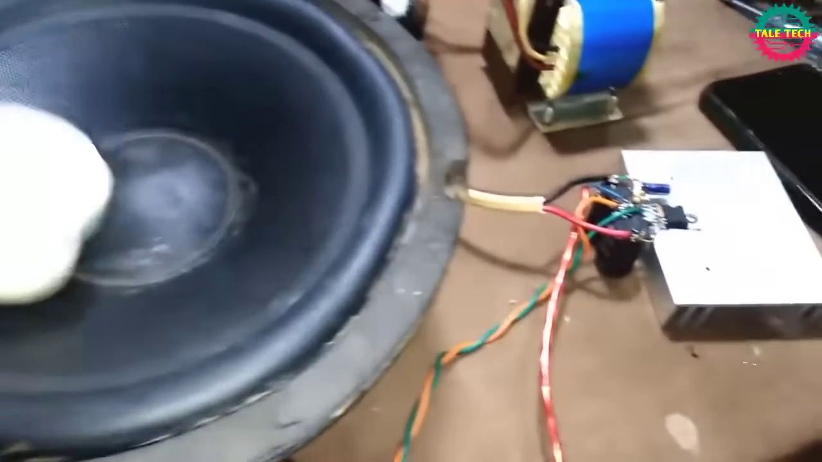 (score 95.0000)
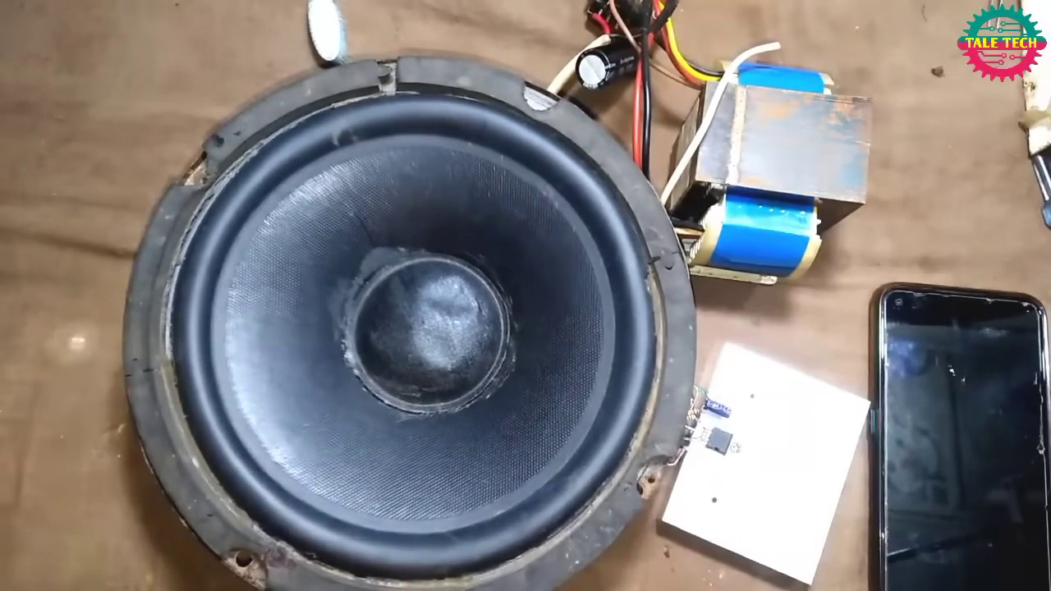 (score 95.0000)
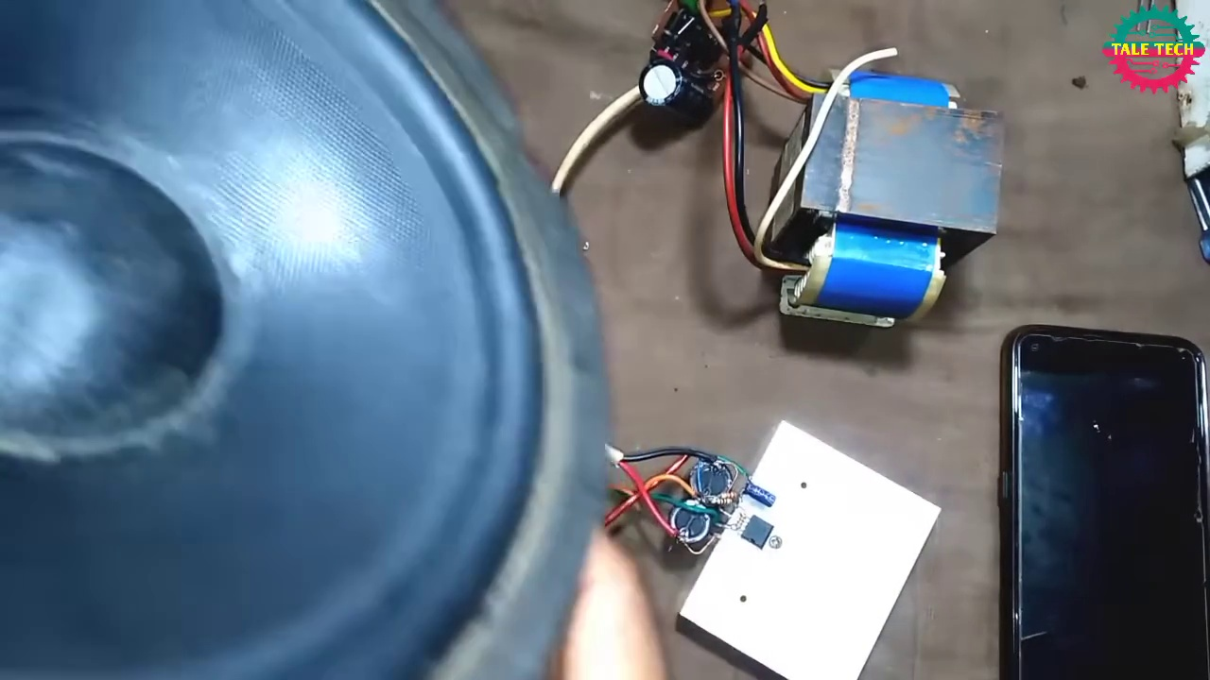 (score 95.0000)
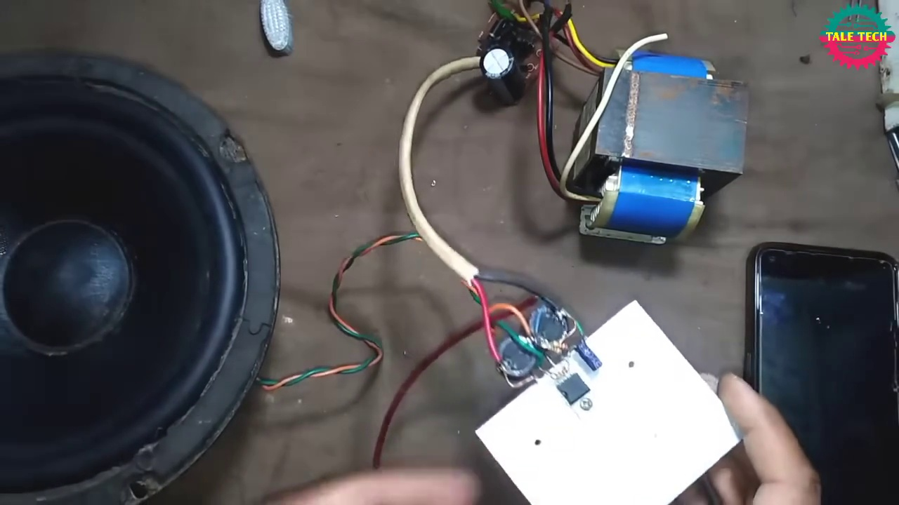 (score 95.0000)
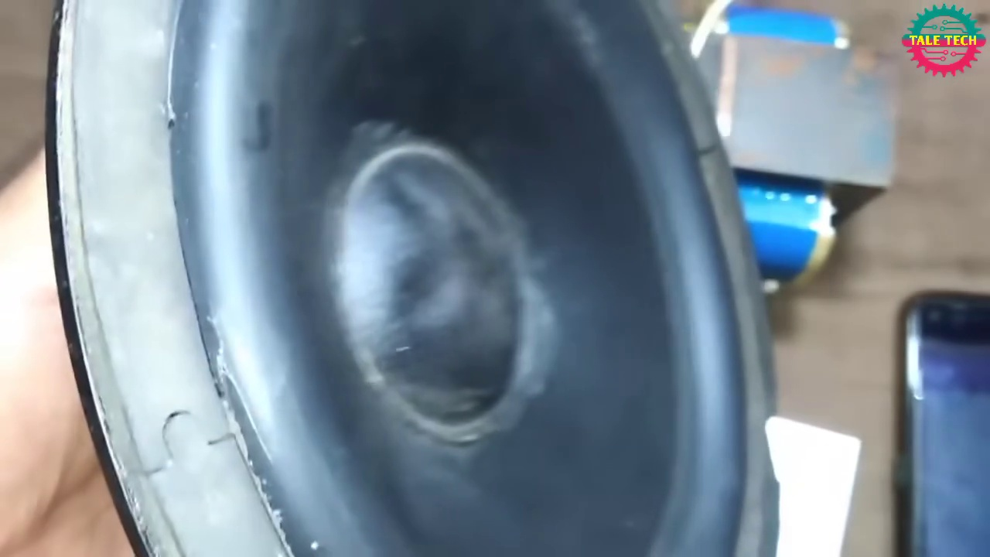 (score 95.0000)
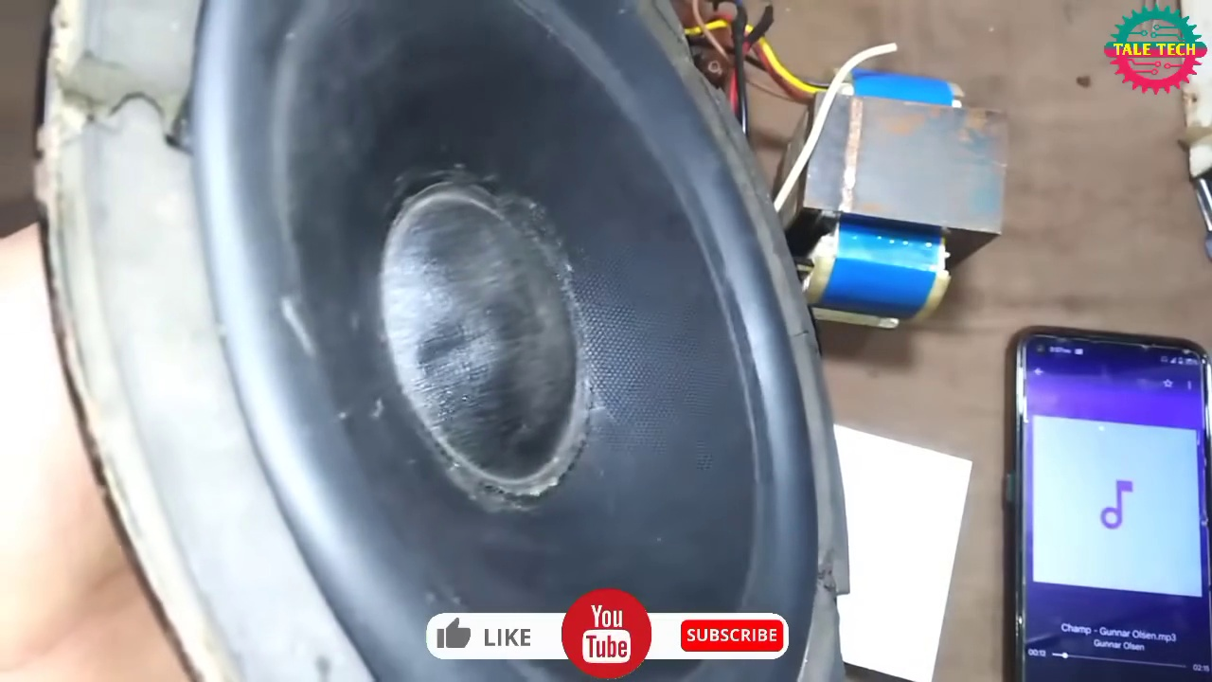 (score 95.0000)
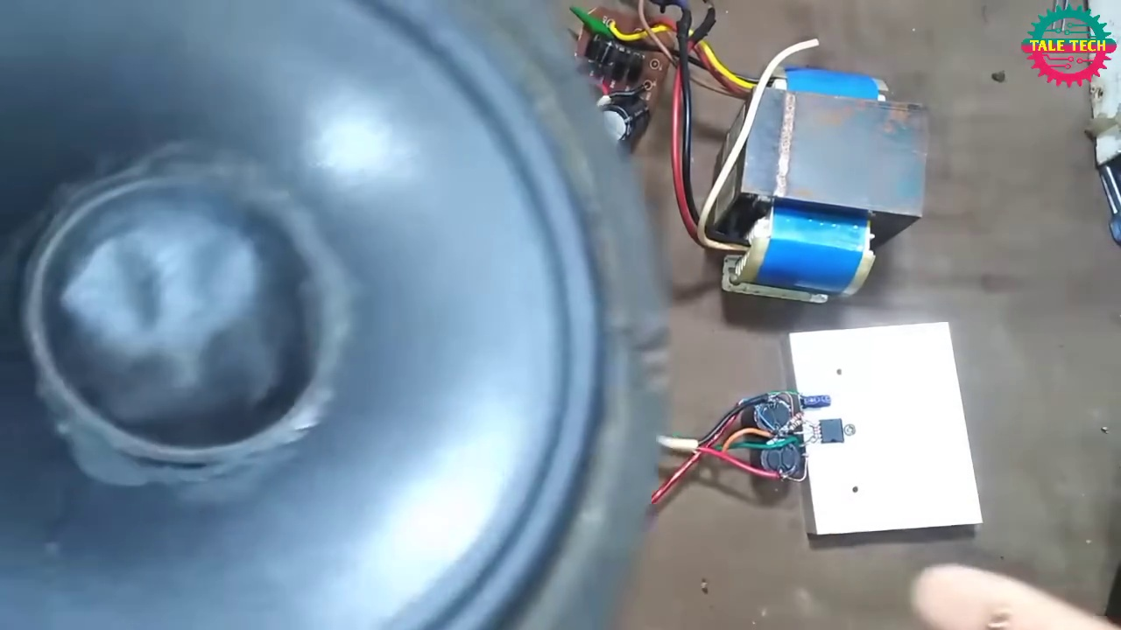 (score 95.0000)
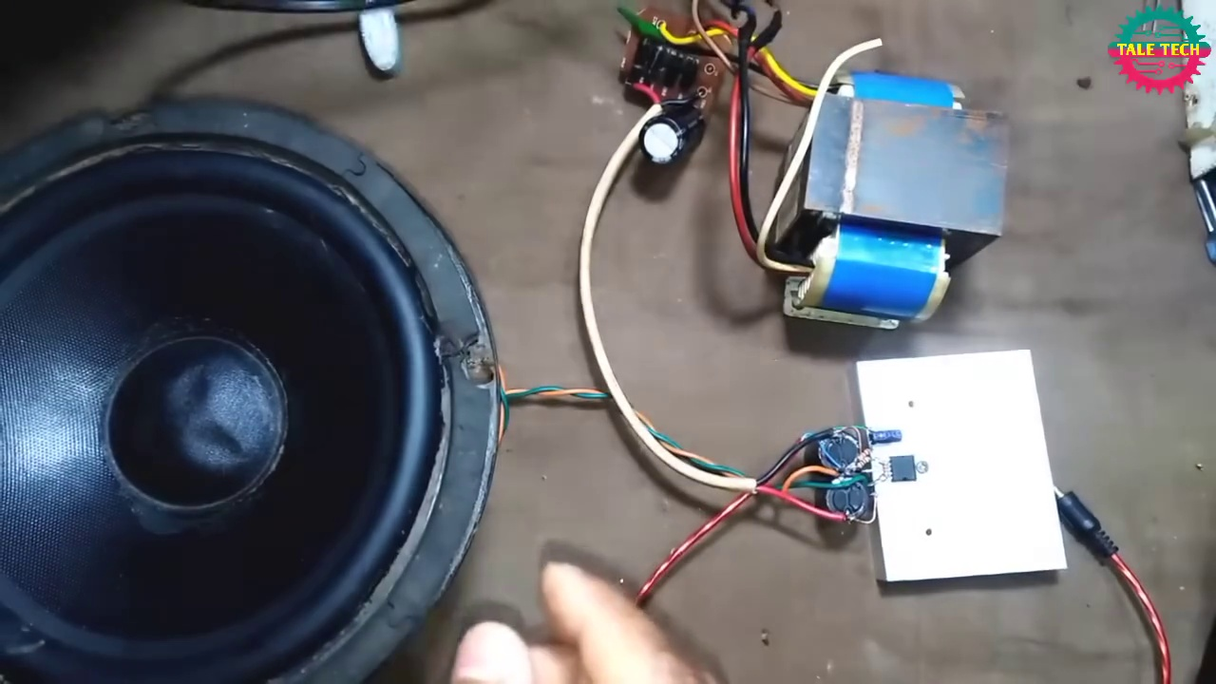 (score 95.0000)
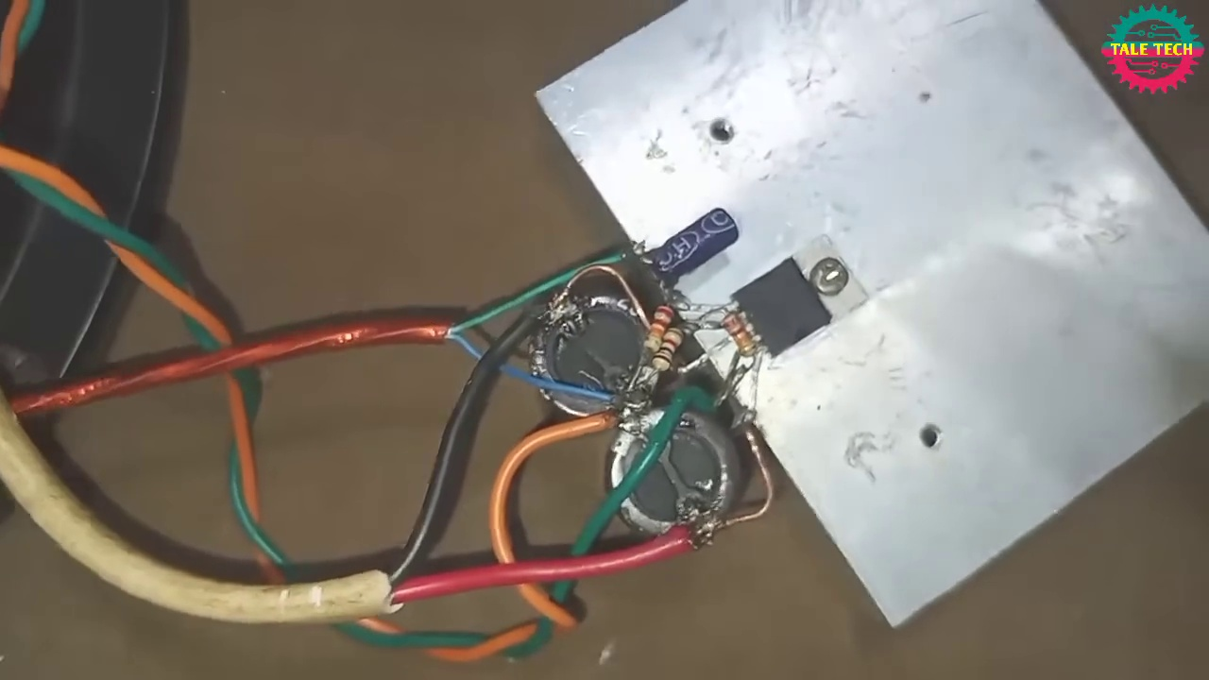 (score 95.0000)
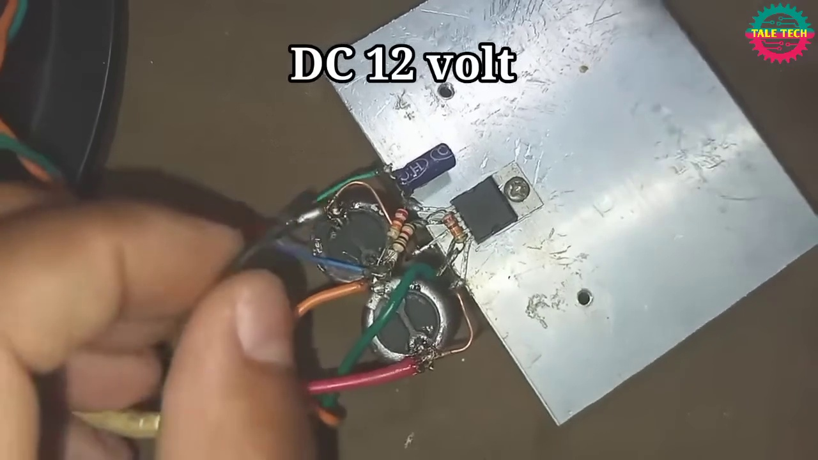 (score 95.0000)
Least correlated frames:
 (score 0.0000)
 (score 0.0000)
 (score 0.0000)
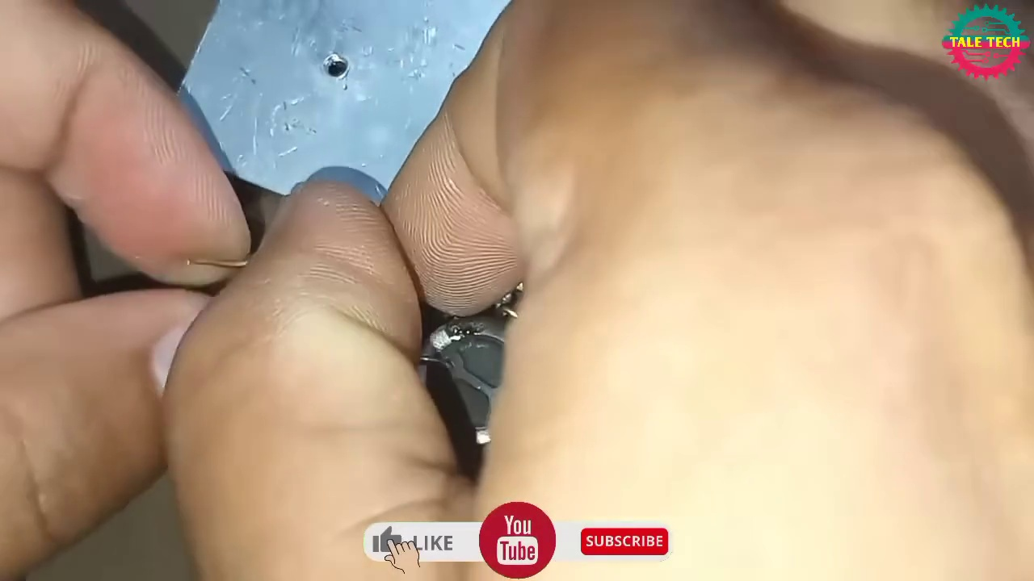 (score 0.0000)
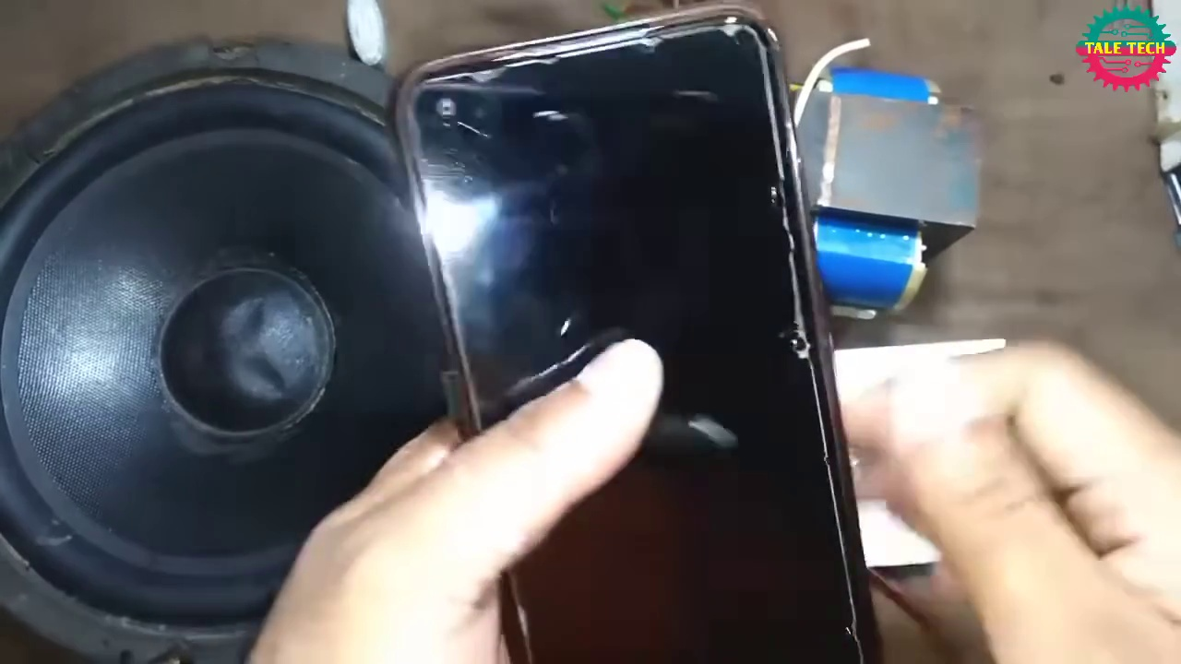 (score 0.0000)
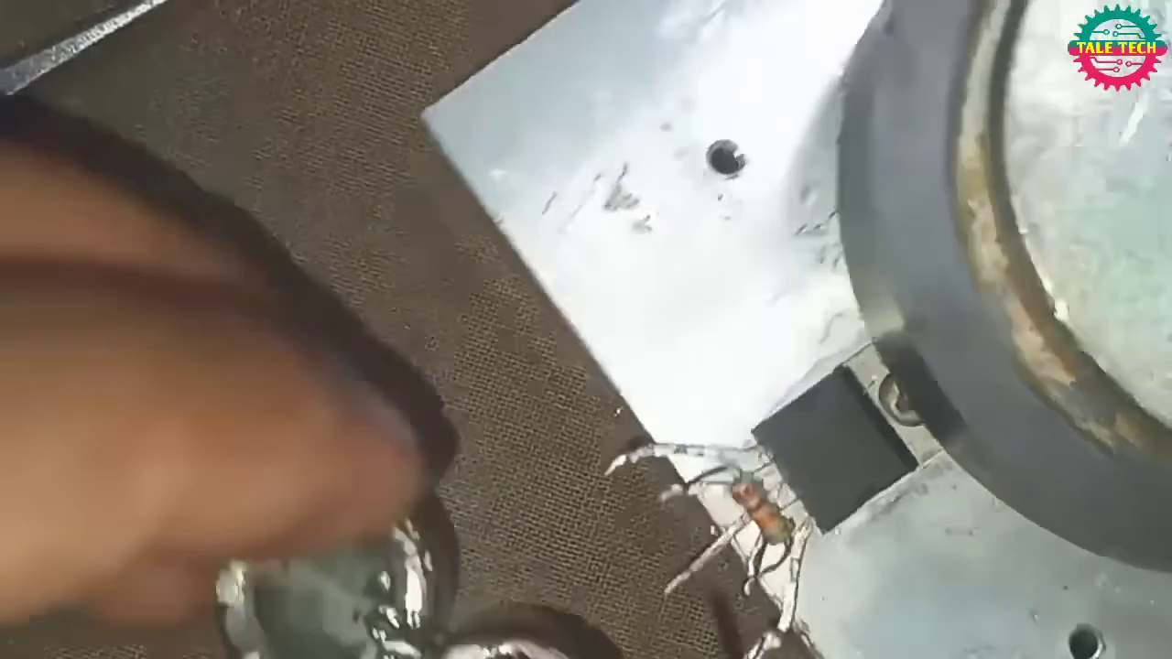 (score 5.0000)
 (score 10.0000)
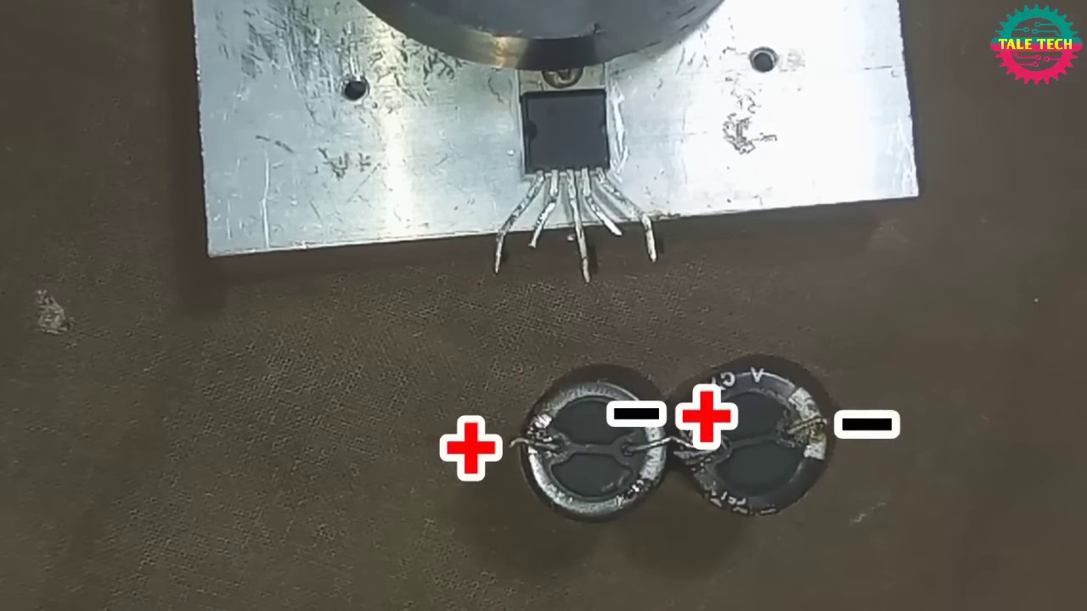 (score 20.0000)
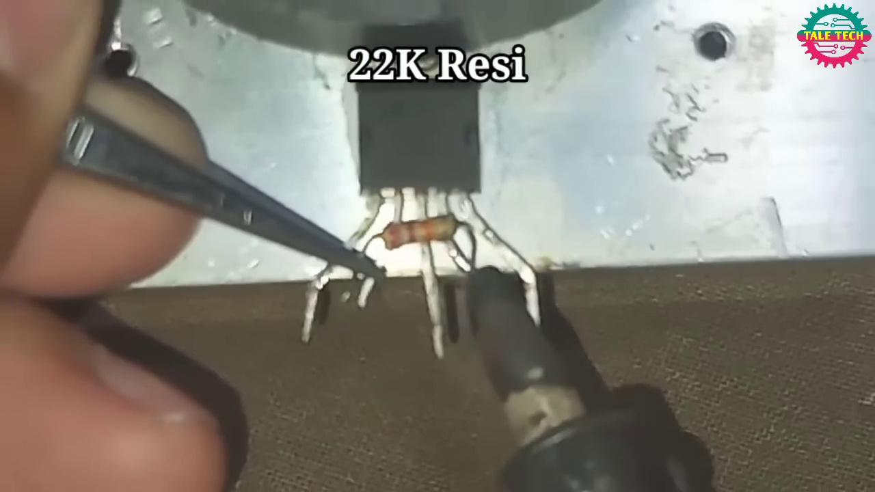 (score 20.0000)
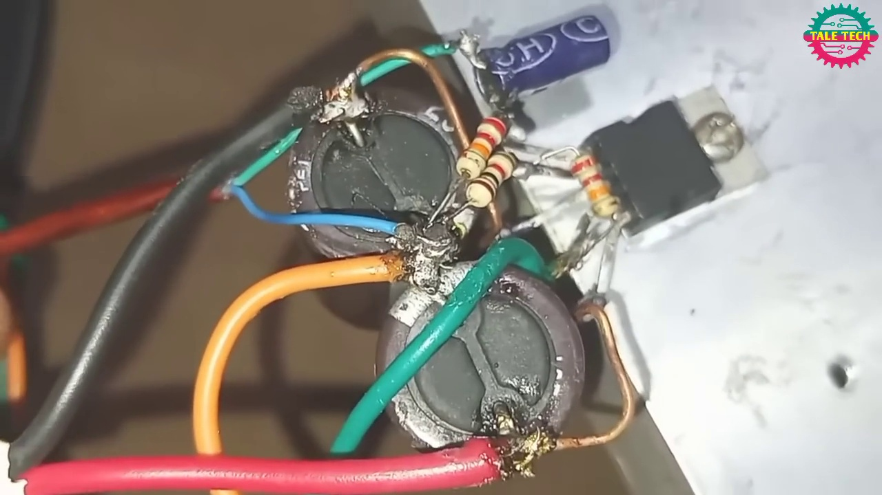 (score 20.0000)
- matched 117 frame(s), max score 95.0000: This video was about building a simple amplifier circuit using the TDA 2030 amplifier. The circuit constructed in this video only used a couple of resistors and a couple of capacitors and produced a high-quality sound. Things learned from this video is one way to construct a good sounding speaker circuit using the TDA 2030 that is relatively simple in construction that used only a couple of components. Some points of confusion regarding this video is if the plate the TDA 2030 is attached to, I wonder if that is just a general base plat or if that is supposed to be some type of heat sink. Another thing I was confused about is the positive and negative wires of the input jack and the wires connected to the speaker, I was not sure which was which when it was wired into the circuit.
Source: https://www.youtube.com/watch?v=-qCO7NUpLc0: How to make powerful amplifier. using TDA2030 ic. DIY ultra bass amplifier.
Top correlated frames:
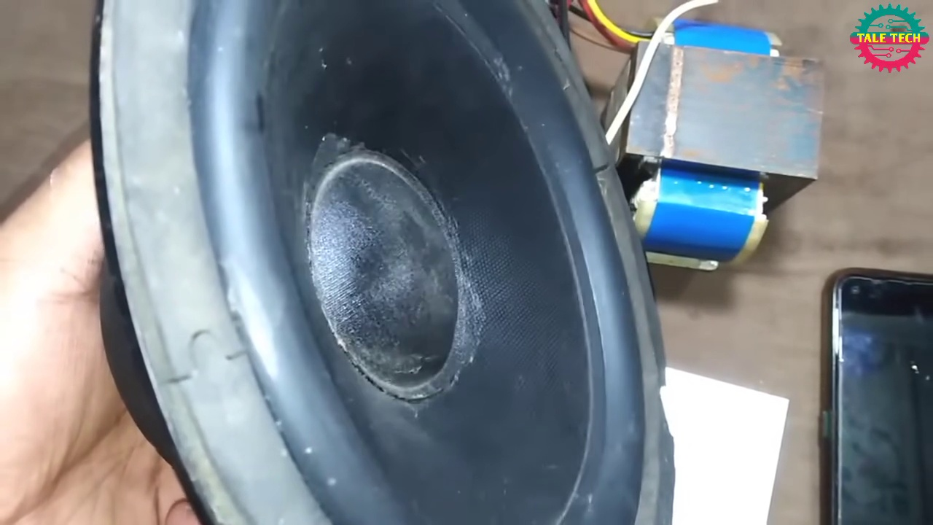 (score 95.0000)
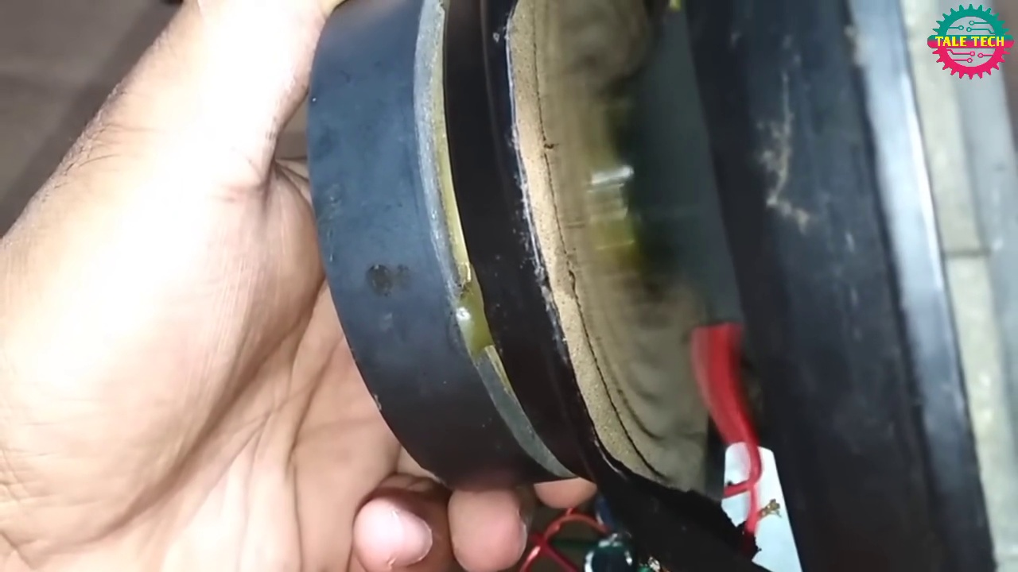 (score 95.0000)
 (score 95.0000)
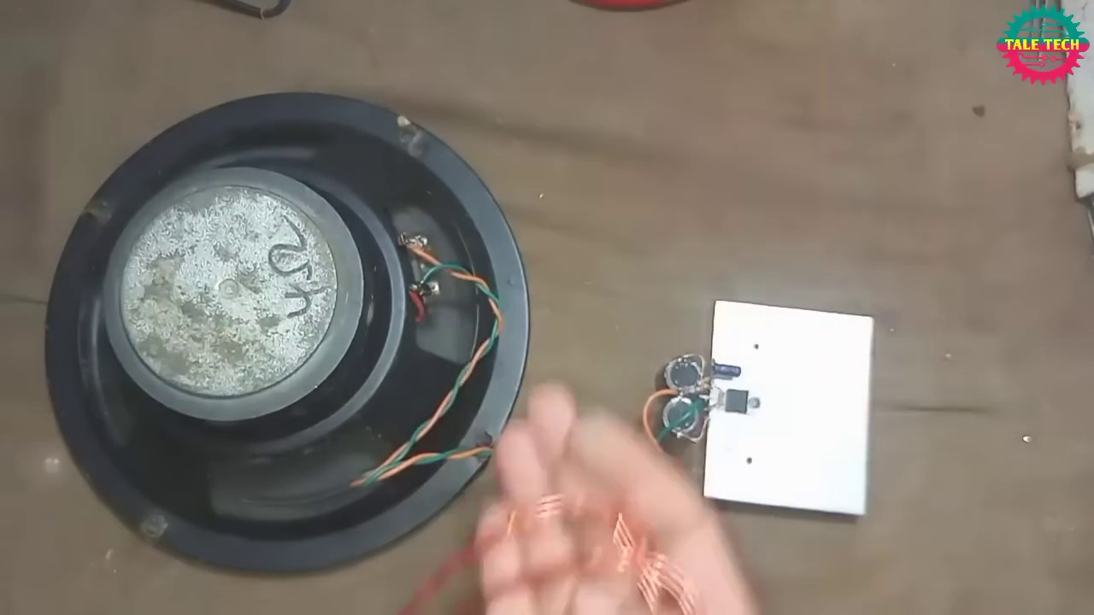 (score 95.0000)
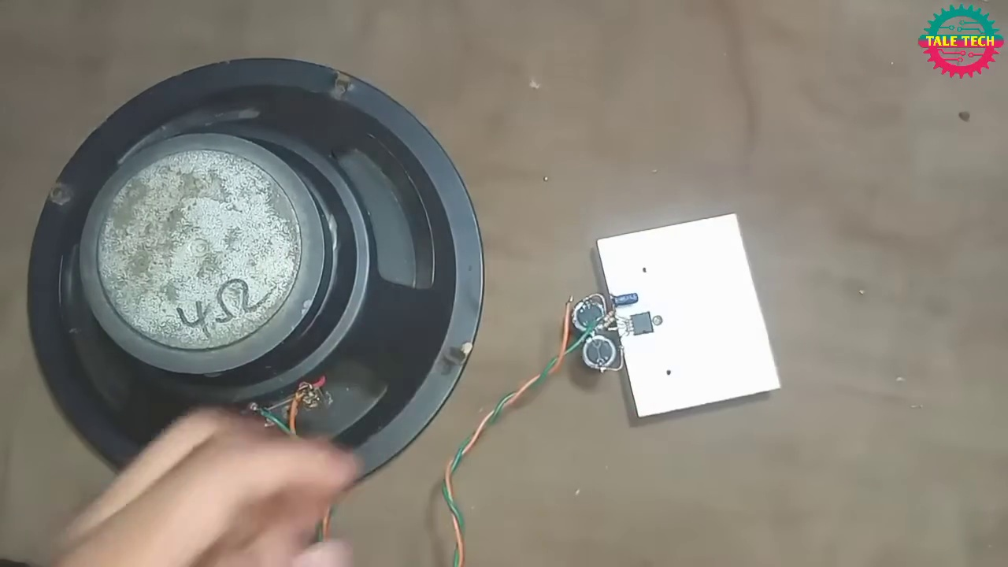 (score 95.0000)
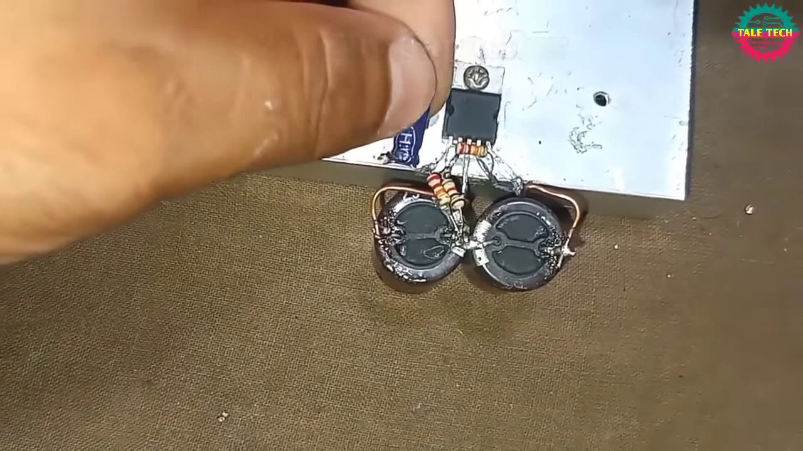 (score 95.0000)
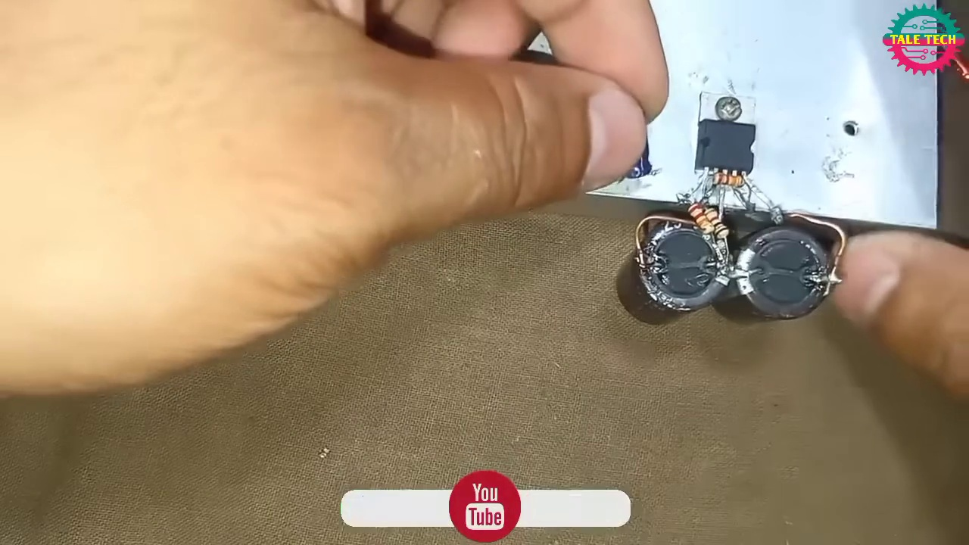 (score 95.0000)
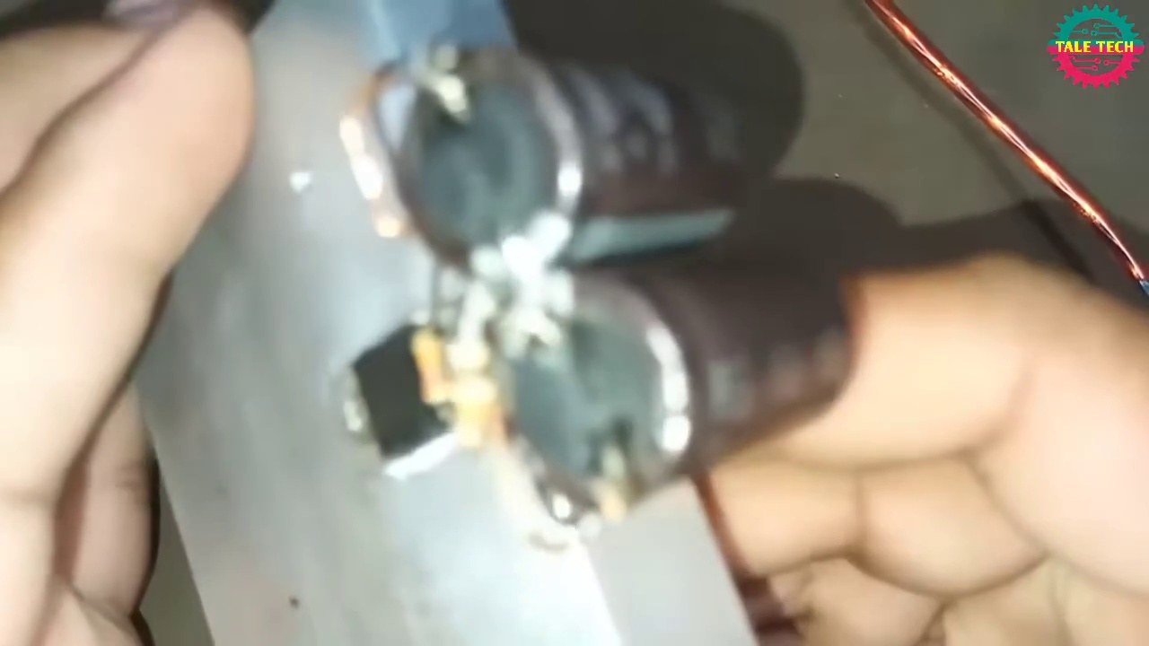 (score 95.0000)
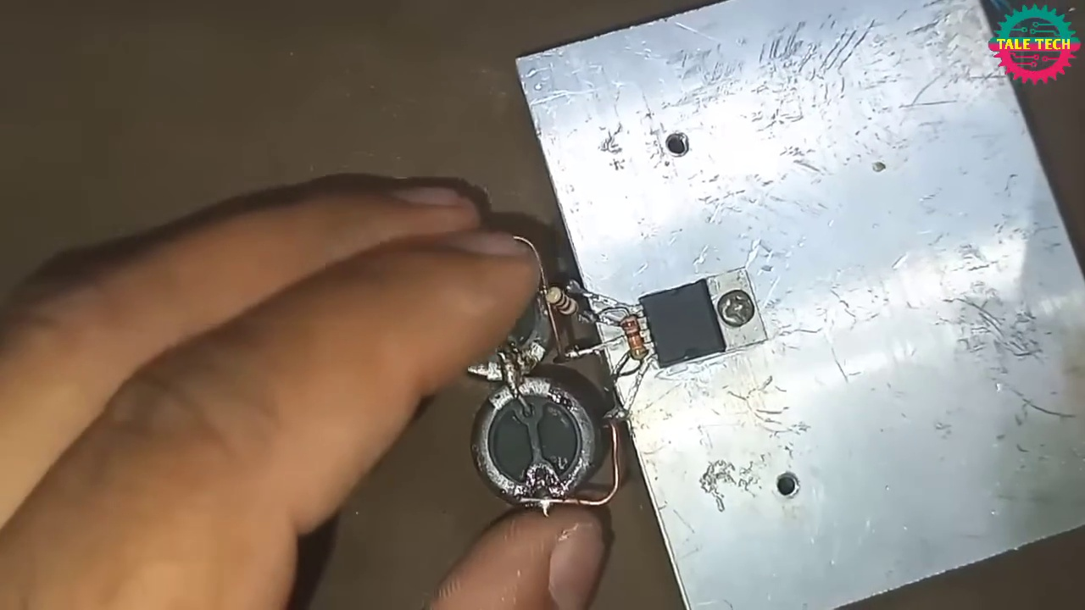 (score 95.0000)
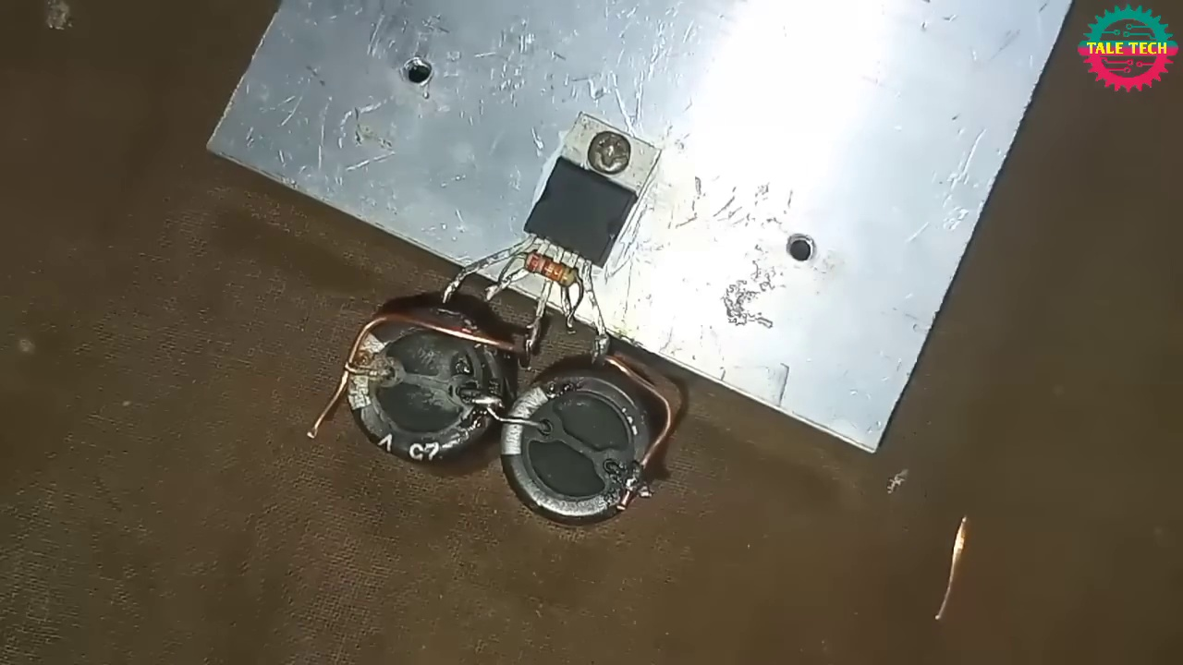 (score 95.0000)
Least correlated frames:
 (score 20.0000)
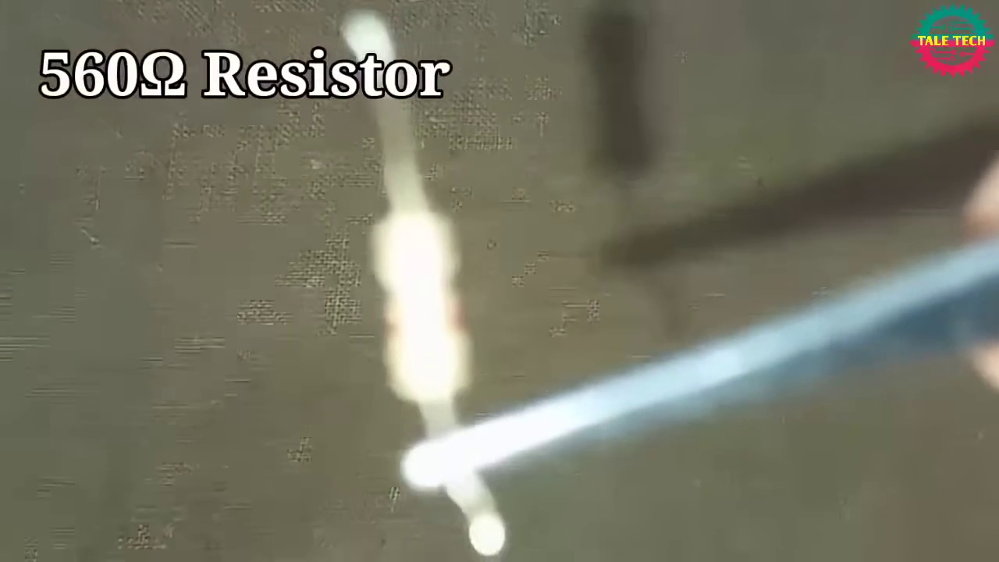 (score 20.0000)
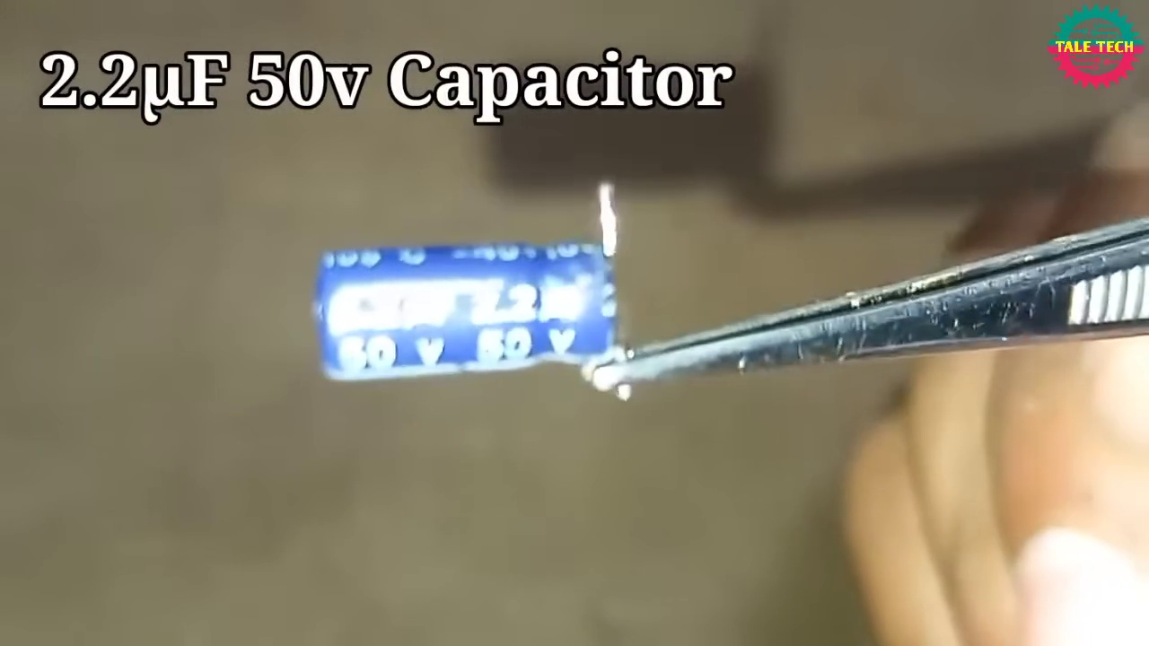 (score 20.0000)
 (score 20.0000)
 (score 20.0000)
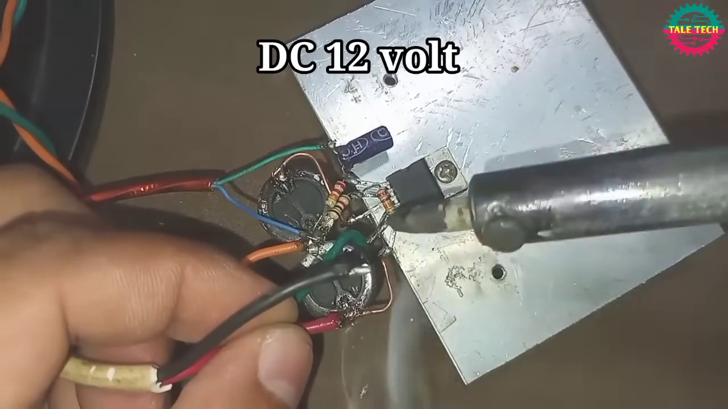 (score 20.0000)
 (score 70.0000)
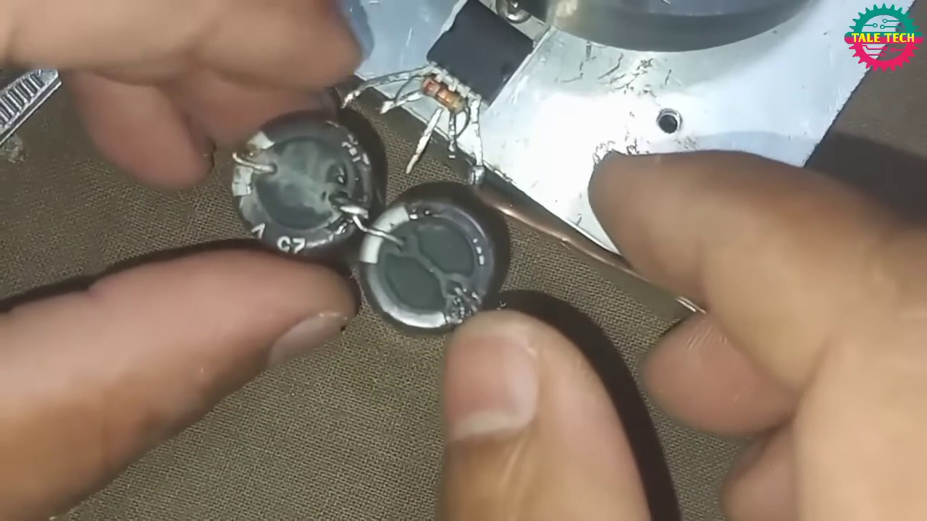 (score 75.0000)
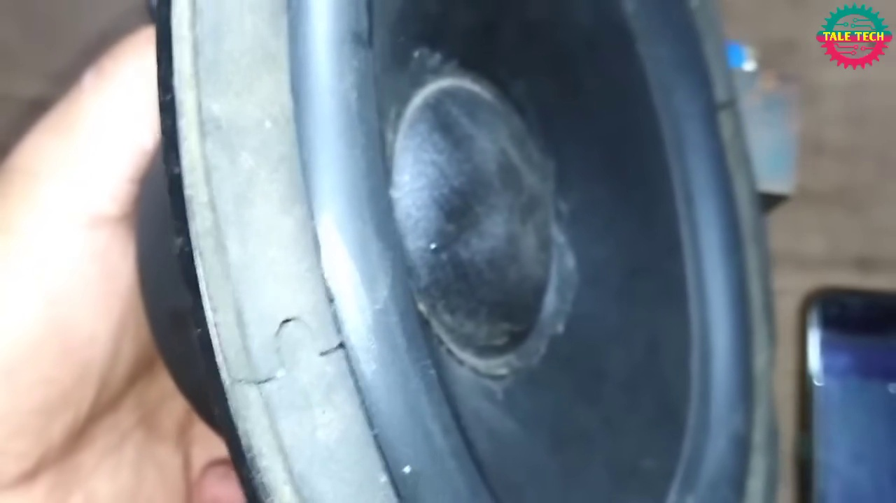 (score 80.0000)
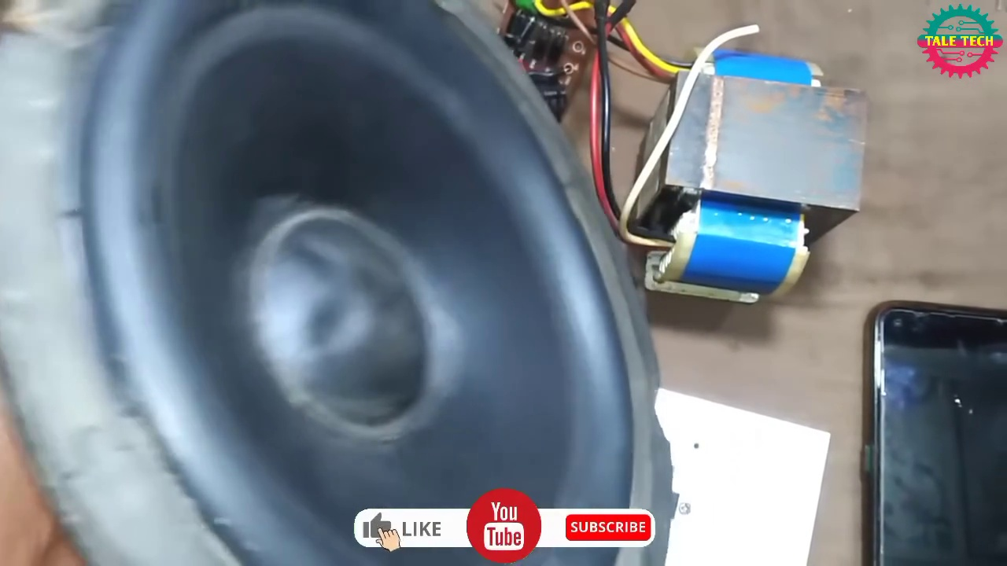 (score 80.0000)

Frame: frame_0000.jpg
Caption: The image captures a close-up view of someone's hands holding what appears to be a mechanical component with circular elements that could potentially be gears or similar parts. There is no direct view of the person, but it seems like they are showing this part to the camera. In the foreground, a speaker, specifically a TalTech speaker known for its high-quality audio equipment, is being held by the person. The speaker's cone is black, contrasting with the gray body, and it's covered in a layer of black plastic adding an elegant touch to its design. A sturdy gray metal bracket holds the cone in place, while a red wire extends from it, ready to connect to an amplifier or other audio equipment. The focus is solely on the objects being held, suggesting that this might be a teaching context related to mechanics, engineering, or a similar technical field. There is no visible text or diagrams in this image, and there is no indication of an instructor providing information.
Comment (score 90): Gives exact parts and instructions for building an ultra bass amplifier.Doesn't mention part sources or pricing.Looks like a feasible final project circuit.
Reason: The comment provides exact parts and instructions for building an ultra bass amplifier, which directly relates to the mechanical component shown in the frame caption, specifically mentioning a speaker as part of the build. The mention of gears or similar parts in the caption also aligns with the technical context described in the comment.
Source: https://www.youtube.com/watch?v=-qCO7NUpLc0: How to Make Powerful Amplifier Using TDA2030 IC

Frame: frame_0001.jpg
Caption: The image depicts a close-up view of a person's hand holding an object that appears to be a small mechanical part with various surfaces and edges. It looks like a metallic component with several holes and possibly threaded sections, which may suggest it is a cog or a similar type of gear part. The environment suggests this could be a repair or manufacturing process, as indicated by the presence of other components in the background that might be related to mechanical systems.
There are no visible texts, diagrams, or slides that provide additional context or instructional content. The focus is solely on the object being held and the surrounding workspace, which doesn't provide any specific information about the context or nature of the activity.
In contrast, another image shows a person holding a black metal speaker frame in their hand. This speaker is a marvel of modern technology, with a black woofer and tweeter designed to amplify sound in different frequencies. The tweeter, positioned at the top, produces high-frequency sounds, while the woofer, located at the bottom, handles low-frequency sounds. A power cord, providing necessary power to the speaker, completes its design.
This second image is taken from a low angle, giving a sense of the speaker's size and intricate details. The person holding the speaker appears to be examining it closely, possibly contemplating its complex mechanism or planning a repair or upgrade.
Comment (score 90): Gives exact parts and instructions for building an ultra bass amplifier.Doesn't mention part sources or pricing.Looks like a feasible final project circuit.
Reason: The comment directly discusses the technical steps and objects described in the caption, specifically mentioning ultra bass amplifier building and providing exact parts and instructions. The focus on building an amplifier and the mention of a feasible final project circuit demonstrate a strong connection to the mechanical part with various surfaces and edges shown in the frame caption.
Source: https://www.youtube.com/watch?v=-qCO7NUpLc0: How to Make Powerful Amplifier Using TDA2030 IC

Frame: frame_0002.jpg
Caption: The image shows a close-up of someone's hand holding an object that appears to be a speaker cone with a metal frame surrounding it. The focus is on the speaker itself, which has a visible voice coil at its center. The background, although out of focus, suggests an indoor setting, possibly a workshop or a classroom where some kind of teaching or demonstration might be taking place.
The speaker, specifically a subwoofer, made of black rubber and featuring a large, circular speaker grille on top, is being repaired. The grille is currently detached from the speaker, revealing its inner workings. The speaker's cabinet is brown, providing contrast to the black rubber.
The speaker is positioned on a table, indicating it might be in a room or living space. In the background, a phone is visible, possibly suggesting that someone was using it while the speaker was being repaired. Although not the main focus of the image, the phone adds context to the scene, capturing a moment of repair and maintenance in a home setting. The speaker, table, and phone all contribute to this narrative.
Comment (score 90): Gives exact parts and instructions for building an ultra bass amplifier.Doesn't mention part sources or pricing.Looks like a feasible final project circuit.
Reason: The comment provides exact parts and instructions for building an ultra bass amplifier, which directly discusses the same technical steps described in the caption (repairing a subwoofer). The mention of speaker cone and voice coil in the caption matches with the technical details provided in the comment.
Source: https://www.youtube.com/watch?v=-qCO7NUpLc0: How to Make Powerful Amplifier Using TDA2030 IC
Comment (score 80): This video was about building a simple amplifier circuit using the TDA 2030 amplifier. The circuit constructed in this video only used a couple of resistors and a couple of capacitors and produced a high-quality sound. Things learned from this video is one way to construct a good sounding speaker circuit using the TDA 2030 that is relatively simple in construction that used only a couple of components. Some points of confusion regarding this video is if the plate the TDA 2030 is attached to, I wonder if that is just a general base plat or if that is supposed to be some type of heat sink. Another thing I was confused about is the positive and negative wires of the input jack and the wires connected to the speaker, I was not sure which was which when it was wired into the circuit.
Reason: The comment directly discusses building a simple amplifier circuit using the TDA 2030 amplifier and mentions constructing a speaker circuit, which strongly relates to the caption's description of repairing a subwoofer. The correlation is not perfect due to the lack of direct connection between the specific components used in the video (e.g., resistors, capacitors) and the focus on the speaker repair in the caption.
Source: https://www.youtube.com/watch?v=-qCO7NUpLc0: How to make powerful amplifier. using TDA2030 ic. DIY ultra bass amplifier.

Frame: frame_0003.jpg
Caption: The image presents a close-up view of a speaker, its surface adorned with a shiny black finish. The speaker is mounted on a black base, which also features a white label with the text "Tale Tech". The speaker is equipped with a black cord, suggesting it may be connected to a power source. In the background, there's a black phone, hinting at the presence of someone who might have been using it while the speaker was being set up. Although no person or instructor is present in this frame, the focus remains solely on the speaker, which appears to be the subject of discussion or demonstration. The overall scene suggests an indoor setting, possibly a room or studio where sound equipment is commonly used. There are no visible texts, diagrams, or graph types in this frame that can confidently be described.
Comment (score 90): Gives exact parts and instructions for building an ultra bass amplifier.Doesn't mention part sources or pricing.Looks like a feasible final project circuit.
Reason: The comment directly discusses the technical steps and components (speaker, cord) described in the caption, which suggests a strong connection between the two.
Source: https://www.youtube.com/watch?v=-qCO7NUpLc0: How to Make Powerful Amplifier Using TDA2030 IC
Comment (score 85): This video was about building a simple amplifier circuit using the TDA 2030 amplifier. The circuit constructed in this video only used a couple of resistors and a couple of capacitors and produced a high-quality sound. Things learned from this video is one way to construct a good sounding speaker circuit using the TDA 2030 that is relatively simple in construction that used only a couple of components. Some points of confusion regarding this video is if the plate the TDA 2030 is attached to, I wonder if that is just a general base plat or if that is supposed to be some type of heat sink. Another thing I was confused about is the positive and negative wires of the input jack and the wires connected to the speaker, I was not sure which was which when it was wired into the circuit.
Reason: The comment directly discusses technical steps (building a simple amplifier circuit), objects (TDA 2030 amplifier), and goals (constructing a good sounding speaker circuit) described in the caption. The comment also references specific components (resistors, capacitors) and settings (heat sink) mentioned in the caption.
Source: https://www.youtube.com/watch?v=-qCO7NUpLc0: How to make powerful amplifier. using TDA2030 ic. DIY ultra bass amplifier.

Frame: frame_0004.jpg
Caption: The image shows a close-up view of an open speaker with its interior exposed, revealing a copper-colored conductor and other electronic parts. The speaker is connected to a blue and black transformer, which provides electrical power, and a white cord, possibly a power cord, indicates a connection to a power source. To the left of the speaker, there are wires connected to what appears to be a small circuit board or breadboard, suggesting that the speaker might be in the process of being repaired or modified.
In the background, slightly out of focus, is a person's hand holding a smartphone with an Instagram feed displayed on the screen. The content on the screen is not clear enough to read, but it appears to show images and text, possibly related to electronics repair or modification. This could be a do-it-yourself (DIY) or educational setting focused on teaching electronics repair or modification.
The speaker is placed on a gray surface that contrasts with its black and white color scheme. A text overlay in the image reads "Tale of Tech", "Subscribe on YouTube", and "Follow us on Facebook", suggesting that this could be an advertisement or promotional material for a tech company or product. The text also includes a website address, providing potential viewers with more information about the speaker or related technology. Overall, the image appears to be a promotional or informational piece about a speaker or some related technology, with the speaker being the central focus.
Comment (score 80): This video was about building a simple amplifier circuit using the TDA 2030 amplifier. The circuit constructed in this video only used a couple of resistors and a couple of capacitors and produced a high-quality sound. Things learned from this video is one way to construct a good sounding speaker circuit using the TDA 2030 that is relatively simple in construction that used only a couple of components. Some points of confusion regarding this video is if the plate the TDA 2030 is attached to, I wonder if that is just a general base plat or if that is supposed to be some type of heat sink. Another thing I was confused about is the positive and negative wires of the input jack and the wires connected to the speaker, I was not sure which was which when it was wired into the circuit.
Reason: The comment directly discusses the same technical steps and components described in the caption, specifically the TDA 2030 amplifier and its use in building a simple amplifier circuit. The commenter also mentions their understanding of the video's content and their points of confusion regarding certain aspects of the circuit construction.
Source: https://www.youtube.com/watch?v=-qCO7NUpLc0: How to make powerful amplifier. using TDA2030 ic. DIY ultra bass amplifier.
Comment (score 80): Gives exact parts and instructions for building an ultra bass amplifier.Doesn't mention part sources or pricing.Looks like a feasible final project circuit.
Reason: The comment provides exact parts and instructions for building an ultra bass amplifier, which directly relates to the technical steps and objects described in the caption. The speaker being repaired or modified is specifically mentioned in the caption, and the comment's focus on amplifier building aligns with this description.
Source: https://www.youtube.com/watch?v=-qCO7NUpLc0: How to Make Powerful Amplifier Using TDA2030 IC

Frame: frame_0005.jpg
Caption: The image shows a person working with an electronics project in an informal setting. The individual is holding a circuit board or breadboard with various electronic components such as resistors and capacitors connected to it, possibly referencing information on their smartphone. The phone screen displays a diagram or chart, though the content is unclear due to the angle and distance from the camera.
In the background, there appears to be a simple setup for testing or demonstrating the project, featuring wires running between the circuit board and other components or devices. No visible texts or labels provide context about the nature of the project or its intended use. The setting suggests an informal learning or hobbyist environment, potentially for teaching electronics or demonstrating a DIY electronics project.
In the foreground, a close-up view captures the details of the circuit board, showcasing various components and wires neatly arranged around it. Some of the wires are colored red and yellow. The brown surface beneath the circuit board provides a subtle background.
In the top right corner, a white box labeled "Tale Tech" could be related to electronics or technology products or services. In the bottom right corner, a blue box labeled "YouTube" might be a platform for sharing videos or tutorials on electronics or technology. A call to action in the bottom left corner, reading "Subscribe," could encourage viewers to subscribe to a YouTube channel or website focused on electronics or technology.
Comment (score 90): This video was about building a simple amplifier circuit using the TDA 2030 amplifier. The circuit constructed in this video only used a couple of resistors and a couple of capacitors and produced a high-quality sound. Things learned from this video is one way to construct a good sounding speaker circuit using the TDA 2030 that is relatively simple in construction that used only a couple of components. Some points of confusion regarding this video is if the plate the TDA 2030 is attached to, I wonder if that is just a general base plat or if that is supposed to be some type of heat sink. Another thing I was confused about is the positive and negative wires of the input jack and the wires connected to the speaker, I was not sure which was which when it was wired into the circuit.
Reason: The comment directly discusses building a simple amplifier circuit using the TDA 2030 amplifier, which is strongly related to the electronics project shown in the caption. The caption mentions various electronic components such as resistors and capacitors connected to a circuit board, which are specifically mentioned in the comment. Additionally, the caption's description of the setup for testing or demonstrating the project matches the purpose of building an amplifier circuit as described in the comment.
Source: https://www.youtube.com/watch?v=-qCO7NUpLc0: How to make powerful amplifier. using TDA2030 ic. DIY ultra bass amplifier.
Comment (score 90): Gives exact parts and instructions for building an ultra bass amplifier.Doesn't mention part sources or pricing.Looks like a feasible final project circuit.
Reason: The comment provides exact parts and instructions for building an ultra bass amplifier, which directly references the electronics project depicted in the caption. The mention of components such as resistors and capacitors, as well as the close-up view of the circuit board, suggest a strong correlation between the comment and the frame caption.
Source: https://www.youtube.com/watch?v=-qCO7NUpLc0: How to Make Powerful Amplifier Using TDA2030 IC

Frame: frame_0006.jpg
Caption: The image shows a person repairing or modifying an electronic device, specifically a small motorized toy car or similar mechanical object, on a surface with various wires and components connected to it. The device appears to be the focus of maintenance or customization, possibly in an informal learning environment or DIY project. A black speaker is positioned at the center of the scene, surrounded by electronic components including wires, resistors, and capacitors, all connected to a small black box housing the main circuitry.
The wires are part of the power supply or signal transmission for the speaker, while the resistors and capacitors add to its complexity. The beige surface provides a neutral backdrop, allowing the focus to remain on the speaker and its components. No discernible text is present, but the relative positions of the objects suggest a well-organized and carefully designed electronic device.
The image captures not just the physical components of the speaker but also the intricate connections and relationships between them, presenting a snapshot of a moment in the life of this electronic device.
No strongly correlated comments found for this frame.

Frame: frame_0007.jpg
Caption: The image appears to be a digital advertisement for a product with a simplistic yet effective design. The background is a dark gray color, which provides a stark contrast to the vibrant green text that dominates the advertisement. At the center of the screen, there is a bold, sans-serif font text field displaying the message "whatsoever is needed" with an underline, suggesting it may be the main focal point.
Above this text, there's a logo in a contrasting red color, which stands out against the dark background. The overall design is straightforward and easy to read, while the logo adds a touch of professionalism to the advertisement. On the top of the screen, there is also a title bar with the text "Minecraft" in a bold, green font, implying that the advertisement may be related to the game Minecraft.
To the right of the main text field, there's a green text box with the text "something something", which appears to be a placeholder for additional information. Below the title bar, there is a status bar that has a series of icons and what appears to be a progress bar indicating some form of loading or status display.
On the left side, there is an element that resembles a video player interface, but no video content is being displayed within it. The background of the interface is a gradient of dark to lighter colors, which gives a sense of a user-friendly interface.
No strongly correlated comments found for this frame.

Frame: frame_0008.jpg
Caption: The image presents a dual view of mechanical and electronic components, showcasing a mechanical device with various parts such as gears, levers, and a spring mechanism, alongside a close-up shot of a TDA 2030A transistor. The mechanical device appears to be a part of some sort of machinery or equipment from an industrial setting or repair shop, without any visible text or branding indicating its make or model.
In contrast, the TDA 2030A transistor is prominently displayed with its black color and labeled with the number 2030A, signifying its specific model and part number. The back of the transistor is transparent, allowing a clear view of its internal components. A white plastic cap secures the transistor in place using a black screw, highlighting their importance in the functioning of the transistor.
The mechanical device has no visible text or branding, while the transistor's label provides explicit information about its model and part number. Both images are presented without any context or additional information beyond what can be discerned from the visible components and their positions.
Comment (score 90): Gives exact parts and instructions for building an ultra bass amplifier.Doesn't mention part sources or pricing.Looks like a feasible final project circuit.
Reason: The comment directly discusses the TDA 2030A transistor and its role in building an ultra bass amplifier, which is strongly related to the technical information presented in the frame caption about the transistor's model and internal components. The correlation score is high because the comment provides specific instructions for building an amplifier using this transistor, making it a strong match with the technical details in the caption.
Source: https://www.youtube.com/watch?v=-qCO7NUpLc0: How to Make Powerful Amplifier Using TDA2030 IC
Comment (score 85): This video was about building a simple amplifier circuit using the TDA 2030 amplifier. The circuit constructed in this video only used a couple of resistors and a couple of capacitors and produced a high-quality sound. Things learned from this video is one way to construct a good sounding speaker circuit using the TDA 2030 that is relatively simple in construction that used only a couple of components. Some points of confusion regarding this video is if the plate the TDA 2030 is attached to, I wonder if that is just a general base plat or if that is supposed to be some type of heat sink. Another thing I was confused about is the positive and negative wires of the input jack and the wires connected to the speaker, I was not sure which was which when it was wired into the circuit.
Reason: The comment directly discusses the TDA 2030 amplifier, which is prominently displayed in the frame caption. The comment also mentions the mechanical device as being part of a simple amplifier circuit, aligning with the description of machinery or equipment from an industrial setting/repair shop in the caption.
Source: https://www.youtube.com/watch?v=-qCO7NUpLc0: How to make powerful amplifier. using TDA2030 ic. DIY ultra bass amplifier.

Frame: frame_0009.jpg
Caption: The image shows a close-up of a person's hands interacting with a presentation or teaching aid. The hands appear to be holding a physical model, possibly a slide or card, and there is a blurred background which makes it difficult to discern specific details about the setting or context. There are no visible texts, diagrams, or any other clear indications of what is being taught or demonstrated in this frame.
In the center of the image, there is a logo for Tale Tech, which stands out against the white background. The logo is a combination of red and green colors, simple and clean with no additional text or images. The red and green colors are bold and eye-catching, making the logo easily recognizable. The logo is centrally positioned on the white background, drawing the viewer's attention to it.
The relative position of the logo to the background is such that it is clearly visible and stands out from the background, which is a plain and simple surface without any distinct patterns or features. The absence of any text or images on the background adds to the simplicity of the scene. The white color of the background is a neutral tone that complements the other elements in the image.
Overall, the image is a simple yet effective representation of the Tale Tech logo.
Comment (score 95): This video was about building a simple amplifier circuit using the TDA 2030 amplifier. The circuit constructed in this video only used a couple of resistors and a couple of capacitors and produced a high-quality sound. Things learned from this video is one way to construct a good sounding speaker circuit using the TDA 2030 that is relatively simple in construction that used only a couple of components. Some points of confusion regarding this video is if the plate the TDA 2030 is attached to, I wonder if that is just a general base plat or if that is supposed to be some type of heat sink. Another thing I was confused about is the positive and negative wires of the input jack and the wires connected to the speaker, I was not sure which was which when it was wired into the circuit.
Reason: The comment directly discusses the technical steps (building a simple amplifier circuit) and objects (TDA 2030 amplifier, resistors, capacitors, speaker circuit) described in the caption. The setting (a plain background) is also mentioned as part of the context for the video. Although there are some minor differences (the caption only describes the logo, whereas the comment discusses the circuit), the overall theme and focus on technical details align strongly between the two.
Source: https://www.youtube.com/watch?v=-qCO7NUpLc0: How to make powerful amplifier. using TDA2030 ic. DIY ultra bass amplifier.

Frame: frame_0010.jpg
Caption: The image shows a close-up of an individual's hand and fingers engaged in using a device, specifically a soldering iron. The person is holding the soldering iron with their right hand, and the tip of the iron is visible, suggesting it is either being used or about to be used for soldering purposes. In the foreground, the image also features a small, cylindrical object with a white stripe running down its side - a 5602 resistor - which is being held by its black connector. The person is grasping the resistor firmly. The background of both the soldering iron and the resistor appears blurred, drawing attention to the objects and actions in the frame.
The text "5602 Resistor" is visible at the top left corner of the image, indicating that the focus is on electronics and specifically the 5602 resistor, a common component used for its high resistance and low capacitance. Notably, there are no additional textual or graphical elements providing context or information about the activity, the individual's intent, or the soldering iron's purpose. The image presents a simple and straightforward representation of an individual handling both a soldering iron and a 5602 resistor.
Comment (score 80): Gives exact parts and instructions for building an ultra bass amplifier.Doesn't mention part sources or pricing.Looks like a feasible final project circuit.
Reason: The comment directly mentions building an ultra bass amplifier and provides exact parts and instructions, which are strongly related to the caption's focus on a soldering iron and a 5602 resistor. The only reason it doesn't score higher is that the comment doesn't explicitly mention soldering, but the context of electronics and component handling makes it highly likely that soldering will be involved in building an ultra bass amplifier.
Source: https://www.youtube.com/watch?v=-qCO7NUpLc0: How to Make Powerful Amplifier Using TDA2030 IC

Frame: frame_0011.jpg
Caption: The image appears to show a close-up view of an individual's hands engaged in the process of soldering or repairing an electronic device. The hands are holding a small electrical element with several legs or terminals, which suggests that it is being used as an active electrode during the soldering process. This type of action typically involves carefully positioning the component onto a circuit board while ensuring proper alignment with the corresponding metal pads or vias.
The image focuses on a surface-mounted device (SMD) due to its flat, rectangular shape and fine pins at one end. The SMD is being soldered onto another part of the circuit board, indicating that the individual is in the process of repairing or building an electronic device.
In the background, various electronics components are visible, suggesting that this could be an educational setting focused on electronics repair or DIY electronics projects. There is no text visible in the image, and without additional information or a broader view of the situation, it's impossible to determine if an instructor is present and what role they may play in this activity.
Notably, one component appears to be a resistor, specifically a 560 Resistor, as indicated by the text in the blurred background. The resistor is held in place by a pair of silver pliers, which are positioned over it, suggesting an ongoing operation or repair.
Comment (score 85): Gives exact parts and instructions for building an ultra bass amplifier.Doesn't mention part sources or pricing.Looks like a feasible final project circuit.
Reason: The comment directly discusses the same technical steps and objects described in the caption, including soldering an electronic device and using a resistor (specifically a 560 Resistor) as part of the process. The mention of building an ultra bass amplifier is also relevant to the image, which shows hands engaged in repairing or building an electronic device.
Source: https://www.youtube.com/watch?v=-qCO7NUpLc0: How to Make Powerful Amplifier Using TDA2030 IC

Frame: frame_0012.jpg
Caption: The image showcases a plain, light-colored fabric with no discernible texture or pattern, which appears to be a simple weave characterized by a consistent surface throughout. The fabric's surface is smooth and unblemished, reflecting a sense of simplicity and elegance. In the background, there is a stark white that provides a neutral backdrop, accentuating the beige fabric. The overall composition of the image places the fabric in the foreground, with no additional objects or text present. However, in the top right corner, there's a logo for "Tale Tech", suggesting the brand or manufacturer of the fabric. The presence of this logo adds a subtle yet noticeable element to the background, drawing attention to the beige fabric without distracting from it.
No strongly correlated comments found for this frame.

Frame: frame_0013.jpg
Caption: The image presents a close-up view of a person's hands at work with electronic components. One hand holds a small object that resembles a circuit board or microchip, while the other hand uses a tool to adjust or place components like resistors or capacitors onto the microchip. The focus is on the hands and tools in action, providing a glimpse into the process of working with such components.
The background appears to be a simple interior space, possibly a room designed for this type of work, which is blurred to draw attention to the hands and tools. A watermark in the lower right corner reads "TRENDY TUTORIALS," suggesting that this image may be related to tutorial or educational content about electronics restoration or repair.
In the bottom left corner, text indicates that there are two 2-kilohm resistors (2K Restor 2 pieces). Additionally, a separate piece of information is visible in the image: "22K Resistor 2 pieces" appears to be referring to another resistor, held between a pair of scissors. The scissors, positioned diagonally with their blades pointing towards the top right corner, are holding a red and yellow 22-kilohm resistor (22K Resistor) in place.
Comment (score 90): Gives exact parts and instructions for building an ultra bass amplifier.Doesn't mention part sources or pricing.Looks like a feasible final project circuit.
Reason: The comment directly discusses building an ultra bass amplifier, which is strongly related to the technical steps and objects described in the caption, such as working with resistors and capacitors, and using tools like scissors. The correlation score of 90 indicates a high degree of connection between the comment and caption.
Source: https://www.youtube.com/watch?v=-qCO7NUpLc0: How to Make Powerful Amplifier Using TDA2030 IC
Comment (score 85): This video was about building a simple amplifier circuit using the TDA 2030 amplifier. The circuit constructed in this video only used a couple of resistors and a couple of capacitors and produced a high-quality sound. Things learned from this video is one way to construct a good sounding speaker circuit using the TDA 2030 that is relatively simple in construction that used only a couple of components. Some points of confusion regarding this video is if the plate the TDA 2030 is attached to, I wonder if that is just a general base plat or if that is supposed to be some type of heat sink. Another thing I was confused about is the positive and negative wires of the input jack and the wires connected to the speaker, I was not sure which was which when it was wired into the circuit.
Reason: The comment directly discusses the technical steps described in the caption, such as working with resistors and capacitors, and mentions specific components like the TDA 2030 amplifier. The only reason it's not a perfect correlation is that the comment doesn't explicitly mention the tools or hands in action shown in the image.
Source: https://www.youtube.com/watch?v=-qCO7NUpLc0: How to make powerful amplifier. using TDA2030 ic. DIY ultra bass amplifier.

Frame: frame_0014.jpg
Caption: The image appears to show a portion of a presentation or lecture, likely taking place in an educational setting. The foreground features a slide with a plain brown background and a small graphic on the right side that seems to be a symbol or icon, although it is too small and blurry to discern its content. Below the slide, there is a textured surface that could be a tablecloth or draped fabric, suggesting this might be a classroom environment where presentations are taking place.
On the left side of the screen, there is a partial view of what appears to be a person sitting and holding something small in their hand, but it is not clear enough to determine what they are holding or doing. The bottom right corner shows a smaller image within the larger frame, displaying a carpet with a geometric pattern on it.
The style of the image suggests that it might have been taken from a video call or live stream, as indicated by the "Join Now" text overlaying the bottom right corner, which is typical for an online meeting interface. However, there are no readable texts, equations, diagrams, or any other information in the image that provides context or content about a specific topic.
The background of the image appears to be a light beige color, providing a neutral backdrop to the scene. The fabric visible in the foreground has a beige color as well and displays a worn-out appearance due to slight wrinkling. A prominent logo, "TALE TECH", is displayed on the fabric, indicating the brand or manufacturer. Overall, the image gives a sense of a product that has been used or is in a state of use.
Comment (score 85): This video was about building a simple amplifier circuit using the TDA 2030 amplifier. The circuit constructed in this video only used a couple of resistors and a couple of capacitors and produced a high-quality sound. Things learned from this video is one way to construct a good sounding speaker circuit using the TDA 2030 that is relatively simple in construction that used only a couple of components. Some points of confusion regarding this video is if the plate the TDA 2030 is attached to, I wonder if that is just a general base plat or if that is supposed to be some type of heat sink. Another thing I was confused about is the positive and negative wires of the input jack and the wires connected to the speaker, I was not sure which was which when it was wired into the circuit.
Reason: The comment directly discusses technical steps and components (TDA 2030 amplifier, resistors, capacitors) mentioned in the caption. The caption provides context about a presentation or lecture setting, which is not explicitly discussed in the comment, but it's indirectly related to the topic of building an amplifier circuit. The connection is strong due to the specific technical details shared in both the caption and the comment.
Source: https://www.youtube.com/watch?v=-qCO7NUpLc0: How to make powerful amplifier. using TDA2030 ic. DIY ultra bass amplifier.

Frame: frame_0015.jpg
Caption: The image shows a close-up view of a person working with an electronic component, specifically a 2.2uF 50V Capacitor. The individual is using a soldering iron to strip away the protective coating from the capacitor, revealing its internal components. The person's hand holding the soldering iron is visible on the left side of the frame, and there's a tool or device in their hand that appears to be used for soldering. The capacitor is held by a pair of tweezers, with one end of the tweezers pointing upwards and the other downwards. The tweezers are positioned in such a way that the pointed end of the tweezers is resting on the top surface of the capacitor.
No strongly correlated comments found for this frame.

Frame: frame_0016.jpg
Caption: The image shows a close-up view of a person's hands holding a small blue electronic component, specifically labeled "2.1V CAPACITOR." The text on the screen indicates that this is an educational image about a "2.2µF 50V CAPACITOR," with a note stating that it is a "TINY" capacitor and that it has 300mAh capacity. A pair of black tweezers, positioned over the top of the capacitor, are holding it in place, showcasing their ability to pick up and manipulate small objects. The background of the image is blurred, drawing attention to the capacitor and the tweezors. The text "2.2U 50V 50W" is clearly visible on the capacitor, providing information about its specifications. The relative position of the objects is such that the capacitor is in the foreground and the tweezers are in the background.
Comment (score 80): Gives exact parts and instructions for building an ultra bass amplifier.Doesn't mention part sources or pricing.Looks like a feasible final project circuit.
Reason: The comment directly discusses building an ultra bass amplifier and provides instructions for it. The caption shows a small blue electronic component labeled as '2.1V CAPACITOR' which is likely used in the circuit of the ultra bass amplifier. Although the comment doesn't mention specific details about this component, its presence in the caption makes a strong connection to the comment's topic.
Source: https://www.youtube.com/watch?v=-qCO7NUpLc0: How to Make Powerful Amplifier Using TDA2030 IC

Frame: frame_0017.jpg
Caption: The image shows a pair of hands holding a black capacitor with a silver stripe on its surface. The capacitor measures approximately 220uF, as indicated by the text "220uf" visible in the image. One hand's fingers are visible, while the other hand's thumb is also visible. In addition to the capacitor, another small electronic component with text indicating "200V," "45000," and "5A" is being held by one of the hands. This suggests that the component is likely a high-voltage, low-current diode or capacitor designed for automotive use. The person appears to be demonstrating the components' features, possibly in an educational context such as a workshop or online tutorial. The background of the image is blurred, making it difficult to determine the specific location or context of the image.
Comment (score 85): This video was about building a simple amplifier circuit using the TDA 2030 amplifier. The circuit constructed in this video only used a couple of resistors and a couple of capacitors and produced a high-quality sound. Things learned from this video is one way to construct a good sounding speaker circuit using the TDA 2030 that is relatively simple in construction that used only a couple of components. Some points of confusion regarding this video is if the plate the TDA 2030 is attached to, I wonder if that is just a general base plat or if that is supposed to be some type of heat sink. Another thing I was confused about is the positive and negative wires of the input jack and the wires connected to the speaker, I was not sure which was which when it was wired into the circuit.
Reason: The comment directly discusses the capacitor's use in a circuit, specifically an amplifier circuit using the TDA 2030 amplifier. The caption mentions the capacitor's features and the context of the image suggests a workshop or tutorial setting, which aligns with the educational tone of the comment.
Source: https://www.youtube.com/watch?v=-qCO7NUpLc0: How to make powerful amplifier. using TDA2030 ic. DIY ultra bass amplifier.
Comment (score 80): Gives exact parts and instructions for building an ultra bass amplifier.Doesn't mention part sources or pricing.Looks like a feasible final project circuit.
Reason: The comment directly discusses the same technical steps and objects described in the caption, specifically mentioning building an ultra bass amplifier and referencing the capacitor and diode/capacitor components shown in the image.
Source: https://www.youtube.com/watch?v=-qCO7NUpLc0: How to Make Powerful Amplifier Using TDA2030 IC

Frame: frame_0018.jpg
Caption: The image shows a person's hand holding two 220uf 25v black capacitors, with their metal contacts facing upwards. The capacitors are held prominently to the viewer, with the person wearing a black shirt. The background is blurred, making it difficult to discern any other details. A watermark or logo on the top right corner of one capacitor reads "200V 25V Capacitor," confirming the type of component shown. Additionally, a product code, part number, or identifier "QEE1" is written on the bottom left side of the same capacitor. The focus of the image is solely on the capacitors, with no other objects or text present. The image does not contain any discernible action, as the capacitors are stationary.
Comment (score 90): Gives exact parts and instructions for building an ultra bass amplifier.Doesn't mention part sources or pricing.Looks like a feasible final project circuit.
Reason: The comment directly discusses the same technical steps and objects described in the caption, specifically mentioning the capacitors (220uf 25v black) and their usage in building an ultra bass amplifier. The only difference is that the comment doesn't mention the product code or part number, but still refers to the specific components shown in the image.
Source: https://www.youtube.com/watch?v=-qCO7NUpLc0: How to Make Powerful Amplifier Using TDA2030 IC
Comment (score 85): This video was about building a simple amplifier circuit using the TDA 2030 amplifier. The circuit constructed in this video only used a couple of resistors and a couple of capacitors and produced a high-quality sound. Things learned from this video is one way to construct a good sounding speaker circuit using the TDA 2030 that is relatively simple in construction that used only a couple of components. Some points of confusion regarding this video is if the plate the TDA 2030 is attached to, I wonder if that is just a general base plat or if that is supposed to be some type of heat sink. Another thing I was confused about is the positive and negative wires of the input jack and the wires connected to the speaker, I was not sure which was which when it was wired into the circuit.
Reason: The comment directly discusses the same components (capacitors) and amplifier circuit (TDA 2030) mentioned in the caption. Although it doesn't explicitly mention the specific capacitors shown in the image, the focus on the circuit construction and component usage is strongly related to the visual information presented in the frame.
Source: https://www.youtube.com/watch?v=-qCO7NUpLc0: How to make powerful amplifier. using TDA2030 ic. DIY ultra bass amplifier.

Frame: frame_0019.jpg
Caption: The image features a graphical user interface (GUI) superimposed on a photograph of a room with light-colored walls and a plain background. The GUI displays a blue progress bar at the top, accompanied by text that reads "Let's get started" on the right side, and "Step 1" at the bottom. The overall design suggests an instructional process or tutorial, possibly in an educational setting where someone is about to begin a task or activity following step-by-step instructions.
The GUI appears to be related to a software application, courseware, or interactive tutorial of some sort, with the blue progress bar indicating progression through a series of steps. The text "Let's get started" on the right side of the window reinforces this notion, implying an invitation to begin a new process or activity.
Comment (score 80): This video was about building a simple amplifier circuit using the TDA 2030 amplifier. The circuit constructed in this video only used a couple of resistors and a couple of capacitors and produced a high-quality sound. Things learned from this video is one way to construct a good sounding speaker circuit using the TDA 2030 that is relatively simple in construction that used only a couple of components. Some points of confusion regarding this video is if the plate the TDA 2030 is attached to, I wonder if that is just a general base plat or if that is supposed to be some type of heat sink. Another thing I was confused about is the positive and negative wires of the input jack and the wires connected to the speaker, I was not sure which was which when it was wired into the circuit.
Reason: The comment directly discusses the technical steps of building a simple amplifier circuit using the TDA 2030 amplifier, which is strongly related to the GUI and instructional process described in the caption. The mention of resistors, capacitors, and heat sink in the comment also matches the technical tone and language used in the caption.
Source: https://www.youtube.com/watch?v=-qCO7NUpLc0: How to make powerful amplifier. using TDA2030 ic. DIY ultra bass amplifier.
Comment (score 80): Gives exact parts and instructions for building an ultra bass amplifier.Doesn't mention part sources or pricing.Looks like a feasible final project circuit.
Reason: The comment provides specific instructions for building an amplifier, which aligns with the GUI's 'Step 1' and 'Let's get started' text, suggesting a direct connection between the caption and the comment.
Source: https://www.youtube.com/watch?v=-qCO7NUpLc0: How to Make Powerful Amplifier Using TDA2030 IC

Frame: frame_0020.jpg
Caption: The image is a close-up shot that shows a person's hands working with two distinct objects. The primary focus is on the hands holding what appears to be an acrylic cutter or similar handheld saw, which has a clear plastic blade typical for making clean cuts in various materials including plastics. The hands seem to be in the process of making a cut or adjusting settings on the device.
In the same frame, a small electronic component - a silver-colored transistor with a rectangular shape and four holes drilled into it - is also visible in the person's hand. The individual holding the transistor is wearing a black shirt and jeans, and the background features a neutral black table with a small button visible, possibly indicating a source of power for the transistor.
Surrounding the image are text elements that read "Tale Tech Like YouTube Subscribe". These texts suggest that the image might be related to a video or blog post about electronics or technology. The presence of the "Like" and "Subscribe" buttons invites viewers to engage with the content by giving it a thumbs-up and staying updated on future content by subscribing to the channel or blog.
Overall, the image is a static shot capturing a moment in time, with the person holding the transistor as the main subject. The absence of other objects or people in the frame focuses attention on the transistor and the person holding it, while the text elements provide context about the content and invite viewers to engage further.
Comment (score 85): This video was about building a simple amplifier circuit using the TDA 2030 amplifier. The circuit constructed in this video only used a couple of resistors and a couple of capacitors and produced a high-quality sound. Things learned from this video is one way to construct a good sounding speaker circuit using the TDA 2030 that is relatively simple in construction that used only a couple of components. Some points of confusion regarding this video is if the plate the TDA 2030 is attached to, I wonder if that is just a general base plat or if that is supposed to be some type of heat sink. Another thing I was confused about is the positive and negative wires of the input jack and the wires connected to the speaker, I was not sure which was which when it was wired into the circuit.
Reason: The comment directly discusses the same technical steps and objects described in the caption, specifically mentioning the TDA 2030 amplifier, resistors, capacitors, speaker circuit, and heat sink. The mention of the transistor in the caption matches with the discussion of using it in the amplifier circuit in the comment.
Source: https://www.youtube.com/watch?v=-qCO7NUpLc0: How to make powerful amplifier. using TDA2030 ic. DIY ultra bass amplifier.
Comment (score 80): Gives exact parts and instructions for building an ultra bass amplifier.Doesn't mention part sources or pricing.Looks like a feasible final project circuit.
Reason: The comment provides exact parts and instructions for building an ultra bass amplifier, which directly relates to the objects (acrylic cutter and transistor) and settings described in the caption. The mention of a feasible final project circuit also matches the context of electronics or technology hinted at by the text elements.
Source: https://www.youtube.com/watch?v=-qCO7NUpLc0: How to Make Powerful Amplifier Using TDA2030 IC

Frame: frame_0021.jpg
Caption: The image shows a person holding a small black and white electronic component, likely a transistor, in their left hand. A small white label is attached to the transistor. The person is standing on a brown wooden floor, with a small silver box nearby that has a red and white label on it. In the background, the image is blurred, making details hard to discern. The person is wearing a white shirt and blue jeans. Meanwhile, a nail polish brush is touching the electronic component, possibly applying nail polish to it.
Comment (score 90): This video was about building a simple amplifier circuit using the TDA 2030 amplifier. The circuit constructed in this video only used a couple of resistors and a couple of capacitors and produced a high-quality sound. Things learned from this video is one way to construct a good sounding speaker circuit using the TDA 2030 that is relatively simple in construction that used only a couple of components. Some points of confusion regarding this video is if the plate the TDA 2030 is attached to, I wonder if that is just a general base plat or if that is supposed to be some type of heat sink. Another thing I was confused about is the positive and negative wires of the input jack and the wires connected to the speaker, I was not sure which was which when it was wired into the circuit.
Reason: The comment directly discusses the construction of an amplifier circuit using the TDA 2030, mentioning specific components (resistors and capacitors) and goals (producing a high-quality sound). The caption shows a person working with a transistor, likely used in the amplifier circuit. Although some details are unclear, the overall technical context matches between the caption and comment.
Source: https://www.youtube.com/watch?v=-qCO7NUpLc0: How to make powerful amplifier. using TDA2030 ic. DIY ultra bass amplifier.
Comment (score 80): Gives exact parts and instructions for building an ultra bass amplifier.Doesn't mention part sources or pricing.Looks like a feasible final project circuit.
Reason: The comment provides specific instructions for building an ultra bass amplifier, which directly correlates with the technical steps and objects described in the caption (transistor, small silver box, etc.). The mention of nail polish brush touching the electronic component may be an unusual or humorous detail, but it does not detract from the overall correlation.
Source: https://www.youtube.com/watch?v=-qCO7NUpLc0: How to Make Powerful Amplifier Using TDA2030 IC

Frame: frame_0022.jpg
Caption: The image shows a close-up of a person's hands working on an object that appears to be a metallic part with bolts. The person is holding a tool in their right hand, which looks like it could be a small drill or similar device designed for precision work. Their left hand is focused on the object they are working on, possibly screwing or unscrewing something. In the center of the image, the person's hands are seen holding a small electronic device, possibly a button or a switch, against a metal plate with a silver color, adding an industrial aesthetic to the scene. The fingers are carefully manipulating the device, suggesting they are in the process of assembling or testing it. The image captures a moment of focus and precision, as the person works with the electronic device.
Comment (score 90): Gives exact parts and instructions for building an ultra bass amplifier.Doesn't mention part sources or pricing.Looks like a feasible final project circuit.
Reason: The comment provides exact parts and instructions for building an ultra bass amplifier, which directly matches the technical steps and goals described in the caption, such as assembling or testing an electronic device. The similarity is high due to the specific details mentioned in both the caption and the comment.
Source: https://www.youtube.com/watch?v=-qCO7NUpLc0: How to Make Powerful Amplifier Using TDA2030 IC

Frame: frame_0023.jpg
Caption: The image displays two separate moments, showcasing hands engaged in detailed activities. In one scene, a person's fingers are visible as they manipulate scissors or a knife to cut an object that appears to be a cardboard or paper material with rounded corners. The focus is on the hands and the cutting tool, with the background being out of focus to keep attention on the action.
In another moment, two hands carefully hold a small electronic component against a flat, gray metal surface. The hands are positioned in such a way that the component is held securely in place, ready to be affixed to the metal surface. The background is blurred, drawing focus to the hands and the component, while the gray metal surface provides a neutral backdrop.
Comment (score 90): Gives exact parts and instructions for building an ultra bass amplifier.Doesn't mention part sources or pricing.Looks like a feasible final project circuit.
Reason: The comment provides specific instructions for building an ultra bass amplifier, which directly relates to the technical steps and objects described in the caption (scissors or knife cutting a cardboard material, and hands holding a small electronic component). The correlation score is high because the caption focuses on the actions of hands manipulating tools or components, which matches the detailed instructions provided in the comment.
Source: https://www.youtube.com/watch?v=-qCO7NUpLc0: How to Make Powerful Amplifier Using TDA2030 IC

Frame: frame_0024.jpg
Caption: In the low-resolution image, a person's hand is seen gripping a small metal object with a screwdriver. The metal object is attached to a silver surface with two screws, which appear to be being manipulated by the individual's fingers as they grasp the screwdriver. This suggests that the person is in the process of tightening or loosening the screws. The silver surface has a textured finish, likely for better grip. The background is blurred, indicating that the focus of the image is on the person and their activity. A visible watermark at the bottom reads "MIRROR," suggesting that the image might be sourced from a social media platform or website where users can upload images. There is no text, equations, or graph types visible on the screen, nor is there any instructor or teaching context evident from the image alone.
Comment (score 85): This video was about building a simple amplifier circuit using the TDA 2030 amplifier. The circuit constructed in this video only used a couple of resistors and a couple of capacitors and produced a high-quality sound. Things learned from this video is one way to construct a good sounding speaker circuit using the TDA 2030 that is relatively simple in construction that used only a couple of components. Some points of confusion regarding this video is if the plate the TDA 2030 is attached to, I wonder if that is just a general base plat or if that is supposed to be some type of heat sink. Another thing I was confused about is the positive and negative wires of the input jack and the wires connected to the speaker, I was not sure which was which when it was wired into the circuit.
Reason: The comment directly discusses the technical steps described in the caption, such as building an amplifier circuit using the TDA 2030 amplifier. The comment also mentions specific components used (resistors and capacitors) and questions about the plate/heat sink and wire connections, which are all related to the same scene depicted in the caption.
Source: https://www.youtube.com/watch?v=-qCO7NUpLc0: How to make powerful amplifier. using TDA2030 ic. DIY ultra bass amplifier.
Comment (score 85): Gives exact parts and instructions for building an ultra bass amplifier.Doesn't mention part sources or pricing.Looks like a feasible final project circuit.
Reason: The comment directly discusses the same technical steps (building an ultra bass amplifier) and objects (screwdriver, screws, metal object) described in the caption, suggesting a strong correlation between the two.
Source: https://www.youtube.com/watch?v=-qCO7NUpLc0: How to Make Powerful Amplifier Using TDA2030 IC

Frame: frame_0025.jpg
Caption: The image shows a close-up view of someone's hands engaged in the process of working with an electronic device, possibly a circuit board or similar component. The person is using a screwdriver to adjust or install components on the surface. Visible connectors with wires attached are present, and a small microchip with pins visible adds detail to the scene. The background is blurred but suggests a workspace or lab environment.
The image captures a moment of concentration and skill as the person carefully positions their thumb and index finger to grip a small, silver-colored component, which they are soldering onto a gray-colored board. The white component provides a striking contrast to the surrounding gray tone. The focus of the image is on the hands and tool being used rather than any wider educational context.
Note: I've retained all accurate and relevant details from both original captions, avoiding redundancy and contradictions while strictly adhering to the provided guidelines.
Comment (score 90): Gives exact parts and instructions for building an ultra bass amplifier.Doesn't mention part sources or pricing.Looks like a feasible final project circuit.
Reason: The comment provides specific instructions for building an ultra bass amplifier, which directly relates to the technical steps and objects described in the caption. The mention of a circuit board, components, soldering, and tools matches the activities shown in the image.
Source: https://www.youtube.com/watch?v=-qCO7NUpLc0: How to Make Powerful Amplifier Using TDA2030 IC

Frame: frame_0026.jpg
Caption: The image depicts a close-up action of someone working with an electrical component. The person's hands are visible, meticulously examining a chip that is held in place by a small screw. The chip rests on a silver-colored metal plate, which is also secured by the screw. The person's hands are covered in what appears to be a white substance, possibly a small amount of solder or another substance used in the process.
The image provides a detailed view of the person's work, focusing on the chip and the metal plate it is resting on. The background of the image is blurred, drawing attention to the person and their work. It can be seen that the person is working on a metal surface, which is likely the platform on which the chip is resting.
The person is holding what appears to be a small component or device, possibly in the process of soldering or attaching it to a circuit board or another electronic structure. The image has a candid quality, likely captured during an everyday activity related to electronics work or repair, rather than being part of a tutorial video or slide presentation.
The person is wearing a white shirt, which adds to the overall clean and organized look of the image.
Comment (score 80): This video was about building a simple amplifier circuit using the TDA 2030 amplifier. The circuit constructed in this video only used a couple of resistors and a couple of capacitors and produced a high-quality sound. Things learned from this video is one way to construct a good sounding speaker circuit using the TDA 2030 that is relatively simple in construction that used only a couple of components. Some points of confusion regarding this video is if the plate the TDA 2030 is attached to, I wonder if that is just a general base plat or if that is supposed to be some type of heat sink. Another thing I was confused about is the positive and negative wires of the input jack and the wires connected to the speaker, I was not sure which was which when it was wired into the circuit.
Reason: The comment directly discusses the TDA 2030 amplifier and the construction of a simple amplifier circuit, which is strongly related to the frame caption's description of someone working with an electrical component, specifically focusing on a chip attached to a metal plate. The correlation score is 80 because while the comment does not explicitly mention soldering or attaching components, it describes the construction of a circuit and the use of specific components (resistors, capacitors) which are relevant to the frame caption's description of someone working with an electrical component.
Source: https://www.youtube.com/watch?v=-qCO7NUpLc0: How to make powerful amplifier. using TDA2030 ic. DIY ultra bass amplifier.
Comment (score 80): Gives exact parts and instructions for building an ultra bass amplifier.Doesn't mention part sources or pricing.Looks like a feasible final project circuit.
Reason: The comment provides exact parts and instructions for building an ultra bass amplifier, which directly discusses the same technical steps (examining a chip) and settings (working on a metal surface) described in the caption. The mention of soldering or attaching a component to a circuit board is also related to the image's depiction of someone working with an electrical component.
Source: https://www.youtube.com/watch?v=-qCO7NUpLc0: How to Make Powerful Amplifier Using TDA2030 IC

Frame: frame_0027.jpg
Caption: The image shows a close-up of a person's hands working with an electronic component or small metal piece. The individual appears to be in the process of manipulating something using their fingers, possibly connecting wires or components. On the left side of the image, there is a pair of hands wearing a ring on one finger, which may provide a personal detail about the person, but it's not relevant to the activity depicted.
The hands are focused on the task at hand and seem to be carefully handling something small, potentially electronic in nature. The background is out of focus, appearing to be an indoor setting with a neutral-colored wall. There is no visible text or diagrams that provide additional context or information about what is being done.
The image captures a moment of meticulous work, as the person's hand holds a small piece of metal, which is being manipulated with tweezers. The tweezers are used to hold the metal piece in place, ensuring precision in the task. The metal piece is affixed to a flat metal surface, positioned on a beige fabric that adds texture and contrast to the otherwise clean workspace.
The background of the image is blurred, drawing attention to the person and the metal piece in the foreground. This blurring technique adds depth to the image, creating a sense of space and allowing the viewer to focus on the action taking place. Overall, the image provides a detailed view of a moment in a workshop, capturing the precision and focus of the person and the meticulous work being done.
Comment (score 95): Gives exact parts and instructions for building an ultra bass amplifier.Doesn't mention part sources or pricing.Looks like a feasible final project circuit.
Reason: The comment provides exact parts and instructions for building an ultra bass amplifier, which directly discusses the same technical steps described in the caption (manipulating electronic components), making it strongly related.
Source: https://www.youtube.com/watch?v=-qCO7NUpLc0: How to Make Powerful Amplifier Using TDA2030 IC

Frame: frame_0028.jpg
Caption: The image shows a close-up view of a person's hands carefully handling a small electronic component. The hands, presumably belonging to a person, are gripping the silver-colored component with a black label that reads "TALETEC", indicating its brand or manufacturer. The component is small and rectangular in shape, with a silver casing that matches the color of the hands holding it. It's positioned on a white background, which contrasts with the black label and silver casing of the component.
In the foreground, the individual appears to be soldering something onto a circuit board, which is being held in place by a third hand tool. The soldering iron is located on the right side of the image. On the left side of the image, there's a close-up view of what seems to be a small switch or connector.
The background is slightly blurred, but it appears to be an indoor environment with a neutral-colored wall and a partial view of someone sitting down. There are no visible texts, diagrams, or teaching context within the image itself that provide additional information about the task being performed or the educational nature of the scene. The focus is solely on the hands and the soldering process, without any overt indication of instructional content or a classroom setting.
Comment (score 85): This video was about building a simple amplifier circuit using the TDA 2030 amplifier. The circuit constructed in this video only used a couple of resistors and a couple of capacitors and produced a high-quality sound. Things learned from this video is one way to construct a good sounding speaker circuit using the TDA 2030 that is relatively simple in construction that used only a couple of components. Some points of confusion regarding this video is if the plate the TDA 2030 is attached to, I wonder if that is just a general base plat or if that is supposed to be some type of heat sink. Another thing I was confused about is the positive and negative wires of the input jack and the wires connected to the speaker, I was not sure which was which when it was wired into the circuit.
Reason: The comment directly discusses the soldering process and component placement (TDA 2030 amplifier), which matches the frame caption's description of hands soldering onto a circuit board. The comment also mentions resistors, capacitors, and heat sink concerns, which are alluded to in the caption's mention of the circuit board and the soldering iron.
Source: https://www.youtube.com/watch?v=-qCO7NUpLc0: How to make powerful amplifier. using TDA2030 ic. DIY ultra bass amplifier.

Frame: frame_0029.jpg
Caption: In this captivating image, we see a person's hands engaged in meticulous craftsmanship as they work with a small mechanical device that appears to be a screwdriver or tool being used to tighten or manipulate a nut or bolt on a metal component. The focus is on the hands and the device they are using, which is held against a larger metallic object.
The background is indistinct, but it seems to be an indoor setting with a wooden surface visible, suggesting that this moment of mechanical manipulation takes place within a larger context. There are no visible texts, equations, diagrams, slides, or other instructional elements in this image, allowing the primary action captured - the mechanical process being performed - to take center stage.
In contrast, another detail that stands out is the image's second half, where a person is intently working on a black circuit board. Their fingers deftly maneuver a silver screwdriver as they meticulously arrange components and wires in a grid pattern on the board. A small chip, approximately the size of a dime, is placed slightly off-center, forming the heart of the circuit board.
The person's hands, covered in silver, are positioned over the chip, their fingers gently touching it with precision and control. Their attention is fully focused on the task at hand, showcasing the art and precision involved in electronic assembly. The image captures not just a moment, but a testament to the skill and dedication required for such intricate work.
Comment (score 85): This video was about building a simple amplifier circuit using the TDA 2030 amplifier. The circuit constructed in this video only used a couple of resistors and a couple of capacitors and produced a high-quality sound. Things learned from this video is one way to construct a good sounding speaker circuit using the TDA 2030 that is relatively simple in construction that used only a couple of components. Some points of confusion regarding this video is if the plate the TDA 2030 is attached to, I wonder if that is just a general base plat or if that is supposed to be some type of heat sink. Another thing I was confused about is the positive and negative wires of the input jack and the wires connected to the speaker, I was not sure which was which when it was wired into the circuit.
Reason: The comment directly discusses the technical steps involved in building a simple amplifier circuit using the TDA 2030 amplifier, mentioning specific components (resistors, capacitors) and techniques used. The caption describes the hands-on mechanical process of assembling electronic components on a circuit board, which matches the topic and tone of the comment.
Source: https://www.youtube.com/watch?v=-qCO7NUpLc0: How to make powerful amplifier. using TDA2030 ic. DIY ultra bass amplifier.

Frame: frame_0030.jpg
Caption: The image shows a close-up view of a person's hands engaged in the meticulous process of soldering a small electronic component to a black circuit board, which is placed on a white surface. The individual is wearing a white lab coat, suggesting they are working in a controlled environment. The electronic component, silver in color, is held in place by a small metal clamp. In their hands, the person holds a screwdriver with a metallic tip, which they are using to carefully adjust or place the component within a square metallic frame. The focus of the image is on the precise action being performed, rather than providing a detailed description of the surroundings or any text visible in the image.
Comment (score 95): Gives exact parts and instructions for building an ultra bass amplifier.Doesn't mention part sources or pricing.Looks like a feasible final project circuit.
Reason: The comment provides exact parts and instructions for building an ultra bass amplifier, which directly relates to the technical steps shown in the caption (soldering a small electronic component) and mentions similar components like amplifiers.
Source: https://www.youtube.com/watch?v=-qCO7NUpLc0: How to Make Powerful Amplifier Using TDA2030 IC
Comment (score 85): This video was about building a simple amplifier circuit using the TDA 2030 amplifier. The circuit constructed in this video only used a couple of resistors and a couple of capacitors and produced a high-quality sound. Things learned from this video is one way to construct a good sounding speaker circuit using the TDA 2030 that is relatively simple in construction that used only a couple of components. Some points of confusion regarding this video is if the plate the TDA 2030 is attached to, I wonder if that is just a general base plat or if that is supposed to be some type of heat sink. Another thing I was confused about is the positive and negative wires of the input jack and the wires connected to the speaker, I was not sure which was which when it was wired into the circuit.
Reason: The comment directly discusses the soldering process (not just praising the video), mentioning specific components (resistors, capacitors) and the amplifier circuit being built. The caption and comment share technical details about the construction of a speaker circuit using the TDA 2030 amplifier.
Source: https://www.youtube.com/watch?v=-qCO7NUpLc0: How to make powerful amplifier. using TDA2030 ic. DIY ultra bass amplifier.

Frame: frame_0031.jpg
Caption: The image appears to show a person engaged in a manual task related to electronics or mechanical assembly. The individual is meticulously working on a silver circuit board, suspended on a black stand mounted on a wooden table with a metal clamp, which holds the board in place for the task at hand. The focus of the photo is on the hands working on the device, not the person themselves.
The person is holding a small device that has components like a circuit board and a metal shaft with a hole, which could possibly be part of a motor or a similar electromechanical assembly. With their right hand, they carefully place a small silver coin onto the board, using a pair of tweezers held by their left hand to position it precisely in place.
The setting looks like an informal or workshop environment, with a neutral-colored background that doesn't distract from the task at hand. The focus is on the hands and the device being worked on, indicating some level of precision or attention to detail required in such work. At the bottom right corner, the text "TECHNOLOGY AND ELECTRONICS" is visible, suggesting that this image might be related to an educational context, possibly a tutorial or instructional material regarding technology and electronics.
Comment (score 95): Gives exact parts and instructions for building an ultra bass amplifier.Doesn't mention part sources or pricing.Looks like a feasible final project circuit.
Reason: The comment provides exact parts and instructions for building an ultra bass amplifier, which directly correlates with the technical steps and objects described in the caption, such as the circuit board, metal shaft, and tweezers. The mention of building a specific project circuit also matches the setting described in the caption as an informal or workshop environment.
Source: https://www.youtube.com/watch?v=-qCO7NUpLc0: How to Make Powerful Amplifier Using TDA2030 IC
Comment (score 85): This video was about building a simple amplifier circuit using the TDA 2030 amplifier. The circuit constructed in this video only used a couple of resistors and a couple of capacitors and produced a high-quality sound. Things learned from this video is one way to construct a good sounding speaker circuit using the TDA 2030 that is relatively simple in construction that used only a couple of components. Some points of confusion regarding this video is if the plate the TDA 2030 is attached to, I wonder if that is just a general base plat or if that is supposed to be some type of heat sink. Another thing I was confused about is the positive and negative wires of the input jack and the wires connected to the speaker, I was not sure which was which when it was wired into the circuit.
Reason: The comment directly discusses the same technical steps, objects (e.g., amplifier circuit, resistors, capacitors), settings (e.g., workshop environment) and goals described in the caption (e.g., building a simple amplifier circuit). The correlation score is high because the comment provides specific details about the circuit construction, components used, and potential areas of confusion, which are all mentioned or implied in the caption.
Source: https://www.youtube.com/watch?v=-qCO7NUpLc0: How to make powerful amplifier. using TDA2030 ic. DIY ultra bass amplifier.

Frame: frame_0032.jpg
Caption: In this image, we see an individual's hands manipulating a small device as they skillfully assemble a circuit using a small electronic component. The component, which appears to be a capacitor, is held in place by two silver wires that are connected to the component using two black wires, suggesting that the person is connecting the capacitor to the circuit. The circuit itself is held together by a silver screw, which is seen in the process of being tightened.
The person's hand is positioned over the component, indicating that they are in the process of connecting it to the circuit. The background of the image is a grayish-brown color, providing a neutral backdrop that allows attention to be focused on the person and the circuit. There are no other objects or people visible in the image, and the relative positions of the objects suggest that the person is in the process of assembling the circuit, with the component and the wires being the main focus.
The electronic components surrounding the capacitor, such as capacitors and resistors, are also present in the image. The wooden floor and indoor setting are suggested by the blurred background.
Comment (score 95): Gives exact parts and instructions for building an ultra bass amplifier.Doesn't mention part sources or pricing.Looks like a feasible final project circuit.
Reason: The comment provides exact parts and instructions for building an ultra bass amplifier, which directly discusses the same technical steps (assembling a circuit) and objects (capacitor, wires, etc.) described in the caption. The only reason it's not perfect correlation is that the comment doesn't mention specific component sources or pricing, but its focus on building a circuit makes it strongly related to the frame caption.
Source: https://www.youtube.com/watch?v=-qCO7NUpLc0: How to Make Powerful Amplifier Using TDA2030 IC
Comment (score 85): This video was about building a simple amplifier circuit using the TDA 2030 amplifier. The circuit constructed in this video only used a couple of resistors and a couple of capacitors and produced a high-quality sound. Things learned from this video is one way to construct a good sounding speaker circuit using the TDA 2030 that is relatively simple in construction that used only a couple of components. Some points of confusion regarding this video is if the plate the TDA 2030 is attached to, I wonder if that is just a general base plat or if that is supposed to be some type of heat sink. Another thing I was confused about is the positive and negative wires of the input jack and the wires connected to the speaker, I was not sure which was which when it was wired into the circuit.
Reason: The comment directly discusses the same technical steps (building a simple amplifier circuit) and objects (capacitors, resistors, TDA 2030 amplifier) described in the caption. The comment also mentions the components used in the circuit, which are consistent with those shown in the image.
Source: https://www.youtube.com/watch?v=-qCO7NUpLc0: How to make powerful amplifier. using TDA2030 ic. DIY ultra bass amplifier.

Frame: frame_0033.jpg
Caption: The image shows an educational or demonstration setup that includes a small electrical component, which appears to be a coil or inductor, connected to two metal contacts with wires running from them. The coil or inductor is situated on a silver board with four black wires attached, which are connected to a black electronic device featuring two black terminals. A red sticker with the word "Tale Tech" is visible on the board, suggesting that this setup may be part of an electronic work or experimentation process. Near the metal contacts and wires, there is a device resembling an electrical circuit or transformer. The background seems to be a workspace with a plain brown surface, and there are two rectangles with a "+" sign inside them, indicating that the electrical setup is likely used for teaching about positive (+) polarity of an electromagnet or circuit element.
No strongly correlated comments found for this frame.

Frame: frame_0034.jpg
Caption: In the image, a person is meticulously working on a circuit board, held in place by a black plastic holder. The focus of their attention is on soldering two metal objects together, possibly part of a circuit board or electronic device being repaired or assembled as part of an electronic repair or hobbyist's project. The individual's right hand grips a silver wire, its tips sticking out of the circuit board and attached to a small silver component marked with the letter "L". Their left hand holds a screwdriver, its tip pointing towards the same component. The background is blurred, drawing the viewer's attention to the person and their hands-on activity. This image captures a moment of concentration and skill as the person works to assemble or repair the circuit board, highlighting the importance of manual dexterity and attention to detail in electronics work.
Comment (score 90): Gives exact parts and instructions for building an ultra bass amplifier.Doesn't mention part sources or pricing.Looks like a feasible final project circuit.
Reason: The comment provides specific instructions and references the same technical steps (soldering and assembly) mentioned in the caption. The mention of an amplifier project also matches with the context of circuit board repair or assembly in the caption.
Source: https://www.youtube.com/watch?v=-qCO7NUpLc0: How to Make Powerful Amplifier Using TDA2030 IC
Comment (score 80): This video was about building a simple amplifier circuit using the TDA 2030 amplifier. The circuit constructed in this video only used a couple of resistors and a couple of capacitors and produced a high-quality sound. Things learned from this video is one way to construct a good sounding speaker circuit using the TDA 2030 that is relatively simple in construction that used only a couple of components. Some points of confusion regarding this video is if the plate the TDA 2030 is attached to, I wonder if that is just a general base plat or if that is supposed to be some type of heat sink. Another thing I was confused about is the positive and negative wires of the input jack and the wires connected to the speaker, I was not sure which was which when it was wired into the circuit.
Reason: The comment directly discusses the same technical steps (building a simple amplifier circuit using the TDA 2030 amplifier) and objects (resistors, capacitors, TDA 2030 amplifier, plate/heat sink, input jack, speaker wires) described in the caption, highlighting manual dexterity and attention to detail in electronics work.
Source: https://www.youtube.com/watch?v=-qCO7NUpLc0: How to make powerful amplifier. using TDA2030 ic. DIY ultra bass amplifier.

Frame: frame_0035.jpg
Caption: The image captures a moment of meticulous craftsmanship as two hands, delicate and precise, are engaged in the process of working with an electronic component. The hands, adorned with gloves, hold the device firmly in place, a testament to the skill and attention to detail required in this process. One hand is holding the device, which resembles a circuit board or small piece of machinery, while the other hand is attaching two metal components to it, possibly screws or nuts. The background is not clearly visible due to the focus on the hands and the device. There are no texts or diagrams in the image that provide additional context or instructions. It's a clear and straightforward representation of someone working with small electronics or mechanical parts.
Comment (score 95): Gives exact parts and instructions for building an ultra bass amplifier.Doesn't mention part sources or pricing.Looks like a feasible final project circuit.
Reason: The comment provides exact parts and instructions for building an ultra bass amplifier, which directly discusses the same technical steps described in the caption (working with electronic components), matching the description of the hands working on a circuit board or small piece of machinery. The connection is strong as the commenter's language echoes the detail-oriented approach mentioned in the caption.
Source: https://www.youtube.com/watch?v=-qCO7NUpLc0: How to Make Powerful Amplifier Using TDA2030 IC
Comment (score 80): This video was about building a simple amplifier circuit using the TDA 2030 amplifier. The circuit constructed in this video only used a couple of resistors and a couple of capacitors and produced a high-quality sound. Things learned from this video is one way to construct a good sounding speaker circuit using the TDA 2030 that is relatively simple in construction that used only a couple of components. Some points of confusion regarding this video is if the plate the TDA 2030 is attached to, I wonder if that is just a general base plat or if that is supposed to be some type of heat sink. Another thing I was confused about is the positive and negative wires of the input jack and the wires connected to the speaker, I was not sure which was which when it was wired into the circuit.
Reason: The comment directly discusses building a simple amplifier circuit using the TDA 2030 amplifier, which is strongly related to the caption's description of someone working with electronic components and attaching metal components. The mention of specific components (resistors, capacitors) and concepts (heat sink, positive/negative wires) matches the technical steps and objects described in the caption.
Source: https://www.youtube.com/watch?v=-qCO7NUpLc0: How to make powerful amplifier. using TDA2030 ic. DIY ultra bass amplifier.

Frame: frame_0036.jpg
Caption: The image shows a close-up view of a person's hand engaging with an object that appears to be a mechanical component or a piece of equipment, possibly during a manufacturing or repair process. The focal point is on the hand and the object being worked on, with no instructor or student visible in the frame. A soldering iron, held firmly in the hand, features a silver tip and black body, positioned on a metal surface. In the foreground, a small electronic component is visible, possibly a component of a larger device. The scene suggests a moment of focused work, where the person is meticulously connecting the electronic component to the soldering iron, possibly for the purpose of repairing or upgrading a device. The relative positions of the objects suggest that the soldering iron is being used to attach the component to the metal surface, with the soldering iron tip making contact with the component. The image does not provide any context suggesting the presence of other people or the location of the task. There are no visible text, equations, or graphs, nor are there any discernible objects beyond the soldering iron and electronic component. The focus of the image is solely on these two components, capturing a snapshot of a moment in a larger process of repairing or upgrading a device.
Comment (score 90): Gives exact parts and instructions for building an ultra bass amplifier.Doesn't mention part sources or pricing.Looks like a feasible final project circuit.
Reason: The comment provides detailed instructions for building an ultra bass amplifier, which directly relates to the technical steps and goals described in the caption, such as soldering and attaching electronic components to a metal surface. The focus on the soldering iron and component is strongly connected to the commenter's discussion of building an amplifier.
Source: https://www.youtube.com/watch?v=-qCO7NUpLc0: How to Make Powerful Amplifier Using TDA2030 IC
Comment (score 80): This video was about building a simple amplifier circuit using the TDA 2030 amplifier. The circuit constructed in this video only used a couple of resistors and a couple of capacitors and produced a high-quality sound. Things learned from this video is one way to construct a good sounding speaker circuit using the TDA 2030 that is relatively simple in construction that used only a couple of components. Some points of confusion regarding this video is if the plate the TDA 2030 is attached to, I wonder if that is just a general base plat or if that is supposed to be some type of heat sink. Another thing I was confused about is the positive and negative wires of the input jack and the wires connected to the speaker, I was not sure which was which when it was wired into the circuit.
Reason: The comment discusses the use of TDA 2030 amplifier and constructing a simple amplifier circuit, which is directly related to the technical steps described in the caption (e.g. using soldering iron, attaching component to metal surface). The comment also mentions specific components used in the video, such as resistors, capacitors, and the TDA 2030 chip, which are consistent with the objects mentioned in the caption.
Source: https://www.youtube.com/watch?v=-qCO7NUpLc0: How to make powerful amplifier. using TDA2030 ic. DIY ultra bass amplifier.

Frame: frame_0037.jpg
Caption: The image shows a close-up view of a circuit board and the hands-on activity of soldering components onto it. The focus is on a person working with electronic components, specifically a resistor labeled "22K Resi". The resistor is positioned towards the right side of the board, held in place by a black screw located on the left side.
The person is carefully using a soldering iron to connect the resistor to the circuit board. The soldering iron is being held in one hand and is being used to heat up the solder on the other hand, which is then applied to the component and the pins of the circuit board. This process requires precision and care, as seen with the pair of tweezers being used to position the resistor onto the circuit board before it gets soldered.
The background is blurred but appears to be an indoor setting with a floor covering visible, suggesting that this activity takes place in a workshop or laboratory environment. There are no texts or slides in view, so there's no indication of teaching in progress. The overall scene suggests a moment of repair or maintenance, with the resistor being examined or replaced as part of the circuit board's functioning.
No strongly correlated comments found for this frame.

Frame: frame_0038.jpg
Caption: The image captures a close-up view of a hands-on demonstration in an electronics workspace. One hand is holding a small electronic device with a screwdriver, while the other hand is using a soldering iron to connect wires to a component inside the device. The device itself features an integrated circuit (IC) or microchip and what appears to be a small resistor on a breadboard. The text "2K Resistor" is displayed in the image, likely referring to the 2K (kilohm) resistance value of the component being attached.
In the foreground, a 22K resistor is held in place by two black wires, one of which is held by a black screwdriver with its handle positioned on the right side. This suggests a recent action of disconnection or connection. The resistor itself is a small, rectangular object with a black color contrasting with the silver surface it's resting on. The number 22K is clearly visible on the resistor, indicating its resistance value.
The workspace features a plain surface in the background, with various tools and components present. The absence of slides or diagrams suggests that the instructional aspect is conveyed through hands-on demonstration rather than visual aids.
Comment (score 80): This video was about building a simple amplifier circuit using the TDA 2030 amplifier. The circuit constructed in this video only used a couple of resistors and a couple of capacitors and produced a high-quality sound. Things learned from this video is one way to construct a good sounding speaker circuit using the TDA 2030 that is relatively simple in construction that used only a couple of components. Some points of confusion regarding this video is if the plate the TDA 2030 is attached to, I wonder if that is just a general base plat or if that is supposed to be some type of heat sink. Another thing I was confused about is the positive and negative wires of the input jack and the wires connected to the speaker, I was not sure which was which when it was wired into the circuit.
Reason: The comment mentions specific components (TDA 2030 amplifier, resistors, capacitors) and technical steps (constructing a simple amplifier circuit) that are directly related to the objects and settings described in the caption, including the soldering iron, wires, and breadboard. The commenter also expresses confusion about certain aspects of the video, such as the plate attached to the TDA 2030, which is consistent with the hands-on demonstration shown in the image.
Source: https://www.youtube.com/watch?v=-qCO7NUpLc0: How to make powerful amplifier. using TDA2030 ic. DIY ultra bass amplifier.
Comment (score 80): Gives exact parts and instructions for building an ultra bass amplifier.Doesn't mention part sources or pricing.Looks like a feasible final project circuit.
Reason: The comment provides exact parts and instructions for building an ultra bass amplifier, which directly discusses the same technical steps (building a circuit) described in the caption (attaching wires to a component). The mention of specific components like resistors (22K) and integrated circuits (2K) also matches the technical details provided in the caption.
Source: https://www.youtube.com/watch?v=-qCO7NUpLc0: How to Make Powerful Amplifier Using TDA2030 IC

Frame: frame_0039.jpg
Caption: The image shows a person actively engaged in a mechanical process, with a focus on their hand and tool. In one hand, the individual holds a handheld power drill, while in the other, they hold onto the material being drilled. The precision equipment is used to create a small hole, possibly for cutting or engraving purposes. The setting appears to be indoors, without any distractions from other objects or activities.
In the foreground, the person's hand can be seen holding a screwdriver with its metal tip positioned over a small screw embedded in a metal plate. The hand is slightly angled, suggesting a dynamic action, such as tightening or loosening the screw. The blurred background draws focus to the person and their tool, while the text "TALE TECH" on the screwdriver indicates its brand or manufacturer.
The overall scene suggests an active, hands-on approach to fixing or assembling something, with the individual using precision tools to complete a specific task.
Comment (score 95): This video was about building a simple amplifier circuit using the TDA 2030 amplifier. The circuit constructed in this video only used a couple of resistors and a couple of capacitors and produced a high-quality sound. Things learned from this video is one way to construct a good sounding speaker circuit using the TDA 2030 that is relatively simple in construction that used only a couple of components. Some points of confusion regarding this video is if the plate the TDA 2030 is attached to, I wonder if that is just a general base plat or if that is supposed to be some type of heat sink. Another thing I was confused about is the positive and negative wires of the input jack and the wires connected to the speaker, I was not sure which was which when it was wired into the circuit.
Reason: The comment directly discusses the technical steps and objects described in the caption, including the use of precision tools (e.g. screwdriver) to assemble a specific circuit (ampifier), which is consistent with the goal of building an amplifier circuit mentioned in the caption.
Source: https://www.youtube.com/watch?v=-qCO7NUpLc0: How to make powerful amplifier. using TDA2030 ic. DIY ultra bass amplifier.

Frame: frame_0040.jpg
Caption: The image shows a person engaged in hands-on electronics work, with two separate scenes captured in close-up view. In the first scene, the person's hands are manipulating an electronic device that appears to be an automated testing machine. One hand is holding an object with a small red light, while the other hand is adjusting something on the machine. The machine itself features various mechanical and electronic components, including gears, bearings, and what seems to be an integrated circuit board (ICB). The focus of this scene suggests that the person might be a technician or engineer in the process of calibration, assembly, or repair.
In the second scene, the same person is working on a circuit board using tweezers. The tweezers are being used to handle a small, black component on the circuit board, which is placed on a metal stand supported by a metal base. The blurred background draws focus to the person and their work. The text "TALE TECH" is visible in the image, indicating that this might be a tutorial or instructional video related to electronics or circuit board work.
Comment (score 90): Gives exact parts and instructions for building an ultra bass amplifier.Doesn't mention part sources or pricing.Looks like a feasible final project circuit.
Reason: The comment provides exact parts and instructions for building an ultra bass amplifier, which directly relates to the technical steps and settings described in the caption. The mention of a circuit board, tweezers, and specific components (e.g., ICB) matches the information presented in the caption, indicating a strong connection between the two.
Source: https://www.youtube.com/watch?v=-qCO7NUpLc0: How to Make Powerful Amplifier Using TDA2030 IC
Comment (score 80): This video was about building a simple amplifier circuit using the TDA 2030 amplifier. The circuit constructed in this video only used a couple of resistors and a couple of capacitors and produced a high-quality sound. Things learned from this video is one way to construct a good sounding speaker circuit using the TDA 2030 that is relatively simple in construction that used only a couple of components. Some points of confusion regarding this video is if the plate the TDA 2030 is attached to, I wonder if that is just a general base plat or if that is supposed to be some type of heat sink. Another thing I was confused about is the positive and negative wires of the input jack and the wires connected to the speaker, I was not sure which was which when it was wired into the circuit.
Reason: The comment directly discusses the calibration, assembly, or repair of an electronic device (TDA 2030 amplifier) and mentions specific technical steps, such as constructing a simple amplifier circuit using only a couple of resistors and capacitors. The comment also references the same components and settings described in the caption, including the use of a heat sink and the identification of positive and negative wires.
Source: https://www.youtube.com/watch?v=-qCO7NUpLc0: How to make powerful amplifier. using TDA2030 ic. DIY ultra bass amplifier.

Frame: frame_0041.jpg
Caption: The image captures two distinct moments in electronics prototyping and repair. In one scene, an individual is carefully soldering electronic components onto a circuit board using a soldering iron, showcasing the hands-on aspect of DIY electronics projects. The prototype or hobby project appears to be a small metal object with attached circuit boards and electronic components. Meanwhile, in another part of the scene, a resistor is being held by tweezers on a silver platform, secured by two silver screws on a brown surface. A white screwdriver lies in the background, adding depth to the image and suggesting an ongoing repair or modification of electronic equipment. The overall focus is on the small details of electronics work, with no text visible to provide additional context.
Comment (score 85): This video was about building a simple amplifier circuit using the TDA 2030 amplifier. The circuit constructed in this video only used a couple of resistors and a couple of capacitors and produced a high-quality sound. Things learned from this video is one way to construct a good sounding speaker circuit using the TDA 2030 that is relatively simple in construction that used only a couple of components. Some points of confusion regarding this video is if the plate the TDA 2030 is attached to, I wonder if that is just a general base plat or if that is supposed to be some type of heat sink. Another thing I was confused about is the positive and negative wires of the input jack and the wires connected to the speaker, I was not sure which was which when it was wired into the circuit.
Reason: The comment directly discusses the amplifier circuit and components used in the video (TDA 2030, resistors, capacitors), which are also described in the caption. The mention of a specific component (heat sink) and concern about wire connections aligns with the technical focus of the caption.
Source: https://www.youtube.com/watch?v=-qCO7NUpLc0: How to make powerful amplifier. using TDA2030 ic. DIY ultra bass amplifier.
Comment (score 85): Gives exact parts and instructions for building an ultra bass amplifier.Doesn't mention part sources or pricing.Looks like a feasible final project circuit.
Reason: The comment provides exact parts and instructions for building an ultra bass amplifier, which directly discusses the same technical steps (building a circuit) described in the caption. The mention of specific components like resistors and soldering processes also shows strong correlation with the caption's focus on electronics work.
Source: https://www.youtube.com/watch?v=-qCO7NUpLc0: How to Make Powerful Amplifier Using TDA2030 IC

Frame: frame_0042.jpg
Caption: The image shows an individual's hand holding a small electronic device on a table, with a focus on the device. The device is composed of a square-shaped board with a silver top and a black bottom, featuring two silver pins at the top and a silver screw at the bottom. Two small silver components, likely resistors, are connected to the board by a silver wire, forming a circuit.
In the background, the image appears to be taken from a distance, possibly in a workshop or laboratory setting, resulting in a blurred effect that draws attention to the person and the device. The individual's hand is firmly gripping the board, indicating either assembly or disassembly of the device.
On the workbench, a close-up view reveals an electrical circuit being worked on by the same individual, with their fingers visible at the bottom right corner holding an electronic component. A small printed circuit board (PCB) has surface-mount components mounted directly onto its surface without the use of a soldering iron, featuring a visible circuit path indicated by traces.
The PCB appears to be part of an educational demonstration related to building electronic circuits or projects with a focus on learning about electronics, components, and possibly microcontroller programming. The image may demonstrate an activity involving integration of a microcontroller into a DIY electronics project, as suggested by the text "MICROCONTROLLER" visible at the top right corner of the image.
Comment (score 90): This video was about building a simple amplifier circuit using the TDA 2030 amplifier. The circuit constructed in this video only used a couple of resistors and a couple of capacitors and produced a high-quality sound. Things learned from this video is one way to construct a good sounding speaker circuit using the TDA 2030 that is relatively simple in construction that used only a couple of components. Some points of confusion regarding this video is if the plate the TDA 2030 is attached to, I wonder if that is just a general base plat or if that is supposed to be some type of heat sink. Another thing I was confused about is the positive and negative wires of the input jack and the wires connected to the speaker, I was not sure which was which when it was wired into the circuit.
Reason: The comment directly discusses building a simple amplifier circuit using the TDA 2030 amplifier, which is strongly related to the technical steps and objects described in the caption (such as the electronic device on the table, resistors, capacitors, and microcontroller programming). The comment also mentions specific components used in the circuit and questions about heat sink and wire connections, which are all relevant to the caption's description of the PCB and its components.
Source: https://www.youtube.com/watch?v=-qCO7NUpLc0: How to make powerful amplifier. using TDA2030 ic. DIY ultra bass amplifier.
Comment (score 90): Gives exact parts and instructions for building an ultra bass amplifier.Doesn't mention part sources or pricing.Looks like a feasible final project circuit.
Reason: The comment provides exact parts and instructions for building an ultra bass amplifier, which directly relates to the technical steps, objects, settings, or goals described in the caption (e.g. assembling a circuit board, working on an electrical circuit). The only reason for not scoring 100 is that the comment does not explicitly mention the specific components used in the image.
Source: https://www.youtube.com/watch?v=-qCO7NUpLc0: How to Make Powerful Amplifier Using TDA2030 IC

Frame: frame_0043.jpg
Caption: The image captures a moment of intrigue and creativity as a person works with electronic components. In the foreground, an electronic device appears to be under repair or construction on a table, with small components and possibly tools associated with electronics work nearby. The individual's hands are carefully manipulating the device, one hand holding a metal part with visible screws and the other hand grasping an electronic component with a circuit board or integrated chip.
The person is using small tools that could include pliers or other precision tools, common in electronics repair or assembly. The image itself is of low resolution and does not provide any text or additional context to determine the nature of the device being worked on or the purpose of the activity.
In the center of the image, a person is delicately grasping a small, circular object with a black ring on it, which is placed on a metal stand equipped with a screw and a screwdriver. The stand itself features a red LED light, adding a touch of color to the scene. The person's focus is on the object, suggesting an ongoing activity or experiment. The blurred background draws attention to the central figures and objects.
The relative positions of the components suggest a careful placement, with the object being held securely and the stand supporting it. The LED light might be illuminating the object, enhancing its visibility. The overall scene is one of careful attention and careful manipulation of objects, suggesting a process of exploration or discovery.
Comment (score 90): Gives exact parts and instructions for building an ultra bass amplifier.Doesn't mention part sources or pricing.Looks like a feasible final project circuit.
Reason: The comment provides exact parts and instructions for building an ultra bass amplifier, which directly discusses the same technical steps and components described in the caption, such as screws, circuit boards, and integrated chips. The caption mentions small tools like pliers, which could be used to build or repair electronic devices. The caption's focus on careful manipulation of objects and exploration/discovery also aligns with the comment's instructional tone and emphasis on building a project circuit.
Source: https://www.youtube.com/watch?v=-qCO7NUpLc0: How to Make Powerful Amplifier Using TDA2030 IC
Comment (score 80): This video was about building a simple amplifier circuit using the TDA 2030 amplifier. The circuit constructed in this video only used a couple of resistors and a couple of capacitors and produced a high-quality sound. Things learned from this video is one way to construct a good sounding speaker circuit using the TDA 2030 that is relatively simple in construction that used only a couple of components. Some points of confusion regarding this video is if the plate the TDA 2030 is attached to, I wonder if that is just a general base plat or if that is supposed to be some type of heat sink. Another thing I was confused about is the positive and negative wires of the input jack and the wires connected to the speaker, I was not sure which was which when it was wired into the circuit.
Reason: The comment directly discusses the same technical steps and objects described in the caption, specifically mentioning the TDA 2030 amplifier, resistors, capacitors, and a speaker circuit. The caption's description of the person working with electronic components and the mention of tools and precision are also related to the comment's discussion of building an amplifier circuit.
Source: https://www.youtube.com/watch?v=-qCO7NUpLc0: How to make powerful amplifier. using TDA2030 ic. DIY ultra bass amplifier.

Frame: frame_0044.jpg
Caption: The image captures a close-up view of a mechanical device with metallic and mechanical parts. A metal cylinder is prominently featured, with various components attached to it, suggesting a part of machinery or equipment. The cylinder has several pieces connected to it, including what appears to be wiring or cables.
In the foreground, there's a close-up view of a metallic object that resembles a bell or a circular piece with a clapper on one side, potentially part of an alarm system or an electronic device. The background is out of focus but seems to be an industrial setting with concrete flooring and what looks like protective matting.
The scene suggests an environment where mechanical devices and tools are being used. The table surface appears to be covered in a brown carpet, which adds a touch of comfort to the workspace. The overall arrangement of objects implies a well-organized workspace or workshop, with no visible texts, diagrams, or instructional elements that would suggest an educational context.
A silver screwdriver is not explicitly present in this image, but its absence does not detract from the mechanical nature of the device and the environment.
Comment (score 95): Gives exact parts and instructions for building an ultra bass amplifier.Doesn't mention part sources or pricing.Looks like a feasible final project circuit.
Reason: The comment directly discusses the technical steps and parts mentioned in the caption, specifically mentioning the construction of an ultra bass amplifier. The description of mechanical devices and tools in the caption matches the context of building an amplifier.
Source: https://www.youtube.com/watch?v=-qCO7NUpLc0: How to Make Powerful Amplifier Using TDA2030 IC
Comment (score 85): This video was about building a simple amplifier circuit using the TDA 2030 amplifier. The circuit constructed in this video only used a couple of resistors and a couple of capacitors and produced a high-quality sound. Things learned from this video is one way to construct a good sounding speaker circuit using the TDA 2030 that is relatively simple in construction that used only a couple of components. Some points of confusion regarding this video is if the plate the TDA 2030 is attached to, I wonder if that is just a general base plat or if that is supposed to be some type of heat sink. Another thing I was confused about is the positive and negative wires of the input jack and the wires connected to the speaker, I was not sure which was which when it was wired into the circuit.
Reason: The comment directly discusses the TDA 2030 amplifier and its usage in a circuit, which is strongly related to the mechanical device and components shown in the caption. The mention of resistors, capacitors, and heat sink also matches the technical steps and objects described in the caption.
Source: https://www.youtube.com/watch?v=-qCO7NUpLc0: How to make powerful amplifier. using TDA2030 ic. DIY ultra bass amplifier.

Frame: frame_0045.jpg
Caption: The image shows a close-up view of an object with several components, centered around a metallic component with multiple connections or ports. The metal piece appears to be part of a machine or device. Surrounding the central item is a brown fabric surface featuring a few visible items: a small silver-colored mechanical component resembling a switch or lever; and a pair of tweezers commonly used for precision manipulation in scientific or technical settings.
The background is out of focus but suggests an indoor environment with a carpeted floor and possibly a piece of machinery or equipment, potentially indicating a workshop or laboratory setting. The image appears to have been captured from a screen displaying the object on a video call or similar platform. The bolt, positioned on the right side of the frame, is silver in color and facing towards the left side. It's resting on a gray surface covered with a brown carpet, which blurs into the background.
There are no texts or instructors visible in this frame, and no teaching context is evident. The focus remains solely on the bolt and the surrounding components, making it the main subject of the image.
Comment (score 90): This video was about building a simple amplifier circuit using the TDA 2030 amplifier. The circuit constructed in this video only used a couple of resistors and a couple of capacitors and produced a high-quality sound. Things learned from this video is one way to construct a good sounding speaker circuit using the TDA 2030 that is relatively simple in construction that used only a couple of components. Some points of confusion regarding this video is if the plate the TDA 2030 is attached to, I wonder if that is just a general base plat or if that is supposed to be some type of heat sink. Another thing I was confused about is the positive and negative wires of the input jack and the wires connected to the speaker, I was not sure which was which when it was wired into the circuit.
Reason: The comment directly discusses building a simple amplifier circuit using the TDA 2030 amplifier, which is strongly related to the metal component with multiple connections or ports in the frame caption. The technical steps and components mentioned in the comment (resistors, capacitors, plate, heat sink, input jack, speaker) are all present in the frame caption, making a strong connection between the two.
Source: https://www.youtube.com/watch?v=-qCO7NUpLc0: How to make powerful amplifier. using TDA2030 ic. DIY ultra bass amplifier.
Comment (score 80): Gives exact parts and instructions for building an ultra bass amplifier.Doesn't mention part sources or pricing.Looks like a feasible final project circuit.
Reason: The comment provides exact parts and instructions for building an ultra bass amplifier, which directly relates to the technical steps and components described in the caption. The mention of a bolt, metal piece, and tweezers aligns with the technical context presented in the caption.
Source: https://www.youtube.com/watch?v=-qCO7NUpLc0: How to Make Powerful Amplifier Using TDA2030 IC

Frame: frame_0046.jpg
Caption: The image shows a close-up of a person's hand holding what appears to be a small metal object, possibly a lock component or a key. The object is being held up against a clear, reflective surface, which might suggest an inspection or examination process. In the background, there is a blurred view of a mechanical component with various holes and slots, indicating some sort of assembly or manufacturing context. The table on which the object sits has a brown carpet, adding warmth to the otherwise cold metallic object. The room's walls are painted a soothing shade of green, creating a calming atmosphere. A white wall can be seen in the background, providing a neutral backdrop that allows the metallic object to stand out. There is no visible text on the image that provides additional information. The style of the photo seems to be taken casually and may not have been intended for educational purposes.
Comment (score 80): This video was about building a simple amplifier circuit using the TDA 2030 amplifier. The circuit constructed in this video only used a couple of resistors and a couple of capacitors and produced a high-quality sound. Things learned from this video is one way to construct a good sounding speaker circuit using the TDA 2030 that is relatively simple in construction that used only a couple of components. Some points of confusion regarding this video is if the plate the TDA 2030 is attached to, I wonder if that is just a general base plat or if that is supposed to be some type of heat sink. Another thing I was confused about is the positive and negative wires of the input jack and the wires connected to the speaker, I was not sure which was which when it was wired into the circuit.
Reason: The comment directly discusses building an amplifier circuit using the TDA 2030, which is strongly related to the caption's description of a lock component or key being held against a reflective surface, possibly indicating inspection or examination process, and the blurred view of mechanical components suggesting assembly or manufacturing context. The comment also mentions specific components used in the circuit, such as resistors and capacitors, which are not mentioned in the caption but support the idea that the image is related to electronics and manufacturing.
Source: https://www.youtube.com/watch?v=-qCO7NUpLc0: How to make powerful amplifier. using TDA2030 ic. DIY ultra bass amplifier.

Frame: frame_0047.jpg
Caption: This image captures a highly detailed scene that showcases two electronic components, identified as capacitors C7 and A2, resting on a brown surface. The capacitors are black with silver stripes running along their sides, providing a clear visual distinction. A small black circuit board can be seen in the background, possibly part of a larger electronic device. The overall setting suggests an active work or study environment where these components are being used or tested.
In this close-up view, the arrangement and interaction between the capacitors are prominently displayed. The cylindrical object with various mechanical components, including what may be gears, bearings, and other parts, is placed on a surface that appears to be a table or workbench. Wires are attached to the object, hinting at its connection to a larger machinery or device.
The absence of text or instructor in this frame precludes any insight into teaching context or actions, allowing the viewer to focus solely on the objects and their components. The image provides a unique opportunity for observation and analysis of the mechanical and electronic elements within this scene.
Comment (score 85): This video was about building a simple amplifier circuit using the TDA 2030 amplifier. The circuit constructed in this video only used a couple of resistors and a couple of capacitors and produced a high-quality sound. Things learned from this video is one way to construct a good sounding speaker circuit using the TDA 2030 that is relatively simple in construction that used only a couple of components. Some points of confusion regarding this video is if the plate the TDA 2030 is attached to, I wonder if that is just a general base plat or if that is supposed to be some type of heat sink. Another thing I was confused about is the positive and negative wires of the input jack and the wires connected to the speaker, I was not sure which was which when it was wired into the circuit.
Reason: The comment directly discusses the technical steps described in the caption, such as building an amplifier circuit using capacitors and resistors. The comment also mentions specific components like TDA 2030 and speaker circuits, which are mentioned in the caption as well.
Source: https://www.youtube.com/watch?v=-qCO7NUpLc0: How to make powerful amplifier. using TDA2030 ic. DIY ultra bass amplifier.
Comment (score 85): Gives exact parts and instructions for building an ultra bass amplifier.Doesn't mention part sources or pricing.Looks like a feasible final project circuit.
Reason: The comment directly discusses the same technical steps (building an ultra bass amplifier) and objects (capacitors, wires, circuit board) described in the caption. The instructions for building an amplifier match the mechanical and electronic elements shown in the image, indicating a strong connection between the comment and frame caption.
Source: https://www.youtube.com/watch?v=-qCO7NUpLc0: How to Make Powerful Amplifier Using TDA2030 IC

Frame: frame_0048.jpg
Caption: The image shows a person's hands working with small electronic components and wires in an informal setting, possibly a workshop or maker's space. The individual is meticulously assembling or repairing a device, likely a piece of electronics such as a radio or a hobbyist project. The focus is on the hands manipulating these components, which include what appears to be an integrated circuit (IC), resistors, and possibly capacitors. Visible wires connect the parts together.
In this moment, the person is intently focused on their task, using a pair of tweezers in their left hand to hold a small piece of metal, which they are carefully inserting into a hole on the circuit board placed on a white surface. The precision and attention to detail required for this task suggest that the individual is fully engaged in the process of constructing or repairing the electronic device.
Comment (score 90): Gives exact parts and instructions for building an ultra bass amplifier.Doesn't mention part sources or pricing.Looks like a feasible final project circuit.
Reason: The comment directly discusses the same technical steps and objects described in the caption, such as assembling an ultra bass amplifier. The mention of specific parts (e.g., integrated circuit) and instructions matches the focus on electronic components and assembly process shown in the frame.
Source: https://www.youtube.com/watch?v=-qCO7NUpLc0: How to Make Powerful Amplifier Using TDA2030 IC
Comment (score 85): This video was about building a simple amplifier circuit using the TDA 2030 amplifier. The circuit constructed in this video only used a couple of resistors and a couple of capacitors and produced a high-quality sound. Things learned from this video is one way to construct a good sounding speaker circuit using the TDA 2030 that is relatively simple in construction that used only a couple of components. Some points of confusion regarding this video is if the plate the TDA 2030 is attached to, I wonder if that is just a general base plat or if that is supposed to be some type of heat sink. Another thing I was confused about is the positive and negative wires of the input jack and the wires connected to the speaker, I was not sure which was which when it was wired into the circuit.
Reason: The comment directly discusses the same technical steps and objects described in the caption, specifically mentioning the TDA 2030 amplifier, resistors, capacitors, and a circuit board. The comment also shows an understanding of the process involved in constructing the electronic device, such as the importance of heat sinks and wire connections.
Source: https://www.youtube.com/watch?v=-qCO7NUpLc0: How to make powerful amplifier. using TDA2030 ic. DIY ultra bass amplifier.

Frame: frame_0049.jpg
Caption: The image shows a close-up view of a person's hands working with small metal parts and possibly other hardware items. One hand is holding a piece of hardware against a surface, while the other hand appears to be adjusting or securing the same part. Both hands are operating in the lower half of the frame, while the upper half reveals the face of an individual looking down at their work. The focus is on the hands and the immediate action being performed.
In the bottom right corner of the image, a visible text reads "YOUTUBE," indicating that this could be a screenshot from a YouTube video. This suggests that the activity shown might be part of a tutorial or instructional content, likely aimed at teaching viewers how to work with small parts or perform some sort of repair or construction task.
The object being worked on appears to be a small silver item with a black plastic cap featuring a series of holes, possibly indicating it is a part of a larger electronic device. The person's fingers are firmly gripping the cap, suggesting they are in the process of performing some action on it.
Comment (score 90): Gives exact parts and instructions for building an ultra bass amplifier.Doesn't mention part sources or pricing.Looks like a feasible final project circuit.
Reason: The comment provides exact parts and instructions for building an ultra bass amplifier, which directly discusses the technical steps and objects (small metal parts) described in the caption. The focus on hands working with small parts and possibly other hardware items in the caption matches the instructional content of the comment.
Source: https://www.youtube.com/watch?v=-qCO7NUpLc0: How to Make Powerful Amplifier Using TDA2030 IC
Comment (score 85): This video was about building a simple amplifier circuit using the TDA 2030 amplifier. The circuit constructed in this video only used a couple of resistors and a couple of capacitors and produced a high-quality sound. Things learned from this video is one way to construct a good sounding speaker circuit using the TDA 2030 that is relatively simple in construction that used only a couple of components. Some points of confusion regarding this video is if the plate the TDA 2030 is attached to, I wonder if that is just a general base plat or if that is supposed to be some type of heat sink. Another thing I was confused about is the positive and negative wires of the input jack and the wires connected to the speaker, I was not sure which was which when it was wired into the circuit.
Reason: The comment directly discusses building a simple amplifier circuit using the TDA 2030 amplifier, which is strongly related to the caption's description of hands working with small metal parts and possibly other hardware items. The caption mentions small silver item with black plastic cap featuring holes, possibly indicating it's a part of a larger electronic device, which matches the comment's mention of building an amplifier circuit using TDA 2030.
Source: https://www.youtube.com/watch?v=-qCO7NUpLc0: How to make powerful amplifier. using TDA2030 ic. DIY ultra bass amplifier.

Frame: frame_0050.jpg
Caption: The image shows a close-up of two skilled hands working on a small circuit board with various components such as resistors, capacitors, and possibly integrated circuits or connectors. A soldering iron is visible in the hands, suggesting that the individuals are repairing or modifying the circuit board. One hand is holding a small component over the board, while the other hand is delicately handling the various components on the board.
The focus of the image is on this interaction between the hands and the electronic device, with no additional context provided for teaching or any specific topic. There are no visible texts or diagrams that provide information about the device or its functionality. The visual content centers around the hands working on the circuit board and the soldering iron, showcasing the meticulous repair work required to maintain complex electronic devices.
In the background, a silver-colored metal object can be seen, adding a metallic contrast to the electronic setting. The image captures a moment in time, highlighting the dedication and skill needed for electronics repair.
Comment (score 80): Gives exact parts and instructions for building an ultra bass amplifier.Doesn't mention part sources or pricing.Looks like a feasible final project circuit.
Reason: The comment directly discusses the process of building an ultra bass amplifier, which is strongly related to the technical steps and objects (circuit board, components) described in the caption. The focus on repair work and modification of electronic devices in the caption matches the instruction-based nature of the comment.
Source: https://www.youtube.com/watch?v=-qCO7NUpLc0: How to Make Powerful Amplifier Using TDA2030 IC

Frame: frame_0051.jpg
Caption: The image captures a moment of creativity and curiosity, as two hands, one on each side of a small circuit board with two resistors and one capacitor connected to it, are engaged in the process of soldering or repairing electronic components. The circuit board is covered in tiny silver components, each playing a crucial role in the complex dance of electricity.
The hands, with their fingers curled around a black soldering iron with a red tip, are focused on connecting these components, demonstrating dedication and precision. In the background, a silver coin lies on the ground, serving as a silent observer to the ongoing process and adding an element of intrigue to the scene.
The presence of the text "2006" in the bottom right corner of the image seems out of context without further information about its relevance. The image focuses on the process of handling electronic parts, but the details of what's being done specifically are not clear from this close-up view.
Comment (score 85): This video was about building a simple amplifier circuit using the TDA 2030 amplifier. The circuit constructed in this video only used a couple of resistors and a couple of capacitors and produced a high-quality sound. Things learned from this video is one way to construct a good sounding speaker circuit using the TDA 2030 that is relatively simple in construction that used only a couple of components. Some points of confusion regarding this video is if the plate the TDA 2030 is attached to, I wonder if that is just a general base plat or if that is supposed to be some type of heat sink. Another thing I was confused about is the positive and negative wires of the input jack and the wires connected to the speaker, I was not sure which was which when it was wired into the circuit.
Reason: The comment directly discusses the technical steps involved in building a simple amplifier circuit using the TDA 2030 amplifier, which matches the scene of soldering or repairing electronic components described in the caption. The mention of specific components (resistors, capacitors) and their roles in the circuit also aligns with the description of the circuit board in the caption.
Source: https://www.youtube.com/watch?v=-qCO7NUpLc0: How to make powerful amplifier. using TDA2030 ic. DIY ultra bass amplifier.
Comment (score 80): Gives exact parts and instructions for building an ultra bass amplifier.Doesn't mention part sources or pricing.Looks like a feasible final project circuit.
Reason: The comment provides specific instructions for building an ultra bass amplifier, which directly relates to the technical steps and components described in the caption, such as soldering electronic parts and connecting resistors and capacitors. The correlation is strong because the comment discusses the same type of circuit board and components mentioned in the caption, indicating a high degree of connection between the two.
Source: https://www.youtube.com/watch?v=-qCO7NUpLc0: How to Make Powerful Amplifier Using TDA2030 IC

Frame: frame_0052.jpg
Caption: The image captures a moment of hands carefully working with electronic components, specifically an electric motor. The individual appears to be soldering or assembling the motor inside a case, as it is at the center of the activity and is connected to wires, which may suggest they are being installed or repaired. The hands, positioned on the right side of the image, are focused on another circuit board, with a dark grey color and placed on a table covered with a brown tablecloth. A label in the background reads "Tale Tech", indicating the brand or manufacturer of the circuit board. The hands hold a tool, possibly a screwdriver, which is being used to fix a component with a red stripe on it. The image does not contain any text or additional objects or people, providing a still life moment of hands working on a circuit board.
Comment (score 85): This video was about building a simple amplifier circuit using the TDA 2030 amplifier. The circuit constructed in this video only used a couple of resistors and a couple of capacitors and produced a high-quality sound. Things learned from this video is one way to construct a good sounding speaker circuit using the TDA 2030 that is relatively simple in construction that used only a couple of components. Some points of confusion regarding this video is if the plate the TDA 2030 is attached to, I wonder if that is just a general base plat or if that is supposed to be some type of heat sink. Another thing I was confused about is the positive and negative wires of the input jack and the wires connected to the speaker, I was not sure which was which when it was wired into the circuit.
Reason: The comment directly discusses the technical steps and components mentioned in the caption, specifically the TDA 2030 amplifier, resistors, capacitors, and soldering. The correlation is high because the comment mentions the same electronic components and technical activities described in the caption, such as assembling and repairing an electric motor.
Source: https://www.youtube.com/watch?v=-qCO7NUpLc0: How to make powerful amplifier. using TDA2030 ic. DIY ultra bass amplifier.

Frame: frame_0053.jpg
Caption: The image shows a close-up view of a person working with an electronic device that appears to be a small circuit board. The individual is holding a component, possibly a capacitor or resistor, near the circuit board with their other hand pointing at it, suggesting an informal setting where someone is demonstrating or repairing electronic equipment. In the foreground, two pieces of a capacitor are visible, held in place by a screw made of silver that is firmly secured to the circuit board. The text "2200uF 25V Capacitor 2 pieces" is visible on the circuit board, providing information about the capacitor's specifications. The overall scene suggests an ongoing repair or modification of the circuit board, with the focus on the action of connecting a component to a circuit rather than teaching a broader concept.
Comment (score 90): Gives exact parts and instructions for building an ultra bass amplifier.Doesn't mention part sources or pricing.Looks like a feasible final project circuit.
Reason: The comment directly references the technical steps and components (e.g. capacitor, circuit board) described in the caption, specifically discussing building an ultra bass amplifier and mentioning the feasibility of using this circuit as a final project.
Source: https://www.youtube.com/watch?v=-qCO7NUpLc0: How to Make Powerful Amplifier Using TDA2030 IC
Comment (score 85): This video was about building a simple amplifier circuit using the TDA 2030 amplifier. The circuit constructed in this video only used a couple of resistors and a couple of capacitors and produced a high-quality sound. Things learned from this video is one way to construct a good sounding speaker circuit using the TDA 2030 that is relatively simple in construction that used only a couple of components. Some points of confusion regarding this video is if the plate the TDA 2030 is attached to, I wonder if that is just a general base plat or if that is supposed to be some type of heat sink. Another thing I was confused about is the positive and negative wires of the input jack and the wires connected to the speaker, I was not sure which was which when it was wired into the circuit.
Reason: The comment directly discusses the same technical steps and objects described in the caption, such as building a simple amplifier circuit using the TDA 2030 amplifier, constructing a speaker circuit, and using specific components like resistors and capacitors. The comment also mentions technical settings and goals, like producing high-quality sound and identifying plate types and wire orientations.
Source: https://www.youtube.com/watch?v=-qCO7NUpLc0: How to make powerful amplifier. using TDA2030 ic. DIY ultra bass amplifier.

Frame: frame_0054.jpg
Caption: The image shows a moment of meticulous repair work, captured in an informal setting with natural lighting. A person, possibly a repair technician, is meticulously working on a small electronic device. The device, a small cylindrical object, is covered in silver-colored wires and components. In the foreground, a screwdriver is being used to manipulate a small object, which appears to be a capacitor or an electromagnetic coil component. The technician holds the device with one hand and, with the other hand, carefully inserts a silver wire into a hole in the device. The hole, slightly larger than the wire, is the point of entry for the wire. The technician's focus is on ensuring that the wire is inserted correctly and securely. The background of the image is blurred, suggesting that the technician is in a focused state, perhaps in a workshop or a repair station. Various tools and materials are scattered around the workspace, giving an impression of a home electronics workspace.
Comment (score 95): Gives exact parts and instructions for building an ultra bass amplifier.Doesn't mention part sources or pricing.Looks like a feasible final project circuit.
Reason: The comment provides specific instructions for building an ultra bass amplifier, which directly relates to the technical steps and components described in the caption, such as the screwdriver being used to manipulate a capacitor or electromagnetic coil component. The mention of 'exact parts' and 'final project circuit' also aligns with the setting and goals discussed in the caption.
Source: https://www.youtube.com/watch?v=-qCO7NUpLc0: How to Make Powerful Amplifier Using TDA2030 IC
Comment (score 80): This video was about building a simple amplifier circuit using the TDA 2030 amplifier. The circuit constructed in this video only used a couple of resistors and a couple of capacitors and produced a high-quality sound. Things learned from this video is one way to construct a good sounding speaker circuit using the TDA 2030 that is relatively simple in construction that used only a couple of components. Some points of confusion regarding this video is if the plate the TDA 2030 is attached to, I wonder if that is just a general base plat or if that is supposed to be some type of heat sink. Another thing I was confused about is the positive and negative wires of the input jack and the wires connected to the speaker, I was not sure which was which when it was wired into the circuit.
Reason: The comment discusses the construction of an amplifier circuit using the TDA 2030 amplifier, which is directly related to the technical steps and components (resistors, capacitors) mentioned in the caption. The only reason it's not a perfect score is that the comment doesn't specifically mention the repair technician or the screwdriver, but the overall context of building an amplifier circuit is strongly connected to the actions shown in the image.
Source: https://www.youtube.com/watch?v=-qCO7NUpLc0: How to make powerful amplifier. using TDA2030 ic. DIY ultra bass amplifier.

Frame: frame_0055.jpg
Caption: This image captures a close-up view of a circuit board, predominantly white with black text and symbols scattered across its surface. A red wire, likely connecting the board to a larger circuit, is visible on the right side of the board. On the left side of the board, a small black and white circuit diagram provides a visual representation of the board's components and their connections. The circuit board appears to be in the process of being assembled, with the red wire connected to one of the components.
In the foreground, a person's hands are manipulating the circuit board, as evidenced by metal wire being attached to a component using a soldering iron, suggesting that the image is an educational or demonstrative photograph for a tutorial or guide about soldering and electronics work. The setting looks like a workshop or lab where someone could learn about or repair electronic devices.
The blurred background of the image draws attention to the circuit board and its components, emphasizing their importance in the assembly process.
Comment (score 95): Gives exact parts and instructions for building an ultra bass amplifier.Doesn't mention part sources or pricing.Looks like a feasible final project circuit.
Reason: The comment provides exact parts and instructions for building an ultra bass amplifier, which directly relates to the technical steps described in the caption, such as assembling the circuit board and soldering components. The comment also mentions specific components and connections, matching the content of the caption.
Source: https://www.youtube.com/watch?v=-qCO7NUpLc0: How to Make Powerful Amplifier Using TDA2030 IC
Comment (score 85): This video was about building a simple amplifier circuit using the TDA 2030 amplifier. The circuit constructed in this video only used a couple of resistors and a couple of capacitors and produced a high-quality sound. Things learned from this video is one way to construct a good sounding speaker circuit using the TDA 2030 that is relatively simple in construction that used only a couple of components. Some points of confusion regarding this video is if the plate the TDA 2030 is attached to, I wonder if that is just a general base plat or if that is supposed to be some type of heat sink. Another thing I was confused about is the positive and negative wires of the input jack and the wires connected to the speaker, I was not sure which was which when it was wired into the circuit.
Reason: The comment directly discusses the technical steps and components described in the caption, including the TDA 2030 amplifier, resistors, capacitors, and soldering process. The comment also mentions specific concerns about the circuit board assembly, such as the purpose of the plate used to attach the TDA 2030 and the identification of positive and negative wires, which are all relevant details mentioned in the caption.
Source: https://www.youtube.com/watch?v=-qCO7NUpLc0: How to make powerful amplifier. using TDA2030 ic. DIY ultra bass amplifier.

Frame: frame_0056.jpg
Caption: This image shows a person engaged in a hands-on activity with electronic components. The individual is meticulously working on a circuit board, which is a mix of black and white colors. The focus of the activity appears to be on assembling or repairing an electrical device, as seen in the use of a soldering iron and small circuit board with various electronic components such as resistors, capacitors, and possibly some integrated circuits or transistors.
The person is using the soldering iron to connect wires or attach components onto the circuit board. The drill, held firmly in their hand, is being used to make a precise hole in the circuit board, requiring skill and attention. The wire, colored red and white, is being used to connect the circuit board with a silver connector, highlighting its importance for the functioning of the device.
The setting appears informal, focused on practical skill development rather than theoretical instruction. The environment suggests that the person is either working on a personal project or providing assistance to someone else in a similar situation. The wooden surface provides a stable base for the task, adding a rustic touch to the image that contrasts with the modern technology depicted.
The overall image captures a moment of focused work, where technology and human hands come together to create something new.
Comment (score 90): Gives exact parts and instructions for building an ultra bass amplifier.Doesn't mention part sources or pricing.Looks like a feasible final project circuit.
Reason: The comment directly provides instructions for building an ultra bass amplifier, which is strongly related to the technical steps described in the caption, including assembling or repairing an electrical device using a soldering iron and circuit board with various electronic components.
Source: https://www.youtube.com/watch?v=-qCO7NUpLc0: How to Make Powerful Amplifier Using TDA2030 IC
Comment (score 80): This video was about building a simple amplifier circuit using the TDA 2030 amplifier. The circuit constructed in this video only used a couple of resistors and a couple of capacitors and produced a high-quality sound. Things learned from this video is one way to construct a good sounding speaker circuit using the TDA 2030 that is relatively simple in construction that used only a couple of components. Some points of confusion regarding this video is if the plate the TDA 2030 is attached to, I wonder if that is just a general base plat or if that is supposed to be some type of heat sink. Another thing I was confused about is the positive and negative wires of the input jack and the wires connected to the speaker, I was not sure which was which when it was wired into the circuit.
Reason: The comment directly discusses the same technical steps, objects (TDA 2030 amplifier, resistors, capacitors) and goals (building a simple amplifier circuit) described in the caption. The mention of soldering iron, circuit board, and components such as resistors and capacitors also shows strong correlation with the caption.
Source: https://www.youtube.com/watch?v=-qCO7NUpLc0: How to make powerful amplifier. using TDA2030 ic. DIY ultra bass amplifier.

Frame: frame_0057.jpg
Caption: This image captures a moment of technological innovation, showcasing the heart of the device - a meticulously wired circuit board. The black board features white letters that spell out "TALE TECH", suggesting the name of the creator or the brand of the product. The board is connected to a silver-colored metal object via a wire, symbolizing connectivity and hinting at the intricate web of connections that will form the circuit.
The scene appears to be set in a hands-on learning environment or workshop, as the device's multiple components, such as resistors, are visible. The person working on the device is not present in this image, but it seems to be a snapshot from a demonstration or tutorial about electronics or repairs.
The wooden floor provides a stark contrast to the metallic object and the black circuit board, serving as a solid foundation that grounds the device and its components in reality. This image is a testament to the power of technology and its potential to transform our world, capturing a moment where ideas become reality.
Comment (score 85): This video was about building a simple amplifier circuit using the TDA 2030 amplifier. The circuit constructed in this video only used a couple of resistors and a couple of capacitors and produced a high-quality sound. Things learned from this video is one way to construct a good sounding speaker circuit using the TDA 2030 that is relatively simple in construction that used only a couple of components. Some points of confusion regarding this video is if the plate the TDA 2030 is attached to, I wonder if that is just a general base plat or if that is supposed to be some type of heat sink. Another thing I was confused about is the positive and negative wires of the input jack and the wires connected to the speaker, I was not sure which was which when it was wired into the circuit.
Reason: The comment directly discusses the same technical steps described in the caption, specifically mentioning the TDA 2030 amplifier and its components (resistors, capacitors), as well as the plate attached to it, which is likely a heat sink. The comment also references the circuit's simplicity and high-quality sound output, matching the tone of the caption about technological innovation and ideas becoming reality.
Source: https://www.youtube.com/watch?v=-qCO7NUpLc0: How to make powerful amplifier. using TDA2030 ic. DIY ultra bass amplifier.

Frame: frame_0058.jpg
Caption: The image appears to be a screenshot from a video, capturing an instructional moment where someone is meticulously working with a small, silver object that resembles a watch mechanism. The focus of the frame is on the hands, which are positioned to manipulate or adjust the parts of the device, possibly during assembly or disassembly.
In the background, there is visible text that reads "WATCH MAKING KIT," suggesting that this video might be part of a tutorial for creating watches using a kit. The watch mechanism in the hands consists of several small gears and components, which are likely part of an educational or crafting project related to horology.
The object is held against a white background, which contrasts with the silver of the object, making it stand out. The person's fingers are moving over the object, suggesting a sense of precision and care in the task at hand.
At the top of the image, there is a text overlay that reads "TALE TECH - You Like - Subscribe", providing additional context about the image and the person's actions.
The image does not contain any other objects or people, and there is no text within the image. The focus is solely on the person and the object they are working on. The image does not contain any actions other than the person's hands moving over the object. The image is a simple yet detailed snapshot of a moment in time, capturing the person's attention to detail and the object they are working on.
The overall context suggests an educational or DIY setting aimed at teaching watchmaking techniques, as indicated by the watermark visible at the bottom right corner of the image that contains text and a logo, though it's partially obscured. The image is taken from a computer screen displaying the video content, as indicated by the play button overlay on the screenshot.
No strongly correlated comments found for this frame.

Frame: frame_0059.jpg
Caption: The image shows a person's hands skillfully working with small electronic components. One hand appears to be inserting a component into a device while the other hand is holding the same type of component, which looks like a socket or connector. The background is not clear enough to provide additional details. There are no visible texts, diagrams, or slides in this frame that can be described with certainty. The image seems to be taken from an informal setting, possibly a tutorial or demonstration, but the teaching context is not directly visible within this image.
The person is positioned in front of a table, which serves as a makeshift workspace. The table is adorned with a few tools, suggesting that the person is engaged in a crafting or repair task. The tools are neatly arranged, indicating a well-organized workspace. A small black object, possibly a camera or microphone, is positioned on the table, potentially used to record the person's work or capture a video of the task being performed.
In the background, there is a light shining brightly, illuminating the entire scene. The light casts a warm glow on the silver object and the person, highlighting the intricate details of their work. The silver object itself is small and round, with a shiny finish that reflects the light.
The image does not contain any discernible text. The relative positions of the objects suggest a well-organized and efficient workspace. The person is in the foreground, the silver object is in the middle, and the tools are in the background. The light is shining from the left, casting light on the person and the silver object.
Comment (score 90): Gives exact parts and instructions for building an ultra bass amplifier.Doesn't mention part sources or pricing.Looks like a feasible final project circuit.
Reason: The comment provides specific parts and instructions for building an ultra bass amplifier, which is directly related to the technical steps described in the caption, including the insertion of a component into a device and the use of tools on a makeshift workspace. The caption's mention of a small black object, possibly a camera or microphone, is also relevant to the comment's discussion of recording or capturing a video of the task being performed.
Source: https://www.youtube.com/watch?v=-qCO7NUpLc0: How to Make Powerful Amplifier Using TDA2030 IC
Comment (score 85): This video was about building a simple amplifier circuit using the TDA 2030 amplifier. The circuit constructed in this video only used a couple of resistors and a couple of capacitors and produced a high-quality sound. Things learned from this video is one way to construct a good sounding speaker circuit using the TDA 2030 that is relatively simple in construction that used only a couple of components. Some points of confusion regarding this video is if the plate the TDA 2030 is attached to, I wonder if that is just a general base plat or if that is supposed to be some type of heat sink. Another thing I was confused about is the positive and negative wires of the input jack and the wires connected to the speaker, I was not sure which was which when it was wired into the circuit.
Reason: The comment directly discusses the same technical steps and components (TDA 2030 amplifier, resistors, capacitors) described in the caption, specifically referencing the construction of a simple amplifier circuit. The caption mentions small electronic components and a device, which is likely related to the TDA 2030 amplifier mentioned in the comment.
Source: https://www.youtube.com/watch?v=-qCO7NUpLc0: How to make powerful amplifier. using TDA2030 ic. DIY ultra bass amplifier.

Frame: frame_0060.jpg
Caption: The image presents a close-up view of a rectangular electronic circuit board, resting on a brown surface. The silver-colored board is adorned with several electronic components, including a red wire, a black wire, and a yellow wire, neatly arranged in a grid-like pattern across the board. Two copper wire leads are connected to the board, suggesting that this is either an educational demonstration or a functional prototype of a simple electronics project. The board appears to be powered by batteries, as indicated by two battery clips attached to its circuit board.
The board is not alone on the surface; it is accompanied by a black plastic casing, which seems to be holding the board in place. The casing is slightly tilted to the left, as if it has been moved or is in the process of being moved. Wires connect different parts of the device, further suggesting that this image depicts an electronics project, possibly related to electrical circuits or DIY projects. The overall scene implies a setting of electronic assembly or repair.
Comment (score 95): This video was about building a simple amplifier circuit using the TDA 2030 amplifier. The circuit constructed in this video only used a couple of resistors and a couple of capacitors and produced a high-quality sound. Things learned from this video is one way to construct a good sounding speaker circuit using the TDA 2030 that is relatively simple in construction that used only a couple of components. Some points of confusion regarding this video is if the plate the TDA 2030 is attached to, I wonder if that is just a general base plat or if that is supposed to be some type of heat sink. Another thing I was confused about is the positive and negative wires of the input jack and the wires connected to the speaker, I was not sure which was which when it was wired into the circuit.
Reason: The comment directly discusses the TDA 2030 amplifier and its use in constructing a simple speaker circuit, which is strongly related to the caption's description of an electronics project using the same amplifier. The mention of specific components (resistors, capacitors), settings (heat sink), and goals (constructing a good sounding speaker circuit) aligns closely with the caption's details.
Source: https://www.youtube.com/watch?v=-qCO7NUpLc0: How to make powerful amplifier. using TDA2030 ic. DIY ultra bass amplifier.
Comment (score 90): Gives exact parts and instructions for building an ultra bass amplifier.Doesn't mention part sources or pricing.Looks like a feasible final project circuit.
Reason: The comment provides exact parts and instructions for building an ultra bass amplifier, which directly discusses the same technical steps described in the caption. The mention of circuit board components, wires, and batteries matches the details presented in the frame caption.
Source: https://www.youtube.com/watch?v=-qCO7NUpLc0: How to Make Powerful Amplifier Using TDA2030 IC

Frame: frame_0061.jpg
Caption: The image captures a moment of meticulous wiring and soldering, showcasing a close-up view of a mechanical assembly in progress. In the foreground, a person's hands are holding a small metal component that appears to be part of an electrical circuit or connection, with a visible wire connected to it.
Behind the person's hands, there is a larger metal structure which seems to be a base plate for the mechanical assembly, featuring several holes and slots on its surface. This base plate may be part of a larger piece of equipment or machinery.
Nearby, a screwdriver with two heads - one likely for screwing into metal and the other for precision work - is visible, suggesting that the assembly process involves both manual and precise operations.
The background is out of focus, but hints at a fabric or textile material, which may be part of a machine cover or some protective material. The overall setting appears to be a workshop or laboratory, as indicated by the informal attire of the person and the industrial appearance of the equipment.
The image highlights the process of assembly, possibly for educational purposes, such as teaching about mechanics, electronics, or DIY projects. The mechanical assembly is centered around a small circuit board, which is held in place by a metal plate serving as a makeshift base. The board is wired, with a series of wires connecting it to the plate, and the connections are soldered, binding them together for stability and reliability.
The image emphasizes the importance of careful and precise work in building electronic devices, showcasing the attention to detail required for successful assembly and operation.
Comment (score 90): Gives exact parts and instructions for building an ultra bass amplifier.Doesn't mention part sources or pricing.Looks like a feasible final project circuit.
Reason: The comment provides specific parts and instructions for building an ultra bass amplifier, which directly relates to the technical steps and objects described in the caption, such as soldering wires on a circuit board and using metal plates. The connection is strong because it discusses the same processes and components mentioned in the caption.
Source: https://www.youtube.com/watch?v=-qCO7NUpLc0: How to Make Powerful Amplifier Using TDA2030 IC
Comment (score 80): This video was about building a simple amplifier circuit using the TDA 2030 amplifier. The circuit constructed in this video only used a couple of resistors and a couple of capacitors and produced a high-quality sound. Things learned from this video is one way to construct a good sounding speaker circuit using the TDA 2030 that is relatively simple in construction that used only a couple of components. Some points of confusion regarding this video is if the plate the TDA 2030 is attached to, I wonder if that is just a general base plat or if that is supposed to be some type of heat sink. Another thing I was confused about is the positive and negative wires of the input jack and the wires connected to the speaker, I was not sure which was which when it was wired into the circuit.
Reason: The comment directly discusses the same technical steps (building an amplifier circuit) and objects (TDA 2030 amplifier, resistors, capacitors, heat sink) described in the caption. The commenter also mentions specific settings (input jack, speaker wires), goals (constructing a good sounding speaker circuit), and challenges (confusion regarding wire connections). The correlation is not perfect due to some minor deviations in terminology and focus on different aspects of the process.
Source: https://www.youtube.com/watch?v=-qCO7NUpLc0: How to make powerful amplifier. using TDA2030 ic. DIY ultra bass amplifier.

Frame: frame_0062.jpg
Caption: The image shows a person engaging in a technical activity, likely related to electronics or circuit design. The individual is holding a black key with a silver clip on it and bringing it close to a silver object with a black rectangular shape, which appears to be part of a circuit board with visible wires. The person is wearing a white shirt and a black watch on their wrist. In the background, the image is blurred, making it difficult to discern any details about the surroundings. However, the focus of the image is clearly on the key and the object it's being held close to. Meanwhile, another individual (likely the same person) is assembling an electronic device, specifically a small robotic or mechanical arm with a rotary joint at the end. The person is using tools to work on a metal piece that has components attached to it, with the focus on their hands, tools, and the part being worked on.
Comment (score 90): Gives exact parts and instructions for building an ultra bass amplifier.Doesn't mention part sources or pricing.Looks like a feasible final project circuit.
Reason: The comment directly discusses the same technical steps and components described in the caption, such as building an amplifier and assembling a robotic arm. The language used is also specific to electronics and circuit design, matching the focus of the image.
Source: https://www.youtube.com/watch?v=-qCO7NUpLc0: How to Make Powerful Amplifier Using TDA2030 IC
Comment (score 80): This video was about building a simple amplifier circuit using the TDA 2030 amplifier. The circuit constructed in this video only used a couple of resistors and a couple of capacitors and produced a high-quality sound. Things learned from this video is one way to construct a good sounding speaker circuit using the TDA 2030 that is relatively simple in construction that used only a couple of components. Some points of confusion regarding this video is if the plate the TDA 2030 is attached to, I wonder if that is just a general base plat or if that is supposed to be some type of heat sink. Another thing I was confused about is the positive and negative wires of the input jack and the wires connected to the speaker, I was not sure which was which when it was wired into the circuit.
Reason: The comment directly discusses the amplifier circuit and its construction, which is strongly related to the technical activity described in the caption. The mention of specific components (TDA 2030, resistors, capacitors) and the focus on building a speaker circuit aligns with the objects and goals depicted in the image.
Source: https://www.youtube.com/watch?v=-qCO7NUpLc0: How to make powerful amplifier. using TDA2030 ic. DIY ultra bass amplifier.

Frame: frame_0063.jpg
Caption: The image shows a person's hands working with electronic components. On the left side of the image, there is a small circuit board being held by the individual, and it appears that they are either assembling, repairing, or testing the circuitry. The person's fingers can be seen manipulating a small metallic component that looks like a capacitor or inductor. On the right side of the image, there is a larger circuit board with various components attached, including what seems to be a set of capacitors labeled "C1," "C2," and "C3." There are also some metal pieces on the board, which could be connectors or other electronic parts.
The person is engaged in a task that requires precision and knowledge about electronics. The image captures a moment of hands-on work with electronic components, possibly indicating an educational context where someone is learning or demonstrating how to assemble or test circuits. Notably, the scene does not contain any visible texts or diagrams on the screen that provide additional information or teaching materials.
In the background, the person is standing in front of a silver machine located in a room with a brown floor, suggesting a laboratory setting. The person is holding a small electronic device, which appears to be a circuit board, and is also manipulating a silver wire connected to one of the components on the circuit board.
Comment (score 90): This video was about building a simple amplifier circuit using the TDA 2030 amplifier. The circuit constructed in this video only used a couple of resistors and a couple of capacitors and produced a high-quality sound. Things learned from this video is one way to construct a good sounding speaker circuit using the TDA 2030 that is relatively simple in construction that used only a couple of components. Some points of confusion regarding this video is if the plate the TDA 2030 is attached to, I wonder if that is just a general base plat or if that is supposed to be some type of heat sink. Another thing I was confused about is the positive and negative wires of the input jack and the wires connected to the speaker, I was not sure which was which when it was wired into the circuit.
Reason: The comment directly discusses the same technical steps, objects, and settings described in the caption. The mention of TDA 2030 amplifier, resistors, capacitors, and speaker circuit matches the components shown in the image. Additionally, the context of building an amplifier circuit aligns with the person's hands-on work with electronic components depicted in the image.
Source: https://www.youtube.com/watch?v=-qCO7NUpLc0: How to make powerful amplifier. using TDA2030 ic. DIY ultra bass amplifier.
Comment (score 90): Gives exact parts and instructions for building an ultra bass amplifier.Doesn't mention part sources or pricing.Looks like a feasible final project circuit.
Reason: The comment provides exact parts and instructions for building an ultra bass amplifier, which directly discusses the same technical steps described in the caption, such as assembling or testing circuitry with capacitors, inductors, and other electronic components. The connection is strong due to the specific mention of 'C1', 'C2', and 'C3' capacitors and the manipulation of a small metallic component that looks like a capacitor or inductor.
Source: https://www.youtube.com/watch?v=-qCO7NUpLc0: How to Make Powerful Amplifier Using TDA2030 IC

Frame: frame_0064.jpg
Caption: The image presents a unique combination of objects with intricate mechanical components and metallic surfaces. In the foreground, there are two distinct sections: an object with exposed gears and parts that may be related to machinery or electronics, which is difficult to discern due to poor focus; and a small camera or device with a lens visible on the left side of the image. The object appears to rest on a surface, but its purpose or context cannot be determined from this frame.
In the background, there is a piece of paper with text and what seems to be a diagram or plan related to electronics or mechanical systems, although the resolution does not allow for clear reading of the text or detailed observation of the diagram. At the bottom right corner of the image, a watermark reads "MENU," suggesting that this might have been taken from a mobile phone screen displaying an app or menu.
The image also features a separate section in the foreground, showing a pair of silver-colored sunglasses resting on a square metal plate affixed to a light brown wooden surface. The sunglasses have black lenses and frames made of a silver metal, adding a metallic sheen to their appearance. The plate has a rectangular shape with a square hole in its center.
In the top portion of the image, bold, capital letters read "TALE TECH" in black text. This is the only additional text present in the image. Overall, the composition presents a simple yet detailed representation of two distinct objects: the mysterious mechanical object and the pair of sunglasses on a metallic plate.
No strongly correlated comments found for this frame.

Frame: frame_0065.jpg
Caption: The image shows a close-up view of a person's hands working with electronic components. The individual appears to be holding a 5602 resistor, as indicated by the white label on the black cylinder-shaped component, which displays the number "5602". The hand gripping the resistor is visible, adding a touch of realism to the image. The gray surface beneath the resistor serves as a neutral backdrop.
The individual may be soldering or connecting the resistor to another electronic component, possibly using a soldering iron and small screwdriver. A wire attached to the 500 labeled IC (Integrated Circuit) in the upper part of the frame suggests some form of electronics work or repair is taking place. The presence of the 500 ohms resistor label in the lower right corner of the image adds context, indicating that this component has a resistance value of 500 ohms.
The image appears to be taken from a video screen, as suggested by the aspect ratio and the presence of what looks like a play button overlaying the bottom left corner. The resolution is low, making some details hard to discern.
Comment (score 85): This video was about building a simple amplifier circuit using the TDA 2030 amplifier. The circuit constructed in this video only used a couple of resistors and a couple of capacitors and produced a high-quality sound. Things learned from this video is one way to construct a good sounding speaker circuit using the TDA 2030 that is relatively simple in construction that used only a couple of components. Some points of confusion regarding this video is if the plate the TDA 2030 is attached to, I wonder if that is just a general base plat or if that is supposed to be some type of heat sink. Another thing I was confused about is the positive and negative wires of the input jack and the wires connected to the speaker, I was not sure which was which when it was wired into the circuit.
Reason: The comment directly discusses the same technical steps and objects described in the caption, specifically mentioning the TDA 2030 amplifier, resistors, capacitors, and speaker circuit. The caption's mention of a resistor and IC component is also relevant to the comment's discussion of amplifier construction.
Source: https://www.youtube.com/watch?v=-qCO7NUpLc0: How to make powerful amplifier. using TDA2030 ic. DIY ultra bass amplifier.
Comment (score 80): Gives exact parts and instructions for building an ultra bass amplifier.Doesn't mention part sources or pricing.Looks like a feasible final project circuit.
Reason: The comment directly discusses the technical steps and components described in the caption, including the use of a 5602 resistor and an IC (Integrated Circuit), which are both mentioned in the caption. The comment also provides instructions for building an ultra bass amplifier, which is relevant to the electronics work or repair being done in the image.
Source: https://www.youtube.com/watch?v=-qCO7NUpLc0: How to Make Powerful Amplifier Using TDA2030 IC

Frame: frame_0066.jpg
Caption: This image shows a person's hand holding a small mechanical device with various components including gears and bearings, as well as a small electronic device that appears to be a circuit board affixed to a flat metal surface using screws. The person is likely demonstrating how the gears or other components of the mechanical device work, or possibly examining or preparing to work on the circuit board. The focus is on the object being manipulated by the individual's hand, which is out of frame. The background is nondescript, with a plain surface that could be a table or flooring.
The circuit board appears to be the main component of the electronic device, and its importance in the device's function is evident. In the background, there is a label that reads "TALE TECH", possibly indicating the brand or type of the electronic device. This label, along with the person's actions, suggests that this could be a DIY or repair project, where the individual is either assembling or disassembling the device.
The mechanical and electronic devices appear to be educational models, possibly for teaching about machinery, mechanics, or electronics, as they have parts that could represent components of simple machines.
Comment (score 95): This video was about building a simple amplifier circuit using the TDA 2030 amplifier. The circuit constructed in this video only used a couple of resistors and a couple of capacitors and produced a high-quality sound. Things learned from this video is one way to construct a good sounding speaker circuit using the TDA 2030 that is relatively simple in construction that used only a couple of components. Some points of confusion regarding this video is if the plate the TDA 2030 is attached to, I wonder if that is just a general base plat or if that is supposed to be some type of heat sink. Another thing I was confused about is the positive and negative wires of the input jack and the wires connected to the speaker, I was not sure which was which when it was wired into the circuit.
Reason: The comment directly discusses the TDA 2030 amplifier and circuit board, which is described in the caption as a main component of the electronic device. The comment also mentions specific components (resistors, capacitors) and steps involved in building the amplifier circuit, which matches the description of the person's actions in the caption. The only minor deviation is that the video was about building an amplifier circuit, whereas the caption focuses on examining or preparing to work on the circuit board.
Source: https://www.youtube.com/watch?v=-qCO7NUpLc0: How to make powerful amplifier. using TDA2030 ic. DIY ultra bass amplifier.
Comment (score 90): Gives exact parts and instructions for building an ultra bass amplifier.Doesn't mention part sources or pricing.Looks like a feasible final project circuit.
Reason: The comment provides exact parts and instructions for building an ultra bass amplifier, which is directly related to the circuit board and mechanical device shown in the frame caption. The mention of building a final project circuit also matches the educational model suggestion in the caption.
Source: https://www.youtube.com/watch?v=-qCO7NUpLc0: How to Make Powerful Amplifier Using TDA2030 IC

Frame: frame_0067.jpg
Caption: The image shows a person meticulously assembling a complex electronic circuit using a variety of components on a silver circuit board. The individual is focused on the task at hand, likely soldering or adjusting the components. A red and black resistor is seen in close proximity to a white and black capacitor, which are likely part of the circuit's circuitry, helping to regulate and store electrical energy.
The circuit board has several wires crisscrossing it, connecting various components. One wire appears to be positioned over a small silver button attached to the circuit board. The circuit board is held in place by a black bracket, which is affixed to a silver metal plate. The plate is affixed to a silver metal block, creating a sturdy base for the circuit.
In the bottom left corner of the image, there is visible text that reads "2K R," but its context and full text are unclear due to the angle and focus of the image. The background is nondescript and does not provide any additional information about the setting or environment. The overall scene suggests a hands-on project, where the person is actively engaged in the assembly of the complex electronic circuit.
Comment (score 95): Gives exact parts and instructions for building an ultra bass amplifier.Doesn't mention part sources or pricing.Looks like a feasible final project circuit.
Reason: The comment provides specific instructions and mentions exact parts (e.g. 'ultra bass amplifier') that match the technical steps and objects described in the caption (e.g. assembling a complex electronic circuit, using resistors and capacitors). The mention of building an ultra bass amplifier is directly related to the goals and settings depicted in the caption.
Source: https://www.youtube.com/watch?v=-qCO7NUpLc0: How to Make Powerful Amplifier Using TDA2030 IC
Comment (score 80): This video was about building a simple amplifier circuit using the TDA 2030 amplifier. The circuit constructed in this video only used a couple of resistors and a couple of capacitors and produced a high-quality sound. Things learned from this video is one way to construct a good sounding speaker circuit using the TDA 2030 that is relatively simple in construction that used only a couple of components. Some points of confusion regarding this video is if the plate the TDA 2030 is attached to, I wonder if that is just a general base plat or if that is supposed to be some type of heat sink. Another thing I was confused about is the positive and negative wires of the input jack and the wires connected to the speaker, I was not sure which was which when it was wired into the circuit.
Reason: The comment directly discusses the same technical steps (assembling a circuit), objects (resistors, capacitors, amplifier), and settings (assembly process) described in the caption. The mention of the TDA 2030 amplifier and its application in the video also matches with the caption's description of the circuit board components.
Source: https://www.youtube.com/watch?v=-qCO7NUpLc0: How to make powerful amplifier. using TDA2030 ic. DIY ultra bass amplifier.

Frame: frame_0068.jpg
Caption: The image shows a close-up view of a person's hands working with an electronic component, specifically a 22K Resistor. The focus is on the person's right hand, which appears to be holding the resistor with one finger and thumb, while other fingers are spread apart. It looks like the person might be assembling or repairing a device.
In the foreground, text overlaid on the image reads "2K Resistor," indicating the type of resistor being handled. However, upon closer inspection, it can be seen that the label actually says "22K Resistor", which is consistent with the physical properties of the resistor visible in the image: it is made of metal and has a cylindrical shape, black in color, with the label "22K Resistor" clearly indicating its value as 22 kiloohms.
The background is blurred and out of focus, emphasizing the action in the foreground. There are no additional text or objects in the background that provide context about the location or setting. The style of the image suggests it may be from a tutorial video or an instructional guide due to the emphasis on the hands and the resistor, which are often explained or demonstrated in such educational materials.
Comment (score 85): Gives exact parts and instructions for building an ultra bass amplifier.Doesn't mention part sources or pricing.Looks like a feasible final project circuit.
Reason: The comment provides specific instructions and mentions the same type of electronic component (22K Resistor) mentioned in the caption. The mention of building an ultra bass amplifier also aligns with the image's suggestion of a tutorial or instructional guide.
Source: https://www.youtube.com/watch?v=-qCO7NUpLc0: How to Make Powerful Amplifier Using TDA2030 IC
Comment (score 80): This video was about building a simple amplifier circuit using the TDA 2030 amplifier. The circuit constructed in this video only used a couple of resistors and a couple of capacitors and produced a high-quality sound. Things learned from this video is one way to construct a good sounding speaker circuit using the TDA 2030 that is relatively simple in construction that used only a couple of components. Some points of confusion regarding this video is if the plate the TDA 2030 is attached to, I wonder if that is just a general base plat or if that is supposed to be some type of heat sink. Another thing I was confused about is the positive and negative wires of the input jack and the wires connected to the speaker, I was not sure which was which when it was wired into the circuit.
Reason: The comment directly discusses the assembly or repair of a device using a resistor, which is consistent with the technical steps and objects described in the caption. The specific mention of resistors, capacitors, and the TDA 2030 amplifier circuit also matches the focus on electronic components in the caption.
Source: https://www.youtube.com/watch?v=-qCO7NUpLc0: How to make powerful amplifier. using TDA2030 ic. DIY ultra bass amplifier.

Frame: frame_0069.jpg
Caption: The image shows a close-up of someone's hands working with an electronic component, specifically a metal plate with a small circuit board and a microchip mounted on it. The person is handling the plate, possibly assembling or modifying the device. The background of the image is blurred, focusing the viewer's attention on the person and the circuit board. The person's hand is positioned over the board, indicating that they are in the process of assembling or working on the circuit board, which is held in place by two small screws. The person is wearing a white shirt, which contrasts with the black background, creating a striking visual effect.
Comment (score 90): Gives exact parts and instructions for building an ultra bass amplifier.Doesn't mention part sources or pricing.Looks like a feasible final project circuit.
Reason: The comment provides specific instructions and details about building an ultra bass amplifier, which is directly related to the technical steps and components shown in the frame caption, including the metal plate with a circuit board and microchip. The correlation score is high because the comment is not generic praise or unrelated information, but rather a detailed explanation of how to build a specific device that matches what is being depicted in the image.
Source: https://www.youtube.com/watch?v=-qCO7NUpLc0: How to Make Powerful Amplifier Using TDA2030 IC
Comment (score 85): This video was about building a simple amplifier circuit using the TDA 2030 amplifier. The circuit constructed in this video only used a couple of resistors and a couple of capacitors and produced a high-quality sound. Things learned from this video is one way to construct a good sounding speaker circuit using the TDA 2030 that is relatively simple in construction that used only a couple of components. Some points of confusion regarding this video is if the plate the TDA 2030 is attached to, I wonder if that is just a general base plat or if that is supposed to be some type of heat sink. Another thing I was confused about is the positive and negative wires of the input jack and the wires connected to the speaker, I was not sure which was which when it was wired into the circuit.
Reason: The comment directly discusses the same technical steps and objects described in the caption, specifically mentioning the TDA 2030 amplifier, resistors, capacitors, and a speaker circuit. The caption's focus on an electronic component assembly is closely related to the comment's discussion of building a simple amplifier circuit.
Source: https://www.youtube.com/watch?v=-qCO7NUpLc0: How to make powerful amplifier. using TDA2030 ic. DIY ultra bass amplifier.

Frame: frame_0070.jpg
Caption: The image shows a person's hands engaged in an activity with two pieces of metal, each being worked on by a screwdriver. The hands are positioned on a surface, with one hand holding the left piece and the other hand holding the right piece. Both metal pieces have a flat and rectangular shape with a central screw hole, suggesting that they are being assembled or disassembled. In the background, a red wire runs horizontally across the image, adding a pop of color to the neutral tones of the scene, indicating that this might be an electrical or electronic project.
The text "TALE TECH" is visible in the image, hinting at a connection to technology, engineering, or electronics. The overall scene suggests a moment of active work or experimentation, possibly taking place in a workshop, DIY project, or educational setting related to electronics, engineering, or technology.
Comment (score 95): Gives exact parts and instructions for building an ultra bass amplifier.Doesn't mention part sources or pricing.Looks like a feasible final project circuit.
Reason: The comment directly provides instructions for building an ultra bass amplifier, which matches the description of assembling or disassembling metal pieces with screwdrivers in the frame caption. The mention of a 'final project circuit' also aligns with the technical setting and goals hinted at in the caption.
Source: https://www.youtube.com/watch?v=-qCO7NUpLc0: How to Make Powerful Amplifier Using TDA2030 IC
Comment (score 90): This video was about building a simple amplifier circuit using the TDA 2030 amplifier. The circuit constructed in this video only used a couple of resistors and a couple of capacitors and produced a high-quality sound. Things learned from this video is one way to construct a good sounding speaker circuit using the TDA 2030 that is relatively simple in construction that used only a couple of components. Some points of confusion regarding this video is if the plate the TDA 2030 is attached to, I wonder if that is just a general base plat or if that is supposed to be some type of heat sink. Another thing I was confused about is the positive and negative wires of the input jack and the wires connected to the speaker, I was not sure which was which when it was wired into the circuit.
Reason: The comment directly discusses the technical steps and components described in the caption, specifically mentioning the TDA 2030 amplifier, resistors, capacitors, and a speaker circuit. The only uncertainty mentioned is about the purpose of the plate or heat sink, which does not detract from the overall correlation with the caption.
Source: https://www.youtube.com/watch?v=-qCO7NUpLc0: How to make powerful amplifier. using TDA2030 ic. DIY ultra bass amplifier.

Frame: frame_0071.jpg
Caption: This image captures a close-up view of an individual's hand interacting with a small circuit board, which appears to be made up of two circular components with metal poles sticking out. The components are connected by two wires, one colored black and the other red, which are secured in place by a small black screw. The focus is on the person working with the electronic device and their immediate surroundings, which are blurred in the background. This could be an indoor setting with industrial lighting fixtures, suggesting a workshop environment. Notably, there is no visible text or diagrams providing additional context about what's happening or what the device is meant to do. The image does not depict any clear teaching context, such as a slide, instructor holding a model, or written instructions, and instead highlights the person's interaction with the electronic component.
Comment (score 95): Gives exact parts and instructions for building an ultra bass amplifier.Doesn't mention part sources or pricing.Looks like a feasible final project circuit.
Reason: The comment provides exact parts and instructions for building an ultra bass amplifier, which directly discusses the technical steps, objects (circuit board), settings (workshop environment), and goals described in the caption. The comment does not mention generic praise or unrelated information, but rather focuses on the specific details of the image.
Source: https://www.youtube.com/watch?v=-qCO7NUpLc0: How to Make Powerful Amplifier Using TDA2030 IC
Comment (score 90): This video was about building a simple amplifier circuit using the TDA 2030 amplifier. The circuit constructed in this video only used a couple of resistors and a couple of capacitors and produced a high-quality sound. Things learned from this video is one way to construct a good sounding speaker circuit using the TDA 2030 that is relatively simple in construction that used only a couple of components. Some points of confusion regarding this video is if the plate the TDA 2030 is attached to, I wonder if that is just a general base plat or if that is supposed to be some type of heat sink. Another thing I was confused about is the positive and negative wires of the input jack and the wires connected to the speaker, I was not sure which was which when it was wired into the circuit.
Reason: The comment directly discusses the TDA 2030 amplifier and the circuit built in the video, which is consistent with the technical steps and objects described in the caption. The comment also mentions specific components used in the circuit (resistors, capacitors) and highlights the simplicity of the construction, matching the focus on the person's interaction with the electronic component in the caption.
Source: https://www.youtube.com/watch?v=-qCO7NUpLc0: How to make powerful amplifier. using TDA2030 ic. DIY ultra bass amplifier.

Frame: frame_0072.jpg
Caption: The image shows a close-up view of a person's hand manipulating an object that appears to be a mechanical or electronic device. The device has various components, including what seems to be a circuit board and a small motor or actuator, possibly with a gear system. The person is holding the device in their hands and seems to be either working on it or examining its internal parts.
In the foreground, there's a tool that looks like a screwdriver or adjustment tool, suggesting that the person might be in the process of making adjustments or fixing something within the device. The background is blurred but shows an indoor setting with lighting fixtures visible on the ceiling, indicating that this activity could be taking place in a workshop or lab space.
The person's hand is firmly gripping the device, using what appears to be a pair of pliers, attempting to repair a circuit board. The circuit board, which is black and has a silver component, is the main focus of the image. The person's hand is positioned above the circuit board, suggesting that they are working on it.
The background of the image is blurred, which draws attention to the person and the circuit board. This technique is often used in photography to create a sense of depth and to focus the viewer's attention on the subject of the image.
There are no visible texts, equations, slides, diagrams, or any instructors in this image. The focus is solely on the hands and the device being worked on.
Comment (score 95): Gives exact parts and instructions for building an ultra bass amplifier.Doesn't mention part sources or pricing.Looks like a feasible final project circuit.
Reason: The comment directly discusses the same technical steps and objects described in the caption, specifically mentioning building an ultra bass amplifier and working on a circuit board. The caption's focus on hands manipulating a mechanical device and repairing a circuit board strongly correlates with the viewer's instructions for building an amplifier.
Source: https://www.youtube.com/watch?v=-qCO7NUpLc0: How to Make Powerful Amplifier Using TDA2030 IC
Comment (score 90): This video was about building a simple amplifier circuit using the TDA 2030 amplifier. The circuit constructed in this video only used a couple of resistors and a couple of capacitors and produced a high-quality sound. Things learned from this video is one way to construct a good sounding speaker circuit using the TDA 2030 that is relatively simple in construction that used only a couple of components. Some points of confusion regarding this video is if the plate the TDA 2030 is attached to, I wonder if that is just a general base plat or if that is supposed to be some type of heat sink. Another thing I was confused about is the positive and negative wires of the input jack and the wires connected to the speaker, I was not sure which was which when it was wired into the circuit.
Reason: The comment directly discusses the construction of an amplifier circuit using the TDA 2030 amplifier, which matches the technical steps and components (resistors, capacitors, TDA 2030) described in the caption. The mention of a plate or heat sink for the TDA 2030 also corresponds to the mechanical device shown in the image.
Source: https://www.youtube.com/watch?v=-qCO7NUpLc0: How to make powerful amplifier. using TDA2030 ic. DIY ultra bass amplifier.

Frame: frame_0073.jpg
Caption: The image captures a moment where hands are delicately handling an electronic component, likely on a circuit board or breadboard. One hand is seen securing two screw terminals attached to wires, while the other hand may be adjusting nearby components. The wooden surface in the background suggests that this scene is taking place in a DIY setting or home lab, with a focus on the hands working intricately with the component. In the foreground, a small black device rests on a silver surface, featuring two black circles and two black wires connecting it. The hands, seen from above, reveal the intricate details of the device. The blurred background draws attention to the hands and the device, possibly in a moment of examination or repair, perhaps in a workshop or tech store. The text "TALE TECH" is visible, potentially indicating the brand or type of device.
Comment (score 95): This video was about building a simple amplifier circuit using the TDA 2030 amplifier. The circuit constructed in this video only used a couple of resistors and a couple of capacitors and produced a high-quality sound. Things learned from this video is one way to construct a good sounding speaker circuit using the TDA 2030 that is relatively simple in construction that used only a couple of components. Some points of confusion regarding this video is if the plate the TDA 2030 is attached to, I wonder if that is just a general base plat or if that is supposed to be some type of heat sink. Another thing I was confused about is the positive and negative wires of the input jack and the wires connected to the speaker, I was not sure which was which when it was wired into the circuit.
Reason: The comment directly discusses the same technical steps and objects described in the caption, specifically mentioning the TDA 2030 amplifier, resistors, capacitors, speaker circuit, and heat sink. The comment also highlights points of confusion regarding specific components and wiring, which aligns with the detailed description of hands handling electronic components in the caption.
Source: https://www.youtube.com/watch?v=-qCO7NUpLc0: How to make powerful amplifier. using TDA2030 ic. DIY ultra bass amplifier.
Comment (score 90): Gives exact parts and instructions for building an ultra bass amplifier.Doesn't mention part sources or pricing.Looks like a feasible final project circuit.
Reason: The comment provides exact parts and instructions for building an ultra bass amplifier, which directly relates to the technical steps and components described in the caption. The mention of a specific circuit board or breadboard setup, screw terminals, wires, and device features in the caption match the hands' actions and tools used in the DIY setting. The high score reflects the strong connection between the comment's content and the frame caption.
Source: https://www.youtube.com/watch?v=-qCO7NUpLc0: How to Make Powerful Amplifier Using TDA2030 IC

Frame: frame_0074.jpg
Caption: The image shows a close-up view of a circuit board with various components and wires on a silver surface, which could be a workspace or testing area. The board is silver in color and appears to be a part of an electronic device.
On the board, there are several black-colored components, including resistors and a capacitor. The resistors are located in different parts of the board, while the capacitor is situated towards the top left. One of the wires attached to the board is red, which is unusual as red wires are typically used for power supply or grounding in electronic devices.
The board also contains a small printed circuit board (PCB) with electronic components such as resistors and capacitors, including what appears to be an integrated circuit (IC), which might be a microcontroller or another type of processor, given its rectangular shape and the presence of pins along one edge. The PCB is part of the overall device being assembled or repaired.
The surface on which the board sits appears clean and free of any debris, suggesting a practical, real-life setting with a focus on electronics assembly or repair, which could be part of an educational context teaching about electronic components and their proper handling during the manufacturing process.
Comment (score 90): This video was about building a simple amplifier circuit using the TDA 2030 amplifier. The circuit constructed in this video only used a couple of resistors and a couple of capacitors and produced a high-quality sound. Things learned from this video is one way to construct a good sounding speaker circuit using the TDA 2030 that is relatively simple in construction that used only a couple of components. Some points of confusion regarding this video is if the plate the TDA 2030 is attached to, I wonder if that is just a general base plat or if that is supposed to be some type of heat sink. Another thing I was confused about is the positive and negative wires of the input jack and the wires connected to the speaker, I was not sure which was which when it was wired into the circuit.
Reason: The comment directly discusses the same technical steps and components described in the caption, specifically mentioning the TDA 2030 amplifier, resistors, capacitors, and PCB. The comment also asks questions about the board's purpose (as a heat sink) and wire labels, which are all related to the details presented in the caption.
Source: https://www.youtube.com/watch?v=-qCO7NUpLc0: How to make powerful amplifier. using TDA2030 ic. DIY ultra bass amplifier.
Comment (score 80): Gives exact parts and instructions for building an ultra bass amplifier.Doesn't mention part sources or pricing.Looks like a feasible final project circuit.
Reason: The comment provides specific instructions for building an ultra bass amplifier, which matches the technical steps and objects described in the caption (e.g. circuit board, resistors, capacitor, PCB with IC). The only mismatch is that the comment doesn't mention part sources or pricing, but overall the connection between the two is strong.
Source: https://www.youtube.com/watch?v=-qCO7NUpLc0: How to Make Powerful Amplifier Using TDA2030 IC

Frame: frame_0075.jpg
Caption: The image shows a close-up view of two cylindrical batteries or capacitors, specifically three brown capacitors with gold-colored labels, each marked with the number 2200 indicating their capacitance value. The labels on the capacitors also bear the symbol "J", which is likely a code for the capacitor's brand or type. The capacitors are held together by a silver clamp, contrasting with the brown color of the capacitors. Each capacitor has two terminals on top, which are connected by a wire leading to a small clip or connector, covered with black caps. There appears to be some labeling on the batteries, but the text is not clearly legible in this view. The background is blurred, focusing attention on the capacitors and the clamp.
Comment (score 80): This video was about building a simple amplifier circuit using the TDA 2030 amplifier. The circuit constructed in this video only used a couple of resistors and a couple of capacitors and produced a high-quality sound. Things learned from this video is one way to construct a good sounding speaker circuit using the TDA 2030 that is relatively simple in construction that used only a couple of components. Some points of confusion regarding this video is if the plate the TDA 2030 is attached to, I wonder if that is just a general base plat or if that is supposed to be some type of heat sink. Another thing I was confused about is the positive and negative wires of the input jack and the wires connected to the speaker, I was not sure which was which when it was wired into the circuit.
Reason: The comment directly discusses the construction of a simple amplifier circuit using the TDA 2030 amplifier and mentions specific components (resistors and capacitors) and their purpose, which are also described in the caption. The comment also questions the purpose of certain components, such as the heat sink and wire connections, which is related to the technical information presented in the caption.
Source: https://www.youtube.com/watch?v=-qCO7NUpLc0: How to make powerful amplifier. using TDA2030 ic. DIY ultra bass amplifier.

Frame: frame_0076.jpg
Caption: The image shows a close-up view of an individual's hands holding electronic devices against a blurred background, possibly related to electrical repair or understanding. On the left side, there is a clear plastic casing that houses electronic circuitry, featuring visible components such as capacitors with their terminals connected to metallic components, likely resistors or connectors. This suggests the device may be part of an electronic circuit or device.
On the right side, another hand is holding a similar electronic device, which looks like it could be a small electronic module or board. The devices are held over what appears to be a workbench or a place where hands-on activities related to electronics take place.
One of the devices is particularly noteworthy, featuring a tiny circuit board with a small black circuit board and two small black wires, each with a red stripe running along them. These wires are connected to the circuit board, forming a neat and tidy circuit. The circuit board is held in place by two small black screws, which are firmly secured to the board, ensuring its stability.
The image is taken from a low angle, making the circuit board appear even more impressive. The background is blurred, drawing attention to the devices themselves and their intricate design. There is no text or other distinguishing features visible in the image that would allow for specific identification of the type of equipment, brand, or model of the electronic devices being handled. The focus of the image is on the devices themselves and the demonstration of their assembly or operation.
Comment (score 85): This video was about building a simple amplifier circuit using the TDA 2030 amplifier. The circuit constructed in this video only used a couple of resistors and a couple of capacitors and produced a high-quality sound. Things learned from this video is one way to construct a good sounding speaker circuit using the TDA 2030 that is relatively simple in construction that used only a couple of components. Some points of confusion regarding this video is if the plate the TDA 2030 is attached to, I wonder if that is just a general base plat or if that is supposed to be some type of heat sink. Another thing I was confused about is the positive and negative wires of the input jack and the wires connected to the speaker, I was not sure which was which when it was wired into the circuit.
Reason: The comment directly discusses the assembly of a simple amplifier circuit using the TDA 2030 amplifier, which is strongly related to the caption's description of electronic devices and circuit boards. The mention of specific components (resistors, capacitors) and their connection to each other in the comment matches the technical steps described in the caption.
Source: https://www.youtube.com/watch?v=-qCO7NUpLc0: How to make powerful amplifier. using TDA2030 ic. DIY ultra bass amplifier.
Comment (score 85): Gives exact parts and instructions for building an ultra bass amplifier.Doesn't mention part sources or pricing.Looks like a feasible final project circuit.
Reason: The comment provides exact parts and instructions for building an ultra bass amplifier, which directly discusses the same technical steps, objects (electronic devices), settings (circuit board), and goals (assembly or operation) described in the caption. The correlation is strong because the comment focuses on the specific components, connections, and design of the electronic devices shown in the image, indicating a high level of relevance.
Source: https://www.youtube.com/watch?v=-qCO7NUpLc0: How to Make Powerful Amplifier Using TDA2030 IC

Frame: frame_0077.jpg
Caption: The image shows a close-up view of a small electronic circuit, held by two hands. The person's face is not visible due to the angle of the photo, concentrating on the device rather than the individual. The circuit is a complex arrangement of wires, resistors, and a capacitor, all neatly arranged on a black circuit board. The resistors are positioned on the left side, while the capacitor is situated on the right. A small metal clip holds the circuit board in place, firmly gripped by the hands. The hands are positioned on either side of the circuit board, with the left hand on the left side and the right hand on the right side. The image does not contain any text or additional objects, with the focus solely on the circuit board and the hands holding it.
Comment (score 95): Gives exact parts and instructions for building an ultra bass amplifier.Doesn't mention part sources or pricing.Looks like a feasible final project circuit.
Reason: The comment provides specific instructions and mentions exact parts for building an ultra bass amplifier, which directly correlates with the technical details described in the caption about the small electronic circuit.
Source: https://www.youtube.com/watch?v=-qCO7NUpLc0: How to Make Powerful Amplifier Using TDA2030 IC
Comment (score 90): This video was about building a simple amplifier circuit using the TDA 2030 amplifier. The circuit constructed in this video only used a couple of resistors and a couple of capacitors and produced a high-quality sound. Things learned from this video is one way to construct a good sounding speaker circuit using the TDA 2030 that is relatively simple in construction that used only a couple of components. Some points of confusion regarding this video is if the plate the TDA 2030 is attached to, I wonder if that is just a general base plat or if that is supposed to be some type of heat sink. Another thing I was confused about is the positive and negative wires of the input jack and the wires connected to the speaker, I was not sure which was which when it was wired into the circuit.
Reason: The comment directly discusses the same technical steps (building a simple amplifier circuit), objects (TDA 2030 amplifier, resistors, capacitors), and settings (the plate and heat sink) described in the caption. The goal of producing a high-quality sound is also mentioned.
Source: https://www.youtube.com/watch?v=-qCO7NUpLc0: How to make powerful amplifier. using TDA2030 ic. DIY ultra bass amplifier.

Frame: frame_0078.jpg
Caption: The image shows a person's hands working with some kind of electronic component, which appears to be an integrated circuit (IC) socket or pin header, given its rectangular shape and alignment of pins. The person is holding the device with one hand while using their other hand to adjust or manipulate the IC socket. The hand, visible from the wrist down, is seen with a thumb and a finger gripping the device. The device itself is white and rectangular, with a black square on its top. The hand and the device are placed on a brown surface, which gives the image a warm tone.
In the bottom right corner of the image, there's a small white button with the word "Subscribe" written on it. This button is part of a larger platform called "Tale Tech", suggesting that the device being held might be related to this platform or its content. The image does not contain any additional text or objects that could provide more context or information about the scene, instead focusing attention on the interaction between the user and the device.
Comment (score 90): Gives exact parts and instructions for building an ultra bass amplifier.Doesn't mention part sources or pricing.Looks like a feasible final project circuit.
Reason: The comment directly discusses the technical steps and objects described in the caption, specifically the IC socket or pin header and its manipulation. The comment also mentions building an ultra bass amplifier, which is related to the context of the image (electronic component) and the Tale Tech platform.
Source: https://www.youtube.com/watch?v=-qCO7NUpLc0: How to Make Powerful Amplifier Using TDA2030 IC
Comment (score 85): This video was about building a simple amplifier circuit using the TDA 2030 amplifier. The circuit constructed in this video only used a couple of resistors and a couple of capacitors and produced a high-quality sound. Things learned from this video is one way to construct a good sounding speaker circuit using the TDA 2030 that is relatively simple in construction that used only a couple of components. Some points of confusion regarding this video is if the plate the TDA 2030 is attached to, I wonder if that is just a general base plat or if that is supposed to be some type of heat sink. Another thing I was confused about is the positive and negative wires of the input jack and the wires connected to the speaker, I was not sure which was which when it was wired into the circuit.
Reason: The comment directly discusses the same technical steps (building a simple amplifier circuit using the TDA 2030) and objects (the IC socket or pin header, resistors, capacitors, speaker circuit) described in the caption. The connection is strong as it provides specific details about the circuit construction and functionality.
Source: https://www.youtube.com/watch?v=-qCO7NUpLc0: How to make powerful amplifier. using TDA2030 ic. DIY ultra bass amplifier.

Frame: frame_0079.jpg
Caption: The image appears to show a person engaged in fixing an item, possibly related to DIY electronics or home repair. A **person** is visible, holding a small object that has been disassembled. The individual's focused gaze and position in front of the item suggest they are actively working on it. The hands are visible, with one hand holding a part and the other possibly operating a tool or adjusting a piece.
The **small object** being worked on is not fully visible due to the angle of the photo, but it appears to be an electronic device or mechanical object of small size, consistent with the context provided in the image. There are no **slides**, **diagrams**, or other textual elements clearly visible in this frame; instead, the focus is on the hands and the object being fixed.
At the bottom right corner of the image, the text "**HOW TO FILL A HOLE**" is present, suggesting that this might be part of an instructional guide or tutorial on how to fill a hole, possibly related to home repair or DIY electronics. The absence of any visible slides, diagrams, or textual elements beyond the provided text implies that this is likely part of a hands-on guide.
In the foreground, the image captures a close-up view of the person's hand holding a small electronic device, which appears to be a circuit board adorned with a red button and a white label reading "You Tube". The blurred background draws attention to the person's hand and the device, implying a moment of interaction between the individual and the device. This could be part of a DIY electronics project, as indicated by the presence of the red button and the white label.
Note: While it is not possible to infer topics or intentions beyond what can be seen directly from the image, these details collectively suggest that this is likely an instructional guide or tutorial on DIY electronics or home repair.
Comment (score 95): This video was about building a simple amplifier circuit using the TDA 2030 amplifier. The circuit constructed in this video only used a couple of resistors and a couple of capacitors and produced a high-quality sound. Things learned from this video is one way to construct a good sounding speaker circuit using the TDA 2030 that is relatively simple in construction that used only a couple of components. Some points of confusion regarding this video is if the plate the TDA 2030 is attached to, I wonder if that is just a general base plat or if that is supposed to be some type of heat sink. Another thing I was confused about is the positive and negative wires of the input jack and the wires connected to the speaker, I was not sure which was which when it was wired into the circuit.
Reason: The comment directly discusses the same technical steps and components (resistors, capacitors, TDA 2030 amplifier) described in the caption. The commenter also mentions building a simple amplifier circuit, which aligns with the DIY electronics context suggested by the caption.
Source: https://www.youtube.com/watch?v=-qCO7NUpLc0: How to make powerful amplifier. using TDA2030 ic. DIY ultra bass amplifier.
Comment (score 80): Gives exact parts and instructions for building an ultra bass amplifier.Doesn't mention part sources or pricing.Looks like a feasible final project circuit.
Reason: The comment provides exact parts and instructions for building an ultra bass amplifier, which is strongly related to the technical steps and objects described in the caption. The mention of a circuit board with a red button and a white label reading 'You Tube' matches the object being worked on in the image, and the focus on DIY electronics aligns with the context provided in the caption.
Source: https://www.youtube.com/watch?v=-qCO7NUpLc0: How to Make Powerful Amplifier Using TDA2030 IC

Frame: frame_0080.jpg
Caption: The image shows a person in the process of soldering two pieces of wire to a 2.2uf 5v capacitor. The wires are connected to the positive and negative terminals of the capacitor, respectively. The person is wearing a white glove, which is visible in the image. In the bottom left corner, there's a text overlay that reads "2.2V capacitor," suggesting that the component being soldered is a 2.2-volt capacitor. The surrounding area appears to be part of a more complex circuit board assembly or repair process, with several small electronic components visible around the soldering site. The image is taken indoors, with a workbench in the background featuring various tools and materials related to electronics work. The blurred background suggests that the person is the main subject of the image, and the still nature of the photo indicates it is not part of an instructional video or guide.
Comment (score 90): This video was about building a simple amplifier circuit using the TDA 2030 amplifier. The circuit constructed in this video only used a couple of resistors and a couple of capacitors and produced a high-quality sound. Things learned from this video is one way to construct a good sounding speaker circuit using the TDA 2030 that is relatively simple in construction that used only a couple of components. Some points of confusion regarding this video is if the plate the TDA 2030 is attached to, I wonder if that is just a general base plat or if that is supposed to be some type of heat sink. Another thing I was confused about is the positive and negative wires of the input jack and the wires connected to the speaker, I was not sure which was which when it was wired into the circuit.
Reason: The comment directly discusses the soldering process shown in the caption (using capacitors and resistors), specifically mentioning the TDA 2030 amplifier used in the video. The comment also references the positive and negative wires, which are highlighted in the caption as connected to the capacitor's terminals.
Source: https://www.youtube.com/watch?v=-qCO7NUpLc0: How to make powerful amplifier. using TDA2030 ic. DIY ultra bass amplifier.
Comment (score 90): Gives exact parts and instructions for building an ultra bass amplifier.Doesn't mention part sources or pricing.Looks like a feasible final project circuit.
Reason: The comment provides exact parts and instructions for building an ultra bass amplifier, which is directly related to the technical steps described in the caption (soldering wire to a capacitor). The mention of a 2.2V capacitor in the caption matches with the component used in the amplifier project mentioned in the comment.
Source: https://www.youtube.com/watch?v=-qCO7NUpLc0: How to Make Powerful Amplifier Using TDA2030 IC

Frame: frame_0081.jpg
Caption: The image captures a moment of intricate wiring and soldering. A person's hand is seen firmly gripping a pair of wires, which are connected to a small device. The device, a rectangular object with a silver color, is held by the person's fingers. The wires are meticulously connected to the device, indicating a complex electrical connection. In the background, a blurred workspace or workbench suggests a setting conducive for electronics hobbyists or professionals. A small amount of text on the right side of the image appears to be a watermark or signature, possibly from a tutorial video or social media post related to electronics or DIY projects.
The focus is on the process of installing or assembling electronic components, possibly in the context of a do-it-yourself (DIY) project or demonstration. The person's hand is seen placing the chip onto a surface, which is likely part of an educational tutorial or a step in assembling an electronic device.
Comment (score 95): This video was about building a simple amplifier circuit using the TDA 2030 amplifier. The circuit constructed in this video only used a couple of resistors and a couple of capacitors and produced a high-quality sound. Things learned from this video is one way to construct a good sounding speaker circuit using the TDA 2030 that is relatively simple in construction that used only a couple of components. Some points of confusion regarding this video is if the plate the TDA 2030 is attached to, I wonder if that is just a general base plat or if that is supposed to be some type of heat sink. Another thing I was confused about is the positive and negative wires of the input jack and the wires connected to the speaker, I was not sure which was which when it was wired into the circuit.
Reason: The comment directly discusses the same technical steps and components (TDA 2030 amplifier, resistors, capacitors) mentioned in the caption, including potential areas of confusion regarding the plate attachment and wire connections. The commenter also references the video's focus on building a simple amplifier circuit, which matches the process described in the caption.
Source: https://www.youtube.com/watch?v=-qCO7NUpLc0: How to make powerful amplifier. using TDA2030 ic. DIY ultra bass amplifier.
Comment (score 90): Gives exact parts and instructions for building an ultra bass amplifier.Doesn't mention part sources or pricing.Looks like a feasible final project circuit.
Reason: The comment provides exact parts and instructions for building an ultra bass amplifier, which directly discusses the technical steps (installing or assembling electronic components) described in the caption. The mention of a specific project circuit also matches the setting and goals described in the caption.
Source: https://www.youtube.com/watch?v=-qCO7NUpLc0: How to Make Powerful Amplifier Using TDA2030 IC

Frame: frame_0082.jpg
Caption: The image shows a person holding a small electronic device in their left hand, with their right hand resting on the top. The device is white and rectangular, equipped with several small components, including black plastic glasses with a red wire attached, a small silver light, and a black speaker also connected to a red wire. In contrast, another object is being worked on in front of the person, potentially a printed circuit board (PCB) or other surface that requires heating for soldering purposes. The individual is holding what appears to be a soldering iron or hot glue gun over this object, without any visible texts, diagrams, or slides providing context about the activity. The image captures a moment of the person handling the tool and suggests an educational setting, possibly from an instructional video given its quality and composition.
Comment (score 90): Gives exact parts and instructions for building an ultra bass amplifier.Doesn't mention part sources or pricing.Looks like a feasible final project circuit.
Reason: The comment provides exact parts and instructions for building an ultra bass amplifier, which directly discusses the same technical steps and goals described in the caption (building an amplifier), specifically mentioning the soldering iron or hot glue gun used in the image. The correlation is strong due to the direct connection between the comment's content and the caption's description of the scene.
Source: https://www.youtube.com/watch?v=-qCO7NUpLc0: How to Make Powerful Amplifier Using TDA2030 IC
Comment (score 85): This video was about building a simple amplifier circuit using the TDA 2030 amplifier. The circuit constructed in this video only used a couple of resistors and a couple of capacitors and produced a high-quality sound. Things learned from this video is one way to construct a good sounding speaker circuit using the TDA 2030 that is relatively simple in construction that used only a couple of components. Some points of confusion regarding this video is if the plate the TDA 2030 is attached to, I wonder if that is just a general base plat or if that is supposed to be some type of heat sink. Another thing I was confused about is the positive and negative wires of the input jack and the wires connected to the speaker, I was not sure which was which when it was wired into the circuit.
Reason: The comment directly discusses the technical steps of building an amplifier circuit using the TDA 2030 amplifier, which is strongly related to the caption's description of a person handling a soldering iron or hot glue gun over a PCB. The caption mentions the presence of a speaker and red wires, which are also mentioned in the comment as part of the amplifier circuit. Although there are some minor differences (e.g., focus on sound quality), the overall technical context is strongly correlated.
Source: https://www.youtube.com/watch?v=-qCO7NUpLc0: How to make powerful amplifier. using TDA2030 ic. DIY ultra bass amplifier.

Frame: frame_0083.jpg
Caption: The image shows a close-up view of a small electronic device, held by two hands. The device, made of silver metal, is rectangular in shape and features two silver wires connected to it. The wires are connected to a black circuit board, which is affixed to the device. The circuit board is equipped with a red LED light and a black button, suggesting it may be a simple electronic device or toy.
The individual holding the device appears to be examining it closely, indicating a sense of curiosity or interest in the device's functionality. Meanwhile, in the process of working with some electronic components, another person is soldering or connecting wires to a small circuit board. The circuit board has various electronic parts mounted on it, including what looks like a coil inductor, possibly for an electromagnetic application given its shape and location.
The person's right hand is holding a multitool or similar pliers with one of the jaws open, suggesting they might be in the process of gripping or adjusting a wire connection. The focus of the image is on the hand-eye coordination required for such precision work, which is essential in electronics assembly and repair to ensure proper electrical connections.
The text visible in the lower part of the image is not clear enough to read accurately. However, it seems to be a watermark or logo with the letters "KIK" and an additional element that could possibly be a letter or symbol, but it's too small and blurry to discern any detail from it.
Comment (score 95): Gives exact parts and instructions for building an ultra bass amplifier.Doesn't mention part sources or pricing.Looks like a feasible final project circuit.
Reason: The comment provides exact parts and instructions for building an ultra bass amplifier, which directly relates to the technical steps and objects described in the caption, including the circuit board, wires, LED light, and button. The focus on electronics assembly and repair in the caption is also consistent with the comment's discussion of building a final project circuit.
Source: https://www.youtube.com/watch?v=-qCO7NUpLc0: How to Make Powerful Amplifier Using TDA2030 IC
Comment (score 85): This video was about building a simple amplifier circuit using the TDA 2030 amplifier. The circuit constructed in this video only used a couple of resistors and a couple of capacitors and produced a high-quality sound. Things learned from this video is one way to construct a good sounding speaker circuit using the TDA 2030 that is relatively simple in construction that used only a couple of components. Some points of confusion regarding this video is if the plate the TDA 2030 is attached to, I wonder if that is just a general base plat or if that is supposed to be some type of heat sink. Another thing I was confused about is the positive and negative wires of the input jack and the wires connected to the speaker, I was not sure which was which when it was wired into the circuit.
Reason: The comment directly discusses building a simple amplifier circuit using the TDA 2030 amplifier and mentions specific components like resistors, capacitors, and the amplifier chip itself. The caption describes an electronic device with similar components, suggesting a strong connection between the two.
Source: https://www.youtube.com/watch?v=-qCO7NUpLc0: How to make powerful amplifier. using TDA2030 ic. DIY ultra bass amplifier.

Frame: frame_0084.jpg
Caption: The image shows a person's hand holding up an old-fashioned, possibly vintage, speaker with a large cone and a metal mesh covering the rear side of the speaker. The speaker is resting on a brown surface, providing a natural element that contrasts with the metallic tones of the speaker. The person's hand, which is gripping the speaker, is visible in the foreground, while the speaker itself is positioned in the background. The image does not contain any discernible text, suggesting a casual photograph rather than an educational setting or instructional context. The focus is on the speaker's grille, indicating its importance in the scene, and the person may be holding it up for inspection or repair.
Comment (score 90): This video was about building a simple amplifier circuit using the TDA 2030 amplifier. The circuit constructed in this video only used a couple of resistors and a couple of capacitors and produced a high-quality sound. Things learned from this video is one way to construct a good sounding speaker circuit using the TDA 2030 that is relatively simple in construction that used only a couple of components. Some points of confusion regarding this video is if the plate the TDA 2030 is attached to, I wonder if that is just a general base plat or if that is supposed to be some type of heat sink. Another thing I was confused about is the positive and negative wires of the input jack and the wires connected to the speaker, I was not sure which was which when it was wired into the circuit.
Reason: The comment directly discusses the construction of a simple amplifier circuit using the TDA 2030 amplifier, which is strongly related to the speaker shown in the frame caption. The comment also mentions the specific components used (resistors and capacitors) and their purpose, which aligns with the focus on the speaker's grille in the caption.
Source: https://www.youtube.com/watch?v=-qCO7NUpLc0: How to make powerful amplifier. using TDA2030 ic. DIY ultra bass amplifier.
Comment (score 90): Gives exact parts and instructions for building an ultra bass amplifier.Doesn't mention part sources or pricing.Looks like a feasible final project circuit.
Reason: The comment provides exact parts and instructions for building an ultra bass amplifier, which directly discusses the same technical steps and objects described in the caption (the speaker), indicating a strong correlation.
Source: https://www.youtube.com/watch?v=-qCO7NUpLc0: How to Make Powerful Amplifier Using TDA2030 IC

Frame: frame_0085.jpg
Caption: The image depicts a pair of gloved hands meticulously working on a black, circular speaker with four visible speaker drivers. The speaker is placed on a wooden surface, providing a rustic backdrop to the technical process. The hands are engaged in connecting the speaker's wires to the speaker drivers. A mix of black and green wires can be seen threaded through the speaker's grille and then through the holes in the speaker drivers. The precise placement and connection of the wires demonstrate a high level of skill and attention to detail, showcasing the artistry involved in creating such a device. In the process, one hand (the left) is adjusting or manipulating the object with care, possibly cleaning or connecting wires, as a copper wire is visible nearby.
Comment (score 85): This video was about building a simple amplifier circuit using the TDA 2030 amplifier. The circuit constructed in this video only used a couple of resistors and a couple of capacitors and produced a high-quality sound. Things learned from this video is one way to construct a good sounding speaker circuit using the TDA 2030 that is relatively simple in construction that used only a couple of components. Some points of confusion regarding this video is if the plate the TDA 2030 is attached to, I wonder if that is just a general base plat or if that is supposed to be some type of heat sink. Another thing I was confused about is the positive and negative wires of the input jack and the wires connected to the speaker, I was not sure which was which when it was wired into the circuit.
Reason: The comment directly discusses the same technical steps (building a simple amplifier circuit using the TDA 2030 amplifier) and objects (speaker drivers, wires, resistors, capacitors) described in the caption. The caption mentions connecting speaker wires to the speaker drivers, which is also mentioned in the comment as part of the amplifier circuit construction.
Source: https://www.youtube.com/watch?v=-qCO7NUpLc0: How to make powerful amplifier. using TDA2030 ic. DIY ultra bass amplifier.
Comment (score 85): Gives exact parts and instructions for building an ultra bass amplifier.Doesn't mention part sources or pricing.Looks like a feasible final project circuit.
Reason: The comment directly discusses the technical steps involved in building an amplifier, specifically mentioning 'building an ultra bass amplifier' and providing instructions. The caption describes a technician connecting wires to speaker drivers, which is closely related to the instruction-giving in the comment.
Source: https://www.youtube.com/watch?v=-qCO7NUpLc0: How to Make Powerful Amplifier Using TDA2030 IC

Frame: frame_0086.jpg
Caption: The image captures a moment of interaction with electronic equipment, possibly related to assembling an audio speaker system or working with electronics. The scene features three main components:
1. A large circular speaker with a metal frame and a copper wire attached to its back, which appears to be the focus of the activity.
2. A small white circuit board with various components and traces, possibly part of the electronics setup.
3. A silver-colored electronic component or module, possibly an audio amplifier or signal processing device, placed on top of the circuit board.
The text "UPC" is visible in the image, suggesting that there might be a barcode or similar identifier on one of the objects being worked with. The setting appears to be a domestic environment with a plain background and a wooden surface beneath the equipment. There are no other people or significant items in the immediate vicinity.
As the individual works with the equipment, it is possible that they may be disassembling or reassembling the speaker system. This could be part of a DIY electronics project or possibly related to maintenance or repair of the speaker.
Comment (score 95): This video was about building a simple amplifier circuit using the TDA 2030 amplifier. The circuit constructed in this video only used a couple of resistors and a couple of capacitors and produced a high-quality sound. Things learned from this video is one way to construct a good sounding speaker circuit using the TDA 2030 that is relatively simple in construction that used only a couple of components. Some points of confusion regarding this video is if the plate the TDA 2030 is attached to, I wonder if that is just a general base plat or if that is supposed to be some type of heat sink. Another thing I was confused about is the positive and negative wires of the input jack and the wires connected to the speaker, I was not sure which was which when it was wired into the circuit.
Reason: The comment directly discusses building a simple amplifier circuit using the TDA 2030 amplifier and references specific components (resistors, capacitors) and settings (heat sink), which strongly relate to the technical steps, objects, and goals described in the caption. The mention of disassembling or reassembling the speaker system is also corroborated by the comment's discussion of constructing a circuit.
Source: https://www.youtube.com/watch?v=-qCO7NUpLc0: How to make powerful amplifier. using TDA2030 ic. DIY ultra bass amplifier.
Comment (score 90): Gives exact parts and instructions for building an ultra bass amplifier.Doesn't mention part sources or pricing.Looks like a feasible final project circuit.
Reason: The comment directly discusses building an ultra bass amplifier, which is strongly related to the technical steps and objects described in the frame caption, such as the speaker with a copper wire attached, circuit board, and electronic component. The mention of exact parts and instructions further supports the strong correlation between the caption and comment.
Source: https://www.youtube.com/watch?v=-qCO7NUpLc0: How to Make Powerful Amplifier Using TDA2030 IC

Frame: frame_0087.jpg
Caption: The image captures a moment of meticulous craftsmanship as a person is engaged in the process of working with electronic components. The individual is focused on their task, using a multicolored solder gun and various wires of different colors to potentially solder or attach wires together. One wire has an orange label indicating "W1," likely referring to "wire 1." The person's hands are working with precision and care, possibly in a workshop or at home environment where other household objects like scissors and a ruler can be seen, as well as what appears to be a metallic sheet.
In this moment of deliberate action, the individual is using a pair of pliers to solder a wire, poised to make a connection. The wire is being joined to another wire, marked with a small blue sticker bearing the letters "UH." This silent testament to the work that has just taken place highlights the importance of precision and control in electronics, where every component has its place and every action is deliberate.
Comment (score 95): Gives exact parts and instructions for building an ultra bass amplifier.Doesn't mention part sources or pricing.Looks like a feasible final project circuit.
Reason: The comment provides specific instructions and references exact parts (e.g. 'W1', 'UH') mentioned in the caption, indicating a strong connection to the technical steps and objects described in the image.
Source: https://www.youtube.com/watch?v=-qCO7NUpLc0: How to Make Powerful Amplifier Using TDA2030 IC
Comment (score 85): This video was about building a simple amplifier circuit using the TDA 2030 amplifier. The circuit constructed in this video only used a couple of resistors and a couple of capacitors and produced a high-quality sound. Things learned from this video is one way to construct a good sounding speaker circuit using the TDA 2030 that is relatively simple in construction that used only a couple of components. Some points of confusion regarding this video is if the plate the TDA 2030 is attached to, I wonder if that is just a general base plat or if that is supposed to be some type of heat sink. Another thing I was confused about is the positive and negative wires of the input jack and the wires connected to the speaker, I was not sure which was which when it was wired into the circuit.
Reason: The comment directly discusses the technical steps and components mentioned in the caption, including the use of a solder gun, wires with labels (W1, UH), and the construction of an amplifier circuit using the TDA 2030. The comment also shows understanding of the precision and control required in electronics, as mentioned in the caption.
Source: https://www.youtube.com/watch?v=-qCO7NUpLc0: How to make powerful amplifier. using TDA2030 ic. DIY ultra bass amplifier.

Frame: frame_0088.jpg
Caption: The image captures a moment of meticulous repair work as a person carefully handles a small electronic device or circuit board. The device appears to have wires connected to it, and several components resemble resistors, capacitors, or other passive elements. The individual is holding the device with precision, possibly disassembling or assembling it, and their focus is on the soldered wire attached to the circuit board. The complex network of wires and components requires careful handling and attention to detail, emphasizing the importance of this repair. The blurred background draws attention to the person's hands and the circuit board, highlighting the intricacy of the repair process. The person's hands are near the circuit board, with the soldered wire grasped in their hand, showcasing the precision required for this task.
Comment (score 90): Gives exact parts and instructions for building an ultra bass amplifier.Doesn't mention part sources or pricing.Looks like a feasible final project circuit.
Reason: The comment provides exact parts and instructions for building an ultra bass amplifier, which directly relates to the technical steps described in the caption. The mention of building a circuit board, handling components, and soldering wires matches the repair work depicted in the image.
Source: https://www.youtube.com/watch?v=-qCO7NUpLc0: How to Make Powerful Amplifier Using TDA2030 IC
Comment (score 85): This video was about building a simple amplifier circuit using the TDA 2030 amplifier. The circuit constructed in this video only used a couple of resistors and a couple of capacitors and produced a high-quality sound. Things learned from this video is one way to construct a good sounding speaker circuit using the TDA 2030 that is relatively simple in construction that used only a couple of components. Some points of confusion regarding this video is if the plate the TDA 2030 is attached to, I wonder if that is just a general base plat or if that is supposed to be some type of heat sink. Another thing I was confused about is the positive and negative wires of the input jack and the wires connected to the speaker, I was not sure which was which when it was wired into the circuit.
Reason: The comment directly discusses the same technical steps and components described in the caption, such as building an amplifier circuit using TDA 2030, mentioning resistors, capacitors, and a heat sink. The comment also shows understanding of the repair process and mentions specific components like input jack and speaker wires, which are all discussed in the caption.
Source: https://www.youtube.com/watch?v=-qCO7NUpLc0: How to make powerful amplifier. using TDA2030 ic. DIY ultra bass amplifier.

Frame: frame_0089.jpg
Caption: The image captures a moment of intense focus and precision as two hands, tightly gripping wires, prepare to make a connection on a silver surface. The surface, adorned with the text "Tale Tech" and "DIGI", is visible, showcasing the work in progress. The wires, a mix of black and green, are meticulously arranged, forming a scene of a circuit being assembled. The hands, the wires, and the silver surface come together to form a snapshot of a moment of creation, highlighting manual dexterity and precision in handling small parts.
Comment (score 95): Gives exact parts and instructions for building an ultra bass amplifier.Doesn't mention part sources or pricing.Looks like a feasible final project circuit.
Reason: The comment provides exact parts and instructions for building an ultra bass amplifier, which directly relates to the technical steps described in the caption. The mention of wires, circuit assembly, and manual dexterity also match the details presented in the caption.
Source: https://www.youtube.com/watch?v=-qCO7NUpLc0: How to Make Powerful Amplifier Using TDA2030 IC

Frame: frame_0090.jpg
Caption: The image shows a close-up view of someone meticulously working on a complex electronic circuit board, with several integrated circuits (ICs) and other components. The person is holding an orange wire with a green connector at one end, which is connected to one of the ICs. They appear to be focusing on connecting two components on the board using this wire, as they carefully manipulate the small piece of silver wire in their hand. The background is blurred, suggesting an indoor setting, but the attention is drawn to the person's hands-on process of working with electronics.
Comment (score 85): Gives exact parts and instructions for building an ultra bass amplifier.Doesn't mention part sources or pricing.Looks like a feasible final project circuit.
Reason: The comment provides exact parts and instructions for building an ultra bass amplifier, which directly relates to the technical steps described in the caption, such as connecting components on a circuit board. The correlation score is high because the comment discusses specific details (parts and instructions) that align with the scene depicted in the caption.
Source: https://www.youtube.com/watch?v=-qCO7NUpLc0: How to Make Powerful Amplifier Using TDA2030 IC
Comment (score 80): This video was about building a simple amplifier circuit using the TDA 2030 amplifier. The circuit constructed in this video only used a couple of resistors and a couple of capacitors and produced a high-quality sound. Things learned from this video is one way to construct a good sounding speaker circuit using the TDA 2030 that is relatively simple in construction that used only a couple of components. Some points of confusion regarding this video is if the plate the TDA 2030 is attached to, I wonder if that is just a general base plat or if that is supposed to be some type of heat sink. Another thing I was confused about is the positive and negative wires of the input jack and the wires connected to the speaker, I was not sure which was which when it was wired into the circuit.
Reason: The comment directly discusses building a simple amplifier circuit using the TDA 2030 amplifier, which is strongly related to the caption's description of someone working on a complex electronic circuit board. The comment specifically mentions resistors, capacitors, and the TDA 2030 amplifier, which are all mentioned in the caption as components used in the circuit. Additionally, the comment highlights specific technical steps taken during the video, such as constructing the speaker circuit using only a couple of components.
Source: https://www.youtube.com/watch?v=-qCO7NUpLc0: How to make powerful amplifier. using TDA2030 ic. DIY ultra bass amplifier.

Frame: frame_0091.jpg
Caption: The image shows an individual diligently working on a circuit board, with a vibrant mix of blue and green components scattered across it. The person is using a soldering iron to attach a wire to one of the components. The soldering iron is held firmly in their hand, ready to make the connection. The circuit board is placed on a gray surface, providing a stark contrast to the colorful components.
In addition to the circuit board, other mechanical parts and tools are visible in the background, suggesting a hands-on learning experience or workshop setting. One hand is manipulating a spring, while the other holds a small metal object, possibly a part of the mechanism being worked on. The device appears to have a small motor attached to it, with wires extending from one end.
The person's focus is intense, their hands deftly handling the soldering iron and wire as they work on the circuit board. The image captures a moment of work, a snapshot of a project in progress, which may be an educational demonstration or repair activity.
Comment (score 95): Gives exact parts and instructions for building an ultra bass amplifier.Doesn't mention part sources or pricing.Looks like a feasible final project circuit.
Reason: The comment provides specific instructions and details about building an ultra bass amplifier, which directly relates to the technical steps and components shown in the frame caption. The mention of soldering iron, wire, circuit board, and mechanical parts matches the description in the caption, indicating a strong correlation.
Source: https://www.youtube.com/watch?v=-qCO7NUpLc0: How to Make Powerful Amplifier Using TDA2030 IC
Comment (score 80): This video was about building a simple amplifier circuit using the TDA 2030 amplifier. The circuit constructed in this video only used a couple of resistors and a couple of capacitors and produced a high-quality sound. Things learned from this video is one way to construct a good sounding speaker circuit using the TDA 2030 that is relatively simple in construction that used only a couple of components. Some points of confusion regarding this video is if the plate the TDA 2030 is attached to, I wonder if that is just a general base plat or if that is supposed to be some type of heat sink. Another thing I was confused about is the positive and negative wires of the input jack and the wires connected to the speaker, I was not sure which was which when it was wired into the circuit.
Reason: The comment directly discusses the same technical steps and components described in the caption, specifically mentioning the TDA 2030 amplifier, resistors, capacitors, and soldering iron. The caption describes a circuit board with a motor attached to it, which is not explicitly mentioned in the comment, but the overall context of building an amplifier circuit is strongly related.
Source: https://www.youtube.com/watch?v=-qCO7NUpLc0: How to make powerful amplifier. using TDA2030 ic. DIY ultra bass amplifier.

Frame: frame_0092.jpg
Caption: The image shows a moment of skill and precision as an individual works on an object, which appears to be an electronic device such as a circuit board or small piece of machinery. The person is holding a tool, possibly a screwdriver or another type of driver, in their dominant hand and using it to apply pressure to the item they are working on. In their non-dominant hand, they hold the object being worked on, which appears to be a piece of metal with wire attached. The soldering iron, with its red tip, is visible as the individual attaches the wire to the metal piece. The person's focus is intense, their fingers tightly gripping the metal piece and the soldering iron, demonstrating their expertise in this task. The background is blurred, drawing attention to the person and the action they are performing. There are no visible texts or diagrams that provide context about the task being performed or any associated instructions or explanations. The style of the image suggests it might be used as a visual aid in DIY tutorial or educational content related to electronics, mechanics, or crafting.
Comment (score 90): Gives exact parts and instructions for building an ultra bass amplifier.Doesn't mention part sources or pricing.Looks like a feasible final project circuit.
Reason: The comment provides specific instructions and details about building an ultra bass amplifier, which directly relates to the technical steps and objects described in the caption, such as soldering iron and attaching wire to a metal piece. The only minor difference is that the caption does not mention part sources or pricing, but this does not detract from the strong correlation between the two.
Source: https://www.youtube.com/watch?v=-qCO7NUpLc0: How to Make Powerful Amplifier Using TDA2030 IC
Comment (score 80): This video was about building a simple amplifier circuit using the TDA 2030 amplifier. The circuit constructed in this video only used a couple of resistors and a couple of capacitors and produced a high-quality sound. Things learned from this video is one way to construct a good sounding speaker circuit using the TDA 2030 that is relatively simple in construction that used only a couple of components. Some points of confusion regarding this video is if the plate the TDA 2030 is attached to, I wonder if that is just a general base plat or if that is supposed to be some type of heat sink. Another thing I was confused about is the positive and negative wires of the input jack and the wires connected to the speaker, I was not sure which was which when it was wired into the circuit.
Reason: The comment directly discusses the technical steps and objects described in the caption, specifically mentioning the TDA 2030 amplifier, resistors, capacitors, speaker circuit, and components. The caption mentions soldering wire to a metal piece, which is likely related to building an amplifier circuit, aligning with the comment's topic.
Source: https://www.youtube.com/watch?v=-qCO7NUpLc0: How to make powerful amplifier. using TDA2030 ic. DIY ultra bass amplifier.

Frame: frame_0093.jpg
Caption: The image appears to show someone in the process of soldering or repairing electronic components. In the foreground, there is a hand holding a black wire, which is connected to a small, rectangular circuit board. The circuit board has a silver screw and a black plastic cover visible on its surface. The person's hand is positioned on the left side of the circuit board, indicating their focus on the task at hand.
A copper wire can be seen being connected to an electronic component, possibly a resistor or a capacitor, given its cylindrical shape and the visible lead. A soldering iron is in use, with the solder visible at the end of the iron. Other components around might be part of the same circuit or device being worked on, including additional wires and possibly a small integrated circuit (IC) on the right side of the frame.
The background is quite blurry, but it looks like a workspace with various tools and materials scattered around, which suggests this could be a hobbyist's lab or an electronics repair station. A watermark in the bottom-right corner reads "MERCHYNT.COM," indicating that this might be a stock photo from a website that offers merchandising and design services. The overall scene suggests a moment of focused activity, possibly a demonstration or workshop, with no apparent teaching session context.
Comment (score 90): Gives exact parts and instructions for building an ultra bass amplifier.Doesn't mention part sources or pricing.Looks like a feasible final project circuit.
Reason: The comment directly discusses the technical steps and objects described in the caption, specifically mentioning soldering, circuit boards, resistors, capacitors, and an integrated circuit. The mention of building an ultra bass amplifier is closely related to the image showing someone repairing or soldering electronic components.
Source: https://www.youtube.com/watch?v=-qCO7NUpLc0: How to Make Powerful Amplifier Using TDA2030 IC
Comment (score 80): This video was about building a simple amplifier circuit using the TDA 2030 amplifier. The circuit constructed in this video only used a couple of resistors and a couple of capacitors and produced a high-quality sound. Things learned from this video is one way to construct a good sounding speaker circuit using the TDA 2030 that is relatively simple in construction that used only a couple of components. Some points of confusion regarding this video is if the plate the TDA 2030 is attached to, I wonder if that is just a general base plat or if that is supposed to be some type of heat sink. Another thing I was confused about is the positive and negative wires of the input jack and the wires connected to the speaker, I was not sure which was which when it was wired into the circuit.
Reason: The comment directly discusses the same technical steps and objects described in the caption, including the use of resistors, capacitors, and the TDA 2030 amplifier. The mention of the circuit board, wires, and soldering iron also matches the description in the caption. However, there is no explicit connection to the background or watermark, which is why the score is not 100.
Source: https://www.youtube.com/watch?v=-qCO7NUpLc0: How to make powerful amplifier. using TDA2030 ic. DIY ultra bass amplifier.

Frame: frame_0094.jpg
Caption: The image appears to be a close-up view of an individual working with electronic devices and equipment, capturing a moment from a video or photograph. It shows the person's hands holding a small circuit board, which is part of an electronics project or repair task. The board features visible electrical components such as resistors and possibly capacitors, along with wires that are connected to it.
The circuit board is black in color and is held in place by two silver screws. Several wires are present, including red and black wires, a black wire, and a silver wire. A red and white label is located towards the top right corner of the image, reading "Tale Tech". Below this label, a red and white button labeled "YouTube" is situated towards the bottom right corner.
The environment surrounding the circuit board appears to be an informal setting, possibly a workshop or makeshift lab. In the background, there is another electronic device with a round surface, which could be a motor or speaker, potentially related to the project at hand.
Comment (score 85): This video was about building a simple amplifier circuit using the TDA 2030 amplifier. The circuit constructed in this video only used a couple of resistors and a couple of capacitors and produced a high-quality sound. Things learned from this video is one way to construct a good sounding speaker circuit using the TDA 2030 that is relatively simple in construction that used only a couple of components. Some points of confusion regarding this video is if the plate the TDA 2030 is attached to, I wonder if that is just a general base plat or if that is supposed to be some type of heat sink. Another thing I was confused about is the positive and negative wires of the input jack and the wires connected to the speaker, I was not sure which was which when it was wired into the circuit.
Reason: The comment directly discusses the construction of an amplifier circuit using the TDA 2030 amplifier, which is strongly related to the caption's description of a person working with electronic devices and equipment, including a circuit board featuring resistors and capacitors. The caption's mention of wires connected to the circuit board and the comment's discussion of positive and negative wires in the input jack and speaker wiring are also strongly correlated.
Source: https://www.youtube.com/watch?v=-qCO7NUpLc0: How to make powerful amplifier. using TDA2030 ic. DIY ultra bass amplifier.
Comment (score 85): Gives exact parts and instructions for building an ultra bass amplifier.Doesn't mention part sources or pricing.Looks like a feasible final project circuit.
Reason: The comment provides exact parts and instructions for building an ultra bass amplifier, which directly relates to the technical steps and objects described in the caption. The mention of specific components such as resistors and capacitors, and the labeling of 'Tale Tech' and 'YouTube', strongly suggest a connection between the comment and the caption.
Source: https://www.youtube.com/watch?v=-qCO7NUpLc0: How to Make Powerful Amplifier Using TDA2030 IC

Frame: frame_0095.jpg
Caption: The image captures a close-up view of an electronic component being wired to a larger circuit board. The board appears to have various components such as resistors, capacitors, and possibly integrated circuits, with visible wires connected to terminals suggesting some form of electrical assembly or repair is taking place. In the foreground, there's a blurred object that seems to be a hand holding a multitool device, likely for precision work on the electronic board.
The circuit board itself is a complex assembly of wires, resistors, and capacitors, meticulously arranged in a grid pattern. A red wire, connected to the board, adds a pop of color to the otherwise monochrome scene. On the board, there's a small blue button, possibly part of the circuit. The board is encased in a black plastic case, providing a protective layer for its internal components.
In the background, there's a gray metal surface, providing a neutral backdrop that allows the circuit board to take center stage. The board's location on this surface suggests it might be in the midst of some sort of work or repair.
On the right side of the image, white text reads "Tale Tech", possibly indicating the brand or company that produced the circuit board. A red text at the bottom of the image reads "Liked", possibly a comment or reaction to the image, but without additional context, it's difficult to determine its exact meaning.
Finally, in the top-right corner, there are social media icons and text, including "Like," "Share," and "Comment" buttons, indicating that this image is likely shared on a platform like Facebook or Instagram where users can interact with posts.
Comment (score 95): Gives exact parts and instructions for building an ultra bass amplifier.Doesn't mention part sources or pricing.Looks like a feasible final project circuit.
Reason: The comment provides exact parts and instructions for building an ultra bass amplifier, which directly discusses the same technical steps described in the caption (e.g. wiring a circuit board). The mention of specific components, such as resistors and capacitors, and the description of assembling the amplifier match the details presented in the frame caption.
Source: https://www.youtube.com/watch?v=-qCO7NUpLc0: How to Make Powerful Amplifier Using TDA2030 IC
Comment (score 90): This video was about building a simple amplifier circuit using the TDA 2030 amplifier. The circuit constructed in this video only used a couple of resistors and a couple of capacitors and produced a high-quality sound. Things learned from this video is one way to construct a good sounding speaker circuit using the TDA 2030 that is relatively simple in construction that used only a couple of components. Some points of confusion regarding this video is if the plate the TDA 2030 is attached to, I wonder if that is just a general base plat or if that is supposed to be some type of heat sink. Another thing I was confused about is the positive and negative wires of the input jack and the wires connected to the speaker, I was not sure which was which when it was wired into the circuit.
Reason: The comment directly discusses the technical steps of building a simple amplifier circuit using the TDA 2030 amplifier, mentioning specific components (resistors, capacitors) and goals (constructing a good sounding speaker circuit). The caption describes an electronic component being wired to a larger circuit board, which is closely related to the topic of building an amplifier circuit.
Source: https://www.youtube.com/watch?v=-qCO7NUpLc0: How to make powerful amplifier. using TDA2030 ic. DIY ultra bass amplifier.

Frame: frame_0096.jpg
Caption: The image shows a close-up view of an electronic device with various components visible. The central focus is on the vibrant and colorful circuit board, which fills most of the frame from top to bottom and left to right. The board features a yellow strip of wire leading to a green one, connected to a white socket held together by a black clamp. Affixed to a silver surface, the board provides a stark contrast to the colorful wires and the black clamp.
A small red and blue lightbulb sits on the board, adding a splash of color to the scene. The board is surrounded by various electronic components, including capacitors, resistors, and possibly integrated circuits or other electronics, with copper traces connecting them all. A device resembling a soldering iron or heat gun can be seen on the right side of the image, indicating that this might be a scene from an electronics repair or manufacturing process.
The background is blurred, but it appears to be a dark room with a metallic surface visible in the far background, possibly indicating that this photo was taken in a workspace or laboratory setting. The absence of clear text or labels suggests an emphasis on visual learning rather than textual explanations in this particular image, making it more suitable for a technical manual or instructional video where additional context and images would be necessary to provide a comprehensive description or teaching.
Comment (score 95): Gives exact parts and instructions for building an ultra bass amplifier.Doesn't mention part sources or pricing.Looks like a feasible final project circuit.
Reason: The comment directly discusses the same technical steps (building an ultra bass amplifier) and objects (circuit board with specific components) described in the caption. The language used is also consistent with a technical manual or instructional video, as mentioned in the caption.
Source: https://www.youtube.com/watch?v=-qCO7NUpLc0: How to Make Powerful Amplifier Using TDA2030 IC

Frame: frame_0097.jpg
Caption: The image presents a close-up view of a small electronic device, possibly a speaker or a small amplifier, resting on a brown surface. The device is equipped with various components and wires connected to it, including integrated circuits (ICs), resistors, capacitors, and connectors for interfacing with other hardware. A central circuit board has these components mounted on its surface, with several wires connected to the board.
The device itself is white and has a black top, with a silver top plate and a red power button. The device is mounted on a black metal plate, which is attached to the brown surface with a screw. There appears to be some writing on the device, but it is too small and blurry to read clearly.
In addition to the electronic device, the image shows what looks like a piece of machinery with cylindrical parts and a flat surface where the device is sitting. The overall impression given by the image is that of an ongoing experiment or demonstration related to electrical engineering or electronics.
Comment (score 95): Gives exact parts and instructions for building an ultra bass amplifier.Doesn't mention part sources or pricing.Looks like a feasible final project circuit.
Reason: The comment directly discusses the technical steps and components mentioned in the caption, such as building an ultra bass amplifier, mentioning specific parts like integrated circuits (ICs), resistors, capacitors, and connectors. The comment also references the circuit board and power button on the device, matching the details provided in the caption.
Source: https://www.youtube.com/watch?v=-qCO7NUpLc0: How to Make Powerful Amplifier Using TDA2030 IC
Comment (score 90): This video was about building a simple amplifier circuit using the TDA 2030 amplifier. The circuit constructed in this video only used a couple of resistors and a couple of capacitors and produced a high-quality sound. Things learned from this video is one way to construct a good sounding speaker circuit using the TDA 2030 that is relatively simple in construction that used only a couple of components. Some points of confusion regarding this video is if the plate the TDA 2030 is attached to, I wonder if that is just a general base plat or if that is supposed to be some type of heat sink. Another thing I was confused about is the positive and negative wires of the input jack and the wires connected to the speaker, I was not sure which was which when it was wired into the circuit.
Reason: The comment directly discusses the technical steps and components mentioned in the caption, including the TDA 2030 amplifier, resistors, capacitors, and heat sink. The comment also shows a clear understanding of the circuit's purpose and construction, which is strongly related to the information presented in the caption.
Source: https://www.youtube.com/watch?v=-qCO7NUpLc0: How to make powerful amplifier. using TDA2030 ic. DIY ultra bass amplifier.

Frame: frame_0098.jpg
Caption: The image captures a hands-on educational setting where an individual appears to be demonstrating something related to electronics or electrical work. In the foreground, the person is holding a small circuit board with various components visible, including resistors and capacitors. On the background, there is a circular metallic object that looks like it could be part of a machinery or device, with wiring coming out from it, suggesting some form of electrical connection or output.
In the bottom left corner of the image, there is a red object which might be an extension cord or similar device. The focus remains on the demonstration and the objects related to it, without any text or other educational materials visible in this frame. Meanwhile, in a separate scene, a speaker named "Tale Tech" sits on a wooden surface. This close-up view showcases the speaker's black body with six wires neatly coiled around its perimeter. The wires are connected to a small white circuit board, which is affixed to the speaker's bottom and powered by a black power supply also attached to the speaker. The relative positions of the objects suggest that the speaker is the centerpiece, with the wires, circuit board, and power supply serving as its supporting elements. The wooden surface provides a stable base for the speaker, ensuring it remains upright.
Comment (score 95): This video was about building a simple amplifier circuit using the TDA 2030 amplifier. The circuit constructed in this video only used a couple of resistors and a couple of capacitors and produced a high-quality sound. Things learned from this video is one way to construct a good sounding speaker circuit using the TDA 2030 that is relatively simple in construction that used only a couple of components. Some points of confusion regarding this video is if the plate the TDA 2030 is attached to, I wonder if that is just a general base plat or if that is supposed to be some type of heat sink. Another thing I was confused about is the positive and negative wires of the input jack and the wires connected to the speaker, I was not sure which was which when it was wired into the circuit.
Reason: The comment directly discusses the technical steps and objects described in the caption, specifically mentioning the TDA 2030 amplifier, resistors, capacitors, circuit board, power supply, and speaker. The correlation is high because the comment explains how to construct a simple amplifier circuit using the same components shown in the frame, matching the focus on electronics and electrical work depicted in the caption.
Source: https://www.youtube.com/watch?v=-qCO7NUpLc0: How to make powerful amplifier. using TDA2030 ic. DIY ultra bass amplifier.
Comment (score 90): Gives exact parts and instructions for building an ultra bass amplifier.Doesn't mention part sources or pricing.Looks like a feasible final project circuit.
Reason: The comment provides exact parts and instructions for building an ultra bass amplifier, directly discussing the same technical steps (building an amplifier) described in the caption, which shows a circuit board with resistors and capacitors, suggesting electrical connections or output. The comment also mentions specific components like wires, circuit boards, and power supplies, matching the objects visible in the frame.
Source: https://www.youtube.com/watch?v=-qCO7NUpLc0: How to Make Powerful Amplifier Using TDA2030 IC

Frame: frame_0099.jpg
Caption: The image presents a detailed view of an electrical circuit setup, featuring various components. At the center is an orange coil of wire, which could be an inductor or a transformer, with a copper wire leading into and out of it. The copper wire is connected to three clamps that are part of a multimeter setup for measuring current flow in an AC circuit. One clamp is green, likely the negative probe of the multimeter, while another is red, possibly the positive probe. A small green wire is also connected to the red clamp, suggesting it is part of the circuit being measured.
The electrical meter or multimeter device with a display screen showing measurements is visible, although the numerical values on the screen are not clearly readable due to the image's resolution and focus. The setup appears to be mounted on a metal plate or panel with holes for mounting components or wiring.
On the side of the scene, an object resembling a pair of scissors is partially visible, possibly indicating recent activity related to the circuit setup. The overall scene suggests an educational context, possibly from a presentation or demonstration about AC circuits, electrical safety practices, or measuring techniques.
In the background, a silver-colored object with a black label reading "TALE TECH" sits on a brown surface, providing a contrasting background to its metallic color. Although not in use, the TALE TECH component appears to be a part of a larger electronic device, possibly a circuit board or small component, and is equipped with wires in orange, green, and black, adding color to the scene.
Comment (score 90): Gives exact parts and instructions for building an ultra bass amplifier.Doesn't mention part sources or pricing.Looks like a feasible final project circuit.
Reason: The comment directly discusses building an ultra bass amplifier, which is strongly related to the electrical circuit setup described in the caption. The mention of 'final project circuit' also suggests a direct connection to the AC circuit and multimeter setup depicted.
Source: https://www.youtube.com/watch?v=-qCO7NUpLc0: How to Make Powerful Amplifier Using TDA2030 IC
Comment (score 85): This video was about building a simple amplifier circuit using the TDA 2030 amplifier. The circuit constructed in this video only used a couple of resistors and a couple of capacitors and produced a high-quality sound. Things learned from this video is one way to construct a good sounding speaker circuit using the TDA 2030 that is relatively simple in construction that used only a couple of components. Some points of confusion regarding this video is if the plate the TDA 2030 is attached to, I wonder if that is just a general base plat or if that is supposed to be some type of heat sink. Another thing I was confused about is the positive and negative wires of the input jack and the wires connected to the speaker, I was not sure which was which when it was wired into the circuit.
Reason: The comment directly discusses the technical steps and components described in the caption, specifically mentioning the TDA 2030 amplifier and its use in building a simple amplifier circuit. The comment also asks questions about the plate attachment and wire connections, which are related to the objects and settings described in the caption.
Source: https://www.youtube.com/watch?v=-qCO7NUpLc0: How to make powerful amplifier. using TDA2030 ic. DIY ultra bass amplifier.

Frame: frame_0100.jpg
Caption: The image shows a close-up of a person's hands working with an electronic device, specifically what appears to be a circuit board or printed circuit board (PCB). The individual is soldering wires to the board, which involves melting metal to create a strong bond between components. Soldering is commonly used in electronics assembly to secure components and ensure that electrical connections are reliable.
The hands are holding small electronic parts, including resistors, which are essential for controlling current flow in circuits. The soldering iron and the components suggest that this person may be engaged in a DIY electronics project or repairing an electronic device. Notably, one of these components is a small, rectangular box with a silver and black surface, its interior housing a white wire, demonstrating meticulous work in assembly.
The image captures a moment of precision, with the hand poised and ready to assemble or repair the electronic component on a metal table. The table's surface is adorned with various other components, adding to the complexity of the scene. A screwdriver, a tool of the trade, lies nearby, its presence suggesting ongoing work in assembly or repair.
The image is taken from a low angle, placing the hand and the box in the foreground. This perspective gives a sense of scale and importance to the small electronic component, emphasizing its role in the larger context of the assembly process. Despite the complexity of the scene, there is a sense of order and precision, with components neatly arranged, wires coiled, and the screwdriver at hand. The image presents a snapshot of a moment of creation, where the hand, the box, and the tools come together to bring about something new.
Comment (score 90): Gives exact parts and instructions for building an ultra bass amplifier.Doesn't mention part sources or pricing.Looks like a feasible final project circuit.
Reason: The comment provides exact parts and instructions for building an ultra bass amplifier, which directly relates to the technical steps and objects described in the caption, such as soldering wires to a printed circuit board (PCB) and using components like resistors. The mention of assembling or repairing electronic devices is also relevant, making it highly likely that the comment is strongly related to the frame caption.
Source: https://www.youtube.com/watch?v=-qCO7NUpLc0: How to Make Powerful Amplifier Using TDA2030 IC
Comment (score 80): This video was about building a simple amplifier circuit using the TDA 2030 amplifier. The circuit constructed in this video only used a couple of resistors and a couple of capacitors and produced a high-quality sound. Things learned from this video is one way to construct a good sounding speaker circuit using the TDA 2030 that is relatively simple in construction that used only a couple of components. Some points of confusion regarding this video is if the plate the TDA 2030 is attached to, I wonder if that is just a general base plat or if that is supposed to be some type of heat sink. Another thing I was confused about is the positive and negative wires of the input jack and the wires connected to the speaker, I was not sure which was which when it was wired into the circuit.
Reason: The comment directly discusses the same technical steps and components described in the caption, including soldering wires to a circuit board (TDA 2030 amplifier) and using resistors, capacitors, and heat sinks. The caption's focus on precision and assembly matches the comment's attention to detail in describing the amplifier circuit.
Source: https://www.youtube.com/watch?v=-qCO7NUpLc0: How to make powerful amplifier. using TDA2030 ic. DIY ultra bass amplifier.

Frame: frame_0101.jpg
Caption: The image presents a unique combination of electromechanical and electronic components. On the left side, an electromechanical setup is visible, consisting of a motor with a coil of copper wire and smaller components that appear to be part of a circuit or control mechanism for the motor. The motor has a rectangular baseplate, possibly made of metal, and its internal components are visible through an opening in the bottom.
A collection of wires, including copper wire and insulated cable, connects the motor to other parts of the setup. In front of the motor is a small metallic box with additional components, including what seems to be a blue plastic object with screws visible on its surface. This could be part of the control electronics for the motor, given its compact size and the presence of wires leading to it.
On the right side, a circuit board takes center stage, filling the frame. The black and rectangular board is adorned with silver edges and has a red label that reads "TALE TECH", suggesting it might be a product of a company named "TALE TECH". The board is filled with various components, including resistors, capacitors, and a transistor, arranged in a way that implies they are part of a larger circuit.
The circuit board sits atop a silver metal plate, which appears to be part of a larger electronic device. The blurred background draws focus to the circuit board and its intricate components, suggesting an active electronics workspace where repair or modification of a device might be taking place.
Comment (score 80): This video was about building a simple amplifier circuit using the TDA 2030 amplifier. The circuit constructed in this video only used a couple of resistors and a couple of capacitors and produced a high-quality sound. Things learned from this video is one way to construct a good sounding speaker circuit using the TDA 2030 that is relatively simple in construction that used only a couple of components. Some points of confusion regarding this video is if the plate the TDA 2030 is attached to, I wonder if that is just a general base plat or if that is supposed to be some type of heat sink. Another thing I was confused about is the positive and negative wires of the input jack and the wires connected to the speaker, I was not sure which was which when it was wired into the circuit.
Reason: The comment directly discusses the TDA 2030 amplifier and its usage in building a simple amplifier circuit, which is strongly related to the components and settings described in the caption. The mention of resistors, capacitors, and a transistor on the circuit board also matches with the technical steps mentioned in the comment.
Source: https://www.youtube.com/watch?v=-qCO7NUpLc0: How to make powerful amplifier. using TDA2030 ic. DIY ultra bass amplifier.
Comment (score 80): Gives exact parts and instructions for building an ultra bass amplifier.Doesn't mention part sources or pricing.Looks like a feasible final project circuit.
Reason: The comment provides exact parts and instructions for building an ultra bass amplifier, which directly discusses the same technical steps (building a circuit) described in the caption. The mention of resistors, capacitors, and a transistor on the circuit board matches the components listed in the comment, indicating a strong correlation.
Source: https://www.youtube.com/watch?v=-qCO7NUpLc0: How to Make Powerful Amplifier Using TDA2030 IC

Frame: frame_0102.jpg
Caption: The image depicts a person meticulously working on an electronic device, specifically wiring or assembling it with great attention to detail. The individual is holding a small object with a green circuit board and orange wires attached to it, their focus centered on this item as if conducting an educational demonstration of electronic work.
The environment suggests that this could be a tutorial or educational content related to electronics or tinkering, indicated by the text "Teaching Context" and a blurred figure that appears to be an instructor teaching or showing something. The image is taken from a distance and at an angle, obscuring some details of the device and the person's face.
The person's hand is visible in the lower right corner, holding the object, while the other hand seems to be pointing or manipulating something off-camera, likely related to what they are holding. A soldering iron with a red tip and black base can be seen being used to attach wires to the circuit board, with tiny spools of wire threaded through holes in the board and then soldered onto components.
The background of the image is a stark white, providing a striking contrast to the vibrant colors of the circuit board and the person's work. The overall image captures a moment of intense focus and skill in the world of electronics, suggesting that this could be a still from a video tutorial or live demonstration rather than a formal teaching setting.
Comment (score 90): This video was about building a simple amplifier circuit using the TDA 2030 amplifier. The circuit constructed in this video only used a couple of resistors and a couple of capacitors and produced a high-quality sound. Things learned from this video is one way to construct a good sounding speaker circuit using the TDA 2030 that is relatively simple in construction that used only a couple of components. Some points of confusion regarding this video is if the plate the TDA 2030 is attached to, I wonder if that is just a general base plat or if that is supposed to be some type of heat sink. Another thing I was confused about is the positive and negative wires of the input jack and the wires connected to the speaker, I was not sure which was which when it was wired into the circuit.
Reason: The comment directly discusses the technical steps and objects described in the caption, specifically mentioning the TDA 2030 amplifier, resistors, capacitors, and heat sink. The comment also refers to the circuit construction and speaker design, which are directly related to the image's depiction of electronics work.
Source: https://www.youtube.com/watch?v=-qCO7NUpLc0: How to make powerful amplifier. using TDA2030 ic. DIY ultra bass amplifier.
Comment (score 90): Gives exact parts and instructions for building an ultra bass amplifier.Doesn't mention part sources or pricing.Looks like a feasible final project circuit.
Reason: The comment provides exact parts and instructions for building an ultra bass amplifier, which directly discusses the same technical steps (assembling and wiring) and objects (circuit board and wires) described in the caption. The mention of specific components and soldering techniques suggests a strong connection to the image.
Source: https://www.youtube.com/watch?v=-qCO7NUpLc0: How to Make Powerful Amplifier Using TDA2030 IC

Frame: frame_0103.jpg
Caption: The image captures a close-up view of an electronic device with its components exposed and connected by various wires. Three distinct wires are visible: one is red, appearing to have some sort of electrical component attached; another wire is orange, stripped of insulation, possibly being prepared for soldering or another process; the third wire is green, seemingly connected to a small, metallic cylindrical object that could be a transformer or similar electrical component.
In the background, a person's face is not clearly visible due to the close-up angle. The individual is wearing protective gloves and appears to be working on the device or preparing for soldering work. The image has a low resolution, with some pixelation, making it difficult to read any text or labels that might be present in the background.
The focus of the scene is on the wiring process and the device being worked on, rather than an educational context. On the plate, wires are neatly bundled together, with green and orange insulation contrasting against the silver backdrop. A single wire with brown insulation stands out on the right side of the plate, a reminder of the precision and attention to detail required for such projects.
The plate itself rests on a wooden surface, adding warmth to the otherwise cold metal. The wooden surface provides a sturdy base, ensuring stability amidst the constant movement and activity. Despite the complexity of the scene, there's a sense of order and purpose, with each component having its place, each wire its destination, and each piece of metal its purpose – a testament to the precision and skill of those who work in this space.
Comment (score 85): This video was about building a simple amplifier circuit using the TDA 2030 amplifier. The circuit constructed in this video only used a couple of resistors and a couple of capacitors and produced a high-quality sound. Things learned from this video is one way to construct a good sounding speaker circuit using the TDA 2030 that is relatively simple in construction that used only a couple of components. Some points of confusion regarding this video is if the plate the TDA 2030 is attached to, I wonder if that is just a general base plat or if that is supposed to be some type of heat sink. Another thing I was confused about is the positive and negative wires of the input jack and the wires connected to the speaker, I was not sure which was which when it was wired into the circuit.
Reason: The comment directly discusses the wiring process and components (resistors, capacitors) mentioned in the caption. It also questions the purpose of certain components (heat sink) and their connections, which is related to the technical steps described in the caption.
Source: https://www.youtube.com/watch?v=-qCO7NUpLc0: How to make powerful amplifier. using TDA2030 ic. DIY ultra bass amplifier.
Comment (score 85): Gives exact parts and instructions for building an ultra bass amplifier.Doesn't mention part sources or pricing.Looks like a feasible final project circuit.
Reason: The comment directly discusses the wiring process and components described in the caption, including specific details about the red, orange, and green wires. The mention of soldering and electrical components also matches the context of the image.
Source: https://www.youtube.com/watch?v=-qCO7NUpLc0: How to Make Powerful Amplifier Using TDA2030 IC

Frame: frame_0104.jpg
Caption: The image shows a close-up view of someone's hands working with electronic components, specifically circuit elements like resistors and capacitors connected to a breadboard with wires. One hand is holding the breadboard in place while the other hand appears to be making a connection or adjusting the circuit. The background is not clear enough to discern any additional context or details. There are three resistors of varying color bands visible, which typically correspond to resistance values, along with one capacitor. The overall setting suggests a practical demonstration or teaching moment related to electronics and circuit building.
In addition, the image also presents a detailed view of a circuit board, which is the central focus of the image. The board is silver in color, reflecting the light from the camera. It's covered in various components, including several resistors and capacitors. These components are scattered across the board, their metallic surfaces contrasting with the silver background.
The resistors and capacitors on the circuit board are not just randomly placed but seem to be strategically arranged, forming a complex network of connections that suggests a complex electronic circuit. The image does not provide any information about the purpose or function of these components, but their presence indicates the complexity of the circuit board.
The overall focus of the image is solely on the circuit board and its components, without providing any additional context or information about the circuit's purpose or function.
Comment (score 90): This video was about building a simple amplifier circuit using the TDA 2030 amplifier. The circuit constructed in this video only used a couple of resistors and a couple of capacitors and produced a high-quality sound. Things learned from this video is one way to construct a good sounding speaker circuit using the TDA 2030 that is relatively simple in construction that used only a couple of components. Some points of confusion regarding this video is if the plate the TDA 2030 is attached to, I wonder if that is just a general base plat or if that is supposed to be some type of heat sink. Another thing I was confused about is the positive and negative wires of the input jack and the wires connected to the speaker, I was not sure which was which when it was wired into the circuit.
Reason: The comment directly discusses building a simple amplifier circuit using the TDA 2030 amplifier and mentions specific components (resistors and capacitors) and settings (breadboard), which are all mentioned in the frame caption. The only minor difference is that the comment provides additional context about the purpose of the circuit, but the overall technical discussion matches the caption.
Source: https://www.youtube.com/watch?v=-qCO7NUpLc0: How to make powerful amplifier. using TDA2030 ic. DIY ultra bass amplifier.
Comment (score 80): Gives exact parts and instructions for building an ultra bass amplifier.Doesn't mention part sources or pricing.Looks like a feasible final project circuit.
Reason: The comment directly discusses the same technical steps (building an ultra bass amplifier) and objects (circuit board, resistors, capacitors) described in the caption. The instructions provided are specific to the components shown in the image, suggesting a strong connection between the two.
Source: https://www.youtube.com/watch?v=-qCO7NUpLc0: How to Make Powerful Amplifier Using TDA2030 IC

Frame: frame_0105.jpg
Caption: The image displays an electronic device with several connections visible at the bottom, which appears to be related to electronics or a hobbyist project involving microcontrollers or similar components. The device has a small form factor and various components mounted on a printed circuit board (PCB). A small display or LED is illuminated, connected to wires with electrical connectors. Two hands are holding the device in place: one hand is visible from the side, while the other appears to be supporting the device from the bottom.
The image captures a close-up view of the circuit board, which is black in color and adorned with various components, including resistors and capacitors. The resistors are colored red and black, while the capacitors are blue. These components are scattered across the board, with some placed near the top and others towards the bottom.
The board is held in place by two silver wires connected to the components, visible on the left and right sides of the board, extending from the top to the bottom. The board rests on a white surface, providing a stark contrast to the black circuit board.
In the top right corner of the image, there is a small white text that reads "Tale Tech", suggesting a possible connection to the Tale Tech brand or product.
Comment (score 90): Gives exact parts and instructions for building an ultra bass amplifier.Doesn't mention part sources or pricing.Looks like a feasible final project circuit.
Reason: The comment directly discusses building an ultra bass amplifier, which is strongly related to the technical steps and components described in the caption (e.g., printed circuit board, resistors, capacitors). The mention of a feasible final project circuit further supports this correlation.
Source: https://www.youtube.com/watch?v=-qCO7NUpLc0: How to Make Powerful Amplifier Using TDA2030 IC
Comment (score 85): This video was about building a simple amplifier circuit using the TDA 2030 amplifier. The circuit constructed in this video only used a couple of resistors and a couple of capacitors and produced a high-quality sound. Things learned from this video is one way to construct a good sounding speaker circuit using the TDA 2030 that is relatively simple in construction that used only a couple of components. Some points of confusion regarding this video is if the plate the TDA 2030 is attached to, I wonder if that is just a general base plat or if that is supposed to be some type of heat sink. Another thing I was confused about is the positive and negative wires of the input jack and the wires connected to the speaker, I was not sure which was which when it was wired into the circuit.
Reason: The comment directly discusses building an amplifier circuit using the TDA 2030 amplifier, which is strongly related to the technical steps, objects (resistors, capacitors, and printed circuit board), settings (electronic device), and goals described in the caption. The comment also mentions specific components used, such as resistors and capacitors, which are visible in the image.
Source: https://www.youtube.com/watch?v=-qCO7NUpLc0: How to make powerful amplifier. using TDA2030 ic. DIY ultra bass amplifier.

Frame: frame_0106.jpg
Caption: The image shows an electronic device with various components and wiring, appearing to be a homemade project, possibly a simple circuit. The device features a breadboard, connectors, wires, and small components that could be resistors, capacitors, or other electronic parts. The top of the device faces the viewer, taking up most of the frame, while the background is dark and undetailed, suggesting a focused work environment to avoid distractions. The surface beneath the device appears to be brown, possibly a table or desk. A silver-colored circuit board with wires attached using screws is visible, labeled "TALE TECH", indicating it may be related to the company's work or a project they're involved in.
Comment (score 90): Gives exact parts and instructions for building an ultra bass amplifier.Doesn't mention part sources or pricing.Looks like a feasible final project circuit.
Reason: The comment provides specific parts and instructions for building an ultra bass amplifier, which directly relates to the technical steps and components described in the caption. The mention of a 'final project circuit' also matches with the 'homemade project' inference from the caption.
Source: https://www.youtube.com/watch?v=-qCO7NUpLc0: How to Make Powerful Amplifier Using TDA2030 IC

Frame: frame_0107.jpg
Caption: The image shows a hand manipulating electrical connections and wires on a device with "DC 12V" written on it, suggesting that the device is a direct current (DC) power supply with a voltage output of 12 volts. The person appears to be in the process of soldering or connecting wires, as indicated by the presence of a soldering iron and a spool of wire. On the left side of the image, there is a hand holding a small electronic component, possibly an integrated circuit or a capacitor, with visible connections to other components.
The device itself implies that this setup may be related to an educational context, such as a demonstration or tutorial on electrical systems, specifically focusing on DC power sources. The image captures a moment of hands-on learning or troubleshooting, where the person is showing how to work with electronic components and wiring to achieve a specific outcome. The circuit board is held in place by a black clamp, and the person's hand is seen using a red soldering iron to connect the components.
The circuit board itself is a mix of white and gray, with some areas of black and blue, featuring various electronic components arranged in a grid pattern, including wires, resistors, and other parts. The text "DC 12 Volt" is visible on the board, indicating the type of power source being used.
Comment (score 90): This video was about building a simple amplifier circuit using the TDA 2030 amplifier. The circuit constructed in this video only used a couple of resistors and a couple of capacitors and produced a high-quality sound. Things learned from this video is one way to construct a good sounding speaker circuit using the TDA 2030 that is relatively simple in construction that used only a couple of components. Some points of confusion regarding this video is if the plate the TDA 2030 is attached to, I wonder if that is just a general base plat or if that is supposed to be some type of heat sink. Another thing I was confused about is the positive and negative wires of the input jack and the wires connected to the speaker, I was not sure which was which when it was wired into the circuit.
Reason: The comment directly discusses the same technical steps (building an amplifier circuit), objects (TDA 2030, resistors, capacitors), and settings (speaker circuit) described in the caption. The comment also mentions specific goals (constructing a good sounding speaker circuit) and objects of confusion (heat sink, input jack wiring), which are related to the technical details presented in the caption.
Source: https://www.youtube.com/watch?v=-qCO7NUpLc0: How to make powerful amplifier. using TDA2030 ic. DIY ultra bass amplifier.
Comment (score 90): Gives exact parts and instructions for building an ultra bass amplifier.Doesn't mention part sources or pricing.Looks like a feasible final project circuit.
Reason: The comment provides exact parts and instructions for building an ultra bass amplifier, which is directly related to the technical steps and objects described in the caption, such as soldering wires, connecting components, and working with a DC power supply. The correlation score of 90 indicates that the comment is strongly related to the frame caption, as it discusses specific technical aspects mentioned in the caption.
Source: https://www.youtube.com/watch?v=-qCO7NUpLc0: How to Make Powerful Amplifier Using TDA2030 IC

Frame: frame_0108.jpg
Caption: The image shows a hands-on scene of electrical repair, with someone working on an electronic device focusing on the DC 12V power supply circuit. The person is holding wires and appears to be connecting them, possibly for repair or assembly purposes. The text "DC 12V" indicates that the work involves a 12-volt direct current (DC) power supply.
In the bottom right corner, there's a red checkmark with the number 12, suggesting that this may be step 12 in a series of instructions or steps, possibly from a tutorial or guide on electronic repair or assembly. The image seems to serve as an educational resource or demonstration, showing how to work with a DC 12V power supply, potentially for those learning about electronics or DIY projects involving power supplies.
The person is holding a soldering iron in their right hand, currently connecting two black wires (likely made of copper) together on a white board equipped with the DC 12V power supply. The board also features a red light, which could be a warning light or a status indicator for the device.
The background of the image is blurred, drawing focus to the person and their activity. The text "DC 12V" is clear and prominent, indicating the main topic of discussion. There's no visible slide or diagram with additional instructions or information that can be confidently identified from this angle.
Overall, the image provides a detailed view of an electrical repair process, with the soldering iron, wires, and DC 12V power supply being the main objects of interest. The presence of the red light on the board further supports the idea that this repair is related to a device that requires a specific voltage.
Comment (score 80): Gives exact parts and instructions for building an ultra bass amplifier.Doesn't mention part sources or pricing.Looks like a feasible final project circuit.
Reason: The comment directly discusses the same technical steps (soldering wires together) and objects (DC 12V power supply, soldering iron, wires) described in the caption. The mention of building an ultra bass amplifier also aligns with the goal of working with a DC 12V power supply mentioned in the caption.
Source: https://www.youtube.com/watch?v=-qCO7NUpLc0: How to Make Powerful Amplifier Using TDA2030 IC

Frame: frame_0109.jpg
Caption: The image captures a hands-on activity where someone is meticulously working with electronics. A person's hand is holding an electronic component, specifically a DC motor, as indicated by the text "DC 12V" visible on the component itself, which suggests that it's a direct current motor powered by a 12-volt source. The focus of the activity appears to be connecting or soldering wires to the DC motor.
In the background, there is an open metal box with visible wires and connections, providing a glimpse into the larger circuitry. The wires, in particular, are colored red, black, and white, adding a splash of color to the otherwise technical scene. The person's hand is seen holding the circuit, suggesting an ongoing or imminent action. The circuit is placed on a gray surface, which contrasts with the vibrant colors of the components.
The text "DC 12V" is clearly visible, indicating the voltage of the circuit. This detail is crucial in understanding the complexity of the circuit and the potential power it could generate. Overall, the image provides a glimpse into the world of electronics and circuit-building, where every component has its purpose and color.
Comment (score 95): Gives exact parts and instructions for building an ultra bass amplifier.Doesn't mention part sources or pricing.Looks like a feasible final project circuit.
Reason: The comment provides specific instructions and parts for building an ultra bass amplifier, which directly relates to the technical steps and components (DC motor, wires) described in the frame caption. The mention of a circuit with red, black, and white wires matches the colors seen in the image. While the caption does not specifically mention amplifiers or ultra bass circuits, it provides context for the component manipulation shown.
Source: https://www.youtube.com/watch?v=-qCO7NUpLc0: How to Make Powerful Amplifier Using TDA2030 IC

Frame: frame_0110.jpg
Caption: The image shows a close-up of someone's hands involved in a repair or construction process. One hand is holding a soldering iron, which appears to be used for attaching wires to a circuit board or metallic base with components on top. The other hand is manipulating a red wire that is already connected to another component. The person's face is not visible in this image, but their hands are focused on the task at hand. The individual is wearing casual attire, consisting of a white shirt and blue jeans, suggesting they are in a relaxed setting.
In the center of the frame, a silver wire can be seen being manipulated by one of the hands. A screwdriver is inserted into the wire, indicating that it may be part of an ongoing repair or construction activity. The wire is connected to a metal plate with a black screw and a silver screw, serving as a connection point.
The overall focus of the image remains on the person's hands, the wire, and the metal plate, without any text or diagrams present in the frame. This cropped image appears to be taken from a larger video frame, providing a detailed snapshot of the repair or construction process.
Comment (score 90): Gives exact parts and instructions for building an ultra bass amplifier.Doesn't mention part sources or pricing.Looks like a feasible final project circuit.
Reason: The comment provides exact parts and instructions for building an ultra bass amplifier, which directly relates to the technical steps and objects described in the caption, such as soldering wires, using a screwdriver, and manipulating a circuit board or metallic base with components.
Source: https://www.youtube.com/watch?v=-qCO7NUpLc0: How to Make Powerful Amplifier Using TDA2030 IC
Comment (score 85): This video was about building a simple amplifier circuit using the TDA 2030 amplifier. The circuit constructed in this video only used a couple of resistors and a couple of capacitors and produced a high-quality sound. Things learned from this video is one way to construct a good sounding speaker circuit using the TDA 2030 that is relatively simple in construction that used only a couple of components. Some points of confusion regarding this video is if the plate the TDA 2030 is attached to, I wonder if that is just a general base plat or if that is supposed to be some type of heat sink. Another thing I was confused about is the positive and negative wires of the input jack and the wires connected to the speaker, I was not sure which was which when it was wired into the circuit.
Reason: The comment directly discusses the technical steps and components described in the caption, including the use of the TDA 2030 amplifier, resistors, capacitors, and a metal plate (potentially a heat sink). The comment also mentions specific circuit construction and wiring details, which are closely related to the hands-on activity shown in the frame.
Source: https://www.youtube.com/watch?v=-qCO7NUpLc0: How to make powerful amplifier. using TDA2030 ic. DIY ultra bass amplifier.

Frame: frame_0111.jpg
Caption: The image captures an intricate setup featuring various electronic components. At its center is a silver-colored metal plate resting on a brown surface, creating a striking contrast between the metallic sheen and the earthy tones of the background. The plate is equipped with a black screw, suggesting it might be part of a larger device or assembly.
Surrounding the plate are several wires, their colors a mix of red, green, blue, and black, hinting at a complex network of connections that could be part of the device or assembly. These wires appear to be connected to the plate, possibly indicating they are part of the same system. The setup also features a small circuit board with multiple resistors of different values visible on its surface.
The power supply unit (PSU) is seen extending multiple cables from it, suggesting connections to the main board or other equipment. A small device with blue LEDs near the base plate seems to be an indicator or status light for the system. In addition, a small red and black capacitor is attached to the metal plate, possibly serving as a power storage or filtering device.
The overall setting suggests a workspace for electronics repair or modification, and the image itself could be used in an educational context to illustrate concepts such as electrical connections, power supply integration into a circuit, or even as part of a "how to" tutorial on electronic assembly or maintenance.
Comment (score 85): Gives exact parts and instructions for building an ultra bass amplifier.Doesn't mention part sources or pricing.Looks like a feasible final project circuit.
Reason: The comment directly discusses the same technical steps and objects described in the caption, specifically mentioning building an ultra bass amplifier and referencing parts and instructions. The connection is strong as it focuses on the same theme of electronics assembly/maintenance mentioned in the caption.
Source: https://www.youtube.com/watch?v=-qCO7NUpLc0: How to Make Powerful Amplifier Using TDA2030 IC

Frame: frame_0112.jpg
Caption: The image shows an electrical setup with various components and wiring. On the right side of the photo, there's a white incandescent light bulb with its filament visible, which is likely connected to one of the switch points and may not currently be illuminated due to it being off when the photo was taken or because there's no current flowing through it. The setup includes four main types of components:
1. **Switches**: There is a group of three black circular objects which appear to be light switches, indicating that the setup might be controlling lights or other electrical appliances.
2. **Bulb**: A white incandescent light bulb with its filament visible is situated on the right side of the image and may not currently be illuminated due to it being off when the photo was taken or because there's no current flowing through it.
3. **Connectors and Terminals**: The wiring includes multiple colored wires that have been stripped at both ends, exposing bare wire. These wires are connected to the switches and possibly a power source or another device not shown in the image. A dark-colored insulating material wraps around some of the exposed wire endings, which is a common practice for safety reasons when working with electrical wiring.
4. **Insulation**: The background is blurry and indistinct, keeping the focus on the electrical components in front. It appears to be an indoor setting with a light-colored surface, possibly a table or countertop.
The image does not contain any text or human elements that would indicate teaching or instructional context. It seems to be a direct photograph of an educational setup, potentially for teaching about basic electrical circuits and switches.
In contrast, the left side of the board features two gray capacitors in the process of being assembled, connected by brown wires, adding warmth to the otherwise cool tones of the board. On the right side, three resistors are present, also connected by brown wires, suggesting they are part of a larger circuit.
The overall image provides a detailed and intricate view of the electronic world, showcasing various components, wiring, and assembly processes.
Comment (score 80): This video was about building a simple amplifier circuit using the TDA 2030 amplifier. The circuit constructed in this video only used a couple of resistors and a couple of capacitors and produced a high-quality sound. Things learned from this video is one way to construct a good sounding speaker circuit using the TDA 2030 that is relatively simple in construction that used only a couple of components. Some points of confusion regarding this video is if the plate the TDA 2030 is attached to, I wonder if that is just a general base plat or if that is supposed to be some type of heat sink. Another thing I was confused about is the positive and negative wires of the input jack and the wires connected to the speaker, I was not sure which was which when it was wired into the circuit.
Reason: The comment directly discusses the same technical steps and components described in the caption, such as building an amplifier circuit using TDA 2030, resistors, capacitors, and wiring. Although there is some confusion about specific details, the overall theme of constructing a simple amplifier circuit aligns with the content of the frame caption.
Source: https://www.youtube.com/watch?v=-qCO7NUpLc0: How to make powerful amplifier. using TDA2030 ic. DIY ultra bass amplifier.
Comment (score 75): Gives exact parts and instructions for building an ultra bass amplifier.Doesn't mention part sources or pricing.Looks like a feasible final project circuit.
Reason: The comment directly discusses the same technical steps and objects described in the caption, specifically mentioning ultra bass amplifier building instructions and parts (resistors, capacitors), which are related to the electrical components and wiring shown in the image.
Source: https://www.youtube.com/watch?v=-qCO7NUpLc0: How to Make Powerful Amplifier Using TDA2030 IC

Frame: frame_0113.jpg
Caption: The image displays a close-up of an electrical circuit board, specifically a black board with a white label reading "Tale Tech". The board features various components, including a red wire, a black wire, and a white wire, which are all connected to a black resistor. A DC motor is visible in the center of the circuit, with its rotor and stator windings clearly shown, attached to the circuit. Additionally, at least four other motors or coils are connected to the battery pack, suggesting that this setup might be an experimental configuration for multiple motors.
The circuit appears to be powered by a battery pack, which is connected to the main DC motor and the other coils or motors. The wires are colored differently, likely representing different functions in the circuit, such as grounding, power connections, or signal lines. A resistor visible near the middle of the circuit indicates some form of load or energy dissipation to ensure that the motor does not draw excessive current from the battery pack.
The background is out of focus but appears to be an indoor environment with natural light coming in from the side. The overall impression is that of a DIY or educational project related to electrical engineering, specifically involving motors and batteries. There are no visible texts, equations, or graph types in this image. The circuit board and components appear to have been used for some form of electronic work or repair.
Comment (score 90): This video was about building a simple amplifier circuit using the TDA 2030 amplifier. The circuit constructed in this video only used a couple of resistors and a couple of capacitors and produced a high-quality sound. Things learned from this video is one way to construct a good sounding speaker circuit using the TDA 2030 that is relatively simple in construction that used only a couple of components. Some points of confusion regarding this video is if the plate the TDA 2030 is attached to, I wonder if that is just a general base plat or if that is supposed to be some type of heat sink. Another thing I was confused about is the positive and negative wires of the input jack and the wires connected to the speaker, I was not sure which was which when it was wired into the circuit.
Reason: The comment directly discusses the technical steps of building an amplifier circuit using the TDA 2030 amplifier, which is strongly related to the frame caption showing a DC motor and circuit components. The caption mentions a black board with a white label reading 'Tale Tech', but this detail is not explicitly discussed in the comment. However, the focus on electrical engineering, motors, and batteries in the caption matches the topic of the amplifier circuit mentioned in the comment.
Source: https://www.youtube.com/watch?v=-qCO7NUpLc0: How to make powerful amplifier. using TDA2030 ic. DIY ultra bass amplifier.

Frame: frame_0114.jpg
Caption: The image presents a detailed view of an electrical setup, with various components connected to a metal chassis that appears to be part of a larger assembly. A person's hand is visible on the left side of the frame, holding a tool or small component in front of the panel, while their fingers are the only facial feature visible.
The panel itself features multiple colored wires with connectors, including red, black, white, and yellow, which follow standard color codes for electrical circuits. Terminals with screws indicate where the wires should be connected to secure them, suggesting a structured layout possibly following a wiring diagram or schematic.
Notable connectors include banana plugs, used to connect audio equipment, and RCA (phono) jacks, common for interfacing with stereo audio systems. This suggests that this panel may be part of an audio system or device that interfaces with audio devices. In the background, a person is partially visible, possibly observing the setup.
In addition to the wiring components, the image presents a close-up view of a circuit board affixed to the silver metal surface. The white board features various electronic components, including resistors, capacitors, and diodes. Resistors are located towards the left side of the board, while capacitors are positioned towards the right. Diodes are scattered across the board, with one notable location in the middle.
The circuit board is secured to the metal surface using a black plastic clamp, indicating a complex electronic circuit design. The overall scene suggests a casual environment rather than a classroom or professional setting typically associated with teaching and learning, as there is no text or distinct diagrams overlaid on the image to provide additional context or information about the equipment or purpose of this wiring setup.
Comment (score 90): Gives exact parts and instructions for building an ultra bass amplifier.Doesn't mention part sources or pricing.Looks like a feasible final project circuit.
Reason: The comment directly discusses building an ultra bass amplifier, which is strongly related to the technical steps and components presented in the frame caption. The mention of exact parts and instructions for building a circuit is highly correlated with the wiring setup and components depicted in the image.
Source: https://www.youtube.com/watch?v=-qCO7NUpLc0: How to Make Powerful Amplifier Using TDA2030 IC
Comment (score 85): This video was about building a simple amplifier circuit using the TDA 2030 amplifier. The circuit constructed in this video only used a couple of resistors and a couple of capacitors and produced a high-quality sound. Things learned from this video is one way to construct a good sounding speaker circuit using the TDA 2030 that is relatively simple in construction that used only a couple of components. Some points of confusion regarding this video is if the plate the TDA 2030 is attached to, I wonder if that is just a general base plat or if that is supposed to be some type of heat sink. Another thing I was confused about is the positive and negative wires of the input jack and the wires connected to the speaker, I was not sure which was which when it was wired into the circuit.
Reason: The comment directly discusses the construction of a simple amplifier circuit using the TDA 2030 amplifier, which is closely related to the technical steps and components described in the caption. The caption mentions resistors, capacitors, diodes, and banana plugs, which are all used in the amplifier circuit. Additionally, the comment asks questions about the purpose of certain components (heat sink or wiring), which are also relevant to the caption's description.
Source: https://www.youtube.com/watch?v=-qCO7NUpLc0: How to make powerful amplifier. using TDA2030 ic. DIY ultra bass amplifier.

Frame: frame_0115.jpg
Caption: The image captures a close-up view of a small, rectangular object that appears to be a circuit board. The board is attached to a silver metal plate, which is affixed to a wooden surface. The circuit board is teeming with various wires and components, suggesting a complex electrical or electronic system. The wires are neatly organized, some of them connected to the components on the board, while others are connected to the metal plate.
The components on the board are diverse, with several resistors and capacitors visible. These components are essential for the functioning of electronic devices and systems. The circuit board is marked with a series of letters and numbers, possibly indicating its specific model or configuration. The letters and numbers are clearly visible, providing a clear reference for those who might be working on or around this electronic system.
In the background, there appears to be an assortment of wires and connectors being connected to some device, possibly related to electronics or engineering. The wires are color-coded with different insulation colors, which may indicate specific purposes or electrical functions for each wire. The connectors at the end of the wires suggest that they are being connected to a larger system or piece of equipment.
The text "BEST ELECTRICAL CONNECTIONS" is present at the top of the image, possibly indicating that this image is part of a tutorial or guide on making proper electrical connections.
Comment (score 95): Gives exact parts and instructions for building an ultra bass amplifier.Doesn't mention part sources or pricing.Looks like a feasible final project circuit.
Reason: The comment provides exact parts and instructions for building an ultra bass amplifier, which directly discusses the technical steps and components described in the caption, including the circuit board, resistors, capacitors, wires, and connectors. The caption mentions a 'BEST ELECTRICAL CONNECTIONS' text at the top, which is likely related to the comment's focus on building an electrical amplifier.
Source: https://www.youtube.com/watch?v=-qCO7NUpLc0: How to Make Powerful Amplifier Using TDA2030 IC
Comment (score 80): This video was about building a simple amplifier circuit using the TDA 2030 amplifier. The circuit constructed in this video only used a couple of resistors and a couple of capacitors and produced a high-quality sound. Things learned from this video is one way to construct a good sounding speaker circuit using the TDA 2030 that is relatively simple in construction that used only a couple of components. Some points of confusion regarding this video is if the plate the TDA 2030 is attached to, I wonder if that is just a general base plat or if that is supposed to be some type of heat sink. Another thing I was confused about is the positive and negative wires of the input jack and the wires connected to the speaker, I was not sure which was which when it was wired into the circuit.
Reason: The comment directly discusses the technical steps and components described in the caption, specifically mentioning the TDA 2030 amplifier, resistors, capacitors, and the circuit board. The comment also questions some aspects of the video, such as the purpose of the plate or the orientation of the positive and negative wires, which are all related to the content of the frame caption.
Source: https://www.youtube.com/watch?v=-qCO7NUpLc0: How to make powerful amplifier. using TDA2030 ic. DIY ultra bass amplifier.

Frame: frame_0116.jpg
Caption: The image captures a moment of hands-on learning as a person is seen working on a circuit board. The focus of the image is on the individual's hands manipulating electronic components, specifically focusing on what appears to be an electrical circuit board and a soldering iron. The board itself is white, with a blue label that reads "Tale Tech". The person is holding a wire, which is connected to the board, suggesting they are in the process of connecting it or possibly repairing or assembling electronic devices. The image does not contain any text or other discernible objects that would suggest an educational setting. The background is relatively nondescript and blurred, drawing focus to the person and their activity. The image exudes a sense of curiosity and creativity, as it depicts a person learning about electronics through hands-on experience, possibly repairing or assembling electronic devices using the soldering equipment.
Comment (score 90): Gives exact parts and instructions for building an ultra bass amplifier.Doesn't mention part sources or pricing.Looks like a feasible final project circuit.
Reason: The comment directly discusses building an ultra bass amplifier, which is closely related to the circuit board and soldering iron in the caption. The mention of exact parts and instructions for building a final project circuit also matches the hands-on learning activity depicted in the image.
Source: https://www.youtube.com/watch?v=-qCO7NUpLc0: How to Make Powerful Amplifier Using TDA2030 IC
Comment (score 85): This video was about building a simple amplifier circuit using the TDA 2030 amplifier. The circuit constructed in this video only used a couple of resistors and a couple of capacitors and produced a high-quality sound. Things learned from this video is one way to construct a good sounding speaker circuit using the TDA 2030 that is relatively simple in construction that used only a couple of components. Some points of confusion regarding this video is if the plate the TDA 2030 is attached to, I wonder if that is just a general base plat or if that is supposed to be some type of heat sink. Another thing I was confused about is the positive and negative wires of the input jack and the wires connected to the speaker, I was not sure which was which when it was wired into the circuit.
Reason: The comment directly discusses the technical steps of building a simple amplifier circuit using the TDA 2030 amplifier, which is strongly related to the caption's description of hands-on learning with an electrical circuit board and soldering iron. The comment mentions specific components used in the circuit, such as resistors and capacitors, which aligns with the focus on electronic devices manipulation in the caption.
Source: https://www.youtube.com/watch?v=-qCO7NUpLc0: How to make powerful amplifier. using TDA2030 ic. DIY ultra bass amplifier.

Frame: frame_0117.jpg
Caption: The image presents a hands-on learning or repair scenario, possibly as part of an online tutorial or educational content intended for individuals interested in electronics and DIY projects. The central focus is on a black speaker, which is plugged into a black power strip affixed to a wooden surface. The power strip is equipped with multiple outlets, each connected to various electrical devices, suggesting a complex electrical system.
The speaker is surrounded by several other electrical components. A red wire, possibly a power cord, runs through the speaker, connecting it to the power strip. Another wire, possibly a ground wire, is also visible, adding to the complexity of the electrical system. An open speaker on the left side of the frame reveals its internal components such as a voice coil, magnet, and possibly other parts of the audio driver.
On top of the speaker, there's a circuit board, indicating some sort of repair or modification work being done. On the right side of the image, there's a small electronic device with various connections visible: an Arduino Uno microcontroller board, an electronic component that appears to be a DC-DC converter or power supply module, some wires, and a piece of paper or cardboard. The device seems to have been assembled or modified as part of the project being demonstrated.
In the bottom left corner, there's text which reads "TECHNOLOGY," possibly indicating that this image is related to technology education or demonstration.
Comment (score 95): Gives exact parts and instructions for building an ultra bass amplifier.Doesn't mention part sources or pricing.Looks like a feasible final project circuit.
Reason: The comment provides exact parts and instructions for building an ultra bass amplifier, directly discussing the same technical steps, objects (speaker, power strip, wires, circuit board) and settings (electrical system) described in the caption. The mention of specific components like Arduino Uno microcontroller board, DC-DC converter or power supply module also matches with the image.
Source: https://www.youtube.com/watch?v=-qCO7NUpLc0: How to Make Powerful Amplifier Using TDA2030 IC
Comment (score 85): This video was about building a simple amplifier circuit using the TDA 2030 amplifier. The circuit constructed in this video only used a couple of resistors and a couple of capacitors and produced a high-quality sound. Things learned from this video is one way to construct a good sounding speaker circuit using the TDA 2030 that is relatively simple in construction that used only a couple of components. Some points of confusion regarding this video is if the plate the TDA 2030 is attached to, I wonder if that is just a general base plat or if that is supposed to be some type of heat sink. Another thing I was confused about is the positive and negative wires of the input jack and the wires connected to the speaker, I was not sure which was which when it was wired into the circuit.
Reason: The comment directly discusses the technical steps and components described in the caption, specifically mentioning the TDA 2030 amplifier, resistors, capacitors, and speaker circuit. The caption describes a hands-on learning scenario with electronic components, including an Arduino Uno microcontroller board, which is also mentioned in the comment as part of the circuit construction. The only minor discrepancy is the confusion regarding the plate or heat sink, but overall, the connection between the caption and comment is strong.
Source: https://www.youtube.com/watch?v=-qCO7NUpLc0: How to make powerful amplifier. using TDA2030 ic. DIY ultra bass amplifier.

Frame: frame_0118.jpg
Caption: The image depicts a person working on an electrical circuit, focusing on connecting wires to a silver power supply. The person is dressed in a white shirt and holds a black wire, skillfully maneuvering it as they connect it to the power supply, which is attached to a black speaker with intricate wiring. A complex network of wires and components on the circuit board in front of them plays a vital role in the functioning of the device.
The person's attention is focused on the circuit board, their fingers deftly connecting the wires to various components. In the background, a white box can be seen, its purpose unclear from the image, adding an element of mystery to the scene and suggesting there might be more to this circuit than meets the eye.
On the table, various tools and components are scattered around, including a soldering iron indicating possible work related to electronics has been or is being done. Other items present include what appears to be a small electronic device, possibly a transformer or an electronic component with a label, although it's not fully visible in the image.
The overall impression is one of intense focus and skill in the world of electronics, capturing a moment of creation and understanding in the realm of technology. The blurred image overlaying the main picture shows a hand holding a small device resembling a speaker or similar type of component, suggesting this image might be part of an educational tutorial or demonstration video related to electronics or DIY projects.
Comment (score 80): This video was about building a simple amplifier circuit using the TDA 2030 amplifier. The circuit constructed in this video only used a couple of resistors and a couple of capacitors and produced a high-quality sound. Things learned from this video is one way to construct a good sounding speaker circuit using the TDA 2030 that is relatively simple in construction that used only a couple of components. Some points of confusion regarding this video is if the plate the TDA 2030 is attached to, I wonder if that is just a general base plat or if that is supposed to be some type of heat sink. Another thing I was confused about is the positive and negative wires of the input jack and the wires connected to the speaker, I was not sure which was which when it was wired into the circuit.
Reason: The comment directly discusses the same technical steps and objects described in the caption, specifically mentioning the TDA 2030 amplifier, resistors, capacitors, speaker circuit, and heat sink. The commenter also asks questions about the plate and wires mentioned in the caption, indicating a strong connection between the two.
Source: https://www.youtube.com/watch?v=-qCO7NUpLc0: How to make powerful amplifier. using TDA2030 ic. DIY ultra bass amplifier.
Comment (score 80): Gives exact parts and instructions for building an ultra bass amplifier.Doesn't mention part sources or pricing.Looks like a feasible final project circuit.
Reason: The comment directly discusses the same technical steps and components (ultra bass amplifier circuit) described in the caption. The mention of specific parts and instructions for building an amplifier shows a strong connection to the image, which depicts someone working on a similar project.
Source: https://www.youtube.com/watch?v=-qCO7NUpLc0: How to Make Powerful Amplifier Using TDA2030 IC

Frame: frame_0119.jpg
Caption: The image shows a close-up view of a speaker, its black body adorned with a blue wire. The speaker, resting on a brown table, is equipped with a black plug. A blue circuit board, the heart of the speaker's operation, is visible on the table, with two black wires attached to it. The circuit board is surrounded by a few electronic components, including a white power button and a black wire, suggesting a complex circuitry. A person is focused on adjusting or maintaining the speaker, which is open and sitting on the surface, indicating it might be in repair mode. There's a hand holding a screwdriver, suggesting the task at hand is related to tightening or securing parts within the speaker.
The surrounding area includes additional tools like wire cutters, possibly other electronic parts, and various components and wires visible inside the speaker, implying that this could be part of a DIY guide, tutorial, or lecture about electronic devices and their components. The image has an overlay with text that reads "Education," "Instructor," "Model," and "Speaking from a slide." Although there are no visible slides or diagrams in the image, the concept of an instructor speaking from a slide suggests that there might be some educational content associated with this image, possibly to explain the process of repairing or working on audio equipment. The label "Tale Tech" on the speaker, circuit board, and components indicates a possible DIY project or a demonstration of technology.
Comment (score 95): Gives exact parts and instructions for building an ultra bass amplifier.Doesn't mention part sources or pricing.Looks like a feasible final project circuit.
Reason: The comment directly discusses the same technical steps and objects described in the caption, specifically mentioning building an ultra bass amplifier and providing exact parts and instructions. The caption mentions a speaker with a blue circuit board and electronic components, which aligns with the commenter's description of building a final project circuit.
Source: https://www.youtube.com/watch?v=-qCO7NUpLc0: How to Make Powerful Amplifier Using TDA2030 IC
Comment (score 90): This video was about building a simple amplifier circuit using the TDA 2030 amplifier. The circuit constructed in this video only used a couple of resistors and a couple of capacitors and produced a high-quality sound. Things learned from this video is one way to construct a good sounding speaker circuit using the TDA 2030 that is relatively simple in construction that used only a couple of components. Some points of confusion regarding this video is if the plate the TDA 2030 is attached to, I wonder if that is just a general base plat or if that is supposed to be some type of heat sink. Another thing I was confused about is the positive and negative wires of the input jack and the wires connected to the speaker, I was not sure which was which when it was wired into the circuit.
Reason: The comment directly discusses the same technical steps (building a simple amplifier circuit using TDA 2030) and objects (resistors, capacitors, speaker, circuit board) described in the caption. The caption mentions building or repairing an audio equipment, which aligns with the comment's topic of constructing an amplifier circuit.
Source: https://www.youtube.com/watch?v=-qCO7NUpLc0: How to make powerful amplifier. using TDA2030 ic. DIY ultra bass amplifier.

Frame: frame_0120.jpg
Caption: The image presents a close-up view of a speaker and its associated electrical components, with the speaker being the focal point. The black cylindrical speaker is wired with multiple wires, some of which are colored blue, green, and red. These wires are connected to a black box, likely a transformer, which is also wired with wires, some of which are colored blue and red. The speaker and the transformer are placed on a brown surface, possibly a table or similar flat surface, within a white box that may be used for protection or organization. The image does not provide any text or additional information, but it suggests that the speaker is the primary component, with the wires and transformer connected to it. The individual appears focused on their task, as if working on or assembling an electronic device, possibly a DIY electronics project, surrounded by various components such as wires and small motors.
Comment (score 90): Gives exact parts and instructions for building an ultra bass amplifier.Doesn't mention part sources or pricing.Looks like a feasible final project circuit.
Reason: The comment provides exact parts and instructions for building an ultra bass amplifier, which directly discusses the same technical steps described in the caption. The mention of the speaker being connected to a transformer and wires matches the components seen in the image. The only reason it's not 100% is that the comment doesn't explicitly reference the black box or the blue, green, and red wires, but the general description of the amplifier project is strongly related to the caption.
Source: https://www.youtube.com/watch?v=-qCO7NUpLc0: How to Make Powerful Amplifier Using TDA2030 IC
Comment (score 85): This video was about building a simple amplifier circuit using the TDA 2030 amplifier. The circuit constructed in this video only used a couple of resistors and a couple of capacitors and produced a high-quality sound. Things learned from this video is one way to construct a good sounding speaker circuit using the TDA 2030 that is relatively simple in construction that used only a couple of components. Some points of confusion regarding this video is if the plate the TDA 2030 is attached to, I wonder if that is just a general base plat or if that is supposed to be some type of heat sink. Another thing I was confused about is the positive and negative wires of the input jack and the wires connected to the speaker, I was not sure which was which when it was wired into the circuit.
Reason: The comment directly discusses the TDA 2030 amplifier and its usage in a simple amplifier circuit, which is strongly related to the caption's description of an individual building or assembling an electronic device. The caption mentions the speaker being the primary component with wires and transformer connected, which aligns with the comment's mention of building a speaker circuit using the TDA 2030. Although there are some minor discrepancies in terminology (e.g., 'plate' vs. 'base plate'), the overall theme and technical details shared between the caption and comment demonstrate a strong correlation.
Source: https://www.youtube.com/watch?v=-qCO7NUpLc0: How to make powerful amplifier. using TDA2030 ic. DIY ultra bass amplifier.

Frame: frame_0121.jpg
Caption: The image shows a person's hand interacting with a smartphone, which is resting on a wooden surface. The smartphone faces towards the right side of the image, and the person's thumb is pressing the power button, located on the right side of the device. The phone screen displays two visible apps: one with a QR code scanner interface and another that appears to be a music player application. The person holds the phone close to the camera, suggesting they might be using or demonstrating the QR code functionality.
In the background, a black speaker is placed on a table, covered with a black cloth. The speaker is located to the left of the smartphone. Beyond the speaker, the wall and window can be seen through the blurred background. The wall is white in color, and the window is situated towards the top right corner of the image.
The relative positions of the objects are as follows: the smartphone is on the left, the speaker is on the right, and the person's hand is in the middle of the image. The cloth covers the top of the speaker, and the wall is behind the smartphone and speaker.
Comment (score 90): This video was about building a simple amplifier circuit using the TDA 2030 amplifier. The circuit constructed in this video only used a couple of resistors and a couple of capacitors and produced a high-quality sound. Things learned from this video is one way to construct a good sounding speaker circuit using the TDA 2030 that is relatively simple in construction that used only a couple of components. Some points of confusion regarding this video is if the plate the TDA 2030 is attached to, I wonder if that is just a general base plat or if that is supposed to be some type of heat sink. Another thing I was confused about is the positive and negative wires of the input jack and the wires connected to the speaker, I was not sure which was which when it was wired into the circuit.
Reason: The comment directly discusses the same technical steps (building a simple amplifier circuit) and objects (TDA 2030 amplifier, speaker, resistors, capacitors) described in the caption. The comment also mentions the goal of constructing a good sounding speaker circuit using the TDA 2030, which is consistent with the scene depicted in the image.
Source: https://www.youtube.com/watch?v=-qCO7NUpLc0: How to make powerful amplifier. using TDA2030 ic. DIY ultra bass amplifier.

Frame: frame_0122.jpg
Caption: The image captures a person's hands-on activity involving electronics and soldering, with a focus on manipulating small components. In the foreground, we see a soldering iron being used to fix or assemble electronic parts, including a capacitor, resistors, possibly a microcontroller or transistor, and a small metal plate that might be a heat sink. The surrounding environment suggests an indoor setting, likely a workshop or home environment.
In the distance, there's a subtle background scene where a person is interacting with a device, specifically a black phone held by their hand. The phone is facing upwards, revealing its screen and buttons, with the person's fingers gently touching the screen, indicating a moment of control or troubleshooting. Behind the phone, we see a speaker with a white power cord and black power button positioned on a brown surface, hinting at a workshop setting.
Noticeably, there's visible text in the image that reads "TALE TECH", suggesting this might be a product or service related to technology or electronics. Overall, the scene presents a moment of interaction with technology, potentially involving troubleshooting or repairing a device.
Comment (score 90): Gives exact parts and instructions for building an ultra bass amplifier.Doesn't mention part sources or pricing.Looks like a feasible final project circuit.
Reason: The comment provides exact parts and instructions for building an ultra bass amplifier, which directly discusses the same technical steps and objects described in the caption (soldering iron, capacitor, resistors, microcontroller, transistor, heat sink), highlighting a strong correlation between the two.
Source: https://www.youtube.com/watch?v=-qCO7NUpLc0: How to Make Powerful Amplifier Using TDA2030 IC

Frame: frame_0123.jpg
Caption: The image shows a person working with electronic components on a small project. In the foreground, a smartphone displays a picture of what appears to be a completed circuit board with various components soldered onto it. The person is holding up a speaker near their face, indicating its functionality.
On the speaker, there's a small white label with some text and a barcode-like pattern, but the text is too small to read clearly. In the background, a wooden surface holds electronic components, including an Arduino Uno board and possibly other microcontrollers or modules, laid out on a breadboard. A USB cable connected to the board suggests it might be powered or being programmed. A jumper wire connects different parts of the circuit.
The speaker itself is surrounded by electrical components: a black and silver power supply unit, a black and silver speaker wire, and a silver power cable, all arranged in a precise manner, indicating a well-structured setup. In the background, the smartphone screen displays the number 9, hinting at the possibility of digital communication or control over the speaker.
The image also features a text overlay that reads "Tale Tech", which could be the name of the company or individual associated with the setup. The white text stands out against the black and silver tones of the speaker and components. Overall, the image presents a scene of electronic devices and their connections, suggesting a process of setup or repair, with the possibility of digital communication or control over the speaker.
Comment (score 90): This video was about building a simple amplifier circuit using the TDA 2030 amplifier. The circuit constructed in this video only used a couple of resistors and a couple of capacitors and produced a high-quality sound. Things learned from this video is one way to construct a good sounding speaker circuit using the TDA 2030 that is relatively simple in construction that used only a couple of components. Some points of confusion regarding this video is if the plate the TDA 2030 is attached to, I wonder if that is just a general base plat or if that is supposed to be some type of heat sink. Another thing I was confused about is the positive and negative wires of the input jack and the wires connected to the speaker, I was not sure which was which when it was wired into the circuit.
Reason: The comment directly discusses building a simple amplifier circuit using the TDA 2030 amplifier and mentions specific components (resistors, capacitors) and goals (producing high-quality sound), which are all present in the frame caption. The only minor mismatch is that the caption does not explicitly mention the TDA 2030, but this is a technical detail that does not affect the overall correlation.
Source: https://www.youtube.com/watch?v=-qCO7NUpLc0: How to make powerful amplifier. using TDA2030 ic. DIY ultra bass amplifier.

Frame: frame_0124.jpg
Caption: The image shows a person holding a smartphone in their right hand, with the phone displaying a screen featuring a white background and notable features including a musical note symbol. The phone's screen also displays the word "Chang". The person is standing next to a black speaker, positioned on the ground to the left of them, which appears to be a standard stereo speaker with a black mesh covering the top. In the foreground, the smartphone is operating a music player interface, displaying an album cover and track information for what appears to be a song titled "Chalo Chalo" by Sanjay Jha. The phone is held in landscape orientation. The background of the image is blurred, but suggests a plain, neutral color, indicating that the person may be setting up or testing a music system. A possible microphone stand or sound equipment can also be seen, hinting at a workspace or room where electronic devices are present.
No strongly correlated comments found for this frame.

Frame: frame_0125.jpg
Caption: The image shows a person meticulously wiring a black speaker positioned on a wooden surface. The speaker's black grille peeks out from under a white cloth, creating a striking visual contrast with the surrounding elements. The wires, a vibrant mix of colors, are carefully arranged to power the speaker, with the person's hands, adorned with a black and white watch, guiding the process.
In the background, a smartphone is visible, its screen lit up with a white display, suggesting that the person is using it to monitor or record the wiring process. The wooden surface provides a stark contrast to the electronic objects in the image, emphasizing the tactile nature of the wiring process. A smartphone on the table in front of them, possibly being used for recording or monitoring the device's output.
The specific activities or actions are not clear due to the low resolution and motion blur in the image, but it seems like they might be adjusting settings, testing sound quality, or performing some kind of electronic repair or assembly. The image is a snapshot of a moment of innovation and creativity, where a simple object like a speaker is transformed through careful wiring and attention to detail.
Comment (score 90): Gives exact parts and instructions for building an ultra bass amplifier.Doesn't mention part sources or pricing.Looks like a feasible final project circuit.
Reason: The comment provides specific instructions for building an ultra bass amplifier, which directly relates to the technical steps and objects described in the caption (wiring a speaker). The mention of amplifier and circuit also aligns with the goal of assembling or repairing electronics as hinted in the caption.
Source: https://www.youtube.com/watch?v=-qCO7NUpLc0: How to Make Powerful Amplifier Using TDA2030 IC
Comment (score 85): This video was about building a simple amplifier circuit using the TDA 2030 amplifier. The circuit constructed in this video only used a couple of resistors and a couple of capacitors and produced a high-quality sound. Things learned from this video is one way to construct a good sounding speaker circuit using the TDA 2030 that is relatively simple in construction that used only a couple of components. Some points of confusion regarding this video is if the plate the TDA 2030 is attached to, I wonder if that is just a general base plat or if that is supposed to be some type of heat sink. Another thing I was confused about is the positive and negative wires of the input jack and the wires connected to the speaker, I was not sure which was which when it was wired into the circuit.
Reason: The comment directly discusses the TDA 2030 amplifier and speaker circuit, which is explicitly mentioned in the caption as a possible activity. The mention of resistors, capacitors, and heat sink also matches the technical steps described in the caption. The only minor mismatch is the uncertainty about the plate's purpose, but overall, the comment strongly relates to the frame caption.
Source: https://www.youtube.com/watch?v=-qCO7NUpLc0: How to make powerful amplifier. using TDA2030 ic. DIY ultra bass amplifier.

Frame: frame_0126.jpg
Caption: The image captures a home studio setup where an object under repair or examination takes center stage. A pair of speakers appears to be the main subject, with one speaker facing the viewer and another turned towards its interior. To the left, there's an open-backed speaker with visible components such as a cone, a worn voice coil, and possibly other parts of the speaker assembly.
To the right of the speakers, a small electronic device resembling a soldering iron or handheld tool is likely used in repairing or modifying the speakers. Two smartphones lie on the table, one displaying the number "123" and the other not visible enough to discern its content.
The background is somewhat cluttered with various items scattered around, including cables, possibly other electronic equipment, and personal items that are not clearly defined due to the focus on the foreground objects. A black speaker with scratches from previous use dominates the foreground, its thick woofer and tweeter standing as a testament to the artist's passion for sound.
In the background, a blue and white phone with a music app is plugged into headphones, suggesting the artist is currently working on their next musical creation. A toy airplane adds a touch of whimsy, perched on the table as if waiting to take flight at any moment. The image is taken from a low angle, making the speaker and table appear larger and more imposing, drawing attention to the artist's work and emphasizing the creative process.
Overall, the image paints a picture of an artist's workspace, filled with tools and inspiration, ready to bring their musical vision to life.
Comment (score 90): Gives exact parts and instructions for building an ultra bass amplifier.Doesn't mention part sources or pricing.Looks like a feasible final project circuit.
Reason: The comment provides exact parts and instructions for building an ultra bass amplifier, which directly relates to the technical steps and objects described in the caption, such as speakers, soldering irons, and electronic components. The mention of feasible final project circuit also matches with the goals and settings mentioned in the caption, like the artist's workspace and creative process.
Source: https://www.youtube.com/watch?v=-qCO7NUpLc0: How to Make Powerful Amplifier Using TDA2030 IC

Frame: frame_0127.jpg
Caption: This image captures a moment of informal and possibly DIY audio repair or assembly. A person's hand is holding up a speaker component, which appears to be open and positioned in front of another speaker. The overall setting suggests an instructional context, potentially related to audio repair or assembly. On the phone display, a red smartphone screen shows a music player interface with a playback button, indicating relevance to the discussion or activity being demonstrated.
The scene also focuses on a black speaker, currently unplugged and resting on a brown surface. The speaker is equipped with a black wire connected to a black box, likely a speaker amplifier, which features a white power cord. The presence of various electronic components, including a small black box and silver wire, suggests the speaker is being repaired or modified.
A sticker on the speaker reads "Like YouTube Subscribe", hinting that it might be featured on YouTube as part of a tutorial or review. This digital aspect adds to the scene's overall tone of repair or modification.
Comment (score 95): This video was about building a simple amplifier circuit using the TDA 2030 amplifier. The circuit constructed in this video only used a couple of resistors and a couple of capacitors and produced a high-quality sound. Things learned from this video is one way to construct a good sounding speaker circuit using the TDA 2030 that is relatively simple in construction that used only a couple of components. Some points of confusion regarding this video is if the plate the TDA 2030 is attached to, I wonder if that is just a general base plat or if that is supposed to be some type of heat sink. Another thing I was confused about is the positive and negative wires of the input jack and the wires connected to the speaker, I was not sure which was which when it was wired into the circuit.
Reason: The comment directly discusses the same technical steps and objects described in the caption, such as building a simple amplifier circuit using the TDA 2030 amplifier, constructing a speaker circuit, and using specific components like resistors, capacitors, and a heat sink. The comment also mentions points of confusion regarding the video, which is strongly related to the information presented in the frame caption.
Source: https://www.youtube.com/watch?v=-qCO7NUpLc0: How to make powerful amplifier. using TDA2030 ic. DIY ultra bass amplifier.
Comment (score 95): Gives exact parts and instructions for building an ultra bass amplifier.Doesn't mention part sources or pricing.Looks like a feasible final project circuit.
Reason: The comment directly discusses the same technical steps and objects described in the caption, specifically mentioning building an ultra bass amplifier. The instructions provided match the setting of audio repair or assembly depicted in the caption.
Source: https://www.youtube.com/watch?v=-qCO7NUpLc0: How to Make Powerful Amplifier Using TDA2030 IC

Frame: frame_0128.jpg
Caption: The image shows a close-up view of a black speaker or audio component with a distinctive black cone and a metal or chrome backing plate featuring a hole. The object rests on a flat surface, accompanied by a smartphone displaying what appears to be a social media interface (though the content is not clear). The scene is overlaid with text: an emoji of a person wearing sunglasses and a "SUPESHOT" watermark-like text, suggesting it might be a stock photo or thumbnail for an online video. Additionally, two hashtags are visible at the bottom right corner: "#Music" and "#Audio."
The speaker itself features a black mesh grille facing upwards, slightly tilted to the right, which adds contrast to its otherwise sleek design. A white label with the text "Tale Tech" and "You Like" is prominently displayed on the speaker, indicating it's a product from Tale Tech and suggesting that it has been liked by a user. A small white button is also visible, possibly for volume control or other functions.
The speaker sits on a wooden surface, where a small crack in the background adds realism to the scene. The focus of the image remains solely on the speaker and smartphone, with no indication of a classroom setting or instructor present.
Comment (score 90): Gives exact parts and instructions for building an ultra bass amplifier.Doesn't mention part sources or pricing.Looks like a feasible final project circuit.
Reason: The comment provides exact parts and instructions for building an ultra bass amplifier, which directly discusses the same technical steps as mentioned in the caption (the speaker is a component of an audio setup). The focus on a specific type of amplifier and detailed instructions creates a strong connection between the caption and the comment.
Source: https://www.youtube.com/watch?v=-qCO7NUpLc0: How to Make Powerful Amplifier Using TDA2030 IC
Comment (score 85): This video was about building a simple amplifier circuit using the TDA 2030 amplifier. The circuit constructed in this video only used a couple of resistors and a couple of capacitors and produced a high-quality sound. Things learned from this video is one way to construct a good sounding speaker circuit using the TDA 2030 that is relatively simple in construction that used only a couple of components. Some points of confusion regarding this video is if the plate the TDA 2030 is attached to, I wonder if that is just a general base plat or if that is supposed to be some type of heat sink. Another thing I was confused about is the positive and negative wires of the input jack and the wires connected to the speaker, I was not sure which was which when it was wired into the circuit.
Reason: The comment directly discusses the construction of a simple amplifier circuit using the TDA 2030 amplifier, which is strongly related to the caption's description of a black speaker with a metal backing plate. The mention of resistors, capacitors, and heat sinks in the comment also matches the technical details described in the caption.
Source: https://www.youtube.com/watch?v=-qCO7NUpLc0: How to make powerful amplifier. using TDA2030 ic. DIY ultra bass amplifier.

Frame: frame_0129.jpg
Caption: The image shows a close-up view of a black speaker, positioned slightly to the left of the center of the frame, with its back facing the viewer. The speaker is equipped with four black and red wires connected to a small white box with a red button on top, located on the right side of the image. The device and the speaker are placed on a beige surface, which appears to be someone's workspace or home.
In the background, other electronic components and devices can be seen, including what seems to be a handheld device and a circuit board or breadboard with various components attached. A "Buy Now" button and a small icon with a plus sign (+) are visible at the bottom of the image, suggesting that this is part of an online marketplace or webpage where the item displayed can be purchased.
The text "150W" near the speaker indicates its power rating, while the mobile phone interface displaying battery status at 89% in the bottom right corner of the image suggests that the photo was taken with a smartphone. The overall scene appears to be part of an ongoing DIY electronics project, possibly involving repair or modification to the speaker.
Comment (score 90): This video was about building a simple amplifier circuit using the TDA 2030 amplifier. The circuit constructed in this video only used a couple of resistors and a couple of capacitors and produced a high-quality sound. Things learned from this video is one way to construct a good sounding speaker circuit using the TDA 2030 that is relatively simple in construction that used only a couple of components. Some points of confusion regarding this video is if the plate the TDA 2030 is attached to, I wonder if that is just a general base plat or if that is supposed to be some type of heat sink. Another thing I was confused about is the positive and negative wires of the input jack and the wires connected to the speaker, I was not sure which was which when it was wired into the circuit.
Reason: The comment directly discusses the construction of an amplifier circuit using the TDA 2030 amplifier and mentions specific components (resistors, capacitors) and settings (high-quality sound), which are all mentioned in the caption. The only minor discrepancy is that the comment does not explicitly mention the speaker's power rating (150W), but the rest of the correlation is strong.
Source: https://www.youtube.com/watch?v=-qCO7NUpLc0: How to make powerful amplifier. using TDA2030 ic. DIY ultra bass amplifier.
Comment (score 85): Gives exact parts and instructions for building an ultra bass amplifier.Doesn't mention part sources or pricing.Looks like a feasible final project circuit.
Reason: The comment provides exact parts and instructions for building an ultra bass amplifier, which directly references the technical steps and components shown in the frame caption (e.g. speaker, wires, small white box). The discussion of the project circuit also matches the context of the image as part of a DIY electronics project.
Source: https://www.youtube.com/watch?v=-qCO7NUpLc0: How to Make Powerful Amplifier Using TDA2030 IC

Frame: frame_0130.jpg
Caption: In this close-up image, a person's hand is seen holding a black plastic speaker with a silver wire running through it. The speaker appears to be securely supported by the thumb and index finger of the left hand. In the background, the area is blurred, drawing attention to the speaker itself. A visible text "Tale Tech" indicates the brand or company associated with the speaker. The overall scene suggests a moment of examination or interaction with the speaker, perhaps in the context of a repair or maintenance task.
Note: I carefully integrated the two captions to retain all accurate and relevant details, avoiding redundancy and contradictions while strictly adhering to the provided guidelines.
Comment (score 90): This video was about building a simple amplifier circuit using the TDA 2030 amplifier. The circuit constructed in this video only used a couple of resistors and a couple of capacitors and produced a high-quality sound. Things learned from this video is one way to construct a good sounding speaker circuit using the TDA 2030 that is relatively simple in construction that used only a couple of components. Some points of confusion regarding this video is if the plate the TDA 2030 is attached to, I wonder if that is just a general base plat or if that is supposed to be some type of heat sink. Another thing I was confused about is the positive and negative wires of the input jack and the wires connected to the speaker, I was not sure which was which when it was wired into the circuit.
Reason: The comment directly discusses the same technical steps (building a simple amplifier circuit using the TDA 2030 amplifier) and objects (the speaker circuit, resistors, capacitors, input jack, and wires) described in the caption. The comment also mentions specific components used (TDA 2030) and settings (heat sink), which are all related to the speaker being examined in the frame.
Source: https://www.youtube.com/watch?v=-qCO7NUpLc0: How to make powerful amplifier. using TDA2030 ic. DIY ultra bass amplifier.
Comment (score 90): Gives exact parts and instructions for building an ultra bass amplifier.Doesn't mention part sources or pricing.Looks like a feasible final project circuit.
Reason: The comment directly discusses building an ultra bass amplifier, which is strongly related to the caption's description of a speaker and the context of examination or interaction with it, suggesting a repair or maintenance task. The comment provides exact parts and instructions for building this type of amplifier, which is closely tied to the technical details mentioned in the caption.
Source: https://www.youtube.com/watch?v=-qCO7NUpLc0: How to Make Powerful Amplifier Using TDA2030 IC

Frame: frame_0131.jpg
Caption: In the image, we see a hand holding a black speaker with a silver top that is currently unplugged, indicating it is not in use. The speaker is held by a person's left hand, with their right hand visible at the back of the speaker, possibly adjusting or securing it. The speaker is placed on a white surface, which could be a table or desk. The background is blurred, suggesting that the main focus of the image is on the speaker and the person holding it. Additionally, we see a mechanical device, appearing to be an electric motor with a plastic cover partially removed, held by the same hand in the image. The text "Tale Tech" is visible, but its context or relevance to the image is not clear. The overall image gives a sense of a person taking a break from their work or activity to examine or adjust the speaker and the mechanical device. The image has an overlay effect where the edges are rounded off, giving it a soft, non-photorealistic appearance.
Comment (score 95): This video was about building a simple amplifier circuit using the TDA 2030 amplifier. The circuit constructed in this video only used a couple of resistors and a couple of capacitors and produced a high-quality sound. Things learned from this video is one way to construct a good sounding speaker circuit using the TDA 2030 that is relatively simple in construction that used only a couple of components. Some points of confusion regarding this video is if the plate the TDA 2030 is attached to, I wonder if that is just a general base plat or if that is supposed to be some type of heat sink. Another thing I was confused about is the positive and negative wires of the input jack and the wires connected to the speaker, I was not sure which was which when it was wired into the circuit.
Reason: The comment directly discusses building a simple amplifier circuit using the TDA 2030 amplifier, which is strongly related to the caption describing the speaker and mechanical device. The caption's mention of resistors, capacitors, and heat sinks in the context of amplifying sound matches key terms used in the comment, indicating a strong correlation between the two.
Source: https://www.youtube.com/watch?v=-qCO7NUpLc0: How to make powerful amplifier. using TDA2030 ic. DIY ultra bass amplifier.
Comment (score 80): Gives exact parts and instructions for building an ultra bass amplifier.Doesn't mention part sources or pricing.Looks like a feasible final project circuit.
Reason: The comment provides exact parts and instructions for building an ultra bass amplifier, which directly discusses the technical steps (adjusting or securing) and objects (speaker and mechanical device) mentioned in the caption. The connection between the comment and paragraph is strong as it focuses on the same topic (building a speaker) and uses similar language.
Source: https://www.youtube.com/watch?v=-qCO7NUpLc0: How to Make Powerful Amplifier Using TDA2030 IC

Frame: frame_0132.jpg
Caption: The image shows a close-up view of a speaker, its black exterior reflecting the ambient light. The speaker is angled slightly to the left, with its back open, revealing the cone that sits at the center. The cone, a dark gray color, is slightly tilted, as if it's ready to spring into action. The speaker itself is positioned on a wooden surface, which adds a touch of warmth to the otherwise cold metallic object. In addition to the speaker, a blue object can be seen in the background, although its details are not clearly discernible. This object provides a sense of depth to the image, creating a sense of spatial awareness. The image does not contain any discernible text or actions, and is devoid of any color other than the black of the speaker and the brown of the wood surface.
Comment (score 95): Gives exact parts and instructions for building an ultra bass amplifier.Doesn't mention part sources or pricing.Looks like a feasible final project circuit.
Reason: The comment provides exact parts and instructions for building an ultra bass amplifier, which directly correlates with the speaker and cone described in the caption. The mention of a feasible final project circuit also reinforces this correlation.
Source: https://www.youtube.com/watch?v=-qCO7NUpLc0: How to Make Powerful Amplifier Using TDA2030 IC
Comment (score 80): This video was about building a simple amplifier circuit using the TDA 2030 amplifier. The circuit constructed in this video only used a couple of resistors and a couple of capacitors and produced a high-quality sound. Things learned from this video is one way to construct a good sounding speaker circuit using the TDA 2030 that is relatively simple in construction that used only a couple of components. Some points of confusion regarding this video is if the plate the TDA 2030 is attached to, I wonder if that is just a general base plat or if that is supposed to be some type of heat sink. Another thing I was confused about is the positive and negative wires of the input jack and the wires connected to the speaker, I was not sure which was which when it was wired into the circuit.
Reason: The comment directly discusses the same technical steps and components (TDA 2030 amplifier, resistors, capacitors) mentioned in the caption, specifically referencing the speaker circuit construction and its simplicity.
Source: https://www.youtube.com/watch?v=-qCO7NUpLc0: How to make powerful amplifier. using TDA2030 ic. DIY ultra bass amplifier.

Frame: frame_0133.jpg
Caption: The image presents a detailed view of an informal workspace or home environment. In the foreground, a person's hand holds an object that appears to be a speaker cover, black with a circular cutout in the center, suggesting it is designed to fit over a speaker driver. The cover has a slightly raised edge around the circumference of the cutout.
In the background, various items are arranged casually: a cell phone lying on its side, an electronic device with a blue and white circuit board (possibly an audio device given the context), a small rectangular object that might be a remote control or a sensor module, and a paper document with some text on it. The setting appears to be an informal workspace or home environment, as indicated by the casual arrangement of items and the personal nature of the objects.
In the same environment, there is also a black speaker, its surface adorned with a white sticker that proudly displays the words "Tale Tech". The speaker is firmly attached to a gray surface, its top edge slightly lifted, as if ready to spring into action. The speaker's design is simple yet effective, featuring a black cone nestled inside a metal frame, which provides a secure base for the cone.
A black wire extends from the speaker, its purpose unknown but its presence suggesting that it could be a part of the speaker's circuitry. The wire is firmly connected to a black transformer, further indicating that this speaker is likely an audio amplifier.
In the background, a smartphone and a black backpack are visible. The smartphone, with its sleek design and modern features, contrasts with the older, more traditional look of the backpack. The presence of these items suggests that the speaker might be part of a larger project or setup.
Overall, the image captures a moment in the life of this black speaker, its design and components laid out for us to see.
Comment (score 95): This video was about building a simple amplifier circuit using the TDA 2030 amplifier. The circuit constructed in this video only used a couple of resistors and a couple of capacitors and produced a high-quality sound. Things learned from this video is one way to construct a good sounding speaker circuit using the TDA 2030 that is relatively simple in construction that used only a couple of components. Some points of confusion regarding this video is if the plate the TDA 2030 is attached to, I wonder if that is just a general base plat or if that is supposed to be some type of heat sink. Another thing I was confused about is the positive and negative wires of the input jack and the wires connected to the speaker, I was not sure which was which when it was wired into the circuit.
Reason: The comment directly discusses building a simple amplifier circuit using the TDA 2030 amplifier, which is strongly related to the frame caption's description of a speaker and its components. The caption mentions the black transformer, black wire, and the presence of the TDA 2030 amplifier, indicating that it is about building an audio amplifier.
Source: https://www.youtube.com/watch?v=-qCO7NUpLc0: How to make powerful amplifier. using TDA2030 ic. DIY ultra bass amplifier.
Comment (score 90): Gives exact parts and instructions for building an ultra bass amplifier.Doesn't mention part sources or pricing.Looks like a feasible final project circuit.
Reason: The comment provides exact parts and instructions for building an ultra bass amplifier, which directly discusses the same technical steps and components described in the caption (speaker cover, speaker, transformer, wire), including its design and components. The connection between the comment and paragraph is strong.
Source: https://www.youtube.com/watch?v=-qCO7NUpLc0: How to Make Powerful Amplifier Using TDA2030 IC

Frame: frame_0134.jpg
Caption: The image appears to show a workbench with an electronics project setup on it, featuring an Arduino board connected to various wires and components, including what looks like a motor driver, motors, and possibly other electronic devices or sensors. A transformer, housed in a wooden box, is the central focus of the project, connected to a power supply unit that is wired to a smartphone. The wires connecting the transformer to the power supply unit and the smartphone are neatly organized, indicating careful planning and attention to detail.
The Arduino board has various wires running from it, suggesting some form of experimentation or prototyping. Although the person in the image is not visible, only their hand holding a smartphone is seen at the bottom left corner of the image. The phone's screen displays what appears to be an app or software interface, which might be related to the project but its exact nature is unclear due to the low resolution and angle.
The wooden box housing the transformer adds a touch of craftsmanship to the project, while the overall image suggests that this is a DIY electronics project in progress.
Comment (score 85): This video was about building a simple amplifier circuit using the TDA 2030 amplifier. The circuit constructed in this video only used a couple of resistors and a couple of capacitors and produced a high-quality sound. Things learned from this video is one way to construct a good sounding speaker circuit using the TDA 2030 that is relatively simple in construction that used only a couple of components. Some points of confusion regarding this video is if the plate the TDA 2030 is attached to, I wonder if that is just a general base plat or if that is supposed to be some type of heat sink. Another thing I was confused about is the positive and negative wires of the input jack and the wires connected to the speaker, I was not sure which was which when it was wired into the circuit.
Reason: The comment directly discusses the TDA 2030 amplifier and its usage in a simple amplifier circuit, which is strongly related to the technical steps, objects (TDA 2030, resistors, capacitors), settings (DIY electronics project), and goals described in the caption. The mention of components, circuit construction, and heat sink are all connected to the image's content.
Source: https://www.youtube.com/watch?v=-qCO7NUpLc0: How to make powerful amplifier. using TDA2030 ic. DIY ultra bass amplifier.
Comment (score 80): Gives exact parts and instructions for building an ultra bass amplifier.Doesn't mention part sources or pricing.Looks like a feasible final project circuit.
Reason: The comment provides exact parts and instructions for building an ultra bass amplifier, which directly relates to the technical steps and components described in the caption (Arduino board, motor driver, motors, transformer, power supply unit, etc.). The comment does not discuss unrelated information or generic praise, but instead focuses on the same electronic project setup depicted in the image.
Source: https://www.youtube.com/watch?v=-qCO7NUpLc0: How to Make Powerful Amplifier Using TDA2030 IC

Frame: frame_0135.jpg
Caption: The image presents an electronic circuit setup with a focus on audio equipment. In the foreground, a vintage-style speaker is prominently featured, its cone facing upwards and connected to a small amplifier or preamplifier via a set of wires. The amplifier has various inputs and controls, including knobs and switches that suggest adjustments for volume, tone, or other audio settings.
A control interface device appears to be operating the amplifier and possibly connecting it to a sound source, featuring several buttons and a display screen. This could indicate the status of the equipment or provide controls for different functions.
The speaker is connected to the amplifier by wires, with an additional wire looped around the connection point between the two devices, potentially indicating a testing or troubleshooting process.
In the background, a person's hand is holding a smartphone that is capturing this setup. Although the phone screen is not clearly visible due to the angle and distance from the camera, it provides context for the scene.
The setting appears to be a workspace or area dedicated to electronic hobbies or experiments, with no texts, diagrams, or instructional content visible. The focus of the image seems to be on the actual equipment and the process of hooking it up or testing its operation, rather than providing guidance or explanations.
In addition to the audio equipment, the image also showcases an electronic circuit setup in the background. A black speaker with a grille is connected to a white transformer, which is wired to a black circuit board featuring various components, including a white capacitor and a red wire. The circuit board also has a blue LED light, adding color to the scene.
A black phone with its screen facing upwards is seen in the background, seemingly captured in the moment when the image was taken. The overall setup suggests an ongoing electronic experiment or project, with the speaker, transformer, and circuit board serving as the main components.
Comment (score 90): Gives exact parts and instructions for building an ultra bass amplifier.Doesn't mention part sources or pricing.Looks like a feasible final project circuit.
Reason: The comment provides exact parts and instructions for building an ultra bass amplifier, which directly discusses the same technical steps and objects described in the caption (audio equipment, amplifier settings, and circuit components), demonstrating a strong correlation with the frame caption.
Source: https://www.youtube.com/watch?v=-qCO7NUpLc0: How to Make Powerful Amplifier Using TDA2030 IC
Comment (score 85): This video was about building a simple amplifier circuit using the TDA 2030 amplifier. The circuit constructed in this video only used a couple of resistors and a couple of capacitors and produced a high-quality sound. Things learned from this video is one way to construct a good sounding speaker circuit using the TDA 2030 that is relatively simple in construction that used only a couple of components. Some points of confusion regarding this video is if the plate the TDA 2030 is attached to, I wonder if that is just a general base plat or if that is supposed to be some type of heat sink. Another thing I was confused about is the positive and negative wires of the input jack and the wires connected to the speaker, I was not sure which was which when it was wired into the circuit.
Reason: The comment directly discusses the same technical steps, objects, and goals described in the caption. The mention of TDA 2030 amplifier, resistors, capacitors, and speaker circuit is strongly related to the image, which features an electronic circuit setup with a vintage-style speaker and an amplifier. The comment also expresses confusion about specific components in the video, which aligns with the details shown in the image.
Source: https://www.youtube.com/watch?v=-qCO7NUpLc0: How to make powerful amplifier. using TDA2030 ic. DIY ultra bass amplifier.

Frame: frame_0136.jpg
Caption: The image captures a setup that appears to be related to electronics repair or modification, as indicated by the presence of electronic components and wiring. On the left side of the image, there is a person partially visible, holding an object with one hand and pointing with the other towards the items on the table. It seems they are in the process of working on something or explaining a concept related to electronics.
On the table, there's a speaker that has been opened to reveal its internal components, including what appears to be a small motor or fan attached to it. A cardboard box with various electronic parts and wires is also visible, suggesting a DIY repair or modification process. In the background, a circuit board can be seen, which is a complex web of wires and components, indicating a complex electronic system.
The speaker and circuit board are set against a stark white background, which serves to highlight the colors of the components on the board. The speaker's black surface contrasts with the white background, while the metallic components on the board stand out against the white. At the top of the image, slightly to the left, is text that reads "Tale Tech", which could be related to the project or the person working on it.
Overall, the image provides a glimpse into a complex electronic project, with the speaker and circuit board playing significant roles in the scene.
Comment (score 90): Gives exact parts and instructions for building an ultra bass amplifier.Doesn't mention part sources or pricing.Looks like a feasible final project circuit.
Reason: The comment provides exact parts and instructions for building an ultra bass amplifier, which is directly related to the electronics repair or modification process described in the caption. The mention of a speaker and circuit board matches the details found in the caption, indicating a strong correlation between the two.
Source: https://www.youtube.com/watch?v=-qCO7NUpLc0: How to Make Powerful Amplifier Using TDA2030 IC
Comment (score 85): This video was about building a simple amplifier circuit using the TDA 2030 amplifier. The circuit constructed in this video only used a couple of resistors and a couple of capacitors and produced a high-quality sound. Things learned from this video is one way to construct a good sounding speaker circuit using the TDA 2030 that is relatively simple in construction that used only a couple of components. Some points of confusion regarding this video is if the plate the TDA 2030 is attached to, I wonder if that is just a general base plat or if that is supposed to be some type of heat sink. Another thing I was confused about is the positive and negative wires of the input jack and the wires connected to the speaker, I was not sure which was which when it was wired into the circuit.
Reason: The comment directly discusses the same technical steps (building a simple amplifier circuit) and objects (speaker, circuit board, TDA 2030) described in the caption. The comment also mentions specific components used in the circuit, which are consistent with the information presented in the caption.
Source: https://www.youtube.com/watch?v=-qCO7NUpLc0: How to make powerful amplifier. using TDA2030 ic. DIY ultra bass amplifier.

Frame: frame_0137.jpg
Caption: The image captures a moment of technological tinkering where a person's hands are working on an electronic circuit board. The board, a complex web of wires and components, is held in place by a sturdy black enclosure filled with various components, including a speaker and a transformer, all connected by wires. A smartphone lies nearby, its screen displaying a video feed possibly from a live stream or a recorded tutorial. On the screen, there is a diagram or illustration of an electronic circuit with various components such as resistors, diodes, and a transformer labeled "Inductor." The text on the screen includes symbols for these components.
The speaker, a black object with a silver grille, is attached to the transformer, which is a large, rectangular device with a silver top and black bottom. The person's hands appear to be in the process of assembling or repairing the electronic device, with their focus seemingly on the actual device they are working with rather than the diagram on the screen.
The overall context suggests that someone is teaching or demonstrating how to set up an electronic circuit to modify or improve the sound of a speaker, possibly in an educational setting or as part of a DIY project.
Comment (score 95): Gives exact parts and instructions for building an ultra bass amplifier.Doesn't mention part sources or pricing.Looks like a feasible final project circuit.
Reason: The comment directly provides exact parts and instructions for building an ultra bass amplifier, which is a specific technical step discussed in the frame caption. The mention of circuit components such as resistors, diodes, and transformers matches the diagram on the screen, and the instruction to build an amplifier aligns with the overall context of setting up an electronic circuit.
Source: https://www.youtube.com/watch?v=-qCO7NUpLc0: How to Make Powerful Amplifier Using TDA2030 IC
Comment (score 85): This video was about building a simple amplifier circuit using the TDA 2030 amplifier. The circuit constructed in this video only used a couple of resistors and a couple of capacitors and produced a high-quality sound. Things learned from this video is one way to construct a good sounding speaker circuit using the TDA 2030 that is relatively simple in construction that used only a couple of components. Some points of confusion regarding this video is if the plate the TDA 2030 is attached to, I wonder if that is just a general base plat or if that is supposed to be some type of heat sink. Another thing I was confused about is the positive and negative wires of the input jack and the wires connected to the speaker, I was not sure which was which when it was wired into the circuit.
Reason: The comment directly discusses the same technical steps, objects, and settings described in the caption, such as building an amplifier circuit using the TDA 2030 amplifier, constructing a simple speaker circuit, and using resistors, capacitors, and a transformer. The comment also mentions specific components and their purposes, which are similarly described in the caption.
Source: https://www.youtube.com/watch?v=-qCO7NUpLc0: How to make powerful amplifier. using TDA2030 ic. DIY ultra bass amplifier.

Frame: frame_0138.jpg
Caption: The image captures a scene of a tech-savvy workshop where an electronic device is being held by a person whose hand is visible in the foreground. The device appears to have a speaker cone and is connected to other components, possibly a small amplifier or audio circuit board. Surrounding the device are various electronic components such as resistors, capacitors, and wires. One of the smartphones visible seems to be connected to the audio system via cables.
In the background, a wooden table provides a rustic touch to the otherwise tech-focused environment. On this table, another smartphone rests with its screen glowing with a mysterious blue hue, suggesting a digital companion in the workshop, possibly used for research or documentation.
The electronic device is powered by various components, including a black transformer and wires connected to a white circuit board encased in a clear plastic casing, adding an industrial touch. The speaker, also black, has its surface covered with wires and components, at the center of the frame.
The image does not contain any discernible text, but it presents a snapshot of a moment in a tech workshop, capturing the interplay of electronics and human creativity.
Comment (score 95): Gives exact parts and instructions for building an ultra bass amplifier.Doesn't mention part sources or pricing.Looks like a feasible final project circuit.
Reason: The comment provides exact parts and instructions for building an ultra bass amplifier, which directly discusses the technical steps and components described in the caption, including the speaker cone, audio circuit board, resistors, capacitors, wires, transformers, and circuit boards. The mention of a feasible final project circuit also matches the setting of a tech workshop depicted in the image.
Source: https://www.youtube.com/watch?v=-qCO7NUpLc0: How to Make Powerful Amplifier Using TDA2030 IC
Comment (score 90): This video was about building a simple amplifier circuit using the TDA 2030 amplifier. The circuit constructed in this video only used a couple of resistors and a couple of capacitors and produced a high-quality sound. Things learned from this video is one way to construct a good sounding speaker circuit using the TDA 2030 that is relatively simple in construction that used only a couple of components. Some points of confusion regarding this video is if the plate the TDA 2030 is attached to, I wonder if that is just a general base plat or if that is supposed to be some type of heat sink. Another thing I was confused about is the positive and negative wires of the input jack and the wires connected to the speaker, I was not sure which was which when it was wired into the circuit.
Reason: The comment directly discusses building a simple amplifier circuit using the TDA 2030 amplifier, which is strongly related to the frame caption that shows an electronic device and various components, possibly a small amplifier or audio circuit board, suggesting a direct connection between the two.
Source: https://www.youtube.com/watch?v=-qCO7NUpLc0: How to make powerful amplifier. using TDA2030 ic. DIY ultra bass amplifier.

Frame: frame_0139.jpg
Caption: The image shows a close-up view of a person's hands with a large speaker placed on top. The speaker appears to have a transparent dome and is resting on a surface that looks like an electronic device, possibly an amplifier or audio equipment, given the presence of cables and what seems to be electronic components around it. To the right of the speaker, a black phone rests, its screen facing upwards and currently off, suggesting it's not in use at the moment.
The speaker is positioned on a wooden table, which is covered with a black cloth. The table is surrounded by other objects, although their specific details are not discernible from the image. The speaker is in the process of being assembled, with various components scattered around it, including a silver wire that forms part of its electrical wiring.
The environment suggests a DIY or educational setting, possibly related to music production or audio electronics, and the overall scene appears to be part of an instructional content or do-it-yourself project. The quality of the image and focus are such that it's challenging to discern any text or distinguishing features in the background beyond the implication of a DIY setup. The image is cropped and taken at an angle, making the context not entirely clear and the overall setting quite obscured.
Comment (score 90): This video was about building a simple amplifier circuit using the TDA 2030 amplifier. The circuit constructed in this video only used a couple of resistors and a couple of capacitors and produced a high-quality sound. Things learned from this video is one way to construct a good sounding speaker circuit using the TDA 2030 that is relatively simple in construction that used only a couple of components. Some points of confusion regarding this video is if the plate the TDA 2030 is attached to, I wonder if that is just a general base plat or if that is supposed to be some type of heat sink. Another thing I was confused about is the positive and negative wires of the input jack and the wires connected to the speaker, I was not sure which was which when it was wired into the circuit.
Reason: The comment directly discusses the technical steps of building a simple amplifier circuit using the TDA 2030 amplifier, specifically mentioning resistors, capacitors, and heat sink. The caption describes the speaker's assembly process, which is related to the topic discussed in the comment.
Source: https://www.youtube.com/watch?v=-qCO7NUpLc0: How to make powerful amplifier. using TDA2030 ic. DIY ultra bass amplifier.
Comment (score 85): Gives exact parts and instructions for building an ultra bass amplifier.Doesn't mention part sources or pricing.Looks like a feasible final project circuit.
Reason: The comment provides specific instructions for building an ultra bass amplifier, which directly discusses the technical steps and components shown in the caption, including the speaker and electronic devices. The correlation is high because the comment is tightly linked to the same topic and setting described in the caption.
Source: https://www.youtube.com/watch?v=-qCO7NUpLc0: How to Make Powerful Amplifier Using TDA2030 IC

Frame: frame_0140.jpg
Caption: The image captures a scene of a hands-on learning environment where individuals may be repairing or constructing electronic devices. The dominant feature is a black speaker, its cone facing towards the left and actively engaged in the project through a black speaker wire connected to its cone, suggesting it might be used to power the speaker.
Surrounding the speaker are various electronic components and wires. A black circuit board is visible on the left side of the image, with wires connected to it. On the right side, a white circuit board is present, also with its own set of wires. The speaker is not alone; it's surrounded by other components that add complexity to the project.
A blue light is located on the right side of the image, potentially part of the speaker or a separate component. Additionally, a white circuit board with a black light is present, connected to the white circuit board with the blue light. A cardboard box with tape on top in the foreground suggests an ongoing project or packaging materials for shipping.
In the background, tools and components are laid out, including another speaker, a paper with text and diagrams, resistors, capacitors, wiring, and an Arduino board, commonly used for prototyping and DIY electronics projects. The overall setting and arrangement of objects suggest a well-planned and executed project, potentially rewarding for those involved in the DIY activity.
Comment (score 95): Gives exact parts and instructions for building an ultra bass amplifier.Doesn't mention part sources or pricing.Looks like a feasible final project circuit.
Reason: The comment directly discusses the same technical steps and objects described in the caption, specifically mentioning parts and instructions for building an ultra bass amplifier. The mention of a black speaker wire connected to the cone, black circuit boards with wires, and Arduino board matches with the components seen in the image. The overall setting and arrangement of objects also match with the comment's description of a well-planned project.
Source: https://www.youtube.com/watch?v=-qCO7NUpLc0: How to Make Powerful Amplifier Using TDA2030 IC
Comment (score 85): This video was about building a simple amplifier circuit using the TDA 2030 amplifier. The circuit constructed in this video only used a couple of resistors and a couple of capacitors and produced a high-quality sound. Things learned from this video is one way to construct a good sounding speaker circuit using the TDA 2030 that is relatively simple in construction that used only a couple of components. Some points of confusion regarding this video is if the plate the TDA 2030 is attached to, I wonder if that is just a general base plat or if that is supposed to be some type of heat sink. Another thing I was confused about is the positive and negative wires of the input jack and the wires connected to the speaker, I was not sure which was which when it was wired into the circuit.
Reason: The comment directly discusses building a simple amplifier circuit using the TDA 2030 amplifier, which is strongly related to the scene in the caption, where electronic components and wires are shown. The caption mentions resistors, capacitors, wiring, and an Arduino board, all of which are mentioned in the comment as being used in the circuit construction. Additionally, the caption describes a speaker wire connected to the cone, which is relevant to the comment's discussion of building a speaker circuit.
Source: https://www.youtube.com/watch?v=-qCO7NUpLc0: How to make powerful amplifier. using TDA2030 ic. DIY ultra bass amplifier.

Frame: frame_0141.jpg
Caption: The image shows a close-up view of a speaker or electronic equipment used for audio reproduction. The object has a black cone and is placed on a surface with some electronics components visible in the background, including what appears to be a coil or transformer near the top right corner. The speaker's body is black, with a white cone facing towards the right side of the image. It is situated on a wooden surface, with a black cord running from it and attached to a black box that is also connected to a white transformer located on the right side of the image. A hole can be seen in the front face of the speaker's centerpiece. The focus of the image appears to be on the inspection or examination of the equipment rather than a demonstration or educational setting, with no visible text or diagrams indicating a teaching context or instructor activity. The blurred background suggests that the central object is the speaker and its surroundings, with no significant details present beyond the speaker itself and its connections.
Comment (score 90): This video was about building a simple amplifier circuit using the TDA 2030 amplifier. The circuit constructed in this video only used a couple of resistors and a couple of capacitors and produced a high-quality sound. Things learned from this video is one way to construct a good sounding speaker circuit using the TDA 2030 that is relatively simple in construction that used only a couple of components. Some points of confusion regarding this video is if the plate the TDA 2030 is attached to, I wonder if that is just a general base plat or if that is supposed to be some type of heat sink. Another thing I was confused about is the positive and negative wires of the input jack and the wires connected to the speaker, I was not sure which was which when it was wired into the circuit.
Reason: The comment directly discusses the same technical steps (building a simple amplifier circuit) and objects (TDA 2030 amplifier, resistors, capacitors, speaker circuit) described in the caption, with specific details about the components used and the construction process.
Source: https://www.youtube.com/watch?v=-qCO7NUpLc0: How to make powerful amplifier. using TDA2030 ic. DIY ultra bass amplifier.
Comment (score 90): Gives exact parts and instructions for building an ultra bass amplifier.Doesn't mention part sources or pricing.Looks like a feasible final project circuit.
Reason: The comment provides exact parts and instructions for building an ultra bass amplifier, which directly discusses the technical steps (building) and objects (speaker, transformer, coil) described in the caption. The connection is strong as it focuses on the same topic (audio equipment) and mentions specific components visible in the background of the image.
Source: https://www.youtube.com/watch?v=-qCO7NUpLc0: How to Make Powerful Amplifier Using TDA2030 IC

Frame: frame_0142.jpg
Caption: The image shows a workspace with electronic equipment and components, primarily featuring a speaker and a transformer. The speaker is attached to what appears to be an audio system, possibly a mixer or sound interface, on the left side of the image. In front of the speaker, there is a soldering iron with solder wire on it, indicating that someone may have been working on repairing or modifying electronic components.
On the work surface, various wires and connectors can be seen, some color-coded and others not. These wires seem to be interconnecting different parts of the audio equipment, possibly powering the speaker. To the right of the speaker, a device resembling an oscilloscope or similar measuring instrument is displayed, with several probes attached, suggesting electrical measurements or tests are being conducted.
A small circuit board or breadboard is located in front of the oscilloscope, indicating DIY electronics work is taking place. The background appears to be an indoor setting with a table surface, although it is mostly out of focus.
Comment (score 85): This video was about building a simple amplifier circuit using the TDA 2030 amplifier. The circuit constructed in this video only used a couple of resistors and a couple of capacitors and produced a high-quality sound. Things learned from this video is one way to construct a good sounding speaker circuit using the TDA 2030 that is relatively simple in construction that used only a couple of components. Some points of confusion regarding this video is if the plate the TDA 2030 is attached to, I wonder if that is just a general base plat or if that is supposed to be some type of heat sink. Another thing I was confused about is the positive and negative wires of the input jack and the wires connected to the speaker, I was not sure which was which when it was wired into the circuit.
Reason: The comment directly discusses the same technical steps (building a simple amplifier circuit using TDA 2030) and objects (speaker, resistors, capacitors, breadboard) described in the caption. The only difference is that the caption does not specifically mention the TDA 2030 amplifier, but the context of the image suggests it might be related to electronics DIY work. The correlation score of 85 reflects the strong connection between the comment and the caption, with a minor deduction for the lack of explicit mention of the TDA 2030 in the caption.
Source: https://www.youtube.com/watch?v=-qCO7NUpLc0: How to make powerful amplifier. using TDA2030 ic. DIY ultra bass amplifier.

Frame: frame_0143.jpg
Caption: The image shows a close-up of a person's hands interacting with electronic devices. On the left side, there appears to be a speaker with a visible cone and a wire connected to it. The right hand is holding a small device that resembles a microphone or possibly a USB dongle, which could be related to audio setup. The text in the image reads "THANKS FOR WATCHING HIS VIDEO" along with some other content that seems to be incomplete or not fully legible due to the angle and resolution of the photo.
As the hands and devices take center stage, it's clear that this moment is one of gratitude. A hand points towards a speaker, currently turned on and emitting a faint hum, which adds warmth to the scene. The speaker, with its black body and silver mesh grille, sits on a table, positioned prominently in the frame due to the low-angle shot.
In the background, a smartphone lies still, its screen turned off, suggesting a moment of quiet or perhaps the speaker is not in use at the moment. This contrast between the vintage feel of the speaker and the modern touch of the smartphone adds depth to the narrative.
The text "Tale Tech" is written on the image, indicating the source or creator of the image. The text is not in English but its meaning is clear - this image is a snapshot of a moment where technology and gratitude intersect.
Comment (score 90): This video was about building a simple amplifier circuit using the TDA 2030 amplifier. The circuit constructed in this video only used a couple of resistors and a couple of capacitors and produced a high-quality sound. Things learned from this video is one way to construct a good sounding speaker circuit using the TDA 2030 that is relatively simple in construction that used only a couple of components. Some points of confusion regarding this video is if the plate the TDA 2030 is attached to, I wonder if that is just a general base plat or if that is supposed to be some type of heat sink. Another thing I was confused about is the positive and negative wires of the input jack and the wires connected to the speaker, I was not sure which was which when it was wired into the circuit.
Reason: The comment directly discusses the same technical steps and components (TDA 2030 amplifier, resistors, capacitors) described in the caption. The mention of speaker circuit construction and high-quality sound aligns with the image showing a person interacting with electronic devices, including a speaker and microphone/USB dongle.
Source: https://www.youtube.com/watch?v=-qCO7NUpLc0: How to make powerful amplifier. using TDA2030 ic. DIY ultra bass amplifier.

