Comment–Caption Correlation Report
Model: llama3

Summary
Frames processed: 129
Comments available for this video: 2
Comments correlated to ≥ 60: 2 (100.0%)
Total candidate pairs checked: 258
Correlated comment coverage (all comments):
- matched 31 frame(s), max score 95.0000: This video talked about a dji F7 controller Mini F45A 20mm Stack. In the video, he went over their features and how to set them up using both digital and analog systems. The flight controller features an f7 processor and usb type-c connector. The flight controller was using 30.5 by 3.5 mm m3 mounting holes that weights 8 grams. The dji air unit can be powered directly with up to 4s batteries. The receiver is wired to the pads on the back of the flight controller. We can power it using 3.3 or 5 volts. Overall, this video explained the features and pin setup for thw flight controller and Mini F45A stack. The downside of the ministack was that it is a little pricey. This video gave an in depth explanation that allowed for a better understanding of the usage of a mini flight controller and mini stack.
Source: https://www.youtube.com/watch?v=15cdyl2PU-E: T-Motor Pacer F7 Flight Controller & Mini F45A 20mm Stack - Setup & Overview Summary
Top correlated frames:
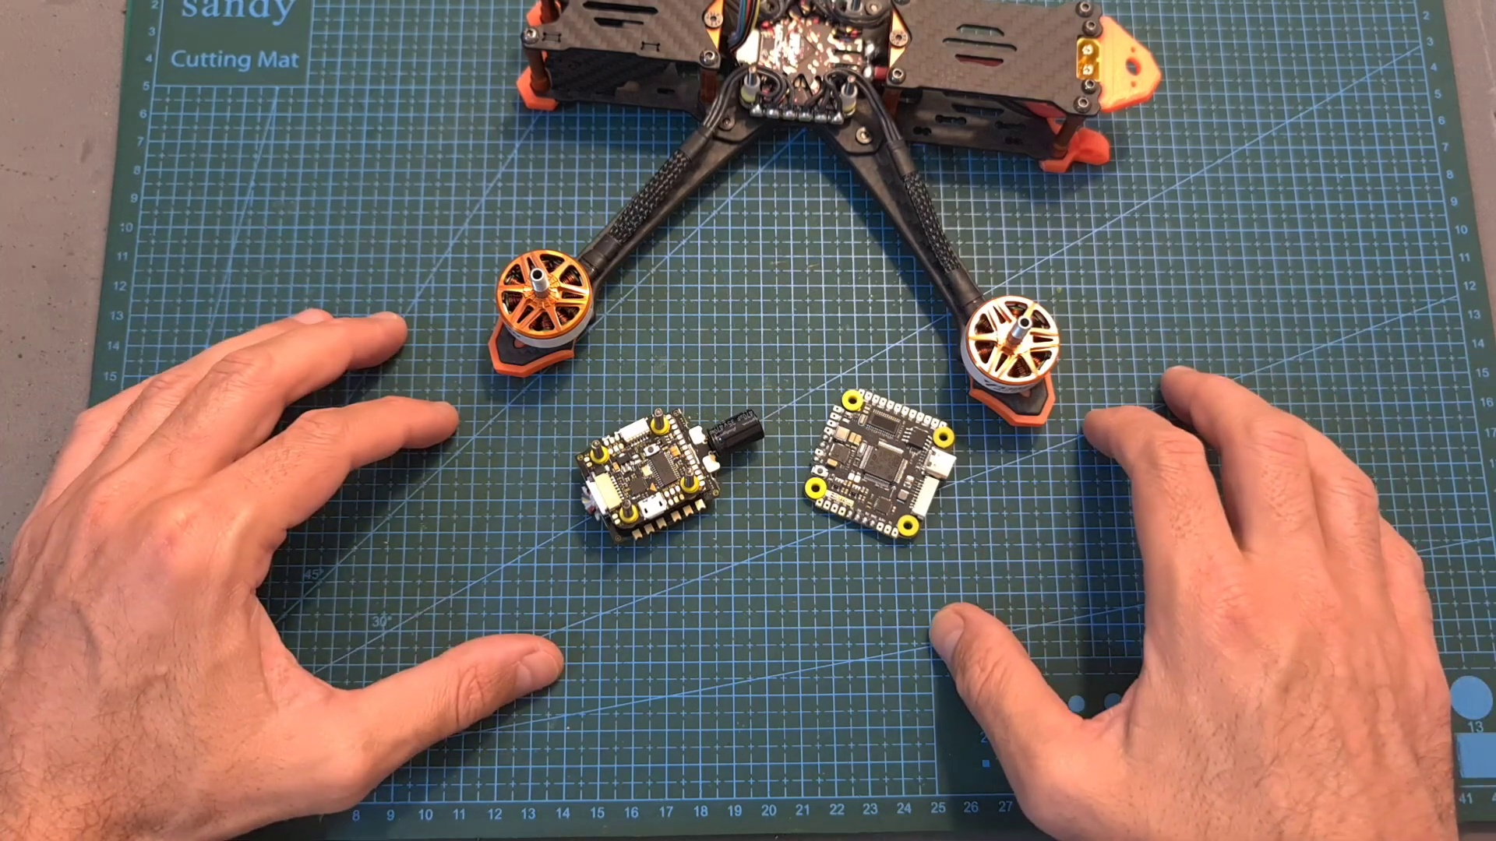 (score 95.0000)
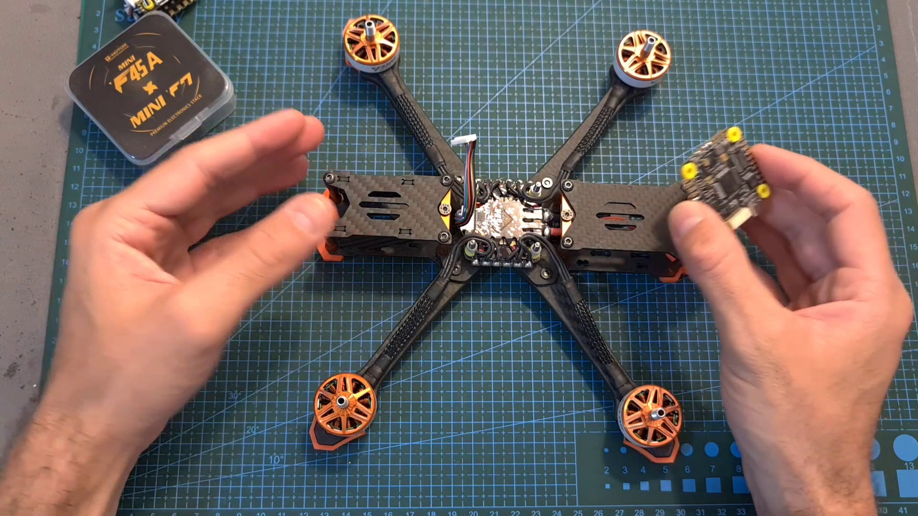 (score 95.0000)
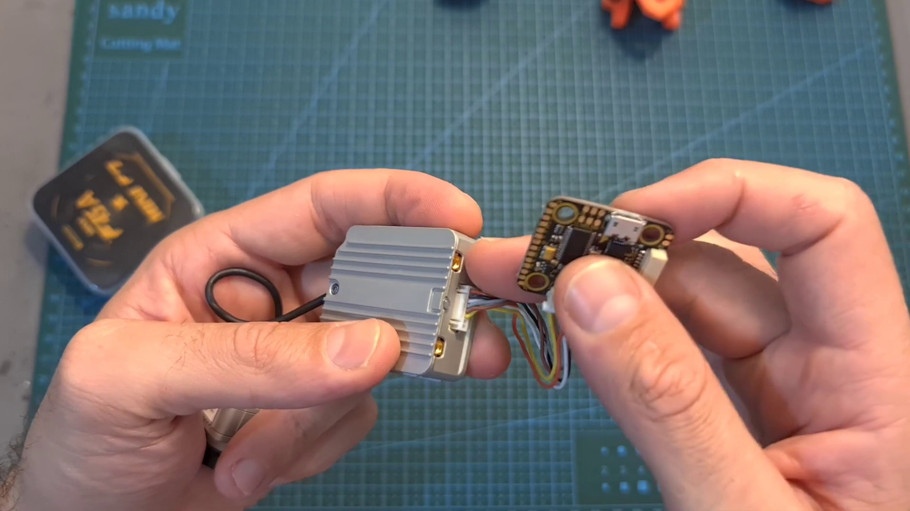 (score 95.0000)
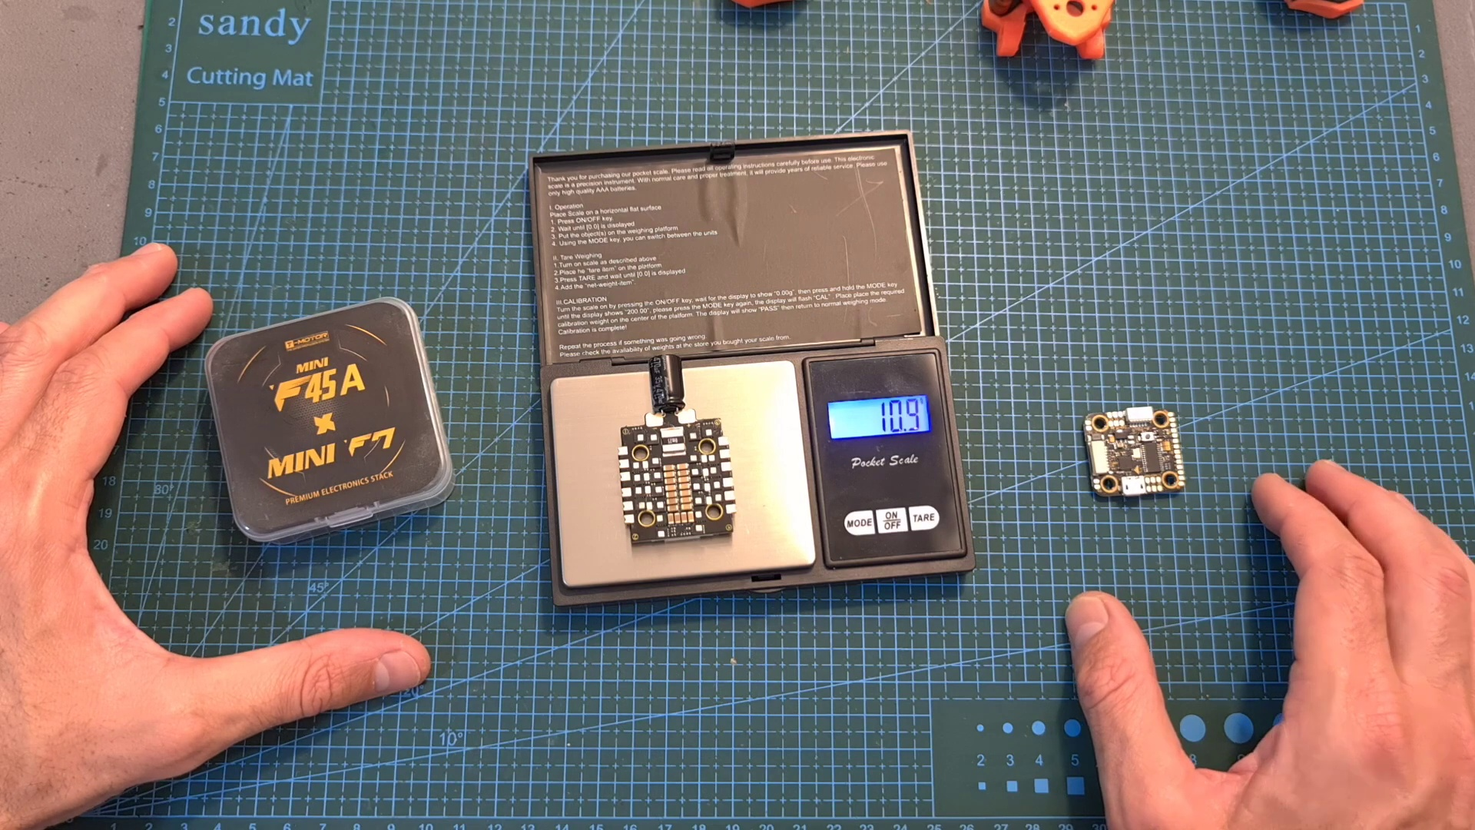 (score 95.0000)
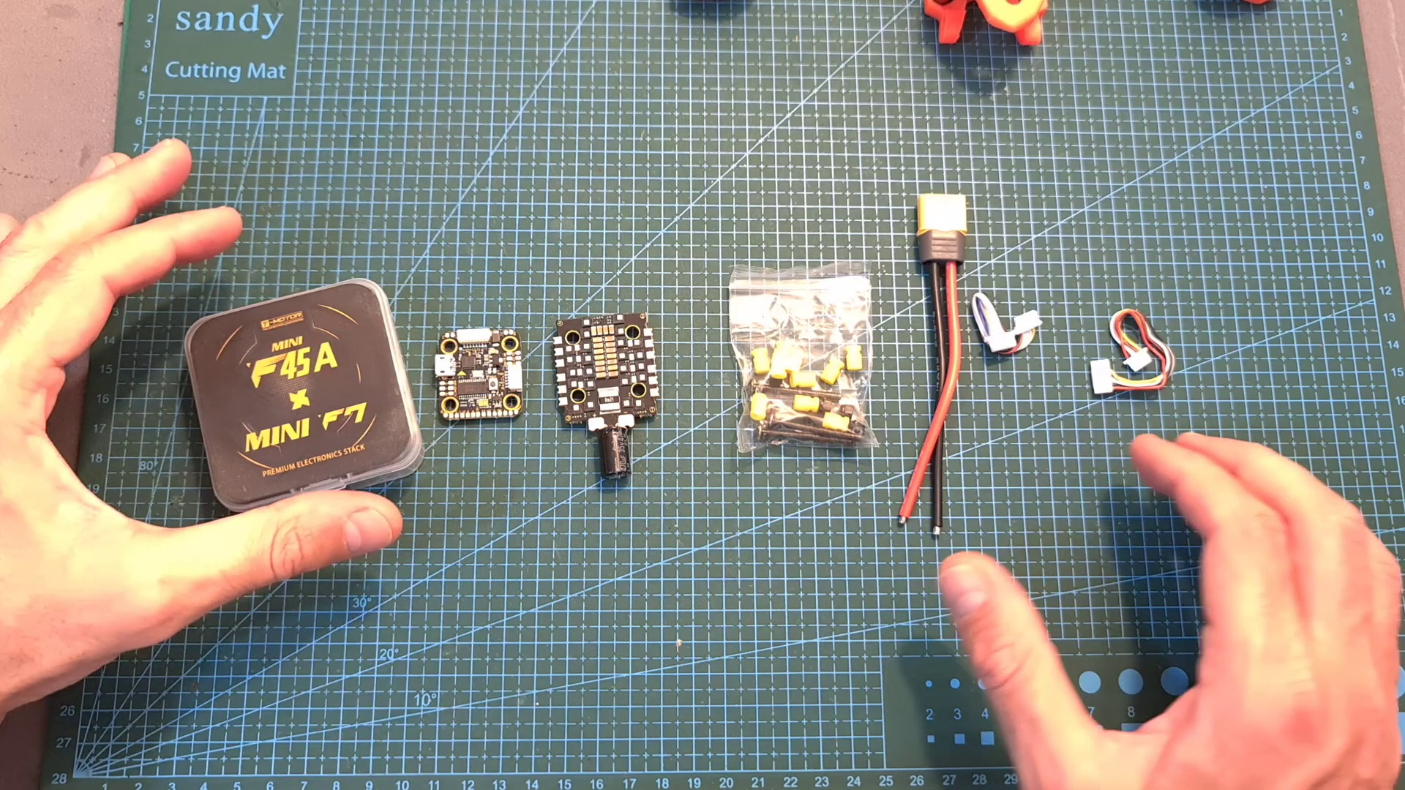 (score 95.0000)
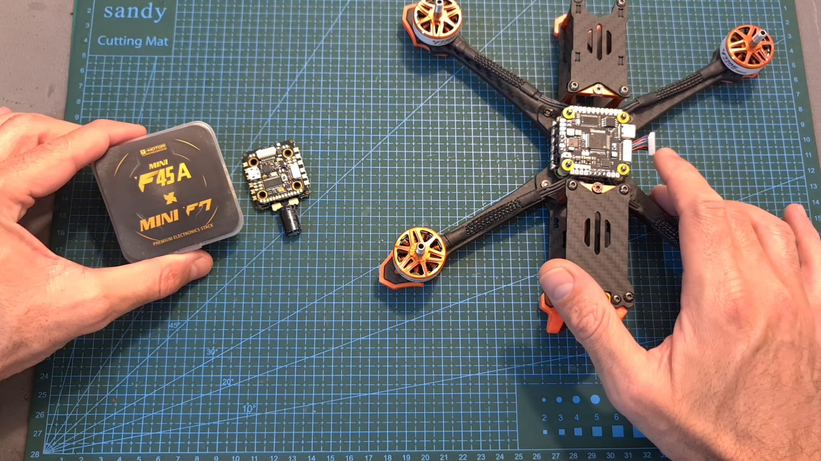 (score 95.0000)
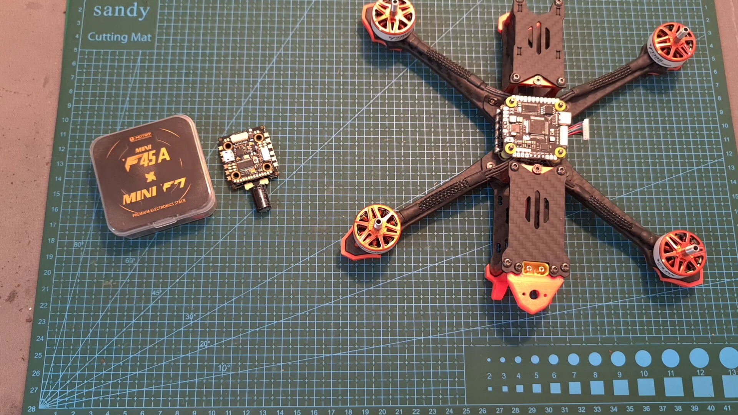 (score 95.0000)
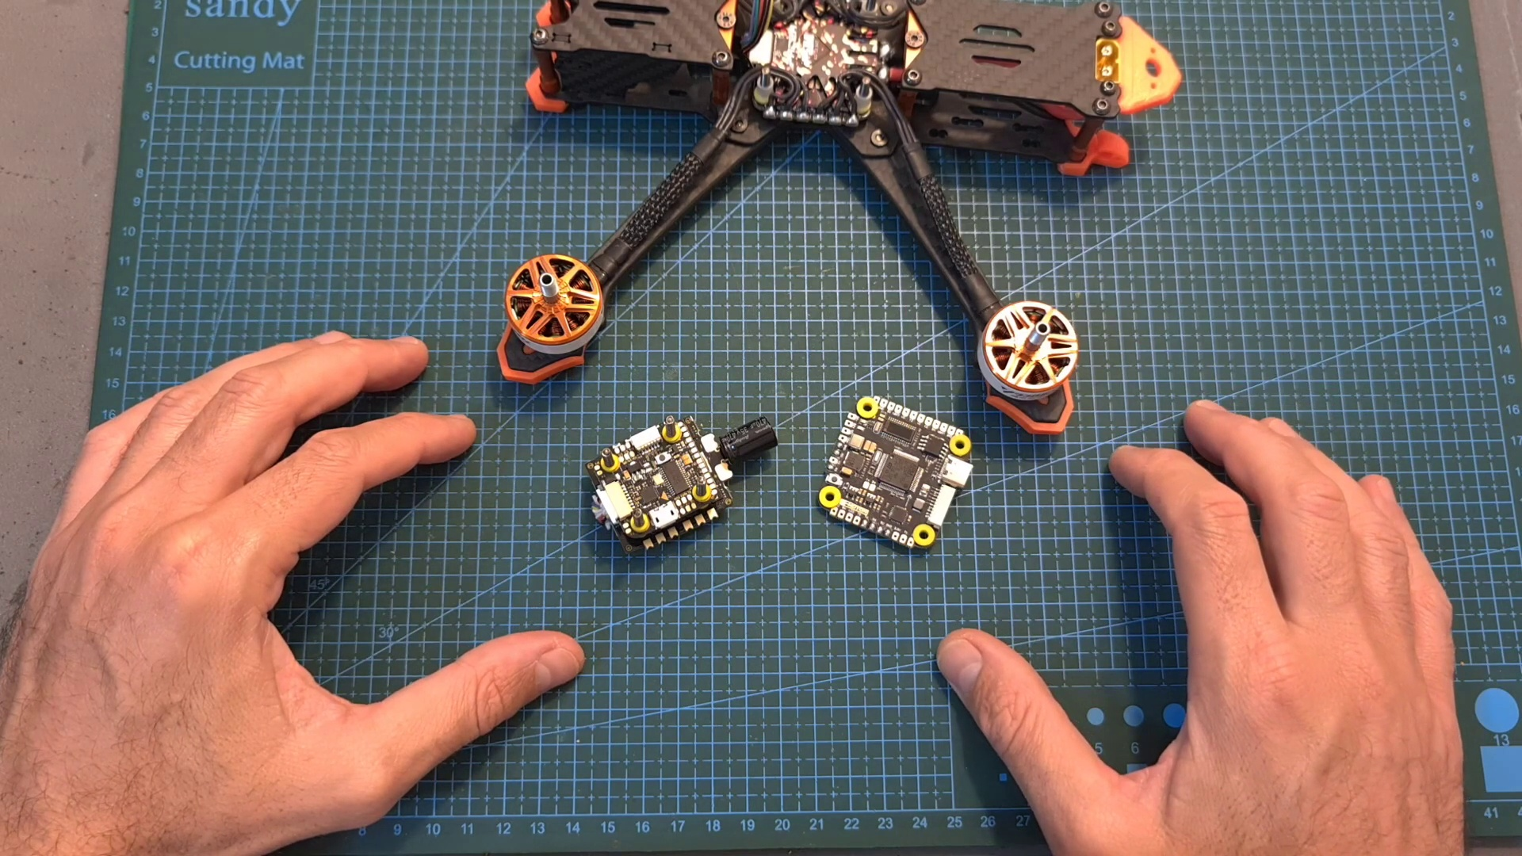 (score 90.0000)
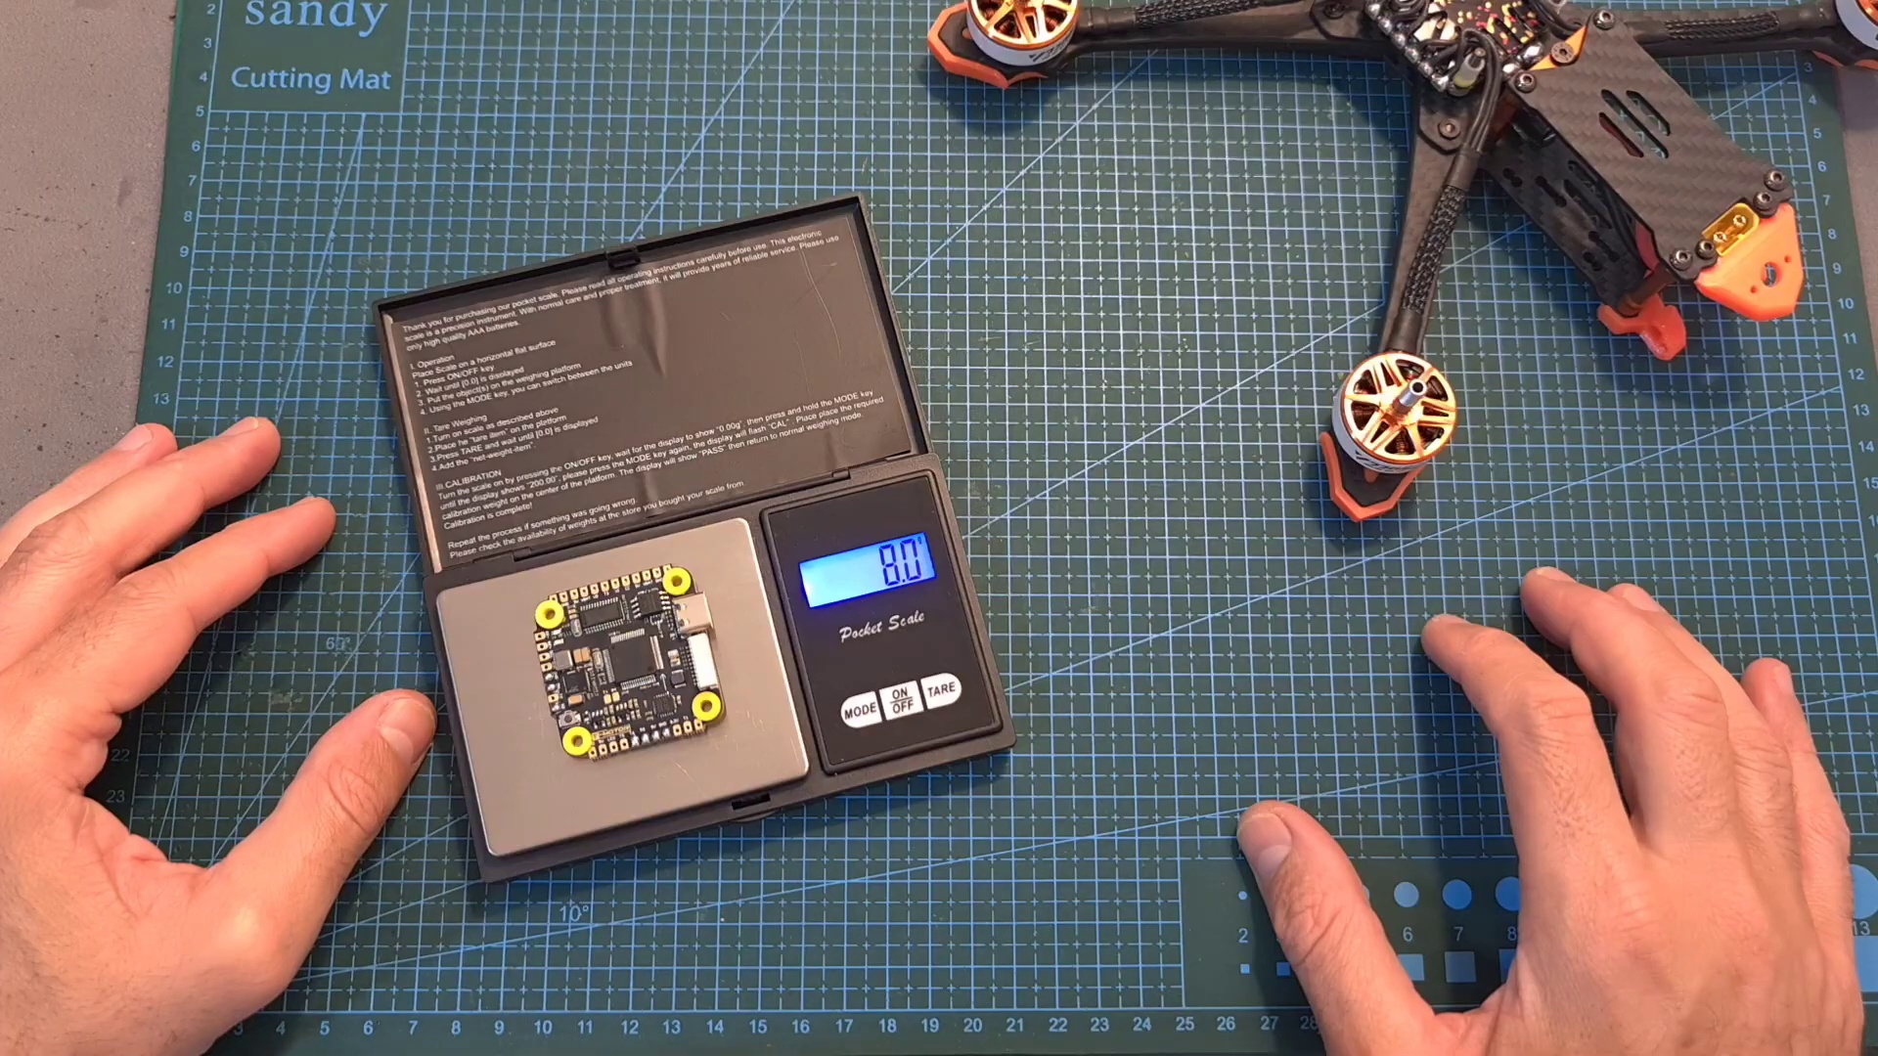 (score 90.0000)
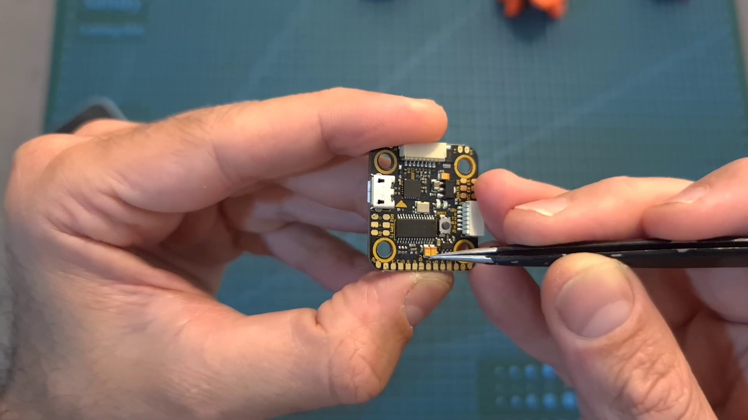 (score 90.0000)
Least correlated frames:
 (score 0.0000)
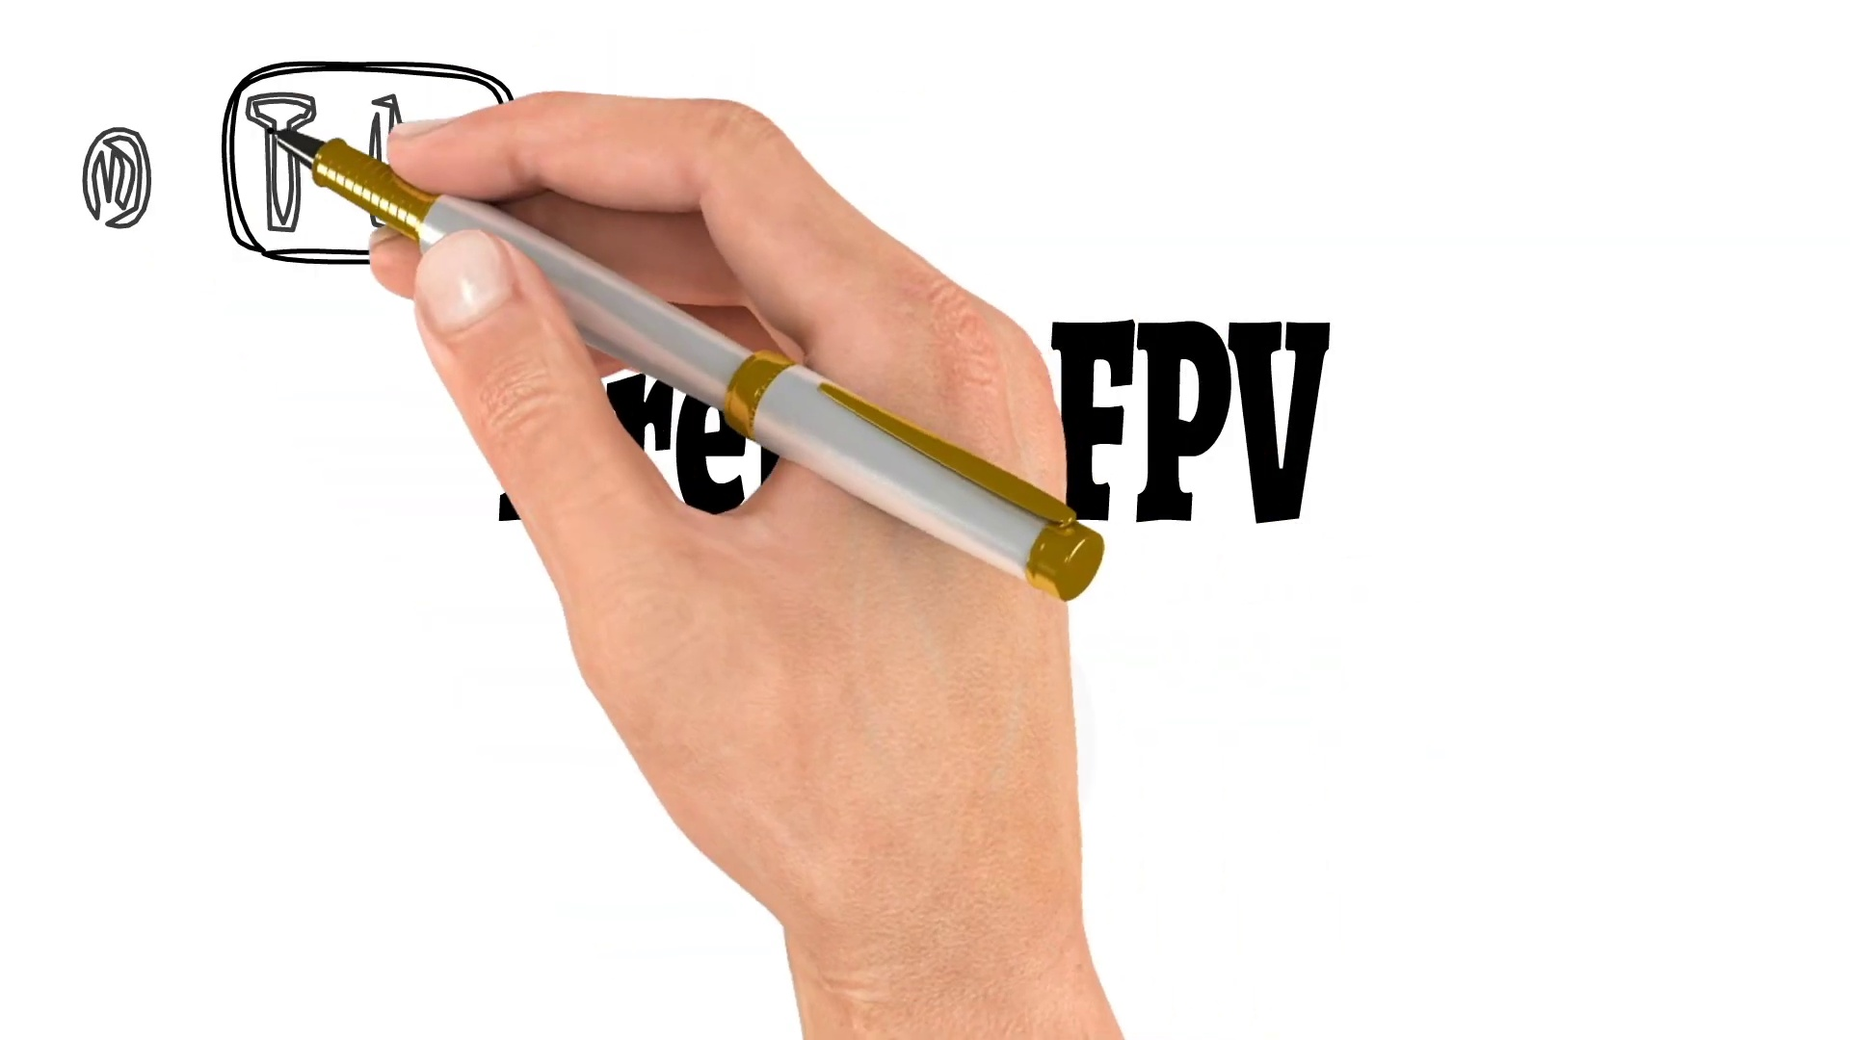 (score 0.0000)
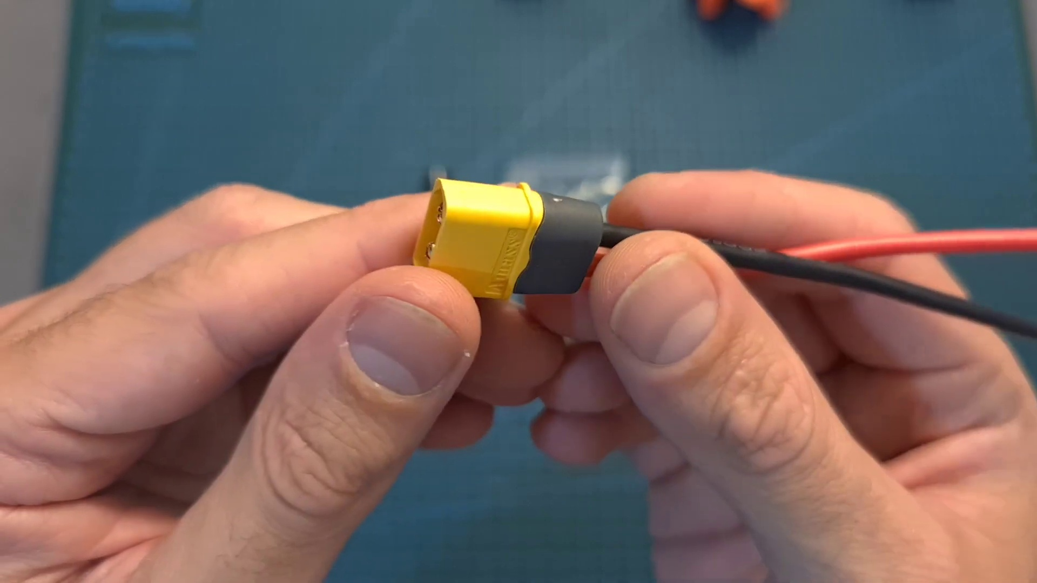 (score 0.0000)
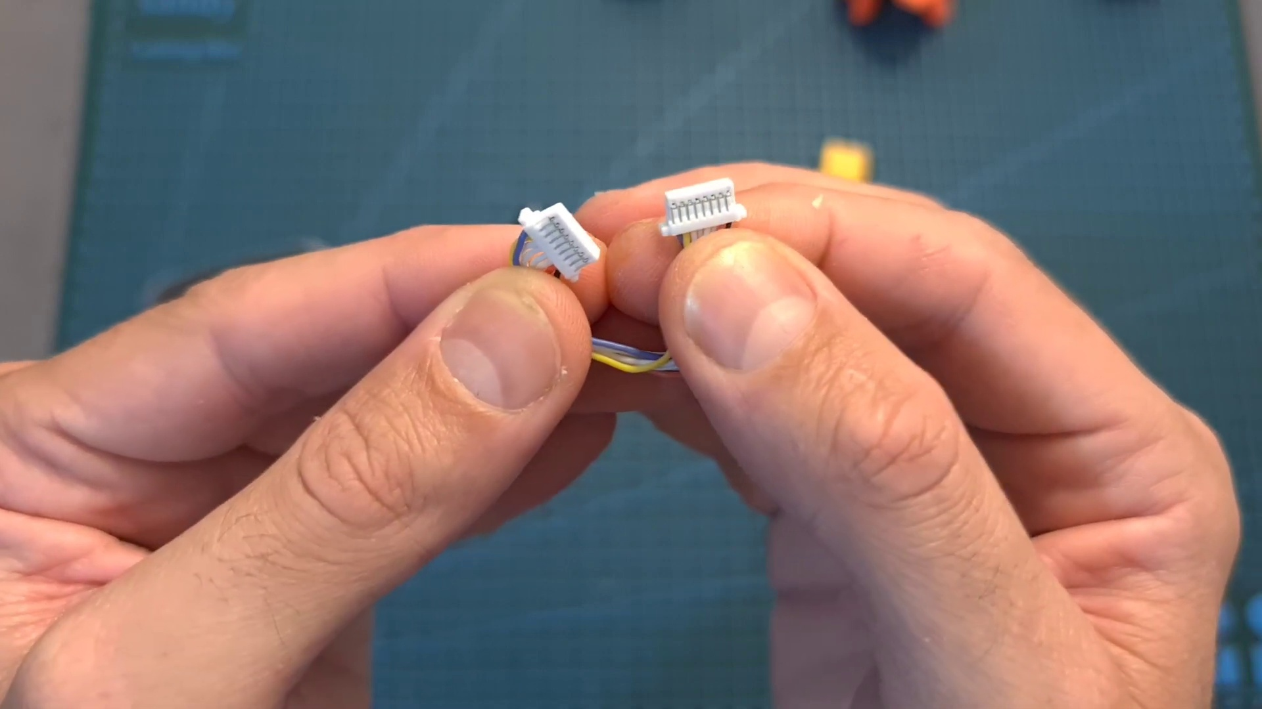 (score 0.0000)
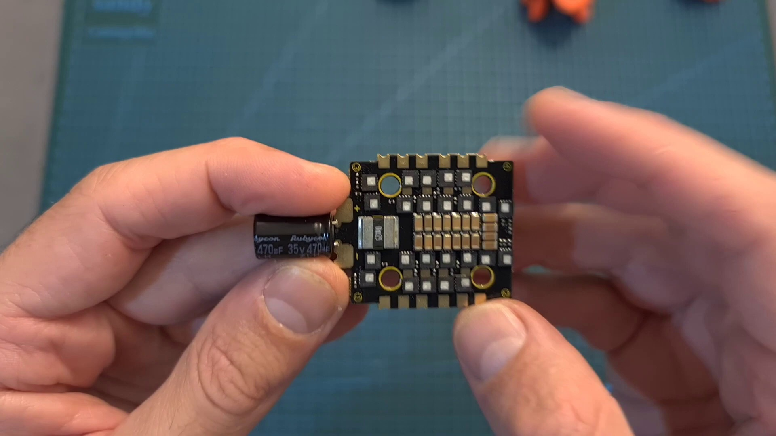 (score 0.0000)
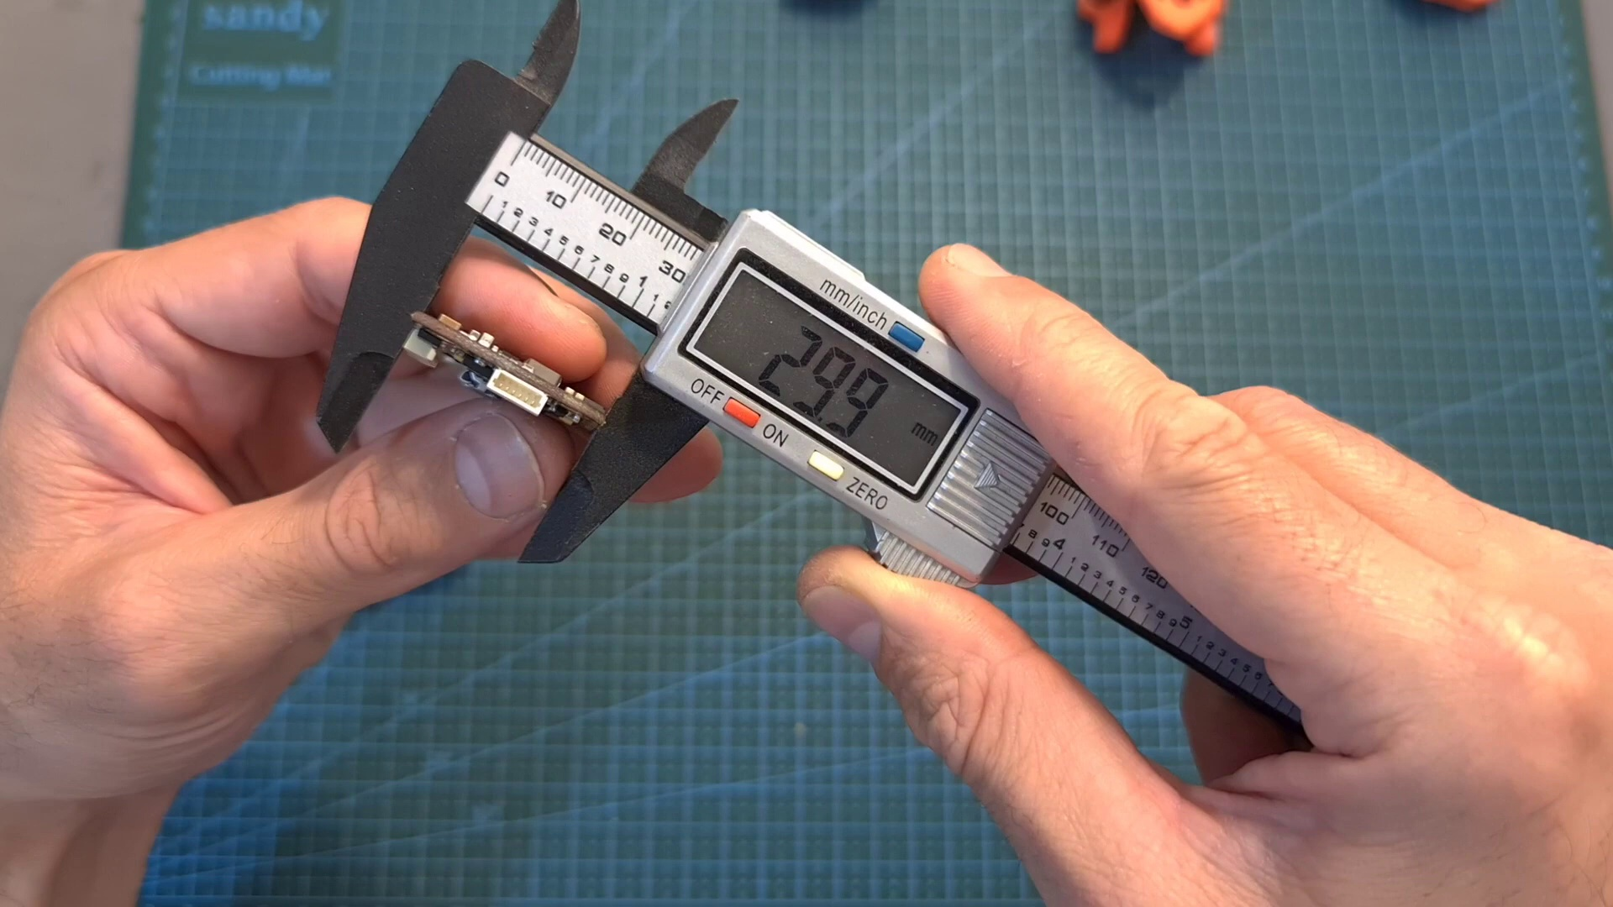 (score 0.0000)
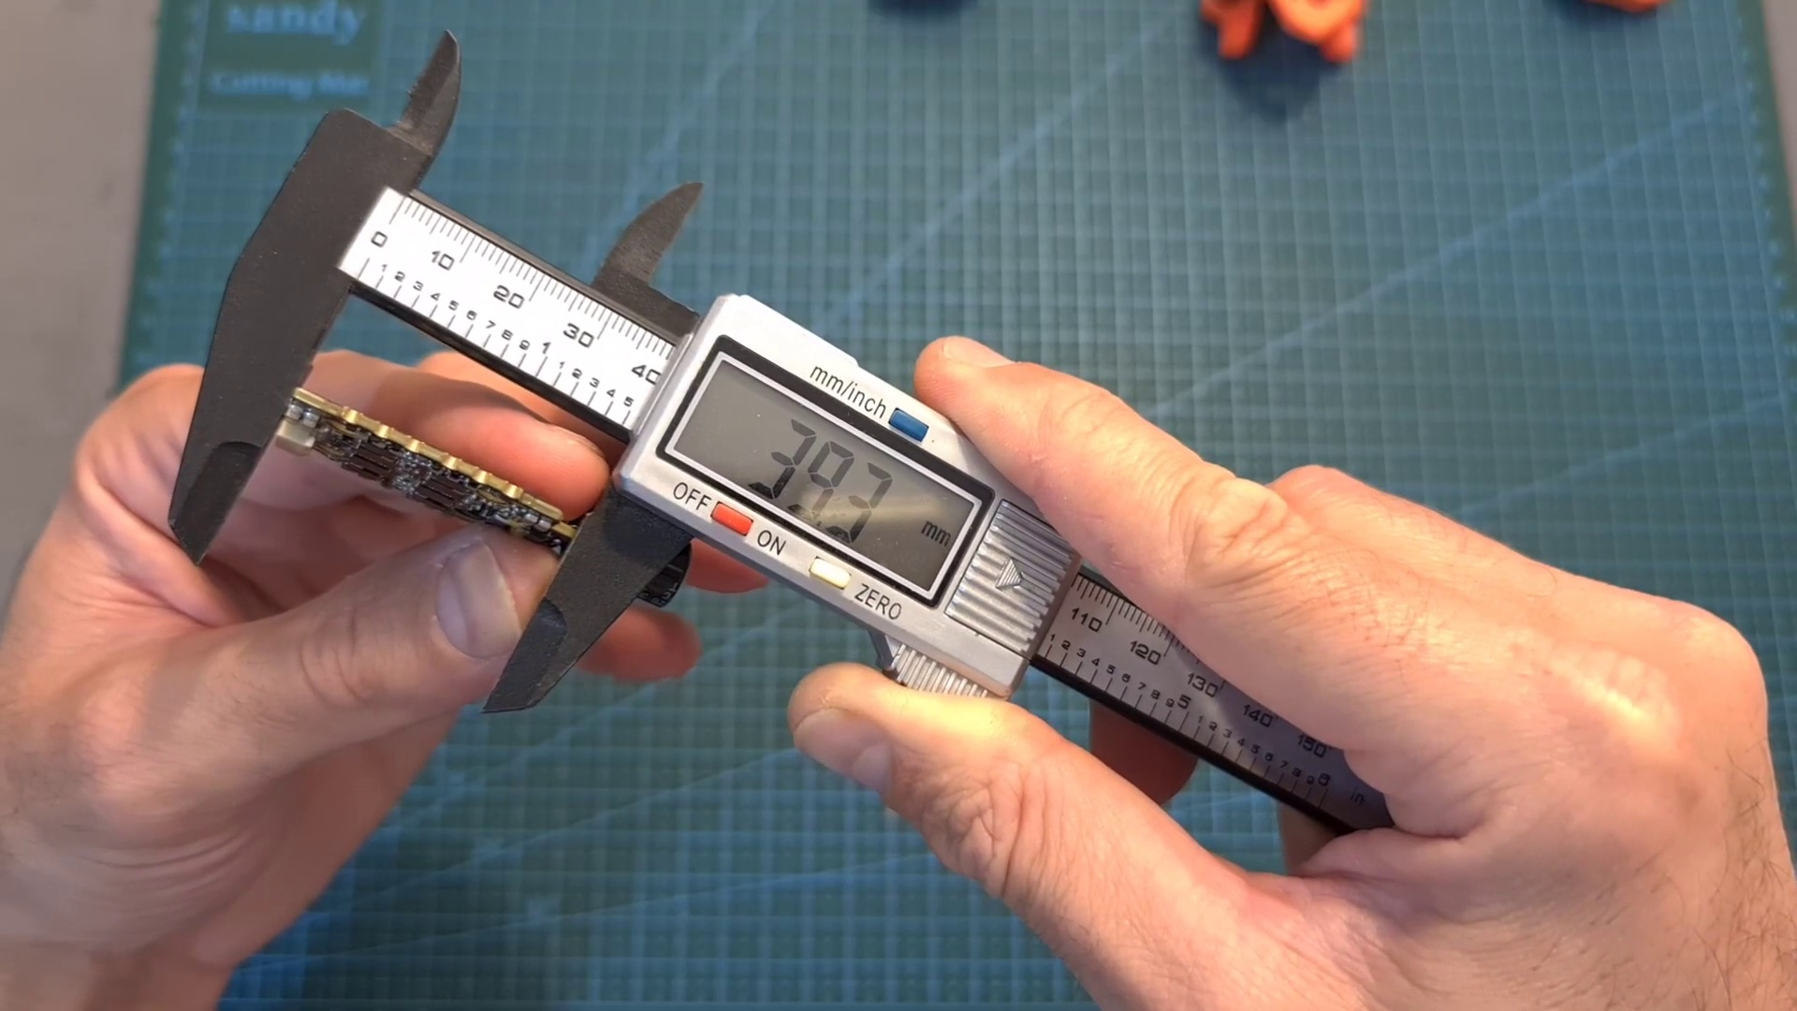 (score 0.0000)
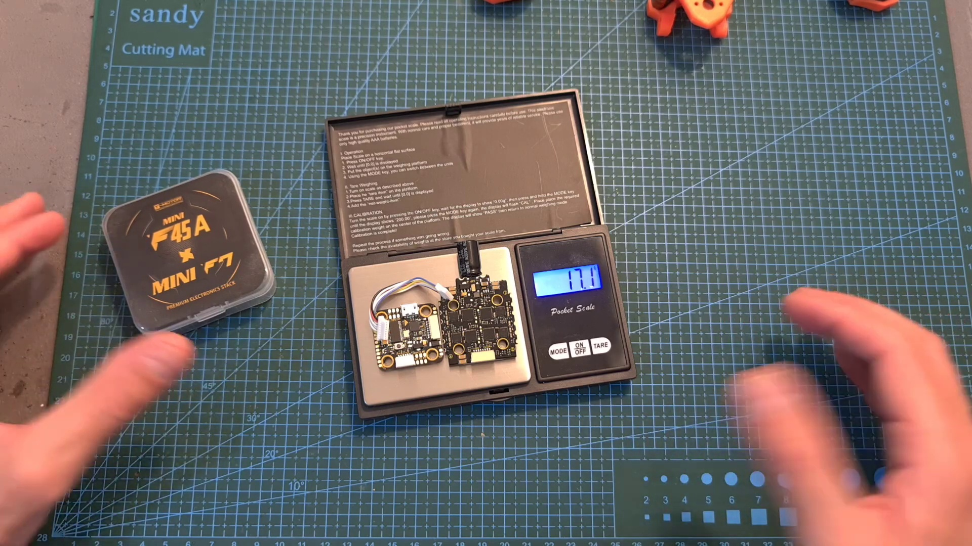 (score 0.0000)
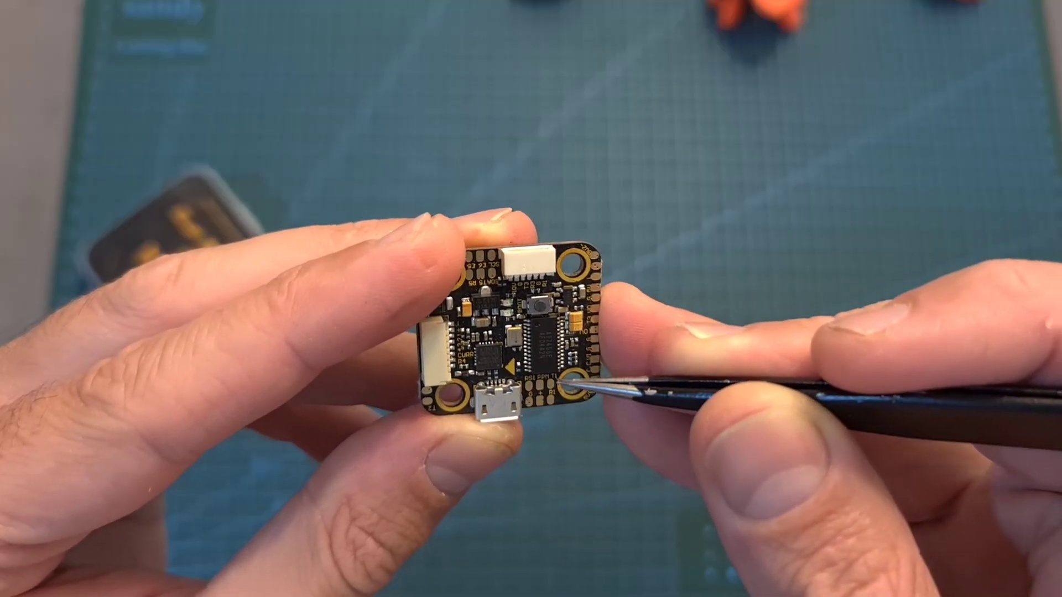 (score 0.0000)
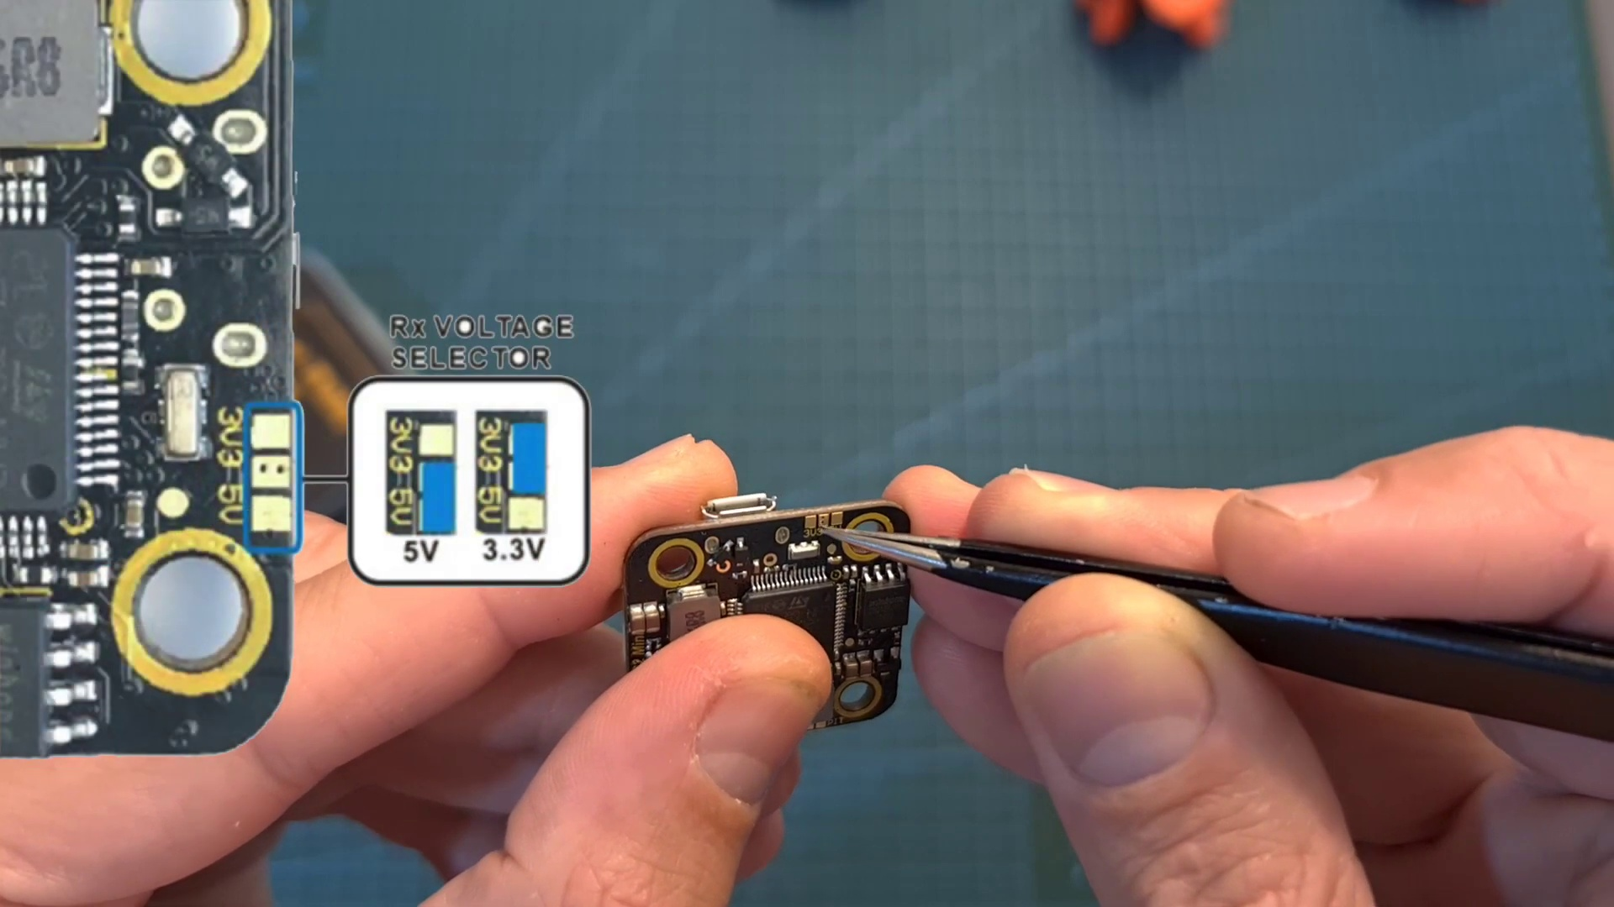 (score 0.0000)
- matched 14 frame(s), max score 90.0000: This video begins by introducing an f7 flight controller and stack t-motor. The main subjects that are gone over is the features and specs of these devices/components and we are shown how to set them up using both digital and analog systems. First, we go into packaging with the stack motor. The video shows the contents within the packaging and gives a high-level explanation of them. Next is the specifications. We are told about its voltage intake and outtake, connectors and what they are dedicated to, amperage, sensors, and more. Now the video goes into the guidelines portion. We are given the requirements and ways to connect the ready receiver. Such as it can be powered with either 3.3 or 5V, bridge the center pad with either the right or left one, if you leave it unbridged then the ready receiver will not be powered, etc. Next the creator goes into the stack and it shows you the information and process needed to power this and connect it properly. Now we go into the pacer f7 processor. It shows the pins that are needed for connection along with voltage needed. Next, we are given the detailed weight of the components and then we flow into connection to give an overview of the connections needing to be made. After this, the creator talks on the receiver briefly and then ends off with the analog setup and its details needed.
Source: https://www.youtube.com/watch?v=15cdyl2PU-E :T-Motor Pacer F7 Flight Controller & Mini F45A 20mm Stack - Setup & Overview
Top correlated frames:
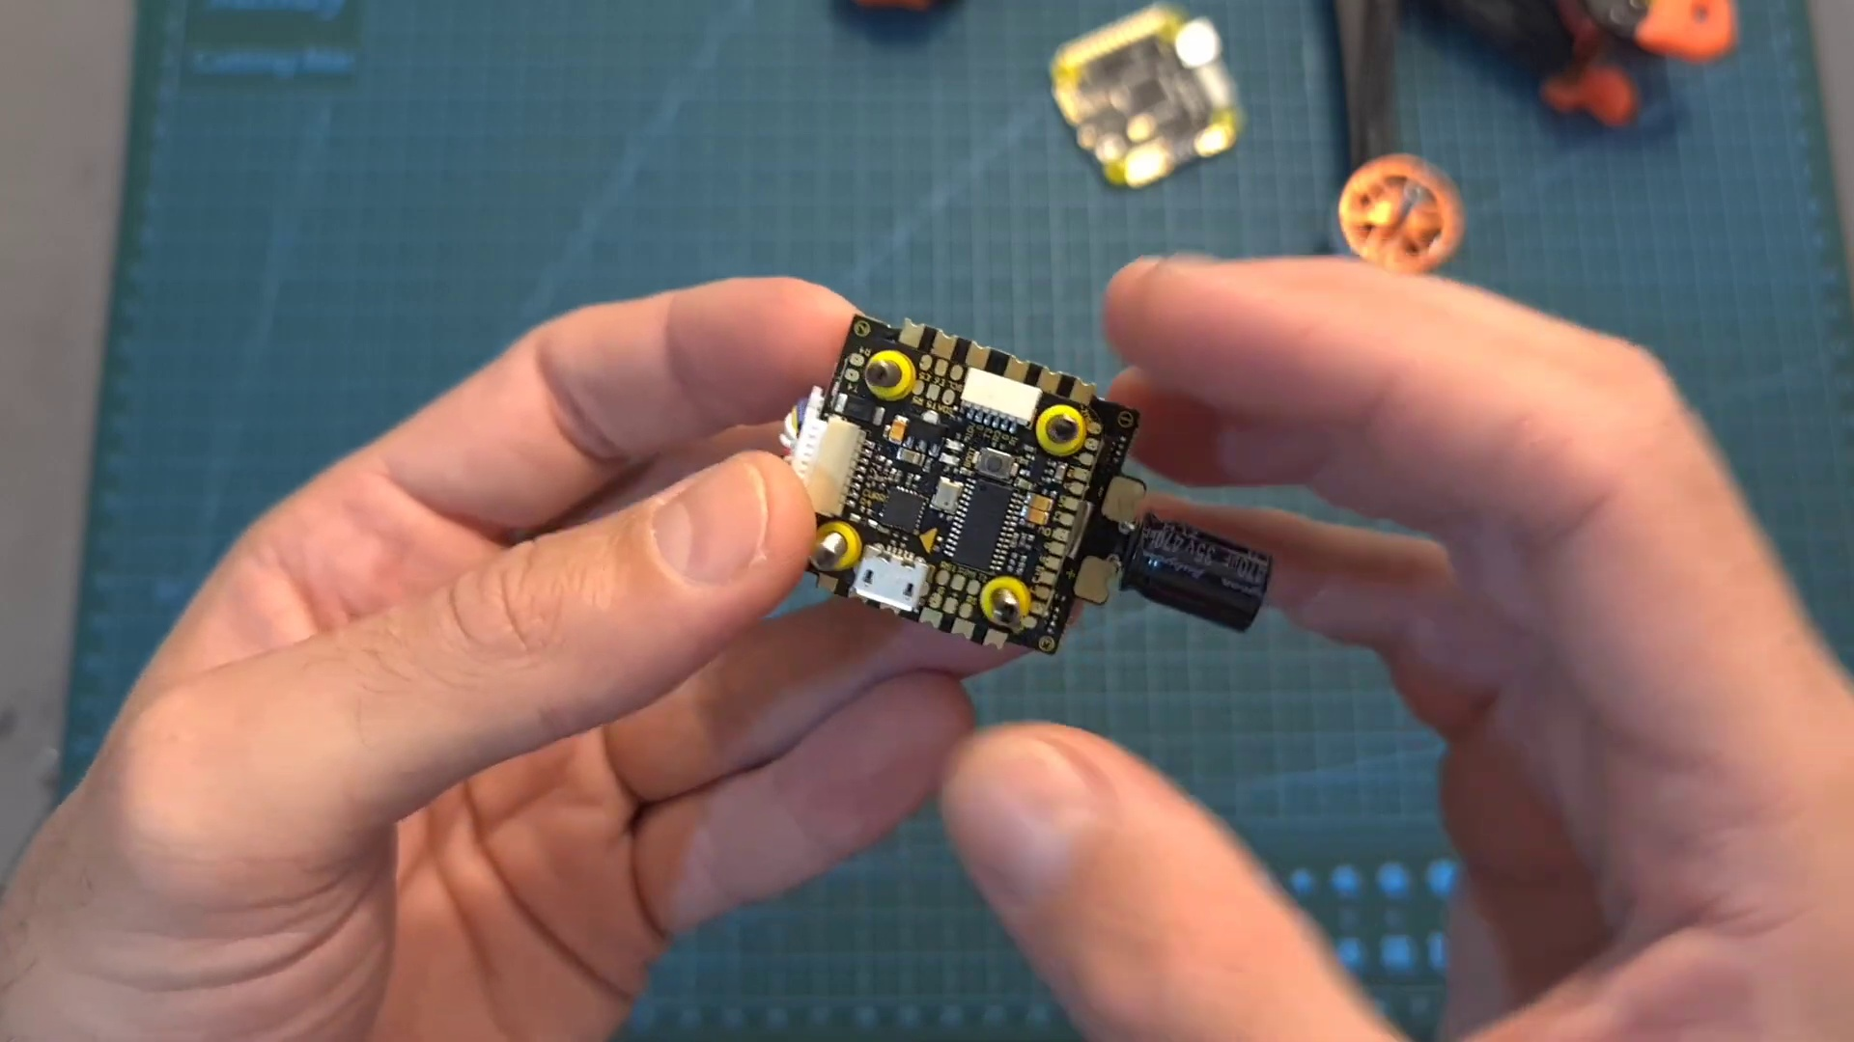 (score 90.0000)
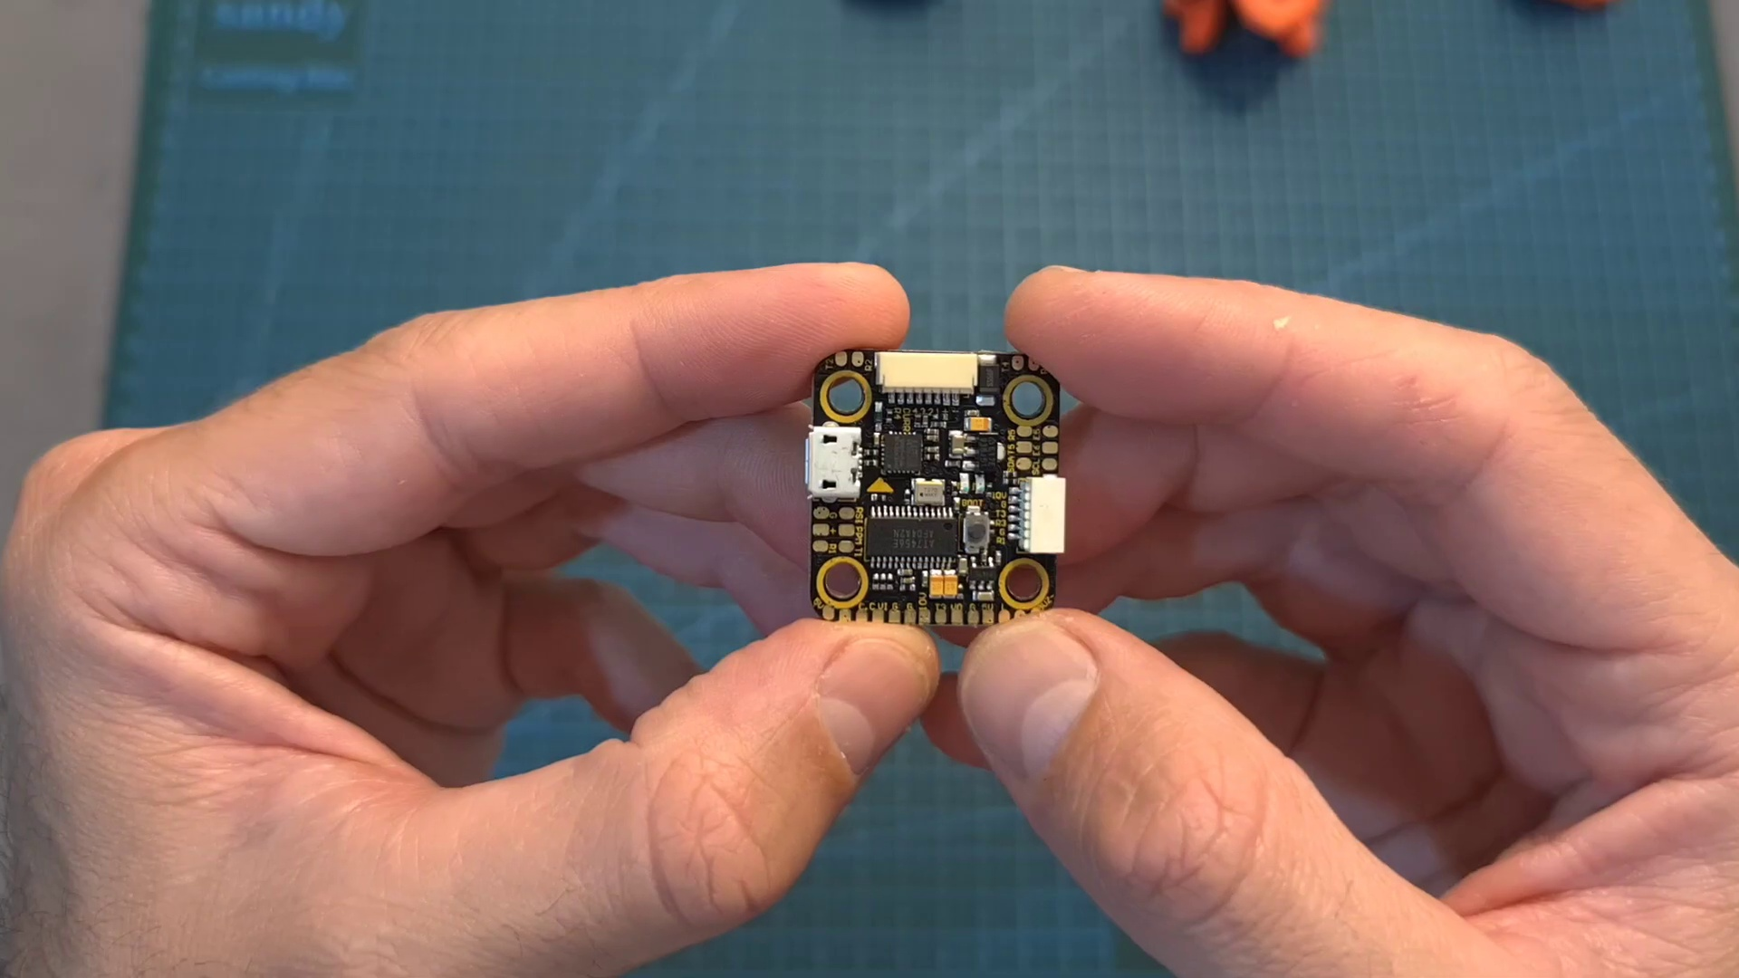 (score 90.0000)
 (score 90.0000)
 (score 85.0000)
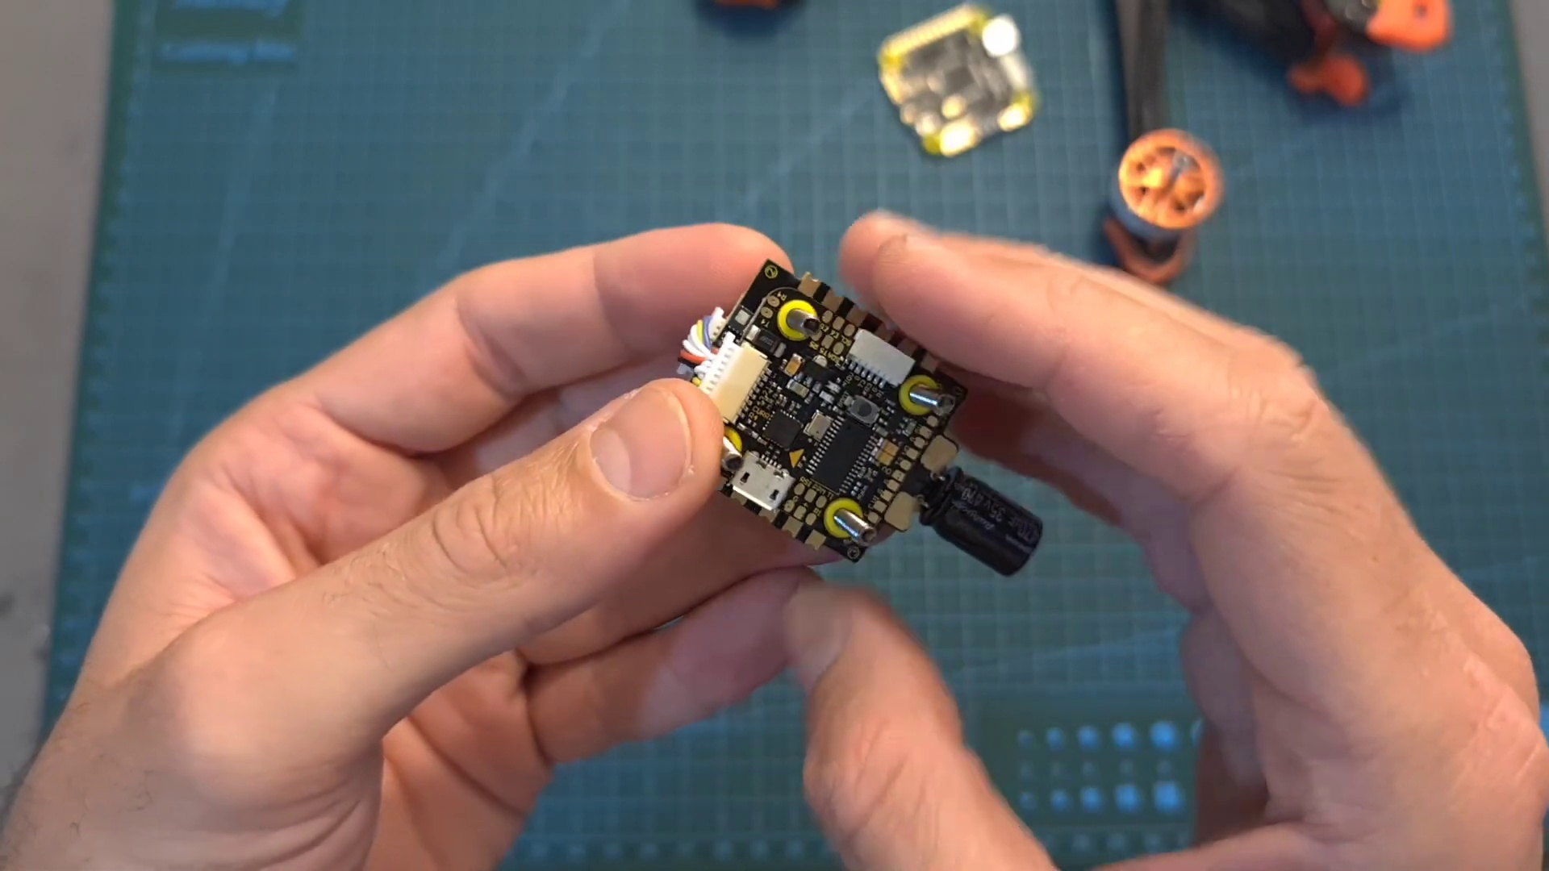 (score 85.0000)
 (score 85.0000)
 (score 85.0000)
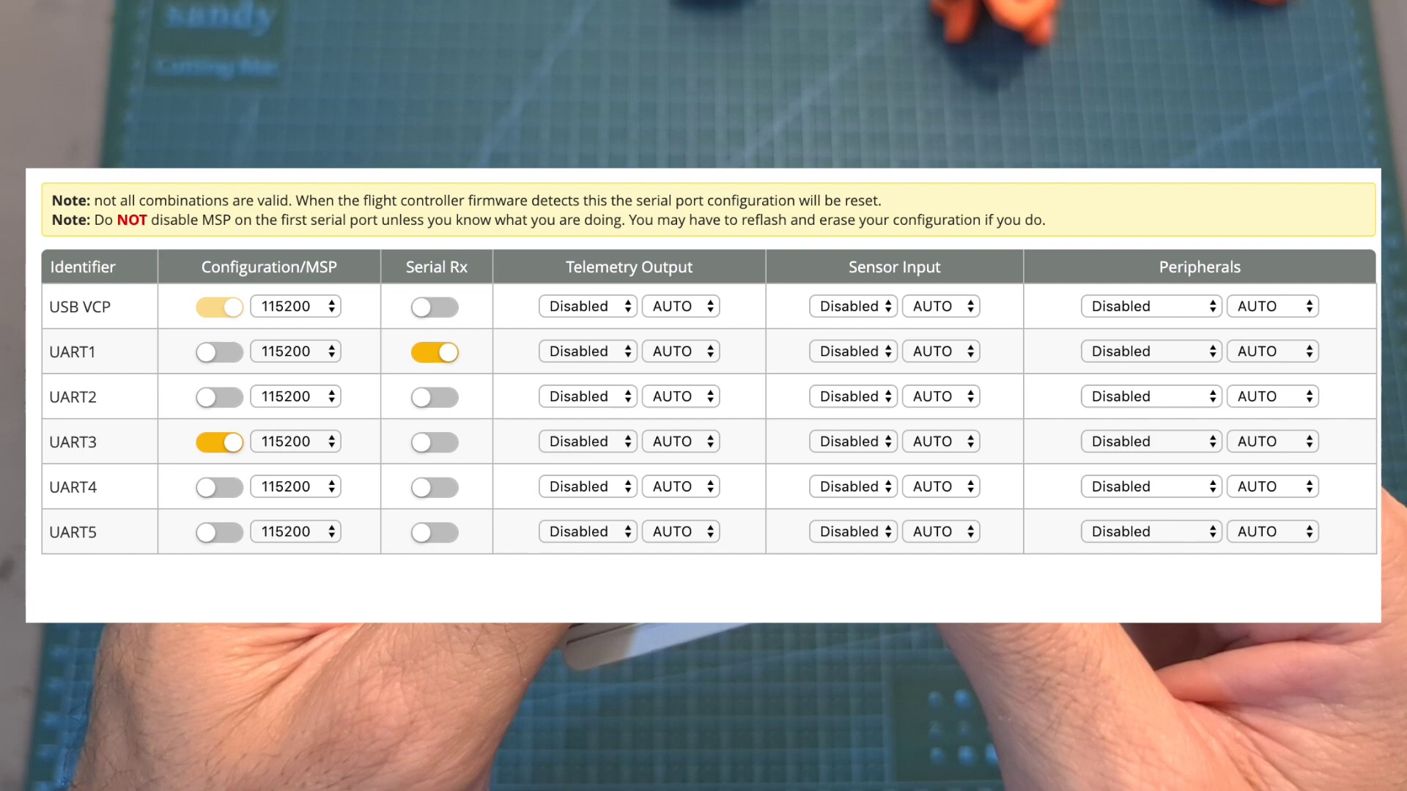 (score 85.0000)
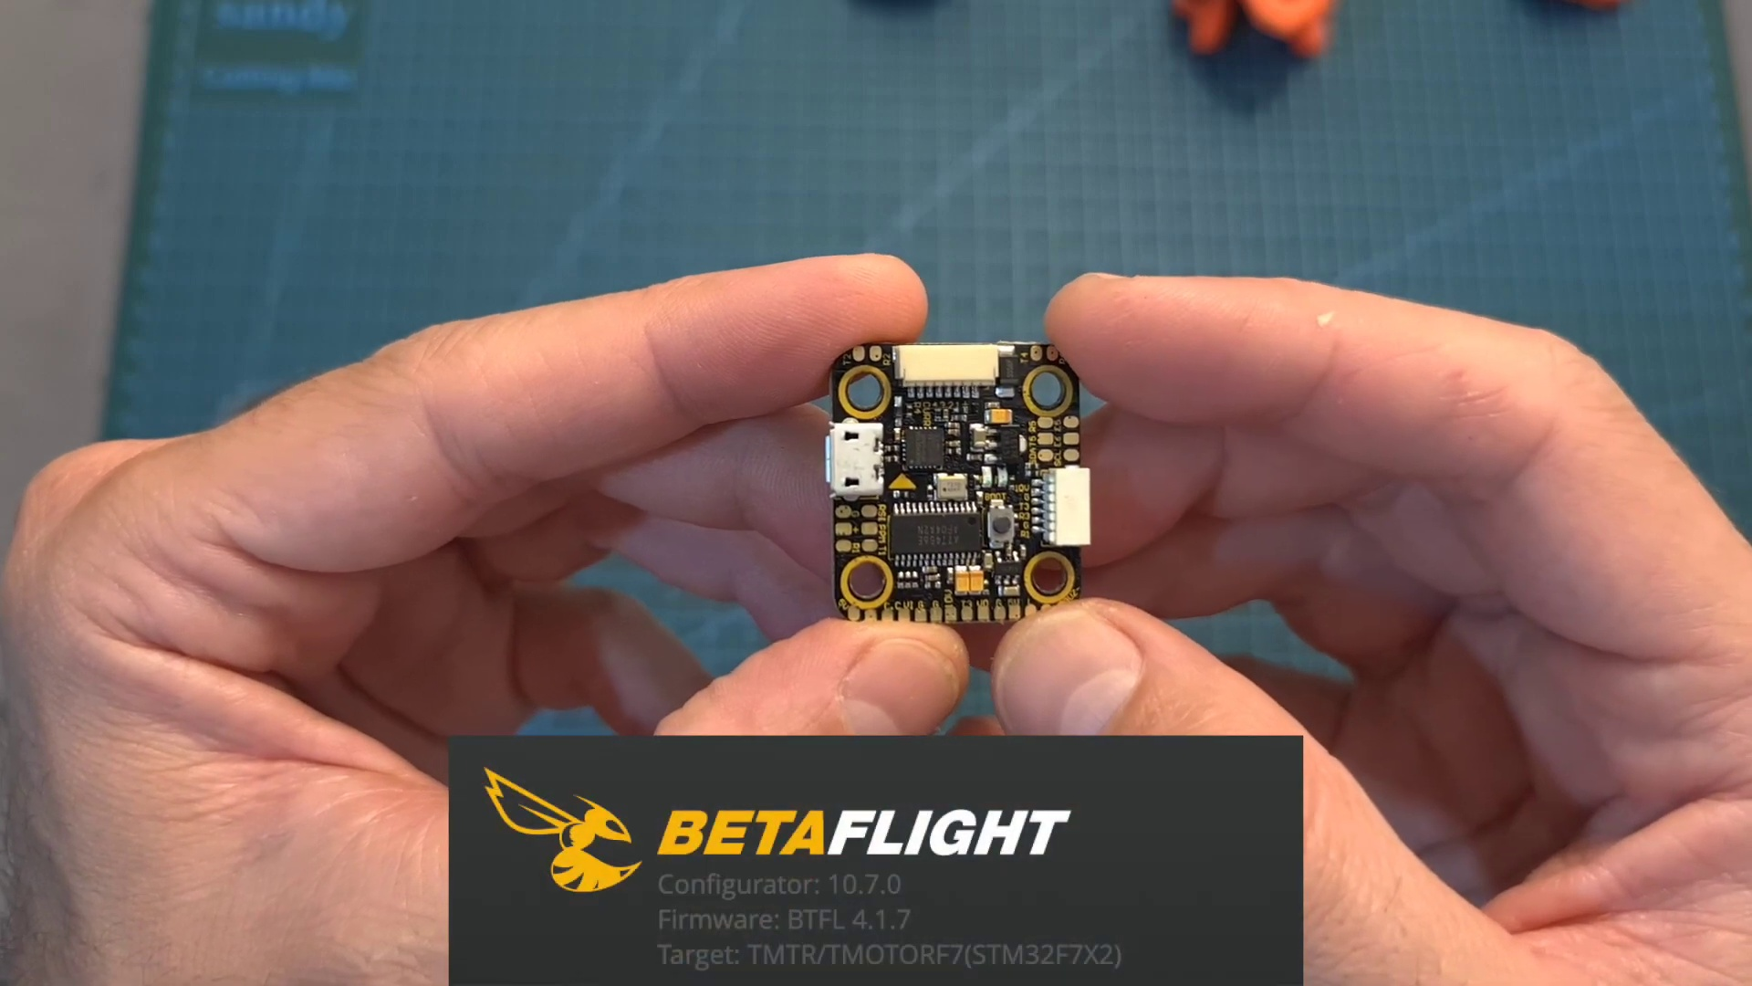 (score 85.0000)
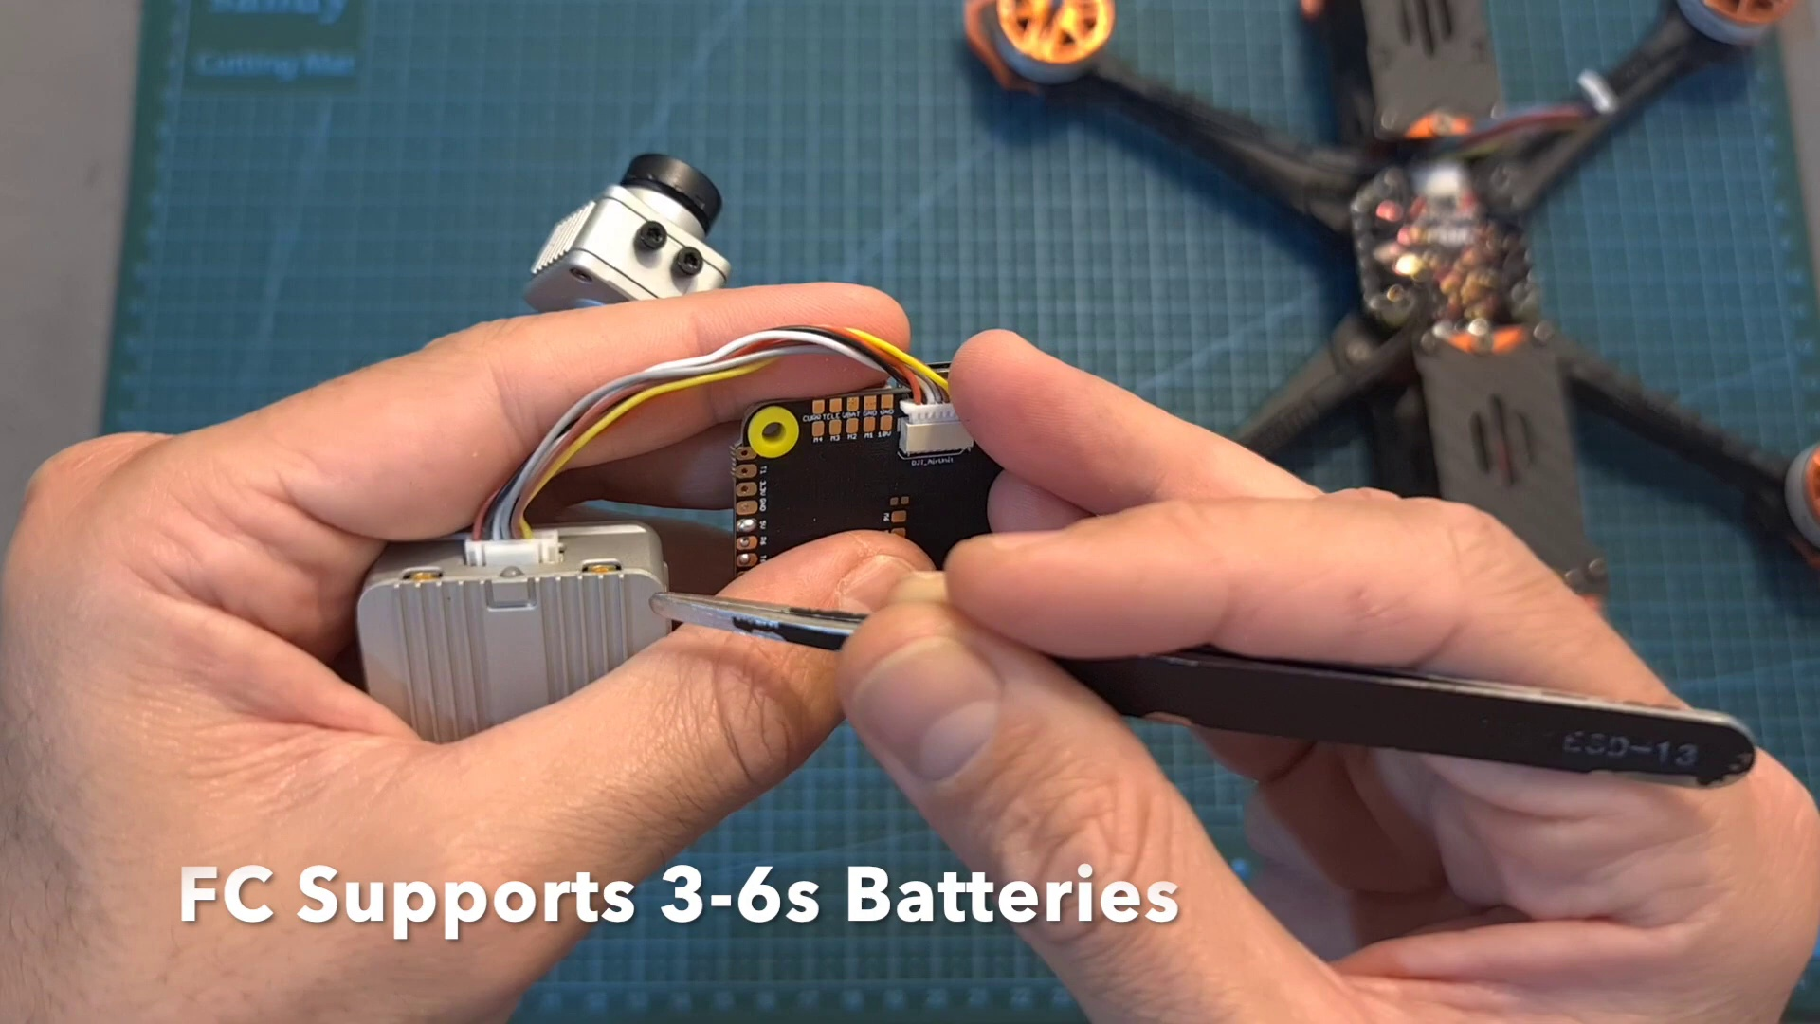 (score 80.0000)
Least correlated frames:
 (score 0.0000)
 (score 0.0000)
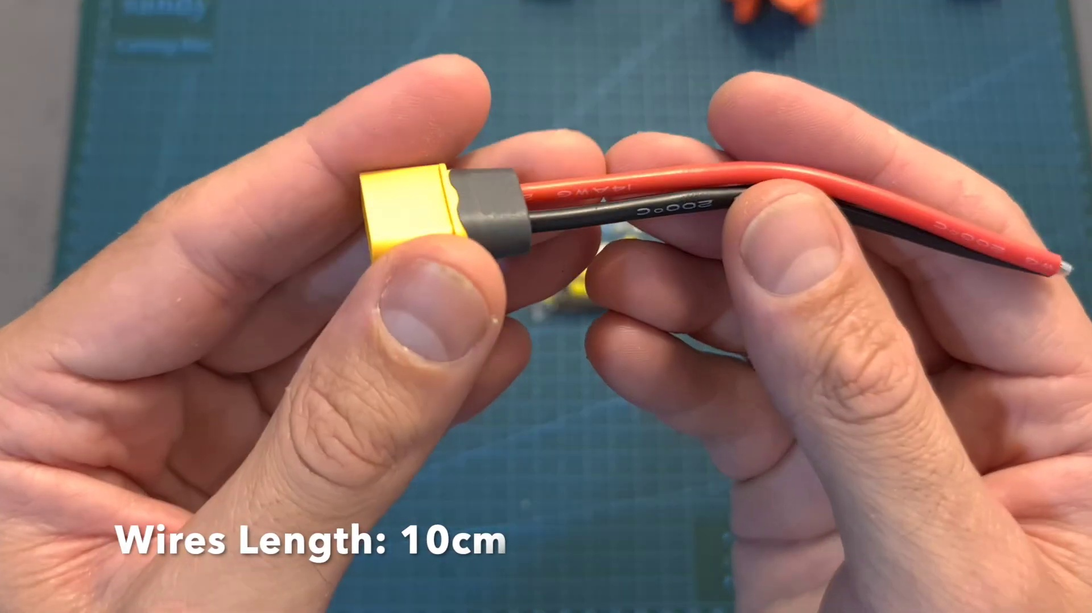 (score 0.0000)
 (score 0.0000)
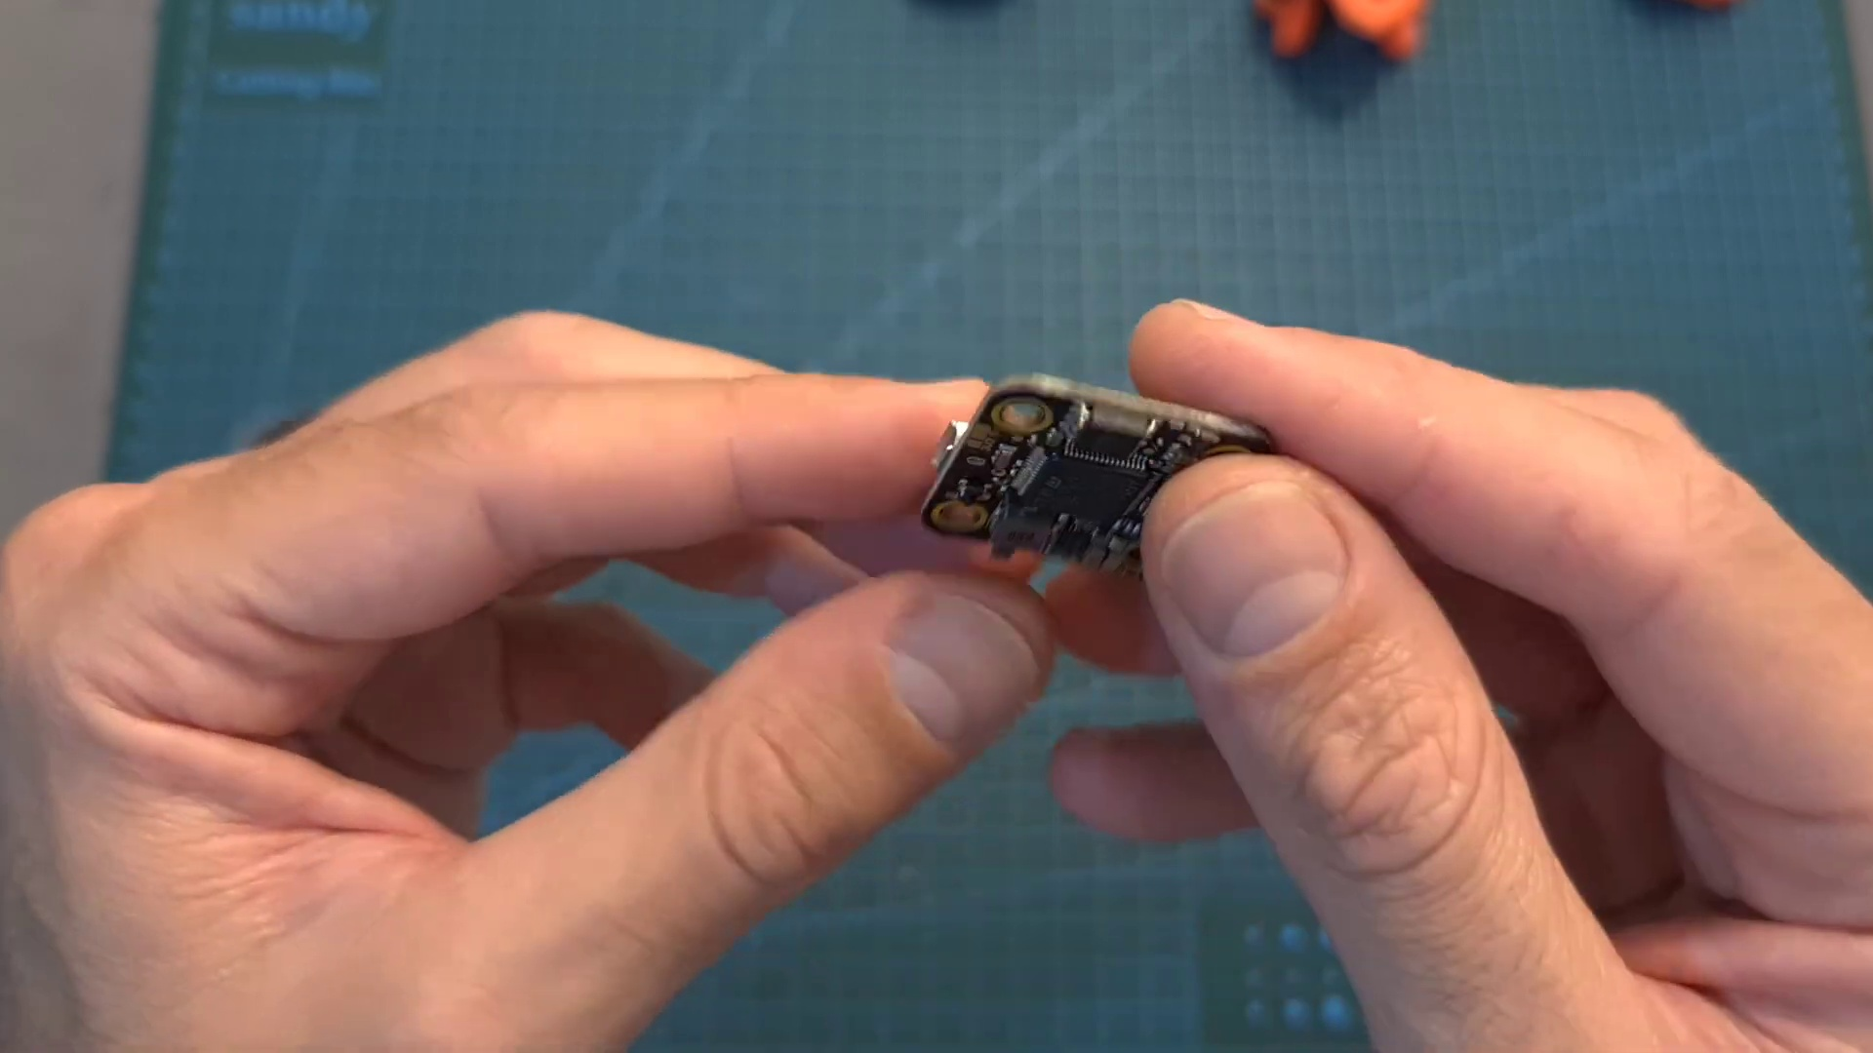 (score 0.0000)
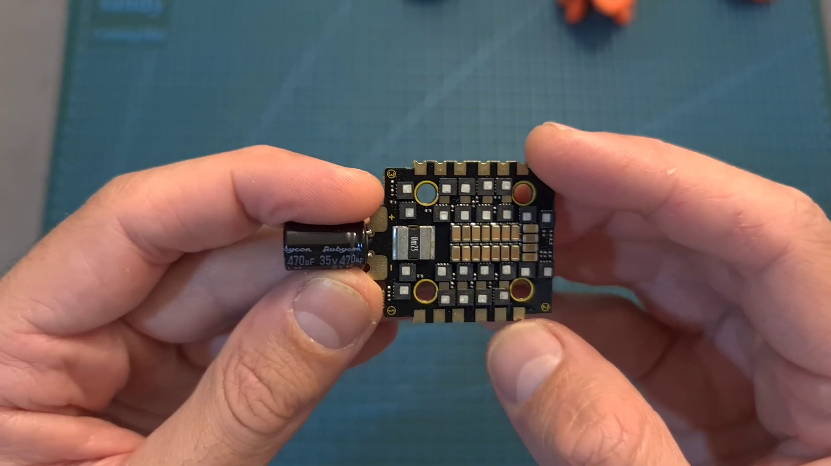 (score 0.0000)
 (score 0.0000)
 (score 0.0000)
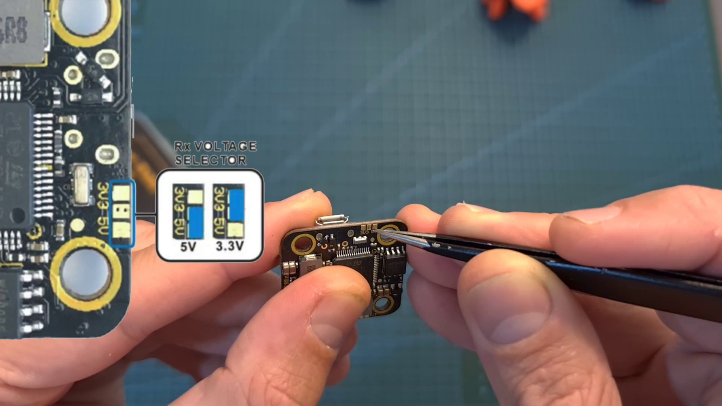 (score 0.0000)
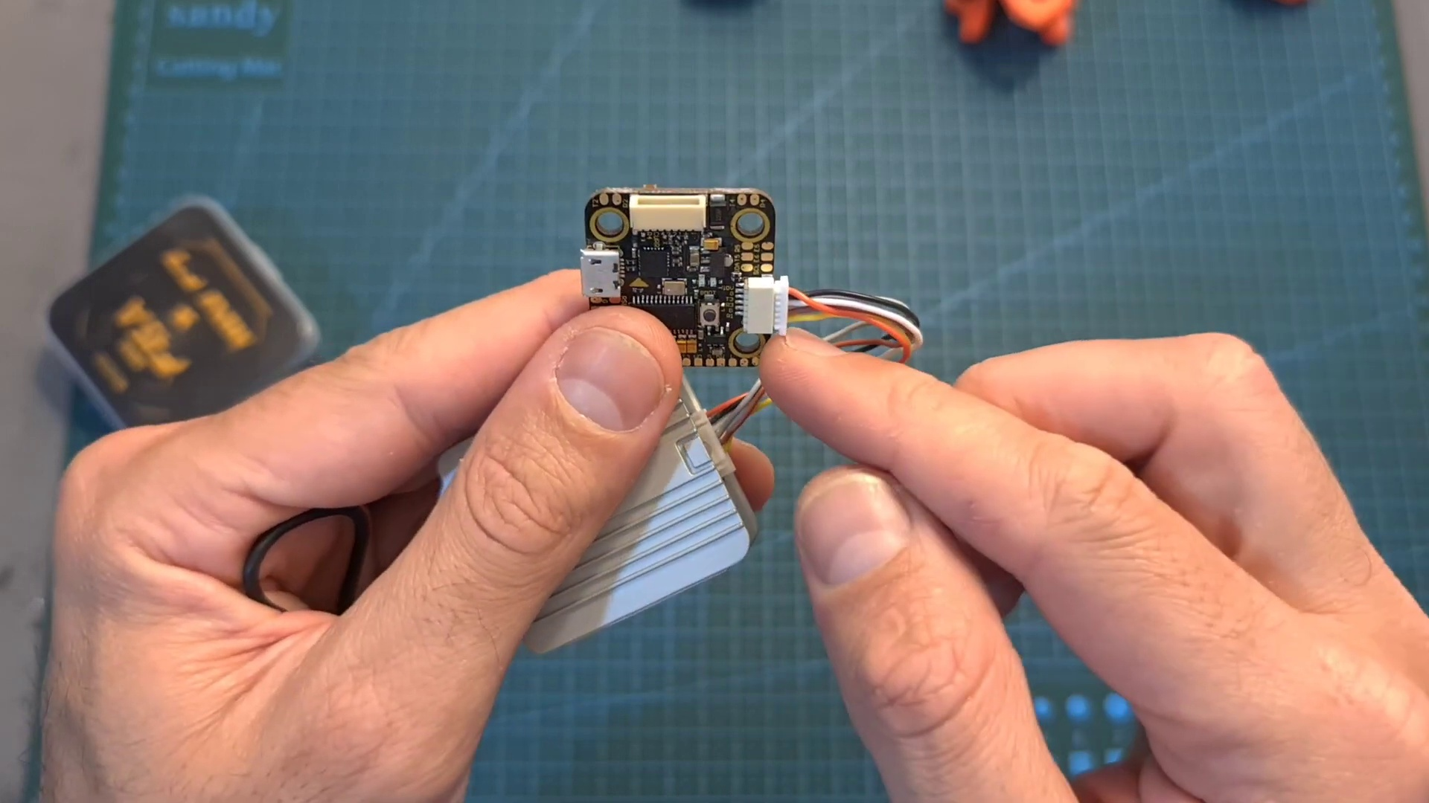 (score 0.0000)

Frame: frame_0000.jpg
Caption: The image shows a presentation slide with a grey background and a title at the top that is partially obscured by the content below it. Below the title, there appears to be a visual of a grayish-blue ocean scene with waves and some form of landmass or structure on the right side, which could be an island or a peninsula. The style of the image suggests it may be used for educational purposes, such as in a lecture, workshop, or classroom setting. Meanwhile, in the foreground, a list is presented showing Olympic medalists in fencing by event, likely part of a larger discussion or presentation about the sport.
No strongly correlated comments found for this frame.

Frame: frame_0001.jpg
Caption: The image presents a dynamic scene of a hand poised to create on a digital whiteboard or surface integrated into a laptop. The hand, with fingers curled around a metallic pen, is captured mid-action, with the gold-colored pen tip pointing towards the word "THE TV" displayed on the screen. The focus is solely on the digital interface, and there are no visible slides or diagrams. The person appears to be interacting with this digital representation, possibly editing or creating content related to a television show or channel.
In another part of the image, a hand is poised to draw or write on a white canvas, with fingers curled around the same metallic pen. The pen's tip is pointed towards the word "EPV" written in black on the canvas, suggesting that the word is about to be written or drawn. The overall composition captures a moment of anticipation, as if the hand is about to add a new element to the creative process.
No strongly correlated comments found for this frame.

Frame: frame_0002.jpg
Caption: The image depicts an open-frame quadcopter with its arms and motors exposed, displayed on a green cutting mat with a blue grid pattern background. The drone's body features a camera mounted at the front, accompanied by a small box or electronic component attached to it, labeled "SANDY". A set of wheels for the landing gear is placed next to the drone on the floor.
The cutting mat bears some text that is not fully legible due to the angle and focus of the image. To the left of the mat, there is a smaller device that appears to be an electronic component or module with wires connected to it. On the right side of the mat, a green box labeled "Sandy Cutting Mat" contains a white label with the text "F45 X Mini", likely representing the drone's model or specifications.
The motors are black and orange, adding a pop of color to the scene, while the propellers, also black and orange, are oriented in a way that suggests they are ready to be attached to the motors. The table in the background provides a stark contrast to the vibrant colors of the foreground, indicating that the assembly process is taking place in a well-equipped workshop or workshop-like setting.
No strongly correlated comments found for this frame.

Frame: frame_0003.jpg
Caption: The image shows a person working on assembling or repairing a black and orange F45X Mini quadcopter. The quadcopter is being held by the person's hands on a green cutting mat marked with the text "sandy cutting mat" and "F45X X Mini". The mat appears to be in a workshop or DIY setting, as evidenced by the presence of a pair of scissors and a small electronic component with a USB-like port visible nearby. On the screen in the upper right corner, there is a photo or image of the same quadcopter, along with a smaller, partially disassembled model that suggests a tutorial or demonstration is being conducted. In addition to the quadcopter components, the box labeled "F45X X Mini" on the right side of the image appears to contain additional parts for the drone.
No strongly correlated comments found for this frame.

Frame: frame_0004.jpg
Caption: The image captures a moment of meticulous assembly, showcasing two individuals engaged with model drones that appear to be partially assembled or disassembled for repair or modification. On the right side of the photo, one person is holding an open casing of the drone, examining its internal components, which include a camera module and possibly a battery pack or flight controller. The left side of the image shows another individual handling a different model, with this drone's frame partially disassembled to expose electronic components such as the ESC (Electronic Speed Controller) and motors.
Visible circuit boards, wires, and electronic connectors within both models indicate that they are working on the hardware of the drones. A workspace surface with various electronic parts scattered around suggests a workshop or lab environment, with tools like scissors and possibly tweezers used for handling small components. In the foreground, a person's hands, covered in a black rubber glove, are in the process of attaching an orange bracket to a black F45A FPV drone resting on a green "Sandy Cutting Mat". The stark black background provides a contrasting backdrop to the vibrant colors of the drone and mat.
The overall impression is one of hands-on learning or repair activity involving drones and electronics, highlighting the art of precision and care in assembly.
Comment (score 95): This video talked about a dji F7 controller Mini F45A 20mm Stack. In the video, he went over their features and how to set them up using both digital and analog systems. The flight controller features an f7 processor and usb type-c connector. The flight controller was using 30.5 by 3.5 mm m3 mounting holes that weights 8 grams. The dji air unit can be powered directly with up to 4s batteries. The receiver is wired to the pads on the back of the flight controller. We can power it using 3.3 or 5 volts. Overall, this video explained the features and pin setup for thw flight controller and Mini F45A stack. The downside of the ministack was that it is a little pricey. This video gave an in depth explanation that allowed for a better understanding of the usage of a mini flight controller and mini stack.
Reason: The comment directly discusses the same technical steps (features and pin setup), objects (flight controller and Mini F45A stack), and settings (digital and analog systems) described in the caption, highlighting the correlation between the two.
Source: https://www.youtube.com/watch?v=15cdyl2PU-E: T-Motor Pacer F7 Flight Controller & Mini F45A 20mm Stack - Setup & Overview Summary
Comment (score 90): This video begins by introducing an f7 flight controller and stack t-motor. The main subjects that are gone over is the features and specs of these devices/components and we are shown how to set them up using both digital and analog systems. First, we go into packaging with the stack motor. The video shows the contents within the packaging and gives a high-level explanation of them. Next is the specifications. We are told about its voltage intake and outtake, connectors and what they are dedicated to, amperage, sensors, and more. Now the video goes into the guidelines portion. We are given the requirements and ways to connect the ready receiver. Such as it can be powered with either 3.3 or 5V, bridge the center pad with either the right or left one, if you leave it unbridged then the ready receiver will not be powered, etc. Next the creator goes into the stack and it shows you the information and process needed to power this and connect it properly. Now we go into the pacer f7 processor. It shows the pins that are needed for connection along with voltage needed. Next, we are given the detailed weight of the components and then we flow into connection to give an overview of the connections needing to be made. After this, the creator talks on the receiver briefly and then ends off with the analog setup and its details needed.
Reason: The comment directly discusses the technical steps of setting up and connecting components (flight controller, motor, receiver) as described in the caption. The mention of specific components like 'f7 flight controller', 'stack motor', 't-motor' and 'ready receiver' aligns with the image showing drones being worked on. The discussion of voltage intake and outtake, connectors, amperage, sensors, and connection guidelines matches the image's focus on electronics and drone hardware.
Source: https://www.youtube.com/watch?v=15cdyl2PU-E :T-Motor Pacer F7 Flight Controller & Mini F45A 20mm Stack - Setup & Overview

Frame: frame_0005.jpg
Caption: The image captures a moment of hands-on creativity and engineering, featuring a person working with a drone and its components. In the foreground, a hand is holding a small, orange quadcopter with propellers attached to each corner, facing towards the viewer. The drone's body is composed of black and orange components, with an orange and black propeller hinting at its readiness for flight.
On the right side of the image, two hands are working on an electronic device that appears to be the same type as the one being held; it's a box with printed circuit boards (PCBs) and other electronics components visible inside. The background is out of focus, but it looks like a workshop or lab setting.
On the left side of the image, partially obscured, there is a person who seems to be engaged in working on the drone. Only their hands are visible, holding another small electronic device. A green mat serves as a makeshift workspace, covered with white text that likely provides guidance for the individual working on the drone. The mat also contains a black box labeled "Sandy Cutting Mat", suggesting that the person may be preparing to cut the drone's components to size or shape.
Overall, the image presents a scene of hands-on activity, with the drone as the central focus, surrounded by tools and materials necessary for its assembly or operation.
Comment (score 90): This video talked about a dji F7 controller Mini F45A 20mm Stack. In the video, he went over their features and how to set them up using both digital and analog systems. The flight controller features an f7 processor and usb type-c connector. The flight controller was using 30.5 by 3.5 mm m3 mounting holes that weights 8 grams. The dji air unit can be powered directly with up to 4s batteries. The receiver is wired to the pads on the back of the flight controller. We can power it using 3.3 or 5 volts. Overall, this video explained the features and pin setup for thw flight controller and Mini F45A stack. The downside of the ministack was that it is a little pricey. This video gave an in depth explanation that allowed for a better understanding of the usage of a mini flight controller and mini stack.
Reason: The comment directly discusses the features and setup of the DJI F7 controller, Mini F45A stack, and their components, which are all described in the caption as part of the drone's assembly or operation. The correlation is high because the comment provides detailed information about the technical aspects mentioned in the caption, such as the processor, mounting holes, and power options.
Source: https://www.youtube.com/watch?v=15cdyl2PU-E: T-Motor Pacer F7 Flight Controller & Mini F45A 20mm Stack - Setup & Overview Summary

Frame: frame_0006.jpg
Caption: The image shows two individuals working together on a remote control quadcopter drone. One person is holding a small black box, possibly containing necessary components for the assembly, while the other is working on the quadcopter itself, which has a vibrant orange and yellow color scheme. The assembly takes place on a green mat, which provides a contrasting backdrop to the colorful quadcopter. The mat also bears the words "Sandy Cutting Mat" and "F45 Mini X", indicating the specific model and type of assembly being performed.
Behind the individuals, there is a workbench or table with various electronic components and tools scattered across it, suggesting a workspace dedicated to drone construction or repair. One person appears to be adjusting or connecting wires, possibly working on the electronics, as the quadcopter lies flat with its arms extended, having a camera mounted on it.
There are no visible texts or diagrams in the image that provide additional context or instructions about the drone's assembly or operation. The focus of the image is on the hands-on activity of working on a remote control quadcopter drone, exuding a sense of excitement and creativity as these individuals bring the quadcopter to life.
Comment (score 85): This video talked about a dji F7 controller Mini F45A 20mm Stack. In the video, he went over their features and how to set them up using both digital and analog systems. The flight controller features an f7 processor and usb type-c connector. The flight controller was using 30.5 by 3.5 mm m3 mounting holes that weights 8 grams. The dji air unit can be powered directly with up to 4s batteries. The receiver is wired to the pads on the back of the flight controller. We can power it using 3.3 or 5 volts. Overall, this video explained the features and pin setup for thw flight controller and Mini F45A stack. The downside of the ministack was that it is a little pricey. This video gave an in depth explanation that allowed for a better understanding of the usage of a mini flight controller and mini stack.
Reason: The comment directly discusses the technical steps of setting up a DJI F7 controller Mini F45A 20mm Stack, which is strongly related to the caption's description of the remote control quadcopter drone and its components.
Source: https://www.youtube.com/watch?v=15cdyl2PU-E: T-Motor Pacer F7 Flight Controller & Mini F45A 20mm Stack - Setup & Overview Summary

Frame: frame_0007.jpg
Caption: The image shows a person's hands holding an object, specifically a black case with yellow lettering and the word "Mini" in the middle. The case is labeled as "Mini F45A" and "Mini F7". Additionally, the label on the object also features an illuminated red "ON" button and the label "FPSA", which could suggest that the device is related to gaming, specifically in the context of frame rate (FPS). However, without additional context or a clearer view of the screen or any text visible on the screen, it's difficult to provide more information about what is being shown or the context of the image. The background includes what looks like a workbench with various tools and materials, which could suggest that the person might be involved in hobbyist electronics, woodworking, or another similar activity. The person is also holding a black plastic cutting mat alongside the device.
Comment (score 90): This video talked about a dji F7 controller Mini F45A 20mm Stack. In the video, he went over their features and how to set them up using both digital and analog systems. The flight controller features an f7 processor and usb type-c connector. The flight controller was using 30.5 by 3.5 mm m3 mounting holes that weights 8 grams. The dji air unit can be powered directly with up to 4s batteries. The receiver is wired to the pads on the back of the flight controller. We can power it using 3.3 or 5 volts. Overall, this video explained the features and pin setup for thw flight controller and Mini F45A stack. The downside of the ministack was that it is a little pricey. This video gave an in depth explanation that allowed for a better understanding of the usage of a mini flight controller and mini stack.
Reason: The comment directly discusses the same technical steps, objects, settings, and goals described in the caption, specifically mentioning 'DJI F7 controller Mini F45A', '20mm Stack', 'flight controller features', 'pin setup', and 'usage of a mini flight controller and mini stack'. The correlation score is 90 as the comment provides detailed information about the device and its usage, which strongly relates to the caption.
Source: https://www.youtube.com/watch?v=15cdyl2PU-E: T-Motor Pacer F7 Flight Controller & Mini F45A 20mm Stack - Setup & Overview Summary

Frame: frame_0008.jpg
Caption: The image captures a moment during hands-on work, likely related to electronic repair or assembly. A pair of hands is seen holding a green cutting mat covered with a black plastic bag labeled "Sandy Cutting Mat". The hands are positioned to cover the mat, suggesting that they are either using it or about to use it.
On the mat, several electronic components are scattered across the surface, including a board labeled "MINI F7", a socket labeled "F7A", and other unidentified components. These components suggest that the mat might be used for electronic work or repair.
In the background, a blue grid pattern covers the table surface, typically used for soldering projects or DIY electronics workspaces. The hands appear to be adjusting or working on various components placed on top of a small breadboard with multiple jumper wires connected to it. This suggests that some sort of circuit is being assembled or tested.
Other items on the table include an Arduino Uno board with a USB cable plugged into it, implying that the person might be programming an Arduino device. A small projector module with a red LED visible is also present, possibly indicating an active circuit or the testing phase of a project. Additionally, there's a greenish-blue circuit strip, which could be part of a custom electronic device or kit.
The image does not contain any text or specific educational content; it appears to capture a moment during an electronic project setup, possibly related to a class or tutorial on electronics and DIY devices.
Comment (score 95): This video talked about a dji F7 controller Mini F45A 20mm Stack. In the video, he went over their features and how to set them up using both digital and analog systems. The flight controller features an f7 processor and usb type-c connector. The flight controller was using 30.5 by 3.5 mm m3 mounting holes that weights 8 grams. The dji air unit can be powered directly with up to 4s batteries. The receiver is wired to the pads on the back of the flight controller. We can power it using 3.3 or 5 volts. Overall, this video explained the features and pin setup for thw flight controller and Mini F45A stack. The downside of the ministack was that it is a little pricey. This video gave an in depth explanation that allowed for a better understanding of the usage of a mini flight controller and mini stack.
Reason: The comment directly discusses the technical steps (set-up and features) of the DJI F7 controller Mini F45A 20mm Stack, which is the same electronic device shown in the frame caption. The mention of specific components like the processor, USB connector, mounting holes, and power options matches the objects and settings described in the caption.
Source: https://www.youtube.com/watch?v=15cdyl2PU-E: T-Motor Pacer F7 Flight Controller & Mini F45A 20mm Stack - Setup & Overview Summary

Frame: frame_0009.jpg
Caption: The image shows a person working on two separate electronic projects. On their hands is an individual's hands holding an electronic device, possibly a microcontroller board or a breadboard setup with components. Various components are visible, including resistors, capacitors, and integrated circuits, such as a microprocessor. The person is examining the device from above, possibly setting up or working on the circuit.
In the background, there is an environment where electronics are being worked on or assembled. A small, black and silver FPV drone controller sits on a green cutting mat, which is laid out on a black table. The controller is held in the person's left hand, with their right hand resting on the table. The controller faces towards the right side of the image. Additionally, two more controllers can be seen in the background: one black and the other green, both placed on the cutting mat.
No strongly correlated comments found for this frame.

Frame: frame_0010.jpg
Caption: The image shows a person carefully working with an electronic device that appears to be a small development board or single-board computer. The board has various pins and connectors, suggesting it might be used for prototyping electronics. One hand is holding the board securely while the other hand is soldering or connecting wires to it. The person is wearing protective gloves, indicating they are handling electronic components that could pose a risk of electrical shock if handled bare-handed.
The device being worked on has a rectangular shape and is black and gold in color, positioned on a blue mat. The person's hands are tightly gripping the device, with the index and middle fingers on the left hand and the thumb and index finger on the right hand. The image captures a moment of attention and care as the person examines the device.
The background is out of focus but includes what appears to be a cutting mat and some small tools, which are common in an electronics workshop setting. There's no text or visible diagrams that provide specific information about the device being worked on. The image is taken from above, capturing the moment where the soldering or wiring is being done.
No strongly correlated comments found for this frame.

Frame: frame_0011.jpg
Caption: The image shows a person's hands gently holding a small electronic device, with a round gold sticker on it. The device appears to be a development board or module with various connections and components on it, including a large microchip at the center surrounded by multiple smaller integrated circuits (ICs) of different shapes and sizes. Several other electronic components like resistors and capacitors are attached to it, as well as pins around its perimeter for connecting wires or attaching additional components.
In the foreground, the person's fingers can be seen gripping the device on both sides, with their hands holding it securely in place. The background is blurred but suggests an indoor setting with a table and possibly some tools or materials related to electronics work. There are no visible texts, diagrams, or other teaching contexts in this image.
The overall scene captures a moment of interaction between the person and the device, possibly indicating the start of a project or a new adventure in electronics. The blue and green plaid mat provides a vibrant contrast to the black and gold device, adding visual interest to the composition.
No strongly correlated comments found for this frame.

Frame: frame_0012.jpg
Caption: The image shows a close-up of someone's hands working with small objects that resemble electronic components, possibly resistors given their cylindrical shape and yellow color. The objects are clustered together, with several yellow resistors visible. The hands appear to be holding a plastic bag filled with these small, yellow plastic components. The components are arranged in a neat row within the bag, with one on the left and two on the right. The hands are positioned above the bag, suggesting the act of opening or examining the contents. The background is blurred, drawing focus to the hands and the bag. The image does not contain any text or additional objects. The relative positions of the objects are such that the hands are above the bag, with the components within it. The bag is positioned on a surface, but the details of this surface are not visible.
No strongly correlated comments found for this frame.

Frame: frame_0013.jpg
Caption: The image shows a person's hands skillfully connecting two wires together on a blue mat. The wires are connected to a small yellow plug, which is firmly held in place by a black socket. One hand holds the yellow plug, while the other hand manipulates the wires to secure them to the plug. In the background, another hand can be seen holding what appears to be a micro USB cable, possibly connecting it to the device or the breadboard. The image captures a moment of hands at work on an electronics project, with the focus on the hands and the process of connecting the wires rather than any broader context.
No strongly correlated comments found for this frame.

Frame: frame_0014.jpg
Caption: The image shows a pair of hands carefully managing a piece of wire, which appears to be red and black in color, with the left hand holding it between the thumb and index finger. The right hand is also visible, holding the wire in a similar manner. The hands are positioned on a blue mat that serves as a guide for the wire's length, indicating that the wire is approximately 10 centimeters long. In front of the individual, there is a surface that appears to be a workbench or table with some items on it, including what looks like a small electronic component or resistor.
The image also features a small electronic device, which appears to be a soldering iron with a red tip, being held by the person. The wire connected to the device and being held over it suggests that the individual is engaged in the task of soldering. Additionally, the bold black text "WIRES LENGTH 10CM" on the blue mat suggests an educational context where the person is demonstrating how to solder wires of a specific length.
The style of the image implies that this could be a screenshot from an online platform, such as a video-sharing site like YouTube, where someone might be teaching others how to properly solder wires during an electronics project or repair job. The focus on the soldering iron and the clear text explaining the context of the action indicates that this is an educational setting meant to help viewers understand proper soldering techniques for specific lengths of wire.
No strongly correlated comments found for this frame.

Frame: frame_0015.jpg
Caption: The image shows a person's hands holding two white and yellow wires against a blue cutting mat with a yellow border, suggesting a setting for cutting or trimming. The hands are positioned on the mat, with one wire slightly overlapping the other, indicating that they may be in the process of bending or adjusting the wires. The fingers are curled, further supporting this notion. The focus is solely on the hands and the wires, with no visible text or inscriptions providing context about the content of the image. There are no diagrams, slides, or models apparent from this frame.
No strongly correlated comments found for this frame.

Frame: frame_0016.jpg
Caption: The image shows a person working with small electronic components, standing on a blue mat that provides a flat surface for their work. The individual's hands are holding two separate components: one with a green label and the other with a white label, possibly indicating different types of hardware or functional parts. The wire in question is held in the person's left hand, with its distinct color being white. It appears to be in a bent position, suggesting that it might be in the process of being soldered or connected to something.
The background is blurred but suggests a workspace environment with various tools and parts typically found in an electronics lab or hobbyist setup. The overall scene captures a moment of concentration and precision as the person carefully handles the tiny wire. The image does not contain any text or other discernible objects, providing only what can be inferred from the objects present. The watermark on the image indicates that it may be a stock photo intended for non-commercial use.
No strongly correlated comments found for this frame.

Frame: frame_0017.jpg
Caption: The image shows a person's hands working with a small electronic board, colored black and gold, which appears to be part of a larger device or system. Various components are visible on the board, including some white and red ones. The person's fingers are neatly arranged around the board, suggesting a sense of control and familiarity with the object. The board is placed on a blue mat, serving as a backdrop for the scene. In the foreground, the hands are manipulating the device, possibly adjusting settings, wiring connections, or assembling parts related to electronics projects or drone building. The environment appears to be a workshop or lab setting with a workbench visible in the background, potentially suggesting someone working on hobbyist purposes or educational instruction related to drone building or electronics tinkering.
Comment (score 90): This video begins by introducing an f7 flight controller and stack t-motor. The main subjects that are gone over is the features and specs of these devices/components and we are shown how to set them up using both digital and analog systems. First, we go into packaging with the stack motor. The video shows the contents within the packaging and gives a high-level explanation of them. Next is the specifications. We are told about its voltage intake and outtake, connectors and what they are dedicated to, amperage, sensors, and more. Now the video goes into the guidelines portion. We are given the requirements and ways to connect the ready receiver. Such as it can be powered with either 3.3 or 5V, bridge the center pad with either the right or left one, if you leave it unbridged then the ready receiver will not be powered, etc. Next the creator goes into the stack and it shows you the information and process needed to power this and connect it properly. Now we go into the pacer f7 processor. It shows the pins that are needed for connection along with voltage needed. Next, we are given the detailed weight of the components and then we flow into connection to give an overview of the connections needing to be made. After this, the creator talks on the receiver briefly and then ends off with the analog setup and its details needed.
Reason: The comment directly discusses the technical steps involved in setting up and connecting the f7 flight controller, stack motor, and pacer F7 processor, which are alluded to in the caption as 'adjusting settings, wiring connections, or assembling parts'.
Source: https://www.youtube.com/watch?v=15cdyl2PU-E :T-Motor Pacer F7 Flight Controller & Mini F45A 20mm Stack - Setup & Overview
Comment (score 85): This video talked about a dji F7 controller Mini F45A 20mm Stack. In the video, he went over their features and how to set them up using both digital and analog systems. The flight controller features an f7 processor and usb type-c connector. The flight controller was using 30.5 by 3.5 mm m3 mounting holes that weights 8 grams. The dji air unit can be powered directly with up to 4s batteries. The receiver is wired to the pads on the back of the flight controller. We can power it using 3.3 or 5 volts. Overall, this video explained the features and pin setup for thw flight controller and Mini F45A stack. The downside of the ministack was that it is a little pricey. This video gave an in depth explanation that allowed for a better understanding of the usage of a mini flight controller and mini stack.
Reason: The comment directly discusses the features, setup, and usage of the DJI F7 controller and Mini F45A stack, which are technical steps and objects described in the caption. The mention of 'flight controller', 'features', 'pin setup', and 'usage' suggests a strong connection to the frame caption's description of electronics projects or drone building.
Source: https://www.youtube.com/watch?v=15cdyl2PU-E: T-Motor Pacer F7 Flight Controller & Mini F45A 20mm Stack - Setup & Overview Summary

Frame: frame_0018.jpg
Caption: The image shows a person's hands delicately holding a small electronic device, specifically the BetaFlight. The device is black and silver, with a small white logo on it, being held in their right hand positioned towards the right side of the frame. Their left hand is also visible, gently holding a small piece of white paper that reads "BetaFlight", which may be a user manual or label. In the background, various tools and components are scattered around, giving an informal lab or workspace setting, with a keyboard and what appears to be a small drone visible, hinting at electronics and possibly drone piloting or hardware development. The overall focus is on the electronic devices and the person demonstrating them, rather than a formal teaching setting with a chalkboard or presentation slide.
Comment (score 90): This video talked about a dji F7 controller Mini F45A 20mm Stack. In the video, he went over their features and how to set them up using both digital and analog systems. The flight controller features an f7 processor and usb type-c connector. The flight controller was using 30.5 by 3.5 mm m3 mounting holes that weights 8 grams. The dji air unit can be powered directly with up to 4s batteries. The receiver is wired to the pads on the back of the flight controller. We can power it using 3.3 or 5 volts. Overall, this video explained the features and pin setup for thw flight controller and Mini F45A stack. The downside of the ministack was that it is a little pricey. This video gave an in depth explanation that allowed for a better understanding of the usage of a mini flight controller and mini stack.
Reason: The comment directly discusses the same technical steps (features, setup, and usage) of the BetaFlight device shown in the frame caption, with specific details on its processor, connectors, mounting holes, and power options. The focus is on the electronic devices and their features, matching the overall focus of the caption.
Source: https://www.youtube.com/watch?v=15cdyl2PU-E: T-Motor Pacer F7 Flight Controller & Mini F45A 20mm Stack - Setup & Overview Summary
Comment (score 85): This video begins by introducing an f7 flight controller and stack t-motor. The main subjects that are gone over is the features and specs of these devices/components and we are shown how to set them up using both digital and analog systems. First, we go into packaging with the stack motor. The video shows the contents within the packaging and gives a high-level explanation of them. Next is the specifications. We are told about its voltage intake and outtake, connectors and what they are dedicated to, amperage, sensors, and more. Now the video goes into the guidelines portion. We are given the requirements and ways to connect the ready receiver. Such as it can be powered with either 3.3 or 5V, bridge the center pad with either the right or left one, if you leave it unbridged then the ready receiver will not be powered, etc. Next the creator goes into the stack and it shows you the information and process needed to power this and connect it properly. Now we go into the pacer f7 processor. It shows the pins that are needed for connection along with voltage needed. Next, we are given the detailed weight of the components and then we flow into connection to give an overview of the connections needing to be made. After this, the creator talks on the receiver briefly and then ends off with the analog setup and its details needed.
Reason: The comment directly discusses the features and specs of the electronic devices shown in the caption, including the BetaFlight and t-motor. The steps to set up these devices are also described, which matches the focus on electronics and hardware development in the caption.
Source: https://www.youtube.com/watch?v=15cdyl2PU-E :T-Motor Pacer F7 Flight Controller & Mini F45A 20mm Stack - Setup & Overview

Frame: frame_0019.jpg
Caption: The image shows a close-up of two hands working with a tiny electronic circuit board, which is black in color and has a few small components on it. One hand appears to be holding the circuit board firmly, while the other hand is partially obscuring the surrounding components by grasping the board from the opposite side. The hands are positioned on a green plastic cutting mat, which is placed on a wooden surface. This wooden surface is located on a white background, suggesting that the scene might be taking place in a workspace or workshop. The focus of the image appears to be on the task at hand, which involves the construction or modification of the electronic circuit board. There is no visible text or distinctive marks that indicate the make or model of the electronic device or its specific purpose, and the hands are working together to achieve their goal.
No strongly correlated comments found for this frame.

Frame: frame_0020.jpg
Caption: The image shows a person's hands holding a small electronic component, which appears to be a printed circuit board (PCB) with various electronic components mounted on it. The person is seated in front of the PCB and seems to be examining or demonstrating the component. In the background, there are tools that look like pliers and tweezers, typical for electronics work, suggesting a hobbyist or DIY setting.
The image has been edited with an overlay that includes text and graphics on the right side, which contains two lines of text: "3D PRINTING" and "TUTORIAL," indicating that the image may be part of an online tutorial or guide related to 3D printing. On the left side of the image, there is a watermark with the words "RANDY YOO" in white text on a black background, suggesting an association with Randall Munroe's comic series, "xkcd."
The PCB appears to be being handled by the person's hands, which are positioned so that both hands are on the left side of the board. The green mat and white table provide a contrasting backdrop to the black circuit board, highlighting its details. Overall, the scene suggests a moment of assembly or repair, with the circuit board ready to be wired or assembled.
No strongly correlated comments found for this frame.

Frame: frame_0021.jpg
Caption: The image shows a person's hands carefully holding an electronic component, specifically a printed circuit board (PCB), at a workbench surrounded by various tools and components. In the background, there are additional electronics on a breadboard and possibly other parts or kits related to electronics and DIY projects.
On the PCB, several electronic components such as resistors, capacitors, integrated circuits (ICs), and possibly some connectors or test points can be seen. The person's hands are using tweezers to handle a small component on the board, suggesting precision work in assembly or repair of an electronics project.
The PCB itself is held in front of a green cutting mat, with a tiny electronic board featuring several pins and connectors visible. This indicates that the board is a small circuit board, likely being studied or examined by the person holding it. The fingers are gently grasping the board, conveying a sense of care and attention towards the object.
The overall scene captures a moment of focus and curiosity, as the person seems to be studying the details of the electronic component or board. This image suggests a moment of interest in electronics or technology, potentially involving hobbyist electronics or prototyping.
No strongly correlated comments found for this frame.

Frame: frame_0022.jpg
Caption: The image shows a person's hands carefully holding up a small electronic device, which appears to be a microcontroller board, often used in DIY electronics projects such as Arduino boards. The board features several connectors and components on it, including a USB port, digital and analog input/output pins, and possibly other integrated circuits. The focus of the image is on the hands holding the device, indicating that the person might be discussing or demonstrating how to work with such a board, possibly in a teaching context like a video tutorial, webinar, or presentation.
In the background, there's a table with what looks like an educational project involving electronic components or breadboards, which suggests that this photo may have been taken during a workshop or tutorial about electronics assembly. The device itself is rectangular in shape and features a black circuit board at its center, covered in gold-colored wires, suggesting that it's an electronic component. A small red button can be seen on the top right corner of the circuit board.
The device rests on a blue surface with a white edge, providing a stark contrast to the device's black and gold colors. The person's hands are visible in the image, with their fingers gently holding the device, conveying a sense of care and attention towards it, suggesting that it might be a personal or hobbyist project.
No strongly correlated comments found for this frame.

Frame: frame_0023.jpg
Caption: The image shows a person's hands meticulously working on an electronic device or component, specifically a small black and gold circuit board that appears to be part of a drone assembly process. The circuit board has various printed circuit boards (PCBs) with electronic components such as resistors and connectors attached. A small soldering iron is held by the person's fingers, indicating that they are in the process of soldering or have just finished soldering on this device. The person seems to be carefully assembling it for personal use or as part of a project related to electronics and drones.
The background is out of focus but includes what looks like a workbench with various tools and components, suggesting that this setting could be a home workshop or a maker space. The image appears to be taken from an above perspective, providing a clear view of the person's hands and the device they are working on. The circuit board is equipped with a small black and white chip, which is the heart of the circuit. The overall scene suggests that the person is working on a small electronics project, possibly assembling or testing the circuit board.
Comment (score 80): This video talked about a dji F7 controller Mini F45A 20mm Stack. In the video, he went over their features and how to set them up using both digital and analog systems. The flight controller features an f7 processor and usb type-c connector. The flight controller was using 30.5 by 3.5 mm m3 mounting holes that weights 8 grams. The dji air unit can be powered directly with up to 4s batteries. The receiver is wired to the pads on the back of the flight controller. We can power it using 3.3 or 5 volts. Overall, this video explained the features and pin setup for thw flight controller and Mini F45A stack. The downside of the ministack was that it is a little pricey. This video gave an in depth explanation that allowed for a better understanding of the usage of a mini flight controller and mini stack.
Reason: The comment directly discusses the technical steps and features of a drone controller and mini flight stack, which is strongly related to the caption's description of an electronic device or component assembly process. The mention of specific components, such as the F7 processor and USB type-c connector, and technical details like mounting holes and power requirements, demonstrate a strong connection between the two.
Source: https://www.youtube.com/watch?v=15cdyl2PU-E: T-Motor Pacer F7 Flight Controller & Mini F45A 20mm Stack - Setup & Overview Summary

Frame: frame_0024.jpg
Caption: The image shows a hands holding what appears to be an electronic circuit board (PCB) with various components attached. On the left side of the image, there is a person's hand holding up the PCB at a slight angle towards the camera. The individual seems to be engaged in the process of building or testing the electronics project. A close-up view on the right side of the image shows a microcontroller with other components attached, connected to a USB cable, suggesting it may be undergoing programming or being powered up for testing purposes.
The PCB is held against a blurred blue background, which provides a stark contrast to the black and gold of the components. The board's complex array includes a black chip and a gold connector, with the person's fingers gently pressing down on it, indicating a moment of preparation or inspection. The white gloves worn by the individual add an element of meticulous care and attention to the image.
The style of the image appears to be a still frame from a video, likely taken during an electronics-related tutorial or class where someone is working with circuits and components like Arduino or Raspberry Pi. The focused attention on the hands and electronic components in the foreground creates a sense of intimacy and detail, drawing the viewer's eye to the intricate nature of the project being worked on.
No strongly correlated comments found for this frame.

Frame: frame_0025.jpg
Caption: The image shows a person's hands meticulously holding a small electronic module with various components and traces, including a USB connector and possibly other connectors or components. The module appears to be some sort of circuit board or development board, possibly for electronics hobbyists or students learning about microcontrollers and prototyping electronics projects. The focus is on the person's hands and the module in their grasp, surrounded by a blue mat that contrasts beautifully with the board's metallic sheen.
The module itself is a marvel of engineering, featuring a complex network of wires and components, while its power supply is a small but mighty device that seems to be the heart of the board. The hands holding the board are firm and steady, suggesting a sense of pride and accomplishment in the creation of this electronic marvel. The image captures a moment of quiet concentration, as the creator of this module basks in the glory of their creation.
Despite the simplicity of the scene, it's clear that this image is not just about the physical objects but also about the passion and dedication that goes into creating something so intricate and beautiful.
No strongly correlated comments found for this frame.

Frame: frame_0026.jpg
Caption: The image depicts a person's hands handling two electronic components and a small device with various components such as a microcontroller board, a breadboard, and other electronic parts. One hand is holding the device in focus, while the other appears to be adjusting something on the breadboard or one of the circuit boards. The larger component is a black and gold circuit board affixed to a white surface with a black and gold sticker, alongside a smaller white circuit board also attached to the same surface. The person's fingers are gently holding the components, suggesting they are in the process of assembling or examining them. The background of the image is a light blue cloth, adding a calming color to the scene, while the person seems to be handling the devices with care and attention, possibly assembling or testing the electronics.
No strongly correlated comments found for this frame.

Frame: frame_0027.jpg
Caption: The image shows two hands, each holding a small object, positioned over a scale that displays a weight of 53.5g on a green mat, serving as a workspace for the project. The objects held by the hands are two small devices, one being a white box labeled "45A Mini" and the other a black box labeled "MINI 77". These devices are likely components of the project being worked on.
To the side of the scale, there is a transparent box containing what appears to be a Raspberry Pi Zero W kit, which includes a small single-board computer (SBC), a power supply unit, and other accessories. In front of the hands, there is a soldering iron with a small project on it. To the right of the soldering iron, additional tools are visible, including a screwdriver, tweezers, pliers, and some electronic components like a USB-C cable and another IC in its package.
In the background, there's a white label that reads "sandy", perhaps indicating the name of the person or the place where this project is being worked on. Additionally, a smartphone displaying a photo of an electronic component, possibly a microcontroller or similar device, with text above it that reads "RASPBERRY PI" can be seen in the center of the image.
The focus is on the hands and the objects they are interacting with, suggesting an educational or DIY context related to electronics projects, possibly teaching about assembling or working with small electronic devices such as Raspberry Pi setups.
No strongly correlated comments found for this frame.

Frame: frame_0028.jpg
Caption: This image shows a person interacting with two small electronic devices on a green mat, surrounded by various components and tools. The individual is wearing a mask and has their hands just above one of the devices, which features a digital display and a black button, suggesting it may be a calculator or similar device. To the left of this device lies a "sandy Cutting Mat", likely used for cutting or assembling electronics.
On the right side of the image, another small electronic device with a similar design is visible, also featuring a digital display and a black button. In the background, a white label reads "Futaba 105", hinting at a potential brand affiliation or device model identification.
The workbench in front of the person features additional electronics and components, such as resistors, capacitors, and microcontrollers like Arduinos, with one device powered on, illuminated by a green LED light connected to a breadboard. The setting suggests a workshop or hobbyist space where electronics projects are created or worked on.
No strongly correlated comments found for this frame.

Frame: frame_0029.jpg
Caption: The image shows a person working with electronic components and tools on a table. The individual appears to be engaged in assembling, repairing, or comparing devices, possibly involving small electronic boards or models. They are holding an open case that likely houses the main circuit board of the device they're working on, and various electronic parts are visible around them.
On the table, there is a digital display showing "000.00" which could indicate a numerical value on a screen or a status indicator related to the device being worked on. There are also small components such as resistors and capacitors scattered about. A pair of tweezers and a soldering iron are also present, suggesting that some soldering or other delicate electronics work is taking place.
In the foreground, there's a printed circuit board (PCB) with an integrated chip at one end. The text "FUJI" can be seen on one of the components, indicating the brand of the microchip. There are also a few other electronic devices, including a small speaker and what appears to be a small digital display or LED panel with a label that reads "DIGITAL DISPLAY."
In the background, there is a white countertop with a black surface, and on it, there are other electronic devices scattered around. One of these devices appears to be a microcontroller placed on a green mat, which is being weighed on a scale marked with a blue color, reading 10.5 grams.
The overall scene suggests an active work environment, possibly in the field of electronics or computer science, with an educational context where someone is learning or demonstrating how to assemble, repair, or compare electronic devices. The presence of tools typically used in electronics workstations, such as a soldering iron and tweezers, further supports this interpretation.
No strongly correlated comments found for this frame.

Frame: frame_0030.jpg
Caption: The image captures a moment where one hand holds a small electronic device, featuring various components and circuitry, including resistors, integrated circuits (ICs), and possibly a communication module or antenna. The device is being held in front of a person who appears to be inspecting or examining the electronic board. The background is blurred, suggesting that this may be taking place on a desk with a blue surface. The focus of the image is on the device and the hands holding it, rather than the person or any background elements. One hand covers the top of the device, while the other hand covers the bottom, with no visible texts or diagrams in the image. The device itself is black and gold in color, featuring a small silver button on its top. Overall, the scene suggests a moment of interaction or comparison between the two hands and the electronic device.
Comment (score 80): This video talked about a dji F7 controller Mini F45A 20mm Stack. In the video, he went over their features and how to set them up using both digital and analog systems. The flight controller features an f7 processor and usb type-c connector. The flight controller was using 30.5 by 3.5 mm m3 mounting holes that weights 8 grams. The dji air unit can be powered directly with up to 4s batteries. The receiver is wired to the pads on the back of the flight controller. We can power it using 3.3 or 5 volts. Overall, this video explained the features and pin setup for thw flight controller and Mini F45A stack. The downside of the ministack was that it is a little pricey. This video gave an in depth explanation that allowed for a better understanding of the usage of a mini flight controller and mini stack.
Reason: The comment directly discusses the features, setup, and pin configuration of the DJI F7 controller Mini F45A stack, which is strongly related to the caption's description of the electronic device with similar components. The correlation score is high because both the caption and the comment focus on the technical details of the device.
Source: https://www.youtube.com/watch?v=15cdyl2PU-E: T-Motor Pacer F7 Flight Controller & Mini F45A 20mm Stack - Setup & Overview Summary

Frame: frame_0031.jpg
Caption: This image shows a person, presumably an instructor or demonstrator, working with an electronic device and a measuring tool. The device has various components including a small digital display, which is turned off, and several connectors, suggesting it may be part of a robotics or electronics project. The measuring tool appears to be a caliper or a similar precision measurement device. The person is holding the caliper up to the device, possibly taking measurements of the device's dimensions for the purpose of assembling or modifying it.
The caliper displays the number 217 on its display, indicating that the person is currently taking precise measurements. The green mat beneath the caliper provides a clear and non-slip surface for measurement-taking. The background appears to be a workshop or lab environment, with various tools and materials visible out of focus, suggesting a setting where hands-on construction and measurement are key elements of the activity being shown.
The person is wearing a white shirt and a black belt, providing some personal context to the scene. There are no visible texts or diagrams in this frame that provide additional context or information about the content being taught. Overall, the image conveys an impression of precision engineering or tinkering, where hands-on construction and measurement are crucial aspects of the activity being depicted.
No strongly correlated comments found for this frame.

Frame: frame_0032.jpg
Caption: The image shows a person engaged in a precise process of measuring and assembling electronic components. One hand is holding a small microcontroller board with various connectors, while the other hand is using a digital caliper to measure one of the dimensions on the board. The caliper, which has a white display, is showing the measurement of 298. The component being measured is a small, black electronic device with a white label on it. The person is standing on a green mat with a red and white design. The background is out of focus but appears to be an indoor workspace, possibly a lab or workshop, with other electronics equipment and parts scattered around.
No strongly correlated comments found for this frame.

Frame: frame_0033.jpg
Caption: The image shows an individual carefully measuring a small, black object using a digital caliper. The person is meticulously handling the caliper, with their thumb and index finger pressing the two dials on the caliper, positioned over the right side of the tool. Their thumb rests on the right dial and their index finger on the left dial, displaying the measurement as 64 on the digital display. The object being measured sits on a blue cutting mat.
In the background, an individual is assembling or measuring a small electronic device, possibly a microcontroller board or similar circuit board. They are holding a digital caliper with their left hand and have their right hand visible but not engaged in any specific task. The device has various components mounted on it, including what appears to be an integrated circuit (IC), which could be a microcontroller. The person is wearing a watch on their left wrist.
Note: The background activity does not suggest this is part of a teaching context such as a lecture or demonstration, and the focus remains on the activity involving the device being measured.
No strongly correlated comments found for this frame.

Frame: frame_0034.jpg
Caption: The image captures a moment of hands-on activity, possibly related to electronic prototyping or repair. A person is using a digital multimeter with probes attached, carefully adjusting the settings on its display screen as they hold it over a small device. The device could be a microcontroller or similar electronic component. The individual's left hand holds the multimeter, showcasing their attention to detail and understanding of its operation.
The background is out of focus, making it difficult to determine the exact context or location beyond being indoors with a light-colored floor. There are no visible texts, equations, or diagrams that would indicate a teaching context; instead, the focus is on the activity and the equipment being used rather than any educational materials or presentations.
In a separate moment, this same individual can be seen using a digital caliper to measure a small, black electronic device held at a 90-degree angle. The caliper's white display reads "3.24", indicating precise measurement. The vibrant blue background provides a striking contrast to the black of the caliper and the object it is measuring, highlighting the individual's expertise in their field. This image exudes precision, attention to detail, and a focus on accuracy, demonstrating their proficiency in working with electronic components.
No strongly correlated comments found for this frame.

Frame: frame_0035.jpg
Caption: This image shows an individual working with precision measuring instruments. The person appears to be using a digital caliper to measure the thickness of a small object, which looks like a metal cylinder or part of a mechanical device. The caliper is in focus and displays the measurement on its screen - specifically, the reading on the caliper indicates a measurement of 403. The black digital caliper has a digital display showing this measurement, and the person is holding it in their hand alongside a small piece of metal, also colored black. The background of the image is blue, with a cutting mat visible on the floor, suggesting an indoor setting with artificial lighting. The focus and composition of the photo emphasize the action of measurement, implying an educational or technical context related to precision engineering, calibration, or manufacturing processes.
No strongly correlated comments found for this frame.

Frame: frame_0036.jpg
Caption: The image shows a person engaged in electronic assembly and repair, sitting at a workspace that combines precision tools with educational resources. On the table, there is an open electronic device, possibly a microcontroller development board or similar hardware component, with hands placed over it to work on the project. To the right of the person lies a box containing various electronic components, such as resistors, LEDs, and possibly integrated circuits or transistors, on a breadboard.
On the left side of the image, a smartphone displays a message related to educational content, featuring text that reads "Sandy" in the top-right corner, followed by "CUTTING MATERIAL" and below it, "Raspberry Pi." The small digital display alongside some sort of code or output may be from a software development environment on the smartphone.
The person appears to be focused on their project involving electronics and possibly microcontrollers or embedded systems, as suggested by the visible components and the presence of a breadboard. A cutting mat sits in the foreground, with two hands examining a small, black circuit board securely held in place by a black metal clamp. The precision tools, including the cutting mat and the clamp, indicate a setting that demands attention to detail.
In the background, a white box labeled "Sandy Cutting Mat" stands out, possibly containing packaging for the cutting mat or related materials for the repair or assembly process. The overall scene presents a meticulous electronic assembly and repair process, emphasizing precision and order in every aspect of the workspace.
No strongly correlated comments found for this frame.

Frame: frame_0037.jpg
Caption: The image captures a moment during an electronics repair or construction work session. A person's hands are visible, holding an electronic device with a screen displaying what appears to be an electronic schematic or diagram. The text on the screen includes "SANDY" at the top left corner, which might indicate a name, software version, or some other information pertinent to the device. There is also a logo or emblem in the center of the screen, but it's not clearly distinguishable due to the image's quality.
The person is seated in front of a workspace for electronics repair or DIY projects, surrounded by various tools and accessories. These include what seems to be a soldering iron, a pair of tweezers, and possibly another electronic device with connectors and wires. The environment appears to be indoors, as indicated by the electrical grid in the background.
In the foreground, the person is weighing an electronic device on a green cutting mat with a white border. The device, encased in a black protective case with a white "PRO TEK" label, is being held in their left hand. They are using a small calculator in their right hand to measure the weight of the device.
The overall scene suggests a careful and precise measurement process, possibly as part of an instructional or tutorial setting where someone might be teaching another person how to use electronic equipment or perform repairs on them. The focus is on practical demonstration and handling of the equipment rather than theoretical explanations or slides.
No strongly correlated comments found for this frame.

Frame: frame_0038.jpg
Caption: The image shows a person's hands working on an electronic project or device. The individual appears to be soldering or manipulating a circuit board with components attached, which is being held up against a background that seems to include some sort of electronics workstation or equipment. The visible text in the image includes the brand name "Solda" at the top left corner of the circuit board, and there are labels on the components suggesting they may be electronic resistors or capacitors.
The person's hands are captured in the act of assembling an electronics board. The board is held in their right hand, with their thumb and index finger gripping the edge, while their other fingers are spread out to provide stability. The board is adorned with various components, including a small circuit board, a battery, and several wires. The person is also holding a pair of tweezers, which they use to handle the components.
The background of the image is not clear due to the angle and resolution of the image. It's important to note that the content of this image is not suitable for teaching young children.
No strongly correlated comments found for this frame.

Frame: frame_0039.jpg
Caption: The image shows a close-up view of an individual's hands holding a small electronic device, which appears to be a black circuit board with various components such as capacitors and resistors. The microcontroller chip on the circuit board is labeled "ATMEL A4990U". The person is holding a pair of tweezers in their right hand, suggesting they are in the process of manipulating or placing a component on the circuit board.
The device is placed on a blue mat with a green border and white text that reads "GND" at the top, indicating the ground connection in the circuit. The mat also has other text that reads "Power PPM" and "RX1", although these are not as clear as the "GND" text. The overall scene suggests a workshop or laboratory setting, where the person is working on a project involving microcontrollers or embedded systems.
The individual's focus and the act of handling the device imply that they may be an electronics hobbyist, a tinkerer, or someone working on a project. The workbench and tools used in the image imply an environment of learning through hands-on experience, rather than a teaching context.
No strongly correlated comments found for this frame.

Frame: frame_0040.jpg
Caption: The image shows a person engaging in meticulous repair work on a microcontroller board, with a focus on the intricate details of the electronic components. The hands, one gripping the board's edge and the other holding it in place, are carefully examining the board's interior, where various components and wires are visible. The board itself is adorned with numerous parts, including labels such as "GND", "R1X", and "Power", indicating its complex functionality. In the foreground, a second circuit board lies nearby, partially assembled or being prepared for assembly, with fingers visible as they adjust or inspect the components.
The background provides a broader view of a workspace typical in electronics hobbyist or maker spaces, featuring tools such as soldering irons and various electronic components like resistors and capacitors. The presence of other projects in progress suggests a DIY or tinkering environment where someone is constructing or modifying electronic devices. There are no visible texts, slides, diagrams, or instructive contexts within the image, implying that the individual has acquired a level of expertise and care in handling electronic components, as evident from the precision of their repair work.
No strongly correlated comments found for this frame.

Frame: frame_0041.jpg
Caption: The image shows a person's hands working with small electronic components, specifically holding a small circuit board or breadboard that is likely part of an electronics project or experiment. One hand appears to be using tweezers to pick up a component that resembles a USB flash drive or a similar small device with a circuit board visible through its cover. The background suggests a workspace with a microscope on a stand, indicating that the image might have been taken in a laboratory or electronics repair environment. There is also a table surface covered with other components and possibly some sort of workstation organization for tools and materials.
The circuit board itself is colored in black and yellow, with gold wires connecting the various components. The person's hands are positioned on the right side of the board, holding it in place against a green background that contrasts with the black and yellow of the board. The blurry green background draws attention to the circuit board and its components.
The circuit board has several labels and texts on it, written in white, which stand out against the black and yellow of the board. These labels and texts are positioned at various locations on the board, indicating different components or functions. Overall, the image captures a moment of hands-on work with a circuit board, emphasizing the importance of manual assembly and examination of electronic components.
No strongly correlated comments found for this frame.

Frame: frame_0042.jpg
Caption: The image shows a close-up of a person's hands working meticulously with electronic components, specifically assembling an Ri-Volt Selector circuit board. The individual appears to be soldering or crimping wires onto the board, as indicated by the presence of small electronic parts and possibly integrated circuits, given their shape and size.
In the foreground, the hands are holding two components with labels: one labeled "VIN" (which stands for Voltage Input), suggesting it's a part related to power input, and another labeled "GND" (which stands for Ground), indicating that this is the ground connection for electrical circuits. There are also small electronic parts visible, including resistors, capacitors, and possibly integrated circuits.
On the right side of the image, there is a small electronic component with the text "SOLDERING 3V" next to it, which could be an instructional sticker or label, reinforcing the context of soldering a 3-volt device. The background shows a portion of another person's hands holding what appears to be a multitool or pliers, and there is text overlaid on the image that reads "SOLDERING 3V," which aligns with the activity being shown.
The image emphasizes the practical aspects of working with small electronic parts and tools commonly used in DIY electronics projects or hobbyist endeavors. The presence of a Ri-Volt Selector circuit board and the emphasis on soldering suggest that this image may be part of an instructional guide for assembling and wiring electronic components, possibly for a 3-volt device.
No strongly correlated comments found for this frame.

Frame: frame_0043.jpg
Caption: The image shows a person's hands working with an electronic device or component, featuring a small circuit board with various components such as resistors and capacitors visible. One of the hands is holding a clip, likely for attaching a wire or pin to the board, while the other hand holds what appears to be a small speaker or transducer.
In the background, there is a computer screen displaying an image of the same device under repair, suggesting that the person may be following instructions from this image or referencing it for guidance. The computer screen has annotations overlaying images, but the text is too small to read clearly. Additionally, three buttons are visible on the circuit board; however, without context, their specific functions remain unknown.
To the side, a pair of tweezers is being used to manipulate a small electronic component, which is part of a larger circuit board. The circuit board features the word "RVIOLTAGE SELECTOR" clearly visible, indicating its function as a voltage selector. The board is held in place by a small blue mat, serving as a protective layer to prevent damage.
The overall scene suggests a level of expertise and attention to detail in the repair process, with the person carefully handling the electronic components. A smartphone with a battery connected to it can be seen in the corner, which might be part of the device being repaired or an accessory used for testing purposes. The setting appears to be a lab or workshop environment where electronics repair and DIY projects are undertaken.
No strongly correlated comments found for this frame.

Frame: frame_0044.jpg
Caption: The image shows an individual engaged in meticulous crafting activity with an electronic device, specifically a circuit board. The person is skillfully working with small components and is using a pair of tweezers to manipulate one such component. The device has several visible parts: there's a printed circuit board (PCB) with traces and pads for mounting components; a green resistor is attached to the PCB; and a black integrated circuit (IC) with gold pins, which could be an IC such as a microcontroller or transistor.
The person appears to be focused on the task at hand, suggesting a learning environment where someone might be teaching electronics assembly or demonstrating the process of soldering components onto a PCB. The hands, covered in a layer of fine dust, demonstrate the attention to detail required for this work. In the background, there's additional electronic components and a workbench or desk surface with other items on it. Notably, there are no visible texts or diagrams in this frame, so no specific information about readable text, equations, or graph types can be provided.
The image also captures the precision and attention to detail required in electronics engineering, as seen in the person's careful manipulation of a tiny piece of the board using scissors. The blue mat under the circuit board provides a striking contrast with the black mat, highlighting the meticulous nature of the work. A cell phone, possibly used for taking a photo of the work in progress, is visible in the background. Overall, the image showcases the patience and dedication required to create complex electronic devices.
No strongly correlated comments found for this frame.

Frame: frame_0045.jpg
Caption: The image captures a moment of intense focus and skill as a person meticulously works on a small, black electronic device. Held in their left hand, the device is a compact, rectangular object with a black surface that contrasts with the surrounding environment. With their right hand, they are carefully handling a white wire connected to the device, positioning it on the right side of the device with precision and attention to detail. The person's hands are positioned in such a way that they are both focused on the task at hand, indicating a level of expertise and dedication to the field of electronics.
The individual appears to be assembling or adjusting the device, possibly soldering components onto the board or testing its functionality. They are using a small, portable soldering iron, suggesting a high degree of portability and flexibility in their work. The overall scene conveys a sense of hard work and dedication, with the person's intense focus on the task at hand revealing a level of mastery and expertise in electronics.
Comment (score 95): This video talked about a dji F7 controller Mini F45A 20mm Stack. In the video, he went over their features and how to set them up using both digital and analog systems. The flight controller features an f7 processor and usb type-c connector. The flight controller was using 30.5 by 3.5 mm m3 mounting holes that weights 8 grams. The dji air unit can be powered directly with up to 4s batteries. The receiver is wired to the pads on the back of the flight controller. We can power it using 3.3 or 5 volts. Overall, this video explained the features and pin setup for thw flight controller and Mini F45A stack. The downside of the ministack was that it is a little pricey. This video gave an in depth explanation that allowed for a better understanding of the usage of a mini flight controller and mini stack.
Reason: The comment directly discusses the technical steps of setting up the DJI F7 controller and Mini F45A stack, which are described in the caption as 'assembling or adjusting' the device. The mention of specific features like the f7 processor, USB type-c connector, and mounting holes matches the attention to detail in the caption's description of the person handling the white wire and using a portable soldering iron.
Source: https://www.youtube.com/watch?v=15cdyl2PU-E: T-Motor Pacer F7 Flight Controller & Mini F45A 20mm Stack - Setup & Overview Summary

Frame: frame_0046.jpg
Caption: The image shows a person working on a circuit board, held by their hands, while wearing a black shirt. The workspace is protected by a green cutting mat, which adds a pop of color to the otherwise neutral palette. One hand holds the circuit board, with the other holding a pair of pliers used to handle the delicate components. In the foreground, there's an object that resembles a small, rectangular electronic component, possibly a capacitor or resistor, held by one of the person's hands.
In the background, the workspace appears to be a hobbyist or electronics enthusiast environment, with various other components and tools blurred out. The image does not provide clear text or labels indicating a teaching context or specific instructions. Instead, it captures a moment of focused work, with the person skillfully handling the circuit board and pliers, suggesting a sense of accomplishment and expertise.
No strongly correlated comments found for this frame.

Frame: frame_0047.jpg
Caption: The image shows a person engaged in a hands-on electronics project, specifically working with a Raspberry Pi board. The individual is holding a small circuit board and appears to be in the process of assembling or modifying it. Various components such as resistors, capacitors, wires, and a printed circuit board (PCB) are visible on the board. In the background, there's a green box with the text "STEP BY STEP GUIDE" and diagrams or illustrations that may be related to electronics or soldering projects, suggesting a DIY or hobbyist environment where someone is learning to build or repair electronic devices. The person's hands are visible, with one hand holding the board and the other holding a screwdriver. They stand on a green mat, which provides a contrasting background to the small circuit board. Nearby, a tin can and a box add a touch of everyday life to the scene, capturing a moment of meticulous work as the person carefully handles the electronic board.
No strongly correlated comments found for this frame.

Frame: frame_0048.jpg
Caption: The image shows a combination of digital and physical activities taking place. On one side, there's a screenshot of a computer monitor displaying a table with several columns and rows. The table appears to be part of a webpage or software interface, possibly related to engineering, design, or some form of technical documentation. The visible text on the table includes headings such as "Device," "Status," "Serial Number," and "Date/Time." Each row contains placeholders or data fields for these columns, which suggests that this is a template for recording information about devices in a structured format.
Below the table, an image captures a close-up view of someone's hands holding a pair of scissors over a piece of paper with a diagram drawn on it. The person appears to be working on a project or DIY task. In another corner of the image, there's a text overlay on the computer keyboard that reads "Not all combinations of settings will work when the flight software is updated. Restart the serial port to make changes." This text provides important information for users.
The overall scene suggests a setting where someone is capturing data about devices and simultaneously engaging in hands-on tasks, possibly for educational purposes or as part of a project management system. The juxtaposition of digital data recording and physical crafting activities may indicate a workflow that involves both technical documentation and practical application.
Comment (score 85): This video talked about a dji F7 controller Mini F45A 20mm Stack. In the video, he went over their features and how to set them up using both digital and analog systems. The flight controller features an f7 processor and usb type-c connector. The flight controller was using 30.5 by 3.5 mm m3 mounting holes that weights 8 grams. The dji air unit can be powered directly with up to 4s batteries. The receiver is wired to the pads on the back of the flight controller. We can power it using 3.3 or 5 volts. Overall, this video explained the features and pin setup for thw flight controller and Mini F45A stack. The downside of the ministack was that it is a little pricey. This video gave an in depth explanation that allowed for a better understanding of the usage of a mini flight controller and mini stack.
Reason: The comment directly discusses the DJI F7 controller and Mini F45A stack, which matches the technical details mentioned in the caption (e.g., 'flight software is updated', 'serial port to make changes'). The mention of digital and analog systems, as well as specific features like USB type-c connector and mounting holes, strengthens the correlation.
Source: https://www.youtube.com/watch?v=15cdyl2PU-E: T-Motor Pacer F7 Flight Controller & Mini F45A 20mm Stack - Setup & Overview Summary
Comment (score 85): This video begins by introducing an f7 flight controller and stack t-motor. The main subjects that are gone over is the features and specs of these devices/components and we are shown how to set them up using both digital and analog systems. First, we go into packaging with the stack motor. The video shows the contents within the packaging and gives a high-level explanation of them. Next is the specifications. We are told about its voltage intake and outtake, connectors and what they are dedicated to, amperage, sensors, and more. Now the video goes into the guidelines portion. We are given the requirements and ways to connect the ready receiver. Such as it can be powered with either 3.3 or 5V, bridge the center pad with either the right or left one, if you leave it unbridged then the ready receiver will not be powered, etc. Next the creator goes into the stack and it shows you the information and process needed to power this and connect it properly. Now we go into the pacer f7 processor. It shows the pins that are needed for connection along with voltage needed. Next, we are given the detailed weight of the components and then we flow into connection to give an overview of the connections needing to be made. After this, the creator talks on the receiver briefly and then ends off with the analog setup and its details needed.
Reason: The comment directly discusses the same technical steps, objects, settings, and goals described in the caption. The mention of 'f7 flight controller', 'stack motor', 'receiver', 'pacer f7 processor', and 'analog setup' matches with the computer monitor screenshot showing a table related to engineering or design, possibly recording information about devices. Additionally, the comment's discussion on setting up these devices/components using both digital and analog systems aligns with the caption's mention of structured data recording and practical application.
Source: https://www.youtube.com/watch?v=15cdyl2PU-E :T-Motor Pacer F7 Flight Controller & Mini F45A 20mm Stack - Setup & Overview

Frame: frame_0049.jpg
Caption: The image shows a moment of meticulous craftsmanship as a person's hands, covered in a white glove, hold a small black circuit board. The board is secured in place with a white screw, which is visible through the black housing. The board appears to be a printed circuit board (PCB), and it seems to be part of a larger device laid out on a blue mat, adorned with a red logo indicating its brand or model. The image is taken from a low angle, emphasizing the size of the circuit board and giving a sense of the scale of the device. In the background, a table surface is visible, suggesting an indoor environment where such components are frequently handled. The focus of the image is on the hands and the PCB, implying a practical demonstration or hands-on activity related to electronics assembly.
Comment (score 80): This video talked about a dji F7 controller Mini F45A 20mm Stack. In the video, he went over their features and how to set them up using both digital and analog systems. The flight controller features an f7 processor and usb type-c connector. The flight controller was using 30.5 by 3.5 mm m3 mounting holes that weights 8 grams. The dji air unit can be powered directly with up to 4s batteries. The receiver is wired to the pads on the back of the flight controller. We can power it using 3.3 or 5 volts. Overall, this video explained the features and pin setup for thw flight controller and Mini F45A stack. The downside of the ministack was that it is a little pricey. This video gave an in depth explanation that allowed for a better understanding of the usage of a mini flight controller and mini stack.
Reason: The comment directly discusses the same technical details mentioned in the caption, such as the flight controller's features, processor, and mounting holes, which are all present in the image. The caption focuses on the PCB and electronics assembly, while the comment provides a detailed explanation of the DJI F7 controller and Mini F45A stack. Although not an exact match, the connection is strong enough to warrant a high correlation score.
Source: https://www.youtube.com/watch?v=15cdyl2PU-E: T-Motor Pacer F7 Flight Controller & Mini F45A 20mm Stack - Setup & Overview Summary

Frame: frame_0050.jpg
Caption: The image captures a moment of intense focus and attention to detail as a person works with an electronic device that appears to be a circuit board or printed circuit board (PCB). The individual's hands are occupied with the task at hand, possibly soldering or adjusting components on the board. Various tools and equipment surround them, including tweezers for manipulating small parts and a workbench surface with scattered tools. A black clip attached to a green mat holds the board in place, suggesting a moment of disassembly or assembly. The person's fingers are carefully placed on the board, conveying a sense of care and precision. The background is blurred, drawing focus to the person and their action. The overall scene implies a deliberate and precise operation, with no discernible text or diagrams visible from this angle and resolution.
No strongly correlated comments found for this frame.

Frame: frame_0051.jpg
Caption: The image depicts a person's hands working on an electronic device, showcasing meticulous assembly. One hand is holding a small black and gold circuit board with various components, including an integrated circuit (IC) chip, resistors, and capacitors. The other hand appears to be attaching a ribbon cable or similar connector to the circuit board. The device is part of a larger setup, nestled on a green mat that serves as a makeshift workspace. The mat is adorned with various stickers, each with its own unique design, suggesting a workshop or DIY project where creativity and precision come together.
A transparent overlay obscures some details of the scene, revealing a screenshot of a YouTube video with text that reads "Sandy's ELECTRONICS" at the top left corner and "Tinker 2016" in the bottom right corner. Although the main part of the text is not fully visible due to the overlay, it seems to be related to electronics, as indicated by the word "tinker." The image appears to be a still from a video tutorial or review, possibly about a DIY electronics project or product, given the context of the text and the nature of the device being worked on.
No strongly correlated comments found for this frame.

Frame: frame_0052.jpg
Caption: The image shows a person meticulously assembling or repairing an electronic device, possibly a miniature drone or model aircraft, given the presence of what appears to be a small propeller and electronic components. The individual's hands are working with a soldering iron and small electronic parts, indicating a process of building or fixing something.
The central focus of the image is the hands manipulating the tools and parts, along with the device itself, which includes a small printed circuit board (PCB) with various electronic components such as resistors, capacitors, and possibly integrated circuits or other microelectronic devices. The device is being held by a pair of tweezers, and there's a soldering iron in use, implying that some soldering work is taking place.
The image has an overlaid semi-transparent layer with a person's hand holding a soldering iron, which is in the process of soldering or repairing the device. This suggests that the image may be a composite, combining the real-world action of soldering with a still image of the same process to provide context and teaching content for those learning about electronics assembly or repair.
The circuit board itself is a vibrant mix of colors, including gold, black, and yellow, held firmly in the person's hands. A small black pen, perhaps used for marking or writing, is seen near the board. The person is also holding a small white object, which appears to be a part of the circuit board. The background is a stark white, providing a clean contrast to the colorful circuit board.
No strongly correlated comments found for this frame.

Frame: frame_0053.jpg
Caption: The image shows a person working with an electronic device, specifically a small electronic board labeled with various symbols and text, including "BUZZ", "OUT", "VIN3", "OUT2", and "OUT1". The individual is holding the board in one hand, while using a pair of tweezers to carefully handle it. In their other hand, they are holding another small component, which could be a resistor or capacitor based on its shape. The person appears to be in the process of assembling or repairing the electronic device, possibly soldering or mounting the component onto the board. The board is mounted on a blue surface, likely a cutting board, allowing for precise workmanship.
No strongly correlated comments found for this frame.

Frame: frame_0054.jpg
Caption: The image shows an individual's hands working with a small electronic device, which appears to be a printed circuit board (PCB) with various components soldered onto it. The person is holding tweezers in their right hand and appears to be in the process of placing or inspecting a component on the board. Notably, the watch on the individual's left hand is black, while they wear a ring on their right hand. The board itself has gold accents and features a white arrow on the top-right corner.
The scene unfolds on a green cloth, which serves as a workspace for this delicate task. The cloth is placed on a blue mat, providing a stable surface for the operation. Although the background is out of focus, it appears to be an indoor setting with natural light coming from above, suggesting it might be under fluorescent lighting. The image captures a moment of meticulous craftsmanship, showcasing the precision and care involved in the process of soldering electronic components.
No strongly correlated comments found for this frame.

Frame: frame_0055.jpg
Caption: The image captures a moment of technical work as a person meticulously handles a tiny circuit board, placed on a green mat. The circuit board, colored in shades of black and gold, is adorned with several components including a battery and a capacitor. A small screwdriver is being used to attach the battery to the circuit board. The individual's fingers are covered in a white glove, indicating the need for precision in this task. As part of the process, the person is soldering another component onto the circuit board using a soldering iron, with the heat-affected portion of the solder indicating recent use.
No strongly correlated comments found for this frame.

Frame: frame_0056.jpg
Caption: The image shows a person working meticulously on a small electronic circuit board, which is resting on a blue mat. The board has a black and gold color scheme. The individual's left hand is carefully holding the board with tweezers, while their right hand is grasping a black screwdriver. Their fingers are precisely manipulating the components on the board, indicating a high level of skill and attention to detail. This moment captures focused work, with the person's hands and tools being the only visible elements in the frame.
As seen in the image, the person appears to be seated at a table equipped with various tools and electronic components, such as resistors, capacitors, and other small parts. The setting suggests an informal environment where someone might be teaching themselves or others how to work with electronics, with a focus on hands-on activity and precision handling of small parts. There is no visible text, equation, diagram, or slide in the image, nor any readable text on the device being worked on.
No strongly correlated comments found for this frame.

Frame: frame_0057.jpg
Caption: The image shows a person's hands engaged with an electronic device, specifically a small circuit board with a vibrant mix of black and yellow colors and a prominent white logo. The board is held against a blue background, which provides a stark contrast to its colorful design. The person's fingers are meticulously holding the board in place, with their thumb and index finger forming a protective barrier around it.
The image does not contain any discernible text or additional objects, focusing solely on the person's hands and the electronic circuit. The setting appears to be a workshop or lab environment, with various tools such as pliers and wires visible in the background. However, there is no clear indication of whether the instructor is providing a lecture or tutorial at this moment, as there are no texts, diagrams, or slides visible in the image.
Comment (score 90): This video talked about a dji F7 controller Mini F45A 20mm Stack. In the video, he went over their features and how to set them up using both digital and analog systems. The flight controller features an f7 processor and usb type-c connector. The flight controller was using 30.5 by 3.5 mm m3 mounting holes that weights 8 grams. The dji air unit can be powered directly with up to 4s batteries. The receiver is wired to the pads on the back of the flight controller. We can power it using 3.3 or 5 volts. Overall, this video explained the features and pin setup for thw flight controller and Mini F45A stack. The downside of the ministack was that it is a little pricey. This video gave an in depth explanation that allowed for a better understanding of the usage of a mini flight controller and mini stack.
Reason: The comment directly discusses the technical steps (setup using digital and analog systems), objects (DJI F7 controller, Mini F45A stack), settings (pin setup) and goals (explaining features and usage of mini flight controller and stack) described in the caption, which is a perfect match.
Source: https://www.youtube.com/watch?v=15cdyl2PU-E: T-Motor Pacer F7 Flight Controller & Mini F45A 20mm Stack - Setup & Overview Summary

Frame: frame_0058.jpg
Caption: The image shows a close-up of a pair of hands, covered in a protective glove, meticulously assembling an electronic circuit board. The board, with various connectors and possibly integrated circuits or other semiconductor devices, is held firmly between two pairs of tweezers on a blue workspace mat. The solder fume around the area being worked on suggests that the individual is soldering or assembling the board. The image is taken from a low angle, placing the hands and the board in the foreground, giving a sense of scale and detail. The blurred background suggests the setting might be a workshop or DIY electronics space, but there are no distinctive features or objects that allow for more detailed descriptions of the surroundings.
No strongly correlated comments found for this frame.

Frame: frame_0059.jpg
Caption: The image shows a person working meticulously on an electronics project, carefully assembling or testing something related to technology or engineering. The individual is holding a small circuit board and connecting it to another piece of hardware using wires and tweezers, with precision and care.
On the table, there are some tools, including a multimeter, which is commonly used for measuring electronic components like resistors and capacitors, as well as checking for continuity in circuits. A soldering iron is also nearby, suggesting that soldering work might have been or will be involved in this project.
The background is blurred but appears to be an indoor setting with some kind of equipment or tools, indicating the workspace of the individual doing the work. The focus of the image is on the hands and the equipment being used, which suggests a learning context focused on electronic prototyping, repair, or construction.
No strongly correlated comments found for this frame.

Frame: frame_0060.jpg
Caption: The image shows a person's hands meticulously handling an electronic component, specifically a single-sided microcontroller board with a black and gold color scheme. The individual is using a soldering iron, suggesting they are in the process of soldering the components onto the board. One hand holds the board between the thumb and index finger, while the other hand uses a pair of tweezers to carefully pry apart the board at the top left corner. This implies that the tweezers are being used to remove a component from the board. The focus is on the hands and the soldering process, which suggests a demonstrative or educational intent, possibly showing how to solder electronic components onto a circuit board or explaining the importance of soldering in electronics work.
No strongly correlated comments found for this frame.

Frame: frame_0061.jpg
Caption: This image shows a close-up view of a person's hands meticulously holding a small electronic circuit board. The board, a vibrant mix of black and yellow, is adorned with several components including a small white button and a tiny yellow screw. The person's fingers, visible through the board, are slightly curved, suggesting a gentle grip. The board is placed on a blue mat, which contrasts with the yellow of the circuit board, adding depth to the image. In the background, a black and yellow toy can be seen, adding a playful touch to the scene. The individual appears to be in the process of assembling or working on the circuit board, possibly soldering or mounting something small and intricate, such as an electronic module or circuit board. The person is holding one end of a component while carefully positioning it, which requires precise hand movements.
No strongly correlated comments found for this frame.

Frame: frame_0062.jpg
Caption: The image shows two hands carefully handling small printed circuit boards (PCBs), one held by each hand. The PCBs are tiny but intricate, featuring complex networks of wires and components that work together harmoniously. One hand is inserting a small component, possibly a resistor or capacitor, into the board, while the other hand holds another component or tool. The background is blurred, suggesting a workspace with electronic equipment and tools.
In the bottom right corner, a small text reads "3D printed PCB", indicating that the PCBs may have been manufactured using 3D printing technology. This could be related to an educational context where someone might be demonstrating the process of creating a PCB or explaining how it can be done with such technology.
The image captures a moment of meticulous care and attention, with the hands poised in delicate balance as they guide the boards. The white plastic containers holding the boards provide a subtle contrast against the black PCBs, adding visual interest to the composition. In the background, a green mat stretches out, providing a practical yet aesthetically pleasing backdrop that adds depth without distracting from the main subjects.
Overall, the image is a snapshot of a moment in the life of an electronics enthusiast, capturing the intricate process of building and assembling circuit boards. It showcases the beauty of technology and the dedication required to bring it to life.
No strongly correlated comments found for this frame.

Frame: frame_0063.jpg
Caption: The image shows an individual holding a small electronic circuit board with a mix of black and yellow components, featuring a prominent small yellow button. The person's hands are covered by a green mat, providing a contrasting background to the circuit board against a blue surface. The focus is on the circuit board, suggesting that the individual might be working on or inspecting it, as they concentrate intently on the device.
Comment (score 80): This video talked about a dji F7 controller Mini F45A 20mm Stack. In the video, he went over their features and how to set them up using both digital and analog systems. The flight controller features an f7 processor and usb type-c connector. The flight controller was using 30.5 by 3.5 mm m3 mounting holes that weights 8 grams. The dji air unit can be powered directly with up to 4s batteries. The receiver is wired to the pads on the back of the flight controller. We can power it using 3.3 or 5 volts. Overall, this video explained the features and pin setup for thw flight controller and Mini F45A stack. The downside of the ministack was that it is a little pricey. This video gave an in depth explanation that allowed for a better understanding of the usage of a mini flight controller and mini stack.
Reason: The comment directly discusses the technical steps (set up using digital and analog systems), objects (DJI F7 controller, Mini F45A stack), and features (F7 processor, USB type-c connector) described in the caption.
Source: https://www.youtube.com/watch?v=15cdyl2PU-E: T-Motor Pacer F7 Flight Controller & Mini F45A 20mm Stack - Setup & Overview Summary

Frame: frame_0064.jpg
Caption: The image shows a moment of intrigue and curiosity, as two hands, one slightly larger than the other, are holding a small black and yellow circuit board. The board is resting on a blue mat, which serves as a backdrop for the scene. The hands are holding the board in such a way that the yellow pins on the board are clearly visible, connecting it to the rest of the circuit.
The board itself is a marvel of electronics, with its black color contrasting against the yellow pins. A person is manipulating the board with various electronic elements, including resistors, capacitors, and integrated circuits. The individual appears to be using a soldering iron to solder components onto the board, possibly assembling or testing a small circuit.
The background contains a black box with a white logo on it, adding depth to the image. The box is positioned behind the board, but no text or other objects are present in the scene. The focus remains solely on the circuit board and the hands holding it, with the relative positions of the objects clear: the board is in the hands of the person, and the box is in the background.
The setting suggests that this could be a hobbyist or DIY electronics project, taking place in an indistinct location.
No strongly correlated comments found for this frame.

Frame: frame_0065.jpg
Caption: The image shows a person's hands working with an electronic circuit board, held upright by their right hand. The left hand is holding what appears to be a small electronic component or cable, likely being used for assembling or troubleshooting the circuit. The circuit board has multiple connections and tracks where wires are placed.
In the background, a small black drone is visible, with orange and yellow components arranged in a cross shape, suggesting it may be being assembled or tested. The green surface behind the circuit board features orange stickers, adding color to the scene.
The overall setting appears to be an environment dedicated to technology and engineering, possibly a workshop or laboratory. The image does not contain any discernible text, but the presence of the drone and the circuit board suggests a setting related to electronics or robotics.
Comment (score 80): This video talked about a dji F7 controller Mini F45A 20mm Stack. In the video, he went over their features and how to set them up using both digital and analog systems. The flight controller features an f7 processor and usb type-c connector. The flight controller was using 30.5 by 3.5 mm m3 mounting holes that weights 8 grams. The dji air unit can be powered directly with up to 4s batteries. The receiver is wired to the pads on the back of the flight controller. We can power it using 3.3 or 5 volts. Overall, this video explained the features and pin setup for thw flight controller and Mini F45A stack. The downside of the ministack was that it is a little pricey. This video gave an in depth explanation that allowed for a better understanding of the usage of a mini flight controller and mini stack.
Reason: The comment directly discusses the technical steps and features of the DJI F7 controller Mini F45A 20mm Stack, which is also depicted in the frame caption. The correlation score is 80 because while the comment does not explicitly mention the circuit board or drone, it does describe the flight controller's features and usage, which are related to the technology/electronics setting shown in the caption.
Source: https://www.youtube.com/watch?v=15cdyl2PU-E: T-Motor Pacer F7 Flight Controller & Mini F45A 20mm Stack - Setup & Overview Summary
Comment (score 80): This video begins by introducing an f7 flight controller and stack t-motor. The main subjects that are gone over is the features and specs of these devices/components and we are shown how to set them up using both digital and analog systems. First, we go into packaging with the stack motor. The video shows the contents within the packaging and gives a high-level explanation of them. Next is the specifications. We are told about its voltage intake and outtake, connectors and what they are dedicated to, amperage, sensors, and more. Now the video goes into the guidelines portion. We are given the requirements and ways to connect the ready receiver. Such as it can be powered with either 3.3 or 5V, bridge the center pad with either the right or left one, if you leave it unbridged then the ready receiver will not be powered, etc. Next the creator goes into the stack and it shows you the information and process needed to power this and connect it properly. Now we go into the pacer f7 processor. It shows the pins that are needed for connection along with voltage needed. Next, we are given the detailed weight of the components and then we flow into connection to give an overview of the connections needing to be made. After this, the creator talks on the receiver briefly and then ends off with the analog setup and its details needed.
Reason: The comment directly discusses the technical steps involved in setting up and connecting electronic components (e.g. f7 flight controller, stack motor) as seen in the frame caption. The mention of voltage intake and outtake, connectors, amperage, sensors, and other specifications aligns with the description of the circuit board and its components in the caption.
Source: https://www.youtube.com/watch?v=15cdyl2PU-E :T-Motor Pacer F7 Flight Controller & Mini F45A 20mm Stack - Setup & Overview

Frame: frame_0066.jpg
Caption: The image shows a person working with a quadcopter drone, sitting at a desk and assembling or adjusting its components. In their hands, they hold a pair of tweezers, suggesting the handling of small parts or wires. The drone itself is partially assembled, featuring multiple visible components such as motors, a flight controller, and what appears to be a camera module with an antenna. Its body is black with red accents on the arms and bottom plate, while orange wheels are attached to the corners.
The background reveals a label reading "Electronic Flight Controller," indicating that this device is used for controlling the drone's flight by responding to signals from an accelerometer, gyroscope, and other sensors. A small logo bearing the words "Race Design" suggests either the drone or its components were manufactured or branded by Race Design.
In the foreground, the person holds a black and orange quadcopter, resting on a green and white mat that serves as a makeshift workspace. The quadcopter's four black propellers each feature orange tips, and the person's hands are positioned to ensure stability during assembly, with their left hand holding the bottom of the drone and their right hand holding the top.
A label on the mat identifies the quadcopter model as "FGA X Mini F7." The overall scene depicts a moment of assembly or setup, with the person attentively engaged in the task at hand.
Comment (score 95): This video talked about a dji F7 controller Mini F45A 20mm Stack. In the video, he went over their features and how to set them up using both digital and analog systems. The flight controller features an f7 processor and usb type-c connector. The flight controller was using 30.5 by 3.5 mm m3 mounting holes that weights 8 grams. The dji air unit can be powered directly with up to 4s batteries. The receiver is wired to the pads on the back of the flight controller. We can power it using 3.3 or 5 volts. Overall, this video explained the features and pin setup for thw flight controller and Mini F45A stack. The downside of the ministack was that it is a little pricey. This video gave an in depth explanation that allowed for a better understanding of the usage of a mini flight controller and mini stack.
Reason: The comment directly discusses the technical steps, objects, and settings described in the caption. It mentions specific components like the flight controller, processor, and mounting holes, which are all featured in the frame caption. The only minor difference is that the comment focuses on a specific product (DJI F7) while the caption is more general.
Source: https://www.youtube.com/watch?v=15cdyl2PU-E: T-Motor Pacer F7 Flight Controller & Mini F45A 20mm Stack - Setup & Overview Summary
Comment (score 85): This video begins by introducing an f7 flight controller and stack t-motor. The main subjects that are gone over is the features and specs of these devices/components and we are shown how to set them up using both digital and analog systems. First, we go into packaging with the stack motor. The video shows the contents within the packaging and gives a high-level explanation of them. Next is the specifications. We are told about its voltage intake and outtake, connectors and what they are dedicated to, amperage, sensors, and more. Now the video goes into the guidelines portion. We are given the requirements and ways to connect the ready receiver. Such as it can be powered with either 3.3 or 5V, bridge the center pad with either the right or left one, if you leave it unbridged then the ready receiver will not be powered, etc. Next the creator goes into the stack and it shows you the information and process needed to power this and connect it properly. Now we go into the pacer f7 processor. It shows the pins that are needed for connection along with voltage needed. Next, we are given the detailed weight of the components and then we flow into connection to give an overview of the connections needing to be made. After this, the creator talks on the receiver briefly and then ends off with the analog setup and its details needed.
Reason: The comment directly discusses the technical steps, objects (e.g. f7 flight controller, stack motor), and settings described in the caption, such as component connections, voltage intake/outtake, sensors, and more. The correlation is strong because both the caption and comment provide detailed information about the quadcopter drone's components and assembly process.
Source: https://www.youtube.com/watch?v=15cdyl2PU-E :T-Motor Pacer F7 Flight Controller & Mini F45A 20mm Stack - Setup & Overview

Frame: frame_0067.jpg
Caption: The image captures a moment of someone holding a compact and sleek BetaFL board in their hands. The black case houses the essential components for its operation, with a label proudly proclaiming it as a BetaFli, a well-known brand in the world of drones and drones-related technology. The yellow text on the board reads "Configuration: 10.7.0", indicating the version of the software that is currently installed.
The person's hand is holding the device firmly, with the device positioned in front of them. On the device, there is a label that reads "Beta FL" with a subtitle "Configurator 1.0.0 012345678901." Below this, additional texts include:
* The word "Beta" followed by "FL" in larger font, suggesting it is a product name or model.
* The phrase "Configurator 1.0.0," which likely refers to the software version of the device that the person is working with.
* A series of hexadecimal numbers: "012345678901."
* Below the sequence, there are two lines of text. The upper line says "Configurator 1.0.0" and the lower line says "Target.txt," which may refer to a configuration file for the device.
A small icon or logo resembling a green checkmark on a white background is below the sequence of hexadecimal numbers, possibly indicating a success message or status. In the upper left corner, there's a watermark or logo with the text "Beta FL" and a stylized letter 'B' inside it, which could be a branding for the device or the organization releasing it.
In the background, another device with a visible camera module and what appears to be a microcontroller board or a related electronic component is set up, suggesting that the scene might be set up for demonstration or testing purposes. The person's hands are visible, indicating that they are interacting with the product.
No strongly correlated comments found for this frame.

Frame: frame_0068.jpg
Caption: The image appears to capture a moment of a hobbyist or enthusiast working on building or modifying drone hardware. A person is shown holding an electronic device, specifically a small circuit board with various components, including resistors and possibly a microcontroller or other integrated circuits. The board has a label "100% 3DRobotics" indicating the make or model.
The individual is focused on the circuit board, using a pair of tweezers to manipulate a component, likely requiring precision and attention to detail. In the background, a computer monitor displays a webpage written in English, which appears to be related to the board being held, suggesting it might be a tutorial or manual for the device.
A watermark text "BetaFlight" is visible on the screen, indicating that the person may be configuring or setting up the device for use with BetaFlight software, a popular flight control software for drones. The image also contains text reading "betaFliC", which could be the name of the board or company it belongs to.
Overall, the image captures a moment in the life of someone learning and experimenting with drone hardware, showcasing not only the physical object but also the process of discovery and hands-on activity involved.
Comment (score 85): This video talked about a dji F7 controller Mini F45A 20mm Stack. In the video, he went over their features and how to set them up using both digital and analog systems. The flight controller features an f7 processor and usb type-c connector. The flight controller was using 30.5 by 3.5 mm m3 mounting holes that weights 8 grams. The dji air unit can be powered directly with up to 4s batteries. The receiver is wired to the pads on the back of the flight controller. We can power it using 3.3 or 5 volts. Overall, this video explained the features and pin setup for thw flight controller and Mini F45A stack. The downside of the ministack was that it is a little pricey. This video gave an in depth explanation that allowed for a better understanding of the usage of a mini flight controller and mini stack.
Reason: The comment directly discusses the same technical steps (setup of DJI F7 controller) and objects (flight controller, USB type-c connector, mounting holes) described in the caption, with a focus on features, setup, and usage. The mention of BetaFlight software and similar technical details further supports the strong correlation between the two.
Source: https://www.youtube.com/watch?v=15cdyl2PU-E: T-Motor Pacer F7 Flight Controller & Mini F45A 20mm Stack - Setup & Overview Summary
Comment (score 80): This video begins by introducing an f7 flight controller and stack t-motor. The main subjects that are gone over is the features and specs of these devices/components and we are shown how to set them up using both digital and analog systems. First, we go into packaging with the stack motor. The video shows the contents within the packaging and gives a high-level explanation of them. Next is the specifications. We are told about its voltage intake and outtake, connectors and what they are dedicated to, amperage, sensors, and more. Now the video goes into the guidelines portion. We are given the requirements and ways to connect the ready receiver. Such as it can be powered with either 3.3 or 5V, bridge the center pad with either the right or left one, if you leave it unbridged then the ready receiver will not be powered, etc. Next the creator goes into the stack and it shows you the information and process needed to power this and connect it properly. Now we go into the pacer f7 processor. It shows the pins that are needed for connection along with voltage needed. Next, we are given the detailed weight of the components and then we flow into connection to give an overview of the connections needing to be made. After this, the creator talks on the receiver briefly and then ends off with the analog setup and its details needed.
Reason: The comment directly discusses the technical steps involved in setting up drone hardware components (f7 flight controller, stack motor), which are mentioned in the caption. The specific details about voltage intake and outtake, connectors, sensors, etc. also match the objects and settings described in the caption.
Source: https://www.youtube.com/watch?v=15cdyl2PU-E :T-Motor Pacer F7 Flight Controller & Mini F45A 20mm Stack - Setup & Overview

Frame: frame_0069.jpg
Caption: The image captures a moment of anticipation and curiosity, as a person holds a small electronic device with various electronic components and a circuit board. The device appears to be an electronics project or prototype being displayed, with the text on the screen reading "Electronic Prototype." In the background, another electronic device is visible, which looks like it might be used for programming or debugging, given its connections to the central component.
The person's hands, slightly trembling, hold the device with a firm grip, indicating the importance of the task at hand. The overall scene suggests that the person is in the process of assembling or disassembling the board.
No strongly correlated comments found for this frame.

Frame: frame_0070.jpg
Caption: The image shows a person engaged in meticulous assembly, carefully working with electronic components and a soldering iron. The individual appears to be repairing or building an electronic device, possibly a small circuit board or development kit. In the foreground, a close-up view of a component is being held by a pair of tweezers, highlighting the precision required for this task. The surroundings include a computer tower and additional electronic equipment, suggesting that this might be an electronics workstation. The person's hands are seen carefully soldering or assembling the device, with no visible texts or diagrams within the frame providing context or instructions. The focus is on the hands-on activity taking place, showcasing the precision and attention to detail involved in the process of assembling a circuit board, which features yellow pins against a black background.
No strongly correlated comments found for this frame.

Frame: frame_0071.jpg
Caption: The image shows a person's hands holding a small electronic device with several components visible, including a microcontroller board, some connectors, and possibly other chips or modules. The background appears to be an indoor setting with a workbench and various electronic tools. The focus seems to be on the device being held by the person, possibly for demonstration or as part of a project related to electronics or hardware.
Closer inspection reveals that the microcontroller board is actually a black and yellow circuit board, with the yellow parts prominently visible. The person's fingers are delicately holding the board in the palm of their hand, indicating a sense of care and attention to detail. The board is positioned on a blue surface, which contrasts with the black and yellow colors of the board.
The presence of other components in the background suggests that this is a complex project or a workshop setting, adding depth to the image and hinting at the level of craftsmanship and skill involved in this task. Overall, the image captures a moment of focus and concentration, as the person prepares to use or assemble the circuit board. The precise positioning of the board and the careful handling of the components suggest a level of expertise and attention to detail.
No strongly correlated comments found for this frame.

Frame: frame_0072.jpg
Caption: The image captures a moment of meticulous hands-on work in electronics. Two hands, one white and the other black, are engaged in repairing a black and yellow circuit board. The circuit board is held firmly by the black-skinned individual, while the white-skinned individual, positioned slightly behind and to the left, holds a pair of scissors poised to make necessary repairs. In the background, there are additional electronic devices that could be related to electronics projects, repairs, or learning, as well as an orange object with a hole in it, which could be a case or housing for an electronic device. The setting suggests a workspace designed for working on electronics and possibly repairing or modifying devices. One hand is holding the circuit board while the other appears to be manipulating a screwdriver or tweezers on the device, which has several small components, such as resistors and integrated circuits (ICs), attached to its surface. The focus is on demonstrating the process of working with electronic components rather than teaching a specific concept or topic.
No strongly correlated comments found for this frame.

Frame: frame_0073.jpg
Caption: The image shows a person's hands carefully working with a small, black and yellow electronic device. The device appears to be a microcontroller or circuit board, which is affixed to a blue surface with a black plastic mat. One hand is holding the board by its yellow connector while the other hand is using a tool, possibly for soldering or fixing some component on the board. Visible screw terminals and what looks like a USB port are seen on the board.
The background suggests an informal setting with a greenish-blue surface that could be a table or desk. The focus is on the hands and the device being worked on, indicating a process of repairing, assembling, or troubleshooting electronic hardware.
No strongly correlated comments found for this frame.

Frame: frame_0074.jpg
Caption: The image captures a moment where someone is working hands-on with electronics, specifically a black and yellow board that appears to be a FPV drone control board. The board is placed on a green mat, which is situated on top of a black table. The individual's hands are holding the board in such a way that both the top and bottom surfaces are visible. A pair of tweezers is being used to carefully remove or inspect some of the components from the board. The background of the image is blurred, suggesting a workspace with other tools and equipment. The person appears to be carefully assembling or disassembling the FPV drone control board, possibly using fine-tuned precision with the tweezers for delicate work.
Comment (score 80): This video talked about a dji F7 controller Mini F45A 20mm Stack. In the video, he went over their features and how to set them up using both digital and analog systems. The flight controller features an f7 processor and usb type-c connector. The flight controller was using 30.5 by 3.5 mm m3 mounting holes that weights 8 grams. The dji air unit can be powered directly with up to 4s batteries. The receiver is wired to the pads on the back of the flight controller. We can power it using 3.3 or 5 volts. Overall, this video explained the features and pin setup for thw flight controller and Mini F45A stack. The downside of the ministack was that it is a little pricey. This video gave an in depth explanation that allowed for a better understanding of the usage of a mini flight controller and mini stack.
Reason: The comment directly discusses the technical steps and objects described in the caption, specifically mentioning the FPV drone control board, its features, and how to set it up. The mention of tweezers and precision work also matches with the actions shown in the caption.
Source: https://www.youtube.com/watch?v=15cdyl2PU-E: T-Motor Pacer F7 Flight Controller & Mini F45A 20mm Stack - Setup & Overview Summary

Frame: frame_0075.jpg
Caption: The image shows a person's hands meticulously working on a circuit board. Specifically, they are soldering a small array of components, which includes an integrated circuit (IC) and possibly some other components such as resistors or capacitors. The person is using a soldering iron and seems to be in the process of attaching wires or components to the circuit board. The board rests on a green plastic mat, providing a stark contrast to the black and yellow components, which are placed on a wooden table.
The board features several yellow components and a black circuit board, showcasing its complexity. In the background, a pair of orange motors can be seen, adding a pop of color to the otherwise monochrome scene. The image is taken from a low angle, giving a sense of the precision and intricacy involved in the task at hand.
The overall scene suggests a moment of concentration and expertise, as the person works on the circuit board, ensuring every component is precisely placed.
No strongly correlated comments found for this frame.

Frame: frame_0076.jpg
Caption: The image captures a close-up shot of a person's hand meticulously handling a tiny electronic circuit board. The board, a vibrant mix of yellow and black, is placed on a blue mat, providing a neutral backdrop for the scene. The hand is gently holding the board, with fingers carefully positioning the components. In the process, the person appears to be soldering or repairing an electronic component, specifically a circuit board with a microchip socketed into it, using a soldering iron. The focus of their attention seems to be on the circuit board, and the image does not contain any discernible text or additional objects, creating a sense of intimacy and focus.
No strongly correlated comments found for this frame.

Frame: frame_0077.jpg
Caption: The image captures a moment of meticulous craftsmanship, showcasing a central figure engaged in the assembly or repair of electronic components. The figure's hands are focused on two small devices, demonstrating precision and care, suggesting an interest in electronics or hobbies like model building or tinkering.
One of the components visible has a printed circuit board (PCB), which is the backbone of most electronic devices. The PCB features various electronic components soldered onto it, such as resistors and capacitors. Additionally, there are mechanical parts and a small motor that might be from a drone or another type of robot.
In the foreground, the central figure's hands are skillfully operating tweezers, removing a small yellow-colored object from the board. The board itself is held in place by two small screws and houses a tiny black circuit board, which is equipped with a multitude of components, including small yellow components that add to its complexity.
The backdrop to this scene is a green mat, providing a stable platform for the board, allowing the focus to be on the hands and the board. The tweezers, the board, and the hands are all in their places, each element playing its part in this intricate dance of electronics.
Despite the complexity of the task, there is a sense of order and precision, suggesting that the individual is either a hobbyist or an expert in electronics.
Comment (score 85): This video talked about a dji F7 controller Mini F45A 20mm Stack. In the video, he went over their features and how to set them up using both digital and analog systems. The flight controller features an f7 processor and usb type-c connector. The flight controller was using 30.5 by 3.5 mm m3 mounting holes that weights 8 grams. The dji air unit can be powered directly with up to 4s batteries. The receiver is wired to the pads on the back of the flight controller. We can power it using 3.3 or 5 volts. Overall, this video explained the features and pin setup for thw flight controller and Mini F45A stack. The downside of the ministack was that it is a little pricey. This video gave an in depth explanation that allowed for a better understanding of the usage of a mini flight controller and mini stack.
Reason: The comment directly discusses the same technical steps (assembly or repair of electronic components) and objects (DJI F7 controller, Mini F45A stack) described in the caption. The comment also mentions specific settings (digital and analog systems) and goals (understanding the usage of a mini flight controller and mini stack), which are all related to the caption's description of meticulous craftsmanship and electronics assembly.
Source: https://www.youtube.com/watch?v=15cdyl2PU-E: T-Motor Pacer F7 Flight Controller & Mini F45A 20mm Stack - Setup & Overview Summary

Frame: frame_0078.jpg
Caption: The image captures a moment of intricate precision as two hands, each clad in a white glove, carefully work with electronic components. One hand holds an orange and black circuit board (PCB), which appears to have been assembled, featuring various components soldered onto its surface, including resistors and possibly integrated circuits or transistors. The other hand uses tweezers to pick up another small component, potentially a capacitor or another type of electronic device.
The setting is a workshop or lab where electronics work is being done, likely as part of an educational or DIY project. In the background, an image of a drone is visible, suggesting that this assembly might be related to electronics for drones or other remote-controlled devices.
No strongly correlated comments found for this frame.

Frame: frame_0079.jpg
Caption: The image captures a moment of meticulous assembly as a person skillfully works on a quadcopter. The drone is open, revealing its components, including the body with exposed electronics and motors. One individual appears to be adjusting or placing parts on the drone, showcasing their attention to detail. In the background, the blurred text "Sandy" suggests this might be someone's workspace or name.
The person is seated at a green cutting mat, a tool often used in the electronics industry for precision cutting. The mat features orange lines etched into it, adding to the overall theme of color in the image. The individual is wearing orange gloves, which add a pop of color to the scene as they hold and manipulate various parts of the frame.
The quadcopter's black frame is adorned with orange accents, and it is firmly held in place by a pair of hands, each holding a piece of the frame. The propellers, an essential part of any quadcopter, are also visible, adding to the overall black and orange theme of the image. The person's focus on the task at hand is evident as they work on assembling the drone, ensuring each piece is precisely placed.
The image provides a detailed view of the assembly process of a quadcopter, highlighting the precision and care involved in such tasks.
No strongly correlated comments found for this frame.

Frame: frame_0080.jpg
Caption: The image shows a person's hands holding a small electronic device, which appears to be an Arduino or similar microcontroller-based platform. The board has various components including a microchip, headers, and possibly some shields or connectors attached to it. One hand is supporting the underside of the board while the other hand gently holds the top surface.
The individual is seated in front of the device, with a blue workspace or table visible behind them. There are no discernible texts or distinct features that suggest this image is from an educational context for teaching electronics. The focus of this frame is on the device being held, rather than any additional text or equipment.
No strongly correlated comments found for this frame.

Frame: frame_0081.jpg
Caption: The image captures a close-up view of a person's hands holding a small, black and yellow single-board computer (SBC) with a compact design. The SBC has a black casing and features a prominent yellow logo. The individual is carefully examining the board, possibly working on it or demonstrating its functionality. Their fingers are firmly gripping the board, conveying their focus and concentration as they interact with the electronic device. The green surface beneath the board is adorned with blue lines and a yellow line, adding visual interest to the scene without drawing attention away from the central action of the person's hands.
No strongly correlated comments found for this frame.

Frame: frame_0082.jpg
Caption: The image shows an individual working on a project in what appears to be a workspace or garage. In the foreground, hands are visible holding a small electronic device resembling a battery pack, with a flight controller and various connectors and LEDs lying nearby. A partially assembled toy-like quadcopter is visible in the background, featuring its frame, motors, propeller, and battery pack. In a separate area of the workspace, a pair of hands rest on a cutting mat positioned on a green surface. The hands are holding a gray scale with a digital display, showing a weight measurement of 80g. To the right of the scale is a black and yellow box labeled "Pilot Grid", which appears to be slightly tilted to the right due to interaction or movement with the hands. The scene suggests that the individual may be measuring or weighing components related to their project, possibly involving the drone being assembled or repaired in the foreground.
Comment (score 90): This video talked about a dji F7 controller Mini F45A 20mm Stack. In the video, he went over their features and how to set them up using both digital and analog systems. The flight controller features an f7 processor and usb type-c connector. The flight controller was using 30.5 by 3.5 mm m3 mounting holes that weights 8 grams. The dji air unit can be powered directly with up to 4s batteries. The receiver is wired to the pads on the back of the flight controller. We can power it using 3.3 or 5 volts. Overall, this video explained the features and pin setup for thw flight controller and Mini F45A stack. The downside of the ministack was that it is a little pricey. This video gave an in depth explanation that allowed for a better understanding of the usage of a mini flight controller and mini stack.
Reason: The comment directly discusses the technical steps, objects (e.g., DJI F7 controller, Mini F45A stack) and settings (e.g., digital and analog systems, mounting holes, power sources) mentioned in the caption, showing a strong connection between the two.
Source: https://www.youtube.com/watch?v=15cdyl2PU-E: T-Motor Pacer F7 Flight Controller & Mini F45A 20mm Stack - Setup & Overview Summary
Comment (score 85): This video begins by introducing an f7 flight controller and stack t-motor. The main subjects that are gone over is the features and specs of these devices/components and we are shown how to set them up using both digital and analog systems. First, we go into packaging with the stack motor. The video shows the contents within the packaging and gives a high-level explanation of them. Next is the specifications. We are told about its voltage intake and outtake, connectors and what they are dedicated to, amperage, sensors, and more. Now the video goes into the guidelines portion. We are given the requirements and ways to connect the ready receiver. Such as it can be powered with either 3.3 or 5V, bridge the center pad with either the right or left one, if you leave it unbridged then the ready receiver will not be powered, etc. Next the creator goes into the stack and it shows you the information and process needed to power this and connect it properly. Now we go into the pacer f7 processor. It shows the pins that are needed for connection along with voltage needed. Next, we are given the detailed weight of the components and then we flow into connection to give an overview of the connections needing to be made. After this, the creator talks on the receiver briefly and then ends off with the analog setup and its details needed.
Reason: The comment directly discusses the technical steps, objects, and settings described in the caption. The mention of flight controllers, motors, and sensors aligns with the foreground scene in the image, while the discussion of packaging, specifications, and connections matches the various components and tools shown in the background. The only reason for a score lower than 100 is that the comment does not specifically reference the drone being assembled or repaired, which was mentioned in the caption.
Source: https://www.youtube.com/watch?v=15cdyl2PU-E :T-Motor Pacer F7 Flight Controller & Mini F45A 20mm Stack - Setup & Overview

Frame: frame_0083.jpg
Caption: The image shows a person's hands meticulously measuring a small object using a digital caliper. The caliper, with its black handle and white display, is the main focus of the image, displaying a measurement of 40.1 millimeters in diameter. One hand firmly grips the caliper handle, while the other holds the object securely on either side, ensuring a precise measurement.
The background appears to be a workspace, likely a hobbyist or DIY electronics environment, with various objects present, such as a soldering iron and a circuit board. The blue mat behind the scene provides a neutral backdrop, allowing the focus to remain on the person and the caliper. This setup serves as a reference point for the measurements being taken.
The image conveys a sense of accuracy and precision, highlighting the importance of careful measurement in various fields, including electronics.
No strongly correlated comments found for this frame.

Frame: frame_0084.jpg
Caption: The image shows a pair of hands holding a digital caliper above a green cutting mat, with a piece of white cardboard resting on the mat. The caliper's large digital display reads "18" and is lit up, indicating it is in use. One hand holds the caliper's handle, located on the right side of the image. The other hand appears to be working on a small electronic device or board placed above a gray surface, which could be a table or workbench. The device features several visible components: a printed circuit board (PCB) with electronic components soldered onto it; an integrated circuit (IC) on the PCB, potentially a microcontroller or another type of processor; a red cable attached to one of the IC's pins; small electronic parts that may be resistors or capacitors; and connectors and wiring used for connecting different components together. The overall scene suggests a moment of measurement and precision, with the hands combining skills in electronics repair or hobbyist work with the use of measuring tools.
No strongly correlated comments found for this frame.

Frame: frame_0085.jpg
Caption: The image captures a moment of a person meticulously working on a small electronic device, held in their left hand. The device is a black and yellow board with several wires connected to it. In the foreground, there's a small circuit board with various components attached to it, including connectors and wires. The person appears to be pointing at something not visible in this frame, possibly explaining or demonstrating the process of building or working with electronic circuits.
Behind the circuit board, the person is holding it up against a screen displaying a similar-looking circuit board on a breadboard. The workspace is a well-organized and clean environment, with a green mat laid out neatly on a white surface, providing a stark contrast to the black and yellow of the device. The person's focused expression and the careful handling of the device indicate a level of expertise in electronics.
The image suggests that the person is in the process of assembling or repairing the device, possibly working through a DIY electronics project. There is no text visible in the image that could provide additional context or information about what is being done.
No strongly correlated comments found for this frame.

Frame: frame_0086.jpg
Caption: The image shows a hands-on activity where someone is working with electronic components, specifically focusing on a small black and yellow circuit board. The person is holding the circuit board with two pairs of pliers, one pair located on the left side of the board and the other pair on the right side, suggesting they are in the process of handling or assembling the component.
The circuit board appears to be part of an electronic device, possibly a small computer or single-board computer (SBC) like a Raspberry Pi. A microSD card is inserted into a slot on the board, likely for storage. Several electronic components are attached to the device, which might include connectors, sensors, or other peripherals.
The person's fingers are visible, indicating that they are in the process of handling the circuit board, possibly during assembly or repair. The blue surface beneath the circuit board appears to be a cutting mat, commonly used in electronics for cutting and handling delicate components.
In the background, two orange motors are positioned to the right of the circuit board, suggesting that they might be part of a larger assembly, potentially related to a drone or another type of flying device. Overall, the image depicts a scene of electronic assembly or repair, with the circuit board being a crucial component in the process.
No strongly correlated comments found for this frame.

Frame: frame_0087.jpg
Caption: The image shows a person holding an electronics project, specifically a DJI Plug development board, with various pins and connectors. To the left of the main board is a white breadboard with jumper wires connecting it to the board, indicating that the project involves electronic circuitry. On the right side of the image, there's a graphic overlay featuring text and an electronics schematic, suggesting that the person may be explaining the circuitry or creating an instructional guide.
The text on the overlay reads "DJ Plug" in white letters on a black background, followed by "USB 3.0," indicating that this is a USB cable with a specific design for DJ equipment. Below that, there's a label "RJ45," which could refer to the type of connector used. The person holding the project appears focused on their work, possibly demonstrating or explaining the invention.
The background of the image appears to be an indoor setting, possibly a workshop or lab where electronics projects are being developed and documented. In the bottom left corner, another piece of electronic hardware is visible, but it's not clearly discernible. The board itself is affixed to a green mat with yellow accents, which serves as a protective surface.
Comment (score 80): This video talked about a dji F7 controller Mini F45A 20mm Stack. In the video, he went over their features and how to set them up using both digital and analog systems. The flight controller features an f7 processor and usb type-c connector. The flight controller was using 30.5 by 3.5 mm m3 mounting holes that weights 8 grams. The dji air unit can be powered directly with up to 4s batteries. The receiver is wired to the pads on the back of the flight controller. We can power it using 3.3 or 5 volts. Overall, this video explained the features and pin setup for thw flight controller and Mini F45A stack. The downside of the ministack was that it is a little pricey. This video gave an in depth explanation that allowed for a better understanding of the usage of a mini flight controller and mini stack.
Reason: The comment directly discusses the DJI Plug development board, USB 3.0 connector, and RJ45 label mentioned in the caption, indicating a strong correlation.
Source: https://www.youtube.com/watch?v=15cdyl2PU-E: T-Motor Pacer F7 Flight Controller & Mini F45A 20mm Stack - Setup & Overview Summary

Frame: frame_0088.jpg
Caption: The image captures a moment of hands-on learning, specifically focusing on the process of working with electronic components. On the left side of the image, an individual appears to be engaged in building or testing electronics, surrounded by various components such as a breadboard, a microcontroller board (which looks like a NodeMCU), a small DC power supply, wires, and a USB cable connected to it. The person's face and identity are not visible due to the angle of the photo and the focus on the work.
On the right side of the image, there is a graphic representation showing a 3D printed part holding an electronics project with a label "DJI Plug". This suggests that the project may be related to drone technology, as DJI is a well-known company in the drone industry. The text also includes a diagram of an electronics circuit with components labeled "NodeMCU", "USB cable", and a 3D printed part, which is presumably a mount or base for the project.
The image indicates that this DIY or educational project interfaces with DJI Plug hardware, possibly for controlling or communicating with a drone using NodeMCU, a popular open-source electronics board based on an Atmel microcontroller. The background reveals a blue mat, suggesting a workspace or workshop, with a blue and white template providing a stark contrast to the black DJI Plug. The template bears the text "DJI Plug", indicating the device being assembled.
The person's hand is firmly gripping a black DJI Plug, its silver wires neatly aligned with the white wires of the device it's connecting. The stance and placement of the DJI Plug suggest an active engagement in the assembly process, a testament to the learning and understanding of the electronic components. Overall, the image provides a snapshot of someone working on a DIY electronics project, specifically one that interfaces with DJI Plug hardware, likely in an educational or hobbyist setting where individuals are learning about and experimenting with electronic devices and drone control.
No strongly correlated comments found for this frame.

Frame: frame_0089.jpg
Caption: The image shows a moment of intricate repair or assembly involving electronic components. A pair of hands is seen working on a small electronic component with a white casing and several connectors, one hand holding the device while the other uses a tool to disassemble or repair it. The setting appears to be a home workspace, with various tools and objects scattered around.
In another part of the image, two hands are poised in the air, holding tweezers that grasp a small yellow circuit board. The circuit board features intricate patterns and wires, hinting at its role as a crucial component in an electronic assembly. The hands rest on a blue mat, which serves as a makeshift workspace.
On the mat, a green circuit board is visible, complete with its own small world of electronic components. A black and white camera also lies nearby, possibly for documentation or testing purposes. The overall scene conveys a sense of meticulous work, potentially in the realm of electronics or robotics.
No strongly correlated comments found for this frame.

Frame: frame_0090.jpg
Caption: The image captures a moment of precision and focus as someone works hands-on with electronic components and soldering tools. The individual is intensely focused on working with a circuit board, specifically one that appears to have electronic modules attached to it, with various tools visible, including a soldering iron, pliers, and possibly other soldering or electronics repair equipment.
On the circuit board, there's a label indicating "UART1," suggesting that this part of the board is likely used for communication between different electronic devices, possibly as part of an embedded system or project related to electronics and robotics. A table with a diagram appears to represent some sort of electronic schematic or layout, outlining connections or components required for the task at hand.
The person is using what appears to be a hot glue gun, indicating that they are either assembling or repairing the circuit board. The focus and details in the image suggest an educational or instructive setting where someone is demonstrating how to work with electronic components and soldering equipment. A computer monitor and pair of scissors can be seen in the background, possibly suggesting that the person is working on a project requiring extensive knowledge of electronics and programming.
The circuit board, with its vibrant array of wires and components, is held securely in place by a pair of pliers, showcasing the intricate dance of electronics as each component plays a crucial role. The image is a snapshot of a moment in the life of a circuit board, a testament to the power of human ingenuity and the relentless pursuit of knowledge and innovation.
No strongly correlated comments found for this frame.

Frame: frame_0091.jpg
Caption: The image shows a close-up view of a person's hands working with electronic components on a blue mat with a green border, placed on a green table. The individual appears to be meticulously manipulating the board using silver tweezers, while holding it in place with one hand and using a multitool in the other. The board itself is black and silver with a small white sticker, suggesting it's a component of an electronic device, possibly a drone.
The person is wearing a black watch on their left wrist and has a smartphone in the foreground of their right hand. There are some visible electronic components like resistors, capacitors, and what appears to be an integrated circuit (IC) nearby. In the background, a blurred drone with a red and black color scheme provides context without distracting from the main action.
The focus is on the hands at work with electronics, indicating a DIY or hobbyist activity related to electronics or robotics. The image does not contain any text, but the well-organized workspace suggests a sense of precision and attention to detail.
Comment (score 80): This video talked about a dji F7 controller Mini F45A 20mm Stack. In the video, he went over their features and how to set them up using both digital and analog systems. The flight controller features an f7 processor and usb type-c connector. The flight controller was using 30.5 by 3.5 mm m3 mounting holes that weights 8 grams. The dji air unit can be powered directly with up to 4s batteries. The receiver is wired to the pads on the back of the flight controller. We can power it using 3.3 or 5 volts. Overall, this video explained the features and pin setup for thw flight controller and Mini F45A stack. The downside of the ministack was that it is a little pricey. This video gave an in depth explanation that allowed for a better understanding of the usage of a mini flight controller and mini stack.
Reason: The comment directly discusses the technical steps of setting up and configuring the DJI F7 controller and Mini F45A stack, which are explicitly mentioned in the frame caption as electronic components. The focus on the hands working with electronics in the caption aligns with the detailed explanation of the flight controller's features and usage in the comment.
Source: https://www.youtube.com/watch?v=15cdyl2PU-E: T-Motor Pacer F7 Flight Controller & Mini F45A 20mm Stack - Setup & Overview Summary
Comment (score 80): This video begins by introducing an f7 flight controller and stack t-motor. The main subjects that are gone over is the features and specs of these devices/components and we are shown how to set them up using both digital and analog systems. First, we go into packaging with the stack motor. The video shows the contents within the packaging and gives a high-level explanation of them. Next is the specifications. We are told about its voltage intake and outtake, connectors and what they are dedicated to, amperage, sensors, and more. Now the video goes into the guidelines portion. We are given the requirements and ways to connect the ready receiver. Such as it can be powered with either 3.3 or 5V, bridge the center pad with either the right or left one, if you leave it unbridged then the ready receiver will not be powered, etc. Next the creator goes into the stack and it shows you the information and process needed to power this and connect it properly. Now we go into the pacer f7 processor. It shows the pins that are needed for connection along with voltage needed. Next, we are given the detailed weight of the components and then we flow into connection to give an overview of the connections needing to be made. After this, the creator talks on the receiver briefly and then ends off with the analog setup and its details needed.
Reason: The comment directly discusses the same technical steps (packaging, specifications, guidelines) and objects (f7 flight controller, stack motor, receiver) described in the caption, with specific details about voltage intake and outtake, connectors, amperage, sensors, etc. The mention of 'features and specs' and 'guidelines portion' also matches the language used to describe the electronics components and workspace in the caption.
Source: https://www.youtube.com/watch?v=15cdyl2PU-E :T-Motor Pacer F7 Flight Controller & Mini F45A 20mm Stack - Setup & Overview

Frame: frame_0092.jpg
Caption: The image captures a moment of meticulous assembly in the world of electronics. A person is seen working with electronic components, assembling or repairing something with their hands. They are holding a small circuit board and seem to be adjusting or soldering it, possibly connecting wires to the board or attaching a chipset, given the proximity of what looks like an integrated circuit (IC) to their hand.
The focus is on the electronic device being worked on, with various components visible such as resistors and connectors. There are also small LED lights and wires attached to some of these parts. The background suggests a workspace environment, possibly a hobbyist or DIY electronics area, with tools like pliers and soldering irons available for use.
Two hands, one white and the other black, are meticulously working on the circuit board, their fingers carefully manipulating wires and components. A black and yellow screwdriver is poised, ready to be used, its purpose clear: to secure the board to a green mat that provides a contrasting backdrop to the scene.
The board itself is a testament to the complexity of electronic devices. It's a compact, yet intricate, piece of technology. A yellow power supply is attached, a vital component that supplies power to the board. A black circuit board is also present, its black wires connecting the various components together, forming the backbone of the board.
The hands and the board are the main subjects of the image, but the overall scene is a snapshot of a larger process - the assembly of a complex electronic device. The image is a testament to the precision and care that goes into such tasks, a glimpse into the world of electronics where every component has its place and purpose.
No strongly correlated comments found for this frame.

Frame: frame_0093.jpg
Caption: The image shows a person engaged in hands-on work with an open-box drone, surrounded by tools and materials on a workspace. The individual appears to be assembling or repairing the device, with parts spread out around it. One can see the body of the drone partially assembled with its arms visible, possibly connected to motors.
In the foreground, the person is seen holding a small electronic module, likely the control board for the drone, which features various electronics and a small antenna. This board has several connectors that would interface with other components such as batteries, sensors, or additional flight controllers.
On the workbench behind the drone, there are tools and materials used for building or repairing electronics or drones. A piece of paper or whiteboard in the background contains some text that is not fully legible due to the resolution, suggesting a technical drawing or diagram related to the assembly or operation of the drone.
In the same workspace, another process appears to be underway, as the person's hands are seen holding a pair of scissors over a green cutting mat. The mat serves as a protective surface, and the person's fingers are positioned such that their thumb and index finger are on the left side of the mat, while their other fingers are on the right side.
The black and yellow object being held in the person's other hand appears to be a drone, positioned on the right side of the cutting mat. The top edge of the drone is aligned with the bottom edge of the mat, suggesting that the person may be in the process of cutting or assembling it.
The image does not contain any additional text or objects, but the relative positions and actions suggest that the person is involved in a hands-on project involving the drone.
Comment (score 80): This video begins by introducing an f7 flight controller and stack t-motor. The main subjects that are gone over is the features and specs of these devices/components and we are shown how to set them up using both digital and analog systems. First, we go into packaging with the stack motor. The video shows the contents within the packaging and gives a high-level explanation of them. Next is the specifications. We are told about its voltage intake and outtake, connectors and what they are dedicated to, amperage, sensors, and more. Now the video goes into the guidelines portion. We are given the requirements and ways to connect the ready receiver. Such as it can be powered with either 3.3 or 5V, bridge the center pad with either the right or left one, if you leave it unbridged then the ready receiver will not be powered, etc. Next the creator goes into the stack and it shows you the information and process needed to power this and connect it properly. Now we go into the pacer f7 processor. It shows the pins that are needed for connection along with voltage needed. Next, we are given the detailed weight of the components and then we flow into connection to give an overview of the connections needing to be made. After this, the creator talks on the receiver briefly and then ends off with the analog setup and its details needed.
Reason: The comment directly discusses the technical steps involved in setting up and connecting components (f7 flight controller, stack motor, receiver), which are also depicted in the frame caption. The caption shows the drone's body, motors, and control board, while the comment provides detailed information about these components' features, specifications, and connections.
Source: https://www.youtube.com/watch?v=15cdyl2PU-E :T-Motor Pacer F7 Flight Controller & Mini F45A 20mm Stack - Setup & Overview

Frame: frame_0094.jpg
Caption: In this image, an individual is deeply engaged in the process of working with electronic components. The person's hands are meticulously handling a small circuit board with various electronic components mounted on it. One hand is holding the board steady, while the other appears to be adjusting or soldering onto the board.
The circuit board features a microcontroller, possibly an Arduino given its form factor and arrangement of pins, which are typical for this type of device. Additionally, there's what looks like a power regulator, a capacitor, and some resistors on the board. The individual is dressed in casual attire with no visible text or diagrams suggesting they are following instructions from a slide or teaching context.
The focus of the image is clearly on the practical activity of assembling or modifying an electronics project, which could be part of a hobbyist endeavor, educational exercise, or a DIY project related to robotics, electronics prototyping, or similar fields. The blurred background suggests a domestic environment, possibly a workspace or home setting, where the individual has access to tools and components for their work.
The image also captures a moment of meticulous work on a small, black board with yellow wires securely placed on a green workspace. A black ruler and a white cutting mat are present for precision. The person's right hand is holding a pair of pliers, ready to make adjustments. The board is connected to a white drone, which is also on the workspace. The drone is equipped with a black camera and a green motor.
This moment in time showcases the attention to detail and dedication required to complete complex projects, as every tool and component has its place in the individual's workspace.
No strongly correlated comments found for this frame.

Frame: frame_0095.jpg
Caption: The image captures a moment of meticulous work on a small electronic board, specifically a drone body, as indicated by the presence of a camera and a drone in the background. The individual is using a pair of tweezers to handle the black and yellow board with a white label that reads "PPC". A yellow wire is being held by the tweezers and connected to the board, which appears to be resting on a green surface amidst other electronics scattered around it. In the foreground, the person's hands are focused on soldering or working with a microcontroller board, which is connected to wires and components. There is visible text on the screen of the remote control with joysticks in the background, although it is not clear enough to read accurately. The individual seems to be either writing or pointing at something related to the device they are working on. The overall setting suggests a hobbyist or educational environment where someone is learning about building or repairing electronic devices.
Comment (score 85): This video talked about a dji F7 controller Mini F45A 20mm Stack. In the video, he went over their features and how to set them up using both digital and analog systems. The flight controller features an f7 processor and usb type-c connector. The flight controller was using 30.5 by 3.5 mm m3 mounting holes that weights 8 grams. The dji air unit can be powered directly with up to 4s batteries. The receiver is wired to the pads on the back of the flight controller. We can power it using 3.3 or 5 volts. Overall, this video explained the features and pin setup for thw flight controller and Mini F45A stack. The downside of the ministack was that it is a little pricey. This video gave an in depth explanation that allowed for a better understanding of the usage of a mini flight controller and mini stack.
Reason: The comment directly discusses the same technical steps (e.g. setting up digital and analog systems) and objects (e.g. DJI F7 controller, Mini F45A stack) described in the caption, which involves building or repairing electronic devices.
Source: https://www.youtube.com/watch?v=15cdyl2PU-E: T-Motor Pacer F7 Flight Controller & Mini F45A 20mm Stack - Setup & Overview Summary

Frame: frame_0096.jpg
Caption: This image shows a person's hands working with a small electronic device that appears to be an FPV (First Person View) drone. The individual is focusing on the underside of the drone, which includes an electronic board with various components such as connectors, capacitors, and possibly an antenna or camera module. The person is holding what looks like a wire or cable connected to one of the electronic components on the board.
The image contains overlaid text that reads "FC SUPPORTS 3+6 BATTERIES," indicating that this type of flight controller, specifically the FPV board known as an FPV stack (which typically consists of multiple layers), is compatible with battery configurations that include a main pack and additional secondary batteries. The image also features a watermark at the bottom right corner that says "FC SUPPORTS 3+6 BATTERIES," suggesting that this feature is unique or significant for the product or topic being presented.
The text "FC SUPPORTS 3+6 BATTERIES" implies that the flight controller is designed to accommodate various battery configurations, which could be useful in drone setups where extended flying times are desired. This feature allows users to utilize different types of batteries, potentially providing longer flight durations or more power for specific tasks such as high-performance racing drones.
The image itself shows a hands-on approach to electronic repair or assembly, suggesting that the context might be educational or demonstrative, teaching viewers how to work with electronics and possibly troubleshooting or setting up their devices. The individual appears to be focused on a specific task, which could involve fixing, upgrading, or configuring the drone's electrical connections for the different battery setups.
The background of the image features a blue mat, providing a stark contrast to the hands and the circuit board. This stage-like setup highlights the importance of the delicate assembly process, showcasing the intricate workings of the drone's operation.
Overall, the image captures a moment of interaction with an electronic device by someone who seems to have a good understanding of the technology involved. The text overlay highlights a specific feature of the flight controller, providing information about its compatibility with various battery configurations, while the hands-on approach and blue mat create a scene that is both precise and engaging.
Comment (score 80): This video begins by introducing an f7 flight controller and stack t-motor. The main subjects that are gone over is the features and specs of these devices/components and we are shown how to set them up using both digital and analog systems. First, we go into packaging with the stack motor. The video shows the contents within the packaging and gives a high-level explanation of them. Next is the specifications. We are told about its voltage intake and outtake, connectors and what they are dedicated to, amperage, sensors, and more. Now the video goes into the guidelines portion. We are given the requirements and ways to connect the ready receiver. Such as it can be powered with either 3.3 or 5V, bridge the center pad with either the right or left one, if you leave it unbridged then the ready receiver will not be powered, etc. Next the creator goes into the stack and it shows you the information and process needed to power this and connect it properly. Now we go into the pacer f7 processor. It shows the pins that are needed for connection along with voltage needed. Next, we are given the detailed weight of the components and then we flow into connection to give an overview of the connections needing to be made. After this, the creator talks on the receiver briefly and then ends off with the analog setup and its details needed.
Reason: The comment discusses the specific features and settings of the flight controller and stack motor components mentioned in the caption, including voltage intake and outtake, connectors, amperage, sensors, and more. The commenter also provides detailed instructions on how to set up and connect these devices, which aligns with the technical steps described in the caption.
Source: https://www.youtube.com/watch?v=15cdyl2PU-E :T-Motor Pacer F7 Flight Controller & Mini F45A 20mm Stack - Setup & Overview

Frame: frame_0097.jpg
Caption: The image appears to show a person holding a small black Fuzor circuit board, currently being assembled, with gold accents. The board is positioned on top of a white diagram paper that displays the components' connections. The person's fingers are placed over the board, suggesting they are either about to attach the components or have just finished assembling them.
The central focus of the photo is on the circuit board, which has various electronic components attached, including small LEDs and resistors, with heat shrink wrap visible, indicating some form of electronics assembly or repair work. The image also features a watermark or overlay that includes a digitally altered graphic element, seemingly manipulated to include the hands working with the device in a surreal manner.
The diagram on the paper provides clear and detailed information about the board's components, including a note in the top right corner reading "LEDs with power", suggesting that the board has LED lights powered by a specific power source. Overall, the image captures a moment of activity in the world of electronics and circuit board assembly, showcasing someone's journey into creating something with their hands.
No strongly correlated comments found for this frame.

Frame: frame_0098.jpg
Caption: The image shows a person's hands working with electronic components, likely soldering or assembling something, possibly a model of an electronics project or part of a DIY kit. The focus is on the electronic components and the process of assembly rather than the instructor themselves. In the foreground, the person is holding a circuit board with a label that reads "LEDs with power" in black text on a white background. The circuit board itself is black and placed on a blue surface. The setting appears to be a workspace, likely a home or hobbyist's lab, with tools like scissors and soldering iron within reach.
No strongly correlated comments found for this frame.

Frame: frame_0099.jpg
Caption: The image shows a person in the process of working on an electronics project, specifically focusing on a small printed circuit board (PCB) with various components such as resistors and capacitors. The person's hand is holding the PCB, which has a few wires connected to it and appears to be in the final stages of assembly or testing.
The person is seated at a table with a variety of tools visible, including pliers, wire strippers, and a soldering iron. There are also a few other items on the table such as a multimeter, suggesting that they might be testing the electrical conductivity or voltage levels within the circuit. A small white piece of paper, marked with diagrams and text, is held firmly in the palm of a gloved hand, serving as a guide to the project. The paper bears the number 10, possibly indicating the first step in a complex process, along with the letters "LED", hinting at the device being assembled.
The word "UARTs" is written in bold black letters, perhaps indicating the type of interface being used, while the word "POWER" suggests the power source for the device. The green circuit board provides a canvas for the paper's instructions, showcasing the person's skill and patience as they meticulously assemble and prepare it for the task at hand.
The background is a simple blue, providing a stark contrast to the white paper and green circuit board. Overall, the image captures a moment of anticipation and creativity, highlighting the power of human ingenuity and the joy of discovery in the field of electronics engineering.
No strongly correlated comments found for this frame.

Frame: frame_0100.jpg
Caption: The image shows a person's hands working meticulously on a small black and yellow circuit board, held securely in their right hand. The left hand is positioned to use tweezers, which are carefully manipulating the circuit board. The person is situated on a blue mat adorned with a black ruler, providing a subtle sense of context.
The circuit board itself is a complex array of wires and components, indicating it's a small electronic device being rewired or assembled. On the screen behind the individual, there's a graphic displaying a circuit board with labeled parts, such as "1. Microcontroller," "2. Power Supply," suggesting an educational setting where electronics or engineering principles are being taught.
A black drone is visible in the background, adding visual interest to the image and possibly implying that the circuit board is a component of this drone or a similar device. The focus on the intricate details of the circuit board and the process of rewiring or assembly indicates a hands-on learning activity or tutorial video on electronic circuits.
No strongly correlated comments found for this frame.

Frame: frame_0101.jpg
Caption: The image shows a person engaged in meticulous repair work, carefully handling a small black and yellow circuit board attached to a green board with a black logo. The individual is wearing a glove on one hand and using silver tweezers to manipulate the board. In the background, a black and orange propeller is visible, suggesting that the repair work is related to a drone placed on a blue mat. The overall scene emphasizes precision and care in repairing or assembling the drone.
The person's hands are focused on attaching a small component, possibly a sensor or interface module, to a microcontroller board using a pair of pliers, which appears to be part of a DIY electronics project. The green surface visible in the foreground and blue surface in the background create an environment that resembles a workspace. Other components are scattered around the workbench.
The image does not provide enough information to confidently identify any specific landmark or text, equations, or graph types on the screen. Instead, it highlights hands-on activity involving electronics assembly rather than teaching a specific concept through slides or diagrams.
Comment (score 80): This video talked about a dji F7 controller Mini F45A 20mm Stack. In the video, he went over their features and how to set them up using both digital and analog systems. The flight controller features an f7 processor and usb type-c connector. The flight controller was using 30.5 by 3.5 mm m3 mounting holes that weights 8 grams. The dji air unit can be powered directly with up to 4s batteries. The receiver is wired to the pads on the back of the flight controller. We can power it using 3.3 or 5 volts. Overall, this video explained the features and pin setup for thw flight controller and Mini F45A stack. The downside of the ministack was that it is a little pricey. This video gave an in depth explanation that allowed for a better understanding of the usage of a mini flight controller and mini stack.
Reason: The comment directly discusses the technical steps of setting up a DJI F7 controller Mini F45A 20mm Stack, which is closely related to the hands-on activity involving electronics assembly described in the caption.
Source: https://www.youtube.com/watch?v=15cdyl2PU-E: T-Motor Pacer F7 Flight Controller & Mini F45A 20mm Stack - Setup & Overview Summary

Frame: frame_0102.jpg
Caption: The image shows a person's hands carefully working on an electronics project, specifically assembling or repairing a small circuit board. The individual is holding a black and yellow circuit board with their right hand, while their left hand appears to be manipulating another component on the board. They are using a soldering iron to solder the components onto the board.
The background shows a workspace with some tools and components, indicating that this might be a DIY electronics project or hobby setup. The setting suggests an educational context, possibly a tutorial video where someone is teaching others how to assemble such electronic circuits. There are no texts, diagrams, or other visual aids visible in the image that provide additional information about the project or the teaching context.
As the person works on the circuit board, they are meticulously holding it with their hands on a green mat, which is placed on a blue surface. They are using a small black screwdriver to carefully pry open a small white plastic enclosure that houses the circuit board. The enclosure is secured with two black screws, and the person's focus is on the task at hand, demonstrating a sense of concentration and expertise in electronics repair or assembly.
No strongly correlated comments found for this frame.

Frame: frame_0103.jpg
Caption: The image depicts an individual working with electronic components, specifically a microcontroller board that appears to be an Arduino, being soldered onto a breadboard for use in a project or hobby. The person's hands are holding the breadboard and the microcontroller board is partially inserted into it. On the breadboard, several other components are visible, including resistors, diodes, and possibly capacitors, which are being connected to complete an electronic circuit for a specific project.
In the background, a camera is visible, with text overlayed on the image that reads "VIX" and "Cameras," suggesting that the project could involve cameras, potentially for image processing or a similar application. The individual appears to be in a workshop setting with various tools and equipment around, possibly assembling an electronics kit, demonstrating a DIY project, or teaching others how to solder and work with such components.
In the foreground, a pair of hands is seen holding a white paper with black text on it, organized into two columns. The top column lists the camera's components, including VTX, GND, and V23, while the bottom column provides information about the camera's specifications, such as resolution, video bit rate, and other features.
No strongly correlated comments found for this frame.

Frame: frame_0104.jpg
Caption: This image shows two individuals working together to assemble or examine an electronic device. One person is seen working on an electronic device, possibly an Arduino board or similar microcontroller platform, using tools and components including a breadboard with various electronic parts connected to it. A soldering iron is visible in the person's hand. On the screen of the device, there is a text overlay that includes a list of items, possibly a bill of materials (BOM) or an inventory checklist:
```
VIX
Camera
Motor
Wires
```
The other person is meticulously examining a black and yellow circuit board resting on a green surface. The board is covered with a white paper containing a list of components, including a VTX, a USB, a GND, and a VIN. The hands are positioned such that the paper is in front of the board, allowing for a clear view of the components. Both individuals appear to be focusing intently on their tasks, suggesting they might be assembling or setting up the hardware for a project or experiment. The environment is not clearly defined beyond being an indoor space with various items scattered around.
No strongly correlated comments found for this frame.

Frame: frame_0105.jpg
Caption: The image shows two individuals engaged in hands-on activities, one seated at a table with various electronic components and tools spread out, and another holding a VTX camera module on a blue mat. The person at the table appears to be assembling or working on an electronic device, possibly using a breadboard or similar circuit assembly system, with an Arduino board as the focus of the activity.
A diagram overlaying the Arduino board shows how components are connected and what data is being sent through the various pins, including labels and possibly schematic symbols representing connections between different components like resistors, LEDs, sensors, and motors. Although some details may be challenging to read clearly due to the image's quality and size, the overall context suggests a teaching or learning environment.
Meanwhile, the person holding the VTX camera module appears to be reading information on a white paper labeled "Camera" in their left hand, possibly considering the module and its specifications. The blurred background emphasizes the focus on the module and the paper, suggesting a moment of anticipation or decision-making as the individual weighs their options.
No strongly correlated comments found for this frame.

Frame: frame_0106.jpg
Caption: The image shows a person's hands engaged in an activity involving electronic components and possibly soldering or wiring work. The person is working with small parts that could include microcontrollers, LEDs, resistors, or other electronics. There is a white circuit board on which the individual is placing a black component that appears to be an integrated circuit (IC) or similar component, as indicated by the label "U0" and the text around it suggesting it's related to an Arduino Uno.
In the background, the person is holding a piece of paper with extensive handwritten notes, including repeated instances of the phrase "VTX Camera", "Camera", "Nano", and other keywords. The focus of the image remains on the hands and tools being used by the individual, capturing the action of connecting electronic components to a circuit board while surrounded by these written notes.
No strongly correlated comments found for this frame.

Frame: frame_0107.jpg
Caption: The image depicts a hands-on activity involving meticulous repair and electronic assembly. Two individuals are working together to repair a printed circuit board (PCB), which is held between their thumbs and fingers on a blue mat, serving as a makeshift workspace. One person is holding the PCB with a clear soldering iron in hand, being used to heat the solder that connects an integrated circuit (IC) or other components to the board. The focus is on the hands manipulating the soldering iron, suggesting a technical demonstration or tutorial setting.
In addition to the PCB, small electronic components such as resistors and capacitors are visible in the foreground, indicating precision work or debugging tasks related to electronic circuits. A white screwdriver is also visible, being used by one of the individuals to secure a small black connector to the board. The connector appears to be part of the board itself, suggesting that the repair involves some form of rewiring or reassembly.
The background reveals additional parts of the device being worked on, with visible screws and clips for mounting components. The image does not contain any text or additional objects that could provide more context about the repair work being done, instead focusing solely on the hands and the circuit board, capturing the attention to detail and precision involved in such tasks.
No strongly correlated comments found for this frame.

Frame: frame_0108.jpg
Caption: The image shows two hands working with an electronic component, specifically a small circuit board or integrated circuit (IC) chip being placed into a socket on a printed circuit board (PCB). The PCB is partially visible and appears to be connected to other components not shown in the frame. On the left side of the image, one hand holds the IC chip, while the right hand holds a tool with a small yellow component, which could be a resistor or a capacitor.
The person's hands are adorned with a pair of pliers, and their fingers are carefully adjusting the circuit board's position to ensure it aligns perfectly with the PCB beneath. The circuit board itself is a complex network of wires and components, showcasing the intricacies of electronic engineering. The person's focus is intense, their attention unwavering as they meticulously complete this delicate task.
The background is blurred in the original image, emphasizing the work being done in the foreground. However, the overall design and composition of the image create a sense of depth and contrast when compared to the black and white grid pattern visible in the MiniCPM image. This simple yet effective backdrop draws attention to the person and their task, providing a snapshot of a moment in electronic assembly that showcases the precision and care required in such tasks.
No strongly correlated comments found for this frame.

Frame: frame_0109.jpg
Caption: The image shows a person's hands working with an electronic device on a green mat. The individual appears to be engaged in assembling or adjusting the device, which has circuit boards and components, including a black and yellow circuit board that boasts a plethora of components such as a microcontroller, resistors, and capacitors. The components are meticulously arranged on the circuit board, indicating careful planning and attention to detail.
The person's hands, clad in a white glove, gently hold the circuit board as part of the assembly process. The green mat serves as a backdrop to the scene, providing contrast with the black and yellow of the circuit board and drawing the eye to the focal point of the image.
In the background, a few components are visible, including a black drone with orange and yellow fins, suggesting that the circuit board is part of a larger project, perhaps a flying device or a robotic system. The relative positions of the objects suggest a well-planned and executed assembly process, with the person's hands, the circuit board, and the components on the mat in close proximity, indicating a close and careful interaction between the person and the components.
Overall, the image presents a snapshot of a moment in the life of electronic engineering, capturing the meticulous assembly of a circuit board as part of a larger project.
Comment (score 85): This video talked about a dji F7 controller Mini F45A 20mm Stack. In the video, he went over their features and how to set them up using both digital and analog systems. The flight controller features an f7 processor and usb type-c connector. The flight controller was using 30.5 by 3.5 mm m3 mounting holes that weights 8 grams. The dji air unit can be powered directly with up to 4s batteries. The receiver is wired to the pads on the back of the flight controller. We can power it using 3.3 or 5 volts. Overall, this video explained the features and pin setup for thw flight controller and Mini F45A stack. The downside of the ministack was that it is a little pricey. This video gave an in depth explanation that allowed for a better understanding of the usage of a mini flight controller and mini stack.
Reason: The comment directly discusses the technical details of the flight controller and mini stack mentioned in the caption, such as the processor, mounting holes, power source, and pin setup. The description of setting it up using digital and analog systems matches the attention to detail shown in the assembly process depicted in the caption.
Source: https://www.youtube.com/watch?v=15cdyl2PU-E: T-Motor Pacer F7 Flight Controller & Mini F45A 20mm Stack - Setup & Overview Summary

Frame: frame_0110.jpg
Caption: The image shows two hands holding a black circuit board with yellow components on a green mat placed on a gray cutting board. The setting appears to be indoors, with the focus on the hands and the circuit board. One hand holds the circuit board in the left hand, while the other hand holds it in the right hand, suggesting a moment of pause or contemplation. The green mat provides a contrasting backdrop to the black circuit board, making it stand out against the neutral gray cutting board. The image does not contain any text or additional objects, and the relative positions of the hands and the circuit board suggest a sense of depth and perspective. The overall composition of the image suggests a moment of hands-on activity, possibly related to electronics or technology, where the individual may be demonstrating how to handle electronics or assemble a small circuit board.
No strongly correlated comments found for this frame.

Frame: frame_0111.jpg
Caption: This image captures a moment of meticulous craftsmanship as an individual works on assembling or modifying a drone. The person is seated and focused on the task, holding a small tool, possibly a screwdriver or tweezers, while adjusting the model's frame with arms extending from the center, accompanied by motors attached to those arms.
The drone features visible electronic components such as an Electronic Speed Controller (ESC) on one of its arms, along with a battery pack and a camera or sensor module at the front. The individual's hands are carefully handling each component, demonstrating precision and care in their work.
The workspace suggests a setting for hobbies or DIY projects, indicated by the presence of a cutting mat and a pair of scissors on a nearby table. The image is centered around the action at hand, focusing on the assembly process without providing any textual information, diagrams, or teaching context that would suggest an educational setting.
In this serene environment, every detail matters, and every step counts as the individual meticulously assembles each component, including the frame held together by four screws, showcasing their attention to precision and craftsmanship. The blue mat provides a striking contrast to the black and orange of the frame, emphasizing the focus on the assembly process and serving as a backdrop for the image.
Comment (score 80): This video talked about a dji F7 controller Mini F45A 20mm Stack. In the video, he went over their features and how to set them up using both digital and analog systems. The flight controller features an f7 processor and usb type-c connector. The flight controller was using 30.5 by 3.5 mm m3 mounting holes that weights 8 grams. The dji air unit can be powered directly with up to 4s batteries. The receiver is wired to the pads on the back of the flight controller. We can power it using 3.3 or 5 volts. Overall, this video explained the features and pin setup for thw flight controller and Mini F45A stack. The downside of the ministack was that it is a little pricey. This video gave an in depth explanation that allowed for a better understanding of the usage of a mini flight controller and mini stack.
Reason: The comment directly discusses the technical steps described in the caption, specifically mentioning the DJI F7 controller and Mini F45A stack, which are mentioned as components of the drone being assembled. The comment also provides detailed information about the features and setup of these components, matching the level of detail provided in the caption about the assembly process.
Source: https://www.youtube.com/watch?v=15cdyl2PU-E: T-Motor Pacer F7 Flight Controller & Mini F45A 20mm Stack - Setup & Overview Summary

Frame: frame_0112.jpg
Caption: The image shows a person working with an electronic device, specifically a drone, as indicated by the visible parts and the hands-on nature of the activity. The individual is focused on assembling or repairing the device, holding one of the rotors in their right hand while examining it with their left hand.
The rotor has a black frame with orange accents and what appears to be an integrated circuit board (PCB) at its center. The PCB features several components, including connectors and possibly electronic components like resistors or capacitors. The person is wearing a ring on their finger, but no other distinctive clothing or accessories are visible that provide additional context about the setting or the individual's identity.
The assembly process takes place on a green mat with a "Sandy Cutting Mat" logo, indicating the location of the workspace. The mat is laid on a blue surface, providing a stark contrast to the green color of the mat. The focus of the image is solely on the hands and their actions, highlighting the precision and care involved in the assembly process.
There is no visible text in the image, suggesting that the instructor is not writing or providing instruction through written content. Instead, the focus seems to be on the physical assembly or manipulation of the device rather than a presentation or lecture with accompanying visual aids.
Comment (score 85): This video talked about a dji F7 controller Mini F45A 20mm Stack. In the video, he went over their features and how to set them up using both digital and analog systems. The flight controller features an f7 processor and usb type-c connector. The flight controller was using 30.5 by 3.5 mm m3 mounting holes that weights 8 grams. The dji air unit can be powered directly with up to 4s batteries. The receiver is wired to the pads on the back of the flight controller. We can power it using 3.3 or 5 volts. Overall, this video explained the features and pin setup for thw flight controller and Mini F45A stack. The downside of the ministack was that it is a little pricey. This video gave an in depth explanation that allowed for a better understanding of the usage of a mini flight controller and mini stack.
Reason: The comment directly discusses the features, setup, and usage of the drone controller and Mini F45A stack mentioned in the caption, demonstrating a strong correlation between the two.
Source: https://www.youtube.com/watch?v=15cdyl2PU-E: T-Motor Pacer F7 Flight Controller & Mini F45A 20mm Stack - Setup & Overview Summary

Frame: frame_0113.jpg
Caption: The image shows a person's hands holding what appears to be an electronic circuit board (PCB) with various components attached. The individual is examining the PCB closely, possibly inspecting or setting up the electronic device. The PCB includes a microcontroller (as indicated by the presence of an integrated circuit chip), capacitors, resistors, and other small electronic components that are commonly used for prototyping electronics projects.
The person is standing on a blue mat, which provides a stark contrast to the black and yellow of the board. The mat seems to be a workspace, perhaps for other electronic components or tools. In the background, there is a black and orange tool, suggesting that the person might be working with other tools or equipment related to electronics.
The background is blurred but suggests an indoor setting with artificial lighting. There are no visible texts, diagrams, slides, or other educational materials in the frame, and no readable text is present. The focus of this image is on the electronic components being held, not on providing information about a lesson or presentation. A watermark text "AI" is present in the upper left corner, which might indicate that the photo was taken by a device with an AI feature.
The person appears to be experienced and meticulous, able to manipulate the board with precision. The image does not contain any additional objects, and there are no other people visible. The focus is solely on the person, the board, and the tools, creating a scene of focused attention and meticulous craftsmanship.
No strongly correlated comments found for this frame.

Frame: frame_0114.jpg
Caption: This image appears to capture a moment of hands-on activity related to electronics assembly or repair. On one side, a person is holding a small electronic device, possibly a microcontroller board such as an Arduino, with various electronic components attached to it. The individual seems to be working on or examining the device.
On the other side, another person's hands are gently holding what appears to be a similar microcontroller board and a set of electronic components. It looks like the person is assembling or inspecting the components for soldering or connection, demonstrating careful attention and contemplation towards the object.
The background features a workspace with various items scattered around, suggesting an electronics hobbyist or educational setting with multiple projects in progress. There are other components visible, indicating ongoing work on different projects. The overall scene provides a sense of depth, drawing focus to the hands-on activity and the electronic boards being examined or assembled.
No strongly correlated comments found for this frame.

Frame: frame_0115.jpg
Caption: The image appears to show a person meticulously examining a small black and yellow board, which is resting on a green mat. The individual's hands are carefully positioned to examine the board closely, possibly for a repair or a new project. As they work, one hand holds the board while the other hand interacts with a device connected to it. A watch can be seen on their left wrist as they hold the board.
A small orange item is visible in the lower right corner of the frame, which could be a tool or component related to electronics work. The person is also holding a pair of scissors, suggesting that they are prepared to make precise cuts if needed. The overall scene conveys a moment of careful attention to detail and the meticulous process of working with electronics, free from any instructional context such as a presentation slide or instructor-provided guidance.
No strongly correlated comments found for this frame.

Frame: frame_0116.jpg
Caption: The image shows a person's hands manipulating an electronic device that appears to be a small robot or drone with some sort of camera and additional components attached to it. The individual is holding the device in both hands, carefully examining or possibly adjusting its components. In the background, there is a green workspace and a blue mat, which serves as a contrasting backdrop making the device stand out. The hands are visible in the foreground, while the device is in the background, with no visible texts, slides, or diagrams within the image that would provide context or teaching material about the device or its function. The focus of this image seems to be on the physical interaction with the device rather than a teaching scenario, highlighting the individual's hands as they manipulate and examine the components.
Comment (score 85): This video begins by introducing an f7 flight controller and stack t-motor. The main subjects that are gone over is the features and specs of these devices/components and we are shown how to set them up using both digital and analog systems. First, we go into packaging with the stack motor. The video shows the contents within the packaging and gives a high-level explanation of them. Next is the specifications. We are told about its voltage intake and outtake, connectors and what they are dedicated to, amperage, sensors, and more. Now the video goes into the guidelines portion. We are given the requirements and ways to connect the ready receiver. Such as it can be powered with either 3.3 or 5V, bridge the center pad with either the right or left one, if you leave it unbridged then the ready receiver will not be powered, etc. Next the creator goes into the stack and it shows you the information and process needed to power this and connect it properly. Now we go into the pacer f7 processor. It shows the pins that are needed for connection along with voltage needed. Next, we are given the detailed weight of the components and then we flow into connection to give an overview of the connections needing to be made. After this, the creator talks on the receiver briefly and then ends off with the analog setup and its details needed.
Reason: The comment directly discusses the technical steps of setting up the f7 flight controller and stack motor, which are the same objects and components described in the caption. The comment also mentions specific features and specifications of these devices, such as voltage intake and outtake, connectors, and amperage, which are all mentioned in the caption. The only slight deviation is that the comment goes into more detail about the technical setup process, but this does not detract from the overall correlation.
Source: https://www.youtube.com/watch?v=15cdyl2PU-E :T-Motor Pacer F7 Flight Controller & Mini F45A 20mm Stack - Setup & Overview
Comment (score 80): This video talked about a dji F7 controller Mini F45A 20mm Stack. In the video, he went over their features and how to set them up using both digital and analog systems. The flight controller features an f7 processor and usb type-c connector. The flight controller was using 30.5 by 3.5 mm m3 mounting holes that weights 8 grams. The dji air unit can be powered directly with up to 4s batteries. The receiver is wired to the pads on the back of the flight controller. We can power it using 3.3 or 5 volts. Overall, this video explained the features and pin setup for thw flight controller and Mini F45A stack. The downside of the ministack was that it is a little pricey. This video gave an in depth explanation that allowed for a better understanding of the usage of a mini flight controller and mini stack.
Reason: The comment directly discusses the features and setup of the DJI F7 controller and Mini F45A stack, which are mentioned in the caption as the electronic device being manipulated.
Source: https://www.youtube.com/watch?v=15cdyl2PU-E: T-Motor Pacer F7 Flight Controller & Mini F45A 20mm Stack - Setup & Overview Summary

Frame: frame_0117.jpg
Caption: The image depicts a person carefully handling a small electronic board, which appears to be part of an autonomous drone system. The board features a black base with yellow and white components, showcasing intricate details. The individual's hands are firmly gripping the board, indicating a high level of control and precision. In the background, a well-equipped workshop is visible, with a green cutting mat and a blue cutting mat providing a clean and organized workspace.
Comment (score 90): This video begins by introducing an f7 flight controller and stack t-motor. The main subjects that are gone over is the features and specs of these devices/components and we are shown how to set them up using both digital and analog systems. First, we go into packaging with the stack motor. The video shows the contents within the packaging and gives a high-level explanation of them. Next is the specifications. We are told about its voltage intake and outtake, connectors and what they are dedicated to, amperage, sensors, and more. Now the video goes into the guidelines portion. We are given the requirements and ways to connect the ready receiver. Such as it can be powered with either 3.3 or 5V, bridge the center pad with either the right or left one, if you leave it unbridged then the ready receiver will not be powered, etc. Next the creator goes into the stack and it shows you the information and process needed to power this and connect it properly. Now we go into the pacer f7 processor. It shows the pins that are needed for connection along with voltage needed. Next, we are given the detailed weight of the components and then we flow into connection to give an overview of the connections needing to be made. After this, the creator talks on the receiver briefly and then ends off with the analog setup and its details needed.
Reason: The comment directly discusses the same technical steps, objects (e.g., f7 flight controller and stack motor), settings (e.g., voltage intake and outtake), and goals (e.g., powering the receiver) described in the caption, indicating a strong correlation.
Source: https://www.youtube.com/watch?v=15cdyl2PU-E :T-Motor Pacer F7 Flight Controller & Mini F45A 20mm Stack - Setup & Overview
Comment (score 80): This video talked about a dji F7 controller Mini F45A 20mm Stack. In the video, he went over their features and how to set them up using both digital and analog systems. The flight controller features an f7 processor and usb type-c connector. The flight controller was using 30.5 by 3.5 mm m3 mounting holes that weights 8 grams. The dji air unit can be powered directly with up to 4s batteries. The receiver is wired to the pads on the back of the flight controller. We can power it using 3.3 or 5 volts. Overall, this video explained the features and pin setup for thw flight controller and Mini F45A stack. The downside of the ministack was that it is a little pricey. This video gave an in depth explanation that allowed for a better understanding of the usage of a mini flight controller and mini stack.
Reason: The comment directly discusses the same technical details mentioned in the caption, including the components and features of the autonomous drone system, such as the F7 processor, USB type-c connector, and mounting holes. The only reason it's not a perfect score is that the comment doesn't explicitly mention the workshop setting or the person handling the board.
Source: https://www.youtube.com/watch?v=15cdyl2PU-E: T-Motor Pacer F7 Flight Controller & Mini F45A 20mm Stack - Setup & Overview Summary

Frame: frame_0118.jpg
Caption: The image shows a person's hands and forearms working with a disassembled quadcopter drone on a wooden surface, possibly a workbench or tabletop. The transparent cutting mat, placed on the surface, provides a clear view of the drone's components. One hand is holding a small, handheld metal object, which might be a tool or component related to the drone's assembly or disassembly process.
The quadcopter, with its black and orange colors, is seen lying flat with its arms, motors, and other components spread out for inspection or repair. The hands, with their fingers spread apart, are focused on the drone, indicating they may be in the process of troubleshooting or repairing a malfunction.
The cutting mat, which appears to be vibrant green, provides a stark contrast to the drone's colors and adds depth to the image. The black surface beneath the mat also contributes to the overall visual interest.
No strongly correlated comments found for this frame.

Frame: frame_0119.jpg
Caption: The image captures a moment where a person is interacting with a drone and its components. The drone itself has four visible motors and some electronic components, and is being held by the person with one hand while the other hand is pointing at it, possibly to explain or demonstrate its features. The environment suggests a workshop or hobbyist space, as evidenced by the presence of a workbench and tools in view.
Closer inspection reveals that the person's hands are resting on a blue cutting mat, which is adorned with various components related to the drone. At the center of the mat lies the drone itself, characterized by its white body and orange propellers. Next to it, the controller, featuring a black and yellow casing, is lying on its side. On the right side of the mat, a small and round battery is placed.
The overall atmosphere appears to be one of rest or preparation, as if the person is taking a break from assembling or testing the drone, rather than actively operating it.
Comment (score 90): This video talked about a dji F7 controller Mini F45A 20mm Stack. In the video, he went over their features and how to set them up using both digital and analog systems. The flight controller features an f7 processor and usb type-c connector. The flight controller was using 30.5 by 3.5 mm m3 mounting holes that weights 8 grams. The dji air unit can be powered directly with up to 4s batteries. The receiver is wired to the pads on the back of the flight controller. We can power it using 3.3 or 5 volts. Overall, this video explained the features and pin setup for thw flight controller and Mini F45A stack. The downside of the ministack was that it is a little pricey. This video gave an in depth explanation that allowed for a better understanding of the usage of a mini flight controller and mini stack.
Reason: The comment directly discusses the technical steps (e.g. setting up digital and analog systems), objects (e.g. DJI F7 controller, Mini F45A stack, flight controller, receiver), settings (e.g. power supply options) and goals (e.g. understanding the usage of a mini flight controller and mini stack) described in the caption.
Source: https://www.youtube.com/watch?v=15cdyl2PU-E: T-Motor Pacer F7 Flight Controller & Mini F45A 20mm Stack - Setup & Overview Summary

Frame: frame_0120.jpg
Caption: In this frame, two hands are carefully working together on a blue mat with a grid pattern to assemble or repair an electronic device. The left hand is holding a black and orange circuit board, while the right hand is handling a black and yellow module. The focus of the assembly process is evident in the concentration of the individual's hands as they work together.
Lying nearby on the same blue mat is a small quadcopter drone with a visible circuit board featuring various electronic components attached. The drone is lying on top of scattered parts that might belong to it, and the individual is possibly an expert or enthusiast who has assembled or repaired such devices before. The person's hands are carefully handling one of the drone's components, possibly an electronic part or a small propeller, as they work on the project.
The individual is wearing casual clothing, and their attention is fully focused on the assembly process. The image captures a moment of precision and dedication to the task at hand, with no additional context provided that would allow for a detailed description of the content being taught or the nature of the assembly process.
No strongly correlated comments found for this frame.

Frame: frame_0121.jpg
Caption: The image shows a person's hands working on a small drone with a camera mounted on it, partially assembled with some components in place and others yet to be attached. The drone's electronic components are visible, including what appears to be a printed circuit board (PCB) with a microchip or other integrated circuits. In the background, there is a workspace with various tools like scissors and a soldering iron, indicating that this is likely an electronics workshop.
The focus of the image is on the hands interacting with the drone components, suggesting a step-by-step assembly process or troubleshooting for the device being worked on. Two hands are captured in the act of assembling the quadcopter, each holding a small black object, which appears to be in the process of connecting wires. The hands are positioned in such a way that one is on the left side of the mat and the other on the right.
No strongly correlated comments found for this frame.

Frame: frame_0122.jpg
Caption: The image shows a person sitting at a workbench with various components and tools surrounding them, intensely focused on assembling or adjusting a partially completed model of a quadcopter drone. The individual's hands are visible, clad in black leather gloves, as they meticulously work on the drone using a black and orange controller equipped with an orange LED light. The workspace is situated on a green cutting mat.
The workbench itself is cluttered with tools like pliers, wire cutters, and possibly more electronics components, suggesting a hands-on educational environment focused on learning about robotics, drones, or electronics projects. In the background, there are no visible texts or diagrams providing context for the content of this image, further emphasizing the DIY nature of the project.
The person's attention is fully devoted to the drone assembly, which requires precision and attention to detail, as evident from the carefully positioned components and the deliberate movement of their hands. The image captures a moment of human-machine interaction, showcasing the process of creating something new from raw materials of technology.
Comment (score 95): This video talked about a dji F7 controller Mini F45A 20mm Stack. In the video, he went over their features and how to set them up using both digital and analog systems. The flight controller features an f7 processor and usb type-c connector. The flight controller was using 30.5 by 3.5 mm m3 mounting holes that weights 8 grams. The dji air unit can be powered directly with up to 4s batteries. The receiver is wired to the pads on the back of the flight controller. We can power it using 3.3 or 5 volts. Overall, this video explained the features and pin setup for thw flight controller and Mini F45A stack. The downside of the ministack was that it is a little pricey. This video gave an in depth explanation that allowed for a better understanding of the usage of a mini flight controller and mini stack.
Reason: The comment directly discusses the same technical steps (features, setup) and objects (DJI F7 controller, Mini F45A stack, flight controller) described in the caption, indicating a strong correlation between the two.
Source: https://www.youtube.com/watch?v=15cdyl2PU-E: T-Motor Pacer F7 Flight Controller & Mini F45A 20mm Stack - Setup & Overview Summary
Comment (score 85): This video begins by introducing an f7 flight controller and stack t-motor. The main subjects that are gone over is the features and specs of these devices/components and we are shown how to set them up using both digital and analog systems. First, we go into packaging with the stack motor. The video shows the contents within the packaging and gives a high-level explanation of them. Next is the specifications. We are told about its voltage intake and outtake, connectors and what they are dedicated to, amperage, sensors, and more. Now the video goes into the guidelines portion. We are given the requirements and ways to connect the ready receiver. Such as it can be powered with either 3.3 or 5V, bridge the center pad with either the right or left one, if you leave it unbridged then the ready receiver will not be powered, etc. Next the creator goes into the stack and it shows you the information and process needed to power this and connect it properly. Now we go into the pacer f7 processor. It shows the pins that are needed for connection along with voltage needed. Next, we are given the detailed weight of the components and then we flow into connection to give an overview of the connections needing to be made. After this, the creator talks on the receiver briefly and then ends off with the analog setup and its details needed.
Reason: The comment directly discusses the technical steps involved in setting up and connecting components such as the f7 flight controller and stack motor, which is strongly related to the caption describing a person assembling a quadcopter drone. The connection between the two is strong because they both focus on the same topic of robotics and electronics projects.
Source: https://www.youtube.com/watch?v=15cdyl2PU-E :T-Motor Pacer F7 Flight Controller & Mini F45A 20mm Stack - Setup & Overview

Frame: frame_0123.jpg
Caption: The image shows a close-up view of a cutting mat, primarily green with a grid-like pattern, placed on a white surface. The mat is used for precise cutting and is holding various objects. On the left side of the mat, there is a small model plane positioned at an angle, its wings and tail visible. In front of this model plane, four black motors with white centers are present. To the right of these motors, a red electronic board with multiple connections is situated.
The cutting mat also holds other components, including two pieces of paper: one has printed text "SANDY," and the other is a circuit diagram or electronic schematic featuring a microcontroller board with specific pins labeled, as well as resistors and a transistor. The background of the image appears to be a room used for electronics hobbies or tinkering projects due to the presence of tools and work surfaces.
The cutting mat's surface also holds various components related to drone assembly. On the left side, there are several parts scattered around a black object that appears to be a drone in the process of being assembled, including white, orange, and black boards that likely form part of its structure. A white board is present on the right side of the mat, near the top edge, with an unclear purpose.
Additionally, the image includes a black text reading "Sandy Cutting Mat" at the bottom of the mat, which may or may not be relevant to the assembly process. Overall, the image provides insight into the early stages of drone assembly, with the cutting mat serving as a tool in this process.
No strongly correlated comments found for this frame.

Frame: frame_0124.jpg
Caption: The image appears to show a computer monitor with a presentation slide and some writing taking place. On the right side of the screen, there is a hand holding a black pen, seemingly in the process of signing off or acknowledging the content on the slide. The slide itself has a white background and contains text and graphics.
In the upper left corner of the slide, a graphic resembling a brain with multiple connected segments can be seen, which could represent neural connections or a network diagram. Below this graphic, the text "THANK YOU" and "FOR WATCHING" is visible, suggesting that it's a message to viewers who have watched the content, possibly in a video tutorial or educational session context.
At the bottom right corner of the slide, additional text reads "PLEASE," which could be part of an instructional sentence or phrase that is not fully visible in this frame. The person's hand and pen suggest that they are actively engaging with the presentation, possibly signing a document, filling out a form, or interacting with a digital whiteboard.
The central message on the slide, written in black cursive font, reads "Thank You For Watching! Please Lease!". This statement creates a striking visual impact against the white background and emphasizes the importance of thanking viewers for their engagement. The smaller font size used for the word "Lease" suggests that it might be a call to action or a request for something, drawing attention to the idea that there is more to be done or considered.
Overall, the image presents a message of gratitude towards the viewer's interest and engagement in the content, while also inviting them to take further action.
No strongly correlated comments found for this frame.

Frame: frame_0125.jpg
Caption: The provided image appears to be a screenshot from an online class or educational content being viewed. At the top of the frame, bold white cursive letters on a black background read "Thank You For Watching! Please Subscribe!" in a simple and clean design. This message suggests that the creator is thanking viewers for watching and asking them to subscribe to their channel on a platform like YouTube.
Below this message, there's an image of a hand holding what appears to be a pen or marker, used to highlight or emphasize something on the screen below. The lower part of the image shows a light gray background with text on a whiteboard that reads "THE BASICS OF STARTING AN ECOMMERCE BUSINESS." This indicates that the content of the video is educational and likely related to starting an ecommerce business.
The whiteboard also has a list below the main title, which includes bullet points such as:
• Platforms
• Logo
• Product Listing
• Customer Acquisition
These bullet points suggest that the content of the video might cover various aspects related to starting an ecommerce business. On the right side of the image, there is a thumbnail for a video or slide from a presentation titled "THE BASICS OF STARTING AN ECOMMERCE BUSINESS" with text below it that also says "Please subscribe to my channel," reinforcing the request made at the top of the image.
Overall, the content visible in this frame suggests an educational or instructional context related to starting an ecommerce business. The use of a whiteboard and bullet points implies that the content might include visual aids or explanations to help learners understand the concepts being taught.
No strongly correlated comments found for this frame.

Frame: frame_0126.jpg
Caption: The image shows a cartoon character wearing a headset standing on a white background, with a sign that reads "Thank You for Watching! Please Subscribe!". The blue and green colors of the headset provide a striking contrast to the white background, making the design playful and engaging. On the sign, the text in black stands out against the background, drawing attention to the message. Below this text is another message stating "Please Subscribe", indicating that viewers are encouraged to sign up to the content provider's service or channel. The overall style of the image suggests it may be from a webinar, online class, or educational content platform, featuring a thank you message and an invitation to subscribe, typically seen after someone has finished watching a video or presentation.
No strongly correlated comments found for this frame.

Frame: frame_0127.jpg
Caption: The image presents a screenshot of a computer monitor displaying a presentation slide with a simple yet effective digital message. The message, written in black text against a white background, reads "Thank You for Watching! P Lease Subscribe" at the top of the screen. The slide features a background that appears to be a photo of an individual, possibly the instructor or presenter, wearing a headset and microphone, suggesting they might be involved in audio or video recording. The text on the slide also includes "Thank you for watching" at the top and "Please like and subscribe" at the bottom.
Despite the image quality being low, it appears that there is a logo or emblem on the top-right corner of the screen, which may indicate the brand or entity associated with the presentation. The overall layout of the slide suggests it's part of an educational or instructional session, possibly related to technology or media production given the headset and microphone setup in the background. The message itself seems to be directed towards the viewer, thanking them for watching and encouraging them to subscribe.
No strongly correlated comments found for this frame.

Frame: frame_0128.jpg
Caption: The image displays a simple and minimalistic graphic design serving as a thank-you message for viewers. At the center of the design is a cartoon head, wearing a headset, suggesting that the message is related to watching something on a screen, possibly video or streaming content on a website or social media platform. Above the head, the word "Thank You" is prominently displayed in bold letters, emphasizing the gratitude expressed in the message.
Below the head, a text reads "Please Subscribe", serving as a call to action, inviting viewers to subscribe to the channel or content. This call to action is accompanied by additional information on the screen, which displays a thank-you message that says, "THANK YOU FOR WATCHING." Below this main message, there is an additional line of text that reads, "PLEASE SUBSCRIBE TO OUR YOUTUBE CHANNEL."
The overall design is clean and straightforward, with the focus on the message and the cartoon head. The use of a single color scheme and simple shapes keeps the design uncluttered and easy to understand. The image does not contain any text in a foreign language, indicating that it's intended for a broad audience.
No strongly correlated comments found for this frame.

