Comment–Caption Correlation Report
Model: llama3

Summary
Frames processed: 160
Comments available for this video: 1
Comments correlated to ≥ 60: 1 (100.0%)
Total candidate pairs checked: 160
Correlated comment coverage (all comments):
- matched 96 frame(s), max score 95.0000: The design process involves starting with an idea, creating a paper schematic, building the schematic in EasyEDA, switching to PCB mode, and finalizing the PCB layout.
Source: https://www.youtube.com/watch?v=35YuILUlfGs: From Idea to Schematic to PCB: How to do it easily!
Top correlated frames:
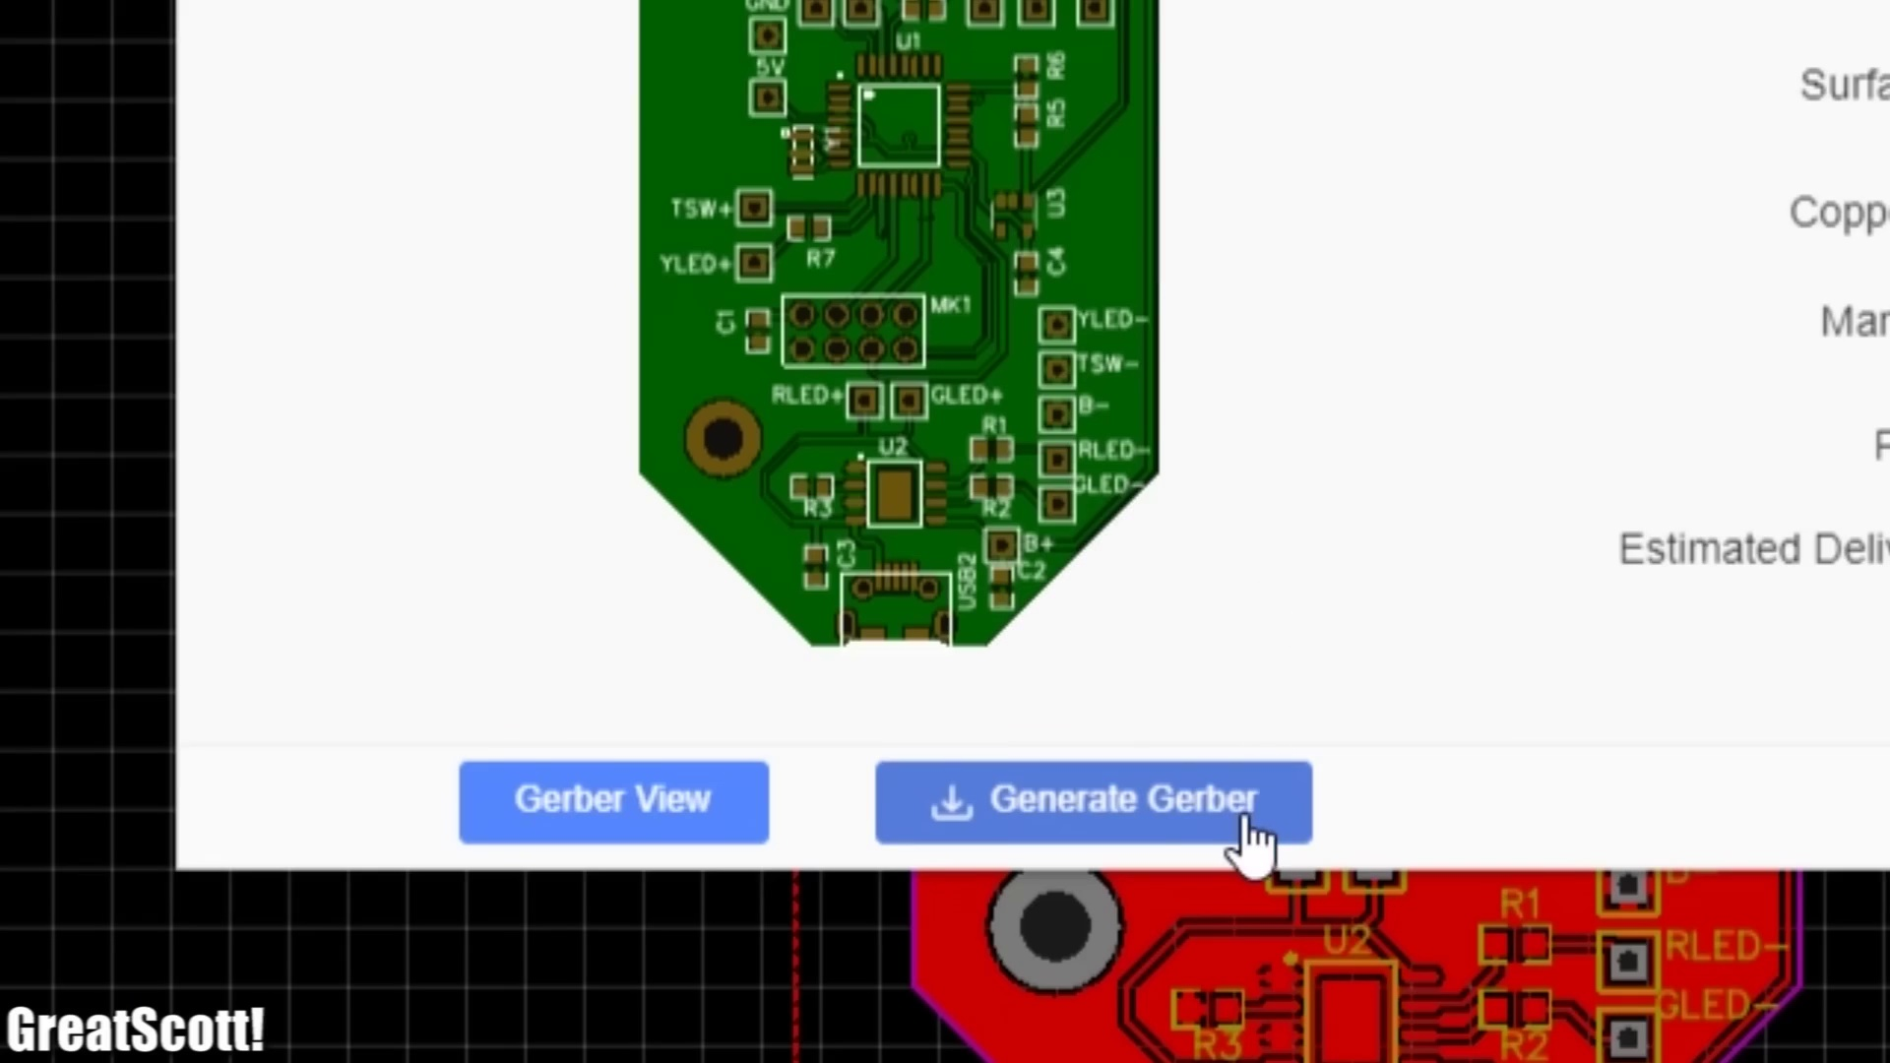 (score 95.0000)
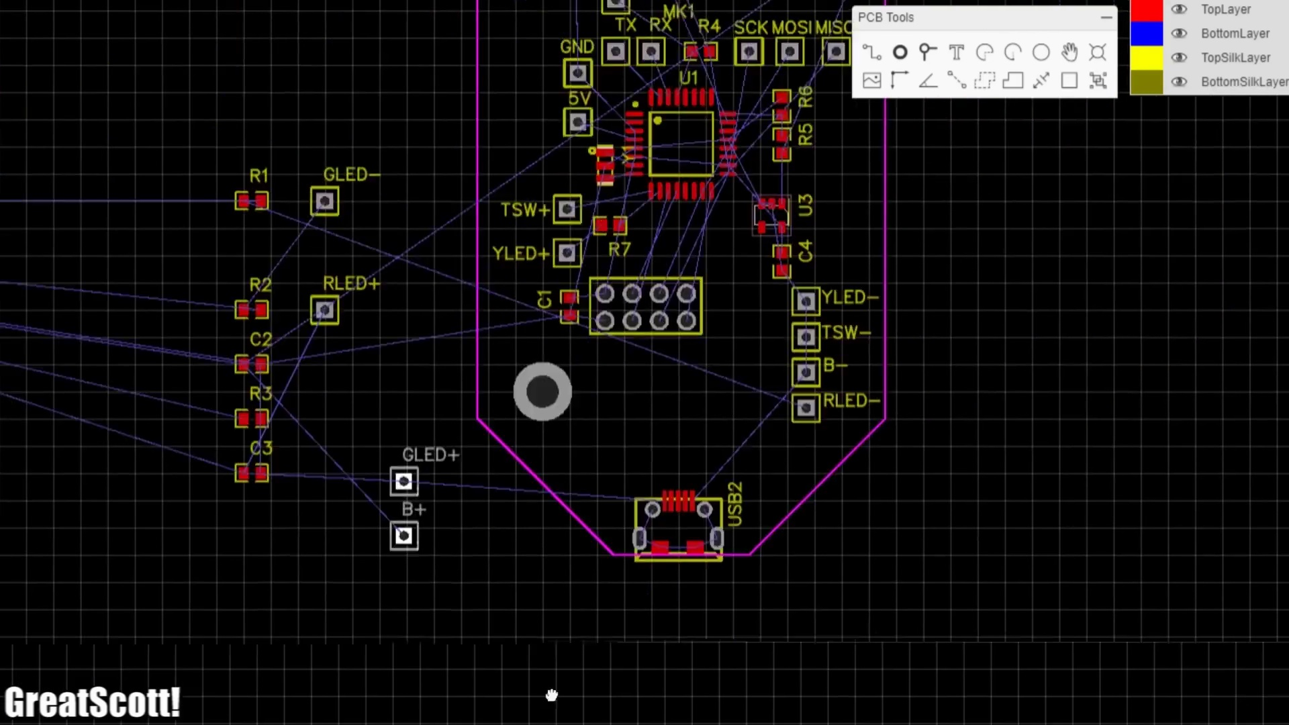 (score 95.0000)
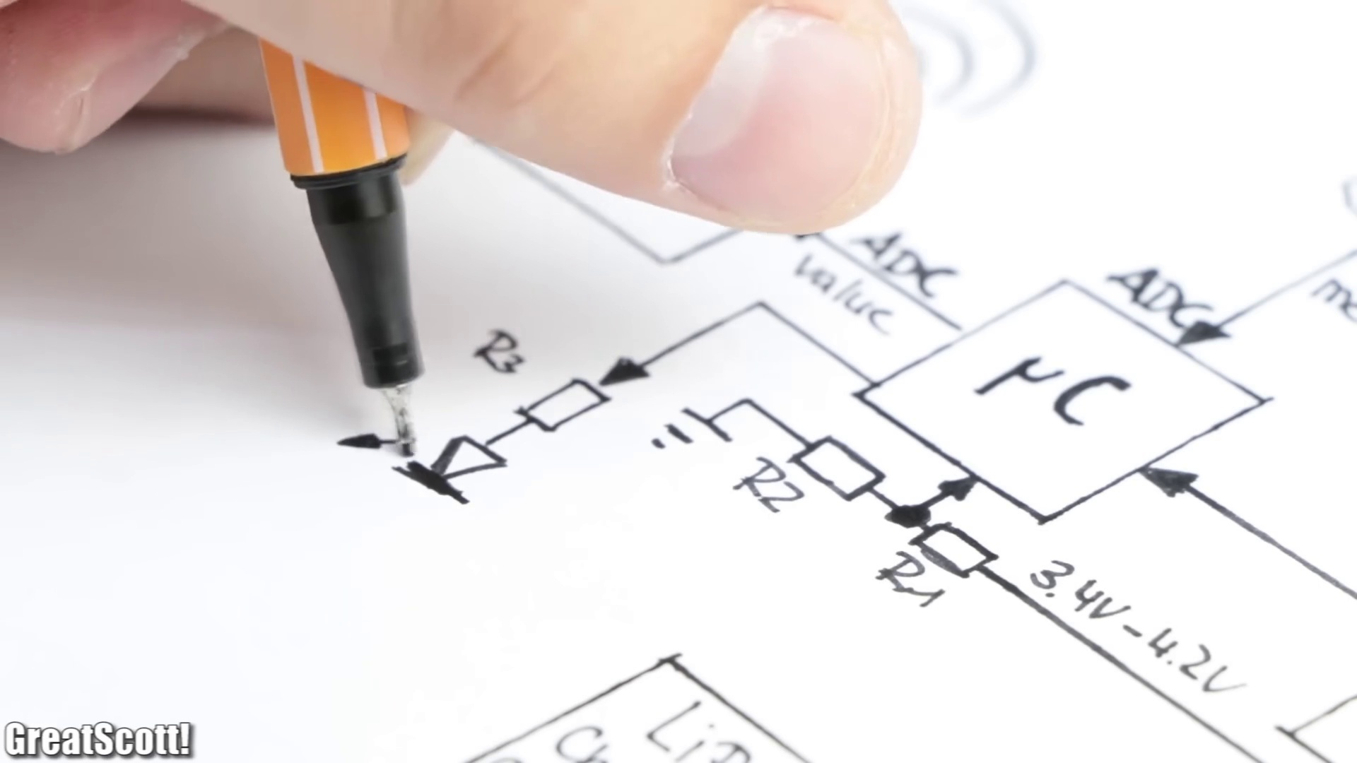 (score 95.0000)
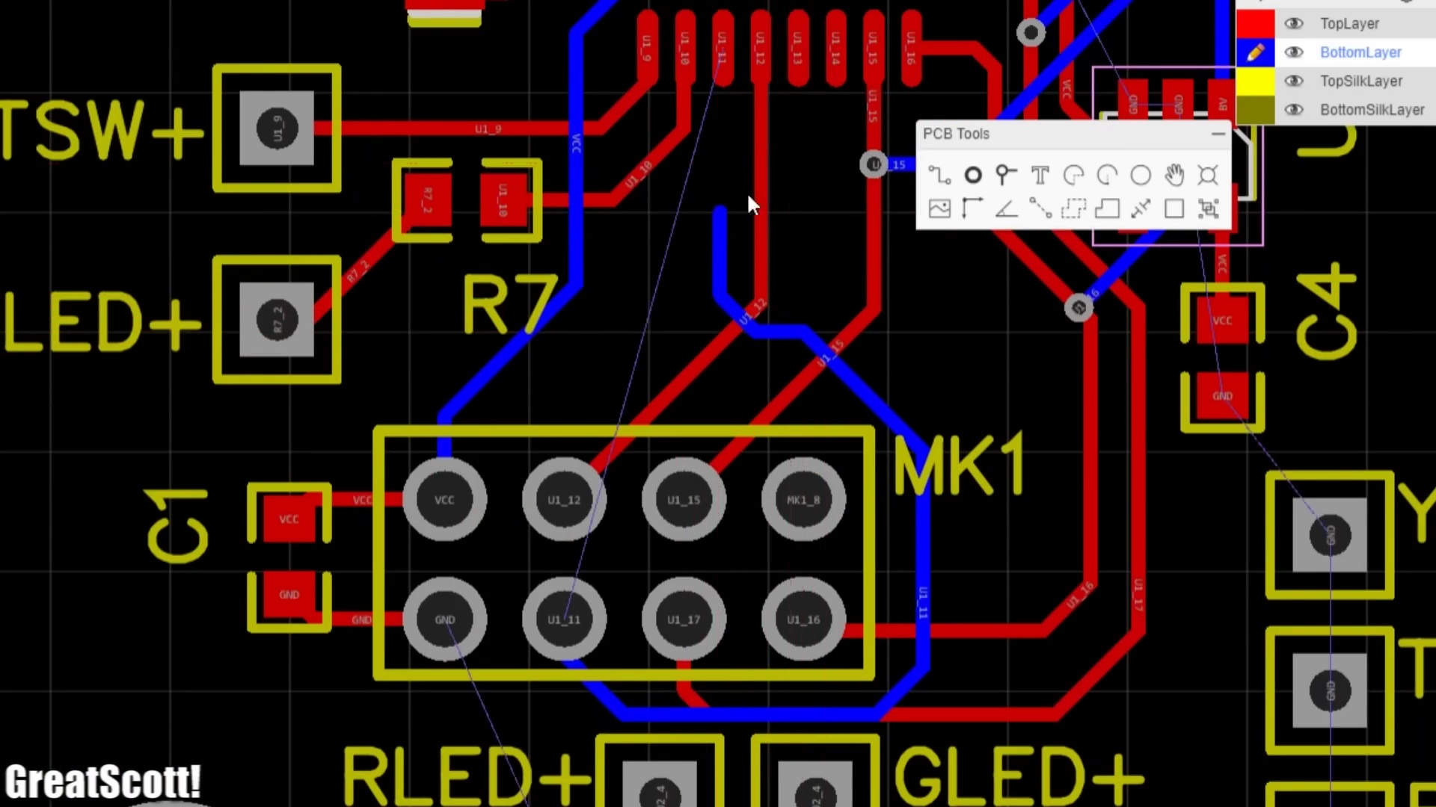 (score 90.0000)
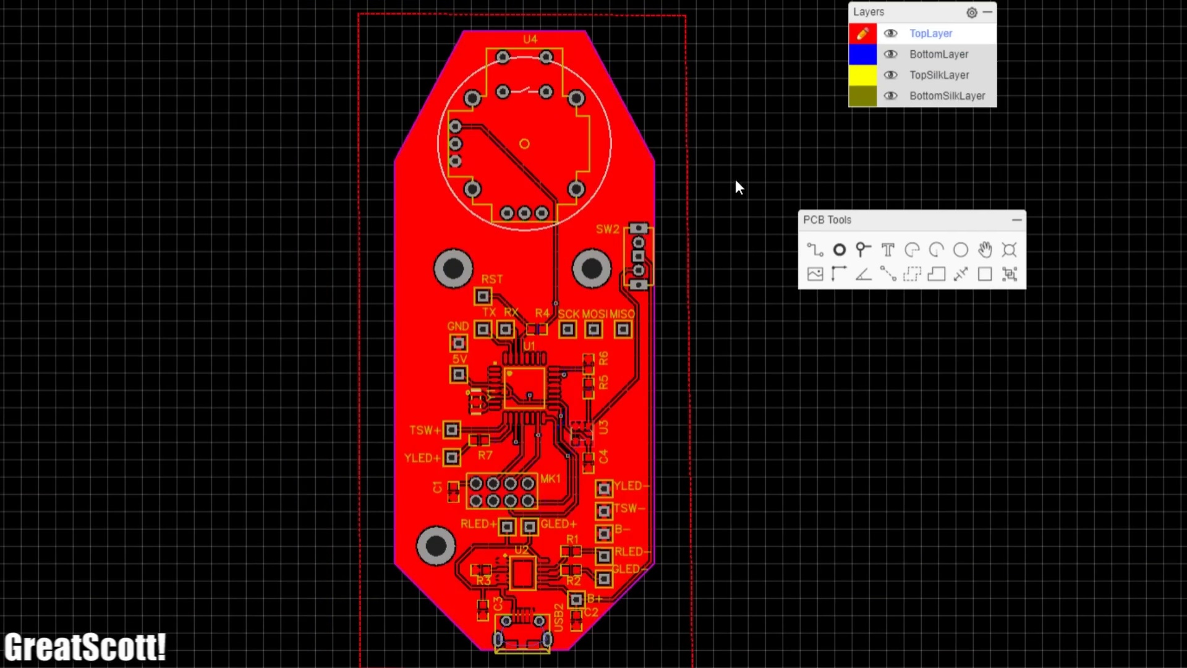 (score 90.0000)
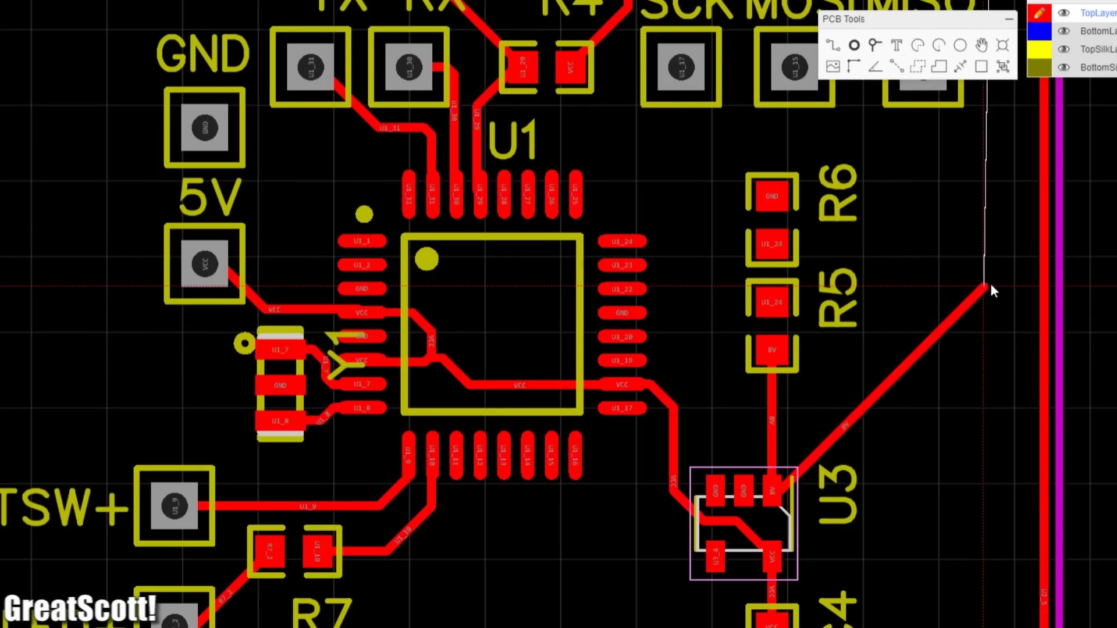 (score 90.0000)
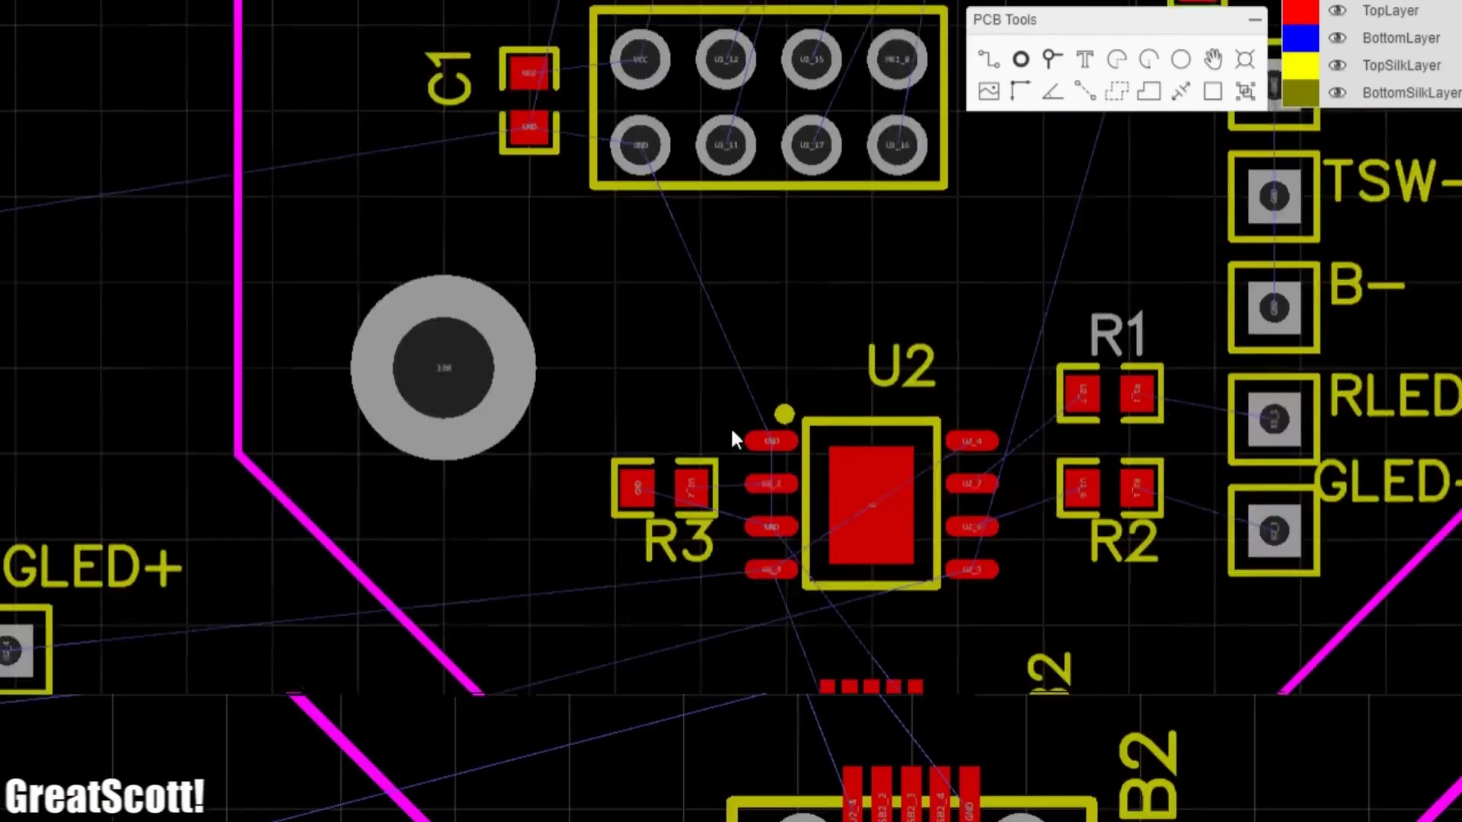 (score 90.0000)
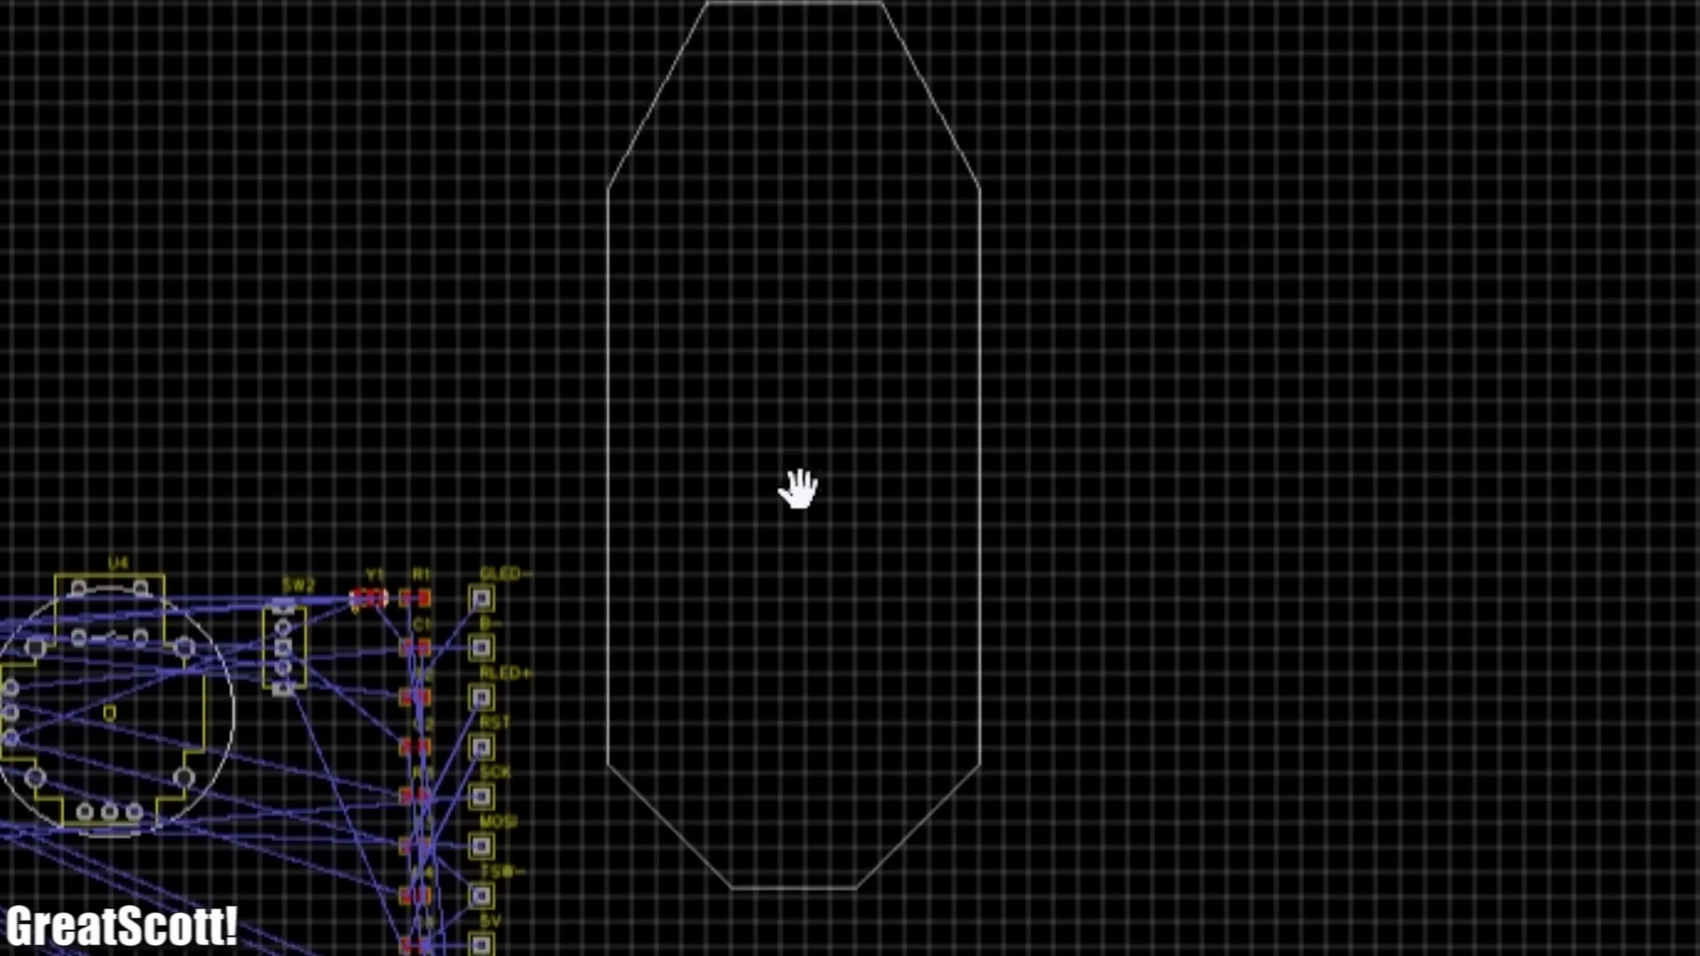 (score 90.0000)
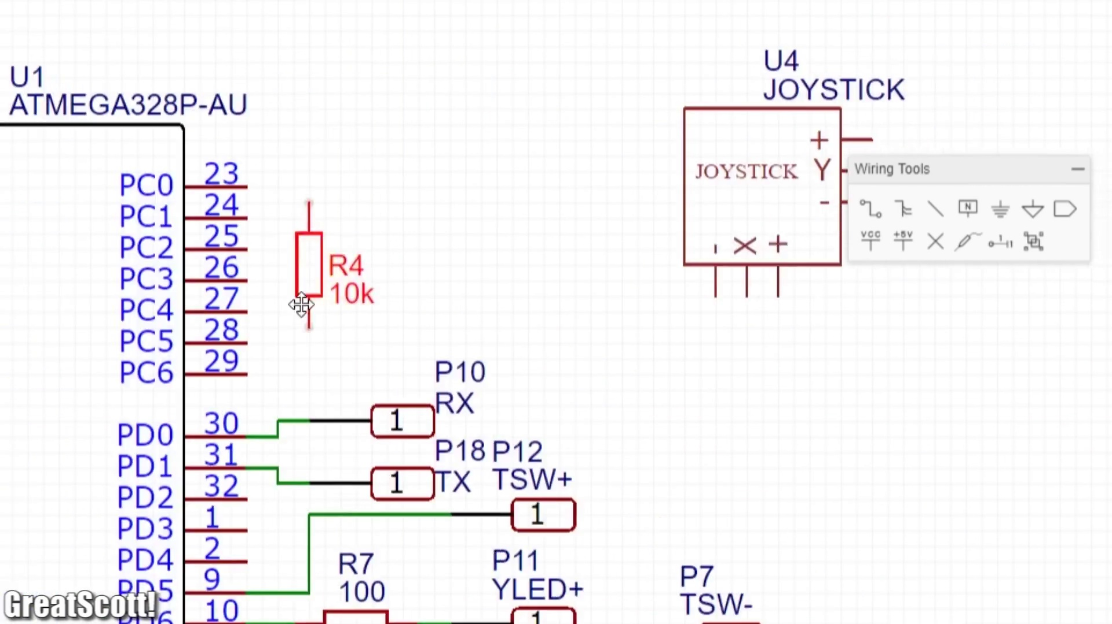 (score 90.0000)
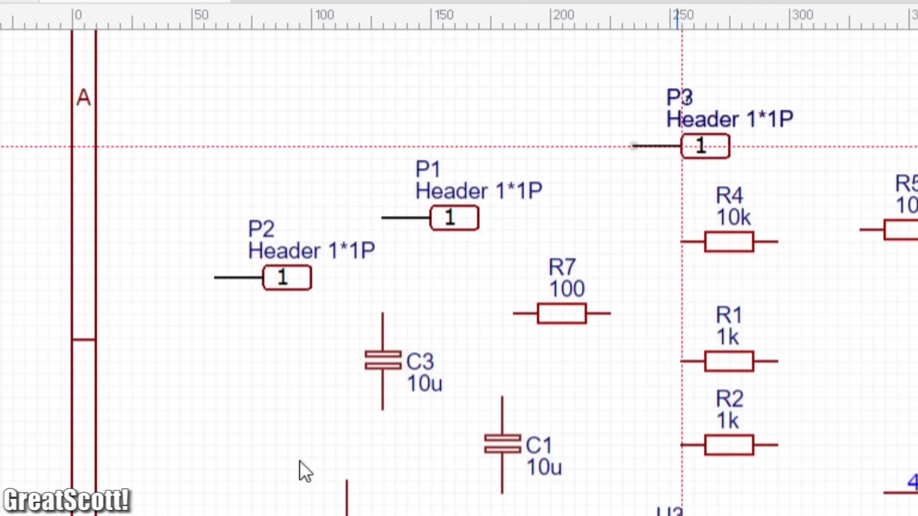 (score 90.0000)
Least correlated frames:
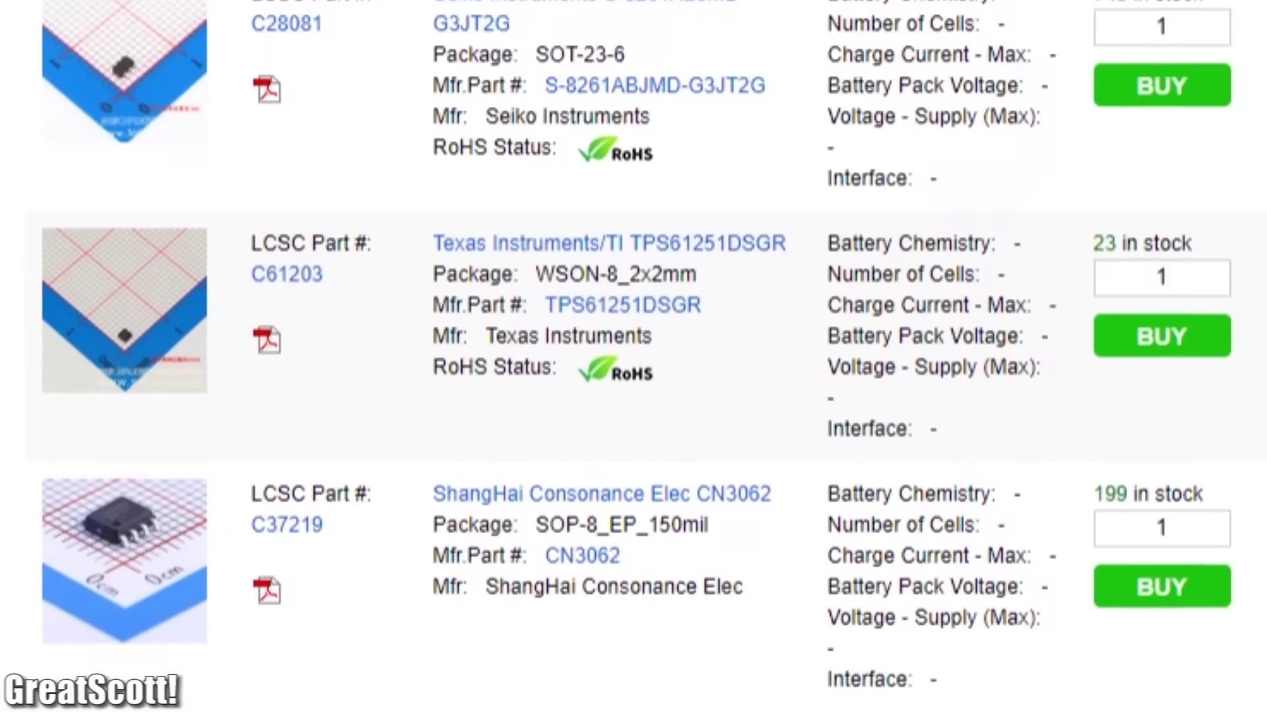 (score 0.0000)
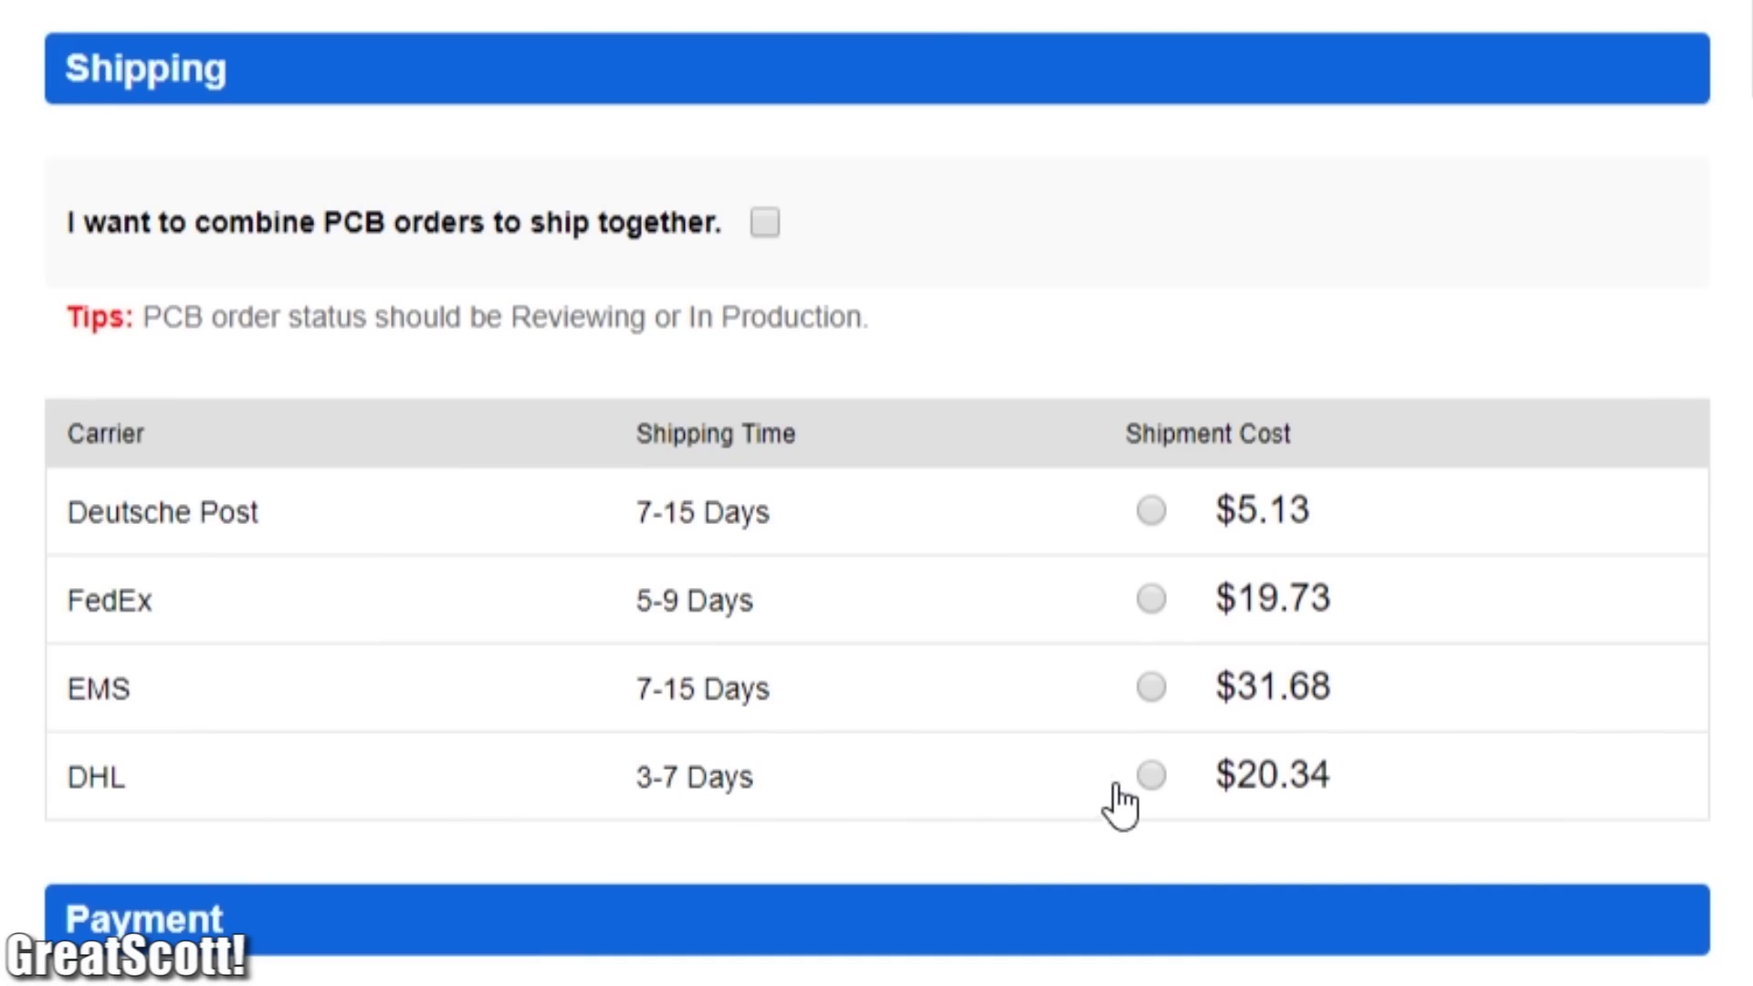 (score 0.0000)
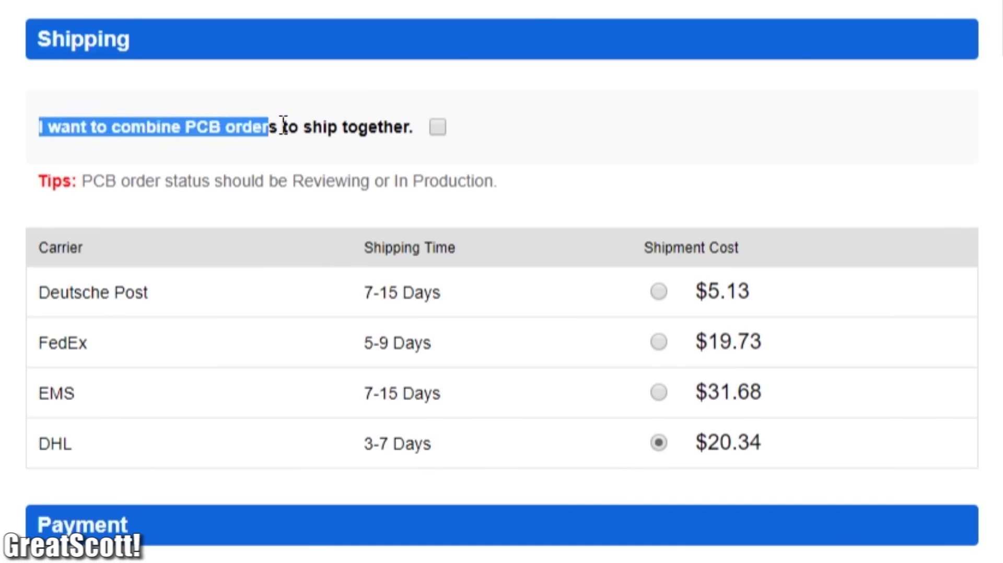 (score 0.0000)
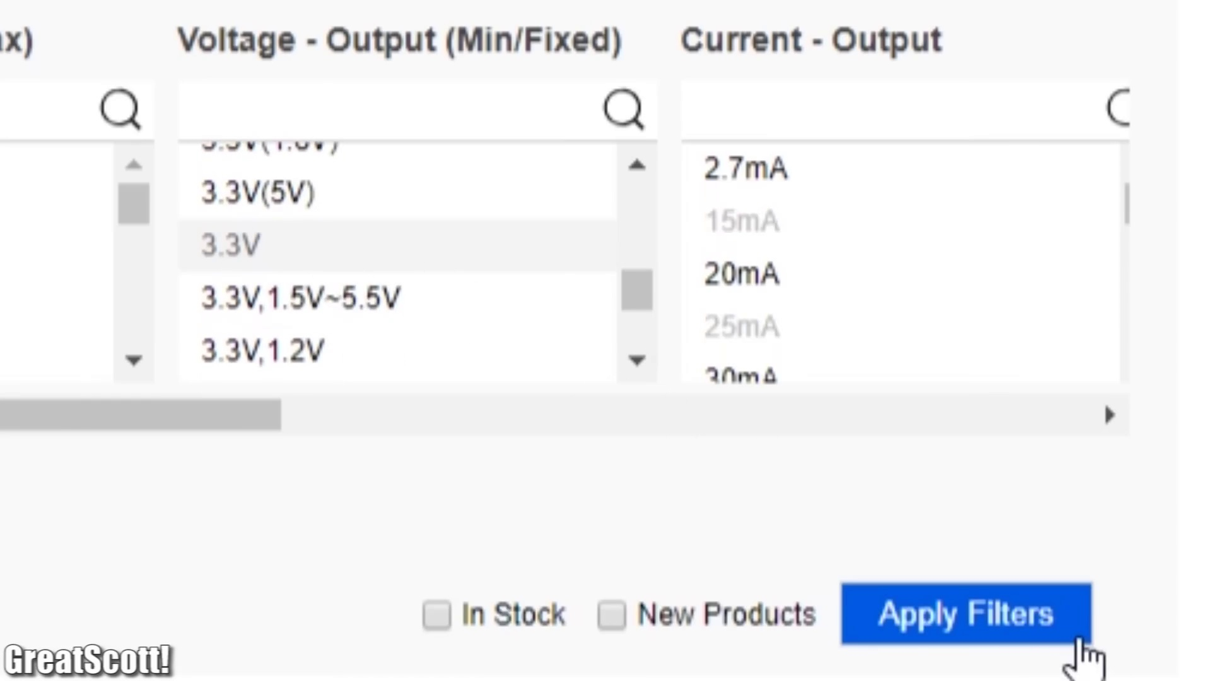 (score 0.0000)
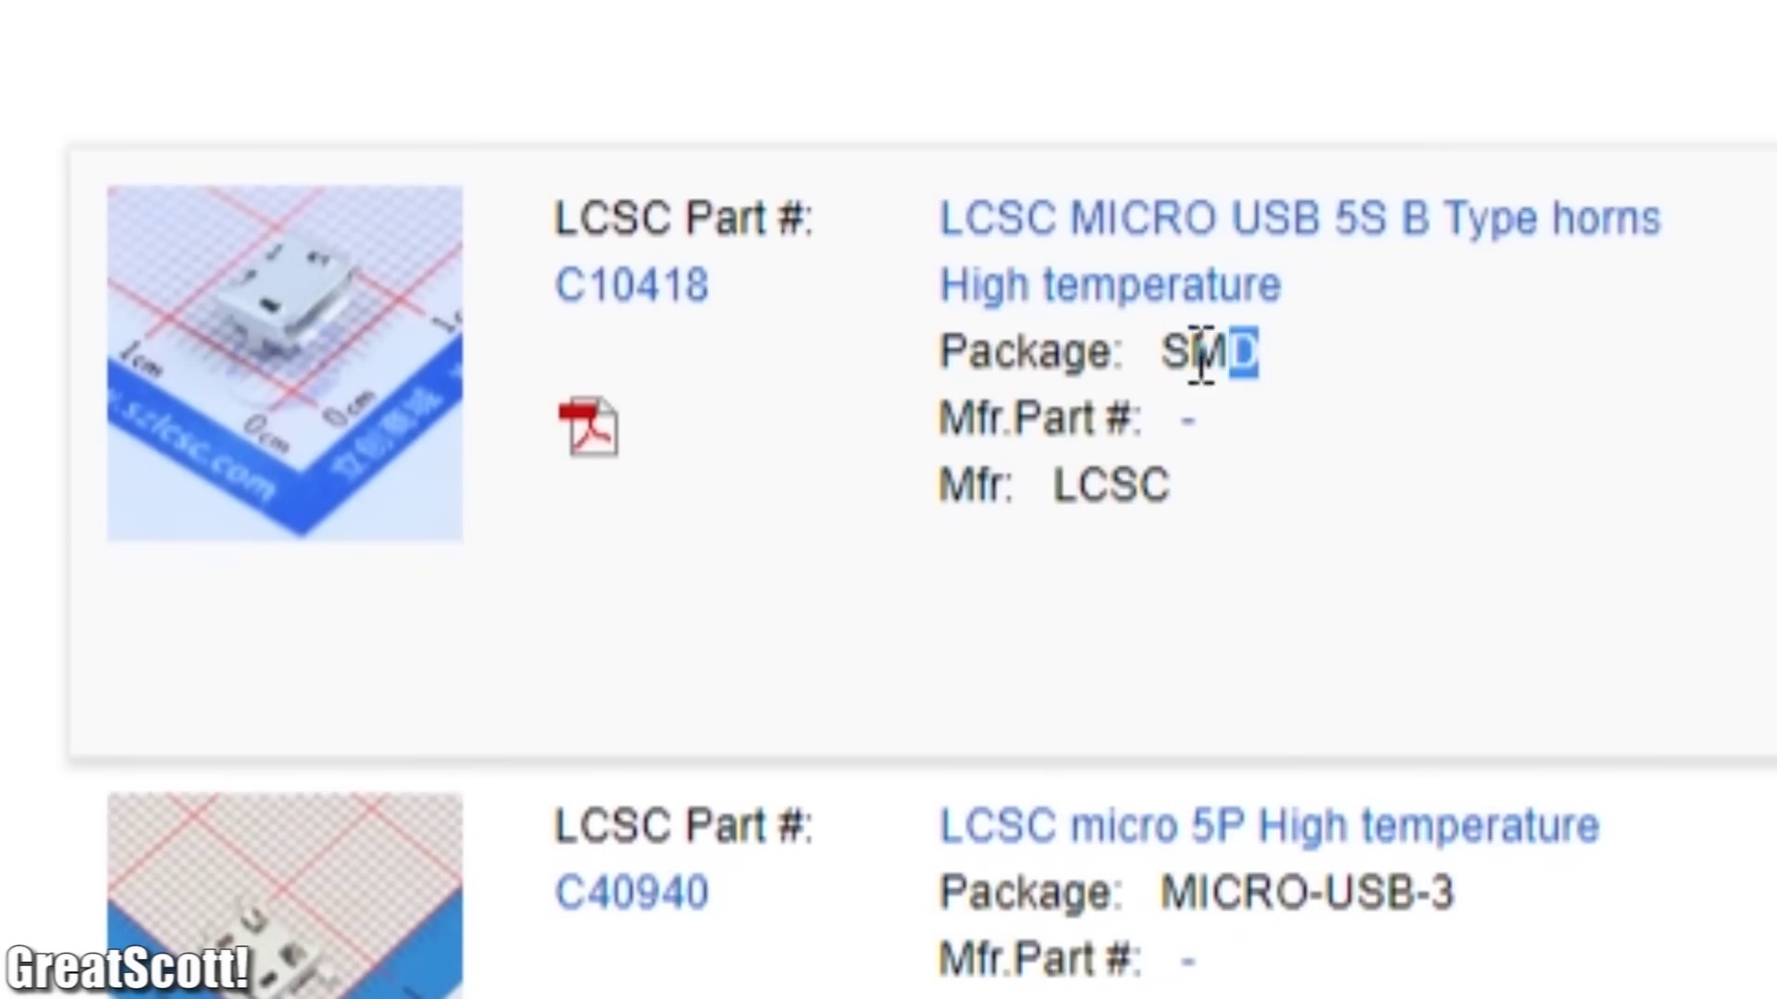 (score 0.0000)
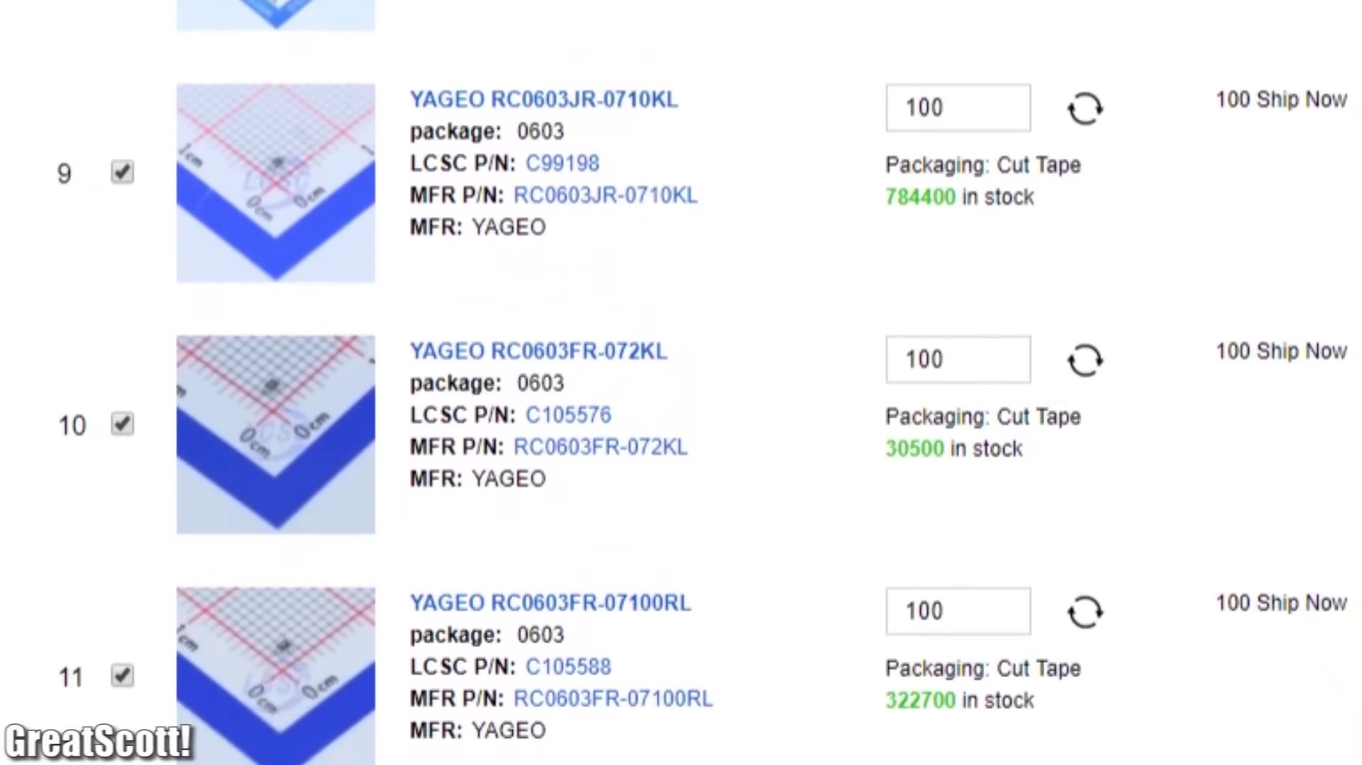 (score 0.0000)
 (score 0.0000)
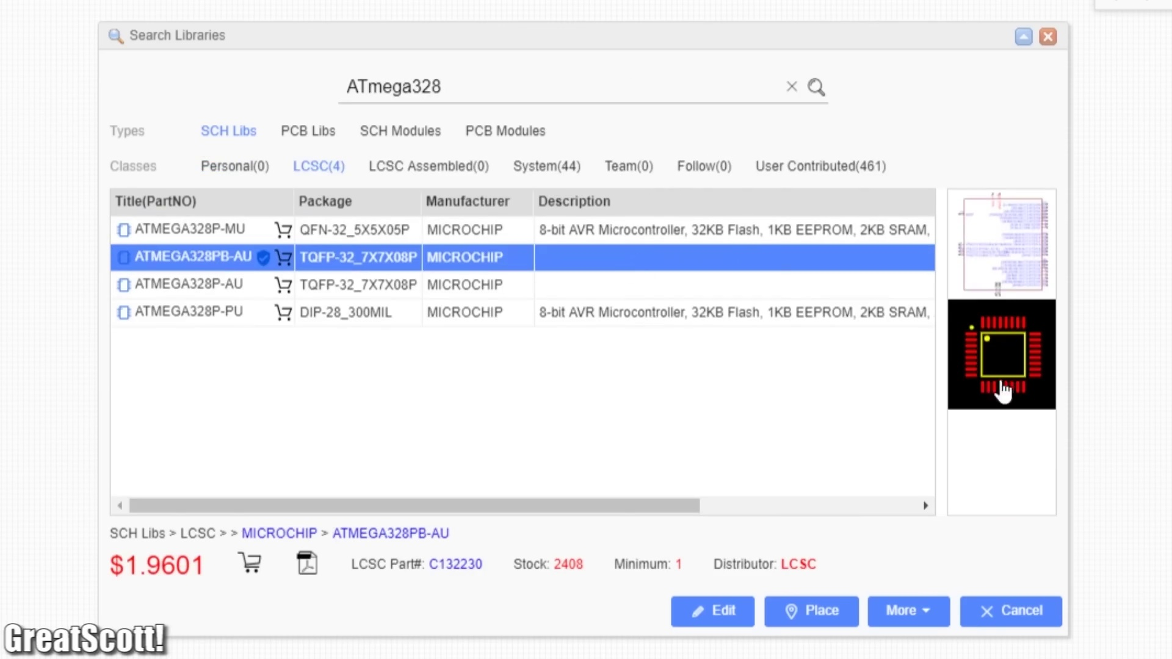 (score 0.0000)
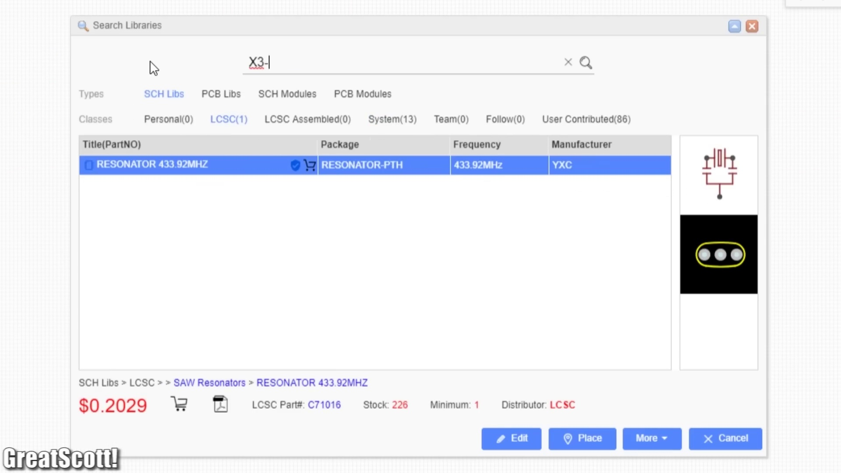 (score 0.0000)
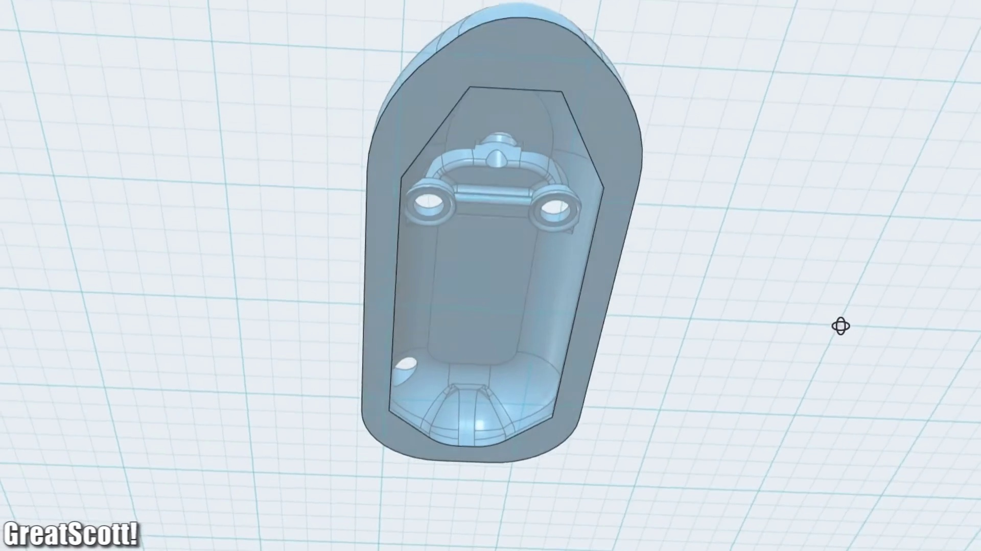 (score 0.0000)

Frame: frame_0000.jpg
Caption: The image appears to show a presentation slide featuring two distinct gray rectangles with different shades of gray inside them. On the left side, there is a darker gray rectangle that could be interpreted as a solid block of material or an object with a smooth surface. The right side features another gray rectangle with a lighter shade inside it, which may represent a different substance or texture within the same context as the left image.
There seems to be some kind of visual or graphical element that connects these two rectangles, but it's not clear from this angle and frame. Given the nature of the slide, it could be related to various topics such as materials science, physics, engineering, color theory, or even a business presentation with different shades representing varying levels of something (e.g., price, performance).
However, without additional context or legible text, it's impossible to determine the exact content or theme of this slide. There is no visible instructor in this image, and no devices like a pointer or laser pointer are present that might be used in a classroom setting. No text, equations, diagrams, or models are visible on the screen, and the slide itself does not appear to have any notes, title, or additional descriptive elements that would provide clues about its content or purpose.
The image does not contain any references to chemistry or organic compounds, but it is worth noting that 1,3-Dichloropropene, a colorless liquid with a sweetish odor, is an organic compound used as a precursor to vinyl chlorides. However, this information is not directly related to the content of the slide.
No strongly correlated comments found for this frame.

Frame: frame_0001.jpg
Caption: The image depicts two moments of engagement with electronic devices. On one side, a person is working with an electronic device that appears to be a wheelchair motor, connected to a breadboard and featuring wires attached to its terminals. The real motor is being experimented with or tested, possibly as part of an electric circuit or exploration of the motor's functionality. In their hands, they hold a small model of the motor, showcasing visible components such as the stator (stationary part of the electric motor) and possibly the rotor.
On the other side, a person is engaged in assembling a complex circuit board on a black surface, with wires, electronic components, and interconnected parts. Their hand is pressing down on one of the wires, indicating active participation in the assembly process. The background features a wooden surface, which could be a table, desk, or bench, providing a subtle contrast to the primary focus on the devices being worked on.
Notably, both scenes lack any additional context-providing objects, texts, or diagrams, instead focusing primarily on the individuals' hands-on interactions with the electronic devices.
No strongly correlated comments found for this frame.

Frame: frame_0002.jpg
Caption: The image shows a person's hand working with electronic components on a circuit board, positioned on a wooden surface. The circuit board features a complex array of wires and components, colored in various shades of green, blue, and yellow, suggesting a multi-colored and potentially complex electronic circuit. The person's hand is positioned over the board, with fingers gently touching the wires, indicating the process of soldering or connecting the components. In addition to the circuit board, several electronic components are visible, including resistors, a capacitor, and an LED (light-emitting diode), which are likely part of an Arduino circuit. Jumper wires connect the components to the Arduino board, suggesting that the person may be in the process of assembling or troubleshooting the circuit. The background of the image is blurred, drawing focus to the person's hand and the circuit board. The text "GreatScott!" is visible in the image, although its relevance to the scene is not immediately clear.
No strongly correlated comments found for this frame.

Frame: frame_0003.jpg
Caption: The image captures a close-up view of a small green circuit board, its surface showcasing intricate wiring and components. The board has multiple silver connectors and wires leading to it, with several circuit traces visible, some of which have been soldered, indicated by the presence of melted solder at the ends of some wires. A person's hands are seen working with electronic components and circuit boards, possibly attaching components or solder points to the board.
The individual is wearing a ring on their finger, but it's unclear if they are pointing or speaking to an audience, as no auditory or visual cues suggest this. The image also features "GREAT SCOTT," a text visible on the board, which might be part of a branding or watermark for an entity or individual related to the content being created or shared.
The board is encased in a brown protective casing, with a variety of wires, both red and silver, snaking their way across its surface, connecting various components. The wires are neatly arranged, leading to the board's edges and corners, hinting at the complex network of connections they form. A hand holds the board, guiding its components gently, adding a human touch to the mechanical scene.
Overall, the image presents a detailed view of the circuit board, its components, wires, and protective casing, as well as the person working with it. The image does not contain any additional text or context information, focusing solely on the objects within its frame.
Comment (score 80): The design process involves starting with an idea, creating a paper schematic, building the schematic in EasyEDA, switching to PCB mode, and finalizing the PCB layout.
Reason: The comment directly discusses the same technical steps and objects (circuit board, wiring, components) described in the caption. The mention of PCB mode and finalizing the PCB layout also matches the visual representation of the circuit board being worked on in the image.
Source: https://www.youtube.com/watch?v=35YuILUlfGs: From Idea to Schematic to PCB: How to do it easily!

Frame: frame_0004.jpg
Caption: The image shows a printed document that appears to be a technical notice or advertisement related to electric motor technology. The top part of the page features a headline in bold text that reads "3 phase brushless DC Motor." Below this headline, additional details are provided about the motor driver, including information on the "BLDC Motor Driver" with specific features such as "Sleep Mode," "LINX PIN MODEL," and "5V/3A."
The middle part of the page includes a small diagram or symbol that represents a sensor or component, accompanied by the text "QC 2", which may indicate a quality control checkpoint or step number. Below this diagram is another line of text stating "Motor Driver", followed by a technical note mentioning "Automatic Threshold Control (ATC) to 16kV."
The lower part of the page lists specifications for the motor driver, including "200V Input," "Sleep Mode," and "Internal Power Supply." The document also includes two bullet points referencing an application note and a technical note, although the details under these bullet points are not fully visible in this image.
No strongly correlated comments found for this frame.

Frame: frame_0005.jpg
Caption: The image depicts two distinct sections that focus on hands and tools engaged in handling electronic components. On the left side, an individual is working with a small electronic device that appears to be a circuit board or integrated circuit chip. The person is holding a pair of tweezers and placing a small chip onto the board, possibly assembling or repairing the device. The background is blurred, suggesting a workbench or desk setup for electronic work.
On the right side, there is a close-up of what seems to be a microchip mounted on the same type of circuit board. The focus remains on the hands and tools engaged in handling electronic components, with no direct interaction between these two sections.
In another part of the image, a person's hand holds a small, square-shaped object with a black and silver color scheme, approximately the size of a thumbnail and made of shiny metal. This is positioned in front of a wooden table, where a small black object can be seen to the right of the hand. The background is again blurred, emphasizing the focus on the object held by the hand.
At the bottom of the image, the text "GreatScott!" is written, although its content cannot be determined from the image alone.
No strongly correlated comments found for this frame.

Frame: frame_0006.jpg
Caption: The image shows a close-up of someone working with electronic components. A small surface-mount device (SMD), which appears to be an integrated circuit (IC) given its rectangular shape and the presence of metal pins on one side for mounting, is being placed onto a circuit board using a precision tool, possibly tweezers or a pick, visible in the lower left corner of the photo. The person's hands are holding what looks like another IC, ready to place it onto the board. In the background, there is a brown paper-like surface with small perforations that could be part of an electronic workbench or a jig designed to hold components in place during assembly or testing.
Meanwhile, in the corner of the image, a black solder iron is being used to attach a small black microprocessor chip to a white board. The solder iron, with its tip glowing red, is positioned over the chip, indicating that it's in the process of soldering. The white board on which the chip is placed has a honeycomb pattern, typical of some types of circuit boards.
The text "GreatScott!" is visible in the image, although its significance isn't immediately clear from the image alone. The overall focus of this image is on the hands and the task at hand, demonstrating common practices in electronics manufacturing or repair.
No strongly correlated comments found for this frame.

Frame: frame_0007.jpg
Caption: The image presents a digital graphic of an electronic circuit board, commonly known as a printed circuit board (PCB), depicted in a top-down view with various components and traces that define the pathways for electrical current. The layout suggests precision and attention to detail, which are typical characteristics of PCB design. The PCB is divided into two sections, each containing a series of components: the left section is populated with a series of resistors and capacitors, while the right section is populated with a series of transistors. The design is outlined in red, adding a pop of color to the otherwise blue background. At the bottom of the image, the text "GreatScott!" is written in red, adding a playful touch to the otherwise technical design. The circuit board does not contain any discernible text or actions. The relative positions of the components are such that they are connected in a circuit, suggesting the board is ready for testing or assembly. The overall design is a testament to the intricate workings of electronic devices and the careful planning that goes into their creation.
No strongly correlated comments found for this frame.

Frame: frame_0008.jpg
Caption: The image appears to be a screenshot of an online interface displaying a circuit board (PCB) design with various components, traces, and electronic components such as resistors, capacitors, and integrated circuits (ICs). The PCB has pads, traces, and intricate details. A text overlay reads "Detected 2 layers of PCB 6456 3669," indicating that the software is analyzing or detecting the number of layers and traces in the design. This suggests a workflow or quality assurance step, as indicated by the checklist item visible on the right side of the interface: "Will all checks be completed before moving to next phase." The overall context of this screenshot seems to be related to electronic design automation (EDA) software, where designs are visualized and analyzed for manufacturing and production purposes.
The PCB image itself is zoomed in, showing the intricate details of the components and traces. In the top section of the page, a message indicates that the user has uploaded a 2-layer board of 60x60mm size. The bottom section of the page provides information on how to proceed with the project, including checking the components and ensuring they are correct. The website also lists the selected components, offering guidance for completing the PCB design.
Comment (score 85): The design process involves starting with an idea, creating a paper schematic, building the schematic in EasyEDA, switching to PCB mode, and finalizing the PCB layout.
Reason: The comment directly discusses the same technical steps (creating a paper schematic, building the schematic in EasyEDA, switching to PCB mode, and finalizing the PCB layout) and goals (designing a PCB) described in the caption, indicating strong correlation.
Source: https://www.youtube.com/watch?v=35YuILUlfGs: From Idea to Schematic to PCB: How to do it easily!

Frame: frame_0009.jpg
Caption: The image shows a person's hands operating on a green circuit board that has been neatly folded in half, revealing its intricate circuitry. The person is working with a tool, possibly a soldering iron or pliers, focused on the task at hand. A red-tipped soldering iron is in the process of joining two components on the board, which are connected by a thin white wire, indicating a successful connection.
The circuit board has various electronic components such as resistors and capacitors printed on it, with a grid of pads that might be used to mount other parts or for connection points. Traces of solder and other components are visible on the board. The background is out of focus, but it seems to be an indoor setting with natural lighting suggesting a window nearby.
There are no visible texts, diagrams, or slides in this image that provide context about the person's actions or the content being taught or demonstrated. It appears to be a close-up shot focused on the hands and the work being done rather than a classroom teaching environment.
No strongly correlated comments found for this frame.

Frame: frame_0010.jpg
Caption: The image provided appears to be a diagram or schematic related to an electronic circuit or system. The diagram is likely from a computer-aided design (CAD) program, such as Autodesk, and features a mix of text and symbols on a grid-like background.
On the left side of the diagram, there are labels denoting different parts of the schematic, including "R1," "R2," "C1," etc., which are common notations in electrical engineering to denote resistors and capacitors. The symbols for electronic components include rectangles for resistors (e.g., R1), triangles for inductors, hexagons for transformers, and circles with lines through them for capacitors.
There's also text "U1," "U2," etc., which could denote integrated circuits or other types of electronic devices. The arrows and lines connecting the components suggest the flow of current or the direction of energy in a circuit.
On the bottom right, there are numbers like 6, 7, 8, which might refer to pins or terminals on the components. Additionally, there's a label "GND," which stands for Ground, indicating a common reference point in an electrical circuit.
The image also features a watermark that says "greatspots," likely indicating the source of the diagram or the platform it was created on. This diagram does not depict a person or a teaching context like writing on a whiteboard, speaking from a slide, or holding a model; instead, it is purely textual and graphic, making it suitable for use in an educational setting to teach about circuits or electronics.
Furthermore, upon closer inspection, the bottom section of the diagram appears to be a screenshot from a PowerSwitch design document. The top section displays the PowerSwitch logo and a header that reads "U2 TP4066," likely indicating the part number of the PowerSwitch. The middle section contains a table with rows labeled "BAT", "CHG", "TEMP", "CHG PROG", "BAT PROG", and "CHG PROG," which likely correspond to the different states or functions of the PowerSwitch.
This comprehensive guide provides detailed information about the components, their functions, and their connections within the PowerSwitch circuit, making it a valuable resource for anyone interested in this technology.
Comment (score 80): The design process involves starting with an idea, creating a paper schematic, building the schematic in EasyEDA, switching to PCB mode, and finalizing the PCB layout.
Reason: The comment directly discusses the design process of creating a schematic in EasyEDA and building the PCB layout, which is closely related to the technical steps and objects described in the caption (e.g. resistors, capacitors, integrated circuits) as well as the settings and goals mentioned (i.e. designing an electrical circuit). The only reason it's not 100% correlated is that the comment doesn't explicitly mention the specific components or their functions, but it does provide a general overview of the design process.
Source: https://www.youtube.com/watch?v=35YuILUlfGs: From Idea to Schematic to PCB: How to do it easily!

Frame: frame_0011.jpg
Caption: This image appears to show a digital schematic of an electronic circuit displayed on a computer screen with several windows and tabs open, suggesting a multi-page document or software interface for designing circuits. The central area shows symbols representing various electronic components such as resistors (R), capacitors (C), diodes (D), transistors (Q), integrated circuits (IC), and connectors like USB ports (USB). Text labels and values are visible next to the components, indicating parameters like resistance values in ohms (Ω) and voltage levels in volts (V), for example, "R1=100Ω," "C1=22nF," "D1=1N4148," and "Q1=2N3904." There are also numbers indicating pin connections between components such as "IC1 Pin 6" and "IC1 Pin 7," etc.
On the right side of the image, there's a window with the title "SW1-SPD," which seems to suggest that this schematic is related to a switch component or a page in a document named "Switch-Speed." Additional tabs at the bottom are labeled "IC1," "USB," and "VCC," hinting at the organization of the circuit's components into these groups. The overall style of the image is that of a computer screen with a graphical user interface (GUI) open, where users can design and modify electronic circuits visually.
The diagram appears to be color-coded for easy identification, with neatly organized text boxes providing information about the components and their connections. The layout suggests it is a schematic, using symbols to represent components and connections, clearly labeled and arranged in a logical order. The text in the diagram is in English and appears to be a combination of instructions and explanations about the components and their connections, indicating that the diagram is likely a manual or guide for working with these components.
The image provides a detailed view of a circuit design, complete with components, connections, and instructions, offering a glimpse into the world of electronics and circuits.
Comment (score 80): The design process involves starting with an idea, creating a paper schematic, building the schematic in EasyEDA, switching to PCB mode, and finalizing the PCB layout.
Reason: The comment directly discusses the creation of a schematic in EasyEDA and PCB mode, which is related to the technical steps and objects (electronic components) described in the caption. The mention of starting with an idea, creating a paper schematic, building in EasyEDA, and finalizing the PCB layout aligns with the goals and settings presented in the caption.
Source: https://www.youtube.com/watch?v=35YuILUlfGs: From Idea to Schematic to PCB: How to do it easily!

Frame: frame_0012.jpg
Caption: The image appears to show a graphical interface, possibly a computer-aided design (CAD) software or a similar technical application. It's displaying an electronic circuit diagram with various components labeled and connected by lines representing electrical connections.
On the left side of the screen, there is a vertical column with a series of interconnected rectangles that seem to represent integrated circuits (ICs), each containing smaller shapes that could be pins or terminals. The first IC in this column has an "R" next to it, which likely stands for resistor, and below that, there is a small image of what looks like a resistor with color bands on its body, suggesting it may represent different values of resistance.
The left section of the circuit board features a rectangular board labeled as "RX," indicating that this component receives signals. Below the RX component, another element with a red and white striped pattern appears; however, its exact function is unclear without further context.
In the center section, there's a square board labeled as "U1" with a white circle inside it, which likely refers to the first IC in this sequence, using the conventional labeling scheme of "U1" for the first component. This labeling convention is commonly used in electronics to differentiate between various components within an integrated circuit or system.
The right section features a rectangular board labeled as "RT." The board is not just a collection of components but a complex network of wires connecting them, suggesting a well-planned and organized circuit design.
At the top of the image, there's text that reads "GreatScott!", indicating a sense of excitement or enthusiasm for the circuit board design.
Comment (score 80): The design process involves starting with an idea, creating a paper schematic, building the schematic in EasyEDA, switching to PCB mode, and finalizing the PCB layout.
Reason: The comment directly discusses the technical steps involved in creating a circuit board design, mentioning tools like EasyEDA and referring to specific components (e.g., 'RX', 'U1', 'RT') as seen in the frame caption. The correlation is high because the comment provides a detailed description of the design process, which matches the context and elements presented in the frame caption.
Source: https://www.youtube.com/watch?v=35YuILUlfGs: From Idea to Schematic to PCB: How to do it easily!

Frame: frame_0013.jpg
Caption: The image appears to be a combination of a computer-aided design (CAD) software interface with a screenshot of an electrical circuit diagram displayed. The CAD interface shows a schematic diagram drawn on a grid background, representing the layout of the circuit on a breadboard or printed circuit board (PCB). The diagram depicts various electronic components, including resistors indicated by zigzag lines, integrated circuits (ICs) resembling small rectangles, and a USB port represented by a five-pin connector.
The diagram includes text labels such as "J1" indicating a specific pin or connection point in the circuit, and "U1" likely referring to an integrated circuit component. Numerical values like "200" are also present, which could be resistance values in ohms for the resistors or another measurement relevant to the circuit design.
A red dashed line encircles some components, suggesting a specific configuration or path within the circuit. The bottom-right corner features a small icon resembling a microchip with a heart symbol, possibly indicating a favorite item or feature within the software.
The left side of the image shows a grid of squares, which could be a toolbar for selecting and arranging components in the CAD interface. The top-right corner has a small menu or toolbar with icons that might represent tools for editing or creating diagrams.
In contrast, the miniCPM image provides a close-up view of an actual circuit board, rectangular in shape with a clear top layer and a black bottom layer. The top layer is covered in a network of wires indicating connections between different components on the board.
The board features various components, including resistors, capacitors, and a transistor, arranged in a way that suggests they are part of a larger circuit likely for controlling and amplifying signals. Annotations in red point to specific components, while blue annotations indicate the direction of current flow, providing additional context about the board's functionality.
A copyright notice from "GreatScott!" is present at the bottom-right corner of the image, possibly referencing the creator or owner of the circuit board design. Overall, these two images provide a comprehensive view of both digital and physical aspects of electronics and circuit design, making them useful resources for anyone interested in this field.
Comment (score 80): The design process involves starting with an idea, creating a paper schematic, building the schematic in EasyEDA, switching to PCB mode, and finalizing the PCB layout.
Reason: The comment directly discusses the technical steps involved in creating a circuit design, mentioning specific software tools (EasyEDA) and modes (PCB mode), which are closely related to the CAD interface and circuit diagram shown in the frame caption. The comment also references the creation of a paper schematic, which is hinted at by the presence of text labels like 'J1' and 'U1' in the caption.
Source: https://www.youtube.com/watch?v=35YuILUlfGs: From Idea to Schematic to PCB: How to do it easily!

Frame: frame_0014.jpg
Caption: The image appears to show a computer screen displaying a complex network of nodes and edges, possibly representing a digital circuit or a network model. It seems likely that this is a screenshot from a software tool used for schematic design, simulation, or analysis, such as Electronic Design Automation (EDA) software.
The visual content on the screen includes a multitude of nodes connected by edges, with each node having an associated symbol that might represent electronic components like resistors, capacitors, transistors, etc. There are also numerical values and possibly other symbols or annotations that are not entirely clear due to the image's resolution.
The text on the screen is too small and blurry to read accurately. However, it is likely related to electrical engineering, computer science (specifically in the domain of digital logic design), or a similar technical field.
In contrast to the complex network, the diagram appears to be set against a black background, adding a stark contrast to the various components and their connections. The components are predominantly represented by red and blue lines, with the red lines indicating power supply lines and the blue lines representing signal lines.
The diagram is filled with numerous components, each with its own unique identifier written in white text, making them stand out against the black background. These identifiers are positioned at various locations on the diagram, indicating the specific components they are associated with.
In addition to the components and their identifiers, the diagram also includes a few labels written in white text, providing additional information about the components. Overall, the image provides a comprehensive view of a circuit, highlighting its various components, connections, and identifiers.
Comment (score 90): The design process involves starting with an idea, creating a paper schematic, building the schematic in EasyEDA, switching to PCB mode, and finalizing the PCB layout.
Reason: The comment directly discusses the technical steps involved in designing a circuit, which is strongly related to the objects and settings described in the caption. The mention of EasyEDA and PCB mode specifically matches the context of schematic design and analysis software mentioned in the caption.
Source: https://www.youtube.com/watch?v=35YuILUlfGs: From Idea to Schematic to PCB: How to do it easily!

Frame: frame_0015.jpg
Caption: The image shows an electronic device with several exposed copper-colored tracks and pins, which appears to be a circuit board or a printed circuit board (PCB). There are small components attached to the track, suggesting it may be used for electronics repair or hobbyist work. The PCB has multiple connections that can be made using conductive materials such as wires or solder.
In the background, there is text on what seems to be a presentation slide with the word "GREAT" prominently displayed at the top right corner, and several smaller words that are not entirely legible due to the angle and resolution of the image. The slide also contains diagrams and illustrations, but their content is not clearly visible.
The circuit board is brown in color, with a design that includes silver wires and tiny holes for pins, laid out on a white surface. It appears to be a flat surface, with no other objects in the immediate vicinity. The focus of the image is solely on the circuit board, with no other elements or text present.
The presence of wires and pins suggests that the circuit board is used for connecting electronic components or components within a larger system. However, without further context, it's difficult to determine its exact purpose or the specific topic of the tutorial or online class from which this image originates.
Comment (score 80): The design process involves starting with an idea, creating a paper schematic, building the schematic in EasyEDA, switching to PCB mode, and finalizing the PCB layout.
Reason: The comment directly discusses the technical steps involved in designing a printed circuit board (PCB), which are closely related to the visual elements shown in the frame caption, such as the PCB layout, tracks, and pins. The mention of EasyEDA and PCB mode further strengthens the connection between the caption and the comment.
Source: https://www.youtube.com/watch?v=35YuILUlfGs: From Idea to Schematic to PCB: How to do it easily!

Frame: frame_0016.jpg
Caption: The image depicts a person engaged in a creative project, surrounded by electronic components and tools. The individual is working with a circuit board that has been stripped of its components, using pliers to manipulate small electronic parts. The board features multiple copper traces that would have connected various electronic elements, but these are now removed, leaving the traces bare.
In the background, there is a digital display showing what appears to be an oscilloscope reading with several channels of measurement. One channel displays a spike or peak in the signal, which could indicate a transient or rapid change in voltage.
The person's hands are visible as they hold the pliers and the components being removed from the board. The focus seems to be on the process of disassembling the electronic circuit. Additionally, the individual is wearing silver paint on their hands, indicating that this project involves creating something new.
There is a yellow screwdriver lying nearby, not currently in use, but suggesting that it may have been employed earlier in the process. A small box of red and silver components is also visible, with some of these parts being attached to the board. The LED component, which appears to be red, has already been added to the board.
The entire setup is situated on a white surface, providing a stark contrast to the vibrant colors of the LED and components. Overall, the image captures the essence of a DIY project, where creativity and skill come together to create something unique.
Comment (score 85): The design process involves starting with an idea, creating a paper schematic, building the schematic in EasyEDA, switching to PCB mode, and finalizing the PCB layout.
Reason: The comment directly discusses the technical steps involved in disassembling and designing an electronic circuit, specifically mentioning PCB mode and layout, which are closely related to the actions depicted in the frame caption. The focus on DIY project and design process in both the caption and comment also supports the correlation.
Source: https://www.youtube.com/watch?v=35YuILUlfGs: From Idea to Schematic to PCB: How to do it easily!

Frame: frame_0017.jpg
Caption: The image depicts a person's hands working on an electronic device, specifically a green circuit board that features several components, including a button and a connector. One hand is holding what appears to be a capacitor or resistor, while the other hand uses tweezers to manipulate something on the circuit board. The board has multiple lines connected to different pads, indicating electronic pathways.
The room has a cozy atmosphere with a warm tone, and there's another similar electronic device on the right side of the image, suggesting that this could be part of a hands-on learning activity or educational setup. In the background, a projector screen may be displaying instructions or diagrams related to electronics or soldering projects, further supporting this idea.
The person holding the circuit board is wearing a shirt with the logo "GreatScott!" on it, which adds context to the image without providing specific information about its content or context.
Comment (score 80): The design process involves starting with an idea, creating a paper schematic, building the schematic in EasyEDA, switching to PCB mode, and finalizing the PCB layout.
Reason: The comment directly discusses the technical steps involved in designing and building a PCB (printed circuit board), which matches the objects and settings described in the caption. The mention of EasyEDA, a specific design tool, further strengthens the connection between the caption and the comment.
Source: https://www.youtube.com/watch?v=35YuILUlfGs: From Idea to Schematic to PCB: How to do it easily!

Frame: frame_0018.jpg
Caption: The image shows a close-up view of someone's hands working with an electronic circuit board or module. The person is holding one end of the board and appears to be adjusting or inspecting it, possibly checking for proper connections or ensuring the components are in place. The circuit board itself has various green integrated circuits (ICs) mounted on it, along with other components that might include resistors or capacitors. The board is held against a dark background, making its details stand out.
The person is wearing a black shirt and sitting on the right side of the image, with the brown wooden surface beneath their arm. The circuit board rests on this surface, which is located to the right of the person. Additionally, a green circuit board sits atop a white board on the left side of the image, held by the same individual.
Notably, the text "GreatScott!" appears in the bottom right corner of the image, providing a humorous and lighthearted tone to the scene. The overall quality of the image is slightly blurry and low resolution, which limits the amount of detail that can be discerned beyond the basic elements described above.
No strongly correlated comments found for this frame.

Frame: frame_0019.jpg
Caption: The image shows a close-up of a hand using a yellow highlighter to write the word "Step" on a white surface, with an ink pen used to add the numeral "1" next to it. The hand appears to belong to someone who is starting a task or process that requires sequential steps.
No strongly correlated comments found for this frame.

Frame: frame_0020.jpg
Caption: The image captures a close-up of a hand holding a black pen with a yellow highlighter poised above a piece of paper. On the paper, there are only a few words written in black, standing out against the white background. The words "Plan the function of the circuit" are written in bold, guiding the hand's focus. The pen is pointing towards these words under the guidance of the highlighter, suggesting a journey of thought and planning. The overall scene conveys a moment of deep concentration, where the hand is in the process of writing or planning something related to the circuit function.
The style of the image suggests it could be a screenshot from a tutorial video, emphasizing the writing tool and the related instructions. There are no other visible elements that would give context to the environment or the person using the pen, keeping the focus on the hand, pen, and paper. The text on the paper appears to be in Italian, indicating an instructional context potentially related to "Manual for the State" or something similar. However, without being able to read the text, specific details about its content cannot be provided.
Comment (score 90): The design process involves starting with an idea, creating a paper schematic, building the schematic in EasyEDA, switching to PCB mode, and finalizing the PCB layout.
Reason: The comment directly mentions the technical steps involved in planning and designing a circuit, which is strongly related to the frame caption's description of writing or planning something related to the circuit function.
Source: https://www.youtube.com/watch?v=35YuILUlfGs: From Idea to Schematic to PCB: How to do it easily!

Frame: frame_0021.jpg
Caption: The image shows a person's hand holding a black pen, poised to write on a white sheet of paper. The pen is currently inscribing the letter 'P' on the paper, with the tip pointing towards the right side of the page. In addition to the pen, the person is also holding a black Sharpie marker on the left side of the paper, which is positioned in the same direction as the pen, towards the right side of the page. The background of the image is blurred, making it difficult to identify any specific details.
On the paper itself, a grid-like pattern and a symbol representing an 'X' are visible. This could signify crossing out or a process of elimination, potentially related to a concept or idea being presented or illustrated by the person. To the right side of the screen, there is a blurred image that appears to be a digital interface or application showing what looks like a chart or graph with a title or heading, although the text is not clear enough to read accurately.
The overall context suggests that the person might be an instructor or presenter illustrating a concept or idea related to the 'X' symbol, possibly in the context of a classroom setting or a presentation slide. The focus of the image is on the person and their action of writing on the paper.
Comment (score 80): The design process involves starting with an idea, creating a paper schematic, building the schematic in EasyEDA, switching to PCB mode, and finalizing the PCB layout.
Reason: The comment directly discusses the process of creating a schematic on paper and building it in EasyEDA, which is strongly related to the action of writing on the paper depicted in the caption. The mention of PCB mode and finalizing the layout also aligns with the concept of presentation or illustration represented by the 'X' symbol.
Source: https://www.youtube.com/watch?v=35YuILUlfGs: From Idea to Schematic to PCB: How to do it easily!

Frame: frame_0022.jpg
Caption: The image shows a close-up of a person's hand drawing on a piece of paper with a black pen. Two distinct images overlay the same photograph. On the left side, the photo is slightly blurred and features a close-up of what appears to be a notebook or sketchbook, upon which the drawing is taking place. However, due to the focus on the right image, the details of the notebook are not clearly visible.
On the right side, a clear, well-lit page shows a hand-drawn diagram that includes a circuit diagram with various components such as an RF (Radio Frequency) module, a battery, and other electronic parts. The diagram also features some text, although it is not entirely legible due to image quality. The diagram appears to be explaining or illustrating how the RF module works in conjunction with a microcontroller and other components, possibly in the context of an educational setting demonstrating electronics or DIY projects.
In addition, the image includes a black box labeled "RF" and "ADCD", representing a radio frequency signal. A white line inside the box symbolizes the RF signal. Below the box is a white rectangle labeled "Measure", with the word "Measure" written in red, indicating the measurement of the RF signal.
In the top left corner, a black pen with a red tip is visible, suggesting that the sketch was drawn using this pen. The image is simple and clear, focusing on the RF signal and its measurement.
Comment (score 85): The design process involves starting with an idea, creating a paper schematic, building the schematic in EasyEDA, switching to PCB mode, and finalizing the PCB layout.
Reason: The comment directly discusses the technical steps involved in designing a circuit diagram with an RF module and microcontroller, which are the same objects, settings, and goals described in the caption. The mention of 'paper schematic' matches the drawing on paper shown in the image, while 'EasyEDA', 'PCB mode', and 'PCB layout' correspond to the technical context depicted in the diagram.
Source: https://www.youtube.com/watch?v=35YuILUlfGs: From Idea to Schematic to PCB: How to do it easily!

Frame: frame_0023.jpg
Caption: The image shows two distinct parts. On the left, there's a photograph of a whiteboard with various sketches and annotations related to electronic circuits or components. The diagrams include a signal generator, a receiver, a symbol indicating Wi-Fi connectivity, and other circuit elements with labels like "RF," "ADC," "CQ," and "RJ45." This suggests that the content is explaining how to build or understand a radio communication system, possibly using a Raspberry Pi as indicated by one of the drawings. On the right side of the image, there's a separate photograph of a piece of paper with annotations and diagrams that are not clearly visible due to the resolution. The text "INTERNET OF THINGS" is present in this part of the image, suggesting a theme related to IoT (Internet of Things).
On the bottom-right corner of the whiteboard, there's a sketch of a wireless communication system. The system consists of two main components: an antenna and a receiver. The antenna, located at the top of the sketch, is depicted as a small square with a black circle in the center, representing the RF signal. Below the antenna, there's a receiver, also depicted as a small square with a black circle in the center, representing the ADC signal.
The receiver and antenna are connected by a wire, which represents the signal transmission path. This wire is depicted as a small line with a black circle in the center, representing the DC signal used for transmitting the ADC signal. The sketch also includes texts that read "RF measure" and "ADCC," likely representing the types of signals used in the wireless communication system.
Overall, the image provides a detailed representation of electronic projects or concepts related to radio communication systems, possibly using a Raspberry Pi, and their applications in the context of IoT devices.
No strongly correlated comments found for this frame.

Frame: frame_0024.jpg
Caption: The image shows two different views of a whiteboard with hand-drawn elements on it. On one side, we see a close-up view of the whiteboard where there is a drawing of a structure resembling a house or a building block. There are two squares drawn on the structure, one larger and the other smaller. The larger square has an exclamation mark inside it. This section appears to be related to construction, architecture, mathematics, or design, given the structure drawn.
On the opposite side of the image, there is another angle of the same whiteboard with similar hand-drawn elements. In this view, we see text on the whiteboard that seems to say "1" followed by a square symbol. Below this, there appears to be a mathematical expression or equation, but it's not entirely clear due to the angle and resolution.
In a separate context, a close-up view of a white piece of paper reveals a black square drawn on it. The square is centered and contains the text "Li Po Battery" written in black cursive. This writing appears to be done in a small, legible font, suggesting that the paper might be used for technical or scientific purposes. The stark contrast between the black text and white background gives an overall sense of precision and detail, as if the paper is meant for meticulous work or study.
The style of both images suggests educational settings where instructors might be explaining concepts related to construction, architecture, mathematics, design, technology, or science, given the focus on drawn structures and written symbols. The setting appears to be a classroom or office environment with an emphasis on educational content displayed.
Comment (score 85): The design process involves starting with an idea, creating a paper schematic, building the schematic in EasyEDA, switching to PCB mode, and finalizing the PCB layout.
Reason: The comment directly discusses the design process, which is closely related to the technical steps and objects described in the caption. The mention of EasyEDA and PCB mode specifically connects to the image's context on construction, architecture, mathematics, or design.
Source: https://www.youtube.com/watch?v=35YuILUlfGs: From Idea to Schematic to PCB: How to do it easily!

Frame: frame_0025.jpg
Caption: The image shows a hand with a pen drawing on a white surface. The person holding the pen is actively engaged in creating a diagram, as evident from the use of various tools and objects. A black pencil is being used to draw lines on the paper, which serves as the canvas for their creation. Additionally, a black marker is being utilized to draw a distinct boundary or key element in the diagram.
The person is also using a black eraser to erase some of the lines they have drawn, suggesting that they are making changes to their diagram. In the background, there is a white box with the text "Lipo" written on it, which likely references Lithium-Polymer (Li-Po) and may contain components related to the circuit being worked on.
The diagram itself includes various elements such as "ELECTRICITY," "BATTERY," and other shapes that could represent electronic components or wiring paths. Boxes on the diagram might represent different components of an electrical system, possibly with connections indicating the flow of electricity. The image is likely from a tutorial or educational video demonstrating how to draw an electric circuit or explain basic principles of electricity.
Comment (score 85): The design process involves starting with an idea, creating a paper schematic, building the schematic in EasyEDA, switching to PCB mode, and finalizing the PCB layout.
Reason: The comment directly references the diagram creation process, mentioning specific tools and actions (drawing on paper, building in EasyEDA) that match the technical steps described in the caption. The mention of 'paper schematic' and 'PCB layout' also aligns with the 'diagram' and 'electrical system' concepts mentioned in the caption.
Source: https://www.youtube.com/watch?v=35YuILUlfGs: From Idea to Schematic to PCB: How to do it easily!

Frame: frame_0026.jpg
Caption: The image captures a close-up view of a person's hands working with a technical drawing or blueprint. The individual is holding a pen and using a ruler to measure distances, appearing to be in the process of using tools to draw or trace lines onto the paper. A piece of graph paper on the left side of the image suggests that precision and accuracy are being emphasized in this drawing exercise, which seems focused on instructional activities related to technical drawing or engineering design.
In the center of the frame, a white compass is held by the hand, with its needle pointing towards the number 90. The compass, marked with a yellow line indicating the angle of 90 degrees, rests on a white paper adorned with black text and numbers. The text reads "GreatScott!" and the numbers 1 through 100 are written in black. Against a dark background, the white compass and white paper stand out, conveying a sense of precision and measurement.
No strongly correlated comments found for this frame.

Frame: frame_0027.jpg
Caption: The image shows a whiteboard with various diagrams and drawings that appear to represent an engineering or technical schematic. The diagrams include blocks labeled "C," "R," and "D," which could possibly refer to control, receive, and display functions or components in a system. These blocks are connected by lines, suggesting a flow or pathway within the system.
The drawing also includes a symbol that represents a battery or power source (indicated by the plus (+) sign), as well as another symbol that might be a thermometer or temperature indicator. Mathematical symbols such as an equal sign (=), greater than signs (>), and less than signs (<) are present, suggesting equations or inequalities related to the system's operation or conditions.
Numbers written on the whiteboard, including "13," which may represent a part number or reference, are also visible. The text on the board is not fully legible due to the angle and quality of the image, but it appears to be handwritten notes possibly explaining what each symbol represents or outlining a problem set for an engineering or computer science course.
The diagram also includes a mention of "EVAL," which could refer to an evaluation metric, process, or question. The presence of a person's hand in the bottom left corner suggests that this image was taken from an educational setting where a teacher or student is working through a problem or explaining a concept related to electrical engineering, computer science, or similar fields.
The diagram can also be seen as representing a circuit, composed of several components including a 3.3V regulator, a power switch, and a battery. The 3.3V regulator is located in the center, with its output connected to the power switch. The power switch is positioned on the right side, with its input connected to the battery, which is located on the left side of the diagram. The diagram is annotated with text that reads "3.3V regulator" and "Power switch," illustrating the relationship between these components and their functions in the circuit.
Comment (score 80): The design process involves starting with an idea, creating a paper schematic, building the schematic in EasyEDA, switching to PCB mode, and finalizing the PCB layout.
Reason: The comment directly discusses the design process, which is strongly related to the technical schematic represented in the caption. The mention of EasyEDA and PCB mode matches with the diagrams and symbols on the whiteboard, indicating a direct connection between the two.
Source: https://www.youtube.com/watch?v=35YuILUlfGs: From Idea to Schematic to PCB: How to do it easily!

Frame: frame_0028.jpg
Caption: The image captures a moment of intense focus and precision as someone works on explaining a technical or engineering concept. On the left side, there's a person using a pencil to draw or mark something on a piece of paper, with their hand visible but their face not shown. The paper appears to have diagrams or notes drawn on it, focusing on writing or sketching.
On the right side, a photograph shows a hand-drawn flowchart with various boxes connected by arrows, indicating a process or sequence of steps related to batteries or a similar concept. Each box contains text that describes different elements such as "AC" and "DC," along with numerical values like 1, 2, and 3. The flowchart is likely used to explain the process described in the boxes.
The overall impression is of someone working on or explaining a technical or engineering concept, possibly teaching someone about the process described in the flowchart.
Comment (score 80): The design process involves starting with an idea, creating a paper schematic, building the schematic in EasyEDA, switching to PCB mode, and finalizing the PCB layout.
Reason: The comment directly discusses the technical steps involved in creating a paper schematic and building it in EasyEDA, which are closely related to the flowchart shown in the frame caption.
Source: https://www.youtube.com/watch?v=35YuILUlfGs: From Idea to Schematic to PCB: How to do it easily!

Frame: frame_0029.jpg
Caption: The image shows a hand writing on a piece of paper with a pen. The paper features a detailed diagram drawn by the person, which appears to represent an electrical circuit. The diagram includes various components such as resistors, capacitors, and possibly a power source or battery (indicated by the orange marker on the right side). Above the circuit, there are some equations or values written, including "20V", "1A", "5W", and "0.4 ohms". These numbers suggest that the circuit is intended to operate at 20 volts of electrical potential, current flowing through the circuit is 1 ampere, it has a power rating of 5 watts, and one component has a resistance value of 0.4 ohms.
The person holding the pen is actively engaged in drawing the circuit diagram against a white background, which allows the components and their handwriting to stand out. The image also includes a text that reads "GreatScott!", which could be a comment or a message related to the diagram or the activity.
Comment (score 80): The design process involves starting with an idea, creating a paper schematic, building the schematic in EasyEDA, switching to PCB mode, and finalizing the PCB layout.
Reason: The comment directly discusses the creation of a paper schematic (matching the diagram in the caption), mentions specific steps such as switching to PCB mode and finalizing the layout, which aligns with the technical aspects described in the caption (circuit components, power ratings, etc.).
Source: https://www.youtube.com/watch?v=35YuILUlfGs: From Idea to Schematic to PCB: How to do it easily!

Frame: frame_0030.jpg
Caption: The image shows a person's hand, holding a small orange marker, meticulously drawing an electrical circuit diagram on a piece of paper. The diagram includes various symbols and numbers, representing a complex electronic circuit. As the hand is poised over the paper, it appears to be adding the final touches to the diagram.
The diagram itself contains standard symbols for resistors (zigzag lines) and capacitors (two parallel lines with a space between), typical for representing these components in schematic diagrams of circuits. The values of the resistor and capacitor can be observed: 500 ohms (Ω) for the resistor and 220 farads (F) for the capacitor, which represent common resistor and capacitor values used in beginner electronic projects or demonstrations.
The image is overlaid with text that reads "Explaining Electronic Circuits," indicating an educational context where someone is teaching about electrical circuits, possibly as part of a tutorial or instructional video.
Comment (score 80): The design process involves starting with an idea, creating a paper schematic, building the schematic in EasyEDA, switching to PCB mode, and finalizing the PCB layout.
Reason: The comment directly discusses the same technical steps mentioned in the caption, such as creating a paper schematic and building it in EasyEDA.
Source: https://www.youtube.com/watch?v=35YuILUlfGs: From Idea to Schematic to PCB: How to do it easily!

Frame: frame_0031.jpg
Caption: The image shows a hand holding a black marker, positioned to draw or write over a piece of paper that appears to have diagrams or schematics on it. The diagrams include lines and symbols representing electronic connections or circuits, possibly related to electronics or engineering, with visible wires or pathways connecting different elements within the diagram. The text "GREATSTUFF" is present in the image, likely indicating that the content is from a social media platform or website known for sharing humorous or "great stuff." The style of the image suggests it might be used to illustrate the concept of hands-on learning or practical application of knowledge.
A closer look at the hand reveals meticulous attention to detail as the person draws a circuit diagram, a precise representation of an electrical system. The diagram is outlined in black, with the circuit elements neatly labeled in white. The person's fingers are visible, indicating the level of detail involved in the process. The diagram is set against a stark white background, providing excellent contrast that makes the details stand out.
Comment (score 95): The design process involves starting with an idea, creating a paper schematic, building the schematic in EasyEDA, switching to PCB mode, and finalizing the PCB layout.
Reason: The comment discusses technical steps (starting with an idea, creating a paper schematic, building in EasyEDA, switching to PCB mode, and finalizing the PCB layout) that are directly related to the same objects (circuit diagram), settings (paper and white background), and goals (practical application of knowledge) described in the caption.
Source: https://www.youtube.com/watch?v=35YuILUlfGs: From Idea to Schematic to PCB: How to do it easily!

Frame: frame_0032.jpg
Caption: The image shows a person's hand with a pen poised in mid-action, meticulously drawing or annotating a technical schematic diagram on a piece of paper. The diagram appears to be related to electronics or a specific type of mechanical system, featuring various symbols and lines that represent connections, paths, or other elements within the system or device being depicted.
The focus is on the hand manipulating the diagram, with no visible texts, equations, or graph types providing additional context about what is being taught or explained. The style of the image suggests it may be used for instructional purposes, such as a tutorial video or step-by-step guide, where the person is demonstrating how to create, edit, or understand technical drawings or blueprints.
The hand, with its pointed pen, is focused on drawing and labeling various components in the circuit diagram, ensuring accuracy in the representation. The diagram not only represents the components but also includes annotations such as "120V" and "AC", providing context and additional information about the circuit's operation.
The background of the image is blurred, drawing the viewer's attention to the hand and the circuit diagram. This technique emphasizes the importance of the hand's action and the meticulousness of the work being done, highlighting the intricate process of circuit design and analysis required in the field of electrical engineering.
Comment (score 80): The design process involves starting with an idea, creating a paper schematic, building the schematic in EasyEDA, switching to PCB mode, and finalizing the PCB layout.
Reason: The comment discusses a specific design process that involves creating and editing technical diagrams, which aligns with the focus on drawing and labeling components in the circuit diagram depicted in the frame caption. The mention of EasyEDA and PCB mode also matches the technical tone and theme present in the caption.
Source: https://www.youtube.com/watch?v=35YuILUlfGs: From Idea to Schematic to PCB: How to do it easily!

Frame: frame_0033.jpg
Caption: The image captures a moment of intense engagement as the person's hands interact with a piece of paper filled with intricate diagrams and equations written in cursive script. The hand is positioned in such a way that the fingers are spread out, pointing towards the paper, suggesting a deep level of focus and analysis. The person's gaze is directed towards the paper, indicating their attention is fully absorbed in the task at hand.
The paper itself provides a stark contrast between its white background and the black lines and red arrows that populate it. The arrows seem to be guiding the viewer's eyes towards different elements on the page, suggesting a logical and well-thought-out plan or strategy. The diagrams and equations are arranged in a deliberate order, implying a step-by-step guide for assembling or understanding something.
The individual's hands are actively engaged with the paper, possibly tracing, cutting, or organizing parts for assembly, potentially related to electronics or technology given the schematic drawings present. The text is not entirely clear due to the resolution and angle of the image, but symbols resembling electronic components or wiring diagrams hint at the possibility of assembling a device, such as a model train set.
The paper serves as a canvas of knowledge and understanding, with the diagrams and equations arranged in a logical order. The person's hand holding the paper adds a human element to the scene, emphasizing their active engagement in this process of learning or analysis. The image focuses solely on the paper and the person holding it, creating an intimate and immersive atmosphere that captures the essence of learning and understanding.
Comment (score 80): The design process involves starting with an idea, creating a paper schematic, building the schematic in EasyEDA, switching to PCB mode, and finalizing the PCB layout.
Reason: The comment directly discusses the same technical steps (paper schematic, building in EasyEDA, switching to PCB mode, and finalizing the PCB layout) and objects (paper, electronic components or wiring diagrams) described in the caption. The mention of 'starting with an idea' provides context for the analysis and focus shown in the image.
Source: https://www.youtube.com/watch?v=35YuILUlfGs: From Idea to Schematic to PCB: How to do it easily!

Frame: frame_0034.jpg
Caption: The image presents a close-up view of a single piece of paper with handwritten notes. The paper itself appears to be white, but due to the angle and resolution of the image, it's difficult to discern any writing beyond the partially obscured sticky note attached to it. The top part of this note reads "Step 2: Component sorting," suggesting that this step might be related to organizing or categorizing components in some context. Below this, there is a list with the items "Component," "Sourcing," and "Supplier."
The yellow marker used for writing draws attention to the text, which neatly aligns on the paper. The phrase "Step 2: Component Sourcing" stands out against the white background, giving off a sense of progress and completion, as if someone has taken the first step in a larger project or task.
Comment (score 80): The design process involves starting with an idea, creating a paper schematic, building the schematic in EasyEDA, switching to PCB mode, and finalizing the PCB layout.
Reason: The comment directly mentions 'Component Sourcing', which is explicitly mentioned in the caption. Additionally, the mention of PCB mode and PCB layout in the comment matches with the technical steps suggested by the caption (Step 2: Component sorting). The correlation is strong as both the caption and comment focus on the same topic of electronics design and component organization.
Source: https://www.youtube.com/watch?v=35YuILUlfGs: From Idea to Schematic to PCB: How to do it easily!

Frame: frame_0035.jpg
Caption: The image shows a split-screen composition, with two separate components taking center stage. On one side is a close-up of a piece of paper with handwritten notes, while on the other is a whiteboard featuring bold, yellow text. The paper note includes step-by-step instructions for cutting out specific components from a larger sheet, starting with Step 2: "Component [part_number] schematic, scissors." Accompanying this instruction is a list of four items that could be related to the task or used as tools for crafting, comprising scissors, paper, tape, and glue. A handwritten note also appears, exclaiming "Great!" and potentially referencing the progress made thus far.
Below these instructions, an arrow points to the right side of the paper, likely indicating where one can find or purchase more paper for this activity, possibly referring to a "paper source." The overall setting suggests that someone is providing directions on how to cut out specific elements from a larger sheet using scissors. In contrast, the whiteboard appears unused and ready for its next use, featuring bold, cursive text in yellow that reads: "Step 2: Component Sourcing Paper Schematic." The stark white background of the board stands out against the vibrant yellow text, giving it a professional and polished appearance.
Comment (score 80): The design process involves starting with an idea, creating a paper schematic, building the schematic in EasyEDA, switching to PCB mode, and finalizing the PCB layout.
Reason: The comment mentions specific technical steps (paper schematic, EasyEDA, PCB mode) and concepts (component sourcing, layout) that are directly related to the actions described in the caption (cutting out components from a larger sheet). The mention of EasyEDA and PCB mode suggests a strong connection between the two.
Source: https://www.youtube.com/watch?v=35YuILUlfGs: From Idea to Schematic to PCB: How to do it easily!

Frame: frame_0036.jpg
Caption: The image appears to be a screenshot of an online shopping interface or product listing page with several items displayed. Each item has a title and a brief description. Here is a detailed breakdown of the content visible in the frame:
**Product Titles**:
- "G102J SOT 6-14-8"
- "Saxopon Bb/C Trumpet"
- "Woodwind instrument set, soprano, alto, tenor, baritone, tuba, with case and stand."
- "Rock Band Electronic Guitar Set"
- "T-Bone Lock for Electric Guitar"
**Descriptions**:
- "G102J SOT 6-14-8" has a brief description that reads "The G102J SOT 6-14-8 is the perfect beginner saxophone set. It comes with everything you need to get started, including:
- Saxopon Bb/C Trumpet - The saxophone is made of brass, a material that provides a warm and mellow sound, making it ideal for beginners.
- "Woodwind instrument set" has a description that starts with "This is a complete woodwind instrument set, including all the essential instruments needed to play music."
- "Rock Band Electronic Guitar Set" has a description that says "This Rock Band electronic guitar set comes with everything you need to start playing. It includes:
- A strum bar for easy strumming action.
- A neck for fret-based playing.
- Strings for strumming and picking.
- "T-Bone Lock for Electric Guitar" has a description that states "The T-Bone lock is the perfect accessory for your electric guitar. It features:
- A high-quality brass construction that provides a warm, mellow sound."
**Price Information**:
- Next to each item is a price tag in dollars and cents (e.g., "$9.95").
**Quantity Selector**:
- There are arrows pointing left and right, presumably to decrease or increase the quantity of the item in the shopping cart.
**Shopping Cart Icon**:
- On the top right, there's an icon that likely represents the shopping cart function where you can see your selected items for purchase.
**Add to Cart Button**:
- Directly below the product titles and descriptions are "Add to Cart" buttons, which presumably allow users to add each item to their shopping cart.
**Product Images**:
- The product images show a saxophone, a trumpet, a case, an electric guitar, and a lock, respectively.
**Website URL**:
- In the upper right corner, there's a "https://www.bestmusicalinstruments.com" URL, indicating the website where these items are being sold.
**Navigation Menu**:
- On the top left, there's a navigation menu with options like "Home," "Instruments," "Sheet Music," and more, suggesting that this is a category on an online musical instrument store.
The image captures a snapshot of an e-commerce platform where musical instruments are being sold.
No strongly correlated comments found for this frame.

Frame: frame_0037.jpg
Caption: The image presents a computer screen with a spreadsheet open, displaying various columns of data related to material characteristics. The columns include "layers," "dimensions," and "thickness" with numerical values provided for each, as well as other properties such as "PCB thickness," "Copper thickness," and "Surface finish." The layout suggests that this could be a BOM (Bill of Materials) template for tracking various specifications required for a product. Specifically, the columns include dimensions and materials related to a Printed Circuit Board (PCB), with information on layer widths and heights, copper thickness, and material density.
The spreadsheet appears to be organized into three sections: "Layers," "PCB Qty," and "Finish." The "Layers" section lists dimensions for each layer of the PCB in a grid format, including width, height, copper thickness, and copper color. The "PCB Qty" section provides information on the quantity of each material used in the PCB, along with density, material color, and finish. The "Finish" section details the color and finish of the copper and solder mask.
Each section is accompanied by a brief description providing additional context about the materials and dimensions. The spreadsheet is presented in an organized and easy-to-read format, allowing users to quickly locate specific information.
No strongly correlated comments found for this frame.

Frame: frame_0038.jpg
Caption: The image shows a screenshot of a webpage with multiple sections, likely from an e-commerce website or shipping platform. At the top, there is a navigation bar featuring links such as "Home," "Shopping Cart," and "Checkout." In the upper right corner, there's a shopping cart icon, indicating that users can add items to their cart.
Below the navigation bar, the main content area displays a search result for a "Pineapple Order" with details including "sour cream" and tagged as "refrigerated." The order has options such as "Pickup" and "Delivery," with "Delivery" currently selected. There is also an estimated cost of $32.74, 6-days delivery time, and shipping costs broken down into $9.18 per package.
To the left of the main content area, there are two smaller sections: one showing an "In Stock" status for the item in question, indicating that it has been restocked after being out of stock; another displaying the number of units available in the warehouse, with 98 units in refrigerated storage and 510 units in non-refrigerated storage.
At the bottom of the page, there are payment options for "Credit Card" or "PayPal," although they are not highlighted as selected methods. There is also a checkbox for "Notify me when this order is ready."
The image also features a blurred-out area with text and numbers at the bottom, possibly representing statistics or figures related to sales, inventory, or order status. The overall layout suggests that this webpage may be a shipping calculator, providing detailed information about shipping costs and methods.
No strongly correlated comments found for this frame.

Frame: frame_0039.jpg
Caption: The screenshot shows a webpage or online form with various fields and sections, likely an e-commerce site's backend interface or management panel. At the top, there is a navigation bar with options such as "Home," "Products," and other tabs that suggest different areas of the site.
Below the navigation bar, there's a search bar with a placeholder text that reads, "Type to search." Next to this, there are two categories or filters: one for "Sort by" which includes options like "Best match," "Price: low to high," and "Price: high to low," among others; and another for "Order by," also offering several sorting options.
On the right side of the screen, there's a chart titled "ORDER STATUS BY USER," with columns listing different user names and corresponding statuses such as "Paid," "Shipped," "Completed," and so on, along with timestamps and other data that likely pertains to shipping and payment information.
The main part of the image features a form or table that is partially obscured, but it appears to be related to shipping, as indicated by the column headers like "User ID," "Date," "Product ID," "Status," "Price," "Payment," and "Shipping." There's an example order with details including the user ID, the date of the order, a product ID, status updates, prices (such as "$31.00" for one item and "$34.00" for another), total cost ("$65.00"), payment method, and shipping information.
At the bottom, there's a footer that says "© GreatStuff 2019," which implies copyright ownership by "GreatStuff" in the year 2019. The image also features a watermark in the lower right corner with the text "WRITE YOUR TEXT HERE."
In addition to this information, the screenshot also displays a shipping page from the website GreatScott. At the top of this section, the text "Shipping" is prominently displayed. Below this, various shipping options are listed, including standard shipping, expedited shipping, and overnight shipping, each with its corresponding cost (with the most expensive option being overnight shipping at $20.34). The page also provides instructions for combining packages and tracking orders, as well as information on delivery times: standard shipping takes 7-15 days, expedited shipping takes 5-7 days, and overnight shipping takes 3-4 days.
No strongly correlated comments found for this frame.

Frame: frame_0040.jpg
Caption: The image provided appears to be a screenshot of a product page for a voltage output module. The page is white with black text and icons. The top left corner of the page displays a search bar, while the bottom right corner contains a "Apply Filters" button. The main focus of the page is a list of voltage output modules. Each module is represented by a blue box with a green icon, and the text "Current Output" is displayed next to each module. The list includes various modules such as "2.7V - 3.5V", "3.5V - 5.5V", and another "3.5V - 5.5V" module. At the bottom of the page, a notification bar indicates that there are new products available.
In the left side of the screen, there's a navigation menu with several dropdown menus that seem to pertain to electrical components or settings. They include options such as "Current", "Voltage", "Power output", and "Fixed current". The selected item in this section is "Voltage output".
On the right side of the screen, there's a settings window with various numerical values and sliders. It includes a field labeled "Voltage output", which is set to "3.1V". There are also fields for "Current limit", which is set to "0.5A", and "Fixed current", which is set to "2mA". The interface includes a numerical value of "3.1V" with an icon that appears to be the representation of a voltage source or power supply, indicating that this setting allows for adjusting voltage output.
There's a slider control labeled "Current limit", which is set at 0.5A, and a numerical value of "2mA", which is associated with the "Fixed current" setting.
No strongly correlated comments found for this frame.

Frame: frame_0041.jpg
Caption: The image captures a close-up view of a whiteboard with a detailed diagram of an electronic circuit, featuring hand-drawn symbols and annotations. The diagram includes schematic representations of various components, such as "RF" (Radio Frequency), "ADC" (Analog to Digital Converter), "R" (resistors), "C" (capacitors), "Vcc" (Voltage supply), and "GND" (Ground). The circuit also features a small rectangular section with annotations indicating connections between components: RF, ADC, Vcc, and GND.
The diagram includes symbols for switches, voltage sources, and other electronic components. Text on the board includes values such as "3.3V," "35MHz," "120kHz," and "3MHz," which likely refer to voltage levels, frequency ranges, or component values within the circuit diagram. An arrow pointing from a component labeled "ADC" to another with the text "ADC to Digital" suggests that someone is explaining how the circuit works or how to design one.
The diagram also features unique hand-drawn elements, including labels such as "Atrea 3287" and "GreatScott!", which may refer to specific components or comments about the diagram. The overall layout of the diagram appears complex, possibly used in electronics or other technical fields, with an artistic feel due to its organic, hand-drawn style.
No strongly correlated comments found for this frame.

Frame: frame_0042.jpg
Caption: The image shows a close-up view of a black pen resting on top of a LiPo Charge Controller box, labeled with bold white letters. The box is colored in shades of black and gray, and the pen's tip is visible through the box, adding realism to the scene. The background is blurred, creating a sense of depth and perspective, with a focus on the pen and the box. In addition to the LiPo Charge Controller box, there are references to "Lipo" and specific battery voltage indicated, suggesting this might be related to batteries or a circuit involving them. There are also references to electrical components such as "Charge" and "Capacity," indicating this could be a schematic for an electronic device or system that includes battery storage. The person's hand is holding the pen, implying they are in the process of drawing or modifying the diagram. The text "GreatScott!" appears in the bottom right corner of the image, possibly indicating the creator's name or a humorous comment.
Comment (score 80): The design process involves starting with an idea, creating a paper schematic, building the schematic in EasyEDA, switching to PCB mode, and finalizing the PCB layout.
Reason: The comment directly discusses the design process, which is closely related to the technical steps and settings described in the caption (e.g., creating a paper schematic, building in EasyEDA). The mention of PCB mode and layout also matches the focus on electronic components and battery storage hinted at in the caption. However, there is no direct connection to the LiPo Charge Controller box or the 'GreatScott!' text, which slightly reduces the correlation score.
Source: https://www.youtube.com/watch?v=35YuILUlfGs: From Idea to Schematic to PCB: How to do it easily!

Frame: frame_0043.jpg
Caption: The image shows a close-up of a person's hand drawing or annotating a schematic diagram. The diagram appears to be a technical drawing, possibly representing a wiring circuit or a layout for electronic components. The person is using a black pen and seems to be engaged in the task at hand, likely explaining or creating the diagram.
The visible part of the text in the image suggests that it's related to electronics, with terms such as "Vcc" which are commonly used in electrical engineering schematics. These terms refer to voltage (Vcc), resistance (R1 and R2), and could be part of a larger circuit or project.
The diagram includes symbols for resistors, a battery or power source, and possibly other components like transistors or integrated circuits, although these are not fully visible due to the close-up nature of the image. The style of the drawing is schematic, with lines representing paths for electricity and symbols representing individual components.
Notably, the diagram specifically includes a 3.3V regulator, as well as various capacitors (470uF, 2.2uF), and is labeled with the text "TPS69833DBR". The image also features the text "GreatScott!".
Comment (score 80): The design process involves starting with an idea, creating a paper schematic, building the schematic in EasyEDA, switching to PCB mode, and finalizing the PCB layout.
Reason: The comment discusses the same technical steps (creating a paper schematic, building in EasyEDA, and finalizing the PCB layout) mentioned in the caption. The mention of 'TPS69833DBR' in the caption is also reflected in the comment's focus on designing a PCB. Although the caption does not explicitly state the design process, the comment's description matches the technical details and components (resistors, battery, etc.) described in the caption.
Source: https://www.youtube.com/watch?v=35YuILUlfGs: From Idea to Schematic to PCB: How to do it easily!

Frame: frame_0044.jpg
Caption: The image captures a close-up view of a person's hand drawing on a piece of paper with a detailed circuit diagram. The diagram represents a simple digital or logic circuit, featuring a series of boxes connected by lines, each box containing values for an electrical circuit. Arrows and labels indicate the direction of current flow and perhaps the type of component within the circuit. Binary digits (0s and 1s) are also present on the lines between the boxes.
The person is using a mechanical pencil with a black eraser tip to draw or trace something on the paper, suggesting that the drawing process may be ongoing. The focus of the image is on this close-up action, capturing the moment of creation or modification of the circuit diagram.
A 3.3V regulator appears to be the central component of the circuit, with a 24V switch and a 470uF capacitor also present, indicating the complexity of the circuit. The text "Tps669333BVR" and "GreatScott!" are also visible on the paper, possibly indicating the name of the circuit or the designer.
The overall scene suggests a moment of creativity and problem-solving, as someone has drawn a circuit diagram on paper, possibly for a project or design. The style of the image is a candid photograph capturing a moment of activity, which appears to be related to an educational or instructional purpose, possibly in the field of electronics or engineering, given the schematic nature of the diagram.
No strongly correlated comments found for this frame.

Frame: frame_0045.jpg
Caption: The image shows a person's hand holding a stylus over a white paper with markings on it. The markings resemble a circuit board design with various symbols that could represent components such as resistors, capacitors, and integrated circuits. There are also lines connecting the symbols, suggesting electrical pathways or traces. In the center of the paper, a tiny chip is positioned, surrounded by two lines that appear to be part of a larger circuit, indicating that the chip is part of a larger electronic device. The chip is labeled with text "TOP-8" and "TPF-48", written in neat, cursive handwriting style.
The setting suggests an educational context where someone is learning about electronic circuits and possibly assembling or designing one. There are no texts or diagrams visible in this frame, but the focus is on the hands-on activity of designing a circuit board layout. The image also contains a copyright symbol, "GreatScott!", suggesting that the image may be copyrighted or the work of a person named "GreatScott".
No strongly correlated comments found for this frame.

Frame: frame_0046.jpg
Caption: The image shows a close-up view of multiple computer chips resting on a white background. One chip is labeled "DP1" with numbers and symbols, suggesting it might be related to a data pin or interface configuration for a microcontroller or similar hardware. Next to this component, there are six other pins labeled as follows: DP2, SDP2, DP3, JTAG, DP6, and TP1. These labels indicate different types of digital pins (DP) and test points (TP), which are used for testing, debugging, or providing additional interfaces to a printed circuit board (PCB).
The chips surrounding the "DP1" component are labeled as follows: one chip is labeled "SOP-8" and another is labeled "DIP-24", while two other chips nearby are labeled "TQFP-48" and "SOP-8". The text "GreatScott!" is also visible in the image, possibly indicating a brand or manufacturer.
No strongly correlated comments found for this frame.

Frame: frame_0047.jpg
Caption: The image shows a person engaged in a hands-on demonstration of electronics assembly. In the foreground, the individual is using tweezers to attach a small black component to a circuit board with several electronic components already placed on breadboard pins. The components include integrated circuits (ICs) and resistors. The circuit board has text labels attached, displaying names or specifications such as "SM62", "TPS05", and "SMD-04".
On the adjacent white surface, there is a piece of paper with handwritten text and annotations that are not fully visible. Additionally, a small logo resembling an integrated circuit chip is present in the image. The background is plain white, emphasizing the focus on the hands-on assembly process.
In the upper right corner of the image, a person can be seen using a pen to write on the same white surface. They hold a small, black chip, which appears to be part of a larger electronic device, as well as a small, black square object that seems to be connected to the chip. The written text on the surface reads "TPF-8" and "TQFP-48", possibly indicating the part numbers of these components.
The person is also holding a small white square object that might be part of the chip or the square object. The blurred background appears to be another white surface, with no other objects or text present in the image.
Comment (score 75): The design process involves starting with an idea, creating a paper schematic, building the schematic in EasyEDA, switching to PCB mode, and finalizing the PCB layout.
Reason: The comment directly mentions the steps involved in electronics assembly, including creating a paper schematic and building it in EasyEDA, which matches the technical context described in the caption (e.g. circuit board with components, handwritten notes). While the specific details are not identical, the general process is strongly related to the image.
Source: https://www.youtube.com/watch?v=35YuILUlfGs: From Idea to Schematic to PCB: How to do it easily!

Frame: frame_0048.jpg
Caption: The image shows a screenshot of a computer interface with a product being demonstrated, likely related to AI Thinker NRF24L01+. At the top right corner of the screen, there is a text field with a QR code and a piece of paper with the label "LCD CSC610" in a white square, indicating the model or component name. Below this, there is a detailed view of an LCD controller board labeled "AI THINKER NRF24L01 1000."
To the right side of the screen, there are two sections: on the left, there's a description that says, "This is a LCD (OLED) CSC610 model" followed by bullet points with more information about the product. On the right side, there's another section titled "Wireless modules" which seems to have additional details related to wireless functionality of the device.
In the center of the screen, there's a small inset image showing a physical model of the LCD controller board on a white surface with a grid pattern underneath it, suggesting a measurement or calibration setup. The model is placed over what appears to be a transparent sheet or protective cover that aligns with the grid lines.
On the bottom right corner of the screen, there's an instructional note in green text that says, "You are not allowed to download this module."
The website where the screenshot originated from, likely written in English, features a product page for a wireless DIP module. The module is described as a "LCSC Part: C93504" and is part of the "Mr. Part" series. A picture of the module and a brief description of its features are also included on the product page.
The overall impression is of a technical demonstration, possibly for educational purposes in a technology or electronics class, with an interface designed to provide clear information about the product's features and components.
Comment (score 80): The design process involves starting with an idea, creating a paper schematic, building the schematic in EasyEDA, switching to PCB mode, and finalizing the PCB layout.
Reason: The comment mentions a design process that involves creating a PCB layout, which is directly related to the technical steps and components described in the caption, such as the LCD CSC610 model and the wireless modules. The mention of EasyEDA and PCB mode further supports this correlation.
Source: https://www.youtube.com/watch?v=35YuILUlfGs: From Idea to Schematic to PCB: How to do it easily!

Frame: frame_0049.jpg
Caption: The image appears to be a screenshot of an online document or presentation, with the title "Nanjing Extension Microelectronics TP046" indicating that it's related to a specific technical topic. The content is partially obscured by text overlay and watermarks, making it difficult to read certain details clearly.
A microchip labeled with the letters "TD-315" is visible in the image, suggesting that it is a model or identification number for the component shown. On the left side of the screen, there is a diagram or figure featuring a microchip, electronic components, and a table with measurements and data. Additionally, the bottom right part of the image shows what appears to be a digital display or interface, possibly related to a simulation or analysis tool used in electronics design or testing.
The component itself is a rectangular shape, with numbers 13 and 15 prominently displayed on its surface. The protective case housing the component is marked with the number 13 on its side. The background of the image is a light blue color, providing a stark contrast to the component. A watermark in the image reads "GreatScott!".
The presence of the watermarks "Greatest" and "GreatScott!" suggests that this image has been altered, likely to convey a message that could be political or social in nature rather than educational, implying unauthorized use of the material or intellectual property without permission from the copyright holder.
Comment (score 80): The design process involves starting with an idea, creating a paper schematic, building the schematic in EasyEDA, switching to PCB mode, and finalizing the PCB layout.
Reason: The comment directly discusses the design process, which is strongly related to the technical steps and objects described in the caption (paper schematic, building in EasyEDA, PCB mode, and finalizing the layout). The mention of EasyEDA and PCB mode matches the diagram or figure shown on the left side of the screen. Although some details are obscured by watermarks and text overlay, the comment provides a clear explanation of the technical steps involved, which is strongly correlated with the caption.
Source: https://www.youtube.com/watch?v=35YuILUlfGs: From Idea to Schematic to PCB: How to do it easily!

Frame: frame_0050.jpg
Caption: The image appears to be a screenshot of an instructional video or presentation related to the use or assembly of Nangjing Extension Microelectronics. The main visual is a product packaging that includes electronic components, such as a circuit board, resistors, and wires, along with a manual and some tools or accessories.
The text visible in the image includes "NANGJING EXTENSION MICROELECTRONICS TP406," which suggests this is a model number or product name. There are also various codes and numbers that are part of the packaging design, but they are not clear enough to read accurately.
In the top portion of the image, the interface of the video or presentation is visible, showing a control bar with playback controls such as pause, stop, forward, backward, volume, and full-screen options. There is also a progress indicator and a description of "Nangjing Extension Microelectronics TP406," indicating the model or product being shown.
A watermark text at the bottom of the image reads "images for reference only," implying that the image is sourced from a website or platform where copyrighted material is used with permission or without, but in this case, it is provided as a reference and not intended for direct use.
Comment (score 80): The design process involves starting with an idea, creating a paper schematic, building the schematic in EasyEDA, switching to PCB mode, and finalizing the PCB layout.
Reason: The comment directly discusses the creation of a paper schematic and building it in EasyEDA, which is strongly related to the product packaging and manual visible in the image, suggesting a connection to PCB layout design.
Source: https://www.youtube.com/watch?v=35YuILUlfGs: From Idea to Schematic to PCB: How to do it easily!

Frame: frame_0051.jpg
Caption: The image appears to be a screenshot of a computer monitor displaying a web page with technical specifications for electronic components and modules from Atmel, a well-known manufacturer of microcontrollers. The top of the page features a header with navigation links and a search bar, which likely leads to other product pages or categories on the website.
Below the header, the left side of the page has a vertical menu listing different types of products available on the site, including "Microchips," "RF Modules," "Atmega," "Au920," and others. These menu items are hyperlinks that likely lead to separate product pages or categories with detailed information about each component.
On the right side of the page, there is a list of components with their respective specifications. One entry displays an image of a microchip, while another details the Atmel ATmega328P microcontroller. This entry features technical specifications such as pinout diagram, operating voltage, clock speed, memory capacity, and other relevant information. The part number for this chip is also provided.
Additionally, there is another component's name followed by a series of numbers and letters, which could be a model or serial number associated with that product.
At the bottom of the page, additional links or buttons are visible, although their specific content is unclear due to the image resolution. However, it is likely that these links provide further information about the products or offer support resources for customers.
The focus of this screenshot appears to be on providing detailed technical specifications for each component, making it a valuable resource for engineers, technicians, and hobbyists seeking accurate information about electronic parts. The absence of people, devices in use, or a classroom setting suggests that the primary purpose is informational rather than educational or instructional.
Comment (score 80): The design process involves starting with an idea, creating a paper schematic, building the schematic in EasyEDA, switching to PCB mode, and finalizing the PCB layout.
Reason: The comment mentions 'design process' and specific steps ('starting with an idea', 'creating a paper schematic', etc.) that are directly related to the technical specifications listed in the caption, such as PCB layout. The mention of EasyEDA and PCB mode further strengthens the connection.
Source: https://www.youtube.com/watch?v=35YuILUlfGs: From Idea to Schematic to PCB: How to do it easily!

Frame: frame_0052.jpg
Caption: The image shows a computer screen displaying a schematic diagram of a microchip labeled "ATMEGA239P-AU". The diagram is detailed and includes various components such as resistors, capacitors, and integrated circuits with their specific part numbers. There are also text annotations that likely provide information about the circuit's operation or functionality. Below the schematic, there are two blocks of text: one on the left reads "MR", which might stand for Master Resistor or another term in the context of electronics, and the other on the right displays a microchip with the label "ATMEGA239P-AU". The microchip appears to be packaged with a green substance that could be silicone encapsulation or similar protective material. To the left of the microchip image is a photo of a microchip with similar specifications and pins, suggesting it might be a different angle or a related model.
The screenshot also includes a user interface element at the top left corner with an exclamation icon next to some text that seems to be in a language other than English; however, the specific content of this text is not visible in the image. The overall layout of the screen suggests that it might be a tool used for designing or analyzing microchips within a software environment.
The "ATMEGA239P-AU" microchip is actually a 32-bit ARM Cortex-M3 CPU, a versatile and powerful microcontroller that can handle a wide range of tasks. It is designed for applications that require high performance and low power consumption. The product comes with a package of 24 packages, each containing 200 units, designed for easy handling and transportation. It is also compatible with Avr and AVR-7TRAY-23, which are commonly used in various electronics applications. The microchip is packaged in a tray and comes with a user manual, which provides detailed instructions for using the product. The product has a temperature range of -40 to 85 degrees Celsius, making it suitable for use in a wide range of environments.
Comment (score 80): The design process involves starting with an idea, creating a paper schematic, building the schematic in EasyEDA, switching to PCB mode, and finalizing the PCB layout.
Reason: The comment directly discusses the design process of creating a schematic in EasyEDA and finalizing the PCB layout, which is strongly related to the technical steps described in the frame caption, such as creating a paper schematic and building it in EasyEDA.
Source: https://www.youtube.com/watch?v=35YuILUlfGs: From Idea to Schematic to PCB: How to do it easily!

Frame: frame_0053.jpg
Caption: The image appears to be a screenshot from a computer display showing information about an electronic component, specifically a microprocessor labeled "MSCR" (Microcontroller Standard Range 5V). The details visible include:
* **Product Name and Type**: At the top, there's a text box with the name "Microchip Technology" followed by a model number "LSC89H6-B" and a description of the microprocessor as being in "Type B." The image is low resolution, but it seems to be a photo or scan.
* **Specifications**: There's a table with various specifications for the microprocessor, such as clock speed (50MHz), memory size (6B type), and pin count (48 pins). There are also fields for "High Temperature," "Low Temperature," and "Storage Temperature," but the actual values are not visible.
* **Safety and Compliance**: The screen indicates that the microprocessor complies with ISO/TS 16949:2015, an international standard for automotive electrical/electronic systems, suggesting it meets safety requirements for use in vehicles.
* **Distribution and Sales Information**: Below the specifications, there's a note indicating "Packaging" followed by some type of product code (C048) and a sales channel code (503).
* **Image of the Microprocessor**: To the left, there's an image of the microprocessor itself, presumably for illustrative purposes in the context of the information presented on the screen.
* **Other Screenshots**: In the background, there are other screenshots that seem to be related to the same product or similar products, but they are not clearly legible due to the image's resolution and size.
The image also appears to feature a product page for a LSCM Micro Part with part number C10418. The page is white with a blue background and contains information about the product, including its specifications such as temperature range, power consumption, and package size. The page also includes a barcode and a QR code for easy reference. The overall layout of the page is organized and easy to read, making it a comprehensive resource for potential buyers.
No strongly correlated comments found for this frame.

Frame: frame_0054.jpg
Caption: The image presents a close-up view of someone engaged in a task related to electronics or engineering, as indicated by the diagram and various components visible on the circuit board. The person is writing with a pen on what appears to be a piece of paper, possibly sketching out an idea or solution related to the diagram.
The diagram itself shows an electronic circuit, including several resistors (marked with their respective values: 20kΩ, 10kΩ, 5kΩ, 1kΩ, and 470Ω), a capacitor (C), and various connections that suggest the circuit is meant to perform some specific function. The text "R2" next to one of the resistors may indicate a reference number for the component.
The circuit board, labeled "HPR24", is covered in various components, including resistors and capacitors, with a pen and black marker resting on its surface. The board is laid out on a white surface, with the word "GreatScott!" written in the bottom right corner.
Comment (score 80): The design process involves starting with an idea, creating a paper schematic, building the schematic in EasyEDA, switching to PCB mode, and finalizing the PCB layout.
Reason: The comment directly discusses the technical steps involved in creating an electronic circuit, specifically mentioning paper schematics and PCB mode, which are alluded to in the caption. The mention of EasyEDA and building a schematic also matches with the diagram visible on the circuit board.
Source: https://www.youtube.com/watch?v=35YuILUlfGs: From Idea to Schematic to PCB: How to do it easily!

Frame: frame_0055.jpg
Caption: The image shows a hand-drawn sketch of an electronic circuit, with a person's hand visible in the bottom right corner, holding a pen and annotating the circuit. The circuit appears to include several electronic components such as resistors (marked by "R"), capacitors (C), and possibly some kind of integrated circuit or microchip (labeled "IC"). There are also lines representing wires or traces on a printed circuit board (PCB). The drawing is done on lined paper, suggesting it might be a quick sketch or notes during an educational session or study.
The text visible in the image includes numerical values for the resistor and capacitor components: "1k" for one kilohm, "0.1µF" for one nanofarad, and "1n" for one nanohindance (or possibly 1 nanosecond). The circuit diagram is detailed and complex, with numerous lines connecting various components, each line a testament to the interconnectedness of these elements.
The person's involvement suggests that they might be a student or instructor going through the process of designing or learning about electronic circuits. The style of the image is informative and appears to be part of an educational process, such as learning about electronics, specifically drawing and understanding circuits. The focus seems to be on practical application rather than theoretical or abstract concepts.
In the bottom right corner of the image, there's a small white text that reads "GreatScott!", perhaps a comment or a personal touch from the person who created this diagram. It adds a touch of humor to the otherwise serious subject matter.
Comment (score 80): The design process involves starting with an idea, creating a paper schematic, building the schematic in EasyEDA, switching to PCB mode, and finalizing the PCB layout.
Reason: The comment directly discusses the design process, which is heavily related to the technical steps and goals described in the caption. The mention of EasyEDA, PCB mode, and finalizing the PCB layout matches the details about the electronic circuit diagram and printed circuit board (PCB) in the caption. The only deviation from a perfect score is that the comment does not explicitly mention the circuit components or annotations in the image.
Source: https://www.youtube.com/watch?v=35YuILUlfGs: From Idea to Schematic to PCB: How to do it easily!

Frame: frame_0056.jpg
Caption: The image shows a hand-drawn diagram with various technical or engineering-related symbols and elements. A person is using a pen to draw or mark the circuit diagram on a piece of paper, which appears to include a central area featuring a circle connected to several straight lines of varying lengths, possibly representing connections or relationships between different parts.
In the top right corner, there are visible elements that resemble a gear and a cylinder, which may be parts of the system or components of the drawing. The background is white, providing clear contrast for the black ink of the diagram. No visible texts or labels on the diagram provide additional context about its content.
The style of the image is candid and informal, with a blurred foreground partially obscuring the view of the hand holding the pen and the diagram being drawn. The focus appears to be more on the drawing process itself rather than the final product.
Comment (score 90): The design process involves starting with an idea, creating a paper schematic, building the schematic in EasyEDA, switching to PCB mode, and finalizing the PCB layout.
Reason: The comment directly discusses the creation of a paper schematic and building it in EasyEDA, which is closely related to the technical steps described in the caption, such as drawing or marking the circuit diagram on paper. The mention of PCB mode and finalizing the PCB layout also matches with the objects (gear and cylinder) and settings (white background) mentioned in the caption.
Source: https://www.youtube.com/watch?v=35YuILUlfGs: From Idea to Schematic to PCB: How to do it easily!

Frame: frame_0057.jpg
Caption: The image presents an electric circuit diagram along with a photograph of an actual physical setup that appears to correspond to the diagram. The diagram includes various symbols representing components such as resistors (labeled R1 and R2), capacitors, a battery, and possibly other electronic components. There are connections between these components, suggesting how they are arranged in the circuit. Annotations like "TP456" could refer to a particular part number or specification for the transistor labeled Q1, and there are numerical values attached to some of the resistors (R1 and R2) indicating their resistance in ohms.
The diagram also includes text, although it is partially obscured by the components themselves and the overlaid text "Typical Applications." This suggests that the image might be from a presentation or tutorial about electronic circuits and their applications. The focus of the text appears to be on transistors and how they are commonly used in various applications.
The photograph shows a physical setup where a breadboard has been used to create the circuit represented by the diagram. The arrangement of components is consistent with what one would expect based on a typical transistor-based circuit layout. In this particular setup, there appears to be a battery-powered device being powered and controlled by the circuit, comprising several components including a battery ("BAT"), a charging circuit, a temperature sensor, a voltage regulator ("VREG"), and an LED.
The battery is connected to the charging circuit via a red wire, and to the temperature sensor via a black wire. The voltage regulator is connected to the battery and the temperature sensor. The LED is connected to the voltage regulator and the temperature sensor. The overall layout of the circuit suggests a simple yet effective design for a battery-powered device.
No strongly correlated comments found for this frame.

Frame: frame_0058.jpg
Caption: The image shows a schematic diagram and a photograph of a physical setup, likely related to an electronics project or program focused on building a simple LED flashing circuit with input control using the TSP8061 microcontroller module. In the schematic, we see the TSP8061 connected to a series of resistors (1kΩ, 2.2kΩ, and 3kΩ) leading to a voltage source indicated as "Vcc," which is set at 5 volts. Two LEDs are present in the circuit; one is labeled with an arrow pointing left, labeled "LED 1" connected to a 2N3904 NPN transistor via a resistor (2kΩ), and another LED labeled "LED 2" connected directly to the voltage source without a transistor. The schematic also shows a potentiometer with a label indicating it is for adjusting the resistance, which seems to be used as an input for controlling the brightness of one or both LEDs.
The photograph beneath the schematic depicts the physical setup corresponding to the diagram above it, featuring the TSP8061 microcontroller module, two LEDs, a voltage source (likely a 5V DC supply), resistors, and the potentiometer for adjusting the resistance. The image also includes text reading "TSP8061" at the top of both the schematic and the photograph, indicating that this is the type of microcontroller used in the project or program.
The context of the image suggests it may be part of an educational material about electronics, specifically how to build a simple LED flashing circuit with a microcontroller for input control. The style of the image appears to be instructional or informative, with a focus on teaching the viewer how to create a specific electronic circuit.
No strongly correlated comments found for this frame.

Frame: frame_0059.jpg
Caption: The image appears to be a screenshot of an online search result page displaying multiple Google Search results for "Arduino wireless communication." Each search result includes a title and some additional context about the content of the webpage or video. The top search result has a title that says "Arduino Wireless Communication - NRF240101 Tutorial" with sections such as "About", "Hardware", "Software", and "Projects". The "About" section provides an overview of the tutorial, including a description of the NRF240101 module and the Arduino platform. The "Hardware" section lists the components required for the tutorial, including the NRF240101 module, an Arduino Uno board, a USB to Serial cable, and an antenna. The "Software" section explains how to install the necessary software, including the Arduino IDE and the NRF240101 library. The "Projects" section lists several examples of projects that can be built using the tutorial. In addition to this top search result, there are two other search results with titles "NRF24L0+ tutoriał: NRF24L0+ to make wireless communication between two Arduino boards using transceiver module so once we connect the two boards we can send data between them" and "Arduino: Wi-Fi tutorial," which seems to be related to using Arduino for Wi-Fi connectivity or possibly a different type of wireless communication. The third search result at the bottom has a title "ARDUINO WIRELESS COMMUNICATION WITH NRF24L0+".
No strongly correlated comments found for this frame.

Frame: frame_0060.jpg
Caption: The image shows a computer screen with a table and accompanying text. The table appears to be part of a spreadsheet or database interface, with columns titled "Details of the PINOUT and connections" and rows that seem to list various electronic devices, their pins, and corresponding connections or labels. The rows include items like "Signal," "Module," and references to different RGB (Red, Green, Blue) color pinout diagrams. Next to the table is a URL address: "http://www.arduino.cc/en/Tutorial/PinOutShield", which suggests that this image may be related to instructions for connecting components on an Arduino shield.
A partial view of a keyboard with keys labeled in various languages such as English, French, Spanish, and Italian is visible, indicating that the keyboard supports multiple language layouts. The visible part of the keyboard shows labels like "Shift," "Control," and "Alt" along with some special function keys. The text next to the table appears too small to read clearly but seems to be related to technical instructions or documentation, possibly from a tutorial or guide on working with an Arduino board and its pinout configuration.
In the background of the image, there are diagrams of Raspberry Pi models F4, M4, and Base Arduino (which is likely a base model of an Arduino), indicating that this image may be related to the Pinout and Connections of these models. The slide also includes several text blocks with information about the Pinout and Connections, but the content of these text blocks is not visible in the image.
Comment (score 80): The design process involves starting with an idea, creating a paper schematic, building the schematic in EasyEDA, switching to PCB mode, and finalizing the PCB layout.
Reason: The comment discusses the design process, which is closely related to the technical steps and goals described in the caption, such as creating a paper schematic, building it in EasyEDA, and finalizing the PCB layout. The mention of PCB mode and PCB layout also matches with the Pinout and Connections information visible in the background of the image.
Source: https://www.youtube.com/watch?v=35YuILUlfGs: From Idea to Schematic to PCB: How to do it easily!

Frame: frame_0061.jpg
Caption: The image shows a person carefully working on a circuit diagram, with their hand visible through a transparent window holding a yellow pencil. The circuit board is a mix of black and white, representing various components and connections within the circuit. The person is using the yellow pencil to draw lines and connect the components, indicating the flow of electricity within the circuit. The circuit board is labeled with various numbers and letters, providing a code that represents the components and their functions within the circuit.
The focus of the image is on the person's meticulous work on the circuit diagram, with no visible slides, diagrams, or other objects suggesting a teaching context. Instead, the attention is solely on the person's interaction with the schematic on the paper. The text on the paper includes numerical values (e.g., "1k") which are typically used to denote resistance values in an electrical circuit, suggesting that the diagram may be a blueprint or schematic for an electrical system.
The overall scene suggests a complex and intricate electrical system being designed or assembled, with the person carefully drawing lines and connections on the circuit board to create a functional circuit.
Comment (score 80): The design process involves starting with an idea, creating a paper schematic, building the schematic in EasyEDA, switching to PCB mode, and finalizing the PCB layout.
Reason: The comment describes a specific design process that matches the technical steps and actions shown in the image, such as creating a paper schematic, building it in EasyEDA, and finalizing the PCB layout. The mention of 'building the schematic' specifically correlates with the person drawing lines and connections on the circuit board in the image.
Source: https://www.youtube.com/watch?v=35YuILUlfGs: From Idea to Schematic to PCB: How to do it easily!

Frame: frame_0062.jpg
Caption: The image presents a close-up view of a circuit board, which is the central focus of the picture. The board is a complex network of wires and components, all meticulously connected in a grid-like pattern. The wires are of varying colors, with black, red, and white being the most prominent. On one side of the board, there's a schematic that includes various electronic components such as resistors (labeled R1 and R2), diodes (D1), and possibly capacitors or other components, connected in a way that suggests they are part of an integrated circuit or chip. The schematic also features a small inscription that says "HNRF24", which could potentially refer to a specific electronic component or function within the circuit.
The right side of the diagram shows what appears to be an IC with multiple pins, indicating its position on the schematic and suggesting that it's part of an integrated circuit or chip. The diagram seems to be a representation of an integrated circuit or IC pinout, showing how the pins on the IC are interconnected through the components in the schematic.
The board is also equipped with a variety of connectors, including sockets and terminals, which are connected to the components. These connectors are essential for the board's functionality, allowing for the exchange of signals between different parts of the circuit. The components on the board are clearly labeled, with the numbers 'hfr24' and 'hfr25' being the most notable. These numbers are likely identifiers for the specific parts on the board.
In addition to the circuit board, there are a few other elements in the image. A white label with the text 'GreatScott!' is visible, likely indicating the brand or manufacturer of the circuit board. There is also a small sticker on the board, although its content is not discernible from the image. A hand appears to be holding a pen or stylus over the diagram, suggesting that someone might be annotating or modifying the circuit diagram. The overall style of the image suggests it could be used in an educational setting to teach about integrated circuits or electronic design.
Comment (score 80): The design process involves starting with an idea, creating a paper schematic, building the schematic in EasyEDA, switching to PCB mode, and finalizing the PCB layout.
Reason: The comment directly discusses the technical steps involved in designing an integrated circuit, specifically mentioning EasyEDA and PCB mode, which are relevant to the schematic and components shown in the caption. The mention of building a paper schematic and finalizing the PCB layout also matches the context of the image, although it does not explicitly match the exact components or settings described.
Source: https://www.youtube.com/watch?v=35YuILUlfGs: From Idea to Schematic to PCB: How to do it easily!

Frame: frame_0063.jpg
Caption: The image appears to be a combination of a 3D modeling software environment and a rendered plastic part, showcasing a digital model likely created using Computer-Aided Design (CAD) software. On the left side of the screen, there is a large, cylindrical object with visible internal details and components that resemble parts of a mechanical assembly or device. The object has several visible holes, grooves, and what appears to be a central cylindrical section.
On the right side of the screen, there is a smaller viewport showing a front perspective of the same object, providing a clearer view of its shape and features. This viewport also features a grid overlaying it, which is commonly used in CAD software for precise alignment and positioning of components during the modeling process. Below the main viewport, there are two pieces of text: "Great Scott!" and "Cad." The first piece of text seems to be a playful comment or exclamation made by the user while working on the model, and "Cad" is an abbreviation for Computer-Aided Design, indicating the software being used.
In the bottom-right corner of the image, there is additional text that reads "GreatScott!". The background of this section appears to be a white grid, which helps to highlight the plastic part. This part itself has a square shape and is blue in color, featuring a white hole located towards the upper left corner.
No strongly correlated comments found for this frame.

Frame: frame_0064.jpg
Caption: The image appears to be a screenshot of both a computer monitor displaying a 3D modeling software interface and a webpage related to electronic components. The 3D model viewed from different angles is visible on the screen, with measurements and notes annotated on it. The software interface includes typical elements such as toolbars, menus, status bars, and a window title bar at the top indicating "RHS HYDRAULIC MODEL". A logo that reads "RHS HYDRAULIC MODEL" along with an arrow pointing to a specific part of the model is also present.
The 3D model displays various aspects such as geometric shapes, textures, and possibly lighting effects. Measurement tools are available for measuring distances within the model, suggesting an environment where precision measurements are being made or checked. Annotations are attached to different parts of the model, providing information that might include measurements, comments, or instructions related to the modeling process.
The webpage displaying a grid of squares, each labeled with a unit of measurement (such as "cm" or "mm"), is visible on the same screen. The page also includes a list of electronic components, each accompanied by a unit of measurement. The overall layout suggests a detailed overview of electronic components for technical or educational purposes.
The text "RoHS Status: R" appears at the top of the webpage, indicating compliance with the RoHS directive. The website address "www.greatscott.com" is also visible, suggesting the source or platform of this information. There is no indication of a person or instructor in this frame, as all attention is on the software interface and the 3D model displayed within it.
No strongly correlated comments found for this frame.

Frame: frame_0065.jpg
Caption: The image appears to be a screenshot of a computer monitor displaying a webpage from the RALEO website. The webpage, titled "RALEO YAGEO R0733KJR," is displayed in a gray color scheme and divided into two sections. The top section contains information about the product, including the model number (R0733KJR), the serial number (1144373), and the product description. Below this section lies additional information, such as product specifications, product type, and product number.
The bottom section also includes a link to the product page and a contact form for inquiries. There is no visible instructor in this image; the focus is solely on the content of the webpage displayed on the monitor. The catalog section is not present in this image, unlike what was previously described about SMSR.
No strongly correlated comments found for this frame.

Frame: frame_0066.jpg
Caption: The image shows a whiteboard with handwritten notes and diagrams, along with a photograph of a hand-drawn sketch placed next to it. The main focus is on an educational or instructional context, as suggested by the drawing itself which appears to be related to a technical or scientific topic, possibly involving dimensions or measurements.
In the sketch, there are three rectangles, each labeled with a different numerical value for width and height, along with a line segment connecting two points that seems to represent an arrow or direction vector. The values next to the sides of the rectangles are as follows:
* Top left rectangle: "0.6 cm"
* Bottom left rectangle: "0.4 cm"
* Right rectangle: "0.8 cm"
Additionally, there is a line segment with numerical values at both ends:
* The starting point of the line segment has the value "0.03 m"
* The ending point has the value "0.09 m"
The handwritten notes to the left of the sketch include the following text: "0.6 cm," "0.4 cm," and "0.8 cm," which seems to be related to the dimensions of the rectangles in the drawing. The numbers "1", "2", "3", "4", "5", "6", and "7" are also visible, possibly indicating steps or stages of a process.
The overall setting suggests an educational environment, perhaps during a lecture, presentation, or tutorial where the instructor is likely explaining some concept related to measurements, geometry, engineering, or a similar field. The whiteboard appears to be part of a classroom or training room setup.
In the bottom right corner of the same page, a separate drawing is visible, labeled "0063". This drawing presents a black and white representation of a rectangular object with dimensions 0.06 inches in width and 0.03 inches in height. The drawing is signed by "GreatScott!" and appears to be a separate illustration from the main sketch on the whiteboard.
No strongly correlated comments found for this frame.

Frame: frame_0067.jpg
Caption: The image presents a dual-view scene. On the right side, it shows a close-up of a drawing or diagram on a white surface with a blue line pointing to it. The diagram appears to be some sort of technical drawing or plan, possibly related to engineering or architecture, given the presence of what looks like construction lines and measurements. There are dimensions provided in millimeters alongside the elements of the drawing. In the bottom right corner, there is text which seems to be an equation, but it's too small to read clearly in this image.
On the left side, a partial view of a person taking the photograph is visible, as indicated by the blurred arm and hand holding the device. However, the individual remains anonymous due to the lack of visible faces or identifiable features. The focus of the photo is on the drawing itself rather than the person capturing it.
In the bottom-left corner of the image, a black and white drawing of a rectangular object is shown. The object is labeled "0603" and is marked with dimensions of 0.06 in (1.54 cm) by 0.06 in (1.54 cm). Above the rectangle, the words "GreatScott!" are written in the top right corner of the image.
Comment (score 80): The design process involves starting with an idea, creating a paper schematic, building the schematic in EasyEDA, switching to PCB mode, and finalizing the PCB layout.
Reason: The comment directly discusses the design process involving technical steps (starting with an idea, creating a paper schematic, building in EasyEDA, and finalizing the PCB layout) which are strongly related to the technical drawing or plan described in the caption.
Source: https://www.youtube.com/watch?v=35YuILUlfGs: From Idea to Schematic to PCB: How to do it easily!

Frame: frame_0068.jpg
Caption: In this image, we see an individual using a black and orange pencil to draw a small line on a white piece of paper. The hand holding the pencil is visible, with fingers curled around it, indicating precision and care in the drawing process. The background is blurred, drawing attention to the hand and the pencil, suggesting a focus on the act of drawing. As the person draws, they are seemingly solving mathematical equations written on the same piece of paper. One equation involves finding the derivative of a function with respect to x. A text overlay at the bottom right corner reads "greatestspam", hinting that this might be a screenshot from an online educational resource or video tutorial where someone is explaining mathematical concepts, possibly focusing on calculus or differential equations. The overall image conveys a sense of concentration and focus on both drawing and problem-solving.
No strongly correlated comments found for this frame.

Frame: frame_0069.jpg
Caption: The image appears to capture an electronics repair or modification scenario. On the left side of the image, a pair of hands are seen holding a soldering iron and working on a printed circuit board (PCB). The soldering iron is touching a point on the PCB, which has several electronic components visible, including integrated circuits (ICs) labeled "C28," indicating they are 555 timer ICs commonly used for timing and oscillation applications. Other components, such as resistors (R) and passive elements, along with copper traces that make up the circuit pathways, are also present on the PCB.
The right side of the image shows a close-up view of the soldering iron tip touching one of the IC pins, presumably to attach or repair it. In the top left corner of the image, a green circuit board with text "GreatScott" is visible, possibly indicating a username or brand name associated with the person working on the PCB.
On the right side of the image, a separate component appears to be in the process of being repaired or assembled. A pair of silver-colored tweezers are seen inserted into a green circuit board labeled "C13," holding a piece of metal, possibly a screw or small component. The overall scene suggests a moment of repair or assembly, with the tweezers and the piece of metal being essential tools in the process.
No strongly correlated comments found for this frame.

Frame: frame_0070.jpg
Caption: The image shows a close-up view of an electronic device's circuit board and interconnections between components. Visible are various electronic components, including capacitors, resistors, and integrated circuits (ICs), as well as metal pathways etched onto the green solder mask that covers the circuit board. In the bottom left corner of the image, a small black insect, possibly an ant or a similar species, is crawling on the electronic device, suggesting it may be from a controlled environment, such as a laboratory, where researchers often encounter various forms of life due to food particles and other organic matter.
In the upper right corner, text reads "GREAT SCOTT," which appears to be unrelated to the educational context or visual content itself. There is no visible person, instructor, or teaching context within this frame; instead, the image appears to be a snapshot from a microscopic examination or detailed photograph of an electronic device. Meanwhile, in the image's main area, a piece of solder is being applied to a small hole on the circuit board as part of a larger repair process. The solder is being applied with a small tool held by a clamp, providing a clear view of the repair from a side angle.
No strongly correlated comments found for this frame.

Frame: frame_0071.jpg
Caption: The image appears to be a screenshot of an online retail platform or e-commerce system. The central part of the screen shows multiple product listings with thumbnail images and descriptions, although some text is not fully legible due to the resolution of the image.
The main elements visible in this frame are the product listings, each with an image and description, which typically includes the product name, brand, price, and other relevant information. The images show items that could be electronics or accessories, but the exact nature cannot be discerned due to the resolution and angle of the photo.
Each product listing also has a price tag and indication of quantity available for purchase. There is a column categorizing products, although the text is too small to read clearly. A sorting mechanism with options such as "Categoria," "Marca," "Stock," etc. is visible on the left side. Additionally, filter options are provided at the bottom of the screen, allowing customers to filter their search by categories like "Electronics," "Gadgets," "Bags," and "Accessories."
The top bar features a search bar, user account information, and possibly a shopping cart icon, indicating that this interface is part of an e-commerce site where users can purchase items online. Sorting indicators are also present on each listing, although these are not detailed enough to discern their exact purpose.
On the left side of the image, there is a vertical navigation menu with links to different categories or sections of the website. A shopping cart icon in the top right corner suggests that the user has items in their cart and can proceed to checkout or review the items they have selected.
In contrast, the lower portion of the image does not appear to be related to the e-commerce platform. Instead, it captures a scene from a shipping process, featuring a large number of shipping labels. These labels are neatly arranged in rows, each one bearing a unique barcode consisting of a blue and white rectangle standing out against the white background.
The text "GreatScott!" is visible at the top right corner, possibly indicating the sender or service provider. The text "Shipping Process" also appears, suggesting that this is a step in the shipping process. Overall, the image provides a clear and detailed view of the shipping process, focusing on the labels and their arrangement in a grid-like pattern.
No strongly correlated comments found for this frame.

Frame: frame_0072.jpg
Caption: The image presents a visually striking combination of text and background. A yellow marker stands out against a white background, boldly stating "Step 3" in black letters. This central positioning creates a sense of balance and harmony in the composition, drawing the viewer's attention to the text. The text itself appears clear and legible, conveying a sense of importance and significance. Furthermore, the image suggests a sense of progress and completion, as if the "Step 3" represents a notable milestone or achievement.
No strongly correlated comments found for this frame.

Frame: frame_0073.jpg
Caption: The image is a screenshot from the "EasyEDA" website, an online platform for designing electronic circuits. The homepage prominently features a large banner that reads "An Easier Electronic Circuit Design Experience". The banner is accompanied by a call to action, inviting users to "Try it!".
At the top of the page, there is a navigation bar with various links, although the text is too small to read clearly. Below the banner, several icons and snippets of information are displayed, including a laptop screen showing a software interface with graphs, which is presumably related to the circuit design experience. A phone number is provided at the bottom of the page.
The background color scheme features shades of purple and blue, giving it a modern and technological feel. The text on the image is too small to read in detail, but one can make out "Design Experience" written in bold letters, indicating that this is likely a course or service related to electronic design. Icons representing software features or tools are also visible.
The website's logo, a stylized "E" with a blue circle inside, representing the "EasyEDA" brand, is situated at the bottom right corner of the image. The website's color scheme is primarily blue and white, with the exception of the search bar, which is black. A footer section containing additional information is also visible.
Overall, the website appears to be a user-friendly platform for designing electronic circuits, with a clear and straightforward layout and a strong emphasis on providing an easy-to-use experience.
Comment (score 80): The design process involves starting with an idea, creating a paper schematic, building the schematic in EasyEDA, switching to PCB mode, and finalizing the PCB layout.
Reason: The comment directly discusses technical steps involved in designing electronic circuits on the EasyEDA platform, specifically mentioning building a schematic and finalizing the PCB layout, which are clearly related to the concepts presented in the frame caption.
Source: https://www.youtube.com/watch?v=35YuILUlfGs: From Idea to Schematic to PCB: How to do it easily!

Frame: frame_0074.jpg
Caption: The image appears to be a screenshot of a webpage with instructions on how to log in to EasyEDA and LCS/JLCPCB. The page features a white background, which provides a stark contrast to the text and buttons that populate it. At the top, there is a title "EasyEDA & LSC SC & JLC CB" that sets the context for the login process.
Below the title, a login form is prominently displayed, consisting of fields for 'username or email', a password field, and a 'remember me' checkbox. To the right of the login form, there's an image of a keyboard with keys clearly visible, providing a visual representation of the login credentials being entered.
At the bottom left corner, there is a button labeled "forgot your password?" which suggests that users can click on it if they have forgotten their password. The overall style of the webpage suggests a simple and user-friendly design, aimed at making the login process easy for the user.
The text visible in the image includes the names "Great Scott" and "Great Dane", which are likely placeholders for username or email and password fields, respectively. There is also a watermark or logo with a copyright symbol (©), but the details of the copyright holder are not fully visible due to the resolution of the image.
The text "GreatScott!" is also present on the page, perhaps serving as a greeting or message to the user. The overall layout of the page suggests a user-friendly interface, designed to guide the user through the login process.
No strongly correlated comments found for this frame.

Frame: frame_0075.jpg
Caption: The image shows two distinct sections on the computer screen. The top section is a white rectangle with a black border, featuring a graphic that includes a black arrow pointing to the right and a white circle with a black dot inside it, situated in the top left corner. This section appears to be part of a website, possibly from the "GreatScott!" website.
The bottom section is a blue rectangle with a white border, also containing a graphic with a small black hand pointing upwards and a white circle with a black dot inside it, located in the bottom right corner. This section may be part of the same website or tutorial as the top section, but without additional context, its purpose cannot be definitively determined.
The central area of the screen is blank, with a grid layout that could be used for aligning objects or defining sections of a design, suggesting that this image might also relate to graphic design or page layout creation. On the left side of the screen, there's a vertical menu bar with various icons that suggest different tools and functions available in the software, including drawing tools, text formatting options, layers management, etc.
A "New Schematic" button is present on the left side, indicating support for creating schematics within the software. The top right corner of the screen features three icons: one for selecting different tools or options, another for a dropdown menu (possibly containing layers or document settings), and a third that could be for undoing actions or closing windows.
A horizontal navigation toolbar is situated below the icons, likely used for editing text, selecting different drawing modes, or applying special effects. A status bar is present at the bottom of the screen, typically providing information about the active object, current settings, and other status-related details.
The right side of the screen is empty, suggesting a workspace area for editing content created in the central area or adding additional elements to the design. Finally, there's a faint border indicating the boundary of the main window, implying support for multiple windows for organizing different views or documents within the interface.
No strongly correlated comments found for this frame.

Frame: frame_0076.jpg
Caption: This image appears to show two computer screens displaying different interfaces. On the left side, there is an interface with various elements that suggest it's a software application possibly related to system configuration or monitoring. The language on the screen is not English.
1. On the left side of the screen, there is a vertical list with numerical values (20, 25, etc.) and some kind of status indicators. There are also terms such as "Untitled," "RAM," "CPU," and "Temperature," which could be referring to system resources or specifications.
2. The main area of the screen shows a table with what looks like technical data or specifications for a system. It includes columns titled "Device," "Status," "IP Address," "MAC Address," and other fields that might pertain to hardware identification, such as a MAC address for a network card. There is also a row of numerical values next to the device column.
3. The right side of the screen displays an error or warning dialog with text that seems to be in Cyrillic script. The message includes a red exclamation mark and mentions "Error 1024," which could be an error code from a software application.
On the right side, there is another window displaying a graphical representation of system performance or status indicators, with labels such as "CPU" and "RAM." Below this, there is another graphical element that seems to be displaying data in real-time, possibly a live feed from the system being monitored.
4. At the top right corner of the screen, there is an additional graphical element that appears to be displaying real-time data.
On the bottom left side, there is a text input field with the placeholder text "Type text here..." and a "Send" button next to it. This suggests an interface for manual input or control over the system.
The user interface elements are consistent with those found in system administration or monitoring tools, designed to provide users with a comprehensive view of their computer's hardware and status.
In contrast, the right side appears to be displaying search results related to the ATmega328P microcontroller. The search window at the top displays the phrase "Search for ATmega328P" followed by a text input field and a search button. Below this, there are three table cells listing SCH_LIBS, SCH_Modules, and SCH_Modules_44 as search results. A blue hyperlink labeled "Product Page" is also present.
The overall layout of both screens suggests that the image presents two distinct interfaces: one related to system configuration or monitoring on the left side, and another for searching information about the ATmega328P microcontroller on the right side.
No strongly correlated comments found for this frame.

Frame: frame_0077.jpg
Caption: The image shows a computer screen displaying an open spreadsheet with various columns and rows of data on one half of the page, while the other half is taken up by a webpage from the website greatscott.com. The top section of the webpage is a search bar where users can enter keywords related to TPS798. Below this search bar, the middle section displays a list of available modules for TPS798, and the bottom section contains a list of available modules with their respective prices.
The spreadsheet on the left side of the image has a title that reads "F5_SPD," which might refer to a specific dataset or file name. The first column lists numbers from 1 to 4, while the rest of the columns contain what appears to be serial numbers or identification codes for items or parts. The cells within the spreadsheet are highlighted in blue, suggesting selection or editing.
In the top left corner of the screen, there's an address bar with a URL that includes a part number (F5_SPD) and a directory path (...). This suggests that the user may be looking at inventory data or a database of parts or products. The background behind the spreadsheet is blurred, but it looks like a typical computer desktop environment with various icons and folders on the taskbar, indicating that this screenshot was taken during regular computer use.
In the bottom right corner of the image, there's a price tag with "39" on it, which could indicate that this screenshot is from a store or marketplace platform where items are listed with their prices. No person is visible in the frame, nor are any devices other than the computer being used to view the spreadsheet and webpage. There's no text, equations, or graph types visible on the screen.
No strongly correlated comments found for this frame.

Frame: frame_0078.jpg
Caption: The image shows an electronic schematic diagram drawn with lines and symbols that represent various components of an electronic circuit. It appears to be a technical drawing or blueprint used in the field of electronics or engineering to represent how an electrical system functions. The diagram features a series of components, including resistors, capacitors, integrated circuits (ICs), and other electronic components, represented by various colored dots and lines. Resistors are depicted in red, capacitors in blue, and possibly other components, while the diagram also includes lines that likely represent signals or power connections between the different components.
The layout is systematic with each component connected to one another according to specific rules of electrical circuit design. The diagram does not provide any textual information or visible context to indicate a teaching setting, an instructor pointing at the diagram, or other actions like writing or speaking from a slide. Instead, the focus is solely on the diagram itself, which serves as an instructional guide for constructing or understanding the electronic system it represents.
The circuit is powered by a battery, represented by a red dot, and is annotated with text in white, providing detailed information about the components and their connections. The overall layout of the diagram suggests a complex electronic circuit, with each component playing a critical role in the operation of the circuit.
Comment (score 80): The design process involves starting with an idea, creating a paper schematic, building the schematic in EasyEDA, switching to PCB mode, and finalizing the PCB layout.
Reason: The comment directly discusses the technical steps involved in designing an electronic circuit, such as creating a paper schematic and building it in EasyEDA. These steps are strongly related to the diagram provided in the caption, which represents various components of an electrical system.
Source: https://www.youtube.com/watch?v=35YuILUlfGs: From Idea to Schematic to PCB: How to do it easily!

Frame: frame_0079.jpg
Caption: The image shows two computer screens displaying different software interfaces. On the left screen, an integrated development environment (IDE) is visible with multiple panels open. The top panel, labeled "Solaris," displays a list of files and directories related to software development, including a "C++" directory structure. In the middle section, a text editor shows source code written in C++, featuring syntax elements like curly braces, semicolons, and function prototypes. The error dialog box at the bottom right corner indicates that there has been a compilation error in the C++ code due to a syntax error or problem with the code.
Below the IDE panels, the screen displays a docking station with various USB ports and devices connected, suggesting this setup might be used for developing software on a physical device, possibly for testing purposes. The overall context implies that someone is either teaching or learning how to use an IDE to write and debug C++ code.
On the right screen, we see a search result page displaying a search bar at the top left corner and a list of options spanning the right side. The options are labeled with different terms such as "SW-5-2.0," "PCM," "Package," and "SCH" in bold font. The background is stark white, providing a clear contrast to the colorful text. The search bar contains the text "GreatScott!," adding a playful touch to the otherwise professional setting.
The precise locations of objects and their relative positions contribute to a clear and organized visual representation on both screens.
Comment (score 85): The design process involves starting with an idea, creating a paper schematic, building the schematic in EasyEDA, switching to PCB mode, and finalizing the PCB layout.
Reason: The comment discusses a design process that involves creating a paper schematic, building it in EasyEDA, and finalizing the PCB layout, which is strongly related to the technical steps described in the caption, such as writing C++ code, debugging, and using an IDE.
Source: https://www.youtube.com/watch?v=35YuILUlfGs: From Idea to Schematic to PCB: How to do it easily!

Frame: frame_0080.jpg
Caption: The image appears to be a screenshot of a computer interface showing a user-friendly software application that is likely used for tracking financial transactions or transactions in general. On the left side of the screen, there's a tree structure with nodes labeled "Electronic Transaction," "Manual Transaction," and "Reversal Transaction." Each node has subnodes that are not clearly visible due to the image resolution.
On the right side of the screen is a more detailed view of a single transaction record. This record contains fields such as "Transaction Date," "Reference Number," "Transaction Type," "Amount," "Currency," and "Description." The "Amount" field is currently blank, and there are no values for the "Currency" or "Description." There's also an icon that seems to represent a file or document attachment.
At the bottom of the screen, there's a numerical value "$2,968.50," which might be related to the transaction amount, but without context, it's unclear if this is the total value of the transaction record shown.
In a separate window, a webpage from "GreatScott" is displayed with the title "X3-H" in blue at the top and the product name "X3-H" written in black at the bottom. The webpage features a white background, with text in black, and includes a search bar at the top right corner of the page labeled as "search" in green.
The overall design of both interfaces suggests that they are functional and utilitarian, focusing on providing information without embellishment. There is no visible interaction between a person and these interfaces; they appear to be purely visual representations of what a user might see when using these applications or browsing this webpage.
No strongly correlated comments found for this frame.

Frame: frame_0081.jpg
Caption: The image shows a digital illustration of a diagram editor interface, possibly taken from a screenshot of a software application used for designing electrical schematics. The interface includes various tools and symbols commonly used in technical drawing and schematic design.
On the left side, there is a vertical toolbar with icons that suggest different types of components or functions one can add to a diagram, such as power supplies, resistors, capacitors, switches, lights, and other electronic elements. The tools are depicted in simple line drawings.
In the center of the image, there is a blank grid where the user would place and connect the various elements to create an electrical circuit or schematic.
On the right side, there's a grid with multiple lines running horizontally and vertically, representing the layout for the circuit design. This grid serves as the workspace for placing symbols from the toolbar onto it.
At the bottom of the image, there is text that reads "US style" which could indicate the type of schematic being created or the orientation preference for the schematic.
In the lower right corner, there's a series of electrical symbols connected with lines, suggesting that the user has begun to create a circuit diagram. The symbols include what appears to be a power supply (with a plus sign), resistors (labeled "R"), a light bulb (symbolizing a lamp), and possibly other components not fully visible.
On the top left corner of the image, there is a circular icon with three lines connecting in a triangle pattern, representing an electrical ground or reference point.
The background color of the workspace area is white, providing contrast for the darker line elements and symbols placed on it.
No strongly correlated comments found for this frame.

Frame: frame_0082.jpg
Caption: The image appears to be a screenshot of a computer-aided design (CAD) software interface, specifically showing an electronic circuit schematic being created or edited using a digital CAD tool like Autodesk's Fusion 360. On the left side of the screen, there is a vertical menu with various tabs and tools for creating, editing, and viewing the circuit diagram.
The primary visual content shows the schematic itself, which includes components such as resistors (represented by "R" symbols), capacitors ("C"), an inductor ("L"), a transformer ("T"), and wiring lines indicating connections between these components. The schematic is laid out on a grid-like background with squares representing individual points where electronic components can be placed or moved.
In the center of the image, there's a red arrow pointing to a label within the schematic that reads "AXAL D1M WV." This indicates that the component labeled "AXAL D1M WV" is likely an integrated circuit, which could be a digital signal processor or another type of integrated circuit.
On the right side of the screen, additional options related to the current selection within the schematic are displayed. These tools and options include functions like adding components, editing the properties of selected components, and creating connections between parts of the circuit. The user interface suggests that this software is used for designing electronic circuits using graphical elements and digital tools.
The bottom part of the image shows a user's interface with some tool options highlighted or selected, indicating the active status of those tools in the current operation. There are no texts or other forms of media visible in this part of the image, except for the text "WRITE TEXT" present in the bottom right corner, suggesting that the user might have editing capabilities related to adding annotations to the schematic.
The overall layout and design of the software suggest it is a professional circuit design tool.
No strongly correlated comments found for this frame.

Frame: frame_0083.jpg
Caption: The image provided appears to be a screenshot of a computer screen displaying a combination of diagrams and software interface using a drawing program. The software has a clean and modern look, with tools and menu options visible along the top edge of the window.
In the center left portion of the window, there is a diagram that seems to be a simple floor plan layout with rectangles representing rooms or spaces, connected by straight lines that might represent doors or pathways. The layout includes what looks like a bathroom, marked by a shower symbol, and other labeled areas. There are also some objects within the rooms that resemble furniture, such as beds or chairs.
In the center right section of the window, there is another diagram with geometric shapes, including circles and rectangles, which might be part of a more complex drawing project or could be related to mathematics, particularly geometry. The shapes are interconnected in a way that suggests they are components of a larger design or pattern.
The bottom left corner shows another section of the software interface with various tools for drawing lines, shapes, and other elements, as well as annotations tool. There is also a zoom level indicator at the top right corner.
In addition to these diagrams, the image also displays a set of electrical circuit symbols arranged in a grid on the screen. The symbols are represented by different colors, with the top row featuring red circles for 'C1' and 'C2', the middle row displaying red squares for 'C3' and 'C4', and the bottom row showing red rectangles for 'C5' and 'C6'. The background of the image is a light blue color, providing a stark contrast to the red symbols.
The image does not contain any text or other objects, suggesting that it may be a snapshot of someone working on a design project using the drawing software.
Comment (score 80): The design process involves starting with an idea, creating a paper schematic, building the schematic in EasyEDA, switching to PCB mode, and finalizing the PCB layout.
Reason: The comment directly discusses the creation of a design schematic in EasyEDA and PCB mode, which is strongly related to the diagrams and software interface shown in the frame caption. The mention of starting with an idea, creating a paper schematic, and finalizing the PCB layout also aligns with the objects and settings described in the caption.
Source: https://www.youtube.com/watch?v=35YuILUlfGs: From Idea to Schematic to PCB: How to do it easily!

Frame: frame_0084.jpg
Caption: The image shows a screenshot of two different computer interfaces displaying applications with distinct designs. On the left side, there is a grid that appears to be a workspace for creating templates or designs, suggesting a structured approach to organizing elements within the program. Above the grid, a menu bar provides standard functions commonly found in software applications, including "File," "Edit," and "View" options, implying that this software is used for creating or editing text documents with different styles and formatting options.
To the right of the grid, there is a section titled "Designer," indicating that this part of the application allows users to customize their designs. Below this title, several interface elements are displayed, including icons with numbers, possibly representing different layers or sections in the design. The number 1 is highlighted in red, suggesting it might be selected for editing or viewing.
Above the menu bar, a toolbar is visible, featuring icons representing typical features found in drawing or design software, such as selecting, moving, resizing, and aligning objects, as well as undoing actions.
The other side of the image shows a screenshot of a circuit design program, likely a schematic editor. The program is currently in a "Connect" mode, with a red line connecting two components labeled 1 and 2. The program is organized into several panels: the top panel displays a list of components, including resistors, capacitors, and LEDs; the middle panel contains the current selection of components represented by the red line connecting them; and the bottom panel provides additional information about the selected components, such as their values and other properties.
A "Connect" button in the bottom panel allows the user to connect the selected components. A text box reads "Header: Male", indicating that the components are male header connectors, a common feature in electronic circuit designs allowing components to be easily connected to other components or to the circuit board. Overall, this image provides a detailed view of the user interfaces of two different computer applications, highlighting their features and functionality.
Comment (score 80): The design process involves starting with an idea, creating a paper schematic, building the schematic in EasyEDA, switching to PCB mode, and finalizing the PCB layout.
Reason: The comment directly discusses the process of building a schematic in EasyEDA and finalizing the PCB layout, which is closely related to the computer interfaces shown in the caption. The mention of starting with an idea, creating a paper schematic, and switching to PCB mode matches the context of the circuit design program depicted in the caption.
Source: https://www.youtube.com/watch?v=35YuILUlfGs: From Idea to Schematic to PCB: How to do it easily!

Frame: frame_0085.jpg
Caption: The image appears to be a screenshot from a software or program, possibly a circuit design or analysis tool. The scene is set in a professional educational environment focused on hands-on learning in engineering, technical drawing, or a similar field. A large whiteboard with a grid pattern serves as the main presentation surface, featuring several diagrams and illustrations related to electrical schematics or circuit diagrams. Symbols for resistors, capacitors, and other components are present, along with lines representing wiring connections.
On one side of the whiteboard, an instructor is visible, partially teaching or explaining something to the class while using a pointer or marker to highlight specific parts of the diagram. The text "5 GREAT CALL" can be seen near their hand. On the opposite side, another individual takes notes or follows along with the instruction, facing the whiteboard and the instructor.
The floor of the room is covered in a tiled surface that matches the grid pattern on the whiteboard. The program being used displays a circuit layout with various components, including resistors and capacitors, arranged in a grid format. Resisters are represented by black rectangles with white numbers indicating their resistance values, while capacitors are represented by white rectangles with blue numbers indicating their capacitance values.
The header section of the program features the text "P3 Header 11IP", which may refer to the header's version or format. A note from "GreatScott!" is present in the bottom right corner of the screenshot, suggesting that this might be a tool used by or for a person named "GreatScott". Overall, the image seems to be a snapshot of a complex circuit design or analysis process, possibly for a project or study in electrical engineering or electronics.
Comment (score 90): The design process involves starting with an idea, creating a paper schematic, building the schematic in EasyEDA, switching to PCB mode, and finalizing the PCB layout.
Reason: The comment directly discusses technical steps (design process) and objects (EasyEDA, PCB mode) described in the caption. The mention of creating a paper schematic and building it in EasyEDA matches the presence of resistors, capacitors, and wiring connections on the whiteboard.
Source: https://www.youtube.com/watch?v=35YuILUlfGs: From Idea to Schematic to PCB: How to do it easily!

Frame: frame_0086.jpg
Caption: The image appears to be a detailed circuit diagram, neatly organized and labeled. The predominantly white background provides a stark contrast to the various components it contains. The diagram is constructed from a series of interconnected lines and shapes representing electronic components such as resistors (R), capacitors (C), inductors (L), possibly integrated circuits or transistors (not clearly labeled), and grounding points marked with triangles pointing downwards.
The color-coding of the lines is consistent with standard practice in electronic schematics, where red or black lines typically represent positive or negative supply voltages, and other colors may indicate specific signals or grounding points. On the left side of the image, a text reads "1.5V", which could be indicating the voltage level for a particular component or circuit within this diagram, suggesting that this part of the schematic might be related to a power supply setup.
The diagram features a series of circuit boards, each with its own unique set of components, arranged in a grid-like pattern. The boards are neatly organized and spaced, with no apparent overlapping or crowding. The components themselves are a mix of digital and analog, each with its own color code: digital components primarily black, while analog components are white.
One of the most prominent components is a U24056 chip, labeled "U24056", indicating its part number. It is located in the middle of the grid, suggesting it is a central component in the circuit. Other important components include "VCC" and "BAT", which are also labeled with their respective part numbers.
The overall context of this image seems to be instructional or educational, possibly from a presentation slide designed to explain how to build an electronic circuit. The layout is meticulous and well-organized, typical of technical manuals or course materials for engineering or physics students.
Comment (score 80): The design process involves starting with an idea, creating a paper schematic, building the schematic in EasyEDA, switching to PCB mode, and finalizing the PCB layout.
Reason: The comment directly discusses the technical steps involved in creating a circuit diagram, which is closely related to the contents of the frame caption. The mention of EasyEDA and PCB mode aligns with the notation of electronic components and schematics in the caption, indicating a strong connection between the two.
Source: https://www.youtube.com/watch?v=35YuILUlfGs: From Idea to Schematic to PCB: How to do it easily!

Frame: frame_0087.jpg
Caption: The image shows a complex electronic circuit board filled with various components and their corresponding labels. The diagram includes resistors, capacitors, transistors, and possibly electronic devices like amplifiers, microcontrollers, or integrated circuits (ICs), represented by symbols on the breadboard pattern. The resistors are located in different parts of the board, with some placed near the top and others towards the bottom. Capacitors are also present, with one situated near the middle of the board. Transistors are scattered across the board, with some near the edges and others closer to the center.
The labels on the components provide important information about their function and connection. The label "VCC" likely indicates a power source or reference voltage, while "STBY" possibly denotes a standby mode or state of the component. Labels "BAT" and "CHRG" suggest that the components are part of a charging circuit.
The circuit board is equipped with various connections, including wires and connectors, which allow the components to communicate with each other and with external devices. The wires are connected to the components, while the connectors provide a means for connecting to other circuits or devices.
The image is displayed on a computer screen, suggesting an educational or instructional context, possibly from a presentation or tutorial video. The person visible in the frame appears to be presenting or explaining this diagram, wearing glasses and pointing at the diagram with their left hand while facing towards it.
Comment (score 80): The design process involves starting with an idea, creating a paper schematic, building the schematic in EasyEDA, switching to PCB mode, and finalizing the PCB layout.
Reason: The comment directly discusses the technical steps involved in designing a circuit board, matching the components and connections described in the caption.
Source: https://www.youtube.com/watch?v=35YuILUlfGs: From Idea to Schematic to PCB: How to do it easily!

Frame: frame_0088.jpg
Caption: The image depicts a computer screen with a software interface open for creating or editing electronic circuit diagrams. On the left side of the screen, there is a large and detailed schematic that appears to represent the layout or wiring of an electrical circuit. The schematic includes various symbols representing different components such as resistors, capacitors, and perhaps integrated circuits or other electronic parts.
On the right side of the screen, there's a smaller window with a user interface showing options for drawing and editing schematics. At the top of this window, there is a toolbar with various icons that correspond to different drawing tools like lines, curves, rectangles, and text boxes. Below this, there are options for selecting and manipulating objects in the diagram.
The bottom right corner of the screen displays a grid-like pattern, which could be part of a ruler or measurement tool within the software, suggesting that the user can precisely measure distances or positions within the schematic.
In the center of the diagram, a red and white switch stands out, its position creating a focal point amidst the complex web of lines and symbols. The diagram is populated with various components, their positions and orientations carefully chosen to ensure a balanced and aesthetically pleasing layout. Each component, each line, and each symbol has been meticulously chosen and arranged to create a harmonious and visually appealing design.
The overall style of the image is a screenshot from a computer program, likely used for creating or editing electronic circuit diagrams. The focus of the image is on the software and its interface rather than any real-world objects or settings.
Comment (score 80): The design process involves starting with an idea, creating a paper schematic, building the schematic in EasyEDA, switching to PCB mode, and finalizing the PCB layout.
Reason: The comment directly discusses the same technical steps involved in creating an electronic circuit diagram, such as starting with an idea, creating a paper schematic, and building the schematic in EasyEDA. The comment also mentions PCB mode and finalizing the PCB layout, which are all related to the software interface shown in the frame caption.
Source: https://www.youtube.com/watch?v=35YuILUlfGs: From Idea to Schematic to PCB: How to do it easily!

Frame: frame_0089.jpg
Caption: The image is a combination of a computer-based drawing or diagram software interface and a close-up view of a computer chip. The software interface appears to be a screenshot of an electrical circuit diagram, featuring various components labeled "R1," "C1," "R2," "D1," and "Vcc." The circuit includes resistors (denoted by zigzag lines), capacitors (represented by two parallel lines), a diode (labeled as D1), and a voltage source (represented by a rectangle labeled "Vcc"). The software interface has a grid overlaying the drawing, suggesting precision in the placement of components. On the left side of the screen, there is a vertical panel with various tools that could be used to draw, edit, or manipulate elements within the circuit diagram. At the top of this vertical toolbar, there are icons for different types of components such as resistors, capacitors, and integrated circuits (ICs).
On the right side of the screen, there is a sidebar with numerical values next to each component, possibly indicating the resistance of the resistors or other properties relevant to the circuit. A label "ATMEGA328P" appears in the sidebar, which might refer to an integrated circuit model number.
In the bottom right corner, there is a text box that contains lines of code with labels such as "A0," "A1," "A2," "...," and "A7." These could be representing analog input pins on an ATmega328P microcontroller. The overall appearance suggests that this image was taken during a tutorial or educational session focused on creating electrical circuit diagrams using computer-aided design (CAD) software, possibly for educational purposes such as learning about electronic circuits.
In the top-left corner of the image, there is a close-up view of a computer chip, which is revealed to be a PCIe 3.0 x4 M.2 SSD controller, manufactured by ATAME, model ATAME4328P. The chip is black in color, with a white label on the bottom containing information such as the chip's model number and specifications. The chip is housed in a black enclosure marked with a white "ATAME" logo and plugged into a white connector labeled with a white "M.2" logo and the number 16. The chip and the connector are both labeled with the same number, indicating that they are both labeled with the frequency of 16 MHz.
A small white text box in the image contains the text "GreatScott!", which appears to be a greeting or message.
Comment (score 75): The design process involves starting with an idea, creating a paper schematic, building the schematic in EasyEDA, switching to PCB mode, and finalizing the PCB layout.
Reason: The comment directly discusses the process of designing a circuit diagram in EasyEDA, which is strongly related to the technical steps and objects described in the caption. The mention of starting with an idea, creating a paper schematic, and building the schematic in EasyEDA matches the context of the image, which appears to be taken during a tutorial or educational session focused on creating electrical circuit diagrams. The comment also references PCB mode, which is consistent with the presence of a computer chip and connector in the image.
Source: https://www.youtube.com/watch?v=35YuILUlfGs: From Idea to Schematic to PCB: How to do it easily!

Frame: frame_0090.jpg
Caption: The image displays a detailed diagram or schematic with several components labeled. At the top of the image, there's a label "ATMEGA328P-U" which suggests the type of microcontroller used in this setup. The text "UJYSTICK" is visible, indicating the name of the device or project.
Below the main title, there are several connected components that seem to be part of a circuit or electronic device. These include resistors labeled "R1," "R2," and "R3," along with a capacitor labeled "C1." A diode is also included in the diagram with the label "D1." There are connecting lines and wires, which may represent the connections between these components.
Additionally, there's a breadboard with multiple jumper pins inserted into it, suggesting that this setup might involve a prototyping board for assembling circuits on a single piece of hardware. In the bottom right corner of the image, there is an overlay with text "10k" and a series of numbers ranging from "29" to "100," which could be pin numbers corresponding to the pins in the breadboard.
The background of the image appears to be a computer screen displaying another part of the schematic, with various components laid out on a grid pattern. There's also a button labeled "SELECT PIN" and a numerical value "1000," which might be related to the selection or configuration of pins in the circuit. The text "WRITE CODE HERE" suggests an interactive interface where one would write code for this electronic device.
Furthermore, the diagram also showcases a UART (Universal Asynchronous Receiver/Transmitter) and a U4 (Universal 4-Pin) connector. The UART is connected to the U4 connector via a wire, and the U4 connector is plugged into the motherboard. The components are color-coded for easy identification, with the UART being blue, the U4 connector being green, and the power connector being red.
A note in the diagram reads "Wiring Tools", indicating the tools needed for connecting the components. Overall, the layout of the diagram is clear and concise, providing a comprehensive overview of the components and their connections. The image appears to be from a step-by-step guide, tutorial, or educational resource focused on electronics assembly and programming.
Comment (score 90): The design process involves starting with an idea, creating a paper schematic, building the schematic in EasyEDA, switching to PCB mode, and finalizing the PCB layout.
Reason: The comment directly discusses the design process of building a schematic in EasyEDA and finalizing the PCB layout, which is strongly related to the technical steps described in the caption, such as creating a paper schematic, building it in EasyEDA, and connecting components on a breadboard.
Source: https://www.youtube.com/watch?v=35YuILUlfGs: From Idea to Schematic to PCB: How to do it easily!

Frame: frame_0091.jpg
Caption: The image displays a diagram on a computer screen with annotations that seem to be related to an electrical schematic or wiring diagram for a control system, possibly for an HVAC (heating, ventilation, and air conditioning) or industrial control system. At the center of the diagram is a control panel with several components, including push buttons labeled P1 through P4, switches labeled S1 through S6, and indicators like VCC, MISO, and various others that are not clearly readable due to the image resolution.
The diagram includes lines connecting these components, which represent electrical connections. Some of the lines are highlighted with dashed arrows, suggesting pathways for the signal or control system. The background of the diagram is white, and there's a grid that suggests a coordinate-based viewer or software interface used to create or view schematics.
The diagram is divided into three main sections: a VCC section, a VC section, and a V6 section. In the VCC section, there are two components connected to a VCC pin: one is a 14-pin MISO, and the other is a 6-pin VCC. Both components are part of the same circuit.
In the VC section, there is a component connected to a VC pin, which is also connected to a VCC pin, suggesting that it is part of the same circuit as the VCC section. In the V6 section, there is a component connected to a V6 pin, which is also connected to a VCC pin, indicating that it is part of the same circuit as the VCC section.
The connections between the components and pins are clearly labeled, making it easy to understand the function and purpose of each component in the circuit. The diagram provides a comprehensive view of the circuit, allowing for a clear understanding of its structure and functionality.
At the bottom of the screen, there's a toolbar with icons for adding components, drawing lines, editing text, undoing actions, and other common features found in CAD (computer-aided design) or graphic software interfaces. The image does not provide any context about the instructor's actions or speech, but it appears to be part of an instructional session where the schematic is being explained or created by a professional, such as an electrical engineer or technician.
The text "GreatSpots" and the logo for "GreatSpots" are visible in the top left corner, which could indicate that this diagram was created using a product or service related to GreatSpots, possibly their software platform for designing and analyzing control systems.
Comment (score 80): The design process involves starting with an idea, creating a paper schematic, building the schematic in EasyEDA, switching to PCB mode, and finalizing the PCB layout.
Reason: The comment directly discusses technical steps related to designing and building a control system schematic, including creating a paper schematic and using EasyEDA. Although it does not mention specific components or settings described in the caption, it shares similar goals and processes involved in circuit design.
Source: https://www.youtube.com/watch?v=35YuILUlfGs: From Idea to Schematic to PCB: How to do it easily!

Frame: frame_0092.jpg
Caption: The image displays a whiteboard with a hand-drawn diagram that appears to be a circuit or schematic. The diagram features various elements such as resistors (labeled R1, R2, etc.), batteries (V1), switches (S1, S2), and ground points, connected by lines representing wires. On the right side of the image, a computer screen displays an electronic circuit diagram with similar components, including resistors (R1, R2) and batteries (V1). The digital version seems to be a more precise representation with values and labels.
Annotations on the whiteboard include text boxes that might indicate component values or names of parts, but the text is too small to read clearly. A red arrow points from the hand-drawn diagram to the corresponding part in the digital version, suggesting a comparison or demonstration between the two representations.
The image itself has a watermark or username "Great_Guy" in the bottom right corner, indicating that it might be a screenshot taken by someone with that name or a user with that moniker on a platform where screenshots are shared or saved. The diagram is divided into two sections: the top section is a schematic, representing the circuit in a linear fashion from left to right, while the bottom section is a blocky diagram, also representing the circuit from left to right.
The circuit starts with a red box labeled "5405" and ends with a blue box labeled "12". Various wires connect the boxes, indicating the flow of current. The wires are colored in red, yellow, and black, with different colors representing different types of wires. The diagram includes several components, including resistors, capacitors, and diodes, each represented by a different color: yellow for resistors, blue for capacitors, and red for diodes.
The circuit is labeled with various components and their corresponding colors, providing a detailed representation of the flow of current, the components, and their colors.
Comment (score 80): The design process involves starting with an idea, creating a paper schematic, building the schematic in EasyEDA, switching to PCB mode, and finalizing the PCB layout.
Reason: The comment directly discusses the technical steps involved in creating a circuit design, including starting with an idea, creating a paper schematic, building it in EasyEDA, and finalizing the PCB layout. The caption provides a visual representation of the same process, showing a hand-drawn diagram and a digital version of the circuit. The comment's mention of EasyEDA and PCB mode specifically matches the features shown in the caption.
Source: https://www.youtube.com/watch?v=35YuILUlfGs: From Idea to Schematic to PCB: How to do it easily!

Frame: frame_0093.jpg
Caption: The image shows a computer-generated diagram of an electrical schematic displayed on a computer monitor. The diagram is predominantly white, with various components and connections highlighted in red, blue, green, and yellow. The schematic includes various electronic components such as resistors, capacitors, transistors, and possibly integrated circuits or other circuit elements, all interconnected with lines representing wires.
The diagram consists of several key components, including resistors, capacitors, and transistors, which are connected to each other using wires, forming a complex network of circuits. A power supply symbol indicates the source of the circuit's power, while a switch symbol suggests the presence of a control mechanism within the circuit.
In addition to the visual information provided by the diagram, text in red provides additional context and explanations about the components and their connections. The text is organized into several sections, with each section corresponding to a specific component or connection.
The monitor is placed on a desk, but there's no indication of someone interacting with it in real-time. There are no visible instructions, teaching materials, or text that would indicate an educational context, such as a slide presentation or a written explanation. Overall, the image focuses on the visual content of the diagram itself and does not provide any additional information about the context or purpose of the schematic.
Comment (score 80): The design process involves starting with an idea, creating a paper schematic, building the schematic in EasyEDA, switching to PCB mode, and finalizing the PCB layout.
Reason: The comment directly discusses the technical steps involved in designing an electrical schematic, specifically mentioning EasyEDA and PCB mode, which are closely related to the components and connections highlighted in the diagram.
Source: https://www.youtube.com/watch?v=35YuILUlfGs: From Idea to Schematic to PCB: How to do it easily!

Frame: frame_0094.jpg
Caption: The image shows a close-up of a white surface with a handwritten note. The note contains two pieces of information. At the top, the text "Step 4" is written in green marker. Below this, there are four items listed, each followed by a number from 1 to 4. Although the actual content of these steps is not visible in the image, it appears that they correspond to the steps taken. The note is held in place by a white piece of paper, and the overall appearance suggests simplicity and informality.
The author of the note, identified as "GreatScott!" in black writing on the sticky note, has written "Step 4" prominently at the top. This adds an air of importance or urgency to the note, implying that the task or event referred to by "Step 4" is significant or time-sensitive.
Comment (score 80): The design process involves starting with an idea, creating a paper schematic, building the schematic in EasyEDA, switching to PCB mode, and finalizing the PCB layout.
Reason: The comment directly mentions design steps ('starting with an idea', 'creating a paper schematic', 'building the schematic in EasyEDA', 'switching to PCB mode', and 'finalizing the PCB layout') which are similar to the generic information listed on the note (although not specific), suggesting strong correlation.
Source: https://www.youtube.com/watch?v=35YuILUlfGs: From Idea to Schematic to PCB: How to do it easily!

Frame: frame_0095.jpg
Caption: The image appears to be a computer screen displaying an Adobe Photoshop interface with various tools and panels open. The top left corner shows a status bar with information such as "Adobe Photoshop 2018," "CC" (Creative Cloud), "4576" (software version number or license code), and other indicators, including the time, battery level, and system status.
The main window displays a canvas where the user seems to be working on an image or graphic design project. The interface elements suggest that the person using this software is likely engaged in photo editing or creating digital artwork.
In the lower right corner, there is an open tool panel with different drawing and painting tools highlighted, such as the selection tool (the dashed circle) and the brush tool. Additionally, there are panels for layers, history, and properties in the upper left corner.
The image does not contain any visible texts, images, or diagrams that suggest teaching or educational content. Instead, it appears to be focused on showcasing the software application itself, commonly used for photo editing and graphic design tasks.
There is also a second part of the screen, which seems to be a white text box containing several lines of text. The first line reads "100%", followed by "100%". The third line reads "BOM", while the fourth line reads "30". The fifth line reads "Power Switch", and the sixth line reads "GreatScott!".
The overall layout of the image suggests that it might be a part of a design or programming process, possibly related to a power switch.
No strongly correlated comments found for this frame.

Frame: frame_0096.jpg
Caption: The image shows an electronic schematic displayed on a computer monitor, representing an electronic circuit with various components labeled U1, U2, U3, and USB, along with resistors (R), capacitors (C), and other standard symbols for electronic devices. The lines representing traces or connections between the components suggest that this is a layout for printed circuit board assembly or a diagram used in electronic design automation (EDA).
On the right side of the screen, there's a digital representation of a breadboard setup with jumper wires connected to it, suggesting that the schematic could be related to a practical exercise in electronics, possibly for a beginner's course or tutorial on understanding and building circuits. The interface of the software used to create this schematic is visible at the bottom of the screen, indicating that this is a screenshot taken from an electronic design automation tool such as Eagle by Autodesk, which is commonly used in electronics prototyping and hobbyist design.
The board appears to be in the process of being designed, with components labeled and wires being arranged. The design seems complex, with three distinct layers: "U2" on top, "U3" in the middle, and "USB" at the bottom. Each layer is populated with a series of components, including capacitors, resistors, and others. While it appears to be an early stage of creation, the layout suggests a complex electronic design that requires careful attention to detail and a thorough understanding of the components involved.
Comment (score 85): The design process involves starting with an idea, creating a paper schematic, building the schematic in EasyEDA, switching to PCB mode, and finalizing the PCB layout.
Reason: The comment directly discusses the same technical steps mentioned in the caption, such as creating a paper schematic and building it in EasyEDA. The comment also references the PCB mode and finalizing the layout, which are all related to the electronic design automation process described in the caption.
Source: https://www.youtube.com/watch?v=35YuILUlfGs: From Idea to Schematic to PCB: How to do it easily!

Frame: frame_0097.jpg
Caption: The image shows a computer monitor displaying a schematic of an electronic circuit, populated with various components such as resistors, capacitors, and integrated circuits (ICs). The circuit appears to be connected via wires, some of which are labeled with numbers like "2" and "3," suggesting pin assignments or connections. The schematic is color-coded with different colors representing different types of components or electrical paths.
In the top right corner of the image, there's a watermark or logo that reads "GREATSCOTT." This could be an indication that the image was sourced from a user named "greatscott" or is part of a presentation by a person with that pseudonym. The text "GREATSCOTT" is not in a context that would suggest they are providing instruction, but rather it's a label on the image itself.
The diagram also includes a schematic for the circuit, with the components labeled in white text. A key component, U4, is highlighted in blue, making it easily distinguishable from other components. The diagram provides a comprehensive view of the circuit, including a list of components and their connections, allowing for a clear understanding of the components and their interactions.
The overall layout of the diagram is organized and easy to follow, with clear labels and connections. The visual content is highly technical and would be most relevant to individuals studying electrical engineering or interested in learning how to create and analyze electronic circuits.
Comment (score 85): The design process involves starting with an idea, creating a paper schematic, building the schematic in EasyEDA, switching to PCB mode, and finalizing the PCB layout.
Reason: The comment directly discusses the technical steps involved in creating a schematic, including using EasyEDA and building a PCB layout, which are alluded to in the caption's description of the diagram. The mention of specific components and connections in the caption matches the focus on those aspects in the comment.
Source: https://www.youtube.com/watch?v=35YuILUlfGs: From Idea to Schematic to PCB: How to do it easily!

Frame: frame_0098.jpg
Caption: The image presents a scene from both an educational setting and a computer game. On the left side of the frame, there's a person instructing or demonstrating something, as indicated by the arrow pointing at the screen. They may be holding a model or tool and focusing their activity on the screen in front of them.
The screen displays a software interface that looks like a CAD (Computer-Aided Design) program or simulation environment, featuring a three-dimensional grid with various lines, dots, and what appears to be a mesh or wireframe representation of a complex shape or object. This suggests the instructor is teaching about modeling or designing in 3D space.
In contrast, the right side of the frame presents a scene from a computer game. The screen is divided into a grid of black squares, each representing a different cell in the game. The game is set in a dark room, and the player is in the middle of the room.
The player holds a sword, ready to defend themselves against approaching enemies represented by small, black squares on the grid. The player's position is marked by a white dot on the grid, while the enemies' positions are represented by black squares. The background of the image is a black screen, adding to the dark atmosphere of the game.
The image does not contain any text or additional information, focusing solely on the two scenes: the educational setting and the computer game.
No strongly correlated comments found for this frame.

Frame: frame_0099.jpg
Caption: The image presents a computer-generated graphical representation of a mathematical function displayed on a CAD (Computer-Aided Design) screen. The function is depicted in two dimensions, with a horizontal axis and a vertical axis. The curve of the function is represented by a series of dots that form a V-shaped pattern, with the apex of the V at the top left of the graph. The dots are arranged in a grid pattern, with two dots per unit length on both the horizontal and vertical axes.
The function itself is represented by a series of lines that connect the dots. These lines are drawn in a diagonal pattern, with the lines at the top and bottom of the graph pointing in opposite directions. The lines are colored in shades of green, yellow, and red, with the colors alternating between each line.
On the screen, there are several toolbars visible at the top with icons for selecting different drawing tools, such as lines, curves, and shapes. This suggests a professional CAD software is being used, likely by an instructor for teaching purposes. There are no text elements present on the image that provide additional context or information about the content of the diagram or the nature of the instruction taking place.
Some numbers can be seen on the right side of the screen, which could represent measurements, dimensions, or coordinates related to the diagram being created. The overall setting suggests an educational environment where someone is creating or teaching a class about celestial bodies or constellations.
No strongly correlated comments found for this frame.

Frame: frame_0100.jpg
Caption: The image appears to show a 3D rendering or screenshot of a virtual simulation, possibly from a video game or simulation software. The scene is set in a room with white walls and a grid pattern on the floor, which suggests it could be an interactive environment for training or teaching purposes.
On the left side of the image, there's a cylindrical object that looks like a metallic container or possibly a water tank, with its lid open. The interior is reflective and shows a blue surface. On the right side, against a white background, there's a smaller, transparent box with what appears to be a green substance inside it. This could be another container or an object of interest within the simulation.
In front of these objects, there are two individuals who seem to be interacting with the environment or the objects themselves. One person is closer to the camera, and the other is slightly further away, both appear to be engaged in some sort of activity. They could be players in a game scenario or characters within a simulation program.
On the opposite side of the image, there's a 3D model of a submarine rendered in a light blue color, with a white circular object located on its top. The submarine appears to be in motion, with one of its circular objects slightly tilted to the right, giving the impression of the submarine navigating through the water.
The text "GREAT WORK" suggests that someone might have been appreciating or praising the work done on this task, implying that the environment is being used for educational or training purposes where feedback and encouragement are part of the learning process. The additional text "GreatScott!" in the bottom right corner of the image could be a comment or label related to the 3D model.
Overall, the image captures a moment of action and movement, with both the submarine simulation and the interactive environment as central focuses. The use of a grid background adds a sense of depth and perspective to both models.
No strongly correlated comments found for this frame.

Frame: frame_0101.jpg
Caption: The image appears to be a screenshot of a computer interface with multiple software applications open. It shows a desktop environment with several windows overlaid on it, dominated by the colors blue and white. In the top left corner, there is a window that looks like a graphic design or photo editing application, possibly Adobe Photoshop or Lightroom given the layout and tools visible. The image within this window displays various layers and their properties, such as opacity and blending modes, with sliders for adjusting brightness, contrast, and other photographic settings.
On the right side of the screen, there is another application open that seems to be related to sound or video editing, based on the visible interface elements like volume meters and waveforms. The bottom left corner of the image shows a computer interface with an audio editing program opened, displaying several layers of audio tracks with their own visual representation of the audio waveform and properties such as levels, panning, and effects processing.
The bottom right corner of the image displays another software application that looks like a digital canvas or drawing tool, possibly Adobe Illustrator or CorelDRAW, given the vector editing environment and tools visible for creating shapes and applying various styles and effects to them. The interface includes options for selecting and manipulating objects within the canvas.
In the background, there is a list of units, perhaps representing different sizes or dimensions, providing a contrast to the blue and white background. The desktop environment is running on a computer operating system that has a graphical user interface (GUI) with icons for different tasks, such as the start button and the taskbar at the bottom of the screen which shows application shortcuts.
The overall impression is of someone working with multimedia editing tools, likely involved in creating or modifying digital artwork and audio files. The instructor seems to be showcasing the capabilities and features of these software applications by capturing the screen with all windows open.
No strongly correlated comments found for this frame.

Frame: frame_0102.jpg
Caption: The image appears to show a computer screen with various open applications and browser tabs. The central part of the screen displays a digital illustration program, likely "GreatScott!" or a similar software, with layers visible on a file labeled "Top Layer" in red, "Bottom Layer" in blue, "Grid" in gray, and others that are not fully legible due to the angle and resolution of the image. The layers are labeled "topLayer," "bottomLayer," "colorGrid," and several others that are not fully legible.
On the left side of the screen, there is a browser open with one tab displaying a webpage related to graphic design or art supplies, as indicated by the text "Art Supplies" on the page. Another tab shows what appears to be a blog post or an article about technology, education, or a similar topic, as suggested by the partially visible title and the word "tech".
On the right side of the screen, there are two panels open from what looks like a digital asset management software (DAMS) or a file explorer. The left panel shows a folder structure with subfolders named "Color Grids," "Layer," "Website Design," and others that are not fully legible due to the angle and resolution of the image.
The bottom portion of the screen features another software interface, possibly Adobe Illustrator or another vector graphics editor, with a file open displaying layers and various tools. The user interface elements include tools for drawing paths, shapes, and text, along with color panels and sliders for adjusting properties.
No strongly correlated comments found for this frame.

Frame: frame_0103.jpg
Caption: The image presents a digital display of two distinct interfaces. On one hand, the central part of the image shows a 2D design or CAD model interface with a grid-like background and thin lines indicating the boundary of the workspace. An active line drawing or editing tool suggests that someone is working on the design. In the top left corner, a sidebar displays text "GreatScott!", which may indicate the name of the user or software being used. Next to this text is a button labeled "Export", allowing users to save their work in a specific format.
The upper part of the image features a horizontal toolbar with icons for different functions, such as selection tools, a zoom function, and other standard CAD operations. To the right, a window shows what appears to be a zoomed-in section of the design, providing more detail on the drawing.
On the other hand, the top portion of the image also displays white text that reads "GreatScott!", which is likely a redundant label or part of the interface design. The overall appearance suggests that this is a screenshot from a computer program used for creating digital 2D designs or models.
Meanwhile, in the lower part of the image, another graphical representation appears, depicting a mathematical function. This function is represented by a curve drawn on a black background, with a white line indicating the x-axis and a red line indicating the y-axis. The equation of the line is not provided, but it appears to be a straight line based on its slope.
Comment (score 80): The design process involves starting with an idea, creating a paper schematic, building the schematic in EasyEDA, switching to PCB mode, and finalizing the PCB layout.
Reason: The comment mentions specific steps involved in the design process (e.g. starting with an idea, creating a paper schematic, building in EasyEDA), which directly relate to the technical steps and objects described in the caption (e.g. CAD model interface, sidebar with 'Export' button). The mention of PCB mode and finalizing the PCB layout also matches the settings and goals discussed in the caption.
Source: https://www.youtube.com/watch?v=35YuILUlfGs: From Idea to Schematic to PCB: How to do it easily!

Frame: frame_0104.jpg
Caption: The image depicts a computer-generated simulation or virtual reality environment with an interface that resembles a technical drawing or architectural model. On the screen, we see various objects that represent different elements of a structure or system, such as walls, doors, and other architectural components, rendered in monochrome schematic fashion typical for technical drawings or models used in architectural design, engineering, or construction (AEC) fields.
These graphical elements are interconnected by pathways, suggesting how they fit together or interact within the system being modeled. Additionally, digital notes, measurements, and annotations are visible, indicating a design or planning process where dimensions and specifications are being worked out.
The focus is on the graphical elements within the software interface, with no visible text or equations, making it impossible to determine the specific intent or purpose behind these objects and connections without additional context or a larger view of the interface.
Comment (score 90): The design process involves starting with an idea, creating a paper schematic, building the schematic in EasyEDA, switching to PCB mode, and finalizing the PCB layout.
Reason: The comment directly discusses technical steps (starting with an idea, creating a paper schematic, building the schematic in EasyEDA, switching to PCB mode, and finalizing the PCB layout) that are strongly related to the graphical elements and interface described in the caption. The mention of specific tools like EasyEDA and PCB mode further supports this correlation.
Source: https://www.youtube.com/watch?v=35YuILUlfGs: From Idea to Schematic to PCB: How to do it easily!

Frame: frame_0105.jpg
Caption: The image appears to be a screenshot from a presentation or tutorial video related to technical drawing or CAD (Computer-Aided Design) in the context of engineering or design. In the top left corner, text reads "greatscott," possibly indicating the name of the instructor or the title of the video series.
At the center is a diagram of a mechanical structure, specifically a simple hydraulic valve system with components such as a piston, spring, and piston rod. Annotations on the diagram indicate dimensions, including "W1" for the width of component 1, "S2" for the length of component 2, and "greatscott" again, which might be the name of the instructor or the platform where the tutorial is being conducted.
On the right side of the screen, a grid with measurement lines suggests a context in which precision is important, such as CAD modeling or manual drafting. This could indicate that the student or viewer should be aware of measurement accuracy and standards.
The bottom left corner displays text reading "10 cm," possibly indicating a scale for the diagram. The overall style of the image is educational, with a focus on teaching technical drawing or CAD skills. The instructor appears to be writing or explaining some aspect of the diagram, as suggested by the presence of a pen and a hand holding it, although their face remains anonymous.
Interestingly, there is no explicit connection between this image and SpaceWire, but it's possible that the tutorial or presentation might touch on wireless communication protocols for spacecraft, given its focus on technical drawing and CAD skills.
Comment (score 80): The design process involves starting with an idea, creating a paper schematic, building the schematic in EasyEDA, switching to PCB mode, and finalizing the PCB layout.
Reason: The comment directly discusses the process of creating a schematic and building it in EasyEDA, which is closely related to the technical drawing or CAD skills described in the caption. The mention of PCB mode and finalizing the layout also corresponds to the diagram shown in the caption.
Source: https://www.youtube.com/watch?v=35YuILUlfGs: From Idea to Schematic to PCB: How to do it easily!

Frame: frame_0106.jpg
Caption: The image presents a step-by-step photographic sequence of assembling a blue structure that resembles a pipe or a tube with a hole in one end. The sequence is displayed side by side, and it appears to illustrate the assembly process with a series of overlapping images where the object progressively transforms from a simple cylindrical shape to a more complex configuration that includes additional components.
The first image on the left shows a flat blue pipe without any internal parts or connections. As you move to the right, subsequent images demonstrate how different components are inserted into the pipe to create various sections or compartments within it. By the end of the sequence, the object is fully assembled with multiple sections and a visible hole in one end, which is presumably the intended opening for some purpose.
In the background, there is no text or additional graphics visible; the focus is solely on the assembly process itself, suggesting an instructional context, possibly for educational purposes or as part of a product manual for someone interested in building or understanding the construction of such objects.
No strongly correlated comments found for this frame.

Frame: frame_0107.jpg
Caption: The image shows two distinct views on a computer screen, with a 3D modeling software interface and a close-up view of a circuit board. On the left side of the screen, there are two windows open: one displaying a 3D model from a different viewpoint, which is rotated, zoomed in, and appears to have been edited or selected in some way; the other window shows diagrams and annotations that resemble technical schematics or design plans for the 3D model. The software interface suggests it's used for designing, modeling, or planning physical objects, possibly related to woodworking, as indicated by the term "Woodwork" on one of the diagrams and the presence of joints and construction details.
The 3D modeling interface features various tools and panels open, including measurement tools (rulers, calipers), sectioning tools, and a properties panel with numerical values that might refer to dimensions or other model-related attributes. In contrast, the close-up view on the right side of the screen shows a circuit board in shades of black and grey, with two distinct lines running across it – one in black and one in grey. A red LED and a white power switch are visible on the board, which is situated on a black background with the text "GreatScott!" visible in the top right corner.
The overall image gives a sense of complexity, possibly indicating that both the 3D model and circuit board are being designed or assembled using these software tools.
Comment (score 85): The design process involves starting with an idea, creating a paper schematic, building the schematic in EasyEDA, switching to PCB mode, and finalizing the PCB layout.
Reason: The comment directly discusses the design process and technical steps involved in creating a PCB layout, which is closely related to the technical schematics and modeling software interface shown in the frame caption. The mention of EasyEDA and PCB mode also matches the context of the circuit board shown in the image.
Source: https://www.youtube.com/watch?v=35YuILUlfGs: From Idea to Schematic to PCB: How to do it easily!

Frame: frame_0108.jpg
Caption: In Blender, a powerful 3D creation software, you can import and edit a wide range of file formats, including OBJ files. To do so, start by opening Blender and selecting the "File" menu. From there, choose "Import" and select the type of file you want to import (e.g., Wavefront OBJ). Then, navigate to the location where your OBJ file is saved and select it. Once imported, you can use various tools and functions in Blender to edit and manipulate the 3D model.
No strongly correlated comments found for this frame.

Frame: frame_0109.jpg
Caption: The image shows a computer screen with an open software application that appears to be related to electrical or mechanical engineering design. The user interface suggests it might be for schematic capture or diagram editing, as there are various tools and options visible on the left side of the screen. On the right side of the screen, there is a large graphic displaying a technical drawing with several components labeled, including "Lens," "LED," "Battery," and "Wires." The diagram includes schematic representations of electronic components, such as an LED light bulb, a lens, and what appears to be a battery or power source. There are also lines connecting the components, indicating connections or pathways.
The diagram specifically focuses on an LED light, with clear wire connections visible. The LED is located in the center of the diagram, with wires extending outwards from it. One wire goes from the top left to the bottom right, and another from the top right to the bottom left. A label for the LED reads "LED." The overall structure of the diagram is complex, featuring multiple wires and labels, but remains clear and easy to follow.
In the lower right corner, there is a text overlay that reads "GreatSociety," which might suggest the name of the software or the company associated with it. The text is in white on a translucent dark background for better readability against both light and dark areas of the screen.
Comment (score 80): The design process involves starting with an idea, creating a paper schematic, building the schematic in EasyEDA, switching to PCB mode, and finalizing the PCB layout.
Reason: The comment directly mentions technical steps ('starting with an idea', 'creating a paper schematic', 'building the schematic in EasyEDA', and 'finalizing the PCB layout') that are relevant to the diagram shown in the frame caption, which appears to be a schematic representation of electronic components. The connection is strong because the comment describes the design process, including steps mentioned in the caption such as building a schematic in EasyEDA.
Source: https://www.youtube.com/watch?v=35YuILUlfGs: From Idea to Schematic to PCB: How to do it easily!

Frame: frame_0110.jpg
Caption: The image provided is a screenshot of a computer-aided design (CAD) software interface, likely used for designing electronic circuits or layouts. It shows a detailed view of an electronic circuit board with various components labeled with part numbers and pin numbers.
The screen displays an electronic circuit schematic and a CAD model of the PCB (Printed Circuit Board) it represents, which is a visual representation of how the components are connected. A toolbar at the top features various buttons and settings related to drawing and editing within the CAD software.
In the center viewport, a detailed view of the PCB layout shows the pins and layout of the components on the board. The left sidebar displays panels labeled "Tools," "Model," "View," etc., suggesting a professional-grade software interface with multiple functionalities. The top-right corner features a zoom level indicator and a rotate icon, allowing for 3D rotation in the viewport.
A layer dropdown menu near the bottom-left corner indicates the ability to switch between different layers or views within the PCB layout. Text boxes in the top-right side of the screen contain numbers and letters (such as "R2," "D1," etc.), possibly referring to specific components on the board, indicating resistor values in ohms (Ω), diode orientations, or other relevant information for the design.
A small window displays a schematic with labels that correspond to the physical layout in the viewport, demonstrating the interconnectivity of the circuit elements. This interface is typically used by engineers, hobbyists, or students who are designing and planning PCBs for prototyping, manufacturing, or learning purposes.
The image also shows a close-up view of a disassembled circuit board, featuring various components including resistors, a transistor, a capacitor, and smaller components. The resistors are positioned at different locations on the board, with some near the center and others towards the edges. The transistor is situated in the middle, while the capacitor is located towards the right. The arrangement of these components suggests they are part of a larger circuit, possibly for a computer.
No strongly correlated comments found for this frame.

Frame: frame_0111.jpg
Caption: The image shows a computer screen displaying an electronic schematic diagram of an electronic circuit. The diagram is complex with various electronic symbols representing different components such as resistors, capacitors, diodes, and integrated circuits (ICs). There are also lines connecting these symbols, indicating the flow of electrical current through the circuit.
The diagram is superimposed on what appears to be a photograph of a room or lab setting, suggesting that this might be part of an educational or instructional context where someone is learning about electronics or teaching it. The schematic is labeled with a title "GREAT SCOUT," which could imply a project name or the source of the diagram.
In the lower left corner, there's a text box that says "GreatScout." On the right side, there's an overlaid digital sketch or CAD model of the same circuit as seen in the schematic, with each component represented by a three-dimensional block. This could be used for visualization or a teaching aid to explain how the components are physically arranged.
Below the computer screen, we see a detailed view of a circuit board design, viewed from above. The board is predominantly black, with white text and symbols scattered across its surface. The design appears to be a complex network of wires and components, suggesting a high-level electronic system.
The design is laid out in a grid-like pattern, with each component precisely located. There are several LEDs, resistors, and capacitors, all of which are clearly labeled with their respective symbols. The layout is organized in a way that allows for easy identification and understanding of the components and their connections.
At the top of the board, there's a white rectangle, which could possibly be a header or a power connector. This indicates that the board is likely used for electronic devices or systems that require power or communication.
In the bottom right corner, there's a small red rectangle labeled "GreatScott!," which could be a personal signature or a design element. This adds a personal touch to the image and could potentially be a signature of the designer.
The overall layout of the board suggests a high level of detail and precision, indicative of a professional or experienced designer. The use of white text and symbols, combined with the grid layout, make it easy to navigate and understand the complex network of components.
Comment (score 95): The design process involves starting with an idea, creating a paper schematic, building the schematic in EasyEDA, switching to PCB mode, and finalizing the PCB layout.
Reason: The comment directly discusses the technical steps involved in creating an electronic circuit schematic and PCB layout, which are also described in the frame caption. The mention of EasyEDA software and PCB mode matches the computer screen display in the image. The overall process outlined in the comment is strongly related to the objects, settings, and goals depicted in the frame caption.
Source: https://www.youtube.com/watch?v=35YuILUlfGs: From Idea to Schematic to PCB: How to do it easily!

Frame: frame_0112.jpg
Caption: The image appears to show a computer screen with an electronic circuit design displayed on it, featuring a detailed circuit diagram possibly related to a Raspberry Pi. The left side of the screen shows a software interface that resembles an integrated development environment (IDE) or a specialized tool for designing and simulating circuits, containing various components such as resistors, LEDs, and transistors connected to form a circuit.
The right side of the screen displays another window with a different interface, possibly a simulation or analysis tool, where the user can view or manipulate the circuit's properties and behavior. Numerical values are present alongside some of the components in this window, likely representing electrical parameters like resistance, capacitance, or transistor parameters.
The diagram itself is depicted in a color scheme of red, black, and white, with various components including resistors, capacitors, and LEDs connected by wires to form a complex network of circuits. The diagram includes labels and text providing information about the components and their connections, written in English, indicating that the diagram is intended for an English-speaking audience.
The circuit layout is organized and structured, with components clearly labeled and connected in a logical order, allowing for easy understanding of the circuit's function and operation.
Comment (score 80): The design process involves starting with an idea, creating a paper schematic, building the schematic in EasyEDA, switching to PCB mode, and finalizing the PCB layout.
Reason: The comment mentions specific design steps (starting with an idea, creating a paper schematic, building the schematic in EasyEDA, switching to PCB mode, and finalizing the PCB layout) that match the technical steps described in the caption (designing and simulating circuits). The mention of EasyEDA, a specialized tool for designing and simulating circuits, also reinforces the connection between the comment and the caption.
Source: https://www.youtube.com/watch?v=35YuILUlfGs: From Idea to Schematic to PCB: How to do it easily!

Frame: frame_0113.jpg
Caption: The image presents a computer screen displaying an electronic circuit diagram with various components labeled. The diagram features resistors (R), capacitors (C), LEDs (D1, D2), and wires connecting these components together, indicating the flow of electrical current through the circuit.
On the left side of the screen, there is a graphical user interface (GUI) with tool options for a schematic or diagramming software. The GUI includes tools such as "Rectangle," "Ellipse," and "Line," suggesting that this program might be used to create or modify technical drawings.
In the center-right part of the screen, there's a text box with the text "LED +3V" which likely refers to the powering the LED light source in the circuit. There is also a series of red and black arrows pointing to different parts of the circuit, possibly representing the flow of electrical current, with the red arrows indicating positive direction and the black arrows negative direction.
On the top right corner, there is another text box that contains what appears to be a list or set of components, such as "SW1" which might refer to a switch component in the circuit. There are also numerical values and letters (like "+3V," "R1," "R2," etc.), possibly denoting specific resistance values or other properties related to the circuit.
In the bottom right corner, there is an image that resembles a breadboard, which is often used in electronics prototyping to create circuits by inserting components into holes arranged in rows. This suggests that the person using the software might be working on a tutorial or educational material related to electronic circuit design.
At the top left of the screen, there is a grid-like layout that appears to be a miniaturized representation of a breadboard. The squares are filled with different colors, indicating various components. A red LED is positioned centrally on the board, surrounded by resistors, capacitors, and other smaller components.
The text boxes on the screen provide additional information about the circuit design, likely providing instructions or descriptions related to the circuit's functionality. Overall, the image provides a comprehensive view of a circuit board layout, showcasing the components and their arrangement, as well as the symbols and text that provide additional information.
Comment (score 90): The design process involves starting with an idea, creating a paper schematic, building the schematic in EasyEDA, switching to PCB mode, and finalizing the PCB layout.
Reason: The comment directly discusses the technical steps involved in designing an electronic circuit, which are visually represented in the frame caption. The mention of EasyEDA and PCB mode specifically corresponds to the GUI and text boxes on the screen, indicating a strong connection between the two.
Source: https://www.youtube.com/watch?v=35YuILUlfGs: From Idea to Schematic to PCB: How to do it easily!

Frame: frame_0114.jpg
Caption: The image shows a close-up view of a printed circuit board (PCB) with an open circuit board (PCB) displayed in a layout viewer on a computer screen. The PCB is a complex network of wires and components, arranged in a grid pattern, featuring resistors, LEDs, connectors, and possibly integrated circuits or transistors. The wires are interconnected, forming a series of circuits that form the backbone of the board.
On the right side of the screen, there's an overlaid graphic with labels such as "LED" and "R1," which likely correspond to the components on the PCB. Various lines connect the components, indicating how they are connected electrically. The PCB itself has a few visible electronic components, including an LED (light-emitting diode) connected to a resistor R1, suggesting this is part of an LED circuit designed to control the brightness of the LED using the value of the resistance in R1.
On the left side of the screen, there's a text editor open with some typed text that is not fully legible due to the resolution. However, one can see that the text mentions "LED" and "R1," which aligns with the labels on the PCB in the layout viewer. The image has a watermark text "GreatScott," suggesting that it might be a tutorial or instructional material related to electronics, specifically for a project involving an LED circuit.
The overall context of the image is technical and educational, with a focus on the schematic of the electronic components and the software used to design or visualize the layout. The board is laid out on a white background, providing a stark contrast to the black wires and components, with labels indicating their function and location on the board. In the top right corner of the image, there's a small icon labeled "GreatScott!", adding a personal touch to the image.
Comment (score 80): The design process involves starting with an idea, creating a paper schematic, building the schematic in EasyEDA, switching to PCB mode, and finalizing the PCB layout.
Reason: The comment directly discusses the design process involved in creating a printed circuit board (PCB), which is closely related to the technical steps and components described in the caption. The mention of EasyEDA, PCB mode, and schematic creation aligns with the visual representation of the PCB layout viewer and the labels on the PCB.
Source: https://www.youtube.com/watch?v=35YuILUlfGs: From Idea to Schematic to PCB: How to do it easily!

Frame: frame_0115.jpg
Caption: The image shows a computer screen displaying multiple windows. On the left side of the screen, there is a vertical navigation panel with options like "Dashboard," "Income," "Expenses," "Goals," and "Reports," suggesting different categories or functionalities within the software. The main window on the right side of the screen appears to be an open spreadsheet application, displaying a budget tracking tool labeled "Budget Tracker" at the top. The spreadsheet has various fields and columns filled out with data, including headers such as "Date," "Description," and "Amount." The user interface indicates that this is a budget tracking tool where entries are being recorded.
On the right side of the window, there is a settings panel with an option for "Currency" selected as "USD," which likely means that the software allows for tracking in multiple currencies. Additional options are visible but not fully readable due to the image's resolution.
At the bottom of the screen, a chat or conversation window is present, although only a single line is clearly visible and does not add any contextual information about the scene.
In the upper right corner of the screen, there is a watermark that reads "GreatScott," indicating the name or username associated with the creator or sharer of this image.
No strongly correlated comments found for this frame.

Frame: frame_0116.jpg
Caption: The image shows a detailed schematic diagram of an electronic circuit, likely related to electronics engineering or design. The diagram is highly technical and features various components such as resistors, capacitors, integrated circuits (ICs), diodes, and connectors, all interconnected with traces that represent the conductive pathways on a printed circuit board (PCB). The schematic includes symbols for each component, labels for each trace or connection, and annotations that describe the connections or properties of the components. There is no visible text on the diagram itself; however, there are several annotations present:
1. "U1" with a label underneath it, which could refer to an IC or other integrated device.
2. "R6," which might denote a resistor (R) labeled with the value "6."
3. "C6," which likely represents a capacitor (C) labeled with the value "6."
4. A sequence of numbers that may be referring to a specific pin configuration on an IC or other component, but without context or labels in this frame, their exact meaning is unclear.
5. There's a symbol resembling a "6" connected to a capacitor, which might indicate the value of the capacitor in farads (F).
6. A small square icon next to "U1," which could be indicating an output or a specific aspect of the IC being labeled "U1."
7. The circuit also includes connections to power sources and ground points, which are standard elements in electronic circuits.
The image is captured from a digital device screen, as indicated by the visible browser tab title "GreatScott!" and other graphical interface elements such as window controls and a mouse cursor at the top right corner of the schematic. There's no indication of an instructor or teaching context within this frame. The focus is solely on the detailed circuit diagram.
The design includes a series of connectors, resistors, and capacitors, all interconnected by wires with red, yellow, and black colors, adding depth and complexity to the design. Labels and numbers scattered throughout provide a guide for the components and their functions, adding detail and context to the design. The overall layout suggests a complex electronic system, with multiple components working together to perform a specific function on a printed circuit board (PCB).
Comment (score 80): The design process involves starting with an idea, creating a paper schematic, building the schematic in EasyEDA, switching to PCB mode, and finalizing the PCB layout.
Reason: The comment discusses the design process of creating a circuit diagram in EasyEDA and finalizing the PCB layout, which strongly relates to the technical steps described in the caption, such as building the schematic and working with components like resistors and capacitors.
Source: https://www.youtube.com/watch?v=35YuILUlfGs: From Idea to Schematic to PCB: How to do it easily!

Frame: frame_0117.jpg
Caption: The image shows a close-up view of an electronic circuit board (PCB), predominantly red with white text and symbols scattered across it. The symbols, representing various components such as resistors, capacitors, transistors, and possibly diodes or LEDs, are the building blocks of the circuit. The board is laid out in a grid-like pattern, with each symbol placed at a specific location, typical of circuit boards designed for efficient and organized connections between components.
At the center of the diagram, a microcontroller is surrounded by digital and analog input/output (I/O) pins. Several capacitors are connected to different points on the board, storing or releasing energy in the circuits. The circuit includes resistors with numerical values indicating their resistance, as well as integrated circuits (ICs), an operational amplifier (op-amp), and possibly a 16-pin connector for connecting other components or external devices.
A few test probes are shown on the board, potentially used for measuring the circuit's resistance or capacitance. Text is visible within the diagram, likely representing different components or parts of the circuit, including "U5" and "U6." Red lines and boxes highlight specific areas of the circuit being discussed or emphasized in the context of teaching or learning about electronics design.
The overall style of the image is technical and schematic, commonly used in electronic engineering to represent the layout of components on a PCB. The board is powered by a 5V power supply, indicated by the red line running across the board, providing the necessary voltage to power the components.
No strongly correlated comments found for this frame.

Frame: frame_0118.jpg
Caption: The image shows an electronic circuit board with various components and connections, featuring a riot of colors and symbols that represent different elements and their functions. The most prominent color is red, used to denote power lines and other critical components, while yellow indicates signals and blue and green represent ground and common elements. The board has multiple sections labeled with corresponding letters, including "U1" in the center, surrounded by others like "RX", "R4", "SCK", and "U2". These labels indicate the various components and their connections within the circuit.
The circuit board is a complex network of connections, with wires guiding the flow of signals and power. Each wire is labeled with its corresponding number, providing a unique identifier for each component. The board has buttons and LEDs (light-emitting diodes), commonly used for input/output control in electronic systems. Integrated circuits (ICs) and a microcontroller chip, often referred to as "Raspberry Pi" in this context, suggest the board may be based on the Raspberry Pi system, an open-source computer platform used in various applications including educational programming.
The image also contains a small text label with the word "GREATSCRIPT," which might refer to a software tool or project related to the Raspberry Pi platform. However, without additional context, its specific meaning is unclear. Despite the complexity of the circuit board, there is a sense of order and purpose, as each component has a specific function and their connections form a coherent system that allows the board to function as a complete circuit.
Comment (score 80): The design process involves starting with an idea, creating a paper schematic, building the schematic in EasyEDA, switching to PCB mode, and finalizing the PCB layout.
Reason: The comment directly discusses the design process of an electronic circuit board, which is related to the technical steps and components described in the caption. The mention of EasyEDA and PCB mode matches with the notation 'RX', 'R4', 'SCK', and 'U2' on the circuit board, indicating a strong connection between the comment and the caption.
Source: https://www.youtube.com/watch?v=35YuILUlfGs: From Idea to Schematic to PCB: How to do it easily!

Frame: frame_0119.jpg
Caption: The image displays an electronic circuit board (PCB) with various components, such as resistors and possibly integrated circuits, arranged on it. The board is covered in a network of red and black lines, which are the pathways for electric current to flow. Yellow lines connecting some components could indicate traces or pathways for electric current to flow. On the PCB, there is a black label with white text that reads "RX," "TX," and "GND," indicating communication functions such as receive (RX), transmit (TX), and ground (GND).
The image also shows a graphical representation of the same circuit board, likely from an electronics design automation (EDA) software. This representation uses symbols to represent the components and lines to represent the connections between them. The EDA software appears to be displaying a schematic diagram or a layout view of the PCB design, which allows for visualization of the placement and arrangement of the components.
On the right side of the image, there is a person's hand holding what looks like a digital caliper. This individual might be involved in measuring or inspecting the circuit board, possibly as part of the manufacturing or assembly process. The focus on the PCB and the precision tool suggests that attention to detail and accuracy is important in this task.
The text "GreatScott!" can be seen at the top right corner, which is likely a username or handle associated with the person holding the caliper. It's not clear if this is a person's comment or part of a software interface.
The board is divided into three main sections, each corresponding to a different section of the device. The top section is labeled "RX", the middle section is labeled "R", and the bottom section is labeled "U1". Each section is further divided into multiple smaller sections, each representing a different component or circuit within the device.
The symbols on the board are clearly labeled, providing a visual representation of the electronic components and their functions. The labels on the symbols are in red, which stands out against the black background of the board. This makes it easy to distinguish between different components and their corresponding labels.
A red and white arrow is used to guide the viewer's attention to a specific component or section of the board. Overall, the image provides a detailed and clear view of the circuit board and its components, making it easy to understand the internal structure and functions of the device.
Comment (score 80): The design process involves starting with an idea, creating a paper schematic, building the schematic in EasyEDA, switching to PCB mode, and finalizing the PCB layout.
Reason: The comment directly discusses the technical steps involved in designing a circuit board, including creating a paper schematic and finalizing the PCB layout. The comment also mentions specific design software (EasyEDA) which is mentioned in the caption as well.
Source: https://www.youtube.com/watch?v=35YuILUlfGs: From Idea to Schematic to PCB: How to do it easily!

Frame: frame_0120.jpg
Caption: The image shows a close-up of a printed circuit board (PCB) with various components such as resistors, capacitors, transistors, and integrated circuits. The board is divided into two distinct sections by a black line, which likely serves as a boundary or separator, allowing for a clear understanding of the different sections of the board. The wires are connected to these components, forming a complex network meticulously arranged in a grid-like pattern.
On the right side of the image, there's a screen displaying an overlay of red squares with black borders on top of the PCB, which corresponds to the physical layout of the PCB. This digital overlay may be used for planning or debugging the circuitry.
The board is predominantly red, with white and black components scattered throughout. The color scheme may be intentional, highlighting specific components or sections of the board. The image is taken from a top-down perspective, providing a comprehensive view of the circuit board and its layout.
In the bottom right corner, a watermark text reads "GreatScott!", likely associated with the person who took this photo or edited this image. The background is out of focus but appears to be an indoor environment with artificial lighting, with no people visible in this frame. The focus remains solely on the electronic circuit and the digital overlay.
Comment (score 80): The design process involves starting with an idea, creating a paper schematic, building the schematic in EasyEDA, switching to PCB mode, and finalizing the PCB layout.
Reason: The comment discusses technical steps involved in designing a PCB, which matches with the components and layout shown in the frame caption. The mention of EasyEDA software specifically highlights the connection to the digital overlay on the screen, which corresponds to the physical layout of the PCB.
Source: https://www.youtube.com/watch?v=35YuILUlfGs: From Idea to Schematic to PCB: How to do it easily!

Frame: frame_0121.jpg
Caption: The image shows a detailed view of a computer screen with design or drafting software open, possibly related to technical drafting or engineering work. On the left side of the screen, there is an image of a router with measurement lines extending from it, indicating its placement within a larger layout or design. The measurement line extends from one point on the router to another point, suggesting that this could be part of a routing or circuit planning process.
The right side of the screen shows a digital interface with various tools and settings for manipulating graphical elements. A ruler tool is selected with a measurement of "450," which might be referring to an angle, as there is also an angle measurement on the left side of the screen indicating "123°." The bottom right corner shows a pop-up window with numerical input fields, possibly for changing settings or values related to the design.
In the lower right corner of the screen, the text "GreatScott!" is visible, which may indicate the name of the user or could be a comment about the software or task being performed. Meanwhile, on the bottom half of the screen, an image captures a detailed view of a computer mouse, specifically focusing on its optical sensor labeled as "Mouse X". The sensor is positioned slightly above the center of the image, indicating its position relative to the mouse.
The mouse itself is colored in shades of gray and white, with the optical sensor being a distinct black. It's situated on a white surface, which is marked with a red line, likely indicating a route or path for the mouse. A text box nearby displays the text "All Snap" and "0.25", which could be related to the dimensions of the mouse or its optical sensor.
The overall impression is that someone is using design or drafting software to create or modify technical drawings, possibly related to electronics or construction, while also capturing a detailed view of a computer mouse's optical sensor.
Comment (score 85): The design process involves starting with an idea, creating a paper schematic, building the schematic in EasyEDA, switching to PCB mode, and finalizing the PCB layout.
Reason: The comment directly discusses technical steps related to designing a printed circuit board (PCB) layout using EasyEDA software, which matches the visual elements in the frame caption such as the router, measurement lines, and graphical interface. The mention of 'paper schematic' and 'PCB mode' also aligns with the context of design or drafting work seen on the computer screen.
Source: https://www.youtube.com/watch?v=35YuILUlfGs: From Idea to Schematic to PCB: How to do it easily!

Frame: frame_0122.jpg
Caption: The image appears to be a screenshot of a computer interface with various settings and values displayed in a dialog box, possibly from an instrument calibration software. The general layout and components visible on the screen are described as follows:
1. **Title Bar**: At the top of the dialog box, there is a title that reads "Input," indicating that this is a window for entering or modifying settings.
2. **Options Tabs**: Below the title, there are tabs labeled "Current," "Thickness," and "Temperature." These suggest different parameters that can be adjusted or checked in the calibration process.
3. **Setting Fields**: The main body of the dialog box contains a series of fields with numerical values next to them. These might represent measurements, settings, or variables relevant to the calibration. For instance, one field is labeled "Current," which could refer to a current measurement in a particular unit (Ampere).
4. **Buttons and Buttons**: There are buttons at the bottom of the dialog box, some of which have text on them such as "OK" and "Cancel." These typically indicate that the user can click "OK" to save or apply changes and "Cancel" to discard them.
5. **Results Section**: In the lower part of the window, there is a section titled "Current" with numerical values in it, which could be related to the current readings or settings.
6. **Graphic Elements**: There are some visual elements resembling graphs, but without clear labels or context, it's not possible to provide specific details about them.
Additionally, the image also captures a table on the left side of the screen with two columns: "Current", "Thickness", and "Width" in the first column, and corresponding values for each parameter in the second column. A small box is visible in the center of the screen, which appears to be the result of a calculation, indicating the output of a mathematical operation. The exact contents of the box are not clear from the image.
On the right side of the screen, there is a text box labeled "Temperature Rise" that is currently empty, awaiting the input of a value.
Overall, the interface suggests it's designed for calculations, possibly related to materials science or engineering, with a focus on input parameters and calculation results. The relative positions of the elements on the screen and their labels provide a clear understanding of the software's functionality.
No strongly correlated comments found for this frame.

Frame: frame_0123.jpg
Caption: The image displays a screenshot of a user interface with various settings and options related to a simulation or model. The top left corner has an input field labeled "Surface Finish" with a dropdown menu indicating different options such as "HASL," "Copper Weight," and "Gold Fingers." Below this, there are three checkboxes: "Surface finish" is checked, and the other two options "Coppper Weight" and "Gold Fingers" are unchecked.
To the right of these settings, there's a prompt asking to confirm if the user wants to proceed without weight, with an instruction that says "Without" next to the "Weight" input field.
At the top right corner of the window, there is a notification bar displaying a green checkmark and the text "HASL with lead." This suggests that some sort of simulation or calculation has been completed with a HASL (which could stand for "High Altitude Surface Lift") weighted by a lead.
The bottom right corner shows a small table with three columns: "Coppper Weight," "Copper Weight + 2 oz," and "Gold Fingers." The first two rows of the table have values of "1 oz" and "2 oz," respectively, under "Coppper Weight + 2 oz," while "Coppper Weight" is left blank for both rows. "Gold Fingers" also shows "1 oz" for the first row and "2 oz" for the second row.
The screenshot appears to be a part of a software interface, possibly related to chemical processing or material characterization, where users can input various parameters to run simulations. The text "Without weight" is an instructional message to the user regarding whether they want to continue without weights being considered in the simulation.
No strongly correlated comments found for this frame.

Frame: frame_0124.jpg
Caption: The image shows a computer screen displaying a software interface with two forms for recording measurements. On the left side of the screen, there is a form labeled "Measurements" with several fields used to input data:
1. A field labeled "Current" followed by numerical input fields.
2. A checkbox next to the label "Current," which presumably allows the user to select or deselect if they are entering current measurements or another state of measurement.
3. A label and a dropdown menu with an option currently selected, labeled "Temperature."
4. A field labeled "Ambient temperature" followed by numerical input fields for both a minimum and maximum reading.
5. A field labeled "Rise/fall rate" followed by numerical input fields for both a minimum and maximum reading.
6. A field labeled "Residence time" followed by numerical input fields.
7. A checkbox next to the label "Rise/fall rate," which presumably allows the user to select or deselect if they are entering rise/fall rates or another state of measurement.
8. A field labeled "Trace width" followed by numerical input fields.
9. A checkbox next to the label "Trace width," which presumably allows the user to select or deselect if they are entering trace width measurements or another state of measurement.
10. A field labeled "Resolution" followed by a dropdown menu with an option currently selected, labeled "Temperature."
11. A field labeled "Temperature range" followed by numerical input fields for both a minimum and maximum reading.
On the right side of the screen, there is a form labeled "Additional Measurements" with several additional fields used to input data:
1. A label and an input field for "Thickness."
2. A label and an input field for "Digital caliper," showing measurements in millimeters.
3. A checkbox next to the label "Calibration?" which presumably allows the user to indicate if a calibration is being performed or not.
4. A label and an input field for "Amps."
5. A checkbox next to the label "Calibration?" which presumably allows the user to select or deselect if a calibration is being performed or not.
6. A field labeled "Resistance" followed by numerical input fields.
7. A label and an input field for "Digital multimeter."
8. A checkbox next to the label "Calibration?" which presumably allows the user to select or deselect if a calibration is being performed or not.
9. A label and an input field for "Temperature range" followed by numerical input fields for both a minimum and maximum reading.
10. A label and an input field for "Digital temperature gauge."
The form also includes various measurement values in the corresponding fields, which suggest that measurements are already being recorded or have been previously recorded. Additionally, there is a section at the bottom right corner labeled "Custom," with additional numerical input fields for recording data.
The image also shows a separate tab labeled "Inputs" highlighted in green, with five columns and four rows dedicated to different inputs: "Current", "Thickness", "Temperature Rise", "Amps", and "Resistance". The "Amps" column is currently active.
No strongly correlated comments found for this frame.

Frame: frame_0125.jpg
Caption: The image presents a comprehensive view of measurement results and data analysis, appearing to be related to scientific or engineering experimentation involving electrical circuits or components. At the center is a computer screen displaying a spreadsheet with multiple columns, including "Results," "Required trace width," "trace width," "resistance," and "Power loss." The spreadsheet contains numerical values for these parameters.
To the left of the main spreadsheet are two smaller windows: one showing a histogram titled "Required trace width" and another presenting a graph titled "Results for external layers in air." This second window features multiple overlaid traces with numerical labels, such as "0.65" and "0.175," providing detailed measurement data.
A small text box appears to contain instructions or notes on the left side of the image, but its contents are not fully visible. The overall style suggests an educational or instructional context, likely related to scientific experimentation involving trace widths and resistances for electrical circuits or components.
In addition, a table is displayed against a light blue background, providing results for power transmission in different layers. The top row lists the dimensions of internal layers with varying widths, while the second row gives the dimensions of external layers also with different widths. The remaining rows present the transmission power, power loss, resistance, capacitance, voltage drop, and additional power loss data for each layer.
The image effectively integrates numerical data analysis, graphical visualization, and textual information to convey complex measurement results and insights in the context of electrical engineering or scientific experimentation.
No strongly correlated comments found for this frame.

Frame: frame_0126.jpg
Caption: The image shows a computer screen with a software interface open, likely related to CAD (Computer-Aided Design) or CAE (Computer-Aided Engineering). In the foreground, there's a toolbar with various buttons and settings options such as "Other," "Drawing width," "0.00 mm," and "1.000 mm." Below this, additional settings are displayed with numerical values and units of measurement like "50.984539 mm" in the "X-axis" field and a similar value in the "Y-axis" field.
The main application window displays a 3D model with a yellow highlight around one specific part or component, possibly indicating the area of interest or manipulation. The highlighted object is cylindrical in shape. In the background, there's an indication of measurement with text that says "49 mm," which might be referring to the size of the highlighted cylinder.
Additionally, the screenshot shows a router model labeled as "0.3" with specific settings: route width 17.5mm, mouse width 57.5mm, and cable width 45mm. The router model is positioned at a 45-degree angle. A box in the image contains the text "GreatScott!", indicating user satisfaction with the router model.
The overall layout suggests that someone is using the software to design or analyze physical objects for manufacturing or engineering purposes.
Comment (score 80): The design process involves starting with an idea, creating a paper schematic, building the schematic in EasyEDA, switching to PCB mode, and finalizing the PCB layout.
Reason: The comment directly discusses the technical steps involved in CAD/CAE software usage, including starting with an idea and creating a paper schematic, which are related to the same settings and goals described in the caption. The mention of EasyEDA and PCB mode also aligns with the CAD/CAM software interface shown in the image.
Source: https://www.youtube.com/watch?v=35YuILUlfGs: From Idea to Schematic to PCB: How to do it easily!

Frame: frame_0127.jpg
Caption: The image shows a digital display presenting a user interface with various input fields, options, and numerical values. On the left side of the screen, there is a field labeled "Current Thickness" displaying a numerical value in meters (m) and an option to choose between "Temperature", "Resistance", or other unspecified parameters. Below this field, two dropdown menus are present: one titled "Optional input" with the selected option "Amps" next to it, and another titled "Input" with the selected option "Thickness" showing a numerical value in millimeters (mm).
To the right of these options, several fields display numerical values for resistance (ohms, Ω), trace length, and trace width (inches, in). The fields also include units such as megohms (MΩ) and millimeters (mm). A section titled "Results for internal layers" is displayed below these fields, featuring a numerical value for "Resistance" in megohms (MΩ) and another numerical value for "Trace width" in inches. A note or error message at the bottom of this section reads, "A required trace width could not be found."
In addition to the GUI elements, a spreadsheet window is visible, possibly from a software program like Excel, with a table containing columns for "I", "Amp", "Current", "Thickness", "Rise", "Dec", "Exp", "Width", and "Length". The values in these columns vary, indicating the different parameters being measured. Text within the window provides information about the measurements, such as the current rise and thickness of the material being measured.
No strongly correlated comments found for this frame.

Frame: frame_0128.jpg
Caption: The image shows an electronic circuit board with various components such as resistors, capacitors, integrated circuits (ICs), and LEDs. The presence of a small microcontroller IC with some pins connected to it suggests that this might be the central processing unit of the circuit. The background has a grid that could represent a breadboard or a similar prototyping tool used in electronics.
There are labels and values associated with some components, including "U1," "V5," and "5V." These labels suggest that this is part of an educational setting where the process of creating a circuit board is being taught or demonstrated. The number "U1" could refer to an integrated circuit unit number 1, which might be used for identification purposes in the context of the electronics project.
The image also presents a digital representation or schematic on the right side that corresponds with the physical components on the breadboard. This schematic provides a visual guide to how the electronic components are connected and their intended function within the circuit.
Additionally, there is a text that reads "GreatScott!" in the bottom right corner of the image, which appears to be a notable aspect of this educational setting or tutorial.
No strongly correlated comments found for this frame.

Frame: frame_0129.jpg
Caption: The image provided appears to show a computer screen displaying a diagram or schematic of an electronic circuit or board. The schematic is complex and includes various components labeled with numbers and letters, which could correspond to individual parts of the system or instructions for assembly. The software interface also shows graphical elements representing the circuit or board, with numerical values associated with some components, likely indicating specifications such as resistor values, capacitor ratings, or pin-out information for integrated circuits (ICs). In the bottom right corner, a watermark reads "GREATSCOOP," suggesting that the image may have been sourced from a platform that provides images, diagrams, or educational materials related to electronics.
The circuit board layout is a testament to the intricate interplay of electronic components. The board is a canvas of red, black, and white, with the colors representing the components and lines connecting them. The design tool interface is visible in the top right corner, indicating the meticulous process of creating this layout. The components are scattered across the board, their placement determined by the rules of the circuit. Some components are connected by lines, traced in black, while others are isolated, with unmarked paths.
The layout is not just a collection of components and lines but a representation of the complex interactions between them. It's a dynamic representation of the system, with the lines connecting the components suggesting the flow of electricity and the movement of charge. The components themselves are more than just electrical devices; they are the building blocks of a system, their connections forming the backbone of the circuit.
The image is a snapshot of a moment in the design process, representing the culmination of careful planning and meticulous execution. It's a testament to the design process, a visual representation of the system that the components and lines are part of.
Comment (score 80): The design process involves starting with an idea, creating a paper schematic, building the schematic in EasyEDA, switching to PCB mode, and finalizing the PCB layout.
Reason: The comment directly discusses the same technical steps (starting with an idea, creating a paper schematic, building in EasyEDA, switching to PCB mode, and finalizing the PCB layout) mentioned in the caption, indicating strong correlation between the two.
Source: https://www.youtube.com/watch?v=35YuILUlfGs: From Idea to Schematic to PCB: How to do it easily!

Frame: frame_0130.jpg
Caption: The image captures a detailed view of both a computer monitor and a printed circuit board (PCB). On the computer screen, a schematic diagram appears to be a layout of an electronic circuit, featuring various components such as resistors (denoted by zigzag lines), capacitors (indicated by circular symbols with arrows and slashes), integrated circuits (chips with multiple pins), and possibly other components like transistors or diodes, represented by specific shapes. The top right corner of the screen displays an overlay interface with numerical values, likely corresponding to the pins of the integrated circuits or other elements within the schematic, which might represent voltages or other properties related to circuit design.
On the left side of the image, there is a smaller window that seems to contain a 3D rendering or model viewer, but it's not possible to discern details about what's being rendered in this viewer due to the resolution and size of the image. The bottom left corner of the monitor displays the text "GreatScott," which could be the name of the software or platform being used to create or edit the schematic diagram.
In the background, a printed circuit board (PCB) is visible, featuring a complex network of interconnected lines and components meticulously arranged in a grid pattern. The components on the board include resistors, capacitors, and LEDs, all color-coded for easy identification: resistors are primarily red, capacitors blue, and LEDs green. This detailed view showcases the intricate layout of electronic components and the use of color coding for easy identification.
The text box "GreatScott!" is also visible on the PCB, possibly indicating the creator's name or a personal comment, adding a personal touch to the image. Overall, the image provides a comprehensive representation of both a computer-generated circuit design and a printed circuit board, highlighting the intricate details and components involved in electronic circuitry.
Comment (score 90): The design process involves starting with an idea, creating a paper schematic, building the schematic in EasyEDA, switching to PCB mode, and finalizing the PCB layout.
Reason: The comment directly discusses the design process involved in creating a circuit diagram and PCB layout, which is strongly related to the technical steps, objects, settings, and goals described in the caption. The mention of EasyEDA and PCB mode specifically correlates with the 'GreatScott' overlay interface and the computer-generated schematic diagram on the monitor.
Source: https://www.youtube.com/watch?v=35YuILUlfGs: From Idea to Schematic to PCB: How to do it easily!

Frame: frame_0131.jpg
Caption: The image depicts a computer screen displaying an electronic circuit board layout on what appears to be a software platform for designing circuits and PCBs, such as Eagle from Autodesk. The interface shows various components of the circuit design, including resistors (marked with "R"), diodes (indicated by "D"), capacitors (designated as "C"), integrated circuits (IC), and others. There are also traces or pathways connecting these components, which is a crucial aspect of creating a functional electronic circuit.
In the foreground, there is a red box with the letters "RX," "TX," "SDA," and "SCLA" inside it, likely referring to specific pins on an IC. In the background, a partial view of a person's hand holds a smartphone with a digital drawing tool open, possibly taking a screenshot or annotating the image. The text "Great Scott" can be seen on the phone screen, which might be a reference to the character Doc Brown from the Back to the Future movie series.
In contrast, the main focus of the image is shifted away from the computer screen and onto a close-up view of a circuit board, a complex network of wires and components. The board is a masterpiece of electronic engineering, with a single processor chip at its center, surrounded by numerous components such as resistors, capacitors, and diodes. These components are neatly arranged in a grid pattern, creating a visually appealing symmetry.
The board features a mix of red and black colors, adding stark contrast to the white background. The text on the board is in black, providing a high level of legibility against the contrasting background. A red rectangle with white text that reads "GreatScott!" can also be seen on the board, possibly indicating that this is a design or project created by someone named GreatScott.
Overall, the image provides a detailed view of both the circuit board and its electronic engineering intricacies, as well as the potential for creative inspiration from the "Great Scott" reference.
Comment (score 80): The design process involves starting with an idea, creating a paper schematic, building the schematic in EasyEDA, switching to PCB mode, and finalizing the PCB layout.
Reason: The comment discusses specific technical steps (design process) and objects (PCB mode, PCB layout) that are directly related to the caption's description of a circuit board design interface. The mention of EasyEDA, a software platform for designing circuits, also matches the caption's reference to Eagle from Autodesk. The only difference is that the comment does not explicitly mention the specific components shown in the image, but the process and objects discussed are strongly connected to the overall theme of electronic circuit design.
Source: https://www.youtube.com/watch?v=35YuILUlfGs: From Idea to Schematic to PCB: How to do it easily!

Frame: frame_0132.jpg
Caption: The image shows a computer screen displaying an electronic schematic with various components labeled. The components include LEDs (light-emitting diodes), resistors, and possibly other electronic elements such as capacitors or integrated circuits. The labels next to each component indicate the type of part, and some parts have additional markings or values that might be related to resistance, voltage, or other electrical parameters.
There are also annotations with text such as "LED" and "R7," which likely refer to specific components on the schematic. Additionally, there is a small, colorful diagram or icon in the top right corner, but it's not clear what it represents from this angle.
In the lower-left part of the image, we can see a hand holding a pen or marker over the schematic, suggesting that someone might be annotating the diagram or taking notes. There is also text at the bottom left of the screen that reads "GreatScott," which could indicate the name of the person using the computer or a watermark of some sort.
The focus of this image is on the educational context, showing a learning environment where someone might be teaching or learning about electronic circuits and their components. The abundance of resistors labeled "R1" to "R350" suggests that this is likely an exercise in circuit analysis or design, perhaps as part of a course or project.
Comment (score 80): The design process involves starting with an idea, creating a paper schematic, building the schematic in EasyEDA, switching to PCB mode, and finalizing the PCB layout.
Reason: The comment directly discusses the process of designing a circuit, which matches the educational context and technical steps mentioned in the caption (e.g., creating a paper schematic, building it in EasyEDA, etc.). The mention of PCB mode and finalizing the layout also corresponds to the components and settings shown in the image. However, there is no direct reference to LEDs, resistors, or other specific components, which prevents a perfect correlation score.
Source: https://www.youtube.com/watch?v=35YuILUlfGs: From Idea to Schematic to PCB: How to do it easily!

Frame: frame_0133.jpg
Caption: The image shows an electronic circuit board with various components soldered onto it. The board is primarily red and black, with some white and yellow elements, and displays a grid-like pattern with overlapping components. Specifically, we can see labeled components including resistors (R), LEDs, and possibly other electronic parts or wires. Text labels on the board include "TSW+", "SW_012", "MK1", "LED", and "R5", which indicate a specific pinout or setup being followed.
The text on the circuit board also contains schematics, with lines connecting certain pins together, indicating how the various components are interconnected. On the left side of the PCB, there's a green symbol that reads "TSW+", followed by a yellow symbol that reads "R7". These symbols are likely part of a larger circuit design, possibly representing a specific component or function.
On the right side of the PCB, there's a red and yellow symbol that reads "Mk1", followed by a white symbol that reads "GreatScott!". These symbols might represent a unique identifier or a brand name, possibly indicating the manufacturer or designer of the circuit. The overall context of the image suggests a teaching or tutorial setting where someone might be learning how to design an electronic circuit using software tools.
The image also includes an overlay of what appears to be a computer interface, possibly a design or simulation software for electronic circuits. This interface includes a virtual breadboard with jumper cables that mimic the physical layout on the circuit board. The software seems to be in a schematic view, as evidenced by the presence of symbols representing different electronic components, such as resistors, LEDs, and wires.
The software window includes annotations like "LED+", "LED-", "SW_012", "TSW+", "R5", "MK1", and "R6". These labels correspond to the physical parts on the circuit board, suggesting that the software is being used to design or analyze this particular electronics project.
Comment (score 85): The design process involves starting with an idea, creating a paper schematic, building the schematic in EasyEDA, switching to PCB mode, and finalizing the PCB layout.
Reason: The comment directly discusses the design process of an electronic circuit, which is strongly related to the technical steps and objects shown in the frame caption. The mention of EasyEDA software, PCB mode, and specific component labels (e.g. 'LED+', 'R5') matches the symbols and components seen on the circuit board and in the computer interface overlay.
Source: https://www.youtube.com/watch?v=35YuILUlfGs: From Idea to Schematic to PCB: How to do it easily!

Frame: frame_0134.jpg
Caption: LLaVA: The image shows a computer screen displaying a schematic diagram of a guitar's electronics. There are various components represented by colored boxes and lines connecting them. These include resistors (in red), capacitors (yellow), switches (black), and possibly other types of electronic parts like resistors or potentiometers (not clearly labeled). The wiring diagram indicates the pathways for electrical current from the pickups to the control knobs and potentially to output jacks. The colors of the components, as well as the layout, suggest a specific model of guitar electronics with colored pickups, likely indicating different types or positions of the pickups within the guitar body.
MiniCPM: This image is unrelated to the topic of electric guitars or their electronic components.
No strongly correlated comments found for this frame.

Frame: frame_0135.jpg
Caption: The image displays a screenshot of an interface with a variety of components that appear to be related to electronic circuits or diagrams. At the top left corner, there is a text box that reads "GreatSCOPE," which might refer to the name of the platform, application, or device being used. Below this, on the right side, there is a small icon resembling a circuit with two points connected by a line.
The main content in the center of the screenshot shows a diagram of what looks like an electronic circuit or diagram. The diagram includes various components such as resistors (indicated by zig-zag lines), a ground symbol (a solid horizontal line), and possibly some sort of integrated circuit or processor chip at the top right. There are no visible texts, labels, or any other textual elements that provide additional context or information about the components or their connections.
The interface suggests a teaching or learning context where students might engage with this software to learn about electrical circuits and how they work. The instructor appears to be pointing at something on the screen, which could be explaining a concept, demonstrating a feature, or discussing the design of the circuit shown in the diagram.
In contrast, there is no indication that trains are involved in this image or context. Instead, the focus of this interface appears to be on the creation or editing of electronic circuit diagrams for educational purposes or for use in designing real circuits.
The bottom right corner shows a semi-transparent overlay with what seems to be a second diagram or layer of components, suggesting a feature that allows for multiple levels of schematics or circuits to be viewed and edited simultaneously. The text "GREATSCOPE" is also repeated here, reinforcing the name of the software or application being used.
Overall, the image depicts an educational software or tool used for teaching or designing electronic circuits, with features such as multiple layers and a user interface that suggests instructional use.
Comment (score 85): The design process involves starting with an idea, creating a paper schematic, building the schematic in EasyEDA, switching to PCB mode, and finalizing the PCB layout.
Reason: The comment directly discusses the design process of creating electronic circuits, which is strongly related to the diagram shown in the frame caption. The mention of EasyEDA and PCB mode reinforces this connection.
Source: https://www.youtube.com/watch?v=35YuILUlfGs: From Idea to Schematic to PCB: How to do it easily!

Frame: frame_0136.jpg
Caption: The image shows a close-up view of a person's hands working meticulously on a green printed circuit board (PCB). The individual is using a tool, possibly tweezers or fine pliers, to manipulate small electronic components, such as resistors or capacitors, with precision. The hands are focused on a particular area where the components are being placed or adjusted.
The PCB itself appears as a complex structure with numerous silver wires and neatly arranged components. A pair of tweezers is used to hold one component in place, allowing for precise adjustments. The board rests on a wooden surface, providing a stable platform for the task at hand, which adds a touch of warmth to the otherwise sterile environment.
The image is taken from a slightly elevated angle, offering a clear view of the circuit board and the tweezers in action. The person's hands are visible, indicating their active involvement in the task. The overall scene conveys a moment of concentration and precision, as the person works on the circuit board.
No strongly correlated comments found for this frame.

Frame: frame_0137.jpg
Caption: The image shows two digital drawing interfaces side by side: LLaVA (left) and MiniCPM (right). The LLaVA interface features a map-like layout with various tools and properties for creating and editing elements within the drawing space. At the top, there is a toolbar with different shapes, lines, and text options. Below this, a side panel displays additional tools and settings, such as layers, selection, and object properties. The drawing canvas itself has several color-coded objects, including lines, areas, and text boxes, which are likely to be elements of the map or diagram being created.
The MiniCPM interface is a screenshot of a computer program, specifically a circuit board design program. The program is currently in a design mode, with the design area highlighted in yellow. The design area is divided into two sections: the top section and the bottom section. The top section is filled with blue lines, representing the design of the circuit board, which are interconnected, forming a complex network of connections.
The bottom section is filled with red lines, representing the design of the components, which are connected to the blue lines, forming a network of connections. In the top right corner of the design area, there is a button labeled "Bottom", indicating that it is currently in the design mode. A text box labeled "PCB Tools" is located in the top left corner of the design area, used in the design process.
The gray toolbar at the bottom of the LLaVA interface features buttons for different functions, such as undo, redo, save, and others commonly found in digital drawing applications. The navigation bar at the top with options like File, Edit, Object, View, Window, and Help is also present. A small icon of a pencil and what appears to be a paintbrush on a canvas next to this bar provides additional functionality.
There is no visible instructor or teaching context in either image provided; the focus is purely on the software interfaces and the tools they provide for creating digital drawings or diagrams.
No strongly correlated comments found for this frame.

Frame: frame_0138.jpg
Caption: The image shows a person's hand using a soldering iron to attach a component, likely an electronic circuit board, commonly known as a printed circuit board (PCB). The PCB is green and has gold-colored traces connecting various pads that are designed for attaching components like resistors, capacitors, or integrated circuits. There's a visible screwing into the center of the board, indicating some form of mechanical attachment point.
The person is diligently working on the green circuit board, which is placed on a wooden surface. The board is covered with tiny holes and a row of holes running vertically across it. The person's hand is firmly gripping a screwdriver, which is inserted into one of these holes. The screwdriver is angled, suggesting it's being used to remove or insert a screw.
The person's face is blurred, adding a sense of focus and concentration to the scene. There is no visible text in the image, except for the small, blurry text "Greatscott" in the lower right corner, which might refer to a username, project name, or could simply be the watermark of the photographer or the entity that holds the rights to this image. The rest of the visible portion of the image is cut off and doesn't provide additional context or information about the activity or surroundings.
Comment (score 80): The design process involves starting with an idea, creating a paper schematic, building the schematic in EasyEDA, switching to PCB mode, and finalizing the PCB layout.
Reason: The comment mentions specific technical steps (design process) that are directly related to the actions shown in the frame caption. The mention of PCB mode and finalizing the PCB layout matches with the green circuit board being worked on in the image.
Source: https://www.youtube.com/watch?v=35YuILUlfGs: From Idea to Schematic to PCB: How to do it easily!

Frame: frame_0139.jpg
Caption: The image displays a detailed view of an electronic circuit design, likely created using electronic component placement and routing software. The diagram includes various symbols representing different components of the circuit, such as integrated circuits (ICs) marked with "U1," "U2," etc., which are likely central processors or other microchips; passive components like resistors (R) and capacitors (C); connectors, such as a JTAG connector at the bottom left; voltage regulators (R1); test points labeled "T1," "T2," etc.; and traces and lines that represent the connections between these components.
The image also features a digital readout at the top left, displaying "U1" with its pinouts, suggesting that the user is in the process of designing the layout for this particular chip. A cursor icon indicates where on the schematic the user is currently working.
In the lower right corner, there's a text box partially obscuring a schematic or diagram, but it's not entirely clear what it represents due to the resolution of the image. Toolbars at the bottom of the image show various tools for adding, deleting, or modifying components and traces on the schematic.
The focus is solely on the electronic circuit design software and the schematic it displays, with no visible instructor in this frame.
No strongly correlated comments found for this frame.

Frame: frame_0140.jpg
Caption: The image shows a comprehensive representation of an electronic device, featuring both a three-dimensional model and a schematic diagram. The 3D model appears to be some kind of remote control or universal controller, with multiple input sections and a layout suggesting it's designed for complex tasks requiring various controls. The model is highly detailed, showcasing different components such as buttons, switches, LEDs, and connectors.
The schematic diagram overlaid on the 3D view provides a technical representation of the device's internal layout and electrical connections. The diagram includes lines representing wires or connections, labels indicating different parts like "button," "LED," and "motor driver," and numerical values that may represent resistance, voltage, or other electronic parameters.
On the left side of the image, there is a partial view of a person working on the CAD software, interacting with tools to design, edit, or build the device. The user appears to be adjusting the model in some way, possibly positioning parts or connecting them.
The software interface is typical for computer-aided design (CAD) software, featuring tools on the left side and a zoomed-in view of the device in the center. There's also a user interface element on the top left that seems to be a selection tool or some other interactive feature.
In addition to the CAD model, the image also shows a breadboard circuit diagram, laid out on a black background with the breadboard visible in the center. The breadboard is composed of wires connected to various components, including resistors, capacitors, and LEDs. Each resistor has different colors, with the largest being black and the smallest being red. Capacitors are depicted in green, while LEDs are shown in red.
The circuit includes a power supply, series of resistors, series of capacitors, and series of LEDs, all clearly labeled with component names. The diagram is also annotated with text, providing additional information about the components and their connections.
Overall, the image provides a detailed view of both the CAD model and the breadboard circuit, offering insights into the design principles and practical applications of the device being modeled. The educational context suggests that this image may be part of a class or tutorial focused on teaching CAD modeling for electronic devices.
Comment (score 70): The design process involves starting with an idea, creating a paper schematic, building the schematic in EasyEDA, switching to PCB mode, and finalizing the PCB layout.
Reason: The comment directly discusses the design process of creating a paper schematic and building it in EasyEDA, which is strongly related to the technical steps described in the caption, such as CAD modeling and breadboard circuit diagram. The correlation score is lower due to the absence of direct references to specific components or settings mentioned in the caption.
Source: https://www.youtube.com/watch?v=35YuILUlfGs: From Idea to Schematic to PCB: How to do it easily!

Frame: frame_0141.jpg
Caption: The image presents a close-up view of a printed circuit board (PCB) with various components and markings. The board is predominantly black, with some sections featuring red and blue hues. The components on the board are labeled with numbers and letters, indicating their unique identifiers.
The PCB appears to have been manufactured, as indicated by the red soldering marks that join conductive pathways. On the left side of the image, there is a yellow label or text box containing machine language instructions or a code snippet, although it's too small to read clearly.
In the top right corner, there are two labels with numbers on them: "1" and "6." These could be referring to different areas or points of interest on the PCB. The label next to the numbers on the left reads "GREATSCOPE," which might refer to a product name, a brand name, or a specific part of the circuit board.
The wires and traces on the board are in various colors, with red, blue, and white being prominent. These colors likely differentiate between different types of components or indicate specific connections. The board also contains text and symbols, including the letters "U" and "G", as well as the number "24". These elements may be part of the component labels or could represent other information related to the design.
The overall setting suggests an educational context, possibly in the field of electrical engineering or computer science, where students are learning about electronics or circuit design. The focus is on the technical details rather than any human elements such as an instructor or students, which would not be clearly visible in this frame.
Comment (score 80): The design process involves starting with an idea, creating a paper schematic, building the schematic in EasyEDA, switching to PCB mode, and finalizing the PCB layout.
Reason: The comment directly discusses the technical steps involved in designing a printed circuit board (PCB), which are strongly related to the components and markings presented in the frame caption. The mention of EasyEDA and PCB mode specifically corresponds to the visual details shown on the PCB, such as the labels, wires, and symbols.
Source: https://www.youtube.com/watch?v=35YuILUlfGs: From Idea to Schematic to PCB: How to do it easily!

Frame: frame_0142.jpg
Caption: The image presents a detailed view of a computer-aided design (CAD) software interface with a schematic of an electronic board or printed circuit board (PCB) displayed on the screen. The PCB features various components such as resistors, capacitors, integrated circuits, and LEDs, all connected by wires arranged in a grid-like pattern. The wires are colored in different shades of blue and red, providing visual contrast to the components.
The design includes multiple layers, with each layer containing different components, allowing for a more organized and efficient design. A schematic view is also provided, offering a detailed representation of the components and their connections.
On the right side of the image, several CAD software tools are visible, including a ruler for measuring distances, a zoom tool, and a pan tool for navigating around the design. The background is predominantly dark, providing contrast to the bright colors and designs in the foreground.
The design includes various tools for editing and analyzing the circuit, such as the "Layering" tool, the "Schematic" tool, and the "Components" tool, allowing users to manipulate components and wires and analyze the circuit's behavior. Additionally, a "Help" section provides information on how to use the tools and features of the design software, making it particularly useful for beginners learning to use the software.
Overall, the image provides a comprehensive view of a circuit board design, including its layout, components, and tools for editing and analyzing the circuit, making it a valuable resource for anyone interested in electronic design.
Comment (score 85): The design process involves starting with an idea, creating a paper schematic, building the schematic in EasyEDA, switching to PCB mode, and finalizing the PCB layout.
Reason: The comment directly discusses the technical steps involved in creating a circuit board design, including building the schematic and finalizing the PCB layout, which are described in the caption. The correlation score is high because the comment specifically mentions software tools (EasyEDA) and modes (PCB mode), which are also mentioned in the caption.
Source: https://www.youtube.com/watch?v=35YuILUlfGs: From Idea to Schematic to PCB: How to do it easily!

Frame: frame_0143.jpg
Caption: The image displays a computer-aided design (CAD) software interface with two separate designs being worked on simultaneously. The main focus is on the 3D schematic in progress, which appears to be designing a physical object such as a vehicle body or a piece of furniture. The design includes flat planes and curved surfaces, with various components being outlined, possibly representing different parts or sections of the model.
The CAD software interface provides measurements in millimeters, indicating precision work typical of engineering or drafting tasks. These measurements are displayed on different parts of the design, with some numbers appearing larger than others due to the perspective of the viewer.
The design is being manipulated using various tools, including a selection tool and possibly a measurement tool, which can be found next to it. The CAD software interface also includes a menu bar at the top with standard options such as 'File', 'Edit', 'View', 'Insert', 'Arrange', 'Tools', 'Draw', 'Modify', 'Measure', '3D Modeling', and 'Render'.
On the right side of the screen, tool options are displayed, suggesting that the user can select from different drawing or modifying tools. These include features such as 'Move', 'Scale', 'Rotate', etc.
A color palette is visible at the bottom of the screen, likely for assigning colors to different components of the model for better visualization and organization.
The image also captures a circuit board design, meticulously laid out on a black background. The circuit board is a complex network of wires and components, each one contributing to the overall functionality of the device. The design is split into four layers, with the top layer highlighted in yellow, indicating it's the most important layer.
Each component has its own unique identifier displayed in white text, providing a clear and readable reference for the design. A tool menu in the top right corner offers options for customization and optimization of the circuit design.
Comment (score 85): The design process involves starting with an idea, creating a paper schematic, building the schematic in EasyEDA, switching to PCB mode, and finalizing the PCB layout.
Reason: The comment directly discusses the same technical steps involved in designing a model (starting with an idea, creating a schematic, building it, etc.) and mentions specific tools like EasyEDA, which are also featured in the frame caption. The mention of PCB mode and finalizing a PCB layout is strongly related to the circuit board design shown in the image.
Source: https://www.youtube.com/watch?v=35YuILUlfGs: From Idea to Schematic to PCB: How to do it easily!

Frame: frame_0144.jpg
Caption: The image shows a computer screen displaying an electronic circuit board diagram with annotations and text overlay, specifically a Fritzing PCB (Printed Circuit Board) layout used to design and plan electronic circuits before they are built. The diagram features various components represented by symbols, including resistors, LEDs, and possibly wires or traces to connect them, along with connections between the components indicating their interconnection within the circuit.
In the top right corner of the image, a small graphic of an LED (Light Emitting Diode) is accompanied by the text "LED +", suggesting that the focus of the diagram or the current step in the process is related to adding an LED component to the circuit. The circuit board includes labels such as "LED +", "GND" (Ground), "Vcc" (Voltage Common), and "R1" (Resistor 1) providing information about the components within the circuit.
On the bottom left corner of the image, there's a window titled "LED +", which appears to be part of a presentation or tutorial related to working with an LED (Light Emitting Diode) in a project. The title is accompanied by a diagram showing the components and connections, and what appears to be a button labeled "+".
The bottom right corner of the image contains a text field with the following content: "GreatScott!", which is likely a placeholder name for the user or project.
Notably, the circuit board design features predominantly red colors, with yellow and black elements scattered throughout. The most prominent element on the board is a pair of rectangles, one yellow and one black, positioned in the center, connected by several lines creating a complex network of connections. The text "PCB Tools" is visible on the board, indicating that it is a product of PcbTools, while the text "GreatScott!" suggests that it is a product from GreatScott.
Overall, the image appears to be a screenshot from an electronic hobbyist's computer, where they are either designing a circuit using Fritzing software or presenting information about working with LEDs in a DIY electronics project. The person creating or viewing this image seems to be engaged in learning or creating something related to electronics.
Comment (score 80): The design process involves starting with an idea, creating a paper schematic, building the schematic in EasyEDA, switching to PCB mode, and finalizing the PCB layout.
Reason: The comment directly discusses the design process, which is closely related to the technical steps and goals described in the caption, such as creating a paper schematic and building it in EasyEDA. The mention of PCB mode and finalizing the PCB layout also matches with the diagram's focus on printed circuit board (PCB) layout.
Source: https://www.youtube.com/watch?v=35YuILUlfGs: From Idea to Schematic to PCB: How to do it easily!

Frame: frame_0145.jpg
Caption: The provided image presents a close-up view of a red circuit board, which appears to be part of a larger circuit board. The circuit board is detailed with various components, including a series of yellow rectangles, green rectangles, and a red rectangle. The rectangles are arranged in a grid pattern, with the yellow rectangles positioned in the top left and bottom right corners, and the green rectangles in the top right and bottom left corners. The red rectangle is located in the center of the board. The circuit board is labeled with various text, including "C3", "R2", and "C2". In addition to these components, a possible microcontroller or integrated circuit (IC) chip with traces and pads can be seen on the image, possibly due to its reflection on the top left corner of the photograph. The background of the image is black, providing a stark contrast to the red circuit board, giving an overall sense of a complex electronic circuit design.
Comment (score 80): The design process involves starting with an idea, creating a paper schematic, building the schematic in EasyEDA, switching to PCB mode, and finalizing the PCB layout.
Reason: The comment directly discusses the design process involved in creating a circuit board, which is strongly related to the technical steps and objects described in the caption (e.g. PCB mode, layout). The mention of specific software like EasyEDA also matches with the discussion of components and labels on the circuit board.
Source: https://www.youtube.com/watch?v=35YuILUlfGs: From Idea to Schematic to PCB: How to do it easily!

Frame: frame_0146.jpg
Caption: The image presents a detailed view of a red and white circuit board, which appears to be the central focus of a 3D model viewer interface. The board is adorned with various electronic components such as resistors, capacitors, integrated circuits (ICs), and other essential parts, neatly arranged in rows on the board's surface. The components are connected by blue and red lines, indicating the flow of electricity between them.
To the right of the circuit board, a user interface panel displays icons and controls for managing the 3D viewer's settings and tools. This panel includes options for undo and redo actions, zoom controls, and rotation and translation handles.
At the top of the image, there is a menu bar with options such as "File," "Edit," "View," "Addon," "Tools," and "Help." Below this, there are toolbars with buttons that might correspond to different design functions, like selection tools or modifying properties of objects in the model.
In the bottom section of the image, there is a status bar with text "GreatScott" followed by a numeric value "15" and a plus sign. The significance of this information is unclear without context.
The overall theme suggests that this is an educational or technical session, possibly demonstrating how to use 3D modeling software for designing electronics, such as creating schematics and 3D models of printed circuit boards (PCBs).
Comment (score 80): The design process involves starting with an idea, creating a paper schematic, building the schematic in EasyEDA, switching to PCB mode, and finalizing the PCB layout.
Reason: The comment directly discusses the design process, which is closely related to the technical steps and settings described in the caption. The mention of EasyEDA and PCB mode specifically matches with the electronic components and interfaces shown in the image.
Source: https://www.youtube.com/watch?v=35YuILUlfGs: From Idea to Schematic to PCB: How to do it easily!

Frame: frame_0147.jpg
Caption: The image presents a close-up view of a blue circuit board being designed using a software program, with a computer-aided design (CAD) model appearing on the left side of the screen. The CAD model shows a circuit board with various components and traces, featuring a digital readout in the center that says "10101," which could represent a binary code or some other form of digital data. On the top left side of the image, there's a smaller graphic of what seems to be a similar device, possibly a control panel or interface, with a display showing "4000" and several buttons around it.
On the right side of the CAD model, a toolbar is visible, indicating different design tools such as measurement, selection, modeling, and others typically used in CAD software. The background is mostly black with a grid pattern to help with precision when working on designs. A small green checkmark icon is present in the top right corner, which might indicate an operation or setting that has been confirmed or completed.
In addition to the CAD model, the image also shows a blue circuit board being designed, marked with several red arrows indicating the direction of connections between different components. The top left corner of the board features a red button, while a red circuit is visible on the bottom right. Other components, including a red switch, a red line, and a red dot, are also present on the board.
The software program used to design the circuit board is highlighted in green, with a red "Build" button visible on the right side of the screen. The overall scene suggests an active and dynamic environment for circuit board design and development. A text box with the word "Teach" at the bottom right corner of the CAD window suggests that the focus is on instructional content.
Comment (score 80): The design process involves starting with an idea, creating a paper schematic, building the schematic in EasyEDA, switching to PCB mode, and finalizing the PCB layout.
Reason: The comment directly discusses the technical steps involved in circuit board design, mentioning specific tools and modes (e.g. EasyEDA, PCB mode) that match the software program highlighted in the caption. The comment also mentions creating a paper schematic, building the schematic, and finalizing the PCB layout, which aligns with the CAD model and design process shown in the image.
Source: https://www.youtube.com/watch?v=35YuILUlfGs: From Idea to Schematic to PCB: How to do it easily!

Frame: frame_0148.jpg
Caption: The image provided appears to be a screenshot of an electronic circuit design process in a computer-aided design (CAD) software interface. The CAD software interface on the left side of the screen shows a 3D model and a schematic diagram of the printed circuit board (PCB), featuring various tools and settings for real-time manipulation.
In the center of the image is a red PCB with electronic components, including resistors (R1, R2, etc.), two capacitors (C1 and C2), and a transistor or integrated circuit (marked as U1). These components are connected by traces on the PCB. Each component has numerical values assigned to them, suggesting an electrical schematic.
The software interface includes design tools typical of electronic CAD software, such as a ruler tool for drawing lines to specific dimensions, a text tool for placing text annotations into the circuit diagram, and measurement tools for real-time distance and angle measurements. The interface also features icons indicating different types of tools and buttons labeled "Object Properties" and "Move Tool," allowing users to edit design elements.
Above the PCB is a gray rectangle displaying the text "GreatScott!", suggesting excitement or enthusiasm for the project. The background of the image is black, providing a stark contrast to the red circuit board and drawing focus to its design.
Comment (score 90): The design process involves starting with an idea, creating a paper schematic, building the schematic in EasyEDA, switching to PCB mode, and finalizing the PCB layout.
Reason: The comment directly discusses the technical steps involved in designing a printed circuit board (PCB), including creating a paper schematic, building it in EasyEDA, and finalizing the PCB layout. These steps align with the objects and settings shown in the frame caption, such as the design tools and components on the PCB.
Source: https://www.youtube.com/watch?v=35YuILUlfGs: From Idea to Schematic to PCB: How to do it easily!

Frame: frame_0149.jpg
Caption: This image captures a moment in a computer program, specifically a circuit design software. The dominant feature of the interface is a green electronic circuit board (PCB), which appears to have multiple components such as resistors, capacitors, and possibly integrated circuits (ICs), all connected with traces on the green solder mask layer. On the right side of the monitor, there is a user interface with several icons and text.
At the top left corner of the interface, the word "Copper" suggests it may be a software application related to circuit design or simulation. The main menu shows options such as "File," "Edit," "Objects," "View," and others, indicating the software supports a variety of functions typical for electronics design automation (EDA) software.
In the center of the interface, there is an active tool with a dropdown menu labeled "Objects." The selected item in the list is "Components," which implies that the user is either placing or editing components on the circuit diagram. There are additional tools visible on the right-hand side, each representing a different action that can be performed within the software.
At the bottom of the interface, there's an address bar with a URL partially visible (http://localhost:8080/), suggesting that this is a local application or test environment running on the user's computer. The overall context suggests that someone is working on or using a circuit design software to create or edit electronic circuits, and they are in the process of adding components to their design.
The interface appears to be customizable, with various tools and menus that allow for precision placement and manipulation of the circuit elements.
Comment (score 95): The design process involves starting with an idea, creating a paper schematic, building the schematic in EasyEDA, switching to PCB mode, and finalizing the PCB layout.
Reason: The comment directly discusses the technical steps involved in designing a circuit using EasyEDA, specifically mentioning PCB mode and layout. The caption provides context about the software interface, including components like resistors and capacitors, which are also mentioned in the comment as part of the design process. The correlation is high because the comment closely follows the same technical path described in the caption.
Source: https://www.youtube.com/watch?v=35YuILUlfGs: From Idea to Schematic to PCB: How to do it easily!

Frame: frame_0150.jpg
Caption: The image shows a computer screen displaying two separate interfaces, one for customizing packaging materials and another for designing printed circuit boards (PCBs). The first interface appears to be from the LLaVA platform, with a window titled "Design a new Packaging" allowing users to customize product design. On this interface, users can select between two sides of a package ("Front" and "Back") and choose from various options such as color, text, surface finish, HASL weight, COPPER price, and material properties (toxic or non-toxic). Additionally, the user can opt for standard or premium packaging materials with corresponding prices listed.
The bottom right corner of this interface includes a shopping cart icon, suggesting that this is an e-commerce site where users can place orders for their customized packaging materials. A note indicates that there will be additional cost due to sales tax (6%).
In the second interface, which appears to be from MiniCPM, the main focus is on designing a PCB with text and symbols displayed prominently. The PCB design shows the color as green and weight as 100g, indicating the material used (Copper Weight). The price for the PCB is listed as $2, along with information about the manufacturer (JLCPCB).
Both interfaces appear to be from computer or mobile devices used for designing or ordering custom products. The overall style of both images suggests that they are static screenshots from a software tool or platform used for product creation and management.
Comment (score 80): The design process involves starting with an idea, creating a paper schematic, building the schematic in EasyEDA, switching to PCB mode, and finalizing the PCB layout.
Reason: The comment directly discusses designing a PCB and customizing packaging materials, which are the same technical steps mentioned in the caption. The mention of EasyEDA and PCB mode also matches the interface seen in the caption, indicating a strong connection between the two.
Source: https://www.youtube.com/watch?v=35YuILUlfGs: From Idea to Schematic to PCB: How to do it easily!

Frame: frame_0151.jpg
Caption: The image captures a meticulous scene of electronic assembly featuring a green circuit board as its centerpiece. The board's surface is etched with intricate patterns of wires and components, showcasing the level of detail and craftsmanship that went into its creation. The circuit board appears to be handcrafted, with visible solder connections between the components, giving it a DIY touch.
The board is held in place by a sturdy black stand on a brown table, surrounded by additional green and white circuit boards that are meticulously arranged, conveying a sense of order amidst the complexity of electronic assembly. The image's low-angle perspective looking up at the circuit boards emphasizes their size and intricacy.
In the background, a simple brown wall provides a neutral backdrop, allowing the attention to remain on the circuit boards and their details. A notable feature is the text "GreatScott!" visible in the image, possibly indicating the source or brand of the circuit boards.
The overall arrangement of the circuit boards suggests careful planning and precision in the assembly process, making this image a testament to the art and science of electronic assembly.
Comment (score 85): The design process involves starting with an idea, creating a paper schematic, building the schematic in EasyEDA, switching to PCB mode, and finalizing the PCB layout.
Reason: The comment directly discusses technical steps (design process) that are similar to those described in the caption (electronic assembly). The mention of EasyEDA and PCB mode also matches the detailed language used in the caption, indicating a strong connection between the two.
Source: https://www.youtube.com/watch?v=35YuILUlfGs: From Idea to Schematic to PCB: How to do it easily!

Frame: frame_0152.jpg
Caption: The image shows a close-up view of a green circuit board (PCB), which is a crucial component in electronic devices. The PCB features several white dots scattered across its surface, adding contrast to the predominantly green color. The board is not just a static object but also a canvas of text, with the word "GreatScott!" prominently displayed in black letters, possibly indicating the name of the manufacturer or brand.
Visible on the PCB are various electronic components, including a series of capacitors labeled "C1," "C2," and so on up to "C8." These components are likely used for different functions within the electronics system. Additionally, there are other components that could be resistors, integrated circuits (ICs), or specialized chips, but their exact type or function cannot be determined due to the image resolution and angle.
Text on the PCB includes what appears to be a serial number or part number "76" and possibly additional alphanumeric codes, which is common for component identification in electronics production. The board features multiple sets of pins, typically used for connecting to other components or providing access points on the surface. These pins are labeled with numbers that could be part of a schematic diagram accompanying this image.
In the background, an out-of-focus area shows more of the electronic assembly, suggesting it is a larger board with various sections and functions. A watermark or logo in the bottom left corner reads "GreatScott," which may indicate the name of the person who took the photo or the entity associated with the image.
Comment (score 85): The design process involves starting with an idea, creating a paper schematic, building the schematic in EasyEDA, switching to PCB mode, and finalizing the PCB layout.
Reason: The comment directly discusses the design process for creating a PCB layout, which is strongly related to the technical steps and objects described in the caption, such as capacitors, resistors, ICs, and pins on the PCB. The mention of EasyEDA, a popular PCB design software, further reinforces this correlation.
Source: https://www.youtube.com/watch?v=35YuILUlfGs: From Idea to Schematic to PCB: How to do it easily!

Frame: frame_0153.jpg
Caption: This image appears to show a close-up view of a green printed circuit board (PCB), filled with various components including resistors, capacitors, and diodes. The resistors and capacitors are predominantly white, while the diodes are black. The circuit board is also adorned with white letters and numbers, likely indicating the names or numbers of the components. One side of the board is labeled "RED," which is likely a reference to the color coding for different functions of the pins on a microcontroller or similar chip. The letters "RLED" are prominently displayed on the board, possibly representing a component or a function.
The image quality is not very high, making it difficult to discern specific details about the text or numbers that may be present on the PCB. The photograph appears to have been taken in an informal setting, possibly with a smartphone camera, as indicated by the reflection and distortion visible around the edges of the image. There is no clear indication of an instructor or teaching context in this frame; the focus is solely on the physical object being photographed without any additional information that would suggest a learning environment or activity.
Comment (score 80): The design process involves starting with an idea, creating a paper schematic, building the schematic in EasyEDA, switching to PCB mode, and finalizing the PCB layout.
Reason: The comment directly discusses the design process, which involves creating a PCB layout. The caption mentions the components and text on a printed circuit board, which are likely part of this design process. Although the comment does not specifically mention the image or its details, it is strongly related to the technical steps described in the caption.
Source: https://www.youtube.com/watch?v=35YuILUlfGs: From Idea to Schematic to PCB: How to do it easily!

Frame: frame_0154.jpg
Caption: The image shows an electronics assembly being worked on, which appears to be a soldering project for a surface-mount device (SMD) component. There's a soldering iron in use, indicating that someone is in the process of attaching the SMD to a circuit board. The circuit board has various electronic components mounted on its surface, and there are traces of solder where connections have been made or are in progress.
The SMD component in focus is encased in a protective cover, which could be for security purposes during the soldering process. Overlaying the image, there's text that reads "HOW TO SOLDER PROPERLY," suggesting that this image might be part of an instructional video or tutorial on soldering techniques for beginners or hobbyists.
The additional text within the overlay provides specific instructions: "through hole TT & surface mount SMJ." This indicates that the SMD in question (SMJ) is being soldered onto the circuit board, and the person working on it might be demonstrating how to solder a through-hole component (TT) or a surface-mount component (SMJ), depending on the context of the instructional material.
The overall setting appears to be a workspace designed for electronics assembly, with a clear focus on safety and precision as indicated by the protective cover and the controlled environment for soldering. The image is likely intended to teach viewers about soldering procedures in a hands-on manner, combining visual examples with explanatory text.
The accompanying guide provides a comprehensive overview of the soldering process, emphasizing proper equipment, correct technique, and adherence to safety guidelines. It is divided into two sections: "How to Solder Properly" and "Through-hole (THT) & Surface-mount (SMD)". The first section provides an introduction to soldering, while the second section explains the differences between through-hole and surface-mount techniques, highlighting their advantages and disadvantages.
Throughout the guide, illustrations are used to further clarify the concepts, making it a valuable resource for anyone looking to improve their soldering skills.
No strongly correlated comments found for this frame.

Frame: frame_0155.jpg
Caption: The image presents a detailed illustration of a soldering process. The main focus is on a small chip, which is being soldered using a soldering iron. The chip is placed on a green circuit board, which serves as the base for the soldering process. The soldering iron is inserted into the chip, indicating the starting point of the soldering process.
The image shows that the soldering iron is in the middle of the chip, with the tip pointing towards the chip's edge. This position is crucial, ensuring the soldering iron's tip is in contact with the chip's edge, allowing for a secure connection.
Notably, the circuit board uses both through-hole (TH) and surface-mount (SM) technology for mounting components, as indicated by the text "Through hole (TH) & surface mount (SM)" in the top right corner of the image. This suggests that the PCB is designed to accommodate different types of electronic component placement.
The overall style of the image is instructional, with a clear focus on the soldering process and how to properly solder electronic components onto a printed circuit board. The text "How to Solder Properly" prominently displayed at the top left corner of the image provides guidance for those who are new to soldering processes. The image likely serves as an educational resource or guide for individuals interested in electronics, specifically those looking to improve their soldering skills.
No strongly correlated comments found for this frame.

Frame: frame_0156.jpg
Caption: This image appears to be a screenshot of an online class or tutorial being conducted via Zoom. The main focus is on the instructor's computer screen, showing a detailed schematic or layout for what seems to be an electronic device or circuit board with various components labeled with alphanumeric codes and symbols using CAD software. The CAD program interface includes elements such as lines, curves, blocks, and text annotations, which are typical features of such tools. There is also a 3D view in the upper right corner, indicating that this platform supports multiple perspectives for design work.
On the instructor's screen, there is a chat window open, suggesting that students can ask questions or interact with the instructor during the session. The chat is currently not active. Additionally, on the instructor's screen, the Zoom interface is visible at the bottom, showing that this class is being conducted via Zoom. The interface includes camera and microphone controls, as well as participant icons and a meeting ID number, which is partially obscured to maintain privacy.
The image quality is slightly grainy, suggesting it might be taken from a video or shared by someone during the session, rather than being directly captured. In terms of teaching context, the instructor seems to be actively using the CAD software and explaining how to design an electronic device or a specific circuit board feature. There are no visible signs of writing or pointing in this snapshot.
In the bottom right corner of the CAD screen, there is a circuit board layout that captures various components and connections. The board is predominantly white, with a few sections of yellow and red that stand out against the background. The components are meticulously arranged, their placement precise and orderly.
The circuit board itself is a study in simplicity and complexity, serving as a physical representation of the digital world. A red "R7" label in the top right corner could be a reference point for the designer, helping them navigate the complex layout. In the bottom right corner, there's a yellow "MK1" label, which might be another reference point, perhaps for a specific component or part of the circuit.
Comment (score 80): The design process involves starting with an idea, creating a paper schematic, building the schematic in EasyEDA, switching to PCB mode, and finalizing the PCB layout.
Reason: The comment directly discusses the design process in CAD software, which is closely related to the technical steps and objects shown in the caption, such as creating a paper schematic, building it in EasyEDA, and finalizing the PCB layout. The comment also mentions specific components and labels (R7 and MK1) that match those seen in the image.
Source: https://www.youtube.com/watch?v=35YuILUlfGs: From Idea to Schematic to PCB: How to do it easily!

Frame: frame_0157.jpg
Caption: The image appears to be a combination of a screenshot from an electronic circuit design software and a photograph of a printed circuit board. The screenshot shows a user interface with various tools and settings, including a circuit design featuring standard logic gates, transistors, resistors, capacitors, and integrated circuits. The circuit elements are color-coded, with labels indicating their function or type.
The circuit includes a combination of logic gates (AND, OR, NOT INVERTERS, and flip-flops) and several transistors labeled with their types (NPN or PNP). There are also symbols for resistors, capacitors, and integrated circuits. The connections between components are represented by color-coded lines.
In the top right corner of the screenshot, there is a toolbar with various icons representing different tools for manipulating the circuit design. The text annotations "LED," "MOSFET," and "RESISTOR" likely correspond to the components on the left side of the design.
The board photograph shows a complex network of wires connecting various components in a grid-like pattern, each component having its own distinct color. The board is marked with the text "GreatScott!", suggesting that it might be a design or project related to electronics or circuit board assembly.
The overall layout of the board suggests a high level of detail and precision, typical of electronic circuits. Despite the complexity, there is no indication of any visible damage or errors in the layout.
Comment (score 80): The design process involves starting with an idea, creating a paper schematic, building the schematic in EasyEDA, switching to PCB mode, and finalizing the PCB layout.
Reason: The comment directly discusses the design process of creating a paper schematic and building it in EasyEDA, which is strongly related to the technical steps described in the caption (e.g. circuit design featuring standard logic gates)
Source: https://www.youtube.com/watch?v=35YuILUlfGs: From Idea to Schematic to PCB: How to do it easily!

Frame: frame_0158.jpg
Caption: The image shows a computer screen with a diagram of an electronic circuit that appears to be part of a PCB (Printed Circuit Board). On the screen, there is a virtual representation of the circuit board with various components and traces connecting them. These elements include resistors, capacitors, LEDs, and integrated circuits. Component values such as "10k" for resistors and "1nF" for capacitors are visible on the screen, along with alphanumeric codes like "T1", "T2", "U3", etc., which likely correspond to specific parts of the circuit or designators.
The user interface suggests that this is a software tool used for designing and reviewing electronic circuits. On the right side of the screen, there's an inset view with a zoomed-in perspective focusing on a single component within the main diagram. This magnified part of the circuit shows individual pins and connections such as LED, resistor, and traces.
In addition to the virtual representation, the image also captures a close-up view of an actual PCB, showcasing a complex network of electronic components meticulously arranged in a grid. The board is a symphony of colors, with red, blue, and green being the dominant hues. Each component is labeled with its corresponding code, a testament to the meticulous organization of the board.
The board's intricate design features various components connected by wires, their paths crisscrossing and intersecting in a dance of electricity. This dynamic representation of the circuit's functionality suggests a flow of energy, a testament to the board's operational capacity.
Together, these two perspectives – virtual and actual – provide a comprehensive view of an electronic circuit, highlighting its complexity, organization, and functionality.
Comment (score 90): The design process involves starting with an idea, creating a paper schematic, building the schematic in EasyEDA, switching to PCB mode, and finalizing the PCB layout.
Reason: The comment directly discusses the technical steps of designing an electronic circuit, specifically mentioning tools like EasyEDA and PCB mode, which are strongly related to the description of a PCB design process in the caption.
Source: https://www.youtube.com/watch?v=35YuILUlfGs: From Idea to Schematic to PCB: How to do it easily!

Frame: frame_0159.jpg
Caption: The image shows a computer screen displaying a detailed diagram of an electrical circuit with various components labeled and connected. The layout includes wires connecting different components such as resistors (labeled "R"), a battery, a light bulb, and possibly other electronic parts. There are arrows indicating the direction of current flow through the circuit. The diagram is quite detailed, suggesting it might be used for educational purposes or as part of an electronics project.
In the bottom left corner of the image, there's a visible interface with tool options typically found in a graphic design or engineering software. Additionally, there's a watermark that reads "GreatScott," which may indicate the name of the creator or platform associated with this diagram. The watermark is semi-transparent and doesn't appear to interfere with the readability of the diagram itself.
The bottom right corner shows a zoom level indicator, suggesting the user can zoom in and out of the diagram, which is a common feature in technical software. There are no people or other objects that are clearly visible on the screen. The text "R" for resistors stands out as it is significantly larger than the surrounding elements in the circuit, drawing attention to this particular component.
The layout is complex, with numerous lines and components intermingling to form a network of connections. The lines, varying in thickness, connect the various components, forming a network of power and data paths. The layout is organized into distinct sections, each labeled with its own unique identifier, providing a way to reference specific parts of the layout.
The layout is not static; it is a dynamic representation of a complex system, with each component and line indicating a specific function. The layout is further augmented by a set of tools, which allow users to manipulate the layout in various ways, such as adding or removing components, changing the color or thickness of lines, or adjusting the layout to suit their needs.
The layout is designed with a user-friendly interface, with clear labels and instructions that guide users through the process of creating and manipulating the layout. The layout is also organized in layers, with each layer providing a different perspective of the overall layout, allowing users to view the layout from different angles, giving them a comprehensive understanding of the system.
Overall, the image provides a detailed view of an educational or simulation setup focused on electronic circuits, likely used to teach concepts such as electrical flow, circuit design, and possibly electronics engineering principles.
Comment (score 80): The design process involves starting with an idea, creating a paper schematic, building the schematic in EasyEDA, switching to PCB mode, and finalizing the PCB layout.
Reason: The comment directly discusses the design process of creating a circuit diagram in EasyEDA, which matches the technical steps and objects described in the caption. The mention of starting with an idea, creating a paper schematic, building the schematic, switching to PCB mode, and finalizing the PCB layout is strongly related to the components, settings, and goals discussed in the caption, such as resistors, batteries, light bulbs, and electrical flow.
Source: https://www.youtube.com/watch?v=35YuILUlfGs: From Idea to Schematic to PCB: How to do it easily!

