Comment–Caption Correlation Report
Model: llama3

Summary
Frames processed: 46
Comments available for this video: 1
Comments correlated to ≥ 60: 1 (100.0%)
Total candidate pairs checked: 46
Correlated comment coverage (all comments):
- matched 31 frame(s), max score 95.0000: This video opens up with the intent behind it, binding an fs-ia6b receiver to the transmitter of a FlySky. The creator goes on to tell you what you will need for this, an: ESC and battery to power the receiver and a bind key that activates the binding state of the receiver. Because of this, you will have to plug the bind key into the last port of the receiver that is used for input power. Then you must take the BEC wire of the ESC, which is the input power to the receiver, and plug it into any port on the receiver. The creator warns to make sure the signal (white) wire is facing upwards towards you. Lastly, he states to then plug the battery into the ESC and then the light in the receiver will begin to blink to represent it is in bind mode. He states that before turning the transmitter on to put all the switches up and the throttle down, press the bind key, and turn on the transmitter to show binding. He then states a few more facts and begins to wind up the video to a close.
Source: https://www.youtube.com/watch?v=3cFSNRG2xfA: FLYSKY Fs-i6X BINDING | Fs-ia6b RECIVER
Top correlated frames:
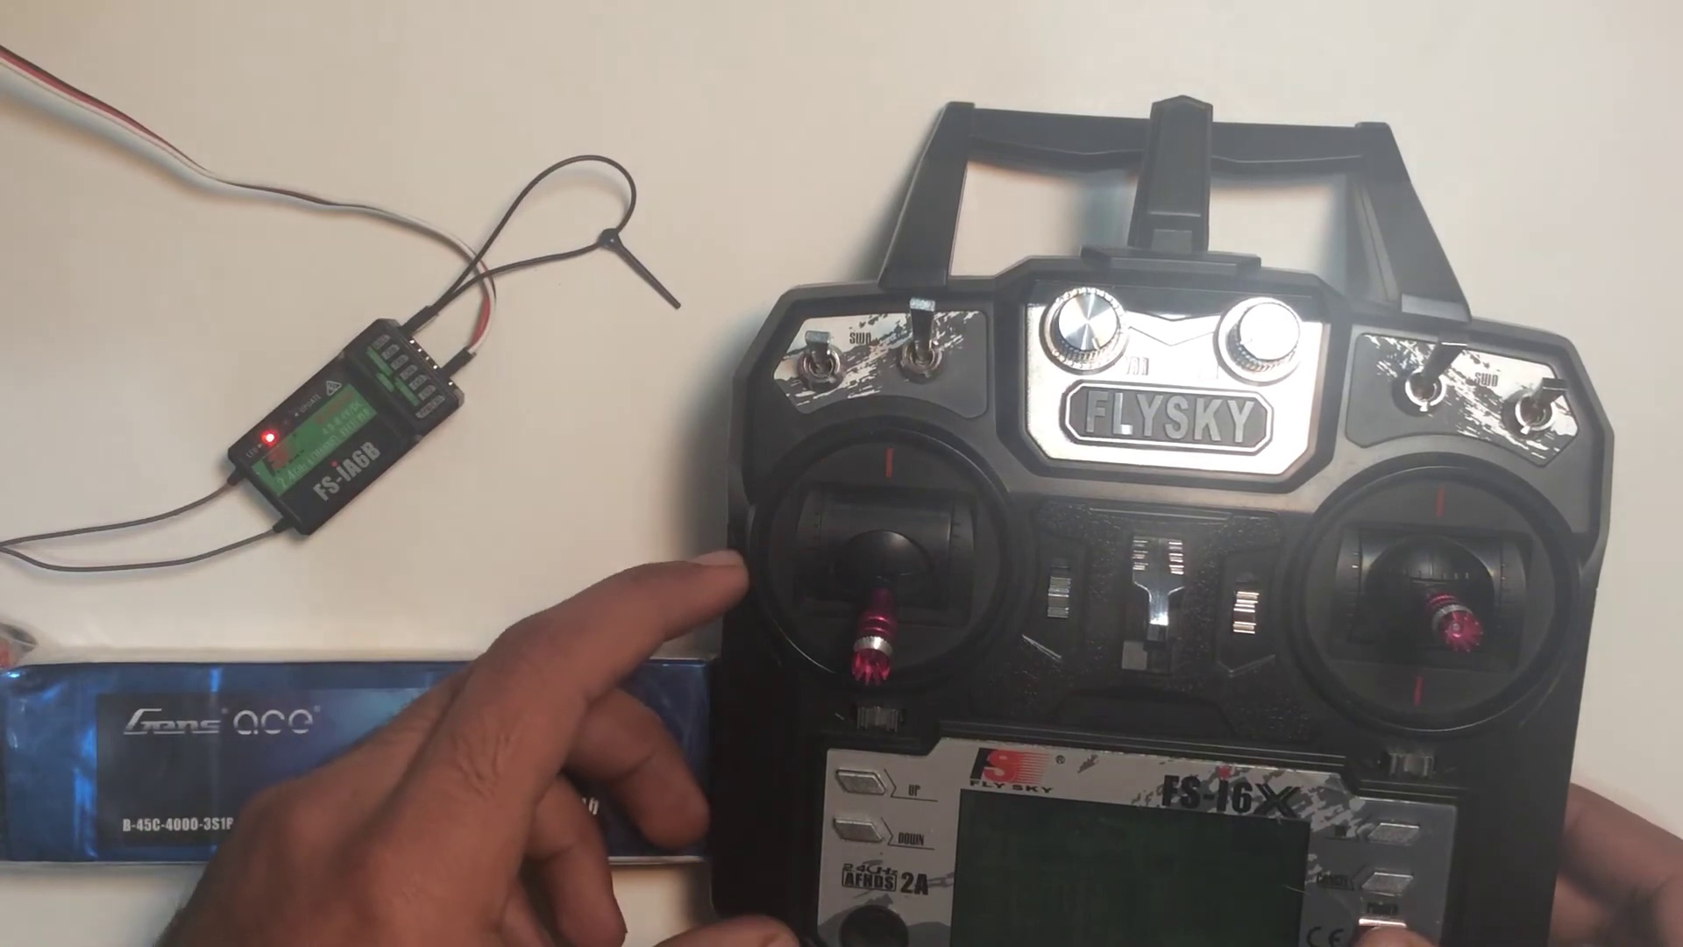 (score 95.0000)
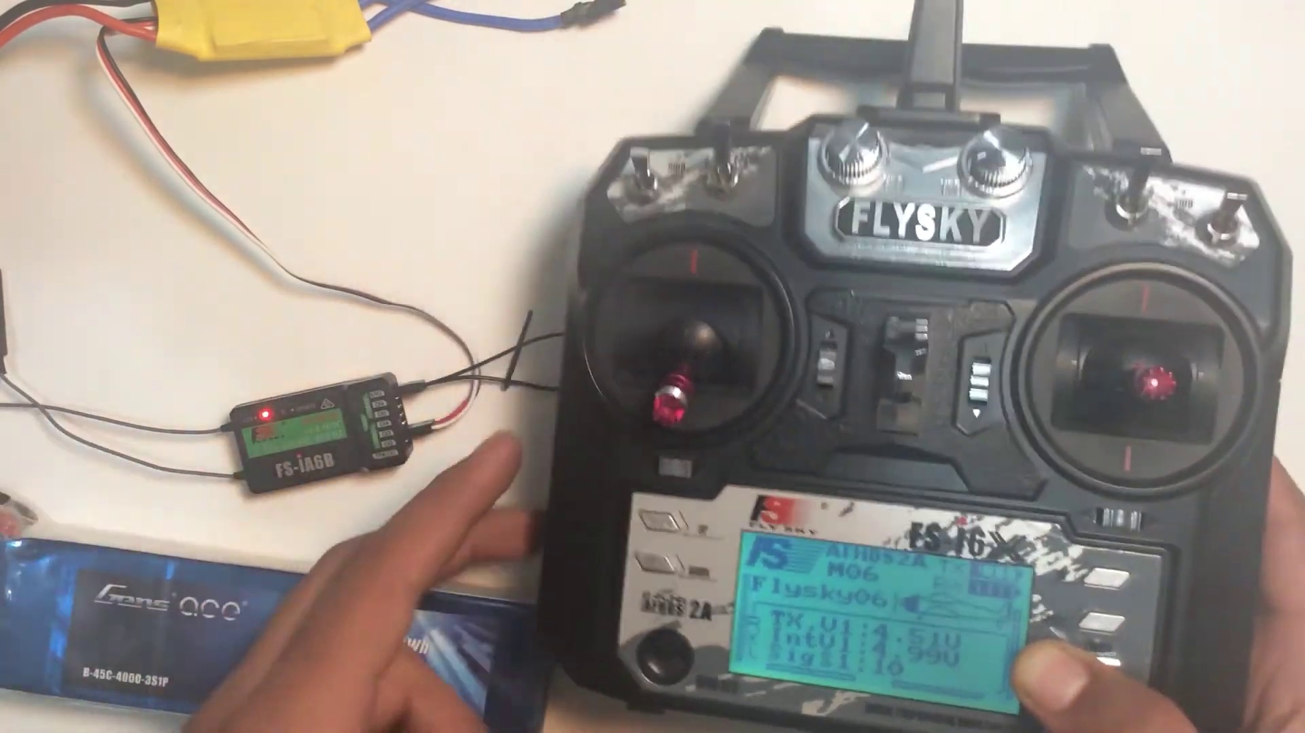 (score 95.0000)
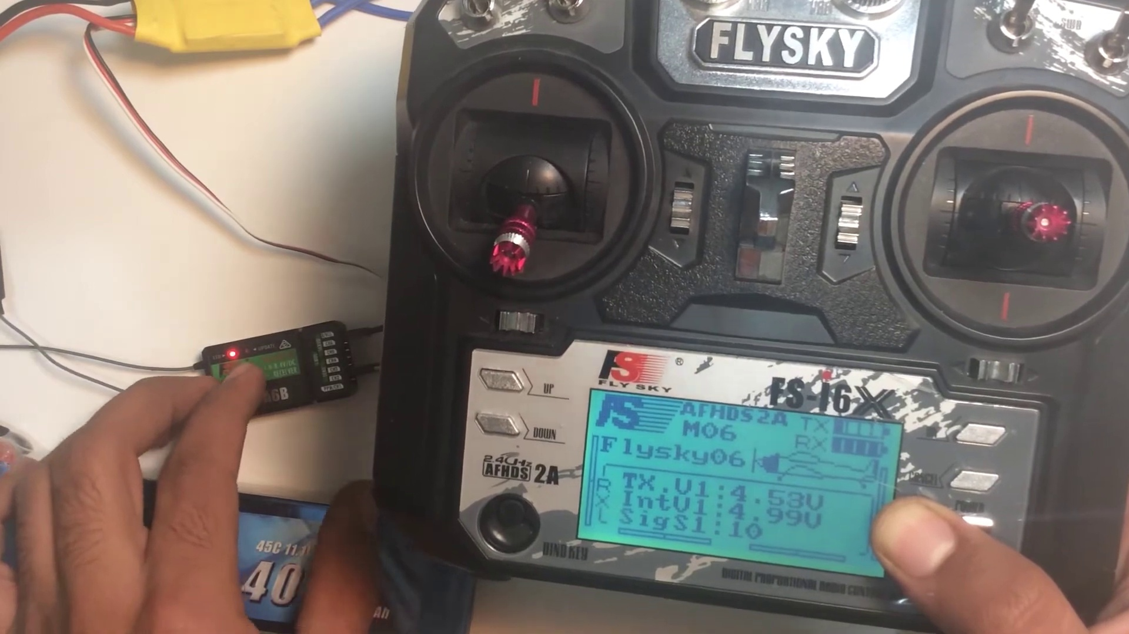 (score 95.0000)
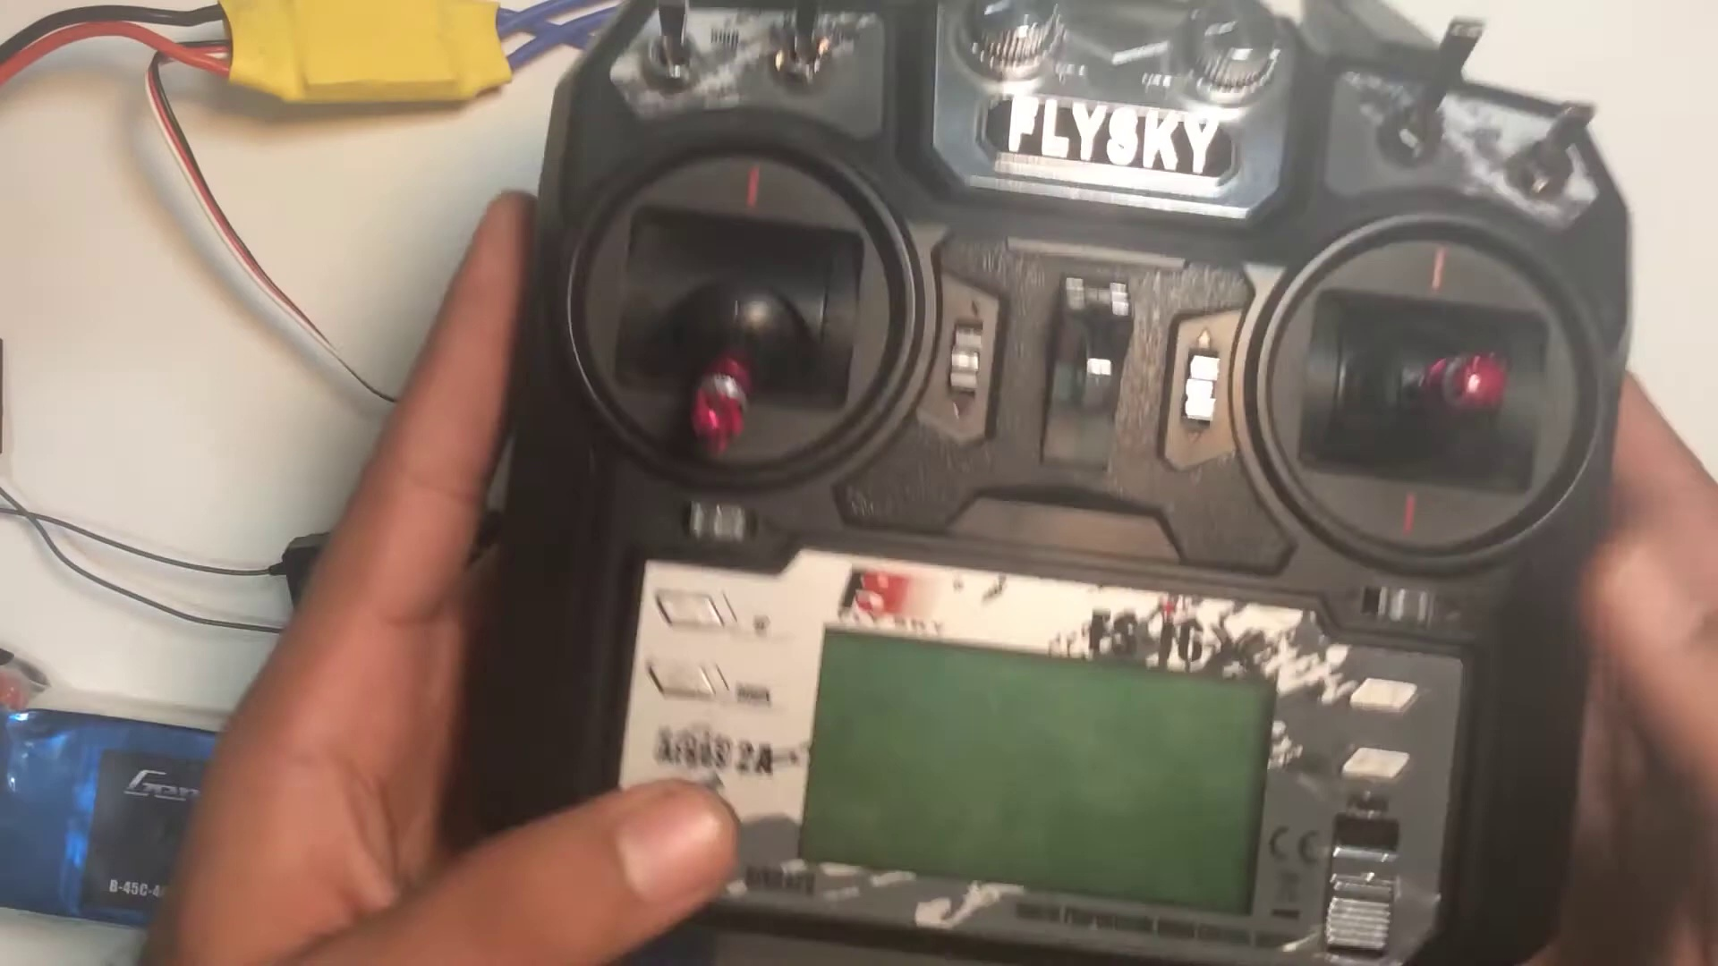 (score 95.0000)
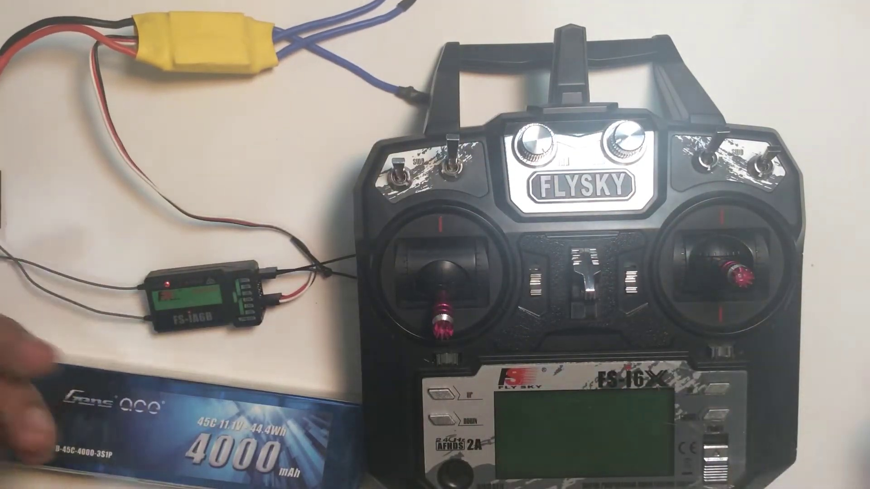 (score 95.0000)
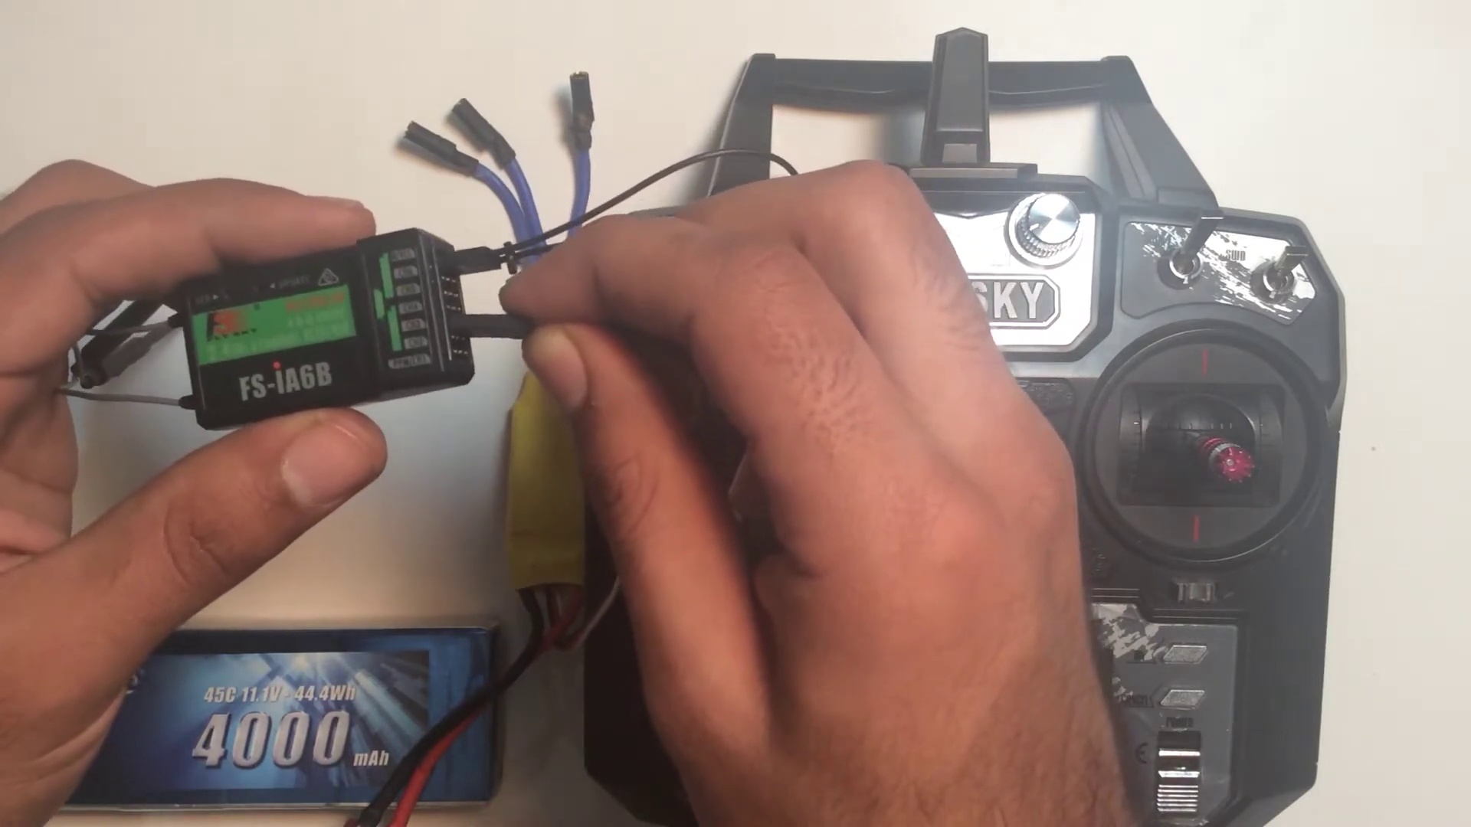 (score 95.0000)
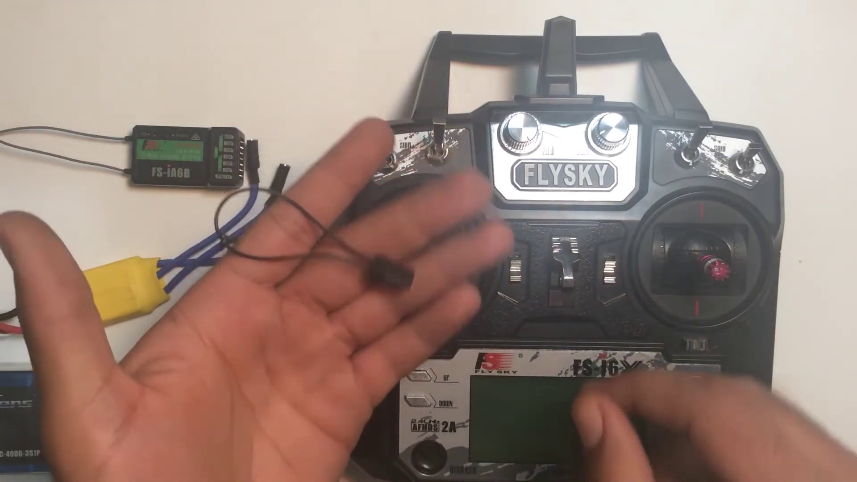 (score 95.0000)
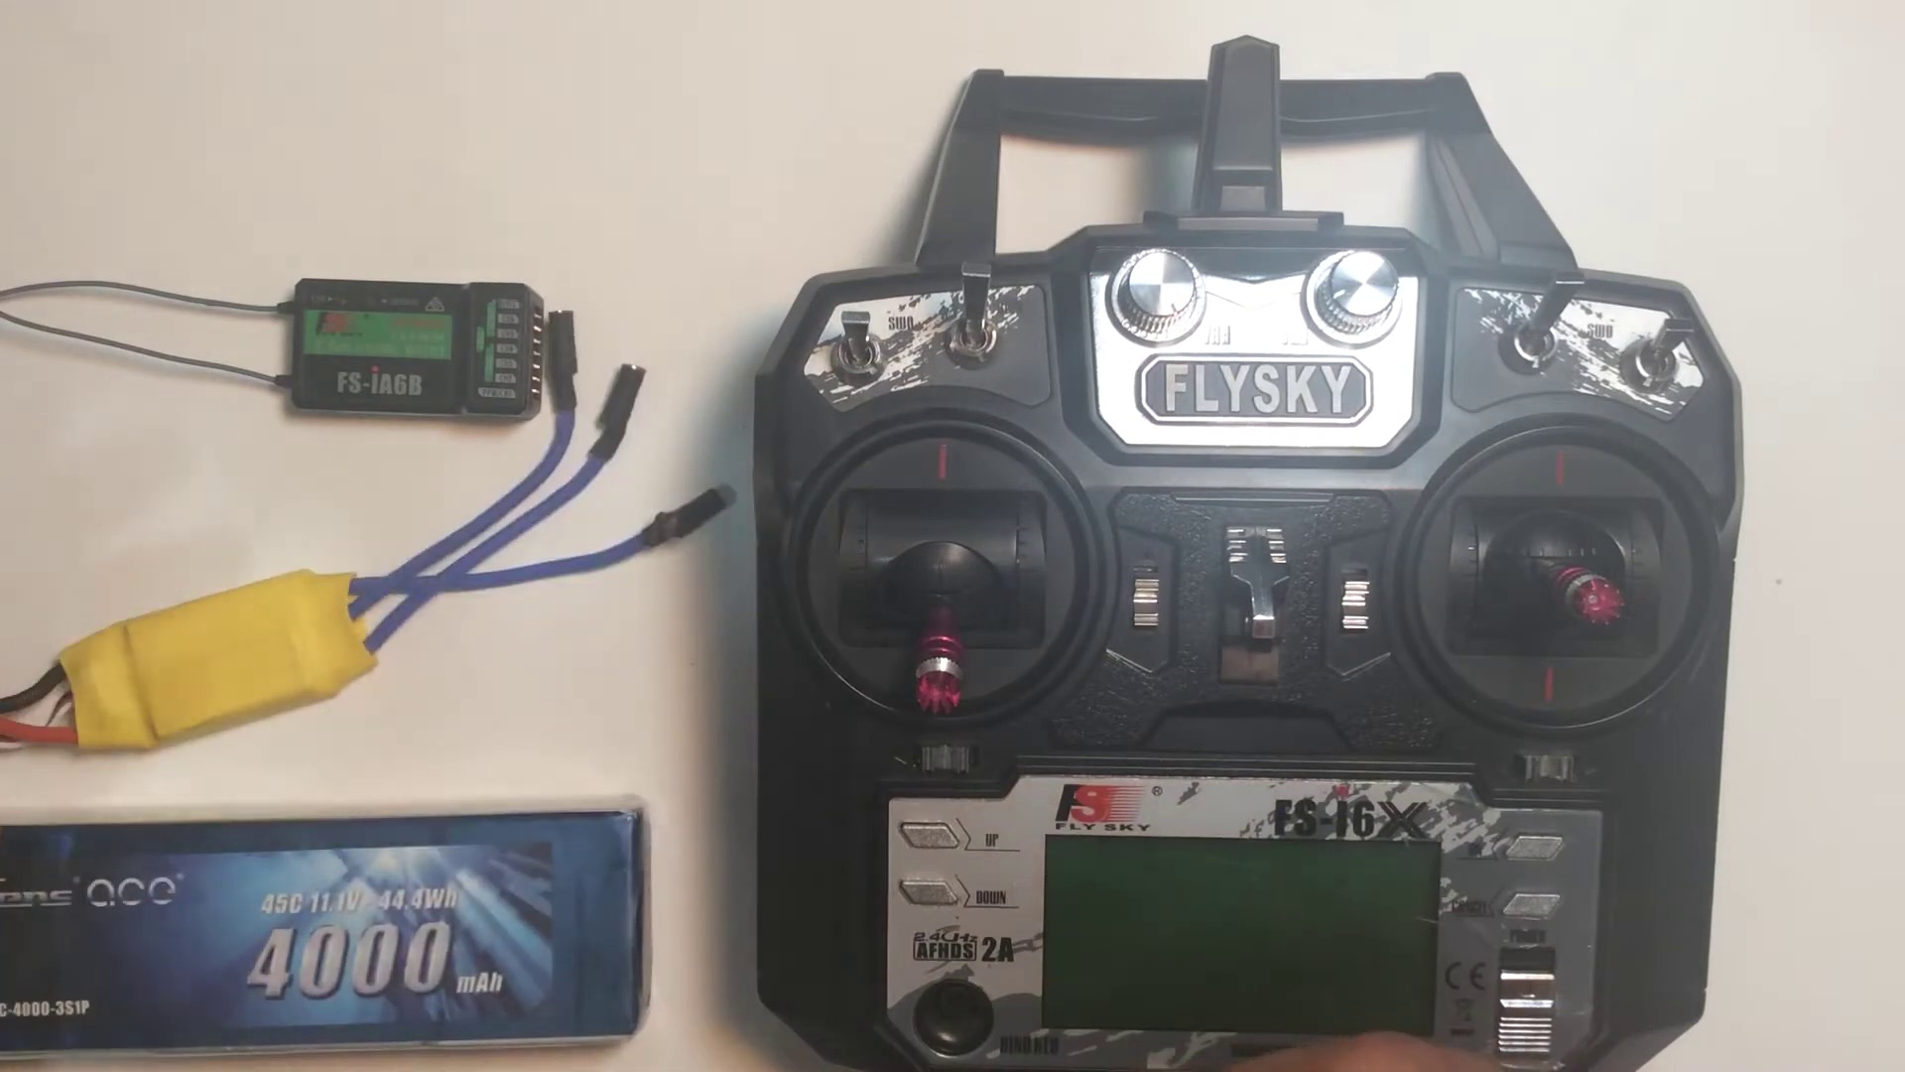 (score 95.0000)
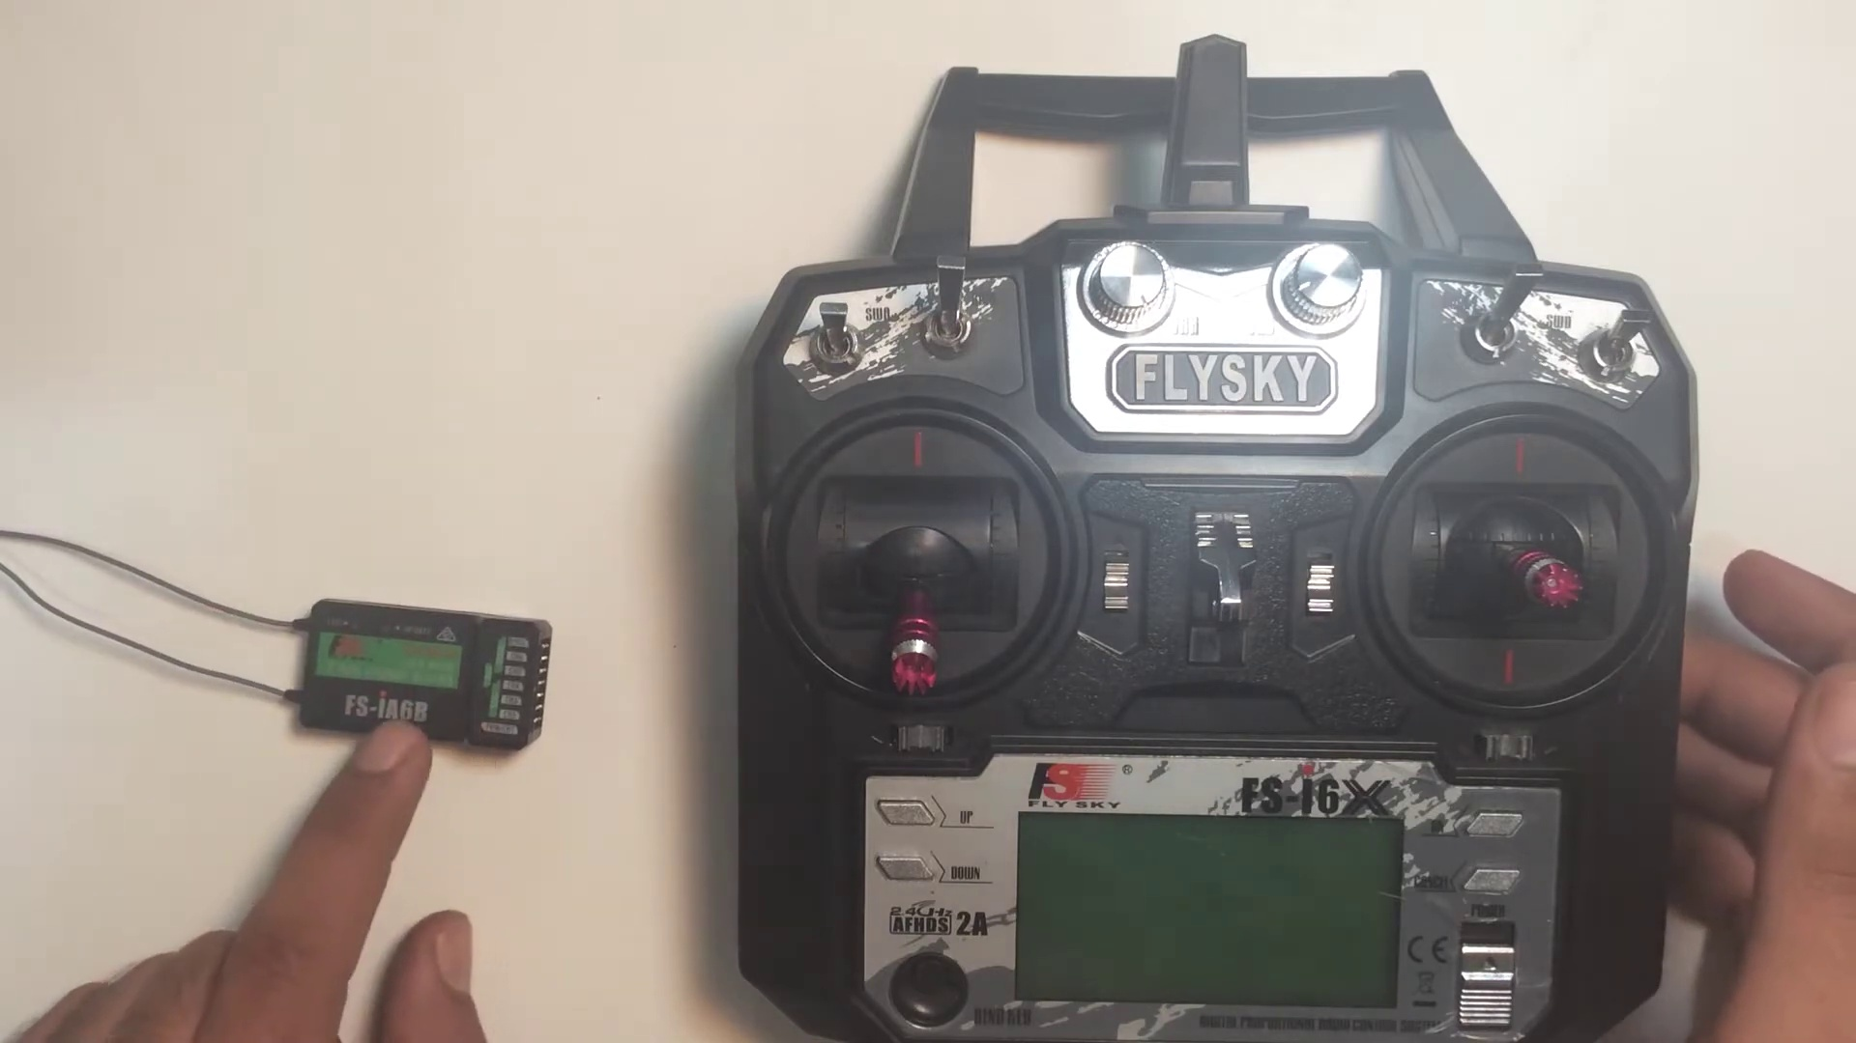 (score 95.0000)
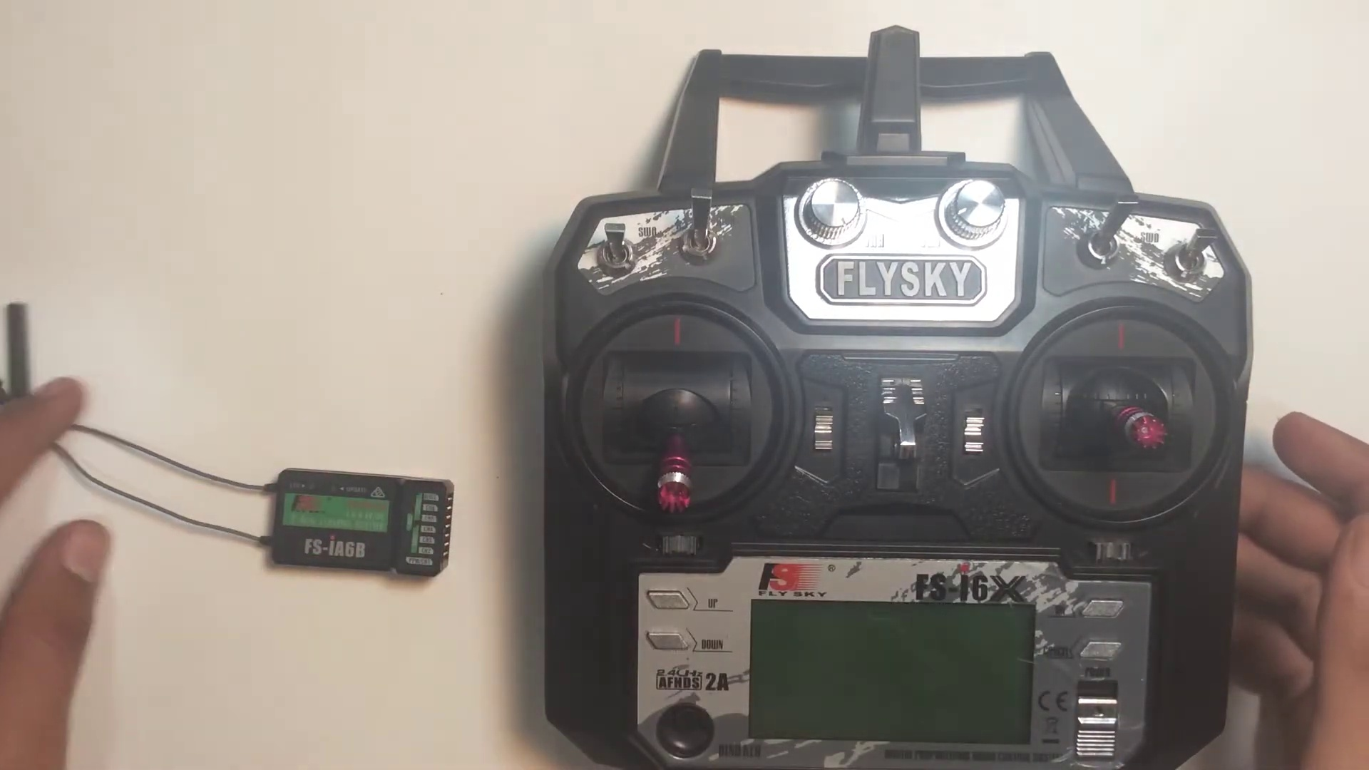 (score 95.0000)
Least correlated frames:
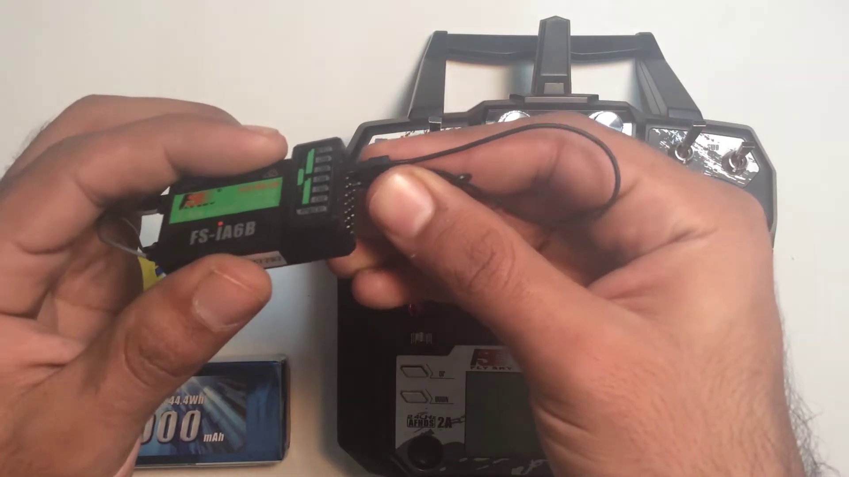 (score 10.0000)
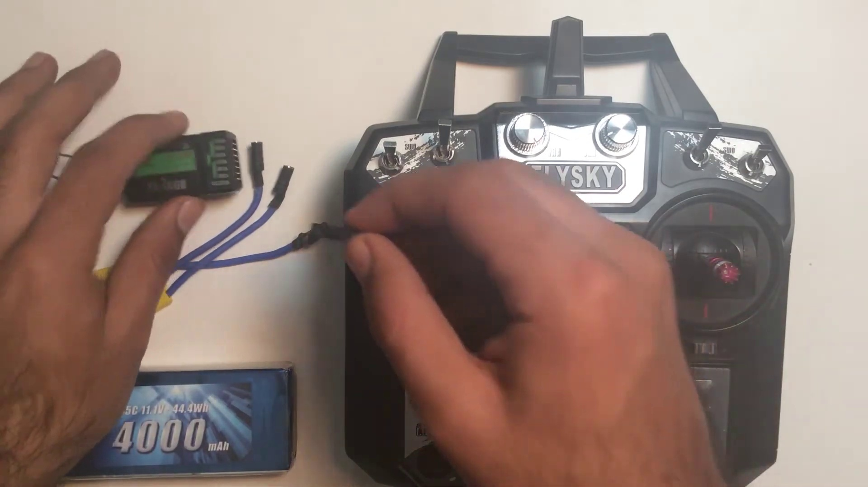 (score 20.0000)
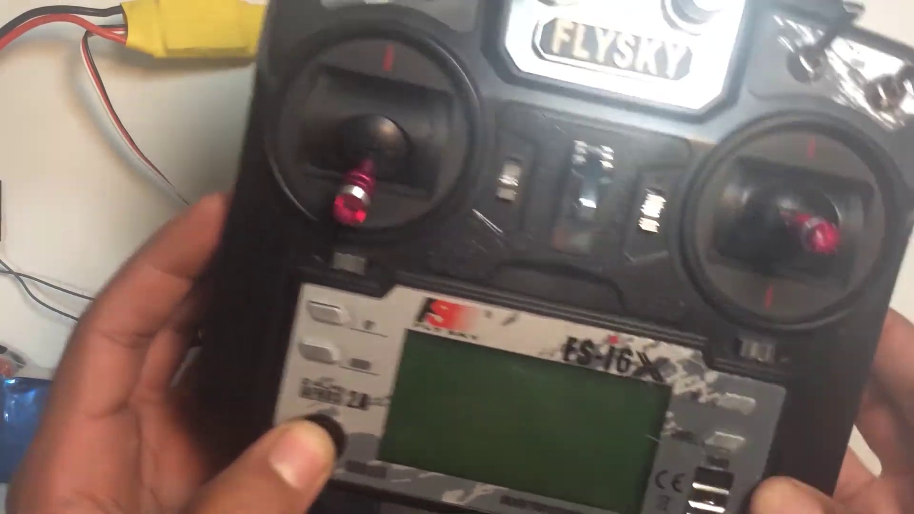 (score 20.0000)
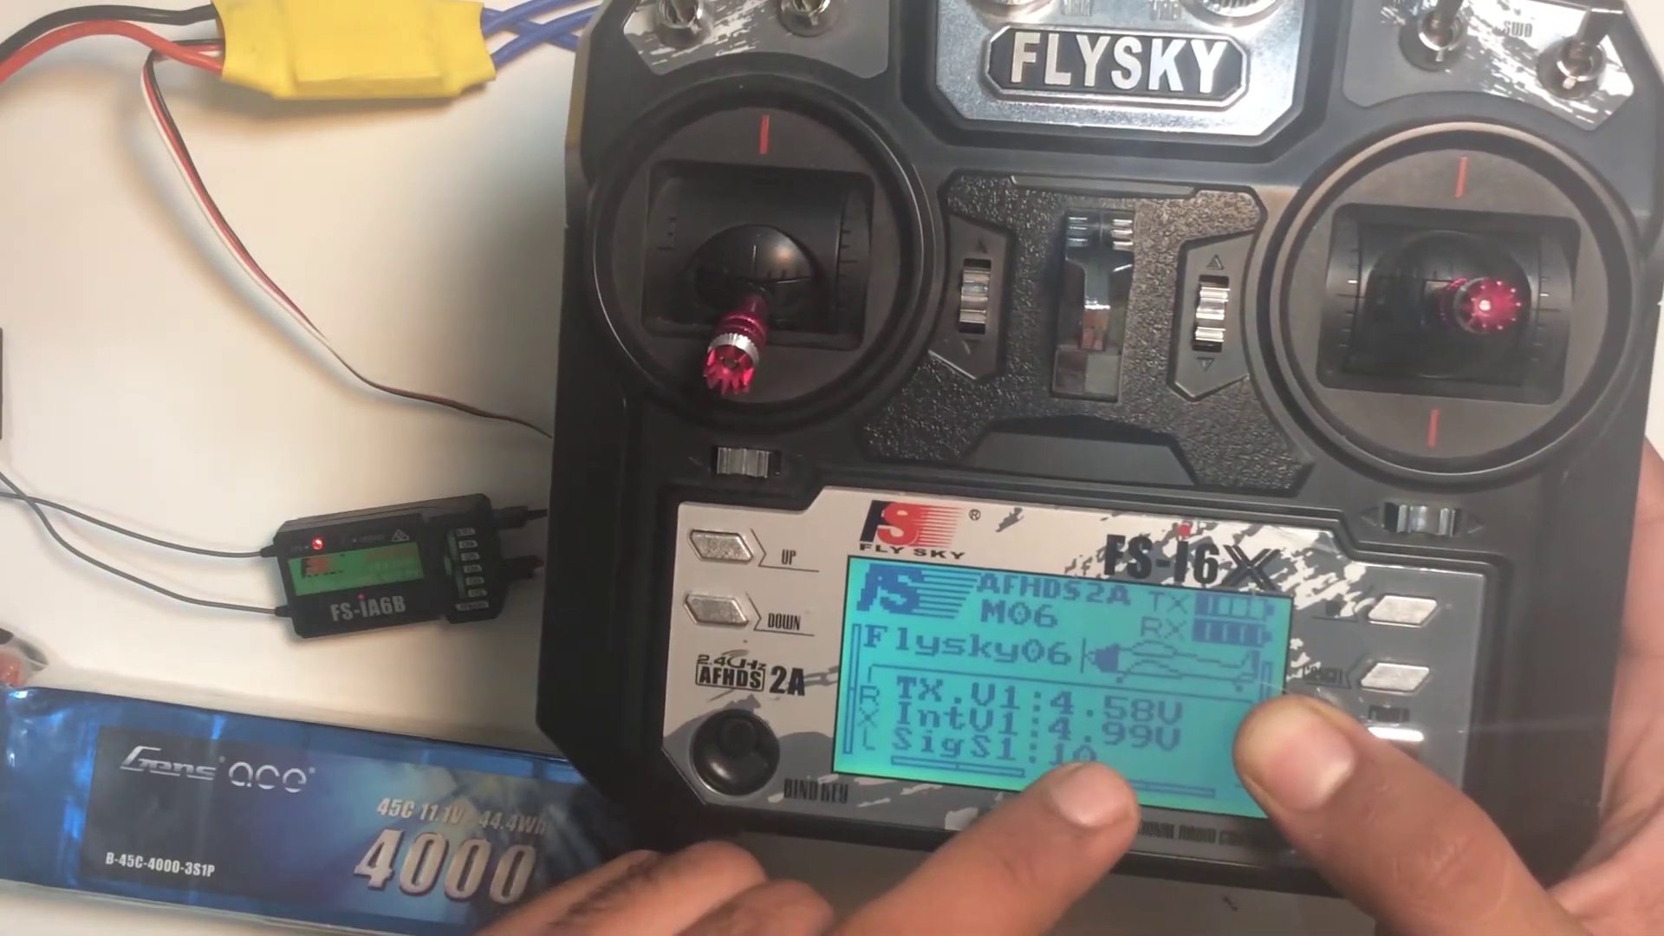 (score 20.0000)
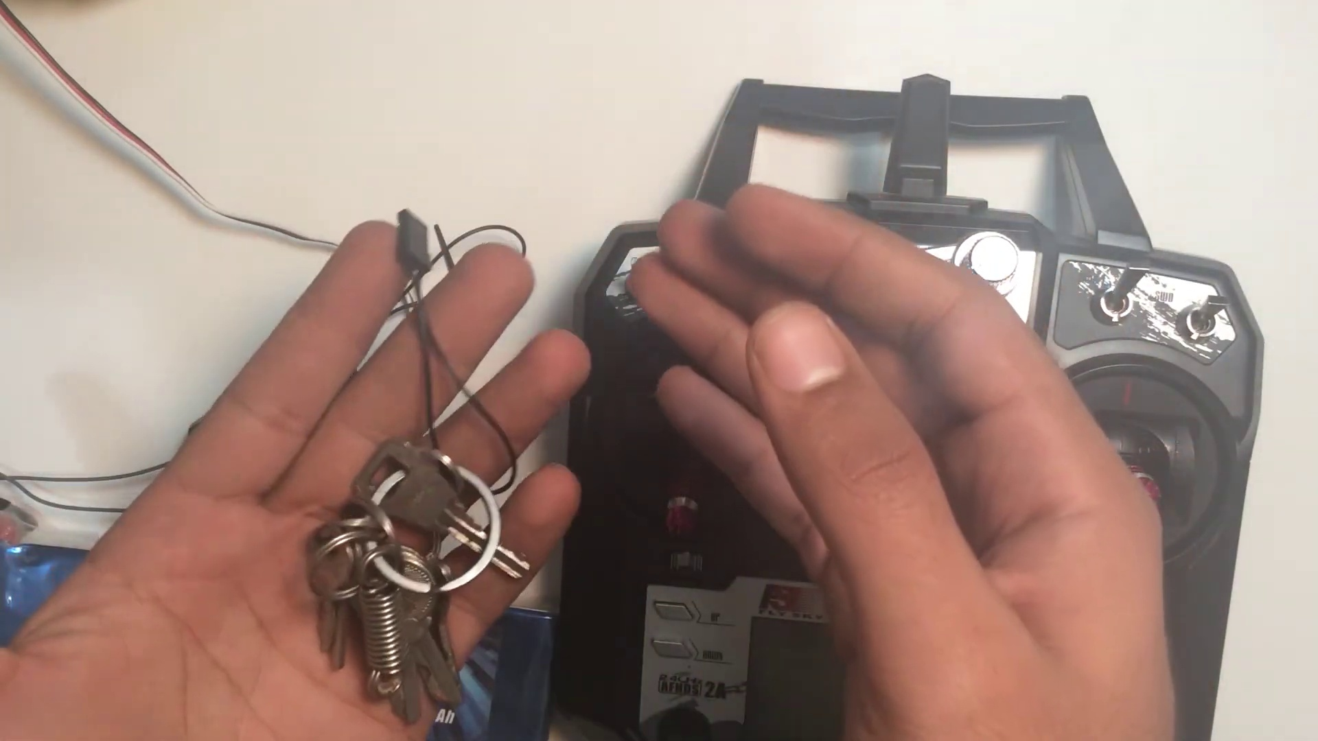 (score 20.0000)
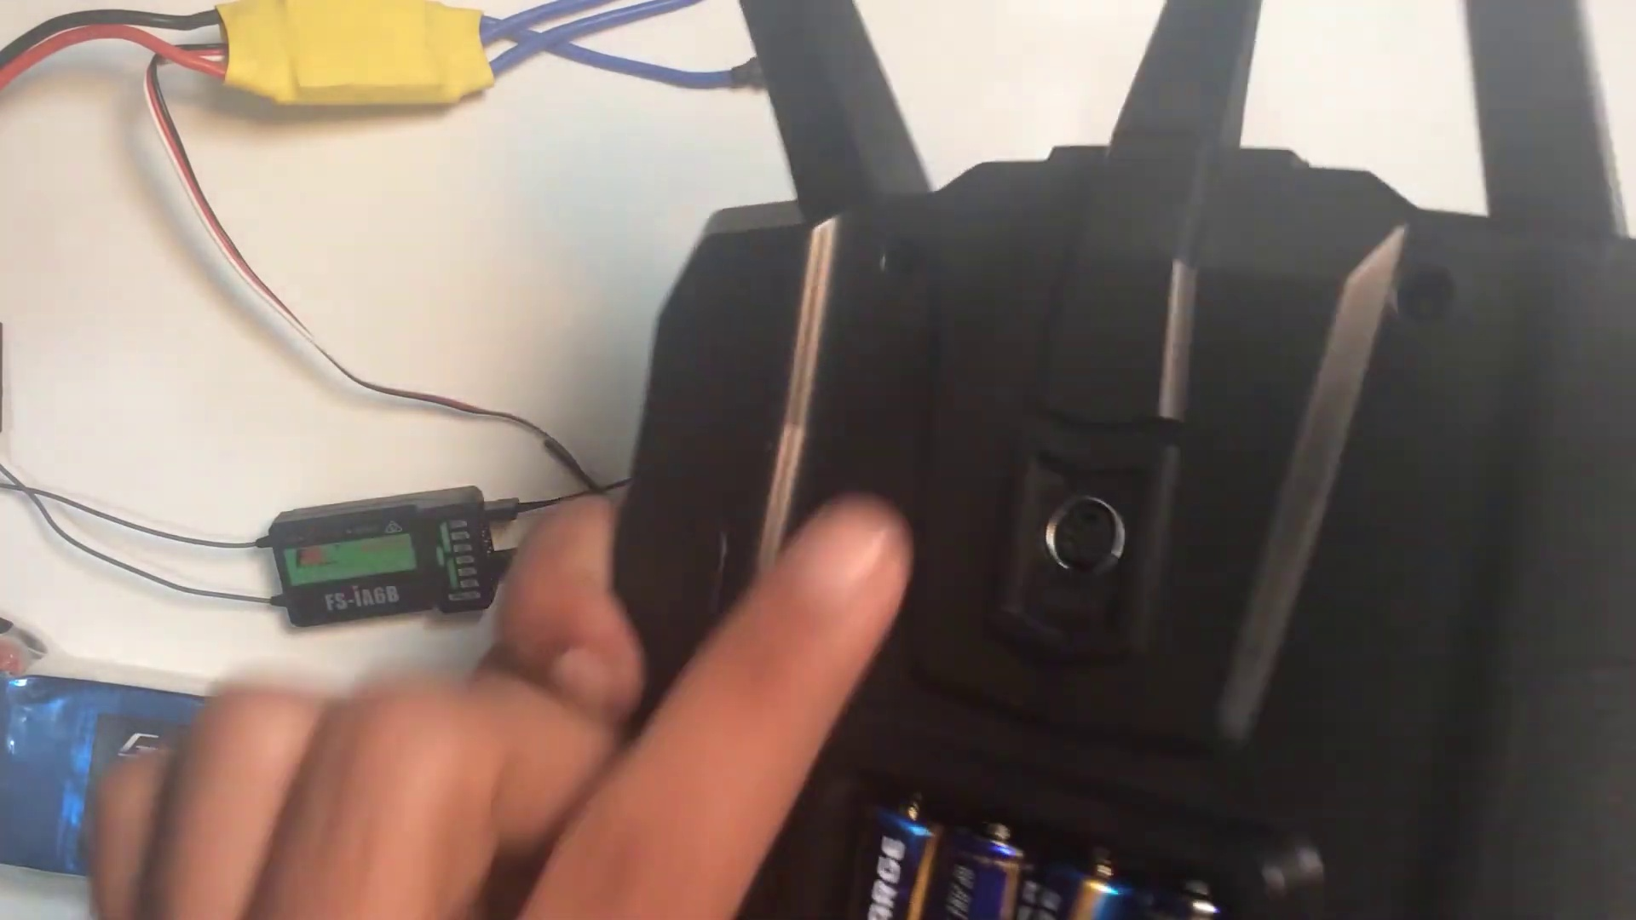 (score 30.0000)
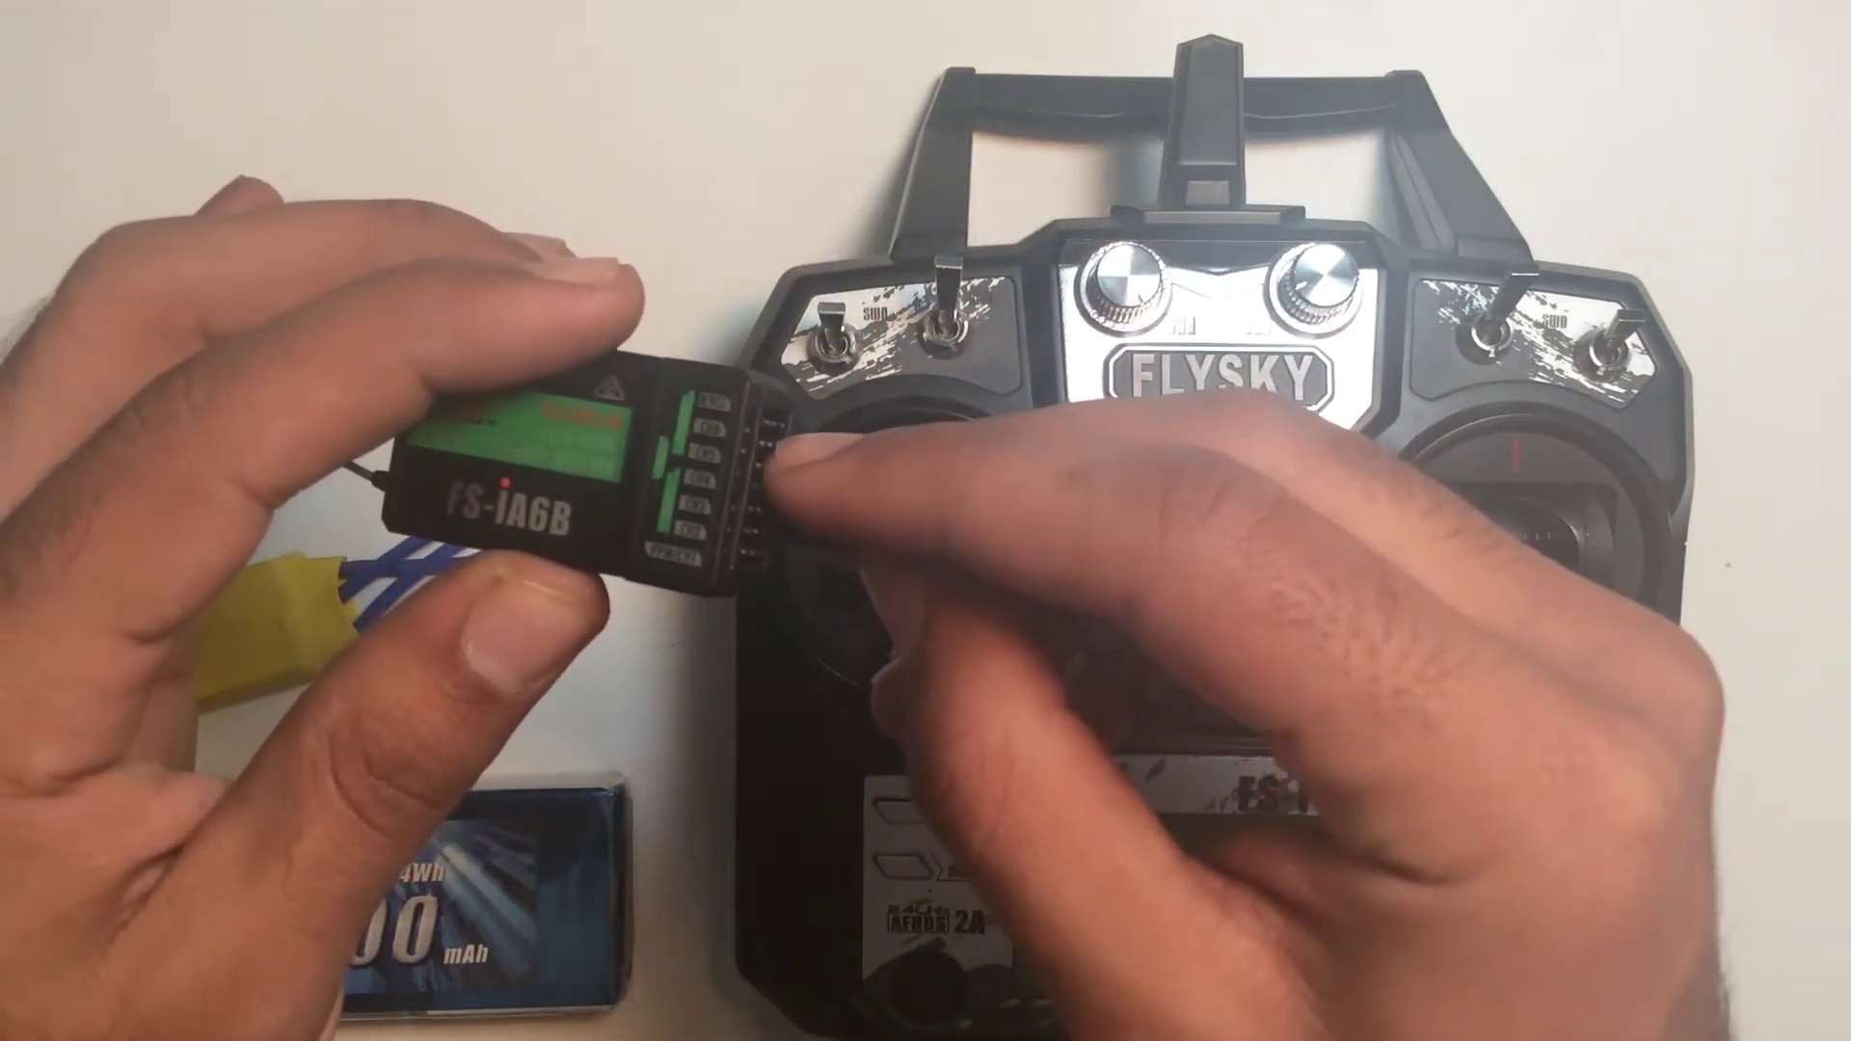 (score 80.0000)
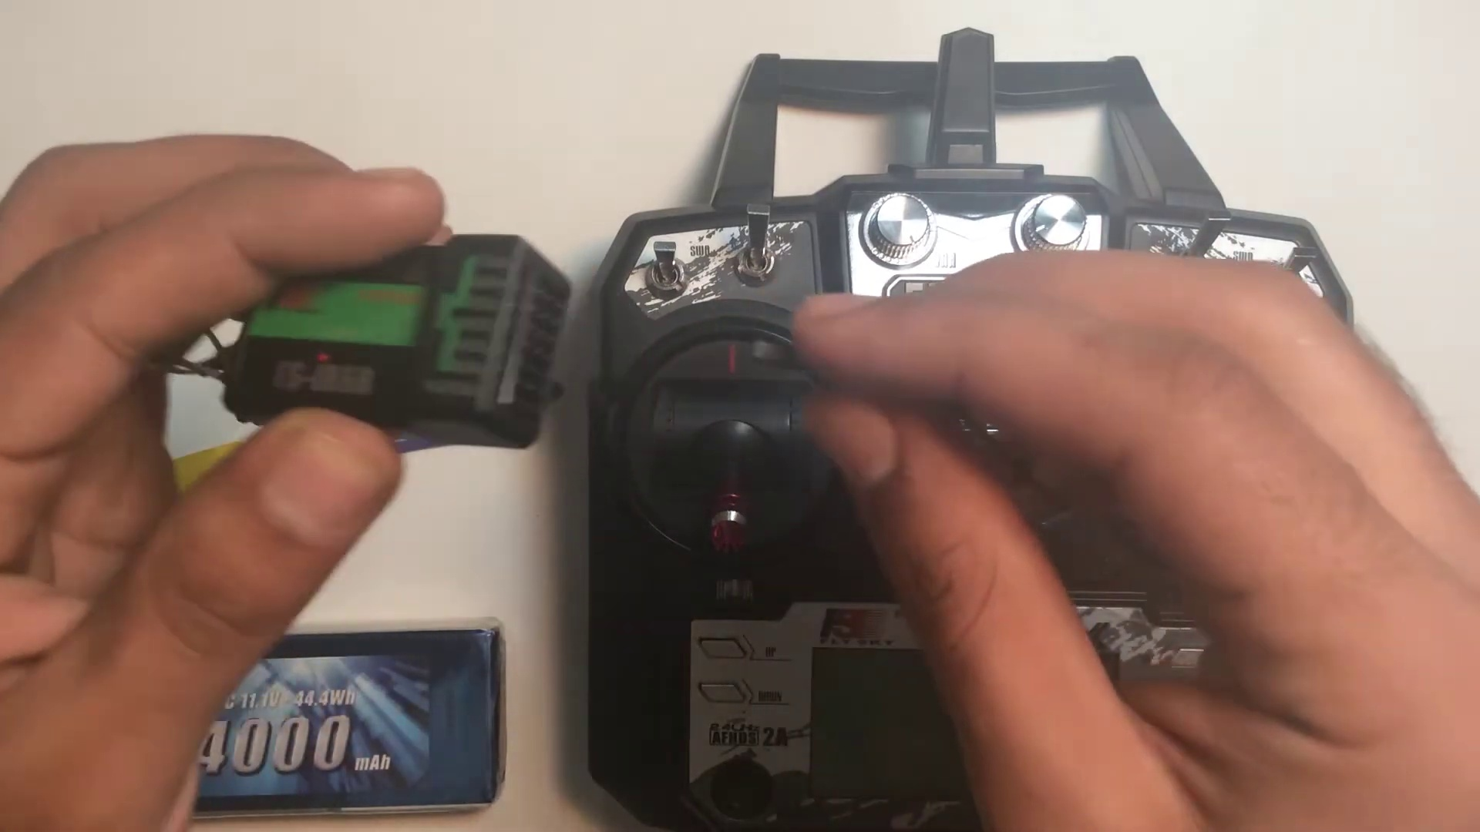 (score 80.0000)
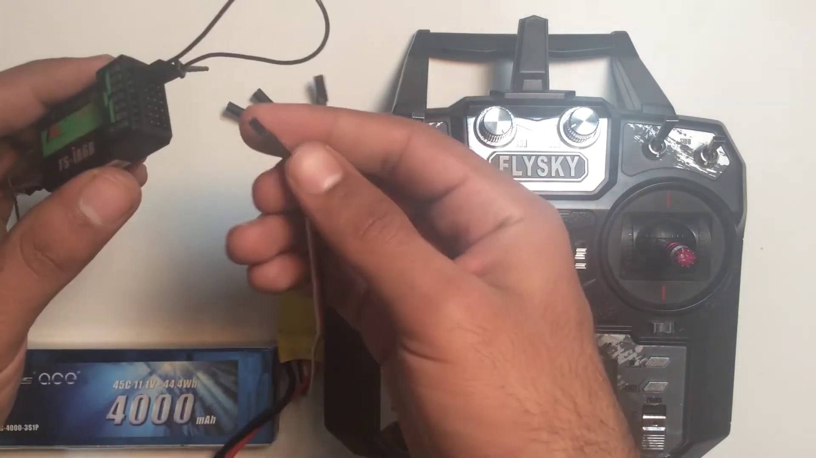 (score 80.0000)
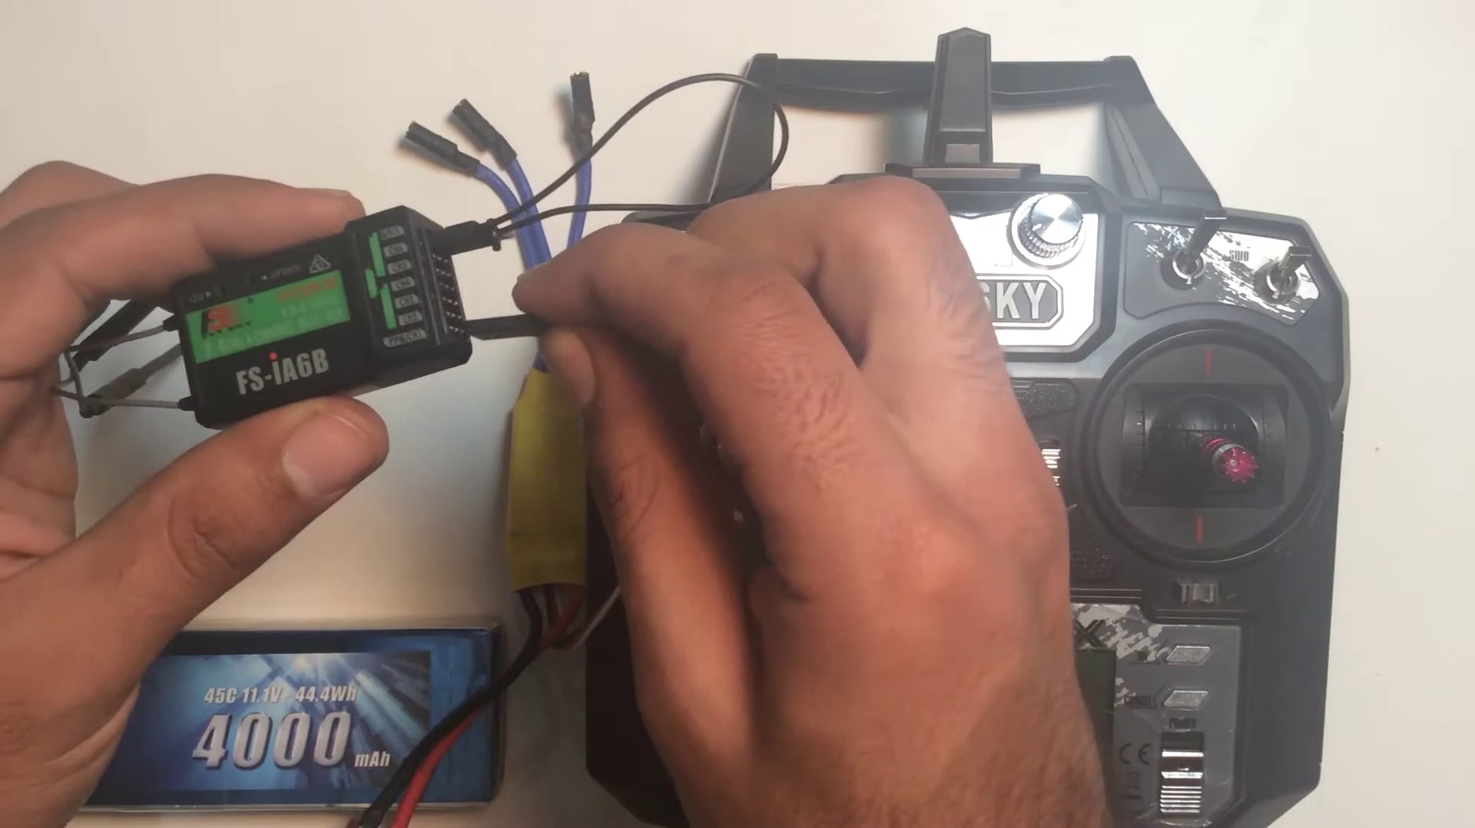 (score 80.0000)

Frame: frame_0000.jpg
Caption: The image presents a person's hand holding a remote control or transmitter, specifically a Flysky device. The device is positioned on a white surface, allowing for a clear focus on its details. A notable feature of the Flysky radio control device is the 2.4GHz receiver located at the bottom, which has a distinctive green and white color scheme that contrasts with the black and silver of the transmitter itself.
The Flysky logo is prominently displayed on the device, indicating its brand. The image also features a text overlay in white, reading "Flysky" and located on the upper left side, providing a clear label for the device.
In the background, a drone (likely a DJI Mavic, as indicated by the distinctive logo and design) is visible, with a small black device attached to it, possibly a remote control or transmitter. To the right of the drone lies a black case labeled "DJI Mavic Pro," suggesting it might be a spare battery pack. The focus appears to be on inspecting the components of the drone and its accessories.
Comment (score 90): This video opens up with the intent behind it, binding an fs-ia6b receiver to the transmitter of a FlySky. The creator goes on to tell you what you will need for this, an: ESC and battery to power the receiver and a bind key that activates the binding state of the receiver. Because of this, you will have to plug the bind key into the last port of the receiver that is used for input power. Then you must take the BEC wire of the ESC, which is the input power to the receiver, and plug it into any port on the receiver. The creator warns to make sure the signal (white) wire is facing upwards towards you. Lastly, he states to then plug the battery into the ESC and then the light in the receiver will begin to blink to represent it is in bind mode. He states that before turning the transmitter on to put all the switches up and the throttle down, press the bind key, and turn on the transmitter to show binding. He then states a few more facts and begins to wind up the video to a close.
Reason: The comment directly discusses the technical steps of binding an fs-ia6b receiver to a FlySky transmitter, mentioning specific components (ESC, battery, bind key) and settings (plug the BEC wire into any port on the receiver), which are all mentioned in the frame caption. The only deviation is that the comment goes beyond just describing the device's details and provides a tutorial on how to perform the binding process.
Source: https://www.youtube.com/watch?v=3cFSNRG2xfA: FLYSKY Fs-i6X BINDING | Fs-ia6b RECIVER

Frame: frame_0001.jpg
Caption: The image captures two moments of hands-on interaction with the Flysky brand, showcasing its radio control system. In one instance, a person is seen holding an open remote-controlled airplane (RC plane) with various buttons and switches surrounding the joysticks at the bottom center. The RC plane's fuselage contains a visible circuit board, suggesting that the person might be setting up the control system or demonstrating its components. Below the RC plane lies a small device labeled "Flysky," which is likely the radio-control system used to fly the plane.
In another instance, a person holds a sleek black Flysky radio controller in their left hand, with a white display glowing with green and red light. The right hand grasps a white remote control, its black and red buttons clearly visible against a stark white background. The text "Flysky" is prominently displayed on the controller, indicating that it's a product of the Flysky brand. The images do not provide information about the person's actions or the precise location of the objects, focusing solely on the physical components and interaction between the controller and remote.
Comment (score 95): This video opens up with the intent behind it, binding an fs-ia6b receiver to the transmitter of a FlySky. The creator goes on to tell you what you will need for this, an: ESC and battery to power the receiver and a bind key that activates the binding state of the receiver. Because of this, you will have to plug the bind key into the last port of the receiver that is used for input power. Then you must take the BEC wire of the ESC, which is the input power to the receiver, and plug it into any port on the receiver. The creator warns to make sure the signal (white) wire is facing upwards towards you. Lastly, he states to then plug the battery into the ESC and then the light in the receiver will begin to blink to represent it is in bind mode. He states that before turning the transmitter on to put all the switches up and the throttle down, press the bind key, and turn on the transmitter to show binding. He then states a few more facts and begins to wind up the video to a close.
Reason: The comment directly discusses the technical steps involved in binding a FlySky receiver to a transmitter, which is also described in the caption. The mention of specific components such as ESC, battery, bind key, and BEC wire matches the objects shown in the image, indicating a strong correlation.
Source: https://www.youtube.com/watch?v=3cFSNRG2xfA: FLYSKY Fs-i6X BINDING | Fs-ia6b RECIVER

Frame: frame_0002.jpg
Caption: The image shows a close-up view of a person's hands working with an electronic device that appears to be the Flysky F16X remote control, resting on a white surface. The remote control is equipped with a red LED display and a gray button, with the name "Flysky" prominently displayed on its front panel. A small receiver-like device is visible nearby, suggesting that the remote control is likely connected to a larger device.
The person's hands are actively engaged with adjusting or manipulating the transmitter. Their left hand is holding the transmitter, while their right hand seems to be pointing at something off-camera, possibly explaining or demonstrating the device's features or usage. The setting appears to be a casual indoor environment, as indicated by the table visible in the background with some indistinct items on it.
No text is clearly legible in this image, and there are no diagrams, slides, or other educational materials present that would provide additional context about the device or any instructions being given. The image seems to capture a moment of someone demonstrating or setting up the transmitter rather than teaching from prepared materials.
Comment (score 95): This video opens up with the intent behind it, binding an fs-ia6b receiver to the transmitter of a FlySky. The creator goes on to tell you what you will need for this, an: ESC and battery to power the receiver and a bind key that activates the binding state of the receiver. Because of this, you will have to plug the bind key into the last port of the receiver that is used for input power. Then you must take the BEC wire of the ESC, which is the input power to the receiver, and plug it into any port on the receiver. The creator warns to make sure the signal (white) wire is facing upwards towards you. Lastly, he states to then plug the battery into the ESC and then the light in the receiver will begin to blink to represent it is in bind mode. He states that before turning the transmitter on to put all the switches up and the throttle down, press the bind key, and turn on the transmitter to show binding. He then states a few more facts and begins to wind up the video to a close.
Reason: The comment directly discusses the technical steps of binding an fs-ia6b receiver to a FlySky transmitter, which is also depicted in the frame caption. The caption describes a person adjusting or manipulating the transmitter, and the comment explains how to do this through specific steps involving the receiver, ESC, battery, and bind key.
Source: https://www.youtube.com/watch?v=3cFSNRG2xfA: FLYSKY Fs-i6X BINDING | Fs-ia6b RECIVER

Frame: frame_0003.jpg
Caption: The image shows a close-up of a Flysky RC transmitter and receiver set, with a black strap connecting the two. The larger transmitter features a large display screen and a set of buttons, while the smaller receiver rests on a white surface next to it. The text on the devices reads "Flysky", "F16", and "RX", indicating the brand and model of the set.
To the left of the transmitter is an open-boxed device that resembles a handheld game controller, possibly the transmitter for controlling the remote-controlled aircraft, or drone. On top of this device, there's a label that reads "Flysky". The lower part of the device has labels indicating various components and specifications: "GPS," "GYRO," "ACCELEROMETER," "MICROSD," "RX/TX," and "BATTERY." These features suggest that the device is equipped with advanced technologies such as GPS navigation, accelerometer sensors for motion tracking, and a transmitter/receiver unit.
In front of the devices are two batteries; one appears to be being inserted into the drone by someone working on it. The batteries have labels indicating their voltage (9V) and capacity (1000mAh).
To the right of the device is a microSD card lying on its side, possibly containing additional software or firmware for the devices.
The background is blurred but seems to be an indoor setting with a white wall and a portion of a tabletop visible. The overall context suggests that someone is either preparing to fly a remote-controlled aircraft or performing maintenance on one.
Comment (score 85): This video opens up with the intent behind it, binding an fs-ia6b receiver to the transmitter of a FlySky. The creator goes on to tell you what you will need for this, an: ESC and battery to power the receiver and a bind key that activates the binding state of the receiver. Because of this, you will have to plug the bind key into the last port of the receiver that is used for input power. Then you must take the BEC wire of the ESC, which is the input power to the receiver, and plug it into any port on the receiver. The creator warns to make sure the signal (white) wire is facing upwards towards you. Lastly, he states to then plug the battery into the ESC and then the light in the receiver will begin to blink to represent it is in bind mode. He states that before turning the transmitter on to put all the switches up and the throttle down, press the bind key, and turn on the transmitter to show binding. He then states a few more facts and begins to wind up the video to a close.
Reason: The comment directly discusses the technical steps involved in binding an FS-IA6B receiver to a FlySky transmitter, matching the objects (receiver and transmitter) and settings (binding mode) described in the caption.
Source: https://www.youtube.com/watch?v=3cFSNRG2xfA: FLYSKY Fs-i6X BINDING | Fs-ia6b RECIVER

Frame: frame_0004.jpg
Caption: The image shows a black Flysky radio control (RC) device equipped with advanced features such as a 6-channel receiver and a 2.4GHz antenna. The device's display screen is lit up, displaying a green signal, indicating that it's ready for use. Next to the device, a yellow connector is visible, possibly a battery or an extension cord. In contrast, another image shows a different RC controller with various components attached, likely being used for repair, modification, or assembly work. This Hitec HS-150 controller has instructional manual next to it and features wires connected to a battery pack and other electronic components. The images are captured from different angles, one showing the backside of the controller where the battery pack and cables are attached, while the other provides a frontal view of the Flysky device with its silver and black buttons gleaming against the white background.
Comment (score 90): This video opens up with the intent behind it, binding an fs-ia6b receiver to the transmitter of a FlySky. The creator goes on to tell you what you will need for this, an: ESC and battery to power the receiver and a bind key that activates the binding state of the receiver. Because of this, you will have to plug the bind key into the last port of the receiver that is used for input power. Then you must take the BEC wire of the ESC, which is the input power to the receiver, and plug it into any port on the receiver. The creator warns to make sure the signal (white) wire is facing upwards towards you. Lastly, he states to then plug the battery into the ESC and then the light in the receiver will begin to blink to represent it is in bind mode. He states that before turning the transmitter on to put all the switches up and the throttle down, press the bind key, and turn on the transmitter to show binding. He then states a few more facts and begins to wind up the video to a close.
Reason: The comment directly discusses the technical steps of binding an fs-ia6b receiver to a FlySky transmitter, mentioning specific components and settings described in the caption, such as the 2.4GHz antenna, green signal, battery pack, and ESC wires.
Source: https://www.youtube.com/watch?v=3cFSNRG2xfA: FLYSKY Fs-i6X BINDING | Fs-ia6b RECIVER

Frame: frame_0005.jpg
Caption: The image presents a scene with two main components: an electronic device, likely a DIY RC (radio-controlled) quadcopter, and a controller. The quadcopter has a black frame with a central battery pack labeled "400mAh" on the bottom left. Four arms extend from the center, each equipped with a small propeller. A white label on the battery pack contains text that is too small to read clearly due to the image resolution.
Nearby, two wires are connected to the quadcopter: one black wire with a red connector and another white wire with a black connector, which appear to be used for powering or charging the battery pack. On the right side of the quadcopter, an instruction manual or set of instructions is printed in English on what appears to be a piece of paper or cardboard cutout with a barcode-like pattern.
In the foreground, a Flysky F-G10X controller is depicted in close-up view. The controller features two control sticks and a throttle on the right side, and it is plugged into a black power supply that shares its black and silver color scheme. A small green box labeled "F-G10X" to the left of the controller likely contains the battery for the controller.
A second white box with the text "4000mAh" printed on it appears to be the battery pack for the power supply, situated on the right side of the controller. The controller and power supply are placed on a white surface, creating a striking contrast with their black and silver colors. The organized setup suggests that this is a well-prepared environment for flying the Flysky F-G10X controller.
No strongly correlated comments found for this frame.

Frame: frame_0006.jpg
Caption: The image shows a person holding a black and silver remote control, labeled "Flysky", with a green LED light on top indicating its current use. The person is wearing a matching black wristband with the same label, "Flysky". Their left hand grasps the remote control tightly, with their right hand reaching towards various controls and buttons on the device, which appears to be a vehicle remote control, possibly for a helicopter or drone, given the presence of joysticks and what looks like a throttle lever. The right hand is also holding onto a black object that seems to be an antenna or receiver connected to the device.
The background suggests an indoor setting with a table, possibly a workspace or hobby area, and there are some other electronic devices and equipment around, although the focus remains on the interaction between the person and the remote control.
Comment (score 95): This video opens up with the intent behind it, binding an fs-ia6b receiver to the transmitter of a FlySky. The creator goes on to tell you what you will need for this, an: ESC and battery to power the receiver and a bind key that activates the binding state of the receiver. Because of this, you will have to plug the bind key into the last port of the receiver that is used for input power. Then you must take the BEC wire of the ESC, which is the input power to the receiver, and plug it into any port on the receiver. The creator warns to make sure the signal (white) wire is facing upwards towards you. Lastly, he states to then plug the battery into the ESC and then the light in the receiver will begin to blink to represent it is in bind mode. He states that before turning the transmitter on to put all the switches up and the throttle down, press the bind key, and turn on the transmitter to show binding. He then states a few more facts and begins to wind up the video to a close.
Reason: The comment directly discusses the technical steps described in the caption, including binding a receiver to a transmitter and setting up the bind key, which is the same green LED light mentioned in the caption. The mention of specific components like ESC, battery, and BEC wire also matches the objects seen in the image.
Source: https://www.youtube.com/watch?v=3cFSNRG2xfA: FLYSKY Fs-i6X BINDING | Fs-ia6b RECIVER

Frame: frame_0007.jpg
Caption: The image captures a moment of hands-on technology where a person is engaged in assembling or modifying an electronic device. The individual's hands are working with wires and equipment, possibly related to electronics or automotive systems, given the presence of a device that resembles an aftermarket air freshener dispenser with LED lights and a control module with buttons and knobs. Visible wires connected to the control module suggest the person may be troubleshooting, assembling, or modifying the device.
In the foreground, a sleek black remote control with a green and black logo is being connected to a battery pack, which is a rectangular black object with a white label. The person's fingers are actively involved in the task, with one hand holding the remote control and the other hand firmly grasping the battery pack.
The backdrop appears to be a plain indoor setting with a white wall and a partial view of what might be a door or window frame in the upper left corner. The scene is devoid of any discernible text, diagrams, or instructional elements that would indicate an educational context. The focus remains on hands-on activity with electronics equipment, suggesting a moment of assembly, modification, or troubleshooting.
No strongly correlated comments found for this frame.

Frame: frame_0008.jpg
Caption: The image shows a person engaged in hands-on learning or tinkering, with two distinct electronic devices prominently featured. The first device appears to be an electronic board, possibly part of a hobbyist electronics project or DIY endeavor. The individual is actively working on the wiring and connections, suggesting they might be adjusting the device for improved functionality or as part of an educational process to demonstrate how it works.
The second device is a remote control, a black and silver gadget resting on a white surface. The person's hands are carefully examining the remote control, focusing on its digital screen, which displays a vibrant green list of options with the words "TS-18B" clearly visible. This suggests that the individual might be in the process of understanding or adjusting the settings of the remote control.
In the background, a blue and white box is visible, bearing the words "10000", possibly indicating the capacity of the battery inside the remote control. The overall environment appears to be one of learning and exploration, with both devices serving as tools for understanding and adjusting their functionalities.
Comment (score 85): This video opens up with the intent behind it, binding an fs-ia6b receiver to the transmitter of a FlySky. The creator goes on to tell you what you will need for this, an: ESC and battery to power the receiver and a bind key that activates the binding state of the receiver. Because of this, you will have to plug the bind key into the last port of the receiver that is used for input power. Then you must take the BEC wire of the ESC, which is the input power to the receiver, and plug it into any port on the receiver. The creator warns to make sure the signal (white) wire is facing upwards towards you. Lastly, he states to then plug the battery into the ESC and then the light in the receiver will begin to blink to represent it is in bind mode. He states that before turning the transmitter on to put all the switches up and the throttle down, press the bind key, and turn on the transmitter to show binding. He then states a few more facts and begins to wind up the video to a close.
Reason: The comment directly discusses the binding process of an fs-ia6b receiver to a FlySky transmitter, which is strongly related to the frame caption's depiction of hands-on learning with electronic devices and remote controls. The comment provides technical steps, such as plugging in wires and activating the bind mode, which are closely tied to the objects and settings described in the caption.
Source: https://www.youtube.com/watch?v=3cFSNRG2xfA: FLYSKY Fs-i6X BINDING | Fs-ia6b RECIVER

Frame: frame_0009.jpg
Caption: The image shows a person's hands working with two electronic devices, which appear to be a digital camera and a radio control device. The digital camera, a Sony Cybershot model, is being opened by removing its side panel, likely to access the internal components such as batteries, SD card, or circuitry. A label on the screen in the bottom left corner confirms its identity as a Sony Cybershot.
In contrast, the radio control device held by the person's hands has a green screen and white keypad, with a green screwdriver being used to open it. The background of this image is a white wall with a black and white logo of the Flysky brand on it, indicating that this device belongs to the Flysky brand.
The overall setting suggests two workspaces: one for electronic devices and components (digital camera) and another for radio control devices (Flysky). The blurred background in the digital camera image appears to include various parts or components for electronics, possibly including batteries and chargers, as well as tools that might be used for repairing or modifying electronic devices.
Comment (score 80): This video opens up with the intent behind it, binding an fs-ia6b receiver to the transmitter of a FlySky. The creator goes on to tell you what you will need for this, an: ESC and battery to power the receiver and a bind key that activates the binding state of the receiver. Because of this, you will have to plug the bind key into the last port of the receiver that is used for input power. Then you must take the BEC wire of the ESC, which is the input power to the receiver, and plug it into any port on the receiver. The creator warns to make sure the signal (white) wire is facing upwards towards you. Lastly, he states to then plug the battery into the ESC and then the light in the receiver will begin to blink to represent it is in bind mode. He states that before turning the transmitter on to put all the switches up and the throttle down, press the bind key, and turn on the transmitter to show binding. He then states a few more facts and begins to wind up the video to a close.
Reason: The comment directly discusses the binding process of a FlySky receiver to a transmitter, which is mentioned in the caption as one of the two workspaces (radio control devices). The technical steps described in the comment, such as plugging the bind key into the last port of the receiver and connecting the BEC wire from the ESC, are also reflected in the caption's mention of electronic components and tools. The only reason it's not a perfect 100 score is that some of the technical details mentioned in the comment (like the binding process itself) are not explicitly described in the caption.
Source: https://www.youtube.com/watch?v=3cFSNRG2xfA: FLYSKY Fs-i6X BINDING | Fs-ia6b RECIVER

Frame: frame_0010.jpg
Caption: The image depicts a person's hands working with a small electronic device, specifically a black Flysky F4-iAgb remote control. The remote control is equipped with two antennas, one of which is visible in the foreground. The person's fingers are positioned on the buttons, suggesting they are in the process of operating the remote. The background of the image is a white wall, providing a stark contrast to the black remote control. On the wall, there's a white sticker with the word "FLYSKY" printed on it, located on the right side of the image, slightly above the midpoint.
The focus of the image is on the hands manipulating the remote control, likely demonstrating its operation or assembly. The person's hands are in a relaxed position, with the remote control resting comfortably in their grasp. The image captures a moment of interaction between the person and the remote control, emphasizing the control they have over the device.
Comment (score 90): This video opens up with the intent behind it, binding an fs-ia6b receiver to the transmitter of a FlySky. The creator goes on to tell you what you will need for this, an: ESC and battery to power the receiver and a bind key that activates the binding state of the receiver. Because of this, you will have to plug the bind key into the last port of the receiver that is used for input power. Then you must take the BEC wire of the ESC, which is the input power to the receiver, and plug it into any port on the receiver. The creator warns to make sure the signal (white) wire is facing upwards towards you. Lastly, he states to then plug the battery into the ESC and then the light in the receiver will begin to blink to represent it is in bind mode. He states that before turning the transmitter on to put all the switches up and the throttle down, press the bind key, and turn on the transmitter to show binding. He then states a few more facts and begins to wind up the video to a close.
Reason: The comment directly discusses the technical steps involved in binding an fs-ia6b receiver to a FlySky transmitter, which is the same process depicted in the frame caption. The comment mentions specific components (ESC, battery, bind key) and settings (plugging wires into ports), as well as goals (representing the receiver's binding state with a blinking light).
Source: https://www.youtube.com/watch?v=3cFSNRG2xfA: FLYSKY Fs-i6X BINDING | Fs-ia6b RECIVER

Frame: frame_0011.jpg
Caption: In this image, a person is engaged in an activity that appears to involve aviation electronics. They are holding a card or microchip with various components attached to it, possibly examining and assembling or modifying something related to the field. The device in question has several visible parts, including what seems to be an electronic speed controller (ESC) labeled as "KINGKONG," which could suggest it's from a brand known for its drones or model aircraft parts. Additionally, there appears to be an accelerometer or gyroscope unit and possibly a power distribution board or similar hardware.
The surroundings hint at a workspace, with other electronic components visible in the background, including a small blue cardboard box to the left side of the image. The focus is on the person and their immediate work area, indicating that this could be part of an instructional video or tutorial where someone is demonstrating how to build or modify such an aircraft for hobby or educational purposes.
In the foreground, the person is holding two remote controls: a black Flysky remote control with two buttons, one red and one green, and another white remote control. The remote controls are resting on a white surface, which could be a table or desk. The background features a wall with a white electrical outlet, providing a neutral setting that allows the focus to be on the person, the remote controls, and their activity.
Comment (score 85): This video opens up with the intent behind it, binding an fs-ia6b receiver to the transmitter of a FlySky. The creator goes on to tell you what you will need for this, an: ESC and battery to power the receiver and a bind key that activates the binding state of the receiver. Because of this, you will have to plug the bind key into the last port of the receiver that is used for input power. Then you must take the BEC wire of the ESC, which is the input power to the receiver, and plug it into any port on the receiver. The creator warns to make sure the signal (white) wire is facing upwards towards you. Lastly, he states to then plug the battery into the ESC and then the light in the receiver will begin to blink to represent it is in bind mode. He states that before turning the transmitter on to put all the switches up and the throttle down, press the bind key, and turn on the transmitter to show binding. He then states a few more facts and begins to wind up the video to a close.
Reason: The comment directly discusses the binding of an fs-ia6b receiver to a FlySky transmitter, which is strongly related to the technical steps and objects described in the caption, including the ESC, battery, bind key, and receiver. The correlation score is high because the comment provides specific details about the components and their functions, matching closely with the information presented in the caption.
Source: https://www.youtube.com/watch?v=3cFSNRG2xfA: FLYSKY Fs-i6X BINDING | Fs-ia6b RECIVER

Frame: frame_0012.jpg
Caption: The image captures a moment of hands-on technology, showcasing two individuals engaged in the process of assembling a remote control. The remote control, a small black and gray gadget, is held in the left hand, its intricate design hinting at the complexity of its functions. The right hand is occupied by a small black object, its purpose unclear but its presence adding to the overall assembly process. In the background, another individual can be seen using a soldering iron, suggesting that they might be in the process of building or repairing electronics. A stark white wall provides a neutral backdrop, allowing the colors of the remote control and objects to stand out. The text "4000" is visible on the wall, its meaning left to interpretation. The focus of this image is on the hands-on activity related to electronic work, with no clear instructions or teaching materials that can be confidently identified from the visible content.
Comment (score 80): This video opens up with the intent behind it, binding an fs-ia6b receiver to the transmitter of a FlySky. The creator goes on to tell you what you will need for this, an: ESC and battery to power the receiver and a bind key that activates the binding state of the receiver. Because of this, you will have to plug the bind key into the last port of the receiver that is used for input power. Then you must take the BEC wire of the ESC, which is the input power to the receiver, and plug it into any port on the receiver. The creator warns to make sure the signal (white) wire is facing upwards towards you. Lastly, he states to then plug the battery into the ESC and then the light in the receiver will begin to blink to represent it is in bind mode. He states that before turning the transmitter on to put all the switches up and the throttle down, press the bind key, and turn on the transmitter to show binding. He then states a few more facts and begins to wind up the video to a close.
Reason: The comment directly discusses the binding process of an fs-ia6b receiver to a transmitter, which is strongly related to the hands-on technology and electronic work depicted in the frame caption. The mention of specific components (ESC, battery, bind key, BEC wire) and instructions for binding the receiver match the technical steps and objects described in the caption.
Source: https://www.youtube.com/watch?v=3cFSNRG2xfA: FLYSKY Fs-i6X BINDING | Fs-ia6b RECIVER

Frame: frame_0013.jpg
Caption: The image shows a person engaged in practical electronic work, likely in a hobbyist or DIY context. The person is holding a coiled wire in one hand and another component of the electronic setup in the other hand. In front of them lies an electronic device, which appears to be a small circuit board or breadboard with various components attached. A coil of black wire is being worked with by the person, and there seems to be a red component attached to one end of the wire.
The background is plain and out of focus, making it difficult to discern specific details or context beyond the person and their immediate workspace. The work surface appears to be a flat table, with various items scattered across it, suggesting a space designed for tasks requiring tools and components.
In the top-right corner of the device, there is a small piece of text that says "F5Lab," which could indicate the brand or model of the electronic setup. There is no visible text that provides additional context or instructions.
No strongly correlated comments found for this frame.

Frame: frame_0014.jpg
Caption: The image shows a person working on an electronic device, holding a black Flysky radio controller labeled "FT-16X" with a white socket. The controller is currently disconnected from its socket, and the wires attached to it are blue and yellow, adding a pop of color to the otherwise monochromatic scene. A small amount of cable is seen connected between the controller and another device, which appears to be a commercial radio transmitter product called "Hammerhead". This larger device has various control surfaces for multi-axis control, suggesting possible use in model airplanes or similar hobbyist applications.
The transmitter unit itself features a digital display showing "20mA" on its screen, indicating current usage, and several buttons and dials for adjusting settings. A handheld radio transmitter controller with an attached antenna is seen held by the individual, connected to the main unit via cables. A small yellow object, potentially a tool related to electronics work such as a soldering iron or tweezers, lies in front of the transmitter unit.
The image has a watermark that reads "YOUTUBE", suggesting it may be a screenshot from a YouTube video where the person is providing instructions or demonstrating how to use radio transmitter equipment. The focus of the activity appears to be related to setting up and configuring the radio control system for model airplanes or other remote-controlled devices, with the person possibly in the process of repairing or maintaining their controller.
No strongly correlated comments found for this frame.

Frame: frame_0015.jpg
Caption: The image shows a person engaged in the process of assembling or repairing electronic equipment. On the left side, an open box contains a small black device with several buttons and display screens, from which some sort of circuit or electronic part has been removed. The person is holding this device and appears to be working on it.
On the right side of the image, there is a larger piece of electronic equipment labeled "Helikopter," suggesting it may be related to controlling a remote-controlled helicopter or similar device. This machine features multiple control sticks and panels with various knobs and switches.
The person in the image seems to be focused on assembling or repairing the smaller device while standing next to the larger equipment, possibly preparing for use together. The scene captures a moment of human activity in a setting that is not explicitly identified as educational, work-related, or domestic.
Comment (score 80): This video opens up with the intent behind it, binding an fs-ia6b receiver to the transmitter of a FlySky. The creator goes on to tell you what you will need for this, an: ESC and battery to power the receiver and a bind key that activates the binding state of the receiver. Because of this, you will have to plug the bind key into the last port of the receiver that is used for input power. Then you must take the BEC wire of the ESC, which is the input power to the receiver, and plug it into any port on the receiver. The creator warns to make sure the signal (white) wire is facing upwards towards you. Lastly, he states to then plug the battery into the ESC and then the light in the receiver will begin to blink to represent it is in bind mode. He states that before turning the transmitter on to put all the switches up and the throttle down, press the bind key, and turn on the transmitter to show binding. He then states a few more facts and begins to wind up the video to a close.
Reason: The comment directly discusses the technical steps involved in binding an fs-ia6b receiver to a transmitter, which matches the setting and objects described in the frame caption. The correlation is strong because the comment specifically mentions the devices (receiver, ESC, battery, and bind key) and actions (plugging wires and turning on the transmitter) that are depicted in the image.
Source: https://www.youtube.com/watch?v=3cFSNRG2xfA: FLYSKY Fs-i6X BINDING | Fs-ia6b RECIVER

Frame: frame_0016.jpg
Caption: The image captures a moment where a person is repairing or modifying an electronic device, possibly a remote control. The remote control has been opened to expose its internal components, with several small parts such as resistors and a capacitor arranged on a breadboard nearby. The individual's hand is in the process of soldering wires to the device, while their other hand holds a black box that may contain additional components or instructions related to the repair. The person is wearing a digital watch with a black strap and has a secure grip on the remote control. The remote control itself is a black device with silver buttons, equipped with a battery indicated by a white label.
Comment (score 80): This video opens up with the intent behind it, binding an fs-ia6b receiver to the transmitter of a FlySky. The creator goes on to tell you what you will need for this, an: ESC and battery to power the receiver and a bind key that activates the binding state of the receiver. Because of this, you will have to plug the bind key into the last port of the receiver that is used for input power. Then you must take the BEC wire of the ESC, which is the input power to the receiver, and plug it into any port on the receiver. The creator warns to make sure the signal (white) wire is facing upwards towards you. Lastly, he states to then plug the battery into the ESC and then the light in the receiver will begin to blink to represent it is in bind mode. He states that before turning the transmitter on to put all the switches up and the throttle down, press the bind key, and turn on the transmitter to show binding. He then states a few more facts and begins to wind up the video to a close.
Reason: The comment directly discusses the technical steps of binding an fs-ia6b receiver to a transmitter, which matches the description of modifying an electronic device in the caption. The mention of components like resistors, capacitors, and battery labels in the caption also relates to the discussion of ESC, battery, and bind key in the comment.
Source: https://www.youtube.com/watch?v=3cFSNRG2xfA: FLYSKY Fs-i6X BINDING | Fs-ia6b RECIVER

Frame: frame_0017.jpg
Caption: The image shows a person's hands working with an electronic device, which appears to be a small radio transmitter or receiver. The individual is attaching a black antenna to a circuit board, and their fingers are holding onto the antenna. There is a display screen on the device that seems to show some type of digital readout or interface, but the specific content is not clear due to the angle and quality of the image.
In the background, there are other electronic devices, including what looks like another remote control with various buttons and a joystick, suggesting that this might be part of a model or hobbyist setup for controlling remote objects. Additionally, there appears to be an old-fashioned cassette tape player in the background, which adds a nostalgic element to the scene.
The person is skillfully holding a small black radio-controlled airplane in their hand. The airplane, which is equipped with a white propeller, is securely fastened to a black and silver remote control. The remote control, which is attached to the airplane with a black strap, is currently powered off.
The person is using a black screwdriver to attach a white wire to the airplane. This wire is connected to a small black box, which is connected to the remote control. The person's attention is focused on the task at hand, demonstrating their expertise in electronics and radio-controlled flying.
In the background, there's a white board with the word "Sky" written on it. This suggests that the person might be working on a project related to flying, possibly in the field of aviation or remote control flying.
The image captures a moment of concentration and skill, as the person works on the airplane and the remote control. The precise location of the objects and their actions contribute to the overall narrative of the image.
Comment (score 95): This video opens up with the intent behind it, binding an fs-ia6b receiver to the transmitter of a FlySky. The creator goes on to tell you what you will need for this, an: ESC and battery to power the receiver and a bind key that activates the binding state of the receiver. Because of this, you will have to plug the bind key into the last port of the receiver that is used for input power. Then you must take the BEC wire of the ESC, which is the input power to the receiver, and plug it into any port on the receiver. The creator warns to make sure the signal (white) wire is facing upwards towards you. Lastly, he states to then plug the battery into the ESC and then the light in the receiver will begin to blink to represent it is in bind mode. He states that before turning the transmitter on to put all the switches up and the throttle down, press the bind key, and turn on the transmitter to show binding. He then states a few more facts and begins to wind up the video to a close.
Reason: The comment directly discusses the technical steps involved in binding an fs-ia6b receiver to a FlySky transmitter, which is specifically mentioned in the caption. The comment explains the necessary components and actions required for the binding process, matching the details described in the caption.
Source: https://www.youtube.com/watch?v=3cFSNRG2xfA: FLYSKY Fs-i6X BINDING | Fs-ia6b RECIVER

Frame: frame_0018.jpg
Caption: The image shows a person in the process of assembling or disassembling an electronic device, specifically a remote control with a sleek black and silver design. The individual is meticulously adjusting the settings on the controller, which features a green and black design, a power button, and a battery compartment. Their fingers are engaged in connecting the green and black wires to the controller, requiring precision and attention to detail.
The focus of the activity appears to be on the remote control itself, as the background is slightly blurred but includes what appears to be a larger model of the same type of device, indicating that this is likely a DIY project or repair work. The setting suggests an at-home environment, and it's not possible to determine if this is part of an instructional process or simply a snapshot of someone working on their own electronics.
In the background, a sign reading "FLYSKY" is visible, indicating the brand of the remote control.
Comment (score 85): This video opens up with the intent behind it, binding an fs-ia6b receiver to the transmitter of a FlySky. The creator goes on to tell you what you will need for this, an: ESC and battery to power the receiver and a bind key that activates the binding state of the receiver. Because of this, you will have to plug the bind key into the last port of the receiver that is used for input power. Then you must take the BEC wire of the ESC, which is the input power to the receiver, and plug it into any port on the receiver. The creator warns to make sure the signal (white) wire is facing upwards towards you. Lastly, he states to then plug the battery into the ESC and then the light in the receiver will begin to blink to represent it is in bind mode. He states that before turning the transmitter on to put all the switches up and the throttle down, press the bind key, and turn on the transmitter to show binding. He then states a few more facts and begins to wind up the video to a close.
Reason: The comment directly discusses the binding of an FS-IA6B receiver to a transmitter, mentioning specific components like ESC, battery, and bind key, which are all mentioned in the caption as part of the remote control's design and functionality. The technical steps described in the comment (binding the receiver) are also reflected in the caption's focus on adjusting settings and connecting wires, indicating a strong correlation between the two.
Source: https://www.youtube.com/watch?v=3cFSNRG2xfA: FLYSKY Fs-i6X BINDING | Fs-ia6b RECIVER

Frame: frame_0019.jpg
Caption: The image shows a person's hands engaged in meticulous work in a workshop environment. On a wooden surface, a remote control is plugged into a black charger, indicating a common color scheme for electronics. The remote control, with its sleek design and white LED display, appears to be recharging. In the foreground, a battery pack with visible wiring and a connected USB cable catches attention, potentially related to the radio transmitter's power source or an accessory.
To the left of the scene, a handheld radio transmitter has been taken apart, revealing various components such as a battery, antenna, and other electronics essential for its operation. The person working on the device seems focused on either disassembling it for maintenance or modification, or putting it back together after work has been done. They are dressed in casual attire.
The background is slightly out of focus, suggesting a typical room interior with a flat surface, potentially a desk or table, providing a workspace for the activity. Notably, there are no visible texts or distinguishable markings that provide specific information about the context, and the image does not depict an instructor teaching a class or any text/slide content present in the frame.
Comment (score 85): This video opens up with the intent behind it, binding an fs-ia6b receiver to the transmitter of a FlySky. The creator goes on to tell you what you will need for this, an: ESC and battery to power the receiver and a bind key that activates the binding state of the receiver. Because of this, you will have to plug the bind key into the last port of the receiver that is used for input power. Then you must take the BEC wire of the ESC, which is the input power to the receiver, and plug it into any port on the receiver. The creator warns to make sure the signal (white) wire is facing upwards towards you. Lastly, he states to then plug the battery into the ESC and then the light in the receiver will begin to blink to represent it is in bind mode. He states that before turning the transmitter on to put all the switches up and the throttle down, press the bind key, and turn on the transmitter to show binding. He then states a few more facts and begins to wind up the video to a close.
Reason: The comment directly discusses the binding process of an FS-IA6B receiver with a FlySky transmitter, which is mentioned in the caption as 'disassembling or modifying' the radio transmitter. The caption highlights specific components and actions related to the transmission's operation, such as plugging in the bind key and connecting the BEC wire, which are also described in the comment.
Source: https://www.youtube.com/watch?v=3cFSNRG2xfA: FLYSKY Fs-i6X BINDING | Fs-ia6b RECIVER

Frame: frame_0020.jpg
Caption: The image shows an individual holding a radio-controlled (RC) quadcopter with its body partially disassembled to expose internal components. The person is seated at a table that has various electronics components and tools, indicating a repair or assembly activity. In their hand, they hold a small component or part, possibly discussing the functionality or structure of the quadcopter. The individual appears to be wearing casual attire, including a black shirt and jeans. Behind them, a white wall provides a stark contrast to the various electronics components laid out on the table.
The person is also holding a Flysky FS-168B remote control in their other hand, with its built-in 4-channel receiver mounted on the front and a 3-channel transmitter positioned on the back. The remote control is securely held by the individual, suggesting a moment of interaction between them and the device, possibly during a flight or test. The overall scene suggests an educational setting focused on tinkering with electronics, potentially teaching about the mechanics of RC drones or how to build or repair them.
No strongly correlated comments found for this frame.

Frame: frame_0021.jpg
Caption: The image showcases two main components: a radio-controlled (RC) airframe and a Flysky radio control device. The RC airframe is equipped with an electronic speed controller (ESC) and a flight control board (FCB), connected by wires visible on the bottom of the frame. A small battery pack is placed near the airframe, suggesting it's either preparing for a flight or has just returned from one.
The Flysky radio control device is prominently displayed on a white surface, featuring a green and red LED display indicating its functionality. The device also includes a black power button, a red and white throttle button, and a black and white throttle stick located on the front panel.
To the right of the device, there is a white box with a blue label reading "4000", which could represent the power capacity of the device or be an identifier code. A black wire in the background may connect the device to another component, although its precise purpose is not clear from the image.
The focus of the image is on the RC airframe and its components, likely for educational purposes such as teaching the assembly or operation of an RC aircraft. The transparent overlay with text and graphics highlights important parts or provides information about the items displayed, suggesting this may be an instructional photo from a DIY project, hobbyist's guide, or tutorial for setting up RC equipment.
Comment (score 85): This video opens up with the intent behind it, binding an fs-ia6b receiver to the transmitter of a FlySky. The creator goes on to tell you what you will need for this, an: ESC and battery to power the receiver and a bind key that activates the binding state of the receiver. Because of this, you will have to plug the bind key into the last port of the receiver that is used for input power. Then you must take the BEC wire of the ESC, which is the input power to the receiver, and plug it into any port on the receiver. The creator warns to make sure the signal (white) wire is facing upwards towards you. Lastly, he states to then plug the battery into the ESC and then the light in the receiver will begin to blink to represent it is in bind mode. He states that before turning the transmitter on to put all the switches up and the throttle down, press the bind key, and turn on the transmitter to show binding. He then states a few more facts and begins to wind up the video to a close.
Reason: The comment directly discusses the binding of an fs-ia6b receiver to a FlySky transmitter, which is mentioned in the frame caption. The technical steps and components described in the caption (ESC, battery, bind key, BEC wire, etc.) are all referenced in the comment, indicating a strong correlation.
Source: https://www.youtube.com/watch?v=3cFSNRG2xfA: FLYSKY Fs-i6X BINDING | Fs-ia6b RECIVER

Frame: frame_0022.jpg
Caption: The image depicts a person engaged in an activity related to electronics and possibly R/C devices. On the left side of the frame, a hand holds a small electronic component, potentially a microchip or other part, which appears to have been removed from its original packaging. This component is attached to a blue circuit board, with several wires connected to it, suggesting that the person may be working on assembling or repairing an electronic device.
In the center of the image, a large R/C transmitter is visible, featuring various buttons and switches, as well as antennas at the top. The digital display on the transmitter shows "Elytron," which might refer to the model or brand name of the device. The transmitter appears to be resting on a surface, possibly a table or desk, with a simple white wall and some tools visible in the background.
The overall setting suggests an indoor workspace or hobby area. On the right side of the frame, there are additional tools visible, although no clear text or labels provide further context or information about the device or project being worked on.
Comment (score 85): This video opens up with the intent behind it, binding an fs-ia6b receiver to the transmitter of a FlySky. The creator goes on to tell you what you will need for this, an: ESC and battery to power the receiver and a bind key that activates the binding state of the receiver. Because of this, you will have to plug the bind key into the last port of the receiver that is used for input power. Then you must take the BEC wire of the ESC, which is the input power to the receiver, and plug it into any port on the receiver. The creator warns to make sure the signal (white) wire is facing upwards towards you. Lastly, he states to then plug the battery into the ESC and then the light in the receiver will begin to blink to represent it is in bind mode. He states that before turning the transmitter on to put all the switches up and the throttle down, press the bind key, and turn on the transmitter to show binding. He then states a few more facts and begins to wind up the video to a close.
Reason: The comment directly discusses the binding of an fs-ia6b receiver to a FlySky transmitter, mentioning specific components and steps, such as using a bind key, ESC, battery, and BEC wire. The caption provides context about the R/C devices and electronics being worked on, which is strongly related to the comment's technical discussion.
Source: https://www.youtube.com/watch?v=3cFSNRG2xfA: FLYSKY Fs-i6X BINDING | Fs-ia6b RECIVER

Frame: frame_0023.jpg
Caption: In this image, we see a person holding a small electronic device with red and green LED lights in their hand. The device appears to be some kind of controller or transmitter, possibly related to model aircraft given the context provided by "RC" on the board, which stands for radio control. The remote control is black and grey in color, featuring a green button and a red button on its right side, with a black label that reads "FLYSKY".
The person's hand is positioned on the left side of the remote control, holding it in a way that the green button is facing upwards. The remote control is placed on a white surface. In the background, there's a blue and white label with the number "4000" on it, which seems to be part of a larger object or device possibly related to the remote control.
The open-box quadcopter in the background includes four motors and arms with attached propeller blades, suggesting it's being worked on or set up. The drone frame is partially visible, indicating that the person may be preparing it for flight or testing its components.
Comment (score 85): This video opens up with the intent behind it, binding an fs-ia6b receiver to the transmitter of a FlySky. The creator goes on to tell you what you will need for this, an: ESC and battery to power the receiver and a bind key that activates the binding state of the receiver. Because of this, you will have to plug the bind key into the last port of the receiver that is used for input power. Then you must take the BEC wire of the ESC, which is the input power to the receiver, and plug it into any port on the receiver. The creator warns to make sure the signal (white) wire is facing upwards towards you. Lastly, he states to then plug the battery into the ESC and then the light in the receiver will begin to blink to represent it is in bind mode. He states that before turning the transmitter on to put all the switches up and the throttle down, press the bind key, and turn on the transmitter to show binding. He then states a few more facts and begins to wind up the video to a close.
Reason: The comment directly discusses the binding process of an FS-IA6B receiver to a FlySky transmitter, which is strongly related to the technical steps described in the caption (e.g., using the bind key, connecting BEC wire to the receiver, and verifying the signal wire orientation). The correlation score is high because the comment provides specific details about the binding process that are visually represented in the image.
Source: https://www.youtube.com/watch?v=3cFSNRG2xfA: FLYSKY Fs-i6X BINDING | Fs-ia6b RECIVER

Frame: frame_0024.jpg
Caption: The image captures two distinct scenes of a person interacting with electronic devices. In one scene, the individual is working with various components and equipment on a table. The focus appears to be on electronics repair or tinkering activities. A handheld gaming console with its controller is held by the person, along with a small camera or security device attached to a cable, a USB cable connected to one of the devices, and a small board with electronic components. Additional miscellaneous items are present, including what seems like a small model car. Notably, there are no visible texts, slides, diagrams, or models in this image, as the focus is on the person's interaction with the devices.
In a separate scene, the image provides a close-up view of the same person's hands holding a Flysky remote control. The remote control features a black and white digital display, indicating it has a digital interface. The person's fingers are firmly grasped around the control, suggesting active engagement. A yellow and black antenna is positioned on the remote control, likely used for transmitting signals. In the background, a stark white surface contrasts with the colors of the remote control and antenna, drawing attention to the device. The text "Flysky" is visible on the remote control, indicating the brand, along with the number "4000", although its significance is unclear from the image alone.
Comment (score 85): This video opens up with the intent behind it, binding an fs-ia6b receiver to the transmitter of a FlySky. The creator goes on to tell you what you will need for this, an: ESC and battery to power the receiver and a bind key that activates the binding state of the receiver. Because of this, you will have to plug the bind key into the last port of the receiver that is used for input power. Then you must take the BEC wire of the ESC, which is the input power to the receiver, and plug it into any port on the receiver. The creator warns to make sure the signal (white) wire is facing upwards towards you. Lastly, he states to then plug the battery into the ESC and then the light in the receiver will begin to blink to represent it is in bind mode. He states that before turning the transmitter on to put all the switches up and the throttle down, press the bind key, and turn on the transmitter to show binding. He then states a few more facts and begins to wind up the video to a close.
Reason: The comment directly discusses the binding process of a FlySky receiver, which is explicitly mentioned in the frame caption as part of the scene. The mention of 'FlySky' and the specific details about the receiver's ports and binding mode matches the description in the caption.
Source: https://www.youtube.com/watch?v=3cFSNRG2xfA: FLYSKY Fs-i6X BINDING | Fs-ia6b RECIVER

Frame: frame_0025.jpg
Caption: The image shows an electronic device that resembles a drone controller, specifically a Flysky F416 remote control. The controller features a black and silver color scheme with several buttons and knobs, indicative of flight control functions. Two visible batteries are connected to the controller; one larger battery is positioned on top of the controller, while a smaller battery is attached to the side. The screen displays "400", which might refer to a specific setting or configuration within the device's software.
The background includes a person whose arm and hand are partially visible at the bottom left corner of the frame, holding what appears to be a small tool or part for the controller. There is also an unreadable label with white text on it placed next to the controller. The focus of the image is on the controller itself, with a shallow depth of field that keeps the controller in sharp focus while the person and the label are slightly out of focus.
The controller features a red LED, indicating it's not currently in use or charging. A white cable, likely used for charging or connecting to another device, is attached to the control. A white label with the text "4000mAh" is visible, possibly providing information about the battery's capacity. The Flysky F416 remote control appears ready for action, waiting to be activated and connected to a drone or other equipment.
No strongly correlated comments found for this frame.

Frame: frame_0026.jpg
Caption: The image shows a person's hands holding an open remote control quadcopter with exposed internal components. Various electronic parts are visible, including what appears to be batteries, motors, and possibly circuitry such as resistors and capacitors. A blue battery pack is visible on the left side of the image, which might be used for powering the drone. To the right, another object looks like an electronic component or module, but its specific function is unclear from this angle.
On top of the quadcopter, a battery housing compartment can be observed, where additional batteries might be stored. The drone itself has a sleek black and silver color scheme with white lettering indicating branding or product information, although it's not legible in this image. The background is nondescript, focusing attention on the quadcopter being worked on, suggesting someone is performing maintenance, inspection, or assembling parts for the drone.
In a separate context, another image shows a close-up view of a Flysky RC helicopter controller held by two hands. The left hand holds the remote control, while the right hand holds the battery pack. The controller features red and green buttons and red and green LEDs. It is plugged into a black power supply connected to a white wall socket in a white background.
The controller's design suggests it is being used for remote control purposes, with the red and green buttons likely controlling the helicopter and the red and green LEDs possibly indicating battery status or operational information. The presence of a white wall socket implies indoor use, possibly in a garage or similar space, but no additional context or purpose is provided about the controller's use.
No strongly correlated comments found for this frame.

Frame: frame_0027.jpg
Caption: The image captures a close-up view of a person's hands holding an open remote control vehicle (RCV) with visible electronic components such as a battery, wiring harness, and possibly a control board or motors. The individual appears to be in the process of working on or examining the RCV. The focus is on the physical components and tools being used with the RCV. Upon closer inspection, it becomes clear that the person is holding a Flysky 2.4G radio transmitter, which features a black and red control panel adorned with a digital display indicating remote control operation capabilities. The text "Flysky" is clearly visible on the device, indicating its brand. The background of the image is blurred, drawing attention to the details of the Flysky transmitter and the person's interaction with it, possibly during a flight or test session.
Comment (score 90): This video opens up with the intent behind it, binding an fs-ia6b receiver to the transmitter of a FlySky. The creator goes on to tell you what you will need for this, an: ESC and battery to power the receiver and a bind key that activates the binding state of the receiver. Because of this, you will have to plug the bind key into the last port of the receiver that is used for input power. Then you must take the BEC wire of the ESC, which is the input power to the receiver, and plug it into any port on the receiver. The creator warns to make sure the signal (white) wire is facing upwards towards you. Lastly, he states to then plug the battery into the ESC and then the light in the receiver will begin to blink to represent it is in bind mode. He states that before turning the transmitter on to put all the switches up and the throttle down, press the bind key, and turn on the transmitter to show binding. He then states a few more facts and begins to wind up the video to a close.
Reason: The comment directly discusses the technical steps involved in binding an fs-ia6b receiver to a FlySky transmitter, which is also mentioned in the frame caption as the device being held. The comment provides specific details about the components and wiring required for binding, which matches the visual information presented in the caption.
Source: https://www.youtube.com/watch?v=3cFSNRG2xfA: FLYSKY Fs-i6X BINDING | Fs-ia6b RECIVER

Frame: frame_0028.jpg
Caption: The image depicts a person holding an unmanned aerial vehicle (UAV) controller, specifically a DJI FPV controller, with a smartphone attached to it for display or recording purposes. The controller features two antennae on top for receiving signals and a green screen displaying a live feed from the drone camera. In the background, there is an outlet with various cables connected to it, suggesting that this setup might be in a workspace or lab where electronic experiments are conducted.
The person's hand is positioned on the right side of the controller, indicating they may be operating it. The image has been edited with a watermark that reads "AI Assistant," which indicates that the content may have been generated by an AI system. The focus of the image is on the UAV controller and its components rather than on the person or the surrounding environment.
There are no additional details provided, as both captions primarily describe the UAV controller and the setup around it, without mentioning specific actions taken by the person holding the controller.
No strongly correlated comments found for this frame.

Frame: frame_0029.jpg
Caption: The image captures a moment of a person working on electronic components and projects. The individual is seated at a desk with various items laid out before them, including an Arduino device, labeled "Arduino," which is an open-source electronics platform based on the ATmega microcontroller. Next to the Arduino, the person holds a soldering iron, suggesting that they are involved in assembling or working with electronic components.
To the right of the desk, a battery pack and cables connected to it can be seen, indicating that the person may be working on a project related to batteries or power systems. The background of the image features wires running along a wall, possibly indicating an environment related to electronics or DIY projects.
In the foreground, the person's hand reaches out to touch a remote control resting on a white surface. The remote control is black in color and equipped with various buttons, including a green button labeled "A" and a red button labeled "B." These buttons are accompanied by a black digital display and a red LED light, indicating the current status of the remote control.
The image also features a yellow circuit board in the background, suggesting that the remote control might be connected to a larger system. The circuit board is connected to a green wire, further hinting at the complex wiring involved in the operation of this remote control. A watermark reading "sa_19982" can also be seen in the image, although its specific meaning remains unclear without additional context.
No strongly correlated comments found for this frame.

Frame: frame_0030.jpg
Caption: The image shows a person holding a remote control, open to reveal its internal components, while preparing to operate it. The remote control is black and silver, with a digital display screen at the bottom displaying a red LED light. Two buttons are visible, one red and the other black and silver, with the person's hand positioned over them. In the foreground, another object is visible - a remote-controlled quadcopter, partially assembled or being adjusted by the same individual. The drone has a visible battery pack and motors mounted on each corner, with two red LED lights on its top surface for status indication during operation. A small screen, possibly an OLED display, is also present below these lights, potentially used for flight control or telemetry purposes.
The background reveals part of the person's body, focused on their hands as they concentrate on the task at hand. The setting appears to be an informal space, such as a workshop or hobby room, with no visible professional equipment and casual attire worn by the individual. No instructional materials or diagrams are present within the image, focusing instead on the hands-on activity of assembling and preparing the remote control and drone for operation.
Comment (score 85): This video opens up with the intent behind it, binding an fs-ia6b receiver to the transmitter of a FlySky. The creator goes on to tell you what you will need for this, an: ESC and battery to power the receiver and a bind key that activates the binding state of the receiver. Because of this, you will have to plug the bind key into the last port of the receiver that is used for input power. Then you must take the BEC wire of the ESC, which is the input power to the receiver, and plug it into any port on the receiver. The creator warns to make sure the signal (white) wire is facing upwards towards you. Lastly, he states to then plug the battery into the ESC and then the light in the receiver will begin to blink to represent it is in bind mode. He states that before turning the transmitter on to put all the switches up and the throttle down, press the bind key, and turn on the transmitter to show binding. He then states a few more facts and begins to wind up the video to a close.
Reason: The comment directly discusses the binding process of an FS-IA6B receiver with a FlySky transmitter, mentioning specific components (ESC, battery, bind key) and steps (plugging wires into ports, ensuring signal wire orientation), which are all mentioned in the frame caption. The correlation is strong because the technical details discussed in the comment match exactly with those visible in the image, specifically the remote control and drone's receiver port and LED lights.
Source: https://www.youtube.com/watch?v=3cFSNRG2xfA: FLYSKY Fs-i6X BINDING | Fs-ia6b RECIVER

Frame: frame_0031.jpg
Caption: The image shows a close-up view of a black and silver remote control device, held by a hand. The device features a large display screen in the center, with red and green lights illuminated on top. A blue LED is visible to the left side of the remote, suggesting it may be connected for communication or power purposes. The remote has various buttons and a joystick, and is connected to an electronic device via wires that appear to link different components together. In addition, a rechargeable battery is present, currently being charged using a USB cable attached to the device. A built-in speaker is also featured, although it appears to be muted at this time. The text "JET" is visible on the device, possibly indicating it's a model or brand name. The background is blurred, highlighting the focus on the remote control and its components rather than the person holding it or their surroundings.
Comment (score 85): This video opens up with the intent behind it, binding an fs-ia6b receiver to the transmitter of a FlySky. The creator goes on to tell you what you will need for this, an: ESC and battery to power the receiver and a bind key that activates the binding state of the receiver. Because of this, you will have to plug the bind key into the last port of the receiver that is used for input power. Then you must take the BEC wire of the ESC, which is the input power to the receiver, and plug it into any port on the receiver. The creator warns to make sure the signal (white) wire is facing upwards towards you. Lastly, he states to then plug the battery into the ESC and then the light in the receiver will begin to blink to represent it is in bind mode. He states that before turning the transmitter on to put all the switches up and the throttle down, press the bind key, and turn on the transmitter to show binding. He then states a few more facts and begins to wind up the video to a close.
Reason: The comment directly discusses binding an fs-ia6b receiver to a FlySky transmitter, mentioning specific components (receiver, ESC, battery, bind key, BEC wire) and technical steps (plugging the bind key into the receiver's last port, connecting the ESC's BEC wire to any receiver port, ensuring the signal wire faces upwards). These details match the description of the remote control device in the caption, specifically the display screen with red and green lights, the joystick, and the wires linking components together. The comment also mentions the process of binding the receiver to the transmitter, which is related to the blue LED visible on the left side of the remote in the caption.
Source: https://www.youtube.com/watch?v=3cFSNRG2xfA: FLYSKY Fs-i6X BINDING | Fs-ia6b RECIVER

Frame: frame_0032.jpg
Caption: The image shows a person holding a sleek black Flysky remote control, equipped with a red LED light and a pair of red buttons. The control is powered by two visible batteries. Standing on a white surface, the person provides a stark contrast to the black device. The background is blurred, drawing focus to the person and the remote control.
In their hands, the person holds a small remote-controlled aircraft with a black and white color scheme, featuring four propellers, two motors with red wires connected, and control surfaces that suggest it is capable of maneuvering in various directions. Visible battery compartments are present on the bottom of the drone, along with an electronic flight controller board mounted on top of the body frame.
The image has a low resolution and is taken at an angle that obscures some details. There are no text, diagrams, or other objects that can be confidently identified in this image, so there is no context provided about the setting or any instructions given. The person holding the control is standing central to the image, with the remote control held in front of them, and their actions or precise location cannot be determined from this image.
Comment (score 95): This video opens up with the intent behind it, binding an fs-ia6b receiver to the transmitter of a FlySky. The creator goes on to tell you what you will need for this, an: ESC and battery to power the receiver and a bind key that activates the binding state of the receiver. Because of this, you will have to plug the bind key into the last port of the receiver that is used for input power. Then you must take the BEC wire of the ESC, which is the input power to the receiver, and plug it into any port on the receiver. The creator warns to make sure the signal (white) wire is facing upwards towards you. Lastly, he states to then plug the battery into the ESC and then the light in the receiver will begin to blink to represent it is in bind mode. He states that before turning the transmitter on to put all the switches up and the throttle down, press the bind key, and turn on the transmitter to show binding. He then states a few more facts and begins to wind up the video to a close.
Reason: The comment directly discusses the same technical steps described in the caption, specifically binding an fs-ia6b receiver to a FlySky transmitter, matching the objects (receiver and transmitter) and settings (binding process) mentioned in the caption.
Source: https://www.youtube.com/watch?v=3cFSNRG2xfA: FLYSKY Fs-i6X BINDING | Fs-ia6b RECIVER

Frame: frame_0033.jpg
Caption: The image shows a person's hands holding an open black remote control with various buttons and a joystick. The device is positioned above what appears to be another smaller controller, suggesting that both are part of a system with multiple inputs. In the foreground, there is a blue and white battery pack next to the remote controls, indicating that the devices may require power for operation.
In the same scene, a small electronic device with a digital display connected to a computer or laptop, which is not fully visible in the image, shows a green area surrounded by red borders on its screen. This visual output might be related to the function of the remote controls.
The remote control itself features white text and graphics, including two buttons: a green one labeled "A" and a red one labeled "B". A white LED display currently shows the letters "ES". The person's hands are positioned on the left side of the remote control, indicating that they are about to press the green button. The background of the image is a white surface, providing a stark contrast to the black remote control. There is no text visible on any of the devices in the image, so there are no specific details or instructions provided by text. The setting suggests a teaching or demonstration context, possibly related to radio control hobby or technology education, but without additional information or context, it is not possible to ascertain the exact nature of the instruction or the person's role as an instructor.
No strongly correlated comments found for this frame.

Frame: frame_0034.jpg
Caption: The image captures a close-up view of a person's hands manipulating a Flysky radio control system, also known as a drone controller. The white and black controller features a large LCD screen displaying a blue and white color scheme, which is lit up, indicating that the device is in operation. The person's fingers are positioned on the controller's buttons, suggesting that they are engaged in some form of interaction with the device.
On the screen, there appears to be some information related to the operation of the drone; however, due to the resolution and angle, the specific details on the screen are not legible. In the background, a table with what looks like an electronic device or component is visible, possibly related to the drone or its components.
A person is partially visible in the bottom right corner, but their role or action is not clear due to the angle and framing of the image. The overall setting appears to be informal, with a focus on technology and electronics. The controller is placed on a white surface, which contrasts with the black background of the image, suggesting an active use of the Flysky radio control system.
Comment (score 80): This video opens up with the intent behind it, binding an fs-ia6b receiver to the transmitter of a FlySky. The creator goes on to tell you what you will need for this, an: ESC and battery to power the receiver and a bind key that activates the binding state of the receiver. Because of this, you will have to plug the bind key into the last port of the receiver that is used for input power. Then you must take the BEC wire of the ESC, which is the input power to the receiver, and plug it into any port on the receiver. The creator warns to make sure the signal (white) wire is facing upwards towards you. Lastly, he states to then plug the battery into the ESC and then the light in the receiver will begin to blink to represent it is in bind mode. He states that before turning the transmitter on to put all the switches up and the throttle down, press the bind key, and turn on the transmitter to show binding. He then states a few more facts and begins to wind up the video to a close.
Reason: The comment directly discusses the technical steps described in the caption, including binding an fs-ia6b receiver to a FlySky transmitter, and mentions specific components such as ESC, battery, bind key, and BEC wire. The commenter also refers to the LCD screen display on the controller, which matches the description in the caption.
Source: https://www.youtube.com/watch?v=3cFSNRG2xfA: FLYSKY Fs-i6X BINDING | Fs-ia6b RECIVER

Frame: frame_0035.jpg
Caption: In this captivating moment, we find ourselves amidst the intricate details of the FlyGear FPV Racing Drone. The sleek and agile aircraft is poised to take off, its propellers spinning rapidly as it prepares to soar through the skies. Notice the carefully crafted design of the drone's body, featuring a streamlined shape that allows for maximum aerodynamics and maneuverability. As we gaze upon this impressive feat of engineering, we can't help but be impressed by the level of precision and attention to detail that has gone into its creation.
The camera attached to the drone captures the stunning aerial view as it lifts off the ground, revealing a breathtaking panorama of rolling hills, lush greenery, and a winding river in the distance. The drone's sensors and algorithms work in harmony to ensure a smooth and stable flight, allowing the pilot to focus on the thrill of the ride.
As we examine the drone's control panel, we notice the carefully designed layout, featuring a range of buttons, levers, and screens that provide real-time feedback and control over the aircraft. The pilot's hands move deftly across the controls, expertly navigating the drone through tight turns, sharp dives, and daring stunts.
In this thrilling display of aerial acrobatics, we witness the FlyGear FPV Racing Drone in all its glory, demonstrating its incredible agility, speed, and precision as it performs death-defying tricks and stunts. Whether you're a seasoned pilot or just a drone enthusiast, this captivating performance is sure to leave you breathless and eager for more.
Let's take a closer look at the drone's propellers, which spin rapidly as they generate the necessary thrust to propel the aircraft through the air. The intricate pattern of the blades creates a mesmerizing display of motion and energy as they work together to produce the desired lift and control.
Now let's shift our attention to the camera attached to the drone, which captures the stunning aerial views in breathtaking detail. With its high-resolution sensor and wide-angle lens, this camera is capable of capturing even the smallest details from a vast distance.
As we gaze upon the drone in action, we can't help but be struck by the sheer excitement and thrill that it embodies. Whether you're an experienced pilot or just a drone enthusiast, there's no denying the sense of adventure and exhilaration that comes with witnessing this incredible machine in flight.
So let's take to the skies and experience the rush of adrenaline as we pilot the FlyGear FPV Racing Drone through the clouds, performing daring stunts and tricks with precision and finesse.
No strongly correlated comments found for this frame.

Frame: frame_0036.jpg
Caption: The image shows a person interacting with an electronic device that appears to be a quadcopter, which has four rotors and is open to expose its internal components. On the top right corner of the frame, there is a digital display screen showing a graphical interface with various readings and values that are likely related to the operation of the quadcopter, such as battery level, flight mode, signal strength, and potentially a GPS coordinate. The bottom right corner of the image shows the name "Flysky" on the device's control board, indicating it might be a brand or model of the remote controller for the quadcopter.
In the foreground, there is a person who seems to be in the process of operating or adjusting the settings on the quadcopter using a Flysky ES-15X remote control. The remote control is black and silver, with a black and white LCD screen in the center that allows the person to navigate through various features, including a list of available modes and channels. A red battery powers the remote control.
The background of the image appears to be a home environment with a plain white wall as the backdrop.
No strongly correlated comments found for this frame.

Frame: frame_0037.jpg
Caption: The image appears to capture a moment of an individual working with electronic equipment, specifically focused on a Flysky radio control system. The person's hands are firmly gripping the control sticks attached to the remote control, which is positioned in front of them. The remote control, featuring a black and white color scheme, has its screen lit up, displaying various settings and information. In the background, there's another electronic device that resembles a power supply or charger, also with a screen displaying status information.
The individual appears to be engaged in either assembling, maintaining, or troubleshooting drone-related equipment, as suggested by their hands-on activity involving electronics. The setting is focused on the person's work with the Flysky radio control system and the devices surrounding it, without any visible text or labels providing additional context. The white surface serving as the background provides a stark contrast to the black and white of the remote control, allowing the viewer to focus on the details of the equipment being worked on.
Comment (score 95): This video opens up with the intent behind it, binding an fs-ia6b receiver to the transmitter of a FlySky. The creator goes on to tell you what you will need for this, an: ESC and battery to power the receiver and a bind key that activates the binding state of the receiver. Because of this, you will have to plug the bind key into the last port of the receiver that is used for input power. Then you must take the BEC wire of the ESC, which is the input power to the receiver, and plug it into any port on the receiver. The creator warns to make sure the signal (white) wire is facing upwards towards you. Lastly, he states to then plug the battery into the ESC and then the light in the receiver will begin to blink to represent it is in bind mode. He states that before turning the transmitter on to put all the switches up and the throttle down, press the bind key, and turn on the transmitter to show binding. He then states a few more facts and begins to wind up the video to a close.
Reason: The comment directly discusses the technical steps involved in binding an fs-ia6b receiver to a FlySky transmitter, which is the same process described in the caption. The comment provides detailed instructions on what equipment is needed and how to bind the receiver, which matches the focus of the caption on the individual working with electronic equipment.
Source: https://www.youtube.com/watch?v=3cFSNRG2xfA: FLYSKY Fs-i6X BINDING | Fs-ia6b RECIVER

Frame: frame_0038.jpg
Caption: The image shows a person's hands working with electronic components, primarily focusing on a Flysky remote control and related equipment. On one side of the frame, there is a small, colorful drone with its propeller motors exposed and its flight controller board mounted on top. Attached to this board are various electronic components, including an OLED screen displaying some text and what appears to be a live telemetry feed, along with a battery pack connected to the flight controller. A USB cable is plugged into one of the ports on the controller, suggesting that it might be charging or being programmed. The drone has a visible camera on its underside, which is part of the FPV (First Person View) system, used for real-time video transmission from the drone to the remote control.
On the other side of the image, there is a close-up view of the person's hand holding what looks like a small electronic module or board with various components on it, including resistors and LEDs. This could be related to the electronics in the drone or used for repairs or upgrades. The background includes a desk that seems to be used as a workspace, featuring another device or component with wires attached to it. There's also some text on the screen visible at the top left corner of the image, which is too small and blurry to read clearly.
The person's hands are holding the Flysky remote control, suggesting they are engaged in some sort of operation or repair. The remote control has a large, black display with two buttons, one labeled "Power" and the other "Mode". The person's fingers are on the buttons, indicating that they are in the process of adjusting or testing the remote control.
The overall composition of the image suggests a focused and detailed work environment, where the person is working on the drone's flight controller and the Flysky remote control, possibly demonstrating how to connect or operate these components.
No strongly correlated comments found for this frame.

Frame: frame_0039.jpg
Caption: The image shows a person operating the Flysky radio control system, featuring a control unit that is the heart of the remote-controlled system. The control unit, a small black device, houses the necessary components for communication with the receiver, which sits securely in place with a white and silver color scheme. The control unit and receiver are firmly secured in their designated positions with a black strap.
In the foreground, the person is working with an RC (remote control) airplane or quadcopter, utilizing the transmitter to prepare the aircraft for flight or make adjustments to its settings. The transmitter has various buttons and dials for controlling the aircraft's movement and possibly other functions, as well as a digital display that shows a "400" value, which may be related to frequency, distance, or some other parameter relevant to the RC system.
A small amount of text is visible on the transmitter, although it's too small and blurred to read clearly. However, one can make out that there might be some kind of label or information sheet on the transmitter, possibly explaining its functions or requirements for operation.
The background is not very clear, but there are other devices and what appears to be a workbench or table where the RC system is being assembled or tested. The presence of additional electronics and tools suggests that this is an activity that requires some level of technical knowledge and setup.
Note: The Flysky radio control system is featured in the image, specifically the control unit and receiver, which are prominently displayed along with other components and tools on a workbench or table.
Comment (score 90): This video opens up with the intent behind it, binding an fs-ia6b receiver to the transmitter of a FlySky. The creator goes on to tell you what you will need for this, an: ESC and battery to power the receiver and a bind key that activates the binding state of the receiver. Because of this, you will have to plug the bind key into the last port of the receiver that is used for input power. Then you must take the BEC wire of the ESC, which is the input power to the receiver, and plug it into any port on the receiver. The creator warns to make sure the signal (white) wire is facing upwards towards you. Lastly, he states to then plug the battery into the ESC and then the light in the receiver will begin to blink to represent it is in bind mode. He states that before turning the transmitter on to put all the switches up and the throttle down, press the bind key, and turn on the transmitter to show binding. He then states a few more facts and begins to wind up the video to a close.
Reason: The comment directly discusses the technical steps and settings described in the caption, specifically the binding process of the FlySky receiver to the transmitter, mentioning the same components (ESC, battery, bind key) and emphasizing the importance of certain details (signal wire orientation). The caption's focus on the control unit and receiver is mirrored in the comment's detailed explanation of the binding procedure.
Source: https://www.youtube.com/watch?v=3cFSNRG2xfA: FLYSKY Fs-i6X BINDING | Fs-ia6b RECIVER

Frame: frame_0040.jpg
Caption: The image captures a unique moment where craftsmanship meets technology. In the foreground, a person is sitting at a table, handling small electronic components or parts for a DIY electronics project with care and precision. The table is equipped with various devices, including a small screwdriver and an electronic device with a digital display and buttons, suggesting it may be used to aid in the assembly process.
In the background, a camera is filming the scene, possibly capturing a tutorial or instructional video on DIY electronics. The text visible in the image appears to provide guidance or instructions for the project, although it's too small to read clearly.
The focus of the image is on the hands and the components being worked with, highlighting the attention to detail required for such projects. The bright and even lighting suggests a well-lit workspace, which is essential for tasks that involve handling small parts.
In a surprising twist, another scene unfolds in the same image. Two hands, each holding a key, rest on a white surface, possibly a table or desk. One hand is slightly above the other, implying a moment of pause in the action. A small electronic device with a red and black color scheme, resembling a remote control, lies in front of them.
The device features a prominent brand or model name, "GLYSKY", along with black buttons and a red LED light. A text overlay reads "4000", which could be related to the number of keys being held or a specific feature of the device. The overall composition of the image conveys a quiet moment of interaction between the individuals and their electronic device.
Comment (score 80): This video opens up with the intent behind it, binding an fs-ia6b receiver to the transmitter of a FlySky. The creator goes on to tell you what you will need for this, an: ESC and battery to power the receiver and a bind key that activates the binding state of the receiver. Because of this, you will have to plug the bind key into the last port of the receiver that is used for input power. Then you must take the BEC wire of the ESC, which is the input power to the receiver, and plug it into any port on the receiver. The creator warns to make sure the signal (white) wire is facing upwards towards you. Lastly, he states to then plug the battery into the ESC and then the light in the receiver will begin to blink to represent it is in bind mode. He states that before turning the transmitter on to put all the switches up and the throttle down, press the bind key, and turn on the transmitter to show binding. He then states a few more facts and begins to wind up the video to a close.
Reason: The comment directly discusses binding an fs-ia6b receiver to the transmitter of a FlySky, mentioning specific technical steps and components (e.g. ESC, battery, bind key, BEC wire) that are also present in the frame caption.
Source: https://www.youtube.com/watch?v=3cFSNRG2xfA: FLYSKY Fs-i6X BINDING | Fs-ia6b RECIVER

Frame: frame_0041.jpg
Caption: The image captures a moment in time where a person's hand, with a gloved grip, holds two metal keys and a small black remote control. The keys, with their silver and white color, are arranged in a slightly twisted position. In the background, there is a blurred image of what seems to be an electronic device with buttons and a screen, suggesting it might be some kind of remote control or gadget of some sort. However, due to the focus on the keys and remote control in the foreground, the exact make and model of the device are indistinct.
The setting appears casual, possibly someone organizing their keys or showing off a collection of keys for some purpose. The individual holding the keys is facing away from the camera, so their face or any distinctive features are not visible. There is no visible text or diagrams in this image that would suggest an educational context.
No strongly correlated comments found for this frame.

Frame: frame_0042.jpg
Caption: This image shows a person handling an object with two hands, standing in front of a table covered with various electronic components. The table is cluttered with a remote control, a small speaker, a speaker wire, and a pair of pliers. The remote control, which is black and silver, is positioned on the left side of the table. A small speaker is located on the right side of the table. A speaker wire is also present on the right side of the table, running from the speaker to the remote control. The person's hands are in the process of assembling the speaker wire onto the remote control. The table itself is white, providing a stark contrast to the colorful electronic components on it. The person appears to be engaged in a task that involves electronic components and a soldering iron, indicating that they may be working on assembling or repairing electronic devices. They are focused on the hands-on process of working with electronics rather than on presenting information or instructions.
Comment (score 80): This video opens up with the intent behind it, binding an fs-ia6b receiver to the transmitter of a FlySky. The creator goes on to tell you what you will need for this, an: ESC and battery to power the receiver and a bind key that activates the binding state of the receiver. Because of this, you will have to plug the bind key into the last port of the receiver that is used for input power. Then you must take the BEC wire of the ESC, which is the input power to the receiver, and plug it into any port on the receiver. The creator warns to make sure the signal (white) wire is facing upwards towards you. Lastly, he states to then plug the battery into the ESC and then the light in the receiver will begin to blink to represent it is in bind mode. He states that before turning the transmitter on to put all the switches up and the throttle down, press the bind key, and turn on the transmitter to show binding. He then states a few more facts and begins to wind up the video to a close.
Reason: The comment directly discusses the binding process of an fs-ia6b receiver to a transmitter, which is similar to the technical steps described in the caption (assembling speaker wire onto remote control). The comment also mentions specific components like ESC, battery, and bind key, which are also present in the caption. However, the score is not 100 because the comment does not exactly match the objects and settings described in the caption.
Source: https://www.youtube.com/watch?v=3cFSNRG2xfA: FLYSKY Fs-i6X BINDING | Fs-ia6b RECIVER

Frame: frame_0043.jpg
Caption: In this frame, there is a person holding an electronic device, which appears to be a Flysky radio control. The control, with its silver and black color scheme, features the Flysky logo and the word "4000". The individual's hands are positioned such that one hand holds the receiver and the other hand grips the transmitter. The control is placed on a white surface, and the background is blurred out, focusing the viewer's attention solely on the hands and the control.
On top of the device, there is a small digital display showing "400" as the current channel setting. The person is likely demonstrating or testing this device, possibly explaining its features or functions to an audience not visible in the image. In the background, there is a blurred text "800MHz", which suggests that the device operates on a frequency of 800 Megahertz.
The individual appears to be actively engaged with the device rather than pointing at a slide or diagram, suggesting a moment of anticipation or excitement, perhaps as they prepare to take control of the radio-controlled vehicle. The focus of the image is on the device being handled by the individual in the foreground, and there are no visible texts or diagrams that would indicate a teaching context.
Comment (score 85): This video opens up with the intent behind it, binding an fs-ia6b receiver to the transmitter of a FlySky. The creator goes on to tell you what you will need for this, an: ESC and battery to power the receiver and a bind key that activates the binding state of the receiver. Because of this, you will have to plug the bind key into the last port of the receiver that is used for input power. Then you must take the BEC wire of the ESC, which is the input power to the receiver, and plug it into any port on the receiver. The creator warns to make sure the signal (white) wire is facing upwards towards you. Lastly, he states to then plug the battery into the ESC and then the light in the receiver will begin to blink to represent it is in bind mode. He states that before turning the transmitter on to put all the switches up and the throttle down, press the bind key, and turn on the transmitter to show binding. He then states a few more facts and begins to wind up the video to a close.
Reason: The comment directly discusses the binding process of an fs-ia6b receiver to a FlySky transmitter, which is closely related to the technical steps and objects described in the caption. The comment specifically mentions the FlySky logo, the 4000 model, and the process of binding the receiver, which are all highlighted in the caption.
Source: https://www.youtube.com/watch?v=3cFSNRG2xfA: FLYSKY Fs-i6X BINDING | Fs-ia6b RECIVER

Frame: frame_0044.jpg
Caption: The image shows two distinct scenes, one featuring an individual handling an electronic device, which appears to be a small quadcopter or drone. The device is connected to a circuit board with multiple electronic components, suggesting it's undergoing repairs or modification. Visible connections from the device to the circuit board include what seems to be a battery pack and possibly some control wires or connectors. The person is working on the device, with their hands positioned near the battery pack and other electronic components.
In another part of the image, a black Flysky RC transmitter is prominently displayed on a white surface. Its buttons and dials are clearly visible, featuring the Flysky logo prominently displayed. To the left of the Flysky transmitter, there's a blue and white box with a simple yet eye-catching design. Inside the box, there's a white battery and a black wire.
The entire scene is set against a blurred background that suggests an indoor setting, likely a workshop or hobbyist space. The image does not contain any text or additional objects, making the electronic device, the Flysky transmitter, and its accompanying box the primary subjects.
Comment (score 80): This video opens up with the intent behind it, binding an fs-ia6b receiver to the transmitter of a FlySky. The creator goes on to tell you what you will need for this, an: ESC and battery to power the receiver and a bind key that activates the binding state of the receiver. Because of this, you will have to plug the bind key into the last port of the receiver that is used for input power. Then you must take the BEC wire of the ESC, which is the input power to the receiver, and plug it into any port on the receiver. The creator warns to make sure the signal (white) wire is facing upwards towards you. Lastly, he states to then plug the battery into the ESC and then the light in the receiver will begin to blink to represent it is in bind mode. He states that before turning the transmitter on to put all the switches up and the throttle down, press the bind key, and turn on the transmitter to show binding. He then states a few more facts and begins to wind up the video to a close.
Reason: The comment directly discusses binding an fs-ia6b receiver to the FlySky transmitter, which is prominently featured in the frame caption. The caption also mentions the electronic device and circuit board, which are mentioned in the comment as being used for input power and receiving the signal. The comment's instructions on how to bind the receiver match the scene depicted in the caption, such as plugging the BEC wire into any port on the receiver.
Source: https://www.youtube.com/watch?v=3cFSNRG2xfA: FLYSKY Fs-i6X BINDING | Fs-ia6b RECIVER

Frame: frame_0045.jpg
Caption: The image shows a person standing in front of a white surface, holding a black Flysky remote control with red and silver buttons. Their thumb is pressed on the red button, suggesting they may be setting up or adjusting the remote control. In their other hand, they are manipulating an object that appears to be a DIY quadcopter or drone, possibly assembling or reassembling it. The drone has disconnected components and exposed wiring, with a visible battery pack connected via a small wire to the main board.
On the lower left side of the image, there is a small electronic device with a display screen, seemingly connected to the drone via a cable. The screen displays some sort of programming or configuration interface with text and icons, although the specific content is not clear due to the angle and size of the device.
In the background, a blue box with white text reads "T/C", possibly indicating the type of remote control or brand of the device. This box is located on the left side of the image, suggesting it might be related to the remote control being used.
The focus of the photo is primarily on the drone and the person's hands working with it, rather than any surrounding context or text-based information. The image captures a moment of interaction between the person and the remote control, possibly indicating an activity related to model aircraft control.
No strongly correlated comments found for this frame.

