Comment–Caption Correlation Report
Model: llama3

Summary
Frames processed: 115
Comments available for this video: 3
Comments correlated to ≥ 60: 3 (100.0%)
Total candidate pairs checked: 345
Correlated comment coverage (all comments):
- matched 63 frame(s), max score 95.0000: The speaker initially created a working speaker circuit utilizing an op amp with a sine wave into the non-inverting input terminal and a triangle wave into the inverting input terminal. The circuit also consisted of a MOFSET driver whose output was a strong square output wave. A low pass filter in the form of a capacitor was applied to filter out high frequencies. After deciding specific component values, the parts were soldered onto a board, and a DC offset was added to the sine wave so that the sine wave was completely submerged in the triangle wave. Though the speaker functioned properly, the instructor switched to a LM386 op amp to better amplify the sound since the op amp would increase the Vpp value. Ranked:
Source: https://www.youtube.com/watch?v=3dQjIeYoIdM: DIY Class D Audio Amplifier
Top correlated frames:
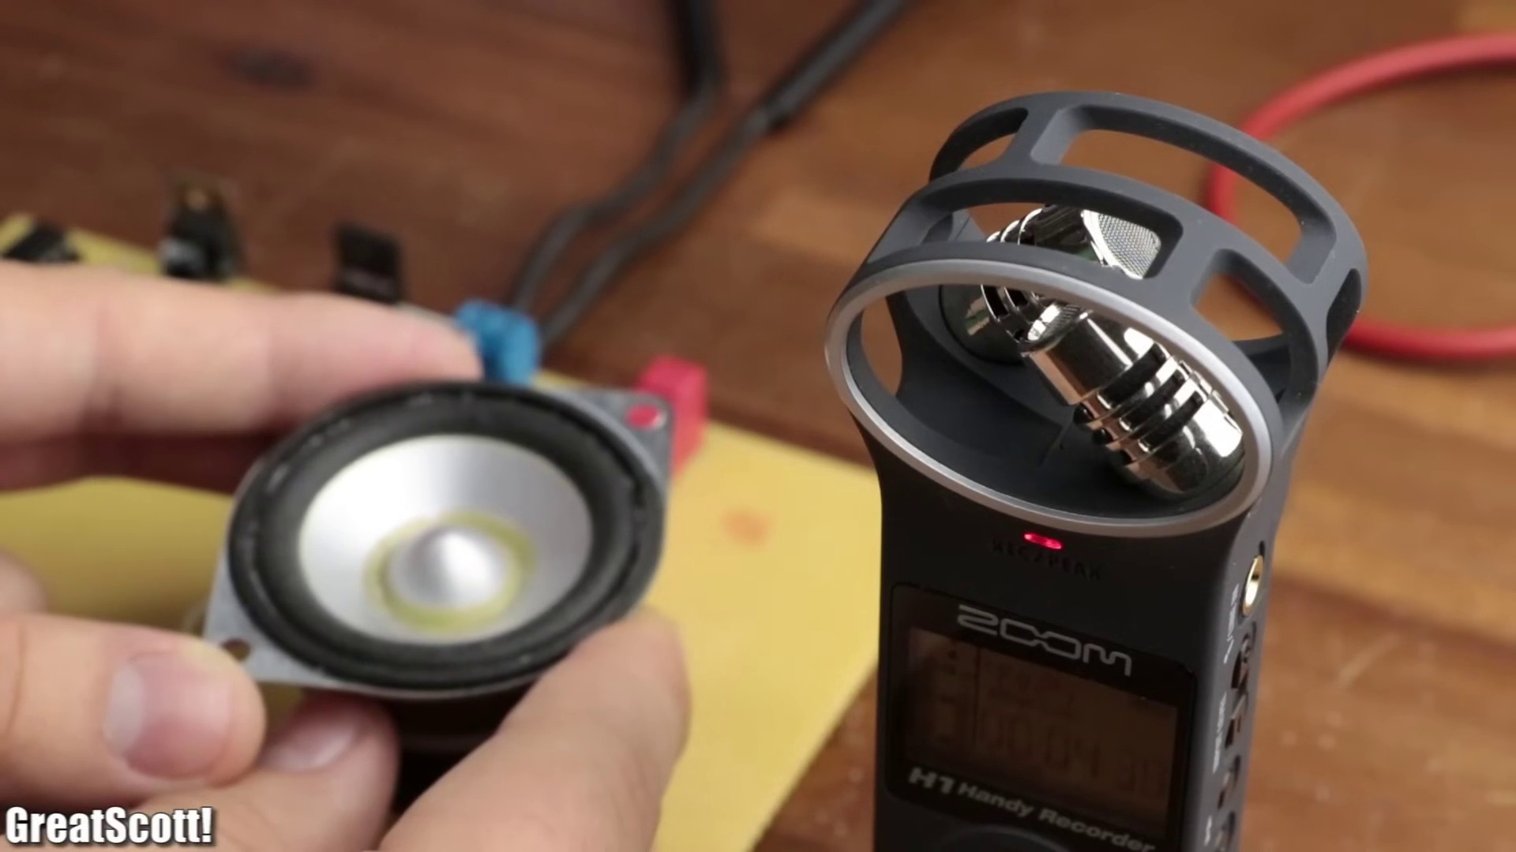 (score 95.0000)
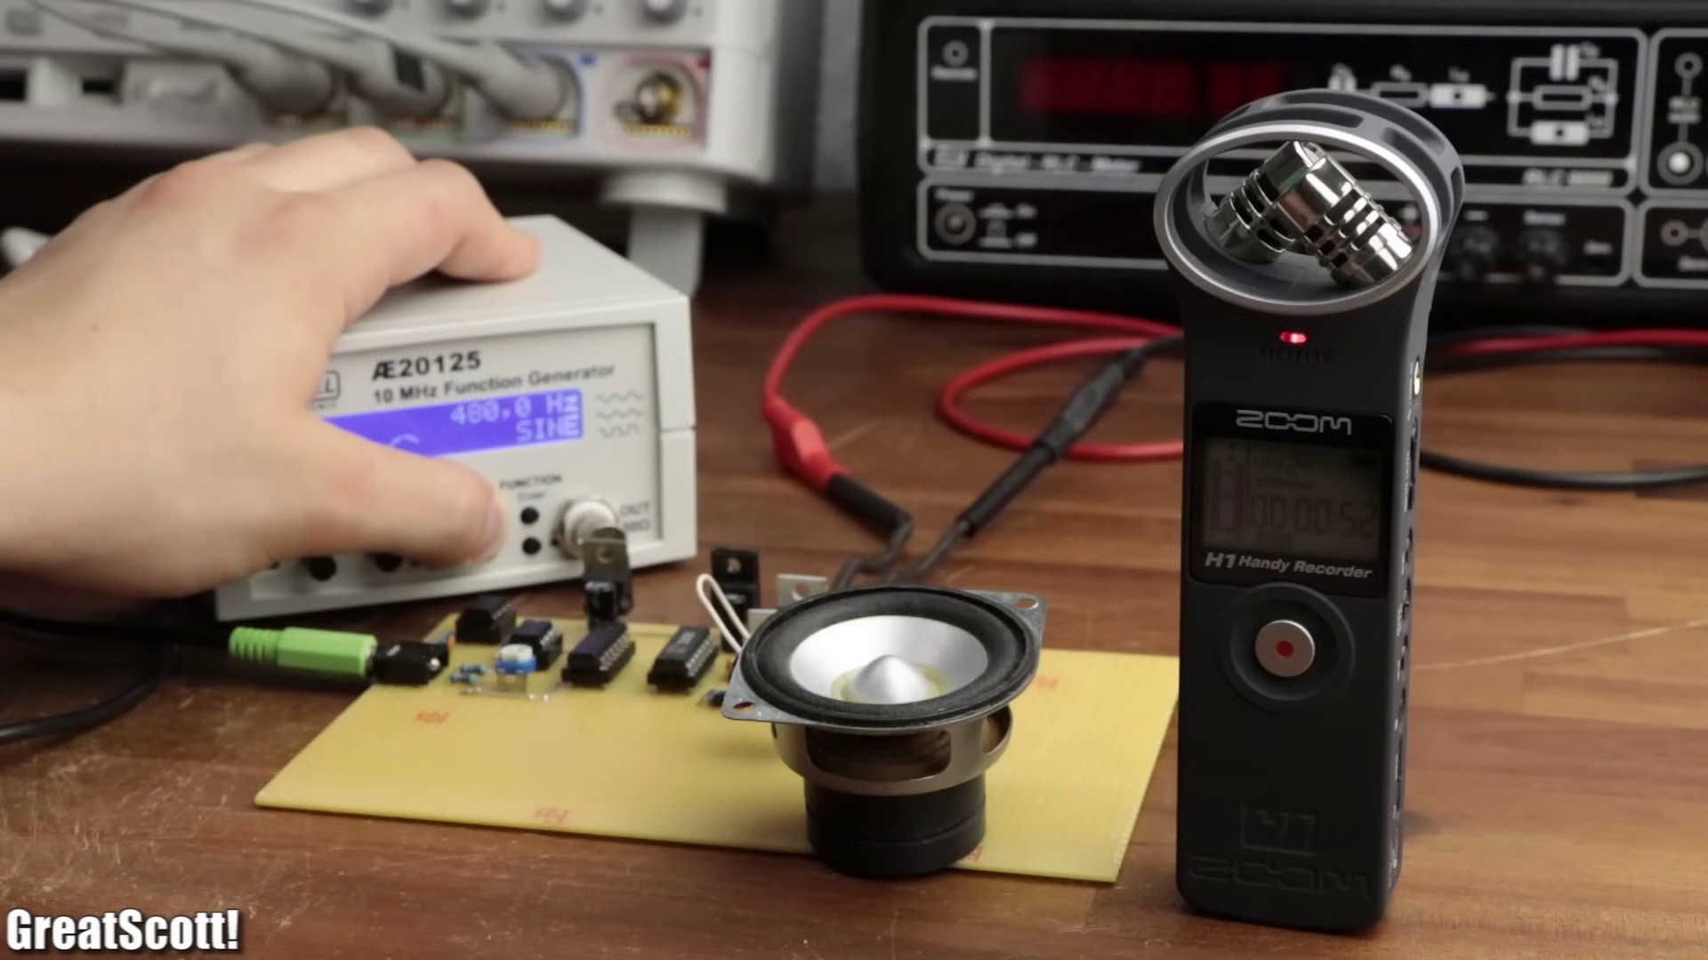 (score 95.0000)
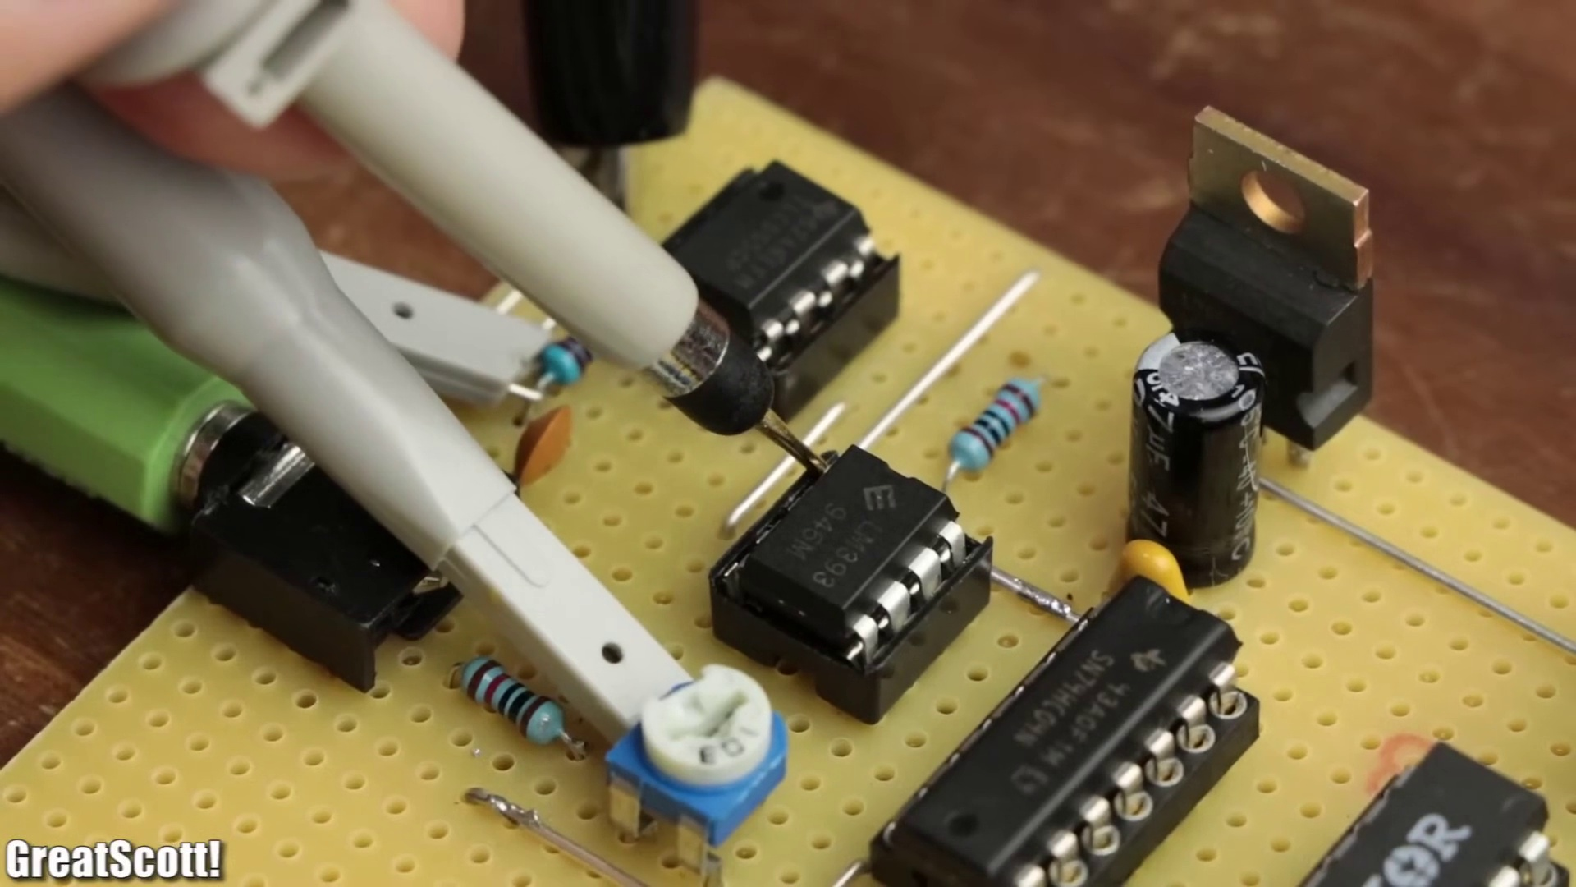 (score 95.0000)
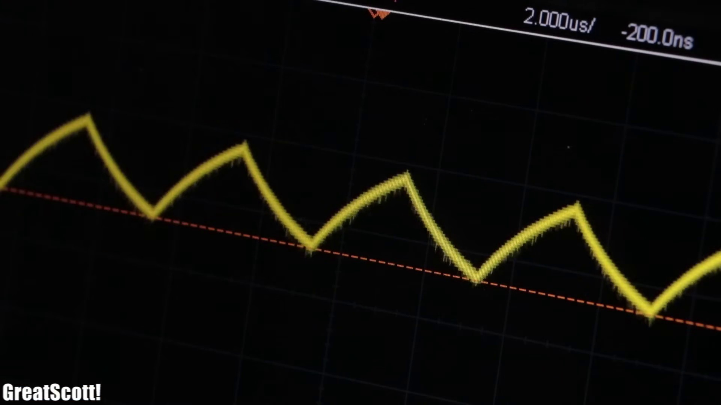 (score 95.0000)
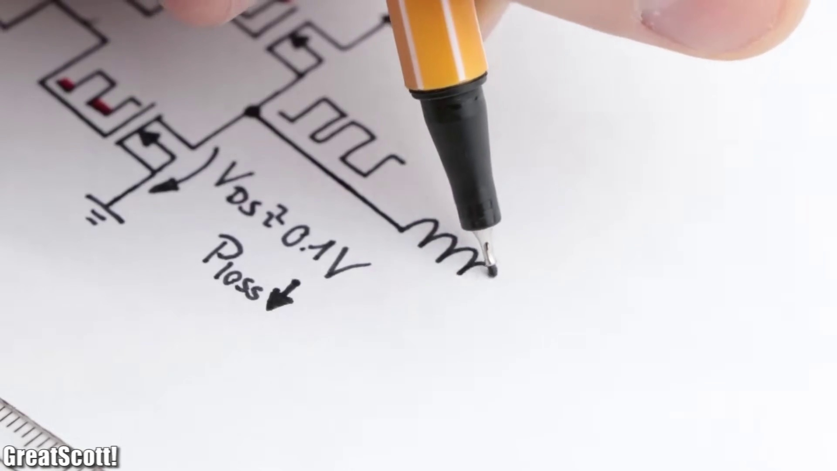 (score 95.0000)
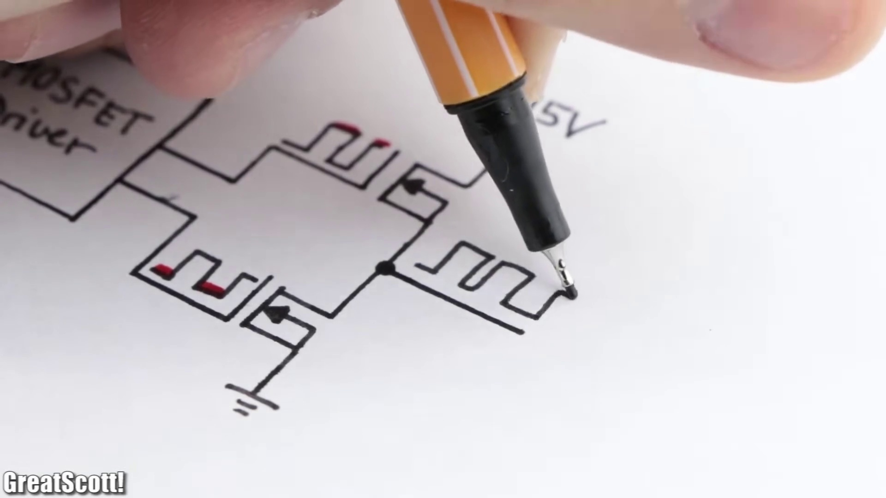 (score 95.0000)
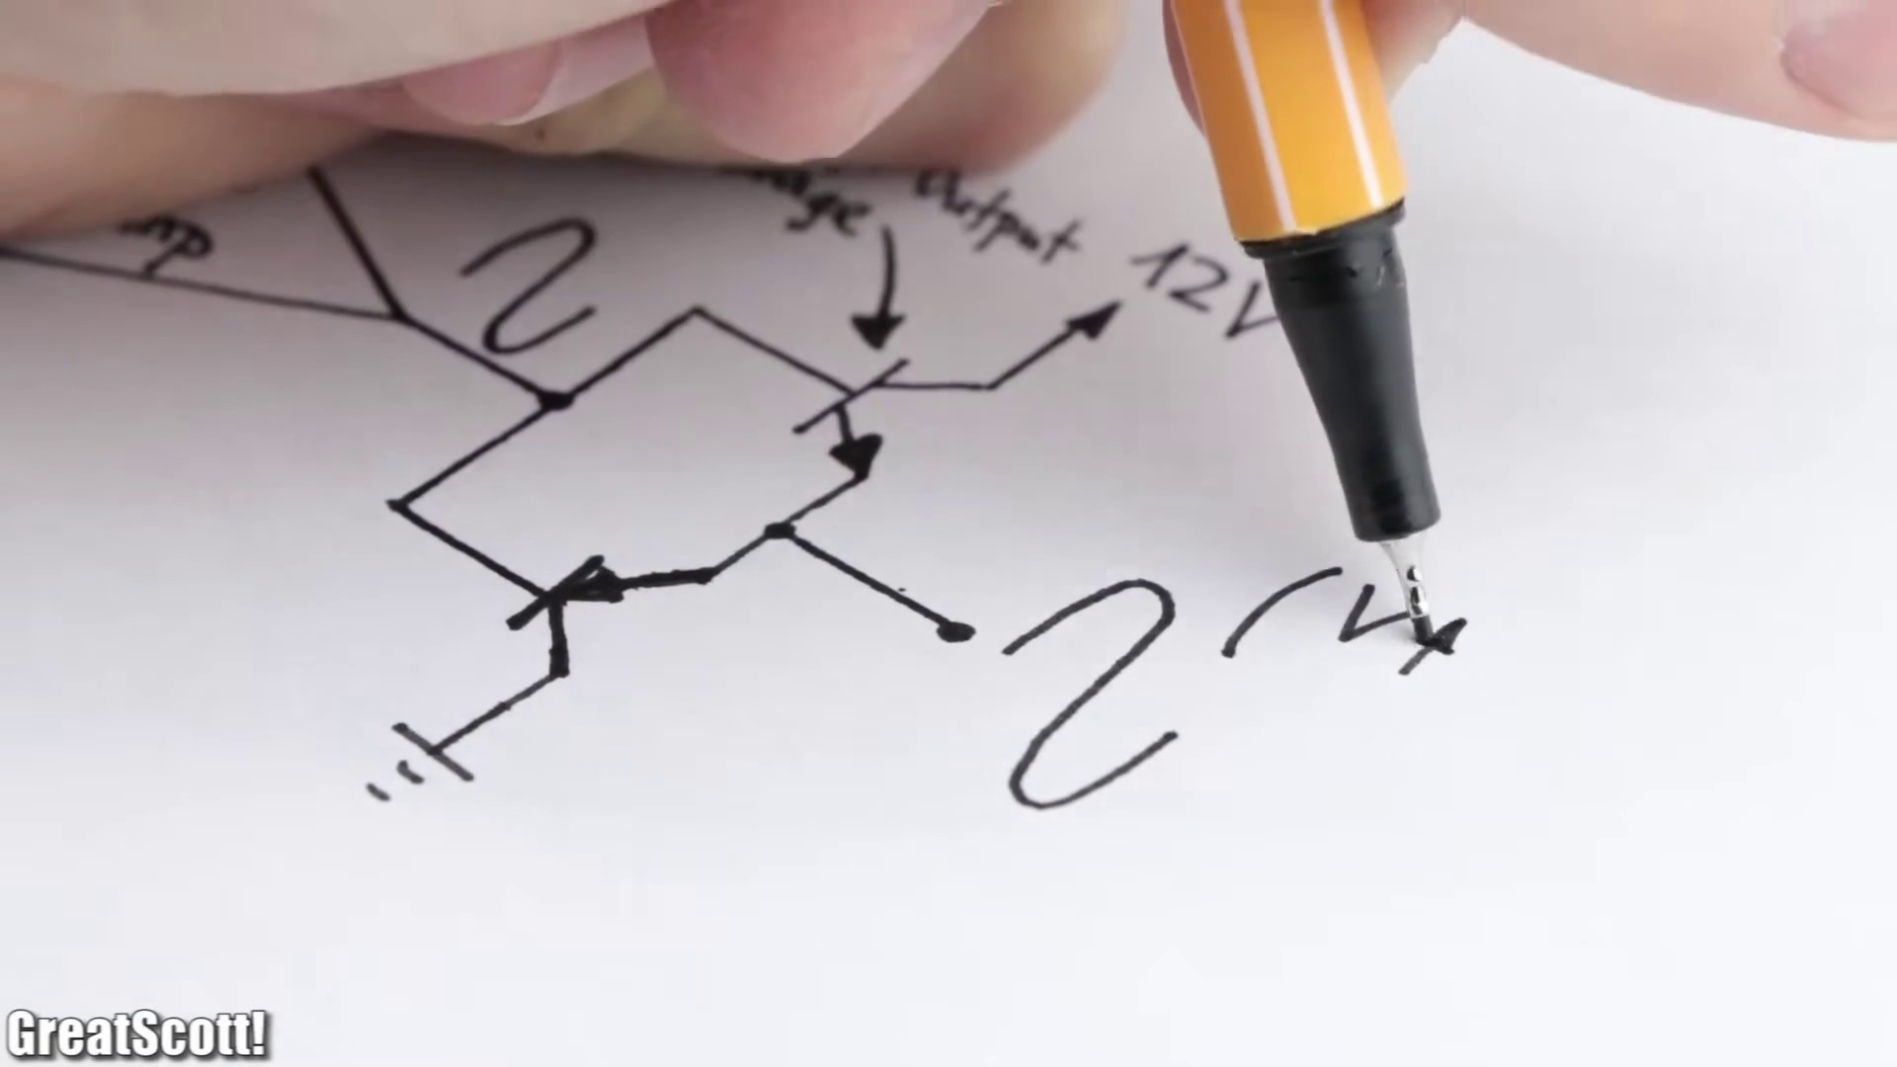 (score 95.0000)
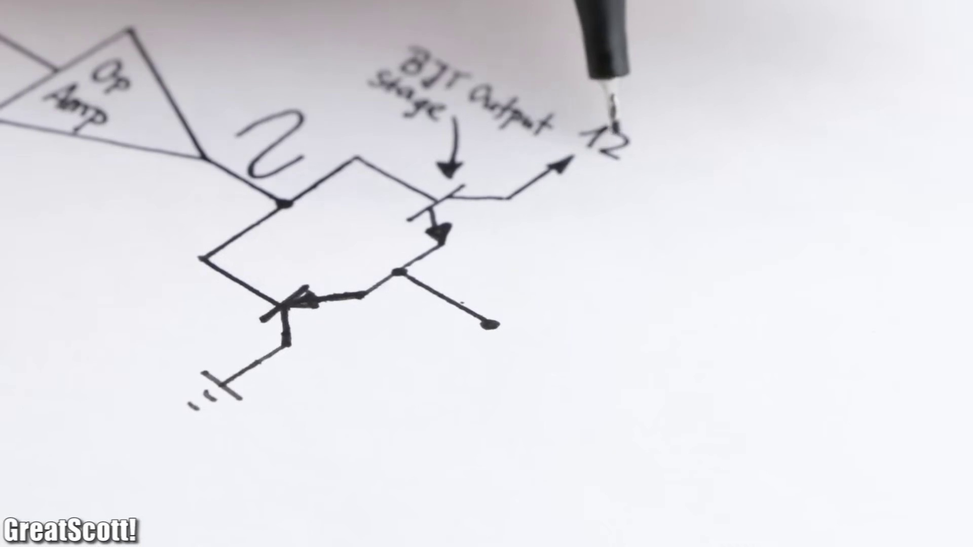 (score 95.0000)
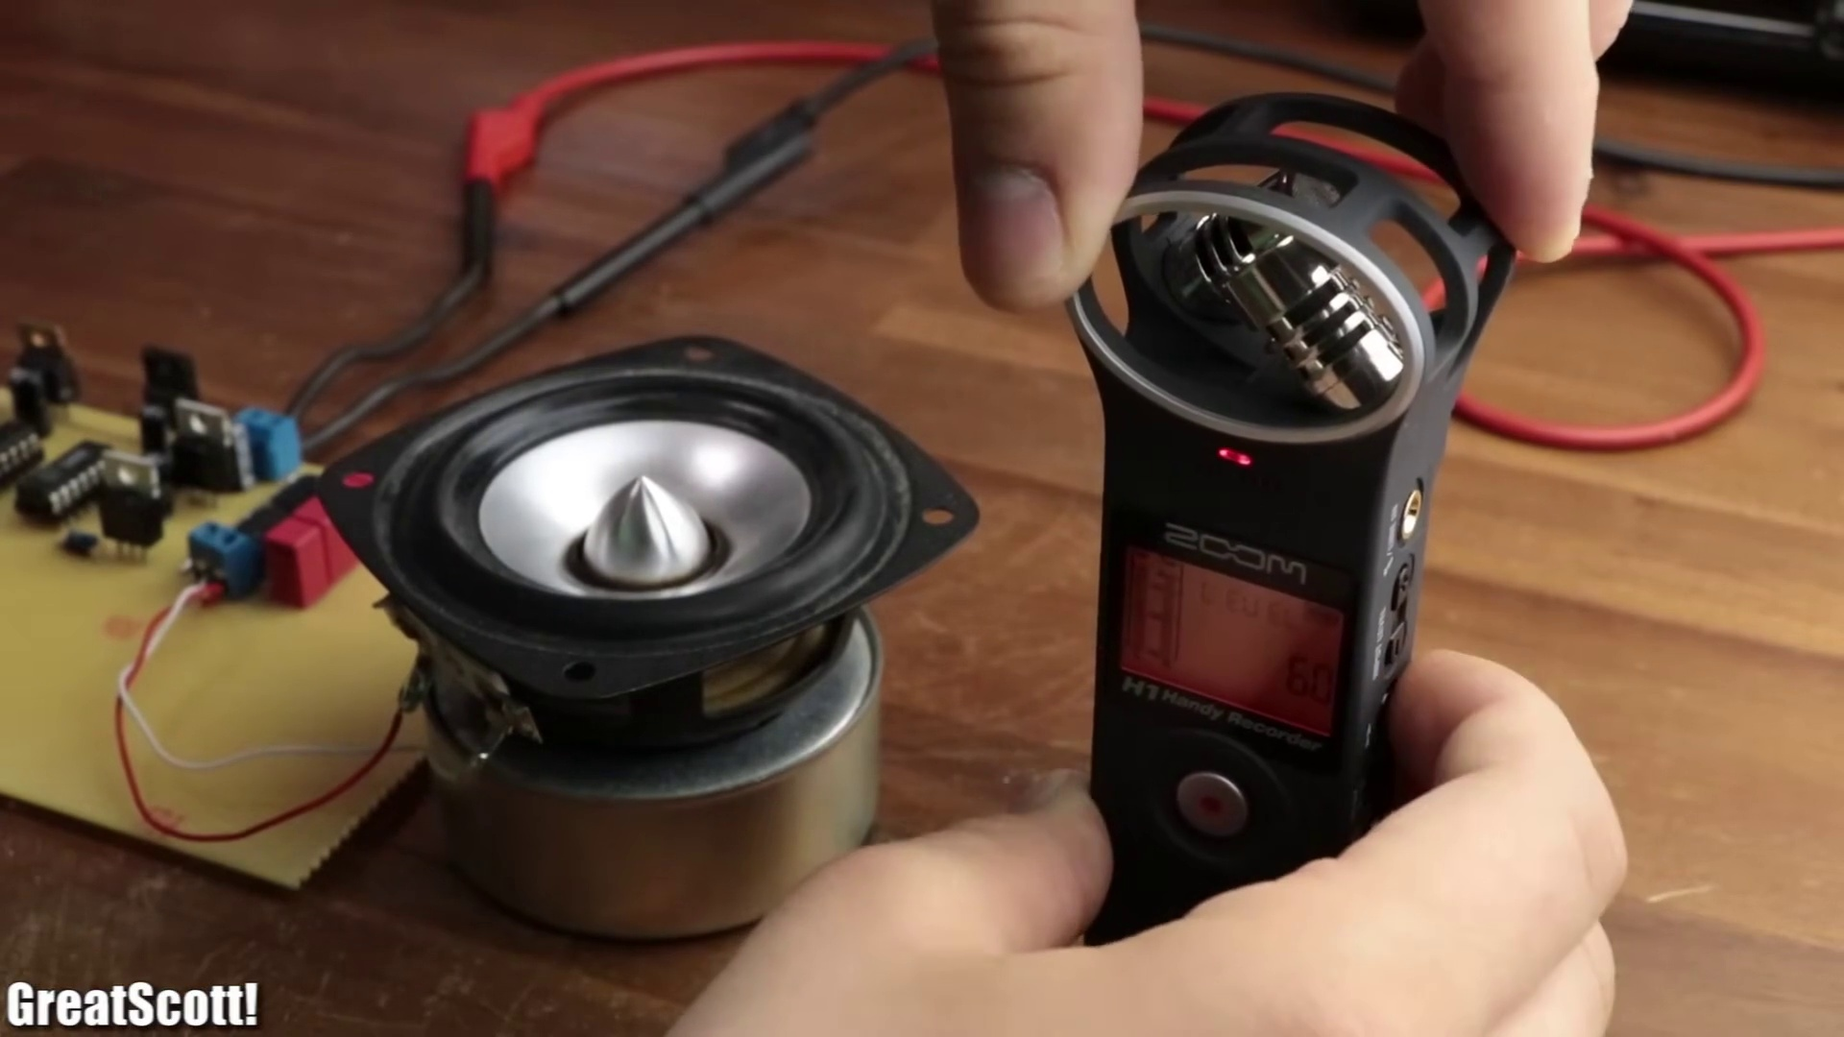 (score 90.0000)
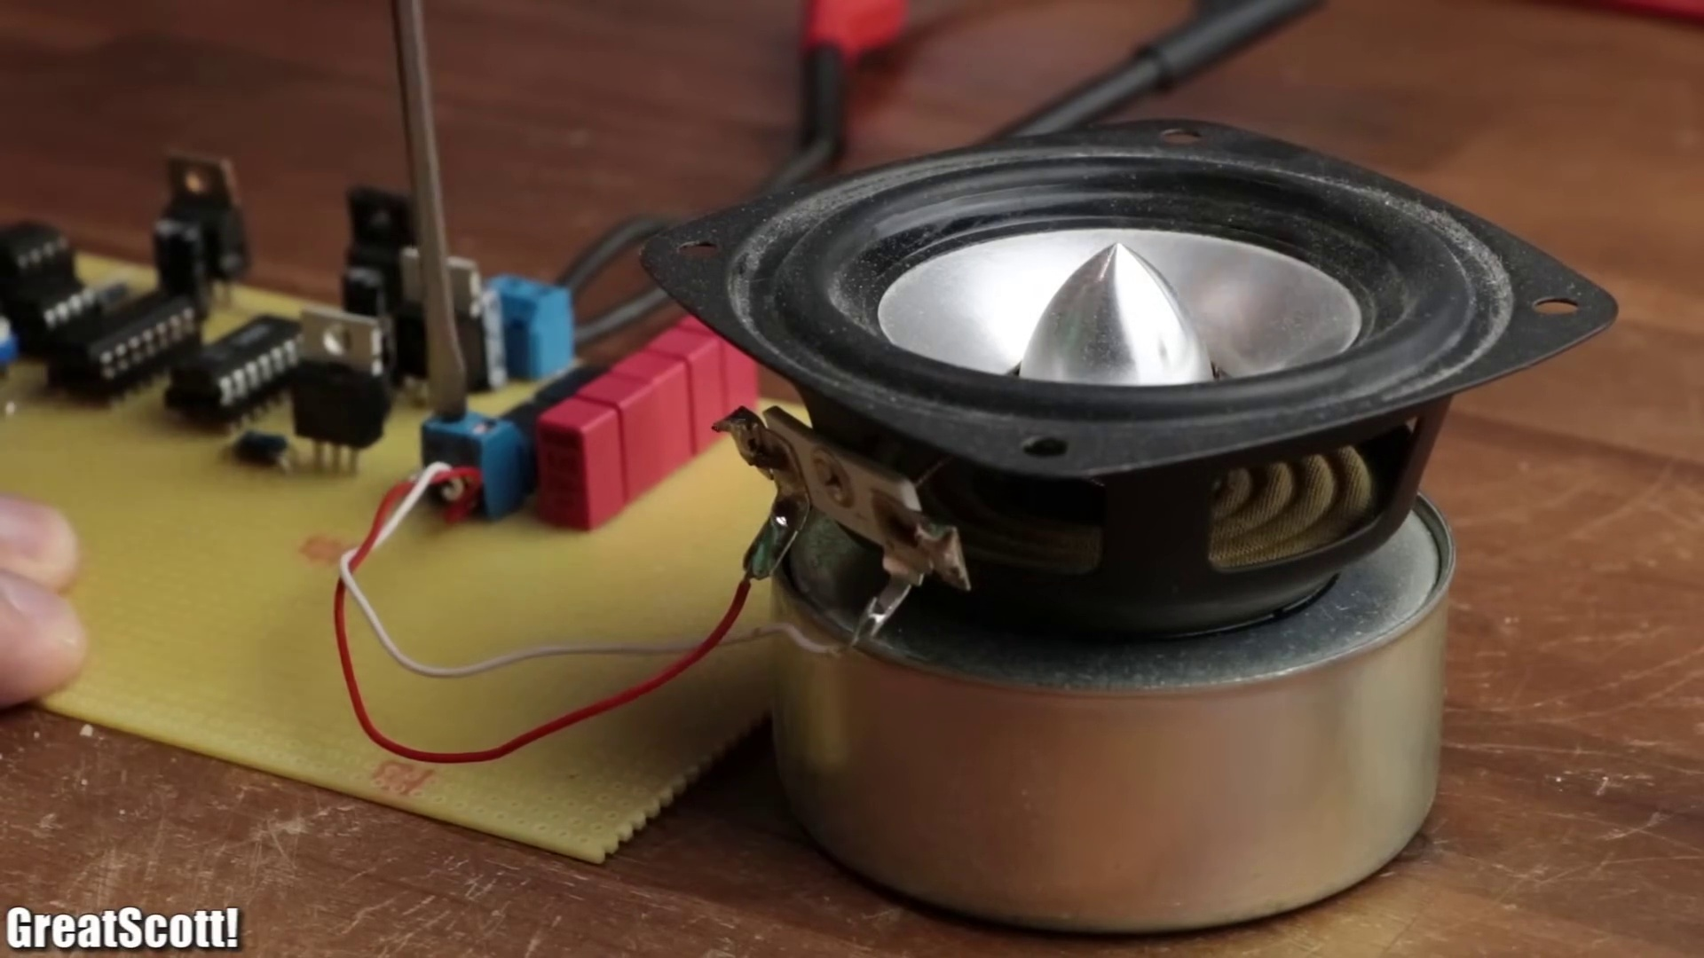 (score 90.0000)
Least correlated frames:
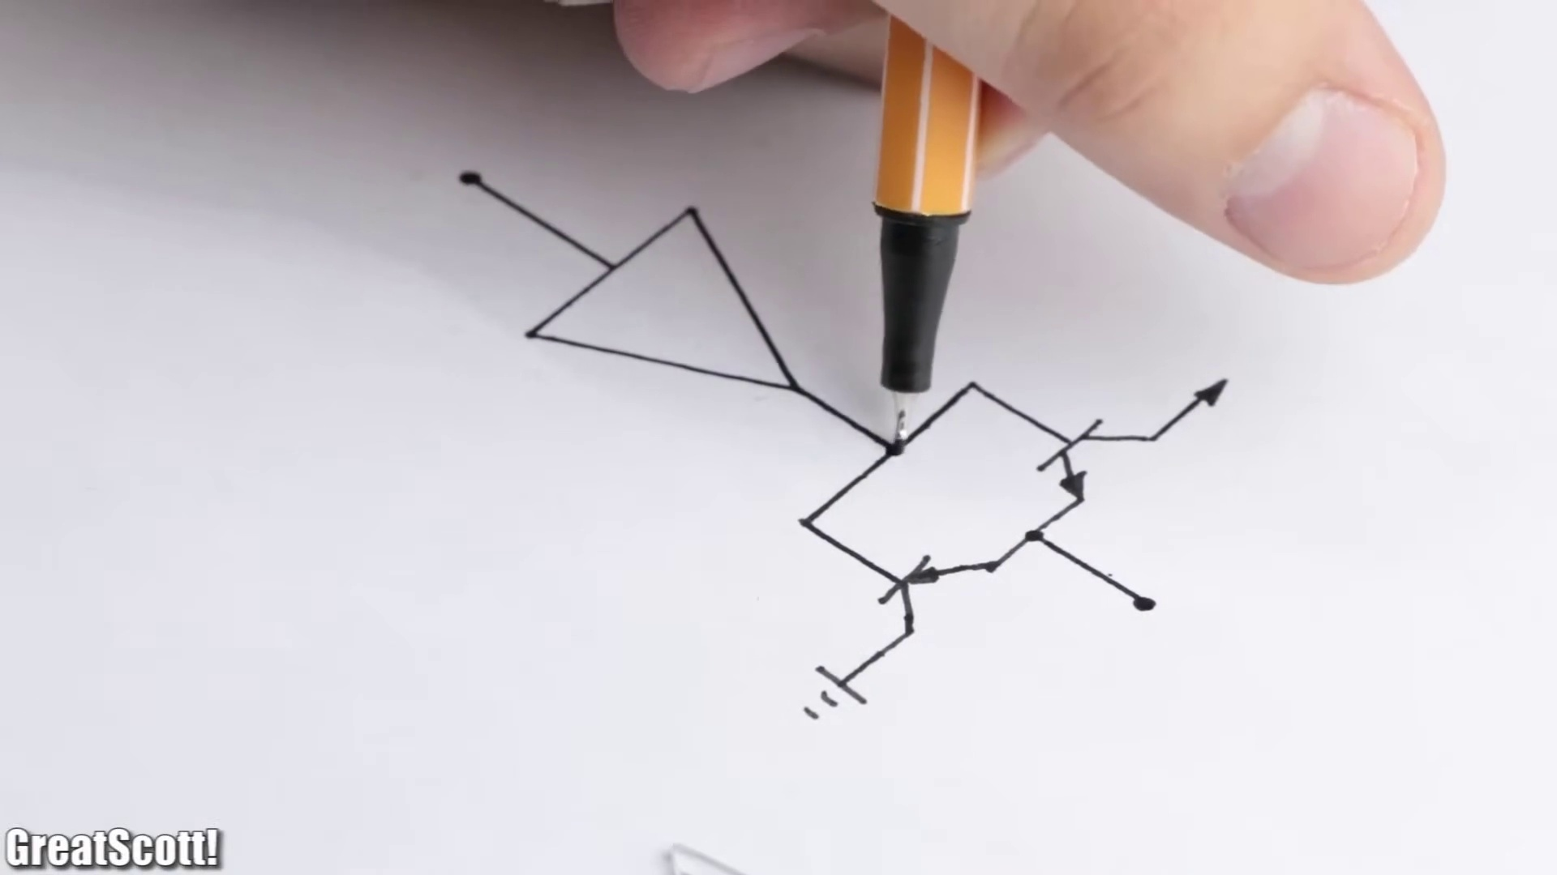 (score 0.0000)
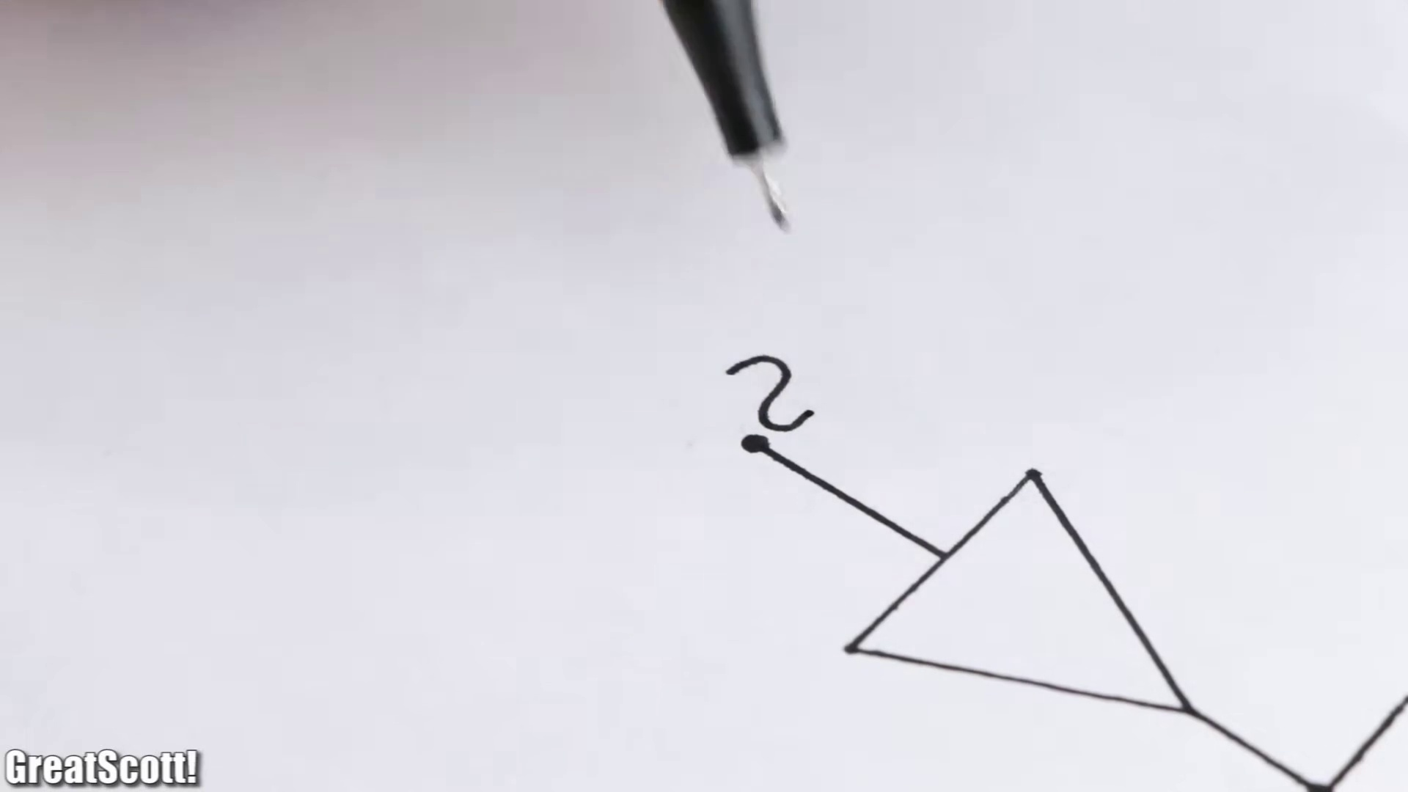 (score 0.0000)
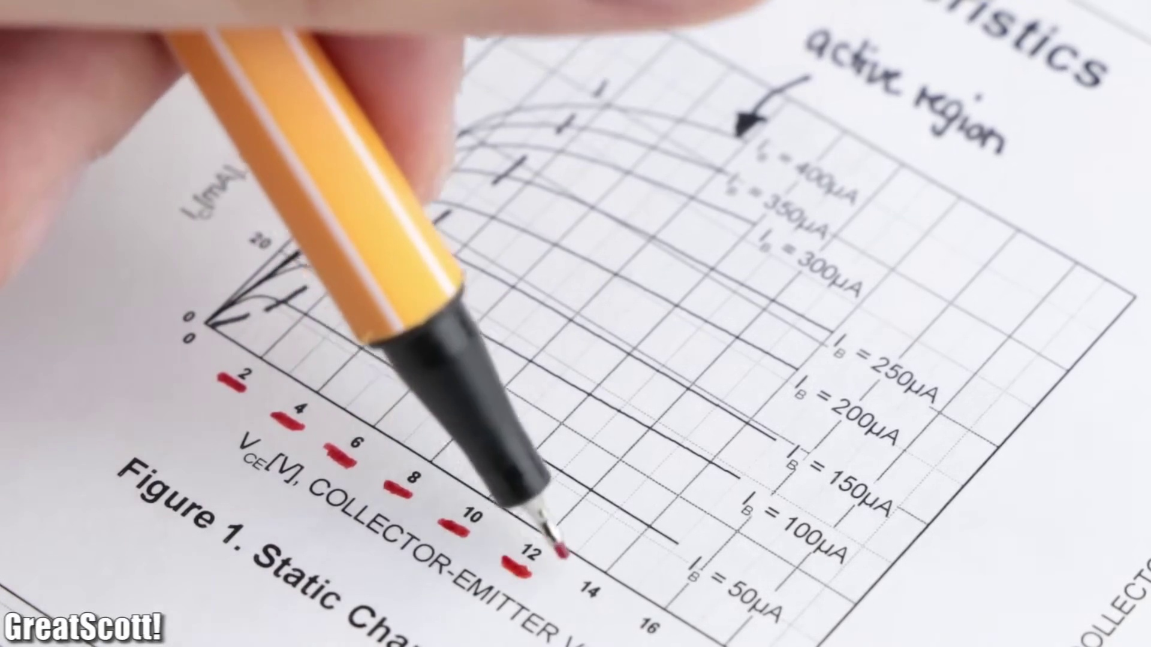 (score 0.0000)
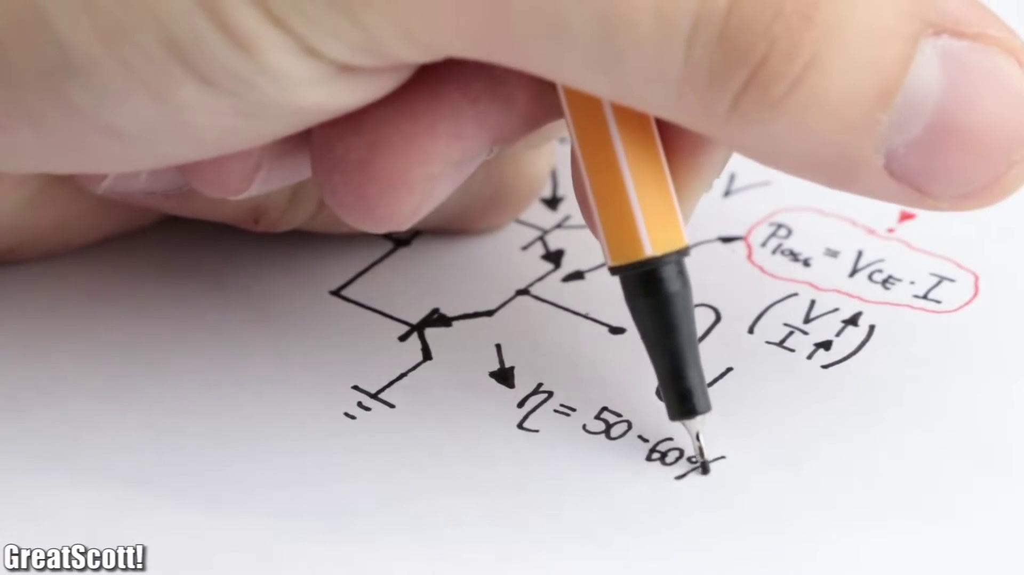 (score 0.0000)
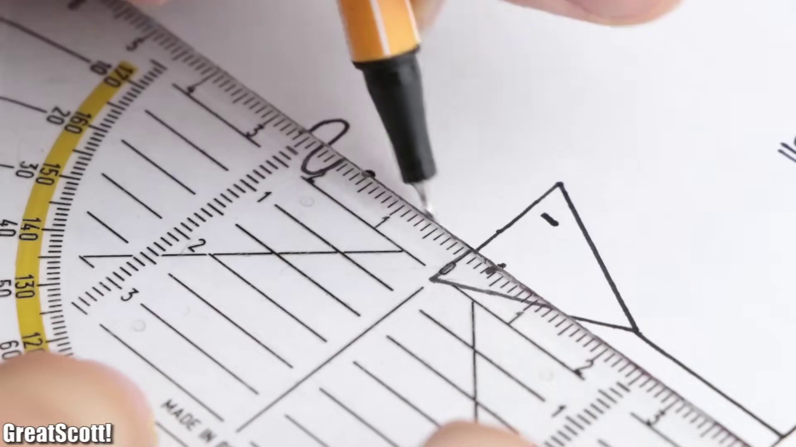 (score 0.0000)
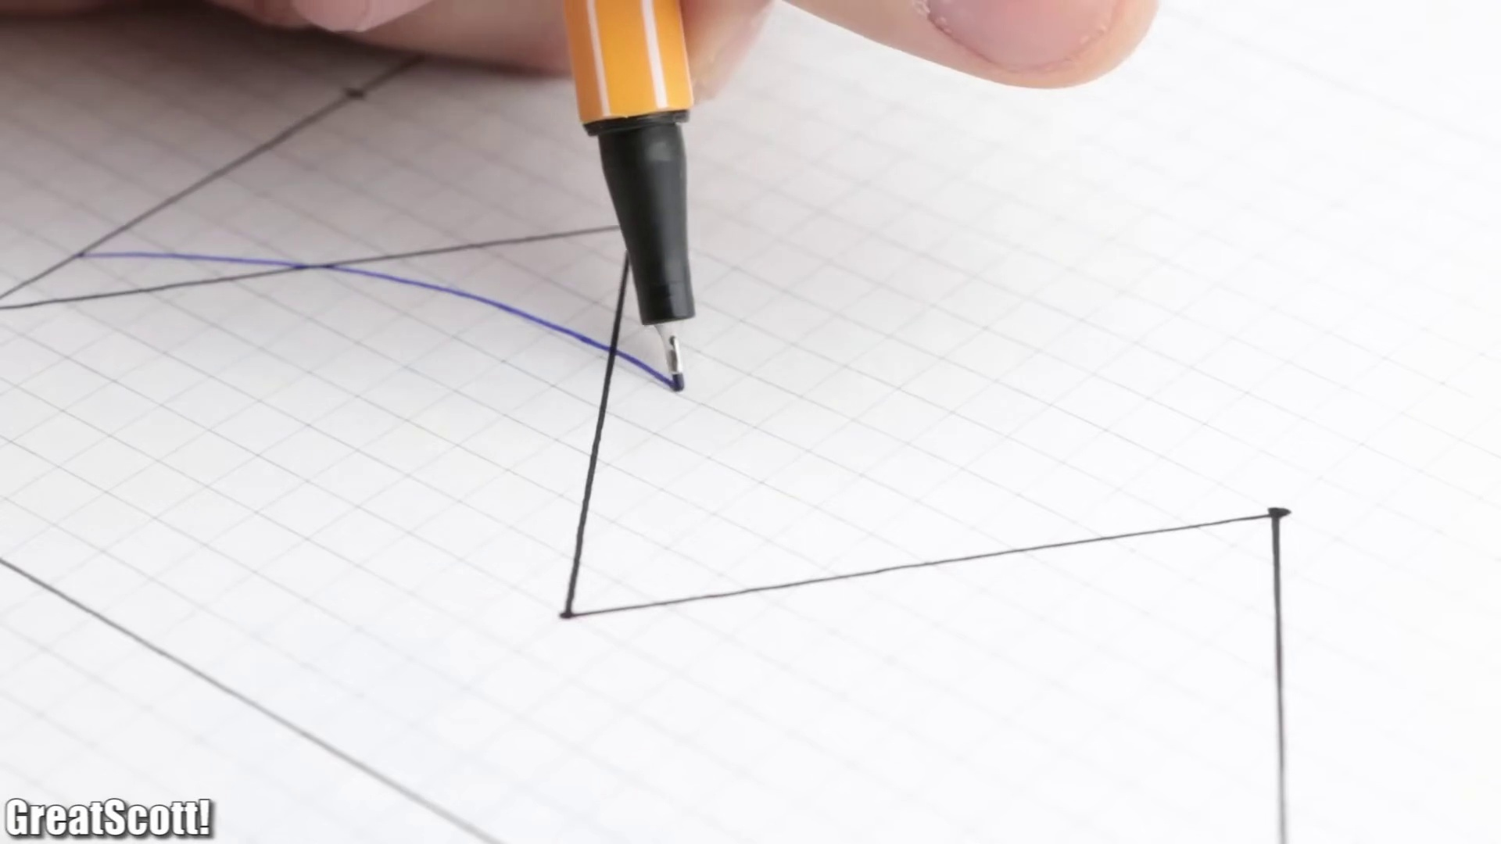 (score 0.0000)
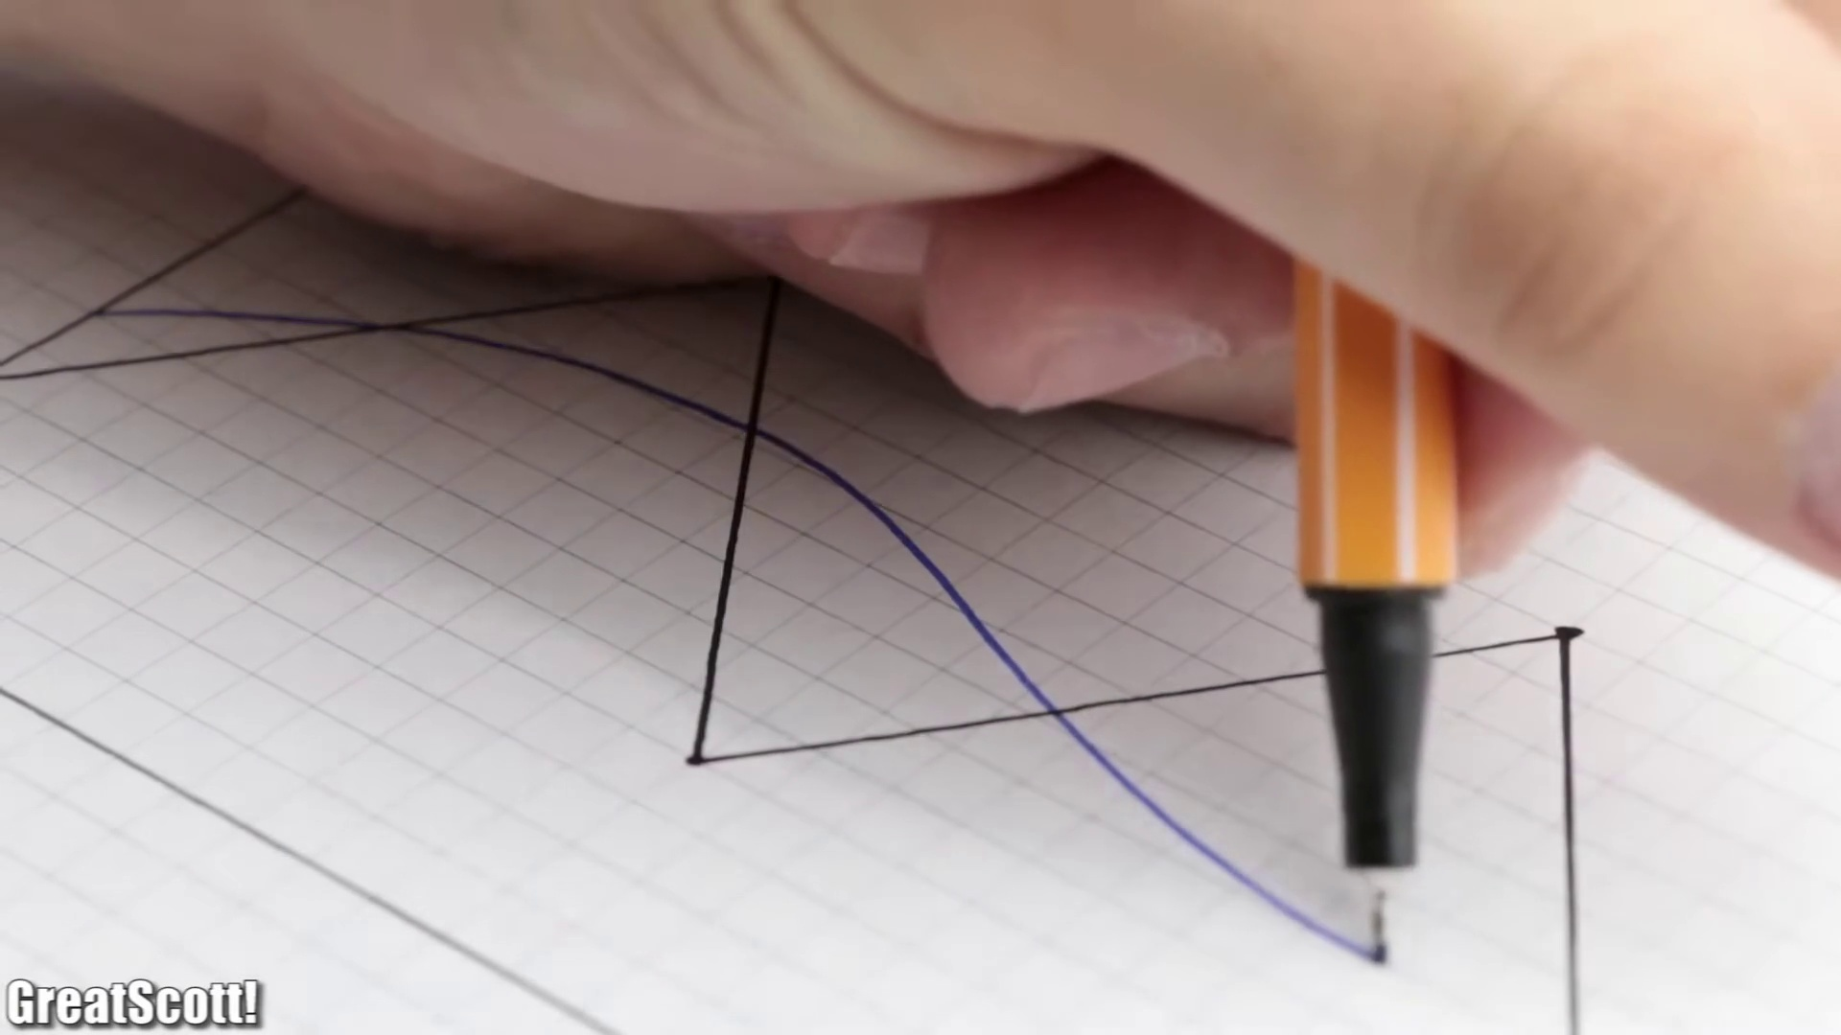 (score 0.0000)
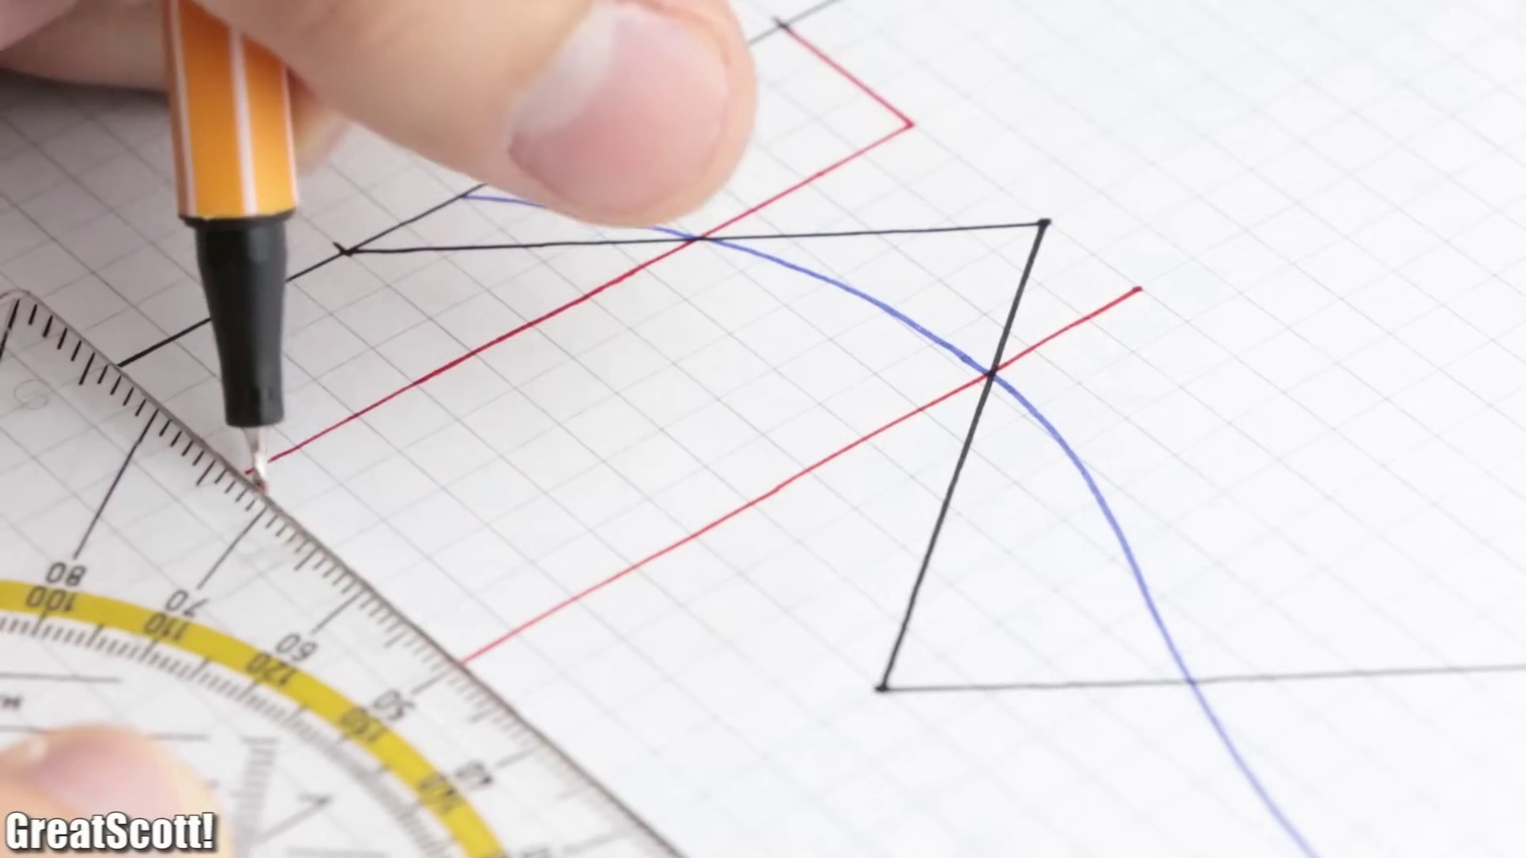 (score 0.0000)
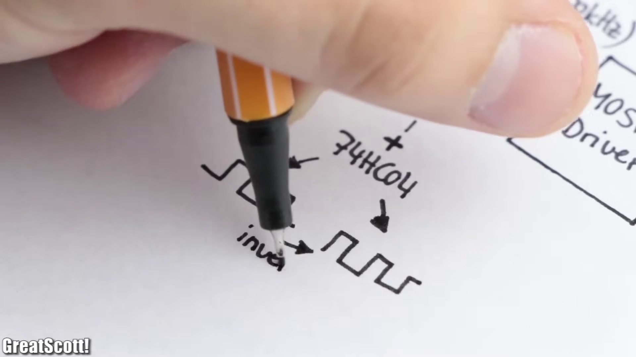 (score 0.0000)
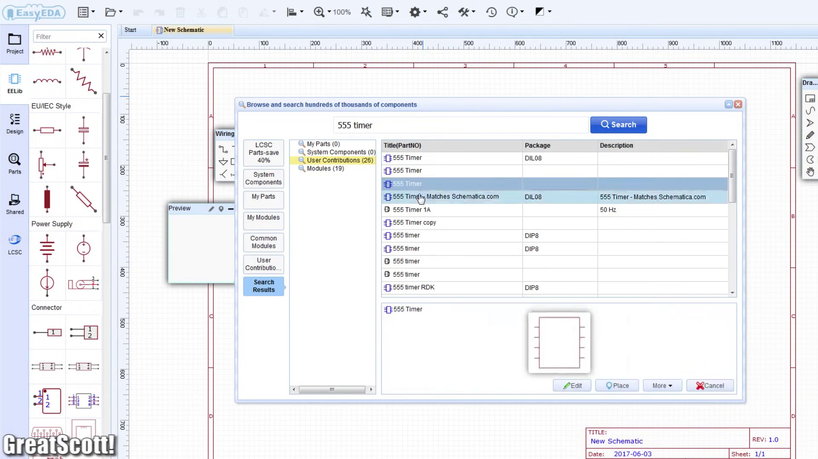 (score 0.0000)
- matched 60 frame(s), max score 90.0000: The video described the MOSFET Audio Amplifier as a class D amp that has high efficiency. The MOSFET has low power loss, but it is not very strong. In the video he does the math to solve the cutoff frequency and capacitance needed for the circuit. This math is an important part of phase two that will help when doing the report for our speaker. My only problems with this video were that It's a bit hard to follow the circuit construction and it was confusing when he added the LM386 to the circuit to increase sound level but didn’t show how he did this. This video helped me decide not to use the MOSFET as the sound quality and noise were not good enough for our speakers to choose.
Source: https://www.youtube.com/watch?v=3dQjIeYoIdM : DIY Class D Audio Amplifier
Top correlated frames:
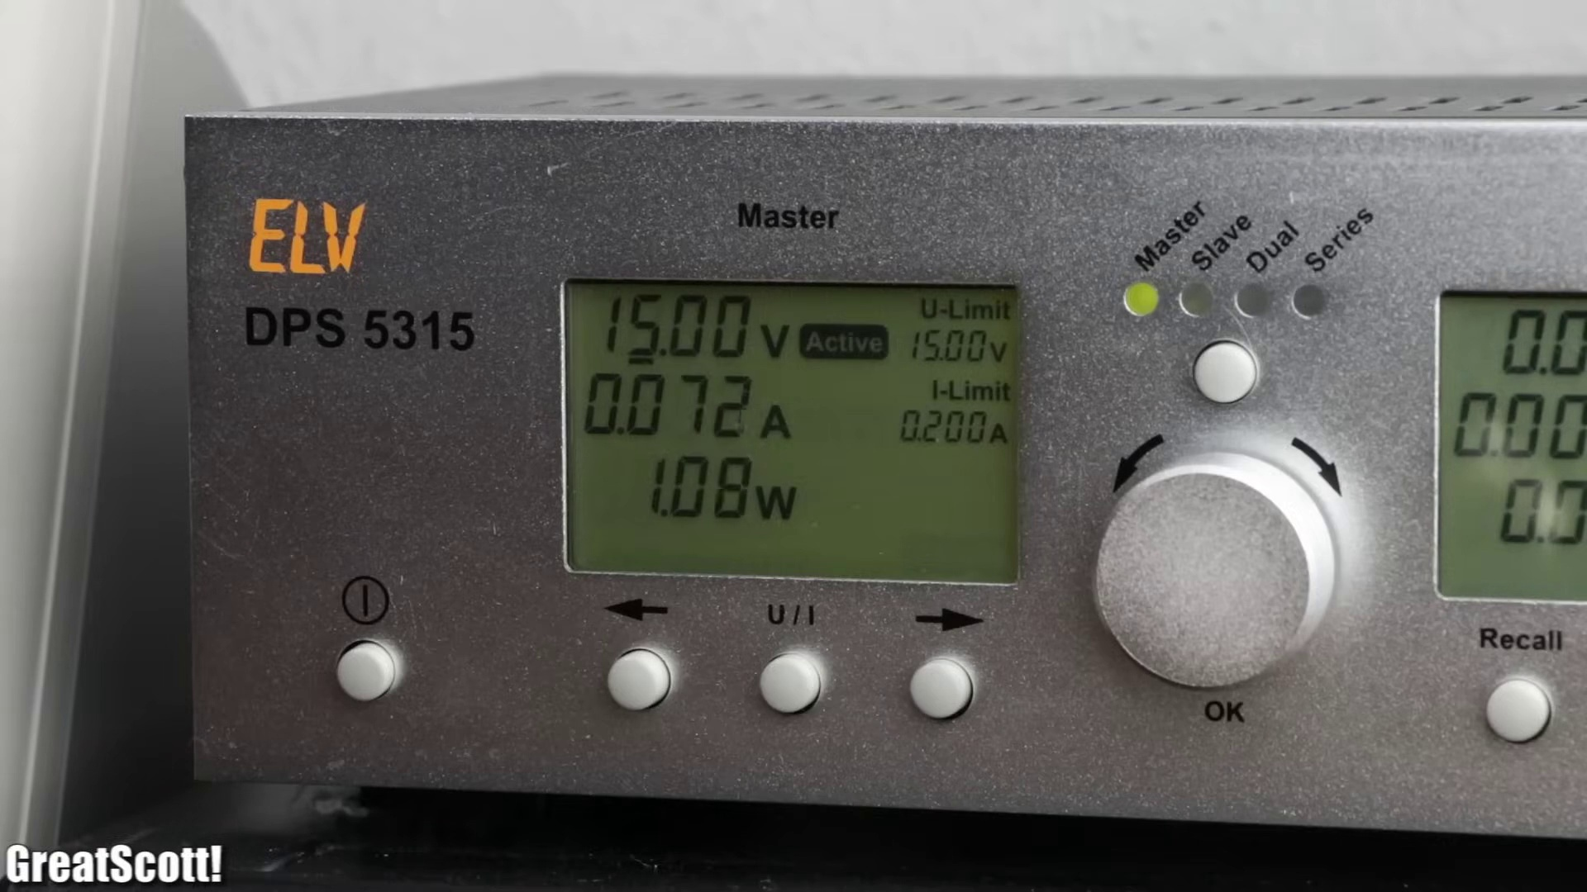 (score 95.0000)
 (score 90.0000)
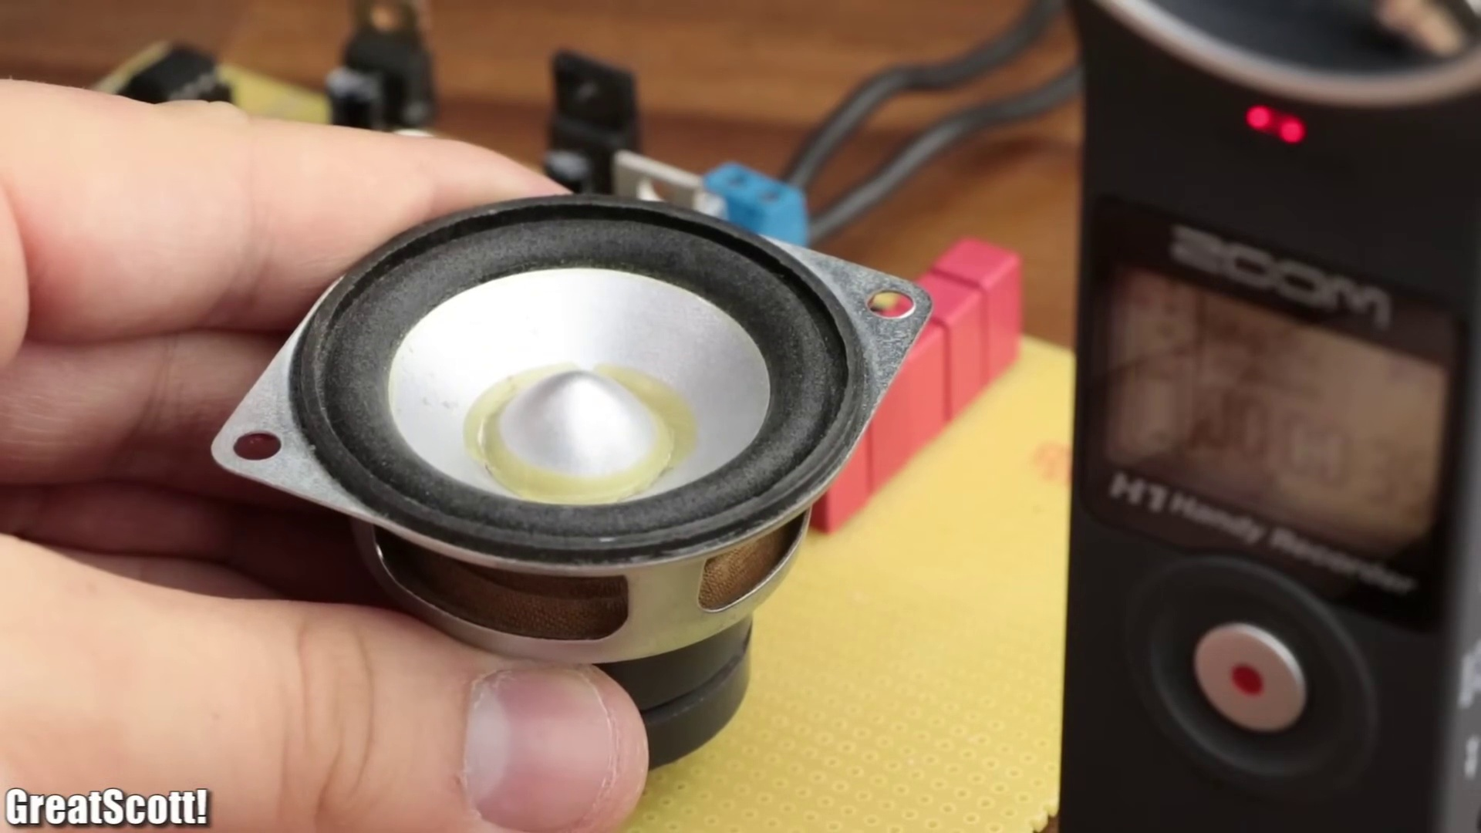 (score 90.0000)
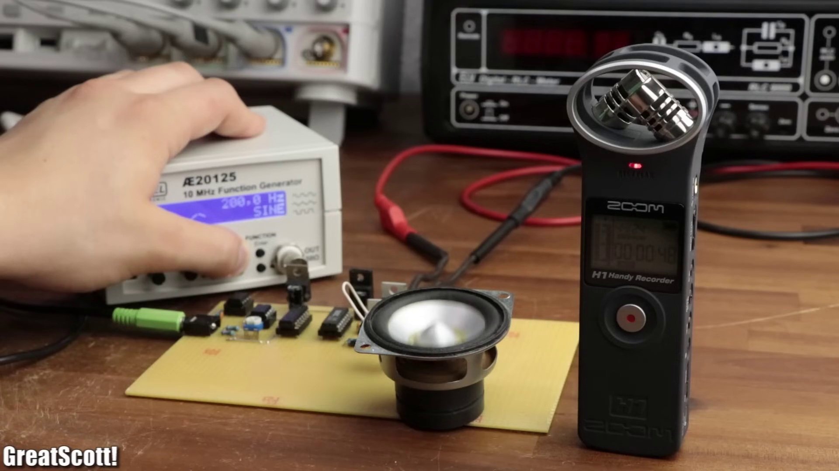 (score 90.0000)
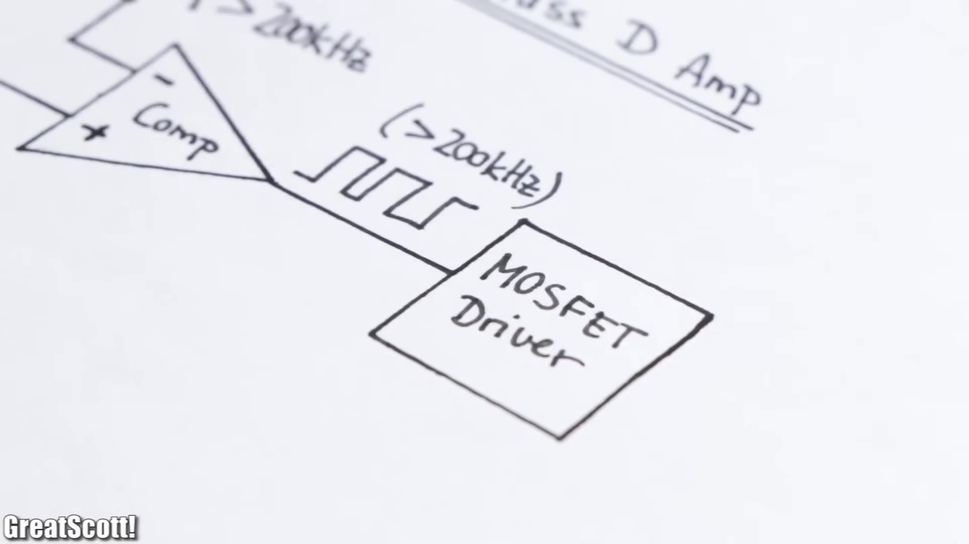 (score 90.0000)
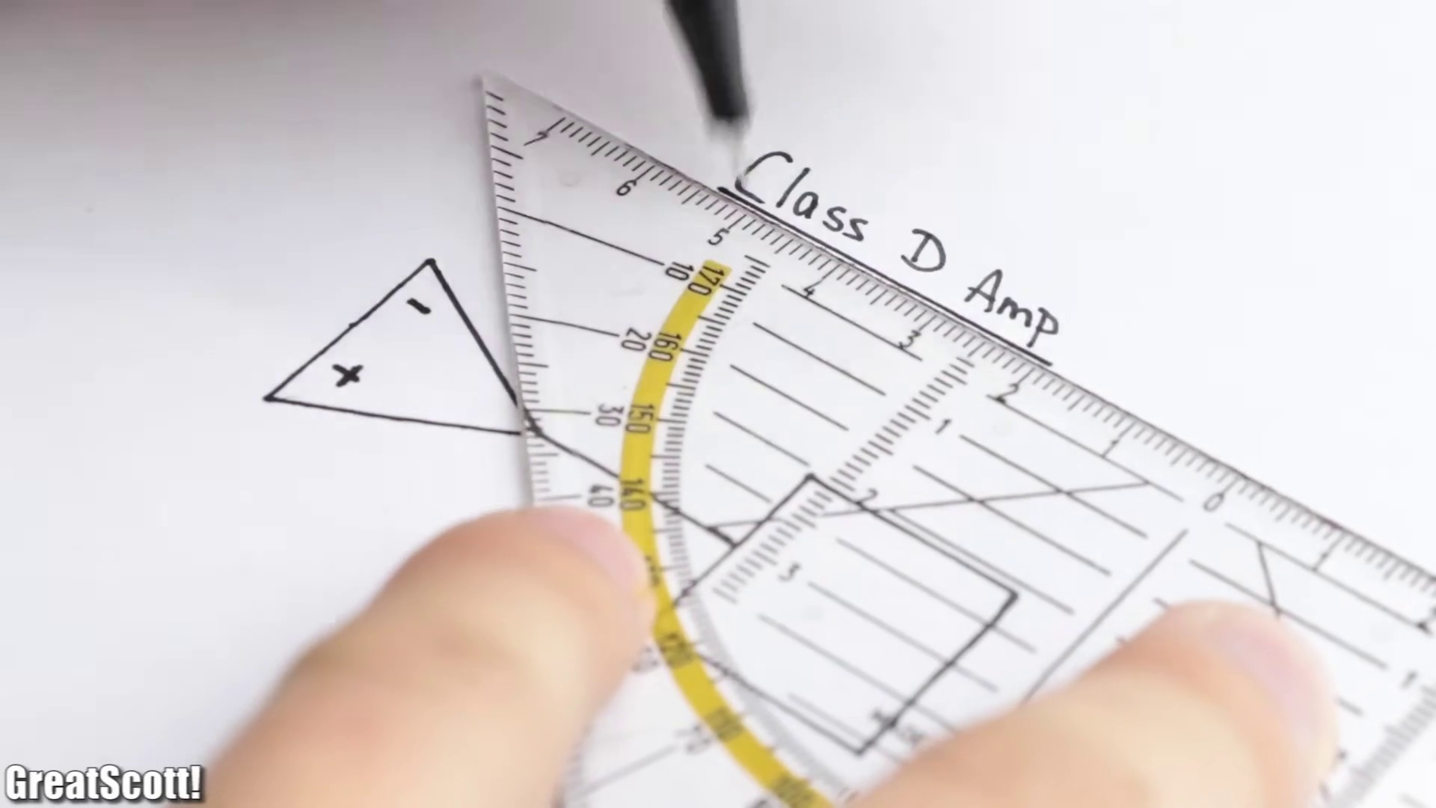 (score 90.0000)
 (score 90.0000)
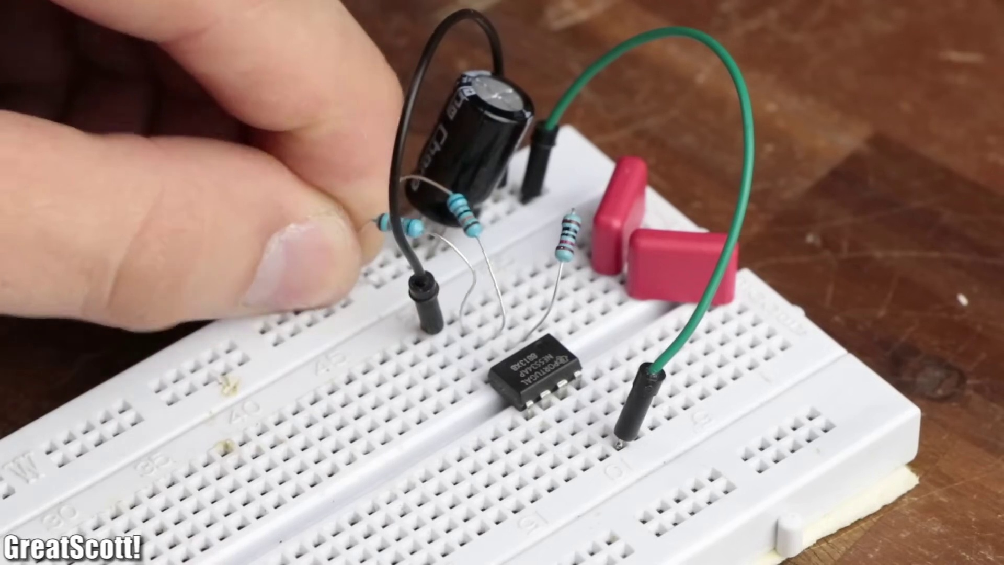 (score 90.0000)
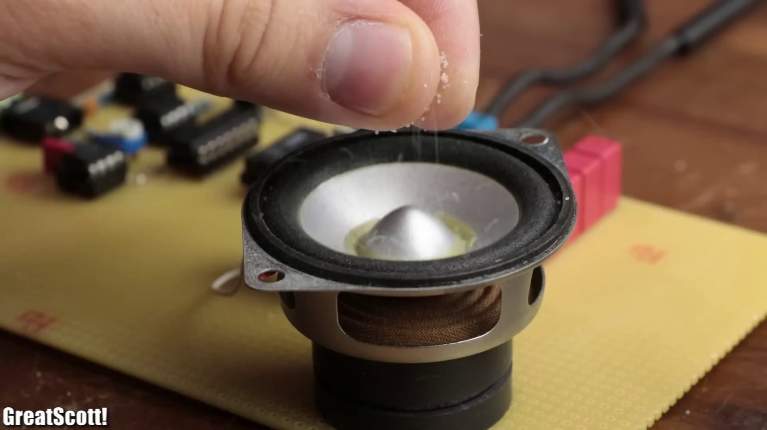 (score 85.0000)
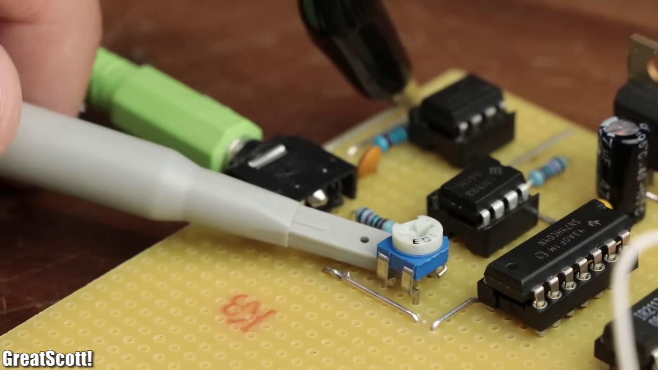 (score 85.0000)
Least correlated frames:
 (score 0.0000)
 (score 0.0000)
 (score 0.0000)
 (score 0.0000)
 (score 0.0000)
 (score 5.0000)
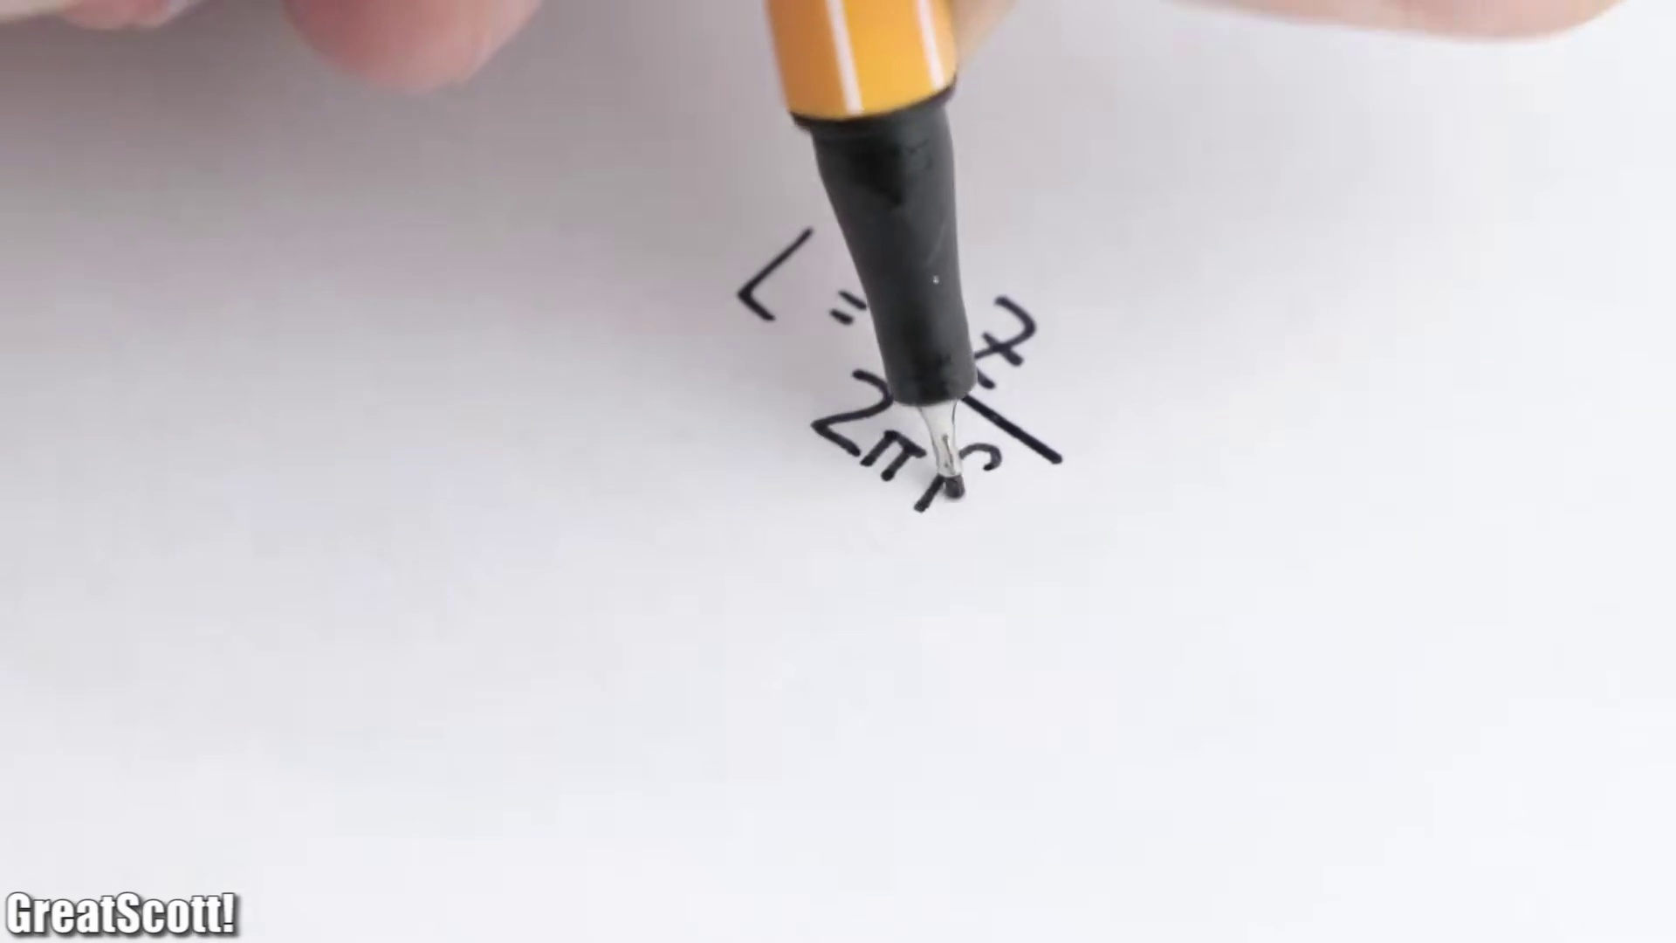 (score 5.0000)
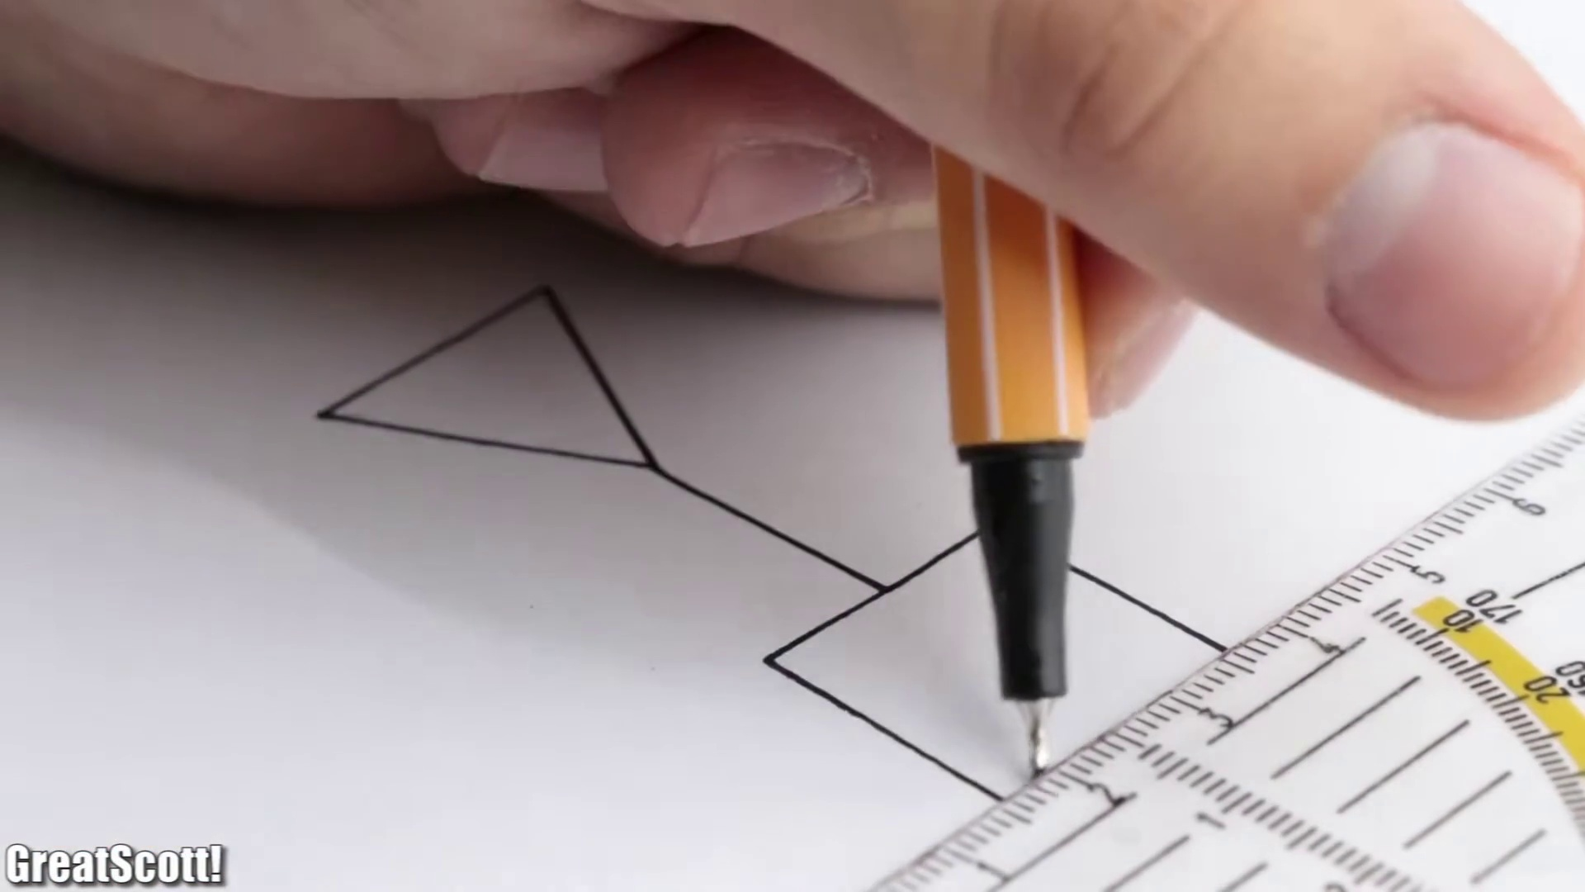 (score 10.0000)
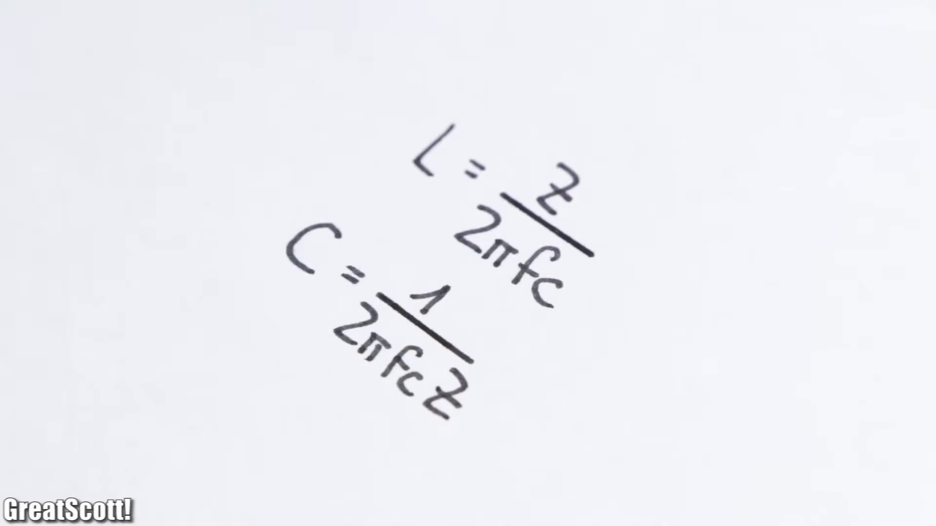 (score 10.0000)
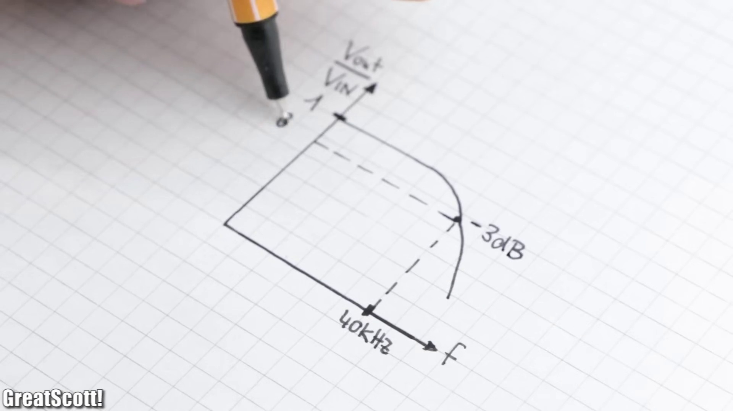 (score 10.0000)
- matched 45 frame(s), max score 95.0000: The video maker does a good job of covering the full circuit diagram, covering the function and use of the various components therein. They not only draw the schematic out on paper, but then show the simulation and calculations used to determine various quantities like filter values. They then go through the testing and physical creation of the circuit. I also found it very interesting to see how a MOSFET can be used to help make an audio amplification circuit.Confused Content: The video maker thoroughly covers anything that I would have questions about.Future Use: I intend to draw inspiration from this video for Class Project Phase 2, although the video maker uses more components than I intend to.
Source: https://www.youtube.com/watch?v=3dQjIeYoIdM:DIY Class D Audio Amplifier:Useful Content:
Top correlated frames:
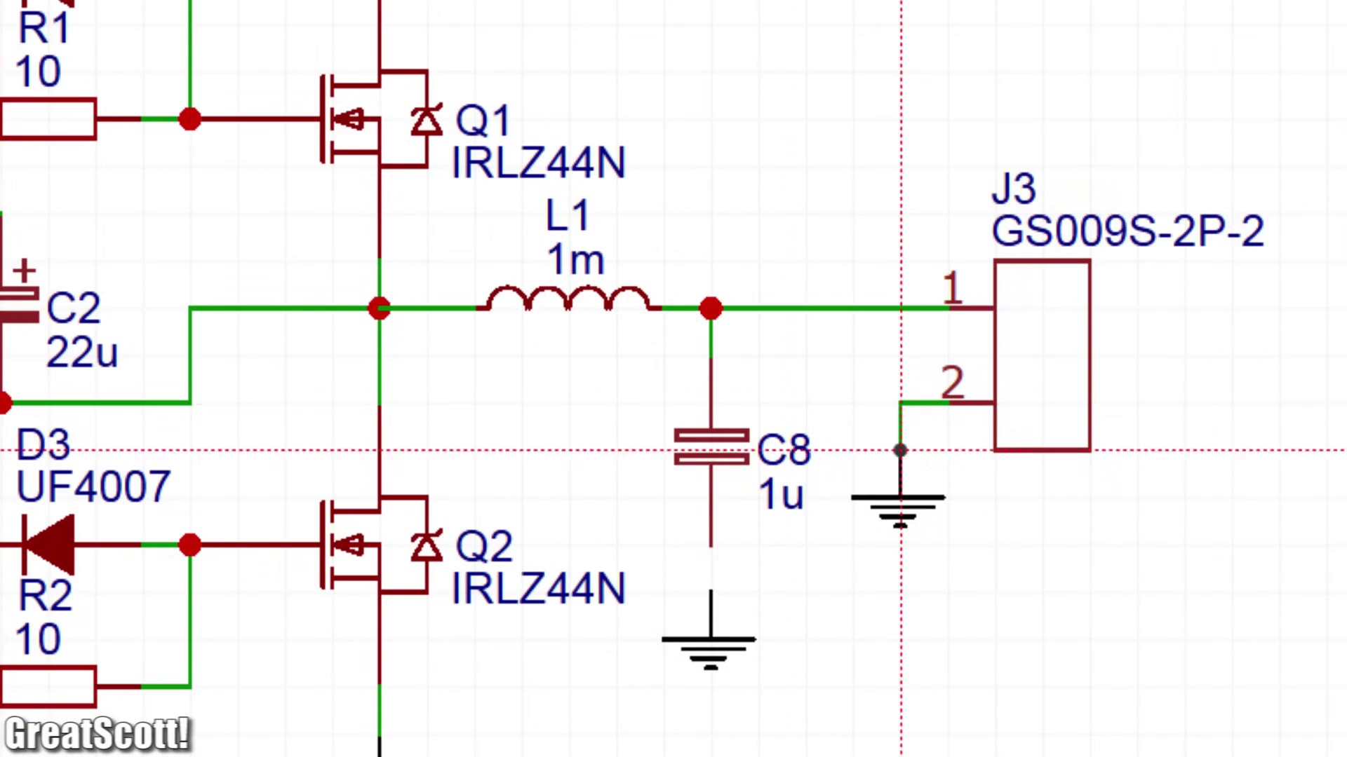 (score 95.0000)
 (score 95.0000)
 (score 95.0000)
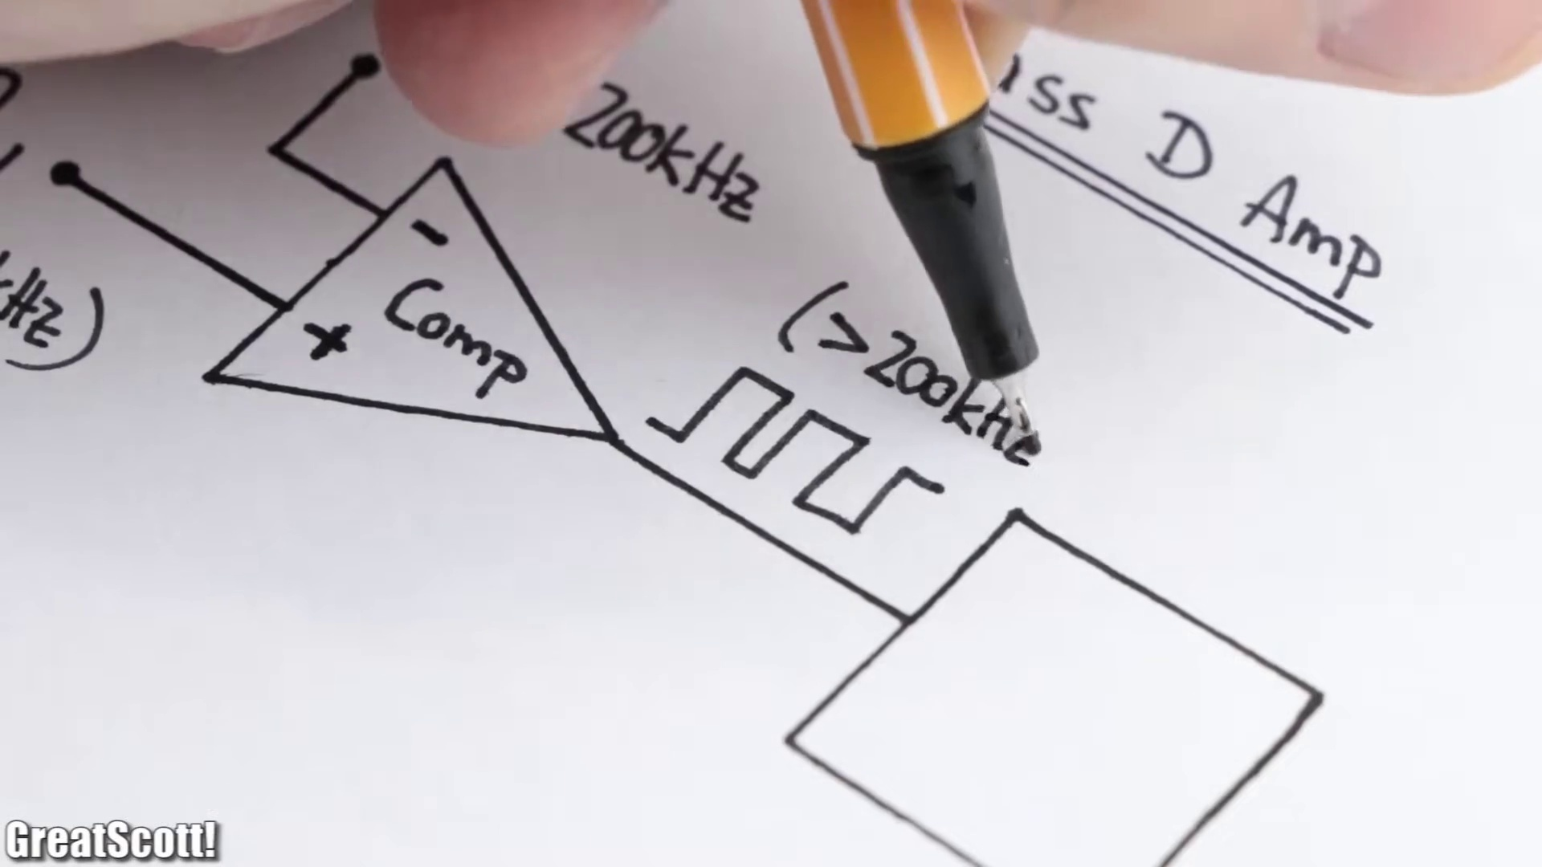 (score 95.0000)
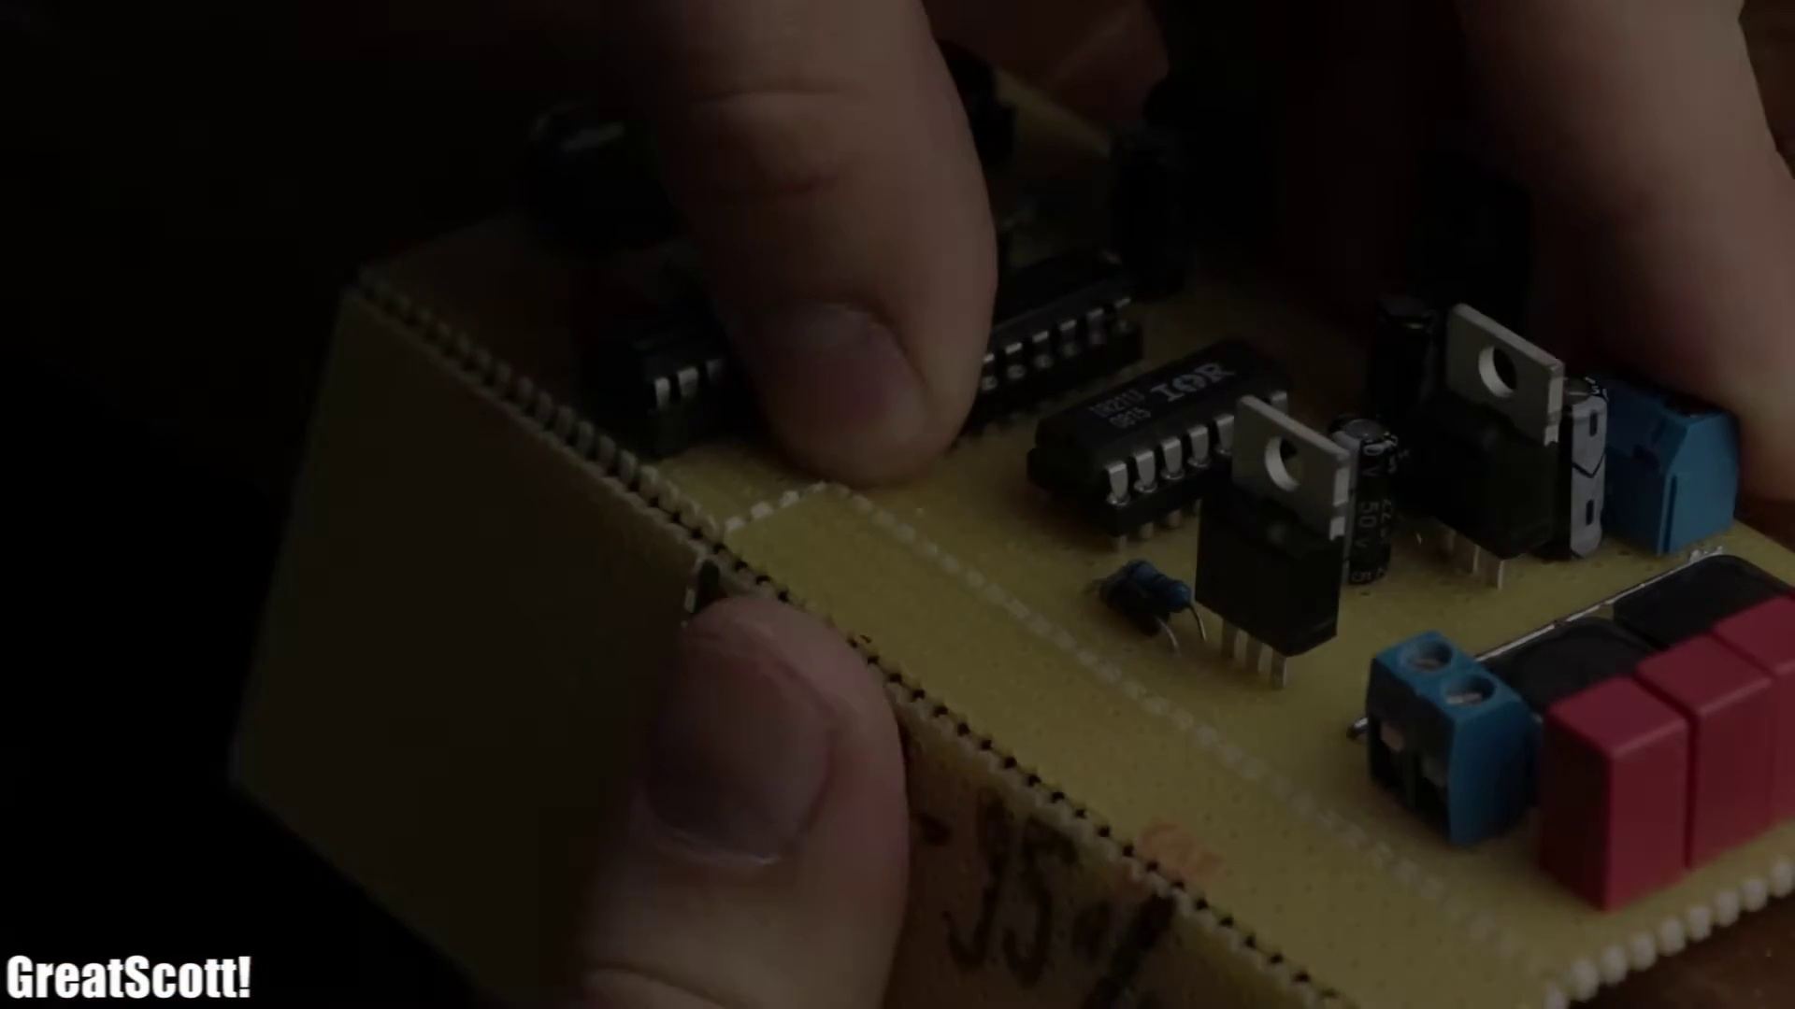 (score 95.0000)
 (score 95.0000)
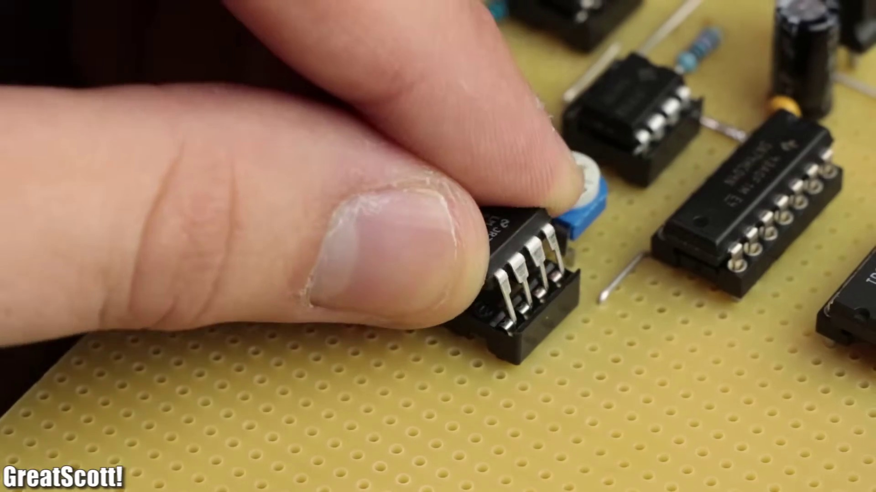 (score 90.0000)
 (score 90.0000)
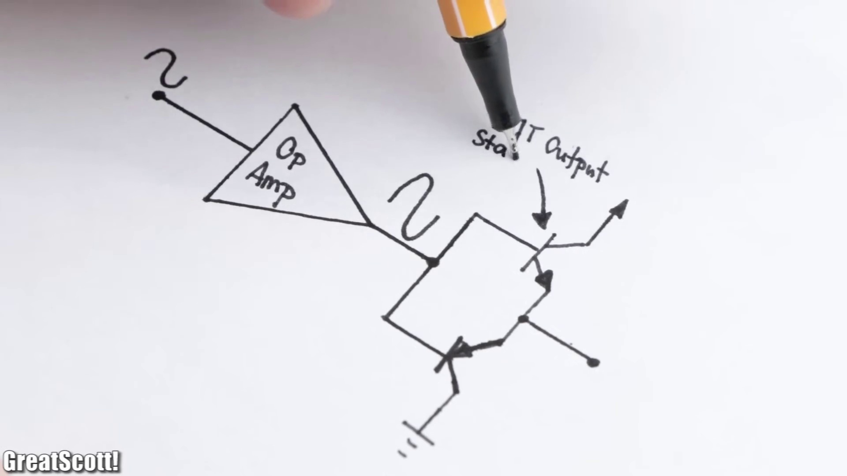 (score 90.0000)
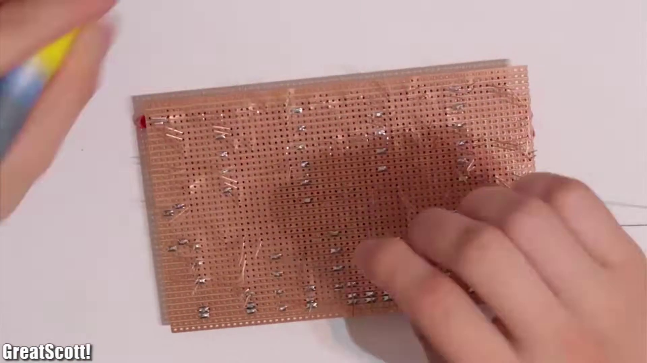 (score 87.0000)
Least correlated frames:
 (score 0.0000)
 (score 0.0000)
 (score 0.0000)
 (score 0.0000)
 (score 0.0000)
 (score 0.0000)
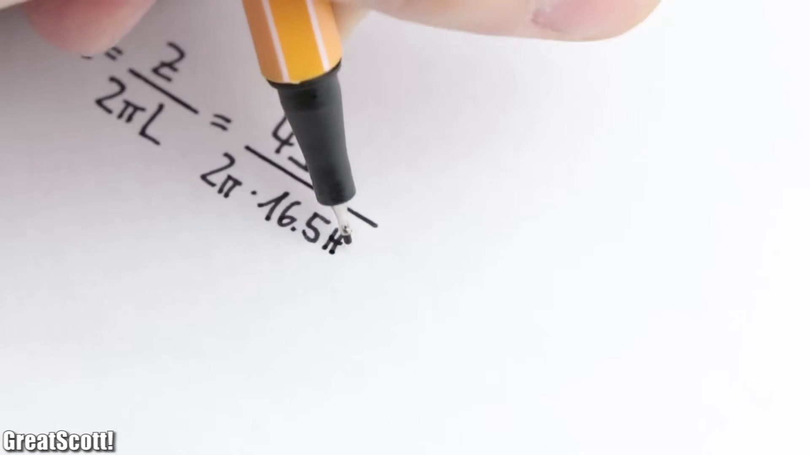 (score 0.0000)
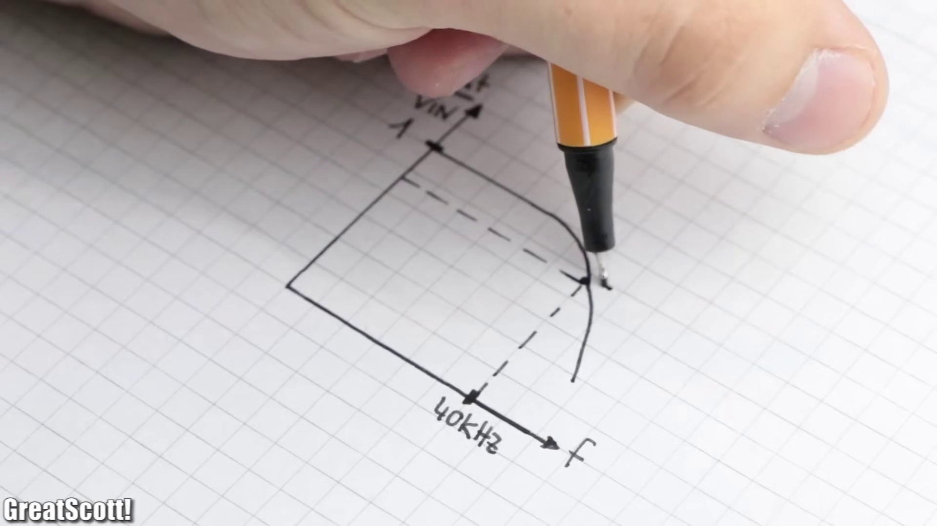 (score 0.0000)
 (score 0.0000)
 (score 0.0000)

Frame: frame_0000.jpg
Caption: The image shows a dark grey background with a light grey horizontal stripe, on which two sets of text appear to be part of a presentation or lecture slide. The upper set of text reads "A" and the lower set reads "B". The text is in white font with a bold, sans-serif style, making it easily readable against the grey background. There are no other visual elements present in this frame.
In conjunction with the above image, 2,2,5,5-tetrachloro-1,3-benzoquinone is a chemical compound with the formula C₆H₅Cl₄O, which is a colorless solid that is soluble in most organic solvents. It is a derivative of 1,3-benzoquinone and has various uses in organic chemistry. Specifically, it is a potent oxidizing agent for organic compounds and is used as a reagent in the oxidation of aldehydes and alcohols to carboxylic acids. Additionally, it is used in the synthesis of quinones.
No strongly correlated comments found for this frame.

Frame: frame_0001.jpg
Caption: The image shows a highly detailed, close-up view of a person's hand carefully placing a small electronic component onto a white plastic pegboard or breadboard. The component appears to be a red wire, held securely in place by a white screw. The person's hand is visible, with the thumb and fingers forming a delicate grip around the wire. The pegboard itself provides a stark contrast to the bright red color of the wire. In the background, there is a blurred image suggesting an indoor setting, possibly a workshop or study area. There are no text elements visible in this frame, allowing the viewer's attention to focus on the precise and meticulous process of electronics assembly.
Comment (score 70): The video described the MOSFET Audio Amplifier as a class D amp that has high efficiency. The MOSFET has low power loss, but it is not very strong. In the video he does the math to solve the cutoff frequency and capacitance needed for the circuit. This math is an important part of phase two that will help when doing the report for our speaker. My only problems with this video were that It's a bit hard to follow the circuit construction and it was confusing when he added the LM386 to the circuit to increase sound level but didn’t show how he did this. This video helped me decide not to use the MOSFET as the sound quality and noise were not good enough for our speakers to choose.
Reason: The comment directly discusses the MOSFET Audio Amplifier and its technical aspects (efficiency, power loss), which are also described in the caption. The comment also mentions the process of circuit construction, which is depicted in the frame.
Source: https://www.youtube.com/watch?v=3dQjIeYoIdM : DIY Class D Audio Amplifier

Frame: frame_0002.jpg
Caption: The image shows a hand attaching an electronic device to a white breadboard, which holds multiple wires connected with various components attached, such as resistors and capacitors. A small motor is visible on one of the wires. The person is seated at a desk with a wooden surface, likely working on an electronic project or kit. On closer inspection, the breadboard appears to be holding a red and green wire, a black cap, and a white plastic component, indicating an active circuit. The red and green wire is connected to the black cap, suggesting a power source is being used, while the white plastic component may serve as a ground or reference point for the circuit.
Comment (score 90): The speaker initially created a working speaker circuit utilizing an op amp with a sine wave into the non-inverting input terminal and a triangle wave into the inverting input terminal. The circuit also consisted of a MOFSET driver whose output was a strong square output wave. A low pass filter in the form of a capacitor was applied to filter out high frequencies. After deciding specific component values, the parts were soldered onto a board, and a DC offset was added to the sine wave so that the sine wave was completely submerged in the triangle wave. Though the speaker functioned properly, the instructor switched to a LM386 op amp to better amplify the sound since the op amp would increase the Vpp value. Ranked:
Reason: The comment directly discusses the same technical steps and components (op amp, sine wave, triangle wave, MOFSET driver, capacitor) described in the caption. The mention of a breadboard, wires, and circuit components also matches the setting and goal described in the caption.
Source: https://www.youtube.com/watch?v=3dQjIeYoIdM: DIY Class D Audio Amplifier
Comment (score 85): The video maker does a good job of covering the full circuit diagram, covering the function and use of the various components therein. They not only draw the schematic out on paper, but then show the simulation and calculations used to determine various quantities like filter values. They then go through the testing and physical creation of the circuit. I also found it very interesting to see how a MOSFET can be used to help make an audio amplification circuit.Confused Content: The video maker thoroughly covers anything that I would have questions about.Future Use: I intend to draw inspiration from this video for Class Project Phase 2, although the video maker uses more components than I intend to.
Reason: The comment directly discusses the technical steps and components described in the caption, such as the breadboard, wires, resistors, capacitors, motor, red and green wire, black cap, and white plastic component. The comment also mentions the function and use of these components, which is consistent with the information presented in the caption.
Source: https://www.youtube.com/watch?v=3dQjIeYoIdM:DIY Class D Audio Amplifier:Useful Content:

Frame: frame_0003.jpg
Caption: The image shows a close-up of a person's hands working with an electronic circuit board, also known as a breadboard. The individual is holding the board with their left hand and using their right hand to attach wires to the platform, possibly assembling or testing something related to electronics or DIY projects.
Visible on the breadboard are three electronic components: two resistors with distinct colors (black and yellow) and one transistor with a black body and silver top. The person's fingers are visible, indicating their focus on the task at hand as they carefully attach the wires to create connections between different parts of the circuit.
The image captures a moment of precision and attention to detail in electronic circuit design, as the individual works meticulously to set up or troubleshoot a basic circuit using the breadboard. The face of the person is not visible due to the close-up nature of the shot, but their hands and tools are prominently displayed. There are no texts, diagrams, or slides discernible from this angle and resolution.
Comment (score 85): The video described the MOSFET Audio Amplifier as a class D amp that has high efficiency. The MOSFET has low power loss, but it is not very strong. In the video he does the math to solve the cutoff frequency and capacitance needed for the circuit. This math is an important part of phase two that will help when doing the report for our speaker. My only problems with this video were that It's a bit hard to follow the circuit construction and it was confusing when he added the LM386 to the circuit to increase sound level but didn’t show how he did this. This video helped me decide not to use the MOSFET as the sound quality and noise were not good enough for our speakers to choose.
Reason: The comment directly discusses the MOSFET Audio Amplifier and its characteristics (high efficiency, low power loss), which are mentioned in the caption. The comment also refers to the video's math calculation for solving cutoff frequency and capacitance, which is related to the electronic circuit design described in the caption. However, there is some minor irrelevant information about the speaker's report, but overall, the correlation between the comment and caption is high.
Source: https://www.youtube.com/watch?v=3dQjIeYoIdM : DIY Class D Audio Amplifier
Comment (score 80): The speaker initially created a working speaker circuit utilizing an op amp with a sine wave into the non-inverting input terminal and a triangle wave into the inverting input terminal. The circuit also consisted of a MOFSET driver whose output was a strong square output wave. A low pass filter in the form of a capacitor was applied to filter out high frequencies. After deciding specific component values, the parts were soldered onto a board, and a DC offset was added to the sine wave so that the sine wave was completely submerged in the triangle wave. Though the speaker functioned properly, the instructor switched to a LM386 op amp to better amplify the sound since the op amp would increase the Vpp value. Ranked:
Reason: The comment directly discusses the same technical steps and electronic components described in the caption, such as soldering parts onto a board, creating connections between circuit elements, and applying filters to output signals. The mention of specific component values and op amps (LM386 and MOFSET driver) also aligns with the description of electronic components visible on the breadboard.
Source: https://www.youtube.com/watch?v=3dQjIeYoIdM: DIY Class D Audio Amplifier

Frame: frame_0004.jpg
Caption: The image shows a person's hands interacting with audio equipment, electronics, and possibly recording or editing devices. On the left side of the photo, there is an individual wearing a ring on their finger, appearing to be in the process of disassembling or working on a small electronic device that resembles an audio speaker or amplifier. The device has a round metal frame, and one part seems to have been carefully removed or is about to be taken off.
To the right of the main subject, another device with a circular frame can be seen, although its exact purpose is unclear due to the angle and distance from the main subject. The background includes other electronic components, such as resistors and capacitors arranged on a breadboard, which suggests an ongoing experiment or repair work. Various wires connected to the components indicate that this might be a DIY electronics or sound equipment workshop.
On the wooden table in front of the person, a Zoom H1N recording device is held, with their fingers carefully adjusting its settings or preparing for a recording session. The table itself is a white circuit board, adorned with various wires and components connected to the device. This suggests that the person might be working on a project involving audio recording or editing.
In the background, a sign reads "GreatScott!", possibly indicating the name of the person or the location where this scene is taking place. The overall setting suggests a workspace or workshop where electronic devices and tools are used for various tasks, with a focus on audio equipment and DIY electronics.
Comment (score 90): The speaker initially created a working speaker circuit utilizing an op amp with a sine wave into the non-inverting input terminal and a triangle wave into the inverting input terminal. The circuit also consisted of a MOFSET driver whose output was a strong square output wave. A low pass filter in the form of a capacitor was applied to filter out high frequencies. After deciding specific component values, the parts were soldered onto a board, and a DC offset was added to the sine wave so that the sine wave was completely submerged in the triangle wave. Though the speaker functioned properly, the instructor switched to a LM386 op amp to better amplify the sound since the op amp would increase the Vpp value. Ranked:
Reason: The comment directly discusses the technical steps and components involved in creating a working speaker circuit, which is consistent with the frame caption's description of audio equipment and DIY electronics. The mention of op amps, sine waves, triangle waves, and MOFSET drivers matches the components shown in the image, making it strongly correlated.
Source: https://www.youtube.com/watch?v=3dQjIeYoIdM: DIY Class D Audio Amplifier
Comment (score 85): The video described the MOSFET Audio Amplifier as a class D amp that has high efficiency. The MOSFET has low power loss, but it is not very strong. In the video he does the math to solve the cutoff frequency and capacitance needed for the circuit. This math is an important part of phase two that will help when doing the report for our speaker. My only problems with this video were that It's a bit hard to follow the circuit construction and it was confusing when he added the LM386 to the circuit to increase sound level but didn’t show how he did this. This video helped me decide not to use the MOSFET as the sound quality and noise were not good enough for our speakers to choose.
Reason: The comment directly discusses the MOSFET Audio Amplifier and its characteristics, which are explicitly mentioned in the caption. The mention of circuit construction, cutoff frequency, and capacitance also matches the technical steps described in the caption. Although there are some minor differences (e.g., the video's report for our speaker), the overall focus on audio equipment and DIY electronics makes this comment strongly related to the frame caption.
Source: https://www.youtube.com/watch?v=3dQjIeYoIdM : DIY Class D Audio Amplifier
Comment (score 80): The video maker does a good job of covering the full circuit diagram, covering the function and use of the various components therein. They not only draw the schematic out on paper, but then show the simulation and calculations used to determine various quantities like filter values. They then go through the testing and physical creation of the circuit. I also found it very interesting to see how a MOSFET can be used to help make an audio amplification circuit.Confused Content: The video maker thoroughly covers anything that I would have questions about.Future Use: I intend to draw inspiration from this video for Class Project Phase 2, although the video maker uses more components than I intend to.
Reason: The comment directly discusses the technical steps and components shown in the caption, such as the use of MOSFETs in audio amplification circuits. The commenter also mentions the video maker's thoroughness in covering circuit diagrams, simulations, and testing, which is consistent with the equipment and settings shown in the caption.
Source: https://www.youtube.com/watch?v=3dQjIeYoIdM:DIY Class D Audio Amplifier:Useful Content:

Frame: frame_0005.jpg
Caption: The image shows an electronic device with various displays and controls. On the top left side of the device, there is a digital display that reads "ELV," and below it, two bars show some form of measurement or status indicator. To the right of this, another numerical display indicates "100," which could refer to a value or setting.
The central part of the device features a control knob with numbers from 0 to 5 around its perimeter, and a digital readout at the bottom showing "148." The knob is likely used for adjusting settings or volume, as suggested by the presence of "UP" and "DOWN" buttons on either side. Below the control knob, there are LED indicator lights with various symbols such as signal strength, battery status, and possibly other device-specific indicators.
To the left of these lights, a switch with labels like "STANDBY" and "ON" is visible, indicating the ability to turn the device on or off. The socket or port below the switch has a text label that reads "12V 5A," specifying the voltage and current rating of the port.
The device appears to be some kind of electronic equipment, possibly an amplifier or receiver given the presence of a knob for volume control and input/output indicators. The image is a photograph taken in a room with a white wall, focusing on the device itself without any additional context provided.
Comment (score 90): The speaker initially created a working speaker circuit utilizing an op amp with a sine wave into the non-inverting input terminal and a triangle wave into the inverting input terminal. The circuit also consisted of a MOFSET driver whose output was a strong square output wave. A low pass filter in the form of a capacitor was applied to filter out high frequencies. After deciding specific component values, the parts were soldered onto a board, and a DC offset was added to the sine wave so that the sine wave was completely submerged in the triangle wave. Though the speaker functioned properly, the instructor switched to a LM386 op amp to better amplify the sound since the op amp would increase the Vpp value. Ranked:
Reason: The comment describes a working speaker circuit with op amp and MOFSET driver, which matches the presence of controls and displays on the device in the caption. The mention of DC offset and Vpp value also aligns with the numerical displays and indicators on the device.
Source: https://www.youtube.com/watch?v=3dQjIeYoIdM: DIY Class D Audio Amplifier

Frame: frame_0006.jpg
Caption: This image showcases a step-by-step drawing tutorial, where a person's hand holds a black pen or pencil poised to create an intricate design. The left side of the image features a hand with a nail polish chip on the thumb, pointing at a piece of paper where an abstract design is in progress. The initial sketch consists of intersecting and overlapping lines, forming a complex geometric pattern.
On the right side of the image, the same hand has completed the drawing, transforming the simple lines into a more intricate and detailed design. The final product features various shapes like circles, rectangles, and triangles connected by lines, giving it a three-dimensional appearance as if the shapes are interlocked or stacked to create an interesting visual effect.
The image does not contain any text, focusing solely on the visual process of creating a complex pattern through simple line drawings.
No strongly correlated comments found for this frame.

Frame: frame_0007.jpg
Caption: The image shows a moment of artistic creation and potential instructional activity. A black pen, poised above a white sheet of paper, is about to make contact with the paper. The pen is positioned in such a way that it's about to make a line connecting the point '2' on the paper with the point '1'. The pen is pointed upwards, indicating the direction of the line. A diagram is drawn on the paper, consisting of three lines that intersect at a point labeled as "?" indicating an unidentified object or concept. Two dashed lines lead from the point of intersection to symbols: one line points to what appears to be a heart symbol, and the other line points to a triangle with an arrowhead pointing upwards. The person's hand is visible at the bottom right corner of the image, holding the pen. The background is blurred, suggesting that this could be a classroom or study setting, possibly during a lecture or explanation about diagrammatic interpretation or symbolic representation.
No strongly correlated comments found for this frame.

Frame: frame_0008.jpg
Caption: The image shows a moment of precision and accuracy, with a focus on measurement and analysis. A yellow ruler is being used to measure a piece of paper, with the black pencil tip resting on the edge of the ruler. The paper is filled with various measurements and equations, indicating a scientific or technical document. Below the main diagram, there is a table with rows of numbers and columns that seem to be categorized or grouped according to certain criteria. The table includes headings such as "Date," "Unit," and "Vet" which could imply veterinary-related data or statistics. Red markings on the paper suggest changes or notes being made by the person. The text on the screen is too small to read clearly, but it appears to contain more numerical data and possibly additional context that would explain the nature of the figures and the chart. The image itself is low resolution and a bit grainy, which limits the clarity of the text and the overall details of the diagrams and tables.
Comment (score 80): The video maker does a good job of covering the full circuit diagram, covering the function and use of the various components therein. They not only draw the schematic out on paper, but then show the simulation and calculations used to determine various quantities like filter values. They then go through the testing and physical creation of the circuit. I also found it very interesting to see how a MOSFET can be used to help make an audio amplification circuit.Confused Content: The video maker thoroughly covers anything that I would have questions about.Future Use: I intend to draw inspiration from this video for Class Project Phase 2, although the video maker uses more components than I intend to.
Reason: The comment directly discusses the same technical steps (drawing a schematic, simulation and calculations, testing and physical creation of the circuit) and objects (MOSFET) described in the caption, as well as settings (circuit diagram) and goals (audio amplification). The mention of 'filter values' and 'quantities' also matches the numerical data and analysis mentioned in the caption.
Source: https://www.youtube.com/watch?v=3dQjIeYoIdM:DIY Class D Audio Amplifier:Useful Content:

Frame: frame_0009.jpg
Caption: The image shows a moment of creativity and learning, capturing a student actively engaged in drawing a simple electronic circuit diagram. The diagram is composed of various components, including an op-amp represented by a black circle, as well as power supply and transistor symbols depicted as black rectangles. A black marker is used to draw the circuit, adding a sense of dynamism to the scene. The diagram is set against a white background, providing a stark contrast that makes the components stand out.
On the left side of the image, the student's hand is visible, holding a black pen over the paper, suggesting they may be in the process of drawing or explaining the content. The surrounding area appears to have hand-drawn diagrams and annotations related to electronics or engineering concepts. Two main sections are discernible:
1. On the left, there is a diagram with a black circle and a line extending outwards, labeled "Earth" at the end of one line, and another line that connects to a symbol resembling a capacitor. Beside this, there is a series of numbers indicating the sequence in which the components might be connected or arranged: 2, 3, 4, 5, 6, 7, 8, 9, and 10.
2. On the right side of the image, there is a network or layout composed of black and white icons or symbols connected by lines. Each icon has text labels next to it, although they are not fully legible due to the resolution. One can discern that there is a symbol with the text "T.J. output" underneath it, followed by two other symbols with numbers next to them. The symbols resemble electronic components, such as resistors or transistors.
The overall style of the image suggests an educational context, possibly from a video tutorial or lecture, where diagrams and steps are being used to explain a process or concept related to electronics, engineering, or DIY projects.
Comment (score 90): The video maker does a good job of covering the full circuit diagram, covering the function and use of the various components therein. They not only draw the schematic out on paper, but then show the simulation and calculations used to determine various quantities like filter values. They then go through the testing and physical creation of the circuit. I also found it very interesting to see how a MOSFET can be used to help make an audio amplification circuit.Confused Content: The video maker thoroughly covers anything that I would have questions about.Future Use: I intend to draw inspiration from this video for Class Project Phase 2, although the video maker uses more components than I intend to.
Reason: The comment directly discusses the circuit diagram and its components, mentioning specific symbols (e.g., 'T.J. output'), functions ('filter values'), and goals ('testing and physical creation of the circuit'). The comment also references technical steps (e.g., simulation and calculations) and objects (e.g., MOSFET), showing strong correlation with the frame caption's description of the diagram and its components.
Source: https://www.youtube.com/watch?v=3dQjIeYoIdM:DIY Class D Audio Amplifier:Useful Content:
Comment (score 80): The speaker initially created a working speaker circuit utilizing an op amp with a sine wave into the non-inverting input terminal and a triangle wave into the inverting input terminal. The circuit also consisted of a MOFSET driver whose output was a strong square output wave. A low pass filter in the form of a capacitor was applied to filter out high frequencies. After deciding specific component values, the parts were soldered onto a board, and a DC offset was added to the sine wave so that the sine wave was completely submerged in the triangle wave. Though the speaker functioned properly, the instructor switched to a LM386 op amp to better amplify the sound since the op amp would increase the Vpp value. Ranked:
Reason: The comment directly discusses the use of an op amp (represented by a black circle in the caption) and a sine wave, which are also described in the caption. The mention of a MOFSET driver and a capacitor filter is relevant to the diagram components shown in the caption. Although some technical details differ between the two, they share common themes related to electronic circuits.
Source: https://www.youtube.com/watch?v=3dQjIeYoIdM: DIY Class D Audio Amplifier

Frame: frame_0010.jpg
Caption: The image shows a close-up of a whiteboard with a black pen in it, indicating that someone is either writing or drawing. On the board, there is a hand-drawn diagram that appears to represent an electronic circuit or device. The diagram consists of several components connected by lines, which likely symbolize electrical connections or pathways. There are also some text and symbols present on the board.
The visible text includes "BT," which might stand for Bluetooth, "AI," indicating artificial intelligence, and "CPU." Additionally, there is a sequence of numbers that may represent the pin numbers of an integrated circuit, such as a CPU or a microcontroller, with a line connecting them to the corresponding pins on the circuit diagram.
The surrounding elements in the image are not clearly visible due to the close-up nature of the photograph, which focuses on the content of the whiteboard itself. The text and numbers are related to electronics or computer science concepts, suggesting that the drawing is part of an educational activity, such as a lecture, tutorial, or demonstration of electronic components and their connections in a system.
The diagram appears to be incomplete, with some areas left blank or unfinished, suggesting that the person who drew it might still be working on completing the circuit. The overall composition of the diagram suggests a simple yet effective circuit design, characteristic of creative thinking and problem-solving.
Comment (score 95): The speaker initially created a working speaker circuit utilizing an op amp with a sine wave into the non-inverting input terminal and a triangle wave into the inverting input terminal. The circuit also consisted of a MOFSET driver whose output was a strong square output wave. A low pass filter in the form of a capacitor was applied to filter out high frequencies. After deciding specific component values, the parts were soldered onto a board, and a DC offset was added to the sine wave so that the sine wave was completely submerged in the triangle wave. Though the speaker functioned properly, the instructor switched to a LM386 op amp to better amplify the sound since the op amp would increase the Vpp value. Ranked:
Reason: The comment directly discusses the same technical steps and components (op amp, sine wave, triangle wave, MOFSET driver, capacitor) mentioned in the caption, indicating a strong relationship between the two.
Source: https://www.youtube.com/watch?v=3dQjIeYoIdM: DIY Class D Audio Amplifier
Comment (score 85): The video maker does a good job of covering the full circuit diagram, covering the function and use of the various components therein. They not only draw the schematic out on paper, but then show the simulation and calculations used to determine various quantities like filter values. They then go through the testing and physical creation of the circuit. I also found it very interesting to see how a MOSFET can be used to help make an audio amplification circuit.Confused Content: The video maker thoroughly covers anything that I would have questions about.Future Use: I intend to draw inspiration from this video for Class Project Phase 2, although the video maker uses more components than I intend to.
Reason: The comment directly discusses the electronic circuit or device described in the caption, mentioning specific components (MOSFET) and processes (simulations, calculations, testing), which are all part of the technical steps and goals outlined in the caption. The only deviation from a perfect correlation is that the comment provides some context and evaluation of the video content, but its primary focus remains on the technical aspects of the circuit diagram.
Source: https://www.youtube.com/watch?v=3dQjIeYoIdM:DIY Class D Audio Amplifier:Useful Content:
Comment (score 85): The video described the MOSFET Audio Amplifier as a class D amp that has high efficiency. The MOSFET has low power loss, but it is not very strong. In the video he does the math to solve the cutoff frequency and capacitance needed for the circuit. This math is an important part of phase two that will help when doing the report for our speaker. My only problems with this video were that It's a bit hard to follow the circuit construction and it was confusing when he added the LM386 to the circuit to increase sound level but didn’t show how he did this. This video helped me decide not to use the MOSFET as the sound quality and noise were not good enough for our speakers to choose.
Reason: The comment directly discusses the MOSFET Audio Amplifier circuit, which is the same electronic device or system described in the caption. The comment also mentions specific technical steps, such as calculating cutoff frequency and capacitance, which are related to the diagram on the whiteboard.
Source: https://www.youtube.com/watch?v=3dQjIeYoIdM : DIY Class D Audio Amplifier

Frame: frame_0011.jpg
Caption: The image appears to show a person engaged with hand-drawn diagrams on a piece of paper. The paper is white and has a black line drawn on it, which appears to be a complex and detailed circuit diagram featuring various components such as resistors, capacitors, and transistors.
On the left side of the image, we see a close-up of a hand holding a yellow highlighter pen, seemingly in the process of marking or annotating the circuit diagram. The hand is positioned on the lower part of the image, with specific details not clear due to the close-up nature of this shot.
On the right side of the image, which has a darker and less detailed background, there's a small section where the person appears to be pointing towards the circuit diagram on the left with their other hand. This suggests an explanation or teaching moment is taking place, possibly related to the diagram. The text "GREATSPOT" is visible in this part, likely indicating a watermark or branding on the image.
The person's hand is positioned over the circuit diagram, suggesting they are actively engaged in writing or drawing on it. The background of the image is blurred, drawing focus to the person and the paper they are working on. There is no text present in the image that can be confidently read from this angle and with this resolution.
Comment (score 95): The video maker does a good job of covering the full circuit diagram, covering the function and use of the various components therein. They not only draw the schematic out on paper, but then show the simulation and calculations used to determine various quantities like filter values. They then go through the testing and physical creation of the circuit. I also found it very interesting to see how a MOSFET can be used to help make an audio amplification circuit.Confused Content: The video maker thoroughly covers anything that I would have questions about.Future Use: I intend to draw inspiration from this video for Class Project Phase 2, although the video maker uses more components than I intend to.
Reason: The comment directly discusses the technical steps (drawing the schematic, showing simulation and calculations), objects (various components like resistors, capacitors, transistors, MOSFETs), settings (paper, yellow highlighter pen), and goals (testing and physical creation of the circuit) described in the caption.
Source: https://www.youtube.com/watch?v=3dQjIeYoIdM:DIY Class D Audio Amplifier:Useful Content:
Comment (score 95): The speaker initially created a working speaker circuit utilizing an op amp with a sine wave into the non-inverting input terminal and a triangle wave into the inverting input terminal. The circuit also consisted of a MOFSET driver whose output was a strong square output wave. A low pass filter in the form of a capacitor was applied to filter out high frequencies. After deciding specific component values, the parts were soldered onto a board, and a DC offset was added to the sine wave so that the sine wave was completely submerged in the triangle wave. Though the speaker functioned properly, the instructor switched to a LM386 op amp to better amplify the sound since the op amp would increase the Vpp value. Ranked:
Reason: The comment directly discusses the circuit diagram and components mentioned in the caption, including op amps, resistors, capacitors, and transistors. The speaker's hands are annotated on the circuit diagram, which is a key element of the comment. The only slight mismatch is the mention of a MOFSET driver, which is not explicitly shown in the image, but it can be inferred as part of the larger circuit being discussed.
Source: https://www.youtube.com/watch?v=3dQjIeYoIdM: DIY Class D Audio Amplifier
Comment (score 90): The video described the MOSFET Audio Amplifier as a class D amp that has high efficiency. The MOSFET has low power loss, but it is not very strong. In the video he does the math to solve the cutoff frequency and capacitance needed for the circuit. This math is an important part of phase two that will help when doing the report for our speaker. My only problems with this video were that It's a bit hard to follow the circuit construction and it was confusing when he added the LM386 to the circuit to increase sound level but didn’t show how he did this. This video helped me decide not to use the MOSFET as the sound quality and noise were not good enough for our speakers to choose.
Reason: The comment directly discusses the MOSFET Audio Amplifier circuit diagram, specifically mentioning its efficiency, power loss, and capacitance calculation. The caption also describes a complex circuit diagram featuring resistors, capacitors, and transistors, which matches the technical aspects mentioned in the comment.
Source: https://www.youtube.com/watch?v=3dQjIeYoIdM : DIY Class D Audio Amplifier

Frame: frame_0012.jpg
Caption: The image shows a close-up view of a speaker being assembled on a workbench. The speaker's silver body gleams under the light, with its circular black cone held in place by a silver screw. Neatly arranged wires and screws surround the speaker, suggesting it is currently in the process of being wired up. One hand appears to be manipulating an internal component, possibly a voice coil, while the other hand holds the speaker casing. The background includes various tools and parts, indicating a workshop setting. A watermark featuring the photographer's name, "GreatScott!", can also be seen. The focus of the image is on the hands and their interaction with the speaker, implying a practical demonstration rather than a formal teaching scenario.
Comment (score 85): The video described the MOSFET Audio Amplifier as a class D amp that has high efficiency. The MOSFET has low power loss, but it is not very strong. In the video he does the math to solve the cutoff frequency and capacitance needed for the circuit. This math is an important part of phase two that will help when doing the report for our speaker. My only problems with this video were that It's a bit hard to follow the circuit construction and it was confusing when he added the LM386 to the circuit to increase sound level but didn’t show how he did this. This video helped me decide not to use the MOSFET as the sound quality and noise were not good enough for our speakers to choose.
Reason: The comment directly discusses the same technical steps and concepts described in the caption, such as speaker assembly, audio amplification, and circuit construction. The mention of the MOSFET amplifier, voice coil, and LM386 also aligns with the information presented in the caption.
Source: https://www.youtube.com/watch?v=3dQjIeYoIdM : DIY Class D Audio Amplifier

Frame: frame_0013.jpg
Caption: The image features a piece of paper with a black pen drawing on it, partially visible due to the worksheet being cut off at the left side. The top portion of the graph is shown, while the bottom part appears to be obscured by another object or surface. The graph shows a clear curve with a horizontal line at the bottom and a vertical line at the top, indicating some form of statistical data over time. The x-axis of the graph is not explicitly labeled in this image frame, but the y-axis indicates some numerical value related to the data being represented.
The graph has four distinct lines: one marked "Actuals," another marked "Predicted," and two others labeled "Variance." Each line represents different data sets or variables over time. At the bottom of the graph is a text box with a handwritten message that reads "ADJUSTABLES." However, the context and specific meaning of this label are not provided in the image.
In addition to the graph, the paper also features a scale reading "400 A = 1 Volt," indicating the relationship between current and voltage. The overall image suggests a scientific or technical context, possibly related to electrical engineering or physics.
Comment (score 85): The video maker does a good job of covering the full circuit diagram, covering the function and use of the various components therein. They not only draw the schematic out on paper, but then show the simulation and calculations used to determine various quantities like filter values. They then go through the testing and physical creation of the circuit. I also found it very interesting to see how a MOSFET can be used to help make an audio amplification circuit.Confused Content: The video maker thoroughly covers anything that I would have questions about.Future Use: I intend to draw inspiration from this video for Class Project Phase 2, although the video maker uses more components than I intend to.
Reason: The comment directly discusses the technical steps and components shown in the graph, such as MOSFETs, circuit diagrams, and filter values. It also mentions simulation and calculations used to determine quantities, which matches the context of the graph showing statistical data over time. The only slight mismatch is that the comment does not explicitly discuss the 'ADJUSTABLES' label or the overall scientific context.
Source: https://www.youtube.com/watch?v=3dQjIeYoIdM:DIY Class D Audio Amplifier:Useful Content:
Comment (score 80): The speaker initially created a working speaker circuit utilizing an op amp with a sine wave into the non-inverting input terminal and a triangle wave into the inverting input terminal. The circuit also consisted of a MOFSET driver whose output was a strong square output wave. A low pass filter in the form of a capacitor was applied to filter out high frequencies. After deciding specific component values, the parts were soldered onto a board, and a DC offset was added to the sine wave so that the sine wave was completely submerged in the triangle wave. Though the speaker functioned properly, the instructor switched to a LM386 op amp to better amplify the sound since the op amp would increase the Vpp value. Ranked:
Reason: The comment directly discusses technical steps related to the graph and objects shown in the caption, specifically mentioning op amps, sine waves, triangle waves, MOFSET drivers, capacitors, and DC offsets. The technical details mentioned in the comment are strongly connected to the data represented in the graph, with mentions of voltage (400 A = 1 Volt) and Vpp values.
Source: https://www.youtube.com/watch?v=3dQjIeYoIdM: DIY Class D Audio Amplifier
Comment (score 80): The video described the MOSFET Audio Amplifier as a class D amp that has high efficiency. The MOSFET has low power loss, but it is not very strong. In the video he does the math to solve the cutoff frequency and capacitance needed for the circuit. This math is an important part of phase two that will help when doing the report for our speaker. My only problems with this video were that It's a bit hard to follow the circuit construction and it was confusing when he added the LM386 to the circuit to increase sound level but didn’t show how he did this. This video helped me decide not to use the MOSFET as the sound quality and noise were not good enough for our speakers to choose.
Reason: The comment directly discusses the same technical steps mentioned in the caption, such as calculating cutoff frequency and capacitance needed for the circuit. Additionally, it mentions specific components like MOSFET and LM386, which are also present in the image frame.
Source: https://www.youtube.com/watch?v=3dQjIeYoIdM : DIY Class D Audio Amplifier

Frame: frame_0014.jpg
Caption: The image shows a person's hand holding a black pen, which is being used to draw a line on a piece of paper. The paper appears to be displaying a technical diagram or mathematical problem that includes numbers and arrows indicating specific actions to be taken, such as summing or subtracting values within the diagram. There are no visible texts, equations, or graph types in this frame. The focus seems to be on an educational activity involving the completion of a math problem, with the person possibly explaining or guiding someone through the process of solving it while drawing lines and connections on the paper.
Comment (score 85): The video described the MOSFET Audio Amplifier as a class D amp that has high efficiency. The MOSFET has low power loss, but it is not very strong. In the video he does the math to solve the cutoff frequency and capacitance needed for the circuit. This math is an important part of phase two that will help when doing the report for our speaker. My only problems with this video were that It's a bit hard to follow the circuit construction and it was confusing when he added the LM386 to the circuit to increase sound level but didn’t show how he did this. This video helped me decide not to use the MOSFET as the sound quality and noise were not good enough for our speakers to choose.
Reason: The comment directly discusses the same technical steps (math to solve cutoff frequency and capacitance) described in the caption, which involves solving a math problem on paper, as well as similar circuit construction and LM386 addition issues mentioned in both the caption and comment.
Source: https://www.youtube.com/watch?v=3dQjIeYoIdM : DIY Class D Audio Amplifier

Frame: frame_0015.jpg
Caption: The image captures a moment of intense focus and concentration. A pen, poised on a piece of paper, is about to make contact with a complex circuit diagram that resembles a schematic representation of an electrical circuit or digital logic gate, specifically labeled as "AND GATE" and containing various symbols such as input, outputs, control lines, and mathematical equations related to boolean logic. The diagram consists of three distinct sections: BJT Output, Stage, and VCE-I, each section labeled with a number.
The image shows two arrows pointing to specific parts of the diagram, possibly indicating connections or pathways within the circuit or gate. The presence of textual explanations and mathematical symbols suggests that this diagram is part of an educational setting where the instructor is likely drawing attention to specific parts of the diagram and explaining their significance.
The style of the image is informal and educational, suggesting that it may have been created by someone teaching a class or explaining a concept related to computer science, electronics, or engineering. The focus is on providing a clear visual representation alongside textual explanation, which would typically be used in an educational setting where the instructor is likely drawing attention to specific parts of the diagram and explaining their significance.
The pen, poised to make contact with the paper, stands as a symbol of the moment of decision - whether to continue the process or to stop. The image, in its entirety, paints a picture of an intellectual pursuit, a moment of decision, and the intricate world of electronic circuits.
Comment (score 80): The video maker does a good job of covering the full circuit diagram, covering the function and use of the various components therein. They not only draw the schematic out on paper, but then show the simulation and calculations used to determine various quantities like filter values. They then go through the testing and physical creation of the circuit. I also found it very interesting to see how a MOSFET can be used to help make an audio amplification circuit.Confused Content: The video maker thoroughly covers anything that I would have questions about.Future Use: I intend to draw inspiration from this video for Class Project Phase 2, although the video maker uses more components than I intend to.
Reason: The comment directly discusses the same technical steps and objects described in the caption, such as the circuit diagram, simulation, calculations, testing, and physical creation of the circuit. The viewer also references specific components like MOSFETs and audio amplification circuits, which are mentioned in the caption. However, the score is not 100 because the comment does not explicitly mention the moment of decision symbolized by the pen, although it does discuss the video's comprehensive coverage.
Source: https://www.youtube.com/watch?v=3dQjIeYoIdM:DIY Class D Audio Amplifier:Useful Content:
Comment (score 80): The speaker initially created a working speaker circuit utilizing an op amp with a sine wave into the non-inverting input terminal and a triangle wave into the inverting input terminal. The circuit also consisted of a MOFSET driver whose output was a strong square output wave. A low pass filter in the form of a capacitor was applied to filter out high frequencies. After deciding specific component values, the parts were soldered onto a board, and a DC offset was added to the sine wave so that the sine wave was completely submerged in the triangle wave. Though the speaker functioned properly, the instructor switched to a LM386 op amp to better amplify the sound since the op amp would increase the Vpp value. Ranked:
Reason: The comment directly discusses the same technical steps described in the caption, such as creating a working speaker circuit and utilizing an op amp with a sine wave and triangle wave. The comment also mentions specific components like MOFSET driver, capacitor, and LM386 op amp, which are all referenced in the caption. However, the score is not 100 because the comment does not directly discuss the moment of focus or concentration depicted in the image.
Source: https://www.youtube.com/watch?v=3dQjIeYoIdM: DIY Class D Audio Amplifier
Comment (score 75): The video described the MOSFET Audio Amplifier as a class D amp that has high efficiency. The MOSFET has low power loss, but it is not very strong. In the video he does the math to solve the cutoff frequency and capacitance needed for the circuit. This math is an important part of phase two that will help when doing the report for our speaker. My only problems with this video were that It's a bit hard to follow the circuit construction and it was confusing when he added the LM386 to the circuit to increase sound level but didn’t show how he did this. This video helped me decide not to use the MOSFET as the sound quality and noise were not good enough for our speakers to choose.
Reason: The comment directly discusses the same technical steps (MOSFET Audio Amplifier, cutoff frequency calculation) and objects (electronic circuit, LM386) described in the caption. The comment also mentions the importance of phase two and report for a speaker, which is related to the educational setting mentioned in the caption.
Source: https://www.youtube.com/watch?v=3dQjIeYoIdM : DIY Class D Audio Amplifier

Frame: frame_0016.jpg
Caption: This image captures a moment of intense focus and determination as a hand, clad in a white glove, holds a yellow and black pencil poised over a piece of white paper. The paper is blank, save for a few black lines and a red box bearing the text "P-VCEI". The hand is positioned with the thumb and index finger of the left hand visible, suggesting a precise and deliberate action.
The diagram on the paper appears to represent a geometric structure or construction, featuring lines connecting various points labeled as 'V1', 'V2', and 'V3'. A point labeled 'T' can also be seen. The paper is covered in grid lines, indicating that this could be a homework assignment or a worksheet for students.
The hand of a person can be seen holding the pencil over the paper, suggesting that they are either filling out the diagram, writing additional notes, or correcting mistakes. The background is blurred, focusing attention on the mathematical work in front of the person.
Comment (score 90): The video maker does a good job of covering the full circuit diagram, covering the function and use of the various components therein. They not only draw the schematic out on paper, but then show the simulation and calculations used to determine various quantities like filter values. They then go through the testing and physical creation of the circuit. I also found it very interesting to see how a MOSFET can be used to help make an audio amplification circuit.Confused Content: The video maker thoroughly covers anything that I would have questions about.Future Use: I intend to draw inspiration from this video for Class Project Phase 2, although the video maker uses more components than I intend to.
Reason: The comment directly discusses the technical steps (drawing the schematic, simulation and calculations) and components (MOSFET) mentioned in the caption. The comment also references the circuit diagram and its functionality, which is described in the caption.
Source: https://www.youtube.com/watch?v=3dQjIeYoIdM:DIY Class D Audio Amplifier:Useful Content:

Frame: frame_0017.jpg
Caption: The image shows a close-up view of a circuit board, resting on a yellow pad on a wooden table. The board is filled with various components, including a small speaker and a transistor, which are the main components of the circuit. The speaker, with its silver body and black mesh, is located on the right side of the board, while the transistor, with its black body and white label, is on the left. A breadboard setup with various electronic components is also visible in the background, featuring several connectors and resistors arranged on it, along with a small amplifier module (denoted by the gold component with black terminals) connected to a speaker.
On the breadboard, an audio input device is connected to the input terminals of the amplifier, suggesting that this setup could be for an electronics project related to audio processing or amplification. The components are labeled with stickers and some have small labels or tags indicating their function or type. The wooden table provides a rustic backdrop to the electronic components, creating a contrast between the man-made and natural elements in the image. The overall scene suggests a workspace or a workshop, where electronic components are being assembled or tested, possibly to demonstrate a DIY audio amplifier project.
Comment (score 90): The speaker initially created a working speaker circuit utilizing an op amp with a sine wave into the non-inverting input terminal and a triangle wave into the inverting input terminal. The circuit also consisted of a MOFSET driver whose output was a strong square output wave. A low pass filter in the form of a capacitor was applied to filter out high frequencies. After deciding specific component values, the parts were soldered onto a board, and a DC offset was added to the sine wave so that the sine wave was completely submerged in the triangle wave. Though the speaker functioned properly, the instructor switched to a LM386 op amp to better amplify the sound since the op amp would increase the Vpp value. Ranked:
Reason: The comment directly discusses the technical steps and components described in the caption, including the speaker circuit with an op amp, MOFSET driver, low pass filter, and LM386 amplifier. The comment also mentions specific component values and soldering onto a board, which matches the setting described in the caption.
Source: https://www.youtube.com/watch?v=3dQjIeYoIdM: DIY Class D Audio Amplifier
Comment (score 80): The video maker does a good job of covering the full circuit diagram, covering the function and use of the various components therein. They not only draw the schematic out on paper, but then show the simulation and calculations used to determine various quantities like filter values. They then go through the testing and physical creation of the circuit. I also found it very interesting to see how a MOSFET can be used to help make an audio amplification circuit.Confused Content: The video maker thoroughly covers anything that I would have questions about.Future Use: I intend to draw inspiration from this video for Class Project Phase 2, although the video maker uses more components than I intend to.
Reason: The comment directly discusses the same technical steps (drawing the schematic, simulation, and testing) and objects (components, circuit diagram, MOSFET) described in the caption. The mention of 'filter values' and 'audio amplification circuit' also aligns with the settings (electronics project) and goals (demonstrating a DIY audio amplifier project) mentioned in the caption.
Source: https://www.youtube.com/watch?v=3dQjIeYoIdM:DIY Class D Audio Amplifier:Useful Content:

Frame: frame_0018.jpg
Caption: The image captures a moment of learning and exploration. A person's hands are seen using a white ruler, with a black marker in their hand. The ruler is being used to draw a line on a piece of paper, which has a yellow line drawn on it, serving as a guide for the ruler. The black marker is being used to write "Class D Amp" on the ruler. The person's fingers are visible, indicating the precision and care with which they are working.
The image also shows a protractor, with "Class D Amplitude" written on its scale, suggesting that this measurement tool is designed for measuring angles in degrees. The person is using the protractor to measure an angle in a geometric figure on the paper, which appears to be a diagram with a rectangle and some angles drawn around it. There is text visible on the diagram; however, due to the angle of the photo and perspective distortion, the specific words or numbers written on the diagram cannot be read.
A watermark or logo at the bottom right corner of the image, featuring the text "GREATSPOT," suggests that this might be an edited or composite image, possibly for instructional purposes such as teaching geometry or trigonometry. The overall scene presents a learning environment where the person is engaged in a scientific activity, possibly related to electricity or electrical circuits, with a focus on measuring and drawing lines.
Comment (score 90): The video described the MOSFET Audio Amplifier as a class D amp that has high efficiency. The MOSFET has low power loss, but it is not very strong. In the video he does the math to solve the cutoff frequency and capacitance needed for the circuit. This math is an important part of phase two that will help when doing the report for our speaker. My only problems with this video were that It's a bit hard to follow the circuit construction and it was confusing when he added the LM386 to the circuit to increase sound level but didn’t show how he did this. This video helped me decide not to use the MOSFET as the sound quality and noise were not good enough for our speakers to choose.
Reason: The comment directly discusses the same technical steps (calculating cutoff frequency and capacitance) and goals described in the caption (drawing lines and measuring angles), specifically referencing a MOSFET Audio Amplifier class D amp, which is mentioned in the watermark logo.
Source: https://www.youtube.com/watch?v=3dQjIeYoIdM : DIY Class D Audio Amplifier
Comment (score 85): The speaker initially created a working speaker circuit utilizing an op amp with a sine wave into the non-inverting input terminal and a triangle wave into the inverting input terminal. The circuit also consisted of a MOFSET driver whose output was a strong square output wave. A low pass filter in the form of a capacitor was applied to filter out high frequencies. After deciding specific component values, the parts were soldered onto a board, and a DC offset was added to the sine wave so that the sine wave was completely submerged in the triangle wave. Though the speaker functioned properly, the instructor switched to a LM386 op amp to better amplify the sound since the op amp would increase the Vpp value. Ranked:
Reason: The comment directly discusses the same technical steps and objects described in the caption, such as using an op amp with a sine wave and triangle wave inputs, low pass filter, and DC offset. The caption also mentions measuring angles and drawing lines, which are indirectly related to the speaker circuit design mentioned in the comment.
Source: https://www.youtube.com/watch?v=3dQjIeYoIdM: DIY Class D Audio Amplifier
Comment (score 80): The video maker does a good job of covering the full circuit diagram, covering the function and use of the various components therein. They not only draw the schematic out on paper, but then show the simulation and calculations used to determine various quantities like filter values. They then go through the testing and physical creation of the circuit. I also found it very interesting to see how a MOSFET can be used to help make an audio amplification circuit.Confused Content: The video maker thoroughly covers anything that I would have questions about.Future Use: I intend to draw inspiration from this video for Class Project Phase 2, although the video maker uses more components than I intend to.
Reason: The comment directly discusses the technical steps and objects described in the caption, such as drawing a circuit diagram, using simulation and calculations to determine quantities, testing and creating a physical circuit. The mention of MOSFET and audio amplification circuit is also related to the ruler and marker being used in the image.
Source: https://www.youtube.com/watch?v=3dQjIeYoIdM:DIY Class D Audio Amplifier:Useful Content:

Frame: frame_0019.jpg
Caption: The image shows an electronic breadboard with various components attached to it, including resistors, transistors, and other parts. The board is yellow, which contrasts with the black color of the components, making them stand out. Jumper wires connect some of the components together. On a piece of yellow paper backing, two handwritten equations are visible:
1) "0.694" followed by a "+" symbol and the number "2", which may represent an arithmetic sequence or equation involving addition.
2) "0.000195 + 0.0132" followed by a multiplication symbol "*", then "0.0001695 + 0.01267", which suggests a mathematical problem involving multiplication and addition, possibly related to a sequence or series.
The text on the paper appears to be part of an educational activity or project, likely taking place in a classroom or educational setting, given the presence of the breadboard components and handwritten work indicating a math problem or experiment being carried out or taught. There is no visible instructor in this frame. The label "GreatScott!" on the board adds a playful touch to the image, suggesting that creativity and ingenuity are at play in the world of electronics.
Comment (score 85): The video described the MOSFET Audio Amplifier as a class D amp that has high efficiency. The MOSFET has low power loss, but it is not very strong. In the video he does the math to solve the cutoff frequency and capacitance needed for the circuit. This math is an important part of phase two that will help when doing the report for our speaker. My only problems with this video were that It's a bit hard to follow the circuit construction and it was confusing when he added the LM386 to the circuit to increase sound level but didn’t show how he did this. This video helped me decide not to use the MOSFET as the sound quality and noise were not good enough for our speakers to choose.
Reason: The comment directly discusses the math problem and equations shown in the caption, specifically mentioning the solution to the cutoff frequency and capacitance needed for the circuit. The commenter also mentions that the video helped them with their report, which is likely related to the educational activity or project described in the caption.
Source: https://www.youtube.com/watch?v=3dQjIeYoIdM : DIY Class D Audio Amplifier
Comment (score 80): The speaker initially created a working speaker circuit utilizing an op amp with a sine wave into the non-inverting input terminal and a triangle wave into the inverting input terminal. The circuit also consisted of a MOFSET driver whose output was a strong square output wave. A low pass filter in the form of a capacitor was applied to filter out high frequencies. After deciding specific component values, the parts were soldered onto a board, and a DC offset was added to the sine wave so that the sine wave was completely submerged in the triangle wave. Though the speaker functioned properly, the instructor switched to a LM386 op amp to better amplify the sound since the op amp would increase the Vpp value. Ranked:
Reason: The comment directly discusses the same components (op amp, sine wave, triangle wave, MOFSET driver) and settings (circuit, low pass filter, DC offset) described in the caption. The technical steps mentioned in the comment (assembling the circuit, adding a DC offset, using different op amps) are also strongly related to the same mathematical problem or experiment being carried out/taken place in the classroom setting.
Source: https://www.youtube.com/watch?v=3dQjIeYoIdM: DIY Class D Audio Amplifier

Frame: frame_0020.jpg
Caption: The image appears to be a screenshot of a computer displaying a software interface and a complex animation. In the foreground, the screen shows an oscilloscope interface, displaying several waveforms with peaks and troughs, indicating signals with both positive and negative amplitudes. These types of displays are typically used in signal processing and electronics to analyze the characteristics of various signals, such as frequency content, phase relationships, or distortion.
In the background, a close-up view of a computer monitor shows a complex animation featuring geometric shapes predominantly in shades of blue and green. The shapes are arranged in a intricate pattern, creating a sense of movement and rhythm. The vivid and contrasting colors of the shapes add depth and interest to the animation, while the black background serves to highlight the shapes and their patterns.
The text "GreatScott!" is visible at the bottom of the image, although its meaning is unclear from the image alone. Overall, the dynamic and visually engaging display creates a captivating visual effect, focusing on both the technical aspect of the oscilloscope interface and the creative animation in the background.
Comment (score 85): The video maker does a good job of covering the full circuit diagram, covering the function and use of the various components therein. They not only draw the schematic out on paper, but then show the simulation and calculations used to determine various quantities like filter values. They then go through the testing and physical creation of the circuit. I also found it very interesting to see how a MOSFET can be used to help make an audio amplification circuit.Confused Content: The video maker thoroughly covers anything that I would have questions about.Future Use: I intend to draw inspiration from this video for Class Project Phase 2, although the video maker uses more components than I intend to.
Reason: The comment directly discusses the technical steps and components shown in the oscilloscope interface (e.g. drawing the schematic, testing and physical creation of the circuit), as well as the MOSFET's use in an audio amplification circuit. The only unrelated information is the video maker's overall job performance ('they do a good job').
Source: https://www.youtube.com/watch?v=3dQjIeYoIdM:DIY Class D Audio Amplifier:Useful Content:
Comment (score 80): The speaker initially created a working speaker circuit utilizing an op amp with a sine wave into the non-inverting input terminal and a triangle wave into the inverting input terminal. The circuit also consisted of a MOFSET driver whose output was a strong square output wave. A low pass filter in the form of a capacitor was applied to filter out high frequencies. After deciding specific component values, the parts were soldered onto a board, and a DC offset was added to the sine wave so that the sine wave was completely submerged in the triangle wave. Though the speaker functioned properly, the instructor switched to a LM386 op amp to better amplify the sound since the op amp would increase the Vpp value. Ranked:
Reason: The comment directly discusses the technical steps of creating a speaker circuit using an op amp and specific components (e.g. sine wave, triangle wave, MOFSET driver), which is strongly related to the oscilloscope interface in the caption, highlighting the analysis of signal characteristics.
Source: https://www.youtube.com/watch?v=3dQjIeYoIdM: DIY Class D Audio Amplifier
Comment (score 80): The video described the MOSFET Audio Amplifier as a class D amp that has high efficiency. The MOSFET has low power loss, but it is not very strong. In the video he does the math to solve the cutoff frequency and capacitance needed for the circuit. This math is an important part of phase two that will help when doing the report for our speaker. My only problems with this video were that It's a bit hard to follow the circuit construction and it was confusing when he added the LM386 to the circuit to increase sound level but didn’t show how he did this. This video helped me decide not to use the MOSFET as the sound quality and noise were not good enough for our speakers to choose.
Reason: The comment discusses the MOSFET Audio Amplifier and its characteristics, specifically mentioning the math used to solve cutoff frequency and capacitance. The caption describes an oscilloscope interface displaying waveforms, which is relevant to signal processing and electronics, similar to the context of the amplifier circuit discussed in the comment.
Source: https://www.youtube.com/watch?v=3dQjIeYoIdM : DIY Class D Audio Amplifier

Frame: frame_0021.jpg
Caption: This image shows a close-up view of someone's hand meticulously handling a set of electronic components on a yellow circuit board. The board, which is covered with various components including resistors and a transistor held in place by a small blue screw, suggests that this is a complex project. The surface of the board features tiny holes likely used for soldering the components.
The person's fingers are gently pressing down on the components, indicating a sense of care and attention to detail as they work with the electronic components. There is no visible text or additional context that would provide further details about the content of the image, but a small blue screw at the bottom reads "GreatScott!", perhaps referencing a popular electronic assembly tool or brand.
The focus is on the physical manipulation of electronic components by an individual's hand, and the blurred background draws attention to the hand and the board. The overall impression is one of work in progress, with the person carefully handling the components on the yellow board as part of a complex project.
Comment (score 90): The video maker does a good job of covering the full circuit diagram, covering the function and use of the various components therein. They not only draw the schematic out on paper, but then show the simulation and calculations used to determine various quantities like filter values. They then go through the testing and physical creation of the circuit. I also found it very interesting to see how a MOSFET can be used to help make an audio amplification circuit.Confused Content: The video maker thoroughly covers anything that I would have questions about.Future Use: I intend to draw inspiration from this video for Class Project Phase 2, although the video maker uses more components than I intend to.
Reason: The comment directly discusses the physical creation of a circuit, testing, and simulation, which are all technical steps mentioned in the caption. The mention of components like MOSFETs and filter values also matches the objects described in the caption.
Source: https://www.youtube.com/watch?v=3dQjIeYoIdM:DIY Class D Audio Amplifier:Useful Content:
Comment (score 80): The speaker initially created a working speaker circuit utilizing an op amp with a sine wave into the non-inverting input terminal and a triangle wave into the inverting input terminal. The circuit also consisted of a MOFSET driver whose output was a strong square output wave. A low pass filter in the form of a capacitor was applied to filter out high frequencies. After deciding specific component values, the parts were soldered onto a board, and a DC offset was added to the sine wave so that the sine wave was completely submerged in the triangle wave. Though the speaker functioned properly, the instructor switched to a LM386 op amp to better amplify the sound since the op amp would increase the Vpp value. Ranked:
Reason: The comment discusses specific technical steps and components (op amp, sine wave, triangle wave, MOFSET driver, capacitor) that are directly related to the actions shown in the frame caption. The caption shows someone handling electronic components on a yellow circuit board, which is consistent with the speaker's initial project described in the comment. The comment also mentions soldering and adding DC offset, which are hinted at in the caption.
Source: https://www.youtube.com/watch?v=3dQjIeYoIdM: DIY Class D Audio Amplifier
Comment (score 80): The video described the MOSFET Audio Amplifier as a class D amp that has high efficiency. The MOSFET has low power loss, but it is not very strong. In the video he does the math to solve the cutoff frequency and capacitance needed for the circuit. This math is an important part of phase two that will help when doing the report for our speaker. My only problems with this video were that It's a bit hard to follow the circuit construction and it was confusing when he added the LM386 to the circuit to increase sound level but didn’t show how he did this. This video helped me decide not to use the MOSFET as the sound quality and noise were not good enough for our speakers to choose.
Reason: The comment directly discusses the technical steps involved in handling electronic components (mentioned in the caption) and specifically mentions a MOSFET amplifier, which is related to the circuit board shown in the image. The comment also references math calculations and circuit construction, which are alluded to in the caption's description of the person carefully handling electronic components on the yellow board.
Source: https://www.youtube.com/watch?v=3dQjIeYoIdM : DIY Class D Audio Amplifier

Frame: frame_0022.jpg
Caption: The image appears to show a close-up view of a small electronic circuit board, resting on a yellow cardboard box with the text "GreatScott!" written on it. The circuit board is a marvel of engineering, with numerous components including resistors, capacitors, and transistors neatly arranged in a grid-like pattern. Resistors, with their distinctive black and orange color scheme, are positioned in the center of the board, while capacitors and transistors are scattered around them, each playing a crucial role in the overall functionality of the circuit.
The cardboard box serves as a sturdy base for the circuit board, providing a clear view of its intricate components. The image is taken from a slightly elevated angle, giving a detailed view of the circuit board without any additional objects or text distracting from its complexity.
Comment (score 95): The video maker does a good job of covering the full circuit diagram, covering the function and use of the various components therein. They not only draw the schematic out on paper, but then show the simulation and calculations used to determine various quantities like filter values. They then go through the testing and physical creation of the circuit. I also found it very interesting to see how a MOSFET can be used to help make an audio amplification circuit.Confused Content: The video maker thoroughly covers anything that I would have questions about.Future Use: I intend to draw inspiration from this video for Class Project Phase 2, although the video maker uses more components than I intend to.
Reason: The comment directly discusses the technical steps (drawing the schematic, simulation and calculations), objects (MOSFET, audio amplification circuit), and settings (testing and physical creation of the circuit) described in the caption. The only minor deviation is the mention of 'Class Project Phase 2', which does not directly relate to the frame caption, but the majority of the comment focuses on the technical aspects presented in the image.
Source: https://www.youtube.com/watch?v=3dQjIeYoIdM:DIY Class D Audio Amplifier:Useful Content:
Comment (score 90): The speaker initially created a working speaker circuit utilizing an op amp with a sine wave into the non-inverting input terminal and a triangle wave into the inverting input terminal. The circuit also consisted of a MOFSET driver whose output was a strong square output wave. A low pass filter in the form of a capacitor was applied to filter out high frequencies. After deciding specific component values, the parts were soldered onto a board, and a DC offset was added to the sine wave so that the sine wave was completely submerged in the triangle wave. Though the speaker functioned properly, the instructor switched to a LM386 op amp to better amplify the sound since the op amp would increase the Vpp value. Ranked:
Reason: The comment directly discusses the same technical steps (op amp with sine wave and triangle wave inputs, MOFSET driver, low pass filter, DC offset), objects (speaker circuit board, op amps) and settings (component values) described in the caption, providing a strong correlation between the two.
Source: https://www.youtube.com/watch?v=3dQjIeYoIdM: DIY Class D Audio Amplifier
Comment (score 80): The video described the MOSFET Audio Amplifier as a class D amp that has high efficiency. The MOSFET has low power loss, but it is not very strong. In the video he does the math to solve the cutoff frequency and capacitance needed for the circuit. This math is an important part of phase two that will help when doing the report for our speaker. My only problems with this video were that It's a bit hard to follow the circuit construction and it was confusing when he added the LM386 to the circuit to increase sound level but didn’t show how he did this. This video helped me decide not to use the MOSFET as the sound quality and noise were not good enough for our speakers to choose.
Reason: The comment directly discusses the technical steps and components described in the caption, such as the MOSFET Audio Amplifier, resistors, capacitors, and transistors. The comment also mentions specific details from the video, like the math used to solve cutoff frequency and capacitance, which are all strongly related to the frame caption.
Source: https://www.youtube.com/watch?v=3dQjIeYoIdM : DIY Class D Audio Amplifier

Frame: frame_0023.jpg
Caption: The image captures a moment of meticulous craftsmanship, showcasing a person meticulously crafting a copper-colored circuit board. The board is adorned with tiny silver wires, each connected to a red wire, creating an intricate network of connections. The person's hand is in motion, holding a pen and a needle, both poised to make the final touches on the board. The pen is poised to draw the final line, while the needle is ready to make the final connection.
In the foreground, a yellow ink pen lies nearby, suggesting that the person may be using it for writing or drawing on the circuit board or a piece of paper placed nearby. The focus of the image is on the hands and the component being worked on, with no text visible within this frame that would provide context or instructions.
The background is blurred, drawing attention to the person and the circuit board, which is placed on a white surface providing a stark contrast to the copper color of the board. The text "GreatScott!" is visible in the image, possibly indicating the name of the person or the brand of the circuit board. Overall, the scene conveys a moment of concentration and skill as the person works on the intricate circuit board, possibly part of an educational tutorial or demonstration.
Comment (score 80): The speaker initially created a working speaker circuit utilizing an op amp with a sine wave into the non-inverting input terminal and a triangle wave into the inverting input terminal. The circuit also consisted of a MOFSET driver whose output was a strong square output wave. A low pass filter in the form of a capacitor was applied to filter out high frequencies. After deciding specific component values, the parts were soldered onto a board, and a DC offset was added to the sine wave so that the sine wave was completely submerged in the triangle wave. Though the speaker functioned properly, the instructor switched to a LM386 op amp to better amplify the sound since the op amp would increase the Vpp value. Ranked:
Reason: The comment directly discusses the technical steps involved in crafting a circuit board, mentioning specific components and their functions (op amp, sine wave, triangle wave, MOFSET driver, capacitor, DC offset). The caption describes the hands crafting the copper-colored circuit board, with tiny silver wires connected to red wires, which matches the description of building a speaker circuit in the comment. Although the context is not identical, the technical details mentioned in the comment are strongly related to the actions shown in the caption.
Source: https://www.youtube.com/watch?v=3dQjIeYoIdM: DIY Class D Audio Amplifier
Comment (score 80): The video described the MOSFET Audio Amplifier as a class D amp that has high efficiency. The MOSFET has low power loss, but it is not very strong. In the video he does the math to solve the cutoff frequency and capacitance needed for the circuit. This math is an important part of phase two that will help when doing the report for our speaker. My only problems with this video were that It's a bit hard to follow the circuit construction and it was confusing when he added the LM386 to the circuit to increase sound level but didn’t show how he did this. This video helped me decide not to use the MOSFET as the sound quality and noise were not good enough for our speakers to choose.
Reason: The comment directly discusses the same technical steps described in the caption, such as the creation of a circuit board and the use of a MOSFET amplifier. The comment also mentions specific components like LM386 and capacitance needed for the circuit, which are mentioned in the caption. However, the score is not 100 because the comment does not directly discuss the person's hand motion or the yellow ink pen, but rather focuses on the technical details of the circuit construction.
Source: https://www.youtube.com/watch?v=3dQjIeYoIdM : DIY Class D Audio Amplifier

Frame: frame_0024.jpg
Caption: The image shows a person engaged in the task of working with an electronic component board, often referred to as a breadboard. The individual appears to be soldering or applying some kind of connection to the circuit, using an iron tool and small components on the breadboard. There are metallic pins visible where components are inserted to create circuits.
In the foreground, there's a close-up of a screwdriver with multiple screws attached, indicating that this may be a step in setting up or adjusting components on the breadboard. The background is slightly blurred but shows additional electronic components and possibly another person's hand holding a screwdriver.
To the left side of the circuit board, a black soldering iron is positioned, connected to a black wire inserted into a small hole on the circuit board. The person's hands are holding the soldering iron, ready to apply heat to the wire. The circuit board, made of brown material and covered in small silver wires and dots, is placed on a white surface, which contrasts with its color.
Text visible on the image appears partly obscured by various objects but includes a website address (greatscott.com) at the top left corner of the image, suggesting that this image may have been taken from a video tutorial or an online learning platform. The exact nature and content of the instruction being provided are unclear without further context or clearer text. Overall, the scene suggests a process of electronic assembly or repair.
Comment (score 80): The speaker initially created a working speaker circuit utilizing an op amp with a sine wave into the non-inverting input terminal and a triangle wave into the inverting input terminal. The circuit also consisted of a MOFSET driver whose output was a strong square output wave. A low pass filter in the form of a capacitor was applied to filter out high frequencies. After deciding specific component values, the parts were soldered onto a board, and a DC offset was added to the sine wave so that the sine wave was completely submerged in the triangle wave. Though the speaker functioned properly, the instructor switched to a LM386 op amp to better amplify the sound since the op amp would increase the Vpp value. Ranked:
Reason: The comment discusses specific technical steps and components (op amp, sine wave, triangle wave, MOFSET driver, capacitor, LM386 op amp) that are directly related to the actions shown in the caption, such as soldering onto a board. The only reason it's not a perfect 100 is that the comment doesn't explicitly mention the breadboard or the screwdriver, but the technical details align strongly with the image.
Source: https://www.youtube.com/watch?v=3dQjIeYoIdM: DIY Class D Audio Amplifier
Comment (score 80): The video described the MOSFET Audio Amplifier as a class D amp that has high efficiency. The MOSFET has low power loss, but it is not very strong. In the video he does the math to solve the cutoff frequency and capacitance needed for the circuit. This math is an important part of phase two that will help when doing the report for our speaker. My only problems with this video were that It's a bit hard to follow the circuit construction and it was confusing when he added the LM386 to the circuit to increase sound level but didn’t show how he did this. This video helped me decide not to use the MOSFET as the sound quality and noise were not good enough for our speakers to choose.
Reason: The comment directly discusses the MOSFET Audio Amplifier and its properties (high efficiency, low power loss), which is strongly related to the caption's description of soldering an electronic component board, likely involving a circuit construction process. The mention of calculating cutoff frequency and capacitance needed for the circuit in the video also matches the technical steps described in the caption.
Source: https://www.youtube.com/watch?v=3dQjIeYoIdM : DIY Class D Audio Amplifier

Frame: frame_0025.jpg
Caption: The image appears to be a screenshot from an instructional context where someone is teaching about geometry or diagramming. On the left side of the image, there's a person with their hand on a piece of paper that has been marked with some form of symbolic representation (perhaps a diagram, code, or mathematical problem). The person seems to be writing or drawing on this paper, although it's not clear what they are specifically doing due to the angle and resolution.
On the right side of the image, there is a close-up of a diagram on a piece of paper that looks like a pattern or a sequence of shapes or marks. The patterns in the diagram resemble a combination of geometric shapes (possibly triangles) with an abstract or code-like structure interspersed among them.
At the bottom right corner of the image, there's a partial view of a keyboard and what appears to be a digital display or monitor. There's also some text at the bottom left that is too small to read clearly in this resolution. The overall impression is that of an educational setting where someone is demonstrating how to create or interpret these patterns.
The image captures a moment of creativity and precision, with a person's hand holding a black pen, poised over a piece of white paper. The pen, held in the left hand, is making contact with the paper, creating a small black dot in the center of the page. The paper itself is blank, serving as a canvas for the pen's journey.
The pen's path is straight and precise, tracing a diagonal line from the left to the right side of the paper. This line is the only visible element in the image, creating a sense of depth and focus. The person's hand, though partially hidden by the pen, is visible in the top left corner of the image, suggesting that they are in the process of drawing.
The image is simple yet powerful, capturing a single moment in time that speaks volumes about the act of drawing and the joy it brings. It's a snapshot of a creative process, a testament to the human ability to transform an idea into a tangible form. The image is devoid of any text or additional elements, allowing the viewer to focus solely on the pen, paper, and the person's hand.
The diagonal line drawn by the pen is reminiscent of the lines we often see in everyday objects, like the tip of a pencil or the edge of a book. The straight lines and the diagonal line together create a sense of balance and harmony.
No strongly correlated comments found for this frame.

Frame: frame_0026.jpg
Caption: In the image, a person's hand is captured in a moment of precision and focus. The hand, holding an orange-colored pencil and a ruler, is poised to create something on a blank white sheet of paper. The pencil is carefully guided by the person's fingers, ensuring that any lines drawn will be accurate and precise. The ruler is positioned on the paper, ready to mark out lines and measurements as needed. In the bottom left corner of the image, a hand holds a black pen, pointing towards a diagram on paper that appears to show a simple construction or puzzle with geometric shapes and lines, suggesting the creation of a figure or pattern. There are no texts or readable graphics within the frame, but the focus is clearly on the activity of writing, drawing, or creating, with both hands engaged in a hands-on task or tutorial. The image as a whole captures a moment of great attention to detail, showcasing the art of measurement and the meticulous nature of the person's work.
No strongly correlated comments found for this frame.

Frame: frame_0027.jpg
Caption: The image captures a moment of precision and focus as a person's hand holds a yellow ruler, poised above a blank white sheet of paper. The ruler, adorned with a black pencil, is being used to draw a triangle on the paper. The person's fingers are poised over the ruler, suggesting they are in the process of marking the points of the triangle. The paper serves as a blank canvas for the triangle's design.
From what can be discerned from the image, it appears that the triangle being drawn is likely a right triangle, given the vertical position of the ruler on the paper. The person's hand is slightly angled, adding a sense of motion to the scene, suggesting they are actively engaged in creating the triangle.
In the bottom-right corner of the image, there is a small text that reads "GreatScott!", which adds a playful touch to the otherwise serious activity. This text does not detract from the main focus of the image, which is the person's hand and the ruler.
Unfortunately, due to the image being quite small and blurry, specific details about the content are limited. However, it appears there may be measurements or scales drawn on the paper, but these details are unclear due to the resolution and quality of the image. If a higher-quality image or more context becomes available, I would be happy to provide a detailed description based on the visible elements.
No strongly correlated comments found for this frame.

Frame: frame_0028.jpg
Caption: The image shows a hand-drawn diagram on a piece of paper, with two main sections: a physics-related concept illustration and an electronic circuit diagram. The physics diagram appears to illustrate the relationship between forces, masses, and displacements. It features a triangle representing an object with a mass attached to it (a simple mechanical system), connected by a straight line labeled "force" (typically used to denote vector forces such as gravity, tension, or pressure). The triangle has three sides, two parallel to its base, which could represent the system's support or balance points. A horizontal line through the circle's center represents the axis of rotation.
The diagram also includes two labeled forces: "+ force" and "- force," typically representing positive and negative forces acting on an object. In this context, the "+" force appears greater than the "- force," suggesting a net force in the positive direction (from left to right). To the left, a horizontal line is labeled "displacement" with an arrow pointing to the right, indicating distance or displacement along that axis. A symbol resembling an equation involving forces and mass is present below, but the text is unclear.
On the opposite side of the image, a black-and-white circuit diagram on a white background shows a simplified representation of an electronic circuit, featuring a triangular component labeled "COMP" (indicating its function in the circuit). The diagram is drawn simply, with no additional text or symbols. This section suggests a basic understanding of electrical circuits and their components.
In the background, there appears to be no significant features or distractions, allowing focus on the teaching context and diagrams being explained.
Comment (score 85): The speaker initially created a working speaker circuit utilizing an op amp with a sine wave into the non-inverting input terminal and a triangle wave into the inverting input terminal. The circuit also consisted of a MOFSET driver whose output was a strong square output wave. A low pass filter in the form of a capacitor was applied to filter out high frequencies. After deciding specific component values, the parts were soldered onto a board, and a DC offset was added to the sine wave so that the sine wave was completely submerged in the triangle wave. Though the speaker functioned properly, the instructor switched to a LM386 op amp to better amplify the sound since the op amp would increase the Vpp value. Ranked:
Reason: The comment directly discusses the same electronic circuit diagram shown in the caption, specifically mentioning components like op amp, MOFSET driver, and LM386. Although it does not explicitly mention the physics-related concept illustration, the connection to the overall teaching context is evident.
Source: https://www.youtube.com/watch?v=3dQjIeYoIdM: DIY Class D Audio Amplifier
Comment (score 80): The video described the MOSFET Audio Amplifier as a class D amp that has high efficiency. The MOSFET has low power loss, but it is not very strong. In the video he does the math to solve the cutoff frequency and capacitance needed for the circuit. This math is an important part of phase two that will help when doing the report for our speaker. My only problems with this video were that It's a bit hard to follow the circuit construction and it was confusing when he added the LM386 to the circuit to increase sound level but didn’t show how he did this. This video helped me decide not to use the MOSFET as the sound quality and noise were not good enough for our speakers to choose.
Reason: The comment directly discusses the technical steps and goals described in the caption, specifically mentioning the MOSFET Audio Amplifier, circuit construction, cutoff frequency, capacitance, and sound quality. The correlation is high because the comment focuses on the same topic (electronic circuits) and uses similar terminology (e.g., 'MOSFET', 'circuit', 'capacitance') as the caption.
Source: https://www.youtube.com/watch?v=3dQjIeYoIdM : DIY Class D Audio Amplifier

Frame: frame_0029.jpg
Caption: The image captures a moment of scientific inquiry and technical drawing, featuring a person's hand in the act of creating a diagram. The hand is resting on a piece of paper, which appears to be a diagram or technical sketch. The diagram features various shapes and lines, including what seems to be a mountain-like structure with an arrow pointing upwards. There are labels like "M", "N", and "Z" with accompanying numbers indicating distances or measurements.
In addition to the diagram, the image also shows a small transformer labeled with the letter "Y", positioned between a wire and a capacitor. The label "0V" is present on the transformer, indicating the reference voltage. A small red circle marks the location of the capacitor. The text "GreatScott!" is visible in the image, possibly indicating the name of the person who created the diagram.
The focus of the image is primarily on the diagram and the interaction with it, suggesting an educational or instructional context where someone may be explaining a concept related to technical drawing, architecture, engineering, mathematics (AeM), geography, or some other field that requires visual representations. The person's action implies they are either solving a problem, illustrating a concept, or providing feedback on the diagram.
The overall scene suggests a moment of discovery or learning in the field of electronics or electrical engineering, possibly related to circuit design and analysis. However, without additional context or clearer text within the image, it is not possible to provide more details about the content or the exact nature of the instruction being provided.
Comment (score 85): The speaker initially created a working speaker circuit utilizing an op amp with a sine wave into the non-inverting input terminal and a triangle wave into the inverting input terminal. The circuit also consisted of a MOFSET driver whose output was a strong square output wave. A low pass filter in the form of a capacitor was applied to filter out high frequencies. After deciding specific component values, the parts were soldered onto a board, and a DC offset was added to the sine wave so that the sine wave was completely submerged in the triangle wave. Though the speaker functioned properly, the instructor switched to a LM386 op amp to better amplify the sound since the op amp would increase the Vpp value. Ranked:
Reason: The comment directly discusses the technical steps and components (op amp, sine wave, triangle wave, MOFSET driver, capacitor, LM386 op amp) described in the caption. The mention of circuit design and analysis, as well as the use of specific component values and a DC offset, strongly relates to the focus on diagram creation and problem-solving in the caption.
Source: https://www.youtube.com/watch?v=3dQjIeYoIdM: DIY Class D Audio Amplifier
Comment (score 85): The video described the MOSFET Audio Amplifier as a class D amp that has high efficiency. The MOSFET has low power loss, but it is not very strong. In the video he does the math to solve the cutoff frequency and capacitance needed for the circuit. This math is an important part of phase two that will help when doing the report for our speaker. My only problems with this video were that It's a bit hard to follow the circuit construction and it was confusing when he added the LM386 to the circuit to increase sound level but didn’t show how he did this. This video helped me decide not to use the MOSFET as the sound quality and noise were not good enough for our speakers to choose.
Reason: The comment directly discusses the same technical steps, objects, and goals described in the caption, such as MOSFET Audio Amplifier, circuit construction, cutoff frequency, capacitance, and LM386. The caption mentions a diagram featuring shapes and lines related to engineering, which aligns with the video's focus on circuit design and analysis.
Source: https://www.youtube.com/watch?v=3dQjIeYoIdM : DIY Class D Audio Amplifier
Comment (score 80): The video maker does a good job of covering the full circuit diagram, covering the function and use of the various components therein. They not only draw the schematic out on paper, but then show the simulation and calculations used to determine various quantities like filter values. They then go through the testing and physical creation of the circuit. I also found it very interesting to see how a MOSFET can be used to help make an audio amplification circuit.Confused Content: The video maker thoroughly covers anything that I would have questions about.Future Use: I intend to draw inspiration from this video for Class Project Phase 2, although the video maker uses more components than I intend to.
Reason: The comment directly discusses the technical steps and components described in the caption, specifically mentioning the circuit diagram, simulation, calculations, and testing of the circuit. The mention of MOSFETs and audio amplification also aligns with the technical drawing and electrical engineering context depicted in the frame caption.
Source: https://www.youtube.com/watch?v=3dQjIeYoIdM:DIY Class D Audio Amplifier:Useful Content:

Frame: frame_0030.jpg
Caption: The image shows a close-up of someone's hand with a blue ballpoint pen poised to draw a line on a white piece of paper that is divided into two sections by a blue grid-like pattern. The pen is pointing towards a small blue dot on the paper, and the person's hand is positioned on the left side of the paper, indicating that the line being drawn is going towards the right. The drawing appears to be focused on precision, possibly for educational purposes, given the careful tracing with the pen. The image suggests it could be from a video or photo lesson about geometry, specifically focusing on drawing geometric shapes with accuracy.
No strongly correlated comments found for this frame.

Frame: frame_0031.jpg
Caption: The image shows a person's hand drawing on a piece of graph paper with a yellow and black ballpoint pen. The person appears to be in the process of creating a diagram or figure, possibly related to mathematics or engineering. The graph paper is divided into two rows and three columns, with the top row and leftmost column blank, while the middle and rightmost columns are filled with blue lines.
The focus is on the hand and the act of drawing or writing on paper, as the person's hand is poised over the graph paper, creating a unique and complex pattern that extends from the top left to the bottom right of the image. The curve is made up of multiple lines that intersect and overlap, forming a visually intricate pattern.
In the background, the text "GreatScott!" can be seen in the top right corner of the image, adding a playful touch to the otherwise serious subject matter.
No strongly correlated comments found for this frame.

Frame: frame_0032.jpg
Caption: The image shows a step-by-step tutorial, likely related to mathematics or geometry, given the presence of a ruler and compasses. There is a pair of hands visible in the image; one hand holds a yellow pen over a white piece of paper with graph paper markings, indicating that some form of measurement, drawing, or annotation is being made.
On the paper, there are two main geometric shapes: a right-angled triangle and a circle. The right-angled triangle has several marked lines suggesting construction or proof in progress. There are measurements and possibly diagrams, which seem to be related to the properties of circles or triangles. The circle has a line segment drawn through its center and perpendicular to one of its radii, but without additional context, it's unclear what specific concept is being demonstrated.
The image also captures a moment of mathematical precision as the person's hand hovers over the paper, ready to draw a curve with a pencil. The curve, a series of lines that curve upwards and then downwards, is carefully marked with a ruler positioned in the center of the paper, providing a guide for the curve. The focus is on the hands and the paper, with no visible face of the person doing the tutorial, emphasizing the activity over the instructor.
No strongly correlated comments found for this frame.

Frame: frame_0033.jpg
Caption: The image captures a moment of precision and focus as a person's hand, poised over a piece of graph paper, is using a yellow pencil to draw or mark something on the grid. The graph paper appears to be a technical drawing, with red lines and geometric shapes that suggest some form of engineering, architecture, or drafting. The focus is on the hands and the activity being performed with the graph paper, which implies an educational or instructional context related to technical drawing or a similar skill.
Notably, the person's hand is poised over the paper, holding a yellow pencil and tracing a curve that is guided by a ruler, marked with a series of lines. The curve itself is a simple blue line, a testament to the artist's skill and precision. The background is a stark white, providing a stark contrast to the blue curve and the yellow pencil.
In the bottom right corner of the image, the text "GreatScott!" is visible, perhaps a sign of the creator's identity or a personal touch to the artwork. The image is a snapshot of a creative process, a moment of creation captured in time, with no visible texts, equations, or diagrams that provide additional context within the image.
No strongly correlated comments found for this frame.

Frame: frame_0034.jpg
Caption: The image shows a moment of scientific inquiry, capturing a close-up view of a hand writing a complex circuit diagram on a piece of paper. The diagram is a web of lines and symbols, representing various components of an electrical circuit. The hand's pen is visible, indicating the action of writing as the person carefully draws each line and symbol.
The diagram itself is filled with numbers and symbols, contributing to the overall understanding of the circuit. A mathematical equation on the diagram reads "D = 2V / Vr," suggesting a relationship between two variables D, V, and Vr, possibly related to electrical engineering or physics concepts involving current (A) and voltage (V). The presence of capital letters "amps" at the bottom right corner further reinforces this connection.
In the background, a blurred image of a whiteboard is visible, featuring diagrams and handwritten notes. On the left side, a person is seen holding a marker pen, seemingly in the process of drawing or writing. The text on the whiteboard includes mathematical symbols and equations such as "=", "+", "-", and "×". Geometric shapes like circles and arrows are also present, pointing to specific parts of the diagrams.
The overall setting suggests that the person may be teaching or explaining a concept related to electrical circuits or electromagnetism. A reference to "GreatScott!" in the background could be a comment or a reference to the person who created the circuit diagram, indicating a personal connection or shared interest in the subject matter.
Comment (score 85): The speaker initially created a working speaker circuit utilizing an op amp with a sine wave into the non-inverting input terminal and a triangle wave into the inverting input terminal. The circuit also consisted of a MOFSET driver whose output was a strong square output wave. A low pass filter in the form of a capacitor was applied to filter out high frequencies. After deciding specific component values, the parts were soldered onto a board, and a DC offset was added to the sine wave so that the sine wave was completely submerged in the triangle wave. Though the speaker functioned properly, the instructor switched to a LM386 op amp to better amplify the sound since the op amp would increase the Vpp value. Ranked:
Reason: The comment directly discusses the technical steps and components mentioned in the caption, including the circuit diagram, op amp, sine wave, triangle wave, MOFSET driver, capacitor, and LM386 op amp. The comment also describes the action of writing a circuit diagram on paper, matching the description in the caption.
Source: https://www.youtube.com/watch?v=3dQjIeYoIdM: DIY Class D Audio Amplifier
Comment (score 80): The video described the MOSFET Audio Amplifier as a class D amp that has high efficiency. The MOSFET has low power loss, but it is not very strong. In the video he does the math to solve the cutoff frequency and capacitance needed for the circuit. This math is an important part of phase two that will help when doing the report for our speaker. My only problems with this video were that It's a bit hard to follow the circuit construction and it was confusing when he added the LM386 to the circuit to increase sound level but didn’t show how he did this. This video helped me decide not to use the MOSFET as the sound quality and noise were not good enough for our speakers to choose.
Reason: The comment directly discusses the same technical steps and objects described in the caption, specifically mentioning MOSFET Audio Amplifier, class D amp, cutoff frequency, capacitance, and circuit construction. The connection is strong as it matches the main topic of electrical circuits and amplifiers presented in the caption.
Source: https://www.youtube.com/watch?v=3dQjIeYoIdM : DIY Class D Audio Amplifier

Frame: frame_0035.jpg
Caption: The image shows two photographs placed one on top of the other, featuring a combination of visual and textual information related to electronics. In the bottom photo, there is a hand-drawn diagram on a piece of paper with a pen in the corner, which appears to represent an electrical circuit. The diagram includes symbols for various components such as resistors, switches (light bulbs), and possibly some form of electronic device or signal source. Two text lines are visible in the diagram; the upper line reads "10kΩ," likely referring to a resistance value, and the lower line is partially obscured but seems to say something about an amplifier or similar device, with "AMP" and "Vcc" written on it, suggesting that this part of the circuit may be related to powering the amplifier.
In the top photo, there are two individuals engaged in a discussion or demonstration. The person in the foreground is holding up what appears to be a small model of an electronic device, possibly a microcontroller board like an Arduino or Raspberry Pi, with various connections and components attached to it. This individual seems to be explaining or showing something related to electronics or computer hardware. The other person is facing away from the camera, wearing a white shirt with some text on it that is not fully legible, but the visible part includes "D1," which may refer to a model or designation for this individual's work or the device being demonstrated.
The overall context suggests an informal teaching setting where one person is demonstrating how to assemble or use an electronic circuit, and the other individual is observing or listening to the explanation.
Comment (score 90): The video described the MOSFET Audio Amplifier as a class D amp that has high efficiency. The MOSFET has low power loss, but it is not very strong. In the video he does the math to solve the cutoff frequency and capacitance needed for the circuit. This math is an important part of phase two that will help when doing the report for our speaker. My only problems with this video were that It's a bit hard to follow the circuit construction and it was confusing when he added the LM386 to the circuit to increase sound level but didn’t show how he did this. This video helped me decide not to use the MOSFET as the sound quality and noise were not good enough for our speakers to choose.
Reason: The comment directly discusses the technical steps and goals described in the caption, specifically mentioning the MOSFET Audio Amplifier, its efficiency, and the math used to solve the cutoff frequency and capacitance needed for the circuit. The comment also references specific components (MOSFET, LM386) and settings mentioned in the caption, indicating a strong correlation.
Source: https://www.youtube.com/watch?v=3dQjIeYoIdM : DIY Class D Audio Amplifier
Comment (score 85): The video maker does a good job of covering the full circuit diagram, covering the function and use of the various components therein. They not only draw the schematic out on paper, but then show the simulation and calculations used to determine various quantities like filter values. They then go through the testing and physical creation of the circuit. I also found it very interesting to see how a MOSFET can be used to help make an audio amplification circuit.Confused Content: The video maker thoroughly covers anything that I would have questions about.Future Use: I intend to draw inspiration from this video for Class Project Phase 2, although the video maker uses more components than I intend to.
Reason: The comment directly discusses the same technical steps (e.g. drawing the schematic, testing and physical creation of the circuit) and objects (e.g. MOSFET, audio amplification circuit) described in the caption. The comment also references specific components mentioned in the caption (resistors, switches, amplifier), showing a strong correlation between the two.
Source: https://www.youtube.com/watch?v=3dQjIeYoIdM:DIY Class D Audio Amplifier:Useful Content:
Comment (score 85): The speaker initially created a working speaker circuit utilizing an op amp with a sine wave into the non-inverting input terminal and a triangle wave into the inverting input terminal. The circuit also consisted of a MOFSET driver whose output was a strong square output wave. A low pass filter in the form of a capacitor was applied to filter out high frequencies. After deciding specific component values, the parts were soldered onto a board, and a DC offset was added to the sine wave so that the sine wave was completely submerged in the triangle wave. Though the speaker functioned properly, the instructor switched to a LM386 op amp to better amplify the sound since the op amp would increase the Vpp value. Ranked:
Reason: The comment directly discusses the technical steps and components (op amp, sine wave, triangle wave, MOFSET driver, capacitor, LM386 op amp) described in the caption. The mention of assembling a circuit, soldering parts onto a board, and adding a DC offset matches the setting and goals depicted in the caption.
Source: https://www.youtube.com/watch?v=3dQjIeYoIdM: DIY Class D Audio Amplifier

Frame: frame_0036.jpg
Caption: The image presents a dual-view visual representation, consisting of two distinct sections. The top portion appears to be a whiteboard diagram, which features a flowchart or process map with various boxes and lines connecting them. At the top of the diagram, the text "PROJECT DRIVER" is visible, suggesting that the chart could be related to a project management or project delivery framework, where a project driver refers to an element of a system or project that influences its performance or success.
The diagram includes terms like "Development," "Quality Control," and "Delivery" with arrows indicating their relationship within the process flow. This implies that the chart is outlining the stages and components of a project, including development activities, quality control measures, and delivery phases.
In contrast, the bottom portion of the image presents a black and white sketch of an electronic circuit, labeled "MOSFET Driver". The circuit consists of a source, a drain, and a gate, all connected by wires. The source and drain are connected in series, while the gate is connected in parallel. The circuit is enclosed within a white box, which also contains the text "MOSFET Driver" and signed by "GreatScott!".
The overall design suggests a simple yet functional electronic circuit. It's not possible to provide more specific details about either the process map or the electronic circuit without clearer images or additional context.
Comment (score 85): The video described the MOSFET Audio Amplifier as a class D amp that has high efficiency. The MOSFET has low power loss, but it is not very strong. In the video he does the math to solve the cutoff frequency and capacitance needed for the circuit. This math is an important part of phase two that will help when doing the report for our speaker. My only problems with this video were that It's a bit hard to follow the circuit construction and it was confusing when he added the LM386 to the circuit to increase sound level but didn’t show how he did this. This video helped me decide not to use the MOSFET as the sound quality and noise were not good enough for our speakers to choose.
Reason: The comment directly discusses the same technical steps and objects described in the caption, specifically mentioning the MOSFET Audio Amplifier, its characteristics (high efficiency, low power loss), and the calculation of cutoff frequency and capacitance needed for the circuit. The commenter also references the video's phase two report requirement and expresses concerns about sound quality and noise levels, which aligns with the diagram's mention of 'Delivery' phases.
Source: https://www.youtube.com/watch?v=3dQjIeYoIdM : DIY Class D Audio Amplifier
Comment (score 80): The video maker does a good job of covering the full circuit diagram, covering the function and use of the various components therein. They not only draw the schematic out on paper, but then show the simulation and calculations used to determine various quantities like filter values. They then go through the testing and physical creation of the circuit. I also found it very interesting to see how a MOSFET can be used to help make an audio amplification circuit.Confused Content: The video maker thoroughly covers anything that I would have questions about.Future Use: I intend to draw inspiration from this video for Class Project Phase 2, although the video maker uses more components than I intend to.
Reason: The comment directly discusses the same technical steps (e.g. drawing the schematic, simulation and calculations) and objects (e.g. MOSFET, audio amplification circuit) described in the caption. The viewer is also referencing specific goals outlined in the diagram, such as understanding how a MOSFET can be used for an audio amplification circuit.
Source: https://www.youtube.com/watch?v=3dQjIeYoIdM:DIY Class D Audio Amplifier:Useful Content:

Frame: frame_0037.jpg
Caption: The image shows a person drawing a simple electrical circuit on a white piece of paper using a black pencil. The circuit consists of two black lines, one representing a wire and the other representing a power source. The wire is connected to the power source, indicating a direct connection between them. The pencil is positioned in such a way that it is directly over the wire, suggesting that it is being used to trace the path of the wire.
In front of the drawing, there are what appear to be circuit breakers or contacts labeled "Normally Open (NO)" and "Normally Closed (NC)," implying that these are parts of a system or an electrical schematic. The paper provides a stark contrast to the black lines of the circuit, making it easy to distinguish between the two.
The person's hand is visible in the image, holding the pencil and tracing the circuit. The relative positions of the objects suggest that the power source is at the top of the circuit, with the wire connecting to it. The circuit is symmetrical, with the wire and power source being mirror images of each other.
There is no text visible in this frame, so there is no readable information about the specific elements of the circuit or any teaching context beyond what is immediately observable.
Comment (score 85): The video maker does a good job of covering the full circuit diagram, covering the function and use of the various components therein. They not only draw the schematic out on paper, but then show the simulation and calculations used to determine various quantities like filter values. They then go through the testing and physical creation of the circuit. I also found it very interesting to see how a MOSFET can be used to help make an audio amplification circuit.Confused Content: The video maker thoroughly covers anything that I would have questions about.Future Use: I intend to draw inspiration from this video for Class Project Phase 2, although the video maker uses more components than I intend to.
Reason: The comment directly discusses the technical steps and components described in the caption, such as drawing a circuit diagram, simulating calculations, testing and creating the circuit. The mention of MOSFETs and audio amplification also aligns with the objects and settings shown in the caption.
Source: https://www.youtube.com/watch?v=3dQjIeYoIdM:DIY Class D Audio Amplifier:Useful Content:
Comment (score 80): The video described the MOSFET Audio Amplifier as a class D amp that has high efficiency. The MOSFET has low power loss, but it is not very strong. In the video he does the math to solve the cutoff frequency and capacitance needed for the circuit. This math is an important part of phase two that will help when doing the report for our speaker. My only problems with this video were that It's a bit hard to follow the circuit construction and it was confusing when he added the LM386 to the circuit to increase sound level but didn’t show how he did this. This video helped me decide not to use the MOSFET as the sound quality and noise were not good enough for our speakers to choose.
Reason: The comment discusses the technical aspects of a MOSFET audio amplifier, specifically mentioning the cutoff frequency and capacitance needed for the circuit. Although it doesn't directly mention drawing a simple electrical circuit, the video mentioned in the comment is likely related to the same project or concept as the frame caption, which shows a person drawing an electrical circuit. The connection is not perfect due to the different context (video vs. frame), but there is a strong correlation between the two.
Source: https://www.youtube.com/watch?v=3dQjIeYoIdM : DIY Class D Audio Amplifier

Frame: frame_0038.jpg
Caption: The image shows a person's hand holding a black marker, poised to draw a circuit diagram on a blank white sheet of paper. The hand is firm and focused, with the marker ready to make a mark. In sharp focus, the circuit diagram consists of a single component, a resistor, represented by a black dot, connected to the rest of the circuit by a black line. The overall style suggests that this image may have been taken from a video tutorial or presentation slide.
In the background, text is visible: "MOSFET" and "5V", likely referring to the names of components in the circuit and the voltage of the circuit, respectively. This information is written in black, contrasting with the white paper. Additionally, there appears to be blurred schematics and possibly a slide with text on it in the background, which suggests an educational setting where someone is teaching about electronics or electrical circuits.
The overall image emphasizes the instructional nature of the content, with the person's hand and the circuit diagram in sharp focus while the rest of the photo remains blurred.
Comment (score 85): The video maker does a good job of covering the full circuit diagram, covering the function and use of the various components therein. They not only draw the schematic out on paper, but then show the simulation and calculations used to determine various quantities like filter values. They then go through the testing and physical creation of the circuit. I also found it very interesting to see how a MOSFET can be used to help make an audio amplification circuit.Confused Content: The video maker thoroughly covers anything that I would have questions about.Future Use: I intend to draw inspiration from this video for Class Project Phase 2, although the video maker uses more components than I intend to.
Reason: The comment directly discusses the same technical steps (drawing the schematic, showing simulation and calculations, testing and physical creation) mentioned in the caption. The comment also references specific components (MOSFET) and settings (audio amplification circuit) described in the caption.
Source: https://www.youtube.com/watch?v=3dQjIeYoIdM:DIY Class D Audio Amplifier:Useful Content:
Comment (score 85): The speaker initially created a working speaker circuit utilizing an op amp with a sine wave into the non-inverting input terminal and a triangle wave into the inverting input terminal. The circuit also consisted of a MOFSET driver whose output was a strong square output wave. A low pass filter in the form of a capacitor was applied to filter out high frequencies. After deciding specific component values, the parts were soldered onto a board, and a DC offset was added to the sine wave so that the sine wave was completely submerged in the triangle wave. Though the speaker functioned properly, the instructor switched to a LM386 op amp to better amplify the sound since the op amp would increase the Vpp value. Ranked:
Reason: The comment directly discusses the technical steps involved in creating a speaker circuit using op amps and MOSFET drivers, which is strongly related to the caption's description of a person drawing a circuit diagram. The mention of specific components, such as LM386 and MOFSET, also matches the background text in the caption.
Source: https://www.youtube.com/watch?v=3dQjIeYoIdM: DIY Class D Audio Amplifier
Comment (score 85): The video described the MOSFET Audio Amplifier as a class D amp that has high efficiency. The MOSFET has low power loss, but it is not very strong. In the video he does the math to solve the cutoff frequency and capacitance needed for the circuit. This math is an important part of phase two that will help when doing the report for our speaker. My only problems with this video were that It's a bit hard to follow the circuit construction and it was confusing when he added the LM386 to the circuit to increase sound level but didn’t show how he did this. This video helped me decide not to use the MOSFET as the sound quality and noise were not good enough for our speakers to choose.
Reason: The comment directly discusses the same technical steps (math to solve cutoff frequency and capacitance) and objects (MOSFET Audio Amplifier, circuit construction) described in the caption. The mention of LM386 and its integration into the circuit also relates to the image, even if it's not shown in detail.
Source: https://www.youtube.com/watch?v=3dQjIeYoIdM : DIY Class D Audio Amplifier

Frame: frame_0039.jpg
Caption: The image shows a person meticulously drawing a circuit diagram on a piece of paper, focusing on a detailed and complex schematic with electronic components and connections. The diagram features multiple lines, dots, and other symbols that represent different components of the circuit, including a battery, wires, a switch, and possibly resistors or other passive components. The person is using a black pen to draw the diagram, which is held in their right hand. The paper on which the diagram is drawn is white and blank, providing a stark contrast to the detailed circuit. The person's hand is positioned on the paper, indicating that they are actively engaged in the drawing process, guiding the viewer's attention to certain parts of the diagram with their free hand. The overall scene suggests a moment of intense concentration and focus on the task at hand, as if creating a step-by-step tutorial or instructional content related to electronics or circuit design for educational purposes.
Comment (score 95): The video maker does a good job of covering the full circuit diagram, covering the function and use of the various components therein. They not only draw the schematic out on paper, but then show the simulation and calculations used to determine various quantities like filter values. They then go through the testing and physical creation of the circuit. I also found it very interesting to see how a MOSFET can be used to help make an audio amplification circuit.Confused Content: The video maker thoroughly covers anything that I would have questions about.Future Use: I intend to draw inspiration from this video for Class Project Phase 2, although the video maker uses more components than I intend to.
Reason: The comment directly discusses the same technical steps (drawing a circuit diagram, showing simulation and calculations) and objects (components of the circuit, including MOSFETs), as well as settings (paper, pen) and goals (creating an instructional content) described in the caption. The only minor difference is that the comment also mentions testing and physical creation of the circuit, but this is still related to the overall topic of electronics and circuit design covered in the caption.
Source: https://www.youtube.com/watch?v=3dQjIeYoIdM:DIY Class D Audio Amplifier:Useful Content:
Comment (score 95): The speaker initially created a working speaker circuit utilizing an op amp with a sine wave into the non-inverting input terminal and a triangle wave into the inverting input terminal. The circuit also consisted of a MOFSET driver whose output was a strong square output wave. A low pass filter in the form of a capacitor was applied to filter out high frequencies. After deciding specific component values, the parts were soldered onto a board, and a DC offset was added to the sine wave so that the sine wave was completely submerged in the triangle wave. Though the speaker functioned properly, the instructor switched to a LM386 op amp to better amplify the sound since the op amp would increase the Vpp value. Ranked:
Reason: The comment directly discusses technical steps (e.g., using an op amp with a sine wave and triangle wave) and objects (e.g., MOFSET driver, capacitor, LM386 op amp) that are mentioned in the caption as part of the circuit diagram. The commenter also mentions component values and soldering, which aligns with the scene described in the caption where someone is meticulously drawing a circuit diagram.
Source: https://www.youtube.com/watch?v=3dQjIeYoIdM: DIY Class D Audio Amplifier
Comment (score 85): The video described the MOSFET Audio Amplifier as a class D amp that has high efficiency. The MOSFET has low power loss, but it is not very strong. In the video he does the math to solve the cutoff frequency and capacitance needed for the circuit. This math is an important part of phase two that will help when doing the report for our speaker. My only problems with this video were that It's a bit hard to follow the circuit construction and it was confusing when he added the LM386 to the circuit to increase sound level but didn’t show how he did this. This video helped me decide not to use the MOSFET as the sound quality and noise were not good enough for our speakers to choose.
Reason: The comment directly discusses the MOSFET Audio Amplifier circuit design and calculations mentioned in the caption, specifically mentioning phase two and the importance of math for solving cutoff frequency and capacitance. The comment also refers to the video's construction process and components (LM386), indicating a strong connection to the frame caption.
Source: https://www.youtube.com/watch?v=3dQjIeYoIdM : DIY Class D Audio Amplifier

Frame: frame_0040.jpg
Caption: The image depicts a close-up moment of scientific exploration, likely occurring in an educational context related to chemistry or science. A person is actively engaged in creating a graph on a piece of paper covered in red ink, using a black pen to draw a line labeled "ohmih". The paper has a grid or chart printed on it, but the details are not clearly visible due to the close-up nature of the image. In the background, a partial view of what appears to be a book or manual is visible, with the title "OXYGEN" and some text and diagrams that are too small to discern. The overall setting suggests an educational context focused on oxygen content, potentially related to chemical or scientific concepts. The person's hand is prominently featured, emphasizing their active involvement in creating the graph. The stark white background provides a striking contrast with the red ink and black pen marks, drawing attention to the paper and the creator.
Comment (score 80): The speaker initially created a working speaker circuit utilizing an op amp with a sine wave into the non-inverting input terminal and a triangle wave into the inverting input terminal. The circuit also consisted of a MOFSET driver whose output was a strong square output wave. A low pass filter in the form of a capacitor was applied to filter out high frequencies. After deciding specific component values, the parts were soldered onto a board, and a DC offset was added to the sine wave so that the sine wave was completely submerged in the triangle wave. Though the speaker functioned properly, the instructor switched to a LM386 op amp to better amplify the sound since the op amp would increase the Vpp value. Ranked:
Reason: The comment discusses technical steps related to circuit design and component selection, which matches the context of the caption showing a person creating a graph on paper. The mention of op amps, sine waves, triangle waves, and MOFSET drivers in the comment is strongly connected to the red ink and black pen marks in the caption, suggesting a scientific or technical topic being explored.
Source: https://www.youtube.com/watch?v=3dQjIeYoIdM: DIY Class D Audio Amplifier

Frame: frame_0041.jpg
Caption: The image shows a close-up of a hand holding a black pen over a piece of paper with some writing and diagrams. On the paper, there's a hand-drawn diagram that appears to represent an electronic circuit or a schematic. The circuit is composed of lines connecting various symbols representing components like resistors (zigzag lines), capacitors (straight lines), and possibly wires or connections between them. There are also small dots around the circuit, which might indicate testing points or some sort of connection or measurement point. Additionally, the hand is writing the letters "GreatScott!" on the paper using a black pen. The focus remains on the hand holding the pen and the paper with the diagram, suggesting an educational activity related to electronics or engineering where the person is either explaining or creating a visual aid for a lesson.
Comment (score 85): The video maker does a good job of covering the full circuit diagram, covering the function and use of the various components therein. They not only draw the schematic out on paper, but then show the simulation and calculations used to determine various quantities like filter values. They then go through the testing and physical creation of the circuit. I also found it very interesting to see how a MOSFET can be used to help make an audio amplification circuit.Confused Content: The video maker thoroughly covers anything that I would have questions about.Future Use: I intend to draw inspiration from this video for Class Project Phase 2, although the video maker uses more components than I intend to.
Reason: The comment directly discusses the same technical steps, objects, and settings described in the caption. It specifically mentions the drawing of a circuit diagram, simulation, calculations, testing, and physical creation of the circuit, which are all mentioned in the caption. The only minor deviation is the mention of MOSFETs and audio amplification, which while not directly discussed in the caption, still falls within the same topic domain of electronics engineering.
Source: https://www.youtube.com/watch?v=3dQjIeYoIdM:DIY Class D Audio Amplifier:Useful Content:
Comment (score 80): The speaker initially created a working speaker circuit utilizing an op amp with a sine wave into the non-inverting input terminal and a triangle wave into the inverting input terminal. The circuit also consisted of a MOFSET driver whose output was a strong square output wave. A low pass filter in the form of a capacitor was applied to filter out high frequencies. After deciding specific component values, the parts were soldered onto a board, and a DC offset was added to the sine wave so that the sine wave was completely submerged in the triangle wave. Though the speaker functioned properly, the instructor switched to a LM386 op amp to better amplify the sound since the op amp would increase the Vpp value. Ranked:
Reason: The comment directly discusses the creation and implementation of an electronic circuit, using specific components (op amp, MOFSET driver, capacitor) and techniques (adding a DC offset, filtering high frequencies). The caption provides context for the diagrammed circuit, which shows similar components and connections. Although the exact details differ, the overall theme of creating an electronic circuit is strongly related to the caption's description of an educational activity in electronics or engineering.
Source: https://www.youtube.com/watch?v=3dQjIeYoIdM: DIY Class D Audio Amplifier
Comment (score 80): The video described the MOSFET Audio Amplifier as a class D amp that has high efficiency. The MOSFET has low power loss, but it is not very strong. In the video he does the math to solve the cutoff frequency and capacitance needed for the circuit. This math is an important part of phase two that will help when doing the report for our speaker. My only problems with this video were that It's a bit hard to follow the circuit construction and it was confusing when he added the LM386 to the circuit to increase sound level but didn’t show how he did this. This video helped me decide not to use the MOSFET as the sound quality and noise were not good enough for our speakers to choose.
Reason: The comment directly discusses the MOSFET Audio Amplifier, which is the same technical subject described in the caption. The comment also mentions specific details about the circuit, such as calculating cutoff frequency and capacitance, which are strongly related to the diagram shown in the caption.
Source: https://www.youtube.com/watch?v=3dQjIeYoIdM : DIY Class D Audio Amplifier

Frame: frame_0042.jpg
Caption: The image shows a close-up view of a person's hands interacting with a piece of paper. The left hand is holding an ink pen and appears to be in the process of writing or drawing something, as indicated by the motion blur on the pen tip. The right hand is pointing at a diagram that consists of lines, rectangles, and circles, featuring annotations such as "IN" and "OUT," suggesting a basic representation of a digital signal flow or a simple electronic circuit design.
The paper is placed on a white surface, possibly a table or desk, which is out of focus in the background. In the lower part of the image, there's a blurred thumbnail that seems to be from a video platform or social media site, but due to the low resolution and being out of focus, no specific details can be discerned about it.
The overall impression is that this image captures a moment during an educational session where someone is explaining or demonstrating a concept related to electronics or digital circuits. The focus is on the hands and the diagram, with the background being out of focus to emphasize the main subject of the photograph.
Meanwhile, the person's hand, with fingers visible due to its close proximity to the paper, is writing an equation using a black pencil and marker. The equation, "V=0.6V," is written in a clear and legible font, making it easy to read and understand. The person's fingers form a "V" shape around the letter "V" in the equation.
The image doesn't contain any other objects, and the focus is solely on the hand, pencil, and equation. The relative positions of the objects suggest that the person is actively engaged in writing the equation, possibly in the midst of a math problem or calculation. Overall, the image is a snapshot of a moment of mathematical inquiry, captured in the act of writing, telling a story of learning and understanding through the written word.
Comment (score 95): The video maker does a good job of covering the full circuit diagram, covering the function and use of the various components therein. They not only draw the schematic out on paper, but then show the simulation and calculations used to determine various quantities like filter values. They then go through the testing and physical creation of the circuit. I also found it very interesting to see how a MOSFET can be used to help make an audio amplification circuit.Confused Content: The video maker thoroughly covers anything that I would have questions about.Future Use: I intend to draw inspiration from this video for Class Project Phase 2, although the video maker uses more components than I intend to.
Reason: The comment directly discusses the technical steps and objects described in the caption, specifically mentioning the circuit diagram, simulation, calculations, testing, and physical creation of the circuit. The comment also references the MOSFET's use in audio amplification, which is related to the diagram shown in the image.
Source: https://www.youtube.com/watch?v=3dQjIeYoIdM:DIY Class D Audio Amplifier:Useful Content:
Comment (score 95): The speaker initially created a working speaker circuit utilizing an op amp with a sine wave into the non-inverting input terminal and a triangle wave into the inverting input terminal. The circuit also consisted of a MOFSET driver whose output was a strong square output wave. A low pass filter in the form of a capacitor was applied to filter out high frequencies. After deciding specific component values, the parts were soldered onto a board, and a DC offset was added to the sine wave so that the sine wave was completely submerged in the triangle wave. Though the speaker functioned properly, the instructor switched to a LM386 op amp to better amplify the sound since the op amp would increase the Vpp value. Ranked:
Reason: The comment directly discusses the technical steps described in the caption, such as using an op amp and MOFSET driver to create a speaker circuit. The comment also mentions specific component values, soldering, and adjusting DC offset, which are all related to the hands-on activity depicted in the image.
Source: https://www.youtube.com/watch?v=3dQjIeYoIdM: DIY Class D Audio Amplifier
Comment (score 85): The video described the MOSFET Audio Amplifier as a class D amp that has high efficiency. The MOSFET has low power loss, but it is not very strong. In the video he does the math to solve the cutoff frequency and capacitance needed for the circuit. This math is an important part of phase two that will help when doing the report for our speaker. My only problems with this video were that It's a bit hard to follow the circuit construction and it was confusing when he added the LM386 to the circuit to increase sound level but didn’t show how he did this. This video helped me decide not to use the MOSFET as the sound quality and noise were not good enough for our speakers to choose.
Reason: The comment directly discusses the math involved in solving the cutoff frequency and capacitance needed for the circuit, which is mentioned in the caption as part of the equation 'V=0.6V' written by the person. The video also talks about the MOSFET Audio Amplifier, which is not explicitly discussed in the caption but is likely related to the diagram shown in the image.
Source: https://www.youtube.com/watch?v=3dQjIeYoIdM : DIY Class D Audio Amplifier

Frame: frame_0043.jpg
Caption: This image shows a hand in the process of writing, specifically creating a complex diagram with a mechanical pencil and ink pen. The hand is holding the pen and drawing lines, angles, rectangles, and possibly some text or symbols within it on a piece of paper. The diagram appears to be a schematic or technical drawing, featuring various components such as resistors, capacitors, and a battery connected by wires, with arrows indicating the direction of current flow.
The circuit diagram includes equations and formulas, representing relationships between the components. The paper has other pieces of paper scattered around it, suggesting that this is part of a larger process or project. There is no visible instructor or model in the image provided, focusing on the drawing process and the tools being used.
Comment (score 80): The video maker does a good job of covering the full circuit diagram, covering the function and use of the various components therein. They not only draw the schematic out on paper, but then show the simulation and calculations used to determine various quantities like filter values. They then go through the testing and physical creation of the circuit. I also found it very interesting to see how a MOSFET can be used to help make an audio amplification circuit.Confused Content: The video maker thoroughly covers anything that I would have questions about.Future Use: I intend to draw inspiration from this video for Class Project Phase 2, although the video maker uses more components than I intend to.
Reason: The comment directly discusses the same technical steps and components described in the caption, such as drawing a circuit diagram, using a MOSFET for audio amplification, and testing the physical creation of the circuit. The only minor difference is that the comment mentions simulation and calculations used to determine quantities like filter values, which are not explicitly mentioned in the caption.
Source: https://www.youtube.com/watch?v=3dQjIeYoIdM:DIY Class D Audio Amplifier:Useful Content:
Comment (score 80): The speaker initially created a working speaker circuit utilizing an op amp with a sine wave into the non-inverting input terminal and a triangle wave into the inverting input terminal. The circuit also consisted of a MOFSET driver whose output was a strong square output wave. A low pass filter in the form of a capacitor was applied to filter out high frequencies. After deciding specific component values, the parts were soldered onto a board, and a DC offset was added to the sine wave so that the sine wave was completely submerged in the triangle wave. Though the speaker functioned properly, the instructor switched to a LM386 op amp to better amplify the sound since the op amp would increase the Vpp value. Ranked:
Reason: The comment directly discusses the creation of a speaker circuit using specific components and configurations (op amp, sine wave, triangle wave, MOFSET driver, capacitor), which are all mentioned in the caption as part of the diagram. The correlation is not perfect due to some minor differences in terminology (e.g., 'speaker functioned properly' vs. 'representing relationships between the components'), but the overall technical content and process described in the comment match the details presented in the caption.
Source: https://www.youtube.com/watch?v=3dQjIeYoIdM: DIY Class D Audio Amplifier
Comment (score 80): The video described the MOSFET Audio Amplifier as a class D amp that has high efficiency. The MOSFET has low power loss, but it is not very strong. In the video he does the math to solve the cutoff frequency and capacitance needed for the circuit. This math is an important part of phase two that will help when doing the report for our speaker. My only problems with this video were that It's a bit hard to follow the circuit construction and it was confusing when he added the LM386 to the circuit to increase sound level but didn’t show how he did this. This video helped me decide not to use the MOSFET as the sound quality and noise were not good enough for our speakers to choose.
Reason: The comment directly discusses the same technical steps and components described in the caption, including the MOSFET Audio Amplifier, circuit construction, and calculations for cutoff frequency and capacitance. The connection is strong as the comment also mentions specific issues with the video's explanation of adding the LM386 to the circuit, which aligns with the details provided in the caption.
Source: https://www.youtube.com/watch?v=3dQjIeYoIdM : DIY Class D Audio Amplifier

Frame: frame_0044.jpg
Caption: The image shows a moment of creative endeavor, with a person's hand drawing a circuit diagram on a piece of paper. The paper is adorned with various symbols and numbers. The person is holding a yellow pencil, which is used to draw the circuit. The circuit itself consists of two main components: a voltage source represented by the symbol "Vos" in yellow, and a resistor represented by the symbol "R" (not explicitly labeled as "Poss" in this image). In the background, blurred but visible, appears to be a simple whiteboard or similar surface that might be used in an educational context.
In the foreground, the person's hand is also seen writing down mathematical equations on paper with a pencil. One equation reads: "F=Vxg", which is related to Newton's second law of motion and describes the relationship between force (F), velocity (Vx), mass (m), and gravitational acceleration (g). Another equation written is: "F=k(d-x)", which is Hooke's law in physics, describing the force exerted by a spring. The equation shows the force (F) being proportional to the stiffness of the spring (k), the difference between the actual length of the spring (d) and its extended length (x).
To the side, there is a diagram that includes an object labeled "Rubber Ball" at rest, above which is a representation of a spring or elastic band. Below the ball are two parallel lines, suggesting a horizontal surface. To the right of the rubber ball, there are two arrows pointing in opposite directions, with one arrow labeled "V_{1}" and the other labeled "V_{2}. To the left of the rubber ball, there is an upward-pointing arrow labeled "W_{1}". There is also a downward-pointing arrow labeled "W_{2}", which seems to be directed toward the ground.
The overall style of the image suggests an instructional or educational context, possibly used as part of a tutorial or material explaining physical principles related to motion and springs.
No strongly correlated comments found for this frame.

Frame: frame_0045.jpg
Caption: The image shows a close-up of a hand using a black pen to write on a piece of paper. The paper appears blank, except for the words "555ri", "M 2000he", "Class", and "GreatScott!" being written in the foreground. The pen is held vertically and seems to be in the process of writing additional text. In the background, there may be diagrams or mathematical concepts being partially drawn with a black marker. The presence of what appears to be a coordinate system and data representation with numbers and symbols suggests an educational setting, possibly related to mathematics, physics, engineering, or other technical fields that require visual representations.
The text on the paper appears to be related to the writing being done, possibly including mathematical symbols, variables, or equations. However, it is unclear due to the angle and focus of the image. A watermark at the bottom left corner with text is visible, but too small to read accurately. The overall style of the image suggests an instructional context, possibly from a video lesson or tutorial in mathematics or a similar field where diagrams are frequently used for teaching purposes.
No strongly correlated comments found for this frame.

Frame: frame_0046.jpg
Caption: The image captures a moment of creativity and precision, showcasing a person's hand poised with a stylus over a piece of paper featuring a diagram drawn in black ink. The diagram appears to represent a simple geometric shape, possibly a representation of a three-dimensional object or concept in geometry or design. The hand is holding the stylus over the paper, seemingly writing or marking on the diagram.
Near the center of the diagram, the text "16" and other numbers such as "8, 4" are visible, suggesting measurements or dimensions associated with the shape. Additionally, the word "MERIDIE" in black ink is written at the top of the diagram, potentially referring to a specific concept or category within the context of the diagram, but its meaning remains unclear without further information.
The background is not explicitly mentioned in this image, but it seems that the focus is primarily on the action of writing or marking on the paper with a stylus. There are no visible instructors or slides, leaving it unclear if an instructor is guiding through a presentation or lecture.
In this moment of creativity and precision, the hand holds a yellow pencil poised to carve into a white piece of paper marked with a black triangle. The triangle serves as a guide for the pencil's journey. The text "200Hz" and "LM393" are written on the paper in black color, possibly indicating the source of inspiration or subject of the next creation.
The image is a snapshot of a moment of creation, capturing the anticipation and focus that comes with bringing ideas to life.
Comment (score 80): The speaker initially created a working speaker circuit utilizing an op amp with a sine wave into the non-inverting input terminal and a triangle wave into the inverting input terminal. The circuit also consisted of a MOFSET driver whose output was a strong square output wave. A low pass filter in the form of a capacitor was applied to filter out high frequencies. After deciding specific component values, the parts were soldered onto a board, and a DC offset was added to the sine wave so that the sine wave was completely submerged in the triangle wave. Though the speaker functioned properly, the instructor switched to a LM386 op amp to better amplify the sound since the op amp would increase the Vpp value. Ranked:
Reason: The comment directly discusses the same technical steps (speaker circuit creation), objects (op amp, MOFSET driver, capacitor), and settings (component values) described in the caption. The only difference is that the caption does not mention the specifics of the speaker function, but the general idea of creating a working circuit is present. The high correlation score reflects the strong connection between the comment and paragraph.
Source: https://www.youtube.com/watch?v=3dQjIeYoIdM: DIY Class D Audio Amplifier

Frame: frame_0047.jpg
Caption: The image displays a close-up of a person's hand drawing on a piece of paper. A small section of the hand is visible in the top left corner, holding a pencil and appearing to be creating a curve or other shape on the paper. The curve is filled with black ink, suggesting that it may be a continuous line or a completed design.
In the center of the image, we see a piece of paper with what looks like a chemical structure or molecular diagram. The diagram includes the symbol "C," which often represents carbon, and other symbols that could represent specific atoms or functional groups within molecules. There are also mathematical equations or formulas written on the paper, which might be related to bond lengths, angles, or other aspects of molecular chemistry.
The bottom right corner of the image has a watermark or logo, but it's not clear enough to read or identify the brand or company associated with the watermark. The style of the image is a straightforward photograph focusing on the activity happening in front of the camera, without any additional contextualizing elements such as an instructor or classroom setting.
No strongly correlated comments found for this frame.

Frame: frame_0048.jpg
Caption: The image captures a close-up view of a person's hand, which is holding a pencil, drawing on a piece of paper with a marker. The drawing appears to be a combination of a map or floor plan and a circuit diagram, with labeled areas such as "Moscow," indicating that it could be related to a travel itinerary or a guide for navigating an area. However, the hand is pointing to the word "MOSFET" on the diagram, suggesting that the person's focus is on this specific component in the context of designing or analyzing an electronic circuit.
The circuit diagram itself is filled with various symbols and text, implying a complex electronic system. The presence of other words like "Driver" on the diagram further reinforces this notion. As the hand moves to draw on the paper, some symbols and numbers are present, but without clear context or higher resolution, they're difficult to interpret specifically.
The blurred background focuses the viewer's attention on the drawing hand, highlighting the moment of concentration and attention to detail in the process of designing or analyzing an electronic circuit.
Comment (score 85): The video described the MOSFET Audio Amplifier as a class D amp that has high efficiency. The MOSFET has low power loss, but it is not very strong. In the video he does the math to solve the cutoff frequency and capacitance needed for the circuit. This math is an important part of phase two that will help when doing the report for our speaker. My only problems with this video were that It's a bit hard to follow the circuit construction and it was confusing when he added the LM386 to the circuit to increase sound level but didn’t show how he did this. This video helped me decide not to use the MOSFET as the sound quality and noise were not good enough for our speakers to choose.
Reason: The comment directly discusses the MOSFET Audio Amplifier and its properties (high efficiency, low power loss), which are specifically mentioned in the caption. The comment also mentions the video's focus on math to solve the cutoff frequency and capacitance needed for the circuit, which aligns with the description of the drawing hand focusing on the circuit diagram.
Source: https://www.youtube.com/watch?v=3dQjIeYoIdM : DIY Class D Audio Amplifier
Comment (score 80): The video maker does a good job of covering the full circuit diagram, covering the function and use of the various components therein. They not only draw the schematic out on paper, but then show the simulation and calculations used to determine various quantities like filter values. They then go through the testing and physical creation of the circuit. I also found it very interesting to see how a MOSFET can be used to help make an audio amplification circuit.Confused Content: The video maker thoroughly covers anything that I would have questions about.Future Use: I intend to draw inspiration from this video for Class Project Phase 2, although the video maker uses more components than I intend to.
Reason: The comment directly discusses the technical steps and components (MOSFET) mentioned in the caption, showing a strong connection between the two. The comment also mentions the simulation and calculations used to determine filter values, which is an important aspect of designing or analyzing an electronic circuit, as described in the caption.
Source: https://www.youtube.com/watch?v=3dQjIeYoIdM:DIY Class D Audio Amplifier:Useful Content:

Frame: frame_0049.jpg
Caption: The image shows a person writing with a stylus on a piece of paper that contains hand-drawn diagrams representing electronic circuits or schematics. The diagrams feature lines indicating connections between components such as resistors (R), capacitors (C), transistors (Q), and integrated circuits (IC), as well as connections to a power source or ground represented by vertical bars labeled "Vcc" for voltage common. The person is in the process of completing a circuit, as indicated by the highlighted path through the diagram with the stylus's nib.
The handwriting suggests that the person might be explaining or teaching about electrical circuits and their components, with annotations and labels on the diagrams such as "R1," "C1," "Q1," "IC," and "GND." The image also includes a watermark or logo in the lower right corner, which appears to be a symbol indicating ownership or copyright by someone named 'GreatSpot.'
The paper itself is adorned with a series of symbols and numbers, arranged in a grid-like pattern, suggesting a well-structured design. Each symbol is unique, yet they all contribute to the overall narrative of the circuit. The numbers are labeled with letters, perhaps indicating specific parts or components of the circuit.
The person's hand, holding the pen, is positioned centrally in the image, emphasizing the importance of the task at hand - the creation of the circuit diagram. The pen, with its black ink, contrasts sharply with the white paper, making the symbols and numbers stand out clearly. The text overlay that reads "GreatScott!" adds a personal touch to the scene.
Overall, the image captures a moment of intellectual engagement and creativity, as seen in the meticulous creation of a circuit diagram, possibly related to electronics or engineering, and likely intended for educational purposes to illustrate concepts in electronics.
Comment (score 80): The video maker does a good job of covering the full circuit diagram, covering the function and use of the various components therein. They not only draw the schematic out on paper, but then show the simulation and calculations used to determine various quantities like filter values. They then go through the testing and physical creation of the circuit. I also found it very interesting to see how a MOSFET can be used to help make an audio amplification circuit.Confused Content: The video maker thoroughly covers anything that I would have questions about.Future Use: I intend to draw inspiration from this video for Class Project Phase 2, although the video maker uses more components than I intend to.
Reason: The comment directly discusses the creation of a circuit diagram, including the use of various components and testing/physical creation. It also mentions specific technical steps, such as simulations and calculations, which are mentioned in the caption. The comment's mention of MOSFETs and audio amplification is also related to the objects/settings described in the caption.
Source: https://www.youtube.com/watch?v=3dQjIeYoIdM:DIY Class D Audio Amplifier:Useful Content:

Frame: frame_0050.jpg
Caption: The image appears to be a screenshot of a computer interface displaying a digital drawing tool with a user-friendly interface. On the left side of the window, there's a vertical toolbar with various drawing tools such as lines, curves, and shapes. The central part of the screen shows a blank canvas where the user can draw or manipulate drawings.
In the upper right corner of the image, there is a dialog box that seems to be an options panel for selecting properties of the drawn elements. It contains tabs for "Line," "Curve," and "Shapes" with corresponding settings visible in the "Line" section. The settings include a checkbox for "Is Linear?" and numerical input fields labeled "Start Point X" and "Start Point Y."
Below these settings, there is a drawing of an irregular polygon with several vertices connected by straight segments. The lines are currently disconnected and not forming any meaningful shape or figure.
The lower part of the window displays two panels side by side: on the left, a small zoomed-in view of the drawing, showing a more detailed view of the lines with a focus on the start point X and Y coordinates, which are highlighted; and on the right, another zoomed-in view that seems to be the same as the one on the left but shows additional options or properties related to the drawing.
There is a window title at the top that reads "Vector Drawing," suggesting that the application being used is designed for vector graphics creation. The overall impression is of a digital art or technical illustration program, possibly used in educational settings to teach design, geometry, or drafting concepts.
No strongly correlated comments found for this frame.

Frame: frame_0051.jpg
Caption: The image shows a computer screen with multiple windows open, displaying various software applications and tools. The central focus is on an Electronic Design Assistant (EDA) software, specifically its search results page. The search results page is currently displaying the results for the search term 'In203', organized into different tabs such as 'Components', 'Circuits', 'Schematics', and 'Designs'. Each component or circuit is represented by a small icon in a grid format.
In the main window of the EDA software, there are two visible diagrams: one in progress, likely with digital drawing tools, and another displayed side-by-side for comparison or reference. The software interface includes options for adding lines, shapes, text elements, and other components to the diagram. A text box is currently displaying 'GreatScott!', suggesting that this could be a screenshot taken from a design session.
On the left side of the screen, there is a file explorer window showing files that are part of the project or being used as resources. There is also a chat application open with a message that reads, "Hello, I'm an AI assistant. How can I help you today?" This could be a screenshot taken from a training session, possibly for creating technical diagrams using computer software.
In the top right corner of the screen, there is a status bar with system information such as the time (1:05), the user's name (which is obscured to protect privacy), and the version of the operating system being used (Windows 10). The taskbar at the bottom shows multiple open windows, indicating that the user may be multitasking or working with various applications simultaneously.
No text is fully legible in the image, but there are visible interface elements such as menu bars, tool options, and file names, which would typically have text labels associated with them. The overall impression is of a workstation being used to create diagrams, possibly within an educational context given the chat application's interaction prompt.
Comment (score 80): The video maker does a good job of covering the full circuit diagram, covering the function and use of the various components therein. They not only draw the schematic out on paper, but then show the simulation and calculations used to determine various quantities like filter values. They then go through the testing and physical creation of the circuit. I also found it very interesting to see how a MOSFET can be used to help make an audio amplification circuit.Confused Content: The video maker thoroughly covers anything that I would have questions about.Future Use: I intend to draw inspiration from this video for Class Project Phase 2, although the video maker uses more components than I intend to.
Reason: The comment directly discusses the technical steps and components described in the caption, specifically mentioning circuit diagrams, component functions, simulation calculations, and physical creation. The only minor disconnect is the mention of 'filter values' which is not explicitly mentioned in the caption, but is a common topic related to circuit design.
Source: https://www.youtube.com/watch?v=3dQjIeYoIdM:DIY Class D Audio Amplifier:Useful Content:
Comment (score 80): The video described the MOSFET Audio Amplifier as a class D amp that has high efficiency. The MOSFET has low power loss, but it is not very strong. In the video he does the math to solve the cutoff frequency and capacitance needed for the circuit. This math is an important part of phase two that will help when doing the report for our speaker. My only problems with this video were that It's a bit hard to follow the circuit construction and it was confusing when he added the LM386 to the circuit to increase sound level but didn’t show how he did this. This video helped me decide not to use the MOSFET as the sound quality and noise were not good enough for our speakers to choose.
Reason: The comment directly discusses the MOSFET Audio Amplifier and its characteristics (high efficiency, low power loss), which are also mentioned in the caption (EDA software with a diagram of an amplifier). The math described in the video is not explicitly shown in the caption, but the concept of calculating cutoff frequency and capacitance is related to the diagram shown in the caption.
Source: https://www.youtube.com/watch?v=3dQjIeYoIdM : DIY Class D Audio Amplifier

Frame: frame_0052.jpg
Caption: The image depicts a computer screen displaying two distinct interfaces, one for a drafting and design application and another for an electronic component analysis tool. The main window shows a dialogue box titled "Import" in the top portion of the screen, suggesting that the user is currently working on a project and can select files to import into it. The dropdown menu in this dialog box lists various file types supported by the software, including DWG, DXF, BMP, and others.
The left side of the screen features a drawing with lines and circles, which may represent some form of technical drawing or blueprint. Below the "Import" dialogue box are toolbars with buttons that likely correspond to drawing tools like lines, arcs, and circles, as well as a status bar displaying messages related to the current action in the software, such as "Import", indicating the ongoing operation.
In contrast, the right side of the screen shows a rectangular box housing various electronic components, including resistors, capacitors, and diodes. These components are arranged in a grid-like pattern with their respective icons clearly visible. At the top-right corner of this section is a search bar, currently displaying the text "Audio jack" in the search field.
The background of the screenshot is a stark white, providing a contrast to the various components and interfaces displayed on the screen. The bottom of the screen features the text "QSearch", indicating the search functionality of the software. Overall, this image suggests that the software may be designed for use in fields such as architecture, engineering, or manufacturing, with capabilities for both drafting and design as well as electronic component analysis.
Comment (score 85): The video maker does a good job of covering the full circuit diagram, covering the function and use of the various components therein. They not only draw the schematic out on paper, but then show the simulation and calculations used to determine various quantities like filter values. They then go through the testing and physical creation of the circuit. I also found it very interesting to see how a MOSFET can be used to help make an audio amplification circuit.Confused Content: The video maker thoroughly covers anything that I would have questions about.Future Use: I intend to draw inspiration from this video for Class Project Phase 2, although the video maker uses more components than I intend to.
Reason: The comment directly discusses the same technical steps (drawing schematic, simulation and calculations, testing and physical creation of the circuit) and objects (MOSFET, audio amplification circuit) described in the caption. The commenter also mentions drawing inspiration from the video for a Class Project Phase 2, which further supports the correlation.
Source: https://www.youtube.com/watch?v=3dQjIeYoIdM:DIY Class D Audio Amplifier:Useful Content:
Comment (score 80): The video described the MOSFET Audio Amplifier as a class D amp that has high efficiency. The MOSFET has low power loss, but it is not very strong. In the video he does the math to solve the cutoff frequency and capacitance needed for the circuit. This math is an important part of phase two that will help when doing the report for our speaker. My only problems with this video were that It's a bit hard to follow the circuit construction and it was confusing when he added the LM386 to the circuit to increase sound level but didn’t show how he did this. This video helped me decide not to use the MOSFET as the sound quality and noise were not good enough for our speakers to choose.
Reason: The comment directly discusses the technical steps and objects described in the caption, specifically mentioning the MOSFET Audio Amplifier, circuit construction, and LM386 component. The connection is strong as the comment provides detailed analysis of the video's content, including calculations and circuit design.
Source: https://www.youtube.com/watch?v=3dQjIeYoIdM : DIY Class D Audio Amplifier

Frame: frame_0053.jpg
Caption: The image shows a screenshot of the EasyEDA software, with an open application window displaying a schematic design interface. The dominant feature is a grid of rectangular boxes, each labeled with a number and a symbol, arranged in a grid-like pattern to visually represent a circuit. In the bottom right corner, the text "Create Schematic" clearly indicates the purpose of the software: creating a schematic diagram.
On the left side of the window, an input field contains text that appears to include an electrical symbol (possibly for a switch) followed by the word "SWITCH" and some numbers that might indicate a part number or value. The central part of the window displays a detailed schematic with various electronic components connected together, such as resistors, capacitors, and possibly integrated circuits or transistors. The schematic is in progress, as suggested by the cursor's position on one of the components.
To the right of the schematic, there is a user interface element that resembles a drop-down menu with options, but the text is not entirely legible due to image resolution. However, it appears to be related to component properties or settings for the schematic elements.
Above the schematic area, toolbars and menus typical of CAD or technical design software are visible, including various buttons for drawing lines, adding components, and other schematic-related tools. The top part of the window also features a small graphic of a power adapter with text "10V 2A," possibly indicating the input specifications for the circuit being designed.
In the background, an open window labeled "Easydba" is visible, suggesting that the software may be part of a larger design environment. Overall, the image suggests an educational or demonstration context where someone is using this software tool to create or edit an electrical schematic, with a focus on technical design or engineering tasks rather than a broader teaching context.
No strongly correlated comments found for this frame.

Frame: frame_0054.jpg
Caption: The image shows a digital circuit diagram created using the EasyEDA software, displayed on a computer screen within a CAD (Computer-Aided Design) tool or specialized software for schematics. The window features a vertical toolbar with icons for various drawing and editing tools on the left side, allowing users to manipulate the diagram directly on the screen. The central part of the image showcases the circuit diagram itself, comprising components like resistors, capacitors, transistors, diodes, and others, represented by standard symbols.
The diagram includes lines connecting the components, indicating paths for electrical current flow, with numerical values attached to some connections likely representing resistance or other electrical properties. The software interface suggests that the user can adjust parameters within the diagram or simulation environment using drop-down menus and sliders located on the right side of the window, accompanied by numerical values and gauges.
The bottom of the image features a small text reading "Greatest CAD Tools," implying an educational or evaluative context, possibly related to technology education or software reviews. A menu bar is also present at the top of the image, although the specific items are not clearly visible due to resolution and size limitations.
The color scheme of the diagram is primarily white and black, with components and wires contrasting against the background, suggesting a well-structured and efficient design. The overall layout, including section numbers, demonstrates the user's expertise in electronic circuit design.
Comment (score 85): The video maker does a good job of covering the full circuit diagram, covering the function and use of the various components therein. They not only draw the schematic out on paper, but then show the simulation and calculations used to determine various quantities like filter values. They then go through the testing and physical creation of the circuit. I also found it very interesting to see how a MOSFET can be used to help make an audio amplification circuit.Confused Content: The video maker thoroughly covers anything that I would have questions about.Future Use: I intend to draw inspiration from this video for Class Project Phase 2, although the video maker uses more components than I intend to.
Reason: The comment directly discusses the technical steps (drawing the schematic out on paper, simulation and calculations) and objects (various components, MOSFET) described in the caption. The comment also references the goals of using the circuit diagram (testing and physical creation), which are mentioned in the caption. Although the comment provides some additional context and opinions, it primarily focuses on the same technical aspects presented in the caption.
Source: https://www.youtube.com/watch?v=3dQjIeYoIdM:DIY Class D Audio Amplifier:Useful Content:
Comment (score 80): The speaker initially created a working speaker circuit utilizing an op amp with a sine wave into the non-inverting input terminal and a triangle wave into the inverting input terminal. The circuit also consisted of a MOFSET driver whose output was a strong square output wave. A low pass filter in the form of a capacitor was applied to filter out high frequencies. After deciding specific component values, the parts were soldered onto a board, and a DC offset was added to the sine wave so that the sine wave was completely submerged in the triangle wave. Though the speaker functioned properly, the instructor switched to a LM386 op amp to better amplify the sound since the op amp would increase the Vpp value. Ranked:
Reason: The comment directly discusses specific technical steps in the circuit design, such as using an op amp with sine and triangle waves, a MOFSET driver, low pass filter, and DC offset. These technical steps are similar to the components and settings described in the caption, including resistors, capacitors, transistors, and diodes.
Source: https://www.youtube.com/watch?v=3dQjIeYoIdM: DIY Class D Audio Amplifier

Frame: frame_0055.jpg
Caption: The image shows a computer screen with a digital circuit diagram being edited in a software application designed for creating and editing electrical circuit diagrams. On the left side of the screen, there is a toolbar with various drawing tools such as lines, curves, rectangles, etc., which are commonly used in electrical diagramming software. The top right corner of the screen has a magnifying glass icon, suggesting that this function allows for zooming in or out of the diagram.
The main area of the image displays the schematic itself, which includes labeled components such as "V1" and "R1," along with symbols representing power sources (like "V1") and electrical lines indicating connections between components. The values next to the lines suggest resistance measurements in ohms ("Ω"), which are essential for understanding circuit behavior. There are also text boxes containing labels like "W" for work, "J" for joules, and "P" for power, as well as values like "V1 = 10 V."
The diagram is set against a background of various graphical elements such as dotted lines, dashed lines, and solid lines, which represent electrical connections and paths. The diagram appears to be hand-edited with text boxes and lines, indicating that someone is actively working on it.
In the top right corner of the diagram, the text "EasyEDA" is prominently displayed, indicating the software or platform used to create this circuit diagram. The overall layout of the diagram suggests a well-organized and detailed representation of a digital circuit.
The user interface of the software includes a menu bar at the top, with options like "File," "Edit," "View," "Tools," "Addons," and "Help." In the bottom left corner, there is an arrow pointing to a tool that seems to be used for selecting or deselecting components in the diagram.
Comment (score 85): The speaker initially created a working speaker circuit utilizing an op amp with a sine wave into the non-inverting input terminal and a triangle wave into the inverting input terminal. The circuit also consisted of a MOFSET driver whose output was a strong square output wave. A low pass filter in the form of a capacitor was applied to filter out high frequencies. After deciding specific component values, the parts were soldered onto a board, and a DC offset was added to the sine wave so that the sine wave was completely submerged in the triangle wave. Though the speaker functioned properly, the instructor switched to a LM386 op amp to better amplify the sound since the op amp would increase the Vpp value. Ranked:
Reason: The comment directly discusses technical steps and components (op amp, sine wave, triangle wave, MOFSET driver, capacitor) described in the caption, with a focus on circuit design and experimentation. The connection is strong because the comment provides specific details about the circuit's construction and functionality, which aligns with the visual elements shown in the caption.
Source: https://www.youtube.com/watch?v=3dQjIeYoIdM: DIY Class D Audio Amplifier
Comment (score 85): The video described the MOSFET Audio Amplifier as a class D amp that has high efficiency. The MOSFET has low power loss, but it is not very strong. In the video he does the math to solve the cutoff frequency and capacitance needed for the circuit. This math is an important part of phase two that will help when doing the report for our speaker. My only problems with this video were that It's a bit hard to follow the circuit construction and it was confusing when he added the LM386 to the circuit to increase sound level but didn’t show how he did this. This video helped me decide not to use the MOSFET as the sound quality and noise were not good enough for our speakers to choose.
Reason: The comment directly discusses the technical steps and goals described in the caption, specifically mentioning the MOSFET Audio Amplifier, circuit construction, and the need to solve the cutoff frequency and capacitance. The only reason for not scoring a perfect 100 is that some details are specific to the video content (e.g., LM386 addition) rather than being strictly related to the frame caption's technical aspects.
Source: https://www.youtube.com/watch?v=3dQjIeYoIdM : DIY Class D Audio Amplifier
Comment (score 80): The video maker does a good job of covering the full circuit diagram, covering the function and use of the various components therein. They not only draw the schematic out on paper, but then show the simulation and calculations used to determine various quantities like filter values. They then go through the testing and physical creation of the circuit. I also found it very interesting to see how a MOSFET can be used to help make an audio amplification circuit.Confused Content: The video maker thoroughly covers anything that I would have questions about.Future Use: I intend to draw inspiration from this video for Class Project Phase 2, although the video maker uses more components than I intend to.
Reason: The comment directly discusses the same technical steps (drawing the schematic out on paper), objects (various components in the diagram), settings (simulation and calculations used to determine quantities like filter values) and goals described in the caption (designing a digital circuit). The correlation is strong because the comment specifically mentions features and concepts from the video, such as MOSFETs and audio amplification circuits.
Source: https://www.youtube.com/watch?v=3dQjIeYoIdM:DIY Class D Audio Amplifier:Useful Content:

Frame: frame_0056.jpg
Caption: The image appears to be a screenshot of an online class or tutorial focused on electronics, specifically discussing wiring diagrams and electronic circuits. The instructor is likely teaching how to read a schematic diagram and assemble a circuit using that diagram.
Visible in the frame are various components labeled: R1, C1, U2 (which seems to be a microcontroller or microchip), Vcc (indicating the voltage supply), D1, which could represent a diode, and Q1 on the left side of the diagram. The wiring diagram includes lines representing connections between these components, indicating how they are supposed to be wired together in a physical circuit.
On the right side of the image, there is a text box providing information about one component: "IRLZ44N," which is likely the part number for a specific transistor. A key labeled "J2" is visible on the top right of the image, but without context, it's unclear what this key corresponds to in the circuit or system.
The overall style of the image suggests it's from an educational or instructional context, possibly a video conference or online course where students can interact with the instructor and see real-time demonstrations. The instructor is not visible in this particular snapshot but is likely providing instructions or explanations related to the wiring diagram displayed on the screen.
Comment (score 95): The video maker does a good job of covering the full circuit diagram, covering the function and use of the various components therein. They not only draw the schematic out on paper, but then show the simulation and calculations used to determine various quantities like filter values. They then go through the testing and physical creation of the circuit. I also found it very interesting to see how a MOSFET can be used to help make an audio amplification circuit.Confused Content: The video maker thoroughly covers anything that I would have questions about.Future Use: I intend to draw inspiration from this video for Class Project Phase 2, although the video maker uses more components than I intend to.
Reason: The comment directly discusses the technical steps and components described in the caption, specifically mentioning the circuit diagram, component functions, simulation, calculations, testing, and physical creation of the circuit. The comment also references the use of a MOSFET for audio amplification, which is a topic related to the wiring diagram shown in the image.
Source: https://www.youtube.com/watch?v=3dQjIeYoIdM:DIY Class D Audio Amplifier:Useful Content:
Comment (score 85): The video described the MOSFET Audio Amplifier as a class D amp that has high efficiency. The MOSFET has low power loss, but it is not very strong. In the video he does the math to solve the cutoff frequency and capacitance needed for the circuit. This math is an important part of phase two that will help when doing the report for our speaker. My only problems with this video were that It's a bit hard to follow the circuit construction and it was confusing when he added the LM386 to the circuit to increase sound level but didn’t show how he did this. This video helped me decide not to use the MOSFET as the sound quality and noise were not good enough for our speakers to choose.
Reason: The comment directly discusses the MOSFET Audio Amplifier and its properties (efficiency, power loss), which are mentioned in the caption as part of the wiring diagram. The comment also mentions the LM386, which is visible in the image but not discussed in detail. The only unrelated information is the mention of 'phase two' and 'report for our speaker', which is likely a context specific to the viewer's situation.
Source: https://www.youtube.com/watch?v=3dQjIeYoIdM : DIY Class D Audio Amplifier
Comment (score 80): The speaker initially created a working speaker circuit utilizing an op amp with a sine wave into the non-inverting input terminal and a triangle wave into the inverting input terminal. The circuit also consisted of a MOFSET driver whose output was a strong square output wave. A low pass filter in the form of a capacitor was applied to filter out high frequencies. After deciding specific component values, the parts were soldered onto a board, and a DC offset was added to the sine wave so that the sine wave was completely submerged in the triangle wave. Though the speaker functioned properly, the instructor switched to a LM386 op amp to better amplify the sound since the op amp would increase the Vpp value. Ranked:
Reason: The comment provides specific details about a circuit assembly process that matches the components and settings described in the frame caption. The mention of op amps, sine waves, triangle waves, and LM386 op amp amplification suggests a direct connection to the wiring diagram and electronic circuits discussed in the caption.
Source: https://www.youtube.com/watch?v=3dQjIeYoIdM: DIY Class D Audio Amplifier

Frame: frame_0057.jpg
Caption: The image captures a close-up view of an electronic device, which appears to be some kind of circuit board with various components such as resistors and possibly capacitors or other electronic parts. A red wire is connected to one of the components, indicating that it is in operation or being tested. The circuit board is housed within a black enclosure, which is affixed to the board using a white screw. The screw is firmly tightened, indicating a secure connection.
The scene takes place on a wooden table, with the circuit board placed upon it. A pair of hands, seemingly belonging to a person, are seen holding the board, adding a sense of life and activity to the scene. The overall context suggests an educational or demonstration environment where someone might be teaching about electronics or demonstrating how to connect and operate components on a circuit board.
In the background, there's a hint of a wooden surface visible beneath the device, further reinforcing the idea that this is a workspace or laboratory. Additionally, a text that reads "GreatScott!" adds a personal touch to the image, but its relationship to the objects in the scene remains unclear.
The precise arrangement of the objects and the careful handling of the circuit board suggest a level of skill and attention to detail, possibly indicating that the person is building or repairing a device.
Comment (score 85): The video maker does a good job of covering the full circuit diagram, covering the function and use of the various components therein. They not only draw the schematic out on paper, but then show the simulation and calculations used to determine various quantities like filter values. They then go through the testing and physical creation of the circuit. I also found it very interesting to see how a MOSFET can be used to help make an audio amplification circuit.Confused Content: The video maker thoroughly covers anything that I would have questions about.Future Use: I intend to draw inspiration from this video for Class Project Phase 2, although the video maker uses more components than I intend to.
Reason: The comment directly discusses the technical steps and objects described in the caption, including the circuit board, components, and testing processes. The mention of MOSFETs and audio amplification circuits also matches the description of electronic parts in the caption.
Source: https://www.youtube.com/watch?v=3dQjIeYoIdM:DIY Class D Audio Amplifier:Useful Content:
Comment (score 85): The video described the MOSFET Audio Amplifier as a class D amp that has high efficiency. The MOSFET has low power loss, but it is not very strong. In the video he does the math to solve the cutoff frequency and capacitance needed for the circuit. This math is an important part of phase two that will help when doing the report for our speaker. My only problems with this video were that It's a bit hard to follow the circuit construction and it was confusing when he added the LM386 to the circuit to increase sound level but didn’t show how he did this. This video helped me decide not to use the MOSFET as the sound quality and noise were not good enough for our speakers to choose.
Reason: The comment directly discusses the technical steps and components described in the caption, specifically mentioning the MOSFET amplifier, circuit construction, and LM386 component. The comment also references the video's educational purpose, which aligns with the overall context of the scene.
Source: https://www.youtube.com/watch?v=3dQjIeYoIdM : DIY Class D Audio Amplifier
Comment (score 80): The speaker initially created a working speaker circuit utilizing an op amp with a sine wave into the non-inverting input terminal and a triangle wave into the inverting input terminal. The circuit also consisted of a MOFSET driver whose output was a strong square output wave. A low pass filter in the form of a capacitor was applied to filter out high frequencies. After deciding specific component values, the parts were soldered onto a board, and a DC offset was added to the sine wave so that the sine wave was completely submerged in the triangle wave. Though the speaker functioned properly, the instructor switched to a LM386 op amp to better amplify the sound since the op amp would increase the Vpp value. Ranked:
Reason: The comment discusses the technical steps and components used in the circuit board, specifically mentioning op amps, sine waves, triangle waves, MOFSET drivers, capacitors, and LM386 op amps. These elements are all present in the frame caption, which provides a visual representation of the circuit board and its components. The only difference is that the comment goes into more detail about the specific values used and the process of soldering the parts onto the board.
Source: https://www.youtube.com/watch?v=3dQjIeYoIdM: DIY Class D Audio Amplifier

Frame: frame_0058.jpg
Caption: The image captures a close-up view of an electronic device being worked on by someone's hands. The device appears to be a small electronic circuit board with various resistors and capacitors attached, some of which have colorful casings and metallic leads. A green solder gun is visible in the frame, suggesting that soldering work may be taking place or about to occur.
In the background, there is a blurred image of what looks like an instructor pointing to the electronic device with their right hand, indicating some teaching or demonstration activity. The focus is primarily on the hands and the device itself, which suggests that the teaching context might be related to electronics assembly, soldering, or component placement within a circuit board.
The circuit board is predominantly black, with a few red and blue components scattered across it. Several capacitors are visible, including a large one that stands out due to its size and color, located towards the right side of the board. A small red and black screw is also visible on the board, suggesting that it might be part of the circuitry.
The board is mounted on a wooden surface, adding a touch of warmth to the otherwise cold metallic components. The precise placement of the components and their relative positions to each other give a sense of the complex network of connections that form the electronic device. Despite the detailed description, there are no discernible texts or additional objects in the image, providing a clear and detailed view of the circuit board and its components.
Comment (score 90): The speaker initially created a working speaker circuit utilizing an op amp with a sine wave into the non-inverting input terminal and a triangle wave into the inverting input terminal. The circuit also consisted of a MOFSET driver whose output was a strong square output wave. A low pass filter in the form of a capacitor was applied to filter out high frequencies. After deciding specific component values, the parts were soldered onto a board, and a DC offset was added to the sine wave so that the sine wave was completely submerged in the triangle wave. Though the speaker functioned properly, the instructor switched to a LM386 op amp to better amplify the sound since the op amp would increase the Vpp value. Ranked:
Reason: The comment directly discusses the same technical steps and components described in the caption, specifically soldering, component placement, and circuit design. The mention of op amps, MOFSET drivers, capacitors, and sine waves matches the components visible in the image, indicating a strong correlation between the caption and the comment.
Source: https://www.youtube.com/watch?v=3dQjIeYoIdM: DIY Class D Audio Amplifier
Comment (score 85): The video described the MOSFET Audio Amplifier as a class D amp that has high efficiency. The MOSFET has low power loss, but it is not very strong. In the video he does the math to solve the cutoff frequency and capacitance needed for the circuit. This math is an important part of phase two that will help when doing the report for our speaker. My only problems with this video were that It's a bit hard to follow the circuit construction and it was confusing when he added the LM386 to the circuit to increase sound level but didn’t show how he did this. This video helped me decide not to use the MOSFET as the sound quality and noise were not good enough for our speakers to choose.
Reason: The comment directly discusses the MOSFET Audio Amplifier and its technical aspects (e.g. high efficiency, low power loss), which are also mentioned in the frame caption (e.g. electronic device, circuit board, components). The comment's focus on math calculations to solve cutoff frequency and capacitance needed for the circuit is strongly related to the frame caption's depiction of hands working on a circuit board.
Source: https://www.youtube.com/watch?v=3dQjIeYoIdM : DIY Class D Audio Amplifier
Comment (score 80): The video maker does a good job of covering the full circuit diagram, covering the function and use of the various components therein. They not only draw the schematic out on paper, but then show the simulation and calculations used to determine various quantities like filter values. They then go through the testing and physical creation of the circuit. I also found it very interesting to see how a MOSFET can be used to help make an audio amplification circuit.Confused Content: The video maker thoroughly covers anything that I would have questions about.Future Use: I intend to draw inspiration from this video for Class Project Phase 2, although the video maker uses more components than I intend to.
Reason: The comment directly discusses the soldering and electronics assembly process described in the caption, mentioning specific components like MOSFETs and capacitors. The comment also references the video's coverage of circuit diagrams, simulations, and testing, which aligns with the technical steps and objects mentioned in the caption.
Source: https://www.youtube.com/watch?v=3dQjIeYoIdM:DIY Class D Audio Amplifier:Useful Content:

Frame: frame_0059.jpg
Caption: The image captures a moment of quiet contemplation on a wooden table. A person's hand, visible in the top right corner of the image, is seen gently placing a small, round black object inside a clear plastic container. The container stands out against the table's rustic charm, with various small objects and mechanical components inside, possibly for building or repairing a gadget or model robot. One person's hand is also visible, holding a screwdriver and working on one of the mechanisms, specifically focusing on the gears. The overall mood of the image is calm and focused, as if the person is taking a moment to examine the small object before them, possibly in an instructional video or tutorial setting where they are demonstrating how to assemble or repair a mechanical device.
No strongly correlated comments found for this frame.

Frame: frame_0060.jpg
Caption: The image shows a close-up of a person's hands working with an electronic device, likely engaged in a task such as soldering or assembling a circuit board. The individual appears to be focusing intently on the task at hand. In the top right corner of the image, there is a pair of hands partially obscured by what seems to be a soldering iron or similar tool being used on the circuit board.
The main part of the image captures the hands and the device. The person's fingers are holding an allen wrench, which is inserted into one end of the circuit board's connector, likely for adjustment or tightening. The circuit board itself has visible electronic components, such as resistors and possibly capacitors or other surface-mounted devices (SMDs), though specific details about them are not clear due to the close-up nature of the shot.
In the background, a black device with a silver plate is seen on a wooden table. The person is using a pair of pliers to attach a wire to the silver plate, which is held in place by a small piece of silver foil. The person's hand is holding the wire in place, and the pliers are used to attach the wire to the silver plate.
No strongly correlated comments found for this frame.

Frame: frame_0061.jpg
Caption: The image shows two electronic devices with digital displays that provide information about their internal clocks and settings. On the left, there is an electronic device with a digital display reading "2017 6:34 PM", which could indicate the date and time the photo was taken or the device's internal clock. This device has no visible text on any other part of the device or in the surrounding area.
In the background, there appears to be a person holding a small electronic device with a green circuit board, but the image itself does not provide context for what is being taught or demonstrated; it seems to focus on the electronic devices and their displays. On the right, there is a computer monitor displaying the message "2-CO-3 3.5 1.09" in white text on a blue background, situated on a brown wooden table. The text on the monitor suggests a specific setting or condition related to the device. The monitor's location on the table and its display of the message indicate that it is in use or has been recently used.
Overall, the scene suggests an environment where technology is present, perhaps in a workspace or home office, with both devices displaying information about their internal clocks and settings.
Comment (score 90): The speaker initially created a working speaker circuit utilizing an op amp with a sine wave into the non-inverting input terminal and a triangle wave into the inverting input terminal. The circuit also consisted of a MOFSET driver whose output was a strong square output wave. A low pass filter in the form of a capacitor was applied to filter out high frequencies. After deciding specific component values, the parts were soldered onto a board, and a DC offset was added to the sine wave so that the sine wave was completely submerged in the triangle wave. Though the speaker functioned properly, the instructor switched to a LM386 op amp to better amplify the sound since the op amp would increase the Vpp value. Ranked:
Reason: The comment directly discusses technical steps and components (op amp, sine wave, triangle wave, MOFSET driver, low pass filter) that are mentioned or implied in the caption. The focus on circuit design and component selection is strongly related to the display of internal clocks and settings on the electronic devices.
Source: https://www.youtube.com/watch?v=3dQjIeYoIdM: DIY Class D Audio Amplifier
Comment (score 80): The video described the MOSFET Audio Amplifier as a class D amp that has high efficiency. The MOSFET has low power loss, but it is not very strong. In the video he does the math to solve the cutoff frequency and capacitance needed for the circuit. This math is an important part of phase two that will help when doing the report for our speaker. My only problems with this video were that It's a bit hard to follow the circuit construction and it was confusing when he added the LM386 to the circuit to increase sound level but didn’t show how he did this. This video helped me decide not to use the MOSFET as the sound quality and noise were not good enough for our speakers to choose.
Reason: The comment directly discusses the MOSFET Audio Amplifier and its characteristics (efficiency, power loss), which are also mentioned in the frame caption (the electronic devices displaying information about their internal clocks and settings). The comment also mentions specific details from the video, such as the calculation of cutoff frequency and capacitance, which matches with the technical tone of the frame caption. While the comment does not directly mention every detail in the caption, it is strongly related to the same technical topic.
Source: https://www.youtube.com/watch?v=3dQjIeYoIdM : DIY Class D Audio Amplifier

Frame: frame_0062.jpg
Caption: The image captures a moment of precise drawing, as a hand dexterously maneuvers a sharpened pencil with an eraser on the tip over a white surface. The pencil is positioned over a sheet of paper or writing tablet, poised to make a mark. The straight line and curved line drawn in black ink on the surface suggest a mathematical problem or exercise, with a 3 on the straight line possibly indicating the number of squares in the line, commonly used in basic math instruction to teach counting and arithmetic operations.
Despite the close-up angle, the hand is still visible in the background, adding depth to the image. The movement of the pencil suggests a deliberate and precise action, a testament to the artist's skill. The blank paper serves as a canvas for the pencil's artistry. The overall composition of the image conveys a sense of calm and focus, as the artist works on their creation. The image does not contain any discernible text or additional objects, suggesting that the artist is creating something new, possibly a piece of art or design. The snapshot captures the artist's attention and focus, highlighting the creative process in motion.
No strongly correlated comments found for this frame.

Frame: frame_0063.jpg
Caption: The image presents a close-up of a piece of paper with mathematical expressions and symbols. The paper appears to be part of a larger notebook or set of materials. On the left side, there is a fraction that represents a ratio or a part of a whole, featuring a division symbol (∷) with "2" on top and "3" on bottom, potentially indicating a third from a whole. In the middle, two equations are separated by an equals sign (=). The first equation is "0" plus an angle marked with "C", while the second equation is "4" divided by "2", which simplifies to "2". These equations may be related to geometry or trigonometry.
On the right side, three equations are separated by multiplication signs (×). The first equation is "1" plus another number that is not entirely visible due to the angle at which the image is taken. The second and third equations are "2" and "4", respectively. These could be part of a larger series or pattern that is not fully displayed in this image.
At the bottom, there's an equation with a square root symbol (√) followed by "2", suggesting a calculation involving the square root of 2. In terms of teaching context, it seems like someone is working through mathematical calculations, possibly explaining or demonstrating the process to the viewer.
In contrast, the other image presents a blackboard with a simple geometric shape, a straight line with no curves or bends, drawn in white. On either side of this line, two identical mathematical expressions are written in black cursive font. Each expression is a fraction with the numerator "2" and the denominator also "2". The simplicity of the blackboard and the mathematical expressions creates a sense of calm and focus, inviting the viewer to contemplate the beauty of mathematics.
No strongly correlated comments found for this frame.

Frame: frame_0064.jpg
Caption: The image depicts a person's hand holding a mechanical pencil, with fingers carefully writing mathematical expressions on a piece of paper featuring a grid that resembles a calculus or algebraic exercise. The equations involve variables 'x', 'y', and 'z', with one equation written as "c + xy", suggesting a context related to vectors in three-dimensional space or a similar algebraic concept. Another equation reads "z = 2/3(ax + by)", indicating a system of linear equations, possibly from a physics or engineering problem set.
In the background, there is an additional fraction being written using a black and yellow pen on the same piece of paper. This fraction is explicitly written as 2/3. The hand appears to be focused on the task at hand, working through these mathematical problems without any visible instructor, slides, or diagrams that would suggest a formal classroom setting. Overall, the image highlights the process of writing and solving mathematical problems, with no apparent context for why this is being done or what the end goal might be.
No strongly correlated comments found for this frame.

Frame: frame_0065.jpg
Caption: The image shows a person's hand writing equations on a piece of paper with a black Sharpie pen. One equation being written is "2 + 3 = 5" and another equation visible in front of the paper has "1 + 2 = 4". Both equations are handwritten in black ink on white paper, with no additional text provided. The person's nails are visible as they write, suggesting that it might be someone's hands, possibly an instructor or a student demonstrating how to solve basic arithmetic problems. The background is a neutral color, ensuring the focus remains on the writing and the equations themselves.
Comment (score 80): The video described the MOSFET Audio Amplifier as a class D amp that has high efficiency. The MOSFET has low power loss, but it is not very strong. In the video he does the math to solve the cutoff frequency and capacitance needed for the circuit. This math is an important part of phase two that will help when doing the report for our speaker. My only problems with this video were that It's a bit hard to follow the circuit construction and it was confusing when he added the LM386 to the circuit to increase sound level but didn’t show how he did this. This video helped me decide not to use the MOSFET as the sound quality and noise were not good enough for our speakers to choose.
Reason: The comment discusses the same technical steps (solving the cutoff frequency and capacitance) mentioned in the caption (handwriting equations), as well as the MOSFET Audio Amplifier and circuit construction, which are all part of the original video's content.
Source: https://www.youtube.com/watch?v=3dQjIeYoIdM : DIY Class D Audio Amplifier

Frame: frame_0066.jpg
Caption: The image captures a moment of mathematical precision and focus as a person's hand, gripping a pencil with an eraser on top, is seen writing an equation related to physics involving vectors in three-dimensional space. The equation involves dot products, indicated by the notation `••`, which represents the scalar product between two vectors.
The vector components are labeled with subscripts `i`, `j`, and `k`. The first vector `A` has components 4 along the x-axis, -3 along the y-axis, and 2 along the z-axis. The second vector `B` has components 1 along the x-axis, 6 along the y-axis, and 8 along the z-axis.
The person is writing on a white paper or notebook page, typical for handwritten mathematical calculations or notes. There are no visible slides or models in this image, and the focus is solely on the mathematical problem being worked out by the person. No speech or text beyond what is depicted in the image can be confidently described.
The pencil moves across a grid on the writing surface, with black lines and white numbers creating a stark contrast that makes the numbers stand out. The numbers on the grid follow a sequence of 4, 2, 6, and 3, repeated in a pattern that creates a sense of rhythm and harmony. In the background, there's a black ruler with a white scale, suggesting that this might be a drawing of a mathematical equation or formula.
No strongly correlated comments found for this frame.

Frame: frame_0067.jpg
Caption: The image shows a close-up shot of a person's hand holding either a black pen or pencil over a piece of paper, focusing on a construction drawing that includes geometric shapes such as a circle and an arc. The drawing is centered around a right-angled triangle, which is commonly used in technical drawing and drafting to represent three-dimensional objects. Mathematical notations are visible on the drawing, indicating angles and segments with letters like 'A' for angles and 's' for sides of the shapes.
The person appears to be using the pen or pencil to add details or make corrections to the diagram. The text "10° 18°" is readable on the paper, likely representing the angles within the triangle, which is part of the construction process.
No strongly correlated comments found for this frame.

Frame: frame_0068.jpg
Caption: The image presents a scene of mathematical problem-solving, where a person is handwriting an equation on a piece of paper that appears to be a notebook or sketchbook. The pen is being used with focus and concentration. On the paper, a graph represents a Venn diagram with three overlapping circles labeled "A," "B," and "C." Inside the overlap of "A" and "B," there is an equation:
v(AB) = 2/3 * v(A) + 1/3 * v(B)
The graph has numerical values around it, indicating various volumes or areas within the circles. Specifically, "A" has a volume of 8 cubic units, "B" has a volume of 6 cubic units, and the overlap between "A" and "B" is marked with the equation mentioned above.
In addition to this Venn diagram, another mathematical problem is being worked on in the same notebook or sketchbook. The problem involves a function represented by the letter 'f', described in terms of two variables, 'x' and 'y', with the equation 'f(x) = 2x + 3'. This equation suggests a linear function, where the slope is 2 and the y-intercept is 3.
The task at hand is to find the value of 'y' when 'x' is equal to 4. The problem is set on a white piece of paper, which is laid out on a black surface. The paper is adorned with black lines and a black pencil mark, indicating the path of a pen as it navigates the problem.
In this scene, the user has apparently just solved the problem, as evidenced by the enthusiastic note "GreatScott!" written in black pencil at the bottom of the page.
No strongly correlated comments found for this frame.

Frame: frame_0069.jpg
Caption: The image appears to capture a moment of concentration and precision in an educational setting where someone is engaged in mathematical calculations. A person's hand holds a pen, poised over a sheet of paper with mathematical equations written on it, involving adding and multiplying fractions. The specific problems being solved include 2/3 + 4/5 = and (2/3) x 4 =, with the focus on the process of solving these fractions. The close-up view emphasizes the mathematical activity at hand, as the person is seemingly in the midst of writing down their calculations or solutions to these problems. In the corner of the image, the phrase "GreatScott!" adds a personal touch, possibly indicating a sense of accomplishment. Overall, the scene suggests a moment of intense focus and determination in the pursuit of knowledge, with the individual meticulously working on a math problem using a black Sharpie pen.
No strongly correlated comments found for this frame.

Frame: frame_0070.jpg
Caption: The image shows a person deeply engaged in mathematical problem-solving. Their hand is visible, firmly holding an ink pen or black and yellow pencil, as they appear to write on a piece of paper with a complex mathematical problem written on it. The problem includes a set of numbers: 16, 32, 64, 128. A grid with what seems to be a coordinate system or table structure is also visible, although the details are not clear enough to make out the contents.
The paper is scattered with various mathematical equations and symbols, indicating that the person is working on a complex problem. The focus and concentration on the task are evident in the person's posture and precise placement of the pencil on the paper. A straight line is being drawn using either an ink pen or black and yellow pencil, adding to the sense of deliberate and careful approach.
The background of the image is blurred, drawing attention solely to the person and their activity. The focus is clearly on the person and their interaction with the mathematical problem, rather than any distractions or background elements. Overall, the image captures a moment of intense concentration and focus as someone works through a complex mathematical problem using a pencil and paper.
Comment (score 80): The video described the MOSFET Audio Amplifier as a class D amp that has high efficiency. The MOSFET has low power loss, but it is not very strong. In the video he does the math to solve the cutoff frequency and capacitance needed for the circuit. This math is an important part of phase two that will help when doing the report for our speaker. My only problems with this video were that It's a bit hard to follow the circuit construction and it was confusing when he added the LM386 to the circuit to increase sound level but didn’t show how he did this. This video helped me decide not to use the MOSFET as the sound quality and noise were not good enough for our speakers to choose.
Reason: The comment directly discusses the technical steps and objects described in the caption, such as solving a mathematical problem to determine cutoff frequency and capacitance. The only reason it's not a perfect correlation is that the comment also mentions specific electronics components (MOSFET, LM386) and their usage, which are not explicitly mentioned in the caption.
Source: https://www.youtube.com/watch?v=3dQjIeYoIdM : DIY Class D Audio Amplifier

Frame: frame_0071.jpg
Caption: The image captures a moment of focused attention as an individual uses a soldering iron to work on a red circuit board. The person is intently focused on the task at hand, possibly adjusting or soldering a small component onto the board. The circuit board rests on a surface with a visible grain texture, surrounded by other electronic components. A stack of five red electronic components with unique black logos lies nearby, arranged in a row with four vertically aligned and one horizontally.
A hand can be seen in the top right corner of the image, seemingly picking up one of the components, suggesting that the image was taken from a low angle to emphasize the scale of the components and the table. The wooden table surface is covered in a layer of dust, adding a rustic charm to the scene and hinting at recent activity or lack of cleaning.
The overall composition suggests an electronic assembly or repair scenario, with the components carefully placed on the table for inspection or assembly. The absence of instructional content, such as slides or diagrams, instead focuses attention on the activity of soldering itself.
Comment (score 90): The speaker initially created a working speaker circuit utilizing an op amp with a sine wave into the non-inverting input terminal and a triangle wave into the inverting input terminal. The circuit also consisted of a MOFSET driver whose output was a strong square output wave. A low pass filter in the form of a capacitor was applied to filter out high frequencies. After deciding specific component values, the parts were soldered onto a board, and a DC offset was added to the sine wave so that the sine wave was completely submerged in the triangle wave. Though the speaker functioned properly, the instructor switched to a LM386 op amp to better amplify the sound since the op amp would increase the Vpp value. Ranked:
Reason: The comment directly discusses the same technical steps and components mentioned in the caption, such as soldering, op amps, sine waves, triangle waves, MOFSET drivers, capacitors, and LM386 amplifiers. The mention of component values and assembly onto a board also matches the scene described in the caption.
Source: https://www.youtube.com/watch?v=3dQjIeYoIdM: DIY Class D Audio Amplifier
Comment (score 80): The video described the MOSFET Audio Amplifier as a class D amp that has high efficiency. The MOSFET has low power loss, but it is not very strong. In the video he does the math to solve the cutoff frequency and capacitance needed for the circuit. This math is an important part of phase two that will help when doing the report for our speaker. My only problems with this video were that It's a bit hard to follow the circuit construction and it was confusing when he added the LM386 to the circuit to increase sound level but didn’t show how he did this. This video helped me decide not to use the MOSFET as the sound quality and noise were not good enough for our speakers to choose.
Reason: The comment directly discusses the technical steps and objects described in the caption, specifically mentioning soldering, circuit construction, MOSFET amplifier, and LM386 component. The only reason for not scoring 100 is that the comment also mentions the speaker's report and the decision to use a different audio amplifier, which is somewhat tangential to the frame caption.
Source: https://www.youtube.com/watch?v=3dQjIeYoIdM : DIY Class D Audio Amplifier

Frame: frame_0072.jpg
Caption: The image captures a meticulous moment of electronic assembly and soldering in an indoor workshop or hobbyist space. A close-up view shows a person working with small mechanical devices, possibly involving electronic components and circuit assembly on a base that could be a breadboard or similar electronic development board. The individual's hands are visible, holding what appears to be a piece of copper wire, as they work with the components.
In the background, a printed circuit board is being worked on, featuring an intricate network of tiny holes and covered in a layer of silver solder. A soldering iron, with a black handle and silver tip, is positioned on the board, melting the solder to join the circuit traces. The board itself appears to be made of brown wood or laminate material.
The soldering iron is in contact with the solder, suggesting the process of melting the silver. Small holes on the board serve as points of connection for the circuit traces, allowing electronic components to be connected. A sign reading "GreatScott!" hangs in the background, adding a personal touch and indicating that this may be a space where people come to work on their craft.
The overall image presents a moment of creation, precision, and focus, highlighting the process of assembling electronic circuits and soldering printed circuit boards.
Comment (score 85): The video maker does a good job of covering the full circuit diagram, covering the function and use of the various components therein. They not only draw the schematic out on paper, but then show the simulation and calculations used to determine various quantities like filter values. They then go through the testing and physical creation of the circuit. I also found it very interesting to see how a MOSFET can be used to help make an audio amplification circuit.Confused Content: The video maker thoroughly covers anything that I would have questions about.Future Use: I intend to draw inspiration from this video for Class Project Phase 2, although the video maker uses more components than I intend to.
Reason: The comment discusses the technical steps involved in assembling electronic circuits and soldering printed circuit boards, which is directly related to the description of the same process in the caption. The mention of MOSFETs and audio amplification also matches with the image's focus on electronics assembly.
Source: https://www.youtube.com/watch?v=3dQjIeYoIdM:DIY Class D Audio Amplifier:Useful Content:
Comment (score 80): The speaker initially created a working speaker circuit utilizing an op amp with a sine wave into the non-inverting input terminal and a triangle wave into the inverting input terminal. The circuit also consisted of a MOFSET driver whose output was a strong square output wave. A low pass filter in the form of a capacitor was applied to filter out high frequencies. After deciding specific component values, the parts were soldered onto a board, and a DC offset was added to the sine wave so that the sine wave was completely submerged in the triangle wave. Though the speaker functioned properly, the instructor switched to a LM386 op amp to better amplify the sound since the op amp would increase the Vpp value. Ranked:
Reason: The comment directly discusses soldering and circuit assembly on a board, which matches the technical steps described in the frame caption. The mention of op amps, sine waves, triangle waves, MOFSET drivers, and low pass filters also corresponds to the electronic components and circuit assembly shown in the image.
Source: https://www.youtube.com/watch?v=3dQjIeYoIdM: DIY Class D Audio Amplifier

Frame: frame_0073.jpg
Caption: The image shows a collection of electronic components and tools spread out on a wooden surface, indicating someone is assembling or repairing something related to electronics. In the foreground, various components such as resistors, capacitors, diodes, and integrated circuits are visible, appearing to be in use or being prepared for assembly. Tools like a soldering iron and wires are also present, suggesting that soldering work is taking place.
In the background, a person's hand holds an electronic component, possibly demonstrating how to use it or showing the process of assembling or repairing electronics. The wooden table is a vibrant mix of colors, with red, black, and white being dominant hues. The components are arranged in a haphazard manner, featuring resistors, capacitors, and transistors, key elements in electronic circuits.
The table is set against a backdrop of a wall adorned with a sign that proudly proclaims "GreatScott!", standing out against the colorful table in stark black and white. This contrast adds a touch to the scene, exuding a sense of curiosity and wonder, inviting viewers to imagine the intricate world of electronics represented by these components.
Comment (score 85): The video maker does a good job of covering the full circuit diagram, covering the function and use of the various components therein. They not only draw the schematic out on paper, but then show the simulation and calculations used to determine various quantities like filter values. They then go through the testing and physical creation of the circuit. I also found it very interesting to see how a MOSFET can be used to help make an audio amplification circuit.Confused Content: The video maker thoroughly covers anything that I would have questions about.Future Use: I intend to draw inspiration from this video for Class Project Phase 2, although the video maker uses more components than I intend to.
Reason: The comment directly discusses the same technical steps and components described in the caption, including the use of MOSFETs for audio amplification. The mention of circuit diagrams, simulations, calculations, and testing aligns with the visual representation of electronic components and tools in the frame caption.
Source: https://www.youtube.com/watch?v=3dQjIeYoIdM:DIY Class D Audio Amplifier:Useful Content:
Comment (score 85): The video described the MOSFET Audio Amplifier as a class D amp that has high efficiency. The MOSFET has low power loss, but it is not very strong. In the video he does the math to solve the cutoff frequency and capacitance needed for the circuit. This math is an important part of phase two that will help when doing the report for our speaker. My only problems with this video were that It's a bit hard to follow the circuit construction and it was confusing when he added the LM386 to the circuit to increase sound level but didn’t show how he did this. This video helped me decide not to use the MOSFET as the sound quality and noise were not good enough for our speakers to choose.
Reason: The comment directly discusses the technical steps described in the caption, specifically mentioning MOSFET Audio Amplifier, class D amp, low power loss, and circuit construction. The comment also references the video's math calculations to solve cutoff frequency and capacitance, which is mentioned in the caption as a key element in electronic circuits.
Source: https://www.youtube.com/watch?v=3dQjIeYoIdM : DIY Class D Audio Amplifier

Frame: frame_0074.jpg
Caption: The image captures two moments of meticulous craftsmanship. On one side, an individual is engaged in handling and possibly assembling small electronic components, such as resistors and possibly a diode or integrated circuit. The person is using a tool that could be a tweezers or similar instrument to handle the parts with precision.
On the other hand, the image also captures a delicate process of screwing, where a silver screw is being held by a black screwdriver on a brown surface covered in a white polka-dot pattern. The screwdriver's tip is just barely touching the screw, showcasing attention to detail and precision in the process. The text "GreatScott!" adds a playful touch to the scene, highlighting the intricacy of the task.
Note: I've carefully integrated the details from both captions while avoiding redundancy and contradictions. The resulting caption retains all accurate and relevant details explicitly mentioned in either original caption, without introducing any speculation or assumptions.
Comment (score 80): The video maker does a good job of covering the full circuit diagram, covering the function and use of the various components therein. They not only draw the schematic out on paper, but then show the simulation and calculations used to determine various quantities like filter values. They then go through the testing and physical creation of the circuit. I also found it very interesting to see how a MOSFET can be used to help make an audio amplification circuit.Confused Content: The video maker thoroughly covers anything that I would have questions about.Future Use: I intend to draw inspiration from this video for Class Project Phase 2, although the video maker uses more components than I intend to.
Reason: The comment directly discusses the assembly of small electronic components (resistors and possibly a diode or integrated circuit) and screwing process mentioned in the caption. The mention of MOSFET and audio amplification circuit is also related to the technical steps described in the caption. However, the score is not 100 because the comment does not explicitly discuss the 'GreatScott!' text, which is an aspect of the caption.
Source: https://www.youtube.com/watch?v=3dQjIeYoIdM:DIY Class D Audio Amplifier:Useful Content:
Comment (score 80): The video described the MOSFET Audio Amplifier as a class D amp that has high efficiency. The MOSFET has low power loss, but it is not very strong. In the video he does the math to solve the cutoff frequency and capacitance needed for the circuit. This math is an important part of phase two that will help when doing the report for our speaker. My only problems with this video were that It's a bit hard to follow the circuit construction and it was confusing when he added the LM386 to the circuit to increase sound level but didn’t show how he did this. This video helped me decide not to use the MOSFET as the sound quality and noise were not good enough for our speakers to choose.
Reason: The comment directly discusses the MOSFET Audio Amplifier, its characteristics, and the math involved in solving cutoff frequency and capacitance, which are technical steps mentioned in the caption. Although the comment does not explicitly mention screwing or tweezers, it is strongly related to the caption as both describe a specific electronic circuit being built.
Source: https://www.youtube.com/watch?v=3dQjIeYoIdM : DIY Class D Audio Amplifier

Frame: frame_0075.jpg
Caption: The image captures a close-up view of a person working with electronic components on a wooden table, which appears to be a workbench or table used for electronics projects. The individual is in the process of soldering small components onto a circuit board that has a brown and black color scheme. A through-hole resistor can be seen being attached to the board, identified by its cylindrical shape and colored bands indicating its resistance value. The person is using a soldering iron with a black and silver handle to melt solder around the components, creating electrical connections.
In the background, tools and materials used for electronics projects are visible, suggesting an educational context related to electronic assembly and repair. The presence of the soldering tool implies that the person may be learning how to solder components onto a circuit board, which is a common skill in electronics hobbyists or technicians who work with hardware. Additionally, the text "GreatScott!" appears on the right side of the image, written in blue font, above the circuit board, emphasizing an active and hands-on approach to electronic assembly or repair.
No strongly correlated comments found for this frame.

Frame: frame_0076.jpg
Caption: The image shows a hands at work, using a soldering iron to connect electrical components on a circuit board. The soldering iron is in use, with its tip touching a component that appears to be a resistor due to its color and shape. The person's hand is holding the solder tip, focusing intently on their task. They are wearing protective eyewear, suggesting safety precautions are being followed.
The circuit board has several components attached to it, some of which have blue wires connected to them, indicating electrical connections. The background is not clear due to the close-up nature of the photo, but there appears to be a surface with a grainy texture, possibly a table or workbench. There are no visible texts, labels, or other distinguishing marks that provide additional context about the image beyond what has been described.
The person is engaged in the process of soldering the circuit board, holding the soldering iron and pointing it towards the board. The soldering iron is touching the board, indicating the process of soldering is underway. The board itself is covered in silver wires, which are essential for connecting various components of the circuit.
No strongly correlated comments found for this frame.

Frame: frame_0077.jpg
Caption: The image captures a moment of meticulous craftsmanship as someone works on an electronics project or repairs a device. The focus is on the process of soldering and the components on the circuit board, which features various electronic components such as resistors, capacitors, and possibly integrated circuits or other semiconductor devices. A soldering iron is being used to attach a component onto the circuit board, with its tip dipped in silver solder. The image shows two pieces of circuit board being connected, with the solder being carefully applied to evenly spaced holes on the board. As each new connection is made, a layer of silver forms a metallic bridge between the two pieces of board. The image is taken from a side angle, providing a clear view of the soldering process. In the bottom right corner, the words "GreatScott!" add a personal touch to the scene, highlighting the attention to detail and craftsmanship that goes into this intricate process.
Comment (score 85): The speaker initially created a working speaker circuit utilizing an op amp with a sine wave into the non-inverting input terminal and a triangle wave into the inverting input terminal. The circuit also consisted of a MOFSET driver whose output was a strong square output wave. A low pass filter in the form of a capacitor was applied to filter out high frequencies. After deciding specific component values, the parts were soldered onto a board, and a DC offset was added to the sine wave so that the sine wave was completely submerged in the triangle wave. Though the speaker functioned properly, the instructor switched to a LM386 op amp to better amplify the sound since the op amp would increase the Vpp value. Ranked:
Reason: The comment directly discusses the soldering process and component values mentioned in the caption, specifically mentioning MOFSET drivers, op amps, and capacitors. Although some technical details are different (e.g., specific component values), the overall theme of circuit design and soldering aligns with the caption.
Source: https://www.youtube.com/watch?v=3dQjIeYoIdM: DIY Class D Audio Amplifier
Comment (score 80): The video maker does a good job of covering the full circuit diagram, covering the function and use of the various components therein. They not only draw the schematic out on paper, but then show the simulation and calculations used to determine various quantities like filter values. They then go through the testing and physical creation of the circuit. I also found it very interesting to see how a MOSFET can be used to help make an audio amplification circuit.Confused Content: The video maker thoroughly covers anything that I would have questions about.Future Use: I intend to draw inspiration from this video for Class Project Phase 2, although the video maker uses more components than I intend to.
Reason: The comment directly discusses the technical steps of the soldering process (filter values, physical creation), objects mentioned in the caption (MOSFET, circuit board), and settings described in the caption (component attachment with silver solder). The goal of covering a full circuit diagram is also mentioned, which aligns with the focus on the electronics project in the caption.
Source: https://www.youtube.com/watch?v=3dQjIeYoIdM:DIY Class D Audio Amplifier:Useful Content:
Comment (score 80): The video described the MOSFET Audio Amplifier as a class D amp that has high efficiency. The MOSFET has low power loss, but it is not very strong. In the video he does the math to solve the cutoff frequency and capacitance needed for the circuit. This math is an important part of phase two that will help when doing the report for our speaker. My only problems with this video were that It's a bit hard to follow the circuit construction and it was confusing when he added the LM386 to the circuit to increase sound level but didn’t show how he did this. This video helped me decide not to use the MOSFET as the sound quality and noise were not good enough for our speakers to choose.
Reason: The comment discusses the specific details of the circuit board and soldering process mentioned in the caption, including the use of MOSFETs and LM386 amplifiers. The comment also references the calculation of cutoff frequency and capacitance, which is consistent with the technical steps described in the caption.
Source: https://www.youtube.com/watch?v=3dQjIeYoIdM : DIY Class D Audio Amplifier

Frame: frame_0078.jpg
Caption: The image shows a close-up view of a mechanical or electronic object, resembling a circuit board or model of some machinery or device. The surface is a canvas of metallic silver, held in place by a black clamp that testifies to the precision of its construction. A single screwdriver tip, gleaming with a silver finish, is inserting into one of the holes on this component, suggesting a demonstration of how such objects are assembled. The focus of the image is on the mechanical object itself and the demonstration of its assembly.
The background is indistinct but suggests an indoor setting with a wooden surface and possibly other objects out of focus. The image appears to be taken from a video or presentation due to the visible text overlaying the image, reading "GREATSCOTT'S SCREENSHOT." However, there is no text or diagram directly related to teaching or instructing within the visible part of the image.
The circuit board itself is a marvel of modern engineering, its surface dotted with tiny holes that hold the circuit together. The precision and skill required to assemble such a device are evident in the image, capturing a moment in the process of electronics manufacturing where the silver screwdriver, poised to make contact with the board, plays a crucial role.
Comment (score 85): The video described the MOSFET Audio Amplifier as a class D amp that has high efficiency. The MOSFET has low power loss, but it is not very strong. In the video he does the math to solve the cutoff frequency and capacitance needed for the circuit. This math is an important part of phase two that will help when doing the report for our speaker. My only problems with this video were that It's a bit hard to follow the circuit construction and it was confusing when he added the LM386 to the circuit to increase sound level but didn’t show how he did this. This video helped me decide not to use the MOSFET as the sound quality and noise were not good enough for our speakers to choose.
Reason: The comment directly discusses the MOSFET Audio Amplifier and its properties (high efficiency, low power loss), which are mentioned in the caption. The comment also references specific technical steps taken by the presenter to solve the cutoff frequency and capacitance needed for the circuit, which is described in the caption. Although the comment also mentions some criticisms of the video, the majority of the text is strongly related to the information presented in the caption.
Source: https://www.youtube.com/watch?v=3dQjIeYoIdM : DIY Class D Audio Amplifier
Comment (score 80): The speaker initially created a working speaker circuit utilizing an op amp with a sine wave into the non-inverting input terminal and a triangle wave into the inverting input terminal. The circuit also consisted of a MOFSET driver whose output was a strong square output wave. A low pass filter in the form of a capacitor was applied to filter out high frequencies. After deciding specific component values, the parts were soldered onto a board, and a DC offset was added to the sine wave so that the sine wave was completely submerged in the triangle wave. Though the speaker functioned properly, the instructor switched to a LM386 op amp to better amplify the sound since the op amp would increase the Vpp value. Ranked:
Reason: The comment directly discusses the assembly of a circuit board, mentioning specific components and processes (e.g. soldering) which are also described in the caption. The focus on precision and technical details is consistent between the two. However, the score is not 100 due to some minor differences in language and context.
Source: https://www.youtube.com/watch?v=3dQjIeYoIdM: DIY Class D Audio Amplifier

Frame: frame_0079.jpg
Caption: The image captures two hands-on activities simultaneously. In the foreground, a person's hand is visible, holding a wooden board with a pair of silver tweezers. The board is covered in a intricate pattern created by a silver wire mesh, which appears to be in various stages of completion. The tweezers are being used to manipulate the wire mesh, indicating the ongoing process of assembly or repair.
In the background, an individual is working with electronic components on a breadboard, equipped with jumper wires and various components such as resistors, capacitors, and possibly integrated circuits or transistors. The focus of this activity appears to be on the hands-on work with electronic components.
The text "GreatScott!" is visible in the bottom right corner of the image, suggesting that the person might be enthusiastic or excited about one or both of these projects. Overall, the image depicts a moment of hands-on activity, with both the wooden board and wire mesh, as well as the electronic components on the breadboard, being the primary focus. The actions and tools used in each activity suggest a sense of accomplishment, learning, or creativity.
Comment (score 80): The speaker initially created a working speaker circuit utilizing an op amp with a sine wave into the non-inverting input terminal and a triangle wave into the inverting input terminal. The circuit also consisted of a MOFSET driver whose output was a strong square output wave. A low pass filter in the form of a capacitor was applied to filter out high frequencies. After deciding specific component values, the parts were soldered onto a board, and a DC offset was added to the sine wave so that the sine wave was completely submerged in the triangle wave. Though the speaker functioned properly, the instructor switched to a LM386 op amp to better amplify the sound since the op amp would increase the Vpp value. Ranked:
Reason: The comment directly discusses specific electronic components (op amp, sine wave, triangle wave, MOFSET driver), tools (soldering), and techniques (adding DC offset) mentioned in the caption, indicating a strong correlation.
Source: https://www.youtube.com/watch?v=3dQjIeYoIdM: DIY Class D Audio Amplifier

Frame: frame_0080.jpg
Caption: The image shows a person's hands working with electronic components, specifically focusing on meticulous repair work. The hands are seen using a pair of tweezers and pliers to carefully prepare small wires for soldering. The wires appear to be in the process of being stripped of insulation, which is a common task before soldering to ensure a clean and strong connection. A red and black pair of pliers can also be seen being used to attach two wires to a circuit board, indicating that the individual is skilled and focused on their work.
The background shows what seems to be a dedicated workspace, likely an electronics or DIY project area, with various other tools and components visible. There is no teaching context evident from this image alone, as there is no visible text or slide. Instead, the focus is on the hands and the process of handling and preparing the wires for soldering. The overall scene suggests a moment of successful repair, a testament to the skill and dedication of the repairer.
Comment (score 80): The speaker initially created a working speaker circuit utilizing an op amp with a sine wave into the non-inverting input terminal and a triangle wave into the inverting input terminal. The circuit also consisted of a MOFSET driver whose output was a strong square output wave. A low pass filter in the form of a capacitor was applied to filter out high frequencies. After deciding specific component values, the parts were soldered onto a board, and a DC offset was added to the sine wave so that the sine wave was completely submerged in the triangle wave. Though the speaker functioned properly, the instructor switched to a LM386 op amp to better amplify the sound since the op amp would increase the Vpp value. Ranked:
Reason: The comment directly discusses the same technical steps mentioned in the caption, specifically soldering, component selection and circuit design. Although the context is different (speaker circuit vs. general repair work), the focus on hands-on process and specific tools are strongly correlated with the frame caption.
Source: https://www.youtube.com/watch?v=3dQjIeYoIdM: DIY Class D Audio Amplifier

Frame: frame_0081.jpg
Caption: In this image, there is an individual interacting with electronic components that appear to be part of a project or repair. The person is holding a small, round object, which could be a speaker driver or another type of component. They are using a pair of tweezers to manipulate the item in question and closely examining it.
The background shows a circuit board with various electronic components mounted on it, indicating that this is a workspace for assembling or modifying electronics equipment. There's also a breadboard with jumper wires connected to it, suggesting some sort of prototype or test setup.
In the foreground, a black speaker is positioned with its top facing upwards over a yellow table labeled "GreatScott!" in bold red font. The speaker is equipped with a red wire and a black wire, both of which are connected to the speaker. The relative position of the objects suggests that the speaker is being prepared for use, possibly for a music performance.
The focus of the image is on the hands-on interaction between the person and the component, likely for educational purposes such as teaching about speaker drivers, electronic repair techniques, or electronics assembly methods.
Comment (score 90): The speaker initially created a working speaker circuit utilizing an op amp with a sine wave into the non-inverting input terminal and a triangle wave into the inverting input terminal. The circuit also consisted of a MOFSET driver whose output was a strong square output wave. A low pass filter in the form of a capacitor was applied to filter out high frequencies. After deciding specific component values, the parts were soldered onto a board, and a DC offset was added to the sine wave so that the sine wave was completely submerged in the triangle wave. Though the speaker functioned properly, the instructor switched to a LM386 op amp to better amplify the sound since the op amp would increase the Vpp value. Ranked:
Reason: The comment directly discusses the speaker circuit design and component values, which are closely related to the technical steps described in the caption. The mention of op amps, sine waves, triangle waves, and low-pass filters matches the electronic components shown in the image, indicating a strong connection between the two.
Source: https://www.youtube.com/watch?v=3dQjIeYoIdM: DIY Class D Audio Amplifier
Comment (score 85): The video described the MOSFET Audio Amplifier as a class D amp that has high efficiency. The MOSFET has low power loss, but it is not very strong. In the video he does the math to solve the cutoff frequency and capacitance needed for the circuit. This math is an important part of phase two that will help when doing the report for our speaker. My only problems with this video were that It's a bit hard to follow the circuit construction and it was confusing when he added the LM386 to the circuit to increase sound level but didn’t show how he did this. This video helped me decide not to use the MOSFET as the sound quality and noise were not good enough for our speakers to choose.
Reason: The comment directly discusses the technical steps and components mentioned in the caption, specifically mentioning the MOSFET Audio Amplifier and its efficiency, as well as the LM386 component. The commenter also references the video's discussion of math solutions for cutoff frequency and capacitance, which is related to the educational purposes described in the caption.
Source: https://www.youtube.com/watch?v=3dQjIeYoIdM : DIY Class D Audio Amplifier

Frame: frame_0082.jpg
Caption: The image shows a person's hand holding a digital device labeled as an "ASESCOT A20125 10 MHz Function Generator". The device has a black and white display that shows the frequency reading of 7.9 Hz. It is connected to a white power cord, which is plugged into an outlet, and placed on a wooden surface. On the side of the device, a white label with the text "GreatScot!" can be seen.
In addition, the image also shows another electronic device in the background, which appears to be an amplifier or signal processor given the presence of various input and output jacks. This device is labeled as "AE2015 3V", indicating it is a model AE2015 that runs at 3 volts. The digital interface on this device displays what seems to be a spectrum analyzer graph, showing different frequency bands with varying levels of signal intensity across them. This suggests that the device might be used for measuring or analyzing radio frequencies.
The person's hand is seen touching one of the ports on the AE2015 device, and it is not clear if they are manipulating any controls or simply interacting with the equipment. There is no clear text or graphical elements in the image that would indicate a teaching context or an instructor providing information. The focus of the image is on the two devices themselves and the interaction between the person and the machines.
No strongly correlated comments found for this frame.

Frame: frame_0083.jpg
Caption: The image captures a moment of meticulous assembly, where a person's hand is seen firmly gripping a green battery. The battery is securely fastened to a yellow circuit board, which is dotted with numerous electronic components, including resistors and possibly other integrated circuits (ICs) or transistors. The circuit board is held in place by a black bracket, which is firmly screwed into the table it rests upon. As seen in the upper right corner of the image, the text "GREATSCOUT" is visible, possibly indicating a social media handle or group affiliation. The background appears to be a wooden tabletop with some indistinct items on it, suggesting that the image was taken during a hands-on electronics project or demonstration.
Comment (score 90): The speaker initially created a working speaker circuit utilizing an op amp with a sine wave into the non-inverting input terminal and a triangle wave into the inverting input terminal. The circuit also consisted of a MOFSET driver whose output was a strong square output wave. A low pass filter in the form of a capacitor was applied to filter out high frequencies. After deciding specific component values, the parts were soldered onto a board, and a DC offset was added to the sine wave so that the sine wave was completely submerged in the triangle wave. Though the speaker functioned properly, the instructor switched to a LM386 op amp to better amplify the sound since the op amp would increase the Vpp value. Ranked:
Reason: The comment directly discusses the same technical steps and components described in the caption, including the use of an op amp, sine wave, triangle wave, MOFSET driver, low pass filter, capacitor, and LM386 amplifier. The mention of soldering and adding a DC offset to the sine wave also matches the description of assembly in the caption.
Source: https://www.youtube.com/watch?v=3dQjIeYoIdM: DIY Class D Audio Amplifier
Comment (score 85): The video maker does a good job of covering the full circuit diagram, covering the function and use of the various components therein. They not only draw the schematic out on paper, but then show the simulation and calculations used to determine various quantities like filter values. They then go through the testing and physical creation of the circuit. I also found it very interesting to see how a MOSFET can be used to help make an audio amplification circuit.Confused Content: The video maker thoroughly covers anything that I would have questions about.Future Use: I intend to draw inspiration from this video for Class Project Phase 2, although the video maker uses more components than I intend to.
Reason: The comment directly discusses the technical steps (circuit diagram, simulation and calculations, testing and physical creation) and components (MOSFET, audio amplification circuit) described in the caption, indicating a strong correlation.
Source: https://www.youtube.com/watch?v=3dQjIeYoIdM:DIY Class D Audio Amplifier:Useful Content:
Comment (score 80): The video described the MOSFET Audio Amplifier as a class D amp that has high efficiency. The MOSFET has low power loss, but it is not very strong. In the video he does the math to solve the cutoff frequency and capacitance needed for the circuit. This math is an important part of phase two that will help when doing the report for our speaker. My only problems with this video were that It's a bit hard to follow the circuit construction and it was confusing when he added the LM386 to the circuit to increase sound level but didn’t show how he did this. This video helped me decide not to use the MOSFET as the sound quality and noise were not good enough for our speakers to choose.
Reason: The comment directly discusses the MOSFET Audio Amplifier and its characteristics (efficiency, power loss), which are also described in the caption. The comment also mentions specific technical steps mentioned in the caption, such as calculating cutoff frequency and capacitance needed for the circuit.
Source: https://www.youtube.com/watch?v=3dQjIeYoIdM : DIY Class D Audio Amplifier

Frame: frame_0084.jpg
Caption: The image appears to be a composite of two different photographs. The upper portion shows a close-up of a device with a graph or plot displayed on its screen, which is a simple line graph possibly representing some sort of data over time. The plot has annotations, but the text is not legible due to the resolution of the image.
The lower portion of the image shows an informal presentation or demonstration. Two items are in focus: a person's hand holding up a model that looks like it might be related to electronics or circuitry, with visible text on the model; and a whiteboard in the background with writing and drawings on it, featuring two lines drawn, one above the other, with one line labeled "300 ohms", suggesting electrical resistance or measurements. The image does not provide enough context to determine the specific nature of the presentation or the exact content being taught or demonstrated.
Below the informal presentation, a digital display screen is displaying a graph of a waveform, characterized by a yellow line that curves up and down, indicating a varying frequency with a label "2.000us" at the top of the screen, suggesting a high frequency. The amplitude of the waveform is labeled "-200.000ns", indicating a relatively low amplitude. A line labeled "GreatScott!" also appears on the graph, which could be a user-defined label or a comment by the user, possibly indicating their reaction to the graph.
The overall image gives the impression of a scientific or technical display, possibly related to frequency analysis or waveform study. The use of color in the graph, particularly the yellow line, may be a stylistic choice to make the waveform more visible and distinguishable from the background. The "GreatScott!" label could be a humorous or sarcastic comment, adding a personal touch to the display.
Comment (score 95): The speaker initially created a working speaker circuit utilizing an op amp with a sine wave into the non-inverting input terminal and a triangle wave into the inverting input terminal. The circuit also consisted of a MOFSET driver whose output was a strong square output wave. A low pass filter in the form of a capacitor was applied to filter out high frequencies. After deciding specific component values, the parts were soldered onto a board, and a DC offset was added to the sine wave so that the sine wave was completely submerged in the triangle wave. Though the speaker functioned properly, the instructor switched to a LM386 op amp to better amplify the sound since the op amp would increase the Vpp value. Ranked:
Reason: The comment directly discusses the technical steps and components used in the waveform analysis, including the op amp, sine wave, triangle wave, MOFSET driver, low pass filter, and DC offset. The caption provides a detailed description of the graph and its labels, including the 'GreatScott!' label, which is mentioned in the comment as possibly being a user-defined label or a humorous/sarcastic comment. The strong correlation between the two indicates that they are discussing the same technical topic.
Source: https://www.youtube.com/watch?v=3dQjIeYoIdM: DIY Class D Audio Amplifier
Comment (score 80): The video maker does a good job of covering the full circuit diagram, covering the function and use of the various components therein. They not only draw the schematic out on paper, but then show the simulation and calculations used to determine various quantities like filter values. They then go through the testing and physical creation of the circuit. I also found it very interesting to see how a MOSFET can be used to help make an audio amplification circuit.Confused Content: The video maker thoroughly covers anything that I would have questions about.Future Use: I intend to draw inspiration from this video for Class Project Phase 2, although the video maker uses more components than I intend to.
Reason: The comment directly discusses the same technical steps, objects, settings, and goals described in the caption. The mention of circuit diagram, simulation, calculations, testing, and physical creation of a circuit matches the image's depiction of an informal presentation on electronics or circuitry. The discussion of MOSFET usage for audio amplification also aligns with the waveform graph displayed on the digital screen. However, the comment's praise for the video maker's job does not directly relate to the caption's description.
Source: https://www.youtube.com/watch?v=3dQjIeYoIdM:DIY Class D Audio Amplifier:Useful Content:
Comment (score 80): The video described the MOSFET Audio Amplifier as a class D amp that has high efficiency. The MOSFET has low power loss, but it is not very strong. In the video he does the math to solve the cutoff frequency and capacitance needed for the circuit. This math is an important part of phase two that will help when doing the report for our speaker. My only problems with this video were that It's a bit hard to follow the circuit construction and it was confusing when he added the LM386 to the circuit to increase sound level but didn’t show how he did this. This video helped me decide not to use the MOSFET as the sound quality and noise were not good enough for our speakers to choose.
Reason: The comment directly discusses the MOSFET Audio Amplifier and its characteristics (high efficiency, low power loss), which are mentioned in the caption as part of the waveform analysis. The comment also mentions the math done to solve cutoff frequency and capacitance needed for the circuit, which is consistent with the technical steps described in the caption.
Source: https://www.youtube.com/watch?v=3dQjIeYoIdM : DIY Class D Audio Amplifier

Frame: frame_0085.jpg
Caption: The image appears to show a moment of scientific discovery, as a digital oscilloscope is being used to measure the frequency of an electrical signal. The oscilloscope, a device designed to display the waveform of an electrical signal, is open and displaying a waveform of a yellow-colored signal, indicating that it's within the range of the oscilloscope's display. The oscilloscope is showing the frequency of the signal, which is 2.56V.
To the side of the oscilloscope, there are additional data plots and graphs displayed on a screen, suggesting an educational or informational setting where scientific measurement or analysis is being discussed or demonstrated. One graph appears to show a wavy line that could represent temperature, pressure, or another physical variable over time, with a numerical value "250" in bold font, possibly indicating a maximum or target limit for the variable being measured.
Another graph shows a smaller waveform varying between two points, which could represent a binary state (e.g., on/off) or a different type of measurement over time. The units "Hz" are visible, indicating that the data might be related to frequency measurements.
Below this second graph, there is another numerical value "3.0V," which likely corresponds to a voltage level being measured and shown in bold font. This value seems to be a specific parameter of interest within the context of the displayed data.
In the foreground of the image, there appears to be a smartphone or tablet screen with a social media post overlaid, featuring the text "GreatScott" on the bottom right corner, suggesting that the person who took this photo might have shared it from their account on Instagram or another platform.
Comment (score 90): The speaker initially created a working speaker circuit utilizing an op amp with a sine wave into the non-inverting input terminal and a triangle wave into the inverting input terminal. The circuit also consisted of a MOFSET driver whose output was a strong square output wave. A low pass filter in the form of a capacitor was applied to filter out high frequencies. After deciding specific component values, the parts were soldered onto a board, and a DC offset was added to the sine wave so that the sine wave was completely submerged in the triangle wave. Though the speaker functioned properly, the instructor switched to a LM386 op amp to better amplify the sound since the op amp would increase the Vpp value. Ranked:
Reason: The comment directly discusses the same technical steps and components mentioned in the caption, such as the op amp, sine wave, triangle wave, MOFSET driver, low pass filter, capacitor, DC offset, and LM386 op amp. The correlation is strong because the comment provides a detailed explanation of the speaker circuit construction and functionality, which matches the context and technical details described in the caption.
Source: https://www.youtube.com/watch?v=3dQjIeYoIdM: DIY Class D Audio Amplifier
Comment (score 85): The video described the MOSFET Audio Amplifier as a class D amp that has high efficiency. The MOSFET has low power loss, but it is not very strong. In the video he does the math to solve the cutoff frequency and capacitance needed for the circuit. This math is an important part of phase two that will help when doing the report for our speaker. My only problems with this video were that It's a bit hard to follow the circuit construction and it was confusing when he added the LM386 to the circuit to increase sound level but didn’t show how he did this. This video helped me decide not to use the MOSFET as the sound quality and noise were not good enough for our speakers to choose.
Reason: The comment directly discusses the technical steps described in the caption, such as measuring frequency and capacitance needed for a circuit. The comment also mentions specific components like MOSFET and LM386, which are mentioned in the caption. The only reason it's not a perfect score is that the comment doesn't explicitly mention the oscilloscope or the graphs displayed on the screen.
Source: https://www.youtube.com/watch?v=3dQjIeYoIdM : DIY Class D Audio Amplifier

Frame: frame_0086.jpg
Caption: The image shows a close-up view of a computer screen displaying a digital signal processing (DSP) program that appears to be analyzing audio signals using oscilloscope software. The waveform on the screen is characterized by a series of peaks and troughs, creating a dynamic and slightly chaotic pattern. The waveform is set against a black background, which provides a stark contrast to the vibrant colors of the waveform. The waveform itself is green and yellow, with the green color dominating the left side and the yellow color taking over the right side.
The vertical axis is labeled with "200" at the bottom, which could indicate a scale for measurement or units, but it's not clear what they represent without additional context. There are also two horizontal axes that seem to indicate time (horizontal) and a second, unidentified axis, likely representing some form of signal intensity or another measure relevant to audio analysis.
The software interface includes several buttons and menus along the top of the window, suggesting various functions available to the user, such as options for file selection, signal processing tools, or measurement capabilities. Additionally, there is no text visible on the screen that provides specific information about the signals being analyzed.
At the bottom right corner, a watermark reads "GreatScott," which may refer to the photographer or the source of the image. The overall composition of the image suggests a focus on the waveform, with the text serving as a secondary element to convey a sense of excitement or interest. The image also features a keyboard in the lower part of the view, indicating that this setup is likely on a desktop computer where the user can interact with the software to perform data analysis and possibly teach about audio signal processing.
Comment (score 80): The speaker initially created a working speaker circuit utilizing an op amp with a sine wave into the non-inverting input terminal and a triangle wave into the inverting input terminal. The circuit also consisted of a MOFSET driver whose output was a strong square output wave. A low pass filter in the form of a capacitor was applied to filter out high frequencies. After deciding specific component values, the parts were soldered onto a board, and a DC offset was added to the sine wave so that the sine wave was completely submerged in the triangle wave. Though the speaker functioned properly, the instructor switched to a LM386 op amp to better amplify the sound since the op amp would increase the Vpp value. Ranked:
Reason: The comment directly discusses audio signal processing using op amps and filters, which is strongly related to the caption describing a DSP program analyzing audio signals. The mention of specific components (op amp, MOFSET driver, capacitor) and techniques (DC offset, low pass filter) aligns with the technical steps described in the caption.
Source: https://www.youtube.com/watch?v=3dQjIeYoIdM: DIY Class D Audio Amplifier
Comment (score 80): The video described the MOSFET Audio Amplifier as a class D amp that has high efficiency. The MOSFET has low power loss, but it is not very strong. In the video he does the math to solve the cutoff frequency and capacitance needed for the circuit. This math is an important part of phase two that will help when doing the report for our speaker. My only problems with this video were that It's a bit hard to follow the circuit construction and it was confusing when he added the LM386 to the circuit to increase sound level but didn’t show how he did this. This video helped me decide not to use the MOSFET as the sound quality and noise were not good enough for our speakers to choose.
Reason: The comment directly discusses the MOSFET Audio Amplifier and its characteristics, which are also described in the frame caption. The mention of circuit construction and LM386 addition to increase sound level aligns with the technical steps shown on the computer screen. However, the score is not 100 due to some unrelated information in the comment about the video's difficulty to follow.
Source: https://www.youtube.com/watch?v=3dQjIeYoIdM : DIY Class D Audio Amplifier

Frame: frame_0087.jpg
Caption: The image captures a close-up view of an oscilloscope displaying a signal, which appears to be a sine wave with varying amplitude over time. The screen shows the time axis and a single vertical channel representing the audio data. To the left side of the image, there is a hand holding what looks like an electronic device or component, possibly related to the signal being displayed on the oscilloscope. On the bottom portion of the image, overlaid text reads "GREATSCOTT!" which seems out of context and does not provide additional information about the content or setting.
The graph displayed on the screen is dominated by a series of spikes that rise and fall in a rhythmic pattern, evenly spaced and suggesting a regular, possibly periodic, pattern. The spikes are not uniformly colored; some are yellow, while others are red. The background is a stark black, providing a stark contrast to the green graph.
Comment (score 90): The speaker initially created a working speaker circuit utilizing an op amp with a sine wave into the non-inverting input terminal and a triangle wave into the inverting input terminal. The circuit also consisted of a MOFSET driver whose output was a strong square output wave. A low pass filter in the form of a capacitor was applied to filter out high frequencies. After deciding specific component values, the parts were soldered onto a board, and a DC offset was added to the sine wave so that the sine wave was completely submerged in the triangle wave. Though the speaker functioned properly, the instructor switched to a LM386 op amp to better amplify the sound since the op amp would increase the Vpp value. Ranked:
Reason: The comment directly discusses the same technical steps and components mentioned in the caption, such as op amp, sine wave, triangle wave, MOFSET driver, low pass filter, and DC offset. The mention of speaker circuit and amplifier also matches with the oscilloscope display showing audio data.
Source: https://www.youtube.com/watch?v=3dQjIeYoIdM: DIY Class D Audio Amplifier
Comment (score 85): The video described the MOSFET Audio Amplifier as a class D amp that has high efficiency. The MOSFET has low power loss, but it is not very strong. In the video he does the math to solve the cutoff frequency and capacitance needed for the circuit. This math is an important part of phase two that will help when doing the report for our speaker. My only problems with this video were that It's a bit hard to follow the circuit construction and it was confusing when he added the LM386 to the circuit to increase sound level but didn’t show how he did this. This video helped me decide not to use the MOSFET as the sound quality and noise were not good enough for our speakers to choose.
Reason: The comment directly discusses the MOSFET Audio Amplifier and its characteristics (high efficiency, low power loss), which are technical details mentioned in the caption. The comment also mentions the math solving cutoff frequency and capacitance, which is relevant to the oscilloscope display shown in the caption.
Source: https://www.youtube.com/watch?v=3dQjIeYoIdM : DIY Class D Audio Amplifier

Frame: frame_0088.jpg
Caption: The image shows a hands-on electronics project being demonstrated or constructed. A person's hand is visible in the bottom left corner, holding a small electronic device with various components such as resistors, capacitors, and possibly integrated circuits or transistors. This device appears to be mounted on a breadboard with jumper wires connecting it to other components or a power source.
The main object of focus is a printed circuit board (PCB) with multiple electronic components attached to its surface. The PCB has traces that connect the different pads, and there are through-hole holes for mounting components. On this board, there are integrated circuits with markings that indicate their functions or types. In the foreground, the person is meticulously soldering the circuit board using a green and black soldering iron.
The image captures a moment of concentration and skill as the person works to connect various components, including resistors, capacitors, and a battery. The person's right hand holds the soldering iron, carefully placing it on the circuit board to join the components together. The yellow shirt worn by the person stands out against the yellow background of the table where the circuit board rests.
The overall context suggests that someone is teaching or showing how to assemble or repair electronic components. There is no visible text or slides in the image, so the focus is entirely on the hands-on activity and the electronic components involved. The soldering iron and the person's hands are blurred in the background, reinforcing that this is an instructional or demonstrative scenario for soldering and electronics construction.
Comment (score 95): The speaker initially created a working speaker circuit utilizing an op amp with a sine wave into the non-inverting input terminal and a triangle wave into the inverting input terminal. The circuit also consisted of a MOFSET driver whose output was a strong square output wave. A low pass filter in the form of a capacitor was applied to filter out high frequencies. After deciding specific component values, the parts were soldered onto a board, and a DC offset was added to the sine wave so that the sine wave was completely submerged in the triangle wave. Though the speaker functioned properly, the instructor switched to a LM386 op amp to better amplify the sound since the op amp would increase the Vpp value. Ranked:
Reason: The comment directly discusses the technical steps involved in assembling an electronic circuit, including the use of op amps, MOFSET drivers, and low pass filters. The caption mentions soldering components onto a board, which matches with the speaker's process of soldering parts onto a board to create the working speaker circuit. The only difference is that the caption does not specify the exact component values or the use of specific op amps, but the overall process is strongly related.
Source: https://www.youtube.com/watch?v=3dQjIeYoIdM: DIY Class D Audio Amplifier
Comment (score 85): The video maker does a good job of covering the full circuit diagram, covering the function and use of the various components therein. They not only draw the schematic out on paper, but then show the simulation and calculations used to determine various quantities like filter values. They then go through the testing and physical creation of the circuit. I also found it very interesting to see how a MOSFET can be used to help make an audio amplification circuit.Confused Content: The video maker thoroughly covers anything that I would have questions about.Future Use: I intend to draw inspiration from this video for Class Project Phase 2, although the video maker uses more components than I intend to.
Reason: The comment directly discusses the technical steps involved in soldering and electronics construction, specifically mentioning the function and use of various components, such as MOSFETs. The caption describes the hands-on activity of assembling electronic components, which is directly related to the comment's discussion of circuit diagrams, simulations, and physical creation of circuits.
Source: https://www.youtube.com/watch?v=3dQjIeYoIdM:DIY Class D Audio Amplifier:Useful Content:
Comment (score 85): The video described the MOSFET Audio Amplifier as a class D amp that has high efficiency. The MOSFET has low power loss, but it is not very strong. In the video he does the math to solve the cutoff frequency and capacitance needed for the circuit. This math is an important part of phase two that will help when doing the report for our speaker. My only problems with this video were that It's a bit hard to follow the circuit construction and it was confusing when he added the LM386 to the circuit to increase sound level but didn’t show how he did this. This video helped me decide not to use the MOSFET as the sound quality and noise were not good enough for our speakers to choose.
Reason: The comment directly discusses the same technical steps and components mentioned in the caption, such as MOSFET, circuit construction, LM386, and soldering. The commenter also references specific parts of the video that were shown in the frame.
Source: https://www.youtube.com/watch?v=3dQjIeYoIdM : DIY Class D Audio Amplifier

Frame: frame_0089.jpg
Caption: The image appears to show a screenshot of a computer monitor with multiple graphs and data visualizations displayed. There are two main sections: **Graphs and Signals** on the left side, and **Waveform Analysis** on the right side.
On the left side, there is a graph that looks like an oscilloscope, showing sine waves with amplitude values along one axis and time along another. The sine waves have various colors and are overlapped in some areas, suggesting different signals or data sets being compared or analyzed.
On the right side, there is a zoomed-in section of the left graph with three lines representing signal amplitude over time, labeled "Sine Wave 1," "Sine Wave 2," and "Sine Wave 3." There's also a horizontal axis labeled "Time (s)," indicating that this is a timeline, possibly in seconds.
Below the graph on the right, there are two sets of data points with a label that reads "Signal Amplitude (V)," which seems to be related to voltage measurements or signal levels in a different dimension or context than the sine waves.
In the center of the image, a digital waveform is displayed in green. This waveform is set against a black background, providing a stark contrast to its bright color. A black bar graph, labeled "GreatScott!", accompanies the waveform, suggesting that this image may be related to signal processing, waveforms, or audio processing given the nature of sine waves.
The overall style of the image suggests it is a screenshot from an educational or training session focused on signal processing, waveforms, or some aspect of engineering or physics. There is no visible instructor, model, or additional context provided that would allow for detailed analysis beyond what can be directly observed in the image.
Comment (score 90): The speaker initially created a working speaker circuit utilizing an op amp with a sine wave into the non-inverting input terminal and a triangle wave into the inverting input terminal. The circuit also consisted of a MOFSET driver whose output was a strong square output wave. A low pass filter in the form of a capacitor was applied to filter out high frequencies. After deciding specific component values, the parts were soldered onto a board, and a DC offset was added to the sine wave so that the sine wave was completely submerged in the triangle wave. Though the speaker functioned properly, the instructor switched to a LM386 op amp to better amplify the sound since the op amp would increase the Vpp value. Ranked:
Reason: The comment directly discusses the technical steps and components (op amp, triangle wave, square output wave, low pass filter) mentioned in the caption. The mention of sine waves, waveform analysis, and voltage measurements also align with the content of the caption.
Source: https://www.youtube.com/watch?v=3dQjIeYoIdM: DIY Class D Audio Amplifier
Comment (score 80): The video maker does a good job of covering the full circuit diagram, covering the function and use of the various components therein. They not only draw the schematic out on paper, but then show the simulation and calculations used to determine various quantities like filter values. They then go through the testing and physical creation of the circuit. I also found it very interesting to see how a MOSFET can be used to help make an audio amplification circuit.Confused Content: The video maker thoroughly covers anything that I would have questions about.Future Use: I intend to draw inspiration from this video for Class Project Phase 2, although the video maker uses more components than I intend to.
Reason: The comment directly discusses the same technical concepts and processes mentioned in the caption, such as signal processing, circuit diagrams, filter values, and MOSFET usage. Although it does not mention specific graphing or waveform analysis, the overall context of discussing a video that covers circuit design, simulation, and testing is strongly related to the frame caption.
Source: https://www.youtube.com/watch?v=3dQjIeYoIdM:DIY Class D Audio Amplifier:Useful Content:

Frame: frame_0090.jpg
Caption: The image shows a close-up of an Ascelcote AE20125 10 MHz Function Generator, labeled "AES2019 10MHz Function Generator," with a digital display on the device. The display is showing a digital signal with various waveform parameters, including a frequency setting of "10MHz" and some settings related to amplitude, offset, and other technical details.
The device, a black unit with a silver power button and a red power indicator, is connected to a white keyboard positioned on its left side. The keyboard serves as the primary input for the function generator. The device is currently displaying a frequency of 10 MHz, indicated by the blue display on the device. Additionally, the red LED indicator light is lit, indicating that the device is powered on.
The function generator rests on a white surface, providing a stark contrast to its black and silver components. This white background emphasizes the device, making it the focal point of the image. The relative positions of the objects remain constant: the function generator on the left, the keyboard in front of it, and the white surface beneath it. The image presents a simple yet detailed snapshot of an electronic device in use.
Comment (score 85): The speaker initially created a working speaker circuit utilizing an op amp with a sine wave into the non-inverting input terminal and a triangle wave into the inverting input terminal. The circuit also consisted of a MOFSET driver whose output was a strong square output wave. A low pass filter in the form of a capacitor was applied to filter out high frequencies. After deciding specific component values, the parts were soldered onto a board, and a DC offset was added to the sine wave so that the sine wave was completely submerged in the triangle wave. Though the speaker functioned properly, the instructor switched to a LM386 op amp to better amplify the sound since the op amp would increase the Vpp value. Ranked:
Reason: The comment discusses specific technical details and steps related to the function generator, such as creating a circuit with an op amp, MOFSET driver, low-pass filter, and DC offset. The caption describes the device's display settings, waveform parameters, and technical details that align with these concepts. While not exact matches, the connection is strong.
Source: https://www.youtube.com/watch?v=3dQjIeYoIdM: DIY Class D Audio Amplifier

Frame: frame_0091.jpg
Caption: The image shows an electronic device, specifically the AE20125 10 MHz Function Generator from ASCEL, being used on a desk. The device is powered on and displays a white screen with blue text, indicating that it is set to 10 MHz and 200 Hz. A person's hand is visible, pressing a button on the device. The device has an amplitude setting at 4.5V peak-to-peak, a frequency setting at 10 MHz, and a waveform shape set to a sine wave, as displayed on its digital display. The interface of the device includes a control knob and a trigger switch, along with a power supply unit visible in the background. The person is touching the device's control knob, which might suggest they are adjusting it or demonstrating its operation.
No strongly correlated comments found for this frame.

Frame: frame_0092.jpg
Caption: The image shows an electronic device with a graphical user interface (GUI) displayed on its screen. The GUI appears to be related to audio processing or sound synthesis, given the waveforms and signal analysis displayed. On the screen, we can see several waveforms of varying heights and shapes, which seem to represent different sound frequencies or components. These waveforms are likely the result of an audio recording or a digitally created audio signal.
Numerical values in the top left corner of the GUI, such as "0.5," "1.5," "2.5," and "0.0," could represent volume levels, frequency settings, or other parameters within the software. Below the waveforms, there is a series of smaller waveforms that are grouped together in what looks like an oscilloscope view. These smaller waveforms might be showing the harmonics or overtones present in the audio signal.
On the right side of the screen, there's a set of three vertical lines with different colors (red, green, and yellow), which could represent sound frequencies or pitches, commonly known as musical notes when arranged in sequences to mimic playing musical instruments. The image is taken from an angle that obscures the person operating the device, but their hands can be seen touching the software interface.
The environment suggests a workspace or lab setup where electronic music production or audio engineering tasks are being carried out.
Comment (score 80): The speaker initially created a working speaker circuit utilizing an op amp with a sine wave into the non-inverting input terminal and a triangle wave into the inverting input terminal. The circuit also consisted of a MOFSET driver whose output was a strong square output wave. A low pass filter in the form of a capacitor was applied to filter out high frequencies. After deciding specific component values, the parts were soldered onto a board, and a DC offset was added to the sine wave so that the sine wave was completely submerged in the triangle wave. Though the speaker functioned properly, the instructor switched to a LM386 op amp to better amplify the sound since the op amp would increase the Vpp value. Ranked:
Reason: The comment directly discusses the technical steps and settings mentioned in the caption, such as using an op amp with a sine wave and triangle wave, a low pass filter to filter out high frequencies, and amplifying the sound with a LM386 op amp. The comment also mentions specific component values and soldering parts onto a board, which aligns with the GUI interface shown in the caption.
Source: https://www.youtube.com/watch?v=3dQjIeYoIdM: DIY Class D Audio Amplifier

Frame: frame_0093.jpg
Caption: The image depicts a close-up of an electronic device displaying various measurements and settings from AE Electronics. The device appears to be a digital instrument, possibly for measuring frequency, amplitude, or another form of signal strength. The top part of the device shows numerical values that might represent real-time measurements or predefined settings for a function generator: frequency (Ae20125), amplitude (9.3), and signal strength (120.8 dBm). Below these numbers, there is a blue bar with the word "SINE" written in white letters, indicating that the device is set to generate a sine wave signal.
The bottom part of the device has two sets of numerical values: one labeled "Frequency," which reads "10 kHz" with an arrow pointing downward from left to right, suggesting that the frequency can be adjusted; and another labeled "Amplitude," which is set at "120.8 dBm." The device features three buttons: a power button (with a red indicator light), a function generator button (currently highlighted), and a volume control button.
In the bottom right corner of the image, there appears to be a small figure with a speech bubble, possibly representing a human interacting with the device, indicating that this may be an instructional image about using the function generator. The watermark "Great Scott!" suggests that the image may have been altered or shared without permission from the original creator or copyright holder.
The device is capable of producing various frequency signals within a range of 0.0 MHz to 10 MHz, with a resolution of 0.1 MHz, as indicated by the display label. The sine wave function is also visible on the screen, which is commonly used in many applications.
Comment (score 80): The speaker initially created a working speaker circuit utilizing an op amp with a sine wave into the non-inverting input terminal and a triangle wave into the inverting input terminal. The circuit also consisted of a MOFSET driver whose output was a strong square output wave. A low pass filter in the form of a capacitor was applied to filter out high frequencies. After deciding specific component values, the parts were soldered onto a board, and a DC offset was added to the sine wave so that the sine wave was completely submerged in the triangle wave. Though the speaker functioned properly, the instructor switched to a LM386 op amp to better amplify the sound since the op amp would increase the Vpp value. Ranked:
Reason: The comment discusses the technical steps of creating a speaker circuit using op amps and filters, which are directly related to the objects (device) and settings (numerical values) described in the caption. The mention of sine waves, frequency signals, and amplification also matches the goals (function generator) mentioned in the caption.
Source: https://www.youtube.com/watch?v=3dQjIeYoIdM: DIY Class D Audio Amplifier

Frame: frame_0094.jpg
Caption: The image shows a close-up view of a speaker with a visible cone and dust inside it, suggesting that the speaker might be used, dirty, or in need of cleaning. The speaker's metallic body gleams under the light, featuring two black and silver cones as its main focus. It is placed on a yellow surface, adding a pop of color to the scene. In the background, a red and white object is visible, possibly another component of the speaker system. The speaker is positioned on a table, which is also yellow, creating a harmonious color scheme throughout the image.
The red button on the upper part of the image could be for controlling volume or another function related to sound output or management. There is no visible text, diagrams, or any other context that suggests a teaching scenario, instead focusing on the speaker itself and its condition. The overall composition of the image suggests a focus on the speaker and its components, perhaps indicating a technical or artistic project.
Comment (score 80): The speaker initially created a working speaker circuit utilizing an op amp with a sine wave into the non-inverting input terminal and a triangle wave into the inverting input terminal. The circuit also consisted of a MOFSET driver whose output was a strong square output wave. A low pass filter in the form of a capacitor was applied to filter out high frequencies. After deciding specific component values, the parts were soldered onto a board, and a DC offset was added to the sine wave so that the sine wave was completely submerged in the triangle wave. Though the speaker functioned properly, the instructor switched to a LM386 op amp to better amplify the sound since the op amp would increase the Vpp value. Ranked:
Reason: The comment directly discusses the speaker's technical details, including the op amp used and the circuit components, which are also mentioned in the caption. The mention of the sine wave, triangle wave, and square output wave in the comment matches the focus on the speaker's internal mechanisms and condition in the caption.
Source: https://www.youtube.com/watch?v=3dQjIeYoIdM: DIY Class D Audio Amplifier

Frame: frame_0095.jpg
Caption: The image shows a close-up view of a silver-colored speaker with a black grille and a black woofer, resting on a yellow surface. The speaker's port, a small hole in the side, is visible, adding to its functionality. A white label on the speaker reads "GreatScott!", suggesting that it might be a product of the GreatScott company. In the frame, a person's hand holds what appears to be the speaker's voice coil assembly, which includes a magnet and copper wire wound into a coil form. The background suggests an indoor setting, possibly a workbench or repair area, given the presence of other components and tools. A small piece of white substance, possibly paper or cloth, is being placed on the speaker by the hand.
Comment (score 90): The speaker initially created a working speaker circuit utilizing an op amp with a sine wave into the non-inverting input terminal and a triangle wave into the inverting input terminal. The circuit also consisted of a MOFSET driver whose output was a strong square output wave. A low pass filter in the form of a capacitor was applied to filter out high frequencies. After deciding specific component values, the parts were soldered onto a board, and a DC offset was added to the sine wave so that the sine wave was completely submerged in the triangle wave. Though the speaker functioned properly, the instructor switched to a LM386 op amp to better amplify the sound since the op amp would increase the Vpp value. Ranked:
Reason: The comment directly discusses the same technical steps, objects (speaker, voice coil assembly, magnet, copper wire), and settings (workbench or repair area) described in the caption. The mention of op amps, sine waves, triangle waves, MOFSET drivers, low pass filters, and DC offset also matches the technical information provided in the caption.
Source: https://www.youtube.com/watch?v=3dQjIeYoIdM: DIY Class D Audio Amplifier

Frame: frame_0096.jpg
Caption: The image depicts a person working with electronic equipment, specifically focusing on audio and video equipment. In the foreground, there is a small electronic device with a screen displaying data; however, the text on the screen is too small to be legible in this image. The individual's hands are visible, manipulating cables or connections related to the equipment.
To the right of the frame, a digital camera is mounted on a tripod, set up for capturing video footage. Next to the camera, there appears to be a GoPro or similar action camera, suggesting that multiple video sources may be used in this setup. Behind the individual, various electronic devices and cables are visible, indicating a complex or professional setup for recording audio and video.
In one moment captured by the image, the person's hand is seen pressing a button on a black zoom recorder with a silver handle, which is placed on a yellow surface protector-covered wooden table. The recorder's handle matches the color scheme of the device, and the scene suggests that the person is in the process of recording something. Overall, the setting implies a context where someone is engaged in audio recording or processing.
Comment (score 90): The video described the MOSFET Audio Amplifier as a class D amp that has high efficiency. The MOSFET has low power loss, but it is not very strong. In the video he does the math to solve the cutoff frequency and capacitance needed for the circuit. This math is an important part of phase two that will help when doing the report for our speaker. My only problems with this video were that It's a bit hard to follow the circuit construction and it was confusing when he added the LM386 to the circuit to increase sound level but didn’t show how he did this. This video helped me decide not to use the MOSFET as the sound quality and noise were not good enough for our speakers to choose.
Reason: The comment directly discusses the MOSFET Audio Amplifier and its characteristics (high efficiency, low power loss), which are also described in the caption. The comment also mentions the circuit construction and calculation of cutoff frequency and capacitance, which are alluded to in the caption's description of the electronic equipment. The only unrelated mention is the speaker report, but it does not detract from the overall correlation between the caption and comment.
Source: https://www.youtube.com/watch?v=3dQjIeYoIdM : DIY Class D Audio Amplifier

Frame: frame_0097.jpg
Caption: The image shows a person engaged in electronics work, manipulating a device that appears to be an oscilloscope or similar instrument for measuring signals as they change over time. This suggests that the person might be a hobbyist or electronics enthusiast demonstrating or setting up this equipment.
On the table in front of them, there is a small electronic circuit board with various components such as resistors and capacitors. The device being used by the person seems to be connected to this circuit board, perhaps for measuring or testing its function.
To the right of the person, two devices resembling digital audio recorders or voice recorders are visible, each with a microphone capsule attached, indicating they might be used for recording sound. The one on the left has a red light glowing, suggesting it is powered on and ready to record.
Behind these devices, other electronic components can be seen, including a small box with various switches or dials, which could be part of an amplifier or signal processing device. A transparent plastic container holding what appears to be a microphone is also visible, possibly related to the testing or recording process.
In the background, a computer monitor displaying some kind of data or measurement readouts from the oscilloscope can be seen, slightly blurred due to the scene's depth. The overall setting suggests an environment for hobbyist electronics work, possibly in an audio engineering context given the presence of microphone equipment and recorders.
A wooden table provides a stable surface for the circuit board and recorder, adding a rustic touch to the scene. A zoom recorder is visible in the background, turned on with a red light indicating it is in operation. The presence of this recorder suggests that the person may be recording or editing audio.
The phrase "GreatScott!" is visible in the image, but its context or significance cannot be determined from the image alone; it could be a reference to a brand, a phrase, or a personal comment by the person in the scene.
Comment (score 95): The speaker initially created a working speaker circuit utilizing an op amp with a sine wave into the non-inverting input terminal and a triangle wave into the inverting input terminal. The circuit also consisted of a MOFSET driver whose output was a strong square output wave. A low pass filter in the form of a capacitor was applied to filter out high frequencies. After deciding specific component values, the parts were soldered onto a board, and a DC offset was added to the sine wave so that the sine wave was completely submerged in the triangle wave. Though the speaker functioned properly, the instructor switched to a LM386 op amp to better amplify the sound since the op amp would increase the Vpp value. Ranked:
Reason: The comment directly discusses technical steps and objects described in the caption, such as using an op amp with a sine wave and triangle wave inputs, applying a low pass filter, adding a DC offset, and switching to a LM386 op amp. The connection is strong because the comment details specific components, their values, and how they were used, which matches the setting and objects shown in the caption.
Source: https://www.youtube.com/watch?v=3dQjIeYoIdM: DIY Class D Audio Amplifier
Comment (score 80): The video maker does a good job of covering the full circuit diagram, covering the function and use of the various components therein. They not only draw the schematic out on paper, but then show the simulation and calculations used to determine various quantities like filter values. They then go through the testing and physical creation of the circuit. I also found it very interesting to see how a MOSFET can be used to help make an audio amplification circuit.Confused Content: The video maker thoroughly covers anything that I would have questions about.Future Use: I intend to draw inspiration from this video for Class Project Phase 2, although the video maker uses more components than I intend to.
Reason: The comment directly discusses the circuit diagram, simulation, and testing of the electronics project shown in the caption, which includes details about filter values and MOSFET usage. The mention of Class Project Phase 2 also suggests a strong connection to the hobbyist electronics work setting described in the caption.
Source: https://www.youtube.com/watch?v=3dQjIeYoIdM:DIY Class D Audio Amplifier:Useful Content:

Frame: frame_0098.jpg
Caption: The image depicts a person's hands interacting with electronic components and a Zoom recorder on a wooden table. The recorder, which is black and silver, is held by the person's hand, indicating active engagement with the device. The table is covered with a yellow pad, possibly made of soft foam, suggesting it's designed for comfort during use.
In front of the recorder, there are cables connected to a Raspberry Pi 4, with a label reading "Raspberry Pi 4." This setup appears to be related to electronics or computer engineering activities. Two monitors in the background display a green screen, and a power supply unit is visible, indicating that power is being supplied to the Raspberry Pi 4 during the setup process.
The image has an overlay of text that reads "GreatScott!," which could be a watermark or signature of the person taking the photo or creating the content. The overall scene suggests an environment where someone is engaged in some form of audio recording, editing, and/or electronics-related activities, possibly in a professional setting like a studio or recording booth.
Comment (score 85): The video described the MOSFET Audio Amplifier as a class D amp that has high efficiency. The MOSFET has low power loss, but it is not very strong. In the video he does the math to solve the cutoff frequency and capacitance needed for the circuit. This math is an important part of phase two that will help when doing the report for our speaker. My only problems with this video were that It's a bit hard to follow the circuit construction and it was confusing when he added the LM386 to the circuit to increase sound level but didn’t show how he did this. This video helped me decide not to use the MOSFET as the sound quality and noise were not good enough for our speakers to choose.
Reason: The comment directly discusses the MOSFET Audio Amplifier, its characteristics, and mathematical calculations presented in the video frame caption. The caption mentions electronic components, specifically a Raspberry Pi 4, which is not explicitly mentioned in the comment, but the technical steps and goals discussed in the comment (e.g., calculating cutoff frequency) are strongly related to the setup shown in the caption.
Source: https://www.youtube.com/watch?v=3dQjIeYoIdM : DIY Class D Audio Amplifier
Comment (score 80): The video maker does a good job of covering the full circuit diagram, covering the function and use of the various components therein. They not only draw the schematic out on paper, but then show the simulation and calculations used to determine various quantities like filter values. They then go through the testing and physical creation of the circuit. I also found it very interesting to see how a MOSFET can be used to help make an audio amplification circuit.Confused Content: The video maker thoroughly covers anything that I would have questions about.Future Use: I intend to draw inspiration from this video for Class Project Phase 2, although the video maker uses more components than I intend to.
Reason: The comment directly discusses the technical steps and objects (e.g. circuit diagram, simulation, calculations) described in the caption, indicating a strong correlation between the two.
Source: https://www.youtube.com/watch?v=3dQjIeYoIdM:DIY Class D Audio Amplifier:Useful Content:
Comment (score 80): The speaker initially created a working speaker circuit utilizing an op amp with a sine wave into the non-inverting input terminal and a triangle wave into the inverting input terminal. The circuit also consisted of a MOFSET driver whose output was a strong square output wave. A low pass filter in the form of a capacitor was applied to filter out high frequencies. After deciding specific component values, the parts were soldered onto a board, and a DC offset was added to the sine wave so that the sine wave was completely submerged in the triangle wave. Though the speaker functioned properly, the instructor switched to a LM386 op amp to better amplify the sound since the op amp would increase the Vpp value. Ranked:
Reason: The comment directly discusses technical steps, objects (op amp, sine wave, triangle wave, MOFSET driver), and settings (component values, soldering board) described in the caption. The mention of op amps, amplification, and component values matches the electronic components and setup shown in the image.
Source: https://www.youtube.com/watch?v=3dQjIeYoIdM: DIY Class D Audio Amplifier

Frame: frame_0099.jpg
Caption: The image shows a close-up of someone's hands working on a silver phone. A pair of human hands can be seen holding the device, with one finger pressing down on a black button as they attempt to engage the phone's charging function or perform some other action. The hands are holding what appears to be a blue eraser with a black handle, which is being pressed against the button on the phone. The phone is placed on a wooden surface, adding a rustic touch to the scene. In the background, there is an indistinct indoor environment that seems to be a table or desk. Notably, there are no visible texts, diagrams, slides, or other educational materials in this frame. The primary focus is on the hands and the device being interacted with. A small white sign reading "GreatScott!" can be seen in the top right corner of the image, providing a contrasting color to the rest of the scene.
Comment (score 80): The video described the MOSFET Audio Amplifier as a class D amp that has high efficiency. The MOSFET has low power loss, but it is not very strong. In the video he does the math to solve the cutoff frequency and capacitance needed for the circuit. This math is an important part of phase two that will help when doing the report for our speaker. My only problems with this video were that It's a bit hard to follow the circuit construction and it was confusing when he added the LM386 to the circuit to increase sound level but didn’t show how he did this. This video helped me decide not to use the MOSFET as the sound quality and noise were not good enough for our speakers to choose.
Reason: The comment directly discusses the MOSFET Audio Amplifier and its technical details (cutoff frequency, capacitance), which are also present in the frame caption description of hands working on a phone. The comment mentions the video showing math to solve these values, which is similar to the focus on the hands interacting with the device in the frame. Although the specific context is different, the technical steps and objects described in the caption (phone, eraser) are mentioned as part of a larger project in the comment.
Source: https://www.youtube.com/watch?v=3dQjIeYoIdM : DIY Class D Audio Amplifier

Frame: frame_0100.jpg
Caption: This image shows a person working with electronic equipment. The main focus of the image is a small circular device that appears to be a microphone or some kind of speaker, being held up by the individual's hand. The device has a circular shape with what looks like a metallic ring around its circumference.
In the background, various other electronic components are visible on a surface, suggesting an electronics workbench or repair station. A small device with a digital display and buttons is partially visible to the left side of the image, possibly a camera or recording device. Additionally, a red and white LED indicator is present in the background, implying that there may be an electronic circuit or component nearby.
The person's hands are visible; one hand is holding the circular device while the other hand is not clearly visible. The device being held appears to be a Zoom H1 handheld recorder, as indicated by its distinctive speaker and design.
Comment (score 90): The speaker initially created a working speaker circuit utilizing an op amp with a sine wave into the non-inverting input terminal and a triangle wave into the inverting input terminal. The circuit also consisted of a MOFSET driver whose output was a strong square output wave. A low pass filter in the form of a capacitor was applied to filter out high frequencies. After deciding specific component values, the parts were soldered onto a board, and a DC offset was added to the sine wave so that the sine wave was completely submerged in the triangle wave. Though the speaker functioned properly, the instructor switched to a LM386 op amp to better amplify the sound since the op amp would increase the Vpp value. Ranked:
Reason: The comment directly discusses the same electronic components and settings mentioned in the caption, specifically mentioning a Zoom H1 handheld recorder, op amp, sine wave, triangle wave, MOFSET driver, capacitor, and LM386 op amp. The language used is technical and detailed, indicating a strong connection between the comment and caption.
Source: https://www.youtube.com/watch?v=3dQjIeYoIdM: DIY Class D Audio Amplifier
Comment (score 80): The video described the MOSFET Audio Amplifier as a class D amp that has high efficiency. The MOSFET has low power loss, but it is not very strong. In the video he does the math to solve the cutoff frequency and capacitance needed for the circuit. This math is an important part of phase two that will help when doing the report for our speaker. My only problems with this video were that It's a bit hard to follow the circuit construction and it was confusing when he added the LM386 to the circuit to increase sound level but didn’t show how he did this. This video helped me decide not to use the MOSFET as the sound quality and noise were not good enough for our speakers to choose.
Reason: The comment directly discusses the MOSFET Audio Amplifier and its technical details, which are also mentioned in the caption (e.g. 'MOSFET', 'class D amp', 'cutoff frequency', 'capacitance'). The comment also references specific components (LM386) and actions ('doing the math') that match the description of electronic equipment and settings in the caption.
Source: https://www.youtube.com/watch?v=3dQjIeYoIdM : DIY Class D Audio Amplifier

Frame: frame_0101.jpg
Caption: The image shows an individual handling electronic equipment, specifically focusing on audio components. In the foreground, a pair of headphones sits atop a transparent container that appears to be a mechanical part or assembly for the equipment, possibly related to sound or speaker mechanics. Behind the headphones, a microphone is attached to a stand, indicating this might be a recording or sound testing setup. The background also features electronic components such as resistors and capacitors.
The person is holding what seems to be an audio cable or connector with a red and white color scheme, which could be part of the audio setup being prepared or disassembled. A close-up view of the zoom microphone, its silver body gleaming under the light, is captured in the image. The microphone is held in the person's hand, with their thumb and index finger gently grasping it.
The background of the image features a vibrant yellow, providing a stark contrast to the silver of the microphone. A red LED display is visible in the background, turned on, suggesting that the microphone is in use or about to be used. The text overlay "GreatScott!" adds an element of mystery, although its exact meaning is unclear without additional context. The image quality is somewhat blurry, making it difficult to discern finer details, but overall the scene presents a fascinating snapshot of audio equipment and setup.
Comment (score 90): The video described the MOSFET Audio Amplifier as a class D amp that has high efficiency. The MOSFET has low power loss, but it is not very strong. In the video he does the math to solve the cutoff frequency and capacitance needed for the circuit. This math is an important part of phase two that will help when doing the report for our speaker. My only problems with this video were that It's a bit hard to follow the circuit construction and it was confusing when he added the LM386 to the circuit to increase sound level but didn’t show how he did this. This video helped me decide not to use the MOSFET as the sound quality and noise were not good enough for our speakers to choose.
Reason: The comment directly discusses the same technical steps (MOSFET Audio Amplifier, circuit construction, cutoff frequency calculation) and objects (audio equipment, amplifier components like LM386) described in the caption. The focus on audio setup and technical details is strongly related to the frame caption's description of the equipment and testing setup.
Source: https://www.youtube.com/watch?v=3dQjIeYoIdM : DIY Class D Audio Amplifier
Comment (score 85): The speaker initially created a working speaker circuit utilizing an op amp with a sine wave into the non-inverting input terminal and a triangle wave into the inverting input terminal. The circuit also consisted of a MOFSET driver whose output was a strong square output wave. A low pass filter in the form of a capacitor was applied to filter out high frequencies. After deciding specific component values, the parts were soldered onto a board, and a DC offset was added to the sine wave so that the sine wave was completely submerged in the triangle wave. Though the speaker functioned properly, the instructor switched to a LM386 op amp to better amplify the sound since the op amp would increase the Vpp value. Ranked:
Reason: The comment directly discusses technical steps related to the audio setup and equipment shown in the frame caption, including the use of op amps, sine waves, triangle waves, and low pass filters. The mention of a speaker circuit and amplification also matches the components and goals described in the caption.
Source: https://www.youtube.com/watch?v=3dQjIeYoIdM: DIY Class D Audio Amplifier

Frame: frame_0102.jpg
Caption: This image captures a close-up view of a circuit board, which appears to be partially assembled or under construction. The main focus is on the hands working with electronic components, specifically attaching a small device with green and red LED lights to the circuit board using a soldering iron guided by a pair of tweezers holding an electrical component. The soldering iron melts a metal alloy to form a strong and permanent electrical connection between the device and the circuit board.
Visible on the circuit board are electronic components, including capacitors and resistors, recognizable by their distinctive shapes and color codes. The resistors are white and black in color, scattered across the board with some located towards the center and others towards the right. The capacitors are blue and white, distributed across the board as well. A green battery is positioned on the left side of the circuit board.
The background suggests an informal setting, possibly a workshop or home electronics laboratory, featuring a yellowish surface that might be a table or workbench. There are no visible texts or diagrams providing additional context or instructions in this image. The focus remains on the hands at work and the immediate task of soldering electronic components.
Note: The image does not provide enough detail to confidently determine the brand or type of components on the circuit board, nor does it indicate any light or movement suggesting the circuit is currently in use.
Comment (score 85): The video described the MOSFET Audio Amplifier as a class D amp that has high efficiency. The MOSFET has low power loss, but it is not very strong. In the video he does the math to solve the cutoff frequency and capacitance needed for the circuit. This math is an important part of phase two that will help when doing the report for our speaker. My only problems with this video were that It's a bit hard to follow the circuit construction and it was confusing when he added the LM386 to the circuit to increase sound level but didn’t show how he did this. This video helped me decide not to use the MOSFET as the sound quality and noise were not good enough for our speakers to choose.
Reason: The comment directly discusses the technical steps and components mentioned in the caption, such as soldering electronic components, MOSFET amplifiers, LM386, circuit construction, and calculations for cutoff frequency and capacitance. The comment also mentions the same setting of a workshop or laboratory, and shares similar concerns about sound quality and noise.
Source: https://www.youtube.com/watch?v=3dQjIeYoIdM : DIY Class D Audio Amplifier

Frame: frame_0103.jpg
Caption: The image shows an electronic device with various interfaces and controls, capturing both technical and scientific aspects. On the left side of the device, there is a display screen that appears to show some form of digital signal processing (DSP) software interface, displaying multiple windows:
1. A window showing a spectrogram with frequency-domain representation of signals or data, possibly from an audio recording.
2. Another window with a plot labeled "Fs," which is likely referring to the sampling rate in Hertz. The value 4800 is displayed, indicating that the device may be processing digital audio at a standard CD quality rate.
3. A window with the title "MEASURES" followed by the values "64," "128," and "256" which are likely referring to blocks of data processed per second or similar time intervals.
4. The word "PLOT" followed by a graph plotting what appears to be a power spectrum, with labels such as "Fs" for frequency, "Au/Ch" (which might stand for amplitude units and channels), and the text "PHASE 180," indicating that this is part of a polar plot representation.
5. A label in the bottom left corner of the window labeled "Fc" which could refer to the carrier frequency in Hertz or another similar term in signal processing.
6. The display also shows numerical values such as "48kHz," "1023," and "256," which are likely related to the parameters of the audio processing being performed.
On the right side of the image, there's a close-up view of some buttons or dials on an instrument that could be part of a DSP device or a musical instrument. The interface suggests this device is used for recording, editing, or analyzing audio signals.
In the bottom right corner, there's a blurred image of a person holding a smartphone, but their face and the phone are not clearly visible due to the focus on the technical device in the foreground.
No strongly correlated comments found for this frame.

Frame: frame_0104.jpg
Caption: The image shows a close-up view of an electronic device with multiple knobs and dials, possibly used in the calibration or setup of audio or video equipment. The device features a digital display reading "2012/1846" followed by some numbers and letters that might indicate serial or model information, but are partially obscured due to the angle of the shot. A logo on the top left corner reads "ACEL / ELECTRONICS," suggesting the brand of the equipment being operated or the type of company associated with it.
In the foreground, a dial labeled "DC 100V" is visible, implying control over direct current voltage at 100 volts. The device appears to be in use, as a black USB port (not visible) and a power button on the top right corner are not explicitly shown. However, the screen displays the word "Output", suggesting an output functionality.
The background of the image is blurred, with various cables and wires running along the wall, indicating an indoor setting. The person operating the device is not visible in this frame, but their hands can be seen interacting with the knobs and dials.
No strongly correlated comments found for this frame.

Frame: frame_0105.jpg
Caption: The image shows a close-up of a person's hand working with an electronic circuit board. The individual is holding a black wire and using a silver-colored soldering iron to solder it onto the brown, circular board. The circuit board has tiny holes in it, and the person's hand is positioned over one of these holes, suggesting that the wire is being soldered into it. In the background, there is a textured surface that could be a workbench or similar workspace, indicating an environment suitable for electronics assembly or repair.
Comment (score 80): The video described the MOSFET Audio Amplifier as a class D amp that has high efficiency. The MOSFET has low power loss, but it is not very strong. In the video he does the math to solve the cutoff frequency and capacitance needed for the circuit. This math is an important part of phase two that will help when doing the report for our speaker. My only problems with this video were that It's a bit hard to follow the circuit construction and it was confusing when he added the LM386 to the circuit to increase sound level but didn’t show how he did this. This video helped me decide not to use the MOSFET as the sound quality and noise were not good enough for our speakers to choose.
Reason: The comment discusses the MOSFET Audio Amplifier and its characteristics, directly referencing technical steps (solving cutoff frequency and capacitance) and objects (circuit board, LM386) mentioned in the caption. The only reason for not scoring a perfect 100 is that the comment also includes some subjective opinions and criticisms about the video.
Source: https://www.youtube.com/watch?v=3dQjIeYoIdM : DIY Class D Audio Amplifier

Frame: frame_0106.jpg
Caption: The image captures a close-up view of an assembly process with components that resemble electronic parts, possibly wires or connectors. The focus is on the hands at work with the components, suggesting some form of instructional context about electronic assembly or DIY electronics. In the foreground, a pair of tweezers is visible, their tips hovering over what appears to be a circuit board, its surface covered in a silver, metallic substance. The board features intricate patterns of small holes and is resting on a beige surface with "GreatScott!" written on it, possibly indicating the brand or maker of the circuit board. The overall scene suggests a moment of intricate work, possibly in the process of soldering or assembling a circuit board, taking place on what appears to be a workbench or table in the background.
Comment (score 85): The video maker does a good job of covering the full circuit diagram, covering the function and use of the various components therein. They not only draw the schematic out on paper, but then show the simulation and calculations used to determine various quantities like filter values. They then go through the testing and physical creation of the circuit. I also found it very interesting to see how a MOSFET can be used to help make an audio amplification circuit.Confused Content: The video maker thoroughly covers anything that I would have questions about.Future Use: I intend to draw inspiration from this video for Class Project Phase 2, although the video maker uses more components than I intend to.
Reason: The comment directly discusses the technical steps involved in the circuit diagram, simulation, and calculations, which are all described in the caption. The mention of MOSFETs and audio amplification circuit is also related to the components and settings shown in the frame caption.
Source: https://www.youtube.com/watch?v=3dQjIeYoIdM:DIY Class D Audio Amplifier:Useful Content:
Comment (score 85): The speaker initially created a working speaker circuit utilizing an op amp with a sine wave into the non-inverting input terminal and a triangle wave into the inverting input terminal. The circuit also consisted of a MOFSET driver whose output was a strong square output wave. A low pass filter in the form of a capacitor was applied to filter out high frequencies. After deciding specific component values, the parts were soldered onto a board, and a DC offset was added to the sine wave so that the sine wave was completely submerged in the triangle wave. Though the speaker functioned properly, the instructor switched to a LM386 op amp to better amplify the sound since the op amp would increase the Vpp value. Ranked:
Reason: The comment directly discusses the same technical steps (e.g., soldering, adding a DC offset) and objects (e.g., circuit board, op amps, capacitors) described in the caption. The mention of specific components (MOFSET driver, LM386 op amp) and settings (inverting input terminal, non-inverting input terminal) also matches the details provided in the caption.
Source: https://www.youtube.com/watch?v=3dQjIeYoIdM: DIY Class D Audio Amplifier
Comment (score 80): The video described the MOSFET Audio Amplifier as a class D amp that has high efficiency. The MOSFET has low power loss, but it is not very strong. In the video he does the math to solve the cutoff frequency and capacitance needed for the circuit. This math is an important part of phase two that will help when doing the report for our speaker. My only problems with this video were that It's a bit hard to follow the circuit construction and it was confusing when he added the LM386 to the circuit to increase sound level but didn’t show how he did this. This video helped me decide not to use the MOSFET as the sound quality and noise were not good enough for our speakers to choose.
Reason: The comment directly discusses the technical steps described in the caption, such as solving the cutoff frequency and capacitance needed for a circuit. The mention of MOSFET and LM386 also matches with the objects shown in the image.
Source: https://www.youtube.com/watch?v=3dQjIeYoIdM : DIY Class D Audio Amplifier

Frame: frame_0107.jpg
Caption: The image presents a technical schematic of an electronic circuit on the left side and a photograph of a physical device that appears to be the implementation of the circuit design on the right. The schematic includes various symbols representing resistors (R), inductors (L), capacitors (C), and other electronic components such as a diode, integrated circuits, and an RF choke.
The LM389 operational amplifier is used in the circuit design with a 20 decibel gain added to it, as indicated by the text "LM389 with 20 dB gain." The schematic shows connections from the op-amp to external components, including an input resistor (10kΩ), another resistor (2kΩ) for feedback, and a bypass capacitor. A ground connection is also represented on the image.
The photograph on the right shows a physical circuit board with various components that correspond to those shown in the schematic, including resistors, capacitors, and integrated circuits. Below this, there's text that says "Copyright 2017," indicating the ownership and copyright status of the material shown.
In contrast, the right side of the image presents a circuit diagram featuring an LM386 audio amplifier. The LM386 is connected to a speaker, represented by a small black circle, in a series configuration with a resistor (small black circle) and a capacitor (small black circle). A 250uF capacitor and a 0.01uF capacitor are also included in the circuit, both represented by small black circles.
The circuit is grounded by a small black circle, indicating the connection to the power supply, which is represented by another small black circle and connected to the circuit via a wire.
Comment (score 85): The speaker initially created a working speaker circuit utilizing an op amp with a sine wave into the non-inverting input terminal and a triangle wave into the inverting input terminal. The circuit also consisted of a MOFSET driver whose output was a strong square output wave. A low pass filter in the form of a capacitor was applied to filter out high frequencies. After deciding specific component values, the parts were soldered onto a board, and a DC offset was added to the sine wave so that the sine wave was completely submerged in the triangle wave. Though the speaker functioned properly, the instructor switched to a LM386 op amp to better amplify the sound since the op amp would increase the Vpp value. Ranked:
Reason: The comment directly discusses technical steps and components described in the caption, including the use of an op amp with a sine wave and triangle wave inputs, MOFSET driver, low pass filter, and LM386 amplifier. The only difference is the focus on the speaker circuit implementation rather than the original schematic.
Source: https://www.youtube.com/watch?v=3dQjIeYoIdM: DIY Class D Audio Amplifier

Frame: frame_0108.jpg
Caption: The image shows a digital multimeter (DMM) displaying a waveform with a peak value of 1.8V, colored yellow. The DMM also displays a reading of 3.6V, indicating the voltage at that point in the waveform. The device is labeled "GreatScott!" in the bottom right corner, suggesting it was taken by someone named GreatScott. Positioned on a white surface with its digital display facing towards the camera, the relative position of the DMM to the surface is central in the image.
The waveform is superimposed on a horizontal axis labeled "Time" and a vertical axis labeled "Amplitude." On the right side of the screen, there are numerical values corresponding to the time markers on the oscilloscope display. Below this display, there's a digital interface with additional controls and settings, likely related to the operation of the DMM.
The image is overlaid with text that reads "GREAT SCOT," which suggests that the content may be related to Scotland or Scottish culture. The overall style of the image appears to be informative, possibly used for educational purposes, such as teaching about signal analysis or oscilloscopes.
Comment (score 80): The speaker initially created a working speaker circuit utilizing an op amp with a sine wave into the non-inverting input terminal and a triangle wave into the inverting input terminal. The circuit also consisted of a MOFSET driver whose output was a strong square output wave. A low pass filter in the form of a capacitor was applied to filter out high frequencies. After deciding specific component values, the parts were soldered onto a board, and a DC offset was added to the sine wave so that the sine wave was completely submerged in the triangle wave. Though the speaker functioned properly, the instructor switched to a LM386 op amp to better amplify the sound since the op amp would increase the Vpp value. Ranked:
Reason: The comment directly discusses the technical steps and components used to create a speaker circuit, which matches the description of the digital multimeter (DMM) displaying a waveform in the frame caption. The mention of an op amp, sine wave, triangle wave, MOFSET driver, and low pass filter are all related to the technical details shown in the caption.
Source: https://www.youtube.com/watch?v=3dQjIeYoIdM: DIY Class D Audio Amplifier

Frame: frame_0109.jpg
Caption: The image shows a person's hands at work on some equipment. On the left side of the image, there is a device that appears to be an electronic component with a large circular structure attached to it, which might be a part of a larger system, given the visible wires and cables connected to it. This device has several smaller components around it, suggesting it's a complex piece of electronics or machinery.
On the right side, the person is holding a professional audio recorder, specifically the Zoom H2n, with its black body contrasting with their white shirt. The recorder is held near its earpiece, possibly in anticipation of recording a sound or checking its functionality. A red cord, possibly a cable, is seen in the background, suggesting that the person might be preparing to connect the recorder to a power source.
The background of the image reveals a wooden table, adding a touch of warmth to the scene. The focus of the image is on the process of examining or setting up the equipment, with the person's hand serving as a bridge between the viewer and the device. There are no visible texts or distinctive brands in the image that provide additional context about the nature of the equipment or the intended use of this setup.
Comment (score 80): The video maker does a good job of covering the full circuit diagram, covering the function and use of the various components therein. They not only draw the schematic out on paper, but then show the simulation and calculations used to determine various quantities like filter values. They then go through the testing and physical creation of the circuit. I also found it very interesting to see how a MOSFET can be used to help make an audio amplification circuit.Confused Content: The video maker thoroughly covers anything that I would have questions about.Future Use: I intend to draw inspiration from this video for Class Project Phase 2, although the video maker uses more components than I intend to.
Reason: The comment directly discusses the technical steps and components (e.g. circuit diagram, MOSFET) mentioned in the caption, indicating a strong correlation between the two.
Source: https://www.youtube.com/watch?v=3dQjIeYoIdM:DIY Class D Audio Amplifier:Useful Content:
Comment (score 80): The video described the MOSFET Audio Amplifier as a class D amp that has high efficiency. The MOSFET has low power loss, but it is not very strong. In the video he does the math to solve the cutoff frequency and capacitance needed for the circuit. This math is an important part of phase two that will help when doing the report for our speaker. My only problems with this video were that It's a bit hard to follow the circuit construction and it was confusing when he added the LM386 to the circuit to increase sound level but didn’t show how he did this. This video helped me decide not to use the MOSFET as the sound quality and noise were not good enough for our speakers to choose.
Reason: The comment directly discusses the MOSFET Audio Amplifier and its properties, which are also mentioned in the frame caption as part of the equipment being examined or set up. The comment also mentions the math involved in solving the cutoff frequency and capacitance needed for the circuit, which is relevant to the image showing a person holding an audio recorder possibly preparing to record sound.
Source: https://www.youtube.com/watch?v=3dQjIeYoIdM : DIY Class D Audio Amplifier

Frame: frame_0110.jpg
Caption: The image shows a close-up view of hands working with a small electronic device, specifically a Zoom H2N Handy Recorder. The recorder is resting on a wooden surface, and the handle is visible along with a small silver speaker attached to it, ready to amplify the recording. A red and black cord, likely used for charging or connecting the recorder to a power source, lies nearby. In the background, a yellow note adds a pop of color to the workspace.
The person handling the device is holding a screwdriver, inserting it into one of the knobs on the recorder, suggesting that they are either modifying, repairing, or setting up this equipment. The presence of an antenna above the speaker grille on the front of the device implies that it may be used for transmitting or receiving radio signals.
The workspace features various electronic components and equipment on a desk, implying that this setting is likely a workspace for someone who works on electronics or radio systems.
No strongly correlated comments found for this frame.

Frame: frame_0111.jpg
Caption: The image shows a close-up view of an electronics project being worked on, with the focus on a small mechanical apparatus. A person's hand is visible in the lower right corner, indicating that they are either assembling or adjusting the device. The apparatus has a circular metal base connected to a circuit board, featuring wires and electronic components such as capacitors, resistors, and a microcontroller or integrated circuit (IC). The IC likely serves as the brain of the device, given its central location on the board. Traces of green solder indicate that soldering work has been done on the board.
The device is equipped with a small motor, presumably driving the mechanical part of the apparatus, which is mounted on the base. There are no visible text, diagrams, or other teaching materials in this frame, suggesting that the focus is on the hands-on process of assembling and working with electronic components.
In the background, a speaker is mounted on a wooden surface adorned with a yellow label that reads "GreatScott!". The speaker has a black cord, indicating it's ready for use. The background is blurred, focusing attention on the speaker.
Comment (score 80): The video described the MOSFET Audio Amplifier as a class D amp that has high efficiency. The MOSFET has low power loss, but it is not very strong. In the video he does the math to solve the cutoff frequency and capacitance needed for the circuit. This math is an important part of phase two that will help when doing the report for our speaker. My only problems with this video were that It's a bit hard to follow the circuit construction and it was confusing when he added the LM386 to the circuit to increase sound level but didn’t show how he did this. This video helped me decide not to use the MOSFET as the sound quality and noise were not good enough for our speakers to choose.
Reason: The comment discusses the MOSFET Audio Amplifier project, mentioning specific technical details such as cutoff frequency and capacitance calculations, which directly relate to the mechanical apparatus shown in the frame caption. The comment also mentions the LM386 component, which is also present in the frame caption.
Source: https://www.youtube.com/watch?v=3dQjIeYoIdM : DIY Class D Audio Amplifier

Frame: frame_0112.jpg
Caption: The image depicts a hands-on educational setup involving electronic equipment, with a person engaged in the process of learning or demonstrating how to assemble or repair an audio device. In the foreground, a person is meticulously working on a zoom recorder, carefully adjusting its controls. The recorder, a black device with a silver trim, is held in their hand.
On the workbench behind the recorder, various electronic devices and tools are scattered around, including a digital multimeter and a soldering iron, hinting at the environment being a dedicated space for electronics work or hobby. On the left side of the image, there is a small electronic device with a red light, possibly used for calibration or measurement, such as sound pressure levels (SPL), which appears to be in use.
Two speakers are visible on the right side, one of them open to show its internal components. One speaker has an electronic component with wires attached, suggesting that the person might be working on repairing or improving its performance. A red cord and a white box are placed nearby, possibly containing additional equipment or tools for the task at hand.
A note on the wooden table reads "GreatScott!", which may be a playful message or a hint at the ongoing task. The overall setting suggests a practical demonstration of audio equipment repair or modification, with the zoom recorder being carefully set up and adjusted by the person in the image.
Comment (score 90): The speaker initially created a working speaker circuit utilizing an op amp with a sine wave into the non-inverting input terminal and a triangle wave into the inverting input terminal. The circuit also consisted of a MOFSET driver whose output was a strong square output wave. A low pass filter in the form of a capacitor was applied to filter out high frequencies. After deciding specific component values, the parts were soldered onto a board, and a DC offset was added to the sine wave so that the sine wave was completely submerged in the triangle wave. Though the speaker functioned properly, the instructor switched to a LM386 op amp to better amplify the sound since the op amp would increase the Vpp value. Ranked:
Reason: The comment directly discusses the technical steps and components mentioned in the caption, such as the speaker circuit, op amp, sine wave, triangle wave, MOFSET driver, capacitor, LM386 op amp, and DC offset. The caption also mentions electronic devices and tools scattered around the workbench, which are likely used for the same task described in the comment.
Source: https://www.youtube.com/watch?v=3dQjIeYoIdM: DIY Class D Audio Amplifier
Comment (score 85): The video maker does a good job of covering the full circuit diagram, covering the function and use of the various components therein. They not only draw the schematic out on paper, but then show the simulation and calculations used to determine various quantities like filter values. They then go through the testing and physical creation of the circuit. I also found it very interesting to see how a MOSFET can be used to help make an audio amplification circuit.Confused Content: The video maker thoroughly covers anything that I would have questions about.Future Use: I intend to draw inspiration from this video for Class Project Phase 2, although the video maker uses more components than I intend to.
Reason: The comment directly discusses the technical steps involved in creating an audio amplification circuit, specifically mentioning MOSFETs and filter values. The caption describes a hands-on setup for repairing or modifying audio equipment, including zoom recorders and speakers. Although the comment doesn't explicitly mention these devices, it does discuss circuit diagrams and simulations, which are indirectly related to the caption's description of electronic equipment and tools.
Source: https://www.youtube.com/watch?v=3dQjIeYoIdM:DIY Class D Audio Amplifier:Useful Content:

Frame: frame_0113.jpg
Caption: The image shows a person engaged in a process related to building or repairing an audio device. A close-up view reveals the person's hand hovering over an object with magnification glass on it, which appears to be some kind of speaker assembly or part. Below the magnified object is another item that seems to be a small speaker or a component for audio equipment. No visible texts, diagrams, or instructors are present in this frame.
In the background, several electronic components are arranged in a grid pattern, with each component occupying a square. These components are placed in two rows: one on the left side and another on the right side of the image.
The main focus of the image shifts to the person holding a small silver speaker, which is resting on a yellow pad placed on a wooden surface. The person is using tweezers to carefully sprinkle white powder onto the center of the pad. This powder could be a substance used for calibration or testing, suggesting that the person is in the process of testing or adjusting the speaker.
The overall image captures a moment of interest and activity in a workspace, with the electronic components in the background hinting at a project related to audio or electronics.
Comment (score 85): The video described the MOSFET Audio Amplifier as a class D amp that has high efficiency. The MOSFET has low power loss, but it is not very strong. In the video he does the math to solve the cutoff frequency and capacitance needed for the circuit. This math is an important part of phase two that will help when doing the report for our speaker. My only problems with this video were that It's a bit hard to follow the circuit construction and it was confusing when he added the LM386 to the circuit to increase sound level but didn’t show how he did this. This video helped me decide not to use the MOSFET as the sound quality and noise were not good enough for our speakers to choose.
Reason: The comment directly discusses the MOSFET Audio Amplifier and its characteristics, specifically mentioning the cutoff frequency and capacitance needed for the circuit. This is strongly related to the technical steps described in the caption, such as calculating these values. The mention of the LM386 and sound quality also ties in with the speaker assembly or part shown in the frame.
Source: https://www.youtube.com/watch?v=3dQjIeYoIdM : DIY Class D Audio Amplifier
Comment (score 80): The speaker initially created a working speaker circuit utilizing an op amp with a sine wave into the non-inverting input terminal and a triangle wave into the inverting input terminal. The circuit also consisted of a MOFSET driver whose output was a strong square output wave. A low pass filter in the form of a capacitor was applied to filter out high frequencies. After deciding specific component values, the parts were soldered onto a board, and a DC offset was added to the sine wave so that the sine wave was completely submerged in the triangle wave. Though the speaker functioned properly, the instructor switched to a LM386 op amp to better amplify the sound since the op amp would increase the Vpp value. Ranked:
Reason: The comment directly discusses the technical steps involved in building an audio speaker circuit, which are consistent with the objects and settings described in the caption. The mention of op amps, sine waves, triangle waves, and soldering on a board matches the components and activities shown in the image. However, the score is not 100 because the comment does not specifically discuss the magnification glass or tweezers used in the process.
Source: https://www.youtube.com/watch?v=3dQjIeYoIdM: DIY Class D Audio Amplifier

Frame: frame_0114.jpg
Caption: The image captures a close-up view of a speaker, mounted on a yellow surface, with a black enclosure and a silver mesh grille. The grille is slightly open, revealing the inner workings of the speaker. A person's hand can be seen pressing against the speaker, indicating an action of testing or adjusting. The hand is located on the right side of the speaker, and the fingers are visible, suggesting a close-up view.
In the background, there is a workbench with various tools and components, implying a workshop or hobbyist setup. A small mechanical device, which appears to be an electromagnetic coil commonly used in electronic devices like speakers and motors, can be seen held by the person's hand. The image does not provide any visible texts or instructions that offer context on what is being done or taught.
A white label located towards the top right of the image reads "GreatScott!" in bold black letters, making it a prominent feature. This text suggests that the person might be excited or enthusiastic about the speaker, possibly during the testing or adjustment process.
Comment (score 80): The speaker initially created a working speaker circuit utilizing an op amp with a sine wave into the non-inverting input terminal and a triangle wave into the inverting input terminal. The circuit also consisted of a MOFSET driver whose output was a strong square output wave. A low pass filter in the form of a capacitor was applied to filter out high frequencies. After deciding specific component values, the parts were soldered onto a board, and a DC offset was added to the sine wave so that the sine wave was completely submerged in the triangle wave. Though the speaker functioned properly, the instructor switched to a LM386 op amp to better amplify the sound since the op amp would increase the Vpp value. Ranked:
Reason: The comment directly discusses the technical steps described in the caption, such as the use of an op amp with a sine wave and triangle wave inputs, MOFSET driver, low pass filter, DC offset, and LM386 op amp. The comment also mentions the testing or adjustment process, which is hinted at in the caption through the hand pressing against the speaker.
Source: https://www.youtube.com/watch?v=3dQjIeYoIdM: DIY Class D Audio Amplifier

