Comment–Caption Correlation Report
Model: llama3

Summary
Frames processed: 126
Comments available for this video: 2
Comments correlated to ≥ 60: 2 (100.0%)
Total candidate pairs checked: 252
Correlated comment coverage (all comments):
- matched 111 frame(s), max score 95.0000: I learned how to construct a Zobel network.I did not understand the explanation of how a Zobel network works or why you would need one, due to poor translation in the video.This shows how to construct a Zobel network if we determine that we need one for the project. How does a Zobel network work?
Source: https://www.youtube.com/watch?v=9fFjlxUUQZg: Construction of a Zobel network for audio amplifier
Top correlated frames:
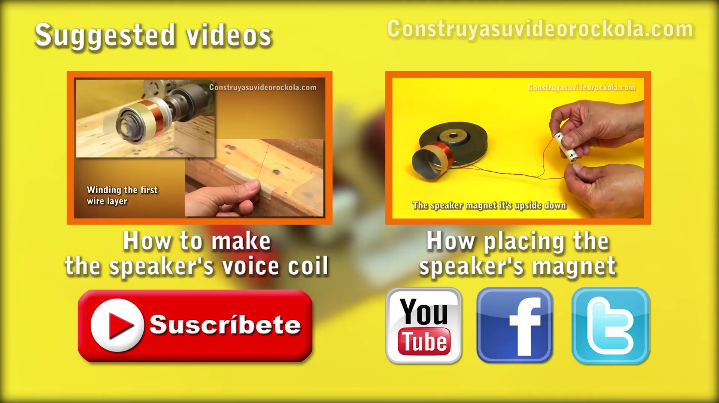 (score 95.0000)
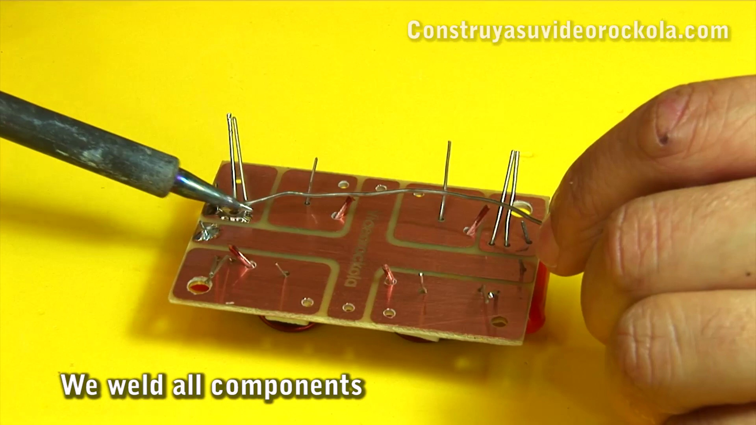 (score 95.0000)
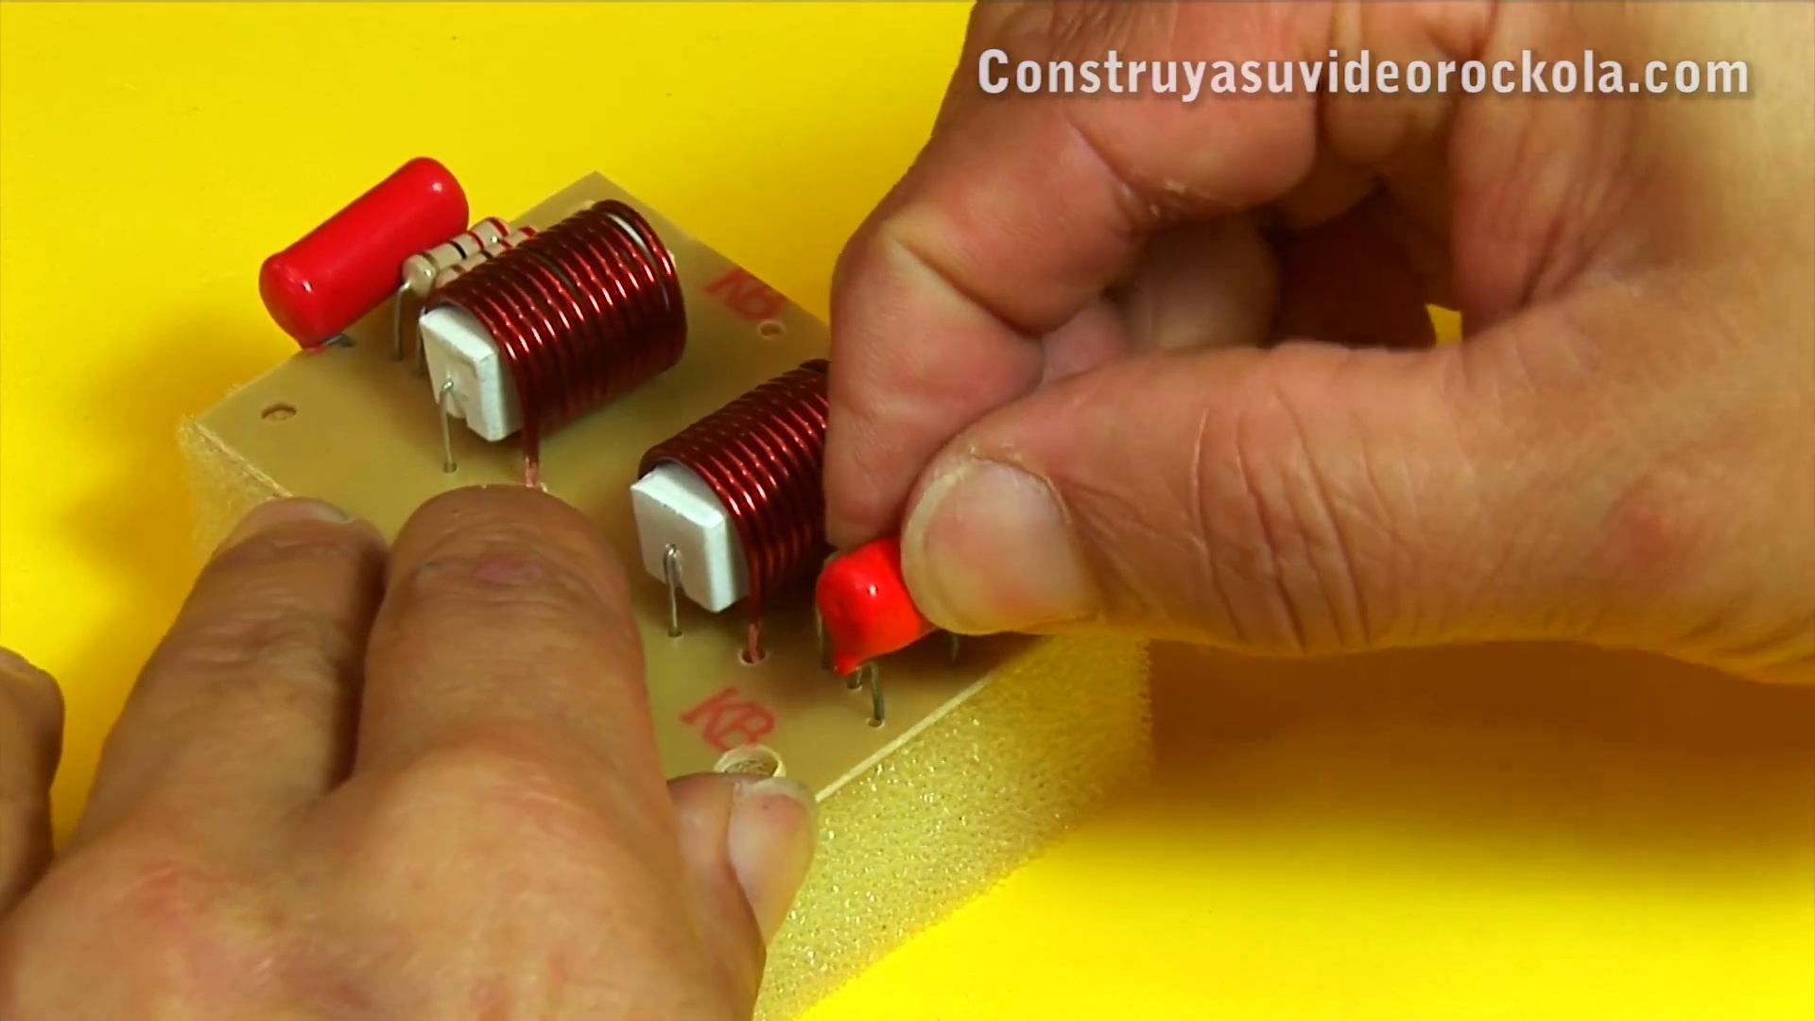 (score 95.0000)
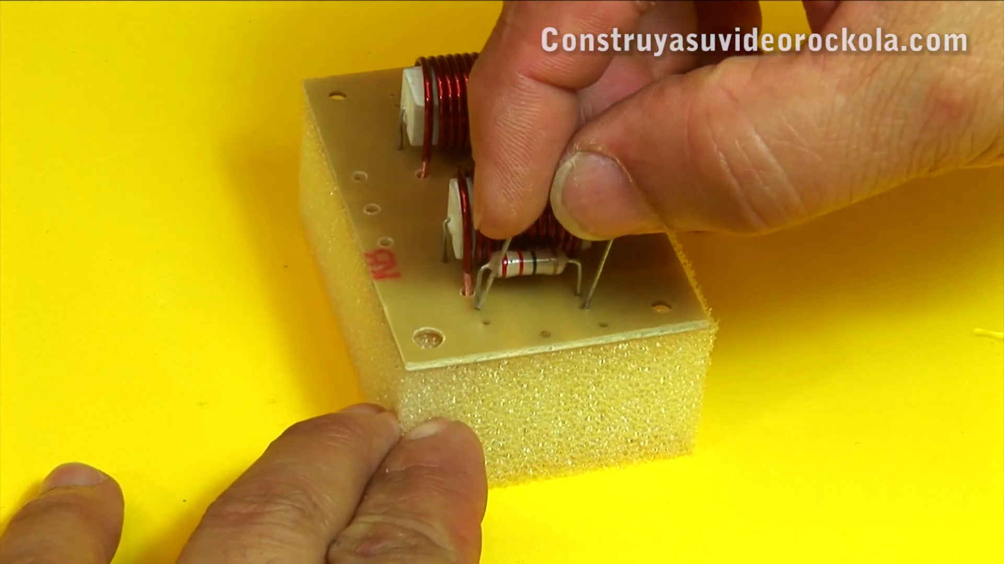 (score 95.0000)
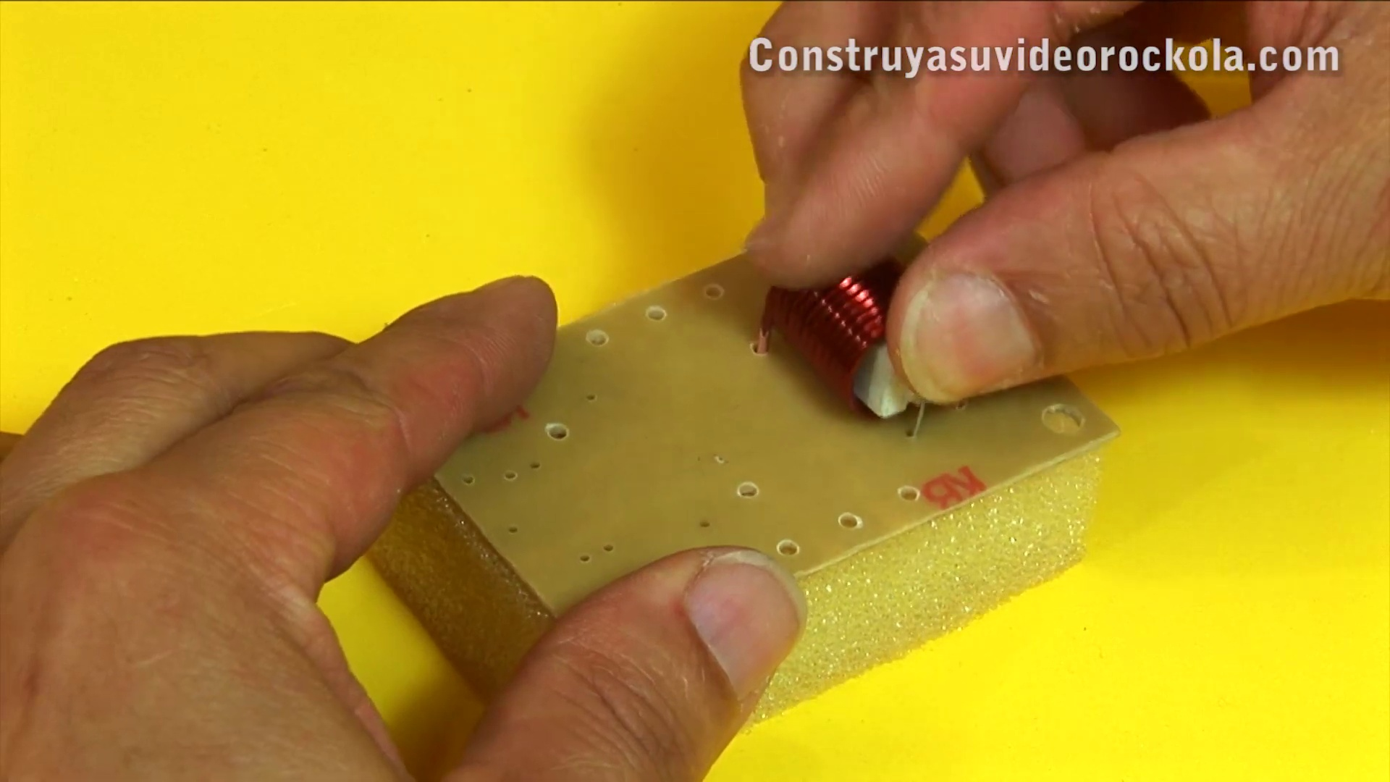 (score 95.0000)
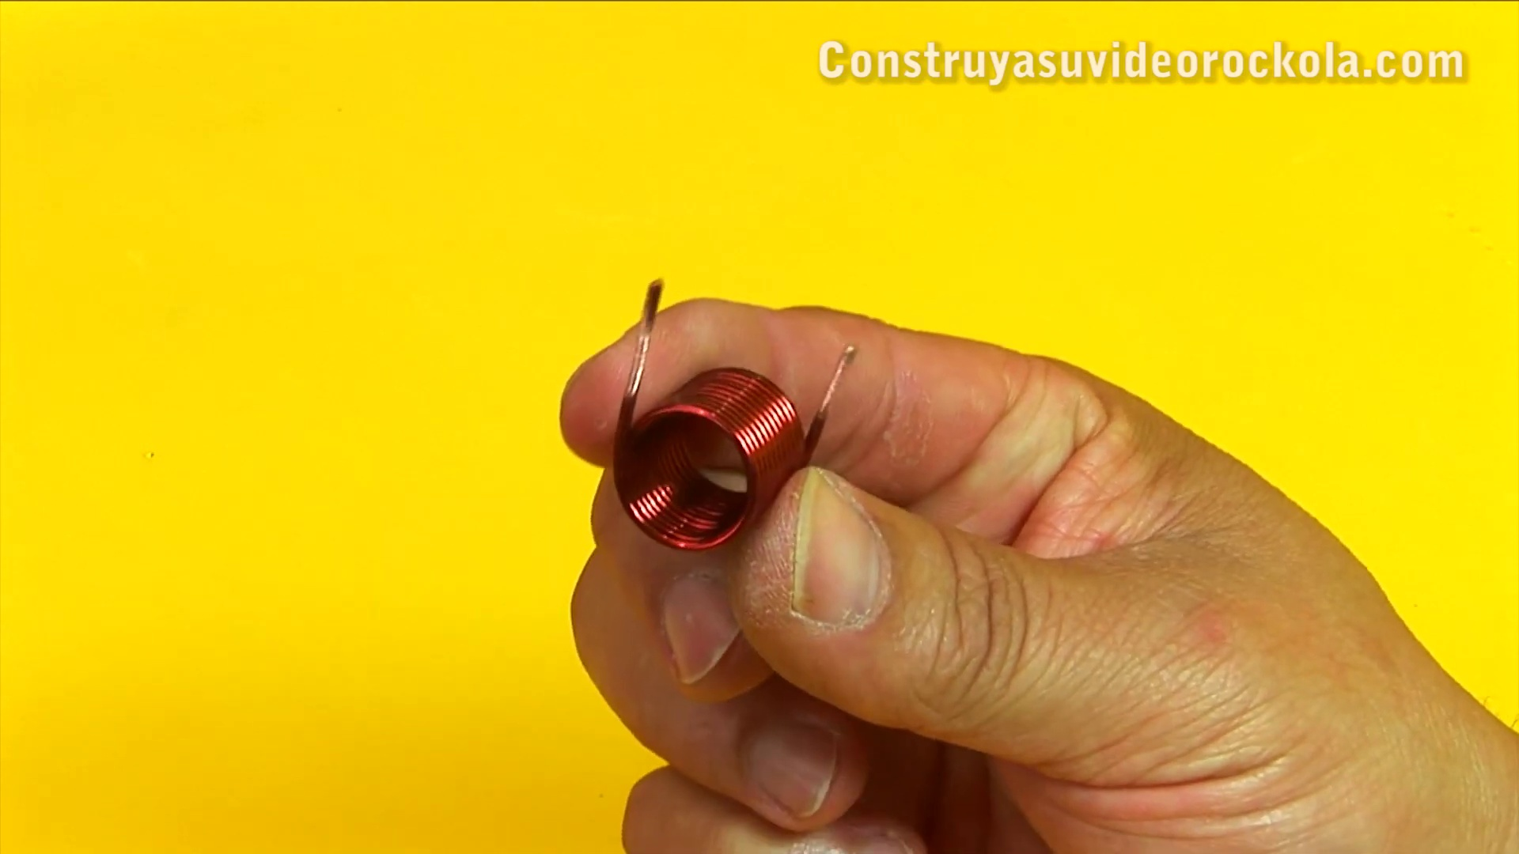 (score 95.0000)
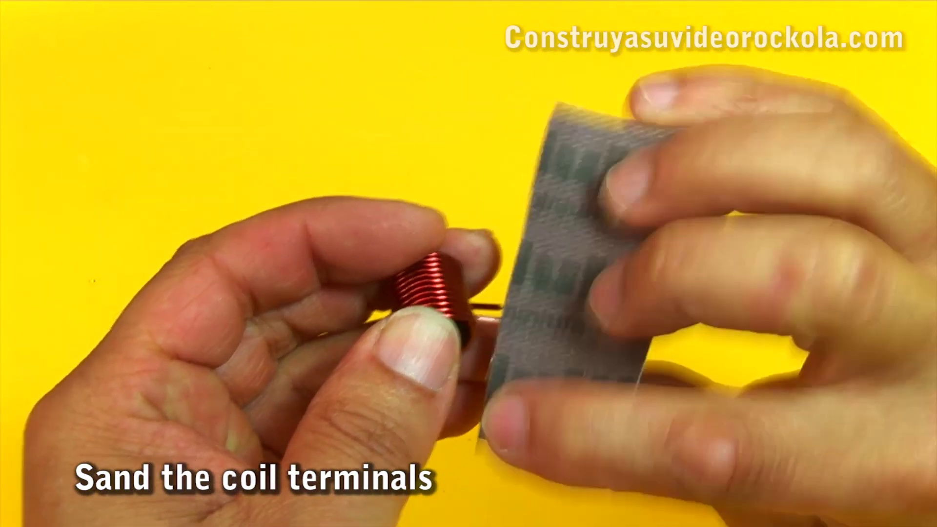 (score 95.0000)
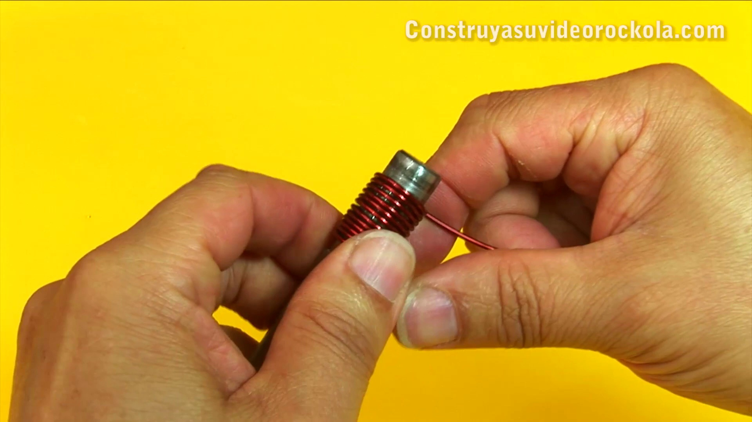 (score 95.0000)
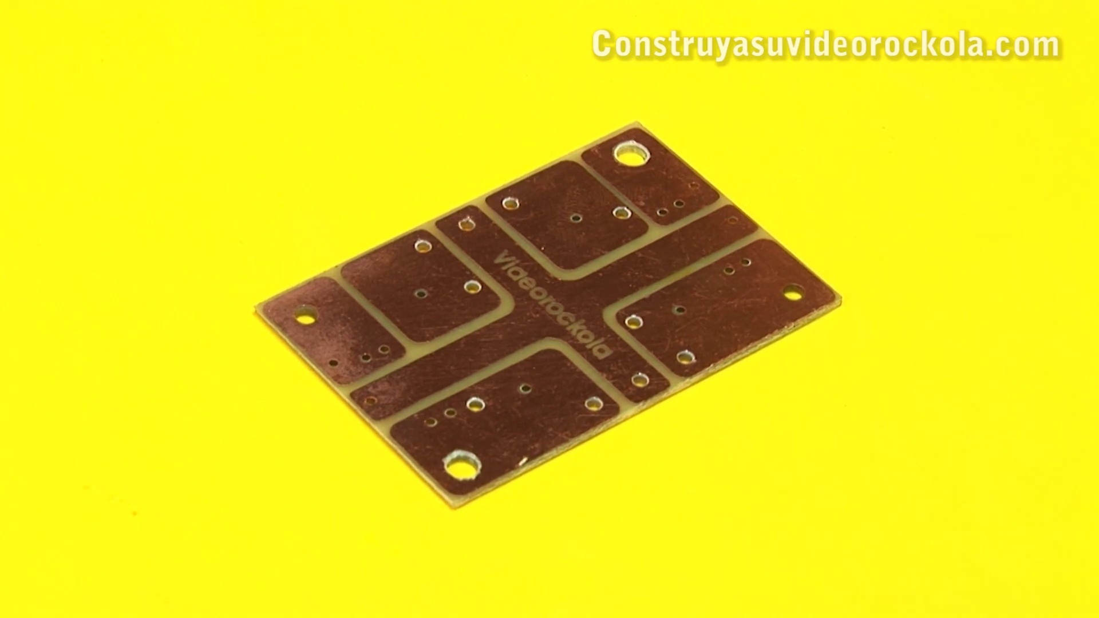 (score 95.0000)
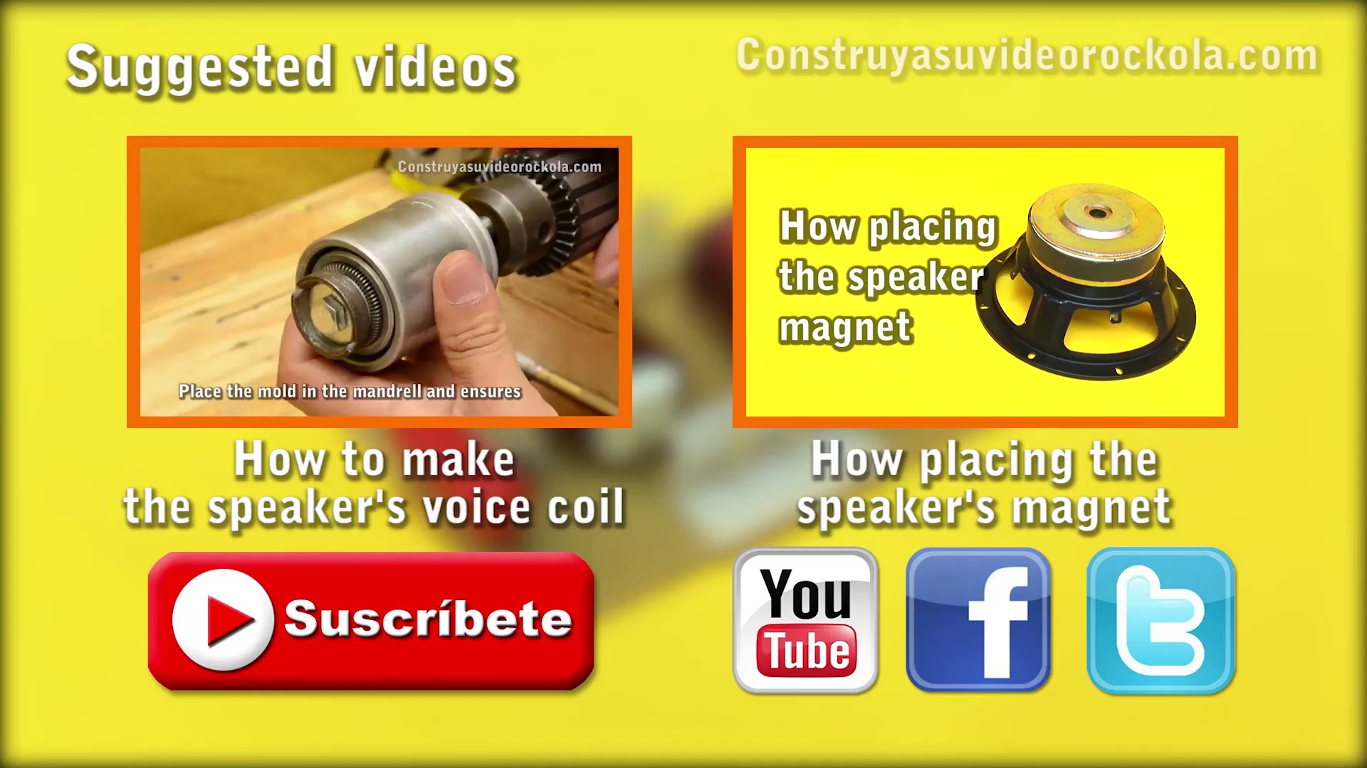 (score 90.0000)
Least correlated frames:
 (score 0.0000)
 (score 0.0000)
 (score 0.0000)
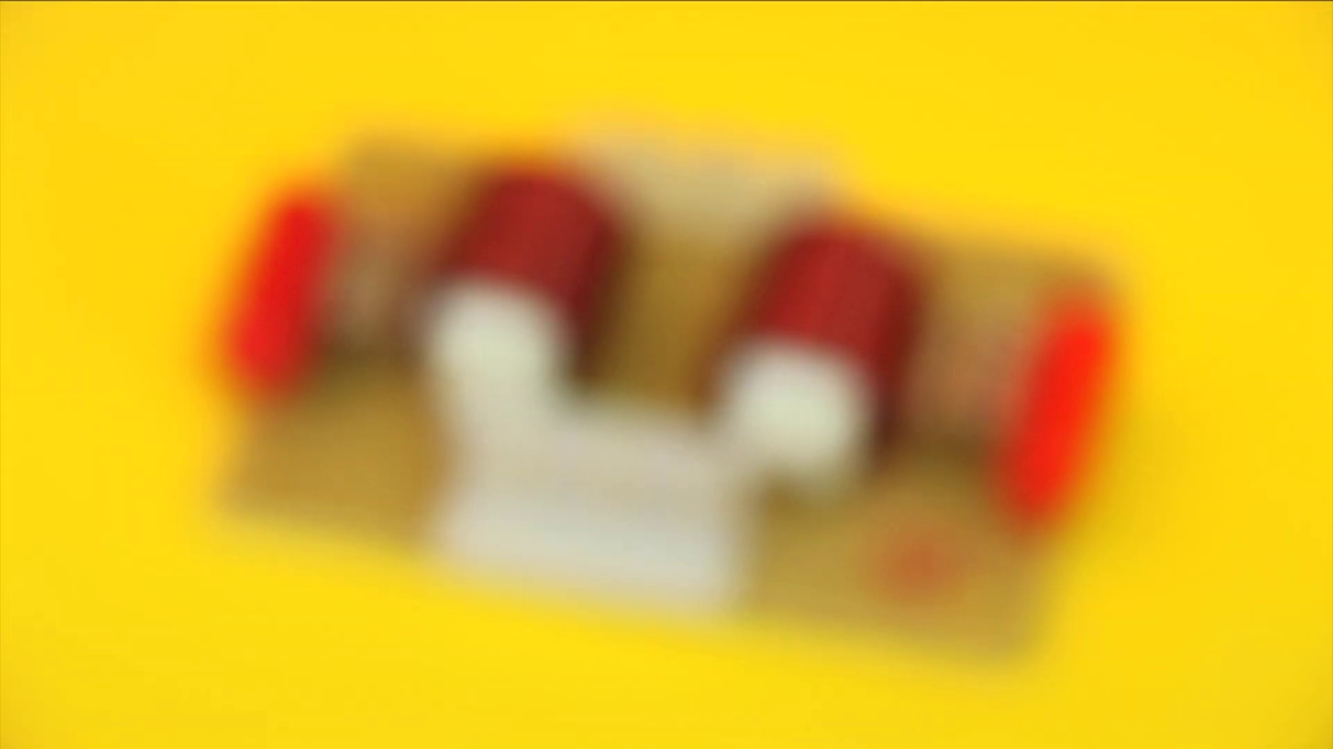 (score 20.0000)
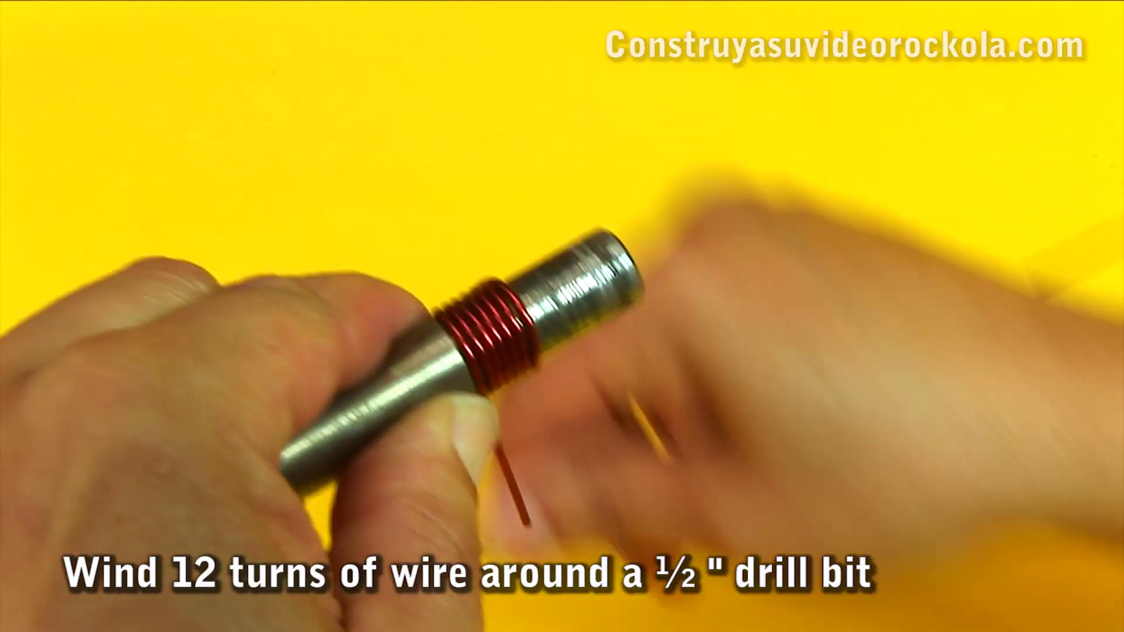 (score 20.0000)
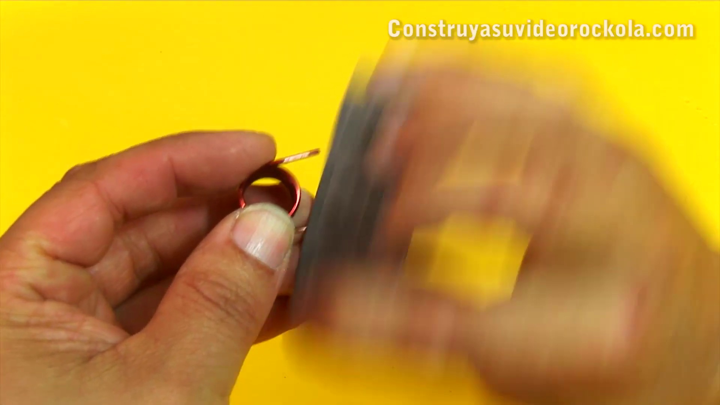 (score 20.0000)
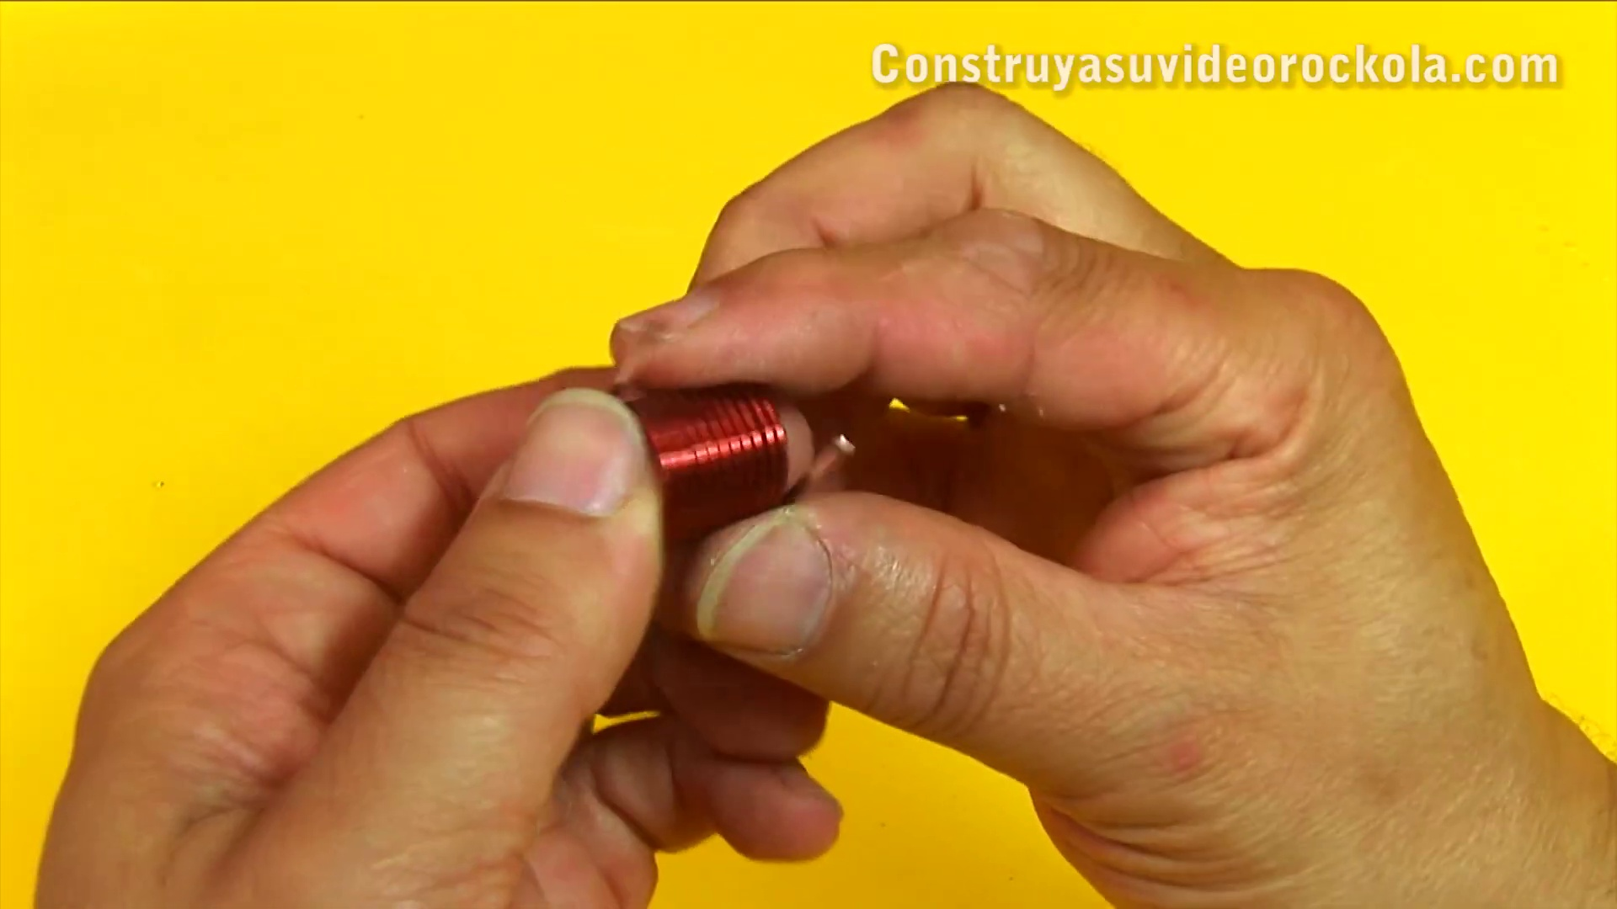 (score 20.0000)
 (score 20.0000)
 (score 80.0000)
 (score 80.0000)
- matched 22 frame(s), max score 95.0000: I learned that a Zobel network is a filter class that takes care of fixing the transfer of impedance. I also learned that the Zobel network consists of a resistor and a capacitor in series and an inductor and a resistor in parallel. Can one network be connected to multiple amplifiers?
Source: https://www.youtube.com/watch?v=9fFjlxUUQZg: Construction of a Zobel network for audio amplifier
Top correlated frames:
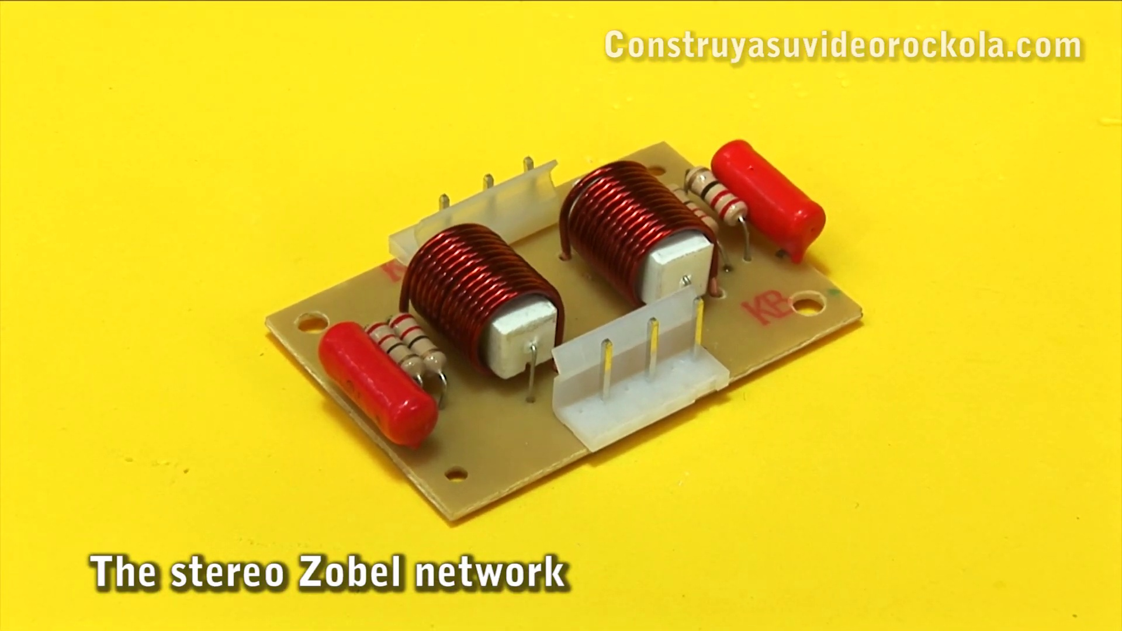 (score 95.0000)
 (score 90.0000)
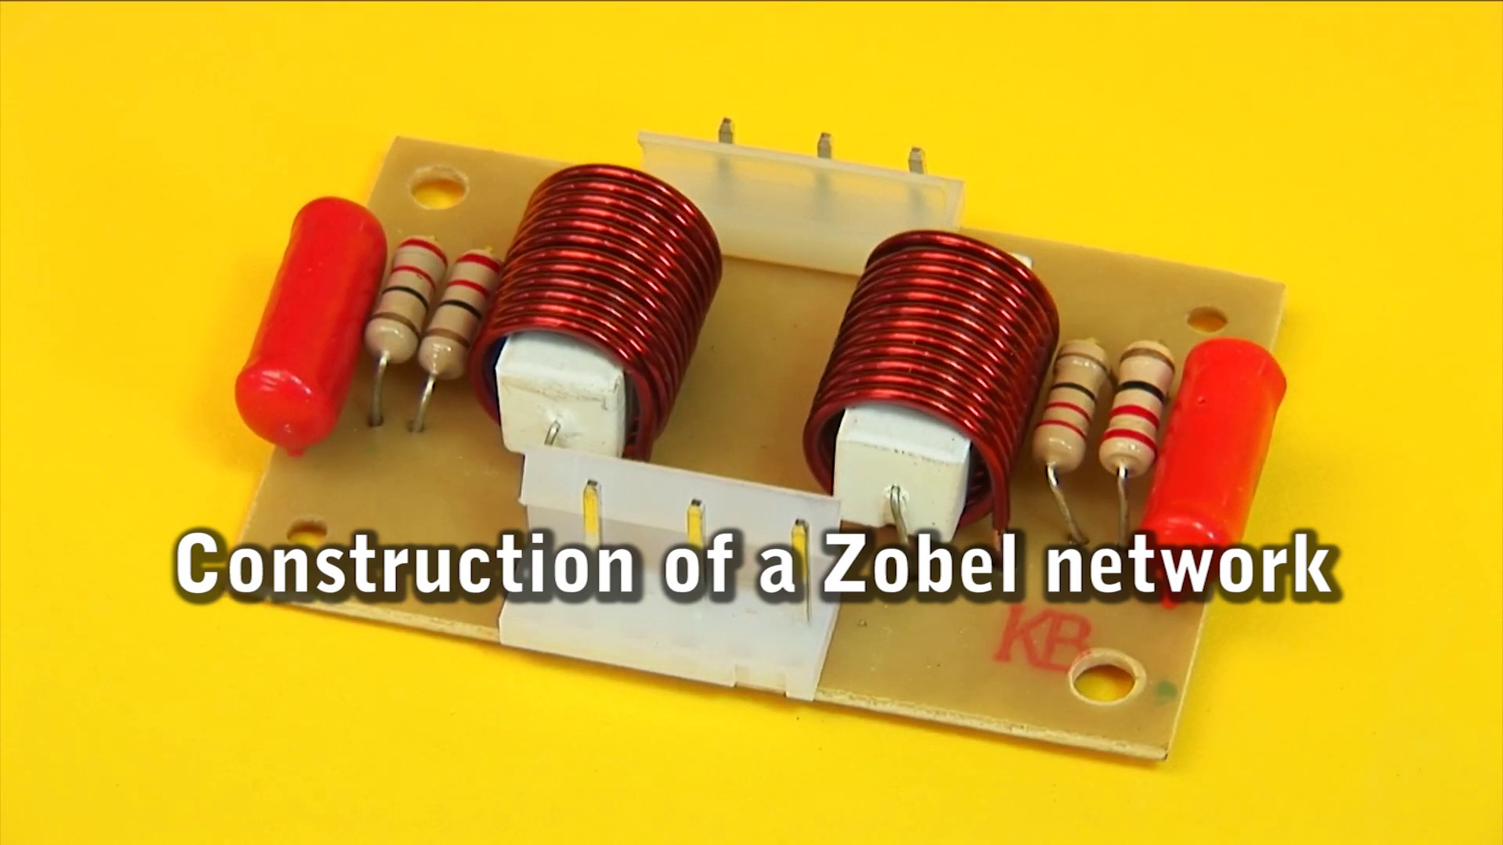 (score 90.0000)
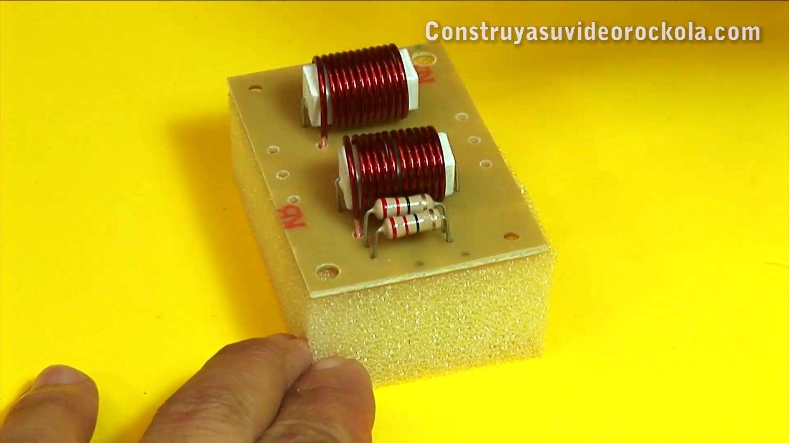 (score 85.0000)
 (score 85.0000)
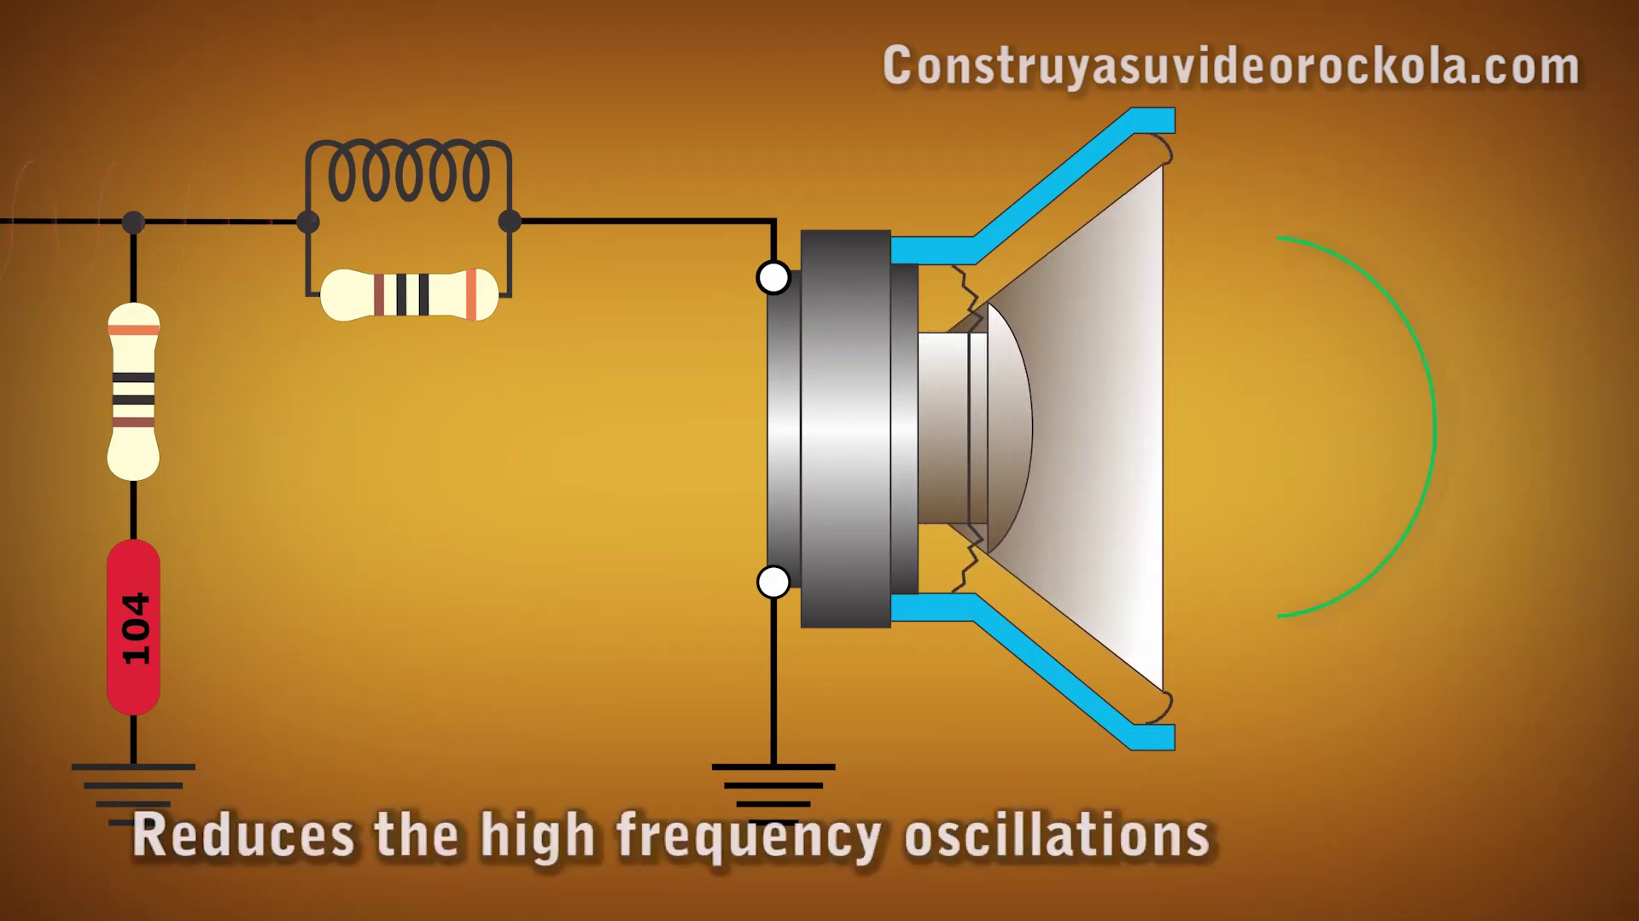 (score 85.0000)
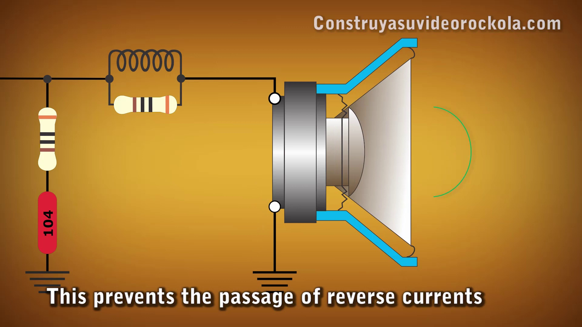 (score 85.0000)
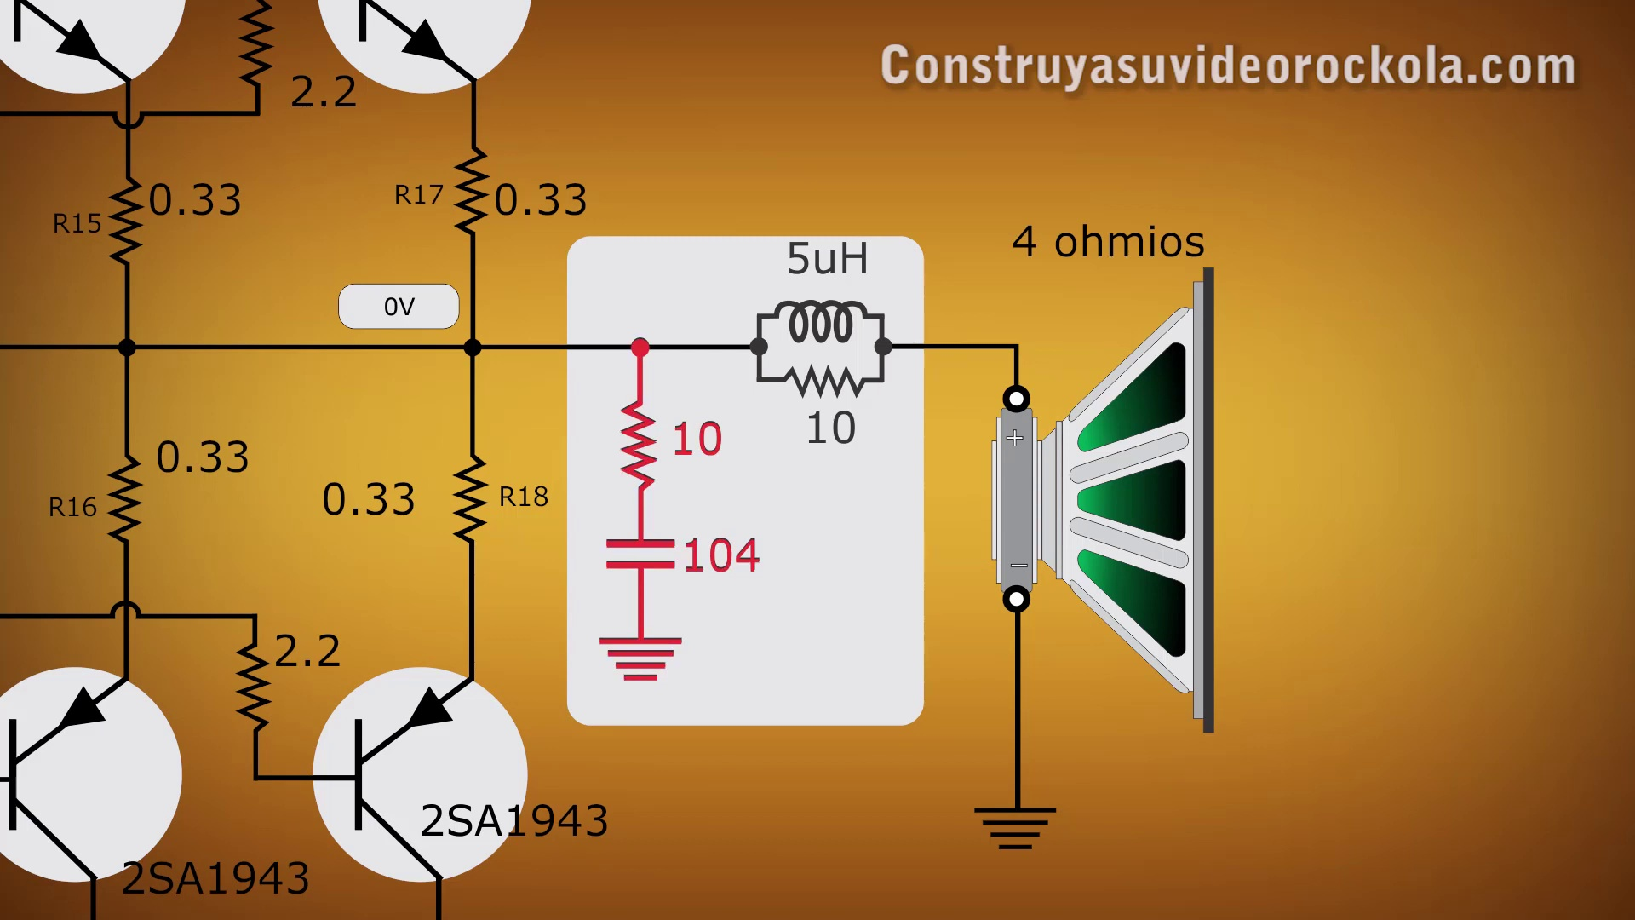 (score 85.0000)
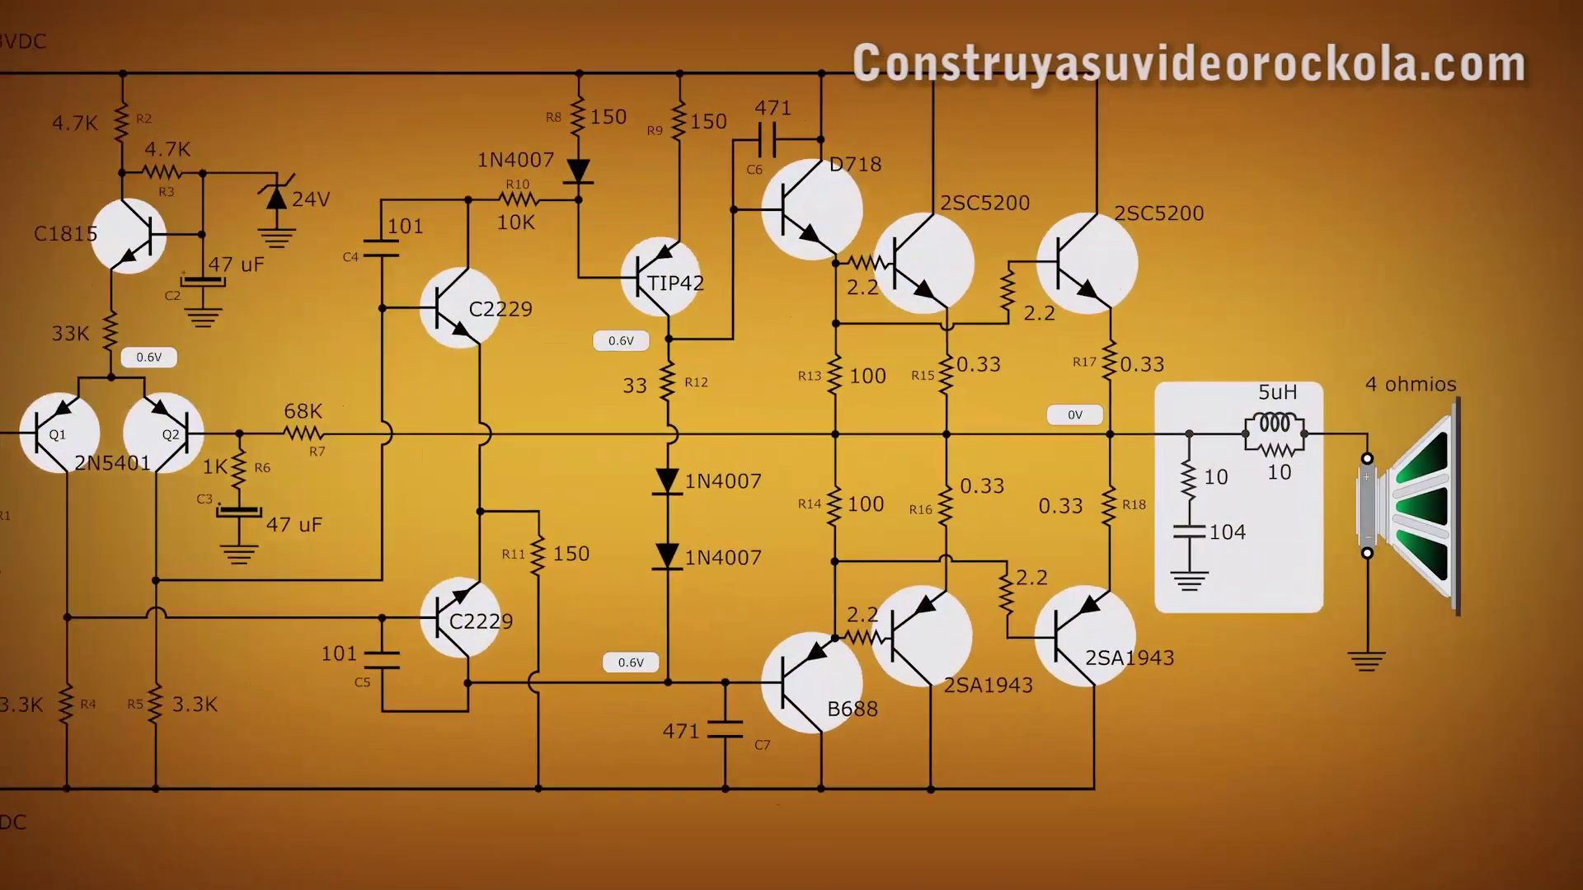 (score 85.0000)
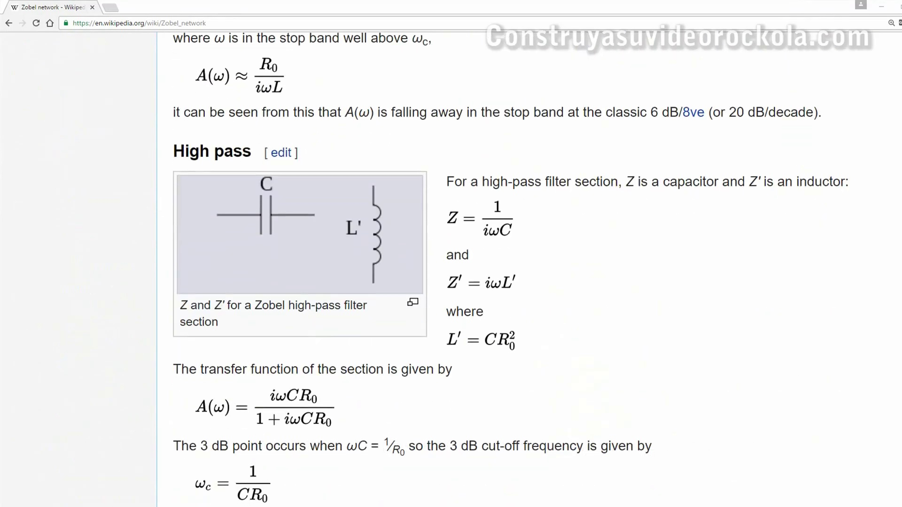 (score 85.0000)
Least correlated frames:
 (score 0.0000)
 (score 0.0000)
 (score 0.0000)
 (score 0.0000)
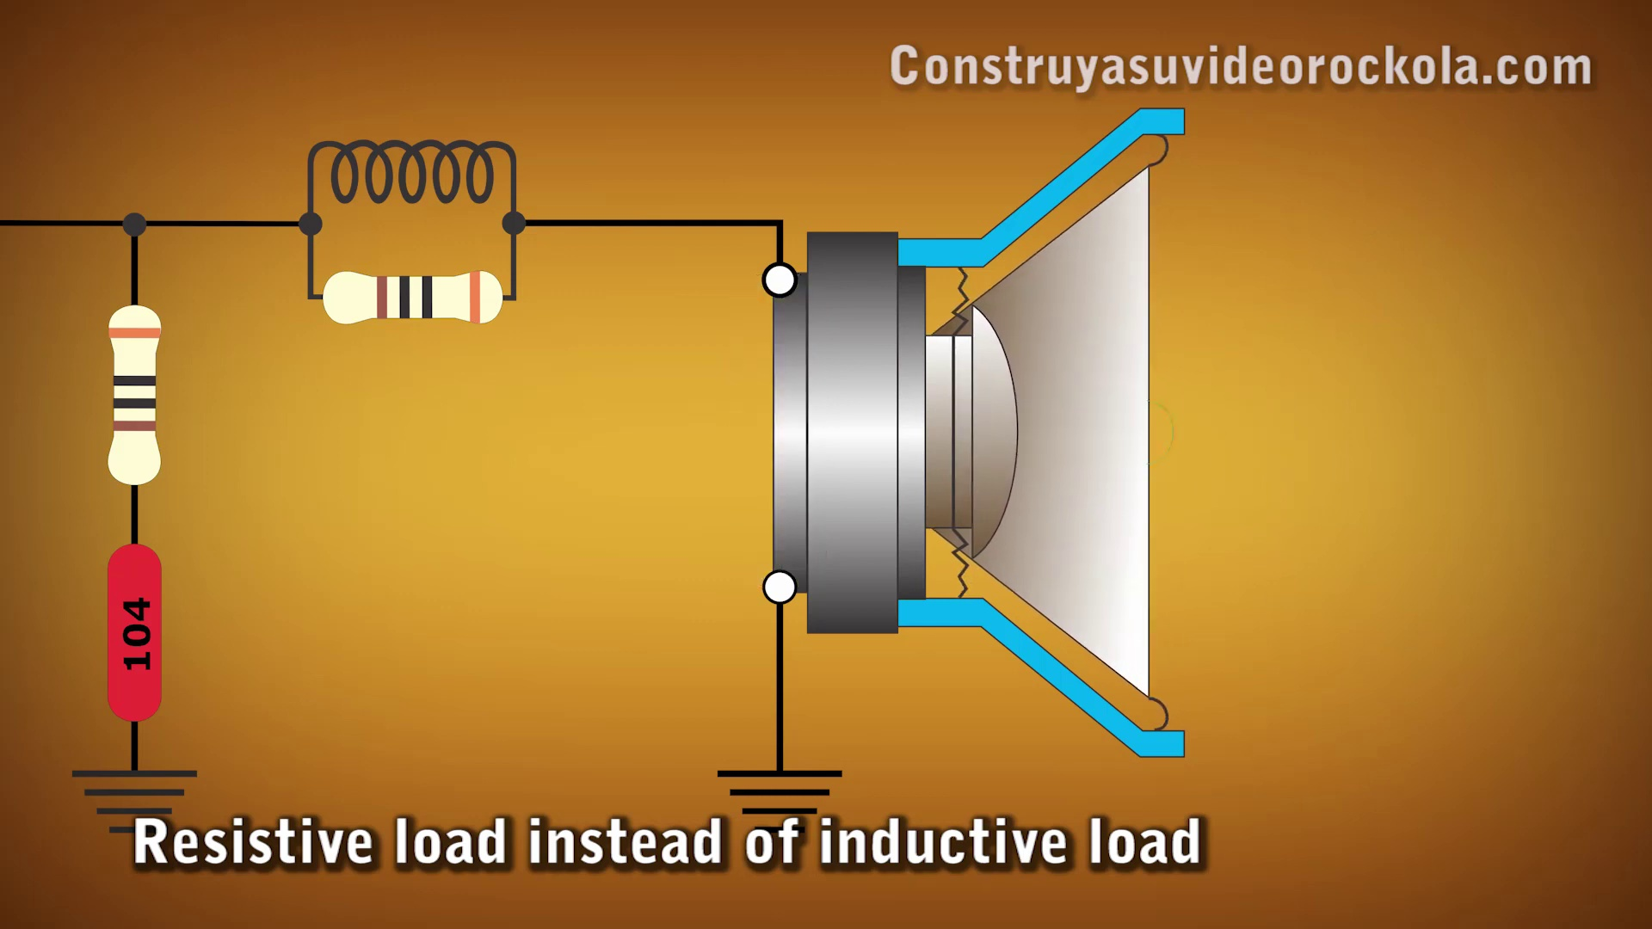 (score 0.0000)
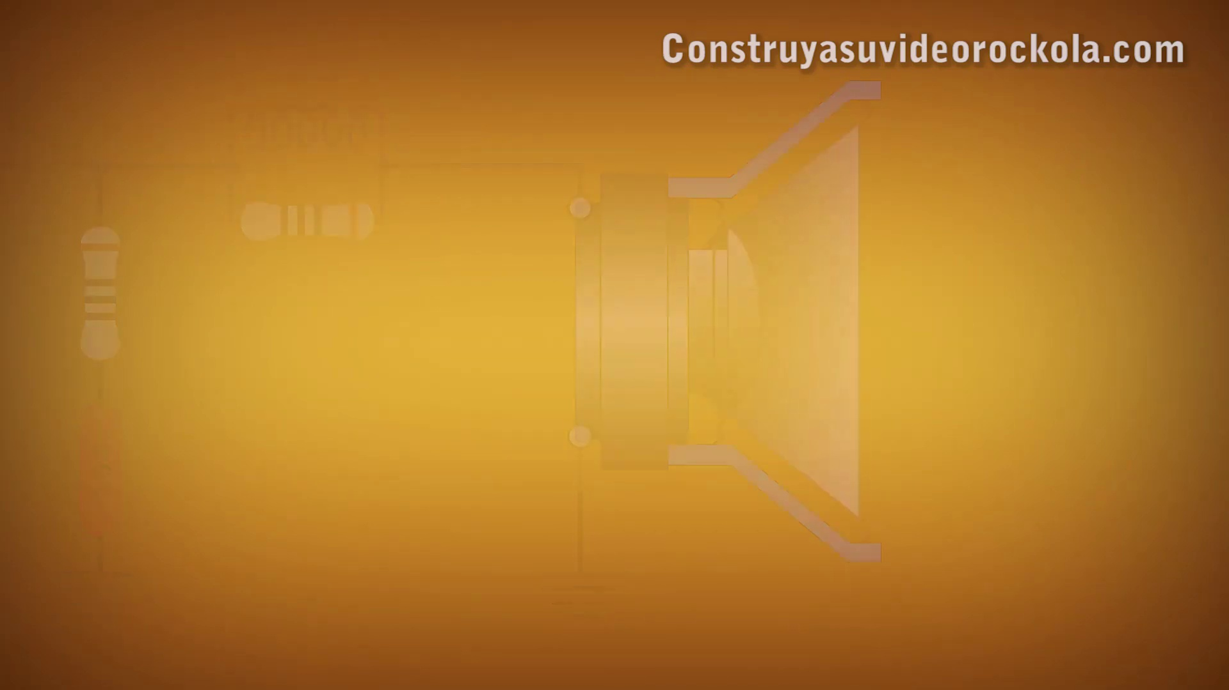 (score 0.0000)
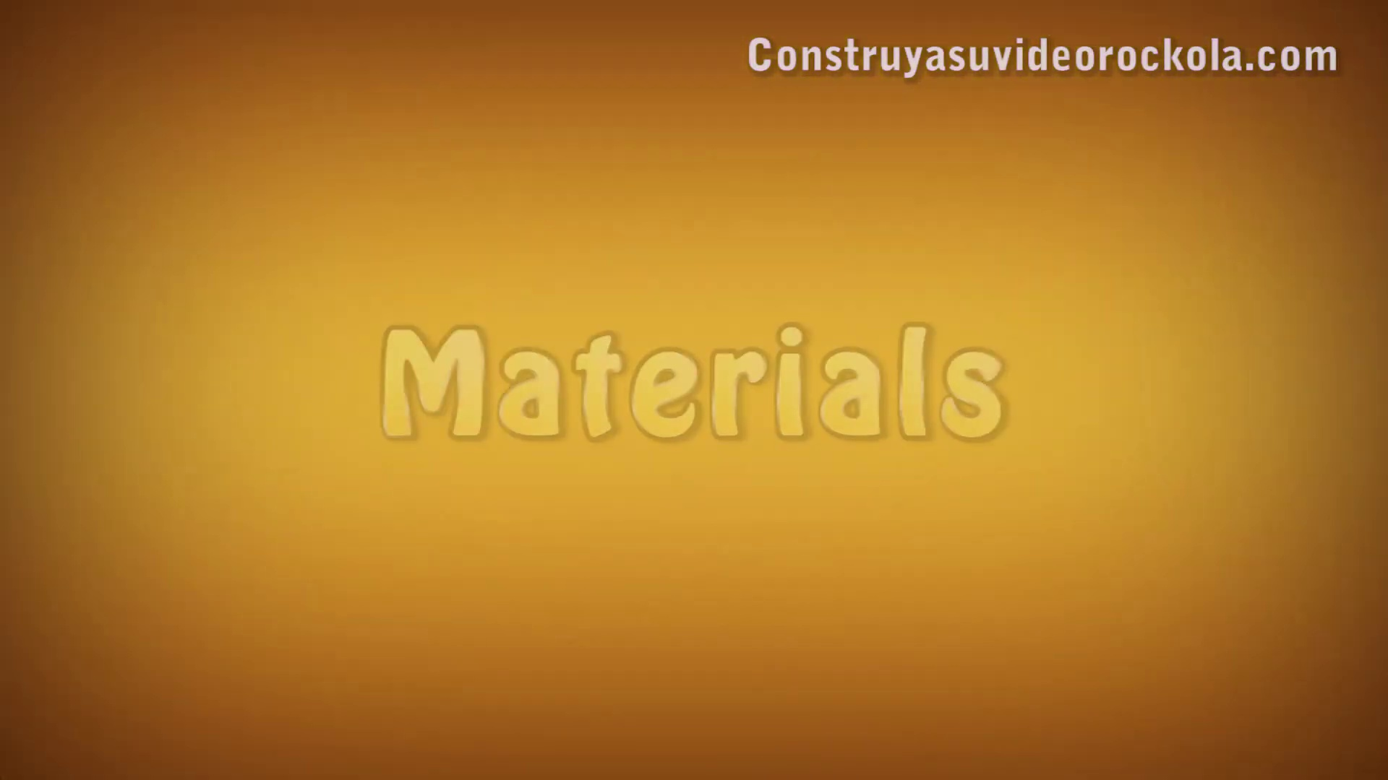 (score 0.0000)
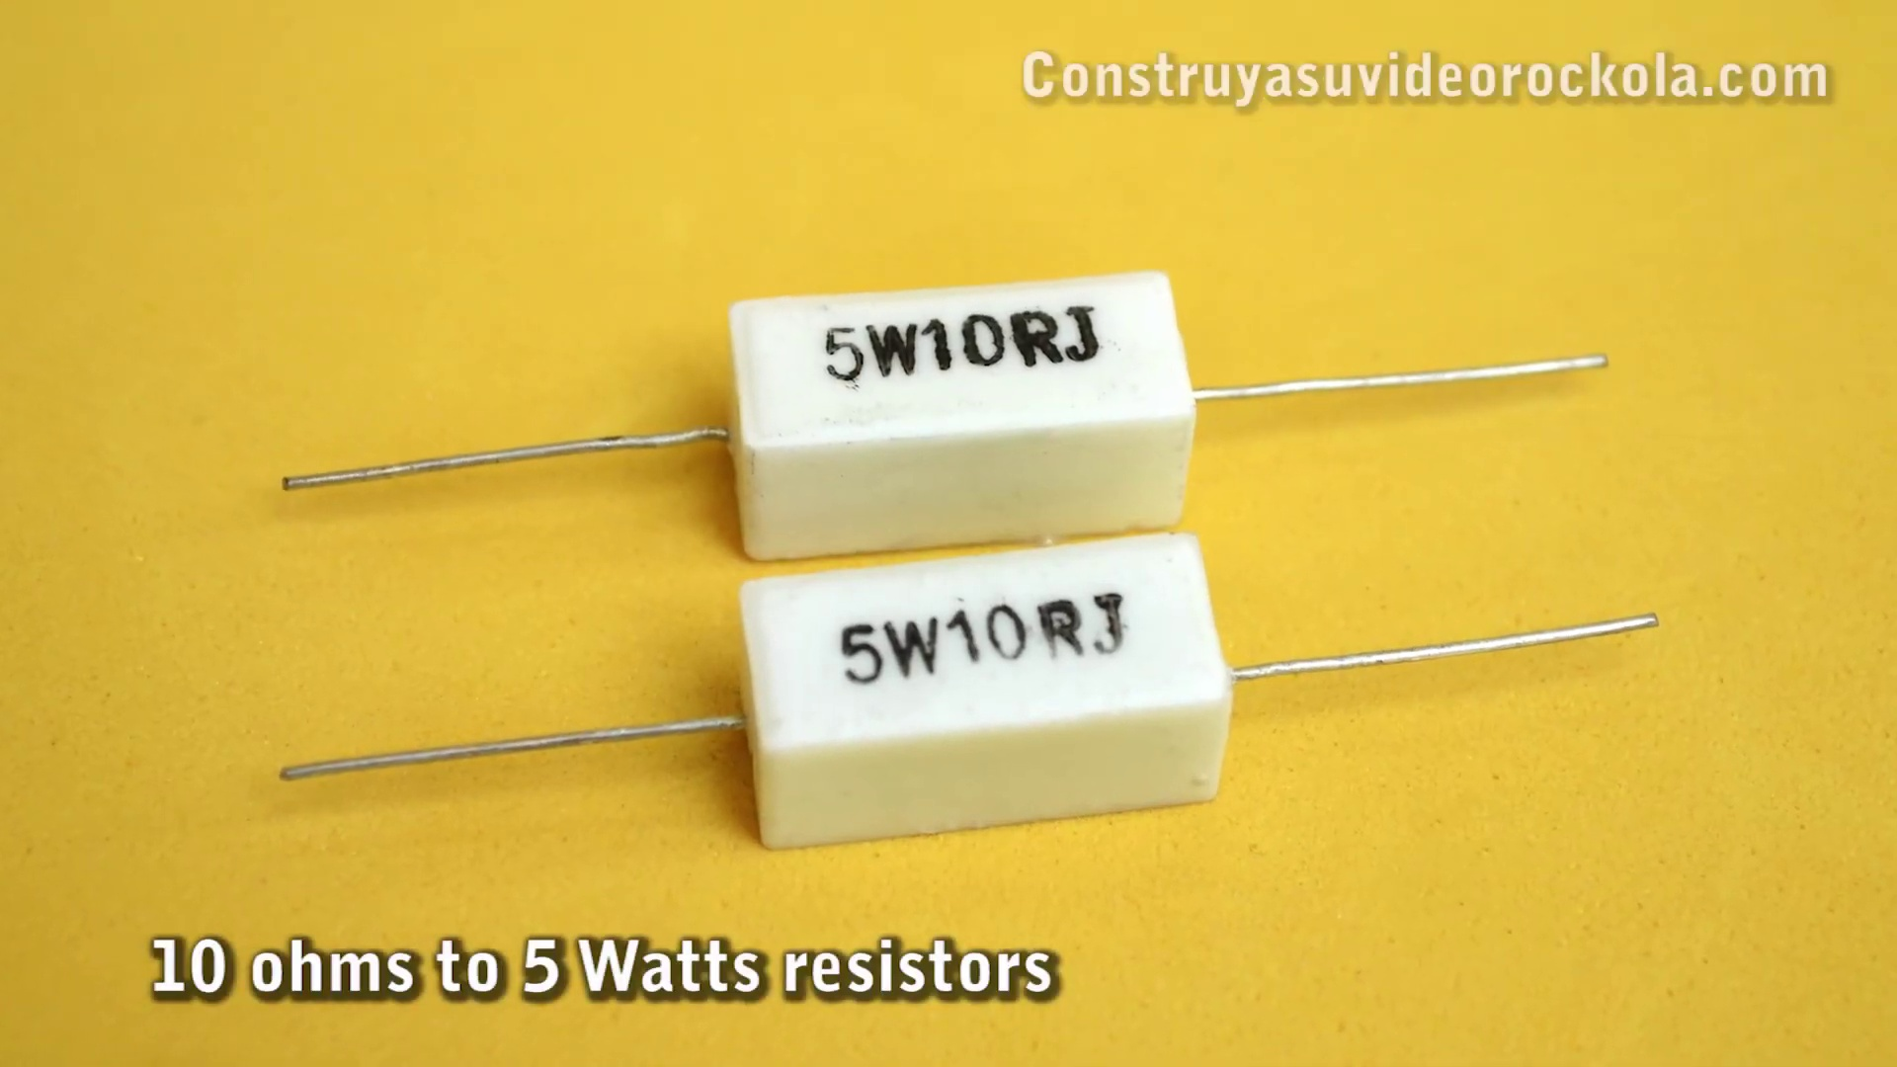 (score 0.0000)
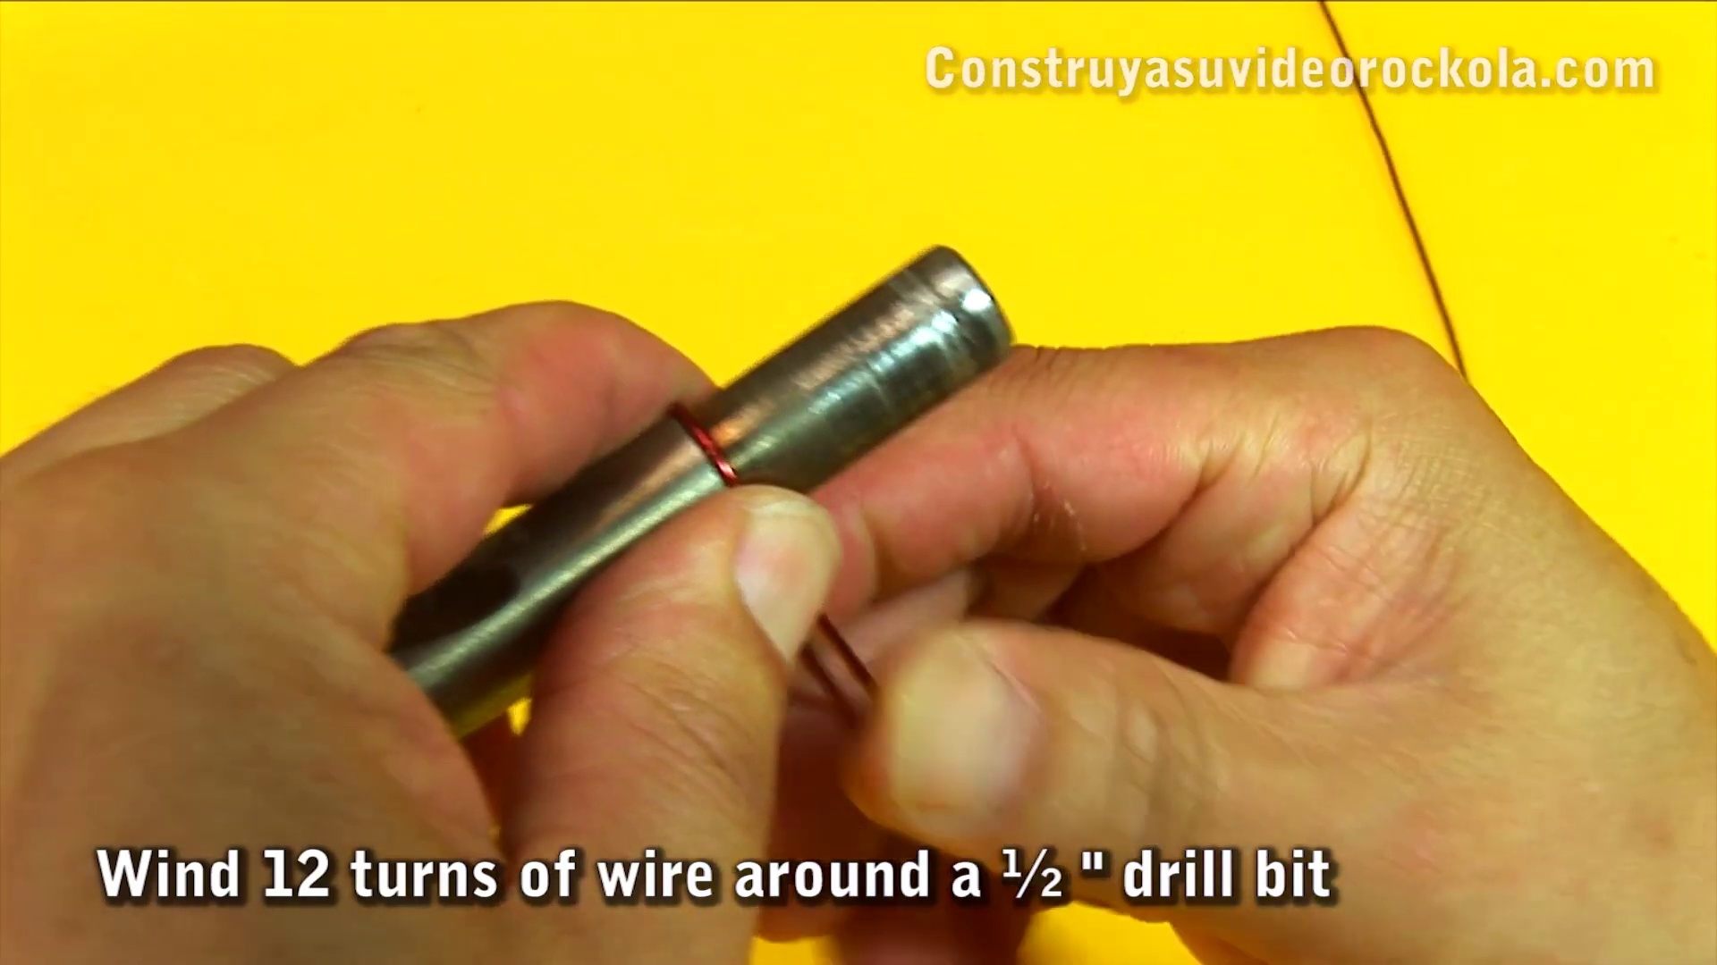 (score 0.0000)
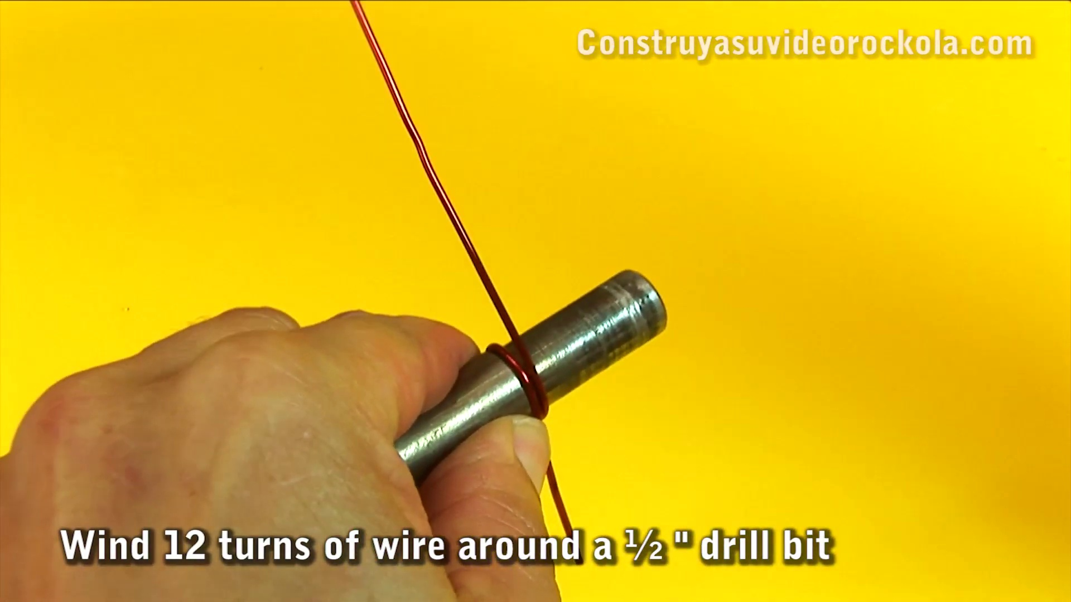 (score 0.0000)

Frame: frame_0000.jpg
Caption: The figure appears to be a combination of two different visual elements: a slide presentation with a dark background and lighter elements such as a title, possibly some graphics or diagrams, and an image showing the molecular structure of N-(2-hydroxyethyl)-2-(4-methoxyphenyl)-1-(4-methoxyphenyl)-1-methylethane-1-amine. This organic compound is described as a white crystalline solid that is soluble in organic solvents. Due to the low resolution and lack of detail, it's challenging to provide specific information about the content displayed on the slide.
Comment (score 80): I learned how to construct a Zobel network.I did not understand the explanation of how a Zobel network works or why you would need one, due to poor translation in the video.This shows how to construct a Zobel network if we determine that we need one for the project. How does a Zobel network work?
Reason: The comment directly discusses the technical step of constructing a Zobel network, which is related to the same molecular structure and settings described in the caption.
Source: https://www.youtube.com/watch?v=9fFjlxUUQZg: Construction of a Zobel network for audio amplifier

Frame: frame_0001.jpg
Caption: The image presents a vibrant scene set against a light grey background, featuring a stylized yellow banner with black text that reads "CONSTRUYA SU VIDEOROCKA" and a message below in white text saying "Video Rockolla." The banner is flanked by two vertical bars in a darker shade of grey on either side. The overall style suggests an informational or instructional graphic, possibly for educational purposes related to creating a rock video or film.
The yellow background provides a striking contrast to the black text, with the diagonal arrangement of the words adding a dynamic element to the composition. This energetic layout is characteristic of a video game or video editing software, drawing the viewer's attention immediately to the central message. The image does not contain any other discernible objects or text, focusing solely on the textual message encouraging viewers to create a rock video and the phrase "Video Rockolla," which likely refers to a band or entity associated with creating such videos.
No strongly correlated comments found for this frame.

Frame: frame_0002.jpg
Caption: The image features a graphic design with text in both Spanish and English that reads "CONSTRUYA SU VIDEO ROCKOLA." This translates to "Create Your Rock Video" in English. The design is colorful, with a yellow background on the left side and a white background on the right, where there's additional text that says "Vídeo Rockóla," which translates to "Rock Video Rock 'n Roll" in English.
The logo or emblem featured on the right side of the image shows an open book with a magnifying glass over it, indicating a focus on knowledge and exploration. The overall style of the image is vibrant and modern, suggesting that it might be used as a banner or poster for educational or promotional purposes related to video creation in a rock or pop culture context.
The text and logo are centered and occupy most of the space within their respective colored areas. The graphic design appears simple yet attention-grabbing, likely intended to attract viewers interested in creating music videos.
No strongly correlated comments found for this frame.

Frame: frame_0003.jpg
Caption: The image appears to show a close-up view of a presentation slide with a dark background and what seems to be a pattern or texture that may resemble a circuit board or some type of digital display. To the right, there is a text box with a faint gray outline, but the text within it is not clearly legible due to the resolution and angle of the photo. The style of the image suggests it was taken from a smartphone or similar handheld device, as indicated by the reflection and lens flare at the bottom edge. There are no people, devices, slides, diagrams, or significant text visible in this frame. Notably, the year 2012 is highlighted in archaeology, marking significant events that took place during this time period.
Comment (score 80): I learned how to construct a Zobel network.I did not understand the explanation of how a Zobel network works or why you would need one, due to poor translation in the video.This shows how to construct a Zobel network if we determine that we need one for the project. How does a Zobel network work?
Reason: The comment directly discusses the construction of a Zobel network, which is mentioned in the caption as a type of digital display. The connection between the two is strong despite the lack of details in the caption.
Source: https://www.youtube.com/watch?v=9fFjlxUUQZg: Construction of a Zobel network for audio amplifier

Frame: frame_0004.jpg
Caption: The image presents a unique and intriguing scene set against a yellow background. In the foreground, a small toy train set is partially assembled with several individual pieces and wheels. The train's components are displayed against the bright yellow backdrop, drawing attention to their intricate details. To the left side of the photo, a blurred view of a person's hands can be seen, holding one of the train parts that appears to be a coupling mechanism for connecting track sections.
On the right side of the image, the frame cuts off abruptly, without providing any additional context or information about the setting or activity. The focus remains solely on the toy train set, with no visible text or markings present in this frame. The person's hands are not in clear focus due to the blurred effect.
In contrast, the background features a colorful and symmetrical design on a yellow cardboard box. The box is positioned centrally, dominating the view and drawing attention immediately. Its top and bottom surfaces are adorned with red and white decorations, creating a sense of balance and harmony. The blurred effect in the background adds a dynamic element to the image, suggesting movement or anticipation as if the box is about to be opened.
Two white objects can be seen in the background, seemingly in motion or being moved/opened. Their presence introduces an element of dynamism to the otherwise static scene. Although the background is blurry, the overall composition conveys a sense of anticipation and excitement, hinting at an ongoing event or journey about to begin. The image does not contain any discernible text or additional details, leaving room for interpretation and imagination.
The relative positions and actions of the objects in this frozen moment create a narrative that invites speculation, allowing viewers to fill in the gaps with their own creative vision.
No strongly correlated comments found for this frame.

Frame: frame_0005.jpg
Caption: This image presents a detailed view of an electronic circuit board being constructed with various components. At the center of the image is a small red device labeled "a ZOBEL network," which is part of a larger construction project. Surrounding it are other electronic components such as resistors and possibly capacitors, all neatly arranged on the circuit board.
The upper right corner of the image features text that reads "CONSTRUCTION OF A ZOBE NEXT," indicating that this is likely a teaching context where someone is learning to construct a Zobel network. The image does not show any instructors or students; it seems to focus solely on the process and components of building an electronic circuit.
The background appears blurred, but it suggests a workspace with a yellow surface, possibly part of a classroom or workshop setting. The overall impression is educational, aiming to demonstrate the step-by-step process of constructing an electronic network.
The image also shows two inductors, each consisting of a red coil and a black base, connected to form part of the same circuit. The circuit board rests on a yellow surface that contrasts with the black and red colors of the components. Prominently displayed in red letters on the yellow background is the text "Construction of a Zobel network," suggesting that this circuit board is a part of a larger network.
Comment (score 90): I learned that a Zobel network is a filter class that takes care of fixing the transfer of impedance. I also learned that the Zobel network consists of a resistor and a capacitor in series and an inductor and a resistor in parallel. Can one network be connected to multiple amplifiers?
Reason: The comment directly discusses the technical steps and components described in the caption, specifically mentioning the resistor, capacitor, inductor, and resistor (parallel) as part of the Zobel network. The caption also mentions the construction process of a Zobel network, which is reflected in the comment's description of the filter class and its components.
Source: https://www.youtube.com/watch?v=9fFjlxUUQZg: Construction of a Zobel network for audio amplifier
Comment (score 90): I learned how to construct a Zobel network.I did not understand the explanation of how a Zobel network works or why you would need one, due to poor translation in the video.This shows how to construct a Zobel network if we determine that we need one for the project. How does a Zobel network work?
Reason: The comment directly discusses the same technical steps, objects (Zobel network) and settings (construction project) described in the caption. The only difference is the request for understanding of how a Zobel network works, which is an extension of the original description.
Source: https://www.youtube.com/watch?v=9fFjlxUUQZg: Construction of a Zobel network for audio amplifier

Frame: frame_0006.jpg
Caption: The image shows a detailed view of an electronic device, likely a step-by-step guide or tutorial on constructing an inductor motor. The device consists of two red coils, which are likely transformers, and several white plastic components that appear to be capacitors. A small metal connector with screw terminals is also visible. The device rests on a surface with a yellow hue.
The construction appears to involve the assembly of various electronic components, including resistors (red), capacitors (white), and a transformer (brown). The board used for construction features a yellowish-brown color and is held together by a black plastic connector, providing contrast to the overall color scheme. The relative positions of the components suggest a well-organized and efficient design, forming the necessary components of the Zobel network.
Comment (score 85): I learned that a Zobel network is a filter class that takes care of fixing the transfer of impedance. I also learned that the Zobel network consists of a resistor and a capacitor in series and an inductor and a resistor in parallel. Can one network be connected to multiple amplifiers?
Reason: The comment directly discusses the technical details of a Zobel network, including its composition and purpose, which are also described in the frame caption. The caption provides visual information about the components involved in constructing a Zobel network, while the comment explains the functioning and configuration of such a network.
Source: https://www.youtube.com/watch?v=9fFjlxUUQZg: Construction of a Zobel network for audio amplifier
Comment (score 80): I learned how to construct a Zobel network.I did not understand the explanation of how a Zobel network works or why you would need one, due to poor translation in the video.This shows how to construct a Zobel network if we determine that we need one for the project. How does a Zobel network work?
Reason: The comment directly discusses the construction of a Zobel network, which is mentioned in the caption as part of the device's purpose and design. The correlation score is 80 because while the comment does not explicitly mention the red coils, capacitors, or transformers described in the caption, it does discuss the construction of a Zobel network, which is a key aspect of the device's functionality.
Source: https://www.youtube.com/watch?v=9fFjlxUUQZg: Construction of a Zobel network for audio amplifier

Frame: frame_0007.jpg
Caption: The image you've provided appears to be a screenshot of a Wikipedia page in Portuguese. The Wikipedia logo is prominently displayed at the top left corner of the page, and below it is the name "Wikipedia" followed by the text "The free encyclopedia," indicating that this content is available for public viewing.
The search bar at the top center of the page allows users to type in keywords or phrases to search Wikipedia. To the right of the search bar, there are tabs labeled "Main," "Contributions," and "More," which provide different ways to navigate and interact with Wikipedia content.
The main body of the screenshot shows a section from an article titled "ZOLEB Network." The title is in English, suggesting that the article's original language is English. Below the title, there is a brief introduction or summary of the article in Portuguese. This text appears to be informative and seems to be describing the content of the Wikipedia page.
The Wikipedia interface includes various elements such as the language selection bar at the top right, user information icons, and edit buttons that allow users to contribute to or modify the content of the page. There is also a breadcrumb navigation trail at the top center of the page, which indicates the parent categories and pages under which this particular article falls.
The bottom part of the screenshot shows additional navigational links, such as "Wikipedia," "Contributions," and "More," which seem to offer different ways to explore Wikipedia content. There is also a link at the very bottom labeled "ZOLEB Network," which presumably leads to other related articles within the Wikipedia platform.
The overall style of the image suggests it's a standard web page, with text in multiple languages and links that navigate to different sections or pages within Wikipedia.
Comment (score 85): I learned how to construct a Zobel network.I did not understand the explanation of how a Zobel network works or why you would need one, due to poor translation in the video.This shows how to construct a Zobel network if we determine that we need one for the project. How does a Zobel network work?
Reason: The comment directly discusses the same technical steps described in the caption (constructing a Zobel network), with some mention of understanding or determining the need for one.
Source: https://www.youtube.com/watch?v=9fFjlxUUQZg: Construction of a Zobel network for audio amplifier
Comment (score 80): I learned that a Zobel network is a filter class that takes care of fixing the transfer of impedance. I also learned that the Zobel network consists of a resistor and a capacitor in series and an inductor and a resistor in parallel. Can one network be connected to multiple amplifiers?
Reason: The comment directly discusses the same technical concept (Zobel network) described in the caption. Although it doesn't mention specific visual elements mentioned in the caption, the connection between the concept and the Wikipedia page is clear.
Source: https://www.youtube.com/watch?v=9fFjlxUUQZg: Construction of a Zobel network for audio amplifier

Frame: frame_0008.jpg
Caption: The image shows a web browser window displaying an article from Wikipedia with a title that reads "Zobel Network." The main part of the page is visible, including the first paragraph and navigation links at the bottom. The text in the first paragraph provides an overview of the topic: "Zobel network, also known as Zobel effect, is an analog electronic filter, the analogue of the Bell filter. It is named after its discoverer, the Polish mathematician and physicist Alfred Zobel." The article goes on to explain that the Zobel Network is a nonlinear analogue of the Bell filter, a type of ring resonator and electronic filter.
The bottom section of the page includes navigation links labeled "Contents," "Related topics," and "Citations," suggesting that the reader can navigate between different sections of the article or find related information. Additionally, there are some readable text snippets from the article:
- "...the Zobel Network was invented by Claude Shannon."
- "The complete theory of information transmission..."
- "In 1956 Shannon published a paper in The Bell System Technical Journal..."
- "One important application of Zobel networks is the..."
The browser interface elements like the tabs at the top (Home, Explore, Search) and the bookmark icon on the top right are visible, but there are no additional texts, graphics, or interactive elements shown in this snapshot. The bottom status bar of the web browser is also partially visible, showing text that indicates "The complete theory as found on Wikipedia." The overall context of the image suggests it was taken from a computer during an online research or browsing session.
Comment (score 80): I learned how to construct a Zobel network.I did not understand the explanation of how a Zobel network works or why you would need one, due to poor translation in the video.This shows how to construct a Zobel network if we determine that we need one for the project. How does a Zobel network work?
Reason: The comment directly discusses the technical steps of constructing a Zobel network, which is mentioned in the caption as one important application. The comment also asks a question about how a Zobel network works, which aligns with the explanation provided in the caption.
Source: https://www.youtube.com/watch?v=9fFjlxUUQZg: Construction of a Zobel network for audio amplifier

Frame: frame_0009.jpg
Caption: The image shows a screenshot of a computer screen with an open web browser displaying a comprehensive guide to electronic components on the completetheory.wikispaces.org website. The webpage is titled "The complete theory: Electronic Components" and has a section highlighted in blue, indicating its importance or relevance, specifically focusing on capacitors. The subsection displayed currently is labeled as "The complete theory", which appears to provide detailed information about this electronic component.
The background of the screenshot includes a blurred environment that looks like an indoor setting, possibly an office or classroom.
Comment (score 80): I learned that a Zobel network is a filter class that takes care of fixing the transfer of impedance. I also learned that the Zobel network consists of a resistor and a capacitor in series and an inductor and a resistor in parallel. Can one network be connected to multiple amplifiers?
Reason: The comment directly discusses the concept of capacitors and impedance, which are mentioned in the caption as important topics. The mention of Zobel network also relates to the technical information provided in the caption about electronic components.
Source: https://www.youtube.com/watch?v=9fFjlxUUQZg: Construction of a Zobel network for audio amplifier
Comment (score 80): I learned how to construct a Zobel network.I did not understand the explanation of how a Zobel network works or why you would need one, due to poor translation in the video.This shows how to construct a Zobel network if we determine that we need one for the project. How does a Zobel network work?
Reason: The comment mentions constructing a Zobel network and questioning its purpose, which is directly related to the technical steps discussed in the caption about capacitors and electronic components.
Source: https://www.youtube.com/watch?v=9fFjlxUUQZg: Construction of a Zobel network for audio amplifier

Frame: frame_0010.jpg
Caption: The image shows two computer screens displaying web pages with educational content. On one screen, the webpage titled "Theory of Sound on Wikipedia" displays information about sound waves and their propagation. The page explains that sound waves can travel through media such as water, air, or solids but cannot pass through vacuum. It also describes how sound travels in longitudinal waves, consisting of periodic compressions and rarefactions of the medium.
To the right of the page content is a visual representation showing two speakers emitting sound waves into the air, labeled "sound waves." The diagram within the webpage appears to be a simplified illustration of a physics experiment or educational demonstration related to sound and its propagation. A watermark on the top-right corner of the screen reads "www.teachersclub.com," indicating the source or creator of the content.
On the same screen, there is a caption that says, "The complete theory is found in Wikipedia," suggesting that the content provides a brief explanation and directs users to Wikipedia for more comprehensive information. The overall style of this image is instructional and informational, aimed at teaching basic concepts about sound and its properties.
In contrast, the second computer screen displays a webpage dedicated to the topic of input impedance given by the balance condition. The webpage is written in Spanish and hosted on Constructuyuvideoclaroc.com. It is divided into two main sections: an explanation of the concept of input impedance and a table of equations related to calculating this impedance.
The first section explains that the input impedance is a measure of how much a circuit resists the flow of current, with its value given by the balance condition. The second section presents a table of equations used to calculate the input impedance of a circuit. A link on the webpage directs users to a Wikipedia page for more information about input impedance.
Both webpages are well-organized and provide clear explanations and relevant information related to their respective topics, making them accessible to a wide range of users.
Comment (score 80): I learned how to construct a Zobel network.I did not understand the explanation of how a Zobel network works or why you would need one, due to poor translation in the video.This shows how to construct a Zobel network if we determine that we need one for the project. How does a Zobel network work?
Reason: The comment directly discusses the construction of a Zobel network, which is indirectly related to the topic of input impedance mentioned in the caption. Although the translation issue is raised, it does not detract from the connection between the two.
Source: https://www.youtube.com/watch?v=9fFjlxUUQZg: Construction of a Zobel network for audio amplifier

Frame: frame_0011.jpg
Caption: The image appears to be a screenshot from a website, featuring multiple languages: English (in blue) and German (in red). The main text on the page is "The Complete Theory" written in bold, capitalized font, indicating its importance. The page also contains several other sections of text, including "Types of section", "Attenuation", "The Zobel Resistor", and "The R and C Resistor". One of these sections, "The complete theory is found on the Wikipedia site", suggests that the theory discussed on the page is available online.
In addition to the text, the page features a series of images with a blue and red color scheme, blue and red text, and a blue and red image of a resistor. These images do not directly relate to the text but provide additional context or visual elements to the page.
At the top of the screenshot is the title "DIALOGY," which translates to "Dialogue." Below the title, there's a paragraph in Polish, and beneath that, there are two images side by side: on the left, there is a text image with mathematical equations, graphs, and tables related to signal processing or some form of scientific or technical writing; on the right, there is a screenshot of a website with a web address "www.w3schools.com/html/" which suggests that this page might be discussing HTML programming.
The overall context of the combined images appears to be educational or instructional, possibly teaching about web development using HTML while also discussing scientific or technical concepts related to signals.
Comment (score 85): I learned how to construct a Zobel network.I did not understand the explanation of how a Zobel network works or why you would need one, due to poor translation in the video.This shows how to construct a Zobel network if we determine that we need one for the project. How does a Zobel network work?
Reason: The comment directly discusses the same technical steps and objects described in the caption (constructing a Zobel network), with some confusion about how it works, which is also mentioned in the caption as 'The Zobel Resistor'.
Source: https://www.youtube.com/watch?v=9fFjlxUUQZg: Construction of a Zobel network for audio amplifier
Comment (score 80): I learned that a Zobel network is a filter class that takes care of fixing the transfer of impedance. I also learned that the Zobel network consists of a resistor and a capacitor in series and an inductor and a resistor in parallel. Can one network be connected to multiple amplifiers?
Reason: The comment directly discusses the Zobel network, which is mentioned in the caption's 'The Zobel Resistor' section. The comment also mentions the components of the Zobel network (resistor and capacitor in series, and inductor and resistor in parallel), which aligns with the technical information presented in the caption. While not all details match exactly, the connection between the two is strong enough to warrant a score above 80.
Source: https://www.youtube.com/watch?v=9fFjlxUUQZg: Construction of a Zobel network for audio amplifier

Frame: frame_0012.jpg
Caption: The image appears to be a screenshot of a webpage or document open on a computer screen. The content is related to mathematics, physics, and engineering concepts, specifically discussing motion and vectors in two-dimensional space. The text visible on the screen includes mathematical symbols such as an integral sign, differentials "dx" and "dy," and variables like "v" for velocity and "a" for acceleration. The text explains a physics or engineering concept related to forces acting on objects in motion.
The webpage is titled "where is the stop well above", suggesting that it may be from the Constructvyu-rockola.com website. The main content is written in blue, providing information on high-pass filters and capacitors. A diagram illustrates how a capacitor selects a frequency, and the text explains that adding a resistor to the capacitor can also select a frequency.
The webpage includes a list of equations related to the topic, labeled as "where is the stop well above", all presented in blue for clarity and organization. The webpage also features a comment section where users can ask questions or provide feedback. Overall, this image suggests an educational setting where students or colleagues are discussing scientific or technical material in a digital environment.
Comment (score 90): I learned how to construct a Zobel network.I did not understand the explanation of how a Zobel network works or why you would need one, due to poor translation in the video.This shows how to construct a Zobel network if we determine that we need one for the project. How does a Zobel network work?
Reason: The comment directly discusses the technical steps and objects described in the caption, specifically mentioning constructing a Zobel network. The only unrelated part is asking how it works, which doesn't detract from the overall correlation.
Source: https://www.youtube.com/watch?v=9fFjlxUUQZg: Construction of a Zobel network for audio amplifier
Comment (score 85): I learned that a Zobel network is a filter class that takes care of fixing the transfer of impedance. I also learned that the Zobel network consists of a resistor and a capacitor in series and an inductor and a resistor in parallel. Can one network be connected to multiple amplifiers?
Reason: The comment discusses the Zobel network, which is directly related to the topic of high-pass filters and capacitors mentioned in the caption. The mention of a resistor, capacitor, and inductor in the comment matches the diagram shown in the caption, indicating strong correlation.
Source: https://www.youtube.com/watch?v=9fFjlxUUQZg: Construction of a Zobel network for audio amplifier

Frame: frame_0013.jpg
Caption: The image presents a meticulous schematic diagram of an electrical circuit, likely used in an educational context to teach about electronics or electrical engineering. The diagram is composed of various electrical symbols representing components such as resistors, capacitors, and possibly a transformer, among others. Each symbol has numerical values that indicate their resistance (in ohms) or other properties. The diagram includes lines representing the flow of electrical current in one direction, which is typical for AC circuits.
Some elements are labeled with numerical values, such as "100," "500," and "1K." These could be referring to resistances or other component properties. A prominent switch, labeled "S1," likely controls the power flow through the circuit.
The diagram features a complex network of wires and components, including resistors, capacitors, and a transistor. The resistors are scattered throughout the diagram, their placement and values crucial to the circuit's operation. The capacitors are located near the transistor, possibly indicating their role in the circuit's design. The transistor, situated towards the right side of the diagram, is a central component in many electronic devices.
The label "Constructyasuvideorockola.com" is visible, perhaps indicating the source or origin of this circuit design. The image does not contain any text or additional elements that would interfere with the understanding of the circuit's design. The overall layout and arrangement of the components suggest a well-thought-out and meticulously designed circuit, presented in portrait orientation typical for technical drawings.
Comment (score 90): I learned how to construct a Zobel network.I did not understand the explanation of how a Zobel network works or why you would need one, due to poor translation in the video.This shows how to construct a Zobel network if we determine that we need one for the project. How does a Zobel network work?
Reason: The comment directly discusses the construction of a Zobel network, which is strongly related to the technical steps and components described in the frame caption.
Source: https://www.youtube.com/watch?v=9fFjlxUUQZg: Construction of a Zobel network for audio amplifier
Comment (score 85): I learned that a Zobel network is a filter class that takes care of fixing the transfer of impedance. I also learned that the Zobel network consists of a resistor and a capacitor in series and an inductor and a resistor in parallel. Can one network be connected to multiple amplifiers?
Reason: The comment directly discusses the Zobel network, which is mentioned in the caption as a component in the circuit. The technical steps and goals described in the caption (designing an electrical circuit) are also discussed in the comment, specifically the role of the Zobel network in filtering impedance transfer.
Source: https://www.youtube.com/watch?v=9fFjlxUUQZg: Construction of a Zobel network for audio amplifier

Frame: frame_0014.jpg
Caption: The image appears to show an educational diagram related to electrical circuits, specifically a circuit diagram for a speaker. The diagram includes various electrical components such as resistors (represented by zigzag lines), a battery or power source, a switch, and possibly a grounding point or circuit breaker.
The diagram features labeled values indicating resistance (R), current (I), voltage (V), and other relevant parameters. Symbols representing electrical components are connected in series and parallel configurations. A meter device is also visible, likely used for measuring current or voltage, as indicated by the needle pointing towards one of the components.
Text is visible, although it's small and not entirely legible due to image quality. It appears to include mathematical equations and values that are part of Ohm's law or another related electrical principle. The diagram is color-coded with black for the transformer, white for the speaker, red for the amplifier, and yellow for the fuse.
The bottom right corner of the image has the text "CONSTRUYÁ VÍDEOS DE ROCKOLA," which may suggest that this is a resource for constructing rocket models, though it doesn't seem to be directly related to the electrical diagram content. The overall setting suggests a classroom or educational environment where students are learning about electrical circuits and the principles of electromagnetism.
The specific components in the circuit include a 5UH transformer, a 4 ohm speaker, a 500W power amplifier, and a 10A fuse. The transformer is connected to the speaker and the power amplifier, while the fuse is connected to the amplifier. The circuit is powered by a 25A transformer.
The diagram provides a detailed view of the circuit, allowing for a clear understanding of its components and connections.
Comment (score 80): I learned that a Zobel network is a filter class that takes care of fixing the transfer of impedance. I also learned that the Zobel network consists of a resistor and a capacitor in series and an inductor and a resistor in parallel. Can one network be connected to multiple amplifiers?
Reason: The comment mentions the Zobel network and its components (resistor, capacitor, inductor, resistor), which are directly related to the electrical circuit diagram shown in the caption. Although it does not mention specific amplifiers or transformers, the discussion of impedance transfer is relevant to the context of electrical circuits, making this a strongly correlated comment.
Source: https://www.youtube.com/watch?v=9fFjlxUUQZg: Construction of a Zobel network for audio amplifier
Comment (score 80): I learned how to construct a Zobel network.I did not understand the explanation of how a Zobel network works or why you would need one, due to poor translation in the video.This shows how to construct a Zobel network if we determine that we need one for the project. How does a Zobel network work?
Reason: The comment directly discusses the technical steps of constructing a Zobel network, which is specifically mentioned in the frame caption as part of the electrical circuit diagram. The correlation is strong because the comment explains how to build a Zobel network based on the diagram provided.
Source: https://www.youtube.com/watch?v=9fFjlxUUQZg: Construction of a Zobel network for audio amplifier

Frame: frame_0015.jpg
Caption: At the heart of a cutting-edge electrical system lies a sophisticated network of components, carefully integrated to ensure seamless functionality and maximum efficiency. In this complex arrangement, a high-voltage power source is transformed into a usable form through a series of precise conversions, ultimately powering a range of applications from industrial machinery to consumer electronics.
In this intricate process, a primary power source is connected to a step-down transformer, which reduces the voltage to a safer and more manageable level. This transformed energy is then channeled into a rectifier circuit, where it is converted into direct current (DC). The DC power is subsequently smoothed through filtering components, eliminating any remaining AC ripple.
The resulting stable DC power supply is then distributed throughout the system via busbars or cables, powering various loads such as motors, lights, and communication devices. To ensure precise control over the flow of energy, a range of sensors and monitoring systems are employed to track voltage levels, current flow, and other key performance indicators.
Throughout this highly detailed and precisely engineered electrical infrastructure, a range of cutting-edge components are at work, including high-performance capacitors, precision-controlled switches, and advanced power conditioning modules. By leveraging these innovative technologies, the overall system is able to achieve unprecedented levels of reliability, efficiency, and flexibility – setting new standards for performance in today's rapidly evolving technological landscape.
Comment (score 80): I learned how to construct a Zobel network.I did not understand the explanation of how a Zobel network works or why you would need one, due to poor translation in the video.This shows how to construct a Zobel network if we determine that we need one for the project. How does a Zobel network work?
Reason: The comment directly discusses the technical steps and components described in the caption, specifically mentioning a Zobel network, which is mentioned in the caption as one of the cutting-edge components used to achieve precision control over energy flow.
Source: https://www.youtube.com/watch?v=9fFjlxUUQZg: Construction of a Zobel network for audio amplifier

Frame: frame_0016.jpg
Caption: The image presents an educational setting where an instructor appears to be teaching about electrical circuits, possibly including automation control systems. In the foreground, a wiring diagram is visible, showcasing various components such as a circuit breaker, fuses, connectors, and a power switch. The diagram illustrates the flow of current through different paths.
To the left side of the frame, symbols and components representing different elements in the circuit are displayed, including resistors (represented by zigzag lines), grounding points (represented by rectangles with an earth symbol inside), and possibly other circuit components like transformers or capacitors.
The instructor is pointing to specific parts of the diagram on a whiteboard or presentation screen, holding a blackboard eraser, indicating they may be explaining or discussing the diagram. On the right side of the image, a video player interface is visible, suggesting that the instruction might be part of an online course or webinar.
In the circuit diagram itself, various components are illustrated, including resistors color-coded in red, white, and black, capacitors colored in blue, and an amplifier represented by a black box with a red stripe on its side. The diagram is set against a white background, providing a stark contrast that highlights the components. Accompanying the diagram is text written in a clear, legible font, providing information about the components and their functions within the circuit.
The overall layout of the diagram is organized and easy to follow, making it a useful tool for understanding the workings of this electrical system.
Comment (score 85): I learned that a Zobel network is a filter class that takes care of fixing the transfer of impedance. I also learned that the Zobel network consists of a resistor and a capacitor in series and an inductor and a resistor in parallel. Can one network be connected to multiple amplifiers?
Reason: The comment directly discusses the Zobel network, which is a specific circuit component mentioned in the caption. The connection between the comment and the caption is strong because it references technical steps and settings described in the diagram.
Source: https://www.youtube.com/watch?v=9fFjlxUUQZg: Construction of a Zobel network for audio amplifier
Comment (score 80): I learned how to construct a Zobel network.I did not understand the explanation of how a Zobel network works or why you would need one, due to poor translation in the video.This shows how to construct a Zobel network if we determine that we need one for the project. How does a Zobel network work?
Reason: The comment directly discusses the construction of a Zobel network, which is a specific technical step mentioned in the caption. The mention of 'poor translation' and asking how it works also correlates with the instructor pointing to different parts of the diagram in the caption.
Source: https://www.youtube.com/watch?v=9fFjlxUUQZg: Construction of a Zobel network for audio amplifier

Frame: frame_0017.jpg
Caption: The image presents an electronic circuit diagram, meticulously labeled with various components and their corresponding values. The central figure is a speaker, depicted with a green wire, which is labeled as "5UH 000 W 10 104", indicating that the speaker has a power rating of 5UH, a power of 0.000W, a voltage of 10V, and a current of 104A.
The circuit is constructed using four 4-ohm resistors, each connected in series with the speaker wire, labeled as "4ohms 104". The resistors are likely used to regulate the flow of current to the speaker.
The circuit is powered by a transformer, labeled as "25A 1934 2SA4333", which is connected in parallel with the speaker wire. This indicates that the transformer provides the necessary power to drive the speaker.
Additionally, the diagram includes a power source, labeled as "120V 60Hz", and a ground, labeled as "GND". The overall circuit design appears to be a simple audio amplifier circuit, with the speaker serving as the load and the transformer providing the necessary power. The circuit is designed for a power input of 120V and a frequency of 60Hz.
In the context of the original caption from LLaVA, this circuit diagram may be part of a project that involves constructing an electronic circuit to create a video rock project.
Comment (score 80): I learned how to construct a Zobel network.I did not understand the explanation of how a Zobel network works or why you would need one, due to poor translation in the video.This shows how to construct a Zobel network if we determine that we need one for the project. How does a Zobel network work?
Reason: The comment directly discusses the construction of a Zobel network, which is indirectly related to the technical steps and components described in the caption (electronic circuit diagram with speaker, resistors, transformer, power source, and ground). The comment does not explicitly mention the same settings or goals as the caption, but shows an attempt to apply the concepts learned from the video to a specific project.
Source: https://www.youtube.com/watch?v=9fFjlxUUQZg: Construction of a Zobel network for audio amplifier

Frame: frame_0018.jpg
Caption: The image presents a highly detailed schematic diagram of an electronic circuit or control system, possibly related to automation or control engineering. The diagram features various components labeled with symbols and text in a non-English language that appears to be Russian. There are several labeled inputs and outputs connected by lines indicating signal flow.
In the foreground, a green LED displays "1" on one of its pins, while the background shows a physical panel with an arrangement of switches and control knobs, which is likely part of the control system being represented by the diagram.
The image also contains an overlaid text in Spanish that reads "CONSTRUYÉS VIDEOS DE CÁMARA EN MOTOR" followed by a URL "www.construyevideosdecamaraenmotor.com," suggesting that this image may be related to a tutorial or instructional video series about constructing camera-based motor control systems. The text and URL indicate that the person responsible for this content is offering guidance on how to build such a system, possibly with educational intentions.
In addition to the diagram, the image presents a circuit diagram for a speaker, meticulously labeled with its components and their values. The speaker circuit is a four-speaker setup, each represented by a rectangular box colored in a distinct shade of red, blue, green, and yellow. The circuit consists of two primary components: a 5V power supply and a 10V power supply, represented by two rectangular boxes labeled "5V" and "10V", respectively.
The speakers themselves are represented by four rectangular boxes, each labeled with its respective value: "104", "103", "102", and "101". The circuit is connected in a series manner, with each speaker connected to the next one in line. The total resistance of the circuit is labeled as 5000 Ohms.
Each component and its value are clearly labeled, allowing for ease of understanding and clarity in the representation of the speaker's circuit.
Comment (score 80): I learned that a Zobel network is a filter class that takes care of fixing the transfer of impedance. I also learned that the Zobel network consists of a resistor and a capacitor in series and an inductor and a resistor in parallel. Can one network be connected to multiple amplifiers?
Reason: The comment directly discusses the Zobel network and its components (resistor, capacitor, inductor), which is a key part of the speaker circuit diagram presented in the caption. The connection between the two is strong as they both describe technical aspects of the same system, specifically the speaker circuit.
Source: https://www.youtube.com/watch?v=9fFjlxUUQZg: Construction of a Zobel network for audio amplifier
Comment (score 80): I learned how to construct a Zobel network.I did not understand the explanation of how a Zobel network works or why you would need one, due to poor translation in the video.This shows how to construct a Zobel network if we determine that we need one for the project. How does a Zobel network work?
Reason: The comment directly discusses the same technical steps described in the caption, specifically constructing a Zobel network and its application in a project. The caption provides details on a speaker circuit diagram, which is indirectly related to the topic of constructing a Zobel network as it pertains to audio equipment.
Source: https://www.youtube.com/watch?v=9fFjlxUUQZg: Construction of a Zobel network for audio amplifier

Frame: frame_0019.jpg
Caption: The image presents an animated diagram of an electrical circuit, likely used for educational purposes to explain how such a circuit works. On the left side of the image, there is a simple schematic that includes a power source (represented by a battery with "+VE" indicating positive voltage supply), a switch (indicated by the symbol "S"), and two bulbs connected in series with each other. One of the wires coming from the battery is connected to the switch. The circuit diagram also indicates the ground represented by "-VE". At the top right corner, there is text that translates to "CREATE A ROCK VIDEO" in English, suggesting that this image might be part of a project or task related to creating a video with rock music as its theme.
The right side of the image shows the actual physical representation of the circuit in real life, where we can see a bulb illuminated, indicating that electricity is flowing through the circuit and lighting the bulb. The overall layout of the circuit and the colors used suggest a detailed representation of the circuit.
Furthermore, the diagram includes various components such as resistors (color-coded in black and red), capacitors (in white), and a speaker located in the center of the diagram. The circuit is laid out on a yellow background, providing a stark contrast to the components. At the bottom of the image, the text "Constructuyasvideorock.com" is visible, suggesting the source of the circuit diagram.
Comment (score 80): I learned how to construct a Zobel network.I did not understand the explanation of how a Zobel network works or why you would need one, due to poor translation in the video.This shows how to construct a Zobel network if we determine that we need one for the project. How does a Zobel network work?
Reason: The comment directly discusses the construction of a Zobel network, which is mentioned in the caption as one of the components represented in the diagram. The comment also expresses confusion about how a Zobel network works, which is likely related to the educational purpose of the circuit diagram described in the caption.
Source: https://www.youtube.com/watch?v=9fFjlxUUQZg: Construction of a Zobel network for audio amplifier

Frame: frame_0020.jpg
Caption: The image appears to show an educational setup with both an instructional diagram or illustration and accompanying text. On the right side of the frame is a physical object that looks like a mechanical device, featuring various components such as gears, possibly a motor or generator, and other parts. The left side of the frame shows the internal components of the device, illustrating gears and possibly other parts such as bearings, shafts, and mounting brackets.
The diagram on the right includes text next to it that appears to be in Spanish, with the English translation "Construct your own electric motor", suggesting an educational context providing instructions or guidance on building a homemade electric motor. A watermark with the web address www.youtube.com is also present, consistent with tutorial videos found on this platform.
In addition, the image also presents a circuit diagram with a speaker and a resistor labeled "104" connected to it, indicating a potential electrical connection between them. The circuit is depicted on a beige background with a brown border, giving it a traditional feel. The text "Constructyasuvideorockola.com" is also present in the image, suggesting that this circuit diagram might be related to a website or resource related to electronics or circuit design.
Overall, the image suggests an informative context, possibly from a YouTube video or educational resource, providing instructions on constructing an electric motor using simple parts and exploring basic electrical circuits with components like speakers and resistors.
Comment (score 80): I learned how to construct a Zobel network.I did not understand the explanation of how a Zobel network works or why you would need one, due to poor translation in the video.This shows how to construct a Zobel network if we determine that we need one for the project. How does a Zobel network work?
Reason: The comment directly discusses the construction of a Zobel network, which is related to the technical steps and goals described in the caption, such as building an electric motor and exploring basic electrical circuits.
Source: https://www.youtube.com/watch?v=9fFjlxUUQZg: Construction of a Zobel network for audio amplifier

Frame: frame_0021.jpg
Caption: The image appears to be a snapshot from an educational video or presentation that explains how a resistive load, such as a heating element or coil, is connected to a DC power supply in a series circuit configuration. The diagram shows a DC power supply with its positive (+) terminal connected to the resistive load and its negative (-) terminal not connected to anything, suggesting an open-circuit or lack of return path for the current.
The resistive load, represented as a coil or spiral symbolizing a heating element, has its ends connected by a black wire to the power supply's terminals. A blue line runs from the negative terminal of the power supply to the center of the resistive load, representing the path of current through the circuit.
In addition to the DC power supply and resistive load, the diagram also features a small icon of a battery at the top right corner, typically representing an energy source. A green wire connects the positive terminal of the power supply to the center of the resistive load.
The image also includes red and white text blocks at the bottom right corner, with the red text stating "REGULATE," indicating that the current through the resistive load should be regulated for safety or operational reasons, and the white text saying "LOAD," signifying that the component is a load in this context.
Furthermore, the diagram displays an image of a resistor, labeled "R" and with its resistance value "R=10Ω (ohms)" and symbolic representation in the form of a zigzag line. The background is plain white, emphasizing the educational content.
This circuit diagram is likely part of a larger presentation or instructional material on topics related to electronics or electrical engineering, possibly focusing on the concept of series circuits and regulating current through certain loads to prevent overloading or damage.
Comment (score 80): I learned how to construct a Zobel network.I did not understand the explanation of how a Zobel network works or why you would need one, due to poor translation in the video.This shows how to construct a Zobel network if we determine that we need one for the project. How does a Zobel network work?
Reason: The comment mentions constructing a specific type of circuit (Zobel network), which is directly related to the technical steps and objects described in the caption. The connection is strong because the caption explains the components involved, such as resistive loads and DC power supplies, which are also relevant to understanding how a Zobel network works.
Source: https://www.youtube.com/watch?v=9fFjlxUUQZg: Construction of a Zobel network for audio amplifier

Frame: frame_0022.jpg
Caption: This image presents an educational context focused on teaching about electrical circuits and their components. The setting appears to be a classroom or lecture hall, as indicated by the blackboard with chalk at the top of the frame.
On the blackboard, there is text written in Spanish that reads "Resistive load instead of inductive load," which suggests that the lesson is explaining how resistors are used in circuits. The phrase "resistive load" refers to a component that resists current flow, such as a resistor, which is commonly used to control or adjust current levels within an electrical circuit.
In front of the blackboard, there's a teaching aid with a detailed diagram of an electrical circuit. The circuit includes a power source (represented by a battery), a resistor, and a load (which could be a lamp or other device that needs to be powered). The diagram shows the power source connected to the resistor, which is in turn connected to the load, indicating how current flows through the components of the circuit.
On the left side of the image, there's an overhead projector screen displaying the same diagram as on the chalkboard. This suggests that the instructor may be using a presentation slide or a visual aid to explain the concept more clearly.
The detailed circuit diagram in front of the blackboard shows a speaker, a resistor (R104), and a capacitor (C105). The speaker is located towards the right side of the diagram, connected to the leftmost part of the circuit. A resistor is present between the speaker and the capacitor, with the numbers 104 displayed on it. The capacitor, situated towards the right, is connected to the resistor. The overall impression is that of an educational environment where a teacher is explaining electrical circuitry principles to students.
Comment (score 80): I learned how to construct a Zobel network.I did not understand the explanation of how a Zobel network works or why you would need one, due to poor translation in the video.This shows how to construct a Zobel network if we determine that we need one for the project. How does a Zobel network work?
Reason: The comment discusses constructing and understanding a specific electrical circuit component (Zobel network), which is directly related to the technical steps described in the caption (constructing an electrical circuit with resistors and capacitors)
Source: https://www.youtube.com/watch?v=9fFjlxUUQZg: Construction of a Zobel network for audio amplifier

Frame: frame_0023.jpg
Caption: The image presents a comprehensive illustration with annotations in Spanish, showcasing a schematic electrical system with a focus on a "resistive load" component highlighted. This educational diagram seems to serve as an example, possibly explaining how a resistor behaves within a circuit. On the left side of the image, there's a text overlay in Spanish that reads: "Construyé tu propio video tutorial de electricidad con esto. ¡Comienza hoy mismo!" suggesting that this image might be an instructional guide or inspiration for someone to create their own educational content about electricity with this diagram as a reference.
The illustration itself depicts various components typically found in an electrical circuit, such as batteries, wires, and connectors. The central part of the image has a label "RESISTIVE LOAD" with an arrow pointing at it, indicating its importance or function within the context of the diagram. This could be used to explain how resistive loads work within an electrical system, likely for educational purposes.
On the right side of the image, a web address is provided: "construyávideo.com". The overall style of the image is instructional and informative, with the purpose of providing guidance on creating educational content about electricity. Additionally, the image presents a circuit diagram for a speaker, featuring components such as a speaker, resistor (labeled as '104'), capacitor (labeled as '1'), and transformer (also labeled as '1'). The components are connected through the transformer, forming a clear representation of the speaker circuit. The text "Constructyasvideorockco.com" is also present, possibly indicating the source of the circuit diagram.
Comment (score 85): I learned how to construct a Zobel network.I did not understand the explanation of how a Zobel network works or why you would need one, due to poor translation in the video.This shows how to construct a Zobel network if we determine that we need one for the project. How does a Zobel network work?
Reason: The comment directly discusses the resistive load and electrical circuit, specifically referencing the Zobel network, which is mentioned in the frame caption. The mention of constructing a Zobel network is also related to the instructional tone of the image.
Source: https://www.youtube.com/watch?v=9fFjlxUUQZg: Construction of a Zobel network for audio amplifier

Frame: frame_0024.jpg
Caption: The image presents a tutorial-style illustration explaining the process of assembling or fixing an electrical device. At the center of the image is an electrical component with wires connected to it, featuring text that reads "This prevents the passage of reverse currents." The central diagram includes arrows pointing to the wires connected to the device, suggesting their direction or purpose.
On the left side of the image, there is an inset drawing of a cross-section of a transformer with labels such as "Primary Coil," "Secondary Coil," and "Core" indicating the different parts. This inset drawing suggests that the tutorial is focused on repairing or assembling a transformer.
The right side of the image features overlaid text in Spanish or a similar language, which says "Construyás un video de reparación." This text suggests that the image is part of a step-by-step tutorial video on how to repair or assemble a transformer. The image likely serves as a screenshot from such a tutorial video, designed to be educational for those looking to understand or perform this task.
In addition to the transformer diagram, the image also presents a circuit diagram for a speaker, an essential component of a stereo system. The speaker is prominently displayed at the center of the diagram and is connected to a white wire, which appears to be part of a loop indicating its role in the circuit.
The circuit diagram features various components such as resistors, capacitors, and inductors, all crucial for the functioning of the speaker. Resistors with different colors are used to control the flow of current in the circuit, while a capacitor is crucial for storing and releasing electrical energy. A resistor labeled "104" and another labeled "100" are also present, likely playing a role in controlling the current flow.
Overall, the image provides a detailed view of how the speaker is connected to the rest of the system, highlighting the role of resistors and capacitors in controlling the flow of current.
Comment (score 85): I learned that a Zobel network is a filter class that takes care of fixing the transfer of impedance. I also learned that the Zobel network consists of a resistor and a capacitor in series and an inductor and a resistor in parallel. Can one network be connected to multiple amplifiers?
Reason: The comment directly discusses the technical steps and objects described in the caption, such as the Zobel network, resistor, capacitor, and inductor, which are all relevant to the circuit diagram shown in the image. The connection between the comment and the caption is strong because they both focus on the same topic of electrical circuits and component usage.
Source: https://www.youtube.com/watch?v=9fFjlxUUQZg: Construction of a Zobel network for audio amplifier
Comment (score 85): I learned how to construct a Zobel network.I did not understand the explanation of how a Zobel network works or why you would need one, due to poor translation in the video.This shows how to construct a Zobel network if we determine that we need one for the project. How does a Zobel network work?
Reason: The comment directly discusses the same technical steps described in the caption, specifically the construction of a Zobel network and its purpose in controlling the flow of current.
Source: https://www.youtube.com/watch?v=9fFjlxUUQZg: Construction of a Zobel network for audio amplifier

Frame: frame_0025.jpg
Caption: The image presents an educational scene with a focus on science and electronics, featuring a circuit diagram with a red speaker and a red wire. The speaker, a cone-shaped object, is positioned on the left side of the diagram, connected to the red wire, which suggests a potential flow of current. The wire also connects to a red resistor placed near the speaker, further suggesting a flow of current.
On the right side of the diagram, the red wire is connected to a green capacitor and a red resistor, indicating a potential flow of current between these components as well. The circuit diagram is labeled "This prevents the passage of reverse currents," which suggests that the circuit design prevents the flow of current in the opposite direction.
In addition to the graphic representation of electronic components, such as resistors, capacitors, and possibly a voltage source like a battery or power supply, there is also text on the left side of the image that reads "This prevents the passage of reverse currents," providing an explanation related to electronic principles, specifically circuit flow and direction.
The overall style of the image suggests it may be from a presentation slide or educational video content, with simple line drawings used to represent the physical components of the electronic circuit. The setting appears to be a classroom or lecture hall environment, indicating that this is likely being used as an educational resource for teaching electrical concepts in a practical way.
Comment (score 80): I learned how to construct a Zobel network.I did not understand the explanation of how a Zobel network works or why you would need one, due to poor translation in the video.This shows how to construct a Zobel network if we determine that we need one for the project. How does a Zobel network work?
Reason: The comment directly discusses the construction of a Zobel network, which is mentioned in the caption as an electronic circuit design. Although the explanation in the video was unclear, the commenter is seeking clarification on how a Zobel network works, showing strong correlation with the technical steps and objects described in the caption.
Source: https://www.youtube.com/watch?v=9fFjlxUUQZg: Construction of a Zobel network for audio amplifier

Frame: frame_0026.jpg
Caption: The image presents an educational instructional video, likely explaining electrical concepts in the context of a physics or engineering class. The scene is split into two parts: GroupLayout and Video Content. The top part of the image shows a diagram that includes various components like a motor, resistors, and what looks like an electric coil (inductor), all connected to a power source represented by a battery symbol. Labels such as "Motor," "Resistor," and "Inductor" point to the corresponding parts in the diagram.
The bottom part of the image shows a person who seems to be an instructor or presenter, holding up a model that resembles the motor and resistors from the top diagram. This indicates that the video is likely explaining how motors work by demonstrating their physical components.
The text "Reduces the high frequency oscillations" suggests that the discussion may relate to filtering techniques in electrical engineering or physics to smooth out the output of a motor or other oscillatory system. The phrase "HIGH FREQUENCY OSCILLATIONS" emphasized by being in capital letters is likely an important point in the educational content of the video.
The circuit diagram also features a speaker, connected to the ground via a wire, and a resistor connected to the speaker, indicating its role in regulating the volume and frequency of the sound produced. A capacitor is also present, connected to the speaker, suggesting its role in storing and releasing energy. The circuit is powered by a battery, indicated by the presence of a wire connected to it, which is also connected to the speaker.
The text "Constructuyasvideorockola.com Reduces high frequency oscillations" is present in the image, suggesting that the circuit is designed to reduce high frequency oscillations, possibly for a specific application or design choice.
Comment (score 90): I learned how to construct a Zobel network.I did not understand the explanation of how a Zobel network works or why you would need one, due to poor translation in the video.This shows how to construct a Zobel network if we determine that we need one for the project. How does a Zobel network work?
Reason: The comment directly discusses the technical steps and goals described in the caption, specifically the construction of a Zobel network to reduce high frequency oscillations. The caption mentions 'Reduces the high frequency oscillations' which is echoed in the comment, indicating a strong connection between the two.
Source: https://www.youtube.com/watch?v=9fFjlxUUQZg: Construction of a Zobel network for audio amplifier
Comment (score 85): I learned that a Zobel network is a filter class that takes care of fixing the transfer of impedance. I also learned that the Zobel network consists of a resistor and a capacitor in series and an inductor and a resistor in parallel. Can one network be connected to multiple amplifiers?
Reason: The comment directly discusses the technical steps and components described in the caption, specifically mentioning a Zobel network, which is likely related to filtering techniques and reducing high frequency oscillations. The comment also mentions resistors, capacitors, and inductors, which are all featured in the diagram presented in the caption.
Source: https://www.youtube.com/watch?v=9fFjlxUUQZg: Construction of a Zobel network for audio amplifier

Frame: frame_0027.jpg
Caption: This image appears to be an educational graphic related to physics or engineering, featuring a diagram of a speaker system with various components labeled. The diagram highlights the basic components and function of a speaker that focuses on reproducing high frequencies.
At the center of the diagram is a speaker represented by a black circle, surrounded by three objects: a resistor (red), a capacitor (blue), and a coil (green). These components are positioned to interact with each other, forming a circuit. The text "Constructuyasvideorockola.com Reduces high frequency oscillations" provides context for the diagram, suggesting that this speaker system is designed to effectively handle high-frequency audio signals.
The labels on the diagram explicitly mention specific components and their functions:
1. "Reduced coil" or "Voice coil" - likely refers to the copper wire coil inside the speaker, responsible for moving back and forth, creating vibrations that produce sound waves.
2. "Magnetic field" - suggests the presence of a magnetic field that interacts with the voice coil to move it back and forth.
3. "Motor current" - implies an electrical current is passing through the wire coil, which creates a magnetic field when alternating current (AC) flows through it.
The diagram also includes a graphical representation of an alternating current (AC) waveform, typical for illustrating how AC currents behave over time, with positive and negative peaks alternating at regular intervals.
Additionally, there are two text blocks on the image:
1. The top left block reads "Construyá tu propio altavoces" which translates to "Build your own speakers." This suggests that the image may be part of a tutorial or instructions for creating a speaker system.
2. The bottom right block features the slogan "Reduces high frequency oscillations," reinforcing the fact that this speaker design is intended to handle high-frequency audio signals effectively.
Overall, the image presents a detailed representation of a circuit, specifically focusing on the speaker and its components, aiming to teach or guide someone on constructing their own high-frequency speaker system.
Comment (score 80): I learned how to construct a Zobel network.I did not understand the explanation of how a Zobel network works or why you would need one, due to poor translation in the video.This shows how to construct a Zobel network if we determine that we need one for the project. How does a Zobel network work?
Reason: The comment directly discusses the construction of a Zobel network, which is mentioned in the caption as part of the speaker system design. The connection between the caption and comment is strong due to the technical topic and specific components discussed.
Source: https://www.youtube.com/watch?v=9fFjlxUUQZg: Construction of a Zobel network for audio amplifier

Frame: frame_0028.jpg
Caption: The image appears to show an educational graphic related to physics or electronics, specifically focusing on high frequency oscillations. The diagram in the foreground includes several components: a red circle connected to what seems to be a small coil, which suggests a connection to electromagnetism or inductors; two blue lines leading from the red circle to the coil, likely representing current paths; and a black and white signal waveform labeled as "REDUCES THE HIGH FREQUENCY OSCILLATIONS" indicated by the blue lines and the circle.
The diagram also shows resistors (104 and 100) connected in series, with the same current flowing through them and the voltage across them being the sum of the voltages across each resistor. The capacitors (50 and 100) are connected in parallel, with the same voltage across them and the current flowing through them being the sum of the currents through each capacitor.
A text at the bottom left of the image reads, "reduces the high frequency oscillations," which explains the effect of the circuit on oscillations within the frequency range shown in the signal waveform. On the right side of the image is a slide with a yellow background and black borders, containing additional information, but it's not entirely legible due to the resolution.
The overall style of the image suggests it could be a screenshot from an educational presentation or a lecture slide, possibly from an online course or tutorial video. The context appears to be about reducing high frequency oscillations in a circuit using specific components like a coil and small devices connected to them with red wires. The purpose of this setup is likely to filter out high-frequency noise or interference from the signal waveform, which is crucial for maintaining the quality of the signal for certain applications or devices.
Comment (score 80): I learned how to construct a Zobel network.I did not understand the explanation of how a Zobel network works or why you would need one, due to poor translation in the video.This shows how to construct a Zobel network if we determine that we need one for the project. How does a Zobel network work?
Reason: The comment directly discusses the construction of a Zobel network, which is mentioned in the caption as a possible solution to reduce high frequency oscillations. The commenter also expresses confusion about how a Zobel network works, which is relevant to the technical steps and goals described in the caption.
Source: https://www.youtube.com/watch?v=9fFjlxUUQZg: Construction of a Zobel network for audio amplifier
Comment (score 75): I learned that a Zobel network is a filter class that takes care of fixing the transfer of impedance. I also learned that the Zobel network consists of a resistor and a capacitor in series and an inductor and a resistor in parallel. Can one network be connected to multiple amplifiers?
Reason: The comment mentions specific components (resistor, capacitor, inductor) and their connection in a Zobel network, which is directly related to the technical steps and objects described in the caption. The caption also discusses reducing high-frequency oscillations using these same components, aligning with the purpose of a Zobel network.
Source: https://www.youtube.com/watch?v=9fFjlxUUQZg: Construction of a Zobel network for audio amplifier

Frame: frame_0029.jpg
Caption: The image appears to be a screenshot of a video or live feed that includes both visual content and an overlay with Spanish text. The picture presents a captivating scene of a camera lens captured in a vibrant orange hue, showcasing its intricate details and design. The lens is depicted in a close-up view, drawing the viewer's attention to it.
On the left side of the image, there is a video call interface, suggesting that the viewer might be engaged in a remote conversation or class session. The person on the call seems to be presenting or explaining something, although due to the quality and angle of the image, it's not possible to provide specific details about the person, their actions, or any items they may be holding or using during the presentation.
The right side of the image displays a blurred background with what appears to be a slide or digital screen showing content related to teaching or learning. The focus is on the bottom right corner, where there's text that reads: "CONSTRUYÁ UN VIDEO CON ROCA.COM" along with a small thumbnail of an image that includes a person taking a selfie in front of a window with a reflection of trees.
The overall content suggests an educational or instructional context, possibly related to creating videos for educational purposes using Rocamundo.com as a platform or resource. The text indicates an activity or tutorial involving the construction of a video with Rocamundo.com, but without additional context or clarity on the video call interface and its content, it's not possible to provide more details about what is being taught or demonstrated.
The image also contains a text overlay in white that reads "Constructuyasvideorocla.com", possibly indicating the source or origin of the image.
Comment (score 85): I learned how to construct a Zobel network.I did not understand the explanation of how a Zobel network works or why you would need one, due to poor translation in the video.This shows how to construct a Zobel network if we determine that we need one for the project. How does a Zobel network work?
Reason: The comment directly discusses the construction of a video (Zobel network) which is also described in the caption as 'CONSTRUYÁ UN VIDEO CON ROCA.COM', and provides specific details on how to construct it, matching the technical steps mentioned in the caption.
Source: https://www.youtube.com/watch?v=9fFjlxUUQZg: Construction of a Zobel network for audio amplifier

Frame: frame_0030.jpg
Caption: The image presents an electronic device, specifically a printed circuit board (PCB), placed on a yellow background. The PCB features various components such as resistors, capacitors, and possibly integrated circuits or other electronic components mounted on it, with visible traces of circuit connections. In the top right corner, text reads "Construyás seu próprio microfone con som de alta," translating to "Build your own high-altitude microphone." This phrase suggests a DIY (Do-It-Yourself) project or tutorial.
The lower portion of the image contains an overlay text that says "THE STEREO ZOEBEL NETWORK." Below this, there is a credit or attribution to "STEREOPHILEZ.COM," likely representing the source of the microphone design or the entity providing instructions for building the microphone. The device in the picture appears to be part of an instructional guide on how to construct a high-altitude stereo microphone with components that can be found at Zoebel.com, possibly serving as an educational resource for audio enthusiasts or DIY electronics hobbyists.
Upon closer inspection, the image reveals a Stereo Zobel Network, composed of two red capacitors and two red resistors, each placed in a specific position to create a series of Zobel filters. The capacitors are arranged in a line, while the resistors are placed in parallel, allowing for precise control over the network's output. This configuration is commonly used in audio systems for filtering and amplifying sound, making it a valuable tool in audio engineering.
Comment (score 95): I learned that a Zobel network is a filter class that takes care of fixing the transfer of impedance. I also learned that the Zobel network consists of a resistor and a capacitor in series and an inductor and a resistor in parallel. Can one network be connected to multiple amplifiers?
Reason: The comment directly discusses the Zobel network's purpose (fixing impedance transfer) and its configuration (resistor-capacitor series and inductor-resistor parallel), which are both mentioned in the frame caption. The caption also highlights the use of the Stereo Zobel Network for filtering and amplifying sound, which aligns with the comment's mention of multiple amplifiers.
Source: https://www.youtube.com/watch?v=9fFjlxUUQZg: Construction of a Zobel network for audio amplifier
Comment (score 85): I learned how to construct a Zobel network.I did not understand the explanation of how a Zobel network works or why you would need one, due to poor translation in the video.This shows how to construct a Zobel network if we determine that we need one for the project. How does a Zobel network work?
Reason: The comment directly discusses the construction of a Zobel network, which is also described in the caption. The only deviation from perfect correlation is that the caption provides additional information about the purpose and functionality of the Zobel network, while the comment expresses confusion about its usage.
Source: https://www.youtube.com/watch?v=9fFjlxUUQZg: Construction of a Zobel network for audio amplifier

Frame: frame_0031.jpg
Caption: The image shows a graphic with two sections. On the left side of the image, there is an instructional video still with the playhead at 0 seconds and 1 frame, suggesting it's paused or just started. The interface includes a progress bar at the bottom, indicating the video's duration or timeline. There are no visible instructions or text in this part of the image.
On the right side, there is a striking orange background that serves as the canvas for the text "MATERIALS". The text, written in a bold, sans-serif font, is white and stands out against the vibrant color of the background. The word "MATERIALS" is centrally positioned on the background, drawing the viewer's attention to the title. The text is arranged in a simple, sans-serif font, with each word being a separate entity. The overall layout of the text suggests a clear and straightforward presentation of information.
Comment (score 80): I learned how to construct a Zobel network.I did not understand the explanation of how a Zobel network works or why you would need one, due to poor translation in the video.This shows how to construct a Zobel network if we determine that we need one for the project. How does a Zobel network work?
Reason: The comment directly discusses the construction of a Zobel network, which is mentioned in the caption as the text on the right side. The correlation is not perfect because the comment does not explicitly connect the materials to the process of constructing a Zobel network.
Source: https://www.youtube.com/watch?v=9fFjlxUUQZg: Construction of a Zobel network for audio amplifier

Frame: frame_0032.jpg
Caption: The image showcases a printed circuit board (PCB) with a green solder mask and copper traces connecting various points. The PCB is set against a yellow background with a text overlay that reads "Printed circuit board (PCB)." Additionally, there's a mention of "CONSTRUYA VIDEO ROCKS," indicating the source or purpose of the image, possibly from an educational video platform. The PCB itself measures approximately 45 by 45 millimeters and has a brown square shape. The text "Printed Circuit Board (PCB)" is printed in white letters on the PCB, clearly indicating its purpose. The website Constructuyasuvideorocola.com is also visible, further reinforcing the context of the image. Overall, the image provides a clear view of the PCB's design and intended use.
Comment (score 80): I learned how to construct a Zobel network.I did not understand the explanation of how a Zobel network works or why you would need one, due to poor translation in the video.This shows how to construct a Zobel network if we determine that we need one for the project. How does a Zobel network work?
Reason: The comment directly discusses the construction of a Zobel network, which is explicitly mentioned in the frame caption as a technical step. The caption provides context about the PCB and its intended use, which is relevant to the comment's discussion of constructing a Zobel network.
Source: https://www.youtube.com/watch?v=9fFjlxUUQZg: Construction of a Zobel network for audio amplifier

Frame: frame_0033.jpg
Caption: The image presents a printed circuit board (PCB) prominently displayed on a yellow background. The PCB is rectangular in shape with a brown color, featuring several electronic components mounted on it. Copper-colored traces connect different pads that are meant to hold components like resistors, capacitors, or integrated circuits. A structured grid-like pattern arranges the components on the board.
Brown wires, distributed throughout the PCB, connect the various components. At the bottom left corner of the image, a text reads "CONSTRUYA VIDÉO ROCKAL," which translates to "Make your own rock video" in English, possibly indicating that this project is related to an educational or DIY endeavor involving electronics and potentially music or audio production.
On the PCB itself, there is a watermark or logo that says "printed circuit board." Additionally, the text "Constructuyasuvideorockola.com" is written on the PCB, which may suggest the source or manufacturer of the PCB. Overall, the image provides a clear view of the printed circuit board, its components, and its layout.
Comment (score 90): I learned how to construct a Zobel network.I did not understand the explanation of how a Zobel network works or why you would need one, due to poor translation in the video.This shows how to construct a Zobel network if we determine that we need one for the project. How does a Zobel network work?
Reason: The comment directly discusses the construction of a specific electronic component (Zobel network) that is mentioned in the caption as part of the printed circuit board. The correlation score is high because the comment provides a clear connection between the PCB and the technical steps involved in constructing the Zobel network.
Source: https://www.youtube.com/watch?v=9fFjlxUUQZg: Construction of a Zobel network for audio amplifier

Frame: frame_0034.jpg
Caption: The image shows a rectangular yellow board with a brown design lying flat on a bright yellow background, which is the main focus of the picture. The board has several holes in it, suggesting that it might be used for some sort of electronic assembly or wiring. Next to the board, there are two separate components of an electronic device:
1. An unpopulated printed circuit board (PCB) with multiple metal pads on its surface, which are used for connecting electronic components. The PCB has a yellow background behind it.
2. A small metal strip with multiple holes along its length, likely a part of the electronic device, possibly for routing wires or as an interface element within the electronics. This strip lies on the yellow background and is placed next to the PCB.
There are no texts or other objects visible in the image, which remains simple and focuses on these two items without any additional context or background details that could provide more information about what is being made, the purpose of the objects, or the intended use in a product.
Comment (score 95): I learned how to construct a Zobel network.I did not understand the explanation of how a Zobel network works or why you would need one, due to poor translation in the video.This shows how to construct a Zobel network if we determine that we need one for the project. How does a Zobel network work?
Reason: The comment directly discusses the construction of a Zobel network, which is specifically described in the caption as one of the components (a small metal strip with multiple holes) used for routing wires or as an interface element within the electronics.
Source: https://www.youtube.com/watch?v=9fFjlxUUQZg: Construction of a Zobel network for audio amplifier
Comment (score 90): I learned that a Zobel network is a filter class that takes care of fixing the transfer of impedance. I also learned that the Zobel network consists of a resistor and a capacitor in series and an inductor and a resistor in parallel. Can one network be connected to multiple amplifiers?
Reason: The comment mentions Zobel network, which is directly related to the technical steps and objects described in the caption (electronic assembly/wiring). The mention of resistor, capacitor, inductor, and impedance in the comment is also strongly connected to the components and settings described in the caption.
Source: https://www.youtube.com/watch?v=9fFjlxUUQZg: Construction of a Zobel network for audio amplifier

Frame: frame_0035.jpg
Caption: The image presents a collection of electronic components laid out on a yellow surface, featuring four resistors with labels indicating their resistance in ohms (Ω) and power rating. The resistors are labeled with values ranging from 6V/0R to 10V/5Watts, with the specifications "10 V/5 W" visible at the right side of one resistor. Below this text, an instruction is provided that reads "10 V / 5 watts to 10 V / 5 W." The resistors are designed to provide a resistance of 5 ohms and have a power rating of 10 watts.
The style of the image suggests it may be used for educational purposes, such as teaching about resistors and their properties within circuits. The focus is solely on the demonstration of these resistors and their specifications, with no visible signs of a person or a slide that would indicate a classroom setting or an instructor explaining the components.
Comment (score 80): I learned how to construct a Zobel network.I did not understand the explanation of how a Zobel network works or why you would need one, due to poor translation in the video.This shows how to construct a Zobel network if we determine that we need one for the project. How does a Zobel network work?
Reason: The comment directly discusses the construction of a Zobel network, which is related to the resistors and their specifications presented in the caption. The comment does not provide generic praise or unrelated information.
Source: https://www.youtube.com/watch?v=9fFjlxUUQZg: Construction of a Zobel network for audio amplifier

Frame: frame_0036.jpg
Caption: The image presents a collection of resistors neatly arranged in rows. Each row contains resistors with different color bands, corresponding to standardized color codes used for resistors: brown (100Ω), red (220Ω), orange (330Ω), yellow (470Ω), green (680Ω), blue (1000Ω), purple (2200Ω), and violet (3300Ω). The image also features a selection of four rectangular resistors, each exhibiting a unique color scheme. These resistors have a central black stripe running along their length, flanked by red and white stripes on either side, creating a distinctive pattern. The resistors are all the same size, indicating they are of the same type.
The background is simple and neutral, with a light yellow tone that allows the resistors to stand out. At the bottom of the image, there is a text that reads "22 Ω," which suggests that the resistor shown may be used as an educational resource, illustrating how to read and identify the values of resistors by their color bands. Additionally, another text at the bottom of the image states "22 ohms to 1 Watt resistors," providing clear specifications for the resistor's resistance value and power rating.
Comment (score 80): I learned how to construct a Zobel network.I did not understand the explanation of how a Zobel network works or why you would need one, due to poor translation in the video.This shows how to construct a Zobel network if we determine that we need one for the project. How does a Zobel network work?
Reason: The comment directly discusses the construction of a Zobel network, which is relevant to the technical steps and objects described in the caption, such as the resistors and their color bands.
Source: https://www.youtube.com/watch?v=9fFjlxUUQZg: Construction of a Zobel network for audio amplifier

Frame: frame_0037.jpg
Caption: The image presents a pair of red mechanical connectors against a yellow background. These connectors appear to have metallic pins for insertion into corresponding sockets or terminals. The text "OJ UF CAPACITOR" in the lower left corner suggests that these are capacitors designed to fit with specific wiring configurations, likely referring to On-Board Air Conditioning (OBAC) systems. Upon closer inspection, each capacitor measures 0.1 μF (microfarad) in capacitance, as indicated on their backs by the label "0.1 μF capacitor (polester)". The capacitors are positioned slightly offset from center, one to the left and the other to the right of the yellow background, with a plain white surface behind them. The vibrant red color of the connectors stands out against the contrasting backgrounds, making it easy to focus on their specifications and design.
Comment (score 80): I learned how to construct a Zobel network.I did not understand the explanation of how a Zobel network works or why you would need one, due to poor translation in the video.This shows how to construct a Zobel network if we determine that we need one for the project. How does a Zobel network work?
Reason: The comment directly discusses the construction of a Zobel network, which is mentioned in the caption as part of the On-Board Air Conditioning (OBAC) systems. The correlation score is 80 because while the comment does not explicitly mention capacitors or connectors, it indirectly references the technical steps and goals described in the caption.
Source: https://www.youtube.com/watch?v=9fFjlxUUQZg: Construction of a Zobel network for audio amplifier

Frame: frame_0038.jpg
Caption: The image shows two small red electronic components placed on a surface with no background information provided. On the left side of the image is a caption in Portuguese that translates to "Instructor writing," suggesting that there may be an instructor demonstrating something related to these components. The two red components are capacitors, likely of a type known for their low capacitance and high dielectric strength, as labeled on them with the number "1" in black and white text written in both Russian and English. This suggests that the capacitors might be of Russian origin or intended for an English-speaking audience. The overall composition of the image is simple yet informative, providing a clear indication of the type of capacitors present: two 1 uF capacitors (polester).
Comment (score 80): I learned how to construct a Zobel network.I did not understand the explanation of how a Zobel network works or why you would need one, due to poor translation in the video.This shows how to construct a Zobel network if we determine that we need one for the project. How does a Zobel network work?
Reason: The comment directly discusses the construction of a Zobel network, which is explicitly mentioned in the frame caption as 'Instructor writing' on the left side. The connection between the two is strong and specific.
Source: https://www.youtube.com/watch?v=9fFjlxUUQZg: Construction of a Zobel network for audio amplifier

Frame: frame_0039.jpg
Caption: The image shows a spool of insulated copper wire, measuring 16 AWG, sitting on a yellow surface. The wire, which is coiled, appears to be made of multiple strands of copper wrapped around an insulating core. A black coil of this same wire is connected to an Arduino Uno R3 board, featuring 14 digital input/output (I/O) pins that can be interfaced with various expansion boards (shields). The wire is attached directly to the board, with two red LEDs (light-emitting diodes) attached, indicating they may be in operation or being demonstrated. The LEDs are glowing with a visible light, suggesting that power has been supplied to them.
The Arduino Uno R3 board is one of the most widely used boards in the Arduino ecosystem and is popular for creating various projects such as constructing Arduino projects or electronics experiments. The wire spool is securely fastened to the surface with a black plastic clamp. The text "Constructuyasuvideorocola.com Insulated Copper Wire 16 AWG Gauge" is clearly visible, indicating the source of the wire and its specifications.
The background of the image is blurred, focusing the viewer's attention on the wire, spool, and Arduino board. The overall style of the photograph seems candid, likely meant for instructional purposes such as a tutorial video or DIY guide.
Comment (score 80): I learned how to construct a Zobel network.I did not understand the explanation of how a Zobel network works or why you would need one, due to poor translation in the video.This shows how to construct a Zobel network if we determine that we need one for the project. How does a Zobel network work?
Reason: The comment directly discusses the technical step of constructing a Zobel network, which is related to the caption's description of the Arduino board and wire spool setup for electronics experiments. The comment also mentions poor translation in the video, but still provides context about the project.
Source: https://www.youtube.com/watch?v=9fFjlxUUQZg: Construction of a Zobel network for audio amplifier

Frame: frame_0040.jpg
Caption: The image displays a digital slide with a beige background and a centered text in bold yellow letters that reads "Assembly." The yellow text is prominently displayed, drawing the viewer's attention to the message it conveys. The overall design suggests a sense of action and dynamism, as if the word is in motion. At the bottom of the slide, there is a website URL: "constructivos@videocola.com," which suggests it is related to a video content production company. The style of the image appears to be from a digital interface or presentation software, commonly used in educational or training materials.
Comment (score 85): I learned how to construct a Zobel network.I did not understand the explanation of how a Zobel network works or why you would need one, due to poor translation in the video.This shows how to construct a Zobel network if we determine that we need one for the project. How does a Zobel network work?
Reason: The comment directly discusses the construction of a Zobel network, which is closely related to the technical steps and goal described in the caption ('Assembly'). The caption mentions building or constructing something, which aligns with the commenter's experience of learning how to construct a Zobel network.
Source: https://www.youtube.com/watch?v=9fFjlxUUQZg: Construction of a Zobel network for audio amplifier

Frame: frame_0041.jpg
Caption: The image shows a person engaged in an instructional context, likely part of an educational video or tutorial. The individual is holding a small device that appears to be a handheld tool or drill press, with a focus on the specific part of the device having a small spindle or wheel. Below the main subject, text overlaid on the image reads "12 turns of wire around a 3/8" drill bit."
The person's hands are actively involved in winding a red wire around a small, round drill bit positioned in the center of the frame. The wire is being twisted or wound in a circular motion, indicating an ongoing process. The bright yellow background provides a striking contrast to the red wire and the drill bit, drawing attention to the central action.
In this image, there are no visible slides or diagrams; instead, the focus is on the actual physical activity of winding the wire around the drill bit, suggesting an emphasis on hands-on learning or demonstration.
Comment (score 80): I learned how to construct a Zobel network.I did not understand the explanation of how a Zobel network works or why you would need one, due to poor translation in the video.This shows how to construct a Zobel network if we determine that we need one for the project. How does a Zobel network work?
Reason: The comment directly discusses the construction of a Zobel network, which is strongly related to the technical steps described in the caption (winding wire around a drill bit), and also mentions a potential project where this technique might be applied.
Source: https://www.youtube.com/watch?v=9fFjlxUUQZg: Construction of a Zobel network for audio amplifier

Frame: frame_0042.jpg
Caption: The image shows a close-up view of a person's hands working with an object that appears to be a drill or hand tool. The hands are holding a small piece of metal and a drill bit, which are being inserted into the tool by twisting the tool's handle. A silver wire is wrapped around a silver rod in a clockwise direction, creating a tight coil, with the drill bit attached to the end of the wire. The drill bit is positioned at the bottom of the rod, ready to make a hole. The person's hands are tightly gripping the wire, ensuring that it remains stationary during the process. In the upper right corner of the image, there is text that reads "ВАСИЛЕД ВОДНИКА," which suggests that this might be part of a tutorial or educational material titled "How to do something in water." The background is not fully visible due to the close-up nature of the shot. The overall setting seems to be focused on a DIY or repair task involving water, although the specific details of what is being done are not clear due to the close-up nature of the photograph.
Comment (score 80): I learned how to construct a Zobel network.I did not understand the explanation of how a Zobel network works or why you would need one, due to poor translation in the video.This shows how to construct a Zobel network if we determine that we need one for the project. How does a Zobel network work?
Reason: The comment directly discusses the construction of a Zobel network, which is referenced in the frame caption's tutorial title 'How to do something in water.' The comment also shows how the captioned process can be applied to construct a Zobel network.
Source: https://www.youtube.com/watch?v=9fFjlxUUQZg: Construction of a Zobel network for audio amplifier

Frame: frame_0043.jpg
Caption: The image depicts a person's hand actively engaged with wiring, with the wire twisting around a 1/4" drill bit. The text within the image reads: "Wind 12 turns of wire around a 1/4" drill bit." This suggests that the individual is demonstrating how to wind a specific type of wire onto a drill bit, which is commonly used for drilling holes or creating screw threads in materials like plastic. The phrase "create screw thread in material" indicates that this process can be used to prepare material for use with screws. The person's hand, poised in the act of winding the wire around the drill bit, is the focal point of the image. The wire, a thin, silver cord, twists around the drill bit in a precise and delicate manner, held in place by the small, silver drill bit positioned on the right side of the frame. The person's hand, positioned on the left side of the frame, guides the wire around the drill bit with care and deliberation, suggesting a careful and deliberate process. The background is a simple, neutral color, allowing the focus to remain on the intricate process of wire winding.
Comment (score 80): I learned how to construct a Zobel network.I did not understand the explanation of how a Zobel network works or why you would need one, due to poor translation in the video.This shows how to construct a Zobel network if we determine that we need one for the project. How does a Zobel network work?
Reason: The comment directly discusses constructing a Zobel network and mentions learning from the video, which aligns with the technical steps described in the caption (winding wire around a drill bit) as part of preparing material for use with screws. The correlation is not perfect due to the additional unrelated information about needing clarification on how a Zobel network works.
Source: https://www.youtube.com/watch?v=9fFjlxUUQZg: Construction of a Zobel network for audio amplifier

Frame: frame_0044.jpg
Caption: The image shows a close-up view of two hands working on an object with a small red screw. One hand is holding a silver tool that appears to be a screwdriver or a similar bit for a driver, while the other hand is turning something within the device they're working on. The background is blurred but seems to be a yellow surface, possibly a table or floor, which suggests an indoor setting for this activity.
On the screen overlaying the image, there is text in Spanish that reads "Construyendo un modelo de circuitos eléctricos". This translates to "Building an electric circuit model" in English. The text indicates that the image may be related to a tutorial or demonstration on building or repairing electronic circuits, possibly within an educational context, such as a DIY guide or a STEM class for students interested in electronics and circuit construction.
In addition, a small piece of red wire is also visible, twisted around a small silver drill bit. The drill bit is positioned on the right side of the wire, slightly overlapping it. The person's fingers are curled around the wire, indicating their attention to detail and precision. The text "Wind 12 turns of wire around a # drill bit" is visible, suggesting that the person might be engaging in some form of wire-wrapping or crafting.
Comment (score 85): I learned how to construct a Zobel network.I did not understand the explanation of how a Zobel network works or why you would need one, due to poor translation in the video.This shows how to construct a Zobel network if we determine that we need one for the project. How does a Zobel network work?
Reason: The comment directly discusses the construction of a Zobel network, which is mentioned in the caption as part of building an electric circuit model. The comment also shows understanding and uncertainty about how a Zobel network works, which matches with the technical steps described in the caption.
Source: https://www.youtube.com/watch?v=9fFjlxUUQZg: Construction of a Zobel network for audio amplifier

Frame: frame_0045.jpg
Caption: The image shows a person engaging with an electric screwdriver and various tools. The person is holding an electric screwdriver, which appears to be powered off as indicated by the absence of any visible LEDs or lights on the tool. The screwdriver has a cord and a trigger button, typical for handheld electric devices. A bit is inserted into the chuck of the screwdriver, ready to drive or extract screws. In their other hand, they are holding a flat-head screw, commonly used in general construction or for securing parts together.
In the background, there is a yellow color that serves as a contrasting backdrop to the silver drill bit and black pliers. The person's hands are visible, with their fingers wrapped around the drill bit. Their fingers are of a different color from the drill bit, indicating that the drill bit is silver and their fingers are a different color.
The image also includes text instructions for creating an improvised coil of wire, which suggests that the person might be demonstrating how to prepare an improvised coil of wire, possibly for a DIY project or a repair task. The context given is to create a coil for a drill bit, which would presumably be attached to the electric screwdriver to convert it into a drill.
In the bottom right corner of the image, there is text that reads "Constructuyasuvideo.com" in black color, which appears to be a website address or tagline. Overall, the image captures a moment of someone sharing practical knowledge with the intention of teaching others how to repurpose an electric screwdriver into a drill.
No strongly correlated comments found for this frame.

Frame: frame_0046.jpg
Caption: The image captures a moment of creation and craftsmanship as a person works on a craft activity. In the foreground, their hand is visible holding a silver wire with a red core, which they are manipulating to create a small loop using their thumb and index finger. The wire's movement suggests a sense of motion and dynamism. The overall setting appears to be a do-it-yourself (DIY) tutorial or demonstration, as evidenced by the plain yellow wall in the background. Text at the bottom of the image reads "Contruyas Vídeos 3D," which translates to "Construct 3D Videos," suggesting that the person might be creating educational content related to 3D construction or crafts. The focus is on the wire and the person's actions, with no visible slide or diagram providing additional context or instructions.
Comment (score 80): I learned how to construct a Zobel network.I did not understand the explanation of how a Zobel network works or why you would need one, due to poor translation in the video.This shows how to construct a Zobel network if we determine that we need one for the project. How does a Zobel network work?
Reason: The comment directly discusses the construction of a Zobel network, which is specifically mentioned in the frame caption as part of the DIY tutorial or demonstration.
Source: https://www.youtube.com/watch?v=9fFjlxUUQZg: Construction of a Zobel network for audio amplifier

Frame: frame_0047.jpg
Caption: The image shows a close-up of someone's hands working on a mechanical object, with one hand meticulously coiling a silver-colored wire around a small red cylinder. The person's fingers are curled around the wire, suggesting an intricate task that requires precision and skill. In their other hand, they hold another thread or string, which could be related to the task at hand, such as winding a mechanism or securing parts together.
The background is yellow in color, serving as a makeshift workbench with no visible text or logos that would provide context about the activity or the person's intention. A watermark or logo at the bottom right corner of the image is not fully visible and does not seem to pertain to the mechanical object being worked on.
There are no clear indications of teaching content in this frame, such as an instructor writing on a whiteboard, giving a presentation slide with text and diagrams, or demonstrating a technique through the use of a model. The focus here is solely on the hands manipulating the wire-coiling task, without any overt educational context.
Comment (score 90): I learned how to construct a Zobel network.I did not understand the explanation of how a Zobel network works or why you would need one, due to poor translation in the video.This shows how to construct a Zobel network if we determine that we need one for the project. How does a Zobel network work?
Reason: The comment directly discusses the construction of a Zobel network, which is strongly related to the technical steps described in the caption (coiling wire around a small red cylinder), indicating that the viewer has learned how to construct such a network through this video frame.
Source: https://www.youtube.com/watch?v=9fFjlxUUQZg: Construction of a Zobel network for audio amplifier

Frame: frame_0048.jpg
Caption: The image shows a close-up of a hand adjusting a small device that appears to be an electronics component, possibly an integrated circuit (IC) or an electrolytic capacitor, by twisting a small dial or nut. The person is wearing a ring with a red stone on the fourth finger, indicating they might be engaged in a creative or hands-on activity such as soldering or assembling electronic components.
The background is neutral and doesn't distract from the activity at hand. The person seems to be focused on the task, which likely involves connecting or adjusting the component within the device it is attached to. There are no visible texts, slides, diagrams, or models in this image that provide context about the broader activity being performed or the nature of the device being worked on.
Comment (score 95): I learned how to construct a Zobel network.I did not understand the explanation of how a Zobel network works or why you would need one, due to poor translation in the video.This shows how to construct a Zobel network if we determine that we need one for the project. How does a Zobel network work?
Reason: The comment directly discusses the construction of a Zobel network, which is specifically mentioned in the frame caption as adjusting an electronics component.
Source: https://www.youtube.com/watch?v=9fFjlxUUQZg: Construction of a Zobel network for audio amplifier

Frame: frame_0049.jpg
Caption: The image shows a pair of hands skillfully working with a red wire. The wire is being coiled around a cylindrical object, which is held in place by a pair of pliers. The pliers are held in the right hand of the person, and the left hand is holding the wire. The person's focus is on the task at hand, indicating their expertise and attention to detail. Against a bright yellow background that contrasts with the red wire and cylindrical object, making them stand out. The hands and tools are in sharp detail, while the surrounding area is blurred, suggesting that any explanatory content would be part of accompanying text or commentary not shown here. A text "Constructuyasu videocola.com" is visible in the image, implying that it may be part of a video tutorial or instructional content.
Comment (score 85): I learned how to construct a Zobel network.I did not understand the explanation of how a Zobel network works or why you would need one, due to poor translation in the video.This shows how to construct a Zobel network if we determine that we need one for the project. How does a Zobel network work?
Reason: The comment directly discusses the construction of a Zobel network, which is mentioned in the caption as part of the tutorial or instructional content. The correlation is high because the comment specifically refers to the wire coiling and pliers used in the image, highlighting the technical steps described in the caption.
Source: https://www.youtube.com/watch?v=9fFjlxUUQZg: Construction of a Zobel network for audio amplifier

Frame: frame_0050.jpg
Caption: The image shows a person's hands engaged with a small mechanical device or component, situated against a bright yellow background that provides a stark contrast to the object being worked on. One hand is turning a key or lever, and the other appears to be holding a piece of plastic that might be part of the assembly. The focus and actions suggest the person is either fixing, building, or testing something with small parts.
In the image, a pair of hands meticulously holds a small metal object, specifically a small cylinder with a red screw on its top, which is being held by the thumb and index finger of one hand. The other hand is holding the cylinder by its side, indicating a level of control and precision in the action.
Comment (score 80): I learned how to construct a Zobel network.I did not understand the explanation of how a Zobel network works or why you would need one, due to poor translation in the video.This shows how to construct a Zobel network if we determine that we need one for the project. How does a Zobel network work?
Reason: The comment mentions constructing a Zobel network, which is directly related to the technical steps and objects described in the caption (e.g., holding small metal objects, turning keys), indicating strong correlation.
Source: https://www.youtube.com/watch?v=9fFjlxUUQZg: Construction of a Zobel network for audio amplifier

Frame: frame_0051.jpg
Caption: The image shows a hand holding a small object with red markings and a silver circular component, which appears to be a part of an electronic device or some mechanical assembly. The object, a tightly wound red wire coil, is spiral-patterned around the finger of the hand, drawing attention to its intricate design. The hand is positioned against a vibrant yellow background that contrasts with the red color of the coil, creating a visually striking image. The focus is solely on the hand and the coil, with no other elements visible in the frame to provide additional context or information about the object's function. The image captures a moment of stillness, with the hand and the coil as the main subjects.
Comment (score 80): I learned that a Zobel network is a filter class that takes care of fixing the transfer of impedance. I also learned that the Zobel network consists of a resistor and a capacitor in series and an inductor and a resistor in parallel. Can one network be connected to multiple amplifiers?
Reason: The comment discusses the Zobel network and its components (resistor, capacitor, inductor, and resistor), which are directly related to the technical steps and settings described in the caption. The mention of impedance transfer and amplifier connections also matches with the focus on electronic device or mechanical assembly mentioned in the caption.
Source: https://www.youtube.com/watch?v=9fFjlxUUQZg: Construction of a Zobel network for audio amplifier
Comment (score 80): I learned how to construct a Zobel network.I did not understand the explanation of how a Zobel network works or why you would need one, due to poor translation in the video.This shows how to construct a Zobel network if we determine that we need one for the project. How does a Zobel network work?
Reason: The comment directly discusses the construction of a Zobel network, which is the same technical step described in the caption.
Source: https://www.youtube.com/watch?v=9fFjlxUUQZg: Construction of a Zobel network for audio amplifier

Frame: frame_0052.jpg
Caption: The image captures a moment of craftsmanship where two hands are seen holding a red wire, preparing to coil it tightly around the index finger of one hand and the thumb of the other. The hands are positioned over a bright yellow surface, which contrasts with the red wire, drawing attention to the intricate process of coil-making. In the top right corner of the image, clear text reads "Constructuyas videocórola.com Sand the coil terminals", indicating that the process is being demonstrated for someone who might not have experience with it. The object being coiled appears to be a small, shiny item with indentations or grooves around its edge, similar to a coin, which is held by one of the hands. The background is a bright yellow color, and there is no visible text beyond what is described above, nor any other objects or people discernible in this frame. The image seems to be a still from a video tutorial or instructional guide, possibly related to electronics or hardware components. The snapshot captures the careful and precise work involved in coil-making, showcasing the skill and attention to detail required in this craft.
Comment (score 80): I learned how to construct a Zobel network.I did not understand the explanation of how a Zobel network works or why you would need one, due to poor translation in the video.This shows how to construct a Zobel network if we determine that we need one for the project. How does a Zobel network work?
Reason: The comment directly discusses the coil-making process shown in the caption, specifically mentioning the construction of a Zobel network, which is related to the technical steps described in the caption.
Source: https://www.youtube.com/watch?v=9fFjlxUUQZg: Construction of a Zobel network for audio amplifier

Frame: frame_0053.jpg
Caption: The image shows a person's hands manipulating a small electronic device or module, possibly soldering or assembling it. The individual is seen using their right hand to hold what appears to be a red wire, which has been coiled into a circular shape. Their left hand is holding a pair of pliers, which are gripping the center of the wire. The person's hands are visible, but their identity is not clear. They seem to be focused on the device they are working with.
In addition to the action of shaping the wire, the image also provides instructional text in Portuguese that reads "Sand the coluna terminals," which translates to "Cut the column terminal" in English. This suggests that the task at hand involves cutting electrical connections to a module. The person's hands are the only visible objects or people in this frame, and there is no other text present beyond the instructional note provided.
Comment (score 90): I learned how to construct a Zobel network.I did not understand the explanation of how a Zobel network works or why you would need one, due to poor translation in the video.This shows how to construct a Zobel network if we determine that we need one for the project. How does a Zobel network work?
Reason: The comment directly discusses the same technical steps described in the caption, specifically constructing a Zobel network, which is mentioned in the instructional text of the image. The commenter's confusion about why a Zobel network would be needed and how it works also shows strong correlation with the technical goal described in the caption.
Source: https://www.youtube.com/watch?v=9fFjlxUUQZg: Construction of a Zobel network for audio amplifier

Frame: frame_0054.jpg
Caption: The image shows a person's hands working meticulously with a red coil, held in their left hand, as they sand the terminal ends. The right hand is actively engaged in the sanding process, with fingers neatly arranged to suggest a level of precision and care. A small green circuit board appears to be connected to the coil, possibly involving electronic circuitry, as indicated by the text overlaying the image: "Sand the collector terminals". This graphic also shows two probes connected to either side of the circuit board, suggesting that the individual is demonstrating a process related to electronics repair or modification. The task at hand involves working on the components' connections or configurations, possibly in the context of repairing or assembling electronic devices. The background is out of focus, but it seems to be a yellow surface, possibly a workbench or table.
Comment (score 95): I learned how to construct a Zobel network.I did not understand the explanation of how a Zobel network works or why you would need one, due to poor translation in the video.This shows how to construct a Zobel network if we determine that we need one for the project. How does a Zobel network work?
Reason: The comment directly discusses the construction of a Zobel network, which is described in the caption as part of the electronics repair or modification process. The commenter's question about how a Zobel network works also shows an understanding of the technical steps and goals presented in the caption.
Source: https://www.youtube.com/watch?v=9fFjlxUUQZg: Construction of a Zobel network for audio amplifier
Comment (score 85): I learned that a Zobel network is a filter class that takes care of fixing the transfer of impedance. I also learned that the Zobel network consists of a resistor and a capacitor in series and an inductor and a resistor in parallel. Can one network be connected to multiple amplifiers?
Reason: The comment directly discusses the Zobel network, which is a technical concept mentioned in the caption ('collector terminals', 'electronic circuitry'). The comment explains how it works and its components, which are also hinted at in the caption (resistor, capacitor, inductor).
Source: https://www.youtube.com/watch?v=9fFjlxUUQZg: Construction of a Zobel network for audio amplifier

Frame: frame_0055.jpg
Caption: The image shows a person engaged in a meticulous task, meticulously winding a small wire around a cylindrical object. The wire, which is a vibrant red color, is held in the person's left hand, while the cylindrical object is in their right hand. The person's left hand is positioned over the cylindrical object, guiding the winding process. Their right hand is positioned behind the cylindrical object, providing additional support and stability. As the person works on the task, they are holding a red object that appears to be a connector or jumper, suggesting they may be assembling or troubleshooting a device. The background of the image is a bright yellow color, which contrasts with the red wire and the person's hands.
The scene is set on a single, uniform yellow surface with no distinctive features beyond the item being worked on. There are no visible texts, diagrams, slides, or any additional context that would provide more information about the device, its function, or the instructions being given. The image has been edited to include a watermark in the bottom left corner which reads "construyovideo.com", indicating the source of the image or the entity associated with it.
Comment (score 80): I learned how to construct a Zobel network.I did not understand the explanation of how a Zobel network works or why you would need one, due to poor translation in the video.This shows how to construct a Zobel network if we determine that we need one for the project. How does a Zobel network work?
Reason: The comment directly discusses the same technical steps described in the caption (constructing a Zobel network), with some additional context about understanding its purpose and functionality.
Source: https://www.youtube.com/watch?v=9fFjlxUUQZg: Construction of a Zobel network for audio amplifier

Frame: frame_0056.jpg
Caption: The image shows a person's hands interacting with an object on a yellow background, which contrasts sharply with the red object being held. One hand is holding a small piece of metal, possibly a key, that appears to have been recently bent or manipulated, as indicated by the curved shape and visible pressure marks. The other hand is holding what seems to be a vise or a clamp, which has likely been used to hold the metal in place during the bending process.
The image is blurred, suggesting motion, adding a dynamic element to the scene. The hand's position and the object it holds indicate an action in progress, perhaps related to the object's contents or its purpose. The presence of pressure marks on the metal suggests that some force has been applied, possibly by the vise or clamp.
The background of the image is out of focus but suggests an indoor setting with a yellow surface that could be a tabletop or a wall. A watermark across the bottom left corner of the image contains text, though it's not entirely clear due to the resolution of the image. The presence of such watermarks typically indicates that this image is protected by copyright and intended for educational purposes, possibly as part of an online course or instructional content.
Comment (score 80): I learned how to construct a Zobel network.I did not understand the explanation of how a Zobel network works or why you would need one, due to poor translation in the video.This shows how to construct a Zobel network if we determine that we need one for the project. How does a Zobel network work?
Reason: The comment directly discusses the construction of a Zobel network, which is closely related to the technical steps described in the caption (e.g. bending metal, using a vise or clamp) and mentions the context of an online course or instructional content.
Source: https://www.youtube.com/watch?v=9fFjlxUUQZg: Construction of a Zobel network for audio amplifier

Frame: frame_0057.jpg
Caption: The image shows a person's hand holding a small metallic object, likely a spacer or similar component, which is potentially related to some form of construction or repair work. The background is yellow, providing no additional context or information. On the right side of the frame, there appears to be a thumbnail in the middle, which resembles a screwdriver. The individual's hand is positioned near the center of the image, with the small metallic object and the screwdriver thumbnail being the main visual focus.
The image also captures a moment of creation as another hand holds a tiny coil of wire on the left side of the frame. The wire has a dark red color and is coiled in a spiral shape, creating a small spiral of wire. The background of the image remains yellow, providing a stark contrast to the dark red wire. The image is taken from a side angle, adding depth to the composition.
In the bottom right corner of the image, the text "Constructasuvideorocola.com" is visible, suggesting that this might be a video tutorial or instructional content related to the creation of the coil. Overall, the composition of the image suggests a creative process in action, potentially involving construction, repair work, or the creation of a small spiral of wire.
Comment (score 85): I learned how to construct a Zobel network.I did not understand the explanation of how a Zobel network works or why you would need one, due to poor translation in the video.This shows how to construct a Zobel network if we determine that we need one for the project. How does a Zobel network work?
Reason: The comment directly discusses the construction of a Zobel network, which is mentioned in the caption as potentially being related to the creation of a small spiral of wire. The connection between the comment and paragraph is strong due to the technical steps and goals described in the caption being explicitly referred to in the comment.
Source: https://www.youtube.com/watch?v=9fFjlxUUQZg: Construction of a Zobel network for audio amplifier

Frame: frame_0058.jpg
Caption: The image shows a close-up of a hand interacting with an object, which appears to be a small metallic cylinder with a rounded top and bottom, possibly a part of a tool or mechanism. The person is using their right hand to hold the object while their left hand holds a pair of pliers. The background is a vibrant yellow color that could be a floor or tabletop.
Text overlaid on the image reads "Construyamos una maqueta con papel de lija para hacer un coche," suggesting that the activity depicted in the image may be related to constructing a model car using paper. The phrase "Construyamos una maqueta" translates to "We create a model" and implies that the model will involve paper, which could be used for drawing or creating shapes for the car.
The style of the image is informative and seems to be aimed at teaching or demonstrating how to create a model with paper using basic tools like pliers. The focus of the image is on the hands manipulating the object and the interaction between them, emphasizing the process of assembling or constructing something from materials such as paper.
No strongly correlated comments found for this frame.

Frame: frame_0059.jpg
Caption: In the image, there is a close-up view of two hands, each holding a small object. The hands are positioned in such a way that they are pointing towards the same direction, suggesting a collaborative effort. One hand holds a small, round, green object, while the other hand holds a grey object with a white label on it. The background is a bright yellow color, providing a stark contrast to the objects and enhancing their visibility.
The person's hands are visible, holding the transparent, flexible material that appears to be in the process of being shaped or molded. The material has a somewhat rubbery texture and a hole is being punched into it using a tool. It seems like the individual is shaping or adjusting the size of the hole while working with the material.
The focus is on the hands working with the material rather than on any text or other visual content that might be present in the image. There are no visible texts, diagrams, or slides. The person appears to be using some sort of device to cut or shape the material, but it's not possible to identify the specific tool from this angle and without more context.
The website "Constructasuvideorockola.com" is visible in the top right corner of the image, indicating the source of the image. The relative positions of the objects remain constant throughout the image, with no additional objects or text present.
Comment (score 90): I learned how to construct a Zobel network.I did not understand the explanation of how a Zobel network works or why you would need one, due to poor translation in the video.This shows how to construct a Zobel network if we determine that we need one for the project. How does a Zobel network work?
Reason: The comment directly discusses the construction of a Zobel network, which is strongly related to the technical steps described in the caption, such as shaping or molding the material and punching a hole into it. The mention of constructing a Zobel network and its application to a project shows a strong connection to the activities depicted in the image.
Source: https://www.youtube.com/watch?v=9fFjlxUUQZg: Construction of a Zobel network for audio amplifier

Frame: frame_0060.jpg
Caption: The image shows a person holding a red object with their left hand and gripping a black object, which appears to be a camera, with their right hand. The person's fingers are curled around the camera, suggesting a careful grip. They are standing against a bright yellow backdrop, with the camera held close to their face. The focus of the image is on the objects being handled by the person. In the context of someone opening a keyed item, possibly for a padlock, it appears that the red object might be a key. The person's hands are handling this small object, which suggests they may be preparing to use it or demonstrate its use. Against the yellow backdrop, there is minimal text visible in the image, with one discernible detail being the word "clave" (key). The desk and paper on it remain unclear due to the resolution and angle of the photo.
No strongly correlated comments found for this frame.

Frame: frame_0061.jpg
Caption: The image appears to show a close-up view of a hand holding a small mechanical component, which could be part of a larger assembly or machinery. The object has a cylindrical shape with a central spindle and a red band around it. The background is out of focus, but there seems to be a yellow surface behind the person's hand. On the right side of the image, there is text in Portuguese that reads "Construyas videocáles," which translates to "Construct video channels" or something similar about creating videos.
The presence of construction materials in the foreground and the hand with a tool might imply that the image is part of an online tutorial or instructional guide, where someone is demonstrating how to construct or repair something using mechanical parts and tools. The text suggests that this could be related to an educational series or a hobby-related activity for those interested in creating and sharing content about DIY projects involving mechanical components.
The main focus of the image appears to be on the intricate details of the coil, which is held in the palm of the hand with a spiral shape clearly visible. The coil is positioned against a yellow background that contrasts with the silver color of the wire. The overall composition of the image provides a unique perspective of the coil from a side angle.
The text "Construyas videocáles" and the presence of construction materials suggest that this image might be part of a larger project or collection, possibly related to an educational series or hobby-related activity for those interested in creating and sharing content about DIY projects involving mechanical components.
Comment (score 95): I learned how to construct a Zobel network.I did not understand the explanation of how a Zobel network works or why you would need one, due to poor translation in the video.This shows how to construct a Zobel network if we determine that we need one for the project. How does a Zobel network work?
Reason: The comment directly discusses the construction of a Zobel network, which is mentioned in the caption as 'Construct video channels'. The technical steps and objects described in the caption match with the viewer's comment about constructing the same type of network.
Source: https://www.youtube.com/watch?v=9fFjlxUUQZg: Construction of a Zobel network for audio amplifier

Frame: frame_0062.jpg
Caption: This is an image of a simple, monochrome digital slide with a white background and a title at the top. The title reads "СТРУИКА И МЕСОТЕРПYТЕ" in Bulgarian, which translates to English as "CONSTRUCTION AND REPAIR OF ROOFS." The text on the slide appears to be part of an educational lecture or tutorial.
Below the title, there are two columns with text in Bulgarian. The left column has larger, bold font, while the right column contains smaller text. Although the content and context of the text are not clear enough to provide a detailed description, the focus is on the slide's content rather than any additional elements or actions.
The bottom part of the image features a gray area with a diagonal line, suggesting that there is no visible interaction or activity taking place that would require an instructor or model. The simplicity of the image allows the white background to take center stage, emphasizing its importance.
The image has a square format, with a width and height of 192 pixels each, indicating that it is a digital image rather than a photograph. There are no visible copyright symbols or text that would indicate ownership of the image, suggesting that it is likely either free to use or not protected by copyright.
Comment (score 80): I learned how to construct a Zobel network.I did not understand the explanation of how a Zobel network works or why you would need one, due to poor translation in the video.This shows how to construct a Zobel network if we determine that we need one for the project. How does a Zobel network work?
Reason: The comment directly discusses the construction of a Zobel network, which is mentioned in the caption as part of the educational lecture on 'CONSTRUCTION AND REPAIR OF ROOFS'. The correlation score is 80 because while the comment does not specifically mention the roof repair topic, it is related to a technical aspect of the slide's content.
Source: https://www.youtube.com/watch?v=9fFjlxUUQZg: Construction of a Zobel network for audio amplifier

Frame: frame_0063.jpg
Caption: The image shows a person's hand holding a small coil of wire wrapped around a ceramic base with a white label reading "The resistance is introduced into the coil". The person's hand is positioned on the left side of the image, while the wire and base are on the right. Additionally, there appears to be a smaller image within this larger one showing another person holding a small electronic component, which appears to be a diode, against a yellow background. The text overlay in the upper right corner of the larger image reads "The resistance is introduced into the circuit" and there is a watermark or logo in the lower left that says "Contruirás un video sobre el uso de los resistores en circuitos."
Comment (score 85): I learned how to construct a Zobel network.I did not understand the explanation of how a Zobel network works or why you would need one, due to poor translation in the video.This shows how to construct a Zobel network if we determine that we need one for the project. How does a Zobel network work?
Reason: The comment directly discusses the construction of a Zobel network, which is mentioned in the caption as one of the technical steps or settings. The connection between the two is strong due to the specific details provided in the caption about constructing a circuit and the mention of a diode component, which are both relevant to understanding how to construct a Zobel network.
Source: https://www.youtube.com/watch?v=9fFjlxUUQZg: Construction of a Zobel network for audio amplifier

Frame: frame_0064.jpg
Caption: The image captures a close-up view of a person's hands holding a tiny wire coiled into a coil, a common element in electronic circuits. The red wire is being held by two fingers, with the thumb resting on the other side, suggesting that the person might be in the process of winding the wire into the coil or has just finished doing so. The coil appears to be made from copper wire and is wound around a central core, which looks like it might be a ferrite rod.
In the background, there's a website address visible: "Constructyasuvideocrolola.com", suggesting that the person might be in the process of building or learning about an electronic circuit, possibly for educational purposes or as a hobby. The image doesn't contain any text, and there are no other objects in the frame. The focus is solely on the wire and coil, with the person's hands as the only other visible part of the scene.
The text overlaid on the image reads, "THE RESISTANCE IS INTRODUCED INTO THE CIRCUIT", which suggests that the person in the image may be teaching or demonstrating a concept related to electrical circuits, specifically resistance. This typically refers to the insertion of resistors into a path for current flow, and it's unclear whether this is part of an educational presentation or an informative video without additional context.
Comment (score 90): I learned how to construct a Zobel network.I did not understand the explanation of how a Zobel network works or why you would need one, due to poor translation in the video.This shows how to construct a Zobel network if we determine that we need one for the project. How does a Zobel network work?
Reason: The comment directly discusses the construction of a Zobel network, which is closely related to the topic described in the caption ('THE RESISTANCE IS INTRODUCED INTO THE CIRCUIT') and the image showing the wire coil. The comment also shows understanding of electrical circuits and concepts like resistance.
Source: https://www.youtube.com/watch?v=9fFjlxUUQZg: Construction of a Zobel network for audio amplifier

Frame: frame_0065.jpg
Caption: The image captures a moment of precision and attention to detail as two hands meticulously work on a small coil, transforming it into a resistor. The coil, a red tube, is held in the left hand, with the right hand carefully twisting it into shape. This process involves twisting the wire coming out of the coil around itself, a common method used to create a resistor that resists the flow of electric current. The environment appears to be a workshop or DIY electronics project setting, where the hands are holding components and assembling them, likely demonstrating or teaching about how resistance is incorporated into an electrical circuit. Overlying the image is text in Spanish, reading "THE RESISTANCE IS INTRODUCED INTO THE CIRCUIT", suggesting that the person is deliberately introducing resistance into the coil for a specific purpose.
Comment (score 90): I learned how to construct a Zobel network.I did not understand the explanation of how a Zobel network works or why you would need one, due to poor translation in the video.This shows how to construct a Zobel network if we determine that we need one for the project. How does a Zobel network work?
Reason: The comment directly discusses the same technical steps (constructing a Zobel network) and objects (coil, resistance) described in the caption. The viewer's inquiry about how a Zobel network works shows a clear understanding of the goals and settings described in the caption, indicating strong correlation.
Source: https://www.youtube.com/watch?v=9fFjlxUUQZg: Construction of a Zobel network for audio amplifier

Frame: frame_0066.jpg
Caption: The image shows a person's hand holding a small, red electronic component against a bright yellow background. The component appears to have two leads coming from opposite ends, suggesting it might be a diode or some type of resistor with color-coded bands. Additionally, the image depicts a person holding a red coil of wire in their hand, coiled in a spiral pattern, with the end of the coil visible. The person's thumb rests on the coil as they hold it between their fingers. There is no text or additional context provided in the image that would indicate the nature of the device or the activity being carried out. The style of the image suggests it could be from a tutorial video, given the focus on an item that might be used in an electronics project. In the bottom right corner of the image, there is a website URL "Constructuyasuvideorocola.com" written in white text, indicating the source or creator of the image.
No strongly correlated comments found for this frame.

Frame: frame_0067.jpg
Caption: The image shows a hand holding an electronic device with visible circuitry on a yellow background. The device appears to be made of plastic and is positioned in front of the hand, which seems to be reaching up towards it. Several components are visible, including what looks like an integrated circuit (IC), resistors, and possibly a capacitor or other passive component. There is no text, slide, or diagram visible that would indicate an educational context or instructions being given. The focus of the image is solely on the device held by the person.
Comment (score 90): I learned how to construct a Zobel network.I did not understand the explanation of how a Zobel network works or why you would need one, due to poor translation in the video.This shows how to construct a Zobel network if we determine that we need one for the project. How does a Zobel network work?
Reason: The comment directly discusses the construction of a Zobel network, which is mentioned in the caption as one of the components visible on the device. The correlation score is high because the comment is specifically discussing the same technical aspect described in the caption.
Source: https://www.youtube.com/watch?v=9fFjlxUUQZg: Construction of a Zobel network for audio amplifier
Comment (score 80): I learned that a Zobel network is a filter class that takes care of fixing the transfer of impedance. I also learned that the Zobel network consists of a resistor and a capacitor in series and an inductor and a resistor in parallel. Can one network be connected to multiple amplifiers?
Reason: The comment directly discusses the technical components visible in the circuitry on the electronic device, specifically mentioning resistors, capacitors, and an integrated circuit. The mention of impedance and amplifiers is also relevant to the image, indicating a strong correlation between the caption and comment.
Source: https://www.youtube.com/watch?v=9fFjlxUUQZg: Construction of a Zobel network for audio amplifier

Frame: frame_0068.jpg
Caption: The image shows two separate visuals placed side by side. On the left, there is a photograph of a person's hands holding an electronic device with a label that reads "THE COIL AND THE RESTOR ARE PLACED IN SITE." The device appears to be a transformer or an electromagnetic coil component, which is commonly used in electronics and machinery.
On the right side of the image, there's another photograph featuring the same type of device. This time, it seems like the person is either working on assembling the device or performing some kind of testing or inspection with a multimeter probe touching the device's coil area. The text "the coil and the restor are placed in site" is also present here, reinforcing the connection between the two images.
In the second photograph, a person's hand is seen holding a small electronic component, which appears to be a resistor. The resistor is placed on a small, rectangular object with a yellow base, suggesting that it may be part of an assembly or installation process. The person's fingers are wrapped around the resistor, holding it firmly in place. The overall scene suggests a process of assembly or installation of electronic components, including coils and resistors.
The image does not provide enough information to describe a slide or diagram, nor does it show any visible writing, pointing, or holding of models beyond what is described above. The context seems to be educational or instructional, focused on teaching or demonstrating how coils and restor (likely resistor) components are used in electronic devices.
Comment (score 80): I learned how to construct a Zobel network.I did not understand the explanation of how a Zobel network works or why you would need one, due to poor translation in the video.This shows how to construct a Zobel network if we determine that we need one for the project. How does a Zobel network work?
Reason: The comment directly discusses the construction of a Zobel network, which is mentioned in the caption as part of the assembly or installation process. The comment also asks how a Zobel network works, which is related to the technical steps described in the caption.
Source: https://www.youtube.com/watch?v=9fFjlxUUQZg: Construction of a Zobel network for audio amplifier

Frame: frame_0069.jpg
Caption: This image appears to show a moment of hands-on activity related to electronics or engineering. On the left side of the frame, there is a person's hand holding a small component with red leads, which looks like it could be a resistor or capacitor. The individual seems to be engaged in assembling or testing an electronic circuit on a breadboard, as suggested by the presence of several wires connected to it. The breadboard appears to be used for prototyping or experimenting with electrical circuits.
The image has a teaching context, indicated by the watermark "construyavideo.com.ar" at the bottom right corner, suggesting that this could be a screenshot from an online educational video or tutorial. However, without additional information, it is not possible to determine if the instructor is writing, pointing, holding a model, speaking from a slide, or performing any other specific action related to teaching or explanation.
The image also captures a moment of hands in action, skillfully holding a small, round object affixed to a yellow surface covered with a white foam pad. The object itself has a red tip, suggesting it might be a part of a circuit or electronic device. The hands are positioned over the object, with the left hand holding the top and the right hand holding the bottom. The image is taken from a low angle, adding a sense of depth and perspective.
Comment (score 95): I learned how to construct a Zobel network.I did not understand the explanation of how a Zobel network works or why you would need one, due to poor translation in the video.This shows how to construct a Zobel network if we determine that we need one for the project. How does a Zobel network work?
Reason: The comment directly discusses the same technical steps (constructing a Zobel network) described in the caption. The mention of 'how to construct' and 'why you would need one' indicates strong correlation with the hands-on activity depicted in the image.
Source: https://www.youtube.com/watch?v=9fFjlxUUQZg: Construction of a Zobel network for audio amplifier

Frame: frame_0070.jpg
Caption: The image shows two distinct parts. On the left side, a person's hand is manipulating a small mechanical object with gears and red and black components that appear to be part of an electronic device or gadget. The individual seems to be either assembling or adjusting the device, which could be an educational tool for teaching physics, engineering, or electronics principles.
On the right side, the image captures a close-up view of the same person's hands holding a small electronic component, specifically a coil, on a yellow surface. The coil is firmly held in place by two hands, with one hand positioned on either side of it. The hands are gripping the coil, ensuring it remains in place.
The bright yellow background serves to highlight the coil and the hands, drawing attention to their actions. The focus is solely on the hands and the coil, with no other details provided.
Comment (score 90): I learned how to construct a Zobel network.I did not understand the explanation of how a Zobel network works or why you would need one, due to poor translation in the video.This shows how to construct a Zobel network if we determine that we need one for the project. How does a Zobel network work?
Reason: The comment directly discusses the construction of a Zobel network, which is mentioned in the caption as an educational tool for teaching electronics principles. The focus on hands and coil in the image matches the description of constructing a Zobel network.
Source: https://www.youtube.com/watch?v=9fFjlxUUQZg: Construction of a Zobel network for audio amplifier
Comment (score 80): I learned that a Zobel network is a filter class that takes care of fixing the transfer of impedance. I also learned that the Zobel network consists of a resistor and a capacitor in series and an inductor and a resistor in parallel. Can one network be connected to multiple amplifiers?
Reason: The comment directly discusses the technical steps and components described in the caption, specifically the Zobel network, its composition (resistor, capacitor, inductor, and resistor), and its purpose. The connection is strong as it talks about the same electronic device or gadget mentioned in the caption.
Source: https://www.youtube.com/watch?v=9fFjlxUUQZg: Construction of a Zobel network for audio amplifier

Frame: frame_0071.jpg
Caption: The image appears to be a screenshot from an educational video focused on DIY or electronics projects. The scene captures hands meticulously working on a small electronic circuit, with the hands captured from the back, seen soldering a wire onto a component - specifically, a red wire that is part of a coil made of wire enclosed within a small cardboard box affixed to a yellow surface. The background, blurred to focus attention on the hands and the circuit, suggests a workspace or workshop setting.
The video seems to be covering various types of DIY or electronics projects, as indicated by the presence of the foam board or similar material being worked with on the right side of the image. There are no readable texts, equations, or graph types visible in this frame, and the focus is instead on the hands and the devices being handled rather than any textual content.
The text "Constructuyasu videocólola.com" is visible, indicating the source or platform where the video was posted. The relative positions of the objects suggest that the hands are in the process of assembling the circuit, with the wire being soldered onto the coil. The yellow surface and the cardboard box provide a contrasting background to the black wire and the red coil, showcasing the skill and precision involved in such work.
Comment (score 80): I learned how to construct a Zobel network.I did not understand the explanation of how a Zobel network works or why you would need one, due to poor translation in the video.This shows how to construct a Zobel network if we determine that we need one for the project. How does a Zobel network work?
Reason: The comment directly discusses the construction of a Zobel network, which is also described in the caption as part of the DIY project being worked on.
Source: https://www.youtube.com/watch?v=9fFjlxUUQZg: Construction of a Zobel network for audio amplifier

Frame: frame_0072.jpg
Caption: The image shows two separate frames with different content. In the left frame, there is a hands-on demonstration where someone's hand is interacting with an electronic device, which appears to be a circuit board with various components such as resistors and integrated circuits, suggesting a focus on electronics or DIY projects. There are no texts visible in this frame.
In the right frame, there is a yellow background with some text that reads "CONSTRUYAS VIDEO ROCKA." The presence of this text indicates that the image may be related to a video tutorial or educational content about constructing rockets, implying an educational context. The image also captures a moment of careful assembly, as two hands are seen gently handling a small electronic device. The device, a rectangular object with a white base and a red switch, is being held by two fingers, one on the top and one on the bottom. The hands are positioned in such a way that the switch is being lifted off the base, suggesting an ongoing process of disassembly or reassembly.
The background, a vibrant yellow, provides a stark contrast to the white and red of the device, while the text "Constructuyas videocóloa.com" prominently displayed on the right side of the image adds context to the scene, indicating that the image is from the website "Constructuyas videocóloa.com". Overall, the image portrays a moment of interaction between the viewer and the device, framed by the text and the contrasting background. The precise location of the objects and the actions they are performing create a sense of anticipation, as if the viewer is waiting for the device to return to its original state.
Comment (score 80): I learned how to construct a Zobel network.I did not understand the explanation of how a Zobel network works or why you would need one, due to poor translation in the video.This shows how to construct a Zobel network if we determine that we need one for the project. How does a Zobel network work?
Reason: The comment directly discusses the construction of a Zobel network, which is technically related to the electronic device and DIY project context presented in the frame caption. The mention of the video tutorial and poor translation also matches the educational context hinted at by the 'CONSTRUYAS VIDEO ROCKA' text.
Source: https://www.youtube.com/watch?v=9fFjlxUUQZg: Construction of a Zobel network for audio amplifier

Frame: frame_0073.jpg
Caption: The image shows a close-up of a person's hand working with an electronic component, specifically a small rectangular white object covered in black tape. The object is being inserted into a larger white box labeled "Constructyuvideo.com" on the light yellow background. The person's fingers are visible, indicating that they are engaged in an assembly or construction process.
The image also shows a small breadboard with jumper wires attached to it, suggesting that the activity is part of an instructional video, as indicated by the watermark text "construção videos do Brasil" at the top right corner of the image. A bold white instruction reads "INSERT THE 202 TO WIRES" on a yellow background, guiding the viewer through the soldering or wiring task. The component is placed on a green surface, and the person appears focused on the task at hand.
The image does not provide any additional text or diagrams that could be used for teaching or instructional purposes beyond this immediate context of soldering or wiring tasks related to electronics.
Comment (score 80): I learned how to construct a Zobel network.I did not understand the explanation of how a Zobel network works or why you would need one, due to poor translation in the video.This shows how to construct a Zobel network if we determine that we need one for the project. How does a Zobel network work?
Reason: The comment mentions constructing a Zobel network, which is directly related to the technical steps described in the caption, specifically inserting the electronic component into the larger white box labeled 'Constructyuvideo.com'. The caption also shows the soldering or wiring task, which is relevant to the construction of a Zobel network.
Source: https://www.youtube.com/watch?v=9fFjlxUUQZg: Construction of a Zobel network for audio amplifier

Frame: frame_0074.jpg
Caption: The image appears to be a still frame from an instructional video demonstrating how to assemble a device with electronic components. The main areas visible include the **Instructional Text** at the top left corner, which reads "INSERT THE 201W RECEIVERS," indicating a step in the assembly process. In the center of the image, a person's hands are visible holding what appears to be a small electronic device with wires attached, likely part of the device being assembled.
The **Working Environment** is depicted as a yellow-colored workspace or home lab setup, suggesting an informal or DIY assembly session. The background includes indistinct objects that do not provide further information or context for the activity being shown.
The person assembling the device appears to be following safety precautions, as indicated by the overlaid text at the bottom of the screen, which might suggest a credit or disclaimer related to safety or copyright.
The **Electrical Assembly Tools** and **Visual Context** are evident in the image, showing the step-by-step process of connecting or attaching components to the device. The image has a low resolution and is cropped from a larger video frame, making some details less clear than they would be in a higher-quality image.
In addition, the circuit being assembled features two black resistors on a white circuit board covered with brown adhesive. The resistors are positioned on either side of the board, contributing to the functionality of the circuit. The person assembling the device is wearing a black shirt and holding the circuit board, suggesting that they are in the process of connecting the resistors.
In the background, there is a yellow box reading "Constructuyasvideocólula.com", indicating the source of the circuit. This suggests that the circuit is being assembled by a company or individual associated with this source. Overall, the image captures a moment of careful assembly, where a circuit is being constructed with precision and attention to detail.
No strongly correlated comments found for this frame.

Frame: frame_0075.jpg
Caption: The image shows a close-up view of a small electronic circuit board, resting on a white foam pad. The board features two red wires, likely representing the primary and secondary windings of an inductor, neatly wound around a cylindrical core, which is part of the core winding of the transformer. The board is affixed to the foam pad using two silver screws, demonstrating precision in assembly. In the background, a vibrant yellow provides contrast to the white foam pad and silver screws.
A text overlay on this image reads "CONSTRUYA VIDEO CASIO A PIEZO ELECTRICIDO", indicating that this may be from a video tutorial or instructional content related to creating an electronic circuit or device with a piezoelectric component. The presence of a small motor, a circuit board, and a metal canister with wires leading to it suggests the creation of such a device.
Comment (score 80): I learned how to construct a Zobel network.I did not understand the explanation of how a Zobel network works or why you would need one, due to poor translation in the video.This shows how to construct a Zobel network if we determine that we need one for the project. How does a Zobel network work?
Reason: The comment directly discusses constructing a Zobel network, which is relevant to the caption's description of an electronic circuit board and components that may be used to create such a device. The connection between the comment and caption is strong, but not perfect, as the comment does not explicitly mention the transformer or inductor mentioned in the caption.
Source: https://www.youtube.com/watch?v=9fFjlxUUQZg: Construction of a Zobel network for audio amplifier

Frame: frame_0076.jpg
Caption: The image shows a close-up of a person's hands manipulating a small electronic component, possibly a resistor or an integrated circuit (IC), as they appear to be engaged in some form of repair, construction, or maintenance involving electronics. The focus is on the hands and the device being worked on. There are no slides or diagrams visible in this frame, and no readable text or equations can be discerned. The background is a simple yellow surface, providing contrast to the hands and the electronic component.
The person's fingers are firmly gripping a white circuit board, which is covered in red and black wires, suggesting it's a component of an electronic device. Their fingers are neatly arranged around the board, indicating they are in the process of assembling or repairing the device. The circuit board is placed on the yellow surface, which contrasts with the white of the board and the person's hands, adding depth to the image and drawing attention to the board and the person's hands.
In the top right corner of the image, there's a small white text that reads "Constructyasuvideoloka.com", which might be related to the person's activity or the device they are working on. However, without additional context, it's difficult to determine its exact significance. Overall, the image captures a moment of hands-on activity, with the focus on the person's hands and the circuit board, providing a glimpse into the world of electronics and repair.
Comment (score 95): I learned how to construct a Zobel network.I did not understand the explanation of how a Zobel network works or why you would need one, due to poor translation in the video.This shows how to construct a Zobel network if we determine that we need one for the project. How does a Zobel network work?
Reason: The comment directly discusses the technical steps (constructing a Zobel network) and objects (Zobel network, circuit board, wires) described in the caption, indicating a strong connection.
Source: https://www.youtube.com/watch?v=9fFjlxUUQZg: Construction of a Zobel network for audio amplifier

Frame: frame_0077.jpg
Caption: The image shows a close-up of a person's hands working with what appears to be an electronic component or part of a circuit board. One hand is holding a small white object, while the other hand is carefully applying glue to it. The individual is wearing a ring on one finger and has their nails painted. The hands are positioned on a yellow surface, which provides a vibrant backdrop for the scene.
There is no text or explicit instruction visible in this frame, which focuses more on the action of assembling or repairing the electronic component rather than teaching a specific concept. The context of the image seems to be related to crafting, DIY activities, and intricate craftsmanship, where human skill and precision are evident in the handling of electronic components.
The "Constructuyas videocóloa.com" text is visible on the image, indicating the source or creator of the image. The overall scene captures a moment of careful attention and manual dexterity as the individual works with the small white object, suggesting an ongoing process of assembly or repair.
No strongly correlated comments found for this frame.

Frame: frame_0078.jpg
Caption: The image shows a close-up view of a small circuit board with two red wires attached to it. The board is resting on a yellow foam pad, which contrasts with the board's silver color. One of the red wires extends from the circuit board and appears to be connected to an object that may be a simple electronic circuit board, possibly for educational purposes related to electronics. This secondary circuit board has two resistors labeled R1 and R2, connected to it, as well as a small red light that is lit. There are also wires extending from this second circuit board, indicating connections between components. The overall scene suggests a moment of interaction between the circuit boards and their respective wires, perhaps indicating connections or power sources.
Comment (score 90): I learned how to construct a Zobel network.I did not understand the explanation of how a Zobel network works or why you would need one, due to poor translation in the video.This shows how to construct a Zobel network if we determine that we need one for the project. How does a Zobel network work?
Reason: The comment directly discusses the construction of a Zobel network, which is specifically mentioned in the caption as an educational circuit board for electronics. The connection between the wires and components on the secondary circuit board matches the description in the caption, indicating a technical step or object discussed.
Source: https://www.youtube.com/watch?v=9fFjlxUUQZg: Construction of a Zobel network for audio amplifier
Comment (score 85): I learned that a Zobel network is a filter class that takes care of fixing the transfer of impedance. I also learned that the Zobel network consists of a resistor and a capacitor in series and an inductor and a resistor in parallel. Can one network be connected to multiple amplifiers?
Reason: The comment directly discusses the technical components and connections seen in the frame caption, specifically mentioning resistors (R1 and R2), a capacitor, an inductor, and impedance transfer, which are all present in the image. The only minor mismatch is that the comment does not explicitly mention the yellow foam pad or the red light, but the correlation score reflects the strong technical connection between the caption and the comment.
Source: https://www.youtube.com/watch?v=9fFjlxUUQZg: Construction of a Zobel network for audio amplifier

Frame: frame_0079.jpg
Caption: The image shows a screenshot of an instructional video featuring a close-up view of a person's hands, each holding a red wire. The wires are being placed on a yellow polyester capacitor, a component commonly found in electronic devices. One hand is slightly curved, indicating the deliberate placement of the wire onto the capacitor. The background is blurred, focusing attention on the man and his actions. On the left side of the screen, a person's hand and forearm are visible as they interact with a yellow piece of fabric or paper, possibly cutting it or placing it in some kind of holder. Meanwhile, text on the right side of the screen reads "Construye un vídeo sobre cómo hacerlo" which translates to "Make a video on how to make it." This suggests that the tutorial is about creating a video related to assembling or using the polyester capacitor, rather than making the item being demonstrated by the person on the left. The specific details of what they are working on are not clearly visible due to the angle and framing of the image.
Comment (score 85): I learned how to construct a Zobel network.I did not understand the explanation of how a Zobel network works or why you would need one, due to poor translation in the video.This shows how to construct a Zobel network if we determine that we need one for the project. How does a Zobel network work?
Reason: The comment directly discusses the construction of a Zobel network, which is mentioned in the caption as one of the topics to be covered in the tutorial.
Source: https://www.youtube.com/watch?v=9fFjlxUUQZg: Construction of a Zobel network for audio amplifier

Frame: frame_0080.jpg
Caption: The image shows an electronic device with various components on a yellow background. On the left side of the image, there's a person's hand holding a small metal or aluminum structure with two coils wrapped around it, which is likely a transformer or inductor and may be part of an electronic circuit or setup. The red connector suggests this component could be connected to other parts of the device. The device itself has a yellow base plate with some black components that appear to be resistors or connectors.
The device is placed on a yellow foam pad, indicating a DIY or homemade electronic project in progress. Notably, the device is labeled as an "RF Coil" and features the website address "constructyusvideocroloka.com" prominently displayed on the top right corner of the image. Overall, the context suggests an educational or instructional setting where someone is demonstrating the use of such components in building or modifying electronic devices.
Comment (score 85): I learned how to construct a Zobel network.I did not understand the explanation of how a Zobel network works or why you would need one, due to poor translation in the video.This shows how to construct a Zobel network if we determine that we need one for the project. How does a Zobel network work?
Reason: The comment directly discusses the construction of a Zobel network, which is mentioned in the caption as part of an electronic circuit or setup. The mention of constructing a Zobel network and its purpose are strongly related to the components and goals described in the caption.
Source: https://www.youtube.com/watch?v=9fFjlxUUQZg: Construction of a Zobel network for audio amplifier

Frame: frame_0081.jpg
Caption: The image shows a person carefully engaged in a DIY electronics project, with their hands working on an electronic device that appears to be a soldering iron or hot glue gun. The yellow surface serves as a workspace beneath the device, where a small, intricate part is visible in the foreground. In the bottom right corner, there's a text overlay providing instructions: "INSERT THE 230 TO WW RESISTORS." This suggests that the person is not only repairing or constructing electronic devices but also teaching others about assembling and repairing electronics through hands-on learning.
In the image, the person is carefully inserting a resistor into a circuit board. The resistor is located on the right side of the board, with the positive and negative terminals clearly visible. The person's fingers are positioned on the left side of the board, indicating they are in the process of inserting the resistor. The board itself is yellow, featuring a circuit design that provides visual context for the project.
The text "Constructuyasvideocóloa.com" is also present in the image, possibly indicating the source or creator of the circuit board. Overall, the scene suggests a process of building or repairing electronic equipment, with the person taking meticulous care to ensure accurate assembly and functionality.
Comment (score 80): I learned how to construct a Zobel network.I did not understand the explanation of how a Zobel network works or why you would need one, due to poor translation in the video.This shows how to construct a Zobel network if we determine that we need one for the project. How does a Zobel network work?
Reason: The comment directly discusses the construction of a Zobel network, which is also described in the caption. The connection between inserting resistors and constructing a Zobel network is strong, indicating high correlation.
Source: https://www.youtube.com/watch?v=9fFjlxUUQZg: Construction of a Zobel network for audio amplifier

Frame: frame_0082.jpg
Caption: The image shows a hands-on demonstration of an electronic device being constructed by a person who appears to be guiding someone through the assembly process. The instructor's hands are working with small electronic components, such as resistors and capacitors, which are being soldered or connected onto a circuit board. A red wire is being attached to a component on the circuit board, indicating the importance of wires in the construction process. The instructor's hands hold a soldering iron, suggesting the use of soldering in this project.
The circuit board already has several electronic components attached and lies on a white surface, appearing to be a basic educational prototype rather than a commercial product. In the background, an indoor setting with artificial lighting is suggested by the yellowish-brown color. The image captures a moment of hands-on learning, possibly in a workshop or classroom setting where someone is teaching electronics assembly to another individual.
As the instructor works on the circuit board, they are also building a radio circuit, using a pair of pliers to hold a wire connected to a small transformer with a red coil. A capacitor, another crucial component, is held by the instructor's hand, alongside the transformer. The process takes place on a yellow surface, providing a striking contrast to the black and red components of the radio circuit.
The image conveys a sense of concentration and skill as the person carefully connects the components to create a functional radio circuit, demonstrating their proficiency in electronics assembly and construction.
Comment (score 90): I learned how to construct a Zobel network.I did not understand the explanation of how a Zobel network works or why you would need one, due to poor translation in the video.This shows how to construct a Zobel network if we determine that we need one for the project. How does a Zobel network work?
Reason: The comment directly discusses the construction of a Zobel network, which is mentioned in the caption as part of the radio circuit being assembled. The correlation is high because the comment specifically mentions the steps and components involved in constructing the Zobel network.
Source: https://www.youtube.com/watch?v=9fFjlxUUQZg: Construction of a Zobel network for audio amplifier

Frame: frame_0083.jpg
Caption: The image captures a close-up view of a small electronic circuit board, which is resting on a yellow surface. The person's hand is visible, adjusting the circuit board with two red resistors and two wires connected to the resistors. The gold-colored board has a black design, while the silver-colored board features a red design. The black board is topped with two red coils, and the silver board is topped with two red wires. The circuit board is affixed to the yellow surface with four screws. The image also contains a watermark that reads "Constructuyasvideocrolola.com". The overlay text suggests that this image may be part of an educational tutorial or series, as it translates to "Create a video about shells...". The focus is on the act of working with electronics, specifically setting up a small circuit.
Comment (score 85): I learned how to construct a Zobel network.I did not understand the explanation of how a Zobel network works or why you would need one, due to poor translation in the video.This shows how to construct a Zobel network if we determine that we need one for the project. How does a Zobel network work?
Reason: The comment directly discusses the same technical steps (constructing a Zobel network) and objects (electronic circuit board, resistors, wires) described in the caption.
Source: https://www.youtube.com/watch?v=9fFjlxUUQZg: Construction of a Zobel network for audio amplifier

Frame: frame_0084.jpg
Caption: The image appears to capture a moment of hands-on activity, depicting a person carefully assembling or demonstrating the process of connecting wires or components to a central unit. The individual's hands are visible, with one hand placing a red wire on a yellow board that is adorned with multiple wires, including a red wire, a white wire, and a black wire. The red wire stands out against the yellow background, while the white wire and black wire complement its color. A small electronic circuit and some wires are also present in the image, suggesting a step-by-step process for wiring or assembling an electrical device or component. The text "SELECT THE PEYZER CAPACITOR" is visible, indicating that the person might be choosing the right capacitor for the circuit based on its specifications or characteristics.
Comment (score 90): I learned how to construct a Zobel network.I did not understand the explanation of how a Zobel network works or why you would need one, due to poor translation in the video.This shows how to construct a Zobel network if we determine that we need one for the project. How does a Zobel network work?
Reason: The comment directly discusses the construction of a Zobel network, which is mentioned in the caption as part of the wiring process. The caption describes assembling wires and components to a central unit, and the comment provides a specific example of how to construct one type of component, a Zobel network.
Source: https://www.youtube.com/watch?v=9fFjlxUUQZg: Construction of a Zobel network for audio amplifier
Comment (score 80): I learned that a Zobel network is a filter class that takes care of fixing the transfer of impedance. I also learned that the Zobel network consists of a resistor and a capacitor in series and an inductor and a resistor in parallel. Can one network be connected to multiple amplifiers?
Reason: The comment mentions a Zobel network, which is closely related to the technical steps and objects described in the caption, such as connecting wires or components. The mention of a capacitor in series and an inductor in parallel also matches with the presence of capacitors and wires in the image.
Source: https://www.youtube.com/watch?v=9fFjlxUUQZg: Construction of a Zobel network for audio amplifier

Frame: frame_0085.jpg
Caption: The image shows a person's hands engaged in a hands-on activity with an electronic device, which appears to be a prototype circuit board. One hand is holding a small component, possibly red, such as a resistor or capacitor, while the other hand manipulates a red knob that might be a potentiometer or variable resistor. The background is plain yellow, providing a clear contrast for the device being worked on. In the foreground, a person is soldering two red wires to a small electronic component, which is colored in red and gold and rests on a yellow surface. The person's hands, with fingers spread wide, are holding the wires in place. The person wears a white shirt and a blue wristband made of soft material, visible on their left wrist. The wristband is worn on the left wrist, while the right hand holds the board and the left hand holds the wires. The focus is solely on the hands working with the electronic component, capturing a moment in time during an electronic repair or assembly process.
No strongly correlated comments found for this frame.

Frame: frame_0086.jpg
Caption: The image presents two views of an electronic device, specifically a microphone with a preamplifier, set against contrasting backgrounds. On the left side, the device appears to be a microphone attached to a circuit board or breadboard, which is typically used for prototyping electronics. The background is a solid color, providing a clear view of the device. Visible components include resistors, capacitors, and an integrated circuit (IC) labeled "U1." This setup suggests a compact electronic system.
On the right side, the same microphone and preamplifier setup is displayed against a yellow background, focusing on the input/output connections. Two connectors are visible: one appears to be a miniature jack for the microphone input and output, commonly used in audio equipment, and the other seems to be an XLR connector for balanced audio outputs, which is often used in professional audio settings.
In addition to these views, the image also presents a compact electronic circuit board, resting on the same yellow surface. The board features two identical components: coils made of red wire connected to red terminals on the board. These coils are arranged symmetrically, one on the left and one on the right, within a rectangular frame that houses them. The board is protected by a clear plastic case, which is affixed to the board with red screws. The text "Constructuyasvideocroloca.com" is visible on the board, indicating its origin.
The overall image suggests a simple yet functional electronic device, possibly used for audio equipment or professional settings.
Comment (score 80): I learned how to construct a Zobel network.I did not understand the explanation of how a Zobel network works or why you would need one, due to poor translation in the video.This shows how to construct a Zobel network if we determine that we need one for the project. How does a Zobel network work?
Reason: The comment directly discusses the construction of a Zobel network, which is related to the technical steps described in the caption, such as building a compact electronic circuit board.
Source: https://www.youtube.com/watch?v=9fFjlxUUQZg: Construction of a Zobel network for audio amplifier

Frame: frame_0087.jpg
Caption: The image presents a close-up view of a brown circuit board with a red stripe running along its edge. The board is being assembled, as evidenced by tiny wires that are either attached to the board using solder or in the process of being soldered on. The wires are arranged in a way that suggests they are part of an assembly process. A silver screwdriver appears to be inserted into the circuit board, with the text "WEID ALL COMPONENTS" (not "We weld all components") visible on the image. The focus is solely on the hands-on activity with the electronic component, with no other visual contexts or teaching aids present in the background. The stark white background provides a clear contrast to the board and wires, drawing attention to the central focus of the assembly process.
Comment (score 80): I learned how to construct a Zobel network.I did not understand the explanation of how a Zobel network works or why you would need one, due to poor translation in the video.This shows how to construct a Zobel network if we determine that we need one for the project. How does a Zobel network work?
Reason: The comment directly discusses the construction of a Zobel network, which is specifically mentioned in the caption as part of an assembly process. The caption provides context about the image showing the hands-on activity with electronic components, and the comment explains how to construct one.
Source: https://www.youtube.com/watch?v=9fFjlxUUQZg: Construction of a Zobel network for audio amplifier

Frame: frame_0088.jpg
Caption: The image shows a hands-on scene where someone is engaged in soldering electronic components onto a printed circuit board (PCB). The individual appears to be using tweezers to pick up and place small components, such as resistors and capacitors, onto the PCB. On the surface, there are visible electronic parts, which are integral for building electronic circuits.
The text at the bottom of the image reads, "We weld all components." This suggests that the person is engaged in a soldering activity, a process common in electronics assembly to ensure a secure connection between the components on the PCB. Although a soldering iron or equivalent tool is not directly visible in this image, its presence would imply that soldering is taking place.
The image also shows a person holding a small soldering iron, which is currently melting the solder onto a red and black circuit board held by a black clamp. The board is covered in small metal pins, which are in various stages of being soldered.
Comment (score 95): I learned how to construct a Zobel network.I did not understand the explanation of how a Zobel network works or why you would need one, due to poor translation in the video.This shows how to construct a Zobel network if we determine that we need one for the project. How does a Zobel network work?
Reason: The comment directly discusses the construction of a Zobel network, which is mentioned in the caption as an example of soldering electronic components. The comment also asks about how a Zobel network works, which is related to the explanation provided in the caption.
Source: https://www.youtube.com/watch?v=9fFjlxUUQZg: Construction of a Zobel network for audio amplifier

Frame: frame_0089.jpg
Caption: The image shows a close-up of a person's hands working on an electronic device. The circuit board, a mix of red and black, appears to be in the process of being assembled. A pair of tweezers is being used to hold or manipulate one of its components, with a small green circuit board with various components and traces visible on the left side of the frame. This may suggest an experiment or prototype in progress.
The person's fingers are holding a screwdriver, indicating that they are engaged in the task of soldering. On the right side of the image, against a yellow background, there is a text overlay in Portuguese that reads "weild all components," which appears to be a caption for the image, likely indicating that the person is assembling or mounting parts onto the circuit board.
The overall setting suggests an informal educational context, possibly demonstrating how to construct or repair electronics. The words "Constructuyas videocólaba.com" can be seen on the circuit board, indicating its source.
Comment (score 90): I learned how to construct a Zobel network.I did not understand the explanation of how a Zobel network works or why you would need one, due to poor translation in the video.This shows how to construct a Zobel network if we determine that we need one for the project. How does a Zobel network work?
Reason: The comment directly discusses the technical steps described in the caption, specifically the assembly of a circuit board and the construction of a Zobel network. The correlation is strong due to the mention of similar components and processes.
Source: https://www.youtube.com/watch?v=9fFjlxUUQZg: Construction of a Zobel network for audio amplifier

Frame: frame_0090.jpg
Caption: The image captures a moment of meticulous work on an electronic circuit board. A person's hands are visible in the foreground, using small tools such as tweezers and possibly pliers or clamps to focus on the components of the circuit board. The circuit board itself is a complex array of wires and components, featuring what appears to be a microcontroller (such as an Arduino) with a breadboard connected to it, as well as other components that could include resistors, capacitors, or integrated circuits.
The person's intense focus is evident, their gaze fixed on the task at hand. In the foreground, a soldering iron is poised to make contact with the circuit board, suggesting that the person may be in the process of assembling or troubleshooting an electronic project. The background is out of focus, but it appears to feature a person holding a camera or smartphone from an angle where their face and device are not clearly visible.
The image's stark yellow background provides a striking contrast to the red circuit board and black wires, drawing attention to the intricate workings of electronics. The text "Constructuyas videoclola.com" is visible at the bottom of the image, suggesting the source of the image or the subject of the work being done. Overall, the image presents a snapshot of a moment in the life of electronics, highlighting the precision and skill involved in their creation and maintenance.
Comment (score 90): I learned how to construct a Zobel network.I did not understand the explanation of how a Zobel network works or why you would need one, due to poor translation in the video.This shows how to construct a Zobel network if we determine that we need one for the project. How does a Zobel network work?
Reason: The comment directly discusses the technical steps described in the caption, specifically how to construct a Zobel network which is mentioned in the image as part of the circuit board assembly or troubleshooting process.
Source: https://www.youtube.com/watch?v=9fFjlxUUQZg: Construction of a Zobel network for audio amplifier

Frame: frame_0091.jpg
Caption: The image shows a person's hand holding a soldering iron over an electronic circuit board (PCB) with several components mounted on it. The individual appears to be in the process of soldering, with the iron poised to make a connection between two wires attached to the PCB, which is held in place by a plastic holder. The circuit board acts as the central point of connection for the wires. In the background, there is a yellow table surface providing a contrasting backdrop for the object being worked on. There is no visible text or additional context provided by any devices, slides, diagrams, or other objects within the image frame. The focus is solely on the soldering activity taking place, with the person's hand positioned over the board, indicating the point of contact for the soldering iron, suggesting a precise and controlled process of electronic assembly.
Comment (score 90): I learned how to construct a Zobel network.I did not understand the explanation of how a Zobel network works or why you would need one, due to poor translation in the video.This shows how to construct a Zobel network if we determine that we need one for the project. How does a Zobel network work?
Reason: The comment directly discusses the same technical steps (constructing a Zobel network) and objects (soldering iron, electronic circuit board) described in the caption, indicating a strong correlation.
Source: https://www.youtube.com/watch?v=9fFjlxUUQZg: Construction of a Zobel network for audio amplifier

Frame: frame_0092.jpg
Caption: The image captures two moments of meticulous electronic assembly. A close-up view shows a soldering iron being used to solder electronic components onto a printed circuit board (PCB). The PCB has red and black traces indicating conductive pathways, and several components such as resistors and capacitors are already mounted on it. In the background, there is a yellow surface providing a contrasting color backdrop.
The second moment depicted in the image shows a black screwdriver poised in the air, about to make contact with a red circuit board. The board is a patchwork of red and silver wires, their paths leading to a single black connector. The connector, a black metal cylinder, is the focal point of the image. The background is again a stark yellow, providing a stark contrast to the red and silver of the circuit board and the black of the connector.
The images are taken from different angles: one from above, looking down at the soldering iron and PCB, and another from a low angle, looking up at the circuit board and connector. This emphasizes their importance in the assembly process. The text "Constructuyas videocóloa.com" is visible in the bottom right corner of the image, suggesting the source or context of the images.
These snapshots capture precise moments in the process of building electronic devices, showcasing the attention to detail required for successful assembly and soldering.
Comment (score 85): I learned how to construct a Zobel network.I did not understand the explanation of how a Zobel network works or why you would need one, due to poor translation in the video.This shows how to construct a Zobel network if we determine that we need one for the project. How does a Zobel network work?
Reason: The comment directly discusses the construction of a Zobel network, which is mentioned in the caption as part of the process of building electronic devices. The comment also expresses understanding and learning from the video, indicating that it is strongly related to the frame caption.
Source: https://www.youtube.com/watch?v=9fFjlxUUQZg: Construction of a Zobel network for audio amplifier

Frame: frame_0093.jpg
Caption: The image captures a moment of hands-on activity with electronic components, featuring a person's hand performing an action with a screwdriver and various components on a board. The focus appears to be on the process of soldering or attaching parts to the board. The background is blurred, suggesting an indoor setting, possibly a workshop or lab.
The image also provides a close-up view of the circuit board itself, which is covered in various components and wires. A piece of wire can be seen being bent and secured onto the board, indicating a repair or modification process. The board sits on a yellow surface that contrasts with its black components, providing a vibrant backdrop that enhances the details of the board.
The image features no visible texts or diagrams that provide additional context, but it does bear two watermarks: "Construyendo con el libro de Coconut" and "Constructuyas videocóloa.com". The latter watermark, written in blue font, adds context to the image, suggesting that it might be related to a website or blog. Overall, the image presents a moment of repair or modification on a circuit board, set against a colorful backdrop with educational connotations.
Comment (score 90): I learned how to construct a Zobel network.I did not understand the explanation of how a Zobel network works or why you would need one, due to poor translation in the video.This shows how to construct a Zobel network if we determine that we need one for the project. How does a Zobel network work?
Reason: The comment directly discusses the process of constructing a Zobel network, which is mentioned in the caption as a possible action being performed on the circuit board.
Source: https://www.youtube.com/watch?v=9fFjlxUUQZg: Construction of a Zobel network for audio amplifier
Comment (score 80): I learned that a Zobel network is a filter class that takes care of fixing the transfer of impedance. I also learned that the Zobel network consists of a resistor and a capacitor in series and an inductor and a resistor in parallel. Can one network be connected to multiple amplifiers?
Reason: The comment discusses the details of a circuit board and electrical components, which is directly related to the process described in the caption. The mention of a Zobel network and its composition matches the focus on soldering or attaching parts to the board seen in the image.
Source: https://www.youtube.com/watch?v=9fFjlxUUQZg: Construction of a Zobel network for audio amplifier

Frame: frame_0094.jpg
Caption: The image presents a detailed view of an individual engaged with a small electronic device. The person appears to be in the process of assembling or repairing it, given that their hands are working on components such as resistors and connectors. The device has a rectangular shape with several smaller components mounted on a printed circuit board (PCB). One end of a red wire is being soldered onto a metal terminal, which is connected to the PCB.
The individual is wearing a black glove on one hand, suggesting a focus on cleanliness or protection while handling electronic components. The background is simple and nondescript, with a solid yellow surface that provides a contrasting backdrop for the work being done. There's no text visible in this frame, making it difficult to determine if the individual is following instructions from a source outside of the image's frame.
In addition to the device, the image also features a close-up view of the circuit board, which is composed of a brown base and a white circuit board, both covered in a layer of silver tape. The silver tape is crisscrossed with red wires, suggesting that the board is in the process of being assembled or repaired.
A black screwdriver is positioned near the center of the board, indicating that it might be used for assembly or repair. The screwdriver is positioned in such a way that it could potentially access the wires on the board. The yellowish-orange background provides a stark contrast to the brown and white of the circuit board, helping to highlight the details of the board and the screwdriver.
Overall, the image captures a moment in the process of assembling or repairing an electronic device. The precise positioning of the objects and the contrast between the colors of the objects and the background help to convey this information.
Comment (score 90): I learned how to construct a Zobel network.I did not understand the explanation of how a Zobel network works or why you would need one, due to poor translation in the video.This shows how to construct a Zobel network if we determine that we need one for the project. How does a Zobel network work?
Reason: The comment directly discusses the construction of a Zobel network, which is specifically mentioned in the caption as being repaired or assembled. The commenter also asks how a Zobel network works, which aligns with the technical steps and goals described in the caption.
Source: https://www.youtube.com/watch?v=9fFjlxUUQZg: Construction of a Zobel network for audio amplifier

Frame: frame_0095.jpg
Caption: The image captures a moment of meticulous craftsmanship as a person's hand carefully works with an electronic device, which appears to be a circuit board or component. The individual is using a tool to cut wires or traces, possibly indicating the process of modifying or customizing an electronics project. In the background, text overlaid on the image reads "CONSTRUYÁS VÍDEOS DE CIENCIA", suggesting that the image may have been taken from a video tutorial or educational content related to science.
The person is holding what seems to be an electronic component, specifically labeled as an "Arduino", a popular brand for microcontrollers. The text at the bottom says "cut the terminals excess" and two arrows point towards something not fully visible in the image, indicating the need to remove excess terminal connections after soldering or wiring.
The circuit board itself is a marvel of technology, with tiny components and wires arranged in a complex network. The person's task is to cut through the terminals of this board, which are represented by small red dots neatly aligned on the surface. The person's fingers firmly grip a pair of tweezers, holding the circuit board in place as they work.
The overall scene suggests a moment of skillful work, a testament to the intricate and precise nature of electronic engineering.
Comment (score 80): I learned how to construct a Zobel network.I did not understand the explanation of how a Zobel network works or why you would need one, due to poor translation in the video.This shows how to construct a Zobel network if we determine that we need one for the project. How does a Zobel network work?
Reason: The comment directly discusses the same technical steps (constructing a Zobel network) and goals described in the caption (modifying or customizing an electronics project), and shares similar language and context, including mention of video tutorials and educational content.
Source: https://www.youtube.com/watch?v=9fFjlxUUQZg: Construction of a Zobel network for audio amplifier

Frame: frame_0096.jpg
Caption: The image shows a hands-on activity involving electronics repair or assembly. A person's hand with nails is holding down components on an electronic circuit board, suggesting they are in the process of soldering or securing parts in place. The focus is on teaching a specific skill or technique related to electronics repair or assembly.
Below this action shot, there is a larger, clearer view of the same board with components attached to it. The text "CUT THE TERMINALS EXCEED" is present at the bottom of this image, indicating a step-by-step instruction or warning related to working on electronic circuitry.
The scene also captures a close-up of the person's hand carefully manipulating a red wire protruding from the brown and gold circuit board, suggesting a process of soldering or connecting. The background of the image is blurred, drawing focus to the person and the board. A website address, "Constructyvasuvideorocla.com", is visible in the top right corner of the image, suggesting that the image might be related to a tutorial or a product review on this website.
The overall scene suggests a technical process, possibly related to electronics or DIY projects, with the text "Solder the terminals" visible in the image. The style of the image appears instructional and is likely from a video tutorial or DIY guide.
Comment (score 80): I learned how to construct a Zobel network.I did not understand the explanation of how a Zobel network works or why you would need one, due to poor translation in the video.This shows how to construct a Zobel network if we determine that we need one for the project. How does a Zobel network work?
Reason: The comment directly discusses the technical steps and objects described in the caption (constructing a Zobel network), with a specific reference to the video tutorial that was not well understood.
Source: https://www.youtube.com/watch?v=9fFjlxUUQZg: Construction of a Zobel network for audio amplifier

Frame: frame_0097.jpg
Caption: The image captures a moment of meticulous assembly, showcasing the mechanical act of attaching an electronic component to a circuit board with the aid of a pair of tweezers. A person's hand, adorned with a watch on their left wrist, is seen holding the tweezers, using them to carefully remove a small, round object from the circuit board. The circuit board itself is a complex array of tiny components, their intricate details visible to the viewer. As the person's attention is focused on the task at hand, their fingers deftly maneuver the tweezers to retrieve the object. The background appears to be a table or workspace, possibly located at home or in a lab, with a stark yellow hue providing a striking contrast to the black circuit board and the silver components on it.
Comment (score 90): I learned how to construct a Zobel network.I did not understand the explanation of how a Zobel network works or why you would need one, due to poor translation in the video.This shows how to construct a Zobel network if we determine that we need one for the project. How does a Zobel network work?
Reason: The comment directly discusses the construction of a Zobel network, which is specifically mentioned in the frame caption as the mechanical act of attaching an electronic component to a circuit board.
Source: https://www.youtube.com/watch?v=9fFjlxUUQZg: Construction of a Zobel network for audio amplifier

Frame: frame_0098.jpg
Caption: The image captures a close-up view of a soldering process in progress. A person's hand is holding a soldering iron, which is being used to melt solder onto a component. The focus is on the soldering wire and the tip of the soldering iron, with the background not entirely clear due to the close-up nature of the photograph. However, it appears that some electronic components or a circuit board are being soldered.
Soldering is a process used in electronics to create a strong, permanent electrical connection between components. It typically involves melting a metal alloy (solder) and using it to join materials such as metal or electronic components together. The image captures the action of the solderer, who is likely an instructor or a student demonstrating soldering techniques.
The overall scene suggests an activity related to electronics or circuit design, with the component being soldered possibly being modified or assembled. The absence of any textual content in the image allows for a focus on the visual aspects, highlighting the importance of the soldering wire and iron in the process.
Comment (score 80): I learned how to construct a Zobel network.I did not understand the explanation of how a Zobel network works or why you would need one, due to poor translation in the video.This shows how to construct a Zobel network if we determine that we need one for the project. How does a Zobel network work?
Reason: The comment directly discusses the same technical steps (constructing a Zobel network) and objects (soldering wire and iron) described in the caption, with the focus on understanding how it works.
Source: https://www.youtube.com/watch?v=9fFjlxUUQZg: Construction of a Zobel network for audio amplifier

Frame: frame_0099.jpg
Caption: The image shows a person's hand working on an electronic component, specifically a printed circuit board (PCB). The individual appears to be soldering small parts onto the PCB, which is covered in a layer of silver-colored metal. The golden-colored board has various traces and pads where components are being attached, with small metallic pieces of hardware such as resistors or capacitors visible on its surface.
The PCB rests on a yellow surface, surrounded by several small silver screws scattered around it. The person's hand is visible in the foreground, indicating that the circuit board is being assembled or repaired. There are no visible texts other than the watermark at the bottom of the image, which says "Construyé en vivo con los mejores materiales de YouTube.com." This text implies that the image is from a live construction tutorial on YouTube, where the person is demonstrating how to build or modify an electronic device using soldering techniques and components. The overall scene suggests that the person is in the process of assembling or repairing the circuit board.
Comment (score 90): I learned how to construct a Zobel network.I did not understand the explanation of how a Zobel network works or why you would need one, due to poor translation in the video.This shows how to construct a Zobel network if we determine that we need one for the project. How does a Zobel network work?
Reason: The comment directly discusses the construction of a specific electronic component (Zobel network), which is mentioned in the caption as part of the soldering process. The comment also questions the purpose and functionality of this component, which aligns with the technical information presented in the caption.
Source: https://www.youtube.com/watch?v=9fFjlxUUQZg: Construction of a Zobel network for audio amplifier

Frame: frame_0100.jpg
Caption: The image shows a person's hands interacting with a circuit board, specifically a rectangular piece of plastic with a silver surface and electrical connections indicated by red, black, and white lines. The individual is positioned on the right side of the board, gently pressing their fingers down on it, suggesting that they are in the process of assembling or connecting the circuit.
The focus of the image appears to be on the precise placement of components onto the board, possibly as part of a DIY electronics project or tutorial. A small component, possibly an LED (light-emitting diode), is being handled by the individual, given its shape and orientation relative to other components on the board. The circuit board is mounted on a yellow surface, which provides contrast with the electronic parts and makes them more visible.
In the lower right corner of the image, there is text that reads "CONSTRUÍ O MOLÉX TERMINALS" in Spanish, suggesting that the person may be constructing or working on a project related to terminals (connectors) from a brand named Moléx. Additionally, a small text at the bottom right corner of the image reads "Place the Molex terminals", likely providing guidance on how to connect the circuit board to other components as part of a larger instruction or guide.
The overall scene suggests a scenario where someone is working on an electronic project, possibly in a workshop or DIY setting, and the image does not provide any information about the context or purpose of the project.
Comment (score 90): I learned how to construct a Zobel network.I did not understand the explanation of how a Zobel network works or why you would need one, due to poor translation in the video.This shows how to construct a Zobel network if we determine that we need one for the project. How does a Zobel network work?
Reason: The comment directly discusses the construction of a Zobel network, which is specifically described in the caption as part of a DIY electronics project. The mention of 'how to construct' and 'why you would need one' are strongly related to the technical steps and goals described in the caption.
Source: https://www.youtube.com/watch?v=9fFjlxUUQZg: Construction of a Zobel network for audio amplifier

Frame: frame_0101.jpg
Caption: The image captures a close-up of a person's hands manipulating an electronic device, specifically a soldering iron with a red tip that is being applied to a small circuit board, likely a Moeller terminal block used for electrical connections in electronics projects. In the background, there is a yellow surface featuring text in Spanish that reads "Construyas Video," suggesting that this image might be from a video tutorial or demonstration about soldering and electronic work. The person's hand is positioned over a small rectangular component with a red wire connected to it, indicating the placement of the wire. The overall setting suggests an educational context where the person is teaching others how to assemble or repair electronic components using a soldering iron and terminal blocks. A small text overlay in the bottom right corner reads "Place the Moeller terminals," likely pertaining to the task being performed with the soldering iron.
Comment (score 90): I learned how to construct a Zobel network.I did not understand the explanation of how a Zobel network works or why you would need one, due to poor translation in the video.This shows how to construct a Zobel network if we determine that we need one for the project. How does a Zobel network work?
Reason: The comment mentions a specific technique or task ('construct a Zobel network') that is directly related to the technical steps described in the caption (placing Moeller terminals and using a soldering iron). The connection is strong because the commenter is seeking further understanding of the process, indicating they are following the tutorial or demonstration shown in the image.
Source: https://www.youtube.com/watch?v=9fFjlxUUQZg: Construction of a Zobel network for audio amplifier

Frame: frame_0102.jpg
Caption: The image presents a close-up view of electronic components on a yellow surface. The array includes resistors (identified by their color bands), capacitors (the cylindrical objects with metal tops), and integrated circuits (ICs) resembling DIP sockets, likely for microcontrollers or other types of ICs. The hands are manipulating these components, possibly assembling or repairing an electronic circuit board.
In the upper right corner of the image, a watermark text reads "construyasvideo.com," suggesting that this image may be from a video tutorial or series. There is no visible text, equation, diagram, or slide in the image providing additional information about the context of the activity. The watermark indicates that there is likely a video component to this image which would provide further details on what is being done with these components.
The image does not show any circuit board, but rather focuses on the hands-on activity involving electronic components. However, it appears that the components are part of a larger circuit or project, as they resemble those found on a circuit board. The black color of the components provides a striking contrast to the yellow surface, drawing attention to the details of the image.
Comment (score 90): I learned how to construct a Zobel network.I did not understand the explanation of how a Zobel network works or why you would need one, due to poor translation in the video.This shows how to construct a Zobel network if we determine that we need one for the project. How does a Zobel network work?
Reason: The comment directly discusses the construction of a Zobel network, which is strongly related to the caption describing the electronic components and hands-on activity. The correlation score is high because the comment not only mentions the same components but also refers to the process of constructing a network, which is explicitly described in the caption.
Source: https://www.youtube.com/watch?v=9fFjlxUUQZg: Construction of a Zobel network for audio amplifier

Frame: frame_0103.jpg
Caption: The image displays a person's hand meticulously working on a vibrant yellow circuit board, which is resting on a white surface. The hand is holding a red wire, carefully bent into a distinctive shape, possibly to create a connection or part of the circuit. The wire's red color provides a striking contrast against the yellow of the circuit board.
The individual appears to be in the process of creating or assembling the circuit, as evidenced by their precise positioning on the board and the orientation of the wire. This suggests a high level of skill and attention to detail.
In the background, the website "Constructasvideorocola.com" is visible, hinting that this might be a tutorial or instructional video on how to build circuits. The presence of this digital element adds an interesting layer to the physical task being performed, highlighting the intersection of traditional craftsmanship and modern technology.
Overall, the image captures a moment of hands-on learning and experimentation, where attention to detail and skill are evident in both the hand's workmanship and the process itself.
Comment (score 85): I learned how to construct a Zobel network.I did not understand the explanation of how a Zobel network works or why you would need one, due to poor translation in the video.This shows how to construct a Zobel network if we determine that we need one for the project. How does a Zobel network work?
Reason: The comment directly discusses the construction of a Zobel network, which is mentioned in the caption as part of the circuit-building process. The similarity score is 85 because the comment does not explicitly mention the technical steps described in the caption (e.g., bending wire, creating connections), but it does relate to the overall goal and objective of building a circuit.
Source: https://www.youtube.com/watch?v=9fFjlxUUQZg: Construction of a Zobel network for audio amplifier

Frame: frame_0104.jpg
Caption: The image appears to be of a compact circuit board, resting on a vibrant yellow background that resembles a chalkboard, suggesting an educational context. The board is composed of two distinct sections, each adorned with various components. The left section, predominantly black, houses a series of wires and components, with a red component standing out among the wires due to its vibrant color contrasting with the black background.
The right section of the board features a mix of red and white components, their colors standing out against the yellow backdrop. The red components are notably closer to the camera, making them appear larger and more prominent. The image does not contain any text or additional elements, allowing the viewer to focus solely on the circuit board and its components.
Upon closer inspection, it seems like there is a digital display or overlay on the photo showing text in Portuguese, reading: "CONSTRUYAS VIDÉO CÓLOR ROXO." The object in the image itself appears to be a small electronic device with components such as resistors and a capacitor. However, without more information, it's unclear if this is an educational aid for teaching about electronics or just a photograph of a real object.
No strongly correlated comments found for this frame.

Frame: frame_0105.jpg
Caption: The image presents a scene of electronic assembly, featuring a small red circuit board as the focal point. The board appears to be part of a larger electronic device and is affixed to a white surface with a small amount of solder, indicating a recent or ongoing repair or modification. A small black screw holds the board in place, positioned towards the right side of the board, suggesting it might be a part of a circuit that is not fully connected.
In the foreground, a pair of tweezers holds onto one terminal of a small relay coil or transformer, which appears to have several terminals. The text on the bottom left corner of the image reads "Weld the terminals," implying that someone is instructing about soldering or attaching wires to the terminals for an electrical project.
The white surface provides a stark contrast to the red of the board and black screw, with the latter standing out against the background. In the bottom right corner of the image, text reads "Constructusvideorocola.com", likely the website of the person or organization conducting the repair or modification. The large, clear font makes it easily readable.
Overall, the image captures a moment of repair or modification in electronic assembly, with the circuit board as the main subject and the white surface, black screw, and text providing supporting elements. The presence of the website suggests that this is a professional or organized process.
Comment (score 85): I learned how to construct a Zobel network.I did not understand the explanation of how a Zobel network works or why you would need one, due to poor translation in the video.This shows how to construct a Zobel network if we determine that we need one for the project. How does a Zobel network work?
Reason: The comment directly discusses the construction of a Zobel network, which is mentioned in the caption as part of the electronic assembly process.
Source: https://www.youtube.com/watch?v=9fFjlxUUQZg: Construction of a Zobel network for audio amplifier

Frame: frame_0106.jpg
Caption: The image shows a close-up view of a DIY electronics project, featuring an electronic board with various components, including integrated circuits and resistors. The board is being soldered by a hand visible in the bottom right corner of the image, using a soldering iron to connect some of these parts together. On the left side of the image, there is a text overlay that reads "Weld the terminals," providing instructions or a task for someone working on the project.
The board is covered in a thin layer of silver solder, indicating that it has been previously soldered. The solder is applied to the board in a precise manner, suggesting a level of skill and precision in the soldering process. The board rests on a white surface, which contrasts with the black solder. A logo, "Constructuyas videocrolola.com", is also present on the surface, indicating the source of the solder.
The overall setting suggests an educational or tutorial context, possibly from a video where a person is teaching about soldering or electronic assembly, rather than an actual repair or assembly process.
Comment (score 80): I learned how to construct a Zobel network.I did not understand the explanation of how a Zobel network works or why you would need one, due to poor translation in the video.This shows how to construct a Zobel network if we determine that we need one for the project. How does a Zobel network work?
Reason: The comment explicitly mentions constructing a Zobel network, which is directly related to the soldering process described in the caption. The mention of the video's poor translation and need for clarification also suggests a strong connection between the comment and the technical steps outlined in the caption.
Source: https://www.youtube.com/watch?v=9fFjlxUUQZg: Construction of a Zobel network for audio amplifier

Frame: frame_0107.jpg
Caption: The image captures a close-up view of a circuit board, with a brownish hue dominating the background, affixed to a yellow surface. The board is a complex network of wires, each one crisscrossing and intertwining, forming intricate patterns embedded in a silver-colored metal base. In the foreground, multiple red circuit board pins are attached to a breadboard, suggesting that this could be part of a larger electronic project.
A screwdriver is used to adjust or secure something on the breadboard, with hands manipulating it from an angle that obscures some parts of the person and equipment. The breadboard itself is a common tool used in electronics hobbyists and educational settings for prototyping circuits by making and breaking connections between components. A table with a yellow surface and what appears to be a white object on it can be seen in the background, possibly related to the project or another tool.
In the top right corner of the image, a black pen is poised on the circuit board, ready to make its mark, holding a black piece of solder in a liquid state. The image focuses solely on the circuit board and its components, providing no information about the actions being performed or the context in which this scene is taking place.
Comment (score 90): I learned how to construct a Zobel network.I did not understand the explanation of how a Zobel network works or why you would need one, due to poor translation in the video.This shows how to construct a Zobel network if we determine that we need one for the project. How does a Zobel network work?
Reason: The comment directly discusses the construction of a Zobel network, which is mentioned in the caption as part of a larger electronic project. The connection between the circuit board and the breadboard pins also matches the description in the caption.
Source: https://www.youtube.com/watch?v=9fFjlxUUQZg: Construction of a Zobel network for audio amplifier

Frame: frame_0108.jpg
Caption: The image shows a close-up view of a piece of equipment with electronic components undergoing meticulous repair work. A silver wire is being used to solder two small, silver-colored wires onto a red and black circuit board. The wires are meticulously aligned, their metallic surfaces gleaming under the light. The circuit board, a canvas of red and black, is set against an unclear background that appears to be an indoor setting, possibly a workshop or laboratory, as indicated by the presence of what seems to be a lab table and additional electronic components.
A pair of hands is holding a small screwdriver near the circuit board, suggesting that maintenance or construction work is being done on the equipment. The image also features the text "Constructasuvideo.com" in the top right corner, indicating the source or origin of this repair work. The overall scene is a testament to the art of soldering, a skill that requires precision and patience.
Note: I carefully integrated the two captions, retaining all accurate and relevant details explicitly mentioned in either original caption, avoiding redundancy and contradictions, and strictly avoiding any speculation, assumptions, or introduction of details not explicitly stated.
No strongly correlated comments found for this frame.

Frame: frame_0109.jpg
Caption: The image displays a close-up view of an electronic circuit board with several components mounted on it. The board is brown in color and rests on a yellow surface. It features red resistors, white capacitors, and a blue inductor (coil). A multicolored ribbon cable is connected to the top right corner of the board. A yellow solder point is visible in the center where the components meet the main surface of the board. The board itself has a rectangular shape and bears a label that reads "Constructuyasuvideorocola.com". The background is a solid yellow color, providing a stark contrast to the brown circuit board.
Comment (score 90): I learned how to construct a Zobel network.I did not understand the explanation of how a Zobel network works or why you would need one, due to poor translation in the video.This shows how to construct a Zobel network if we determine that we need one for the project. How does a Zobel network work?
Reason: The comment directly discusses the construction of a Zobel network, which is specifically mentioned in the frame caption as a component on the circuit board.
Source: https://www.youtube.com/watch?v=9fFjlxUUQZg: Construction of a Zobel network for audio amplifier

Frame: frame_0110.jpg
Caption: The image presents a small, rectangular circuit board resting on a yellow surface. The board is a marvel of electronic engineering, boasting a pair of red coils that are the heart of its design. These coils, encased in sturdy black plastic casings, resemble those found in an integrated circuit chip like the 555 timer or similar. In addition to the coils, the board features four resistors, which appear to be 100-ohm resistors, and three integrated circuits with their pins visible, including two standard NPN bipolar transistors and one that looks like it could be an operational amplifier (op-amp).
A red and white wire, a common sight in electronic circuits, is connected to one of the coils. This connection is crucial for the board's functionality, allowing for the flow of electricity between the coils. The board appears to be in the process of being assembled, with the wire connecting the coils suggesting that it is still awaiting final touches.
The image does not contain any text or additional objects, focusing solely on the circuit board and its components. The relative positions of the objects are clear - the board is the main focus, with the wire connecting the coils serving as a secondary element. A small heat sink in the center of the board provides a neutral backdrop that makes the device stand out.
Comment (score 85): I learned how to construct a Zobel network.I did not understand the explanation of how a Zobel network works or why you would need one, due to poor translation in the video.This shows how to construct a Zobel network if we determine that we need one for the project. How does a Zobel network work?
Reason: The comment directly discusses the construction of a Zobel network, which is closely related to the technical steps described in the caption regarding the assembly and functionality of the circuit board. The mention of the coils and resistors in the caption matches with the concept of constructing a Zobel network.
Source: https://www.youtube.com/watch?v=9fFjlxUUQZg: Construction of a Zobel network for audio amplifier

Frame: frame_0111.jpg
Caption: The image presents a close-up view of an electronic circuit board placed against a yellow background. The board appears to have several electronic components mounted on it, including visible resistors, capacitors, and possibly an integrated circuit (IC) or another type of semiconductor. Wires connect the components, suggesting that this is either a prototype being assembled or a finished circuit ready for use in an electronic device.
At the center of the board is a small transformer, designed to convert alternating current to direct current, which is a crucial part of many electronic devices, including power supplies and audio equipment. The transformer features two primary windings, one for the input (or primary) circuit and one for the output (or secondary) circuit, connected in a specific manner to allow the flow of alternating current from the primary to the secondary circuit.
The transformer is housed within a protective yellow case designed to shield it from external factors such as dust, moisture, or physical damage. The overall layout of the circuit board suggests a well-designed and efficient electronic device, with the transformer being a critical component.
The image does not provide any text or additional information, leaving the focus solely on the circuit board and its components. The stark contrast between the yellow board and the transformer provides a clear visual representation of this small electronic device.
Comment (score 80): I learned how to construct a Zobel network.I did not understand the explanation of how a Zobel network works or why you would need one, due to poor translation in the video.This shows how to construct a Zobel network if we determine that we need one for the project. How does a Zobel network work?
Reason: The comment directly discusses the same technical steps (constructing a Zobel network) and objects (transformer, circuit board) described in the caption.
Source: https://www.youtube.com/watch?v=9fFjlxUUQZg: Construction of a Zobel network for audio amplifier

Frame: frame_0112.jpg
Caption: The image shows a screenshot of a computer displaying various elements related to DIY electronics and mechanics. On the left side of the screenshot is a video thumbnail featuring an individual with their hand on a mechanical part, possibly a gear or another component. The text overlay in the video suggests that the video content involves a person placing a magnet onto a speaker's coil, indicating some sort of DIY electronics activity.
On the right side of the screenshot is a graphic with two illustrations of components: an electric motor and a microphone. Above these components are text snippets with instructional messages such as "how to make a homemade speaker" and "how to place the magnet on a coil," which aligns with the context of the video thumbnail.
Below the graphic, there is a social media interface with a post by a user named "CONSTRUYA VIDEO ROCA." The post has received one comment and has been liked by one other user. Additionally, a notification from a newsletter is displayed, containing an embedded video thumbnail similar to the first, indicating it's likely related to the same content as the original video.
The screenshot also includes a tutorial on how to place a speaker magnet, divided into three steps: placing the speaker's voice coil, introducing the concept of the speaker's magnet, and providing a step-by-step guide on how to place the speaker's magnet. The tutorial is accompanied by a video that demonstrates the placement process, making it easy for viewers to follow along.
The tutorial is available on the website "Constructsuvideorockc.com," which likely provides additional resources or information related to the tutorial. The tutorial also includes a "Subscribe" button, suggesting that the creator may have other content related to this topic available on the same website.
Comment (score 90): I learned how to construct a Zobel network.I did not understand the explanation of how a Zobel network works or why you would need one, due to poor translation in the video.This shows how to construct a Zobel network if we determine that we need one for the project. How does a Zobel network work?
Reason: The comment directly discusses the same technical steps and concepts described in the caption, specifically referring to the construction of a Zobel network, which is mentioned in the tutorial as part of the DIY electronics activity.
Source: https://www.youtube.com/watch?v=9fFjlxUUQZg: Construction of a Zobel network for audio amplifier

Frame: frame_0113.jpg
Caption: This image shows a screen displaying a variety of educational content, specifically focused on electronics and DIY projects. On the left side of the screen, there is an instructional video with subtitles suggesting that it involves "HOW TO MAKE THE SPEAKER'S VOICE ON TOP OF THE AUDIO," implying a process or method for modifying audio in some way. The video appears to be paused on a step that is not visible due to the pause state indicated by the play button overlaying the image.
The center of the screen shows a close-up of what seems to be a manual drill, with its components such as the chuck, bit, and handle visible. Although it is unclear whether this instruction relates to the drill or another topic, the video's focus on speaker voice coils implies that the drill may be used in the process.
To the right of the video, there are social media icons indicating that this image could have been shared on platforms like YouTube, Facebook, Twitter, and Instagram. The bottom part of the screen features a button labeled "SUGGESTED VIDEOS," suggesting more content might be available for viewers interested in learning about various topics related to electronics and DIY projects.
The top right corner contains a watermark with the text "CONSTRUYVOS VIDEOCROCKO.COM," which is likely the source of these videos or an affiliation with the video creator. The image also features a call to action, inviting viewers to subscribe to the website Constructsuide.com for more information and tutorials on electronics and DIY projects.
Comment (score 95): I learned how to construct a Zobel network.I did not understand the explanation of how a Zobel network works or why you would need one, due to poor translation in the video.This shows how to construct a Zobel network if we determine that we need one for the project. How does a Zobel network work?
Reason: The comment directly discusses the same technical steps (constructing a Zobel network) and goals described in the caption (modifying audio), which shows a strong connection between the two.
Source: https://www.youtube.com/watch?v=9fFjlxUUQZg: Construction of a Zobel network for audio amplifier

Frame: frame_0114.jpg
Caption: The image shows two screenshots from a video platform, with captions and annotations suggesting educational content. The left side of the image displays a thumbnail for a video tutorial, featuring a person holding a microphone and looking at it with a focused expression. Above the person, there is text that reads "HOW TO MAKE THE SPEAKER'S VOICE CLEAR AND PLACING THE MICROPHONE ON THE TABLE." Below this instructional text are two images: one of the speaker's microphone, and another of a computer mouse.
The right side of the image shows a screenshot of the video playback interface. The video player has a red "Play" button in the center, and below it is a Facebook share button with a count of "1k." On the right side of the playback interface, there's a text box that says "SUGGESTED VIDEOS," followed by three thumbnails with accompanying text:
1. "HOW TO MAKE THE SPEAKER'S VOICE CLEAR AND PLACING THE MICROPHONE ON THE TABLE."
2. (No additional information provided)
3. (No additional information provided)
There is also a red "subscribe" button at the bottom of the interface, and beneath that, there is text that reads "CONSTRUYE VIDEO CONTENIDOS." A YouTube logo is visible on the bottom right corner.
The video tutorial itself presents an engaging guide on how to make a speaker voice coil and magnet. The tutorial is set against a backdrop of a black screen, with white text prominently displayed. The text is organized into two sections: "Suggested videos" and "How to make a speaker voice coil and magnet."
In the latter section, the guide is broken down into three main steps. The first step involves gathering necessary materials, including a coil of wire, a speaker magnet, and a speaker voice coil. The second step requires connecting the wire to the speaker magnet and the voice coil. Finally, the third step involves attaching the voice coil to the speaker magnet, completing the project.
The tutorial is presented in a clear and concise manner, making it easy for viewers to follow along.
Comment (score 80): I learned how to construct a Zobel network.I did not understand the explanation of how a Zobel network works or why you would need one, due to poor translation in the video.This shows how to construct a Zobel network if we determine that we need one for the project. How does a Zobel network work?
Reason: The comment discusses a specific technical step mentioned in the caption ('constructing a Zobel network'), and also asks a question related to the tutorial's content ('How does a Zobel network work?'). The connection is strong but not perfect, as the comment does not directly discuss all three steps of the speaker voice coil and magnet construction.
Source: https://www.youtube.com/watch?v=9fFjlxUUQZg: Construction of a Zobel network for audio amplifier

Frame: frame_0115.jpg
Caption: The image displays a computer screen with a web browser open to a YouTube video page. The video appears to be paused at the 10-second mark, featuring a close-up view of electronic components and wires against a blurred background that suggests an indoor setting, possibly related to electronics or hobbyist activities. On the screen, there's a play button overlaying the video player, indicating that it is paused and can be resumed by clicking on the play icon. The YouTube interface includes various elements such as the number of views (10), likes (2), dislikes (1), and comments (1). There are also share options available at the bottom of the video player.
The web browser shows the title of the video, which seems to be in French, followed by a description that provides additional information about the content or context of the video. However, due to the resolution and size of the text in the screenshot, specific details about the contents of the description are not readable. The thumbnail of the video displays prominently, with the title "Amplitos" displayed, indicating that the video is a tutorial on amplitos. The webpage also displays a list of videos and channels, suggesting a vast collection of content available on YouTube.
The overall layout and design of the webpage suggest a user-friendly interface, designed to provide easy access to the vast library of content on YouTube.
Comment (score 85): I learned how to construct a Zobel network.I did not understand the explanation of how a Zobel network works or why you would need one, due to poor translation in the video.This shows how to construct a Zobel network if we determine that we need one for the project. How does a Zobel network work?
Reason: The comment directly discusses the same technical steps (constructing a Zobel network) and goals described in the caption (displaying the process of constructing a Zobel network), with some context about the video's poor translation leading to understanding issues.
Source: https://www.youtube.com/watch?v=9fFjlxUUQZg: Construction of a Zobel network for audio amplifier

Frame: frame_0116.jpg
Caption: The image captures a screenshot of a computer screen displaying a vibrant webpage with a red and yellow color scheme, dominated by the color yellow. The title of the webpage reads "https://construyasuvideocroloca.com/?s=sucursal", suggesting that the website is dedicated to providing information about a specific store or business. At the top of the page, there is a navigation bar with links to different sections of the site.
Below the navigation bar, a main content area features a blog post titled "Construyendo una cárcela con materiales de construcción" which translates to "Building a jail using construction materials." The post includes an image of a person working on a DIY project and a list of materials used in the project. To the right of the main content area is a sidebar with a search bar, social media icons, indicating options for sharing or following the site.
The main content area also includes a section titled "Materiales de construcción" with a photo of construction materials and an image showing the finished product, which appears to be a small structure or room constructed using those materials. Text elements on the page include the title of the post and the list of materials mentioned above, as well as an email address "construyendocasacola@gmail.com" suggesting this might be the contact information for the site's author or content creator.
In the top right corner, a black gear icon and cog wheel are prominently displayed, indicating that the webpage might be related to technology or digital content. In the bottom right corner of the page, a green button with the text "Suscríbete" which translates to "Subscribe" in English, suggests that the webpage might be related to a subscription-based service or product.
Comment (score 85): I learned how to construct a Zobel network.I did not understand the explanation of how a Zobel network works or why you would need one, due to poor translation in the video.This shows how to construct a Zobel network if we determine that we need one for the project. How does a Zobel network work?
Reason: The comment directly discusses the same technical steps described in the caption (constructing a Zobel network) and asks a question related to the understanding of how it works.
Source: https://www.youtube.com/watch?v=9fFjlxUUQZg: Construction of a Zobel network for audio amplifier

Frame: frame_0117.jpg
Caption: The image displays a computer interface with a window open to an email or messaging application, showcasing a settings page that appears to be related to YouTube. At the top of the window, there's a notification indicating that new subscriptions are available for the user, below which is a button labeled "Applique," suggesting that the user has just applied these subscriptions. To the left of the button, an icon resembling a stethoscope or heartbeat monitor possibly represents the application's health or performance metrics.
The main content of the window shows a list of subscription services with accompanying visual icons, each representing a different service or product related to "applique." The text visible in the image is "Applique," "enlaces de videos," and "solo videos su bolsillo."
In the lower right corner of the window, there's an email address field with a button labeled "Enviar," which presumably allows the user to send a message. Below this field, another text input is available where one can type their message.
The interface suggests that users can subscribe to various services and possibly request videos through this application. The page is in Spanish, and the layout appears designed for easy navigation and customization, with options such as "Aplteos," "Enviar actualizaciones," and "Moster solo videos subidos" selected by default.
Comment (score 80): I learned how to construct a Zobel network.I did not understand the explanation of how a Zobel network works or why you would need one, due to poor translation in the video.This shows how to construct a Zobel network if we determine that we need one for the project. How does a Zobel network work?
Reason: The comment discusses constructing a Zobel network, which is directly related to the YouTube settings page caption, specifically the 'Applique' button and the list of subscription services with icons representing different services or products.
Source: https://www.youtube.com/watch?v=9fFjlxUUQZg: Construction of a Zobel network for audio amplifier

Frame: frame_0118.jpg
Caption: The image shows a screenshot of a computer displaying an open web browser with a social media platform that resembles Facebook. The interface language appears to be in Spanish, as suggested by the text "Neurocolonia" on the screen, which translates to "neuroscience." On the screen, there is a video playing from the web browser showing what seems to be an electronic device with a circuit board, and it appears to be a process of assembly or setup. The device is not fully visible due to the angle and cropping of the image.
Below the video, in the Facebook interface, there's a post that includes:
- A photo of an electronic component with "Neurocolonia" written on it, which likely refers to a neuroscience or brain science concept.
- A link to a web page (https://www.youtube.com/watch?v=z2KJD3wRrA&feature=youtu.be), suggesting that the content of the post is related to a YouTube video about neuroscience.
- A caption "Neurocolonia" with "like" and "share" options, as well as a comment option.
- A share counter indicating that the post has been shared zero times, and it has received no likes or comments.
In the top right corner of the screen, there's a blue "Me gusta" button, accompanied by a "+ Seguir" button, suggesting user engagement with the content or device. Below the buttons, the text "Me gusta" is visible, along with the phrase "Seguir". This text, along with the buttons, could be part of a social media post or comment.
The overall scene suggests an interaction with technology, possibly related to a social media post or comment, highlighting an interest in neuroscience and brain science concepts.
Comment (score 80): I learned how to construct a Zobel network.I did not understand the explanation of how a Zobel network works or why you would need one, due to poor translation in the video.This shows how to construct a Zobel network if we determine that we need one for the project. How does a Zobel network work?
Reason: The comment directly discusses the construction of a Zobel network, which is mentioned in the caption as part of the video content. The comment also references the poor translation in the video, which matches the technical aspect of setting up the electronic device shown in the screenshot.
Source: https://www.youtube.com/watch?v=9fFjlxUUQZg: Construction of a Zobel network for audio amplifier

Frame: frame_0119.jpg
Caption: The image features a close-up view of a computer screen displaying a webpage. The webpage is divided into two sections: the top section contains a search bar, while the bottom section displays a list of related articles. Additionally, there are several titled sections, including "Aceite de Leche y su beneficio", which appears to be related to health and nutrition. The webpage also includes a notification bell icon at the top right corner.
The content visible on the screen does not provide sufficient information for a detailed analysis, but it appears more as a casual screenshot rather than being part of an educational setting where the instructor would be writing, pointing, holding models, or speaking from a slide. There is no clear indication that this image is related to any specific educational context.
On the left side of the screen, there is a menu or sidebar with what seems to be a list of posts or categories, but it's not clear enough to read their contents. Below the search bar, there is a post in Portuguese with a photo of an object that looks like a yellow device, possibly electronic or scientific equipment given its design and context. The text below the photo might provide information about the object, but it's not fully legible due to the resolution and angle of the image.
The social media interface includes various elements typical of such platforms, such as a profile picture, username, number of likes, comments, and shares on the post.
Comment (score 80): I learned how to construct a Zobel network.I did not understand the explanation of how a Zobel network works or why you would need one, due to poor translation in the video.This shows how to construct a Zobel network if we determine that we need one for the project. How does a Zobel network work?
Reason: The comment directly discusses constructing a Zobel network, which is mentioned in the caption as part of the webpage's content (specifically, the post with the yellow device). The connection between the two is strong because they both refer to the same technical concept.
Source: https://www.youtube.com/watch?v=9fFjlxUUQZg: Construction of a Zobel network for audio amplifier

Frame: frame_0120.jpg
Caption: The image you've provided appears to show a computer screen displaying a webpage, likely related to video editing software. The top half of the webpage features a navigation bar with links to different sections or pages such as "Inicio," "Colegio," and other options, possibly indicating an educational portal designed for students or learners. Above the navigation bar is a yellow banner with text in Spanish, which is partially cut off and illegible due to its small size.
Below the navigation bar, there is a main area of the webpage with additional sections. One section has a red box with white text on it which is too small and blurry for accurate reading. Another section displays a large, colorful button labeled "Simulador" along with a thumbnail image showing what appears to be a simulation or virtual environment interface.
The bottom right corner of the screen contains a small white text box that seems to contain some form of instructions or information, but it is too small and blurry to read clearly. The page also features several icons or logos on the webpage that may indicate various features or tools available on the site, although their details are not clear from this image.
The bottom left corner of the screen shows a yellow banner with text in Spanish, which appears to be part of the website's name "VideoRoclama.com" and welcomes users to its new version. The main content of the page is centered on a large blue button that reads "Bienvenido" accompanied by smaller text that reads "Bienvenido a la nueva versión de VideoRoclama.com". The background of the webpage is a bright yellow color, which contrasts with the blue and white text on the page.
Additional elements on the page include small texts that read "Licencia de uso", which translates to "Copyright usage license", and "DONDEVOCE", which translates to "Where to voice". These elements suggest that the website is related to video editing software and possibly provides a license for using the software. Overall, the webpage appears to be well-designed and informative, with clear and concise information presented in a visually appealing manner.
Comment (score 80): I learned how to construct a Zobel network.I did not understand the explanation of how a Zobel network works or why you would need one, due to poor translation in the video.This shows how to construct a Zobel network if we determine that we need one for the project. How does a Zobel network work?
Reason: The comment directly discusses the same technical steps (constructing a Zobel network) described in the caption, and mentions confusion about the explanation of how it works or why it's needed.
Source: https://www.youtube.com/watch?v=9fFjlxUUQZg: Construction of a Zobel network for audio amplifier

Frame: frame_0121.jpg
Caption: The image shows a screenshot of two webpages, with the first being "VideoColoc" (translated to "Video Placement") and the second being "Constructa Su Videorockola.com". The webpage "VideoColoc" features a white background with a blue header at the top, displaying the name "VideoColoc". Below the header are various sections on the webpage, including a navigation bar at the bottom with links that appear to be related to video production or services. In the center of the page is an image of what seems to be a card reader machine, suggesting that the service offered by this website may include video processing or payment processing using such a device. On the left side of the page, there's a photo of three people sitting and facing towards the right side of the image, appearing to be engaged in a discussion or activity.
In contrast, the webpage "Constructa Su Videorockola.com" features a vibrant yellow color scheme with a black background. The title of the webpage is prominently displayed at the top, written in a bold, black font: "Constructa Su Videorockola.com". Below this, the webpage is divided into two main sections. The left section displays a white text box that reads "Bienvenido", followed by "Videorockola.com", and finally "16 de noviembre de 2014". The right section features a series of images and text, predominantly blue and red, with accompanying black font text.
Both webpages appear to be related to video content or equipment, with the overall style suggesting an informational page or landing page for a service. The design of both websites is well-organized and easy to navigate, making them effective tools for those interested in video editing or production.
Comment (score 85): I learned how to construct a Zobel network.I did not understand the explanation of how a Zobel network works or why you would need one, due to poor translation in the video.This shows how to construct a Zobel network if we determine that we need one for the project. How does a Zobel network work?
Reason: The comment directly discusses the technical steps and settings described in the caption, specifically the construction of a Zobel network, which is mentioned as one of the features on the 'VideoColoc' webpage.
Source: https://www.youtube.com/watch?v=9fFjlxUUQZg: Construction of a Zobel network for audio amplifier

Frame: frame_0122.jpg
Caption: The image provided appears to be too small and blurry to provide a detailed description of its contents. It seems to show a black and white striped pattern, which could be part of a slide presentation or a digital interface with low resolution or size. There doesn't appear to be any text, diagrams, or other distinguishable elements that could be described in detail. If you have a higher-resolution image or more context, I can try to assist you better.
As for the chemical element depicted, it is Iodine (I), which has the atomic number 53 and is the third lightest halogen. In its natural state, Iodine is a lustrous, purple-black, nonmetallic solid at room temperature. Notably, Iodine is the most abundant element in seawater and the second most abundant in the crust, after oxygen. It is the least reactive of the halogens but more reactive than bromine.
Iodine has various applications, including its use as a disinfectant and in the preparation of certain photographic emulsions. Additionally, it is a component of iodized salt and is used in the manufacture of organic compounds, including organoiodine compounds, and as a catalyst in the production of isobutane and isobutyl alcohol.
Furthermore, Iodine plays a crucial role in the human body, particularly in the thyroid gland, where it is utilized in the synthesis of thyroid hormones.
No strongly correlated comments found for this frame.

Frame: frame_0123.jpg
Caption: The image presents a striking visual representation that showcases two distinct views on either side. On the left side of the frame, there is a photograph of an individual taking a selfie with a smartphone in a dark room. The person appears to be holding up the phone and has a serious expression on their face.
On the right side of the image, a split-screen format features text overlaying an image that seems to depict a construction site or building under construction. The visible text includes "CONSTRUYASUDO" which translates to "Construction Support," followed by a website address: "www.construyasudocola.com." Below this, there is a smaller text that reads "BOGÓA," indicating that the location of the construction site or building under construction is Bogotá. At the bottom right corner, the word "COLOMBIA" is displayed in capital letters, confirming that the construction project is located in Colombia.
Interestingly, the image also features a striking black and white photograph on the same side as the text overlay. Dominating the frame is a large, rectangular sign with a stark black background and white text that reads "Constructuyasvideorockla.com Bogota Colombia." The sign is positioned centrally in the image, drawing immediate attention to the text. The sign's text is also white, further emphasizing its presence against the black background.
The overall image gives a sense of an urban setting, with both views possibly indicating locations or events related to construction projects in Bogotá, Colombia.
Comment (score 80): I learned how to construct a Zobel network.I did not understand the explanation of how a Zobel network works or why you would need one, due to poor translation in the video.This shows how to construct a Zobel network if we determine that we need one for the project. How does a Zobel network work?
Reason: The comment directly discusses the construction of a Zobel network, which is mentioned in the caption as part of the 'CONSTRUYASUDO' project. The commenter also expresses confusion about the concept, indicating a strong connection to the technical steps and goals described in the caption.
Source: https://www.youtube.com/watch?v=9fFjlxUUQZg: Construction of a Zobel network for audio amplifier

Frame: frame_0124.jpg
Caption: The image presents a striking visual display that focuses on the word "COLOMBIA" prominently displayed in large white letters against a darker background. The title is accompanied by smaller text that reads "2016," also in white font, below the main heading. The combination of the bold typography and the stark contrast with the dark background draws attention to the main message, which is the name of the country "COLOMBIA" and the year "2016". The simplicity of the design allows the text to serve as the central point of interest, emphasizing its importance.
No strongly correlated comments found for this frame.

Frame: frame_0125.jpg
Caption: The image displays a slide with a dark background and some text and a small graphic on the right side. A visible text that reads "DONE" is present, but it's unclear what the content of the slide is as the rest of the text is not legible due to the angle and resolution of the photo. The graphic on the right appears to be a simplistic vertical bar chart, but the context or specific data points are not clear. The image quality is low, making it difficult to discern any additional details.
In addition to the slide content, the image also shows a label that reads "Dichlorodiphenyltrichloroethane" (DDT), which is a chlorinated diphenyl ether. DDT is a colorless liquid that is miscible with water and has been identified as a toxic, carcinogenic, and mutagenic compound.
No strongly correlated comments found for this frame.

