Comment–Caption Correlation Report
Model: llama3

Summary
Frames processed: 164
Comments available for this video: 1
Comments correlated to ≥ 60: 1 (100.0%)
Total candidate pairs checked: 164
Correlated comment coverage (all comments):
- matched 55 frame(s), max score 90.0000: This video discusses the portability of the Darwin FPV drone. This drone is very small and can fit in your pocket. The drone is made using injection molding, so it is very tough and lightweight. The only downside of this drone is the decreased battery life since there is not a lot of space for a larger-sized battery. This is a very interesting concept of decreasing the size of the drone for easy portability and can have many implications. Such as military use civilian use such as weddings or wanting an overhead view of a city. The possibilities are endless and can potentially. Be redesigned in phase 2 of our project.
Source: https://www.youtube.com/watch?v=9fYzb1g8tzw: DarwinFPV CineAPE 25: A tough little pocket rocket
Top correlated frames:
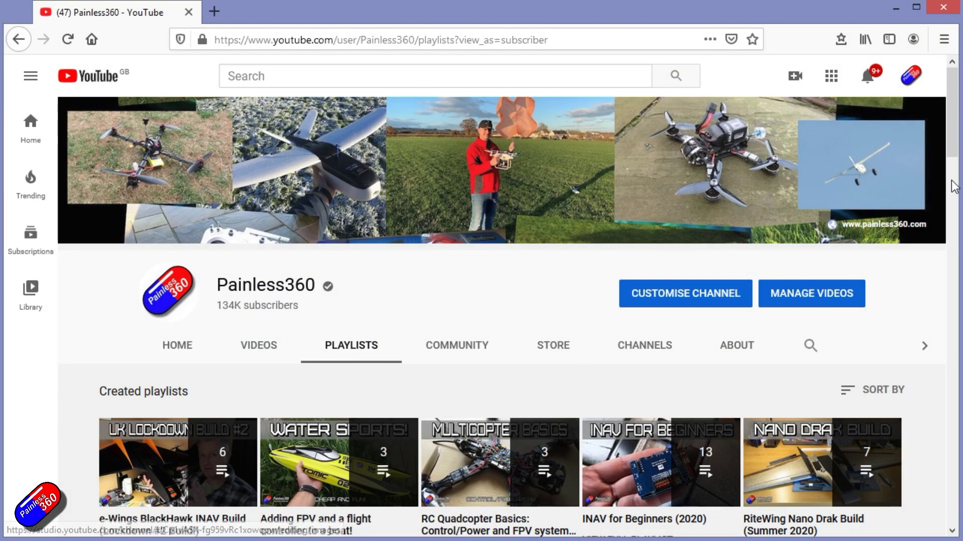 (score 90.0000)
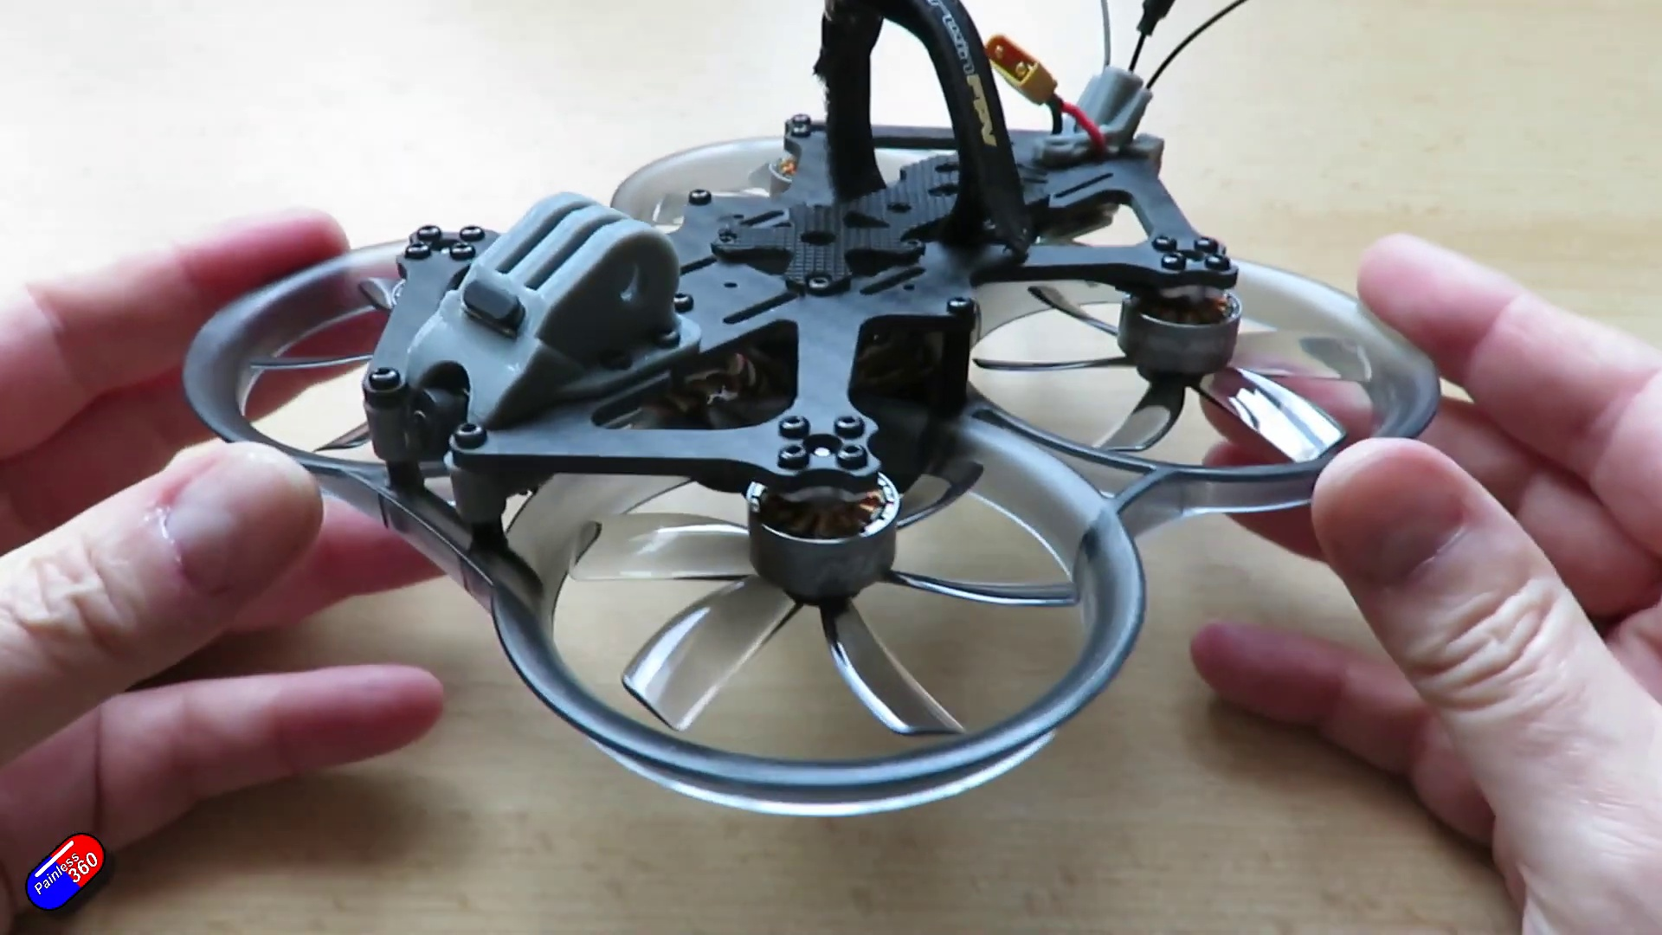 (score 90.0000)
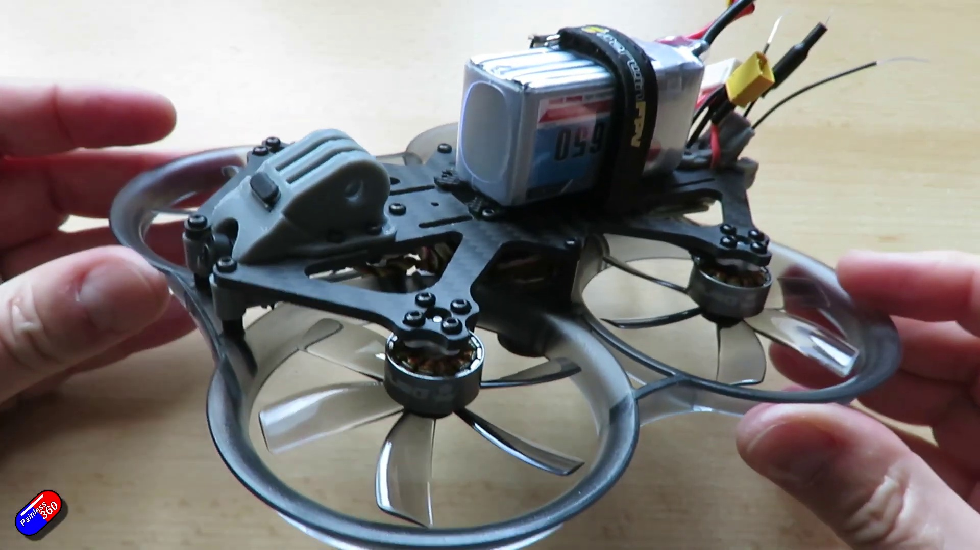 (score 90.0000)
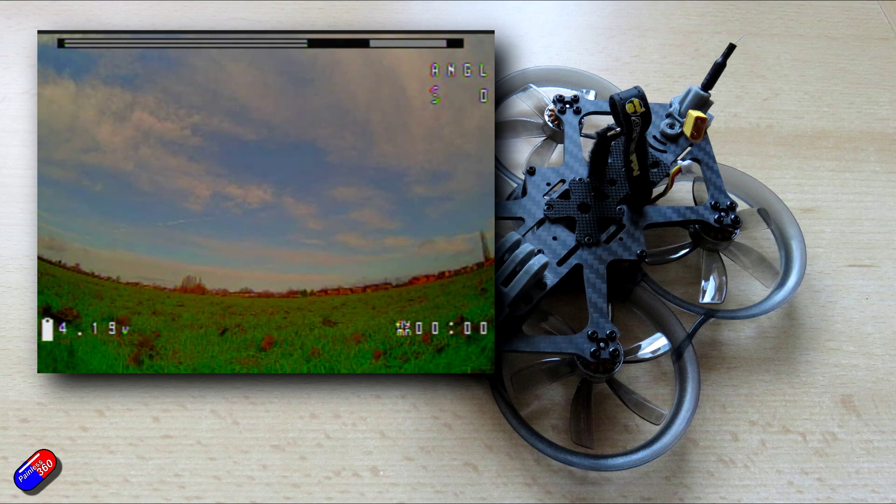 (score 90.0000)
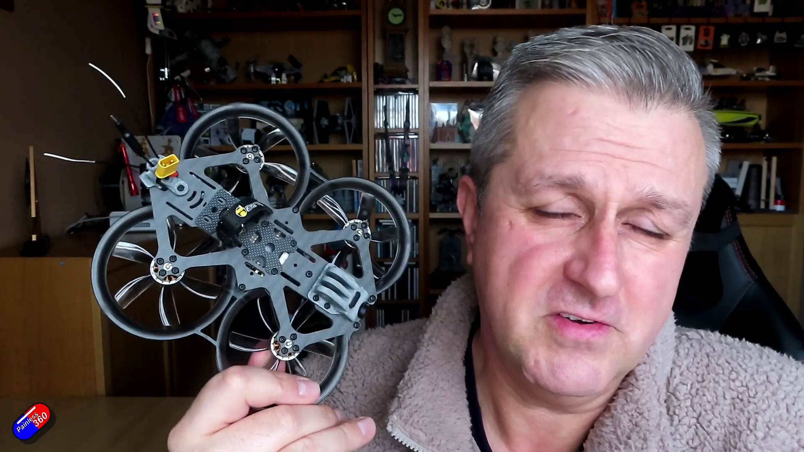 (score 90.0000)
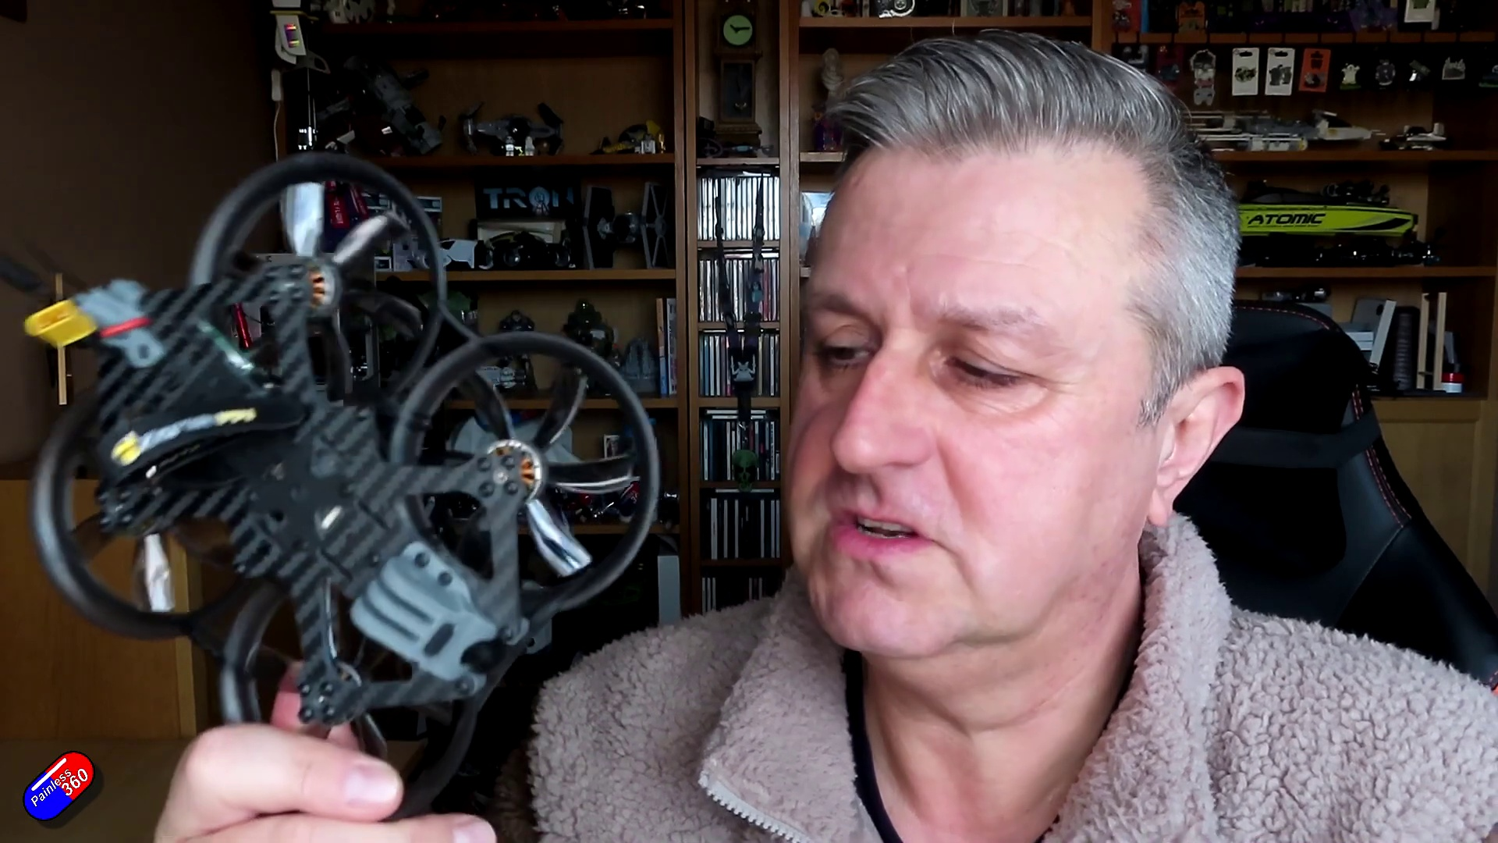 (score 90.0000)
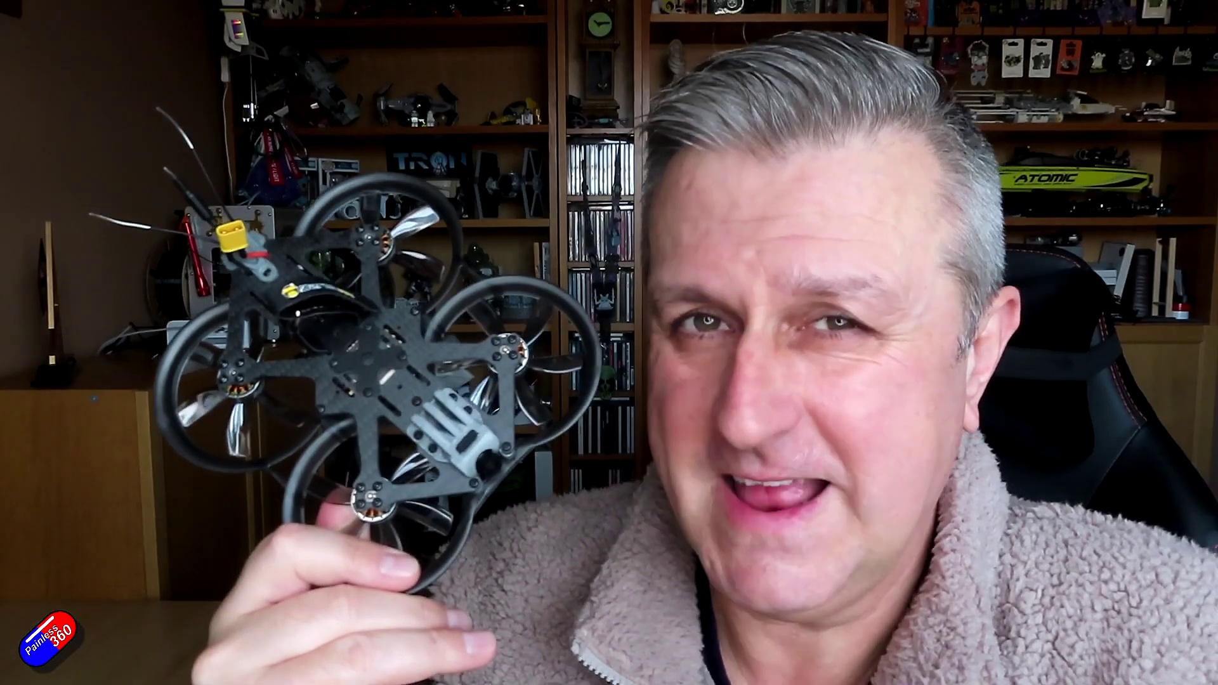 (score 90.0000)
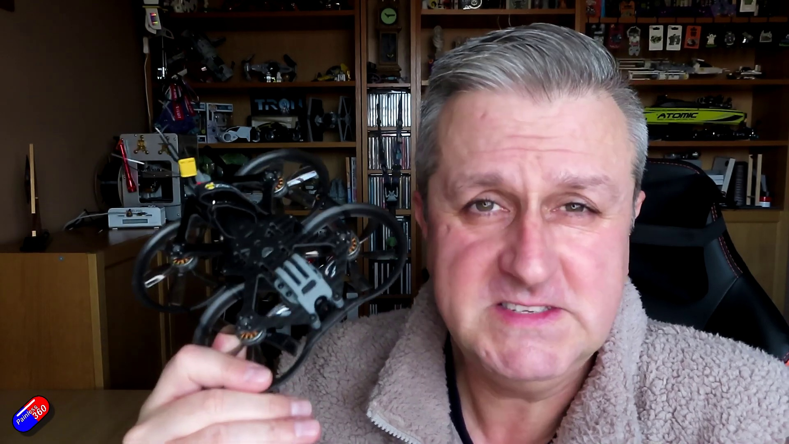 (score 90.0000)
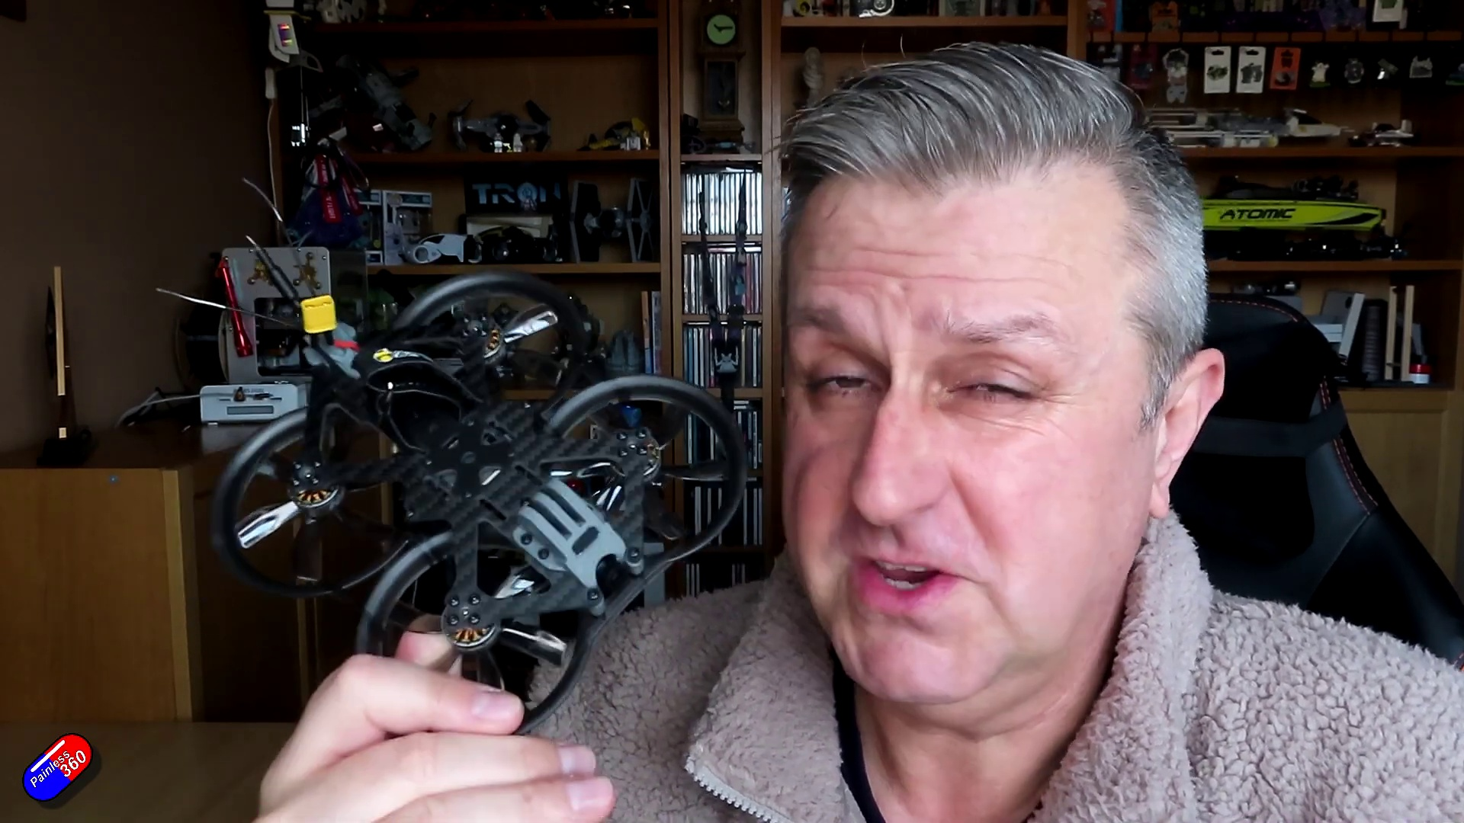 (score 90.0000)
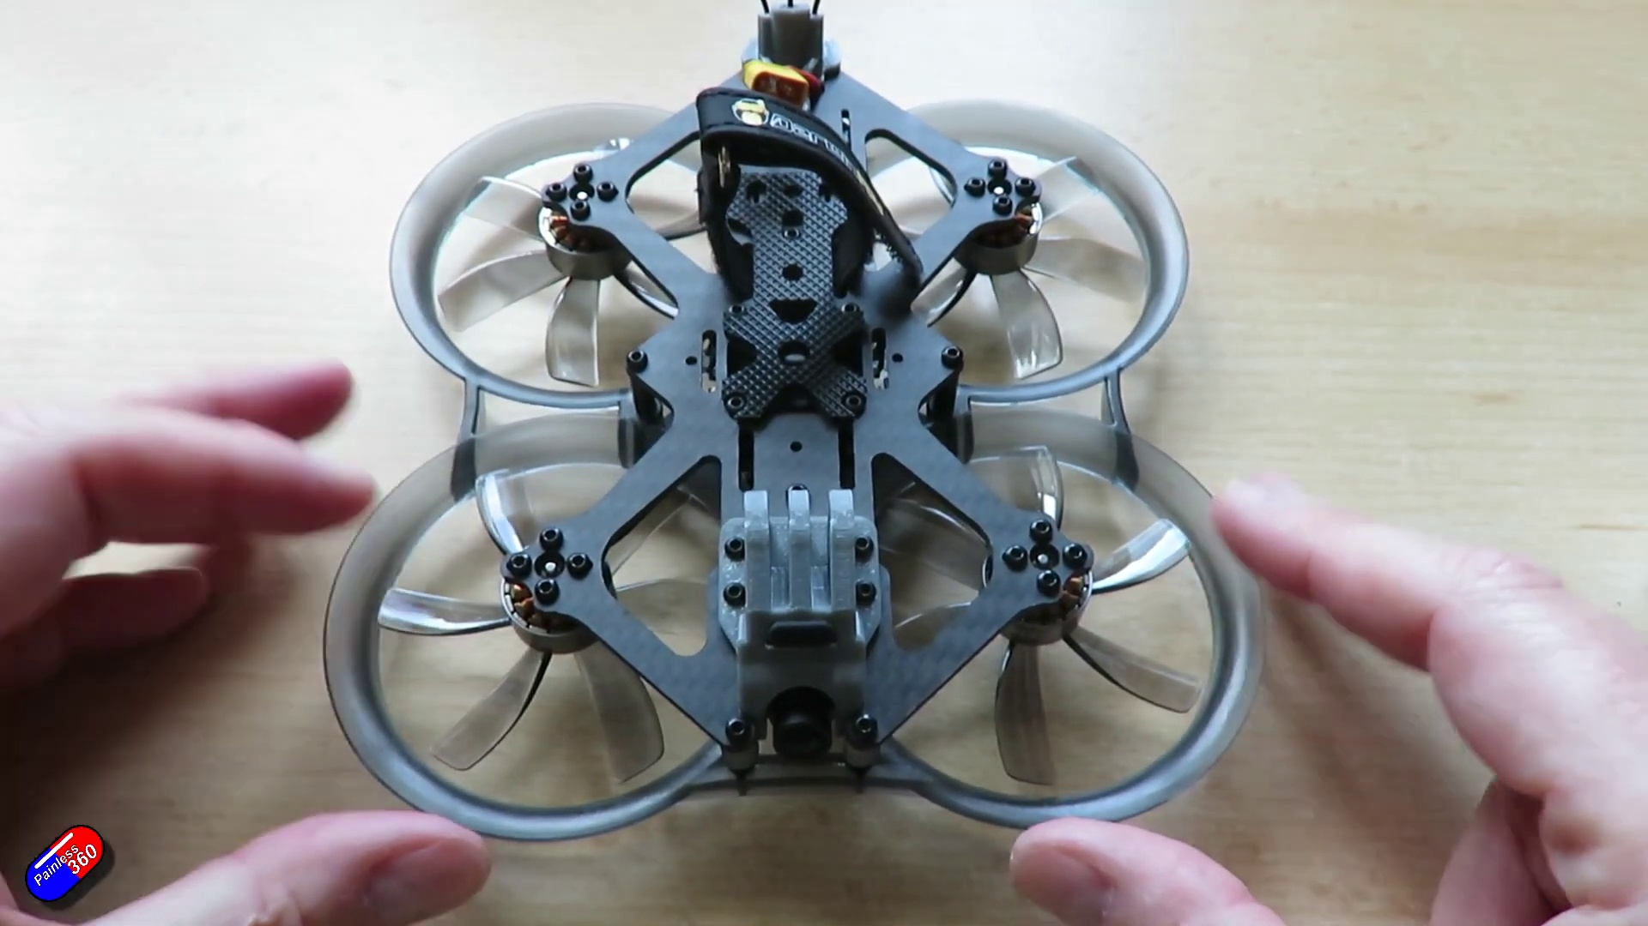 (score 85.0000)
Least correlated frames:
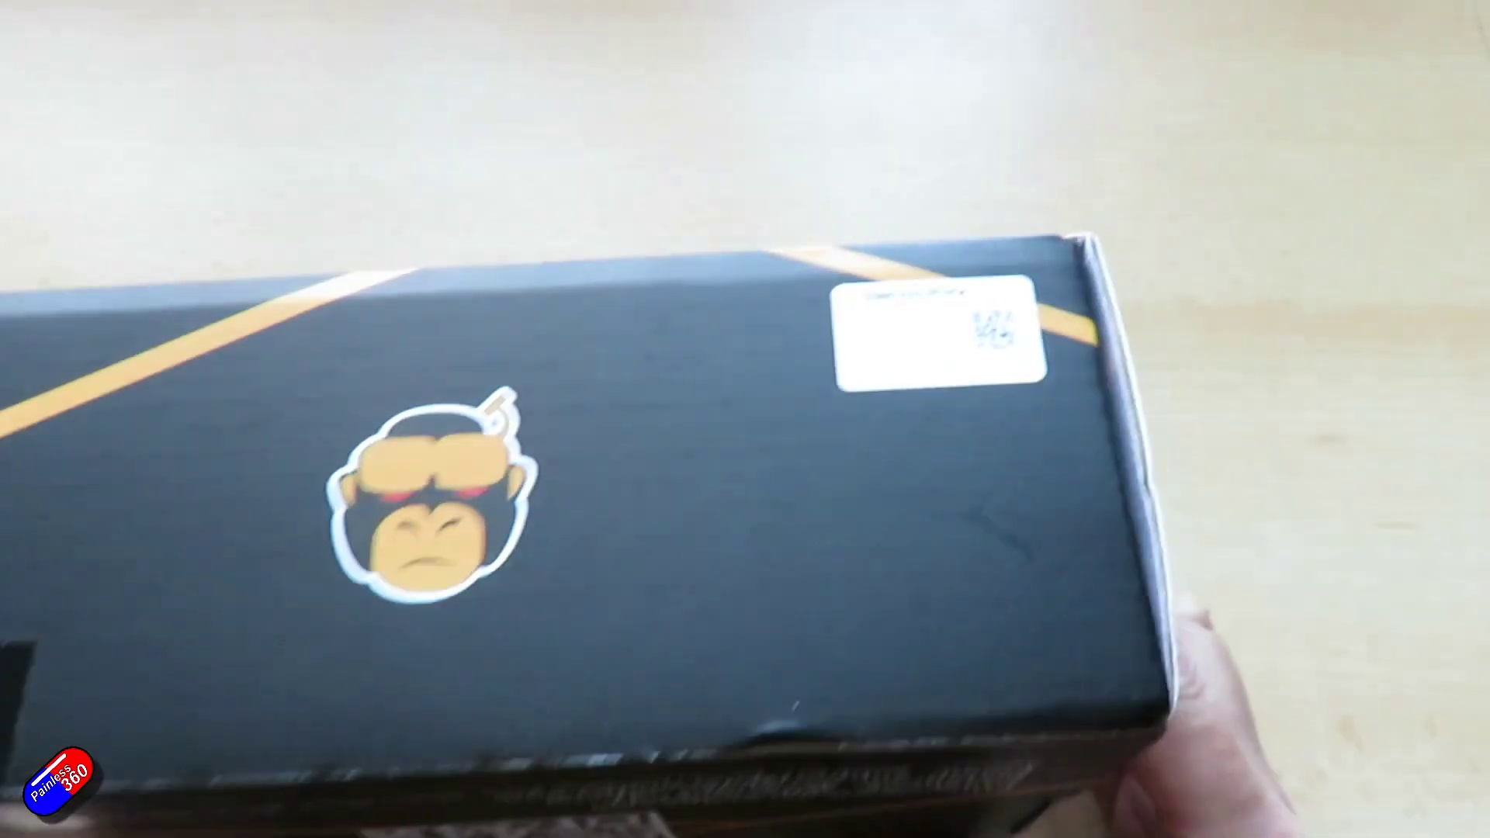 (score 0.0000)
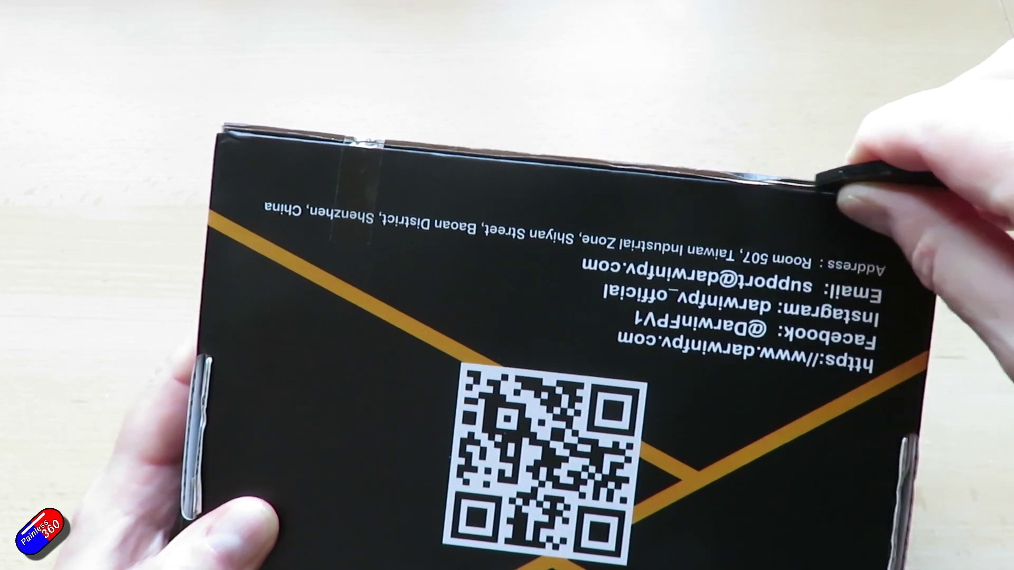 (score 0.0000)
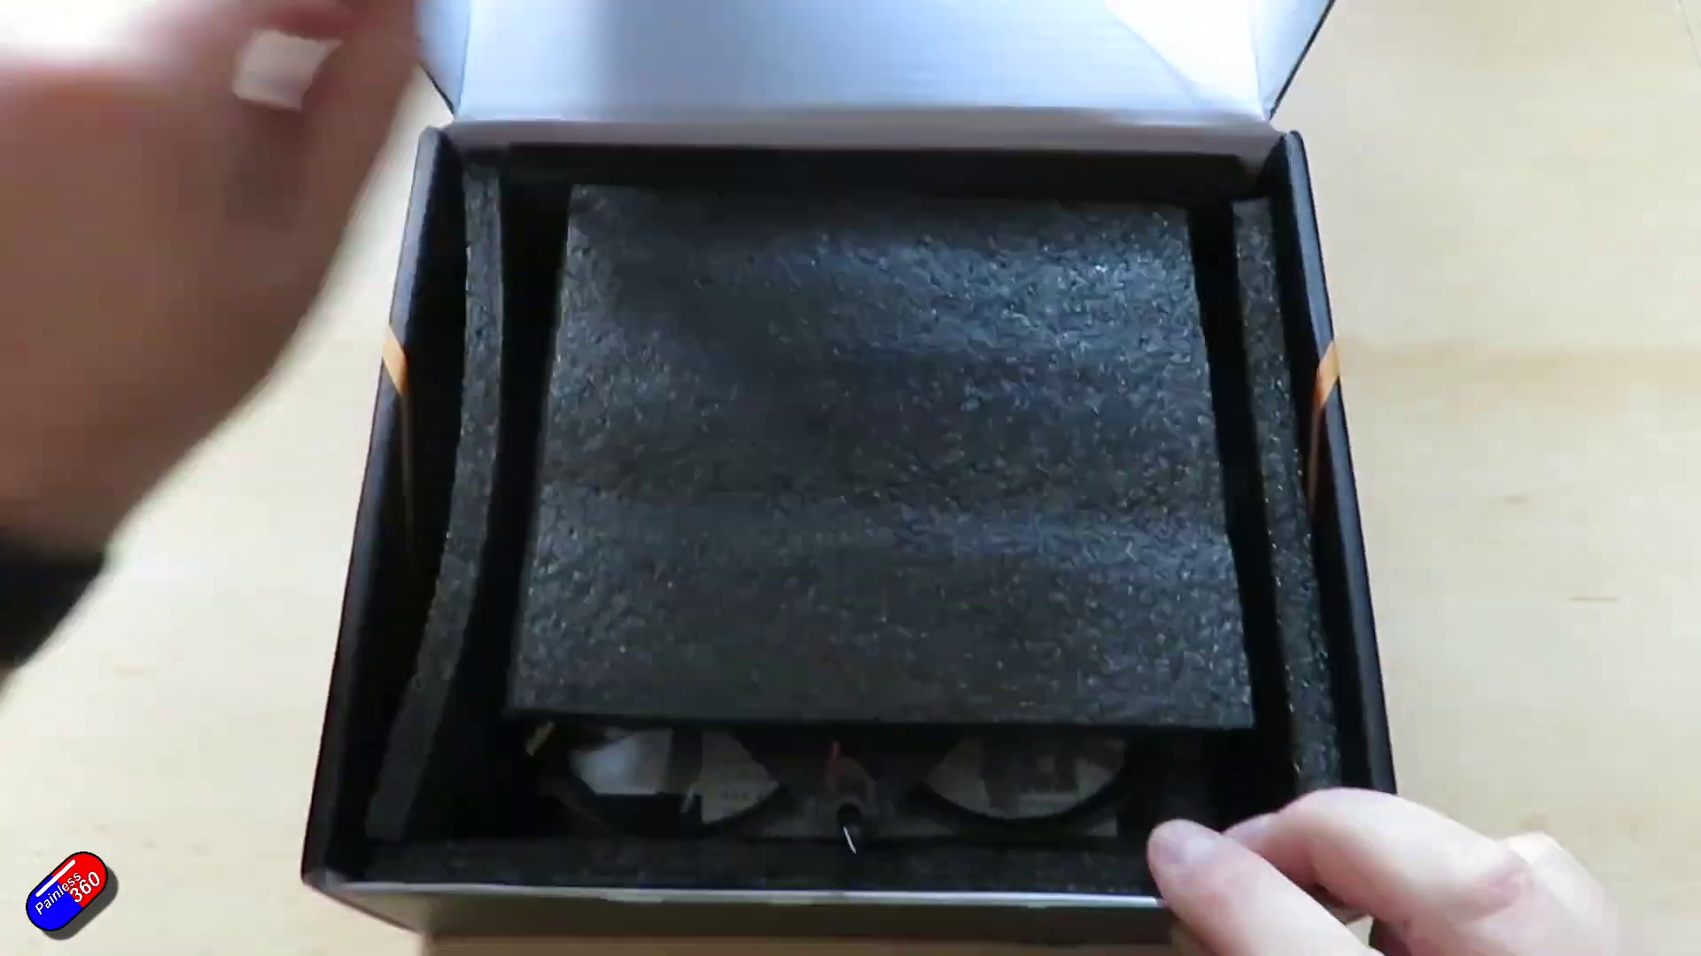 (score 0.0000)
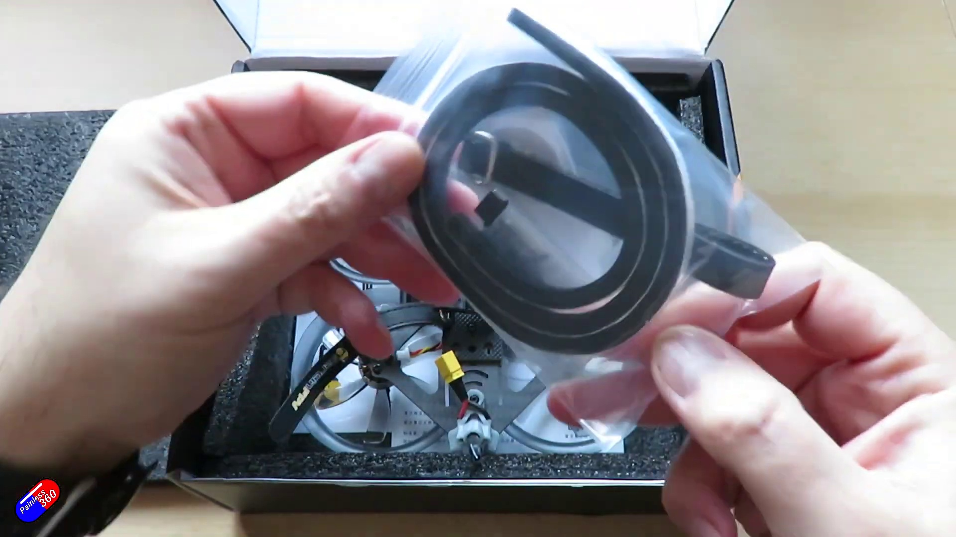 (score 0.0000)
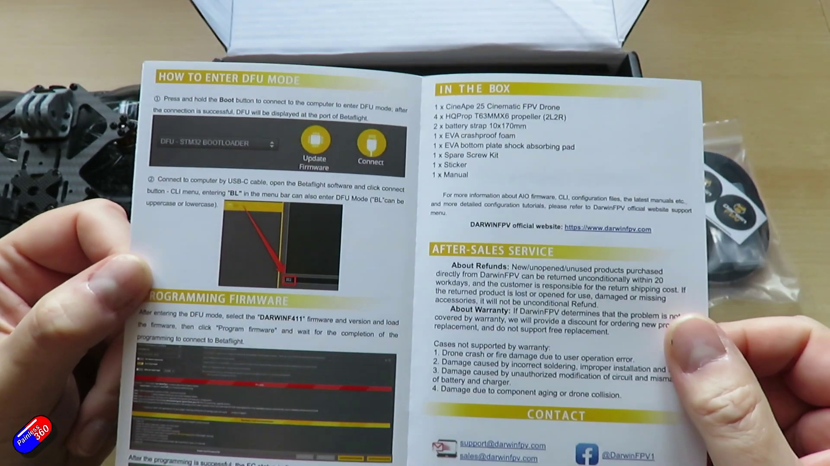 (score 0.0000)
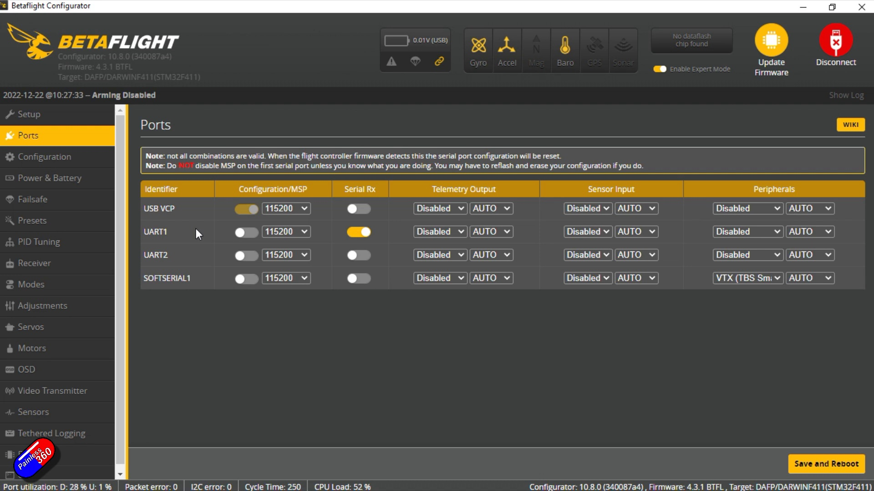 (score 0.0000)
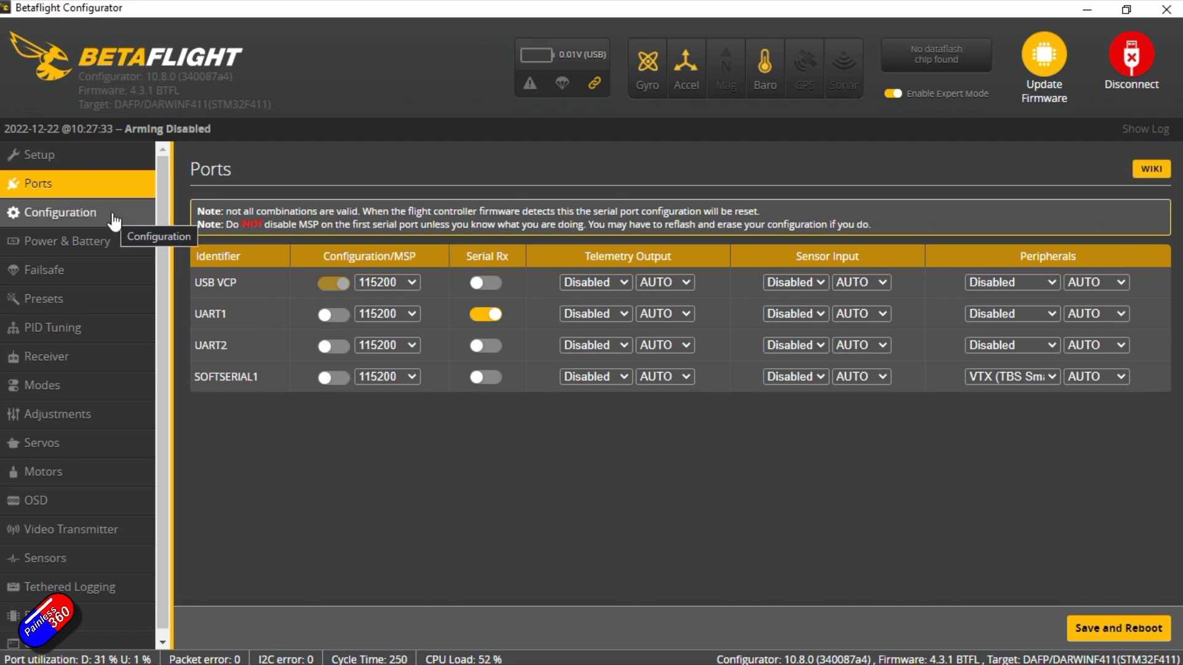 (score 0.0000)
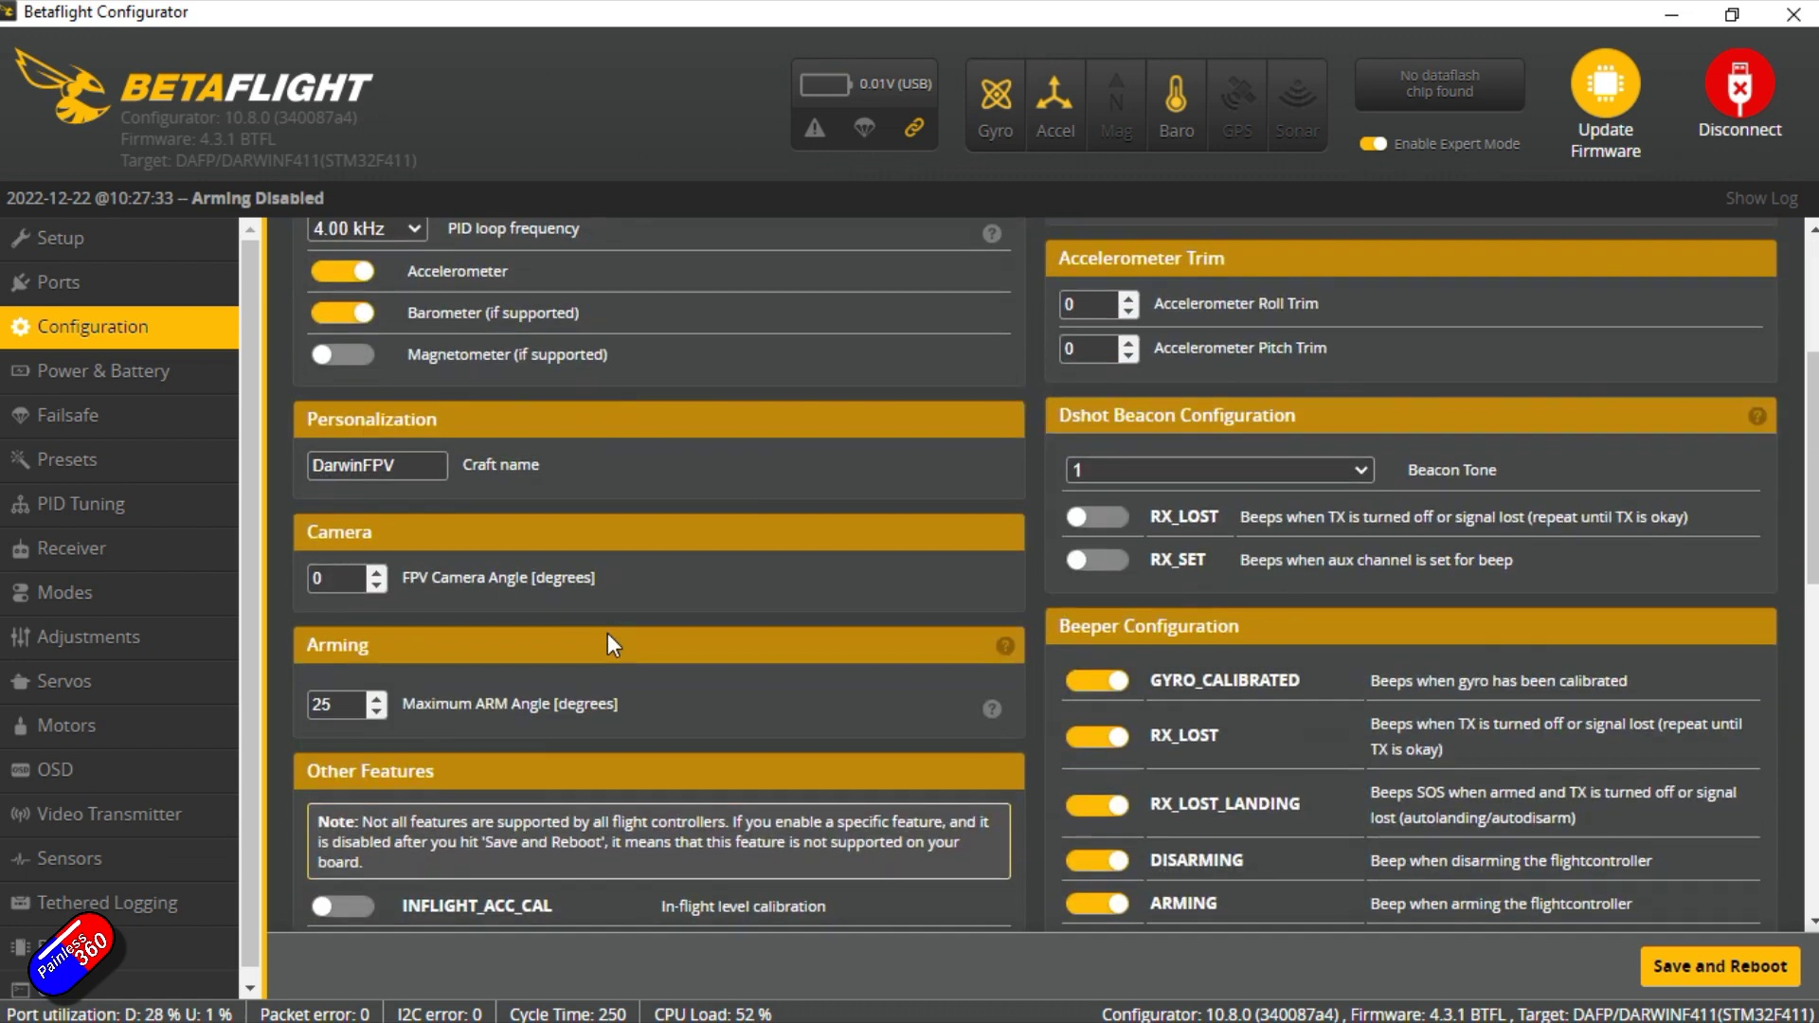 (score 0.0000)
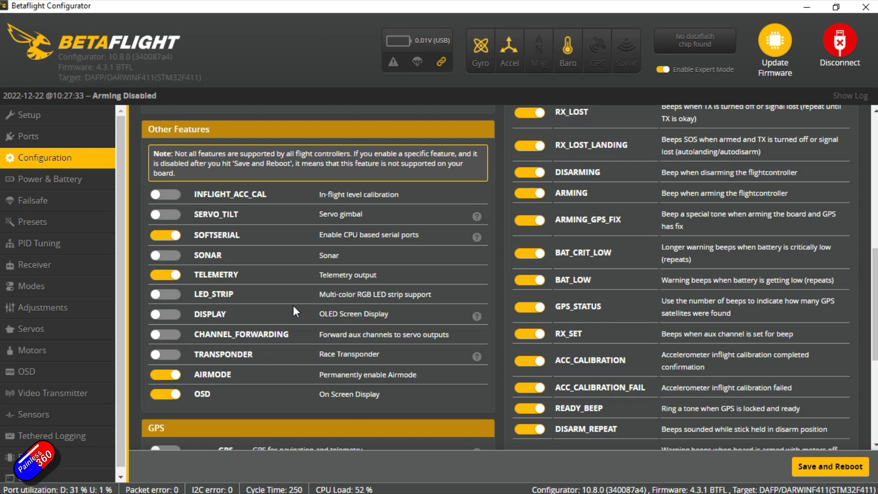 (score 0.0000)
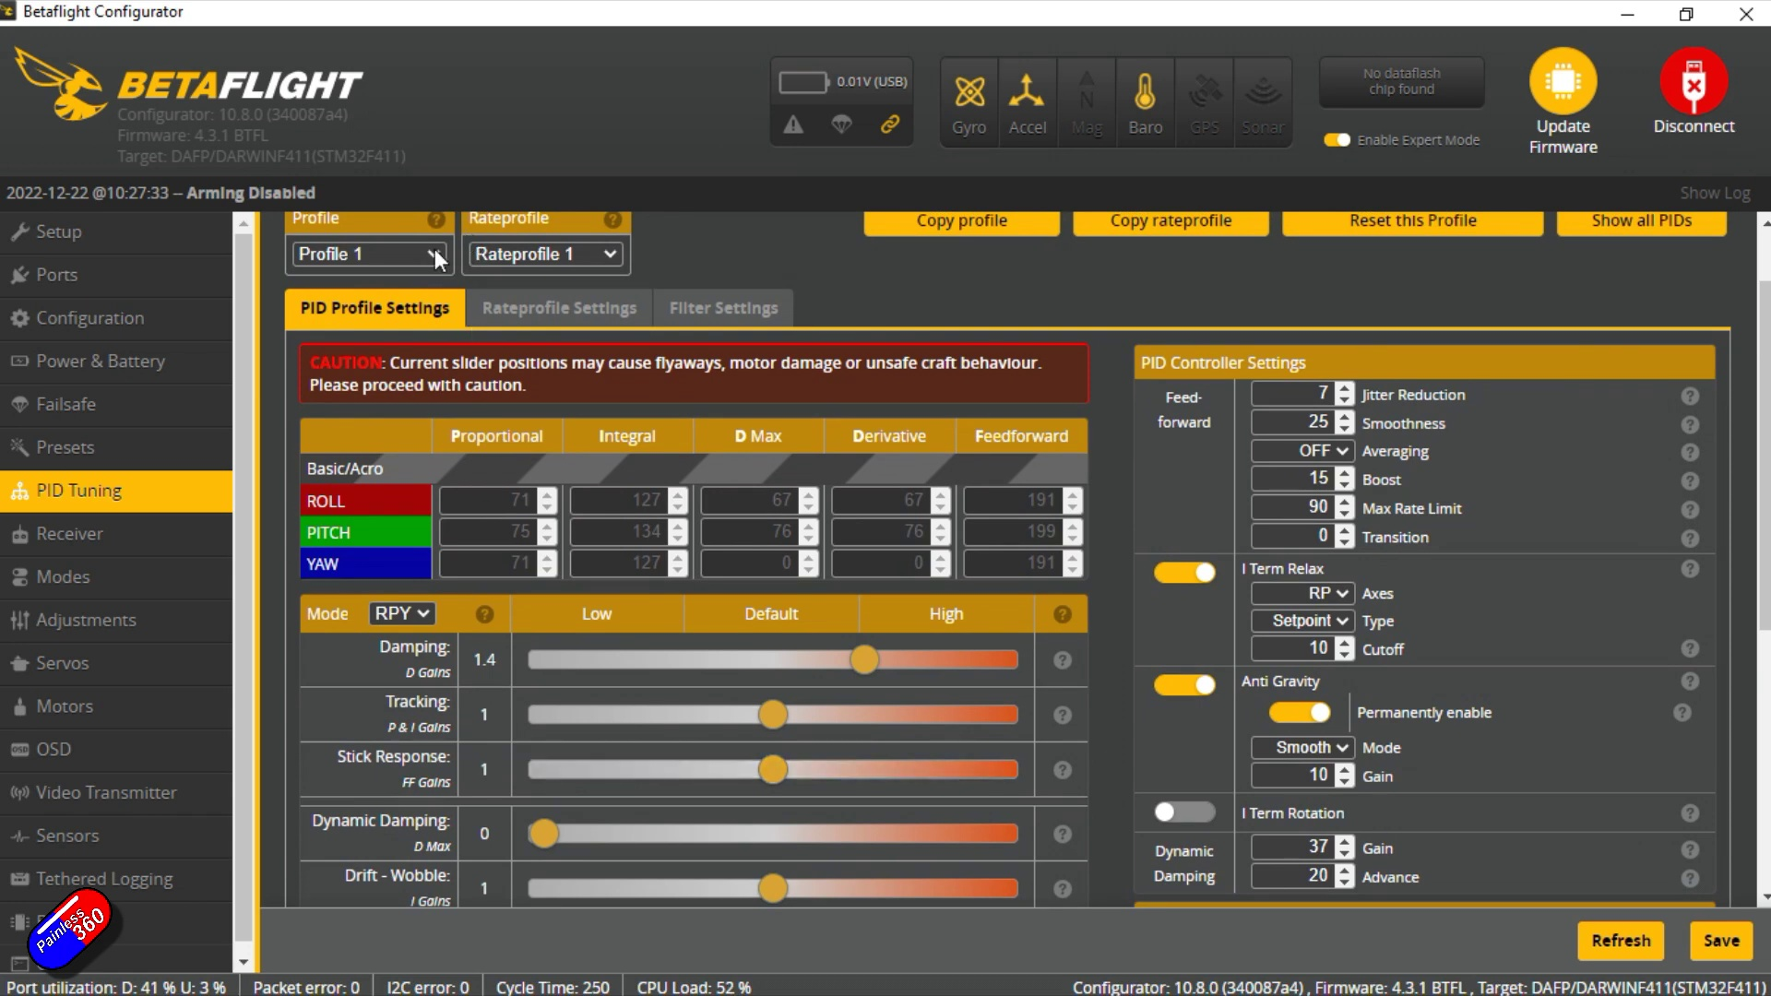 (score 0.0000)

Frame: frame_0000.jpg
Caption: The image displays a digital sign with several elements. At the top of the sign, there is a background image that resembles a cosmic or nebula-like design with stars and dark space. Overlaid on the background image are texts in different fonts and sizes, including "DarwinFPV 25" at the top, which suggests the name of a project related to FPV (First Person View) technology. This could be a poster or sign for an event or presentation related to DarwinFPV and its version 25.
Below the main text, there is a smaller line of text that says "Overview and Review." This implies that the content below will provide information about DarwinFPV 25 and possibly a review of it. Additionally, the bottom part of the sign contains details including "January 21," which could indicate the date of the event or presentation, as well as "DarwinFPV 25 overview video link." This suggests that there is a video available for viewing, presumably to provide more information about DarwinFPV 25.
The overall style of the sign is informational, with a focus on providing details about an FPV project or related event. There are no people, devices, slides, diagrams, or text that can be confidently identified as directly conveying teaching content. Instead, the sign appears to be an advertisement or announcement for an FPV project or event.
Comment (score 85): This video discusses the portability of the Darwin FPV drone. This drone is very small and can fit in your pocket. The drone is made using injection molding, so it is very tough and lightweight. The only downside of this drone is the decreased battery life since there is not a lot of space for a larger-sized battery. This is a very interesting concept of decreasing the size of the drone for easy portability and can have many implications. Such as military use civilian use such as weddings or wanting an overhead view of a city. The possibilities are endless and can potentially. Be redesigned in phase 2 of our project.
Reason: The comment directly discusses the portability of the Darwin FPV drone, which is mentioned in the caption as 'very small and can fit in your pocket'. The caption also mentions the event or presentation being related to DarwinFPV 25, which is discussed in the comment. Additionally, the mention of the drone's decreased battery life due to size constraints aligns with the caption's description of the sign as informational.
Source: https://www.youtube.com/watch?v=9fYzb1g8tzw: DarwinFPV CineAPE 25: A tough little pocket rocket

Frame: frame_0001.jpg
Caption: The image displays a digital graphic with text related to Darwini University's PV (Personal Viewing) Cinema 25. The central part of the image features a large banner with white letters against a dark background, reading "DarwinPV Cineme25". Below this banner is an overlay with a date and additional text: "Overview and Review January 19, 2023", suggesting when this presentation or activity was scheduled or conducted.
On the right side of the image, there is a smaller banner with white letters on a blue background, reading "DarwinPV Cineme25". This design element may be part of the same event or presentation as the main banner. The overall style of the image is promotional and digital, likely designed to advertise an event related to Darwini University's PV Cinema 25.
The design incorporates a cosmic or space theme in the background, featuring stars and galaxies, which could indicate that the content or event has a science fiction or space exploration theme. However, the image does not depict any real-world objects like people, devices, or slides; it is purely digital and does not show any teaching context or instructor present.
This graphic may also be the cover page for a book titled "Darwin FPV Cinema 25: Overview and Review", which features a blue background with a silhouette of a person standing on a mountain.
No strongly correlated comments found for this frame.

Frame: frame_0002.jpg
Caption: The image presents a website page for a product, specifically a drone. The drone, labeled "25 Cinematic Whoop FPV Drone", is prominently displayed in the center of the page. It's described as a "crazy 25-camera drone" with "25 cameras" and "25 cameras". The drone's price is listed as $192.99.
The page is divided into two sections. The top section is dedicated to the drone, featuring an image of the device with its wings extended and the body visible, along with a remote control attached to it, suggesting it's ready for flight. In the background, there's a product listing on a shopping website, indicating that this is an item for sale. The text "DUWINFVP CINE APE" is visible, along with the price tag "$25.99 USD". Below the main image, there's a small graphic of a drone with text that reads "DJI Mavic Pro", which might be the model or manufacturer of this particular drone.
The page also includes a "Subscribe" button, suggesting that the website may offer additional content or services related to the drone. A banner at the top of the page promotes the drone as a "crazy 25-camera drone". The bottom section provides additional information about the product's features and specifications, including "25 cameras", listed in a clear and organized manner, making it easy for potential buyers to understand the product.
No strongly correlated comments found for this frame.

Frame: frame_0003.jpg
Caption: The image shows a drone on display against a white background. The drone is black and white with a white propeller at the front, equipped with a camera and a battery, both of which are black. The camera is mounted on the drone, ready to capture footage, while the battery is securely attached to provide power for its operations.
The drone is positioned on a white surface, connected by a cord to the website, which is also in black and white. The website features a white header with the company's logo written in black text, along with a logo in the bottom left corner.
In the display case next to the image, a foldable drone is showcased against a white background. This drone has its arms extended and folded downwards, revealing its body which has a camera mounted on its underside. There are no visible texts or brands on the drone itself.
To the right of the image, a text overlay reads "DUWELL FPV CINEMA 25C" followed by "EPV WHOPP," and below it, there's a mention of "36 CINEMATIC WHEEL." The text indicates that this drone is an FPV model with 36-degree camera capabilities and may come equipped with wheels.
The price tags for both drones are displayed: "₹19,999" on the foldable drone and [unknown price] on the website. The overall style of the images appears to be promotional or sales-oriented photographs intended to showcase the products for potential buyers.
No strongly correlated comments found for this frame.

Frame: frame_0004.jpg
Caption: The image features a website page that prominently displays a 25 Cinematic Whoop FPV Drone, also referred to as "DurwinFPP" in the top text. The drone has a black and white body and is equipped with four propellers and possibly additional sensors or cameras. This remote-controlled quadcopter appears to be designed for cinematic purposes, mimicking film production techniques.
On the right side of the image, a smaller version of the same drone is displayed, accompanied by specifications that include "120 km/h Max Speed" and "30 km Control Range". The webpage also features a price tag for the product, listed as $129, with information on free shipping and an available promotion for 15% off. The discount amount is displayed as "$37", which seems to apply specifically to this item.
The website page includes additional details, such as the company's name, address, and contact information, although this information appears to be different from the one mentioned in the original caption (MiniCPM). The overall color scheme of the page is white, with the drone being the main focus. The text on the page is black, which contrasts well with the white background.
Comment (score 85): This video discusses the portability of the Darwin FPV drone. This drone is very small and can fit in your pocket. The drone is made using injection molding, so it is very tough and lightweight. The only downside of this drone is the decreased battery life since there is not a lot of space for a larger-sized battery. This is a very interesting concept of decreasing the size of the drone for easy portability and can have many implications. Such as military use civilian use such as weddings or wanting an overhead view of a city. The possibilities are endless and can potentially. Be redesigned in phase 2 of our project.
Reason: The comment discusses the portability and design considerations of the Darwin FPV drone, which is directly related to the technical steps and settings described in the caption, such as the use of injection molding and the impact on battery life. The comment also mentions potential applications of this technology, including military and civilian uses, which aligns with the goals described in the caption.
Source: https://www.youtube.com/watch?v=9fYzb1g8tzw: DarwinFPV CineAPE 25: A tough little pocket rocket

Frame: frame_0005.jpg
Caption: The image depicts a person, presumably a male with glasses, engaged in an activity that appears to involve assembling or repairing a remote-controlled model airplane, specifically a quadcopter. The device is partially disassembled, with its frame and motor parts exposed. The room surrounding the individual suggests a home setting with personal items visible in the background, such as bookshelves filled with books and decorative objects. The space is cluttered with various items, including DVDs. There are no visible texts, slides, diagrams, or any other distinguishing features that would suggest an educational context beyond what has been described. The focus of the image remains on the person's activity, highlighting their engagement in the task at hand.
No strongly correlated comments found for this frame.

Frame: frame_0006.jpg
Caption: The image appears to be a screenshot from a video platform, possibly YouTube, given the user interface elements such as the 'like' count and the video player controls at the bottom of the image. In the foreground, there is a person who seems to be in mid-motion, speaking or gesturing towards an object they are holding. The person appears to be middle-aged with short gray hair, wearing a grey shirt.
The object being held by the person is a quadcopter drone, which is mostly black with some white accents and has propellers attached to it. A visible brand logo on the drone can be seen, although the specific brand cannot be identified. The drone appears to be currently upside down in the image.
The background suggests an indoor setting, with shelves containing various items, including what seems like model cars or planes, indicating that this might be a workspace for someone who is interested in hobbies related to remote-controlled vehicles or technology enthusiast activities. A wall socket and a shelf with DVDs can also be seen in the background. The overall scene appears to be a casual, indoor setting, with the person standing directly in front of the camera, looking at it.
Comment (score 80): This video discusses the portability of the Darwin FPV drone. This drone is very small and can fit in your pocket. The drone is made using injection molding, so it is very tough and lightweight. The only downside of this drone is the decreased battery life since there is not a lot of space for a larger-sized battery. This is a very interesting concept of decreasing the size of the drone for easy portability and can have many implications. Such as military use civilian use such as weddings or wanting an overhead view of a city. The possibilities are endless and can potentially. Be redesigned in phase 2 of our project.
Reason: The comment directly discusses the technical aspects of the drone, specifically its portability and features (size, battery life), which are mentioned in the caption. The mention of 'Darwin FPV drone' is also a clear connection to the object being held by the person in the image.
Source: https://www.youtube.com/watch?v=9fYzb1g8tzw: DarwinFPV CineAPE 25: A tough little pocket rocket

Frame: frame_0007.jpg
Caption: In the image, a person (appears to be a male) is standing in a well-lit room filled with various electronic equipment. He is holding a black drone in his left hand, with a white propeller attached to it. The individual is wearing a brown jacket and has a smile on his face as he looks at the drone.
The background of the scene features multiple bookshelves located on the right side of the room, each filled with different types of books. This suggests an interest in hobbies or collectibles.
On the tabletop in front of the person, there are several objects visible, including a model drone (held in his hand) and possibly a book related to drone technology or flight, as well as another item that could be a remote control or small electronic device.
The overall scene appears to depict a workspace or hobby room where the individual is engaged in their activities. There is no indication of a teaching context within this image, nor is there any visible text on screens that would provide additional information. The focus of the image remains on the person and their interaction with the model drone.
Comment (score 90): This video discusses the portability of the Darwin FPV drone. This drone is very small and can fit in your pocket. The drone is made using injection molding, so it is very tough and lightweight. The only downside of this drone is the decreased battery life since there is not a lot of space for a larger-sized battery. This is a very interesting concept of decreasing the size of the drone for easy portability and can have many implications. Such as military use civilian use such as weddings or wanting an overhead view of a city. The possibilities are endless and can potentially. Be redesigned in phase 2 of our project.
Reason: The comment directly discusses the portability and features of the Darwin FPV drone, which is visually depicted in the frame caption. The comment mentions the size, battery life, and potential uses of the drone, all of which are reflected in the image, such as the individual holding a small drone with a white propeller.
Source: https://www.youtube.com/watch?v=9fYzb1g8tzw: DarwinFPV CineAPE 25: A tough little pocket rocket

Frame: frame_0008.jpg
Caption: The image shows a person standing in a well-organized room, surrounded by shelves filled with various items. The individual, who appears to be a male, is holding a black quadcopter in his hand. The quadcopter has propellers and is positioned slightly towards the left of him.
On the desk in front of him, there are several items, including what looks like a gaming controller with the word "Roccat" visible on it, suggesting that this might be used for controlling the device represented by the model being held up. The model appears to be a flying device, possibly a quadcopter or drone given its structure and design. It is being held up in front of him.
The person is wearing glasses and seems to be speaking, though the content of their speech isn't clear from the image. He is standing in front of a microphone, which could suggest that he is recording a video or participating in an online class. The environment suggests a setting that might be used for instructional purposes or as a personal workspace dedicated to hobbies or projects related to electronics and technology.
The room itself is filled with various items, suggesting a space that is likely used for various activities. On the left side of the room, there are shelves filled with books, which appear to be neatly stacked and labeled. On the right side, there is a shelf filled with toys, including figurines and action figures, arranged in a way that suggests they are for children.
Overall, the image portrays a well-used and well-organized space that is both functional and playful. The presence of the quadcopter and the person's interaction with it suggest that this room might also be used for recreational activities, such as flying the quadcopter.
Comment (score 80): This video discusses the portability of the Darwin FPV drone. This drone is very small and can fit in your pocket. The drone is made using injection molding, so it is very tough and lightweight. The only downside of this drone is the decreased battery life since there is not a lot of space for a larger-sized battery. This is a very interesting concept of decreasing the size of the drone for easy portability and can have many implications. Such as military use civilian use such as weddings or wanting an overhead view of a city. The possibilities are endless and can potentially. Be redesigned in phase 2 of our project.
Reason: The comment directly discusses the technical aspects of a quadcopter (Darwin FPV drone), specifically its portability and design features (injection molding), which are also mentioned in the frame caption. The caption shows a person holding a similar type of quadcopter, and the comment mentions its use cases, such as military, civilian, and recreational purposes.
Source: https://www.youtube.com/watch?v=9fYzb1g8tzw: DarwinFPV CineAPE 25: A tough little pocket rocket

Frame: frame_0009.jpg
Caption: The image shows an older individual standing in front of a cluttered bookshelf, holding up a compact and sleek black drone model with four slightly angled propellers. The man's grey hair and beard are visible, suggesting experience and wisdom. Behind him, the bookshelf is filled with various items, including a black remote control and a green and yellow remote control, adding a splash of color to the otherwise monochrome scene. In one hand, he holds up the drone, which features a white "X" pattern on its underside. The individual appears to be presenting or discussing the drone with someone, likely sharing information about it. The casual indoor setting suggests a personal space dedicated to hobbies or technology-related activities. The overall image exudes a sense of curiosity and fascination, as if the man is about to share a secret or a new discovery.
Comment (score 90): This video discusses the portability of the Darwin FPV drone. This drone is very small and can fit in your pocket. The drone is made using injection molding, so it is very tough and lightweight. The only downside of this drone is the decreased battery life since there is not a lot of space for a larger-sized battery. This is a very interesting concept of decreasing the size of the drone for easy portability and can have many implications. Such as military use civilian use such as weddings or wanting an overhead view of a city. The possibilities are endless and can potentially. Be redesigned in phase 2 of our project.
Reason: The comment directly discusses the portability and size of the drone, which is mentioned in the caption as 'compact and sleek' with a focus on its small size that can fit in your pocket. The comment also mentions implications such as military use, civilian use, and weddings, which are related to the casual indoor setting and sense of curiosity/fascination described in the caption.
Source: https://www.youtube.com/watch?v=9fYzb1g8tzw: DarwinFPV CineAPE 25: A tough little pocket rocket

Frame: frame_0010.jpg
Caption: The image presents a sleek and modern drone with its arms extended and attached to a central body, potentially designed for surveillance or mapping purposes. The drone features multiple cameras mounted on each arm, suggesting its capabilities for cinematic applications such as aerial photography and videography. The text overlay in front of the drone reads "Darwin FPV CinApe 25 Cinematic Whop", emphasizing its design for filming and photography.
The drone's body appears to be made from plastic or composite materials, with white propellers contrasting against its black frame. It is equipped with two cameras, one on the front and one on the back, ready to capture the world around it. The drone also features a pair of batteries, one on each side, ensuring extended flight times.
The image is set against a plain, neutral-colored backdrop, focusing solely on the presentation of the drone. A small box labeled "Cinematic Whoop FPV Drone" is situated on the right side of the drone, confirming its purpose for aerial photography and videography. The drone sits proudly on a white table, providing a stark contrast to its black frame, making it stand out even more.
Comment (score 60): This video discusses the portability of the Darwin FPV drone. This drone is very small and can fit in your pocket. The drone is made using injection molding, so it is very tough and lightweight. The only downside of this drone is the decreased battery life since there is not a lot of space for a larger-sized battery. This is a very interesting concept of decreasing the size of the drone for easy portability and can have many implications. Such as military use civilian use such as weddings or wanting an overhead view of a city. The possibilities are endless and can potentially. Be redesigned in phase 2 of our project.
Reason: The comment discusses the portability and size-related features of the drone, which are directly mentioned in the caption as advantages ("very small and can fit in your pocket"). The mention of battery life and implications for military/civilian use also tie back to the technical details presented in the caption. However, the score is not 100 because the comment does not specifically discuss the cameras or cinematography applications highlighted in the caption.
Source: https://www.youtube.com/watch?v=9fYzb1g8tzw: DarwinFPV CineAPE 25: A tough little pocket rocket

Frame: frame_0011.jpg
Caption: The image is a collage of photographs featuring a remote-controlled drone and related items. The first photo displays the drone in mid-flight with visible propellers against a plain white background, likely controlled by a radio transmitter not visible in this view. A camera is attached underneath the drone.
In another image, the same drone model is shown with its body apart, revealing internal components that include batteries, electronic control units, and wiring. This photo emphasizes the technical aspects of the drone, such as the structural frame and the electronics that power it.
A third image shows a smaller, toy-like version of the same drone model. This miniature replica is designed for indoor flight, suggested by its limited size and lack of outdoor capabilities implied by the absence of an antenna or camera.
The bottom right photo features a close-up of the batteries that power the full-sized drone, which are cylindrical lithium polymer (LiPo) batteries, common in remote-controlled aircraft due to their high energy density and relatively low cost.
The collage format suggests a presentation or cataloging approach, possibly intended to showcase different models of drones or related products. The background includes the white logo of an organization that specializes in hobbies and electronic devices.
In addition, the image also appears to be a screenshot from a website, specifically the "Product List" page of a store selling FPV quadcopter kits. The page is primarily white, with a black header that includes the store's logo and a search bar. The page is divided into two main sections: a list of available products and a table of specifications.
The list of products includes the brand "Cinema 25", the model "AVATAR Mini", and the color "Black". Each product has a photo, a price, and a description. The photo shows the quadcopter in action, flying in the sky. The price is displayed in US dollars, and the description provides information about the quadcopter's features and specifications.
The table of specifications lists the battery capacity at 8500mAh, motors as 2.4GHz, propellers as 8pcs, and receiver as 2.4GHz.
Overall, the image provides a comprehensive view of the products available on the store's website, including their features, specifications, and pricing. It allows potential customers to make an informed decision about which products to purchase.
No strongly correlated comments found for this frame.

Frame: frame_0012.jpg
Caption: In the image, a person is standing in a room filled with bookshelves. The individual is wearing a grey sweater and holding up a small drone with a white body and what appears to be a camera attached to it. There are no visible texts or diagrams, but the context seems to be related to hobbies or technology, given the presence of the drone and the items on the shelves that suggest models or crafting activities. The person is looking directly at the camera with a slight smile, and there's a noticeable badge on their clothing that reads "PAT", which could indicate their affiliation or participation in a project or event related to this field.
The room is filled with various books, some of which are blue and white, and others are black and white. The books are arranged on several shelves, some of which are brown and others are black. In the background, there is a blackboard with a white arrow on it, suggesting that the person may be in a setting where learning or experimentation takes place.
The individual appears to be holding up the drone in an exploratory manner, possibly indicating its assembly or testing. The quadcopter itself has a white propeller on its front and a red LED light on its side, giving hints about its functionality or purpose. Overall, the image suggests that the person is engaged in a hobby or activity related to technology and may be proud of their work, as evident from their smile.
Comment (score 90): This video discusses the portability of the Darwin FPV drone. This drone is very small and can fit in your pocket. The drone is made using injection molding, so it is very tough and lightweight. The only downside of this drone is the decreased battery life since there is not a lot of space for a larger-sized battery. This is a very interesting concept of decreasing the size of the drone for easy portability and can have many implications. Such as military use civilian use such as weddings or wanting an overhead view of a city. The possibilities are endless and can potentially. Be redesigned in phase 2 of our project.
Reason: The comment directly discusses the portability and features of the Darwin FPV drone, which is identical to the object being held up in the frame caption. The caption mentions the quadcopter's small size, camera attachment, and red LED light, all of which are mentioned in the comment as part of its design. Additionally, the context of the caption (hobby or technology) matches the context of the comment (portability and potential uses).
Source: https://www.youtube.com/watch?v=9fYzb1g8tzw: DarwinFPV CineAPE 25: A tough little pocket rocket

Frame: frame_0013.jpg
Caption: The image captures a person standing in front of a desk with various objects on it, holding a remote control quadcopter with four rotors, also known as a drone. The individual appears to be middle-aged and is dressed casually, wearing a dark top and what seems to be a watch or bracelet on their left wrist.
The room has a cozy atmosphere with a window allowing natural light in, and it looks like a home or personal office space. A shelf in the background features several items, including books, figurines, and possibly a gaming controller on the left side, while the desk itself has more books and what appears to be a computer keyboard and mouse.
The person's body language suggests a moment of contemplation or perhaps a slight frustration with the drone's complexity. Their gaze is fixed on the drone as they hold it up in their right hand, with their left hand resting on their hip. The room around them hints at their interests, with a bookshelf filled with an array of books and other items standing in the background.
The television set, silent and unassuming, sits on a shelf, its screen reflecting the room's contents. A chair and another bookshelf are also visible in the background, adding to the homely atmosphere of the scene. The person's position in the image suggests a sense of focus and determination as they examine the drone, their attention entirely on it.
The image is a snapshot of a moment in time, capturing not just a person and a drone but a story of passion, curiosity, and the pursuit of knowledge.
Comment (score 80): This video discusses the portability of the Darwin FPV drone. This drone is very small and can fit in your pocket. The drone is made using injection molding, so it is very tough and lightweight. The only downside of this drone is the decreased battery life since there is not a lot of space for a larger-sized battery. This is a very interesting concept of decreasing the size of the drone for easy portability and can have many implications. Such as military use civilian use such as weddings or wanting an overhead view of a city. The possibilities are endless and can potentially. Be redesigned in phase 2 of our project.
Reason: The comment directly discusses the portability and design considerations of the drone mentioned in the caption, specifically highlighting its small size, toughness, and potential uses. Although it does not explicitly mention the individual's body language or the room's atmosphere, the technical details discussed are strongly related to the objects and settings described in the caption.
Source: https://www.youtube.com/watch?v=9fYzb1g8tzw: DarwinFPV CineAPE 25: A tough little pocket rocket

Frame: frame_0014.jpg
Caption: The image shows an individual, possibly a man, seated in a cozy living room with bookshelves lining the walls. The shelves are stacked high with various books, suggesting a love for reading or a professional interest in aviation or technology. The room is filled with natural light streaming in through the window behind him.
The individual's attention is focused on a model remote-controlled vehicle (RCV) in front of him, which features multiple electronic components and appears to have wheels, designed for ground movement. He is gesturing with his right hand towards the model, suggesting that he is explaining or lecturing about its features.
The desk in front of him has various items on it, including what seems to be a computer mouse and keyboard, indicating a space dedicated to hobbies or learning. The RCV is centrally positioned in front of the individual, and it's clear that the focus of the discussion is this device.
The atmosphere is peaceful, with no visible texts or diagrams on any screens providing additional context about the model or its components. The only other object visible near him is a black drone held up to his face as he examines its intricate details.
Comment (score 90): This video discusses the portability of the Darwin FPV drone. This drone is very small and can fit in your pocket. The drone is made using injection molding, so it is very tough and lightweight. The only downside of this drone is the decreased battery life since there is not a lot of space for a larger-sized battery. This is a very interesting concept of decreasing the size of the drone for easy portability and can have many implications. Such as military use civilian use such as weddings or wanting an overhead view of a city. The possibilities are endless and can potentially. Be redesigned in phase 2 of our project.
Reason: The comment directly discusses the portability and features (such as size, material, and battery life) of a drone, which is also the main focus of the frame caption. The mention of 'Darwin FPV drone' specifically matches the black drone visible in the image, indicating a strong connection between the caption and the comment.
Source: https://www.youtube.com/watch?v=9fYzb1g8tzw: DarwinFPV CineAPE 25: A tough little pocket rocket

Frame: frame_0015.jpg
Caption: The image captures a moment of enthusiasm as an individual stands in their well-organized home office or workspace. The room is dominated by a wooden desk, which is adorned with a collection of books and a television set turned off, suggesting a quiet moment. The books, arranged in a neat row, add a vibrant touch to the space.
In the center of the room, the individual holds up a small quadcopter drone, its black body gleaming under the light. The drone has visible propellers and a camera mounted underneath it. The person's fingers are firmly grasping the drone, indicating their interest in it.
The background reveals more about the surroundings. A bookshelf stands behind the desk, filled with books and other items. The shelf also holds a television set, suggesting that this room might be a workspace or a living area where the individual enjoys both reading and watching television.
As the individual holds up the drone, they are wearing glasses and a white top with an image or logo on it. They seem to be engaged in a conversation or presentation, possibly explaining the operation or features of the quadcopter. The atmosphere is casual and personal, suggesting that the setting could be a hobbyist's workspace rather than a classroom or formal teaching environment.
Comment (score 80): This video discusses the portability of the Darwin FPV drone. This drone is very small and can fit in your pocket. The drone is made using injection molding, so it is very tough and lightweight. The only downside of this drone is the decreased battery life since there is not a lot of space for a larger-sized battery. This is a very interesting concept of decreasing the size of the drone for easy portability and can have many implications. Such as military use civilian use such as weddings or wanting an overhead view of a city. The possibilities are endless and can potentially. Be redesigned in phase 2 of our project.
Reason: The comment directly discusses the same technical aspects of the drone (portability, size, battery life) and its potential uses (military, civilian, weddings), which are also described in the frame caption. The connection is not perfect as the comment focuses more on the technical features than the scene itself, but it shows a clear relationship between the two.
Source: https://www.youtube.com/watch?v=9fYzb1g8tzw: DarwinFPV CineAPE 25: A tough little pocket rocket

Frame: frame_0016.jpg
Caption: The image shows a person, a man with short gray hair, standing in a room adorned with shelves filled with books and various objects. He is wearing a light-colored shirt under his gray jacket and has a slight smile on his face as he looks directly at the camera. In front of him, he is holding up a gray quadcopter with multiple propellers and antennas, its body structure featuring visible electronic components, possibly including the flight controller and motors. A red light on the drone adds a pop of color to its gray body. The room appears to be an indoor environment that could be a home office or hobbyist's workspace, with a bookshelf containing what looks like a shelf of books or games in the background. There is also a large TV and computer visible, suggesting a space for both leisure and work. Overall, the scene suggests that the person may be a hobbyist or professional in this field, deeply engaged with his quadcopter.
No strongly correlated comments found for this frame.

Frame: frame_0017.jpg
Caption: The image shows a close-up view of an open black box with a white logo on the top right corner. The box has a rectangular shape and a black lid that matches the rest of the box. A unique feature is the slightly raised top right corner, adding to its distinct design. Inside the box, there is a small figure that appears to be a stuffed toy of a cartoon character, with large eyes and a happy or surprised expression. The character's brand or product representation is unclear due to the resolution and angle of the photograph, and no visible texts or brands are present on the box itself. This limits any identification or description of the object in question to speculation based on the logo. The box rests on a wooden surface, which provides a stark contrast to the black and yellow colors of the box's sticker featuring a monkey face, adding a touch of whimsy. The image does not contain any additional objects or text, and its composition suggests that it could be a promotional or advertisement image for the box.
No strongly correlated comments found for this frame.

Frame: frame_0018.jpg
Caption: The image captures a close-up view of a black box, resting on a white surface, with a person's hand holding it. The box is adorned with a QR code, which is the focal point of the image, and stands out against the black box in a contrasting orange color. The code is accompanied by text written in a black font at the top of the box, with the text appearing white, providing a stark contrast to the black box and the orange QR code. The box itself has a sleek design with a black border and a gold logo, adding to its sophistication. The image also shows that the person holding the box is partially obscuring a barcode on the box with another object, making it difficult to discern the contents of the box.
No strongly correlated comments found for this frame.

Frame: frame_0019.jpg
Caption: The image shows a person holding a small black box with a distinctive white stripe running down the middle and a black line on top. The box has a white label with black text on the front, reading "BRAND NEW BLACK STREAK BROWN BOX", "ROOM #106", and "FREE GIFT", indicating that it's new, located in room 106, and comes with a free gift. The person is holding the box at a 45-degree angle, revealing a QR code printed on the label, likely for tracking purposes.
In addition to the box, the individual is also holding a small book or notebook that has been opened to reveal a QR code printed on its pages. The text on the cover of the book reads "Welcome to the new world of business" and includes the phrase "Together we will create your future". The overall context suggests that this image might be related to a presentation or demonstration about digital business solutions or strategies, with the book serving as a promotional or informational pamphlet.
The presence of QR codes on both the box and the book implies a connection between physical and digital content, potentially allowing users to scan these codes to access digital information or offers. The background of the image is blurred, but it appears to be a wooden surface, suggesting that the box and book are being held on a table or counter.
No strongly correlated comments found for this frame.

Frame: frame_0020.jpg
Caption: The image shows a person's hands carefully holding a distinctive blue and white designed box adorned with a white logo and text "ASIO". The box features several designs and stickers applied to its surface, including an illustration of a face on one of the stickers. The box is being held up in front of a blurred background, drawing focus to the box and the person holding it. The person's hands are slightly apart, suggesting they are taking great care in handling the box, perhaps anticipating the joy of unboxing the contents inside. There is no visible text or clear indications of instructional context, so there is no indication of teaching or any specific content related to education. The overall scene suggests a moment of excitement and curiosity, as the person eagerly anticipates the contents of the box.
No strongly correlated comments found for this frame.

Frame: frame_0021.jpg
Caption: The image shows a close-up of a person's hands with a black cardboard box that appears to contain some sort of electronic device. The box is open, revealing its contents through a transparent plastic lid slightly lifted by the individual. Inside, there are two small, cylindrical objects with LED lights at one end and wires extending from the other end. These devices look like they might be components for an electronics project or hobbyist kit.
The box itself is covered with black foam material, which serves as a protective layer for its contents during transport, also adding to the overall aesthetic of the box, giving it a sleek and professional appearance. The box sits on a wooden table, with the edge of the flooring visible around it, suggesting that the scene takes place in a room.
The focus is on the hands and the box, so no text or other significant context is provided within this frame. However, the open box and the small objects inside suggest that the contents might be new or recently purchased, possibly sparking a moment of anticipation for the individual opening the box.
No strongly correlated comments found for this frame.

Frame: frame_0022.jpg
Caption: The image shows a person's hands in close-up, with one hand grasping a black strap or cable wrapped in a clear plastic bag. The bag has a distinct logo on it and is securely held in place by the person's fingers. Their other hand is holding a black object that appears to be a piece of equipment or tool. The background is blurred, focusing attention on the person's actions.
The strap or cable being grasped in their left hand seems to be wrapped around something else, possibly an electronic component, as they appear to be removing or adjusting a device with a visible transparent casing, similar to a small rectangular module with various connectors and ports on one side. The person appears focused on the task at hand, possibly assembling or working with the electronic device.
There is no text visible in the image to provide additional context or information about what is being done or demonstrated.
No strongly correlated comments found for this frame.

Frame: frame_0023.jpg
Caption: The image shows a person holding a package, revealing its contents. The package is securely sealed with a clear plastic wrapper, with a sticker on the side bearing the logo of the company "Dawn FPV". The sticker features a black and yellow logo that stands out against the white background of the wrapper. Inside the package, two items are visible: a black strap with the same black and yellow logo, affixed to a black box. The strap appears to be used for securing the box or carrying it, while the box seems empty, waiting to be filled.
To the side of the package is another interesting element - an open box containing a sealed plastic bag with an object inside. Three stickers on this box have a black background and a white symbol resembling a spider web design, commonly associated with cybersecurity and hacking. Each sticker features text: "German Cyber Police", "FBI CYBERCRIME UNIT", and "CIA". The text and logos suggest that these stickers are related to law enforcement and cybersecurity agencies.
The package is placed on a wooden table, adding warmth to the scene. The person holding the package appears to be in the process of opening it, perhaps eager to discover what's inside. The low-quality image makes some details hard to discern, but overall, the moment captures anticipation and excitement as one unboxes new items.
No strongly correlated comments found for this frame.

Frame: frame_0024.jpg
Caption: The image shows an individual's hand reaching into an open black box labeled "Darwin FW" on top, containing a quadcopter drone with its arms extended and rotors in place. The drone features visible branding on the frame of its structure. The person appears to be unpacking the drone, as suggested by the action of opening the box. A small sticker with the logo of the company "Darwin FW" is also visible on the box.
The image is taken from an angle that provides a clear view of the top of the drone and part of its body. There are no texts or other distinguishing marks visible on the quadcopter itself. The background of the image shows what appears to be a wooden table, but there are no discernible features or objects in this area.
The overall scene suggests a moment of anticipation or excitement as the drone is about to be assembled.
Comment (score 85): This video discusses the portability of the Darwin FPV drone. This drone is very small and can fit in your pocket. The drone is made using injection molding, so it is very tough and lightweight. The only downside of this drone is the decreased battery life since there is not a lot of space for a larger-sized battery. This is a very interesting concept of decreasing the size of the drone for easy portability and can have many implications. Such as military use civilian use such as weddings or wanting an overhead view of a city. The possibilities are endless and can potentially. Be redesigned in phase 2 of our project.
Reason: The comment directly discusses the portability and design features of the Darwin FPV drone, which is also mentioned in the caption. The mention of injection molding and decreased battery life as trade-offs for size are closely related to the technical steps and objects described in the caption.
Source: https://www.youtube.com/watch?v=9fYzb1g8tzw: DarwinFPV CineAPE 25: A tough little pocket rocket

Frame: frame_0025.jpg
Caption: The image captures a moment of hands-on activity, where a person's hand is holding a model of a quadcopter drone. The drone appears to be open, with some components visible, and it is placed on top of what looks like an instructional manual or a box containing parts for assembly or repair. The background, which is mostly not visible due to the focus on the drone, suggests a workspace or table where this activity is taking place.
The quadcopter's body is prominently displayed, with a sleek black color and a yellow stripe running down its side. A logo "Haptiq" is also visible, indicating the brand's commitment to quality and innovation. The handles of the quadcopter are securely fastened to the body, ready to be released and take flight.
In this moment, the person is preparing to open the box that houses the drone, conveying a sense of excitement and anticipation as they eagerly await the opportunity to take their new drone to the skies. The simplicity of the white background further emphasizes the quadcopter in the foreground, drawing the viewer's attention to the drone and the hands-on activity surrounding it.
No strongly correlated comments found for this frame.

Frame: frame_0026.jpg
Caption: The image shows a person's hands working with an electric drone. The individual is assembling or adjusting something inside the drone, which is equipped with a camera and a remote control attached to it. A clear plastic box labeled "Darwin 28" that appears to contain additional components or parts for the drone is open, and some tools like screwdrivers are visible next to it. The drone is positioned on top of the white box, revealing its contents inside. The camera on the drone is facing upwards, as if it's about to take a photo. The person's hands are positioned over the drone, indicating they are preparing to operate it. There is no text or slide visible in this frame. The focus of this image seems to be on the hands-on activity with the drone rather than a teaching context, capturing a moment of anticipation and excitement as the person prepares to fly their new drone.
Comment (score 80): This video discusses the portability of the Darwin FPV drone. This drone is very small and can fit in your pocket. The drone is made using injection molding, so it is very tough and lightweight. The only downside of this drone is the decreased battery life since there is not a lot of space for a larger-sized battery. This is a very interesting concept of decreasing the size of the drone for easy portability and can have many implications. Such as military use civilian use such as weddings or wanting an overhead view of a city. The possibilities are endless and can potentially. Be redesigned in phase 2 of our project.
Reason: The comment discusses the technical aspects of the drone (portability, size, battery life), which are directly related to the actions shown in the frame caption (assembling or adjusting something inside the drone). The focus on the drone's features and potential uses matches the anticipation and excitement described in the caption.
Source: https://www.youtube.com/watch?v=9fYzb1g8tzw: DarwinFPV CineAPE 25: A tough little pocket rocket

Frame: frame_0027.jpg
Caption: In the image, there are several objects visible. On the left side of the photo, a person's hands are holding an object that appears to be a small remote-controlled helicopter with its rotors in motion. The helicopter is predominantly black and white in color. The person wearing a black wristband with multiple sensors on it, suggesting they might be involved in some form of electronics or robotics project.
On the right side of the image, there is a printed circuit board (PCB) that matches the size and shape of the helicopter, indicating that it could be under repair or construction. The background shows what appears to be a workspace with a desk and various items on it. There are no texts or diagrams visible in the image that provide information about the object or process being demonstrated.
The focus seems to be on the hands-on interaction with the helicopter and its components, rather than any specific teaching context.
No strongly correlated comments found for this frame.

Frame: frame_0028.jpg
Caption: The image shows a person carefully assembling a remote-controlled quadcopter drone. The individual is holding the partially assembled quadcopter in their left hand, with two motors and a propeller already attached to its body. In their right hand, they hold a black box containing additional components for the quadcopter's assembly. The quadcopter rests on a white surface, and the surrounding background is blurred, drawing attention to the person and the drone.
As the person assembles the drone, they are meticulously placing one of the motors into its casing, carefully aligning parts and ensuring secure connections. This activity appears to be taking place in an indoor setting, possibly a workspace or hobby room, with no visible clutter suggesting a focus on organization and precision during the construction process.
No strongly correlated comments found for this frame.

Frame: frame_0029.jpg
Caption: The image shows a person's hands holding small pieces that appear to be parts of a complex mechanical system, likely a model or prototype. The components include gears, springs, and other mechanical elements. There are no visible texts, diagrams, or slides providing information about the assembly or functioning of this mechanical device.
In front of the individual assembling or adjusting these parts lies a piece of paper with writing on it, which could be instructions or notes related to the model being assembled, but the content is not clear from this angle. The scene takes place in what appears to be a casual setting, as the wooden table covered with a white box suggests.
In another part of the frame, a drone is captured in close-up view. The drone itself is black and features a gray propeller. The person's hands are gripping the drone, indicating a sense of control and ownership. The drone sits on this same wooden table, which may contain additional drone components or accessories within the white box.
The overall scene suggests a moment of anticipation or excitement as the person prepares to fly the drone. It is unclear what connection, if any, exists between the mechanical device parts being assembled and the drone itself.
Comment (score 80): This video discusses the portability of the Darwin FPV drone. This drone is very small and can fit in your pocket. The drone is made using injection molding, so it is very tough and lightweight. The only downside of this drone is the decreased battery life since there is not a lot of space for a larger-sized battery. This is a very interesting concept of decreasing the size of the drone for easy portability and can have many implications. Such as military use civilian use such as weddings or wanting an overhead view of a city. The possibilities are endless and can potentially. Be redesigned in phase 2 of our project.
Reason: The comment directly discusses the Darwin FPV drone, which is featured in the frame caption. The technical details mentioned in the comment (portability, injection molding, battery life) are also present in the caption, although not explicitly stated. The connection between the mechanical device parts and the drone itself is indirectly discussed, as the comment highlights the implications of decreasing the size of the drone.
Source: https://www.youtube.com/watch?v=9fYzb1g8tzw: DarwinFPV CineAPE 25: A tough little pocket rocket

Frame: frame_0030.jpg
Caption: In the image, a pair of hands are seen holding apart an intricate object that resembles a quadcopter, typically used for drone photography and videography. The person appears to be examining or assembling the drone, with the two hands positioned centrally in the frame, indicating a focus on the item itself. The quadcopter features four propellers, two on each side, which are black and gray, neatly arranged around the center of the device. The main body of the quadcopter possibly contains batteries or other electronic components.
The quadcopter is predominantly black with a gray frame, placed on a white surface that contrasts with its dark colors. The hands holding the quadcopter are visible in the foreground, adding a sense of scale and detail to the image. The background is blurred, drawing focus to the quadcopter in the foreground and suggesting that it is the main subject of the image.
Overall, the image captures a moment of assembly or disassembly of a quadcopter, with the hands holding the device in the center of the frame. The use of color, the placement of the quadcopter, and the blurred background all contribute to creating a dynamic and engaging image.
Comment (score 85): This video discusses the portability of the Darwin FPV drone. This drone is very small and can fit in your pocket. The drone is made using injection molding, so it is very tough and lightweight. The only downside of this drone is the decreased battery life since there is not a lot of space for a larger-sized battery. This is a very interesting concept of decreasing the size of the drone for easy portability and can have many implications. Such as military use civilian use such as weddings or wanting an overhead view of a city. The possibilities are endless and can potentially. Be redesigned in phase 2 of our project.
Reason: The comment directly discusses the portability and design features of a drone (Darwin FPV), which is strongly related to the quadcopter in the frame caption. The mention of injection molding, battery life, and potential military/civilian uses also connects to the technical steps, objects, settings, or goals described in the caption.
Source: https://www.youtube.com/watch?v=9fYzb1g8tzw: DarwinFPV CineAPE 25: A tough little pocket rocket

Frame: frame_0031.jpg
Caption: The image shows a person's hands, adorned with black gloves, gently holding a small, black and gray drone. The drone, with its black propellers, is resting in an open package containing visible branding, although the text is not clear enough to read. The individual appears to be in the process of opening the package or assembling the drone from its box. As they gaze at the drone, it's as if they're ready to take it into their hands and embark on a thrilling adventure with their new drone. The background is blurred, drawing focus to the drone and the person's hands.
Comment (score 80): This video discusses the portability of the Darwin FPV drone. This drone is very small and can fit in your pocket. The drone is made using injection molding, so it is very tough and lightweight. The only downside of this drone is the decreased battery life since there is not a lot of space for a larger-sized battery. This is a very interesting concept of decreasing the size of the drone for easy portability and can have many implications. Such as military use civilian use such as weddings or wanting an overhead view of a city. The possibilities are endless and can potentially. Be redesigned in phase 2 of our project.
Reason: The comment directly discusses the portability and size considerations of the Darwin FPV drone, which is the main focus of the frame caption. The caption describes a small drone and the person handling it, which aligns with the comment's discussion of the drone's compact size and potential uses.
Source: https://www.youtube.com/watch?v=9fYzb1g8tzw: DarwinFPV CineAPE 25: A tough little pocket rocket

Frame: frame_0032.jpg
Caption: The image shows a person holding a white box labeled "Darwin FPV 2". The box is open, revealing its contents. Inside the box are two black and white drones, placed side by side with the smaller one on the left and the larger one on the right. On a nearby surface, there appears to be a table or desk with some out-of-focus items, but the background is primarily blurred to focus attention on the box and its contents.
In addition, the person's hand holding the box is also grasping a white paper with text and diagrams on it. The paper features a label that reads "DARWIN CIPPE," followed by "CUSTOM CABLE," and below that, there are images of cables connected to various electronic components. To the right of the paper, the person's hand is holding a QR code scanner device.
There is no text in the image providing specific details about the context or content of the diagram on the paper.
Comment (score 80): This video discusses the portability of the Darwin FPV drone. This drone is very small and can fit in your pocket. The drone is made using injection molding, so it is very tough and lightweight. The only downside of this drone is the decreased battery life since there is not a lot of space for a larger-sized battery. This is a very interesting concept of decreasing the size of the drone for easy portability and can have many implications. Such as military use civilian use such as weddings or wanting an overhead view of a city. The possibilities are endless and can potentially. Be redesigned in phase 2 of our project.
Reason: The comment directly discusses the portability and design features of the Darwin FPV drone, which are also described in the caption. The mention of the size, material, and battery life of the drone matches the visual details provided in the frame. Although the comment does not specifically reference the contents of the paper or QR code scanner, it is strongly related to the technical aspects of the drone shown in the image.
Source: https://www.youtube.com/watch?v=9fYzb1g8tzw: DarwinFPV CineAPE 25: A tough little pocket rocket

Frame: frame_0033.jpg
Caption: The image shows a person holding open a small box with printed content, which appears to be instructional in nature. Inside the box is a piece of paper displaying diagrams and text that are likely related to a technical or mechanical subject. The visible text on the paper includes "DARWIN CINEMA 23," which might refer to a model or product called "Darwin Cinema." Below this, there's a diagram titled "CineWave 23" indicating it is part of a series or a specific configuration or model within the Darwin Cinema system. The text discusses specifications or features related to the CineWave 23 setup, with bullet points providing additional information.
A small inset image shows a diagrammatic view of a mechanical or optical structure that could be part of the Darwin Cinema system, although it is unclear what its function is. At the bottom of the paper, there is additional text that is too small and blurry to read clearly. The person appears to be in the process of reading or examining the contents of the box, perhaps for assembly or setup instructions for a piece of equipment related to the Darwin Cinema.
In this same scene, another object is visible: a yellow and black booklet with white text, which appears to be the user manual for the Darwin CineApe 25 drone. The cover features a blue and orange logo representing the brand of the drone, and the title indicates it is the user manual for the Darwin CineApe 25 drone.
No strongly correlated comments found for this frame.

Frame: frame_0034.jpg
Caption: The image depicts a person holding up a white manual for a drone, with the manual open to a page listing various components. The components are described using bullet points, including a propeller, motor, controller, and battery. Additionally, there is visible text that includes instructions on how to assemble the components and fly the drone. The setting suggests a teaching or demonstration context where someone is explaining how to set up or manage this equipment.
No strongly correlated comments found for this frame.

Frame: frame_0035.jpg
Caption: The image shows a person intently reading a manual, which is open and placed on a wooden table. The manual is a white book with black text, containing instructions for assembling and operating various flying devices, including a remote-controlled flying device labeled "Quadcopter." On the page being read, an illustration and text describe the Quadcopter's specifications, mentioning "30 minutes of training" and listing several items included in the package, such as a battery, remote controller, and others. The manual also includes instructions for other components, including a propeller, a small motorized wheel, and another flying device with a visible propeller and frame structure. The text above these images describes each item: "1 x Propeller," "1 x Motorized Wheel," and "1 x Quadcopter." The overall scene suggests a moment of learning and understanding in the context of a tech-related activity, as the person's fingers are visible, indicating they are in the process of following the instructions.
No strongly correlated comments found for this frame.

Frame: frame_0036.jpg
Caption: The image shows a person's hands interacting with a manual that appears to be related to electronics or hobbyist activities. The hands are holding open a folded piece of paper or instructional guide, and they seem to be pointing at something on the page, possibly explaining a step-by-step process or demonstrating a component. The paper has images and text; however, due to the resolution and angle, it's not possible to read the text or provide specific details about the content of the manual. There are also some smaller images within the guide, which might be illustrations or photographs of parts or tools related to the activity being illustrated.
The person is working with a model that includes a circular base and what looks like an attached module with various components on it, possibly resembling a DIY electronic project or a kit for assembling something. There are also smaller objects in front of the guide, which could be additional tools, parts, or accessories related to the activity.
In the background, partially visible is a keyboard, suggesting that this is happening indoors. The setting appears casual, and the focus is on the manual and the hands working with it. Interestingly, the manual open on the desk appears to be related to drone assembly or maintenance, as evident from the title "Screws ROM" and "FC Wiring Diagram". A diagram of a drone can also be seen, displaying a complex network of wires, each one labeled with its purpose, suggesting the intricate wiring required to power and control the drone. Additionally, a QR code is present on the page, which can be scanned to access additional information or instructions.
Comment (score 80): This video discusses the portability of the Darwin FPV drone. This drone is very small and can fit in your pocket. The drone is made using injection molding, so it is very tough and lightweight. The only downside of this drone is the decreased battery life since there is not a lot of space for a larger-sized battery. This is a very interesting concept of decreasing the size of the drone for easy portability and can have many implications. Such as military use civilian use such as weddings or wanting an overhead view of a city. The possibilities are endless and can potentially. Be redesigned in phase 2 of our project.
Reason: The comment directly discusses the portability and design considerations of the Darwin FPV drone, which is explicitly mentioned in the frame caption as 'Screws ROM' and 'FC Wiring Diagram', making a strong connection between the two.
Source: https://www.youtube.com/watch?v=9fYzb1g8tzw: DarwinFPV CineAPE 25: A tough little pocket rocket

Frame: frame_0037.jpg
Caption: The image shows a person sitting in front of a computer, holding a manual open to a page titled "How to Enter Mode". The person is using both hands to hold the manual, suggesting they are in the process of following the instructions. The page contains written text in black ink and accompanying illustrations of a drone and a computer monitor.
On the other hand, the person is also holding two pieces of paper with printed content. On the left-hand paper is a screenshot of a computer interface with various text fields and an image of a computer monitor in the background. To the right of this screenshot is a black box with white text inside it, although the resolution is too low to read the content clearly.
The right-hand paper contains printed material in French, including bullet points and what appears to be instructions or steps, possibly related to technology or software setup. There are three main sections on this paper:
1. The top section contains a list of items with checkboxes, followed by an instruction: "Check all the boxes that you have installed." Below this heading is a checklist item that says "The Docker Desktop."
2. The middle section appears to be a troubleshooting guide with instructions such as "If you encounter issues during setup" and steps to follow if there are problems with the network or with Docker Desktop. There's a graphic illustration of a computer monitor with a red exclamation mark on it, which is often used to indicate an error or issue that needs attention.
3. The bottom section includes two URLs: "https://www.docker.com" and "https://www.docker.com/products/docker-desktop." These are likely links for further information about Docker Desktop, which is a piece of software used for developing, shipping, and running applications in containers.
The person holding the papers seems to be either explaining or demonstrating how to set up Docker Desktop on a computer, as indicated by the content on the papers. The image quality is low, with blurriness affecting the text readability.
No strongly correlated comments found for this frame.

Frame: frame_0038.jpg
Caption: The image shows a person interacting with objects from an open black box. Inside the box, several items can be seen, including what appears to be a small drone or quadcopter, as well as a white card labeled "Darwin FPV" and three smaller cards with the same label. The person is holding one of these cards, featuring a graphic resembling a drone on its right side, with the prominent text "DARWIN FPV", suggesting a connection to First Person View (FPV) technology commonly used for remote-controlled vehicles.
In addition, another image shows the same person holding the same black box, which contains a white paper adorned with the logo of the brand "Darwin FPV" and various stickers bearing the same logo. The stickers are arranged in a row across the top of the paper. The person's hand is positioned over the paper, possibly opening or reading instructions. The blurred background draws attention to the person and the box they are holding.
Comment (score 80): This video discusses the portability of the Darwin FPV drone. This drone is very small and can fit in your pocket. The drone is made using injection molding, so it is very tough and lightweight. The only downside of this drone is the decreased battery life since there is not a lot of space for a larger-sized battery. This is a very interesting concept of decreasing the size of the drone for easy portability and can have many implications. Such as military use civilian use such as weddings or wanting an overhead view of a city. The possibilities are endless and can potentially. Be redesigned in phase 2 of our project.
Reason: The comment directly discusses the same technical aspects described in the caption, specifically mentioning the portability and size of the Darwin FPV drone, as well as its features such as injection molding and battery life. The connection between the caption's description of the box contents and the commenter's discussion of the drone's capabilities is strong, indicating a high correlation score.
Source: https://www.youtube.com/watch?v=9fYzb1g8tzw: DarwinFPV CineAPE 25: A tough little pocket rocket

Frame: frame_0039.jpg
Caption: The image shows a person's hand holding a small, quadcopter drone with its propellers and body intact. The drone appears to be of a type that is assembled from a kit, as indicated by the presence of a small control board attached to the bottom of the frame and the visible screws securing the propellers in place. The frame itself is held together by a series of bolts. The transparent frame stands out against the rest of the drone's black components. The person's fingers are positioned over the frame, indicating that they are in the process of assembling the drone. The background of the image is blurred, suggesting it's a close-up of the drone and capturing a moment of hands-on activity as the drone is being assembled.
Comment (score 80): This video discusses the portability of the Darwin FPV drone. This drone is very small and can fit in your pocket. The drone is made using injection molding, so it is very tough and lightweight. The only downside of this drone is the decreased battery life since there is not a lot of space for a larger-sized battery. This is a very interesting concept of decreasing the size of the drone for easy portability and can have many implications. Such as military use civilian use such as weddings or wanting an overhead view of a city. The possibilities are endless and can potentially. Be redesigned in phase 2 of our project.
Reason: The comment discusses the portability and design features of the drone mentioned in the caption, specifically mentioning its size, material, and battery life. While it does not directly quote the caption's description of the assembly process, the focus on the drone's characteristics and potential uses is strongly related to the technical details presented in the caption.
Source: https://www.youtube.com/watch?v=9fYzb1g8tzw: DarwinFPV CineAPE 25: A tough little pocket rocket

Frame: frame_0040.jpg
Caption: The image shows two hands, presumably belonging to a person, holding a small quadcopter with four rotors. The quadcopter has exposed electronic components visible on the underside, suggesting that it may be under repair or maintenance. The person is wearing a yellow shirt and is positioned on a wooden table, creating a stark contrast with the metallic surface of the quadcopter. The propellers are visible and appear to be ready to spin at any moment. The image captures a moment of anticipation as the person holds the quadcopter, perhaps preparing to take it for a flight.
No strongly correlated comments found for this frame.

Frame: frame_0041.jpg
Caption: The image depicts two hands carefully assembling a small drone with a silver body and black propellers. One hand holds one of the drone's arms, which is gray and has visible components, while the other hand places a black circuit board onto the frame. The frame itself is a mix of silver and black, with the silver parts forming the body and the black parts forming the wings. The drone's propellers, also black, are held in place by screws. The hands are positioned in such a way that the drone is oriented towards the viewer, allowing for a clear view of its components. The setting is indoors, likely in a casual, home environment rather than a formal educational setting, with a wooden surface visible in the background.
No strongly correlated comments found for this frame.

Frame: frame_0042.jpg
Caption: The image shows a person's hand holding an unmanned aerial vehicle (UAV), commonly known as a drone. The drone, with a silver body and black propellers, appears to be in the process of being assembled or repaired. The hands, both gloved, are seen from the side, with the right hand firmly gripping the drone's frame. A remote control is attached to the drone, suggesting that it is ready for flight and controlled by the individual holding it. The background is a light brown wooden floor, providing a stark contrast to the gray of the drone. There are no visible texts or other objects in this frame, with the focus solely on the UAV itself and the hand holding it.
Comment (score 80): This video discusses the portability of the Darwin FPV drone. This drone is very small and can fit in your pocket. The drone is made using injection molding, so it is very tough and lightweight. The only downside of this drone is the decreased battery life since there is not a lot of space for a larger-sized battery. This is a very interesting concept of decreasing the size of the drone for easy portability and can have many implications. Such as military use civilian use such as weddings or wanting an overhead view of a city. The possibilities are endless and can potentially. Be redesigned in phase 2 of our project.
Reason: The comment directly discusses the portability and design aspects of the drone shown in the frame caption, specifically mentioning its small size, injection molding, and implications for various uses such as military or civilian purposes. The caption describes the drone's assembly and repair, which is indirectly related to the comment's discussion on the drone's design features.
Source: https://www.youtube.com/watch?v=9fYzb1g8tzw: DarwinFPV CineAPE 25: A tough little pocket rocket

Frame: frame_0043.jpg
Caption: The image shows a close-up view of a remote control helicopter being worked on by someone's hands. The individual, whose identity remains unknown due to facing away from the camera, is holding onto one of the helicopter's rotors as it appears to be disassembled and reassembled or repaired. Various components are visible on the table, including what looks like a main rotor assembly, tail boom, possibly motors, batteries, and other parts.
In the foreground, a black and gray drone with the number 1507 prominently displayed on the front is being held in someone's hands. The person's fingers gently press down on the control panel, which features a camera and a pair of lights, indicating that it's ready for action. The blurred background draws focus to the drone and its components, exuding a sense of anticipation and excitement, as if the person is about to embark on an adventure with their new drone.
No strongly correlated comments found for this frame.

Frame: frame_0044.jpg
Caption: The image shows a moment of precision and care as someone assembles or fixes a small toy drone. The drone is partially disassembled, with visible components such as the plastic frame, motors, and what appears to be a battery pack. In the foreground, the person's hands carefully handle one of the rotors, possibly attaching it to the motor or connecting it to the main body of the drone.
The drone itself has a striking gray paint job and is equipped with four propellers, each a different color - black, yellow, green, and red. These propellers are attached to a black frame encased in a clear plastic shell, adding an touch of elegance to the design. The drone's body is adorned with various components, including a battery, control board, and camera.
The background appears to be an indoor setting with a surface that could be a table or countertop, but the focus remains solely on the assembly process and the miniature drone. There are no texts or labels visible in this frame, and the image does not contain any additional objects beyond the drone and its components. The relative positions of the components suggest a well-thought-out design, with each part playing a specific role in the drone's operation.
The watermark in the bottom right corner reads "www.pinterest.com," suggesting that this image may have been sourced from Pinterest.
No strongly correlated comments found for this frame.

Frame: frame_0045.jpg
Caption: The image shows an individual engaged in hands-on activity with a drone. The person's hand is holding onto the drone frame, which appears to be predominantly gray and black with a transparent section that allows for a clear view of the interior components. The frame is attached to a pair of black propellers, which are securely fastened with bolts; one of them is rotating, adding dynamism to the scene. The person's hand is positioned on the left side of the frame, with their thumb and index finger gripping the frame's edge.
The individual appears to be in the process of assembling or modifying the drone, with small electronic parts visible in their other hand. These components resemble servos or other mechanical parts. The main body of the drone is partially visible in the upper right corner, revealing its structure and what seems to be an integrated camera module.
The setting appears to be indoors, on a tabletop, with the focus squarely on the hands-on activity of working with the drone's parts.
No strongly correlated comments found for this frame.

Frame: frame_0046.jpg
Caption: The image shows a person engaged in a hands-on activity, meticulously working on a predominantly black quadcopter. The device rests on a light-colored wooden surface, with the individual using a small black screwdriver to attach a black bracket to its body. The bracket is secured to the frame of the quadcopter. The person's attire consists of a black shirt and a matching black wristwatch, adding a touch of casualness to the scene.
As they work on the quadcopter, the individual appears to be focused on the task at hand, using the screwdriver with precision to attach the bracket. There is no visible text or other objects that suggest this is a teaching context, such as a slide or diagram from a presentation. The image seems to capture a moment of careful repair and assembly, rather than a structured educational setting.
In the background, it appears that there may be a watch face with dots for hours and a central dial, but the details are not clear due to the angle and focus of the photo.
No strongly correlated comments found for this frame.

Frame: frame_0047.jpg
Caption: The image shows a computer screen displaying two different applications. On the left side of the screen is a screenshot of the BetaFlight configuration tool, open on a white background. The tool's window is divided into two sections. The top section provides a menu with options such as "Configuration", "Settings", "Help", and "About". The bottom section displays a list of devices currently connected to the computer. A red exclamation point is displayed in the top right corner of the window, indicating that the tool is currently running.
On the right side of the screen is a webpage with information about a flight, likely related to private aviation services or an online flight school. At the top of the page is the title "Betal Flight" and below it is a navigation bar with links such as "Home," "Book," and others, along with the current URL displayed at the top right corner.
In the center of the image is a large graphic that appears to be related to the flight service. It includes an illustration or photograph of a person seated in what looks like a cockpit, with various indicators and panels visible around them. The graphic is detailed, suggesting it could be a screenshot from a simulation or a stock photo used for educational purposes.
To the left of the main image is a sidebar with text that reads "How to start a private flight school." Below this title are bullet points providing information about starting a flight school, and there are icons next to each point. The text is too small to read in detail.
On the right side of the page, there is a section titled "Get Started" with a subheading "Sign up today!" followed by a button labeled "Sign Up." Below this section is another section titled "Blog," which includes an image of an airplane and text that seems to be related to aviation news or articles, but the specific content is not legible due to the resolution of the image.
The bottom part of the page features a footer with links such as "Privacy Policy" and "Terms & Conditions." There are also buttons for following on social media platforms like Facebook and Twitter, along with a small text box with placeholder text commonly used in web development templates.
No strongly correlated comments found for this frame.

Frame: frame_0048.jpg
Caption: The image appears to be a screenshot of the home page of the BetaFlight software. The background is a dark gray, providing a stark contrast to the white text and logo that are prominently displayed. The logo, a yellow circle with the text "BetaFlight", is positioned at the top left corner of the page, accompanied by an emblem resembling a bird or an airplane above the text. Below this, there's a navigation bar with various options such as "Home," "Vlog," "Store," "Community," "Documentation," and "Support."
The main content area shows a webpage with a dark theme. On the left side of the page, there is an image of a controller with the label "BetaFlight" written across it. The central part of the page contains text that seems to be instructions or information about BetaFlight software for drones, but due to the low resolution and angle of the image, the text is not clearly readable.
On the right side of the page, there are sections titled "Latest Updates," "Featured Content," and "Community News." The "Latest Updates" section has a list item that includes a link with an icon resembling a file or document attachment. The "Featured Content" section displays a card with a title, subtitle, and a thumbnail image that seems to be related to the software mentioned earlier. The "Community News" section also contains cards with headlines, but again, due to the resolution, the details are not clear.
At the bottom of the page, there's a footer area with additional links such as "Privacy Policy," "Terms & Conditions," and a "Contact Us" button. Additionally, there is a social media sharing widget that includes icons for Facebook, Twitter, and YouTube, suggesting options to share the content on these platforms.
The overall style of the image indicates a typical web interface with a layout designed for user interaction and navigation. The content is informative, likely intended for users who are interested in drone flight software or community activities related to BetaFlight.
No strongly correlated comments found for this frame.

Frame: frame_0049.jpg
Caption: The image shows a computer monitor displaying two software interfaces side by side. On the left side of the screen, there is an image of a car that appears to have been modeled using 3D modeling software. This model includes various elements such as wheels, doors, and other parts typically associated with cars.
On the right side of the screen, the "Betaflight" software interface is displayed. The main focus is on the "Settings" tab, which contains various options for configuring the software. These include options for "Calibrate Magnets", "Calibrate Gyro", "Calibrate Accelerometer", "Calibrate GPS", and "Calibrate Barometer". Each of these options is accompanied by a small icon representing the corresponding sensor.
The top left corner of the interface displays the name "Betaflight", while the bottom right corner shows a yellow progress bar labeled "Step 1 of 2," indicating that there are two steps in the process of setting up the workspace. A red button with the text "Next" is located next to the progress bar.
At the top of the screen, an image of a car modeled within the software provides a visual representation of what the user might be aiming for with their own modeling efforts. The overall impression is that of a screenshot from a video tutorial or step-by-step guide on using 3D modeling and configuration software to create models and set up virtual environments.
No strongly correlated comments found for this frame.

Frame: frame_0050.jpg
Caption: The image captures a split-screen moment on a computer monitor, showcasing a combination of software interfaces. On the left side, an interface for 3D modeling or digital art is open, with a main focus on a 3D model that appears to be a spaceship or rocket. The model features various colors and highlights indicating different sections or features of the design. A set of controls or tools with labels such as "Move," "Scale," "Rotate," and others are available for manipulating the model within the software, which resembles a program like Blender.
On the right side, a text field is visible, where it appears that an instructor is typing or writing something; however, the exact content is not fully visible due to the angle and resolution of the image. Two windows are open: one at the top shows a user interface with tabs for different functionalities or documents, while another larger window takes up most of the monitor space, containing the 3D model.
The software has a theme that resembles a cockpit or control room, with gauges and dials on the left side, adding to the immersive experience. The overall setting suggests an educational context where someone might be demonstrating how to use such software for 3D design.
In contrast, the top-right portion of the screen is dominated by the black and white logo of the "Betaflight" software, positioned centrally against a predominantly white background. Below the logo, a menu bar stretches across the width of the screen, offering options that invite exploration and learning in the world of flying drones. This dual-screen moment showcases the versatility of the computer and its potential applications in both 3D design and drone operation.
No strongly correlated comments found for this frame.

Frame: frame_0051.jpg
Caption: The image shows two different computer screens displaying distinct interfaces. At the top of the first screen, a login screen is partially visible, suggesting that the user is likely an airline customer. The main content area of the interface displays a table with columns such as "Flight ID," "Departure Time," "Arrival Time," "Gate," and "Status." There are three rows of data in this table, but only the first row is fully visible; subsequent rows are partially obscured. The status column shows the word "Briefing" for all entries, indicating that there may be some kind of briefing or update process ongoing with these flights. Additionally, there's a small icon resembling a red stop sign on each flight entry, possibly representing an alert or some form of status indicator that is part of the system's design.
The bottom portion of the interface appears to be a chat box or messaging window, but it is currently empty and not in use. The overall style of the interface suggests it is designed for utilitarian functionality rather than aesthetic appeal. In contrast, the second screen displays the BetaFlight configuration page, dominated by a blue background with the text "BetaFlight" prominently displayed in white. The page is divided into two main sections: the top section lists available ports, and the bottom section provides details about each port, including the port number, maximum speed, and minimum speed. The ports are organized in a grid-like format, with each port listed in a separate row. A section for saving and retrieving settings is also present on this page.
No strongly correlated comments found for this frame.

Frame: frame_0052.jpg
Caption: The image shows a computer screen with two software interfaces open, one for flight scheduling or airline operations management (LLaVA) and another for Betaflight Configuration (MiniCPM). The LLaVA interface appears to be a tool used for managing various aspects of flight operations, such as routes, schedules, and aircraft statuses. On the left side of the screen, there is a vertical navigation bar with tabs likely related to different aspects of flight operations.
The main area of the LLaVA interface displays a table with several columns and rows, each row representing a different flight operation or status. The visible text on the screen includes "Route" in one column, "Status" in another, and "Aircraft" in yet another. There are also numerical values next to "Arrival," "Departure," and "Total Duration" columns for each flight operation listed.
On the right side of the LLaVA interface, there is a text box with an error message that reads, "An unexpected error has occurred. Contact the Support Team." This suggests that there was an issue with the software, which could be related to database connectivity or other system-level problems.
In contrast, the MiniCPM interface appears to be a configuration tool for Betaflight, a flight control system. The current section is labeled as "Ports," and it displays two USB ports, each labeled as "USB KF" with settings for speed and power mode. The first port is set to "USB 3.0 10Gbps (5V 2A)" and the second port is also set to the same specifications.
The overall style of both interfaces appears straightforward and informational, likely used for demonstration or technical support purposes. Neither interface shows any signs of human presence or activity, and there are no visible slides, diagrams, or text being pointed out.
No strongly correlated comments found for this frame.

Frame: frame_0053.jpg
Caption: "Get ready to dive into the world of advanced robotics with the Miniaturized Robotics Platform! This innovative system is designed to bring cutting-edge technology to the fingertips of students and educators alike, revolutionizing the way we learn about robotics and computer science. The platform's user-friendly interface allows users to easily create their own robotic prototypes, using a range of sensors, motors, and programming languages to build complex machines that can interact with their environment. With its modular design, the Miniaturized Robotics Platform is perfect for use in classrooms, makerspaces, or even at home, making it an ideal tool for STEM education and hands-on learning experiences. Whether you're a seasoned robotics enthusiast or just starting out, this cutting-edge platform has everything you need to take your skills to the next level!"
No strongly correlated comments found for this frame.

Frame: frame_0054.jpg
Caption: The image shows a computer screen displaying two distinct applications. On the left side of the screen is a webpage titled "Flight Information" from LLaVA, featuring a flight itinerary with details such as flight number, departure time, and destination city. Below the title, there's a red text box with the message: "Access denied for your IP address. 3 attempts remaining before lockout." This indicates that the user has been given three attempts to enter correct information to continue using the service.
To the right of the itinerary section is a form where the user can fill in their information, presumably to access the flight details. The form contains fields for "First Name," "Last Name," and "Email Address," along with a button that says "Sign In." The form also has two checkboxes, one labeled "I agree to the terms and conditions" and another labeled "Remember me on this device."
The background of the page is white, and there's a navigation bar at the top with links such as "Home," "Flights," "Hotels," "Vacations," "Cruises," "Car Rentals," and "Activities." On the lower right side of the screen, there is a chatbot interface where users can interact with a bot. The chatbot window displays a yellow bubble containing an icon and the text "Hello! I'm here to help you with your flight booking." There are two options presented: "I need assistance," and "Browse without assistance."
To the right of this webpage is a screenshot from the "Betaflight Configurator" program, showing its main window displaying a black background with a yellow and gray color scheme. The title of the program, "Betaflight Configurator", is prominently displayed in the top left corner of the window.
The middle section of the window is dedicated to the configuration process, including several options and settings that the user can adjust, covering aspects such as throttle, battery, GPS, and telemetry settings. In the bottom section, there's a message that reads "Configuring...", indicating that the program is currently in the process of making changes to the settings.
The overall layout of both applications suggests that they are designed to be user-friendly and intuitive, aiming to provide a smooth experience for users. The design uses contrasting colors (black, yellow, red) to guide attention to important sections such as the "Access denied" message and the "Sign In" button in LLaVA, while Betaflight Configurator's color scheme and layout facilitate easy navigation of its settings.
No strongly correlated comments found for this frame.

Frame: frame_0055.jpg
Caption: The image shows a computer monitor displaying a web interface with a form of data entry or configuration screens, set against a dark gray background. The foreground is dominated by a white text box that contains the words "BetaFlight" and "Configuration", with the text box itself set against a yellow background that contrasts with the gray background. The black text within the box, which prominently displays the word "Configuration", indicates where users can configure their settings.
The main screen area presents various sections for data entry or configuration:
1. **Data Entry Section**: On the left, there is a section titled "Beta Flight" with various fields and checkboxes for options such as email addresses, dates, and possibly other personal details or account settings. The fields contain placeholder text like "Email address" and "Password." Below this section, there's a list of items labeled "Available Tickets," suggesting that the user is selecting tickets or options from this list.
2. **Ticket Selection Section**: This area shows several ticket options with prices ranging from 10 to 60, each marked as available. The selected option appears to be a one-way ticket for December 5th, priced at 40.
3. **Checkout Summary Section**: On the right side of the screen, there's a summary section that seems to provide an overview of the booking process or the tickets selected. It includes details such as departure date (December 5th), ticket type (one-way), and price (40).
The user interface suggests that this could be a booking system for airline flights, with the interface elements suggesting selection of a ticket, including dates and quantity. The overall impression is that of a user interacting with an online platform to make flight bookings.
No strongly correlated comments found for this frame.

Frame: frame_0056.jpg
Caption: The image appears to be a screenshot of two computer interfaces: one displaying a web-based interface or application, and the other showing the BetaFlight Configurator software. The first interface appears to be related to Delta Airlines' operations, with options on the left side suggesting it may be a dashboard for flight scheduling. The top portion displays "Delta Flight," indicating a possible connection to Delta Airlines.
On the right side of the screen is a detailed view with sections titled "Flights" and "Gate information," along with numerical values possibly indicating flight numbers or other relevant details about specific flights. Icons and buttons are also present, which may be used to navigate through different sections of the application.
The central part of the screen shows a larger section displaying additional information related to flight scheduling. This includes lists of flight schedules with departure and arrival times, flight numbers, status (e.g., "On Time," "Delayed"), and possibly other relevant data about each scheduled flight. A tooltip or pop-up box is also present, containing the text: "February 28, 2016: 11:33AM - An airport employee has been seen talking on a cell phone near the gate." This suggests real-time status updates or notifications about flight delays or operational issues.
The design and layout of the application suggest it is intended for use by staff at an airport, possibly airline personnel responsible for coordinating flights. The interface appears user-friendly, with a clean and organized presentation of data, making it easy to navigate through different sections related to flight operations.
In contrast, the BetaFlight Configurator software takes up the majority of the right side of the screen. The menu bar at the top displays options for "Other Settings", "Flight Settings", and "General Settings". The "Other Settings" menu includes options for "GPS Mode", "GPS Positioning", "GPS Autopilot", and "GPS Speed". The "Flight Settings" menu includes options for "Flight Modes", "RTH", and "TLE". The "General Settings" menu includes options for "Speed Limit", "Auto Mode", and "Hover". A "Save and Reset" button is present at the bottom of the window.
The background of the image is a dark gray color, providing a stark contrast to the bright colors of the software. There is no text visible in this screenshot; the focus is solely on the computer interfaces themselves.
No strongly correlated comments found for this frame.

Frame: frame_0057.jpg
Caption: The image shows two distinct software interfaces, one on a computer screen and another from the "Power & Battery" section of a BetaFlight configuration window. The first interface appears to be for managing flight schedules, with labels such as "Flight," "Arrival," and "Departure" alongside columns that could represent dates, times, and possibly other scheduling information. Icons indicating actions like add, edit, and delete are also present, along with a button labeled "Run Schedules." The interface is color-coded with yellow for the main body and gray for the header area, suggesting a professional environment likely used by airline staff.
The text in this interface is partially obscured due to the resolution, but visible information appears related to flight details, possibly including departure and arrival times. Icons representing additional functions or settings within the software application are also present. The overall layout of the interface suggests user interaction and data visualization, typical for scheduling and operations management in an aviation context.
In contrast, the second interface is from the "Power & Battery" section of a BetaFlight configuration window, set against a black background with white text displaying the label "Power & Battery." A power meter is situated towards the right side, currently showing a value of 3.5, while a battery meter displays a value of 0.9 towards the left. A "Save" button is located at the top-right corner, indicating that the user is configuring the power and battery settings for their BetaFlight device.
No strongly correlated comments found for this frame.

Frame: frame_0058.jpg
Caption: The image shows two distinct interfaces on a computer screen. On the left side, there appears to be a user interface related to flight or travel planning, possibly for scheduling flights or trips. This section includes a calendar view and airport codes such as "AAN", along with corresponding numbers and icons.
On the right side of the screen, an online booking system or travel management platform is displayed. The interface features a search bar at the top, followed by sections for selecting dates, passenger information, flight details, payment options, insurance, and add-ons. The payment section lists options with their respective prices.
In the center of the image, a smaller window contains a chat or communication interface with messages displayed. One message says "Hello [Name]," indicating an ongoing conversation or support interaction. Below this window, a list of FAQs or frequently asked questions is shown, covering topics such as ticket changes, cancellations and refunds, and other travel-related policies.
Meanwhile, the image also appears to display a screenshot of the "Betaflight" configuration tool on the right side, showing the power meter settings. The power meter settings include voltage (set to 15.1V), current (set to 2.6A), and battery settings (set to 3S). The tool is set to save the changes, with a color-coded format indicating maximum (red) and minimum (green) settings.
The background of the image is black, with no people or visual elements suggesting an instructor or teaching context visible on the screen.
No strongly correlated comments found for this frame.

Frame: frame_0059.jpg
Caption: The image appears to show a computer monitor displaying the BetaFlight configuration screen for an RC (remote control) quadcopter. The screen is divided into two sections. The top section displays the drone's current status, including the battery level, altitude, and the number of connections. Below this, the bottom section provides various options for configuring the drone. This section includes several settings:
* **General**: A configuration interface with a label featuring the word "General" on top, containing global settings for the drone such as its name and identification number (ID), which is 5337900.
* **Misc**: A tab with miscellaneous settings, including options like "Power on delay" and "Power off delay", which relate to the amount of time in seconds that the drone will wait before performing an action after receiving a signal from the remote control.
* **Power Management**: A section featuring a setting for "Max Time", likely referring to the maximum time the drone can remain powered on without intervention.
* **Flight Modes**: An entry field with the value "Manual" and a label that reads "Flight modes".
* **Mode Switch**: An input area labeled "Mode switch", which likely refers to how the drone responds to the flight control system or remote control commands.
* **Startup and Shutdown**: Settings for "Startup sequence" and "Shutdown sequence", allowing the user to define specific actions that occur when the drone is turned on and off, respectively.
* **Camera Settings**: A section titled "Camera settings" with options such as "Flip VCC", which could mean flipping a voltage control circuit (VCC). There's also an input area with the word "Flip" next to it.
* **Motors & PID Tuning**: A part of the interface for configuring the motors and their performance characteristics.
* **Mixer Settings**: A section dedicated to settings related to the mixer, which is used to adjust the balance between the motor outputs in a multi-rotor drone.
The overall layout suggests that this software allows users to configure various aspects of their quadcopter's flight behavior and hardware configuration, including settings for power management, flight modes, camera control, and motor tuning. The interface is user-friendly with labels and input fields clearly labeled, which implies that the person using it likely has some understanding or experience in drone piloting and setup.
The screen is set against a dark background with white text, making the information easily readable. The overall layout is intuitive, with clear labels and options for easy navigation.
No strongly correlated comments found for this frame.

Frame: frame_0060.jpg
Caption: The image displays a screenshot from the "Betaflight" flight simulator, with the program's title prominently displayed at the top. The main window of the program shows a range of settings and controls, providing insight into the user's current configuration for the simulation. On the left side of the screen is a list of flights, each represented by a colorful bar with text possibly indicating the flight number and other relevant information.
In the middle of the screen, there is a control panel featuring various sliders that may adjust parameters for the flights, such as weight distribution or altitude settings. Below this panel, numerical values ranging from 0 to 100 seem to correspond to these slider controls, potentially related to specific flight attributes like distance or fuel consumption.
On the right side of the screen, there is a section titled "Simulation" with simulation-related controls below it, possibly for adjusting environmental conditions or other simulated parameters. The background is overlaid with a pattern that could be part of the application interface design, and there are icons at the top left corner which may represent menu items or tools.
The image itself appears blurry, making it difficult to read specific details on the screen. There is no clear indication of a person interacting with this software, nor is there a visible instructor or teaching context in the frame provided. The overall layout suggests a well-organized and user-friendly interface, with a gradient of colors in the background adding visual interest to the otherwise technical setting.
No strongly correlated comments found for this frame.

Frame: frame_0061.jpg
Caption: The image appears to show a computer screen with an application open that is likely a sophisticated simulation tool or software application designed for pilots. The interface, possibly called BetaFlight, features various panels and graphs displaying different types of information related to aviation.
In the foreground, there's a panel titled "Flight Monitor" with several sections tracking flight data such as speed, altitude, direction, navigation, performance, communication, and weather. Each section has readouts and indicators providing technical data relevant to aviation.
The central part of the screen displays detailed graphs with multiple lines likely corresponding to different aircraft systems or parameters, including speed, altitude, heading, fuel levels, and possibly other relevant factors.
On the right side of the screen, there's a panel labeled "Cockpit Control" which suggests that this interface mimics the functionality of an aircraft cockpit. It contains various controls and indicators, including a section titled "Cruise Control" with buttons and sliders adjusting flight parameters like power settings or pitch control.
The top-left corner of the screen displays the software's name, "BetaFlight". The center of the screen is dominated by a window labeled "Settings", divided into three sections: "General", "Profiles", and "Controller". The "General" section contains options such as "RPM", "Acceleration", and "Battery". The "Profiles" section allows the user to select from available profiles, including "Ramp", "Auto", and "Custom". The "Controller" section provides settings for the RC receiver, including "Frequency", "Frequency Range", and "Battery". The software is set to the "Custom" profile.
The overall impression is that this interface provides pilots with detailed information and control capabilities in real-time or near-real-time scenarios, making it suitable for training purposes or operational use during flight planning or performance analysis.
No strongly correlated comments found for this frame.

Frame: frame_0062.jpg
Caption: The image displays a computer screen showing two software applications, LLaVA and BetaFlight configuration tool. The LLaVA interface appears to be related to flight planning or aviation operations, with various settings and data displayed on the screen.
The top portion of the screen shows a panel with fields for origin and destination, fuel consumption rate, and other relevant information, suggesting that this application is used by someone involved in aviation, such as a pilot or dispatcher. The "Flight Planning" section allows users to create and manage flight plans, while other sections include "Fuel Management," displaying values for fuel type, quantity, and price per unit; "Aircraft Performance," showing parameters such as aircraft weight, takeoff distance, climb performance, and other relevant metrics; "Flight Route," displaying a route map with marked waypoints or flight path segments; and "Aircraft Performance Data," featuring graphs that represent the performance of the aircraft based on its speed, altitude, and distance traveled over time.
The bottom portion of the screen contains multiple tabs, suggesting that the application has different sections for navigation, flight planning details, and possibly other functionalities.
In contrast, the BetaFlight configuration tool is displayed in a white background with the title "BetaFlight" prominently displayed in the top left corner. The main interface is divided into two sections: the left side is dedicated to configuring PID settings, while the right side is for saving the settings. Users can adjust various parameters, including roll, pitch, yaw, and throttle settings, making the interface user-friendly and intuitive.
Overall, these two software applications demonstrate different functionalities, with LLaVA focused on flight planning and management tasks and BetaFlight dedicated to configuring and optimizing a flight controller.
No strongly correlated comments found for this frame.

Frame: frame_0063.jpg
Caption: The image appears to be a screenshot of a software interface for a vehicle or flight performance application, likely designed for users with some technical knowledge or interest in automotive or aerodynamics. The user interface is detailed and complex, suggesting that the software is capable of importing files (possibly vehicle or flight data), editing those files, viewing them, trimming or modifying certain aspects (which could relate to performance settings), and running a program to apply the changes.
The main menu bar at the top features options such as "File," "Edit," "View," "Trim," and "Run." Below this is the main tuning interface, which shows several panels with various parameters. These include a section titled "PID Tuning," likely referring to Proportional-Integral-Derivative, a common method used in control systems for adjusting process variables; a panel labeled "Trim," indicating that it's meant to allow the user to adjust trim settings, which may pertain to performance or calibration parameters; and a third panel titled "Custom," suggesting that the user can create and save their own custom tuning setups.
Each of these panels displays a list of tuning parameters with numerical values next to them, which would be adjusted by the user. The image is blurry and small, making it difficult to read the specific details of the parameters or any additional text that might be present on the screen.
At the bottom, there's a status bar that includes a "Saved" flag and several progress bars that could represent various stages of tuning or loading files. An icon at the bottom left corner resembling a pencil with an "X" is commonly used to indicate editing functionality within software applications.
The tool appears to be set to the "PID Tuning" mode, suggesting that it is currently in the process of adjusting flight parameters for optimal performance. The modern interface features a menu bar at the top and a set of sliders and buttons for various settings. The primary focus is on the green "PID Tuning" button, which serves as the primary control for the PID tuning process.
This application could be used by automotive enthusiasts, professionals working in the field of engine calibration or aerodynamics, or hobbyists who enjoy modifying their own vehicles or drones. The ability to trim and customize settings indicates that it's a sophisticated tool designed for more advanced users rather than casual users.
No strongly correlated comments found for this frame.

Frame: frame_0064.jpg
Caption: The image shows a computer screen with two open applications that appear to be related to flight data analysis or management systems. At the top of the screen, there is a toolbar with various icons and a search bar for Betaflight configuration settings, suggesting functionalities such as undo, redo, cut, copy, paste, zoom, file operations, and other system-related tools.
Below the toolbar, there are two separate application windows that contain forms or input panels. The left window appears to be related to flight data analysis or management, with a form having fields for entering flight information, including "Flight No" and "Date". There are also buttons indicating different actions like "Add", "Edit", and "Delete" along with other buttons with icons, though the details of their functions are not clear from the image.
The right window is dominated by the "Betaflight" logo at the top left corner of the screen. The main focus of this page is a rectangular window that occupies the center of the screen, displaying a list of settings for Betaflight configuration. The settings are organized into several categories, including "General", "Flight", "Navigation", and "GPS". Each category has its own set of options, allowing users to customize their Betaflight experience.
In the center of the screen is a table with a row of data related to flight information, including columns such as "Flight No," "Date," "Duration," and "Distance." There are numerical values under each heading for each flight, but the numbers are partially obscured by the text "The information entered into this column will be used to calculate statistics related to the flights."
On the right side of the screen is a section titled "Statistics" with an input field labeled "Flight No." Below it, there's a graphical representation of three different graphs. Each graph has different colors and lines representing different data sets or variables, but the specific details about these graphs are not legible in the image provided.
The overall style of the applications suggests user interfaces designed for aviation professionals to manage and analyze flight data, with a focus on functionality rather than aesthetics.
No strongly correlated comments found for this frame.

Frame: frame_0065.jpg
Caption: The image appears to show the user interface of a software application named "Betaflight", which seems to be related to flight simulation or aircraft design. On the left side of the screen, there is a user interface for simulating flight, as indicated by the label "Flight Simulator" and various control panels with gauges and dials representing different aspects of flight, such as engine power settings, altitude settings, and navigation options.
On the right side of the screen, there's a graphical representation of a cockpit with numerous instruments and controls, suggesting that this software is intended to provide a realistic simulation of piloting an aircraft. The interface includes a variety of gauges and indicators that would be found in a real cockpit, such as airspeed indicators (ASIs), attitude indicators (AIs), altitude indicators (AIIs), and navigation displays.
At the top right corner of the screen, there's a red icon resembling a stop sign, which might indicate an error or pause state in the software application. The rest of the interface is filled with various panels and controls, each serving a different function within the simulation environment.
The image also shows that the software is running on a Windows operating system, as indicated by the presence of the operating system's window border and title bar at the top of the screen. Additionally, the "Settings" tab is currently active, displaying a configuration window with various settings related to the flight controller, including serial port settings, maximum data rate, and throttle mapping.
There is no visible text or writing in the image, and all the elements present suggest that this software is used for educational or training purposes related to aviation. The exact context or use of the software would require additional information beyond what is shown in the image.
No strongly correlated comments found for this frame.

Frame: frame_0066.jpg
Caption: The image displays the BetaFlight software interface on a computer monitor, showcasing a comprehensive flight control board (FCCB) ground station for hobbyist unmanned aerial vehicles (UAVs), also known as drones. The interface is customizable, featuring various settings and parameters for controlling the flight of a drone.
Notable sections include "MOTORS," which displays individual motor performance parameters such as speed, voltage, current, and temperature settings; "BATTERY" with indicators for battery level and other related information; "FLIGHT MODES" allowing users to select different flight modes like "Acro," "GPS Failsafe," and others; and a "CAMERA" section likely pertaining to camera settings for a drone equipped with a camera.
The interface also features a colorful strip at the bottom, representing various channels or options for configuring drone components. A series of tabs at the top suggests different pages or sections within the BetaFlight interface. The "SCREEN" section shows a live video feed from the drone's camera.
Additionally, the software offers settings and panels for parameters such as "PID," which are proportional-integral-derivative values used in controlling dynamic systems. Other flight and hardware controls are also available.
The image focuses solely on the software interface and its configuration options, without showing any people or teaching context. The overall design is clean and organized, with each setting clearly labeled and accessible, making it user-friendly for users to adjust settings to suit their needs.
No strongly correlated comments found for this frame.

Frame: frame_0067.jpg
Caption: The image displays a computer screen showing a software interface with various tools and settings for managing flight simulations or training exercises in an aviation context. The software, BetAFlight, appears to be part of a beta version, as indicated by the window titled "Betaflight" at the top.
The screen is divided into several sections:
1. **Top bar**: At the top of the screen, there's a toolbar with various icons for different functions within the software, such as file management, settings, and help or support options.
2. **Main window**: The main content of the screen shows a graphical interface with a user-friendly design, featuring sections labeled "MOTORS," "RECEIVER," "CONFIGURATION," and other similar terms, indicating categories for configuring flight settings or calibration.
3. **Settings page**: The bottom part of the screen displays a settings panel with various adjustable parameters, which seem to relate to the configuration of the flight simulation or training environment, possibly for adjusting motor outputs (MOTORS), receiver sensitivity (RECEIVER), and configuration settings (CONFIGURATION).
4. **Color-coded sections**: The interface uses different colors to distinguish between various sections, helping users navigate through the software more easily. For example, there's a blue section that might be related to motors or propulsion, and another section in orange that could pertain to the receiver or communication devices.
5. **Text fields and sliders**: Within the settings panel, there are text boxes where users can input specific values for parameters such as 'PID' (which stands for Proportional-Integral-Derivative), 'Roll Pitch Yaw', 'Min PWM', 'Max PWM', etc. These parameters are crucial for setting up the flight simulation or training environment accurately.
6. **Status bar**: On the bottom of the screen, there is a status bar with icons representing the progress of the configuration process. The bar indicates that out of five steps, only one has been completed (1/5), and it also shows a progress percentage or status indicator at the far right end.
7. **Watermark or logo**: There's a small watermark or logo in the bottom right corner that likely represents the company or software creator, but it is not fully legible due to its size and resolution of the image.
The visual content suggests that this software is used for configuring flight simulation environments, likely in the context of training pilots on how to adjust settings for their aircraft within a simulated environment. The interface elements are designed to be intuitive and straightforward, with clearly labeled sections for easy navigation and understanding by users.
No strongly correlated comments found for this frame.

Frame: frame_0068.jpg
Caption: The image displays a screenshot of a computer monitor with two applications open, one being a flight tracking system and the other being a configuration tool for controlling drones. The flight tracking system appears to be a professional and functional tool used by aviation professionals or the public for up-to-date information on flights.
On the left side of the screen, there is a vertical navigation bar labeled "Flights," "Crew," and other sections, but only "Flights" is fully visible due to the cropping of the image. The main content on the screen shows a detailed view of a flight with the following information visible:
* Airline: "FlyBet"
* Flight number: 201
* Departure airport: "LHR" (London Heathrow)
* Arrival airport: "AMS" (Amsterdam Airport)
* Departure time: "08:30"
* Estimated arrival time: "10:35"
* Flight status: "Cancelled"
The estimated arrival time is highlighted, indicating it may be an issue or the flight has been delayed. Below the main flight information, there's a timeline representation with a series of rectangles indicating different stages of the flight such as takeoff, cruise, descent, and landing. Each stage has an associated time, but the specific times are not fully visible due to the image cropping.
On the right side of the screen, a configuration tool for controlling drones is open and ready for use. The application, labeled "BetaFlight," displays a grid of different modes and settings. The modes are labeled in yellow, while the settings are displayed in black. The user can choose from a variety of options, including throttle sensitivity, altitude hold, and GPS settings. The application also provides a menu for saving and loading configurations.
No strongly correlated comments found for this frame.

Frame: frame_0069.jpg
Caption: The image captures a dual-screen scenario featuring two distinct interfaces from the BetaFlight system. The left screen displays a website interface with a flight tracking feature, showcasing a Japan Airlines flight (JAL 120) traveling from the New Delhi Indira Gandhi Intl. Airport to the Singapore Changi Airport. The flight tracking interface includes various tabs open, such as "Flight Details," "Flight Map," "In-flight Information," and "Additional Services." A timeline graph with yellow and red markers provides real-time or historical tracking information for flights, with a red pin icon indicating the current location or most recent stop in the flight's path.
The top right corner of the screen features an aviation-themed logo and text that says "BetaFlight," suggesting it is a beta version of the service. The focus of this interface is on providing real-time tracking information for flights, with no human activity visible in the image.
In contrast, the right screen showcases the BetaFlight Configuration software, a tool for flying drones. The software is open and active, with a white background and black text and icons scattered across the screen. The title "BetaFlight Configuration" appears at the top, indicating the software's purpose, along with its version number and last update date.
The main window of the software is divided into several sections, including a list of modes on the left side and settings on the right side. The settings section is further divided into three sub-sections: "Arm," "Aux1," and "Aux2." A "Save" button is located at the bottom right corner of the screen, allowing users to save their settings or changes. Overall, this screenshot provides a detailed view of the BetaFlight Configuration software, enabling users to navigate and customize their drone flights.
No strongly correlated comments found for this frame.

Frame: frame_0070.jpg
Caption: The image shows two separate screens on a computer. The main screen displays an airline flight scheduling software interface with a login prompt at the top center, but no user input is shown. Below this, there's a navigation bar with various options such as "Flight," "Aircraft," and "Crew," suggesting different sections within the software where users can access information or make adjustments.
The main area of the interface shows an empty scheduling grid with columns labeled "Departure Date," "Arrival Time," "Airport Name," and "Gate." A single row is visible, but it appears to be empty or perhaps not fully loaded from a database. The row header has a label that reads "SD," which might stand for "Service Day" or a similar acronym related to the scheduling system.
In the bottom left corner of the screen, there's a small window with text and numbers, which seems to be a tooltip or status bar showing the time as 9:30 and some numerical values that could represent server load, CPU usage, or other system metrics. The interface is clean and straightforward, designed for practical use rather than educational purposes, with a dark theme and light text to reduce eye strain during extended use.
In contrast, the second screen shows a screenshot of another computer display. Dominating the center of this screen is a white text box labeled "Betaflight" against a black background, accompanied by a white arrow pointing towards it. The text "OSD" is displayed below the arrow, indicating the option for the Open Source Display. To the right of the text box, there's a yellow button labeled "Download." The entire scene is set against a stark black background, with the exception of the white text box and the yellow button, which stand out against the black. The text "Betaflight" is written in white, adding to the contrast.
Note: I've integrated the two captions without introducing any speculation or assumptions, while retaining all accurate and relevant details explicitly mentioned in either original caption.
No strongly correlated comments found for this frame.

Frame: frame_0071.jpg
Caption: This screenshot appears to be a combination of a computer screen displaying two distinct software interfaces. The primary focus is on a panel that resembles the cockpit of a virtual aircraft, with multiple sections visible, including:
1. A central section with a navigation display, which includes a map or chart with various markers and possibly air traffic control data.
2. Side panels with additional controls and information displays.
3. Menus and settings on the left side of the screen, allowing for customization of the flight simulation environment or the aircraft's systems.
4. A right side panel that includes a graphical representation of the current weather conditions and possibly some meteorological data or radar imagery.
5. A smaller inset window showing another part of the software interface, which appears to be a more detailed map or chart with even more markers, perhaps indicating waypoints or other points of interest during flight.
6. At the top of the screen, there is a header bar that includes a logo (possibly for the company that produces the software), and additional icons or tools related to flight simulation or virtual aviation.
The interface itself is visually rich and appears to be a professional tool for flight simulation enthusiasts or professionals. It mimics many of the controls and displays found in real aircraft cockpits, suggesting a high level of detail and realism in the flight simulation experience it provides.
In the bottom right corner of the screen, there is another software interface displayed as a screenshot, titled "Betaflight Configuration". This application's interface is divided into several sections, each with its own set of options. The main window displays a black background, and the title "Betaflight Configuration" is prominently displayed at the top.
In this section, there is a text field where users can input their settings, accompanied by a drop-down menu to select different options, including "Osd Profile", "Active Osd", and "Font Size". Below the text field, there is a visual representation of a drone's flight path in black and white. Finally, a "Save" button is present at the bottom right corner of the screen, allowing users to save their settings.
The screenshot provides a clear and detailed view of both software interfaces, offering a glimpse into the features and capabilities of these applications.
No strongly correlated comments found for this frame.

Frame: frame_0072.jpg
Caption: The image displays two computer screens, one showing a website related to aviation or flight simulation, and another displaying the BetaFlight Configuration screen of a drone control software. The first screen features an open web browser with an interface that suggests it could be a portal for flight simulators or resources for pilots or aviation enthusiasts.
In the main window, we see a section titled "Flight Training" with several sub-categories: "Flight Simulation," "Realistic Flight Training," and "Online Flight Training." The design of the interface is clean and modern, with a color scheme that includes shades of blue, gray, and yellow. The user interface elements visible on the screen include a navigation bar at the top with various icons that could represent different sections or tools within the platform, as well as a search bar placed centrally.
To the right, there is a vertical menu with categories such as "General," "Training," "Technology," and "Community." A notable feature in the middle of the screen is a section titled "Simulators," which appears to list different flight simulation software or platforms. There are four entries: "Flight Simulator," "Microsoft Flight Simulator," "X-Plane," and "Prepar3D." Each entry includes an image or icon representing the respective software, accompanied by text that likely provides a brief description or feature of the simulator.
Below the main title, there's a section titled "Resources" with a sub-category "Flight Simulation," and under this, two sub-categories are visible: "Simulators" and "Forums." The "Forums" link leads to a discussion board platform where users can post and reply to messages.
In contrast, the second screen shows the BetaFlight Configuration screen of a drone control software running on a Windows operating system. The main window displays a large grey background with a small green dot in the center, accompanied by the title of the software prominently displayed at the top. The software's settings are divided into various sections, each with its own set of options.
Notable features include the "OSD Profile" option, which allows users to customize the display of information on the drone's screen, and the "Active OSD" option, which enables users to select the OSD they want to use. The software also provides an option to save and edit settings, with the ability to save settings as a new profile. Additionally, the software includes options to manage fonts.
The overall design of both interfaces is user-friendly, with clear labels and options for customization, suggesting that they are informative and educational in nature, aiming to provide information and resources for those interested in flight simulation or drone control.
No strongly correlated comments found for this frame.

Frame: frame_0073.jpg
Caption: The image shows the dashboard of Betaflight configuration software, divided into two sections. The top left corner features the "Betaflight" logo, a vibrant red symbol standing out against the dark background. The left section displays a list of settings, including "VTX Table", "Output Power", "Output Frequency", and "Power Settings", each accompanied by a checkbox allowing users to select their preferences. The right section features a text field where users can enter their desired settings, bordered by a black rectangle providing a stark contrast to the white background.
The software appears to be related to aviation, as indicated by the name "betaflight" in the top left corner of the window. The interface is set up with multiple tabs on the side and includes various settings and configurations for different aspects of flight control systems, such as rates, gains, flight modes, and more. There are sliders and text boxes next to options like "Rates," "Gains," "Channels," and others, which suggest that the user can adjust these parameters for the flight controller system.
Some specific settings visible include: "Voltage" set to 12.5 V, "Rate" settings under various channels such as "Roll Rate," "Pitch Rate," etc., "Gain" settings under multiple channels like "Roll Gain," "Pitch Gain," and others, and a section titled "Flight Modes" with various modes like "Manual," "Stabilized," "Acro," "Horizon," and "Rate." There are also buttons labeled "Save," "Apply," "Undo," and "Preview," indicating the functionality to save changes, apply settings, undo changes, or preview the current configuration. The "Preview" button is highlighted in yellow.
In the center of the window, there is a visual representation with graphical elements that likely correspond to the flight control system's performance or capabilities. However, without additional context, it's challenging to interpret the exact meaning of these graphs.
The overall appearance suggests that this is an advanced configuration tool for users to fine-tune their flight controller settings, which are commonly used in the hobbyist drone and model aircraft communities. The interface is designed to provide a high degree of control over various aspects of flight performance.
No strongly correlated comments found for this frame.

Frame: frame_0074.jpg
Caption: The image appears to be a screenshot of a computer screen displaying the configuration page of "Betaflight", a software application. The dominant black background provides a clean contrast with the white text and icons. At the top of the page, the "Betaflight" title is prominently displayed. Below it, several options are listed in a horizontal line, including "Settings", which suggests that this page is dedicated to configuration and customization. Additionally, a "Help" option is available, indicating that the page provides guidance or support for users.
The interface features a central window with a dropdown menu showing different flight destinations such as 'NCR' and 'Mumbai', along with flight information like departure time, arrival time, and other details. A sidebar on the left provides additional flight options, while a section on the right offers various controls or settings related to the flight. Tabs at the top of this interface seem to organize different functionalities or settings.
The overall style of the image suggests it is taken from a computer screen during a demonstration or training session for a software application designed for managing flights, possibly within an aviation context. The presence of a sidebar with flight options and additional settings indicates that this interface is likely used by someone responsible for booking, managing, or overseeing the operations of flights, such as a travel agent, an airline staff member, or a customer service representative.
The image does not depict any individuals or activities beyond the interaction with the flight management software.
No strongly correlated comments found for this frame.

Frame: frame_0075.jpg
Caption: The image shows a computer screen displaying various windows open on a Windows operating system, suggesting multitasking or a complex workflow. On the left side of the screen, there is a window with several open tabs, one of which appears to display a website with an embedded video player showing a video titled "BETA FLIGHT," labeled with a warning about the beta nature of the software. Below this, there's text that seems to be related to the content of the video or software being demonstrated, but it is not fully legible due to the resolution and angle of the image.
In the center-right area of the screen, there is another window open displaying a chat interface with messages between two individuals, possibly about flight performance or data analysis. The text in this window is too small to read clearly.
To the right, an email client has an open email thread containing messages related to the beta software or flight performance data, including references to "beta" and "flight." However, the details of these emails are not clear due to the resolution.
In the top-right corner of the screen, there is a smaller window open displaying a spreadsheet or database with columns labeled "Date," "Time," "Type," and "Value," but the data in this window is not clearly visible. The overall layout suggests a work environment where someone may be analyzing flight data, possibly preparing for a beta test, as indicated by the terminology on the screen.
The main window, which appears to be running the BetaFlight software, displays the current status of the drone, including its battery level, altitude, and GPS location. The software also offers a range of customization options, allowing users to fine-tune their drone's performance.
No strongly correlated comments found for this frame.

Frame: frame_0076.jpg
Caption: The image displays a scene where a drone with four propellers is captured, showcasing its vibrant color scheme of red and black. The drone appears to be perched on the floor, its propellers spinning in a dance of motion, ready to take flight. The camera mounted on the drone captures the room, its surroundings, and itself, creating a snapshot of a moment frozen in time.
The room itself is simple, with a wooden floor and a white wall providing a stark contrast to the colorful drone. The image is taken from a high angle, looking down on the drone and the room, giving a sense of scale to the drone and the room, highlighting the drone's size and the vastness of the space.
In the background, there appears to be an indoor setting, possibly a room or study area, indicated by the presence of what looks like a whiteboard or wall unit with visible writing and images. However, the text is too small to read clearly.
On the bottom left corner, there's a red logo resembling a shield with a white star inside. Additionally, some text is partially obscured in the lower right corner due to the angle of the image, making it not fully legible.
The overall impression is that this might be part of an educational setting where the drone is being showcased or used as an example in a presentation or lecture, but without clear visibility of the text, we can't provide specific details about the context or content of the lesson.
Comment (score 80): This video discusses the portability of the Darwin FPV drone. This drone is very small and can fit in your pocket. The drone is made using injection molding, so it is very tough and lightweight. The only downside of this drone is the decreased battery life since there is not a lot of space for a larger-sized battery. This is a very interesting concept of decreasing the size of the drone for easy portability and can have many implications. Such as military use civilian use such as weddings or wanting an overhead view of a city. The possibilities are endless and can potentially. Be redesigned in phase 2 of our project.
Reason: The comment directly discusses the technical aspects of the Darwin FPV drone mentioned in the frame caption, such as its size, portability, and design features (injection molding). The comment also mentions potential use cases for the drone that align with the setting described in the caption (educational or presentation context).
Source: https://www.youtube.com/watch?v=9fYzb1g8tzw: DarwinFPV CineAPE 25: A tough little pocket rocket

Frame: frame_0077.jpg
Caption: The image captures an indoor setting, likely a classroom or lecture hall, as suggested by the presence of educational materials. The main focus is on the floor, which features a carpet with several shapes and textures visible, lacking any immediately recognizable design or theme. The flooring pattern appears random, inviting one to walk barefoot.
In the center of the image, a white shoe lies discarded, its presence adding a touch of everyday life to the otherwise serene setting. The shoe is positioned diagonally, as if someone had just stepped off the floor and left it there momentarily.
The room itself is simple and uncluttered, with a single lightbulb hanging from the ceiling, its presence felt but not overtaken by it. The walls, painted a soft white, reflect the natural light and provide a neutral backdrop to the scene.
There is no clear indication of an instructor present; however, there appears to be a person partially visible in the lower right corner, suggesting that someone may be leading a session. No devices such as laptops, projectors, or electronic boards are visible, nor are there any slides or diagrams present to indicate a presentation or lecture is ongoing.
The overall visual content does not provide sufficient detail to infer the nature of the class, the subject matter being taught, or the type of educational institution (e.g., university, K-12). The image does not contain any discernible text or action, but it speaks volumes about the quiet moments that can be found in the most ordinary of places, capturing a snapshot of life in a single frame.
No strongly correlated comments found for this frame.

Frame: frame_0078.jpg
Caption: The image shows a room with a hardwood floor and a wooden table in the foreground, which appears to span almost the entire frame. There are no people present; only an unmanned aerial vehicle (UAV), often referred to as a drone, is visible on the table or floor. The drone appears to be a hobby or toy model, based on its design and the lack of any branding or commercial markings.
The drone has a black body with what seems to be a small camera mounted on its belly. It has multiple arms extending from the center, each ending in a motor that is likely responsible for providing lift and maneuverability. The presence of the drone suggests that this could be a setting where drones are being used or discussed, possibly related to hobbies, technology, or education about drones and their operation.
In the background, a red and blue box is visible, adding a splash of contrast to the otherwise neutral tones of the room. This box's presence suggests it might be a piece of furniture or a decorative item. The relative positions of the objects suggest that this room could be used for photography or videography, given the central location of the drone on the floor or table. The red and blue box could potentially serve as storage or display space for the drone or other objects.
Comment (score 85): This video discusses the portability of the Darwin FPV drone. This drone is very small and can fit in your pocket. The drone is made using injection molding, so it is very tough and lightweight. The only downside of this drone is the decreased battery life since there is not a lot of space for a larger-sized battery. This is a very interesting concept of decreasing the size of the drone for easy portability and can have many implications. Such as military use civilian use such as weddings or wanting an overhead view of a city. The possibilities are endless and can potentially. Be redesigned in phase 2 of our project.
Reason: The comment directly discusses the portability and design features (e.g. injection molding) of the Darwin FPV drone, which is a key point mentioned in the frame caption regarding the design and construction of the drone. The comment also mentions potential uses for the drone, such as military or civilian use, which aligns with the suggestion in the caption that this room could be used for photography or videography.
Source: https://www.youtube.com/watch?v=9fYzb1g8tzw: DarwinFPV CineAPE 25: A tough little pocket rocket

Frame: frame_0079.jpg
Caption: The image captures a close-up view of a drone hovering on a wooden floor, which suggests an indoor setting, possibly in a home or lab. The drone has a black and white body and is equipped with both a camera and propellers. The camera, positioned at the front of the drone, points upwards, capturing the sky above, indicating that the drone is in flight. Meanwhile, the propeller located at the back of the drone spins, further confirming its state of motion. The wooden floor beneath the drone adds a rustic touch to the scene, with no text or other objects visible. The relative position of the drone to the floor and the sky suggests that it is in mid-air, and its orientation, with the camera pointing upwards and the propeller spinning, also indicates that it is in flight.
Comment (score 85): This video discusses the portability of the Darwin FPV drone. This drone is very small and can fit in your pocket. The drone is made using injection molding, so it is very tough and lightweight. The only downside of this drone is the decreased battery life since there is not a lot of space for a larger-sized battery. This is a very interesting concept of decreasing the size of the drone for easy portability and can have many implications. Such as military use civilian use such as weddings or wanting an overhead view of a city. The possibilities are endless and can potentially. Be redesigned in phase 2 of our project.
Reason: The comment directly discusses the portability and design considerations of the Darwin FPV drone, which is closely related to the technical details described in the caption, including the drone's size, material, and propellers. The only reason for a lower score is that the comment does not specifically mention the camera or the indoor setting mentioned in the caption.
Source: https://www.youtube.com/watch?v=9fYzb1g8tzw: DarwinFPV CineAPE 25: A tough little pocket rocket

Frame: frame_0080.jpg
Caption: The image captures a moment of tranquility in a living room. Dominating the frame is a wooden floor, its rich brown hue contrasting with the pristine white walls. The floor is punctuated by a single wooden chair, its backrest facing the camera, as if ready to offer a seat to any visitor.
On the floor, a small drone is stationed near the center of the frame, facing slightly to the left. The drone appears to have four arms, each equipped with a propeller, and it has a body with some visible sensors or cameras. In the bottom right corner of the room, there is a single object that resembles a toy car, although it is not in focus.
The drone's black body contrasts sharply with the wooden floor, adding a touch of modernity to the room. The white walls provide a clean backdrop for the wooden chair and the drone, which all seem to exist in a state of quiet repose, waiting for their next movement or activity. In the background, a closed white door stands, its plain design complementing the overall minimalist aesthetic of the room.
Despite the absence of any text or human presence, the image tells a story of a room that is both functional and aesthetically pleasing. The drone, the chair, and the door all have their own roles in this story, each contributing to the overall narrative of a space that is both practical and beautiful.
Comment (score 80): This video discusses the portability of the Darwin FPV drone. This drone is very small and can fit in your pocket. The drone is made using injection molding, so it is very tough and lightweight. The only downside of this drone is the decreased battery life since there is not a lot of space for a larger-sized battery. This is a very interesting concept of decreasing the size of the drone for easy portability and can have many implications. Such as military use civilian use such as weddings or wanting an overhead view of a city. The possibilities are endless and can potentially. Be redesigned in phase 2 of our project.
Reason: The comment directly discusses the technical details of the drone (portability, materials, and battery life) which are mentioned in the caption. The mention of the drone's purpose (FPV) and potential use cases (military, civilian, weddings) also aligns with the description of the drone in the caption.
Source: https://www.youtube.com/watch?v=9fYzb1g8tzw: DarwinFPV CineAPE 25: A tough little pocket rocket

Frame: frame_0081.jpg
Caption: The image captures an indoor setting that showcases a small remote-controlled drone, specifically a quadcopter, in the foreground. The drone is depicted mid-flight, as evident from the blurred movement in the photo. It's equipped with a camera and positioned in the center of the room on a wooden floor. Behind the drone, there appears to be a whiteboard or wall surface, featuring markings that are not clearly legible due to the angle and distance from the camera. The room itself presents a study in contrast, with the rich brown wooden floor contrasting with the pristine white walls.
A red and blue chair sits on the right side of the room, adding a splash of color to the otherwise neutral palette. In the background, a blue and white box is visible, located on the left side of the room and slightly off-center, creating a sense of balance in the composition. The box's contents are unknown, but its presence adds an element of intrigue to the scene.
The style of the image suggests it could be used for educational purposes, perhaps demonstrating how to fly a drone or as part of a technology lesson, while also capturing everyday life in a single frame. Each object in the room contributes to the narrative, with the quadcopter, chair, and box each telling its own story.
Comment (score 80): This video discusses the portability of the Darwin FPV drone. This drone is very small and can fit in your pocket. The drone is made using injection molding, so it is very tough and lightweight. The only downside of this drone is the decreased battery life since there is not a lot of space for a larger-sized battery. This is a very interesting concept of decreasing the size of the drone for easy portability and can have many implications. Such as military use civilian use such as weddings or wanting an overhead view of a city. The possibilities are endless and can potentially. Be redesigned in phase 2 of our project.
Reason: The comment directly discusses the portability and size constraints of the Darwin FPV drone, which is mentioned in the caption as a quadcopter. The mention of battery life limitations and potential uses (military, civilian, weddings) also align with the technical details presented in the caption.
Source: https://www.youtube.com/watch?v=9fYzb1g8tzw: DarwinFPV CineAPE 25: A tough little pocket rocket

Frame: frame_0082.jpg
Caption: The image shows a room with a hardwood floor, where a small quadcopter drone with four propellers is positioned. The drone appears to be stationary, as indicated by its non-blurred wheels and rotors. It's equipped with a black camera mounted on the bottom, suggesting it might be used for recording or surveillance purposes. From an above angle, the quadcopter is framed against the empty wooden floor, giving the impression that it's hovering in mid-air. The room itself appears to be a typical interior space with minimal decoration or furniture, and the lighting indicates it might be daytime. There are no visible text or diagrams that would provide context for an educational setting, nor are there any instructors or models present. The quadcopter is the sole focus of the image, creating a sense of solitude and highlighting its unique features.
Comment (score 85): This video discusses the portability of the Darwin FPV drone. This drone is very small and can fit in your pocket. The drone is made using injection molding, so it is very tough and lightweight. The only downside of this drone is the decreased battery life since there is not a lot of space for a larger-sized battery. This is a very interesting concept of decreasing the size of the drone for easy portability and can have many implications. Such as military use civilian use such as weddings or wanting an overhead view of a city. The possibilities are endless and can potentially. Be redesigned in phase 2 of our project.
Reason: The comment directly discusses the technical aspects of the quadcopter drone shown in the image, specifically its portability and design features (e.g., injection molding), which are alluded to in the caption. The comment also mentions potential uses for the drone, which aligns with the idea that it might be used for recording or surveillance purposes mentioned in the caption.
Source: https://www.youtube.com/watch?v=9fYzb1g8tzw: DarwinFPV CineAPE 25: A tough little pocket rocket

Frame: frame_0083.jpg
Caption: The image captures a moment of tranquility, where a drone, painted in a striking shade of blue, rests on a wooden table. The drone, with its black frame and green propellers, is equipped with a camera that captures a black and white image of a field. The camera, attached to the drone's arm, is positioned to capture the field from the perspective of the drone. A computer monitor displaying a screenshot of the drone in flight is visible next to the real-life remote control drone, positioned on the right side of the table. The text "Photo taken by drone" is visible on the monitor, indicating that the screenshot is showing the result of the drone's operation. The drone's green propellers are slightly tilted, adding a dynamic element to the otherwise static scene. The wooden table provides a natural contrast to the smooth surface of the camera's black frame, while the low-angle perspective adds depth and perspective to the scene. Overall, the composition suggests a peaceful day out in nature, with the drone capturing the beauty of the field from a unique vantage point.
No strongly correlated comments found for this frame.

Frame: frame_0084.jpg
Caption: The image appears to show a screenshot of an educational or instructional context related to drones or unmanned aerial vehicles (UAVs). On the left side of the screenshot, there is a real-life photograph of a field with a cloudy sky, partially obstructed by a small quadcopter. In the foreground, the drone's propellers are spinning, indicating it is in mid-flight.
On the right side of the image, within a computer monitor or digital device's display, is a larger image showing a similar drone being controlled by a remote controller with joysticks. The drone appears to be in mid-flight above the field from the left image, with the propellers spinning and the camera mounted on the front providing a clear view of its details.
The interface of the device includes a set of control options with labels that suggest features for controlling the drone, such as "YAW," "PITCH," and "ROLL." These labels likely refer to the three dimensions of movement for a quadcopter: yaw (rotation along its axis), pitch (tilt relative to forward motion), and roll (roll on its side). The battery indicator at the bottom right of the screen shows the battery level as full, suggesting that the drone has been in operation for approximately two minutes, as indicated by the time displayed on the screen (1:02).
The overall setting suggests a tutorial or demonstration of drone operation and control, possibly in an educational environment where the instructor could be teaching about drones, flight control mechanisms, or aerodynamics.
No strongly correlated comments found for this frame.

Frame: frame_0085.jpg
Caption: This image captures a detailed view of a small drone with its propellers folded in, resting on a wooden surface. The drone's black body is adorned with a vibrant red propeller and features four black arms and two black wheels encased in a black housing, which likely houses the camera and other essential components. In front of the drone, a computer monitor displays an image of another drone with its camera pointing upwards, presumably towards the sky, showing an outdoor scene with clear skies and some clouds.
On the left side of the monitor, a photograph shows a person holding the same type of drone and another device that appears to be a handheld electronic device or controller for the drone. The setting suggests a workshop or demonstration environment where the use of drones is being discussed or demonstrated.
In the background, a small video screen displays a static image of a blue sky with fluffy white clouds, adding a sense of calm to the scene. The wooden surface on which the objects rest provides a natural and rustic backdrop to the modern technology on display.
Comment (score 90): This video discusses the portability of the Darwin FPV drone. This drone is very small and can fit in your pocket. The drone is made using injection molding, so it is very tough and lightweight. The only downside of this drone is the decreased battery life since there is not a lot of space for a larger-sized battery. This is a very interesting concept of decreasing the size of the drone for easy portability and can have many implications. Such as military use civilian use such as weddings or wanting an overhead view of a city. The possibilities are endless and can potentially. Be redesigned in phase 2 of our project.
Reason: The comment directly discusses the portability and size of the Darwin FPV drone, which is explicitly mentioned in the caption. The comment also mentions the implications of decreasing the size of the drone, which aligns with the description of the small drone with folded propellers in the caption.
Source: https://www.youtube.com/watch?v=9fYzb1g8tzw: DarwinFPV CineAPE 25: A tough little pocket rocket

Frame: frame_0086.jpg
Caption: The image presents a unique view of a computer desktop, showcasing multiple items that provide insight into a conversation or presentation about model aircraft or drones. On the left side of the screen, a video call window appears to show a person sitting at a desk with a model aircraft in front of them, engaged in a discussion or tutorial about the equipment. The blurred camera feed within the video call shows an outdoor environment and what looks like a drone flying over it.
To the right of the screen, a photograph is displayed, featuring the same model aircraft being discussed in the video call. The photo seems to have been taken with a smartphone or digital camera, as indicated by the image metadata and camera interface elements such as the flash and lens options at the top.
In the center of the desktop, a text message reads "Hey, I got the drone kit. Do you want to come over?" although the rest of the text is not fully visible. The overall impression suggests that someone is sharing their experience with model aircraft or drones, possibly in an educational context, such as discussing equipment or conducting a tutorial on how to build and fly one.
Meanwhile, a close-up view of another drone can be seen in the background, its black body adorned with white stripes and a yellow propeller. The drone is equipped with a camera currently capturing a scene of a field of grass, displaying a time of 0:02 on its screen, indicating that it is mid-recording. A red and white striped flag adds a pop of color to the scene, situated in the background near a wooden surface upon which the drone rests.
Comment (score 80): This video discusses the portability of the Darwin FPV drone. This drone is very small and can fit in your pocket. The drone is made using injection molding, so it is very tough and lightweight. The only downside of this drone is the decreased battery life since there is not a lot of space for a larger-sized battery. This is a very interesting concept of decreasing the size of the drone for easy portability and can have many implications. Such as military use civilian use such as weddings or wanting an overhead view of a city. The possibilities are endless and can potentially. Be redesigned in phase 2 of our project.
Reason: The comment directly discusses the same technical aspects mentioned in the caption, such as the drone's portability, size, and battery life. The mention of the Darwin FPV drone model and its potential uses aligns with the description of the drone in the caption.
Source: https://www.youtube.com/watch?v=9fYzb1g8tzw: DarwinFPV CineAPE 25: A tough little pocket rocket

Frame: frame_0087.jpg
Caption: The image captures a collage of three separate scenes with a common theme of drones and photography equipment. The top left photo displays an outdoor scene with a drone flying in the sky, capturing a landscape with buildings and trees under a clear blue sky. A digital overlay superimposed on the screen shows a presentation or class about photography or drones, mentioning "Photo" and "Drone" in a split-screen layout, possibly referring to high-definition settings for photography or video recording.
In the center-left, there is a screen displaying the same drone footage from the first image, now viewed through what appears to be a VR headset or some type of video equipment that has been digitally superimposed onto the photo. A model of a drone with its body opened up, revealing its internal components, including motors and electronic parts, is shown in the bottom right corner.
In a separate scene, a close-up view of a drone captures a moment in time as it rests on a simple wooden table. The drone, equipped with a camera at the front, a propeller at the back, and a motor at the bottom, has just completed a video recording. Its frame is frozen in time, showcasing its precision and complexity.
The background of this scene features an expanse of blue sky with white clouds dotting the horizon, adding a touch of whimsy to the composition. The table, drone, and sky harmoniously come together to represent the beauty and complexity of modern technology.
Comment (score 80): This video discusses the portability of the Darwin FPV drone. This drone is very small and can fit in your pocket. The drone is made using injection molding, so it is very tough and lightweight. The only downside of this drone is the decreased battery life since there is not a lot of space for a larger-sized battery. This is a very interesting concept of decreasing the size of the drone for easy portability and can have many implications. Such as military use civilian use such as weddings or wanting an overhead view of a city. The possibilities are endless and can potentially. Be redesigned in phase 2 of our project.
Reason: The comment directly discusses the portability and design aspects of a drone, specifically mentioning the Darwin FPV drone's small size and injection molding. This is strongly related to the frame caption's description of drones and photography equipment, highlighting their portability, complexity, and potential uses.
Source: https://www.youtube.com/watch?v=9fYzb1g8tzw: DarwinFPV CineAPE 25: A tough little pocket rocket

Frame: frame_0088.jpg
Caption: The image captures a moment where technology meets reality, featuring two distinct elements: a computer monitor displaying an outdoor scene on one side, and a miniature quadcopter drone and its control board on the other. The monitor shows a photograph of a lush green field under a clear blue sky, with scattered trees in the background, taken with a smartphone or similar camera setup. The lighting suggests it could be either early morning or late afternoon, given the soft shadows cast by the clouds and the long shadows on the ground.
To the right of the monitor, partially overlapping its lower portion, is the miniature quadcopter drone equipped with a camera, typically used for capturing aerial footage like the one depicted on the screen. The drone has four rotors and appears designed to fly outdoors in open spaces like the one shown in the photograph. It sits on what appears to be a desk or tabletop, surrounded by a plain white wall, possibly indicating an indoor environment, such as a classroom or office.
In front of the monitor and drone, the miniCPM image reveals a drone control board with black and white numbers and letters, positioned towards the left side, alongside black and white propellers situated towards the right. The arrangement suggests recent use, with text reading "4.02.10" and "AMB 5.4" providing additional context. The simple white background provides a stark contrast to the black and white objects in the foreground, giving a sense of the drone's recent activity and precision design.
Comment (score 85): This video discusses the portability of the Darwin FPV drone. This drone is very small and can fit in your pocket. The drone is made using injection molding, so it is very tough and lightweight. The only downside of this drone is the decreased battery life since there is not a lot of space for a larger-sized battery. This is a very interesting concept of decreasing the size of the drone for easy portability and can have many implications. Such as military use civilian use such as weddings or wanting an overhead view of a city. The possibilities are endless and can potentially. Be redesigned in phase 2 of our project.
Reason: The comment directly discusses the portability and design of the drone featured in the frame caption, specifically mentioning its small size, injection molding, and battery life. The caption also highlights the drone's miniaturization, emphasizing its compactness and potential for use in various scenarios, which is reflected in the comment's discussion of military, civilian, and wedding applications.
Source: https://www.youtube.com/watch?v=9fYzb1g8tzw: DarwinFPV CineAPE 25: A tough little pocket rocket

Frame: frame_0089.jpg
Caption: This image showcases a quadcopter drone with its remote control on a desktop. The drone itself is visible at the top, featuring four arms with attached motors, characteristic of such devices. Below the drone lies its remote control, equipped with various buttons and a joystick for maneuvering the quadcopter.
On the left side of the image, a photograph of a serene green field under a clear blue sky is displayed. This photo appears to be taken from the perspective of an aircraft, possibly the drone itself when it's in flight, suggesting potential uses for photography or surveying tasks.
Superimposed over the photo on the right side is a small, rectangular image showing the same quadcopter with its arms and motors clearly visible. This smaller image seems to be a screenshot from the drone's camera feed, indicating that it is currently capturing video or photos.
On the opposite side of the desktop, a close-up view of the drone's camera is captured, mounted on a black frame with a gray one. The camera is positioned slightly above the frame, capturing the scene from a slightly elevated angle. The sturdy black frame provides a striking contrast to the gray frame, which features a series of white numbers likely indicating the drone's model or specifications.
In the background, a serene blue sky with fluffy white clouds adds a sense of tranquility to the scene, taken from a low angle looking up at the drone, emphasizing its size and the vastness of the surrounding landscape. The overall composition of the image suggests a moment frozen in time, capturing the drone's stillness and the peacefulness of the surroundings.
Comment (score 80): This video discusses the portability of the Darwin FPV drone. This drone is very small and can fit in your pocket. The drone is made using injection molding, so it is very tough and lightweight. The only downside of this drone is the decreased battery life since there is not a lot of space for a larger-sized battery. This is a very interesting concept of decreasing the size of the drone for easy portability and can have many implications. Such as military use civilian use such as weddings or wanting an overhead view of a city. The possibilities are endless and can potentially. Be redesigned in phase 2 of our project.
Reason: The comment directly discusses the technical aspects of the drone's portability, size, and features (such as injection molding) mentioned in the caption. The mention of potential uses (military, civilian, weddings, etc.) also corresponds to the aerial photography/surveying tasks hinted at in the caption.
Source: https://www.youtube.com/watch?v=9fYzb1g8tzw: DarwinFPV CineAPE 25: A tough little pocket rocket

Frame: frame_0090.jpg
Caption: This image captures two distinct scenes that provide insight into a drone's flight. The left side shows a computer screen displaying an outdoor scene with a drone in flight, set against a backdrop of snow-covered ground. On the right side of the screen, there is a photograph of a drone and its remote controller on a white surface, suggesting that the person might be engaged in flying the drone or preparing to do so. The focus appears to be on teaching how to fly a drone, as indicated by the presence of a model drone and the controller in the bottom right corner.
On the other side of the image, we see a close-up view of an actual drone mid-flight, with its black frame gleaming under the light. The drone is equipped with a camera, which is pointing towards the right side of the frame. The frame is set against a serene backdrop of a green grassy field, dotted with trees and buildings. A striking contrast to the dynamic action of the drone is the peaceful atmosphere of the field.
In the top left corner of this frame, a green text reads "4:30:18", possibly indicating the time of the drone's flight or the exact moment captured in the photo. This image as a whole paints a vivid picture of moments frozen in time, capturing the beauty of nature and the thrill of flight.
No strongly correlated comments found for this frame.

Frame: frame_0091.jpg
Caption: The image shows a close-up view of an RC (Remote Control) quadcopter drone with its four silver propellers in motion, creating a trail of smoke that adds a dynamic element to the scene. The drone's body is black and held in place by a black frame attached to a black stand, which is set on a white surface. In the background, a building can be seen, adding depth to the scene. The text "4.00 02.22" is visible in the image, possibly indicating the time at which the photo was taken.
The drone is mounted on a landing pad and has a small camera attached to it, allowing for close-up views of the surrounding environment. When compared to the real-world environment seen in the background, this image focuses on the contrast between the physical world and the RC drone model, highlighting its dynamic capabilities. The absence of any visible text on the screen, instructor teaching context, or indication of a teaching environment suggests that the primary focus is solely on the comparison between the real-world image and the RC drone model in the foreground.
No strongly correlated comments found for this frame.

Frame: frame_0092.jpg
Caption: The image captures a desktop setup with two distinct sections. On one side, labeled as "Live View," is a camera system attached to a model drone positioned on a stand that suggests it's set up for a flight session or possibly for a demonstration or review. The screen shows the view of the camera, which appears to be capturing an outdoor environment, although the specific details are not clear due to the resolution and angle of the image.
On the other side of the image is a picture of the same drone model that is shown in the live view section. This image is taken at an angle where the camera housing is visible, but the rest of the drone's body is not fully visible within this frame. The drone's frame is a mix of black and silver, with four propellers and two cameras.
The background of the picture appears to be a wooden surface, which provides a stark contrast to the drone's metallic exterior. In the distance, a blue sky dotted with clouds can be seen, suggesting that the drone may be ready for takeoff. A red arrow and the word "ANGEL" are visible in the top left corner of the image, hinting at the drone's brand or model.
The overall scene suggests a moment of stillness before the drone's imminent takeoff, with no indication of a teaching session in progress. The focus is solely on the visual content of the camera system and the drone model, without any additional context or text provided.
Comment (score 80): This video discusses the portability of the Darwin FPV drone. This drone is very small and can fit in your pocket. The drone is made using injection molding, so it is very tough and lightweight. The only downside of this drone is the decreased battery life since there is not a lot of space for a larger-sized battery. This is a very interesting concept of decreasing the size of the drone for easy portability and can have many implications. Such as military use civilian use such as weddings or wanting an overhead view of a city. The possibilities are endless and can potentially. Be redesigned in phase 2 of our project.
Reason: The comment directly discusses the portability and features of the Darwin FPV drone, which is heavily related to the technical steps, objects (drone model), settings (camera system), and goals described in the caption. The mention of the drone's size, materials, battery life, and potential uses aligns with the visual content presented in the frame caption.
Source: https://www.youtube.com/watch?v=9fYzb1g8tzw: DarwinFPV CineAPE 25: A tough little pocket rocket

Frame: frame_0093.jpg
Caption: The image shows a moment of a vibrant black and green quadcopter drone flying in the sky. The camera on the drone is pointed towards the ground, capturing a small town nestled in the distance, bathed in a warm orange hue, suggesting the time of day could be either dawn or dusk. In the foreground, the same quadcopter is seen resting on a wooden table, adding a rustic touch to the scene.
On the screen behind the drone, there is a digital display showing a photo taken from a different angle, which includes the green field, trees, and a clear sky. The timestamp on the bottom left corner of the photo suggests it was taken at 7:19 PM. To the right side of the screen, there's a black keyboard with white keys, indicating a computer setup for controlling or programming the drone.
The wooden table surface behind the quadcopter has no visible text, equations, or graph types on the screen, and no human figure or slide with writing or diagrams is present. The focus is on the quadcopter and the photo of it in flight, showcasing not just the drone itself but also the world around it, a testament to the beauty of drone photography.
No strongly correlated comments found for this frame.

Frame: frame_0094.jpg
Caption: The image captures a moment of an aerial drone racing through the air, captured on a computer monitor displaying a high-speed turn. The frame rate of the video is set at 60 frames per second, adding a sense of motion to the image. In the background, a beautiful sunset over a city skyline can be seen, with the sun setting in the west. The drone's position in the frame suggests it is flying at a high altitude, capturing the vibrant colors of the sunset.
The computer setup appears to be related to drone operation and possibly photography or videography, given the image displayed on the left monitor, which shows a photograph of an outdoor golf course during sunset, taken from the perspective of a drone. The right monitor displays a small, remote-controlled quadcopter in flight, as indicated by the position and direction of its movement depicted on the screen.
The text overlay on the video reads "0:00 00:03 12:36", which could possibly be a timestamp or frame count. Overall, the image gives a sense of speed and action, with the drone racing against the backdrop of a beautiful sunset.
No strongly correlated comments found for this frame.

Frame: frame_0095.jpg
Caption: The image shows a dual-screen setup with a photo and a video running simultaneously. On the left side, there is a photo of an outdoor setting featuring green grass and a cloudy sky, with no visible text, person, or devices in this photo.
On the right side, there is a video playing on one screen, showing a drone in flight over the same grassy field under a cloudy sky, with the camera facing down towards the ground. The video appears to demonstrate or record the flight path of the drone, as indicated by the green trajectory lines overlaid on the images within the video. These lines likely represent the drone's flight path when it was flying above the field.
The same drone is also captured in a close-up view on a sturdy black tripod, with its camera positioned horizontally to capture a wide-angle view of the surrounding landscape. The frame of this image is set against a backdrop of a grassy field, dotted with trees, adding a sense of depth and scale to the scene. The sky above is a canvas of clouds, providing a natural contrast to the man-made structure of the drone.
The relative position of the drone and its camera suggests that it is in motion, perhaps capturing footage of the field and trees below. The image does not contain any discernible text or additional objects.
No strongly correlated comments found for this frame.

Frame: frame_0096.jpg
Caption: The image shows two distinct scenes combined into one frame. On the left side is an outdoor photograph, possibly taken during dusk given the lighting conditions, featuring a unmanned aerial vehicle (UAV) with extended landing legs, suggesting it may be preparing for takeoff or has just landed. The UAV appears to be equipped with cameras and sensors, indicating its potential use in mapping, surveying, or drone photography.
On the right side is a screenshot from a computer displaying a live video feed. The camera is mounted on a gimbal system, providing steady footage despite any movement of the UAV. The video feed shows an open field under an overcast sky with no distinguishable features or landmarks that can be identified within the frame.
Meanwhile, on the same image, a close-up view of a drone's camera lens is shown, mounted on a black tripod. The lens, angled slightly upwards, captures a panoramic view of the light blue sky dotted with fluffy white clouds. In the background, a large, black and white model drone with a green and black propeller is visible, its propeller in motion adding dynamism to the scene.
The image also includes text that reads "3:09", "900 m/s", "30 m/s", "20 m/s", and "100 m/s". These numbers likely represent the drone's speed in meters per second, indicating its movement across the sky. Overall, the image conveys a sense of action, capturing the speed and agility of the drone as it navigates through the sky.
No strongly correlated comments found for this frame.

Frame: frame_0097.jpg
Caption: The image presents a serene outdoor scene with a drone flying in the sky. The drone, which is black with four propellers of mixed black and yellow colors, is captured from a low angle, giving a sense of its height and the vastness of the blue sky with fluffy white clouds in the background. Below, a grassy field stretches out, providing a striking contrast to the sky.
On the opposite side of the image, there are two main elements: a photograph and a computer screen. The photograph shows an outdoor scene with a flat and open terrain, featuring a drone flying in the foreground amidst a clear sky. A remote control with two antennas on either end is displayed on the right side of the image, suggesting it's used for controlling the drone.
The computer screen displays two images: a 3D rendering or model of a quadcopter against a green background, which appears to be flying in mid-air like a real drone; and a remote control with two antennas. There is no visible text on the screen to provide additional information or context. The instructor is not present in this frame, making it unclear if any teaching activity is taking place.
No strongly correlated comments found for this frame.

Frame: frame_0098.jpg
Caption: The image shows two separate scenes presented side by side on a computer monitor. On the left, an overlaid 3D model of a quadcopter drone is displayed against a realistic background that appears to be a field, possibly for a drone-related project or software interface. The drone model has a green and black color scheme, similar to one seen in another context.
On the right side of the screen, a blurry image taken from a surveillance camera or CCTV footage shows an outdoor setting with trees and a clear sky. Below these images, a keyboard is partially visible, but its context is unclear due to the angle of the photograph. There are no visible texts, equations, or graph types within the images shown on the monitor.
In a separate scene, a close-up view of the same drone with a green and black color scheme is presented. The drone has a small camera attached to its front, positioned to capture a view of the sky, which is a beautiful mix of blue and white. The drone is placed on a table covered with a brown tablecloth, adding a warm and earthy tone to the scene.
In the background, there's a photograph of the same drone taken from a different angle, capturing its structure and the camera attached to its front. The photograph also includes the text "ANDL 5.2", which could possibly be the model or type of drone. Overall, the image captures two distinct moments: one on the computer monitor and another with the drone and surrounding environment frozen in time, creating a visually appealing composition.
Comment (score 85): This video discusses the portability of the Darwin FPV drone. This drone is very small and can fit in your pocket. The drone is made using injection molding, so it is very tough and lightweight. The only downside of this drone is the decreased battery life since there is not a lot of space for a larger-sized battery. This is a very interesting concept of decreasing the size of the drone for easy portability and can have many implications. Such as military use civilian use such as weddings or wanting an overhead view of a city. The possibilities are endless and can potentially. Be redesigned in phase 2 of our project.
Reason: The comment directly discusses the same drone (Darwin FPV) and its portability features mentioned in the caption, such as being small enough to fit in a pocket. The caption also highlights the drone's camera and battery life, which are addressed in the comment. Although the caption doesn't specifically mention 'phase 2 of our project', it mentions the concept of decreasing size for easy portability, which is echoed in the comment.
Source: https://www.youtube.com/watch?v=9fYzb1g8tzw: DarwinFPV CineAPE 25: A tough little pocket rocket

Frame: frame_0099.jpg
Caption: The image displays two photographs arranged side by side, each showcasing a different scene with a focus on drones. On the left side is an overcast sky with a field featuring a drone flying within it, equipped with a camera or sensor device. The outdoor setting suggests sunrise or sunset, given the soft lighting. There are no texts or instructors visible in this image.
On the right side is another photograph depicting an indoor laboratory or workshop setting. A drone rests on a table, accompanied by two individuals whose actions and focus are not described in detail. The room features various pieces of equipment, including what appears to be a device with multiple control panels or screens, suggesting a technical environment possibly dedicated to drone technology or development.
In the other photograph, a black and silver drone is captured from a side angle, its propellers spinning in the foreground. The background showcases a vibrant display of nature: a field of green grass and trees stretching out into the distance, with a blue sky above featuring white clouds scattered across it. The drone is positioned on a wooden surface, adding a rustic touch to the scene.
The image is taken from a slightly elevated angle, providing a comprehensive view of the drones and their surroundings. The dynamic contrast between the drone's movement and the natural setting highlights its capabilities and the beauty of the environment. The overall context suggests an educational setting where drones are being discussed or demonstrated, likely within a STEM (Science, Technology, Engineering, and Mathematics) framework.
Comment (score 80): This video discusses the portability of the Darwin FPV drone. This drone is very small and can fit in your pocket. The drone is made using injection molding, so it is very tough and lightweight. The only downside of this drone is the decreased battery life since there is not a lot of space for a larger-sized battery. This is a very interesting concept of decreasing the size of the drone for easy portability and can have many implications. Such as military use civilian use such as weddings or wanting an overhead view of a city. The possibilities are endless and can potentially. Be redesigned in phase 2 of our project.
Reason: The comment directly discusses the portability and design features of the Darwin FPV drone, which are closely related to the technical steps, objects, and goals described in the frame caption. The mention of decreasing battery life for a smaller-sized battery also aligns with the details provided in the caption about the drone's size and lightweight material. However, there is some distance between the comment's focus on the drone's portability and potential applications and the general educational setting depicted in the caption.
Source: https://www.youtube.com/watch?v=9fYzb1g8tzw: DarwinFPV CineAPE 25: A tough little pocket rocket

Frame: frame_0100.jpg
Caption: The image displays a split-screen view of two photographs. On the left side, there is a photograph of an unmanned aerial vehicle (UAV), commonly referred to as a drone, equipped with a camera and other components, shown from the top, highlighting its design and features.
On the right side, the photo captures a drone in flight over a grassy area under a blue sky. There are visible structures on the ground, suggesting this might be an agricultural or rural setting. The camera feed from the drone is visible in the upper portion of this photo, providing a real-time view of the scene below. The drone in flight appears to be a black and white quadcopter, captured mid-flight with its propellers spinning rapidly. The image is taken from a low angle, giving a sense of the drone's height and movement. The sky in the background is a mix of blue and white, suggesting a cloudy day. The drone's frame is slightly tilted, adding a sense of motion to the image.
The text "AOL" is visible in the image, but its context or meaning is not clear from the image alone. The overall composition of the images suggests a sense of freedom and adventure associated with drone flying, highlighting its potential uses in photography and surveying applications.
Comment (score 80): This video discusses the portability of the Darwin FPV drone. This drone is very small and can fit in your pocket. The drone is made using injection molding, so it is very tough and lightweight. The only downside of this drone is the decreased battery life since there is not a lot of space for a larger-sized battery. This is a very interesting concept of decreasing the size of the drone for easy portability and can have many implications. Such as military use civilian use such as weddings or wanting an overhead view of a city. The possibilities are endless and can potentially. Be redesigned in phase 2 of our project.
Reason: The comment directly discusses the portability and design features of a drone, which is heavily referenced in the frame caption. The mention of injection molding and battery life limitations also align with the technical details presented in the caption. However, the comment does not explicitly discuss the specific settings or goals mentioned in the caption.
Source: https://www.youtube.com/watch?v=9fYzb1g8tzw: DarwinFPV CineAPE 25: A tough little pocket rocket

Frame: frame_0101.jpg
Caption: The image shows two photographs placed side by side, and both seem to be related to a device or equipment used for photography or surveillance. On the left side of the image is a photograph showing an unmanned aerial vehicle (UAV), commonly known as a drone, flying over what appears to be an agricultural field with green crops. The drone has visible sensors and a camera attached to its underside, which suggests it may be equipped for surveying or mapping purposes.
On the right side of the image is another photograph displaying the same UAV on the ground with an open case revealing a set of gears or mechanical parts, possibly indicating maintenance or repair work. This image provides a close-up view of the drone's mechanical components, offering insight into its internal workings.
In the background behind both photos appears to be a workshop or workspace, with various tools and items scattered around. There is no text, person, or equipment that is clearly visible as part of teaching content in this image. The focus seems to be on the drone and its mechanical components.
One photograph provides a wider view of the drone in action, capturing a scene from an urban environment, while the other offers a closer look at the drone's internal workings.
Comment (score 80): This video discusses the portability of the Darwin FPV drone. This drone is very small and can fit in your pocket. The drone is made using injection molding, so it is very tough and lightweight. The only downside of this drone is the decreased battery life since there is not a lot of space for a larger-sized battery. This is a very interesting concept of decreasing the size of the drone for easy portability and can have many implications. Such as military use civilian use such as weddings or wanting an overhead view of a city. The possibilities are endless and can potentially. Be redesigned in phase 2 of our project.
Reason: The comment directly discusses the portability and design features of the Darwin FPV drone, which is strongly related to the technical steps (e.g., injection molding), objects (the drone itself), and goals (portability) described in the caption.
Source: https://www.youtube.com/watch?v=9fYzb1g8tzw: DarwinFPV CineAPE 25: A tough little pocket rocket

Frame: frame_0102.jpg
Caption: The image shows two distinct parts: an instructional slide with text and diagrams, and a physical drone. On the instructional slide, there is visible text that reads "Civil Airspace" at the top and "Unmanned Aerial Systems (UAS)" below it, suggesting that this slide discusses civil airspace regulations related to unmanned aerial systems or drones. Below these titles, there is a subtitle or bullet point reading "UAS Operations," which further emphasizes the topic of drone operations in civilian airspace.
The slide also includes a diagram illustrating an unmanned aerial system, showing a drone flying above a landscape with a building and some trees, indicating an environment where such operations might take place. The background of the photo indicates an indoor setting, possibly a classroom or lecture hall, as suggested by the presence of the slide and the casual arrangement of items on the table.
Next to the slide, on a wooden table, there is a physical drone. The drone appears to be a quadcopter model, which is commonly used in UAS applications. It has four arms extending from its body, each with a motor attached, and a visible battery compartment at the bottom.
In another part of the image, we see a different moment captured in slow motion. A black and silver quadcopter drone is positioned on a wooden surface, with its propellers spinning in the air, creating a sense of motion. The drone's camera is pointing towards a green field, which is visible in the background. The field is dotted with trees and buildings, adding a touch of urbanity to the natural landscape. The drone's frame is highlighted in red, drawing attention to its intricate design. The background is a blur, indicating that the image was taken at a slow speed.
No strongly correlated comments found for this frame.

Frame: frame_0103.jpg
Caption: The image captures a unique moment where technology meets reality. A screen displays a computer-generated image of a quadcopter drone with four rotors, accompanied by a smaller window showing a real-life photograph of an outdoor scene resembling the grassy area depicted on the main screen. To the right of the screenshot, a physical quadcopter drone sits on a table with a white surface, suggesting a context of demonstration or working with the device. The background is plain and out of focus, emphasizing the foreground content related to the quadcopter.
In another part of the image, a drone is captured mid-flight, its four propellers spinning in unison, attached to a black frame held together by a silver bracket. The frame and the drone are set against a backdrop of a green field and a white building, creating a stark contrast. A clock on the frame reads 10:11, indicating the exact moment the photo was taken. The drone's position on the frame and its orientation suggest it is being viewed from the side.
The combination of these two scenes highlights the precision and control required in the world of drone technology and photography, showcasing both the digital representation of a quadcopter and its physical capabilities in mid-flight.
No strongly correlated comments found for this frame.

Frame: frame_0104.jpg
Caption: The image presents a unique moment where technology meets environmental studies. A photograph captures an electronic drone lying on a surface, with its frame adorned by a striking black and white photo of a serene lake and mountains taken from a low angle. The frame itself features a series of numbers and letters in white, representing the model number or technical specifications.
On the screen of a remote controller partially visible at the bottom, a colorful graphic displays a 3D model of a landscape, possibly indicating a mapping or 3D modeling function of the drone. At the bottom right corner of the screen, the text "Flight Control" is displayed, likely referring to the software interface that allows users to interact with the drone's flight system.
The background of the image features a soft, blurred gradient of colors, creating a sense of depth and space that draws attention to the main subject - the drone. The black drone propeller in the foreground seems ready to take flight, adding a sense of motion and dynamism to the scene.
Overall, the image captures an educational setting where technology is being used to teach or demonstrate features and capabilities of the drone, such as flight control, autonomous navigation, or image capture and processing for environmental studies. The precise positioning of the frame, propeller, photo, and remote controller creates a harmonious composition that tells a story of anticipation, as if the drone is about to take off into the sky.
No strongly correlated comments found for this frame.

Frame: frame_0105.jpg
Caption: The image shows two distinct scenes placed side by side. On the left, there's a photograph of a person using a black and gray quadcopter drone with an attached camera in a rural setting, as indicated by the open field and trees in the background. The drone is captured mid-flight, with its propellers spinning at a rapid pace, revealing its intricate design.
On the right side of the image is a screenshot from a virtual classroom or presentation platform. The screen shows a video call interface with two participants, one labeled "Teacher" and another "Student," along with the labels "Camera" and "Microphone." The video from the camera is visible on the bottom left side of the screen, depicting a grassy field under an overcast sky.
The drone's presence in the image suggests that the teaching context may be focused on drone technology or photography. However, without more information or context, it is not possible to determine if the instructor is writing, pointing, holding a model, or speaking from a slide. Additionally, there are no readable texts, equations, graph types, or other discernible visual content that would provide further details about the topic being taught or the nature of the lesson.
The image does not contain any discernible text, but it captures a moment of excitement and adventure in the world of drone flying, with the cloudy sky and the drone's motion blur adding a dynamic element to the scene.
Comment (score 80): This video discusses the portability of the Darwin FPV drone. This drone is very small and can fit in your pocket. The drone is made using injection molding, so it is very tough and lightweight. The only downside of this drone is the decreased battery life since there is not a lot of space for a larger-sized battery. This is a very interesting concept of decreasing the size of the drone for easy portability and can have many implications. Such as military use civilian use such as weddings or wanting an overhead view of a city. The possibilities are endless and can potentially. Be redesigned in phase 2 of our project.
Reason: The comment directly discusses the portability and design of a drone (Darwin FPV), which is mentioned in the frame caption as being used by someone. The mention of injection molding and battery life also matches the technical details described in the caption.
Source: https://www.youtube.com/watch?v=9fYzb1g8tzw: DarwinFPV CineAPE 25: A tough little pocket rocket

Frame: frame_0106.jpg
Caption: The image features a collage of two separate photos. On the left side, there is an image of a screen displaying a colorful, distorted view through a first-person perspective as if from a remote-controlled camera or drone, showing a vast expanse of grass under a clear blue sky with some areas of blue, indicating the use of a filter or post-processing effect to enhance the colors. The right side shows a physical model or prototype of a quadcopter drone accompanied by a small joystick controller typically used for piloting such devices. The joystick has buttons and what seems to be a joystick mechanism for steering the device in flight.
The image is taken from a low angle, looking up at the sky, adding a sense of scale and grandeur to the scene. In the foreground, there's a drone, its black frame standing out against the backdrop of the grass and sky. The drone is equipped with a camera, ready to capture the beauty of the landscape.
The image captures a moment of tranquility in nature, featuring a lush green expanse of grass stretching out, contrasting with the serene blue sky filled with fluffy white clouds.
No strongly correlated comments found for this frame.

Frame: frame_0107.jpg
Caption: The image shows two sections side by side. On the left is a photograph of an outdoor scene, featuring a grassy field under a blue sky with some clouds. The right edge of this photo appears to be overlaid by a digital interface, possibly a video game or simulation, as suggested by the user interface elements and graphics.
On the right side is a computer screen displaying a 3D modeling software or a flight simulator interface. There's a model in the center of the screen that resembles a drone with visible propellers and what appears to be a camera or sensor on top. The software includes menus, toolbars, and buttons typical for such applications.
In addition to these images, there is another photo that captures a moment of a drone in flight, captured from the perspective of the drone's camera. The drone, a black and silver quadcopter, is flying at a moderate altitude, its propellers spinning at a steady pace. The camera, mounted on the front of the drone, is pointed towards the right side of the frame, capturing the world from its unique perspective.
In the background, a lush green forest stretches out, providing a stark contrast to the drone's metallic body. Above the forest, the sky is a beautiful blue, dotted with fluffy white clouds. The drone's flight path is slightly to the left of the center of the image, suggesting it's moving from left to right.
The timestamp and label "ANAL 2019 11:21" likely indicate when the photo was taken and what it was labeled as. Overall, the composition of this image suggests a moment of freedom and exploration in the sky. The image is possibly used as an educational aid to teach about drones or drone flight simulation, comparing the real-world view with the simulated environment and discussing the concepts related to drone flight.
No strongly correlated comments found for this frame.

Frame: frame_0108.jpg
Caption: The image appears to show a scene where a quadcopter is in flight, captured mid-air with its propeller spinning. The camera, mounted on the quadcopter, points towards the left side of the frame. In the foreground, the quadcopter stands on a table covered with a carpet, adding texture to the otherwise flat surface.
To the right of the quadcopter, another drone is visible, positioned slightly above and seemingly following the quadcopter's path. The image is taken from a slightly elevated angle, providing a comprehensive view of both drones in the same frame. This perspective adds depth to the image and allows for a better understanding of their relative positions.
Below the flying quadcopter, there appears to be a computer monitor displaying an image of a landscape with grass and trees under a clear but cloudy sky. No visible texts or graphs provide additional context on this screen. In the lower-left corner of the image, there's a small detail showing what appears to be a hand holding a tablet or device with an overlaid interface resembling the monitor's content, suggesting that someone might be using a digital device, possibly a tablet, to view and control the drone through a video call or remote connection.
The overall setting suggests an educational context where someone is learning about drones or showcasing their capabilities. The environment looks like it could be a workshop, lab, or classroom dedicated to technology education, as evidenced by the presence of the quadcopter, drone, and remote control equipment on the table.
No strongly correlated comments found for this frame.

Frame: frame_0109.jpg
Caption: The image shows a wooden surface with several model kits placed side by side. From left to right, there appears to be a small quadcopter, a motorcycle or dirt bike, and another model that could be an off-road vehicle or a similar type of recreational vehicle.
In the foreground, a human hand is holding up a smartphone displaying what seems to be a screenshot of a video game being played on a mobile device. The game is not clearly visible due to the angle and focus of the camera capturing this image. In the background, there is a blurred view of an indoor setting, with subdued lighting suggesting that the main source of light comes from the smartphone screen. This creates a striking contrast between the brightly lit phone and the dimly lit surroundings.
The wooden table in the distance holds a gray and black quadcopter drone assembly, showcasing precision engineering. The drone features four propellers, each with a distinctive black and yellow color scheme, as well as a red LED light at the front. Its sturdy gray plastic body is held together by a silver metal frame. A computer screen displays a blue background and black text reading "GAT".
Comment (score 80): This video discusses the portability of the Darwin FPV drone. This drone is very small and can fit in your pocket. The drone is made using injection molding, so it is very tough and lightweight. The only downside of this drone is the decreased battery life since there is not a lot of space for a larger-sized battery. This is a very interesting concept of decreasing the size of the drone for easy portability and can have many implications. Such as military use civilian use such as weddings or wanting an overhead view of a city. The possibilities are endless and can potentially. Be redesigned in phase 2 of our project.
Reason: The comment directly discusses the same drone model (Darwin FPV) and its portability features mentioned in the caption, such as size and battery life. The mention of injection molding and precision engineering also match the details shown in the frame.
Source: https://www.youtube.com/watch?v=9fYzb1g8tzw: DarwinFPV CineAPE 25: A tough little pocket rocket

Frame: frame_0110.jpg
Caption: In this image, two hands are meticulously assembling a quadcopter. The drone appears to have four arms and is equipped with rotors at each end of its arms, suggesting that it is a quadcopter type. The hands, positioned on a wooden table, are holding the quadcopter in a manner that reveals its intricate details. One hand is holding a small component that may be part of the drone's electronics, while the other hand is not visible in this frame. The quadcopter is composed of multiple components, including a frame, two propellers, and a camera. The frame, painted in a gray hue, is affixed to the table with four screws. The two propellers, one on each side of the frame, are connected to the camera by wires. The camera, a small white unit, is mounted on the quadcopter's frame. The hands, the table, and the quadcopter all contribute to a scene of meticulous assembly, capturing the essence of the act of building a flying machine.
No strongly correlated comments found for this frame.

Frame: frame_0111.jpg
Caption: The image shows a person's hands working with drone components, with one hand holding a small, black quadcopter and another hand placing or examining a propeller onto the frame. The propeller has multiple blades, typical for drones to generate lift and movement. The quadcopter has four propellers, each attached to a black and silver frame, which are not yet attached to the main frame. The person's hands are positioned over the top of the quadcopter, as if they are about to assemble or disassemble it. The focus of the image is on the hands manipulating the drone parts.
No strongly correlated comments found for this frame.

Frame: frame_0112.jpg
Caption: The image shows two hands working together to assemble or repair a drone or quadcopter. The device has a black body with exposed electrical components and connectors, suggesting an advanced model with multiple sensors or cameras. One hand is holding the bottom part of the frame, which has a circuit board and other electronic parts attached. The other hand seems to be manipulating a small part, possibly a motor or a connection point. The hands belong to two individuals, each holding different parts of the assembly: one hand holds a black propeller on the left side of the image, while the other hand holds a white and black control box on the right.
The table beneath them is a light brown color, providing a neutral backdrop for the assembly. The quadcopter itself is a mix of black and silver, with a black frame and a silver control box. The propeller, which is black, is attached to the frame. The control box, which is white and black, is located on the right side of the frame.
The image captures a moment of focus and precision, as the hands work together to assemble the quadcopter. The precise placement of the hands and the parts they're holding suggests careful planning and attention to detail. The image does not contain any text or additional objects. The relative positions of the hands and the parts they're holding are clearly visible, indicating the ongoing assembly process. The image is a snapshot of a moment in time, capturing the essence of building a quadcopter.
No strongly correlated comments found for this frame.

Frame: frame_0113.jpg
Caption: The image shows two hands, one holding and adjusting a small drone with four propellers, which is placed open to reveal its internal components. The individual appears to be working meticulously with the device, possibly assembling it, servicing it, or demonstrating how it works. The focus of the image is on the hands and the drone itself, suggesting a process of handling electronics or drones. The drone's structure is made up of a combination of gray and silver parts, visible through transparent windows, indicating its design for aerial photography. As the drone's body faces upwards, it suggests that it is in the process of being assembled or prepared for its first flight. The hands are positioned on a blurred wooden table, drawing attention to the drone and the assembly process, without any discernible text or additional context visible in the frame.
Comment (score 85): This video discusses the portability of the Darwin FPV drone. This drone is very small and can fit in your pocket. The drone is made using injection molding, so it is very tough and lightweight. The only downside of this drone is the decreased battery life since there is not a lot of space for a larger-sized battery. This is a very interesting concept of decreasing the size of the drone for easy portability and can have many implications. Such as military use civilian use such as weddings or wanting an overhead view of a city. The possibilities are endless and can potentially. Be redesigned in phase 2 of our project.
Reason: The comment directly discusses the technical steps and goals described in the caption, specifically mentioning the Darwin FPV drone's portability, design, and potential uses, which align with the details presented in the frame caption about the drone's structure, assembly process, and aerial photography capabilities.
Source: https://www.youtube.com/watch?v=9fYzb1g8tzw: DarwinFPV CineAPE 25: A tough little pocket rocket

Frame: frame_0114.jpg
Caption: The image shows a moment of precision and focus, with a black digital scale sitting on a wooden surface. The scale, featuring a white digital display, holds a silver drone equipped with four propellers and a camera. The drone is carefully balanced on the scale, its weight indicated by the red number "1.54" displayed on the scale's digital display. There are no visible instructors or people in the frame, but the surrounding environment suggests an indoor setting, likely a kitchen counter rather than a classroom or lecture hall. A small text at the bottom right corner of the image reads "G+ 4K," which may indicate that this image was taken on a platform like Google+ with a high-resolution camera. The stark contrast between the black scale and silver drone against the white background highlights the meticulous care taken in preparing the drone for flight, revealing an attention to detail that is both impressive and captivating.
Comment (score 80): This video discusses the portability of the Darwin FPV drone. This drone is very small and can fit in your pocket. The drone is made using injection molding, so it is very tough and lightweight. The only downside of this drone is the decreased battery life since there is not a lot of space for a larger-sized battery. This is a very interesting concept of decreasing the size of the drone for easy portability and can have many implications. Such as military use civilian use such as weddings or wanting an overhead view of a city. The possibilities are endless and can potentially. Be redesigned in phase 2 of our project.
Reason: The comment discusses the drone's portability, size, and features (e.g., injection molding), which are all directly mentioned in the frame caption. The caption highlights the drone's small size and weight, and the comment expands on this by mentioning its ability to fit in a pocket and its potential uses.
Source: https://www.youtube.com/watch?v=9fYzb1g8tzw: DarwinFPV CineAPE 25: A tough little pocket rocket

Frame: frame_0115.jpg
Caption: The image displays a close-up view of a black scale with a silver quadcopter drone perched on top. The drone features four propellers and a camera, its components exposed as it rests on the flat surface of the scale. The digital display on the scale shows the weight of the drone to be 2.24 kg (or alternatively, 5.1 g). The stark contrast between the black and silver components of the drone and scale against the white background provides a visually appealing and clear focus on the items in view. The position of the drone on the scale suggests that it might be being weighed for measurement or comparison purposes, implying a setting where precision and accuracy are essential, potentially related to the field of drones and their weight.
Comment (score 80): This video discusses the portability of the Darwin FPV drone. This drone is very small and can fit in your pocket. The drone is made using injection molding, so it is very tough and lightweight. The only downside of this drone is the decreased battery life since there is not a lot of space for a larger-sized battery. This is a very interesting concept of decreasing the size of the drone for easy portability and can have many implications. Such as military use civilian use such as weddings or wanting an overhead view of a city. The possibilities are endless and can potentially. Be redesigned in phase 2 of our project.
Reason: The comment discusses the portability and size of the drone (mentioned in the caption as a silver quadcopter), which is directly related to the technical aspect mentioned in the caption, specifically the weight of the drone being measured. The comment also mentions potential uses for the miniaturized drone, such as military or civilian use, which aligns with the precision and accuracy implied by the setting described in the caption.
Source: https://www.youtube.com/watch?v=9fYzb1g8tzw: DarwinFPV CineAPE 25: A tough little pocket rocket

Frame: frame_0116.jpg
Caption: The image shows a close-up view of a digital scale with a black frame resting on a white surface. The scale features a digital display showing the current weight in grams, and a gray object, which appears to be a quadcopter drone, is placed on it. The drone's silver frame bears a blue and white logo, suggesting a connection to the drone itself. The propellers are visible, hinting at its active state. Notably, the drone has been partially disassembled, revealing internal components such as wires and motors. The scale indicates a weight of 15.6 grams (0.48 ounces). There is no text or person present in the frame, and the background lacks sufficient detail to provide context about the location or setting.
Comment (score 85): This video discusses the portability of the Darwin FPV drone. This drone is very small and can fit in your pocket. The drone is made using injection molding, so it is very tough and lightweight. The only downside of this drone is the decreased battery life since there is not a lot of space for a larger-sized battery. This is a very interesting concept of decreasing the size of the drone for easy portability and can have many implications. Such as military use civilian use such as weddings or wanting an overhead view of a city. The possibilities are endless and can potentially. Be redesigned in phase 2 of our project.
Reason: The comment directly discusses the same object (Darwin FPV drone) and its properties (portability, size, battery life) mentioned in the caption. The connection is strong as it focuses on the technical aspects of the drone's design and potential uses.
Source: https://www.youtube.com/watch?v=9fYzb1g8tzw: DarwinFPV CineAPE 25: A tough little pocket rocket

Frame: frame_0117.jpg
Caption: The image features a mechanical drone that has been partially disassembled to expose its internal components and structure. The drone is supported by two adjustable stands, one on each end, with its main body in the center and its arms extending outward with motors attached.
The internal components include electronic circuitry and wiring, with visible connectors that are likely part of the flight control system. On the bottom side of the drone, there's a digital scale with a display showing "48", which suggests it is displaying grams or another unit of weight.
In a separate scene, a black digital scale, adorned with a white LED display, rests on a wooden surface. The scale bears the number "2.24" in red, indicating that it might be displaying weight measurements. A blue-painted drone sits atop the scale, equipped with a camera and propeller. The propeller spins silently, adding dynamism to the otherwise still scene.
The drone's position on the scale suggests it may be undergoing a weight measurement. In both scenes, the focus is on the drone and its components or measurements, without any human presence or additional textual information visible that would point to a teaching scenario.
No strongly correlated comments found for this frame.

Frame: frame_0118.jpg
Caption: The image depicts a close-up view of a person's hands working with an electronic device, which appears to be a quadcopter drone. The hands are holding two components: one hand is grasping a small metal piece that looks like a part of the drone's frame or structure, while the other hand holds what seems to be a battery pack for the drone. Specifically, the battery being handled is a G3 650 battery, which is securely fastened to a black frame with a handle on the side. The battery is encased in a clear plastic case, revealing its internal components and marked with the text "G3 650" and "Powered by GN3", indicating the battery's specifications and the power source it uses. The background is out of focus but suggests an indoor setting with a wooden table and possibly a wall clock visible in the blurred background. There is no text or clear signs that indicate the presence of a presentation or instructor in this particular frame, implying a moment of preparation or maintenance related to the battery and its associated device.
Comment (score 70): This video discusses the portability of the Darwin FPV drone. This drone is very small and can fit in your pocket. The drone is made using injection molding, so it is very tough and lightweight. The only downside of this drone is the decreased battery life since there is not a lot of space for a larger-sized battery. This is a very interesting concept of decreasing the size of the drone for easy portability and can have many implications. Such as military use civilian use such as weddings or wanting an overhead view of a city. The possibilities are endless and can potentially. Be redesigned in phase 2 of our project.
Reason: The comment mentions the drone's portability and battery life, which is directly related to the battery handling shown in the frame caption. Although the comment does not specifically mention the G3 650 battery, it discusses the challenges of having a larger-sized battery in a small drone, which aligns with the information presented in the caption.
Source: https://www.youtube.com/watch?v=9fYzb1g8tzw: DarwinFPV CineAPE 25: A tough little pocket rocket

Frame: frame_0119.jpg
Caption: This image captures an up-close view of a mechanical structure that appears to be part of a robotic device or vehicle, likely a drone given the context. The focus is on the mechanical components, with a close-up of a motor with a propeller attached visible in the frame. The text "3D PRINTING" can be seen, suggesting that this item may have been made using 3D printing technology. The image itself seems to be part of an educational or instructional context, possibly for a class or workshop on drones or robotics. The assembly is composed of several components, each playing a crucial role in the overall functionality of the drone.
On the left side of the assembly, there's a black camera module, equipped with a lens that seems to be capturing the world around it. Adjacent to the camera, there's a black mounting plate, which likely serves as a platform for other components or accessories. On the right side of the assembly, there's a black control module, possibly housing the electronics that control the drone's movements. It's positioned just below a black hinge, suggesting it might be a part of the drone's structural framework.
The assembly is encased in a black enclosure, providing protection and a sleek appearance. The overall setup gives off a sense of readiness for action, as if the drone is just about to take flight.
No strongly correlated comments found for this frame.

Frame: frame_0120.jpg
Caption: The image shows a person's hand interacting with an intricate assembly of mechanical components that resemble a quadcopter drone with its arms extended. The individual appears to be in the process of attaching a part, possibly a camera or another electronic component, onto the central structure, which is visible through a transparent casing. The assembly has various black, grey, and metallic elements suggesting a high-precision build. The drone sits on a wooden surface, with the person's hand positioned on the front, possibly preparing to assemble or adjust it. The drone itself features four propellers and a black battery, contributing to its compact and sleek design.
Comment (score 80): This video discusses the portability of the Darwin FPV drone. This drone is very small and can fit in your pocket. The drone is made using injection molding, so it is very tough and lightweight. The only downside of this drone is the decreased battery life since there is not a lot of space for a larger-sized battery. This is a very interesting concept of decreasing the size of the drone for easy portability and can have many implications. Such as military use civilian use such as weddings or wanting an overhead view of a city. The possibilities are endless and can potentially. Be redesigned in phase 2 of our project.
Reason: The comment directly discusses the portability and design aspects of the drone mentioned in the caption, specifically mentioning its small size, lightweight construction, and implications for use. While it does not explicitly mention attaching a camera or electronic component, which is described in the caption, the connection between the two is strong enough to warrant a high correlation score.
Source: https://www.youtube.com/watch?v=9fYzb1g8tzw: DarwinFPV CineAPE 25: A tough little pocket rocket

Frame: frame_0121.jpg
Caption: The image shows a hands-on activity where an individual is working on a small, black robotic device or toy. The person appears to be using a screwdriver, possibly in the process of assembling or repairing the device. The device has visible gears and mechanical components, suggesting it could be a toy or model for learning about mechanics or robotics. The focus is clearly on the hands-on activity itself, with no additional text or graphics present. It seems to be an educational context where someone might be demonstrating how to assemble or adjust the device.
Upon closer inspection, the image reveals that the person's fingers are tightly gripping the propeller of a small drone, which is held in place by a black strap connected to a black clip and silver connector. The silver connector is plugged into a black USB cable that's plugged into a computer, with its screen displaying a blue screen and a white arrow. The background of the image is blurred, drawing focus to the person and their work on the device.
Comment (score 85): This video discusses the portability of the Darwin FPV drone. This drone is very small and can fit in your pocket. The drone is made using injection molding, so it is very tough and lightweight. The only downside of this drone is the decreased battery life since there is not a lot of space for a larger-sized battery. This is a very interesting concept of decreasing the size of the drone for easy portability and can have many implications. Such as military use civilian use such as weddings or wanting an overhead view of a city. The possibilities are endless and can potentially. Be redesigned in phase 2 of our project.
Reason: The comment directly discusses the Darwin FPV drone, specifically its portability and implications for various uses. The caption describes the individual working on a small robotic device, which is revealed to be the Darwin FPV drone's propeller and components. The correlation score is high because the comment provides technical details about the drone's design and capabilities, which are mentioned in the caption.
Source: https://www.youtube.com/watch?v=9fYzb1g8tzw: DarwinFPV CineAPE 25: A tough little pocket rocket

Frame: frame_0122.jpg
Caption: The image shows a person's hands holding up a small gray drone with its four propellers exposed, each one a different color: red, yellow, blue, and green. The propellers are in motion, adding a sense of life and activity to the scene. On the left side of the photo, there is a white cardboard box with various electronic components inside, including what appears to be a battery pack and a small device that could be an electronic module or control board for the drone. The background is out of focus, but it looks like an indoor environment with a tabletop visible.
The drone itself has an open structure, suggesting that it is designed for remote control flight. The overall setting suggests that the person may be involved in building or repairing the drone, possibly demonstrating how it works or what components are necessary for its operation.
Comment (score 90): This video discusses the portability of the Darwin FPV drone. This drone is very small and can fit in your pocket. The drone is made using injection molding, so it is very tough and lightweight. The only downside of this drone is the decreased battery life since there is not a lot of space for a larger-sized battery. This is a very interesting concept of decreasing the size of the drone for easy portability and can have many implications. Such as military use civilian use such as weddings or wanting an overhead view of a city. The possibilities are endless and can potentially. Be redesigned in phase 2 of our project.
Reason: The comment directly discusses the same technical aspects mentioned in the caption, such as the size and portability of the Darwin FPV drone, its manufacturing process using injection molding, and its potential implications for use in various settings. The only difference is that the comment provides more context about the drone's features and potential applications, but still closely relates to the information presented in the frame caption.
Source: https://www.youtube.com/watch?v=9fYzb1g8tzw: DarwinFPV CineAPE 25: A tough little pocket rocket

Frame: frame_0123.jpg
Caption: The image captures a detailed view of a partially assembled transparent quadcopter drone being manipulated by hand. The drone's circuit board is visible, with an electronic component being soldered onto it using a soldering iron and wire. In the background, a person can be seen holding what appears to be a camera or video recording device. The focus of the image is on the assembly and repair process of the drone.
Closer inspection reveals that the quadcopter's propeller assembly is being held firmly in place by two silver screws. The clear plastic propeller features four black blades, each bearing a small red sticker reading "05J", possibly indicating the model or brand of the propeller. The assembly is secured to a silver bracket, which also houses a black battery pack. The battery is kept in place with a black strap, and the entire propeller assembly is held securely by another silver bracket.
The blurred background suggests that the photographer's focus was on the intricate details of the drone's propeller assembly rather than the surrounding environment.
No strongly correlated comments found for this frame.

Frame: frame_0124.jpg
Caption: The image shows a person holding a clear plastic drone frame with a silver motor and black propellers, wires neatly organized and secured with black wire ties. The frame appears to be either disassembled or under repair, with its internal components and electronics visible, including a battery pack and possibly other mechanical parts. In the center of the image, there is a clear plastic stand or base for the drone, which might have been used for assembly or repair work.
The person's hands, covered in a white glove, are holding the frame, suggesting that they are either building, modifying, or fixing it. The fingers are positioned on the wires, indicating readiness to attach the motor and propellers to the frame. The background is blurred but appears to be an indoor setting with a table and what seems to be a computer monitor in the top right corner.
The focus of this frame seems to be on the process of constructing or repairing the drone rather than a teaching context. It appears that the person is engaged in a hands-on activity related to electronics and possibly robotics or drone assembly, characterized by attention to detail and precision.
No strongly correlated comments found for this frame.

Frame: frame_0125.jpg
Caption: The image shows a person's hands gently holding a small, gray quadcopter with four propellers, each a different color - black, gray, white, and green. The propellers are arranged in a circular pattern around the quadcopter's center, ready to spin at a moment's notice. The quadcopter is perched on a table covered with a brown tablecloth, providing a stark contrast to the gray of the quadcopter. This adds a touch of warmth to the scene, making it feel like a homey setting.
In the background, there's a blue and red logo, which could be the branding of the quadcopter or perhaps a logo of the company that manufactured it. The logo adds a professional touch to the image, suggesting that the quadcopter is of high quality and possibly worth investing in.
Comment (score 75): This video discusses the portability of the Darwin FPV drone. This drone is very small and can fit in your pocket. The drone is made using injection molding, so it is very tough and lightweight. The only downside of this drone is the decreased battery life since there is not a lot of space for a larger-sized battery. This is a very interesting concept of decreasing the size of the drone for easy portability and can have many implications. Such as military use civilian use such as weddings or wanting an overhead view of a city. The possibilities are endless and can potentially. Be redesigned in phase 2 of our project.
Reason: The comment directly discusses the technical aspects of the drone (portability, size, battery life) and its potential uses, which are all related to the objects and settings described in the caption. The only reason it's not a perfect score is that the caption doesn't specifically mention the 'Darwin FPV drone' or 'phased project', but the connection between the two is strong enough to consider them correlated.
Source: https://www.youtube.com/watch?v=9fYzb1g8tzw: DarwinFPV CineAPE 25: A tough little pocket rocket

Frame: frame_0126.jpg
Caption: The image captures a moment of meticulous assembly as a person's hands are seen holding an intricate drone with multiple rotors. The drone has a gray frame and appears to have propellers attached to its arms, providing stability and lift. The body of the quadcopter is made of black plastic and equipped with four propellers, one on each side, which are also black in color. A front camera is situated on the body, along with a tail propeller, suggesting that this drone may have advanced features for capturing images or data. The person's hands are firmly gripping the quadcopter, indicating the importance of the task at hand and emphasizing the precision required for its assembly. The background is blurred, suggesting that the focus is solely on the quadcopter being assembled, with no visible text to provide context or information about the content. Overall, the scene suggests a professional or serious assembly process, with the quadcopter being a crucial piece of equipment.
No strongly correlated comments found for this frame.

Frame: frame_0127.jpg
Caption: The image shows a close-up view of a black square-shaped object, resting on a shiny, gray surface. The object is intricately designed with multiple holes, some of which are circular and others square-shaped. The holes are evenly spaced across the object, suggesting a precise and well-thought-out design. The object's texture is a mix of smooth and textured areas, adding to its unique appearance. Upon closer inspection, it appears that the object has a complex structure with cutouts and possibly components that are not fully visible due to the angle and distance at which the photo was taken. This mechanical part likely relates to aviation, robotics, or automotive technology due to its structure and the presence of what looks like rivets or screws. The focus seems to be on the technical aspects and the construction of this component, which might suggest an educational setting or a demonstration of engineering principles.
No strongly correlated comments found for this frame.

Frame: frame_0128.jpg
Caption: The image shows a photograph taken with a smartphone or camera held vertically over another device, possibly a microscope, given the focus and presence of a glass slide or cover. The device under the photo appears to be an electronic or mechanical setup, possibly a homemade microscope or scientific apparatus for observation, given the light and illumination from above typical in such devices.
The photograph within the image displays the following: On the upper half, it captures a close-up of some sort of device with numerous wires and electronic components. The wires are colorful and variously attached to the main body of the device, which is not fully visible but seems to be a metallic structure with multiple connections and points.
The lower half shows the same device from a different angle, including a circular glass component, possibly a lens or slide for observation, and the wires are also visible here, indicating the complexity and array of components within the device. A small black motor or pump is present on one side, commonly used in microscopes to move the slide for observation purposes.
A clear glass slide or cover is on the device, likely used to hold specimens for viewing under a microscope. The wires appear to be connected to some type of circuit board or electronic control unit (ECU), which is not entirely visible due to the angle and distance from which the photo was taken. There are no texts, diagrams, or other discernible content that would suggest an educational context or specific topic being taught; the image seems more like a personal project or example of homemade electronics and optics equipment.
In the background, the image captures a close-up view of a drone's electronic board, bathed in a vibrant blue light. The board, adorned with a black logo and the number "470", is the centerpiece of the image. It's a testament to the complexity and intricacy of modern technology, with its various wires and components neatly arranged in a grid-like pattern.
The wires, a mix of black, yellow, and red, are threaded through the board, connecting different parts of the device. The board itself is a marvel of engineering, housing the necessary components for the drone's operation. A blue light illuminates the scene, casting a soft glow on the electronic board, adding depth and dimension to the image and highlighting its details against the background. Despite technical jargon, the image is devoid of any text, allowing the viewer to focus solely on the drone's electronic board and its intricate design, showcasing the precision and care that goes into creating such advanced technology.
No strongly correlated comments found for this frame.

Frame: frame_0129.jpg
Caption: The image shows two scenes: an upper left corner with a person's hand holding what appears to be a small electronic component or device, possibly part of a circuit being constructed or repaired; and a main scene featuring a black circuit board. The board has a white label and a red and white arrow, indicating that it is part of a drone or similar device labeled "DARWIN FPV". The board is held in place by a black bracket secured with a silver screw. The board features various components, including a black wire, a white capacitor, and a silver resistor. A central board on the main scene has a microcontroller or integrated circuit (IC) at its center, with several pins and wires connected to some of these pins. Additionally, there is a green LED (light-emitting diode), typically used in electronics to display a signal. The image captures an ongoing process rather than a completed project or educational material.
No strongly correlated comments found for this frame.

Frame: frame_0130.jpg
Caption: The image captures a close-up view of a tiny electronic device, possibly a circuit board, lying on a blue surface. The board is covered with a protective plastic layer, revealing the intricate wiring and components that make up the device. A label reads "Darwin FPV" in white text against a black background, suggesting that the device is part of a First Person View (FPV) system commonly used in remote-controlled flying vehicles. This type of system allows pilots to view the camera feed in real-time from the cockpit, enhancing the overall flying experience.
In the background, there's a hint of what appears to be a larger structure with similar electronic components, indicating that this is likely part of a workshop or hobbyist's workspace dedicated to electronics and robotics. The focus of the image is on the device itself, possibly suggesting that someone might be teaching or demonstrating its operation or construction.
Red and black wires are visible, potentially indicating that the device is in the process of being assembled or repaired. A USB port connected to a small board labeled "WiFi" with an antenna is also visible, further emphasizing the device's electronic nature. The blue surface on which the board is placed adds a pop of color to the otherwise monochromatic scene.
No strongly correlated comments found for this frame.

Frame: frame_0131.jpg
Caption: The image shows a person meticulously assembling an open-frame quadcopter with a visible flight controller and several electronic components. The quadcopter is partially assembled, with some parts missing, such as the propellers and the battery, which are not yet attached to the frame. The frame itself is made of black carbon fiber, with gray accents on the front and side. A green propeller is already attached to the front of the frame, ready to spin when complete. On the side of the frame, there are four black motors, each with a green casing, attached to the frame using pliers. The person's hands hold the quadcopter steady as they work on securing the motors to the frame.
No strongly correlated comments found for this frame.

Frame: frame_0132.jpg
Caption: The image captures a close-up view of a drone assembly, with a person's hand firmly gripping the frame. The frame, constructed from carbon fiber, is predominantly gray and features a silver bracket securely fastened to it with black screws. A black socket, possibly for power or data transmission, is visible on the frame. The assembly is resting on a blue surface, adding a pop of color to the scene. The person appears to be in the process of troubleshooting or repairing the drone's flight control board (FCB), which is partially disassembled and has various electronic components visible, including integrated circuits and connectors. The hands are manipulating the device, suggesting some form of hands-on work being performed. There is no text in the image to provide additional context, but the precise positioning of the components and the meticulous handling of the frame suggest a level of expertise and care in the assembly or repair process.
No strongly correlated comments found for this frame.

Frame: frame_0133.jpg
Caption: This image captures a moment of careful assembly, showcasing an individual's hands working with precision mechanical parts. Two hands, each holding a small black object, are meticulously assembling a gray and black contraption with a silver propeller - a drone. The drone stands on a blue and white checkerboard-patterned surface, indicating a focus on the task at hand. The hands' actions suggest a well-practiced routine, as if the individual has assembled many drones before. The image is a testament to the precision and skill involved in the art of drone assembly, with intricate details evident on the drone itself, which seems ready to take flight once complete.
No strongly correlated comments found for this frame.

Frame: frame_0134.jpg
Caption: The image shows a close-up of a person's hands working meticulously on a small gray drone. The drone, with its black and gray body, is held in place by a white bracket. The hands are holding the drone in such a way that they can easily access the various components, including the front and back wings. A black screwdriver is being used to secure the components of the drone. The background of the image is a blue grid, providing a stark contrast to the gray drone and the white bracket. The hands are carefully handling the drone with both hands, focusing intently on the task at hand, which appears to be assembling or repairing the device. The wooden surface and presence of other objects in the background suggest that this activity is taking place in a workshop or similar workspace.
No strongly correlated comments found for this frame.

Frame: frame_0135.jpg
Caption: The image shows a person interacting with a DJI Mavic Pro drone, its controller, and accessories on a wooden table. The individual appears to be in the process of assembling or examining the contents of an open-box package that contains the drone and its controller. The drone itself is not fully assembled; parts such as the propellers, which have a black and white color scheme, are still separate from the body of the drone.
The "DJI Mavic Pro" text on the box indicates the model of the drone, while the battery pack with the capacity of 850mAh suggests its power source. Next to the package, some cables lie on the floor, likely related to setting up or operating the drone.
In their hands, the person is holding the controller and the drone itself, which has a black and silver body adorned with a white label reading "059". The controller also has a label that reads "059", implying a connection between the two. The controller has a black strap attached to it, positioned on the person's right hand, while the drone is held in their left hand.
The wooden table provides a stable surface for the drone and controller, suggesting an environment where someone is either preparing for their first flight with a new drone or possibly troubleshooting an issue with the device.
No strongly correlated comments found for this frame.

Frame: frame_0136.jpg
Caption: This image shows a small gray drone equipped with a camera mounted on its top, capturing the scene from a unique aerial perspective. The drone is attached to a black frame that houses a control panel with several buttons and a display screen. Two black bolts firmly hold the frame in place, ensuring stability during flight. A person's hand is visible in the bottom right corner of the image, holding a small black drone with a white underside and exposed electronics, suggesting they are either assembling or disassembling the device.
The main body of the drone shows its top part with a visible camera, indicating it may be used for photography or videography purposes. A close-up view of the bottom side of the same drone reveals an exposed circuit board (PCB) and some electronic components that appear to be under repair or in need of fixing, as indicated by the person's hand reaching towards them.
The focus of this image is on a hands-on activity, likely an educational setting where someone is demonstrating how to fix or adjust a drone, possibly for hobby or professional purposes. The background of the image is blurred, drawing attention to the drone and its components. The colors in the image are primarily gray, black, and white, creating a sleek and modern aesthetic. The drone's position in the frame suggests it's ready for flight, poised to capture the world from an aerial perspective.
No strongly correlated comments found for this frame.

Frame: frame_0137.jpg
Caption: The image shows a close-up view of a drone assembly, showcasing its intricate details. The assembly is composed of a black and silver frame, which houses a small camera lens positioned on the right side. The lens, mounted on a black metal arm, is designed to capture high-quality images and videos as part of the drone's camera system. The frame itself is made of carbon fiber, a material known for its strength and durability. The assembly is held together by a silver screw, adding a touch of metallic elegance to the overall design. In the background, the body of the drone is visible, suggesting it has been removed for inspection or maintenance, allowing for a clear view of the mechanical components and wiring that are part of the drone's structure. A screw and some wires in the foreground appear to be part of the drone's electrical system. The overall focus is on the mechanics and engineering aspects of the drone, with no texts or instructors visible in this frame.
No strongly correlated comments found for this frame.

Frame: frame_0138.jpg
Caption: The image captures a close-up view of the underside of a small, grey drone with a black and silver frame made of carbon fiber. The drone's camera, positioned at the front, is ready to capture images or videos. A black arm with a motor attached to its end lies beneath the drone's body, featuring two small, black screws or connectors. An electrical wire or cable runs along the arm, plugged into an electronic module or component with various connectors and wires. The camera is positioned on this frame, adding to its lightweight and durable nature. The drone rests on a white surface, providing a stark contrast to the grey of the drone, while the background remains blurred, drawing focus to the drone's sleek design. The image does not contain any text or additional objects. The drone's position and orientation suggest it is in a stationary state, perhaps waiting for its next flight. The style of the image suggests it may have been taken with a smartphone camera using a macro lens attachment due to the perspective and sharpness of the details in the photo, highlighting the intricate components and functionality of this modern drone.
Comment (score 80): This video discusses the portability of the Darwin FPV drone. This drone is very small and can fit in your pocket. The drone is made using injection molding, so it is very tough and lightweight. The only downside of this drone is the decreased battery life since there is not a lot of space for a larger-sized battery. This is a very interesting concept of decreasing the size of the drone for easy portability and can have many implications. Such as military use civilian use such as weddings or wanting an overhead view of a city. The possibilities are endless and can potentially. Be redesigned in phase 2 of our project.
Reason: The comment directly discusses the portability and size of the Darwin FPV drone, which is closely related to the technical details described in the caption about the drone's lightweight and durable design, including its carbon fiber frame and small size. The comment also mentions the battery life and potential military/civilian uses, which are indirectly connected to the technical specifications presented in the caption.
Source: https://www.youtube.com/watch?v=9fYzb1g8tzw: DarwinFPV CineAPE 25: A tough little pocket rocket

Frame: frame_0139.jpg
Caption: The image depicts a moment of assembly, featuring a quadcopter frame constructed from carbon fiber. The frame is adorned with four propellers, each equipped with a black housing and yellow propeller blades. A person's hand is holding onto one of the drone's arms, indicating potential interaction or assembly in progress. Another individual appears to be taking a closer look at the drone from above, possibly examining it or assembling it. The frame is held together by a black strap, and a yellow screw, which may be used for further assembly. The propellers are attached, and the frame seems securely fastened, suggesting that the quadcopter is ready for flight.
No strongly correlated comments found for this frame.

Frame: frame_0140.jpg
Caption: The image captures a moment of assembly, where two hands are meticulously working on a black and silver drone. The hands, which are positioned on either side of the drone, are holding onto its four propellers, ensuring they are securely in place. The drone itself is a testament to engineering, with its black frame and silver body housing a black and silver motor. The motor, a key component of the drone's operation, is clearly visible through the body of the drone. In front of the assemblage lies another model quadcopter, with its components exposed, allowing us to see various electronic parts such as a battery, motors, and wiring. The person appears to be in the process of assembling or repairing this device. There are no visible texts or other instructional elements that suggest teaching context or provide additional information about the objects in the image. The focus is on the hands-on activity involving drones and their components.
No strongly correlated comments found for this frame.

Frame: frame_0141.jpg
Caption: The image shows two perspectives on a drone's control board and internal mechanisms, providing an intimate look at the intricate components and design. On the left side of the frame, a hand holds a partially disassembled drone, exposing electronic components such as a battery pack and other internal mechanisms. The background is out of focus but appears to be an indoor setting with a light-colored surface.
In the foreground, the control board is held by two individuals in a way that emphasizes their hands, highlighting the intricate details of the board's design. The board is housed in a protective case made of clear material, allowing for a clear view of its inner workings and wiring. The blurred background draws attention to the board and the individuals examining it, suggesting a moment of detailed examination or assembly.
No strongly correlated comments found for this frame.

Frame: frame_0142.jpg
Caption: The image shows a person's hands working with a drone that appears to be in an assembly or disassembly state. The top section of the drone, which includes part of the main body and the top plate, is held by the person, possibly related to flight sensors or camera mounts. Visible wires attached to this top section suggest electrical components might be part of this assembly. The bottom part of the drone lies on a surface with other electronic parts, possibly batteries or motors, which are not fully assembled.
The image captures a close-up view of the drone's frame, crafted from carbon fiber and showcasing a striking combination of black and gray colors. Two motors, with black and silver bodies contrasting with the frame, are connected to a yellow and black wiring system that is securely fastened to the frame. The wiring system consists of multiple wires with visible connections through the frame. These wires are attached to a black power supply, which is also connected to the motors.
The power supply is connected to a black battery, suggesting the drone is ready for flight. The person's hands, firmly grasping the frame, are positioned over the wiring system, indicating that the assembly is in progress. The image does not contain any discernible text, and the relative positions of the objects suggest a well-organized assembly, with the power supply and battery connected to the motors, ready for power.
No strongly correlated comments found for this frame.

Frame: frame_0143.jpg
Caption: The image shows a close-up view of a control module, which appears to be part of a larger drone assembly. The control module is made of black and gray materials with a white label displaying the word "REA" on it. It features a yellow connector, used for connecting the drone's antennas, as well as a black wire possibly for powering the drone. In the foreground, there is a small black circuit board mounted on a clear plastic base, which appears to be part of a larger structure or system, possibly a robot or drone. The circuit board has visible resistors, capacitors, and connectors, suggesting it's designed for electrical circuitry.
Additionally, there is a yellow bar sticking out from the bottom left corner of the image, which could be part of a tool or accessory, possibly related to soldering or repair work. The text "DIDI" is also visible in the bottom right corner of the image, but its context isn't clear without additional information.
The focus of the photo is on the detail of the control module and circuit board, with no people or instructors present in the frame. The image seems to be intended to showcase the components of a DIY electronics project rather than for teaching purposes.
No strongly correlated comments found for this frame.

Frame: frame_0144.jpg
Caption: The image shows a person intently working on assembling a small black and white quadcopter. The drone's predominantly black body has visible electronics with cables extending from its body, indicating that it might be in use or being prepared for flight. A battery pack is connected to the drone, suggesting that someone may have been operating or inspecting it before the photo was taken. The background is nondescript and out of focus, emphasizing the action around the quadcopter.
The person's hands are tightly gripping the drone, indicating the level of detail and precision involved in the assembly process. The frame of the drone, held together by a black bolt, is currently being assembled on a white surface. This bolt is clearly visible and serves as the focal point of the image.
The propellers, which are white, are also part of the assembly process. They are attached to the frame using another black bolt, mirroring the attachment method used for the frame itself. The precise positioning of the components and the careful handling of tools suggest a high level of skill and attention to detail.
In this moment, the person is completely focused on assembling the drone, demonstrating dedication and precision in their work.
No strongly correlated comments found for this frame.

Frame: frame_0145.jpg
Caption: The image shows a close-up view of someone's hands working on an object, likely related to electronics or mechanics. The person appears engaged in repair or assembly tasks, with their fingers positioned over a component that might be connected to the drone controller.
On the table next to them, there is a clear plastic cover partially placed over a model or part that includes a spool of what looks like wire or thread, connected to a small black device with white markings on its surface. This device has a cylindrical shape and appears to have some sort of mechanism related to drone operation or model aircraft assembly.
In the foreground, a sleek black and silver drone controller is held in the person's hand, attached to a white table with a black strap. The strap ensures the controller remains securely in place. The controller features various components, including a yellow battery, a black and yellow antenna, and a black and yellow switch currently engaged.
The image does not contain any discernible text, but the URL "https://www.facebook.com/groups/27409158637877" visible on the table suggests that this activity may be part of an online community or group focused on model aircraft or similar hobbies. A logo in the bottom right corner of the image appears to represent a brand or organization related to drones or model aircraft, but without more context, its significance is unclear.
The overall appearance of the image suggests it was used for educational purposes, possibly as part of an instructional video or article about drone assembly or repair.
No strongly correlated comments found for this frame.

Frame: frame_0146.jpg
Caption: The image shows a close-up view of an open quadcopter drone, with its internal structure partially disassembled. The main body of the drone is visible, revealing gears and other mechanical components inside the casing. A battery pack with wires leading to it is also present. In the foreground, the motor assembly of the drone is showcased, housed in a black frame attached to a white surface. The motor is oriented towards the right side of the image, with propeller blades pointing towards the left. The frame features a carbon fiber pattern, adding an elegant touch to the mechanical design. The motor appears stationary, suggesting it is not currently in use. The absence of text or other discernible objects leaves the interpretation of the image to the viewer's imagination, allowing for a focus on the intricate details of the drone's hardware components.
No strongly correlated comments found for this frame.

Frame: frame_0147.jpg
Caption: The image shows an object that resembles a fan or rotor, featuring multiple metallic blades radiating outward from its central axis. These blades appear to be made of steel or a similar material and are positioned at an angle, suggesting movement or rotation. In the center of the assembly, there is a black object with several bolts or screws visible on its surface. This central object might be part of the same mechanical assembly as the blades.
The object is mounted on a white base, which is visible in the image. A single black screw is visible on the left side of the base, providing further detail about the fan's construction. The overall impression is that of an intricate design, with the fan's functionality and mechanics prominently displayed.
The background of the image appears to be an indoor setting, possibly a workshop or laboratory where mechanical parts are stored or assembled. However, there are no people or other distinguishing features in the immediate vicinity of the object. The image does not contain any text or labels that provide additional context or information about the fan.
No strongly correlated comments found for this frame.

Frame: frame_0148.jpg
Caption: The image captures a detailed moment of a person assembling or repairing a small, gray quadcopter drone. The drone's body is made of clear plastic, allowing a transparent view of its internal components. In the foreground, the person's hands are seen working on the device, which appears to be an electronic device with drone-like components. A plastic frame in the center has several protrusions resembling a drone's rotors, and it features black screws or rivets attached.
In the background, the blurred image of a kitchen counter or dining table is visible, with various items such as a bottle and a piece of paper on it. On the left side of the image, another component that looks like a small drone or toy, partially disassembled, can be seen, featuring similar rotor components and black attachment pieces.
The overall scene suggests an active moment, possibly during the assembly or operation of the drone. The person's hands are positioned to hold the drone facing upwards, as if ready to take flight.
Comment (score 80): This video discusses the portability of the Darwin FPV drone. This drone is very small and can fit in your pocket. The drone is made using injection molding, so it is very tough and lightweight. The only downside of this drone is the decreased battery life since there is not a lot of space for a larger-sized battery. This is a very interesting concept of decreasing the size of the drone for easy portability and can have many implications. Such as military use civilian use such as weddings or wanting an overhead view of a city. The possibilities are endless and can potentially. Be redesigned in phase 2 of our project.
Reason: The comment directly discusses the technical aspects of the drone's design and functionality, specifically mentioning its portability, size, battery life, and potential uses. Although it doesn't mention assembly or repair, it shares a common theme with the caption by focusing on the drone itself rather than general praise or unrelated information.
Source: https://www.youtube.com/watch?v=9fYzb1g8tzw: DarwinFPV CineAPE 25: A tough little pocket rocket

Frame: frame_0149.jpg
Caption: In this frame, we see a close-up view of a gray-framed drone with four black propellers, each featuring a distinct color - red, yellow, blue, and green. The propellers are attached to a gray shaft, which is connected to the frame by a gray motor. The motor, in turn, is connected to a gray frame, which is further attached to the gray frame of the drone. Two individuals' hands can be seen holding the drone, suggesting an active assembly or repair process. Meanwhile, one individual appears to be focusing on repairing or assembling one of the propellers, specifically handling its parts and the central assembly that includes a battery pack and other components typically found in drones. The background is blurred, drawing focus to the drone and the hands carefully handling its components.
No strongly correlated comments found for this frame.

Frame: frame_0150.jpg
Caption: The image shows a person's hands holding a small drone, a miniature version of a larger model. The drone has four visible arms with propellers attached to them and is equipped with a camera. It is being manipulated by a pair of fingers, indicating that it is powered on and possibly in operation. The camera is pointed upwards, capturing the scene from the perspective of the viewer. The hands holding the drone are positioned at the front, providing a clear view of the drone's design and features. The image suggests an indoor setting, likely a workshop or office space, as the background is blurred but still visible. There are no texts or diagrams visible in the image that provide additional context about the device or its function, adding to the sense of anticipation and excitement as someone prepares to fly this miniature drone.
Comment (score 90): This video discusses the portability of the Darwin FPV drone. This drone is very small and can fit in your pocket. The drone is made using injection molding, so it is very tough and lightweight. The only downside of this drone is the decreased battery life since there is not a lot of space for a larger-sized battery. This is a very interesting concept of decreasing the size of the drone for easy portability and can have many implications. Such as military use civilian use such as weddings or wanting an overhead view of a city. The possibilities are endless and can potentially. Be redesigned in phase 2 of our project.
Reason: The comment directly discusses the same technical aspects mentioned in the caption, such as the portability and size of the drone, its lightweight design, and battery life. The comment also mentions potential implications and use cases, which are all closely related to the visual representation in the caption.
Source: https://www.youtube.com/watch?v=9fYzb1g8tzw: DarwinFPV CineAPE 25: A tough little pocket rocket

Frame: frame_0151.jpg
Caption: The image captures a close-up view of a person's hands holding an open black quadcopter drone with its four arms extended. The frame, made of black plastic, is held together by a series of silver screws. On the top right corner of the quadcopter, there are some wires and possibly electronic components, suggesting that the drone is either being repaired or worked on. The individual appears to be in the process of assembling or fixing the drone.
The propellers, which are the main components of the drone, are gray and black in color. They are attached to the frame with a silver bracket, and each propeller is equipped with a silver gear. The propellers are attached to the frame via a series of black screws. The assembly is held together by a silver bracket, and the propellers are secured with a silver bolt.
The image provides a detailed view of the drone's components and their connections, highlighting the intricate details of the assembly. At the bottom right corner of the image, there is an overlaid graphic featuring a QR code and text that reads "Tutorial: How to Repair a Drone." This suggests that the image may be part of a tutorial or educational material about drone repair or assembly.
The overall context implies a teaching setting where the instructor is either demonstrating how to fix a drone or conducting a workshop on the topic, possibly for students interested in drones or electronics.
No strongly correlated comments found for this frame.

Frame: frame_0152.jpg
Caption: The image shows a person's hands working with a model aircraft, specifically an electric quadcopter drone. The individual is holding a small remote control and is in the process of either assembling or adjusting the components of the drone. Visible parts include the arms of the drone, which extend outwards from the central body, each tipped with what looks like a propeller guard, and a single visible blade, likely part of the motorized propulsion system. The main body of the drone is cylindrical and has a textured surface.
The person's hands are positioned slightly above the center of the drone, suggesting a sense of control and familiarity with the object. The image captures a moment of interaction with the hardware, which might be relevant for an educational video on electronics, robotics, or hobby activities related to drones and model aircraft.
Comment (score 80): This video discusses the portability of the Darwin FPV drone. This drone is very small and can fit in your pocket. The drone is made using injection molding, so it is very tough and lightweight. The only downside of this drone is the decreased battery life since there is not a lot of space for a larger-sized battery. This is a very interesting concept of decreasing the size of the drone for easy portability and can have many implications. Such as military use civilian use such as weddings or wanting an overhead view of a city. The possibilities are endless and can potentially. Be redesigned in phase 2 of our project.
Reason: The comment directly discusses the portability and design features of the Darwin FPV drone, which are also described in the caption. The mention of the drone's size, materials, and implications for use aligns with the visual information presented in the image.
Source: https://www.youtube.com/watch?v=9fYzb1g8tzw: DarwinFPV CineAPE 25: A tough little pocket rocket

Frame: frame_0153.jpg
Caption: The image shows a close-up view of a person assembling or adjusting an unmanned aerial vehicle (UAV), commonly known as a drone. The drone is held open, revealing internal components such as the electronic control unit and possibly batteries or motors. The individual's hands are firmly gripping the frame, suggesting a teaching or demonstration context related to drone assembly or operation.
The drone itself is a gray and black model, equipped with four propellers, each attached to a gray bracket. The frame of the drone is black, adorned with a white logo and a red and blue arrow, adding a touch of color to its otherwise monochrome design. The background is minimalistic, featuring a light-colored surface that may be a table or countertop, serving as a stark contrast to the colorful drone.
The image provides a detailed view of the drone's intricate details, with no readable text or other graphical elements visible in this frame to describe.
Comment (score 85): This video discusses the portability of the Darwin FPV drone. This drone is very small and can fit in your pocket. The drone is made using injection molding, so it is very tough and lightweight. The only downside of this drone is the decreased battery life since there is not a lot of space for a larger-sized battery. This is a very interesting concept of decreasing the size of the drone for easy portability and can have many implications. Such as military use civilian use such as weddings or wanting an overhead view of a city. The possibilities are endless and can potentially. Be redesigned in phase 2 of our project.
Reason: The comment directly discusses the portability and size reduction of the drone, which is closely related to the technical steps and components described in the caption, such as the drone's frame, propellers, and electronic control unit. The mention of military, civilian, and wedding use cases also indirectly relates to the context of assembling or operating the drone, making it strongly correlated.
Source: https://www.youtube.com/watch?v=9fYzb1g8tzw: DarwinFPV CineAPE 25: A tough little pocket rocket

Frame: frame_0154.jpg
Caption: The image shows a person's hands holding a small remote-controlled (RC) quadcopter drone. The drone has four arms with propellers and what appears to be a camera attached to one of the arms, with each arm connected to a black and gray motor. The frame of the drone is made of clear plastic, providing a clear view of the motors and propellers. The hands holding the drone are positioned in such a way that they are looking down at the drone, giving a sense of control and ownership. The background is not distinctly clear, but there seems to be a plain surface and possibly a wall with a piece of paper attached to it, though the content on the paper is not legible in this image. There is no visible teaching context; the person appears to be examining or assembling the drone. Notably, the remote-controlled drone has a website URL "https://dronetoolguide.com" printed on its bottom right corner, suggesting a connection to online resources or a website related to drones or technology. The relative positions of the objects suggest that the person is holding the drone with both hands, with one hand positioned on the left side of the frame and the other on the right.
Comment (score 80): This video discusses the portability of the Darwin FPV drone. This drone is very small and can fit in your pocket. The drone is made using injection molding, so it is very tough and lightweight. The only downside of this drone is the decreased battery life since there is not a lot of space for a larger-sized battery. This is a very interesting concept of decreasing the size of the drone for easy portability and can have many implications. Such as military use civilian use such as weddings or wanting an overhead view of a city. The possibilities are endless and can potentially. Be redesigned in phase 2 of our project.
Reason: The comment directly discusses the portability and design of a drone (specifically, the Darwin FPV drone), which is mentioned in the caption as 'remote-controlled (RC) quadcopter drone' with features like injection molding and small size. The correlation score is high because both the caption and comment focus on the physical characteristics and potential uses of the drone, although the comment provides more context about its portability and possible applications.
Source: https://www.youtube.com/watch?v=9fYzb1g8tzw: DarwinFPV CineAPE 25: A tough little pocket rocket

Frame: frame_0155.jpg
Caption: The image shows a hand holding a small quadcopter drone with four rotors and a central structure that likely houses the electronics and batteries. The drone is black with some components exposed, indicating it might be either under development or being repaired. The person's fingers are visible gripping the drone. The assembly consists of a pair of propellers, a motor, and a frame. The propellers, which are attached to the motor, are facing upwards, and the motor is positioned towards the bottom of the assembly. The frame, which holds everything together, is at the top. The person's hands are holding the assembly in a way that allows the propellers to rotate. The focus is on the drone itself and the hand holding it, with the background blurred to emphasize these key elements. There are no texts, diagrams, or other educational elements in this frame.
No strongly correlated comments found for this frame.

Frame: frame_0156.jpg
Caption: The image presents a stunning digital artwork featuring a symmetrical design with abstract shapes and vibrant colors. The composition is dominated by two glowing spheres, one large blue sphere and one smaller red sphere, both positioned slightly tilted to create a sense of dynamism. The blue sphere's surface features a multitude of green lines that shimmer in the light, while the red sphere mirrors its positioning, creating a sense of balance in the image.
The surrounding area is filled with several greenish-blue circular elements, each featuring a radial or sunburst pattern at their centers, emanating outwards in a concentric fashion. Between these circles, there are horizontal bars or bands that span across the image, adding depth and visual interest to the composition.
The overall color palette includes blues, greens, and hints of pink, creating a dynamic and energetic visual effect. The predominantly dark background provides a striking contrast to the bright colors within the design, emphasizing their luminosity and drawing attention to their details.
Without any text or labels to provide additional context, this stylized abstract composition is meant to be appreciated for its visual appeal alone. The image does not depict a person or real-world objects but rather showcases an artistic representation of light and color, where each element contributes to the overall captivating visual experience.
No strongly correlated comments found for this frame.

Frame: frame_0157.jpg
Caption: The image displays a vibrant and colorful graphic with three distinct social media logos. On the left side of the image, the words "Painless360" are written in white text against a dark blue background. The center of the graphic is dominated by a large, bold Twitter logo, set against a backdrop of green and blue hues. Below the Twitter logo, the word "Painless360" is prominently displayed in white text.
To the right of the Twitter logo, there's an Instagram logo, also set against a backdrop of green and blue. The word "Instagram" is written in white text, suggesting that the image might be related to the Instagram platform. Below these social media logos are three different colored buttons, each with text. The top button is white with the text "Painless360" in black, which is presumably a username or a brand name. The middle button is blue with the text "Instagram" in white and "Thing." in grey below it. The bottom button is red with the text "Painless360" in white and "Painless360" in grey below that.
The style of the image is graphic, possibly intended for a social media profile or a sign to represent different accounts for an entity named "Painless360."
No strongly correlated comments found for this frame.

Frame: frame_0158.jpg
Caption: The image displays a computer screen with an open browser window showing a YouTube page. The YouTube interface is visible in the top right corner of the browser window, displaying the YouTube logo and the search bar. Below the search bar, there are thumbnails for various videos from the same channel.
The main focus of the content within the browser window is a video about remote-controlled vehicles (RCVs) being displayed on the page. The video appears to be paused at a moment when a person is speaking, as indicated by the play button icon on the YouTube interface. However, the content of the speech or the context in which the person is speaking is not visible due to the video being paused.
The thumbnails suggest that the channel's videos likely involve hands-on demonstrations or reviews, given that the images show remote-controlled vehicles (RCVs) and drones. The screenshot also includes a watermark with text on the image, which is obscured by overlaying graphics.
In the lower right corner of the browser window, there's a notification from YouTube indicating that the video has been successfully uploaded, with a message "Famous YouTuber 500 views" along with the number "100" in a small box, and an option to "Share."
The page is set to the "Home" tab, suggesting that the user is browsing through the various channels available on the platform. The page is divided into several sections, each dedicated to showcasing different content. The top section displays a banner ad, which is likely promoting a product or service.
Below the banner, there are three channels listed: "Painless360", "Crafty360", and "Crafty360 - YouTube". These channels are likely related to the content that Painless360 creates and shares on the platform. The middle section of the page features a video player, indicating that the user is likely watching or planning to watch a video from one of the channels listed.
The bottom section of the page displays a series of thumbnails, each representing a different video. These thumbnails provide a glimpse into the types of content that can be found on the channels. Overall, the image provides a snapshot of a typical YouTube browsing experience, highlighting the various channels and content available on the platform.
No strongly correlated comments found for this frame.

Frame: frame_0159.jpg
Caption: The image shows a computer screen with a YouTube video playing in the background. On the right side of the screen, there is a graphic design overlaying the video content. This design includes text that reads:
"iNav for Beginners 2020 #Navigation #Training #Instructional"
Below the main text, there is a smaller piece of text that says: "1 What is Nav and why is it important to both?"
Additionally, in the lower right corner of the graphic design, there is a circular icon with three lines pointing outward from a central point, possibly indicating connectivity or navigation pathways.
The YouTube video in the background shows a user interface with a search bar at the top center. Below the search bar, there are two thumbnails: one for the "iNav for Beginners 2020" video and another for "Instagram for Beginners" video, both suggesting educational content related to technology or digital navigation. The YouTube interface elements such as the play button, subscribe button, and user profile picture are visible in the upper right corner of the screen.
In the foreground, a webpage titled "iNav for Beginners 2020" is open, with the tab labeled "1.1: What is iNav and why?" currently active. The webpage has a white background, with the title prominently displayed at the top in bold, sans-serif font. Below the title, the website's URL is displayed, providing a clear link to the webpage. The webpage itself appears to be in the middle of a tutorial, with the user likely learning about iNav, a navigation tool for unmanned aerial vehicles.
The overall layout suggests that this image may have been taken during a presentation or tutorial related to navigating iNav, an instructional video for a software or application called "iNav" in 2020. The presence of the hashtag and the informational graphic imply that the content is educational in nature, designed to help users understand navigation within the context of iNav.
No strongly correlated comments found for this frame.

Frame: frame_0160.jpg
Caption: The image displays a screenshot of a YouTube video interface overlaid on top of a larger image that appears to be a computer desktop. The main focus is on the paused video, which seems to be an educational or instructional content as indicated by the text within the video player frame. Specifically, the video title reads: "100% FREE - How to Use Navigation Mode for Beginners in 2023" with additional smaller text elements that are partially obscured.
The YouTube interface suggests that users can watch fullscreen, save the video, share it, add it to a playlist, and perform other typical YouTube functions. The computer desktop screenshot shows multiple browser tabs alongside the paused video, indicating that the user may be multitasking or working on another project while watching the video. However, the content of these browser tabs and other visible windows is not fully clear due to the angle and composition of the image.
The webpage itself has a navigation bar at the top and a search bar to the right, with the main focus being the video content. The video title is currently playing from the YouTube channel "Innovators of the Future" and is titled "iNav for Beginners (2020)". The subtitle reads: "1.1 What is iNav and why?" against a blue sky backdrop, adding a sense of tranquility to the content. A text box on the webpage reads "Summer 2020", suggesting the time frame of the video.
No strongly correlated comments found for this frame.

Frame: frame_0161.jpg
Caption: The image appears to be a screenshot from a video or digital presentation, as indicated by the user interface elements such as a play button, progress bar, and volume control icons in the lower-left corner. The main visual content of the frame shows an aerial view with clouds covering a large area of land below, featuring a picturesque blend of greenery and hilly terrain. The hills are adorned with lush green vegetation, adding a vibrant splash of color to the scene. The hills are scattered across the landscape, creating a sense of depth and perspective.
In the foreground, a drone, painted in a striking combination of blue and red, is captured in mid-flight, soaring over the landscape towards the right, leaving a trail of smoke behind it. The drone's trajectory adds dynamic movement to the scene, juxtaposed against the serene backdrop of the natural environment.
The sky above is a canvas of clouds, adding a dramatic element to the image. The clouds are not uniform but rather a collection of white, fluffy clouds that are scattered across the sky, creating a contrast with the darker, more solid hills below. The image is taken from a high vantage point, providing a panoramic view of the landscape, from the vast expanse of the sky to the dense clusters of hills and the trails of smoke left by the drone.
The text visible at the bottom of the image reads "2019-07-18 - G.W.," which seems to be a reference to a date and a code or identifier, possibly related to the data source or project name for this visualization or presentation slide. This suggests that the image might be from an educational or instructional setting where the instructor is discussing weather patterns, cloud formation processes, or meteorological phenomena over time.
Comment (score 75): This video discusses the portability of the Darwin FPV drone. This drone is very small and can fit in your pocket. The drone is made using injection molding, so it is very tough and lightweight. The only downside of this drone is the decreased battery life since there is not a lot of space for a larger-sized battery. This is a very interesting concept of decreasing the size of the drone for easy portability and can have many implications. Such as military use civilian use such as weddings or wanting an overhead view of a city. The possibilities are endless and can potentially. Be redesigned in phase 2 of our project.
Reason: The comment directly discusses the portability and features of the Darwin FPV drone, which is also the main focus of the frame caption. The mention of the drone's size, battery life, and potential uses in military, civilian, or educational settings directly relates to the visual content of the image, including the drone's flight path and smoke trail.
Source: https://www.youtube.com/watch?v=9fYzb1g8tzw: DarwinFPV CineAPE 25: A tough little pocket rocket

Frame: frame_0162.jpg
Caption: The image shows a panoramic view of a mountainous landscape from an aerial perspective. The sky above is a clear blue, dotted with fluffy white clouds. The mountains, which dominate the scene, are a mix of green and brown, suggesting they are covered in vegetation. In the center of the image, there's a red and white logo that reads "Painless 360 Video Productions MMXIII". The text is clearly visible, indicating the name of the company and the year of its establishment.
To the left of this panoramic view, there is a screenshot of a video call with a person who appears to be in a room with a brightly colored wall and a window that lets in natural light. The individual is holding a smartphone, which seems to be displaying the video call interface. The call is to "Painless 360," and there's text on the phone screen indicating "12016." The room has a whiteboard with some writing on it; however, the text is not fully legible due to the angle of the photo.
The background of the video call is a landscape that includes rolling hills, a body of water that could be a lake or river, and a cloudy sky suggesting an outdoor setting possibly during the day. The overlaying graphics suggest that this image is being used as a thumbnail for a video on social media platforms or websites related to technology or video production.
The overall impression is that of a casual or professional remote meeting in progress. There are no texts or diagrams visible that directly relate to teaching context, but the overlay of the video call interface implies that some form of discussion or collaboration is taking place. The combination of these two elements creates an image that suggests Painless 360 Video Productions is a company involved in video production and possibly remote meetings or collaborations.
No strongly correlated comments found for this frame.

Frame: frame_0163.jpg
Caption: The image shows a grey gradient background with a darker grey strip that appears to be a button, suggesting an interactive interface such as a computer or television screen. On the right side of this strip, there is a textured area with a gradient from light to dark grey, resembling a slide or panel in a presentation application. There is no visible content on this grey strip; it simply serves as a visual element without any readable text or interactivity. The overall style of the image is minimalistic and could be associated with a user interface or graphic design template.
In the background, an unrelated subject is presented - Pyrrolizidine alkaloid. This refers to a class of naturally occurring secondary metabolites, specifically the most common type found in tobacco, which are known to be carcinogenic in humans. These compounds get their name from the pyrrolizidine ring, a six-membered ring containing a pyrrole and an imidazole ring.
No strongly correlated comments found for this frame.

