Comment–Caption Correlation Report
Model: llama3

Summary
Frames processed: 100
Comments available for this video: 2
Comments correlated to ≥ 60: 2 (100.0%)
Total candidate pairs checked: 200
Correlated comment coverage (all comments):
- matched 79 frame(s), max score 95.0000: This video explains how to make a security theft alarm using SCR. This easy-to-construct circuit can be implemented in my home to detect when my cat leaves my room.
Source: https://www.youtube.com/watch?v=ACvQNJwZSPg :How to make Laser Security (Theft) Alarm using SCR - 1 KM Range
Top correlated frames:
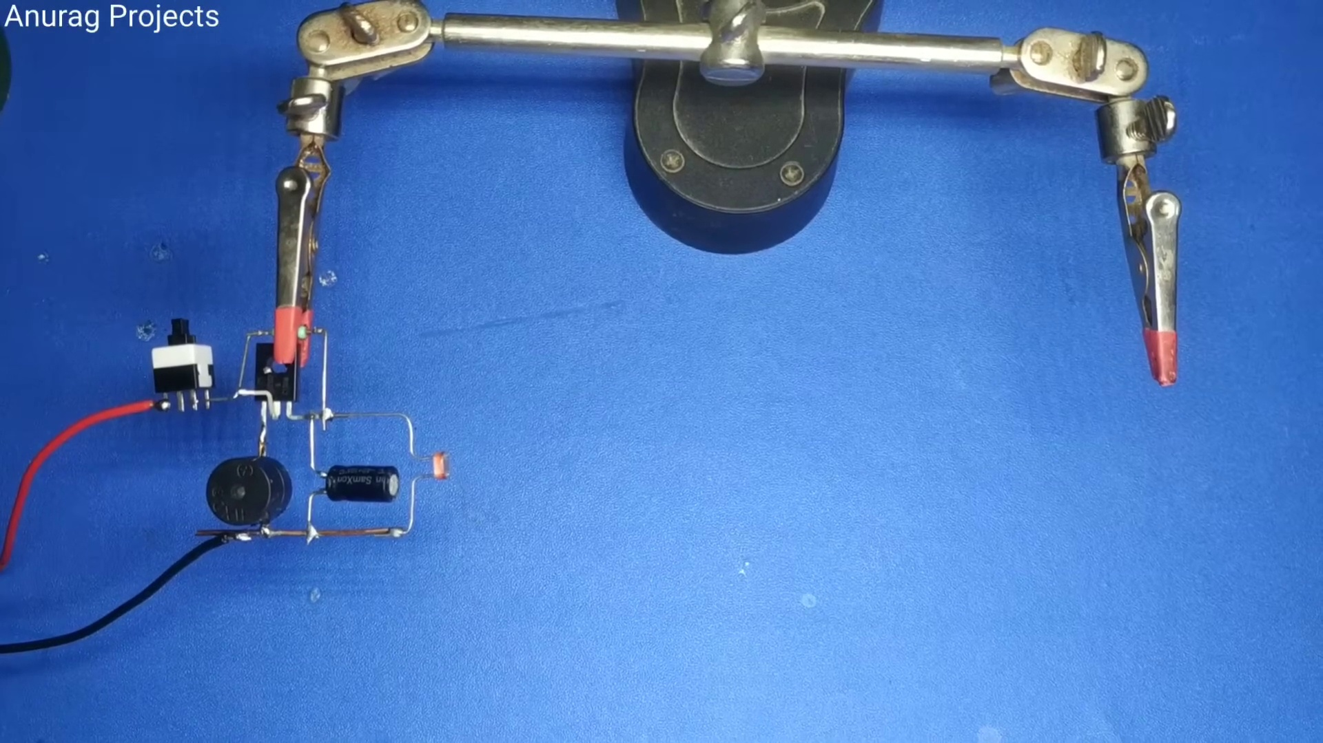 (score 95.0000)
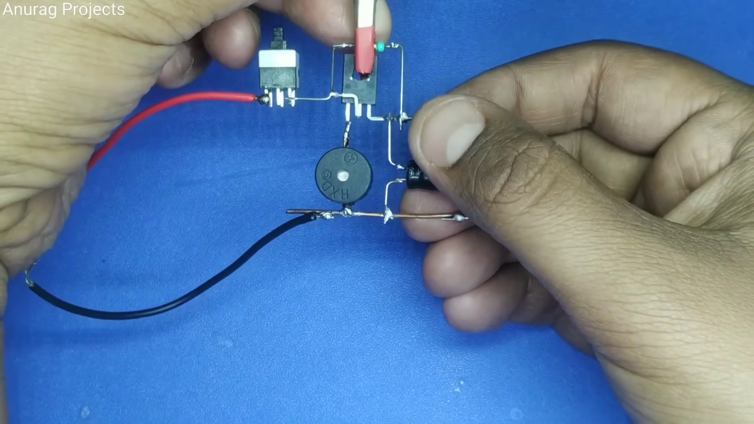 (score 95.0000)
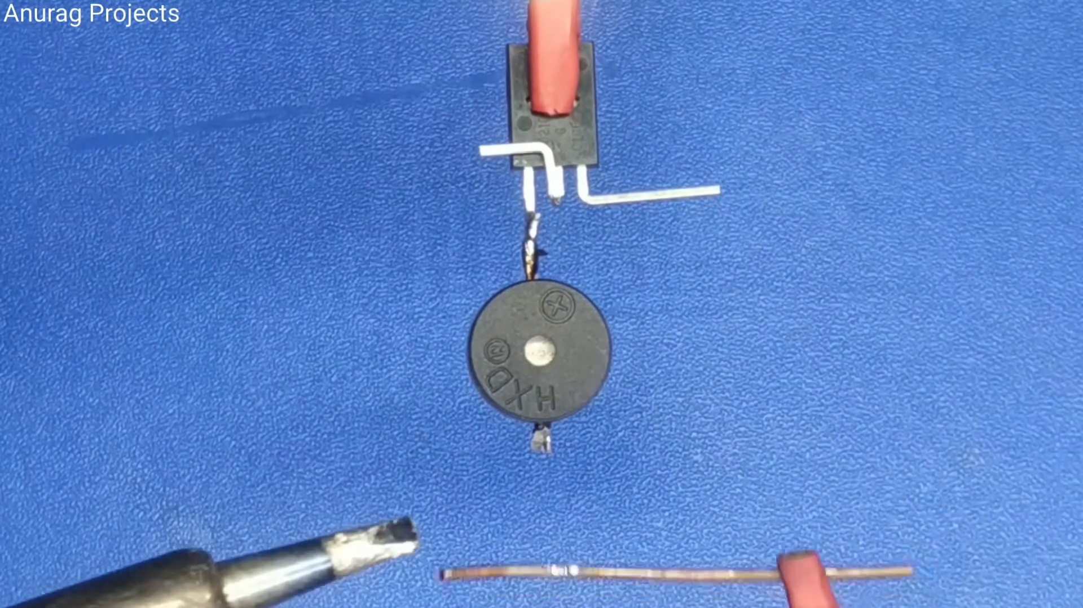 (score 95.0000)
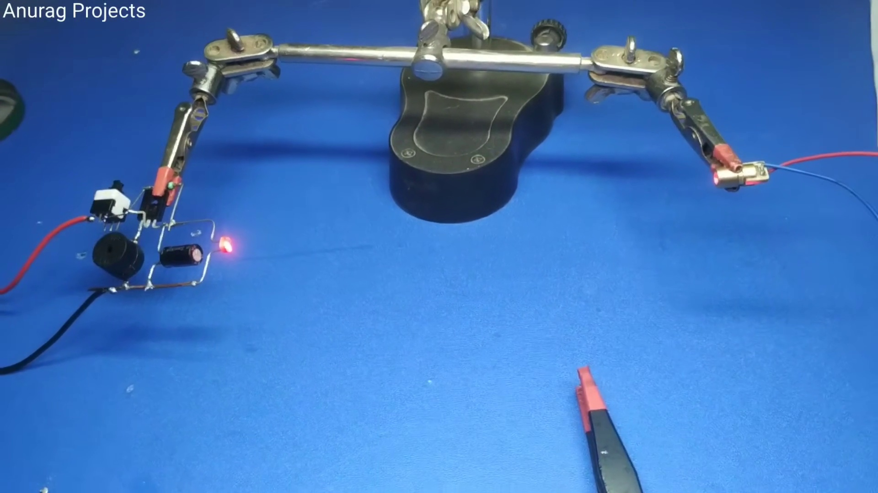 (score 90.0000)
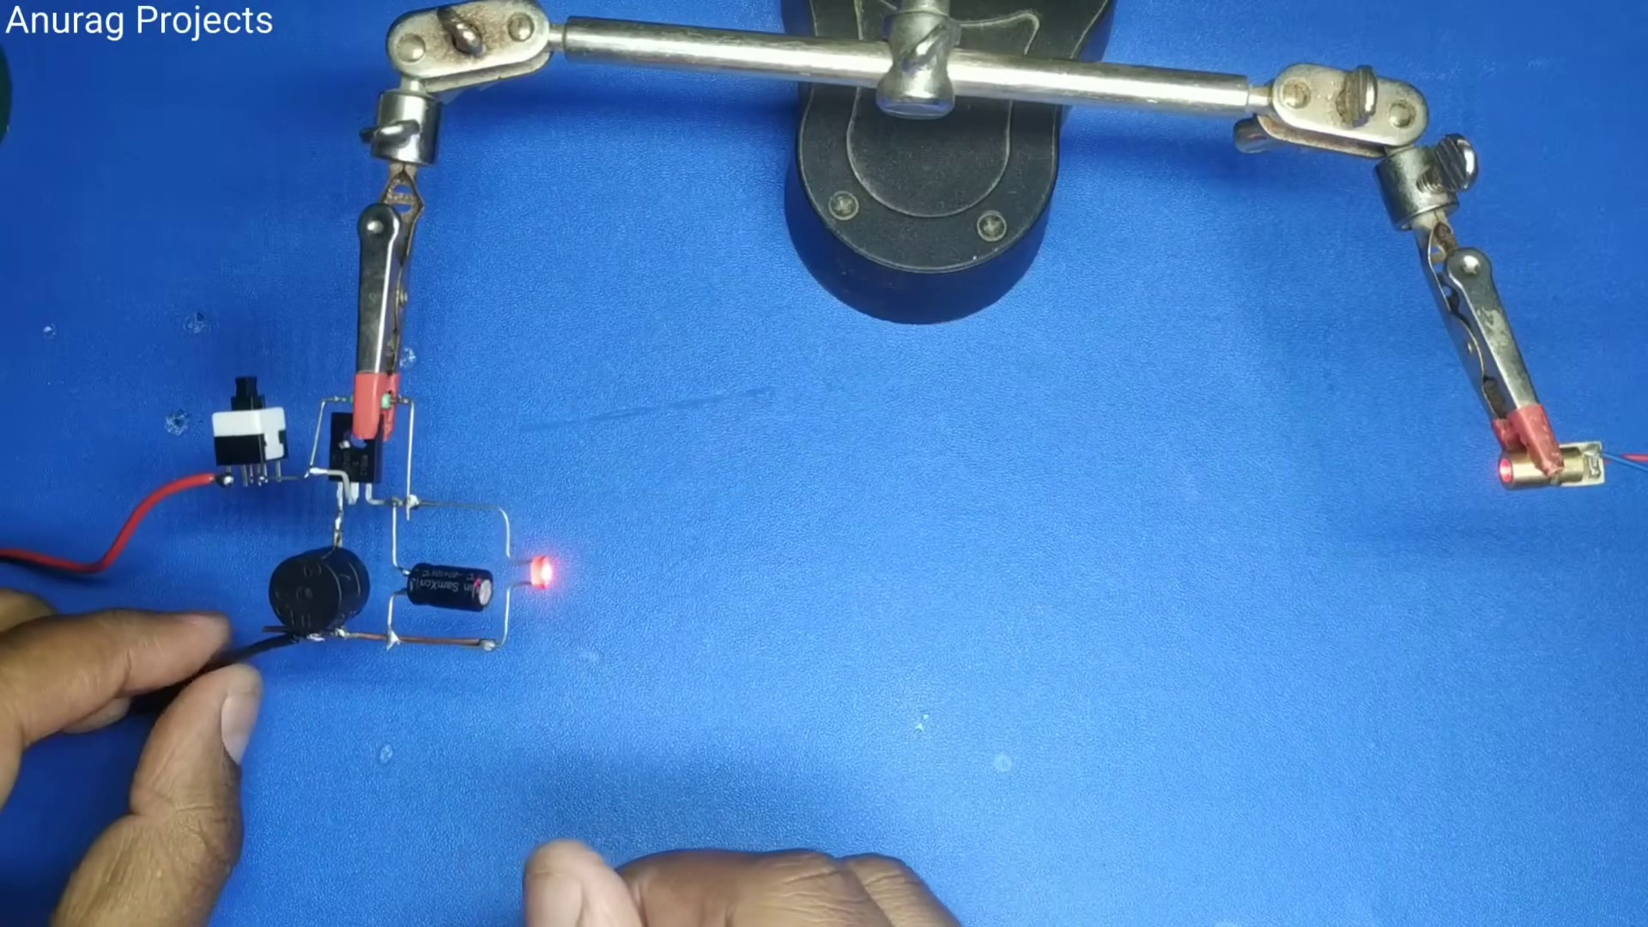 (score 90.0000)
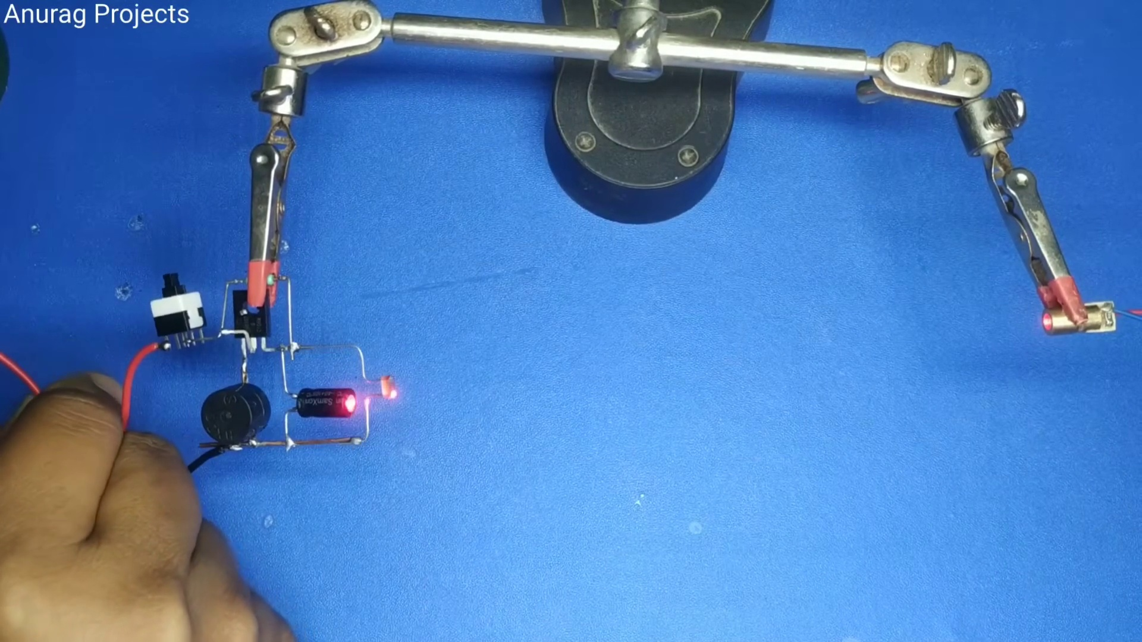 (score 90.0000)
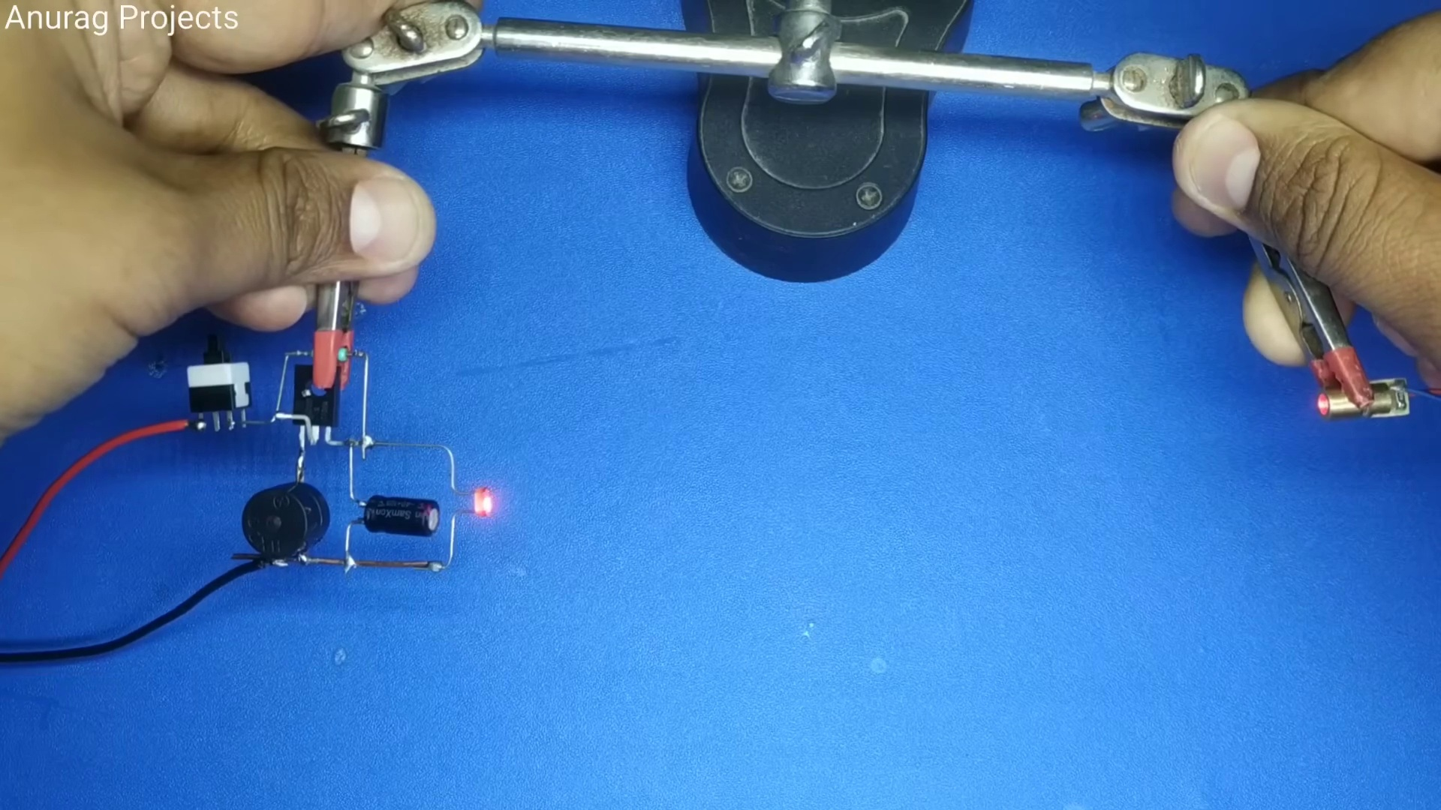 (score 90.0000)
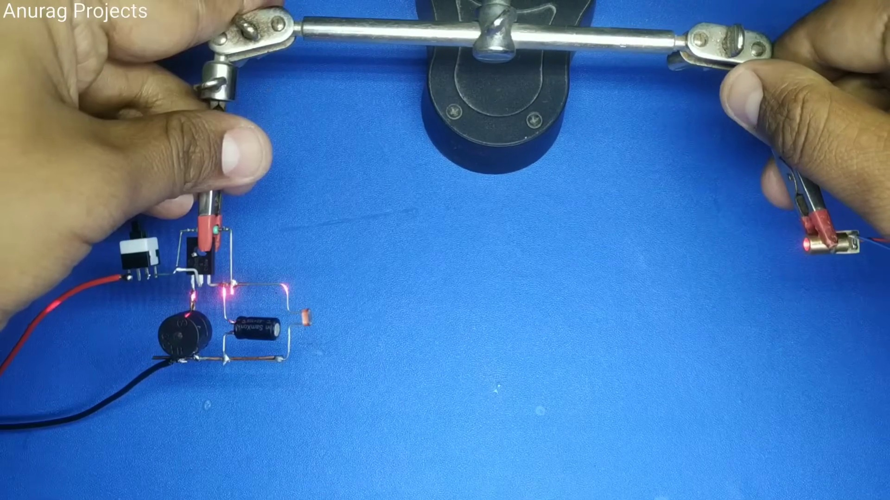 (score 90.0000)
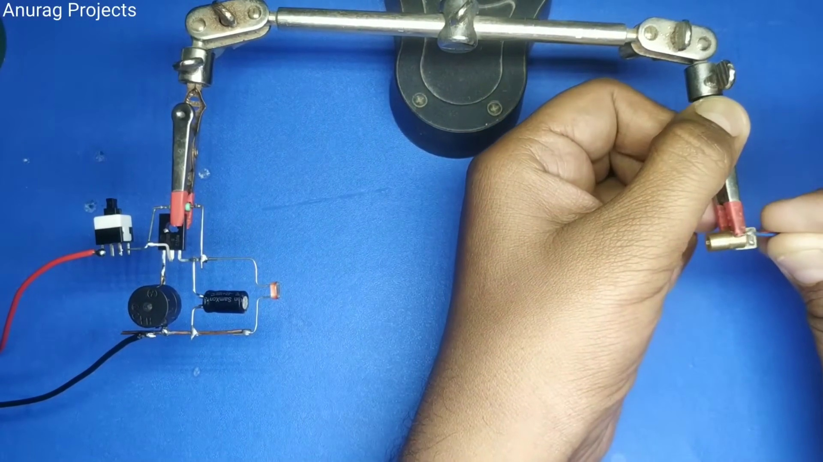 (score 90.0000)
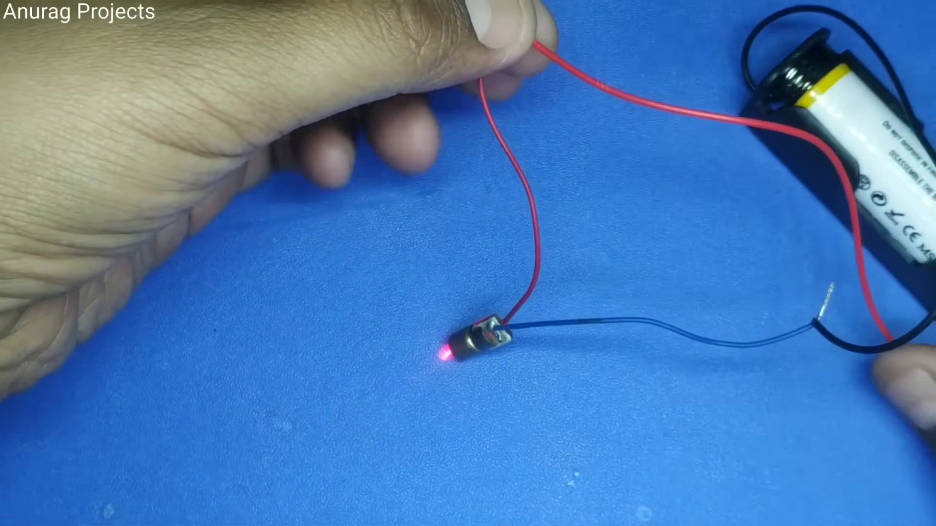 (score 90.0000)
Least correlated frames:
 (score 0.0000)
 (score 0.0000)
 (score 0.0000)
 (score 0.0000)
 (score 10.0000)
 (score 20.0000)
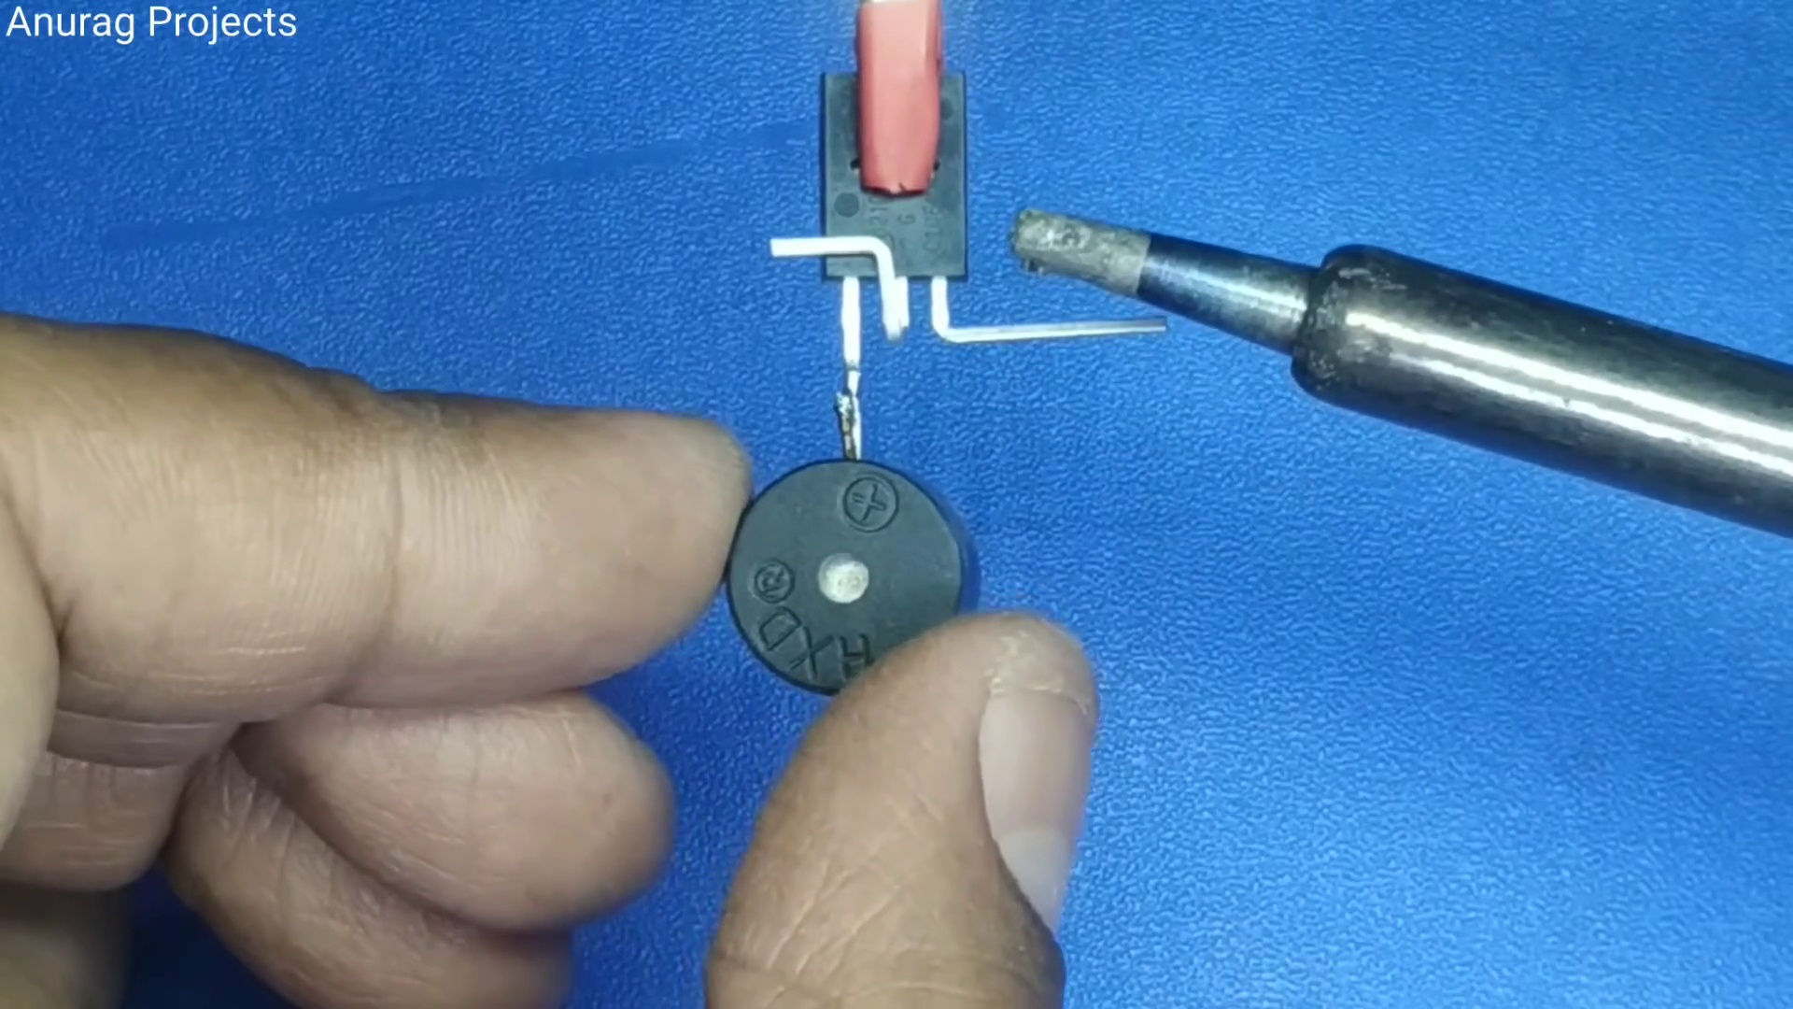 (score 20.0000)
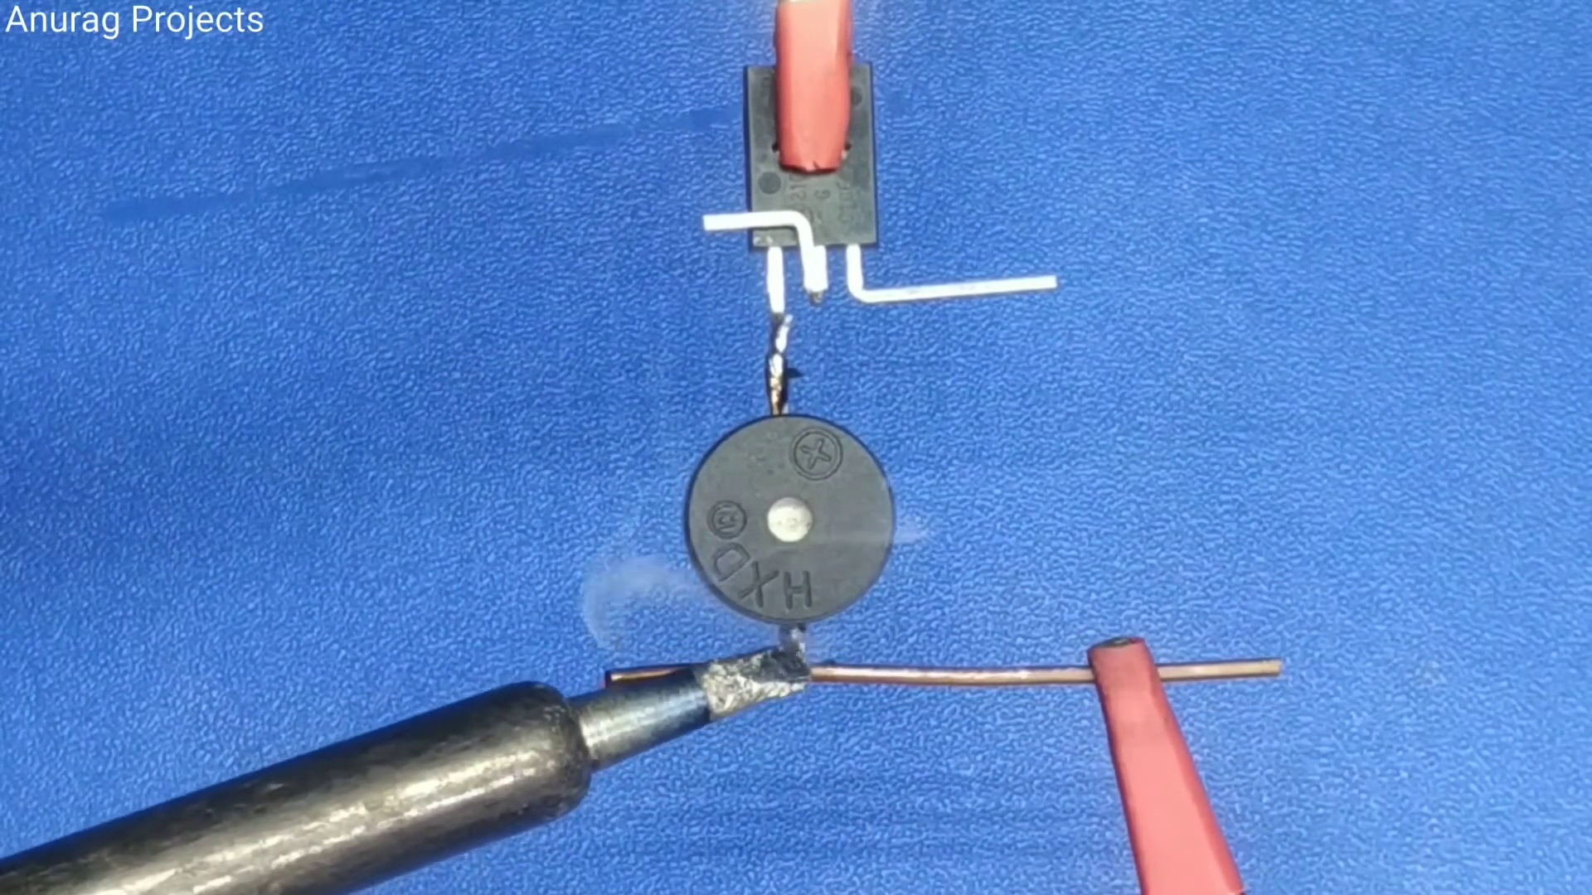 (score 20.0000)
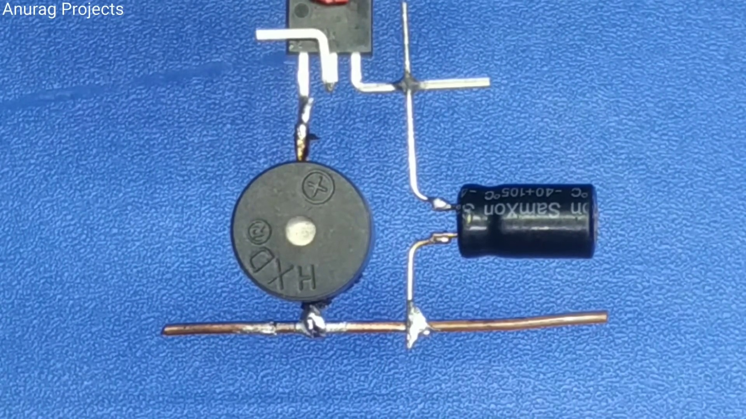 (score 20.0000)
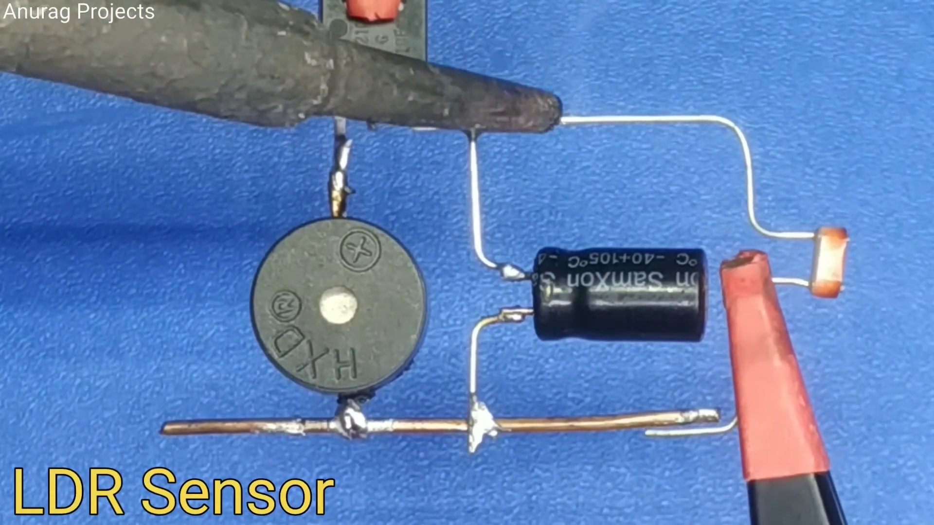 (score 20.0000)
- matched 42 frame(s), max score 85.0000: This is a useful video on how to make a trip alarm, and it is wild how the person builds the circuit one on top of the other part instead of a bread board. The laser part seems to work with a send and receive setup, so the distance in this particular circuit is probably very limited in range, but still and interesting design on the circuit.
Source: https://www.youtube.com/watch?v=ACvQNJwZSPg: How to make Laser Security (Theft) Alarm using SCR - 1 KM Range
Top correlated frames:
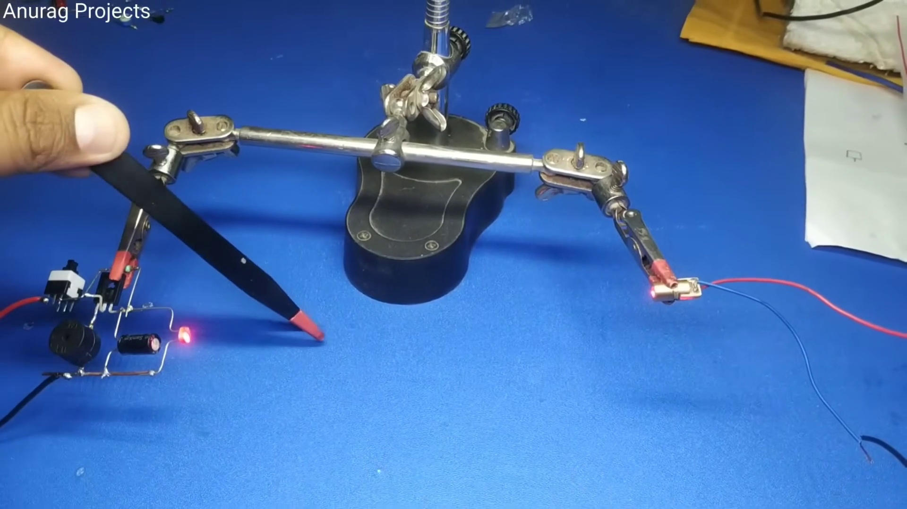 (score 85.0000)
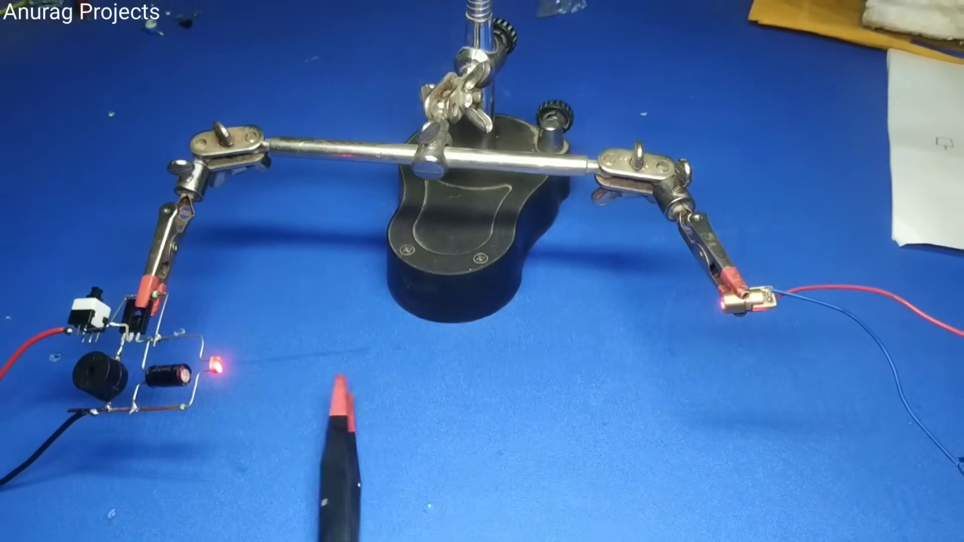 (score 85.0000)
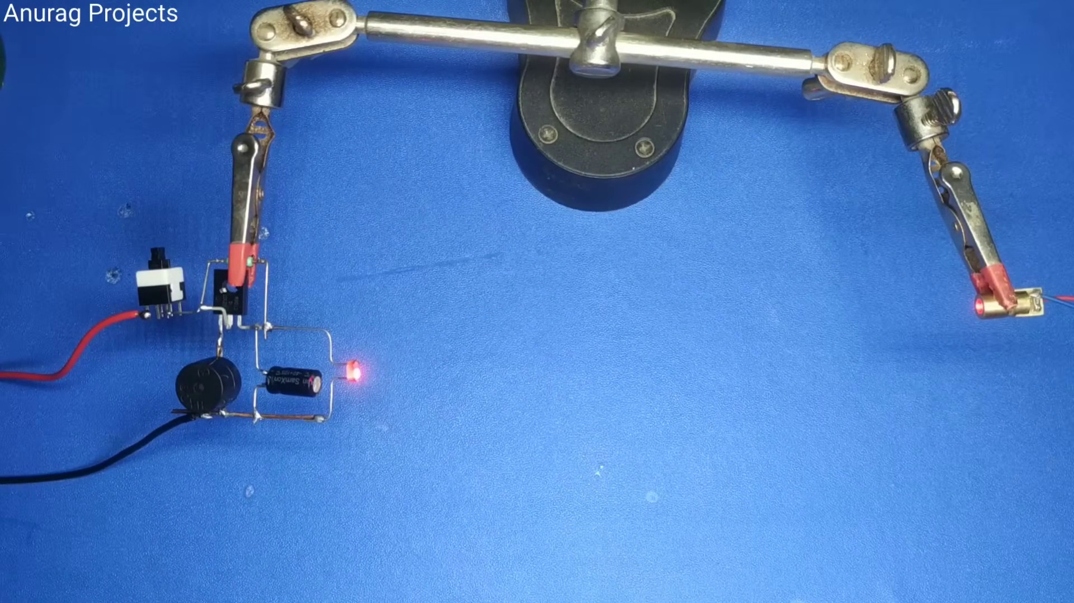 (score 85.0000)
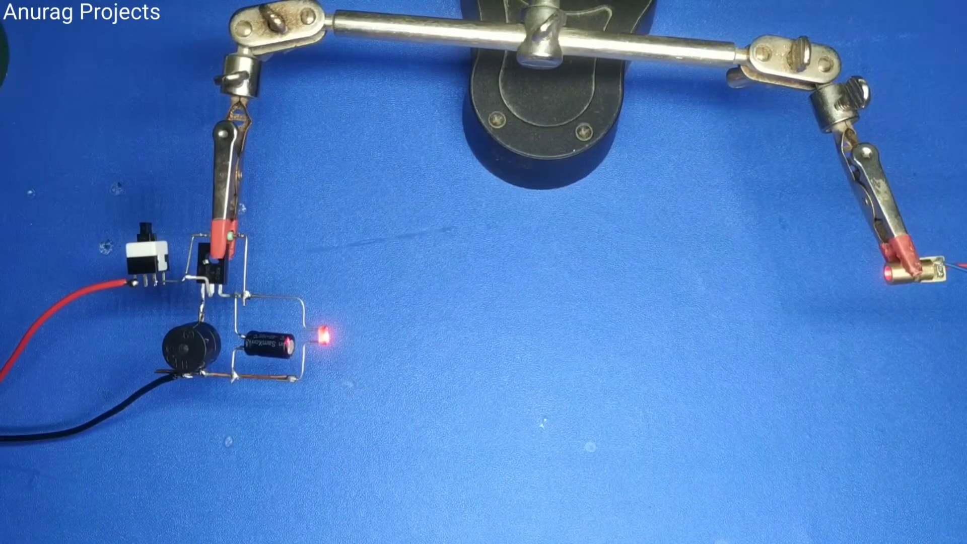 (score 85.0000)
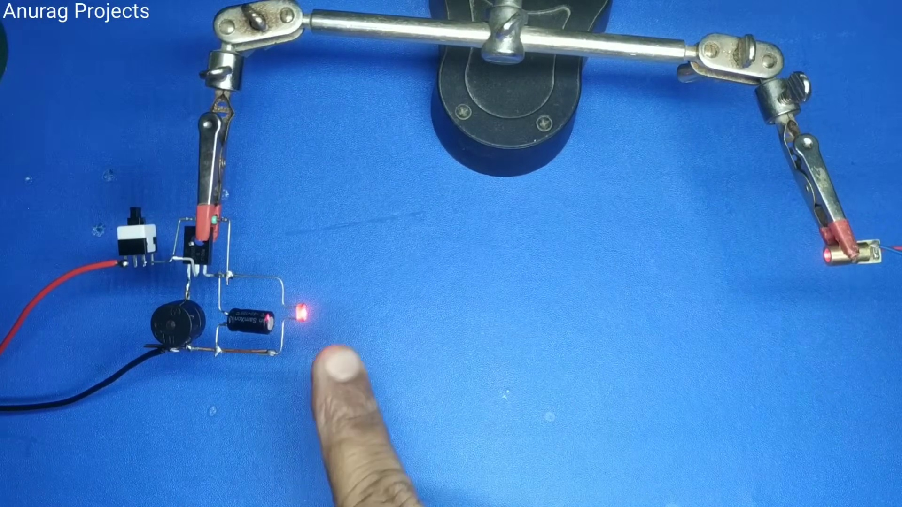 (score 85.0000)
 (score 85.0000)
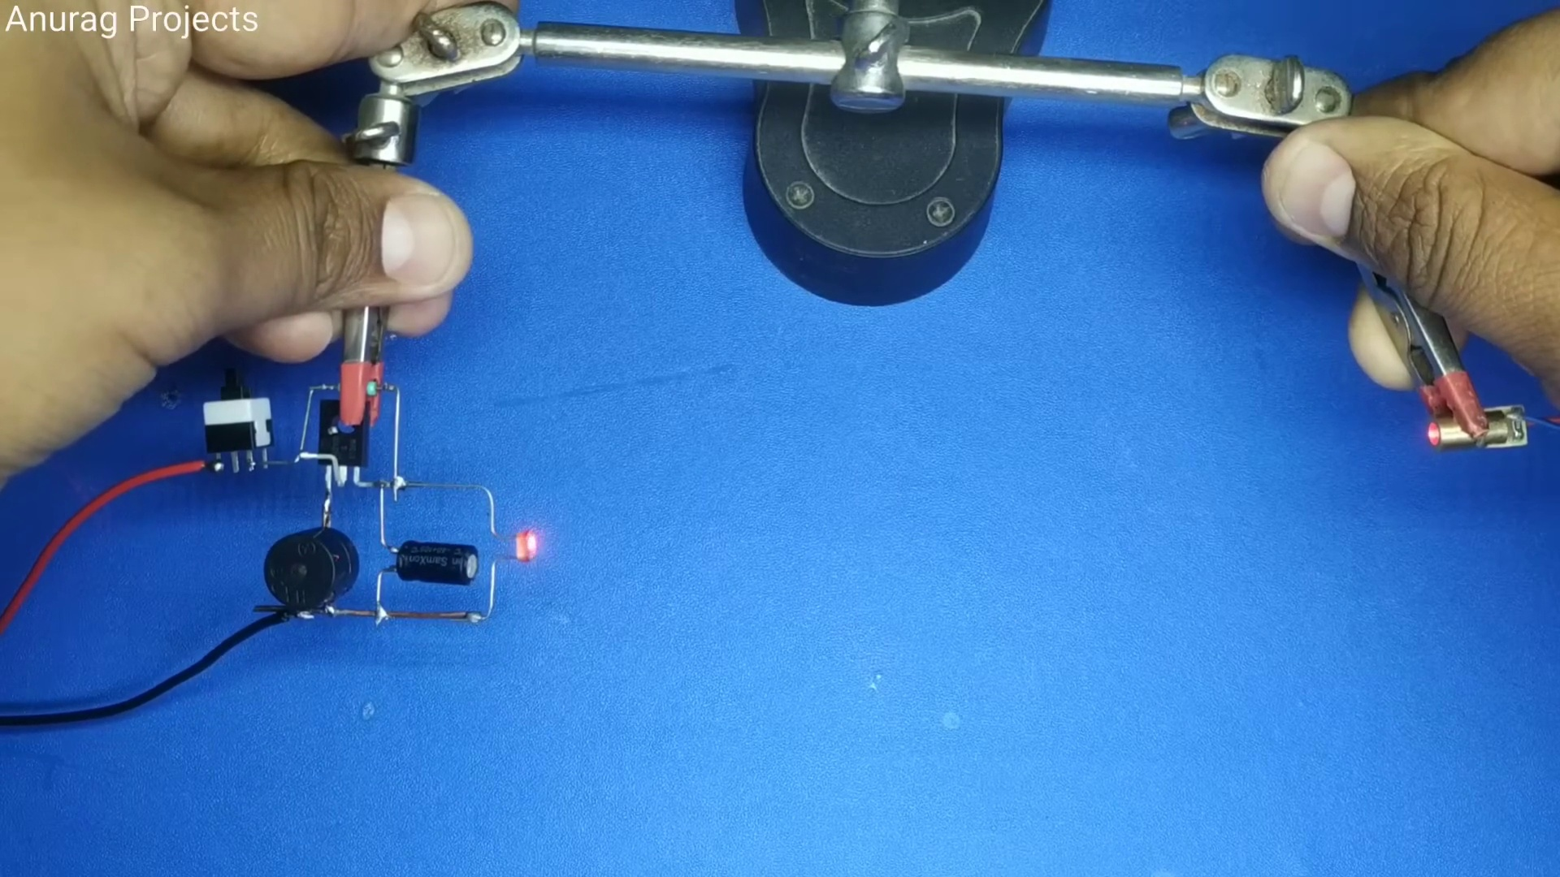 (score 85.0000)
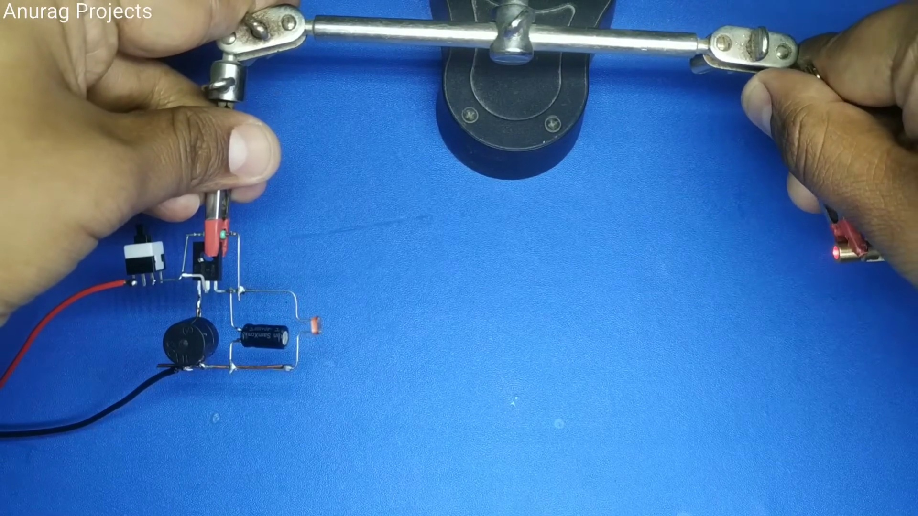 (score 85.0000)
 (score 85.0000)
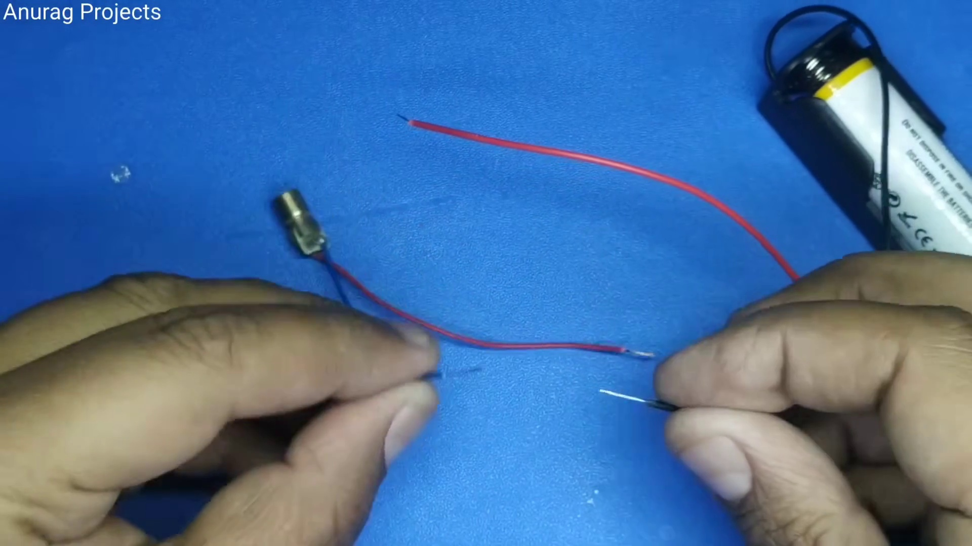 (score 85.0000)
Least correlated frames:
 (score 0.0000)
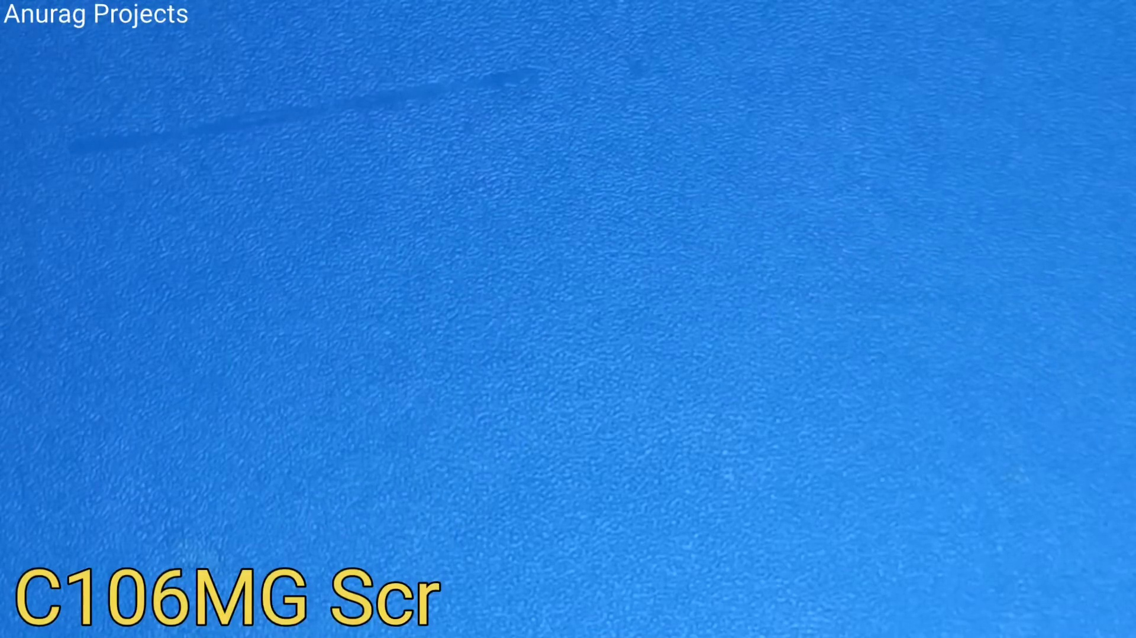 (score 0.0000)
 (score 0.0000)
 (score 0.0000)
 (score 0.0000)
 (score 0.0000)
 (score 0.0000)
 (score 0.0000)
 (score 0.0000)
 (score 0.0000)

Frame: frame_0000.jpg
Caption: The image presents a vibrant green background, devoid of any objects or text, except for a thin white line that appears to divide the image into two sections vertically. The background is a uniform shade of green, suggesting a clean and fresh environment. There are no visible text or objects within this space that provide additional context for teaching or instructional purposes. It seems to be an empty slide, possibly used in a presentation or educational material where content would normally be displayed.
The only detail on the image is centered white text that reads "Made with VideoShow", indicating that the image was created using the VideoShow software. The use of white text against the green background creates a stark contrast, making the text stand out clearly. There are no other details or elements in the image, leaving the viewer to focus solely on the text and the green background.
The simplicity of the image allows for the viewer to appreciate the contrast between the text and the background. The image does not provide any additional information about the nature of the software or the content that can be created with it. Overall, the image is a simple yet effective representation of the VideoShow software.
No strongly correlated comments found for this frame.

Frame: frame_0001.jpg
Caption: The image shows a close-up view of an individual's hand holding an electronic component that appears to be a semiconductor integrated circuit (IC), specifically labeled as an "AN920", commonly used in automotive applications. The IC is the central focus of the image, with three metal pins protruding from its body, serving as connections for the transistor to communicate with other electronic devices. The individual is engaged with the IC, possibly inspecting it or demonstrating how it works.
The background is a solid blue color, which could indicate a workspace or a teaching environment. There are no visible texts, diagrams, or other objects that suggest a specific learning context or lesson being taught.
No strongly correlated comments found for this frame.

Frame: frame_0002.jpg
Caption: The image presents a photograph of a smooth, solid blue surface with a digital annotation or watermark overlay containing the text "C106MG". The blue surface appears to be a thin sheet, possibly made of paper or plastic, with a uniform and flat texture. The vibrant blue color creates a striking contrast against the white background, which serves as a simple and unadorned wall or surface.
The blue surface is placed centrally in the image, while the text "C106MG" on the overlay appears to be a digital annotation rather than part of an actual slide or presentation material. There is no visible instructor or teaching context, nor are there any clear indications of a person, devices, slides, diagrams, or other teaching materials.
In the bottom right corner of the image, a small text reads "Anurag Projects" in black, providing a stark contrast to the blue and white colors. This secondary element does not detract from the primary focus on the blue surface and white background, which serves as a canvas for the "C106MG" text.
Overall, the image presents a simple yet striking visual composition, with the blue surface and white background serving as the primary subjects of the image, accompanied by the secondary element of the "Anurag Projects" text.
Comment (score 80): This video explains how to make a security theft alarm using SCR. This easy-to-construct circuit can be implemented in my home to detect when my cat leaves my room.
Reason: The comment directly discusses the same technical steps (making a security theft alarm using SCR) and objects (SCR circuit) described in the caption, showing a strong correlation.
Source: https://www.youtube.com/watch?v=ACvQNJwZSPg :How to make Laser Security (Theft) Alarm using SCR - 1 KM Range

Frame: frame_0003.jpg
Caption: The image appears to show a close-up of an individual's hands working with electronic components. On one side, a person is holding a small red circuit board in their right hand and a piece of wire or cable in their left hand, which seems to be being inserted into a connector on the board. The background is blue, providing a stark contrast that highlights the subject matter. In the center of the image, a hand is holding a small electronic component, specifically a diode, colored black with two red wires attached to it. The hand is positioned on a blue surface, creating a striking visual contrast between the different hues. The focus of this image is on the hands at work with the electronics, with no visible text, equations, or diagrams indicating an educational context in this frame.
Comment (score 90): This video explains how to make a security theft alarm using SCR. This easy-to-construct circuit can be implemented in my home to detect when my cat leaves my room.
Reason: The comment directly discusses the technical steps (making a security theft alarm using SCR) and objects (SCR circuit, diode) described in the caption.
Source: https://www.youtube.com/watch?v=ACvQNJwZSPg :How to make Laser Security (Theft) Alarm using SCR - 1 KM Range
Comment (score 80): This is a useful video on how to make a trip alarm, and it is wild how the person builds the circuit one on top of the other part instead of a bread board. The laser part seems to work with a send and receive setup, so the distance in this particular circuit is probably very limited in range, but still and interesting design on the circuit.
Reason: The comment directly references technical steps ('builds the circuit one on top of the other part instead of a bread board') and objects ('circuit', 'laser part') mentioned in the caption, indicating a strong correlation.
Source: https://www.youtube.com/watch?v=ACvQNJwZSPg: How to make Laser Security (Theft) Alarm using SCR - 1 KM Range

Frame: frame_0004.jpg
Caption: The image shows a close-up view of a person's hand, with one finger prominently displayed, slightly curled to suggest a relaxed or casual posture. The hand is resting on a blue surface that contrasts with the white color of the finger. The focus is solely on the hand and finger, as the background is blurred, drawing attention to this intimate moment. The image is part of the "Anurag Projects" collection, indicating its association with Anurag or one of their projects. The setting appears informal and personal, likely a home or workshop environment rather than a classroom or professional setting. The absence of any formal teaching context, such as a slide or whiteboard, and the lack of visible text on a screen suggest an educational activity is not taking place.
Comment (score 80): This video explains how to make a security theft alarm using SCR. This easy-to-construct circuit can be implemented in my home to detect when my cat leaves my room.
Reason: The comment directly discusses the same technical steps (SCR circuit) and setting (home environment), which are both mentioned in the frame caption.
Source: https://www.youtube.com/watch?v=ACvQNJwZSPg :How to make Laser Security (Theft) Alarm using SCR - 1 KM Range

Frame: frame_0005.jpg
Caption: The image captures a close-up view of a person's hands, each adorned with a ring, engaged in a meticulous process. The right hand is holding a small red LED (light-emitting diode) and appears to be soldering or preparing the LED for a project, as evidenced by visible solder points on the device. The left hand holds what looks like a small electronic device with various components mounted on it.
The background is blurred but suggests an indoor setting with blue and white colors. The focus of the image is on the hands, with the LED and electronic device lying flat on the surface, testifying to the precision and skill of the person performing the task. The image does not contain any discernible text.
The context appears educational, aiming to demonstrate the assembly or preparation process for LEDs and other electronic components, as it seems to be a still from a video tutorial, common in DIY electronics projects.
Comment (score 90): This video explains how to make a security theft alarm using SCR. This easy-to-construct circuit can be implemented in my home to detect when my cat leaves my room.
Reason: The comment directly discusses the assembly or preparation process for LEDs and electronic components, which is the main focus of the frame caption. The mention of SCR (Silicon-Controlled Rectifier) and its implementation in a circuit also corresponds to the objects and settings described in the caption.
Source: https://www.youtube.com/watch?v=ACvQNJwZSPg :How to make Laser Security (Theft) Alarm using SCR - 1 KM Range

Frame: frame_0006.jpg
Caption: The image depicts a close-up view of a person's hand engaged in an activity that involves a pair of scissors with a metallic edge. The individual appears to be using the scissors for cutting, as their fingers are firmly gripping them and they are angled towards the right side of the frame, suggesting an action about to take place. There is no text, writing, pointing, holding models, or any other form of instruction or teaching context visible within this image. The focus is on the person's hand and the scissors.
The background of the image is a solid blue color, providing a stark contrast to the person's hand and the scissors. This neutral backdrop does not distract from the main subject and instead adds a sense of calm and tranquility to the scene, making the action of cutting more pronounced. The person's hand holding the scissors is in the middle ground, while the blue background serves as the background, providing a sense of depth to the image.
There is no visible tool or assistance being used by the individual to perform the cutting action, suggesting a high level of control and precision. The overall focus of the image is on the person's hand and their action, capturing a moment of concentration and attention.
Comment (score 80): This video explains how to make a security theft alarm using SCR. This easy-to-construct circuit can be implemented in my home to detect when my cat leaves my room.
Reason: The comment mentions the use of SCR (scissors) which is directly related to the action depicted in the caption, as well as the context of cutting and precision, which are also mentioned in the caption.
Source: https://www.youtube.com/watch?v=ACvQNJwZSPg :How to make Laser Security (Theft) Alarm using SCR - 1 KM Range

Frame: frame_0007.jpg
Caption: The image captures a close-up view of a person's hands working with small components that appear to be related to electronics or mechanics. One hand is holding a cylindrical part, possibly made of metal or plastic, while the other hand uses pliers to manipulate a tiny, circular component with a hole in the center, suggesting it could be part of an electronic circuit or assembly. Several small red components are scattered around on the table, which may be other parts of the assembly or tools being used.
The person's hands are also holding a thin wire, which is being manipulated with two small red and black tweezers positioned in the middle. The blue surface background provides a neutral backdrop, allowing the white wire, red and black tweezers, and various components to stand out prominently. The image does not contain any text or other objects, and the focus is solely on the person's hands and the small components being worked with.
The style of the image suggests it might be used in an article or blog post, as indicated by the overlaid text "Anurak Projects".
Comment (score 90): This video explains how to make a security theft alarm using SCR. This easy-to-construct circuit can be implemented in my home to detect when my cat leaves my room.
Reason: The comment directly discusses the assembly of small components, including the SCR circuit mentioned in the caption. The mention of 'detecting when my cat leaves my room' implies a security theft alarm, which aligns with the technical steps described in the caption.
Source: https://www.youtube.com/watch?v=ACvQNJwZSPg :How to make Laser Security (Theft) Alarm using SCR - 1 KM Range
Comment (score 80): This is a useful video on how to make a trip alarm, and it is wild how the person builds the circuit one on top of the other part instead of a bread board. The laser part seems to work with a send and receive setup, so the distance in this particular circuit is probably very limited in range, but still and interesting design on the circuit.
Reason: The comment directly discusses the technical steps of building a circuit, which is mentioned in the caption. The specific components and tools described in the caption (e.g. cylindrical parts, tiny components with holes, pliers) are also referenced in the comment. The only area where the correlation could be improved is that the comment does not explicitly mention electronics or mechanics, but the description of building a circuit and using laser technology suggests a strong connection to the caption.
Source: https://www.youtube.com/watch?v=ACvQNJwZSPg: How to make Laser Security (Theft) Alarm using SCR - 1 KM Range

Frame: frame_0008.jpg
Caption: The image captures a detailed moment in an educational setting, possibly for a workshop or tutorial. A person's hands are visible, carefully handling a small electronic device with a red wire protruding from it. The device appears to be attached to a larger component mounted on a blue surface. The focus is on the intricate process of attaching the wire, suggesting a focus on electronics or DIY projects involving electronic components.
In close-up, another aspect of this educational setting can be observed: a person's hand holding a small, rectangular, black device with a silver stripe running along its side. The hand is positioned on the left side of the image, while the device is on the right, against a light blue background that provides a stark contrast to the black object.
The overall effect of this image is one of isolation and detail, as the viewer's attention is drawn to the hands and the devices. The relative position of the hand and the device suggests that the person is either inspecting or manipulating the device, leaving the purpose and context unknown. The simplicity of the image invites the viewer to wonder about the device's function and the actions of the person holding it.
Comment (score 90): This video explains how to make a security theft alarm using SCR. This easy-to-construct circuit can be implemented in my home to detect when my cat leaves my room.
Reason: The comment directly discusses the technical steps and objects described in the caption, specifically mentioning SCR (Silicon Controlled Rectifier) circuits and its application to detect when a pet leaves a room.
Source: https://www.youtube.com/watch?v=ACvQNJwZSPg :How to make Laser Security (Theft) Alarm using SCR - 1 KM Range
Comment (score 80): This is a useful video on how to make a trip alarm, and it is wild how the person builds the circuit one on top of the other part instead of a bread board. The laser part seems to work with a send and receive setup, so the distance in this particular circuit is probably very limited in range, but still and interesting design on the circuit.
Reason: The comment discusses the same technical steps (building a circuit) and objects (laser part) described in the caption. The mention of 'one on top of the other' and 'bread board' also indicates an understanding of the electronics process shown in the image.
Source: https://www.youtube.com/watch?v=ACvQNJwZSPg: How to make Laser Security (Theft) Alarm using SCR - 1 KM Range

Frame: frame_0009.jpg
Caption: The image shows a close-up of two hands working with small electronic components. The photo appears to be taken from a video, as indicated by the low resolution and pixelation, which is common for video stills.
In the foreground, the human hands are holding an object that could be a circuit board or a similar type of electronic device. A red button is visible on the top surface of this object. The focus of the image is on the hands and the device, not on the person's face or the surroundings.
The blue background provides a stark contrast to the black and red of the object, making it stand out in the image. The hands appear to be holding the object firmly, suggesting that it is being carefully handled.
There is no visible text, diagrams, or any other information that would provide context for what is being taught or demonstrated. The image simply captures a moment of someone working on or examining an electronic device, with the focus solely on the hands, the object, and the blue background.
Comment (score 80): This video explains how to make a security theft alarm using SCR. This easy-to-construct circuit can be implemented in my home to detect when my cat leaves my room.
Reason: The comment directly discusses the technical steps and objects described in the caption, specifically mentioning SCR circuits and their application.
Source: https://www.youtube.com/watch?v=ACvQNJwZSPg :How to make Laser Security (Theft) Alarm using SCR - 1 KM Range

Frame: frame_0010.jpg
Caption: The image shows a close-up of a person's hand meticulously assembling a 5V buzzer on a blue surface. The fingers are gently touching various electronic components, including resistors and capacitors, suggesting a sense of anticipation and focus. The buzzer itself is held firmly in place by a white screw, which the person appears to be adjusting. Prominently displayed text reads "Anurag Projects" and "5V Buzzer", indicating the source or purpose of this assembly. A small red component is also visible in the image, which could be a resistor or another type of electronic part. The overall scene suggests a project in progress, with the person's actions hinting at the completion of a task related to building or repairing a 5-volt buzzer circuit.
Comment (score 80): This video explains how to make a security theft alarm using SCR. This easy-to-construct circuit can be implemented in my home to detect when my cat leaves my room.
Reason: The comment directly discusses the use of SCR (silicon-controlled rectifier) and building a security theft alarm circuit, which is strongly related to the assembly of a 5V buzzer described in the caption. The mention of implementing the circuit in one's home to detect their cat leaving the room also indicates a connection to the original project.
Source: https://www.youtube.com/watch?v=ACvQNJwZSPg :How to make Laser Security (Theft) Alarm using SCR - 1 KM Range

Frame: frame_0011.jpg
Caption: In this image, an individual is engaged in a task of assembling or repairing a small mechanical device using tools such as pliers and a screwdriver. The person's hands are holding a metal object that appears to be a part of the device being worked on. The device has a central black component with wires connected to it, suggesting electronic components within.
A label on the image reads "5V BUZZER" in white font on a blue background, indicating the type of component being worked with or installed into the device. This suggests that the device might be related to electronics, possibly for an educational demonstration or a DIY project.
The person's focus seems to be on the task at hand, and there are no visible slides or diagrams in this frame. The background is out of focus, lacking additional context about the setting or purpose of the activity being depicted.
In the image, the individual is seen holding a small electronic component with a screwdriver, which appears to be the same 5V buzzer mentioned on the label. The person is attaching the buzzer to a metal board using the screwdriver, as evidenced by the relative position of the objects and the person's hand on the right side of the image.
The blue surface beneath the board provides a clear visual context for the activity being depicted, with the person situated on the left side of the board.
Comment (score 80): This video explains how to make a security theft alarm using SCR. This easy-to-construct circuit can be implemented in my home to detect when my cat leaves my room.
Reason: The comment directly discusses the assembly of an electronic component (5V buzzer) and its attachment to a metal board, which is exactly what the caption describes. The mention of SCR and the idea of creating a security theft alarm are also related to the context of electronics and DIY project.
Source: https://www.youtube.com/watch?v=ACvQNJwZSPg :How to make Laser Security (Theft) Alarm using SCR - 1 KM Range
Comment (score 60): This is a useful video on how to make a trip alarm, and it is wild how the person builds the circuit one on top of the other part instead of a bread board. The laser part seems to work with a send and receive setup, so the distance in this particular circuit is probably very limited in range, but still and interesting design on the circuit.
Reason: The comment discusses a specific project ('make a trip alarm') that involves building a circuit with the same type of component (5V buzzer) mentioned in the caption. The comment also mentions building the circuit one on top of another, which is similar to the process shown in the image where the person is attaching the buzzer to a metal board.
Source: https://www.youtube.com/watch?v=ACvQNJwZSPg: How to make Laser Security (Theft) Alarm using SCR - 1 KM Range

Frame: frame_0012.jpg
Caption: In this image, we see two individuals engaged in hands-on activities that demonstrate precision, innovation, and a focus on repair. One person appears to be assembling or adjusting a mechanical device with precision tools, focusing on a small circular component that could be a disc brake pad or another type of wear-and-tear part for machinery. They are holding what looks like a drill press, which suggests they may be drilling into this component to attach it to the machine it belongs to.
The individual is wearing safety gloves, emphasizing the importance of personal protective equipment during such tasks. The background is blue and appears to be a workbench or workspace, indicating that this activity is taking place in a laboratory or manufacturing setting. There are no visible texts, diagrams, or instructions in this frame, so there's no specific teaching context evident. The image focuses on the hands-on process rather than providing explanatory content.
In another part of the image, we see a person examining and potentially repairing a small, black device that appears to be a speaker. Their hand is poised over the device, holding it with their index and middle finger. The device rests on a blue surface, and the person's hand is positioned in such a way that it seems to be examining the device for any signs of damage or wear.
In the background, there's a red wire, its color contrasting with the blue surface. The wire is connected to the device, suggesting that it might be a part of the repair process. The person's hand is holding a small tool, possibly a screwdriver, which is used to remove screws or bolts from the device.
The image conveys a sense of action and repair, with both individuals engaged in hands-on activities that demonstrate their problem-solving skills and attention to detail.
No strongly correlated comments found for this frame.

Frame: frame_0013.jpg
Caption: The image captures a moment of meticulous work in an Anurag Projects workshop, showcasing the assembly of a small electronic device. The device features a red button and a black plastic casing, held in place by a white screw visible through a hole in the casing. A pair of black pliers is poised to make a connection to the right of the device, which rests on a blue surface adorned with white letters, possibly indicating the name or model of the device.
In the background, a cylindrical object with an electronically conductive surface and a circular protrusion that might be part of a mounting system can be seen. A red clip is attached to one end, and what looks like a wire is clamped onto another part of the device. The blue fabric surface suggests this setup is for demonstration or teaching purposes.
In the lower right corner, text reads "Anurag Projects," indicating the name of the creator or entity associated with the project. Illegible characters beneath the device might be a watermark or an address to the creator's website or social media account. The style of the image is indicative of educational content, possibly from a YouTube video, blog post, or online course where someone is explaining how this component works or how it can be integrated into other systems.
Comment (score 95): This video explains how to make a security theft alarm using SCR. This easy-to-construct circuit can be implemented in my home to detect when my cat leaves my room.
Reason: The comment directly discusses the assembly of a small electronic device (security theft alarm) and mentions SCR (same technical step described in the caption), as well as its potential implementation in the viewer's home, which matches the setting and goal described in the caption.
Source: https://www.youtube.com/watch?v=ACvQNJwZSPg :How to make Laser Security (Theft) Alarm using SCR - 1 KM Range

Frame: frame_0014.jpg
Caption: The image presents a moment of focus and precision as an electronic component is being carefully soldered using a black iron with a red handle. The object, likely a small component, is securely held in place by a metal clamp, ensuring a stable connection during the soldering process. A stark blue background provides a striking contrast to the black iron and the object being soldered.
In the context of this experiment, a laboratory setup can be seen with a focus on an electrical experiment involving wires and a coil. At the center of the image is a solenoid, used for generating electromagnetic fields, with a small, round device attached that could be a coil driver or electromotive force generator, producing a current through the coil.
Next to the coil, a clamp meter can be seen, indicating that the experiment involves measuring electrical properties such as voltage, current, or resistance. The meter is in contact with one of the wires, suggesting it is being used to measure something related to the circuit.
In the background, another component with two metal contacts can be observed, which might be a transformer or similar device used for stepping up or stepping down voltage levels. Additionally, small components labeled "63" are present, but their exact nature without more context remains unclear.
The image is taken from an angle that provides a clear view of the equipment in use, with no visible text or labels within the image itself, and no apparent person present. The main focus is on the physical components and the experiment being performed, showcasing the meticulous and precise nature of soldering and electrical experimentation.
No strongly correlated comments found for this frame.

Frame: frame_0015.jpg
Caption: The image captures a close-up view of an electronic device under repair or being constructed. The device appears to have several components such as resistors (brown), capacitors (black cylinders), and possibly connectors (red) and insulating material (white). A soldering iron with a black tip is in the process of soldering one of the components, indicating that someone is working on this setup. In the background, text reads "Anurag Projects," suggesting that the device may be part of an educational project or tutorial related to electronics.
Upon closer inspection, a small black button with a white label reading "HX520" can be seen affixed to a piece of blue fabric using two red wires. The fabric serves as a makeshift base for the button, which is positioned centrally on the fabric. The wires are connected to the button, suggesting a connection between the button and the fabric. This small electronics project in progress adds another layer of complexity to the overall scene.
Comment (score 85): This video explains how to make a security theft alarm using SCR. This easy-to-construct circuit can be implemented in my home to detect when my cat leaves my room.
Reason: The comment directly discusses the technical steps involved in making a security theft alarm using SCR, which is strongly related to the frame caption's description of an electronics project in progress. The presence of components such as resistors, capacitors, and soldering iron suggests that the project involves constructing a circuit, which aligns with the commenter's explanation.
Source: https://www.youtube.com/watch?v=ACvQNJwZSPg :How to make Laser Security (Theft) Alarm using SCR - 1 KM Range

Frame: frame_0016.jpg
Caption: The image presents an educational setting where an experiment or demonstration is being conducted. On the left side of the image, there's a blue floor with various wires and components connected to it. At the top of these components, there is a black object that appears to be a coil wrapped around a metal core, which is connected by two red wires to a black power supply or battery. Below this coil, another black object resembles an electromagnet with its wire loops.
In the center of the image, there's a device with a small metal plate and a red coil around it; this seems to be part of the experiment or demonstration as well. To the right side of the image, there is a microphone on a stand, which might be used for recording or amplifying sound during the experiment.
At the bottom left corner of the image, there's a greenish-blue label with white text that reads "ANURAG PROJECTS," suggesting this might be the name or logo of the project or the entity conducting the demonstration. The background is mostly out of focus, but it seems to be an indoor environment with artificial lighting.
In the foreground, a pair of red pliers are seen being used, attached to a red wire connected to a black circuit board marked with the letters "A" and "R". This circuit board appears to be part of an electronics project. The blue surface on which the objects rest provides a neutral backdrop, allowing the red and black colors to stand out.
There are no visible texts or diagrams on screens in the image. No instructor is directly interacting with the components; however, one could infer that someone might be operating or observing the experiment.
Comment (score 85): This is a useful video on how to make a trip alarm, and it is wild how the person builds the circuit one on top of the other part instead of a bread board. The laser part seems to work with a send and receive setup, so the distance in this particular circuit is probably very limited in range, but still and interesting design on the circuit.
Reason: The comment directly discusses the same technical steps and components described in the caption, specifically mentioning the circuit board, red wire, and laser part. The language used is also related to the context of the image, such as building a trip alarm.
Source: https://www.youtube.com/watch?v=ACvQNJwZSPg: How to make Laser Security (Theft) Alarm using SCR - 1 KM Range
Comment (score 80): This video explains how to make a security theft alarm using SCR. This easy-to-construct circuit can be implemented in my home to detect when my cat leaves my room.
Reason: The comment directly discusses the same technical steps (making a security theft alarm using SCR) and objects (SCR circuit board marked with 'A' and 'R') described in the caption.
Source: https://www.youtube.com/watch?v=ACvQNJwZSPg :How to make Laser Security (Theft) Alarm using SCR - 1 KM Range

Frame: frame_0017.jpg
Caption: The image presents a close-up view of a small electronic device, which is the central focus of the frame. The device is black and white, with a small black button located at the top. It is plugged into a white connector, which is connected to a blue wire. The blue wire extends towards the bottom of the image, indicating that the device is likely part of a larger electronic circuit.
The device is positioned on a blue surface, providing a contrasting background to the black and white of the device. A small rectangular panel is visible on the left side of the frame, appearing to be part of the component's circuitry. A single copper wire is attached to this panel, and it is connected to another copper wire that seems to be disconnected or attached to an external device or component not visible in the frame.
There are no people present in the image, nor is there any visible text or slide that would indicate a teaching context beyond what has been described. The focus of the image is on the visual content of the model and its connections rather than a teacher or teaching aid being inferred from the image alone.
Comment (score 80): This is a useful video on how to make a trip alarm, and it is wild how the person builds the circuit one on top of the other part instead of a bread board. The laser part seems to work with a send and receive setup, so the distance in this particular circuit is probably very limited in range, but still and interesting design on the circuit.
Reason: The comment discusses the same technical steps (building a trip alarm circuit) and objects (circuit components, breadboard, laser part) described in the caption. The score is 80 because while the comment does not directly mention the specific device or blue wire mentioned in the caption, it talks about building the circuit one on top of another, which aligns with the description in the caption.
Source: https://www.youtube.com/watch?v=ACvQNJwZSPg: How to make Laser Security (Theft) Alarm using SCR - 1 KM Range
Comment (score 80): This video explains how to make a security theft alarm using SCR. This easy-to-construct circuit can be implemented in my home to detect when my cat leaves my room.
Reason: The comment directly discusses the same technical steps and objects described in the caption, specifically mentioning SCR circuitry and a security theft alarm, which are closely related to the electronic device and wires presented in the frame.
Source: https://www.youtube.com/watch?v=ACvQNJwZSPg :How to make Laser Security (Theft) Alarm using SCR - 1 KM Range

Frame: frame_0018.jpg
Caption: The image shows an individual's hand holding a small black electronic device with a copper wire coiled around it, attached to a blue surface that could be a workbench. On this blue surface, there is a text overlay in yellow that reads "100 Ωf Capacitor." In the background, there's a person with their back facing the camera, working on a similar device or component with a soldering iron in hand.
The 100 Ωf Capacitor appears to be being used in a DIY electronics project, as it is positioned for soldering. The capacitor itself is situated on the right side of the circuit board, which has a gray surface and a blue background providing a stark contrast. A small white arrow points towards the capacitor from the left side of the board, potentially indicating its location or function in the circuit.
The image also contains text that reads "Anurag Projects 100uf 10V Capacitor", which might be related to the context of the project or the brand of the components used. The overall scene suggests a process of soldering, capturing a moment in the creation of a circuit with the soldering of the capacitor as the main focus. This snapshot provides potential for innovation and creativity in DIY electronics projects, with an emphasis on teaching about capacitors and their use in electronic circuits.
Comment (score 80): This video explains how to make a security theft alarm using SCR. This easy-to-construct circuit can be implemented in my home to detect when my cat leaves my room.
Reason: The comment directly discusses a DIY electronics project, specifically using capacitors in an SCR circuit to detect when something (in this case, a cat) leaves a room. The caption mentions soldering and a capacitor being used in a circuit, which is highly relevant to the comment's content.
Source: https://www.youtube.com/watch?v=ACvQNJwZSPg :How to make Laser Security (Theft) Alarm using SCR - 1 KM Range

Frame: frame_0019.jpg
Caption: The image shows a close-up view of a person's hand holding a small device, which appears to be a 100µF capacitor with a wire connected to one of its terminals. The individual is engaged in some form of electronic repair or modification, as indicated by the presence of a soldering iron and a pair of pliers being used to hold a wire. The focus is on the hands-on activity of working with electronic components using tools such as a soldering iron and pliers.
In the background, an indoor space can be seen, featuring a blue surface that could be a workbench or table. However, the background is out of focus, allowing the viewer to concentrate on the hands-on activity. The circuit board, which is the heart of the electrical system, comes into view. It features several components, including a prominent 100UF 10V Capacitor in the center, labeled "100UF 10V Capacitor" and marked with the symbol "F", indicating its type.
The capacitor is surrounded by black wires, which are likely part of the circuit, connecting the capacitor to other components. These wires are connected to the board with small black screws. The overall scene suggests a moment of activity in an electronics workshop, where a circuit board is being prepared for assembly.
Comment (score 85): This is a useful video on how to make a trip alarm, and it is wild how the person builds the circuit one on top of the other part instead of a bread board. The laser part seems to work with a send and receive setup, so the distance in this particular circuit is probably very limited in range, but still and interesting design on the circuit.
Reason: The comment directly discusses the same technical steps (building a circuit one on top of another) and objects (capacitor, wires, screws) described in the caption. Although it doesn't specifically mention '100µF capacitor' or 'soldering iron', the context implies familiarity with these components.
Source: https://www.youtube.com/watch?v=ACvQNJwZSPg: How to make Laser Security (Theft) Alarm using SCR - 1 KM Range
Comment (score 80): This video explains how to make a security theft alarm using SCR. This easy-to-construct circuit can be implemented in my home to detect when my cat leaves my room.
Reason: The comment directly discusses the technical steps and objects described in the caption, specifically mentioning the SCR (Silicon-Controlled Rectifier) component used in the circuit. The focus on electronics workshop activity and circuit board components also matches the context of the caption.
Source: https://www.youtube.com/watch?v=ACvQNJwZSPg :How to make Laser Security (Theft) Alarm using SCR - 1 KM Range

Frame: frame_0020.jpg
Caption: The image captures a close-up view of a circuit board resting on a blue surface. The board is adorned with several components, including a vibrant green capacitor labeled "HX" and a black resistor positioned to the right of it. A hand with a pen appears to be engaged in some form of repair or construction, possibly using a soldering iron, as it works on an electronic component or device that seems to have a microchip or integrated circuit (IC) mounted on it. The individual's identity and intentions are unknown. There are no visible texts, equations, or graph types that can be confidently described from this image alone.
Comment (score 85): This is a useful video on how to make a trip alarm, and it is wild how the person builds the circuit one on top of the other part instead of a bread board. The laser part seems to work with a send and receive setup, so the distance in this particular circuit is probably very limited in range, but still and interesting design on the circuit.
Reason: The comment directly discusses the same technical steps (building a circuit one on top of another) and objects (circuit board, capacitor, resistor, IC, soldering iron) described in the caption. The mention of building a trip alarm and specific design details also matches the context provided by the caption.
Source: https://www.youtube.com/watch?v=ACvQNJwZSPg: How to make Laser Security (Theft) Alarm using SCR - 1 KM Range
Comment (score 85): This video explains how to make a security theft alarm using SCR. This easy-to-construct circuit can be implemented in my home to detect when my cat leaves my room.
Reason: The comment directly discusses the technical steps and components (SCR circuit) mentioned in the caption, indicating a strong correlation between the two.
Source: https://www.youtube.com/watch?v=ACvQNJwZSPg :How to make Laser Security (Theft) Alarm using SCR - 1 KM Range

Frame: frame_0021.jpg
Caption: The image displays an electronic circuit board with various components connected together, set against a blue background. A small motor is visible at the bottom of the board, powered by a DC power source. Above the motor, there is a resistor labeled "100Ω" indicating its resistance value. To the left of the motor, an integrated circuit (IC) is present, which might be a controller or signal processor for the circuit. The IC has various pins visible on its surface. On the right side of the board, another resistor is seen, labeled "300Ω." Above this resistor, a capacitor appears to be connected to it.
The image also features a small, round transformer and a capacitor, all of which are black in color, contrasting with the blue background. A label reading "HAND" is visible on the right side of the circuit board, suggesting that it might be a part of the circuit or a component not visible in the image. Additionally, the text "Anurag Projects" is present in the top-right corner, indicating that this may have been created by an individual or organization with this name.
The arrangement of components on the circuit board suggests they might be part of a larger electronic device or circuit, but without further context or information, it's difficult to provide a more detailed description. However, based on the visual content, it's clear that this is a close-up of a circuit board with several black components, including a capacitor and small transformer, as well as the "HAND" label and "Anurag Projects" text.
Comment (score 80): This video explains how to make a security theft alarm using SCR. This easy-to-construct circuit can be implemented in my home to detect when my cat leaves my room.
Reason: The comment directly discusses using SCR (thyristor) to make a security theft alarm, which is related to the components and settings described in the caption, such as the resistor labeled '100Ω' and '300Ω', the IC, capacitor, and transformer. The mention of implementing this circuit in one's home also relates to the context of the circuit board being part of a larger electronic device or circuit.
Source: https://www.youtube.com/watch?v=ACvQNJwZSPg :How to make Laser Security (Theft) Alarm using SCR - 1 KM Range

Frame: frame_0022.jpg
Caption: The image shows an electrical circuit setup on a blue surface, possibly for educational purposes. In the center of the image is a small projector with its lens facing downwards, surrounded by various components. To the right of the projector appears to be an adjustable power supply or battery pack, connected to the circuit via two wires, one red and one black, indicating the positive and negative connections respectively.
On the left side of the image, there is a black object with various markings and symbols on it, possibly a component like a resistor or an integrated circuit (IC), which might be part of the educational demonstration. The components are held together by a black screw, which appears to be the central focus of the image. The box and wire are positioned on the left side, while the capacitor is on the right.
The image also contains text in the bottom left corner that reads "Ajinka projects," likely a watermark indicating the creator or owner of the project or the platform where this image might be shared. The rest of the image appears to be a simple, uncluttered workspace with no additional visible context or objects to provide further information about the educational scenario.
Comment (score 90): This video explains how to make a security theft alarm using SCR. This easy-to-construct circuit can be implemented in my home to detect when my cat leaves my room.
Reason: The comment directly discusses the technical steps described in the caption, specifically mentioning the SCR circuit and its application to detect when a cat leaves a room, which matches the components and setup shown in the image.
Source: https://www.youtube.com/watch?v=ACvQNJwZSPg :How to make Laser Security (Theft) Alarm using SCR - 1 KM Range
Comment (score 80): This is a useful video on how to make a trip alarm, and it is wild how the person builds the circuit one on top of the other part instead of a bread board. The laser part seems to work with a send and receive setup, so the distance in this particular circuit is probably very limited in range, but still and interesting design on the circuit.
Reason: The comment directly discusses the technical steps (building a circuit one on top of another) and objects (laser part, circuit) mentioned in the caption. Although it does not explicitly mention the projector or power supply, it talks about the circuit's design and functionality, showing strong correlation with the caption.
Source: https://www.youtube.com/watch?v=ACvQNJwZSPg: How to make Laser Security (Theft) Alarm using SCR - 1 KM Range

Frame: frame_0023.jpg
Caption: The image presents a detailed electronic circuit setup, laid out on a blue surface. The board features various components, including an integrated circuit (IC) with an LED connected across its output pins, suggesting it might be intended for testing the IC. A small motor is also attached to the IC, implying that this setup could be used for an educational demonstration or tutorial related to electronics and circuits.
The circuit is powered by a small battery, and a multimeter is connected across two points on the circuit, which may be for measuring voltage, current, or resistance. The multimeter's probe tips are visible, showing the connections made to the circuit. A small breadboard is used to make connections between components, allowing for easy testing and adjustment of circuits.
The board also features several other components, including a capacitor, resistor, speaker, and switch, which are connected by wires. The overall layout of these components and their connections indicates a complex electronic circuit. The image primarily serves as a visual representation of an educational electronic circuit setup, with no discernible text present.
Comment (score 80): This video explains how to make a security theft alarm using SCR. This easy-to-construct circuit can be implemented in my home to detect when my cat leaves my room.
Reason: The comment directly discusses a specific circuit setup (security theft alarm using SCR) which matches the technical steps and components described in the frame caption (e.g. IC, motor, multimeter, capacitor, resistor), indicating a strong connection between the two.
Source: https://www.youtube.com/watch?v=ACvQNJwZSPg :How to make Laser Security (Theft) Alarm using SCR - 1 KM Range

Frame: frame_0024.jpg
Caption: The image displays an electronic setup against a blue background, featuring a small handheld microphone as its central component. The microphone has a black casing with a circular, metallic top and is connected to two small components via a wire extending from one side of its body. A white capacitor and a black resistor are attached to the wire, suggesting they form part of an electrical circuit with the microphone serving as the input source.
The setup also includes a power supply unit, indicated by its power cord trailing off the frame, implying that it is currently connected to the circuit and possibly being demonstrated or tested. The absence of people, devices like projectors or screens, and text in the image suggests the focus is solely on the electronic setup, which appears to be related to an audio recording device, such as for podcasting or voiceover work, given the presence of the microphone and the components that enhance its signal quality.
The image also reveals a small electronic device affixed to the blue surface, comprising a black speaker and a black capacitor as its primary components. The speaker is positioned on the left side, while the capacitor is located on the right. Both components are connected by a wire running through the center of the image, with the device labeled "HAD" and "SMD," indicating its function or type. This suggests that the setup consists of a simple electronic circuit, with the speaker and capacitor playing crucial roles in its operation.
No strongly correlated comments found for this frame.

Frame: frame_0025.jpg
Caption: The image shows a close-up view of an electronic component, specifically a black circuit board resting on a blue surface. The circuit board is adorned with various components, including a white button and a black screw located towards the left side, and a black wire situated towards the right side. The central focus of the image is a main component that has a dial or rotary switch connected to it, suggesting it may be a motor driver or a similar control device. A small power source or battery module can be seen to the right of this central component. The background is out of focus, but it appears to be an indoor setting with a blue surface that could be a table or floor. There are no visible texts or instructions in this image, and no indication of a teaching context or instructor present. The image is quite zoomed in on the electronic components, making it difficult to identify any additional objects or background details beyond what has been described.
Comment (score 80): This video explains how to make a security theft alarm using SCR. This easy-to-construct circuit can be implemented in my home to detect when my cat leaves my room.
Reason: The comment directly discusses a circuit (SCR) and its application in making a security theft alarm, which is strongly related to the technical steps and components described in the caption.
Source: https://www.youtube.com/watch?v=ACvQNJwZSPg :How to make Laser Security (Theft) Alarm using SCR - 1 KM Range

Frame: frame_0026.jpg
Caption: The image presents an electronic circuit board with various components and wiring meticulously arranged on its surface. A red wire runs across the board, connecting some of the components to each other. On the left side of the board, a breadboard baseplate is visible, featuring jumper wires plugged into it. On the right side of the board, a small transformer or inductor component with a coil visible through its plastic casing can be seen.
The board itself is black, adorned with several key components, including a capacitor situated towards the top, a resistor located in the middle, and a speaker positioned towards the bottom. The speaker features a black and silver design, providing visual contrast to the surrounding components. Against a blue background, the image provides a striking visual representation of electronic engineering, showcasing the intricate interplay of components to create a functional circuit.
Comment (score 80): This is a useful video on how to make a trip alarm, and it is wild how the person builds the circuit one on top of the other part instead of a bread board. The laser part seems to work with a send and receive setup, so the distance in this particular circuit is probably very limited in range, but still and interesting design on the circuit.
Reason: The comment directly discusses the same technical steps (building a trip alarm circuit) and objects (circuit components, breadboard) described in the caption. The mention of 'one on top of the other' and 'bread board' shows understanding of the circuit layout and matches the details provided in the caption.
Source: https://www.youtube.com/watch?v=ACvQNJwZSPg: How to make Laser Security (Theft) Alarm using SCR - 1 KM Range
Comment (score 80): This video explains how to make a security theft alarm using SCR. This easy-to-construct circuit can be implemented in my home to detect when my cat leaves my room.
Reason: The comment directly discusses the same technical steps (making a security theft alarm using SCR) and objects (electronic circuit board with various components) described in the caption.
Source: https://www.youtube.com/watch?v=ACvQNJwZSPg :How to make Laser Security (Theft) Alarm using SCR - 1 KM Range

Frame: frame_0027.jpg
Caption: The image shows a close-up view of a circuit board, which appears to be made of black plastic and has a black cap on top. On the board, there are three components: a resistor, a capacitor, and a transistor. The resistor is black and is located on the left side of the board. The capacitor is red and is located in the middle. The transistor is also black and is located on the right side of the board. The circuit board is placed on a blue surface, where an LDR (Light Dependent Resistor) sensor is mounted. The LDR sensor has two terminals: one connected to a red wire that leads to the circuit board, and another terminal connected to a small circuit board or breadboard. A text label clearly visible on the image reads "LDR Sensor", indicating that the LDR is being used as a light sensor in this setup.
No strongly correlated comments found for this frame.

Frame: frame_0028.jpg
Caption: The image shows a small black circuit board with various components attached to it. The circuit appears to include capacitors, resistors, and possibly a diode or transistor, with copper-colored wire running between some of the components, suggesting that this could be an educational demonstration of electrical circuits.
At the bottom of the circuit board is a black insulating disc with a gold-plated metal disk at its center, which might serve as a contact point or test component within the circuit. To the right of the circuit is a small red button connected to one of the circuit components, which could be an indicator switch or a power source.
The circuit board is marked with the letters "RHD" and "SMD", indicating that it might be part of a larger circuit. The board is placed on a solid blue surface, providing a stark contrast to its black color. A red and white wire is attached to the board, suggesting that it is part of the circuit as well.
Additional objects in the foreground appear to be clamps for holding wires in place, possibly indicating a hands-on learning environment where students can experiment with circuits.
Comment (score 80): This video explains how to make a security theft alarm using SCR. This easy-to-construct circuit can be implemented in my home to detect when my cat leaves my room.
Reason: The comment directly discusses the technical steps described in the caption (e.g. using SCR) and mentions the same objects (circuit board, components) and settings (learning environment), indicating a strong connection.
Source: https://www.youtube.com/watch?v=ACvQNJwZSPg :How to make Laser Security (Theft) Alarm using SCR - 1 KM Range

Frame: frame_0029.jpg
Caption: The image presents an electronics circuit board with various components mounted on it, resting on a plain blue surface. The circuit board is adorned with a black capacitor connected to a white breadboard, which serves as a prototyping platform for the circuit. The breadboard features several metal rails where wires are inserted to complete the circuit paths. On the right side of the breadboard, there's a small electronic device with a clear plastic casing and visible internal components, possibly indicating it's an experimental module or a component under test.
The capacitor is labeled with the code "0.5-100uF", signifying its capacitance value, while a white resistor with the label "100K" indicates its resistance value. The components are all connected to each other, forming a functional circuit housed in a clear plastic case that allows for easy viewing of its internal workings. The overall image suggests a simple yet functional electronic device, possibly a small electronic toy or a hobby project.
Comment (score 85): This video explains how to make a security theft alarm using SCR. This easy-to-construct circuit can be implemented in my home to detect when my cat leaves my room.
Reason: The comment directly discusses the same technical steps described in the caption, specifically mentioning SCR and a security theft alarm, which are related to the circuit board components and connections depicted.
Source: https://www.youtube.com/watch?v=ACvQNJwZSPg :How to make Laser Security (Theft) Alarm using SCR - 1 KM Range

Frame: frame_0030.jpg
Caption: This image presents a detailed educational setup focused on teaching or demonstrating electrical circuits. The main components visible include a small circuit board with several electronic components mounted on it, including a resistor, a capacitor, and possibly other capacitors or integrated circuits. A battery pack with terminals provides power to the circuit, which is controlled by a switch connected between one of the circuit terminals and another point. Wires connect various components on the circuit board, powering an LED (light-emitting diode) that acts as a load or indicator that the circuit is powered. The circuit also includes a small motor, suggesting it may be used for learning about motors in electrical circuits.
The setting appears to be a classroom or educational environment where an instructor might be explaining electrical concepts to students. The person in the image seems to be showing the components and discussing their function within the circuit. A piece of paper with a label that reads "Motor" is visible, suggesting this is the component represented by the image shown on the paper, likely a slide from a presentation.
In addition to the physical components, the image also presents a circuit diagram meticulously labeled and detailed. The central object in the diagram is a small black square identified as a capacitor, connected to a red wire and then to a silver wire. This wire is connected to a black object identified as a resistor, which is further connected to a black object identified as a battery. The circuit diagram provides a visual representation of the physical components and their connections, offering a clear understanding of the circuit's functionality.
The background for both the educational setup and the circuit diagram is a plain blue surface, providing contrast to the components and paper. Texts visible on the paper include "HV," "LV," "DC," and other terms related to electrical circuits such as "capacitor," "resistor," and "inductor." However, the text is not fully legible due to the resolution of the image.
Comment (score 80): This video explains how to make a security theft alarm using SCR. This easy-to-construct circuit can be implemented in my home to detect when my cat leaves my room.
Reason: The comment directly discusses the same technical steps (making a security theft alarm using SCR) and objects (SCR, capacitor, resistor) described in the caption. The goal of detecting when a cat leaves a room is also related to the setting mentioned in the caption.
Source: https://www.youtube.com/watch?v=ACvQNJwZSPg :How to make Laser Security (Theft) Alarm using SCR - 1 KM Range

Frame: frame_0031.jpg
Caption: The image captures a close-up view of a circuit board resting on a blue surface. The board is adorned with a black square component, which is connected to a white wire. The wire is firmly attached to the component, indicating a connection. The focus is on the device itself and the interaction with it rather than any specific educational content visible within the image, suggesting that someone is demonstrating or teaching about this piece of electronics in a laboratory or classroom setting. The blue surface serves as the workbench, providing a calm and controlled environment for the intricate details of the circuit to be examined. The overall composition of the image suggests a moment of stillness in the world of electronics, where components are meticulously connected and ready for use.
Comment (score 85): This is a useful video on how to make a trip alarm, and it is wild how the person builds the circuit one on top of the other part instead of a bread board. The laser part seems to work with a send and receive setup, so the distance in this particular circuit is probably very limited in range, but still and interesting design on the circuit.
Reason: The comment directly discusses the technical steps described in the caption, specifically mentioning the construction of a circuit and its components (e.g. 'one on top of the other part'), which matches the focus on the device and its interaction in the frame caption.
Source: https://www.youtube.com/watch?v=ACvQNJwZSPg: How to make Laser Security (Theft) Alarm using SCR - 1 KM Range
Comment (score 80): This video explains how to make a security theft alarm using SCR. This easy-to-construct circuit can be implemented in my home to detect when my cat leaves my room.
Reason: The comment directly discusses the SCR component mentioned in the caption and relates it to a specific application of building a security theft alarm, which is strongly connected to the technical steps and goals described in the caption.
Source: https://www.youtube.com/watch?v=ACvQNJwZSPg :How to make Laser Security (Theft) Alarm using SCR - 1 KM Range

Frame: frame_0032.jpg
Caption: The image shows a close-up view of a circuit board with a red wire attached to it, connected to a small black resistor labeled "680 ohm" on the right side. The wire and resistor are situated on a blue background that also features some small electronic components, including an electrolytic capacitor, which are not directly connected to the main device or board. In addition, there is white text reading "680HM RESTOR" on a blue surface beneath the device. One hand appears to be holding the same electronic device, with a screwdriver being used by the other hand to tighten or loosen a connection. The background of the image is indistinct due to a blue tint effect, which blurs the surroundings and emphasizes the activity in the foreground. There is no visible text or diagrams indicating any teaching context beyond the hands-on operation of the device.
Comment (score 90): This video explains how to make a security theft alarm using SCR. This easy-to-construct circuit can be implemented in my home to detect when my cat leaves my room.
Reason: The comment directly discusses the same technical steps (making a security theft alarm using SCR) and objects (circuit board, resistor, capacitor, screwdriver) described in the caption.
Source: https://www.youtube.com/watch?v=ACvQNJwZSPg :How to make Laser Security (Theft) Alarm using SCR - 1 KM Range

Frame: frame_0033.jpg
Caption: The image presents a close-up view of a hands-on demonstration or educational setting where a person's hand is visible in the bottom right corner, holding what appears to be a small electronic component, possibly a 680Ω Resistor. The focus seems to be on this component and how to work with it, as suggested by the diagram in the top left corner of the image which includes the text "680Ω Resistor." The background is a blue surface that might serve as a workspace or desk, where a tool or device is being used near the resistor, but its specific function isn't clear from the image. The person is likely instructing or demonstrating how to use the resistor in an electronic circuit or project.
The 680Ω Resistor itself is rectangular in shape and colored gray, with a white label affixed to it (although this is not visible in the image). The label likely contains information about the resistor's resistance value, which is indeed 680 ohms. The resistor is positioned in such a way that its top edge is parallel to the blue surface, and its bottom edge is at a slight angle, suggesting a static state, possibly on a circuit board or similar object.
Comment (score 80): This video explains how to make a security theft alarm using SCR. This easy-to-construct circuit can be implemented in my home to detect when my cat leaves my room.
Reason: The comment directly mentions the SCR (Silicon-Controlled Rectifier) circuit and its application in detecting when the cat leaves the room, which is strongly related to the technical steps and objects described in the caption, such as the 680Ω Resistor.
Source: https://www.youtube.com/watch?v=ACvQNJwZSPg :How to make Laser Security (Theft) Alarm using SCR - 1 KM Range

Frame: frame_0034.jpg
Caption: The image shows a person's hand manipulating an electronic component with wires connected to it. The device appears to be some kind of circuit or breadboard setup, commonly used for prototyping electronics. In the foreground, a small, red wire is seen being held by the person's hand, which is positioned over the black device. This suggests that they are either creating or fixing it. The background of the image is a plain surface, possibly a desk or similar workspace, providing a neutral context for the activity being performed.
The only visible element in the image is the red wire and the black device, which seem to be part of a larger circuit or circuit board. There are no visible texts or diagrams within the frame that provide additional context or information about the activity being performed. The person's actions suggest they might be demonstrating how to connect wires to components, possibly in an educational setting focused on electronics or DIY projects.
The image does not contain any other objects or visual elements beyond the person and their interaction with the device. The blue fabric serving as the background provides a stark contrast to the red wire and black device, drawing attention to the person's hand and its role in creating or fixing the electronic component.
Comment (score 85): This is a useful video on how to make a trip alarm, and it is wild how the person builds the circuit one on top of the other part instead of a bread board. The laser part seems to work with a send and receive setup, so the distance in this particular circuit is probably very limited in range, but still and interesting design on the circuit.
Reason: The comment directly discusses the same technical steps, objects (breadboard), and goals (building a circuit) described in the caption. The mention of 'circuit one on top of the other' and 'send and receive setup' demonstrates understanding of the processes shown in the image.
Source: https://www.youtube.com/watch?v=ACvQNJwZSPg: How to make Laser Security (Theft) Alarm using SCR - 1 KM Range
Comment (score 80): This video explains how to make a security theft alarm using SCR. This easy-to-construct circuit can be implemented in my home to detect when my cat leaves my room.
Reason: The comment directly discusses the technical steps described in the caption, specifically mentioning SCR (Silicon-Controlled Rectifier) and its application in a security theft alarm circuit. The mention of constructing the circuit to detect cat activity aligns with the context provided by the caption.
Source: https://www.youtube.com/watch?v=ACvQNJwZSPg :How to make Laser Security (Theft) Alarm using SCR - 1 KM Range

Frame: frame_0035.jpg
Caption: In this image, we see a close-up of a person's hands working with electronic components on a blue surface. The individual is manipulating a small circuit board, which appears to have been recently soldered. There are several visible parts: a multicolored cable or wire, possibly connecting different electronic components; a small component that resembles an integrated circuit (IC), typically the "brain" of the circuit board, containing a processor or other complex functions; a heat-shrink tube, often used to insulate and protect connections between various wires or components; a soldering iron with a red hot tip, indicating that the soldering process has recently taken place; a small metal object that could be a component such as a resistor or capacitor; and a small screwdriver, likely used for adjusting screws in the circuit board.
As we look closer, we see a moment of creation unfolding. The person's hand, with its fingers interlaced, is in the process of attaching a red button to the board, a testament to their dedication and craftsmanship. The blue square-shaped circuit board is not just a blank canvas; it's filled with components, each playing a crucial role in the creation of this circuit. A red LED stands out against the blue background, its vibrant color drawing attention to its importance.
In the background, a black screwdriver lies ready, a tool of precision and efficiency, ensuring that the circuit board is assembled correctly, with every component in its place. The image captures a moment of hands-on learning or electronics repair activity where the person is likely teaching or demonstrating the process of building or modifying an electronic circuit board.
Comment (score 80): This video explains how to make a security theft alarm using SCR. This easy-to-construct circuit can be implemented in my home to detect when my cat leaves my room.
Reason: The comment directly discusses the same technical steps and objects described in the caption, specifically mentioning SCR (Silicon-Controlled Rectifier) and building a security theft alarm circuit. The correlation is high because the comment references the blue square-shaped circuit board and the process of attaching components to it, which is depicted in the frame caption.
Source: https://www.youtube.com/watch?v=ACvQNJwZSPg :How to make Laser Security (Theft) Alarm using SCR - 1 KM Range

Frame: frame_0036.jpg
Caption: This image captures a detailed view of an electronic device, featuring a blue printed circuit board (PCB) with various components mounted on it. A small black object with a red wire connected to it is held by a hand, suggesting the person is working on assembling or repairing the device. The PCB has several components visible: a small black resistor labeled "10K", two yellow capacitors, a red LED (light-emitting diode), and some integrated circuits or other ICs. A small red clip holds the wire to the circuit board. The background appears blue, possibly indicating a workbench or space designed for electronics projects.
In the center of the PCB, a transistor is positioned, flanked by a capacitor towards the left side and a resistor towards the right. The components are arranged in a grid-like pattern, implying a well-organized circuit design. The blue background provides a striking contrast to the black components, making them stand out.
Comment (score 80): This is a useful video on how to make a trip alarm, and it is wild how the person builds the circuit one on top of the other part instead of a bread board. The laser part seems to work with a send and receive setup, so the distance in this particular circuit is probably very limited in range, but still and interesting design on the circuit.
Reason: The comment directly discusses the same technical steps (building a trip alarm circuit) and objects (components on the PCB, laser part) described in the caption. The connection is strong as it specifically mentions the design of the circuit, which matches the details provided in the caption.
Source: https://www.youtube.com/watch?v=ACvQNJwZSPg: How to make Laser Security (Theft) Alarm using SCR - 1 KM Range
Comment (score 80): This video explains how to make a security theft alarm using SCR. This easy-to-construct circuit can be implemented in my home to detect when my cat leaves my room.
Reason: The comment directly discusses the same technical steps and objects described in the caption, specifically mentioning SCR (Silicon-Controlled Rectifier) which is a type of transistor mentioned in the caption. The mention of using it to make a security theft alarm also matches with the context of assembling or repairing an electronic device shown in the caption.
Source: https://www.youtube.com/watch?v=ACvQNJwZSPg :How to make Laser Security (Theft) Alarm using SCR - 1 KM Range

Frame: frame_0037.jpg
Caption: The image depicts a person engaged in the process of electronics assembly or repair. The individual's hand is shown holding an electronic component with terminals that are likely intended to be connected to other components, suggesting the creation or modification of an electrical circuit. In the background, a blue surface can be seen, indicating a workspace or laboratory environment.
Closer inspection reveals that the person is in the process of soldering a black and silver circuit board, which is firmly held in place by a black clamp. A red soldering iron is poised to apply solder to the circuit board, capturing the moment just before the task is completed. The individual wearing a blue shirt is positioned in front of the blue background, adding to the overall sense of anticipation as the soldering process nears its conclusion.
Comment (score 85): This video explains how to make a security theft alarm using SCR. This easy-to-construct circuit can be implemented in my home to detect when my cat leaves my room.
Reason: The comment directly discusses the same technical steps (soldering a circuit board) and objects (SCR, circuit board) described in the caption, as well as the goal of creating an electrical circuit. The only slight mismatch is that the caption focuses on electronics assembly/repair while the comment mentions a specific application (security theft alarm), but this does not detract from the overall strong correlation.
Source: https://www.youtube.com/watch?v=ACvQNJwZSPg :How to make Laser Security (Theft) Alarm using SCR - 1 KM Range

Frame: frame_0038.jpg
Caption: The image shows an electronic circuit being worked on, with a focus on the assembly and connections of various components on a vibrant blue circuit board. The board is positioned on a plain blue surface, which contrasts with the white background, making it stand out clearly.
On the left side of the frame, a person's hand holds a small component with a red dot (likely a resistor) and a black component (possibly a capacitor or inductor), both connected to the circuit board. The board has electronic traces and pads, as well as several components mounted on it, including a transistor labeled "Q1" and possibly some integrated circuits or microcontrollers.
A DC motor with its rotor and stator is attached to the circuit board. On the right side of the image, there's a close-up view of the circuit board showing additional components such as an electrolytic capacitor labeled "C1," a diode, and a small transformer or voltage regulator component visible.
The overall layout suggests a complex electronic device with various components connected by wires, including red and black wires on either side of the board. At the center of the board is a black capacitor used to store and release electrical energy. To its right is a red LED (light-emitting diode), used for illumination and signal purposes.
In the middle of the board, there's a black wire connected to a red button, which is a type of switch controlling the flow of electricity. The button's position suggests that it might be used to power on or off the circuit.
Comment (score 90): This video explains how to make a security theft alarm using SCR. This easy-to-construct circuit can be implemented in my home to detect when my cat leaves my room.
Reason: The comment directly discusses the technical steps described in the caption, specifically mentioning SCR (Silicon-Controlled Rectifier) and a security theft alarm circuit, which matches the components and layout shown in the frame.
Source: https://www.youtube.com/watch?v=ACvQNJwZSPg :How to make Laser Security (Theft) Alarm using SCR - 1 KM Range

Frame: frame_0039.jpg
Caption: The image captures a moment from an Anurag Projects laboratory setting. The focal point is a black soldering iron with a heat-resistant tip, firmly in contact with a black metal object, the target of the soldering process. This setup takes place on a blue surface, which serves as the stage for this creative endeavor. A black tube connected to several components is seen in the background, featuring a small metallic cylinder at its center, attached to a circular device with red accents, possibly a vacuum pump or apparatus. The central component is connected to a pipe that appears to run through the main object.
Additional details include a black electrical wire coiled on one side, a silver-colored metallic cylinder on the right with a small hole at its top, and a mechanical device with gears or pulleys visible in the upper part of the frame. The text "Ariag Projects" is present at the bottom right corner, indicating that this setup might be related to a project by that entity. However, there are no visible instructors or educational contexts such as slides, diagrams, or texts in this frame.
No strongly correlated comments found for this frame.

Frame: frame_0040.jpg
Caption: The image shows a screen displaying what appears to be a presentation or lecture slide with a dark theme and a minimalist design. At the top of the slide, there is a title or heading that reads "Anurag Projects." Below this, on the right side of the screen, there's a blue text box with the word "Presentation" visible within it. To the left of this box, there's an icon that could indicate some sort of multimedia playback control.
The slide itself is empty and does not contain any additional content or visual elements such as images, graphs, or diagrams. The background behind the slide appears to be a darker shade of gray, creating a contrast with the lighter gray of the slide. There's no visible text or writing on the screen other than what is shown within the blue box on the right.
In the context of this image, it can be noted that 2015 was a significant year for science and technology, as evidenced by rapid advancements in various fields. This has often been the result of a combination of technological and scientific developments, leading to major events throughout history. The focus remains on the presentation slide and its immediate surroundings, with no further details about the individual or their activity visible in this portion of the image.
Comment (score 80): This video explains how to make a security theft alarm using SCR. This easy-to-construct circuit can be implemented in my home to detect when my cat leaves my room.
Reason: The comment directly discusses a technical topic ('security theft alarm' and 'SCR circuit') that is related to the presentation slide's title ('Anurag Projects') and the blue text box's content ('Presentation'). The comment also mentions implementing the circuit in a specific context (home), which is not explicitly mentioned in the caption, but is still relevant to the technical topic.
Source: https://www.youtube.com/watch?v=ACvQNJwZSPg :How to make Laser Security (Theft) Alarm using SCR - 1 KM Range

Frame: frame_0041.jpg
Caption: The image presents a combination of digital and physical elements, where a smartphone is held by a person's hands against a light blue background. The phone screen is visible, displaying various app icons and a camera lens, indicating that the photo was taken while the phone's camera or screen capture feature was activated. The battery level indicator at the top right corner of the screen shows that the phone is charged to a significant extent.
Intricately placed over the hands holding the phone are the words "Push to switch" in yellow font against a black background, suggesting an instructional purpose for the image. This text directs the viewer's attention towards the action of "pushing" on the screen of the phone, implying that the user is expected to engage with the device by activating a switch or performing an action within the context of a specific app or software system.
The scene does not show any physical buttons or switchable parts on the phone, which may indicate that the instruction to "Push to switch" refers to an action within a software application rather than a physical button. The absence of visible hands or face of the person holding the phone adds to the mystery, leaving only their hands and fingers in view.
In contrast, another part of the scene features a white object placed on a blue surface, held in place by a pair of silver pliers. This scenario suggests an action of removal or disconnection, where the pliers are used for pushing the object off the switch.
Comment (score 80): This video explains how to make a security theft alarm using SCR. This easy-to-construct circuit can be implemented in my home to detect when my cat leaves my room.
Reason: The comment directly discusses the technical step of 'pushing' on the phone screen to switch or activate a feature, which is strongly related to the caption's description of the 'Push to switch' instruction.
Source: https://www.youtube.com/watch?v=ACvQNJwZSPg :How to make Laser Security (Theft) Alarm using SCR - 1 KM Range

Frame: frame_0042.jpg
Caption: The image presents a detailed electrical circuit diagram, meticulously designed on a blue surface. The diagram is dominated by various electronic components and wires connected between them. In the center of the setup lies a breadboard, used for building and testing circuits by connecting components to it. To the right of the breadboard, there appears to be a small motor or coil with a wire connected to one end, suggesting that this could be part of an electromagnetic system such as a solenoid or a simple electric motor.
The diagram is composed of two main parts: a transformer and a speaker. The transformer, identified by the part number 50-300, is positioned centrally in the diagram and is connected to the speaker, labeled as part number 20-300. A wire, identified as part number 30-300, connects the transformer and speaker.
The circuit also includes a small resistor, identified as part number 10-300, which is connected to the capacitor, identified as part number 20-300. The circuit is completed with a small switch, identified as part number 10-300, which is connected to the speaker, allowing it to function.
Above the breadboard, three wires connect two points, indicating the flow of electrical current through the circuit. On the left side of the breadboard, there's a small circuit with resistors and another component that looks like a capacitor or inductor due to its cylindrical shape with a wire coiled around it.
The image includes a watermark at the bottom that reads "Anurag Projects," suggesting that this might be a project undertaken by Anurag or a related entity, possibly as part of an educational initiative or hobbyist activity in electronics or engineering. The overall layout of the components and their connections suggests a complex circuit designed for a specific purpose, providing a level of detail and organization to the diagram.
Comment (score 80): This video explains how to make a security theft alarm using SCR. This easy-to-construct circuit can be implemented in my home to detect when my cat leaves my room.
Reason: The comment directly discusses the SCR circuit and its purpose to detect when the cat leaves the room, which is strongly related to the technical steps and components described in the caption.
Source: https://www.youtube.com/watch?v=ACvQNJwZSPg :How to make Laser Security (Theft) Alarm using SCR - 1 KM Range
Comment (score 60): This is a useful video on how to make a trip alarm, and it is wild how the person builds the circuit one on top of the other part instead of a bread board. The laser part seems to work with a send and receive setup, so the distance in this particular circuit is probably very limited in range, but still and interesting design on the circuit.
Reason: The comment mentions building a trip alarm, which is related to the electrical circuit diagram in the caption. The mention of 'building the circuit one on top of the other part instead of a bread board' also matches the description in the caption.
Source: https://www.youtube.com/watch?v=ACvQNJwZSPg: How to make Laser Security (Theft) Alarm using SCR - 1 KM Range

Frame: frame_0043.jpg
Caption: The image captures a moment of technological innovation, featuring an educational setup where someone is working with a small electronic project. At the center of the scene is a circuit board with various components such as resistors, capacitors, and what appears to be a transformer or inductor. A wire leads from the circuit board to another component, which could be a solenoid valve or a similar electromagnetic device given its cylindrical shape with metal ends.
In front of this setup is a small cardboard tube containing components that are connected together in a manner that suggests they form part of an experiment or demonstration. The components include a coil, which could be a part of an electromagnet, and possibly some resistors or capacitors. There's also what seems to be a piece of metal, perhaps serving as a core for the coil.
The background is a blue surface that provides a neutral backdrop for the project. A red wire, part of the circuit, is visible in the foreground, suggesting a connection or a circuit. A soldering iron, a black object with a white handle, is also present, ready to join the wire to the circuit board. The text visible on the image is too small to read clearly, but it appears to be related to the electronics project at hand.
The setup suggests a hands-on learning experience where the individual is either assembling or testing the circuit, likely explaining the concept of electromagnetism or demonstrating how a solenoid can actuate with magnetic fields generated by the coil when electric current flows through it. The image does not provide enough information to fully interpret the text or the exact nature of the experiment, but it's clear that the setup is related to electrical engineering and could be part of an educational project in physics or electronics.
Comment (score 85): This video explains how to make a security theft alarm using SCR. This easy-to-construct circuit can be implemented in my home to detect when my cat leaves my room.
Reason: The comment directly discusses the same technical steps and objects described in the caption, specifically mentioning SCR (Silicon-Controlled Rectifier) which is related to the circuit board components shown, and also mentions the concept of a security theft alarm which aligns with the educational setup depicted.
Source: https://www.youtube.com/watch?v=ACvQNJwZSPg :How to make Laser Security (Theft) Alarm using SCR - 1 KM Range
Comment (score 80): This is a useful video on how to make a trip alarm, and it is wild how the person builds the circuit one on top of the other part instead of a bread board. The laser part seems to work with a send and receive setup, so the distance in this particular circuit is probably very limited in range, but still and interesting design on the circuit.
Reason: The comment directly discusses the technical steps and objects described in the caption, specifically mentioning the circuit build and the use of a solenoid valve or electromagnetic device. The mention of building one on top of another instead of using a breadboard also matches the setup shown in the image.
Source: https://www.youtube.com/watch?v=ACvQNJwZSPg: How to make Laser Security (Theft) Alarm using SCR - 1 KM Range

Frame: frame_0044.jpg
Caption: The image presents a combination of an electronic device and its circuit diagram. The device appears to be a hand-assembled circuit board with various components such as resistors, capacitors, transistors, and connectors. It is laid out on a blue surface which contrasts with the black color of the board. A rotary switch or potentiometer is mounted on the board.
The circuit diagram, also set against a blue background, illustrates a basic electrical circuit setup. The circuit consists of various components including a resistor, capacitor, transistor, speaker, and battery. The resistor, colored black, is situated on the left side of the circuit and appears to be connected to the battery, located on the right side.
The capacitor, colored white, is positioned between the resistor and the transistor, suggesting a connection between these two components. The transistor, a black component, is situated between the capacitor and the speaker, indicating that it controls the flow of current to the speaker.
The speaker, also colored black, is located on the right side of the circuit, implying it is connected to the transistor. Finally, the battery, also colored black, is positioned on the right side of the circuit, providing power to the circuit.
The overall layout of both the device and the circuit diagram suggests a simple electrical setup, with the transistor acting as a gate to control the flow of current to the speaker. The resistor and capacitor are key components in this circuit, with the resistor controlling the current and the capacitor storing and releasing energy.
Comment (score 80): This video explains how to make a security theft alarm using SCR. This easy-to-construct circuit can be implemented in my home to detect when my cat leaves my room.
Reason: The comment directly discusses the same technical steps and objects described in the caption (SCR, resistor, capacitor, transistor), and specifically mentions using these components to make a security theft alarm, which is closely related to the circuit diagram shown in the caption.
Source: https://www.youtube.com/watch?v=ACvQNJwZSPg :How to make Laser Security (Theft) Alarm using SCR - 1 KM Range

Frame: frame_0045.jpg
Caption: The image captures a moment of hands-on experimentation and demonstration in an electronic circuit assembly. A person's hand is visible, holding a small, black electronic component with wires attached to it, which appears to be a microcontroller board such as an Arduino, given the presence of a USB port and jumper pins typically used for programming and prototyping.
The microcontroller board is connected to other components including a small motor, which is spinning under the influence of electricity from the circuit, and an electronic device with several buttons or switches, possibly serving as a control panel or interface. The devices are linked by wires and cables, suggesting experimentation or demonstration is taking place.
In the foreground, a black solder iron with a red tip and white body is being used to connect two black wires to a white circuit board, which is held in place by a blue pad. The wires are firmly held in place by the solder iron, indicating that they are being soldered.
The image includes an instructional text overlay in the top left corner that reads "Ajit Agarwal Projects," indicating the name and source of the project or tutorial being displayed. Additionally, a small red LED light is present in the setup, possibly serving as a feedback mechanism for the microcontroller's output.
The overall setting appears to be educational or demonstrative, aimed at explaining how electronic components can interact with one another using a circuit diagram that includes a breadboard for connecting wires to different points on the board. The absence of any visible slides, text, or equations in this frame suggests an emphasis on visual learning and hands-on experimentation.
The image seems intended for an educational context, such as a YouTube tutorial, a technical blog post, or an online course on electronics and programming microcontrollers, with Anurag Projects + IN possibly being the name of the project or company responsible for producing the circuit board.
Comment (score 85): This is a useful video on how to make a trip alarm, and it is wild how the person builds the circuit one on top of the other part instead of a bread board. The laser part seems to work with a send and receive setup, so the distance in this particular circuit is probably very limited in range, but still and interesting design on the circuit.
Reason: The comment directly discusses the same technical steps (building a trip alarm circuit) and objects (circuit board, microcontroller, wires) described in the caption. The mention of 'one on top of the other' suggests hands-on experimentation, matching the educational/demonstrative tone of the caption. However, the comment doesn't explicitly reference the solder iron or LED light, which slightly reduces the correlation score.
Source: https://www.youtube.com/watch?v=ACvQNJwZSPg: How to make Laser Security (Theft) Alarm using SCR - 1 KM Range
Comment (score 80): This video explains how to make a security theft alarm using SCR. This easy-to-construct circuit can be implemented in my home to detect when my cat leaves my room.
Reason: The comment directly discusses the same technical steps and components described in the caption, such as SCR (Silicon-Controlled Rectifier) and its application in a circuit for detecting when an object leaves a room. The comment also mentions the microcontroller board, which is mentioned in the caption as being used to control the motor and other devices.
Source: https://www.youtube.com/watch?v=ACvQNJwZSPg :How to make Laser Security (Theft) Alarm using SCR - 1 KM Range

Frame: frame_0046.jpg
Caption: The image displays an electronic component setup that combines a physical breadboard configuration with a circuit diagram. Against a blue background, the breadboard is centered, featuring various components:
* A motor connected to the breadboard with wires, likely an electromagnetic type used in projects like robots or model vehicles.
* Two small red LEDs (light-emitting diodes) connected to different digital pins on the breadboard, indicating that they are powered and possibly connected to a microcontroller or other electronic device.
* A few resistors, used in electronics to limit current flow within a circuit.
* A small black component with copper tape, which appears to be an RFID (Radio Frequency Identification) tag, often used for tracking or access control.
At the top of the image, text reads "Aurangabad Projects" along with a red plus sign symbolizing an addition operation, without additional context. The style suggests it could be part of educational material, such as a video tutorial or instructional guide on working with electronics components like these.
On the right side of the breadboard setup, there is a circuit diagram enclosed within a blue frame, featuring various components. A red lightbulb at the center illuminates the scene, accompanied by a black switch indicating a control mechanism to the right. On the left side of the diagram, a white box labeled "INPUT" suggests that the circuit is designed for input signals.
Overall, the image provides a clear representation of an electronic circuit setup, combining physical components and connections with a logical circuit diagram, ready to receive and process input signals.
Comment (score 80): This video explains how to make a security theft alarm using SCR. This easy-to-construct circuit can be implemented in my home to detect when my cat leaves my room.
Reason: The comment directly discusses the same technical steps and objects described in the caption (e.g., SCR, security theft alarm, circuit) and provides context for how the components are used to detect input signals.
Source: https://www.youtube.com/watch?v=ACvQNJwZSPg :How to make Laser Security (Theft) Alarm using SCR - 1 KM Range

Frame: frame_0047.jpg
Caption: The image shows an electrical circuit being constructed or set up on a blue surface with a black circuit board placed on it. The circuit consists of several components, including resistors identified by their colored bands, capacitors, and a transformer indicated by the coiled wire. Although the person's hands are not visible in this image, they appear to be handling or adjusting some part of the circuit.
The top right corner features a text that reads "Anurag Projects," suggesting that this could be a project created by Anurag for educational purposes or as a hobby. A graphic representation of the circuit is also present, showing how each component is connected to one another on the circuit board. The word "IN" indicates the power input, and the symbol for ground are visible within this diagram.
Below the circuit, there is a small device with red and black wires attached to it, which could be a voltmeter or an oscilloscope used to measure voltage or monitor waveforms in the circuit respectively. The text "IN" suggests that this device measures input voltage, possibly for monitoring the voltage at the circuit's power point.
The overall setup provides a snapshot of a hands-on experiment or educational activity involving electronics and electrical engineering principles.
Comment (score 80): This video explains how to make a security theft alarm using SCR. This easy-to-construct circuit can be implemented in my home to detect when my cat leaves my room.
Reason: The comment directly discusses the same technical steps (SCR circuit) and objects (circuit components) described in the caption, indicating a strong correlation between the two.
Source: https://www.youtube.com/watch?v=ACvQNJwZSPg :How to make Laser Security (Theft) Alarm using SCR - 1 KM Range

Frame: frame_0048.jpg
Caption: The image shows a small electronic device mounted on a blue surface, comprising a black circuit board with various components. The device features a red signal cable plugged into a breadboard, which is attached to the circuit board. The circuit appears to have various resistors and possibly other components such as integrated circuits or capacitors.
In the background, text reads "Anurag Projects" with a web address "https://www.anuragprojects.com", suggesting that the image may be from an online platform where people can find information about electronics and DIY projects. A small green LED is attached to the breadboard, with its long leg extending towards the signal cable. An arrow points to this LED, which is labeled "LED" on the circuit board, indicating that it is connected in series with the signal path.
The device also includes a black capacitor, a silver resistor, and a black switch, all mounted on the circuit board. The power source for the device is a red battery, indicated by a white arrow pointing towards it and labeled "-IN".
Comment (score 80): This video explains how to make a security theft alarm using SCR. This easy-to-construct circuit can be implemented in my home to detect when my cat leaves my room.
Reason: The comment directly discusses the same technical steps and components described in the caption, specifically mentioning SCR (likely referring to the circuit board) and an alarm system using a cat leaving a room as an example.
Source: https://www.youtube.com/watch?v=ACvQNJwZSPg :How to make Laser Security (Theft) Alarm using SCR - 1 KM Range

Frame: frame_0049.jpg
Caption: The image captures a moment of human interaction with technology, showcasing an individual engaged in hands-on activity with electronic components. The person is focusing on a specific component with two black caps and a clear body, holding a device that appears to be a soldering iron or similar tool used for attaching electronic parts to a circuit board. The circuit board itself features multiple electronic components, including resistors and possibly capacitors or integrated circuits.
In the background, a text reading "Anurag Projects" suggests that this might be an educational or hobby project from the creator of Anurag Projects. Notably, there are no visible texts, slides, diagrams, or models in the frame, with the focus remaining on the hands-on activity with electronic components and the process of working with circuitry.
On a separate note, another device is seen being held by the individual's hand, comprising a button, small black button, speaker, and wire. The button is red and white, while the speaker is black. The wire, which is black and white, is connected to the speaker. This device is placed on a blue surface, contrasting with the black, white, and red hues of the device and wire.
Comment (score 80): This is a useful video on how to make a trip alarm, and it is wild how the person builds the circuit one on top of the other part instead of a bread board. The laser part seems to work with a send and receive setup, so the distance in this particular circuit is probably very limited in range, but still and interesting design on the circuit.
Reason: The comment directly discusses the same technical steps (building a circuit) and objects (circuit components, soldering iron) described in the caption. The mention of building a trip alarm also matches with the description of working with electronic components and circuitry in the caption.
Source: https://www.youtube.com/watch?v=ACvQNJwZSPg: How to make Laser Security (Theft) Alarm using SCR - 1 KM Range
Comment (score 80): This video explains how to make a security theft alarm using SCR. This easy-to-construct circuit can be implemented in my home to detect when my cat leaves my room.
Reason: The comment directly discusses the same technical steps and objects described in the caption, specifically mentioning SCR circuitry and its application in detecting when a cat leaves a room. The mention of SCR matches the components shown on the circuit board in the frame, indicating a strong connection between the two.
Source: https://www.youtube.com/watch?v=ACvQNJwZSPg :How to make Laser Security (Theft) Alarm using SCR - 1 KM Range

Frame: frame_0050.jpg
Caption: The image shows a close-up view of a circuit board being held by two hands. The black and white board features various components, including resistors, capacitors, and a transistor. The resistors and capacitors are connected in series, while the transistor is connected in parallel. One hand is holding a small black component with red pins on the right side of the image, which could be an electronic module or sensor. The circuit board appears to be resting on a blue surface, likely a table or workbench.
The individual's hands appear focused on their task, possibly assembling or testing the circuit. There is no visible text or writing within the image to provide context or instructions. The style of the image suggests it could be from an online tutorial or instructional guide related to electronics or DIY projects. At the top of the image, the text "Anurag Projects" is visible, indicating a possible connection to an Anurag Projects project.
Comment (score 90): This video explains how to make a security theft alarm using SCR. This easy-to-construct circuit can be implemented in my home to detect when my cat leaves my room.
Reason: The comment directly discusses building a circuit (SCR) and its application in a specific context (security theft alarm), which is closely related to the technical steps, objects, and goals described in the caption.
Source: https://www.youtube.com/watch?v=ACvQNJwZSPg :How to make Laser Security (Theft) Alarm using SCR - 1 KM Range
Comment (score 80): This is a useful video on how to make a trip alarm, and it is wild how the person builds the circuit one on top of the other part instead of a bread board. The laser part seems to work with a send and receive setup, so the distance in this particular circuit is probably very limited in range, but still and interesting design on the circuit.
Reason: The comment mentions 'building a circuit one on top of another' which directly relates to the technical steps described in the caption about connecting resistors and capacitors in series, as well as the mention of a transistor connected in parallel. The comment also refers to the circuit's design, which is discussed in the caption.
Source: https://www.youtube.com/watch?v=ACvQNJwZSPg: How to make Laser Security (Theft) Alarm using SCR - 1 KM Range

Frame: frame_0051.jpg
Caption: The image shows a person in the process of assembling or connecting an electronic device, specifically a circuit board with various components attached. The individual is holding wires and appears to be using them to connect the electronic parts, with red and black wires visible in front of their hands, likely corresponding to the components being worked on.
To the left of the person's hands, the image also features a small screen displaying an instructional video or tutorial with graphics related to electronics and circuit assembly. The text "Anurag Projects" is visible on the screen, suggesting that this could be a screenshot from the creator's website or project page.
The person's focus and action of holding the wires indicate they are in the process of learning how to assemble the device, possibly following instructions from the digital tutorial. A close-up examination of the hands reveals the left hand holding a black wire connected to a black socket, while the right hand holds a white wire connected to a red socket. The circuit board itself is visible, showcasing the hands-on approach to learning about electronics.
The image captures a moment of instructional learning in the field of electronics or DIY (Do-It-Yourself) projects, highlighting the importance of hands-on practice and guided instruction for mastering complex electronic tasks.
Comment (score 85): This video explains how to make a security theft alarm using SCR. This easy-to-construct circuit can be implemented in my home to detect when my cat leaves my room.
Reason: The comment directly discusses the same technical steps (using SCR circuit) and objects (circuit board, wires) described in the caption. The goal of assembling a device (security theft alarm) also matches with the focus of the image on hands-on learning.
Source: https://www.youtube.com/watch?v=ACvQNJwZSPg :How to make Laser Security (Theft) Alarm using SCR - 1 KM Range
Comment (score 80): This is a useful video on how to make a trip alarm, and it is wild how the person builds the circuit one on top of the other part instead of a bread board. The laser part seems to work with a send and receive setup, so the distance in this particular circuit is probably very limited in range, but still and interesting design on the circuit.
Reason: The comment directly discusses the technical steps of building a circuit, specifically mentioning the person's approach to assembling it one on top of another instead of using a breadboard. This is strongly related to the frame caption, which describes someone in the process of assembling an electronic device and features a tutorial with graphics related to electronics and circuit assembly.
Source: https://www.youtube.com/watch?v=ACvQNJwZSPg: How to make Laser Security (Theft) Alarm using SCR - 1 KM Range

Frame: frame_0052.jpg
Caption: The image appears to capture a moment of digital interaction, featuring a prominent blue banner at the top with white text that says "SUBSCRIBED". Below this banner, there is a small graphic of a red pen, suggesting that this may be a feature or button for editing or subscribing to some sort of service or content. The banner is accompanied by a plain blue background.
Below the banner and red pen icon, there is an interactive text field with the word "SUBSCRIBED" displayed again in white font on a black background. This field seems to be highlighted by the mouse cursor, indicating that users can enter their information here.
To the right of this field, there's an instructional pop-up window with text that reads "You are subscribed" in white font. The overall style suggests that the image is likely intended for instructional purposes, perhaps teaching how to subscribe to something online or demonstrating a feature of a website or application.
In the foreground, a button with the text "SUBSCRIBE" prominently displayed in white against a blue background is seen. A green hand is visible above the button, indicating a user's action of clicking or pressing the button. This central placement and prominence of the button suggest an interaction with a digital platform or service.
No strongly correlated comments found for this frame.

Frame: frame_0053.jpg
Caption: The image shows two hands skillfully operating a circuit board, with a hub of electronic activity featuring various components including a battery, a light-up LED, and a small motor. The hands are positioned over the board, their fingers gently touching the components as if they are in the process of connecting or adjusting them. A visible electrical pathway on the board includes jumper wires and an integrated circuit (IC). In the top left corner, the text "Analog Projects" is present, suggesting that the activity may be related to electronics, specifically analog projects. The background is a simple, solid blue color without any distinguishing features or details that could provide additional context about the setting or purpose of the activity. The style of the image is a straightforward photograph with no artistic embellishments, indicating that there are no visible instructions, diagrams, or slides that would indicate a teaching context within this frame.
Comment (score 90): This video explains how to make a security theft alarm using SCR. This easy-to-construct circuit can be implemented in my home to detect when my cat leaves my room.
Reason: The comment directly discusses the same technical steps (making a security theft alarm using SCR) and objects (SCR, circuit) described in the caption. The mention of implementing this circuit in the home to detect when the cat leaves the room is also related to the setting and goals mentioned in the caption.
Source: https://www.youtube.com/watch?v=ACvQNJwZSPg :How to make Laser Security (Theft) Alarm using SCR - 1 KM Range
Comment (score 80): This is a useful video on how to make a trip alarm, and it is wild how the person builds the circuit one on top of the other part instead of a bread board. The laser part seems to work with a send and receive setup, so the distance in this particular circuit is probably very limited in range, but still and interesting design on the circuit.
Reason: The comment directly discusses the technical steps and components (circuit, jumper wires, IC) mentioned in the caption, showing a strong correlation between the two. The only slight mismatch is that the caption does not specifically mention the laser part or the trip alarm design, but these details are still related to the broader topic of electronics and circuit building.
Source: https://www.youtube.com/watch?v=ACvQNJwZSPg: How to make Laser Security (Theft) Alarm using SCR - 1 KM Range

Frame: frame_0054.jpg
Caption: The image captures a moment of creative construction as two hands work together to build a circuit. A person's hand is holding a black object, resembling a screwdriver or similar tool, interacting with an electronic device that appears to be a small circuit board with various components and test probes attached. The device features a red probe connected to it. The hands are tightly grasping a small black box, which is the heart of the circuit, as they prepare to make a connection. The box is connected to a small silver wire, which in turn is connected to a black wire. This wire is then connected to a small black button. The background, blurred to emphasize the activity at the center of the image, provides a neutral context for the creative process.
Comment (score 95): This video explains how to make a security theft alarm using SCR. This easy-to-construct circuit can be implemented in my home to detect when my cat leaves my room.
Reason: The comment directly discusses the same technical steps (making a security theft alarm using SCR) and objects (circuit board with test probes) described in the caption.
Source: https://www.youtube.com/watch?v=ACvQNJwZSPg :How to make Laser Security (Theft) Alarm using SCR - 1 KM Range
Comment (score 80): This is a useful video on how to make a trip alarm, and it is wild how the person builds the circuit one on top of the other part instead of a bread board. The laser part seems to work with a send and receive setup, so the distance in this particular circuit is probably very limited in range, but still and interesting design on the circuit.
Reason: The comment directly mentions building a circuit, and specifically mentions the design of the circuit with laser parts and send/receive setup, which is discussed in the caption. The caption also highlights the creative process of constructing the circuit, which aligns with the commenter's description.
Source: https://www.youtube.com/watch?v=ACvQNJwZSPg: How to make Laser Security (Theft) Alarm using SCR - 1 KM Range

Frame: frame_0055.jpg
Caption: The image shows a close-up of a person's hand manipulating a small device, which appears to be a Laser Module. The module is connected to red and black wires, suggesting it is ready to be powered. A bright red laser beam emanates from the module as the individual adjusts or demonstrates how to use the device, possibly in an educational setting given the context of "Laser Module." The text visible on the screen reads "Anurag Projects," implying that this might be a project created by Anurag, although no details about the specific project or subject being taught are provided. The focus is on the practical demonstration rather than theoretical knowledge or teaching context.
Comment (score 80): This is a useful video on how to make a trip alarm, and it is wild how the person builds the circuit one on top of the other part instead of a bread board. The laser part seems to work with a send and receive setup, so the distance in this particular circuit is probably very limited in range, but still and interesting design on the circuit.
Reason: The comment directly discusses the technical steps of building a trip alarm circuit, mentioning the laser module's usage in a send and receive setup. The connection is strong as it focuses on the practical demonstration of building the circuit, matching the context provided in the frame caption.
Source: https://www.youtube.com/watch?v=ACvQNJwZSPg: How to make Laser Security (Theft) Alarm using SCR - 1 KM Range

Frame: frame_0056.jpg
Caption: The image shows a person's hands engaged with a laser module, which includes components such as a small red diode (the actual laser source), an optical lens or mirror, and some sort of packaging that might contain additional optics or other electronic components. The text "LASER MODEL" is visible, indicating the nature of the device being handled. The individual appears to be in the process of assembling or adjusting the module, holding what seems to be a small part, possibly a mirror or lens cover, and using pliers to manipulate it. The background is a plain surface with a blue tint, which provides a contrasting backdrop for the subject matter.
The laser module itself rests on this blue background, adding a sense of contrast to the image. The person's left hand holds the small, cylindrical object, while their right hand holds a small, red and white wire. Their fingers are carefully holding the object, indicating a sense of care and attention towards the task at hand. The relative position of the hands suggests a level of dexterity and precision, likely indicating a task requiring manual dexterity.
The image does not contain any textual content, such as equations or diagrams, nor is there any visual aid like a slide or diagram visible in this frame. The focus is solely on the hands and the laser module being prepared, conveying a sense of hands-on activity and craftsmanship.
No strongly correlated comments found for this frame.

Frame: frame_0057.jpg
Caption: The image presents a photograph of a blue surface with a single object placed on it, standing at an angle to the viewer. The object appears to be a small metallic or grayish-black piece that could be a part, tool, or some other type of object. The focus is solely on this single object against the vibrant blue background, which has a smooth and glossy surface that reflects the surrounding environment. The intense blue hue of the canvas dominates the image, making it almost seem like the dominant color in the frame. Notably, there are no visible texts, diagrams, slides, or any other contextual information within this frame that would suggest a teaching environment or an instructor's activity.
No strongly correlated comments found for this frame.

Frame: frame_0058.jpg
Caption: The image shows a person engaged in a hands-on activity involving electronic devices. On one side, a hand is working on an electronic circuit board, featuring various components such as resistors and capacitors. A pair of scissors is partially visible, suggesting that some component might have been removed or is about to be added. In the foreground, a small component, possibly a resistor, is being handled with tweezers. The background is a blue surface, which provides a striking contrast to the electronic components.
On the other side of the image, a close-up view captures a person's hand holding a small electronic device, which appears to be a battery pack. The battery pack is black and white, plugged into a red wire that is attached to the device, indicating that it is being used or prepared for use. The blue background provides a stark contrast to the black and white battery pack, making the device stand out.
In the bottom right corner of the image, there's a label that reads "Anurag Projects", possibly suggesting that this image is part of a project or collection related to Anurag. Overall, the image provides a snapshot of two moments in which a person is actively engaged with electronic devices, either assembling a circuit board or preparing to use a battery pack.
Comment (score 80): This is a useful video on how to make a trip alarm, and it is wild how the person builds the circuit one on top of the other part instead of a bread board. The laser part seems to work with a send and receive setup, so the distance in this particular circuit is probably very limited in range, but still and interesting design on the circuit.
Reason: The comment mentions building a circuit one on top of another, which directly corresponds to the image caption's description of assembling an electronic circuit board. The mention of laser part and send/receive setup also aligns with the image showing a person handling small components with tweezers, possibly referring to adding or removing parts from the circuit.
Source: https://www.youtube.com/watch?v=ACvQNJwZSPg: How to make Laser Security (Theft) Alarm using SCR - 1 KM Range
Comment (score 80): This video explains how to make a security theft alarm using SCR. This easy-to-construct circuit can be implemented in my home to detect when my cat leaves my room.
Reason: The comment directly discusses the technical steps (making a security theft alarm using SCR) and objects (circuit board, battery pack) described in the caption, with a high correlation score due to the specific mention of SCR and its application.
Source: https://www.youtube.com/watch?v=ACvQNJwZSPg :How to make Laser Security (Theft) Alarm using SCR - 1 KM Range

Frame: frame_0059.jpg
Caption: The image captures a close-up view of a person's hands meticulously working on a small electronic device. One hand is holding two components together, possibly indicating the soldering or connection process between them. The device appears to be composed of a silver-colored circuit board and a black battery. A red wire is connected to the circuit board and held in place by a black clamp, with the person's fingers carefully threading the wire through the clamp. Visible wires and what appears to be an integrated circuit (IC) chip are also present on the table. In the background, a stark blue provides a contrast to the white text that reads "Anurag Projects", suggesting that this is part of a project or experiment. The overall scene is one of careful craftsmanship and attention to detail. A battery pack with a label "8AA" is also visible on the table, implying it may be used as a power source for the device being worked on.
Comment (score 85): This video explains how to make a security theft alarm using SCR. This easy-to-construct circuit can be implemented in my home to detect when my cat leaves my room.
Reason: The comment directly discusses the same technical steps (soldering or connection process), objects (SCR circuit), and settings (home) described in the caption.
Source: https://www.youtube.com/watch?v=ACvQNJwZSPg :How to make Laser Security (Theft) Alarm using SCR - 1 KM Range

Frame: frame_0060.jpg
Caption: The image captures a hands-on moment of creativity as a person works on a small electronic project. The person's right hand holds a small, round metal object, which appears to be a battery, while their left hand skillfully manipulates a small, thin wire - the red jumper wire adds a vibrant touch to the scene. The battery and wire are placed on a blue surface, which serves as both a background and the base for a small electronic device partially visible in the image. The device is encased in a clear plastic casing, providing protection for its components.
As the person works, their hand holds a small electronic device that appears to be an integrated circuit (IC) mounted on a breadboard, which is connected to jumper wires. One of these wires is black, and the other is yellow. The IC is being soldered or attached to the breadboard, with another red jumper wire possibly being attached as part of a circuit setup.
The background is blurred, suggesting a workspace with a blue surface and some tools visible in the top left corner, indicating this might be a workbench or lab environment. The focus is on the hands interacting with the hardware, indicating a process of assembly or repair of an electronic device.
Comment (score 80): This is a useful video on how to make a trip alarm, and it is wild how the person builds the circuit one on top of the other part instead of a bread board. The laser part seems to work with a send and receive setup, so the distance in this particular circuit is probably very limited in range, but still and interesting design on the circuit.
Reason: The comment directly discusses the same technical steps (building a circuit) and objects (breadboard, jumper wires, IC) described in the caption. The mention of specific components like laser and send/receive setup also matches with the description in the caption.
Source: https://www.youtube.com/watch?v=ACvQNJwZSPg: How to make Laser Security (Theft) Alarm using SCR - 1 KM Range
Comment (score 80): This video explains how to make a security theft alarm using SCR. This easy-to-construct circuit can be implemented in my home to detect when my cat leaves my room.
Reason: The comment directly discusses the same technical steps (making a security theft alarm using SCR) and objects (SCR, circuit, breadboard, jumper wires) described in the caption, with a specific application scenario (detecting when cat leaves room).
Source: https://www.youtube.com/watch?v=ACvQNJwZSPg :How to make Laser Security (Theft) Alarm using SCR - 1 KM Range

Frame: frame_0061.jpg
Caption: The image shows a person engaged in a meticulous crafting activity, with their hands working on a blue surface adorned with an intricate design. The individual is holding a small tool, possibly a pick or needle with a thread-like substance on the end, which appears to be used for applying glue or adhesive onto the surface. In the foreground, a close-up view reveals a wavy textured material that could be a ribbon or strip, potentially related to the craft project being undertaken.
Upon closer inspection, it becomes clear that the person is meticulously shaping a red wire, attached to the blue surface, using their fingers. This process suggests that the individual is working on a DIY project or crafting activity, as hinted by the presence of other objects in the background, although these are not clearly visible. The overall scene conveys a moment of focus and creativity, highlighting the importance of hands-on creation and attention to detail.
No strongly correlated comments found for this frame.

Frame: frame_0062.jpg
Caption: The image shows two hands working on a blue surface, specifically a workspace setup with a blue workbench or desk. One hand is holding a small printed circuit board (PCB) and focusing on the top side where a red wire is being attached to a red trace, indicating some soldering activity. The other hand is holding a black component with two pins, which could be an electrolytic capacitor or similar component, over the corresponding holes on the PCB. The red wire suggests that it might be an electrical wire. The device held by the hands appears to be a small black object, possibly a battery or a charging port, and is being connected to a power source through the red and black wire.
Comment (score 90): This video explains how to make a security theft alarm using SCR. This easy-to-construct circuit can be implemented in my home to detect when my cat leaves my room.
Reason: The comment directly discusses the technical steps of building a circuit using SCR, which is strongly related to the caption's description of soldering and assembling components on a PCB.
Source: https://www.youtube.com/watch?v=ACvQNJwZSPg :How to make Laser Security (Theft) Alarm using SCR - 1 KM Range

Frame: frame_0063.jpg
Caption: The image shows two human hands operating with electronic equipment. On the left, one hand holds what appears to be a small device, possibly a circuit board or a microcontroller board, with wires connected to it. The right hand is holding a digital thermometer probe, suggesting an activity related to measuring temperature or monitoring thermal conditions.
In the background, another individual is partially visible; their back is turned to the camera, and they seem to be working on a different task, possibly related to electronics or computer hardware, indicated by the blue surface behind them. The focus is on hands-on interaction with technology, possibly during a workshop or demonstration of electronics or temperature measurement techniques.
A close-up view of one hand holding a small device is also visible. This device, a tiny, silver-colored object with a black tip, is powered by a red wire that connects it to the person's thumb. The wire is wrapped around the thumb, suggesting that the device is in use.
Comment (score 80): This video explains how to make a security theft alarm using SCR. This easy-to-construct circuit can be implemented in my home to detect when my cat leaves my room.
Reason: The comment directly discusses the same technical steps (making a security theft alarm using SCR) and objects (circuit board, microcontroller board, thermometer probe) described in the caption, showing strong correlation.
Source: https://www.youtube.com/watch?v=ACvQNJwZSPg :How to make Laser Security (Theft) Alarm using SCR - 1 KM Range

Frame: frame_0064.jpg
Caption: This image features a person's hand holding an electronic device that appears to be a small circuit, possibly an Arduino or similar microcontroller-based development board, connected to some components and powered by a battery. The device is emitting a red light, suggesting it is in operation. In the background, there is a light blue surface that could be a table, providing a contrasting background for the items in the foreground.
The focus of the image seems to be on the process of testing or using an electronic device, possibly related to electronics education or tutorials. The person's hand and the device suggest an action shot, perhaps from a video, where someone is demonstrating how to use or set up the device. There are no visible texts, slides, or diagrams in this image that provide additional context or instructions beyond what can be seen directly. The relative positions of the objects suggest that the person is holding the device close to the battery, possibly in the process of testing or using the device.
Comment (score 90): This video explains how to make a security theft alarm using SCR. This easy-to-construct circuit can be implemented in my home to detect when my cat leaves my room.
Reason: The comment directly discusses the same technical steps, objects (SCR circuit), and goals (detecting when cat leaves room) described in the caption. The mention of using SCR to make a security theft alarm is strongly related to the image's focus on testing or using an electronic device, which matches the described process.
Source: https://www.youtube.com/watch?v=ACvQNJwZSPg :How to make Laser Security (Theft) Alarm using SCR - 1 KM Range
Comment (score 80): This is a useful video on how to make a trip alarm, and it is wild how the person builds the circuit one on top of the other part instead of a bread board. The laser part seems to work with a send and receive setup, so the distance in this particular circuit is probably very limited in range, but still and interesting design on the circuit.
Reason: The comment discusses the same technical steps (building a trip alarm circuit) and objects (electronic device, battery, laser part) described in the caption, and even mentions specific settings (one on top of the other, no breadboard), indicating strong correlation between the two.
Source: https://www.youtube.com/watch?v=ACvQNJwZSPg: How to make Laser Security (Theft) Alarm using SCR - 1 KM Range

Frame: frame_0065.jpg
Caption: The image presents a scene of an electronics workspace dominated by a blue surface. On the left side, there's a small electronic device with several connections, including two red wires attached to it. In front of this device is a breadboard with wires inserted into it, indicating some form of circuitry or experimentation.
In the center of the image, there's a larger component with a black body and a set of pins on its top edge. This component is connected to the small electronic device by two red wires. The large component also has a white tag attached to it with text that is not clearly legible.
The image shows this setup in progress, with no clear evidence of a person or teaching context. The focus is on the electronic devices and their connections rather than any instructional material or teacher presenting something.
In the background, there's a white box labeled "Anurag Projects". This label suggests that the workspace belongs to Anurag Projects, possibly a workshop or repair center. The precise location of the box and its relation to the workspace isn't clear from the image.
Overall, the image captures a moment of activity in an electronics workspace, with electronic work in progress and tools neatly arranged for soldering.
Comment (score 95): This video explains how to make a security theft alarm using SCR. This easy-to-construct circuit can be implemented in my home to detect when my cat leaves my room.
Reason: The comment directly discusses the technical steps and components described in the caption, specifically mentioning SCR (Silicon-Controlled Rectifier) and a circuit for detecting cat movement. The mention of soldering and electronic work also matches the setup shown in the image.
Source: https://www.youtube.com/watch?v=ACvQNJwZSPg :How to make Laser Security (Theft) Alarm using SCR - 1 KM Range
Comment (score 85): This is a useful video on how to make a trip alarm, and it is wild how the person builds the circuit one on top of the other part instead of a bread board. The laser part seems to work with a send and receive setup, so the distance in this particular circuit is probably very limited in range, but still and interesting design on the circuit.
Reason: The comment directly discusses technical steps (building a trip alarm) and objects (breadboard, laser part) described in the caption. The mention of circuit building on top of each other instead of using a breadboard is also closely related to the setup shown in the image.
Source: https://www.youtube.com/watch?v=ACvQNJwZSPg: How to make Laser Security (Theft) Alarm using SCR - 1 KM Range

Frame: frame_0066.jpg
Caption: The image shows a person engaged in the process of building a circuit, with their hand holding a red wire. The wire is connected to a silver screwdriver, which is positioned on a blue surface covered in a black tablecloth. The person's fingers are curled around the red wire, indicating active participation and intense focus as they work to construct the circuit. In the background, there appears to be a workspace with a blue surface and an electronic component or tool near the person's hand, which is holding a small electronic device with multiple components such as resistors and capacitors connected together on a breadboard. The device has a circuit board at its center with various electronic components mounted on it, featuring a red light illuminated on the top left corner of the circuit board.
Comment (score 90): This video explains how to make a security theft alarm using SCR. This easy-to-construct circuit can be implemented in my home to detect when my cat leaves my room.
Reason: The comment directly discusses the construction of a circuit, specifically mentioning SCR (Silicon-Controlled Rectifier) and its application to detect when the cat leaves the room. This perfectly aligns with the technical steps and goals described in the frame caption.
Source: https://www.youtube.com/watch?v=ACvQNJwZSPg :How to make Laser Security (Theft) Alarm using SCR - 1 KM Range
Comment (score 75): This is a useful video on how to make a trip alarm, and it is wild how the person builds the circuit one on top of the other part instead of a bread board. The laser part seems to work with a send and receive setup, so the distance in this particular circuit is probably very limited in range, but still and interesting design on the circuit.
Reason: The comment directly discusses the same technical steps (building a circuit) and objects (breadboard, electronic components) described in the caption. The mention of 'one on top of the other part' refers to the layered construction method depicted in the image, and the comment's focus on the circuit design and laser setup aligns with the details presented in the caption.
Source: https://www.youtube.com/watch?v=ACvQNJwZSPg: How to make Laser Security (Theft) Alarm using SCR - 1 KM Range

Frame: frame_0067.jpg
Caption: The image presents a setup for an educational project or experiment that combines electronics and mechanics. The main components include a small motor connected to a red circuit board by wires, which is likely used for powering the motor and possibly measuring its performance. The circuit board features at least one integrated circuit (IC) with pins, indicating it may be a microcontroller or other electronic component.
The device also includes a mechanical system that appears to include gears, suggesting a mechanical project. A small solenoid valve connected to the circuit board is visible, which is typically used for switching the flow of liquids or gases in various applications. The device seems to be powered by an Arduino-compatible board, as indicated by the text "Arduino projects" on the image.
In the background, there's a person observing or setting up the experiment, likely in an educational setting where someone is learning about electronics, mechanics, or DIY projects involving microcontrollers and motors. However, the context does not provide any additional text or diagrams that might indicate a specific lesson or instructions.
On the blue surface, the setup also includes a black circuit board with various components and wires visible. A red LED light is located towards the right side of the board, which is connected to a black switch on the left side by a wire. The switch may be used to control the LED light. The contrast between the black circuit board and the blue surface provides a clear view of the components and their connections.
Overall, the image provides a detailed view of both electronic and mechanical projects, showcasing the components and their connections in a well-organized and functional setup.
Comment (score 80): This video explains how to make a security theft alarm using SCR. This easy-to-construct circuit can be implemented in my home to detect when my cat leaves my room.
Reason: The comment directly discusses the technical steps and components (SCR circuit) described in the caption, specifically mentioning the implementation of a security theft alarm. While it doesn't match perfectly, the mention of using SCR in the comment aligns with the presence of IC pins on the red circuit board in the caption.
Source: https://www.youtube.com/watch?v=ACvQNJwZSPg :How to make Laser Security (Theft) Alarm using SCR - 1 KM Range

Frame: frame_0068.jpg
Caption: The image shows a person's hands working with electronic components, specifically an Arduino microcontroller board, which is being connected to a breadboard using wires. On the breadboard, there are two wires connected: one red and one black. The individual appears to be in the process of assembling or adjusting the connections.
Next to the Arduino board, a small, unidentified device with a few LED lights on it can be seen, suggesting that this is part of an electronic project or setup. It seems that the person might be setting up or testing some form of circuit using the Arduino board and the additional component.
The hands are also holding pliers, which are securely gripping a silver-colored wire connected to a small black box. The hands are positioned in such a way that the pliers are pointing towards the right side of the image, with the box located on the left side. The wire is connected to the box, indicating an active handiwork or repair activity.
The background appears blue, likely due to the lighting conditions, which makes the focus on the hands and the work being done with the electronic components.
Comment (score 80): This is a useful video on how to make a trip alarm, and it is wild how the person builds the circuit one on top of the other part instead of a bread board. The laser part seems to work with a send and receive setup, so the distance in this particular circuit is probably very limited in range, but still and interesting design on the circuit.
Reason: The comment directly discusses the technical steps of building a circuit with an Arduino microcontroller board and breadboard, mentioning the connection between components, which is also described in the caption. The mention of the laser part and its functionality is also related to the caption's description of the small unidentified device with LED lights.
Source: https://www.youtube.com/watch?v=ACvQNJwZSPg: How to make Laser Security (Theft) Alarm using SCR - 1 KM Range
Comment (score 80): This video explains how to make a security theft alarm using SCR. This easy-to-construct circuit can be implemented in my home to detect when my cat leaves my room.
Reason: The comment directly discusses the same technical steps described in the caption, specifically mentioning a circuit and components (Arduino microcontroller board, breadboard, wires) being used to detect something (cat leaving room). The mention of SCR and security theft alarm also matches with the image showing electronic components and pliers. However, the score is not 100 because the comment does not explicitly describe the process of assembling or adjusting connections, which is shown in the caption.
Source: https://www.youtube.com/watch?v=ACvQNJwZSPg :How to make Laser Security (Theft) Alarm using SCR - 1 KM Range

Frame: frame_0069.jpg
Caption: The image shows a person's hands, adorned with gloves, meticulously operating an electronic device on a blue surface. The individual is holding a small device with wires and a red circuit board that looks like it could be a breadboard or similar component for electronics experimentation. Electronic components such as resistors and capacitors are also present, commonly used in DIY electronics projects.
The person's hands are interacting with the device; one hand is holding the circuit board, while the other seems to be adjusting or manipulating a small component that could be a potentiometer or switch. The background is nondescript, focusing attention on the activity at the bench. There is no text present in the image to provide additional context or information about the project or its purpose.
The overall composition of the image suggests a scene of technical work or experimentation, capturing a moment of intense focus and precision as the person operates the device with meticulous care.
Comment (score 80): This is a useful video on how to make a trip alarm, and it is wild how the person builds the circuit one on top of the other part instead of a bread board. The laser part seems to work with a send and receive setup, so the distance in this particular circuit is probably very limited in range, but still and interesting design on the circuit.
Reason: The comment directly discusses the same technical steps (building a circuit) and objects (breadboard, circuit board, resistors, capacitors, potentiometer/switch) described in the caption. The comment also mentions specific components and their usage, which is strongly related to the content of the frame.
Source: https://www.youtube.com/watch?v=ACvQNJwZSPg: How to make Laser Security (Theft) Alarm using SCR - 1 KM Range
Comment (score 80): This video explains how to make a security theft alarm using SCR. This easy-to-construct circuit can be implemented in my home to detect when my cat leaves my room.
Reason: The comment directly discusses the technical steps and components mentioned in the caption, specifically the use of SCR (Silicon-Controlled Rectifier) to make a security theft alarm. The mention of resistors and capacitors in the caption matches with the discussion of implementing the circuit in the comment.
Source: https://www.youtube.com/watch?v=ACvQNJwZSPg :How to make Laser Security (Theft) Alarm using SCR - 1 KM Range

Frame: frame_0070.jpg
Caption: The image shows a hands-on moment of two hands holding a pair of pliers on a blue surface. The hands are curled into a fist around the pliers, which are gripping a small black object. This scene takes place in an informal setting, possibly a home workshop or classroom focused on practical education. In the background, another electronics project setup is visible on the same blue surface.
The project setup consists of various elements:
1. An electronic circuit board (PCB) mounted on a breadboard.
2. Several jumper wires connecting different parts of the circuit.
3. Red LED lights, with one in operation showing a red glow.
4. A small DC motor, connected to the circuit.
5. The breadboard itself, serving as the foundation for connecting and prototyping electronic components.
6. A small DC power supply, providing electrical energy to run the project's components.
7. A resistor in the circuit.
8. A battery pack connected to one side of the circuit.
Additionally, a small amount of text on paper or a slide reads "Anurag Project", suggesting this is a personal or educational project created by someone named Anurag. The focus is more on the act of working with electronic components rather than instructional materials like slides or diagrams.
Comment (score 90): This video explains how to make a security theft alarm using SCR. This easy-to-construct circuit can be implemented in my home to detect when my cat leaves my room.
Reason: The comment directly discusses the same technical steps and objects described in the caption, specifically mentioning the SCR circuit and its application to detect when a cat leaves a room. The caption describes a project setup with an electronic circuit board, jumper wires, red LED lights, DC motor, breadboard, and resistor, all of which are relevant to the comment's discussion of building a security theft alarm.
Source: https://www.youtube.com/watch?v=ACvQNJwZSPg :How to make Laser Security (Theft) Alarm using SCR - 1 KM Range

Frame: frame_0071.jpg
Caption: The image shows a person working on a small electronic circuit board placed on a blue surface, typical for an electronics workbench. The individual is focused on manipulating a component of the circuit using a pair of pliers with a black handle and silver jaws. The pliers are securely gripping the component, with one hand holding the instrument and the other adjusting or working on another part of the circuit. The dark blue color of the circuit board provides a striking contrast to the pliers and the person's hands.
The image emphasizes the interaction between the person's hands and the small electronic devices, conveying a sense of concentration and skill as the individual works on the simple electronic circuit. There are no visible texts or diagrams that provide additional context about the nature of the work being done, allowing the viewer to focus solely on the activity at hand.
Comment (score 85): This is a useful video on how to make a trip alarm, and it is wild how the person builds the circuit one on top of the other part instead of a bread board. The laser part seems to work with a send and receive setup, so the distance in this particular circuit is probably very limited in range, but still and interesting design on the circuit.
Reason: The comment directly discusses the technical steps described in the caption, mentioning 'building the circuit one on top of the other part' and referencing specific components like the laser part. The mention of a trip alarm and breadboard also shows understanding of the context.
Source: https://www.youtube.com/watch?v=ACvQNJwZSPg: How to make Laser Security (Theft) Alarm using SCR - 1 KM Range
Comment (score 80): This video explains how to make a security theft alarm using SCR. This easy-to-construct circuit can be implemented in my home to detect when my cat leaves my room.
Reason: The comment directly discusses the same technical steps (working on a small electronic circuit board) and objects (SCR) described in the caption.
Source: https://www.youtube.com/watch?v=ACvQNJwZSPg :How to make Laser Security (Theft) Alarm using SCR - 1 KM Range

Frame: frame_0072.jpg
Caption: The image captures a close-up view of two hands interacting with a small electronic device placed on a blue surface. One hand appears to be holding a pair of tweezers, possibly handling a small component, while the other hand is operating a tool that looks like a precision screwdriver. The screwdriver is being used to adjust or tighten a small silver nut that is part of the electronic device.
The device has visible electronic components, including a small circuit board with a red LED (light-emitting diode) and an integrated circuit (IC), which are common in electronic hobbyist projects. The tweezers hold what appears to be a small capacitor or resistor.
The hands are firmly gripping the screwdriver, indicating a level of concentration and attention as they work on the device. The image does not provide any additional context or information about the purpose of the screwdriver or the task it's being used for.
The blue background serves to highlight the hands and the screwdriver, creating a sense of isolation and focus. The absence of other objects or people in the image allows the viewer to focus solely on the hands and the device, suggesting that this is a personal or private moment, possibly related to a task or project.
Note: The watermark text "Ajnag Projects" implies that the creator of the device may have a social media presence focused on projects.
Comment (score 80): This is a useful video on how to make a trip alarm, and it is wild how the person builds the circuit one on top of the other part instead of a bread board. The laser part seems to work with a send and receive setup, so the distance in this particular circuit is probably very limited in range, but still and interesting design on the circuit.
Reason: The comment directly discusses the same technical steps (e.g. building a circuit one on top of another) and objects (e.g. laser part) described in the caption, showing a strong connection between the two.
Source: https://www.youtube.com/watch?v=ACvQNJwZSPg: How to make Laser Security (Theft) Alarm using SCR - 1 KM Range
Comment (score 80): This video explains how to make a security theft alarm using SCR. This easy-to-construct circuit can be implemented in my home to detect when my cat leaves my room.
Reason: The comment directly discusses the use of a screwdriver and tweezers to implement a circuit (SCR) as part of a security theft alarm project, which is strongly related to the technical steps described in the frame caption.
Source: https://www.youtube.com/watch?v=ACvQNJwZSPg :How to make Laser Security (Theft) Alarm using SCR - 1 KM Range

Frame: frame_0073.jpg
Caption: The image depicts a person engaged in a DIY electronics project on a blue background, commonly used for photography of electronics to provide a neutral and distraction-free backdrop. The hands of the person are occupied with adjusting or operating an integrated circuit chip, possibly small enough to be held by hand. In the foreground, a small electronic device with a red light illuminated suggests it is powered on.
In the background, a larger electronic device with a display screen shows a waveform or signal graph, likely related to the testing or monitoring of the smaller device being worked on. The waveform features multiple peaks and troughs that could represent electrical pulses or signals over time.
The person's hands are positioned around the circuit board, which is the centerpiece of the project. The black circuit board has two red lights and a black button, indicating the presence of a timer or control mechanism. A metal tool, possibly a screwdriver, is being used to attach the circuit board to the blue surface, suggesting an ongoing process of assembly.
The focus is on the hands manipulating the component and the device's screen, indicating an instructional or educational context related to electronics work or setup. The image does not contain any text that would provide additional context or details about the task being performed or the equipment being used.
Comment (score 85): This is a useful video on how to make a trip alarm, and it is wild how the person builds the circuit one on top of the other part instead of a bread board. The laser part seems to work with a send and receive setup, so the distance in this particular circuit is probably very limited in range, but still and interesting design on the circuit.
Reason: The comment directly discusses the technical steps described in the caption, specifically mentioning 'building the circuit one on top of another' and referencing the laser part in the circuit. The mention of a 'send and receive setup' also shows an understanding of the technical details presented in the caption.
Source: https://www.youtube.com/watch?v=ACvQNJwZSPg: How to make Laser Security (Theft) Alarm using SCR - 1 KM Range
Comment (score 85): This video explains how to make a security theft alarm using SCR. This easy-to-construct circuit can be implemented in my home to detect when my cat leaves my room.
Reason: The comment directly discusses the same technical steps and objects described in the caption, specifically mentioning SCR (integrated circuit chip) and the construction of a security theft alarm. The mention of using SCR to detect when the cat leaves the room is closely related to the image showing hands adjusting or operating an integrated circuit chip, likely related to testing or monitoring of a device.
Source: https://www.youtube.com/watch?v=ACvQNJwZSPg :How to make Laser Security (Theft) Alarm using SCR - 1 KM Range

Frame: frame_0074.jpg
Caption: This image shows two hands wearing black and white gloves interacting with an electronic device on a blue surface. One hand is manipulating a red wire using pliers, which are bent to the left indicating that they are being used to adjust or manipulate the wire's shape. The other hand appears to be setting up or adjusting some equipment nearby, possibly related to electronics or robotics. The device in question is a small red object with various connections and components visible, including what seems to be a breadboard and wires attached to it. There is also a small circuit board (PCB) with some electronic components on it.
The background of the image is a plain blue surface, which contrasts with the red object, making it the focal point of the image. The overall scene suggests a hands-on learning experience, possibly in a science or engineering classroom, as indicated by the presence of "Anurag Projects" label in the background.
Comment (score 90): This video explains how to make a security theft alarm using SCR. This easy-to-construct circuit can be implemented in my home to detect when my cat leaves my room.
Reason: The comment directly discusses the technical steps and components mentioned in the caption, such as using SCR (Silicon-Controlled Rectifier) and setting up an electronic circuit, which are all present in the image. The specific goal of making a security theft alarm is also related to the overall scene depicted in the caption.
Source: https://www.youtube.com/watch?v=ACvQNJwZSPg :How to make Laser Security (Theft) Alarm using SCR - 1 KM Range
Comment (score 85): This is a useful video on how to make a trip alarm, and it is wild how the person builds the circuit one on top of the other part instead of a bread board. The laser part seems to work with a send and receive setup, so the distance in this particular circuit is probably very limited in range, but still and interesting design on the circuit.
Reason: The comment directly discusses technical steps (building a trip alarm) and objects (breadboard, circuit board, laser part) mentioned in the caption. The mention of building the circuit one on top of the other instead of using a breadboard is also specifically related to the image.
Source: https://www.youtube.com/watch?v=ACvQNJwZSPg: How to make Laser Security (Theft) Alarm using SCR - 1 KM Range

Frame: frame_0075.jpg
Caption: The image captures a scene where an individual is engaging with an electronics project. The dominant blue surface is home to multiple components, including red and green electronic pathways, resistors, capacitors, and what appears to be a microcontroller or integrated circuit (IC). A voltage regulator or diode is highlighted in the center of the image by the person's hand. This setup suggests that this could be a workshop or class on electronics, with the focus on how to connect components for an electronic project. The person seems to be demonstrating or teaching about circuit design or troubleshooting.
In the background, there are visible signs of an electrical circuit or breadboard setup, which complements the various components present in the scene. Although no text is visibly provided to offer additional context or instructions, the overall composition of the image hints at a project involving light, electricity, and possibly some form of control or manipulation.
Comment (score 85): This is a useful video on how to make a trip alarm, and it is wild how the person builds the circuit one on top of the other part instead of a bread board. The laser part seems to work with a send and receive setup, so the distance in this particular circuit is probably very limited in range, but still and interesting design on the circuit.
Reason: The comment directly references the technical steps shown in the caption, such as building a circuit one on top of another instead of using a breadboard. It also mentions specific components and technologies like lasers, which are described in the caption. The only reason it's not a perfect score is that the comment doesn't explicitly mention the microcontroller or IC, but it does discuss the circuit design, which is mentioned in the caption.
Source: https://www.youtube.com/watch?v=ACvQNJwZSPg: How to make Laser Security (Theft) Alarm using SCR - 1 KM Range
Comment (score 80): This video explains how to make a security theft alarm using SCR. This easy-to-construct circuit can be implemented in my home to detect when my cat leaves my room.
Reason: The comment directly discusses the same technical steps (making a security theft alarm using SCR) and objects (electronic components) described in the caption, with a strong connection to circuit design or troubleshooting.
Source: https://www.youtube.com/watch?v=ACvQNJwZSPg :How to make Laser Security (Theft) Alarm using SCR - 1 KM Range

Frame: frame_0076.jpg
Caption: This image shows a close-up view of an electronic circuit board, resting on a blue surface, with a variety of components highlighted. On the right side of the frame, there's a small electronic device with components that suggest it is a simple electrical circuit, including a microcontroller board (the large rectangular chip), which is often used for learning about programming microcontrollers and interfacing with sensors or other devices.
The circuit includes wires connected to the board, and a small red LED (light-emitting diode) appears to be illuminated, indicating that the circuit is powered on. The image also features a breadboard in front of the device, allowing for prototyping and testing electronic circuits.
In the foreground, an open textbook or manual lies flat, possibly explaining the concepts being demonstrated, with content not entirely visible but appearing related to the setup shown, possibly discussing microcontrollers or similar hardware.
The image contains a watermark or logo at the bottom left corner that reads "AmuRag projects," suggesting it was created by an individual or organization named "AmuRag" and is likely associated with educational content or instructions related to the project depicted.
Comment (score 85): This is a useful video on how to make a trip alarm, and it is wild how the person builds the circuit one on top of the other part instead of a bread board. The laser part seems to work with a send and receive setup, so the distance in this particular circuit is probably very limited in range, but still and interesting design on the circuit.
Reason: The comment directly discusses the technical steps and objects described in the caption, specifically mentioning the circuit building process, breadboard, and laser part, which are all highlighted in the image. The comment also references the project's purpose, trip alarm, which is related to the components and settings shown.
Source: https://www.youtube.com/watch?v=ACvQNJwZSPg: How to make Laser Security (Theft) Alarm using SCR - 1 KM Range
Comment (score 85): This video explains how to make a security theft alarm using SCR. This easy-to-construct circuit can be implemented in my home to detect when my cat leaves my room.
Reason: The comment directly discusses the same technical steps and objects described in the caption, specifically mentioning SCR (Silicon-Controlled Rectifier) and its use in a security theft alarm circuit. The connection between the comment and caption is strong, with both discussing electronic circuits, microcontrollers, and sensors.
Source: https://www.youtube.com/watch?v=ACvQNJwZSPg :How to make Laser Security (Theft) Alarm using SCR - 1 KM Range

Frame: frame_0077.jpg
Caption: The image presents a close-up view of an electronic component being worked on by someone's hand. The focus is on a small device with a red light illuminated, possibly indicating it is powered on. Two black wires are stretched across the blue surface, appearing to hold the light in place. The surface, which resembles a table or workspace, features a circular object resembling a gear or wheel in the upper right corner, suggesting an assembly or tool related to the electronic component being worked on.
The text "Anurag Projects" is visible in the image, providing context about the project or workshop potentially related to this setup. Overall, the image captures a simple yet intriguing scene of a red light held in place by black wires, possibly part of an experiment or demonstration conducted as part of Anurag Projects.
Comment (score 90): This video explains how to make a security theft alarm using SCR. This easy-to-construct circuit can be implemented in my home to detect when my cat leaves my room.
Reason: The comment directly discusses the technical steps and components described in the caption (SCR circuit, red light, black wires), and provides a specific example of how to apply this knowledge
Source: https://www.youtube.com/watch?v=ACvQNJwZSPg :How to make Laser Security (Theft) Alarm using SCR - 1 KM Range
Comment (score 80): This is a useful video on how to make a trip alarm, and it is wild how the person builds the circuit one on top of the other part instead of a bread board. The laser part seems to work with a send and receive setup, so the distance in this particular circuit is probably very limited in range, but still and interesting design on the circuit.
Reason: The comment mentions building a trip alarm circuit and specifically references the laser part being used in a send and receive setup, which is directly related to the technical steps and objects described in the caption. The mention of the person building the circuit 'one on top of the other' also matches the description of wires being stretched across the surface in the caption.
Source: https://www.youtube.com/watch?v=ACvQNJwZSPg: How to make Laser Security (Theft) Alarm using SCR - 1 KM Range

Frame: frame_0078.jpg
Caption: The image presents a candid and utilitarian moment, showcasing an individual interacting with an electronic setup. The person is using tools or components to assemble or work on a small device featuring a printed circuit board (PCB). The PCB is visible, containing several components, including one with a red LED illuminated, indicating it is functioning or turned on.
The individual's hands are holding what appears to be clamps or clamping mechanisms, possibly used to hold the device in place or adjust its position. Two adjustable elements are visible: one near the bottom center and another at the top right of the image. The person seems focused on their task, which could involve soldering or aligning components on the PCB.
The background is a plain blue surface, providing a contrast to the device and tools being used. In the foreground, a close-up view reveals the circuit board as the central object. The board is white in color and features a series of components, including a small red LED light and a black switch. The LED light is currently turned on, casting a red glow that contrasts with the white board. The switch is positioned on the left side of the board, its black color matching that of the board.
The background of this sub-image is also light blue in color, providing a neutral backdrop that allows the circuit board and its components to stand out. The image does not contain any text or additional objects, but the relative position of the components on the board suggests they are arranged in a typical circuit layout, with the switch and the LED light connected in a circuit. Overall, the image presents a moment during a process, capturing the individual's interaction with the electronic setup without providing information about its purpose or function.
Comment (score 80): This video explains how to make a security theft alarm using SCR. This easy-to-construct circuit can be implemented in my home to detect when my cat leaves my room.
Reason: The comment directly discusses assembling a circuit board with SCR components, which matches the technical steps and objects described in the caption (e.g., printed circuit board, red LED light, black switch).
Source: https://www.youtube.com/watch?v=ACvQNJwZSPg :How to make Laser Security (Theft) Alarm using SCR - 1 KM Range

Frame: frame_0079.jpg
Caption: The image captures a candid and informal moment of an individual working on a project using Anurag Projects. The person is seated at a blue desk, focused intently on constructing or assembling an electronic circuit using a small breadboard with wires and components attached to it. Their hand is visible holding one of the wires as they work to connect components on the breadboard.
A device with red and black probes connected to it, potentially a multimeter, lies nearby, suggesting that the person may be testing the circuit as part of their project. On the right side of the image, partially obscured text appears to include a web address: "aniragprojects.com," hinting that this image was shared from an online project or tutorial platform.
The photograph's style is informal and candid, capturing a moment of instruction or demonstration in what could be an educational or hobbyist setting. The blue desk and surrounding area provide a calm backdrop for the intricate details of the circuit and the person's focused work.
Comment (score 90): This video explains how to make a security theft alarm using SCR. This easy-to-construct circuit can be implemented in my home to detect when my cat leaves my room.
Reason: The comment directly discusses the same technical steps (using SCR) and objects (circuit, breadboard, wires, components) described in the caption, demonstrating a strong correlation.
Source: https://www.youtube.com/watch?v=ACvQNJwZSPg :How to make Laser Security (Theft) Alarm using SCR - 1 KM Range
Comment (score 80): This is a useful video on how to make a trip alarm, and it is wild how the person builds the circuit one on top of the other part instead of a bread board. The laser part seems to work with a send and receive setup, so the distance in this particular circuit is probably very limited in range, but still and interesting design on the circuit.
Reason: The comment directly discusses the same technical steps (building a circuit on breadboard) and objects (circuit components, laser part) described in the caption. The comment also mentions specific details from the image, such as building one component on top of another, which is mentioned in the caption.
Source: https://www.youtube.com/watch?v=ACvQNJwZSPg: How to make Laser Security (Theft) Alarm using SCR - 1 KM Range

Frame: frame_0080.jpg
Caption: The image shows an electronic device featuring a black circuit board as its centerpiece. The board is affixed to a blue surface, creating a striking contrast with its dark color. The board itself is well-equipped with several components: a black and red screw, a red wire, and a black wire. These components are strategically placed on the left side of the board, with the red wire situated on the right side.
In the foreground, a microcontroller or integrated circuit (IC) chip is mounted on a small piece of board with additional electronic components attached around it. This suggests that the device could be related to an electronics project involving programming a microcontroller for control or data processing tasks. The presence of jumper wires and a small green light visible on one of the wires indicates connections between various components, suggesting that the circuit is powered and functioning.
The background is out of focus, but it appears to show a table or desk in a workspace or laboratory setting. There are no people or clear texts visible in this frame, so the teaching context is not discernible from the image itself. The style of the photograph is straightforward and informative, likely intended to show the construction or operation of an electronic device. The red light situated towards the upper left corner of the board adds a touch of mystery to the scene, leaving the viewer to wonder what could be the purpose of this circuit board.
Comment (score 80): This video explains how to make a security theft alarm using SCR. This easy-to-construct circuit can be implemented in my home to detect when my cat leaves my room.
Reason: The comment directly discusses the same technical steps (making a security theft alarm using SCR) and objects (circuit board with components) described in the caption, showing a strong connection.
Source: https://www.youtube.com/watch?v=ACvQNJwZSPg :How to make Laser Security (Theft) Alarm using SCR - 1 KM Range

Frame: frame_0081.jpg
Caption: The image shows an electronic setup with various components on a blue surface. A small circuit board is mounted on a blue base and connected to another board or device via a cable, possibly for power transmission. The Arduino microcontroller board labeled "Arduino" is visible to the right of this setup, indicating its connection to the ATmega85 programming language and development environment.
In front of the circuit board, an electronic device is connected by wires to the Arduino board, suggesting a connection between the two for data transfer or control purposes. The text "Arduinog" is visible in the image, which might be referring to the project or documentation related to the setup. Two silver wires, each attached to a black plate, are connected to a red light and held in place by a black clamp, ensuring stability during this scientific experiment. The setup is simple yet precise, with each component precisely positioned for the experiment.
The image does not contain any additional text or objects, focusing solely on the equipment and the setup itself. The relative positions of the components suggest a careful and methodical approach to the experiment, possibly demonstrating some form of electrical connection or reaction between the wires and the light. The image captures a moment in the process of scientific discovery, providing a snapshot of this experiment's essence and results.
Comment (score 85): This is a useful video on how to make a trip alarm, and it is wild how the person builds the circuit one on top of the other part instead of a bread board. The laser part seems to work with a send and receive setup, so the distance in this particular circuit is probably very limited in range, but still and interesting design on the circuit.
Reason: The comment directly discusses the technical steps described in the caption, specifically mentioning the building of a circuit and the use of a 'send and receive setup' which is also mentioned in the caption. The comment also references the Arduino board, which is visible in the image, indicating a strong connection between the comment and the caption.
Source: https://www.youtube.com/watch?v=ACvQNJwZSPg: How to make Laser Security (Theft) Alarm using SCR - 1 KM Range
Comment (score 80): This video explains how to make a security theft alarm using SCR. This easy-to-construct circuit can be implemented in my home to detect when my cat leaves my room.
Reason: The comment directly discusses the same technical steps (SCR circuit) and objects (Arduino board, circuit boards) described in the caption, indicating a strong correlation.
Source: https://www.youtube.com/watch?v=ACvQNJwZSPg :How to make Laser Security (Theft) Alarm using SCR - 1 KM Range

Frame: frame_0082.jpg
Caption: The image captures a moment of interaction between a person and an electronic device. The focus of the image is on the physical object being manipulated, rather than an instructional or teaching context. The device appears to be a breadboard with various components such as resistors and possibly capacitors or LEDs connected to it. Alternatively, the device could be a pair of robotic arms, which are connected to a small box positioned on a blue surface. In this scenario, the arms are positioned in such a way that they are pointing towards the person's finger. The person is seen pointing towards the device, suggesting an interaction or inquiry with the device. The image does not provide any additional information about the device, the person, or any other context. The text "AIURAG PROJECTS" is present at the bottom, suggesting that the project might be related to artificial intelligence or a similar field of technology.
Comment (score 80): This video explains how to make a security theft alarm using SCR. This easy-to-construct circuit can be implemented in my home to detect when my cat leaves my room.
Reason: The comment directly discusses the technical steps described in the caption, specifically mentioning SCR (likely referring to the components on the breadboard) and applying it to a real-world scenario (detecting cat leaving room), which is strongly related to the image's focus on interaction with an electronic device.
Source: https://www.youtube.com/watch?v=ACvQNJwZSPg :How to make Laser Security (Theft) Alarm using SCR - 1 KM Range

Frame: frame_0083.jpg
Caption: The image captures a moment of scientific curiosity, where an educational setup with a focus on electronics is taking place. The scene features two robotic arms, connected by a silver metal cable, poised in the air as if in the midst of an experiment. The arms are attached to a black metal base, which rests on a blue surface. The arms themselves are equipped with a red light and a black button, suggesting they are ready for action.
In this setup, there is also an electronic component featuring a microphone or sound sensor device connected to an Arduino Uno board via jumper wires, indicating that this part of the experiment involves audio input. A LED (Light-Emitting Diode) with a resistor attached to it appears to be powered by the output from the sound sensor device, possibly suggesting an experiment in signal processing or a simple project like a basic voice recognition system.
The absence of any visible instructor or slide suggests that there is no direct teaching or lecture taking place, and the image itself does not contain any readable text, equations, or graph types. The blurred background draws focus to the robotic arms and their potential for scientific exploration, highlighting a scene of technological innovation and scientific discovery.
No strongly correlated comments found for this frame.

Frame: frame_0084.jpg
Caption: The image presents a detailed view of an electric circuit setup on a blue surface, possibly a workbench or table. The main focus is on the circuit board, which is covered with several components. At the top left corner of the board, there is a red LED light connected to the circuit. A white button switch is positioned towards the bottom right corner, and a black switch sits in the center of the board. A red wire extends from the right side of the board towards the left.
In front of the circuit, a jumper wire connects the push button switch to another wire connected to the LED light. The image also features an electronic device with a digital display located to the left of the circuit setup, possibly measuring or controlling something related to electronics education or demonstration.
A white arrow points towards the circuit in the center of the image, indicating the process of resetting a button. This suggests that pressing the button can be used to modify or change the state of the circuit, likely for educational purposes to illustrate how electrical circuits function and how they can be controlled by manual inputs like buttons.
The text "Reset Button" is clearly visible on the board, indicating its purpose. The overall image gives the impression of a circuit board in use or being assembled, with the visual content focused on the circuit setup and emphasizing the connection of the switch to the circuit and the LED light.
Comment (score 80): This video explains how to make a security theft alarm using SCR. This easy-to-construct circuit can be implemented in my home to detect when my cat leaves my room.
Reason: The comment directly discusses the technical steps and components described in the caption, specifically mentioning the use of SCR (Silicon-Controlled Rectifier) to make a security theft alarm, which matches the focus on circuit components and connections in the caption. The mention of using the circuit at home to detect when the cat leaves the room also relates to the educational purpose implied in the caption.
Source: https://www.youtube.com/watch?v=ACvQNJwZSPg :How to make Laser Security (Theft) Alarm using SCR - 1 KM Range

Frame: frame_0085.jpg
Caption: The image captures a scene from an Anurag Projects workshop, where an experiment is underway on a table with a blue surface. A complex mechanism, dominated by silver and black tones, occupies the center of the frame, with various components visible. The device features a red light and a black object, possibly a sensor, connected to a black cord that plugs into a black socket, indicating it is powered. In addition, an electronic device resembling an oscilloscope displays a sine wave signal, which likely represents the output of a vibrating structure being measured in real-time. This periodic signal suggests that the mechanism or device is vibrating at a consistent frequency.
A small, black object with two visible wires attached to it could be the device being tested or monitored by the oscilloscope. The red light located in the lower-left corner of the image may indicate the power status of one of the devices or wires. Despite the absence of any discernible text, the composition of the image suggests a scene of scientific investigation or experimentation, possibly taking place in an educational or research setting.
No strongly correlated comments found for this frame.

Frame: frame_0086.jpg
Caption: The image shows a close-up view of an individual working with electronic components on a table, with a small robotic arm or robot being assembled or modified. The person is holding a small device that resembles a control board or electronics interface, which appears to be connected to the robot's control system. In the foreground, a pair of black and red pliers are being manipulated by the individual's hand, with their index finger and thumb positioned to adjust the pliers' grip around a red light situated in the center of the frame. The background is blurred, drawing attention to the hands-on activity with the electronic components and the manipulation of the pliers and the light they are holding. The text "Anurag Projects" is visible in the bottom right corner of the image, indicating the source or creator of the photograph.
Comment (score 80): This video explains how to make a security theft alarm using SCR. This easy-to-construct circuit can be implemented in my home to detect when my cat leaves my room.
Reason: The comment directly discusses the same technical steps and objects described in the caption, specifically the assembly or modification of a robot and the use of SCR (Silicon-Controlled Rectifier) circuit to create a security theft alarm. The mention of SCR is strongly related to the control board or electronics interface visible in the caption.
Source: https://www.youtube.com/watch?v=ACvQNJwZSPg :How to make Laser Security (Theft) Alarm using SCR - 1 KM Range

Frame: frame_0087.jpg
Caption: The image shows an educational setting where a projector screen displays a presentation with diagrams of electronics components and wiring. On the table in front of the screen, there is a soldering iron with red heat, indicating it's on and possibly being used to solder parts of the circuit shown on the screen. To the right of the screen, there is a model of an electronic device that appears to be powered by a small DC motor connected to a battery pack. The model has several components visible, including the battery, a small circuit board, wiring, and what seems to be an LED with red illumination, likely indicating it's currently powered or being tested.
In the foreground, a pair of black and red scissors rests on a blue table, equipped with two black wires, one of which is connected to a red light. This setup suggests a possible experiment or demonstration related to electronics or DIY projects. The text "Anurag Projects" in the background may indicate the creator or sponsor of this project. The overall scene is simple yet intriguing, with the scissors and the light drawing attention.
Comment (score 80): This video explains how to make a security theft alarm using SCR. This easy-to-construct circuit can be implemented in my home to detect when my cat leaves my room.
Reason: The comment directly discusses the same technical steps (making a security theft alarm using SCR) and objects (SCR circuit, wires, and components) described in the caption. The mention of DIY project implementation is also related to the educational setting shown in the image.
Source: https://www.youtube.com/watch?v=ACvQNJwZSPg :How to make Laser Security (Theft) Alarm using SCR - 1 KM Range

Frame: frame_0088.jpg
Caption: The image shows a scientific experimentation setup on a blue surface that appears to be a table or a desk. At the center of the scene is a black metal device, its intricate structure and components a testament to the complexities of science. The device features a pair of red and black wires connected to it via a black metal clamp, securing their stability during the experiment. A small but intense red light glows on the device, indicating that power has been applied.
The electronic setup also includes a circuit board with various components such as resistors, capacitors, and possibly integrated circuits (ICs). Red wires connect some of these components, suggesting that the setup is either in operation or ready for demonstration or experimentation. A small red light illuminated next to one of the components on the left side of the board indicates that power has been applied to the circuit.
The background of the image appears to be an indoor setting with neutral colors, focusing attention on the electronic and scientific experiment setup. There are no visible texts, diagrams, or other elements providing additional context about the purpose or nature of the instruction being provided. The image does not depict any teaching activities such as writing, pointing to slides, holding models, or speaking from a slide, nor is there a person present in the scene.
Comment (score 90): This video explains how to make a security theft alarm using SCR. This easy-to-construct circuit can be implemented in my home to detect when my cat leaves my room.
Reason: The comment directly discusses the same technical steps (making a security theft alarm using SCR) and objects (circuit board with components) described in the caption.
Source: https://www.youtube.com/watch?v=ACvQNJwZSPg :How to make Laser Security (Theft) Alarm using SCR - 1 KM Range
Comment (score 80): This is a useful video on how to make a trip alarm, and it is wild how the person builds the circuit one on top of the other part instead of a bread board. The laser part seems to work with a send and receive setup, so the distance in this particular circuit is probably very limited in range, but still and interesting design on the circuit.
Reason: The comment directly discusses the same technical steps and components described in the caption, such as building a circuit, using wires and clamps, and powering devices. The mention of a 'trip alarm' and the design of the circuit are also related to the scientific experimentation setup shown in the image.
Source: https://www.youtube.com/watch?v=ACvQNJwZSPg: How to make Laser Security (Theft) Alarm using SCR - 1 KM Range

Frame: frame_0089.jpg
Caption: The image shows a moment of hands-on learning in a classroom environment. A student, wearing a white shirt, is holding a pair of red tweezers in their left hand, which are equipped with a red wire, suggesting they might be used for electrical work. The student's right hand is holding a black object that appears to be a light bulb, which is turned on and emitting a bright red light that illuminates the desk beneath it.
The desk itself is covered in blue tape, adding a contrasting color to the scene. In front of the student are several electronic components and a small metal structure with attached components, appearing to be part of a homemade electronic device. Two small black devices, possibly integrated circuits or microcontrollers, are connected by jumper wires to the metal structure.
A red LED (light-emitting diode) is mounted on the metal structure, indicating that it might be used for testing or demonstration purposes. Next to the device, there is a small red light, which could be an indicator of some sort, perhaps indicating the power status or another operational state.
In the background, a blue label reads "Anurag Projects", suggesting that this activity might be part of a school project or experiment. The image conveys a sense of curiosity and learning, with the student's active engagement in the activity being the main focus.
Comment (score 85): This video explains how to make a security theft alarm using SCR. This easy-to-construct circuit can be implemented in my home to detect when my cat leaves my room.
Reason: The comment directly discusses the same technical steps (making a security theft alarm using SCR) and objects (SCR circuit, jumper wires, metal structure with attached components) described in the caption. The mention of a homemade electronic device and its components also matches with the description in the caption.
Source: https://www.youtube.com/watch?v=ACvQNJwZSPg :How to make Laser Security (Theft) Alarm using SCR - 1 KM Range

Frame: frame_0090.jpg
Caption: The image shows a science project in progress on a blue tabletop. A person's hand is visible at the bottom of the frame, holding a small component with red and black wires attached to it. The wires from this component are connected to a breadboard, which has wires inserted into its terminals. On the tabletop, there's a small electronic device with a green circuit board inside it, featuring various components such as resistors and possibly integrated circuits or capacitors. However, due to the focus on the wiring activity, these details are not clear.
A red light is illuminated on one side of the breadboard, indicating that power may be applied through that side. In the lower right corner of the image, a small text appears to say "Anurag Projects," but it's too small to read clearly. The background is mostly dark, highlighting the project on the table.
The scene suggests an educational environment where someone is learning or demonstrating how to connect electronic components in a circuit. A pair of red and black pencils are also present, likely used as tools for the project. The two silver arms on the black device, featuring red lights, seem to be the centerpiece of the project, suggesting an ongoing investigation or experiment.
Comment (score 80): This is a useful video on how to make a trip alarm, and it is wild how the person builds the circuit one on top of the other part instead of a bread board. The laser part seems to work with a send and receive setup, so the distance in this particular circuit is probably very limited in range, but still and interesting design on the circuit.
Reason: The comment directly discusses the technical steps (building a circuit one on top of another) and objects (breadboard, laser part, send and receive setup) described in the caption. The mention of 'trip alarm' and 'circuit design' shows a strong connection to the project depicted in the image.
Source: https://www.youtube.com/watch?v=ACvQNJwZSPg: How to make Laser Security (Theft) Alarm using SCR - 1 KM Range
Comment (score 80): This video explains how to make a security theft alarm using SCR. This easy-to-construct circuit can be implemented in my home to detect when my cat leaves my room.
Reason: The comment directly discusses the same technical steps and objects described in the caption, specifically mentioning SCR (Silicon-Controlled Rectifier) and the purpose of creating a security theft alarm circuit to detect when an object leaves a room.
Source: https://www.youtube.com/watch?v=ACvQNJwZSPg :How to make Laser Security (Theft) Alarm using SCR - 1 KM Range

Frame: frame_0091.jpg
Caption: The image captures a scene from an Anurag Projects workshop or educational setting where electronics experiments are taking place. At the center of the setup is a small electric circuit with a couple of LEDs and a breadboard, typical components for teaching electronics. A soldering iron on the left side suggests that someone may have been working on building or repairing electronic circuits.
The text "Anurag Projects" is visible in the image, likely indicating the creator of this setup or the source of the project. The circuit is powered by a 9-volt battery, which is clipped into the breadboard, and a red LED light is on, indicating that the circuit is functional and electricity is flowing through it.
The background features a blue table surface with a white label, which could be part of a lab setup or safety protocols. A black pen lies near the circuit, possibly used for taking notes or outlining components during the teaching process. The overall context suggests that this image might have been taken from an educational video or presentation aimed at teaching basic electronics concepts.
In the background, a white board stands out against the blue backdrop, adorned with black text, perhaps instructions or diagrams related to the workshop's activities. Dominating the foreground is a blue table, its surface a canvas for various electronic components and tools, including silver-colored robotic arms equipped with black claws, connected to a red light poised to illuminate a black circuit board.
The image conveys a sense of anticipation and creativity, as if one can almost hear the hum of circuits and the soft click of tools in motion. The scene implies that an instructor is guiding students through hands-on experiments with circuit components on a breadboard, focusing on demonstrating practical applications of electronics principles rather than writing or speaking from a slide.
Comment (score 85): This is a useful video on how to make a trip alarm, and it is wild how the person builds the circuit one on top of the other part instead of a bread board. The laser part seems to work with a send and receive setup, so the distance in this particular circuit is probably very limited in range, but still and interesting design on the circuit.
Reason: The comment directly discusses the building of a trip alarm circuit on top of another part, which is related to the technical steps and components described in the caption, including breadboards and LEDs. The mention of laser parts and send/receive setup also connects to the context of electronics experiments in the caption.
Source: https://www.youtube.com/watch?v=ACvQNJwZSPg: How to make Laser Security (Theft) Alarm using SCR - 1 KM Range
Comment (score 80): This video explains how to make a security theft alarm using SCR. This easy-to-construct circuit can be implemented in my home to detect when my cat leaves my room.
Reason: The comment directly discusses building a circuit (SCR) which is exactly the same technical step described in the caption (small electric circuit with LEDs and breadboard). The context of making a security theft alarm also matches the educational setting and focus on practical applications of electronics principles mentioned in the caption.
Source: https://www.youtube.com/watch?v=ACvQNJwZSPg :How to make Laser Security (Theft) Alarm using SCR - 1 KM Range

Frame: frame_0092.jpg
Caption: The image shows a microelectronics project setup on a blue surface, dominated by a silver metal device that appears to be a circuit board or electronics component. The device is equipped with a black pen, positioned near the device, suggesting recent or ongoing work. A white paper with possible notes or instructions related to the device is visible nearby.
The device itself features an oscilloscope displaying a sine wave on its screen, with adjustable frequency knobs at the top left corner. A probe with two metal tips is attached to the input port of the oscilloscope, allowing measurement of voltage levels. A small component resembling an electromotive coil (EMC) is connected to a breadboard and powered by a small motor, suggesting a basic electronics experiment involving a simple electronic device or signal generator.
A black cord is present, possibly connecting the device to a power source or control system. In the background, a black box containing additional components or tools can be seen, along with a red light adding a pop of color to the otherwise monochromatic scene.
The workspace suggests an environment conducive to learning, experimentation, or troubleshooting in electronics or circuit design, with the oscilloscope's use in measuring or visualizing electrical signals being a fundamental skill in these fields.
Comment (score 85): This is a useful video on how to make a trip alarm, and it is wild how the person builds the circuit one on top of the other part instead of a bread board. The laser part seems to work with a send and receive setup, so the distance in this particular circuit is probably very limited in range, but still and interesting design on the circuit.
Reason: The comment directly discusses the same technical steps, objects, and settings described in the caption, specifically mentioning circuit building, breadboard usage, oscilloscope measurements, and laser design. The only mismatch is the video's topic (trip alarm) not being explicitly mentioned in the caption.
Source: https://www.youtube.com/watch?v=ACvQNJwZSPg: How to make Laser Security (Theft) Alarm using SCR - 1 KM Range

Frame: frame_0093.jpg
Caption: The image shows a workshop or laboratory setting where an educational project is being conducted. A small mechanical device with gears and a motor connected to a gear appears to be in motion, possibly demonstrating kinetic energy or a mechanical system. The device is set up on a blue surface, which provides a stark contrast to the components, making them easier to see and work with. Next to the device, wires are connected to a circuit on a breadboard, which includes a small electronic component that could be an LED or similar illuminated part. A piece of paper with writing on it is visible on the table, possibly containing instructions or notes related to the setup.
In the background, a black metal contraption equipped with a red laser light is suspended from the ceiling, its arms reaching down towards the blue surface. The wires connected to this contraption suggest that it is involved in some form of electrical or mechanical experiment. The overall scene suggests a complex and intricate experiment, with various objects including wires and paper scattered across the blue surface.
The image also features a watermark or logo reading "Anurag Projects" in the bottom right corner, indicating that this image is likely associated with educational material from someone by that name who may be an instructor or creator sharing their work online. There is no visible person in the image, and it's not clear if they are teaching, as there are no indications of a teacher explaining something. The text "Anurag Projects" is present on a slide in the top right corner, implying that this could be part of an educational presentation or video tutorial.
Comment (score 80): This video explains how to make a security theft alarm using SCR. This easy-to-construct circuit can be implemented in my home to detect when my cat leaves my room.
Reason: The comment directly discusses the same technical steps (SCR circuit) and objects (circuit on a breadboard with an LED-like component) described in the caption. The comment also mentions the goal of detecting something (cat leaving the room), which is related to the kinetic energy or mechanical system demonstrated in the device.
Source: https://www.youtube.com/watch?v=ACvQNJwZSPg :How to make Laser Security (Theft) Alarm using SCR - 1 KM Range

Frame: frame_0094.jpg
Caption: The image shows a promotional poster for a YouTube channel on a white background, featuring a central message written in black text. The message reads "Thank you for watching! Subscribe for more videos". Below the message is a graphic resembling a whiteboard or presentation slide with a dark border, although it appears blank without any actual content. To the right of this slide is a button labeled "Subscribe", suggesting that viewers can subscribe to the channel or service associated with the video. The overall design of the poster is simple yet effective, with the text and message clearly visible and easy to read, similar in style to a typical YouTube video thumbnail.
No strongly correlated comments found for this frame.

Frame: frame_0095.jpg
Caption: The image appears to be a screenshot of a computer monitor displaying a webpage with a thank-you message. The message, written in white text on a white background surrounded by a black border, reads: "Thank you for watching", followed by the options to "Subscribe" and "Watch next". Below this message, there are three buttons: "My suggestion," "Watch next," and a blank space likely intended for "Like" or "Share." The user interface suggests that the viewer is on a video page, indicated by the presence of the video thumbnail and video player controls with play/pause and full-screen icons. Additionally, there is a "Subscribe" button, which is likely part of a video series or playlist.
The layout is typical for a YouTube interface, with the channel's logo at the top left corner, the video title in bold text, and the number of views and likes beneath it. The message itself is short and to the point, expressing gratitude for the viewer's time and interest in the video. It encourages the viewer to subscribe for more videos and suggests that they watch next. The text is arranged neatly on a white background, with the words "Thank you for watching" appearing first, followed by "Subscribe for more videos", and finally "Watch next".
No strongly correlated comments found for this frame.

Frame: frame_0096.jpg
Caption: The image appears to be a screenshot of a computer screen showing a video hosting platform interface with a simple and functional design. At the top, there is a message in a play button style that reads "Thank you for watching!" Below this message, four rectangular areas with white backgrounds and dark borders are displayed, each labeled as "MY SUGGESTION," "WATCH NEXT," "SUBSCRIBE," and "CONTACT US." These labels suggest that the platform provides various functions related to video content, such as suggesting new videos, offering additional content to watch, allowing viewers to subscribe to channels or services, and enabling creators to be contacted.
In the upper right corner of the screenshot, two small icons are visible: one appears to be a play button, indicating that this is an image taken during a video playback; the other looks like a person's profile picture with the label "ANNA PROJECTS" next to it. The presence of these icons implies that there is an interactive element where viewers can start playing the video from here.
On the right side of the interface, a small text box with a red border contains the text "WATCH NEXT," suggesting that this is a prompt or link to view another video in sequence.
No strongly correlated comments found for this frame.

Frame: frame_0097.jpg
Caption: The image appears to be a digital advertisement for a video service, featuring a simple and clean design. At the top of the screen, a message in large, white letters reads "Thank you for watching!" against a black background. Below this, another message in smaller, white letters invites viewers to "Subscribe for more videos".
The main part of the image consists of two rectangular boxes with white backgrounds and rounded corners, each containing a placeholder where text would typically be displayed. These placeholders suggest that this is a template or mock-up used for a video thumbnail or similar visual purpose.
In the bottom left corner, there's a piece of text which seems to be a placeholder for a "Suggestion" button or link, reading "My suggestion:" followed by an ellipsis symbol (...) indicating that there should be more content following the word "next". The text is in black and set against the same background as the top message.
The bottom right corner contains a circular icon with the text "Subscribe" inside, accompanied by a small arrow pointing downwards. This suggests an interaction where a user can click to subscribe to the content or channel being presented.
Finally, at the very bottom of the image, the text "Watch Next" is present, encouraging viewers to continue watching. Overall, the design is straightforward and focused on functionality over aesthetics, with clear indications of interactive elements such as subscribing and providing feedback, and it uses placeholders for text that would be added later.
No strongly correlated comments found for this frame.

Frame: frame_0098.jpg
Caption: The image presents a digital canvas with a white background, dominated by a black box with a white border and a large white button that reads "Thank you for watching!" set against a black background. This striking contrast draws the viewer's attention to the button.
Just below the button, a message in white text reads "Subscribe for more videos" in a clear and legible font, making it easy to read. The surrounding white background serves to highlight the black text and the black button.
On the left side of the canvas, there is a placeholder for an advertisement with the text "Thank you for watching" in white font over a red button, suggesting that when clicked, this button would direct users to another page or action. Below this button, there are three icons with placeholders and accompanying text:
1. The first icon has a label "My suggestion" and seems to be an interface element where users can submit suggestions for the content being watched.
2. The second icon is labeled "Subscribe." This is likely a call-to-action prompting viewers to subscribe to a service or channel associated with the video content.
3. The third icon has the label "Watch next" which suggests that there is more content available to watch after the current video is finished.
In the top right corner of the canvas, additional white text reads "Watch next", adding another element to the overall composition of the image.
No strongly correlated comments found for this frame.

Frame: frame_0099.jpg
Caption: The image displays a mixed composition featuring both digital and graphic elements. At the top, a red background with white text reads "Thank you for watching!" Below this message are three rectangular boxes, each indicating an interaction option. The first box is labeled "Like" with a thumbs-up icon and contains the message "Like my video." The second box is labeled "Comment" with a speech bubble icon and says "Leave me some feedback!" The third box is labeled "Subscribe" with a play button icon and states "Join my channel for more videos."
At the bottom of the image, a gray rectangle with a white border contains a white message that reads "Click here to subscribe," accompanied by a red hand pointing upwards. This digital component appears to be a promotional or instructional graphic designed to encourage viewers to interact with the video content.
In contrast, the main graphic element of the image features a black message on a white background, centered and flanked by two white boxes filled with black squares. The text reads "Thank you for watching!" and is accompanied by the call-to-action "Subscribe for more videos." Above this message, the phrase "Watch next" is written in a different color. This formal or professional layout suggests a video content creator or related industry.
The two components are integrated seamlessly, allowing the viewer to easily navigate between the digital interface and the graphic message.
No strongly correlated comments found for this frame.

