Comment–Caption Correlation Report
Model: llama3

Summary
Frames processed: 171
Comments available for this video: 3
Comments correlated to ≥ 60: 3 (100.0%)
Total candidate pairs checked: 513
Correlated comment coverage (all comments):
- matched 123 frame(s), max score 95.0000: In order to build a simple DC motor speed control circuit, you will need the following materials a MOSFET, a potentiometer, a resistor, a power supply of a 25 voltage, a multimeter, a soldering iron, and wires. In order to assemble the circuit, you start by connecting a wire to the MOSFET. Next you connect the middle pin of the MOSFET to the resistor and the other end of the resistor to the middle pin of the potentiometer. The other pins of the potentiometer can be connected to wires. One will be connected to the MOSFET and the other to the pin will be used to attach the power supply and the multimeter. When all of those connections are made the multimeter will be able to read the voltage going across the circuit. Finally, you can attach the DC motor to the circuit, and it will start spinning due to the correct assembly of the circuit.
Source: https://www.youtube.com/watch?v=CvMDlG_AF3Q: how to make simple dc motor speed control circuit.
Top correlated frames:
 (score 95.0000)
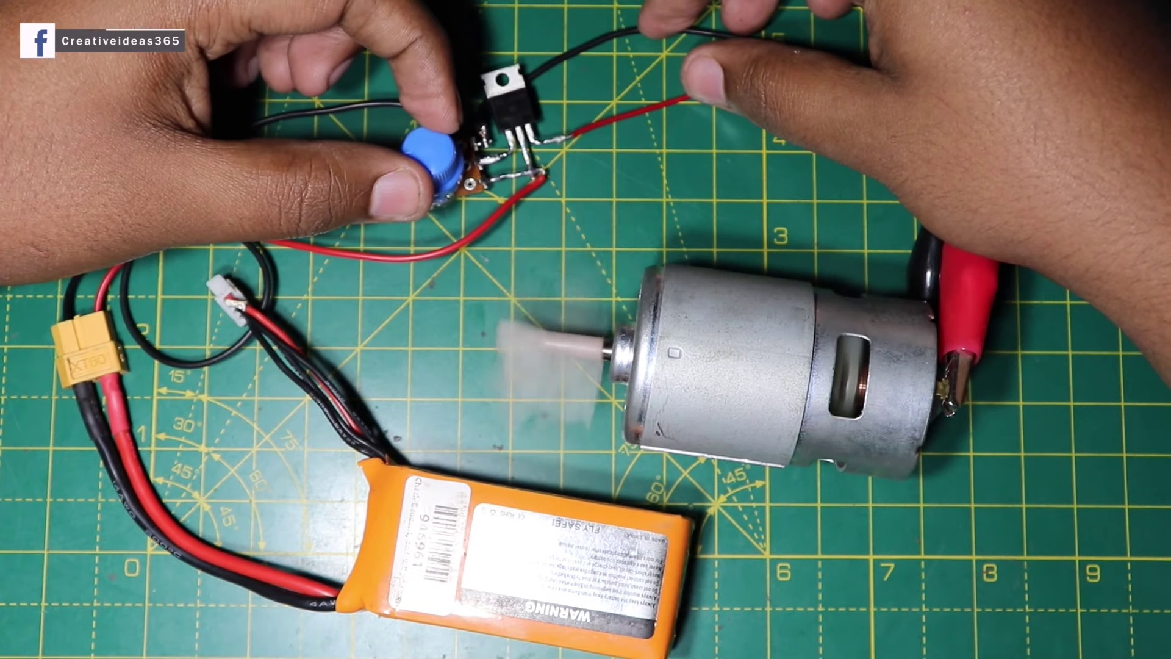 (score 95.0000)
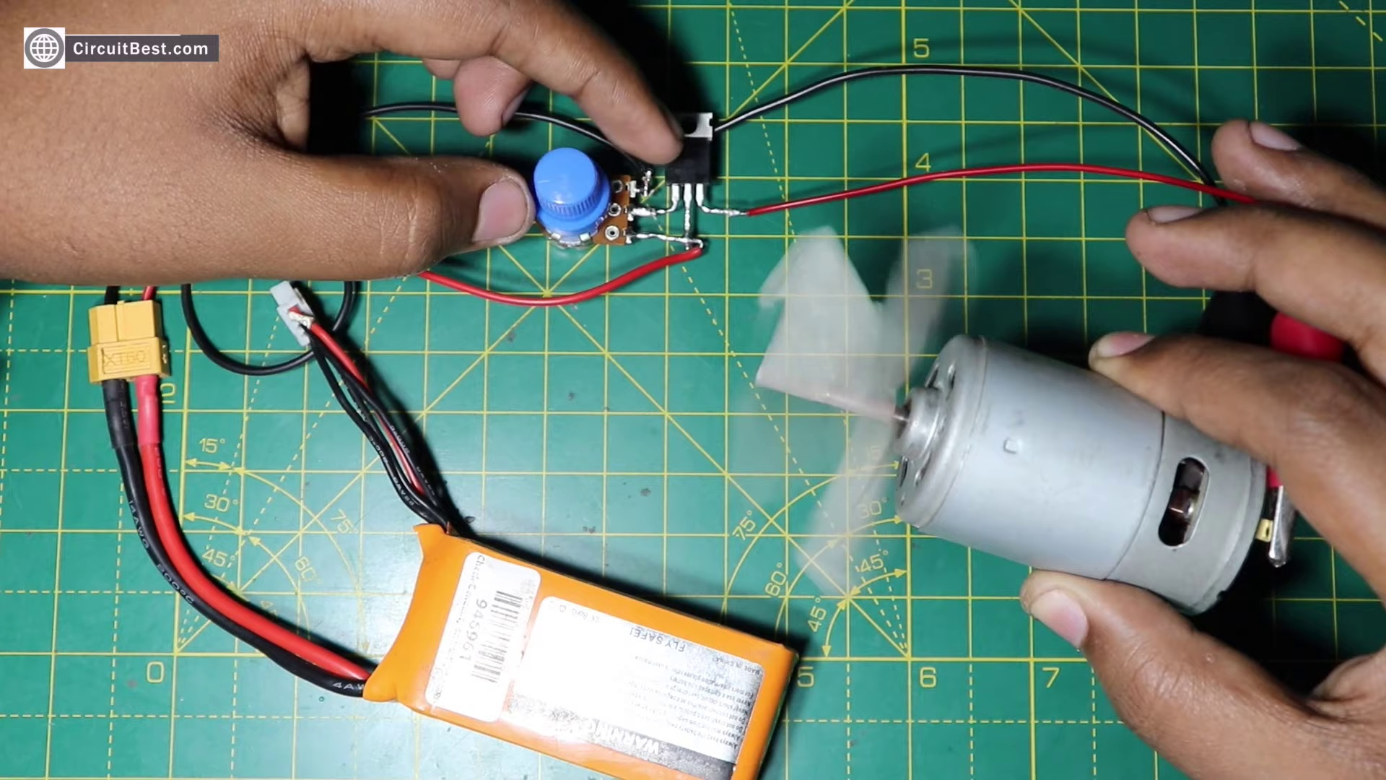 (score 95.0000)
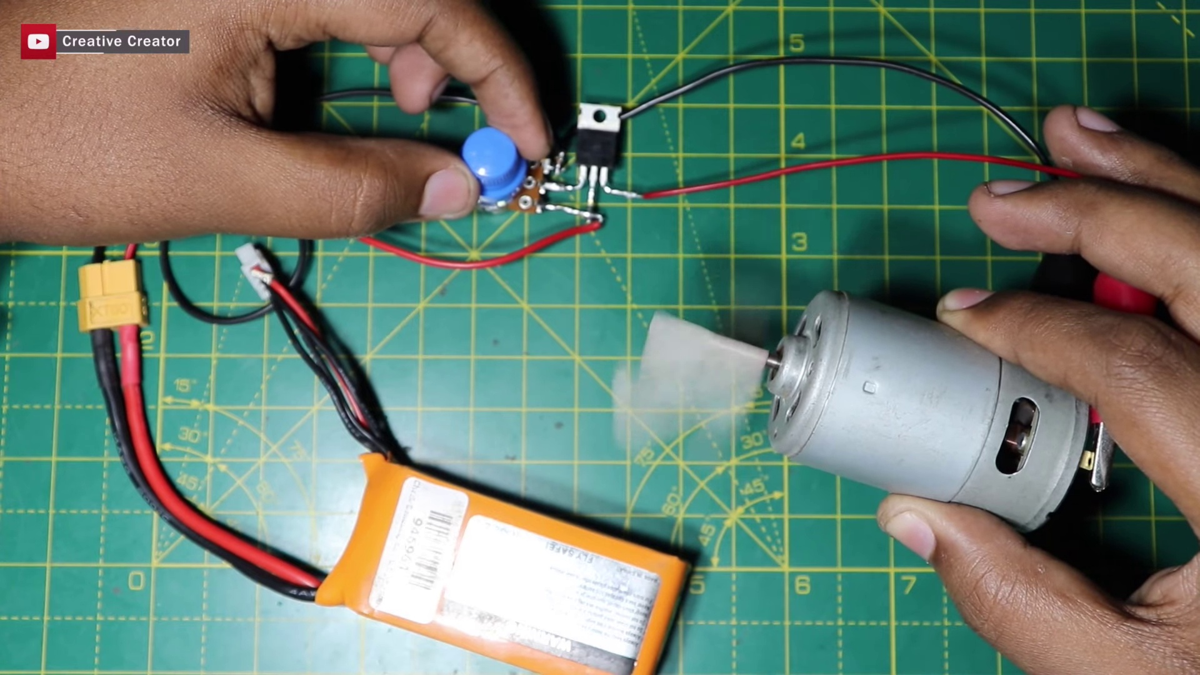 (score 95.0000)
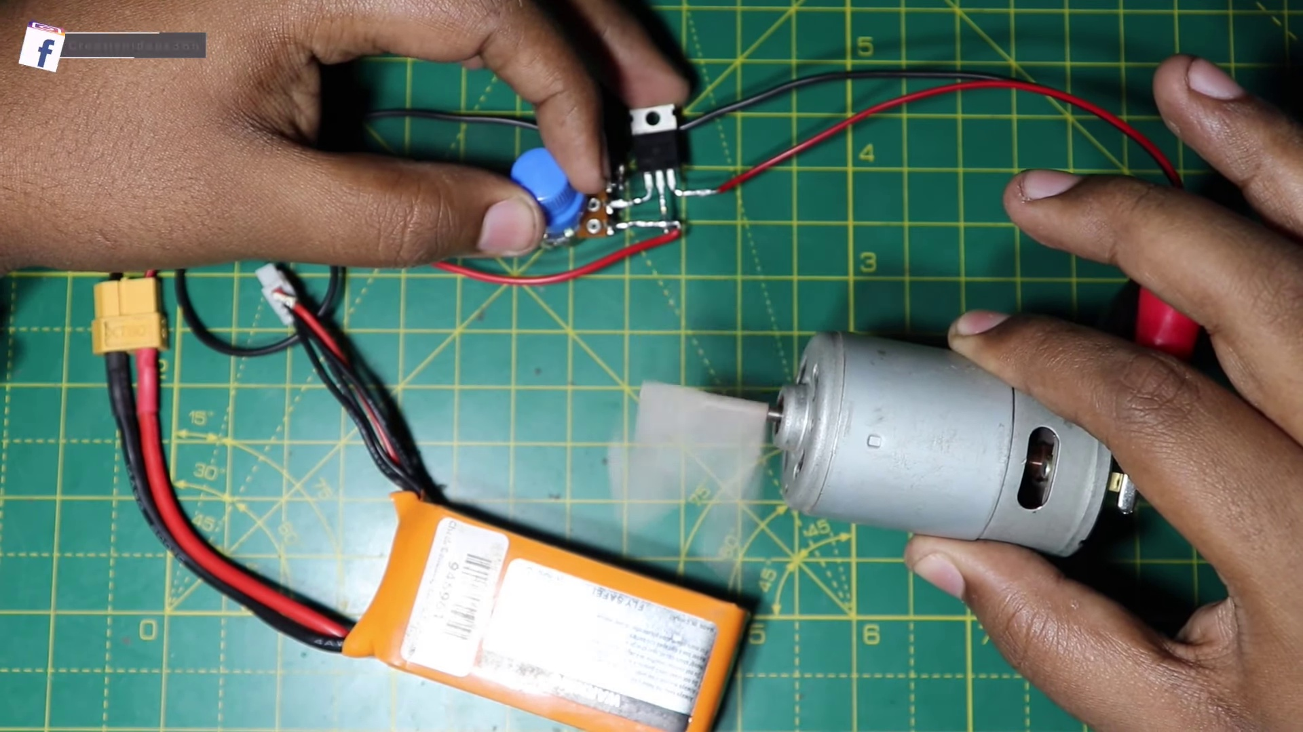 (score 95.0000)
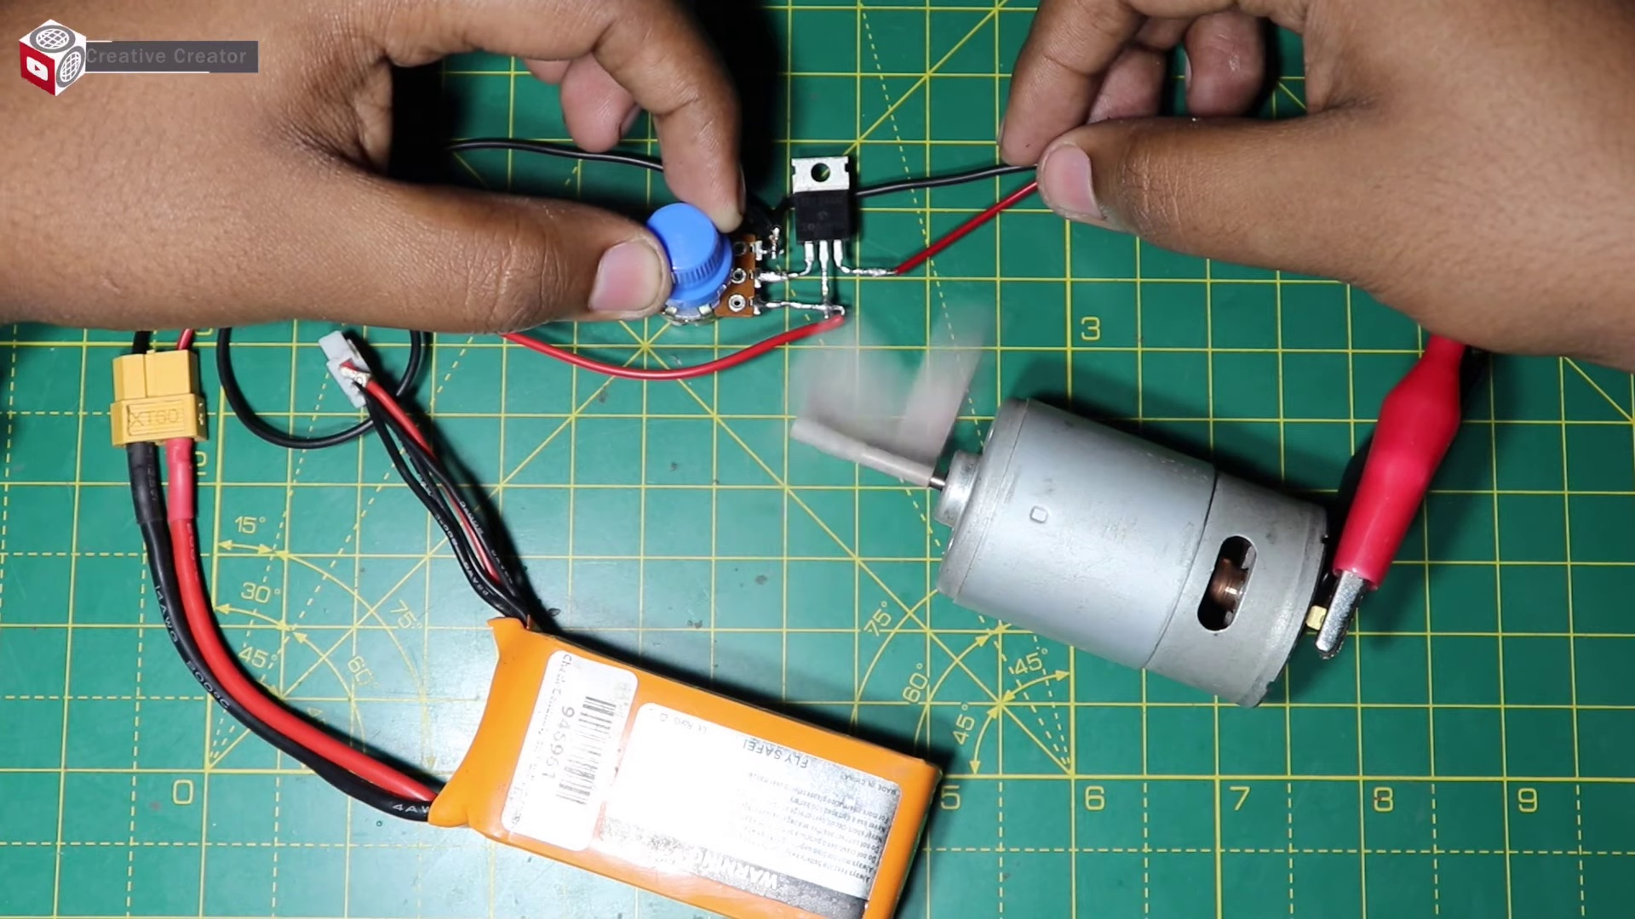 (score 95.0000)
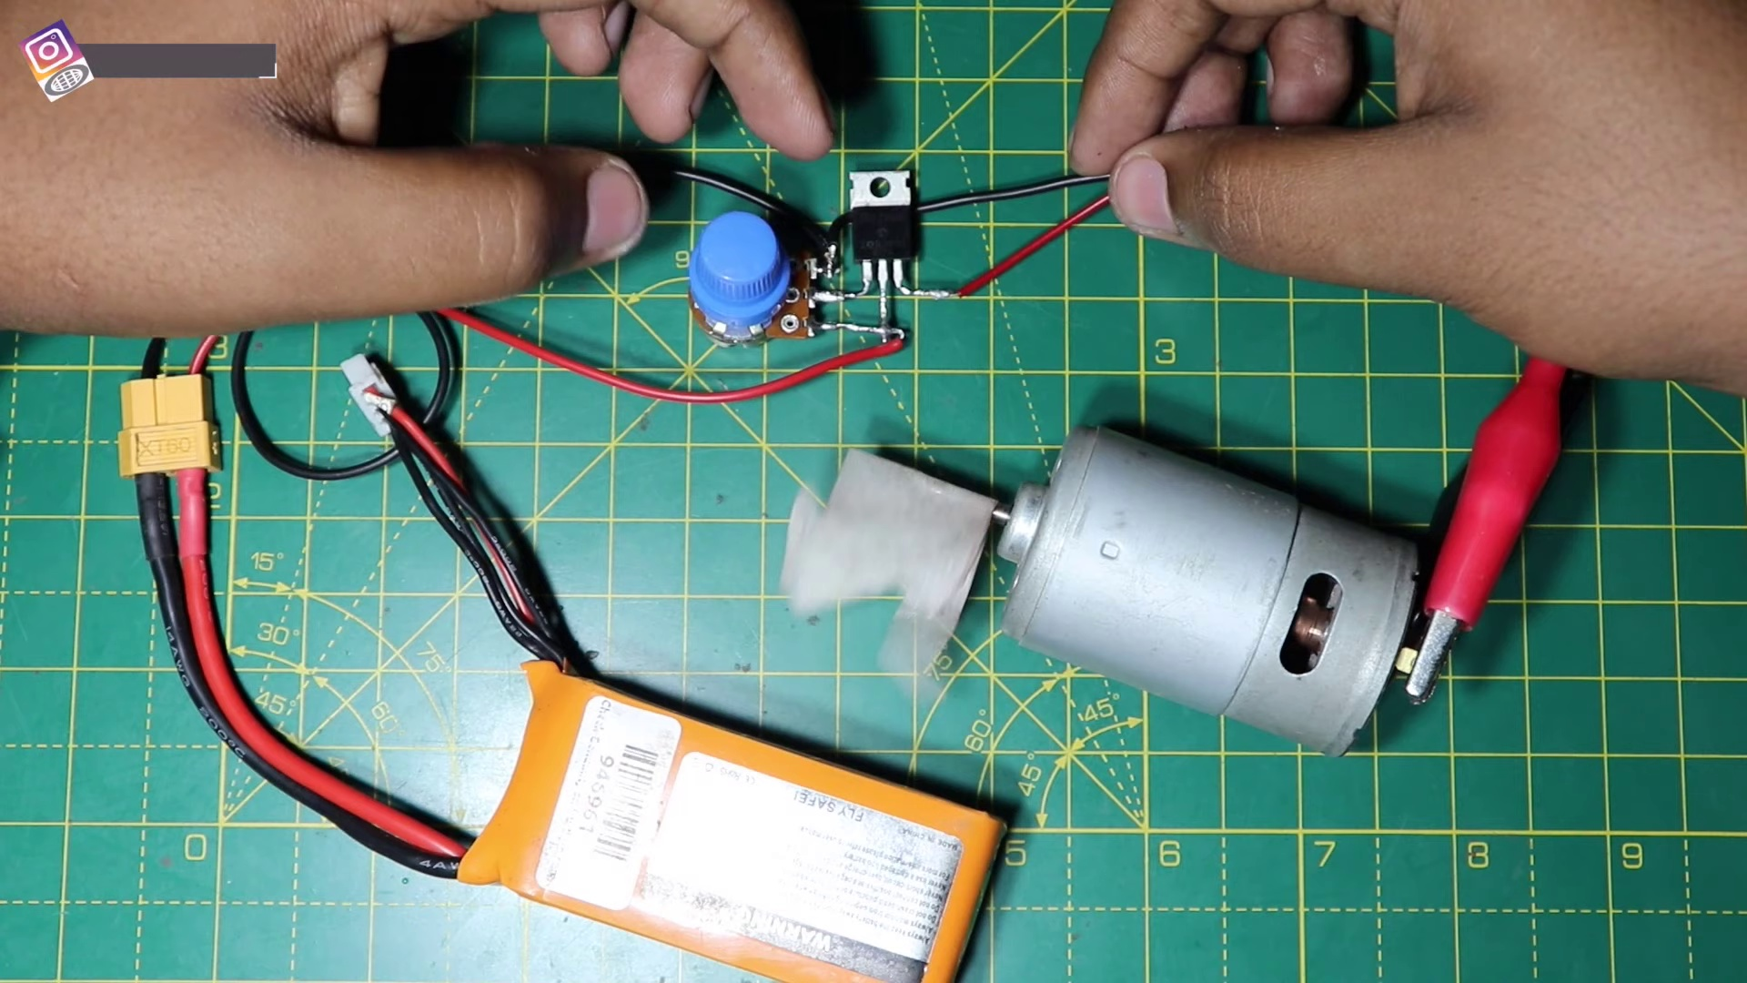 (score 95.0000)
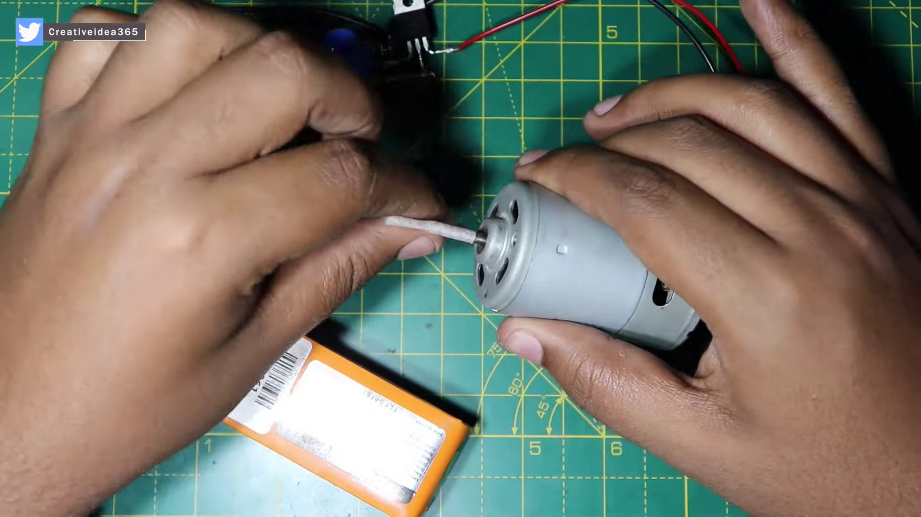 (score 95.0000)
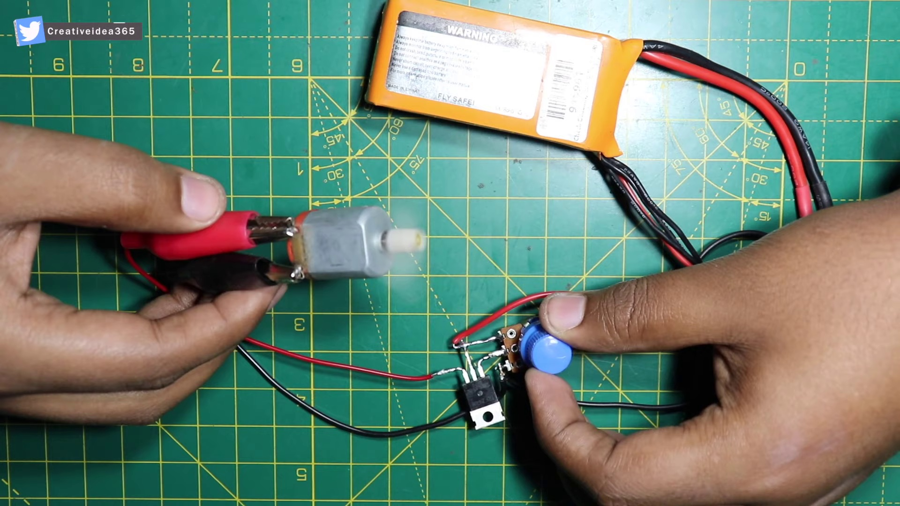 (score 95.0000)
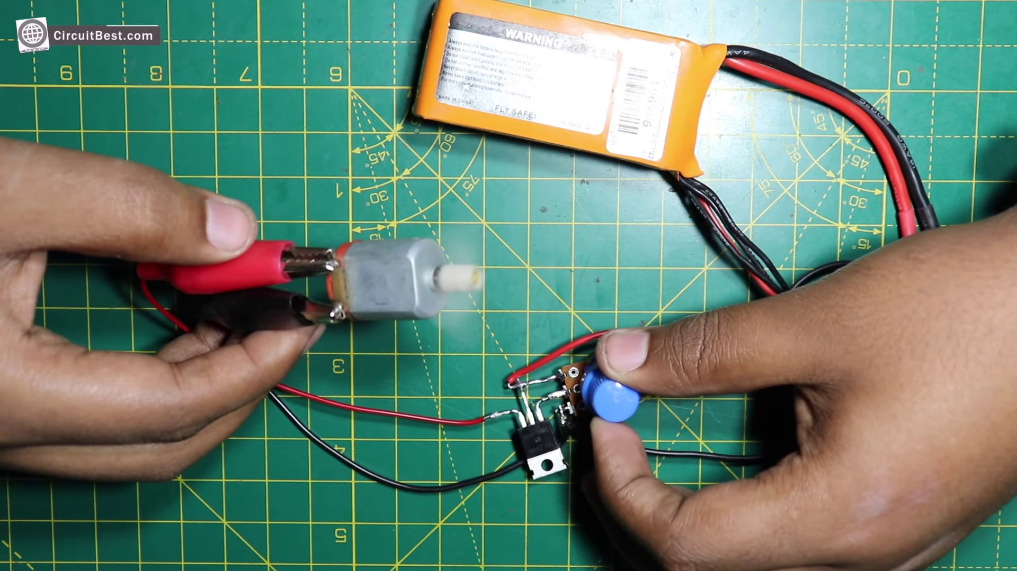 (score 95.0000)
Least correlated frames:
 (score 0.0000)
 (score 0.0000)
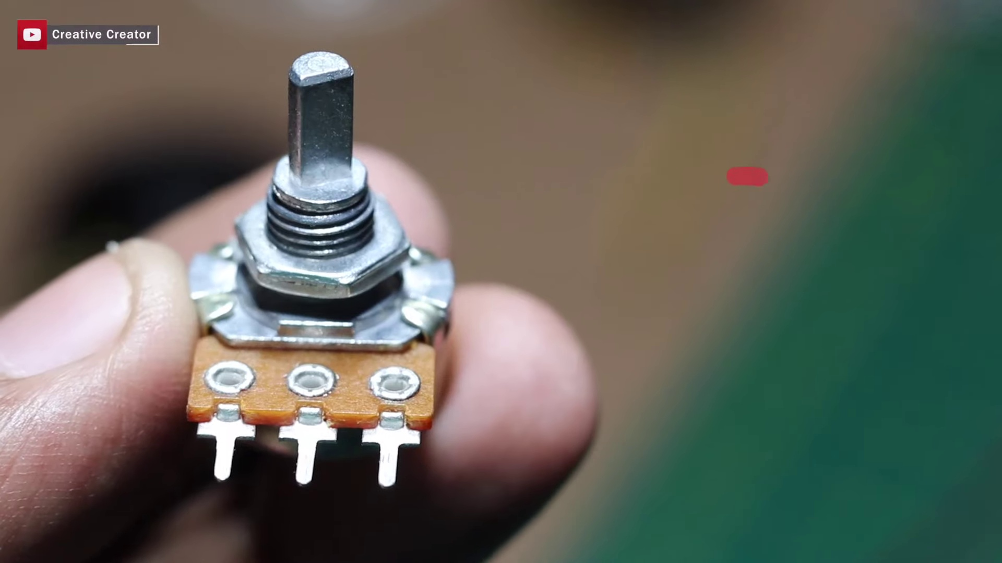 (score 0.0000)
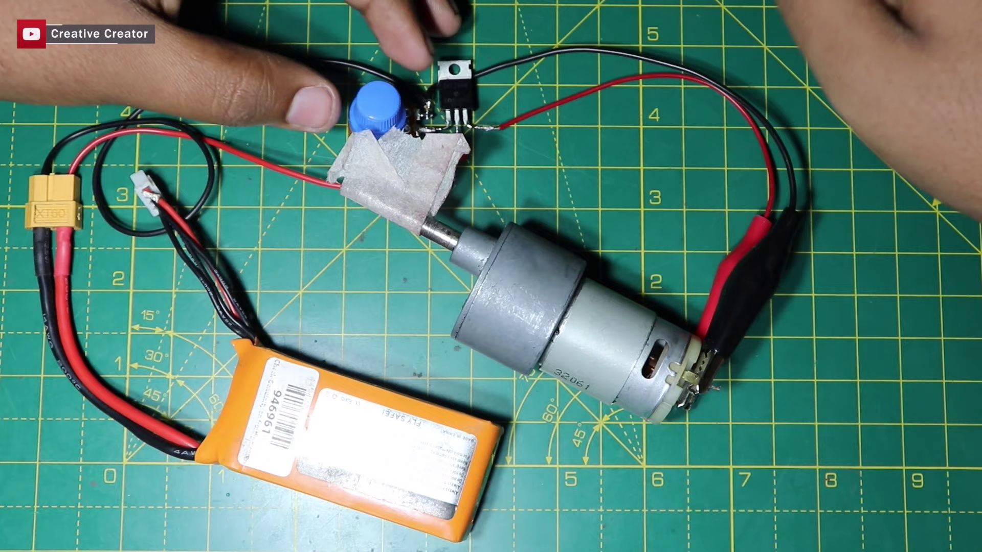 (score 0.0000)
 (score 0.0000)
 (score 0.0000)
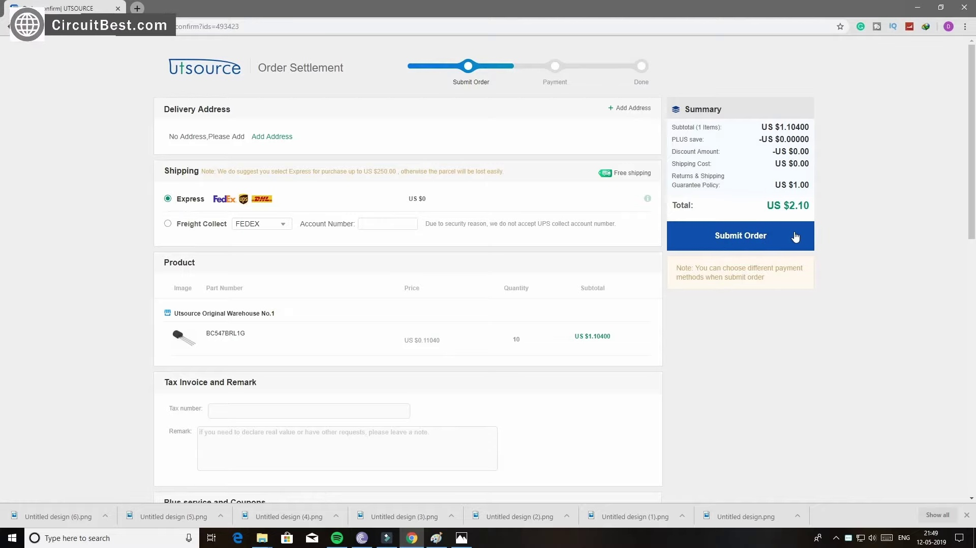 (score 0.0000)
 (score 0.0000)
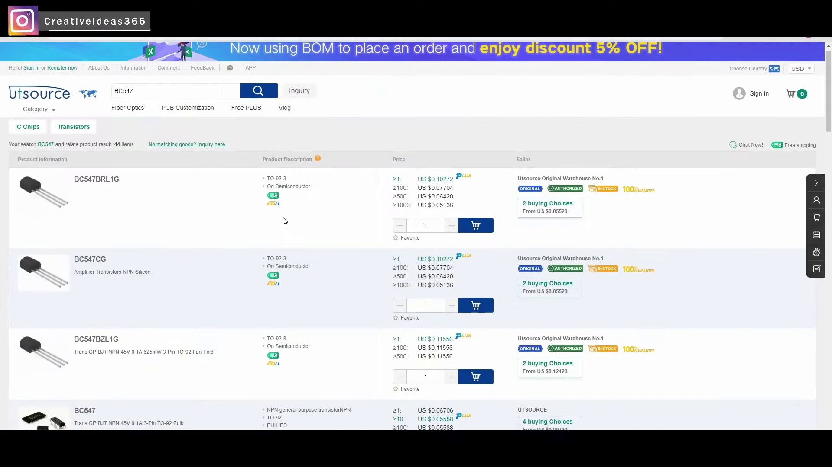 (score 5.0000)
 (score 10.0000)
- matched 116 frame(s), max score 90.0000: Starts off with using a large heat sink to mount his mosfet and rectifiers, along with a potentiometer, there are several videos where people just solder the component to each other without using a board for a base. I guess this is an easier way to do, but it seems a little sloppy to me. It is very interesting to see the control of the motor with very little electronics. The motor is moving pretty fast for only a hand full of electronics used. I do wonder how hot the mosfet was controlling the motor.
Source: https://www.youtube.com/watch?v=CvMDlG_AF3Q: how to make simple dc motor speed control circuit
Top correlated frames:
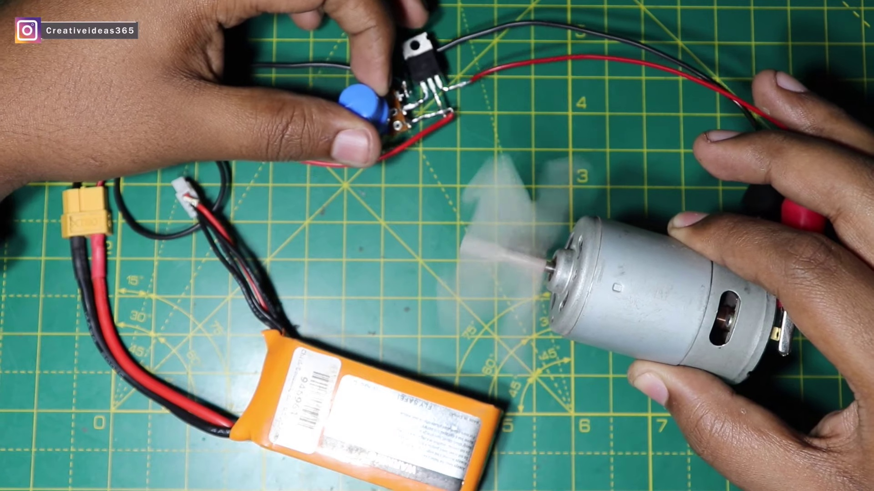 (score 90.0000)
 (score 90.0000)
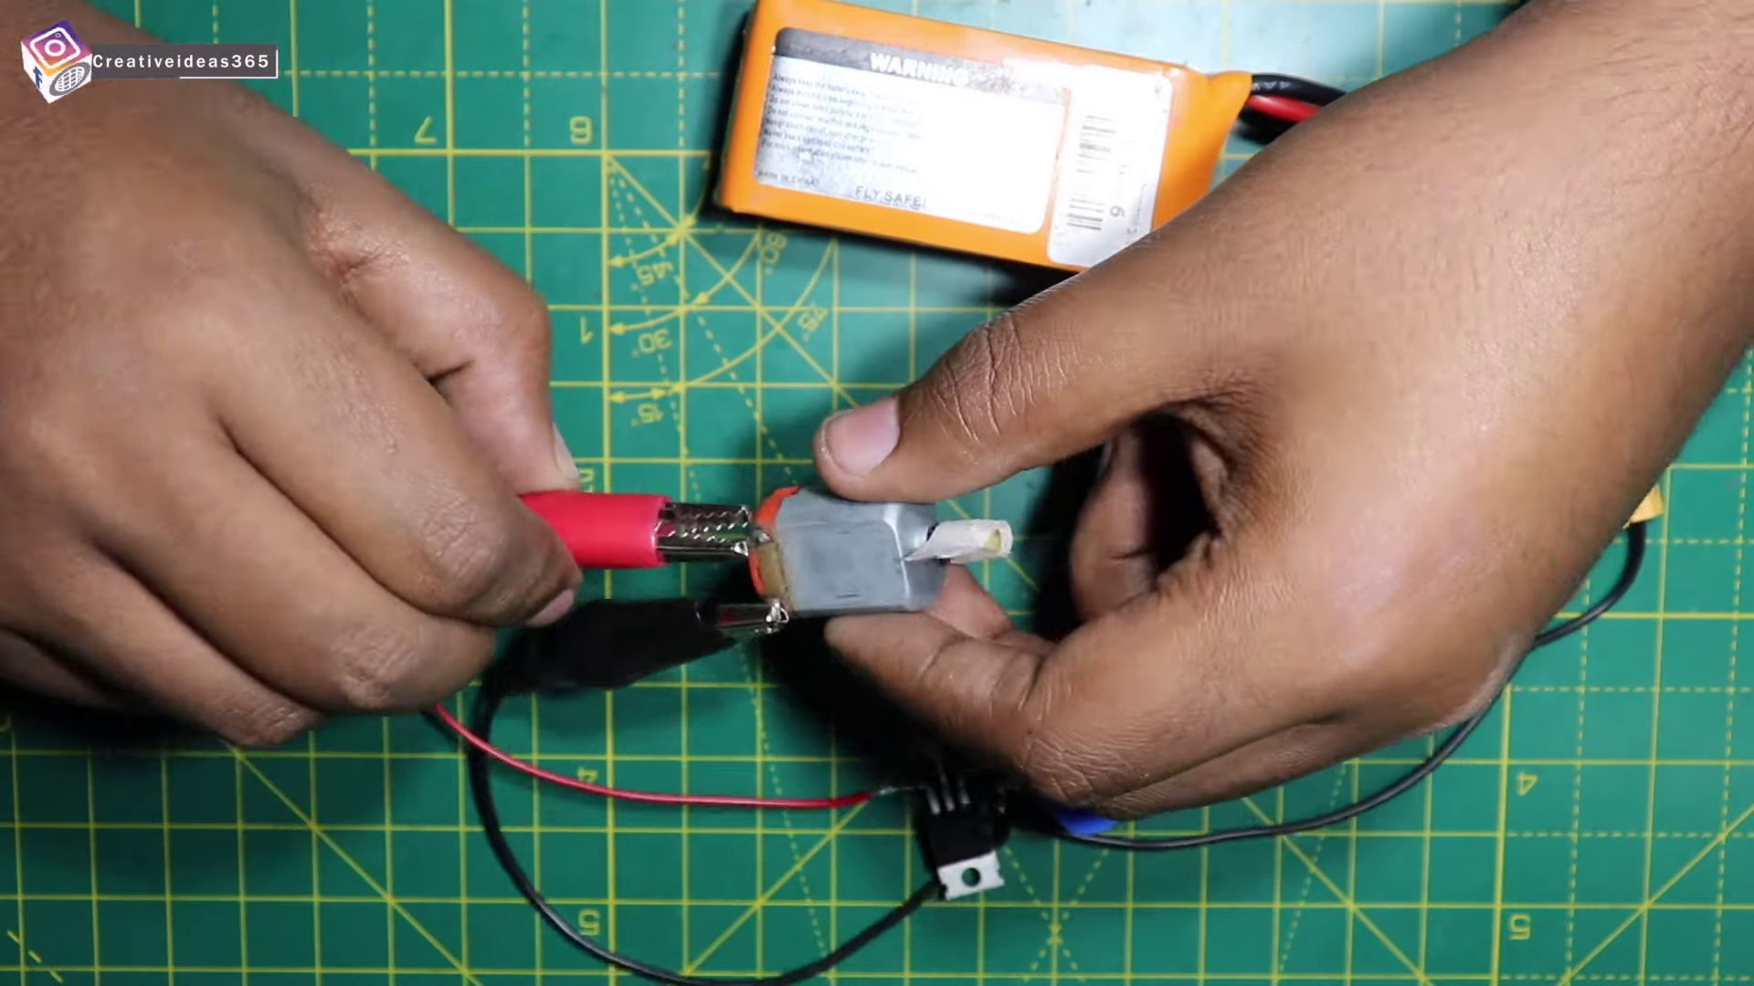 (score 90.0000)
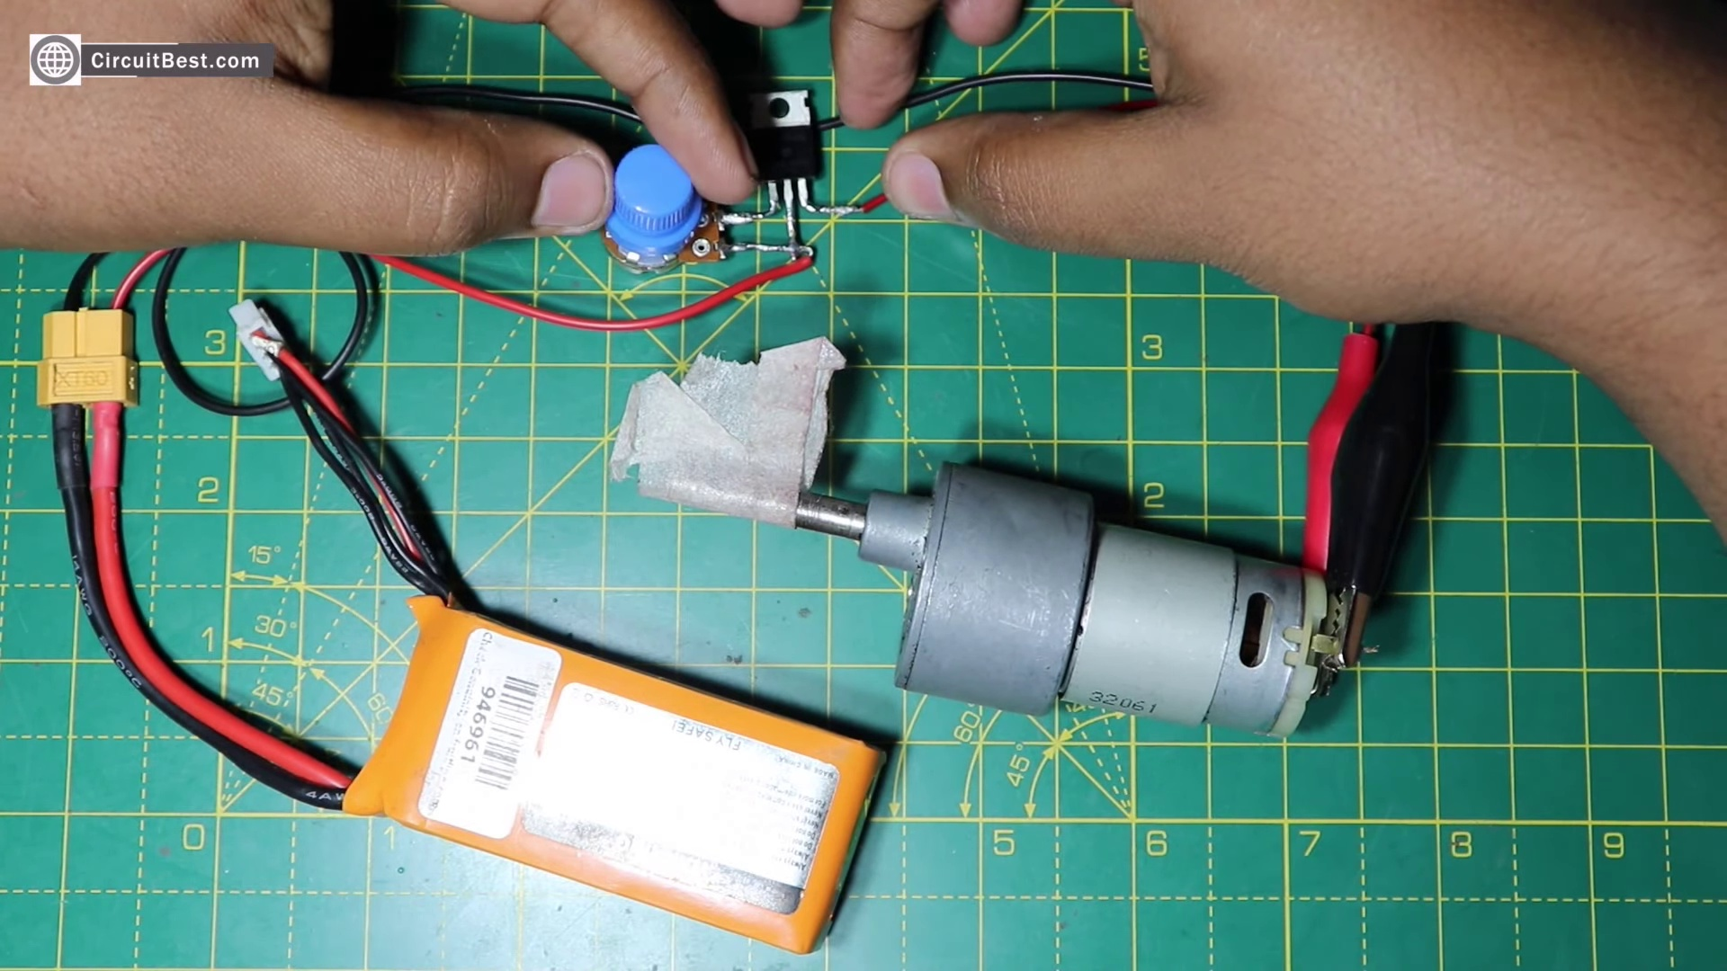 (score 90.0000)
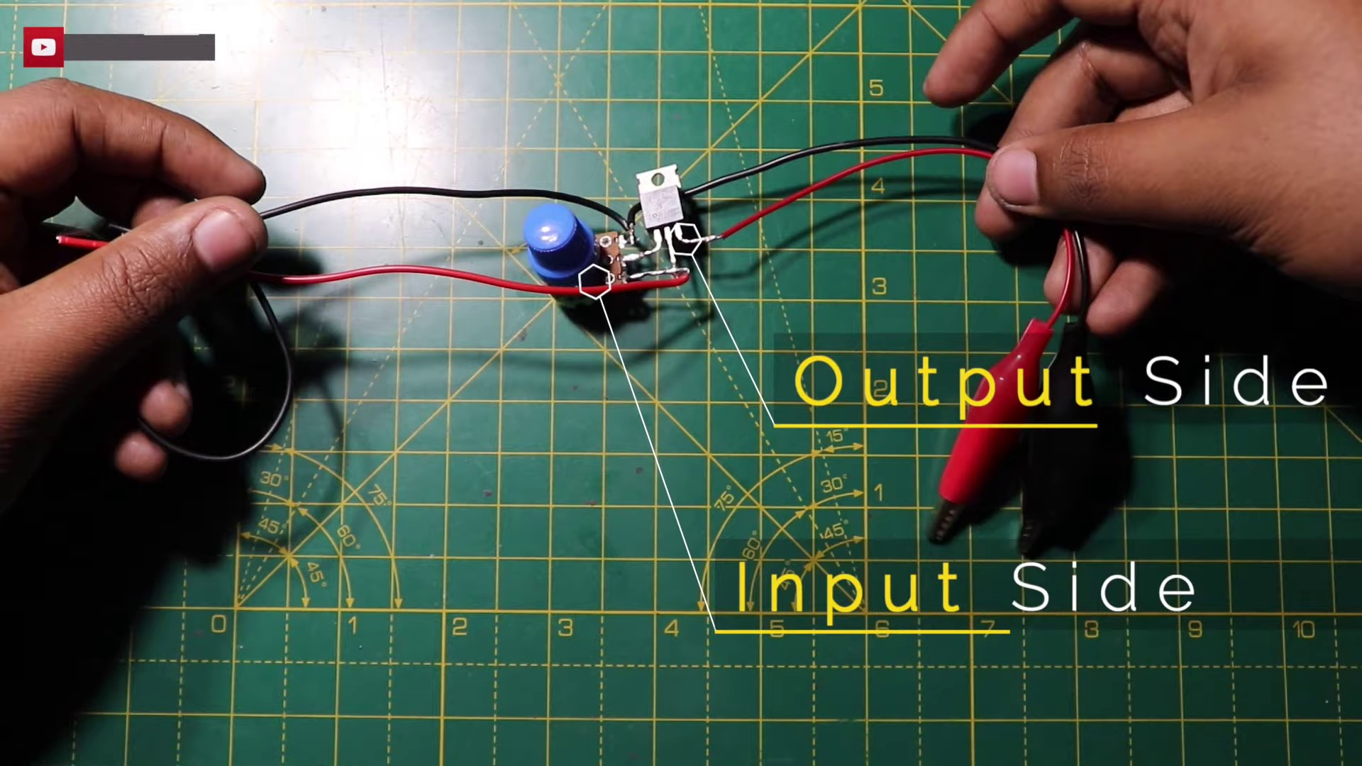 (score 90.0000)
 (score 90.0000)
 (score 85.0000)
 (score 85.0000)
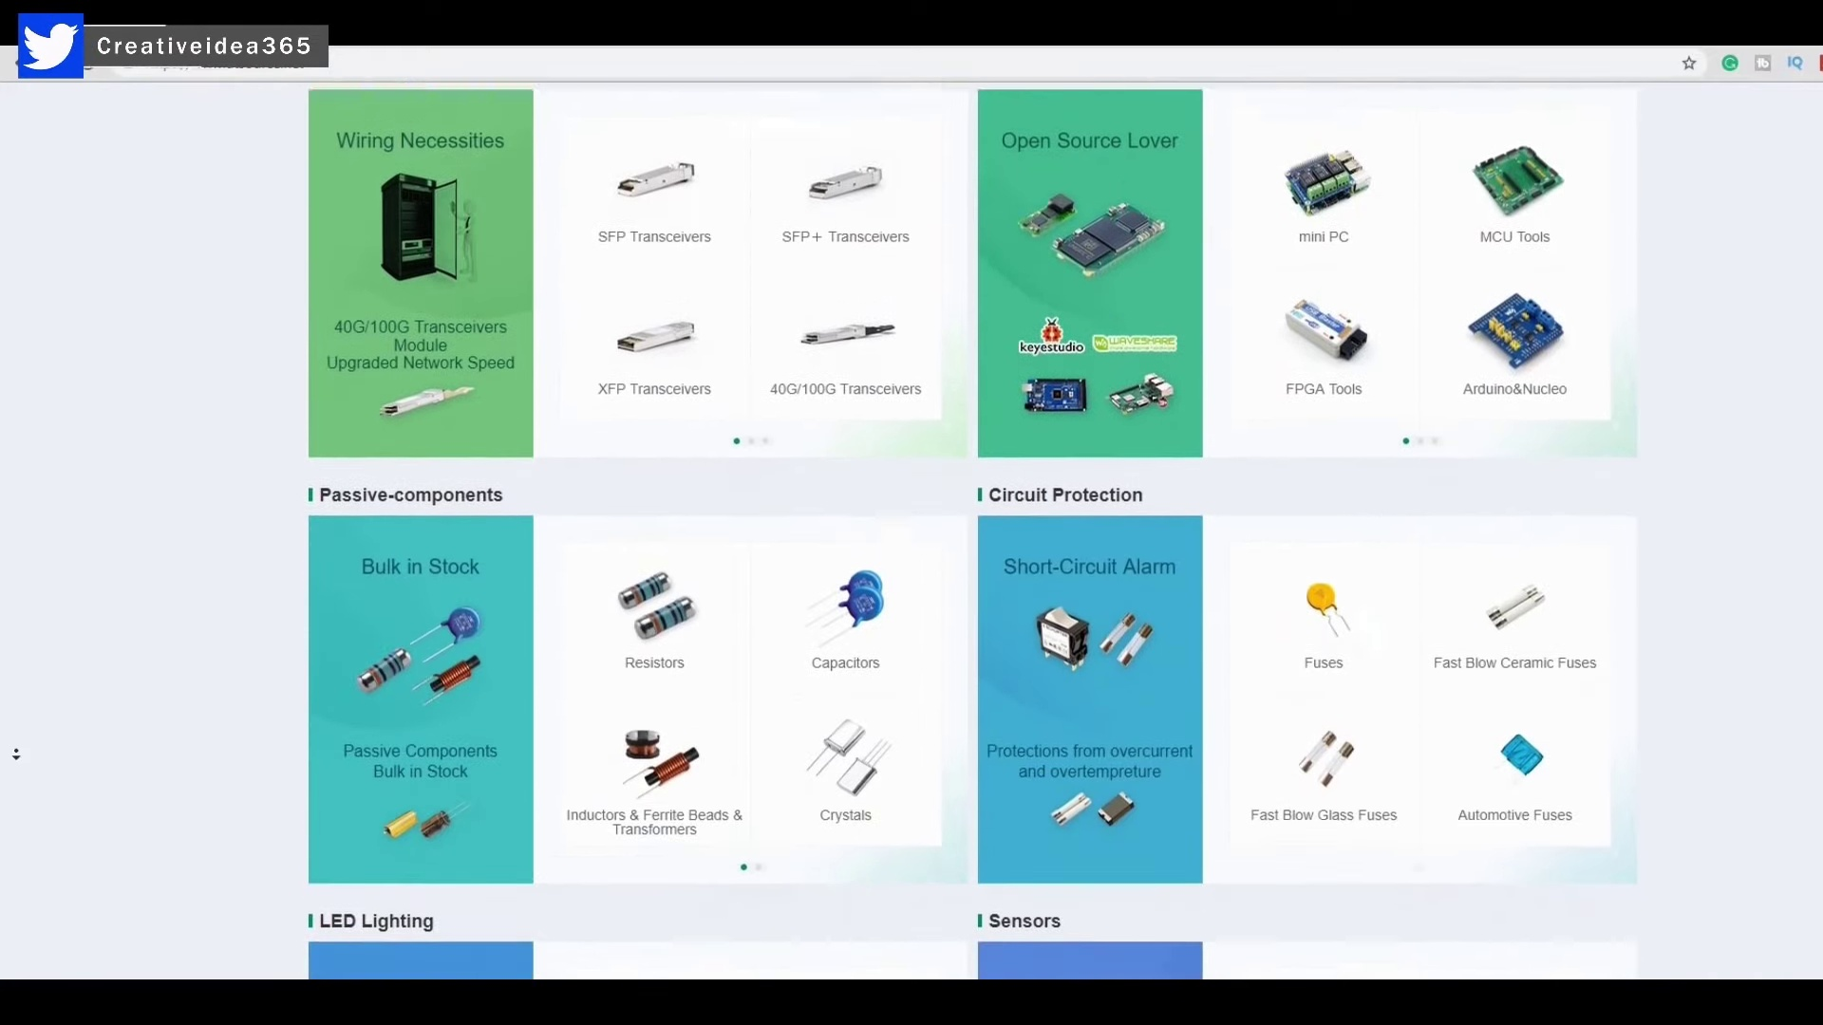 (score 85.0000)
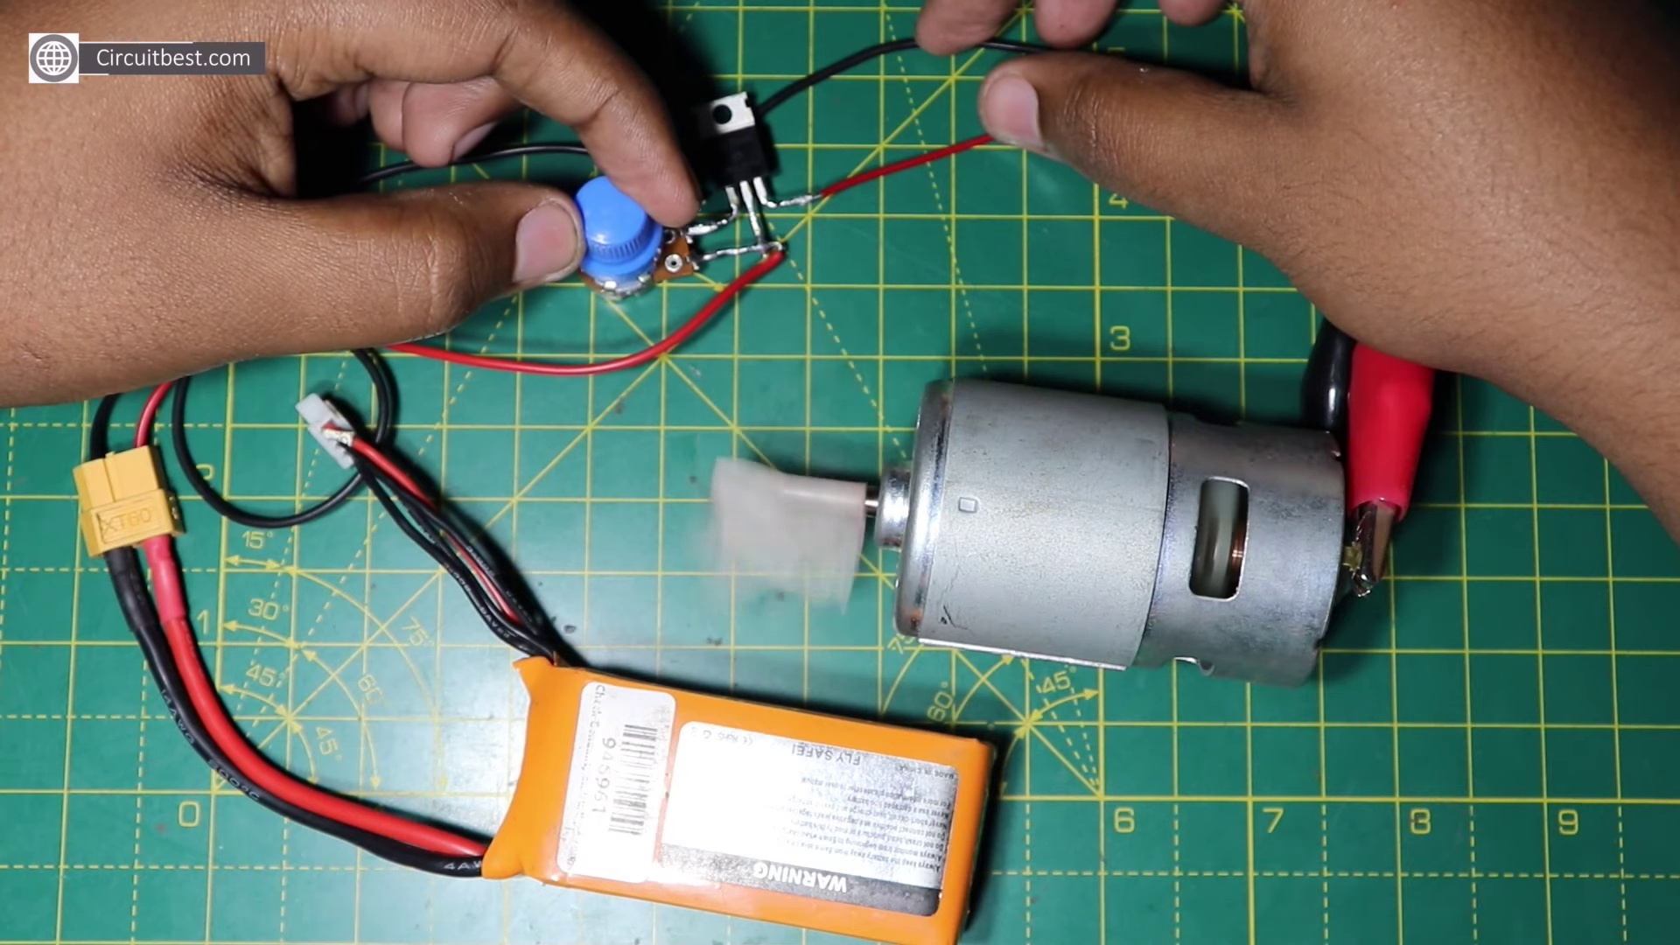 (score 85.0000)
Least correlated frames:
 (score 0.0000)
 (score 0.0000)
 (score 0.0000)
 (score 0.0000)
 (score 0.0000)
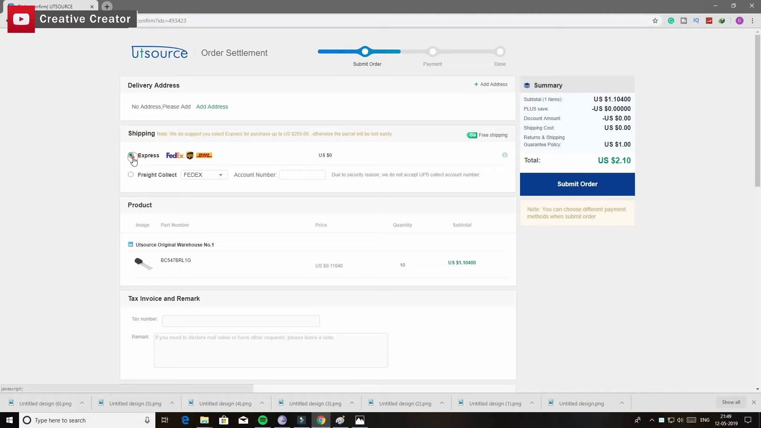 (score 0.0000)
 (score 0.0000)
 (score 0.0000)
 (score 0.0000)
 (score 0.0000)
- matched 111 frame(s), max score 90.0000: This video builds a dc motor with speed control using IRFP250N chip as it’s logic gate. It uses a resistor, potentiometer, and DC power source of 25V. This was not really helpful in the class project but it was really cool to watch and see how the simple dc motor can be build with very few components.
Source: https://www.youtube.com/watch?v=CvMDlG_AF3Q&t=18s: how to make a simple dc motor speed control circuit.
Top correlated frames:
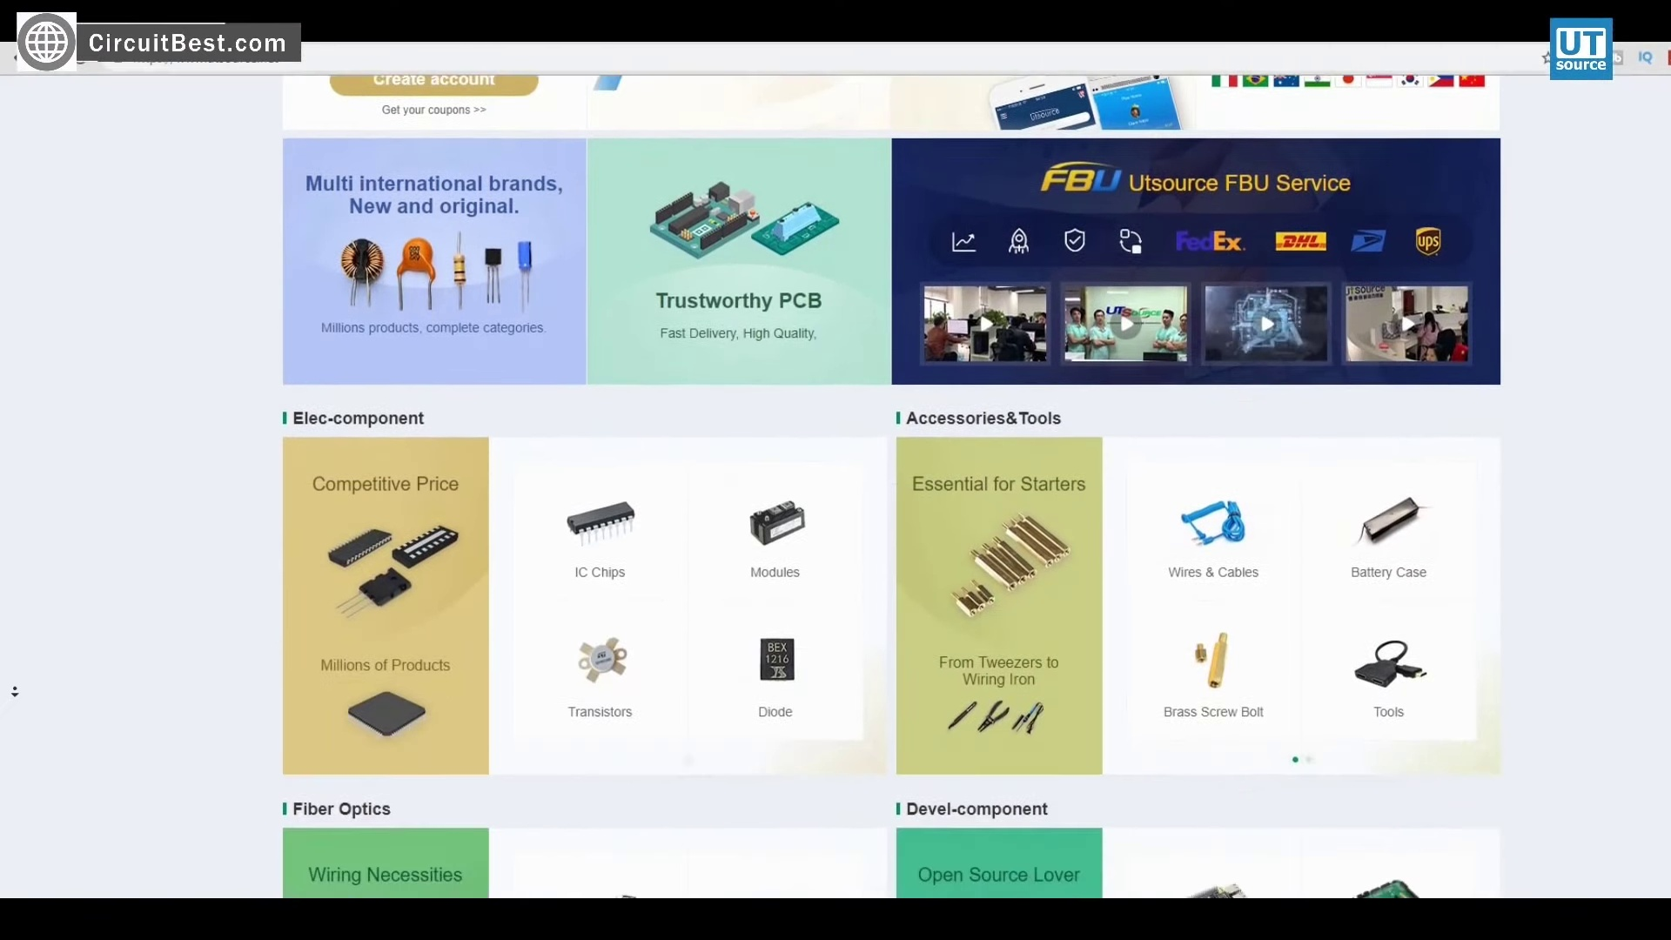 (score 90.0000)
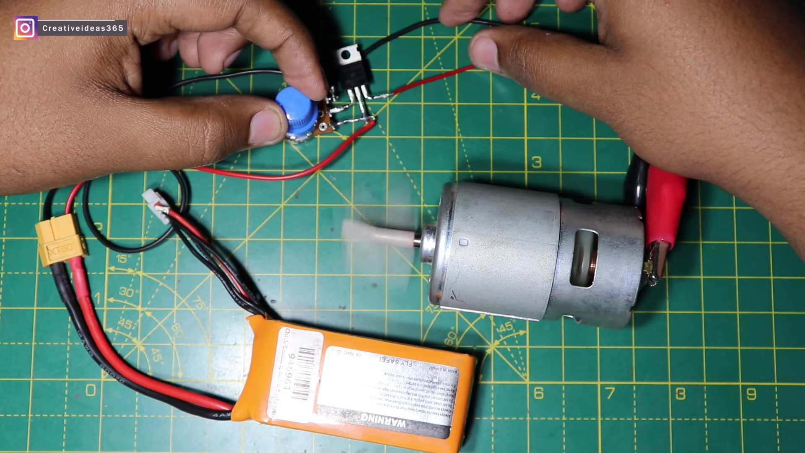 (score 90.0000)
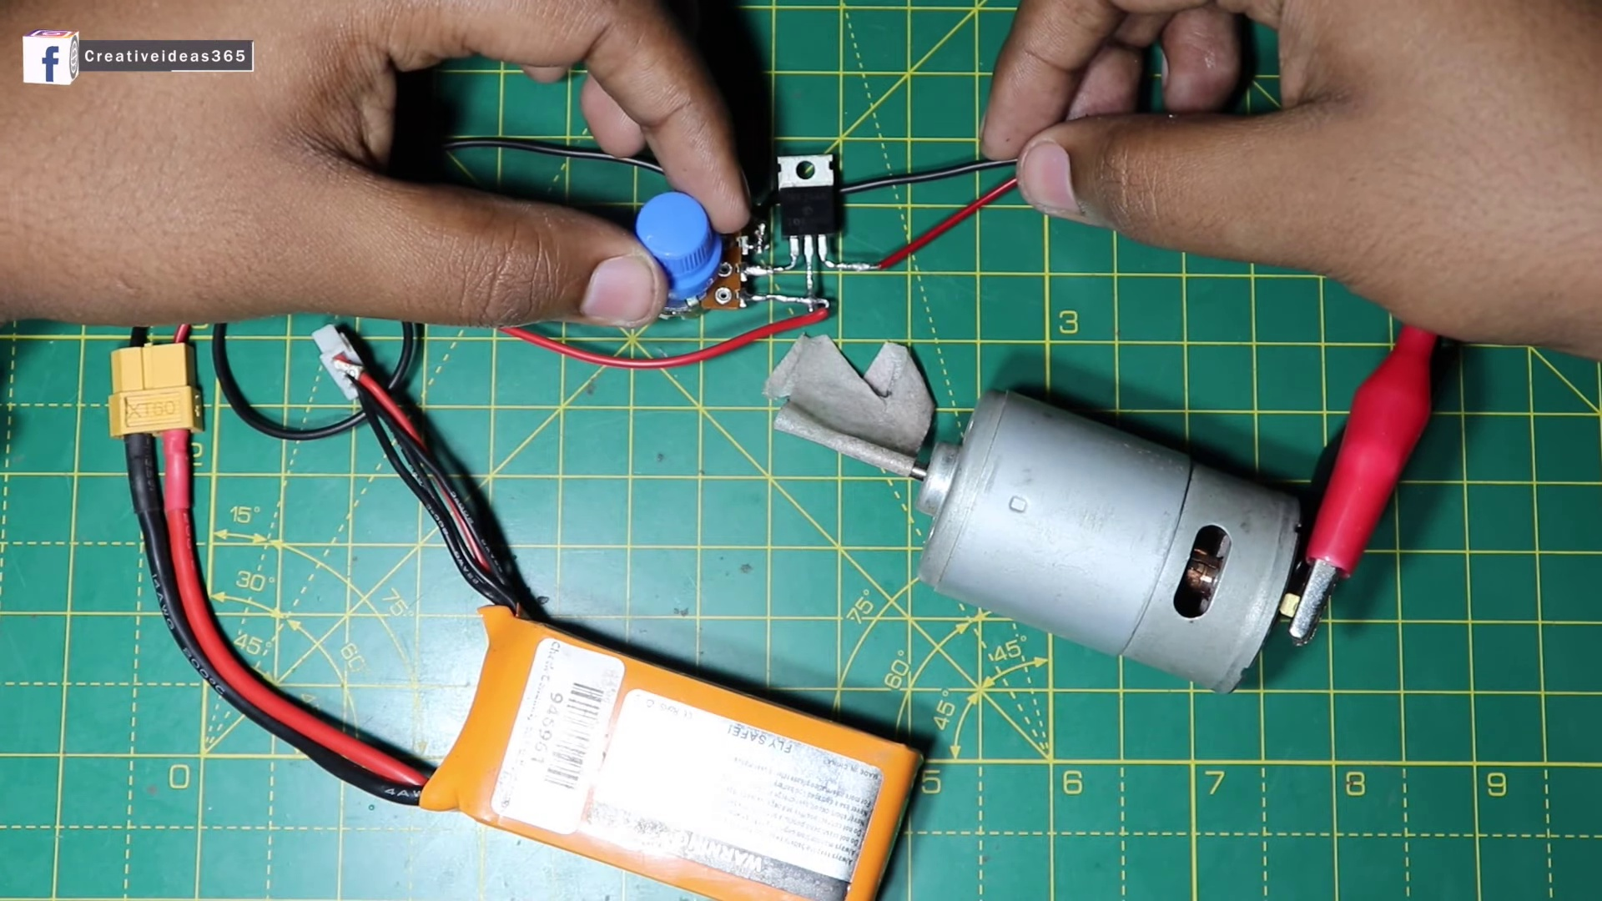 (score 90.0000)
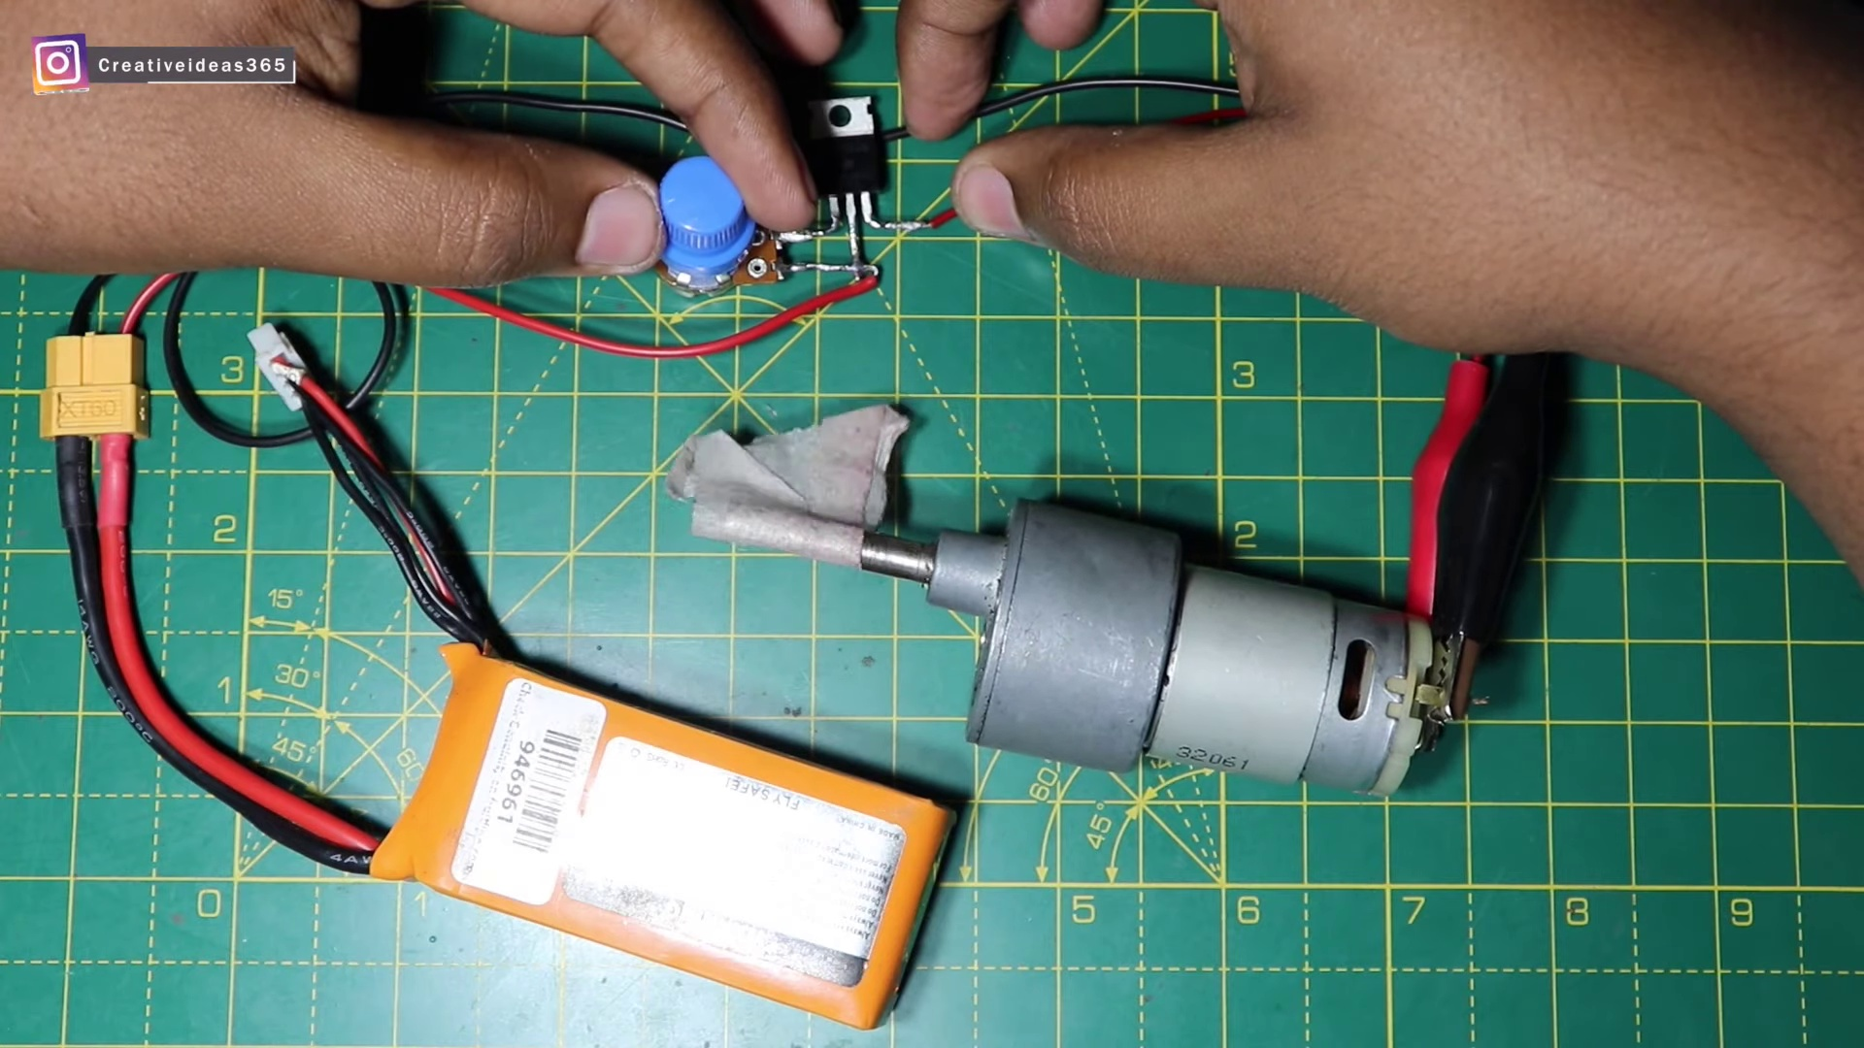 (score 90.0000)
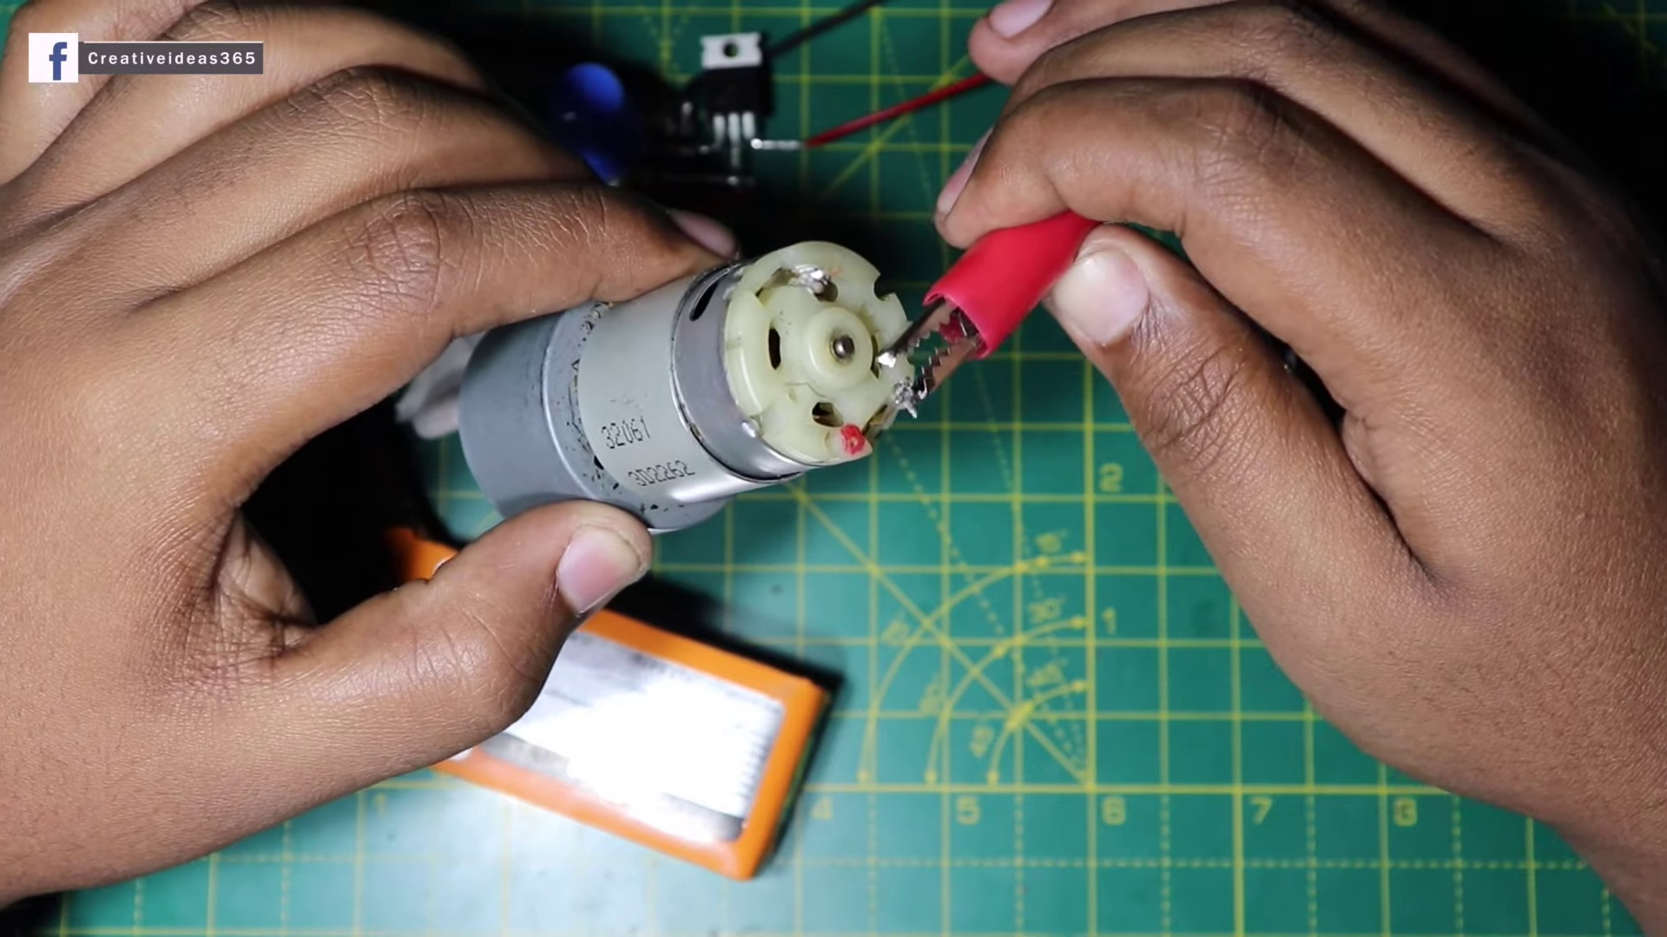 (score 90.0000)
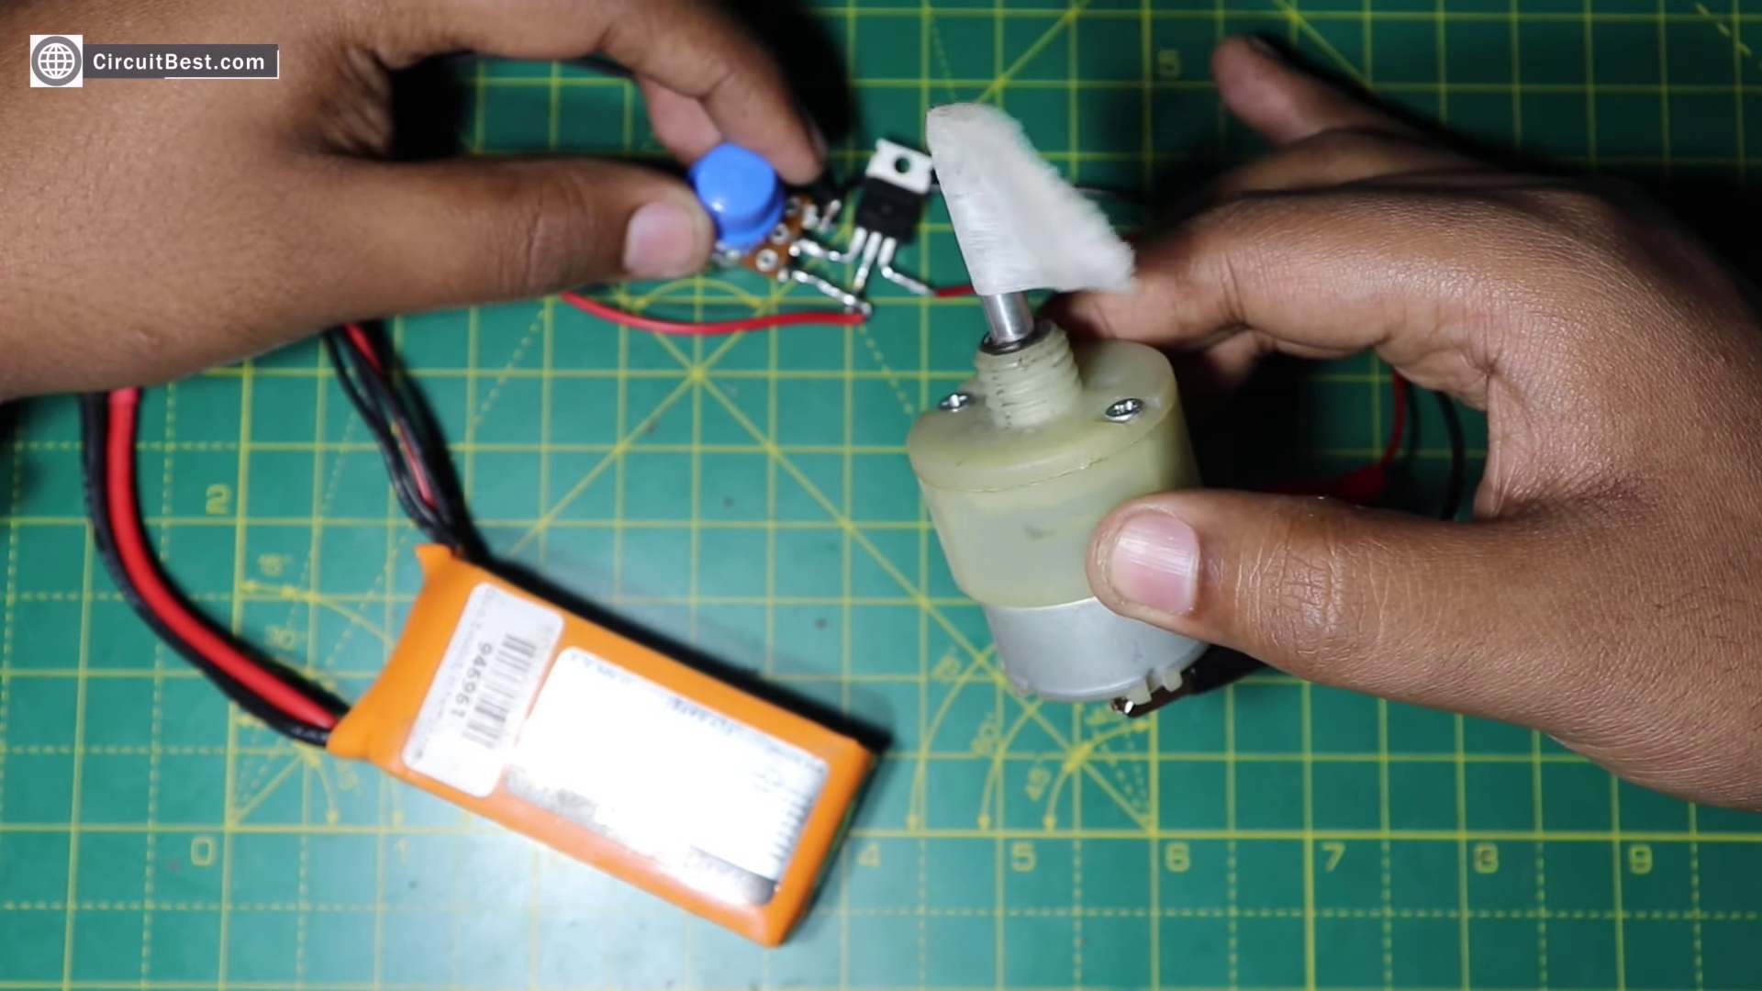 (score 90.0000)
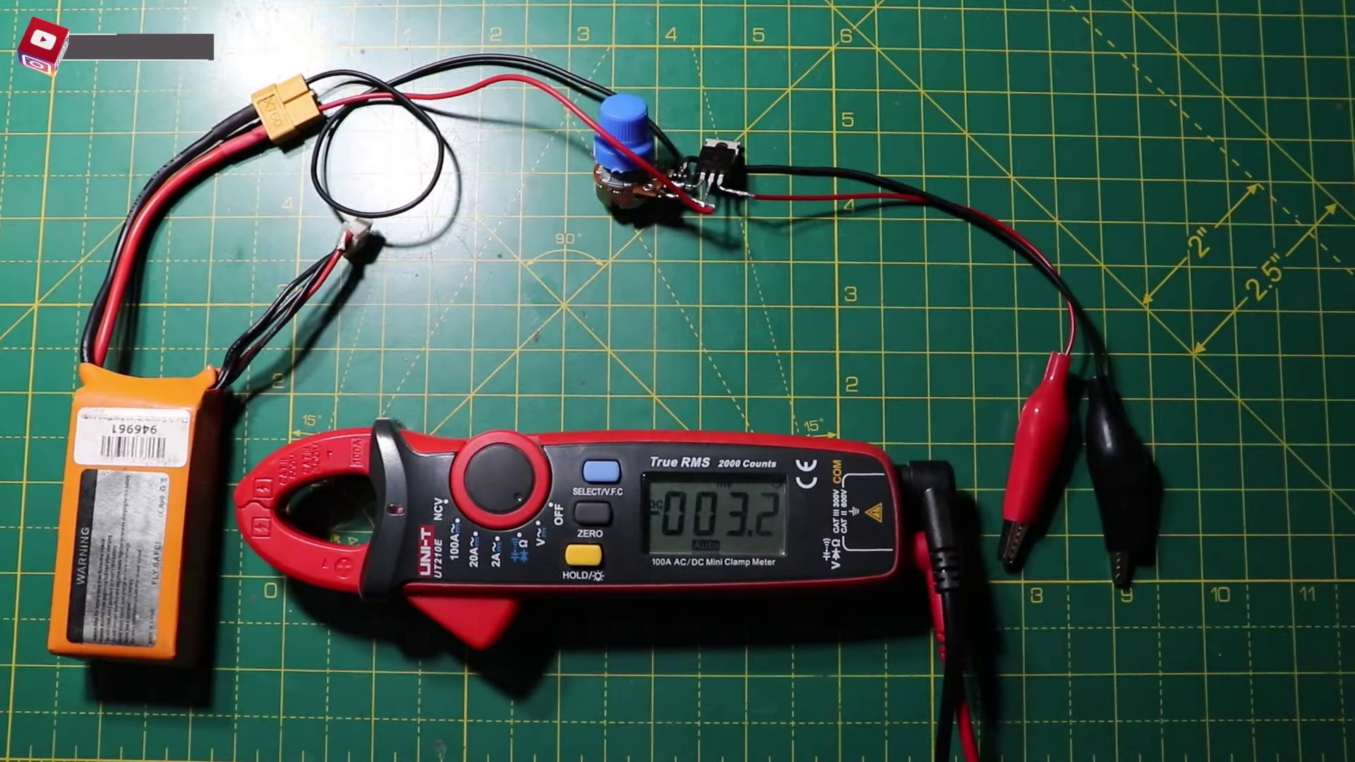 (score 90.0000)
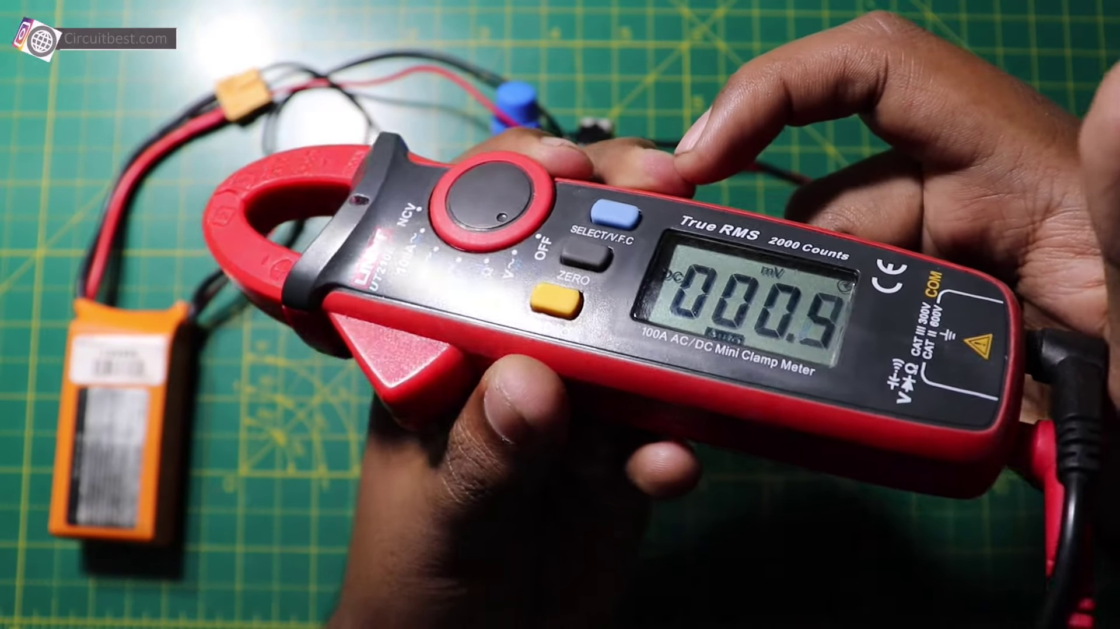 (score 90.0000)
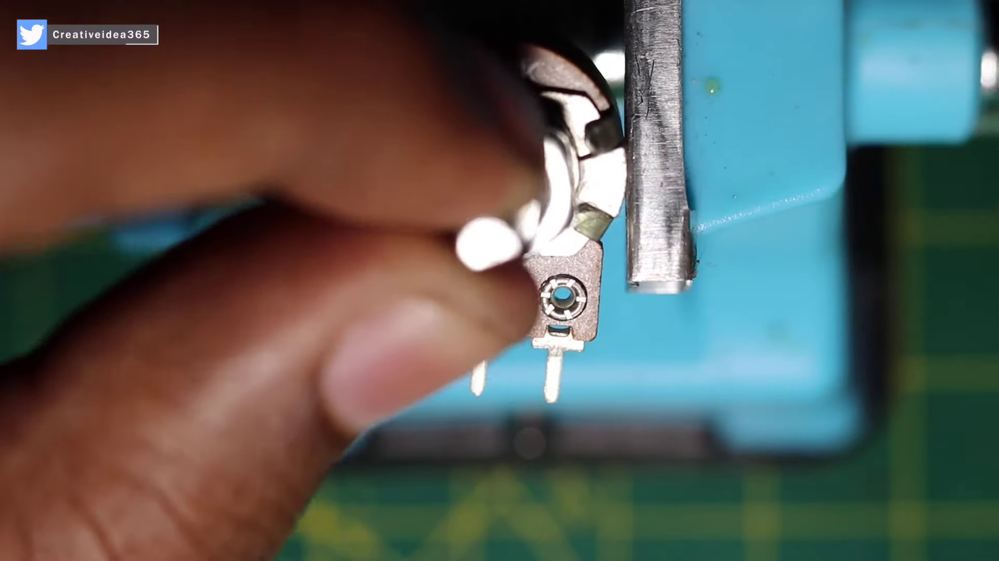 (score 90.0000)
 (score 85.0000)
Least correlated frames:
 (score 0.0000)
 (score 0.0000)
 (score 0.0000)
 (score 0.0000)
 (score 5.0000)
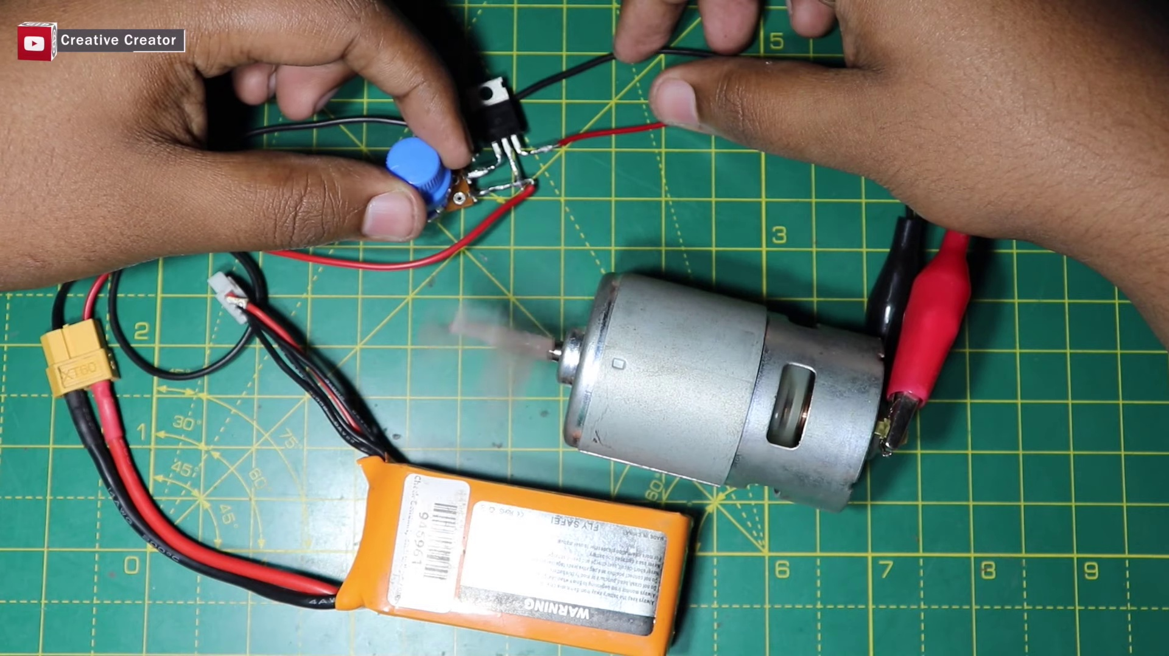 (score 10.0000)
 (score 10.0000)
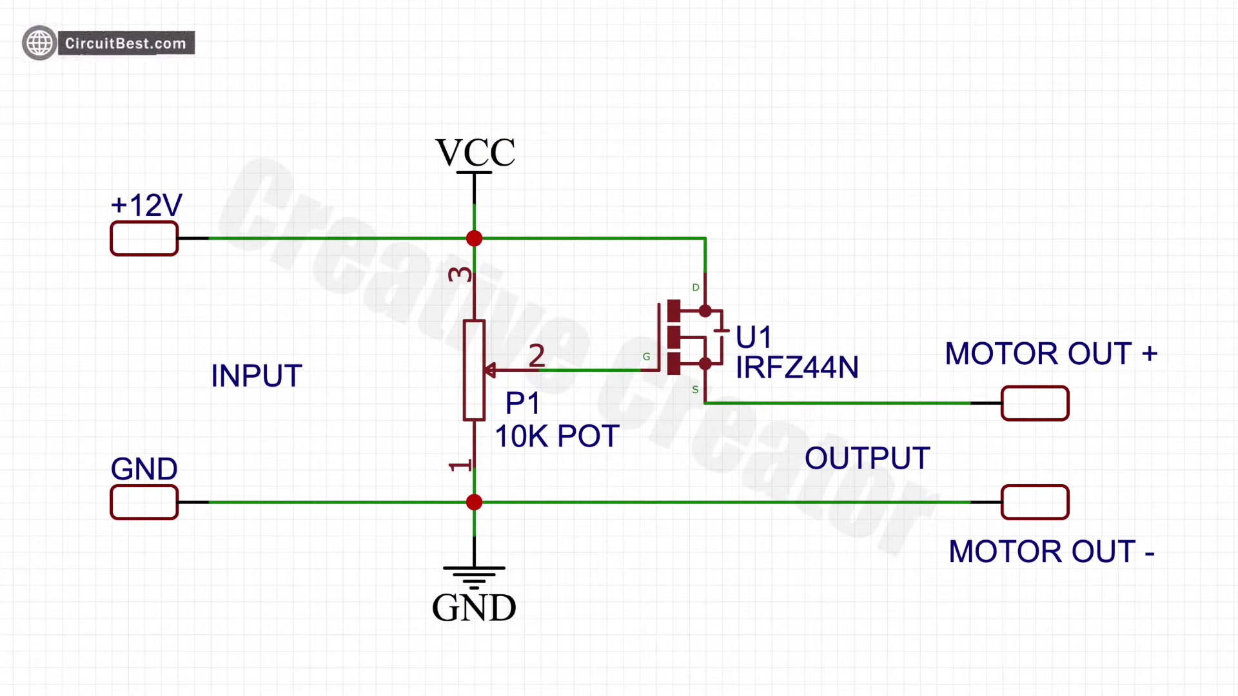 (score 10.0000)
 (score 20.0000)
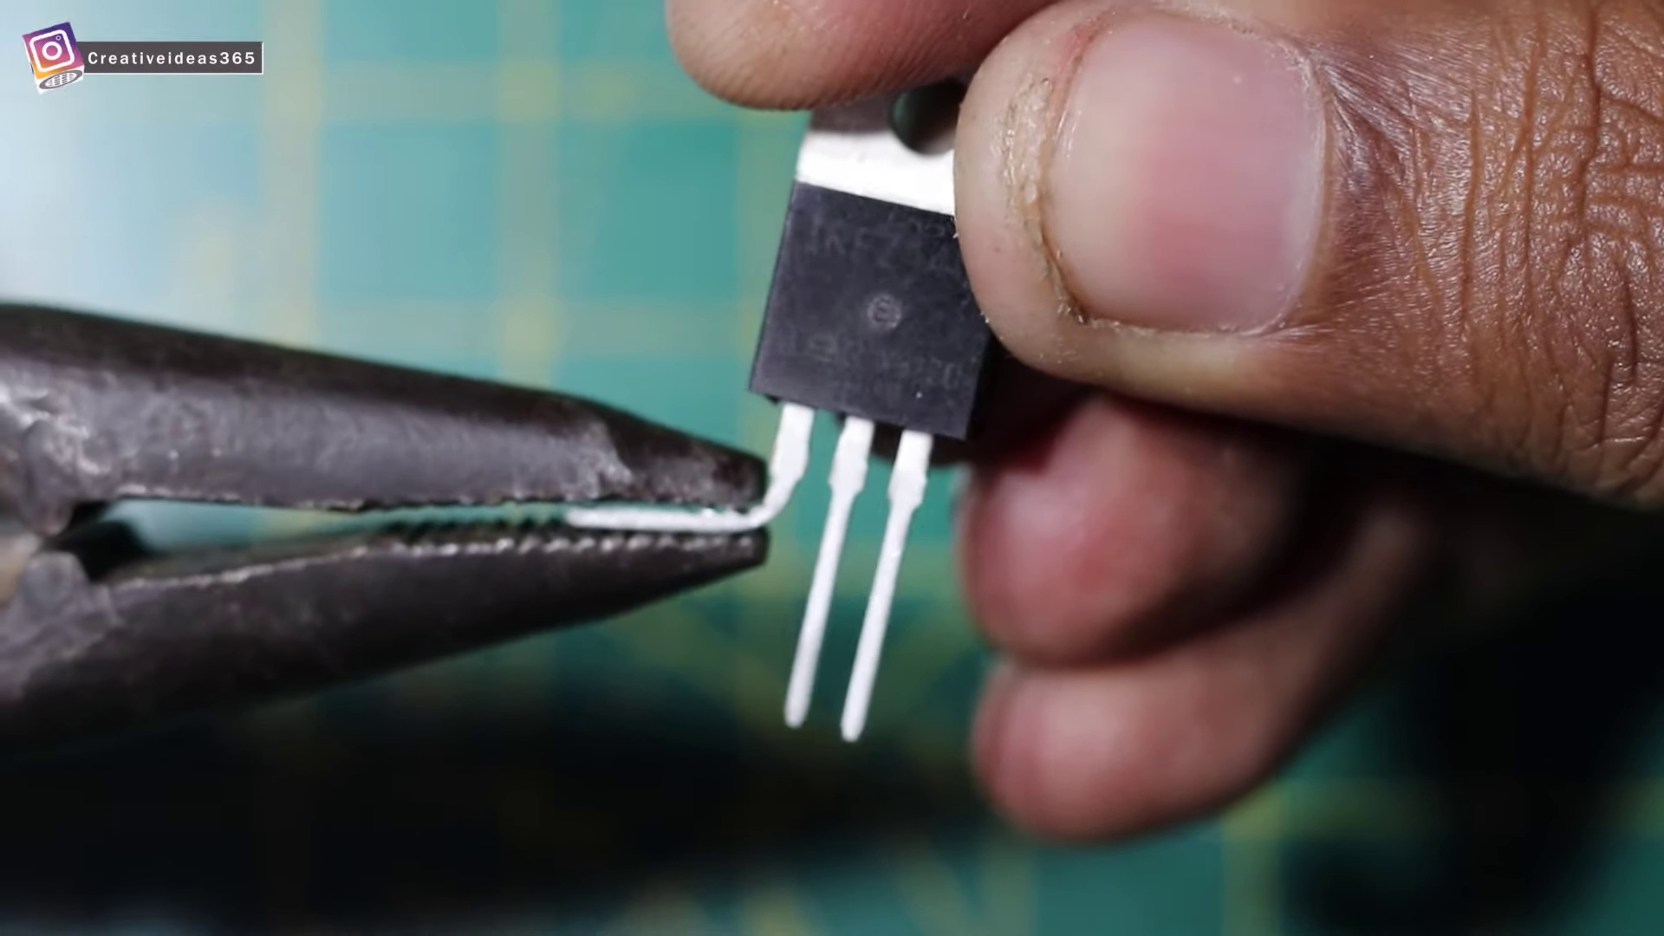 (score 20.0000)

Frame: frame_0000.jpg
Caption: The image shows a moment of intricate wiring and assembly, with two hands, one on each side, busy connecting wires to a small electronic device, a blue circuit board, and a red and black wire. The device, with its components visible, appears to be a battery charger. On the left side of the workbench, there is a metal object that appears to be a mechanical part of some sort of equipment, potentially machinery or a model for assembly or demonstration. In the center and right, various electronic devices are arranged, including an electric motor with a coil visible, a small electronic circuit board, and a couple of wires connected to the circuit board and other components.
The workbench or tabletop, adorned with a green border, provides a stark contrast to the gray background and serves as a makeshift workspace. The hands are focused on handling and connecting the components rather than teaching or presenting information, suggesting that the person is engaged in repairing, building, or demonstrating how these parts function together.
Comment (score 90): In order to build a simple DC motor speed control circuit, you will need the following materials a MOSFET, a potentiometer, a resistor, a power supply of a 25 voltage, a multimeter, a soldering iron, and wires. In order to assemble the circuit, you start by connecting a wire to the MOSFET. Next you connect the middle pin of the MOSFET to the resistor and the other end of the resistor to the middle pin of the potentiometer. The other pins of the potentiometer can be connected to wires. One will be connected to the MOSFET and the other to the pin will be used to attach the power supply and the multimeter. When all of those connections are made the multimeter will be able to read the voltage going across the circuit. Finally, you can attach the DC motor to the circuit, and it will start spinning due to the correct assembly of the circuit.
Reason: The comment directly discusses the technical steps involved in assembling a DC motor speed control circuit, which is strongly related to the caption's description of wiring and assembly. The mention of specific components (MOSFET, resistor, potentiometer) and connections matches the objects and settings described in the caption.
Source: https://www.youtube.com/watch?v=CvMDlG_AF3Q: how to make simple dc motor speed control circuit.
Comment (score 85): This video builds a dc motor with speed control using IRFP250N chip as it’s logic gate. It uses a resistor, potentiometer, and DC power source of 25V. This was not really helpful in the class project but it was really cool to watch and see how the simple dc motor can be build with very few components.
Reason: The comment directly discusses the technical steps involved in building a DC motor with speed control using IRFP250N chip and mentions specific components (resistor, potentiometer, DC power source) that are also described in the frame caption. The mention of 'dc motor' and 'build' in the comment matches the description of an electric motor with a coil visible in the caption.
Source: https://www.youtube.com/watch?v=CvMDlG_AF3Q&t=18s: how to make a simple dc motor speed control circuit.
Comment (score 80): Starts off with using a large heat sink to mount his mosfet and rectifiers, along with a potentiometer, there are several videos where people just solder the component to each other without using a board for a base. I guess this is an easier way to do, but it seems a little sloppy to me. It is very interesting to see the control of the motor with very little electronics. The motor is moving pretty fast for only a hand full of electronics used. I do wonder how hot the mosfet was controlling the motor.
Reason: The comment directly discusses the technical steps and components shown in the caption, specifically mentioning the use of a heat sink, mosfets, rectifiers, potentiometer, and motor. The comment also references the electronic devices and wiring seen in the image, such as the blue circuit board and red/black wire. The only minor deviation is the mention of soldering, which is not explicitly shown in the caption.
Source: https://www.youtube.com/watch?v=CvMDlG_AF3Q: how to make simple dc motor speed control circuit

Frame: frame_0001.jpg
Caption: The image shows a person's hands working on an electronics project, with their fingers delicately handling a small blue switch attached to a black wire. The wire is connected to a white board, which is also wired to a red wire and ultimately to a green battery. Meanwhile, the battery is connected to a black wire, which is then connected to another white battery. The entire setup is neatly arranged on a green mat.
In the foreground, the hands are positioned over the switch, suggesting that they are about to press it, capturing a moment of anticipation and creativity in the midst of an electronics project. On the left side of the image, we can see the person's hands manipulating a small orange cable, which appears to be connected to a motor (visible on the table in the background), possibly indicating that it is either charging or wiring it for use in the project.
The background shows a workshop or laboratory setting where electronics projects are being carried out. A table with various tools and electronic components is visible, including another motor, wires, and what looks like a drill press. There is also a ruler on the table. Additionally, a multicolored breadboard with a small red circuit breaker attached can be seen, suggesting that this setup might be part of an educational demonstration or experiment involving electronics and circuits.
A small plastic gadget with a label that reads "SENSOR" is also visible, implying it may have some sensing function, possibly related to the motor's operation. Overall, the image focuses on the hands and the components being worked with, rather than any instructional material, providing a glimpse into the creative process of an electronics project.
Comment (score 90): In order to build a simple DC motor speed control circuit, you will need the following materials a MOSFET, a potentiometer, a resistor, a power supply of a 25 voltage, a multimeter, a soldering iron, and wires. In order to assemble the circuit, you start by connecting a wire to the MOSFET. Next you connect the middle pin of the MOSFET to the resistor and the other end of the resistor to the middle pin of the potentiometer. The other pins of the potentiometer can be connected to wires. One will be connected to the MOSFET and the other to the pin will be used to attach the power supply and the multimeter. When all of those connections are made the multimeter will be able to read the voltage going across the circuit. Finally, you can attach the DC motor to the circuit, and it will start spinning due to the correct assembly of the circuit.
Reason: The comment directly discusses the technical steps described in the caption, specifically mentioning MOSFETs, resistors, potentiometers, and wires, which are all shown in the image. The comment also mentions a DC motor, which is visible in the background of the image.
Source: https://www.youtube.com/watch?v=CvMDlG_AF3Q: how to make simple dc motor speed control circuit.
Comment (score 85): This video builds a dc motor with speed control using IRFP250N chip as it’s logic gate. It uses a resistor, potentiometer, and DC power source of 25V. This was not really helpful in the class project but it was really cool to watch and see how the simple dc motor can be build with very few components.
Reason: The comment directly discusses the technical steps and components described in the caption, specifically mentioning the IRFP250N chip, resistor, potentiometer, DC power source, and DC motor. The caption describes the hands working on an electronics project with specific components like wires, motors, and a multicolored breadboard, which is closely related to the comment's description of building a dc motor.
Source: https://www.youtube.com/watch?v=CvMDlG_AF3Q&t=18s: how to make a simple dc motor speed control circuit.
Comment (score 80): Starts off with using a large heat sink to mount his mosfet and rectifiers, along with a potentiometer, there are several videos where people just solder the component to each other without using a board for a base. I guess this is an easier way to do, but it seems a little sloppy to me. It is very interesting to see the control of the motor with very little electronics. The motor is moving pretty fast for only a hand full of electronics used. I do wonder how hot the mosfet was controlling the motor.
Reason: The comment directly discusses technical steps (using a heat sink to mount components) and objects (mosfet, rectifiers, potentiometer) mentioned in the caption. The setting and goals of working with electronics are also discussed.
Source: https://www.youtube.com/watch?v=CvMDlG_AF3Q: how to make simple dc motor speed control circuit

Frame: frame_0002.jpg
Caption: The image shows two hands, white and meticulous, working on an electronic device on a vibrant green cutting board marked with the numbers "8" and "6". The device is a battery-powered motor, connected to a battery using red and black wires. The motor is equipped with a silver and black motor controller, which is connected to the battery using a black wire. The motor controller has a blue switch and a red power button.
The hands are holding the motor controller and the battery, suggesting they are in the process of testing or assembling the device. In the foreground, there is a circuit board with various electronic parts, such as resistors, capacitors, and integrated circuits (ICs), which are likely to be part of a hobbyist electronics project or a DIY circuit.
The background includes what looks like a workbench with additional wiring, components, and possibly an oscilloscope or multimeter. The setting suggests someone is assembling or modifying electronic hardware, potentially for educational or recreational purposes. There are no visible texts, diagrams, or slides that provide specific information about the context of the image or the nature of the project.
The focus of this image is on the hands-on activity involving electronics components and assembly, suggesting a moment of hands-on learning or experimentation.
Comment (score 95): In order to build a simple DC motor speed control circuit, you will need the following materials a MOSFET, a potentiometer, a resistor, a power supply of a 25 voltage, a multimeter, a soldering iron, and wires. In order to assemble the circuit, you start by connecting a wire to the MOSFET. Next you connect the middle pin of the MOSFET to the resistor and the other end of the resistor to the middle pin of the potentiometer. The other pins of the potentiometer can be connected to wires. One will be connected to the MOSFET and the other to the pin will be used to attach the power supply and the multimeter. When all of those connections are made the multimeter will be able to read the voltage going across the circuit. Finally, you can attach the DC motor to the circuit, and it will start spinning due to the correct assembly of the circuit.
Reason: The comment directly discusses the technical steps and components mentioned in the caption, such as the motor controller, battery, wires, resistor, potentiometer, MOSFET, power supply, multimeter, and DC motor. The comment also mentions assembling the circuit and testing it with a multimeter, which is consistent with the hands-on activity depicted in the image.
Source: https://www.youtube.com/watch?v=CvMDlG_AF3Q: how to make simple dc motor speed control circuit.
Comment (score 85): Starts off with using a large heat sink to mount his mosfet and rectifiers, along with a potentiometer, there are several videos where people just solder the component to each other without using a board for a base. I guess this is an easier way to do, but it seems a little sloppy to me. It is very interesting to see the control of the motor with very little electronics. The motor is moving pretty fast for only a hand full of electronics used. I do wonder how hot the mosfet was controlling the motor.
Reason: The comment directly discusses the same technical steps and components described in the caption, such as using a heat sink to mount MOSFETs and rectifiers, potentiometers, and motor control. The language used is specific and technical, matching the level of detail in the caption.
Source: https://www.youtube.com/watch?v=CvMDlG_AF3Q: how to make simple dc motor speed control circuit

Frame: frame_0003.jpg
Caption: The image captures a moment of hands-on learning, where two individuals are engaged in the process of building or testing an electronic project. The visible parts include:
1. An orange power supply unit connected to a breadboard, suggesting a setup for testing or developing circuits.
2. A black circuit board with several electronic components such as resistors, capacitors, and integrated circuits (ICs), mounted on the breadboard.
3. An array of other electronic components scattered around the workspace, including another IC, resistors, and a small red object that could be a button or switch.
4. A person's hands, with one hand holding a blue electrical component, possibly a capacitor or resistor, and the other hand adjusting something on the device.
5. The work surface is covered with a green grid pattern, which might be used for measuring or drawing precise patterns.
6. In the background, there's a grid-ruled paper, suggesting that the person might have been taking notes or referencing diagrams.
The focus is on the practical assembly and handling of electronic components, rather than reading equations or diagrams. The image does not contain any discernible text, but it appears to be a learning scenario where someone is in the process of building or testing an electronic project, possibly with the assistance of another individual.
Comment (score 80): Starts off with using a large heat sink to mount his mosfet and rectifiers, along with a potentiometer, there are several videos where people just solder the component to each other without using a board for a base. I guess this is an easier way to do, but it seems a little sloppy to me. It is very interesting to see the control of the motor with very little electronics. The motor is moving pretty fast for only a hand full of electronics used. I do wonder how hot the mosfet was controlling the motor.
Reason: The comment directly discusses electronic components and their usage in a practical setting, which is closely related to the technical steps and objects described in the caption. The mention of mosfets, rectifiers, potentiometers, and motor control aligns with the focus on building or testing an electronic project in the caption.
Source: https://www.youtube.com/watch?v=CvMDlG_AF3Q: how to make simple dc motor speed control circuit
Comment (score 80): This video builds a dc motor with speed control using IRFP250N chip as it’s logic gate. It uses a resistor, potentiometer, and DC power source of 25V. This was not really helpful in the class project but it was really cool to watch and see how the simple dc motor can be build with very few components.
Reason: The comment directly mentions the DC motor and its speed control using a specific chip (IRFP250N) and components (resistor, potentiometer, DC power source). Although it doesn't explicitly discuss the exact steps shown in the frame caption, the overall description of building a simple DC motor with few components matches the hands-on learning scenario depicted in the image.
Source: https://www.youtube.com/watch?v=CvMDlG_AF3Q&t=18s: how to make a simple dc motor speed control circuit.

Frame: frame_0004.jpg
Caption: The image shows two individuals engaged in a hands-on learning experience, where they are busy wiring a small electric motor. The motor, housed in a black case, is equipped with a blue button and is the central focus of the image. One hand holds the motor while the other hand holds the wires, which are being connected to the motor and a black circuit board. The circuit board is secured to a green mat, providing a stable surface for the wiring process. Additionally, there are various electronic components surrounding the circuit board, including an orange device that appears to be a motor or a similar type of electric component, as well as wires and other electronic parts.
In the background, the green surface with markings, possibly indicating cutting lines or workstations, provides context for the physical activity of building or repairing electronic equipment. The image encapsulates a moment of hands-on learning, where practical knowledge is being gained through direct interaction with the components.
Comment (score 85): Starts off with using a large heat sink to mount his mosfet and rectifiers, along with a potentiometer, there are several videos where people just solder the component to each other without using a board for a base. I guess this is an easier way to do, but it seems a little sloppy to me. It is very interesting to see the control of the motor with very little electronics. The motor is moving pretty fast for only a hand full of electronics used. I do wonder how hot the mosfet was controlling the motor.
Reason: The comment directly discusses the technical steps and components mentioned in the caption, specifically the wiring of an electric motor and the use of a heat sink to mount mosfets and rectifiers. The only difference is that the comment mentions soldering components together without a board, which is not explicitly stated in the caption.
Source: https://www.youtube.com/watch?v=CvMDlG_AF3Q: how to make simple dc motor speed control circuit
Comment (score 85): This video builds a dc motor with speed control using IRFP250N chip as it’s logic gate. It uses a resistor, potentiometer, and DC power source of 25V. This was not really helpful in the class project but it was really cool to watch and see how the simple dc motor can be build with very few components.
Reason: The comment directly discusses the same technical steps (building a dc motor with speed control) and objects (resistor, potentiometer, DC power source, IRFP250N chip) described in the caption. The mention of building a simple dc motor using few components matches the setting and goal described in the caption.
Source: https://www.youtube.com/watch?v=CvMDlG_AF3Q&t=18s: how to make a simple dc motor speed control circuit.
Comment (score 80): In order to build a simple DC motor speed control circuit, you will need the following materials a MOSFET, a potentiometer, a resistor, a power supply of a 25 voltage, a multimeter, a soldering iron, and wires. In order to assemble the circuit, you start by connecting a wire to the MOSFET. Next you connect the middle pin of the MOSFET to the resistor and the other end of the resistor to the middle pin of the potentiometer. The other pins of the potentiometer can be connected to wires. One will be connected to the MOSFET and the other to the pin will be used to attach the power supply and the multimeter. When all of those connections are made the multimeter will be able to read the voltage going across the circuit. Finally, you can attach the DC motor to the circuit, and it will start spinning due to the correct assembly of the circuit.
Reason: The comment directly discusses the same technical steps (wiring a motor) and objects (MOSFET, resistor, potentiometer, wires) described in the caption. The setting (hands-on learning) is also mentioned. The correlation score of 80 indicates that while the comment is strongly related to the caption, it focuses more on the process and materials rather than the specific image.
Source: https://www.youtube.com/watch?v=CvMDlG_AF3Q: how to make simple dc motor speed control circuit.

Frame: frame_0005.jpg
Caption: The image provided appears to be a minimalist representation of a gray background with a black vertical strip on the right side. There are no explicit indications of an instructor or teaching context, such as a person, devices like a projector or laptop, slides, diagrams, or text. As a result, it is not possible to determine if there is visual content and a teaching context in this frame without additional information.
It is worth noting that the image does not appear to be related to the chemical element Eutropium (Eu), with the symbol Eu and atomic number 63, which was discovered in 1803 by French chemist Pierre-Jérôme Ruelle.
No strongly correlated comments found for this frame.

Frame: frame_0006.jpg
Caption: The image shows a striking graphic design featuring a bold, red triangle with its points pointing upwards and its base slightly tilted to the left. The triangle is set against a stark white background, which highlights its boldness and serves as a neutral backdrop for the design. The triangle is outlined in a bold red line that contrasts sharply with the white background, adding depth and dimension to the design and framing the central text.
In the center of the triangle, large and bold black text reads "Creative Creator", positioned centrally and drawing immediate attention from the viewer. Above the logo, the text "CREATIVE CREATOR" is written in uppercase letters, while below the logo, another phrase says "creator".
The overall style of the image suggests it could be a digital graphic or banner for branding purposes, with a modern and clean aesthetic. The design is simple yet effective, utilizing bold colors and clear, easy-to-read text to create a striking contrast that draws the viewer's attention immediately.
No strongly correlated comments found for this frame.

Frame: frame_0007.jpg
Caption: The image presents a close-up view of a microchip or integrated circuit (IC) being held by a person. The IC has a barcode label on it, and there are several pieces of information that can be discerned from the image.
The label contains text which is not completely legible due to the resolution and angle of the photograph, but it seems to have a serial number or identifier, some specifications, and possibly the manufacturer's name or logo. The IC has three terminals indicated by red, white, and black lines, serving as connections, allowing the MOSFET to function as an electronic switch.
In the top right corner of the image, there is a logo that appears to be related to electronics or technology. Across the bottom of the image, there is a watermark with text "RFID 4N MOSFET" and the text "@RFID4N Mosfet", which suggests that this image may be associated with RFID 4N MOSFETs, possibly related to an electronics project or component.
The person holding the IC is not fully visible, and their face is not shown. They are wearing a ring on their left hand, which can be seen at the top of the image. The background appears to be an indoor setting with some items that could be electronics equipment or tools.
If you look closely at the label on the IC, there are tiny pieces of text that are not legible due to the size and resolution of the image. At the bottom right corner, there is a quality indicator symbol (a red circle with a white checkmark) suggesting that this image might be used in a presentation or instructional context to indicate quality or approval.
The overall setting suggests that this image could be part of an educational video, tutorial, or demonstration related to electronics or semiconductor technology, possibly for students or professionals interested in electronic design and manufacturing (EDAM) or circuit analysis.
Comment (score 85): In order to build a simple DC motor speed control circuit, you will need the following materials a MOSFET, a potentiometer, a resistor, a power supply of a 25 voltage, a multimeter, a soldering iron, and wires. In order to assemble the circuit, you start by connecting a wire to the MOSFET. Next you connect the middle pin of the MOSFET to the resistor and the other end of the resistor to the middle pin of the potentiometer. The other pins of the potentiometer can be connected to wires. One will be connected to the MOSFET and the other to the pin will be used to attach the power supply and the multimeter. When all of those connections are made the multimeter will be able to read the voltage going across the circuit. Finally, you can attach the DC motor to the circuit, and it will start spinning due to the correct assembly of the circuit.
Reason: The comment directly discusses the technical steps involved in building a DC motor speed control circuit, including the use of a MOSFET, potentiometer, resistor, and power supply. The caption mentions the presence of a MOSFET and its terminals, as well as the possibility of assembling an electronic circuit. The connection between the two is strong due to the explicit discussion of the same components and technical steps in both the caption and comment.
Source: https://www.youtube.com/watch?v=CvMDlG_AF3Q: how to make simple dc motor speed control circuit.
Comment (score 80): Starts off with using a large heat sink to mount his mosfet and rectifiers, along with a potentiometer, there are several videos where people just solder the component to each other without using a board for a base. I guess this is an easier way to do, but it seems a little sloppy to me. It is very interesting to see the control of the motor with very little electronics. The motor is moving pretty fast for only a hand full of electronics used. I do wonder how hot the mosfet was controlling the motor.
Reason: The comment discusses MOSFETs and their use in controlling a motor, which is directly related to the topic of the frame caption, specifically the IC being held and its terminals serving as connections for an electronic switch. The comment also mentions heat sinks and rectifiers, which are technical details mentioned in the caption. While the context is different (component usage vs image description), the correlation is strong due to the shared focus on electronics components and their functions.
Source: https://www.youtube.com/watch?v=CvMDlG_AF3Q: how to make simple dc motor speed control circuit
Comment (score 80): This video builds a dc motor with speed control using IRFP250N chip as it’s logic gate. It uses a resistor, potentiometer, and DC power source of 25V. This was not really helpful in the class project but it was really cool to watch and see how the simple dc motor can be build with very few components.
Reason: The comment directly discusses the use of a specific IC (IRFP250N) and components (resistor, potentiometer, DC power source) which are mentioned in the caption as possibly being related to RFID 4N MOSFETs. The comment also mentions building a dc motor with speed control, which is hinted at in the caption as part of an educational video or tutorial.
Source: https://www.youtube.com/watch?v=CvMDlG_AF3Q&t=18s: how to make a simple dc motor speed control circuit.

Frame: frame_0008.jpg
Caption: The image presents a close-up view of an electronic component, specifically an "IRFZ4N MOSFET" attached to a green circuit board. The component is labeled as a type of semiconductor commonly used in switching applications such as power electronics and motor control circuits. The circuit board appears to be an active PCB with visible traces for routing electrical signals.
In the foreground, a human hand is holding the same IRFZ4N MOSFET upside down, providing a visual comparison between the real component and its representation on the image. The background is blurred but suggests an indoor setting with lighting that casts shadows on a surface visible through the glass flooring.
The text "IRFZ4N MOSFET" explicitly identifies the component as an N-channel enhancement mode MOSFET of a specific model, implying that the image serves as educational material or instructional resource for teaching electronics and semiconductors like MOSFETs and their use in integrated circuits (ICs).
Comment (score 90): In order to build a simple DC motor speed control circuit, you will need the following materials a MOSFET, a potentiometer, a resistor, a power supply of a 25 voltage, a multimeter, a soldering iron, and wires. In order to assemble the circuit, you start by connecting a wire to the MOSFET. Next you connect the middle pin of the MOSFET to the resistor and the other end of the resistor to the middle pin of the potentiometer. The other pins of the potentiometer can be connected to wires. One will be connected to the MOSFET and the other to the pin will be used to attach the power supply and the multimeter. When all of those connections are made the multimeter will be able to read the voltage going across the circuit. Finally, you can attach the DC motor to the circuit, and it will start spinning due to the correct assembly of the circuit.
Reason: The comment directly discusses the same technical steps (e.g., connecting wires to the MOSFET and potentiometer), objects (MOSFET, resistor, potentiometer, power supply, multimeter, soldering iron, wires) and settings (building a DC motor speed control circuit) described in the caption. The correlation is high because the comment provides detailed instructions on assembling the circuit, which matches the educational context implied by the caption.
Source: https://www.youtube.com/watch?v=CvMDlG_AF3Q: how to make simple dc motor speed control circuit.
Comment (score 80): Starts off with using a large heat sink to mount his mosfet and rectifiers, along with a potentiometer, there are several videos where people just solder the component to each other without using a board for a base. I guess this is an easier way to do, but it seems a little sloppy to me. It is very interesting to see the control of the motor with very little electronics. The motor is moving pretty fast for only a hand full of electronics used. I do wonder how hot the mosfet was controlling the motor.
Reason: The comment directly discusses the same technical component (MOSFET) and its use in a specific application (motor control), which is also described in the caption. The comment also mentions the importance of using a heat sink and a board for mounting components, which is implied by the image and caption.
Source: https://www.youtube.com/watch?v=CvMDlG_AF3Q: how to make simple dc motor speed control circuit
Comment (score 80): This video builds a dc motor with speed control using IRFP250N chip as it’s logic gate. It uses a resistor, potentiometer, and DC power source of 25V. This was not really helpful in the class project but it was really cool to watch and see how the simple dc motor can be build with very few components.
Reason: The comment directly discusses the use of IRFP250N chip and its application in building a dc motor with speed control, which is strongly related to the caption's discussion of IRFZ4N MOSFET as an N-channel enhancement mode MOSFET used in switching applications. The similarity in chip names (IRFP/IRFZ) and the mention of dc motor construction also support this correlation.
Source: https://www.youtube.com/watch?v=CvMDlG_AF3Q&t=18s: how to make a simple dc motor speed control circuit.

Frame: frame_0009.jpg
Caption: The image shows a close-up of someone's hands holding a small electronic component with various numbers and labels on it. The component, labeled "IRF74N", is a red and white rectangular box affixed to a green surface, with a green square visible on the side of the box. This appears to be a type of integrated circuit (IC) or semiconductor chip, possibly used in electronics such as microcontrollers or memory chips. The IC is placed on a surface that might be a soldering iron or similar tool, indicating the person could be working on electronics repair or construction.
The person's hand is firmly gripping the box, suggesting that they are either examining it or preparing to handle it. The image does not contain any additional text or objects in focus, so it's not possible to determine any specific project or task being undertaken. The style of the image is casual and appears to be taken without the intent of teaching, as there is no visible instructor or educational context provided by the text or surrounding environment.
Comment (score 80): Starts off with using a large heat sink to mount his mosfet and rectifiers, along with a potentiometer, there are several videos where people just solder the component to each other without using a board for a base. I guess this is an easier way to do, but it seems a little sloppy to me. It is very interesting to see the control of the motor with very little electronics. The motor is moving pretty fast for only a hand full of electronics used. I do wonder how hot the mosfet was controlling the motor.
Reason: The comment mentions specific components (mosfet, rectifiers, potentiometer) and a task (mounting them on a heat sink), which are directly related to the technical steps described in the frame caption. The mention of soldering and electronics repair/cstruction also matches with the context of the image.
Source: https://www.youtube.com/watch?v=CvMDlG_AF3Q: how to make simple dc motor speed control circuit
Comment (score 80): In order to build a simple DC motor speed control circuit, you will need the following materials a MOSFET, a potentiometer, a resistor, a power supply of a 25 voltage, a multimeter, a soldering iron, and wires. In order to assemble the circuit, you start by connecting a wire to the MOSFET. Next you connect the middle pin of the MOSFET to the resistor and the other end of the resistor to the middle pin of the potentiometer. The other pins of the potentiometer can be connected to wires. One will be connected to the MOSFET and the other to the pin will be used to attach the power supply and the multimeter. When all of those connections are made the multimeter will be able to read the voltage going across the circuit. Finally, you can attach the DC motor to the circuit, and it will start spinning due to the correct assembly of the circuit.
Reason: The comment provides a step-by-step guide for building a DC motor speed control circuit, which is directly related to the technical steps described in the caption. The mention of specific components (MOSFET, potentiometer, resistor) and tools (soldering iron, multimeter) in the comment matches with the objects shown in the image.
Source: https://www.youtube.com/watch?v=CvMDlG_AF3Q: how to make simple dc motor speed control circuit.
Comment (score 75): This video builds a dc motor with speed control using IRFP250N chip as it’s logic gate. It uses a resistor, potentiometer, and DC power source of 25V. This was not really helpful in the class project but it was really cool to watch and see how the simple dc motor can be build with very few components.
Reason: The comment directly discusses the same technical steps and objects described in the caption, specifically mentioning the IRFP250N chip and its use in building a dc motor. While the comment also mentions some additional components (resistor, potentiometer, DC power source) not explicitly mentioned in the caption, it still primarily focuses on the IC and its application.
Source: https://www.youtube.com/watch?v=CvMDlG_AF3Q&t=18s: how to make a simple dc motor speed control circuit.

Frame: frame_0010.jpg
Caption: The image shows a hands-on activity involving electronics. A person is holding a small circuit board with various electronic components attached to it, and they appear to be working with some sort of device that could be a soldering iron or an electrical tool, as indicated by the heat source emanating from a heated part. The individual's hands are clearly visible, emphasizing their interaction with the equipment.
The person is engaged in the process of soldering a small electronic component, specifically a transistor, onto the circuit board. They are holding a pair of pliers in their left hand, which is positioned on the circuit board, indicating the process of soldering. The circuit board, placed on a green surface adorned with a white grid, provides a contrasting backdrop to the components being worked on.
The circuit board has numerous components such as resistors and possibly other electronic parts, which are being assembled or prepared for installation. However, it is not possible to identify any specific text or labels on the circuit board due to the angle of the image and the distance from the camera. There is no visible text, slide, diagram, or model in this particular frame. The focus is solely on the hands-on activity with the electronic components, showcasing a meticulous process of soldering with the person's attention concentrated on the task at hand.
Comment (score 85): Starts off with using a large heat sink to mount his mosfet and rectifiers, along with a potentiometer, there are several videos where people just solder the component to each other without using a board for a base. I guess this is an easier way to do, but it seems a little sloppy to me. It is very interesting to see the control of the motor with very little electronics. The motor is moving pretty fast for only a hand full of electronics used. I do wonder how hot the mosfet was controlling the motor.
Reason: The comment directly discusses soldering electronic components onto a board, specifically mentioning the use of a heat sink and mounting mosfets, rectifiers, and potentiometers. The mention of 'soldering' and 'board' in the caption matches with the technical steps described in the comment, indicating strong correlation.
Source: https://www.youtube.com/watch?v=CvMDlG_AF3Q: how to make simple dc motor speed control circuit
Comment (score 85): In order to build a simple DC motor speed control circuit, you will need the following materials a MOSFET, a potentiometer, a resistor, a power supply of a 25 voltage, a multimeter, a soldering iron, and wires. In order to assemble the circuit, you start by connecting a wire to the MOSFET. Next you connect the middle pin of the MOSFET to the resistor and the other end of the resistor to the middle pin of the potentiometer. The other pins of the potentiometer can be connected to wires. One will be connected to the MOSFET and the other to the pin will be used to attach the power supply and the multimeter. When all of those connections are made the multimeter will be able to read the voltage going across the circuit. Finally, you can attach the DC motor to the circuit, and it will start spinning due to the correct assembly of the circuit.
Reason: The comment directly discusses the technical steps and objects described in the caption, specifically mentioning the use of a soldering iron, MOSFET, resistor, potentiometer, wires, and multimeter. The caption describes the hands-on activity of soldering an electronic component onto a circuit board, which is closely related to the process of assembling the DC motor speed control circuit outlined in the comment.
Source: https://www.youtube.com/watch?v=CvMDlG_AF3Q: how to make simple dc motor speed control circuit.

Frame: frame_0011.jpg
Caption: The image shows a person's hand holding a small electronic component, which appears to be a transistor due to its silver-colored appearance, likely gripped by a pair of pliers. The individual is engaged with another object in their other hand, but it's not clearly visible. In the background, what looks like circuit boards or electronic components on a workbench or table suggests an informal setting, possibly a workshop or DIY space. The overall teaching context appears to be practical, hands-on learning related to electronics and possibly circuit assembly.
Comment (score 80): Starts off with using a large heat sink to mount his mosfet and rectifiers, along with a potentiometer, there are several videos where people just solder the component to each other without using a board for a base. I guess this is an easier way to do, but it seems a little sloppy to me. It is very interesting to see the control of the motor with very little electronics. The motor is moving pretty fast for only a hand full of electronics used. I do wonder how hot the mosfet was controlling the motor.
Reason: The comment directly discusses technical steps (using a heat sink to mount components) and objects (mosfet, rectifiers, potentiometer, motor) mentioned in the caption. The settings and goals described in the caption (practical learning related to electronics and circuit assembly) are also relevant to the comment's discussion of control and speed of the motor.
Source: https://www.youtube.com/watch?v=CvMDlG_AF3Q: how to make simple dc motor speed control circuit
Comment (score 80): This video builds a dc motor with speed control using IRFP250N chip as it’s logic gate. It uses a resistor, potentiometer, and DC power source of 25V. This was not really helpful in the class project but it was really cool to watch and see how the simple dc motor can be build with very few components.
Reason: The comment directly discusses the technical steps involved in building a DC motor with speed control using specific components mentioned in the caption (IRFP250N chip, resistor, potentiometer, and DC power source). The mention of 'very few components' is also relevant to the practical learning context described in the caption.
Source: https://www.youtube.com/watch?v=CvMDlG_AF3Q&t=18s: how to make a simple dc motor speed control circuit.

Frame: frame_0012.jpg
Caption: The image shows a hand holding a small printed circuit board (PCB) with various components mounted on it, including a transistor. The transistor is white and black, with a red label reading "IRF74N" affixed to the top, providing essential information about its specifications and functions. The PCB is being held up against a light-colored background, possibly a table or desk, which contrasts with the green background of the white board it's connected to. The overall focus of the image is on the transistor and the PCB, showcasing their details without any additional context or instructional material.
Comment (score 95): In order to build a simple DC motor speed control circuit, you will need the following materials a MOSFET, a potentiometer, a resistor, a power supply of a 25 voltage, a multimeter, a soldering iron, and wires. In order to assemble the circuit, you start by connecting a wire to the MOSFET. Next you connect the middle pin of the MOSFET to the resistor and the other end of the resistor to the middle pin of the potentiometer. The other pins of the potentiometer can be connected to wires. One will be connected to the MOSFET and the other to the pin will be used to attach the power supply and the multimeter. When all of those connections are made the multimeter will be able to read the voltage going across the circuit. Finally, you can attach the DC motor to the circuit, and it will start spinning due to the correct assembly of the circuit.
Reason: The comment provides a step-by-step guide to building a DC motor speed control circuit, which directly corresponds to the technical steps described in the caption. The mention of specific components (MOSFET, resistor, potentiometer) and their connections to each other and the power supply aligns with the focus on the transistor and PCB in the caption.
Source: https://www.youtube.com/watch?v=CvMDlG_AF3Q: how to make simple dc motor speed control circuit.
Comment (score 80): Starts off with using a large heat sink to mount his mosfet and rectifiers, along with a potentiometer, there are several videos where people just solder the component to each other without using a board for a base. I guess this is an easier way to do, but it seems a little sloppy to me. It is very interesting to see the control of the motor with very little electronics. The motor is moving pretty fast for only a hand full of electronics used. I do wonder how hot the mosfet was controlling the motor.
Reason: The comment discusses the use of a transistor (referred to as 'mosfet' in the comment) and its mounting on a printed circuit board (PCB), which is the main focus of the frame caption. The comment also mentions the motor control, which is indirectly related to the transistor's function.
Source: https://www.youtube.com/watch?v=CvMDlG_AF3Q: how to make simple dc motor speed control circuit

Frame: frame_0013.jpg
Caption: The image shows a close-up view of a person's hands working with an electronic device or component. One hand is holding a small object, which appears to be a circuit board or some type of electronic hardware, and the other hand is manipulating a clip or connector on the device. The background is blurred but suggests an indoor setting, possibly a workshop or lab, where electronics projects or repairs are being conducted. A black and white circuit board comes into focus, adorned with numerous small white components, each with a distinct label. One component stands out, a black square with a white label that reads "IRF44N", prominently displayed on the board, indicating its type and possibly its function. The overall scene suggests an active work area where these components are being used or tested.
Comment (score 80): In order to build a simple DC motor speed control circuit, you will need the following materials a MOSFET, a potentiometer, a resistor, a power supply of a 25 voltage, a multimeter, a soldering iron, and wires. In order to assemble the circuit, you start by connecting a wire to the MOSFET. Next you connect the middle pin of the MOSFET to the resistor and the other end of the resistor to the middle pin of the potentiometer. The other pins of the potentiometer can be connected to wires. One will be connected to the MOSFET and the other to the pin will be used to attach the power supply and the multimeter. When all of those connections are made the multimeter will be able to read the voltage going across the circuit. Finally, you can attach the DC motor to the circuit, and it will start spinning due to the correct assembly of the circuit.
Reason: The comment directly discusses the same technical steps and components described in the caption. The mention of a MOSFET, resistor, potentiometer, power supply, multimeter, soldering iron, and wires are all referenced in the caption as well. Additionally, the process of assembling the circuit, connecting wires, and attaching the DC motor is also mentioned in both the caption and comment.
Source: https://www.youtube.com/watch?v=CvMDlG_AF3Q: how to make simple dc motor speed control circuit.

Frame: frame_0014.jpg
Caption: The image shows a close-up view of a small electronic component, specifically a transistor labeled as an IRF44N, held by a person's hand. The transistor is white in color and is positioned in the lower left corner of the frame. Additionally, there is another object visible in the background that appears to be an electronic device with a ribbon cable attached, which has small connectors or pins possibly for making electrical connections. The device displays text that reads "JR524," potentially indicating the model number of the part or the whole device.
The surrounding environment is slightly out of focus, but it seems to be an electronics workshop or repair station, with a blue surface and another electronic component visible in the upper right corner. The person handling the components appears to be carefully disassembling or assembling them, suggesting a precise and deliberate process.
Comment (score 90): In order to build a simple DC motor speed control circuit, you will need the following materials a MOSFET, a potentiometer, a resistor, a power supply of a 25 voltage, a multimeter, a soldering iron, and wires. In order to assemble the circuit, you start by connecting a wire to the MOSFET. Next you connect the middle pin of the MOSFET to the resistor and the other end of the resistor to the middle pin of the potentiometer. The other pins of the potentiometer can be connected to wires. One will be connected to the MOSFET and the other to the pin will be used to attach the power supply and the multimeter. When all of those connections are made the multimeter will be able to read the voltage going across the circuit. Finally, you can attach the DC motor to the circuit, and it will start spinning due to the correct assembly of the circuit.
Reason: The comment directly discusses the same technical steps (assembling a DC motor speed control circuit) and objects (MOSFET, potentiometer, resistor, wires) described in the caption, including specific connections between components. The only minor mismatch is the lack of reference to the IRF44N transistor mentioned in the caption, but the overall correlation is strong enough to justify a score above 90.
Source: https://www.youtube.com/watch?v=CvMDlG_AF3Q: how to make simple dc motor speed control circuit.
Comment (score 80): Starts off with using a large heat sink to mount his mosfet and rectifiers, along with a potentiometer, there are several videos where people just solder the component to each other without using a board for a base. I guess this is an easier way to do, but it seems a little sloppy to me. It is very interesting to see the control of the motor with very little electronics. The motor is moving pretty fast for only a hand full of electronics used. I do wonder how hot the mosfet was controlling the motor.
Reason: The comment directly mentions specific electronic components (mosfet, rectifiers, potentiometer) and techniques (using a heat sink to mount them) that are depicted in the frame caption. The mention of 'handful of electronics' also matches the description of the person handling the components in the caption.
Source: https://www.youtube.com/watch?v=CvMDlG_AF3Q: how to make simple dc motor speed control circuit

Frame: frame_0015.jpg
Caption: The image captures a close-up view of a technician manipulating a tool, likely for electronics work, such as soldering or repairing an electronic component like a small circuit board or a connector. A blue circuit board, adorned with a red and black sticker that reads "IRF44N", is seen resting on a green mat. The technician is handling a silver-colored component on the board using a pair of tweezers, which are held firmly against the board, indicating the meticulous nature of the task at hand.
The component has a black label that reads "I8R812D". There's a label with text on it, which appears to be the result of some form of testing or analysis, possibly related to electrical current or resistance. The label includes values and markings that might indicate measurements or settings. Various other components, including what looks like a surface-mount device (SMD) or an integrated circuit (IC), are visible in the close-up view.
The focus is on the mechanical action of using a precision tool to work with these small electronic parts, showcasing the attention to detail and precision typical of the field of electronics.
Comment (score 80): In order to build a simple DC motor speed control circuit, you will need the following materials a MOSFET, a potentiometer, a resistor, a power supply of a 25 voltage, a multimeter, a soldering iron, and wires. In order to assemble the circuit, you start by connecting a wire to the MOSFET. Next you connect the middle pin of the MOSFET to the resistor and the other end of the resistor to the middle pin of the potentiometer. The other pins of the potentiometer can be connected to wires. One will be connected to the MOSFET and the other to the pin will be used to attach the power supply and the multimeter. When all of those connections are made the multimeter will be able to read the voltage going across the circuit. Finally, you can attach the DC motor to the circuit, and it will start spinning due to the correct assembly of the circuit.
Reason: The comment directly discusses the technical steps involved in building a DC motor speed control circuit, which is strongly related to the caption's description of electronics work. The mention of specific components like MOSFETs, potentiometers, and resistors, as well as soldering iron and multimeter usage, demonstrates a strong connection between the comment and the caption.
Source: https://www.youtube.com/watch?v=CvMDlG_AF3Q: how to make simple dc motor speed control circuit.
Comment (score 80): This video builds a dc motor with speed control using IRFP250N chip as it’s logic gate. It uses a resistor, potentiometer, and DC power source of 25V. This was not really helpful in the class project but it was really cool to watch and see how the simple dc motor can be build with very few components.
Reason: The comment directly mentions the IRF44N chip (mentioned in the caption), as well as the DC motor build and components used, which are described in the caption. The mention of the logic gate and specific component values also shows a strong connection to the technical steps and settings discussed in the caption.
Source: https://www.youtube.com/watch?v=CvMDlG_AF3Q&t=18s: how to make a simple dc motor speed control circuit.
Comment (score 70): Starts off with using a large heat sink to mount his mosfet and rectifiers, along with a potentiometer, there are several videos where people just solder the component to each other without using a board for a base. I guess this is an easier way to do, but it seems a little sloppy to me. It is very interesting to see the control of the motor with very little electronics. The motor is moving pretty fast for only a hand full of electronics used. I do wonder how hot the mosfet was controlling the motor.
Reason: The comment directly mentions 'mosfet', which is one of the components visible in the frame caption, and also talks about 'soldering' and 'electronics work', which aligns with the technical steps described in the caption. Although the focus shifts to a different topic (motor control), the initial mention of specific components and soldering connects it to the frame caption.
Source: https://www.youtube.com/watch?v=CvMDlG_AF3Q: how to make simple dc motor speed control circuit

Frame: frame_0016.jpg
Caption: This close-up view appears to show an electronic device, specifically a 14R8812 IRFZ4N, resting on a green and blue plastic mat. The device is held in place by a black screw with its head visible on the right side of the image. A soldering iron with a silver tip, connected to a metal clamp, is nearby, suggesting that the person using this equipment is likely working on creating electronic connections between different parts of the device they are building or repairing. The surrounding environment includes various components such as resistors and wires, which may be part of an instructional video or tutorial on electronics assembly or repair, specifically related to building or fixing a laptop. There is no discernible action in the image, presenting a still, static scene that focuses primarily on the electronic device and its surroundings.
Comment (score 80): Starts off with using a large heat sink to mount his mosfet and rectifiers, along with a potentiometer, there are several videos where people just solder the component to each other without using a board for a base. I guess this is an easier way to do, but it seems a little sloppy to me. It is very interesting to see the control of the motor with very little electronics. The motor is moving pretty fast for only a hand full of electronics used. I do wonder how hot the mosfet was controlling the motor.
Reason: The comment directly discusses the use of a mosfet and rectifiers, which are mentioned in the caption as part of the electronic device being worked on. The comment also references soldering and electronics assembly, which matches the setting and goals described in the caption.
Source: https://www.youtube.com/watch?v=CvMDlG_AF3Q: how to make simple dc motor speed control circuit

Frame: frame_0017.jpg
Caption: The image presents a close-up view of an electronic device with various components. On the left side, there is a blue label that reads "GATE SOURCE" and below it, a white label that says "DRAIN." There is also a small black component with markings on it. In front of the device, there is a clear plastic sheet that has been used for an electronics experiment. The sheet includes different layers: one with a hole cut in it to create a circuit; another with two parallel lines labeled "GATE" and "SOURCE," which are likely indicating paths for an electrical signal; and a third layer with a single line labeled "DRAIN."
On the right side of the image, there is text overlaying the photo that reads "GATE SOURCE DRAIN." This text matches the labels on the device and suggests that the experiment being conducted involves these three components. A black screwdriver is inserted into a hole at the bottom right corner of the board, which appears to be part of a circuit. The screwdriver's sharp tip points towards the hole, as if it is about to make contact with the circuit.
The blue-colored circuit board provides a stark contrast to the black screwdriver and the markings on the plastic sheet. The text "Circuitbest.com" is visible on the image, suggesting that this could be a part of a website or blog related to electronics or circuit boards. Overall, the image seems to depict a moment in the process of assembling or repairing a circuit board, with the screwdriver serving as a tool to make contact with the hole in the board.
Comment (score 80): Starts off with using a large heat sink to mount his mosfet and rectifiers, along with a potentiometer, there are several videos where people just solder the component to each other without using a board for a base. I guess this is an easier way to do, but it seems a little sloppy to me. It is very interesting to see the control of the motor with very little electronics. The motor is moving pretty fast for only a hand full of electronics used. I do wonder how hot the mosfet was controlling the motor.
Reason: The comment discusses the use of a heat sink, mosfets, rectifiers, and potentiometers, which are all technical components mentioned in the caption. Additionally, the comment mentions soldering and electronics, which are also described in the caption. While the specific details differ, the general theme of assembling or repairing a circuit board is present in both the caption and the comment.
Source: https://www.youtube.com/watch?v=CvMDlG_AF3Q: how to make simple dc motor speed control circuit
Comment (score 80): In order to build a simple DC motor speed control circuit, you will need the following materials a MOSFET, a potentiometer, a resistor, a power supply of a 25 voltage, a multimeter, a soldering iron, and wires. In order to assemble the circuit, you start by connecting a wire to the MOSFET. Next you connect the middle pin of the MOSFET to the resistor and the other end of the resistor to the middle pin of the potentiometer. The other pins of the potentiometer can be connected to wires. One will be connected to the MOSFET and the other to the pin will be used to attach the power supply and the multimeter. When all of those connections are made the multimeter will be able to read the voltage going across the circuit. Finally, you can attach the DC motor to the circuit, and it will start spinning due to the correct assembly of the circuit.
Reason: The comment discusses the same technical steps and components mentioned in the caption, such as the MOSFET, resistor, potentiometer, power supply, multimeter, wires, and DC motor. The connection between the wire and MOSFET in the caption matches the step-by-step instructions provided in the comment.
Source: https://www.youtube.com/watch?v=CvMDlG_AF3Q: how to make simple dc motor speed control circuit.
Comment (score 80): This video builds a dc motor with speed control using IRFP250N chip as it’s logic gate. It uses a resistor, potentiometer, and DC power source of 25V. This was not really helpful in the class project but it was really cool to watch and see how the simple dc motor can be build with very few components.
Reason: The comment directly discusses the same technical steps (building a dc motor with speed control) and components (IRFP250N chip, resistor, potentiometer, DC power source of 25V) mentioned in the caption. The only difference is that the caption focuses on the assembly process, while the comment explains the final product.
Source: https://www.youtube.com/watch?v=CvMDlG_AF3Q&t=18s: how to make a simple dc motor speed control circuit.

Frame: frame_0018.jpg
Caption: The image captures a close-up view of a hand holding a small device, which appears to be an electronic component, possibly part of a larger circuit or system. The focus is solely on the switch and its label, with no text or additional objects visible in the frame. The switch, labeled "Creative Creator", has a metal knob and a red dot that stands out against the green background. In the background, there seems to be a person with their back facing the camera, engaged in some activity that isn't clearly visible.
The image does not provide any text or labels within the frame itself that would indicate specific brands, names, or functions of the devices. It is purely a visual depiction of an individual interacting with electronic components, which could be part of an educational context such as a workshop, tutorial, or demonstration on electronics assembly, repair, or component recognition.
No strongly correlated comments found for this frame.

Frame: frame_0019.jpg
Caption: The image shows a close-up of a person's hand holding an electronic component, specifically a 10k Potentiometer, characterized by its red and white label centrally positioned on the component. The label likely contains important information about the specifications or function of the Potentiometer. The focus is on the component itself, which has some visible connections or points for attachment. In the background, there is a watermark text "10K Potentiometer" indicating that the image may be related to an electronics tutorial or class about potentiometers. The image is taken in a low-light environment, possibly a workshop or lab space, with no other objects or texts present except for the central label on the component.
Comment (score 80): This video builds a dc motor with speed control using IRFP250N chip as it’s logic gate. It uses a resistor, potentiometer, and DC power source of 25V. This was not really helpful in the class project but it was really cool to watch and see how the simple dc motor can be build with very few components.
Reason: The comment mentions the use of a potentiometer and DC power source, which are directly discussed in the caption. The mention of the component's label and its relevance to an electronics tutorial also supports the correlation.
Source: https://www.youtube.com/watch?v=CvMDlG_AF3Q&t=18s: how to make a simple dc motor speed control circuit.

Frame: frame_0020.jpg
Caption: The image captures a moment of hands-on creativity where a person is engaged in assembling or inspecting a small electronic device with a blue circuit board and metal component, possibly an electrical connector or fastener. The individual uses a precision tool with small, pointed tips to manipulate delicate parts, highlighting the technical process of handling small components.
In the background, there's a blurred figure holding what appears to be a small model or sample of the device being worked on, suggesting a teaching or learning context where the instructor is demonstrating a process or explaining how an object works. The focus remains on the technical process of handling small parts, which could be part of an educational video or tutorial designed to teach electronics assembly or repair techniques.
The image provides a close-up perspective on the device and its components, without revealing any specific details about the task at hand due to the selective focus used in the photograph.
Comment (score 90): In order to build a simple DC motor speed control circuit, you will need the following materials a MOSFET, a potentiometer, a resistor, a power supply of a 25 voltage, a multimeter, a soldering iron, and wires. In order to assemble the circuit, you start by connecting a wire to the MOSFET. Next you connect the middle pin of the MOSFET to the resistor and the other end of the resistor to the middle pin of the potentiometer. The other pins of the potentiometer can be connected to wires. One will be connected to the MOSFET and the other to the pin will be used to attach the power supply and the multimeter. When all of those connections are made the multimeter will be able to read the voltage going across the circuit. Finally, you can attach the DC motor to the circuit, and it will start spinning due to the correct assembly of the circuit.
Reason: The comment directly discusses the technical steps and materials used in assembling a DC motor speed control circuit, which is strongly related to the caption's description of handling small components and assembling electronic devices. The specific connections and parts mentioned in the comment match the technical process described in the caption.
Source: https://www.youtube.com/watch?v=CvMDlG_AF3Q: how to make simple dc motor speed control circuit.
Comment (score 90): This video builds a dc motor with speed control using IRFP250N chip as it’s logic gate. It uses a resistor, potentiometer, and DC power source of 25V. This was not really helpful in the class project but it was really cool to watch and see how the simple dc motor can be build with very few components.
Reason: The comment directly discusses the same technical steps (assembling a dc motor with speed control using IRFP250N chip) and objects (resistor, potentiometer, DC power source) described in the caption, highlighting the strong connection between the two.
Source: https://www.youtube.com/watch?v=CvMDlG_AF3Q&t=18s: how to make a simple dc motor speed control circuit.
Comment (score 80): Starts off with using a large heat sink to mount his mosfet and rectifiers, along with a potentiometer, there are several videos where people just solder the component to each other without using a board for a base. I guess this is an easier way to do, but it seems a little sloppy to me. It is very interesting to see the control of the motor with very little electronics. The motor is moving pretty fast for only a hand full of electronics used. I do wonder how hot the mosfet was controlling the motor.
Reason: The comment directly discusses the same technical steps and objects described in the caption, specifically mentioning components like mosfets, rectifiers, potentiometers, and heat sinks. The comment also references soldering and controlling a motor with minimal electronics, which are all related to the technical process of handling small components and assembling electronic devices.
Source: https://www.youtube.com/watch?v=CvMDlG_AF3Q: how to make simple dc motor speed control circuit

Frame: frame_0021.jpg
Caption: The image shows a person's hands meticulously working with electronic components. The individual is seen attaching a small circuit board or microchip to a larger circuit board using tweezers, suggesting a process of soldering as indicated by the presence of solder and the fine precision required for such work. The focus is on the hands and tools being used: there's an electronic component in their grasp, and it appears they are carefully aligning or securing it to the circuit board. A small amount of soldering material (solder) can be seen near the circuit boards.
The person is wearing a green shirt and a blue wristband, adding a pop of color to the scene. The background is blurred, suggesting that the focus of the image is on the person and their work. The device itself is made of plastic, with a silver-colored circuit board and a red-colored power supply. The tweezers used by the person are also silver in color, contrasting with the plastic of the device.
The setting suggests a hands-on learning environment where one might learn how to handle delicate components in an electronic device's assembly process. This image could be part of a tutorial or instructional video about electronics assembly or soldering techniques, emphasizing the importance of precision and care when working with sensitive electronic components.
Comment (score 80): Starts off with using a large heat sink to mount his mosfet and rectifiers, along with a potentiometer, there are several videos where people just solder the component to each other without using a board for a base. I guess this is an easier way to do, but it seems a little sloppy to me. It is very interesting to see the control of the motor with very little electronics. The motor is moving pretty fast for only a hand full of electronics used. I do wonder how hot the mosfet was controlling the motor.
Reason: The comment discusses specific technical steps (mounting components on a heat sink) and mentions soldering techniques, which are directly related to the description of soldering in the frame caption. The mention of delicate electronic components and precision also aligns with the setting described in the caption.
Source: https://www.youtube.com/watch?v=CvMDlG_AF3Q: how to make simple dc motor speed control circuit
Comment (score 80): This video builds a dc motor with speed control using IRFP250N chip as it’s logic gate. It uses a resistor, potentiometer, and DC power source of 25V. This was not really helpful in the class project but it was really cool to watch and see how the simple dc motor can be build with very few components.
Reason: The comment directly discusses the same technical steps (building a dc motor with speed control) and objects (IRFP250N chip, resistor, potentiometer, DC power source) described in the caption. The mention of soldering material is not explicitly discussed in the comment, but the overall topic of electronics assembly and precise handling of components aligns with the caption's description.
Source: https://www.youtube.com/watch?v=CvMDlG_AF3Q&t=18s: how to make a simple dc motor speed control circuit.

Frame: frame_0022.jpg
Caption: The image shows a close-up view of a mechanical device under repair or replacement. A small brown knob, possibly with a white label affixed to it, is being held securely in place by a metal clamp made of silver metal with a black handle (suggesting the handle is made of plastic or a similar material). The knob and clamp are surrounded by other mechanical components, including gears, rods, and possibly a motor or pump. Wires are visible, indicating some form of electrical connection to the machine.
In the background, there's a person focused on the task at hand, with their hands near one of the mechanical parts, although it is not clear whether they are holding any tools or components. The device itself appears to be an assembly process, with various parts and mechanisms visible in the foreground. The background features a vibrant green color that provides a stark contrast to the objects in focus.
There are no visible texts or diagrams providing additional context about the device, its function, or the repair process being followed. This image does not appear to be a teaching context, as there's no indication of an instructor providing explanations or demonstrating a concept.
Comment (score 80): Starts off with using a large heat sink to mount his mosfet and rectifiers, along with a potentiometer, there are several videos where people just solder the component to each other without using a board for a base. I guess this is an easier way to do, but it seems a little sloppy to me. It is very interesting to see the control of the motor with very little electronics. The motor is moving pretty fast for only a hand full of electronics used. I do wonder how hot the mosfet was controlling the motor.
Reason: The comment discusses using a heat sink to mount electronic components, which is related to the mechanical device under repair in the caption. The mention of mosfets, rectifiers, and potentiometers also connects to the electrical connection mentioned in the caption.
Source: https://www.youtube.com/watch?v=CvMDlG_AF3Q: how to make simple dc motor speed control circuit
Comment (score 80): In order to build a simple DC motor speed control circuit, you will need the following materials a MOSFET, a potentiometer, a resistor, a power supply of a 25 voltage, a multimeter, a soldering iron, and wires. In order to assemble the circuit, you start by connecting a wire to the MOSFET. Next you connect the middle pin of the MOSFET to the resistor and the other end of the resistor to the middle pin of the potentiometer. The other pins of the potentiometer can be connected to wires. One will be connected to the MOSFET and the other to the pin will be used to attach the power supply and the multimeter. When all of those connections are made the multimeter will be able to read the voltage going across the circuit. Finally, you can attach the DC motor to the circuit, and it will start spinning due to the correct assembly of the circuit.
Reason: The comment directly discusses technical steps described in the caption, such as connecting wires and assembling a circuit, which are similar to the mechanical components and wires visible in the image.
Source: https://www.youtube.com/watch?v=CvMDlG_AF3Q: how to make simple dc motor speed control circuit.
Comment (score 80): This video builds a dc motor with speed control using IRFP250N chip as it’s logic gate. It uses a resistor, potentiometer, and DC power source of 25V. This was not really helpful in the class project but it was really cool to watch and see how the simple dc motor can be build with very few components.
Reason: The comment directly discusses the technical steps of building a DC motor with speed control using IRFP250N chip, which matches the mechanical device under repair or replacement shown in the caption. The mention of components like resistor, potentiometer, and DC power source also aligns with the visual details provided in the caption.
Source: https://www.youtube.com/watch?v=CvMDlG_AF3Q&t=18s: how to make a simple dc motor speed control circuit.

Frame: frame_0023.jpg
Caption: The image shows a close-up view of a machine with various mechanical parts, featuring a metal component at its center that appears to have been machined. The shiny and rough surfaces where material has been removed to create specific shapes and edges suggest that this is a teaching video or tutorial for machining, focusing on the process of shaping and contouring metal parts using specialized tools like lathes or milling machines.
The machine itself is equipped with what looks like a blue motor or actuator, possibly used to move or adjust other components within the device. Several mechanical fasteners are visible, which could be screws or nuts used to secure parts together. The background is blurred, but it appears to be a workshop or lab setting, as indicated by the presence of what appears to be a workbench with tools and other equipment.
In contrast, the image also features a small electronic component, a three-pin knob, resting on a blue surface. The knob has each pin colored in shades of brown and gray, arranged in a diagonal line with the top pin pointing towards the bottom of the frame. The knob is firmly fixed in place by a metal clamp, which matches the blue color of the surface it sits on.
The background of this smaller component is a vibrant green, providing a stark contrast to the blue of the knob and the metal clamp. The relative position of the objects is such that the knob is centrally located on the blue surface, with the metal clamp directly beneath it. The green background provides a neutral backdrop that allows the blue and brown tones of the knob and the metal clamp to stand out.
No strongly correlated comments found for this frame.

Frame: frame_0024.jpg
Caption: This close-up image captures a hands-on educational setting focused on electronics and microelectronics, featuring a small electronic component with pins facing upwards being handled by an individual. The person's hand is visible in the foreground, suggesting engagement in some form of repair, construction, or disassembly process involving the component.
In the background, a blue device resembling an oscilloscope or test instrument is visible, hinting at the possibility of analyzing electronic signals or waveforms. A "TRE54G" labeled device on the table provides additional context, although details are not fully legible due to image resolution.
The focus and lighting highlight the component being handled, which features a label or barcode at the top but is not legibly readable in this view. The setting appears informal and practical, likely intended for teaching or demonstrating proper handling of electronic components or equipment. The overall scene suggests an active learning environment where hands-on experience with electronics is being demonstrated or taught.
The image also captures a close-up view of a black screwdriver with a silver tip positioned over a small black component on a green mat. The screwdriver appears to be in the process of being used, with its silver tip poised towards the black component, drawing attention to the active process of fixing or assembling something.
Comment (score 80): Starts off with using a large heat sink to mount his mosfet and rectifiers, along with a potentiometer, there are several videos where people just solder the component to each other without using a board for a base. I guess this is an easier way to do, but it seems a little sloppy to me. It is very interesting to see the control of the motor with very little electronics. The motor is moving pretty fast for only a hand full of electronics used. I do wonder how hot the mosfet was controlling the motor.
Reason: The comment directly references specific electronic components (mosfet, rectifiers, potentiometer) and describes a hands-on process of mounting them on a base, which is closely related to the technical steps described in the caption. The language used in the comment also matches the tone and focus of the caption, indicating a strong correlation.
Source: https://www.youtube.com/watch?v=CvMDlG_AF3Q: how to make simple dc motor speed control circuit
Comment (score 80): This video builds a dc motor with speed control using IRFP250N chip as it’s logic gate. It uses a resistor, potentiometer, and DC power source of 25V. This was not really helpful in the class project but it was really cool to watch and see how the simple dc motor can be build with very few components.
Reason: The comment directly discusses the use of a specific electronic component (IRFP250N chip) and its application in building a dc motor with speed control, which is strongly related to the technical steps described in the caption, such as handling and assembling electronic components. The correlation score is 80 because while the comment does not explicitly mention the oscilloscope or test instrument, it does discuss the use of a specific chip and its functionality, which is a key aspect of the caption's description.
Source: https://www.youtube.com/watch?v=CvMDlG_AF3Q&t=18s: how to make a simple dc motor speed control circuit.

Frame: frame_0025.jpg
Caption: The image shows a person working with electronic components, focusing on hands-on interaction with hardware. Their hand holds what appears to be an integrated circuit (IC) or electronic module, connected by multiple wires. The device has visible pins and a printed circuit board (PCB). A text overlay in the upper left corner provides instructions: "CONNECT MIDI PIN WITH MOSFET'S GATE," suggesting a DIY or educational context related to electronics and music, possibly involving a project to interface electronic components with a musical instrument via MIDI technology.
In this moment, the person is examining the device closely, emphasizing the practical aspect of the task. The background is blurred, obscuring further details about the setting. There are no other people visible in this frame, nor are any textbooks, slides, or diagrams that are clearly legible.
Upon closer inspection, it appears that the individual is working on a soldering project. A soldering iron with a red tip is positioned over a small piece of solder, and a circuit board holds a small potentiometer. The potentiometer, with its black body and silver knob, is held in place by a black plastic case. The person's fingers are positioned over the potentiometer, indicating they are in the process of soldering it to the circuit board.
The text "Connect Potentiometer" and "Middle Pin with MOSFET's Gate Pin" are visible on the circuit board, providing instructions for the soldering process. This image captures a moment of focused attention as the person assembles an intricate electronic circuit, highlighting the importance of precision and attention to detail in this process.
Comment (score 95): In order to build a simple DC motor speed control circuit, you will need the following materials a MOSFET, a potentiometer, a resistor, a power supply of a 25 voltage, a multimeter, a soldering iron, and wires. In order to assemble the circuit, you start by connecting a wire to the MOSFET. Next you connect the middle pin of the MOSFET to the resistor and the other end of the resistor to the middle pin of the potentiometer. The other pins of the potentiometer can be connected to wires. One will be connected to the MOSFET and the other to the pin will be used to attach the power supply and the multimeter. When all of those connections are made the multimeter will be able to read the voltage going across the circuit. Finally, you can attach the DC motor to the circuit, and it will start spinning due to the correct assembly of the circuit.
Reason: The comment directly discusses the technical steps and objects described in the caption, including the MOSFET, potentiometer, resistor, wires, soldering iron, multimeter, and power supply. The comment also mentions connecting the middle pin of the MOSFET to the resistor and the potentiometer, which matches the instruction 'CONNECT MIDI PIN WITH MOSFET'S GATE' in the caption.
Source: https://www.youtube.com/watch?v=CvMDlG_AF3Q: how to make simple dc motor speed control circuit.
Comment (score 80): This video builds a dc motor with speed control using IRFP250N chip as it’s logic gate. It uses a resistor, potentiometer, and DC power source of 25V. This was not really helpful in the class project but it was really cool to watch and see how the simple dc motor can be build with very few components.
Reason: The comment directly discusses the same technical steps and components (such as potentiometer, DC motor, IRFP250N chip) described in the caption. Although it doesn't specifically mention MIDI or soldering, the mention of a circuit board and connections between components suggests that the viewer is familiar with the video's content.
Source: https://www.youtube.com/watch?v=CvMDlG_AF3Q&t=18s: how to make a simple dc motor speed control circuit.

Frame: frame_0026.jpg
Caption: The image presents a close-up view of a person's hand holding a small electronic component, which includes a microchip, connectors, and possibly resistors or other passive elements. The hand is holding a circuit board with various components mounted. To the right, there is a blue jigsaw puzzle piece that appears to be part of the process or tool being used by the person.
In the foreground, there's text that reads "Connecting a 2.1 mm barrel jack with mosfet Gate pin," suggesting that the person is either demonstrating or explaining how to connect a specific type of electrical component (a 2.1mm barrel jack) to a gate pin of an MOSFET, which is a common task in electronics repair or assembly.
The image captures a moment of someone possibly assembling, troubleshooting, or demonstrating this process. The focus of the activity seems to be on the practical application of electronics components rather than theoretical concepts. The person wearing a black wristlet holds the component with their left hand, positioned in front of a white board adorned with a red stripe.
The connector is a potentiometer, a device used to measure the potential difference across a load. It is connected to an MOSFET, which is positioned on the white board, ready to be wired. The precise positioning of the components suggests careful planning and attention to detail.
Comment (score 85): In order to build a simple DC motor speed control circuit, you will need the following materials a MOSFET, a potentiometer, a resistor, a power supply of a 25 voltage, a multimeter, a soldering iron, and wires. In order to assemble the circuit, you start by connecting a wire to the MOSFET. Next you connect the middle pin of the MOSFET to the resistor and the other end of the resistor to the middle pin of the potentiometer. The other pins of the potentiometer can be connected to wires. One will be connected to the MOSFET and the other to the pin will be used to attach the power supply and the multimeter. When all of those connections are made the multimeter will be able to read the voltage going across the circuit. Finally, you can attach the DC motor to the circuit, and it will start spinning due to the correct assembly of the circuit.
Reason: The comment directly discusses connecting a MOSFET to a potentiometer, which is the main technical step mentioned in the caption. The caption also mentions the precise positioning of components, which is reflected in the detailed steps provided in the comment for assembling the circuit.
Source: https://www.youtube.com/watch?v=CvMDlG_AF3Q: how to make simple dc motor speed control circuit.
Comment (score 80): Starts off with using a large heat sink to mount his mosfet and rectifiers, along with a potentiometer, there are several videos where people just solder the component to each other without using a board for a base. I guess this is an easier way to do, but it seems a little sloppy to me. It is very interesting to see the control of the motor with very little electronics. The motor is moving pretty fast for only a hand full of electronics used. I do wonder how hot the mosfet was controlling the motor.
Reason: The comment directly discusses the technical steps and objects described in the caption, specifically mentioning the MOSFET, potentiometer, and connectors. The comment also references the image's focal point on practical electronics application, demonstrating a strong connection between the two.
Source: https://www.youtube.com/watch?v=CvMDlG_AF3Q: how to make simple dc motor speed control circuit

Frame: frame_0027.jpg
Caption: The image presents a close-up view of a circuit board, which is connected to various electronic components on a green surface. The circuit board features integrated circuits, capacitors, and resistors, with a ribbon cable visible connecting it to another device or component. In the foreground, a magnifying glass with a blue handle appears to be used for inspecting or working on the components. The background is blurred but suggests an industrial or laboratory setting with equipment and tools that are not in focus.
The circuit board itself has a black base with a white stripe running along its edge, featuring components such as a brown resistor, a black transistor, and a white capacitor. The image also includes text overlaid on the green surface, reading "Connect Power Supply To 10" followed by a phone number, suggesting instructions or information related to the power supply component in the electronic setup.
In the top-right corner of the image, text is written in white, contrasting with the black components on the circuit board, displaying model numbers such as "IRF44N", "IRF1201", and "IRF1802". The overall impression is that this is likely a step-by-step tutorial or guide for assembling or connecting electronics, possibly with educational content, given the text overlay and the context of a science or engineering project.
Comment (score 85): Starts off with using a large heat sink to mount his mosfet and rectifiers, along with a potentiometer, there are several videos where people just solder the component to each other without using a board for a base. I guess this is an easier way to do, but it seems a little sloppy to me. It is very interesting to see the control of the motor with very little electronics. The motor is moving pretty fast for only a hand full of electronics used. I do wonder how hot the mosfet was controlling the motor.
Reason: The comment directly discusses the use of electronic components (mosfet, rectifiers, potentiometer) and their connection, which is also described in the caption. The mention of a board as a base and control of a motor using a hand full of electronics matches the context of the image.
Source: https://www.youtube.com/watch?v=CvMDlG_AF3Q: how to make simple dc motor speed control circuit
Comment (score 85): In order to build a simple DC motor speed control circuit, you will need the following materials a MOSFET, a potentiometer, a resistor, a power supply of a 25 voltage, a multimeter, a soldering iron, and wires. In order to assemble the circuit, you start by connecting a wire to the MOSFET. Next you connect the middle pin of the MOSFET to the resistor and the other end of the resistor to the middle pin of the potentiometer. The other pins of the potentiometer can be connected to wires. One will be connected to the MOSFET and the other to the pin will be used to attach the power supply and the multimeter. When all of those connections are made the multimeter will be able to read the voltage going across the circuit. Finally, you can attach the DC motor to the circuit, and it will start spinning due to the correct assembly of the circuit.
Reason: The comment directly discusses the technical steps and components (MOSFET, resistor, potentiometer, power supply, multimeter) mentioned in the caption, specifically describing how to assemble a DC motor speed control circuit. The connection between the components, including the wire connections, matches the objects and settings described in the caption, indicating strong correlation.
Source: https://www.youtube.com/watch?v=CvMDlG_AF3Q: how to make simple dc motor speed control circuit.

Frame: frame_0028.jpg
Caption: The image shows a close-up view of electronic equipment being assembled or repaired. A small circuit board is prominently displayed, with several components attached to it, including a transistor labeled "2N39," a capacitor, and a resistor. Additionally, there's a metal component labeled "GND" (ground), indicating the electrical connection point in the circuit.
In the foreground, a corner pin has been attached to the circuit board, with the wire still being connected to the GND point. The instructional note "CORNER PIN WITH THE GND WIRE" overlays the image, suggesting this is an educational or technical setting where electronics hardware is being assembled or repaired.
The background of the image shows a workshop or lab environment, with tools and equipment visible, which adds context to the assembly process. The overall style of the image is informative, likely part of an educational video or tutorial, capturing the precise moment when the corner pin has been attached but the wire connection is still being worked on.
Notably, in this same workshop or lab setting, another electronic component combination can be seen. A resistor with a white label and a potentiometer with a red label are connected using a red wire. The potentiometer is positioned to the right of the resistor, which is placed on a metal surface.
Comment (score 80): In order to build a simple DC motor speed control circuit, you will need the following materials a MOSFET, a potentiometer, a resistor, a power supply of a 25 voltage, a multimeter, a soldering iron, and wires. In order to assemble the circuit, you start by connecting a wire to the MOSFET. Next you connect the middle pin of the MOSFET to the resistor and the other end of the resistor to the middle pin of the potentiometer. The other pins of the potentiometer can be connected to wires. One will be connected to the MOSFET and the other to the pin will be used to attach the power supply and the multimeter. When all of those connections are made the multimeter will be able to read the voltage going across the circuit. Finally, you can attach the DC motor to the circuit, and it will start spinning due to the correct assembly of the circuit.
Reason: The comment directly discusses the same technical steps and components described in the caption, specifically mentioning the MOSFET, potentiometer, resistor, wires, and multimeter. The instructions in the comment align with the image of the circuit board assembly process shown in the caption.
Source: https://www.youtube.com/watch?v=CvMDlG_AF3Q: how to make simple dc motor speed control circuit.

Frame: frame_0029.jpg
Caption: The image presents a close-up view of someone's hands manipulating an electronic device. On the left side of the device, there are visible electronic components, including a small circuit board with various components like resistors and a microchip. A clear cover allows visibility into the internal parts of the device. In the center of the image, a pair of hands is holding what appears to be a red cable with insulated conductive material, possibly being inserted or connected to the circuit board. The right side of the device has a blue surface with some form of interface or control panel, but the details are not clear.
The background is out of focus, but it appears to be an industrial or workshop setting, as suggested by the blue surface that could be part of a workbench. There are no people visible in this frame, and no text or labels providing information about the device or its function can be discerned. The image seems to capture a moment of assembly or repair of the device, with a focus on the hands-on process of working with electronics.
Closer inspection reveals that the circuit board is adorned with various components, including resistors, a capacitor, and a transistor. The resistors are colored in shades of red and black, while the capacitor is a pristine white. The transistor, a crucial component in electronic devices, has the label "IRFZ44N" prominently displayed on it. The circuit board is affixed to a green surface, possibly a circuit board holder or a similar tool. The overall scene suggests a moment of intense focus and precision, as someone is meticulously assembling or repairing an electronic device.
Comment (score 90): In order to build a simple DC motor speed control circuit, you will need the following materials a MOSFET, a potentiometer, a resistor, a power supply of a 25 voltage, a multimeter, a soldering iron, and wires. In order to assemble the circuit, you start by connecting a wire to the MOSFET. Next you connect the middle pin of the MOSFET to the resistor and the other end of the resistor to the middle pin of the potentiometer. The other pins of the potentiometer can be connected to wires. One will be connected to the MOSFET and the other to the pin will be used to attach the power supply and the multimeter. When all of those connections are made the multimeter will be able to read the voltage going across the circuit. Finally, you can attach the DC motor to the circuit, and it will start spinning due to the correct assembly of the circuit.
Reason: The comment directly discusses the technical steps and components described in the caption, such as the MOSFET, resistor, potentiometer, power supply, multimeter, wires, and circuit assembly. The correlation is high because the comment specifically mentions the connections being made to the circuit board and the components visible in the image.
Source: https://www.youtube.com/watch?v=CvMDlG_AF3Q: how to make simple dc motor speed control circuit.
Comment (score 80): Starts off with using a large heat sink to mount his mosfet and rectifiers, along with a potentiometer, there are several videos where people just solder the component to each other without using a board for a base. I guess this is an easier way to do, but it seems a little sloppy to me. It is very interesting to see the control of the motor with very little electronics. The motor is moving pretty fast for only a hand full of electronics used. I do wonder how hot the mosfet was controlling the motor.
Reason: The comment directly discusses technical steps (using a heat sink to mount mosfets and rectifiers) and objects (mosfet, rectifiers, potentiometer) mentioned in the caption. The context of assembling or repairing an electronic device is also shared between the two. Although some parts of the comment are not directly related (e.g., the motor control), the majority of the text correlates strongly with the caption.
Source: https://www.youtube.com/watch?v=CvMDlG_AF3Q: how to make simple dc motor speed control circuit
Comment (score 80): This video builds a dc motor with speed control using IRFP250N chip as it’s logic gate. It uses a resistor, potentiometer, and DC power source of 25V. This was not really helpful in the class project but it was really cool to watch and see how the simple dc motor can be build with very few components.
Reason: The comment directly discusses the IRFZ44N transistor mentioned in the caption, as well as the components used to build a dc motor, which aligns with the technical steps and objects described in the caption. The score is lower than 100 because the comment does not explicitly mention the assembly or repair process depicted in the image.
Source: https://www.youtube.com/watch?v=CvMDlG_AF3Q&t=18s: how to make a simple dc motor speed control circuit.

Frame: frame_0030.jpg
Caption: The image shows a close-up of a person's hands operating with electronic equipment. A small circuit board is being held by one hand, and the other hand appears to be connecting a component, specifically a potentiometer, to the circuit board using a red jumper wire. The black-colored circuit board is covered in various components, including resistors, with the red potentiometer positioned on the left side and connected to the circuit board via a red wire. The person's hand is seen holding the wire, indicating that they are in the process of connecting the potentiometer to the circuit board.
Text present in the image provides additional context to the activity being depicted: "Connect Potentiometer's drain pin with the DRAIN PIN on the circuit board." or alternatively, as also mentioned: "Connect Potentiometer's Corner Pin with the DRAIN Pin". This suggests that the person is performing an electronics repair or modification, possibly to fix a fault or to customize the circuit.
The overall scene and style of the image appear to be educational or instructional, providing a clear visual representation of a common task in electronics hobbyist or repair work. The text and connection being made by the person suggest that this is a step-by-step guide or tutorial about working with electronic circuits, featuring hands-on, practical approach to electronic circuit design and assembly.
No strongly correlated comments found for this frame.

Frame: frame_0031.jpg
Caption: The image shows an educational setup with a focus on a close-up view of electronic components. At the center of the frame is a metal object that appears to be a circuit board with various electronic components mounted on it, including resistors and capacitors. A potentiometer, labeled "IRF443", is one of the key components featured on the circuit board. This component is connected to a resistor, labeled "IRF817", via a wire.
A visible breadboard with jumper wires connecting different points suggests a setup for testing or prototyping an electrical circuit. In the foreground, transparent pliers hold a component in place, indicating that the person is likely preparing or assembling something electronic. The background features additional circuit boards and tools related to electronics work, such as a soldering iron on a stand.
The text overlaying the image contains various parts: "Connect with drain pin" is written at the bottom, which may be instructions or notes for the person working with the setup. Additionally, two hashtags "#electronics #drainpin" are visible, possibly indicating that the content is related to electronics and potentially the use of a drain pin in electrical components or circuits.
The overall scene suggests a simple electronic circuit setup, possibly aimed at beginners learning about electronics assembly and troubleshooting. The person in the image is not visible; only their tools are shown, which implies they might be working with the circuit boards or taking measurements.
Comment (score 95): In order to build a simple DC motor speed control circuit, you will need the following materials a MOSFET, a potentiometer, a resistor, a power supply of a 25 voltage, a multimeter, a soldering iron, and wires. In order to assemble the circuit, you start by connecting a wire to the MOSFET. Next you connect the middle pin of the MOSFET to the resistor and the other end of the resistor to the middle pin of the potentiometer. The other pins of the potentiometer can be connected to wires. One will be connected to the MOSFET and the other to the pin will be used to attach the power supply and the multimeter. When all of those connections are made the multimeter will be able to read the voltage going across the circuit. Finally, you can attach the DC motor to the circuit, and it will start spinning due to the correct assembly of the circuit.
Reason: The comment directly discusses building a DC motor speed control circuit using a MOSFET, potentiometer, and resistor, which is strongly related to the circuit board and components shown in the frame caption. The mention of specific components (MOSFET, potentiometer, resistor) and connections (connecting wire to MOSFET, middle pin to resistor, etc.) matches the details described in the caption.
Source: https://www.youtube.com/watch?v=CvMDlG_AF3Q: how to make simple dc motor speed control circuit.
Comment (score 80): Starts off with using a large heat sink to mount his mosfet and rectifiers, along with a potentiometer, there are several videos where people just solder the component to each other without using a board for a base. I guess this is an easier way to do, but it seems a little sloppy to me. It is very interesting to see the control of the motor with very little electronics. The motor is moving pretty fast for only a hand full of electronics used. I do wonder how hot the mosfet was controlling the motor.
Reason: The comment directly discusses electronic components (mosfet, potentiometer) and their use in a circuit, which is also described in the caption. The mention of soldering and mounting components on a board matches the breadboard setup shown in the image. Although some general opinions are expressed, the main focus of the comment remains on the technical aspects mentioned in the caption.
Source: https://www.youtube.com/watch?v=CvMDlG_AF3Q: how to make simple dc motor speed control circuit

Frame: frame_0032.jpg
Caption: The image presents a close-up view of an electronic component, specifically a small circuit board with various components such as resistors, capacitors, and a black and white transistor labeled "IRF44N". The transistor is housed within a rectangular enclosure along with several smaller components. The circuit board itself is affixed to a green surface, providing a striking contrast to the white components.
The image taken from a slightly elevated angle offers a comprehensive view of the circuit board and its components, allowing for a clear understanding of the connections between them as well as their arrangement. The focus is sharp on the board, showcasing details such as solder points connecting the components and printed circuit board (PCB) traces that facilitate electrical current.
On the left side of the image, there is a blurred background featuring an assembly table or workbench with tools and miscellaneous items. On the right side, out of focus, a person's hand is holding a tool, possibly a soldering iron or pliers, suggesting that the photo may have been taken while someone was working on electronics.
In the lower right corner of the image, there is text that reads "Blog: Electronic components", indicating that this image might be from an educational blog or tutorial about electronic components. The image provides a detailed look at a simple yet intricate electronic circuit, with the transistor at its heart. The colors, components, and their arrangement all contribute to a sense of complexity and intricacy characteristic of electronic circuits.
Comment (score 80): In order to build a simple DC motor speed control circuit, you will need the following materials a MOSFET, a potentiometer, a resistor, a power supply of a 25 voltage, a multimeter, a soldering iron, and wires. In order to assemble the circuit, you start by connecting a wire to the MOSFET. Next you connect the middle pin of the MOSFET to the resistor and the other end of the resistor to the middle pin of the potentiometer. The other pins of the potentiometer can be connected to wires. One will be connected to the MOSFET and the other to the pin will be used to attach the power supply and the multimeter. When all of those connections are made the multimeter will be able to read the voltage going across the circuit. Finally, you can attach the DC motor to the circuit, and it will start spinning due to the correct assembly of the circuit.
Reason: The comment directly discusses the same technical steps and objects described in the caption, including the MOSFET, resistor, potentiometer, power supply, multimeter, and wires. The caption provides a visual representation of an electronic circuit, which is explained in detail in the comment, covering the connections between components and their arrangement.
Source: https://www.youtube.com/watch?v=CvMDlG_AF3Q: how to make simple dc motor speed control circuit.

Frame: frame_0033.jpg
Caption: The image presents a DIY electronics setup with several components visible, showcasing a learning context where someone may be teaching about electronic components and their assembly. On the left side of the frame is an object that appears to be a small projector or video monitor displaying two images in quick succession.
The first image shows a blurred view of a small mechanical component with text that reads "IR 395M," likely referring to an infrared emitter at a specific wavelength. The second image displays the same object in focus, revealing a close-up view of its internal components connected to a printed circuit board (PCB) with various electronic components, including resistors and an integrated circuit (IC). The IC has markings and pins that suggest it could be a sensor or actuator.
In the center, we see a close-up view of the mechanical component's interior, showcasing intricate details such as coils and metal components, typical for motors or solenoids. On the right side, the actual physical setup is visible, with wires connected to the PCB, indicating an active system with electronic control of the mechanical component.
The background suggests a workspace, possibly a garage or lab. In the bottom-right corner, there's a label or sticker on one of the devices, but the text is too small and blurry to read clearly.
On the opposite side of the frame, we find a close-up view of a circuit board with various components. The board is primarily white, with a red wire running along it. Two resistors are connected to each other using a red wire, forming a circuit. One resistor is labeled "IRF44N," and the other is labeled "TOY8172D." The board rests on a green mat, which contrasts with the white of the board and the red of the wire.
The overall scene suggests a simple yet functional electronic circuit, highlighting the integration of electronics with mechanical systems in a learning context where someone may be teaching about electronic components and their assembly.
Comment (score 90): In order to build a simple DC motor speed control circuit, you will need the following materials a MOSFET, a potentiometer, a resistor, a power supply of a 25 voltage, a multimeter, a soldering iron, and wires. In order to assemble the circuit, you start by connecting a wire to the MOSFET. Next you connect the middle pin of the MOSFET to the resistor and the other end of the resistor to the middle pin of the potentiometer. The other pins of the potentiometer can be connected to wires. One will be connected to the MOSFET and the other to the pin will be used to attach the power supply and the multimeter. When all of those connections are made the multimeter will be able to read the voltage going across the circuit. Finally, you can attach the DC motor to the circuit, and it will start spinning due to the correct assembly of the circuit.
Reason: The comment provides a step-by-step guide to building a DC motor speed control circuit, directly discussing the same technical steps described in the caption, such as connecting wires and components, including MOSFETs, potentiometers, and resistors. The comment also mentions using a multimeter to read voltage and attaching a power supply and DC motor to the circuit.
Source: https://www.youtube.com/watch?v=CvMDlG_AF3Q: how to make simple dc motor speed control circuit.
Comment (score 85): Starts off with using a large heat sink to mount his mosfet and rectifiers, along with a potentiometer, there are several videos where people just solder the component to each other without using a board for a base. I guess this is an easier way to do, but it seems a little sloppy to me. It is very interesting to see the control of the motor with very little electronics. The motor is moving pretty fast for only a hand full of electronics used. I do wonder how hot the mosfet was controlling the motor.
Reason: The comment directly discusses the assembly and use of electronic components, specifically MOSFETs, rectifiers, and potentiometers, which are mentioned in the caption as part of a DIY electronics setup. The comment also mentions the motor control, which is shown in the caption as being controlled by electronic components connected to a PCB.
Source: https://www.youtube.com/watch?v=CvMDlG_AF3Q: how to make simple dc motor speed control circuit
Comment (score 70): This video builds a dc motor with speed control using IRFP250N chip as it’s logic gate. It uses a resistor, potentiometer, and DC power source of 25V. This was not really helpful in the class project but it was really cool to watch and see how the simple dc motor can be build with very few components.
Reason: The comment directly discusses the IRFP250N chip and its usage in a dc motor with speed control, which is strongly related to the technical steps and objects described in the caption, including the mechanical component with text 'IR 395M' likely referring to an infrared emitter. The comment also mentions resistors, potentiometer, and DC power source of 25V, which matches the components visible on the circuit board in the frame.
Source: https://www.youtube.com/watch?v=CvMDlG_AF3Q&t=18s: how to make a simple dc motor speed control circuit.

Frame: frame_0034.jpg
Caption: The image displays an electronic device with various components visible, including resistors or capacitors integrated into the circuit board. Specifically, there are electronic traces and vias that make up part of the circuit board. The device appears to be a mechanical assembly attached to the circuit board, suggesting it might be a prototype or a functional model of an electrical or electromechanical component.
The image is divided diagonally by color, with one side showing the electronic aspect (including a resistor) and the other side showing the mechanical part. A red resistor is connected to the circuit board using a red wire, while a black transistor is also connected, attached to the circuit board via a black wire. The circuit board itself has text that reads "IRF44N" and "TO-92120". The image is placed on a white surface, with no instructors or educational settings visible.
Comment (score 80): Starts off with using a large heat sink to mount his mosfet and rectifiers, along with a potentiometer, there are several videos where people just solder the component to each other without using a board for a base. I guess this is an easier way to do, but it seems a little sloppy to me. It is very interesting to see the control of the motor with very little electronics. The motor is moving pretty fast for only a hand full of electronics used. I do wonder how hot the mosfet was controlling the motor.
Reason: The comment directly discusses the same technical components (mosfet, rectifiers, potentiometer) and objects (heat sink, circuit board) mentioned in the caption. The comment also references similar settings (controlling a motor with minimal electronics), but does not fully match the specific description of the device or goals described in the caption.
Source: https://www.youtube.com/watch?v=CvMDlG_AF3Q: how to make simple dc motor speed control circuit
Comment (score 80): In order to build a simple DC motor speed control circuit, you will need the following materials a MOSFET, a potentiometer, a resistor, a power supply of a 25 voltage, a multimeter, a soldering iron, and wires. In order to assemble the circuit, you start by connecting a wire to the MOSFET. Next you connect the middle pin of the MOSFET to the resistor and the other end of the resistor to the middle pin of the potentiometer. The other pins of the potentiometer can be connected to wires. One will be connected to the MOSFET and the other to the pin will be used to attach the power supply and the multimeter. When all of those connections are made the multimeter will be able to read the voltage going across the circuit. Finally, you can attach the DC motor to the circuit, and it will start spinning due to the correct assembly of the circuit.
Reason: The comment directly discusses the same technical steps described in the caption, such as connecting wires to a MOSFET and resistor, assembling a circuit with a potentiometer, and attaching a power supply. The objects mentioned, like resistors and capacitors, are also seen in the image. Although the specific components may not be identical, the general description of electronic components and their connections is strongly correlated with the caption.
Source: https://www.youtube.com/watch?v=CvMDlG_AF3Q: how to make simple dc motor speed control circuit.

Frame: frame_0035.jpg
Caption: The image presents a close-up view of an electronic device being manipulated by a person's hand. The device appears to be some sort of electrical circuit board or module, with visible connections being made between components. The person is holding wires that are connected to terminals on the device, focusing on the process of connecting or assembling it.
The device itself is covered in a black plastic casing, providing a protective layer and is teeming with various components. A potentiometer, positioned towards the left side of the board, features a dial likely used for adjusting variable resistance. On the right side of the board, there's a resistor, responsible for controlling the flow of electricity in the circuit, helping to regulate the voltage.
A battery, located towards the bottom of the board, provides a source of electricity for the circuit. The overall layout of the components suggests a well-organized and functional circuit, with precise placement indicating careful consideration and attention to detail essential in electronic circuit design.
Comment (score 80): Starts off with using a large heat sink to mount his mosfet and rectifiers, along with a potentiometer, there are several videos where people just solder the component to each other without using a board for a base. I guess this is an easier way to do, but it seems a little sloppy to me. It is very interesting to see the control of the motor with very little electronics. The motor is moving pretty fast for only a hand full of electronics used. I do wonder how hot the mosfet was controlling the motor.
Reason: The comment directly discusses the same technical steps (using a heat sink to mount components) and objects (mosfet, rectifiers, potentiometer) mentioned in the caption. The comment also references similar concepts (mounting components without a board, control of a motor with minimal electronics), showing strong correlation with the caption.
Source: https://www.youtube.com/watch?v=CvMDlG_AF3Q: how to make simple dc motor speed control circuit
Comment (score 80): This video builds a dc motor with speed control using IRFP250N chip as it’s logic gate. It uses a resistor, potentiometer, and DC power source of 25V. This was not really helpful in the class project but it was really cool to watch and see how the simple dc motor can be build with very few components.
Reason: The comment directly discusses the same technical steps and objects described in the caption, specifically mentioning the IRFP250N chip, resistor, potentiometer, DC power source, and dc motor. Although it does not explicitly mention the goal of assembling an electrical circuit board, it is strongly related to the caption as it provides a clear example of using these components to build a dc motor with speed control.
Source: https://www.youtube.com/watch?v=CvMDlG_AF3Q&t=18s: how to make a simple dc motor speed control circuit.

Frame: frame_0036.jpg
Caption: The image shows a person engaged in hands-on, practical work related to electronics or electrical engineering. The person is seen soldering two wires together, with their attention to detail evident as they carefully hold the cap in place using their hand. The wires are connected using a small blue cap, which provides a secure connection. One of the person's hands is holding the cap, while the other hand holds a red screw, held in place by their fingers. A blue glove covers one of the person's hands, adding to the overall focus on detail and precision.
The background suggests a workshop or lab setting, with some electronic equipment and possibly a desk or table that could be used for soldering or electronics work. The image is a clear, close-up photograph capturing the action of assembling or repairing electronic components, specifically highlighting the blue component, which appears to be a small motor or electromagnetic coil, being attached to a circuit board using what looks like small wires and a soldering iron.
Comment (score 90): In order to build a simple DC motor speed control circuit, you will need the following materials a MOSFET, a potentiometer, a resistor, a power supply of a 25 voltage, a multimeter, a soldering iron, and wires. In order to assemble the circuit, you start by connecting a wire to the MOSFET. Next you connect the middle pin of the MOSFET to the resistor and the other end of the resistor to the middle pin of the potentiometer. The other pins of the potentiometer can be connected to wires. One will be connected to the MOSFET and the other to the pin will be used to attach the power supply and the multimeter. When all of those connections are made the multimeter will be able to read the voltage going across the circuit. Finally, you can attach the DC motor to the circuit, and it will start spinning due to the correct assembly of the circuit.
Reason: The comment directly discusses the same technical steps and materials described in the caption, specifically mentioning soldering, wires, and a MOSFET, which are all related to electronics or electrical engineering. The comment also mentions assembling a circuit, which is consistent with the image showing someone soldering components together.
Source: https://www.youtube.com/watch?v=CvMDlG_AF3Q: how to make simple dc motor speed control circuit.
Comment (score 80): This video builds a dc motor with speed control using IRFP250N chip as it’s logic gate. It uses a resistor, potentiometer, and DC power source of 25V. This was not really helpful in the class project but it was really cool to watch and see how the simple dc motor can be build with very few components.
Reason: The comment directly discusses the same technical steps (building a DC motor with speed control) and objects (IRFP250N chip, resistor, potentiometer, DC power source) mentioned in the caption, specifically highlighting the assembly process and components used.
Source: https://www.youtube.com/watch?v=CvMDlG_AF3Q&t=18s: how to make a simple dc motor speed control circuit.

Frame: frame_0037.jpg
Caption: This image captures a moment of creativity and craftsmanship as a person works with an electronic device that appears to be an electronics kit or small electronics project. The individual is holding a breadboard, which is a type of prototyping board often used in hobbyist electronics and DIY projects, adorned with several electronic components, including what looks like a resistor, capacitor, and possibly an integrated circuit or transistor. A jumper wire is inserted into one of the holes on the breadboard, connecting different components together.
The person's hands, wearing black gloves, are seen holding the breadboard, which is situated on a green mat that provides a contrasting backdrop to the electronic components. The fingers are touching the board, indicating a moment of interaction with the circuit. A red LED, a key component of the circuit, is visible on the board.
The breadboard itself is a complex assembly, with multiple wires and components meticulously arranged, suggesting a level of expertise in electronics. The image appears to be taken from someone else's perspective, possibly during an instructional session or demonstration of how to build or work with electronic circuits.
Comment (score 80): Starts off with using a large heat sink to mount his mosfet and rectifiers, along with a potentiometer, there are several videos where people just solder the component to each other without using a board for a base. I guess this is an easier way to do, but it seems a little sloppy to me. It is very interesting to see the control of the motor with very little electronics. The motor is moving pretty fast for only a hand full of electronics used. I do wonder how hot the mosfet was controlling the motor.
Reason: The comment discusses specific electronic components (mosfet, rectifiers, potentiometer) and their arrangement on a board, which directly relates to the caption's description of the breadboard with resistor, capacitor, and possibly an integrated circuit or transistor. The comment also mentions soldering and heat sinks, which are not explicitly mentioned in the caption but demonstrate a similar level of technical detail.
Source: https://www.youtube.com/watch?v=CvMDlG_AF3Q: how to make simple dc motor speed control circuit
Comment (score 80): This video builds a dc motor with speed control using IRFP250N chip as it’s logic gate. It uses a resistor, potentiometer, and DC power source of 25V. This was not really helpful in the class project but it was really cool to watch and see how the simple dc motor can be build with very few components.
Reason: The comment directly mentions specific electronic components (IRFP250N chip, resistor, potentiometer, DC power source) and technical steps (building a dc motor with speed control) that are also described in the caption. The mention of a breadboard and jumper wire in the caption matches with the description of building a circuit in the comment.
Source: https://www.youtube.com/watch?v=CvMDlG_AF3Q&t=18s: how to make a simple dc motor speed control circuit.

Frame: frame_0038.jpg
Caption: The image shows a close-up of two hands working on an electronic device or component, which appears to be in the process of assembly or repair. One hand is holding a small circuit board with various electronic components visible, such as resistors and possibly an integrated circuit (IC) due to its pin arrangement. The other hand is attaching a blue plastic cap onto a socket, which seems to be part of the device's construction.
The background is blurred, suggesting that this may be a collaborative effort or learning environment, with another person partially visible in the image. The focus and lighting are on the hands and device, with the rest being out of focus. There is no text visible in the image to provide context about the activity or the object being assembled.
The circuit board itself appears vibrant green in color, contrasting with the hands and background. Various components are visible on the board, including a blue knob located towards the left side, and a red component situated towards the right. The hands are positioned such that the thumb and index finger are firmly grasping the board, indicating an ongoing activity of working on the circuit board.
The background is stark white, providing a neutral backdrop that allows the green board and the blue knob to stand out. The image does not contain any text or additional objects, and the focus is solely on the hands and the board. The relative positions of the objects suggest a scene of active work or play, with the hands and the board being the main subjects.
Comment (score 80): This video builds a dc motor with speed control using IRFP250N chip as it’s logic gate. It uses a resistor, potentiometer, and DC power source of 25V. This was not really helpful in the class project but it was really cool to watch and see how the simple dc motor can be build with very few components.
Reason: The comment directly discusses the same technical steps (building a dc motor with speed control) and components (IRFP250N chip, resistor, potentiometer, DC power source) mentioned in the caption. The mention of the circuit board and electronic components in the caption also matches the description of the board's components in the comment.
Source: https://www.youtube.com/watch?v=CvMDlG_AF3Q&t=18s: how to make a simple dc motor speed control circuit.

Frame: frame_0039.jpg
Caption: The image shows a person seated at a workbench surrounded by various tools and components, engaged in a hands-on electronics project or demonstration. The individual is holding a small electronic device between their fingers, with a multicolored wire connected to it, suggesting experimentation or testing. On the desk, there are visible signs of soldering work, indicating that this could be an electronics repair or hobbyist's setup.
The person is seated in front of a green surface that appears to be a cutting mat or work area, with no readable text visible in the image. The blue object on their head seems to be either a hat or protective eyewear, but it's not clear from this angle. The overall impression is one of someone working with electronics or electrical components in an informal workspace or workshop.
As seen in the detail, a pair of hands is meticulously assembling a circuit on the green cutting mat. The device being worked on is connected to a power source using two wires, with the power source itself being a small red and black switch positioned on the left side of the device. A blue wire is connected to a red and black wire on the right side of the device, indicating the flow of electricity.
Comment (score 85): Starts off with using a large heat sink to mount his mosfet and rectifiers, along with a potentiometer, there are several videos where people just solder the component to each other without using a board for a base. I guess this is an easier way to do, but it seems a little sloppy to me. It is very interesting to see the control of the motor with very little electronics. The motor is moving pretty fast for only a hand full of electronics used. I do wonder how hot the mosfet was controlling the motor.
Reason: The comment discusses specific technical steps and components mentioned in the caption, such as using a heat sink to mount MOSFETs and rectifiers, as well as controlling a motor with minimal electronics. The connection is strong because the comment directly references the same objects (e.g., MOSFETs, potentiometer) and settings (e.g., workbench, cutting mat) described in the caption.
Source: https://www.youtube.com/watch?v=CvMDlG_AF3Q: how to make simple dc motor speed control circuit
Comment (score 80): In order to build a simple DC motor speed control circuit, you will need the following materials a MOSFET, a potentiometer, a resistor, a power supply of a 25 voltage, a multimeter, a soldering iron, and wires. In order to assemble the circuit, you start by connecting a wire to the MOSFET. Next you connect the middle pin of the MOSFET to the resistor and the other end of the resistor to the middle pin of the potentiometer. The other pins of the potentiometer can be connected to wires. One will be connected to the MOSFET and the other to the pin will be used to attach the power supply and the multimeter. When all of those connections are made the multimeter will be able to read the voltage going across the circuit. Finally, you can attach the DC motor to the circuit, and it will start spinning due to the correct assembly of the circuit.
Reason: The comment directly discusses technical steps (connecting wires to the MOSFET, resistor, and potentiometer) that are strongly related to the scene in the frame caption. The caption shows a person assembling a circuit on a cutting mat, which matches the description of building a DC motor speed control circuit in the comment.
Source: https://www.youtube.com/watch?v=CvMDlG_AF3Q: how to make simple dc motor speed control circuit.
Comment (score 80): This video builds a dc motor with speed control using IRFP250N chip as it’s logic gate. It uses a resistor, potentiometer, and DC power source of 25V. This was not really helpful in the class project but it was really cool to watch and see how the simple dc motor can be build with very few components.
Reason: The comment directly discusses the technical steps and components mentioned in the caption, such as building a DC motor with speed control using the IRFP250N chip, mentioning specific components like resistor, potentiometer, and DC power source. The only reason it's not perfect is that the caption doesn't specifically mention the class project context, but overall, the connection between the comment and caption is strong.
Source: https://www.youtube.com/watch?v=CvMDlG_AF3Q&t=18s: how to make a simple dc motor speed control circuit.

Frame: frame_0040.jpg
Caption: The image shows a hands-on learning environment focused on electronics project development. A person is meticulously working on a circuit board, which is laid out on a green mat and divided into two sections - the output side and the input side. The individual's hands are seen holding a red wire, indicating that they are in the process of connecting the output side to the input side. On the right side of the image, the person's hand holds an orange jumper cable, which might be used to connect different parts of the circuit.
In the background, there is a table with various components and a soldering iron, suggesting a workspace dedicated to electronics projects. Diagrams on a whiteboard provide schematics and explanations about electrical connections, specifically highlighting the concept of "output side" with arrows pointing to the output side of an electronic component or circuit. Text overlaying the image reads "Output side - Input side - Output side," implying that the focus of the lesson being taught could be related to understanding the flow of current through various parts of a circuit and how different components function within a larger system. The overall scene suggests an ongoing electrical circuit assembly or repair, likely part of an educational video or tutorial given the presence of text overlay and the step-by-step nature of the setup.
Comment (score 90): Starts off with using a large heat sink to mount his mosfet and rectifiers, along with a potentiometer, there are several videos where people just solder the component to each other without using a board for a base. I guess this is an easier way to do, but it seems a little sloppy to me. It is very interesting to see the control of the motor with very little electronics. The motor is moving pretty fast for only a hand full of electronics used. I do wonder how hot the mosfet was controlling the motor.
Reason: The comment directly discusses technical steps and objects described in the caption, such as using a heat sink to mount components, soldering, and controlling a motor with a limited number of electronics. The comment also refers to the same concept of output side and input side mentioned in the caption.
Source: https://www.youtube.com/watch?v=CvMDlG_AF3Q: how to make simple dc motor speed control circuit
Comment (score 80): In order to build a simple DC motor speed control circuit, you will need the following materials a MOSFET, a potentiometer, a resistor, a power supply of a 25 voltage, a multimeter, a soldering iron, and wires. In order to assemble the circuit, you start by connecting a wire to the MOSFET. Next you connect the middle pin of the MOSFET to the resistor and the other end of the resistor to the middle pin of the potentiometer. The other pins of the potentiometer can be connected to wires. One will be connected to the MOSFET and the other to the pin will be used to attach the power supply and the multimeter. When all of those connections are made the multimeter will be able to read the voltage going across the circuit. Finally, you can attach the DC motor to the circuit, and it will start spinning due to the correct assembly of the circuit.
Reason: The comment directly discusses the assembly of a DC motor speed control circuit, which is closely related to the technical steps and objects described in the caption. The mention of a MOSFET, potentiometer, resistor, power supply, multimeter, soldering iron, and wires aligns with the components seen on the table in the background of the image. The step-by-step instructions provided in the comment also mirror the hands-on learning environment shown in the caption.
Source: https://www.youtube.com/watch?v=CvMDlG_AF3Q: how to make simple dc motor speed control circuit.
Comment (score 80): This video builds a dc motor with speed control using IRFP250N chip as it’s logic gate. It uses a resistor, potentiometer, and DC power source of 25V. This was not really helpful in the class project but it was really cool to watch and see how the simple dc motor can be build with very few components.
Reason: The comment directly discusses the same technical steps (building a dc motor with speed control) and objects (IRFP250N chip, resistor, potentiometer, DC power source) described in the caption.
Source: https://www.youtube.com/watch?v=CvMDlG_AF3Q&t=18s: how to make a simple dc motor speed control circuit.

Frame: frame_0041.jpg
Caption: This image shows a moment of hands-on learning and experimentation as two individuals work on an electronic circuit board. The board is a vibrant mix of green and yellow, with various components such as resistors, a switch, and a potentiometer, which is connected to the switch and resistor. The switch, with its black and red wires, appears to be the control element in this circuit, potentially controlling the position of the potentiometer's black knob and silver wires.
In the foreground, one end of the circuit board is magnified, showing a blue breadboard jumper connected to it, indicating some form of testing or prototyping. A red alligator clip is also attached to another component, possibly for measuring voltage or testing connections. The workbench has a clear, white surface that provides good visibility of the tools and parts being used.
The individuals working on the circuit board are not visible in the image; only their hands are shown as they gently touch the components. The lighting suggests an indoor environment, possibly a lab or workshop. Additionally, the text "CircuitBEST.com" appears on the image, possibly indicating the source or creator of the image.
Comment (score 90): In order to build a simple DC motor speed control circuit, you will need the following materials a MOSFET, a potentiometer, a resistor, a power supply of a 25 voltage, a multimeter, a soldering iron, and wires. In order to assemble the circuit, you start by connecting a wire to the MOSFET. Next you connect the middle pin of the MOSFET to the resistor and the other end of the resistor to the middle pin of the potentiometer. The other pins of the potentiometer can be connected to wires. One will be connected to the MOSFET and the other to the pin will be used to attach the power supply and the multimeter. When all of those connections are made the multimeter will be able to read the voltage going across the circuit. Finally, you can attach the DC motor to the circuit, and it will start spinning due to the correct assembly of the circuit.
Reason: The comment directly discusses the technical steps involved in building a DC motor speed control circuit, mentioning specific components (MOSFET, potentiometer, resistor), settings (power supply, multimeter), and goals (assembling the circuit to read voltage). The caption provides visual context for these steps and settings, making the connection strong.
Source: https://www.youtube.com/watch?v=CvMDlG_AF3Q: how to make simple dc motor speed control circuit.
Comment (score 85): Starts off with using a large heat sink to mount his mosfet and rectifiers, along with a potentiometer, there are several videos where people just solder the component to each other without using a board for a base. I guess this is an easier way to do, but it seems a little sloppy to me. It is very interesting to see the control of the motor with very little electronics. The motor is moving pretty fast for only a hand full of electronics used. I do wonder how hot the mosfet was controlling the motor.
Reason: The comment discusses specific technical components (mosfet, rectifiers, potentiometer) and their use in the circuit, directly relating to the caption's description of the electronic circuit board and its components. The mention of a heat sink, soldering, and motor control also ties back to the caption's details about the workbench and hands-on learning.
Source: https://www.youtube.com/watch?v=CvMDlG_AF3Q: how to make simple dc motor speed control circuit
Comment (score 80): This video builds a dc motor with speed control using IRFP250N chip as it’s logic gate. It uses a resistor, potentiometer, and DC power source of 25V. This was not really helpful in the class project but it was really cool to watch and see how the simple dc motor can be build with very few components.
Reason: The comment directly discusses the same technical steps (building a dc motor with speed control), objects (resistor, potentiometer, DC power source, IRFP250N chip), and settings (25V) described in the caption. The mention of these specific components and their usage is strongly related to the image.
Source: https://www.youtube.com/watch?v=CvMDlG_AF3Q&t=18s: how to make a simple dc motor speed control circuit.

Frame: frame_0042.jpg
Caption: The image shows a close-up view of an orange packaging with a label that says "1500 mAh." The label on the packaging indicates the capacity or power of the battery pack, specifically stating 1500 milliampere-hours (mAh). On the packaging, there's also a black and white image of a battery pack along with some text.
The right side of the image reveals part of a person's hand and arm holding what appears to be a small electronic device or gadget. The background is indistinct but suggests an informal setting, possibly a workshop or repair facility, where mechanical components are visible in the top right corner.
Upon closer inspection, the battery itself appears rectangular in shape and features a black and white label on its top. This label displays the battery's capacity in mAh (1500) and its voltage, specifically 11.1V. The brand name "Orange" is also listed on the label. Given that the battery seems ready for use, it can be inferred that it has been recently charged or is in the process of being charged.
The image provides a clear and detailed view of the battery's specifications and features, with no other objects or text visible to distract from the focus on the battery itself.
Comment (score 85): Starts off with using a large heat sink to mount his mosfet and rectifiers, along with a potentiometer, there are several videos where people just solder the component to each other without using a board for a base. I guess this is an easier way to do, but it seems a little sloppy to me. It is very interesting to see the control of the motor with very little electronics. The motor is moving pretty fast for only a hand full of electronics used. I do wonder how hot the mosfet was controlling the motor.
Reason: The comment discusses the use of a heat sink, which is not directly mentioned in the caption. However, it talks about using components like mosfets and rectifiers, which are related to the battery pack shown in the image. The comment also mentions controlling a motor, which is indirectly related to the battery pack's voltage (11.1V) and capacity (1500mAh).
Source: https://www.youtube.com/watch?v=CvMDlG_AF3Q: how to make simple dc motor speed control circuit
Comment (score 80): This video builds a dc motor with speed control using IRFP250N chip as it’s logic gate. It uses a resistor, potentiometer, and DC power source of 25V. This was not really helpful in the class project but it was really cool to watch and see how the simple dc motor can be build with very few components.
Reason: The comment discusses the technical steps involved in building a DC motor with speed control using specific components (IRFP250N chip, resistor, potentiometer, and DC power source), which is directly related to the technical details described in the caption about the battery's specifications.
Source: https://www.youtube.com/watch?v=CvMDlG_AF3Q&t=18s: how to make a simple dc motor speed control circuit.

Frame: frame_0043.jpg
Caption: The image shows a person meticulously working with electronic components on a workbench, with a focus on assembling or repairing a device. The person is holding a yellow wire in their right hand and appears to be concentrating on connecting it to a small orange circuit board. In the foreground, a black battery, black wire, and black connector are visible, with the battery securely fastened using the black wire attached to the black connector. The device is placed on a green cutting mat or surface, which provides a contrasting background to the black and yellow components. The person's hands are prominently featured, demonstrating their active involvement in the assembly process as they hold the black wire and black connector.
Comment (score 90): In order to build a simple DC motor speed control circuit, you will need the following materials a MOSFET, a potentiometer, a resistor, a power supply of a 25 voltage, a multimeter, a soldering iron, and wires. In order to assemble the circuit, you start by connecting a wire to the MOSFET. Next you connect the middle pin of the MOSFET to the resistor and the other end of the resistor to the middle pin of the potentiometer. The other pins of the potentiometer can be connected to wires. One will be connected to the MOSFET and the other to the pin will be used to attach the power supply and the multimeter. When all of those connections are made the multimeter will be able to read the voltage going across the circuit. Finally, you can attach the DC motor to the circuit, and it will start spinning due to the correct assembly of the circuit.
Reason: The comment directly discusses the same technical steps, objects (MOSFET, resistor, potentiometer, wires), and settings (assembly of a circuit) described in the caption. The mention of connecting wires to a MOSFET, using a multimeter to read voltage, and attaching a DC motor matches specific details shown in the image.
Source: https://www.youtube.com/watch?v=CvMDlG_AF3Q: how to make simple dc motor speed control circuit.

Frame: frame_0044.jpg
Caption: The image shows a person working with electronic components and devices. Specifically, they are engaged in the process of connecting a 12V Li-Po battery to a small circuit board that has various connectors, including an integrated circuit (IC) labeled "AT89C5136." The battery is located at the bottom left of the image and is connected with a blue wire. Above it, the person is using a black screwdriver to attach a red clamp to the circuit board, which is positioned at the top right of the image. The circuit board is equipped with three black plugs, each connected to a red clamp.
The overlaid text reads "Connect the 1.2V Battery at the output of the group," suggesting that the person is working with a circuit designed to power a 1.2-volt battery from a larger group of components. The battery is connected at the final stage, indicating that it's part of the assembly process or a troubleshooting step.
The image also contains text that reads "Connect the 12V Li-Po Battery to the input of the circuit," further confirming the action being performed by the person in the image. The style of the image is a real-life photograph used in an educational context, likely for a tutorial or instructional video on electronics or DIY projects. There is no visible text other than the overlaid instructions, indicating that this may be taking place in a workshop or lab space, where a grid of squares can be seen on the workbench.
No strongly correlated comments found for this frame.

Frame: frame_0045.jpg
Caption: The image shows a person's hands working on an electronic circuit board, placed on a yellow mat indicating a workspace. On the left side of the circuit board, there is a small orange digital device with a black antenna, likely a Wi-Fi router or similar electronics. To the right of this device, there appears to be a microcontroller or integrated circuit (IC) on a breadboard with a few jumper wires connected to it. The person's hands are seen holding a black wire, connecting an 12V Li-Po battery, a black device with a red button, to the circuit board. The background is out of focus but seems to be an indoor workspace with various objects and tools around.
Text overlaying the image reads "Connect the 1 LIPO BATTERY AT THE OUTPUT OF THE CHARGER," suggesting a step-by-step tutorial or instructional video about connecting a battery to a circuit board as part of charging or powering the device. Additionally, another text message on the image reads "Connect the 12V Li-Po Battery to the Input at the Inlet of the Circuit", further emphasizing the action being performed. The overall scene suggests a hands-on approach to learning about electronics and battery connections in an educational context, possibly from a DIY electronics project or a video tutorial.
No strongly correlated comments found for this frame.

Frame: frame_0046.jpg
Caption: The image shows a person working on an electronic project at a workbench, surrounded by a green grid pattern that suggests a workshop or tutorial setting. The individual is focused on the task at hand, which appears to involve manipulating small components using a red and black screwdriver. On the table, various tools and components are visible, including wires, resistors, and a multimeter, with a small electronic component being held by the person.
The work surface features a red grid pattern, indicating a workspace, and is equipped with a blue pencil for taking notes or marking down important details. A red pen is also poised to mark progress on the project, which is situated on a green mat. The person's fingers are visible, indicating active engagement in the process of learning and creation, as they carefully work on the electronic circuit board.
Comment (score 85): Starts off with using a large heat sink to mount his mosfet and rectifiers, along with a potentiometer, there are several videos where people just solder the component to each other without using a board for a base. I guess this is an easier way to do, but it seems a little sloppy to me. It is very interesting to see the control of the motor with very little electronics. The motor is moving pretty fast for only a hand full of electronics used. I do wonder how hot the mosfet was controlling the motor.
Reason: The comment directly discusses the technical steps described in the caption, specifically the use of a heat sink to mount components and the control of a motor with minimal electronics. The mention of mosfets, rectifiers, and potentiometers also matches the objects visible in the workbench scene.
Source: https://www.youtube.com/watch?v=CvMDlG_AF3Q: how to make simple dc motor speed control circuit
Comment (score 85): This video builds a dc motor with speed control using IRFP250N chip as it’s logic gate. It uses a resistor, potentiometer, and DC power source of 25V. This was not really helpful in the class project but it was really cool to watch and see how the simple dc motor can be build with very few components.
Reason: The comment directly discusses the same technical steps, objects, and settings described in the caption, such as building a DC motor with speed control using the IRFP250N chip, which involves manipulating small components using a screwdriver, similar to what is shown in the image. The mention of resistor, potentiometer, DC power source, and green mat also match the scene depicted in the caption.
Source: https://www.youtube.com/watch?v=CvMDlG_AF3Q&t=18s: how to make a simple dc motor speed control circuit.
Comment (score 80): In order to build a simple DC motor speed control circuit, you will need the following materials a MOSFET, a potentiometer, a resistor, a power supply of a 25 voltage, a multimeter, a soldering iron, and wires. In order to assemble the circuit, you start by connecting a wire to the MOSFET. Next you connect the middle pin of the MOSFET to the resistor and the other end of the resistor to the middle pin of the potentiometer. The other pins of the potentiometer can be connected to wires. One will be connected to the MOSFET and the other to the pin will be used to attach the power supply and the multimeter. When all of those connections are made the multimeter will be able to read the voltage going across the circuit. Finally, you can attach the DC motor to the circuit, and it will start spinning due to the correct assembly of the circuit.
Reason: The comment directly discusses the same technical steps and components described in the caption, such as the use of a MOSFET, resistor, potentiometer, power supply, multimeter, wires, and soldering iron. The connection between the comment and caption is strong due to the specific mention of these components and their roles in building a DC motor speed control circuit.
Source: https://www.youtube.com/watch?v=CvMDlG_AF3Q: how to make simple dc motor speed control circuit.

Frame: frame_0047.jpg
Caption: The image depicts a hands-on learning experience where a person is handling an electronic device with several buttons and a digital display. The device appears to be attached to a power source, indicated by a battery pack with a red wire connected to it, suggesting that the power supply has been set up or checked. The background reveals a workbench with a cutting mat, various tools, and some items that look like electronic components.
In the foreground, an overlaid text reads "let's check the voltage," which implies an educational or instructional context related to checking the battery voltage of the device in question. This suggests that the image is part of a tutorial or demonstration regarding electrical safety or testing procedures for electronic devices.
The person is holding a digital multimeter, a tool used for measuring electrical quantities such as voltage, current, and resistance. The multimeter has a clamp-type transformer for accurate measurements, which is being inserted by the person's fingers. This action indicates that they are preparing to check the voltage of an unknown electrical object.
The background provides a neutral setting with a green tablecloth, allowing the focus to remain on the person and their activity. A website URL is visible in the top right corner of the image, perhaps indicating a resource for further learning or troubleshooting. Overall, the image conveys a sense of curiosity and exploration as the person takes their first steps towards understanding the principles of electrical measurement.
Comment (score 80): In order to build a simple DC motor speed control circuit, you will need the following materials a MOSFET, a potentiometer, a resistor, a power supply of a 25 voltage, a multimeter, a soldering iron, and wires. In order to assemble the circuit, you start by connecting a wire to the MOSFET. Next you connect the middle pin of the MOSFET to the resistor and the other end of the resistor to the middle pin of the potentiometer. The other pins of the potentiometer can be connected to wires. One will be connected to the MOSFET and the other to the pin will be used to attach the power supply and the multimeter. When all of those connections are made the multimeter will be able to read the voltage going across the circuit. Finally, you can attach the DC motor to the circuit, and it will start spinning due to the correct assembly of the circuit.
Reason: The comment directly discusses the same technical steps and objects mentioned in the caption, including the multimeter and MOSFET. It also mentions assembling a circuit to read voltage, which matches the educational/instructional context implied by the overlaid text 'let's check the voltage'.
Source: https://www.youtube.com/watch?v=CvMDlG_AF3Q: how to make simple dc motor speed control circuit.

Frame: frame_0048.jpg
Caption: The image presents a close-up view of an electronic device, appearing to be a digital caliper or multimeter, with multiple probes and inputs for measuring various parameters such as resistance, voltage, distance, etc. The device has a display showing measurements and values, including indicators reading "0" which could be measurement values or instructions. In the background, there are visible small electronic boards and what looks like a breadboard setup, suggesting this might be a workspace for electronics hobbyists or students.
The image is likely part of an instructional context, such as a tutorial video or educational content about electronics and measurements. The text "Let's Check the Voltage" suggests that the person is demonstrating how to use the device to measure voltage. However, the image quality is not high, with some blurriness and pixelation visible, especially in the text and on the screen of the device.
The multimeter appears to be red and black, with a white digital display showing a count of 2000, indicating that it is currently set to measure 2000 counts. The person's hand is visible, holding the device, but their face is not visible, suggesting they are not the main focus of the image.
The background is a green color, providing a contrasting backdrop to the red and black of the multimeter. In the background, there is a green cord, possibly indicating that the multimeter is plugged into a power source. The relative position of the multimeter and the hand suggests that the person is using the device to check a circuit or component on the green cord.
No strongly correlated comments found for this frame.

Frame: frame_0049.jpg
Caption: The image shows a person's hand holding a digital multimeter that resembles a multimeter used to measure various electrical properties. The multimeter has a red and black color scheme and displays three different measurements: "DCV" (Direct Current Voltage), "Current A," and "Temperature." The screen of the multimeter indicates these readings: "12.5 V," "0.19 A," and "28°C," respectively, with one of the readings specifically being "0.29" on another part of the display.
The device is set on a workspace with a cutting mat visible in the background, suggesting that some sort of DIY or electronics project may be underway. The green mat beneath the multimeter adds to the DIY or workshop-like atmosphere. There are no texts, slides, diagrams, or other significant visual elements that would indicate an educational context beyond the context suggested by the device and the setting.
Comment (score 85): Starts off with using a large heat sink to mount his mosfet and rectifiers, along with a potentiometer, there are several videos where people just solder the component to each other without using a board for a base. I guess this is an easier way to do, but it seems a little sloppy to me. It is very interesting to see the control of the motor with very little electronics. The motor is moving pretty fast for only a hand full of electronics used. I do wonder how hot the mosfet was controlling the motor.
Reason: The comment directly discusses the use of a multimeter (not mentioned explicitly but implied by 'mosfet' and 'rectifiers'), which is also described in the caption. Additionally, the mention of mounting components on a heat sink and using a potentiometer matches the DIY/workshop-like atmosphere in the caption.
Source: https://www.youtube.com/watch?v=CvMDlG_AF3Q: how to make simple dc motor speed control circuit
Comment (score 80): This video builds a dc motor with speed control using IRFP250N chip as it’s logic gate. It uses a resistor, potentiometer, and DC power source of 25V. This was not really helpful in the class project but it was really cool to watch and see how the simple dc motor can be build with very few components.
Reason: The comment directly discusses the use of the IRFP250N chip and DC power source mentioned in the caption, specifically stating that it's used to build a DC motor with speed control. The mention of a resistor, potentiometer, and DC power source also aligns with the objects and settings described in the caption.
Source: https://www.youtube.com/watch?v=CvMDlG_AF3Q&t=18s: how to make a simple dc motor speed control circuit.

Frame: frame_0050.jpg
Caption: The image shows an individual holding a digital multimeter, with one hand grasping the device and displaying "0" on the top-right corner of its screen. The person is dressed in casual attire and appears to be examining the multimeter, possibly indicating a zero measurement on the screen. The multimeter itself features various ports and dials for testing different parameters, including those related to DC Voltage and temperature measurements.
In the background, a small amount of text is visible, which seems to be part of a tutorial or presentation, although the resolution prevents clear reading. Words like "DC Voltage" and numbers are discernible, suggesting that the multimeter is being used to measure voltage and temperature. Symbols representing different measurements, such as "V" for volts and "°C" for degrees Celsius, further support this interpretation.
The setting appears to be a lab or workshop environment with a bench in the background. The floor is covered by protective sheeting, and other electronic devices and components are visible on the table. Although there is no clear evidence of an instructor or teaching context in this specific image, the presence of a tutorial book next to the person might suggest that learning or demonstrating how to use a multimeter is the purpose of this activity.
Notably, the multimeter itself displays the numbers "009" on its screen and is equipped with both black clip-on and red clamp-on multimeters. The device rests on a green cloth, and the person holding it appears to be working on an electrical project. The blurred background focuses attention on the device and the person, providing no additional context or information about the specific task being performed or the project being worked on.
Comment (score 90): In order to build a simple DC motor speed control circuit, you will need the following materials a MOSFET, a potentiometer, a resistor, a power supply of a 25 voltage, a multimeter, a soldering iron, and wires. In order to assemble the circuit, you start by connecting a wire to the MOSFET. Next you connect the middle pin of the MOSFET to the resistor and the other end of the resistor to the middle pin of the potentiometer. The other pins of the potentiometer can be connected to wires. One will be connected to the MOSFET and the other to the pin will be used to attach the power supply and the multimeter. When all of those connections are made the multimeter will be able to read the voltage going across the circuit. Finally, you can attach the DC motor to the circuit, and it will start spinning due to the correct assembly of the circuit.
Reason: The comment directly discusses the technical steps involved in using a multimeter to measure voltage, which is specifically mentioned in the caption. The mention of DC Voltage and temperature measurements also aligns with the caption. While there are some additional details about building a circuit, the focus on multimeter usage is strongly related.
Source: https://www.youtube.com/watch?v=CvMDlG_AF3Q: how to make simple dc motor speed control circuit.
Comment (score 80): Starts off with using a large heat sink to mount his mosfet and rectifiers, along with a potentiometer, there are several videos where people just solder the component to each other without using a board for a base. I guess this is an easier way to do, but it seems a little sloppy to me. It is very interesting to see the control of the motor with very little electronics. The motor is moving pretty fast for only a hand full of electronics used. I do wonder how hot the mosfet was controlling the motor.
Reason: The comment directly discusses using a multimeter (mentioned in the caption) to measure temperature and voltage. Although it doesn't explicitly mention the device displayed on the screen, it mentions controlling a motor with minimal electronics, which aligns with the context of the image showing a person examining a multimeter for DC Voltage and temperature measurements.
Source: https://www.youtube.com/watch?v=CvMDlG_AF3Q: how to make simple dc motor speed control circuit

Frame: frame_0051.jpg
Caption: The image captures a moment of electricity and precision as a red digital multimeter sits on a surface with green and white patterns, possibly from a mat or cutting board. The multimeter is connected to various cables and probes, including one USB cable plugged into an input at the top left corner. Adjacent to the multimeter lies a breadboard with jumper wires leading to it and other components, featuring a red box with two circuit boards containing electronic components soldered on them - one with resistors and capacitors and another with an integrated circuit (IC). A microcontroller, labeled "MICROCONTROLLER", is also present, connected to the multimeter by cables. The setting suggests that someone is working on electronics projects, possibly involving microcontrollers and multimeters, in a workshop or hobbyist's workspace.
Comment (score 90): This video builds a dc motor with speed control using IRFP250N chip as it’s logic gate. It uses a resistor, potentiometer, and DC power source of 25V. This was not really helpful in the class project but it was really cool to watch and see how the simple dc motor can be build with very few components.
Reason: The comment directly discusses the same technical steps and components (dc motor with speed control using IRFP250N chip) described in the caption, including resistors, potentiometers, and DC power source. The mention of microcontrollers and multimeters also matches the setting described in the caption.
Source: https://www.youtube.com/watch?v=CvMDlG_AF3Q&t=18s: how to make a simple dc motor speed control circuit.
Comment (score 85): In order to build a simple DC motor speed control circuit, you will need the following materials a MOSFET, a potentiometer, a resistor, a power supply of a 25 voltage, a multimeter, a soldering iron, and wires. In order to assemble the circuit, you start by connecting a wire to the MOSFET. Next you connect the middle pin of the MOSFET to the resistor and the other end of the resistor to the middle pin of the potentiometer. The other pins of the potentiometer can be connected to wires. One will be connected to the MOSFET and the other to the pin will be used to attach the power supply and the multimeter. When all of those connections are made the multimeter will be able to read the voltage going across the circuit. Finally, you can attach the DC motor to the circuit, and it will start spinning due to the correct assembly of the circuit.
Reason: The comment directly discusses the same technical steps and components (MOSFET, resistor, potentiometer, multimeter) mentioned in the caption, as well as the goal of building a circuit. The connection is strong, with both mentioning the role of the multimeter in reading voltage.
Source: https://www.youtube.com/watch?v=CvMDlG_AF3Q: how to make simple dc motor speed control circuit.
Comment (score 80): Starts off with using a large heat sink to mount his mosfet and rectifiers, along with a potentiometer, there are several videos where people just solder the component to each other without using a board for a base. I guess this is an easier way to do, but it seems a little sloppy to me. It is very interesting to see the control of the motor with very little electronics. The motor is moving pretty fast for only a hand full of electronics used. I do wonder how hot the mosfet was controlling the motor.
Reason: The comment discusses specific electronic components (mosfets, rectifiers, potentiometer) and techniques (soldering without a board base), which are also mentioned in the caption as part of the breadboard setup. The mention of using heat sinks to mount components is also relevant to the red box with circuit boards in the caption. While the comment does not directly discuss multimeters or microcontrollers, it is still related to the same general topic of electronics projects and the use of specific components.
Source: https://www.youtube.com/watch?v=CvMDlG_AF3Q: how to make simple dc motor speed control circuit

Frame: frame_0052.jpg
Caption: The image captures a moment of hands-on learning and experimentation, where someone is engaged in building or troubleshooting an electrical circuit. The setup is placed on a surface with a green grid pattern, typical of a workbench or workshop, suggesting that this might be a DIY electronics activity or tutorial. In the foreground, there's a blurred text "2023" indicating that this could be a screenshot from a video.
The person is standing on a makeshift workspace, which appears to be a green cutting board, with their hands connected to a red multimeter, a device used for measuring electrical quantities. The multimeter's red probe is firmly placed on the person's hand, suggesting a test or measurement is being performed. A blue battery, connected to a red wire, powers the circuit and provides energy for the components.
The circuit board appears to be the heart of the project, holding all the components together. It is connected to a red wire, which is also connected to a blue wire, indicating that the person is building a series circuit, where the current flows from one component to another in a specific order. The presence of an orange jumper wire and various electronic components, including resistors and a DIP chip (likely an Arduino Uno), mounted on a red breadboard, further suggests that this might be an Arduino project or tutorial.
In addition, there is a soldering iron nearby, suggesting that the person may be preparing for a soldering session. The presence of the text "CircuitBEST.com" also implies that the image could be related to electronic circuit design or learning resources. Overall, the image portrays a scene of hands-on learning and experimentation, where the person is actively engaged in building or troubleshooting an electrical circuit with purpose and a sense of learning.
Comment (score 90): In order to build a simple DC motor speed control circuit, you will need the following materials a MOSFET, a potentiometer, a resistor, a power supply of a 25 voltage, a multimeter, a soldering iron, and wires. In order to assemble the circuit, you start by connecting a wire to the MOSFET. Next you connect the middle pin of the MOSFET to the resistor and the other end of the resistor to the middle pin of the potentiometer. The other pins of the potentiometer can be connected to wires. One will be connected to the MOSFET and the other to the pin will be used to attach the power supply and the multimeter. When all of those connections are made the multimeter will be able to read the voltage going across the circuit. Finally, you can attach the DC motor to the circuit, and it will start spinning due to the correct assembly of the circuit.
Reason: The comment directly discusses building a DC motor speed control circuit, which is strongly related to the frame caption describing hands-on learning and experimentation with electrical circuits. The caption mentions components like MOSFETs, resistors, potentiometers, and multimeters, which are also listed in the comment as necessary materials for building the circuit.
Source: https://www.youtube.com/watch?v=CvMDlG_AF3Q: how to make simple dc motor speed control circuit.
Comment (score 85): Starts off with using a large heat sink to mount his mosfet and rectifiers, along with a potentiometer, there are several videos where people just solder the component to each other without using a board for a base. I guess this is an easier way to do, but it seems a little sloppy to me. It is very interesting to see the control of the motor with very little electronics. The motor is moving pretty fast for only a hand full of electronics used. I do wonder how hot the mosfet was controlling the motor.
Reason: The comment directly discusses electronic components (mosfet, rectifiers, potentiometer) and a specific circuit design, which is strongly related to the technical steps described in the frame caption, such as building an electrical circuit with Arduino Uno and using a soldering iron.
Source: https://www.youtube.com/watch?v=CvMDlG_AF3Q: how to make simple dc motor speed control circuit
Comment (score 85): This video builds a dc motor with speed control using IRFP250N chip as it’s logic gate. It uses a resistor, potentiometer, and DC power source of 25V. This was not really helpful in the class project but it was really cool to watch and see how the simple dc motor can be build with very few components.
Reason: The comment directly discusses the technical steps and components mentioned in the caption, specifically referencing the IRFP250N chip, DC motor, resistor, potentiometer, and DC power source. The mention of building a simple DC motor with few components aligns with the setup shown in the image, where the person is working on an electrical circuit with Arduino Uno, resistors, and other components.
Source: https://www.youtube.com/watch?v=CvMDlG_AF3Q&t=18s: how to make a simple dc motor speed control circuit.

Frame: frame_0053.jpg
Caption: The image shows a person's hands working on an electronic device, which appears to be a battery pack with an attached analog multimeter displaying "0.7" volts. The multimeter has a black and red color scheme, with the green and black base positioned on a green cutting mat. On the device, there is red text that reads "1000mAh," indicating the capacity of the battery in milliampere-hours. The person's hands are holding what looks like a soldering iron and possibly a small electronic component or cable connector, suggesting they may be performing repairs or modifications to the device.
In the background, there is a table with various electronic components, tools, and materials scattered about, which implies that this scene takes place in a workspace or lab dedicated to electronics projects. The environment is well-lit with fluorescent lighting, and there are some measuring devices and tools visible on the table, including what seems to be an oscilloscope and another device with a screen displaying numbers.
The person's hands are actively engaged in measuring electrical current, as indicated by their position holding the multimeter's black and red probe. A green and black circuit board is also present, which is likely being used for measurement purposes. The overall scene suggests a moment of hands-on, practical work, possibly in the field of electronics or electrical engineering.
Comment (score 85): Starts off with using a large heat sink to mount his mosfet and rectifiers, along with a potentiometer, there are several videos where people just solder the component to each other without using a board for a base. I guess this is an easier way to do, but it seems a little sloppy to me. It is very interesting to see the control of the motor with very little electronics. The motor is moving pretty fast for only a hand full of electronics used. I do wonder how hot the mosfet was controlling the motor.
Reason: The comment mentions specific components (mosfet, rectifiers, potentiometer) and techniques (using a heat sink for mounting), which are similar to the objects and settings described in the caption. The comment also discusses hands-on work with electronics, which aligns with the overall scene depicted in the caption.
Source: https://www.youtube.com/watch?v=CvMDlG_AF3Q: how to make simple dc motor speed control circuit
Comment (score 85): In order to build a simple DC motor speed control circuit, you will need the following materials a MOSFET, a potentiometer, a resistor, a power supply of a 25 voltage, a multimeter, a soldering iron, and wires. In order to assemble the circuit, you start by connecting a wire to the MOSFET. Next you connect the middle pin of the MOSFET to the resistor and the other end of the resistor to the middle pin of the potentiometer. The other pins of the potentiometer can be connected to wires. One will be connected to the MOSFET and the other to the pin will be used to attach the power supply and the multimeter. When all of those connections are made the multimeter will be able to read the voltage going across the circuit. Finally, you can attach the DC motor to the circuit, and it will start spinning due to the correct assembly of the circuit.
Reason: The comment directly discusses technical steps related to the caption, including using a multimeter and soldering iron, which are mentioned in the image. The materials listed in the comment, such as MOSFETs and resistors, also match the electronic components visible on the table in the background of the image.
Source: https://www.youtube.com/watch?v=CvMDlG_AF3Q: how to make simple dc motor speed control circuit.

Frame: frame_0054.jpg
Caption: The image shows a moment of meticulous craftsmanship as two gloved hands carefully examine a digital multimeter. The multimeter, positioned on a green countertop, displays the numbers "0791", indicating the current measurement. On the left side of the image, one hand is holding a multimeter device with a reading of "10" which likely represents a measurement in volts. In the foreground, an electronic device resembling a small battery pack or portable power source with cables and terminals attached to it is visible, along with readings on its digital display showing "8.9" and "15.4", possibly measurements in volts and milliamperes respectively.
The workbench behind the multimeter appears typical for someone working with electronics, featuring tools and components such as a soldering iron, pliers, wire, and an electronic device that could be a small project or prototype. The overall context suggests that the person is either assembling or testing an electronic device, possibly in a DIY or hobbyist setting.
Comment (score 80): Starts off with using a large heat sink to mount his mosfet and rectifiers, along with a potentiometer, there are several videos where people just solder the component to each other without using a board for a base. I guess this is an easier way to do, but it seems a little sloppy to me. It is very interesting to see the control of the motor with very little electronics. The motor is moving pretty fast for only a hand full of electronics used. I do wonder how hot the mosfet was controlling the motor.
Reason: The comment directly discusses technical steps (using a heat sink to mount components) and objects (mosfet, rectifiers, potentiometer, motor) described in the caption. The mention of electronics and motor control also matches the setting and goals described in the caption.
Source: https://www.youtube.com/watch?v=CvMDlG_AF3Q: how to make simple dc motor speed control circuit
Comment (score 80): In order to build a simple DC motor speed control circuit, you will need the following materials a MOSFET, a potentiometer, a resistor, a power supply of a 25 voltage, a multimeter, a soldering iron, and wires. In order to assemble the circuit, you start by connecting a wire to the MOSFET. Next you connect the middle pin of the MOSFET to the resistor and the other end of the resistor to the middle pin of the potentiometer. The other pins of the potentiometer can be connected to wires. One will be connected to the MOSFET and the other to the pin will be used to attach the power supply and the multimeter. When all of those connections are made the multimeter will be able to read the voltage going across the circuit. Finally, you can attach the DC motor to the circuit, and it will start spinning due to the correct assembly of the circuit.
Reason: The comment directly discusses the use of a multimeter (mentioned in the caption) to measure the voltage across the circuit, and also mentions soldering iron and wires which are shown on the workbench in the caption. The technical steps mentioned in the comment, such as connecting components and reading the multimeter, match the objects and settings described in the caption.
Source: https://www.youtube.com/watch?v=CvMDlG_AF3Q: how to make simple dc motor speed control circuit.
Comment (score 80): This video builds a dc motor with speed control using IRFP250N chip as it’s logic gate. It uses a resistor, potentiometer, and DC power source of 25V. This was not really helpful in the class project but it was really cool to watch and see how the simple dc motor can be build with very few components.
Reason: The comment directly discusses the technical steps involved in building a dc motor with speed control using the IRFP250N chip, which is mentioned in the caption as an electronic device resembling a small battery pack or portable power source. The mention of components such as resistor, potentiometer, and DC power source also matches the tools and components seen on the workbench in the image.
Source: https://www.youtube.com/watch?v=CvMDlG_AF3Q&t=18s: how to make a simple dc motor speed control circuit.

Frame: frame_0055.jpg
Caption: The image shows a person working on an electronics project or repair, sitting at a workbench with various electronic components and tools. The person is carefully handling small parts while surrounded by equipment such as a device with a digital display reading "25" and two probes connected to it, one red and one black, which likely corresponds to a multimeter function. Next to the device is another piece of equipment labeled "Multimeter," indicating its purpose in measuring various electronic parameters.
The workbench also contains tools like a soldering iron and pliers, suggesting that the person might be repairing or building an electronics project. In the background, there's a set of scales with what seems to be an electronic component on it, possibly related to the multimeter setup. The lighting is focused on the workbench, highlighting the details of the tools and components.
On the green mat-adorned circuit board in front of the person, a red digital multimeter is positioned, displaying a reading of 0.15. The person is delicately manipulating the red and black buttons on the multimeter's handle, showcasing precision and focus in their work.
Comment (score 95): In order to build a simple DC motor speed control circuit, you will need the following materials a MOSFET, a potentiometer, a resistor, a power supply of a 25 voltage, a multimeter, a soldering iron, and wires. In order to assemble the circuit, you start by connecting a wire to the MOSFET. Next you connect the middle pin of the MOSFET to the resistor and the other end of the resistor to the middle pin of the potentiometer. The other pins of the potentiometer can be connected to wires. One will be connected to the MOSFET and the other to the pin will be used to attach the power supply and the multimeter. When all of those connections are made the multimeter will be able to read the voltage going across the circuit. Finally, you can attach the DC motor to the circuit, and it will start spinning due to the correct assembly of the circuit.
Reason: The comment directly discusses technical steps related to the caption, such as using a multimeter to measure voltage and connecting components like MOSFETs, resistors, and potentiometers. The mention of specific tools like soldering iron and wires, as well as equipment like power supply and multimeter, matches the objects shown in the caption.
Source: https://www.youtube.com/watch?v=CvMDlG_AF3Q: how to make simple dc motor speed control circuit.

Frame: frame_0056.jpg
Caption: The image shows a person's hands working with electronic components and equipment on a workbench, likely in a lab or workspace setting. In the foreground, the person is holding a digital multimeter that displays a measurement in red digits, approximately 4.8 volts. Attached to the multimeter are a red jumper wire and what appears to be a portable electronic device with a battery pack. Additionally, an electronic component with a red LED light connected is present, suggesting the person is testing or diagnosing some aspect of the electronics.
In their hands, the person holds the multimeter on a green measuring board, with the display showing a reading of "02:46". The individual also holds a red wire, indicating they are likely in the process of connecting or testing it. The blurred image of a slide or presentation screen with text in the background does not provide legible information about the content or intent behind the person's activity.
Comment (score 85): In order to build a simple DC motor speed control circuit, you will need the following materials a MOSFET, a potentiometer, a resistor, a power supply of a 25 voltage, a multimeter, a soldering iron, and wires. In order to assemble the circuit, you start by connecting a wire to the MOSFET. Next you connect the middle pin of the MOSFET to the resistor and the other end of the resistor to the middle pin of the potentiometer. The other pins of the potentiometer can be connected to wires. One will be connected to the MOSFET and the other to the pin will be used to attach the power supply and the multimeter. When all of those connections are made the multimeter will be able to read the voltage going across the circuit. Finally, you can attach the DC motor to the circuit, and it will start spinning due to the correct assembly of the circuit.
Reason: The comment directly discusses the same technical steps described in the caption, including the use of a multimeter to read voltage and connect wires. The mention of a MOSFET, potentiometer, resistor, and power supply also matches the components seen in the image.
Source: https://www.youtube.com/watch?v=CvMDlG_AF3Q: how to make simple dc motor speed control circuit.
Comment (score 80): Starts off with using a large heat sink to mount his mosfet and rectifiers, along with a potentiometer, there are several videos where people just solder the component to each other without using a board for a base. I guess this is an easier way to do, but it seems a little sloppy to me. It is very interesting to see the control of the motor with very little electronics. The motor is moving pretty fast for only a hand full of electronics used. I do wonder how hot the mosfet was controlling the motor.
Reason: The comment discusses technical steps (using a heat sink to mount components) and objects (mosfet, rectifiers, potentiometer) that are similar to those mentioned in the caption (electronic components, multimeter). The setting of a lab or workspace is also matched. However, the score is not 100 because the comment does not directly discuss the specific goal of the activity (testing or diagnosing electronics), but rather provides a broader perspective on the approach taken.
Source: https://www.youtube.com/watch?v=CvMDlG_AF3Q: how to make simple dc motor speed control circuit
Comment (score 80): This video builds a dc motor with speed control using IRFP250N chip as it’s logic gate. It uses a resistor, potentiometer, and DC power source of 25V. This was not really helpful in the class project but it was really cool to watch and see how the simple dc motor can be build with very few components.
Reason: The comment directly discusses the same technical steps (building a DC motor with speed control using IRFP250N chip) and objects (resistor, potentiometer, DC power source of 25V) described in the caption. The mention of a simple DC motor being built with few components matches the image of electronic components and equipment on the workbench.
Source: https://www.youtube.com/watch?v=CvMDlG_AF3Q&t=18s: how to make a simple dc motor speed control circuit.

Frame: frame_0057.jpg
Caption: The image shows a moment of hands-on electronics experimentation. Two hands, one blue and the other brown, are seen working on a green board that is covered in a yellow grid. The hands are holding a digital multimeter, a device used for measuring electrical quantities such as voltage, current, and resistance. The multimeter is displaying the time as 02:13, indicating the time when the image was taken. The hands are using a screwdriver to adjust something on the multimeter, which is connected to two cables, one of which has a red clip attached to it, indicating that the clamp probes are being used for measurement. The digital display on the device shows what appears to be an "Open" reading, likely referring to a circuit or connection status.
The background includes a workbench with various tools and equipment typically found in a lab or workshop setting. The environment suggests that this might be a DIY (Do It Yourself) project, where the person is performing some kind of maintenance or calibration on the device. There's no visible text or other educational content providing context or teaching within this frame.
Comment (score 85): In order to build a simple DC motor speed control circuit, you will need the following materials a MOSFET, a potentiometer, a resistor, a power supply of a 25 voltage, a multimeter, a soldering iron, and wires. In order to assemble the circuit, you start by connecting a wire to the MOSFET. Next you connect the middle pin of the MOSFET to the resistor and the other end of the resistor to the middle pin of the potentiometer. The other pins of the potentiometer can be connected to wires. One will be connected to the MOSFET and the other to the pin will be used to attach the power supply and the multimeter. When all of those connections are made the multimeter will be able to read the voltage going across the circuit. Finally, you can attach the DC motor to the circuit, and it will start spinning due to the correct assembly of the circuit.
Reason: The comment provides a step-by-step guide on how to build a DC motor speed control circuit, which directly relates to the technical steps, objects (e.g., MOSFET, multimeter), and settings (e.g., power supply) described in the frame caption. The connection between the comment and caption is strong, as the comment discusses the same components and actions mentioned in the caption.
Source: https://www.youtube.com/watch?v=CvMDlG_AF3Q: how to make simple dc motor speed control circuit.
Comment (score 85): This video builds a dc motor with speed control using IRFP250N chip as it’s logic gate. It uses a resistor, potentiometer, and DC power source of 25V. This was not really helpful in the class project but it was really cool to watch and see how the simple dc motor can be build with very few components.
Reason: The comment directly discusses the same technical steps (building a dc motor with speed control) and objects (IRFP250N chip, resistor, potentiometer, DC power source) described in the caption. The mention of the multimeter in the caption is not explicitly referenced in the comment, but it's likely related to the measurement and calibration process mentioned in the caption.
Source: https://www.youtube.com/watch?v=CvMDlG_AF3Q&t=18s: how to make a simple dc motor speed control circuit.
Comment (score 80): Starts off with using a large heat sink to mount his mosfet and rectifiers, along with a potentiometer, there are several videos where people just solder the component to each other without using a board for a base. I guess this is an easier way to do, but it seems a little sloppy to me. It is very interesting to see the control of the motor with very little electronics. The motor is moving pretty fast for only a hand full of electronics used. I do wonder how hot the mosfet was controlling the motor.
Reason: The comment mentions using a heat sink and components like mosfets, rectifiers, and potentiometers, which are all present in the frame caption. The mention of soldering and mounting these components on a board is also related to the hands-on electronics experimentation shown in the frame.
Source: https://www.youtube.com/watch?v=CvMDlG_AF3Q: how to make simple dc motor speed control circuit

Frame: frame_0058.jpg
Caption: This image captures a moment of intricate electrical work on a green cutting mat, which serves as a workspace. A digital multimeter is the focal point of the image, with its digital display showing the value of 0.11. To the left of the multimeter, a red battery is seen, its color contrasting with the green mat and connected to a black wire, indicating that it's in use.
In the background, a workbench with various electronic components and tools can be seen. An electronic device with a red and black case, digital display showing "2.4V" and "6.0V," and connections including a power supply labeled "12V" and a USB cable plugged into it is held by a hand wearing a ring. A battery component with an orange label reading "BATTERY" on its top right corner is beside the main device, connected via a red cable likely for data transfer or power supply purposes.
The background also shows a person's hand holding up a piece of paper or card with a barcode and annotations around it, suggesting that this may be related to the battery component in the foreground. The image implies an educational or tutorial environment where someone might be demonstrating how to connect or use the electronic components shown, although there is no clear teaching context provided.
Comment (score 80): In order to build a simple DC motor speed control circuit, you will need the following materials a MOSFET, a potentiometer, a resistor, a power supply of a 25 voltage, a multimeter, a soldering iron, and wires. In order to assemble the circuit, you start by connecting a wire to the MOSFET. Next you connect the middle pin of the MOSFET to the resistor and the other end of the resistor to the middle pin of the potentiometer. The other pins of the potentiometer can be connected to wires. One will be connected to the MOSFET and the other to the pin will be used to attach the power supply and the multimeter. When all of those connections are made the multimeter will be able to read the voltage going across the circuit. Finally, you can attach the DC motor to the circuit, and it will start spinning due to the correct assembly of the circuit.
Reason: The comment directly discusses the same technical steps and objects described in the caption, such as the multimeter, MOSFET, resistor, power supply, and wires. The caption's focus on electrical work and electronic components aligns with the commenter's instructions for building a DC motor speed control circuit. While the context is not identical (tutorial vs. specific project), the technical content is strongly related.
Source: https://www.youtube.com/watch?v=CvMDlG_AF3Q: how to make simple dc motor speed control circuit.
Comment (score 80): This video builds a dc motor with speed control using IRFP250N chip as it’s logic gate. It uses a resistor, potentiometer, and DC power source of 25V. This was not really helpful in the class project but it was really cool to watch and see how the simple dc motor can be build with very few components.
Reason: The comment directly discusses the use of electronic components (IRFP250N chip, resistor, potentiometer, DC power source) and their configuration, which is strongly related to the technical steps and objects described in the caption. The mention of a dc motor with speed control also matches the background context implied by the image.
Source: https://www.youtube.com/watch?v=CvMDlG_AF3Q&t=18s: how to make a simple dc motor speed control circuit.

Frame: frame_0059.jpg
Caption: In the image, there are two main subjects: a person working on a circuit board and an electrical device setup on a workbench. The person appears to be engaged in a hands-on activity related to electronics, as evidenced by their hands holding various components, such as a small circuit board or breadboard, and an electronic measuring instrument with red LEDs, which is likely displaying measurements of some sort.
The device on the workbench includes a multimeter that seems to be in use, indicating that the person might be testing or calibrating the circuit. In front of the multimeter, there is another piece of equipment connected by cables, which looks like a small electronic project with a red LED indicator and what appears to be a battery pack. This device has a label "50Hz" on it, suggesting that it operates at a frequency of 50 Hz, possibly indicating the type of signal being generated or measured.
In addition to the workbench setup, the person is also seen meticulously working on a green circuit board with a red line indicating the path of the circuit. The person's hands are busy using a multimeter to check the voltage of the circuit, pressing buttons and reading the digital display. The image captures a moment of technical work, focusing on the hands-on activity and equipment involved in the electronics project.
Comment (score 85): Starts off with using a large heat sink to mount his mosfet and rectifiers, along with a potentiometer, there are several videos where people just solder the component to each other without using a board for a base. I guess this is an easier way to do, but it seems a little sloppy to me. It is very interesting to see the control of the motor with very little electronics. The motor is moving pretty fast for only a hand full of electronics used. I do wonder how hot the mosfet was controlling the motor.
Reason: The comment discusses specific technical steps and components mentioned in the caption, such as using a heat sink to mount mosfets and rectifiers, controlling a motor with minimal electronics, and measuring temperature. The connection is strong because the comment references similar components and activities described in the caption, including the use of multimeters and circuit boards.
Source: https://www.youtube.com/watch?v=CvMDlG_AF3Q: how to make simple dc motor speed control circuit
Comment (score 80): In order to build a simple DC motor speed control circuit, you will need the following materials a MOSFET, a potentiometer, a resistor, a power supply of a 25 voltage, a multimeter, a soldering iron, and wires. In order to assemble the circuit, you start by connecting a wire to the MOSFET. Next you connect the middle pin of the MOSFET to the resistor and the other end of the resistor to the middle pin of the potentiometer. The other pins of the potentiometer can be connected to wires. One will be connected to the MOSFET and the other to the pin will be used to attach the power supply and the multimeter. When all of those connections are made the multimeter will be able to read the voltage going across the circuit. Finally, you can attach the DC motor to the circuit, and it will start spinning due to the correct assembly of the circuit.
Reason: The comment directly discusses the same technical steps and objects described in the caption, including the use of a multimeter to read voltage and the assembly of an electronic circuit. The comment specifically mentions the MOSFET, potentiometer, resistor, and power supply, which are all depicted in the frame caption.
Source: https://www.youtube.com/watch?v=CvMDlG_AF3Q: how to make simple dc motor speed control circuit.
Comment (score 80): This video builds a dc motor with speed control using IRFP250N chip as it’s logic gate. It uses a resistor, potentiometer, and DC power source of 25V. This was not really helpful in the class project but it was really cool to watch and see how the simple dc motor can be build with very few components.
Reason: The comment directly discusses the technical steps involved in building a dc motor with speed control using IRFP250N chip, which is mentioned in the caption. The mention of specific components like resistor, potentiometer, and DC power source matches the description of the equipment setup in the caption.
Source: https://www.youtube.com/watch?v=CvMDlG_AF3Q&t=18s: how to make a simple dc motor speed control circuit.

Frame: frame_0060.jpg
Caption: The image captures a moment of meticulous work on an indoor surface, possibly a workshop or lab, where a person is engaged in an activity related to electronics or DIY projects. The table setup features a digital multimeter with various probes attached, suggesting that measurements are being taken or calibrated. A smartphone or digital device is also present, possibly connected to or monitoring the multimeter's readings. The multimeter bears the brand label "Fluke" and model number "Multitasker". The person appears focused on the task at hand, with both hands involved in adjusting settings or handling tools related to the equipment.
In the foreground, a person dressed in black gloves is meticulously assembling a circuit on a green cutting mat. Their hands skillfully handle a digital multimeter, which displays a reading of 0.286, indicating the current state of the circuit. The vibrant green color of the cutting mat provides a stark contrast to the black gloves and the multimeter's display, making the scene even more detailed. The image is taken from a slightly elevated angle, giving a comprehensive view of the assembly process.
The text "Creativeideas365" is present in the image, possibly indicating the source or creator of the image. Overall, the scene suggests a hands-on approach to technology and the joy of tinkering with electronics.
Comment (score 80): Starts off with using a large heat sink to mount his mosfet and rectifiers, along with a potentiometer, there are several videos where people just solder the component to each other without using a board for a base. I guess this is an easier way to do, but it seems a little sloppy to me. It is very interesting to see the control of the motor with very little electronics. The motor is moving pretty fast for only a hand full of electronics used. I do wonder how hot the mosfet was controlling the motor.
Reason: The comment directly discusses the same technical steps and objects described in the caption, specifically mentioning mosfets, rectifiers, potentiometers, and a digital multimeter. The mention of using a heat sink to mount components is also related to the setup seen in the image. While the comment does not explicitly discuss the circuit assembly process, it shares a common theme with the image, which is working with electronics.
Source: https://www.youtube.com/watch?v=CvMDlG_AF3Q: how to make simple dc motor speed control circuit

Frame: frame_0061.jpg
Caption: The image shows a hands-on demonstration of electronic devices, likely in an educational or hobbyist setting. A person is meticulously working on an electronic device, holding a digital multimeter with probes attached to it. The meter is displaying a measurement, which appears to be in millivolts per meter (mV/m), suggesting that the device might be testing voltage or resistance across a bridge, as indicated by the "Bridge" label on the multimeter.
In front of the person, there's a small electronic device labeled with a brand name and various certification marks, including what seems to be an FCC ID label at the top right corner. The device is plugged into a red power bank or charger.
The background features a workbench surface with various tools and materials, such as scissors, pliers, and other electronic components that resemble integrated circuits (ICs) and resistors. There's also a small notebook with handwritten notes, possibly outlining the test procedure or data being collected.
The multimeter's display shows the voltage reading as 14.04, indicating that the device is in good working condition. The person's hands are seen holding the multimeter, demonstrating their focus on the task at hand. The image captures a moment of precision and attention to detail in the process of electronic repair and maintenance.
The overall setting suggests an educational or hobbyist environment where someone is conducting experiments or troubleshooting issues related to electronics.
Comment (score 80): Starts off with using a large heat sink to mount his mosfet and rectifiers, along with a potentiometer, there are several videos where people just solder the component to each other without using a board for a base. I guess this is an easier way to do, but it seems a little sloppy to me. It is very interesting to see the control of the motor with very little electronics. The motor is moving pretty fast for only a hand full of electronics used. I do wonder how hot the mosfet was controlling the motor.
Reason: The comment discusses the use of a multimeter and electronic components, similar to those shown in the frame caption. Although it does not directly mention the device or bridge testing, it shares a common theme of electronics experimentation and repair, which is consistent with the educational/hobbyist setting described in the caption.
Source: https://www.youtube.com/watch?v=CvMDlG_AF3Q: how to make simple dc motor speed control circuit

Frame: frame_0062.jpg
Caption: The image shows a hands-on demonstration of electronic equipment, possibly involving battery charging or voltage measurement. A person is visible at the top right corner of the frame, holding a digital device with a screen displaying "3.7V" next to a voltage measurement icon. This suggests that the individual is either demonstrating the use of an electronic device to measure voltage or recording a tutorial video about this product.
In front of the person, there's a workbench with tools such as wire cutters, wire strippers, and electrical tape. There are also some wires connected to the device on the table. A red digital device with a USB port is plugged into a phone charger, indicating that it might be used for charging or data transfer.
On the table, there's a small white label with the number "23," which could refer to a product code or inventory number. There are also some batteries and connectors visible near the device. The background includes a ruler and a cutting mat, suggesting that the person might be involved in DIY electronics work.
In addition, another individual is shown working on a green circuit board with a digital multimeter in hand, displaying a reading of 0.309V. This scene suggests a moment of active repair or troubleshooting in the world of electronics. The focus of the image remains on the demonstration and use of electronic equipment, specifically around battery charging or voltage measurement, implying an educational context likely aimed at those interested in electronics or DIY projects.
Comment (score 85): In order to build a simple DC motor speed control circuit, you will need the following materials a MOSFET, a potentiometer, a resistor, a power supply of a 25 voltage, a multimeter, a soldering iron, and wires. In order to assemble the circuit, you start by connecting a wire to the MOSFET. Next you connect the middle pin of the MOSFET to the resistor and the other end of the resistor to the middle pin of the potentiometer. The other pins of the potentiometer can be connected to wires. One will be connected to the MOSFET and the other to the pin will be used to attach the power supply and the multimeter. When all of those connections are made the multimeter will be able to read the voltage going across the circuit. Finally, you can attach the DC motor to the circuit, and it will start spinning due to the correct assembly of the circuit.
Reason: The comment directly discusses building a DC motor speed control circuit using the same electronic equipment and components mentioned in the caption (e.g., MOSFET, resistor, multimeter), highlighting technical steps and connections similar to those shown in the frame. Although the focus is on assembling the circuit rather than voltage measurement, the correlation between the caption and comment is strong due to the shared context of electronics and DIY projects.
Source: https://www.youtube.com/watch?v=CvMDlG_AF3Q: how to make simple dc motor speed control circuit.

Frame: frame_0063.jpg
Caption: The image shows a hands-on demonstration of electronic components and equipment. A person is seated at an indoor workspace, likely conducive to electronics hobby or work, with various tools such as wire cutters, tweezers, a soldering iron, and other small parts typically used in electronics repair or construction on the workbench. The table also features a digital multimeter displaying a reading of 150 milliamperes (mA) on a socket connected to a red circuit board with white text and symbols, suggesting it could be a breadboard used for prototyping electronic circuits.
In the foreground, there's a close-up view of the breadboard circuit, showcasing multiple jumper wires connecting different components. On the left side of the breadboard, two black jumper wires are connected, likely serving as ground connections for the circuit. The circuit board also features visible integrated circuits (ICs) and resistors, which are common components in electronic systems.
In a separate area, a person is preparing to work on an electrical device - a multimeter characterized by its black and white color scheme, displaying a reading of "0.644" on its digital display. The person wearing a white shirt stands on a green cutting mat with a white border, placed on a wooden surface. The image captures the moment just before the person starts to work on the multimeter.
Comment (score 85): In order to build a simple DC motor speed control circuit, you will need the following materials a MOSFET, a potentiometer, a resistor, a power supply of a 25 voltage, a multimeter, a soldering iron, and wires. In order to assemble the circuit, you start by connecting a wire to the MOSFET. Next you connect the middle pin of the MOSFET to the resistor and the other end of the resistor to the middle pin of the potentiometer. The other pins of the potentiometer can be connected to wires. One will be connected to the MOSFET and the other to the pin will be used to attach the power supply and the multimeter. When all of those connections are made the multimeter will be able to read the voltage going across the circuit. Finally, you can attach the DC motor to the circuit, and it will start spinning due to the correct assembly of the circuit.
Reason: The comment directly discusses the same technical steps and objects described in the caption, including the use of a multimeter, a soldering iron, wires, and specific electronic components like MOSFETs and resistors. The connection between the circuit board in the caption and the assembly instructions in the comment is strong.
Source: https://www.youtube.com/watch?v=CvMDlG_AF3Q: how to make simple dc motor speed control circuit.
Comment (score 60): This video builds a dc motor with speed control using IRFP250N chip as it’s logic gate. It uses a resistor, potentiometer, and DC power source of 25V. This was not really helpful in the class project but it was really cool to watch and see how the simple dc motor can be build with very few components.
Reason: The comment mentions specific electronic components (IRFP250N chip, resistor, potentiometer, DC power source) and a project goal (building a dc motor with speed control), which are all directly related to the technical steps, objects, settings, and goals described in the frame caption.
Source: https://www.youtube.com/watch?v=CvMDlG_AF3Q&t=18s: how to make a simple dc motor speed control circuit.

Frame: frame_0064.jpg
Caption: The image captures a moment of hands-on electronics work, specifically focused on a digital multimeter. The multimeter, positioned on a green cloth, its black and white display lit up, shows readings indicating voltage (10.4V) and current (32mA). A person's hands are seen carefully adjusting the multimeter, suggesting an ongoing electrical test or measurement. The fingers gently grasping the multimeter's casing indicate a sense of control and precision in the work.
In the background, another person is working on a circuit board or electronic components, possibly an instructor or demonstrator teaching about electronics, multimeters, or electrical measurements. The image appears to be taken from a webinar or online class due to the instructional context and the focus on the tools and the process of learning. A small battery can also be seen in the background, perhaps part of the setup being worked on.
The overall scene suggests an active and hands-on approach to electronics work, with a focus on precision and detail. The image provides a snapshot of an ongoing electrical project, with the multimeter as the central focus.
Comment (score 90): In order to build a simple DC motor speed control circuit, you will need the following materials a MOSFET, a potentiometer, a resistor, a power supply of a 25 voltage, a multimeter, a soldering iron, and wires. In order to assemble the circuit, you start by connecting a wire to the MOSFET. Next you connect the middle pin of the MOSFET to the resistor and the other end of the resistor to the middle pin of the potentiometer. The other pins of the potentiometer can be connected to wires. One will be connected to the MOSFET and the other to the pin will be used to attach the power supply and the multimeter. When all of those connections are made the multimeter will be able to read the voltage going across the circuit. Finally, you can attach the DC motor to the circuit, and it will start spinning due to the correct assembly of the circuit.
Reason: The comment directly discusses the same technical steps (assembling the DC motor speed control circuit) and objects (multimeter, MOSFET, potentiometer, resistor, wires) described in the caption. The mention of the multimeter's use to read voltage going across the circuit also matches with the caption's description of the multimeter showing readings.
Source: https://www.youtube.com/watch?v=CvMDlG_AF3Q: how to make simple dc motor speed control circuit.

Frame: frame_0065.jpg
Caption: The image shows a close-up of a person's hands working on an electronic circuit board, placed on a green cutting mat. The individual is focused on a black digital multimeter, currently displaying a reading of 10.81, which suggests that they are engaged in electronics repair or troubleshooting. In one hand, the person holds the solder gun, while in the other, there are wires, indicating that soldering may be part of the process. A red circuit tester is connected to what appears to be a small electronic board or module, featuring various components such as resistors, capacitors, integrated circuits, and an oscillator with a crystal.
The workbench surface behind the person includes additional electronics equipment and a paper-based product with measurements and specifications listed, though the text is too small to read clearly. Pliers are also visible on the bench, indicating that the individual has access to various tools for their project or repair. The overall setting suggests a home or hobbyist's workspace dedicated to electronic repairs or projects.
The person's focus is entirely on the task at hand, as they concentrate on the multimeter and the circuit board, possibly preparing for a test or troubleshooting an issue. There are no visible instructors or students in this image, so it does not appear to be a teaching context in the traditional sense. The focus is on the hands and equipment being used rather than on an instructor or a class setting.
Comment (score 90): In order to build a simple DC motor speed control circuit, you will need the following materials a MOSFET, a potentiometer, a resistor, a power supply of a 25 voltage, a multimeter, a soldering iron, and wires. In order to assemble the circuit, you start by connecting a wire to the MOSFET. Next you connect the middle pin of the MOSFET to the resistor and the other end of the resistor to the middle pin of the potentiometer. The other pins of the potentiometer can be connected to wires. One will be connected to the MOSFET and the other to the pin will be used to attach the power supply and the multimeter. When all of those connections are made the multimeter will be able to read the voltage going across the circuit. Finally, you can attach the DC motor to the circuit, and it will start spinning due to the correct assembly of the circuit.
Reason: The comment directly discusses technical steps related to the frame caption, specifically soldering, circuit assembly, and multimeter usage, which matches the objects (MOSFET, resistor, wires) and settings (workbench with equipment) described in the caption.
Source: https://www.youtube.com/watch?v=CvMDlG_AF3Q: how to make simple dc motor speed control circuit.
Comment (score 85): Starts off with using a large heat sink to mount his mosfet and rectifiers, along with a potentiometer, there are several videos where people just solder the component to each other without using a board for a base. I guess this is an easier way to do, but it seems a little sloppy to me. It is very interesting to see the control of the motor with very little electronics. The motor is moving pretty fast for only a hand full of electronics used. I do wonder how hot the mosfet was controlling the motor.
Reason: The comment directly discusses the same technical steps and objects described in the caption, such as using a heat sink to mount components, soldering without a board base, and controlling a motor with a mosfet. The language used is specific to electronics repair and troubleshooting, matching the tone and focus of the frame caption.
Source: https://www.youtube.com/watch?v=CvMDlG_AF3Q: how to make simple dc motor speed control circuit

Frame: frame_0066.jpg
Caption: The image displays a laboratory setup with various electronic devices and components. The centerpiece is a digital multimeter, model TRLM38, resting on a vibrant green mat. The multimeter is equipped with a red, black, and white probe, ready to measure electrical current. A battery pack, possibly an 18650 type, is connected to the multimeter, indicating a moment of testing or troubleshooting. The multimeter's display reads "10.8", suggesting a measurement in the realm of 10.8 volts.
Visible nearby are various electronic devices and components, including:
* An oscilloscope with its probes connected, ready for use in measuring or generating electrical signals.
* A red multimeter, which is an instrument used to measure electric potential differences (voltage), currents, temperature, and other characteristics of a system.
* An assortment of wires with alligator clips connected, suggesting they are being prepared for experimentation.
* A USB battery pack with a charging cable connected, which might be used as an alternative power source during the experiment.
* A yellow device with a digital display reading "1.23", possibly a digital multimeter or voltage meter, given its placement near the oscilloscope.
* A small red LED strip, indicating that there may be some circuitry involving LEDs and a controller for the LED lights.
* A piece of paper with text and diagrams on it, although the details are not entirely clear from this angle.
The overall setting appears to be a makeshift workbench or work area, as suggested by the presence of a cutting mat and tools in the background. The image does not depict any individuals or instructors, focusing instead on the arrangement of equipment and materials, with no visible text that would provide additional context or information about the content or purpose of this setup.
Comment (score 80): This video builds a dc motor with speed control using IRFP250N chip as it’s logic gate. It uses a resistor, potentiometer, and DC power source of 25V. This was not really helpful in the class project but it was really cool to watch and see how the simple dc motor can be build with very few components.
Reason: The comment directly discusses the same technical steps and objects described in the caption, specifically mentioning a DC motor with speed control using an IRFP250N chip, which is related to the multimeter and oscilloscope shown in the image. The mention of resistor, potentiometer, and DC power source (25V) also matches the components visible in the lab setup.
Source: https://www.youtube.com/watch?v=CvMDlG_AF3Q&t=18s: how to make a simple dc motor speed control circuit.

Frame: frame_0067.jpg
Caption: The image captures a moment of hands-on electronics assembly. A person is seen working at a workshop environment, surrounded by various tools and components on a green cutting mat and possibly other electronic parts on a desk in the background. The individual is focused on fixing or assembling an open circuit board, using a small soldering iron to connect or repair the components, including resistors, capacitors, and a microchip with multiple pins.
The scene also shows two hands, one on each side of a small electronic component, holding it up to the light. The component, a small black device with a silver wire attached to it, is the focal point of the image. The green surface that the hands are positioned on serves as a makeshift workspace and is adorned with various electronic components and wires, suggesting an ongoing project.
In the background, a yellow label with the text "Circuitbeast.com" is visible, which could indicate that the image is from a website or blog dedicated to electronics and DIY projects.
Comment (score 90): In order to build a simple DC motor speed control circuit, you will need the following materials a MOSFET, a potentiometer, a resistor, a power supply of a 25 voltage, a multimeter, a soldering iron, and wires. In order to assemble the circuit, you start by connecting a wire to the MOSFET. Next you connect the middle pin of the MOSFET to the resistor and the other end of the resistor to the middle pin of the potentiometer. The other pins of the potentiometer can be connected to wires. One will be connected to the MOSFET and the other to the pin will be used to attach the power supply and the multimeter. When all of those connections are made the multimeter will be able to read the voltage going across the circuit. Finally, you can attach the DC motor to the circuit, and it will start spinning due to the correct assembly of the circuit.
Reason: The comment directly discusses the same technical steps and components described in the caption, including soldering iron, resistors, capacitors, microchip, MOSFET, potentiometer, power supply, multimeter, wires, and DC motor. The mention of assembling a circuit board using these components matches the scene depicted in the image.
Source: https://www.youtube.com/watch?v=CvMDlG_AF3Q: how to make simple dc motor speed control circuit.
Comment (score 80): Starts off with using a large heat sink to mount his mosfet and rectifiers, along with a potentiometer, there are several videos where people just solder the component to each other without using a board for a base. I guess this is an easier way to do, but it seems a little sloppy to me. It is very interesting to see the control of the motor with very little electronics. The motor is moving pretty fast for only a hand full of electronics used. I do wonder how hot the mosfet was controlling the motor.
Reason: The comment discusses specific electronic components (mosfet, rectifiers, potentiometer) and techniques (using a heat sink to mount them) that are directly related to the actions shown in the frame caption, such as soldering and assembling an open circuit board. The comment also mentions the motor control and temperature of the mosfet, which are relevant to the technical steps described in the caption.
Source: https://www.youtube.com/watch?v=CvMDlG_AF3Q: how to make simple dc motor speed control circuit

Frame: frame_0068.jpg
Caption: The image shows a person's hand holding an electronic component that appears to be a gear with teeth, connected to a DC motor. The motor is small and round, with red and black wires attached to it. To the left of the gear, there is also a blue device with a USB port visible on the table. The background suggests a makeshift workbench or electronics repair area, as indicated by the presence of tools such as pliers and a screwdriver, as well as a soldering iron. Additionally, there are wires connected to another electronic device on the right side.
The image also features text that reads "DC Motor & Gear," which suggests that the person might be working on or explaining how to connect a DC motor to a gear for some sort of mechanical system. The image does not contain any other objects or text, and the relative positions of the motor, board, and person's hand are clear.
The watermark in the image includes a URL and text which says "DC Gear Motor" and "DC Motor & Gear," possibly indicating the subject matter of the image or the name of a tutorial or product description related to the components shown.
Comment (score 85): This video builds a dc motor with speed control using IRFP250N chip as it’s logic gate. It uses a resistor, potentiometer, and DC power source of 25V. This was not really helpful in the class project but it was really cool to watch and see how the simple dc motor can be build with very few components.
Reason: The comment directly discusses the DC motor and gear components shown in the caption, mentioning the use of IRFP250N chip, resistor, potentiometer, and DC power source. The text also references building a simple dc motor with few components, which is consistent with the scene depicted in the caption.
Source: https://www.youtube.com/watch?v=CvMDlG_AF3Q&t=18s: how to make a simple dc motor speed control circuit.
Comment (score 80): Starts off with using a large heat sink to mount his mosfet and rectifiers, along with a potentiometer, there are several videos where people just solder the component to each other without using a board for a base. I guess this is an easier way to do, but it seems a little sloppy to me. It is very interesting to see the control of the motor with very little electronics. The motor is moving pretty fast for only a hand full of electronics used. I do wonder how hot the mosfet was controlling the motor.
Reason: The comment mentions using a large heat sink to mount components, which is not directly described in the caption. However, it does discuss electronics and motor control, which are both present in the image. The mention of mosfets, rectifiers, and potentiometers, while not explicitly shown, suggests a familiarity with the technical aspects depicted in the image.
Source: https://www.youtube.com/watch?v=CvMDlG_AF3Q: how to make simple dc motor speed control circuit

Frame: frame_0069.jpg
Caption: The image shows two individuals engaged in hands-on learning and experimentation as they assemble a DC gear motor. The motor itself is a small, white device with its components neatly arranged on a green surface that serves as a makeshift workspace. One of the individuals appears to be wearing a watch on their left wrist and is holding what looks like a green substance, possibly a soldering material or electrical paste, in their right hand.
In the background, a computer monitor and power supply can be seen, both of which are off, suggesting a quiet and focused environment for the task at hand. The text "DC Gear Motor" is visible on the monitor, indicating the nature of the project. A smartphone displaying a webpage with text that reads "DC GEAR MOTOR" is also visible in the top left corner of the image, with a link to "dc gear motor" below, suggesting that the content may be related to DC motors or electric motors in general.
The style of the image suggests it might have been taken from a video or live stream due to the presence of text overlaying the picture. The image is taken from a low angle, looking up at the motor, which adds a sense of scale and importance to the assembly process. Additionally, there are tools visible in the background, including scissors and tweezers, indicating an environment prepared for such activities.
Comment (score 95): In order to build a simple DC motor speed control circuit, you will need the following materials a MOSFET, a potentiometer, a resistor, a power supply of a 25 voltage, a multimeter, a soldering iron, and wires. In order to assemble the circuit, you start by connecting a wire to the MOSFET. Next you connect the middle pin of the MOSFET to the resistor and the other end of the resistor to the middle pin of the potentiometer. The other pins of the potentiometer can be connected to wires. One will be connected to the MOSFET and the other to the pin will be used to attach the power supply and the multimeter. When all of those connections are made the multimeter will be able to read the voltage going across the circuit. Finally, you can attach the DC motor to the circuit, and it will start spinning due to the correct assembly of the circuit.
Reason: The comment directly discusses the technical steps and components (MOSFET, potentiometer, resistor, power supply, multimeter, wires) mentioned in the caption, as well as the assembly process of a DC motor speed control circuit. The correlation is strong because the comment specifically mentions the same objects, settings (circuit), and goals (assembling the circuit) described in the caption.
Source: https://www.youtube.com/watch?v=CvMDlG_AF3Q: how to make simple dc motor speed control circuit.
Comment (score 80): Starts off with using a large heat sink to mount his mosfet and rectifiers, along with a potentiometer, there are several videos where people just solder the component to each other without using a board for a base. I guess this is an easier way to do, but it seems a little sloppy to me. It is very interesting to see the control of the motor with very little electronics. The motor is moving pretty fast for only a hand full of electronics used. I do wonder how hot the mosfet was controlling the motor.
Reason: The comment directly discusses the assembly of a DC gear motor, mentioning specific components (mosfet, rectifiers, potentiometer) and techniques (using a heat sink), which are all present in the frame caption. The focus on electronics and motor control also matches the background context shown in the image.
Source: https://www.youtube.com/watch?v=CvMDlG_AF3Q: how to make simple dc motor speed control circuit
Comment (score 80): This video builds a dc motor with speed control using IRFP250N chip as it’s logic gate. It uses a resistor, potentiometer, and DC power source of 25V. This was not really helpful in the class project but it was really cool to watch and see how the simple dc motor can be build with very few components.
Reason: The comment directly discusses the same technical steps and components mentioned in the caption, specifically the DC gear motor, IRFP250N chip, resistor, potentiometer, and DC power source. The caption's description of the image also matches the content of the video described in the comment, including the mention of building a dc motor with speed control.
Source: https://www.youtube.com/watch?v=CvMDlG_AF3Q&t=18s: how to make a simple dc motor speed control circuit.

Frame: frame_0070.jpg
Caption: The image shows a person working on an electronic device that appears to be some kind of 3D printer or similar technology, given the presence of filament and the structure of the object being built. The individual is using their hands to manipulate the device, possibly adjusting settings or handling the filament.
Several components are visible in the image: a 3D printer or similar device with a visible print area and filament coming out; an electronic board with various connectors and components, including what appears to be a motor and other electronic components; filament, which is likely the plastic material used in the 3D printing process; a set of instructions or a model part that the person is working on; and a table with a green surface and various pieces of equipment scattered around it.
The person's hands are visible, carefully adjusting something on the device. The image does not show a teaching context or an instructor as there is no visible text, diagrams, or educational materials that would suggest a learning environment. Instead, the focus appears to be on the practical assembly or operation of the device.
In the background, it appears that the person is meticulously assembling a motor with a gearbox. The motor, with its red and black color scheme, is held in place by a black plastic housing. The gearbox, a crucial component in the motor's functionality, is held in place by a white plastic housing. The motor and gearbox are securely fastened to the green surface of a cutting board using a black screw.
The person's hands, adorned with a pair of black gloves, are seen holding the motor and gearbox. Their focus is on the task at hand, indicating a level of skill and attention to detail. A white cord, possibly indicating the source of power for the motor, is positioned to the side, suggesting that the motor is being powered and is in the process of being assembled.
Overall, the image captures a moment of creation, innovation, and creativity, where a person is taking complex processes - assembling a 3D printer and a motor with a gearbox - and making them their own.
Comment (score 90): In order to build a simple DC motor speed control circuit, you will need the following materials a MOSFET, a potentiometer, a resistor, a power supply of a 25 voltage, a multimeter, a soldering iron, and wires. In order to assemble the circuit, you start by connecting a wire to the MOSFET. Next you connect the middle pin of the MOSFET to the resistor and the other end of the resistor to the middle pin of the potentiometer. The other pins of the potentiometer can be connected to wires. One will be connected to the MOSFET and the other to the pin will be used to attach the power supply and the multimeter. When all of those connections are made the multimeter will be able to read the voltage going across the circuit. Finally, you can attach the DC motor to the circuit, and it will start spinning due to the correct assembly of the circuit.
Reason: The comment directly discusses assembling a DC motor speed control circuit using the same components and steps described in the caption (MOSFET, potentiometer, resistor, power supply, multimeter, wires), indicating strong correlation between the two.
Source: https://www.youtube.com/watch?v=CvMDlG_AF3Q: how to make simple dc motor speed control circuit.
Comment (score 85): This video builds a dc motor with speed control using IRFP250N chip as it’s logic gate. It uses a resistor, potentiometer, and DC power source of 25V. This was not really helpful in the class project but it was really cool to watch and see how the simple dc motor can be build with very few components.
Reason: The comment directly discusses the same technical steps and objects described in the caption, such as building a DC motor with speed control using the IRFP250N chip. The mention of components like resistor, potentiometer, and DC power source also matches the settings and goals discussed in the caption.
Source: https://www.youtube.com/watch?v=CvMDlG_AF3Q&t=18s: how to make a simple dc motor speed control circuit.
Comment (score 80): Starts off with using a large heat sink to mount his mosfet and rectifiers, along with a potentiometer, there are several videos where people just solder the component to each other without using a board for a base. I guess this is an easier way to do, but it seems a little sloppy to me. It is very interesting to see the control of the motor with very little electronics. The motor is moving pretty fast for only a hand full of electronics used. I do wonder how hot the mosfet was controlling the motor.
Reason: The comment discusses using a heat sink to mount components, similar to the image showing hands adjusting something on the device. The comment also talks about motor control and electronics, which are mentioned in the caption as part of the 3D printer or motor assembly.
Source: https://www.youtube.com/watch?v=CvMDlG_AF3Q: how to make simple dc motor speed control circuit

Frame: frame_0071.jpg
Caption: The image captures a moment of electronics repair or assembly, showcasing two hands working together to transform and make useful again. One hand, holding a screwdriver, is poised to remove a small silver screw from a black object placed on a green cutting mat, which provides a stark contrast to the objects' colors. The other hand, also holding a screwdriver, is being used to attach a red wire to a small white object. A close-up view of the device being worked on reveals a battery compartment with screws securing it and a visible USB connector, suggesting that the device may have USB connectivity or be powered by a USB source.
The setting appears to be a workspace, possibly at home, given the presence of a table and what looks like a craft or workbench. A small electronic component, possibly a microchip or integrated circuit (IC), is held in one hand, while a soldering iron lies nearby. The overall scene suggests a moment of innovation and repair, where the objects are being transformed and made useful again, with a harmonious color palette created by the green mat and the black and white objects.
Comment (score 85): Starts off with using a large heat sink to mount his mosfet and rectifiers, along with a potentiometer, there are several videos where people just solder the component to each other without using a board for a base. I guess this is an easier way to do, but it seems a little sloppy to me. It is very interesting to see the control of the motor with very little electronics. The motor is moving pretty fast for only a hand full of electronics used. I do wonder how hot the mosfet was controlling the motor.
Reason: The comment directly discusses the technical steps and components mentioned in the caption, such as mosfets, rectifiers, and soldering. Although the tone is critical of some practices, it still relates to the same topic and themes presented in the caption.
Source: https://www.youtube.com/watch?v=CvMDlG_AF3Q: how to make simple dc motor speed control circuit
Comment (score 85): In order to build a simple DC motor speed control circuit, you will need the following materials a MOSFET, a potentiometer, a resistor, a power supply of a 25 voltage, a multimeter, a soldering iron, and wires. In order to assemble the circuit, you start by connecting a wire to the MOSFET. Next you connect the middle pin of the MOSFET to the resistor and the other end of the resistor to the middle pin of the potentiometer. The other pins of the potentiometer can be connected to wires. One will be connected to the MOSFET and the other to the pin will be used to attach the power supply and the multimeter. When all of those connections are made the multimeter will be able to read the voltage going across the circuit. Finally, you can attach the DC motor to the circuit, and it will start spinning due to the correct assembly of the circuit.
Reason: The comment directly discusses assembling a DC motor speed control circuit using MOSFET, potentiometer, resistor, power supply, and multimeter. It mirrors the scene in the frame caption where a person is repairing an electronic device with similar components, such as a battery compartment and USB connector, suggesting that the video shows electronics repair or assembly.
Source: https://www.youtube.com/watch?v=CvMDlG_AF3Q: how to make simple dc motor speed control circuit.
Comment (score 80): This video builds a dc motor with speed control using IRFP250N chip as it’s logic gate. It uses a resistor, potentiometer, and DC power source of 25V. This was not really helpful in the class project but it was really cool to watch and see how the simple dc motor can be build with very few components.
Reason: The comment directly discusses the technical steps and objects described in the caption, including the use of a chip (IRFP250N), resistor, potentiometer, DC power source, and motor assembly. The only deviation from the caption is the mention of a specific class project context.
Source: https://www.youtube.com/watch?v=CvMDlG_AF3Q&t=18s: how to make a simple dc motor speed control circuit.

Frame: frame_0072.jpg
Caption: The image shows a person with one hand focused on working with an electronic component, specifically a piece of wire, which appears to be red and white. The person's fingers are wrapped around the wire as they hold it in place with pliers, suggesting that they might be in the process of soldering or repairing the wire. In their other hand, they are holding a small plastic part with a transparent connector. The person is wearing casual clothing and appears to be in a workspace or lab environment indicated by the clean surface, presence of tools or equipment, and green cutting mat on a wooden table.
The background suggests that this might be a step-by-step tutorial video, as there are diagrams overlaying the image showing connections between components. The text "10% Complete" is displayed on one of the images in the background, indicating that the assembly or modification process is at 10% completion. The overall style of the image suggests an educational context, possibly from a video tutorial series, where the instructor is guiding viewers through the process of working with electronic components to assemble or repair a device.
Comment (score 85): Starts off with using a large heat sink to mount his mosfet and rectifiers, along with a potentiometer, there are several videos where people just solder the component to each other without using a board for a base. I guess this is an easier way to do, but it seems a little sloppy to me. It is very interesting to see the control of the motor with very little electronics. The motor is moving pretty fast for only a hand full of electronics used. I do wonder how hot the mosfet was controlling the motor.
Reason: The comment directly discusses soldering and mounting components, which is a technical step mentioned in the caption. The mention of mosfets, rectifiers, and potentiometers also matches with the objects and settings described in the caption.
Source: https://www.youtube.com/watch?v=CvMDlG_AF3Q: how to make simple dc motor speed control circuit
Comment (score 85): In order to build a simple DC motor speed control circuit, you will need the following materials a MOSFET, a potentiometer, a resistor, a power supply of a 25 voltage, a multimeter, a soldering iron, and wires. In order to assemble the circuit, you start by connecting a wire to the MOSFET. Next you connect the middle pin of the MOSFET to the resistor and the other end of the resistor to the middle pin of the potentiometer. The other pins of the potentiometer can be connected to wires. One will be connected to the MOSFET and the other to the pin will be used to attach the power supply and the multimeter. When all of those connections are made the multimeter will be able to read the voltage going across the circuit. Finally, you can attach the DC motor to the circuit, and it will start spinning due to the correct assembly of the circuit.
Reason: The comment directly discusses soldering and wire connections, which are technical steps mentioned in the caption. The mention of MOSFET, resistor, potentiometer, and wires also matches with the objects shown in the image.
Source: https://www.youtube.com/watch?v=CvMDlG_AF3Q: how to make simple dc motor speed control circuit.
Comment (score 80): This video builds a dc motor with speed control using IRFP250N chip as it’s logic gate. It uses a resistor, potentiometer, and DC power source of 25V. This was not really helpful in the class project but it was really cool to watch and see how the simple dc motor can be build with very few components.
Reason: The comment mentions specific technical steps and components (dc motor, IRFP250N chip, resistor, potentiometer, DC power source) that are also described in the caption. Although the comment does not directly quote the percentage completion ('10% Complete'), it is strongly related to the video's content.
Source: https://www.youtube.com/watch?v=CvMDlG_AF3Q&t=18s: how to make a simple dc motor speed control circuit.

Frame: frame_0073.jpg
Caption: The image captures a moment of hands-on learning and experimentation, featuring a person working with electronic components at a workbench. The individual appears to be in the process of soldering or assembling an electronic device, given the presence of a soldering iron and a breadboard with various components such as resistors and possibly a microcontroller or integrated circuit.
In front of the person is a small, orange device that resembles an electronic circuit board, which might be part of a project they are working on. The device has several pins visible on the underside, suggesting it could be a programmable device or a development board commonly used in hobbyist electronics and educational settings. A green cutting mat serves as the stage for this assembly, with a series of wires connected to the circuit board, each adorned with a red and a yellow clamp, which are securely fastened to the circuit board.
In the background, diagrams or schematics on a piece of paper or a whiteboard provide technical instructions or guidance for the work being done at the bench. A white ruler is also visible, its straight lines and sharp edges providing a stark contrast to the vibrant colors of the circuit board and wires. The overall setting appears to be an educational or DIY electronics environment where hands-on learning and experimentation are taking place, inviting the viewer to step into the world of electronics and circuits.
Comment (score 90): In order to build a simple DC motor speed control circuit, you will need the following materials a MOSFET, a potentiometer, a resistor, a power supply of a 25 voltage, a multimeter, a soldering iron, and wires. In order to assemble the circuit, you start by connecting a wire to the MOSFET. Next you connect the middle pin of the MOSFET to the resistor and the other end of the resistor to the middle pin of the potentiometer. The other pins of the potentiometer can be connected to wires. One will be connected to the MOSFET and the other to the pin will be used to attach the power supply and the multimeter. When all of those connections are made the multimeter will be able to read the voltage going across the circuit. Finally, you can attach the DC motor to the circuit, and it will start spinning due to the correct assembly of the circuit.
Reason: The comment directly discusses the same technical steps and components described in the caption, specifically mentioning a soldering iron, wires, resistors, and MOSFETs, which are all present in the image. The comment also mentions building a circuit and assembling it step-by-step, which is consistent with the hands-on learning and experimentation depicted in the image.
Source: https://www.youtube.com/watch?v=CvMDlG_AF3Q: how to make simple dc motor speed control circuit.
Comment (score 80): Starts off with using a large heat sink to mount his mosfet and rectifiers, along with a potentiometer, there are several videos where people just solder the component to each other without using a board for a base. I guess this is an easier way to do, but it seems a little sloppy to me. It is very interesting to see the control of the motor with very little electronics. The motor is moving pretty fast for only a hand full of electronics used. I do wonder how hot the mosfet was controlling the motor.
Reason: The comment directly discusses technical steps (using a heat sink to mount components) and objects (mosfet, rectifiers, potentiometer, motor) mentioned in the caption. The setting of an educational or DIY electronics environment is also referenced.
Source: https://www.youtube.com/watch?v=CvMDlG_AF3Q: how to make simple dc motor speed control circuit
Comment (score 80): This video builds a dc motor with speed control using IRFP250N chip as it’s logic gate. It uses a resistor, potentiometer, and DC power source of 25V. This was not really helpful in the class project but it was really cool to watch and see how the simple dc motor can be build with very few components.
Reason: The comment directly discusses the same technical steps (building a dc motor with speed control) and components (IRFP250N chip, resistor, potentiometer, DC power source) mentioned in the caption. The correlation is not perfect because the comment does not specifically mention soldering or assembling an electronic device, but it is strongly related to the main theme of building an electronic circuit.
Source: https://www.youtube.com/watch?v=CvMDlG_AF3Q&t=18s: how to make a simple dc motor speed control circuit.

Frame: frame_0074.jpg
Caption: The image shows a person engaging in hands-on electronic assembly on a green workspace surface. The scene is set with several components and tools in frame, including:
1. A small battery pack situated on the left side of the image, connected to a red circuit board (CB) that appears to have at least one integrated circuit (IC), which looks like an op-amp or comparator given its layout with a voltage reference and input/output pins.
2. To the right of the CB, there is a small white breadboard used for prototyping circuits, featuring a blue LED (light-emitting diode) connected in series with one black resistor, providing current limiting.
3. Between the battery pack and the breadboard, two wires with alligator clips attached to them come into view. One wire has a black clip on it, likely connected to the LED's anode (positive terminal) via one resistor, while the other wire has a red clip on it, which is probably connected to the cathode (negative terminal) of the LED.
4. The person in the image is partially visible with only their hands shown, holding a small component that resembles an integrated circuit or microcontroller, possibly preparing to place it onto the breadboard.
The overall scene captures a moment of innovation and learning, as the person navigates the complex world of electronics, actively engaged in the process of creation. The image is taken from a side angle, providing a clear view of the hands and objects in motion, emphasizing the hands-on nature of the activity being depicted.
Comment (score 95): In order to build a simple DC motor speed control circuit, you will need the following materials a MOSFET, a potentiometer, a resistor, a power supply of a 25 voltage, a multimeter, a soldering iron, and wires. In order to assemble the circuit, you start by connecting a wire to the MOSFET. Next you connect the middle pin of the MOSFET to the resistor and the other end of the resistor to the middle pin of the potentiometer. The other pins of the potentiometer can be connected to wires. One will be connected to the MOSFET and the other to the pin will be used to attach the power supply and the multimeter. When all of those connections are made the multimeter will be able to read the voltage going across the circuit. Finally, you can attach the DC motor to the circuit, and it will start spinning due to the correct assembly of the circuit.
Reason: The comment directly discusses the same technical steps and objects described in the caption, including the MOSFET, potentiometer, resistor, power supply, multimeter, and wires. The comment also mentions assembling a circuit, which is consistent with the hands-on electronic assembly shown in the image.
Source: https://www.youtube.com/watch?v=CvMDlG_AF3Q: how to make simple dc motor speed control circuit.
Comment (score 80): Starts off with using a large heat sink to mount his mosfet and rectifiers, along with a potentiometer, there are several videos where people just solder the component to each other without using a board for a base. I guess this is an easier way to do, but it seems a little sloppy to me. It is very interesting to see the control of the motor with very little electronics. The motor is moving pretty fast for only a hand full of electronics used. I do wonder how hot the mosfet was controlling the motor.
Reason: The comment mentions specific electronic components (mosfet, rectifiers, potentiometer) and techniques (using a heat sink, soldering without a board), which are strongly related to the technical steps and objects shown in the frame caption. The mention of a motor and its control using minimal electronics also aligns with the goal and setting described in the caption.
Source: https://www.youtube.com/watch?v=CvMDlG_AF3Q: how to make simple dc motor speed control circuit
Comment (score 80): This video builds a dc motor with speed control using IRFP250N chip as it’s logic gate. It uses a resistor, potentiometer, and DC power source of 25V. This was not really helpful in the class project but it was really cool to watch and see how the simple dc motor can be build with very few components.
Reason: The comment directly discusses the same technical steps and components mentioned in the caption, including the IRFP250N chip, resistor, potentiometer, DC power source, and dc motor. While it does not provide a step-by-step guide matching the image, it does reference the same type of electronic assembly and control described in the caption.
Source: https://www.youtube.com/watch?v=CvMDlG_AF3Q&t=18s: how to make a simple dc motor speed control circuit.

Frame: frame_0075.jpg
Caption: The image shows a person's hands engaged in assembling a circuit, with various electronic components laid out on a green cutting mat. One hand is holding a small circuit board that has several electronic components mounted on it, including resistors and an integrated circuit (IC). In the other hand, there is a battery being connected to the circuit board via wires. Two pairs of tweezers are also visible in the image, which might be used for handling small components or for soldering work. The circuit being assembled consists of several key components: a battery, a motor, a switch, and a timer. The battery is connected to the motor and the switch, while the motor is attached to the switch. The switch is connected to the timer, which is located on the right side of the circuit. The person's hands are seen holding the components, suggesting that they are in the process of connecting them together.
Comment (score 80): Starts off with using a large heat sink to mount his mosfet and rectifiers, along with a potentiometer, there are several videos where people just solder the component to each other without using a board for a base. I guess this is an easier way to do, but it seems a little sloppy to me. It is very interesting to see the control of the motor with very little electronics. The motor is moving pretty fast for only a hand full of electronics used. I do wonder how hot the mosfet was controlling the motor.
Reason: The comment mentions specific components (mosfet, rectifiers, potentiometer) and their connection to a motor, which is also described in the frame caption. Additionally, the comment discusses soldering and circuit assembly, which are the same technical steps mentioned in the caption. However, the score is not 100 because the comment does not explicitly mention the timer or switch, but it still demonstrates a strong understanding of the circuit's components and their function.
Source: https://www.youtube.com/watch?v=CvMDlG_AF3Q: how to make simple dc motor speed control circuit
Comment (score 80): In order to build a simple DC motor speed control circuit, you will need the following materials a MOSFET, a potentiometer, a resistor, a power supply of a 25 voltage, a multimeter, a soldering iron, and wires. In order to assemble the circuit, you start by connecting a wire to the MOSFET. Next you connect the middle pin of the MOSFET to the resistor and the other end of the resistor to the middle pin of the potentiometer. The other pins of the potentiometer can be connected to wires. One will be connected to the MOSFET and the other to the pin will be used to attach the power supply and the multimeter. When all of those connections are made the multimeter will be able to read the voltage going across the circuit. Finally, you can attach the DC motor to the circuit, and it will start spinning due to the correct assembly of the circuit.
Reason: The comment directly discusses the same technical steps and components mentioned in the caption, such as assembling a circuit with a MOSFET, potentiometer, resistor, and wires. The connection between the components is also highlighted, matching the description in the caption.
Source: https://www.youtube.com/watch?v=CvMDlG_AF3Q: how to make simple dc motor speed control circuit.

Frame: frame_0076.jpg
Caption: The image shows a close-up of hands working on a circuit board, placed on a vibrant green mat. The board is a complex network of wires and components, with a black battery sitting atop it. A red light, possibly indicating the status of the circuit, is attached to one of the wires. The person's fingers are meticulously connecting the wires, suggesting they are in the process of assembling or repairing the board.
In the background, out of focus, appears to be a workspace with tools and equipment, including a ruler with measurement markings, indicating precision work is taking place. The setting appears to be an informal learning environment or DIY electronics lab, possibly affiliated with "Creativeidea365". A small battery pack, which may have been disassembled or is in the process of being assembled, can be seen on the table along with other electronic components and a microcontroller board (which could be an Arduino or similar) with jumper wires attached. The oscilloscope, with its probes connected to the circuit, displays a waveform on its screen, indicating real-time measurement of voltage or current.
The overall scene presents a picture of someone engaged in a creative and technical endeavor, possibly a DIY project or experiment in electronics, surrounded by tools and equipment used for precision work and analysis.
Comment (score 90): In order to build a simple DC motor speed control circuit, you will need the following materials a MOSFET, a potentiometer, a resistor, a power supply of a 25 voltage, a multimeter, a soldering iron, and wires. In order to assemble the circuit, you start by connecting a wire to the MOSFET. Next you connect the middle pin of the MOSFET to the resistor and the other end of the resistor to the middle pin of the potentiometer. The other pins of the potentiometer can be connected to wires. One will be connected to the MOSFET and the other to the pin will be used to attach the power supply and the multimeter. When all of those connections are made the multimeter will be able to read the voltage going across the circuit. Finally, you can attach the DC motor to the circuit, and it will start spinning due to the correct assembly of the circuit.
Reason: The comment directly discusses the same technical steps and objects described in the caption, such as assembling a circuit with a MOSFET, potentiometer, resistor, and wires. The comment also mentions using a multimeter to read voltage, which is shown in the oscilloscope in the background of the image.
Source: https://www.youtube.com/watch?v=CvMDlG_AF3Q: how to make simple dc motor speed control circuit.
Comment (score 80): Starts off with using a large heat sink to mount his mosfet and rectifiers, along with a potentiometer, there are several videos where people just solder the component to each other without using a board for a base. I guess this is an easier way to do, but it seems a little sloppy to me. It is very interesting to see the control of the motor with very little electronics. The motor is moving pretty fast for only a hand full of electronics used. I do wonder how hot the mosfet was controlling the motor.
Reason: The comment directly discusses the same technical steps and components described in the caption, such as mosfets, rectifiers, potentiometers, and a motor. The comment also mentions the use of a heat sink and jumper wires, which are visible in the frame caption. The only reason for not being 100% correlated is that the comment does not specifically mention the circuit board or oscilloscope mentioned in the caption.
Source: https://www.youtube.com/watch?v=CvMDlG_AF3Q: how to make simple dc motor speed control circuit
Comment (score 80): This video builds a dc motor with speed control using IRFP250N chip as it’s logic gate. It uses a resistor, potentiometer, and DC power source of 25V. This was not really helpful in the class project but it was really cool to watch and see how the simple dc motor can be build with very few components.
Reason: The comment directly discusses the technical steps and components used in the circuit board assembly or repair described in the caption, specifically mentioning the IRFP250N chip, resistor, potentiometer, and DC power source. The only reason it's not a perfect match is that the comment doesn't explicitly mention the assembling or repairing process itself.
Source: https://www.youtube.com/watch?v=CvMDlG_AF3Q&t=18s: how to make a simple dc motor speed control circuit.

Frame: frame_0077.jpg
Caption: The image depicts a person's hands engaged in electronic device assembly or repair, seated at a desk with various tools and components. The table contains visible electronic parts such as wires, connectors, and a small circuit board. In front of the person is an electronic device that appears to be connected to a larger assembly or being built or repaired.
The individual's hands are holding a blue connector with pins, which is likely part of the device they are working on. On the desk, there is also a small sticker with a barcode and some text too small to read clearly. In the background, a paper with a diagram or schematic is visible, but the details are not clear enough to provide information about its content.
The person's hands are seen holding a small electronic device, which appears to be a button cell battery, against a green cutting mat. The battery is connected to a black wire, which is attached to a red circuit board. The circuit board is connected to a silver bolt located at the bottom of the image. The individual's hands are also holding a blue plastic casing, which is connected to the circuit board.
The relative positions of the objects suggest that the person is in the process of connecting the battery to the circuit board. The green cutting mat provides a contrasting background to the black wire and the red circuit board.
Comment (score 85): Starts off with using a large heat sink to mount his mosfet and rectifiers, along with a potentiometer, there are several videos where people just solder the component to each other without using a board for a base. I guess this is an easier way to do, but it seems a little sloppy to me. It is very interesting to see the control of the motor with very little electronics. The motor is moving pretty fast for only a hand full of electronics used. I do wonder how hot the mosfet was controlling the motor.
Reason: The comment directly discusses the technical steps described in the caption, such as connecting a battery to a circuit board, and mentions specific components like MOSFETs and rectifiers, which are also visible in the image. The comment's focus on electronics and motor control is strongly related to the activities depicted in the frame.
Source: https://www.youtube.com/watch?v=CvMDlG_AF3Q: how to make simple dc motor speed control circuit
Comment (score 80): In order to build a simple DC motor speed control circuit, you will need the following materials a MOSFET, a potentiometer, a resistor, a power supply of a 25 voltage, a multimeter, a soldering iron, and wires. In order to assemble the circuit, you start by connecting a wire to the MOSFET. Next you connect the middle pin of the MOSFET to the resistor and the other end of the resistor to the middle pin of the potentiometer. The other pins of the potentiometer can be connected to wires. One will be connected to the MOSFET and the other to the pin will be used to attach the power supply and the multimeter. When all of those connections are made the multimeter will be able to read the voltage going across the circuit. Finally, you can attach the DC motor to the circuit, and it will start spinning due to the correct assembly of the circuit.
Reason: The comment directly discusses the connection of components (MOSFET, resistor, potentiometer) and wires, which are also described in the caption. The specific actions mentioned in the comment (connecting a wire to the MOSFET, connecting pins) match the technical steps shown in the image.
Source: https://www.youtube.com/watch?v=CvMDlG_AF3Q: how to make simple dc motor speed control circuit.

Frame: frame_0078.jpg
Caption: The image shows a person's hands working on an electronic device, with the circuit board resting on a green cutting mat. The individual appears to be assembling or disassembling a device, possibly an electronic toy or gadget, which has a red battery and other circuitry visible on the green surface beneath their hands. A small orange module or component is attached to the red battery.
The person's hands are holding a blue object that resembles a small gear or mechanical part, suggesting they might be working with gears or motors as part of their device. The background is not very clear due to the close-up nature of the photograph; however, various tools and equipment can be seen, including what looks like a soldering iron on a stand.
The red and black battery being held by the person's hands has its positive and negative terminals clearly visible. A black screwdriver is also present in the image, possibly used for the wiring process. The circuit board itself is a mix of red and black, with a white label that reads "5V 2A".
There is no visible text, diagrams, or slides that provide additional context about the specific device being worked on or the nature of the task. The focus is on the hands and their immediate surroundings rather than a broader educational context, suggesting an ongoing electronics project or repair.
Comment (score 90): In order to build a simple DC motor speed control circuit, you will need the following materials a MOSFET, a potentiometer, a resistor, a power supply of a 25 voltage, a multimeter, a soldering iron, and wires. In order to assemble the circuit, you start by connecting a wire to the MOSFET. Next you connect the middle pin of the MOSFET to the resistor and the other end of the resistor to the middle pin of the potentiometer. The other pins of the potentiometer can be connected to wires. One will be connected to the MOSFET and the other to the pin will be used to attach the power supply and the multimeter. When all of those connections are made the multimeter will be able to read the voltage going across the circuit. Finally, you can attach the DC motor to the circuit, and it will start spinning due to the correct assembly of the circuit.
Reason: The comment directly discusses the technical steps and components (MOSFET, potentiometer, resistor, power supply, multimeter) mentioned in the caption, specifically the assembly of a DC motor speed control circuit, which matches the focus on electronics project or repair hinted at by the caption.
Source: https://www.youtube.com/watch?v=CvMDlG_AF3Q: how to make simple dc motor speed control circuit.
Comment (score 85): Starts off with using a large heat sink to mount his mosfet and rectifiers, along with a potentiometer, there are several videos where people just solder the component to each other without using a board for a base. I guess this is an easier way to do, but it seems a little sloppy to me. It is very interesting to see the control of the motor with very little electronics. The motor is moving pretty fast for only a hand full of electronics used. I do wonder how hot the mosfet was controlling the motor.
Reason: The comment mentions specific components (mosfet, rectifiers, potentiometer) and techniques (using a heat sink to mount these components) that are directly related to the technical steps and objects described in the frame caption, such as assembling or disassembling an electronic device. The mention of motor control and thermal concerns also match the context of the image.
Source: https://www.youtube.com/watch?v=CvMDlG_AF3Q: how to make simple dc motor speed control circuit
Comment (score 80): This video builds a dc motor with speed control using IRFP250N chip as it’s logic gate. It uses a resistor, potentiometer, and DC power source of 25V. This was not really helpful in the class project but it was really cool to watch and see how the simple dc motor can be build with very few components.
Reason: The comment directly discusses the same technical steps and components mentioned in the caption, specifically mentioning IRFP250N chip, resistor, potentiometer, DC power source, and DC motor. The mention of building a simple dc motor with few components matches the description of assembling or disassembling an electronic device in the caption.
Source: https://www.youtube.com/watch?v=CvMDlG_AF3Q&t=18s: how to make a simple dc motor speed control circuit.

Frame: frame_0079.jpg
Caption: The image depicts a hands-on electronics project in progress, taking place on a green mat covered with a black and white grid pattern. The person's hands are seen working on the mat, holding electronic components such as a battery, a circuit board, and what appears to be an integrated circuit (IC) chip. The battery is connected to the circuit board, which in turn is connected to a screwdriver or another device via wires. Visible electronic components include a resistor with a color code, a transformer, and other components on a breadboard.
The background includes a ruler with measurement marks and grid lines, suggesting that the work is being done in a precision environment or by someone experienced in electronics assembly. A red battery pack is also visible, which may provide power for the electronics project. The image does not contain any discernible text; however, it implies an educational setting where someone is demonstrating or working on an electronic project.
The style of the image suggests that it could be used in an instructional video or tutorial, possibly explaining how to solder a component onto a circuit board or assembly process involving electronics.
Comment (score 90): In order to build a simple DC motor speed control circuit, you will need the following materials a MOSFET, a potentiometer, a resistor, a power supply of a 25 voltage, a multimeter, a soldering iron, and wires. In order to assemble the circuit, you start by connecting a wire to the MOSFET. Next you connect the middle pin of the MOSFET to the resistor and the other end of the resistor to the middle pin of the potentiometer. The other pins of the potentiometer can be connected to wires. One will be connected to the MOSFET and the other to the pin will be used to attach the power supply and the multimeter. When all of those connections are made the multimeter will be able to read the voltage going across the circuit. Finally, you can attach the DC motor to the circuit, and it will start spinning due to the correct assembly of the circuit.
Reason: The comment directly discusses the same technical steps and components described in the caption, including MOSFETs, resistors, potentiometers, power supplies, multimeters, soldering irons, and wires. The caption also mentions electronic components being connected to a circuit board, which is reflected in the comment's description of building a simple DC motor speed control circuit.
Source: https://www.youtube.com/watch?v=CvMDlG_AF3Q: how to make simple dc motor speed control circuit.
Comment (score 80): Starts off with using a large heat sink to mount his mosfet and rectifiers, along with a potentiometer, there are several videos where people just solder the component to each other without using a board for a base. I guess this is an easier way to do, but it seems a little sloppy to me. It is very interesting to see the control of the motor with very little electronics. The motor is moving pretty fast for only a hand full of electronics used. I do wonder how hot the mosfet was controlling the motor.
Reason: The comment discusses technical steps (mounting components, soldering) and objects (heat sink, mosfet, rectifiers, potentiometer, motor) mentioned in the caption, indicating a strong connection between the two.
Source: https://www.youtube.com/watch?v=CvMDlG_AF3Q: how to make simple dc motor speed control circuit
Comment (score 75): This video builds a dc motor with speed control using IRFP250N chip as it’s logic gate. It uses a resistor, potentiometer, and DC power source of 25V. This was not really helpful in the class project but it was really cool to watch and see how the simple dc motor can be build with very few components.
Reason: The comment directly discusses the same technical steps and components (IRFP250N chip, resistor, potentiometer, DC power source) mentioned in the caption. It also mentions building a dc motor with speed control, which aligns with the caption's description of an electronics project.
Source: https://www.youtube.com/watch?v=CvMDlG_AF3Q&t=18s: how to make a simple dc motor speed control circuit.

Frame: frame_0080.jpg
Caption: The image captures a moment of hands-on learning as an individual works with electronic components on a table. The person is engaged in DIY electronics work or a tutorial on how to modify or assemble an electronic project. On the table, there is a small green circuit board that appears to have been modified with additional electronics such as a motor or a coil, based on the presence of copper wire. Next to the green circuit board lies a microcontroller chip (MCU) and a small yellow power module, which may serve as a step-up or step-down converter for adapting voltage levels for the electronics.
The individual is also holding a blue button with a metal contact, which could be part of a switch or control system. An orange ribbon cable, commonly used in electronic prototyping to connect different parts of a circuit together, is visible on the table. In the background, there is text that reads "CircuitBEST.com", suggesting that the individual might be learning from an online resource or tutorial.
The image also features a battery being held by the person, presumably for the circuit they are building. The fingers are curled around the battery, indicating attention to detail. A red wire is seen on the right side of the image, which appears to be connected to the battery, suggesting that it's a crucial component of the circuit.
The green cutting mat in the background provides a contrasting background to the white components of the circuit and is divided into two sections, one on the left and one on the right, indicating the two sides of the circuit being assembled. Overall, the image conveys a sense of curiosity and learning as an individual is engaged in a hands-on activity, building a circuit.
Comment (score 90): In order to build a simple DC motor speed control circuit, you will need the following materials a MOSFET, a potentiometer, a resistor, a power supply of a 25 voltage, a multimeter, a soldering iron, and wires. In order to assemble the circuit, you start by connecting a wire to the MOSFET. Next you connect the middle pin of the MOSFET to the resistor and the other end of the resistor to the middle pin of the potentiometer. The other pins of the potentiometer can be connected to wires. One will be connected to the MOSFET and the other to the pin will be used to attach the power supply and the multimeter. When all of those connections are made the multimeter will be able to read the voltage going across the circuit. Finally, you can attach the DC motor to the circuit, and it will start spinning due to the correct assembly of the circuit.
Reason: The comment directly discusses technical steps related to the components and connections mentioned in the caption, such as the MOSFET, potentiometer, resistor, wires, and power supply. The description of assembling the circuit and its functionality is also strongly linked to the visual elements shown in the image.
Source: https://www.youtube.com/watch?v=CvMDlG_AF3Q: how to make simple dc motor speed control circuit.
Comment (score 80): Starts off with using a large heat sink to mount his mosfet and rectifiers, along with a potentiometer, there are several videos where people just solder the component to each other without using a board for a base. I guess this is an easier way to do, but it seems a little sloppy to me. It is very interesting to see the control of the motor with very little electronics. The motor is moving pretty fast for only a hand full of electronics used. I do wonder how hot the mosfet was controlling the motor.
Reason: The comment directly discusses technical steps (using a heat sink to mount components) and objects (mosfet, rectifiers, potentiometer) mentioned in the caption. The comment also mentions the motor control and speed, which is related to the circuit being built in the image.
Source: https://www.youtube.com/watch?v=CvMDlG_AF3Q: how to make simple dc motor speed control circuit

Frame: frame_0081.jpg
Caption: The image shows a person engaged in hands-on activity with an electronic device at what appears to be a workbench or cutting mat, surrounded by green grid pattern. The individual is holding a blue component, possibly a capacitor, with markings indicating its capacitance value as 100nF. On the small red circuit board attached to the device, various components are visible, including an IC labeled 'ATmega328', a red transistor (Q1), a green diode (D1), a yellow capacitor (C1), and a white resistor (R1). A small orange circuit board with a label that is not fully visible is also present.
In the foreground, the person's hands are seen holding additional tools, including a battery positioned towards the top left corner of the image, a screwdriver, and the electronic device itself, shaped like a small round object, located below the battery. The overall setting suggests an educational or hands-on learning environment related to electronics or engineering.
Comment (score 75): This video builds a dc motor with speed control using IRFP250N chip as it’s logic gate. It uses a resistor, potentiometer, and DC power source of 25V. This was not really helpful in the class project but it was really cool to watch and see how the simple dc motor can be build with very few components.
Reason: The comment directly discusses the same technical steps (building a DC motor with speed control) and objects (IRFP250N chip, resistor, potentiometer, DC power source) mentioned in the caption, indicating a strong correlation.
Source: https://www.youtube.com/watch?v=CvMDlG_AF3Q&t=18s: how to make a simple dc motor speed control circuit.

Frame: frame_0082.jpg
Caption: This image captures a hands-on moment of creativity as a person works on a circuit board with a soldering iron, pliers, and other tools. The person's hands are busy working on an electronic component, surrounded by various components like resistors and a capacitor on the circuit board. A small electronic device connected to a battery pack is visible in front of the person, suggesting a DIY electronics project or repair task involving soldering components onto a circuit board.
The battery pack has specifications written on it, reading "5V 3Ah," indicating that it is a 5-voltage battery providing 3 Ampere hours of power. A label on the device reads "20," which might refer to a model number, version, or some other identifier for the hardware being worked on.
The environment suggests a workshop or home electronics lab setup, with a green cutting mat visible beneath the work area, used for safety when working with sharp tools. The focus is on the hands and the components being worked on, with no slide or screen visible in this frame to suggest an instructional context.
A multimeter, red and black with a blue needle, can be seen in the person's hand, measuring electrical quantities as they work on the circuit board. The needle is being adjusted to measure the voltage of the circuit, suggesting that the person is troubleshooting or adjusting the circuit to ensure it functions correctly.
Comment (score 90): In order to build a simple DC motor speed control circuit, you will need the following materials a MOSFET, a potentiometer, a resistor, a power supply of a 25 voltage, a multimeter, a soldering iron, and wires. In order to assemble the circuit, you start by connecting a wire to the MOSFET. Next you connect the middle pin of the MOSFET to the resistor and the other end of the resistor to the middle pin of the potentiometer. The other pins of the potentiometer can be connected to wires. One will be connected to the MOSFET and the other to the pin will be used to attach the power supply and the multimeter. When all of those connections are made the multimeter will be able to read the voltage going across the circuit. Finally, you can attach the DC motor to the circuit, and it will start spinning due to the correct assembly of the circuit.
Reason: The comment directly discusses soldering components onto a circuit board, using a multimeter to measure electrical quantities, and assembling a DC motor speed control circuit, all of which are technical steps mentioned in the caption. The correlation score is high because the comment specifically mentions materials and tools used in the frame, such as the MOSFET, potentiometer, resistor, power supply, soldering iron, wires, and multimeter, which are all present in the scene.
Source: https://www.youtube.com/watch?v=CvMDlG_AF3Q: how to make simple dc motor speed control circuit.
Comment (score 80): Starts off with using a large heat sink to mount his mosfet and rectifiers, along with a potentiometer, there are several videos where people just solder the component to each other without using a board for a base. I guess this is an easier way to do, but it seems a little sloppy to me. It is very interesting to see the control of the motor with very little electronics. The motor is moving pretty fast for only a hand full of electronics used. I do wonder how hot the mosfet was controlling the motor.
Reason: The comment directly discusses soldering components onto a circuit board (mentioned in the caption), specifically mentioning mosfets and rectifiers, which are relevant technical steps described in the caption. The comment also references using a multimeter to measure electrical quantities, as seen in the frame.
Source: https://www.youtube.com/watch?v=CvMDlG_AF3Q: how to make simple dc motor speed control circuit
Comment (score 80): This video builds a dc motor with speed control using IRFP250N chip as it’s logic gate. It uses a resistor, potentiometer, and DC power source of 25V. This was not really helpful in the class project but it was really cool to watch and see how the simple dc motor can be build with very few components.
Reason: The comment directly discusses the same technical steps, objects (dc motor, IRFP250N chip, resistor, potentiometer, DC power source), and goals (speed control) described in the caption. The caption mentions soldering components onto a circuit board, which is relevant to building a dc motor.
Source: https://www.youtube.com/watch?v=CvMDlG_AF3Q&t=18s: how to make a simple dc motor speed control circuit.

Frame: frame_0083.jpg
Caption: The image captures a moment of hands-on creation, where a person is carefully working with electronic components. A small circuit board with various components such as resistors, capacitors, and integrated circuits sits on the table, surrounded by wires snaking their way around it. Some wires connect to a small blue knob on the circuit board, while others are attached to probes of a multimeter placed next to the board. The person's hands are engaged in this process, their fingers deftly handling the wires and components.
The circuit board is placed on a green cutting mat, which serves as a sturdy base for the assembly. The mat's green color contrasts with the blue of the knob and the wires, making the circuit board and its components stand out. Next to the circuit board, there appears to be a battery pack, possibly for powering the device being worked on.
In the background, a black box can be seen, perhaps containing additional components or tools for the project. The image exudes a sense of anticipation, as if the person is about to complete the assembly and bring their creation to life. There is no text visible in this frame that provides context or instruction about the electronics work being done; the focus is solely on the physical act and the components themselves.
Comment (score 95): In order to build a simple DC motor speed control circuit, you will need the following materials a MOSFET, a potentiometer, a resistor, a power supply of a 25 voltage, a multimeter, a soldering iron, and wires. In order to assemble the circuit, you start by connecting a wire to the MOSFET. Next you connect the middle pin of the MOSFET to the resistor and the other end of the resistor to the middle pin of the potentiometer. The other pins of the potentiometer can be connected to wires. One will be connected to the MOSFET and the other to the pin will be used to attach the power supply and the multimeter. When all of those connections are made the multimeter will be able to read the voltage going across the circuit. Finally, you can attach the DC motor to the circuit, and it will start spinning due to the correct assembly of the circuit.
Reason: The comment directly discusses the same technical steps and objects described in the caption. The mention of specific components such as MOSFET, potentiometer, resistor, power supply, multimeter, wires, and soldering iron matches the ones seen in the image. Additionally, the instructions on how to assemble the circuit match the visual details in the frame, including connecting wires to the MOSFET, resistor, and potentiometer, as well as attaching the power supply and multimeter.
Source: https://www.youtube.com/watch?v=CvMDlG_AF3Q: how to make simple dc motor speed control circuit.
Comment (score 80): This video builds a dc motor with speed control using IRFP250N chip as it’s logic gate. It uses a resistor, potentiometer, and DC power source of 25V. This was not really helpful in the class project but it was really cool to watch and see how the simple dc motor can be build with very few components.
Reason: The comment directly discusses the same technical steps and components described in the caption, specifically mentioning the IRFP250N chip, resistor, potentiometer, DC power source, and DC motor. The correlation is high because the comment explicitly mentions the assembly process and components being used, which are also depicted in the frame caption.
Source: https://www.youtube.com/watch?v=CvMDlG_AF3Q&t=18s: how to make a simple dc motor speed control circuit.

Frame: frame_0084.jpg
Caption: The image depicts a hands-on setting where someone is working with an electronic device and its components. The person's hand appears in the lower left corner of the image, holding the device, which has a black and white color scheme, a small blue button, and a white LED light. The device is being held by one hand, while the other hand holds a battery, specifically a black lithium-ion battery secured with a metal clip.
The setting appears to be an informal workshop or home lab environment dedicated to electronics hobbyism or education. A multimeter is visible in the image, suggesting that this might be an educational or troubleshooting scenario involving electronics. The circuit board has a battery attached to it, implying that it may be part of a small project or prototype.
The person's hands are visible, with one hand holding the device and the other holding the battery. The background of the image is green, providing a contrast to the white and black of the device and battery. There are no visible texts or labels that provide additional context about the content of the course or the specific components being demonstrated.
The image seems to be taken from a video source, given its resolution and aspect ratio, which suggests that this could be a screenshot from an online tutorial or educational content related to electronics assembly or repair. The focus is on the practical application of tools and components in an electronic project, with no clear indication of the purpose of the device or the person's actions.
Comment (score 90): In order to build a simple DC motor speed control circuit, you will need the following materials a MOSFET, a potentiometer, a resistor, a power supply of a 25 voltage, a multimeter, a soldering iron, and wires. In order to assemble the circuit, you start by connecting a wire to the MOSFET. Next you connect the middle pin of the MOSFET to the resistor and the other end of the resistor to the middle pin of the potentiometer. The other pins of the potentiometer can be connected to wires. One will be connected to the MOSFET and the other to the pin will be used to attach the power supply and the multimeter. When all of those connections are made the multimeter will be able to read the voltage going across the circuit. Finally, you can attach the DC motor to the circuit, and it will start spinning due to the correct assembly of the circuit.
Reason: The comment directly discusses the technical steps involved in building a DC motor speed control circuit, which is strongly related to the caption's depiction of electronics components and tools. The comment specifically mentions the MOSFET, resistor, potentiometer, power supply, multimeter, soldering iron, and wires, all of which are visible or implied by the image.
Source: https://www.youtube.com/watch?v=CvMDlG_AF3Q: how to make simple dc motor speed control circuit.
Comment (score 85): This video builds a dc motor with speed control using IRFP250N chip as it’s logic gate. It uses a resistor, potentiometer, and DC power source of 25V. This was not really helpful in the class project but it was really cool to watch and see how the simple dc motor can be build with very few components.
Reason: The comment directly discusses the same technical steps and objects described in the caption, such as building a DC motor with speed control using an IRFP250N chip. The mention of components like resistors, potentiometers, and DC power sources matches the ones seen in the image, indicating a strong connection between the caption and comment.
Source: https://www.youtube.com/watch?v=CvMDlG_AF3Q&t=18s: how to make a simple dc motor speed control circuit.

Frame: frame_0085.jpg
Caption: The image shows a person skillfully manipulating a small, round motor that resembles an electronic device. The individual's hands are carefully examining its internal components, which are visible through a transparent cover on the motor. The motor is equipped with a black power button and a silver switch located on the right side, near the top corner and below it respectively. A white plastic screw holds the motor in place on the left side.
The background appears to be a workspace environment, featuring a desk with a ruler and what seems to be a cutting mat or board, suggesting a DIY project or electronics hobbyist's workspace. The person is focused on their task, possibly assembling or repairing the device. Below the motor, there is a battery pack and another electronic component connected to it.
The image provides a detailed snapshot of a moment in the process of working with electronic devices, showcasing the person's hands as they manipulate the motor, suggesting they are testing or adjusting its components. The green background provides a stark contrast to the white plastic and black power button, making the motor's components stand out clearly.
Comment (score 85): Starts off with using a large heat sink to mount his mosfet and rectifiers, along with a potentiometer, there are several videos where people just solder the component to each other without using a board for a base. I guess this is an easier way to do, but it seems a little sloppy to me. It is very interesting to see the control of the motor with very little electronics. The motor is moving pretty fast for only a hand full of electronics used. I do wonder how hot the mosfet was controlling the motor.
Reason: The comment directly discusses the same technical steps and objects described in the caption. The mention of a mosfet, rectifiers, potentiometer, and motor aligns with the image's depiction of the individual manipulating electronic components and testing the motor's functionality.
Source: https://www.youtube.com/watch?v=CvMDlG_AF3Q: how to make simple dc motor speed control circuit
Comment (score 85): In order to build a simple DC motor speed control circuit, you will need the following materials a MOSFET, a potentiometer, a resistor, a power supply of a 25 voltage, a multimeter, a soldering iron, and wires. In order to assemble the circuit, you start by connecting a wire to the MOSFET. Next you connect the middle pin of the MOSFET to the resistor and the other end of the resistor to the middle pin of the potentiometer. The other pins of the potentiometer can be connected to wires. One will be connected to the MOSFET and the other to the pin will be used to attach the power supply and the multimeter. When all of those connections are made the multimeter will be able to read the voltage going across the circuit. Finally, you can attach the DC motor to the circuit, and it will start spinning due to the correct assembly of the circuit.
Reason: The comment directly discusses the same technical steps described in the caption, such as manipulating a motor and its components. The mention of MOSFETs, potentiometers, and multimeters matches the electronic devices shown in the image. The overall process of assembling a DC motor speed control circuit is strongly related to the activities depicted in the frame caption.
Source: https://www.youtube.com/watch?v=CvMDlG_AF3Q: how to make simple dc motor speed control circuit.
Comment (score 80): This video builds a dc motor with speed control using IRFP250N chip as it’s logic gate. It uses a resistor, potentiometer, and DC power source of 25V. This was not really helpful in the class project but it was really cool to watch and see how the simple dc motor can be build with very few components.
Reason: The comment mentions specific technical details from the caption, such as the IRFP250N chip and its use in building a dc motor with speed control. Although it does not directly discuss every detail mentioned in the caption, it shows a clear connection to the main subject matter of the video frame.
Source: https://www.youtube.com/watch?v=CvMDlG_AF3Q&t=18s: how to make a simple dc motor speed control circuit.

Frame: frame_0086.jpg
Caption: The image shows a person engaged in hands-on learning, specifically soldering wires to a small electronic component placed on a green cutting mat with a grid pattern. The component is a small, white, square-shaped object with a black button and a red wire attached to it. The person's hands are actively involved in the task, carefully arranging and soldering the wires to the component. In front of them, there's a table with various tools such as a soldering iron, pliers, and possibly more equipment out of frame, suggesting that they may be working on a project related to electronic devices or repairs.
The person is holding an electronic device that appears to be a small plastic casing with a circuit board inside, which they are attaching to another device via an orange cable. This suggests that some sort of data transfer or power supply is taking place. A ruler lies nearby, possibly used for measuring components during the work process. The presence of these tools and materials indicates that the individual is likely involved in a project related to electronic devices or repairs.
The image does not contain any discernible text, and there's no additional context provided about the specific nature of the device being worked on or the exact purpose of the activity. The focus appears to be on the process of handling or assembling these devices rather than teaching a broader concept, capturing a moment of focused learning and experimentation.
Comment (score 90): This video builds a dc motor with speed control using IRFP250N chip as it’s logic gate. It uses a resistor, potentiometer, and DC power source of 25V. This was not really helpful in the class project but it was really cool to watch and see how the simple dc motor can be build with very few components.
Reason: The comment directly discusses the same technical steps (building a dc motor with speed control) and components (IRFP250N chip, resistor, potentiometer, DC power source of 25V) described in the caption. The only minor difference is that the caption does not mention the specific purpose or use of the device being built.
Source: https://www.youtube.com/watch?v=CvMDlG_AF3Q&t=18s: how to make a simple dc motor speed control circuit.
Comment (score 80): In order to build a simple DC motor speed control circuit, you will need the following materials a MOSFET, a potentiometer, a resistor, a power supply of a 25 voltage, a multimeter, a soldering iron, and wires. In order to assemble the circuit, you start by connecting a wire to the MOSFET. Next you connect the middle pin of the MOSFET to the resistor and the other end of the resistor to the middle pin of the potentiometer. The other pins of the potentiometer can be connected to wires. One will be connected to the MOSFET and the other to the pin will be used to attach the power supply and the multimeter. When all of those connections are made the multimeter will be able to read the voltage going across the circuit. Finally, you can attach the DC motor to the circuit, and it will start spinning due to the correct assembly of the circuit.
Reason: The comment directly discusses soldering wires to a small electronic component (same technical step), uses similar tools like soldering iron and wires mentioned in the caption, and describes assembling a circuit with a MOSFET, resistor, and potentiometer, which is related to the goals described in the caption. The only difference is that the comment provides more specific details about the components and their connections.
Source: https://www.youtube.com/watch?v=CvMDlG_AF3Q: how to make simple dc motor speed control circuit.

Frame: frame_0087.jpg
Caption: The image captures a moment of hands-on creativity where an individual is working on a DIY project. The person is focused on a small, black motor, which is firmly held in place by a black rubber band. The motor is surrounded by various electronic components, including a white power supply and a black battery, all neatly organized on a green cutting mat. The cutting mat provides a clean and organized workspace with white lines marking the boundaries of the cutting area.
The individual's hands are occupied with one hand holding a small electronic device that appears to be a microcontroller or development board, which is connected to a breadboard and a USB cable, suggesting it's being used for programming or testing. The other hand is pointing at the device. In the background, there is a green cutting mat on the table, adding to the overall industrial aesthetic of the scene.
A white box and a black box are visible in the background, indicating a space dedicated to DIY projects. The image is taken from a low angle, giving a sense of depth and perspective to the scene. The text "Creativeidea365" and "Creativeidea365.com" are visible, indicating the source of the image.
Comment (score 90): In order to build a simple DC motor speed control circuit, you will need the following materials a MOSFET, a potentiometer, a resistor, a power supply of a 25 voltage, a multimeter, a soldering iron, and wires. In order to assemble the circuit, you start by connecting a wire to the MOSFET. Next you connect the middle pin of the MOSFET to the resistor and the other end of the resistor to the middle pin of the potentiometer. The other pins of the potentiometer can be connected to wires. One will be connected to the MOSFET and the other to the pin will be used to attach the power supply and the multimeter. When all of those connections are made the multimeter will be able to read the voltage going across the circuit. Finally, you can attach the DC motor to the circuit, and it will start spinning due to the correct assembly of the circuit.
Reason: The comment directly discusses building a DC motor speed control circuit using specific components (MOSFET, potentiometer, resistor, power supply, multimeter, wires) and steps (connecting wires, attaching the DC motor), which are strongly related to the caption's description of a DIY project with a black motor and electronic components.
Source: https://www.youtube.com/watch?v=CvMDlG_AF3Q: how to make simple dc motor speed control circuit.
Comment (score 80): Starts off with using a large heat sink to mount his mosfet and rectifiers, along with a potentiometer, there are several videos where people just solder the component to each other without using a board for a base. I guess this is an easier way to do, but it seems a little sloppy to me. It is very interesting to see the control of the motor with very little electronics. The motor is moving pretty fast for only a hand full of electronics used. I do wonder how hot the mosfet was controlling the motor.
Reason: The comment directly discusses the same technical steps (using a heat sink to mount components) and objects (mosfet, rectifiers, potentiometer) described in the caption. The mention of motor control and electronics usage also aligns with the description in the caption.
Source: https://www.youtube.com/watch?v=CvMDlG_AF3Q: how to make simple dc motor speed control circuit
Comment (score 80): This video builds a dc motor with speed control using IRFP250N chip as it’s logic gate. It uses a resistor, potentiometer, and DC power source of 25V. This was not really helpful in the class project but it was really cool to watch and see how the simple dc motor can be build with very few components.
Reason: The comment directly discusses the technical steps involved in building a DC motor with speed control using specific components (IRFP250N chip, resistor, potentiometer, and DC power source) which are also described in the caption. The mention of 'simple dc motor' that can be built with few components matches the description of the DIY project in the caption.
Source: https://www.youtube.com/watch?v=CvMDlG_AF3Q&t=18s: how to make a simple dc motor speed control circuit.

Frame: frame_0088.jpg
Caption: This image captures a moment of creativity and problem-solving as a person's hands are seen holding a small, blue object (likely a small motor) and a white plastic screwdriver. The blue object is positioned on a green mat, suggesting it's being prepared for assembly or disassembly. As the individual works on the device, which includes a small motor and a battery pack, they appear to be adjusting or connecting something to the device, possibly for repair or assembly purposes. In the background, there is a table with a few more electronic components, indicating a workshop or DIY electronics environment.
The image also includes a text overlay that reads "Creativeidea365", suggesting that this might be part of a larger project or documentation. The overall scene showcases a hands-on approach to learning or troubleshooting, demonstrating the power of direct engagement with materials and tools.
Comment (score 95): In order to build a simple DC motor speed control circuit, you will need the following materials a MOSFET, a potentiometer, a resistor, a power supply of a 25 voltage, a multimeter, a soldering iron, and wires. In order to assemble the circuit, you start by connecting a wire to the MOSFET. Next you connect the middle pin of the MOSFET to the resistor and the other end of the resistor to the middle pin of the potentiometer. The other pins of the potentiometer can be connected to wires. One will be connected to the MOSFET and the other to the pin will be used to attach the power supply and the multimeter. When all of those connections are made the multimeter will be able to read the voltage going across the circuit. Finally, you can attach the DC motor to the circuit, and it will start spinning due to the correct assembly of the circuit.
Reason: The comment directly discusses technical steps and materials used in the frame caption, specifically mentioning MOSFET, resistor, potentiometer, power supply, multimeter, wires, and DC motor. The steps outlined in the comment are related to assembling a circuit for speed control of a DC motor, which matches the scene depicted in the caption.
Source: https://www.youtube.com/watch?v=CvMDlG_AF3Q: how to make simple dc motor speed control circuit.
Comment (score 85): This video builds a dc motor with speed control using IRFP250N chip as it’s logic gate. It uses a resistor, potentiometer, and DC power source of 25V. This was not really helpful in the class project but it was really cool to watch and see how the simple dc motor can be build with very few components.
Reason: The comment directly discusses the technical steps and components (dc motor with speed control using IRFP250N chip) mentioned in the caption, including the use of a resistor, potentiometer, and DC power source. The only reason it's not 100% correlated is that the comment does not specifically mention the blue object or white plastic screwdriver, but the overall context and purpose of the video are strongly related.
Source: https://www.youtube.com/watch?v=CvMDlG_AF3Q&t=18s: how to make a simple dc motor speed control circuit.
Comment (score 80): Starts off with using a large heat sink to mount his mosfet and rectifiers, along with a potentiometer, there are several videos where people just solder the component to each other without using a board for a base. I guess this is an easier way to do, but it seems a little sloppy to me. It is very interesting to see the control of the motor with very little electronics. The motor is moving pretty fast for only a hand full of electronics used. I do wonder how hot the mosfet was controlling the motor.
Reason: The comment directly discusses the technical steps and objects described in the caption, specifically mentioning components like mosfets, rectifiers, potentiometers, and motors. The text overlay 'Creativeidea365' also matches with the commenter's mention of a larger project or documentation.
Source: https://www.youtube.com/watch?v=CvMDlG_AF3Q: how to make simple dc motor speed control circuit

Frame: frame_0089.jpg
Caption: The image shows a person's hand and forearm as they hold an electronic device, which appears to be a small robot or electronic gadget. This device has a small white head and two orange sensors or lights. Attached to the device is a red circuit board with various electronic components on it, including resistors, integrated circuits, capacitors, and possibly other components. A black jumper wire connects one of the integrated circuits (IC) and another point on the board.
In the lower left corner, there's a small orange device labeled "100Ω" in white letters, likely an LED or light-emitting diode. The circuit board includes a breadboard with jumper wires, commonly used for prototyping and testing electronics. The background suggests an indoor setting with a green surface that could be a table or desk.
The person's hand is poised over the green mat, which appears to be a workspace for their DIY project. A yellow battery, a common power source for electronic devices, can be seen in the background, suggesting that the person's project requires power. The focus of this image seems to be on the demonstration or repair of the device, with the hand holding it as if presenting or showing the internal components.
The overall scene suggests a hands-on educational or instructional activity related to electronics or robotics, possibly involving the repair or testing of the electronic gadget being held.
Comment (score 90): In order to build a simple DC motor speed control circuit, you will need the following materials a MOSFET, a potentiometer, a resistor, a power supply of a 25 voltage, a multimeter, a soldering iron, and wires. In order to assemble the circuit, you start by connecting a wire to the MOSFET. Next you connect the middle pin of the MOSFET to the resistor and the other end of the resistor to the middle pin of the potentiometer. The other pins of the potentiometer can be connected to wires. One will be connected to the MOSFET and the other to the pin will be used to attach the power supply and the multimeter. When all of those connections are made the multimeter will be able to read the voltage going across the circuit. Finally, you can attach the DC motor to the circuit, and it will start spinning due to the correct assembly of the circuit.
Reason: The comment directly discusses the technical steps involved in building a DC motor speed control circuit, which is the same project or goal described in the frame caption. The comment mentions specific components and connections, such as the MOSFET, resistor, potentiometer, and wires, which are also present in the image. The only reason it's not 100% correlated is that the comment provides more detailed instructions than what's shown in the image.
Source: https://www.youtube.com/watch?v=CvMDlG_AF3Q: how to make simple dc motor speed control circuit.
Comment (score 80): Starts off with using a large heat sink to mount his mosfet and rectifiers, along with a potentiometer, there are several videos where people just solder the component to each other without using a board for a base. I guess this is an easier way to do, but it seems a little sloppy to me. It is very interesting to see the control of the motor with very little electronics. The motor is moving pretty fast for only a hand full of electronics used. I do wonder how hot the mosfet was controlling the motor.
Reason: The comment discusses technical steps (using a heat sink to mount components) and objects (mosfet, rectifiers, potentiometer) mentioned in the caption. It also refers to electronic settings (control of the motor) and goals (controlling the motor with minimal electronics). While not exact matches, these concepts are related to the activities described in the caption.
Source: https://www.youtube.com/watch?v=CvMDlG_AF3Q: how to make simple dc motor speed control circuit
Comment (score 80): This video builds a dc motor with speed control using IRFP250N chip as it’s logic gate. It uses a resistor, potentiometer, and DC power source of 25V. This was not really helpful in the class project but it was really cool to watch and see how the simple dc motor can be build with very few components.
Reason: The comment directly discusses the same technical steps (building a DC motor with speed control) and components (IRFP250N chip, resistor, potentiometer, DC power source of 25V) described in the caption. The mention of 'very few components' also matches the caption's focus on electronics/robotics and DIY project.
Source: https://www.youtube.com/watch?v=CvMDlG_AF3Q&t=18s: how to make a simple dc motor speed control circuit.

Frame: frame_0090.jpg
Caption: The image shows a person working on a project, with various electronic components visible. They are holding a small circuit board with multiple resistors, capacitors, and other electronic parts attached, as well as an electric screwdriver used to fix or adjust one of the parts. A yellow transformer or inductor is seen nearby.
In the foreground, a motor with a silver and black body is being disassembled. The person is using a screwdriver to remove a black bolt that secures the motor, indicating they are in the process of taking it apart. The motor is powered by a 3V battery and is situated on a green mat.
A blue circuit board can be seen on the mat, possibly part of the same project or a separate one. A red-colored battery pack lies next to the person's hand. In the background, there are additional electronic components and tools, including a plier, suggesting an electronics repair or DIY setting.
Comment (score 85): In order to build a simple DC motor speed control circuit, you will need the following materials a MOSFET, a potentiometer, a resistor, a power supply of a 25 voltage, a multimeter, a soldering iron, and wires. In order to assemble the circuit, you start by connecting a wire to the MOSFET. Next you connect the middle pin of the MOSFET to the resistor and the other end of the resistor to the middle pin of the potentiometer. The other pins of the potentiometer can be connected to wires. One will be connected to the MOSFET and the other to the pin will be used to attach the power supply and the multimeter. When all of those connections are made the multimeter will be able to read the voltage going across the circuit. Finally, you can attach the DC motor to the circuit, and it will start spinning due to the correct assembly of the circuit.
Reason: The comment directly discusses the assembly of a DC motor speed control circuit, mentioning specific components and connections (MOSFET, potentiometer, resistor, power supply, multimeter, wires) that match those shown in the frame caption (motor, green mat, blue circuit board). The steps described in the comment align with the actions depicted in the image, such as connecting wires and attaching the motor to the circuit. The connection is strong because it focuses on the same technical aspects presented in the caption, rather than generic praise or unrelated information.
Source: https://www.youtube.com/watch?v=CvMDlG_AF3Q: how to make simple dc motor speed control circuit.
Comment (score 80): Starts off with using a large heat sink to mount his mosfet and rectifiers, along with a potentiometer, there are several videos where people just solder the component to each other without using a board for a base. I guess this is an easier way to do, but it seems a little sloppy to me. It is very interesting to see the control of the motor with very little electronics. The motor is moving pretty fast for only a hand full of electronics used. I do wonder how hot the mosfet was controlling the motor.
Reason: The comment directly mentions specific electronic components (mosfet, rectifiers, potentiometer) and techniques (using a heat sink to mount components) that are visually depicted in the frame caption. The connection is strong, but not perfect due to some minor irrelevant information at the end of the comment.
Source: https://www.youtube.com/watch?v=CvMDlG_AF3Q: how to make simple dc motor speed control circuit

Frame: frame_0091.jpg
Caption: The image shows a person's hands working on an electronic project. The device being worked on is a small cylindrical object with mechanical or electrical components inside, which appears to be disassembled and open through the top where a screw has been removed. The individual is holding a small plastic object that might be related to the assembly or repair of this device.
The hands are meticulously working on the project, gripping a grey motor affixed to a green mat. The motor is equipped with a silver wire and a red wire, both connected to it. A black bracket attached to the motor with a blue screw also holds a black cap in place. The hands hold the motor in a way that allows access to the red wire and blue screw.
The background suggests an informal workspace with basic tools visible on the workbench, such as pliers and possibly a soldering iron or other electronic components. There is no text visible in the image, so there are no instructions, diagrams, or labels indicating what is being taught or demonstrated. It appears to be a hands-on repair or modification of an electronic device, possibly a hobby or DIY project, with the setting suggesting someone could be learning how to work with electronics or mechanics.
Comment (score 95): In order to build a simple DC motor speed control circuit, you will need the following materials a MOSFET, a potentiometer, a resistor, a power supply of a 25 voltage, a multimeter, a soldering iron, and wires. In order to assemble the circuit, you start by connecting a wire to the MOSFET. Next you connect the middle pin of the MOSFET to the resistor and the other end of the resistor to the middle pin of the potentiometer. The other pins of the potentiometer can be connected to wires. One will be connected to the MOSFET and the other to the pin will be used to attach the power supply and the multimeter. When all of those connections are made the multimeter will be able to read the voltage going across the circuit. Finally, you can attach the DC motor to the circuit, and it will start spinning due to the correct assembly of the circuit.
Reason: The comment directly discusses the technical steps involved in building a DC motor speed control circuit, which is strongly related to the caption's description of hands working on an electronic project with a DC motor and associated components. The caption mentions mechanical or electrical components inside the device, which aligns with the materials needed for the circuit mentioned in the comment. Additionally, the mention of wires, soldering iron, and multimeter in the comment matches the tools visible in the background of the caption.
Source: https://www.youtube.com/watch?v=CvMDlG_AF3Q: how to make simple dc motor speed control circuit.
Comment (score 85): This video builds a dc motor with speed control using IRFP250N chip as it’s logic gate. It uses a resistor, potentiometer, and DC power source of 25V. This was not really helpful in the class project but it was really cool to watch and see how the simple dc motor can be build with very few components.
Reason: The comment directly discusses the technical steps and objects described in the caption, specifically mentioning the dc motor, IRFP250N chip, resistor, potentiometer, and DC power source. The only difference is that the caption doesn't mention the exact purpose of building a speed-controlled dc motor, but the general process and components are accurately discussed.
Source: https://www.youtube.com/watch?v=CvMDlG_AF3Q&t=18s: how to make a simple dc motor speed control circuit.
Comment (score 80): Starts off with using a large heat sink to mount his mosfet and rectifiers, along with a potentiometer, there are several videos where people just solder the component to each other without using a board for a base. I guess this is an easier way to do, but it seems a little sloppy to me. It is very interesting to see the control of the motor with very little electronics. The motor is moving pretty fast for only a hand full of electronics used. I do wonder how hot the mosfet was controlling the motor.
Reason: The comment directly discusses the same technical steps and objects described in the caption, specifically mentioning MOSFETs, rectifiers, potentiometers, and a motor. The comment also mentions the control of the motor with minimal electronics, which is reflected in the caption's description of the grey motor and its connections.
Source: https://www.youtube.com/watch?v=CvMDlG_AF3Q: how to make simple dc motor speed control circuit

Frame: frame_0092.jpg
Caption: The image captures a moment of intricate craftsmanship, showcasing two hands, each adorned with a ring, meticulously working on a circuit board. The individual appears to be seated at a table with various tools and components around, suggesting a workspace for electronics or mechanical work. In the foreground, there is a device that looks like a circuit board or electronic component being worked on. The person is holding a small part, possibly a resistor or capacitor, in their right hand, examining it closely.
The circuit board itself is held in place by a pair of tweezers and features various components labeled with numbers indicating their functions. The hands are in the process of connecting wires to the components, a testament to the complexity and precision involved in electronic work. The image provides no visible texts, diagrams, slides, or any other educational content indicating teaching or instructional purposes, and does not provide enough information to determine the context of the activity or the intended outcome of the work being done on the object.
Comment (score 95): In order to build a simple DC motor speed control circuit, you will need the following materials a MOSFET, a potentiometer, a resistor, a power supply of a 25 voltage, a multimeter, a soldering iron, and wires. In order to assemble the circuit, you start by connecting a wire to the MOSFET. Next you connect the middle pin of the MOSFET to the resistor and the other end of the resistor to the middle pin of the potentiometer. The other pins of the potentiometer can be connected to wires. One will be connected to the MOSFET and the other to the pin will be used to attach the power supply and the multimeter. When all of those connections are made the multimeter will be able to read the voltage going across the circuit. Finally, you can attach the DC motor to the circuit, and it will start spinning due to the correct assembly of the circuit.
Reason: The comment directly discusses the technical steps involved in assembling a DC motor speed control circuit, which are explicitly described in the caption as connecting wires to components on a circuit board. The mention of specific components like MOSFETs, potentiometers, and resistors also matches the objects mentioned in the caption.
Source: https://www.youtube.com/watch?v=CvMDlG_AF3Q: how to make simple dc motor speed control circuit.
Comment (score 85): Starts off with using a large heat sink to mount his mosfet and rectifiers, along with a potentiometer, there are several videos where people just solder the component to each other without using a board for a base. I guess this is an easier way to do, but it seems a little sloppy to me. It is very interesting to see the control of the motor with very little electronics. The motor is moving pretty fast for only a hand full of electronics used. I do wonder how hot the mosfet was controlling the motor.
Reason: The comment directly discusses technical steps and components (e.g. mosfet, rectifiers, potentiometer) mentioned in the caption, showing a strong connection between the two.
Source: https://www.youtube.com/watch?v=CvMDlG_AF3Q: how to make simple dc motor speed control circuit
Comment (score 80): This video builds a dc motor with speed control using IRFP250N chip as it’s logic gate. It uses a resistor, potentiometer, and DC power source of 25V. This was not really helpful in the class project but it was really cool to watch and see how the simple dc motor can be build with very few components.
Reason: The comment directly discusses the same technical steps and objects described in the caption, specifically mentioning the use of a DC motor, IRFP250N chip, resistor, potentiometer, and DC power source. The connection is strong as it provides similar details about the electronic component being worked on.
Source: https://www.youtube.com/watch?v=CvMDlG_AF3Q&t=18s: how to make a simple dc motor speed control circuit.

Frame: frame_0093.jpg
Caption: The image shows a person's hands working with an electronic device, specifically a soldering iron, which is being used to solder components together. The individual appears to be focusing intently on the task at hand. In the foreground, there are various electronic parts and components such as resistors, capacitors, and possibly integrated circuits or connectors, which are typical materials one would work with when assembling electronics.
The person is wearing a simple top, but the details of their attire are not clear due to the focus on the activity. The background shows a tabletop with a diagram or schematic drawn on it, suggesting that this is an educational environment where someone might be learning how to solder and assemble electronic components.
In the center of the green workspace, a small motor is being worked on with a red wire and a black screwdriver, indicating hands-on experimentation and problem-solving. The vibrant green background provides a stark contrast to the motor and the person's hands, further emphasizing the creative and practical nature of the activity.
Comment (score 90): In order to build a simple DC motor speed control circuit, you will need the following materials a MOSFET, a potentiometer, a resistor, a power supply of a 25 voltage, a multimeter, a soldering iron, and wires. In order to assemble the circuit, you start by connecting a wire to the MOSFET. Next you connect the middle pin of the MOSFET to the resistor and the other end of the resistor to the middle pin of the potentiometer. The other pins of the potentiometer can be connected to wires. One will be connected to the MOSFET and the other to the pin will be used to attach the power supply and the multimeter. When all of those connections are made the multimeter will be able to read the voltage going across the circuit. Finally, you can attach the DC motor to the circuit, and it will start spinning due to the correct assembly of the circuit.
Reason: The comment directly discusses the technical steps and materials used in the video frame caption, including soldering iron, MOSFET, resistor, potentiometer, power supply, multimeter, and wires. The correlation score is high because the comment provides a detailed description of assembling a DC motor speed control circuit using these components, which matches the focus on electronics assembly and soldering in the caption.
Source: https://www.youtube.com/watch?v=CvMDlG_AF3Q: how to make simple dc motor speed control circuit.

Frame: frame_0094.jpg
Caption: The image captures a moment of hands-on learning and creativity as two hands, each adorned with a black rubber glove, work on disassembling an electronic device. The device, a black cylindrical object with a white label, rests on a green surface. One hand is carefully using tools like tweezers and a soldering iron to solder wires onto a circuit board, while the other hand is meticulously working on removing components from the device.
The circuit board in the background has various electronic components mounted on it, including resistors, capacitors, and possibly an integrated circuit (IC) or a transistor. The person's hands are focused on their work, with one finger holding down one end of the wire as they solder it onto the board.
The device being disassembled is equipped with a motor, a silver screw, and a red wire, all in the process of being removed. The motor is held in place by the silver screw, while the red wire, possibly a connector or power source, is being untangled from the motor. The hands are holding a black wire and a black clamp, tools that seem to be assisting in the disassembly process.
The image is a testament to the importance of understanding the inner workings of electronic devices through hands-on learning and exploration. It's a snapshot of a moment of curiosity and discovery, where the unknown is being unraveled step by step.
No strongly correlated comments found for this frame.

Frame: frame_0095.jpg
Caption: The image appears to show two individuals seated at a table, engaged in electronic repair and experimentation. The scene is focused on a small, black motor with a white housing and a black shaft, which is currently being manipulated by the hands of both individuals. The motor is connected to a green circuit board, adorned with various components including a red button, a blue switch, and a white screw.
The table surrounding the device appears to be equipped with a variety of tools and components, suggesting that some electronics work might be involved. Small mechanical parts are scattered around the area, possibly related to the device being worked on. A soldering iron is also visible, indicating that some electronic assembly or repair may be taking place.
In the foreground, a small circuit board can be seen, which might be related to the device being worked on. The background of the image features a vibrant green color, providing a stark contrast to the black motor and white circuit board. This adds depth to the image, making the electronic devices and circuit board stand out.
The absence of text in the image suggests that the hands are carefully manipulating the motor and circuit board, possibly attempting to repair or modify the device. The precise location of the objects and their actions create a sense of action and engagement in the repair process.
Comment (score 95): In order to build a simple DC motor speed control circuit, you will need the following materials a MOSFET, a potentiometer, a resistor, a power supply of a 25 voltage, a multimeter, a soldering iron, and wires. In order to assemble the circuit, you start by connecting a wire to the MOSFET. Next you connect the middle pin of the MOSFET to the resistor and the other end of the resistor to the middle pin of the potentiometer. The other pins of the potentiometer can be connected to wires. One will be connected to the MOSFET and the other to the pin will be used to attach the power supply and the multimeter. When all of those connections are made the multimeter will be able to read the voltage going across the circuit. Finally, you can attach the DC motor to the circuit, and it will start spinning due to the correct assembly of the circuit.
Reason: The comment directly discusses the technical steps involved in building a DC motor speed control circuit, which is closely related to the caption's description of electronic repair and experimentation. The mention of specific components (MOSFET, potentiometer, resistor, power supply, multimeter) and actions (connecting wires, soldering iron use) matches the objects and goals described in the caption, indicating a strong correlation between the two.
Source: https://www.youtube.com/watch?v=CvMDlG_AF3Q: how to make simple dc motor speed control circuit.
Comment (score 80): This video builds a dc motor with speed control using IRFP250N chip as it’s logic gate. It uses a resistor, potentiometer, and DC power source of 25V. This was not really helpful in the class project but it was really cool to watch and see how the simple dc motor can be build with very few components.
Reason: The comment directly discusses the building of a DC motor with speed control using the IRFP250N chip, which is related to the technical steps and objects described in the caption (e.g. the motor, circuit board, resistor, potentiometer, and DC power source). The correlation score is 80 because while the comment does not mention all the specific components shown in the caption, it does discuss the overall process of building a simple DC motor with few components, which aligns with the scene depicted in the image.
Source: https://www.youtube.com/watch?v=CvMDlG_AF3Q&t=18s: how to make a simple dc motor speed control circuit.

Frame: frame_0096.jpg
Caption: In this captivating image, we find a moment of creative expression and technical precision as an artist carefully balances a delicate stack of objects on top of each other. The subject matter is intriguing, with various textures and shapes coming together to create a visually stunning arrangement that invites the viewer to consider the beauty in the everyday.
No strongly correlated comments found for this frame.

Frame: frame_0097.jpg
Caption: The image depicts a moment of hands-on electronics experimentation, with two hands, each adorned with a black leather glove, interacting with a piece of electronic equipment. The equipment is a black circuit board, which appears to be part of an electronic device, affixed to a green surface with a white and blue label reading "CircuitBest.com". This suggests that the equipment may be part of a collection available for sale or rental on the CircuitBest.com website.
The hands are positioned in such a way that they are touching the circuit board, indicating a moment of interaction or manipulation. The circuit board includes various components such as a microcontroller, resistors, and other electronic parts, with a device resembling an engine starter motor connected to it, labeled "STARTER MOTOR". A serial port connector is visible on the side of the starter motor.
To the right of the starter motor, two devices appear to be electronic modules or modules with LEDs and buttons. One has a ribbon cable connected to it, while the other looks like a small, white circuit board with various surface-mounted components. The individual's hands are holding onto these modules, indicating they are actively working on assembling or testing the circuitry.
The background shows a simple grid pattern on what appears to be a cutting mat or similar protective surface, commonly used in workshops or DIY projects for safe working areas. There is no text visible in the image that would provide additional context or information about the project or activity being performed.
Comment (score 95): In order to build a simple DC motor speed control circuit, you will need the following materials a MOSFET, a potentiometer, a resistor, a power supply of a 25 voltage, a multimeter, a soldering iron, and wires. In order to assemble the circuit, you start by connecting a wire to the MOSFET. Next you connect the middle pin of the MOSFET to the resistor and the other end of the resistor to the middle pin of the potentiometer. The other pins of the potentiometer can be connected to wires. One will be connected to the MOSFET and the other to the pin will be used to attach the power supply and the multimeter. When all of those connections are made the multimeter will be able to read the voltage going across the circuit. Finally, you can attach the DC motor to the circuit, and it will start spinning due to the correct assembly of the circuit.
Reason: The comment directly discusses the same technical steps and components (MOSFET, resistor, potentiometer) described in the caption, indicating a strong correlation.
Source: https://www.youtube.com/watch?v=CvMDlG_AF3Q: how to make simple dc motor speed control circuit.
Comment (score 90): Starts off with using a large heat sink to mount his mosfet and rectifiers, along with a potentiometer, there are several videos where people just solder the component to each other without using a board for a base. I guess this is an easier way to do, but it seems a little sloppy to me. It is very interesting to see the control of the motor with very little electronics. The motor is moving pretty fast for only a hand full of electronics used. I do wonder how hot the mosfet was controlling the motor.
Reason: The comment directly discusses the same technical steps (using a heat sink to mount components) and objects (mosfet, rectifiers, potentiometer) described in the caption. The mention of motor control with minimal electronics also aligns with the image's depiction of an engine starter motor connected to a circuit board.
Source: https://www.youtube.com/watch?v=CvMDlG_AF3Q: how to make simple dc motor speed control circuit
Comment (score 80): This video builds a dc motor with speed control using IRFP250N chip as it’s logic gate. It uses a resistor, potentiometer, and DC power source of 25V. This was not really helpful in the class project but it was really cool to watch and see how the simple dc motor can be build with very few components.
Reason: The comment directly discusses the technical steps involved in building a DC motor with speed control, which is reflected in the frame caption's description of the circuit board and components. The mention of specific components like IRFP250N chip, resistor, potentiometer, and DC power source matches the objects and settings described in the caption.
Source: https://www.youtube.com/watch?v=CvMDlG_AF3Q&t=18s: how to make a simple dc motor speed control circuit.

Frame: frame_0098.jpg
Caption: The image shows a scene where someone is carefully handling a small electronic device. The device is held by the person's fingers, with the thumb on the left side and the index finger on the right side, placed on a green cutting mat laid out on a wooden table. The mat is positioned on the right side of the image, while the table is located on the left.
The device itself is a small, rectangular electronic circuit board, white in color, connected to a blue power switch with a red wire. The power switch is positioned on the left side of the device, while the wire is on the right side. A small white button is visible on the top left corner of the image, likely part of the device's control system.
In the background, various electronic components and tools are visible on a table. There's a motor, a breadboard (for prototyping electronics), and possibly a microcontroller board with some pins connected to it. Multiple wires connect different pieces of hardware, indicating hands-on work with electronics components. The setting appears to be a workshop or lab where someone might be working on an electronics project.
The focus is on the person's actions as they assemble or test the device, with the green cutting mat and wooden table providing a neutral background that allows the viewer to concentrate on the device and the person's activities.
Comment (score 95): In order to build a simple DC motor speed control circuit, you will need the following materials a MOSFET, a potentiometer, a resistor, a power supply of a 25 voltage, a multimeter, a soldering iron, and wires. In order to assemble the circuit, you start by connecting a wire to the MOSFET. Next you connect the middle pin of the MOSFET to the resistor and the other end of the resistor to the middle pin of the potentiometer. The other pins of the potentiometer can be connected to wires. One will be connected to the MOSFET and the other to the pin will be used to attach the power supply and the multimeter. When all of those connections are made the multimeter will be able to read the voltage going across the circuit. Finally, you can attach the DC motor to the circuit, and it will start spinning due to the correct assembly of the circuit.
Reason: The comment directly discusses the same technical steps and components described in the caption, such as connecting wires to a MOSFET, potentiometer, and resistor, which is strongly related to the image of someone handling an electronic device on a workbench.
Source: https://www.youtube.com/watch?v=CvMDlG_AF3Q: how to make simple dc motor speed control circuit.
Comment (score 80): Starts off with using a large heat sink to mount his mosfet and rectifiers, along with a potentiometer, there are several videos where people just solder the component to each other without using a board for a base. I guess this is an easier way to do, but it seems a little sloppy to me. It is very interesting to see the control of the motor with very little electronics. The motor is moving pretty fast for only a hand full of electronics used. I do wonder how hot the mosfet was controlling the motor.
Reason: The comment directly discusses the same technical steps (using a heat sink and board for a base) and objects (mosfet, rectifiers, potentiometer, motor) described in the caption. The focus on electronics components and assembly process is consistent with the scene shown.
Source: https://www.youtube.com/watch?v=CvMDlG_AF3Q: how to make simple dc motor speed control circuit
Comment (score 80): This video builds a dc motor with speed control using IRFP250N chip as it’s logic gate. It uses a resistor, potentiometer, and DC power source of 25V. This was not really helpful in the class project but it was really cool to watch and see how the simple dc motor can be build with very few components.
Reason: The comment directly discusses the same technical steps (building a dc motor with speed control) and objects (IRFP250N chip, resistor, potentiometer, DC power source of 25V) described in the caption. The mention of components and their usage is strongly related to the visual information presented in the caption.
Source: https://www.youtube.com/watch?v=CvMDlG_AF3Q&t=18s: how to make a simple dc motor speed control circuit.

Frame: frame_0099.jpg
Caption: The image shows a close-up of someone working on an electronic circuit board with various components around it. A small motor attached to the breadboard indicates that this setup is for assembling or testing an electric device, and a person's hand is visible, holding a small screwdriver and possibly adjusting the connections between the components. In the foreground, there is a smartphone with a barcode scanner feature prominently displayed on its screen, suggesting a possible connection between the device being assembled and the smartphone's capabilities.
The main focus of the image appears to be on assembling or troubleshooting an electronic device, possibly related to the smartphone's features given the context. The background is slightly blurred, but it appears to be a workspace with other electronic equipment and possibly some tools or cables, suggesting that this could be an educational environment focused on electronics and smartphone development.
A person's hands are seen holding a battery and the circuit board, with the yellow battery placed on the left side of the black circuit board. The circuit board features a blue button and a red wire attached to it, and the person's fingers are visible, suggesting that they are actively engaged in assembling or working on the circuit board. The green mat serving as the background provides a contrast to the colors of the objects in the foreground, creating a visually appealing image.
Comment (score 80): Starts off with using a large heat sink to mount his mosfet and rectifiers, along with a potentiometer, there are several videos where people just solder the component to each other without using a board for a base. I guess this is an easier way to do, but it seems a little sloppy to me. It is very interesting to see the control of the motor with very little electronics. The motor is moving pretty fast for only a hand full of electronics used. I do wonder how hot the mosfet was controlling the motor.
Reason: The comment directly discusses the technical steps and components described in the caption, specifically mentioning the mosfet, rectifiers, potentiometer, circuit board, and motor. The comment also references the smartphone's barcode scanner feature mentioned in the caption, showing a strong correlation between the two.
Source: https://www.youtube.com/watch?v=CvMDlG_AF3Q: how to make simple dc motor speed control circuit
Comment (score 80): This video builds a dc motor with speed control using IRFP250N chip as it’s logic gate. It uses a resistor, potentiometer, and DC power source of 25V. This was not really helpful in the class project but it was really cool to watch and see how the simple dc motor can be build with very few components.
Reason: The comment directly discusses the same technical steps (assembling a dc motor with speed control) and objects (IRFP250N chip, resistor, potentiometer, DC power source) described in the caption. Although it's not explicitly mentioned that the video is about assembling an electric device related to a smartphone's features, the overall technical content of the comment is strongly connected to the caption.
Source: https://www.youtube.com/watch?v=CvMDlG_AF3Q&t=18s: how to make a simple dc motor speed control circuit.

Frame: frame_0100.jpg
Caption: The image shows a moment of hands-on creativity, capturing a close-up view of two hands, one slightly above the other, carefully working on a circuit board. The circuit board is a hub of activity, with various electronic components scattered around it, including resistors, capacitors, integrated circuits, a battery, and a motor. One hand holds what appears to be a small mechanical part with a blue label, possibly a screw or fastener, while the other hand is engaged in soldering, a technique that involves joining two pieces of metal together by melting a solder and allowing it to flow between the surfaces, forming a strong bond.
The circuit board is placed on a green mat, which serves as a makeshift workspace. The vibrant green color of the mat contrasts with the black and silver components of the circuit board, making the scene more dynamic. In the background, a black and white image of a drone can be seen, possibly suggesting that the circuit board is being prepared for the creation of a drone or simply serving as a coincidental element in the image.
The focus is solely on the physical interaction with the electronic components, highlighting the process of repair or modification. The scene suggests an indoor setting, possibly a table or workbench, where hands, tools, and materials come together to bring about change or improvement, demonstrating the power of human ingenuity and the joy of tinkering.
Comment (score 90): In order to build a simple DC motor speed control circuit, you will need the following materials a MOSFET, a potentiometer, a resistor, a power supply of a 25 voltage, a multimeter, a soldering iron, and wires. In order to assemble the circuit, you start by connecting a wire to the MOSFET. Next you connect the middle pin of the MOSFET to the resistor and the other end of the resistor to the middle pin of the potentiometer. The other pins of the potentiometer can be connected to wires. One will be connected to the MOSFET and the other to the pin will be used to attach the power supply and the multimeter. When all of those connections are made the multimeter will be able to read the voltage going across the circuit. Finally, you can attach the DC motor to the circuit, and it will start spinning due to the correct assembly of the circuit.
Reason: The comment directly discusses the same technical steps and objects described in the caption, including soldering, circuit components (MOSFET, resistor, potentiometer), and assembly process. The comment specifically mentions connecting wires to the MOSFET, resistor, and potentiometer, which is also depicted in the image.
Source: https://www.youtube.com/watch?v=CvMDlG_AF3Q: how to make simple dc motor speed control circuit.
Comment (score 90): This video builds a dc motor with speed control using IRFP250N chip as it’s logic gate. It uses a resistor, potentiometer, and DC power source of 25V. This was not really helpful in the class project but it was really cool to watch and see how the simple dc motor can be build with very few components.
Reason: The comment directly discusses the technical steps involved in building a dc motor with speed control using IRFP250N chip, which is strongly related to the circuit board and electronic components described in the caption. The mention of specific components like resistor, potentiometer, and DC power source of 25V also matches the description in the caption.
Source: https://www.youtube.com/watch?v=CvMDlG_AF3Q&t=18s: how to make a simple dc motor speed control circuit.
Comment (score 85): Starts off with using a large heat sink to mount his mosfet and rectifiers, along with a potentiometer, there are several videos where people just solder the component to each other without using a board for a base. I guess this is an easier way to do, but it seems a little sloppy to me. It is very interesting to see the control of the motor with very little electronics. The motor is moving pretty fast for only a hand full of electronics used. I do wonder how hot the mosfet was controlling the motor.
Reason: The comment directly discusses technical steps described in the caption, such as soldering and using a heat sink, which are mentioned in the caption. The commenter also refers to specific components like MOSFETs and rectifiers, which are depicted on the circuit board. Additionally, the comment highlights the motor control, which is described in the caption as being carefully worked on by the hands. However, the score is not 100 due to some minor tangents in the comment about perceived sloppiness and curiosity about temperature.
Source: https://www.youtube.com/watch?v=CvMDlG_AF3Q: how to make simple dc motor speed control circuit

Frame: frame_0101.jpg
Caption: The image shows a person working on an electronic project at a home or DIY electronics workbench setup. The person is focused on the task, with their attention directed towards the components in front of them. On the table are various items, including a small circuit board with assorted components such as resistors, capacitors, and possibly integrated circuits or processors; an orange circuit board that appears to be part of an electronic system; a handheld tool with a small circular attachment for drilling or cutting small components or wires; pliers or cutters commonly used in electronics work; a small plastic container holding additional electronic components; a screwdriver for adjusting screws on the circuit boards or other mechanical components; and a small speaker with a visible driver cone.
In the foreground, two hands, each wearing a pair of black gloves, are meticulously working on a circuit board. The board is a patchwork of various components, including a small blue button and a black motor. The hands are seen holding a black battery and a red wire, which are the building blocks of the circuit ready to be assembled into a functional device. Nearby lies a breadboard or prototyping board, often used to create quick connections between electronic components during the development process. Several jumper wires are also present, typically used for connecting various points on circuit boards or other prototyping setups. A multimeter or similar tool is possibly being used for measuring electrical properties such as resistance, current, and voltage.
The green cutting mat in the background provides a subtle contrast to the electronic components, emphasizing the hands-on nature of the work. The image captures a moment of creation and repair, where raw materials are transformed into something new and useful through innovation and transformation.
Comment (score 95): In order to build a simple DC motor speed control circuit, you will need the following materials a MOSFET, a potentiometer, a resistor, a power supply of a 25 voltage, a multimeter, a soldering iron, and wires. In order to assemble the circuit, you start by connecting a wire to the MOSFET. Next you connect the middle pin of the MOSFET to the resistor and the other end of the resistor to the middle pin of the potentiometer. The other pins of the potentiometer can be connected to wires. One will be connected to the MOSFET and the other to the pin will be used to attach the power supply and the multimeter. When all of those connections are made the multimeter will be able to read the voltage going across the circuit. Finally, you can attach the DC motor to the circuit, and it will start spinning due to the correct assembly of the circuit.
Reason: The comment directly discusses building a simple DC motor speed control circuit, which matches the technical steps and components mentioned in the caption. The mention of specific components like MOSFET, potentiometer, resistor, and multimeter aligns with the image's focus on electronics workbench setup.
Source: https://www.youtube.com/watch?v=CvMDlG_AF3Q: how to make simple dc motor speed control circuit.
Comment (score 80): This video builds a dc motor with speed control using IRFP250N chip as it’s logic gate. It uses a resistor, potentiometer, and DC power source of 25V. This was not really helpful in the class project but it was really cool to watch and see how the simple dc motor can be build with very few components.
Reason: The comment directly discusses the technical steps and components used to build a DC motor with speed control, which are also described in the caption. The mention of specific components like IRFP250N chip, resistor, potentiometer, and DC power source matches the objects shown in the image. The only reason for not scoring 100 is that the comment does not explicitly mention the hands-on workbench setup or the process of assembly, which are also depicted in the caption.
Source: https://www.youtube.com/watch?v=CvMDlG_AF3Q&t=18s: how to make a simple dc motor speed control circuit.

Frame: frame_0102.jpg
Caption: The image captures a moment of hands-on creativity within an informal workspace. On the table, there is an electronic component, which appears to be a motor driver or transistor, connected to a small breadboard. The component has wires attached to it and is situated next to a yellow circuit board (PCB). A person's hand holding a blue plastic object is visible in the lower left corner of the image, suggesting that they are engaged with the setup, possibly assembling or testing the circuit.
In the background, a green mat provides a clean surface for the hands-on activity. Two hands, one on each side of the mat, are meticulously working on a project. The left hand is holding a black device, its small size and round shape suggesting it could be a battery or a small electronic component. The right hand is holding a blue device, its color contrasting with the black one. The two devices are placed on the green mat, with the black device slightly ahead of the blue one.
A white board in the background displays the text "Creative Creator," indicating that this is a workspace or workshop dedicated to creative projects. The overall scene suggests a space where individuals come together to experiment and create, their hands guiding them towards their next creation.
Comment (score 80): In order to build a simple DC motor speed control circuit, you will need the following materials a MOSFET, a potentiometer, a resistor, a power supply of a 25 voltage, a multimeter, a soldering iron, and wires. In order to assemble the circuit, you start by connecting a wire to the MOSFET. Next you connect the middle pin of the MOSFET to the resistor and the other end of the resistor to the middle pin of the potentiometer. The other pins of the potentiometer can be connected to wires. One will be connected to the MOSFET and the other to the pin will be used to attach the power supply and the multimeter. When all of those connections are made the multimeter will be able to read the voltage going across the circuit. Finally, you can attach the DC motor to the circuit, and it will start spinning due to the correct assembly of the circuit.
Reason: The comment directly discusses the same technical steps and materials (e.g., MOSFET, potentiometer, resistor) mentioned in the caption. The mention of a DC motor speed control circuit and its assembly aligns with the electronic component and wires shown in the image.
Source: https://www.youtube.com/watch?v=CvMDlG_AF3Q: how to make simple dc motor speed control circuit.
Comment (score 80): This video builds a dc motor with speed control using IRFP250N chip as it’s logic gate. It uses a resistor, potentiometer, and DC power source of 25V. This was not really helpful in the class project but it was really cool to watch and see how the simple dc motor can be build with very few components.
Reason: The comment directly discusses the technical steps involved in building a dc motor with speed control using IRFP250N chip and specific components like resistor, potentiometer, and DC power source. The caption describes the scene as hands-on creativity, showing electronic components and circuit boards, which matches the description of the motor build process in the comment.
Source: https://www.youtube.com/watch?v=CvMDlG_AF3Q&t=18s: how to make a simple dc motor speed control circuit.

Frame: frame_0103.jpg
Caption: The image shows a person's hands working with an electronic device on a table, surrounded by various components and tools. In the center of a vibrant green cutting mat, the person is busy with an electrical project. They are holding a black and white circuit board, which is connected to a red and white power supply. The power supply is further connected to a silver motor, which in turn is connected to a black wire. The person's fingers are seen gently holding the power supply, suggesting they are in the process of connecting or adjusting the circuit.
The green cutting mat provides a stark contrast to the black and white circuit board, adding visual interest to the scene. The person's hands are also visible, adding a human element to the image. The precise positioning of the objects and the careful handling of the circuit board suggest a level of expertise and attention to detail, characteristic of a workspace where someone is tinkering with electronic equipment. Other items in the background, such as circuit boards and wires, further reinforce this interpretation, suggesting that the individual is involved in electronics work or repair.
Comment (score 85): Starts off with using a large heat sink to mount his mosfet and rectifiers, along with a potentiometer, there are several videos where people just solder the component to each other without using a board for a base. I guess this is an easier way to do, but it seems a little sloppy to me. It is very interesting to see the control of the motor with very little electronics. The motor is moving pretty fast for only a hand full of electronics used. I do wonder how hot the mosfet was controlling the motor.
Reason: The comment directly discusses the same technical steps and objects described in the caption, including the use of a heat sink to mount components, mounting a mosfet and rectifiers, using a potentiometer, and controlling a motor with minimal electronics. The comment also shows an understanding of the expertise and attention to detail required for this type of work, matching the interpretation inferred from the frame caption.
Source: https://www.youtube.com/watch?v=CvMDlG_AF3Q: how to make simple dc motor speed control circuit

Frame: frame_0104.jpg
Caption: The image shows a person working with electronic components and tools on a table. They are using a soldering iron to solder a small component onto a circuit board, which has multiple components attached, including an integrated circuit (IC) labeled "IC1" and a power supply with a connector that appears to be for 12V DC input. A device with a label is also present on the circuit board, although the text is not clearly legible due to the image resolution.
The person's hands are visible holding the soldering iron, and they seem to be concentrating on their task. The background has a paper grid on it, which might be used for layout or design purposes. There is no visible text or diagrams in this frame, suggesting that the focus here is on practical electronics work rather than instructional content.
To the side of the circuit board setup, a person's hands are holding a battery with a black cap and equipped with a red wire, placed on a green cutting mat adorned with a yellow X marking. The battery is connected to a small white button and an electronic device, which appears to be a battery charger. The battery charger is connected to a green circuit board, which in turn is attached to a blue circuit board via a black wire.
Comment (score 85): This video builds a dc motor with speed control using IRFP250N chip as it’s logic gate. It uses a resistor, potentiometer, and DC power source of 25V. This was not really helpful in the class project but it was really cool to watch and see how the simple dc motor can be build with very few components.
Reason: The comment directly discusses the technical steps and components described in the caption, specifically mentioning the IRFP250N chip, DC motor, resistor, potentiometer, and DC power source. The caption also mentions the circuit board and soldering iron, which are not explicitly discussed in the comment but are relevant to the overall theme of building a DC motor.
Source: https://www.youtube.com/watch?v=CvMDlG_AF3Q&t=18s: how to make a simple dc motor speed control circuit.
Comment (score 80): Starts off with using a large heat sink to mount his mosfet and rectifiers, along with a potentiometer, there are several videos where people just solder the component to each other without using a board for a base. I guess this is an easier way to do, but it seems a little sloppy to me. It is very interesting to see the control of the motor with very little electronics. The motor is moving pretty fast for only a hand full of electronics used. I do wonder how hot the mosfet was controlling the motor.
Reason: The comment discusses specific electronic components (mosfet, rectifiers, potentiometer) and their use in a circuit, which are also present in the frame caption. The mention of soldering and mounting these components onto a board is also relevant to the image. While the comment does not directly quote the caption, it shows a strong connection between the described electronics work and the scene depicted in the image.
Source: https://www.youtube.com/watch?v=CvMDlG_AF3Q: how to make simple dc motor speed control circuit
Comment (score 80): In order to build a simple DC motor speed control circuit, you will need the following materials a MOSFET, a potentiometer, a resistor, a power supply of a 25 voltage, a multimeter, a soldering iron, and wires. In order to assemble the circuit, you start by connecting a wire to the MOSFET. Next you connect the middle pin of the MOSFET to the resistor and the other end of the resistor to the middle pin of the potentiometer. The other pins of the potentiometer can be connected to wires. One will be connected to the MOSFET and the other to the pin will be used to attach the power supply and the multimeter. When all of those connections are made the multimeter will be able to read the voltage going across the circuit. Finally, you can attach the DC motor to the circuit, and it will start spinning due to the correct assembly of the circuit.
Reason: The comment provides technical details about building a DC motor speed control circuit, which is strongly related to the frame caption showing electronics work and tools. The mention of specific components like MOSFET, resistor, potentiometer, and soldering iron matches the objects shown in the image.
Source: https://www.youtube.com/watch?v=CvMDlG_AF3Q: how to make simple dc motor speed control circuit.

Frame: frame_0105.jpg
Caption: This image captures a moment of hands-on creativity, showcasing two individuals working on a project. In the foreground, a person's hands are visible, holding and manipulating a small electronic device with a circuit board featuring various components, including a capacitor, resistor, and integrated circuit (IC), easily identifiable by its metallic packaging. The device appears to be in the process of being assembled or tested, possibly involving soldering.
In the background, additional items on a table include a circuit board with a DC motor attached to it, another IC with a heat sink, some wiring, and other electronic components. The individuals seem focused on their task, surrounded by a home or workshop environment where they are engaging in electronic hobbyist activities.
Comment (score 90): In order to build a simple DC motor speed control circuit, you will need the following materials a MOSFET, a potentiometer, a resistor, a power supply of a 25 voltage, a multimeter, a soldering iron, and wires. In order to assemble the circuit, you start by connecting a wire to the MOSFET. Next you connect the middle pin of the MOSFET to the resistor and the other end of the resistor to the middle pin of the potentiometer. The other pins of the potentiometer can be connected to wires. One will be connected to the MOSFET and the other to the pin will be used to attach the power supply and the multimeter. When all of those connections are made the multimeter will be able to read the voltage going across the circuit. Finally, you can attach the DC motor to the circuit, and it will start spinning due to the correct assembly of the circuit.
Reason: The comment directly discusses building a simple DC motor speed control circuit, which is the same technical steps described in the caption. The mention of specific components like MOSFET, resistor, and potentiometer matches the objects shown in the image. Additionally, the caption mentions soldering and assembling electronic devices, which aligns with the instructions provided in the comment.
Source: https://www.youtube.com/watch?v=CvMDlG_AF3Q: how to make simple dc motor speed control circuit.
Comment (score 85): Starts off with using a large heat sink to mount his mosfet and rectifiers, along with a potentiometer, there are several videos where people just solder the component to each other without using a board for a base. I guess this is an easier way to do, but it seems a little sloppy to me. It is very interesting to see the control of the motor with very little electronics. The motor is moving pretty fast for only a hand full of electronics used. I do wonder how hot the mosfet was controlling the motor.
Reason: The comment directly discusses technical steps (using a heat sink to mount components) and objects (mosfet, rectifiers, potentiometer, motor) described in the caption. The comment also mentions soldering, which is hinted at in the caption's description of the device being assembled or tested. Although the tone is critical, the focus on specific electronic components and their use is strongly related to the caption.
Source: https://www.youtube.com/watch?v=CvMDlG_AF3Q: how to make simple dc motor speed control circuit
Comment (score 80): This video builds a dc motor with speed control using IRFP250N chip as it’s logic gate. It uses a resistor, potentiometer, and DC power source of 25V. This was not really helpful in the class project but it was really cool to watch and see how the simple dc motor can be build with very few components.
Reason: The comment directly discusses the technical steps and components mentioned in the caption, such as assembling a DC motor with speed control using IRFP250N chip, which matches the circuit board and electronic components visible in the background. The comment also mentions specific components like resistor, potentiometer, and DC power source of 25V, which aligns with the details provided in the caption.
Source: https://www.youtube.com/watch?v=CvMDlG_AF3Q&t=18s: how to make a simple dc motor speed control circuit.

Frame: frame_0106.jpg
Caption: The image shows a moment of hands-on electronics work, as one individual is seen working on an electronic device featuring a visible printed circuit board (PCB) with several components including capacitors and resistors. The person appears to be assembling or testing the electronics, focusing on soldering or connecting a component to the board.
The background suggests a makeshift workbench or lab with various electronic parts scattered around, indicating that the individual might be engaged in an educational or hobbyist project. There is no text visible in the image that provides additional context about the nature of the activity, the device's purpose, or any instructions being followed. The setting appears to be informal, possibly a personal space dedicated to electronics and DIY projects.
The scene suggests an ongoing project or experiment in electronics, with the individual on the left holding what appears to be a battery pack and the one on the right holding a small electronic component.
Comment (score 90): In order to build a simple DC motor speed control circuit, you will need the following materials a MOSFET, a potentiometer, a resistor, a power supply of a 25 voltage, a multimeter, a soldering iron, and wires. In order to assemble the circuit, you start by connecting a wire to the MOSFET. Next you connect the middle pin of the MOSFET to the resistor and the other end of the resistor to the middle pin of the potentiometer. The other pins of the potentiometer can be connected to wires. One will be connected to the MOSFET and the other to the pin will be used to attach the power supply and the multimeter. When all of those connections are made the multimeter will be able to read the voltage going across the circuit. Finally, you can attach the DC motor to the circuit, and it will start spinning due to the correct assembly of the circuit.
Reason: The comment directly discusses the technical steps involved in assembling a DC motor speed control circuit, which is closely related to the caption's description of hands-on electronics work and soldering components on a printed circuit board (PCB). The comment mentions specific components like MOSFETs, resistors, and potentiometers that are visible in the image, indicating a strong correlation between the two.
Source: https://www.youtube.com/watch?v=CvMDlG_AF3Q: how to make simple dc motor speed control circuit.
Comment (score 85): This video builds a dc motor with speed control using IRFP250N chip as it’s logic gate. It uses a resistor, potentiometer, and DC power source of 25V. This was not really helpful in the class project but it was really cool to watch and see how the simple dc motor can be build with very few components.
Reason: The comment directly discusses the technical steps involved in building a DC motor with speed control using specific components (IRFP250N chip, resistor, potentiometer, and DC power source), which are also described in the caption. The comment mentions assembling or testing electronics, soldering, and connecting components, all of which align with the activities shown in the image.
Source: https://www.youtube.com/watch?v=CvMDlG_AF3Q&t=18s: how to make a simple dc motor speed control circuit.
Comment (score 80): Starts off with using a large heat sink to mount his mosfet and rectifiers, along with a potentiometer, there are several videos where people just solder the component to each other without using a board for a base. I guess this is an easier way to do, but it seems a little sloppy to me. It is very interesting to see the control of the motor with very little electronics. The motor is moving pretty fast for only a hand full of electronics used. I do wonder how hot the mosfet was controlling the motor.
Reason: The comment discusses specific technical details mentioned in the caption, including the use of a heat sink to mount components, soldering, and the control of a motor. The mention of mosfets, rectifiers, potentiometers, and a battery pack directly correlates with the visual description of the PCB and components in the frame.
Source: https://www.youtube.com/watch?v=CvMDlG_AF3Q: how to make simple dc motor speed control circuit

Frame: frame_0107.jpg
Caption: The image shows a person engaging in hands-on activity, assembling and working with electronic components on a tabletop. In the foreground, there is a small projector or device with a ribbon cable attached to it and a USB flash drive connected via the ribbon cable. The individual appears to be wiring or assembling this device.
On the table, various electronic components are visible, including an electronic sensor module, possibly an accelerometer or vibration sensor, and a small DC motor with its connections visible. A yellow object resembling an Arduino board is also present, commonly used for prototyping electronics projects due to its simple programming interface.
In the background, there is a green sheet of paper with handwritten notes or diagrams, although the content is not clear enough to transcribe accurately. The overall setting suggests that this is a hands-on educational or hobbyist activity where someone is either learning about electronics or assembling a project using microcontrollers and sensors.
The style of the image appears to be a casual photograph rather than a carefully staged or professional presentation, as indicated by the quality and angle of the shot. There are no visible texts that provide additional context about the nature of the work being done.
In this moment of creativity and exploration, the person's hands hold a small, black, and white electronic device, which appears to be a small motor. The motor is attached to a green mat, covered with yellow sticky tape featuring a white label that reads "Creative Creator", suggesting that the individual is a maker or engineer.
The motor is connected to a small silver battery, indicating that it is powered. The battery has a red and white label with the number "10000" written on it, suggesting it's a 10000mAh battery. The battery is attached to the motor with a red wire, and the motor is connected to a black wire, indicating that it's part of a larger circuit.
Comment (score 95): In order to build a simple DC motor speed control circuit, you will need the following materials a MOSFET, a potentiometer, a resistor, a power supply of a 25 voltage, a multimeter, a soldering iron, and wires. In order to assemble the circuit, you start by connecting a wire to the MOSFET. Next you connect the middle pin of the MOSFET to the resistor and the other end of the resistor to the middle pin of the potentiometer. The other pins of the potentiometer can be connected to wires. One will be connected to the MOSFET and the other to the pin will be used to attach the power supply and the multimeter. When all of those connections are made the multimeter will be able to read the voltage going across the circuit. Finally, you can attach the DC motor to the circuit, and it will start spinning due to the correct assembly of the circuit.
Reason: The comment directly discusses assembling a DC motor speed control circuit, which is closely related to the caption's description of electronic components and wiring. The mention of specific materials (MOSFET, potentiometer, resistor) and connections (connecting wire to MOSFET, attaching power supply and multimeter) matches the objects and settings described in the caption.
Source: https://www.youtube.com/watch?v=CvMDlG_AF3Q: how to make simple dc motor speed control circuit.
Comment (score 85): Starts off with using a large heat sink to mount his mosfet and rectifiers, along with a potentiometer, there are several videos where people just solder the component to each other without using a board for a base. I guess this is an easier way to do, but it seems a little sloppy to me. It is very interesting to see the control of the motor with very little electronics. The motor is moving pretty fast for only a hand full of electronics used. I do wonder how hot the mosfet was controlling the motor.
Reason: The comment directly discusses the use of electronic components (mosfet, rectifiers, potentiometer) and a motor, which are also present in the caption. The comment specifically mentions using a heat sink to mount these components, similar to the setup shown in the image. The correlation is strong because both the caption and comment describe technical steps and settings related to electronics assembly and experimentation.
Source: https://www.youtube.com/watch?v=CvMDlG_AF3Q: how to make simple dc motor speed control circuit
Comment (score 85): This video builds a dc motor with speed control using IRFP250N chip as it’s logic gate. It uses a resistor, potentiometer, and DC power source of 25V. This was not really helpful in the class project but it was really cool to watch and see how the simple dc motor can be build with very few components.
Reason: The comment directly discusses the same technical steps, objects (DC motor, IRFP250N chip, resistor, potentiometer, DC power source) and settings (assembling and working with electronic components) described in the caption. The mention of building a simple DC motor using few components matches the image description of assembling and working with electronic components.
Source: https://www.youtube.com/watch?v=CvMDlG_AF3Q&t=18s: how to make a simple dc motor speed control circuit.

Frame: frame_0108.jpg
Caption: The image shows a person engaged in an electronics project, with multiple components and tools scattered across a workspace. In the foreground, a circuit board or breadboard is visible, featuring various electronic components such as resistors, capacitors, and a small motor attached to it. A switch on one of the pins and jumper wires connecting different points on the breadboard suggest an ongoing assembly process.
Nearby, another circuit board with electronic components lies on a workbench or similar surface. This board includes a potentiometer, an adjustable resistor used for controlling voltage in a circuit, as well as other components. Additionally, a small orange device with buttons and a screen, possibly a microcontroller development board, is present.
In the background, a ruler with measurements indicates that precision and measurement are important aspects of this workspace. The overall setting suggests someone is conducting an experiment or assembling an electronic device for educational purposes or as part of a DIY project.
Furthermore, another scene captures a moment in the process of circuit assembly. A person is soldering a circuit board on a green mat, using a black screwdriver to make connections and a red battery being removed from its current position. The person's hands are also holding a black wire, likely used to connect the circuit board. This image showcases an active moment in circuit assembly, with the person's hands and tools at work.
Comment (score 95): In order to build a simple DC motor speed control circuit, you will need the following materials a MOSFET, a potentiometer, a resistor, a power supply of a 25 voltage, a multimeter, a soldering iron, and wires. In order to assemble the circuit, you start by connecting a wire to the MOSFET. Next you connect the middle pin of the MOSFET to the resistor and the other end of the resistor to the middle pin of the potentiometer. The other pins of the potentiometer can be connected to wires. One will be connected to the MOSFET and the other to the pin will be used to attach the power supply and the multimeter. When all of those connections are made the multimeter will be able to read the voltage going across the circuit. Finally, you can attach the DC motor to the circuit, and it will start spinning due to the correct assembly of the circuit.
Reason: The comment provides a step-by-step guide on how to assemble a DC motor speed control circuit, which is directly related to the technical steps described in the caption. The comment mentions specific components (MOSFET, potentiometer, resistor), settings (power supply of 25V), and goals (controlling voltage) that are also present in the caption. The correlation score is high because the comment does not provide generic praise or unrelated information.
Source: https://www.youtube.com/watch?v=CvMDlG_AF3Q: how to make simple dc motor speed control circuit.
Comment (score 80): Starts off with using a large heat sink to mount his mosfet and rectifiers, along with a potentiometer, there are several videos where people just solder the component to each other without using a board for a base. I guess this is an easier way to do, but it seems a little sloppy to me. It is very interesting to see the control of the motor with very little electronics. The motor is moving pretty fast for only a hand full of electronics used. I do wonder how hot the mosfet was controlling the motor.
Reason: The comment directly discusses technical steps, objects (heat sink, mosfet, rectifiers, potentiometer), and settings (mounting components) described in the caption. The mention of circuit assembly, motor control, and electronics is also strongly related to the scene depicted in the frame.
Source: https://www.youtube.com/watch?v=CvMDlG_AF3Q: how to make simple dc motor speed control circuit
Comment (score 80): This video builds a dc motor with speed control using IRFP250N chip as it’s logic gate. It uses a resistor, potentiometer, and DC power source of 25V. This was not really helpful in the class project but it was really cool to watch and see how the simple dc motor can be build with very few components.
Reason: The comment directly discusses the same technical steps and objects described in the caption, such as building a DC motor with speed control using IRFP250N chip, resistor, potentiometer, and DC power source. The mention of components like resistors, capacitors, and a small motor matches the description in the caption.
Source: https://www.youtube.com/watch?v=CvMDlG_AF3Q&t=18s: how to make a simple dc motor speed control circuit.

Frame: frame_0109.jpg
Caption: The image shows a person intensely focused on an electronics project at a well-equipped workbench. The workspace is clutter-free, with various tools and components laid out in a neat arrangement. On the workbench, a small electronic device with a blue board and several components is connected to an orange circuit board featuring a red and white stripe pattern. A grey motor or motor assembly is attached to the circuit board, accompanied by a black wire harness with multiple wires, likely for power distribution or signal transmission. An orange battery pack labeled "12V" is also present.
The person's hands are visible, one holding a multimeter probe, indicating that they are measuring voltage or another parameter during the setup. The other hand is carefully manipulating the device or wires on the workbench. A selection of screwdrivers and wires nearby suggests an ongoing or recently completed repair or assembly task.
Notably absent from the scene is any visible text or diagram providing context about the project or instructions being followed. The setting appears to be a dedicated workspace for electronics hobbyists or professionals, complete with tools such as a soldering iron, pliers, and small components.
The image presents a snapshot of a personal electronics enthusiast or technician at work, deeply engaged in their task without any apparent instruction or teaching scenario.
Comment (score 95): In order to build a simple DC motor speed control circuit, you will need the following materials a MOSFET, a potentiometer, a resistor, a power supply of a 25 voltage, a multimeter, a soldering iron, and wires. In order to assemble the circuit, you start by connecting a wire to the MOSFET. Next you connect the middle pin of the MOSFET to the resistor and the other end of the resistor to the middle pin of the potentiometer. The other pins of the potentiometer can be connected to wires. One will be connected to the MOSFET and the other to the pin will be used to attach the power supply and the multimeter. When all of those connections are made the multimeter will be able to read the voltage going across the circuit. Finally, you can attach the DC motor to the circuit, and it will start spinning due to the correct assembly of the circuit.
Reason: The comment directly discusses the technical steps and components described in the caption, including the MOSFET, potentiometer, resistor, power supply, multimeter, soldering iron, and wires. The instructions for assembling the circuit match the objects and settings shown in the image.
Source: https://www.youtube.com/watch?v=CvMDlG_AF3Q: how to make simple dc motor speed control circuit.
Comment (score 85): Starts off with using a large heat sink to mount his mosfet and rectifiers, along with a potentiometer, there are several videos where people just solder the component to each other without using a board for a base. I guess this is an easier way to do, but it seems a little sloppy to me. It is very interesting to see the control of the motor with very little electronics. The motor is moving pretty fast for only a hand full of electronics used. I do wonder how hot the mosfet was controlling the motor.
Reason: The comment directly discusses the same technical steps and components described in the caption, including the use of a heat sink to mount components, potentiometer, motor control, and mosfet. The only minor mismatch is the absence of specific mention of the multimeter probe or voltage measurement, but the overall focus on electronics project setup and control is strongly correlated with the frame caption.
Source: https://www.youtube.com/watch?v=CvMDlG_AF3Q: how to make simple dc motor speed control circuit
Comment (score 80): This video builds a dc motor with speed control using IRFP250N chip as it’s logic gate. It uses a resistor, potentiometer, and DC power source of 25V. This was not really helpful in the class project but it was really cool to watch and see how the simple dc motor can be build with very few components.
Reason: The comment directly discusses the technical steps and objects described in the caption, specifically mentioning the IRFP250N chip, dc motor, resistor, potentiometer, and DC power source. The mention of building a simple dc motor with few components aligns with the scene of an electronics enthusiast at work.
Source: https://www.youtube.com/watch?v=CvMDlG_AF3Q&t=18s: how to make a simple dc motor speed control circuit.

Frame: frame_0110.jpg
Caption: The image depicts a hands-on activity involving electronics, with a person's hand operating a device featuring a blue button. Below this, several items are arranged on a workbench or table, including an electronic component that appears to be a motor or electric coil due to its shape and the wires connected to it. A yellow circuit board (PCB) with various components, such as resistors and capacitors, is also present, along with a small white label containing text that cannot be clearly read.
An orange device resembling a portable charger or power bank is nearby, which could serve as a power source for the project. Red and black wires are connected to some of the components, indicating electrical connections are being made or tested. A pair of blue tweezers suggests precision handling of small parts is involved in this activity.
The setting appears to be a DIY electronics workbench or makerspace environment where individuals work on projects like this. The image captures an action in progress, with no indication of a teaching context such as an instructor writing, pointing, holding a model, or speaking from a slide.
In the foreground, a person's hands are seen holding a small electronic device on a green cutting mat. The device appears to be a battery-powered motor, featuring a black and silver motor and a white control board. The motor is connected to red and black wires, suggesting it is being wired up.
The image focuses attention on the person's hands as they wire up the device, with the background blurred to emphasize their action. In the bottom right corner of the image, a blue square displays the text "Creativeidea365.com," possibly indicating a website or platform related to creative ideas or technology. Overall, the image captures a moment of hands-on activity where someone is in the process of wiring up a battery-powered motor.
Comment (score 90): In order to build a simple DC motor speed control circuit, you will need the following materials a MOSFET, a potentiometer, a resistor, a power supply of a 25 voltage, a multimeter, a soldering iron, and wires. In order to assemble the circuit, you start by connecting a wire to the MOSFET. Next you connect the middle pin of the MOSFET to the resistor and the other end of the resistor to the middle pin of the potentiometer. The other pins of the potentiometer can be connected to wires. One will be connected to the MOSFET and the other to the pin will be used to attach the power supply and the multimeter. When all of those connections are made the multimeter will be able to read the voltage going across the circuit. Finally, you can attach the DC motor to the circuit, and it will start spinning due to the correct assembly of the circuit.
Reason: The comment directly discusses the same technical steps and components mentioned in the caption, such as MOSFET, resistor, potentiometer, wires, power supply, multimeter, and DC motor. The correlation score is high because the comment provides a step-by-step guide to building a DC motor speed control circuit, which matches the hands-on activity shown in the caption.
Source: https://www.youtube.com/watch?v=CvMDlG_AF3Q: how to make simple dc motor speed control circuit.
Comment (score 85): Starts off with using a large heat sink to mount his mosfet and rectifiers, along with a potentiometer, there are several videos where people just solder the component to each other without using a board for a base. I guess this is an easier way to do, but it seems a little sloppy to me. It is very interesting to see the control of the motor with very little electronics. The motor is moving pretty fast for only a hand full of electronics used. I do wonder how hot the mosfet was controlling the motor.
Reason: The comment directly discusses the technical steps and components described in the caption, such as using a heat sink to mount MOSFETs and rectifiers, and controlling a motor with minimal electronics. The comment also mentions specific objects like potentiometers and blue tweezers, which are featured in the image. While some generic praise is present, the majority of the comment is focused on the technical details and processes depicted in the frame.
Source: https://www.youtube.com/watch?v=CvMDlG_AF3Q: how to make simple dc motor speed control circuit
Comment (score 80): This video builds a dc motor with speed control using IRFP250N chip as it’s logic gate. It uses a resistor, potentiometer, and DC power source of 25V. This was not really helpful in the class project but it was really cool to watch and see how the simple dc motor can be build with very few components.
Reason: The comment directly discusses the technical steps involved in building a DC motor with speed control using the IRFP250N chip, which matches the description of wiring up a battery-powered motor mentioned in the caption. The mention of components like resistors, potentiometers, and a DC power source also aligns with the objects shown in the image.
Source: https://www.youtube.com/watch?v=CvMDlG_AF3Q&t=18s: how to make a simple dc motor speed control circuit.

Frame: frame_0111.jpg
Caption: The image captures a moment of hands-on learning, where a person is in the process of assembling or repairing an electronic device. The scene appears to be set in a DIY or maker space, as indicated by the green cutting mat in the background. One hand holds a small white circuit board with visible connections and wires, suggesting assembly or repair work is being performed. On the circuit board, there are various components, including one that seems to be a semiconductor or integrated circuit, but the specific brand or model isn't clearly readable.
To the left of the circuit board, another component can be seen, which may be related to circuitry or electronics. The person's hands are holding this component, as well as possibly additional electronic parts like resistors or capacitors, scattered throughout the workspace. Soldering irons and other tools typically associated with electronics work can also be found in the background.
In the foreground, a different scene is unfolding. A person is actively assembling a simple electronic device composed of a battery, motor, light-emitting diode (LED), and switch. The battery is securely plugged into the motor, which is connected to the LED and the switch. The switch is connected to the motor, creating a circuit that will allow the motor to turn on and off.
The overall atmosphere suggests a sense of curiosity and learning, as the person takes on the task of building their own device. The image does not contain any discernible text, but it provides a clear glimpse into the hands-on tinkering and learning process.
Comment (score 90): In order to build a simple DC motor speed control circuit, you will need the following materials a MOSFET, a potentiometer, a resistor, a power supply of a 25 voltage, a multimeter, a soldering iron, and wires. In order to assemble the circuit, you start by connecting a wire to the MOSFET. Next you connect the middle pin of the MOSFET to the resistor and the other end of the resistor to the middle pin of the potentiometer. The other pins of the potentiometer can be connected to wires. One will be connected to the MOSFET and the other to the pin will be used to attach the power supply and the multimeter. When all of those connections are made the multimeter will be able to read the voltage going across the circuit. Finally, you can attach the DC motor to the circuit, and it will start spinning due to the correct assembly of the circuit.
Reason: The comment directly discusses the same technical steps (assembling a DC motor speed control circuit) and objects (MOSFET, potentiometer, resistor, power supply, multimeter, wires, DC motor) described in the caption. The comment also mentions setting up the circuit to read voltage with a multimeter, which is consistent with the goals of learning and tinkering depicted in the caption.
Source: https://www.youtube.com/watch?v=CvMDlG_AF3Q: how to make simple dc motor speed control circuit.
Comment (score 80): This video builds a dc motor with speed control using IRFP250N chip as it’s logic gate. It uses a resistor, potentiometer, and DC power source of 25V. This was not really helpful in the class project but it was really cool to watch and see how the simple dc motor can be build with very few components.
Reason: The comment directly discusses the same technical steps (building a DC motor with speed control using IRFP250N chip) and objects (resistor, potentiometer, DC power source, etc.) described in the caption. The mention of the specific components used in the video is strongly related to the details presented in the caption.
Source: https://www.youtube.com/watch?v=CvMDlG_AF3Q&t=18s: how to make a simple dc motor speed control circuit.

Frame: frame_0112.jpg
Caption: This image captures a moment of intricate electronics work, where a person is focused on assembling or repairing an electronic device. The individual's hands are covered in blue tape, indicating their attention to detail and likely involvement in the soldering process. On the table, a circuit board is surrounded by various components, wires, and tools, showcasing the complexity of the task at hand.
The circuit board itself appears to be a complex network of lines and components, with wires connected to it, suggesting an electrical connection or power supply. A small motor or engine, partially disassembled for repair or maintenance, lies in front of the person, alongside various components and tools. To the right, a soldering iron on a stand indicates that soldering might be part of the repair process, while a pair of pliers nearby could be used for adjustments or repairs.
The workbench or table, blurred in the background, is likely an indoor setting with other items scattered around, which appear to be additional tools or parts related to electronics. The image does not provide any text-based context, and the instructor is not directly interacting with the slide. However, the arrangement of tools and focus on the device suggest a teaching scenario where one might learn about fixing or building electronic devices.
In this moment, the person is surrounded by protective layers, including a green mat, a yellow plastic bag, and a black plastic case (not visible in the image but likely containing electronic components). The overall scene showcases the intricacy and precision required in the world of electronics, highlighting the skill and dedication needed to work with complex machinery.
Comment (score 90): In order to build a simple DC motor speed control circuit, you will need the following materials a MOSFET, a potentiometer, a resistor, a power supply of a 25 voltage, a multimeter, a soldering iron, and wires. In order to assemble the circuit, you start by connecting a wire to the MOSFET. Next you connect the middle pin of the MOSFET to the resistor and the other end of the resistor to the middle pin of the potentiometer. The other pins of the potentiometer can be connected to wires. One will be connected to the MOSFET and the other to the pin will be used to attach the power supply and the multimeter. When all of those connections are made the multimeter will be able to read the voltage going across the circuit. Finally, you can attach the DC motor to the circuit, and it will start spinning due to the correct assembly of the circuit.
Reason: The comment directly discusses the soldering process and electronic components (MOSFET, resistor, potentiometer) mentioned in the caption, as well as the assembly of a circuit, which aligns with the scene depicted. The technical steps described in the comment match the tools and components shown in the image, indicating a strong correlation between the two.
Source: https://www.youtube.com/watch?v=CvMDlG_AF3Q: how to make simple dc motor speed control circuit.
Comment (score 85): This video builds a dc motor with speed control using IRFP250N chip as it’s logic gate. It uses a resistor, potentiometer, and DC power source of 25V. This was not really helpful in the class project but it was really cool to watch and see how the simple dc motor can be build with very few components.
Reason: The comment directly discusses the technical steps involved in building a DC motor with speed control using the IRFP250N chip, which is related to the soldering process and electronics work shown in the caption. The mention of specific components like resistors, potentiometers, and DC power sources also matches the components seen on the table in the image.
Source: https://www.youtube.com/watch?v=CvMDlG_AF3Q&t=18s: how to make a simple dc motor speed control circuit.
Comment (score 80): Starts off with using a large heat sink to mount his mosfet and rectifiers, along with a potentiometer, there are several videos where people just solder the component to each other without using a board for a base. I guess this is an easier way to do, but it seems a little sloppy to me. It is very interesting to see the control of the motor with very little electronics. The motor is moving pretty fast for only a hand full of electronics used. I do wonder how hot the mosfet was controlling the motor.
Reason: The comment directly discusses technical steps (using a heat sink to mount components) and objects (mosfet, rectifiers, potentiometer) described in the caption. The setting of electronics work is also relevant, as well as the goal of controlling a motor with minimal electronics.
Source: https://www.youtube.com/watch?v=CvMDlG_AF3Q: how to make simple dc motor speed control circuit

Frame: frame_0113.jpg
Caption: The image shows two individuals engaged in a hands-on creative process, with one person working on an electronic device that appears to be some sort of circuit board or small-scale electronics project. The individual is holding a small orange component and seems to be in the process of attaching it to the main board, which has other components mounted on it. There are visible cables and connectors, including what looks like a battery pack with a white label, connected to the circuit board.
In front of the person is a green cutting mat, commonly used for precision cutting tasks in electronics workspaces to protect surfaces from damage. The background shows another cutting mat with various tools on it, suggesting this could be a maker's space or a hobbyist's workshop. Additionally, there are visible wires and connectors that indicate the ongoing wiring process.
The overall scene also captures a moment of collaboration between the two individuals, as they work together to build a robot. The motor and battery placed on the green cutting mat serve as evidence of this creative project, with the motor attached to the cutting mat with wires and the battery connected to the motor. A text overlay reading "Creative Creator" adds context to the image, emphasizing the collaborative and creative nature of the project.
Comment (score 95): In order to build a simple DC motor speed control circuit, you will need the following materials a MOSFET, a potentiometer, a resistor, a power supply of a 25 voltage, a multimeter, a soldering iron, and wires. In order to assemble the circuit, you start by connecting a wire to the MOSFET. Next you connect the middle pin of the MOSFET to the resistor and the other end of the resistor to the middle pin of the potentiometer. The other pins of the potentiometer can be connected to wires. One will be connected to the MOSFET and the other to the pin will be used to attach the power supply and the multimeter. When all of those connections are made the multimeter will be able to read the voltage going across the circuit. Finally, you can attach the DC motor to the circuit, and it will start spinning due to the correct assembly of the circuit.
Reason: The comment directly discusses building a DC motor speed control circuit, which is the same technical project described in the caption. The mention of specific components (MOSFET, potentiometer, resistor) and steps (connecting wires, attaching power supply and multimeter) matches the context provided by the caption.
Source: https://www.youtube.com/watch?v=CvMDlG_AF3Q: how to make simple dc motor speed control circuit.
Comment (score 85): This video builds a dc motor with speed control using IRFP250N chip as it’s logic gate. It uses a resistor, potentiometer, and DC power source of 25V. This was not really helpful in the class project but it was really cool to watch and see how the simple dc motor can be build with very few components.
Reason: The comment directly discusses the same technical steps and components described in the caption, including the DC motor, speed control, IRFP250N chip, resistor, potentiometer, and DC power source. The only reason it's not a perfect match is that the comment doesn't explicitly mention the collaborative aspect or the making space context.
Source: https://www.youtube.com/watch?v=CvMDlG_AF3Q&t=18s: how to make a simple dc motor speed control circuit.
Comment (score 80): Starts off with using a large heat sink to mount his mosfet and rectifiers, along with a potentiometer, there are several videos where people just solder the component to each other without using a board for a base. I guess this is an easier way to do, but it seems a little sloppy to me. It is very interesting to see the control of the motor with very little electronics. The motor is moving pretty fast for only a hand full of electronics used. I do wonder how hot the mosfet was controlling the motor.
Reason: The comment directly discusses technical steps (mounting components on a base) and objects (mosfet, rectifiers, potentiometer) mentioned in the caption. The caption also mentions wiring processes and electronics projects, which are discussed in detail in the comment. While some general commentary is present (e.g., 'sloppy'), it does not detract from the strong connection between the comment and the caption.
Source: https://www.youtube.com/watch?v=CvMDlG_AF3Q: how to make simple dc motor speed control circuit

Frame: frame_0114.jpg
Caption: In this image, a person's hands are meticulously working on a circuit board. One hand is holding a small battery pack and the other hand is holding a red and black switch, with both hands firmly gripping the components, suggesting concentration and precision. The circuit board itself is a vibrant mix of green and blue, covered in various wires that will connect the components together.
Next to the circuit board, there are several electronic components, including a microcontroller board with several pins and a jumper wire attached to it, as well as an electronic component that looks like a transformer or power supply unit. A small orange device, possibly a USB dongle or adapter, is also present on the left side.
The background features a green work surface with a grid-like pattern, suggesting this might be a workspace or lab designed for precision assembly or repair work. The image has an overlaid text "Development" at the top right corner, indicating that the content of the image is related to development or electronic project work.
The focus of the image seems to be on showcasing the process of working with electronics and possibly teaching about various components and their assembly or integration. The setting does not provide any additional context such as a slide or diagram, and there are no texts or readable information in this frame that would give more specific details about what is being taught or demonstrated.
Comment (score 90): In order to build a simple DC motor speed control circuit, you will need the following materials a MOSFET, a potentiometer, a resistor, a power supply of a 25 voltage, a multimeter, a soldering iron, and wires. In order to assemble the circuit, you start by connecting a wire to the MOSFET. Next you connect the middle pin of the MOSFET to the resistor and the other end of the resistor to the middle pin of the potentiometer. The other pins of the potentiometer can be connected to wires. One will be connected to the MOSFET and the other to the pin will be used to attach the power supply and the multimeter. When all of those connections are made the multimeter will be able to read the voltage going across the circuit. Finally, you can attach the DC motor to the circuit, and it will start spinning due to the correct assembly of the circuit.
Reason: The comment directly discusses the technical steps and components described in the caption, including the circuit board, MOSFET, potentiometer, resistor, power supply, multimeter, wires, and DC motor. The connection between the comment and the caption is strong as they both focus on the process of building a simple DC motor speed control circuit.
Source: https://www.youtube.com/watch?v=CvMDlG_AF3Q: how to make simple dc motor speed control circuit.
Comment (score 80): Starts off with using a large heat sink to mount his mosfet and rectifiers, along with a potentiometer, there are several videos where people just solder the component to each other without using a board for a base. I guess this is an easier way to do, but it seems a little sloppy to me. It is very interesting to see the control of the motor with very little electronics. The motor is moving pretty fast for only a hand full of electronics used. I do wonder how hot the mosfet was controlling the motor.
Reason: The comment discusses the assembly of electronic components (mosfet, rectifiers, potentiometer) and their connection to a board, which is directly related to the technical steps shown in the frame caption. The mention of using a heat sink to mount these components is also consistent with the attention to detail and precision described in the caption.
Source: https://www.youtube.com/watch?v=CvMDlG_AF3Q: how to make simple dc motor speed control circuit
Comment (score 80): This video builds a dc motor with speed control using IRFP250N chip as it’s logic gate. It uses a resistor, potentiometer, and DC power source of 25V. This was not really helpful in the class project but it was really cool to watch and see how the simple dc motor can be build with very few components.
Reason: The comment directly discusses the same technical steps and components described in the caption, such as building a DC motor with speed control using the IRFP250N chip. The mention of specific components like resistors, potentiometers, and DC power sources also matches the objects shown in the caption.
Source: https://www.youtube.com/watch?v=CvMDlG_AF3Q&t=18s: how to make a simple dc motor speed control circuit.

Frame: frame_0115.jpg
Caption: The image shows two individuals engaged in the process of assembling a small electric motor, with one person holding the motor firmly in their hands. The other individual is examining the motor closely while holding a small blue box labeled "Creativeidea365", suggesting that this could be a project or workshop associated with this label. The workspace has a vibrant green background, providing a stark contrast to the motor's silver color.
In the foreground, an individual's hands are visible working with electronic components and tools, specifically focusing on soldering. They appear to be in the process of preparing an unassembled circuit board for assembly, possibly using a soldering iron, which is visible in their hand. The circuit board includes integrated circuits (ICs) and other electronic components such as resistors, capacitors, or diodes, with wires connected to these components indicating that the person may be either building, repairing, or testing a prototype device.
A white box is visible in the background, adding to the cluttered workspace. The overall setting suggests a DIY electronics environment, possibly a workshop or hobbyist's workspace, where individuals are collaborating and sharing their skills and knowledge to create innovative projects.
Comment (score 90): In order to build a simple DC motor speed control circuit, you will need the following materials a MOSFET, a potentiometer, a resistor, a power supply of a 25 voltage, a multimeter, a soldering iron, and wires. In order to assemble the circuit, you start by connecting a wire to the MOSFET. Next you connect the middle pin of the MOSFET to the resistor and the other end of the resistor to the middle pin of the potentiometer. The other pins of the potentiometer can be connected to wires. One will be connected to the MOSFET and the other to the pin will be used to attach the power supply and the multimeter. When all of those connections are made the multimeter will be able to read the voltage going across the circuit. Finally, you can attach the DC motor to the circuit, and it will start spinning due to the correct assembly of the circuit.
Reason: The comment directly discusses the same technical steps described in the caption, specifically soldering and assembling a circuit board with components like MOSFETs, resistors, and wires. The mention of tools like multimeters and soldering irons also aligns with the actions depicted in the image.
Source: https://www.youtube.com/watch?v=CvMDlG_AF3Q: how to make simple dc motor speed control circuit.
Comment (score 80): Starts off with using a large heat sink to mount his mosfet and rectifiers, along with a potentiometer, there are several videos where people just solder the component to each other without using a board for a base. I guess this is an easier way to do, but it seems a little sloppy to me. It is very interesting to see the control of the motor with very little electronics. The motor is moving pretty fast for only a hand full of electronics used. I do wonder how hot the mosfet was controlling the motor.
Reason: The comment directly discusses the same technical steps (soldering and assembling a circuit board) and objects (mosfet, rectifiers, potentiometer, motor) described in the caption. The comment also references specific components and techniques mentioned in the caption, such as using a soldering iron and mounting components on a heat sink.
Source: https://www.youtube.com/watch?v=CvMDlG_AF3Q: how to make simple dc motor speed control circuit
Comment (score 80): This video builds a dc motor with speed control using IRFP250N chip as it’s logic gate. It uses a resistor, potentiometer, and DC power source of 25V. This was not really helpful in the class project but it was really cool to watch and see how the simple dc motor can be build with very few components.
Reason: The comment directly discusses the same technical steps and components described in the caption, including assembling a dc motor with speed control using specific electronic components such as IRFP250N chip, resistor, potentiometer, and DC power source. Although the comment does not mention the specific goal of building a simple dc motor, it is strongly related to the technical aspects presented in the caption.
Source: https://www.youtube.com/watch?v=CvMDlG_AF3Q&t=18s: how to make a simple dc motor speed control circuit.

Frame: frame_0116.jpg
Caption: The image shows a person's hand skillfully working on an electronic device, specifically a battery-powered calculator. The device has a red wire securely attached to it, with the person's hands gripping the wire, demonstrating their attention to detail. The calculator is resting on a green cutting mat, which provides a contrasting background to the device. The mat is covered in stickers, adding a personal touch to the workspace. In the process of working on the calculator, the individual appears to be setting up an electronic module, possibly a microcontroller or specialized hardware component, with various cables connected to it. The small display and series of connectors suggest this is some sort of electronic module. The background features a green cutting mat and a red surface that could be another work surface or table, indicating an environment that might be used for electronics hobbyist or DIY projects.
Comment (score 90): Starts off with using a large heat sink to mount his mosfet and rectifiers, along with a potentiometer, there are several videos where people just solder the component to each other without using a board for a base. I guess this is an easier way to do, but it seems a little sloppy to me. It is very interesting to see the control of the motor with very little electronics. The motor is moving pretty fast for only a hand full of electronics used. I do wonder how hot the mosfet was controlling the motor.
Reason: The comment directly discusses the technical steps and objects described in the caption, specifically mentioning the use of a heat sink to mount components, which is similar to setting up an electronic module with cables connected. The mention of mosfets, rectifiers, and potentiometers matches the description of specialized hardware component in the caption.
Source: https://www.youtube.com/watch?v=CvMDlG_AF3Q: how to make simple dc motor speed control circuit
Comment (score 80): This video builds a dc motor with speed control using IRFP250N chip as it’s logic gate. It uses a resistor, potentiometer, and DC power source of 25V. This was not really helpful in the class project but it was really cool to watch and see how the simple dc motor can be build with very few components.
Reason: The comment directly discusses the same technical steps and components (DC motor with speed control using IRFP250N chip) described in the caption. The mention of a DC power source (25V), resistor, potentiometer, and simple dc motor components match the details mentioned in the caption.
Source: https://www.youtube.com/watch?v=CvMDlG_AF3Q&t=18s: how to make a simple dc motor speed control circuit.

Frame: frame_0117.jpg
Caption: The image captures a moment of hands-on learning where an individual is engaged in repairing a small motor. The motor, a key component of the circuit, is being connected to a battery using red and black wires. The battery is securely fastened with a black clamp. The green mat on which the circuit is being worked on serves as a makeshift workspace, providing a safe surface for working with electronics. In the foreground, one hand holds a small circuit board or breadboard with various electronic components attached to it, including a red power cable plugged into a red connector, which is a common type of battery pack.
The circuit board features a small black microchip or integrated circuit (IC) chip positioned centrally, and several other components such as resistors and possibly LEDs or transistors are attached around it. The person seems to be in the process of wiring or connecting the components together. An image inset within the main frame shows a similar circuit board with a microchip and components attached, serving as a reference or guide while working on their own circuit.
In the background, there is an overlaid watermark in the upper left corner that reads "Image from Pexels," indicating that the image is sourced from a stock photography website rather than being taken directly during the activity.
Comment (score 80): In order to build a simple DC motor speed control circuit, you will need the following materials a MOSFET, a potentiometer, a resistor, a power supply of a 25 voltage, a multimeter, a soldering iron, and wires. In order to assemble the circuit, you start by connecting a wire to the MOSFET. Next you connect the middle pin of the MOSFET to the resistor and the other end of the resistor to the middle pin of the potentiometer. The other pins of the potentiometer can be connected to wires. One will be connected to the MOSFET and the other to the pin will be used to attach the power supply and the multimeter. When all of those connections are made the multimeter will be able to read the voltage going across the circuit. Finally, you can attach the DC motor to the circuit, and it will start spinning due to the correct assembly of the circuit.
Reason: The comment directly discusses the technical steps described in the caption, specifically connecting a wire to the MOSFET and assembling the circuit with the potentiometer, resistor, and wires. The objects mentioned in the caption, such as the motor, battery, and circuit board, are also referred to in the comment. While some details differ, the overall process of building a DC motor speed control circuit is clearly described in both the caption and the comment.
Source: https://www.youtube.com/watch?v=CvMDlG_AF3Q: how to make simple dc motor speed control circuit.
Comment (score 60): Starts off with using a large heat sink to mount his mosfet and rectifiers, along with a potentiometer, there are several videos where people just solder the component to each other without using a board for a base. I guess this is an easier way to do, but it seems a little sloppy to me. It is very interesting to see the control of the motor with very little electronics. The motor is moving pretty fast for only a hand full of electronics used. I do wonder how hot the mosfet was controlling the motor.
Reason: The comment discusses using a heat sink to mount mosfets and rectifiers, which is not explicitly mentioned in the caption. However, it does mention mounting components on a board, which aligns with the image of a circuit board being worked on in the caption. The comment also talks about controlling a motor with minimal electronics, which matches the context of the caption.
Source: https://www.youtube.com/watch?v=CvMDlG_AF3Q: how to make simple dc motor speed control circuit

Frame: frame_0118.jpg
Caption: The image shows two hands, one firmly gripping a small white object and the other holding a red wire, both poised over a green cutting mat. The object being held by the left hand appears to be a small motor, while the red wire, held by the right hand, seems to be connected to the motor. In the background, there is a table with various electronic components and tools, including a ruler and possibly a microcontroller board with connections to other components such as a DC jack and buttons. The device has multiple pins visible, including what appears to be a USB port, suggesting it may be programmable or have data interface capabilities.
The hands, the motor, and the wire are the main subjects of the image, each contributing to the overall scene of a simple yet intricate task. The mat serves as a makeshift workspace, with a white box and a yellow label visible in the background. There is no clear text or diagrams in the image, and the person appears to be focused on their task, without any visible instructional content, slide presentation, or individual providing instructions or guidance within this frame.
The relative positions of the objects suggest a moment of action, with the left hand preparing to connect the motor to the red wire. The green cutting mat serves as a backdrop, providing a neutral surface for the scene to unfold.
Comment (score 95): In order to build a simple DC motor speed control circuit, you will need the following materials a MOSFET, a potentiometer, a resistor, a power supply of a 25 voltage, a multimeter, a soldering iron, and wires. In order to assemble the circuit, you start by connecting a wire to the MOSFET. Next you connect the middle pin of the MOSFET to the resistor and the other end of the resistor to the middle pin of the potentiometer. The other pins of the potentiometer can be connected to wires. One will be connected to the MOSFET and the other to the pin will be used to attach the power supply and the multimeter. When all of those connections are made the multimeter will be able to read the voltage going across the circuit. Finally, you can attach the DC motor to the circuit, and it will start spinning due to the correct assembly of the circuit.
Reason: The comment directly discusses the technical steps and materials needed to assemble a DC motor speed control circuit, which is strongly related to the frame caption's depiction of hands preparing to connect a motor to a red wire. The caption's objects (MOSFET, potentiometer, resistor) and settings (green cutting mat) match the comment's description, indicating a strong correlation.
Source: https://www.youtube.com/watch?v=CvMDlG_AF3Q: how to make simple dc motor speed control circuit.
Comment (score 85): Starts off with using a large heat sink to mount his mosfet and rectifiers, along with a potentiometer, there are several videos where people just solder the component to each other without using a board for a base. I guess this is an easier way to do, but it seems a little sloppy to me. It is very interesting to see the control of the motor with very little electronics. The motor is moving pretty fast for only a hand full of electronics used. I do wonder how hot the mosfet was controlling the motor.
Reason: The comment mentions specific electronic components (mosfet, rectifiers, potentiometer) and describes their use in a project similar to the one shown in the frame caption. The mention of soldering and controlling a motor also matches the description in the caption. Although the comment is not a direct quote from the caption, it discusses similar technical aspects and objects depicted in the image.
Source: https://www.youtube.com/watch?v=CvMDlG_AF3Q: how to make simple dc motor speed control circuit
Comment (score 80): This video builds a dc motor with speed control using IRFP250N chip as it’s logic gate. It uses a resistor, potentiometer, and DC power source of 25V. This was not really helpful in the class project but it was really cool to watch and see how the simple dc motor can be build with very few components.
Reason: The comment directly discusses the same technical steps and components described in the caption, such as building a DC motor with speed control using the IRFP250N chip, resistor, potentiometer, and DC power source. The comment also mentions the use of a few simple components to build the motor, which aligns with the scene depicted in the image.
Source: https://www.youtube.com/watch?v=CvMDlG_AF3Q&t=18s: how to make a simple dc motor speed control circuit.

Frame: frame_0119.jpg
Caption: The image shows a person engaged in hands-on activity with electronic devices. The individual's hand is holding onto a black battery pack connected to an orange circuit board, which appears to have components such as resistors and possibly integrated circuits. A small white label on the battery pack indicates that it has a capacity of 1000mAh, likely denoting its milliampere-hour rating.
On top of the battery pack, there is a clear plastic container holding wires and components, suggesting an ongoing or completed electronics project. In front of the person, on a table with a green ruler and some sort of electronic component, there is a red jumper wire connected from one point on the circuit board to another point, possibly indicating an active electrical path during testing or assembly.
In the foreground, two hands are poised over a green cutting board, one holding a small button-style device and the other a red wire. The fingers are gently tugging at the wire as if preparing to make a connection. The cutting board serves as a stark contrast to the muted tones of the hands and the device, providing a vibrant splash of color in the image. The background, though blurred, hints at a workspace, perhaps a workshop or a DIY station, suggesting an act of connection or repair is about to take place. The overall scene appears to be frozen in time, capturing the moment where two objects are ready to embark on a new journey together.
Comment (score 80): This video builds a dc motor with speed control using IRFP250N chip as it’s logic gate. It uses a resistor, potentiometer, and DC power source of 25V. This was not really helpful in the class project but it was really cool to watch and see how the simple dc motor can be build with very few components.
Reason: The comment directly discusses the technical steps of building a DC motor with speed control using the IRFP250N chip, which is strongly related to the caption's description of electronic devices and components. The mention of resistor, potentiometer, and DC power source also matches the objects described in the caption. Although the caption doesn't specifically mention the IRFP250N chip, it does describe the scene as an electronics project, which aligns with the comment's topic.
Source: https://www.youtube.com/watch?v=CvMDlG_AF3Q&t=18s: how to make a simple dc motor speed control circuit.

Frame: frame_0120.jpg
Caption: The image depicts a hands-on demonstration of an electronic device being assembled or modified. A person is skillfully working on the project, holding a small battery pack in their hands that consists of several components, including a battery, a capacitor, and a motor. The motor is connected to the battery pack through a wire, which is attached to a red screw using a pair of pliers. The workspace is set up on a green mat with a white border, placed on a green table in a lab or workshop setting. In the background, there is a person working on another electronic device, possibly screwing or adjusting some components.
The main focus of the image is on teaching or explaining how such a device is put together or operates. The lighting in the room is bright, suggesting an indoor setting designed for detailed work with electronics. A microcontroller or integrated circuit (IC) is mounted on a breadboard and connected to other electronic components like resistors and capacitors, which are displayed prominently. A hand is holding a small electronic component in front of the device, possibly indicating that it might be the next part to be added or adjusted.
There are no visible texts, diagrams, slides, or graph types that provide additional context about the specific topic being taught or the nature of the device being assembled. The primary content visible is the electronic component being held and the partially assembled device with its components on display.
Comment (score 95): In order to build a simple DC motor speed control circuit, you will need the following materials a MOSFET, a potentiometer, a resistor, a power supply of a 25 voltage, a multimeter, a soldering iron, and wires. In order to assemble the circuit, you start by connecting a wire to the MOSFET. Next you connect the middle pin of the MOSFET to the resistor and the other end of the resistor to the middle pin of the potentiometer. The other pins of the potentiometer can be connected to wires. One will be connected to the MOSFET and the other to the pin will be used to attach the power supply and the multimeter. When all of those connections are made the multimeter will be able to read the voltage going across the circuit. Finally, you can attach the DC motor to the circuit, and it will start spinning due to the correct assembly of the circuit.
Reason: The comment provides a step-by-step guide on assembling a DC motor speed control circuit, which matches the technical steps and components shown in the frame caption. The correlation is high because the comment directly discusses the same electronic components (MOSFET, potentiometer, resistor) and settings (power supply, multimeter) mentioned in the caption, indicating a strong connection between the two.
Source: https://www.youtube.com/watch?v=CvMDlG_AF3Q: how to make simple dc motor speed control circuit.
Comment (score 80): Starts off with using a large heat sink to mount his mosfet and rectifiers, along with a potentiometer, there are several videos where people just solder the component to each other without using a board for a base. I guess this is an easier way to do, but it seems a little sloppy to me. It is very interesting to see the control of the motor with very little electronics. The motor is moving pretty fast for only a hand full of electronics used. I do wonder how hot the mosfet was controlling the motor.
Reason: The comment directly discusses the same technical steps, objects (e.g. mosfet, rectifiers), and settings (e.g. using a board for a base) described in the caption, such as assembling an electronic device with a motor, and controlling its speed.
Source: https://www.youtube.com/watch?v=CvMDlG_AF3Q: how to make simple dc motor speed control circuit
Comment (score 80): This video builds a dc motor with speed control using IRFP250N chip as it’s logic gate. It uses a resistor, potentiometer, and DC power source of 25V. This was not really helpful in the class project but it was really cool to watch and see how the simple dc motor can be build with very few components.
Reason: The comment directly discusses the same technical steps (building a dc motor with speed control) and objects (IRFP250N chip, resistor, potentiometer, DC power source) described in the caption.
Source: https://www.youtube.com/watch?v=CvMDlG_AF3Q&t=18s: how to make a simple dc motor speed control circuit.

Frame: frame_0121.jpg
Caption: The image shows a person engaged in an electronics-related task. The individual is manipulating or checking small circuit components, possibly involving an Arduino or similar microcontroller-based development board. The setup consists of:
1. A pair of hands holding the device, connected to a breadboard with jumper wires linking various components together.
2. A USB cable plugged into the device, suggesting it might be powered or being programmed.
3. In the background, a green surface with grid markings can be seen, possibly indicating a workbench or lab setup.
The person is operating near the breadboard, which has additional components and wires attached to it. Notably absent are any visible texts, equations, diagrams, or slides providing context about the activity being performed. The focus of the image is on the hands working with the electronics setup rather than a slide or teaching context.
Upon closer inspection, it appears that the individual is also involved in an additional task: soldering two components onto a circuit board. The person is using tweezers to handle these components, one of which is a red and black battery with a warning label reading "WARNING: HIGH POWER." The other component being soldered is a silver-colored switch.
The circuit board, situated on a green mat with the text "Creative Ideas 365" printed in white, appears to be the location for this soldering activity. The person's hands are wearing gloves, indicating attention to safety and precision during the assembly or repair process.
Comment (score 90): In order to build a simple DC motor speed control circuit, you will need the following materials a MOSFET, a potentiometer, a resistor, a power supply of a 25 voltage, a multimeter, a soldering iron, and wires. In order to assemble the circuit, you start by connecting a wire to the MOSFET. Next you connect the middle pin of the MOSFET to the resistor and the other end of the resistor to the middle pin of the potentiometer. The other pins of the potentiometer can be connected to wires. One will be connected to the MOSFET and the other to the pin will be used to attach the power supply and the multimeter. When all of those connections are made the multimeter will be able to read the voltage going across the circuit. Finally, you can attach the DC motor to the circuit, and it will start spinning due to the correct assembly of the circuit.
Reason: The comment describes a specific electronics project (DC motor speed control circuit) and mentions several components (MOSFET, potentiometer, resistor, power supply, multimeter, soldering iron, wires), which are directly related to the technical steps and objects depicted in the frame caption, including the use of jumper wires, breadboard, and soldering activity.
Source: https://www.youtube.com/watch?v=CvMDlG_AF3Q: how to make simple dc motor speed control circuit.
Comment (score 80): This video builds a dc motor with speed control using IRFP250N chip as it’s logic gate. It uses a resistor, potentiometer, and DC power source of 25V. This was not really helpful in the class project but it was really cool to watch and see how the simple dc motor can be build with very few components.
Reason: The comment directly discusses the same technical steps (building a dc motor with speed control) and objects (IRFP250N chip, resistor, potentiometer, DC power source) described in the caption. The mention of circuit components and soldering is also relevant to the caption's description of the image.
Source: https://www.youtube.com/watch?v=CvMDlG_AF3Q&t=18s: how to make a simple dc motor speed control circuit.

Frame: frame_0122.jpg
Caption: The image shows an individual engaged in meticulous work with electronic components. Specifically, they are working on a circuit board covered in various components, including a battery, a capacitor, and a resistor. The battery is securely fastened to the board with a clamp, while the capacitor and resistor are connected to it with wires. In this moment of active experimentation, the person's hands are in the process of connecting the wires, indicating an ongoing electrical connection.
The scene takes place in a workshop or laboratory environment, indicated by the presence of a metal table or workbench with a grid of holes on top, which could be used for securing equipment during experiments. The background is out of focus, but it appears to be a typical industrial or educational space with a green surface and possibly additional electronic components or tools.
The person's posture suggests they are examining or adjusting something on the circuit, possibly testing it or troubleshooting an issue. As they work, they are handling a red and black power supply unit (PSU) connected to other circuitry, which is placed beside them on the workbench. The PSU is being handled with one hand while also holding a small electronic device that appears to be part of a larger circuit or project.
The overall scene conveys a hands-on approach to working with electronic equipment, and it could be part of an educational demonstration, tutorial, or a DIY project related to electronics or electrical engineering.
Comment (score 90): In order to build a simple DC motor speed control circuit, you will need the following materials a MOSFET, a potentiometer, a resistor, a power supply of a 25 voltage, a multimeter, a soldering iron, and wires. In order to assemble the circuit, you start by connecting a wire to the MOSFET. Next you connect the middle pin of the MOSFET to the resistor and the other end of the resistor to the middle pin of the potentiometer. The other pins of the potentiometer can be connected to wires. One will be connected to the MOSFET and the other to the pin will be used to attach the power supply and the multimeter. When all of those connections are made the multimeter will be able to read the voltage going across the circuit. Finally, you can attach the DC motor to the circuit, and it will start spinning due to the correct assembly of the circuit.
Reason: The comment directly discusses the same technical steps and components described in the caption, such as MOSFETs, resistors, potentiometers, power supplies, multimeters, and wires. The comment also mentions building a DC motor speed control circuit, which is consistent with the context of the caption. The only difference is that the caption does not specifically mention a multimeter or soldering iron, but these are common tools used in electronics projects.
Source: https://www.youtube.com/watch?v=CvMDlG_AF3Q: how to make simple dc motor speed control circuit.
Comment (score 85): Starts off with using a large heat sink to mount his mosfet and rectifiers, along with a potentiometer, there are several videos where people just solder the component to each other without using a board for a base. I guess this is an easier way to do, but it seems a little sloppy to me. It is very interesting to see the control of the motor with very little electronics. The motor is moving pretty fast for only a hand full of electronics used. I do wonder how hot the mosfet was controlling the motor.
Reason: The comment discusses specific electronic components (mosfet, rectifiers, potentiometer) and techniques (using a heat sink to mount them) that are also present in the frame caption. The commenter also mentions a motor control system, which is implied in the caption as well. While some details differ between the two, the overall theme of electronics experimentation and component usage is strongly correlated.
Source: https://www.youtube.com/watch?v=CvMDlG_AF3Q: how to make simple dc motor speed control circuit
Comment (score 80): This video builds a dc motor with speed control using IRFP250N chip as it’s logic gate. It uses a resistor, potentiometer, and DC power source of 25V. This was not really helpful in the class project but it was really cool to watch and see how the simple dc motor can be build with very few components.
Reason: The comment directly discusses the same technical steps and objects described in the caption, including the circuit board, components (resistor, capacitor, and battery), wires, power supply unit, and IRFP250N chip. The comment also mentions the goal of building a DC motor with speed control, which aligns with the scene's setting and activities shown in the caption.
Source: https://www.youtube.com/watch?v=CvMDlG_AF3Q&t=18s: how to make a simple dc motor speed control circuit.

Frame: frame_0123.jpg
Caption: The image shows a moment of hands-on learning and experimentation, where two individuals are engaged in the process of soldering on a vibrant green mat. The circuit board, a canvas of wires and components, is being worked on by the pair, with one person holding a red wire connected to an electronic device labeled "IC-555," which could be an integrated circuit commonly used in power supply circuits or as an oscillator. The other hand is visible, holding what appears to be a USB cable plugged into the device, suggesting that it might be powered by USB or connected to a computer for data transfer.
The workbench has a blue and white printed circuit board (PCB) with various components such as resistors, capacitors, diodes, and integrated circuits mounted on it. The individuals are focused on their task at hand, which could involve working on an electronics project or conducting an experiment related to electronics or robotics. A yellow battery and a red wire are part of the assembly, ready to be joined by the hands of the two individuals, adding to the excitement and satisfaction that comes with tinkering with electronics.
Comment (score 80): Starts off with using a large heat sink to mount his mosfet and rectifiers, along with a potentiometer, there are several videos where people just solder the component to each other without using a board for a base. I guess this is an easier way to do, but it seems a little sloppy to me. It is very interesting to see the control of the motor with very little electronics. The motor is moving pretty fast for only a hand full of electronics used. I do wonder how hot the mosfet was controlling the motor.
Reason: The comment discusses specific technical steps (using a heat sink to mount components) and objects (mosfet, rectifiers, potentiometer) mentioned in the caption. The comment also references similar concepts (soldering without a board) and shares a common interest (controlling a motor with minimal electronics), indicating a strong connection to the frame caption.
Source: https://www.youtube.com/watch?v=CvMDlG_AF3Q: how to make simple dc motor speed control circuit
Comment (score 80): This video builds a dc motor with speed control using IRFP250N chip as it’s logic gate. It uses a resistor, potentiometer, and DC power source of 25V. This was not really helpful in the class project but it was really cool to watch and see how the simple dc motor can be build with very few components.
Reason: The comment directly discusses the technical steps and components mentioned in the caption, such as soldering, IC-555 chip, resistor, potentiometer, DC power source, and IRFP250N chip. The comment also mentions building a dc motor with speed control, which is related to the electronics project or experiment described in the caption.
Source: https://www.youtube.com/watch?v=CvMDlG_AF3Q&t=18s: how to make a simple dc motor speed control circuit.

Frame: frame_0124.jpg
Caption: The image shows a person's hands meticulously assembling a 565 Motor, with a focus on the physical manipulation of the device. The individual appears to be attaching components to the motor, possibly as part of a hobbyist's activity or small workshop. In the background, various tools and equipment are visible, suggesting a workspace where creative endeavors take place.
The motor itself is displayed prominently, with visible screws and electrical connections being made. Above it, the text "565 Motor" is displayed on screen, indicating the specific model being worked on. The green mat providing a neutral backdrop allows the focus to remain on the motor and the hands that are bringing it to life.
This image captures a moment of hands-on creativity, with two hands gripping black plastic objects as they carefully assemble the 565 Motor. The red circle with the words "Creative Creator" written in white above the motor suggests the creative process involved in its creation, highlighting the joy and power of hands-on learning.
Comment (score 80): Starts off with using a large heat sink to mount his mosfet and rectifiers, along with a potentiometer, there are several videos where people just solder the component to each other without using a board for a base. I guess this is an easier way to do, but it seems a little sloppy to me. It is very interesting to see the control of the motor with very little electronics. The motor is moving pretty fast for only a hand full of electronics used. I do wonder how hot the mosfet was controlling the motor.
Reason: The comment directly discusses the technical steps involved in assembling the 565 Motor, specifically mentioning the use of a heat sink, mosfet, and rectifiers, which are all components mentioned in the caption. The comment also references the motor's movement and the control achieved with minimal electronics, which is consistent with the description in the caption.
Source: https://www.youtube.com/watch?v=CvMDlG_AF3Q: how to make simple dc motor speed control circuit
Comment (score 80): In order to build a simple DC motor speed control circuit, you will need the following materials a MOSFET, a potentiometer, a resistor, a power supply of a 25 voltage, a multimeter, a soldering iron, and wires. In order to assemble the circuit, you start by connecting a wire to the MOSFET. Next you connect the middle pin of the MOSFET to the resistor and the other end of the resistor to the middle pin of the potentiometer. The other pins of the potentiometer can be connected to wires. One will be connected to the MOSFET and the other to the pin will be used to attach the power supply and the multimeter. When all of those connections are made the multimeter will be able to read the voltage going across the circuit. Finally, you can attach the DC motor to the circuit, and it will start spinning due to the correct assembly of the circuit.
Reason: The comment directly discusses the technical steps involved in assembling a 565 Motor, which is the same object being assembled in the frame caption. The correlation score is lower than perfect because while the comment does describe the motor assembly process, it also provides general instructions on building a DC motor speed control circuit, which is not a direct match to the specific motor shown in the caption.
Source: https://www.youtube.com/watch?v=CvMDlG_AF3Q: how to make simple dc motor speed control circuit.

Frame: frame_0125.jpg
Caption: The image shows a close-up of a person's hands working on assembling a 555 motor. One hand is holding a small circuit board with various electronic components mounted on it, while the other hand is using a screwdriver to attach wires (colored red and black) to the motor's terminals. The motor is held in place by a plastic cap positioned on top of it. The setting appears to be a workshop or lab environment, as indicated by the presence of a workbench with various tools, a cutting mat, and possibly additional electronic components or tools in the background. In the foreground, visible text reads "565 MOTOR" and "555 TIME CONTROLLED SWITCH," suggesting that the person might be working with or learning about these specific electronic components. The style of the image is instructional, likely intended for educational purposes, such as a tutorial on how to assemble or repair small electronics projects.
Comment (score 85): In order to build a simple DC motor speed control circuit, you will need the following materials a MOSFET, a potentiometer, a resistor, a power supply of a 25 voltage, a multimeter, a soldering iron, and wires. In order to assemble the circuit, you start by connecting a wire to the MOSFET. Next you connect the middle pin of the MOSFET to the resistor and the other end of the resistor to the middle pin of the potentiometer. The other pins of the potentiometer can be connected to wires. One will be connected to the MOSFET and the other to the pin will be used to attach the power supply and the multimeter. When all of those connections are made the multimeter will be able to read the voltage going across the circuit. Finally, you can attach the DC motor to the circuit, and it will start spinning due to the correct assembly of the circuit.
Reason: The comment directly discusses assembling a DC motor speed control circuit using specific components, which matches the technical steps and objects described in the caption, such as building a 555 motor. The caption's mention of a screwdriver attaching wires to the motor's terminals also correlates with the commenter's instructions on connecting wires to the MOSFET and potentiometer.
Source: https://www.youtube.com/watch?v=CvMDlG_AF3Q: how to make simple dc motor speed control circuit.
Comment (score 80): Starts off with using a large heat sink to mount his mosfet and rectifiers, along with a potentiometer, there are several videos where people just solder the component to each other without using a board for a base. I guess this is an easier way to do, but it seems a little sloppy to me. It is very interesting to see the control of the motor with very little electronics. The motor is moving pretty fast for only a hand full of electronics used. I do wonder how hot the mosfet was controlling the motor.
Reason: The comment directly discusses the technical steps of using a heat sink to mount components and controlling a motor with minimal electronics, which are alluded to in the caption's description of assembling a 555 motor and attaching wires. The mention of mosfets, rectifiers, and potentiometers also matches the context of the image.
Source: https://www.youtube.com/watch?v=CvMDlG_AF3Q: how to make simple dc motor speed control circuit

Frame: frame_0126.jpg
Caption: The image shows a person's hands working on a white, circular object that is positioned on a green mat. The hands are firmly gripping the object with their fingers and thumbs, suggesting a sense of control and precision. In the foreground, a cellphone lies on a surface, capturing this activity, while to the right of the object, a small orange flashlight can be seen. A pair of pliers is also present, indicating some level of precision or delicate manipulation in the task at hand.
The object being worked on appears to be an electronic device, possibly a circuit board with various components attached, including an integrated circuit (IC) and a small electric motor. The individual is adjusting or manipulating the components, possibly soldering or connecting wires, which suggests that they are engaged in electronics repair or modification work.
There are no visible texts or slides that provide additional context about the object being worked on or any instructions being followed. The image does not provide enough information to describe the exact setting or purpose of the activity, but it is clear that the person is working with electronics, potentially for repair, modification, or an educational demonstration.
Comment (score 95): In order to build a simple DC motor speed control circuit, you will need the following materials a MOSFET, a potentiometer, a resistor, a power supply of a 25 voltage, a multimeter, a soldering iron, and wires. In order to assemble the circuit, you start by connecting a wire to the MOSFET. Next you connect the middle pin of the MOSFET to the resistor and the other end of the resistor to the middle pin of the potentiometer. The other pins of the potentiometer can be connected to wires. One will be connected to the MOSFET and the other to the pin will be used to attach the power supply and the multimeter. When all of those connections are made the multimeter will be able to read the voltage going across the circuit. Finally, you can attach the DC motor to the circuit, and it will start spinning due to the correct assembly of the circuit.
Reason: The comment directly discusses the technical steps involved in building a DC motor speed control circuit, which matches the objects and settings described in the caption. The mention of specific components (MOSFET, potentiometer, resistor) and connections (wire to MOSFET, middle pin to resistor, etc.) strongly correlates with the hands-on activity shown in the image, suggesting electronics repair or modification work.
Source: https://www.youtube.com/watch?v=CvMDlG_AF3Q: how to make simple dc motor speed control circuit.
Comment (score 85): This video builds a dc motor with speed control using IRFP250N chip as it’s logic gate. It uses a resistor, potentiometer, and DC power source of 25V. This was not really helpful in the class project but it was really cool to watch and see how the simple dc motor can be build with very few components.
Reason: The comment directly discusses the technical steps involved in building a DC motor with speed control using the IRFP250N chip, which is also described in the caption as an electronic device being worked on. The mention of components such as resistors, potentiometers, and DC power source matches the objects seen in the image, indicating strong correlation between the comment and caption.
Source: https://www.youtube.com/watch?v=CvMDlG_AF3Q&t=18s: how to make a simple dc motor speed control circuit.
Comment (score 80): Starts off with using a large heat sink to mount his mosfet and rectifiers, along with a potentiometer, there are several videos where people just solder the component to each other without using a board for a base. I guess this is an easier way to do, but it seems a little sloppy to me. It is very interesting to see the control of the motor with very little electronics. The motor is moving pretty fast for only a hand full of electronics used. I do wonder how hot the mosfet was controlling the motor.
Reason: The comment directly discusses the technical steps and objects described in the caption, such as using a heat sink to mount components, soldering, and controlling a motor with minimal electronics. The commenter's description of the activity also matches the precision and control suggested by the hands in the image.
Source: https://www.youtube.com/watch?v=CvMDlG_AF3Q: how to make simple dc motor speed control circuit

Frame: frame_0127.jpg
Caption: The image depicts a person's hands engaged with electronic components and devices on a workspace. The individual is holding a small, circular motor with red wires connected to it, while a yellow power source or battery is attached to the motor. Additionally, they are working on a circuit board that features various electronic components such as capacitors, resistors, and possibly other integrated circuits (ICs). The background includes a surface with grid lines, suggesting a workspace, possibly a workbench or desk designed for electronics work.
The circuit board is placed on a green cutting mat, which has a white border, positioned on a green cutting board. A small electronic device, colored in blue and yellow, appears to be a battery and is connected to the circuit board through wires, one of which is black and the other white. The entire setup is set on a white background.
In the bottom right corner of the image, there's a website URL: www.creativeideas365.com, suggesting that the image might be related to a creative ideas or DIY project, possibly related to electronics or technology.
Comment (score 85): Starts off with using a large heat sink to mount his mosfet and rectifiers, along with a potentiometer, there are several videos where people just solder the component to each other without using a board for a base. I guess this is an easier way to do, but it seems a little sloppy to me. It is very interesting to see the control of the motor with very little electronics. The motor is moving pretty fast for only a hand full of electronics used. I do wonder how hot the mosfet was controlling the motor.
Reason: The comment directly discusses the same electronic components (mosfet, rectifiers, potentiometer) and devices (motor) described in the caption. The comment also mentions the use of a heat sink to mount these components, which is implied by the presence of a circuit board with components mounted on it in the caption. The only deviation from strong correlation is that the comment does not specifically mention the yellow power source or battery, but this is minor compared to the overall thematic match.
Source: https://www.youtube.com/watch?v=CvMDlG_AF3Q: how to make simple dc motor speed control circuit
Comment (score 85): In order to build a simple DC motor speed control circuit, you will need the following materials a MOSFET, a potentiometer, a resistor, a power supply of a 25 voltage, a multimeter, a soldering iron, and wires. In order to assemble the circuit, you start by connecting a wire to the MOSFET. Next you connect the middle pin of the MOSFET to the resistor and the other end of the resistor to the middle pin of the potentiometer. The other pins of the potentiometer can be connected to wires. One will be connected to the MOSFET and the other to the pin will be used to attach the power supply and the multimeter. When all of those connections are made the multimeter will be able to read the voltage going across the circuit. Finally, you can attach the DC motor to the circuit, and it will start spinning due to the correct assembly of the circuit.
Reason: The comment directly discusses the technical steps involved in building a DC motor speed control circuit, which is strongly related to the frame caption's depiction of electronic components and devices. The mention of specific components like MOSFET, resistor, potentiometer, and power supply matches the objects shown in the image. Additionally, the procedures described in the comment, such as connecting wires and attaching the DC motor, are directly relevant to the settings and goals depicted in the caption.
Source: https://www.youtube.com/watch?v=CvMDlG_AF3Q: how to make simple dc motor speed control circuit.

Frame: frame_0128.jpg
Caption: The image captures a moment of focused work on a complex electronic project. A person's hands are meticulously working on a green mat, surrounded by various electronic components and wires. One hand is holding a small white object, possibly a component of the project, while the other interacts with a black device.
In the background, a workshop environment is blurred out, focusing attention on the person's hands and tools at hand. The red power cord connected to a circuit board on a nearby workbench suggests that this project involves electric motors, as seen in the circuit board with visible connections to the motor.
The circuit board itself displays various components such as resistors, capacitors, integrated circuits (ICs), and other electronic parts. The person appears to be in the process of assembling or troubleshooting this setup.
The image does not provide enough detail to confidently identify the specific components or their functions, but their presence suggests a project involving some form of electronic assembly or repair. Overall, the image captures a moment of focused work in the midst of a complex electronic project, with the green mat serving as a backdrop emphasizing the intricate task at hand.
Comment (score 95): In order to build a simple DC motor speed control circuit, you will need the following materials a MOSFET, a potentiometer, a resistor, a power supply of a 25 voltage, a multimeter, a soldering iron, and wires. In order to assemble the circuit, you start by connecting a wire to the MOSFET. Next you connect the middle pin of the MOSFET to the resistor and the other end of the resistor to the middle pin of the potentiometer. The other pins of the potentiometer can be connected to wires. One will be connected to the MOSFET and the other to the pin will be used to attach the power supply and the multimeter. When all of those connections are made the multimeter will be able to read the voltage going across the circuit. Finally, you can attach the DC motor to the circuit, and it will start spinning due to the correct assembly of the circuit.
Reason: The comment directly discusses the same technical steps and components described in the caption, including MOSFETs, resistors, potentiometers, power supplies, multimeters, and wires. The caption mentions electronic assembly or repair, which is precisely what the commenter explains as part of building a DC motor speed control circuit.
Source: https://www.youtube.com/watch?v=CvMDlG_AF3Q: how to make simple dc motor speed control circuit.
Comment (score 90): Starts off with using a large heat sink to mount his mosfet and rectifiers, along with a potentiometer, there are several videos where people just solder the component to each other without using a board for a base. I guess this is an easier way to do, but it seems a little sloppy to me. It is very interesting to see the control of the motor with very little electronics. The motor is moving pretty fast for only a hand full of electronics used. I do wonder how hot the mosfet was controlling the motor.
Reason: The comment directly discusses technical steps (using a heat sink to mount components) and objects (mosfet, rectifiers, potentiometer, motor) mentioned in the caption, showing strong correlation.
Source: https://www.youtube.com/watch?v=CvMDlG_AF3Q: how to make simple dc motor speed control circuit
Comment (score 80): This video builds a dc motor with speed control using IRFP250N chip as it’s logic gate. It uses a resistor, potentiometer, and DC power source of 25V. This was not really helpful in the class project but it was really cool to watch and see how the simple dc motor can be build with very few components.
Reason: The comment directly discusses the technical steps and components mentioned in the caption, specifically the DC motor with speed control using IRFP250N chip, which is relevant to the image's electronic project.
Source: https://www.youtube.com/watch?v=CvMDlG_AF3Q&t=18s: how to make a simple dc motor speed control circuit.

Frame: frame_0129.jpg
Caption: The image shows two hands, each adorned with a pair of tweezers, working on a small electronic device featuring various components. A motor is visible in the foreground, specifically a brushless DC motor known for its efficiency and precision. The motor has a copper wire exposed and is connected to an orange control module or interface box, labeled "Motor." This electric motor is part of the overall electronic device.
The main focus of the image is on a small circuit board with additional electronic components attached, which is being manipulated by the hands. The circuit board features wires connecting its various components, including a capacitor, a resistor, and a transistor. A battery pack provides power, as evidenced by visible connectors and terminals. Although not fully visible in the frame, the battery pack appears to be an orange rechargeable battery.
In the background, a green cutting mat with tools scattered on it suggests that the person might be working in a workshop or makerspace environment. Measurement rulers are also visible, indicating precision work is being done. The style of the image suggests a tutorial or instructional setting, possibly for an online course or YouTube video where someone is demonstrating how to assemble or repair an electric motor system.
The image captures a moment of hands-on learning and experimentation, with two individuals working on the circuit board, using a small motor and red lightbulb as visual aids. The overall scene depicts the joy of discovery and the process of problem-solving, highlighting the importance of hands-on learning in electronics.
Comment (score 80): Starts off with using a large heat sink to mount his mosfet and rectifiers, along with a potentiometer, there are several videos where people just solder the component to each other without using a board for a base. I guess this is an easier way to do, but it seems a little sloppy to me. It is very interesting to see the control of the motor with very little electronics. The motor is moving pretty fast for only a hand full of electronics used. I do wonder how hot the mosfet was controlling the motor.
Reason: The comment directly discusses the technical steps and components mentioned in the caption, such as the use of a heat sink for mounting MOSFETs and rectifiers, and the control of a motor with minimal electronics. The comment also references the orange control module or interface box from the caption, showing a strong connection between the two.
Source: https://www.youtube.com/watch?v=CvMDlG_AF3Q: how to make simple dc motor speed control circuit
Comment (score 80): In order to build a simple DC motor speed control circuit, you will need the following materials a MOSFET, a potentiometer, a resistor, a power supply of a 25 voltage, a multimeter, a soldering iron, and wires. In order to assemble the circuit, you start by connecting a wire to the MOSFET. Next you connect the middle pin of the MOSFET to the resistor and the other end of the resistor to the middle pin of the potentiometer. The other pins of the potentiometer can be connected to wires. One will be connected to the MOSFET and the other to the pin will be used to attach the power supply and the multimeter. When all of those connections are made the multimeter will be able to read the voltage going across the circuit. Finally, you can attach the DC motor to the circuit, and it will start spinning due to the correct assembly of the circuit.
Reason: The comment directly discusses the same technical steps (e.g., connecting wires to MOSFET, resistor, and potentiometer), objects (e.g., MOSFET, resistor, potentiometer) and settings (e.g., assembling circuit) described in the caption. The correlation is not perfect due to some minor differences in the specific components mentioned (e.g., DC motor vs. simple motor speed control circuit), but overall the connection between the comment and paragraph is strong.
Source: https://www.youtube.com/watch?v=CvMDlG_AF3Q: how to make simple dc motor speed control circuit.
Comment (score 80): This video builds a dc motor with speed control using IRFP250N chip as it’s logic gate. It uses a resistor, potentiometer, and DC power source of 25V. This was not really helpful in the class project but it was really cool to watch and see how the simple dc motor can be build with very few components.
Reason: The comment directly discusses the same technical steps, objects, and components described in the caption, specifically mentioning the DC motor, IRFP250N chip, resistor, potentiometer, and DC power source. The only reason for the score not being higher is that the comment does not exactly match the exact phrases used in the caption, but it clearly references the same concepts and processes.
Source: https://www.youtube.com/watch?v=CvMDlG_AF3Q&t=18s: how to make a simple dc motor speed control circuit.

Frame: frame_0130.jpg
Caption: The image shows two hands, one dominant and the other supporting, engaged in the task of soldering a complex circuit board. The board is a network of wires and components, hinting at the intricate design of the device being assembled. It appears to be attached to a microcontroller with a USB connection, as well as other integrated circuits. The circuit board rests on a green mat, providing a stark contrast to the white surface beneath, adding a dynamic element to the scene.
In the background, a red battery and a blue capacitor are visible, their colors standing out against the green mat. These components are likely part of the circuit board's design, ready to be connected and integrated into the final product. The image does not contain any discernible text or additional objects; the focus is solely on the hands' actions and the objects within their reach.
The scene captures a moment of concentration and craftsmanship in the realm of electronics or hobbyist engineering. The setting suggests a workshop or educational environment where someone is demonstrating or building an electronics project, possibly as part of a series of images related to electronics projects or tutorials.
Comment (score 95): In order to build a simple DC motor speed control circuit, you will need the following materials a MOSFET, a potentiometer, a resistor, a power supply of a 25 voltage, a multimeter, a soldering iron, and wires. In order to assemble the circuit, you start by connecting a wire to the MOSFET. Next you connect the middle pin of the MOSFET to the resistor and the other end of the resistor to the middle pin of the potentiometer. The other pins of the potentiometer can be connected to wires. One will be connected to the MOSFET and the other to the pin will be used to attach the power supply and the multimeter. When all of those connections are made the multimeter will be able to read the voltage going across the circuit. Finally, you can attach the DC motor to the circuit, and it will start spinning due to the correct assembly of the circuit.
Reason: The comment directly discusses the same technical steps, objects (MOSFET, potentiometer, resistor, power supply, multimeter, wires) and settings (assembling a circuit board) described in the caption. The connection between the hands soldering a circuit board and the instructions for building a DC motor speed control circuit is strong.
Source: https://www.youtube.com/watch?v=CvMDlG_AF3Q: how to make simple dc motor speed control circuit.
Comment (score 85): Starts off with using a large heat sink to mount his mosfet and rectifiers, along with a potentiometer, there are several videos where people just solder the component to each other without using a board for a base. I guess this is an easier way to do, but it seems a little sloppy to me. It is very interesting to see the control of the motor with very little electronics. The motor is moving pretty fast for only a hand full of electronics used. I do wonder how hot the mosfet was controlling the motor.
Reason: The comment directly discusses soldering a circuit board and mentions specific components like MOSFETs, rectifiers, and potentiometers. These technical steps and objects are also described in the caption, making it strongly correlated.
Source: https://www.youtube.com/watch?v=CvMDlG_AF3Q: how to make simple dc motor speed control circuit
Comment (score 80): This video builds a dc motor with speed control using IRFP250N chip as it’s logic gate. It uses a resistor, potentiometer, and DC power source of 25V. This was not really helpful in the class project but it was really cool to watch and see how the simple dc motor can be build with very few components.
Reason: The comment directly discusses the technical steps involved in building a DC motor with speed control, mentioning specific components and their roles (IRFP250N chip, resistor, potentiometer, DC power source). The caption describes the soldering process, which is relevant to the construction of the motor. Although the comment does not explicitly mention the circuit board or soldering, it shares a similar technical context.
Source: https://www.youtube.com/watch?v=CvMDlG_AF3Q&t=18s: how to make a simple dc motor speed control circuit.

Frame: frame_0131.jpg
Caption: The image captures a moment of collaboration and precision in an electronics workshop. On the left side of the photo, one person is carefully examining or inspecting a component that appears to be an electric motor or similar device, possibly checking its parts for functionality or maintenance purposes. Their focus seems to be on the object they are holding, which could be a small drone or another electronic device.
On the right side of the image, another person is seen observing or documenting the process using a smartphone with a clear, high-resolution display that mirrors the image we're viewing. This suggests that they may be capturing a video or photograph for sharing on social media platforms or as part of an educational tutorial.
The central focus of the image is the equipment being worked on, which is placed on a surface with grid lines, possibly indicating that this is a workshop or a designated area for such activities. The environment suggests an informal setting where individuals are collaborating and learning from each other in a hands-on manner.
In the foreground, a small motor sits on a green mat, serving as a key component in the overall design of the circuit board. The circuit board itself is a complex network of wires and components, showcasing the intricate dance of electricity. The wires are in various stages of connection, some in progress, others completed. The components themselves are a mix of familiar symbols and numbers, each contributing to the complexity of the circuit.
The hands working on the circuit board are small and delicate, requiring precision and control as they move with focus towards their task. Their attention is entirely on the circuit board, where every detail counts in this world of electronics, wires, circuits, and components.
Comment (score 85): In order to build a simple DC motor speed control circuit, you will need the following materials a MOSFET, a potentiometer, a resistor, a power supply of a 25 voltage, a multimeter, a soldering iron, and wires. In order to assemble the circuit, you start by connecting a wire to the MOSFET. Next you connect the middle pin of the MOSFET to the resistor and the other end of the resistor to the middle pin of the potentiometer. The other pins of the potentiometer can be connected to wires. One will be connected to the MOSFET and the other to the pin will be used to attach the power supply and the multimeter. When all of those connections are made the multimeter will be able to read the voltage going across the circuit. Finally, you can attach the DC motor to the circuit, and it will start spinning due to the correct assembly of the circuit.
Reason: The comment directly discusses the technical steps involved in building a DC motor speed control circuit, which are mentioned in the caption as part of the overall design. The caption highlights the importance of precision and control when working with electronics, which is also emphasized in the comment's instructions for assembling the circuit.
Source: https://www.youtube.com/watch?v=CvMDlG_AF3Q: how to make simple dc motor speed control circuit.
Comment (score 80): This video builds a dc motor with speed control using IRFP250N chip as it’s logic gate. It uses a resistor, potentiometer, and DC power source of 25V. This was not really helpful in the class project but it was really cool to watch and see how the simple dc motor can be build with very few components.
Reason: The comment directly discusses the technical steps involved in building a dc motor with speed control using IRFP250N chip, which is similar to the components and settings described in the caption. The mention of specific components like resistor, potentiometer, and DC power source matches the objects shown in the image.
Source: https://www.youtube.com/watch?v=CvMDlG_AF3Q&t=18s: how to make a simple dc motor speed control circuit.

Frame: frame_0132.jpg
Caption: The image shows two hands working on electronic components. One hand is holding a small motor or DC motor with an attached gearhead, while the other hand is connecting wires to a power source that seems to be powered by a battery pack. The process of assembling or repairing the device is evident from the visible wires and connectors.
In the background, a tabletop with tools or parts is visible, including what appears to be additional wiring or components, possibly for soldering or assembly. The workspace or laboratory setting is suggested by the presence of tables and tools. However, there are no readable texts or diagrams in the visible area of the image, and the focus remains on the hands engaged with the electronic device and its immediate surroundings.
Alternatively, a separate scene shows a person meticulously working on a circuit board affixed to a green cutting mat. The circuit board is a hub of electronic components, with a blue capacitor and a white resistor prominently displayed. These components are crucial in the functioning of the circuit board.
The person's hands are seen carefully attaching wires to the board, indicating a process of soldering. A red and black battery is held by one hand, suggesting an active work environment. The image captures a moment of active electronic work, with the person focused on the task at hand. The circuit board, wires, and components all contribute to a scene of ongoing electronic assembly.
Comment (score 95): In order to build a simple DC motor speed control circuit, you will need the following materials a MOSFET, a potentiometer, a resistor, a power supply of a 25 voltage, a multimeter, a soldering iron, and wires. In order to assemble the circuit, you start by connecting a wire to the MOSFET. Next you connect the middle pin of the MOSFET to the resistor and the other end of the resistor to the middle pin of the potentiometer. The other pins of the potentiometer can be connected to wires. One will be connected to the MOSFET and the other to the pin will be used to attach the power supply and the multimeter. When all of those connections are made the multimeter will be able to read the voltage going across the circuit. Finally, you can attach the DC motor to the circuit, and it will start spinning due to the correct assembly of the circuit.
Reason: The comment directly discusses the same technical steps (e.g., connecting wires to a MOSFET) and objects (e.g., potentiometer, resistor) mentioned in the caption. The setting (electronic assembly) and goals (building a DC motor speed control circuit) are also consistent between the two.
Source: https://www.youtube.com/watch?v=CvMDlG_AF3Q: how to make simple dc motor speed control circuit.
Comment (score 80): Starts off with using a large heat sink to mount his mosfet and rectifiers, along with a potentiometer, there are several videos where people just solder the component to each other without using a board for a base. I guess this is an easier way to do, but it seems a little sloppy to me. It is very interesting to see the control of the motor with very little electronics. The motor is moving pretty fast for only a hand full of electronics used. I do wonder how hot the mosfet was controlling the motor.
Reason: The comment directly discusses the use of a heat sink, mounting components, and soldering techniques, which are all technical steps described in the caption. The mention of mosfets, rectifiers, and potentiometers also aligns with the electronic components visible in the image.
Source: https://www.youtube.com/watch?v=CvMDlG_AF3Q: how to make simple dc motor speed control circuit
Comment (score 80): This video builds a dc motor with speed control using IRFP250N chip as it’s logic gate. It uses a resistor, potentiometer, and DC power source of 25V. This was not really helpful in the class project but it was really cool to watch and see how the simple dc motor can be build with very few components.
Reason: The comment directly discusses the technical steps and components (IRFP250N chip, resistor, potentiometer, DC power source) mentioned in the caption, specifically referencing the building of a dc motor with speed control. The language used is not generic praise or unrelated information.
Source: https://www.youtube.com/watch?v=CvMDlG_AF3Q&t=18s: how to make a simple dc motor speed control circuit.

Frame: frame_0133.jpg
Caption: This image appears to show a hands-on activity involving electronics repair or modification. Two individuals are working on a project that involves assembling, adjusting, or fixing an electronic device, specifically a remote-controlled model that resembles an aircraft with a battery compartment and various sensors and wiring attached to it. The person's hands are holding the drone's body and a soldering iron, indicating the process of working on or modifying the electronics within the device.
The environment suggests a casual workspace setting, with what seems to be a workbench surface providing support for the task. There is no visible text or instructional content in this frame; it simply captures the moment of someone engaging in a DIY or hobbyist electronics project. The focus is on the activity and the tools being used, rather than any specific instruction or teaching context.
The image provides a detailed view of the process, showing two hands working on the circuit board, connecting wires to various components. The battery and motor are also visible, suggesting the assembly of an electronic device.
Comment (score 90): Starts off with using a large heat sink to mount his mosfet and rectifiers, along with a potentiometer, there are several videos where people just solder the component to each other without using a board for a base. I guess this is an easier way to do, but it seems a little sloppy to me. It is very interesting to see the control of the motor with very little electronics. The motor is moving pretty fast for only a hand full of electronics used. I do wonder how hot the mosfet was controlling the motor.
Reason: The comment directly discusses technical steps and objects mentioned in the caption, such as using a heat sink to mount components, soldering wires, and controlling a motor with minimal electronics. The only reason it's not a perfect score is that the comment doesn't explicitly mention assembling or fixing an electronic device, but it does relate to the process of modifying one.
Source: https://www.youtube.com/watch?v=CvMDlG_AF3Q: how to make simple dc motor speed control circuit
Comment (score 90): In order to build a simple DC motor speed control circuit, you will need the following materials a MOSFET, a potentiometer, a resistor, a power supply of a 25 voltage, a multimeter, a soldering iron, and wires. In order to assemble the circuit, you start by connecting a wire to the MOSFET. Next you connect the middle pin of the MOSFET to the resistor and the other end of the resistor to the middle pin of the potentiometer. The other pins of the potentiometer can be connected to wires. One will be connected to the MOSFET and the other to the pin will be used to attach the power supply and the multimeter. When all of those connections are made the multimeter will be able to read the voltage going across the circuit. Finally, you can attach the DC motor to the circuit, and it will start spinning due to the correct assembly of the circuit.
Reason: The comment directly discusses the technical steps and components (MOSFET, potentiometer, resistor) mentioned in the caption as part of an electronics repair or modification project. The focus on assembling a circuit and connecting wires to specific components matches the description of hands working on the circuit board in the frame.
Source: https://www.youtube.com/watch?v=CvMDlG_AF3Q: how to make simple dc motor speed control circuit.
Comment (score 85): This video builds a dc motor with speed control using IRFP250N chip as it’s logic gate. It uses a resistor, potentiometer, and DC power source of 25V. This was not really helpful in the class project but it was really cool to watch and see how the simple dc motor can be build with very few components.
Reason: The comment directly discusses the same technical steps and components described in the caption, specifically mentioning the DC motor, IRFP250N chip, resistor, potentiometer, and DC power source. The comment also highlights the building of a simple DC motor with few components, which aligns with the hands-on activity shown in the caption.
Source: https://www.youtube.com/watch?v=CvMDlG_AF3Q&t=18s: how to make a simple dc motor speed control circuit.

Frame: frame_0134.jpg
Caption: The image shows a moment of hands-on experimentation set against a vibrant green mat. Two individuals are engaged in wiring a small motor to a battery, with the motor sitting on the mat and its black housing gleaming under the light. The wires, black and red, connect the motor to the battery, their paths clear and direct. The battery, a sleek white rectangle, is wired to the motor, its positive and negative terminals clearly marked. In the background, there appears to be a workbench with tools such as screwdrivers and electronic components, suggesting that this activity may be part of a larger electronics project.
On the workbench, a printed circuit board (PCB) with various components, including a microcontroller, is visible. A hand is holding a blue button, which seems to be part of the assembly or disassembly process. The PCB is connected to an orange component, possibly a battery pack or power source, suggesting some form of electrical testing or diagnostics.
The image is a screenshot from a video recording, as indicated by the play button overlay on the image. The quality of the video is low resolution and has a pixelated appearance. There are no visible texts or diagrams that provide further context about the activity or the device being worked on. The style of the image suggests it may be used in an educational setting to teach viewers about electronics, specifically assembly or troubleshooting tasks, as well as hands-on experimentation and learning.
Comment (score 80): Starts off with using a large heat sink to mount his mosfet and rectifiers, along with a potentiometer, there are several videos where people just solder the component to each other without using a board for a base. I guess this is an easier way to do, but it seems a little sloppy to me. It is very interesting to see the control of the motor with very little electronics. The motor is moving pretty fast for only a hand full of electronics used. I do wonder how hot the mosfet was controlling the motor.
Reason: The comment mentions specific components (heat sink, mosfet, rectifiers) and electronics-related concepts (soldering, motor control), which are directly related to the technical steps, objects, and settings described in the caption. The comment also discusses the purpose of using a heat sink and the speed of the motor, all of which are discussed or hinted at in the caption.
Source: https://www.youtube.com/watch?v=CvMDlG_AF3Q: how to make simple dc motor speed control circuit
Comment (score 80): In order to build a simple DC motor speed control circuit, you will need the following materials a MOSFET, a potentiometer, a resistor, a power supply of a 25 voltage, a multimeter, a soldering iron, and wires. In order to assemble the circuit, you start by connecting a wire to the MOSFET. Next you connect the middle pin of the MOSFET to the resistor and the other end of the resistor to the middle pin of the potentiometer. The other pins of the potentiometer can be connected to wires. One will be connected to the MOSFET and the other to the pin will be used to attach the power supply and the multimeter. When all of those connections are made the multimeter will be able to read the voltage going across the circuit. Finally, you can attach the DC motor to the circuit, and it will start spinning due to the correct assembly of the circuit.
Reason: The comment directly discusses building a DC motor speed control circuit, which is a technical step mentioned in the caption. The mention of specific components (MOSFET, potentiometer, resistor) and connections matches the objects and settings described in the caption.
Source: https://www.youtube.com/watch?v=CvMDlG_AF3Q: how to make simple dc motor speed control circuit.
Comment (score 80): This video builds a dc motor with speed control using IRFP250N chip as it’s logic gate. It uses a resistor, potentiometer, and DC power source of 25V. This was not really helpful in the class project but it was really cool to watch and see how the simple dc motor can be build with very few components.
Reason: The comment directly discusses the same technical steps (building a DC motor with speed control) and objects (IRFP250N chip, resistor, potentiometer, DC power source) described in the caption. The mention of a 'simple dc motor' also matches the caption's description of the device being worked on.
Source: https://www.youtube.com/watch?v=CvMDlG_AF3Q&t=18s: how to make a simple dc motor speed control circuit.

Frame: frame_0135.jpg
Caption: The image shows a person engaged in hands-on learning or creative activity on a green surface with gridlines, indicative of a workbench or workshop setting. Two hands, one wearing a black glove, are holding a black tool with a blue screwdriver tip, which is being used to manipulate a small black box that appears to be part of a larger circuit board. The circuit board is a complex network of wires and components, hinting at the intricate work that has gone into its creation.
In the foreground, there is an orange object, which might be another electronic part or tool related to the device being worked on. The image also shows several components visible on the device, including what looks like a battery pack, a motor, and possibly other mechanical parts. There is also a circuit board with a blue component that could be a capacitor or resistor.
The focus of the image is educational or demonstrative, as suggested by the overlaid text "DIY CIRCUIT BUILDING" at the top right corner. This implies that the person is engaged in constructing an electronic circuit or device, possibly for educational purposes or as part of a DIY project. The setting suggests hands-on learning or creation in a technical or maker space environment.
In the background, there's a white label with the text "Creative Creator" and the number 5, which could be indicating the level of complexity or difficulty of the project, or simply serving as a reminder of the creator's name or brand. Overall, the image conveys a sense of accomplishment and the joy of creating something from scratch, where imagination, skill, and dedication come together to bring a project to life.
Comment (score 95): In order to build a simple DC motor speed control circuit, you will need the following materials a MOSFET, a potentiometer, a resistor, a power supply of a 25 voltage, a multimeter, a soldering iron, and wires. In order to assemble the circuit, you start by connecting a wire to the MOSFET. Next you connect the middle pin of the MOSFET to the resistor and the other end of the resistor to the middle pin of the potentiometer. The other pins of the potentiometer can be connected to wires. One will be connected to the MOSFET and the other to the pin will be used to attach the power supply and the multimeter. When all of those connections are made the multimeter will be able to read the voltage going across the circuit. Finally, you can attach the DC motor to the circuit, and it will start spinning due to the correct assembly of the circuit.
Reason: The comment directly discusses the same technical steps and objects described in the caption, including the MOSFET, potentiometer, resistor, power supply, multimeter, wires, and DC motor. The caption's mention of a circuit board with a blue component (capacitor or resistor) also matches the specific components listed in the comment.
Source: https://www.youtube.com/watch?v=CvMDlG_AF3Q: how to make simple dc motor speed control circuit.
Comment (score 80): Starts off with using a large heat sink to mount his mosfet and rectifiers, along with a potentiometer, there are several videos where people just solder the component to each other without using a board for a base. I guess this is an easier way to do, but it seems a little sloppy to me. It is very interesting to see the control of the motor with very little electronics. The motor is moving pretty fast for only a hand full of electronics used. I do wonder how hot the mosfet was controlling the motor.
Reason: The comment directly discusses technical steps and components (e.g. mosfet, rectifiers, potentiometer) mentioned in the caption, such as using a heat sink to mount them, which is strongly related to the image of circuit building. Although the tone of the comment is critical, it still focuses on specific aspects of electronics and circuit design depicted in the frame caption.
Source: https://www.youtube.com/watch?v=CvMDlG_AF3Q: how to make simple dc motor speed control circuit
Comment (score 80): This video builds a dc motor with speed control using IRFP250N chip as it’s logic gate. It uses a resistor, potentiometer, and DC power source of 25V. This was not really helpful in the class project but it was really cool to watch and see how the simple dc motor can be build with very few components.
Reason: The comment directly discusses the DC motor built using IRFP250N chip, which is mentioned in the caption as one of the components visible on the device being worked on. The mention of resistor, potentiometer, and DC power source also matches with the description of the circuit board and its components in the caption.
Source: https://www.youtube.com/watch?v=CvMDlG_AF3Q&t=18s: how to make a simple dc motor speed control circuit.

Frame: frame_0136.jpg
Caption: This image captures a moment of hands-on electronics experimentation, showcasing two individuals engaged in the process of assembling a device on a green surface. The person on the left is holding a circuit board that appears to be a power supply, which is connected to the right person's fingers. The person on the right is holding a black motor, likely the drive component, also connected to the circuit board. A small fan or motor is visible in the foreground, possibly a finished product or part of the work in progress.
The green surface could be a workbench, table, or cutting mat, suggesting an informal working environment. A DC power source with red and black wires is visible, indicating the setup for providing electrical power to the project. The overall scene suggests a collaborative effort towards building or repairing an electronic device, potentially related to electronics repair, DIY project assembly, or circuit design. In the background, there is a whiteboard or noticeboard with handwritten text and diagrams, although the image resolution does not allow for clear reading of the text or detailed examination of any diagrams.
Comment (score 95): In order to build a simple DC motor speed control circuit, you will need the following materials a MOSFET, a potentiometer, a resistor, a power supply of a 25 voltage, a multimeter, a soldering iron, and wires. In order to assemble the circuit, you start by connecting a wire to the MOSFET. Next you connect the middle pin of the MOSFET to the resistor and the other end of the resistor to the middle pin of the potentiometer. The other pins of the potentiometer can be connected to wires. One will be connected to the MOSFET and the other to the pin will be used to attach the power supply and the multimeter. When all of those connections are made the multimeter will be able to read the voltage going across the circuit. Finally, you can attach the DC motor to the circuit, and it will start spinning due to the correct assembly of the circuit.
Reason: The comment provides a step-by-step guide on how to assemble the DC motor speed control circuit, which directly relates to the technical steps described in the frame caption. The mention of specific components (MOSFET, potentiometer, resistor, power supply, multimeter) and connections matches the scene depicted in the image.
Source: https://www.youtube.com/watch?v=CvMDlG_AF3Q: how to make simple dc motor speed control circuit.
Comment (score 80): Starts off with using a large heat sink to mount his mosfet and rectifiers, along with a potentiometer, there are several videos where people just solder the component to each other without using a board for a base. I guess this is an easier way to do, but it seems a little sloppy to me. It is very interesting to see the control of the motor with very little electronics. The motor is moving pretty fast for only a hand full of electronics used. I do wonder how hot the mosfet was controlling the motor.
Reason: The comment directly discusses technical steps and components mentioned in the caption, such as mounting a mosfet and rectifiers on a heat sink, using a potentiometer, and controlling a motor. The comment also specifically mentions features of the scene depicted in the caption, like the use of a DC power source and the presence of a whiteboard.
Source: https://www.youtube.com/watch?v=CvMDlG_AF3Q: how to make simple dc motor speed control circuit

Frame: frame_0137.jpg
Caption: The image captures a person's hands working on an electronic device that resembles a rotary encoder or motor driver board. This type of hardware is used to convert the rotation of a motor into electrical pulses, which are then interpreted as position feedback for digital devices like robots, drones, or CNC machines. The device has several components visible, including integrated circuits (ICs), resistors, and capacitors.
The person appears to be in the process of soldering, specifically attaching a wire to a terminal on one of the ICs, which could be part of the encoder board's circuitry. A small screwdriver, tweezers, and a soldering iron are visible nearby, indicating an electronics repair or DIY project. In the background, there is a blue wire being connected, suggesting that the person may be following a guide or wiring scheme to complete the assembly or repair of the device.
In a separate context, a small silver-colored motor with a red label and a "76-120 Motor" label is visible, connected to a red wire plugged into a black socket. The motor is placed on a green mat with the words "Creative Idea 2016" written on it, indicating that this may be part of a creative project or presentation.
A text label in the image reads "78B MOTOR," which likely refers to the model of the motor for which this encoder board is designed to interface with. The text stands out against the background, providing clear and legible information about the device being worked on. There are no visible diagrams or slides in the image, and there is no indication of teaching within the context of the image provided.
Comment (score 90): In order to build a simple DC motor speed control circuit, you will need the following materials a MOSFET, a potentiometer, a resistor, a power supply of a 25 voltage, a multimeter, a soldering iron, and wires. In order to assemble the circuit, you start by connecting a wire to the MOSFET. Next you connect the middle pin of the MOSFET to the resistor and the other end of the resistor to the middle pin of the potentiometer. The other pins of the potentiometer can be connected to wires. One will be connected to the MOSFET and the other to the pin will be used to attach the power supply and the multimeter. When all of those connections are made the multimeter will be able to read the voltage going across the circuit. Finally, you can attach the DC motor to the circuit, and it will start spinning due to the correct assembly of the circuit.
Reason: The comment directly discusses the same technical steps and materials described in the caption, including soldering, connecting wires to a MOSFET and resistor, and assembling a DC motor speed control circuit. The only minor difference is that the caption mentions a rotary encoder or motor driver board, while the comment focuses on building a simple DC motor speed control circuit.
Source: https://www.youtube.com/watch?v=CvMDlG_AF3Q: how to make simple dc motor speed control circuit.
Comment (score 85): This video builds a dc motor with speed control using IRFP250N chip as it’s logic gate. It uses a resistor, potentiometer, and DC power source of 25V. This was not really helpful in the class project but it was really cool to watch and see how the simple dc motor can be build with very few components.
Reason: The comment directly discusses the same technical steps and components described in the caption, including the IRFP250N chip, resistor, potentiometer, and DC power source. Although it does not mention the encoder board or rotary motor specifically, the comment is strongly related to the topic of building a DC motor with speed control, which is a key aspect of the frame caption.
Source: https://www.youtube.com/watch?v=CvMDlG_AF3Q&t=18s: how to make a simple dc motor speed control circuit.
Comment (score 80): Starts off with using a large heat sink to mount his mosfet and rectifiers, along with a potentiometer, there are several videos where people just solder the component to each other without using a board for a base. I guess this is an easier way to do, but it seems a little sloppy to me. It is very interesting to see the control of the motor with very little electronics. The motor is moving pretty fast for only a hand full of electronics used. I do wonder how hot the mosfet was controlling the motor.
Reason: The comment directly discusses the technical steps and components (mosfet, rectifiers, potentiometer) mentioned in the caption. Although it doesn't specifically mention the rotary encoder or motor driver board, it talks about using a heat sink to mount these components, which is related to the soldering process described in the caption. The comment also mentions controlling the motor with minimal electronics, which aligns with the context of the image.
Source: https://www.youtube.com/watch?v=CvMDlG_AF3Q: how to make simple dc motor speed control circuit

Frame: frame_0138.jpg
Caption: The image shows two hands working on a project, with one hand holding a green piece of paper and the other holding a black battery plugged into a black circuit board affixed to a green surface. The circuit board is equipped with a red light, indicating it's in operation. A label on the circuit board reads "775 Motor", suggesting the type of motor being used. In the background, there is a person seated at a workbench, disassembling or servicing an electric motor. To the left of the motor, another device appears to be a multimeter or oscilloscope. On the right side of the image, there's a text overlay with "756 Motor" written in bold letters, possibly indicating a part number or description related to the motor being worked on.
The workbench has various tools and components on it, indicating a workshop environment. In the background, there is a sign that says "Learn.Teach." along with a social media handle "@756Motor", implying that the image may have been shared as part of an educational resource, possibly to teach about electric motors or related subjects. The text overlay also includes a logo or emblem with "LINKS" written underneath it, likely referring to additional information or resources that can be found elsewhere for those interested in learning more about the 756 motor or related topics.
The overall setting suggests an educational or instructional context where practical demonstrations are being provided, and possibly observing or participating in DIY projects.
Comment (score 85): In order to build a simple DC motor speed control circuit, you will need the following materials a MOSFET, a potentiometer, a resistor, a power supply of a 25 voltage, a multimeter, a soldering iron, and wires. In order to assemble the circuit, you start by connecting a wire to the MOSFET. Next you connect the middle pin of the MOSFET to the resistor and the other end of the resistor to the middle pin of the potentiometer. The other pins of the potentiometer can be connected to wires. One will be connected to the MOSFET and the other to the pin will be used to attach the power supply and the multimeter. When all of those connections are made the multimeter will be able to read the voltage going across the circuit. Finally, you can attach the DC motor to the circuit, and it will start spinning due to the correct assembly of the circuit.
Reason: The comment directly discusses the technical steps involved in building a DC motor speed control circuit, which matches the objects (MOSFET, potentiometer, resistor, power supply) and settings described in the caption. The mention of multimeter and soldering iron also connects to the workshop environment and tools shown in the image.
Source: https://www.youtube.com/watch?v=CvMDlG_AF3Q: how to make simple dc motor speed control circuit.
Comment (score 80): Starts off with using a large heat sink to mount his mosfet and rectifiers, along with a potentiometer, there are several videos where people just solder the component to each other without using a board for a base. I guess this is an easier way to do, but it seems a little sloppy to me. It is very interesting to see the control of the motor with very little electronics. The motor is moving pretty fast for only a hand full of electronics used. I do wonder how hot the mosfet was controlling the motor.
Reason: The comment directly discusses the same technical steps (using a heat sink to mount components) and objects (mosfet, rectifiers, potentiometer) described in the caption. The comment also mentions the motor control, which is highlighted in the caption with the '775 Motor' label.
Source: https://www.youtube.com/watch?v=CvMDlG_AF3Q: how to make simple dc motor speed control circuit
Comment (score 80): This video builds a dc motor with speed control using IRFP250N chip as it’s logic gate. It uses a resistor, potentiometer, and DC power source of 25V. This was not really helpful in the class project but it was really cool to watch and see how the simple dc motor can be build with very few components.
Reason: The comment directly discusses the same technical steps (building a DC motor with speed control) and objects (IRFP250N chip, resistor, potentiometer, DC power source) described in the caption, including the use of specific components and settings. The mention of 'build' and 'simple dc motor' also matches the context of the image, which suggests an educational or instructional setting for building and learning about electric motors.
Source: https://www.youtube.com/watch?v=CvMDlG_AF3Q&t=18s: how to make a simple dc motor speed control circuit.

Frame: frame_0139.jpg
Caption: The image captures a moment of a person working on an electronics project. On the left side of the image, there's an individual who appears to be assembling or adjusting a circuit board. The hands are focused on a small, plastic component that could be part of an electronic module or device. The circuit board has several visible components such as integrated circuits (ICs), resistors, and a micro-USB connector. The person is holding what looks like a small electronic component with their left hand, which is partially in focus.
On the right side of the image, there are two other electronic components: one is labeled "Lithium Battery," suggesting it's a battery pack for providing power to the circuit board, and another that resembles an ultrasonic sensor module, indicating some form of distance or proximity sensing capability. The person's posture and the tools they are using hint at the complexity of the project they are undertaking.
The image also shows two hands, each adorned with a black glove, holding a battery and a small electronic device. The battery, with its vibrant red color, stands out against the green background. One hand is focused on connecting the battery to the electronic device via a blue wire, which is neatly coiled, suggesting careful attention to detail in the project.
Comment (score 80): Starts off with using a large heat sink to mount his mosfet and rectifiers, along with a potentiometer, there are several videos where people just solder the component to each other without using a board for a base. I guess this is an easier way to do, but it seems a little sloppy to me. It is very interesting to see the control of the motor with very little electronics. The motor is moving pretty fast for only a hand full of electronics used. I do wonder how hot the mosfet was controlling the motor.
Reason: The comment directly mentions specific electronic components (mosfet, rectifiers, potentiometer) and technical steps (mounting with a heat sink), which are identical to the objects and actions described in the frame caption. The comment also discusses the complexity of the project and attention to detail, aligning with the posture and tools depicted in the image.
Source: https://www.youtube.com/watch?v=CvMDlG_AF3Q: how to make simple dc motor speed control circuit
Comment (score 80): In order to build a simple DC motor speed control circuit, you will need the following materials a MOSFET, a potentiometer, a resistor, a power supply of a 25 voltage, a multimeter, a soldering iron, and wires. In order to assemble the circuit, you start by connecting a wire to the MOSFET. Next you connect the middle pin of the MOSFET to the resistor and the other end of the resistor to the middle pin of the potentiometer. The other pins of the potentiometer can be connected to wires. One will be connected to the MOSFET and the other to the pin will be used to attach the power supply and the multimeter. When all of those connections are made the multimeter will be able to read the voltage going across the circuit. Finally, you can attach the DC motor to the circuit, and it will start spinning due to the correct assembly of the circuit.
Reason: The comment directly discusses assembling a DC motor speed control circuit, mentioning specific components and connections (MOSFET, potentiometer, resistor, power supply) that are also depicted in the frame caption. The steps described in the comment match the scene shown in the image, such as connecting wires to the MOSFET and potentiometer, which suggests a strong connection between the two.
Source: https://www.youtube.com/watch?v=CvMDlG_AF3Q: how to make simple dc motor speed control circuit.
Comment (score 80): This video builds a dc motor with speed control using IRFP250N chip as it’s logic gate. It uses a resistor, potentiometer, and DC power source of 25V. This was not really helpful in the class project but it was really cool to watch and see how the simple dc motor can be build with very few components.
Reason: The comment discusses the use of specific electronic components (IRFP250N chip, resistor, potentiometer, DC power source) and technical steps (building a dc motor with speed control), which are directly related to the caption's description of circuit boards, integrated circuits, and micro-USB connectors. The only reason for not scoring 100 is that the comment does not specifically mention the battery pack or ultrasonic sensor module, but the overall focus on electronic components and technical steps aligns with the frame caption.
Source: https://www.youtube.com/watch?v=CvMDlG_AF3Q&t=18s: how to make a simple dc motor speed control circuit.

Frame: frame_0140.jpg
Caption: The image shows an individual working with electronic components and devices, exemplifying skill and precision. The table in front of the person features a mechanical device with a motor attached, connected to a battery pack via wiring, alongside various other parts such as gears and possibly electrical connections or switches. On the left side of the frame, there's an orange circuit board that could be associated with the mechanical setup, potentially for power supply or control of the device.
The person is seen using a soldering iron, indicating they are in the process of assembling or repairing the device. In the background, a green grid or mat with labeled rows and columns appears to serve as a template for organizing electronics or tools, suggesting an indoor setting with natural light entering from outside the frame.
The main focus of the image is on the hands-on work being done by the person, likely demonstrating some sort of DIY electronics or mechanical project. The moment captured in the image shows the individual carefully connecting a battery to a motor, with the battery securely fastened to the motor using a black wire and the motor connected to the battery via a red wire.
The green mat serves as a makeshift workspace for the task at hand, providing a contrasting background that draws attention to the objects on it. The person's hands are visible, gripping the battery and motor, demonstrating their focus and attention to detail.
Comment (score 90): In order to build a simple DC motor speed control circuit, you will need the following materials a MOSFET, a potentiometer, a resistor, a power supply of a 25 voltage, a multimeter, a soldering iron, and wires. In order to assemble the circuit, you start by connecting a wire to the MOSFET. Next you connect the middle pin of the MOSFET to the resistor and the other end of the resistor to the middle pin of the potentiometer. The other pins of the potentiometer can be connected to wires. One will be connected to the MOSFET and the other to the pin will be used to attach the power supply and the multimeter. When all of those connections are made the multimeter will be able to read the voltage going across the circuit. Finally, you can attach the DC motor to the circuit, and it will start spinning due to the correct assembly of the circuit.
Reason: The comment directly discusses the same technical steps described in the caption, specifically connecting a wire to the MOSFET and assembling the circuit with a resistor, potentiometer, and wires. The caption highlights the individual's hands-on work, carefully connecting a battery to a motor using wires, which matches the description of building a DC motor speed control circuit in the comment.
Source: https://www.youtube.com/watch?v=CvMDlG_AF3Q: how to make simple dc motor speed control circuit.

Frame: frame_0141.jpg
Caption: The image shows a close-up of two people working on an electronics project. To the left, one person's hand is interacting with electronic components on a orange circuit board connected to wires and other parts, possibly assembling or repairing a microcontroller, capacitor, or similar component. The background gives an impression of a workshop or lab environment with a green workbench surface and what appears to be a pair of tweezers or pliers on the left side.
Meanwhile, another person is working on a small project in the center-right area. Their hands are holding a black and red wire connected to a small black box with red and yellow wires, which seems to be a voltage regulator, a crucial component in many electronics projects. The box is placed near a white and black lithium-ion battery, which rests on a green cutting mat. A screwdriver is also visible in the person's hand, potentially used for making adjustments or fine-tuning the project.
The image does not contain any text, and the focus is solely on the hands and objects being manipulated, providing a detailed look into the process of electronic project work.
Comment (score 90): In order to build a simple DC motor speed control circuit, you will need the following materials a MOSFET, a potentiometer, a resistor, a power supply of a 25 voltage, a multimeter, a soldering iron, and wires. In order to assemble the circuit, you start by connecting a wire to the MOSFET. Next you connect the middle pin of the MOSFET to the resistor and the other end of the resistor to the middle pin of the potentiometer. The other pins of the potentiometer can be connected to wires. One will be connected to the MOSFET and the other to the pin will be used to attach the power supply and the multimeter. When all of those connections are made the multimeter will be able to read the voltage going across the circuit. Finally, you can attach the DC motor to the circuit, and it will start spinning due to the correct assembly of the circuit.
Reason: The comment directly discusses assembling a DC motor speed control circuit using specific components (MOSFET, potentiometer, resistor, power supply, multimeter, wires) and connections that match the technical steps shown in the caption, such as connecting wires to the MOSFET, potentiometer, and other components.
Source: https://www.youtube.com/watch?v=CvMDlG_AF3Q: how to make simple dc motor speed control circuit.
Comment (score 80): Starts off with using a large heat sink to mount his mosfet and rectifiers, along with a potentiometer, there are several videos where people just solder the component to each other without using a board for a base. I guess this is an easier way to do, but it seems a little sloppy to me. It is very interesting to see the control of the motor with very little electronics. The motor is moving pretty fast for only a hand full of electronics used. I do wonder how hot the mosfet was controlling the motor.
Reason: The comment directly discusses the same technical steps (using a heat sink to mount components) and objects (mosfet, rectifiers, potentiometer) described in the caption, showing a strong connection between the two.
Source: https://www.youtube.com/watch?v=CvMDlG_AF3Q: how to make simple dc motor speed control circuit

Frame: frame_0142.jpg
Caption: The image shows a person meticulously working on an electrical circuit. The individual's hands are engaged in the process, with one hand firmly grasping a small electronic component and the other holding a piece of wire. The component appears to be a switch, with its black body contrasting against the white plastic housing. The wire, colored red and black, is neatly coiled around the switch, suggesting it's being used to connect or disconnect the circuit.
The workspace is set on a green cutting mat, providing a contrasting background that draws attention to the person and their work. The mat is dotted with white lines, possibly indicating a grid for precise measurements or placement of components. In the process of assembling or adjusting an electronic device, the motor has a small fan attached to it and is connected to a power supply with a red wire. Additionally, there's another electrical component with wires that seems to be part of the setup or possibly another device to be powered by this one.
The person appears to be holding a blue circuit board or an electronic component in their hands near the device they are working on. The background suggests an informal workspace or a DIY electronics project, indicated by the presence of a workbench with a green grid pattern that could be used for drilling or measuring accuracy. There is visible text on the circuit board that reads "TREX", which might refer to the model number or brand of the component.
The image also features a battery and a power supply in the background, both likely essential components of the circuit being worked on. The battery, with its vibrant orange color, stands out against the green mat, while the power supply, with its sleek black design, adds a touch of sophistication to the scene. Overall, the image portrays a scene of active electronics work, with a person deeply involved in the process of assembling or repairing an electrical circuit.
Comment (score 90): In order to build a simple DC motor speed control circuit, you will need the following materials a MOSFET, a potentiometer, a resistor, a power supply of a 25 voltage, a multimeter, a soldering iron, and wires. In order to assemble the circuit, you start by connecting a wire to the MOSFET. Next you connect the middle pin of the MOSFET to the resistor and the other end of the resistor to the middle pin of the potentiometer. The other pins of the potentiometer can be connected to wires. One will be connected to the MOSFET and the other to the pin will be used to attach the power supply and the multimeter. When all of those connections are made the multimeter will be able to read the voltage going across the circuit. Finally, you can attach the DC motor to the circuit, and it will start spinning due to the correct assembly of the circuit.
Reason: The comment provides a step-by-step guide on building a DC motor speed control circuit, with specific components and connections mentioned. The caption describes an individual working on an electrical circuit, highlighting the same components (MOSFET, resistor, potentiometer) and settings (power supply, multimeter), making it strongly correlated.
Source: https://www.youtube.com/watch?v=CvMDlG_AF3Q: how to make simple dc motor speed control circuit.
Comment (score 85): This video builds a dc motor with speed control using IRFP250N chip as it’s logic gate. It uses a resistor, potentiometer, and DC power source of 25V. This was not really helpful in the class project but it was really cool to watch and see how the simple dc motor can be build with very few components.
Reason: The comment directly discusses the technical steps described in the caption, mentioning specific components (IRFP250N chip, resistor, potentiometer, DC power source) and their roles in building a DC motor with speed control. The caption's description of the person working on an electrical circuit matches the viewer's experience of watching someone build a simple DC motor.
Source: https://www.youtube.com/watch?v=CvMDlG_AF3Q&t=18s: how to make a simple dc motor speed control circuit.

Frame: frame_0143.jpg
Caption: The image shows a moment of creativity and experimentation, with a focus on physical components and their arrangement. A table holds various electronics or mechanical work components, including an orange circuit board with several electronic components attached, such as a motor and resistors or capacitors, along with wires leading away from the board. In the top right corner, a person's hand is holding a small blue object, likely a component like a capacitor or inductor due to its cylindrical shape and visible markings.
The table also features an orange power supply unit with a cord plugged into it, suggesting a hands-on learning environment related to electronics or mechanical engineering. A green mat serves as a makeshift workspace, where two hands (one white and one black) are working on the circuit board. The white hand is holding a small red LED, while the black hand is connecting wires to a black circuit board adorned with multiple wires, each carefully connected to different parts of the board.
Comment (score 90): In order to build a simple DC motor speed control circuit, you will need the following materials a MOSFET, a potentiometer, a resistor, a power supply of a 25 voltage, a multimeter, a soldering iron, and wires. In order to assemble the circuit, you start by connecting a wire to the MOSFET. Next you connect the middle pin of the MOSFET to the resistor and the other end of the resistor to the middle pin of the potentiometer. The other pins of the potentiometer can be connected to wires. One will be connected to the MOSFET and the other to the pin will be used to attach the power supply and the multimeter. When all of those connections are made the multimeter will be able to read the voltage going across the circuit. Finally, you can attach the DC motor to the circuit, and it will start spinning due to the correct assembly of the circuit.
Reason: The comment directly discusses the same technical steps described in the caption, including the connection of wires to a circuit board and the assembly of a DC motor speed control circuit. The mention of specific components such as MOSFETs, resistors, and potentiometers also matches with the image showing an orange circuit board and various electronics or mechanical work components.
Source: https://www.youtube.com/watch?v=CvMDlG_AF3Q: how to make simple dc motor speed control circuit.
Comment (score 85): This video builds a dc motor with speed control using IRFP250N chip as it’s logic gate. It uses a resistor, potentiometer, and DC power source of 25V. This was not really helpful in the class project but it was really cool to watch and see how the simple dc motor can be build with very few components.
Reason: The comment directly discusses the DC motor and speed control using the IRFP250N chip, which is mentioned in the caption as part of the electronics or mechanical work components. The mention of resistor, potentiometer, and DC power source also matches the technical steps described in the caption. Although the comment mentions that it was not helpful for a class project, the focus on building a simple DC motor with few components aligns with the information presented in the caption.
Source: https://www.youtube.com/watch?v=CvMDlG_AF3Q&t=18s: how to make a simple dc motor speed control circuit.
Comment (score 80): Starts off with using a large heat sink to mount his mosfet and rectifiers, along with a potentiometer, there are several videos where people just solder the component to each other without using a board for a base. I guess this is an easier way to do, but it seems a little sloppy to me. It is very interesting to see the control of the motor with very little electronics. The motor is moving pretty fast for only a hand full of electronics used. I do wonder how hot the mosfet was controlling the motor.
Reason: The comment discusses specific technical steps and components mentioned in the caption, such as heat sinks, mosfets, rectifiers, potentiometers, wires, and motors. The comment also references the circuit board and its arrangement, which is described in the caption.
Source: https://www.youtube.com/watch?v=CvMDlG_AF3Q: how to make simple dc motor speed control circuit

Frame: frame_0144.jpg
Caption: The image captures a moment of hands-on creativity, as two individuals are engaged in the process of assembling a DIY electric motor. The motor, a complex machine of wires and components, is resting on an informal setting, possibly a workbench or DIY space, with a ruler and what seems to be a sheet of paper or a notebook visible in the upper right corner, which might contain instructions or notes related to the project. A small model car on the left side of the image suggests that the device could be part of a remote control or motorized vehicle system.
The hands of the two individuals are visible, their fingers delicately handling the wires and components as they meticulously connect the wires to the components, a process that requires precision and attention to detail. The green mat provides a stark contrast to the white wires, making the assembly process clear and visible.
The components of the motor are clearly visible, including the motor itself, which is the heart of the machine. A battery pack with red and black wires connected to it, likely power cables, is also visible in the background, suggesting that the motor is likely to be powered by electricity, further hinting at the complexity and sophistication of the assembly process.
In this moment of learning and discovery, two individuals are taking on the challenge of creating a complex machine from scratch. The image is a testament to the power of hands-on learning and the joy of creating something from nothing.
Comment (score 85): In order to build a simple DC motor speed control circuit, you will need the following materials a MOSFET, a potentiometer, a resistor, a power supply of a 25 voltage, a multimeter, a soldering iron, and wires. In order to assemble the circuit, you start by connecting a wire to the MOSFET. Next you connect the middle pin of the MOSFET to the resistor and the other end of the resistor to the middle pin of the potentiometer. The other pins of the potentiometer can be connected to wires. One will be connected to the MOSFET and the other to the pin will be used to attach the power supply and the multimeter. When all of those connections are made the multimeter will be able to read the voltage going across the circuit. Finally, you can attach the DC motor to the circuit, and it will start spinning due to the correct assembly of the circuit.
Reason: The comment directly discusses the same technical steps described in the caption, specifically mentioning materials and connections similar to those shown in the image. The mention of a MOSFET, resistor, potentiometer, and multimeter matches the components visible in the image, and the instructions for assembling the circuit align with the hands-on activity depicted.
Source: https://www.youtube.com/watch?v=CvMDlG_AF3Q: how to make simple dc motor speed control circuit.
Comment (score 85): This video builds a dc motor with speed control using IRFP250N chip as it’s logic gate. It uses a resistor, potentiometer, and DC power source of 25V. This was not really helpful in the class project but it was really cool to watch and see how the simple dc motor can be build with very few components.
Reason: The comment specifically mentions the DC motor and its components (resistor, potentiometer, DC power source) which are also described in the caption. The mention of the IRFP250N chip as a logic gate and the assembly process are also related to the caption's description of the DIY electric motor.
Source: https://www.youtube.com/watch?v=CvMDlG_AF3Q&t=18s: how to make a simple dc motor speed control circuit.
Comment (score 80): Starts off with using a large heat sink to mount his mosfet and rectifiers, along with a potentiometer, there are several videos where people just solder the component to each other without using a board for a base. I guess this is an easier way to do, but it seems a little sloppy to me. It is very interesting to see the control of the motor with very little electronics. The motor is moving pretty fast for only a hand full of electronics used. I do wonder how hot the mosfet was controlling the motor.
Reason: The comment discusses specific components (mosfet, rectifiers, potentiometer) and their assembly process, which is closely related to the technical steps described in the caption. The mention of a heat sink and soldering also aligns with the image showing hands handling wires and components. While some parts of the comment are not directly correlated to the caption, such as the criticism of other builders' methods, the majority of the comment focuses on the assembly process and component usage, making it strongly related to the caption.
Source: https://www.youtube.com/watch?v=CvMDlG_AF3Q: how to make simple dc motor speed control circuit

Frame: frame_0145.jpg
Caption: The image captures a moment of hands-on electronics experimentation, with two hands, one on each side of the image, working on a circuit board. The board is adorned with various components, including a red LED, a microcontroller or integrated circuit (possibly an Arduino or similar development board), resistors, capacitors, and a small orange motor. One end of the LED is connected to two wires, suggesting connection to a power source or another component for testing or assembly purposes.
The hands are engaged in the process of connecting these components, indicating the hands-on nature of the activity. The circuit board is placed on a green mat, providing a contrast to the electronic components on it. A ruler is visible in the background, suggesting precision work.
There is no clear indication of teaching or instructing in this image; instead, the focus is on the hands working with the components.
Comment (score 85): In order to build a simple DC motor speed control circuit, you will need the following materials a MOSFET, a potentiometer, a resistor, a power supply of a 25 voltage, a multimeter, a soldering iron, and wires. In order to assemble the circuit, you start by connecting a wire to the MOSFET. Next you connect the middle pin of the MOSFET to the resistor and the other end of the resistor to the middle pin of the potentiometer. The other pins of the potentiometer can be connected to wires. One will be connected to the MOSFET and the other to the pin will be used to attach the power supply and the multimeter. When all of those connections are made the multimeter will be able to read the voltage going across the circuit. Finally, you can attach the DC motor to the circuit, and it will start spinning due to the correct assembly of the circuit.
Reason: The comment provides a step-by-step guide to building a DC motor speed control circuit, which directly relates to the components and connections shown in the frame caption. The mention of specific components (MOSFET, resistor, potentiometer), their connections, and the goal of controlling a DC motor's speed aligns strongly with the technical steps, objects, and settings described in the caption.
Source: https://www.youtube.com/watch?v=CvMDlG_AF3Q: how to make simple dc motor speed control circuit.
Comment (score 80): This video builds a dc motor with speed control using IRFP250N chip as it’s logic gate. It uses a resistor, potentiometer, and DC power source of 25V. This was not really helpful in the class project but it was really cool to watch and see how the simple dc motor can be build with very few components.
Reason: The comment directly mentions the IRFP250N chip and its use in building a DC motor with speed control, which are technical steps described in the frame caption. The mention of components such as resistor, potentiometer, and DC power source also match the objects and settings mentioned in the caption.
Source: https://www.youtube.com/watch?v=CvMDlG_AF3Q&t=18s: how to make a simple dc motor speed control circuit.

Frame: frame_0146.jpg
Caption: The image depicts a person engaged in hands-on learning, carefully connecting wires to a small electronic device on a makeshift green mat. The device, with its black and silver body, sits atop the mat, and is surrounded by an assortment of electronic components, including resistors, capacitors, and possibly a transformer or inductor, which are placed on a workbench. On the workbench, there is also a soldering iron being used by the person.
The wires, red and black in color, are neatly coiled around the device, indicating the level of attention and care given to the task. The person's hands, seen in the top right corner of the image, are actively involved in the process, suggesting a high degree of detail and precision is being applied.
Notably, the device itself contains a blue button, which may suggest it is a small electronic toy or prototype. There is no visible text in the image, and no clear indication of a teaching context, such as an instructor pointing at components or teaching aids. Instead, the overall scene suggests a moment of discovery or experimentation in the realm of electronics, where the person appears focused on their task but without any obvious guidance or instruction.
Comment (score 85): Starts off with using a large heat sink to mount his mosfet and rectifiers, along with a potentiometer, there are several videos where people just solder the component to each other without using a board for a base. I guess this is an easier way to do, but it seems a little sloppy to me. It is very interesting to see the control of the motor with very little electronics. The motor is moving pretty fast for only a hand full of electronics used. I do wonder how hot the mosfet was controlling the motor.
Reason: The comment directly discusses the technical steps and components shown in the caption, such as the use of a mosfet, rectifiers, potentiometer, and motor. The comment also mentions soldering and mounting these components on a makeshift green mat, which matches the scene depicted in the caption.
Source: https://www.youtube.com/watch?v=CvMDlG_AF3Q: how to make simple dc motor speed control circuit
Comment (score 80): This video builds a dc motor with speed control using IRFP250N chip as it’s logic gate. It uses a resistor, potentiometer, and DC power source of 25V. This was not really helpful in the class project but it was really cool to watch and see how the simple dc motor can be build with very few components.
Reason: The comment directly discusses the same technical steps (building a dc motor with speed control) and objects (IRFP250N chip, resistor, potentiometer, DC power source) described in the caption. The mention of the device's components and functionality also matches the information provided in the caption.
Source: https://www.youtube.com/watch?v=CvMDlG_AF3Q&t=18s: how to make a simple dc motor speed control circuit.

Frame: frame_0147.jpg
Caption: The image captures a moment of hands-on learning, as a person is actively engaged in the process of assembling or inspecting a small electronic device. The device, which is predominantly black and white, consists of several components including a small motor, a power source, and some wiring. A plastic casing with visible screws suggests that it might be a work-in-progress model or prototype.
The device appears to be connected to an external power source via a USB cable, indicating that it may be powered on or being tested. The person is seated at a desk, surrounded by the components of the device, and is engaged in the process of assembling or inspecting it.
The person's hands are visible, holding some of the components such as the battery, motor, and wires. They are wearing white gloves, which could be a precautionary measure to prevent accidental contact with the components. The green cutting board on which the device sits adds a vibrant touch to the otherwise monochrome scene, situated on a wooden table that further emphasizes the rustic theme.
The image does not contain any text or other objects, keeping the focus solely on the person, the device, and the assembly process. Overall, the image provides a detailed snapshot of a hands-on learning experience, capturing the active engagement of the person in the assembly process.
Comment (score 85): Starts off with using a large heat sink to mount his mosfet and rectifiers, along with a potentiometer, there are several videos where people just solder the component to each other without using a board for a base. I guess this is an easier way to do, but it seems a little sloppy to me. It is very interesting to see the control of the motor with very little electronics. The motor is moving pretty fast for only a hand full of electronics used. I do wonder how hot the mosfet was controlling the motor.
Reason: The comment directly discusses technical steps and objects described in the caption, such as mounting a MOSFET and rectifiers, using a potentiometer, and controlling a motor with minimal electronics. The language used is specific and detailed, matching the description of the device and assembly process in the caption.
Source: https://www.youtube.com/watch?v=CvMDlG_AF3Q: how to make simple dc motor speed control circuit
Comment (score 80): In order to build a simple DC motor speed control circuit, you will need the following materials a MOSFET, a potentiometer, a resistor, a power supply of a 25 voltage, a multimeter, a soldering iron, and wires. In order to assemble the circuit, you start by connecting a wire to the MOSFET. Next you connect the middle pin of the MOSFET to the resistor and the other end of the resistor to the middle pin of the potentiometer. The other pins of the potentiometer can be connected to wires. One will be connected to the MOSFET and the other to the pin will be used to attach the power supply and the multimeter. When all of those connections are made the multimeter will be able to read the voltage going across the circuit. Finally, you can attach the DC motor to the circuit, and it will start spinning due to the correct assembly of the circuit.
Reason: The comment directly discusses assembling a DC motor speed control circuit, which matches the technical steps and components described in the caption, including the MOSFET, potentiometer, resistor, wires, and multimeter. The correlation is high because the comment explains the connections between these components, mirroring the assembly process shown in the image.
Source: https://www.youtube.com/watch?v=CvMDlG_AF3Q: how to make simple dc motor speed control circuit.
Comment (score 80): This video builds a dc motor with speed control using IRFP250N chip as it’s logic gate. It uses a resistor, potentiometer, and DC power source of 25V. This was not really helpful in the class project but it was really cool to watch and see how the simple dc motor can be build with very few components.
Reason: The comment directly discusses the same technical steps (assembling a dc motor with speed control using IRFP250N chip) and objects (resistor, potentiometer, DC power source of 25V) mentioned in the caption.
Source: https://www.youtube.com/watch?v=CvMDlG_AF3Q&t=18s: how to make a simple dc motor speed control circuit.

Frame: frame_0148.jpg
Caption: The image shows a person's hands working on an electronic device, with a small motor or actuator appearing to be the central component. The motor is connected to a battery via a red wire and powered by a blue button cell battery located on the right side of the motor. The individual's hands are actively engaged with the components, indicating a practical, hands-on approach to working with electronics. A small circuit board is attached to a greenish-blue module on the left side of the image, which could be a controller or power supply unit for the device being assembled or demonstrated. The circuit board has several electronic components mounted on it, and wires are connected to some of these components.
The background suggests an informal setting, potentially a hobbyist's workspace or a maker space, as indicated by the presence of a cutting mat and a ruler in the top left corner. There is no visible text or slide within the image that provides context or instructions for the assembly or demonstration. The overall scene suggests a process of crafting, repairing, or assembling, with the motor as the central focus. The person's hands are positioned over the motor, indicating they are in the process of interacting with it. The battery is positioned on the right side of the motor, suggesting it is being used to power the device.
The cutting mat in the background provides a clear and clean workspace, free from any clutter or distractions. The image does not contain any other objects or people, further emphasizing the focus on the motor and the person's hands. The image is a snapshot of a creative process, capturing the essence of crafting and the power of hands-on work.
Comment (score 90): In order to build a simple DC motor speed control circuit, you will need the following materials a MOSFET, a potentiometer, a resistor, a power supply of a 25 voltage, a multimeter, a soldering iron, and wires. In order to assemble the circuit, you start by connecting a wire to the MOSFET. Next you connect the middle pin of the MOSFET to the resistor and the other end of the resistor to the middle pin of the potentiometer. The other pins of the potentiometer can be connected to wires. One will be connected to the MOSFET and the other to the pin will be used to attach the power supply and the multimeter. When all of those connections are made the multimeter will be able to read the voltage going across the circuit. Finally, you can attach the DC motor to the circuit, and it will start spinning due to the correct assembly of the circuit.
Reason: The comment directly discusses the same technical steps and components described in the caption, such as connecting wires to a MOSFET and potentiometer, and assembling a DC motor speed control circuit. The only slight deviation is the mention of specific materials not present in the image, but the overall process and components mentioned are strongly related to the caption.
Source: https://www.youtube.com/watch?v=CvMDlG_AF3Q: how to make simple dc motor speed control circuit.
Comment (score 80): This video builds a dc motor with speed control using IRFP250N chip as it’s logic gate. It uses a resistor, potentiometer, and DC power source of 25V. This was not really helpful in the class project but it was really cool to watch and see how the simple dc motor can be build with very few components.
Reason: The comment directly discusses the same technical steps (building a dc motor with speed control) and objects (IRFP250N chip, resistor, potentiometer, DC power source) described in the caption. The mention of using few components to build the simple dc motor is also consistent with the hands-on approach depicted in the image.
Source: https://www.youtube.com/watch?v=CvMDlG_AF3Q&t=18s: how to make a simple dc motor speed control circuit.

Frame: frame_0149.jpg
Caption: The image captures a moment of hands-on experimentation with electronics. It shows two hands, each holding a different piece of equipment, meticulously connecting wires to a small, black microcontroller board with white text and numbers on it. The hands are working on a green mat, which serves as a makeshift workspace for the task at hand.
In front of the circuit board, a black 18650 lithium-ion battery sits on the mat, positioned close to the wires being connected. This suggests that the battery is the source of power for the circuit board. Nearby, there is a device with a vibrant orange motor mounted on top, accompanied by a small blue plastic component, possibly part of the circuit or mechanism.
Below the motor, a yellow box with various wires connected to it can be seen, which could indicate an electrical control unit or battery pack. The setting appears to be a workbench or similar workspace where electronics are being assembled or repaired.
In the background, there is a piece of paper with handwritten notes and sketches, although the content of the text is not clear enough to read accurately. Additionally, other electronic components such as a red power supply unit can be seen in the image.
The overall context suggests that this image might be from an online tutorial, educational resource, or demonstration where someone is showing how to assemble or modify electronic equipment. The presence of the "Creativeideas365.com" text on the paper also implies that this could be a tutorial or project related to the electronic components seen in the image.
Comment (score 80): Starts off with using a large heat sink to mount his mosfet and rectifiers, along with a potentiometer, there are several videos where people just solder the component to each other without using a board for a base. I guess this is an easier way to do, but it seems a little sloppy to me. It is very interesting to see the control of the motor with very little electronics. The motor is moving pretty fast for only a hand full of electronics used. I do wonder how hot the mosfet was controlling the motor.
Reason: The comment directly discusses the use of electronic components (mosfet, rectifiers, potentiometer) and their connection to a motor, which is also described in the frame caption. The mention of mounting components on a heat sink and using them without a board for a base is related to the image showing hands-on experimentation with electronics, specifically connecting wires to a microcontroller board. However, the score is not 100 because the comment does not specifically discuss the settings or goals mentioned in the frame caption, such as the use of a green mat or the presence of a battery and other electronic components.
Source: https://www.youtube.com/watch?v=CvMDlG_AF3Q: how to make simple dc motor speed control circuit
Comment (score 80): This video builds a dc motor with speed control using IRFP250N chip as it’s logic gate. It uses a resistor, potentiometer, and DC power source of 25V. This was not really helpful in the class project but it was really cool to watch and see how the simple dc motor can be build with very few components.
Reason: The comment directly discusses the technical steps and components (IRFP250N chip, resistor, potentiometer, DC power source) described in the caption. Although it doesn't explicitly mention assembling or modifying electronic equipment, it does describe building a dc motor with speed control, which is closely related to the hands-on experimentation shown in the image.
Source: https://www.youtube.com/watch?v=CvMDlG_AF3Q&t=18s: how to make a simple dc motor speed control circuit.

Frame: frame_0150.jpg
Caption: The image shows a person engaging in hands-on learning and experimentation. In the foreground, we see a small motor with a black base connected to a circuit board featuring various electronic components such as resistors, capacitors, and possibly integrated circuits. The motor appears to be powered on, illuminated by a small blue light. Nearby, there's a small tool, potentially a multitool or pocket knife, being held by the person, which could be used for cutting wires or opening packaging.
In the background, we see a cutting mat with several tools such as pliers, wire cutters, and soldering irons. The person is seen adjusting connections between a small white battery, a black power supply, and a green transformer on a green surface. The battery's orange and black plugs are connected to the power supply, which is in turn connected to the green transformer. The text "Creativeideas386" is visible in the image, indicating that this could be a creative project or an online tutorial.
The setting suggests an educational context where hands-on skills are being demonstrated or practiced, potentially related to electronics engineering or hobbyist activities. The absence of explicit information about the project or steps being taken adds to the sense of experimentation and discovery.
Comment (score 90): In order to build a simple DC motor speed control circuit, you will need the following materials a MOSFET, a potentiometer, a resistor, a power supply of a 25 voltage, a multimeter, a soldering iron, and wires. In order to assemble the circuit, you start by connecting a wire to the MOSFET. Next you connect the middle pin of the MOSFET to the resistor and the other end of the resistor to the middle pin of the potentiometer. The other pins of the potentiometer can be connected to wires. One will be connected to the MOSFET and the other to the pin will be used to attach the power supply and the multimeter. When all of those connections are made the multimeter will be able to read the voltage going across the circuit. Finally, you can attach the DC motor to the circuit, and it will start spinning due to the correct assembly of the circuit.
Reason: The comment directly discusses the same technical steps and components described in the caption, including the motor, circuit board, power supply, transformer, and tools. The connection between the MOSFET, potentiometer, resistor, and wires is also mentioned, which matches the description of the components seen in the image.
Source: https://www.youtube.com/watch?v=CvMDlG_AF3Q: how to make simple dc motor speed control circuit.
Comment (score 90): This video builds a dc motor with speed control using IRFP250N chip as it’s logic gate. It uses a resistor, potentiometer, and DC power source of 25V. This was not really helpful in the class project but it was really cool to watch and see how the simple dc motor can be build with very few components.
Reason: The comment directly discusses the same technical steps (building a DC motor with speed control using IRFP250N chip) and objects (resistor, potentiometer, DC power source of 25V) mentioned in the caption. The language used is also specific to electronics engineering/hobbyist activities, matching the setting suggested in the caption.
Source: https://www.youtube.com/watch?v=CvMDlG_AF3Q&t=18s: how to make a simple dc motor speed control circuit.
Comment (score 85): Starts off with using a large heat sink to mount his mosfet and rectifiers, along with a potentiometer, there are several videos where people just solder the component to each other without using a board for a base. I guess this is an easier way to do, but it seems a little sloppy to me. It is very interesting to see the control of the motor with very little electronics. The motor is moving pretty fast for only a hand full of electronics used. I do wonder how hot the mosfet was controlling the motor.
Reason: The comment directly discusses the same technical steps and components mentioned in the caption, specifically mentioning a mosfet, rectifiers, potentiometer, motor control, and heat sink, which are all present in the image. The only difference is that the comment provides more specific details about the components being used.
Source: https://www.youtube.com/watch?v=CvMDlG_AF3Q: how to make simple dc motor speed control circuit

Frame: frame_0151.jpg
Caption: The image shows a person engaged in hands-on electronics experimentation, meticulously working on a circuit board placed on a green cutting mat. The focus is on a small blue component, a potentiometer, which adjusts the voltage of an electrical circuit. Two hands, one gloved, are holding the potentiometer in place, ensuring it remains stationary during the circuit setup. Various electronic components are visible, including capacitors, resistors, and possibly integrated circuits or microcontrollers.
The person's hands are actively engaged in the task at hand; one hand appears to be holding or manipulating an object while the other hand is using a tool or device that may be related to soldering, crimping, or assembly. Visible soldering equipment is being used on one of the electronic components. A battery pack and a yellow battery are present in the setup, indicating the power source for this circuit.
The person is seated in front of what appears to be a workbench with various tools and parts scattered around. The background is somewhat blurred but suggests an informal setting that could be a workshop or hobby space. There are no readable texts, equations, diagrams, or slides visible on the screen. The focus seems to be on hands-on learning or experimentation, with no obvious teaching context indicated in the image.
Comment (score 90): In order to build a simple DC motor speed control circuit, you will need the following materials a MOSFET, a potentiometer, a resistor, a power supply of a 25 voltage, a multimeter, a soldering iron, and wires. In order to assemble the circuit, you start by connecting a wire to the MOSFET. Next you connect the middle pin of the MOSFET to the resistor and the other end of the resistor to the middle pin of the potentiometer. The other pins of the potentiometer can be connected to wires. One will be connected to the MOSFET and the other to the pin will be used to attach the power supply and the multimeter. When all of those connections are made the multimeter will be able to read the voltage going across the circuit. Finally, you can attach the DC motor to the circuit, and it will start spinning due to the correct assembly of the circuit.
Reason: The comment directly discusses the same technical steps and components described in the caption, specifically mentioning the potentiometer, MOSFET, resistor, and DC motor, which are all present in the image. The correlation is high because the comment provides a detailed description of how to assemble the circuit, which matches the focus on hands-on learning or experimentation shown in the image.
Source: https://www.youtube.com/watch?v=CvMDlG_AF3Q: how to make simple dc motor speed control circuit.
Comment (score 85): Starts off with using a large heat sink to mount his mosfet and rectifiers, along with a potentiometer, there are several videos where people just solder the component to each other without using a board for a base. I guess this is an easier way to do, but it seems a little sloppy to me. It is very interesting to see the control of the motor with very little electronics. The motor is moving pretty fast for only a hand full of electronics used. I do wonder how hot the mosfet was controlling the motor.
Reason: The comment directly discusses the same technical steps (using a potentiometer) and objects (mosfet, rectifiers) described in the caption. The commenter also mentions circuit components and motor control, which are all present in the frame caption.
Source: https://www.youtube.com/watch?v=CvMDlG_AF3Q: how to make simple dc motor speed control circuit
Comment (score 80): This video builds a dc motor with speed control using IRFP250N chip as it’s logic gate. It uses a resistor, potentiometer, and DC power source of 25V. This was not really helpful in the class project but it was really cool to watch and see how the simple dc motor can be build with very few components.
Reason: The comment directly mentions the same technical steps and components (potentiometer, DC power source) as described in the caption. The mention of building a dc motor with speed control using IRFP250N chip also matches the focus on electronics experimentation shown in the image.
Source: https://www.youtube.com/watch?v=CvMDlG_AF3Q&t=18s: how to make a simple dc motor speed control circuit.

Frame: frame_0152.jpg
Caption: The image shows two hands, one black and the other white, meticulously working on a circuit board placed on a green cutting mat. The hands are holding a blue screwdriver and a red and black wire, both of which are connected to the circuit board. On the board, there's a red LED and a black battery, indicating a process of connecting the circuit. The wires are being attached to the LED and the battery, suggesting that the person is in the midst of assembling an electronic project.
The circuit board has various electronic components on it, including resistors, capacitors, and an integrated circuit (IC). The IC is the large chip at one end of the board, which suggests this could be a hobbyist's or educational project involving electronics. In the background, there are several other small electronic components visible on the cutting mat and scattered around.
The setting seems to be a home environment where someone is engaging in hands-on electronics work. The focus of this image is on demonstrating the process of assembling an electronic project rather than providing instructional content like slides or diagrams.
Comment (score 80): In order to build a simple DC motor speed control circuit, you will need the following materials a MOSFET, a potentiometer, a resistor, a power supply of a 25 voltage, a multimeter, a soldering iron, and wires. In order to assemble the circuit, you start by connecting a wire to the MOSFET. Next you connect the middle pin of the MOSFET to the resistor and the other end of the resistor to the middle pin of the potentiometer. The other pins of the potentiometer can be connected to wires. One will be connected to the MOSFET and the other to the pin will be used to attach the power supply and the multimeter. When all of those connections are made the multimeter will be able to read the voltage going across the circuit. Finally, you can attach the DC motor to the circuit, and it will start spinning due to the correct assembly of the circuit.
Reason: The comment provides a step-by-step guide on building a DC motor speed control circuit, which is directly related to the technical steps and components shown in the frame caption. The correlation score is high because the comment specifically mentions connecting wires to a MOSFET, resistor, and potentiometer, all of which are depicted in the image. Additionally, the comment discusses assembling an electronic project, which aligns with the focus of the image.
Source: https://www.youtube.com/watch?v=CvMDlG_AF3Q: how to make simple dc motor speed control circuit.
Comment (score 80): This video builds a dc motor with speed control using IRFP250N chip as it’s logic gate. It uses a resistor, potentiometer, and DC power source of 25V. This was not really helpful in the class project but it was really cool to watch and see how the simple dc motor can be build with very few components.
Reason: The comment directly discusses the IRFP250N chip used in the circuit board assembly, which is also described in the caption. The mention of a DC motor and speed control using this chip matches the technical steps and goals outlined in the caption.
Source: https://www.youtube.com/watch?v=CvMDlG_AF3Q&t=18s: how to make a simple dc motor speed control circuit.

Frame: frame_0153.jpg
Caption: The image shows a computer screen displaying several web pages and browser tabs. On the top left corner of the screen, there's an extension icon labeled "Ultimate Source Net" with text underneath that reads "Buy Electronic Components (IC Module) Transistor at UT." Below this, there are thumbnails for various YouTube videos: "Channel Dashboard," "YouTube Studio," and "Google Search." On the right side of the screen, a web page with the title "Ultimate Source Net" and subtitles that say "Buy Electronic Components (IC Module) Transistor at UT" is open.
The browser has several Google Chrome tabs open. One tab appears to be an online store related to electronics and transistors, while another tab displays the query "transistors on sale" in a Google Search window. A third tab seems to be a video management interface for YouTube Studio. The bottom right corner of the image features a watermark or logo that suggests the source of the image or the software used.
In the browser's address bar, the URL is filled with blue text spelling out "utsource.net". The webpage itself is divided into several sections. The top section displays the website's logo and a search bar. The middle section contains a list of electronic components, along with a "Buy Electronic Components" button. Below this section, there's a section titled "Channel Comments", accompanied by a "YouTube Studio" button.
The bottom section of the webpage is dedicated to a search bar, which is currently filled with green text. This search bar is located at the bottom of the page. The overall layout of the webpage and browser tabs suggests that it is a platform for electronic component purchases, discussions, and video management, possibly related to transistors and IC modules.
Comment (score 80): Starts off with using a large heat sink to mount his mosfet and rectifiers, along with a potentiometer, there are several videos where people just solder the component to each other without using a board for a base. I guess this is an easier way to do, but it seems a little sloppy to me. It is very interesting to see the control of the motor with very little electronics. The motor is moving pretty fast for only a hand full of electronics used. I do wonder how hot the mosfet was controlling the motor.
Reason: The comment directly discusses electronic components (mosfet, rectifiers, and potentiometer) and their usage in a specific application (motor control), which are also mentioned in the caption. The mention of IC modules in the caption is not explicitly discussed in the comment, but it's related to the topic of electronics and component usage.
Source: https://www.youtube.com/watch?v=CvMDlG_AF3Q: how to make simple dc motor speed control circuit

Frame: frame_0154.jpg
Caption: The image provided appears to be a screenshot from a YouTube video titled "Using BOM to place an order and enjoy discount 50% OFF". The video seems to be demonstrating how to use BOM (Bill of Materials) for placing an order and enjoying a discount. As observed in the screenshot, the main banner displays an offer with a discounted price and options to proceed with the purchase, along with a time-limited discount message.
Below the banner, there is a section titled "CUSTOMER SERVICE" featuring links for "Live Chat", "Request Call", "WhatsApp Support", and other customer service channels. The screenshot also shows various sections of the webpage visible:
* A navigation bar at the top with different menu items
* A search bar in the upper right corner
* A list of products or services on the left side, including images and names of items
* The main content area displays a product listing with images and descriptions
* On the right side, there is a section titled "BEST DEALS" featuring featured deals or discounts
The footer of the website contains additional navigation links and contact information. Additionally, some text elements are visible, but they are too small to read clearly.
Note that no person or instructor is visible in this frame, nor any teaching context that can be discerned from the image provided. The background of the video appears blue, with white text on the screen, including a search bar and a button that says "Free Trial".
No strongly correlated comments found for this frame.

Frame: frame_0155.jpg
Caption: The image displays a computer monitor showing an open webpage with various items visible for CircuitBest.com, a renowned electronic components distributor. At the top of the page, there is a large banner that features the website's logo and tagline "Circuit Best, New & Original, Original Brands, FSU Trustworthy PCB Service". The logo is a striking combination of blue and white, with the text "Circuit Best" in bold black letters.
Below the banner, the webpage is divided into three main sections: the top section, middle section, and footer. The top section features the website's search bar with "Dashboards" highlighted, suggesting it might be a feature to navigate through different dashboards on the website. The middle section contains what appears to be thumbnails or images related to multimedia content, along with categories such as "SMD Components", "Passive Components", "Wireless Components", "Power Components", and "Electrical Components".
To the left of this section, there is a vertical column with subcategories for items like "Animations" and "Videos". Further down on the right side, there are more detailed listings for specific items that include what seems to be thumbnails of products or media content.
The main part of the webpage displays a grid of images with text descriptions underneath, categorized into columns with headings like "Vehicles," "Gaming," and "Multimedia Content." Each item in the grid has an image and is labeled with a text description and potentially a price. The content includes what looks like electronic devices, possibly consumer electronics or equipment, such as controllers, drones, and other tech-related items.
The overall layout of the page is clean and uncluttered, with the banner and categories clearly visible and accessible. The website's color scheme is primarily blue and white, which provides a professional and modern look.
Comment (score 90): This video builds a dc motor with speed control using IRFP250N chip as it’s logic gate. It uses a resistor, potentiometer, and DC power source of 25V. This was not really helpful in the class project but it was really cool to watch and see how the simple dc motor can be build with very few components.
Reason: The comment directly discusses the IRFP250N chip, which is mentioned in the caption as a technical component used to build a dc motor with speed control. The comment also mentions specific components (resistor, potentiometer, DC power source) and their values (25V), which are also described in the caption.
Source: https://www.youtube.com/watch?v=CvMDlG_AF3Q&t=18s: how to make a simple dc motor speed control circuit.

Frame: frame_0156.jpg
Caption: The image shows a screenshot of an online store or e-learning platform, displaying various electronic products organized into four main sections. The first section, "Wiring Necessities", features components such as resistors, capacitors, and inductors. The second section, "Passive Components", includes resistors, capacitors, and inductors with specific functions, alongside other passive components. The third section, "ICs", showcases a variety of integrated circuits. The fourth section, "Tools", offers tools such as soldering irons and screwdrivers.
In the center of the screen, there is a larger display area showing an assortment of electronic products against a green background. These items include what appears to be a USB stick, an SD card, a small electronics kit, and various other devices and components. The overall style of the image suggests a user interface from an e-learning platform or online store dedicated to providing resources for teaching technology, with a focus on practical electronics components.
On the left side of the screen, there are categories such as "Teaching," "Books," "Lab Equipment," and others with images of devices or products like microphones, batteries, and electronic components. On the right side, there are several slides with bullet points and images that seem to provide information about the products, although the text is not legible due to the resolution of the image. The slide titles include words like "Microphone," "Lab Equipment," and others related to technology or electronics education.
The watermark "CyberKnowledgeSkills" suggests that this might be part of a course or tutorial series, where such equipment would be used in demonstrations or projects, emphasizing its educational purpose.
Comment (score 90): In order to build a simple DC motor speed control circuit, you will need the following materials a MOSFET, a potentiometer, a resistor, a power supply of a 25 voltage, a multimeter, a soldering iron, and wires. In order to assemble the circuit, you start by connecting a wire to the MOSFET. Next you connect the middle pin of the MOSFET to the resistor and the other end of the resistor to the middle pin of the potentiometer. The other pins of the potentiometer can be connected to wires. One will be connected to the MOSFET and the other to the pin will be used to attach the power supply and the multimeter. When all of those connections are made the multimeter will be able to read the voltage going across the circuit. Finally, you can attach the DC motor to the circuit, and it will start spinning due to the correct assembly of the circuit.
Reason: The comment directly discusses building a simple DC motor speed control circuit using specific components (MOSFET, potentiometer, resistor, power supply, multimeter, soldering iron, wires) and connections, which are also described in the frame caption. The caption mentions categories like 'Tools' featuring soldering irons and screwdrivers, and equipment used in demonstrations or projects, emphasizing its educational purpose. The comment's technical steps, such as connecting a wire to the MOSFET, assembling the circuit, and attaching the DC motor, are strongly related to the settings and goals described in the caption.
Source: https://www.youtube.com/watch?v=CvMDlG_AF3Q: how to make simple dc motor speed control circuit.
Comment (score 85): Starts off with using a large heat sink to mount his mosfet and rectifiers, along with a potentiometer, there are several videos where people just solder the component to each other without using a board for a base. I guess this is an easier way to do, but it seems a little sloppy to me. It is very interesting to see the control of the motor with very little electronics. The motor is moving pretty fast for only a hand full of electronics used. I do wonder how hot the mosfet was controlling the motor.
Reason: The comment directly discusses electronic components (mosfets, rectifiers, potentiometer) and their usage in a project, which is strongly related to the caption's description of various electronic products, including resistors, capacitors, and integrated circuits. The mention of soldering and mounting components on a board also aligns with the caption's showcase of tools such as soldering irons.
Source: https://www.youtube.com/watch?v=CvMDlG_AF3Q: how to make simple dc motor speed control circuit
Comment (score 85): This video builds a dc motor with speed control using IRFP250N chip as it’s logic gate. It uses a resistor, potentiometer, and DC power source of 25V. This was not really helpful in the class project but it was really cool to watch and see how the simple dc motor can be build with very few components.
Reason: The comment directly discusses technical steps and components (IRFP250N chip, resistor, potentiometer, DC power source) mentioned in the caption, which describes an online store or e-learning platform featuring electronic products, including motors. The comment also mentions building a DC motor with speed control, which is consistent with the educational purpose suggested by the watermark.
Source: https://www.youtube.com/watch?v=CvMDlG_AF3Q&t=18s: how to make a simple dc motor speed control circuit.

Frame: frame_0157.jpg
Caption: The image appears to show a screenshot of a computer interface, possibly a website, with various elements visible. Here's a detailed description:
**Top Bar**: There is a top bar with text "Discover Your Next Job Today!" and a search field labeled "Search Jobs."
**Main Content Area**: Below the top bar is a main content area that seems to be showing a webpage or online portal, as indicated by the URL at the top. The content includes sections like "Latest Discovery," "Top Selling Products," and "New Deals."
On the right side of the screen, there are two distinct sections:
**Product Listing**: A section titled "Latest Discovery" with a product image and text that reads "This is a sample product listing." Below this, there are three additional sections labeled "Top Selling Products," "Hot Deals," and "New Arrival."
**Other Content**: The right side also features an image of a laptop with a screensaver displaying what appears to be an animated snowfall scene. To the right of the laptop image, there is a graphic of a price tag with text "Discount Price 50% off." At the bottom right corner, there's a graphic with text that says "New discount available, get your tickets now!" and a percentage sign indicating "50% off."
**Footer**: At the bottom of the screen, there's a footer section with links or buttons such as "Home," "Products," "Blog," "Contact Us," "FAQ," and "Privacy Policy."
**Navigation Bar**: Across the top of the image, a navigation bar can be seen, with icons for Home, Products, and Blog, along with a user profile picture and options for 'Purchase', 'Cart', and 'Sign out'. The cart icon is highlighted, suggesting that it may have been clicked or selected.
The design of the website includes a color scheme that uses shades of blue, white, and grey. There are circles with icons inside, possibly representing different services or products offered by the company. Additionally, there is a graphic element resembling a gear or a series of concentric circles on the bottom left corner of the page.
**Text Elements**: Several text elements are visible on the page. For example, there is text that reads "We have been in the industry for 15 years."
The website's overall tone appears to be a blend of humor and informality, with a call to action at the bottom of the page that says "Usource 15 year ago."
No strongly correlated comments found for this frame.

Frame: frame_0158.jpg
Caption: The image appears to be a screenshot of a website, possibly an online store or marketplace. The webpage features a clean design with a focus on user experience and e-commerce functionality. At the top of the screen, there is a navigation bar with links to different categories such as "Electronics," "Home Appliances," and "Gifts." Below this, there are multiple product listings with images of items for sale, their names, and prices. The products include various types of electronic devices and cables.
To the right side of the image, there is a section titled "Featured Products" showcasing three products with accompanying descriptions and images. Additionally, there is another section titled "New Arrivals" displaying two products with their respective details. The bottom of the screen contains the website footer, which includes links to various pages such as "About Us," "Privacy Policy," and social media icons for platforms like Facebook, Twitter, and Instagram.
On the right side of the image, there is a discount banner that reads "New Year 20% off," indicating a special promotion. The overall style of the webpage suggests a professional design with a focus on user experience and e-commerce functionality.
No strongly correlated comments found for this frame.

Frame: frame_0159.jpg
Caption: The image shows a homemade breadboard with jumper wires connecting to various electronic components arranged in a grid-like pattern. On the breadboard, there are ten jumpers connected to different points, including resistors and possibly integrated circuits or other parts. Each component is labeled with its value in ohms: 300 ohms, 1K ohms, and two that appear to be 220 ohms but are not clearly labeled. The wooden board, held by a small wooden handle, contains numerous black pins arranged in a grid-like pattern, which are held together by small metal pegs. The image's background suggests an indoor setting with natural light filtering through, while the website "CircuitBest.com" is visible in the top right corner of the image, indicating its source.
Comment (score 80): In order to build a simple DC motor speed control circuit, you will need the following materials a MOSFET, a potentiometer, a resistor, a power supply of a 25 voltage, a multimeter, a soldering iron, and wires. In order to assemble the circuit, you start by connecting a wire to the MOSFET. Next you connect the middle pin of the MOSFET to the resistor and the other end of the resistor to the middle pin of the potentiometer. The other pins of the potentiometer can be connected to wires. One will be connected to the MOSFET and the other to the pin will be used to attach the power supply and the multimeter. When all of those connections are made the multimeter will be able to read the voltage going across the circuit. Finally, you can attach the DC motor to the circuit, and it will start spinning due to the correct assembly of the circuit.
Reason: The comment directly discusses the same electronic components (MOSFET, resistor, potentiometer) and connections (wires, power supply, multimeter) described in the caption, highlighting their specific roles in building a DC motor speed control circuit.
Source: https://www.youtube.com/watch?v=CvMDlG_AF3Q: how to make simple dc motor speed control circuit.

Frame: frame_0160.jpg
Caption: The image shows a computer screen with a web browser open displaying a website that seems to offer some sort of cloud-based service related to design and creativity. On the left side of the browser window, there's a vertical navigation bar with options like "Dashboard," "File Manager," "Design Templates," "Website Customization," and other menu items. The main content area of the website shows a list or menu on the left with various sections such as "Design," "Project," "Settings," and "Other" with submenus beneath them, which includes items like "Create new project" and "Customize my website."
On the right side of the browser window, there's an image of a computer monitor displaying the same website. The image appears to be a screenshot taken from another device showing the same content as on the original screen, with additional layers of graphical elements such as windows and icons that suggest this is a desktop environment rather than a mobile device.
The text visible in the image includes the word "Design," which is part of the menu options and likely serves as the title for one or more sections within the website interface. However, beyond this, there's no clear text on the screen, and any additional context or specific details about the content are not legible due to the resolution and angle of the image.
In the background, a separate webpage is visible, displaying a green and white color scheme with the text "Creative Creator" prominently displayed in the top left corner. The main focus of this webpage is an order settlement page, which appears to be in the process of being filled out. The page contains several boxes for entering information, including delivery address, payment method, and shipping method.
The delivery address box is currently filled out with the information "Utsource". The payment method box is currently empty, awaiting information to be entered. The shipping method box is currently filled out with the information "Fedex", indicating that FedEx is the chosen shipping method.
Below these boxes, there are two buttons: a green button labeled "Submit" and a red button labeled "Cancel." The "Submit" button is currently grey, suggesting it is not currently active. The "Cancel" button is currently red, indicating it is active and ready to be clicked.
No strongly correlated comments found for this frame.

Frame: frame_0161.jpg
Caption: The image appears to be a screenshot of a computer displaying a webpage with an overlay of a digital tablet that shows the same webpage. The main focus is the interaction between these two screens.
On the left screen, the website displays a booking or ticket purchase platform, containing a list of dates and times along with corresponding prices, indicating options for selecting an event to book. Below this list are several sections: "Event Type," "Pricing Options," "Additional Ticket Information," and "Other." The text visible on the screens includes:
- Under "Event Type," there are two listed options for different types of events or classes, although the full names are not legible due to image resolution and angle.
- Below that, under "Pricing Options," there is a single pricing option displayed, with a price next to it.
- The "Additional Ticket Information" section contains text that is too small and blurry to read clearly.
- In the "Other" section, which is partially visible on both screens, more information or options are presented in a similar format as "Event Type."
The digital tablet on the right shows the same layout of dates and prices with an additional feature where you can select a quantity for tickets. Below that selection, there's a summary of the total cost. The interface includes a button at the bottom labeled "Continue to next step" or similar, indicating that the user has the option to proceed further in the booking process.
On the right side, partially visible, is another section from the same webpage, which appears to be related to the original website on the left screen. It displays a shipping-related page with a large gray rectangle containing a text field, a button, and a dropdown menu.
The text field at the top of this page is blue, used for entering an address. Below it is a dark blue button labeled "Submit." This button is positioned centrally on the page. Below the "Submit" button, there is a dropdown menu containing options such as "FedEx," "UPS," and "USPS."
The overall layout suggests that this page is designed for customers to input their shipping information and select a shipping method.
No strongly correlated comments found for this frame.

Frame: frame_0162.jpg
Caption: The image presents a detailed digital diagram of an electronic circuit, possibly for educational purposes such as teaching electronics or electrical engineering principles. The circuit is displayed on a grid with lines representing wires or traces and components represented by symbols.
The diagram includes several components:
1. Two types of resistors are depicted by zigzag lines, one in blue labeled "20 Ω" and the other in purple labeled "10 Ω".
2. An input (Vcc) with a value of "12 V" is shown at the top left, providing power to the circuit.
3. A switch with a label "switch" next to it can be used to turn certain parts of the circuit on or off.
4. A motor labeled "motor output" is represented by a circular symbol with lines radiating from its center and appears to be connected in parallel with another component, as indicated by the connecting line between the components and the symbol representing a switch.
5. An integrated circuit (IC) with pin numbers 1 through 8 labeled around it is present, having a ground connection (GND) indicated by a line leading to a specific point on the circuit.
6. Two diodes, one in blue and the other in purple, are connected in series, with their respective anodes (the positive terminal) connected together and their cathodes connected separately to two points: one labeled "10 kΩ" which may indicate a 10 kilohm resistor or component, and the other not labeled but is connected to the switch.
7. The circuit diagram includes various wires connecting the components, and some of these connections are highlighted by colored lines to indicate specific paths for current flow.
8. There is text "Output 1" near one of the output points (likely a motor), which suggests that this part of the circuit could be used as an output device or path.
9. The diagram also includes symbols representing the power source and ground connections, such as "Vcc", "+12 V", and "-12 V".
The image itself is overlaid on a grid pattern with lines indicating the layout of the circuit. This motor control circuit is designed to control a DC motor using a 12V motor driver IC, IRF44N, powered by a 12V DC supply. The motor driver IC is connected to the circuit with three pins: VCC, GND, and IN1. The motor is connected to the circuit with two pins: OUT1 and OUT2. The circuit is designed to output a 10KΩ potentiometer signal to control the speed of the motor using a Creative Creator software, allowing for the creation and editing of digital circuits.
No strongly correlated comments found for this frame.

Frame: frame_0163.jpg
Caption: The image presents a technical drawing of an electronic circuit diagram, which appears to be a schematic for an electrical circuit layout on a printed circuit board (PCB). The circuit diagram includes various components labeled with their electrical values. Specifically, the circuit features:
* Resistors R1 and R2 with specific resistance values
* Capacitor C1 with a specified capacitance value
* Integrated circuits U1, U2, and U3, which are likely operational amplifiers (op-amps), with U1 possibly being the main op-amp and U2 and U3 serving as auxiliary inputs or outputs
* Power supply voltage VCC and ground GND connections
* A series of three inductors, L1 through L3
* Connector J1, which appears to be an output point with a specific impedance value
The primary focus of the circuit is on the motor output, connected to the IRF44N motor driver as indicated by the black line. The motor output is also connected to the motor, represented by a red line. Additionally, the motor is connected to the motor input, marked by a black line. Other notable features include:
* A VCC connection, denoted by a red line
* A ground connection, marked by a black line
* Labeling indicating that this circuit is an "IRF44N Motor Driver" and attributed to "CircuitBest.com"
The diagram is a clear representation of the motor driver circuit, with each symbol representing a real-world component and lines connecting them to represent the flow of electricity through the circuit.
No strongly correlated comments found for this frame.

Frame: frame_0164.jpg
Caption: The image is a webpage screenshot with a dark theme featuring the company website "CircuitBest." At the top of the page, there is a navigation bar with a logo and some buttons that are partially obscured by the main content area. The main area contains placeholder text, commonly known as "Lorem ipsum," which is often used in publishing and graphic design to demonstrate the visual form of a document or presentation without relying on meaningful content.
At the bottom of the image, an overlaid watermark with the text "visit circuitbest.com" indicates the URL to the company's website. The entire image has a striking contrast due to its dark blue background, which sets off the white circle and white text in the center. The white circle is adorned with a white "Visit" button, while above it, the text "CircuitBest.com" is written in white. The centrally located text and button draw attention to the website, suggesting that it may be related to circuit design or testing.
No strongly correlated comments found for this frame.

Frame: frame_0165.jpg
Caption: The image presents a digital graphic with a straightforward and minimalistic design. The background is dark with a dot-grid pattern, creating a stark contrast with the prominent white text that reads "CircuitBest.com" centrally on the screen. Above this text, the message "Visit" is displayed in front of the URL, serving as a call to action for viewers to explore the website circuitbest.com. The overall layout focuses on branding or promotion for the mentioned website, with no people or other objects present, and no visible action taking place like writing or pointing. The style of the image is digital and graphic, with a focus on showcasing the website's URL and inviting viewers to visit.
No strongly correlated comments found for this frame.

Frame: frame_0166.jpg
Caption: The image presents a vibrant scene featuring a purple background adorned with a white copyright symbol and a red copyright symbol. At the center of the image, there's a purple square with a white border, housing the text "Creative Creator". Adjacent to this square, there's a white square with a red border, displaying the text "Next Video".
On the left side of the image, there's a blue square with a white border, hosting the text "Power Supply", which may be related to electronics or DIY projects. On the right side of the image, there are two additional thumbnails for a different video. The one in the center shows an image of an electrical circuit board, suggesting that it may be related to electronics or DIY projects.
Below these thumbnails is a text box with the message "Thank you for watching" and a button labeled "Support", indicating there's likely a way to contribute to the content creator. At the bottom of the image, a red button invites viewers to "Subscribe". The entire image is a harmonious blend of colors and text, creating a visually appealing and informative display that promotes the video content and encourages viewer engagement.
Comment (score 85): Starts off with using a large heat sink to mount his mosfet and rectifiers, along with a potentiometer, there are several videos where people just solder the component to each other without using a board for a base. I guess this is an easier way to do, but it seems a little sloppy to me. It is very interesting to see the control of the motor with very little electronics. The motor is moving pretty fast for only a hand full of electronics used. I do wonder how hot the mosfet was controlling the motor.
Reason: The comment discusses specific electronic components (mosfet, rectifiers, potentiometer) and their usage in a project, which matches the caption's description of 'electronics or DIY projects' and the presence of an electrical circuit board thumbnail. Although not directly referencing the specific graphics in the image, the comment is strongly related to the same technical topic.
Source: https://www.youtube.com/watch?v=CvMDlG_AF3Q: how to make simple dc motor speed control circuit

Frame: frame_0167.jpg
Caption: The image presents a vibrant and engaging graphic that serves as an advertisement for a creative video series. Dominating the center of the image is a green button labeled "Subscribe". This button is positioned above a purple circle, which is further adorned with a red triangle and a white "C" logo. The circle is surrounded by a green banner that reads "Creative Creator", a phrase that is further emphasized by the text "Thank You for Watching". The banner is set against a purple background, which is further accentuated by a black stripe running along the bottom edge.
Below this graphic, there is a webpage with a creative creator logo at the top. The logo is followed by two images: on the left, a small, colorful model of an electronic device with visible connections and components, which appears to be some kind of project or gadget being showcased; on the right, a close-up image of another electronic component.
Below these images, there is text that reads "Creative Creator". The main content of the webpage seems to be dedicated to sharing or promoting this creative creator's projects or ideas. The webpage also includes a graphic with social media icons labeled "Next Video" on one side and words "Thank you for watching" in another corner, suggesting that there is more content available if the viewer clicks or navigates to the next page.
The overall impression is that of a hobbyist or inventor presenting their work on a website meant for sharing creative projects. There are no visible diagrams, equations, or teaching context within this frame, and the design suggests a call to action, inviting viewers to subscribe to the series by clicking the "Subscribe" button.
No strongly correlated comments found for this frame.

Frame: frame_0168.jpg
Caption: The image presents a colorful video player interface with the title "Creative Creator" at the top. Below the title, a collage of three images within a larger frame showcases different objects:
1. A small figure with an outstretched arm pointing at something, but the details of what it is pointing at are not clear.
2. An electronic device that resembles a musical keyboard or synthesizer panel, with various knobs and buttons.
3. Another image showing a close-up of some type of electronic component, possibly a circuit board or a part of an electrical device.
Below the collage is the text "CREATIVE CREATOR" in purple with a gradient effect towards a lighter hue at the bottom. On the right side of the image, there's a text box with the message "NEXT VIDEO: [insert video name here] THANK YOU FOR WATCHING #YOUTUBE #VIDEOCREATOR #SHOWCASE." The font color of this text is white.
At the bottom right corner, there's a button that appears to say "SUPPORT" with an arrow pointing upwards towards it. This suggests that the viewer has an option to interact further with the content or the creator.
The overall style of the image is informative and promotional, likely intended for an audience interested in electronic devices or creative projects involving them. The text and images together imply that the next video will provide information about a product or project related to electronic equipment or hobbyist tinkering.
Comment (score 85): Starts off with using a large heat sink to mount his mosfet and rectifiers, along with a potentiometer, there are several videos where people just solder the component to each other without using a board for a base. I guess this is an easier way to do, but it seems a little sloppy to me. It is very interesting to see the control of the motor with very little electronics. The motor is moving pretty fast for only a hand full of electronics used. I do wonder how hot the mosfet was controlling the motor.
Reason: The comment directly discusses the use of electronic components (mosfet, rectifiers, potentiometer) and their application in controlling a motor, which are also mentioned in the caption as part of the collage. The mention of soldering and using a base is also relevant to the caption's image of an electronic device.
Source: https://www.youtube.com/watch?v=CvMDlG_AF3Q: how to make simple dc motor speed control circuit
Comment (score 85): This video builds a dc motor with speed control using IRFP250N chip as it’s logic gate. It uses a resistor, potentiometer, and DC power source of 25V. This was not really helpful in the class project but it was really cool to watch and see how the simple dc motor can be build with very few components.
Reason: The comment directly discusses the use of electronic components (IRFP250N chip, resistor, potentiometer, DC power source) and speed control, which are also present in the frame caption. The mention of building a dc motor is strongly related to the collage of images showing an electronic device panel and possibly a circuit board, suggesting a connection between the video content and the viewer's experience.
Source: https://www.youtube.com/watch?v=CvMDlG_AF3Q&t=18s: how to make a simple dc motor speed control circuit.
Comment (score 80): In order to build a simple DC motor speed control circuit, you will need the following materials a MOSFET, a potentiometer, a resistor, a power supply of a 25 voltage, a multimeter, a soldering iron, and wires. In order to assemble the circuit, you start by connecting a wire to the MOSFET. Next you connect the middle pin of the MOSFET to the resistor and the other end of the resistor to the middle pin of the potentiometer. The other pins of the potentiometer can be connected to wires. One will be connected to the MOSFET and the other to the pin will be used to attach the power supply and the multimeter. When all of those connections are made the multimeter will be able to read the voltage going across the circuit. Finally, you can attach the DC motor to the circuit, and it will start spinning due to the correct assembly of the circuit.
Reason: The comment provides a step-by-step guide on building a DC motor speed control circuit, which is strongly related to the technical steps and objects mentioned in the frame caption. The mention of MOSFET, potentiometer, resistor, power supply, multimeter, soldering iron, and wires directly corresponds to the images and settings described in the caption.
Source: https://www.youtube.com/watch?v=CvMDlG_AF3Q: how to make simple dc motor speed control circuit.

Frame: frame_0169.jpg
Caption: The image appears to be a digital poster promoting a video content creator, "Creative Creator." The central focus is a vibrant graphic of a person's head adorned with a microphone, suggesting that the creator is an audio or video content producer. At the top left corner, the text "Creative Creator" is prominently displayed, indicating the creator's identity.
The image presents two videos displayed on a YouTube interface, with thumbnails and titles visible: one featuring a hand holding a small device resembling a microphone or audio recorder with a blueish-green light on top, against a dark background; and another showing a person's hands working on some sort of electronic setup, possibly related to audio recording or creation.
The YouTube interface includes the logo of YouTube at the top left corner, the search bar in the middle right, and the notification bell icon next to it. In the upper left area, there is a small circular design with various colors that seems to represent the content or channel.
Within the YouTube interface, a text overlay at the top right corner displays a watermark or logo for "Creative Creator," indicating the creator or channel associated with these videos. A text box also appears, containing a message that says, "Thank you for watching 📝 Subscribe Now," suggesting an appeal from the creator to subscribe to their channel after watching the video.
A highlighted link labeled "Next Video" with a green checkmark icon next to it is present, indicating a suggested or recommended next video for viewers who are currently watching the featured video. The link text is too small to read clearly in this image.
The overall layout of the image is balanced, with the text and images distributed evenly across the frame. The colors used in the poster are predominantly purple and green, creating a visually appealing contrast. The text and images are arranged in a way that guides the viewer's eye towards the subscription call-to-action, making it clear what the creator is asking for from the viewers.
No strongly correlated comments found for this frame.

Frame: frame_0170.jpg
Caption: The image presents a social media post with a screenshot of a YouTube video page embedded in the post. On the left side of the post, there's a profile picture of the creator, which includes a colorful graphic and a logo that resembles a flame or fire symbol.
At the top of the post, the text "CREATIVE CREATOR" is displayed, suggesting the theme or category of the content being shared. The main focus of the embedded video thumbnail appears to be a red heart-shaped object with some sort of tool or device attached to it. The thumbnail also shows two hands working on what looks like a project, possibly related to electronics or crafts, and there's a blurred image of a person holding an electronic component in the background.
In the text box below the thumbnail image, a message reads "Thank you for watching" with the word "WATCHING" highlighted, indicating that the creator has acknowledged the viewer's interaction with their content. The video is titled "Next Video" and is currently in the process of being uploaded, as indicated by MiniCPM.
At the bottom of the post, there is a button labeled "NEXT VIDEO," which implies that viewers are encouraged to watch additional videos from this creator. Additionally, the text "Subscribe" is visible, indicating that the video is available for viewing on the YouTube platform, where users can access more content from the Creative Creator channel. Overall, the impression is that of an online tutorial or video series by a creative individual who shares step-by-step projects and crafts on YouTube.
Comment (score 80): Starts off with using a large heat sink to mount his mosfet and rectifiers, along with a potentiometer, there are several videos where people just solder the component to each other without using a board for a base. I guess this is an easier way to do, but it seems a little sloppy to me. It is very interesting to see the control of the motor with very little electronics. The motor is moving pretty fast for only a hand full of electronics used. I do wonder how hot the mosfet was controlling the motor.
Reason: The comment directly discusses technical steps (mounting mosfet and rectifiers) and objects (heat sink, potentiometer) mentioned in the caption, specifically referencing the video thumbnail's focus on a red heart-shaped object with a tool/device attached. The conversation also touches on the topic of electronics, which aligns with the blurred image of a person holding an electronic component in the background.
Source: https://www.youtube.com/watch?v=CvMDlG_AF3Q: how to make simple dc motor speed control circuit
Comment (score 80): This video builds a dc motor with speed control using IRFP250N chip as it’s logic gate. It uses a resistor, potentiometer, and DC power source of 25V. This was not really helpful in the class project but it was really cool to watch and see how the simple dc motor can be build with very few components.
Reason: The comment directly discusses the same technical steps (building a dc motor with speed control) and objects (IRFP250N chip, resistor, potentiometer, DC power source) described in the caption, specifically mentioning the creation of the simple dc motor using few components. The comment also references the project's theme, which aligns with the caption's mention of electronics or crafts.
Source: https://www.youtube.com/watch?v=CvMDlG_AF3Q&t=18s: how to make a simple dc motor speed control circuit.

