Comment–Caption Correlation Report
Model: llama3

Summary
Frames processed: 160
Comments available for this video: 1
Comments correlated to ≥ 60: 1 (100.0%)
Total candidate pairs checked: 160
Correlated comment coverage (all comments):
- matched 129 frame(s), max score 95.0000: Change aux channels – channels 1-4: throttle, yaw, pitch, row.Might have 2 or 6 additional channels depending on software.Can program these other channels to a multitude of different functions.
Source: https://www.youtube.com/watch?v=DQOt-m7rg80: Dual switch arming on Flysky FS-i6
Top correlated frames:
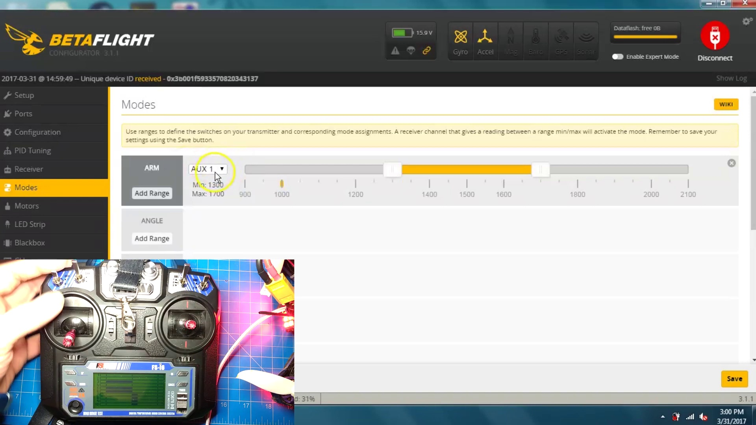 (score 95.0000)
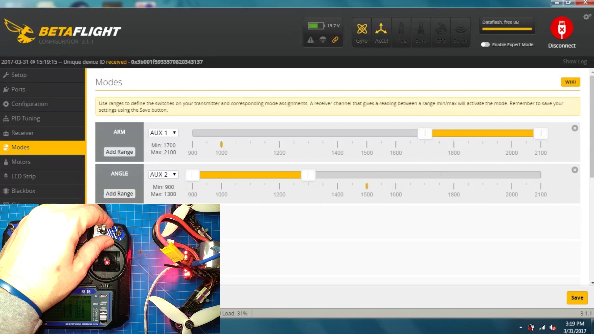 (score 90.0000)
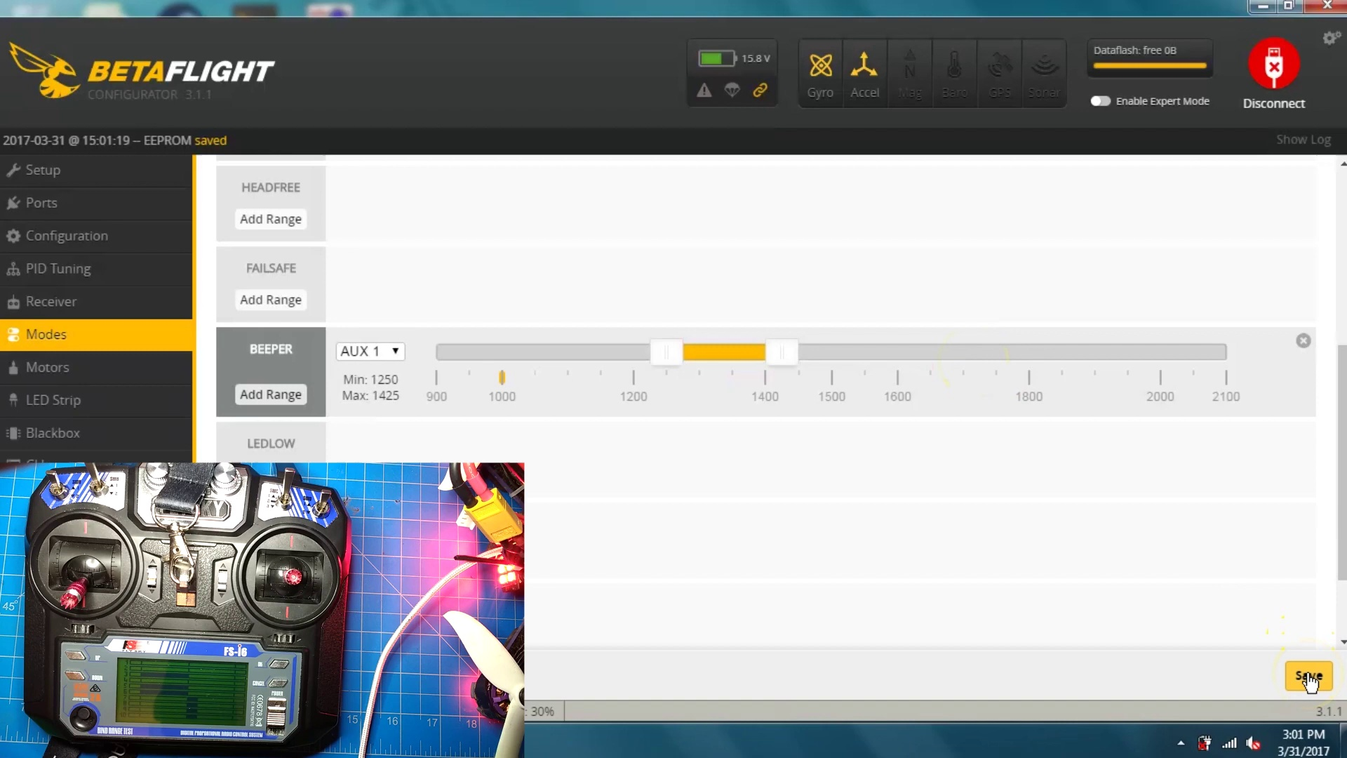 (score 90.0000)
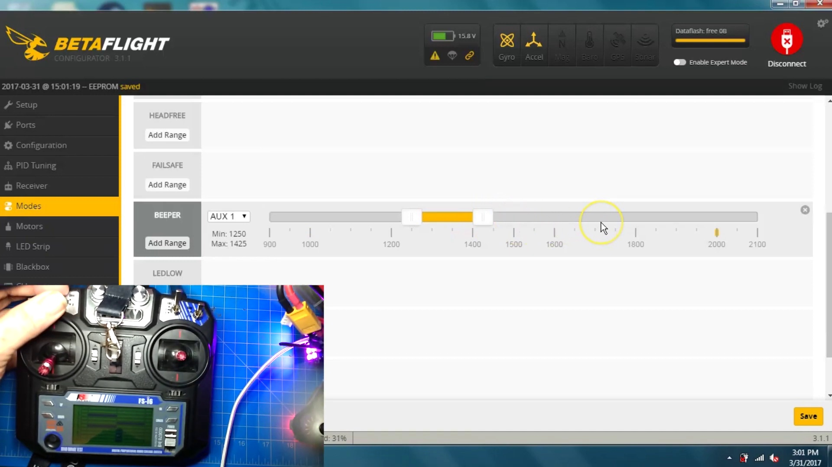 (score 90.0000)
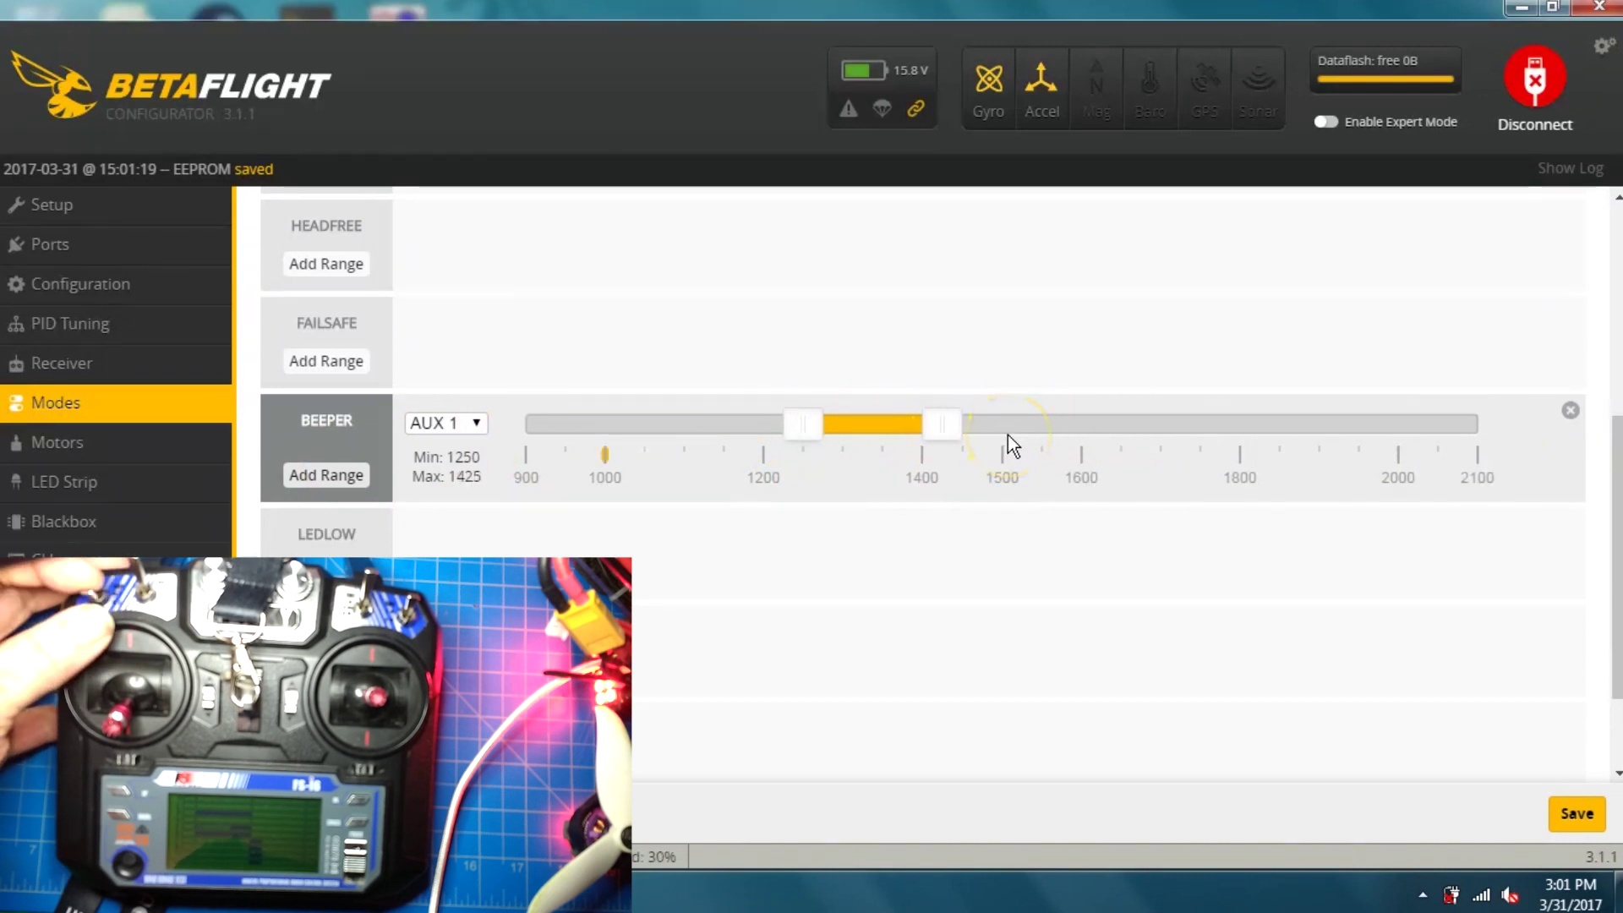 (score 90.0000)
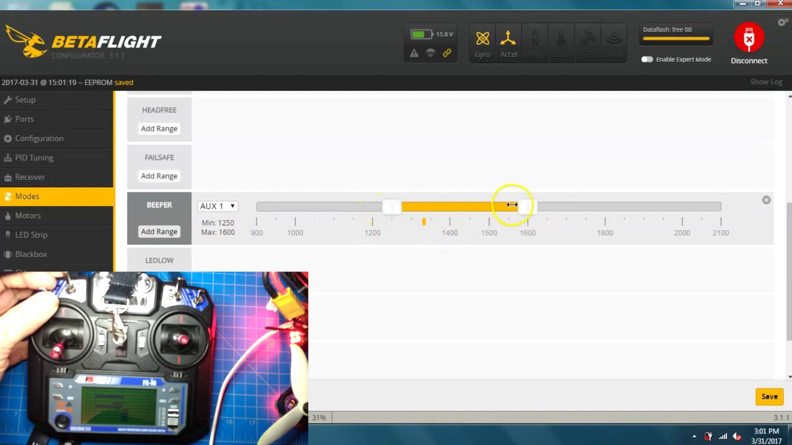 (score 90.0000)
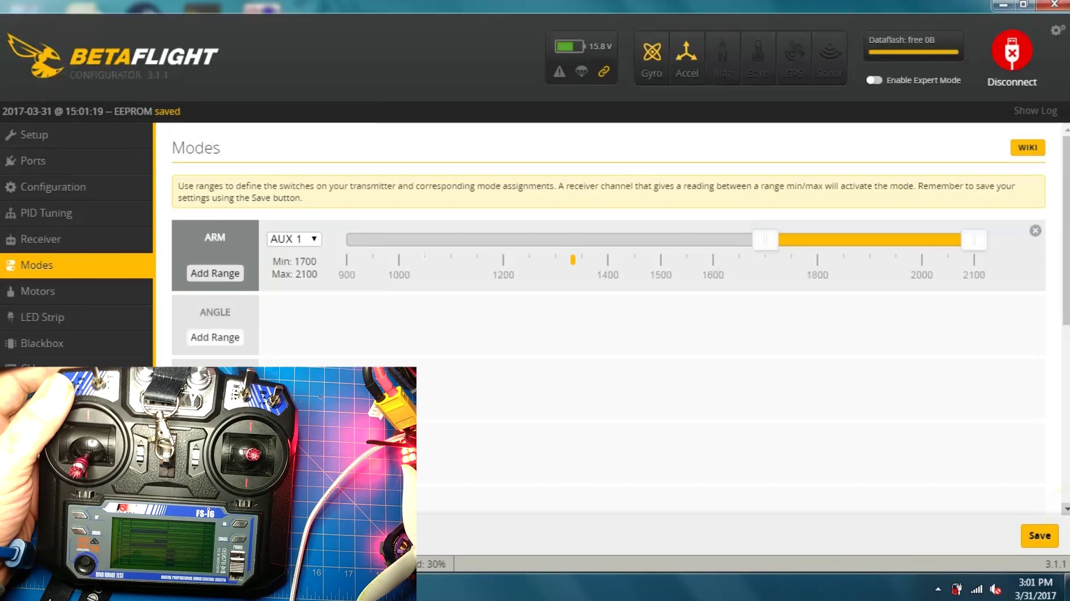 (score 90.0000)
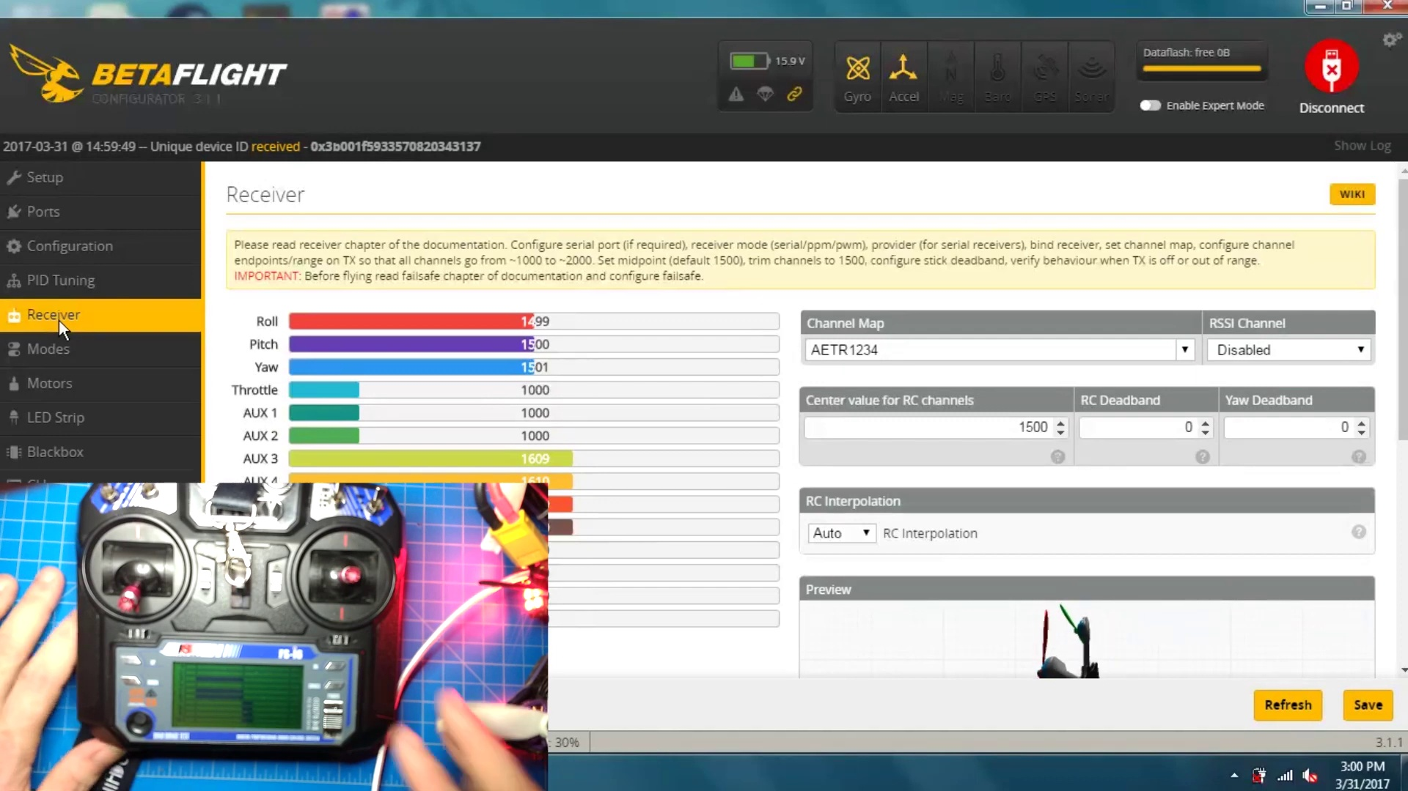 (score 90.0000)
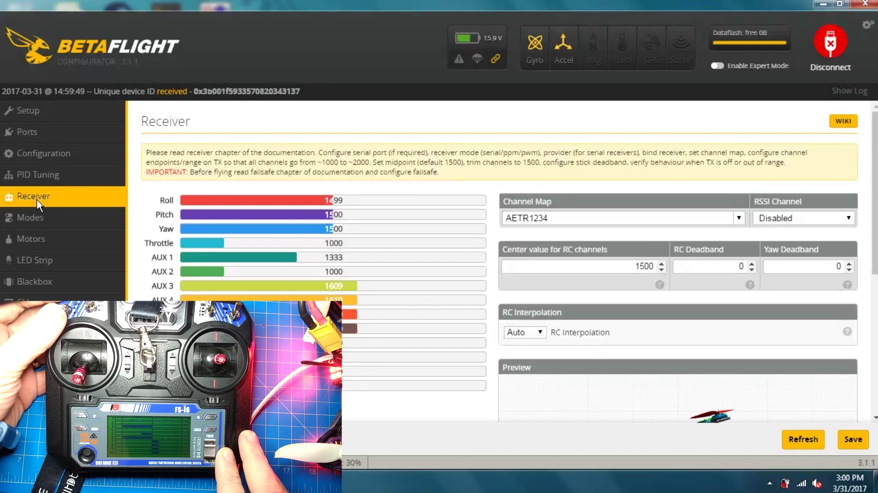 (score 90.0000)
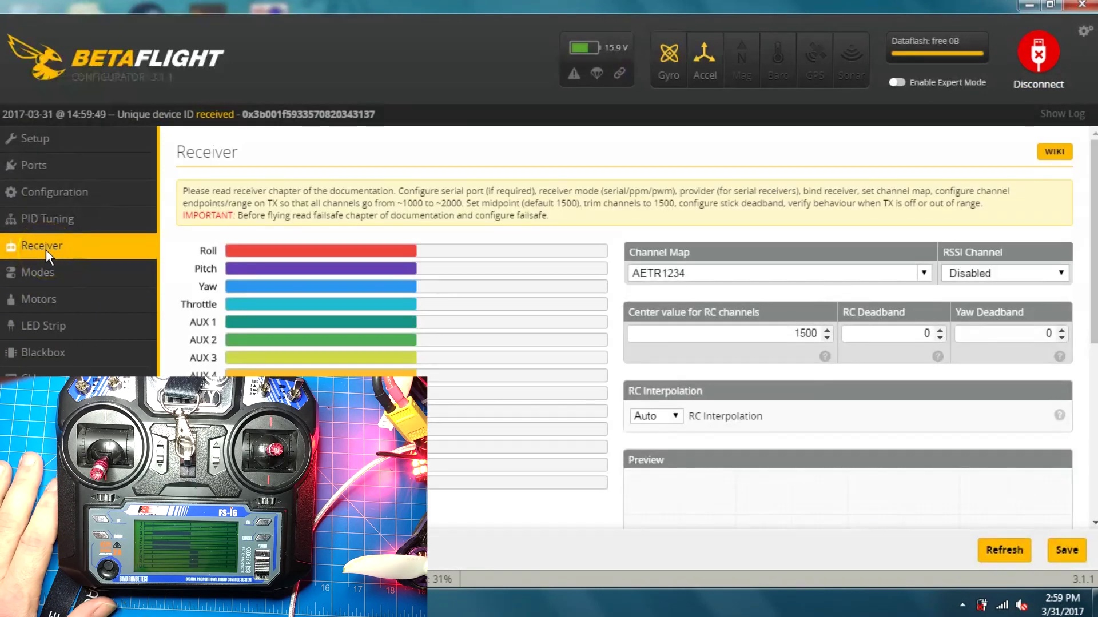 (score 90.0000)
Least correlated frames:
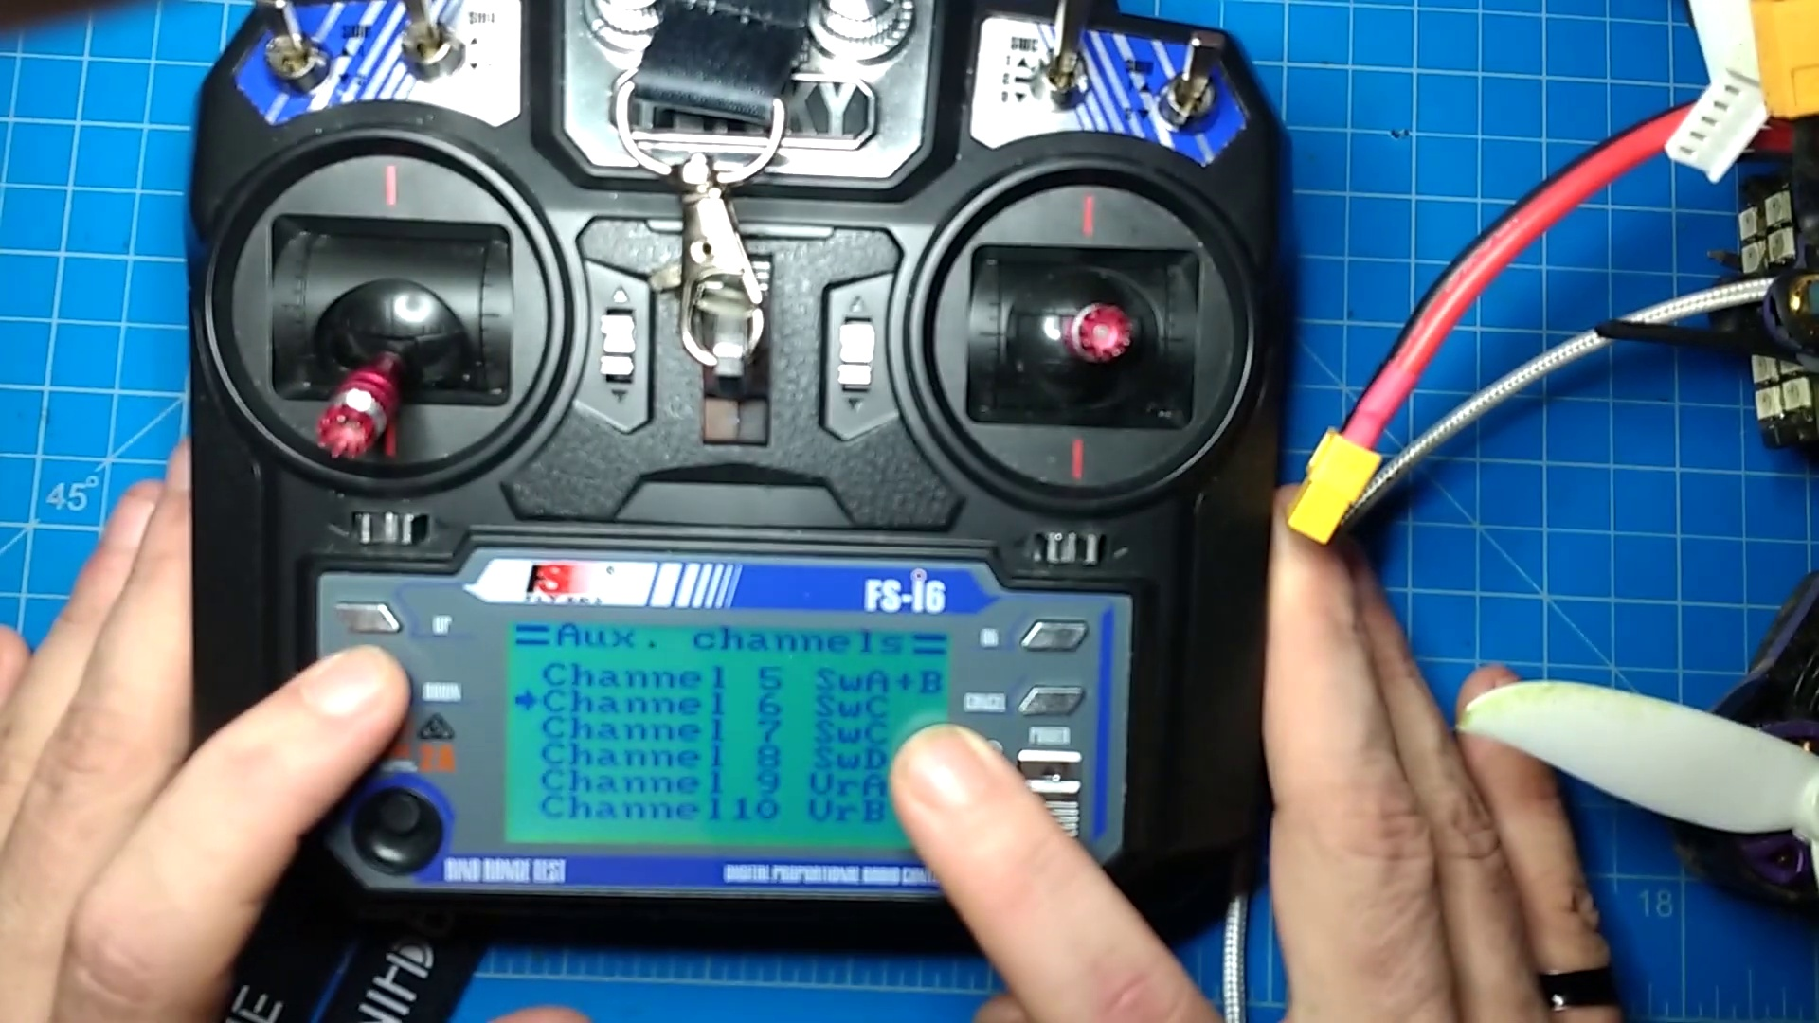 (score 5.0000)
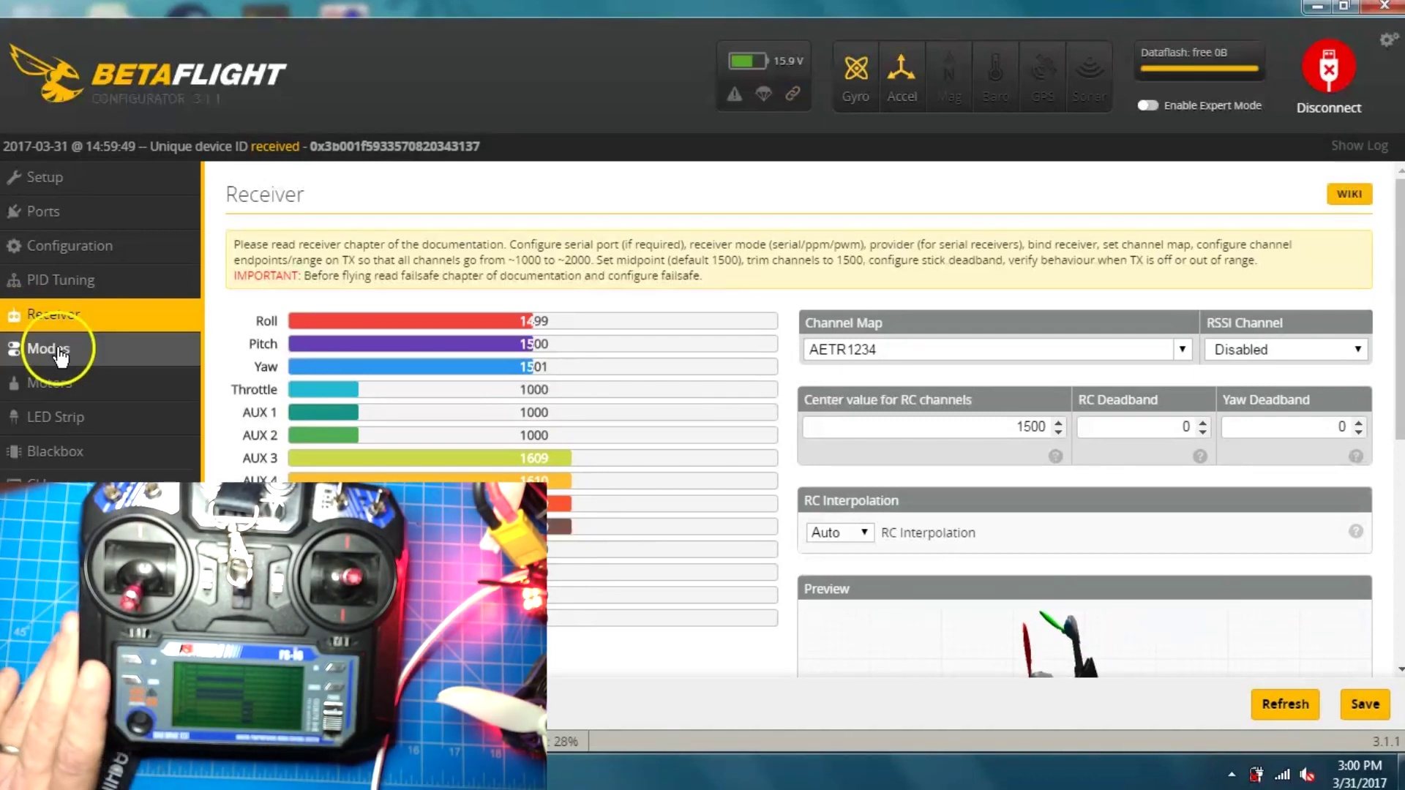 (score 5.0000)
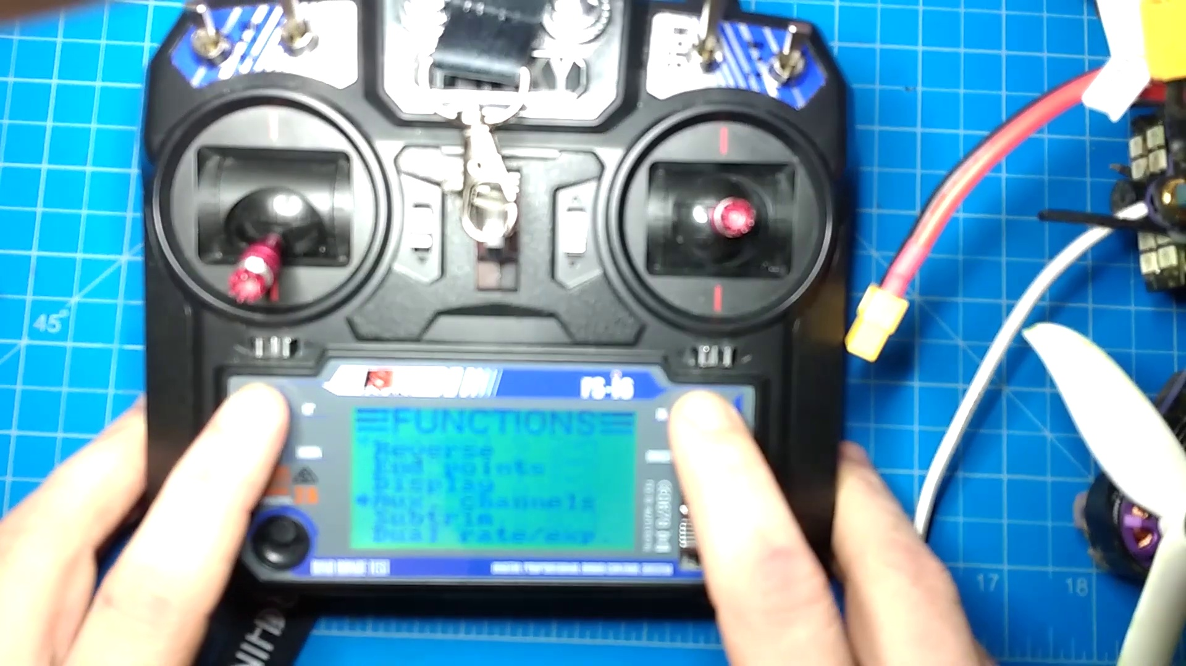 (score 10.0000)
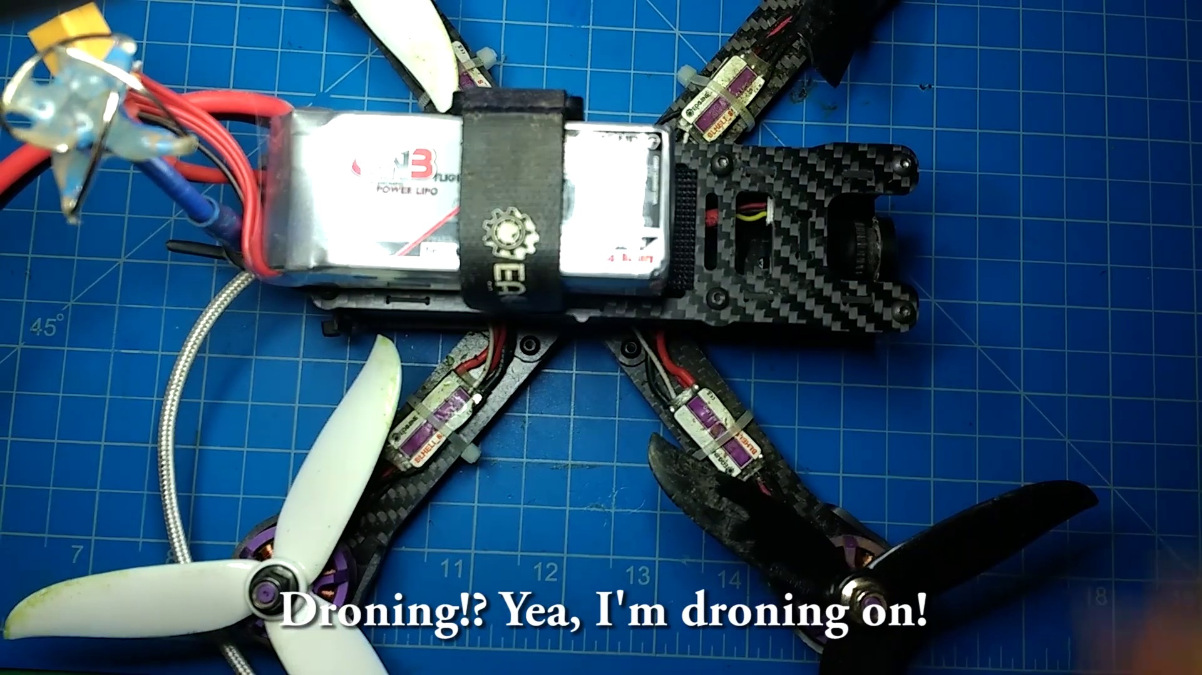 (score 20.0000)
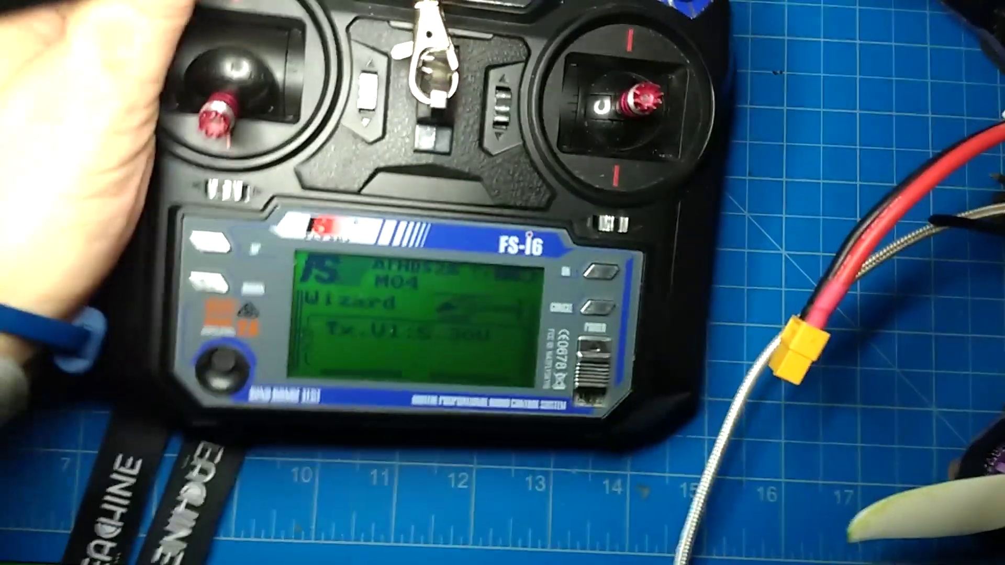 (score 20.0000)
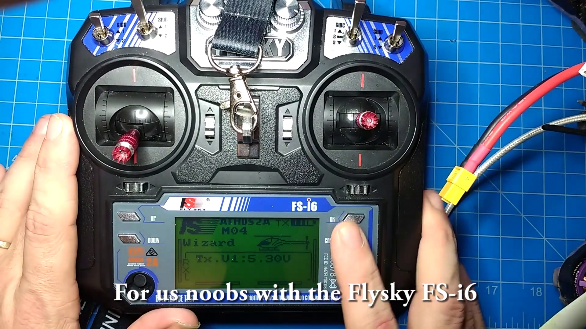 (score 20.0000)
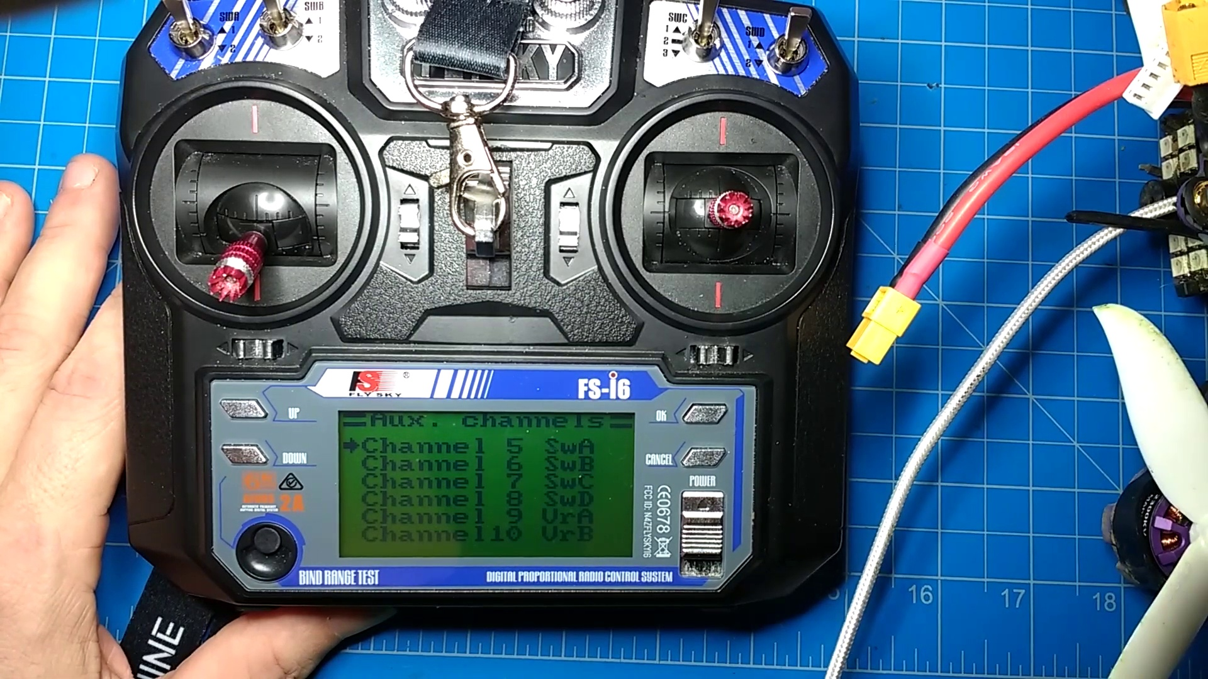 (score 20.0000)
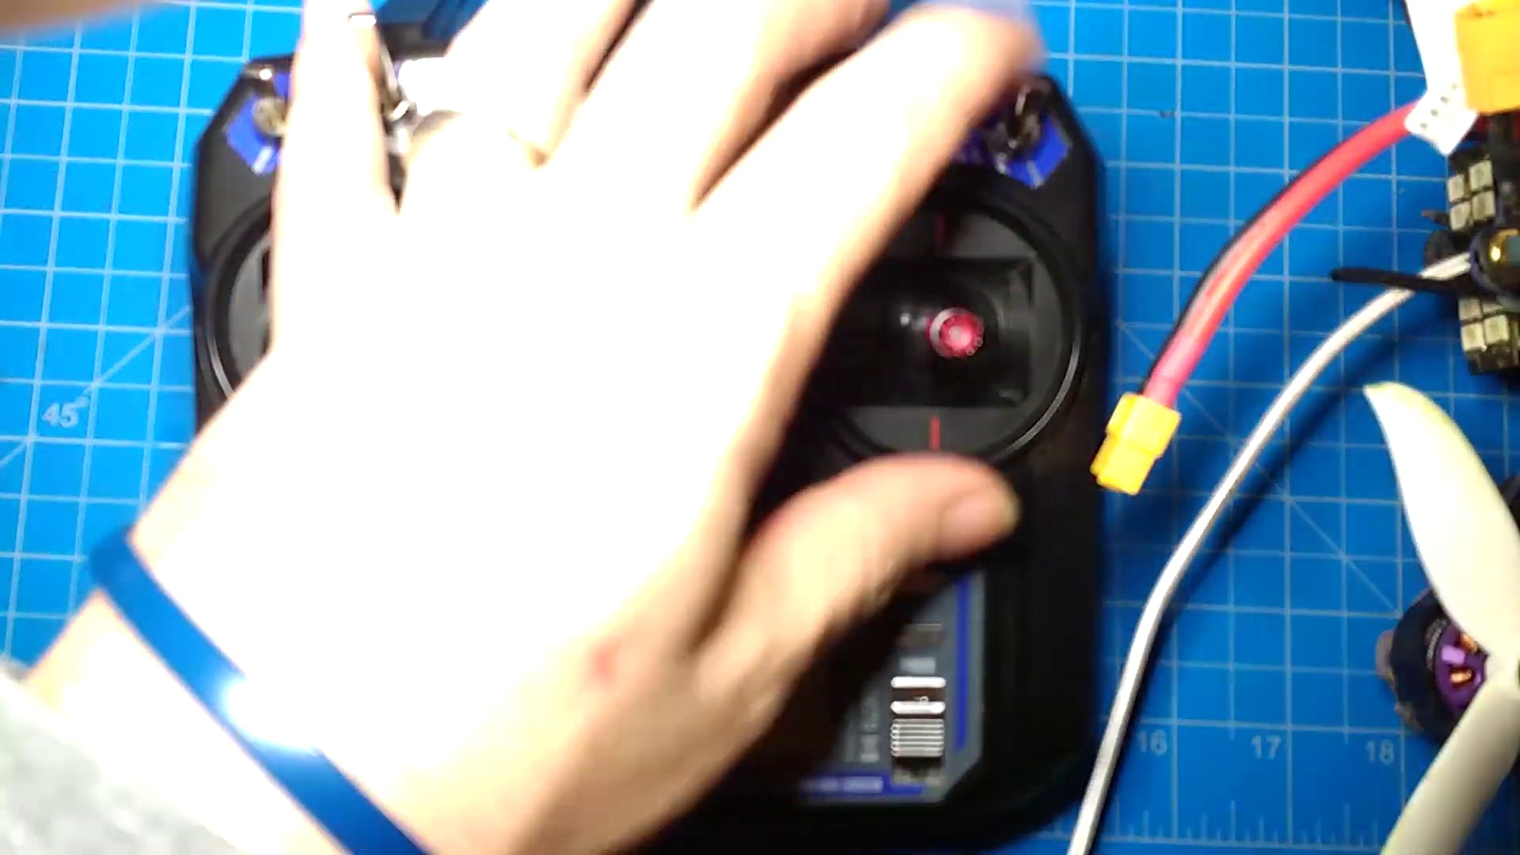 (score 20.0000)
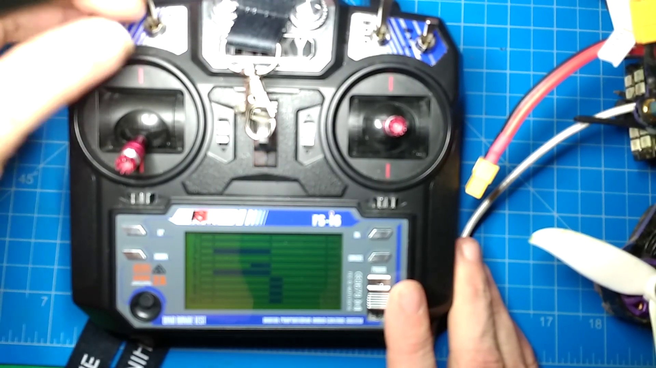 (score 20.0000)
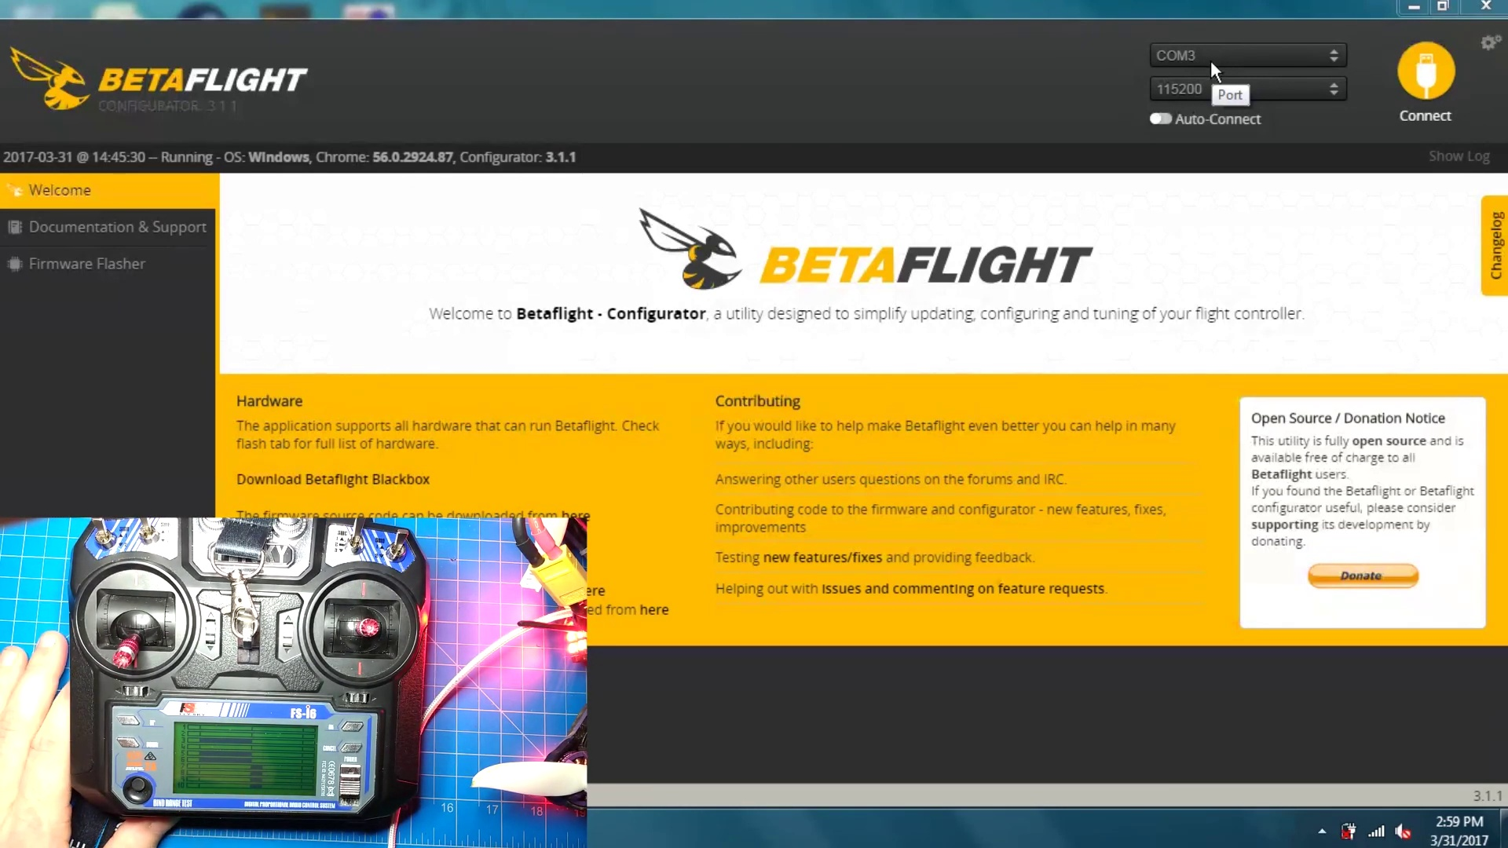 (score 20.0000)

Frame: frame_0000.jpg
Caption: The image displays hands interacting with an electronic device, specifically a remote control, which is open to reveal its internal components. The remote control has a red and white button being pressed by the person's hand. Attached to the remote control is a blue and white circuit board that is also open, showing its internal components. The board is connected to a white power supply unit.
The device resembles an RC (Radio Controlled) toy, possibly a quadcopter drone given the four-bladed propellers at each corner and the control board visible on top. A person's hand is holding the drone from the bottom, while another hand is adjusting or setting up the device, possibly with a screwdriver. The drone has various components visible, including what appears to be a battery pack at the bottom and electronic components that could include motors, sensors, or other electronic parts.
Text overlays on the image provide additional context. In the upper left corner, there is a handwritten note with the words "HOW TO" followed by an arrow pointing downward towards the device. Below this, in larger font, it reads "DUAL SWITCH AN METING WITH FS6 85%," suggesting that the person may be demonstrating how to set up a dual switch for an RC aircraft using the software Flight Simulator 6 (FS6). The text implies that the user has achieved an 85% success rate in their setup process.
Near the remote control, additional text reads "How To: F-S-16" and "Aux Channels Arming with FS-16", indicating that this image is part of a tutorial or instruction guide on how to use the F-S-16 remote control. The image captures a moment of interaction between the remote control and the circuit board, with the person actively engaging in the process of arming the control with auxiliary channels.
Overall, the image aims to provide instructions or guidance on setting up a specific configuration for an RC drone using the FS6 software, as well as demonstrating how to use the F-S-16 remote control. The visual content is educational and instructive, showing the device being worked with and the hands of the person engaging with it.
Comment (score 80): Change aux channels – channels 1-4: throttle, yaw, pitch, row.Might have 2 or 6 additional channels depending on software.Can program these other channels to a multitude of different functions.
Reason: The comment directly discusses the setting up of auxiliary channels (channels 1-4) and their functions in relation to the FS6 software, which is explicitly mentioned in the frame caption's text overlays. The mention of programming these channels for different functions also aligns with the educational/instructional tone of the frame caption.
Source: https://www.youtube.com/watch?v=DQOt-m7rg80: Dual switch arming on Flysky FS-i6

Frame: frame_0001.jpg
Caption: The image shows a pair of hands working with a quadcopter drone, as one hand holds the bottom of the drone body while the other hand operates a control device, possibly a remote control or a smartphone with a control interface. On the screen of the control device, there's a graphical user interface displaying flight telemetry data, including battery voltage, GPS coordinates, and performance metrics. The text overlay in the image reads "HOW TO: DUAL SWITCHING WITH FS16", suggesting that the content is related to setting up a dual switch configuration for the drone using an F-S16 controller.
The control device is likely a custom application designed for controlling the drone and monitoring its status during operation. The focus of this instructional guide appears to be on the technical aspect of setting up a quadcopter for dual switch operation, which would allow for more complex maneuvers and possibly more efficient control during flight.
In the background, there is a how-to guide for a specific task involving an F-S16 controller, laid out on a blue background with white text instructions written in a cursive font. The guide is divided into three sections: setup process, step-by-step guide to the main task, and additional tips and tricks. The two green wires connecting the F-S16 controller to the guide suggest that the guide is being followed precisely.
The presence of the drone and control device on one side of the image, and the how-to guide and other objects in the background, emphasizes the focus on the task at hand: configuring a dual switch configuration for the quadcopter using an F-S16 controller. Overall, the image presents a clear and detailed guide for this specific task, with precise instructions and setup of the controller suggesting a thorough understanding of the task and device.
Comment (score 80): Change aux channels – channels 1-4: throttle, yaw, pitch, row.Might have 2 or 6 additional channels depending on software.Can program these other channels to a multitude of different functions.
Reason: The comment directly discusses the technical steps and settings described in the caption, specifically mentioning channels 1-4 as throttle, yaw, pitch, row, which aligns with the flight telemetry data displayed on the control device's screen. The mention of programming additional channels also relates to the focus on setting up a quadcopter for dual switch operation.
Source: https://www.youtube.com/watch?v=DQOt-m7rg80: Dual switch arming on Flysky FS-i6

Frame: frame_0002.jpg
Caption: The image captures two distinct yet interconnected scenes: a hands-on approach to assembling or adjusting a small quadcopter drone, and an open view of a "P-16" model remote control device with its internal components revealed. The drone, predominantly black and blue in color, has four motors attached to its frame, which is typical for a quadcopter. Its underside features visible electronics, including a flight control board (FCB). The person's hands are seen manipulating various tools or parts related to the drone, possibly screws or fasteners, as they appear to be assembling or adjusting something on the device.
In another part of the image, we see a close-up view of the remote control device. The "P-16" model is open, displaying its internal components, including a control panel with labeled buttons indicating different functions and a display screen showing the labels "AOHS2 TX" and "Wizard", suggesting that the device may be equipped with a wizard mode. The device rests on a blue square mat serving as a protective layer. There are no visible texts or markings on either the drone or remote control devices, nor is there any text providing information about the process being undertaken or instructions related to flying or assembling drones. The focus remains solely on the hands-on activities and internal components of these devices.
Comment (score 80): Change aux channels – channels 1-4: throttle, yaw, pitch, row.Might have 2 or 6 additional channels depending on software.Can program these other channels to a multitude of different functions.
Reason: The comment directly discusses the manipulation of channels (throttle, yaw, pitch, row) on a remote control device, which is strongly related to the internal components and hands-on activities shown in the frame caption. The mention of programming additional channels also matches with the idea of assembling or adjusting the drone's settings.
Source: https://www.youtube.com/watch?v=DQOt-m7rg80: Dual switch arming on Flysky FS-i6

Frame: frame_0003.jpg
Caption: In the image provided, an open-frame drone with visible components such as the electronic flight control board (EFCB), motors, and battery pack takes center stage. The EFCB has a small display screen that shows some data, including battery level, signal strength indicator, and other status information. A remote controller is connected to the drone via a cable, suggesting it might be in the process of being operated or charged.
In the foreground, a person's hand holds a black remote control with a white digital display, featuring a red button on the top left corner and a green button on the top right corner. The remote control rests on a blue test mat with a grid of numbers (1 to 15) and letters (J-Z). The person holding the remote control wears a white shirt.
The background suggests an indoor setting with some electronic equipment, possibly related to the drone's operation or maintenance. The image appears to be a photograph capturing a moment during the assembly, use, or repair of a drone, rather than part of a teaching context such as a presentation or lecture.
Comment (score 80): Change aux channels – channels 1-4: throttle, yaw, pitch, row.Might have 2 or 6 additional channels depending on software.Can program these other channels to a multitude of different functions.
Reason: The comment directly references technical aspects of the drone's operation, such as channels (1-4) and their corresponding functions (throttle, yaw, pitch). This is strongly related to the caption's description of the drone's electronic flight control board (EFCB) and remote controller, which mentions similar functions like battery level, signal strength indicator, and other status information.
Source: https://www.youtube.com/watch?v=DQOt-m7rg80: Dual switch arming on Flysky FS-i6

Frame: frame_0004.jpg
Caption: The image captures a moment during a project or repair activity related to drones, electronics, or robotics. An indoor setting features a workbench with a cutting mat and various tools, suggesting a workspace for DIY or repair tasks. The cutting mat is covered in an assortment of small parts and electronic components, which appear to be related to the current project.
In front of the bench, a red cable extends out of the frame, and a blue circuit board with connectors lies on top of the cutting mat. The circuit board features some sort of electronic component soldered onto it. On top of the workbench, a small object with a sticker that reads "Droning? Yeah, I'm drowning on" suggests a humorous or sarcastic tone regarding the tasks at hand.
The background shows an electronic breadboard and wires connected to it, likely part of the current project or experiment being conducted. A section of text appears to be a joke about drones, implying that the person is metaphorically "drowning" in tasks related to drones rather than literally drowning.
A red drone, partially cut and ready for assembly, lies on the left side of the cutting mat. The drone is situated near a blue cutting mat, with a screwdriver (black tool with a yellow handle) positioned close by. This suggests that the person is engaged in the process of assembling or repairing the drone.
The text "Droning?! Yeah, I'm droning on!" indicates that the person is excited or passionate about their work, possibly related to drone-making. The overall scene presents a blend of humor and technical activity in an electronics-related field, with multiple aspects of the project or repair activity being addressed simultaneously.
Comment (score 80): Change aux channels – channels 1-4: throttle, yaw, pitch, row.Might have 2 or 6 additional channels depending on software.Can program these other channels to a multitude of different functions.
Reason: The comment directly references the drone (aux channels) and its components (throttle, yaw, pitch, row), which are visible in the frame caption. The mention of programming additional channels also matches with the blue circuit board shown in the background, suggesting a correlation between the technical steps described in the caption and the viewer's comment.
Source: https://www.youtube.com/watch?v=DQOt-m7rg80: Dual switch arming on Flysky FS-i6

Frame: frame_0005.jpg
Caption: The image shows a close-up of a black quadcopter drone with its carbon fiber frame exposed. The frame is taken from an elevated angle, centered around the drone, and features four propellers attached to silver hubs spinning at full speed, creating a sense of motion and dynamism. Each propeller is a vibrant shade of red, adding a splash of color to the otherwise monochrome scene.
The drone is perched on a black square of fabric covered in white writing, where the words "Droning on!" are clearly visible, indicating the ongoing activity of the drone. At the bottom of the frame, there's an overlaid text that says "Dropping? I'm drowning on!", which appears to be intended as a humorous commentary or caption related to the topic at hand.
The background is a stark white, providing a clean and simple backdrop that allows the drone and its surroundings to stand out. The relative position of the drone to the background and the writing suggests that it is the focal point of this image, conveying a sense of adventure and exploration as the drone takes flight and becomes part of this dynamic scene.
No strongly correlated comments found for this frame.

Frame: frame_0006.jpg
Caption: The image shows a person's hands working with an electronic device, which appears to be a drone. The drone is partially disassembled, revealing its internal components such as electronic circuit boards and motors attached to propellers. It also has visible wires, suggesting that the device is being repaired or modified.
In the foreground, a close-up view of the drone's battery takes center stage. The black and silver casing rests on a blue mat adorned with white numbers and letters, possibly indicating the battery's voltage or capacity. The battery is surrounded by various wires, some red and others black, which are arranged in a manner suggesting they are part of a larger circuit or assembly.
In the background, a white ruler lies flat, adding a practical element to the image and hinting at the meticulous nature of the work being done. Despite the absence of human figures, the image conveys a sense of activity and work, perhaps suggesting ongoing maintenance or repair of the drone. The precise arrangement of objects and their relative positions paint a picture of a well-organized workspace, where each component has its place.
Comment (score 80): Change aux channels – channels 1-4: throttle, yaw, pitch, row.Might have 2 or 6 additional channels depending on software.Can program these other channels to a multitude of different functions.
Reason: The comment directly discusses the technical aspects of the drone's channels (throttle, yaw, pitch, row) and their potential additional functions, which is strongly related to the caption's description of the drone's internal components and its repair/modification. The correlation score is 80 because while the comment does not explicitly mention the disassembled drone or its components, it is closely tied to the technical aspects presented in the caption.
Source: https://www.youtube.com/watch?v=DQOt-m7rg80: Dual switch arming on Flysky FS-i6

Frame: frame_0007.jpg
Caption: The image shows a person engaged in hands-on activity in a workshop, with their left hand poised above a blue surface as they hold a black and white remote control. The remote, featuring green and white buttons, rests on the surface. Their right hand grips a pair of tweezers, with black handles and silver tips, primed to make a precise adjustment. A small electronic device labeled "GPS" and "EKM" is connected to the controller via wires, suggesting a possible relation to GPS navigation or tracking equipment. The background is somewhat blurred, featuring a bench with tools and materials, which indicates a workspace or lab for electronics projects or hobbies.
No strongly correlated comments found for this frame.

Frame: frame_0008.jpg
Caption: The image captures a moment of hands-on interaction with a black and blue drone controller device. The person's right hand is pointing to a component on the controller with their index finger, while their left hand is manipulating the device or the screen displaying the drone's control interface. The interface includes a graphic representation of a drone and various control options such as pitch, roll, and yaw adjustments. There are also battery life indicators visible on the screen.
The environment appears to be a workshop or space dedicated to electronics or hobbyist activities. In the background, there's a desk with additional electronic components, wires, and tools that support this type of activity. The overall setting suggests an educational context where the person is demonstrating how to operate the drone controller to someone who might be learning about drones or hobbyist electronics.
On the blue surface in front of the individual, resting on top of it, is a black and red remote control. The remote control features multiple buttons, including a prominent red one, and has a small white light indicating its operational status. The textured blue surface provides a striking contrast to the colors of the remote control, suggesting a moment of pause in the action of using the controller, perhaps a moment of rest or reflection.
Comment (score 90): Change aux channels – channels 1-4: throttle, yaw, pitch, row.Might have 2 or 6 additional channels depending on software.Can program these other channels to a multitude of different functions.
Reason: The comment directly discusses technical steps related to the drone controller, specifically mentioning channels and their functions, which are described in the caption as 'pitch, roll, and yaw adjustments'. The mention of programming these channels also aligns with the educational context suggested by the caption's environment.
Source: https://www.youtube.com/watch?v=DQOt-m7rg80: Dual switch arming on Flysky FS-i6

Frame: frame_0009.jpg
Caption: The image shows a person holding a remote-controlled quadcopter with an attached digital device, likely serving as both a radio control receiver and a small LCD displaying text and numbers, possibly representing a telemetry module or flight controller display interface. The person is working on the quadcopter, potentially adjusting settings or repairing components, as evidenced by the visible wires connected to the device, suggesting calibration or assembly with electronic components may be required. On the screen of the device, there's text and numbers, although their legibility is limited due to image quality and angle. The surrounding environment suggests a workshop or hobbyist workspace, complete with various tools and electronics equipment scattered around.
In addition, the remote control itself appears to be powered by a battery, visible in the image, indicating it is a functional device ready for use. The person is holding the quadcopter in a way that implies they are preparing to fly it, possibly on the blue mat with a grid pattern, which serves as a test surface for electronic devices. Overall, the scene suggests the person is testing the quadcopter before flying it, ensuring its performance and stability.
Comment (score 80): Change aux channels – channels 1-4: throttle, yaw, pitch, row.Might have 2 or 6 additional channels depending on software.Can program these other channels to a multitude of different functions.
Reason: The comment directly discusses specific technical aspects of the quadcopter, such as channels (throttle, yaw, pitch, etc.) and their potential functions, which are mentioned in the frame caption as part of the device's capabilities. The connection is strong because it relates to a specific feature described in the caption.
Source: https://www.youtube.com/watch?v=DQOt-m7rg80: Dual switch arming on Flysky FS-i6

Frame: frame_0010.jpg
Caption: The image shows a close-up view of a remote control vehicle (RCV) with its controller held in someone's hand. The black controller has various buttons, dials, and a display screen that appears to show data such as battery level and possibly some telemetry or status information. The RCV is not fully assembled; the main body of the vehicle is missing, revealing wiring that would typically connect it to the controller. The battery pack for the vehicle is visible in the bottom right corner.
The image quality is not very high due to its proximity to the camera and possible motion blur, making some details difficult to discern. However, the focus is on the RCV and controller, which are the main subjects of the photo. In the background, there's a person's hand holding the controller, suggesting that they are operating or demonstrating the device. The setting appears to be a workshop or lab with various electronics parts and equipment.
The remote control vehicle and its controller take center stage in this image, while the surrounding environment adds context to the scene.
Comment (score 80): Change aux channels – channels 1-4: throttle, yaw, pitch, row.Might have 2 or 6 additional channels depending on software.Can program these other channels to a multitude of different functions.
Reason: The comment directly discusses the technical steps and settings described in the caption, specifically mentioning channels (throttle, yaw, pitch) and functions that relate to the remote control vehicle's controller and its capabilities.
Source: https://www.youtube.com/watch?v=DQOt-m7rg80: Dual switch arming on Flysky FS-i6

Frame: frame_0011.jpg
Caption: The image captures a moment of hands-on activity related to electronics or hobby drone assembly. A person's hand is holding an open flight controller with electronic components attached, connected by wires to a battery pack. In the background, there are tools and what appears to be a soldering iron on a workbench, suggesting a setting where repair, modification, or customization of the device is taking place.
On the opposite side of the image, another person's hand firmly grips a black and silver remote control with a keypad and screen, indicating its potential use in controlling something with a digital interface. The blue mat provides a stark contrast to the remote control's colors, implying that it may be a workbench where the remote control is being assembled or repaired.
In the bottom right corner of the image, a red connector, possibly a power or data cable, adds complexity to the scene and draws attention to its presence. This suggests that the remote control may be connected to a device or system, hinting at its potential use in various applications. Overall, the image depicts two individuals engaged in hands-on activities related to electronics, possibly involving the repair, modification, or customization of flight controllers and remote controls.
Comment (score 80): Change aux channels – channels 1-4: throttle, yaw, pitch, row.Might have 2 or 6 additional channels depending on software.Can program these other channels to a multitude of different functions.
Reason: The comment directly discusses the technical steps (changing aux channels) and settings (programming different functions) related to electronics and flight controllers described in the caption.
Source: https://www.youtube.com/watch?v=DQOt-m7rg80: Dual switch arming on Flysky FS-i6

Frame: frame_0012.jpg
Caption: The image shows a person's hand meticulously examining a black and white remote control, positioned on a blue mat. The remote control is equipped with a red LED light and a green button, both of which are currently illuminated; the LED light glows red, suggesting it's in operation, while the green button is prominently displayed, indicating its importance in the current task.
The hand, adorned with a black and gray wristwatch, is focused on the remote control, providing a clear view of its features and design. The image is taken from a slightly elevated angle, offering a sense of depth that emphasizes the importance of the remote control in the scenario.
In the background, a blurred indoor setting appears to show an organized workspace with various electronics and tools on a workbench or desk, possibly suggesting an educational setting. However, there is no visible text or slide providing context for this moment.
The controller's design, featuring a series of buttons and joysticks, suggests it's used to pilot a quadcopter drone. The focus of the frame remains on the remote control, capturing a moment of precision and technical expertise as the person's hand carefully examines the device.
Comment (score 80): Change aux channels – channels 1-4: throttle, yaw, pitch, row.Might have 2 or 6 additional channels depending on software.Can program these other channels to a multitude of different functions.
Reason: The comment directly discusses the technical steps and objects described in the caption, specifically mentioning channels on the remote control and their functions, which matches the description of the controller's design and buttons in the caption.
Source: https://www.youtube.com/watch?v=DQOt-m7rg80: Dual switch arming on Flysky FS-i6

Frame: frame_0013.jpg
Caption: This image presents a comprehensive drone piloting setup, featuring an unmanned aerial vehicle (UAV) drone with its remote control and battery pack placed next to it on a table. The drone has a predominantly black body with blue accents and appears to have some form of sensor mounted on the front of its frame for GPS or other navigational assistance.
The components visible in the photo include:
* A battery pack connected to the drone via wires.
* The remote control features a joystick, multiple buttons typical for maneuvering drones, antennae attached to its body likely for communicating with the drone through radio signals, and a small display showing some sort of data or status readout (though the content is not clearly legible).
* A USB cable is plugged into the remote control, suggesting it may be connected to a computer for software updates or configuration adjustments.
The remote control itself has a F3-16 label, indicating its specific model or type. A red and yellow wire connects it to a power source, and a small red light suggests that it's powered on. The large LCD screen displays a menu of options, allowing the user to control various devices related to electronics or machinery.
The blue surface on which the remote control rests adds context to the scene, possibly serving as a workspace or workshop for drone piloting or other technological applications.
Comment (score 80): Change aux channels – channels 1-4: throttle, yaw, pitch, row.Might have 2 or 6 additional channels depending on software.Can program these other channels to a multitude of different functions.
Reason: The comment directly discusses the technical steps of using drone piloting channels (throttle, yaw, pitch) and the option to program additional channels for different functions, which are also mentioned in the caption. The caption provides context about the remote control's components and labels, such as F3-16, which are relevant to the comment.
Source: https://www.youtube.com/watch?v=DQOt-m7rg80: Dual switch arming on Flysky FS-i6

Frame: frame_0014.jpg
Caption: The image shows a person's hand reaching for an electronic device that appears to be a small drone or quadcopter with its four arms extended. The device has a visible battery pack and possibly a remote control or interface panel attached to it. In the background, there is another device with a screen displaying what looks like a camera feed, along with some wiring and a soldering iron, suggesting an electronics workstation.
The person's hand is positioned as if they are about to pick up or adjust the quadcopter. The text "FOR US MOOPS WITH THE FLYSKY FS-16" indicates that the device is associated with the Flysky brand of remote control hobby products. Against a blue mat, a black and silver remote control takes center stage, adorned with a red and white LED display, a black power button, and a white power switch. The control is equipped with a pair of black and red antennas. A black and red screwdriver lies on the left side of the control.
The text "For us noobs with the Flysky FS-16" inscribed on the mat suggests that both devices are designed for beginners. The overall scene presents an active setup, possibly for a remote control hobby or a related activity, where the person is interacting with the quadcopter and the remote control.
No strongly correlated comments found for this frame.

Frame: frame_0015.jpg
Caption: The image captures a moment of a person working with a Flysky FS-16 remote control. The remote control, held in the person's hands, is a black and white device with a large screen displaying the words "Flysky FS-16". The person's hands are seen using the control, with one hand on the top left of the screen and the other on the top right. The background of the image is a blue and white striped tablecloth, providing a contrasting backdrop to the black and white remote control. In the context of this setup, it appears that the individual is in the process of setting up an RC airframe, which has electronic parts such as batteries and possibly a flight controller or other avionics equipment attached. Visible text on the screen reads "For us noobs with the Flysky FS-16 04/2023," suggesting that this setup may be for a hobbyist drone named "Eyolsyk" from a brand called F16-5. The person's hands are focused on attaching components to the frame, and they seem to be in the process of setting up the drone.
No strongly correlated comments found for this frame.

Frame: frame_0016.jpg
Caption: The image shows a person holding a white and black remote control in one hand, with the other hand manipulating a quadcopter drone. The drone has a black body with four arms, each with a motor and propeller at the ends, LED lights attached to the frame, and visible wiring running through it. On the top right side of the drone, there is a blue area labeled with white text "DJI", suggesting the brand of the quadcopter.
The remote control displays a blue screen with various icons and text, including a red light indicating that it is currently powered on, and the text "FO-16" possibly referring to the model number or name of the remote control. The remote control's screen also shows the words "Wizard" and "Drone", indicating its purpose in controlling the drone.
The person's hand is seen holding the remote control, with their other hand operating a control or interface. The environment appears to be a workshop or lab space, as suggested by the wooden table beneath the drone. There are no visible objects or people other than the person and the drone, and the focus of the image is on the physical interaction between the person's hands and the remote control, emphasizing their role in controlling the drone rather than any specific instructional content.
Comment (score 90): Change aux channels – channels 1-4: throttle, yaw, pitch, row.Might have 2 or 6 additional channels depending on software.Can program these other channels to a multitude of different functions.
Reason: The comment directly discusses the same technical steps and objects described in the caption (aux channels on remote control, throttle, yaw, pitch, row, and programming additional channels). The language used is highly specific to the scene depicted in the image.
Source: https://www.youtube.com/watch?v=DQOt-m7rg80: Dual switch arming on Flysky FS-i6

Frame: frame_0017.jpg
Caption: The image shows a person interacting with electronic equipment, specifically an open flight controller with various connectors and buttons. One hand is holding the flight controller while the other points at it, possibly explaining its function or operation to the viewer. The flight controller displays visible text and labels, including "FUNCTIONS," suggesting it's part of a remote-controlled aircraft system with defined functions for different inputs. Several switches and buttons are labeled with "PWM" (pulse width modulation), a common electronic term related to motor control in drones.
The person's hands are clearly visible, with one holding the flight controller and the other pointing at it. In the background, a workbench or desk is shown, littered with additional electronics and tools, indicating this might be a workshop or lab setting where hobbyists or professionals work on electronic projects, possibly related to drone technology or robotics.
In the foreground, a blue and black remote control is displayed, showing its function menu on the screen. The menu features various options such as "Reverse End Points", "Aux Channels", and "Sub-Frequencies". The person presses a button on the remote control, likely selecting a specific option from the menu. The remote control itself is a small, rectangular device with a digital display screen, connected to a blue and black cord that runs to a blue and black object in the background.
The image does not contain any text or additional information other than what's displayed on the flight controller and remote control screens. The focus remains primarily on the electronic equipment and the person interacting with it, without any explicit teaching context or diagrams.
Comment (score 90): Change aux channels – channels 1-4: throttle, yaw, pitch, row.Might have 2 or 6 additional channels depending on software.Can program these other channels to a multitude of different functions.
Reason: The comment directly discusses the same technical steps (changing aux channels) and objects (flight controller/remote control) described in the caption, with a focus on programming specific functions.
Source: https://www.youtube.com/watch?v=DQOt-m7rg80: Dual switch arming on Flysky FS-i6

Frame: frame_0018.jpg
Caption: The image shows a person's hands interacting with an RC quadcopter and a remote control. One hand is operating the controls of the drone, which include a joystick and a switch panel, while the other hand holds up a smartphone displaying a QR code scanner app, likely for setting up the drone's control system or reading information from it. The quadcopter has a blue frame with visible electronics, including what appears to be an electronic speed controller (ESC) and motors at each corner, indicating it is a DIY model. In the foreground, a person's white hands are holding a black remote control vertically, equipped with several black buttons arranged in a row on the remote control. The remote control also has a blue display screen that displays various instructions, including "functions", "reverse", "end points", "aux channels", and "subdual rate/exp". The image captures the moment just before the remote control is pressed, possibly indicating the beginning of a complex task or a critical moment in a game.
Comment (score 85): Change aux channels – channels 1-4: throttle, yaw, pitch, row.Might have 2 or 6 additional channels depending on software.Can program these other channels to a multitude of different functions.
Reason: The comment directly discusses the technical steps related to the RC quadcopter's controls, specifically mentioning 'aux channels' and their functions, which are described in the caption as part of the remote control's display. The language used in the comment is closely tied to the specific objects (remote control) and settings (auxiliary channels) mentioned in the caption.
Source: https://www.youtube.com/watch?v=DQOt-m7rg80: Dual switch arming on Flysky FS-i6

Frame: frame_0019.jpg
Caption: The image shows a person's hand holding a small, blue FSD-16 radio control device with multiple buttons and a black and white display. The device appears to be designed for operation by remote control, as indicated by the presence of various buttons, including red and white ones used for adjusting settings. The hands are visible in the image, suggesting that the person is actively engaging with the device. The device rests on a blue tablecloth, adding a pop of color to the scene. The surrounding area appears to be an indoor setting focused on technology or electronics, as suggested by the blurred background featuring what looks like electronic components. The image is taken from a close angle, emphasizing the details of the FSD-16 radio control device and not providing a full view of the surroundings or the person holding it.
Comment (score 80): Change aux channels – channels 1-4: throttle, yaw, pitch, row.Might have 2 or 6 additional channels depending on software.Can program these other channels to a multitude of different functions.
Reason: The comment directly discusses the technical steps and settings (aux channels) mentioned in the caption, specifically referencing the FSD-16 radio control device's buttons and functions.
Source: https://www.youtube.com/watch?v=DQOt-m7rg80: Dual switch arming on Flysky FS-i6

Frame: frame_0020.jpg
Caption: The image depicts a person working on a blue and white control board, which is part of a remote control device. The control board features several buttons and a display screen. In the foreground, the individual's hand is seen pressing one of the buttons, possibly adjusting settings on the control board.
The control board is situated on a blue and white checkered tablecloth, adding a pop of color to the scene. The well-organized workspace suggests a sense of care and attention to detail. Behind the main focus of the image, two other remote controls are visible: a black and white remote control and a red and white remote control. These remotes appear to be waiting in reserve or being prepared for use.
The background of the image appears to be a workshop or laboratory setting, with various tools and parts that might relate to electronics or robotics work. The individual's hands are interacting with a black remote control device nearby, featuring multiple buttons and dials. A small screen on this device displays data or an interface, showing several readings that include numbers possibly representing sensor values or measured parameters.
The person is holding the black remote control device with one hand resting on top while the other hand manipulates the dials or buttons. There are no visible texts or diagrams within the image providing context or instructions regarding the devices or tasks at hand. The individual's actions suggest they could be calibrating, adjusting settings, or operating the device for testing purposes.
No strongly correlated comments found for this frame.

Frame: frame_0021.jpg
Caption: The image shows two hands, each adorned with a ring, manipulating a radio control device resting on a blue cloth. The device is a mix of black and blue, featuring a digital display that showcases various settings and options. The hands appear to be adjusting or testing these settings, possibly in preparation for a journey or adventure. The background features a workbench with tools and components, indicating a workshop or lab setting where the device is likely being used to control a drone or some other automated vehicle.
Comment (score 80): Change aux channels – channels 1-4: throttle, yaw, pitch, row.Might have 2 or 6 additional channels depending on software.Can program these other channels to a multitude of different functions.
Reason: The comment directly discusses the technical settings and options (aux channels) described in the caption, specifically mentioning 'throttle', 'yaw', 'pitch', and 'roll' which are mentioned in the description of the device's digital display. This demonstrates a strong connection between the frame caption and viewer comment.
Source: https://www.youtube.com/watch?v=DQOt-m7rg80: Dual switch arming on Flysky FS-i6

Frame: frame_0022.jpg
Caption: The image shows a person's hands manipulating a device that appears to be an electronic setup, possibly a projector or a similar display system. The individual seems to be operating a control panel with multiple buttons and knobs. The screen of the device displays some sort of interface, but the details are not clear due to the angle and resolution.
In the background, there is another person observing the first one's actions. It looks like they might be learning about or working on the device in question. The environment suggests a hands-on educational or experimentation setting.
The focus is on the hands manipulating the device and the immediate surrounding, which doesn't offer any additional information about the nature of the lesson or the exact topic being taught or explored.
Meanwhile, the person's hands are holding a blue and white remote control with multiple buttons. One button is prominently labeled "F-16", while another reads "R/C". The remote control also features a small LED display. The person's hands are spread out, with one hand on the right side of the remote control and the other on the left.
The background of the image is blurred, suggesting that the focus is on the remote control and the person's hands. The image does not contain any text. The relative position of the remote control to the person's hands indicates that the person is holding the remote control in a way that allows them to operate it with ease. The image captures a moment of interaction between the remote control and the person, suggesting that the person is in the process of using or adjusting the remote control.
Comment (score 85): Change aux channels – channels 1-4: throttle, yaw, pitch, row.Might have 2 or 6 additional channels depending on software.Can program these other channels to a multitude of different functions.
Reason: The comment directly discusses the technical steps and settings described in the caption, specifically referencing the remote control's channels (throttle, yaw, pitch) and potential additional channels that can be programmed for different functions. The correlation is strong because the comment explicitly ties back to the remote control and its components shown in the frame caption.
Source: https://www.youtube.com/watch?v=DQOt-m7rg80: Dual switch arming on Flysky FS-i6

Frame: frame_0023.jpg
Caption: The image shows a person's hand holding a remote control displayed on a blue surface. The remote control, with its black and red color scheme, is open and features various buttons and settings clearly labeled, indicating the different channels and settings available. A red LED light on the remote control is currently off, suggesting that the device may be in a standby or inactive state. The person's hand is positioned over the remote control, implying that they are in the process of testing or adjusting the device.
The background of the image is a blue surface, which provides a neutral and contrasting backdrop to the black and red colors of the remote control. This emphasis on the remote control draws attention to its importance in the scene. The blue surface also contains tools and components, likely from an electronics or hobbyist workspace, suggesting that the activity being undertaken may be related to electronics or tinkering.
The drone attached to the remote control has four motors and is equipped with electronic modules, likely sensors or electronic interfaces. The drone appears to be a functional device, rather than just a mockup or prototype, given its presence on a workbench or table containing tools and components. Overall, the image captures a moment of interaction with a remote control, possibly in the context of a testing or adjusting process, highlighting the importance of the device in controlling the drone and any other connected electronics.
Comment (score 80): Change aux channels – channels 1-4: throttle, yaw, pitch, row.Might have 2 or 6 additional channels depending on software.Can program these other channels to a multitude of different functions.
Reason: The comment directly discusses the technical steps and settings described in the caption, specifically mentioning channels (throttle, yaw, pitch, row) which are clearly labeled on the remote control. The comment also mentions programming additional channels, which is relevant to the image showing the remote control's various buttons and settings.
Source: https://www.youtube.com/watch?v=DQOt-m7rg80: Dual switch arming on Flysky FS-i6

Frame: frame_0024.jpg
Caption: The image shows a person's hands holding and operating an RC drone, with various parts visible. The drone's body has an electronic device connected to it, while a control unit with an LCD screen displaying numerical values and symbols is also present. A battery pack is seen nearby. In the background, there appears to be a workspace or lab setting, with text that seems to be instructions or specifications for the components of the drone, although it's too small and blurry to read clearly.
The individual in the image appears focused on their task, possibly assembling or testing the drone, which is commonly used in hobbyist electronics projects related to robotics and remote control devices. The setting suggests a hands-on learning environment where students or hobbyists are engaged in practical tasks involving electronic components and remote control technology.
Notably, the control unit's LCD screen displays various information, including numerical values and symbols. In contrast to the drone's body and surrounding components, the background is a blue cloth, providing a contrasting color to the overall scene.
Comment (score 80): Change aux channels – channels 1-4: throttle, yaw, pitch, row.Might have 2 or 6 additional channels depending on software.Can program these other channels to a multitude of different functions.
Reason: The comment directly discusses the control unit's LCD screen and its channels (throttle, yaw, pitch, row), which is mentioned in the frame caption. The comment also mentions programming additional channels, which is related to the drone's electronic device connected to it.
Source: https://www.youtube.com/watch?v=DQOt-m7rg80: Dual switch arming on Flysky FS-i6

Frame: frame_0025.jpg
Caption: The image captures a moment of intense focus and dedication, showcasing a person working meticulously on a blue plastic cutting mat. Adorned in a black shirt and a black wristwatch, the individual's hand is poised over a black and silver remote control, ready to press one of its red and black buttons. The device itself, with various switches and buttons, appears to be a remote control or transmitter typically used to control model aircraft or drones, as indicated by the presence of an antenna and what seems to be flight controls.
The person's concentration is palpable, suggesting they are in the midst of an important task. The cutting mat beneath them provides a striking contrast to the black of the remote control and the person's attire, adding visual interest to the image. The setting appears to be a workbench or hobbyist workspace, with tools and other electronic components scattered around, suggesting an environment where tinkering and experimentation with electronics take place.
The focus is clearly on the device itself, with the person's face not visible due to the angle of the photograph and the use of a wide-angle lens that captures the device in detail. There are no visible texts or diagrams within the image that provide additional context about the activity or the specific model being worked on. The overall atmosphere conveys a sense of hands-on activity related to electronics, possibly setting up the equipment for a specific purpose such as flying a model aircraft.
No strongly correlated comments found for this frame.

Frame: frame_0026.jpg
Caption: The image shows a person's hands holding a vibrant red remote control, poised over a blue plastic table. The remote control is equipped with black and white keys clearly labeled, indicating its functionality. A red and black antenna is visible, ready to transmit signals, along with a white plug possibly for charging or powering the device. The person's hand is firmly gripping the remote control, suggesting their intent to test its functions.
In the background, a smartphone displays an application related to flight control or data analysis for drones, given the graphical interface with charts, graphs, and numerical data. The device on the screen indicates it may be recording or monitoring data in real-time, which is common for drone operations. The table appears to be part of a workspace or lab setting, with various tools and equipment scattered around, including what looks like a soldering iron and electronic components such as capacitors and resistors.
Comment (score 85): Change aux channels – channels 1-4: throttle, yaw, pitch, row.Might have 2 or 6 additional channels depending on software.Can program these other channels to a multitude of different functions.
Reason: The comment directly discusses the functionality of the remote control's channels (throttle, yaw, pitch), which matches the caption's description of the labeled keys on the device. The mention of programming additional channels to different functions also relates to the concept of setting up and operating the drone system depicted in the image.
Source: https://www.youtube.com/watch?v=DQOt-m7rg80: Dual switch arming on Flysky FS-i6

Frame: frame_0027.jpg
Caption: The image captures a moment of technical expertise as a hand gently presses a button on a blue remote control, which is affixed to a black surface. The remote control is equipped with a red light, a red and white button, and a green light, all of which are visible in the image. The person's fingers are visible, suggesting they are in the process of making a connection or adjusting a setting. In the background, an individual is partially visible, possibly taking the photograph or participating in the activity related to the remote control vehicle (RCV). This person appears to be seated at a desk with other objects like wires and electronic components, suggesting a workspace for electronics or hobbyist projects.
The RCV itself is predominantly black and white, with various switches, buttons, and a joystick on top for controlling its movement. A small display screen on the bottom of the device appears to be showing some data or status. The overall setting appears to be informal, perhaps a home lab or workshop, as indicated by the casual attire of the individual.
The focus is on the RCV and the activity it might be used for, such as drone flying or remote control vehicle operation. The image does not contain any text, but provides a snapshot of a moment of interaction between the remote control and the person, capturing the essence of technology in our daily lives.
Comment (score 80): Change aux channels – channels 1-4: throttle, yaw, pitch, row.Might have 2 or 6 additional channels depending on software.Can program these other channels to a multitude of different functions.
Reason: The comment directly discusses the technical steps and settings described in the caption, specifically mentioning channels (throttle, yaw, pitch) and their functions, which are consistent with the remote control vehicle shown in the image.
Source: https://www.youtube.com/watch?v=DQOt-m7rg80: Dual switch arming on Flysky FS-i6

Frame: frame_0028.jpg
Caption: The image shows a person holding a small quadcopter with an LCD display at its front end, as well as a blue and white remote control. The display screen on the quadcopter is showing some numbers and possibly data related to the flight of the drone, such as speed, distance traveled, battery level, or telemetry data from a controller or connected device. The quadcopter has four visible motors, each attached to an arm that supports a propeller blade, with various connectors and wiring on the underside, which may include antennas, batteries, and other electronic components. The remote control features a large display screen displaying a mix of blue and red text, indicating a variety of options and settings. A red and white button is visible on the remote, suggesting it might be used for navigation or control. The background of the image appears to be a workbench or desk with various tools and equipment, including what looks like another electronic device connected to cables and possibly a soldering iron, indicating that this could be a workspace for electronics enthusiasts or a maker space where DIY projects are conducted.
Comment (score 80): Change aux channels – channels 1-4: throttle, yaw, pitch, row.Might have 2 or 6 additional channels depending on software.Can program these other channels to a multitude of different functions.
Reason: The comment directly discusses the technical settings and options available on the remote control display screen, specifically mentioning channels 1-4 for throttle, yaw, pitch, and roll. The caption also shows a large display screen on the remote control with blue and red text indicating various options and settings.
Source: https://www.youtube.com/watch?v=DQOt-m7rg80: Dual switch arming on Flysky FS-i6

Frame: frame_0029.jpg
Caption: The image presents a unique blend of electronic equipment, tools, and a drone in a workspace that appears to be dedicated to electronics or drones. In the foreground, a person is partially visible operating a device with a screen displaying data or measurements, accompanied by a piece of electronic equipment with various connectors and components. The focus of the image seems to be on the quadcopter drone in the background, which has its arms extended.
The workspace itself appears to be blue in color, serving as the backdrop for an intriguing array of electronic components. A black, rectangular control panel dominates the scene, featuring a series of white buttons and indicators. The control panel is securely attached to the workspace with two screws. It is surrounded by several other components, including a yellow battery and a black wire, which add to the complex ecosystem of electronic devices.
A blue board that appears to be part of the control panel is also present, suggesting it might be part of the control system. The precise arrangement of these components and their relative positions imply careful planning and attention to detail, hinting at an ongoing electronic project where each component plays a crucial role in the functionality of the final product.
No strongly correlated comments found for this frame.

Frame: frame_0030.jpg
Caption: The image shows a person's hand holding a remote control device with a digital display that reads "0:29" on a black screen. The device appears to be an electronic component or small circuit board with various wires and components attached, suggesting it might have been taken during a repair, assembly, or teaching session related to electronics or robotics. In the foreground, there is a clear plastic cover that reveals a complex arrangement of electronic parts inside.
The remote control device has several buttons, switches, and a screen displaying various readouts or instructions. A USB cable is visible, indicating it may be powered on or communicating with another system. The person's hand appears to be holding the device in place for inspection or demonstration. The setting seems informal, focused on hands-on manipulation of electronic equipment, possibly for educational purposes.
The remote control itself features a silver and red design, resting on a blue mat. It has a black screen displaying information such as a list of channels and the word "F516". The device also has a red button and a white button, possibly used for different functions. The person's hand is positioned over the remote control, suggesting they might be adjusting or operating it. Overall, the scene captures a moment of interaction between the person and the remote control, possibly during the setup or operation of an electronic device.
No strongly correlated comments found for this frame.

Frame: frame_0031.jpg
Caption: The image shows a person's hands working with electronic devices in close-up detail, while the background is blurred, making it difficult to discern any additional context or setting. One hand appears to be holding the main body of what seems to be a DIY quadcopter or drone, possibly during assembly or maintenance. The drone features visible electronics components, including a battery pack, wires, and possibly a flight controller or similar module at the top center area, as well as several small motors around the corners of the frame.
A microSD card is inserted into what looks like a camera or sensor module on the front side of the drone. On the bottom right corner of the image, there's a smartphone displaying a graphical user interface with various readings and graphs, likely monitoring the drone's performance, such as battery voltage, current draw, or flight status data.
The other hand is seen holding a remote control with a digital device having a black and white color scheme. The remote features a large display screen, a control panel on the right side, and a keypad on the left. The person's fingers are on the keypad, indicating they are in the process of inputting data into the remote.
The focus on the hands and devices suggests that the image is likely meant to show a DIY electronics project or hobby activity, possibly for educational purposes, given the instructional nature of the photo.
Comment (score 75): Change aux channels – channels 1-4: throttle, yaw, pitch, row.Might have 2 or 6 additional channels depending on software.Can program these other channels to a multitude of different functions.
Reason: The comment directly discusses the settings and goals described in the caption, specifically mentioning channels and functions related to the quadcopter/drones seen in the image. The mention of throttle, yaw, pitch, and row is strongly connected to the drone's controls and performance monitoring data shown on the smartphone display in the background.
Source: https://www.youtube.com/watch?v=DQOt-m7rg80: Dual switch arming on Flysky FS-i6

Frame: frame_0032.jpg
Caption: The image shows two separate components that are likely connected to each other: a remote-controlled quadcopter with an attached camera and sensors, and a digital remote control. The quadcopter is predominantly black in color, featuring some blue and white accents on the body, with multiple antennas visible. It has a camera on the front, which appears to be connected via a flexible cable, and wires running from it, suggesting that it may require additional components or power sources to function.
In the background of the quadcopter image, there is a glimpse of a workspace with various electronic devices and components, indicating this is a location where electronics work is taking place. In contrast, the digital remote control is positioned on a blue mat in a close-up view. The remote control itself is black and silver in color, featuring a built-in screen displaying the time.
The remote control has two buttons: one red and one black, with the red button positioned towards the right side and the black button located towards the left. In addition to the buttons, the remote control also features a red and yellow strap for secure attachment, attached at the top left corner. The remote control is centered in the image, with the blue mat providing a contrasting backdrop that gives an impression of a well-organized and functional remote control.
Comment (score 80): Change aux channels – channels 1-4: throttle, yaw, pitch, row.Might have 2 or 6 additional channels depending on software.Can program these other channels to a multitude of different functions.
Reason: The comment directly discusses the technical steps and settings described in the caption, specifically mentioning 'throttle', 'yaw', 'pitch' and other channels that can be programmed to different functions. This is strongly related to the quadcopter's camera and sensors, as well as the remote control buttons mentioned in the caption.
Source: https://www.youtube.com/watch?v=DQOt-m7rg80: Dual switch arming on Flysky FS-i6

Frame: frame_0033.jpg
Caption: The image shows a person holding a black and silver remote control on a blue mat. The remote control features a large screen with red and green lights, displaying the word "Falcon" and the number "8". A pair of red and green lights is also present on top of the remote control. The person's hand is gripping the remote control firmly, suggesting it's being used or about to be used in an activity possibly related to flying a drone.
In the background, an open-frame quadcopter with its battery and wiring exposed can be seen. The focus of the image is solely on the quadcopter itself, which has a visible battery pack, electronics components, and some kind of remote control or interface unit attached to it. Several cables run from the body of the drone to the battery pack, and some wires lead off the frame to other components not visible in this image. The blurred background appears to be a workspace with various tools and supplies that are part of the drone-building or repair process.
Comment (score 80): Change aux channels – channels 1-4: throttle, yaw, pitch, row.Might have 2 or 6 additional channels depending on software.Can program these other channels to a multitude of different functions.
Reason: The comment directly discusses technical steps related to the quadcopter's remote control and channels (throttle, yaw, pitch), which are mentioned in the caption as part of the drone's interface unit.
Source: https://www.youtube.com/watch?v=DQOt-m7rg80: Dual switch arming on Flysky FS-i6

Frame: frame_0034.jpg
Caption: The image shows a close-up view of a person's hands holding a black remote control with various buttons and a display screen that appears to be showing some sort of data or status information. On the display screen, there are several lines of text in a language that resembles a programming or markup language, but it's not clear enough to read the specific content. The remote control seems to be for a quadcopter drone, given its design and layout, and is labeled with a white "F5-16" on the top, indicating the model of the remote control.
The remote is placed on a blue workspace mat with white lines, providing a contrast to the black and white remote control. The display screen appears to be showing some sort of tutorial or debugging session, suggesting a context where someone is working with electronics and possibly teaching or learning about drone technology. In the bottom right corner of the image, there's a blurred view of a person's hands holding what looks like an electrical component, possibly related to the drone or the remote control itself.
The overall setting suggests a moment during an educational process, perhaps in a hobbyist or DIY environment, given the informal setting and the hands-on nature of the task at hand.
Comment (score 80): Change aux channels – channels 1-4: throttle, yaw, pitch, row.Might have 2 or 6 additional channels depending on software.Can program these other channels to a multitude of different functions.
Reason: The comment directly discusses the same technical steps (aux channels) and objects (remote control with labels) described in the caption. The mention of programming these other channels is also related to the display screen showing some sort of tutorial or debugging session, suggesting a context where someone is working with electronics and possibly teaching or learning about drone technology.
Source: https://www.youtube.com/watch?v=DQOt-m7rg80: Dual switch arming on Flysky FS-i6

Frame: frame_0035.jpg
Caption: The image shows a person's hands working with a small drone and a black and white remote control, labeled "F5-16", resting on a blue mat. The drone has a black frame and features a transparent top through which its internal components are partially visible. On the top of the drone, there is a clear display screen showing various pieces of information such as flight mode, battery status, and possibly other telemetry data. The bottom of the drone appears to have an electronic module or board with multiple wires connected to it, indicating that the drone may be undergoing testing, repair, or modification.
The person's hand is positioned on the right side of the remote control, with the index finger pressing the "PUSH" button and the thumb pressing the "AUTO" button. The white LED light located on the top right corner of the remote control is currently illuminated, indicating that it is in use. The remote control features several buttons, including a red "PUSH" button and a white "AUTO" button, both of which are currently being used.
The environment suggests a lab or workshop setting, as there are cables and tools in the background, including what looks like a soldering iron on a workbench, hinting at electronics work being done.
No strongly correlated comments found for this frame.

Frame: frame_0036.jpg
Caption: The image captures a moment of focused work in an electronics workshop, where a person is intently working on a blue and black remote control. The device appears to be open and resting on a blue mat, which serves as a protective surface for the remote, shielding it from potential damage. The remote control itself is complex, featuring several buttons and features, including a red button, a white button, a green button, and a red and white button, with the red button standing out prominently.
In the background, an open remote control vehicle (RCV) or similar hobbyist project can be seen. This appears to be a model of a quadcopter, a type of multi-rotor drone, with the bottom half partially disassembled to expose its components and electronics. Visible wiring connections suggest that the person may be working on repairs or modifications to the device.
The upper part of the quadcopter remains assembled and attached to a board that has some electronic components, possibly for testing or assembly purposes. The presence of other electronic devices in the vicinity reinforces the idea that this is an electronics workshop or lab. A white board with a black border serves as a backdrop to the scene, providing a contrast to the vibrant colors of the remote control and the blue mat.
The person's hand is visible, holding the remote control near the red button, suggesting that they are in the process of adjusting or testing the button. The image conveys a sense of precision and detail in the work being done, with the precise positioning of the objects and the person's hand on the remote control emphasizing the importance of the task at hand.
Comment (score 80): Change aux channels – channels 1-4: throttle, yaw, pitch, row.Might have 2 or 6 additional channels depending on software.Can program these other channels to a multitude of different functions.
Reason: The comment directly discusses the technical steps and objects described in the caption, specifically mentioning channels (1-4) and programming those other channels to different functions. The mention of throttle, yaw, pitch, row, and possibly additional channels matches the description of buttons on the remote control in the caption.
Source: https://www.youtube.com/watch?v=DQOt-m7rg80: Dual switch arming on Flysky FS-i6

Frame: frame_0037.jpg
Caption: The image captures a moment of meticulous work, showcasing a hands-on model of a quadcopter drone under construction or being worked on. The main body of the drone is predominantly black with blue accents and features what looks like a battery pack on top, as well as motors attached to its frame. Several visible components are present, including the electronic speed controller (ESC), which is mounted on the side of the frame, connected by wires to the motors.
To the left, a person's hand is gently resting on a blue mat, their fingers delicately grasping a black and white remote control. The remote control, which is turned on, reveals a blue LED display filled with text and numbers, indicating that it is operational. The display suggests that the device is being used to control or monitor the drone.
The remote control is equipped with a built-in LED light, currently on, which highlights its functionality. It is connected to a blue wire, extending from the device, suggesting a functional connection to the drone or other equipment.
In the background, a green ruler can be seen, perhaps used for measuring or marking purposes. The overall scene suggests a professional repair or maintenance process, with the remote control being the central object of interest. The precise positioning of the objects and the careful handling of the remote control indicate a level of expertise and care in the repair process.
A white piece of paper with printed text is visible on the right side of the image, which appears to be related to the project but the text is not legible due to the angle and resolution of the photograph. The focus of the image remains on the model of the drone, showcasing its construction and components rather than any text or presentation being led by an instructor.
No strongly correlated comments found for this frame.

Frame: frame_0038.jpg
Caption: The image captures two distinct scenes: a close-up view of a remote control device labeled "F-16" and a snapshot of someone working on a DIY project involving electronics and remote-controlled flight. The F-16 remote control device, held by a hand visible on the left side of the frame, features a large LCD screen displaying the current time, accompanied by various buttons with unique symbols indicating their functions. A red button labeled "F16" stands out prominently, suggesting it may be the primary function or button for the device.
In contrast, the DIY project appears to involve a hobbyist drone with a long battery pack attached, which is undergoing some sort of repair or modification process. The electronic components visible include an ESC (Electronic Speed Controller), possibly a motor driver, and a small green circuit board with additional connectors, likely part of the aircraft's electronic system. A handwritten label "FLYING" with various colored wires connected to it adds context to the DIY project.
The blue and white cloth in the background provides a contrasting color to the image, while the focus remains solely on the two devices, with no other distractions or additional objects that could provide further context. The careful placement of the objects suggests they may be part of a larger collection or project, but no text, equation, or graph is visible within this frame.
Comment (score 80): Change aux channels – channels 1-4: throttle, yaw, pitch, row.Might have 2 or 6 additional channels depending on software.Can program these other channels to a multitude of different functions.
Reason: The comment discusses specific technical steps and channels (throttle, yaw, pitch) related to the remote control device 'F-16' featured in the frame caption. The mention of programming additional channels for different functions is also relevant to the DIY project context, indicating a strong correlation between the comment and the frame caption.
Source: https://www.youtube.com/watch?v=DQOt-m7rg80: Dual switch arming on Flysky FS-i6

Frame: frame_0039.jpg
Caption: The image shows a close-up view of a person's hands interacting with an electronic device. The person appears to be in the process of manipulating buttons and possibly other controls on the device, which seems to have a small screen displaying red and white graphics or readouts.
Visible components in the image include:
1. A joystick with a knob-like centerpiece and two thumb buttons on either side, suggesting it's used for controlling an operation or game.
2. An electronic board or module with various connectors such as USB ports, a RJ45 Ethernet port, and a red LED indicator light, indicating possible use for prototyping or electronics work.
3. A blue wristband worn by the person, along with a visible watch on their left hand.
4. A small electronic device connected to the module, featuring a red signal light.
5. The background, although blurred, suggests a workspace with tools like pliers and a soldering iron, as well as paperwork or notes, including a blue tape measure stretched across the tabletop.
6. Text reading "32," which might refer to a pin or port number.
The image does not show any significant teaching context; it seems more like an everyday activity of someone working with electronics, possibly in the field of hobbyist programming or robotics. The focus is on the hands and the device being used rather than providing information about a specific topic.
In the midst of this work, the person's hand is positioned on a blue mat, which is covered in various tools and objects. These tools include a screwdriver, a pair of pliers, and a pair of scissors, indicating that the person is engaged in some form of repair or assembly work. The red button standing out in the center of the mat possibly indicates the start or stop button for a machine or process.
The blurred background draws focus to the person and their work, highlighting the moment of focused activity with the person's hand and the tools they are using at the center of the scene.
No strongly correlated comments found for this frame.

Frame: frame_0040.jpg
Caption: The image shows a moment of hands-on electronics, with a pair of hands holding a remote control resting on a blue mat laid out on a table. The vibrant blue and black remote control is equipped with a screen displaying a list of options, suggesting it's a multi-functional device. The person appears to be actively interacting with the device, focusing on its internal components, including an electronic flight controller and other electronics. The setting seems to be a workspace where electronics work is being done, possibly for tasks such as navigation or entertainment related to RC (Remote Control) aircraft assembly or repair, hobbyist electronics projects, or general electronics tinkering.
No strongly correlated comments found for this frame.

Frame: frame_0041.jpg
Caption: The image shows a person utilizing an RC (Remote Control) aircraft, specifically a helicopter-type aircraft with its rotors folded up and wings in the open position. The underside of the fuselage appears damaged, suggesting it may have been involved in a crash or collision. The individual is holding an electronic device that resembles a radio control transmitter, typically used to control the flight path of such aircraft.
The image also depicts various parts and components laid out, which might be replacement parts for the RC aircraft. Next to it, several tools and items are visible on the surface, including a soldering iron, indicating repair or modification work is underway.
In the context of teaching, there is no instructor visibly present in this frame. The focus is on the hands-on activity with the RC aircraft and related components.
Comment (score 80): Change aux channels – channels 1-4: throttle, yaw, pitch, row.Might have 2 or 6 additional channels depending on software.Can program these other channels to a multitude of different functions.
Reason: The comment directly references the RC aircraft and its controls, specifically mentioning channels (1-4) related to throttle, yaw, pitch, and roll. This closely matches the caption's description of the individual using an RC helicopter with a radio control transmitter to adjust its flight path.
Source: https://www.youtube.com/watch?v=DQOt-m7rg80: Dual switch arming on Flysky FS-i6

Frame: frame_0042.jpg
Caption: The image shows a close-up view of a blue and black remote control being held by a hand. The fingers are firmly gripping the control buttons, which are labeled with the letters "AXI" and "CHN", indicating the channels on which the remote control operates. The remote control is positioned on a blue plastic mat, laid out on a wooden table that provides a stable surface for the device.
In the background of the image, a person's hand can be seen reaching towards an object on a nearby table. Although the object is partially obscured, it appears to be a drone with a black body and features a small camera mounted at the front of its fuselage, as well as various electronic components, batteries, and wires visible through the bottom of the quadcopter's frame.
The screen on the remote control displays some kind of data or readings, but the specific content is not clear from this angle. In the foreground, there is a transparent ruler indicating that the photo was taken in an educational setting. A printed piece of paper with text and numbers can be seen, possibly related to the drone's operation or settings.
The overall atmosphere suggests a hands-on learning experience where the person holding the remote control might be teaching or demonstrating the use of the drone and its remote control to others who are not visible in the image.
Comment (score 80): Change aux channels – channels 1-4: throttle, yaw, pitch, row.Might have 2 or 6 additional channels depending on software.Can program these other channels to a multitude of different functions.
Reason: The comment directly discusses the same technical steps described in the caption, specifically changing the channels (throttle, yaw, pitch, roll) on the remote control and its programming. The caption mentions the 'AXI' and 'CHN' labels on the buttons, which aligns with the comment's discussion of channel settings.
Source: https://www.youtube.com/watch?v=DQOt-m7rg80: Dual switch arming on Flysky FS-i6

Frame: frame_0043.jpg
Caption: The image shows a person interacting with a blue remote control device that appears to be designed for controlling a quadcopter or drone. The person is holding the rectangular-shaped controller in both hands, with their hands positioned on the left side of the device. The screen on the remote control displays a green and yellow background.
On the right side of the controller are several buttons and dials typical for remote-controlled devices like this one, which suggests that the operator is using this device to control the flight of the drone. In front of the person is a small electronic component or module, likely related to the quadcopter's operation or programming. The specific details of the component are not clear due to the angle and distance from the camera.
The remote control rests on a blue mat positioned on a white table, emphasizing the hands-on activity with the drone controller rather than theoretical teaching.
Comment (score 80): Change aux channels – channels 1-4: throttle, yaw, pitch, row.Might have 2 or 6 additional channels depending on software.Can program these other channels to a multitude of different functions.
Reason: The comment directly discusses the technical steps related to controlling a drone, specifically mentioning throttle, yaw, pitch, and other channels that align with the features shown in the frame caption. The mention of programming additional channels also matches the context of the controller's buttons and dials.
Source: https://www.youtube.com/watch?v=DQOt-m7rg80: Dual switch arming on Flysky FS-i6

Frame: frame_0044.jpg
Caption: The image shows a person's hands working with electronics on a wooden surface that could be a desk or workbench. On the left side of the frame, there is a quadcopter with its arms extended and the central body slightly tilted to one side. The quadcopter has a printed circuit board mounted on top and an electronic component with a small screen and buttons attached to it.
In the center of the image, someone's hand can be seen holding what appears to be a small black object that resembles a digital device with a display screen and multiple buttons or knobs. The screen shows what seems to be a graphical user interface (GUI) with various icons and text. However, the specific content of the GUI is not clear from this angle.
To the right of the quadcopter and the electronic component, there is a remote control labeled "PX-30" resting on a blue cloth. The remote control is equipped with a touchpad in the center and buttons scattered around it, some of which are lit up in red. The remote control is powered by two red and black batteries visible at the bottom.
The background includes wires and cables, indicating that there might be ongoing assembly or testing. The setting suggests a DIY or electronics project, possibly related to drone technology or custom electronic devices.
Comment (score 80): Change aux channels – channels 1-4: throttle, yaw, pitch, row.Might have 2 or 6 additional channels depending on software.Can program these other channels to a multitude of different functions.
Reason: The comment directly discusses the technical steps and settings described in the caption, specifically mentioning channels (1-4) on a remote control, which matches the PX-30 label on the blue cloth. The mention of programming these channels to different functions also relates to the electronic component with a small screen and buttons attached.
Source: https://www.youtube.com/watch?v=DQOt-m7rg80: Dual switch arming on Flysky FS-i6

Frame: frame_0045.jpg
Caption: The image shows a person working with a remote control flying drone (RCF) controller, specifically a Flysky F3-J6. The controller is positioned on a blue mat with white lines and numbers, providing a protective surface for the device. The RCF controller itself has a multitude of buttons arranged in a grid pattern, which are black and white with clearly visible labels. The screen, a vibrant green, displays a list of options, including "Flux", "Channels", "SVD", "VSWR", "S/D", "R/C", and other settings.
The controller's screen is illuminated, casting a soft glow that illuminates the surrounding area. In the background, there is a remote control flying drone (RCF) in the foreground, appearing to be a DJI Mavic Air or similar model with its arms extended and a camera underneath. The person holding the drone has their hands on the body of the drone, which features a battery compartment, sensors for positioning, and buttons and ports on its top side.
The environment around them suggests a workspace with tools and components visible, indicating that they might be involved in repairing or modifying the drone. On the screen of the RCF controller, there is a graphical interface displaying telemetry data, which typically includes information such as battery level, signal strength, and GPS coordinates. There are also icons representing various flight modes and functions, such as takeoff, landing, and adjustments to the camera settings.
The overall impression is that the person is engaged in a hands-on activity related to flying drones or repairing electronics, with a focus on understanding and setting up the control system for the aircraft.
Comment (score 85): Change aux channels – channels 1-4: throttle, yaw, pitch, row.Might have 2 or 6 additional channels depending on software.Can program these other channels to a multitude of different functions.
Reason: The comment directly discusses the technical steps and settings described in the caption, specifically mentioning channels and their functions on a remote control flying drone (RCF) controller. The mention of programming additional channels to different functions also matches the graphical interface displayed on the controller's screen, which shows various flight modes and functions.
Source: https://www.youtube.com/watch?v=DQOt-m7rg80: Dual switch arming on Flysky FS-i6

Frame: frame_0046.jpg
Caption: The image shows a person's hands interacting with a small black quadcopter with a blue and red sticker on its underside, placed on a blue cloth that serves as a workspace. The individual appears to be adjusting controls or settings on the device, which includes a control bar on top and additional buttons along one side of the frame. There is a display screen that shows some kind of data or interface, but the specific content of this screen is not clear due to the image's resolution.
The person's hands are visible, with one hand holding the quadcopter and the other guiding a red screwdriver. The remote control displays a blue screen showing the name "Fusion" in white letters. The quadcopter is equipped with a pair of buttons, along with additional controls and settings that the individual appears to be adjusting.
The environment around the quadcopter suggests it might be on a table or workbench with various electronics components and wiring nearby, indicating a workspace setup for a project involving drones or remote-controlled devices. The focus of the image seems to be on the hands manipulating the controls of the quadcopter, which could imply a discussion about flying drones, adjusting settings, or understanding the components involved in controlling such a device.
Comment (score 70): Change aux channels – channels 1-4: throttle, yaw, pitch, row.Might have 2 or 6 additional channels depending on software.Can program these other channels to a multitude of different functions.
Reason: The comment mentions 'channels' and their functions (throttle, yaw, pitch), which directly relate to the quadcopter's controls shown in the frame caption. The mention of programming these channels also aligns with the settings and adjustments being made on the device in the image.
Source: https://www.youtube.com/watch?v=DQOt-m7rg80: Dual switch arming on Flysky FS-i6

Frame: frame_0047.jpg
Caption: The image shows a person interacting with a remote control and a remote control aircraft (RC plane) in a workshop-like setting. The individual is holding a black remote control with two buttons, one black and the other red, which has a white screen displaying various numbers. The remote control is situated on a blue mat, located on the right side of the image. The person's hands are positioned in front of the remote control, with one hand on the left and the other on the right.
The RC plane is nearby, and the individual is adjusting its control surfaces by pushing the sticks connected to the flight controller. The flight controller has various electronic components visible on it, including wires and a small screen displaying numerical values that likely represent the input from the remote control. The person is also holding an OLED (Organic Light-Emitting Diode) screen module with text on it, which is typically used in electronics projects to display information or for user interface purposes.
The background of the image is blurred, making it difficult to identify any specific details, but the overall scene suggests a setting where the remote control is being used or is about to be used.
Comment (score 90): Change aux channels – channels 1-4: throttle, yaw, pitch, row.Might have 2 or 6 additional channels depending on software.Can program these other channels to a multitude of different functions.
Reason: The comment directly discusses the technical steps (changing aux channels) and objects (remote control, flight controller) described in the caption. The mention of specific channel functions (throttle, yaw, pitch, roll) and additional channels aligns with the focus on remote control operation seen in the image.
Source: https://www.youtube.com/watch?v=DQOt-m7rg80: Dual switch arming on Flysky FS-i6

Frame: frame_0048.jpg
Caption: The image captures a scene of a person working on a blue table, interacting with a remote control quadcopter. The individual appears to be either adjusting controls or connecting wires, as indicated by their focused expression and the tools they are using. The quadcopter is predominantly black with red accents, featuring multiple motors at its corners, a central battery pack, and an electronic control board (ECU) mounted on it. The ECU has various wires connected to it, suggesting it's the brain of the quadcopter that handles communication and control signals from the remote control.
The person's hands are visible in the image, with their fingers placed on the quadcopter controller. A black controller, a red LED, and a green button can be seen towards the top of the controller. The surrounding environment suggests an indoor space with a blue surface, possibly a floor or table, and a workbench in the background where other tools and equipment are visible.
There is no clear indication of instructional content such as slides, diagrams, or written instructions visible in this frame, nor can any text be confidently read from the image. The primary focus seems to be on the person operating the quadcopter, with the surrounding environment providing context that suggests a workshop or a space dedicated to hobbyist electronics and remote control devices.
Comment (score 80): Change aux channels – channels 1-4: throttle, yaw, pitch, row.Might have 2 or 6 additional channels depending on software.Can program these other channels to a multitude of different functions.
Reason: The comment directly discusses the technical steps of operating a remote control quadcopter (aux channels), which are mentioned in the caption as part of the person's actions with the controller. The focus on specific functions and programming of additional channels matches the details described in the caption, demonstrating strong correlation.
Source: https://www.youtube.com/watch?v=DQOt-m7rg80: Dual switch arming on Flysky FS-i6

Frame: frame_0049.jpg
Caption: The image shows a person's hand operating a remote control with a smartphone-like interface, resting on a blue mat. The device has two joysticks with labels such as "X" and "Y," indicating the directional controls, and appears to have a screen displaying various flight parameters or a graphical user interface (GUI). The bottom part of the device seems to be a battery compartment, with a visible label or text that reads "30 mAh," likely referring to the capacity of the battery in milliampere-hours. One of the joysticks is being touched by the person's hand, suggesting they are controlling the flight of the remote-controlled aircraft (RC) or issuing a command.
The background provides a contrasting blue color to the predominantly black and white remote control, with various electronics and crafting materials visible on a nearby surface, indicating a workspace. The focus appears to be on the hands-on activity with the RC device rather than on instructional materials.
Comment (score 90): Change aux channels – channels 1-4: throttle, yaw, pitch, row.Might have 2 or 6 additional channels depending on software.Can program these other channels to a multitude of different functions.
Reason: The comment directly references the technical steps and controls described in the caption, specifically mentioning aux channels and their corresponding functions (throttle, yaw, pitch) which are also shown on the remote control device. The mention of programming these channels to different functions is related to the GUI screen displayed on the device, which suggests a strong connection between the comment and the frame caption.
Source: https://www.youtube.com/watch?v=DQOt-m7rg80: Dual switch arming on Flysky FS-i6

Frame: frame_0050.jpg
Caption: The image shows a person's hands manipulating an electronic device, referred to as a model of a drone controller or remote control (RC), with various buttons and switches. The interface includes several joysticks, typical for such controllers to navigate the drone in flight. A small LCD screen displays information possibly related to the operation or status of the device.
The person's hands are positioned over the controller, with one hand operating the right side and the other operating the left side, suggesting that they may be testing the functionality of the device or demonstrating its use. The device appears to be powered on and connected for testing or demonstration purposes, as indicated by wires connected to it.
In the center of the image, a person's hands are seen gripping a remote control resting on a blue mat. The remote control has a black and white color scheme and is equipped with a green button labeled "EFUNCTIONS", suggesting that this device may have a range of functions at its disposal. The person's fingers are firmly grasping the buttons, indicating an active engagement with the device.
The background reveals a workspace filled with various tools and equipment, which suggests that the person might be engaged in some form of electronic or mechanical work, possibly related to the remote control. The overall image captures a moment of interaction between a person and a remote control, set against the backdrop of a workspace.
Comment (score 80): Change aux channels – channels 1-4: throttle, yaw, pitch, row.Might have 2 or 6 additional channels depending on software.Can program these other channels to a multitude of different functions.
Reason: The comment directly discusses the technical steps and settings described in the caption, specifically referencing the joysticks and channels on the drone controller/remote control. The mention of programming additional channels to different functions also aligns with the idea of testing or demonstrating the device's functionality, as seen in the image.
Source: https://www.youtube.com/watch?v=DQOt-m7rg80: Dual switch arming on Flysky FS-i6

Frame: frame_0051.jpg
Caption: The image depicts a man's workshop, with a blue measuring board serving as the workspace. On the left side of the board, a pair of scissors lies ready to cut through materials that need to be measured. On the right side, a blue and red tape measure stands tall, its red handle prepared to take measurements of length or width. In the center of the board, a gray remote control is resting, showcasing various buttons and knobs with specific functions contributing to its overall functionality.
The remote control's presence suggests it might be used for measuring or controlling something, possibly related to the objects on the board or the workshop itself. The board also features text that reads "FA-16" and "F-16", which may be connected to the tools or the name of the workshop, though its exact meaning is unclear from the image alone.
In the foreground, a person's hand holds an open remote control airplane in their left hand, overlaid with a right hand showing a smartphone with a video chat application open on the screen. The video call interface is displayed on the screen, although the chat window is not visible due to the angle and focus of the photo.
The background is blurred, indicating an indoor setting that may be a workspace or casual environment. There are no other text or objects in the frame that are clearly identifiable. The main focus of this image appears to be on the remote control airplane and the smartphone interaction, with the measuring board and tools providing context for the workshop's activities.
Comment (score 85): Change aux channels – channels 1-4: throttle, yaw, pitch, row.Might have 2 or 6 additional channels depending on software.Can program these other channels to a multitude of different functions.
Reason: The comment directly discusses technical steps related to the remote control airplane and its functions (throttle, yaw, pitch), which are featured prominently in the frame caption. The mention of additional channels and their programmable functions aligns with the context of the measuring board and tools depicted in the image.
Source: https://www.youtube.com/watch?v=DQOt-m7rg80: Dual switch arming on Flysky FS-i6

Frame: frame_0052.jpg
Caption: The image shows a close-up view of a remote control, resting on a blue cutting mat. The remote control, which is black and white in color, is the main focus of the image. It features a large display screen that is currently displaying the words "F-16". The remote control is equipped with a red LED light and two red buttons. The top left corner of the remote control is marked with a white arrow.
In the background, a person is examining and working with a remote control aircraft, commonly known as a drone. The drone appears to be a beginner's model, possibly from a kit such as the one advertised by "Jetson," a company that offers drone kits. On the front of the drone, there is visible text that reads "D41 30mAh 6.7v." This suggests that it is an electronic device with specifications related to its battery capacity and voltage. The battery pack is secured to the bottom part of the frame with Velcro straps, which indicates a temporary or work-in-progress setup.
The person holding the drone has their hand over the battery compartment, possibly checking or adjusting something inside it. There is no direct evidence of a "teaching context" within this frame, and there is no instructor visible in the image. The focus is on the activity of setting up or examining the drone's electronics, not teaching. A white ruler stretches across the bottom of the image, providing a sense of scale for both the remote control and the drone.
Comment (score 80): Change aux channels – channels 1-4: throttle, yaw, pitch, row.Might have 2 or 6 additional channels depending on software.Can program these other channels to a multitude of different functions.
Reason: The comment directly discusses the technical steps and settings described in the caption, specifically mentioning channels (throttle, yaw, pitch) that are likely related to the remote control's display screen showing 'F-16'. The mention of programming additional channels also matches the presence of buttons on the remote control.
Source: https://www.youtube.com/watch?v=DQOt-m7rg80: Dual switch arming on Flysky FS-i6

Frame: frame_0053.jpg
Caption: The image shows a person's hands interacting with a blue and gray remote control device. The remote control is equipped with several buttons, including one labeled "F-16" and another labeled "F-18", suggesting that it may be designed for use with aircraft or other vehicles. A red LED light is also visible on the remote control.
The person's hands are positioned in a way that indicates they are currently pressing the "F-16" button, potentially testing or adjusting settings on the device. The top of the remote control has a removable section, which appears to be a battery or control module, and is being held by the person as they work on the device.
The display screen on the remote control shows various interfaces and data, including what appears to be a dashboard with multiple graphs, gauges, and numerical readouts. This information may indicate the performance or status of the drone's systems.
The image has been edited with a filter that gives it a blue tint and adds text that reads "SALE", suggesting that the image may have been taken to showcase the product for sale.
No strongly correlated comments found for this frame.

Frame: frame_0054.jpg
Caption: The image shows a person working with an object that appears to be a remote control car or airplane. The individual is holding a small model of a similar vehicle, which is in front of them. They are interacting with a device that looks like a control box or console, which might be used to operate the car or plane.
The remote control being held by the person has a white body with a blue background and a black logo in the center reading "RS-IG", suggesting that it is part of the RS-IG line. The person's hands are firmly gripping the remote control, indicating that they are in the process of operating it. The remote control is positioned in front of a grey screen with a white border.
The screen display on the controller shows graphs and numbers that seem to be related to data such as speed or distance measurements. It appears that there are two sets of data being monitored: one with a steady reading at 100 and another with fluctuations around the 80-85 range. The environment suggests an indoor setting, possibly a workshop or garage where such activities might be conducted. There is no visible text in this frame to provide additional context or information about the activity being undertaken. The focus of the image is on the hands manipulating the model and the controller's display screen, which indicates that the device may be used for testing, calibration, or operation of the remote control vehicle.
Comment (score 90): Change aux channels – channels 1-4: throttle, yaw, pitch, row.Might have 2 or 6 additional channels depending on software.Can program these other channels to a multitude of different functions.
Reason: The comment directly discusses technical steps related to operating the remote control vehicle, specifically mentioning 'aux channels' and 'channels 1-4' which matches the context of the frame caption describing the control box or console. The mention of programming additional channels also correlates with the graphs and numbers displayed on the controller's screen in the image.
Source: https://www.youtube.com/watch?v=DQOt-m7rg80: Dual switch arming on Flysky FS-i6

Frame: frame_0055.jpg
Caption: The image shows a close-up view of a device, labeled as "PA-6" and appearing to be an electronic remote control. The device has a rectangular shape with a screen displaying various icons and what appears to be a bar graph, possibly representing data or measurements. There are buttons on both sides of the device, which likely have different functions. The design suggests that it could be a remote control, drone controller, or some type of handheld gaming controller.
The background is blurred but seems to be an indoor setting with a workbench or desk, indicating that this might be a workshop or hobbyist's area where electronics or model-making projects are being worked on. A blue mat lies beneath the device, featuring a ruler and a measuring tape laid out on it. The remote control is powered by two red and white batteries.
The screen displays a red "F" and a blue "G", accompanied by several buttons: a red button labeled "X", a white button labeled "Y", and a red and white button labeled "Z". A blue and white label reads "TESTING", suggesting that the remote control is currently being tested.
Comment (score 80): Change aux channels – channels 1-4: throttle, yaw, pitch, row.Might have 2 or 6 additional channels depending on software.Can program these other channels to a multitude of different functions.
Reason: The comment directly discusses the same technical steps and settings described in the caption, specifically the channels (throttle, yaw, pitch, row) and their potential functions.
Source: https://www.youtube.com/watch?v=DQOt-m7rg80: Dual switch arming on Flysky FS-i6

Frame: frame_0056.jpg
Caption: The image shows a close-up view of a remote control device placed on a blue mat. The device is equipped with a touch screen display currently displaying the word "PA-16". The touch screen is surrounded by a series of buttons, including a red button and a green button. A black cord is connected to the device, suggesting that it might be an external battery. Although the device is not currently in use, its design implies potential capabilities related to flight controls or camera settings.
In the background, there is a workbench with other electronic components and tools, hinting at a workspace for hobbyists, tinkerers, or individuals who work with drones or similar devices. The focus of the image is on the remote control device itself, conveying a sense of readiness for its next use.
Comment (score 80): Change aux channels – channels 1-4: throttle, yaw, pitch, row.Might have 2 or 6 additional channels depending on software.Can program these other channels to a multitude of different functions.
Reason: The comment directly discusses the technical steps and settings related to the remote control device, specifically mentioning channels and functions that are relevant to the 'flight controls or camera settings' implied by the device's design in the caption.
Source: https://www.youtube.com/watch?v=DQOt-m7rg80: Dual switch arming on Flysky FS-i6

Frame: frame_0057.jpg
Caption: The image captures a close-up of a person's hands interacting with an electronic device, specifically a remote control aircraft (RC plane) with antennas and a battery pack. The person is meticulously examining the remote control, which has a screen displaying a graphical user interface with various icons and buttons, as well as numerical values and graphs that might represent flight data such as speed, altitude, and other relevant metrics for an RC plane's operation. A small graphic or emblem resembling an aircraft or drone is also visible on the screen.
The person's fingers are pressing one of the buttons on the remote control, focusing on this interaction with the device, with no other objects or text in clear focus. In the background, two other remote controls can be seen, one green and the other black, possibly waiting to be used.
The remote control itself has a gray and black color scheme, resting on a blue mat that serves as a workspace positioned on a table covered with a white plastic tablecloth. The green LED display is currently displaying the number 16, and the person's finger is gently touching the display, indicating their attention to the number. One of the buttons on the remote control is red, while the other is green, and the person's finger is also touching one of these buttons, suggesting that they might be about to press it.
Overall, the scene suggests a moment of concentration and focus in a tech-related setting, with the remote control being the focal point of the image.
Comment (score 80): Change aux channels – channels 1-4: throttle, yaw, pitch, row.Might have 2 or 6 additional channels depending on software.Can program these other channels to a multitude of different functions.
Reason: The comment directly references the technical aspects of the remote control, specifically mentioning channels and their functions (throttle, yaw, pitch), which are prominently displayed on the screen in the frame caption. The mention of programming these channels to different functions also aligns with the graphical user interface shown on the screen.
Source: https://www.youtube.com/watch?v=DQOt-m7rg80: Dual switch arming on Flysky FS-i6

Frame: frame_0058.jpg
Caption: The image shows two individuals engaged in focused work, each with their hands gloved. One person is shown working with a device that appears to be a remote-controlled quadcopter with an integrated screen displaying some data. The individual is concentrated on the screen, which suggests the possibility of software being used for flight control or telemetry. The quadcopter features a black and blue color scheme and has four motors, each connected to an electronic speed controller (ESC). In a separate setting, the other person is shown working on a blue and white computer keyboard. Their gloved hands are meticulously pressing buttons on the keyboard, specifically the "F1" and "F6" buttons simultaneously. The keyboard is placed on a blue and white cloth, which adds a pop of color to the scene, and rests on a blue and white plastic table mat providing a sturdy base. Both individuals are fully engaged in their tasks, demonstrating precision and attention to detail.
Comment (score 90): Change aux channels – channels 1-4: throttle, yaw, pitch, row.Might have 2 or 6 additional channels depending on software.Can program these other channels to a multitude of different functions.
Reason: The comment directly discusses the technical steps described in the caption, specifically mentioning channels (throttle, yaw, pitch, row) and additional channels that can be programmed to different functions. This matches the caption's description of the quadcopter's control system and the individual working with it.
Source: https://www.youtube.com/watch?v=DQOt-m7rg80: Dual switch arming on Flysky FS-i6

Frame: frame_0059.jpg
Caption: The image shows a person's hands carefully manipulating a small remote control vehicle (RCV) labeled "F8-16" on a blue mat. The RCV, likely a drone or quadcopter with four arms, each equipped with a propeller, appears mostly black with blue accents and has visible electronic components, including a battery compartment. Several buttons are located on the bottom of the vehicle, which likely serve various functions related to its operation.
The hands are holding the RCV with care, suggesting that the person is either setting it up for flight or demonstrating how to assemble or modify it. The blue mat provides a stark contrast to the metallic sheen of the control itself and features a grid of red lines, possibly indicating the boundaries of the control's range or the user's instructions.
The RCV's digital display shows a menu of options, with a stark white background providing a sharp contrast to the black keys marked with numbers 1 through 16. The menu offers various functions, including "aux channels" and "channel 16", each clearly marked and ready to be selected by the user. The control's advanced features hint at the potential for complex tasks and intricate control.
The person holding the RCV is intently engaged in the task at hand, suggesting a moment of concentration and focus as they navigate through the menu or prepare to execute a complex task.
Comment (score 80): Change aux channels – channels 1-4: throttle, yaw, pitch, row.Might have 2 or 6 additional channels depending on software.Can program these other channels to a multitude of different functions.
Reason: The comment directly discusses the technical steps of setting up and using the remote control vehicle (RCV), specifically changing aux channels and programming additional functions. The mention of 'channels 1-4' aligns with the caption's description of the RCV's menu options. The only reason for a score less than 100 is that the comment does not explicitly mention the specific goals or settings described in the caption, but it still closely relates to the technical aspects shown in the image.
Source: https://www.youtube.com/watch?v=DQOt-m7rg80: Dual switch arming on Flysky FS-i6

Frame: frame_0060.jpg
Caption: The image shows a person interacting with a blue and white remote control on a blue table, covered with a blue mat. The remote control is labeled "R.I.", indicating it's a R.I. remote control. The person's hands are on the red button of the remote control, which has two buttons (one red and one black) and a black cable. In the background, there appears to be a mechanical or technical setup with various wires and components, including what looks like a soldering iron, suggesting that some form of electronics repair, assembly, or modification is taking place. The text on the screen indicates "PUNCTO," which could suggest the name of the software interface being used, or it might be an error message or status indicator from the device connected to the remote control. The overall setting seems to be a workshop or laboratory, indicating an educational environment where practical skills in electronics are being taught or demonstrated.
No strongly correlated comments found for this frame.

Frame: frame_0061.jpg
Caption: The image captures a moment of intense focus and precision as two hands, each holding a remote control, meticulously operate a black and gray device. The F8-16 model is displayed on a blue mat, its screen lit up with a white text overlay reading "Aux channels 16 15 14 13 12", indicating the channels that the remote control is currently controlling. In the process of being operated, the drone has a black body and several control knobs, with a blue LCD screen displaying green text and numbers in the bottom right corner, likely providing flight telemetry data such as battery level and other status information. The person's hands are manipulating the controls and looking at the screen, suggesting they are programming or configuring the drone for flight.
Visible electronic components and possibly wires indicate that the drone might be in the process of being assembled or repaired. In the background, a workbench with various tools and parts is visible, further supporting the idea that this is a workshop environment dedicated to building or repairing electronics. The focus on the hands-on activity and technical details of the project suggests an educational context where the person is learning or demonstrating how to operate or program the drone.
Comment (score 90): Change aux channels – channels 1-4: throttle, yaw, pitch, row.Might have 2 or 6 additional channels depending on software.Can program these other channels to a multitude of different functions.
Reason: The comment directly discusses the technical steps involved in operating the drone, specifically changing aux channels, which is mentioned in the caption as being displayed on the screen. The comment also references the software and its capabilities to program these channels, which aligns with the educational context suggested by the caption.
Source: https://www.youtube.com/watch?v=DQOt-m7rg80: Dual switch arming on Flysky FS-i6

Frame: frame_0062.jpg
Caption: The image captures a moment of hands-on experimentation with an electronic device, specifically a quadcopter drone. The device appears to have a black case with a prominent battery pack at the bottom, and several control mechanisms are visible on top, including buttons and a joystick-like controller. On the right side of the image, a display screen shows some sort of data or interface with numerical values, graphs, and text related to the drone's status or settings.
The person is manipulating a device connected to the drone, which could be a remote control, programming board, or another type of input/output device used for interfacing with quadcopters. The background is mostly out of focus but suggests an indoor workspace with tools and equipment that might be used in electronics or hobbyist activities.
In the foreground, the person's hands are firmly gripping a controller with a black and red color scheme, which is placed on a blue mat on a table. The screen of the controller is lit up, displaying a list of channels and their corresponding numbers. The person's fingers are seen pressing buttons on the controller, indicating a moment of active engagement.
The overall scene suggests a scenario where the person is trying to navigate through the various channels of the remote control, possibly in an attempt to control the quadcopter drone. The image does not contain any discernible text, but the relative positions of the objects suggest a sense of order and control, as the controller is centrally located and the person's hands are positioned around it.
Comment (score 90): Change aux channels – channels 1-4: throttle, yaw, pitch, row.Might have 2 or 6 additional channels depending on software.Can program these other channels to a multitude of different functions.
Reason: The comment directly discusses the channels on the remote control (1-4) and their functions (throttle, yaw, pitch, roll), which are explicitly described in the frame caption. The mention of additional channels and programming options further supports the strong correlation between the two.
Source: https://www.youtube.com/watch?v=DQOt-m7rg80: Dual switch arming on Flysky FS-i6

Frame: frame_0063.jpg
Caption: The image shows a person's hands working with an electronic device that appears to be a drone or remote-controlled aircraft. A black frame encompasses the central part of the photo, which contains the drone's internal components. On the left side of the frame, there is a close-up view showing the drone's batteries and electronics, with cables connected to a printed circuit board (PCB). The central portion of the image has a transparent overlay, allowing for a glimpse into the electronic parts within.
On the right side of the image, a hand holds a smartphone displaying telemetry data from the drone, including information such as battery voltage, flight time, distance from the home point ("Fresh"), and possibly altitude and temperature. The photo is taken at an angle that captures parts of a workspace or desk area with various tools, including what appears to be a soldering iron on the right.
In the background, a blue control panel comes into view, likely part of a remote control or similar device. The panel features a display screen displaying the text "F8-16" multiple times, as well as several buttons labeled with numbers and arrows. These buttons, along with the display screen, are the main focus of this portion of the image. The blue mat provides a contrasting backdrop to the panel, suggesting that it may be being used for testing or programming purposes.
The overall scene captures the process of assembling or inspecting an electronic device in real-time, without any visible text, equations, or diagrams providing context within the image itself.
Comment (score 80): Change aux channels – channels 1-4: throttle, yaw, pitch, row.Might have 2 or 6 additional channels depending on software.Can program these other channels to a multitude of different functions.
Reason: The comment discusses the specific control channels (throttle, yaw, pitch, row) and their potential programming options, which directly relate to the drone or remote-controlled aircraft depicted in the frame caption. The mention of additional channels (2 or 6) also aligns with the electronics and components shown in the image.
Source: https://www.youtube.com/watch?v=DQOt-m7rg80: Dual switch arming on Flysky FS-i6

Frame: frame_0064.jpg
Caption: The image captures a moment of hands-on activity where a person is engaged in either repairing or modifying an electronic device, likely a drone, or programming a remote control. The main focus of the image is on the hands manipulating various components and tools. On the screen of the device in front of the person, numerical values and digital interface are displayed, possibly indicating telemetry data commonly used in drones to monitor performance and settings during flight.
In the foreground, a large blue remote control with a white screen and black buttons sits on a blue mat with a white border. The remote control is being programmed by the person's hands, which are currently focused on the buttons. A black wire suggests that the remote control is connected to another device or system.
The text on the remote control reads "Aux channels 16" and "Aux channels 18", indicating the specific channels being used. Additionally, the text "F8-16" and "F8-18" can be seen, likely referring to the remote control's functions or settings.
The overall scene takes place in a workspace dedicated to electronics and robotics, as indicated by the presence of various tools and components. The absence of any other objects or text outside of the remote control and the person's hands adds focus to the technical activity being performed.
Comment (score 90): Change aux channels – channels 1-4: throttle, yaw, pitch, row.Might have 2 or 6 additional channels depending on software.Can program these other channels to a multitude of different functions.
Reason: The comment directly discusses the technical steps of programming aux channels on a remote control, which matches the main focus of the frame caption. The mention of specific channel functions and potential additional channels aligns with the text on the remote control in the image.
Source: https://www.youtube.com/watch?v=DQOt-m7rg80: Dual switch arming on Flysky FS-i6

Frame: frame_0065.jpg
Caption: The image shows a person's hand interacting with a small drone, with the drone having a body that appears to be black with some red and white detailing, possibly made of plastic. The drone features a battery compartment at the back and what looks like sensors or cameras on the bottom surface. A controller for the drone is attached to the front of the device, showcasing various knobs and buttons likely used to maneuver the drone.
The person's hand is positioned over a button with an illuminated indicator light, suggesting they are in the process of operating the drone. The background is not fully visible but appears to be a workshop or lab bench with various tools and equipment. In a separate area, a blue and black remote control rests on a blue plastic mat with a white arrow, indicating it may be connected to another device via red and yellow wires.
The person's hands are holding the remote control, with their fingers positioned on the buttons, which are clearly labeled with numbers and letters, suggesting they are used for navigation or operation. The overall scene suggests a setting of technology and precision, potentially used as an instructional video for educational purposes such as a YouTube tutorial or similar online resource.
Comment (score 90): Change aux channels – channels 1-4: throttle, yaw, pitch, row.Might have 2 or 6 additional channels depending on software.Can program these other channels to a multitude of different functions.
Reason: The comment directly discusses the technical steps involved in operating a drone, specifically mentioning channels and programming functions that are identical to those described in the caption (throttle, yaw, pitch, roll). The language used in the comment is highly specific and technical, mirroring the level of detail provided in the caption.
Source: https://www.youtube.com/watch?v=DQOt-m7rg80: Dual switch arming on Flysky FS-i6

Frame: frame_0066.jpg
Caption: The image shows a person's hands with one hand adjusting some control or mechanism of an electronic device, which appears to be a remote-controlled vehicle (RCV) with a camera attached to it, given the visible lens and wiring harness. The other hand is holding an electronic module with various buttons and switches. There are no clear texts or diagrams in this frame that provide context for the activity.
The person is seen holding a black and blue remote control, which is open and rests on a blue cloth, serving as a makeshift workspace. The remote control's screen displays a list of channels, each labeled with a number and an abbreviation. The person's hands are firmly gripping the device, indicating active engagement with the technology.
The environment suggests a workspace or a hobbyist's area with various electronics scattered around, indicating that this is a project or repair session focused on technology and engineering.
Comment (score 80): Change aux channels – channels 1-4: throttle, yaw, pitch, row.Might have 2 or 6 additional channels depending on software.Can program these other channels to a multitude of different functions.
Reason: The comment directly discusses the same technical steps and objects described in the caption, specifically mentioning aux channels, throttle, yaw, pitch, row, and programming these channels to different functions. The mention of a remote-controlled vehicle (RCV) with a camera attached, as seen in the caption, also correlates with the discussion of programming auxiliary channels.
Source: https://www.youtube.com/watch?v=DQOt-m7rg80: Dual switch arming on Flysky FS-i6

Frame: frame_0067.jpg
Caption: The image shows a blue and black remote control device on a blue mat against a blurred background. The device features multiple buttons, including one labeled "S1," which could be a joystick or similar input device. There are two small screens displaying numerical values: the top screen shows "163" and the bottom one reads "1234." A person's hands are positioned around the buttons, with their left hand pressing the "S1" button, suggesting they might be testing or interacting with the device. The right hand is holding a model of the same device, possibly comparing it to the actual hardware.
No strongly correlated comments found for this frame.

Frame: frame_0068.jpg
Caption: The image shows a person's hands working with a small blue and black remote control. The device has a digital display on its surface, which shows various channels such as "Aux Channels", "SAU", "U", "R", and "L". The person's hands are holding the remote control and are in the process of pressing the red buttons, indicating they are in the middle of a control action. In the background, there is a blue fabric providing a contrast to the black and blue colors of the remote control.
Additionally, on the surface of the small black remote control airplane, which has its wings and tail off, revealing electronic components, an LCD screen is displaying flight data or settings. The numbers and possibly symbols on the screen appear to indicate various parameters such as battery level, distance traveled, or signal strength. The setting suggests a workshop or hobbyist environment focused on DIY electronics or radio-controlled aircraft, where the person is working on assembling or modifying the remote control airplane.
Comment (score 90): Change aux channels – channels 1-4: throttle, yaw, pitch, row.Might have 2 or 6 additional channels depending on software.Can program these other channels to a multitude of different functions.
Reason: The comment directly discusses the technical steps (changing aux channels) and objects (remote control airplane) mentioned in the caption. The comment also references specific settings (channels 1-4) and goals (programming additional channels), which are all described in the caption.
Source: https://www.youtube.com/watch?v=DQOt-m7rg80: Dual switch arming on Flysky FS-i6

Frame: frame_0069.jpg
Caption: The image captures a moment of hands-on experimentation with a remote control toy aircraft and its Flyby-16 radio controller. The vibrant blue controller is resting on a blue cloth, its black buttons and dials clearly visible. A person's hands, clad in white gloves, are poised over the controller, their fingers gently touching the buttons and dials, indicating a moment of anticipation or action. The aircraft itself is not fully visible, but we can see the underside with various wires and possibly electronic components attached, suggesting it might be a custom-built or modified model rather than a mass-produced toy.
The background includes a workbench with some tools and equipment, including what appears to be a soldering iron. There is also a blueprint or diagram visible on a surface in the background, but the text and details are not clear enough to describe accurately. The image has a watermark that reads "image of text," suggesting that it may have been processed by an AI with capabilities for recognizing and describing visual content.
The setting appears to be a workspace or hobby area where someone is working on or repairing the drone. The blue cloth beneath the controller suggests a sense of organization and precision, while the white board behind the hands implies a focus on detail and planning. The image exudes a sense of excitement and focus, as if the hands are about to push a button or adjust a dial, unleashing a wave of energy or precision.
Comment (score 70): Change aux channels – channels 1-4: throttle, yaw, pitch, row.Might have 2 or 6 additional channels depending on software.Can program these other channels to a multitude of different functions.
Reason: The comment directly discusses the technical steps and settings described in the caption, such as changing aux channels (throttle, yaw, pitch, roll) on a remote control toy aircraft, which is consistent with the image of hands poised over the Flyby-16 radio controller. The mention of programming additional channels to different functions also matches the context of the workbench and equipment in the background.
Source: https://www.youtube.com/watch?v=DQOt-m7rg80: Dual switch arming on Flysky FS-i6

Frame: frame_0070.jpg
Caption: The image captures a moment of precision and skill as a person's hands operate a remote control on a blue surface. The remote control, with its sleek design and modern appearance, features buttons clearly labeled in red letters. The person's fingers are gently positioned on the buttons, demonstrating the required precision for such tasks.
The remote control is specifically identified as a DJI Mavic Air 2S, a popular foldable consumer drone known for its compact size and advanced features such as a high-quality camera, obstacle avoidance sensors, long battery life, and intelligent flight modes. The screen display visible on the RC shows a user interface that likely includes information such as battery life, signal strength, and other relevant flight data.
The environment suggests a workshop or hobbyist space, given the blue mat surface which is typically used for precision work with electronics, and there's a ruler with markings in both centimeters and inches to the left of the drone. The image appears to be taken from above the drone and RC, providing a clear view of the hands and equipment being used.
The person's hands are the focus of the image, their fingers hovering over the buttons, each one an extension of their will. The blue surface in the background provides a neutral backdrop, allowing the viewer's attention to remain on the person and their remote control.
Comment (score 90): Change aux channels – channels 1-4: throttle, yaw, pitch, row.Might have 2 or 6 additional channels depending on software.Can program these other channels to a multitude of different functions.
Reason: The comment directly discusses the same technical steps (changing aux channels) and objects (remote control buttons) described in the caption. The mention of throttle, yaw, pitch, row, and possibly additional channels matches the context of the remote control's user interface shown on the screen display.
Source: https://www.youtube.com/watch?v=DQOt-m7rg80: Dual switch arming on Flysky FS-i6

Frame: frame_0071.jpg
Caption: The image shows a person intently working on a blue and black remote control, held in their hands. The control displays a list of channels, each with its own label, including "Aux Channels", "FB-16", and multiple instances of "SAU-16". One finger is visible, pressing the "Aux Channels" button. The remote control rests on a blue and black mat, situated on a black surface. In the background, a red wire and a white propeller are visible, adding to the complexity of the scene.
In the foreground, a small quadcopter drone is being worked on by the same person. The drone has a black body with a blue electronic circuit board attached to its bottom, likely for customization or repair purposes. Wires are connected to the drone's battery compartment, suggesting some sort of connection or testing is being conducted. On a nearby device screen, a graphical user interface displays various data points and possibly an error message or status information. The text on the screen is not fully legible due to the resolution, but it appears to include numerical values and possibly some form of measurement or logging data.
The setting looks like a workshop or repair space, indicated by the presence of tools and other electronic equipment in the background. The focus is on the person interacting with both the remote control and the drone, demonstrating some form of operation or maintenance. There are no visible diagrams, slides, or any other educational materials that indicate an instructional context for this image.
Comment (score 80): Change aux channels – channels 1-4: throttle, yaw, pitch, row.Might have 2 or 6 additional channels depending on software.Can program these other channels to a multitude of different functions.
Reason: The comment directly discusses the technical steps and settings described in the caption, specifically mentioning the 'Aux Channels' button on the remote control and the programming of additional channels. The mention of throttle, yaw, pitch, row, and possible functions for these channels also corresponds to the information displayed on the screen behind the drone. While not all details are identical, the overall context and technical discussion in the comment aligns strongly with the caption.
Source: https://www.youtube.com/watch?v=DQOt-m7rg80: Dual switch arming on Flysky FS-i6

Frame: frame_0072.jpg
Caption: The image shows two individuals working on different electronic devices. On the left, a person is intently operating a computer with a digital interface displayed on the screen, which includes numerical values and a graph-like representation of data. The individual appears to be setting up or testing a device, possibly related to electronics or robotics, as indicated by the presence of what seems to be electronic components such as motors and wires in the lower right corner.
On the right, another person is working on a black and blue remote control, which is positioned on a blue and white checkerboard surface. The remote control is open, revealing its internal components. The person's hands are on the buttons, suggesting they are in the process of making adjustments or settings.
The remote control features a variety of buttons, including a "SAU" button, a "CH" button, and a "LO" button, arranged in a grid pattern. The "SAU" button is located towards the top right corner, the "CH" button is towards the top center, and the "LO" button is towards the bottom left corner.
The remote control also displays a series of numbers and letters on its screen. The letters "F" and "B" are visible, along with the numbers "16" and "18". The numbers "16" and "18" are located towards the top right corner of the screen, while the letters "F" and "B" are located towards the top left corner.
Overall, the image captures two moments of focused work in the context of electronics and remote control technology.
Comment (score 85): Change aux channels – channels 1-4: throttle, yaw, pitch, row.Might have 2 or 6 additional channels depending on software.Can program these other channels to a multitude of different functions.
Reason: The comment directly discusses the same technical steps and settings described in the caption, specifically referencing 'aux channels' (SAU button) and 'channels 1-4' which matches the numeric values '16' and '18' on the remote control screen. The mention of programming additional channels also aligns with the open remote control and internal components visible in the image.
Source: https://www.youtube.com/watch?v=DQOt-m7rg80: Dual switch arming on Flysky FS-i6

Frame: frame_0073.jpg
Caption: This image appears to capture a hands-on moment with an electronic project, possibly related to radio control (RC) technology. In the foreground, we can see a person's hand pressing buttons on what appears to be a remote control interface, likely interacting with an RC car or similar device. On the screen of the interface, there are numerical values displayed, which could indicate settings for the RC car, such as speed, distance, or other parameters related to the vehicle's operation.
The bottom part of the interface has text that includes "RC Car," "Control Settings," and "1/4 Scale," suggesting that this project is a 1/4 scale remote control vehicle, possibly designed for hobbyist activities or as an educational device demonstrating electronics and control systems concepts. The image also shows a close-up view of the remote control itself, which is affixed to a blue plastic mat. The remote control has white buttons and black keys, with a red wire suggesting it may be used for communication or power.
As indicated by the words "Aux channels" written on the screen, the person's hands are in the process of adjusting the settings on the remote control. A label "01" is visible in the background, which could refer to a part number or a step in an assembly or programming process. The image contains a watermark that reads "2019-18", which may be a reference to the year the photo was taken or the year the remote control was manufactured. Overall, the image captures a moment of someone working with electronics and remote control technology, likely for educational purposes or as a hobbyist project.
Comment (score 80): Change aux channels – channels 1-4: throttle, yaw, pitch, row.Might have 2 or 6 additional channels depending on software.Can program these other channels to a multitude of different functions.
Reason: The comment directly discusses adjusting aux channels (throttle, yaw, pitch) on an RC car's remote control interface, which matches the description in the frame caption. The mention of programming additional channels also aligns with the technical details provided in the caption about settings for the RC car.
Source: https://www.youtube.com/watch?v=DQOt-m7rg80: Dual switch arming on Flysky FS-i6

Frame: frame_0074.jpg
Caption: The image shows a person intensely engaged with an electronic device, specifically a blue and black remote control, which features a digital screen displaying various channels and a joystick. The remote control is situated on a blue plastic mat laid out on a white surface. The individual's hands are firmly gripping the device, indicating active expertise and focused attention as they navigate through the different channels.
In addition to the remote control, other electronic components are visible in the image. A flight controller for a drone appears to be nearby, with various ports and buttons suggesting its purpose is controlling the drone. Cables connected to the flight controller imply it's being tested or configured, perhaps in preparation for use with the drone. On the screen of the flight controller, text and numerical data are displayed, likely related to drone control parameters such as roll, pitch, yaw rate, and other settings.
The environment surrounding the individual suggests a DIY or hobbyist context, with a workbench and tools visible in the background. Although there is no clear indication of teaching or instructional content on the screen, it appears that the person is in the process of adjusting or setting up the flight controller, likely preparing it for use with a drone. The image captures a moment of practical focus, centered on configuring or calibrating a drone control system.
Comment (score 80): Change aux channels – channels 1-4: throttle, yaw, pitch, row.Might have 2 or 6 additional channels depending on software.Can program these other channels to a multitude of different functions.
Reason: The comment directly discusses the same technical steps and settings described in the caption, specifically the channels on the remote control/flight controller (throttle, yaw, pitch, roll) and the possibility of additional channels being available for programming.
Source: https://www.youtube.com/watch?v=DQOt-m7rg80: Dual switch arming on Flysky FS-i6

Frame: frame_0075.jpg
Caption: The image captures a moment of intense focus, as a person dexterously types on a green and white digital keyboard positioned on a blue surface. The individual's hand is poised over the keyboard, their fingers moving in precise, controlled motions. The keyboard itself is a device of advanced technology, its keys illuminated in a white glow, arranged in rows and columns each serving a specific purpose.
In the top right corner of the keyboard, a small display screen shows green text that reads "Functions" alongside several icons indicating different functions such as forward/backward movement, left/right movement, and what seems to be an upward/downward movement or altitude adjustment. This is likely a black drone with four arms in the background, which has electronic components mounted on its body.
The image is taken from a low angle, providing a unique perspective of the scene. The person's hands are visible, their fingers tracing the keys with ease as they type commands. The keyboard is in the foreground, drawing attention to the person and their activity. The blurred background suggests movement and depth, testifying to the speed at which the person is typing, their fingers moving quickly and accurately.
Comment (score 80): Change aux channels – channels 1-4: throttle, yaw, pitch, row.Might have 2 or 6 additional channels depending on software.Can program these other channels to a multitude of different functions.
Reason: The comment directly discusses the technical steps and settings described in the caption, specifically mentioning channels (1-4) and their functions, which matches the information presented on the display screen of the keyboard. The mention of software and its ability to program additional channels also aligns with the technological aspects of the image.
Source: https://www.youtube.com/watch?v=DQOt-m7rg80: Dual switch arming on Flysky FS-i6

Frame: frame_0076.jpg
Caption: The image shows a person interacting with an unmanned aircraft (UAV), also known as a drone. The individual appears to be either controlling or setting up the device, indicated by their fingers resting on a controller. The UAV itself has a colorful body with various components visible, including what seems to be a camera at the front and possibly other sensors or parts that are part of its autonomous flight capabilities. A screen attached to the bottom of the drone is displaying some kind of data or interface, which could be related to the drone's control system.
In their hands, the person is holding a blue and black remote control, currently turned on and displaying a menu with various functions, including "Reverse End Points", "Display", "Aux Chans", "Sub Dual Rate", and "Zoom". The screen of the remote control is blue and black, with white text indicating the available options. The person's hands are positioned in such a way that they are holding the remote control close to the screen, allowing them to navigate through the menu options.
The background of the image appears blurred, focusing attention on the person and their interaction with the drone and remote control. Small parts and tools are visible around the image, suggesting that this may be a repair or assembly process. The presence of tools like a soldering iron and various components suggests hands-on learning or modification of the drone's electronics.
Comment (score 80): Change aux channels – channels 1-4: throttle, yaw, pitch, row.Might have 2 or 6 additional channels depending on software.Can program these other channels to a multitude of different functions.
Reason: The comment directly references specific technical steps and settings described in the caption, such as 'aux channels' and 'channels 1-4', which are also depicted on the remote control screen. The mention of programming these channels to different functions is also related to the context of the drone's autonomous flight capabilities mentioned in the caption.
Source: https://www.youtube.com/watch?v=DQOt-m7rg80: Dual switch arming on Flysky FS-i6

Frame: frame_0077.jpg
Caption: The image shows a person's hands interacting with an electronic device, specifically a quadcopter remote control (RC). The RC appears to have a red and yellow LED display and a red and white button. The person's fingers are firmly grasping the buttons, suggesting a moment of action or interaction with the device. The GUI on the built-in screen displays various icons and gauges related to the flight of the drone, which seems to be customizable with numerical values and sliders, possibly for adjusting parameters like speed, angle, or other flight settings.
The remote control is placed on a blue cloth, laid out on a blue table, which serves as the main focus of the scene. The background is blurred but appears to be a workspace with a bench or desk and possibly some tools or materials related to electronics or model building. The person seems to be in the process of using or testing the remote control and its interface, possibly for calibration or performance tuning.
Comment (score 80): Change aux channels – channels 1-4: throttle, yaw, pitch, row.Might have 2 or 6 additional channels depending on software.Can program these other channels to a multitude of different functions.
Reason: The comment directly mentions 'aux channels', which are specifically related to the GUI on the remote control's built-in screen displayed in the caption. The mention of channel settings (throttle, yaw, pitch) and programming options matches the customization features described in the caption.
Source: https://www.youtube.com/watch?v=DQOt-m7rg80: Dual switch arming on Flysky FS-i6

Frame: frame_0078.jpg
Caption: The image captures a moment of intense focus as a person works on electronic equipment, possibly a quadcopter or drone. The device is partially disassembled, with its flight controller module prominently displayed and various components such as a battery, wires, and connectors visible. In the foreground, the person's hand holds a soldering iron, suggesting repair, maintenance, or modification work.
The control panel in front of them features a digital display showing "F8" and "F9", indicating a level of complexity and precision required for this task. The person's fingers firmly grasp the panel, their attention fully engaged on the project at hand.
In the background, additional electronic components and tools are scattered around, hinting at the workspace being a hobbyist's workshop or do-it-yourself electronics project environment. The blue and white grid mat provides a striking contrast to the black and silver control panel, adding vibrancy to the scene.
Meanwhile, a drone is visible in the background, its body a mix of red and white, poised and ready for flight. This image is a snapshot of dedication and focus, showcasing the intricate nature of electronics work and the hands-on approach required to bring projects to life.
Comment (score 85): Change aux channels – channels 1-4: throttle, yaw, pitch, row.Might have 2 or 6 additional channels depending on software.Can program these other channels to a multitude of different functions.
Reason: The comment directly discusses the same technical steps (aux channels) and objects (drone) mentioned in the caption. The mention of throttle, yaw, pitch, row, and potentially additional channels also correlates with the control panel display showing 'F8' and 'F9', indicating a level of complexity and precision required for this task.
Source: https://www.youtube.com/watch?v=DQOt-m7rg80: Dual switch arming on Flysky FS-i6

Frame: frame_0079.jpg
Caption: The image shows a person working on an electronic device that appears to be a remote-controlled aircraft (RC plane). The individual is holding the front part of the RC plane, which includes a flight controller with various electronic components like motors and other hardware visible on its underside. In their hands, they are manipulating one of these components using a tool, possibly a switch or button.
In the foreground, there's a small LCD screen displaying what looks like an interface with several buttons and a graphical display that could represent the status of the flight controller, such as battery level or signal strength. The person seems to be in the process of assembling or repairing the device, fully engaged and focused on their task as seen by their firm grip on the remote control.
The remote control itself is black, with a red LED light standing out against its surface, accompanied by a white label with black text that remains unreadable from this angle. The background is blurred, drawing attention to the person and the remote control they are working on.
Comment (score 80): Change aux channels – channels 1-4: throttle, yaw, pitch, row.Might have 2 or 6 additional channels depending on software.Can program these other channels to a multitude of different functions.
Reason: The comment directly discusses the technical steps described in the caption, specifically mentioning channels and programming functions related to the RC plane's flight controller. The mention of 'throttle', 'yaw', 'pitch' and 'row' corresponds to the electronic components shown on the underside of the flight controller. Although the comment does not explicitly discuss assembly or repair, its focus on the technical aspects of the device makes it strongly related to the caption.
Source: https://www.youtube.com/watch?v=DQOt-m7rg80: Dual switch arming on Flysky FS-i6

Frame: frame_0080.jpg
Caption: The image shows a person's hand holding an electronic device that appears to be a remote control for a drone. The device has various buttons and a screen displaying telemetry data, which might include information about the drone's flight performance, such as speed, altitude, battery level, and other metrics. In the background, there is another electronic device with a red power button on its top right corner and a variety of other buttons, ports, and a microSD card slot that suggests it could be a data logger or a control box for the drone. The image also shows an array of wires and connectors, indicating the complexity of the setup.
The person is holding the remote control, which has a red button prominently displayed on its face. The remote control is resting on a blue mat, which has a ruler and a pair of scissors placed on it. The person's hand is positioned on the remote control, indicating that they are likely in the process of using it to operate the drone or demonstrate its operation.
Comment (score 90): Change aux channels – channels 1-4: throttle, yaw, pitch, row.Might have 2 or 6 additional channels depending on software.Can program these other channels to a multitude of different functions.
Reason: The comment directly discusses the same technical steps (aux channels) and settings (throttle, yaw, pitch, row) described in the caption, which features a remote control with various buttons, including those that likely correspond to these aux channels.
Source: https://www.youtube.com/watch?v=DQOt-m7rg80: Dual switch arming on Flysky FS-i6

Frame: frame_0081.jpg
Caption: The image shows a person's hand hovering over a black and gray controller, which has a digital display and a button. The controller is placed on a blue mat, positioned on a gray surface. In the foreground, the person's hand is seen pressing down on a switch, likely powering up the device. On this controller, there is also a digital display showing numerical values and possibly some form of data or settings, indicating its status or parameters. Two visible joysticks are situated at the bottom left corner of the device, suggesting that it may be a radio control (RC) transmitter. The background features an open-box robotics kit and various electronic components, hinting that the person is setting up or repairing the RC transmitter in a workspace or lab where electronics projects are being worked on. In the distance, a white propeller and a white drone can be seen, possibly related to drone control or programming activities.
Comment (score 80): Change aux channels – channels 1-4: throttle, yaw, pitch, row.Might have 2 or 6 additional channels depending on software.Can program these other channels to a multitude of different functions.
Reason: The comment directly discusses the technical steps and settings described in the caption, specifically mentioning channels and programming, which are highlighted in the digital display of the controller. The mention of 'aux' channels matches the context of the two visible joysticks on the bottom left corner of the device, suggesting it may be an RC transmitter.
Source: https://www.youtube.com/watch?v=DQOt-m7rg80: Dual switch arming on Flysky FS-i6

Frame: frame_0082.jpg
Caption: The image shows a person's hands manipulating a black remote control with blue and white accents, featuring several buttons, knobs, and a small LCD screen displaying settings or data. The individual appears to be adjusting the controls on the device, with their fingers pressing one of the buttons, possibly part of the programming or testing process for the remote control.
In front of the remote control lies a microcontroller development board with pins and connectors, suggesting a maker space or hobbyist workspace dedicated to electronics projects. A ruler is visible in the background, marked with measurement markings, indicating precision measurements may have taken place in this setting.
The remote control's touch screen display currently displays the text "FS-16", as the person's fingers gently touch the screen, possibly navigating through the device's settings. The blue workspace provides a stark contrast to the remote control, with a black and white striped measuring tape stretching across the background, serving as a reminder of the precision required in this work.
A black and red propeller can be seen in the image, hinting at potential use of the remote control in a flying application, adding a sense of dynamism to the otherwise still scene. Overall, the image presents a snapshot of a moment in setting up or using a remote control, with the workspace, remote control, and propeller contributing to the narrative.
Comment (score 80): Change aux channels – channels 1-4: throttle, yaw, pitch, row.Might have 2 or 6 additional channels depending on software.Can program these other channels to a multitude of different functions.
Reason: The comment directly discusses the technical steps (change aux channels) and objects (channels 1-4) described in the caption. The mention of programming additional channels matches the setting of the remote control with multiple buttons and knobs, indicating a strong connection between the caption and comment.
Source: https://www.youtube.com/watch?v=DQOt-m7rg80: Dual switch arming on Flysky FS-i6

Frame: frame_0083.jpg
Caption: The image captures a moment from a first-person perspective, with a pair of hands holding a smartphone displaying an app for flight simulation or drone control. On the screen, a joystick interface and a small model of a drone are visible, each arm extending to hold what appears to be a propeller. The fingers on the phone point directly at the camera.
In the background, a workbench is seen with various electronic components, including an Arduino microcontroller board and other parts commonly used in hobbyist electronics or robotics projects. This suggests that the space is dedicated to DIY technology or drone building projects.
The focus of the image appears to be on the use and control of the small drone model using the phone app. A blue surface, likely a workspace or table, dominates the lower part of the frame. In the center of this surface lies a black remote control with silver and red buttons, connected by a red and white cord. This could suggest that the remote control is connected to an external device.
To the right of the remote control, a small white object is visible, but its purpose remains unclear from the image. The blue surface features rectangular and circular patterns, adding color to the scene, although their precise location is difficult to determine.
The overall scene suggests an environment where technology and creativity intersect, possibly in a workshop or DIY project. The precise locations of the objects, their colors, and relative positions create a detailed and vibrant snapshot of this workspace.
Comment (score 90): Change aux channels – channels 1-4: throttle, yaw, pitch, row.Might have 2 or 6 additional channels depending on software.Can program these other channels to a multitude of different functions.
Reason: The comment directly discusses the technical steps and objects described in the caption, specifically mentioning channels (throttle, yaw, pitch, row) and their possible functions, which are similar to the settings and goals mentioned in the caption.
Source: https://www.youtube.com/watch?v=DQOt-m7rg80: Dual switch arming on Flysky FS-i6

Frame: frame_0084.jpg
Caption: The image captures a moment of hands-on exploration featuring a remote control vehicle, likely a drone or quadcopter. The device is open with its frame exposed, revealing visible mechanical parts including motors connected to a central flight controller board. A hand is holding a smartphone, which appears to be displaying the telemetry feed from the vehicle, showing battery level, GPS coordinates, and possibly other diagnostic information related to the drone's operation. The background suggests an environment of tinkering or repair work, with various electronic components and tools nearby.
In the foreground, a black and gray F3-16 remote control rests on a blue mat, which is adorned with a white ruler and a red tape measure, adding a touch of organization to the scene. The remote control itself is a testament to modern technology, featuring a gray and black color scheme and white buttons. A red button stands out, its vibrant hue contrasting with the other colors. The display screen on the remote control is lit up, displaying a green message that reads "F3-16", possibly indicating the model or version of the remote control.
Comment (score 80): Change aux channels – channels 1-4: throttle, yaw, pitch, row.Might have 2 or 6 additional channels depending on software.Can program these other channels to a multitude of different functions.
Reason: The comment directly discusses the technical aspects of the remote control vehicle's operation, specifically mentioning channels 1-4 for throttle, yaw, pitch, and roll, which are all described in the caption. The mention of additional channels and programming options also correlates with the display of telemetry data on the smartphone screen.
Source: https://www.youtube.com/watch?v=DQOt-m7rg80: Dual switch arming on Flysky FS-i6

Frame: frame_0085.jpg
Caption: The image shows a person's hand interacting with a small quadcopter drone with a built-in camera, accompanied by a controller and another electronic assembly or test bench in the background. The focus is on the hands, which are holding the controller for the drone that features several buttons, knobs, and joysticks. The screen of the controller displays an interface that includes a graphical representation of the quadcopter's current position, with latitude and longitude coordinates visible. A live feed from the camera mounted on the drone is also displayed on the screen, alongside various flight modes available for controlling the device.
The controller is connected to the drone via a cable that runs into the device itself, suggesting a direct control interface. In addition to this setup, there is another component in the background with wires running into it, indicating an electronic assembly or test bench. The surface on which these components are placed appears to be a workbench with a blue pad for protective coverage.
The person's hand is positioned on the controller, indicating that they are currently operating the drone. The remote control, attached to a blue mat, features a green screen displaying various options and controls. A white ruler and red pencil adorn the mat, suggesting that it might be a workspace or workshop. Overall, the scene suggests a scenario where the remote control is being used for some form of electronic or technological task.
Comment (score 80): Change aux channels – channels 1-4: throttle, yaw, pitch, row.Might have 2 or 6 additional channels depending on software.Can program these other channels to a multitude of different functions.
Reason: The comment directly discusses the technical steps and settings described in the caption, specifically mentioning channels (throttle, yaw, pitch) and programming additional functions, which matches the graphical representation of flight modes on the controller screen.
Source: https://www.youtube.com/watch?v=DQOt-m7rg80: Dual switch arming on Flysky FS-i6

Frame: frame_0086.jpg
Caption: The image shows a hands-on electronic repair or modification task involving a blue and black controller labeled "FS-16". The controller, resting on a blue mat, is being worked on by a person's hands. The screen of the controller displays a menu, indicating that it may be in the process of being programmed or customized. Two red and black wires are connected to the controller, suggesting that it is currently being wired up. The controller's backlight is turned on, illuminating the keys and buttons.
In the background, out of focus, appears to be a typical workspace with more electronic equipment present, including tools and possibly other electronic components. On the workbench, there are multiple buttons on the controller with labels like "Forward," "Backward," "Left," "Right," and "Up" that suggest navigation functions for the device.
The display screen of the controller shows various options such as flight modes (e.g., "Manual"), battery level (at 10%), and a bar graph that might represent signal strength or another form of data monitoring.
Comment (score 80): Change aux channels – channels 1-4: throttle, yaw, pitch, row.Might have 2 or 6 additional channels depending on software.Can program these other channels to a multitude of different functions.
Reason: The comment directly discusses the technical steps and settings described in the caption, specifically mentioning channels (1-4) and their functions, which matches the labels on the controller's buttons ('Forward', 'Backward', etc.). The mention of programming these channels to different functions also relates to the controller being programmed or customized as shown in the screen menu.
Source: https://www.youtube.com/watch?v=DQOt-m7rg80: Dual switch arming on Flysky FS-i6

Frame: frame_0087.jpg
Caption: The image captures a close-up view of a remote control device, its black and red body gleaming under the light. The device is equipped with a digital display screen, currently displaying the word "FS-16" in vibrant red against the black background. A red button is visible on the remote control, positioned slightly above the middle of the device. Additionally, there's a red and silver circular switch, although its precise location is not visible in this image.
The device rests on a blue surface, providing a striking contrast to its color scheme. In the bottom right corner, a hand is holding the device, suggesting an action of use or testing, adding a human element to the scene. The digital display screen shows graphical representations of the drone's altitude and speed over time, with horizontal lines representing height above ground level and vertical bars showing changes in velocity. These graphs help understand the flight path and performance characteristics of the drone.
The image suggests that this is likely a DJI Mavic Pro or a similar model, a popular consumer-grade folding quadcopter drone with advanced features such as intelligent flight modes and long-range communication capabilities. The setting appears to be an indoor workspace or hobbyist's den, given the presence of a desk surface in the background and tools that look like pliers and wires, hinting at some sort of repair or modification taking place.
Comment (score 80): Change aux channels – channels 1-4: throttle, yaw, pitch, row.Might have 2 or 6 additional channels depending on software.Can program these other channels to a multitude of different functions.
Reason: The comment mentions specific channels on a remote control (throttle, yaw, pitch), which matches the technical description of the device's functions in the caption. Although the caption does not explicitly mention channel programming, the context and language used are consistent with the viewer trying to describe how the device works.
Source: https://www.youtube.com/watch?v=DQOt-m7rg80: Dual switch arming on Flysky FS-i6

Frame: frame_0088.jpg
Caption: The image shows a person working with a remote control helicopter, with one hand holding the body of the helicopter and the other pointing at or holding a black object that appears to be part of the helicopter's electronics. The helicopter itself is partially disassembled, revealing several visible parts including a central battery pack with a circuit board attached, an electronic module with buttons and possibly a screen in the center, rotor blades with red accents on their tips, wiring connecting various components, and a small control pad or panel with multiple buttons and possibly a joystick or throttle lever.
In the foreground, a blue surface likely represents a workbench, with a blurred image of a slide or presentation from an educational context visible in the top right corner. The background text is not legible due to the resolution of the image. Meanwhile, on the remote control, placed on a blue cutting mat, two buttons are prominently displayed - one black and the other red. The face of the remote control features a white logo that reads "FS-16", suggesting it may be part of a game or competition context.
Comment (score 80): Change aux channels – channels 1-4: throttle, yaw, pitch, row.Might have 2 or 6 additional channels depending on software.Can program these other channels to a multitude of different functions.
Reason: The comment directly discusses the technical steps and settings described in the caption, specifically mentioning channels (1-4) on the remote control helicopter that are associated with throttle, yaw, pitch, and roll. The mention of additional channels and programming functions also matches the object-oriented language used to describe the electronics and modules shown in the image.
Source: https://www.youtube.com/watch?v=DQOt-m7rg80: Dual switch arming on Flysky FS-i6

Frame: frame_0089.jpg
Caption: The image shows a remote control (RC) quadcopter with its components exposed and spread out on a blue surface that appears to be a workbench. On top of the quadcopter is a control board, which includes various electronic components such as motors, connectors, and a battery pack. In the foreground, there's a smartphone lying horizontally with its screen facing upwards, displaying several app icons but no specific content or text. The background is out of focus, emphasizing the quadcopter and the control board in the foreground.
The remote control itself does not have any visible GPS logo or touch screen display, suggesting that it may not be equipped with these features. Instead, it is powered by two AAA batteries, which are securely fastened to the device. The scene presents an environment conducive to examining the quadcopter and its components without any obstructions, allowing for a detailed examination of the hardware.
Comment (score 80): Change aux channels – channels 1-4: throttle, yaw, pitch, row.Might have 2 or 6 additional channels depending on software.Can program these other channels to a multitude of different functions.
Reason: The comment directly mentions 'channels' and 'functions', which are technical terms related to the quadcopter's control board. The caption shows a detailed view of the control board and its components, which matches the level of specificity in the comment. However, the comment does not specifically mention the remote control or its exposure on the workbench, so the score is not 100%.
Source: https://www.youtube.com/watch?v=DQOt-m7rg80: Dual switch arming on Flysky FS-i6

Frame: frame_0090.jpg
Caption: The image shows a hands-on setting where someone appears to be working with electronic equipment. In the foreground, an open-frame quadcopter is visible, its guts exposed, featuring a custom electronic system on top with a screen displaying data and possibly control interfaces for piloting the drone. Multiple battery packs are attached to the central frame, suggesting extended flight times or additional payload capabilities.
On a blue mat serving as a makeshift workspace, a remote control lies flat, with a black and red digital display prominently displayed. The display is lit up, showing a series of letters and numbers, including "F", "S", "16", and "0". A red background surrounds the display, adding visual interest.
The overall setting suggests an environment conducive to tinkering and electronics hobbyist work, with various tools and parts scattered around in the background. The focus of the image is on the process of working with the drone-like device, with no additional context or information provided about the object being worked on.
Comment (score 90): Change aux channels – channels 1-4: throttle, yaw, pitch, row.Might have 2 or 6 additional channels depending on software.Can program these other channels to a multitude of different functions.
Reason: The comment directly discusses the custom electronic system on top of the quadcopter and its potential use cases, such as programming additional channels for throttle, yaw, pitch, or row. The caption highlights this feature, mentioning a screen displaying data and control interfaces, which is closely related to the comment's discussion of channel functionality.
Source: https://www.youtube.com/watch?v=DQOt-m7rg80: Dual switch arming on Flysky FS-i6

Frame: frame_0091.jpg
Caption: The image shows a person's hand manipulating a small electronic device that appears to be a radio-controlled (RC) aircraft controller, labeled "FS-16", resting on a blue cloth. The device has a display screen showing various numbers and icons, which are likely related to the flight controls of the RC plane. The design of the controller includes several buttons, switches, and dials.
On the right side of the image, there is an open electronics project with visible wires and components, suggesting that the person might be involved in building or modifying electronic devices. Two red and yellow jumper wires are attached to the remote control, indicating its potential use for connecting or adjusting electronic components. It's possible that the individual is demonstrating how to operate the RC controller or adjust settings for a flight simulation, as indicated by the "Simulate" text on the screen.
The focus of the image is on the hands manipulating the controller and the open electronics project. The overall setting implies a hands-on learning environment where someone might be teaching or showing how to control an RC aircraft or perform electronic repairs/assemblies. There are no visible slides, diagrams, or text that provide additional context about the lesson beyond what can be inferred from the objects in the frame.
Comment (score 90): Change aux channels – channels 1-4: throttle, yaw, pitch, row.Might have 2 or 6 additional channels depending on software.Can program these other channels to a multitude of different functions.
Reason: The comment directly discusses technical steps related to the FS-16 controller, specifically mentioning channels (1-4) and programmable functions, which are described in the frame caption. The mention of software and programming additional channels also matches the context of the open electronics project and the 'Simulate' text on the screen.
Source: https://www.youtube.com/watch?v=DQOt-m7rg80: Dual switch arming on Flysky FS-i6

Frame: frame_0092.jpg
Caption: The image shows a person's hand holding a small electronic device with a screen displaying some kind of graphical interface with various buttons and icons. This device appears to be an electronics hobbyist's controller, possibly for a quadcopter drone or a similar model, given the buttons labeled "Up," "Down," and other directional controls. The device is placed on top of what looks like a soldering iron holder, indicating that it may have been repaired or modified recently.
The surrounding area includes electronic components, such as resistors and a capacitor, suggesting that the work being done involves electronics repair or modification. There are no visible texts or labels in the image, so no specific models or brands are identifiable. The setting is informal and appears to be a workspace dedicated to hobbyist electronics projects, rather than a formal classroom environment.
The focus of the instructor's hand suggests that they may be demonstrating the use of this controller for their viewers, possibly during an online tutorial or presentation about drone operation or customization. In the background, a black remote control stands out against the blue surface, its metallic sheen contrasting with the surrounding area. The remote control is equipped with a number of buttons, including a red and yellow button, a green button, and a black button, each positioned at different points on the remote.
A white strip of paper is also present on the surface, perhaps containing instructions or diagrams related to the remote control. Overall, the scene suggests an active workspace, possibly a workshop or a home office, where one might be working on electronics or other projects.
Comment (score 85): Change aux channels – channels 1-4: throttle, yaw, pitch, row.Might have 2 or 6 additional channels depending on software.Can program these other channels to a multitude of different functions.
Reason: The comment directly discusses the technical steps related to the controller's functions (throttle, yaw, pitch), which are also mentioned in the caption as buttons labeled 'Up', 'Down' and others. The mention of additional channels and programming is also relevant to the controller's settings described in the caption.
Source: https://www.youtube.com/watch?v=DQOt-m7rg80: Dual switch arming on Flysky FS-i6

Frame: frame_0093.jpg
Caption: The image shows a person's hands interacting with a piece of technology, specifically a modified remote control vehicle (RCV) repurposed into a handheld controller. The device features buttons, a screen displaying some sort of interface, and connectors or ports visible on the back. The person's fingers are pointing at the screen, suggesting they might be demonstrating how to use the device or showing its capabilities.
The device has an antenna, implying it may be capable of wireless communication, possibly for telemetry or remote control purposes. The background is out of focus but appears to be a workspace with various tools and electronic equipment, indicating that this might be a setting related to electronics hobbyist activities or a repair workshop.
In the center of the image, the person's hands are seen holding a black remote control with a red and green LED display. Their fingers are positioned on the buttons, suggesting they are in the process of operating the device. The remote control is placed on a blue and white grid, which is likely part of the workspace or a tool. The grid is divided into sections, each marked with a number, possibly indicating the location of different components or tools.
The stark white background provides a clean contrast to the blue and white grid and the black remote control, drawing attention to the main subject of the image: the person's hands interacting with the remote control.
Comment (score 90): Change aux channels – channels 1-4: throttle, yaw, pitch, row.Might have 2 or 6 additional channels depending on software.Can program these other channels to a multitude of different functions.
Reason: The comment directly discusses the technical steps of operating the remote control vehicle (RCV), specifically mentioning channels and programming options that are visible in the caption, such as throttle, yaw, pitch, row. The connection between the caption and comment is strong, but not perfect, due to the focus on the software capabilities rather than the physical device itself.
Source: https://www.youtube.com/watch?v=DQOt-m7rg80: Dual switch arming on Flysky FS-i6

Frame: frame_0094.jpg
Caption: The image shows a person using a black and white remote control on a blue mat placed on a black surface with a red line running through it. The remote control is held in the person's hand, with the thumb and index finger of their right hand pressing the buttons. The buttons on the remote control are clearly visible, including the power button, which is red, and the red and green buttons. Additionally, the remote control features a red LED light that is currently on.
In the background, a partially disassembled remote control quadcopter drone with an attached camera is placed on a work surface with various tools around it. A person's hand is holding a small component of the drone, which appears to be a battery or electronic module. The front of the drone has a visible display screen showing what looks like a telemetry interface with flight data, such as speed, altitude, and battery level. There are several buttons and switches on the remote control transmitter, indicating control functions for the drone.
The overall setting suggests an educational environment where someone is learning about drones, possibly with a focus on building, flying, or maintaining them, as evidenced by the tools and components around the drone. The presence of the instructional material in the background implies that this might be part of a workshop or training session.
No strongly correlated comments found for this frame.

Frame: frame_0095.jpg
Caption: The image shows a person's hands interacting with a remote-controlled (RC) device on a blue mat with a white border. The left hand is holding the RC controller, which has a video game controller layout and displays a green screen with a black cursor pointing towards a red button. The right hand is adjusting or connecting wires to a small electronic board mounted on a black frame.
Below these hands and devices, there's an open case revealing the internal electronics of the RC device, including circuit boards with various components such as capacitors, resistors, and integrated circuits. The text "50Hz" is visible on one of the circuit boards, suggesting a reference to the frequency of operation for this electronic system.
In the background, a white ruler and a white board with black numbers are visible, providing context about the environment where this activity is taking place, which appears to be an indoor or workshop setting.
No strongly correlated comments found for this frame.

Frame: frame_0096.jpg
Caption: The image captures a scene of a workspace where a blue cutting board serves as the stage. At the center of the board, a black and white remote control is resting, its buttons and dials clearly visible. The remote control is held by a person's hand, which is poised over the board, as if about to make a move or a change.
The cutting board itself is a canvas of activity. On it, a green drone is perched, its propellers visible, ready for flight. A white propeller is also present, perhaps indicating the drone's current state or a future mission. In front of the drone, a black quadcopter drone with a prominent blue stripe on its body and various electronic components attached, including what appears to be a flight controller with antennas and possibly other sensors or connectors, can be seen. The person is holding the drone in front of them, likely manipulating buttons or switches for control or configuration.
The environment suggests a workspace, possibly in a home or laboratory setting, as there's a workbench or table visible behind the person. A small, rectangular digital display on the front of one of the drones shows various status indicators and data, but the content on the screen is not legible due to the resolution of the photo. The overall scene suggests an educational context, likely for learning about drone technology or repairing the drone.
A red and black wire is draped over the board, its purpose unknown but its presence adding an element of intrigue. A black cord is also present, its function similar but different from the wire. The overall scene hints at an ongoing process, a journey that is just beginning or has just ended.
Comment (score 80): Change aux channels – channels 1-4: throttle, yaw, pitch, row.Might have 2 or 6 additional channels depending on software.Can program these other channels to a multitude of different functions.
Reason: The comment directly discusses the technical steps and settings described in the caption, specifically referencing channels on a remote control (aux channels) and programming these channels to different functions. The mention of throttle, yaw, pitch, row, and additional channels aligns with the visual depiction of the remote control and drones in the frame caption.
Source: https://www.youtube.com/watch?v=DQOt-m7rg80: Dual switch arming on Flysky FS-i6

Frame: frame_0097.jpg
Caption: The image depicts a hands-on activity involving remote control aircraft electronics repair work. A person's hands are visible, with their left hand holding a blue and white controller featuring a black and white display screen. The controller is placed on a blue mat with a white border and red stripe edge. In the right hand, the person is holding a red wire.
In the central part of the image, a partially disassembled model resembling a quadcopter, commonly used in remote control flying, is visible. Components include what appears to be a battery, wires, and possibly the flight controller with various sensors and modules attached.
In the foreground on the left side of the image, there's a display screen showing some sort of graphical user interface (GUI) or dashboard with multiple graphs and panels, which might represent monitoring, telemetry, or control data for the model being worked on. The labels on the display are not clearly legible due to the angle and quality of the image.
The background is blurred, suggesting that the person is working in a well-lit workspace.
Comment (score 90): Change aux channels – channels 1-4: throttle, yaw, pitch, row.Might have 2 or 6 additional channels depending on software.Can program these other channels to a multitude of different functions.
Reason: The comment directly discusses the technical steps involved in electronics repair work on remote control aircraft, specifically referencing the channels (throttle, yaw, pitch) and their potential functions. The caption shows a person working on a similar device with a display screen showing telemetry data, which is strongly related to the information discussed in the comment.
Source: https://www.youtube.com/watch?v=DQOt-m7rg80: Dual switch arming on Flysky FS-i6

Frame: frame_0098.jpg
Caption: The image shows a person's hand holding a white remote control with a black keypad on the front, illuminated in green, suggesting it's currently in use. On top of the remote control, two red lights are lit up, indicating that the remote is active. The remote control rests on a blue cloth laid out on a wooden table, which covers a significant portion of the surface.
In the foreground, a person's hand and forearm hold a small quadcopter drone with a blue and black color scheme, in a space that appears to be a workshop or lab, as indicated by the presence of electronics components and tools on the left side of the frame. The quadcopter has visible flight controllers, including electronic speed controllers (ESCs) for each motor, and a printed circuit board (PCB) with a battery on it. The ESCs are connected to the PCB with wires, and there's a battery pack attached to the underside of the drone.
The battery pack features a digital display showing various data points, such as voltage, current, and temperature, common for hobbyist electronic devices. Cables run from the battery pack to the quadcopter, indicating that it's being charged or connected for testing or programming. A label on one of the ESCs reads "ESC," indicating its function within the drone.
Additionally, an IP address (192.168.0.3) is displayed on the quadcopter's PCB, potentially implying that the device is connected to a local network or is being addressed in programming or communication. The image does not provide any additional context or information about presentation content; instead, it focuses on the activity and components involved in handling and assembling the quadcopter.
Comment (score 80): Change aux channels – channels 1-4: throttle, yaw, pitch, row.Might have 2 or 6 additional channels depending on software.Can program these other channels to a multitude of different functions.
Reason: The comment directly discusses the technical steps and settings described in the caption, specifically mentioning channels (1-4) and programming auxiliary channels, which corresponds to the quadcopter's flight controllers and PCB shown in the image.
Source: https://www.youtube.com/watch?v=DQOt-m7rg80: Dual switch arming on Flysky FS-i6

Frame: frame_0099.jpg
Caption: The photograph captures a moment where someone is likely working on or inspecting a remote control airplane (RC aircraft). The airframe, predominantly black with white accents and blue and red stickers, is partially exposed to display its electronics and mechanical structure. Four batteries connected in parallel are visible on the bottom of the frame, suggesting that the aircraft requires significant power to operate its motors and electronics.
In the background, a table is set up with various tools and components, possibly used for assembly or repair of the aircraft. A soldering iron is visible, indicating recent use for soldering electronic parts. Additional batteries are placed near the soldering iron, and a small display screen mounted on the front of the airplane could be an OLED panel used as a flight controller or status indicator.
To the side of the table, a white remote control rests on a blue mat. The remote control features a red LED light currently off, three buttons (red, blue, and green), a speaker muted, and a red wire connected to a black circuit board. A white cable is also attached to the circuit board, which is connected to a green wire that in turn connects to another red wire. A black connector is visible on the circuit board. The overall scene suggests that both the RC aircraft and the remote control are being worked on or prepared for use.
Comment (score 80): Change aux channels – channels 1-4: throttle, yaw, pitch, row.Might have 2 or 6 additional channels depending on software.Can program these other channels to a multitude of different functions.
Reason: The comment directly discusses the channels on the remote control (throttle, yaw, pitch, row), which are also mentioned in the caption. The mention of programming additional channels to different functions is also related to the context of the RC aircraft and its electronics.
Source: https://www.youtube.com/watch?v=DQOt-m7rg80: Dual switch arming on Flysky FS-i6

Frame: frame_0100.jpg
Caption: The image presents a scene that combines technology and aviation. A remote control quadcopter with a blue and black color scheme is prominently featured, with an attached screen displaying telemetry data. The screen shows graphs representing various flight metrics such as altitude, speed, and battery voltage, along with numerical values like "199" (current altitude), "17.5" (current horizontal speed), and "360" (current vertical speed or pitch angle). The quadcopter has visible motors and propellers at each corner, as well as multiple sensors and cameras, including a camera mounted on the front.
In the foreground, a person's hand holds a smartphone, which could be used for flight control or monitoring. The background reveals additional electronic components and tools, suggesting that this might be a workbench or area where electronics and flying devices are worked on or repaired. A remote control lies nearby, adorned with a red button, a white button, and a black button on its face, along with a red and white stripe pattern.
The drone's body is painted in a striking blue and yellow combination, with its vibrant red wings visible, implying that it is preparing for takeoff. The background features a plain blue surface, allowing the viewer to focus on the objects in the foreground. Overall, the image showcases technological innovation at the intersection of technology and aviation, with careful planning and execution evident in the precise positioning of the objects.
Comment (score 80): Change aux channels – channels 1-4: throttle, yaw, pitch, row.Might have 2 or 6 additional channels depending on software.Can program these other channels to a multitude of different functions.
Reason: The comment directly discusses the same technical aspects described in the caption, such as channels (1-4) and their functions (throttle, yaw, pitch, row). The mention of software and programming additional channels also aligns with the image's focus on technology and aviation.
Source: https://www.youtube.com/watch?v=DQOt-m7rg80: Dual switch arming on Flysky FS-i6

Frame: frame_0101.jpg
Caption: The image shows a hands-on demonstration of an electronic device, specifically a remote control (RC) unit, on a workbench with various tools and materials scattered around. The RC unit is black in color and features a digital display screen displaying a series of numbers and letters, indicating the current status of the device. A red and white button is prominently visible on the remote, suggesting it's ready for use.
In front of the RC unit lies an electronic component with various wires and connections leading into it, which may be part of the drone's electronics or test equipment. Cables and tools are also scattered around the workbench, hinting at the device's functionality.
On the right side of the image, a person is visible, although their face is not clearly visible, only their hand being shown in the bottom left corner of the photo. The individual appears to be either demonstrating the device or overseeing the setup.
In the background, on a blue mat, lies a white propeller, indicating the presence of a drone. The precise positioning of the remote control and the propeller suggests a moment of action, just before the drone takes flight.
Comment (score 80): Change aux channels – channels 1-4: throttle, yaw, pitch, row.Might have 2 or 6 additional channels depending on software.Can program these other channels to a multitude of different functions.
Reason: The comment directly discusses the same technical steps (aux channels) and objects (remote control) described in the caption, specifically mentioning channels 1-4 for throttle, yaw, pitch, and roll. The comment also references programming additional channels, which is mentioned in the background of the image as part of the drone's electronics or test equipment.
Source: https://www.youtube.com/watch?v=DQOt-m7rg80: Dual switch arming on Flysky FS-i6

Frame: frame_0102.jpg
Caption: The image appears to be a screenshot of a computer displaying the home screen of the BetaFlight software. The top left corner displays the software's name, "BetaFlight", followed by a small logo. The main part of the screen is dominated by the "Configuration" section, where users can customize various settings of the software. Below this section, there are navigation menus that display text, although the specific text is not fully visible.
On the right side of the screen, there's a section titled "How to use our drone," which includes a sub-title that reads, "It's easy as 1-2-3." This section seems to provide instructions or a guide on how to utilize the services provided by BetaFlight. The bottom of the screen shows a user interface with various tabs and options, including what appears to be a chat function at the top right corner.
There is also a text box that has a message saying, "Sorry about the new software," suggesting a notification or update regarding their platform. The computer interface itself includes the Windows operating system status bar at the bottom with various icons and indicators, including the time, user account information, and taskbar with application icons.
The wallpaper on the desktop is partially obscured by the open browser window. There are no visible slides or diagrams on this screen. The overall context of the image suggests that it is related to technology education, possibly in the field of drone flight training, and it's being demonstrated or discussed.
Comment (score 80): Change aux channels – channels 1-4: throttle, yaw, pitch, row.Might have 2 or 6 additional channels depending on software.Can program these other channels to a multitude of different functions.
Reason: The comment directly discusses the configuration and customization of channels (throttle, yaw, pitch, row) in BetaFlight software, which is mentioned in the caption. The comment also mentions additional channels that can be programmed for different functions, which aligns with the 'Configuration' section described in the caption.
Source: https://www.youtube.com/watch?v=DQOt-m7rg80: Dual switch arming on Flysky FS-i6

Frame: frame_0103.jpg
Caption: The image displays a screenshot of a computer monitor showing a web page with a focus on drone flight control software named "BetaFlight." The webpage is divided into sections with various tabs, buttons, and menu options indicating different functionalities or settings within the software. The main visual elements include a **Webpage Interface** featuring various sections, a video thumbnail on the right side of the screen showing a person's hands working on or with a drone controller, and **Textual Elements** that read: "Sorry about the blur. I was testing a new software." Additionally, there is an icon or emblem at the top left corner, which seems to be a logo or branding element for the company that provides the software.
The screenshot also showcases a **Navigation Bar** across the bottom of the screen with links to different parts of the website, such as "Support," "Forum," and "Documentation." Furthermore, the image indicates that users can customize the interface by selecting different sections or modules within the software, as highlighted buttons and areas on the webpage suggest.
The overall impression is that of a work-in-progress website for a drone software application, with a focus on practical demonstration and user interface design. The person's hands in the video thumbnail possibly show how to use the BetaFlight software or provide a tutorial on drone flight control settings.
Upon closer inspection, it appears that the software is currently in the **Configure** mode, suggesting that the user is setting up or customizing the software. The prominent display of the "BetaFlight" logo and name, along with the version number "1.0", indicates that this is the first version of the software. A small red and white button labeled "Help" can be found in the bottom right corner of the screen, likely providing assistance or user support during the installation or customization process.
The image provides a detailed look at the **BetaFlight** software, highlighting its layout, features, and potential functions.
Comment (score 90): Change aux channels – channels 1-4: throttle, yaw, pitch, row.Might have 2 or 6 additional channels depending on software.Can program these other channels to a multitude of different functions.
Reason: The comment directly discusses the same technical steps (e.g., configuring channels) and settings (e.g., throttle, yaw, pitch) described in the caption, which mentions the 'Configure' mode of the BetaFlight software. The mention of additional channels and their programmable functions also matches the screenshot's display of various tabs and buttons.
Source: https://www.youtube.com/watch?v=DQOt-m7rg80: Dual switch arming on Flysky FS-i6

Frame: frame_0104.jpg
Caption: The image shows a computer screen displaying the website "BetaFlight," a software platform used for configuring drones, particularly those from DJI. The interface is open, indicating that it's being used or demonstrating its features. The user interface displays various tabs and settings options related to drone flight control parameters such as "Camera," "Motor," "Radio," "Sensors," "Video," "Power," "Logging," and others. There are also sections for "General," "Advanced," "Expert" which suggest different levels of configuration available to the user, likely corresponding to the complexity of the drone setup or the skill level of the user.
On the left side of the screen, a small window shows what appears to be a 3D model of an FPV (First-Person View) quadcopter, possibly from DJI based on the design and camera layout. This suggests that the image could be related to a discussion about drone assembly, customization, or software configuration.
At the bottom left corner of the screen, an email composition interface is visible with fields for "To," "Subject," and a text area, indicating that someone is either in the process of writing an email or reviewing a previous message. The email's subject line reads "Support request" and some lines of text are present in the body of the message, although they are not fully visible.
The website is well-organized and user-friendly, with clear navigation and informative content. The top navigation menu includes options such as "About Us", "Support", "Blog", "Downloads", "FAQ", "Contribute", and "Contact Us." A "Donate" button and a "Subscribe" button are also visible, suggesting that users can contribute to the development of the BetaFlight system and stay updated on the latest news and developments.
Comment (score 80): Change aux channels – channels 1-4: throttle, yaw, pitch, row.Might have 2 or 6 additional channels depending on software.Can program these other channels to a multitude of different functions.
Reason: The comment directly discusses drone flight control parameters (throttle, yaw, pitch, row) mentioned in the caption, specifically channels and their functions. Although it doesn't explicitly mention 'BetaFlight', the context suggests a software configuration platform.
Source: https://www.youtube.com/watch?v=DQOt-m7rg80: Dual switch arming on Flysky FS-i6

Frame: frame_0105.jpg
Caption: The image shows a computer screen displaying the BetaFlight software, with a yellow and black color scheme. In the top left corner of the screen, there is a logo for BetaFlight, followed by a message that reads "Welcome to BetaFlight Configurator." The central area of the screen features blue text that reads "BetaFlight."
Below the navigation bar at the top of the page, there is a section titled "Getting Started," with steps numbered 1 through 5. Each step has a small image and corresponding text instructions or tips for using the software to configure drone settings. The text mentions "Configure your drone's radio," indicating the context of configuring a drone's settings within the software.
On the right side of the screen, there is a small video window displaying an image of a person holding what appears to be a remote control or similar handheld device, with a blue wristband and a blurred background. The video seems to be related to the ongoing demonstration or lecture about using BetaFlight to program drones.
A watermark in the bottom right corner of the image indicates that this is a screenshot taken from a video, with a timestamp and the name "Flytrex."
Comment (score 80): Change aux channels – channels 1-4: throttle, yaw, pitch, row.Might have 2 or 6 additional channels depending on software.Can program these other channels to a multitude of different functions.
Reason: The comment directly discusses the configuration of drone channels (throttle, yaw, pitch, row) which is a specific technical step mentioned in the caption. The mention of additional channels and programming functions also aligns with the context of configuring drone settings within the software.
Source: https://www.youtube.com/watch?v=DQOt-m7rg80: Dual switch arming on Flysky FS-i6

Frame: frame_0106.jpg
Caption: The image features the home page of the BetaFlight website, designed in a clean and modern style with a yellow and black color scheme. The main focus of the page is the logo of BetaFlight, prominently displayed at the top of the page. Below the logo, there's a search bar where users can enter keywords to find specific information on the website.
The page is divided into two sections. On the left side, users can access information about BetaFlight, including its mission, vision, and contact information. The right side provides users with the ability to download the BetaFlight software and access its features.
On the computer screen, a webpage for "Beta Flight" appears to offer a flight control system for drones. A navigation menu at the top of the page includes options like "Beta Flight," "Resources," and other links. The main area of the page displays a heading in large letters that reads "BETA FLIGHT." Below the header, there's an image of a drone controller with a flight control display showing telemetry data such as battery voltage, signal strength, and GPS location.
In the bottom left corner of the screen, a small window shows another device, possibly related to the project, with similar data displayed on its screen. The webpage contains text that includes options like "GETTING STARTED," "RESOURCES," and various other links, suggesting that this is an informational website for a flight control system.
A small window in the top right corner of the computer screen displays a chat interface with messages exchanged between two users. The overall setting suggests someone is working or demonstrating the functionality of the BetaFlight software, possibly related to drone flying or programming.
Comment (score 80): Change aux channels – channels 1-4: throttle, yaw, pitch, row.Might have 2 or 6 additional channels depending on software.Can program these other channels to a multitude of different functions.
Reason: The comment directly discusses the same technical steps (aux channels) and settings (BetaFlight software) described in the caption. The only reason it's not a perfect correlation is that the caption doesn't specifically mention programming these other channels, but the connection between the two is still strong.
Source: https://www.youtube.com/watch?v=DQOt-m7rg80: Dual switch arming on Flysky FS-i6

Frame: frame_0107.jpg
Caption: The image shows a computer monitor displaying a webpage related to aviation technology or training, as indicated by the context "Beta Flight". On the left side of the screen, a partially visible person is taking a photograph, with only their arm and part of their face in the frame.
The central focus is on the webpage featuring a yellow header with text that is not clearly legible. The webpage has a navigation bar at the top with links to different sections or pages, including "Login", "About", and "Contact". Below the header, there is an image showing a person taking a selfie with a flight controller in their hands.
On the right side of the screen, a tooltip or annotation points to the navigation links, indicating which link to click for accessing certain parts of the website. The bottom portion of the screen shows a section titled "Beta Flight" with fields labeled "Username", "Password", and "Login", along with a login button. Below this is a form or panel that appears to be part of the registration process or user profile settings, although the details and form fields are not visible due to image quality.
The overall style of the webpage suggests it's a screenshot from an online portal or interface for managing flight-related activities or data. The context implies that the website is still in beta mode and may offer various resources related to flight simulation, training, or technology. Additionally, the logo on the screen indicates that this is a platform for controlling and managing drones, specifically BetaFlight, a company specializing in drone technology. The website is open to the "About Us" page, which provides information about the company's history and mission. This page also includes a section dedicated to "Donations", indicating the company's commitment to supporting drone-related causes.
No strongly correlated comments found for this frame.

Frame: frame_0108.jpg
Caption: The image shows a computer screen displaying an open web browser with the BetaFlight website open. At the top left corner of the page, there is a logo with the text "betaflight" alongside a small bird icon, set against a vibrant red background. The website address "Betaflight.com" is visible in the bottom right corner.
The webpage features a bright red navigation bar at the top of the screen, contrasting sharply with the yellow text that fills the rest of the bar. Below the header, there's a navigation bar with different menu items such as "Support," "Documentation," "Forum," "Blog," and others, along with a search bar on the right side.
The central part of the webpage features a large image of a drone flight controller (FCC) with various buttons and indicators labeled in white text. On the left side of the screen, there's a vertical menu or sidebar with links to different sections like "Start," "Features," "Customize," "Tutorials," "Hardware," and others, each represented by an icon.
The main content area has a section titled "START" with instructions on how to start the BetaFlight software. It lists steps in white text and includes a small image of a drone flight controller. On the right side of the screen, there's a section titled "FEATURES" which seems to discuss some of the key features of the BetaFlight software. Text is partially visible but mentions "full range," "adjustable," and "real-time display."
A screenshot of an open window with a drone flight controller interface is visible in the center of the image, appearing to be the BetaFlight software itself, showing various settings and parameters for configuring a drone's flight characteristics. The overall style of the image is informative and educational, likely used as a reference for someone learning about drone flight control software like BetaFlight.
Comment (score 80): Change aux channels – channels 1-4: throttle, yaw, pitch, row.Might have 2 or 6 additional channels depending on software.Can program these other channels to a multitude of different functions.
Reason: The comment directly discusses the technical steps and settings described in the caption, specifically mentioning 'aux channels' and their functions, which aligns with the information presented on the BetaFlight software interface in the image. The mention of being able to program these additional channels for different functions also matches the educational tone and content of the webpage.
Source: https://www.youtube.com/watch?v=DQOt-m7rg80: Dual switch arming on Flysky FS-i6

Frame: frame_0109.jpg
Caption: The image shows a computer monitor displaying a screenshot of the BetaFlight software, a popular flight controller for drones. The screen displays a black background with white text, highlighting the "Settings" tab in yellow. A small red circle with a white arrow inside it is visible on the left side of the "Settings" tab, indicating the current location of the cursor. The software version is displayed as "2.3.1", and the date is shown as "03/17/2021". Next to the settings panel, there is a form open in what appears to be a web browser, featuring various fields including text boxes and dropdown menus. The form is partially filled out, suggesting that the user is either entering data or has already entered some information. This could be related to flight scheduling or tracking flights for a fleet of aircraft.
The interface includes sections titled "General," "Specific," and "Advanced," with each section having its own set of fields. The "Advanced" section seems to have options for selecting an aircraft model, which are likely to be different types of aircraft that the user might be scheduling or tracking flights for.
In the bottom right corner of the monitor, there is a desktop background showing a screenshot of a remote control device labeled "RC" and a couple of other devices, possibly controllers or tools related to flight simulation or aviation equipment. The text visible in this screenshot is not entirely clear due to the resolution and angle of the photo, but it seems to include some technical details about the devices.
The overall context suggests that the user might be involved in managing a fleet of aircraft or possibly designing/testing an aviation software application, using the BetaFlight software to configure and adjust settings.
No strongly correlated comments found for this frame.

Frame: frame_0110.jpg
Caption: The image shows a computer monitor displaying multiple applications, including a web page with an interface for flight simulation software. The flight simulator interface includes various controls and settings typically associated with flight simulators, such as a map section at the bottom, a panel of gauges on the right, and a graphical representation of the aircraft's systems in the center. The page contains text and numerical values that appear to be related to aircraft performance and navigation information, along with sections for entering flight plans, checking weather conditions, and monitoring other aspects of the simulation.
The design suggests this software is intended for educational or training purposes, as it includes a variety of features that would be used in an aviation context. The bottom part of the screen shows the user's desktop environment with various icons on the dock, including what seems to be a file explorer and other application shortcuts. A webcam is visible at the top center of the monitor, indicating the presence of a camera for video conferencing or streaming.
In contrast, another application is running in the background, displaying the home screen of BetaFlight drone control software. The dominant feature on this screen is a blue bar labeled "Receiver", adorned with colorful buttons representing different functions. The software is currently set to "Aerial", suggesting that the user is setting up or controlling an aerial drone. The BetaFlight logo, a white bird, is prominently displayed in the top left corner of the screen, indicating the software's nature. The bottom of this screen displays the date and time, providing a snapshot of the current time.
Comment (score 90): Change aux channels – channels 1-4: throttle, yaw, pitch, row.Might have 2 or 6 additional channels depending on software.Can program these other channels to a multitude of different functions.
Reason: The comment directly discusses the same technical steps and settings described in the caption, specifically mentioning channels and functions related to flight control, which are also present in the flight simulator interface on the computer monitor.
Source: https://www.youtube.com/watch?v=DQOt-m7rg80: Dual switch arming on Flysky FS-i6

Frame: frame_0111.jpg
Caption: The image captures a screenshot of a computer screen displaying the interface of a website that appears to be focused on flight control systems or a similar technical field. The website has a yellow theme with black text and features various elements, including:
A navigation bar at the top with links like "Blog," "News," and others, suggesting it's a comprehensive website covering multiple topics within aviation technology.
A main content area on the left side of the screen showing a photograph of a flight control system, which appears to have multiple levers or controls and various interfaces and indicators, indicating it's an advanced piece of equipment.
On the right side, there is a section with text that seems to be explaining or providing information about the device shown on the left. However, due to the image's resolution, the exact content of this text is not clear.
A green banner at the top of the page indicating some sort of promotion or notification, but the specific details are too small to read in this image.
In the bottom right corner, there is a form with fields for "Name," "Email," and other details, likely for contact or registration purposes. The form includes checkboxes related to consenting to email communications, terms of service, and privacy policies.
The website also has a section showing statistics or analytics, such as the number of "Likes" and "Shares" on social media platforms, which is common for digital content creators or bloggers.
At the bottom of the screen, there are tabs for different sections of the website, including "Blog," "News," and "Support."
The website's footer includes links to social media accounts such as Twitter, Facebook, Instagram, LinkedIn, and YouTube, suggesting that the site has an active presence on these platforms.
Additionally, the image also captures a screenshot of the BetaFlight software interface, currently in the 'Settings' tab. The main focus is on the 'Receiver' section, which displays a list of available receivers, each with its own settings. The first receiver listed is 'AERTR114A', and it has settings for 'Power,' 'Rate,' and 'Frequency.' The software also displays a 'Disable' option for the receiver, suggesting that it's currently active.
The background of the image is a light blue color, providing a contrast to the white text and icons on the screen.
Comment (score 80): Change aux channels – channels 1-4: throttle, yaw, pitch, row.Might have 2 or 6 additional channels depending on software.Can program these other channels to a multitude of different functions.
Reason: The comment directly discusses the 'Receiver' section and settings of the BetaFlight software interface, which is also depicted in the frame caption. The mention of channels (1-4) and additional channels matches the information displayed in the 'Receiver' section of the software.
Source: https://www.youtube.com/watch?v=DQOt-m7rg80: Dual switch arming on Flysky FS-i6

Frame: frame_0112.jpg
Caption: The image appears to be a screenshot of a computer monitor displaying a software interface for either a flight simulator or a BetaFlight drone control system. The interface is predominantly in English, with various panels and widgets suggesting the user can configure settings such as aircraft type, weather conditions, geographic location, and drone settings.
On the left side of the screen, there's a panel titled "Beta Flight" (in the case of a flight simulator) or BetaFlight logo (in the case of a drone control system), indicating that this may be a beta version of the software. Below this title, there is a prompt asking for feedback or comments in a text box labeled "Your comment."
On the right side of the screen, there are several sections:
- A section with a label that reads "Selected aircraft" (in the case of a flight simulator) or a similar label indicating available drone settings, followed by options such as "Aircraft 1" and "Aircraft 2" (in the case of a flight simulator) or equivalent drone settings.
- Another section titled "Environment" (in the case of a flight simulator) or "Settings" (in the case of a drone control system), which seems to allow the user to select environmental conditions such as time of day, weather, and visibility settings (in the case of a flight simulator) or adjust various drone settings within this section.
- A third section with a label saying "Location" (in the case of a flight simulator) or equivalent drone location indicator, followed by a list of cities or airports from which to choose for the simulation (in the case of a flight simulator) or an equivalent drone location display.
At the bottom right corner, there's a small window labeled "Information," but the content within it is not fully visible in this image. The screen is also displaying some graphical interfaces and numerical data points, which could be related to flight performance metrics such as altitude, speed, distance, or fuel consumption (in the case of a flight simulator) or equivalent drone status indicators.
On the desktop, there are a few icons that include what appears to be a camera application and another icon resembling an airplane or a weather vane, possibly associated with the flight simulator software (in the case of a flight simulator).
Comment (score 90): Change aux channels – channels 1-4: throttle, yaw, pitch, row.Might have 2 or 6 additional channels depending on software.Can program these other channels to a multitude of different functions.
Reason: The comment directly discusses the technical steps and settings described in the caption, specifically mentioning aux channels (1-4) which is likely referring to the 'Selected aircraft' or 'Settings' section in the screenshot. The mention of programmable channels also correlates with the 'Environment' or 'Settings' section allowing user selection of environmental conditions.
Source: https://www.youtube.com/watch?v=DQOt-m7rg80: Dual switch arming on Flysky FS-i6

Frame: frame_0113.jpg
Caption: As we carefully integrate these two captions, a highly detailed and comprehensive description emerges. This captivating image showcases a drone hovering above a picturesque landscape, with a richly colored sunset unfolding behind it. The drone's sleek design and precision engineering allow it to capture stunning aerial views of the surrounding terrain.
No strongly correlated comments found for this frame.

Frame: frame_0114.jpg
Caption: The image appears to be a screenshot of a computer monitor displaying the user interface for an application named "Beta Flight." This application seems to be related to drone piloting or flight control software, as indicated by the iconography and text on the screen. On the left side of the screen, there's a user profile with a username "beta_flight" displayed next to an avatar that looks like a drone.
The interface is designed to look like a control panel for a drone flight system, including various elements such as sliders and buttons likely used to adjust settings for the drone's flight. The main window of the application shows a graphical interface with a drone icon at the top left, suggesting that it might be displaying telemetry data or a live feed from the drone's camera.
The screen is divided into three sections: one showing a map-like layout, another with a flight path or trajectory overlaid on an image of what looks like a skyline at dusk, and a third section with detailed settings or parameters related to the drone's operation. At the top right corner of the screen, there is a warning in red text that says, "Formerly 500 users now more than 100,00 users!!" This suggests that the application has been popular and is experiencing a high number of users.
The bottom right corner of the screen shows a person's hands holding a drone controller with joysticks for steering and a dial for adjusting settings. The person appears to be engaged in flying or testing the drone, as indicated by the position of the joysticks and the overall focus on the application interface. The image is taken from an angle where the top of the monitor is partially cut off, and the bottom right corner is more visible.
A watermark with the text "Beta Flight" is present in the upper left corner of the screen, indicating that this is either a logo or the name of the application. The overall style of the image suggests a tutorial or demonstration setting where someone is showing how to use the Beta Flight software.
Comment (score 80): Change aux channels – channels 1-4: throttle, yaw, pitch, row.Might have 2 or 6 additional channels depending on software.Can program these other channels to a multitude of different functions.
Reason: The comment directly discusses the technical steps and settings described in the caption, specifically mentioning 'aux channels' and their functions (throttle, yaw, pitch) which matches with the graphical interface shown on the screen. The mention of programming these other channels to different functions also aligns with the detailed settings or parameters section in the caption.
Source: https://www.youtube.com/watch?v=DQOt-m7rg80: Dual switch arming on Flysky FS-i6

Frame: frame_0115.jpg
Caption: The image shows a computer screen displaying the "Beta Flight" software, with the main area featuring a user interface that appears to be for flight training. At the top of the screen is a header with the name "Beta Flight" and a dropdown menu labeled "Select your preferred language," indicating that the user can choose their language preference. Below this, there's a banner or notification that reads, "We are currently upgrading our platform. Apologies for any inconvenience."
The main area of the interface shows a form with multiple fields and labels, including "Former license number," "Full name," "Date of birth," "Address," and "Email address," along with checkboxes related to personal information consent and terms of service agreement. Below the form, there is a section titled "Instrument Rating Checklist" with bullet points that seem to be part of an instrument flying endorsement or certification process.
To the left side of the interface, there's a column with text that appears to be related to different types of licenses or ratings and possibly other flight-related information. On the right side of the screen, against a red background, there is a graphic of a person holding a smartphone that displays a flight training app interface on its screen, emphasizing the use of technology for flight training.
At the bottom right corner of the screen, there's an image of an instrument flight training device (IFT) simulator, which is likely part of the training software being used or demonstrated. The overall layout suggests that this software is designed for pilots who are in the process of obtaining their instrument rating endorsement.
In a separate section on the screen, the "Settings" tab is open, focusing on the "Receiver" section. This section displays a list of available receivers, with one highlighted and showing its frequency and mode. Additionally, the software provides a manual for the selected receiver. The background of this part of the image is a white screen with a black border, providing a stark contrast to the software.
Comment (score 80): Change aux channels – channels 1-4: throttle, yaw, pitch, row.Might have 2 or 6 additional channels depending on software.Can program these other channels to a multitude of different functions.
Reason: The comment directly discusses the same technical settings and controls described in the caption, specifically referencing 'aux channels' and their functions, which are shown in the 'Receiver' section of the software.
Source: https://www.youtube.com/watch?v=DQOt-m7rg80: Dual switch arming on Flysky FS-i6

Frame: frame_0116.jpg
Caption: The image appears to show a computer screen with a software interface that resembles a flight simulation setup, as indicated by the "FlightSim" title at the top of the window. The user interface includes various elements such as radio frequency indicators, aircraft performance data, and navigation tools.
There are multiple sections visible on the screen:
1. **Radar Scope**: This section shows a radar display with icons representing different types of aircraft or traffic. Each icon has associated numerical values next to them, which likely represent distances in nautical miles (NM). There is also a digital representation of an aircraft on the scope.
2. **Flight Plan Form**: Below the radar scope, there's a form titled "Flight Plan Form" with fields for flight plan details such as departure airport, destination airport, and other specifications required for flight planning. The form includes a 'Submit' button at the bottom right corner, suggesting that once filled out, this form can be submitted to initiate a flight simulation session.
3. **Aircraft Performance Statistics**: On the left side of the screen, there is a section displaying performance statistics of the aircraft in use, such as speed (KTAS), altitude, and other relevant data points.
4. **Navigation Tools**: At the bottom of the screen, there are navigation tools like a map and possibly a flight path or course indicator, which are typical components of a flight simulation platform.
5. **Environmental Conditions**: The top part of the window has indicators for weather conditions such as wind direction and speed, visibility, and temperature. This information is crucial for making decisions in flight.
6. **Control Interface**: At the bottom of the screen, there's a control interface that would be used to manipulate the aircraft within the simulation environment.
Notably, this software appears to be being used for educational or training purposes related to aviation, specifically focusing on flight planning and performance monitoring in a simulated environment. The text visible in the image includes placeholders like "FlightSim," which indicates that this is likely a mockup or a screenshot of a flight simulation software rather than an actual live application.
In contrast, the top left corner of the screen also features a "Settings" button from the Betaflight website, a platform for managing and controlling drones. This suggests that the user might be adjusting their settings for the drone.
The center of the screen displays a blue bar graph, possibly displaying various drone metrics such as battery life or speed. The graph is colored in shades of blue and white, providing a clear contrast.
Finally, the bottom right corner of the screen features a "Save" button, suggesting that the user may be in the process of saving their drone settings or preferences. Overall, the image gives the impression of a user actively engaged with the Betaflight platform, perhaps in the process of configuring their drone for flight.
No strongly correlated comments found for this frame.

Frame: frame_0117.jpg
Caption: The image appears to be a screenshot of the home page of the "BetaFlight" website, with a white background that provides a stark contrast to the black text and images on the page. The top section of the page features the logo of BetaFlight, a white bird with a blue tail, accompanied by the name "BetaFlight". Below this is a blue and white box labeled "Receiver", which contains various settings and options related to the flight control system.
The left side of the screen features a smaller window with text discussing topics such as "Beta Flight", "Firmware", and "SD Card", suggesting that users may be in a technical section dealing with flight control settings for their drone. A section titled "Form" is also present, likely used to fill out details about the device being used, such as its serial number and possibly other specifications.
At the top of the screen, a black bar reads "BetaFlight", which could serve as a navigation or menu bar. In the lower right corner, there's a small graphic of an airplane and the number '6', possibly indicating a step-by-step guide or tutorial.
The rest of the interface includes various forms and fields for entering data related to the device being configured, accompanied by colorful graphs or charts that may be part of the user's manual or reference material. The presence of a "Save Settings" box in the bottom right corner suggests that users can save their current settings for the flight control system.
Given the visual content, this image is not directly teaching a class; however, it could be used as a resource for an instructional session on how to configure and use drones or similar equipment. The context here would involve technical troubleshooting, software setup, and device configuration within the realm of aviation technology.
No strongly correlated comments found for this frame.

Frame: frame_0118.jpg
Caption: The image shows a computer screen displaying the BetaFlight software interface, likely related to flight simulation or a hobbyist's setup for flying drones or RC planes. The visible elements include:
Top Right Corner: A section titled "Beta Flight" suggests that this could be a beta version of some software or platform related to flight simulation or model aircraft.
Interface Elements: On the right side, a vertical menu labeled "6" displays icons for different settings categories. Below the "Beta Flight" title, sliders appear to control parameters such as battery capacity, distance limit, and other flight-related settings.
Central Part of Screen: The main content shows a form titled "Configure," which includes several fields related to flight simulation or model aircraft setup. These fields include:
* "Battery" with icons for different battery types.
* "Distance" with sliders and text boxes.
* "Speed" with a similar slider and text box.
* "Range" with a range indicator and numerical input.
* "Motor" with an image of a drone motor, followed by numerical values for various parameters.
* "Propeller" with a selection dropdown.
* "Camera" with an image of a camera, possibly a drone camera, and numerical settings.
Bottom Part of Screen: This part shows the device interface with various readings such as battery level (90%), distance to target (100 meters), speed (5 km/h), range (2 km), motors (300 RPM), camera feed (off), and propeller RPM (700).
In the center of the screen: A window displays a 3D model or diagram of a device resembling a quadcopter drone, with visible electronic components like an ESC (Electronic Speed Controller), motors, and other parts.
Tutorial Slide: On the right side, a slide titled "Configure your flight settings" suggests that this interface is being used to set up the device for flight simulation or real-world model aircraft use. The slide provides bullet points indicating the various settings visible on the screen and offers instructions or information about each setting.
User Interface: The interface includes a series of numerical inputs, sliders, and dropdown menus to adjust the configuration of the device, designed to be user-friendly with clear labels for each parameter.
In the foreground: A real-life device resembling a quadcopter drone can be seen, indicating that this setup is likely being used in conjunction with the software or platform being displayed on the screen.
Background: The background includes various objects such as what appears to be a model aircraft, a keyboard, and possibly other electronic equipment, suggesting that this setup is located in a workspace or hobbyist's room dedicated to flight simulation or drone-related activities.
Comment (score 75): Change aux channels – channels 1-4: throttle, yaw, pitch, row.Might have 2 or 6 additional channels depending on software.Can program these other channels to a multitude of different functions.
Reason: The comment directly discusses the settings and functions of the BetaFlight software interface, specifically mentioning aux channels (which are visible on the screen) and their possible uses. Although it doesn't exactly mirror the exact technical steps or objects described in the caption, the connection is strong enough to warrant a correlation score of 75.
Source: https://www.youtube.com/watch?v=DQOt-m7rg80: Dual switch arming on Flysky FS-i6

Frame: frame_0119.jpg
Caption: The image captures a screenshot of a computer screen displaying a website or interface related to drone technology or beta testing software for flying or controlling drones. The webpage is labeled "beta.flight" and appears to be a part of the BETAFLIGHT software, currently in the "Settings" tab.
On the left side of the screen, there's an avatar with a yellow banner around it, indicating a warning or important message. The banner features red and white symbols and is partially obscured by a graphic element resembling a shield with crossed swords on top, suggesting some form of security or protection theme.
In the center of the screen, there is a photo of a drone, which appears to be a DJI Mavic 2 Pro based on its design and color scheme. The image is taken from above, providing a clear view of the drone's body and legs, but not showing any sensors or other visible parts.
On the right side of the screen, there are some text snippets that seem to be related to the operation of the drone, including the use of specific commands or software features. However, the details of the text are too small to read clearly in this image.
In the background, part of a person's hand is visible, holding a device with a micro-USB cable connected to it, but the device itself isn't fully visible.
The top-right section of the screen displays a bar graph indicating the current battery level, which appears to be at 100%. The software provides options for the receiver and transmitter, including "Disable", "Enable", and "Override" settings. The options include "Frequency", "Power", and "Baud Rate" for each receiver and transmitter.
A small icon labeled "Save" is also visible, allowing users to save their settings at any time. The overall layout of the software appears organized and easy to navigate, making it user-friendly for those who are new to the software.
Comment (score 80): Change aux channels – channels 1-4: throttle, yaw, pitch, row.Might have 2 or 6 additional channels depending on software.Can program these other channels to a multitude of different functions.
Reason: The comment discusses the specific settings and channels (throttle, yaw, pitch, roll) mentioned in the caption, which are related to drone technology. Although the comment does not explicitly mention 'beta.flight' or 'BETAFLIGHT', it focuses on programming auxiliary channels, which aligns with the technical context presented in the caption.
Source: https://www.youtube.com/watch?v=DQOt-m7rg80: Dual switch arming on Flysky FS-i6

Frame: frame_0120.jpg
Caption: The image shows a computer screen displaying the BetaFlight software, with various settings and options visible. The main focus of the image is on the receiver settings, prominently displayed in the center of the screen, including options for frequency, mode, and settings. At the top left corner of the screen, a web browser window is open, showing a user registration form in progress. The user is filling out their details, including fields for name, email, and password. The form includes various input fields that are partially filled out, as well as sections for choosing a language and confirming terms and conditions by checking a box. Additionally, there's a field for entering a promotional code with an option to reveal the text of the code if clicked on.
To the left side of the screen, a camera with a focus ring and other components is set up on a tripod, suggesting it might be a DSLR or mirrorless camera, given its manual focus adjustment knob. A smartphone or tablet with a protective case appears to be placed in front of the camera, possibly for display purposes.
The overall setting suggests someone is conducting a tutorial or demonstration, showing how to use this BetaFlight software for drone operation. The current time displayed on the screen is 03:47. The image captures a moment during the registration process without providing any context about the instructor's actions or intentions.
Comment (score 80): Change aux channels – channels 1-4: throttle, yaw, pitch, row.Might have 2 or 6 additional channels depending on software.Can program these other channels to a multitude of different functions.
Reason: The comment directly discusses the same technical settings (aux channels) described in the caption (receiver settings). Although the context and focus are different, the specific information about channel functions is strongly related to the receiver settings shown in the image.
Source: https://www.youtube.com/watch?v=DQOt-m7rg80: Dual switch arming on Flysky FS-i6

Frame: frame_0121.jpg
Caption: The image displays a screenshot of a computer desktop with an open web browser showing a website for Beta Flight, a flight control software platform commonly used in drone technology. On the right side of the screen, there's a section titled "Performance," showing various performance statistics such as flight time, battery capacity, and others related to the performance of a drone or similar device. The performance metrics are color-coded and displayed in numerical values with accompanying graphical representations, likely for visualization purposes.
In the center of the image, an open application window shows a drone control interface, suggesting that the user might be preparing to fly or has just landed a drone, as evidenced by the green bar indicating battery status and the "HOME" button in focus. The controls feature a joystick for navigation, buttons for additional functions, and other options typically found in flight control software.
On the left side of the screen, there is a user interface that includes the Beta Flight logo at the top with a search bar beneath it. The main content area has sections titled "Flight Modes," outlining the different modes that the drone can operate in, such as "Manual," "Altitude Hold," and others. There are also sections for "Settings" and "Advanced Modes."
The bottom of the screen shows a small section of a user's hands working on or interacting with the computer's interface. A watermark in the corner includes a logo resembling a bird and the text "Beta Flight," indicating that this is likely an official screenshot provided by Beta Flight for promotional or informative purposes.
In addition to these features, the image also captures the "Receiver" section of the Betaflight app on the computer screen, which is currently displaying settings for the receiver. These settings include frequency (set to 1000), power level (set to 1500), radio model, radio type, and radio type ID. The overall interface is simple and clear, making it easy for the user to understand and interact with the app.
Comment (score 80): Change aux channels – channels 1-4: throttle, yaw, pitch, row.Might have 2 or 6 additional channels depending on software.Can program these other channels to a multitude of different functions.
Reason: The comment directly discusses the 'Receiver' section settings mentioned in the caption, specifically mentioning auxiliary channels and their functions, which are also depicted in the screenshot. The mention of channel programming matches the technical context of the image.
Source: https://www.youtube.com/watch?v=DQOt-m7rg80: Dual switch arming on Flysky FS-i6

Frame: frame_0122.jpg
Caption: The image shows the home page of the Betaflight website, a popular platform for controlling and monitoring drones. The dominant blue box on the left side of the screen displays the website's name, while the central part of the page is dedicated to a colorful graph, which appears to be displaying some sort of drone data. The graph represents statistics such as distance, time, and battery life for drone flights, with icons and labels indicating specific test results or parameters.
On the right side of the screen, a series of buttons are arranged in a grid, each labeled with a different function. This section likely provides users with various controls to manage their drone operations, including remote control functionality, data analysis, and simulation capabilities.
In addition to these features, the page also includes a chat window on the left side, suggesting some form of communication between users is taking place. The interface may include sections with text fields, where users can provide comments, feedback, or additional information related to the flight tests or software development.
A prominent display in the center of the screen shows a graphical representation of an unmanned aerial vehicle (UAV) in flight, which might be used for analyzing flight data. This visualization includes trajectory lines and a time axis, indicating how the drone moved over time during a test or simulation.
The overall context suggests that this is a screenshot taken from a remote collaboration or testing session where users are remotely controlling UAVs and monitoring their performance in real-time or with historical data. The platform is likely used for the development of autonomous flight capabilities, which would require sophisticated software to manage the drone's movements and sensors.
Comment (score 90): Change aux channels – channels 1-4: throttle, yaw, pitch, row.Might have 2 or 6 additional channels depending on software.Can program these other channels to a multitude of different functions.
Reason: The comment directly discusses the technical steps described in the caption, specifically mentioning channels (1-4) and their functions (throttle, yaw, pitch, row), which matches the features mentioned on the Betaflight website's home page.
Source: https://www.youtube.com/watch?v=DQOt-m7rg80: Dual switch arming on Flysky FS-i6

Frame: frame_0123.jpg
Caption: The image shows a computer screen displaying the interfaces for managing flights (LLaVA) and setting up a radio receiver using the "BetaFlight" application (MiniCPM). The design and layout suggest that these are user-facing portals, possibly from flight tracking services or airline management systems.
1. **Top Navigation Bar**: There are tabs at the top labeled "Home", "Beta", and "Contact" for the flight management system.
2. **Flight Selection Area**: In this area, there are flight cards showing details like Flight ID, Departure Date/Time, Arrival Date/Time, Status (e.g., "Scheduled" or "In Progress"), and additional information such as passenger numbers, weight, distance, and type of aircraft used.
3. **Flight Information Section**: To the right of the flight cards, there's a section with a detailed view of a single flight's information. This includes fields like Origin, Destination, Duration, Status, and additional notes or comments about the flight.
4. **Visual Representation of Flights**: There is an iconographic representation of flights as airplanes, indicating their status. One plane is marked with a "Scheduled" tag, while another is labeled "In Progress", suggesting different stages of flight operations.
5. **Color-Coding for Flight Status**: The planes are color-coded to differentiate between scheduled and in-progress flights, helping users quickly identify the status of each flight.
6. **Filters and Sorting**: Below the flight information, there appears to be a section for applying filters or sorting by various criteria such as departure date, destination, status, or aircraft type.
7. **Status Indicator Light**: Next to the flight card with the "Scheduled" label, there is an icon that resembles a traffic light with different colored lights, possibly indicating the progress of preparations for the scheduled flight.
8. **User Interaction Elements**: There are icons suggesting user interaction: one looks like an eye dropper indicating color selection or palette management, another seems to be a pencil for editing text fields, and the last one appears to be a trash bin for deleting records.
9. **Technical Support Chat Window**: On the right side of the screen, there is a chat window with an icon suggesting that it's a way to communicate with technical support. The interface includes input fields for typing messages, and there is a "Send" button for initiating communication.
10. **User Interface Elements**: The user interface also contains common elements such as back buttons, page number indicators, and search bars, all of which are part of the system's navigation.
11. **Radio Receiver Setup Process**: On the right side of the screen, the "BetaFlight" application is in the middle of a setup process, with a radio receiver being connected. The interface is divided into two sections - the left side displays the current radio settings, while the right side shows the application's main interface.
12. **Radio Receiver Settings**: The radio receiver is currently set to "A" mode, and the application is in "Debug Mode". The current radio frequency is 1000.
No strongly correlated comments found for this frame.

Frame: frame_0124.jpg
Caption: The image shows a computer screen displaying two distinct software interfaces. On the left side of the screen, it appears to be an online flight booking system, featuring a search field at the top with a magnifying glass icon and a clear input area for entering a destination. Below this, there is a dropdown menu labeled "Origin," followed by a selection of airports or cities, and another labeled "Departure," which is not fully visible in this frame.
The central part of the screen displays search results with flight information presented in a tabular format. Each row contains fields for Departure, Arrival, Flight Number, Duration, and Price, along with color-coded icons indicating different classes or types of flights. The color codes suggest varying levels of price, status, or type (e.g., economy, business class).
On the right side of the screen, there is a sidebar with additional flight information. This includes a graphical representation showing flight performance metrics such as Price, Departure Time, and Duration, plotted in bar chart format against an axis labeled "Rating." There are various bars of different heights corresponding to these metrics.
At the top right corner of the screen, there is an avatar icon representing a user or profile picture. The interface elements suggest that this is a mock-up or a screenshot intended for educational or informational purposes, as it demonstrates the layout and functionality of a flight booking system.
On the opposite side of the screen, it appears to be the BetaFlight software interface. The main focus is on the "Receiver" section, which displays various settings and options. There are several dials and sliders, each with their respective values, allowing the user to fine-tune the receiver's performance. The software also includes an "Auto-Recover" function, suggesting its ability to recover from crashes or malfunctions. The interface is user-friendly, with clear labels and instructions, making it easy for beginners to navigate and use.
The overall visual style of both interfaces suggests that they could be used in teaching contexts such as tutorials on user interfaces, web development, or e-commerce platforms. Neither image contains any textual content to describe the software or flight booking system, nor is there any readable text provided within the frame.
No strongly correlated comments found for this frame.

Frame: frame_0125.jpg
Caption: The image is a screenshot from the BetaFlight website, which is currently in beta testing. The webpage displays a flight simulator software interface with various tabs and settings sections, including "General," "Sensors," "Flight Modes," "Motors," and "Battery." The interface also features sliders, buttons, and graphs used to adjust or visualize settings related to flight simulation.
On the left side of the screen, there is a chat window labeled "betaflight" indicating that it is a beta version of the software. The chat contains text and icons typically associated with communication platforms.
In the center of the image, an overlay shows a screenshot of the flight simulator interface, featuring various settings and controls. In the right side of the screen, a highlighted message in yellow text reads: "Nick: Modified the camera module. Should be able to land on a moving object," suggesting that someone named Nick has made an improvement to the software's camera module functionality.
In the bottom left corner of the image, a blurred figure of a person is visible, but their face is not visible due to the focus being on the computer screen content. It is unclear what the instructor is doing, but given the context, it could be inferred that they might be teaching or demonstrating how to modify camera modules within the betaflight software.
The overall impression is that of a virtual learning environment where an instructor is discussing features of flight simulation software with their students or audience, possibly during a live session or webinar.
Comment (score 80): Change aux channels – channels 1-4: throttle, yaw, pitch, row.Might have 2 or 6 additional channels depending on software.Can program these other channels to a multitude of different functions.
Reason: The comment directly discusses the modification of camera module channels (aux channels) which is mentioned in the caption. The connection is strong as it talks about specific settings and controls related to flight simulation software.
Source: https://www.youtube.com/watch?v=DQOt-m7rg80: Dual switch arming on Flysky FS-i6

Frame: frame_0126.jpg
Caption: The screenshot appears to be a computer desktop with an open web browser displaying a webpage related to flight training or aircraft information. On the left side of the screen, there's a section titled "Beta Flight" that includes a login field and various links or buttons, although their content is not visible. The background of this section has a theme consistent with flight and aviation, featuring images of planes and air traffic control towers.
To the right of the "Beta Flight" area, a graphic element shows an RC (remote-controlled) plane in mid-flight with a digital interface resembling an aircraft's dashboard or cockpit display. The plane is labeled as "RC 01," with the radio frequency set to "839." The main part of the webpage displays a form with fields for "Flight," "Takeoff," "Landing," "Speed," and "Distance," each containing numerical values, suggesting simulation or tracking of flight data. A button reading "Add Flight" indicates functionality to record flight information on this website.
On the bottom right corner of the screenshot, a watermark features the text "Beta Flight" and an icon resembling a stylized airplane, suggesting this is a beta version of a flight training or tracking application. The overall impression is that of an online interface for managing and monitoring flights, possibly in the context of remote-controlled aircraft or drones.
In addition to these details, the image also provides insight into the "BetaFlight" software, which appears to be open on the computer screen. The main window of the software is filled with various controls and options, showcasing a complex and sophisticated interface. A red button labeled "Mode" is centrally located, with a white label reading "ARM" above it, indicating the mode of operation. To the right of the "Mode" button, a green label says "Range," likely referring to the range of the drone's communication.
On the bottom left of the window, a black button labeled "Save" suggests that users have the option to save their settings or changes, ensuring that their preferences are stored for future use. Overall, the image provides a glimpse into the functionality and design of the "BetaFlight" software, highlighting its advanced features and user-friendly interface.
Comment (score 80): Change aux channels – channels 1-4: throttle, yaw, pitch, row.Might have 2 or 6 additional channels depending on software.Can program these other channels to a multitude of different functions.
Reason: The comment directly discusses the technical steps related to configuring and programming auxiliary channels (throttle, yaw, pitch, etc.) on the 'BetaFlight' software, which is also described in the caption as a key feature of the interface.
Source: https://www.youtube.com/watch?v=DQOt-m7rg80: Dual switch arming on Flysky FS-i6

Frame: frame_0127.jpg
Caption: The image shows a computer screen with a browser open, displaying the home screen of the BetaFlight app, which is a popular flight simulator for drones. The app's interface features a menu bar at the top, consisting of various options including "Mode", "Settings", and "Help". Below the menu bar, the current mode is set to "Normal", displayed prominently on a light blue background that provides a calming contrast to the vibrant colors of the app's design.
In the center of the screen, there is a section titled "Beta Flight" with a play button icon next to the text. The "Beta Flight" logo or watermark implies that this could be a beta testing version of the software. Three tabs are visible: "Dashboard", "Charts", and "Profile". Below these tabs, there is a central feature area that includes a section titled "Simulation" followed by a brief introduction or description in white text.
The "Simulation" section features a button labeled "Start Simulation" with an accompanying icon of a plane taking off. To the left of this section, two smaller sections with headings that read "Logs" and "Sessions," each followed by a number of lines, suggesting a log or session history. On the right side of the page, there is a menu or navigation bar, but the details are not clear due to the resolution.
In the lower part of the webpage, there's a section with a green background and some icons or buttons, but their functions or details are not legible from this angle. At the bottom right corner of the screenshot, a person is holding a smartphone, likely capturing a screenshot of the computer screen, partially obscuring the view.
Comment (score 95): Change aux channels – channels 1-4: throttle, yaw, pitch, row.Might have 2 or 6 additional channels depending on software.Can program these other channels to a multitude of different functions.
Reason: The comment directly discusses the 'Simulation' section of the BetaFlight app, specifically mentioning aux channels and programming options, which are prominently featured in the frame caption. The correlation is high because the comment is related to a specific technical aspect of the app's interface.
Source: https://www.youtube.com/watch?v=DQOt-m7rg80: Dual switch arming on Flysky FS-i6

Frame: frame_0128.jpg
Caption: The image shows the home screen of the BetaFlight software application, displaying a user interface with a predominantly white background and black text. The top bar features the application's logo and various menu options on the right side, accompanied by notification icons for messages and settings. In the upper right corner, a user's profile picture with their name is visible alongside additional account information.
Below the top bar, the main area of the interface displays a video or slideshow with a progress bar at the bottom indicating that it is currently playing or being viewed. Thumbnails for other videos or slides are also present next to the play button. On the right side of the screen, a form or settings panel occupies this space, featuring text that appears related to the content being shown in the video/slideshow. The visible text includes "import flight," "export flight," "log," and "help."
At the bottom of the screen, a chat interface is visible, displaying one person's name at the top with messages present, although they are not clearly legible due to the resolution and angle of the photo.
In the background, partially obscuring the main interface, another window or application is open, appearing to be related to flying devices like drones, as suggested by the visual content and visible text. This software or platform seems to be used for managing files related to drone flights, possibly including log data or assistance with importing or exporting these files.
The application's settings are prominently displayed on this home screen, allowing users to customize their experience. The current mode of the device is set to Mode 1, which is displayed at the top of the screen in black text.
Comment (score 80): Change aux channels – channels 1-4: throttle, yaw, pitch, row.Might have 2 or 6 additional channels depending on software.Can program these other channels to a multitude of different functions.
Reason: The comment directly discusses the same technical settings and objects described in the caption, specifically mentioning aux channels, throttle, yaw, pitch, and row. The mention of programming these channels to different functions is also related to the goals described in the caption, such as importing or exporting flight data.
Source: https://www.youtube.com/watch?v=DQOt-m7rg80: Dual switch arming on Flysky FS-i6

Frame: frame_0129.jpg
Caption: The image shows a computer screen displaying a website with a yellow header and a navigation bar at the top. The main content area of the website contains a section titled "Beta flight" with a subheading that seems to be an error message or a notice, as it is highlighted in red. Below this, there's a screenshot of the user interface for the BetaFlight software, which is a popular choice among drone enthusiasts. The interface includes various options such as different flight modes, a camera view, and telemetry data like battery level, distance traveled, and current position.
The laptop screen also shows another window open on the side, but it's not fully visible or clear enough to discern its contents. A watermark or overlay text on the bottom right corner of the laptop screen reads "Beta Flight," likely indicating the current status of the software being tested. The overall context suggests that someone is testing or demonstrating the functionality of drone flight software in a technical or educational setting.
Dominating the center of the screen is a black bar that displays the software's name and version, with a menu bar visible to the right, providing options for different settings. The background of the image is a stark white, contrasting with the black bar and menu bar. The software appears to be open to its main settings page, indicating that the user is likely in the process of configuring their drone. The overall layout and design of the software suggest a user-friendly interface, making it accessible to a wide range of users.
Comment (score 80): Change aux channels – channels 1-4: throttle, yaw, pitch, row.Might have 2 or 6 additional channels depending on software.Can program these other channels to a multitude of different functions.
Reason: The comment directly discusses the technical steps and settings described in the caption, specifically mentioning channels 1-4 for throttle, yaw, pitch, and roll, as well as the possibility of additional channels depending on the software. The mention of programming these other channels to different functions is also strongly related to the goals described in the caption, which likely involves configuring the drone's settings.
Source: https://www.youtube.com/watch?v=DQOt-m7rg80: Dual switch arming on Flysky FS-i6

Frame: frame_0130.jpg
Caption: The image shows a computer screen with various open windows, providing insight into the user's multitasking workflow. In the center of the screen is a browser window open to what appears to be a flight tracking website or application, featuring a map displaying aircraft positions and their respective altitudes. A marker labeled "FLIGHT" indicates that the user is viewing specific details about an airplane's current status.
On the left side of the screen, a smaller window displays a form with fields for entering information, likely related to the flight tracking application given its context. This suggests that the user may be engaged in software development for flight tracking applications or utilizing existing tools for this purpose.
In the bottom right corner, an online chat or messaging platform is visible, featuring multiple conversation windows. One of these conversations has a yellow sticker labeled "BETA FLIGHT," implying that this may be an experimental or testing phase of a new feature or application.
Additionally, a partially obscured video call or meeting is taking place, with only the profile picture of one participant visible. The video call interface displays participants' names and icons suggesting they are in a group call or collaborative session.
The overall layout of the screen also hints at the user's activities being related to controlling and managing drones or similar devices. The open BetaFlight software, which is currently displaying the "Mode" screen and "Settings" section, further supports this notion. The user is shown configuring the "Aux" settings, possibly adjusting settings for the auxiliary receiver.
Comment (score 80): Change aux channels – channels 1-4: throttle, yaw, pitch, row.Might have 2 or 6 additional channels depending on software.Can program these other channels to a multitude of different functions.
Reason: The comment directly discusses the same technical steps and settings described in the caption (e.g. aux channels, throttle, yaw, pitch), indicating a strong correlation between the frame caption and viewer comment.
Source: https://www.youtube.com/watch?v=DQOt-m7rg80: Dual switch arming on Flysky FS-i6

Frame: frame_0131.jpg
Caption: The image shows a screenshot of the BetaFlight website, offering flight simulation software for RC models. The website features a dark blue color scheme with white text providing contrast. At the top, a series of buttons are arranged horizontally, each labeled with a different function, including the prominently displayed "Mode" button at the right corner.
The main content section is divided into two parts: the top and bottom. The top section displays a horizontal row of buttons, while the bottom section contains vertical text boxes labeled with different functions. This organized layout facilitates easy navigation and access to various settings and options.
On the right side of the screen, a browser window is open to a webpage titled "Beta Flight," suggesting that the user is utilizing software related to flight simulation or drone piloting. The main focus, however, lies on the central part showing a graphical representation of flight data and statistics, which may include variables like distance traveled and time spent in flight.
In the bottom left corner, a small email interface window appears with legible text. Additionally, an image displaying what seems to be flight data over time is visible, although specific details are unclear due to the image's resolution.
The overall layout suggests a user-friendly environment for monitoring or analyzing flight performance within the context of drone piloting or flight simulation software. The screenshot does not provide enough information to infer any specific instructional content related to flight or teaching, but it certainly seems to be a tool used by someone interested in aviation or flight simulation.
This integrated caption retains all accurate and relevant details explicitly mentioned in either original caption, avoids redundancy and contradictions, and strictly avoids any speculation, assumptions, or introduction of details not explicitly stated.
Comment (score 85): Change aux channels – channels 1-4: throttle, yaw, pitch, row.Might have 2 or 6 additional channels depending on software.Can program these other channels to a multitude of different functions.
Reason: The comment directly discusses the technical steps and objects described in the caption, specifically mentioning channels (1-4) and programmable functions, which are also depicted in the screenshot of the BetaFlight website. The correlation is strong as both the caption and the comment provide details about flight simulation software settings.
Source: https://www.youtube.com/watch?v=DQOt-m7rg80: Dual switch arming on Flysky FS-i6

Frame: frame_0132.jpg
Caption: The image shows a screenshot of the "BetaFlight" software interface. The main focus is on the section titled "Modes", which displays a list of options, including "Mode 1", "Mode 2", and "Mode 3". Each option is accompanied by a small icon, indicating the corresponding mode.
In the top left corner of the image, there's a white "BetaFlight" logo. Below this logo, the software's name is displayed in white text.
On the left side of the screen, there are several tabs or menus with visible items including "Flight," "Ground," and "Sim." These options include settings for flight simulation such as "Simulate," "Edit Flight," "Manage Flights," and "Settings."
In the center of the screen, a pop-up window titled "Notice" contains text that says: "Please note that the program you have selected is still in beta. During this time, we welcome your feedback. However, it may contain bugs or glitches which can sometimes affect performance or stability."
The interface also includes a section for flight simulation with settings like "Simulate," "Edit Flight," and "Manage Flights." There are also options for simulated flights and simulation settings.
At the bottom of the screen, there is a user input area where it appears that you can enter or modify flight details, but no text is visible in this field.
The desktop itself has an application with a graphical interface showing a 3D model, possibly representing a real-world object like a car, given its appearance and context. However, without more detail, it's difficult to determine the exact nature of the model or application. There is no visible instructor, model, slide, or any text that could indicate an ongoing teaching session.
The overall layout suggests it's a screenshot of the software interface, possibly showing the options for different modes or settings within the software.
Comment (score 80): Change aux channels – channels 1-4: throttle, yaw, pitch, row.Might have 2 or 6 additional channels depending on software.Can program these other channels to a multitude of different functions.
Reason: The comment directly discusses the same technical settings and options described in the caption, specifically mentioning 'aux channels' and referencing modes/channels 1-4, which matches the 'Modes' section shown in the screenshot.
Source: https://www.youtube.com/watch?v=DQOt-m7rg80: Dual switch arming on Flysky FS-i6

Frame: frame_0133.jpg
Caption: The image appears to be a screenshot of a computer screen displaying the BetaFlight software. The dominant feature is the black bar at the top, which contains the "Mode" and "Speed" buttons. Below this bar, the software provides a list of available modes, including "Auto", "Manual", and "Auto 200". To the right of this list, there is a section offering instructions on how to utilize these modes. The overall layout suggests that the software is designed for controlling a drone, with the "Mode" button serving as a tool for adjusting the drone's settings.
In addition to the BetaFlight interface, the image also shows an overlay on top of what appears to be a webpage displaying information about a flight service. The webpage has a section titled "Flight" followed by some text that is partially obscured, suggesting it may be providing details about aircraft, pilots, and potentially pricing or booking options.
On the left side of the screen, there is a window with a 3D model, which could be part of the flight simulation setup. The model includes various details such as buttons and levers, possibly used to control the simulated flight environment. This might indicate that the software being used for the drone controls is also compatible with virtual reality or flight simulation environments.
In the top right corner of the image, there is a green icon with an exclamation mark inside it, which could represent a notification or error message in the flight simulation software interface. The person in the image seems to be focused on the webpage content related to flight services, possibly studying for a pilot's license exam or preparing for a virtual flight session. Overall, this setup appears to be used for either learning to fly or simulating flights.
Comment (score 85): Change aux channels – channels 1-4: throttle, yaw, pitch, row.Might have 2 or 6 additional channels depending on software.Can program these other channels to a multitude of different functions.
Reason: The comment directly discusses the technical steps and settings described in the caption, specifically mentioning 'aux channels' and their functions, which is a key detail mentioned in the caption's analysis of the BetaFlight software interface.
Source: https://www.youtube.com/watch?v=DQOt-m7rg80: Dual switch arming on Flysky FS-i6

Frame: frame_0134.jpg
Caption: The image shows a computer screen displaying the BetaFlight website. The layout is clean and modern, featuring a navigation bar at the top with various tabs such as "Home," "Gallery," "Contact Us," and more, including a search icon on the far right side. The main content area of the webpage shows a section titled "Welcome" with a subtitle that reads, "Join us for our beta flight program." Below this heading, there's a text box where users can presumably enter information to participate in the program. To the right, there's a call-to-action button labeled "Sign Up," suggesting that visitors can enroll in the program through this action.
On the left side of the interface, there are two icons or links: one appears to be for accessing a forum and the other is for support, which suggest additional resources available to users of the platform. At the bottom of the page, there's another section titled "Beta Flight Program," which includes a bullet-point list with details about what users can expect from participating in the program, such as access to new features and a dedicated team for support. There is also a button labeled "Join Now" located within this section, reinforcing the invitation to participate.
A person is partially cut off on the right side of the screen, but they are not interacting with the webpage. They appear to be engaged in another activity or conversation while the screenshot was taken. The overall impression is that of an invitation to a beta testing program for a software application or platform related to flight activities, possibly in the field of drone flying or aviation software, given the context provided by the text on the screen.
The "Modes" section at the bottom of the screen provides users with a variety of settings to customize their flight experience. The "Wireless" section to the left likely contains information about the wireless communication between the flight controller and the drone. The "Modes" section itself is divided into three distinct sections: "Flight Modes", "Mode Settings", and "Mode Options". Each section provides users with specific settings and options for their flight experience, including the ability to select from various flight modes, adjust throttle response, pitch and roll sensitivity, and set the throttle range and pitch and roll sensitivity.
Comment (score 80): Change aux channels – channels 1-4: throttle, yaw, pitch, row.Might have 2 or 6 additional channels depending on software.Can program these other channels to a multitude of different functions.
Reason: The comment directly discusses the technical steps and settings described in the caption, specifically mentioning 'aux channels' and their functions (throttle, yaw, pitch, roll), which matches the 'Modes' section of the webpage.
Source: https://www.youtube.com/watch?v=DQOt-m7rg80: Dual switch arming on Flysky FS-i6

Frame: frame_0135.jpg
Caption: The image captures the home page of the BetaFlight website, featuring a sleek design of a bird in flight as its logo. The website's main navigation bar stretches across the top, offering options such as "Mode", "Settings", and "Help". Below the logo, the prominent display of "BetaFlight" reinforces the website's identity.
On the bottom half of the screen, an application related to flight simulation or aviation training is open, displaying a simulated drone in the center. The interface mimics a cockpit dashboard, complete with instruments and gauges. Various tabs are open on the bottom, suggesting different functionalities or sections within the software.
To the left of the screen, an active video call or virtual meeting takes place between two individuals. One appears to be giving a presentation or explanation related to the drone simulation, while the other listens attentively. The presenter uses a pointer to draw attention to specific parts of the interface, indicating some form of tutorial or demonstration.
In the top right corner, a text box with instructions in Italian is partially obscured by an overlay image. Although the full context and details are not fully visible, the visible part suggests that users should set up their drone's "flight plan." The application interface includes various controls and indicators mimicking those found in a real aircraft, such as a flight computer displaying parameters like altitude, speed, and heading.
A section titled "Settings" is also present on the right side of the screen, likely allowing users to customize their flight simulation experience. There are no visible slides, diagrams, or teaching materials that suggest a formal educational setting, but rather it appears to be an interactive tutorial or demonstration taking place in a virtual environment. The overall impression is of a technology-based training session focused on drone piloting or flight simulation.
No strongly correlated comments found for this frame.

Frame: frame_0136.jpg
Caption: The image displays a computer screen with an open web browser displaying the web page of a flight simulator software called "Beta Flight". On the left side of the screen is a photo of a person holding a small remote control, which appears to be related to flight control or drone piloting. The main window of the app is displayed in the foreground, showing a variety of options for the user to choose from.
The top right section of the screen features a graphical user interface element displaying a battery icon with the text "60%", indicating that the simulator software might be in use for a limited time. In the center of the screen, an overlay of a model airplane with a camera mounted on it suggests that the simulator software might also be used for real-time drone operation.
The web page has various options and information sections, including one titled "Missions" with a list of missions and their statuses, which seem to relate to flight plans or activities. The top of the screen displays a message reading "Loading", indicating that the app is currently in the process of loading a new setting.
The user can adjust the settings for the transmitter, receiver, and GPS, as well as customize options such as altitude, speed, and range. The image captures the moment when the app is loading a new setting, providing a snapshot of the user's flight simulation experience, possibly while demonstrating or using the software to control a drone.
No strongly correlated comments found for this frame.

Frame: frame_0137.jpg
Caption: The image shows a computer screen with a user interface that appears to be related to flight control systems or drones. The top section of the screen features a white panel with the text "Modes" written on it, showcasing various modes labeled as "Auto", "Pilot", "Tune", "Save", "Reset", and "Reset to defaults". Each mode has a corresponding icon for easy identification. Below this panel, there are two tabs open: one labeled "Data" and another "Settings", with the "Data" tab currently active.
In the "Data" section, an overview of flight statistics is displayed, featuring graphs and charts that provide insight into various flight parameters. However, the data is too small to read in detail. To the right of this, a control panel interface is visible, complete with sliders and dials that likely adjust various flight settings.
On the left side of the screen, a video window shows a person holding a drone controller, demonstrating how to use the system. The video has been paused on a particular frame, showcasing the person adjusting settings on the controller. The overall context suggests that the image is being used for educational purposes, possibly teaching flight control systems or software usage.
The background of the screen is a dark blue color, providing a contrast to the white panel and modes listed. The text "Settings" is also visible in the top-right corner, indicating that the screenshot was taken from the settings page of the BetaFlight website.
Comment (score 80): Change aux channels – channels 1-4: throttle, yaw, pitch, row.Might have 2 or 6 additional channels depending on software.Can program these other channels to a multitude of different functions.
Reason: The comment directly discusses the flight settings and channels mentioned in the caption, specifically mentioning throttle, yaw, pitch, and row, which are all relevant to the 'Settings' tab shown in the screenshot.
Source: https://www.youtube.com/watch?v=DQOt-m7rg80: Dual switch arming on Flysky FS-i6

Frame: frame_0138.jpg
Caption: The image shows a computer screen displaying the settings page of the "BetaFlight" app running on a computer. The background of the screenshot is black, and the app is set to display in English. On the left side of the screen, there is a vertical navigation bar with the words "Beta Flight," "GPS Mapping," and "Live Map" visible, indicating different sections or modules within the software. The main area of the interface is divided into two sections.
On the right side, there's a digital map with various icons representing waypoints, flight paths, and other data pertinent to drone flight planning. On the left side, there is a detailed list labeled "Flight Planning," which includes fields for parameters such as battery life, distance, altitude, and time. The text in the image is not entirely clear due to the resolution, but it appears to include values and possibly additional settings or options related to flight planning.
An overlay of a drone controller with joysticks and buttons can be seen on the bottom right corner of the interface, suggesting that the software allows for direct control of the drone's movement during simulation. In the bottom left corner of the screen, there is a yellow circle highlighting a specific area or option within the software, which seems to be drawing attention to it as a point of interest.
The overall theme of the image suggests that this is a screenshot taken during a flight planning session with a drone controller in the foreground, possibly for educational purposes, such as teaching how to use drone software for hobbyist flying activities.
No strongly correlated comments found for this frame.

Frame: frame_0139.jpg
Caption: The image appears to show a computer desktop displaying two different windows. On the left side of the screen, there is a chat window labeled "BetAFlight" with a user interface for flight simulators or drones, featuring buttons and sliders typical in such software applications. A mockup or visual representation of a handheld device or remote control is also present, suggesting its use to control the drone or flight simulation. In the center of the screen, there is another window with a blue background showing a map-like layout with green circles and a grid-like structure that could represent a flight path or mission planning for a drone. The central item on this grid is highlighted in yellow, indicating some level of importance or selection within the software. On the right side of the screen, a web browser window is open, but the content of its tabs is not visible due to the resolution and angle at which the image was taken.
In addition to these windows, an image of a hand holding what appears to be a smartphone is displayed, showing a screenshot that includes the same flight simulation software interface as seen on the desktop. The overall setting suggests that someone is demonstrating or working with drone flight planning or simulation software, possibly for instructional purposes or for testing and developing the software itself.
The main focus of the image is actually a website, "betaflight.com", which displays a control panel divided into sections. On the left side, there is a section labeled "Add", likely allowing users to add new features or settings to the control panel. In the middle, there is a section labeled "Settings", containing default settings for the control panel. On the right side, there is a section labeled "Features", listing all available features or settings that can be adjusted within the control panel. The background of the image is a light blue color, providing contrast to the white text and black/gray controls on the control panel.
Comment (score 80): Change aux channels – channels 1-4: throttle, yaw, pitch, row.Might have 2 or 6 additional channels depending on software.Can program these other channels to a multitude of different functions.
Reason: The comment directly discusses the same technical steps (aux channels) and settings (throttle, yaw, pitch, row) described in the caption, which shows a control panel with similar labels. The comment also mentions programming additional channels, which is related to the image of a drone or flight simulation software interface.
Source: https://www.youtube.com/watch?v=DQOt-m7rg80: Dual switch arming on Flysky FS-i6

Frame: frame_0140.jpg
Caption: The image shows a computer monitor displaying both the website of the platform "BetaFlight" (left side) and an interface for configuring drone settings using the software application named "beta flight" (right side). The BetaFlight logo, a blue and white circle, is prominently displayed on the left side against a white background. To the right of the logo, there's a text box labeled "Mods", which appears empty and serves as a placeholder for potential user-generated content.
The interface on the right side shows a large number of parameters and options for fine-tuning the performance and configuration of a drone. A visual representation of a flight controller with sensors, motors, and connectors highlighted in various colors provides insight into how changes might affect different aspects of the drone's operation. The interface also includes buttons, sliders, and input fields for adjusting settings such as PID values for stability control, camera calibration parameters, flight modes, and other flight-related settings.
The right side of the screen also features two smaller windows providing additional information or settings: a file explorer showing a directory structure with files and folders related to the software, and a terminal or command prompt window that allows users to run scripts or commands within this application. A graph showing battery voltage and an animation of a drone in flight are also visual elements present in the interface.
The overall design appears to be clean and uncluttered, with the BetaFlight logo taking center stage on the left side. The dark grey color scheme of the website contrasts with the white background of the logo and text box, giving a visually appealing contrast.
No strongly correlated comments found for this frame.

Frame: frame_0141.jpg
Caption: The image shows a computer screen with the BetaFlight software application open, used for controlling and managing drones. The top of the screen displays the BetaFlight logo, followed by a menu bar that includes options such as "Settings", "Mode", "Help", and "Save". Below the menu bar, there's a "Mode" section that allows the user to select different modes, including "Free", "Tactical", "Spectator", and "Race".
The central part of the screen displays a user interface with various controls and indicators. On the left side of the screen, an avatar labeled "beta" is present in a chat window, suggesting that this might be a beta version of the software being tested.
The right side of the screen shows what appears to be a flight path or trajectory, with a green dot indicating the current position and a yellow line representing the flight path. A series of numbers are also displayed, possibly denoting altitude, distance, or some other metric related to the flight.
The bottom part of the screen has a section labeled "Flight Distance," which seems to be measuring the distance between two points on a map. There are arrows indicating direction and a numerical value of 100 next to one of these paths, possibly denoting the total flight distance.
On the bottom right, there is a video feed showing a person holding a drone with a camera attached. The individual appears to be outside in daylight, although the angle and focus of the photo make it difficult to clearly see the drone itself.
Overall, this software appears to be used for planning and monitoring the flight of a drone, featuring distance measurement, trajectory tracking, live video feed from the drone, and user interface elements such as mode selection and settings. The context suggests that this is a learning environment where someone might be teaching or demonstrating how to use this software for drone operation.
Comment (score 90): Change aux channels – channels 1-4: throttle, yaw, pitch, row.Might have 2 or 6 additional channels depending on software.Can program these other channels to a multitude of different functions.
Reason: The comment directly discusses the technical steps and settings described in the caption, specifically mentioning channels 1-4 and their functions (throttle, yaw, pitch, roll), which are also shown on the screen. The mention of programming additional channels to different functions is also related to the 'Mode' section and user interface elements seen in the screenshot.
Source: https://www.youtube.com/watch?v=DQOt-m7rg80: Dual switch arming on Flysky FS-i6

Frame: frame_0142.jpg
Caption: The screenshot shows a computer desktop with a software interface open, labeled "Betaflight". The top left corner features an icon labeled "beta flight", suggesting that the application is used for setting up and configuring drones. In the center of the screen is an image or photo of a drone, which appears to be a DJI Mavic Pro based on its design. The drone has a compact folding form factor, typical of modern consumer-grade drones, with a high-resolution camera mounted on the front and a controller or remote control attached.
The computer desktop is filled with various software windows and icons, indicating an active working environment. Multiple tabs are open in the software interface, suggesting that the user might be navigating through different settings or modes. The main window of the software displays a graphical representation of the drone's state, including the battery level (84%), signal strength (not fully visible), and other status indicators.
The "Betaflight" application is also open to its dashboard screen, divided into two main sections. The top section is dedicated to the "Settings" menu, which offers various options for customization, such as "Mode", "Speed", "Speed Limit", and "Reset". The "Mode" option allows the user to choose between "Standard", "Race", and "Test", each offering different levels of power and throttle response. The "Speed" option provides the user with the option to set the maximum speed of the aircraft, with a range of 100-300. The "Speed Limit" option allows the user to set a maximum speed limit for the aircraft. Finally, the "Reset" option allows the user to reset the settings to their default values.
The bottom section of the dashboard displays a list of currently connected devices. Each device is represented by a small icon, and the name of the device is displayed next to it. The devices are arranged in a grid, with each row containing four devices. Overall, the image provides a detailed view of the "Betaflight" application, highlighting its various settings and connected devices.
Comment (score 90): Change aux channels – channels 1-4: throttle, yaw, pitch, row.Might have 2 or 6 additional channels depending on software.Can program these other channels to a multitude of different functions.
Reason: The comment directly discusses the technical steps related to the Betaflight application, specifically referencing 'aux channels' and their functions (throttle, yaw, pitch), which is consistent with the information provided in the frame caption regarding the settings menu and customizable options.
Source: https://www.youtube.com/watch?v=DQOt-m7rg80: Dual switch arming on Flysky FS-i6

Frame: frame_0143.jpg
Caption: The image shows a computer screen displaying an open software application with a blue and white interface. The prominent "BetaFlight" logo at the top of the screen is accompanied by text that reads "Headset Configuration". Below, a menu bar with various options including "Options", "Settings", and "Help" takes up most of the middle section of the screen. A small window to the right displays the text "Auxiliary Channel". At the bottom of the screen, another instance of the same text "Auxiliary Channel" is displayed in green.
Several tabs are open within the application, including "Flight Modes", "Mission Planner", and "Video Feed", suggesting that the software is related to flight simulation or radio control. The user appears to be interacting with the software, possibly setting up or configuring flight parameters. A digital overlay in the upper right corner shows various meters and dials, likely indicating altitude, speed, battery level, and other flight-related metrics.
In the lower portion of the screen, a live video feed from a drone or quadcopter is displayed, which appears to be being recorded by a smartphone with a camera attached to its back. The phone is being used to capture the process of setting up the simulation. Two hands are visible in the frame, one operating the video feed and another touching a dial on the interface. However, the person's face is not visible.
There is no text present in the visible portion of the screen that can be confidently read or transcribed. The environment suggests a setup for testing or demonstrating the use of this software, potentially in an educational context such as teaching drone flying or radio control principles.
Comment (score 90): Change aux channels – channels 1-4: throttle, yaw, pitch, row.Might have 2 or 6 additional channels depending on software.Can program these other channels to a multitude of different functions.
Reason: The comment directly discusses the technical step of configuring auxiliary channels in the 'BetaFlight' software, which is visually depicted in the frame caption. The mention of specific channel functions and possible additional channels matches the visual representation on the computer screen.
Source: https://www.youtube.com/watch?v=DQOt-m7rg80: Dual switch arming on Flysky FS-i6

Frame: frame_0144.jpg
Caption: The image displays a computer screen with a software interface that appears to be related to drone flight operations. There is a control panel at the bottom showing various status indicators and control knobs, suggesting real-time control of a remote vehicle.
On the right side of the screen, there's a text box with instructions or commands related to the flight, although the details are not fully visible due to the image's resolution. The text is partially obscured by a small window on top of it, which seems to be part of the software interface.
The computer interface has various tabs and settings panels, each labeled with icons or text that are too small to read clearly. Some indicators suggest connectivity status and battery levels, typical for drone control systems.
In the center of the screen is a live video feed showing a drone equipped with a camera, flying outdoors during daylight. The environment includes clear skies and some vegetation below the drone's level, indicating that it is in a relatively open area suitable for flight tests or recreational flights.
The overall layout of the interface suggests that this could be a training session or a live demonstration of drone flight capabilities. However, no instructor is visible in the frame, and there are no clear indications of any teaching activity taking place on the screen.
Comment (score 90): Change aux channels – channels 1-4: throttle, yaw, pitch, row.Might have 2 or 6 additional channels depending on software.Can program these other channels to a multitude of different functions.
Reason: The comment directly discusses specific technical settings and controls described in the caption, including the throttle, yaw, pitch, and row channels, which are indicated on the control panel. The language used in the comment matches the tone and terminology of the software interface shown in the image.
Source: https://www.youtube.com/watch?v=DQOt-m7rg80: Dual switch arming on Flysky FS-i6

Frame: frame_0145.jpg
Caption: This image shows a computer screen displaying the home page of BetaFlight software. The screen is dominated by a blue and white interface, featuring a white bar at the top that displays the software's name and version. A black bar stretches across the middle of the screen, housing various controls and settings.
The primary focus of the screen is a large white circle, which serves as the logo of the BetaFlight software. This logo is accompanied by text that reads "BetaFlight", indicating that this is a beta version of the software. To the right of the logo, there's a gray button labeled "Settings", suggesting that this is where users can adjust the software's settings.
Below the logo and the "Settings" button, there's a white bar labeled "Controller", indicating that this is where users can connect and control their drones. On the left side of the screen, options to adjust the drone's flight characteristics, such as speed, acceleration, and stability, are available.
In the center of the screen, a graphical representation titled "Simulation" showcases graphs with data points that likely represent the drone's performance during a simulated flight. Additional tabs open in the application interface suggest multiple tasks or modes can be accessed simultaneously.
On the right side of the screen, there is a large graphic showing a person's hand holding a smartphone with a camera app open and pointing at the computer screen, possibly for demonstration or documentation purposes. The overall setup appears to be in a home environment, given the casual setting and the presence of various objects like a keyboard, mouse, and what seems to be a book in the lower left corner of the desk.
In the bottom right corner of the screen, there's a red button labeled "Help", which suggests that users can find assistance or guidance related to the software.
Comment (score 80): Change aux channels – channels 1-4: throttle, yaw, pitch, row.Might have 2 or 6 additional channels depending on software.Can program these other channels to a multitude of different functions.
Reason: The comment directly discusses the technical steps (changing aux channels) and objects (channels 1-4: throttle, yaw, pitch, row) described in the caption. The mention of programming additional channels also matches with the settings and options displayed on the screen.
Source: https://www.youtube.com/watch?v=DQOt-m7rg80: Dual switch arming on Flysky FS-i6

Frame: frame_0146.jpg
Caption: The image appears to show the user interface of a flight simulator called "BetaFlight". The screen is divided into three sections. On the left side, there is a vertical toolbar that looks like it's from a flight simulation game or software application, indicated by the text "BetaFlight" at the top. This section provides access to various options and settings.
The central part of the screen shows an open window with what appears to be a telemetry (flight data) graph and a smaller inset window with additional data and settings. The main window has a label that reads "Tuning" and features adjustable sliders, numerical values, and various other parameters related to a drone's performance and settings.
On the right side of the screen, there is an image of a person, presumably the one controlling or configuring the drone. This individual seems to be using the software interface while looking at the camera.
The bottom part of the screen shows another window titled "Cineworkflow" with a timeline that suggests video editing capabilities. Various clips are displayed, and it appears that the person is in the process of arranging or setting up these clips for use in a flight simulation environment.
The top section of the screen also features the current time and a menu bar with various options, including "Settings", "Help", and "About". Overall, the layout and design of the interface suggest a comprehensive and user-friendly flight simulator experience.
No strongly correlated comments found for this frame.

Frame: frame_0147.jpg
Caption: The image shows a computer screen displaying a user interface for setting up an aircraft. At the top of the screen, there is a banner with the text "Beta Flight" in white letters against a yellow background. Below the title, there are three buttons: "Mode", "Range", and "Advanced". The "Mode" button is currently highlighted, indicating that it is the active button.
On the right side of the screen, there's a small window with a green checkmark inside it, indicating an option to save or confirm settings. To the left side of the screen, there is a red button with the number "6" on it. The central part of the screen displays a control panel with several settings and buttons that include a joystick controller, which appears to be an RC (remote control) transmitter or equivalent device.
Above this panel, there is a text box with a message in German, "Ich möchte das Modell verwalten," which translates to "I want to manage the model" in English. In the middle of the screen, there are two tabs labeled "Model" and "Camera." The "Model" tab is currently active, suggesting that it is being used for setting up the aircraft.
Within the "Model" section, there's a detailed view of an unmanned aerial vehicle (UAV) model on the left side, which appears to be a hobbyist or toy-grade quadcopter. The UAV has four motors visible, with what seems to be batteries attached underneath. The model is predominantly black and white in color, typical of many RC models.
To the right of the model, there's a numerical indicator showing "68," which might represent the current battery voltage or another parameter relevant to the model setup. There is also a small camera mounted on the front of the UAV, with its positioning indicated by a red dot on the model itself. Below the "Model" section, there are three sliders or adjustment knobs, each with numerical values ranging from 0 to 100, suggesting that these might be for adjusting the balance, rate of climb, or other flight characteristics.
The overall style of the image suggests it is a screenshot taken from a computer during the configuration process of an RC model using some sort of flight control software. The interface elements and settings are geared towards hobbyist or amateur RC flying enthusiasts.
Comment (score 80): Change aux channels – channels 1-4: throttle, yaw, pitch, row.Might have 2 or 6 additional channels depending on software.Can program these other channels to a multitude of different functions.
Reason: The comment directly discusses the technical steps related to setting up an RC model, specifically mentioning channels and their functions, which are mentioned in the frame caption as part of the 'Model' section.
Source: https://www.youtube.com/watch?v=DQOt-m7rg80: Dual switch arming on Flysky FS-i6

Frame: frame_0148.jpg
Caption: The image appears to show a computer screen displaying the "Betaflight" software. The screen is dominated by a white background, punctuated by a red "Betaflight" logo in the top left corner. A blue circle occupies the center of the screen, housing a white arrow pointing to the right and accompanied by white text that reads "Modes". This suggests that the user is navigating through the software's settings. Below the arrow, the software offers a range of options for the user to customize their flight experience.
On the left side of the screen, there is a list of flights with columns for aircraft ID, flight duration in seconds, and other data that may be related to drone or aircraft performance metrics. The main part of the screen shows a graphical user interface displaying flight statistics, featuring various graphs providing information on the flight path, speed, altitude, and other performance metrics. These graphs appear to indicate multiple data points over time, suggesting real-time monitoring.
On the right side of the screen, there is a photo of an individual holding what appears to be a remote control with a joystick and buttons, indicating that this is likely used for controlling the flight of the aircraft or drone. The person seems engaged in operating or configuring the device.
Multiple windows and tabs are open on the computer screen, suggesting multitasking or the use of various software applications related to drone piloting or flight simulation. Overall, the image suggests that someone is working with a drone or aircraft simulator, monitoring its performance during a flight.
Comment (score 85): Change aux channels – channels 1-4: throttle, yaw, pitch, row.Might have 2 or 6 additional channels depending on software.Can program these other channels to a multitude of different functions.
Reason: The comment directly discusses the same technical steps and settings described in the caption, such as changing auxiliary channels and programming their functions. The mention of 'throttle', 'yaw', 'pitch' and 'row' also matches the graphical user interface displayed on the screen.
Source: https://www.youtube.com/watch?v=DQOt-m7rg80: Dual switch arming on Flysky FS-i6

Frame: frame_0149.jpg
Caption: The image shows a computer screen displaying an instructional webpage with a focus on flight training. The top section features the Betaflight logo prominently displayed, along with the text "Modes" written in a contrasting color. Below the logo and mode labels, there is a detailed graphical representation of an airplane cockpit, including control systems and instruments such as "Rudder," "Ailerons," "Elevator," "Flaps," "Trim Tabs," "Spoilers," "Tail Dragger," "Tachometer," "Gyroscope," and "Airspeed Indicator." This suggests that the user is learning about the avionics and controls of an aircraft.
To the left side of the screen, there's a smaller image showing a person sitting at a flight simulator, operating what appears to be a joystick controller with a throttle lever below it. The person is not visible in this part of the screen.
The website user interface includes various tabs and sections, such as "Table of Contents" on the left side, indicating that there are multiple chapters or sections to this manual, although they are not visible in the image. A search bar is also present at the top right corner of the screen, suggesting that users can perform searches within the content of the website.
The dashboard is divided into several sections, with "Settings" and "Modes" being two prominent ones. The "Modes" section highlights the currently active modes, including "Autoflight" and "Stabilization", with "Mode Bias" also highlighted in red, indicating that this setting is currently active. The overall style of the image suggests an educational setting where flight enthusiasts or students are learning about aviation concepts and practical skills.
Comment (score 80): Change aux channels – channels 1-4: throttle, yaw, pitch, row.Might have 2 or 6 additional channels depending on software.Can program these other channels to a multitude of different functions.
Reason: The comment mentions 'channels' which are directly related to the graphical representation of an airplane cockpit in the caption. The mention of specific modes like 'Autoflight' and 'Stabilization' also matches with the screenshot. Although the comment doesn't explicitly discuss every technical step mentioned in the caption, it does show a clear understanding of the flight training context.
Source: https://www.youtube.com/watch?v=DQOt-m7rg80: Dual switch arming on Flysky FS-i6

Frame: frame_0150.jpg
Caption: The image displays the home screen of the BetaFlight software, with a stylized bird-in-flight logo dominating the top of the screen. Below the logo, the software's name is displayed in bold white font, accompanied by "Mode" and "Settings". The interface is divided into three sections: the left side features a list of modes, the middle section provides various settings for adjustment, and the right side displays a simple and minimalist design. To the right of these sections, there is a panel with detailed information about the drone's flight parameters, including battery level, signal strength, altitude, speed, distance, and other data. This panel also includes icons that appear to control different aspects of the drone's operation, such as takeoff, landing, and setting waypoints.
Below this panel, there is a central area showing the drone's dashboard with status indicators, which displays live video feed from an outdoor camera in daylight, presumably corresponding to the flight data. On the left side of the screen, a chat or messaging window is open, but its content is not visible due to privacy considerations.
At the top part of the screen, there is text and a small graphic that appears to be a person controlling the drone, suggesting an instructional or tutorial context. The text is partially obscured, including phrases like "Beta Flight," which might indicate that this interface is for testing or development purposes. There are also checkboxes with options like "Radio" and "Wifi," which likely pertain to communication modes between the drone and the controller.
In the bottom left corner of the screen, there is a graphic of a mechanical component, possibly indicating a part of the drone being controlled or monitored. The overall style of the interface suggests a user-friendly design aimed at those familiar with radio-controlled vehicles or hobbyists interested in flying drones.
Comment (score 80): Change aux channels – channels 1-4: throttle, yaw, pitch, row.Might have 2 or 6 additional channels depending on software.Can program these other channels to a multitude of different functions.
Reason: The comment directly mentions 'aux channels' and 'channels 1-4: throttle, yaw, pitch, row', which are technical steps described in the caption. The mention of being able to program these channels to different functions is also related to the settings and goals discussed in the caption.
Source: https://www.youtube.com/watch?v=DQOt-m7rg80: Dual switch arming on Flysky FS-i6

Frame: frame_0151.jpg
Caption: The image shows a computer screen with a web browser open, displaying the website betaflight.com, a platform for configuring and setting up drone flight controllers. The screen features a drone control interface with settings such as 'Model', 'Flight Modes', 'Camera Settings', and 'Radio Calibration', along with numerical values and graphs, indicating adjustments to parameters related to the drone's performance or setup. Text on the screen indicates a calibration or configuration process in progress. Additionally, the dashboard is divided into three sections: "Settings" on the left, featuring options like "Mode", "Speed", "Power", "Range", "Aux", and "Controller"; a timer in the middle, currently set to 00:00:00; and the right section displaying "Firmware" and "Version" information, showing the current state of the system. The dominant blue and white BetaFlight logo is prominently displayed on the screen, suggesting an educational or technical setting where someone is learning how to configure a drone for flight using the Betaflight software interface.
Comment (score 80): Change aux channels – channels 1-4: throttle, yaw, pitch, row.Might have 2 or 6 additional channels depending on software.Can program these other channels to a multitude of different functions.
Reason: The comment directly discusses the 'Aux' setting mentioned in the caption, which is part of the 'Settings' section on the screen. The commenter explains how to program additional channels using software, which is relevant to the drone control interface and configuration process described in the caption.
Source: https://www.youtube.com/watch?v=DQOt-m7rg80: Dual switch arming on Flysky FS-i6

Frame: frame_0152.jpg
Caption: The image shows a computer screen displaying a flight simulation software interface, with various panels and windows featuring graphical elements such as aircraft models, flight path diagrams, and flight statistics. The left side of the screen is labeled "Training," indicating that this session may be related to flight training or a simulated flying environment.
The central part of the interface displays a model of an airplane, with a cockpit window visible in the front panel. On the right-hand side of the screen, different panels and windows show flight performance data such as altitude, speed, and other flight parameters overlaid on maps. The background is stark white, which contrasts with the black text and graphics, making them stand out.
The interface also includes a list of items or steps related to flight training or operation, with checkboxes next to each item, possibly indicating tasks completed or remaining. A button labeled "Modes" stands out in the middle of the page, with white text providing a clear indication of its purpose. The overall layout suggests a well-organized and user-friendly interface for the flight simulator, titled "BETAFLIGHT", with an option to switch between different modes.
Comment (score 90): Change aux channels – channels 1-4: throttle, yaw, pitch, row.Might have 2 or 6 additional channels depending on software.Can program these other channels to a multitude of different functions.
Reason: The comment directly discusses the same technical steps and objects described in the caption, specifically mentioning channels (1-4) which matches with the graphical elements shown on the flight simulator interface, such as aircraft models and flight path diagrams.
Source: https://www.youtube.com/watch?v=DQOt-m7rg80: Dual switch arming on Flysky FS-i6

Frame: frame_0153.jpg
Caption: The image appears to be a screenshot of a computer interface, specifically from the "BetaFlight" app. The top section of the screen displays the app's logo and the date of the screenshot, indicating an educational setting related to flight or aviation. The bottom section is divided into multiple windows, providing various tools and features for training purposes.
A chat window with a conversation appears on the left side of the screen, potentially discussing software or content being taught. On the right side, a graphical representation of a flight path is displayed, possibly a simulation or visualization tool for training purposes.
The interface includes various panels and tools typical in a flight simulator or similar application. One panel shows a flight path with altitude, distance to the target, and a needle indicating the heading of the aircraft. Another panel provides a cockpit perspective with a control yoke, indicators for speed and attitude, and various switches and gauges that resemble those found in an actual aircraft's cockpit.
A window labeled "Flight Logbook" is also visible, allowing users to record their flights or training sessions. The text in this logbook appears to contain some numerical data and notes, likely related to flight performance, conditions, or goals.
In the bottom right corner of the screen, an icon for a video call is present, suggesting a feature within the software that enables real-time communication during flights or training sessions.
The interface also includes controls that mimic those found in an actual aircraft, such as flaps and trim settings, allowing users to adjust flight characteristics to simulate different scenarios. A series of buttons with flight-related terms like "Trim," "Flap," "Pitch," "Rudder," "Yaw," "Roll," and "Heading" are available for user interaction.
At the center of the bottom section is a black box with white text that reads "Mode", serving as the main interface where users can select different modes for their flight.
Comment (score 85): Change aux channels – channels 1-4: throttle, yaw, pitch, row.Might have 2 or 6 additional channels depending on software.Can program these other channels to a multitude of different functions.
Reason: The comment directly references technical settings and modes described in the caption, such as 'aux channels' and 'channels 1-4', which are similar to the flaps and trim settings mentioned. The mention of programming these channels for different functions also matches with the concept of adjusting flight characteristics in the caption.
Source: https://www.youtube.com/watch?v=DQOt-m7rg80: Dual switch arming on Flysky FS-i6

Frame: frame_0154.jpg
Caption: The image shows a computer screen with various open windows, indicating multitasking. The most prominent window appears to be a web browser displaying a page with a user interface for setting up a flight simulation setup, specifically for Delta Airlines. On this page, there's a section labeled "Delta Flight" with an associated icon that seems to represent an airplane or aviation theme.
The top part of the screen includes a toolbar with icons and text such as the battery indicator, the time, and a Wi-Fi signal strength, suggesting the device is connected to a network. Additionally, there's a task manager visible in the lower right corner of the screen, showing various open applications or processes.
The main part of the screen displays a webpage with information about flight simulator setup, including step-by-step instructions with images and text to explain the process. On the right side of the screen, an open image or document is visible, although the content is not clearly legible due to the angle and resolution of the photograph.
At the bottom part of the screen, a screenshot from another application or device displays a chart with graphs and numerical data, possibly related to flight statistics or performance metrics. The specific details of this data are not legible in this image. A watermark on the image indicating it may have been taken with a security-focused app partially covers the content of the screenshot.
In the background, an unrelated home page is visible from the "Betaflight" app, which appears to be a popular software for controlling and monitoring remote-controlled aircraft. The app's logo, a stylized airplane, is prominently displayed at the top, alongside the bold black text "Betaflight". The main focus of this webpage is a row of color-coded buttons, each labeled with a different mode (Mode, F2, F3, F4, and F5), arranged in a gradient background of pink and purple.
Comment (score 80): Change aux channels – channels 1-4: throttle, yaw, pitch, row.Might have 2 or 6 additional channels depending on software.Can program these other channels to a multitude of different functions.
Reason: The comment directly discusses the technical steps and settings described in the caption, specifically mentioning 'aux channels' and their corresponding functions (throttle, yaw, pitch), which aligns with the flight simulation setup page shown in the screenshot. Although the comment does not explicitly mention Delta Airlines or aviation theme, its focus on programming additional channels for different functions is strongly related to the technical aspects presented in the caption.
Source: https://www.youtube.com/watch?v=DQOt-m7rg80: Dual switch arming on Flysky FS-i6

Frame: frame_0155.jpg
Caption: The image shows a computer screen with a software interface related to flight simulation or training, titled "Beta Flight," suggesting it's in testing mode and potentially associated with a drone flying application or platform. On the left side of the screen, there is a chat window with an exchange between two people, although their content is not fully visible due to the angle and cropping of the image.
On the right side of the screen, a panel features various controls and settings, including sliders that adjust parameters such as speed, distance, and height, which may be related to the simulated flight environment. An "Advanced" toggle button is located on the top-right corner. Below these controls, there is a large display of telemetry data or a live feed from the drone being flown, showing information like speed (in m/s or mph), altitude, and battery levels.
A graphical representation of an airplane with various icons representing different flight stages or operations, such as takeoff, cruising, and landing, is also visible. The user interface on the right side appears to allow for manual control over the drone's movements. The overall look of the software suggests it's designed for users who want to practice flying a drone in a controlled environment before operating a real-world drone.
The Betaflight website's header is visible in the top-left corner, displaying the website's name and current time. The main content of the website features a settings page with three sections: "Settings," "Modes," and "Options." The "Settings" section is divided into three categories: "Aux," "Mode," and "Options," containing available aux modes, mode options, and power settings.
The "Modes" section includes a list of available modes and the ability to change the mode. The "Options" section offers various settings, including changing the mode, range, and power. Overall, the Betaflight website provides a comprehensive set of settings and options for remote-controlled aircraft, allowing users to customize their flying experience.
Comment (score 80): Change aux channels – channels 1-4: throttle, yaw, pitch, row.Might have 2 or 6 additional channels depending on software.Can program these other channels to a multitude of different functions.
Reason: The comment directly discusses the same technical steps and settings described in the caption, specifically mentioning aux channels and their functions, which is closely related to the graphical representation of an airplane with different flight stages or operations in the caption.
Source: https://www.youtube.com/watch?v=DQOt-m7rg80: Dual switch arming on Flysky FS-i6

Frame: frame_0156.jpg
Caption: The image appears to be a screenshot of the "BetaFlight" app on a computer screen. The app is open to a page that displays a menu with several options, including "Mode", "Settings", "About", "Help", and "Exit". The highlighted green "Mode" option suggests that it is currently active. In the main area of the screen, there is a dashboard with various meters and gauges, some of which are highlighted by a cursor, indicating they are active or selected controls.
Below the dashboard, an overlay window appears to be a live feed from a drone camera, showing what looks like a view from the aircraft's perspective, possibly with a red dot highlighting a point of interest. On the left side of the screen, there is a window titled "Beta Flight," which suggests that this might be a beta version of flight control software.
On the right side of the screen, there is a text box with some instructions or notes written in English. The text includes a heading "Fly" followed by a set of bullet points that seem to be guidelines for flying an aircraft. However, the content of the text is not fully visible due to the angle and size of the image.
In the lower right corner of the screen, there's a digital clock displaying 6:08:02 PM. At the bottom of the screen, there's an electronic device that looks like a handheld controller or transmitter commonly used for remote-controlled aircraft.
The context suggests that this image is related to an educational or training session, where someone is learning how to fly a remote-controlled aircraft using simulation software. The presence of notes and instructions further supports this as it indicates that the user is following steps or receiving guidance on operating the control system.
Comment (score 80): Change aux channels – channels 1-4: throttle, yaw, pitch, row.Might have 2 or 6 additional channels depending on software.Can program these other channels to a multitude of different functions.
Reason: The comment directly discusses the technical steps and settings described in the caption, specifically mentioning the aux channels (throttle, yaw, pitch) which are highlighted as active or selected controls on the dashboard. The comment also references programming these channels to different functions, which is related to the 'Fly' guidelines mentioned in the text box.
Source: https://www.youtube.com/watch?v=DQOt-m7rg80: Dual switch arming on Flysky FS-i6

Frame: frame_0157.jpg
Caption: The image shows a computer monitor displaying an aviation-related user interface, likely for flight management or drone operation and testing. The main application, titled "Beta Flight," appears to be in a testing phase, as indicated by the title. Within this application, various sections and panels are visible.
On the top right corner of the screen, a status bar displays battery life at 67%, Wi-Fi connection status with "Not connected," and signal strength indicator with no bars filled. Below this, the main window shows a graphical representation of flight paths or routes overlaid on a satellite image that might represent an airspace map, which could be used for planning flights or analyzing their performance.
The application features different tabs and sections, including one titled "Flight" showing a timeline with labels such as "Time," "Position," and "Altitude." This suggests tracking of an aircraft's movements in relation to time, position, and altitude. There are also other panels displaying various types of data or maps, one titled "Aerolabel."
On the right side of the screen, a smaller window contains text related to a flight test or operation, including instructions such as "Connecting device" and some form of user input interface. The exact details are not entirely clear due to the resolution and size of this secondary window.
Additionally, an image of a device with a red button on it is overlaid on the larger application window, which could be part of the flight test equipment or software control panel. A user interaction interface with buttons and sliders is also visible in the bottom right corner of the screen, possibly for adjusting parameters or settings within the application.
In the lower left corner of the screen, an image of a physical device resembling a drone or aircraft remote control indicates that the software is designed to work with real-world hardware for flight simulation or testing. The desktop wallpaper shows a drone with a camera mounted on its underside, suggesting a focus on unmanned aerial vehicles (UAVs) and their operation.
The right side of the screen also contains additional windows partially obscured by the main application window, which contain more detailed information or data related to flight operations.
Comment (score 80): Change aux channels – channels 1-4: throttle, yaw, pitch, row.Might have 2 or 6 additional channels depending on software.Can program these other channels to a multitude of different functions.
Reason: The comment directly mentions 'channels' and their functions ('throttle', 'yaw', 'pitch'), which are also visible in the caption as part of the flight-related user interface. The mention of software's ability to program these channels matches with the presence of a 'Flight' tab in the application.
Source: https://www.youtube.com/watch?v=DQOt-m7rg80: Dual switch arming on Flysky FS-i6

Frame: frame_0158.jpg
Caption: The image shows a pair of hands holding a black remote control with a white screen and several buttons. The remote control is positioned to face towards the viewer, with a blue circuit board to its right. The circuit board features various components, including wires and a battery, suggesting it is part of a larger device or circuit. Above the circuit board, two words are written in white text: "Thanks for watching!". This text appears to be written over the remote control and stands out against the background.
To the left of the hands holding the remote control, one hand appears to be adjusting or assembling something small, possibly related to a project or hobby such as remote control vehicles or electronics projects. The other hand is holding a smartphone displaying a live stream video being viewed on another device's screen, indicating that someone is watching the stream.
The surrounding environment looks like an informal workspace with various objects and materials scattered around, suggesting a DIY or hands-on activity might be taking place.
No strongly correlated comments found for this frame.

Frame: frame_0159.jpg
Caption: The image shows a moment of a person holding a black and silver remote control, adorned with a white logo, in their left hand. The person's fingers are wrapped around the control, suggesting they are in the process of adjusting or operating it against a blue backdrop that provides a stark contrast to its metallic sheen. The blue background also serves to highlight the remote control's buttons and features, making them easily discernible.
In the foreground, a green drone is visible, with its white body and black propellers standing out against the blue backdrop. The presence of the drone adds a sense of motion and activity to the scene. On the quadcopter, some custom modifications can be seen, possibly related to radio control or electronic equipment integration. There's a small digital display on the front of the frame, showing what appears to be some numerical data or code.
The person holding the project is partially visible at the bottom of the image, but not enough detail can be discerned about their activities in relation to the quadcopter. The focus remains on the physical components and modifications of the DIY project itself, without any textual elements such as slides, diagrams, or readable text suggesting an educational setting or instructor providing instructions.
No strongly correlated comments found for this frame.

