Comment–Caption Correlation Report
Model: llama3

Summary
Frames processed: 97
Comments available for this video: 1
Comments correlated to ≥ 60: 1 (100.0%)
Total candidate pairs checked: 97
Correlated comment coverage (all comments):
- matched 57 frame(s), max score 90.0000: I like the videos using the 555 timer, this is something I have looked at a lot to see how it works. He is using sound to trigger the LED light on. Interesting that the LED may try to stay on, so the load resistance may need to be increased in order for the LED to not stay on
Source: https://www.youtube.com/watch?v=DkbfBIMSdgo: Clap Switch circuit on Breadboard (Sound triggered LED) | Transistor + 555 timer projects
Top correlated frames:
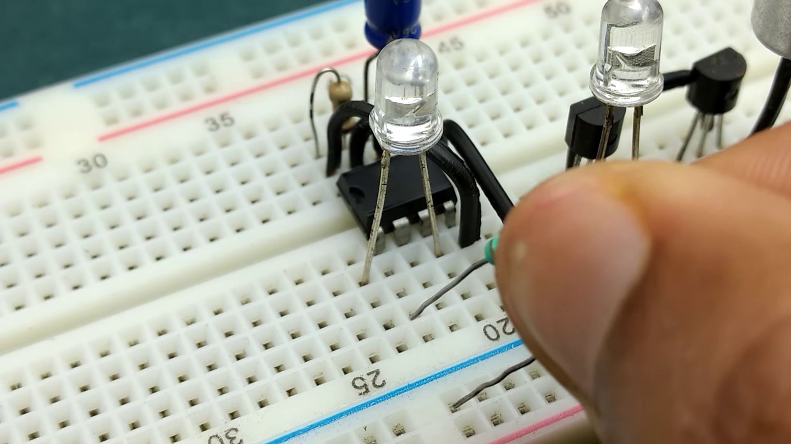 (score 90.0000)
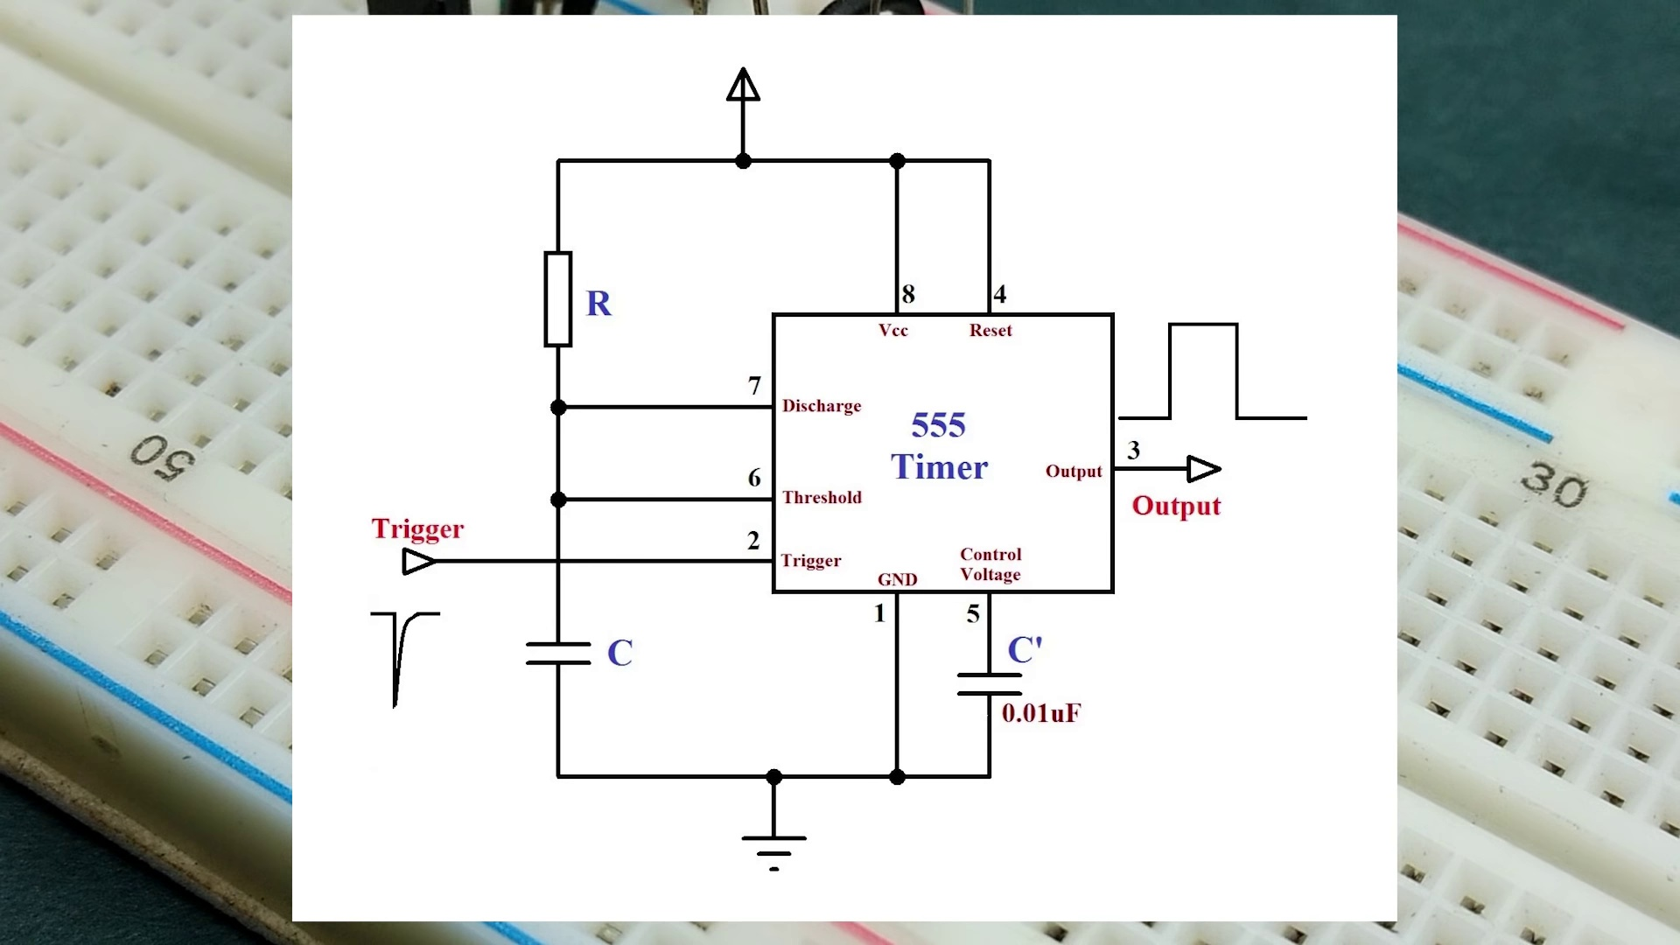 (score 90.0000)
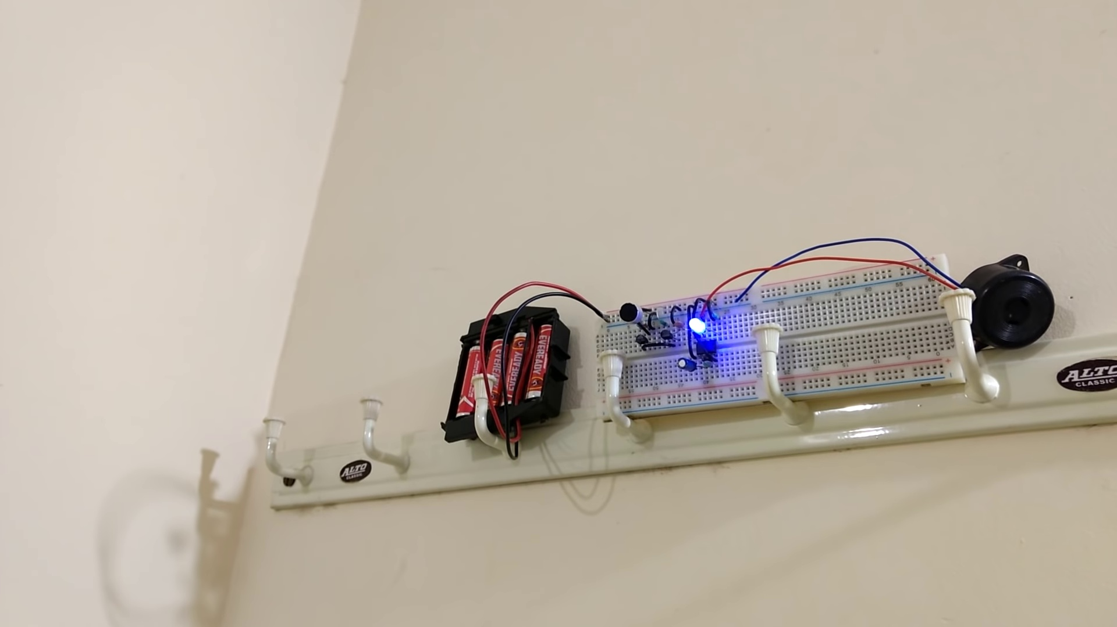 (score 90.0000)
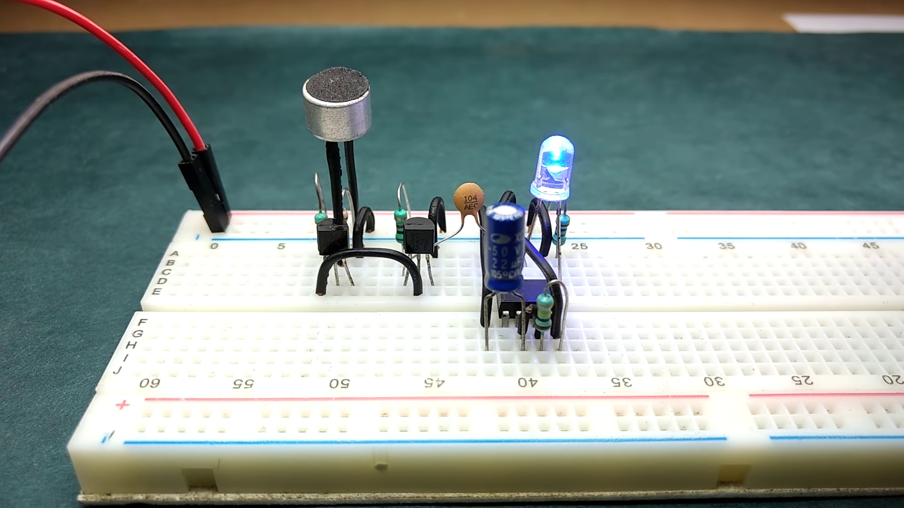 (score 85.0000)
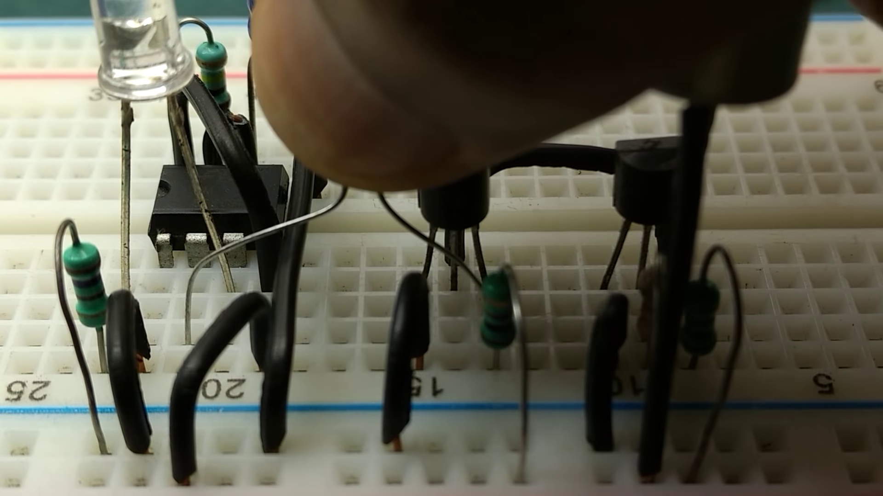 (score 85.0000)
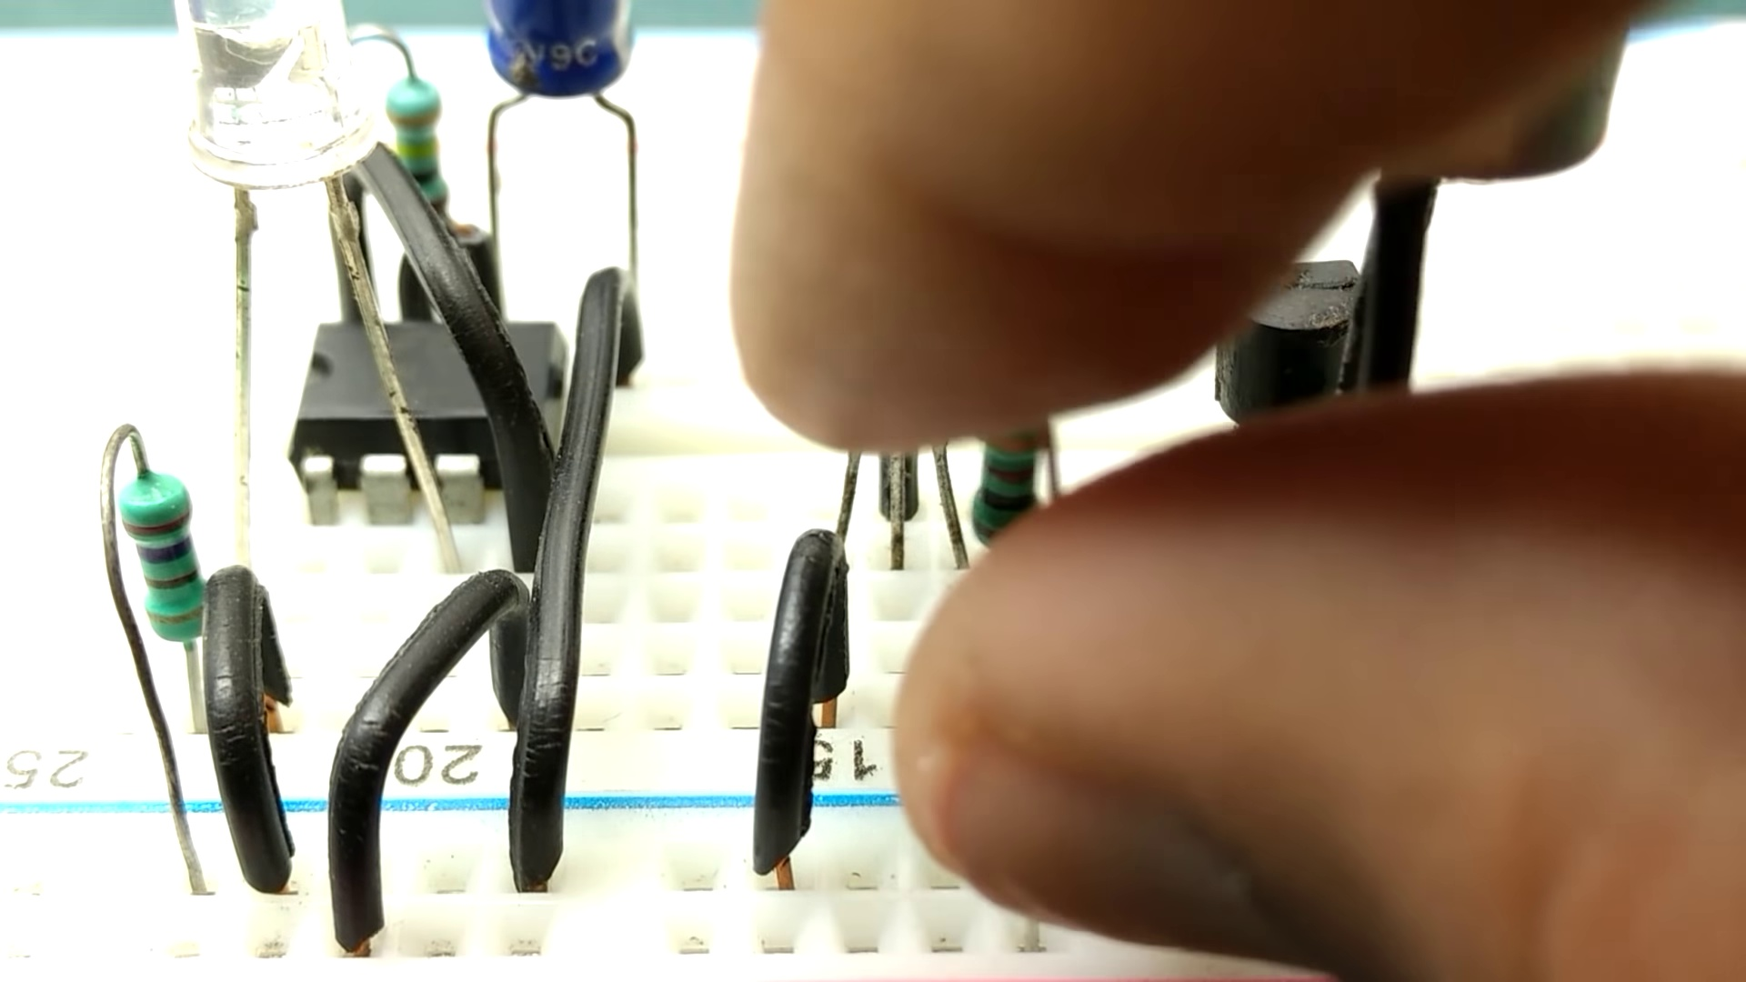 (score 85.0000)
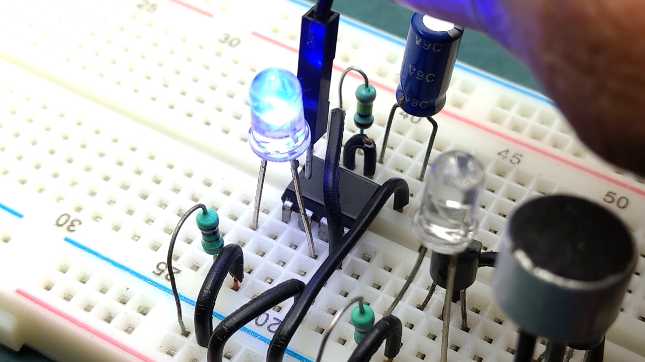 (score 85.0000)
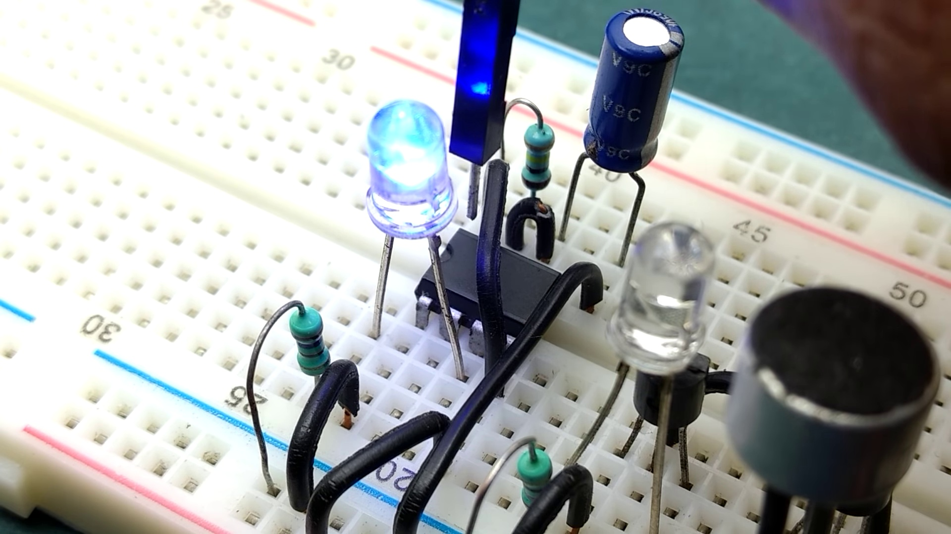 (score 85.0000)
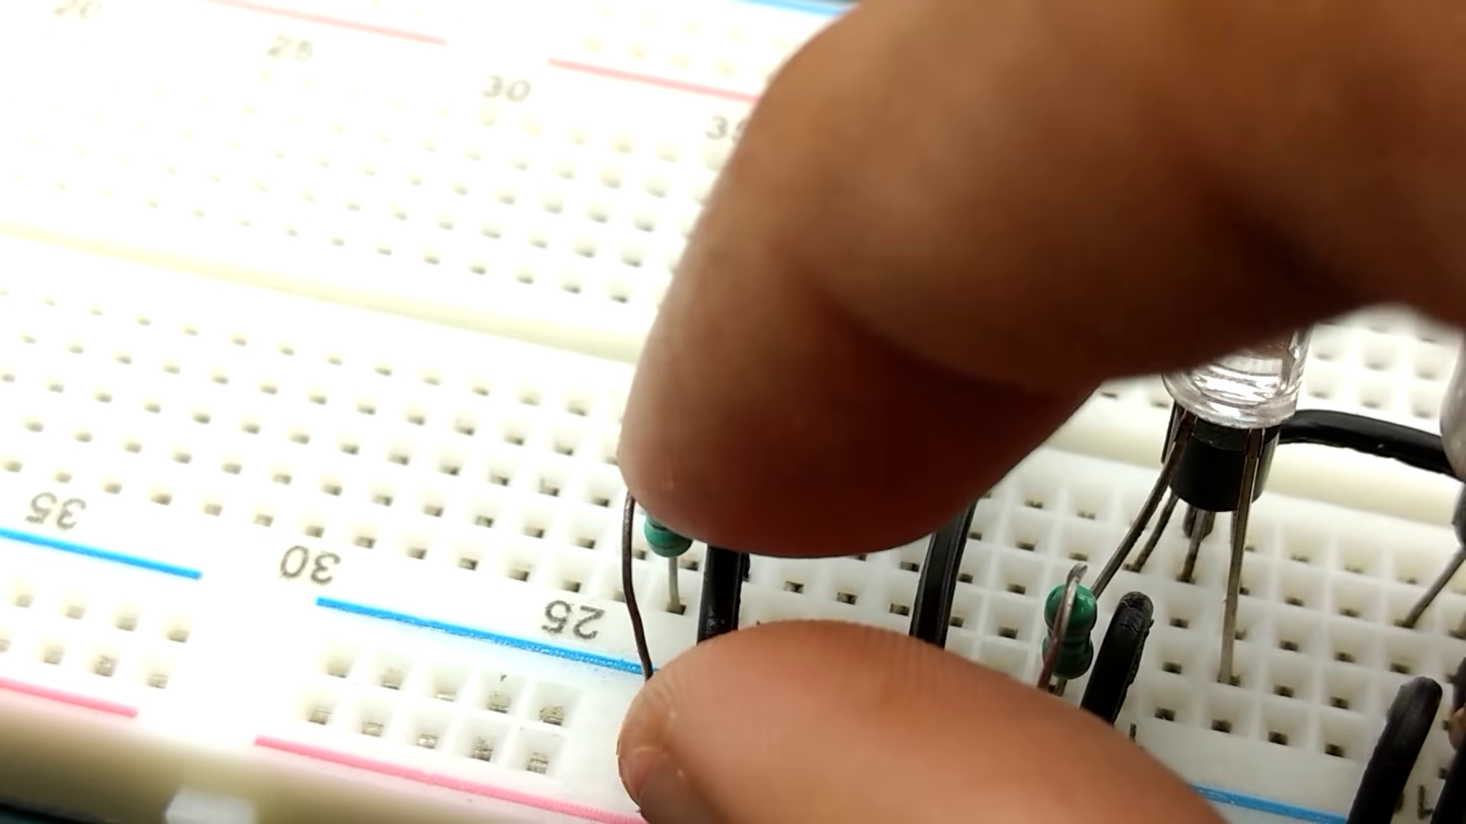 (score 85.0000)
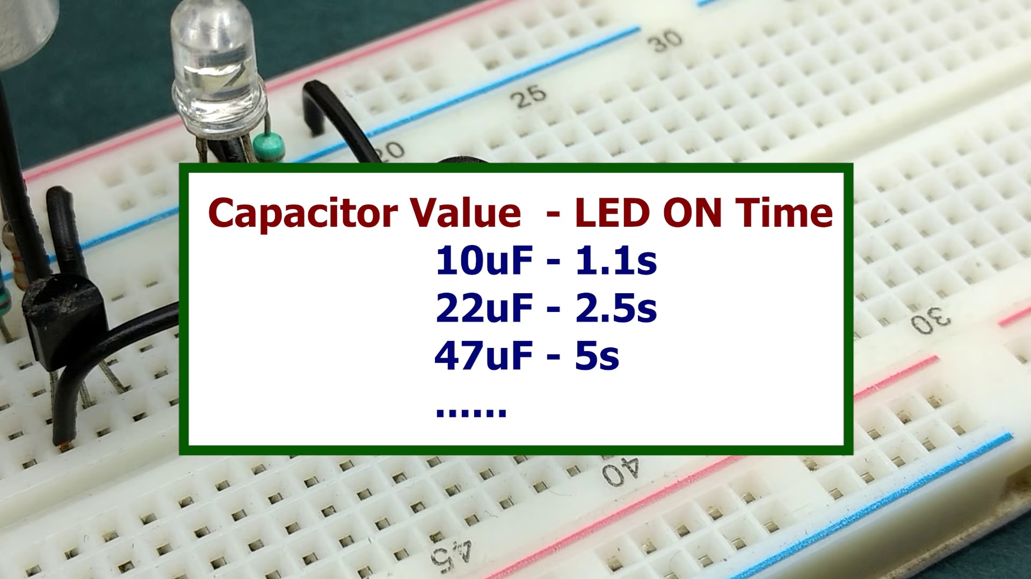 (score 85.0000)
Least correlated frames:
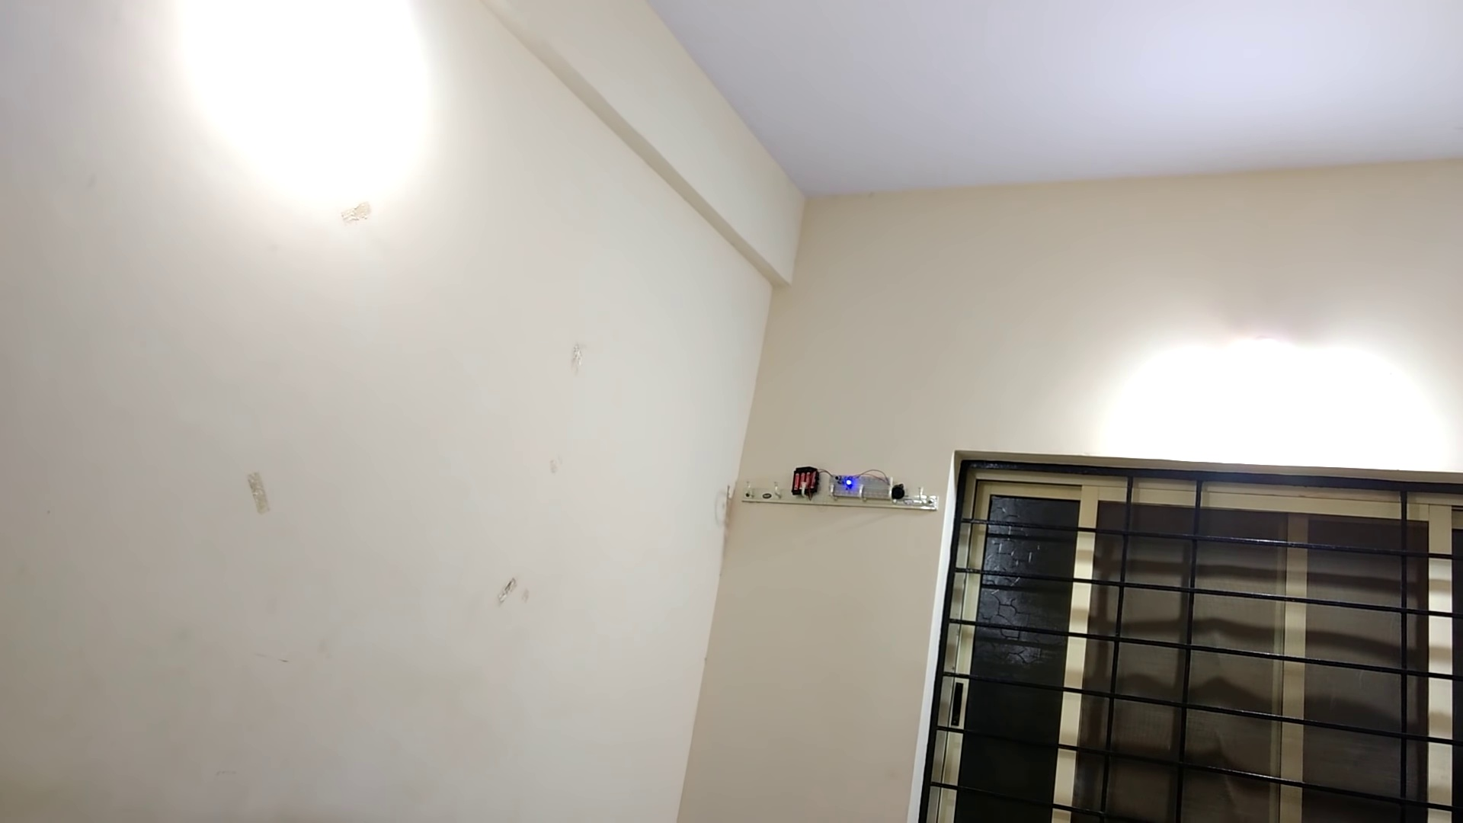 (score 0.0000)
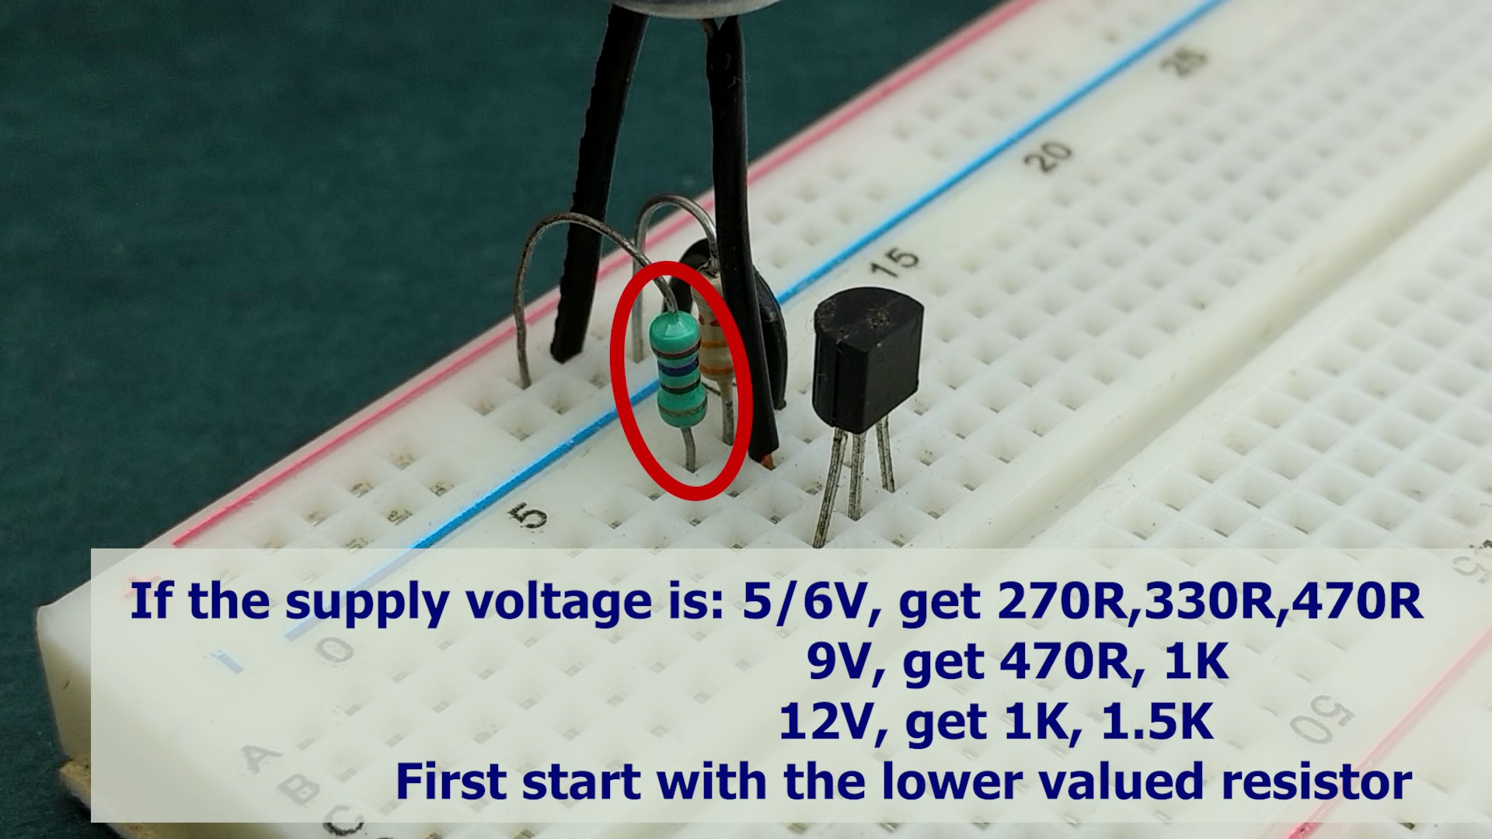 (score 0.0000)
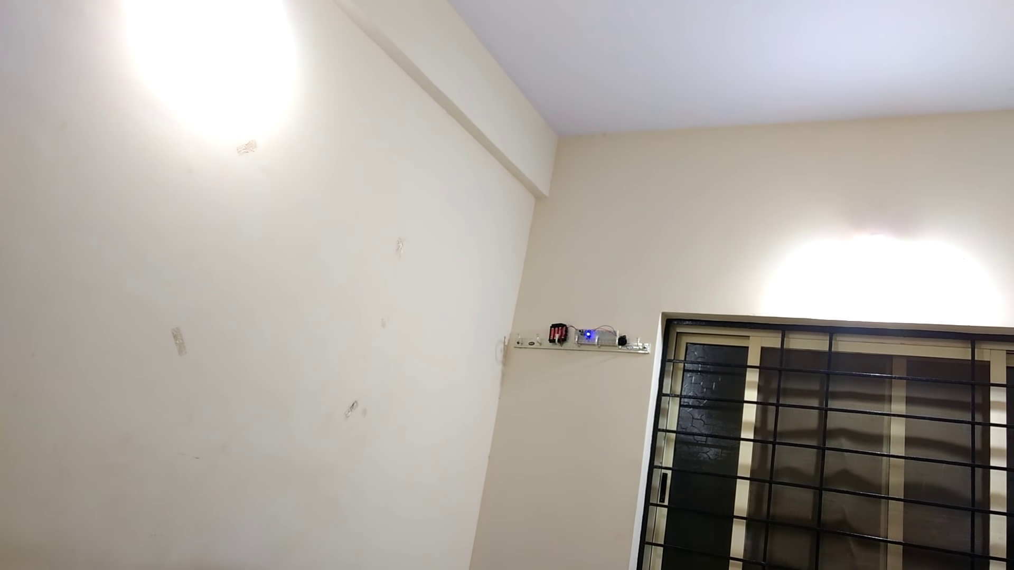 (score 10.0000)
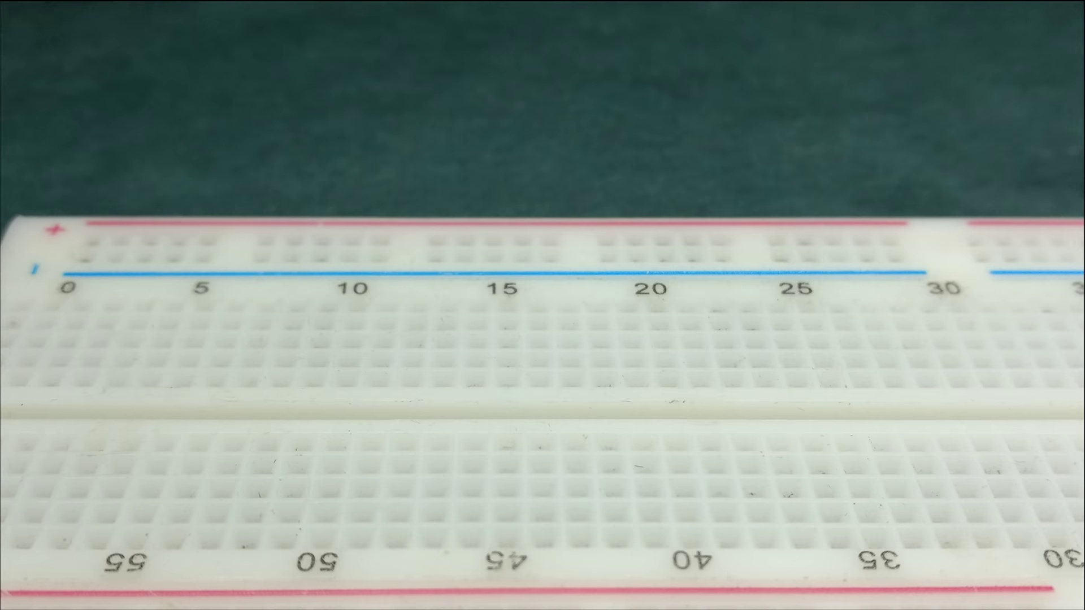 (score 20.0000)
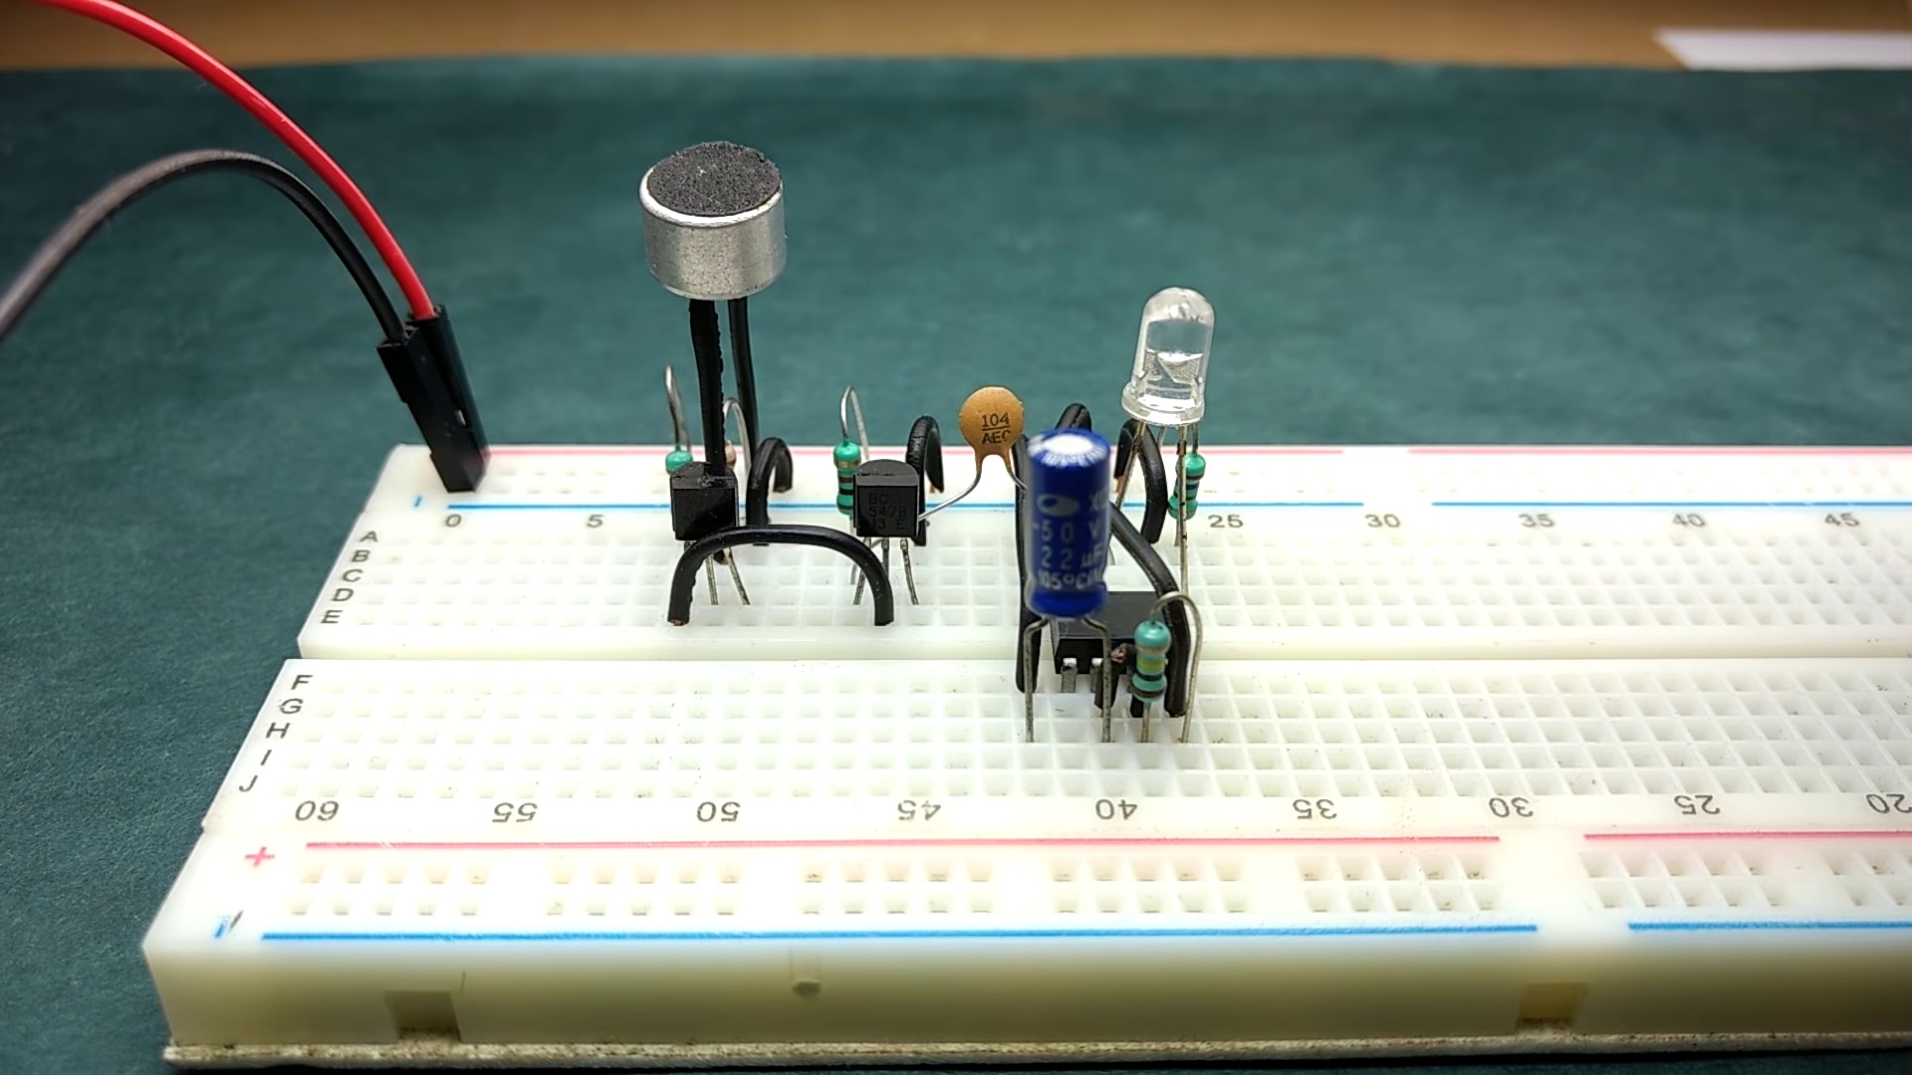 (score 20.0000)
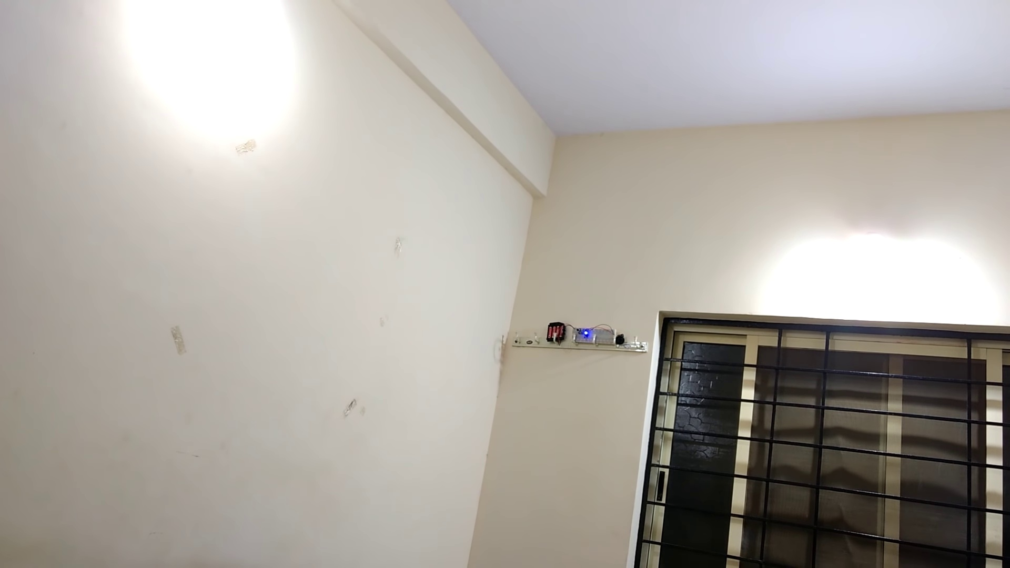 (score 20.0000)
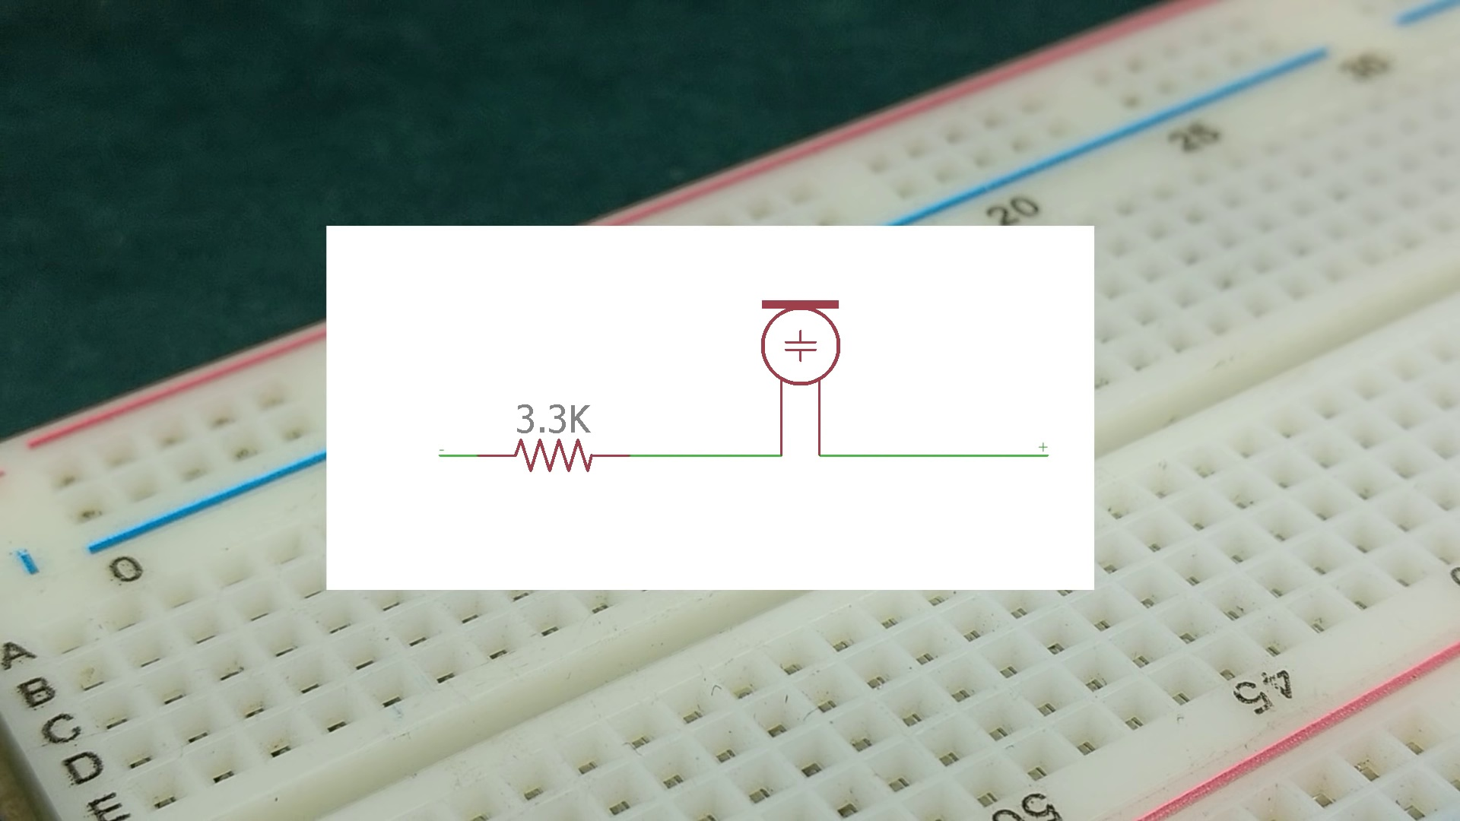 (score 20.0000)
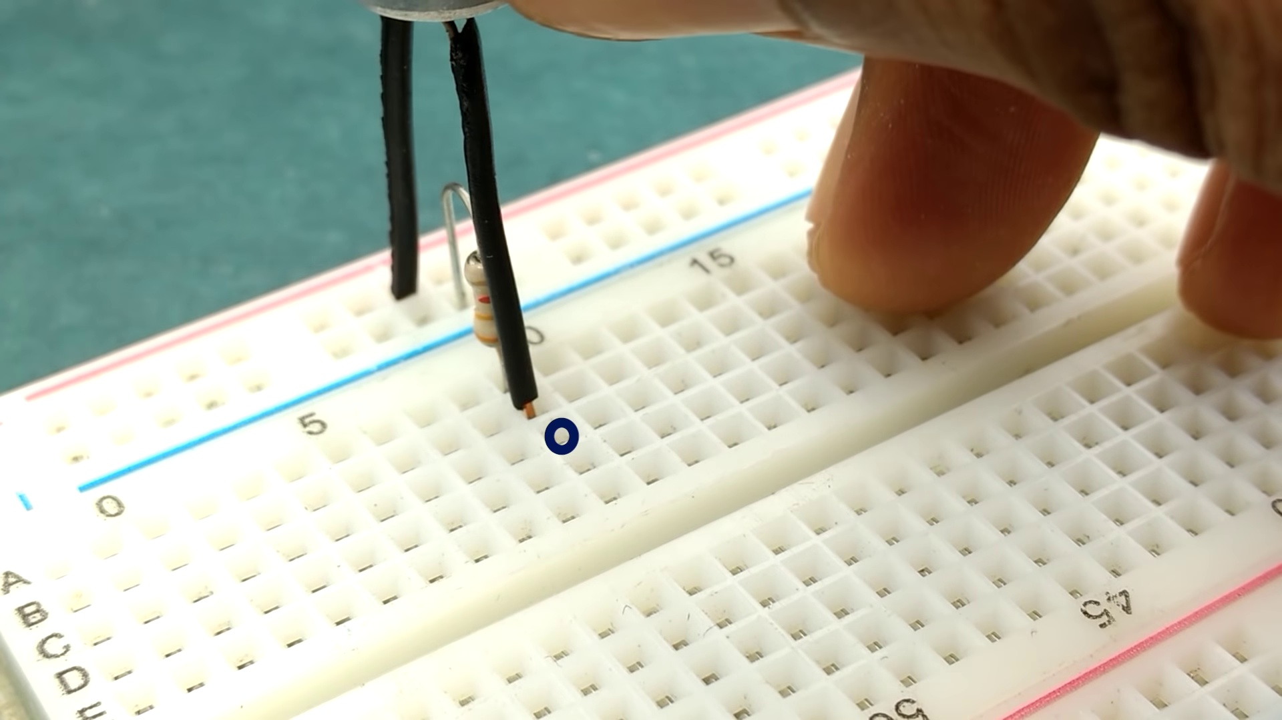 (score 20.0000)
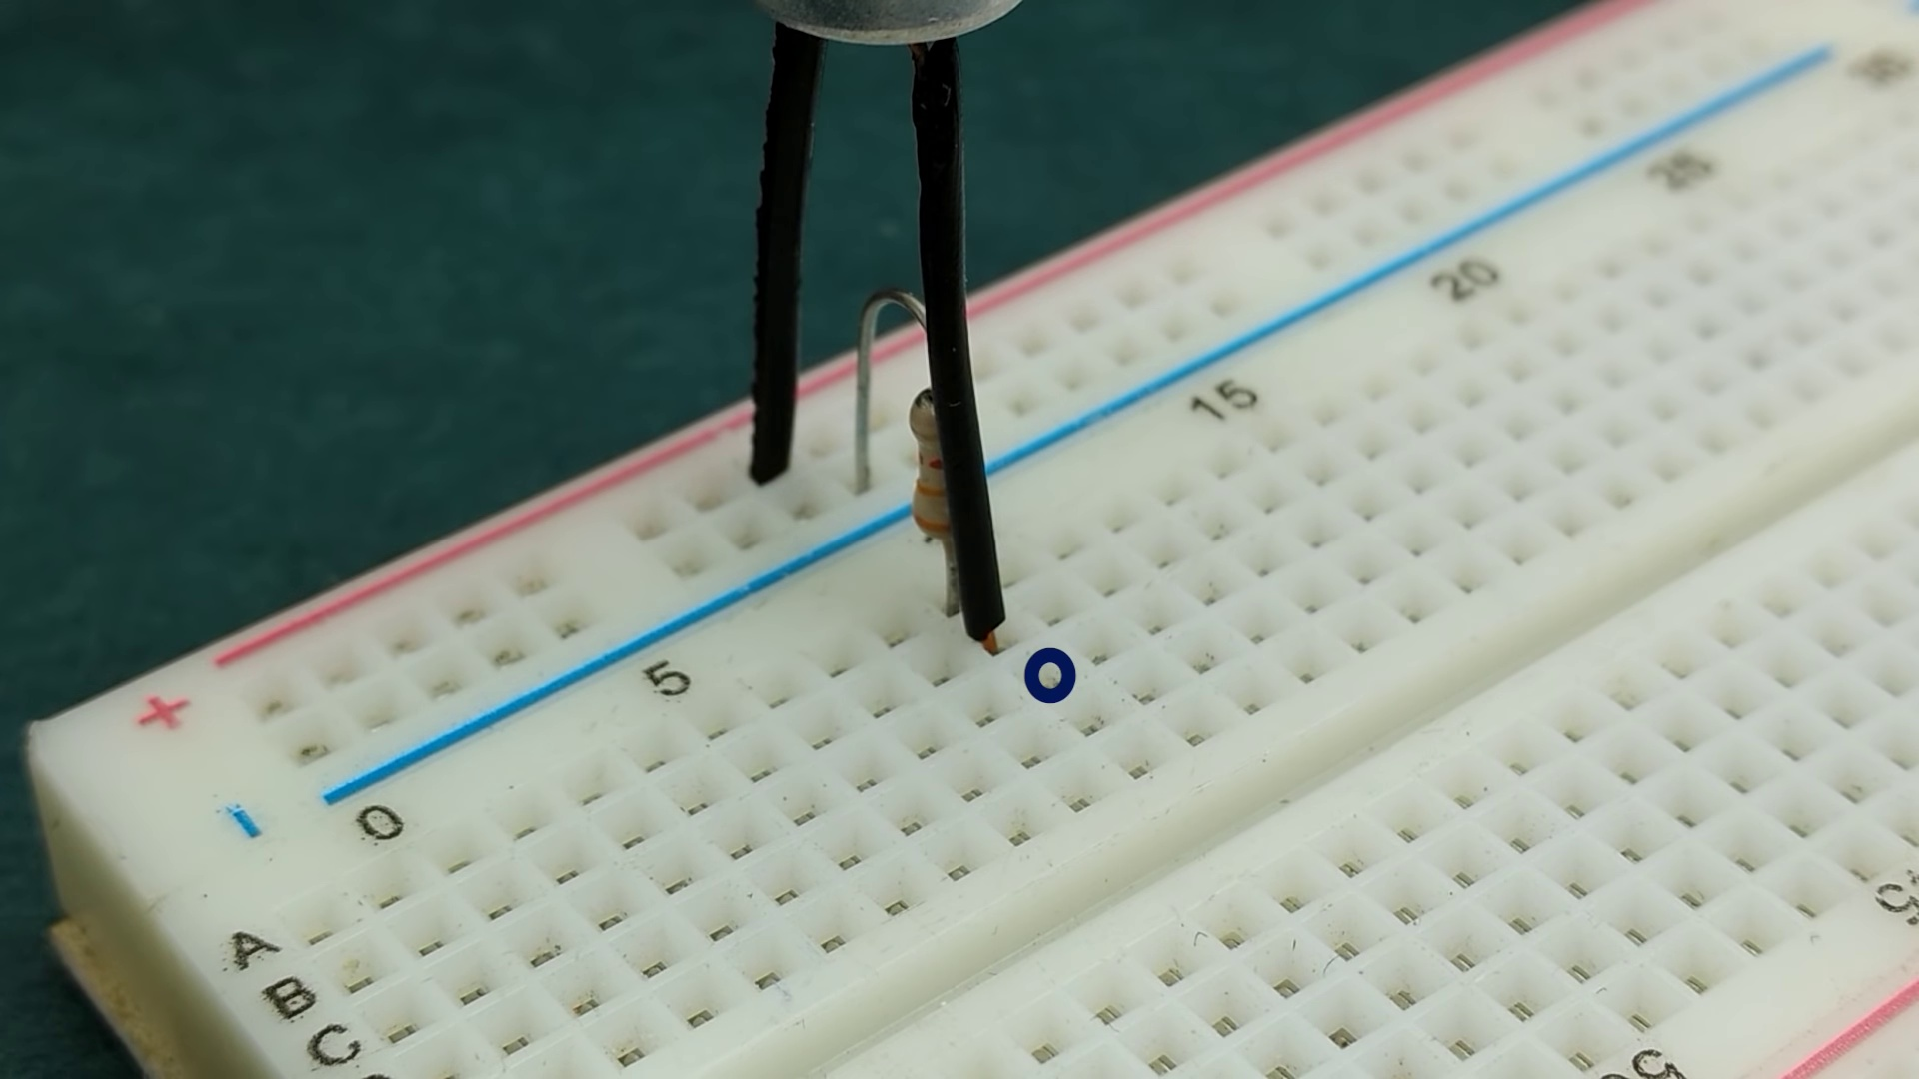 (score 20.0000)
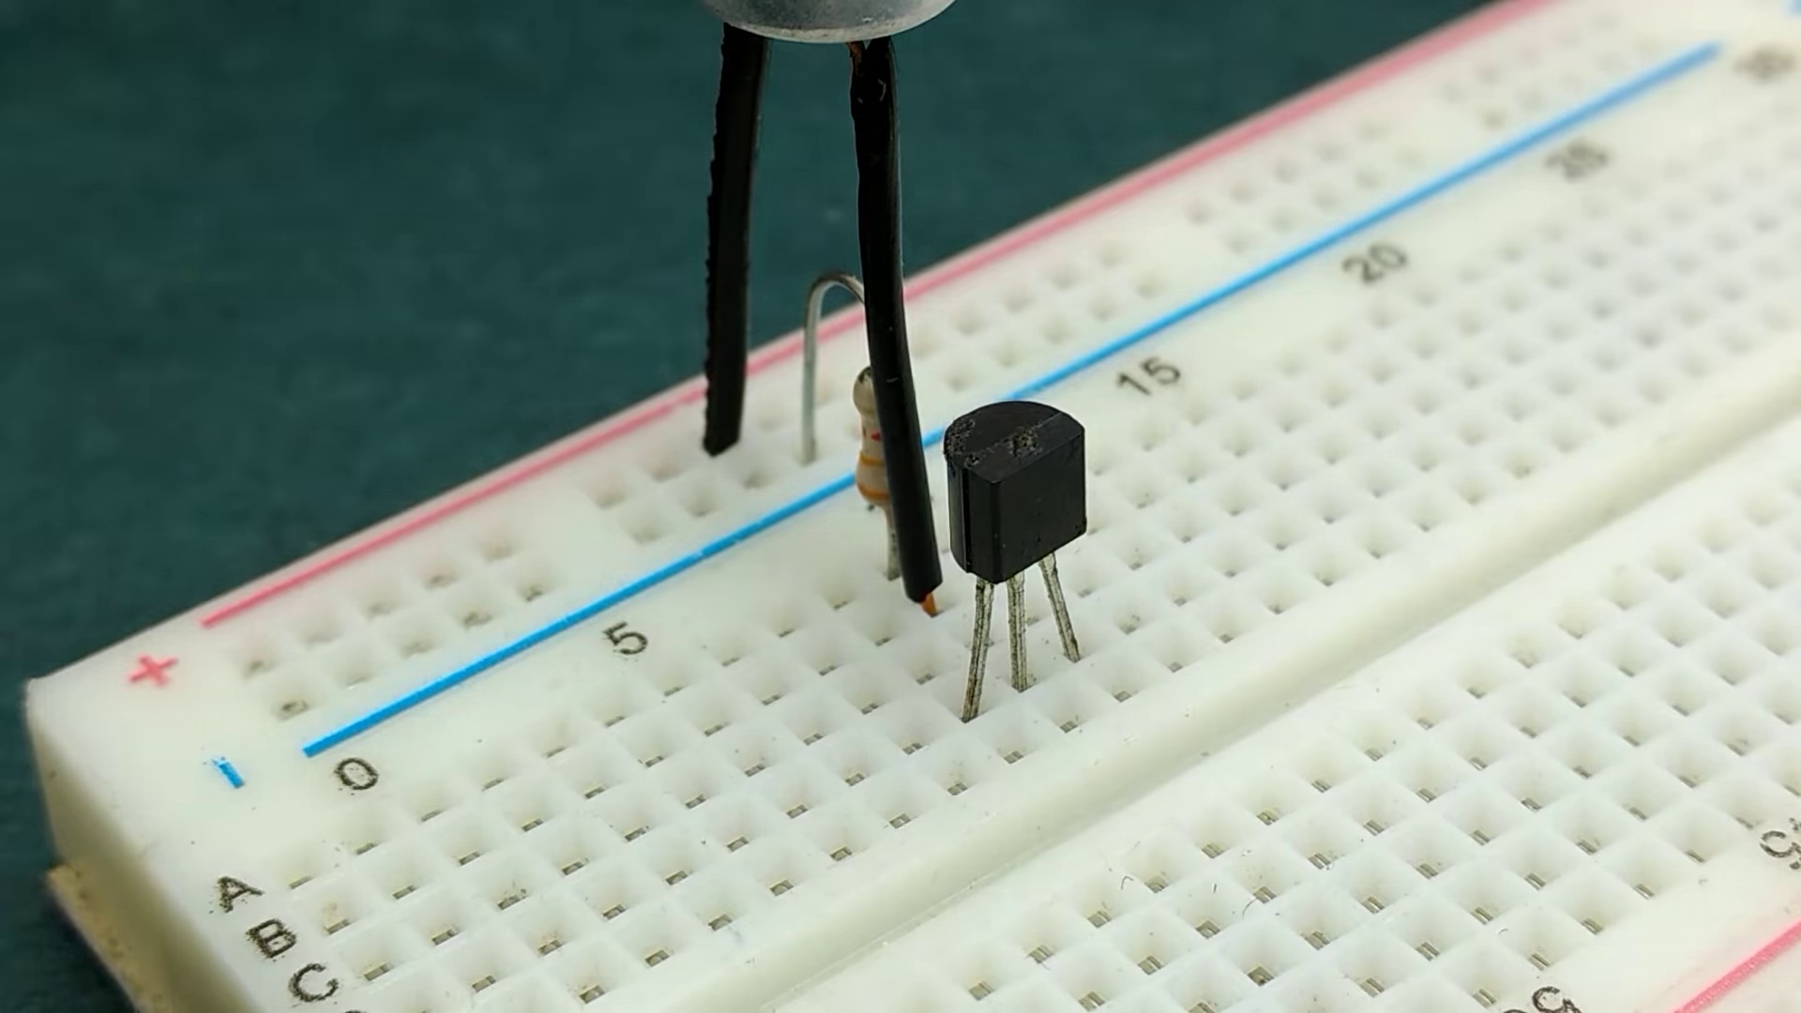 (score 20.0000)

Frame: frame_0000.jpg
Caption: The image captures a close-up view of two distinct objects on a blue surface: a transparent plastic sheet with a grid of holes and a ruler at the bottom left corner, and a plastic breadboard laid flat. The transparent sheet has markings along its top edge (0 through 16) and is labeled as "PATTERN 5" of an unknown series. There are no people, devices, or other objects in the frame; the focus is solely on these two objects and their markings.
The transparent sheet appears to be related to a scientific or educational setting, possibly for teaching about perforation patterns or the creation of optical devices. The ruler provides measurements from 0 to 10 units in millimeters, suggesting that this object may be used for measurement or comparison purposes.
The plastic breadboard is divided into rows and columns, each marked with a different number ranging from 1 to 30. The numbers are clearly visible, and the overall layout gives a clear indication of the breadboard's structure. The top row is numbered from 1 to 5, the second row from 6 to 10, and so on.
The blue surface behind these objects provides a contrasting background, making their details stand out. There is no text or other context provided in the image that would indicate the purpose or use of these objects beyond their descriptive markings.
No strongly correlated comments found for this frame.

Frame: frame_0001.jpg
Caption: The image shows an educational setting, likely a classroom or workshop environment. There are three main components visible: on the left side of the frame, a small electronic device with various components such as resistors and capacitors appears to be a model or demonstration setup for teaching about electronics or circuitry; in the center, there's a transparent plastic stand that has been assembled, possibly as part of a classroom project or demonstration, being held up by two hands visible from the front side of the stand; on the right, an electronics kit with various parts is present, which might be used for constructing circuits or assembling electronic devices.
In the background, there are whiteboards that could contain text or diagrams relevant to the lesson being taught. A small object resembling an electronic device, possibly an oscilloscope or a multimeter, is also visible, commonly used in electronics classes for measurements and troubleshooting.
Closer inspection of the image reveals a circuit board resting on one of the whiteboards, adorned with various components, including resistors, capacitors, and diodes. The resistors are colored in hues of brown and black, while the capacitors are painted in shades of blue and green. The diodes are colored in a vibrant shade of red. A small light bulb is also present on the circuit board.
The overall scene is one of electronic assembly, showcasing the intricate world of electronics, with hands-on demonstrations and projects being conducted to teach students about circuitry and electrical components.
Comment (score 85): I like the videos using the 555 timer, this is something I have looked at a lot to see how it works. He is using sound to trigger the LED light on. Interesting that the LED may try to stay on, so the load resistance may need to be increased in order for the LED to not stay on
Reason: The comment directly discusses the technical steps and components described in the caption, specifically mentioning the use of a 555 timer and LED light on, which are both present in the image. The comment also references the load resistance and its effect on the LED's behavior, which is also depicted in the circuit board shown in the frame.
Source: https://www.youtube.com/watch?v=DkbfBIMSdgo: Clap Switch circuit on Breadboard (Sound triggered LED) | Transistor + 555 timer projects

Frame: frame_0002.jpg
Caption: The image presents a small educational setup demonstrating a simple electrical circuit or experiment. A breadboard with various electronic components connected together is the central focus of the image, resting on a wooden surface that could be a table or workbench. The breadboard features:
1. A 9-volt battery connected to a black plastic hookup wire.
2. An electric motor attached to the breadboard.
3. A small DC motor with a shaft and two axles attached to it.
4. A multimeter or voltmeter set to the voltage setting, indicating that it is measuring the voltage of the circuit at a certain point in time.
5. A light bulb connected in series with the motor and battery. The bulb is currently unlit, suggesting either that there's not enough current passing through to make it glow or that the circuit is intentionally set up for an educational demonstration.
6. An electric motor controller or a similar device that seems to be controlling or regulating the operation of the motor.
7. A blue object with some kind of emblem on it, which could be a logo or a symbol related to the experiment or project being demonstrated. The details are unclear due to the camera angle and distance.
8. An LED light that is currently turned off, positioned next to the motor controller.
9. A hookup wire with an alligator clip attached to it, which could be used for additional components or connections.
On the right side of the image, a person appears to be setting up the circuit or demonstrating its operation. They are holding two wires, possibly connecting them to other parts of the setup or demonstration. The individual's face is not clearly visible due to the angle and distance from the camera.
In the background, there is a partial view of what seems to be a presentation slide or a piece of paper with text and diagrams on it, but the content is not fully visible in this image. The focus of the image is clearly on the educational setup involving electronics and mechanics, suggesting that the individual might be teaching or learning about electrical circuits and their effects on mechanical components.
In addition to the breadboard setup, a separate circuit board is also present, resting on a green table. This board features various electronic components, including resistors, a microphone, an LED, and a capacitor, arranged in a neat row. The board is connected to the green table with black wires and has a power source indicated by the black wire connecting to it.
Comment (score 80): I like the videos using the 555 timer, this is something I have looked at a lot to see how it works. He is using sound to trigger the LED light on. Interesting that the LED may try to stay on, so the load resistance may need to be increased in order for the LED to not stay on
Reason: The comment discusses the same technical steps (using sound to trigger the LED light) and objects (555 timer, LED light) described in the caption. The mention of load resistance and trying to keep the LED from staying on also relates to the settings and goals depicted in the image.
Source: https://www.youtube.com/watch?v=DkbfBIMSdgo: Clap Switch circuit on Breadboard (Sound triggered LED) | Transistor + 555 timer projects

Frame: frame_0003.jpg
Caption: The image shows a close-up view of an electronic setup featuring a breadboard as its centerpiece. The breadboard is laid out on a green surface, likely a mat or foam board for protection, and is populated with various electronic components. A microcontroller module (possibly an Arduino) appears to be connected to other components, including what looks like a small motor and a resistor, all of which are part of the larger circuit or project.
In this detailed view, we see that the breadboard is labeled with a black A-Z alphabet, indicating the order of the components on the board. The components themselves include a black microphone, its wires connected to the board; a red lightbulb with a blue glow and its wires also connected to the board; a black LED, its wires connected to the board; and a white transistor, its wires connected to the board.
The setup suggests a hands-on approach to learning about electronics and computer programming. The precise nature of the tutorial (teaching others, learning independently) is not possible to determine from this image alone, but it's clear that some sort of project or code is being demonstrated or created.
Comment (score 85): I like the videos using the 555 timer, this is something I have looked at a lot to see how it works. He is using sound to trigger the LED light on. Interesting that the LED may try to stay on, so the load resistance may need to be increased in order for the LED to not stay on
Reason: The comment directly discusses the same technical steps and components described in the caption, specifically mentioning the LED light and its potential behavior due to load resistance. The correlation is high because the comment references specific details from the frame caption, such as the LED's wires being connected to the board.
Source: https://www.youtube.com/watch?v=DkbfBIMSdgo: Clap Switch circuit on Breadboard (Sound triggered LED) | Transistor + 555 timer projects

Frame: frame_0004.jpg
Caption: This image presents a highly detailed view of an electronic breadboard setup with various components attached to it. The setup is powered on, as indicated by the glowing red LED connected to the 5V DC power supply. The breadboard features a small circuit on its left side that includes a red LED (Light-Emitting Diode), an NPN transistor (Q1) in common-emitter configuration, a diode (D1), and jumper wires connecting these components together.
The transistor is connected to the 5V power supply through a resistor, which is not fully visible in this image. The emitter pin of the transistor is connected directly to the positive rail, while its base is presumably connected to the 5V power supply. A diode (D1) with its cathode connected to the collector of the transistor suggests it might be used as a flyback diode or for reverse voltage protection.
An Arduino Uno microcontroller board appears to be the main processing unit for this circuit, with several digital and analog pins exposed that can be used to interface with other circuits or devices. A small green signal LED (D2) is connected directly to one of the Arduino's digital pins, likely serving as an output for a simple test program running on the Arduino.
The right side of the image features a small bottle labeled "Maker's Milk," which is often used as a placeholder for a real component or to represent a concept in educational settings related to electronics. The setup suggests that this could be part of an educational demonstration or project involving basic electronics concepts such as transistors, LEDs, and Arduino programming.
The circuit board appears to be resting on a green table, providing a stark contrast to the white of the board. The board is a complex network of wires and components, including resistors, transistors, and capacitors, indicating a sophisticated electronic project. A microphone is positioned towards the left side of the board, surrounded by other components.
The overall image suggests a project related to electronics and possibly audio processing, given the presence of the microphone. The precise location and arrangement of the components on the board provide a glimpse into the intricacies of the project.
No strongly correlated comments found for this frame.

Frame: frame_0005.jpg
Caption: The image you've provided shows an interior room, likely a bedroom or study area, with a wall-mounted light illuminating the space. On one side of the room, a sign with text and possibly an image is visible on the wall; however, due to the resolution and angle of the photo, the text on the sign is not clearly legible. The room features a simple and functional design with plain walls and no decorative elements visible.
The room is narrow, with a white wall serving as its backdrop. A black shelf adorns this wall, holding a small lamp and a box, each with distinct designs. The lamp's bulb glows brightly, casting a warm light over the room. The box, with its dark exterior, sits on the shelf, adding an element of contrast to the otherwise monochrome room.
On the right side of the room, a window is visible, which is closed, offering privacy and security. The window is framed in black, matching the color of the shelf and lamp, creating a cohesive look.
Despite the simplicity of the room, it's filled with a sense of warmth and homeliness. The colors, objects, and their arrangement all contribute to this feeling. There are no people or instructors in this frame, and there are no indications of any teaching or educational activity taking place. The relative positions of the objects suggest a well-organized space, with each item having its own designated place.
The lamp and box on the shelf suggest a functional and practical room. The closed window and the shelf's design also hint at a sense of security and privacy. Overall, the image presents a simple yet charming room, filled with everyday objects that tell a story of daily life, without any discernible text.
No strongly correlated comments found for this frame.

Frame: frame_0006.jpg
Caption: The image captures an indoor scene with a plain beige wall and a simple window with closed curtains to the left. On the wall opposite the window is a mirror where a person's reflection is captured, appearing to be seated and facing away from the camera, with only their back and head visible due to the angle of the photograph. There is no direct view of the individual's face or body.
On the same wall as the mirror, a watermark reading "DIDO" is visible, which could indicate the name of the device used to take the photo or the brand associated with it. A small light fixture attached to the ceiling in the right corner appears to be turned off. The photograph appears to have been taken during the daytime, suggested by the natural lighting coming from outside the frame.
The same room also features a white wall serving as the backdrop, where a small black shelf is affixed. The shelf is adorned with three objects: a small blue light positioned towards the left, a black box, and a small red object to the right. The blue light is the most prominent among the three. The overall scene is devoid of any text or discernible action, suggesting a well-arranged space with each object having its own designated spot.
No strongly correlated comments found for this frame.

Frame: frame_0007.jpg
Caption: The image shows an interior space that appears to be a room in a residential setting. A large white wall dominates the left side of the frame, with a small metal object attached to it but its purpose is unclear from this angle. In front of this wall, there are two visible doors or openings, suggesting that the room might be part of an apartment complex or a house where different units share walls.
On the right side of the image, a person is sitting at a desk with what looks like a computer monitor in front of them. However, their face and any activity they may be engaged in are not fully visible due to the angle and distance of the photo. The lighting in the room suggests it might be an overcast day outside.
The wall on the left side features a small shelf, which is adorned with a single blue light that emits a soft glow, casting an ethereal light that dances on the wall. A black grate, possibly a window, sits at the bottom of the shelf, adding a touch of contrast to the otherwise monochrome setting.
The overall impression is one of a typical domestic environment rather than a classroom or lecture hall, with the simple yet intriguing scene exuding a sense of tranquility and simplicity.
No strongly correlated comments found for this frame.

Frame: frame_0008.jpg
Caption: The image presents a white wall that serves as a backdrop for a black and red circuit board, which is filled with various electronic components. The components on the circuit board include resistors, capacitors, possibly LEDs or other electronic elements, and several wires, including a red wire and a black wire. A blue light is also illuminated on the circuit board, suggesting that the system might be powered on or has been tested recently.
The circuit board is attached to a white speaker, which is mounted on the board and connected to it via a red wire. The speaker is turned on, emitting a faint sound. At the top of the board, a white hook connects the board to the wall using a black wire, forming a neat and organized display against the white wall.
A small power supply unit with an adjustable voltage output powers the circuit. Above the device, two sticky notes with writing on them are visible, although the text is too small and blurry to be legible in this image.
Comment (score 90): I like the videos using the 555 timer, this is something I have looked at a lot to see how it works. He is using sound to trigger the LED light on. Interesting that the LED may try to stay on, so the load resistance may need to be increased in order for the LED to not stay on
Reason: The comment directly discusses the technical steps described in the caption, specifically mentioning the use of a 555 timer and an LED light being triggered by sound. The comment also references the circuit board's components and settings, such as the load resistance needed to prevent the LED from staying on.
Source: https://www.youtube.com/watch?v=DkbfBIMSdgo: Clap Switch circuit on Breadboard (Sound triggered LED) | Transistor + 555 timer projects

Frame: frame_0009.jpg
Caption: The image shows a scene with two main elements: an electronic device mounted on a wall to the left, and a wooden cabinet or table with a white surface on the right. The device has a blue LED display and several connectors or ports. In front of the cabinet, there is an object that appears to be a smartphone or tablet propped up against a small stand, with its screen displaying a colorful digital interface featuring various icons and text.
On the wall, there is a white wall socket mounted on it, equipped with a black cord connected to the wall. The socket has three small silver plugs arranged in a neat row, each with a red button on top. The plugs are symmetrical around the central socket, providing a simple and clean composition that draws attention to the socket.
The image has a low resolution and appears to be taken casually, possibly capturing someone setting up their devices at home. There is no visible text or diagram that provides additional information about the device or its function.
Comment (score 80): I like the videos using the 555 timer, this is something I have looked at a lot to see how it works. He is using sound to trigger the LED light on. Interesting that the LED may try to stay on, so the load resistance may need to be increased in order for the LED to not stay on
Reason: The comment directly discusses the technical steps described in the caption, specifically the use of a 555 timer to trigger an LED light. The mention of load resistance and trying to keep the LED from staying on also corresponds to the scene depicted in the caption.
Source: https://www.youtube.com/watch?v=DkbfBIMSdgo: Clap Switch circuit on Breadboard (Sound triggered LED) | Transistor + 555 timer projects

Frame: frame_0010.jpg
Caption: The image shows an interior space that appears to be a room used for educational purposes. There is no person present in the frame, and no explicit teaching context is visible. The room has white walls, including one with a blackboard featuring red chalk marks, although their purpose or content cannot be discerned due to the low resolution.
The flooring appears to be tile-covered. A door with natural light entering from outside provides a view into the room. On the wall opposite the blackboard, an electrical panel is mounted, featuring a power switch and a red light at the top and bottom, respectively. A black cord runs vertically across the panel, connecting to the switch and the red light.
The panel is secured to the wall with a black screw, providing a sturdy base for the components. The overall scene suggests an electrical installation in progress, with the switch and light ready for use. Although no discernible text is present, the relative positions of the components suggest careful planning and attention to detail, indicating that the panel is part of an electrical system designed for powering devices or appliances.
The image does not provide enough information to confidently determine the purpose or function of the components, but the presence of the switch and light suggests that the panel is securely fastened in place, ensuring stability and safety. The white wall behind the panel provides a neutral background that allows the panel and its components to stand out.
Comment (score 80): I like the videos using the 555 timer, this is something I have looked at a lot to see how it works. He is using sound to trigger the LED light on. Interesting that the LED may try to stay on, so the load resistance may need to be increased in order for the LED to not stay on
Reason: The comment directly discusses the use of a switch and light, which are technical steps described in the caption. The mention of load resistance and LED staying on also relates to the electrical system described in the caption, indicating strong correlation between the two.
Source: https://www.youtube.com/watch?v=DkbfBIMSdgo: Clap Switch circuit on Breadboard (Sound triggered LED) | Transistor + 555 timer projects

Frame: frame_0011.jpg
Caption: The image appears to capture an indoor scene, likely taken in a laboratory setting given the presence of electronic components and a well-organized workspace. A black wire rack is mounted on a white wall using a white metal bracket, filled with various components including batteries, resistors, and a circuit board. The batteries are neatly arranged in rows, while the resistors are scattered throughout the rack. The circuit board is mounted on the top row of the rack.
Below the wire rack, there is a small whiteboard with a schematic-like diagram or illustration that appears to be related to electronics or technology. Although the text on the diagram is partially visible but not legible due to the image resolution, it suggests a connection between the components on the wire rack and the diagram on the wall.
On the floor below the whiteboard, there's a person's arm extended, holding something close to the board that could be a small model or component related to the diagram above. The individual is not fully visible in this frame, making it unclear whether they are giving an instruction or demonstration, as no other contextual elements such as a lecture hall, presentation slide, or instructional video are visible. The focus of the image seems to be on the whiteboard and the object being held by the individual, with the wire rack and its contents providing context for the scene.
No strongly correlated comments found for this frame.

Frame: frame_0012.jpg
Caption: The image shows a combination of electronic components spread out on what appears to be a breadboard. The breadboard features a collection of resistors with color bands indicating resistance values, an integrated circuit (IC), and other components such as capacitors and possibly a transistor. A black plug is centered on the board, which could be part of the circuit setup or an adapter for power supply. In the background, there appears to be a grid or matrix, but its purpose is unclear.
The text at the top of the image in bold uppercase letters states "COMPONENTS REQUIRED IN DESCRIPTION", suggesting that these components are part of a list or description required for some educational or informational purpose. The style of the image, focusing on the components and overlay text, implies it may be used to teach about electronics components, their functions, or how they can be used in a circuit.
A close-up view of the breadboard reveals the arrangement of these components, with resistors scattered across the board in distinct black and brown colors. The capacitors, featuring a typical white and blue color scheme, are positioned towards the top right and bottom left of the board. In the middle of the board, an LED with its distinctive red color is situated.
The breadboard sits on a white surface, providing a striking contrast to the components' colors and arrangements. The relative positions of the components suggest a well-organized circuit design, with each component strategically placed for optimal functionality.
Comment (score 85): I like the videos using the 555 timer, this is something I have looked at a lot to see how it works. He is using sound to trigger the LED light on. Interesting that the LED may try to stay on, so the load resistance may need to be increased in order for the LED to not stay on
Reason: The comment directly discusses the same technical steps (using a 555 timer and triggering an LED light) and objects (LED, load resistance) described in the caption. The mention of increasing load resistance to prevent the LED from staying on also refers to specific settings mentioned in the caption.
Source: https://www.youtube.com/watch?v=DkbfBIMSdgo: Clap Switch circuit on Breadboard (Sound triggered LED) | Transistor + 555 timer projects

Frame: frame_0013.jpg
Caption: The image shows a close-up view of an electronic circuit board with various components mounted on it, as well as a white breadboard in the background. The breadboard is arranged in a grid pattern with red and blue wires, indicating it's a dual-sided breadboard. The wires are neatly labeled with numbers, suggesting they are used for connecting electronic components. The grid of the breadboard is divided into rows and columns, each marked with a number, providing a clear layout for connections.
On the top left corner of the circuit board, there is a red label with white lettering that reads "A1". In the center right part of the image, there's a sticker with a cross symbol on it and some text below, which is partially obscured; however, the visible part includes what looks like a digital readout displaying the number "0" in red. To the left of this sticker, there is a transparent plastic object that might be a tool or component related to electronics or circuitry.
The background suggests an indoor setting with artificial lighting, but no specific details about the surroundings are visible due to the close-up angle of the photo. The focus seems to be on the electronic components and the breadboard. There is no indication that any instructional content is being shown or if a person is present in the image.
Comment (score 80): I like the videos using the 555 timer, this is something I have looked at a lot to see how it works. He is using sound to trigger the LED light on. Interesting that the LED may try to stay on, so the load resistance may need to be increased in order for the LED to not stay on
Reason: The comment directly discusses the technical steps (using sound to trigger the LED light) and objects (555 timer, LED, breadboard) described in the caption. The mention of load resistance and LED staying on also relates to the circuit board layout mentioned in the caption. However, the comment does not fully capture all the details provided in the caption, such as the specific components mounted on the circuit board.
Source: https://www.youtube.com/watch?v=DkbfBIMSdgo: Clap Switch circuit on Breadboard (Sound triggered LED) | Transistor + 555 timer projects

Frame: frame_0014.jpg
Caption: The image captures a detailed view of an indoor setting with a focus on a piece of equipment resembling an electronic component. The device appears to be a white breadboard, commonly used for prototyping and testing circuits. The breadboard is set against a blurred background, emphasizing the components on the board.
On the breadboard, several red and blue components are arranged in a grid-like pattern. Resistors are placed in rows, while a potentiometer is positioned in a column. The top left corner of the breadboard is marked with the number 20, indicating the position of the components relative to each other. The bottom right corner is marked with the number 7, suggesting that this corner is the end point of the grid.
A white label at the top left corner of the image contains text and symbols, but the resolution and angle make it difficult to read in detail. Additionally, a red 'A' symbol with lines pointing to different sections of the device is present in the bottom right corner, possibly indicating areas for discussion or study.
No strongly correlated comments found for this frame.

Frame: frame_0015.jpg
Caption: The image displays a close-up of an electronic circuit board with several components such as resistors, capacitors, and other electronic parts. The board is split into two sections, each marked with the number "3.3K", indicating specific resistor values. One component on the top right corner has a label reading "300V", signifying its voltage rating. The circuit appears to be connected to a breadboard, which is commonly used for prototyping and testing electronic circuits. The photo seems to have been taken indoors with natural light illuminating the scene, as indicated by the shadows visible on the circuit board. There are no people or text visible in this frame, and it focuses solely on the hardware elements of an electronics project.
Comment (score 85): I like the videos using the 555 timer, this is something I have looked at a lot to see how it works. He is using sound to trigger the LED light on. Interesting that the LED may try to stay on, so the load resistance may need to be increased in order for the LED to not stay on
Reason: The comment discusses the same technical steps (using a 555 timer, triggering an LED light with sound) and objects (resistor values, LED light, breadboard) mentioned in the caption. The connection between the circuit components and the goal of the project (prototyping and testing) is also discussed.
Source: https://www.youtube.com/watch?v=DkbfBIMSdgo: Clap Switch circuit on Breadboard (Sound triggered LED) | Transistor + 555 timer projects

Frame: frame_0016.jpg
Caption: The image presents a close-up view of a transparent circuit board with various electronic components and traces. On the left side of the board, rows of holes are visible for inserting components like resistors or capacitors. A label "3kΩ" is also noticeable near one end, indicating the resistance value in kilohms. In the foreground, partially cropped out of the image, is a piece of paper with text and diagrams on it. The text appears too small to read clearly, but it seems related to an electronics project or experiment being conducted.
The board itself features various components, including resistors and wires, arranged in a grid-like pattern, suggesting a circuit layout. One of the resistors is prominently marked as "3.3K", accompanied by the number "+" and the letter "C". The overall setting suggests an educational environment where a student or instructor is engaged in an electronics lesson or project, perhaps explaining the use of resistors and other passive components in a circuit.
No strongly correlated comments found for this frame.

Frame: frame_0017.jpg
Caption: The image shows an electronics-related object that resembles a breadboard, which is commonly used for building circuits using electronic components. On this breadboard, there are several jumper wires connected in various configurations. A 3.3K resistor is located on the top right corner of the breadboard, represented by the number "3.3K" written in white on the board. The circuit board itself is white with black lines indicating connections. In the background, a green board with the number "20" on it is visible. The entire setup is placed on a black surface, possibly in a workshop or classroom setting with a workbench and some educational materials or notes nearby.
Comment (score 80): I like the videos using the 555 timer, this is something I have looked at a lot to see how it works. He is using sound to trigger the LED light on. Interesting that the LED may try to stay on, so the load resistance may need to be increased in order for the LED to not stay on
Reason: The comment directly discusses the technical steps and settings described in the caption, specifically the use of a breadboard for building circuits and the purpose of the 3.3K resistor. The mention of the LED light and load resistance also matches the objects and goals described in the caption.
Source: https://www.youtube.com/watch?v=DkbfBIMSdgo: Clap Switch circuit on Breadboard (Sound triggered LED) | Transistor + 555 timer projects

Frame: frame_0018.jpg
Caption: The image shows a person engaged in hands-on activities with electronic components, captured in two distinct moments. The first moment reveals a individual focused on assembling or adjusting electronic parts mounted on a perforated board with red and blue lines marking a grid pattern. One component of particular interest is a small, square-shaped device with circuitry visible under a clear plastic cover, bearing a white label with numbers suggesting it may be part of an experiment or educational demonstration related to electronic circuits or signals. The person is using a screwdriver to interact with the device, possibly to attach wires or other components.
The second moment takes us closer to the action, capturing a snapshot of a breadboard in use. A hand presses down on the white and rectangular breadboard, its fingernail visible, as it holds the board by its edge. The breadboard features a grid of black wires connected to a blue board with numbers and letters, including the clearly visible number "20," suggesting it might be a 20-pin breadboard.
The blurred background focuses attention on the breadboard and hand, hinting at the act of testing or debugging a circuit. It is unclear what specific action is taking place, but it appears the person is either testing a circuit or troubleshooting a problem. The overall image conveys the meticulous and precise nature of electronic engineering, offering a glimpse into an ongoing process of designing or testing electronic circuits.
Comment (score 85): I like the videos using the 555 timer, this is something I have looked at a lot to see how it works. He is using sound to trigger the LED light on. Interesting that the LED may try to stay on, so the load resistance may need to be increased in order for the LED to not stay on
Reason: The comment directly discusses the technical steps (using sound to trigger LED light), objects (555 timer), and settings (load resistance) described in the caption, demonstrating a strong correlation.
Source: https://www.youtube.com/watch?v=DkbfBIMSdgo: Clap Switch circuit on Breadboard (Sound triggered LED) | Transistor + 555 timer projects

Frame: frame_0019.jpg
Caption: The image shows an electronics project setup with various components on a white breadboard. The breadboard has black lines marking connections, with a small red resistor occupying the top left corner. The resistor, marked with the number 18 and having a brown wick, is connected to the top right corner of the board.
On the left side of the image, there are three jumper wires connected to the breadboard: one inserted into the 5th and 1st holes from the bottom, another in the 6th hole from the top, and a third partially visible in the center of the breadboard. A small black device with a red LED attached is situated in the middle section, along with an electrolytic capacitor connected to the breadboard and a resistor with white and orange bands on its ends.
On the right side of the image, a digital multimeter or meter indicates various readings on its screen. The needle points to an unidentified number, suggesting a measurement being taken. A person's arm, wearing a wristwatch, holds a small screwdriver or tool related to electronics work in the background, appearing to be engaged in setting up or adjusting components on the breadboard.
In the top right corner of the image, there is text that reads "1," which could indicate a step number in an instructional context or simply the first component in a sequence. The overall setup showcases the versatility and complexity of electronic design and testing.
Comment (score 80): I like the videos using the 555 timer, this is something I have looked at a lot to see how it works. He is using sound to trigger the LED light on. Interesting that the LED may try to stay on, so the load resistance may need to be increased in order for the LED to not stay on
Reason: The comment directly discusses the technical steps (using sound to trigger the LED light) and objects (555 timer, LED light, load resistance) mentioned in the caption. The connection is not perfect as it does not specifically mention the breadboard or multimeter, but the overall theme of electronic design and testing is consistent.
Source: https://www.youtube.com/watch?v=DkbfBIMSdgo: Clap Switch circuit on Breadboard (Sound triggered LED) | Transistor + 555 timer projects

Frame: frame_0020.jpg
Caption: The image displays a person's hand holding a small electronic component, specifically a white resistor with a black wiper, which is placed on a light green-colored breadboard paper labeled "Breadboard". The breadboard has a grid pattern and the person's thumb is positioned on the top left corner of the paper. The focus is on demonstrating how to work with electronic components and circuits. The background of the image appears to be blurred, suggesting that the attention is on the resistor and the person's hand rather than any external context. The scene implies that the person is in the process of assembling or testing an electronic circuit.
Comment (score 80): I like the videos using the 555 timer, this is something I have looked at a lot to see how it works. He is using sound to trigger the LED light on. Interesting that the LED may try to stay on, so the load resistance may need to be increased in order for the LED to not stay on
Reason: The comment directly discusses the technical steps (using sound to trigger LED light) and objects (LED light, resistor) described in the caption, which shows a strong connection between the two.
Source: https://www.youtube.com/watch?v=DkbfBIMSdgo: Clap Switch circuit on Breadboard (Sound triggered LED) | Transistor + 555 timer projects

Frame: frame_0021.jpg
Caption: The image shows a close-up view of either an electronic circuit board or a breadboard, depending on the perspective. The board appears to have numerous electronic components, including resistors with red and black color-coded markings indicating different values of resistance. A series of letters and numbers can be seen along the top edge of the board, but their meaning is unclear due to the angle and focus of the photograph.
In this image, a person's hands are working with the circuit board or breadboard, possibly soldering or adjusting components. Two red wires are attached to a small white resistor, which has a yellow stripe running through it for identification or indicating a specific value. The resistor is connected to the breadboard, which has black lines running across it, likely indicating connections between various components.
The setting suggests an educational environment where electronic assembly or repair is being taught, possibly as part of a class demonstrating basic electronics or circuit design principles. The focus on the hands and surrounding components indicates that the subject at hand is practical, hands-on experience with electronics.
Comment (score 85): I like the videos using the 555 timer, this is something I have looked at a lot to see how it works. He is using sound to trigger the LED light on. Interesting that the LED may try to stay on, so the load resistance may need to be increased in order for the LED to not stay on
Reason: The comment directly discusses the technical steps and objects described in the caption, specifically mentioning the 555 timer, sound triggering LED light on, load resistance, and trying to stay on. The mention of these specific details shows a strong connection between the comment and the frame caption.
Source: https://www.youtube.com/watch?v=DkbfBIMSdgo: Clap Switch circuit on Breadboard (Sound triggered LED) | Transistor + 555 timer projects

Frame: frame_0022.jpg
Caption: The image shows a close-up view of hands holding a metal wire between two electrical terminals connected to an integrated circuit board with various electronic components and lines. The focus appears to be on teaching someone how to insert a jumper wire correctly into an electronic circuit, possibly for educational purposes. There is a visible pattern on the terminal where the jumper wire is placed, which might represent the correct way to connect wires in this context.
In the background, there's a partial view of a person, likely an instructor or student, looking at the setup. The board and components are on a table or desk, suggesting an informal or classroom learning environment. On the same surface, a breadboard is placed, which holds a small electronic component, a resistor, colored red. The resistor is positioned on the left side of the breadboard.
The resistor is connected to a black wire, which is connected to the breadboard's red line. The black wire is also connected to a white wire, which is attached to the breadboard's blue line. The white wire is connected to a black wire, which is connected to the breadboard's red line. The breadboard is placed on a green surface, providing a stark contrast to the white and blue of the breadboard.
The image does not contain any text, but the relative positions of the objects suggest that the breadboard is being used to connect the resistor to a circuit. The black wire is likely the positive terminal, while the white wire is the negative terminal. The red line on the breadboard is the ground or reference point. The blue line on the breadboard is used to connect to the positive terminal of the circuit.
No strongly correlated comments found for this frame.

Frame: frame_0023.jpg
Caption: The image captures a close-up view of a transparent breadboard filled with electronic components such as resistors and wires. The breadboard is sectioned off by blue lines, indicating different areas for connections. The top of the board is marked with numbers and letters, likely representing various components and connections.
In the foreground, a microcontroller module sits on top of the breadboard, its pins exposed alongside other components that may include integrated circuits or capacitors. A small green LED (light-emitting diode) is connected to one of the microcontroller module's pins, suggesting it might be demonstrating how to control an LED using a microcontroller.
To the left of the microcontroller, a 10K resistor is visible on the breadboard, with its symbol prominently displayed. Behind the components and breadboard lies what appears to be a piece of paper with handwritten notes or diagrams, possibly explaining the circuit setup or providing instructions for the electronics project. The notes include electrical symbols, although the specific content is unclear from this angle.
The background reveals an indoor environment with a greenish-brown surface that could be a table or desk where the demonstration is taking place. There are no visible texts or slides on which an instructor is speaking or writing. The lighting and focus in the image suggest it was taken to showcase or explain the electronics setup for educational purposes, potentially providing a temporary workspace for prototyping.
Comment (score 80): I like the videos using the 555 timer, this is something I have looked at a lot to see how it works. He is using sound to trigger the LED light on. Interesting that the LED may try to stay on, so the load resistance may need to be increased in order for the LED to not stay on
Reason: The comment directly discusses the microcontroller's ability to control an LED, which is mentioned in the caption. The mention of load resistance and trying to stay on also corresponds to the components shown on the breadboard.
Source: https://www.youtube.com/watch?v=DkbfBIMSdgo: Clap Switch circuit on Breadboard (Sound triggered LED) | Transistor + 555 timer projects

Frame: frame_0024.jpg
Caption: This close-up image shows an individual engaged in hands-on activity involving a white breadboard and electronic components. The breadboard has rows of holes for inserting components, with at least four columns of holes visible. Two black wires are inserted into the top left and right corners of the board, connecting to the blue dot and red dot represented components.
The jumper wires on the breadboard appear to be connecting resistors in series and parallel configurations, indicating a focus on learning about basic electrical circuits or demonstrating how to create simple electronic circuits using breadboards. The image does not contain any text or additional objects, with the focus solely on the breadboard and its components.
In this image, the background is out of focus but appears to be an indoor environment, possibly a classroom or lab. The green background provides contrast to the white breadboard, drawing attention to the electronic components and jumper wires. The image does not provide information about the purpose of the breadboard or the components on it, instead offering a simple yet informative view of a breadboard in use.
Comment (score 85): I like the videos using the 555 timer, this is something I have looked at a lot to see how it works. He is using sound to trigger the LED light on. Interesting that the LED may try to stay on, so the load resistance may need to be increased in order for the LED to not stay on
Reason: The comment directly discusses the same technical steps and components described in the caption, specifically mentioning the use of a breadboard and LED light to create a circuit. The mention of sound triggering the LED light and the potential need for load resistance adjustment is closely related to the activities shown in the frame.
Source: https://www.youtube.com/watch?v=DkbfBIMSdgo: Clap Switch circuit on Breadboard (Sound triggered LED) | Transistor + 555 timer projects

Frame: frame_0025.jpg
Caption: The image shows an educational setting where a teacher appears to be demonstrating an experiment or concept involving electricity, conductivity, and breadboard connections. On the left side of the image, there is a teacher standing at a whiteboard with an electrical circuit connected to two probes and a small object that looks like a nail or paperclip attached to one probe. The teacher seems to be pointing at the object with a stick or pointer.
The whiteboard has several diagrams and annotations related to the demonstration:
1. A diagram showing a simple electrical circuit with two probes connected by wires, one on each side of the circuit.
2. An arrow indicating a positive (+) side and a negative (-) side of the circuit, suggesting the direction of the current flow in the circuit.
3. There is a text box that contains the word "CONDUCTIVITY," which is likely being explained or demonstrated in this context.
To the right of the teacher, there's a table with more electronic components and labels, including one that reads "A," which might be for labeling purposes during the demonstration or experiment. The background features an electrical component board with labeled terminals, possibly representing the conductivity test setup for students to learn from.
On the right side of the image, a close-up view shows a breadboard, a common tool in electronics and engineering. The breadboard is white in color, adorned with black lines and numbers, indicating its utility for connecting electronic components. A red and black probe, part of a multimeter, is inserted into one of the breadboard's holes, suggesting that it is in the process of measuring or testing the circuit. The precise placement of the probe and the breadboard suggests a focused and meticulous approach to the task at hand.
Note: No text within the actual content of the demonstration itself, the focus remains on the practical aspect of teaching about electricity and conductivity using a breadboard and multimeter setup.
No strongly correlated comments found for this frame.

Frame: frame_0026.jpg
Caption: The image shows an electrical breadboard setup with a small circuit. On the breadboard, there are two resistors connected in series, and one of them has a jumper wire connected to it. A single-pole double-throw (SPDT) switch is also present on the breadboard, typically allowing for selection between two different connections or paths.
The circuit is powered by an AA battery, which is inserted into the positive terminal of a small electronic device with a clear plastic casing and visible internal components, including a coil or inductor. This appears to be an electromagnetic device, possibly for demonstration or educational purposes.
In the foreground, there's a hand holding what looks like an electronics project board or module, which is not fully assembled but seems to have electronic components such as transistors or integrated circuits on it. This could indicate that the person in the image is either building, repairing, or demonstrating how to use the breadboard and the project board.
In the background, there's a partial view of a transparent surface with printed circuit board (PCB) templates or designs, suggesting an electronics lab or classroom setting. The background also includes some text characters visible at the top left corner of the image which seem to be "A" and "C," possibly indicating letters on a slide or a diagram.
The overall context suggests that this is likely a classroom setting where students are learning about basic electronics concepts such as series connections, switches, and breadboard circuits. The instructor appears to be showing the circuit setup or demonstrating how to assemble the circuit, with the goal of teaching about electrical paths and how to connect components on a breadboard using an SPDT switch to control which path is active.
A close-up view of the breadboard reveals a blue and black grid pattern running along its length. On the left side, there are three black wires, each connected to a different section of the board, firmly attached to the board, indicating connections. On the right side, there is a black square chip, which is connected to the board via a black wire, suggesting that it might be a part of the circuit being tested or prototyped.
The green background provides a stark contrast to the white breadboard, indicating that the breadboard is in a state of active use, with the chip and wires connected to it, possibly as part of a circuit being tested or built.
No strongly correlated comments found for this frame.

Frame: frame_0027.jpg
Caption: The image shows an electronic component, specifically two resistors and one potentiometer, placed on a white breadboard. The resistors have black bases with red stripes, while the potentiometer has a black and white base. The components are connected in series through a single wire, indicating their functionality within the circuit.
One of the resistors has a black band around it, typically used to indicate its value in ohms, with color bands that correspond to its resistance value. Behind the resistor, there's a blue background with a grid of numbers from 1 to 20, which appears to be a wiring or circuit board layout commonly used in electronics projects for breadboard circuits.
The text "R3" is visible on the breadboard, indicating that this is the third resistor in a series, likely part of an educational exercise or experiment. In front of the resistors and potentiometer, there's another object with a small black base and a metal loop on top, possibly used for measuring resistance or current.
The overall scene suggests a typical electronic circuit setup, with the breadboard serving as the platform for connecting various components. The image likely originates from an educational setting where students are learning about electrical components and how they can be connected using a breadboard, focusing on the practical demonstration of using resistors in a circuit, possibly as part of an electronics class or workshop.
No strongly correlated comments found for this frame.

Frame: frame_0028.jpg
Caption: In this close-up view, we see a person's hand using what appears to be an electronic device, possibly a soldering iron or heat-shrink gun, on a white breadboard with multiple terminals. The breadboard is placed on a surface that looks like a wooden table, and various electronic components, including capacitors and resistors, are attached to the terminals of the breadboard. One component visible on the breadboard is a small red and black resistor, while another is a black and white capacitor, with a black and yellow transistor also in place. The black wires connect these components to the breadboard's grid, clearly indicating the connections between them. The image provides a detailed look at the intricate workings of electronics, from the smallest components to the larger circuits they form, without any additional context or educational content.
Comment (score 85): I like the videos using the 555 timer, this is something I have looked at a lot to see how it works. He is using sound to trigger the LED light on. Interesting that the LED may try to stay on, so the load resistance may need to be increased in order for the LED to not stay on
Reason: The comment directly discusses the technical steps (using a sound trigger to activate an LED) and objects (555 timer, LED, load resistance) mentioned in the caption. The mention of breadboard and electronics components also shows a connection to the caption. However, there is some additional context about the 555 timer and LED behavior that is not explicitly stated in the caption, which lowers the score.
Source: https://www.youtube.com/watch?v=DkbfBIMSdgo: Clap Switch circuit on Breadboard (Sound triggered LED) | Transistor + 555 timer projects

Frame: frame_0029.jpg
Caption: The image shows a close-up view of a white breadboard, adorned with various electronic components, including resistors, a capacitor, and a transistor. The black line running down the center of the breadboard serves as a guide for connecting wires. The resistors, characterized by their black and green color, are neatly arranged in a row near the bottom of the board, while the capacitor and transistor are positioned closer to the top. Clearly visible wire connections indicate the points where components are connected.
In the background, the image appears to show a blue surface with some indistinct objects, suggesting a laboratory or workshop setting focused on electronics work. The hand holding the breadboard is visible in the top right corner of the frame, providing a firm grip as it connects the components on the board. The overall setup suggests a typical breadboarding scenario, where components are connected in a specific order to create a functional circuit.
The image does not contain any text or additional objects, and the relative positions of the components and hand imply that this is an in-process shot of electronics work.
Comment (score 80): I like the videos using the 555 timer, this is something I have looked at a lot to see how it works. He is using sound to trigger the LED light on. Interesting that the LED may try to stay on, so the load resistance may need to be increased in order for the LED to not stay on
Reason: The comment directly references the components used (555 timer, LED light) and discusses their specific functionality (sound triggering LED), which is strongly related to the technical steps and settings described in the caption.
Source: https://www.youtube.com/watch?v=DkbfBIMSdgo: Clap Switch circuit on Breadboard (Sound triggered LED) | Transistor + 555 timer projects

Frame: frame_0030.jpg
Caption: The image shows a close-up view of an electronics project set up on a white breadboard, adorned with black lines and red and blue markings. A versatile electronic component used for prototyping and testing electronic circuits, the breadboard is home to several components, including two resistors - one black and one red - placed on either side of the board. The black resistor is located on the left side, while the red resistor is on the right side, both connected to the breadboard as part of a circuit.
In addition to the resistors, a transistor, a key component in many electronic devices, is present on the breadboard, situated in the middle and surrounded by other components. The transistor is black and white, matching the color scheme of the breadboard.
Also featured on the breadboard is an integrated circuit (IC) with multiple pins connected to the board's power rails, indicating that it is powered by the breadboard. At least four other electronic components are attached to different pins of the IC, which appear to be resistors and possibly a transistor or another integrated circuit.
The image does not provide any information about additional components or circuits present on the breadboard, but the presence of these three main components suggests that the breadboard is likely used for testing and prototyping electronic circuits.
No strongly correlated comments found for this frame.

Frame: frame_0031.jpg
Caption: The image shows a detailed view of an electronic setup on a laboratory setting. On the left side of the photo, there is a breadboard with various electronic components attached to it. The central component appears to be a microcontroller board (which looks like an Arduino Uno), and connected to it are two small motors and some wiring.
On the same breadboard, a green resistor is firmly connected at the top left corner, its color contrasting with the white background. To the right of the resistor, a black and silver transistor is attached in the middle right corner, its black body contrasting with the silver contacts.
In the foreground, on the right side of the image, there is a human figure, likely an instructor or student, interacting with the electronic setup on the breadboard. The person is holding up a model or device that seems to be part of the circuit or related to the microcontroller's function, possibly a sensor or some other type of input or output component.
The background suggests a classroom or workshop environment, providing a stark contrast to the green surface on which the breadboard sits. There are no visible texts, equations, diagrams, or slides in this frame which could provide context for the image. The focus is on the hands-on demonstration of electronics being conducted.
Comment (score 85): I like the videos using the 555 timer, this is something I have looked at a lot to see how it works. He is using sound to trigger the LED light on. Interesting that the LED may try to stay on, so the load resistance may need to be increased in order for the LED to not stay on
Reason: The comment directly discusses the microcontroller board (Arduino Uno) and its potential use with a sensor or input/output component, which is mentioned in the caption. The comment also talks about the LED light being triggered by sound, which is indirectly related to the motors connected to the breadboard. However, there's no mention of the green resistor or transistor, which reduces the score.
Source: https://www.youtube.com/watch?v=DkbfBIMSdgo: Clap Switch circuit on Breadboard (Sound triggered LED) | Transistor + 555 timer projects

Frame: frame_0032.jpg
Caption: The image shows a detailed view of a breadboard with electronic components connected to it. The breadboard has black lines indicating connections between various components. On the breadboard, there are two resistors - one green and one black - which are connected and playing a crucial role in the circuit.
To the right of the breadboard is a black power supply, providing essential power to the circuit and allowing its components to function properly. In the foreground, a magnifying glass is visible, likely being used to inspect one of the components or the circuit itself.
The focus of the image remains on the breadboard and its contents, but in the bottom right corner, there's a partial view of a person who appears to be engaged with the setup, possibly setting up the circuit or demonstrating how it works. The person is likely an instructor or demonstrator, but no teaching aids such as slides or diagrams are visible in this frame.
In the background, there's a blue and white circuit diagram providing a visual representation of the circuit, helping to understand the connections and flow of electricity within the circuit.
Comment (score 85): I like the videos using the 555 timer, this is something I have looked at a lot to see how it works. He is using sound to trigger the LED light on. Interesting that the LED may try to stay on, so the load resistance may need to be increased in order for the LED to not stay on
Reason: The comment directly discusses the technical steps and objects described in the caption, specifically mentioning the use of a 555 timer and an LED light, which are depicted in the breadboard. The comment also references the circuit diagram in the background, indicating a strong connection to the frame caption.
Source: https://www.youtube.com/watch?v=DkbfBIMSdgo: Clap Switch circuit on Breadboard (Sound triggered LED) | Transistor + 555 timer projects

Frame: frame_0033.jpg
Caption: The image presents an educational setup with a white breadboard, marked with a red line on the top surface and black text on the bottom surface. The top surface is occupied by various electronic components, including two resistors connected in series. One resistor is colored brown, indicating a 5k ohm value, while the other is colored black, suggesting a 270R ohm value.
A label on the breadboard reads "FOR 1 / 2 / 3 / 4 / 5 / 6 / 7 / 8 / 9 / 10 / 11 / 12" with the number 6 marked out, indicating a position for inserting components into the breadboard. Next to this label is a blue box with a red arrow pointing at it, and a text that reads "5 / 6 V," which likely refers to a voltage range or setting within an electronic circuit.
A person's hand is visible on the left side of the image, suggesting someone may be in the process of demonstrating or explaining the setup. The background appears to be a classroom or laboratory environment, indicated by the presence of whiteboards and what looks like educational materials or notes. A diagram with mathematical notations and symbols such as "6 V" and "2 Ω" can be seen on the whiteboard, which seems to be related to electrical circuit analysis or experimentation.
The text at the bottom right corner of the image is obscured, but it appears to contain some mathematical expression or equation that relates to the setup. The overall setting suggests a teaching context where students might be learning about electronics and circuits, with a focus on practical applications and experimental setups.
Comment (score 85): I like the videos using the 555 timer, this is something I have looked at a lot to see how it works. He is using sound to trigger the LED light on. Interesting that the LED may try to stay on, so the load resistance may need to be increased in order for the LED to not stay on
Reason: The comment directly discusses the technical steps (using sound to trigger the LED light) and objects (555 timer, LED, load resistance) described in the caption. The mention of adjusting the load resistance to prevent the LED from staying on is also related to the goal of setting up a circuit.
Source: https://www.youtube.com/watch?v=DkbfBIMSdgo: Clap Switch circuit on Breadboard (Sound triggered LED) | Transistor + 555 timer projects

Frame: frame_0034.jpg
Caption: The image shows a setup involving electronics and physics experiment related to electricity on a white breadboard, a versatile tool used in electronics for prototyping and testing circuits. The breadboard is adorned with various components, including resistors, a capacitor (the two parallel cylinders), an LED (light-emitting diode) in series with a resistor, and a small electronic device or circuit board that includes integrated circuits, possibly a microcontroller or transistors.
The components are connected by several jumper wires on the breadboard. A resistor (with color bands) is attached to the board, along with an LED labeled "For 5 / 6 V", indicating the recommended input voltage for the LED. The circuit is designed to be powered by an external power supply (not visible in the image), and the LED is illuminated, suggesting that the circuit is active and current is flowing through it.
In the background, a person wearing safety goggles or protective eyewear is pointing at a specific component on the breadboard, which appears to be related to voltage measurement or calibration. The individual is not clearly visible due to the angle and distance from the camera.
An equation written on the bottom right corner of the image reads "V = 2.70 R", relating to Ohm's law, which states that the voltage (V) in a circuit is equal to the current (I) times the resistance (R). The presence of safety goggles suggests caution during this hands-on activity, likely from a physics class or workshop where students are learning about electrical circuits and principles such as Ohm's law.
The largest resistor on the breadboard is labeled as 5k6V270R, indicating its type. A transistor is also labeled as 5k6V270R, suggesting its functionality and compatibility with the rest of the circuit. The breadboard is held in place by two metal clamps, providing a secure connection for the components.
No strongly correlated comments found for this frame.

Frame: frame_0035.jpg
Caption: The image shows an educational setting where someone is working with an electronics kit on a breadboard, a tool used to create circuits without soldering. In the foreground, a person's hand holds onto one of the breadboard's connectors, specifically the black clip that connects wires to the breadboard's metal grid, appearing to be in the process of connecting or disconnecting something from this clip.
The breadboard itself is set on a surface with a pattern of holes for inserting wires or electronic components. It's clear that someone has been working on a circuit, as indicated by the soldered components and the arrangement of jumper wires (the colored pieces connecting different parts of the circuit).
On the breadboard, various electronic components are visible:
- A small motor with two terminals, one for power supply and the other likely to be connected to the wiring.
- Some resistors, which are used in circuits to control the flow of electrical current. These resistors are color-coded with red, yellow, green, and blue, each with a different value.
- Several jumper wires, which are used to connect components together on the breadboard.
- A transistor, positioned on the left side of the breadboard.
In the background, there is a piece of paper with text and annotations. The visible text includes mathematical equations or symbols related to electronics, such as Ohm's law (V = IR), but without more context, it's not possible to provide details about what those equations represent in this specific scenario.
The overall impression is that the person is teaching or learning how to create simple circuits using a breadboard and basic electronic components. The setting suggests an informal educational environment, possibly a workshop or a self-guided learning activity in electronics.
No strongly correlated comments found for this frame.

Frame: frame_0036.jpg
Caption: This image presents an electronics setup on a white breadboard with a red line marking its top layer. The breadboard is labeled from 0 to 16, indicating the top layer's numerical convention. A green resistor, possibly a potentiometer, and a red resistor are visible, along with two wires connecting them. One wire is black, likely connected to the potentiometer, while the other is red, connected to the standard resistor.
A small black device with an antenna, potentially a Wi-Fi router or electronic sensor, is also present on the breadboard, suggesting this setup might be part of a home automation system or similar electronics project. The text "REMEMBER TO INCREASE THIS RESISTOR IF THE FINAL OUTPUT DON'T TURN OFF" emphasizes the importance of adjusting the resistor's value if the circuit's output does not function as expected.
The image highlights the components and their connections, providing clear instructions for their use, making it suitable for educational contexts such as tutorials or presentations on electronics projects.
Comment (score 85): I like the videos using the 555 timer, this is something I have looked at a lot to see how it works. He is using sound to trigger the LED light on. Interesting that the LED may try to stay on, so the load resistance may need to be increased in order for the LED to not stay on
Reason: The comment directly discusses the technical steps (increasing load resistance) and goals (ensuring LED does not stay on) described in the caption. The mention of sound triggering the LED light is also related to the setup shown, as it aligns with the emphasis on adjusting the resistor's value in the caption.
Source: https://www.youtube.com/watch?v=DkbfBIMSdgo: Clap Switch circuit on Breadboard (Sound triggered LED) | Transistor + 555 timer projects

Frame: frame_0037.jpg
Caption: The image shows a laboratory setting with an electronic device being tested on a white breadboard, which is resting on a green surface. The breadboard features red and blue lines running across it and is home to various electronic components, including resistors arranged in a row along the bottom of the board and a microphone positioned in the middle.
In the foreground, a person is visible, focused on the device or the process being carried out. The individual appears to be wearing a pair of gloves, suggesting that they are handling a temperature-sensitive material or component. To the left side of the photo, there's a digital thermometer connected to a small heating element, which is sitting on top of the breadboard and labeled "HEATING ELEMENT," indicating its purpose for heating.
The setup includes jumper wires, commonly used in electronics projects to create connections between different components on the breadboard, suggesting that it's part of a circuit. The image does not contain any discernible text, equations, diagrams, or clear indications of teaching or instructional content within this image. It's simply a snapshot of a laboratory setting with an ongoing experiment or test involving electronics and temperature control.
No strongly correlated comments found for this frame.

Frame: frame_0038.jpg
Caption: The image captures a moment of intense focus and precision, as a hand is poised in mid-action, holding a piece of circuit board. The board appears to be a breadboard, typically used for prototyping and testing electronic circuits, with multiple rows of holes. On the left side of the image, we see the hands of a person interacting with the electronics, adjusting, testing, or inspecting the circuitry. Their attention is directed towards the breadboard and its components.
On the right side of the image, there is a photograph showing the completed setup on the breadboard, featuring various electronic components, including resistors, a LED (light-emitting diode), and what seems to be an integrated circuit or microcontroller. The circuit appears to be powered by a battery or another power source that is not fully visible.
The image also captures the details of a specific component: a blue LED shining brightly on the breadboard, casting a vibrant glow that contrasts sharply with the surrounding elements. A red wire, connected to the LED and a black socket, suggests that the LED is part of a circuit, a fundamental building block of electronic devices. The board sits on a green surface, adding a pop of color to the scene and providing a nice contrast to the white breadboard.
Overall, the image portrays a moment of technical work, where a hand is in the process of connecting a red wire to a blue LED, part of a larger circuit board. The image is a snapshot of an ongoing process, capturing the essence of electronic engineering in a single frame.
Comment (score 80): I like the videos using the 555 timer, this is something I have looked at a lot to see how it works. He is using sound to trigger the LED light on. Interesting that the LED may try to stay on, so the load resistance may need to be increased in order for the LED to not stay on
Reason: The comment directly discusses the technical steps (using sound to trigger the LED light) and objects (555 timer, LED) described in the caption. The mention of load resistance adjustment also relates to the circuit being built on the breadboard.
Source: https://www.youtube.com/watch?v=DkbfBIMSdgo: Clap Switch circuit on Breadboard (Sound triggered LED) | Transistor + 555 timer projects

Frame: frame_0039.jpg
Caption: The image shows two frames. In the left frame, there's a person's hand adjusting a small mechanical device connected to a breadboard. The device appears to be a small stepper motor, often used in electronics and robotics projects for its precision movement. The breadboard has jumper wires connecting it to the stepper motor, suggesting an experimental setup or demonstration.
In the right frame, a close-up of the same mechanical device is shown within a plastic enclosure on a breadboard. This is likely part of a hands-on demonstration or tutorial related to electronics and robotics. A red and white circuit board with various electronic components is also visible in the background. The components include resistors, capacitors, and a light sensor, which are scattered across the board. The background of the image appears to be an indoor setting, possibly a classroom or workshop where such projects are conducted.
The text "TeachingContext" in the image suggests that this could be a screenshot from an educational resource or presentation, possibly explaining how stepper motors work or how they can be integrated into DIY electronics projects.
No strongly correlated comments found for this frame.

Frame: frame_0040.jpg
Caption: The image shows a close-up view of a person's hand holding a pair of silver-colored electronic components, likely resistors, on a white breadboard labeled with numbers and symbols. The focus is on the physical action as the individual appears to be preparing to use these components in a circuit. The breadboard is laid out with wires and other components, suggesting that the person may be setting up an experiment, demonstrating a concept in electronics, or assembling a circuit. The hand is positioned in such a way that the components are facing upwards, ready for use in the circuit. The blurred background of the image directs the viewer's attention to the hand and the components, emphasizing the active process of electronic circuit-building.
Comment (score 85): I like the videos using the 555 timer, this is something I have looked at a lot to see how it works. He is using sound to trigger the LED light on. Interesting that the LED may try to stay on, so the load resistance may need to be increased in order for the LED to not stay on
Reason: The comment directly discusses the same technical steps (using a 555 timer) and components (LED light) mentioned in the caption. The commenter also references the experiment setup, including the sound triggering the LED, which is also described in the caption.
Source: https://www.youtube.com/watch?v=DkbfBIMSdgo: Clap Switch circuit on Breadboard (Sound triggered LED) | Transistor + 555 timer projects

Frame: frame_0041.jpg
Caption: The image shows a person's hands working with electronic components in a workspace or lab. One hand is inserting a wire into a small connector that appears to be part of a breadboard or circuit board, while the other hand holds an alligator clip attached to a small cable. The focus is solely on the hands and the electronic components being manipulated.
The scene captures a moment of intense focus and precision as the person's hand, poised and ready, holds a piece of circuit board. The circuit board is a canvas of white, with black lines and symbols etched onto it, indicating the presence of various electronic components. The board is surrounded by a plethora of electronic components, including resistors and capacitors, each playing its part in the intricate dance of electricity.
The circuit board is not just a flat surface but a three-dimensional object, with the person's hand forming a part of its structure. The relative positions of the objects suggest a careful assembly or disassembly process, where precision and care are paramount. The resistors are near the capacitors, indicating a possible connection or separation between these components.
Comment (score 80): I like the videos using the 555 timer, this is something I have looked at a lot to see how it works. He is using sound to trigger the LED light on. Interesting that the LED may try to stay on, so the load resistance may need to be increased in order for the LED to not stay on
Reason: The comment directly discusses the technical steps and components described in the caption, such as inserting a wire into a connector and using sound to trigger an LED light. The mention of load resistance and trying to keep the LED off also relates to the settings and goals described in the caption.
Source: https://www.youtube.com/watch?v=DkbfBIMSdgo: Clap Switch circuit on Breadboard (Sound triggered LED) | Transistor + 555 timer projects

Frame: frame_0042.jpg
Caption: This image shows an electronic breadboard setup with various components attached to it. On the left side of the breadboard, there is a white breadboard base with multiple rows of holes, and several jumper wires are inserted into these holes to connect different components together.
On the right side of the breadboard, there is a circuit that includes:
- A resistor (visible as a cylindrical component) connected between two points on the breadboard.
- Two transistors (identifiable by their three legs each) connected in series, with one leg of each transistor connected to the same point on the breadboard.
- A small electronic device (possibly a microcontroller or an integrated circuit) placed between the resistor and the first transistor.
- The electronic device is connected to two points on the breadboard by a series of jumper wires.
Above the breadboard, there are blue indicator lights with the numbers 20, 21, 22, and 23 next to them, likely indicating specific pins or connections on the breadboard or the electronic device. These indicator lights are connected in parallel to one another.
The background is out of focus, but it appears to be a light green colored room with some light sources illuminating the setup. A black screwdriver is present in the center of the breadboard, its pointed end resting on the board, and a black wire is connected to the board at location marked 20.
No strongly correlated comments found for this frame.

Frame: frame_0043.jpg
Caption: The image shows a close-up view of a white breadboard with various electronic components inserted into it. The board features a blue line running across it and a red line on the right side, providing a clear visual separation between different sections. The breadboard is covered in a grid-like pattern of components, including resistors, capacitors, transistors, and possibly other integrated circuits or connectors.
The resistors are black and white, with numbers indicating their resistance values, while the capacitors are also black and white, with a specific number indicating their capacitance. The transistors are black and gray, with a number indicating their voltage range. The components appear to be arranged in a well-organized and functional circuit design.
On the left side of the breadboard, jumper wires are connected to the pins, suggesting that they are set up in some configuration. A person is visible in the background, standing behind the breadboard and possibly observing or setting up the circuitry. However, their face and upper body are out of focus, emphasizing the electronics setup in the foreground.
The breadboard itself has a white label on it with numbers from 1 to 20, indicating the rows of pins where components can be inserted. The background of the image is a light blue color, providing a stark contrast to the white breadboard.
No strongly correlated comments found for this frame.

Frame: frame_0044.jpg
Caption: This image captures a highly detailed view of an electronics setup, featuring a close-up look at a breadboard and an electronic circuit board. The focus is on the hands-on activity with the components.
On the circuit board, a set of connectors with metal pins and black plastic tops are visible, likely intended for attaching wires to complete a circuit. A person is actively manipulating one of these connectors, suggesting a workshop or educational setting where someone might be learning about electronics assembly or repair.
The circuit board also features text indicating pin numbers: "1", "2", "3", "4", "5", and "6". This implies that the individual may be referring to specific instructions or diagrams for correctly connecting these pins. The background shows additional circuit boards and components, part of the same learning environment.
In contrast, the breadboard is a common tool in electronics and computer engineering. It's a white board with numbers 0-9 visible, split into two rows of 10 slots each, ready to hold various components. Two black resistors are seen on the board, labeled with their values (100 and 200 ohms). A black wire connects the top row, likely serving as a connection for the resistors.
The blurred background focuses attention on the breadboard and its components, suggesting a simple electronic circuit setup, possibly for experimentation or testing.
No strongly correlated comments found for this frame.

Frame: frame_0045.jpg
Caption: The image shows an electronics project in progress, featuring a breadboard filled with various electronic components. The breadboard is placed on a green surface and has black lines running across it, allowing the components to be connected together. At the top left corner of the breadboard, there's a black light sensor, a type of light-sensitive device used to detect the presence or absence of light. In the center of the breadboard, a red LED is visible, which is a small, energy-efficient light source commonly used in electronic devices. A piece of paper with numbers indicating rows on the breadboard is placed directly below it, helping to keep track of where components are placed for correct wiring.
On top of the breadboard, two wires are connected together, suggesting that this setup is part of a circuit experiment. The components visible on the breadboard include a small light bulb, a resistor (visible at the bottom right corner), and what appears to be a voltage source or battery. The artificial lighting in the image provides an evenly distributed, indoor setting with controlled lighting conditions. The blurred background suggests a room with other equipment or items, possibly indicating a classroom or workshop environment focused on electronics or engineering.
Comment (score 80): I like the videos using the 555 timer, this is something I have looked at a lot to see how it works. He is using sound to trigger the LED light on. Interesting that the LED may try to stay on, so the load resistance may need to be increased in order for the LED to not stay on
Reason: The comment directly discusses the technical steps involved in the circuit experiment (using sound to trigger the LED light on), and references specific components (LED, load resistance) and settings (artificial lighting). The connection is strong, but not perfect due to some minor tangential information.
Source: https://www.youtube.com/watch?v=DkbfBIMSdgo: Clap Switch circuit on Breadboard (Sound triggered LED) | Transistor + 555 timer projects

Frame: frame_0046.jpg
Caption: The image shows an electronic breadboard filled with various components, including a jumper wire connected LED light illuminated to indicate functionality. The LED is situated between two power supply points on the breadboard. The breadboard itself has a grid of red and blue lines, and it's filled with electronic components such as a black light sensor, a red and black potentiometer, a black and silver voltage divider, and a black and white transistor.
The components are arranged in a grid-like pattern, allowing for easy identification and connection. The black light sensor, which detects light and sends an electrical signal to indicate the presence of light, is situated at the center of the breadboard. A red and black potentiometer, used to control the flow of current by changing resistance, is located to the left. A black and silver voltage divider, capable of dividing a voltage into multiple parts, is situated to the right of the light sensor.
On the far right of the breadboard, there's a black and white transistor, a key component in many electronic devices. The image has been edited with text at the top that reads "An Introduction To Electric Circuits," suggesting an educational context where the breadboard and its components are being used as teaching tools to explain basic principles of electrical circuits.
In the background, there's a blue surface which could be part of the workspace or the floor, but no other objects or people are visible. The image includes a watermark at the bottom right corner that appears to be a digital signature or logo, indicating ownership or copyright.
Comment (score 85): I like the videos using the 555 timer, this is something I have looked at a lot to see how it works. He is using sound to trigger the LED light on. Interesting that the LED may try to stay on, so the load resistance may need to be increased in order for the LED to not stay on
Reason: The comment directly discusses the technical steps involved in using the breadboard and components, specifically mentioning the LED light's functionality and the need to increase load resistance. The caption describes the same components and their roles, making it strongly related.
Source: https://www.youtube.com/watch?v=DkbfBIMSdgo: Clap Switch circuit on Breadboard (Sound triggered LED) | Transistor + 555 timer projects

Frame: frame_0047.jpg
Caption: The image captures a close-up view of a white breadboard with blue and red lines running across it, serving as the board's grid. A variety of components are attached to it, each with its own label. The top left corner of the breadboard is occupied by a black LED, its red and blue wires connected to the board. The middle of the breadboard is home to a black resistor, its brown and black wires attached to the board. The bottom right corner is marked by a red and black resistor, its wires also connected to the board.
In the top right corner, a black and white transistor is seen, its wires connected to the board. The bottom left corner of the breadboard is marked by a black and red capacitor, its wires connected to the board. The image provides a detailed view of the breadboard, showing the various components and their connections. The precise locations of the components and their labels indicate a careful and precise work, possibly in the process of assembling or testing an electronic circuit.
No strongly correlated comments found for this frame.

Frame: frame_0048.jpg
Caption: The image shows a close-up view of an electronics setup on a breadboard. The breadboard is predominantly white with black lines, providing a stark contrast to the components it holds. Various electronic components are connected to each other and to the breadboard, including resistors, capacitors, transistors, and possibly integrated circuits or LEDs. A small circuit is also visible, with wires connecting the components.
At the top of the image, a device appears that could be an Arduino board or a similar programmable microcontroller unit (MCU), suggesting that the setup might be for an electronics experiment or project related to digital electronics, possibly involving a small circuit or control system. Below the components, a ruler with markings along its length is visible, which could be used for measuring distances or resistances in the electronic circuit.
The background of the image provides a neutral backdrop for the breadboard and components. The resistors are arranged in a row on the left side of the breadboard, while an LED is located towards the right side, suggesting that the components might be being used for a specific purpose, perhaps a simple circuit design. Overall, the composition of the image provides a clear and detailed view of the breadboard and its components, allowing for a comprehensive understanding of the electronic circuit design.
Comment (score 80): I like the videos using the 555 timer, this is something I have looked at a lot to see how it works. He is using sound to trigger the LED light on. Interesting that the LED may try to stay on, so the load resistance may need to be increased in order for the LED to not stay on
Reason: The comment directly discusses the same technical steps (using a 555 timer), objects (LED and resistor), and settings (sound triggering) described in the caption. The comment also mentions specific goals (increasing load resistance to avoid LED staying on), which are all related to the electronic circuit design presented in the frame.
Source: https://www.youtube.com/watch?v=DkbfBIMSdgo: Clap Switch circuit on Breadboard (Sound triggered LED) | Transistor + 555 timer projects

Frame: frame_0049.jpg
Caption: The image shows an electronic project setup on a green workbench with a printed circuit board (PCB) at its center. The PCB features various components, including at least three integrated circuits (ICs), possibly microcontrollers, with accompanying connectors and wiring to them. A red status LED indicates some sort of activity or communication is taking place.
Above the PCB, an Arduino Uno board is seen with its own set of ICs and connectors, connected to the project via wires. This suggests it may serve as a control board for the hardware on the PCB below. To the right of the Arduino, a breadboard appears to hold additional electronic components such as resistors, diodes, or transistors, along with an array of red and blue LEDs that can be individually switched on and off.
To the left of the Arduino, a small electronic module has its own set of connectors, featuring a display screen and several buttons that seem to be part of an interface for interacting with the device. In the background, a person is seen working on the project, standing behind the workbench and observing the setup. The overall setting suggests a laboratory or workshop environment where an electronic project is being assembled or tested.
In a separate section of the image, a close-up view of a breadboard resting on the same green table provides a clear view of its layout and components. The breadboard is covered with various components, including two resistors, two LEDs, and a microphone, with numbers labeling their positions. This suggests that it might be used for a specific electronic project.
Comment (score 80): I like the videos using the 555 timer, this is something I have looked at a lot to see how it works. He is using sound to trigger the LED light on. Interesting that the LED may try to stay on, so the load resistance may need to be increased in order for the LED to not stay on
Reason: The comment directly references the 555 timer and the LED light on the breadboard, which is a specific technical step mentioned in the caption. The mention of sound triggering the LED light also matches with the red status LED indicating activity or communication in the caption.
Source: https://www.youtube.com/watch?v=DkbfBIMSdgo: Clap Switch circuit on Breadboard (Sound triggered LED) | Transistor + 555 timer projects

Frame: frame_0050.jpg
Caption: The image shows a person looking at a circuit board with a small electronic device attached to it. The person appears to be pointing towards something on the board, which is mounted with various components, including a breadboard with wires attached, a small integrated circuit (IC), and other capacitors or resistors. In the background, there is a blurred photo of a hand holding an electronics component, likely a resistor or capacitor based on its cylindrical shape.
The person is wearing a ring, and the blueish surface in the background suggests an indoor setting that could be part of a desk or table. The image captures a moment of learning or demonstration related to electronics, possibly in a classroom or workshop environment.
In the foreground, a white breadboard is prominently displayed on a green surface, which contrasts with the white of the board. A series of black wires are attached to the board, running along its length and width. On the board, several components are clearly visible, including a red LED light, a black wire, and a silver screw.
The LED light is situated towards the left side of the board, while the wire and screw are positioned towards the right. The wires are connected to the board at various points, indicating that they are part of an electronic circuit. In the top left corner of the image, there is a hand reaching out, seemingly pointing towards the breadboard. The hand is partially obscured by the board but adds a human element to the image, suggesting that this is a scene from a real-world scenario.
Overall, the image captures a moment of interaction between a person and a breadboard, with the breadboard being the focal point of the image. The presence of the hand suggests that the person is either inspecting or working on the breadboard, perhaps in the process of building or repairing an electronic device.
No strongly correlated comments found for this frame.

Frame: frame_0051.jpg
Caption: The image shows a close-up view of a white breadboard with red and blue stripes, featuring three electronic components: two resistors with black and brown colors, placed in a row, and a transistor with black and silver colors located towards the right side. A hand, partially visible on the left side of the board, is pointing towards the transistor, indicating direction or purpose. The breadboard appears to be serving as a platform for the components, suggesting an electronics or circuit design project in progress. In the background, a person's hand with a finger pointing at the same electronics prototype on a nearby surface (presumably a breadboard) is visible, potentially explaining how to set up or use the device.
Comment (score 85): I like the videos using the 555 timer, this is something I have looked at a lot to see how it works. He is using sound to trigger the LED light on. Interesting that the LED may try to stay on, so the load resistance may need to be increased in order for the LED to not stay on
Reason: The comment directly discusses the transistor and its usage with an LED light, which is also mentioned in the caption. The mention of increasing load resistance to prevent the LED from staying on is a specific technical step related to the breadboard setup described in the caption.
Source: https://www.youtube.com/watch?v=DkbfBIMSdgo: Clap Switch circuit on Breadboard (Sound triggered LED) | Transistor + 555 timer projects

Frame: frame_0052.jpg
Caption: The image presents two distinct scenes that highlight the world of electronics. At the top, there's an electromagnetic coil setup featuring various components on a small circuit board, including capacitors, resistors, and inductors. Below this, a large solenoid coil made up of numerous turns of copper wire is visible.
To provide further insight into the coil's structure, a magnified view of a small section has been included, with a red outline surrounding the central part to highlight its detailed design. This edited view suggests that the image may be used for educational purposes, possibly illustrating electromagnetism principles or the construction of an electromagnetic device.
In contrast, the lower portion of the image captures a close-up view of a breadboard, a popular tool in electronics for prototyping and testing circuits. The white breadboard features black lines indicating connections between components. On the left side, two resistors are visible: a red one standing out due to its vibrant color, and a green one blending with the white background.
On the right side of the breadboard, a transistor (black) and an integrated circuit (silver) are situated next to each other. The green background provides a striking contrast to the white breadboard, emphasizing the simple yet powerful design of this essential tool in electronics.
No strongly correlated comments found for this frame.

Frame: frame_0053.jpg
Caption: This image captures a close-up view of a breadboard, a versatile tool used in electronics for prototyping. The breadboard is white and has a black line running down the middle, mounted on what appears to be a wooden surface and held in place by clamps. It is adorned with various components, including resistors and transistors, all neatly arranged on the board.
The most prominent component on the breadboard is a green resistor labeled "100" located in the middle of the board, with its black wiper pointing towards the positive side. The resistor is connected to a red wire, indicating that it is part of a circuit. To the right of the resistor, there is a black and silver transistor labeled "200" also connected to a red wire.
In front of the breadboard, two objects are placed: a small robot with wheels and a motor attached, suggesting it might be part of a DIY robotics project; and a microphone likely being used to detect sound for the robot's operation. The image seems to be taken in a learning or teaching context, as indicated by the label "Teaching Context" and the red arrow pointing at the robot component, possibly explaining how it works or how it should be connected to the breadboard.
The background is out of focus, drawing attention to the components on the breadboard and the accompanying equipment. A black and white image of a person wearing a black shirt can be seen in the background, adding a personal touch to the image, suggesting that the breadboard and its components are being used for a project or experiment.
Overall, the image provides a snapshot of a moment in an electronics project, with the breadboard serving as the central focus.
Comment (score 80): I like the videos using the 555 timer, this is something I have looked at a lot to see how it works. He is using sound to trigger the LED light on. Interesting that the LED may try to stay on, so the load resistance may need to be increased in order for the LED to not stay on
Reason: The comment directly discusses the technical steps and components described in the caption, such as the use of a breadboard, resistors, transistors, and LEDs. The comment also mentions the sound triggering the LED light on, which is mentioned in the caption as part of the DIY robotics project. The only reason for not scoring 100 is that the comment does not explicitly mention the 'Teaching Context' or the label '200' transistor, but still shows a strong connection to the technical aspects described in the caption.
Source: https://www.youtube.com/watch?v=DkbfBIMSdgo: Clap Switch circuit on Breadboard (Sound triggered LED) | Transistor + 555 timer projects

Frame: frame_0054.jpg
Caption: The image presents a setup for an electrical experiment, featuring a small circuit board or microcontroller board connected to a breadboard with jumper wires. The right side of the image displays a description in English that provides instructions and information. The text reads: "If the supply voltage is 6V get 200 Ohm resistor 5V get 800 Ohm resistor 4V get 1200 Ohm resistor", suggesting an educational context where learners are being taught how to calculate the appropriate resistance for a given voltage, using Ohm's Law (V = IR, where R is resistance).
The image also includes a circuit diagram with a red wire labeled "5V" connected to a series of resistors, which are labeled "270R", "470R", "1K", "12K", and "1.5K". A note accompanying the diagram reads: "If the voltage supply is 5/6V, get 270R, 470R, 1K, 12K, and 1.5K". The diagram includes a red arrow pointing to the voltage supply, indicating that the circuit is designed to work with a voltage of 5/6V.
The image also features a price list with items available for purchase, including a voltage source (6V), breadboard, jumper wires, and resistors of different values (200 Ohm, 800 Ohm, and 1200 Ohm). The overall setting suggests an educational context where the instructor might be teaching electronics principles, such as using components to create a circuit and understanding how voltage, current, and resistance interact in circuits.
No strongly correlated comments found for this frame.

Frame: frame_0055.jpg
Caption: The image presents an electronic component setup that combines a breadboard with wires and terminals, a voltage meter with a blue display screen, electrical components such as resistors (labeled "300/400R" and "800kΩ"), and a small DC power source. The voltage meter indicates the measurement of voltage levels, with the needle pointing towards the 5-volt level.
The setup includes several terminals on the breadboard where wires are connected, which may be part of a circuit or setup for teaching purposes. Two figures are visible: an icon of a robot labeled "Robot," possibly indicating that this experiment or demonstration involves robots or robotics as part of an educational context; and a small human figure, likely a student or participant in the educational setting.
Instructions or requirements for certain values of resistors (300 ohms and 400 kilohms) and voltages (5 volts and 15 volts) are provided, suggesting that the object is set up to work within these ranges. The DC power source presumably provides the voltage being measured by the meter.
In addition to the breadboard setup, a circuit diagram is also presented, featuring a voltage supply indicated by the red line, which is set at 5.6V, 6V, or 7V depending on the specific part being used. The circuit includes resistors (labeled R1, R2, and R3) connected in series with the voltage supply. Other components include a transistor labeled as R4, a 12V battery, a 1K resistor, and a 1.5V battery.
The overall setup appears to be designed for an educational demonstration or experiment involving electrical components and supply voltage measurement, possibly within the context of robotics education.
No strongly correlated comments found for this frame.

Frame: frame_0056.jpg
Caption: The image shows an electronic device with wires connected to it, placed on a breadboard which is part of a larger circuit board setup. There are electronic components attached to the breadboard, including resistors and other integrated circuits (ICs). In front of this setup, there is a text that reads:
"If the supply voltage i ≥ 5V, get 200r/330r/640r/1kΩ ≈ 96.33V. To get 7200R/640R/1500R/300R/800R/600R. Get 94.21V (50Hz)."
The image likely serves as an example problem for students learning about basic electronic circuits. The text suggests that the student should be able to calculate the output voltage for different input voltages and resistor values.
In the background, a circuit diagram is presented on a white background, featuring various components and wires. The main components include a voltage supply with labels 5V/6V/7V, indicating it can provide power at three different voltage levels. A resistor labeled as 1200 Ohm and a transistor labeled as 1K are also featured. Additionally, there is a battery labeled as 12V.
The wires in the circuit are connected to allow for the flow of electricity, with the overall layout suggesting a simple circuit setup where the voltage supply provides power to the components. A note on the diagram reads "First start with the lower value resistor", implying that the lower value resistor should be connected first.
The image also includes mathematical representation of Ohm's law:
V = IR / n (where V is the voltage, I is the current, R is the resistance, and n is the number of parallel resistors). This equation is used to calculate the voltage across a series or parallel circuit.
No strongly correlated comments found for this frame.

Frame: frame_0057.jpg
Caption: This image presents a close-up view of an electronic breadboard setup with various components connected to it. The breadboard is predominantly white, adorned with red and black labels, filled with resistors, capacitors, and possibly integrated circuits (though their exact type isn't clear from this angle). One of the resistors, a 100k ohm type, is clearly visible on the board, suggesting it's ready for use in an electrical circuit. A small capacitor can be seen next to the resistor, which is an essential component in many electronic devices, often used for storing and releasing electrical energy.
On top of the breadboard, there is a small LED light (light-emitting diode) that appears to be lit up, indicating it's on, with text above the breadboard that reads "Only if the LED continuously stays on." This implies that the setup may be part of an educational demonstration or experiment related to electronic circuits and components. The presence of a person partially visible in the top left corner suggests that someone might be observing or explaining the circuit, but they are not the main focus of the image.
The breadboard is held together by a silver connector, which is black in color, a common component in electronic circuits used to connect different parts of the circuit, allowing them to communicate and function as a unified system. The text "LED CONTINUOUSLY STAYS ON" indicates that the LED is expected to remain on without any interruptions, possibly part of a teaching context where an instructor would explain how to ensure an LED stays continuously on.
Comment (score 85): I like the videos using the 555 timer, this is something I have looked at a lot to see how it works. He is using sound to trigger the LED light on. Interesting that the LED may try to stay on, so the load resistance may need to be increased in order for the LED to not stay on
Reason: The comment directly discusses the technical steps (using sound to trigger the LED) and objects (LED light) described in the caption, as well as references to specific components (555 timer, load resistance) that are mentioned or implied in the caption.
Source: https://www.youtube.com/watch?v=DkbfBIMSdgo: Clap Switch circuit on Breadboard (Sound triggered LED) | Transistor + 555 timer projects

Frame: frame_0058.jpg
Caption: The image presents an experiment in progress on a desk, with a breadboard featuring a single red LED connected to a small electronic device, possibly a microcontroller or integrated circuit. The breadboard is situated on what appears to be a blue cloth-covered desk, with the LED lit up and remaining functional. A sign above the setup reads "ONLY IF THE LED CONTINUOUSLY STAYS ON", suggesting that this ongoing experiment aims to observe if an electronic component remains functional over time under certain conditions.
In addition to the breadboard, the image also features a separate circuit board positioned on a white surface. This board is adorned with various components, including black resistors arranged in a grid-like pattern and a light bulb situated towards the right side of the board. A red wire connects the light bulb, likely providing power for its operation.
A label on the circuit board reads "Only if the LED Continuously Stays ON", indicating that the board's function is dependent on the continuous operation of the LED. This connection between the two setups implies a relationship between the experiment with the breadboard and the design or testing of an electronic circuit, which includes the functionality of the light bulb.
Overall, the image captures a moment in the process of designing, building, and testing an electronic device, showcasing both the experimental setup and the intricate components that make up its functionality.
No strongly correlated comments found for this frame.

Frame: frame_0059.jpg
Caption: The image captures a close-up view of a person's hands working with an electronics circuit board. On the left side of the photo, there is a hand holding a small component, which appears to be a resistor or a capacitor due to its cylindrical shape and the presence of stripes.
The board itself has a grid of holes where electronic components are placed, with red and blue lines indicating specific circuit paths. The person's hands are focused on the task at hand, suggesting that they might be assembling or debugging the circuit.
In the background, another electronic device is visible, with a digital display and various buttons, possibly used for programming or setting up the circuit board. The blur indicates that the focus is on the hands and the circuit board in the foreground.
The image also shows a breadboard, a common tool in electronics and engineering, with various components attached to it. The breadboard is white, with red and blue lines running across it, likely representing the connections between the components.
On the left side of the breadboard, there's a silver component with a black top, which appears to be a potentiometer, used to control the flow of current in an electrical circuit. In the middle, a light-emitting diode (LED) is attached, which produces light when an electrical current is passed through it.
On the right side, two resistors are placed next to each other, used to limit the flow of current in an electrical circuit. The components are arranged in a row, with the potentiometer on the left, the LED in the middle, and the resistors on the right.
The image provides no explicit teaching material within the frame itself, but implies a demonstration of how to work with electronics through the actions of the person. Overall, it gives a glimpse into the world of electronics, showing how various components can be connected to create functional circuits.
No strongly correlated comments found for this frame.

Frame: frame_0060.jpg
Caption: The image presents a close-up view of a breadboard, a common tool in electronics and computer engineering. The breadboard is white with blue lines and red borders, providing a contrast to the black components that are scattered across it. A person's hand and arm reach towards the prototype circuit board placed on the breadboard, suggesting the individual is working on assembling or debugging the circuit. On the breadboard, multiple electronic components, including resistors, capacitors, and integrated circuits (ICs), can be seen. There is also a power supply or voltage source connected to one end of the breadboard.
Two red LEDs, one on the left and one on the right, stand out prominently. They are connected to a single black wire, which is attached to a black resistor positioned between the two LEDs. A black speaker and a black capacitor are also present on the breadboard, with the speaker located to the left of the resistor and the capacitor on the right side.
The overall arrangement of the components suggests a circuit design, possibly for a simple electronic device or computer program. The relative positions of the components imply a well-thought-out design, with each component serving a specific purpose in the circuit. The breadboard provides a flat surface for the components to be mounted, making it easy to connect and test electronic circuits.
The image does not contain any text or additional objects, focusing solely on the breadboard and its components. The scene appears to capture a moment in the process of creating a simple electronic circuit or computer program, providing a glimpse into the world of electronics and computer engineering.
Comment (score 80): I like the videos using the 555 timer, this is something I have looked at a lot to see how it works. He is using sound to trigger the LED light on. Interesting that the LED may try to stay on, so the load resistance may need to be increased in order for the LED to not stay on
Reason: The comment directly discusses the technical steps and objects described in the caption, specifically mentioning the use of a 555 timer and LEDs to trigger the LED light. The comment also mentions the load resistance and its effect on the LED's behavior, which is mentioned in the caption as well.
Source: https://www.youtube.com/watch?v=DkbfBIMSdgo: Clap Switch circuit on Breadboard (Sound triggered LED) | Transistor + 555 timer projects

Frame: frame_0061.jpg
Caption: The image shows an electronic breadboard setup with several components connected by wires, accompanied by a detailed circuit diagram on the right side of the board. The breadboard has rows of holes arranged in two columns, some of which have jumper wires inserted, indicating connections between various components. A multimeter is visible on the left side of the breadboard, suggesting that this setup might be used for testing or measuring electrical properties such as voltage, current, and resistance.
The circuit diagram on the paper to the right of the board includes schematic symbols and labels indicating electronic components like resistors (R), diodes (D), transistors (Q), and possibly a capacitor (C). Although the text is partially obscured, it appears to be related to building or understanding a simple electronic circuit.
In the background, a circuit diagram for a 555 timer is visible, featuring a complex network of resistors, capacitors, and transistors meticulously labeled for easy understanding. The 555 timer is the central component, with labels clearly indicating the "Trigger" and "Output." Labels such as "VCC" and "GND" also appear, indicating the power source and ground points respectively.
The overall setup appears to be in an educational or instructional context, possibly used by someone to teach about electronic circuits, basic electrical concepts, and the use of breadboards for constructing simple circuits. The combination of the breadboard setup, circuit diagram, and multimeter suggests a thorough understanding of electronics and circuit design.
Comment (score 90): I like the videos using the 555 timer, this is something I have looked at a lot to see how it works. He is using sound to trigger the LED light on. Interesting that the LED may try to stay on, so the load resistance may need to be increased in order for the LED to not stay on
Reason: The comment directly discusses the same technical steps (using the 555 timer and an LED light) and objects (breadboard setup, circuit diagram, multimeter) described in the caption. The comment also references specific components (LED, load resistance) and settings (triggering sound), showing a strong connection to the video frame.
Source: https://www.youtube.com/watch?v=DkbfBIMSdgo: Clap Switch circuit on Breadboard (Sound triggered LED) | Transistor + 555 timer projects

Frame: frame_0062.jpg
Caption: The image presents a printed circuit diagram (PCD) of an electronic circuit with various components meticulously labeled. The diagram shows a breadboard with two rows of white rectangles, representing the breadboard itself, and wires connecting the components. On the left side of the breadboard is a 10-pin header or connector, typically used for interfacing with other devices or prototyping on a breadboard.
The circuit includes a power source (possibly a battery or DC power supply), indicated by "POWER" labels connected to the power source terminal, often labeled as Vcc or 5V. A symbol representing a transistor is also present, with three labels around it: "BASE," "COLLECTOR," and "EMITTER." This is likely a common-emitter NPN silicon transistor (N2304 or N29) commonly used in electronics for amplifying signals or switching loads.
The circuit appears to be designed around a timer, which is the central component. The timer is connected to a trigger and a reset button, essential for the timer's operation. The diagram is set against a white background, with the circuit components highlighted in different colors. The diagram is likely used for troubleshooting or design purposes.
Notably, the diagram includes labels A through G, suggesting a step-by-step guide or explanation of how to build and use the circuit. However, the text within the image is not fully legible due to the resolution and angle of the photo. The background includes elements that might be part of an electronics lab or a hobbyist workspace, such as a whiteboard with writing on it and what appears to be other electronic components or kits on a shelf behind the diagram.
The focus of this image is on the printed circuit diagram (PCD), which serves as a teaching aid for explaining how to construct and operate an electronic device using a breadboard and simple components like a transistor, power supply, and timer. The instructor might be showing how these components are connected or what their functions are within the context of the circuit being demonstrated.
Comment (score 85): I like the videos using the 555 timer, this is something I have looked at a lot to see how it works. He is using sound to trigger the LED light on. Interesting that the LED may try to stay on, so the load resistance may need to be increased in order for the LED to not stay on
Reason: The comment directly discusses the same technical steps (using a 555 timer) and components (transistor, LED light) described in the caption, as well as the goal of triggering the LED light using sound.
Source: https://www.youtube.com/watch?v=DkbfBIMSdgo: Clap Switch circuit on Breadboard (Sound triggered LED) | Transistor + 555 timer projects

Frame: frame_0063.jpg
Caption: The image shows a close-up view of a circuit board, which is a key component in electronic devices. The board is a white board with a black outline, providing a stark contrast to the various components that are visible.
At the center of the board, there's a black LED, its bright light illuminating the surrounding components. The LED is connected to a white resistor, which is part of a larger circuit that includes a white transistor and a black resistor. These components are arranged in a way that suggests they are part of a timer circuit, as indicated by the labels on the board.
In addition to the LED, resistors, and transistor, the diagram also shows other components: two resistors marked "R1" and "R2," a switch labeled "S," and a ground connection at the bottom. There is also a label indicating that the light bulb (labeled "D") is connected to the positive terminal of the battery (represented by a circle with a plus sign in the middle).
The diagram illustrates how the circuit works, showing how electrical current flows through the components. The text "Current" is written next to the battery, indicating the direction of the current from the positive to the negative terminal. There are arrows pointing towards the light bulb, suggesting that the current will flow through the switch and resistors to the light bulb, causing it to glow if the circuit is complete and a sufficient amount of current is present.
The board is placed on a white plastic tab, which is likely used to hold it in place while it's being assembled or tested. The overall arrangement of the components and their labels indicates a well-designed and functional timer circuit. The precise positioning of the components and their labels suggests careful consideration and attention to detail in the circuit design.
The style of the drawing suggests an educational context, possibly used by someone teaching basic electrical concepts such as circuit flow, resistance, and current.
No strongly correlated comments found for this frame.

Frame: frame_0064.jpg
Caption: The image shows a Breadboard with electronic components connected to form an electrical circuit. The board has red, white, and yellow color bands that help identify the positive (+) and negative (-) terminals of the board. The background includes a green surface with a grid pattern, likely a tabletop or workbench, and a ruler visible on the left side.
The circuit features several electronic components connected by lines representing electrical connections:
1. Diode (labeled with "R") allows current to flow in one direction only.
2. Resistor (labeled with "R1" and "R2") regulates voltage, reduces current flow, or matches characteristic impedances.
3. Capacitor (labeled with "C") stores and releases electrical energy.
4. Transistor (labeled with "Q1" and "Q2") amplifies or switches electronic signals and electrical power.
5. LED (Light-Emitting Diode, labeled with "D") connected in series with a resistor (labeled with "R3").
6. Integrated Circuit (IC), specifically an IC marked as 'U1', combines several electronic components on a single silicon chip.
The circuit is powered by a 9-volt battery, indicated by the text "9V Battery". The points of connection for each component are labeled: "GND" (ground), "5V" (5-volts supply), and "OUT" (the output point of the circuit).
In addition to these components, a potentiometer (variable resistor, labeled with "V" and "W") allows the output voltage to be adjusted over a range. A 555 timer is not visible in this image.
The board is laid out in a grid pattern, with each component neatly placed according to its function. This grid layout is a common design choice in electronic circuits, allowing for easy visualization of the components and their connections.
A paper is placed on top of the circuit board, possibly for documentation or testing purposes, providing a blank canvas for detailed annotations or diagrams.
No strongly correlated comments found for this frame.

Frame: frame_0065.jpg
Caption: The image shows an electronic circuit diagram with various components labeled as resistors (R), capacitors (C), and transistors (Q). The diagram is presented in a schematic style, using standard symbols for each component. There are connections between the components that suggest how the circuit is meant to function. The central component of the circuit is the 555 timer, represented by a red and black box, connected to other circuit elements such as resistors, capacitors, and a transistor. The diagram also includes a "trigger" and "output" section, indicating the input and output connections of the circuit. The circuit is designed for a 0.037V DC supply, as indicated by the red text. The diagram is superimposed on a photograph of a breadboard, which is a type of electronic prototyping board used with jumper wires to create and test simple circuits. In the background, there's a visible number "68," which might refer to a specific component or setting within the circuit. This image likely serves as an educational tool for teaching electronics, specifically how to build a basic electronic circuit using the components shown in the diagram and breadboard.
No strongly correlated comments found for this frame.

Frame: frame_0066.jpg
Caption: The image shows a schematic diagram displayed on a transparent surface with a mechanical background that includes a wooden track and various small mechanical parts, suggesting an educational or demonstration setting related to robotics or mechanics. The diagram appears to represent the inner workings of a mechanical structure or mechanism, possibly a train model given the presence of a track.
The diagram is a hand-drawn sketch with annotations that include various labels such as "R," "S," and "E," which could refer to components like rollers, slides, and ejectors or similar parts in a mechanical system. There are also numerical values and symbols indicating directions or actions, such as arrows and plus (+) signs, which help to convey the sequence or operation of these mechanisms.
The diagram is likely being used by an instructor to teach the principles of mechanics or robotics, possibly explaining how these components interact within a larger system or explaining a particular concept related to roller systems, slides, or ejectors in mechanical engineering or design. The presence of the track and parts in the background suggests that the teaching context involves practical demonstration or experimentation with physical models.
No strongly correlated comments found for this frame.

Frame: frame_0067.jpg
Caption: The image captures a close-up view of a person's hands working with electronic components on a breadboard. The individual is holding a small electronic component, possibly a resistor, over a pair of tweezers that are resting on the breadboard. Below the breadboard, there is a white label with a series of numbers and symbols indicating pin connections or perhaps an electrical schematic.
The breadboard itself appears to be filled with various components, including resistors and a transistor. The resistors are color-coded, with the numbers 100 and 1000 visible. The transistor is a small black component, its terminals clearly labeled.
The setting appears to be a laboratory or classroom environment where electronics work is being conducted or taught. The breadboard is laid out on a green surface, providing a stark contrast to the white label. The image quality is low, making it difficult to discern finer details, and the text on the white label is too small and blurry to be legible.
The focus of the image is on the components and their arrangement on the breadboard, highlighting the detailed work involved in electronic prototyping.
Comment (score 85): I like the videos using the 555 timer, this is something I have looked at a lot to see how it works. He is using sound to trigger the LED light on. Interesting that the LED may try to stay on, so the load resistance may need to be increased in order for the LED to not stay on
Reason: The comment directly discusses the same technical steps (using a 555 timer to trigger an LED) and objects (LED light, load resistance) described in the caption. The mention of the breadboard and components is also relevant, as it provides context for the experiment.
Source: https://www.youtube.com/watch?v=DkbfBIMSdgo: Clap Switch circuit on Breadboard (Sound triggered LED) | Transistor + 555 timer projects

Frame: frame_0068.jpg
Caption: The image shows a close-up view of a hand manipulating a small device that appears to be a soldering iron. The individual is wearing a ring and seems to be carefully holding the tool, with their focus on a breadboard in the foreground. The breadboard is white and features a grid of 100 holes, each marked with a number used to identify each hole.
In the image, one of the holes on the breadboard is being pressed down by the hand, with the fingers clearly visible indicating the precise location. The background reveals a blue table providing a stark contrast to the white breadboard, highlighting the breadboard and the hand pressing it.
Visible in the foreground is text that reads "100Ω" along with some numerical values, possibly referring to resistances or a component's specifications. This suggests that the person might be working on an electronic circuit, perhaps testing or soldering components onto the breadboard or printed circuit board (PCB).
There is no clear indication of the instructor in this frame, and there are no slides, diagrams, or other teaching materials visible in this portion of the image. The focus is solely on the hands engaged in the electronic task at hand.
No strongly correlated comments found for this frame.

Frame: frame_0069.jpg
Caption: The image shows a close-up view of a hands-on electronics project, where a person's hand holds a small screwdriver and presses down on a black circuit board filled with various components. The resistors are colored in blue and green, while the transistors are black. The numbers 20 and 30 are visible on the board, possibly indicating the values of the components. In the background, additional electronic components such as capacitors and resistors are arranged in rows on a breadboard-like structure. The person's finger is firmly pressed onto the circuit board, suggesting that they are in the process of connecting the components. The image does not contain any text, but appears to be an active process of electronic circuit assembly, possibly taking place in an educational setting where someone is demonstrating or teaching electronics assembly techniques, such as soldering or installing a component onto a circuit board.
Comment (score 80): I like the videos using the 555 timer, this is something I have looked at a lot to see how it works. He is using sound to trigger the LED light on. Interesting that the LED may try to stay on, so the load resistance may need to be increased in order for the LED to not stay on
Reason: The comment specifically discusses the same electronic circuit assembly process described in the caption, mentioning components like the 555 timer and LED light. The comment also refers to the goal of using sound to trigger the LED light on, which is closely related to the steps shown in the image.
Source: https://www.youtube.com/watch?v=DkbfBIMSdgo: Clap Switch circuit on Breadboard (Sound triggered LED) | Transistor + 555 timer projects

Frame: frame_0070.jpg
Caption: The image appears to capture an electronics project under development or being displayed, featuring a breadboard with various components connected to it. The breadboard is white with a black stripe running along its length and is adorned with numerous electronic components. On the left side of the breadboard, a small red light-emitting diode (LED) is visible, connected to a black wire indicating that it's currently powered on. On the right side of the breadboard, a black resistor is present, also connected to a black wire, suggesting its part of the circuit.
The setting suggests a classroom or lab environment due to the presence of the breadboard and an array of LED lights with different colors (red, green, and blue) visible next to it. The individual in the foreground appears to be engaged with the project, holding what looks like a small electronic device or component in their right hand and adjusting or working on it. They are wearing a black top, and we can see their hands and upper body.
Given the context provided by the image, it seems that the person could be a student or educator guiding others through the assembly or demonstration of an electronic circuit using components like resistors, LED lights, and potentially other active components. The precise nature of the device being worked on is not clear from this angle, but the setting suggests a focus on learning about electronics and possibly the principles of color LEDs and how they can be controlled through different resistor values or circuits.
Comment (score 85): I like the videos using the 555 timer, this is something I have looked at a lot to see how it works. He is using sound to trigger the LED light on. Interesting that the LED may try to stay on, so the load resistance may need to be increased in order for the LED to not stay on
Reason: The comment directly discusses the same technical steps (using a sound to trigger the LED light) and objects (resistor, LED light) described in the caption. The mention of increasing load resistance to prevent the LED from staying on also matches the context of the breadboard setup.
Source: https://www.youtube.com/watch?v=DkbfBIMSdgo: Clap Switch circuit on Breadboard (Sound triggered LED) | Transistor + 555 timer projects

Frame: frame_0071.jpg
Caption: The image presents a breadboard setup with various electronic components attached to it. On the left side of the breadboard, there are wires connected between an LED light and a small blue device which appears to be an integrated circuit (IC). Below this, there is a label with "5V" indicating that the circuit should receive 5 volts.
On the right side of the breadboard, there is a resistor labeled "10k Ohms" connected between one end of the breadboard and another point which seems to be an unidentified pin or component. There's also a blue device with a white label that reads "8-bit IC." The board is arranged in a grid pattern, with each component placed in its designated position.
Behind the breadboard, there are additional electronic components including a small motor (possibly a DC motor) and other ICs or integrated circuits. The environment suggests a lab setting for electronics experimentation or education. Notably, one of the components on the board is a capacitor, a device that stores and releases electrical energy, which is blue in color. Another component is a resistor, which is black in color and limits the flow of electric current. Additionally, there is an LED, a device that emits light when an electric current is applied, which is red in color.
The breadboard setup provides a detailed view of various electronic components and their connections, highlighting the different devices used for electronics experimentation or education.
Comment (score 80): I like the videos using the 555 timer, this is something I have looked at a lot to see how it works. He is using sound to trigger the LED light on. Interesting that the LED may try to stay on, so the load resistance may need to be increased in order for the LED to not stay on
Reason: The comment discusses the same technical steps and objects described in the caption, specifically mentioning the LED light being triggered by sound, the use of a load resistance to control the LED's behavior, and the 555 timer IC. The correlation score is 80 because while the comment does not directly mention the breadboard setup or electronic components, it relates to the same technical concepts and goals presented in the caption.
Source: https://www.youtube.com/watch?v=DkbfBIMSdgo: Clap Switch circuit on Breadboard (Sound triggered LED) | Transistor + 555 timer projects

Frame: frame_0072.jpg
Caption: The image presents a close-up view of a laboratory or workshop setup with electronic components and equipment. The focal point is on the breadboard, which appears to be a common tool in electronics projects. The breadboard is white with a grid of numbers and letters, indicating its use for connecting electronic components.
On the left side of the breadboard, there are several components including an integrated circuit (IC), possibly an MCU (microcontroller unit) or a similar type of chip, and a small transformer or inductor with a coil visible. There is also a small electronic component that could be a resistor or capacitor, which has a voltage rating of 3.3V, indicating it might be used for power supply purposes in the circuit being constructed.
The breadboard features a blue device resembling a digital display, possibly an LED (light-emitting diode) or a digital signaling display, with the number 60 visible, potentially referring to the display's refresh rate or another setting relevant to the circuit. The right side of the breadboard is occupied by a single capacitor labeled with the number 25.
The image also shows three resistors on the left side of the breadboard, labeled with numbers 10, 100, and 1000, indicating their resistance values. These resistors are placed in a row, suggesting a typical layout for an electronic circuit.
The green surface below the breadboard provides a contrasting background to the white breadboard, and there is no text or additional objects visible in the image. The equipment suggests that it could be part of an educational setting or an experiment involving electronics.
No strongly correlated comments found for this frame.

Frame: frame_0073.jpg
Caption: The image shows a breadboard setup with an LED and a resistor connected in series with a jumper wire. On the breadboard, there are also several wires running to different points, including two jumper wires that connect to a power supply not visible in the frame. At the top of the image, a text overlay on the breadboard reads: "CAPACITOR VALUE - 10uF @ 14V", indicating that the capacitor has a capacity of 10 microfarads (µF) and it is connected to a circuit with a voltage of 14 volts.
The breadboard also features two labels: "LED ON TIME" and "20S". The "LED ON TIME" label suggests the time duration for which the LED will be lit, while "20S" likely represents the timing delay or debounce time for the LED, meaning the time it takes for the LED to turn off after it has been turned on.
A white sign attached to the breadboard displays the words "Capacitor Value - LED ON Time", filled with various numbers and symbols. These numbers include 10uf, which corresponds to the capacitor value mentioned in the text overlay, as well as other values such as 1.1s, 22uf, 2.5s, 47uf, and 5s. These values likely represent the capacitance values and time constants for the LEDs on the circuit board.
Overall, the image appears to demonstrate an electrical engineering concept related to electronic circuits, possibly for educational purposes, such as teaching about timing circuits or how to calculate LED turn-off time in a given circuit.
Comment (score 85): I like the videos using the 555 timer, this is something I have looked at a lot to see how it works. He is using sound to trigger the LED light on. Interesting that the LED may try to stay on, so the load resistance may need to be increased in order for the LED to not stay on
Reason: The comment directly discusses the technical steps and objects described in the caption, such as the use of a 555 timer and the LED light being triggered by sound. The comment also mentions specific concepts related to the circuit, like load resistance and timing circuits, which are alluded to in the caption.
Source: https://www.youtube.com/watch?v=DkbfBIMSdgo: Clap Switch circuit on Breadboard (Sound triggered LED) | Transistor + 555 timer projects

Frame: frame_0074.jpg
Caption: The image appears to show a person's hand working with an electronic device or circuit board that is placed on a breadboard with jumper wires. The person seems to be adjusting or manipulating something small, possibly a resistor or a component of the circuit. A moment of meticulous precision is captured as the hand holds a wire that's neatly coiled and is being held in place by a tiny screwdriver, a tool of precision and control. The wire is connected to a tiny chip, a small, black square, a silent sentinel in the vast expanse of the circuit board. The chip is part of a larger circuit board, a complex network of wires and components that testifies to human ingenuity. The image is a snapshot of a moment in time, a moment of connection, of power, as the wire connected to the chip is one of many potential sources of energy on the circuit board. The indoor setting, likely a workshop or lab where electronics work is being conducted, provides a neutral background that focuses attention on the hands and the device, with no visible texts, diagrams, or slides in this frame.
Comment (score 80): I like the videos using the 555 timer, this is something I have looked at a lot to see how it works. He is using sound to trigger the LED light on. Interesting that the LED may try to stay on, so the load resistance may need to be increased in order for the LED to not stay on
Reason: The comment directly discusses the technical steps and objects described in the caption, specifically mentioning the 555 timer, LED light, and load resistance. The correlation is high because the comment provides specific details about how the circuit works and how to adjust it, which matches the meticulous precision and focus on the hands and device in the caption.
Source: https://www.youtube.com/watch?v=DkbfBIMSdgo: Clap Switch circuit on Breadboard (Sound triggered LED) | Transistor + 555 timer projects

Frame: frame_0075.jpg
Caption: The image shows a close-up view of an electronic breadboard with various components attached to it. On the left side of the breadboard, there is a white rectangular object that appears to be a lightbulb module with three LEDs and resistors connected to it. To the right, a person's hand is visible holding a small screwdriver, which seems to be in the process of adjusting or connecting something on the board.
The background is out of focus but suggests an indoor setting with lighting that casts soft shadows, indicating artificial light sources. The image has a grainy quality, possibly due to low light conditions or the photograph being taken without flash.
The breadboard itself is adorned with various electronic components, including resistors, LEDs, and possibly a switch, arranged in a grid-like pattern that indicates the layout of the circuit. The resistors, building blocks of many electronic circuits, are scattered throughout the board, while the LEDs add an element of color to the circuit.
In the foreground, a finger is captured, its thumb gently touching one of the LEDs on the board. This action suggests the careful attention given to the project, perhaps indicating the importance of precision in electronics.
The blurred background draws focus to the detailed view of the circuit board and emphasizes the intricate nature of the components and wiring. Overall, the image provides a comprehensive view of a typical electronics project, showcasing the meticulous work involved in creating a functional circuit.
Comment (score 90): I like the videos using the 555 timer, this is something I have looked at a lot to see how it works. He is using sound to trigger the LED light on. Interesting that the LED may try to stay on, so the load resistance may need to be increased in order for the LED to not stay on
Reason: The comment directly discusses the technical steps described in the caption, such as using the 555 timer and triggering the LED light with sound. The mention of load resistance and increasing it to prevent the LED from staying on also matches the components and settings shown in the image.
Source: https://www.youtube.com/watch?v=DkbfBIMSdgo: Clap Switch circuit on Breadboard (Sound triggered LED) | Transistor + 555 timer projects

Frame: frame_0076.jpg
Caption: The image presents a detailed view of an electronic circuit being built, with a focus on a person's hand manipulating a small component on a larger circuit board. The hands are positioned over a rectangular board with various colored wires and components attached to it. In the foreground, a 4x4 breadboard is filled with resistors (green and black), LEDs (black), and jumper wires, all carefully placed to form a complex electronic circuit. The red and blue lines on the breadboard indicate its dimensions as a standard 4x4 unit. The image does not contain any text, but it appears to be taken in an educational or instructional setting, such as a workshop, tutorial, or demonstration of electronics assembly or repair.
Comment (score 85): I like the videos using the 555 timer, this is something I have looked at a lot to see how it works. He is using sound to trigger the LED light on. Interesting that the LED may try to stay on, so the load resistance may need to be increased in order for the LED to not stay on
Reason: The comment directly discusses the technical steps and goals described in the caption, specifically mentioning the use of a 555 timer and an LED light triggered by sound, which are all objects, settings, and goals depicted in the image.
Source: https://www.youtube.com/watch?v=DkbfBIMSdgo: Clap Switch circuit on Breadboard (Sound triggered LED) | Transistor + 555 timer projects

Frame: frame_0077.jpg
Caption: The image presents a close-up view of an electronics project setup on a breadboard, likely in a classroom or workshop environment. The white breadboard with black lines and numbers is a common tool for prototyping and testing circuits. On the breadboard, several components are connected:
1. A blue cylindrical lithium battery.
2. Two LED lights with clear glass enclosures, connected to the breadboard with black wires. One LED has its anode connected to pin 50 and its cathode connected to ground. The other LED has its cathode connected to pin 51 and its anode connected to a resistor, which is then connected to pin 52, with the resistor's leg connected to another resistor that goes to ground.
3. Two small, blue cylindrical components resembling resistors, connected across pins 50 and 51 on the breadboard.
4. A small green capacitor with a stripe down its side, connected between pin 50 and ground.
5. Additional electronic components, such as resistors, transistors, or integrated circuits, are present but not fully visible.
The breadboard is situated on a surface with a grid pattern, which might be part of the educational setup to help students understand circuit connections. To the right of the breadboard, several small plastic bags contain what appears to be a resistor or an LED, organized in rows and labeled "10k," indicating their resistance value in ohms.
In the background, text visible reads "LED," suggesting that the lesson is likely focused on light-emitting diodes (LEDs). There are no visible instructors or slides in this frame, so it appears to be a still photo meant to illustrate an educational project rather than an active teaching session.
No strongly correlated comments found for this frame.

Frame: frame_0078.jpg
Caption: The image shows an individual working with electronics equipment, specifically focusing on a breadboard with various components attached. The breadboard contains several electronic components including LED lights, resistors, and possibly capacitors or diodes, though their details are not clear due to the image resolution. The LEDs have blue covers, which might be diffusers or protective casings for the light emitters, and are connected by wires to a separate power source, visible on the right side of the breadboard.
Behind the breadboard, there is a white surface with what appears to be temperature probes attached. These probes have cables leading to the breadboard, indicating that they might be used for measuring temperature or for use in an experiment or demonstration related to electronics and possibly thermodynamics.
The overall setting looks like an informal learning environment, such as a workshop, makerspace, or educational demonstration, where hands-on experience with electronics is being provided. The atmosphere suggests a focus on practical knowledge rather than theoretical instruction.
In the foreground, a circuit board lies on a white surface, providing a stark contrast that makes the components and any potential blue light stand out. The grid pattern visible in the background adds to the complexity of the image, highlighting the intricate nature of electronic circuits.
One notable feature is the blue light that appears to be turned on, illuminating part of the circuit board. This suggests that the circuit is functioning correctly, ready to perform its tasks.
Comment (score 85): I like the videos using the 555 timer, this is something I have looked at a lot to see how it works. He is using sound to trigger the LED light on. Interesting that the LED may try to stay on, so the load resistance may need to be increased in order for the LED to not stay on
Reason: The comment directly discusses the technical steps described in the caption, specifically mentioning the use of the 555 timer and the LED light being triggered by sound. The comment also references the load resistance and its potential impact on the LED's behavior, which is consistent with the information presented in the caption about the breadboard and electronic components.
Source: https://www.youtube.com/watch?v=DkbfBIMSdgo: Clap Switch circuit on Breadboard (Sound triggered LED) | Transistor + 555 timer projects

Frame: frame_0079.jpg
Caption: The image shows a close-up view of an electronic circuit being worked on by a person. The circuit board, divided into sections by black lines, features various components and wires interwoven. A blue LED light is prominently displayed in the center of the board, its light indicating it is currently in use. To the right of the LED is a red and black resistor, a fundamental component in electronic circuits. The board also contains a green capacitor and a black potentiometer, both crucial components in electronic circuits. The potentiometer, with its black handle, is positioned on the right side of the board.
The circuit appears to be mounted on a breadboard, a common tool for prototyping and testing electrical circuits. Various electronic components are visible, including resistors, diodes, capacitors, and connectors, suggesting that the person might be involved in creating or debugging an electrical circuit. A blue LED light attached to the breadboard is also connected to other electronic components and is illuminated, indicating it's powered on and functioning correctly within the circuit.
In the background, there is an electrical schematic with different symbols representing various electronic components. This suggests that the person might be following or referencing a diagram to understand the connections or troubleshoot any issues with their project. The lighting in the photo appears to be artificial, and there is no visible text on the screen that indicates a teaching context.
No strongly correlated comments found for this frame.

Frame: frame_0080.jpg
Caption: This high-resolution image appears to capture a moment in the creation of an electronic device. The central focus is on a meticulously assembled circuit board, showcasing various components including multiple resistors, each varying in size and color, with some labeled with their respective values. A few capacitors are also strategically placed, contributing to the overall complexity of the circuit.
In the upper right corner, a blue LED is attached to what appears to be a breadboard and some jumper wires, suggesting that the person working on this project might be demonstrating how to use LEDs in an electronic device or setting up a circuit that uses them for signaling or display purposes. The components are connected together, indicating that someone is assembling or testing an electrical circuit.
The person, whose body is partially visible, appears to be interacting with the circuit, possibly attaching or adjusting components. They are focused on the task at hand and could potentially be teaching or demonstrating the use of electronic components such as LEDs. The environment looks like a workshop or lab, indicated by the presence of a workbench with various electronics equipment.
The image does not contain any discernible text, but the relative positions of the components and their labels suggest a well-planned and organized design.
Comment (score 80): I like the videos using the 555 timer, this is something I have looked at a lot to see how it works. He is using sound to trigger the LED light on. Interesting that the LED may try to stay on, so the load resistance may need to be increased in order for the LED to not stay on
Reason: The comment directly discusses the use of LEDs in an electronic device and mentions specific components (555 timer) and techniques (using sound to trigger the LED light on), which are all present in the frame caption. The only minor deviation is that the comment does not explicitly mention circuit boards or resistors, but it still shows a strong understanding of the same technical concepts.
Source: https://www.youtube.com/watch?v=DkbfBIMSdgo: Clap Switch circuit on Breadboard (Sound triggered LED) | Transistor + 555 timer projects

Frame: frame_0081.jpg
Caption: The image shows a close-up view of a circuit board with various electronic components connected to it. The board is white, with a black border and dotted lines, providing a grid-like pattern for component arrangement. A series of resistors, their black bodies contrasting with the white background, are arranged in a grid-like pattern, connected to each other and other components on the board. Additionally, there are LEDs (light-emitting diodes) present on the board, their green bodies standing out against the white background.
Starting from the left side, there is a row of resistors labeled "10k," "560," and "220" in sequence. Following the resistors are two black jumper wires connected across the breadboard. There are also three blue jumper wires crossing over each other, with one wire connecting to another component that is partially visible on the right side of the image.
The visible part of this component appears to be a green LED (light-emitting diode) with an associated resistor labeled "330." The circuit board has a grid pattern typical for prototyping electronics, and there are blue wires running along the top edge of the breadboard. In the bottom left corner, there is a small circular object that could be a capacitor or another type of component; however, it's not entirely clear due to the angle and the partial view.
The image is taken from a perspective slightly above the circuit board, providing an overhead view of the setup. There is no text or graph visible in this frame, and it seems to be a simple demonstration of basic electronic components arranged on a breadboard for educational purposes or as part of an electronics project.
No strongly correlated comments found for this frame.

Frame: frame_0082.jpg
Caption: The image shows a detailed view of an electronic circuit being built on a breadboard. The background is partially covered by various electronic parts and tools, including jumper wires, resistors, and possibly some tools or clips for holding the parts in place. In the foreground, there are jumper wires connected to a circuit board that has several electronic components attached to it, including resistors, capacitors, and integrated circuits (ICs). To the right of the circuit board, an oscilloscope is displaying a signal, suggesting that the person working on this setup may be measuring or analyzing electronic signals. The oscilloscope is connected to the circuit board by jumper wires as well.
The breadboard in the background features a grid of red, white, and blue lines and has several rows of holes for inserting components like resistors and LEDs. A black LED stands out against the white background in the top right corner, while three resistors - one each in black, red, and blue - are connected to form a complex circuit in the center. On the bottom left, there's a green diode, another fundamental component in electronic circuits. Additional components on the breadboard include a black switch and a black wire, which are part of the intricate network of circuits.
There is no visible text or diagrams on a screen, and no clear indication of a person teaching or instructing. The image captures a moment of work in progress, with the focus being on the hands-on process of assembling or testing an electronic circuit.
Comment (score 80): I like the videos using the 555 timer, this is something I have looked at a lot to see how it works. He is using sound to trigger the LED light on. Interesting that the LED may try to stay on, so the load resistance may need to be increased in order for the LED to not stay on
Reason: The comment directly discusses the technical steps (using sound to trigger the LED light on) and objects (555 timer, LED) described in the caption. The mention of load resistance and trying to keep the LED off also relates to the components and settings shown in the image.
Source: https://www.youtube.com/watch?v=DkbfBIMSdgo: Clap Switch circuit on Breadboard (Sound triggered LED) | Transistor + 555 timer projects

Frame: frame_0083.jpg
Caption: The image shows an electronic breadboard set up with various components typically used in hobbyist electronics projects. The breadboard itself is white with a blue grid, providing a stark contrast to the other colors present in the image. The board has several jumper wires connected between its terminals and a few components mounted directly onto it.
On the top right side of the breadboard, there is a small black motor with red accents, which could be part of a simple DC motor control experiment. Below the motor, on the bottom right, there appears to be a small greenish LED (light-emitting diode) with a resistor connected in series to it.
On the bottom left side, there is a transistor (labeled as "2N3904") and two jumper wires connected to its terminals. There's also a black clip attached to the breadboard by a wire, but it's not clear what this is connected to. Additionally, another transistor (labeled as "Q1") is present on the bottom middle side, with jumper wires connecting to its terminals.
The breadboard is filled with resistors, diodes, and additional transistors that are either not fully visible or have their details obscured. The background of the image shows a wooden desk with a greenish surface and some white paper taped to it.
No strongly correlated comments found for this frame.

Frame: frame_0084.jpg
Caption: In this close-up image, we see a person's hands engaged with an electronic circuit board, densely packed with various components including resistors, capacitors, and integrated circuits. Jumper wires connect these components, suggesting that this could be a DIY electronics project or a laboratory setting where circuit design and modification is taking place. The board itself appears to be in motion, as indicated by the presence of a small white arrow pointing towards a prominent capacitor with its distinctive blue color and a small white label reading "20". This capacitor is surrounded by numerous resistors, their cylindrical shapes and varying colors adding to the complexity of the board.
Comment (score 85): I like the videos using the 555 timer, this is something I have looked at a lot to see how it works. He is using sound to trigger the LED light on. Interesting that the LED may try to stay on, so the load resistance may need to be increased in order for the LED to not stay on
Reason: The comment directly discusses the same technical steps (using a 555 timer and triggering an LED light with sound) and objects (resistors and capacitors) described in the caption, indicating a strong connection between the two.
Source: https://www.youtube.com/watch?v=DkbfBIMSdgo: Clap Switch circuit on Breadboard (Sound triggered LED) | Transistor + 555 timer projects

Frame: frame_0085.jpg
Caption: The image depicts a close-up view of an electronic breadboard setup with various components mounted on it, including resistors, transistors, and capacitors. The components are connected by jumper wires to create a circuit. On the left side of the breadboard, there is a voltage meter displaying "15", which likely indicates the voltage level being measured. Next to the voltage meter, a small microcontroller or integrated circuit (IC), possibly an Arduino board given its visible pin layout and brand name's resemblance to the Arduino logo, can be seen. Below this IC is another device with multiple pins, possibly an expansion shield or another type of IC that interfaces with the microcontroller.
The background shows what seems to be an educational setting with a whiteboard containing text that reads "10V 5W," which could indicate a discussion about electrical measurements or a practical demonstration. There are no visible instructors, but there are small magnets with wires attached to them near the breadboard, possibly indicating a teaching activity related to electromagnetism.
The image seems to be used for educational purposes, perhaps in an electronics class or workshop where students learn about building circuits and understanding electronic components.
Comment (score 80): I like the videos using the 555 timer, this is something I have looked at a lot to see how it works. He is using sound to trigger the LED light on. Interesting that the LED may try to stay on, so the load resistance may need to be increased in order for the LED to not stay on
Reason: The comment directly discusses the use of a 555 timer and its triggering mechanism using sound, which is strongly related to the electronic breadboard setup with jumper wires and components connected in a circuit. The mention of LED lights and load resistance also matches the caption's description of components and their connections.
Source: https://www.youtube.com/watch?v=DkbfBIMSdgo: Clap Switch circuit on Breadboard (Sound triggered LED) | Transistor + 555 timer projects

Frame: frame_0086.jpg
Caption: The image displays an electronic breadboard setup with various components connected to it, featuring numerous jumper wires and circuit components attached to the board. On the left side of the breadboard, there is a small glass jar filled with water, which appears to be part of an experiment involving electrical conductivity. The breadboard itself has resistors, capacitors, diodes, and integrated circuits (ICs) resembling 555 timers or similar general-purpose ICs.
The connections suggest a basic educational circuit setup, possibly for demonstrating concepts such as electronic circuits, conducting current in water, or the use of electronic components in simple projects. The jars, along with the water and conductive materials (such as copper or aluminum), could be part of an experiment to test electrical conductivity through different liquids.
The image does not provide specific information about the setup or its purpose, but the presence of water, a breadboard, and electronic components indicates that this is likely a teaching environment, possibly a classroom or workshop setting where an instructor might be explaining the principles of electrical conductivity in different liquids or how to set up basic electronic circuits.
Comment (score 80): I like the videos using the 555 timer, this is something I have looked at a lot to see how it works. He is using sound to trigger the LED light on. Interesting that the LED may try to stay on, so the load resistance may need to be increased in order for the LED to not stay on
Reason: The comment directly discusses the same technical steps and components (555 timer, LED light, load resistance) described in the caption. The mention of using sound to trigger the LED light is a specific application mentioned in the caption as well.
Source: https://www.youtube.com/watch?v=DkbfBIMSdgo: Clap Switch circuit on Breadboard (Sound triggered LED) | Transistor + 555 timer projects

Frame: frame_0087.jpg
Caption: The image shows a person's hand manipulating electronic components on a breadboard, a type of prototyping board used in electronics projects for creating circuits. The breadboard features various electronic components visible, including resistors, capacitors, and possibly integrated circuits or other active devices. On the table beside the breadboard, additional electronic equipment and potentially a monitor displaying text or diagrams related to electronics or programming are partially visible.
One notable detail on the screen is the green font reading "100", which may indicate that settings or values are being adjusted or selected during this process. The instructor's hands are focused on the breadboard, with their actions not clear due to the angle and focus of the image. Without further context, it remains unclear what specific task the person is performing on the breadboard.
In a separate view, a close-up capture reveals the same circuit board, neatly arranged with a series of resistors and a single LED. The resistors, with their black bodies and green leads, are spread across the board, their lines of color running parallel to each other. The LED, a small, round component, is positioned towards the right side of the board, its red and white lines clearly visible against the black background of the board.
Comment (score 85): I like the videos using the 555 timer, this is something I have looked at a lot to see how it works. He is using sound to trigger the LED light on. Interesting that the LED may try to stay on, so the load resistance may need to be increased in order for the LED to not stay on
Reason: The comment directly discusses the technical steps and objects described in the caption, specifically mentioning the use of a 555 timer to trigger an LED light. The comment also references the breadboard and resistors, which are mentioned in the caption.
Source: https://www.youtube.com/watch?v=DkbfBIMSdgo: Clap Switch circuit on Breadboard (Sound triggered LED) | Transistor + 555 timer projects

Frame: frame_0088.jpg
Caption: The image presents a detailed view of an electronics experiment or demonstration, with various components and measuring instruments arranged on a laboratory bench. In the foreground, a multimeter is displayed, showing a measurement of 10 milliohms. Behind the multimeter, multiple jars containing electrolytes for capacitors are visible, along with a small soldering iron, electronic components such as resistors, diodes, and capacitors connected together on a breadboard, and an array of these components labeled with numbers indicating specific pins or connections.
On closer inspection, a separate image reveals a circuit board featuring meticulously arranged components. The board is predominantly white, with black components scattered across it. A total of five resistors are evenly spaced across the board, their black bodies contrasting with the white background and labeled with resistance values of 100 and 50. Similarly, two capacitors are distributed evenly, their black bodies complementing the resistors and also labeled with the numbers 100 and 50.
The circuit board also features diodes located towards its bottom edge, their black bodies standing out against the white background and similarly labeled with a value of 100, matching those of the resistors and capacitors. The overall arrangement of these components suggests a well-planned and organized circuit design, with precise placement and corresponding labels indicating expertise and attention to detail in the circuit design process.
No strongly correlated comments found for this frame.

Frame: frame_0089.jpg
Caption: The image shows an intricate electronics setup with various components connected together on a breadboard. On the left side, there are two rows of jumper wires and several resistors labeled with values like "100" and "470," indicating their resistance in ohms. In the center, a small electronic circuit features components such as resistors (labeled "1k" and "470"), a capacitor (labeled "100uF"), and two integrated circuits with text and symbols on them, suggesting they are microcontrollers or transistors.
To the right of the breadboard is an Arduino board, a small, open-source electronics board based on a combination of through-hole integrated circuits (ICs) and surface-mount devices (SMDs), possibly used for programming or controlling electronic components. Above the breadboard, several jumper wires connect different parts of the circuit.
In the background, a clear glass jar with an unknown substance inside, possibly containing resin or another material used in electronics or crafts, can be seen on what appears to be a wall or board behind the breadboard. The setup is illuminated by soft lighting, suggesting that it might be part of an educational demonstration or tutorial.
Close-up examination reveals a patchwork of various components on the circuit board, each with its own purpose in the intricate dance of electricity. A brown and black capacitor, labeled "104 AER", stands out with its rounded edges and smooth surface, storing and releasing electrical energy. Next to it is a green and black resistor, regulating the flow of current by preventing it from getting too high or too low.
A black and white transistor, characterized by its pointed edges and round center, is also part of the ensemble, playing a key role in the digital world of electronics. The image captures this moment in time, showcasing the intricate interplay between these components, each with its unique role in the larger system, ready to perform its vital functions.
Comment (score 75): I like the videos using the 555 timer, this is something I have looked at a lot to see how it works. He is using sound to trigger the LED light on. Interesting that the LED may try to stay on, so the load resistance may need to be increased in order for the LED to not stay on
Reason: The comment directly references the technical steps and components described in the caption, such as the use of a 555 timer, sound triggering an LED light, and adjusting load resistance. Although it doesn't specifically mention the breadboard setup or individual component labels, its focus on the electrical circuit's behavior is strongly related to the frame caption.
Source: https://www.youtube.com/watch?v=DkbfBIMSdgo: Clap Switch circuit on Breadboard (Sound triggered LED) | Transistor + 555 timer projects

Frame: frame_0090.jpg
Caption: The image shows an electronics workbench with various components and tools. The main focus is on two distinct areas: the left side of the image, where a small white breadboard is connected to electronic components including resistors, capacitors, and possibly integrated circuits or transistors; and the right side, which displays a small LED (light-emitting diode) that is lit, indicating it is receiving electrical current.
In the center of the image, a digital multimeter is positioned with its probes connected in some way, though the exact parameters being measured are not clear from this angle. This tool is used for measuring electrical properties such as voltage, current, and resistance.
On the left side of the breadboard, wires are inserted into it, suggesting that someone might be building or testing an electronic circuit. A close-up view reveals a complex network of wires and components on the board, meticulously labeled with numbers and letters. The presence of resistors, capacitors, and possibly integrated circuits or transistors suggests they might be part of a power supply circuit.
On the right side of the breadboard, an LED is lit, indicating it is receiving electrical current. Overall, the image provides a detailed view of electronic components and tools used in the process of building and testing electronic circuits.
Comment (score 80): I like the videos using the 555 timer, this is something I have looked at a lot to see how it works. He is using sound to trigger the LED light on. Interesting that the LED may try to stay on, so the load resistance may need to be increased in order for the LED to not stay on
Reason: The comment directly discusses the same technical steps and components described in the caption, specifically mentioning the use of a 555 timer and the LED light being triggered by sound. The mention of load resistance and staying on also correlates with the breadboard setup shown in the caption.
Source: https://www.youtube.com/watch?v=DkbfBIMSdgo: Clap Switch circuit on Breadboard (Sound triggered LED) | Transistor + 555 timer projects

Frame: frame_0091.jpg
Caption: The image captures an intricate electronic circuit set up on a breadboard, featuring several components, including resistors, capacitors, and other components not clearly identifiable due to the angle and resolution of the photograph. A small green LED with a voltage regulator in front of it is lit, suggesting that the circuit is powered on. A multimeter probe is inserted into one of the input jacks of the breadboard, measuring voltage levels within the circuit.
The breadboard has a vertical orientation and appears to be taken at an angle, with the board slightly rotated from its usual horizontal position. The presence of the LED and the multimeter indicates that the focus is on understanding electrical components and how they interact within a circuit, perhaps as part of an educational demonstration or experiment related to electronics.
In contrast, another image shows a close-up view of a circuit board teeming with electronic components. The board is a riot of colors, with black, white, and green resistors scattered across it, forming intricate patterns that suggest the complexity of the circuit. One resistor stands out due to its red color, labeled "10A" on its side, indicating its maximum current rating.
The precise placement of the resistors and connections they form are a testament to the skill and attention to detail of the circuit designer. A white ruler can be seen in the background, perhaps used for measuring the components or the board itself, adding a practical element to the image.
Overall, these images provide a glimpse into the world of electronics, showcasing the beauty and complexity of circuits and the meticulous work involved in their design and construction.
No strongly correlated comments found for this frame.

Frame: frame_0092.jpg
Caption: The image shows an intricately arranged circuit board with various electronic components. Dominating the board are three resistors, their colors standing out against the white background: one black, one red, and one green. These resistors are connected to a series of wires, their ends pointing towards the center of the board. Adjacent to the resistors, a light bulb is nestled within a metal enclosure, its bulb glowing brightly. The enclosure is marked with a label that reads "10A", indicating its maximum current rating.
Scattered across the board are several small components, including a capacitor and another resistor, their precise placement hinting at a complex circuit design. In the foreground, a small oscilloscope displays a signal that appears to be a square wave with a frequency of approximately 14 kHz. The display also shows several measurement instruments, including meters indicating the amplitude and phase of the signal.
In the background, a scale model of what seems to be a similar electronic circuit is visible, suggesting a teaching or demonstration context where concepts such as circuit analysis, signal generation, or electronic project design might be discussed. However, there is no text visible in this frame that could provide further context or information about the specific components, their functions, or the purpose of the circuit.
Comment (score 80): I like the videos using the 555 timer, this is something I have looked at a lot to see how it works. He is using sound to trigger the LED light on. Interesting that the LED may try to stay on, so the load resistance may need to be increased in order for the LED to not stay on
Reason: The comment directly discusses the same technical steps and components (555 timer, LED light, load resistance) described in the caption, with a clear connection between sound triggering the LED and the need to adjust the load resistance.
Source: https://www.youtube.com/watch?v=DkbfBIMSdgo: Clap Switch circuit on Breadboard (Sound triggered LED) | Transistor + 555 timer projects

Frame: frame_0093.jpg
Caption: The image captures a detailed educational setup with electronic components arranged on a breadboard. On the left side of the image, there is a small model of a breadboard with wires connected between it and various electronic devices such as resistors, capacitors, LEDs, and perhaps transistors or integrated circuits. The central device appears to be a microcontroller board, suggesting that the setup is for learning about electronics and programming microcontrollers.
To the right of the breadboard, there's an electronic test instrument with a probe connected to it, indicating that this could be used for measuring or testing the circuit. The background suggests that the image was taken in a lab or classroom environment, possibly a science or engineering class setting.
The focus is on the physical setup of the circuit and the devices involved in the learning process. A close-up view of a breadboard captures various electronic components, including two resistors (one red and one black), a small speaker, and a light bulb (black and turned off). The circuit board is labeled with numbers and letters in blue font, likely indicating the function or purpose of each component.
The overall scene suggests a workspace or an electronics workshop, where the circuit board is being used to build or test an electronic device. The precise arrangement of components and labeled numbers and letters make it clear that this is a working environment, not a mere display.
Comment (score 80): I like the videos using the 555 timer, this is something I have looked at a lot to see how it works. He is using sound to trigger the LED light on. Interesting that the LED may try to stay on, so the load resistance may need to be increased in order for the LED to not stay on
Reason: The comment directly discusses the technical steps and objects described in the caption, specifically mentioning the 555 timer, LED light, load resistance, and sound triggering. The correlation is high because the comment provides detailed analysis of the circuit setup and components, matching the focus on the physical setup and devices mentioned in the caption.
Source: https://www.youtube.com/watch?v=DkbfBIMSdgo: Clap Switch circuit on Breadboard (Sound triggered LED) | Transistor + 555 timer projects

Frame: frame_0094.jpg
Caption: This image captures a close-up view of a breadboard, placed on a green surface, which is a common tool in electronics. The white breadboard has a grid pattern and features several components, including resistors, a microphone, and a light-emitting diode (LED). Resistors are scattered around the board, some arranged in a row, while others are randomly positioned. The microphone is situated near the center of the board, and the LED is located towards the right side.
Attached to the breadboard are several devices: a multimeter, which is likely being used for measuring electrical properties such as voltage, current, and resistance; an LED connected in a circuit that includes resistors; a transistor (labeled "NPN"), typically used to amplify or switch electronic signals; another LED, part of the same circuit as the first one; and two additional components not clearly identifiable due to the resolution and angle of the photo.
A person wearing headphones can be seen in the background, possibly listening to an audio source related to the experiment or subject being taught. The room appears to be a classroom or lab environment with a desk, although there are no visible texts or diagrams providing additional context about the activity taking place. The individual in the image seems to be either setting up the components on the breadboard or examining the connections and measurements provided by the multimeter.
The focus of this setting is on practical application of electronics, with a hands-on approach to learning.
Comment (score 85): I like the videos using the 555 timer, this is something I have looked at a lot to see how it works. He is using sound to trigger the LED light on. Interesting that the LED may try to stay on, so the load resistance may need to be increased in order for the LED to not stay on
Reason: The comment directly discusses the technical steps and components depicted in the caption, specifically mentioning the 555 timer, LED, sound triggering, and load resistance. The comment is strongly related to the caption as it details a specific application of electronics, which aligns with the focus of the setting shown.
Source: https://www.youtube.com/watch?v=DkbfBIMSdgo: Clap Switch circuit on Breadboard (Sound triggered LED) | Transistor + 555 timer projects

Frame: frame_0095.jpg
Caption: The image shows an educational setup, likely for teaching electronics, robotics, or a related field. A transparent breadboard with various electronic components such as resistors, transistors, and a microcontroller board on it, along with a jumper wire and a 9V power adapter, appears to be demonstrating a basic electronic circuit. The breadboard is labeled with the letters "A" and "B" on the left side, indicating the rows of the board.
In the center of the frame, there is a person who appears to be instructing or demonstrating the setup. They are holding a microcontroller board and may be explaining its use in controlling circuits or for interfacing with robots. The individual has short hair, is wearing a dark top, and is focused on the components on the breadboard.
The breadboard itself is filled with various electronic components, including resistors, a light sensor (colored blue), and a speaker (also colored blue). The resistors are scattered across the board, with some located near the center and others towards the edges. The image does not contain any discernible text, suggesting that the focus is on the hands-on demonstration of the electronic circuit rather than providing additional context through texts, diagrams, or slides.
Comment (score 80): I like the videos using the 555 timer, this is something I have looked at a lot to see how it works. He is using sound to trigger the LED light on. Interesting that the LED may try to stay on, so the load resistance may need to be increased in order for the LED to not stay on
Reason: The comment directly discusses the same technical steps (using a 555 timer and triggering an LED light) and objects (resistors) described in the caption.
Source: https://www.youtube.com/watch?v=DkbfBIMSdgo: Clap Switch circuit on Breadboard (Sound triggered LED) | Transistor + 555 timer projects

Frame: frame_0096.jpg
Caption: The image shows a close-up view of a breadboard with various electronic components connected to it. The breadboard is a white plastic board with black lines running across it, acting as the connections for various components. On the left side of the breadboard, a jumper wire is connected to a transistor, suggesting that it might be an active component of the circuit. In front of the breadboard, there is a USB cable plugged into what appears to be a USB power source or an electronic device, indicating that the circuit is being powered by a computer or other USB-compatible device.
The breadboard also features a microphone connected to a blue LED, which is currently glowing, indicating that it's receiving power. A white resistor is connected to a black and red wire, which is part of the circuit. The resistor is connected to a green and white board, possibly another component of the circuit.
The components are placed on a green surface, possibly a desk or workbench, with some visible text on the breadboard, although it's not legible in this image. A small LED (light-emitting diode) with a resistor in series is connected to the microcontroller, suggesting that it might be an active component as well. The board appears to be part of a teaching scenario where someone is demonstrating how to assemble, test, or debug an electronic circuit.
Comment (score 80): I like the videos using the 555 timer, this is something I have looked at a lot to see how it works. He is using sound to trigger the LED light on. Interesting that the LED may try to stay on, so the load resistance may need to be increased in order for the LED to not stay on
Reason: The comment directly discusses the same technical steps (using sound to trigger the LED) and components (555 timer, LED, microcontroller) described in the caption. Although it doesn't explicitly mention the breadboard or some other details, the connection between the sound triggering the LED light on is strongly related to the circuit setup shown in the image.
Source: https://www.youtube.com/watch?v=DkbfBIMSdgo: Clap Switch circuit on Breadboard (Sound triggered LED) | Transistor + 555 timer projects

