Comment–Caption Correlation Report
Model: llama3

Summary
Frames processed: 103
Comments available for this video: 1
Comments correlated to ≥ 60: 1 (100.0%)
Total candidate pairs checked: 103
Correlated comment coverage (all comments):
- matched 46 frame(s), max score 85.0000: This video shows a simple circuit that includes a proximity sensor that could be added to the speaker for use. We looked at this option when deciding on the design of our speaker. This could be used to increase volume using proximity or to turn the speaker on and off.
Source: https://www.youtube.com/watch?v=FNG9f2qJdWk: How To Make A New Generation Proximity Sensor Circuit - Approach Level Indicator
Top correlated frames:
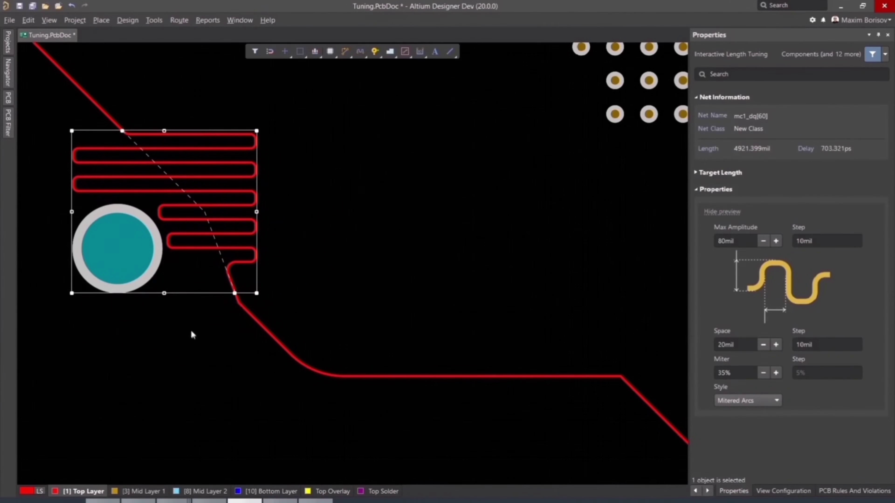 (score 90.0000)
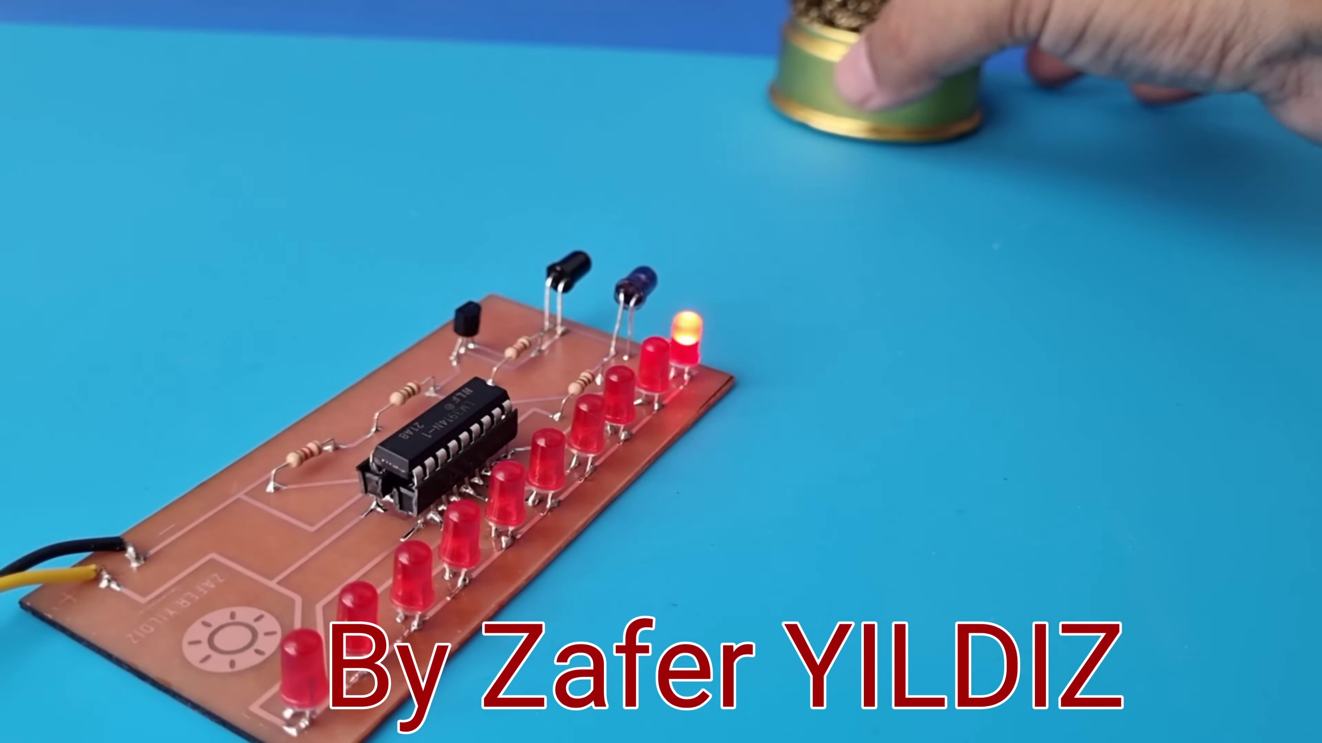 (score 85.0000)
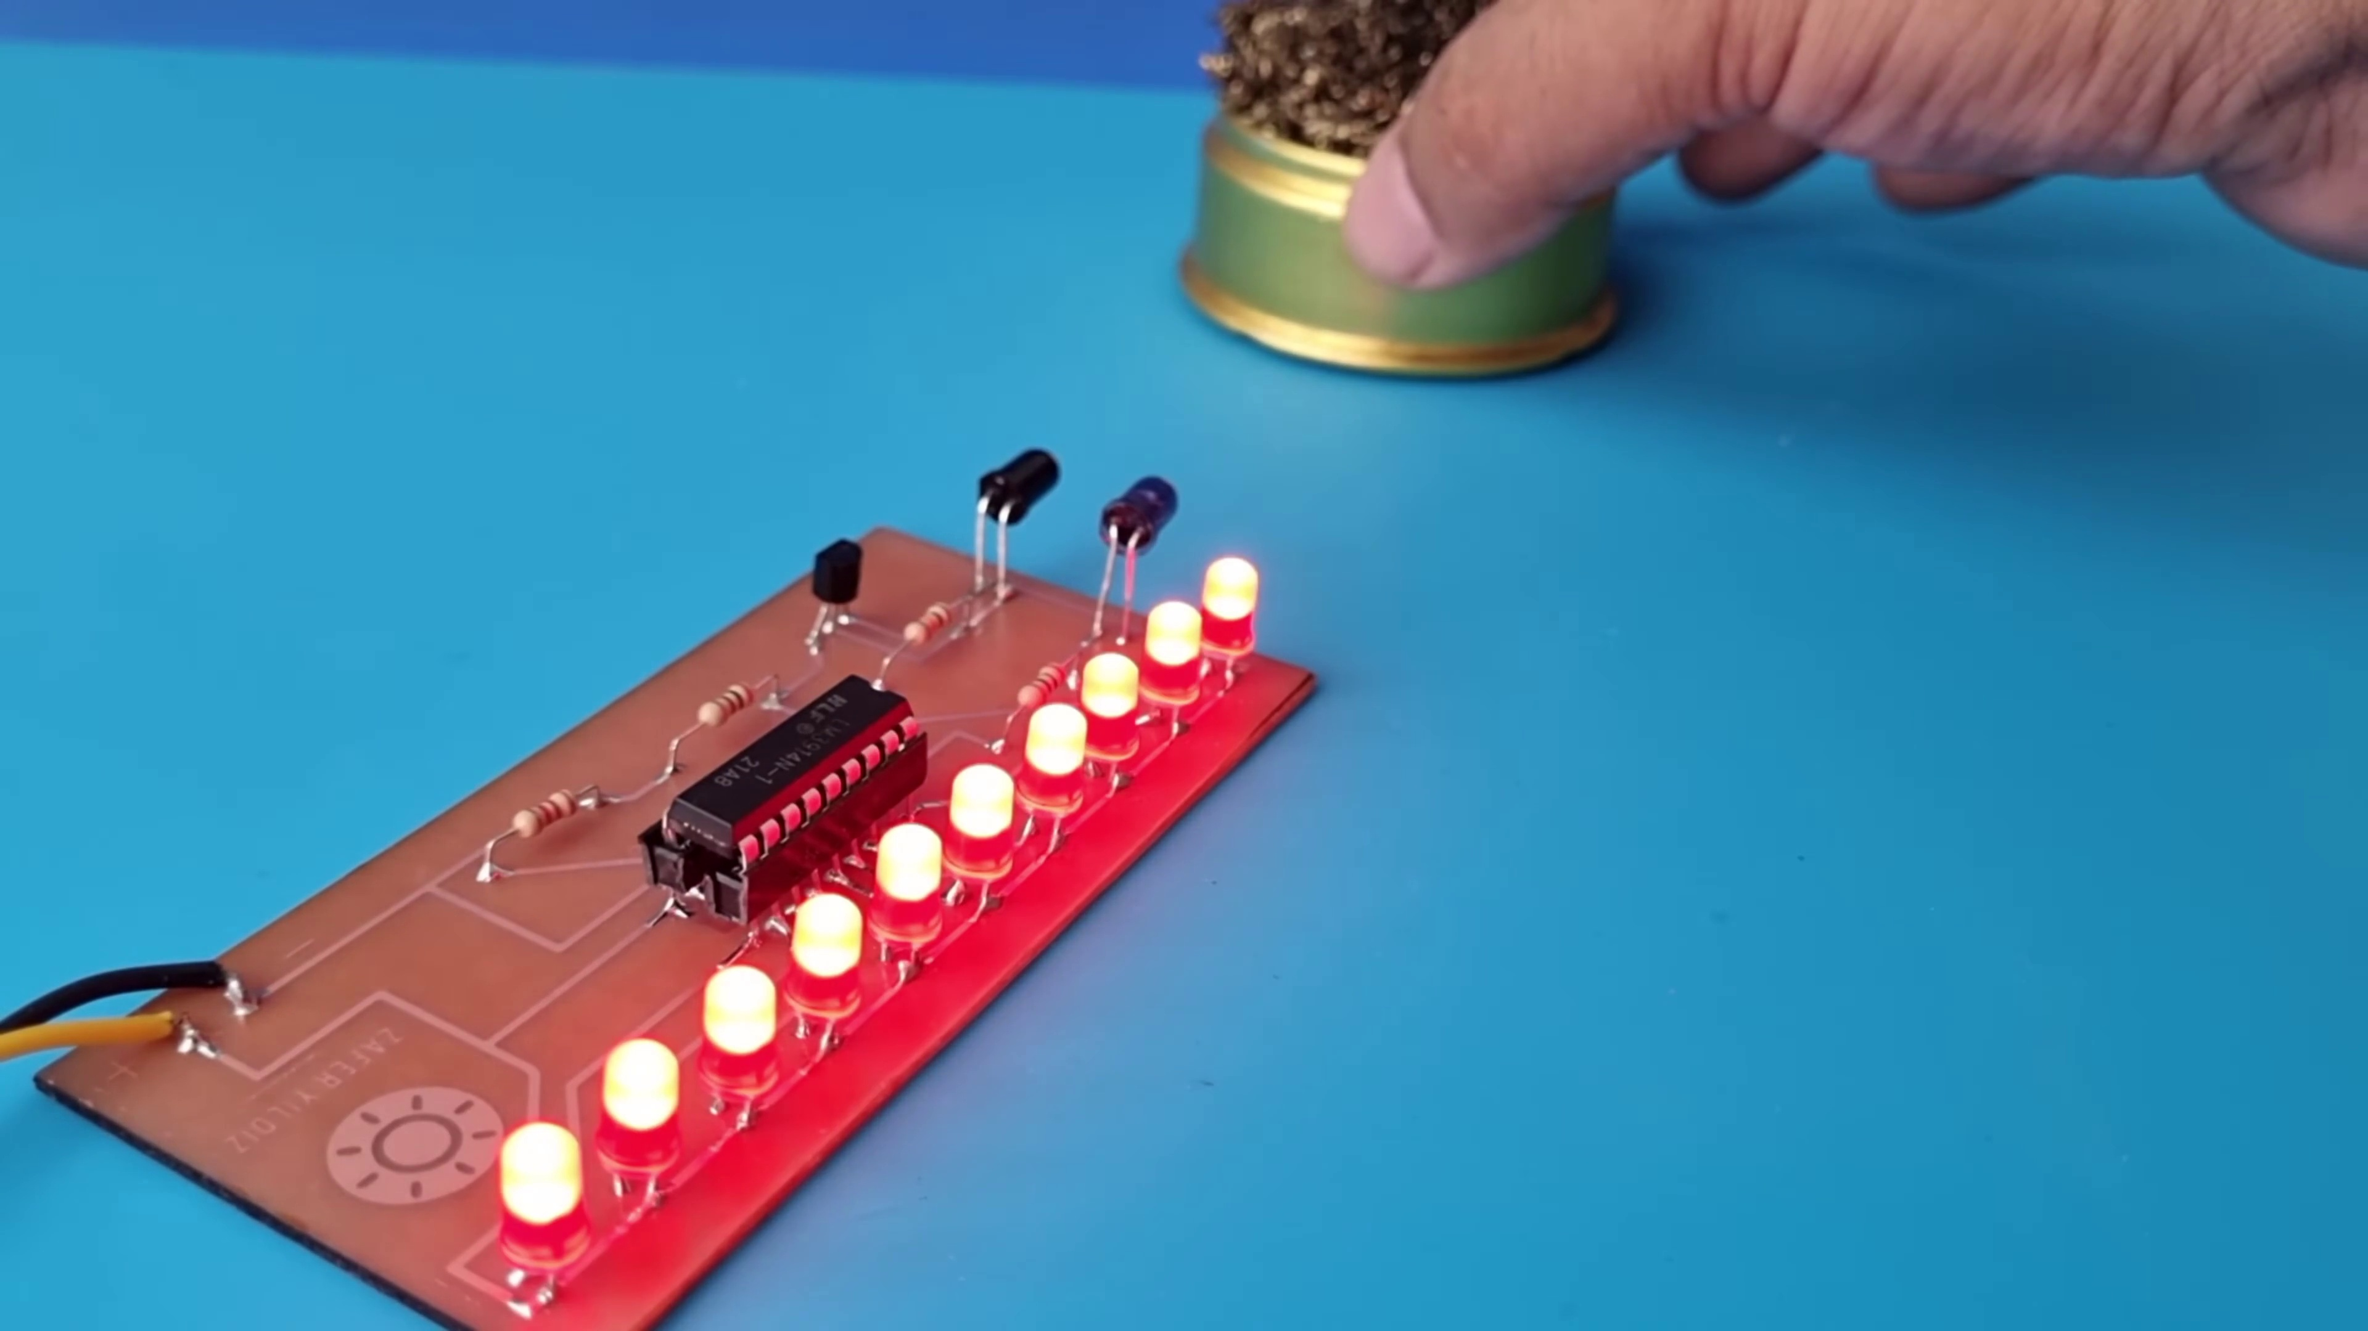 (score 85.0000)
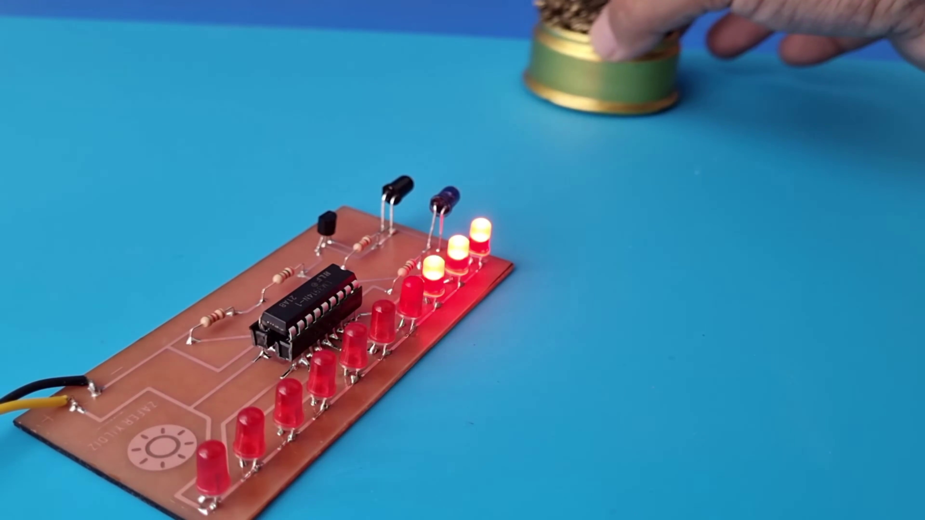 (score 85.0000)
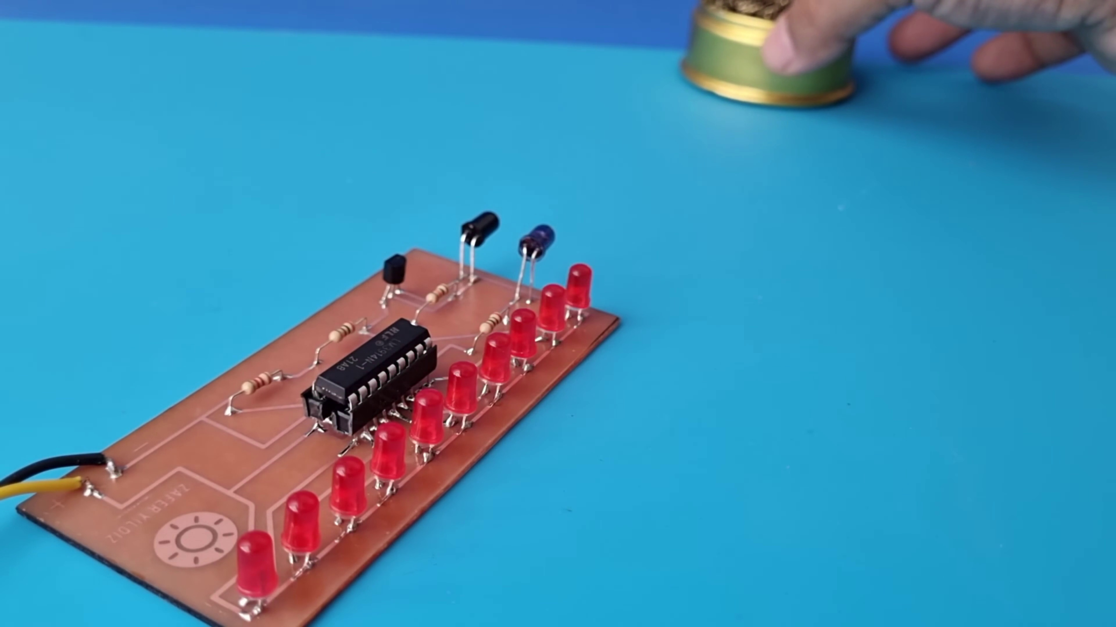 (score 85.0000)
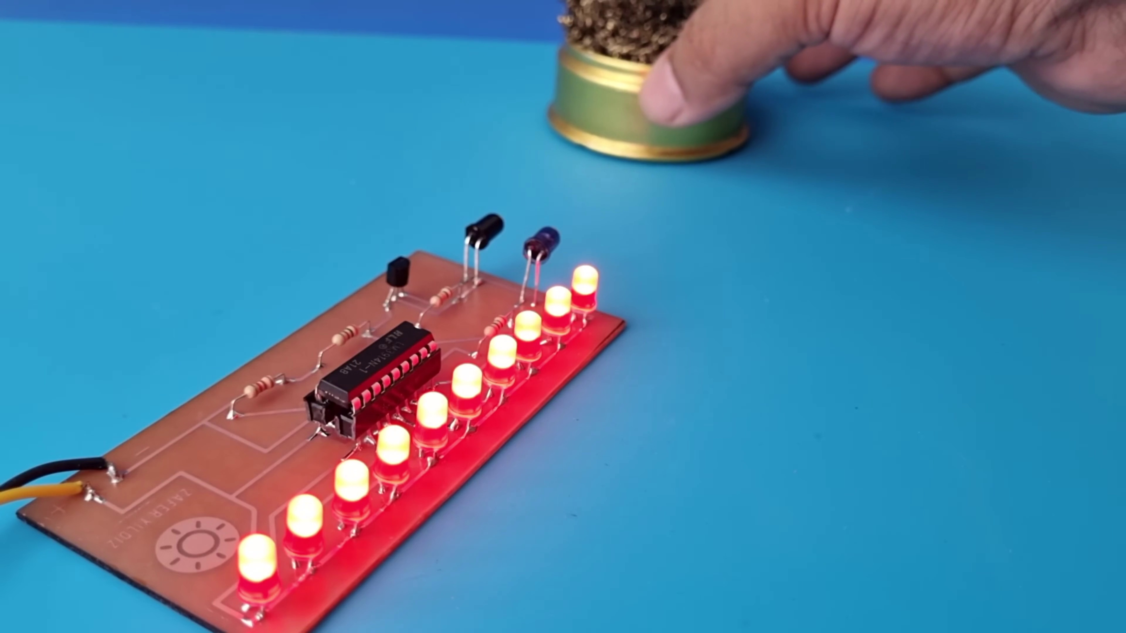 (score 85.0000)
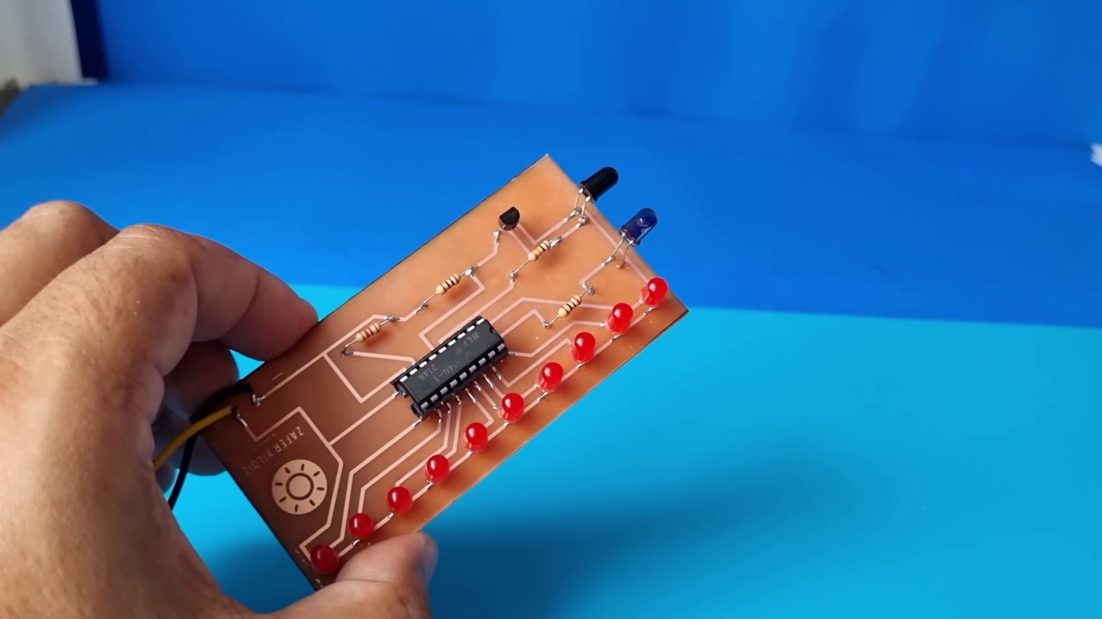 (score 85.0000)
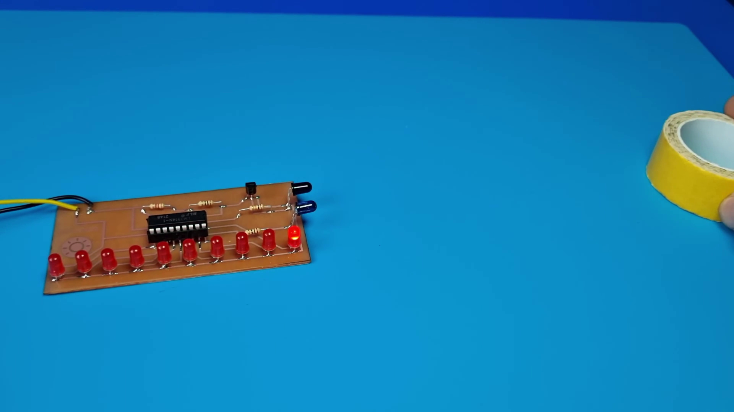 (score 85.0000)
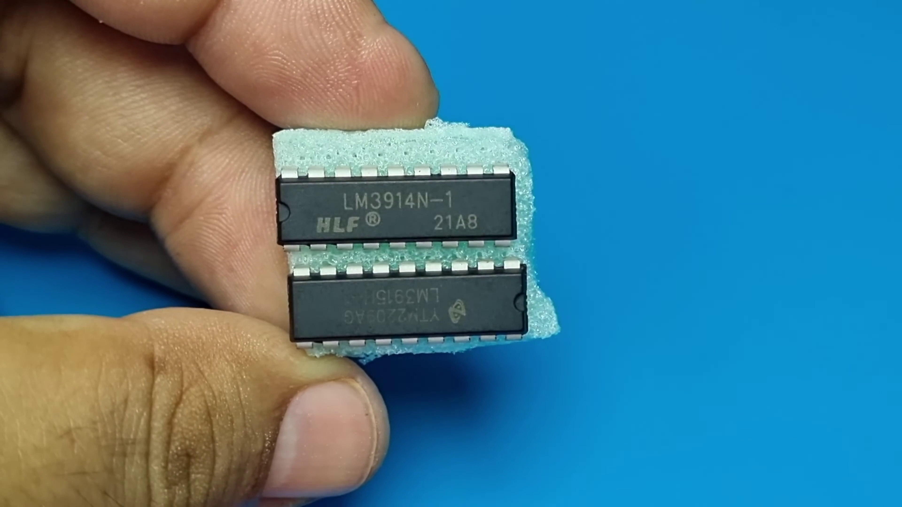 (score 85.0000)
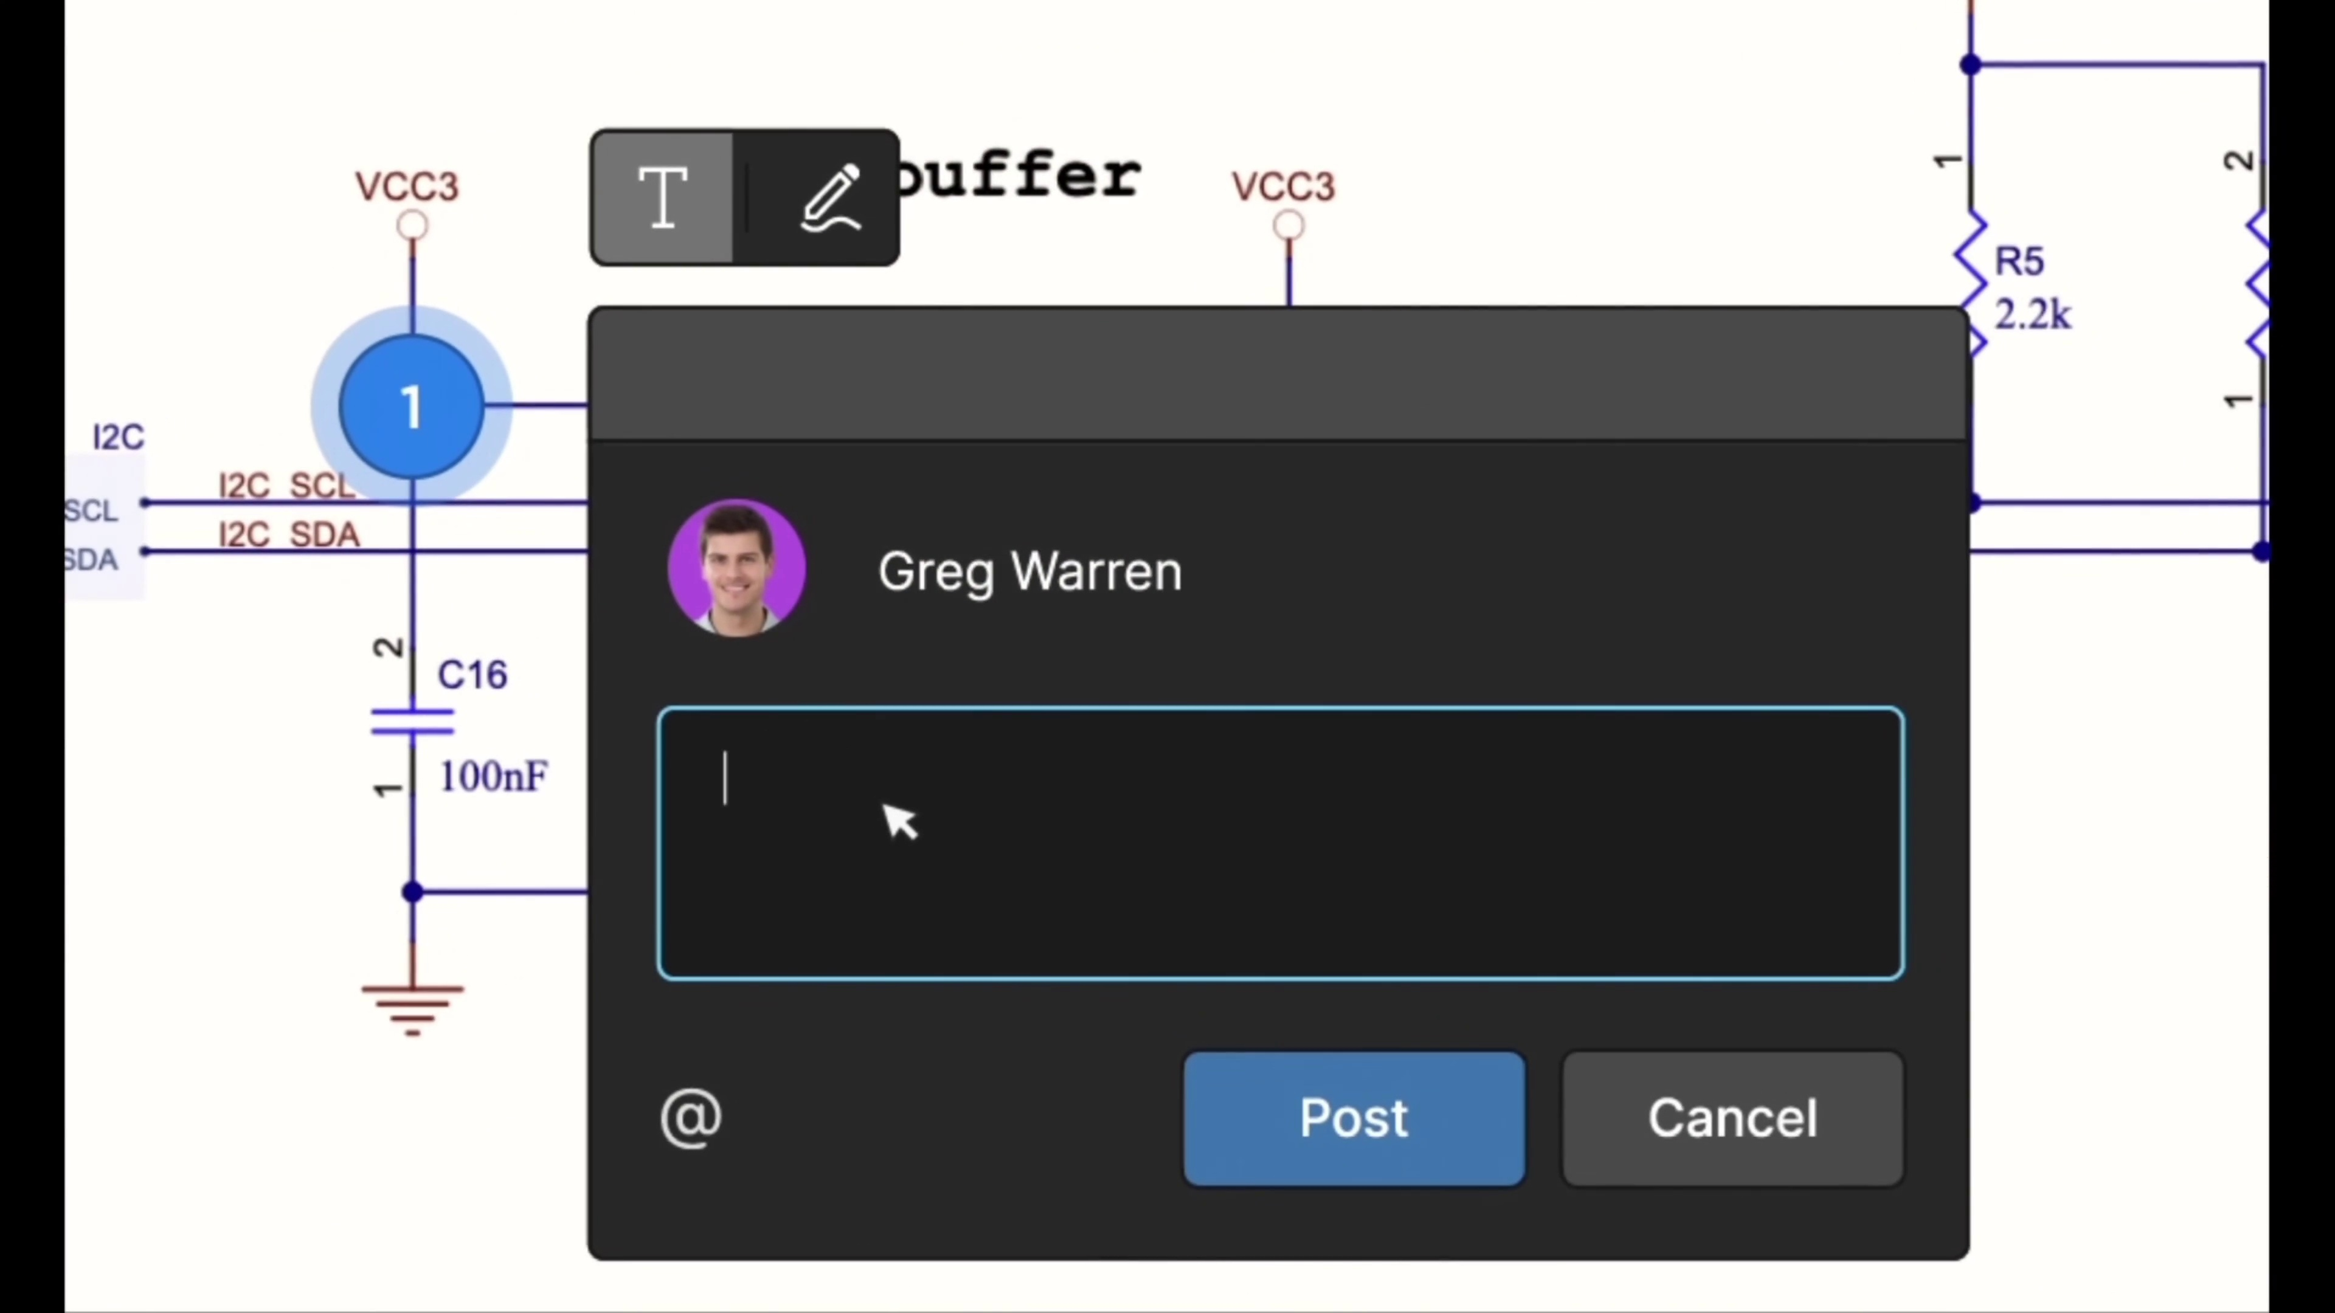 (score 85.0000)
Least correlated frames:
 (score 0.0000)
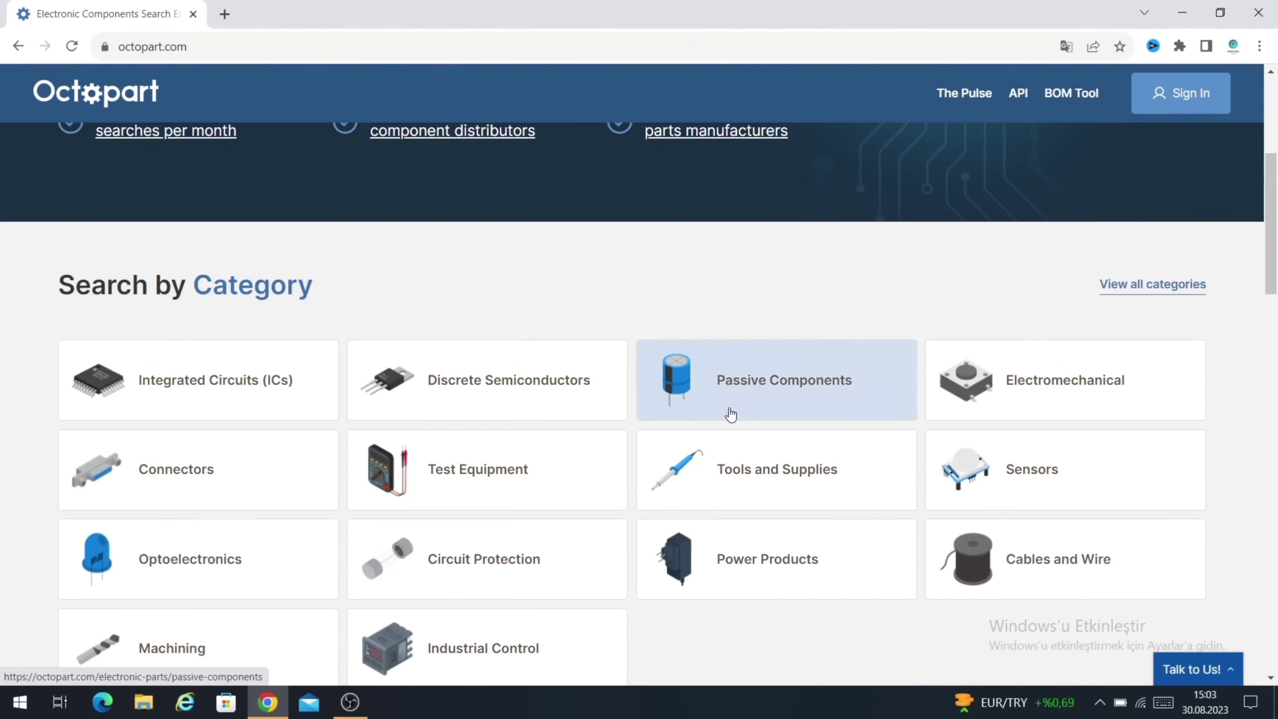 (score 0.0000)
 (score 0.0000)
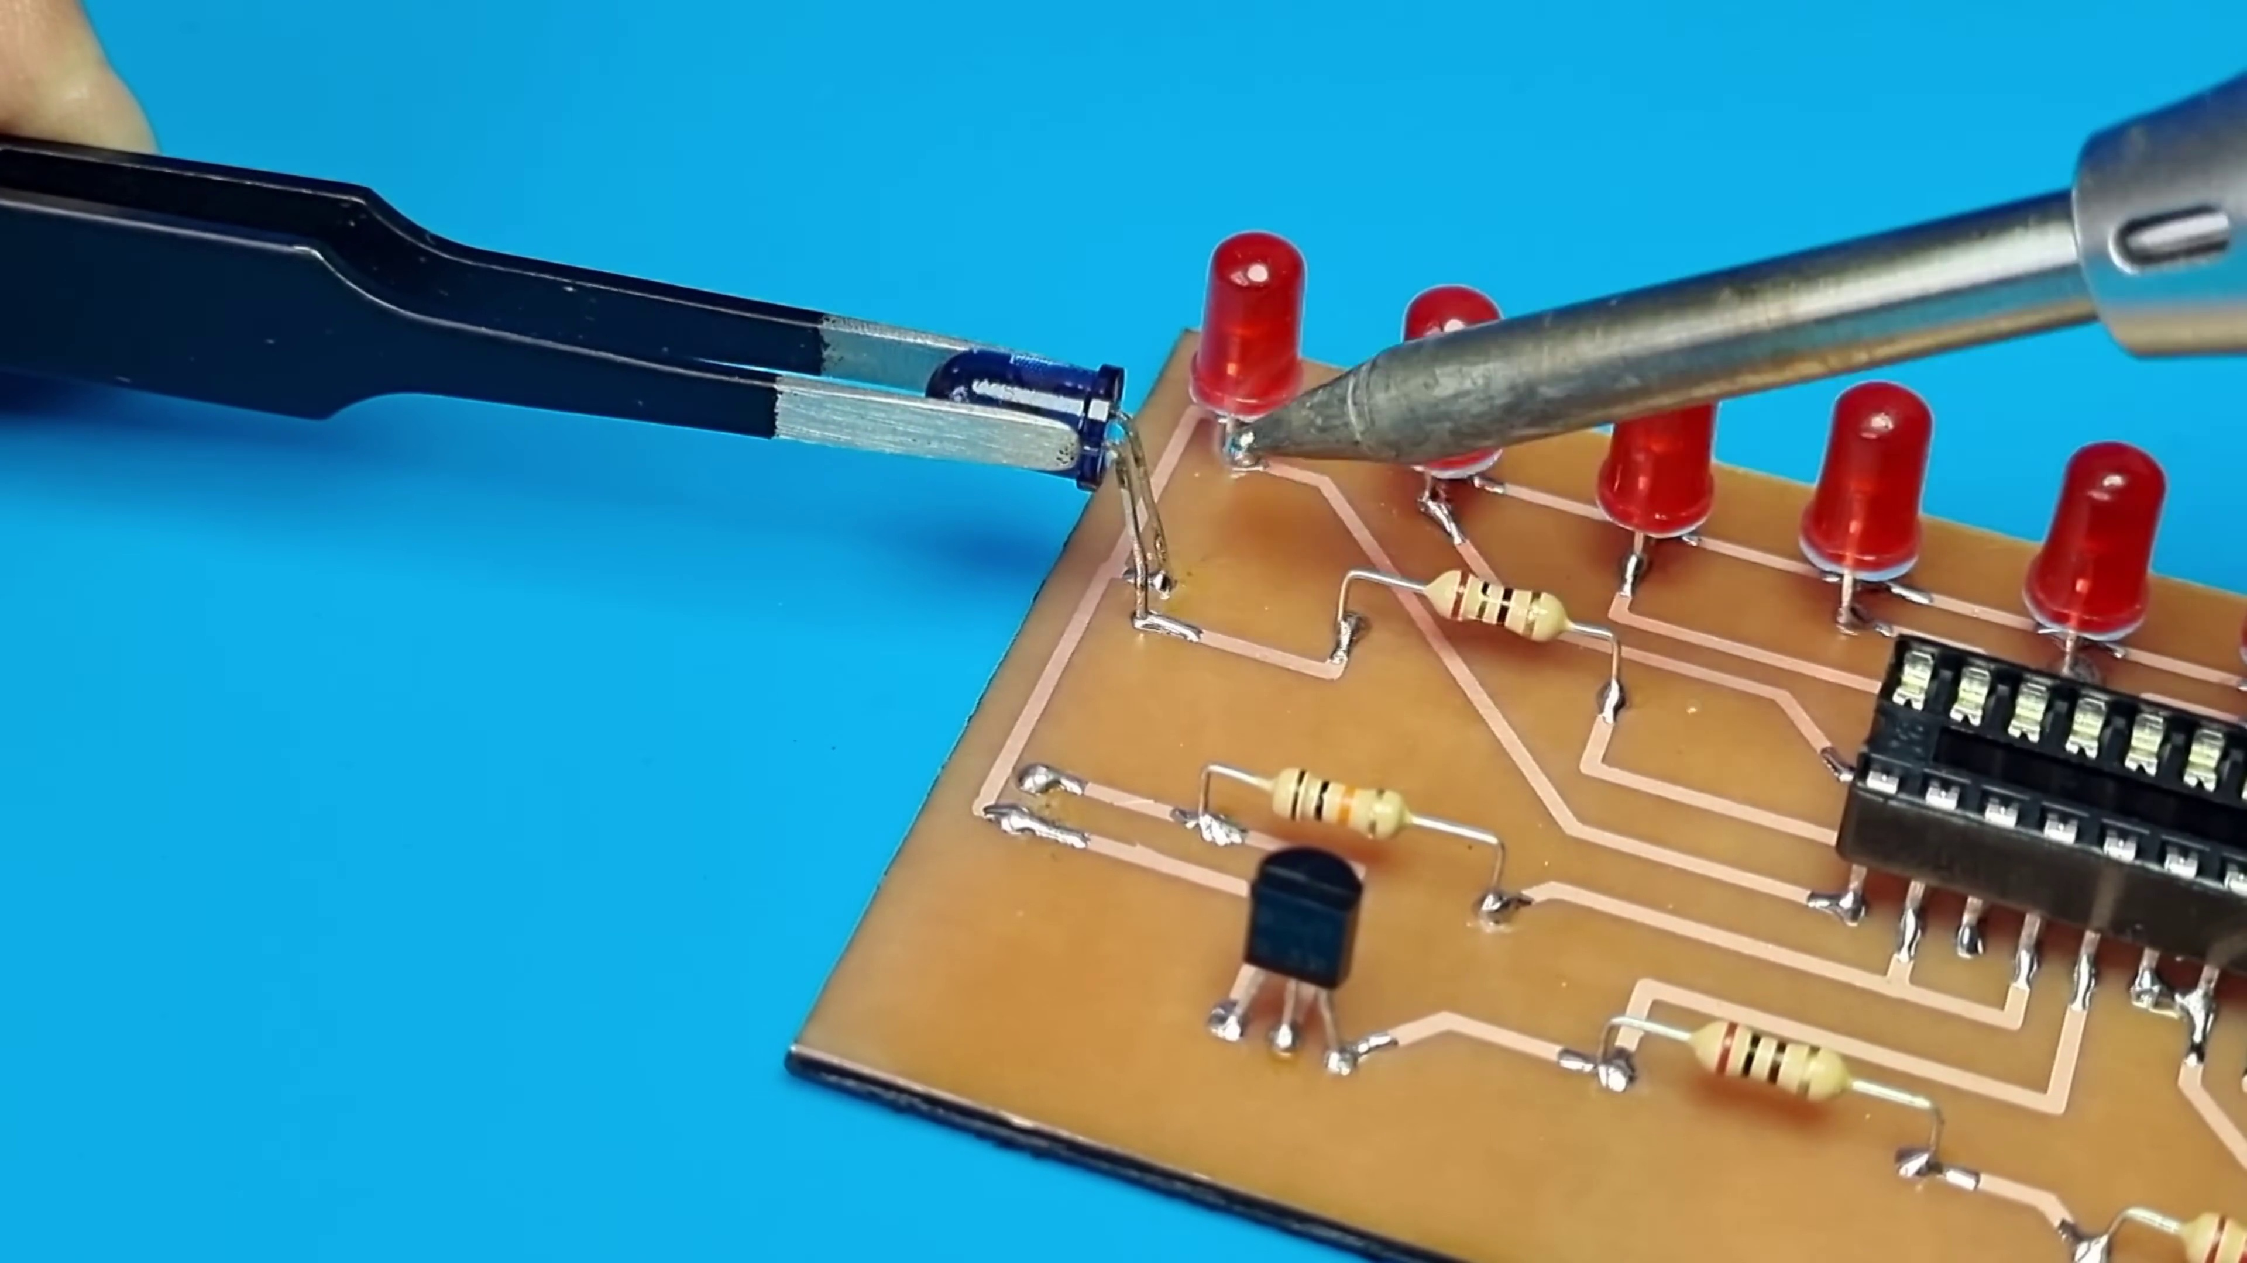 (score 0.0000)
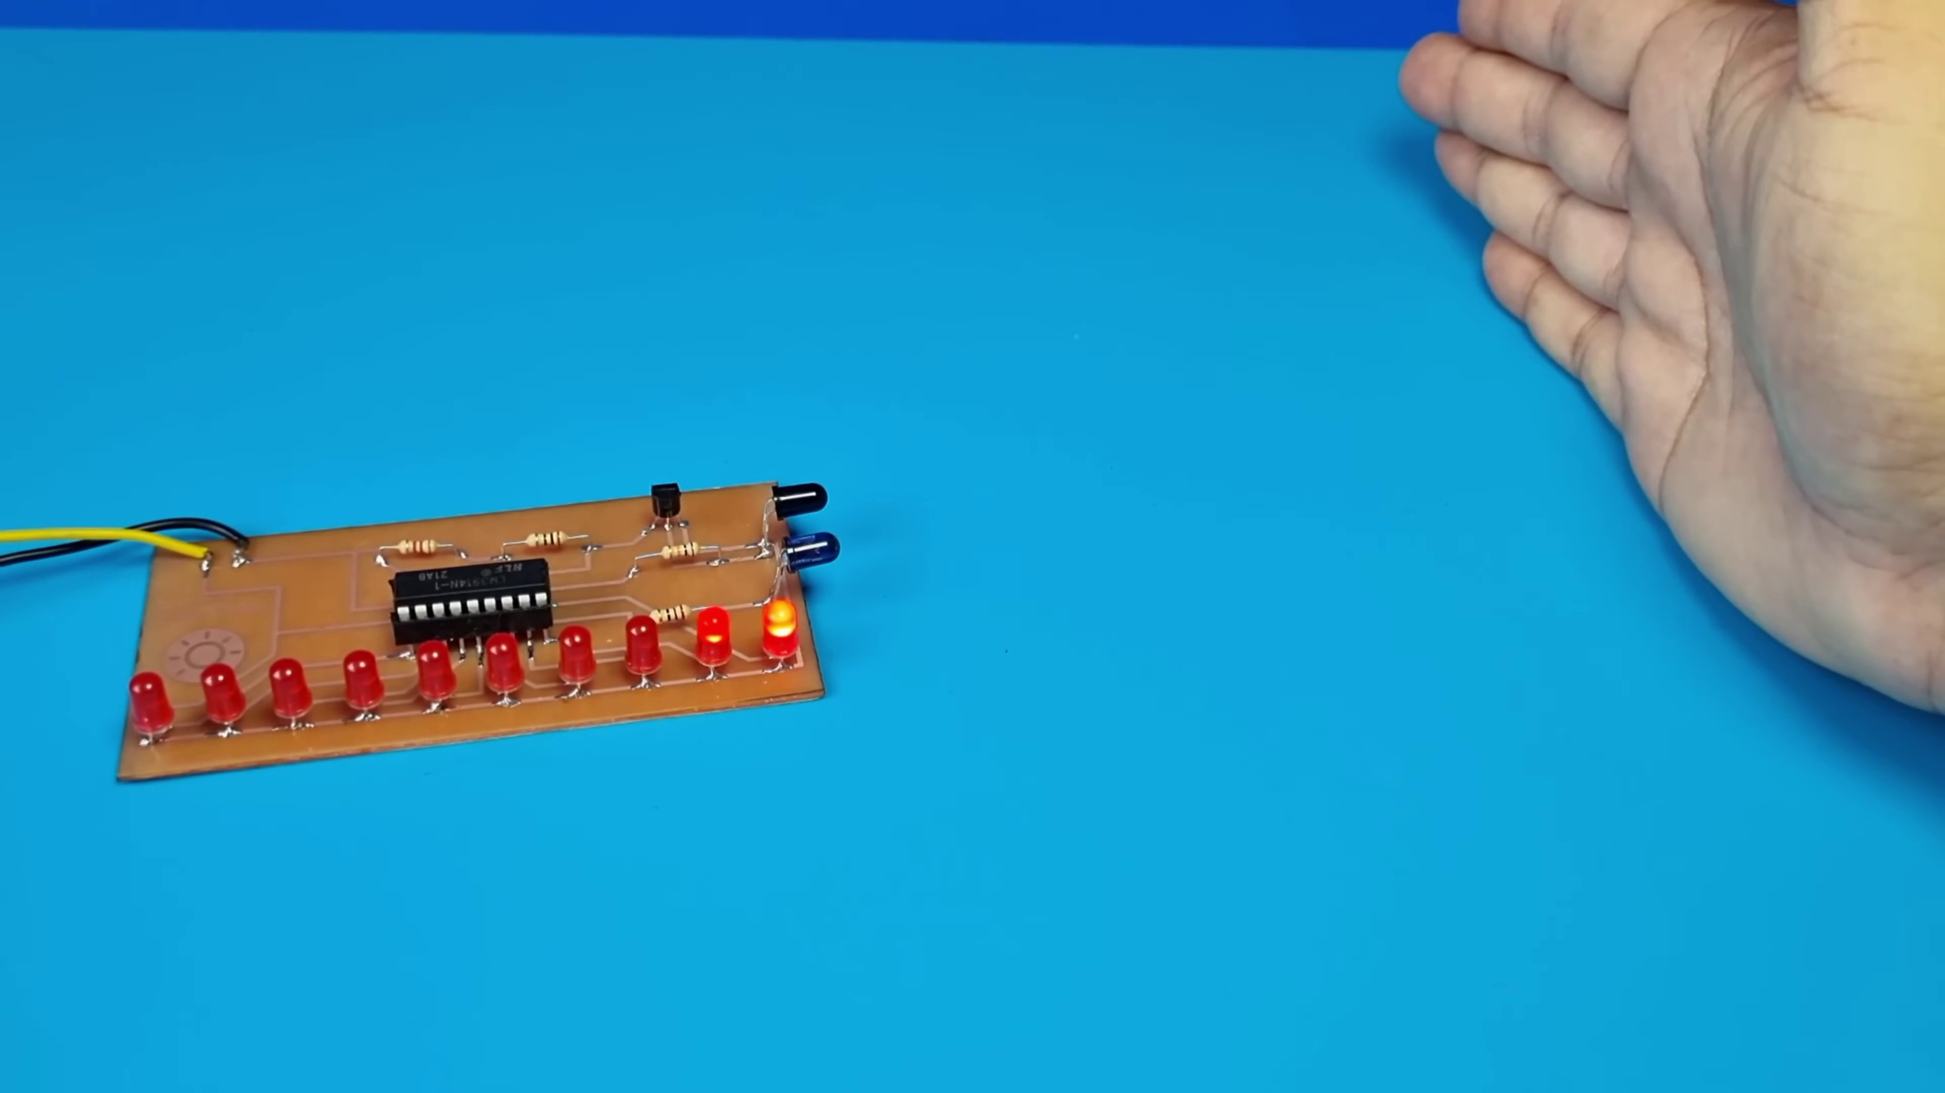 (score 0.0000)
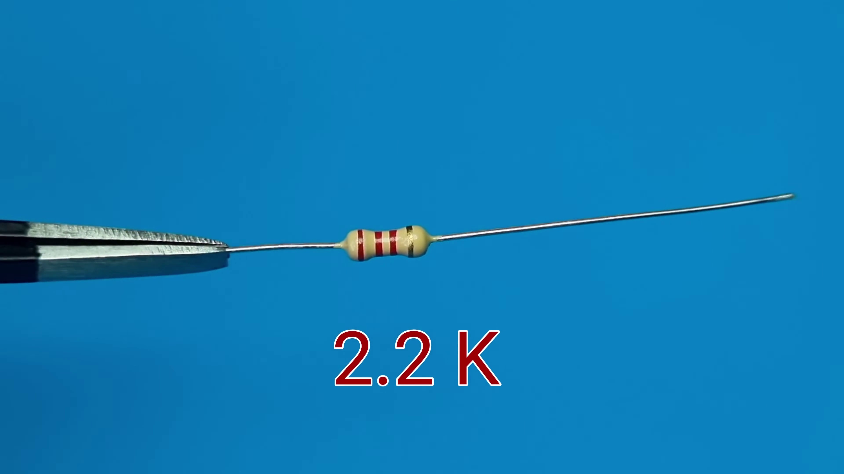 (score 10.0000)
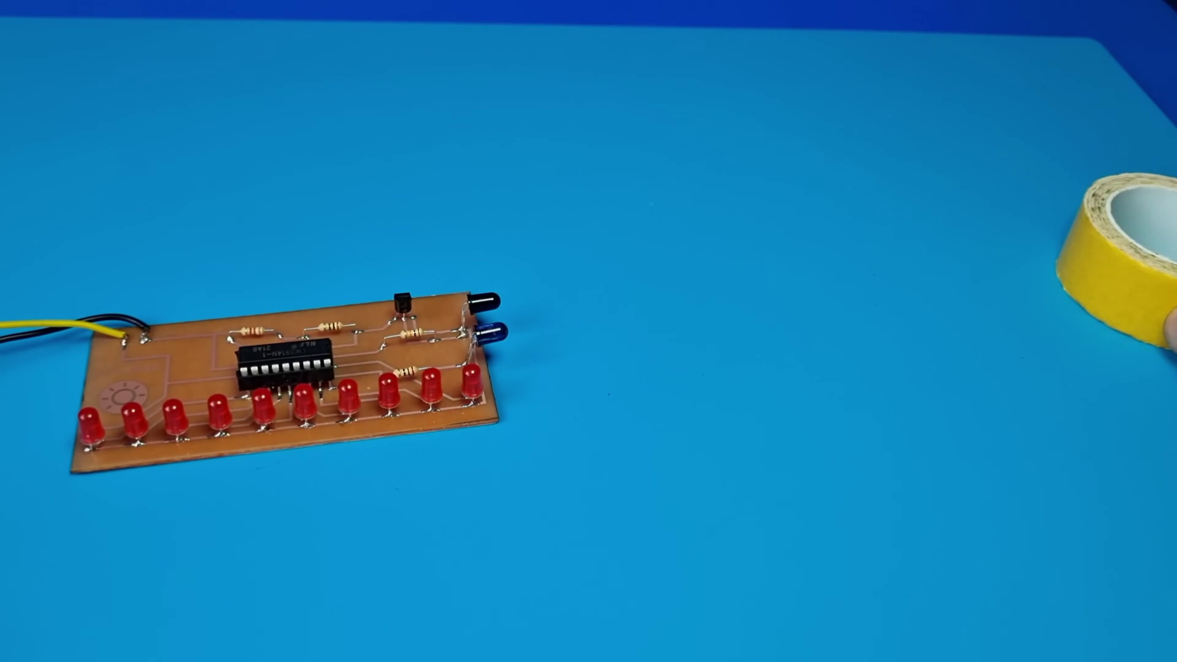 (score 10.0000)
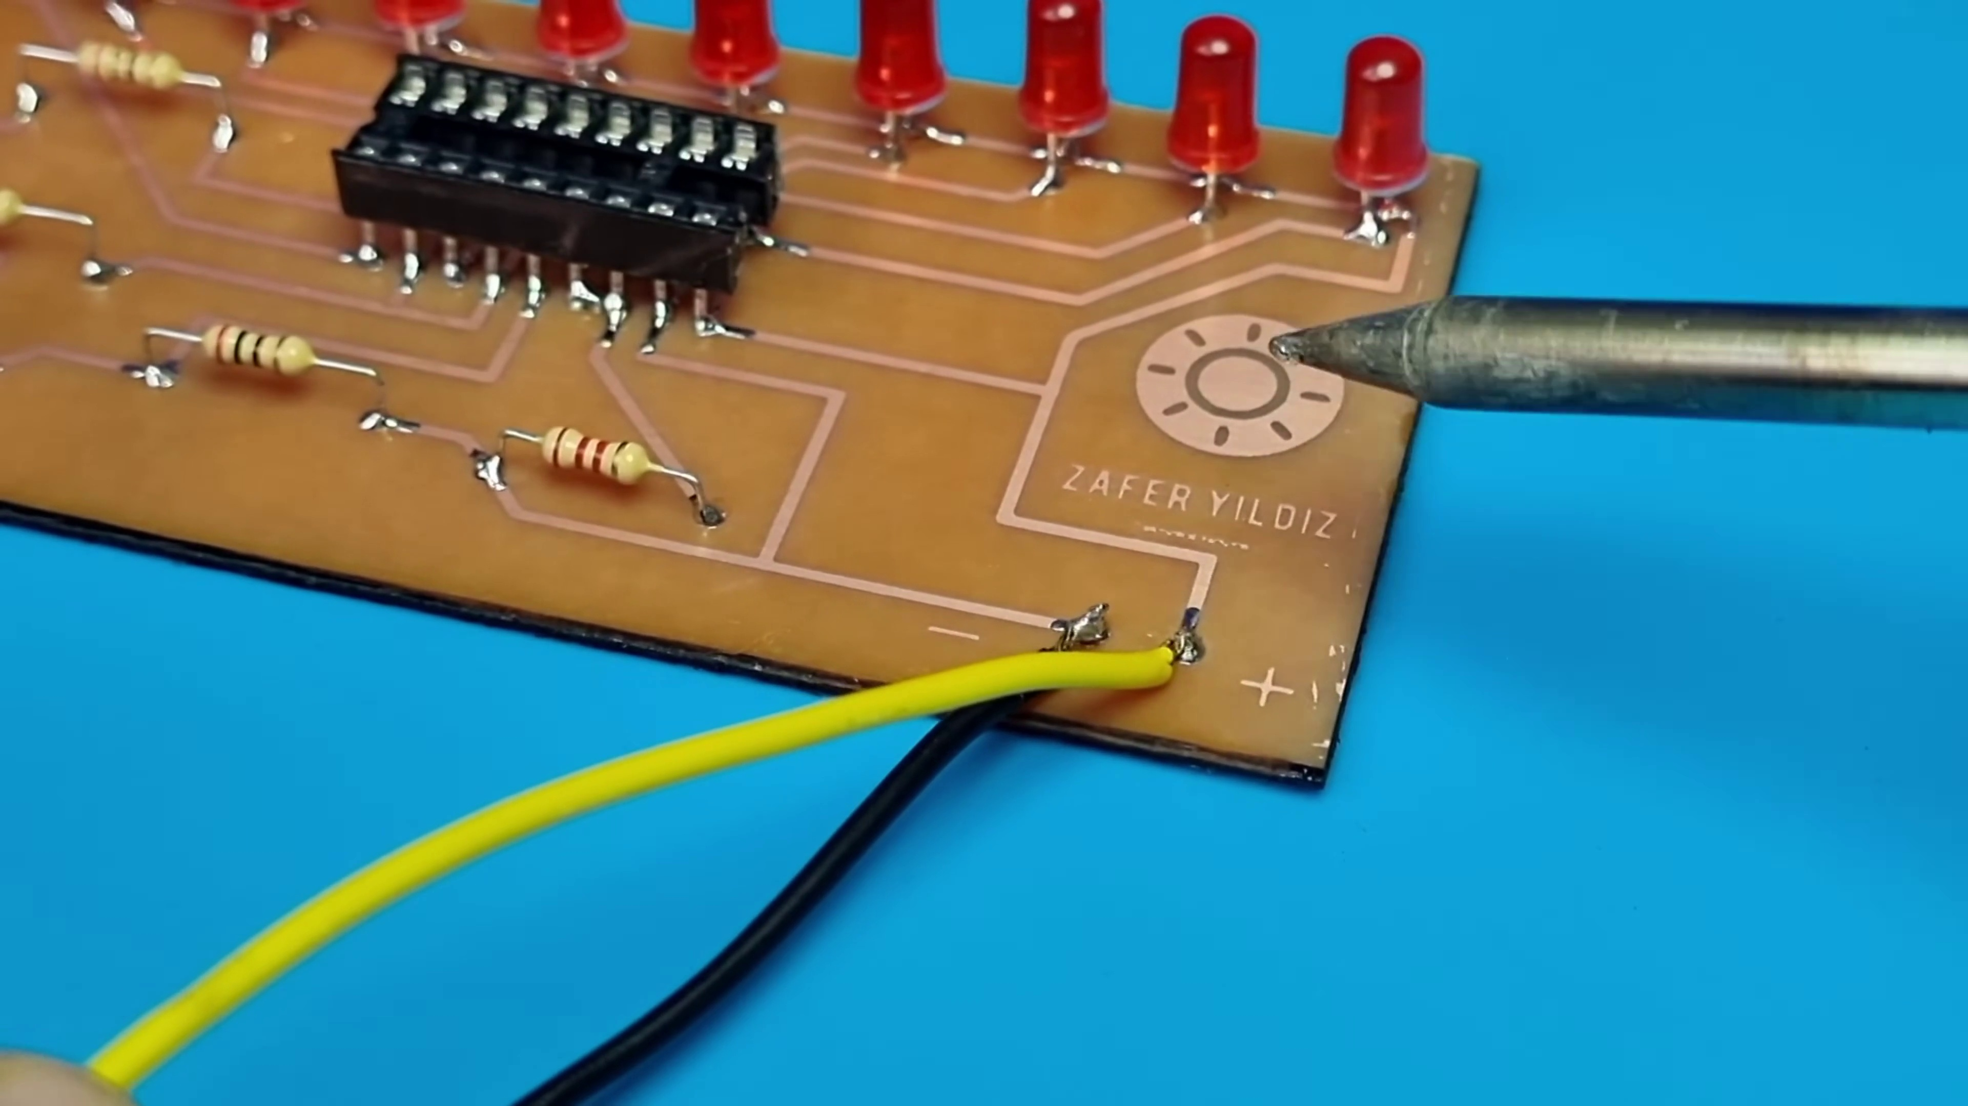 (score 15.0000)
 (score 20.0000)
 (score 20.0000)

Frame: frame_0000.jpg
Caption: The image presents a captivating scene that combines digital elements with a visually striking background. The dominant feature is the digital interface on the left side, which displays a dark background with a bright spark effect, suggesting an emphasis on igniting or lighting something up. Overlaid on this interface are the words "ZAFER YILDIZ," likely referring to individuals or entities associated with the content shown.
Below the title, another word "YLDİZ" is displayed in Turkish, possibly related to the content or topic of discussion. On the right side of the image, a thumbnail for a video appears, featuring an individual with a beard and a mustache, wearing a dark top with light-colored stripes. The person is looking directly at the camera, giving a subtle smile.
In the top left corner of the image, the text "Zafar Yildiz" is prominently displayed in black, serving as the title or name of the image. This text draws the viewer's attention immediately to the name. In stark contrast, the background is a striking red color that appears to be a textured graphic design, adding depth and interest to the image.
The overall composition of the image is balanced, with the digital interface on one side and the thumbnail on the other, flanking the central title text. The use of the red background provides a strong visual anchor, drawing the viewer's attention towards the man and the text.
No strongly correlated comments found for this frame.

Frame: frame_0001.jpg
Caption: The image displays a black screen with a blue hexagon centered on the screen, which serves as the logo for Altium, a company renowned for its software in electronic design. Below the logo, the word "Altium" is written in white text. The background of the screen is dark blue, providing a striking contrast to the logo and text. The logo and text are positioned centrally on the screen, making them easily readable. Additionally, the top-left portion of the screen features an Altium logo with the tagline "Where the world designs electronics." This logo consists of a stylized "A" followed by the word "altium," accompanied by two hexagons forming a shape reminiscent of a gear or circuit. A digital clock displaying the time as 6:04 PM is situated in the upper right corner of the screen, while a small graphic resembling an LED light bulb is present on the bottom right corner, possibly indicating electronics or LED technology. To the left of the Altium logo, there is text that reads "351," which could be a model number, product code, or reference to a specific item within the context of Altium. The overall impression is that this image is likely from an instructional or promotional presentation related to electronics and electronic design automation (EDA), given the logo's association with Altium, a company known for providing software tools for EDA.
No strongly correlated comments found for this frame.

Frame: frame_0002.jpg
Caption: The image shows a hand holding up a homemade printed circuit board (PCB) with various electronic components, including LEDs, resistors, and possibly capacitors or other passive components. The PCB features gold-colored surfaces with white lines indicating the pathways for these components to connect. The text "HOMEMADE PCB" is prominently displayed, suggesting that the photo is meant to demonstrate the creation of a custom printed circuit board.
In the background, there appears to be a diagram or schematic related to the electronic circuit, adding context to the overall scene. The blue wall provides a stark contrast to the gold and white tones of the PCB, drawing attention to the hand holding it. The text "ZAFER YILOZ" is written on the PCB, possibly indicating the name of the creator or manufacturer.
The overall setting appears casual and educational, with a clear intention to share the process of making a PCB at home. The image serves as a visual guide or tutorial for those interested in electronics projects, showcasing an individual's achievement in creating an electronic device from scratch.
Comment (score 80): This video shows a simple circuit that includes a proximity sensor that could be added to the speaker for use. We looked at this option when deciding on the design of our speaker. This could be used to increase volume using proximity or to turn the speaker on and off.
Reason: The comment directly discusses the same technical steps (e.g., adding a proximity sensor) and objects (speaker) described in the caption, with a clear connection to the creation of a custom PCB.
Source: https://www.youtube.com/watch?v=FNG9f2qJdWk: How To Make A New Generation Proximity Sensor Circuit - Approach Level Indicator

Frame: frame_0003.jpg
Caption: The image captures a moment of creation where two hands are gently holding a homemade PCB. The PCB, a small rectangular board with a circuit pattern etched on it, is brown in color. The hands are positioned over the top of the PCB, with the fingers of one hand slightly overlapping the other, indicating the careful placement of electronic components. The focus of the image seems to be on the practical aspect of making a PCB, likely for educational or instructional purposes, as indicated by the words "HOME MADE" visible on the circuit board.
The background of the image is a light blue color, providing a stark contrast to the brown PCB and serving as a neutral backdrop for the activity being demonstrated. The setting appears to be a workspace with a blue background, emphasizing the hands at work and the circuit board they are working with.
In the top right corner of the image, the text "Homemade PCB" is written in bold red letters, clearly indicating the nature of the project. This text stands out against the blue background, drawing the viewer's attention to the handmade nature of the PCB and the process of creating something from scratch that it represents.
Comment (score 80): This video shows a simple circuit that includes a proximity sensor that could be added to the speaker for use. We looked at this option when deciding on the design of our speaker. This could be used to increase volume using proximity or to turn the speaker on and off.
Reason: The comment directly discusses the same technical steps (e.g. adding a proximity sensor) and objects (the speaker) mentioned in the caption, demonstrating a strong connection between the two.
Source: https://www.youtube.com/watch?v=FNG9f2qJdWk: How To Make A New Generation Proximity Sensor Circuit - Approach Level Indicator

Frame: frame_0004.jpg
Caption: The image depicts a person's hand holding a pile of 10 red LED lightbulbs, arranged neatly on a surface. The LED bulbs are in close-up focus, while the background is out of focus but appears to be a plain blue surface. On this surface, a larger text "10x LED" is visible, suggesting that these LEDs might be an enlarged version of standard LEDs and potentially used for different applications due to their increased size. The hand holding the LED bulbs is the only human presence in the image, creating a sense of balance and symmetry. The focus is solely on the LED bulbs, emphasizing their importance in the scene.
No strongly correlated comments found for this frame.

Frame: frame_0005.jpg
Caption: The image shows a slide with a title at the top, featuring a background that transitions from light to dark, separated by a horizontal line. On the left side of the slide, there is a vertical strip that is lighter than the rest of the slide, creating a border effect between the two shades. The style of the image is simple and minimalistic, commonly used in presentations for slide transitions or color changes.
In a different context, Sodium hydrogen carbonate, also known as baking soda, is a white solid compound with the formula NaHCO₃. It is a salt of carbonic acid and the sodium salt of bicarbonate. This compound has various applications, including being a component of most common household cleaning agents, used in industrial processes such as manufacturing glass, paper, and textiles, and also serving as a food additive, treatment for gastric acid-related diseases, and a cleaning agent.
No strongly correlated comments found for this frame.

Frame: frame_0006.jpg
Caption: The image captures a close-up view of an electronics project in progress. The focus of the scene is on the process of working with electronic components to build a circuit board. A brown printed circuit board (PCB) rests on a blue surface, adorned with white lines that suggest it's a circuit board design. At the top of the board, there's a red LED light, adding a touch of color to the otherwise neutral palette. The board is also marked with the text "ZAFER YILDIZ" in white letters, indicating it might be a product or brand name.
On the PCB, various electronic components are soldered onto it, including resistors and possibly capacitors or integrated circuits. Traces connect different components on the board, as well as test points. A red jumper wire is being used to make a connection between two points on the PCB, showcasing the process of working with electronic components.
The overall scene suggests a moment of anticipation, as if someone is about to connect the board to a larger system or continue building upon it.
No strongly correlated comments found for this frame.

Frame: frame_0007.jpg
Caption: The image shows a close-up view of a small electronic circuit board with various components mounted on it, lying on a blue surface. The brown-colored circuit board is prominently displayed, featuring a red resistor prominently in the center. On the left side of the board, an integrated circuit (IC) chip with several pins around its edge is visible. To the right of the IC, multiple lines and dots represent traces or conductive pathways on the circuit board.
A blue surface provides a striking contrast to the yellow-green hue of the circuit board. A watermark at the bottom left corner reads "Image of," suggesting that this is an overlaid image or a mockup rather than a live photograph. The text on the board indicates that it represents the layout of a simple electronic circuit, possibly used in educational materials to teach basic concepts of electrical engineering and electronics design.
The red LED on the board suggests its function as a light source. Additionally, the white adhesive holding the circuit board to the blue surface ensures its stability. The text "ZATER YILOZ" is visible on the board, which may indicate the brand or manufacturer of the circuit board. Overall, the scene appears to be a stage or setup for a demonstration or presentation, showcasing this simple electronic circuit and its components.
Comment (score 80): This video shows a simple circuit that includes a proximity sensor that could be added to the speaker for use. We looked at this option when deciding on the design of our speaker. This could be used to increase volume using proximity or to turn the speaker on and off.
Reason: The comment directly discusses the same technical steps (e.g., adding a proximity sensor) and objects (e.g., speaker) mentioned in the caption. The connection is strong as it refers to the specific components and settings described, such as using proximity or turning the speaker on/off.
Source: https://www.youtube.com/watch?v=FNG9f2qJdWk: How To Make A New Generation Proximity Sensor Circuit - Approach Level Indicator

Frame: frame_0008.jpg
Caption: The image presents a close-up view of an electronic device featuring a printed circuit board (PCB) with several components visible. The PCB is a greenish-gold color, and integrated circuit (IC) chips are mounted on it. Two red LEDs are attached to the board, appearing to have been soldered in place.
In the foreground, there is an electronic component resembling a transistor labeled "2N3904," indicating its type. The board has multiple connections of traces, which are metal lines that connect components on a PCB. There are also two resistors visible: one with a red band and the other without any markings.
The background is blue, providing contrast to the electronic device in the foreground. On the left side of the image, there is text partially cut off; however, the visible part reads "2N3904." The text appears to be a label or instruction, but it's not fully legible due to cropping.
The circuit board features a white label with black text that reads "ZAFER YILOZ" in the top-left corner. This brown-colored PCB is a printed circuit board, typically used in electronic devices to connect various components and allow for the flow of electricity. The presence of red LED lights on the board suggests it is currently powered and functioning.
The layout of the board suggests multiple components are present, but the precise arrangement is not visible in the image. However, the red LEDs indicate that these components are likely part of the board's functionality.
Overall, this snapshot captures a moment in the life of the circuit board, from its construction to its current state of operation, providing a glimpse into the world of electronics.
Comment (score 70): This video shows a simple circuit that includes a proximity sensor that could be added to the speaker for use. We looked at this option when deciding on the design of our speaker. This could be used to increase volume using proximity or to turn the speaker on and off.
Reason: The comment directly mentions a simple circuit, proximity sensor, and speaker design, which are all related to the technical steps, objects, and settings described in the caption. The mention of adding components to a speaker is also connected to the PCB's functionality discussed in the caption.
Source: https://www.youtube.com/watch?v=FNG9f2qJdWk: How To Make A New Generation Proximity Sensor Circuit - Approach Level Indicator

Frame: frame_0009.jpg
Caption: The image captures a moment of meticulous craftsmanship as a person meticulously solderes electronic components onto a circuit board. The circuit board, possibly a prototype for a personal electronics device, features various components such as resistors and capacitors, with four red LED lights visible, potentially part of a signal or status indication system. The surroundings suggest a workspace designed for electronics prototyping, with blue walls providing a contrasting background to the activity.
In the top right corner, a zoomed-in view of the soldering process shows the tip of the soldering iron making contact with the circuit board and a component, emphasizing the person's focus on this task. The absence of visible text or instructions in the image implies that the specific steps being taken are not explicitly stated.
The image captures a moment of manual assembly or repair, common in electronics hobbyist workspaces, DIY projects, or small-scale manufacturing settings. The person is engaged in hands-on activity typical for both educational and practical purposes in the field of electronics.
Comment (score 80): This video shows a simple circuit that includes a proximity sensor that could be added to the speaker for use. We looked at this option when deciding on the design of our speaker. This could be used to increase volume using proximity or to turn the speaker on and off.
Reason: The comment directly discusses the same technical steps (adding a proximity sensor to a speaker) and objects (circuit board, components, soldering iron) described in the caption. The mention of the circuit being 'simple' and the focus on proximity sensing as a feature also aligns with the description of the circuit board and its components in the caption.
Source: https://www.youtube.com/watch?v=FNG9f2qJdWk: How To Make A New Generation Proximity Sensor Circuit - Approach Level Indicator

Frame: frame_0010.jpg
Caption: The image shows a close-up of an electronic circuit board with various components mounted on it. A black soldering iron is being used to solder red light-emitting diodes (LEDs) onto the brown circuit board, suggesting that this may be part of a DIY electronics project or tutorial. The LEDs are neatly arranged on the board, ready to be connected. In the background, there appears to be a person's hand holding a component, possibly a resistor or capacitor, ready for installation on the circuit board. The focus and lighting are set up in a way that highlights the soldering process and the small LEDs. The image captures a moment in time during a hands-on electronics assembly or demonstration, with the circuit board placed on a blue surface that contrasts with the brown color of the board.
No strongly correlated comments found for this frame.

Frame: frame_0011.jpg
Caption: The image shows a close-up view of a brown printed circuit board (PCB) with several electronic components, including integrated circuits, resistors, possibly capacitors or inductors, and four red LEDs arranged in a row on silver strips. The PCB features the text "J8" next to one of the resistors, which typically refers to the type or model of a resistor. A white logo that reads "ZATER MILLOZ" is also visible on the board, suggesting the brand or manufacturer of the circuit board. The background is a vibrant blue, providing a stark contrast to the brown board and the red LEDs.
No strongly correlated comments found for this frame.

Frame: frame_0012.jpg
Caption: The image shows a close-up view of a circuit board with several electronic components attached, including resistors and possibly other components such as capacitors or integrated circuits (ICs). A soldering iron is being used to melt solder onto the joints where the components are attached to the board, indicating that the process of constructing a circuit board is taking place. In the foreground, a model of a circuit board with similar components can be seen, suggesting that this could be a demonstration or tutorial on electronics assembly.
The focus is on the hands-on process rather than an educational slide or text, as there are no visible texts or diagrams in this particular frame. The setting appears to be a workspace designed for electronic hobbyists or professionals, with a blue surface in the background which could be a workbench or desk. A pair of tweezers can be seen in the background, their purpose unclear from the image.
The circuit board itself features an intricate network of wires and is resting on a blue surface. Red LEDs are meticulously crafted onto the board, each one connected to the board ready to be powered on. The red LEDs are arranged in a neat row, making them the focal point of the image. A white label bearing the text "ZAFER MILLO" is also visible, possibly indicating the brand of the circuit board or the tool used for soldering. Overall, the image provides a snapshot of a moment in the creation of a circuit board, showcasing the meticulous craftsmanship involved in such tasks.
No strongly correlated comments found for this frame.

Frame: frame_0013.jpg
Caption: The image shows a DIY electronics project in progress, with a circuit board being assembled. The board features printed traces and surface-mounted devices (SMDs), with various electronic components attached, including red resistors possibly due to their function or component type. A screwdriver is visible in the top left corner of the image, indicating that someone is working on the project.
The style of the image is straightforward and documentary, showing the process of manual assembly rather than any particular teaching context. The circuit board itself appears complex, with numerous traces and components, potentially designed for an embedded system, microcontroller-based project, or other electronic setup. A logo "ZAFER YILCIOGUL" stands out in the top right corner of the image.
In the foreground, a close-up view reveals a network of red LEDs on the circuit board's surface, their glowing bodies reflecting the light in the room. The board rests on a blue surface, providing a striking contrast to the red LEDs. A pair of scissors, sharp and ready, are poised to cut through the board, symbolizing the work ahead.
Comment (score 85): This video shows a simple circuit that includes a proximity sensor that could be added to the speaker for use. We looked at this option when deciding on the design of our speaker. This could be used to increase volume using proximity or to turn the speaker on and off.
Reason: The comment directly discusses the same technical steps (assembling a circuit board) and objects (proximity sensor, speaker) described in the caption. The goal of adding the proximity sensor to increase volume or turn the speaker on/off is also mentioned, which aligns with the goals discussed in the caption.
Source: https://www.youtube.com/watch?v=FNG9f2qJdWk: How To Make A New Generation Proximity Sensor Circuit - Approach Level Indicator

Frame: frame_0014.jpg
Caption: The image shows an electronic circuit board with various components such as resistors and capacitors arranged in a pattern. The board, a rich brown color, features a series of red LEDs, their bright glow contrasting with the neutral tones of the board. The LEDs are arranged in a row, their positions seemingly random yet purposeful, connected by wires that carry signals controlling the LEDs.
The wires, like veins in a body, are crucial for the board's functionality and are carefully placed on the blue background, providing a stark contrast to the brown of the board and the red of the LEDs. The blue background highlights the board and its components, drawing the viewer's attention to the intricate details of the circuit board.
On the top right corner of the circuit board, there is a soldering iron, indicating that the person working on this project may be in the process of soldering or has just finished soldering. The circuit board itself appears to be a homemade or DIY model, as suggested by the handwritten lines and connections that deviate from standard printed circuit boards (PCBs).
No strongly correlated comments found for this frame.

Frame: frame_0015.jpg
Caption: The image captures a close-up view of an electronic circuit being created using a soldering iron, components, and a breadboard. On the left side of the image, a person is using a soldering iron to connect red wires to the breadboard, which has traces or conductive pathways etched onto it. The breadboard appears to be a prototyping platform with jumper wires inserted into it, allowing for easy modification of connections between components.
The circuit board is adorned with eight red LEDs, each with a distinct position along the circuit, connected via wires that contrast with the silver wires on the board. The board is affixed to a plain blue surface, providing a stark contrast against the circuit board. Notably, the board's design is such that it is upside down, with the red LEDs positioned at the top.
In the foreground, a pair of pliers can be seen, bent and reaching out towards the top of the board, possibly to adjust the position of the LEDs. The focus of the image is on the hands and tools involved in the soldering process, with no visible texts or additional objects that provide context about the content of the instruction.
The background is plain blue, suggesting that this image might have been taken in a setting designed to minimize distractions from the task at hand. The red wires being soldered to the breadboard could be connecting the two rows of pins on either side, which would make a complete circuit.
No strongly correlated comments found for this frame.

Frame: frame_0016.jpg
Caption: The image presents a detailed view of an electronic setup, with two distinct components prominently featured. To the left, an electronic breadboard is seen with various jumper wires attached to it, suggesting that this is a circuit being set up for some kind of experiment or demonstration related to electronics and possibly circuits involving LED lights. The breadboard has red LEDs placed on it, adding visual interest. On the right side of the breadboard, an electronic device with a clear plastic case and an antenna or connector protruding from it can be seen.
In the foreground, a circuit board is situated on a blue surface, providing a striking contrast to its brown color. The circuit board features a black design comprising lines and dots, forming a complex network of connections. Eight red LEDs are evenly spaced across the board, creating a neat row that stands out against the brown background.
Two pairs of tweezers, one on each side, appear poised to manipulate the circuit board, hinting at some form of activity or modification. A logo reading "ZAPER" is situated in the top-right corner of the image, potentially indicating the manufacturer or brand of the circuit board.
The overall scene presented is one of preparation and potential experimentation, with all the components and tools arranged precisely to facilitate their use or modification.
Comment (score 80): This video shows a simple circuit that includes a proximity sensor that could be added to the speaker for use. We looked at this option when deciding on the design of our speaker. This could be used to increase volume using proximity or to turn the speaker on and off.
Reason: The comment directly discusses the use of a proximity sensor in a circuit, which matches the technical step described in the caption (adding LEDs to a circuit board). The mention of speaker design and volume increase also relates to the context of electronics experimentation presented in the caption.
Source: https://www.youtube.com/watch?v=FNG9f2qJdWk: How To Make A New Generation Proximity Sensor Circuit - Approach Level Indicator

Frame: frame_0017.jpg
Caption: The image captures a moment of electronics work, featuring a hands-on activity with electronic components and a soldering iron. A person's hands are visible working with an electronics board that appears to have various small components such as resistors, integrated circuits, or capacitors. The soldering iron is being used to attach or adjust one of these components on the board, with its probe at the end holding down the component in place during the soldering process.
In a close-up view, the soldering iron is positioned on the left side of the circuit board, with its silver tip and black body. A red LED, glowing brightly, is being soldered onto the board. The circuit board, a complex network of wires and components, sits on a blue surface, suggesting an ongoing electronic repair or assembly task.
The overall scene focuses on the action of soldering and the tools used, with no readable texts or visible diagrams within this frame.
No strongly correlated comments found for this frame.

Frame: frame_0018.jpg
Caption: The image shows an electronic circuit board with various components attached, including integrated circuits (ICs), resistors, and possibly some diodes or connectors. Some of the ICs have red plastic covers over their pins, which might indicate they are in use or for protection during development or testing. The circuit board itself is predominantly brown, with a white line running across it, providing a stark contrast. Six red LEDs are aligned in a straight line, creating a sense of symmetry against the muted tones of the board. The board is set against a blue background, adding a cool color to the warm tones of the circuit board. The image does not contain any text or other discernible objects. The relative positions of the LEDs and the board are such that they are all aligned in a straight line, further emphasizing the symmetry of the scene. The image appears to be a photograph rather than a graphic or diagram, as there is no text or illustration superimposed on it.
Comment (score 80): This video shows a simple circuit that includes a proximity sensor that could be added to the speaker for use. We looked at this option when deciding on the design of our speaker. This could be used to increase volume using proximity or to turn the speaker on and off.
Reason: The comment directly discusses the proximity sensor that could be added to the speaker's circuit board, which aligns with the description of ICs, resistors, and possibly diodes or connectors in the caption. The mention of the simple circuit and its potential uses for increasing volume or turning the speaker on/off also matches the general setting and goals described in the caption.
Source: https://www.youtube.com/watch?v=FNG9f2qJdWk: How To Make A New Generation Proximity Sensor Circuit - Approach Level Indicator

Frame: frame_0019.jpg
Caption: The image shows a close-up view of a circuit board, which is a component of an electronic device. The board is primarily brown, with a white line running across it, possibly indicating a connection or a path for the circuit. On the board, there are eight red light-emitting diodes (LEDs) arranged in a row, with six of them on the left side and two on the right side, creating a symmetrical pattern. The LEDs are evenly spaced, drawing attention to their arrangement.
The board is placed on a blue background, which provides a stark contrast to the brown of the circuit board and highlights the white line running across it. The blue background also emphasizes the physical components of the circuit and their arrangement, without any visible texts or diagrams that might indicate an instructor's presence or teaching context.
A clear plastic overlay covers part of the circuit board, possibly used for demonstration or diagnosis purposes. There are no additional objects in the image, with the focus remaining on the circuit board and its components.
Comment (score 80): This video shows a simple circuit that includes a proximity sensor that could be added to the speaker for use. We looked at this option when deciding on the design of our speaker. This could be used to increase volume using proximity or to turn the speaker on and off.
Reason: The comment directly discusses the same technical steps (adding a proximity sensor to a speaker) and objects (circuit board with LEDs) described in the caption. The mention of designing the speaker also connects to the setting of the circuit board being part of an electronic device. However, the score is not 100 as the comment does not specifically discuss the exact placement of the LEDs or the blue background.
Source: https://www.youtube.com/watch?v=FNG9f2qJdWk: How To Make A New Generation Proximity Sensor Circuit - Approach Level Indicator

Frame: frame_0020.jpg
Caption: The image presents a close-up view of an electronic circuit board with several red LEDs connected to it. The circuit board is brown in color, featuring a white line running across it, likely representing the ground or negative side of the circuit. Each LED has a black base and a white top, arranged in a neat row, connected to a white board that shares the same brown color as the main board.
The circuit board is mounted on a breadboard, often used as a prototyping platform for electronics. The background is out of focus, appearing to be a solid color, possibly blue or teal, providing high-contrast support for the electronic components.
The image also includes a white label that reads "ZAFERYLED", suggesting it is a ZAFERYLED circuit board. The contrast between the brown circuit board and the blue background adds a dynamic element to the image, drawing attention to the circuit itself and its assembly using LEDs and resistors.
Comment (score 80): This video shows a simple circuit that includes a proximity sensor that could be added to the speaker for use. We looked at this option when deciding on the design of our speaker. This could be used to increase volume using proximity or to turn the speaker on and off.
Reason: The comment directly mentions a circuit board and LEDs, which are also described in the frame caption. The mention of proximity sensors is not explicitly discussed in the caption, but it's related to the circuit design concept presented in the image.
Source: https://www.youtube.com/watch?v=FNG9f2qJdWk: How To Make A New Generation Proximity Sensor Circuit - Approach Level Indicator

Frame: frame_0021.jpg
Caption: The image shows a close-up of a DIY electronics project, featuring a breadboard with four rows of pins and two jumper wires inserted into the top row. A pair of pliers is visible in focus, likely being used for adjusting or cutting wires. In the foreground, a soldering iron is being used to join two components together on a circuit board, showcasing human ingenuity. The circuit board itself is a work of art, its surface etched with lines and patterns that tell a story of circuits and connections. The blue background serves as a stark contrast to the intricate details of the board, drawing focus to the task at hand.
Comment (score 80): This video shows a simple circuit that includes a proximity sensor that could be added to the speaker for use. We looked at this option when deciding on the design of our speaker. This could be used to increase volume using proximity or to turn the speaker on and off.
Reason: The comment directly discusses the same technical steps (adding a proximity sensor to a speaker) and objects (soldering iron, circuit board) described in the caption. The connection is strong as both mention DIY electronics project and the goal of creating a functional device.
Source: https://www.youtube.com/watch?v=FNG9f2qJdWk: How To Make A New Generation Proximity Sensor Circuit - Approach Level Indicator

Frame: frame_0022.jpg
Caption: The image presents a close-up view of a vibrant circuit board, with a dominant brown hue punctuated by white and orange elements. The board is resting on a blue surface, providing a stark contrast to its colors. Neatly arranged components, including resistors and a chip, adorn the board, suggesting a well-organized and precise assembly process.
In the midst of this active process, a black screwdriver is captured in the act of inserting a silver wire into a hole on the board. The wire is held firmly in place by the screwdriver, indicating a careful and precise action. A person, wearing a black shirt, is visible in the image, positioned to the right of the circuit board, providing a sense of scale and perspective.
In the foreground, an electronic component is being soldered onto the circuit board using a soldering iron. The soldering process appears to be underway, with solder being applied to the component's pins, which suggest it might be a microchip or integrated circuit (IC). The background is out of focus, appearing to be an indoor setting with what looks like a tabletop or workbench, possibly part of a lab or workshop.
The image presents a snapshot of an ongoing electronic assembly process, with the circuit board as the central object and the black screwdriver, silver wire, and soldering iron as the tools of the trade.
No strongly correlated comments found for this frame.

Frame: frame_0023.jpg
Caption: The image captures a moment of practical electronics work, showcasing the process of creating an electrical connection through manual soldering technique. The scene depicts an electronic component being attached to a printed circuit board (PCB) using a soldering iron. A small screwdriver is being used to apply heat to the solder, which is melting and connecting the two ends of the wire lead. The person using the soldering iron appears focused on their task, ensuring proper alignment and contact between the components. The background is a blue table, providing a stark contrast to the black and silver objects in the foreground. The PCB is adorned with a series of tiny dots, which are the traces of the circuit. A white clamp holds the soldering iron firmly in place as it connects the wire to the board.
No strongly correlated comments found for this frame.

Frame: frame_0024.jpg
Caption: The image shows a close-up of a small circuit mounted on a breadboard, where a single LED (light-emitting diode) is connected to two resistors and an electrolytic capacitor. The LED is not lit in the image. In the background, there's a blue surface that could be a desk or workspace, with a magnified image of a person holding the circuit component, suggesting an educational setting where someone is demonstrating how to assemble and test simple circuits.
The breadboard has several holes arranged in rows, typically used for prototyping electronic circuits. The LED is connected in series with the resistors, one on each end of the LED. One of these resistors, labeled "200 R", has a resistance value of 200 ohms, as indicated by its label. This resistor is resting on the blue surface, held by a finger and extending towards the top of the image.
No text is visible in the image to provide additional context or information about what's happening or what's being taught. The focus is purely on the physical components of the electronic circuit, showcasing the importance of resistors like this one, which control the flow of electric current in various applications.
No strongly correlated comments found for this frame.

Frame: frame_0025.jpg
Caption: The image depicts a close-up view of a 200 ohm resistor, held in place by a thin wire. The resistor is made of a black material, likely to be a type of ceramic or conductive material, with a black base and a black stripe running along its side. The number "200" is clearly visible on the resistor, indicating its resistance value. The resistor is placed on a white surface with a blue background in the upper left corner, providing a stark contrast between the dark color of the resistor and the bright colors of the background. There is no visible text or graph types within this frame; it focuses solely on the resistor being held. The image does not provide any indication of an instructor or teaching context, nor does it contain any additional information about the resistor or its use in an electronic circuit.
No strongly correlated comments found for this frame.

Frame: frame_0026.jpg
Caption: The image shows a close-up view of an electronics project in progress. A soldering iron, being used to attach electronic components, is prominently featured on the right side of the frame. The iron is being used to solder a red LED onto a small, rectangular circuit board, which appears to be a breadboard with multiple jumper cables connected to it. The breadboard has several red LED lights on top and possibly other electronic components not fully visible due to the angle.
On the left side of the frame, there is a blue object with various buttons or switches, but its function is unclear from this perspective. Above the breadboard and the blue object, multiple small red LED lights are lined up horizontally. The image also features an array of additional electronic components and jumper cables that are not fully connected.
The circuit board being worked on has tiny red LEDs covering it, suggesting it is part of a larger electronic device. The soldering iron is black with a red tip, matching the color of the LED being attached. The blue surface beneath the breadboard provides a contrasting background for the project. No text or writing is visible in the image, so no readable content can be described. The focus appears to be on the soldering process and the work being done with the electronic components.
No strongly correlated comments found for this frame.

Frame: frame_0027.jpg
Caption: The image displays an electronic circuit board with several red LED lights and resistors connected to it. The board features a row of unique-shaped and positioned LED lights, each connected to a series of wires neatly organized and arranged in a pattern on the brown-colored surface. A small electronic device with a black body and white logo is situated towards the center of the board, slightly tilted to the right.
The circuit board itself sits on a blue surface, providing a striking contrast to the brown color of the board and the red color of the lights. The image also features a small breadboard for prototyping electronics located on the left side of the board. Overall, the composition of the image suggests a scene of electronic assembly or testing, with the precise locations and relative positions of the objects providing a sense of depth and detail.
Comment (score 80): This video shows a simple circuit that includes a proximity sensor that could be added to the speaker for use. We looked at this option when deciding on the design of our speaker. This could be used to increase volume using proximity or to turn the speaker on and off.
Reason: The comment directly mentions the proximity sensor and its potential application in the context of a speaker design, which is closely related to the technical steps and objects described in the caption (e.g. circuit board, LED lights, breadboard). The comment also references the video's content as an option considered during the speaker design process, demonstrating a strong connection to the frame caption.
Source: https://www.youtube.com/watch?v=FNG9f2qJdWk: How To Make A New Generation Proximity Sensor Circuit - Approach Level Indicator

Frame: frame_0028.jpg
Caption: The image captures a moment of careful electronic assembly as a DIY electronics project unfolds. The circuit board is home to various components, including a microchip labeled "A498," resistors, and capacitors, all soldered onto the board. A small screwdriver is being used to adjust or insert components on the board. In the background, a person's hand holds what appears to be an electronic component, possibly a transistor or integrated circuit (IC).
The text overlay on the right side of the image reads "10K," indicating the resistance value of one of the resistors on the circuit board. The style of the image suggests it might be used for educational purposes to demonstrate how to work with electronic components, possibly as part of an online tutorial or a DIY electronics class. The focus is clearly on the hands-on process of building and adjusting an electronic circuit.
A soldering iron, poised on the circuit board, is ready to join two components together, highlighting the precision required in electronic assembly. The red components on the board serve as resistors, used to limit current flow, while the black components are capacitors, used to store and release electrical energy. The presence of "10K" adds a layer of specificity to the image, emphasizing the intricate nature of the circuit board and the precision needed in its construction.
No strongly correlated comments found for this frame.

Frame: frame_0029.jpg
Caption: The image shows two distinct objects: an electrical device with various components and a small, black diode. The electrical device has several parts, including a green power light labeled "BCG 47," which is commonly used for indicating power status. There are also various other connectors and parts that suggest this object is some kind of electrical device, possibly a controller or interface module given the presence of jacks and ports.
The text present on the electrical device reads: "BCG 47" on the green light, "BCG 47 69 487" which could be a part number, and "BCG 47 69 487 075133." This text suggests that the object is made by BCG, specifically model 47, and the numbers are likely to be a part of an inventory or identification system.
In contrast, the diode in the image is small, rectangular, and black with three legs, each of which is also black. The label "BC547" is prominently displayed on the front of the diode, indicating its model. The diode is held in place by a white wire, which is connected to the front of the diode. The background is a deep blue color, providing a stark contrast to the white wire and the black diode.
The relative position of the objects is such that the electrical device appears in the background, while the diode is in the foreground against this blue backdrop. There is no text or additional objects present in the image, making it a simple yet clear representation of both the electrical device and the B-547 diode.
No strongly correlated comments found for this frame.

Frame: frame_0030.jpg
Caption: The image shows a close-up of an electronic device with a blue background, giving it the appearance of being suspended in mid-air. The device appears to be a small, possibly wireless, controller with a couple of buttons and a central LED light. It is partially obscured by what looks like a pair of scissors with black handles, which are superimposed on the image. At the bottom of the image, there is visible text that reads "BC46 329", which could be a model number or a reference code for the device shown.
A closer inspection reveals that the device is actually an integrated circuit, specifically a B331 chip, resting against the blue background. The chip has a black and white color scheme and is held by a black wire, indicating its connection to a larger circuit. The text "B331" is clearly visible on the chip, providing information about its model or type.
The style of the image is somewhat artistic due to the blue background and the angle at which the photo is taken, making it appear as if the device is floating in space. The focus on the device and the lack of other contextual elements suggest that this image may have been used for educational purposes, possibly in a technology or electronics class, to discuss the features or functions of such a controller or integrated circuit.
Comment (score 85): This video shows a simple circuit that includes a proximity sensor that could be added to the speaker for use. We looked at this option when deciding on the design of our speaker. This could be used to increase volume using proximity or to turn the speaker on and off.
Reason: The comment discusses the addition of a proximity sensor to a speaker, which is related to the technical aspect of the integrated circuit (B331 chip) shown in the frame caption. The mention of considering this option when designing a speaker aligns with the educational purpose suggested by the style of the image.
Source: https://www.youtube.com/watch?v=FNG9f2qJdWk: How To Make A New Generation Proximity Sensor Circuit - Approach Level Indicator

Frame: frame_0031.jpg
Caption: This image appears to capture a moment of meticulous electronic assembly, showcasing a hands-on educational setting where one might learn about electronics, soldering techniques, and basic electronic assembly. The scene depicts an individual engaged in DIY electronics work or repair, with a printed circuit board (PCB) featuring multiple electronic components mounted on it. A soldering iron is visible to the left of the PCB, suggesting that the person is involved in some form of electronics-related activity.
The focus is on a small screw or pin being inserted into one of the holes on the PCB. The individual appears to be using tweezers and a plunger to attach a small black component to a wooden board, which is itself a complex assembly featuring a row of red LEDs and a row of resistors neatly arranged. The blue background creates a stark contrast with the delicate details of the electronic components and tools, drawing the viewer's attention to the precision and care required in electronic assembly.
No strongly correlated comments found for this frame.

Frame: frame_0032.jpg
Caption: The image shows a close-up view of an electronic circuit board with various components. The board is predominantly brown in color, with different sized resistors and capacitors arranged on it. A transistor is situated towards the right side of the board. The board appears to be mounted on a blue background, which contrasts with its brown color. Multiple red LED lights are connected to the circuit via wires and other components, including a small transformer or choke coil. In the lower right corner of the circuit, there appears to be a small motor or coil. A base that resembles a breadboard is visible beneath the board, featuring several rows of pins for inserting additional components.
In the top right corner of the image, a zoomed-in view shows one of the LED lights with its positive leg connected to a voltage source and the negative leg grounded. The circuit seems to be powered by a 9V DC power supply, as indicated by the presence of a connector for the power supply and a red LED light that is illuminated, indicating that the circuit is functioning and providing enough voltage and current for the LED to glow brightly.
No strongly correlated comments found for this frame.

Frame: frame_0033.jpg
Caption: The image shows a close-up of an electrical device, specifically a small, round, and brown resistor with a red stripe on it. The resistor is being held by a pair of pliers, which are placed against the resistor's body. A bright blue background provides a stark contrast to the resistor. On top of the resistor is a yellow tag with the number "200 R" printed in red, indicating that the resistance value of the component is 200 ohms. In the upper right corner of the image, there's a blue-screened background with text on it: "500Ω," which suggests another value for resistance, and "12V DC," which specifies the voltage level of the device. The setting appears to be a laboratory or classroom environment focused on electrical components and their properties, such as resistance and voltage.
No strongly correlated comments found for this frame.

Frame: frame_0034.jpg
Caption: The image shows an electronic circuit board with various components meticulously assembled on it. The board features resistors, capacitors, integrated circuits (ICs), which appear to be some sort of microprocessor or memory chip, and jumper wires connecting them. A small soldering iron is being used by someone to solder a component onto the board, indicating that this is an active process of circuit construction or repair.
A red wire connects one of the IC chips to the board, standing out against the backdrop of black and red components that crisscross the board. In the foreground, a pair of tweezers is poised, ready to make contact with another chip, which is being held in place by the tweezers, awaiting soldering.
The circuit board has several traces or pathways connecting the components, and a small amount of blue background can be seen behind it, suggesting a lab setting. The image has a watermark in the bottom right corner indicating that it was taken with an AI image recognition system, but otherwise lacks any text, diagrams, or other visual elements providing explicit instructional content within the frame itself. The focus is on the hands-on activity of soldering components onto the circuit board, showcasing a moment of anticipation in the process of circuit assembly.
No strongly correlated comments found for this frame.

Frame: frame_0035.jpg
Caption: The image captures a moment of precise craftsmanship in the world of electronics, showcasing an electronic circuit board with various components. Multiple resistors of different colors are visible, indicating distinct resistance values, and some integrated circuits (ICs) appear to be microcontrollers or chips used for processing tasks. A soldering iron is positioned on the right side of the board, suggesting that soldering work is being performed or has just been completed. The presence of the soldering iron and components implies a do-it-yourself electronics project or a step in the process of assembling an electronic device.
In this moment, a soldering iron with its red tip is poised over a small white component on the circuit board, ready to connect it. A pair of tweezers held by hands are being used to handle the component, ensuring precise placement. The circuit board, a brown-colored circuit, serves as the stage for this intricate dance of technology.
A blue background provides a stark contrast to the electronic components and the soldering iron, drawing attention to the scene's precision and craftsmanship. The text "ZAFER YILO" is visible, possibly indicating the brand or manufacturer of the soldering iron.
No strongly correlated comments found for this frame.

Frame: frame_0036.jpg
Caption: This image showcases an electronic printed circuit board (PCB) with various components, including resistors, capacitors, and possibly integrated circuits or diodes. The PCB appears to be hand-built and is placed on a blue surface, which may serve as a workspace for electronics work. The board features lines of copper pathways (traces) connecting the components, suggesting that this is a DIY or hobbyist project where the individual has designed and built their own circuit board.
At the center of the board, a black chip plays a crucial role in the functioning of the circuit. This key component is surrounded by several resistors, each contributing to the overall functionality of the circuit. These resistors, with their distinct brown color, are spread across the board, their placement carefully calculated to ensure optimal performance.
In addition to the resistors, the image also features a red light, which serves as a symbol of power and illumination. This vibrant element is positioned towards the right side of the board, providing a striking contrast to the more muted tones of the circuit components.
The PCB is set against a blue background, which provides a stark contrast that highlights the intricate details of the circuit. The blue background also serves to draw attention to the board, emphasizing its importance in the overall scene. Despite the complexity of the circuit, there's a sense of order and precision to it. Each component is precisely placed, their connections forming a complex web that tells a story of technology and engineering.
The image is a testament to the intricate world of electronics, where every component has a role to play in creating a functional whole.
Comment (score 85): This video shows a simple circuit that includes a proximity sensor that could be added to the speaker for use. We looked at this option when deciding on the design of our speaker. This could be used to increase volume using proximity or to turn the speaker on and off.
Reason: The comment directly discusses a proximity sensor that could be added to the speaker, which is related to the components and settings described in the caption (e.g. resistors, integrated circuits) and their role in creating a functional whole.
Source: https://www.youtube.com/watch?v=FNG9f2qJdWk: How To Make A New Generation Proximity Sensor Circuit - Approach Level Indicator

Frame: frame_0037.jpg
Caption: The image shows a close-up view of an electronic circuit board with various components mounted on it. The board itself appears to be made of brown and black material, resting on a blue surface. The focus is solely on the visual content of the electronic components and their arrangement on the printed circuit board (PCB).
Visible are resistors, capacitors, and a microchip, which is likely an integrated circuit (IC). The resistors are colored red and black, arranged in a grid pattern on the circuit board. The capacitors are also colored red and black, scattered throughout the circuit board.
In addition to these components, there are a few other components on the circuit board, including a small black chip and a red LED. These components likely play a role in the circuit's functionality.
The overall layout of the circuit board suggests that it is a simple electronic circuit, with a few basic components arranged in a grid pattern. The presence of resistors and capacitors indicates that this circuit board might be used for filtering or amplifying signals. The small black chip and red LED suggest that it might be used for powering or signaling the circuit.
The blue background provides a stark contrast to the brown and black circuit board, making the components on the board stand out. The image does not contain any text or additional objects; the focus is solely on the circuit board and its components.
No strongly correlated comments found for this frame.

Frame: frame_0038.jpg
Caption: The image presents a close-up view of two distinct objects, situated within an educational setting likely in a science or technology class. On the left side of the frame, we see a microscope slide featuring a small object composed of multiple materials or components, possibly related to electronics or scientific research. There are no visible texts or labels on this slide.
On the right side of the image, we can observe two separate objects. The top one is a microscope needle with a transparent tip, attached to which is a small cylindrical object labeled "2.3 KΩ." This combination seems to be part of an experiment or demonstration related to electrical resistances or measurements.
The bottom object on the right side of the image is a pair of scissors, suggesting some form of crafting or laboratory preparation activity. The scissors are partially visible in this frame, with only their blades extending into the blue background.
A separate close-up view reveals a small, round resistor made of black material with a white stripe running along its side. This resistor is held in place by silver-colored pliers, and above it, the number "2.2K" is written in red letters, indicating its resistance value. The deep blue background provides a stark contrast to the white stripe on the resistor.
Overall, these two scenes suggest moments of precision, attention to detail, and hands-on activities in an educational setting where scientific concepts are being explored or demonstrated.
No strongly correlated comments found for this frame.

Frame: frame_0039.jpg
Caption: The image captures a moment of careful electronics assembly, showcasing a close-up view of the process. A circuit board with multiple electronic components, including resistors and possibly integrated circuits or capacitors, is being assembled or tested. The components have gold-colored contacts for connection to other parts of the circuit. A small screwdriver is visible, likely used to tighten or adjust the components on the circuit board.
A hand holding a screwdriver is positioned over one of the electronic components, suggesting that the person is working on or inspecting the circuit board. The background is not clearly visible due to the close-up nature of the image, but appears to be a blue surface with a glossy finish beneath the circuit board and the hand of the person.
On the right side of the frame, a pair of pliers (black in color) are being used to grip a small brown electronic component. The pliers are positioned on the right side of the image, suggesting the right-handed nature of the assembly process. The background is a light blue color, providing a stark contrast to the dark objects in the foreground.
The focus of the image remains on the electronics and the assembly process, with no other objects or actions visible. However, on the right side of the image, the text "ZAFER YILDIZ" is written in white letters, suggesting that Zafar Yildiz is the person performing the assembly, implying a sense of personal ownership or responsibility over the task.
The overall composition of the image conveys a moment of precision and attention to detail in the world of electronics assembly.
No strongly correlated comments found for this frame.

Frame: frame_0040.jpg
Caption: The image captures a detailed view of an electronic component board with various components mounted onto it. The brown and black board features gold-colored wires and components arranged in a neat grid, indicating a well-structured circuit. In the foreground, a pair of black pliers is being used to manipulate the components, held by a blue handle that provides a contrasting color against the board. The pliers are currently handling a component, suggesting ongoing work in assembling or repairing the circuit board.
Notably, "ZAPPE VOLTSI" is visible on one of the components, likely indicating that this is a transformer or voltage-doubling device. On the left side of the board, a small screwdriver or similar tool appears to be used with an electrical component, possibly for installation or adjustment. A soldering iron is also present next to the board, suggesting that soldering may be in progress or about to begin.
A white text on the board reads "ZAFER YILDIZ", which could be a brand name or code related to the board, written in Turkish, adding cultural context to the image. The overall scene presents a moment of work or repair, with the pliers and board in close proximity, perhaps indicating recent or ongoing task.
No strongly correlated comments found for this frame.

Frame: frame_0041.jpg
Caption: The image shows an electronic circuit board with various components attached, resting on a blue surface. The board is predominantly brown in color, with a few white and black components scattered across it. A large black chip is centrally located on the board, surrounded by several small resistors arranged in a linear fashion. These resistors have metallic bodies that gleam under the light, contrasting with the brown of their bodies.
The circuit board features a white and black logo inscribed on the top left corner, reading "ZAFER YILDIZ", possibly indicating the manufacturer or brand of the circuit board. A series of connections are marked on the board, including what appear to be positive (+) and negative (-) electrical polarity symbols, as well as handwritten notes or annotations that may explain the purpose or function of the components and their connections.
A small yellow LED (light-emitting diode), a common electronic component used to transmit light, is also present. The LED has a cathode (negative side) indicated by a symbol that looks like a circle with an arrow going through it, representing the path for current flow. Wires are running between these components, indicating connections designed to complete the electrical path.
The overall image gives a sense of a well-designed and meticulously crafted electronic component, ready to be assembled into a larger device. The precise arrangement of components and clear markings on the board suggest careful planning and attention to detail.
Comment (score 75): This video shows a simple circuit that includes a proximity sensor that could be added to the speaker for use. We looked at this option when deciding on the design of our speaker. This could be used to increase volume using proximity or to turn the speaker on and off.
Reason: The comment directly discusses the same technical steps (proximity sensor) and objects (speaker) described in the caption, specifically mentioning its application in the design of the speaker.
Source: https://www.youtube.com/watch?v=FNG9f2qJdWk: How To Make A New Generation Proximity Sensor Circuit - Approach Level Indicator

Frame: frame_0042.jpg
Caption: The image appears to be a screenshot of a digital interface related to filmmaking or animation, possibly showcasing Altium Designer software designed for electrical engineers and electrical design. On the left side, there is a logo with the text "ALTIM MODEL" alongside an abstract representation of mountains or peaks, indicating a connection to the software or platform being advertised.
On the right side, a watermark or emblem features the same text "ALTIM MODEL", suggesting a link to the same product or brand. Below this text, a social media profile page or website section is visible, associating with a person named "Designer", implying they are the creator or representative of Altium Designer.
The middle section presents a promotional graphic on a dark background with graphical elements in lighter colors, featuring the slogan "Design your dream". This suggests that Altium Designer is designed to assist users in creating their desired content, possibly for use in 3D modeling and animation projects. The logo prominently features a stylized white letter 'D' against a black background, surrounded by colorful lines arranged in a circular pattern.
No strongly correlated comments found for this frame.

Frame: frame_0043.jpg
Caption: The image shows a computer screen with an open vector graphics editing program displaying a graphic that resembles a simplified circuit diagram. The diagram features lines representing traces and pads on a printed circuit board (PCB). The overall focus of the image appears to be showcasing the design process for electronic circuits within the context of a computer-aided design (CAD) software.
The editing program interface is visible around the edges of the screen, with various tool options on the left side and layers and properties panels on the right side. This suggests that someone might be designing a PCB using this software. The "Turning Point Designer" logo is prominently displayed at the top of the screen, indicating the specific software being used.
A blue line is highlighted in red on the right side of the screen, representing the current path being followed by the software in the design process. The stark white background provides a significant contrast to the blue line, highlighting its importance in the design process. Overall, the scene suggests that the software is actively engaged in the design of a circuit board.
No strongly correlated comments found for this frame.

Frame: frame_0044.jpg
Caption: The image showcases two interconnected scenes: a digital design on a computer screen and a physical workspace. The computer screen displays a digital model of a surface with dots, likely related to a technical or engineering concept, featuring a red dashed line drawn across the surface, possibly indicating a path or feature in the design. The CAD software interface on the right side of the screen offers various tools and options, including buttons for selection, measurement, editing, and other functions commonly found in computer-aided design (CAD) tools.
In the physical workspace, a room is filled with a variety of objects, including a computer monitor, computer keyboard, computer mouse, speaker, lightbulb, door, and window. The objects are arranged throughout the room, with some placed on the floor and others on the table. The computer monitor is turned on, displaying a design program, suggesting that this space is being used for creative work.
The color scheme of the room is predominantly black and white, with the exception of the blue computer monitor. The objects in the room appear to be in use, with the computer peripherals placed close to the monitor. The overall scene blends technology and creativity, depicting a workspace for design where digital models are being developed and refined on the computer screen.
Comment (score 80): This video shows a simple circuit that includes a proximity sensor that could be added to the speaker for use. We looked at this option when deciding on the design of our speaker. This could be used to increase volume using proximity or to turn the speaker on and off.
Reason: The comment directly discusses a technical step (adding a proximity sensor to the speaker) related to one of the objects in the frame caption (the speaker), and also mentions design considerations that align with the CAD software interface shown on the computer screen.
Source: https://www.youtube.com/watch?v=FNG9f2qJdWk: How To Make A New Generation Proximity Sensor Circuit - Approach Level Indicator

Frame: frame_0045.jpg
Caption: The image shows a computer screen with a software interface that appears to be a technical drawing tool, specifically a schematic diagram application. The central part of the screen displays a schematic diagram with various elements such as lines, blocks, and annotations. The diagram includes a series of labeled blocks that might represent different components or parts of a system or structure, which are connected together to form a complete layout.
On the left side of the screen is the main menu with icons for various functions, such as "New," "Open," "Save," "Print," and "Export." There are also tools represented by icons for drawing lines, arcs, rectangles, and circles, as well as a selection tool and other utilities. At the top of the screen, there's a status bar displaying information such as "New" and "Save." There are also tooltips or dropdown menus on the icons suggesting additional functionality like zooming in/out, undoing/redoing actions, and other editing options.
On the right side of the screen is a sidebar with panels labeled "Pages," "Layers," and "Tools." The "Pages" panel shows a list of documents that can be added to the diagram. The "Layers" panel seems to manage different layers or levels within the schematic, which could be used for organizing or grouping parts of the design.
At the bottom of the screen features a timeline interface with markers indicating different points or states within the diagram's creation process, suggesting that the user can navigate through different stages of the schematic design, possibly to compare or review previous versions. The overall impression is that of a digital workspace designed for creating technical drawings or floor plans.
Additionally, it appears that this software program has been used to create a circuit design, specifically a schematic diagram of a circuit with two panels: one showing electronic components and their connections, and another panel displaying a power supply circuit. The software program used to create this diagram is labeled as "BTS1000 Design Engineer DVI", suggesting it's a professional circuit design tool used in the field of electronics.
No strongly correlated comments found for this frame.

Frame: frame_0046.jpg
Caption: The image displays a digital interface with graphic design elements that showcases the logo of Altium. The logo, set against a dark blue background, features a black and white hexagon shape with a blue gradient filling, prominently displaying the text "Altium 365" in white. This logo serves as the central focus of the screen.
On the left side of the screen is a stylized number "150" accompanied by the logo text "ALTUIN 365," followed by the tagline "WHERE THE WORLD DESIGNS ELECTRONICS." The background of the screen features a cosmic scene with stars and what appears to be the Earth in the distance, creating an atmospheric setting that might symbolize innovation or global reach.
The right side of the screen shows a stylized graphic of a hexagon with the word "ELECTRONICS" inside it, indicating a connection to the broader theme of technology and design. The bottom left corner of the image has a quote or description in white text that says, "WHERE THE WORLD DESIGNS ELECTRONICS," echoing the slogan above.
The overall design is simple yet effective, with the logo's color scheme and placement clearly communicating the company's name and brand identity. There is no visible educational content, such as instructors or teaching aids, within the frame. The focus seems to be on branding and the theme of electronic design rather than instructional content.
No strongly correlated comments found for this frame.

Frame: frame_0047.jpg
Caption: The image depicts a man seated at a desk, engrossed in his work on a computer. He is dressed in a black shirt and appears focused on the screen, which displays a 3D model of what seems to be a floor plan or architectural design. To the right of the man, there's a monitor displaying a blueprint or design layout, suggesting he may be in the process of creating or reviewing these plans.
In front of him is a keyboard and a mouse, indicating that he is interacting with a computer system. The office has a contemporary design with modern furniture and decorative elements such as plants (not visible) and framed artwork on the walls. There are no visible texts or graphics that provide additional context or information.
The overall setting suggests an educational or professional environment focused on architecture, design, or digital modeling tasks. The man could be a student learning these skills, a teacher instructing students, or a professional working in the field of design and architecture visualization.
No strongly correlated comments found for this frame.

Frame: frame_0048.jpg
Caption: The image appears to be a screenshot from an instructional or educational content, possibly from a YouTube tutorial video. On the screen, there is a large graphic design application open, displaying a detailed layout that includes text fields, icons, and vector shapes typical of graphic design software. The individual is visible only partially; they are seated at a desk in an office setting, wearing a black sweater, and seem to be operating the computer, as indicated by their hands hovering over the keyboard and mouse.
The monitor displays Adobe Illustrator (CC 2021), with a colorful graphic adding a touch of vibrancy to the scene. In front of them, a cup of coffee sits on the desk, perhaps a reminder of the caffeine needed to stay alert. The office around them is well-lit, with lights hanging from the ceiling casting a warm glow on the wooden floor. A window in the background lets in natural light, enhancing the atmosphere of productivity.
A text overlay on the bottom right reads "How to use Adobe Illustrator (CC 2021) - YouTube," suggesting that this is a screenshot from a YouTube tutorial video that guides viewers through the process of using Adobe Illustrator, specifically focusing on its creative cloud version. The watermark or logo in the corner indicates the source of the content as "youtube."
No strongly correlated comments found for this frame.

Frame: frame_0049.jpg
Caption: The image shows a computer screen displaying a software interface with various elements related to electronic schematics and circuit design. On the left side of the screen, there is a large circuit diagram with blue traces representing traces on a printed circuit board (PCB). This PCB layout includes components such as resistors, capacitors, and integrated circuits (ICs), as well as connections and lines that define the electronic pathways.
On the right side of the screen, there is a software window open with another circuit diagram displayed in a dark gray background. The focus is on this diagram, which has a central IC chip surrounded by other components and traces. There are messages overlaid on the diagram: "Select component" pointing to an integrated circuit (IC), and "Set pins" prompting for user interaction.
At the top of the software window, there are buttons and options such as "File," "Edit," "View," and other standard menu items, which suggests that this is a digital electronic design automation (EDA) tool. There's also a text box with a question: "Do you want to add pins?" followed by an affirmative response button labeled "Yes."
In the foreground of the screen, the monitor is open and displaying the Share Name PMU window, suggesting that the user is in the process of sharing a project or document. The text "Share Name PMU" is visible in the window, indicating that the user is sharing a project with the name "PMU". The monitor's status bar displays a share name of "PMU", which is likely the name of the project being shared.
The overall theme of the image indicates that it is related to electronic design or programming, likely used in educational settings to teach about creating circuits using software tools.
No strongly correlated comments found for this frame.

Frame: frame_0050.jpg
Caption: This image shows a computer screen with various open applications and tools, taken from a casual screenshot. The central focus appears to be an electronic diagram displayed in a software application that resembles an integrated development environment (IDE) or a technical drawing tool. The diagram is somewhat complex, featuring multiple elements such as lines, rectangles, and possibly text or symbols within it, although the exact content of the diagram is not clear due to the resolution and angle of the photograph.
The user interface indicates that the computer is running Windows 10, as evidenced by the Start menu visible on the left side of the screen. There are several open windows and applications:
1. On the left, there is a browser window with multiple tabs open, but the content within these tabs is not visible in the image.
2. At the bottom center, there's an application that seems to be running a simulation or analysis of some sort, possibly related to engineering or electronics, given the presence of graphical elements resembling signals or waveforms.
3. On the top right corner of the screen, there is a chat window with a conversation taking place, which includes text, but the content of the conversation is not legible in this image.
4. The taskbar at the bottom of the screen indicates several pinned applications and icons for system functions like search and power button.
5. There is an overlay or semi-transparent window on top of some applications, possibly indicating a paused screenshot tool or a similar application layer that obscures parts of the applications beneath it.
The image also shows a separate webpage open in the browser, set to share mode from the 365 PCB Workspace. The webpage has a white background and black border, with the title "PCB workspace" indicating that it is a platform for designing and sharing electronic projects. The webpage is currently set to the "Design" tab, suggesting that the user is currently working on a design project. The webpage also displays a list of files, which may contain additional information or resources related to the project. Finally, the webpage is set to "Copy to clipboard", possibly indicating that the user is planning to copy the design or files to another location or device.
Comment (score 70): This video shows a simple circuit that includes a proximity sensor that could be added to the speaker for use. We looked at this option when deciding on the design of our speaker. This could be used to increase volume using proximity or to turn the speaker on and off.
Reason: The comment directly discusses the technical steps of adding a proximity sensor to the speaker, which is related to the electronic diagram and software applications mentioned in the caption. The mention of 'designing' and 'deciding on the design' also matches with the context of the PCB workspace webpage in the image.
Source: https://www.youtube.com/watch?v=FNG9f2qJdWk: How To Make A New Generation Proximity Sensor Circuit - Approach Level Indicator

Frame: frame_0051.jpg
Caption: The image captures a moment in the world of electronics, featuring a circuit board and a digital display. The circuit board, a complex network of wires and components, is the heart of the image. It's adorned with a series of resistors, each with its own unique color and position. The resistors are scattered across the board, some closer to the top, others near the bottom, and a few nestled in the middle.
On the digital display located at the top of the image, it displays a single line of text, "16 C", suggesting the value of one of the components on the board. Additionally, the display shows "Post Cancel", indicating that the operation of this component has been completed and it's ready for the next step.
In the background, there is a computer interface with various elements that suggest an educational context. The menu bar at the top left corner displays standard options for a desktop operating system like Windows or macOS, but the specific items are unclear due to the resolution and size of the window. To the right, there appears to be a graphical representation of what looks like a circuit or electronic diagram with annotations that are too small to read, featuring the text "BUFFER", which might refer to a specific component in the schematic.
On the mid-left side, an icon resembling a pen suggests some sort of drawing or editing tool within the program. The main focus is a window that seems to be a screenshot of a presentation slide or a graphical user interface (GUI) for software related to electronics or engineering. The slide contains several elements: a text box with the name "Greg Warren", an input field where text is being entered or displayed, and a button labeled "POST" indicating that the input text can be submitted to a platform or software application.
The bottom part of the image is obscured and not clearly visible, making it difficult to determine if there are any additional details or context at this point in the screenshot.
Comment (score 85): This video shows a simple circuit that includes a proximity sensor that could be added to the speaker for use. We looked at this option when deciding on the design of our speaker. This could be used to increase volume using proximity or to turn the speaker on and off.
Reason: The comment directly discusses the same technical steps (adding a proximity sensor to the speaker) and objects (speaker) described in the caption. The context of designing the speaker is also mentioned, which aligns with the educational setting shown in the image.
Source: https://www.youtube.com/watch?v=FNG9f2qJdWk: How To Make A New Generation Proximity Sensor Circuit - Approach Level Indicator

Frame: frame_0052.jpg
Caption: The image appears to be a screenshot of a webpage displaying a search result for the term "octopus." At the top of the page, there is a prominent search bar with the text "Search by category" adjacent to it. The main content of the page shows several search results related to "octopus," which include images and what seem to be product or item listings. These items are categorized under different sections, such as "Technology," "Home," "Sports & Outdoors," and others.
Each search result displays an image of an octopus, likely representing a product or item that matches the search term. The bottom part of the image contains a list of related items, each with an image and a description or title, indicating various types of octopuses, possibly as toys, decorations, or other merchandise.
On the left side of the page, there is a sidebar with additional categories, such as "Health & Beauty," "Toys & Hobbies," and others, suggesting that this webpage is part of an online marketplace or e-commerce platform where users can browse products by category. The overall style of the image indicates that it is a screenshot from a computer screen displaying a search on a product listing site.
The layout of the screen provides a clear and user-friendly interface for the user to navigate and find what they're looking for, with the search bar at the top and the list of results below.
No strongly correlated comments found for this frame.

Frame: frame_0053.jpg
Caption: The image shows a screenshot of the Octopart website on a computer screen. The main focus is the search bar at the top of the screen, which is currently set to "QRF24", suggesting that the user is in the process of searching for a specific electronic component. Below the search bar, there is text that reads "THE ELECTRONIC PARTS SECTION OF OCTOPUS ONLY HAS A FEW COMPONENTS LEFT IN STOCK. ALL OTHER COMPONENTS HAVE BEEN PURCHASED OR ARE OUT OF PRINT. WE APOLOGIZE FOR THE INCONVENIENCE." Additionally, a sidebar on the left side of the page titled "Category" is visible, featuring a category selection dropdown menu (although the specific options are not visible due to the image's cropping).
On the right-hand side of the screen, icons indicating different categories or types of products such as batteries, LEDs, and connectors are displayed. The overall style of the webpage is minimalistic with a clean and modern design, featuring a color scheme that includes shades of blue and white, suggesting a professional and trustworthy appearance. A watermark or logo in the bottom right corner appears to be part of the website's branding, although specific details are not clear due to the image's resolution. The background of the image is white, providing a stark contrast to the black text on the website, making it easy to read.
No strongly correlated comments found for this frame.

Frame: frame_0054.jpg
Caption: This image appears to capture a screenshot of a webpage viewed on a desktop computer with a focus on an online shopping site. The screenshot is taken from the perspective of the user's monitor, showing both the browser window and the taskbar at the bottom of the screen.
On the webpage, there is a prominent navigation bar at the top with the word "Octoprint" written in white letters against a blue background, suggesting that this could be the name of the website or brand. Below the navigation bar, on the left side of the page, there's a search bar where users can presumably type in items they want to purchase or search for.
The main content of the webpage displays various product categories and items for sale. One product stands out with its image—it appears to be a digital file or document, as indicated by the "Product Type" entry set to "PDF", along with other details such as "Product Name" set to "IRF24APF", "Product Size" set to "1.57", and "Product Price" set to $1.57. Additional details about the product include "Shipping," "Seller Rating," and "Availability" icons.
In the upper right corner of the webpage, there is a shopping cart icon, suggesting that users can add items to their cart and continue shopping or proceed to checkout.
The bottom of the page features a footer with links to different sections of the website such as "FAQ," "About Us," "Contact Us," and others. These footer links are typically used for providing additional information about the site's policies, terms of service, or customer support.
In the taskbar at the bottom of the screenshot, there is a partially visible icon indicating that the user has Microsoft Windows operating system installed on their computer. The icons suggest that the user may have popular applications such as Google Chrome (which is the active browser), File Explorer, and possibly others open but not fully in view.
The image provided does not include any text or additional context about what the instructor is doing or teaching. It simply shows a typical e-commerce website with its interface visible to the user.
No strongly correlated comments found for this frame.

Frame: frame_0055.jpg
Caption: This image shows a split-screen display featuring two distinct webpages on a computer screen. On the left side, a screenshot of the "OptiSpark" login page is displayed. The webpage appears to be related to scientific visualization, given the presence of a 3D model and scientific notation in the visible text. The 3D model depicts a molecule with a label reading "TFE," accompanied by an equation or chemical reaction formula:
```
C6H12COOH + CH3CH2CH2OH → C7H14COOH
```
The login form on the right side of the screen includes fields for username and password, a "Remember me" checkbox, and a "Forgot your password?" link. A button labeled "Sign in" is also present. At the top of the screen, the webpage's title bar displays the text "OptiSpark," accompanied by tabs or options such as "Home" and "About" at the top right corner. The bottom right corner features an icon that appears to be a speech bubble with a question mark, indicating a help feature or chat window.
The visible portion of the computer's taskbar shows the Windows operating system interface with the start button on the bottom left corner and a minimized file explorer window at the bottom right corner.
On the right side of the screen, another webpage is displayed, featuring the "Octopart" website. The website has a dark background and a search bar at the top, currently empty. Below the search bar, a list of options is organized into three columns: "Find by Part Number," "Find by Description," and "Find by Manufacturer." The top left column displays a list of part numbers, the top right column displays a list of part descriptions, and the bottom left column displays a list of manufacturers. In the bottom right corner, a green "Download PDF" button is unclicked.
The overall design of both websites suggests ease of navigation and efficient search functionality.
No strongly correlated comments found for this frame.

Frame: frame_0056.jpg
Caption: The image shows a screenshot of the YouTube website displaying a video titled "Aniliz ve Videoziz". The video has a blue background and is currently playing. The video's description reads "217.150.202.25 - Aniliz ve Videoziz - 2023". The video's thumbnail features a woman in a white dress, and its duration is listed as 25 minutes and 55 seconds. The URL of the video is octopus365.com/1898899/aniliz-ve-videoziz-2023.
The YouTube interface elements visible within the frame include:
* The main title bar at the top with the YouTube logo and the text "Untuk menemukan alternatif yang lebih bagi Anda." which translates to "To find alternatives that are more beneficial for you."
* A list of categories or tags beneath the title, though they are not clearly readable in this image.
* The date and time at the top right corner of the interface.
* Video statistics or views at the bottom of the interface, indicating that the video has had a certain number of views and comments.
Note: The overlaid text on the thumbnail preview image mentions two main things: "Alternatif" (meaning alternatives) and "Seleksi" (meaning selection), suggesting that the content of the video may be related to presenting different options or choices within a certain context. However, this is not explicitly stated in the original captions and should not be assumed or speculated upon.
No strongly correlated comments found for this frame.

Frame: frame_0057.jpg
Caption: The image shows a computer screen with two distinct elements displayed simultaneously. On the top portion of the screen, an empty PowerPoint presentation slide dominates the view, featuring a predominantly white background with no visible images, text, or graphics. A small text box can be seen in the top right corner, but the text itself is not legible due to the image's low resolution. Below this minimalistic presentation slide, an email composition window from Microsoft Outlook occupies the bottom portion of the screen. The email window appears empty, with no recipient, subject line, or body content visible. The user interface elements suggest that the operating system is a version of Windows, although specific details about the version are not clear due to the image's low resolution and angle.
In contrast, the lower third of the screen displays an inactive webpage with the text "aboutbank" written in black font on a white background, creating a stark visual contrast. The overall image conveys a sense of simplicity and tranquility, focusing attention on the text and the surrounding whitespace.
No strongly correlated comments found for this frame.

Frame: frame_0058.jpg
Caption: The image shows a close-up view of a brown-colored circuit board, which is the central focus. The board features numerous red LEDs, each glowing with a vibrant red light, adding color to the otherwise neutral palette. Scattered across the board are various components, including resistors and capacitors, all in shades of brown and white, arranged in a seemingly random pattern.
The circuit board has silver terminals on each end, which can be connected to external circuits or power sources. The board is adorned with red LEDs at the top, arranged in a series, below which there appears to be a circuit with resistors and possibly other components such as capacitors or integrated circuits.
In the background, there's a blue wall, providing a stark contrast to the warm tones of the board, adding depth to the image and highlighting the board as the main subject. At the bottom of the image, the text "ZAFER YILDIZ" is visible, although its meaning is not immediately clear from the image alone.
Overall, the image presents a complex yet intriguing scene, with the circuit board at its heart, surrounded by a backdrop of a blue wall and various components, leaving room for interpretation.
Comment (score 80): This video shows a simple circuit that includes a proximity sensor that could be added to the speaker for use. We looked at this option when deciding on the design of our speaker. This could be used to increase volume using proximity or to turn the speaker on and off.
Reason: The comment directly discusses technical steps (adding a proximity sensor to the speaker) and objects (the circuit board with LEDs, resistors, and capacitors) mentioned in the caption. The mention of using proximity or turning the speaker on/off aligns with the goals and settings described in the caption, such as connecting the circuit to external circuits or power sources.
Source: https://www.youtube.com/watch?v=FNG9f2qJdWk: How To Make A New Generation Proximity Sensor Circuit - Approach Level Indicator

Frame: frame_0059.jpg
Caption: The image shows an electronic breadboard with various electronic components attached to it, capturing a close-up view from a side angle. The board, composed of a single layer of circuit traces, is a canvas of electronic components. Five red LEDs are prominently displayed, each connected to a resistor, which is also attached to the breadboard. Additionally, there appears to be a transistor (the three-legged component in the center) as part of the circuit setup.
The background is a blue surface, providing a clear contrast to the electronic components. The board's brown background is inscribed with the word "ZAFER YILDIZ" in black, perhaps a name, brand, or symbol of the person or entity that crafted this board. Each component, from the resistors to the LEDs and transistor, is a building block in the creation of this piece of technology.
The image does not reveal any actions or movements, but it captures a moment of stillness, a snapshot of the electronic world at rest. The focus is solely on the physical arrangement of the electronics and their components, showcasing the intricate world of electronics.
Comment (score 80): This video shows a simple circuit that includes a proximity sensor that could be added to the speaker for use. We looked at this option when deciding on the design of our speaker. This could be used to increase volume using proximity or to turn the speaker on and off.
Reason: The comment directly references the electronic components shown in the caption, specifically mentioning a proximity sensor and its potential use in a speaker design. The mention of resistors, LEDs, and transistor is also relevant to the caption's description of the breadboard setup.
Source: https://www.youtube.com/watch?v=FNG9f2qJdWk: How To Make A New Generation Proximity Sensor Circuit - Approach Level Indicator

Frame: frame_0060.jpg
Caption: The image presents a detailed view of an electronic device, specifically a printed circuit board (PCB), showcasing various components including resistors, capacitors, integrated circuits, and other components. The PCB is adorned with red and black jumper wires connected to the components, suggesting that this setup may be used for soldering or testing purposes. The background is not clearly visible due to focus on the device itself.
The board is marked with the word "ZAFERY" in white text, indicating its origin or manufacturer, situated in the center of the PCB. A collection of resistors and LEDs surrounds the board, some located closer to the center while others are positioned towards the edges. The resistors, with their distinct cylindrical shapes, are primarily found towards the left and right of the board, whereas the LEDs are primarily situated towards the top and bottom.
Overall, the image provides a close-up view of a circuit board, showcasing its components, arrangement, and origin, offering a detailed look at an electronic project or component.
Comment (score 80): This video shows a simple circuit that includes a proximity sensor that could be added to the speaker for use. We looked at this option when deciding on the design of our speaker. This could be used to increase volume using proximity or to turn the speaker on and off.
Reason: The comment directly discusses technical steps ('add to the speaker', 'increase volume using proximity') and objects ('proximity sensor', 'speaker') described in the caption. The mention of the PCB's components (resistors, LEDs) and its origin ('ZAFERY' mark) also strongly relate to the comment's discussion of the circuit design and potential applications.
Source: https://www.youtube.com/watch?v=FNG9f2qJdWk: How To Make A New Generation Proximity Sensor Circuit - Approach Level Indicator

Frame: frame_0061.jpg
Caption: The image shows a moment of electronic assembly or repair, featuring a close-up view of an electronic device under work. The central focus is a rectangular printed circuit board (PCB) with various electronic components mounted on it, including capacitors, resistors, and integrated circuits (ICs). A small, red, single-pole, single-throw switch is present, along with a pair of pliers near the top right corner, suggesting ongoing maintenance or repair work. Additionally, a small screwdriver is inserted into one of the IC sockets on the board, indicating active assembly or adjustment of the circuitry.
In the foreground, a soldering iron is in the process of joining two wires together, as part of the overall circuit board construction. The light blue PCB features various components such as resistors and LEDs, arranged in a pattern that conveys order and purpose. The stark white background provides a striking contrast to the blue circuit board and the red solder from the soldering iron.
The image does not contain any discernible text or diagrams that provide additional context about the device or the repair process. No instructor is present; the focus is solely on the device and the tools being used for maintenance.
No strongly correlated comments found for this frame.

Frame: frame_0062.jpg
Caption: The image shows a close-up view of a pair of pliers holding a tiny blue LED, positioned on a blue surface with a brown background. The text "ir LED" is prominently displayed in the bottom right corner of the image, indicating the type of LED being held by the pliers. In the upper part of the frame, an electronics assembly process is visible, featuring a printed circuit board (PCB) with two electronic components that appear to be LEDs, given their shape and size. One of these components is being soldered by a soldering iron, which has a blue handle and metallic tip, indicating it's in use for the task at hand. The background is a plain, light color, providing a contrast to the darker hues of the PCB and soldering equipment. The text "IR LED" on the image suggests that the type of electronic component being used is an infrared light emitting diode (LED). This indicates that the image likely serves an educational purpose, teaching about infrared LEDs in the context of electronics assembly or construction.
No strongly correlated comments found for this frame.

Frame: frame_0063.jpg
Caption: The image appears to be a screenshot from an educational setting, possibly featuring a teacher or presenter. The scene is dominated by a blue background, with a blurred figure of a person occupying the foreground. The person's identity and specific actions are not clear due to the motion blur effect, but they are positioned towards the left side of the image, their body slightly tilted to the right.
The figure wears a blue object that could be part of their attire, possibly a shirt or jacket, located on the right side of the image. At the bottom of the image, a text reads "iLED" in a contrasting color standing out against the blue background.
The lower left corner of the image features a blurry figure that could be a person, but their identity and specific actions are not clear due to the motion blur effect. The background behind the person is very blurred, making it difficult to discern any details about the setting or context of the lesson. A blue screen covers the lower part of the image, possibly part of a teaching aid or presentation tool being used by the presenter.
The bottom right corner shows a pixelated image of what looks like a slide or diagram from a presentation, but the text and details on the slide are not legible due to the low resolution. There is no visible text or readable content in the image that would provide additional context about the subject matter of the lesson or the nature of the teaching activity.
The quality of the image is quite poor, with motion blur and a grainy texture, making it challenging to discern finer details or assess the content accurately.
Comment (score 70): This video shows a simple circuit that includes a proximity sensor that could be added to the speaker for use. We looked at this option when deciding on the design of our speaker. This could be used to increase volume using proximity or to turn the speaker on and off.
Reason: The comment directly discusses the technical aspect of adding a proximity sensor to a speaker, which is related to the blue object mentioned in the caption as possibly part of the presenter's attire. The mention of 'speaker' and 'design' also matches the setting and context described in the caption, but the overall connection is not perfect due to the poor image quality.
Source: https://www.youtube.com/watch?v=FNG9f2qJdWk: How To Make A New Generation Proximity Sensor Circuit - Approach Level Indicator

Frame: frame_0064.jpg
Caption: The image depicts a person engaged in the process of soldering, a crucial step in assembling electronic components. The individual is using a soldering iron with a black handle and a red tip, indicating that it's hot, to join a series of resistors to a printed circuit board (PCB). The PCB is mounted on a blue surface, featuring various components including resistors, a capacitor, and a transistor. The focus is on the soldering process itself, as the person demonstrates the technique of applying heat with the soldering iron while simultaneously holding the component in place.
The image appears to be taken during an educational process or tutorial session, possibly for teaching electronic assembly or soldering techniques. Although there is no text visible in this frame, it seems like a step-by-step instructional image or part of an online class where someone could be teaching how to solder electronics. The PCB serves as a model or real-world example for the viewer to learn from.
No strongly correlated comments found for this frame.

Frame: frame_0065.jpg
Caption: The image shows a small printed circuit board (PCB) with several electronic components mounted on it. The PCB is placed against a blue background, and there is an object in the foreground that resembles a hand holding a small electronic device with a screen displaying what looks like a data or control interface. At least four red resistors are present, each having some sort of identification tag or component number attached to them, as well as two white-colored capacitors. The image captures this arrangement from an angle that provides a clear view of the electronic components and the layout of the circuit board.
Dominating the center of the board is a small LED, its vibrant red color contrasting with the rest of the board's neutral tones. To the right of the LED, a pair of resistors are visible, their black bodies contrasting with the board's neutral hues. The PCB has no visible texts or labels on it itself.
The image suggests a well-organized circuit board, with the LED and resistors in close proximity to each other. The blue surface beneath the board adds a touch of color to the otherwise neutral tones of the circuit board. At the top right corner of the image, the text "Instructors writing slide" is present, suggesting that someone may be creating educational materials, possibly to explain how to build a similar circuit board or to discuss the components used and their functions in an electronics context.
Comment (score 80): This video shows a simple circuit that includes a proximity sensor that could be added to the speaker for use. We looked at this option when deciding on the design of our speaker. This could be used to increase volume using proximity or to turn the speaker on and off.
Reason: The comment directly discusses the same electronic components (resistors and LED) mentioned in the caption, as well as their potential use in a circuit board design. The mention of proximity sensors and speaker design also matches the educational context implied by the 'Instructors writing slide' text.
Source: https://www.youtube.com/watch?v=FNG9f2qJdWk: How To Make A New Generation Proximity Sensor Circuit - Approach Level Indicator

Frame: frame_0066.jpg
Caption: The image shows a photograph with two distinct components: a close-up view of a black photo transistor and an unmanned aerial vehicle (UAV), also known as a drone. The photo transistor, held firmly in place by a pair of tweezers, is positioned in the center of the image, with bold red letters indicating its type. To the right of the photo transistor, the word "Photo Transistor" is written in clear and concise language.
The UAV appears to have a small camera or sensor at its front, visible from the angle and distance of the photograph. The drone itself seems to be flying in the sky against a clear blue backdrop, with no other objects or individuals visible within the frame. This dual-image format suggests that the photograph is intended for educational purposes, possibly teaching about drone technology or photography, with a focus on visual content rather than textual explanations.
The background of the image featuring the photo transistor is a deep blue color, providing a stark contrast to the black photo transistor and the red text. The overall composition of this section of the image suggests a scientific or technical setting, possibly related to electronics or optics.
No strongly correlated comments found for this frame.

Frame: frame_0067.jpg
Caption: This image shows a close-up view of an electronic device with multiple components and connections on a blue background. The device features several resistors of different values, a capacitor, and wires connecting these components to each other. The resistors include one labeled "10K," suggesting that the image may be educational in nature, possibly teaching about electronic components and circuits. The instructor is not visible; however, it appears to be an instructional setting given the focus on the device's construction and the presence of a labeled resistor.
The device itself has a series of connections that suggest it could be part of a larger circuit or system. It appears to be a hands-on learning experience, likely in a classroom or workshop environment, where students or participants can learn about electronics through practical demonstration.
The blue background provides contrast to the device, which appears to rest on a white or light-colored surface. The image does not contain any discernible text other than the labeled resistor. The relative positions of the components on the board suggest a well-organized and thoughtfully designed circuit, creating a sense of symmetry in the image.
Comment (score 80): This video shows a simple circuit that includes a proximity sensor that could be added to the speaker for use. We looked at this option when deciding on the design of our speaker. This could be used to increase volume using proximity or to turn the speaker on and off.
Reason: The comment directly discusses the electronic components (resistors, capacitor) and connections shown in the caption, specifically mentioning a proximity sensor that could be added to the speaker. This is strongly related to the technical steps and goals described in the caption.
Source: https://www.youtube.com/watch?v=FNG9f2qJdWk: How To Make A New Generation Proximity Sensor Circuit - Approach Level Indicator

Frame: frame_0068.jpg
Caption: The image shows a moment of careful electronic assembly, capturing a close-up view of a wooden circuit board adorned with various components, including resistors and LEDs. The resistors are small, cylindrical objects with a red color, while the LEDs are small, round objects with a red and yellow color. A pair of pliers, with their needle-nose end pointed towards the circuit board, are being used to hold a small piece of bright yellow solder, which has just been applied to the circuit board. On the left side of the photo, there's a pair of tweezers with its handle sticking out of the frame, suggesting that someone is using them to manipulate small components on the circuit board.
The wooden circuit board provides a natural contrast to the blue background, making it stand out prominently in the image. The various electronic components, including resistors and capacitors, are commonly used in electronics for filtering and other functions. There are no visible texts or labels within the image, providing an unobstructed view of the assembly process.
This scene suggests an ongoing electronic repair or assembly task, possibly taking place during a workshop or class where someone is teaching about assembling or repairing circuits.
Comment (score 80): This video shows a simple circuit that includes a proximity sensor that could be added to the speaker for use. We looked at this option when deciding on the design of our speaker. This could be used to increase volume using proximity or to turn the speaker on and off.
Reason: The comment directly references the same electronic components (proximity sensor) and circuit assembly process described in the caption. The mention of using proximity to increase volume or turn on/off is a specific technical detail that corresponds to the scene depicted in the image.
Source: https://www.youtube.com/watch?v=FNG9f2qJdWk: How To Make A New Generation Proximity Sensor Circuit - Approach Level Indicator

Frame: frame_0069.jpg
Caption: The image shows a close-up view of a medium brown-colored circuit board with a black center and a white stripe running along the top. The board is attached to a blue surface, creating a stark contrast between its color and the surrounding background. The board is adorned with numerous electronic components, including resistors, diodes, and integrated circuits (ICs). The resistors, colored in red and black, are scattered across the board, their positions seemingly random yet purposeful. A transistor, a larger black device with a silver tip, stands out due to its distinct shape.
The breadboard has slots where wires can be inserted to create connections between different parts of the circuit. The electronic components on this particular board include resistors, diodes, and ICs, showcasing standard colors and sizes for electronics. The image does not contain any discernible text or additional objects, focusing solely on the circuit board and its components, creating a simple yet intriguing scene of electronic engineering.
Comment (score 80): This video shows a simple circuit that includes a proximity sensor that could be added to the speaker for use. We looked at this option when deciding on the design of our speaker. This could be used to increase volume using proximity or to turn the speaker on and off.
Reason: The comment directly discusses a specific component (proximity sensor) and its potential application in the context of the circuit board shown in the caption. The mention of the breadboard's slots for wire connections also matches the description provided in the caption, indicating a strong connection between the two.
Source: https://www.youtube.com/watch?v=FNG9f2qJdWk: How To Make A New Generation Proximity Sensor Circuit - Approach Level Indicator

Frame: frame_0070.jpg
Caption: The image shows a close-up view of an electronic device, featuring a person's hands working on it. The soldering iron is visible, and the molten solder forms a bridge between wires. The device has several components, including a printed circuit board (PCB) with various electronic components attached, such as resistors, capacitors, and integrated circuits. A red LED component is also present, likely a light-emitting diode.
The PCB has connectors that suggest the device is intended to interface with other electronics or be powered by them. A label on the device reads "12V," indicating its operating voltage at 12 volts. The background is a plain blue surface, providing a clear contrast for the electronic components and soldering process.
In addition to the device, the image also captures a circuit board in the background, which is black with red and black components scattered across it. The components include resistors and diodes, all neatly arranged on the board. A red wire connects two of the components, indicating a connection between them. In the top right corner, a logo reads "ZAFER YILDIZ," suggesting that this might be a product or brand related to electronics.
The background of the image is bright blue, providing a stark contrast to the black board and red wire. This helps to highlight the black components on the board, showcasing a simple yet detailed process of soldering components on a circuit board. The precise placement of the components and solder wire suggests careful attention to detail and precision, likely indicating a product or brand that values these qualities.
Comment (score 80): This video shows a simple circuit that includes a proximity sensor that could be added to the speaker for use. We looked at this option when deciding on the design of our speaker. This could be used to increase volume using proximity or to turn the speaker on and off.
Reason: The comment directly discusses a specific electronic component (proximity sensor) and its potential use in the same context as the frame caption (speaker design), showing strong correlation with the technical steps and objects described in the caption.
Source: https://www.youtube.com/watch?v=FNG9f2qJdWk: How To Make A New Generation Proximity Sensor Circuit - Approach Level Indicator

Frame: frame_0071.jpg
Caption: This image features an electronic setup that showcases a breadboard with several components attached to it. The breadboard is surrounded by a blue background, which provides contrast and makes the components stand out clearly. On the breadboard, there are jumper wires creating connections between different components. One of the components is a small red LED (light-emitting diode) with a black resistor attached to one of its terminals. The LED appears to be lit up, indicating that it's receiving power or connected to an active circuit.
There are two additional resistors visible on the breadboard: one with a brown body and another with a red body. The colors of the resistors indicate their resistance values in ohms. The setup does not include any text or diagrams, focusing solely on demonstrating the use of a LED and a simple circuit setup on a breadboard.
In the background, there is an orange-colored circuit board that captures attention. The board is covered with red LEDs, each emitting a warm glow. These LEDs are arranged in a neat row, showcasing their diversity. The circuit board is attached to a black wire, which coils around it, connecting it to the rest of the circuit. The wire is firmly secured, ensuring that the board remains in place.
The orange circuit board sits on a blue surface, providing a striking contrast between the two colors. While the surface is not fully visible, its color suggests it could be a countertop or table. In the top-right corner of the image, there's a white logo reading "ZAFER YILDIZ" against the blue background, adding an element of mystery to the scene.
Overall, this image presents two distinct electronic setups: a simple circuit on a breadboard and a more complex device with its components neatly arranged. The combination of these two scenes showcases the versatility of electronics and the creativity of their designers.
Comment (score 80): This video shows a simple circuit that includes a proximity sensor that could be added to the speaker for use. We looked at this option when deciding on the design of our speaker. This could be used to increase volume using proximity or to turn the speaker on and off.
Reason: The comment directly discusses a proximity sensor that could be added to the speaker, which is related to the LED and circuit setup on the breadboard in the caption. The mention of using the proximity sensor to increase volume or turn the speaker on/off is also connected to the LED's reception of power or connection to an active circuit described in the caption.
Source: https://www.youtube.com/watch?v=FNG9f2qJdWk: How To Make A New Generation Proximity Sensor Circuit - Approach Level Indicator

Frame: frame_0072.jpg
Caption: This image captures a moment of electronic assembly, showcasing an Arduino Uno board-based electronics project. On the left side of the photo, a close-up view reveals a breadboard with tightly connected jumper wires, a resistor, and a red LED (light-emitting diode) attached to it. The device appears to be in the process of being assembled or soldered, as indicated by the presence of a soldering iron with a yellow tip in the foreground.
The Arduino board itself has its microchip exposed, which is typical for electronics hobbyists working on custom circuits or troubleshooting issues. The board features a USB port on one side and multiple digital and analog input/output (I/O) pins arranged in two rows along the top edge, used to interface with various expansion boards called shields that can provide additional functionality such as interfaces for sensors, motors, or other electronic components.
In the background, a hand is holding a wire with an alligator clip connected to one of the Arduino's digital pins. The image does not provide any text or visible writing explaining the device's operation, instead capturing the moment of someone working on an electronics project with a focus on the physical components rather than instructions or explanations.
The right side of the image shows a solder iron being used to attach a wire to a complex circuit board, which is a complex array of red and yellow LEDs positioned at different intervals. The solder iron holds the wire in place, ensuring a secure connection, against a blue background that provides a stark contrast to the metallic colors of the solder iron and the board. Visible text on the board reads "ZAFER YILOZID," possibly indicating the brand or model of the circuit board. The image is a testament to the precision and skill involved in electronic assembly.
No strongly correlated comments found for this frame.

Frame: frame_0073.jpg
Caption: The image shows a pair of fingers holding a small circuit board with various electronic components mounted on it. The board appears to be a Printed Circuit Board (PCB) with blue substrate and traces connecting the components. On top of this substrate, there are several chips or integrated circuits visible, including an LM3914N IC chip with a silver stripe running along its edge. The chip has part number "21A" marked on it, indicating its type.
The board also features visible text, including "L165M-10", which likely refers to the type of chip on the board, and "27C-50", which could be a model number for the board itself. A white plastic cap secures the assembly with a black screw, holding everything in place. The background of the image is a solid blue surface that provides a stark contrast to the white, black, and silver components of the chip.
Comment (score 85): This video shows a simple circuit that includes a proximity sensor that could be added to the speaker for use. We looked at this option when deciding on the design of our speaker. This could be used to increase volume using proximity or to turn the speaker on and off.
Reason: The comment directly references the circuit board and its components (LM3914N IC chip), as well as the design aspect of adding a proximity sensor to a speaker, which is closely related to the caption's description of the PCB and its features.
Source: https://www.youtube.com/watch?v=FNG9f2qJdWk: How To Make A New Generation Proximity Sensor Circuit - Approach Level Indicator

Frame: frame_0074.jpg
Caption: The image shows a close-up view of a person's hands carefully working with an electronic component, specifically a microcontroller board labeled "LM3914 6.0 V." One hand is holding the board and another hand appears to be using tweezers or a similar tool to manipulate it, as evidenced by the LM3914 chip being held in place at one end of the tweezers. The text "LM3914" is clearly visible on the top of the board, which indicates the model number of the microcontroller chip.
The background is blurred but suggests an indoor setting with a blue surface that could be a workbench. There are also some numbers and letters in the bottom right corner of the image, which seem to be part of another piece of equipment or text not fully visible in this close-up shot. The focus of the image is on the hands and the board, so there's no text, diagram, or other visual content that can provide information about a lecture or teaching context.
Comment (score 80): This video shows a simple circuit that includes a proximity sensor that could be added to the speaker for use. We looked at this option when deciding on the design of our speaker. This could be used to increase volume using proximity or to turn the speaker on and off.
Reason: The comment directly discusses the use of a proximity sensor in a circuit, which is related to the LM3914 microcontroller chip shown in the frame caption. The comment also mentions considering this option for a speaker design, which is indirectly connected to the technical steps and settings described in the caption.
Source: https://www.youtube.com/watch?v=FNG9f2qJdWk: How To Make A New Generation Proximity Sensor Circuit - Approach Level Indicator

Frame: frame_0075.jpg
Caption: The image shows a person's hands working with an electronic device, specifically a printed circuit board (PCB). The PCB is being held by one hand, which appears to be holding onto it at two points, while the other hand holds a small tool that seems to be used for soldering or repairing the circuit. The circuit board itself has various components visible, including resistors and possibly some integrated circuits (ICs). The colors of the components are typical: the resistors appear brown or black, and there's at least one component that looks like it could be an IC, with a metallic casing and possibly pins or test points around it.
In the background, there is a blue surface providing a contrast to the PCB. The focus is on the hands and the device, making the person appear as if they are demonstrating how to work with such electronics. There's no text visible in this frame, so there's no information about the content or context of the instruction.
Closer inspection reveals one specific IC chip: a black and silver LM391N-A integrated circuit chip, also known as a LM391N-A. The chip is held in place by a silver metal clamp on its left side. The back of the chip is clearly visible, revealing a white LED and a black and silver power supply connector. The text "LM391N-A" is clearly visible on the chip, indicating its model number.
No strongly correlated comments found for this frame.

Frame: frame_0076.jpg
Caption: The image shows a close-up view of an electronic circuit board, commonly known as a printed circuit board (PCB), covered with a layer of brown paint giving it a textured appearance. The PCB is held in place by a pair of tweezers positioned at the top left corner of the board. Several components are visible on the board:
Red LEDs (light-emitting diodes) with clear plastic casings to protect their internal parts, having wires connected to them which typically serve as power connections or control signals. The white text "GND" at one corner refers to ground in an electrical context, indicating where electronic components should be grounded for safety and proper operation.
Small resistors with colored bands indicating their resistance values are also present, crucial components used for impeding current flow. Small capacitors with blue and white caps store and release electrical energy. A pair of alligator clips, commonly used to make quick and temporary connections between two points on a circuit board, can be seen. The yellow text "S132 2N" is visible next to the first LED, possibly referring to the specific model or type of component.
The PCB itself has a greenish-blue color, typical for epoxy resins used in electronics manufacturing. A LM3914-1 power management IC (Integrated Circuit) is present on the board, marked with the text "LM3914-1" indicating its model and version. This IC is commonly used in electronic devices to control power in various applications.
The image is a photograph that provides a clear view of the components' details without any additional contextual elements, suggesting an active work environment, perhaps in a laboratory or workshop, where electronic components are being handled and tested with care and precision.
No strongly correlated comments found for this frame.

Frame: frame_0077.jpg
Caption: The image shows an electronics board with various electronic components attached, including red connectors, a black socket that might be for power supply or connections to other parts of the circuit, and several smaller components which could include resistors, capacitors, diodes, or integrated circuits. The text visible in the image includes "DOS10," likely the name of the board or kit, and "L6," possibly indicating a model number or a part of the circuitry.
The board is adorned with a variety of electronic components, including resistors, LEDs, and a capacitor. The resistors, with their distinct black color, are scattered across the board, while the LEDs, with their vibrant red hue, stand out in the foreground. A capacitor, a vital component in many electronic circuits, is also present on the board.
The focus is entirely on the electronics board and its components, indicating that this image may have been taken for educational purposes, such as teaching about electronics assembly or demonstrating a DIY electronics project. The background is not clearly visible due to the close-up nature of the photo, but it appears to be a plain surface, possibly a table or workbench.
The precise arrangement of the components on the board suggests a well-designed and thoughtfully constructed circuit.
Comment (score 80): This video shows a simple circuit that includes a proximity sensor that could be added to the speaker for use. We looked at this option when deciding on the design of our speaker. This could be used to increase volume using proximity or to turn the speaker on and off.
Reason: The comment directly discusses the electronic components and circuitry mentioned in the caption, specifically mentioning a proximity sensor that could be added to the speaker. The connection is strong as it references specific technical aspects of the electronics board, indicating a high correlation between the caption and comment.
Source: https://www.youtube.com/watch?v=FNG9f2qJdWk: How To Make A New Generation Proximity Sensor Circuit - Approach Level Indicator

Frame: frame_0078.jpg
Caption: The image shows a hands-on activity involving an electronic device with numerous red LEDs connected to a breadboard and a small green circuit board. Two hands are seen holding the circuit board, which is a mix of brown and black colors and features various red and yellow components. One hand, on the left, is holding a red and yellow component, while the other hand, on the right, is holding a black and yellow component. The board is placed on a blue background, providing a stark contrast to the components on the board. A person is adjusting or examining the circuit, likely setting up or troubleshooting connections in an informal environment, possibly in a classroom or workshop setting. There is no text visible in the image, nor any slides or diagrams that would indicate a teaching context. The focus remains on the hands-on activity of working with electronics, capturing a moment of interaction between the hands and the board, suggesting some form of repair or assembly work.
Comment (score 80): This video shows a simple circuit that includes a proximity sensor that could be added to the speaker for use. We looked at this option when deciding on the design of our speaker. This could be used to increase volume using proximity or to turn the speaker on and off.
Reason: The comment directly discusses the use of a proximity sensor in a circuit, which is mentioned in the caption as 'various red and yellow components' on the green circuit board. The mention of adding it to a speaker and adjusting or examining connections in an informal environment also matches the activity depicted in the frame caption.
Source: https://www.youtube.com/watch?v=FNG9f2qJdWk: How To Make A New Generation Proximity Sensor Circuit - Approach Level Indicator

Frame: frame_0079.jpg
Caption: The image shows a person's hand holding two small electronic components: a red circuit board with various electronic pathways and components attached to it, including a soldered component. The circuit board has a red and black button and a yellow wire connected to it, suggesting that the wires might be used to power or control the button. Additionally, there is a red and black wire connected to the circuit board, which could be used for power or signal transmission.
The background of the image appears to be plain blue, possibly indicating that this is a screen capture from an educational video, tutorial, or online class. The text overlaid on the image reads "3.69 V" and "0.375 A," likely referring to voltage (V) and current (A), respectively, in the context of electrical components.
Note: I've carefully integrated the captions while avoiding redundancy, contradictions, and speculation.
No strongly correlated comments found for this frame.

Frame: frame_0080.jpg
Caption: The image presents a detailed view of an electronic device with a red board and various components mounted on it. The device is connected to a yellow cable that has an end plugged into a 3.6V socket, suggesting that it's a power supply for the electronic device. The background is a plain blue surface, providing a contrast to the device in the foreground.
A text overlay on the image reads "3.6V," indicating the voltage level of the power supply. Another text overlay at the bottom left corner displays the characters "0.9V" and a mathematical symbol for percent, "%," which likely refers to the current draw or efficiency of the device when powered by 3.6V.
In addition, there is a graph-like image on the bottom right corner featuring the numerical value "0.9V," possibly indicating some sort of voltage measurement or specification related to the electronic device. The overall style of the image suggests it could be used for educational purposes, perhaps as part of a tutorial or guide about electronics, power supplies, or circuit design.
At the top of the image, the number 3.7-9 is visible in white text above the red board, serving as a guide that indicates the voltage range of the circuit. The board itself is brown, providing a stark contrast to the blue background, and features red LEDs and black resistors, adding visual interest to the composition. The overall image conveys a sense of simplicity and functionality, with the circuit board as the central focus.
No strongly correlated comments found for this frame.

Frame: frame_0081.jpg
Caption: The image shows a detailed representation of a circuit board against a blue background, with various components visible. The board, a light brown color, features intricate wiring and connections. A red LED, positioned in the center of the board, is connected to a red wire, which appears to be part of the circuit. Another yellow wire is also present on the board, connected to a black component whose purpose is not immediately clear.
On the bottom right corner of the image, there is a blurred label that reads "0.25V," indicating a voltage value associated with the device or its operation. The circuit board and its components are set against a stark blue background, providing a striking contrast that emphasizes their complexity.
No strongly correlated comments found for this frame.

Frame: frame_0082.jpg
Caption: The image shows a person's hand reaching out to gently touch a small electronic circuit board, which appears to be blue in color. The circuit board features 12 components, including 10 red LEDs and 2 black resistors. The components are connected by wires to the surrounding environment, specifically to a red LED that is visible in the frame. The circuit board is connected to a black cable, which in turn connects to a red and yellow electrical wire. The person's hand is positioned on the right side of the circuit board, with their fingers lightly touching the board. The background of the image is a light blue color, providing a contrast to the circuit board and the person's hand. The focus of the image is on the person's action of handling the device and the immediate environment around it, without any instructional content or text present in the frame.
No strongly correlated comments found for this frame.

Frame: frame_0083.jpg
Caption: The image captures a moment in an electronics project where a circuit is being demonstrated or created. On the blue surface, a small circuit board with red and black lights is placed, connected to a silver wire. A person's hand can be seen on the left side of the board, with fingers relaxed and spread out. The central focus is an electronic breadboard with various components attached, including:
1. Jumper wires connecting different nodes.
2. An integrated circuit (IC), potentially an Arduino board or similar programmable device.
3. Several resistors and capacitors connected in various configurations around the IC.
4. Two red LEDs with their respective current-limiting resistors, one of which is illuminated, suggesting the circuit is powered and operational.
5. A small pushbutton switch.
6. A DC power supply or battery pack with a JST connector (usually used for providing power to electronics projects).
7. A USB cable connected to one of the IC's pins, likely for programming or data transfer.
8. A small red LED indicating power status, which is on in this image.
The person holding the breadboard appears to be physically demonstrating how an electronics project might be set up and what components are involved, with no visible text, slide, or other instructional content. The focus seems to be on teaching or explaining the use of such components and the basic structure of a simple electronic circuit.
No strongly correlated comments found for this frame.

Frame: frame_0084.jpg
Caption: The image shows a person's hand reaching towards an electronic device, appearing to be poised on a blue surface, which could be a table or a desk. The device is a small circuit board with various components like resistors and capacitors, along with an integrated circuit chip and some LED lights connected in series. The circuit board features a row of ten red and orange LEDs, arranged in two rows of five, with the top row lit up and the bottom row dark.
The hand appears to be just a fraction of an inch away from the circuit board, creating a sense of depth and space. The background is a simple blue, which contrasts with the black surface of the circuit board and the red and orange LEDs. There is no text present in the image. The overall context suggests that this might be from an educational setting where someone is explaining how electronic circuits work.
The moment captured in the image conveys a sense of anticipation, as if the hand is about to make contact with the circuit board, perhaps to test its functionality or explore its properties.
No strongly correlated comments found for this frame.

Frame: frame_0085.jpg
Caption: The image appears to show a laboratory setting where an electronic experiment is being set up or demonstrated. The scene features a blue board, likely a breadboard, with various components attached, including resistors, diodes, and possibly integrated circuits (ICs). A row of red LEDs are connected to the board via wires, alongside a single white LED, suggesting that this board is the central component in an electronic circuit. A yellow wire on the board may be used for powering the LEDs. The scene also includes additional electronic components like resistors, which may be part of the experiment being conducted.
The instructional text in the lower left corner reads "1: Connect the LEDS to the breadboard," implying that this image is a screenshot from an online tutorial or educational resource guiding viewers on how to set up electronic circuits using a breadboard. The background is a solid blue, providing a contrast that highlights the objects on the table. A person's hand is visible in the bottom left corner, likely holding the breadboard and components, but their face is not shown, so it's unclear if they are speaking or demonstrating something related to the setup.
The overall image suggests a simple electronic project in progress, with the board at its center and the LEDs waiting to be powered.
No strongly correlated comments found for this frame.

Frame: frame_0086.jpg
Caption: The image shows an electronics project setup on a blue surface, featuring a small electronic breadboard with multiple components connected to it. The breadboard has several jumper wires and resistors attached, along with a small DC motor and possibly other components. A yellow tape dispenser sits atop the blue surface to the right of the breadboard, while in the foreground, a transparent container contains a small mechanical component or part.
The centerpiece of the image is the electronic circuit board, resting on the blue surface. The board is a canvas of electronic components, including red LEDs, black resistors, and a white capacitor. The components are neatly arranged, their colors contrasting against the blue backdrop. A yellow tape, wrapped around the board, serves as a guide to help align the components during assembly.
The image does not contain any text, and the relative positions of the objects are clear: the circuit board is the focal point, with the yellow tape wrapped around it, and the red LEDs, resistors, and capacitor scattered across the board. The image provides a snapshot of a moment in an electronics project, capturing the raw materials and initial assembly of the circuit.
Comment (score 60): This video shows a simple circuit that includes a proximity sensor that could be added to the speaker for use. We looked at this option when deciding on the design of our speaker. This could be used to increase volume using proximity or to turn the speaker on and off.
Reason: The comment mentions a proximity sensor that could be added to the speaker, which is not explicitly discussed in the caption. However, the caption does describe an electronics project setup with components connected to an electronic breadboard, including a DC motor and resistors, which are similar to the technical steps mentioned in the comment. Although the specific component (proximity sensor) is not directly discussed in the caption, the general topic of electronics project setup and circuit design is related.
Source: https://www.youtube.com/watch?v=FNG9f2qJdWk: How To Make A New Generation Proximity Sensor Circuit - Approach Level Indicator

Frame: frame_0087.jpg
Caption: The image shows a person engaged in a hands-on activity, removing a clear tape over a small electronic circuit board. The individual appears to be working on the device, which seems to be a prototype or model for some sort of electronics project. The brown board has several components visible, including what looks like a breadboard with various electronic components such as resistors and possibly an integrated circuit (IC) or other form of microelectronic component.
The background suggests a workspace or lab environment, characterized by a light blue tabletop against which the work is being done. On the top left corner of the image, there's a small portion of what might be an instructional slide or document, but it's not possible to read the text due to its size and angle in relation to the other elements in the photo.
The focus of this image seems to be on the process of assembling or working with electronic components, possibly for educational purposes. The person is holding a roll of yellow tape, which was previously wrapped around the circuit board, now being removed from it. A red LED light is lit up in the center of the board, surrounded by other red LEDs. The image captures a moment of creation and experimentation, as the individual's hand is poised to cover the circuit board with the tape once again.
Comment (score 80): This video shows a simple circuit that includes a proximity sensor that could be added to the speaker for use. We looked at this option when deciding on the design of our speaker. This could be used to increase volume using proximity or to turn the speaker on and off.
Reason: The comment directly discusses the use of a proximity sensor in a circuit, which is mentioned in the caption as an electronic component on the breadboard. The context of the video being about designing and prototyping a speaker is also hinted at in both the caption and the comment.
Source: https://www.youtube.com/watch?v=FNG9f2qJdWk: How To Make A New Generation Proximity Sensor Circuit - Approach Level Indicator

Frame: frame_0088.jpg
Caption: The image presents a close-up view of an Arduino breadboard setup, with a focus on several components connected to the board. On the breadboard, there are multiple components connected, including:
1. An Arduino board (the black rectangular object with many pins).
2. A red LED (light-emitting diode) connected to one of the digital pins on the Arduino board.
3. A small green potentiometer or resistor connected to another pin on the Arduino board, presumably serving as a variable resistor for controlling the LED's brightness.
4. Two jumper wires (red and black) connecting the components to the breadboard pins.
5. A roll of electrical tape lying beside the breadboard.
The background is out of focus but appears to be a blue surface, possibly a desk or workbench. The image seems to be from a tutorial video or step-by-step guide on building an electronic circuit using Arduino hardware.
In addition to the components and breadboard, the image also features a simple circuit board lying flat on the blue surface. The board is composed of a central part and two side sections, all of which are black in color. The central part of the board features a small red LED and a single silver switch, connected by a black wire forming a closed circuit.
The scene is completed by the presence of yellow tape partially covering the circuit board, adding an element of color and contrast to the otherwise monochrome scene. There is no text or additional objects in the image, with all components stationary and no indication of movement or interaction.
No strongly correlated comments found for this frame.

Frame: frame_0089.jpg
Caption: The image showcases a creative space where electronics and innovation come together. A person's hands are manipulating a breadboard with electronic components such as resistors, capacitors, and jumper cables attached, demonstrating the process of soldering wires to a circuit board. A soldering iron is being used to melt solder onto one of the circuit connections, highlighting the importance of this step in creating functional circuits.
The breadboard itself sits on a plain, solid-colored background, providing a clear contrast to the subject matter and allowing the viewer's focus to remain on the creative process. The absence of visible texts or diagrams adds to the image's simplicity, drawing attention to the hands-on nature of electronics education and experimentation.
In the midst of this creative setup, a small, homemade circuit board catches the eye, comprising a small amount of circuitry with a red LED as its centerpiece. Ten red wires surround the LED, their purpose unknown but adding to the overall complexity of the circuit. The yellow tape stretching across the surface to the right of the circuit board adds another layer of intrigue, its purpose unclear but contributing to the overall sense of possibility and creativity.
Despite the simplicity of the objects, there's an air of excitement and potential around this moment in time. The image is a snapshot of the creative process, frozen in the midst of experimentation and discovery, where human ingenuity and technological innovation come together to create something extraordinary.
Comment (score 85): This video shows a simple circuit that includes a proximity sensor that could be added to the speaker for use. We looked at this option when deciding on the design of our speaker. This could be used to increase volume using proximity or to turn the speaker on and off.
Reason: The comment directly discusses the same technical steps (adding a proximity sensor to the speaker) and objects (circuit board with red LED) described in the caption, highlighting the importance of this step in creating functional circuits.
Source: https://www.youtube.com/watch?v=FNG9f2qJdWk: How To Make A New Generation Proximity Sensor Circuit - Approach Level Indicator

Frame: frame_0090.jpg
Caption: The image shows a person's hand holding a circuit board with 14 components arranged in a grid pattern. The top row has 5 components, the bottom row has 5, and there are 4 in between. The circuit board is colored in shades of brown and orange, with a few black components scattered throughout. It rests on a blue surface, providing a stark contrast to the warm tones of the components. The person's hand appears to be holding what seems to be a small control module or interface with several pins and one red LED light, suggesting they might be working on a circuit where this module interacts with the larger PCB. The PCB itself has various components soldered onto it, including resistors and possibly other electronic parts, as well as two visible red LED lights indicating their possible function as output or indicators. The blue surface could be a table or desk, with part of a blue-toned structure or wall visible in the top right corner. The focus is clearly on the electronic work being done, with no text or additional objects discernable enough to describe them. It's a technical setting where someone is demonstrating or assembling a DIY electronics project, possibly either assembling or testing the circuit board.
Comment (score 85): This video shows a simple circuit that includes a proximity sensor that could be added to the speaker for use. We looked at this option when deciding on the design of our speaker. This could be used to increase volume using proximity or to turn the speaker on and off.
Reason: The comment directly references specific components (proximity sensor) and functions (increasing volume or turning the speaker on/off), which are also described in the caption. The mention of a DIY electronics project and the use of PCBs aligns with the setting depicted in the image.
Source: https://www.youtube.com/watch?v=FNG9f2qJdWk: How To Make A New Generation Proximity Sensor Circuit - Approach Level Indicator

Frame: frame_0091.jpg
Caption: The image shows a person's hand reaching towards an electronic device that appears to be a breadboard with various components connected. The breadboard features a microcontroller board with some digital pins populated and one analog pin, possibly for reading a signal from an external source such as a sensor or motor. A small red LED light and a resistor are also present, indicating that the circuit may be set up to control the LED using the microcontroller. The person's hand is extending towards the device, suggesting they might be about to make a connection, test the circuit, or demonstrate something related to electronics or programming.
The focus of the image is on the activity involving the breadboard and its components, which could be part of an educational setting where someone is demonstrating how to set up an electronic circuit or possibly teaching a class or workshop about electronics projects. The person's hand suggests an interactive teaching context, potentially leading to explanations or demonstrations of electronic connections, circuits, and programming.
In the background, the same individual can be seen holding a small circuit board with a red power button in the center. The circuit board features several white LEDs, each with a black base, placed on a blue surface. This setup appears to be an additional component or tool being used in the educational activity.
The environment surrounding the scene looks like a classroom or workshop space with blue walls in the background, implying an organized and structured learning environment.
Comment (score 80): This video shows a simple circuit that includes a proximity sensor that could be added to the speaker for use. We looked at this option when deciding on the design of our speaker. This could be used to increase volume using proximity or to turn the speaker on and off.
Reason: The comment directly discusses the same technical steps (setting up a circuit) and objects (breadboard, microcontroller board, sensor or motor) described in the caption. Although it doesn't mention specific settings or goals, the context of the comment is related to electronics and programming, which aligns with the focus of the image.
Source: https://www.youtube.com/watch?v=FNG9f2qJdWk: How To Make A New Generation Proximity Sensor Circuit - Approach Level Indicator

Frame: frame_0092.jpg
Caption: The image shows a person's hands manipulating an electronic device. In the foreground, there is a small printed circuit board (PCB) with various components such as resistors, capacitors, and possibly integrated circuits or other types of semiconductors. The individual appears to be working on this device, perhaps assembling it or demonstrating how to use it.
A single LED is lit up on the PCB, adding visual interest to the scene. In the same frame, a hand is seen holding the circuit board with the LED lit up. The board itself is brown and features a series of black and white components. The hand, which is visible in the foreground, is also holding a white object, possibly a pair of gloves.
The background is a bright blue color, providing a stark contrast to the brown circuit board. It's not clear if the individual observing or assisting with the task at hand is actively involved in the process shown or just watching. The setting appears to be an informal workspace, possibly a workshop or demonstration area, given the blue surface and the casual attire of the individuals present.
The focus of the image is on the hands working with the PCB and the immediate environment surrounding the task being performed. No text is clearly visible in this frame, so there are no indications of specific instructions, explanations, or diagrams being used. The teaching context within this image is not evident; it could be a workshop, an educational demonstration, or simply two individuals engaged in a hobbyist project related to electronics.
Comment (score 80): This video shows a simple circuit that includes a proximity sensor that could be added to the speaker for use. We looked at this option when deciding on the design of our speaker. This could be used to increase volume using proximity or to turn the speaker on and off.
Reason: The comment directly discusses the same technical steps (e.g., adding a proximity sensor) and objects (e.g., speaker) described in the caption. Although it does not specifically mention the printed circuit board or LED, the focus on circuit design and functionality is strongly related to the image.
Source: https://www.youtube.com/watch?v=FNG9f2qJdWk: How To Make A New Generation Proximity Sensor Circuit - Approach Level Indicator

Frame: frame_0093.jpg
Caption: The image shows a person's hand reaching towards an electronic circuit board that is lying on a blue surface. The circuit board has several electronic components mounted on it, including resistors and a transistor. A small LED glows with a vibrant red light, connected to a series of red resistors, creating a circuit ready to be powered on. The board is positioned centrally, with a silver can sitting to the side, its label slightly blurred, suggesting it might be used as a power source for the circuit board. The blue background provides a stark contrast to the red of the circuit board and the silver of the can, drawing attention to the central objects. In the background, another similar circuit board is visible, hinting at an educational or demonstrative setting related to electronics or DIY projects. The image captures a moment in a hands-on learning activity, with no visible texts, equations, or diagrams providing additional information within this frame.
Comment (score 80): This video shows a simple circuit that includes a proximity sensor that could be added to the speaker for use. We looked at this option when deciding on the design of our speaker. This could be used to increase volume using proximity or to turn the speaker on and off.
Reason: The comment directly discusses the same electronic circuit board and its components (resistors, transistor) as well as the proximity sensor option, which is hinted at in the caption's background scenario. The mention of a speaker design and volume control also aligns with the goals described in the caption.
Source: https://www.youtube.com/watch?v=FNG9f2qJdWk: How To Make A New Generation Proximity Sensor Circuit - Approach Level Indicator

Frame: frame_0094.jpg
Caption: The image shows a person's hand manipulating a small electronic device, which appears to be an electronic breadboard with various components connected to it. The setup features rows of holes that allow for the insertion of electronic components like resistors and capacitors to create circuits without soldering. Jumper wires are inserted into some of these holes, connecting the components together.
In the lower right corner of the image, a microcontroller board is visible with multiple digital pins on one side. These pins are typically used for interfacing with other electronic systems or for programming the microcontroller to control the LEDs and possibly other connected devices. The LEDs themselves are arranged in a pattern, likely intended for demonstrating how to control multiple lights using digital signals from the microcontroller.
The breadboard is held together by jumper wires, with no visible text or additional context providing information about the specific topic being taught or any instructions from an instructor. The focus is on the hands-on demonstration of assembling and testing a simple electronic circuit with a microcontroller.
No strongly correlated comments found for this frame.

Frame: frame_0095.jpg
Caption: The image shows a person's hand placing an electronic component, specifically a microcontroller board with eight red LED lights attached to it. The microcontroller board is placed on a blue surface and is the central focus of the image, drawing attention to its intricate design and glowing LEDs. A small black metal cup is placed next to it, adding an element of contrast to the otherwise monochrome scene, as well as creating a visually interesting juxtaposition with the wooden texture of the circuit board.
In the background, another electronic device can be seen, possibly an ultrasonic sensor, which could be used in conjunction with the microcontroller for projects like autonomous vehicles or robotics. The setting appears to be a workshop or educational environment where electronics are being taught or demonstrated, providing context for the scene.
Comment (score 85): This video shows a simple circuit that includes a proximity sensor that could be added to the speaker for use. We looked at this option when deciding on the design of our speaker. This could be used to increase volume using proximity or to turn the speaker on and off.
Reason: The comment directly discusses the same technical steps (adding a proximity sensor) and objects (speaker, speaker design) described in the caption. The mention of using proximity to increase volume or turn on/off is closely related to the microcontroller board with red LEDs attached in the caption.
Source: https://www.youtube.com/watch?v=FNG9f2qJdWk: How To Make A New Generation Proximity Sensor Circuit - Approach Level Indicator

Frame: frame_0096.jpg
Caption: The image shows a close-up of an electronics project setup on a blue surface. A person's hand is holding a small device, which appears to have a red circuit board with various electronic components such as resistors, capacitors, and possibly integrated circuits or connectors. On the circuit board, there are at least eight red resistors, some of which are connected to what looks like a transistor or other semiconductor component. A yellow object resembling a microphone or sensor is on top of the circuit board.
In the center of the image, a small, red circuit board with 12 red LEDs and a black chip is placed on the blue surface. The board is connected to a green button positioned to the right of the board. The presence of other objects in the background suggests that the circuit board is part of a larger project.
The overall scene appears to be an electronic project in progress, likely for testing or demonstration purposes, with the focus on teaching or learning about simple electronic circuits. The image seems to be a still from a tutorial video or step-by-step guide on electronics hobbyist projects or DIY electronic experiments.
Comment (score 85): This video shows a simple circuit that includes a proximity sensor that could be added to the speaker for use. We looked at this option when deciding on the design of our speaker. This could be used to increase volume using proximity or to turn the speaker on and off.
Reason: The comment directly discusses the same technical steps (proximity sensor added to speaker) and objects (speaker, proximity sensor) described in the caption. The mention of a simple circuit and electronics project aligns with the scene depicted in the frame.
Source: https://www.youtube.com/watch?v=FNG9f2qJdWk: How To Make A New Generation Proximity Sensor Circuit - Approach Level Indicator

Frame: frame_0097.jpg
Caption: In the image, a person is seen reaching out to interact with an electronic device placed on a blue surface. The device appears to be a circuit board or breadboard with various components attached to it, including small LED lights in different colors, resistors, and possibly a microcontroller or integrated circuit based on its shape. These components are arranged in a linear fashion, with six red LEDs standing out prominently, each emitting a bright red glow from left to right.
The circuit board also features two black switches, one located on the left side and the other on the right side, allowing for easy operation by hand. A small metal can is positioned to the right of the board, its lid closed and not visible in the image. The blue background provides a striking contrast to the red LEDs, making them stand out prominently.
The overall scene suggests an experiment or demonstration of electronic circuits, with the LED lights, switches, and possibly the microcontroller serving as the main components. The text "Microcontrollers & Circuit Design" in the lower right corner of the image hints at a learning or teaching context, although no detailed diagrams or slides are visible to confirm this beyond what can be seen directly. The image captures a moment of curiosity and learning, as one might be experimenting with electronic circuits, exploring the properties of different components, and demonstrating their functionality through hands-on interaction.
Comment (score 85): This video shows a simple circuit that includes a proximity sensor that could be added to the speaker for use. We looked at this option when deciding on the design of our speaker. This could be used to increase volume using proximity or to turn the speaker on and off.
Reason: The comment directly discusses the technical steps described in the caption, mentioning a proximity sensor and its potential use in a speaker design, which is relevant to the LED lights, switches, and microcontroller on the circuit board shown in the image.
Source: https://www.youtube.com/watch?v=FNG9f2qJdWk: How To Make A New Generation Proximity Sensor Circuit - Approach Level Indicator

Frame: frame_0098.jpg
Caption: The image shows a person's hand gently pressing a button on a small, rectangular electronic device with a red circuit board covered in several components. The device features multiple red LED lights and a circuit board with mounted components. As the person's hand interacts with the device, one of the LED lights is glowing brightly, indicating that the circuit board is functioning properly. To the right of this device, a table is visible with multiple red LED lights connected in a series with resistors, suggesting an ongoing demonstration or tutorial related to electronics or hobbyist projects. The background is out of focus but appears to be a plain surface, possibly indicative of a workshop or educational setting. A small metal tin can be seen in the background, possibly used for holding the circuit board. The image has a slightly blurry quality, particularly around the device and the person's hand, indicating movement or a less stable photo.
Comment (score 85): This video shows a simple circuit that includes a proximity sensor that could be added to the speaker for use. We looked at this option when deciding on the design of our speaker. This could be used to increase volume using proximity or to turn the speaker on and off.
Reason: The comment directly discusses the technical step of adding a proximity sensor to the speaker, which is mentioned in the caption as one of the components on the circuit board. The mention of increasing volume using proximity or turning the speaker on and off also corresponds to the glowing LED light indicating proper functioning of the circuit board.
Source: https://www.youtube.com/watch?v=FNG9f2qJdWk: How To Make A New Generation Proximity Sensor Circuit - Approach Level Indicator

Frame: frame_0099.jpg
Caption: The image shows a close-up view of a circuit board resting on a vibrant blue background. The circuit board is adorned with 14 red LEDs (light-emitting diodes), each emitting a soft glow, as well as resistors and an integrated circuit (IC) or transistor. A blue ribbon cable is connected to the IC, suggesting it may be a data connection. The overall appearance suggests that this image may be used in an educational setting, such as a DIY electronics class or tutorial, where the device shown is being explained or demonstrated.
In the bottom right corner of the image, there appears to be a person's hand holding a smartphone with a visible screen, but the content on the screen is not clear enough to describe accurately. The phone's screen displays some sort of interface or application, but it is too small and blurry to discern its purpose.
The circuit board is a testament to human ingenuity, with each component neatly arranged in a row, showcasing the intricate beauty of electronics. At the center of the board, a single black chip stands out, its presence providing a stark contrast to the surrounding red lights. The overall context suggests that this image may be used to educate viewers about the components of the circuit board and their function within the circuit.
Comment (score 80): This video shows a simple circuit that includes a proximity sensor that could be added to the speaker for use. We looked at this option when deciding on the design of our speaker. This could be used to increase volume using proximity or to turn the speaker on and off.
Reason: The comment directly discusses the technical steps (adding a proximity sensor to the speaker) and objects (circuit board, proximity sensor, speaker) described in the caption. The connection is strong because it references the same context as the image (speaker design) and mentions specific components (proximity sensor) that are visible in the picture.
Source: https://www.youtube.com/watch?v=FNG9f2qJdWk: How To Make A New Generation Proximity Sensor Circuit - Approach Level Indicator

Frame: frame_0100.jpg
Caption: The image shows a person's hand interacting with an electronic device that appears to be a simple circuit board with various components such as resistors, capacitors, and perhaps some integrated circuits or transistors. The text "By Afir Yöldüz" is present at the top of the image, which translates from Turkish to "By Afir Yöldüz" in English. The device is placed on a blue surface with a grid pattern arrangement of components connected by visible wiring traces, indicating that this setup might be for an electrical circuit project or lesson.
A person's hand, seen in the background, is reaching out towards the board, suggesting an act of interaction or perhaps even a demonstration. The hand is poised in a position that seems to be about to touch the board, perhaps to demonstrate its functionality or to engage in a repair or maintenance task. The image captures a moment of interaction with modern technology, set against a serene blue backdrop.
The text "By Zafar Yildiz" is subtly displayed in the image, likely indicating the creator or designer of the circuit board. The text is not the main focus of the image, but its inclusion adds a layer of context and attribution to the scene. Overall, the image presents a small electronic circuit board, meticulously designed and constructed, with various components arranged to form a functional circuit.
No strongly correlated comments found for this frame.

Frame: frame_0101.jpg
Caption: The image shows a hands-on activity involving electronic components such as resistors, capacitors, and a red LED connected to a breadboard on a blue surface. A human hand is holding a small device with a red light, suggesting it might be a microcontroller board like an Arduino or similar electronics prototype. The circuit board resembles a person's thumb, with the red LED acting as the thumb, the white button as the index finger, and the resistors as the other fingers. The image is low-resolution, which affects the clarity of details within it. However, the overall context appears to be an electronics or technology educational video, aimed at individuals interested in learning about circuits and electronics projects. The content seems designed for a beginner audience looking to learn about building simple electronic circuits. The text overlaid on the image reads "Please Like and Subscribe," indicating that this is likely a screenshot from a video tutorial on YouTube or a similar platform where viewers are encouraged to engage with the content by liking, commenting, and subscribing to the channel for more educational material. Additionally, the text at the bottom "Facebook Like and Subscribe" suggests a secondary call to action for viewers to follow the creator of the tutorial on Facebook.
Comment (score 80): This video shows a simple circuit that includes a proximity sensor that could be added to the speaker for use. We looked at this option when deciding on the design of our speaker. This could be used to increase volume using proximity or to turn the speaker on and off.
Reason: The comment directly discusses a technical aspect (adding a proximity sensor) and mentions the same electronic components (speaker, speaker design) as those described in the caption. Although it doesn't specifically reference the breadboard or red LED, its focus on circuit design and functionality demonstrates a strong connection to the caption's content.
Source: https://www.youtube.com/watch?v=FNG9f2qJdWk: How To Make A New Generation Proximity Sensor Circuit - Approach Level Indicator

Frame: frame_0102.jpg
Caption: The image shows a close-up view of an electronic component that appears to be a printed circuit board (PCB) with various components such as resistors and capacitors connected to it. The PCB is resting on a blue surface, suggesting that this might be part of an ongoing project or experiment involving electronics. The board is composed of several components, including red LEDs and a black resistor, all connected by a series of wires. In the top right corner of the image, there's a white "Like" button, possibly indicating that the image has been shared or liked by someone.
The individual's hand is seen adjusting or pointing at one of the components on the PCB, specifically a red LED (light-emitting diode) with associated resistors. This action implies that the person may be explaining or showing how to set up an electronic circuit or demonstrating proper usage of the component. The person has a thumb pointing at the connection between the LED and the other components on the PCB, indicating their focus on this particular setup.
There are no visible texts, equations, graphs, or slides in the image that provide additional context or teaching content about the electronics being demonstrated. The focus is primarily on the hands-on activity with the electronic components and not on any textual explanation or instruction. The overall scene suggests a level of detail and precision, typical of electronic work or projects.
Comment (score 80): This video shows a simple circuit that includes a proximity sensor that could be added to the speaker for use. We looked at this option when deciding on the design of our speaker. This could be used to increase volume using proximity or to turn the speaker on and off.
Reason: The comment directly discusses the same technical steps (adding proximity sensor) and objects (speaker) described in the caption
Source: https://www.youtube.com/watch?v=FNG9f2qJdWk: How To Make A New Generation Proximity Sensor Circuit - Approach Level Indicator

