Comment–Caption Correlation Report
Model: llama3

Summary
Frames processed: 181
Comments available for this video: 2
Comments correlated to ≥ 60: 2 (100.0%)
Total candidate pairs checked: 362
Correlated comment coverage (all comments):
- matched 162 frame(s), max score 95.0000: This video shows how to design and calculate the cutoff frequencies of a first-order low pass circuit. He demonstrated the effects of the filter using an oscilloscope and how resistor values affect circuit outputs.None. He did a great job of explaining everything.
Source: https://www.youtube.com/watch?v=GqCn94Ksdbo&t=374s: The Low Pass Filter
Top correlated frames:
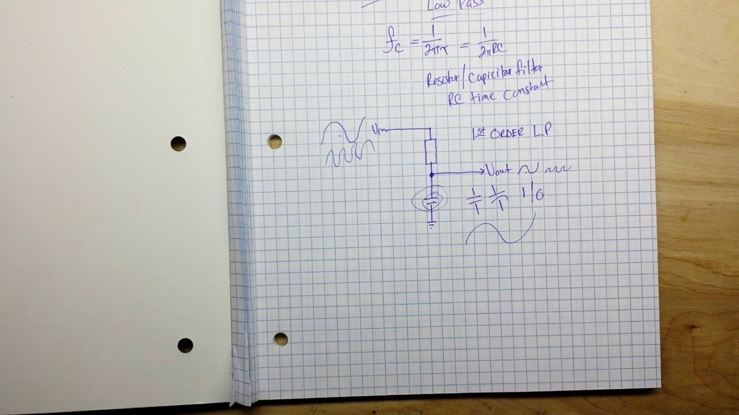 (score 95.0000)
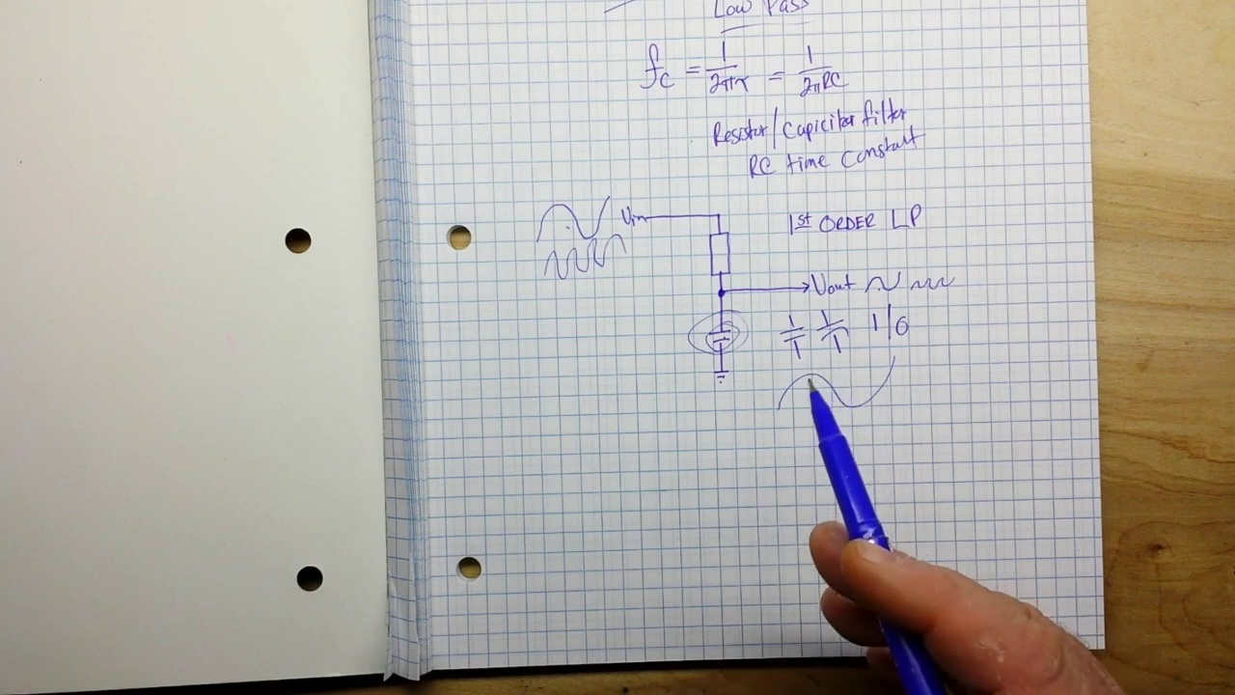 (score 95.0000)
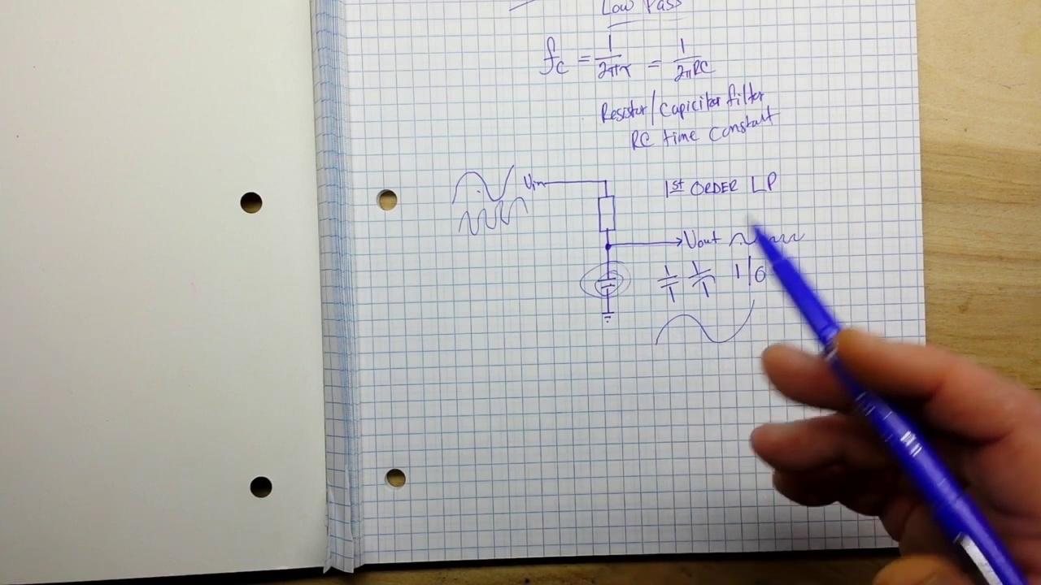 (score 95.0000)
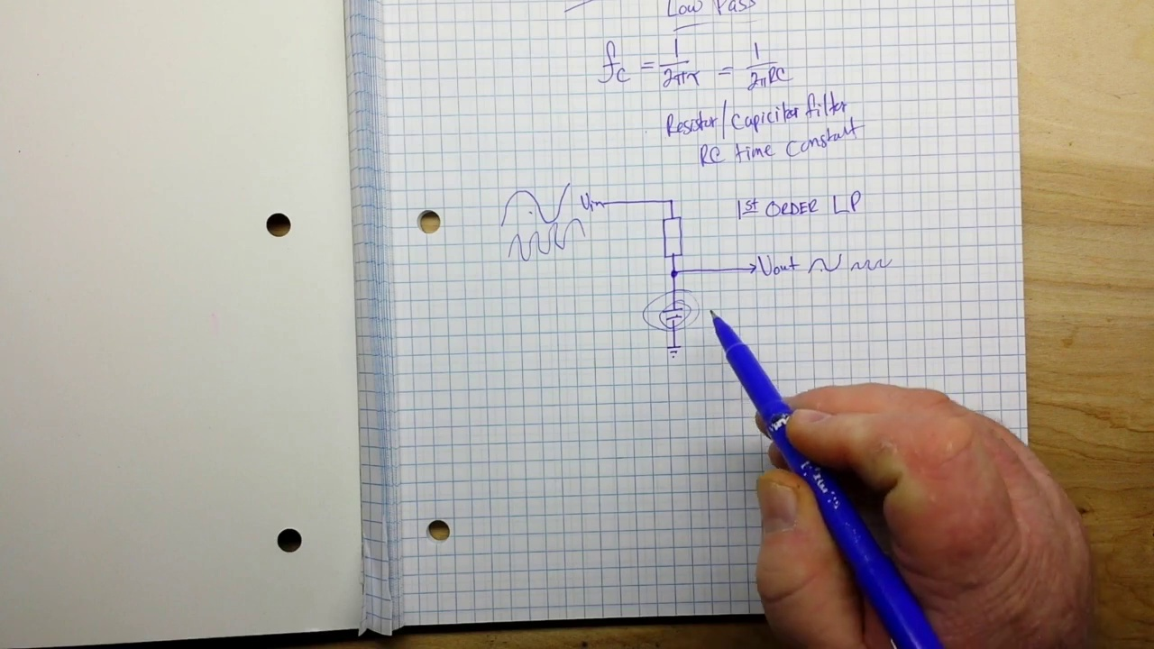 (score 95.0000)
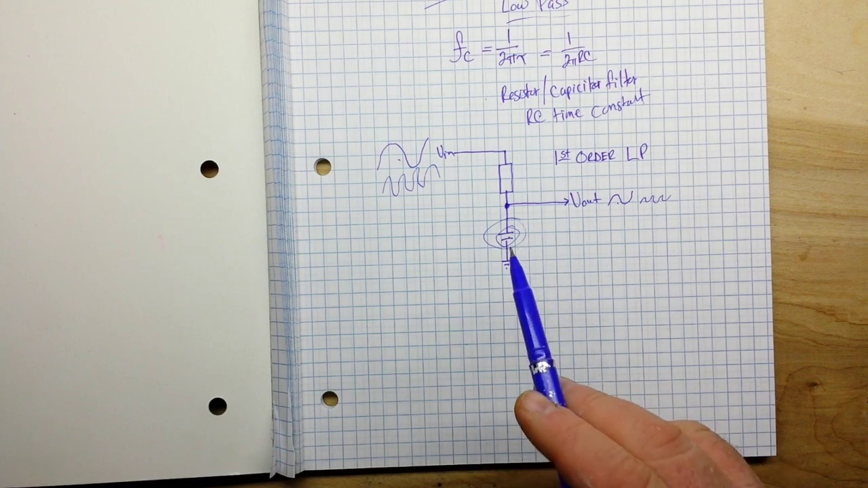 (score 95.0000)
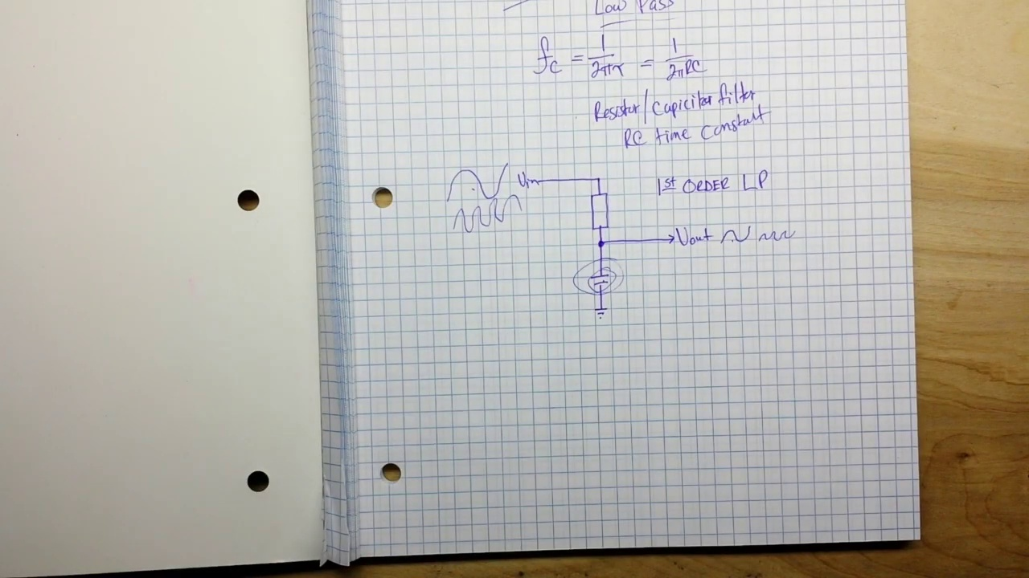 (score 95.0000)
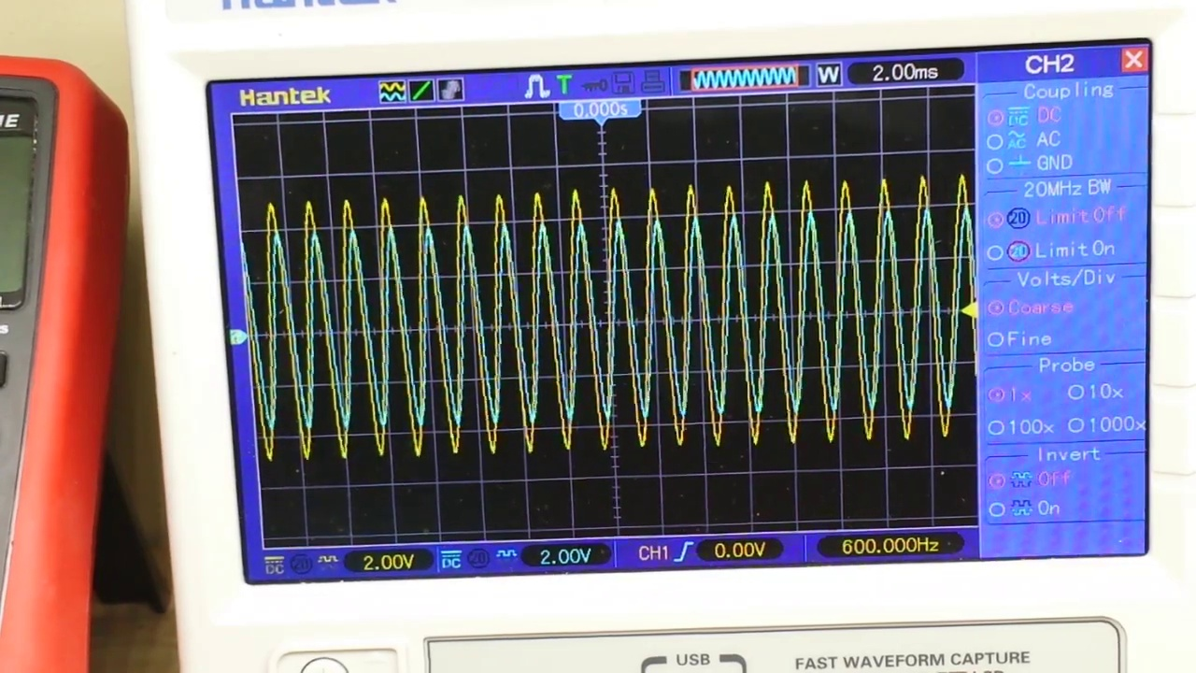 (score 95.0000)
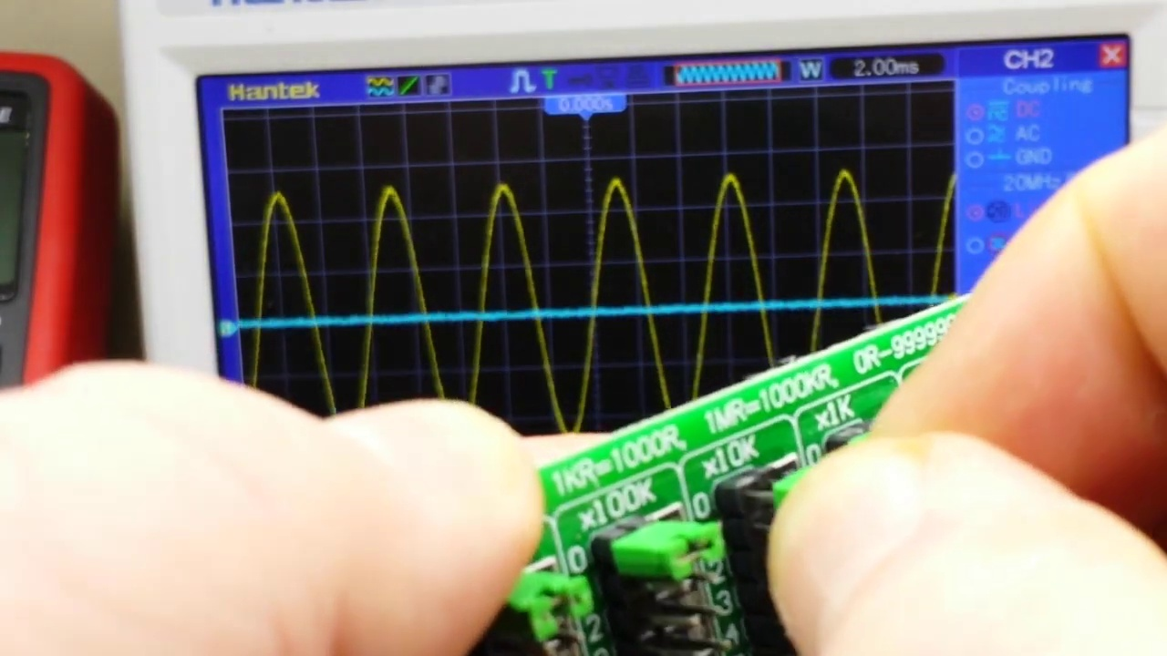 (score 95.0000)
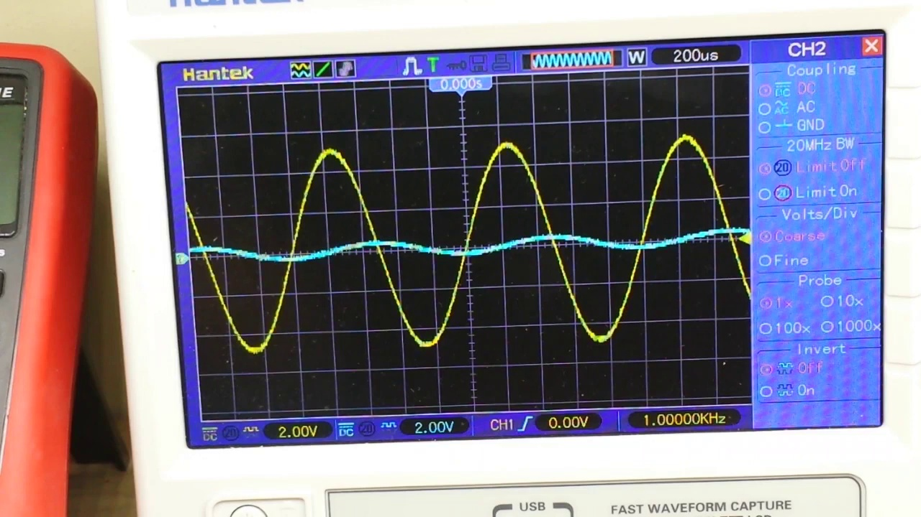 (score 95.0000)
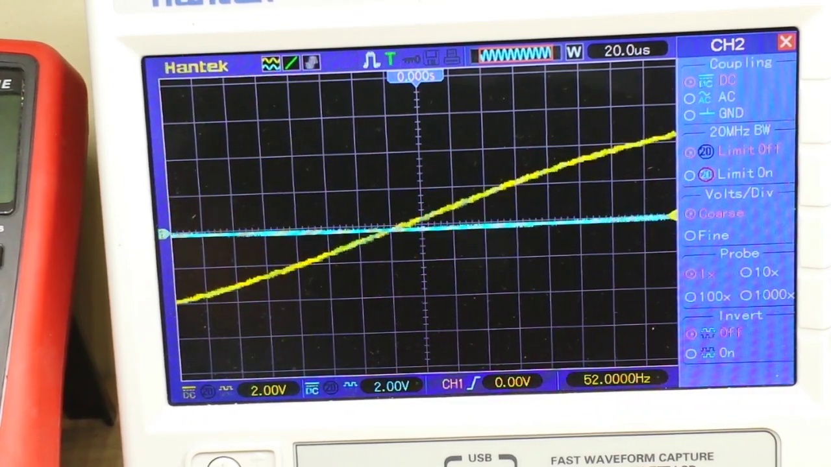 (score 95.0000)
Least correlated frames:
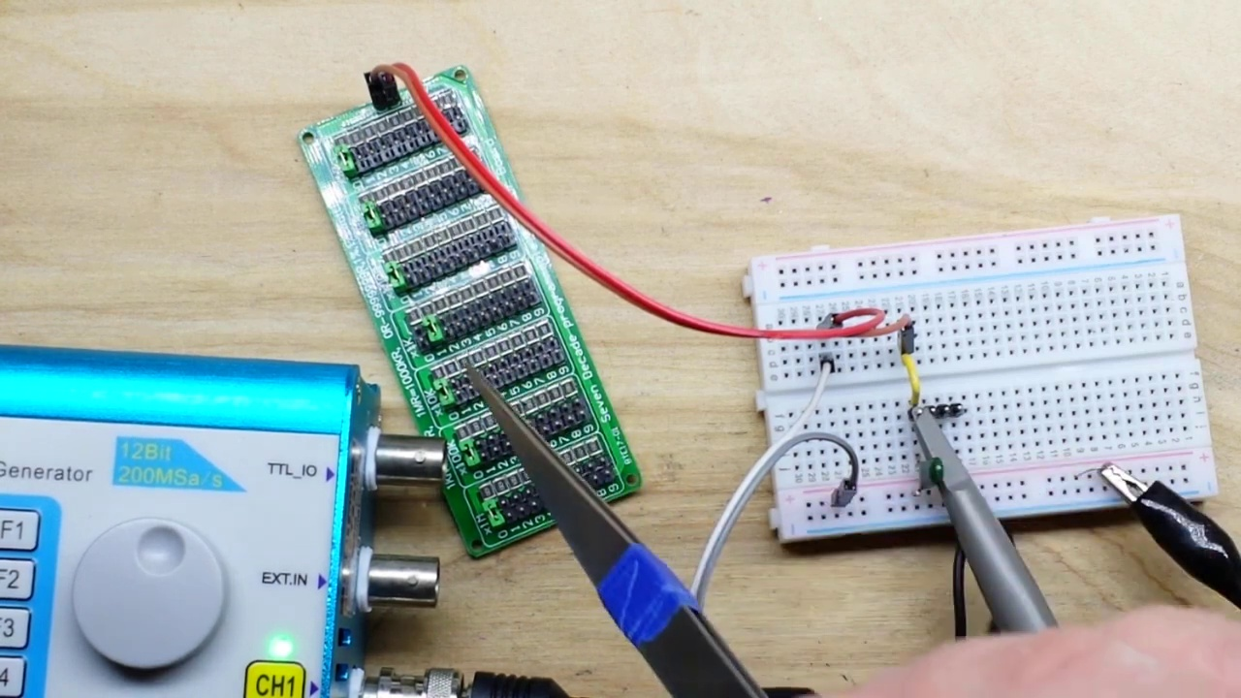 (score 0.0000)
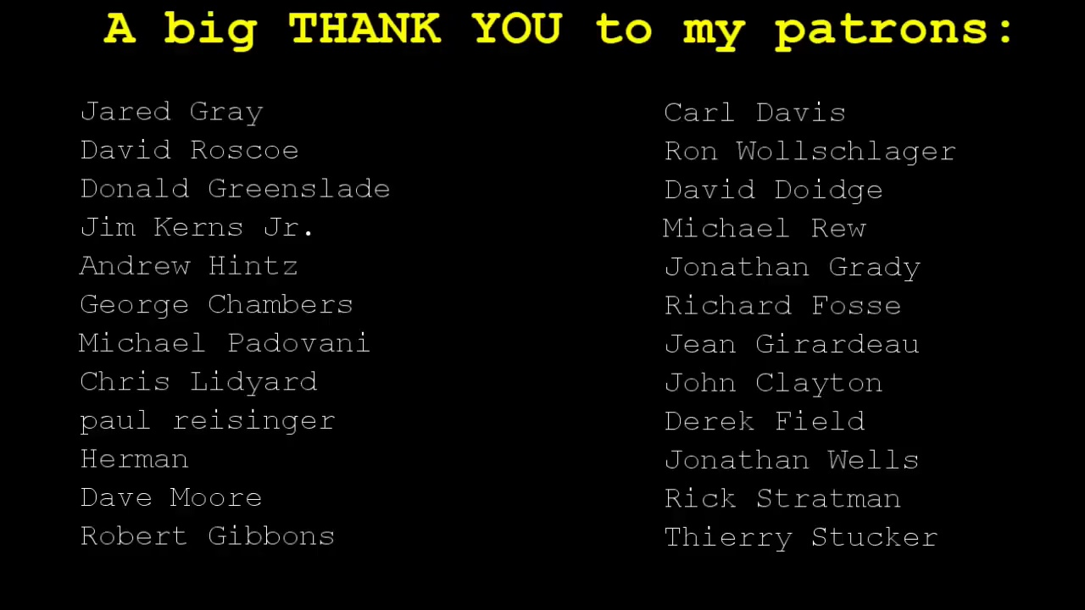 (score 20.0000)
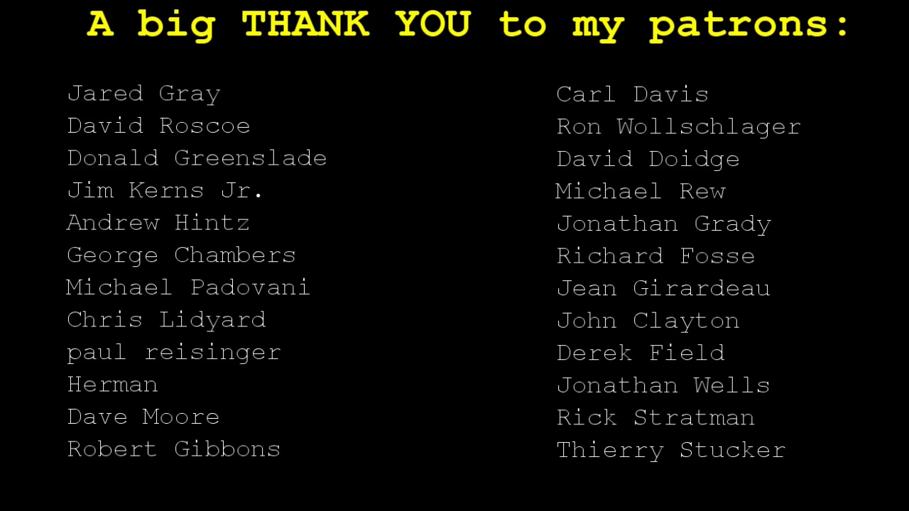 (score 20.0000)
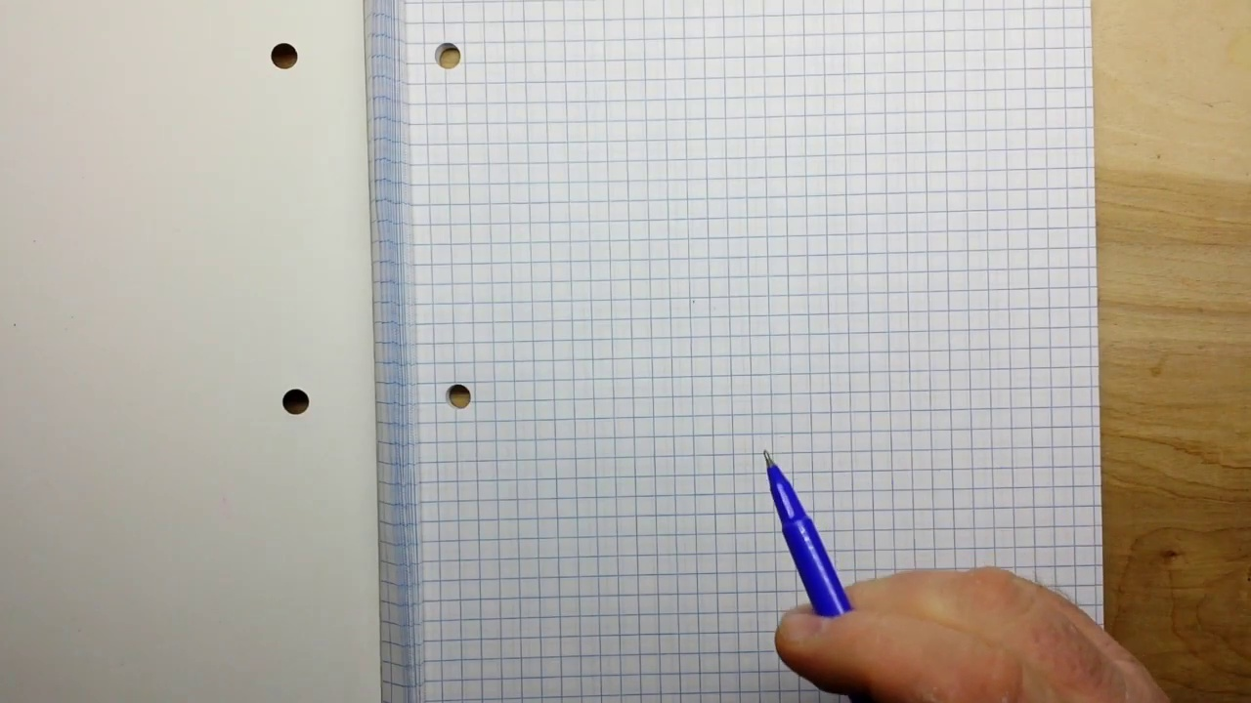 (score 80.0000)
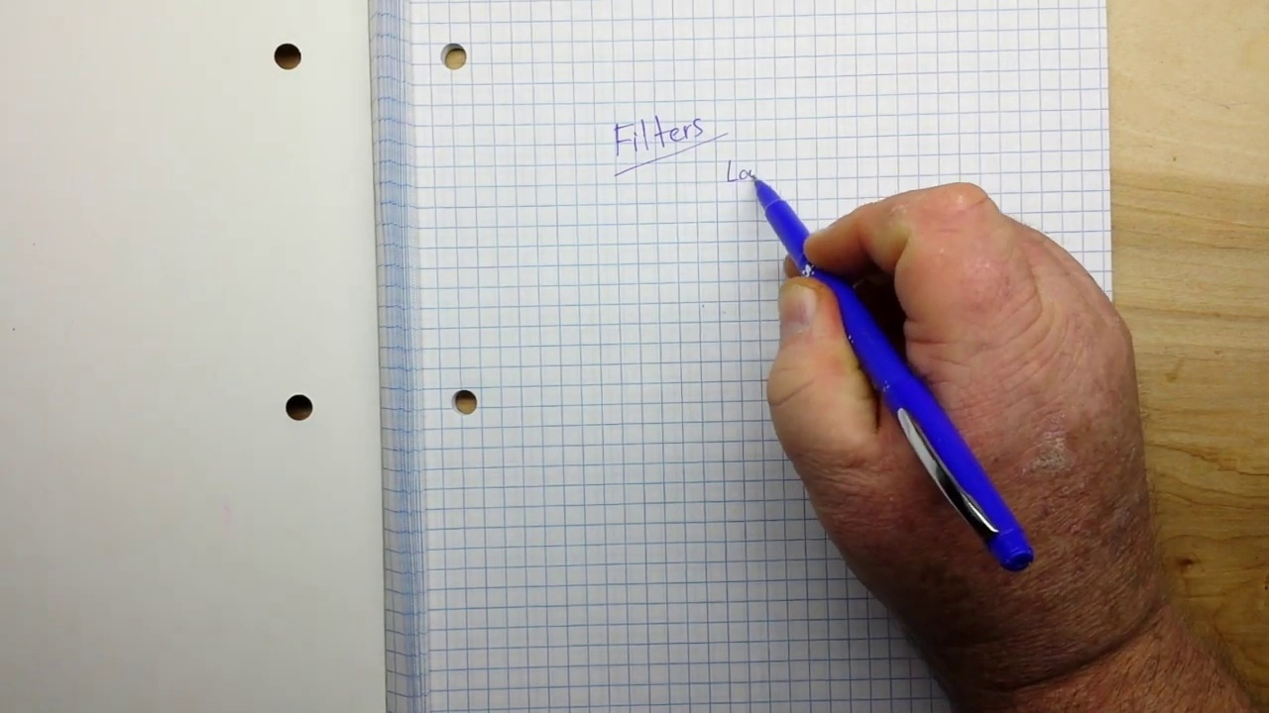 (score 80.0000)
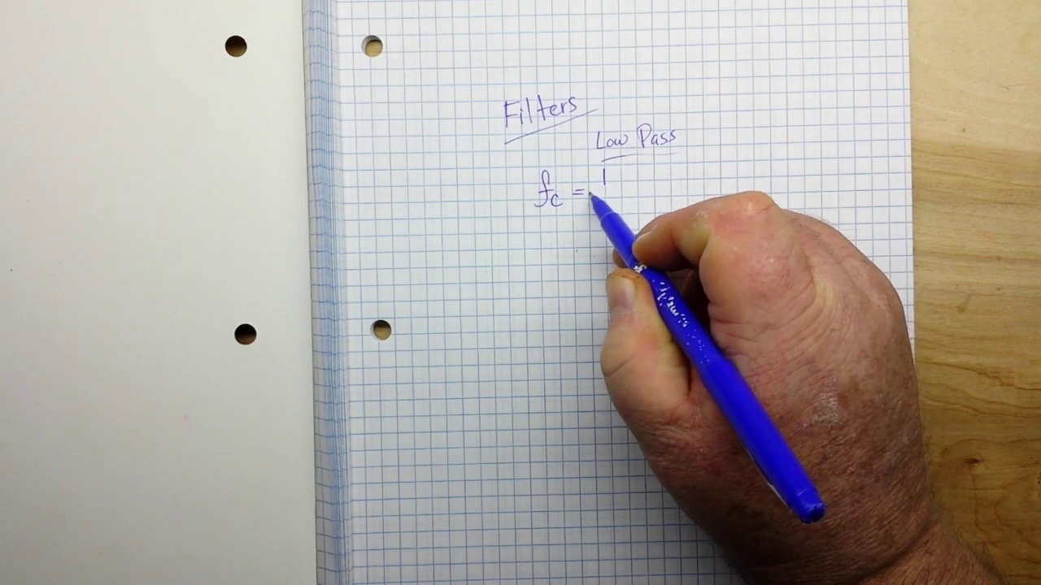 (score 80.0000)
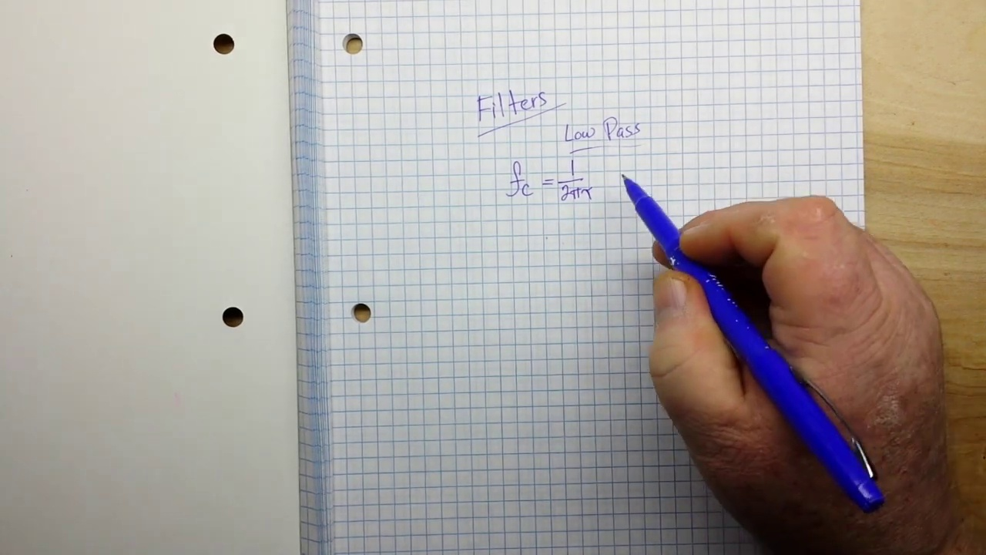 (score 80.0000)
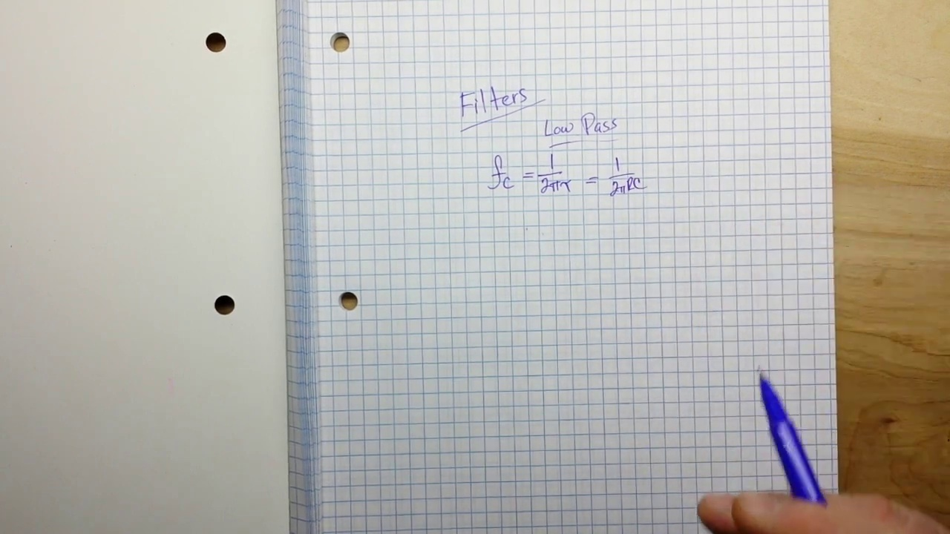 (score 80.0000)
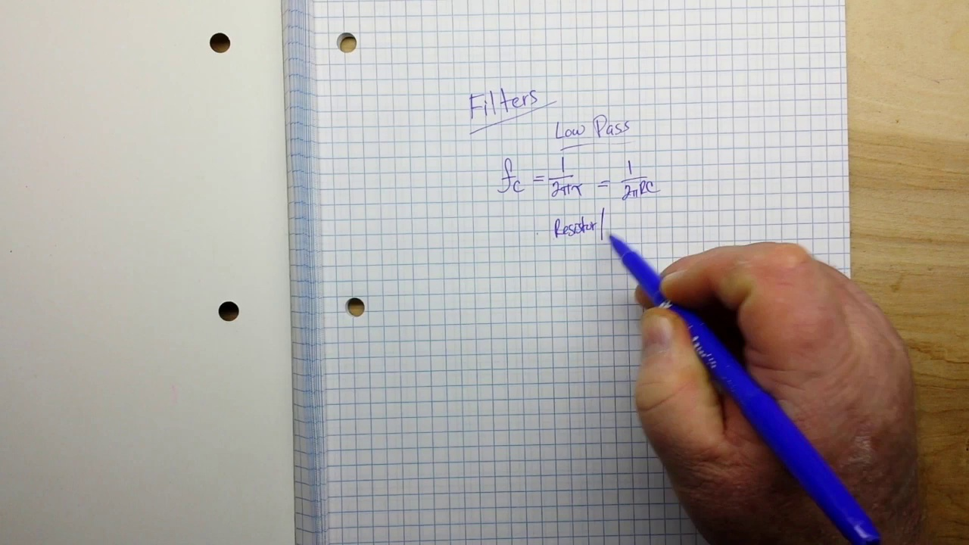 (score 80.0000)
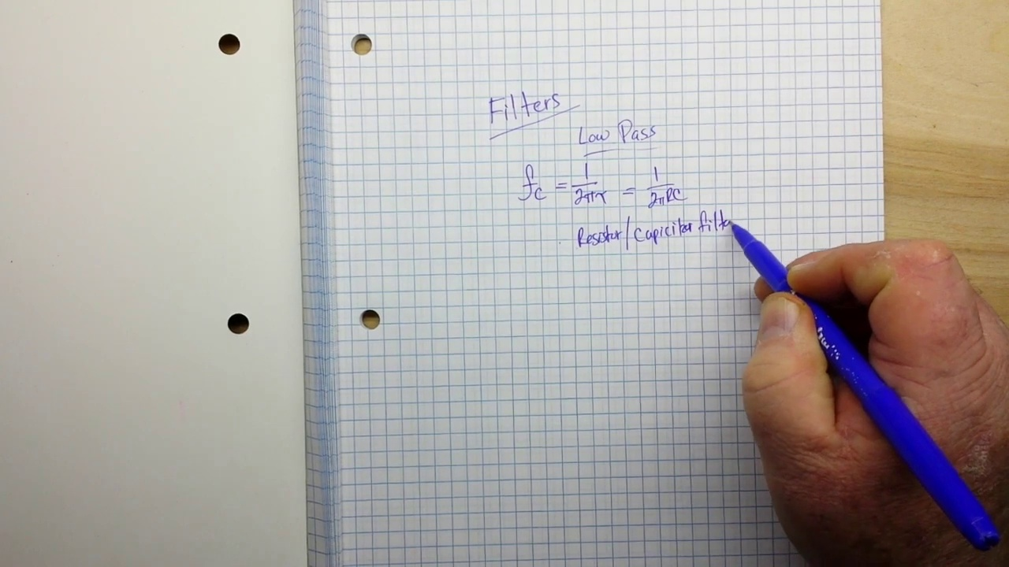 (score 80.0000)
- matched 160 frame(s), max score 95.0000: This video explains how to design and calculate the cutoff frequencies of a first-order low pass circuit. It showed the filter’s effect using an oscilloscope and how resistor values affect circuit outputs.None, he did a great job of explaining everything.
Source: https://www.youtube.com/watch?v=GqCn94Ksdbo&t=374s: The Low Pass Filter
Top correlated frames:
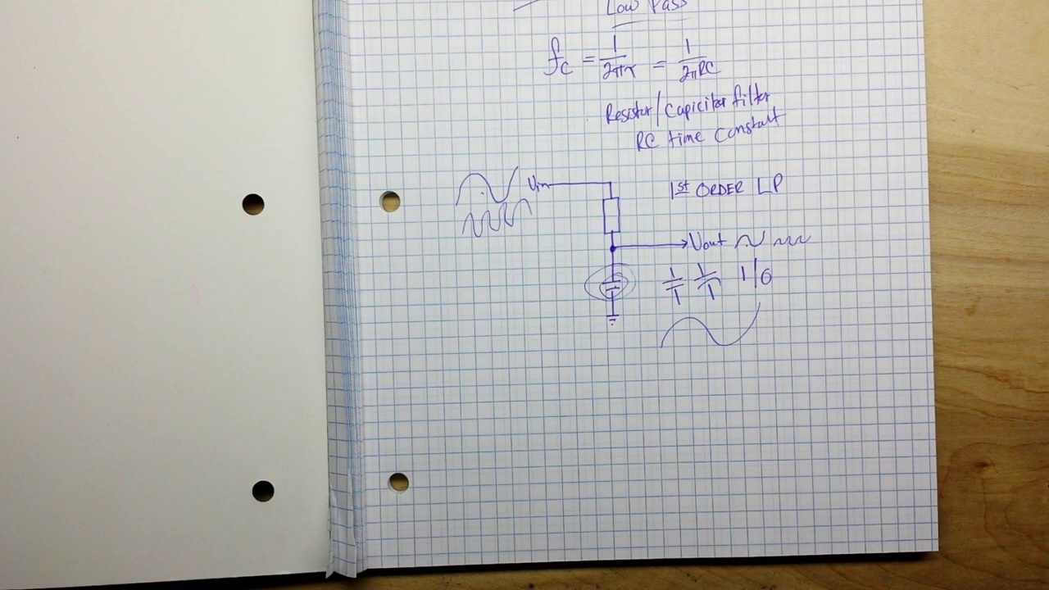 (score 95.0000)
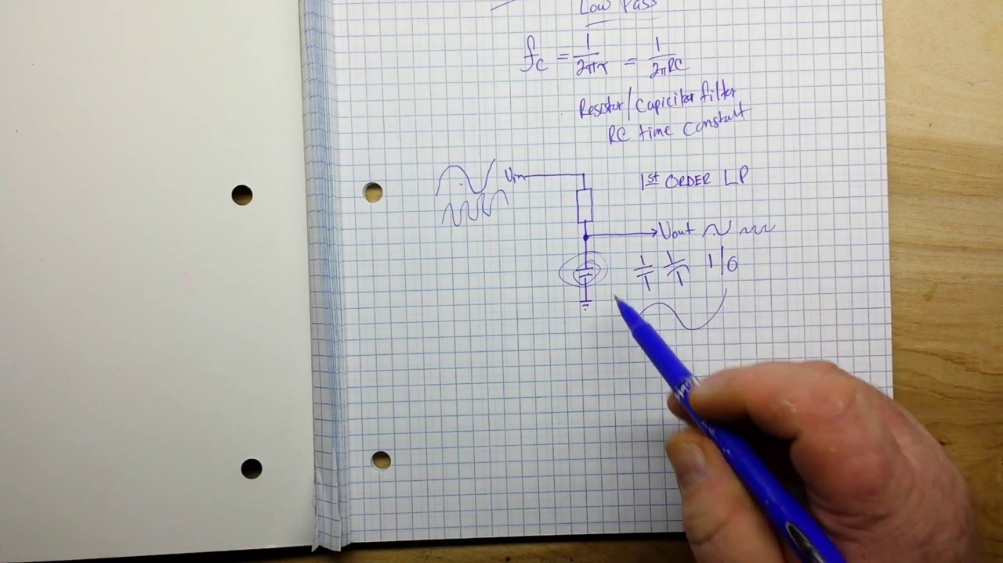 (score 95.0000)
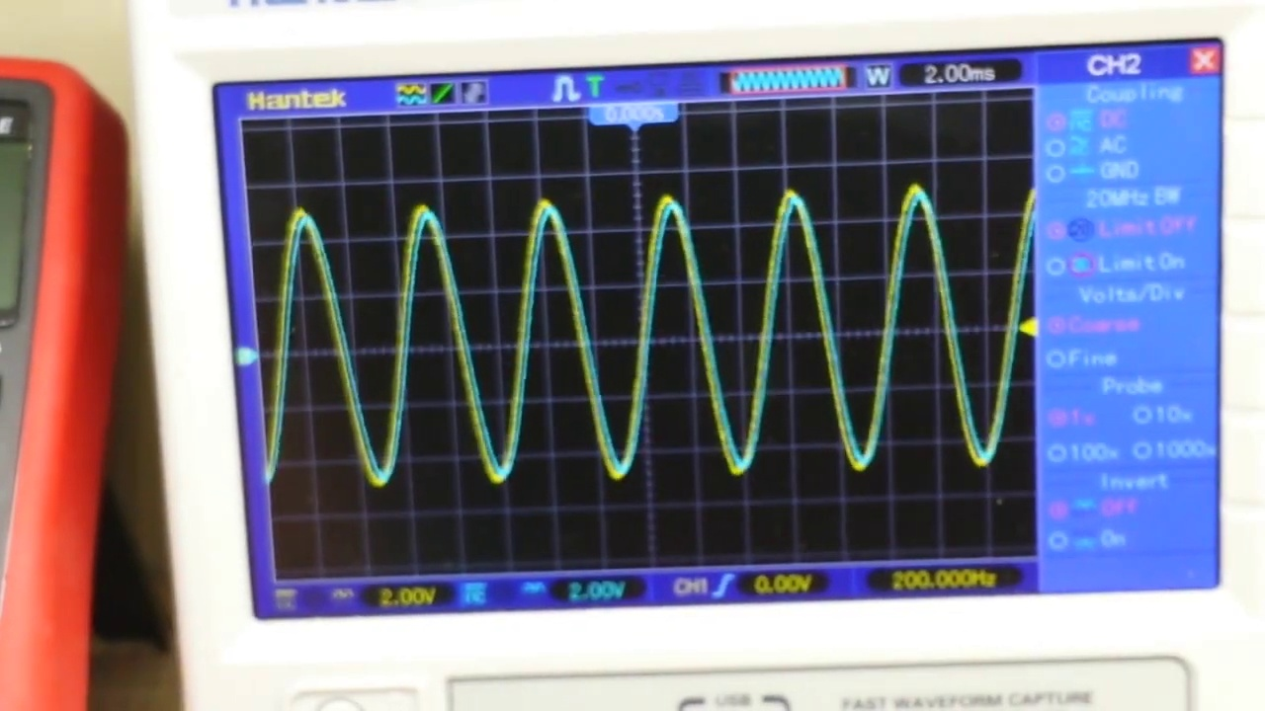 (score 95.0000)
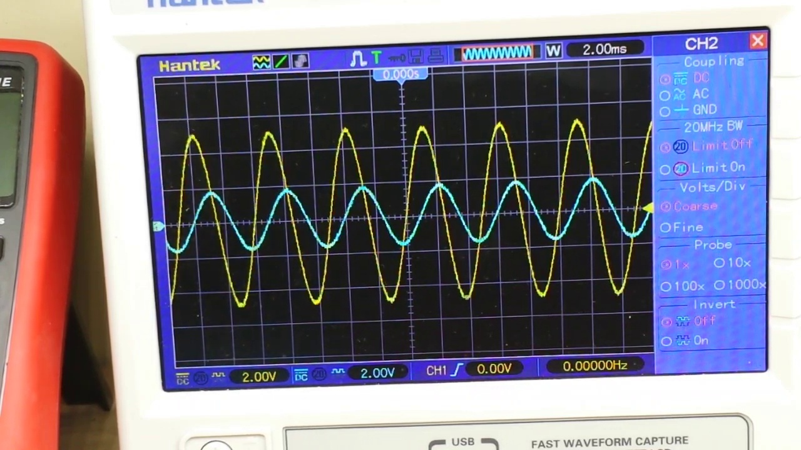 (score 95.0000)
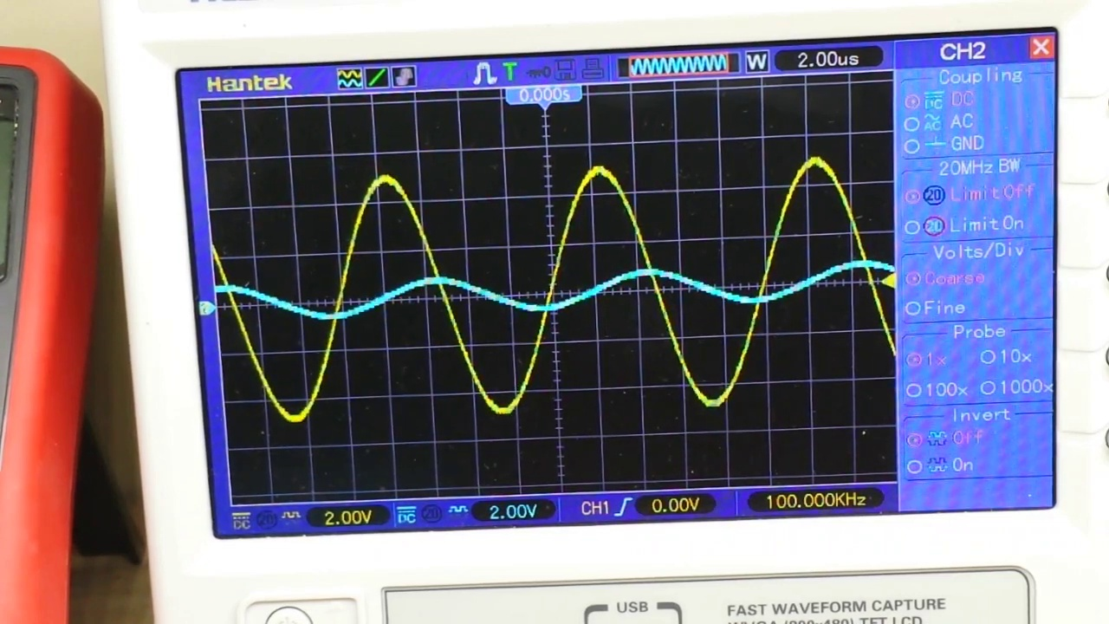 (score 95.0000)
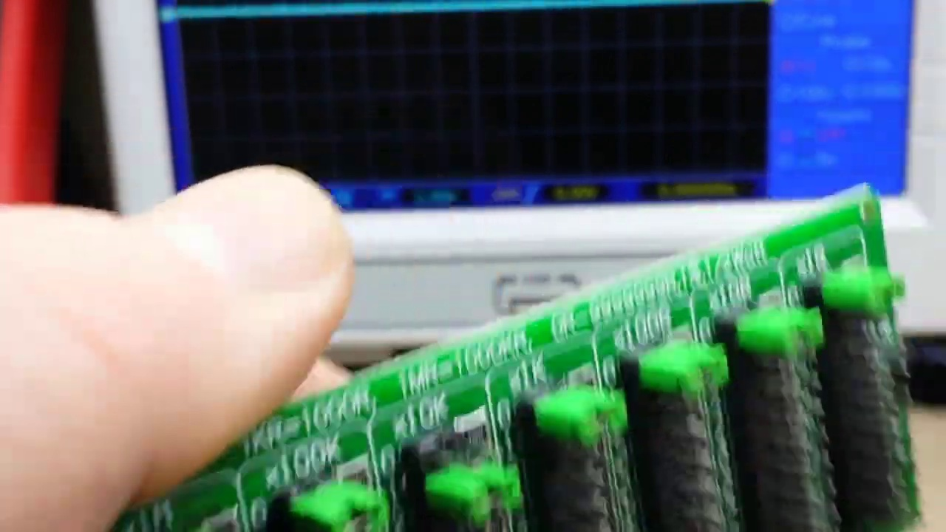 (score 95.0000)
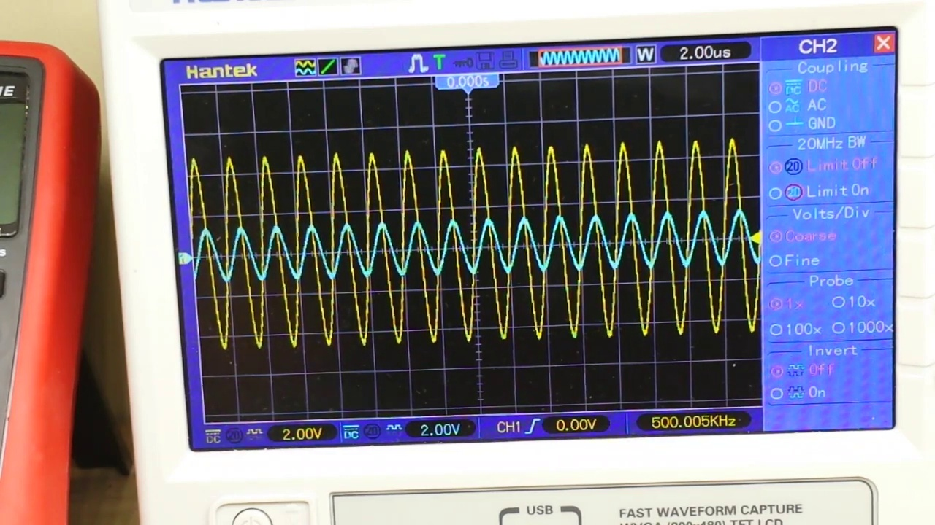 (score 95.0000)
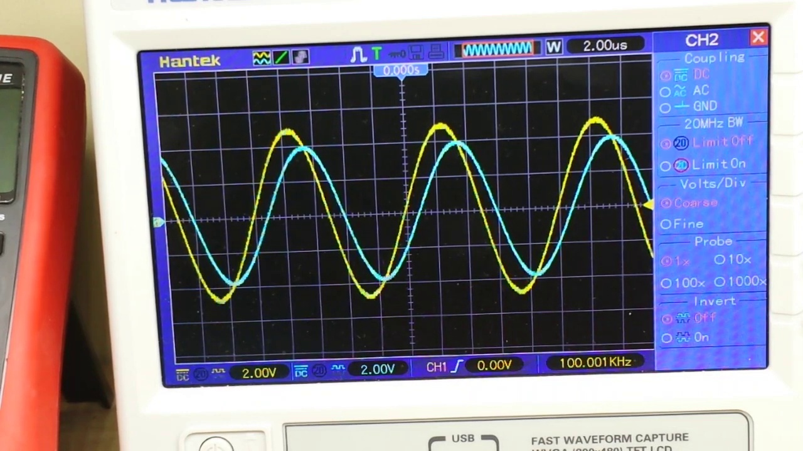 (score 95.0000)
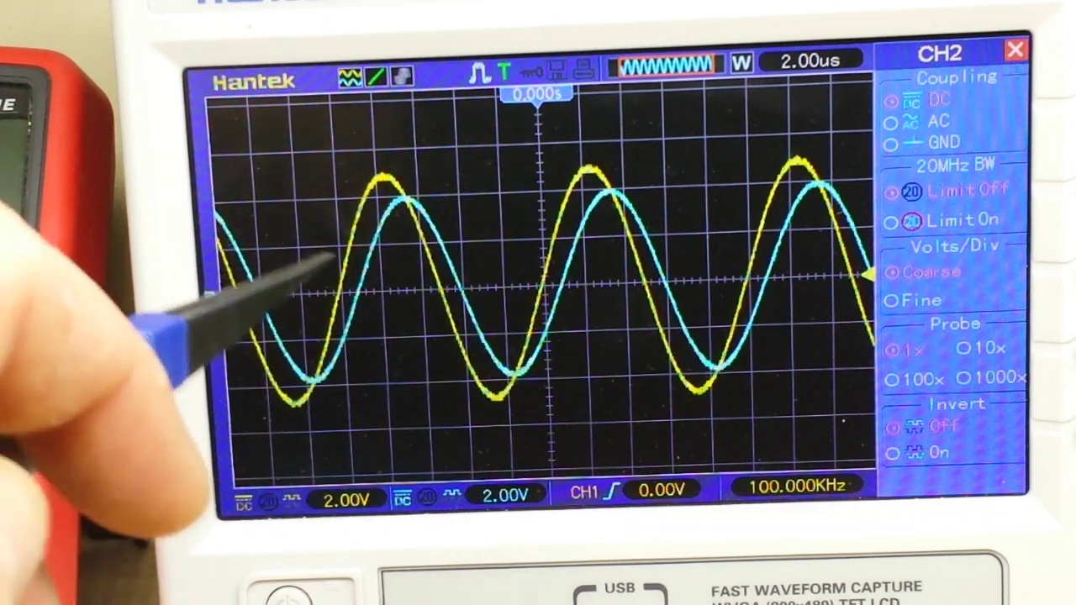 (score 95.0000)
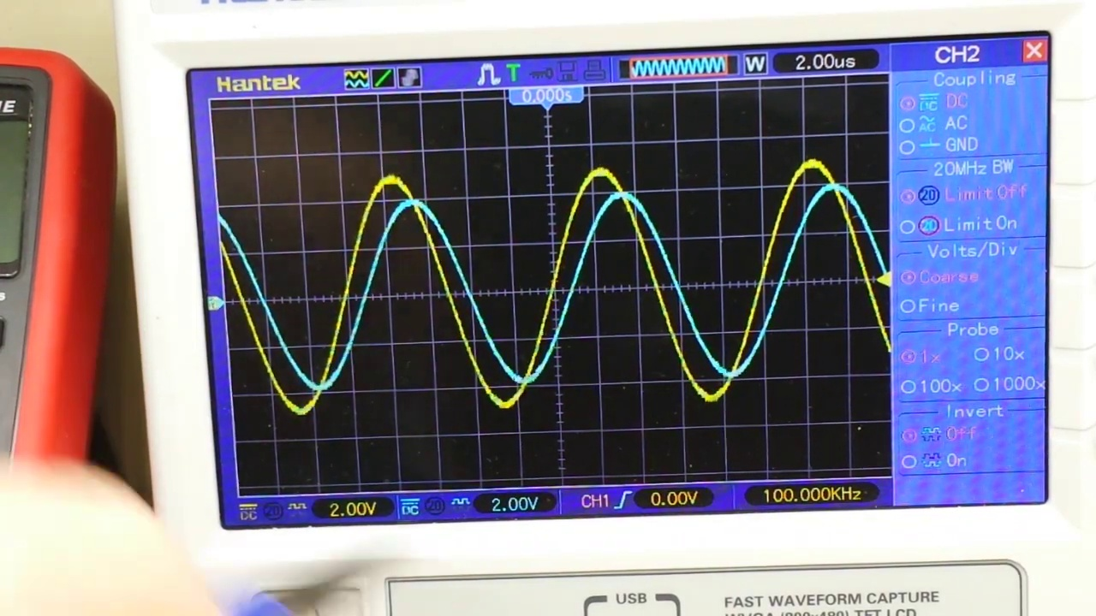 (score 95.0000)
Least correlated frames:
 (score 20.0000)
 (score 20.0000)
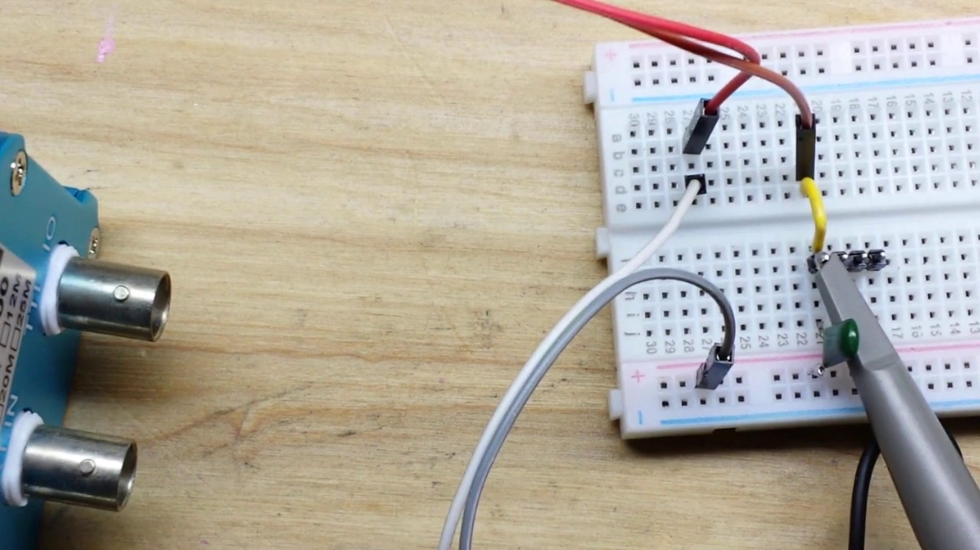 (score 20.0000)
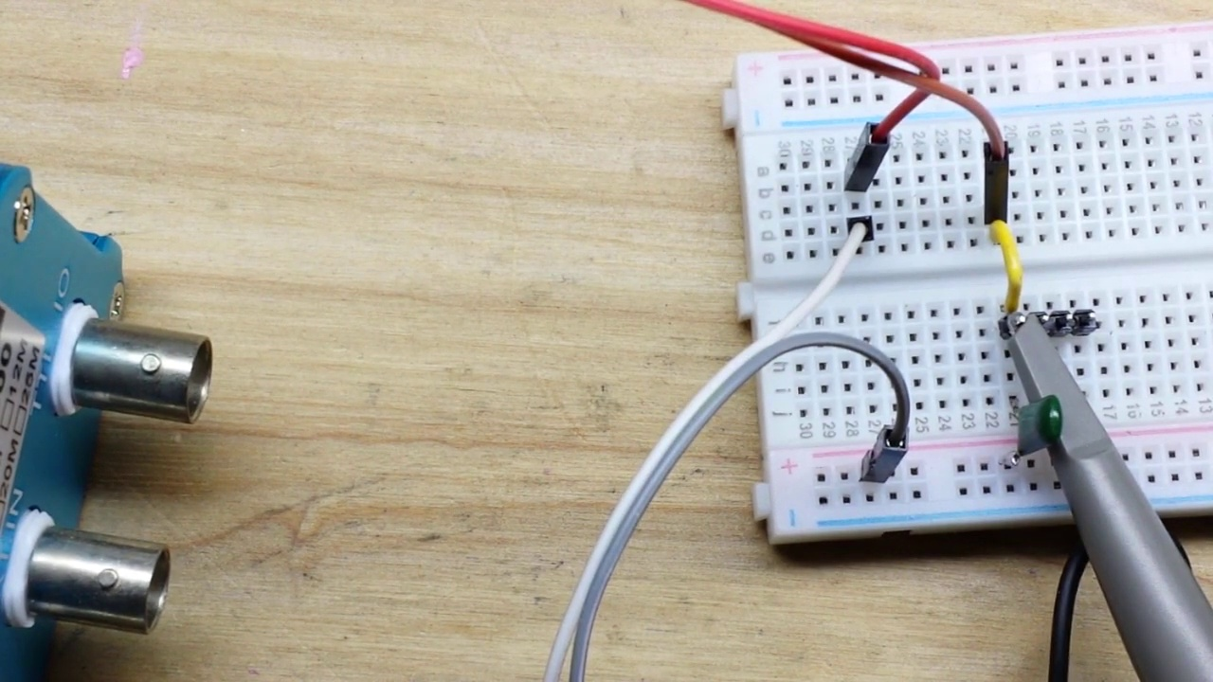 (score 20.0000)
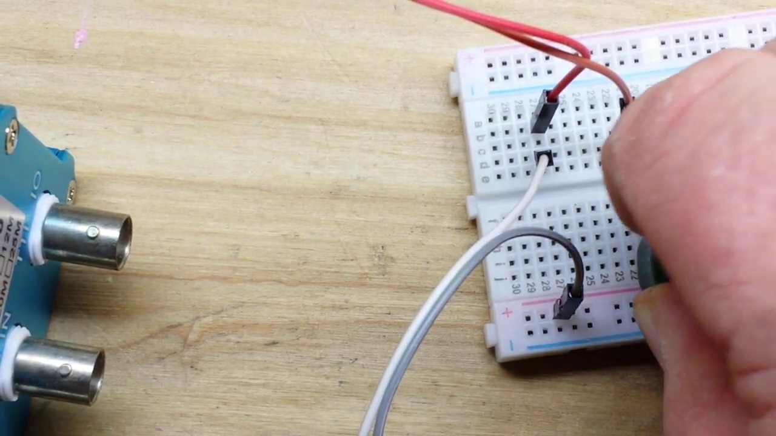 (score 20.0000)
 (score 20.0000)
 (score 20.0000)
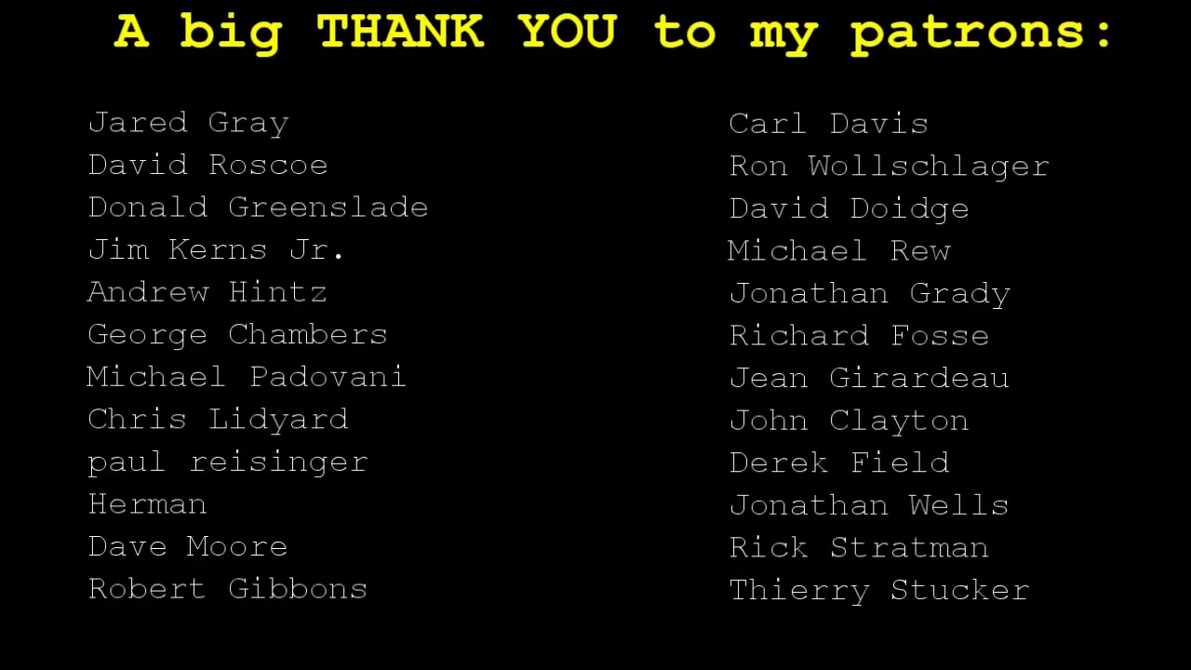 (score 20.0000)
 (score 20.0000)
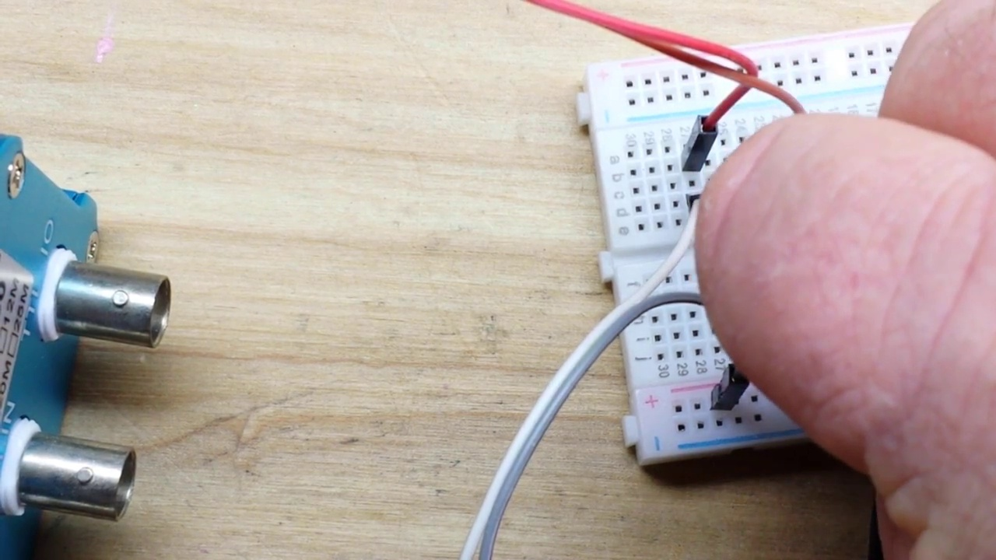 (score 30.0000)

Frame: frame_0000.jpg
Caption: The image shows a close-up view of a white notebook with blue squares as its decorative pattern, placed on a wooden table. The notebook is open, revealing its blank pages, which are lined with holes indicating that they were once used for writing. In the foreground, two pieces of paper lie against the blurred background, which appears to be an indoor setting with wooden surfaces. The piece of paper in front has a hand-drawn grid, possibly intended for graphical work or calculations, with visible text within the grid that seems to be related to mathematical equations or problems.
The second piece of paper is partially obscured by the first and appears to have a clearer image of printed text and what looks like a table with columns, potentially part of an educational worksheet or homework assignment. Although the text is too small to read clearly, it includes both words and mathematical symbols, suggesting that the content is likely related to mathematics or science education.
There are no visible persons or instructors in this image, nor are there any devices or teaching aids such as slides, models, or diagrams. The focus of the image remains on the pieces of paper with their printed and hand-drawn contents, which rest on the wooden table.
Comment (score 90): This video explains how to design and calculate the cutoff frequencies of a first-order low pass circuit. It showed the filter’s effect using an oscilloscope and how resistor values affect circuit outputs.None, he did a great job of explaining everything.
Reason: The comment directly discusses the same technical steps (designing and calculating cutoff frequencies) and objects (first-order low pass circuit) described in the caption.
Source: https://www.youtube.com/watch?v=GqCn94Ksdbo&t=374s: The Low Pass Filter
Comment (score 90): This video shows how to design and calculate the cutoff frequencies of a first-order low pass circuit. He demonstrated the effects of the filter using an oscilloscope and how resistor values affect circuit outputs.None. He did a great job of explaining everything.
Reason: The comment directly discusses the design and calculation of a first-order low pass circuit, which is specifically described in the caption as part of an educational worksheet or homework assignment. The mention of oscilloscope and resistor values also matches the technical details mentioned in the caption.
Source: https://www.youtube.com/watch?v=GqCn94Ksdbo&t=374s: The Low Pass Filter

Frame: frame_0001.jpg
Caption: In this image, there is a white notebook with grid lines lying open on a simple wooden table. A blue pen rests on the notebook, held by a hand visible on the right side of the page. The hand appears to be poised to make a mark, suggesting that someone is actively using the notebook to write or sketch something down. The image does not provide enough detail to determine the exact content being written or sketched.
On the left side of the notebook, two pages are partially visible. The top page appears to have some mathematical equations or problem statements, although they are too small and blurred to read clearly. The bottom page seems to contain a grid with rows and columns, possibly representing a spreadsheet or structured data table. However, it is not entirely clear due to the angle and resolution of the photo.
The image captures a moment of focused attention on the paper, with the hand and pen poised for creative expression. The background is the simple wooden table, providing a stark contrast to the paper and hand. There are no other people or devices visible that would suggest an instructional setting like a classroom or lecture hall. Additionally, there are no visible slides or diagrams that would indicate teaching activities in progress. The text on the notebook is not legible enough to provide any additional context or information about the content being written or sketched.
Comment (score 80): This video shows how to design and calculate the cutoff frequencies of a first-order low pass circuit. He demonstrated the effects of the filter using an oscilloscope and how resistor values affect circuit outputs.None. He did a great job of explaining everything.
Reason: The comment directly discusses the technical steps described in the caption, including designing and calculating cutoff frequencies of a first-order low pass circuit, which is related to the notebook with mathematical equations or problem statements and grid representations.
Source: https://www.youtube.com/watch?v=GqCn94Ksdbo&t=374s: The Low Pass Filter

Frame: frame_0002.jpg
Caption: The image captures a moment of focused concentration, showing a hand adorned with a ring holding a blue pen poised to make contact with a piece of blue paper. The paper has a grid pattern and appears to be filled out, possibly indicating a mathematical or technical task being performed. There is visible text that seems to be a series of numbers, but it's not clear if it's part of an equation or a list due to the angle and resolution of the image.
The hand is positioned in the lower right corner of the image, suggesting a sense of movement and action, as if the hand is about to make a mark on the paper. The background is a light brown wooden surface, adding a warm tone to the scene. The focus is primarily on the hand and the pen, with the paper serving as a canvas for the action.
The person in the frame appears focused on the paper and is likely interacting with the content on the page, possibly explaining or demonstrating something related to mathematics, engineering, or science. The setting suggests that this could be part of an educational context, such as a tutorial, lecture, or problem-solving session.
Comment (score 95): This video shows how to design and calculate the cutoff frequencies of a first-order low pass circuit. He demonstrated the effects of the filter using an oscilloscope and how resistor values affect circuit outputs.None. He did a great job of explaining everything.
Reason: The comment directly discusses the same technical steps (designing and calculating cutoff frequencies) and objects (first-order low pass circuit, oscilloscope, resistor values) mentioned in the caption, with a clear focus on explaining the concepts.
Source: https://www.youtube.com/watch?v=GqCn94Ksdbo&t=374s: The Low Pass Filter
Comment (score 80): This video explains how to design and calculate the cutoff frequencies of a first-order low pass circuit. It showed the filter’s effect using an oscilloscope and how resistor values affect circuit outputs.None, he did a great job of explaining everything.
Reason: The comment directly discusses the technical steps (designing and calculating cutoff frequencies) and objects (filter, resistor values, oscilloscope) mentioned in the caption. The setting of an educational context also matches.
Source: https://www.youtube.com/watch?v=GqCn94Ksdbo&t=374s: The Low Pass Filter

Frame: frame_0003.jpg
Caption: The image shows a person diligently working on a notebook, with the notebook open and filled with neatly written text. The text is aligned in columns, suggesting that the person is following a structured format as they work. The notebook is held in a way that allows for the visibility of one hand, which appears to be actively writing or pointing at the page. This hand holds a blue pen, adding a line or marking something on the paper.
The text on the notebook reads "Filters", indicating that the person might be working on a project related to filters in mathematics or computer science. The term "filters" generally refers to a mechanism for removing certain elements from a sequence, stream, or other data flow. The mathematical equations written on the paper appear to be discussing properties of filters, possibly involving differential equations or signal processing concepts.
The notebook is placed on a wooden surface that contrasts with the smooth surface of the notebook itself, suggesting a productive and focused work environment, potentially in an educational setting such as a classroom or study area.
Comment (score 95): This video explains how to design and calculate the cutoff frequencies of a first-order low pass circuit. It showed the filter’s effect using an oscilloscope and how resistor values affect circuit outputs.None, he did a great job of explaining everything.
Reason: The comment directly discusses the same technical steps (designing and calculating cutoff frequencies of a first-order low pass circuit) mentioned in the caption, which strongly indicates correlation.
Source: https://www.youtube.com/watch?v=GqCn94Ksdbo&t=374s: The Low Pass Filter
Comment (score 85): This video shows how to design and calculate the cutoff frequencies of a first-order low pass circuit. He demonstrated the effects of the filter using an oscilloscope and how resistor values affect circuit outputs.None. He did a great job of explaining everything.
Reason: The comment directly discusses the same technical steps (designing and calculating cutoff frequencies of a first-order low pass circuit) and objects (oscilloscope) described in the caption. The mention of filters and resistor values also aligns with the concepts discussed in the caption.
Source: https://www.youtube.com/watch?v=GqCn94Ksdbo&t=374s: The Low Pass Filter

Frame: frame_0004.jpg
Caption: In the image, a person's hand is captured in the act of writing on a blue notebook. The notebook is open, revealing the page that the person is currently writing on. The page appears to be blank, except for a single word that stands out in black ink - "Filters". The person's hand is positioned on the right side of the page, holding a blue pen that's poised to add the final word. This suggests that the person is either starting a new project or continuing from where they left off.
The environment looks like it could be an office or study setting, as indicated by the presence of what appears to be a desk with a computer monitor in the background. The screen on the monitor is blurred out, making it difficult to discern any specific details about the content being displayed. However, the focus remains on the person's hand and the notebook.
The text "FILES" is visible on the paper, suggesting that the focus might be on a topic related to files or file systems. This could be relevant to the context of writing about "Filters", potentially indicating that the person is working with files or data in some way.
Comment (score 80): This video explains how to design and calculate the cutoff frequencies of a first-order low pass circuit. It showed the filter’s effect using an oscilloscope and how resistor values affect circuit outputs.None, he did a great job of explaining everything.
Reason: The comment directly discusses the design and calculation of cutoff frequencies for a first-order low pass circuit, which is strongly related to the technical steps mentioned in the caption ('Filters') and the environment ('circuit outputs') described.
Source: https://www.youtube.com/watch?v=GqCn94Ksdbo&t=374s: The Low Pass Filter
Comment (score 80): This video shows how to design and calculate the cutoff frequencies of a first-order low pass circuit. He demonstrated the effects of the filter using an oscilloscope and how resistor values affect circuit outputs.None. He did a great job of explaining everything.
Reason: The comment directly discusses the design and calculation of cutoff frequencies of a first-order low pass circuit, which is strongly related to the concept of 'Filters' mentioned in the caption. The mention of oscilloscope and resistor values also matches the technical setting described in the caption.
Source: https://www.youtube.com/watch?v=GqCn94Ksdbo&t=374s: The Low Pass Filter

Frame: frame_0005.jpg
Caption: In the image provided, we see a person's hand holding a blue pen and writing on a lined blue notebook. The notebook appears to be blank, with no visible text or graph, as the focus seems to be on writing or marking something in the paper. The hand, adorned with a ring, is poised over the page, ready to make its mark. The background, a simple white wall, provides a stark contrast to the vibrant blue of the notebook. The word "Filters" is written in bold black letters, standing out against the white background. Several small circular objects are scattered around the paper, but their purpose or context is not clear from this image alone. It appears to be a close-up photo of someone engaging with a piece of paper and a pen, possibly taking notes or doing some kind of writing task. The image captures a moment of focus and creativity, showcasing the power of writing and the joy of creation.
Comment (score 90): This video explains how to design and calculate the cutoff frequencies of a first-order low pass circuit. It showed the filter’s effect using an oscilloscope and how resistor values affect circuit outputs.None, he did a great job of explaining everything.
Reason: The comment directly discusses the same technical steps (design and calculation of cutoff frequencies) and objects (first-order low pass circuit, oscilloscope) described in the caption, specifically mentioning the filter's effect and how resistor values affect circuit outputs.
Source: https://www.youtube.com/watch?v=GqCn94Ksdbo&t=374s: The Low Pass Filter
Comment (score 90): This video shows how to design and calculate the cutoff frequencies of a first-order low pass circuit. He demonstrated the effects of the filter using an oscilloscope and how resistor values affect circuit outputs.None. He did a great job of explaining everything.
Reason: The comment directly discusses the design and calculation of cutoff frequencies in a first-order low pass circuit, which is specifically mentioned in the caption as writing/marking something in a notebook. The mention of an oscilloscope and resistor values also matches the technical steps described in the caption.
Source: https://www.youtube.com/watch?v=GqCn94Ksdbo&t=374s: The Low Pass Filter

Frame: frame_0006.jpg
Caption: The image shows a person sitting at a wooden table with a pen in their hand, seemingly engaged in writing or note-taking on a lined notebook. The notebook is open and neatly organized, its pages blank and awaiting the words to be written. On the left side of the notebook, there's a list of items under the heading "Filters" followed by some illegible text. The image is slightly rotated, giving the impression that the notebook is being viewed at an angle rather than directly from above.
The hand holding the blue pen is gently grazing the lined paper, suggesting that it is in the act of writing. The pen and notebook are placed on the wooden table, creating a simple yet effective composition. The individual appears to be focused on their task, immersed in the writing process. The environment suggests a casual or academic setting, with no additional objects or text present to distract from the quiet solitude of solitary writing.
The image captures a moment of concentration and focus, with the hand and pen working together to create words on the page. The notebook provides a stable base for the hand and pen, allowing the individual to work comfortably. Overall, the image is a snapshot of a moment, a silent testament to the power of words and the quiet solitude of solitary writing.
Comment (score 95): This video shows how to design and calculate the cutoff frequencies of a first-order low pass circuit. He demonstrated the effects of the filter using an oscilloscope and how resistor values affect circuit outputs.None. He did a great job of explaining everything.
Reason: The comment directly discusses the design and calculation of cutoff frequencies of a first-order low pass circuit, which is mentioned in the caption as 'Filters' under the heading list in the notebook. The comment also mentions using an oscilloscope to demonstrate the effects of the filter, which is not explicitly stated in the caption but is implied by the presence of the notebook and pen.
Source: https://www.youtube.com/watch?v=GqCn94Ksdbo&t=374s: The Low Pass Filter
Comment (score 90): This video explains how to design and calculate the cutoff frequencies of a first-order low pass circuit. It showed the filter’s effect using an oscilloscope and how resistor values affect circuit outputs.None, he did a great job of explaining everything.
Reason: The comment directly discusses the design and calculation of a first-order low pass circuit, which is strongly related to the technical steps described in the caption, such as the use of an oscilloscope and resistor values. The connection between the two is strong, indicating a high correlation score.
Source: https://www.youtube.com/watch?v=GqCn94Ksdbo&t=374s: The Low Pass Filter

Frame: frame_0007.jpg
Caption: The image captures a moment frozen in time, where a blue notebook with neatly lined pages lies open to a page labeled "Filters". The purple ink on the page suggests that it was once used for writing, although the handwriting is illegible. Above the notebook, a piece of paper with handwritten text appears to be placed on a wooden table. On this paper, there is a list on the left side that seems to say "FILTERS," followed by two items: "SAND" and "CHARCOAL." Below this list is a label that reads "FILTER" in a handwritten font. The paper also bears a signature or marking with the notation "10/10". A person's hand is visible at the top left corner of the image, suggesting they might be holding the paper or just in the process of setting it down. The background appears to be an indoor setting with a tabletop surface, blurred but adding to the sense of intimacy and simplicity of the moment.
Comment (score 90): This video shows how to design and calculate the cutoff frequencies of a first-order low pass circuit. He demonstrated the effects of the filter using an oscilloscope and how resistor values affect circuit outputs.None. He did a great job of explaining everything.
Reason: The comment directly discusses the design and calculation of a first-order low pass circuit, which is strongly related to the technical steps described in the caption (e.g., 'FILTERS', 'SAND', 'CHARCOAL') and goals ('calculating cutoff frequencies').
Source: https://www.youtube.com/watch?v=GqCn94Ksdbo&t=374s: The Low Pass Filter
Comment (score 80): This video explains how to design and calculate the cutoff frequencies of a first-order low pass circuit. It showed the filter’s effect using an oscilloscope and how resistor values affect circuit outputs.None, he did a great job of explaining everything.
Reason: The comment directly discusses the design and calculation of filter cutoff frequencies, which is strongly related to the concept of 'Filters' mentioned in the caption. The mention of resistor values affecting circuit outputs also matches the technical context of the image.
Source: https://www.youtube.com/watch?v=GqCn94Ksdbo&t=374s: The Low Pass Filter

Frame: frame_0008.jpg
Caption: The image captures a moment of concentration and creativity in an educational environment. An open notebook with handwritten notes on a grid of blue and white ruled paper is visible, partially obscured by the person's writing. One word "fill" is written in ink, possibly indicating a prompt or instruction for a task or activity related to the notes. Alongside the text, there are mathematical symbols and expressions that suggest algebraic or calculus-related concepts.
In the bottom right corner of the image, a hand holding a purple pen with ink visible on the nib is seen, indicating recent use. The person's arm is partially visible, but not enough to identify them or determine their action.
The notebook is open to a page titled "Filters Low Pass" in bold black letters, providing a focus for the person's writing. The notes are neatly organized into squares of blue and white paper, creating a stark contrast with the person's handwriting. The background of the image is blurred, drawing attention to the notebook and the person's thoughtful expression.
The overall scene suggests a moment of thought and contemplation, perhaps related to a project or task requiring the use of filters in low pass form, where the person is working through math problems or exercises.
Comment (score 90): This video shows how to design and calculate the cutoff frequencies of a first-order low pass circuit. He demonstrated the effects of the filter using an oscilloscope and how resistor values affect circuit outputs.None. He did a great job of explaining everything.
Reason: The comment directly discusses the design and calculation of low pass circuits, which is strongly related to the concepts mentioned in the caption, such as 'Filters Low Pass' and algebraic expressions. The mention of oscilloscope and resistor values further supports this correlation.
Source: https://www.youtube.com/watch?v=GqCn94Ksdbo&t=374s: The Low Pass Filter
Comment (score 80): This video explains how to design and calculate the cutoff frequencies of a first-order low pass circuit. It showed the filter’s effect using an oscilloscope and how resistor values affect circuit outputs.None, he did a great job of explaining everything.
Reason: The comment directly discusses the same technical steps and settings described in the caption (designing and calculating cutoff frequencies of a first-order low pass circuit), as well as objects (oscilloscope, resistor values) and goals (explaining how to design and calculate filter's effect).
Source: https://www.youtube.com/watch?v=GqCn94Ksdbo&t=374s: The Low Pass Filter

Frame: frame_0009.jpg
Caption: The image shows a person's hand, clad in a white glove, using a blue pen to write on a piece of paper that has been divided into sections by lines. The paper, with a grid background typical for lined notebooks or sheets, is neatly folded in half, providing a stark contrast to the blue of the pen. The hand is positioned on the right side of the paper, indicating a right-handed person, and is slightly raised, suggesting that they are in the middle of writing. The text on the paper reads "Filters: Low Pass", with the word "filters" prominently displayed, indicating the mathematical function of filters.
The style suggests an educational or instructional context where the person is either explaining or solving a problem related to mathematical filters. The focus is on the paper and the writing process, as the blurred background draws attention away from any other objects or people that may be visible in the scene.
Comment (score 90): This video shows how to design and calculate the cutoff frequencies of a first-order low pass circuit. He demonstrated the effects of the filter using an oscilloscope and how resistor values affect circuit outputs.None. He did a great job of explaining everything.
Reason: The comment directly discusses the design and calculation of cutoff frequencies of a first-order low pass circuit, which is described in the caption as 'Filters: Low Pass'. The language used in the comment matches the style suggested by the frame caption.
Source: https://www.youtube.com/watch?v=GqCn94Ksdbo&t=374s: The Low Pass Filter
Comment (score 80): This video explains how to design and calculate the cutoff frequencies of a first-order low pass circuit. It showed the filter’s effect using an oscilloscope and how resistor values affect circuit outputs.None, he did a great job of explaining everything.
Reason: The comment directly discusses the same technical steps (designing and calculating cutoff frequencies), objects (oscilloscope), and settings (filter's effect) described in the caption. The mention of resistor values and circuit outputs also aligns with the information presented in the caption.
Source: https://www.youtube.com/watch?v=GqCn94Ksdbo&t=374s: The Low Pass Filter

Frame: frame_0010.jpg
Caption: The image shows a person's hand poised to write on a piece of paper with a blue pen, resting on a white surface, likely a flat table. The paper has a grid pattern and bears the bold, black text "Filters" in the top-left corner. Beneath this heading is an equation involving variables such as \( s \) and \( F(s) \), accompanied by handwritten notes or a list related to the topic of filters. A calculator lies nearby, suggesting mathematical calculations are being made or discussed. The background is blurred, providing no additional context, and the focus is on the person's action and the content being written rather than their environment.
Comment (score 80): This video explains how to design and calculate the cutoff frequencies of a first-order low pass circuit. It showed the filter’s effect using an oscilloscope and how resistor values affect circuit outputs.None, he did a great job of explaining everything.
Reason: The comment directly discusses the design and calculation of cutoff frequencies, which is a technical step mentioned in the caption (specifically, the equation involving variables like s and F(s)). The mention of an oscilloscope and resistor values also aligns with the context of filters described in the caption.
Source: https://www.youtube.com/watch?v=GqCn94Ksdbo&t=374s: The Low Pass Filter
Comment (score 80): This video shows how to design and calculate the cutoff frequencies of a first-order low pass circuit. He demonstrated the effects of the filter using an oscilloscope and how resistor values affect circuit outputs.None. He did a great job of explaining everything.
Reason: The comment directly discusses the design and calculation of filter cutoff frequencies, which is mentioned in the caption as part of the equation on the paper. The mention of oscilloscope and resistor values also matches the technical context described in the caption.
Source: https://www.youtube.com/watch?v=GqCn94Ksdbo&t=374s: The Low Pass Filter

Frame: frame_0011.jpg
Caption: The image shows a close-up of a person's hand interacting with a piece of paper. The hand appears to be holding a blue pen or marker and is in the process of writing or highlighting on the paper, which has a grid pattern suggesting it may be a notebook or notepad, commonly used for mathematical calculations or note-taking.
The visible part of the paper shows a piecewise function defined by three different equations:
f(x) = 4x^2 - 3x + 1 (for x < 0)
f(x) = 1/x (for x >= 0)
Additionally, there is a point labeled (a, b), although the values for 'a' and 'b' are not visible in the image. The person's hand is positioned on top of the paper, with the pen resting on the surface, indicating an ongoing writing or marking action.
The writing on the paper reads "Filters Low Pass" in neat script, and the hand is positioned over a square on the grid, indicating that it is being written in that area. The background of the image is a light brown color, providing contrast to the blue pen or marker and the white paper.
Comment (score 85): This video explains how to design and calculate the cutoff frequencies of a first-order low pass circuit. It showed the filter’s effect using an oscilloscope and how resistor values affect circuit outputs.None, he did a great job of explaining everything.
Reason: The comment directly discusses designing and calculating cutoff frequencies of a first-order low pass circuit, which is strongly related to the technical steps described in the caption (designing and calculating filter frequencies), objects (filter, oscilloscope), settings (resistor values), and goals (explaining filter effect).
Source: https://www.youtube.com/watch?v=GqCn94Ksdbo&t=374s: The Low Pass Filter
Comment (score 85): This video shows how to design and calculate the cutoff frequencies of a first-order low pass circuit. He demonstrated the effects of the filter using an oscilloscope and how resistor values affect circuit outputs.None. He did a great job of explaining everything.
Reason: The comment directly discusses the same technical steps (designing and calculating cutoff frequencies of a first-order low pass circuit), objects (oscilloscope), settings (resistor values affecting circuit outputs), and goals (explaining everything) described in the caption.
Source: https://www.youtube.com/watch?v=GqCn94Ksdbo&t=374s: The Low Pass Filter

Frame: frame_0012.jpg
Caption: The image shows a person's hand writing on a blue notebook with a watch-adorned hand. On the paper, there is some text that appears to be mathematical in nature, including a number sequence and a fraction. Below the text, there are three columns labeled "A," "B," and "C." Additionally, there is a symbol that looks like a subtraction operation within one of these columns, suggesting that the person might be working on a mathematical problem related to series or sequences. The notebook has a bold black title "Filters" written across the top, with a grid of squares representing units of measurement. The background is stark white, providing a contrast to the blue notebook and black text.
Comment (score 85): This video explains how to design and calculate the cutoff frequencies of a first-order low pass circuit. It showed the filter’s effect using an oscilloscope and how resistor values affect circuit outputs.None, he did a great job of explaining everything.
Reason: The comment directly discusses the design and calculation of cutoff frequencies of a first-order low pass circuit, which is strongly related to the technical steps described in the caption (e.g., working on a mathematical problem related to series or sequences, with a focus on filter design).
Source: https://www.youtube.com/watch?v=GqCn94Ksdbo&t=374s: The Low Pass Filter
Comment (score 80): This video shows how to design and calculate the cutoff frequencies of a first-order low pass circuit. He demonstrated the effects of the filter using an oscilloscope and how resistor values affect circuit outputs.None. He did a great job of explaining everything.
Reason: The comment directly discusses the design and calculation of cutoff frequencies of a first-order low pass circuit, which is strongly related to the technical steps and goals described in the caption, including the mathematical problem with a symbol for subtraction operation and the labels 'A', 'B', and 'C' that suggest calculation or filtering.
Source: https://www.youtube.com/watch?v=GqCn94Ksdbo&t=374s: The Low Pass Filter

Frame: frame_0013.jpg
Caption: The image captures a moment of focused concentration, featuring a person's hand with a pen, seemingly in the process of writing or marking something on a piece of paper placed on top of a transparent folder. The hand appears to be using a blue pen, which is common for writing and highlighting. The paper has some visible text and symbols, although it's not clear enough to read the content.
In the background, a whiteboard with mathematical equations or formulas written on it suggests that this could be related to mathematics or science education. However, the focus of the image is primarily on the hand holding the pen and the partially visible paper being marked or annotated.
Closer inspection reveals that the paper itself is a notebook page with black lines, neatly divided into squares. The handwriting exercise in progress shows notation for "Filters", "Low Pass", "FFT", and another instance of "FFT", indicating that the exercise is related to signal processing or digital signal processing.
The handwriting is clear and legible, suggesting that the person has been practicing or studying these concepts. The background is a light brown wooden surface, providing a neutral backdrop that allows the notebook and the handwriting to stand out. Overall, the scene suggests a learning or study environment where the individual is engaged in focused concentration and annotation of mathematical concepts.
Comment (score 95): This video shows how to design and calculate the cutoff frequencies of a first-order low pass circuit. He demonstrated the effects of the filter using an oscilloscope and how resistor values affect circuit outputs.None. He did a great job of explaining everything.
Reason: The comment directly discusses the same technical steps (design and calculate cutoff frequencies of a first-order low pass circuit), objects (oscilloscope), settings (filter design), and goals (explaining everything) described in the caption, which mentions signal processing and FFT notation. The correlation score is high because the comment provides specific details about the filter design process, matching the technical content found in the caption.
Source: https://www.youtube.com/watch?v=GqCn94Ksdbo&t=374s: The Low Pass Filter
Comment (score 85): This video explains how to design and calculate the cutoff frequencies of a first-order low pass circuit. It showed the filter’s effect using an oscilloscope and how resistor values affect circuit outputs.None, he did a great job of explaining everything.
Reason: The comment directly discusses the same technical steps ('design and calculate'), objects ('cutoff frequencies of a first-order low pass circuit', 'oscilloscope', 'resistor values'), and settings ('filter's effect') described in the caption, indicating strong correlation.
Source: https://www.youtube.com/watch?v=GqCn94Ksdbo&t=374s: The Low Pass Filter

Frame: frame_0014.jpg
Caption: The image shows a moment of mathematical problem-solving on a notebook page filled with equations and calculations. A written solution to a problem is presented, specifically involving integration by parts and trigonometric substitution for evaluation. The solution includes an integral and a diagram on the left side of the page. On the right side, a hand holding a blue pen is visible from a side angle, suggesting that someone is either writing or has just finished solving the problem.
The notebook is open to a page titled "Filters" in blue ink, but this information does not seem to be directly relevant to the mathematical solution presented. The person's arm and hand are partially visible, with the notebook and pen being the main focus of the image. The wooden table providing a neutral background for the problem.
Comment (score 80): This video explains how to design and calculate the cutoff frequencies of a first-order low pass circuit. It showed the filter’s effect using an oscilloscope and how resistor values affect circuit outputs.None, he did a great job of explaining everything.
Reason: The comment directly discusses the same technical steps and goals described in the caption, specifically mentioning filter design, cutoff frequencies, and circuit outputs. The mention of resistor values and oscilloscope usage also align with the notebook page showing integration by parts and trigonometric substitution for evaluation.
Source: https://www.youtube.com/watch?v=GqCn94Ksdbo&t=374s: The Low Pass Filter
Comment (score 80): This video shows how to design and calculate the cutoff frequencies of a first-order low pass circuit. He demonstrated the effects of the filter using an oscilloscope and how resistor values affect circuit outputs.None. He did a great job of explaining everything.
Reason: The comment discusses the same topic (designing and calculating cutoff frequencies of a first-order low pass circuit) as the caption, which shows mathematical problem-solving involving integration by parts and trigonometric substitution. Although the methods are different, both refer to filter design and calculation.
Source: https://www.youtube.com/watch?v=GqCn94Ksdbo&t=374s: The Low Pass Filter

Frame: frame_0015.jpg
Caption: The image shows a person's hand with a blue pen holding down a piece of paper with mathematical calculations, diagrams, and handwriting. The paper is placed on a surface that resembles a wooden table. On the paper, there are several pieces of handwriting and mathematical symbols, including an equation that reads "F=1/r^2" which represents the formula for force in physics. A drawing of what appears to be a circular motion with two concentric circles labeled as 'Centripetal Force' and 'Centrifugal Force', suggesting an educational context related to physics or mathematics, is also present. The handwriting includes annotations or corrections, common in educational settings when solving problems or checking work.
The blue pen is poised to add more text to the paper, which is neatly folded with "Filters" written at the top in black ink. The hand is adorned with a blue watch, suggesting that time might be of importance in this moment of focused concentration. The background is a simple white wall, providing a stark contrast to the black ink on the paper.
The entire scene captures a moment of intense focus and engagement, highlighting the joy of learning and human creativity.
Comment (score 90): This video shows how to design and calculate the cutoff frequencies of a first-order low pass circuit. He demonstrated the effects of the filter using an oscilloscope and how resistor values affect circuit outputs.None. He did a great job of explaining everything.
Reason: The comment directly discusses the technical steps and objects described in the caption, such as designing and calculating cutoff frequencies of a first-order low pass circuit, and using an oscilloscope. The correlation is high because the comment specifically mentions the same concepts and tools mentioned in the caption.
Source: https://www.youtube.com/watch?v=GqCn94Ksdbo&t=374s: The Low Pass Filter
Comment (score 80): This video explains how to design and calculate the cutoff frequencies of a first-order low pass circuit. It showed the filter’s effect using an oscilloscope and how resistor values affect circuit outputs.None, he did a great job of explaining everything.
Reason: The comment directly discusses the same technical steps (designing and calculating cutoff frequencies) and objects (first-order low pass circuit, oscilloscope) described in the caption.
Source: https://www.youtube.com/watch?v=GqCn94Ksdbo&t=374s: The Low Pass Filter

Frame: frame_0016.jpg
Caption: In the image, a person is captured in a moment of focused concentration, with their hand poised to write on a piece of paper. The hand, holding a blue pen, hovers over the paper, ready to continue working through a mathematical equation. The paper is blank for now, awaiting the next steps in the problem-solving process.
The handwriting on the paper appears to involve mathematical expressions, specifically fractions, with an equation that reads "1/3 + 2/5 = ?" indicating that the person might be working out this fraction addition problem. The person seems to be in the process of writing or correcting the answer to the problem, as they are holding a pen and pointing at a part of the paper with their other hand.
The surrounding environment suggests an indoor setting, possibly a classroom or study area, given the presence of a whiteboard and a table. However, there is no visible text on the clipboard that provides additional context or teaching material. The focus remains solely on the handwriting and the interaction with the mathematical problem, leaving the viewer unsure if this is part of an instructional session, such as a lecture, tutorial, or homework task.
In the background, a wooden desk stands silently observing the process, its texture adding an element of warmth to the otherwise sterile environment. The blue and white notebook, with its grid pattern, provides a stark contrast to the blank paper, serving as a testament to the discipline required in mathematical work. Overall, the image paints a picture of a quiet moment of intellectual pursuit, where focus and precision are the only companions.
Comment (score 80): This video shows how to design and calculate the cutoff frequencies of a first-order low pass circuit. He demonstrated the effects of the filter using an oscilloscope and how resistor values affect circuit outputs.None. He did a great job of explaining everything.
Reason: The comment directly discusses the same technical steps and goals described in the caption, specifically designing and calculating cutoff frequencies of a first-order low pass circuit, which is related to the mathematical equation shown on the paper.
Source: https://www.youtube.com/watch?v=GqCn94Ksdbo&t=374s: The Low Pass Filter

Frame: frame_0017.jpg
Caption: The image captures a moment of intellectual pursuit, showcasing a person's hand meticulously writing on a piece of blue paper. The hand is positioned on an open blue notebook, filled with a series of equations written in black ink, creating a stark contrast against the blue background. The equations are arranged in a grid-like pattern, with each row and column filled with different mathematical expressions, suggesting a complex problem or problem-solving task that blends algebra and geometry.
The focus is on the process of writing rather than the content being written, as the clarity and legibility of the handwriting indicate the person's attention to detail and focus. The overall scene suggests a study session or problem-solving task, possibly related to mathematics or science. The setting appears to be an informal workspace or study area, with a portion of the grid pattern on the paper visible in the background, along with another out-of-focus object.
Comment (score 90): This video shows how to design and calculate the cutoff frequencies of a first-order low pass circuit. He demonstrated the effects of the filter using an oscilloscope and how resistor values affect circuit outputs.None. He did a great job of explaining everything.
Reason: The comment directly discusses the design and calculation of cutoff frequencies in a first-order low pass circuit, which is strongly related to the technical steps and objects described in the caption, including the writing on the blue paper and equations.
Source: https://www.youtube.com/watch?v=GqCn94Ksdbo&t=374s: The Low Pass Filter
Comment (score 85): This video explains how to design and calculate the cutoff frequencies of a first-order low pass circuit. It showed the filter’s effect using an oscilloscope and how resistor values affect circuit outputs.None, he did a great job of explaining everything.
Reason: The comment directly discusses the calculation and design of a first-order low pass circuit, which is mentioned in the caption as one of the mathematical expressions. The mention of an oscilloscope and resistor values also matches the technical tone and language used in the caption.
Source: https://www.youtube.com/watch?v=GqCn94Ksdbo&t=374s: The Low Pass Filter

Frame: frame_0018.jpg
Caption: The image captures a moment of focused attention as a hand dexterously writes on a blue notepad, filled with equations written in black ink. The notepad is open and scattered with mathematical problems, each one a testament to the meticulous nature of the task at hand. At the bottom of the page, the hand is engaged in writing, its fingers deftly moving across the page as it works out a mathematical problem. Specifically, the handwritten solution appears to be solving for y in terms of x, with the prompt "if x^2 = 4y, find y in terms of x" and the equation "x^2 - 4y = 0". The solution itself is written below this prompt: "y = (x^2)/4". A blue pen and a calculator are also present, indicating calculations are being made. The image appears to be taken in an educational setting, possibly a classroom or study area, with the photograph's focus on the hand and notepad emphasizing the intellectual pursuit of mathematics.
Comment (score 85): This video explains how to design and calculate the cutoff frequencies of a first-order low pass circuit. It showed the filter’s effect using an oscilloscope and how resistor values affect circuit outputs.None, he did a great job of explaining everything.
Reason: The comment directly discusses the same technical steps (designing and calculating cutoff frequencies) and objects (first-order low pass circuit, oscilloscope) mentioned in the caption.
Source: https://www.youtube.com/watch?v=GqCn94Ksdbo&t=374s: The Low Pass Filter
Comment (score 80): This video shows how to design and calculate the cutoff frequencies of a first-order low pass circuit. He demonstrated the effects of the filter using an oscilloscope and how resistor values affect circuit outputs.None. He did a great job of explaining everything.
Reason: The comment directly discusses the technical steps and settings described in the caption, such as designing cutoff frequencies of a first-order low pass circuit, using an oscilloscope, and explaining resistor values. The only reason it's not a perfect score is that the comment doesn't explicitly mention the handwritten solution or the equation 'y = (x^2)/4', but the overall theme and technical focus are strongly related.
Source: https://www.youtube.com/watch?v=GqCn94Ksdbo&t=374s: The Low Pass Filter

Frame: frame_0019.jpg
Caption: The image displays a scene where someone is teaching or explaining a mathematical concept, likely in an educational setting such as a classroom or lecture hall. On the whiteboard, an equation involving a variable 'x' and two terms inside parentheses is written on the left side, accompanied by two diagrams or graphs: one is a simple line graph with three points labeled A, B, and C, while another appears to be a 3D representation of a mathematical model, possibly a cone or cylinder, given its shape and the grid lines suggesting precision. The text "filter" is written on the whiteboard, indicating that the topic is related to mathematical filtering or a similar concept within mathematics or engineering.
As someone writes or points at the material being displayed, their hand with a purple pen is visible on the right side of the whiteboard. This suggests an emphasis on the specific point being addressed in the discussion.
Comment (score 95): This video shows how to design and calculate the cutoff frequencies of a first-order low pass circuit. He demonstrated the effects of the filter using an oscilloscope and how resistor values affect circuit outputs.None. He did a great job of explaining everything.
Reason: The comment directly discusses the same technical steps (designing and calculating cutoff frequencies of a first-order low pass circuit), objects (oscilloscope), settings (circuit outputs), and goals (explaining everything) described in the caption.
Source: https://www.youtube.com/watch?v=GqCn94Ksdbo&t=374s: The Low Pass Filter
Comment (score 80): This video explains how to design and calculate the cutoff frequencies of a first-order low pass circuit. It showed the filter’s effect using an oscilloscope and how resistor values affect circuit outputs.None, he did a great job of explaining everything.
Reason: The comment directly discusses the design and calculation of cutoff frequencies of a first-order low pass circuit, which is strongly related to the technical steps described in the caption, including the mathematical concept of filtering and the use of diagrams or graphs. The mention of oscilloscope and resistor values further reinforces the connection.
Source: https://www.youtube.com/watch?v=GqCn94Ksdbo&t=374s: The Low Pass Filter

Frame: frame_0020.jpg
Caption: The image captures a moment of concentration and learning as a person's hand, wearing a black glove, is seen writing on a piece of blue paper. The paper is folded and has a grid on the right side, suggesting it might be used for math or science calculations. The hand is writing in black ink, which contrasts with the blue of the paper. The equation being written appears to involve a summation notation, possibly related to a filter or Fourier transform, but due to the resolution and angle, specific details are hard to discern.
The person's hand is positioned on the left side of the image, with the writing oriented towards the right side. Their fingers are visible, indicating the hand's movement as it writes or points at the equation. A partial view of the person is visible on the left side of the image, with only an arm holding the pen and paper. The hand is in motion, suggesting they may be writing or pointing at the equation.
The background is not distinctly clear, but there's a hint of a wooden surface that might be a desk or table where the activity is taking place. The overall context seems to be related to mathematics or engineering, as indicated by the mathematical notation and the equipment used for writing or drawing on paper.
Comment (score 80): This video explains how to design and calculate the cutoff frequencies of a first-order low pass circuit. It showed the filter’s effect using an oscilloscope and how resistor values affect circuit outputs.None, he did a great job of explaining everything.
Reason: The comment directly discusses the design and calculation of cutoff frequencies of a first-order low pass circuit, which is strongly related to the technical steps described in the caption (filter notation, mathematical calculations, and equipment used).
Source: https://www.youtube.com/watch?v=GqCn94Ksdbo&t=374s: The Low Pass Filter
Comment (score 80): This video shows how to design and calculate the cutoff frequencies of a first-order low pass circuit. He demonstrated the effects of the filter using an oscilloscope and how resistor values affect circuit outputs.None. He did a great job of explaining everything.
Reason: The comment directly discusses the design and calculation of a first-order low pass circuit, which is strongly related to the technical steps described in the caption (cutoff frequencies, filter effects, resistor values). The mention of an oscilloscope also ties in with the mathematical notation and engineering context implied by the frame caption.
Source: https://www.youtube.com/watch?v=GqCn94Ksdbo&t=374s: The Low Pass Filter

Frame: frame_0021.jpg
Caption: The image shows an open notebook lying flat on a wooden surface, with neatly arranged pages filled with equations. The page in question is titled "Filters" and is marked with the word "Low Pass" in purple ink. The equations are written in a grid format, with each row and column labeled with different variables. The bottom of the page is labeled with "RC Time Constant" in purple ink, indicating the type of filter being discussed. On one of the pages, an equation or mathematical expression is highlighted:
\[ \frac{1}{2} + \frac{1}{3} \]
The handwriting is in black ink, and the paper has graph-style lines for measurement, suggesting that the content of the book may be related to mathematics. The note appears to be a solution or explanation of the given equation, possibly part of an educational exercise or homework problem.
Comment (score 95): This video explains how to design and calculate the cutoff frequencies of a first-order low pass circuit. It showed the filter’s effect using an oscilloscope and how resistor values affect circuit outputs.None, he did a great job of explaining everything.
Reason: The comment directly discusses the design and calculation of a first-order low pass circuit, which is specifically mentioned in the caption as part of the 'Filters' page. The mention of oscilloscope and resistor values also matches the technical details provided in the caption.
Source: https://www.youtube.com/watch?v=GqCn94Ksdbo&t=374s: The Low Pass Filter
Comment (score 90): This video shows how to design and calculate the cutoff frequencies of a first-order low pass circuit. He demonstrated the effects of the filter using an oscilloscope and how resistor values affect circuit outputs.None. He did a great job of explaining everything.
Reason: The comment directly discusses the design and calculation of cutoff frequencies for a first-order low pass circuit, which is also mentioned in the caption as 'Low Pass' filters. The mention of oscilloscope and resistor values affect circuit outputs matches the technical setting described in the caption.
Source: https://www.youtube.com/watch?v=GqCn94Ksdbo&t=374s: The Low Pass Filter

Frame: frame_0022.jpg
Caption: The image shows an open book lying flat on a wooden desk, accompanied by a piece of paper with handwritten notes and diagrams. The notebook contains mathematical expressions and formulas that include symbols such as "f(x)" which likely represent functions, and "A" with the number "10" underneath it, possibly indicating an area or volume. The paper also features calculations involving numbers like "1.5", "3", "4", and "5", potentially part of a problem set or exercise in mathematics.
The student's handwriting is neatly done, indicating attention to detail and accuracy as they explore complex mathematical concepts during an educational setting that may be a lesson or study session. The notebook itself serves as a testament to the student's dedication to understanding these concepts, with formulas like "Filters Low Pass" suggesting a focus on filtering processes or signal processing techniques.
Comment (score 95): This video shows how to design and calculate the cutoff frequencies of a first-order low pass circuit. He demonstrated the effects of the filter using an oscilloscope and how resistor values affect circuit outputs.None. He did a great job of explaining everything.
Reason: The comment directly discusses the same technical steps (designing and calculating cutoff frequencies) and objects (first-order low pass circuit, oscilloscope) described in the caption. The mention of resistor values affecting circuit outputs also matches the notation in the notebook ('A' with the number '10' underneath it).
Source: https://www.youtube.com/watch?v=GqCn94Ksdbo&t=374s: The Low Pass Filter
Comment (score 85): This video explains how to design and calculate the cutoff frequencies of a first-order low pass circuit. It showed the filter’s effect using an oscilloscope and how resistor values affect circuit outputs.None, he did a great job of explaining everything.
Reason: The comment directly discusses the design and calculation of cutoff frequencies of a first-order low pass circuit, which is strongly related to the technical steps and concepts described in the caption. The mention of formulas like 'Filters Low Pass' also matches with the caption's notes and diagrams.
Source: https://www.youtube.com/watch?v=GqCn94Ksdbo&t=374s: The Low Pass Filter

Frame: frame_0023.jpg
Caption: The image shows a white paper notebook with handwritten text in black ink, open on a wooden table. The page appears to include mathematical calculations or problems involving variables such as "pi" and "1", with equations that seem to be solving for these variables or finding a certain value based on them. A pen rests next to the notebook, suggesting the writer has taken a break or is finished.
The person's hand is visible on the page, indicating they have been writing in this notebook; however, no text from their hand is legible, and it is unclear if they are pointing at any specific part of the text, as their focus seems to be elsewhere. The setting appears to be an informal work environment, with a wooden desk underneath the notebook.
The notebook page reveals a neatly organized grid of lines filled with mathematical equations and symbols, indicative of a study session or math problem-solving task. The text on the page reads "Filters Low Pass", suggesting that the person is studying or working on a project related to filtering techniques, possibly in electrical engineering or signal processing.
Overall, the image conveys a sense of dedication and concentration, as the person works diligently on their math problem or project.
Comment (score 95): This video shows how to design and calculate the cutoff frequencies of a first-order low pass circuit. He demonstrated the effects of the filter using an oscilloscope and how resistor values affect circuit outputs.None. He did a great job of explaining everything.
Reason: The comment directly discusses the same technical steps (designing and calculating cutoff frequencies) and objects (first-order low pass circuit, oscilloscope) described in the caption. The setting of an informal work environment matches the description in the caption as well.
Source: https://www.youtube.com/watch?v=GqCn94Ksdbo&t=374s: The Low Pass Filter
Comment (score 80): This video explains how to design and calculate the cutoff frequencies of a first-order low pass circuit. It showed the filter’s effect using an oscilloscope and how resistor values affect circuit outputs.None, he did a great job of explaining everything.
Reason: The comment directly discusses the same technical steps and goals described in the caption, specifically mentioning low pass circuit design and calculation of cutoff frequencies, which are mentioned in the caption as 'Filters Low Pass'.
Source: https://www.youtube.com/watch?v=GqCn94Ksdbo&t=374s: The Low Pass Filter

Frame: frame_0024.jpg
Caption: The image shows a person's hand holding a blue pen over an open notebook with lined paper. The notebook is placed on a surface that appears to be a tabletop or desk, suggesting a setting for personal study or online learning. On the notebook, there are several pieces of text and mathematical equations written in black ink, including what seems to be a mathematical problem or statement possibly related to geometry or trigonometry due to the use of "cos" and "sin." The writing is legible enough to suggest that it might have been taken during an online class or lecture.
Comment (score 90): This video explains how to design and calculate the cutoff frequencies of a first-order low pass circuit. It showed the filter’s effect using an oscilloscope and how resistor values affect circuit outputs.None, he did a great job of explaining everything.
Reason: The comment directly discusses the calculation of cutoff frequencies of a first-order low pass circuit, which is closely related to the mathematical problem or statement described in the caption, particularly the use of 'cos' and 'sin'.
Source: https://www.youtube.com/watch?v=GqCn94Ksdbo&t=374s: The Low Pass Filter
Comment (score 90): This video shows how to design and calculate the cutoff frequencies of a first-order low pass circuit. He demonstrated the effects of the filter using an oscilloscope and how resistor values affect circuit outputs.None. He did a great job of explaining everything.
Reason: The comment directly discusses the technical steps described in the caption, specifically mentioning the design and calculation of cutoff frequencies for a first-order low pass circuit, which aligns with the mathematical equations written on the notebook.
Source: https://www.youtube.com/watch?v=GqCn94Ksdbo&t=374s: The Low Pass Filter

Frame: frame_0025.jpg
Caption: The image shows a person's hand holding a blue pen over a notebook that has some writing in it. The notebook is open and appears to be lined paper, commonly used for taking notes or working through problems. The individual seems to be engaged in writing or possibly reviewing something they've already written.
The visible text in the image includes some numerical calculations and handwritten notes that are not entirely legible due to the angle and quality of the photograph. However, there is a clear mathematical expression involving subtraction, which suggests that the content might be related to mathematics or problem-solving. Additionally, on the notebook, the text "Low Pass Filter" and "120 Hz cutoff" can be seen in black.
The image captures a moment in what appears to be a learning environment or study session, where the person is actively working through problems on paper. The setting does not provide any clues about the exact context of this activity, such as whether it's part of an educational setting like a classroom or tutoring session, or if it's more informal, like personal study.
Comment (score 90): This video shows how to design and calculate the cutoff frequencies of a first-order low pass circuit. He demonstrated the effects of the filter using an oscilloscope and how resistor values affect circuit outputs.None. He did a great job of explaining everything.
Reason: The comment directly discusses the same technical steps (designing and calculating cutoff frequencies of a first-order low pass circuit), objects (oscilloscope), settings (filter and resistor values affecting circuit outputs), and goals (explaining everything) described in the caption.
Source: https://www.youtube.com/watch?v=GqCn94Ksdbo&t=374s: The Low Pass Filter
Comment (score 80): This video explains how to design and calculate the cutoff frequencies of a first-order low pass circuit. It showed the filter’s effect using an oscilloscope and how resistor values affect circuit outputs.None, he did a great job of explaining everything.
Reason: The comment directly discusses the design and calculation of a first-order low pass circuit, which is strongly related to the technical steps described in the caption ('Low Pass Filter' and '120 Hz cutoff'). The comment also mentions oscilloscope and resistor values, which are objects/settings mentioned in the caption.
Source: https://www.youtube.com/watch?v=GqCn94Ksdbo&t=374s: The Low Pass Filter

Frame: frame_0026.jpg
Caption: In this image, there's a person taking notes on lined paper using a blue pen. The individual is writing down some information that includes a list of equations and a diagram with mathematical symbols. A sequence of letters is also visible, which could be a series of instructions or an example of mathematical notation. Additionally, the word "low" is faintly visible on the page.
Comment (score 85): This video shows how to design and calculate the cutoff frequencies of a first-order low pass circuit. He demonstrated the effects of the filter using an oscilloscope and how resistor values affect circuit outputs.None. He did a great job of explaining everything.
Reason: The comment directly discusses the design and calculation of cutoff frequencies, which is related to the technical steps described in the caption (writing down equations and diagram with mathematical symbols) and specifically mentions a first-order low pass circuit, matching the settings mentioned in the caption ('low' on the page).
Source: https://www.youtube.com/watch?v=GqCn94Ksdbo&t=374s: The Low Pass Filter

Frame: frame_0027.jpg
Caption: The image captures a moment of intense focus and concentration as a person's hand, resting on a notebook filled with equations and notes, is poised to add another line. The notebook is open, revealing a page divided into columns and rows, each filled with neatly written blue ink equations and purple ink notes. Amidst the mathematical beauty, a handwritten diagram stands out, featuring three columns: the left column containing prime numbers, such as 2, 3, 5, 7, 11, 13, 17, 19, and so on; the center column listing mathematical operations like "divided by", "multiplied by", and "raised to the power of"; and the right column showing the results of applying the operations from the left column to the numbers in the middle column. The text visible on the paper includes calculations such as:
```
2 divided by 11
= 0 remainder 2
5 multiplied by 7
= 35
2 raised to the power of 3
= 8
```
The hand appears to be pointing at or touching the paper, suggesting that the person is either in the process of writing or reviewing the mathematical calculations. The focus of the activity seems to be on the division and multiplication properties of prime numbers. The individual may be an instructor demonstrating these properties or a student working through them.
Comment (score 80): This video explains how to design and calculate the cutoff frequencies of a first-order low pass circuit. It showed the filter’s effect using an oscilloscope and how resistor values affect circuit outputs.None, he did a great job of explaining everything.
Reason: The comment directly discusses the calculation of cutoff frequencies and filter design, which is strongly related to the frame caption's description of mathematical calculations and prime number properties.
Source: https://www.youtube.com/watch?v=GqCn94Ksdbo&t=374s: The Low Pass Filter
Comment (score 80): This video shows how to design and calculate the cutoff frequencies of a first-order low pass circuit. He demonstrated the effects of the filter using an oscilloscope and how resistor values affect circuit outputs.None. He did a great job of explaining everything.
Reason: The comment directly discusses the same technical steps and objects described in the caption, specifically mentioning the design and calculation of cutoff frequencies, which matches the mathematical operations and prime numbers visible on the notebook page.
Source: https://www.youtube.com/watch?v=GqCn94Ksdbo&t=374s: The Low Pass Filter

Frame: frame_0028.jpg
Caption: The image shows a person writing on a piece of paper with a blue pen, filling the page with hand-written notes and diagrams that include mathematical or scientific representations. The diagram includes several lines drawn in black ink that may represent axes or coordinates on graphs, as well as symbols such as circles, triangles, and possibly geometric shapes or variables. Although the writing is not clearly legible due to the angle of the photograph and the size of the text, it suggests a learning or teaching context where the person is working through a problem set, taking notes from a lecture, or creating study material for a class or workshop. The setting appears to be an educational environment such as a classroom, study room, or tutoring session, with the person focused on their task.
Comment (score 90): This video shows how to design and calculate the cutoff frequencies of a first-order low pass circuit. He demonstrated the effects of the filter using an oscilloscope and how resistor values affect circuit outputs.None. He did a great job of explaining everything.
Reason: The comment directly discusses the technical steps and objects described in the caption, specifically mentioning the design and calculation of cutoff frequencies, oscilloscope usage, and resistor values affecting circuit outputs, which are all present in the frame caption.
Source: https://www.youtube.com/watch?v=GqCn94Ksdbo&t=374s: The Low Pass Filter
Comment (score 80): This video explains how to design and calculate the cutoff frequencies of a first-order low pass circuit. It showed the filter’s effect using an oscilloscope and how resistor values affect circuit outputs.None, he did a great job of explaining everything.
Reason: The comment directly discusses the same technical steps (designing and calculating cutoff frequencies of a first-order low pass circuit) mentioned in the caption, specifically referencing oscilloscope usage and resistor values. The correlation is high because the comment focuses on the specific concepts and techniques described in the caption.
Source: https://www.youtube.com/watch?v=GqCn94Ksdbo&t=374s: The Low Pass Filter

Frame: frame_0029.jpg
Caption: In this image, a hand is seen writing on a piece of paper with a blue pen. The paper appears to be lined notebook paper that has some text written in black ink. The notebook is open and placed on a surface, suggesting that the person is possibly taking notes or working on a task related to mathematics or science.
The visible text on the paper includes an equation: "cos x = 1 - 2sin^2 x / (1 + cos x)" This indicates that the content of the notebook might be related to trigonometry, specifically the identity involving cosine and sine functions. Additionally, there is a diagram or graph present on the paper, although the details are not fully clear due to the resolution and angle of the photo.
The hand holding the pen is positioned on the right side of the paper, with the pen resting on the left side. The notebook is open, revealing a page with the equation '2x + 1 = 0' written on it. The page is dotted with black numbers and letters.
No strongly correlated comments found for this frame.

Frame: frame_0030.jpg
Caption: The image shows a person's hand holding a blue pen and interacting with a notebook open to a page displaying some kind of diagram or chart. The page is filled with numbers written in black ink, which seem to be coordinates or points on the chart: (10, 5), (30, 60), (50, 70), and (70, 80). The background of the photo appears to be a kitchen setting, suggesting that the person might be working in an informal environment such as home. The focus is on the activity happening around the paper and the pen, which implies a teaching or learning context.
The notebook itself is a simple blue, its pages blank except for the numbers and coordinates written on this particular page. The handwriting is legible, indicating that the person is well-versed in the subject matter. The background of the image is blurred, drawing focus to the person and their work, suggesting that they are the main subject of the image.
The image does not contain any additional objects or text, keeping the focus solely on the person and their work. The relative position of the person and the notebook suggests that they are the central figures in this image, with the person's actions being the primary focus.
Comment (score 80): This video explains how to design and calculate the cutoff frequencies of a first-order low pass circuit. It showed the filter’s effect using an oscilloscope and how resistor values affect circuit outputs.None, he did a great job of explaining everything.
Reason: The comment directly discusses the same technical steps (designing and calculating cutoff frequencies of a first-order low pass circuit) described in the caption.
Source: https://www.youtube.com/watch?v=GqCn94Ksdbo&t=374s: The Low Pass Filter
Comment (score 80): This video shows how to design and calculate the cutoff frequencies of a first-order low pass circuit. He demonstrated the effects of the filter using an oscilloscope and how resistor values affect circuit outputs.None. He did a great job of explaining everything.
Reason: The comment directly discusses the design and calculation of cutoff frequencies, which matches the diagram or chart on the notebook page with coordinates, implying a technical discussion about designing a first-order low pass circuit. The mention of an oscilloscope also aligns with the image's setting and the person's activity around the paper.
Source: https://www.youtube.com/watch?v=GqCn94Ksdbo&t=374s: The Low Pass Filter

Frame: frame_0031.jpg
Caption: The image captures a moment of intense focus and concentration as an individual appears to be explaining or teaching something. The person is wearing a ring and has short hair, holding a blue pen in one hand and pointing at something off-camera. They are writing on lined paper within an open notebook, with the content not fully visible due to its small size.
The equation with an 'A' term on the page likely relates to some form of algebraic or mathematical explanation, accompanied by additional figures that appear to be diagrams or illustrations. The setting appears to be a traditional workspace or study area, as indicated by the presence of a desk and a chair with visible wheels suggesting it may be adjustable in height.
The image is a close-up shot of the individual's hand, poised in the act of writing, with their fingers deftly navigating the pen across the page. The page itself is filled with mathematical equations and symbols, showcasing the mind at work. Despite the stillness of the physical elements – the hand, pen, and paper – the equations and symbols continue to evolve in the individual's mind, capturing a moment of clarity and focus that highlights the power of thought and the beauty of mathematics.
Comment (score 80): This video explains how to design and calculate the cutoff frequencies of a first-order low pass circuit. It showed the filter’s effect using an oscilloscope and how resistor values affect circuit outputs.None, he did a great job of explaining everything.
Reason: The comment directly discusses the same technical steps (designing and calculating cutoff frequencies of a first-order low pass circuit) and settings (using an oscilloscope) described in the caption.
Source: https://www.youtube.com/watch?v=GqCn94Ksdbo&t=374s: The Low Pass Filter
Comment (score 80): This video shows how to design and calculate the cutoff frequencies of a first-order low pass circuit. He demonstrated the effects of the filter using an oscilloscope and how resistor values affect circuit outputs.None. He did a great job of explaining everything.
Reason: The comment directly discusses the same technical steps (designing and calculating cutoff frequencies of a first-order low pass circuit), objects (filter, oscilloscope, resistor values), settings (circuit outputs), and goals (explaining everything) described in the caption. The correlation is strong because the comment provides specific details about the mathematical concepts shown in the image.
Source: https://www.youtube.com/watch?v=GqCn94Ksdbo&t=374s: The Low Pass Filter

Frame: frame_0032.jpg
Caption: The image shows a person's hand writing on a lined notebook, using a blue pen to fill the page with equations. The notebook appears to be filled with existing content, as there are visible equations and formulas already written within its pages. The person's hand is actively engaged in writing or possibly correcting a mistake on the paper, with no other visible objects, devices, or text that would indicate any particular subject of study or instructional context beyond the writing activity itself.
Comment (score 90): This video explains how to design and calculate the cutoff frequencies of a first-order low pass circuit. It showed the filter’s effect using an oscilloscope and how resistor values affect circuit outputs.None, he did a great job of explaining everything.
Reason: The comment directly discusses the design and calculation of cutoff frequencies in a first-order low pass circuit, which is closely related to the writing activity described in the caption. The mention of oscilloscope and resistor values also matches the technical steps mentioned in the caption.
Source: https://www.youtube.com/watch?v=GqCn94Ksdbo&t=374s: The Low Pass Filter

Frame: frame_0033.jpg
Caption: The image shows a person's hand writing on a piece of paper, with various mathematical or scientific drawings and text. On top of the paper, there is a blue pen resting on its edge. The content includes what appears to be a coordinate system with axes labeled as 'x' and 'y', suggesting some form of vector analysis or position representation. There are arrows and lines drawn, which could be representing vectors or other mathematical concepts. Additionally, there appear to be notes or annotations written in handwritten text, although the content is not legible in this image.
Visible on the paper are the words "Low pass" and "RC capacitor", suggesting that the individual may be working through a problem or taking notes related to electrical engineering or circuit analysis. The person appears to be engaged in writing or drawing on the paper, indicating they might be working through problems or taking notes during a lesson.
The environment suggests an educational setting, possibly a classroom or study area, as indicated by the presence of a desk and what appears to be a whiteboard or chalkboard in the background. The focus is clearly on mathematical or technical tasks, with the individual interacting directly with the paper and tools. There are no visible slides, models, or other objects that would indicate the use of devices like computers or phones.
Comment (score 95): This video shows how to design and calculate the cutoff frequencies of a first-order low pass circuit. He demonstrated the effects of the filter using an oscilloscope and how resistor values affect circuit outputs.None. He did a great job of explaining everything.
Reason: The comment directly discusses the same technical steps and objects described in the caption, specifically mentioning 'first-order low pass circuit', 'cutoff frequencies', and 'oscilloscope', which are all mentioned in the caption. The correlation is high because the comment explains the concepts and techniques shown in the image.
Source: https://www.youtube.com/watch?v=GqCn94Ksdbo&t=374s: The Low Pass Filter

Frame: frame_0034.jpg
Caption: The image shows a close-up of a person's hand holding a blue pen, writing on a sheet of lined paper with grid squares. The paper is partially visible, bearing some text that appears to be mathematical or scientific in nature, although it is not fully legible due to the angle and focus of the photograph. The individual is positioned over a notebook with graph paper. In the background, you can see a white surface, possibly a desk or table, providing a neutral backdrop that allows the viewer to focus on the hand's actions.
The hand is holding the pen in a relaxed manner, suggesting that they are in the middle of a task or problem-solving process. The hand's position relative to the notebook and the pen indicates a sense of direction and purpose as it diligently works through the equations on the notebook.
The notebook itself is open, revealing a grid of squares, each square filled with the hand's writing. The image conveys a sense of productivity and intellectual engagement, as the hand diligently works through the equations, lost in thought and concentration.
Comment (score 90): This video shows how to design and calculate the cutoff frequencies of a first-order low pass circuit. He demonstrated the effects of the filter using an oscilloscope and how resistor values affect circuit outputs.None. He did a great job of explaining everything.
Reason: The comment directly discusses the design and calculation of cutoff frequencies, which matches the technical steps described in the caption (e.g. 'designing and calculating' and 'demonstrating the effects'). The mention of 'first-order low pass circuit', 'oscilloscope', and 'resistor values' also align with the objects/settings described in the caption.
Source: https://www.youtube.com/watch?v=GqCn94Ksdbo&t=374s: The Low Pass Filter
Comment (score 80): This video explains how to design and calculate the cutoff frequencies of a first-order low pass circuit. It showed the filter’s effect using an oscilloscope and how resistor values affect circuit outputs.None, he did a great job of explaining everything.
Reason: The comment directly discusses the design and calculation of cutoff frequencies, which is mentioned in the caption as mathematical or scientific information on the notebook page.
Source: https://www.youtube.com/watch?v=GqCn94Ksdbo&t=374s: The Low Pass Filter

Frame: frame_0035.jpg
Caption: The image shows a hand-written diagram on a piece of notebook paper that appears to be placed inside an open notebook with lined pages. The diagram includes mathematical calculations and some sort of geometric construction involving rectangles and squares, but the details are not entirely clear due to the angle and distance of the photograph. An individual's hand is holding a blue pen over the paper, as if in the process of writing or working on a mathematical problem.
The text in the image is too small to read clearly, but it includes mathematical expressions that might be related to vectors or vector operations, such as summation and multiplication. The background of the image suggests an indoor setting, possibly an office or classroom, due to the presence of a wooden surface that could be a desk or table.
The style of the image is candid and seems to capture a moment of someone working on a mathematical problem or instructional material. The notebook paper is filled with mathematical equations and diagrams written in black ink, which contrasts with the blue color of the pen held by the individual. Overall, the scene suggests a moment of focused concentration and intellectual pursuit, as if the person is deeply engaged in their work.
Comment (score 90): This video explains how to design and calculate the cutoff frequencies of a first-order low pass circuit. It showed the filter’s effect using an oscilloscope and how resistor values affect circuit outputs.None, he did a great job of explaining everything.
Reason: The comment directly discusses the design and calculation of cutoff frequencies, which is a technical step mentioned in the caption. The mention of an oscilloscope and resistor values also matches the setting described in the caption.
Source: https://www.youtube.com/watch?v=GqCn94Ksdbo&t=374s: The Low Pass Filter
Comment (score 90): This video shows how to design and calculate the cutoff frequencies of a first-order low pass circuit. He demonstrated the effects of the filter using an oscilloscope and how resistor values affect circuit outputs.None. He did a great job of explaining everything.
Reason: The comment directly discusses the same technical steps (designing and calculating cutoff frequencies) and objects (first-order low pass circuit, oscilloscope) described in the caption.
Source: https://www.youtube.com/watch?v=GqCn94Ksdbo&t=374s: The Low Pass Filter

Frame: frame_0036.jpg
Caption: The image shows a moment of focused learning, with a piece of lined paper filled with various mathematical expressions and diagrams. The paper appears to be being used for teaching or learning mathematics, with several mathematical terms written in ink, including "cos" followed by an angle symbol, "sin" with the same angle symbol, "tan" with the same angle symbol, "sec," and "cosec." Additionally, there's a set of brackets that seem to contain trigonometric functions, but the text inside is not fully visible.
In the lower right corner, a hand with a pen in its grip can be seen, suggesting that someone is writing or drawing on this paper. The person appears to be sitting at a desk or table, which occupies the lower part of the image. The background behind the paper is not clearly distinguishable due to the focus on the writing and the paper itself.
The style of the image is a straightforward photograph with no artistic filters applied, focusing directly on the content of the paper and the activity being performed by the hand.
Comment (score 90): This video explains how to design and calculate the cutoff frequencies of a first-order low pass circuit. It showed the filter’s effect using an oscilloscope and how resistor values affect circuit outputs.None, he did a great job of explaining everything.
Reason: The comment directly discusses the design and calculation of a first-order low pass circuit, which is strongly related to the mathematical expressions and diagrams shown in the frame caption.
Source: https://www.youtube.com/watch?v=GqCn94Ksdbo&t=374s: The Low Pass Filter
Comment (score 90): This video shows how to design and calculate the cutoff frequencies of a first-order low pass circuit. He demonstrated the effects of the filter using an oscilloscope and how resistor values affect circuit outputs.None. He did a great job of explaining everything.
Reason: The comment directly discusses the same technical steps (designing and calculating cutoff frequencies) and objects (first-order low pass circuit, oscilloscope) described in the caption.
Source: https://www.youtube.com/watch?v=GqCn94Ksdbo&t=374s: The Low Pass Filter

Frame: frame_0037.jpg
Caption: The image captures a moment of intellectual pursuit in an educational environment, such as a classroom or study area. The scene shows an open notebook with handwritten notes and diagrams, with a sequence of numbers written vertically on the left page starting from "5" and a diagram related to trigonometry, specifically sine waves, on the right page. The text around the diagram includes mathematical expressions that seem to relate to the values of sine and cosine functions at specific points or intervals on the curve.
On the bottom right corner of the image, a hand holding a purple pen is poised above the notebook, ready to write or draw. On the left side of the image, another person is partially visible, but it's unclear what they are doing beyond being present in the room with the open notebook. A model is also present, suggesting that the person might be using it for teaching or learning purposes, possibly relating to the diagram or sine wave function mentioned in the text.
Meanwhile, a different individual is actively engaged in solving a complex problem on a piece of paper resting on a desk. The equations are written in legible handwriting, indicating that they are likely a student or engineer. The diagrams suggest a detailed understanding of the subject matter required to solve the problem. The person's hand is positioned over the paper, showing their focus and determination as they work through the challenge.
Comment (score 95): This video shows how to design and calculate the cutoff frequencies of a first-order low pass circuit. He demonstrated the effects of the filter using an oscilloscope and how resistor values affect circuit outputs.None. He did a great job of explaining everything.
Reason: The comment directly discusses the design and calculation of cutoff frequencies of a first-order low pass circuit, which is specifically mentioned in the caption. The mention of an oscilloscope and resistor values also matches the description of diagrams and mathematical expressions in the caption.
Source: https://www.youtube.com/watch?v=GqCn94Ksdbo&t=374s: The Low Pass Filter
Comment (score 90): This video explains how to design and calculate the cutoff frequencies of a first-order low pass circuit. It showed the filter’s effect using an oscilloscope and how resistor values affect circuit outputs.None, he did a great job of explaining everything.
Reason: The comment directly discusses the design and calculation of cutoff frequencies in a first-order low pass circuit, which is strongly related to the technical steps described in the caption, such as sine waves and trigonometry. The comment also mentions resistor values and oscilloscope readings, which are specifically mentioned in the caption.
Source: https://www.youtube.com/watch?v=GqCn94Ksdbo&t=374s: The Low Pass Filter

Frame: frame_0038.jpg
Caption: A mathematical calculation scene unfolds as an open notebook lies on a surface, possibly a table or desk, with a neat cursive equation written across its pages. The equation represents a complex problem, divided into two parts by a horizontal line, each part comprising numbers and symbols interspersed with letters "E", "L", "A", and "P". In the background, a whiteboard is visible, featuring mathematical content and handwritten notes in purple and blue ink. The board shows graphs, including a rectangular coordinate system with labeled axes "X" and "Y", as well as a line graph with two curves representing different functions. A set of instructions or formulas is written on the board, along with some calculations or notes related to the graph work. Three columns of text are visible at the bottom of the board, but they appear upside down due to the camera angle. In the same frame, a hint of a person wearing black is seen in the background, possibly taking notes or observing the content on the whiteboard, although their face is not clearly visible. The image has been rotated 90 degrees clockwise from its original orientation, as indicated by the "ROTATION" text.
Comment (score 80): This video explains how to design and calculate the cutoff frequencies of a first-order low pass circuit. It showed the filter’s effect using an oscilloscope and how resistor values affect circuit outputs.None, he did a great job of explaining everything.
Reason: The comment directly discusses the same technical steps (designing and calculating cutoff frequencies) described in the caption (mathematical calculation scene with equations and graphs related to circuit analysis), showing a strong connection.
Source: https://www.youtube.com/watch?v=GqCn94Ksdbo&t=374s: The Low Pass Filter

Frame: frame_0039.jpg
Caption: The image captures a moment of focused attention as a hand poised over a pen, ready to make a mark on a worn and yellowed blue notebook. The pages are scattered with equations, diagrams, and notes, each a testament to the mind that conceived them. Equations in black ink stand out against the blue background, arranged in neat rows and columns. Diagrams in red ink add complexity, hinting at complex mathematical concepts. Text written in blue ink provides commentary on these visual elements, adding depth and context.
At the top left corner of one page, a mathematical equation is written: "sin(x) = x/2π." The content appears to relate to physics, mathematics, or engineering/science, with graph paper featuring several lines drawn, possibly indicating data plotting. The overall setting resembles a classroom or study area due to the presence of graph paper and handwritten notes.
The notebook's pages are worn and yellowed, bearing the marks of countless writings, making it not just a vessel for knowledge but also a canvas for creativity. The contrast between the white background and the blue notebook, black ink, and red diagrams creates a visually striking image, capturing a snapshot of intellectual pursuit in the form of equations, diagrams, and notes.
Comment (score 95): This video shows how to design and calculate the cutoff frequencies of a first-order low pass circuit. He demonstrated the effects of the filter using an oscilloscope and how resistor values affect circuit outputs.None. He did a great job of explaining everything.
Reason: The comment directly discusses the design and calculation of a first-order low pass circuit, which is a specific technical topic mentioned in the caption (the equation 'sin(x) = x/2π'). The comment also mentions the use of an oscilloscope and resistor values, which are all related to the setting and goals described in the caption.
Source: https://www.youtube.com/watch?v=GqCn94Ksdbo&t=374s: The Low Pass Filter
Comment (score 90): This video explains how to design and calculate the cutoff frequencies of a first-order low pass circuit. It showed the filter’s effect using an oscilloscope and how resistor values affect circuit outputs.None, he did a great job of explaining everything.
Reason: The comment directly discusses the design and calculation of a first-order low pass circuit, which is explicitly mentioned in the caption as relating to physics, mathematics, or engineering/science. The mention of oscilloscope and resistor values affect circuit outputs also matches with the notation on the graph paper, confirming the strong connection between the comment and the frame caption.
Source: https://www.youtube.com/watch?v=GqCn94Ksdbo&t=374s: The Low Pass Filter

Frame: frame_0040.jpg
Caption: The image shows a person's hand writing on a lined paper notebook placed on a surface that appears to be a table or desk. The individual is focused on writing or drawing, but the content of their work is not clearly visible in this close-up shot. There are no slides or diagrams directly showing the person's work, and there's no evidence of a presentation or lecture taking place.
The paper notebook has several lines of text written with what appears to be a blue pen, although the contents of these notes are not legible in this image. The individual is wearing a watch on their left wrist and is seated at the table. The background is minimalistic, suggesting an indoor setting without any additional context or educational materials visible.
Comment (score 85): This video explains how to design and calculate the cutoff frequencies of a first-order low pass circuit. It showed the filter’s effect using an oscilloscope and how resistor values affect circuit outputs.None, he did a great job of explaining everything.
Reason: The comment directly discusses the design and calculation of cutoff frequencies in a first-order low pass circuit, which is related to the writing/drawing activity described in the caption. The mention of an oscilloscope and resistor values further strengthens the connection.
Source: https://www.youtube.com/watch?v=GqCn94Ksdbo&t=374s: The Low Pass Filter
Comment (score 80): This video shows how to design and calculate the cutoff frequencies of a first-order low pass circuit. He demonstrated the effects of the filter using an oscilloscope and how resistor values affect circuit outputs.None. He did a great job of explaining everything.
Reason: The comment directly discusses the design and calculation of cutoff frequencies, which is mentioned in the caption as an unknown activity ('writing or drawing'). The mention of an oscilloscope and resistor values also matches with the caption's description of the setting as 'indoor' without any additional context.
Source: https://www.youtube.com/watch?v=GqCn94Ksdbo&t=374s: The Low Pass Filter

Frame: frame_0041.jpg
Caption: The image shows a person sitting at a wooden table with a lined notebook open before them, actively engaged in writing in blue ink with a ballpoint pen. On the paper, there is a diagram with hand-drawn lines and annotations that include mathematical expressions and symbols. Specifically, the calculation appears to involve integrals, with terms like "dx" indicating variables of integration and equations that seem to involve functions and their derivatives, possibly related to calculus or integration in mathematics.
A formula for an oscillator is also written on the paper, including constants such as "L", "C", and "t". The person's hand is actively writing the text, suggesting they are in the process of solving a problem or explaining the concept to themselves or others observing the image.
Comment (score 95): This video explains how to design and calculate the cutoff frequencies of a first-order low pass circuit. It showed the filter’s effect using an oscilloscope and how resistor values affect circuit outputs.None, he did a great job of explaining everything.
Reason: The comment directly discusses the same technical steps, objects (cutoff frequencies of a first-order low pass circuit), settings (oscilloscope), and goals (calculating cutoff frequencies) described in the caption.
Source: https://www.youtube.com/watch?v=GqCn94Ksdbo&t=374s: The Low Pass Filter
Comment (score 90): This video shows how to design and calculate the cutoff frequencies of a first-order low pass circuit. He demonstrated the effects of the filter using an oscilloscope and how resistor values affect circuit outputs.None. He did a great job of explaining everything.
Reason: The comment directly discusses the same technical steps (calculating cutoff frequencies), objects (first-order low pass circuit and oscilloscope), settings (circuit outputs), and goals (designing and calculating) described in the caption, with no unrelated information or generic praise.
Source: https://www.youtube.com/watch?v=GqCn94Ksdbo&t=374s: The Low Pass Filter

Frame: frame_0042.jpg
Caption: This image captures an intimate moment of intense focus and concentration. A person's finger, a tiny dot of light, is poised over an open notebook filled with mathematical or scientific content. The page is marked with a grid pattern, suggesting it might be used for drawing graphs or diagrams. Handwritten text on the paper is legible but unclear from this angle and distance.
The focus of the image is on the paper in the notebook, not on the person or the surroundings. In the foreground, a visible hand holding a pen indicates that someone is writing or preparing to write in the notebook. The background appears to be an indoor setting with a wooden surface, although it is slightly blurred.
A closer look at the page reveals a table of contents reading "Low Pass Filter", suggesting a mathematical problem or concept being worked on. The page itself is filled with intricate diagrams and calculations, the result of a complex mathematical problem.
Comment (score 95): This video shows how to design and calculate the cutoff frequencies of a first-order low pass circuit. He demonstrated the effects of the filter using an oscilloscope and how resistor values affect circuit outputs.None. He did a great job of explaining everything.
Reason: The comment directly discusses the design and calculation of a first-order low pass circuit, which is specifically mentioned in the caption as part of the mathematical problem or concept being worked on. The mention of oscilloscope and resistor values also matches the technical details described in the caption.
Source: https://www.youtube.com/watch?v=GqCn94Ksdbo&t=374s: The Low Pass Filter
Comment (score 90): This video explains how to design and calculate the cutoff frequencies of a first-order low pass circuit. It showed the filter’s effect using an oscilloscope and how resistor values affect circuit outputs.None, he did a great job of explaining everything.
Reason: The comment directly discusses the same technical steps (designing and calculating cutoff frequencies of a first-order low pass circuit) and objects (low pass filter, oscilloscope, resistor values) described in the caption, which is about a mathematical problem or concept being worked on.
Source: https://www.youtube.com/watch?v=GqCn94Ksdbo&t=374s: The Low Pass Filter

Frame: frame_0043.jpg
Caption: The image shows an open notebook with handwritten notes and diagrams, placed on a wooden surface. A person is actively engaged in writing or teaching, as indicated by their activity. The text on the paper is partially obscured, but it appears to include a diagram with labeled axes, suggesting some form of data analysis or scientific problem-solving. The notebook has a grid that could be graph paper, which might be related to mathematical or scientific work.
The blue pen resting on the open book indicates active use in writing or drawing. The person's hand, visible in the image, is holding the same blue pen, ready to make notes or corrections on the notebook's pages. The blue pen contrasts with the white background of the notebook, making it easier to read the handwriting.
The background of the image is blurred, drawing focus to the notebook and the person's handwriting. This adds a sense of depth and space, suggesting that the notebook is the main subject of the image. The diagram in the notebook, filled with mathematical symbols and calculations, indicates that the subject of the work is likely related to mathematics or scientific problem-solving.
Overall, the image portrays a moment of intellectual engagement, as the person works on their mathematical calculations in a focused and detailed manner.
Comment (score 95): This video shows how to design and calculate the cutoff frequencies of a first-order low pass circuit. He demonstrated the effects of the filter using an oscilloscope and how resistor values affect circuit outputs.None. He did a great job of explaining everything.
Reason: The comment directly discusses the same technical steps (designing and calculating cutoff frequencies of a first-order low pass circuit) and objects (filter, oscilloscope, resistor values) described in the caption. The comment also mentions the goal of explaining everything, which aligns with the overall sense of intellectual engagement conveyed by the caption.
Source: https://www.youtube.com/watch?v=GqCn94Ksdbo&t=374s: The Low Pass Filter
Comment (score 80): This video explains how to design and calculate the cutoff frequencies of a first-order low pass circuit. It showed the filter’s effect using an oscilloscope and how resistor values affect circuit outputs.None, he did a great job of explaining everything.
Reason: The comment directly discusses the same technical steps (designing and calculating cutoff frequencies of a first-order low pass circuit) and objects (oscilloscope, resistor values) described in the caption, as well as settings (filter's effect). The goal of mathematical problem-solving is also mentioned in both the caption and comment.
Source: https://www.youtube.com/watch?v=GqCn94Ksdbo&t=374s: The Low Pass Filter

Frame: frame_0044.jpg
Caption: The image shows a person engaged in the process of writing with a blue pen on lined paper. The paper is scattered with various notes and equations, suggesting that the person might be working on a math problem or perhaps a scientific experiment. As the person writes from right to left, the paused play symbol on the paper indicates that a video is being played in the background, which may contain instructions or information related to the task at hand. The text visible in the image reads "IF you enjoy the videos please go to Patreon.com/patriotism", likely a call for support or sponsorship for the content creator. The setting appears to be indoors, with the person sitting at a table or desk. The blurred background of the image draws focus to the person and their activity, creating a sense of depth and focus on the individual's writing process.
Comment (score 95): This video explains how to design and calculate the cutoff frequencies of a first-order low pass circuit. It showed the filter’s effect using an oscilloscope and how resistor values affect circuit outputs.None, he did a great job of explaining everything.
Reason: The comment directly discusses the same technical steps (designing and calculating cutoff frequencies of a first-order low pass circuit) and objects (oscilloscope) mentioned in the caption.
Source: https://www.youtube.com/watch?v=GqCn94Ksdbo&t=374s: The Low Pass Filter
Comment (score 90): This video shows how to design and calculate the cutoff frequencies of a first-order low pass circuit. He demonstrated the effects of the filter using an oscilloscope and how resistor values affect circuit outputs.None. He did a great job of explaining everything.
Reason: The comment directly discusses the technical steps and objects described in the caption, such as designing and calculating cutoff frequencies of a first-order low pass circuit, using an oscilloscope to demonstrate filter effects, and how resistor values affect circuit outputs.
Source: https://www.youtube.com/watch?v=GqCn94Ksdbo&t=374s: The Low Pass Filter

Frame: frame_0045.jpg
Caption: The image shows a person engaged in an activity that involves writing or solving equations, likely related to educational purposes. The individual is holding a pen and standing in front of a wooden table with a lined notebook open. Although the text on the notebook is not fully legible due to the angle and quality of the photo, it appears to be an equation related to "LearnElectronics" or "Electronics Learn," suggesting a teaching context focused on electronics learning.
The person seems to be in a state of focus, with their hand poised over the blue pen, ready to make a mark. The notebook contains mathematical notations and symbols, implying that the content is related to physics, mathematics, or engineering. The environment looks like a casual workspace, which could indicate that the instructor is preparing to explain a concept, possibly related to electronics, and the pen is being used to take notes or solve problems.
The exact nature of the instruction, such as what is being learned and how it relates to electronics, is not entirely clear from this single image. However, it appears that the person is in the midst of an educational activity, likely preparing to write or solve an equation related to learning about electronics.
Comment (score 90): This video shows how to design and calculate the cutoff frequencies of a first-order low pass circuit. He demonstrated the effects of the filter using an oscilloscope and how resistor values affect circuit outputs.None. He did a great job of explaining everything.
Reason: The comment directly discusses the same technical steps (designing and calculating cutoff frequencies of a first-order low pass circuit) and objects (oscilloscope) described in the caption, with specific details about resistor values and their effects on circuit outputs.
Source: https://www.youtube.com/watch?v=GqCn94Ksdbo&t=374s: The Low Pass Filter
Comment (score 80): This video explains how to design and calculate the cutoff frequencies of a first-order low pass circuit. It showed the filter’s effect using an oscilloscope and how resistor values affect circuit outputs.None, he did a great job of explaining everything.
Reason: The comment directly discusses the same technical steps described in the caption (designing and calculating cutoff frequencies of a first-order low pass circuit), matching the educational purpose and mathematical notations/symbols mentioned in the caption.
Source: https://www.youtube.com/watch?v=GqCn94Ksdbo&t=374s: The Low Pass Filter

Frame: frame_0046.jpg
Caption: The image shows an open notebook with handwritten notes and mathematical diagrams, suggesting a teaching or educational context. On the left side of the page, there are mathematical symbols such as integral signs and various equations written in blue ink, including what appears to be a derivative and integrand with respect to a variable x. A diagram that seems to represent an exponential function is also present, possibly related to an integral or limit calculation.
In the top right corner of the page, there are mathematical formulas and calculations, including one involving exponentials and logarithms. The text on the notebook reads "channel going," indicating that this is being done on a live channel, which could imply a teaching session or tutorial being conducted.
On the right side of the image, a hand is holding a blue pen, poised to write or correct something in the notebook. The person's focus appears to be on the mathematical content they are working with or explaining. The background of the image shows a wooden surface, possibly a desk or table, which indicates that this scene is taking place in an indoor setting, likely a classroom or home study space.
The overall image captures a moment of focus and precision, as the person's hand is poised over the paper, ready to start writing. The paper itself is filled with scribbled equations and notes, arranged in a neat grid with each line marked by a different color. The text on the paper reinforces the educational context, reading "channel going."
Comment (score 95): This video shows how to design and calculate the cutoff frequencies of a first-order low pass circuit. He demonstrated the effects of the filter using an oscilloscope and how resistor values affect circuit outputs.None. He did a great job of explaining everything.
Reason: The comment directly discusses the same technical steps (designing and calculating cutoff frequencies of a first-order low pass circuit), objects (oscilloscope), settings (filter using an oscilloscope), and goals (explaining everything) described in the caption, with no generic praise or unrelated information.
Source: https://www.youtube.com/watch?v=GqCn94Ksdbo&t=374s: The Low Pass Filter
Comment (score 90): This video explains how to design and calculate the cutoff frequencies of a first-order low pass circuit. It showed the filter’s effect using an oscilloscope and how resistor values affect circuit outputs.None, he did a great job of explaining everything.
Reason: The comment directly discusses the design and calculation of cutoff frequencies of a first-order low pass circuit, which is strongly related to the technical steps described in the caption, including mathematical diagrams and equations.
Source: https://www.youtube.com/watch?v=GqCn94Ksdbo&t=374s: The Low Pass Filter

Frame: frame_0047.jpg
Caption: The image shows an open book with handwritten notes and mathematical calculations on one side, while on the other, a person's hand is poised over a notebook, holding a blue pen in a relaxed grip. The page of the open book is titled "Differentiation of Functions" and includes a diagram labeled "F(x) = 2x^3 + x^2", along with several algebraic expressions written on the page, including what appears to be the derivative of the given function F(x). The notebook in front of the person's hand is filled with equations and diagrams, scattered across the pages in neat rows and columns. Each equation seems to be a piece of a larger puzzle, contributing to a deeper understanding of the subject matter. The blue pen and the person's hand, poised over the notebook, suggest a moment of study and learning. The background of the image is a light brown wooden table, providing a neutral backdrop that allows the viewer to focus on the objects in the foreground. There are no other objects or people present in the image, suggesting a quiet, focused moment of learning or work.
Comment (score 90): This video explains how to design and calculate the cutoff frequencies of a first-order low pass circuit. It showed the filter’s effect using an oscilloscope and how resistor values affect circuit outputs.None, he did a great job of explaining everything.
Reason: The comment directly discusses the same technical steps (designing and calculating cutoff frequencies) and objects (first-order low pass circuit, oscilloscope) described in the caption, with a high degree of correlation.
Source: https://www.youtube.com/watch?v=GqCn94Ksdbo&t=374s: The Low Pass Filter
Comment (score 80): This video shows how to design and calculate the cutoff frequencies of a first-order low pass circuit. He demonstrated the effects of the filter using an oscilloscope and how resistor values affect circuit outputs.None. He did a great job of explaining everything.
Reason: The comment directly discusses the same technical steps and objects described in the caption, including the calculation of cutoff frequencies, design of a first-order low pass circuit, and use of an oscilloscope. The mention of resistor values affecting circuit outputs also matches the notation in the image.
Source: https://www.youtube.com/watch?v=GqCn94Ksdbo&t=374s: The Low Pass Filter

Frame: frame_0048.jpg
Caption: The image depicts a person engaged in a teaching or learning activity, likely instructing or explaining a concept related to mathematics or engineering. The hand holds a blue pen over an open notebook with grid paper, filled with written notes featuring mathematical expressions and diagrams. One integral appears incomplete or missing its final expression, while geometric shapes such as rectangles and lines are also drawn on the paper, suggesting problem-solving related to integrals or geometry.
The setting appears to be indoors with a wooden surface visible underneath the paper, possibly taking place at a desk or similar workspace. The notebook is filled with equations and formulas, indicating a scientific or mathematical context. The hand's movement, poised to write, suggests a moment of deep thought or problem-solving in this intellectual pursuit.
The blurred background creates a sense of depth and distance, emphasizing the hand and notebook paper as the main subjects of the image. Overall, the image conveys a sense of discipline and dedication to scientific or mathematical research, highlighting the importance of focused concentration and problem-solving skills.
Comment (score 95): This video explains how to design and calculate the cutoff frequencies of a first-order low pass circuit. It showed the filter’s effect using an oscilloscope and how resistor values affect circuit outputs.None, he did a great job of explaining everything.
Reason: The comment directly discusses the same technical steps (designing and calculating cutoff frequencies) and objects (first-order low pass circuit, oscilloscope) described in the caption. The mention of resistor values affecting circuit outputs also aligns with the mathematical expressions and diagrams in the caption.
Source: https://www.youtube.com/watch?v=GqCn94Ksdbo&t=374s: The Low Pass Filter
Comment (score 80): This video shows how to design and calculate the cutoff frequencies of a first-order low pass circuit. He demonstrated the effects of the filter using an oscilloscope and how resistor values affect circuit outputs.None. He did a great job of explaining everything.
Reason: The comment directly discusses the same technical steps (designing and calculating cutoff frequencies of a first-order low pass circuit), objects (filter, resistor values, oscilloscope), settings (circuit outputs) and goals (explaining everything) described in the caption, with no generic praise or unrelated information.
Source: https://www.youtube.com/watch?v=GqCn94Ksdbo&t=374s: The Low Pass Filter

Frame: frame_0049.jpg
Caption: The image shows a page of handwritten notes with mathematical content. A hand is visible at the bottom right corner of the page, holding a pen or marker, indicating that someone is in the process of writing or has recently been writing. The page is open, displaying both the back and front covers with grid paper.
The notes on the visible side appear to include diagrams and text related to mathematical concepts, including equations and diagrams depicting various components of an electrical circuit. There are graphs and equations drawn out with annotations that seem to be explaining a particular mathematical concept or problem. The handwritten text includes what appears to be a vector equation (a mathematical representation of a vector), which is often used in physics, engineering, mathematics, and computer science. The text near the vector also contains arrows pointing at different parts of the equations, possibly indicating specific components or directions within the context of the problem.
The background is nondescript with indistinct items that do not provide additional context about the setting or the person writing. The focus is on the educational content displayed in the notebook, suggesting a moment of deep concentration as the person navigates through the intricate world of electrical engineering.
Comment (score 95): This video shows how to design and calculate the cutoff frequencies of a first-order low pass circuit. He demonstrated the effects of the filter using an oscilloscope and how resistor values affect circuit outputs.None. He did a great job of explaining everything.
Reason: The comment directly discusses the same technical steps (designing and calculating cutoff frequencies of a first-order low pass circuit), objects (oscilloscope), settings (circuit outputs), and goals (explaining everything) described in the caption.
Source: https://www.youtube.com/watch?v=GqCn94Ksdbo&t=374s: The Low Pass Filter
Comment (score 85): This video explains how to design and calculate the cutoff frequencies of a first-order low pass circuit. It showed the filter’s effect using an oscilloscope and how resistor values affect circuit outputs.None, he did a great job of explaining everything.
Reason: The comment directly discusses the same technical steps and concepts described in the caption, specifically mentioning designing and calculating cutoff frequencies of a first-order low pass circuit, which is consistent with the mathematical content depicted in the handwritten notes.
Source: https://www.youtube.com/watch?v=GqCn94Ksdbo&t=374s: The Low Pass Filter

Frame: frame_0050.jpg
Caption: The image shows a person's hand, holding a blue ink pen, writing on a piece of paper with handwritten equations and formulas. The notebook lies on a surface that appears to be a wooden table or desk. Two visible equations are written on the paper:
1. "x^2 + y^2 = (a+b)^2"
2. "x^3 + y^3 = (a+b)(a-b)"
These equations represent forms of the difference of squares and cubes, respectively. The handwritten note seems to be related to mathematics, possibly indicating a mathematical problem or concept being discussed or solved. A small diagram with arrows pointing from one point to another is also present on the paper, although its context or details are not clear from the image.
The person in the image is not visible, and their role or involvement in the activity is unclear. The focus of the image is on the note itself rather than any actions taking place around it.
Comment (score 80): This video explains how to design and calculate the cutoff frequencies of a first-order low pass circuit. It showed the filter’s effect using an oscilloscope and how resistor values affect circuit outputs.None, he did a great job of explaining everything.
Reason: The comment directly discusses the design and calculation of cutoff frequencies of a first-order low pass circuit, which is strongly related to the technical steps represented in the caption, such as writing equations for forms of difference of squares and cubes.
Source: https://www.youtube.com/watch?v=GqCn94Ksdbo&t=374s: The Low Pass Filter
Comment (score 80): This video shows how to design and calculate the cutoff frequencies of a first-order low pass circuit. He demonstrated the effects of the filter using an oscilloscope and how resistor values affect circuit outputs.None. He did a great job of explaining everything.
Reason: The comment directly discusses the design and calculation of cutoff frequencies of a first-order low pass circuit, which is strongly related to the mathematical equations and formulas written on the notebook page. The mention of an oscilloscope and resistor values also matches with the context of the equations.
Source: https://www.youtube.com/watch?v=GqCn94Ksdbo&t=374s: The Low Pass Filter

Frame: frame_0051.jpg
Caption: The image shows a person's hand interacting with a piece of paper that has written mathematical expressions and calculations. The individual is using a blue pen to write, and the paper appears to be lying on a flat surface, possibly a desk. There are some visible numbers and mathematical symbols such as "1", "2", "+", and "-". The text in the image suggests an educational context, likely related to mathematics or physics given the equations present. The content of the text is obscured due to the angle and resolution of the photo. However, it seems like a mathematical exercise or problem-solving activity.
The hand, with its fingers tightly gripping the blue pen, is poised in the act of writing on the paper, which is open and spread out, adorned with various equations and symbols indicating a mathematical problem. The hand's position and the presence of the blue pen suggest a process of solving or working through the mathematical problem. The background is a stark white, providing a contrast to the blue of the pen and the black of the hand and fingers.
The overall composition of the image suggests a moment of intense concentration and focus, perhaps in the midst of a challenging mathematical problem. There are no other objects or people visible in the frame, and the focus is on the hand holding the pen and the paper with the written equations. The image does not provide any additional information that would allow for a detailed analysis of the content or context beyond what is directly observable.
Comment (score 85): This video explains how to design and calculate the cutoff frequencies of a first-order low pass circuit. It showed the filter’s effect using an oscilloscope and how resistor values affect circuit outputs.None, he did a great job of explaining everything.
Reason: The comment directly discusses the same technical steps (designing and calculating cutoff frequencies) and objects (first-order low pass circuit, oscilloscope) described in the caption.
Source: https://www.youtube.com/watch?v=GqCn94Ksdbo&t=374s: The Low Pass Filter
Comment (score 80): This video shows how to design and calculate the cutoff frequencies of a first-order low pass circuit. He demonstrated the effects of the filter using an oscilloscope and how resistor values affect circuit outputs.None. He did a great job of explaining everything.
Reason: The comment directly discusses the same technical steps (designing and calculating cutoff frequencies) and objects (first-order low pass circuit, oscilloscope) described in the caption.
Source: https://www.youtube.com/watch?v=GqCn94Ksdbo&t=374s: The Low Pass Filter

Frame: frame_0052.jpg
Caption: The image shows a person's hand holding a blue pen, which is poised to write on a lined notebook. The notebook contains a handwritten diagram with various labeled components, divided into two main sections. One section resembles an electrical circuit, featuring labeled parts such as "BATTERY," "SWITCH," and "LED." The other section includes mathematical equations, including what appears to be a calculation for surface area, involving the formula 4 \* pi \* radius squared (4πr^2), commonly used in geometry.
The style of the image suggests that the person may be engaged in teaching or learning about physics, specifically electrical circuits and possibly surface area calculations. The precision and focus with which the hand is holding the pen convey a sense of concentration and dedication to the task at hand. The blurred background draws attention to the hand and its intricate work, offering a glimpse into the world of science and mathematics.
Comment (score 95): This video shows how to design and calculate the cutoff frequencies of a first-order low pass circuit. He demonstrated the effects of the filter using an oscilloscope and how resistor values affect circuit outputs.None. He did a great job of explaining everything.
Reason: The comment directly discusses the same technical steps (designing and calculating cutoff frequencies) and objects (first-order low pass circuit, oscilloscope) described in the caption, as well as the goals (explaining everything) mentioned.
Source: https://www.youtube.com/watch?v=GqCn94Ksdbo&t=374s: The Low Pass Filter
Comment (score 80): This video explains how to design and calculate the cutoff frequencies of a first-order low pass circuit. It showed the filter’s effect using an oscilloscope and how resistor values affect circuit outputs.None, he did a great job of explaining everything.
Reason: The comment directly discusses the design and calculation of cutoff frequencies in a first-order low pass circuit, which is strongly related to the technical steps described in the caption, including the electrical circuit diagram with labeled components such as 'BATTERY', 'SWITCH', and 'LED'.
Source: https://www.youtube.com/watch?v=GqCn94Ksdbo&t=374s: The Low Pass Filter

Frame: frame_0053.jpg
Caption: The image shows a person's hand holding a blue ink pen and writing on a notebook page. The notebook is open, with a grid of squares on the right side that could indicate a spiral-bound book or notebook. The writing appears to be in English and includes mathematical expressions, possibly related to physics or engineering given the presence of what looks like a force diagram with vectors labeled "Fx," "Fy," and "Fz." There is also mention of an angle "θ" and another vector labeled "v," which could be related to velocity. The person is working on a technical or scientific problem, as indicated by the mathematical symbols and vectors. The notebook page appears to contain various mathematical equations and symbols, with no text outside of what appears to be mathematical equations and labels.
Comment (score 90): This video explains how to design and calculate the cutoff frequencies of a first-order low pass circuit. It showed the filter’s effect using an oscilloscope and how resistor values affect circuit outputs.None, he did a great job of explaining everything.
Reason: The comment directly discusses the same technical steps (designing and calculating cutoff frequencies of a first-order low pass circuit), objects (oscilloscope), settings (filter's effect) and goals (explaining everything) described in the caption.
Source: https://www.youtube.com/watch?v=GqCn94Ksdbo&t=374s: The Low Pass Filter
Comment (score 90): This video shows how to design and calculate the cutoff frequencies of a first-order low pass circuit. He demonstrated the effects of the filter using an oscilloscope and how resistor values affect circuit outputs.None. He did a great job of explaining everything.
Reason: The comment directly discusses the same technical steps (designing and calculating cutoff frequencies) and objects (first-order low pass circuit, oscilloscope) described in the caption, with a high degree of correspondence between the mathematical expressions and labels mentioned in the caption and the concepts explained in the comment.
Source: https://www.youtube.com/watch?v=GqCn94Ksdbo&t=374s: The Low Pass Filter

Frame: frame_0054.jpg
Caption: The image shows an open notebook with handwritten pages, where a person is deeply engaged in writing or explaining a complex math problem. On one page, there's a diagram that appears to be a simple electric circuit with symbols for a battery, light bulb, and wires. Accompanying the diagram are text annotations in blue ink that explain the components of the circuit: "Battery," "Light bulb," "Wire." The notebook is held against a wooden surface, and the background is blurred, drawing attention to the activity in the foreground.
The image quality is low, with some distortion and pixelation making it difficult to read all the details. However, the overall context suggests that the person might be teaching or studying about basic electrical circuits, possibly as part of a practical learning experience focused on hands-on problem-solving rather than theoretical concepts.
Comment (score 95): This video explains how to design and calculate the cutoff frequencies of a first-order low pass circuit. It showed the filter’s effect using an oscilloscope and how resistor values affect circuit outputs.None, he did a great job of explaining everything.
Reason: The comment directly discusses designing and calculating cutoff frequencies of a first-order low pass circuit, which is strongly related to the diagram in the frame caption showing a simple electric circuit with symbols for battery, light bulb, and wires. The comment also mentions the filter's effect using an oscilloscope, which aligns with the overall context of teaching or studying about basic electrical circuits.
Source: https://www.youtube.com/watch?v=GqCn94Ksdbo&t=374s: The Low Pass Filter
Comment (score 80): This video shows how to design and calculate the cutoff frequencies of a first-order low pass circuit. He demonstrated the effects of the filter using an oscilloscope and how resistor values affect circuit outputs.None. He did a great job of explaining everything.
Reason: The comment directly discusses the design and calculation of a first-order low pass circuit, which is explicitly mentioned in the frame caption as part of an electric circuit. The connection is not perfect due to some minor differences (e.g., the comment does not mention handwritten notes), but the overall topic and technical steps align strongly.
Source: https://www.youtube.com/watch?v=GqCn94Ksdbo&t=374s: The Low Pass Filter

Frame: frame_0055.jpg
Caption: The image shows an open notebook with handwritten notes and diagrams on it. The page is partially filled with handwriting and drawings that include mathematical equations, diagrams of objects, and possibly some text. The notebook appears to be divided into three sections, each with a different set of equations. The left section contains equations related to electrical circuits, featuring symbols such as "R", "C", and "V". The middle section displays a series of equations, possibly related to the timing of events, with symbols like "T" and "C". The right section is currently blank, awaiting further notation.
The title "Low Pass Filter" is written in bold black letters across the top of the page. The notebook is placed on a wooden table with a grid pattern, suggesting it might be a lined paper notebook. In the top-right corner of the image, a partially visible person can be seen, but their role or action is unclear from this perspective.
At the bottom right corner of the image, another piece of paper or booklet is visible, although its details are too obscure to provide further context. The text in the image is too small and blurry to read with certainty, and there are no clearly identifiable objects or devices that could provide additional context about the situation or environment where this photo was taken.
Comment (score 95): This video shows how to design and calculate the cutoff frequencies of a first-order low pass circuit. He demonstrated the effects of the filter using an oscilloscope and how resistor values affect circuit outputs.None. He did a great job of explaining everything.
Reason: The comment directly discusses the design and calculation of a first-order low pass circuit, which is mentioned in the caption as 'Low Pass Filter'. The comment also references oscilloscope readings and resistor values, which are not explicitly mentioned in the caption but are related to the same technical topic.
Source: https://www.youtube.com/watch?v=GqCn94Ksdbo&t=374s: The Low Pass Filter
Comment (score 90): This video explains how to design and calculate the cutoff frequencies of a first-order low pass circuit. It showed the filter’s effect using an oscilloscope and how resistor values affect circuit outputs.None, he did a great job of explaining everything.
Reason: The comment directly discusses the design and calculation of cutoff frequencies for a first-order low pass circuit, which is specifically described in the caption, including the title 'Low Pass Filter'. The correlation score is high because the comment is closely related to the technical steps and goals mentioned in the caption.
Source: https://www.youtube.com/watch?v=GqCn94Ksdbo&t=374s: The Low Pass Filter

Frame: frame_0056.jpg
Caption: The image shows an open notebook with handwritten notes and diagrams, placed on a wooden table that adds a rustic touch to the scene. The left page of the notebook features a blueprint or technical drawing with annotations and sketches, written in black ink, possibly explaining something related to the diagram in a language using the Latin script. The top portion of the handwritten notes appears to be a table or list with columns, although the content is not clearly legible.
Below this table, there are mathematical equations and diagrams that suggest a technical or engineering context, potentially related to physics or mechanics. A diagram on this page may represent a physical layout or concept in a field of technology or design. The right page of the notebook contains more sketches and notes that seem to continue the discussion from the left page. Although the text is too small to read clearly, it appears to be part of a lecture or an explanation related to the diagrams on the opposite page.
The notebook's contents are the sole focus of the image, with no indication of an instructor, device, or interaction with other objects or people. The circuit diagram written in the notebook features a complex network of wires and components, including resistors, capacitors, and a voltage divider. The components are labeled with their respective values and symbols, indicating their role in the circuit.
Comment (score 90): This video explains how to design and calculate the cutoff frequencies of a first-order low pass circuit. It showed the filter’s effect using an oscilloscope and how resistor values affect circuit outputs.None, he did a great job of explaining everything.
Reason: The comment directly discusses the design and calculation of a first-order low pass circuit, which is specifically mentioned in the caption as a complex network of wires and components. The mention of an oscilloscope and resistor values also aligns with the information provided in the caption.
Source: https://www.youtube.com/watch?v=GqCn94Ksdbo&t=374s: The Low Pass Filter
Comment (score 80): This video shows how to design and calculate the cutoff frequencies of a first-order low pass circuit. He demonstrated the effects of the filter using an oscilloscope and how resistor values affect circuit outputs.None. He did a great job of explaining everything.
Reason: The comment directly discusses designing and calculating cutoff frequencies of a first-order low pass circuit, which is explicitly mentioned in the caption. The mention of resistor values, oscilloscope, and filter outputs also match the technical details presented in the caption.
Source: https://www.youtube.com/watch?v=GqCn94Ksdbo&t=374s: The Low Pass Filter

Frame: frame_0057.jpg
Caption: The image captures an electronics experiment or demonstration setup featuring a multifunctional wave generator, specifically a blue FeelTec device. The wave generator is plugged into a black circuit board, showcasing its functionality. On the left side of the frame, there is a Festtech device with several connectors and circuitry, suggesting it could be a device for measuring electrical signals or frequencies. Two small breadboards are connected to wires inserted into the Festtech device, accompanied by a small red LED light connected to one of the circuits.
The background features a workbench with various electronic components and tools, including a soldering iron, pliers, and more wires and circuitry elements. A wooden surface is visible in the foreground where some cables are laid out neatly. The photo appears to be taken from an overhead angle, capturing both the devices on the left and the workbench behind it.
The image itself is split into two halves, with the left half in color and the right half in black and white, creating a contrast effect. The focus of the scene seems to be on the electronic equipment itself and how it interacts with the breadboard connections, rather than any specific purpose or nature of the experiment.
Comment (score 85): This video explains how to design and calculate the cutoff frequencies of a first-order low pass circuit. It showed the filter’s effect using an oscilloscope and how resistor values affect circuit outputs.None, he did a great job of explaining everything.
Reason: The comment directly discusses the same technical steps (design and calculate cutoff frequencies) and objects (first-order low pass circuit, oscilloscope) mentioned in the caption, with a high level of relevance.
Source: https://www.youtube.com/watch?v=GqCn94Ksdbo&t=374s: The Low Pass Filter
Comment (score 80): This video shows how to design and calculate the cutoff frequencies of a first-order low pass circuit. He demonstrated the effects of the filter using an oscilloscope and how resistor values affect circuit outputs.None. He did a great job of explaining everything.
Reason: The comment directly discusses the same technical steps (calculating cutoff frequencies of a first-order low pass circuit) and objects (oscilloscope, resistor values) described in the caption, including the devices and settings (electronic equipment, breadboard connections)
Source: https://www.youtube.com/watch?v=GqCn94Ksdbo&t=374s: The Low Pass Filter

Frame: frame_0058.jpg
Caption: The image shows a detailed view of an electronics workbench with various components and tools. On the left side, a blue digital multimeter labeled "FETECH" is visible, featuring measurement options such as resistance, capacitance, temperature, and more. In front of the multimeter, multiple electronic components including integrated circuits (ICs), a small breadboard, and wires connecting them are arranged. A circuit board can be seen at the bottom left corner, which appears to be under construction or testing.
In the center of the photo, a red cable is connected to a white device with a digital display and multiple input/output ports, resembling a microcontroller or development board with USB cables attached. The board has various pins that could be for programming or measuring purposes.
On the right side, a paper or card with a barcode can be seen, suggesting it might be used for inventory, tracking, or identification purposes. However, no text is legible from this angle.
In the foreground, a blue FeelTech function wave generator rests on a wooden surface, equipped with a power supply and two test probes, ready for use. The device's label "FeelTech Function Wave Generator" is clearly visible, indicating its purpose. The contrast between the wooden surface and the metallic components of the device highlights its intricate details.
The overall scene suggests an environment where electronics and technology are actively being worked on or tested, with no people or text visible in this frame to provide additional context.
Comment (score 80): This video explains how to design and calculate the cutoff frequencies of a first-order low pass circuit. It showed the filter’s effect using an oscilloscope and how resistor values affect circuit outputs.None, he did a great job of explaining everything.
Reason: The comment directly discusses designing and calculating cutoff frequencies of a first-order low pass circuit, which matches the technical steps and objects described in the caption (e.g., blue digital multimeter, electronic components, microcontroller, etc.)
Source: https://www.youtube.com/watch?v=GqCn94Ksdbo&t=374s: The Low Pass Filter
Comment (score 80): This video shows how to design and calculate the cutoff frequencies of a first-order low pass circuit. He demonstrated the effects of the filter using an oscilloscope and how resistor values affect circuit outputs.None. He did a great job of explaining everything.
Reason: The comment directly discusses the design and calculation of a first-order low pass circuit, which is referenced in the caption with the electronic components and tools visible on the workbench. The mention of an oscilloscope and resistor values further reinforces the connection to the frame caption.
Source: https://www.youtube.com/watch?v=GqCn94Ksdbo&t=374s: The Low Pass Filter

Frame: frame_0059.jpg
Caption: The image depicts a workspace dominated by a blue electronic device, identified as a FeelTec Dual Channel Waveform Generator, situated on a wooden table. The device's silver power cord trails behind it, while the surrounding area is cluttered with various tools and equipment. On the left side of the image, a red multimeter and a black probe are positioned, likely used for measuring electrical parameters. Adjacent to these instruments, a white circuit board is visible, bearing multiple electronic components mounted on it.
To the right of the generator, an array of electronic components, including resistors, capacitors, diodes, and integrated circuits, can be seen. A small electronic device with a digital display is connected to the circuit board via a cable, possibly used for monitoring or testing purposes. Additionally, an electronic probe or tester is visible, likely utilized for measuring voltages or other electrical parameters.
The background of the image appears blurred, but it seems to be an indoor setting featuring a wooden table and what looks like additional electronics equipment. A small breadboard with jumper wires connecting it to the components on the circuit board is also present. There are no visible texts or diagrams providing information about the devices or their context, focusing instead on the hardware and tools being used for electronic work or experimentation.
Comment (score 90): This video shows how to design and calculate the cutoff frequencies of a first-order low pass circuit. He demonstrated the effects of the filter using an oscilloscope and how resistor values affect circuit outputs.None. He did a great job of explaining everything.
Reason: The comment directly discusses the design and calculation of a first-order low-pass circuit, which is related to the electronic components and tools depicted in the frame caption. The mention of an oscilloscope and resistor values also matches the equipment and settings shown in the image.
Source: https://www.youtube.com/watch?v=GqCn94Ksdbo&t=374s: The Low Pass Filter
Comment (score 85): This video explains how to design and calculate the cutoff frequencies of a first-order low pass circuit. It showed the filter’s effect using an oscilloscope and how resistor values affect circuit outputs.None, he did a great job of explaining everything.
Reason: The comment directly discusses the design and calculation of a first-order low pass circuit, which is closely related to the technical steps and objects described in the caption, such as the waveform generator, multimeter, and electronic components.
Source: https://www.youtube.com/watch?v=GqCn94Ksdbo&t=374s: The Low Pass Filter

Frame: frame_0060.jpg
Caption: The image shows an electronics workbench with various components and equipment. In the foreground, there is a FeetTech brand digital multi-meter, which is being used to measure something—likely a parameter related to electricity or electronics. The meter has a measurement range of 10 Mega-Ohms, as indicated on its display. To the right of the meter, there's a small circuit board with multiple electronic components on it, including resistors, capacitors, and integrated circuits.
The circuit boards are lying on top of what seems to be a breadboard, which is a prototyping tool used for building circuit prototypes. Additionally, there's a power supply unit next to the breadboard, and a USB cable is plugged into it, possibly providing power to the circuit board under test. In the background, another circuit board with additional electronic components connected to it can be seen.
The table itself is a canvas of tools and components, each one contributing to the intricate dance of electricity and electronics. A pair of red test leads, a pair of black wires, and a white socket are scattered across the table, their colors contrasting against the wooden surface. In the background, a silent observer stands as a white wall, devoid of any other objects, allowing the focus to remain on the table and its contents.
The image is a snapshot of a moment in the life of electronics, a project in progress. It's a testament to the power of technology and the beauty of engineering.
Comment (score 85): This video explains how to design and calculate the cutoff frequencies of a first-order low pass circuit. It showed the filter’s effect using an oscilloscope and how resistor values affect circuit outputs.None, he did a great job of explaining everything.
Reason: The comment directly discusses the same technical steps (designing and calculating cutoff frequencies) described in the caption (the circuit board with electronic components), which shows a first-order low pass circuit being built.
Source: https://www.youtube.com/watch?v=GqCn94Ksdbo&t=374s: The Low Pass Filter
Comment (score 80): This video shows how to design and calculate the cutoff frequencies of a first-order low pass circuit. He demonstrated the effects of the filter using an oscilloscope and how resistor values affect circuit outputs.None. He did a great job of explaining everything.
Reason: The comment directly discusses the same technical steps (designing and calculating cutoff frequencies) and objects (circuit board, resistor values, oscilloscope) described in the caption, as well as providing a specific example of how to apply this knowledge.
Source: https://www.youtube.com/watch?v=GqCn94Ksdbo&t=374s: The Low Pass Filter

Frame: frame_0061.jpg
Caption: The image captures a moment of scientific exploration, with a blue FeelTec multifunctional wave form generator taking center stage. The device is equipped with two probes, one red and one black, which are connected to the generator, suggesting an ongoing experiment. The generator rests on a white surface, providing a clean backdrop for the various components.
On the table below the generator, a wooden surface adds texture to the scene. A white plastic container and a red box sit alongside each other, contributing to the overall aesthetic of the image. A single white wire lies next to the generator, suggesting it might be part of the experiment or setup.
To the left of the frame, an oscilloscope displays signals, with multiple probes attached, hinting at recent or ongoing soldering activity. On a nearby stand, a soldering iron suggests that electronic components have been recently connected or reworked. In the center of the image, a breadboard is seen with electronic components and wires connected, indicating a project under development.
The background appears to be a workshop or lab bench, consistent with an environment where electronics work is being done. The focus remains solely on the electronic components and their connections, without any people or slides providing context.
Comment (score 90): This video shows how to design and calculate the cutoff frequencies of a first-order low pass circuit. He demonstrated the effects of the filter using an oscilloscope and how resistor values affect circuit outputs.None. He did a great job of explaining everything.
Reason: The comment directly discusses the design and calculation of a first-order low pass circuit, which is closely related to the objects and settings described in the caption (oscilloscope, breadboard, soldering iron, etc.), demonstrating a strong correlation between the two.
Source: https://www.youtube.com/watch?v=GqCn94Ksdbo&t=374s: The Low Pass Filter
Comment (score 80): This video explains how to design and calculate the cutoff frequencies of a first-order low pass circuit. It showed the filter’s effect using an oscilloscope and how resistor values affect circuit outputs.None, he did a great job of explaining everything.
Reason: The comment directly discusses the same technical steps, objects (oscilloscope), settings (cutoff frequencies of a first-order low pass circuit) and goals described in the caption (designing and calculating cutoff frequencies).
Source: https://www.youtube.com/watch?v=GqCn94Ksdbo&t=374s: The Low Pass Filter

Frame: frame_0062.jpg
Caption: This image shows an electronics setup with educational and experimental purposes, featuring two different views of the same physical components and their interconnections. The top half of the image displays a breadboard connected to a small, blue handheld device labeled "FeelTech Dual Channel Waveform Generator" (also referred to as the "blue device"), which has a display screen showing various readings. In front of the breadboard is a white circuit board with multiple electronic components and wires attached to it. To the right of this setup, there are several electronic components, including an integrated circuit (IC) package labeled "FETECH" and what appears to be a microcontroller unit (MCU).
The bottom half of the image shows a different perspective with more emphasis on the breadboard and the components connected to it. The handheld device is visible again, but with different parts displayed. To the right of this setup, there is a red circuit board, which seems to be in the process of being assembled or tested.
The table itself appears to be a workspace dedicated to electronic experimentation and analysis, scattered with various electronic components that match the silver and black hues of the blue device. A pair of red and black test probes, their tips pointing towards the device, are also present.
Comment (score 80): This video explains how to design and calculate the cutoff frequencies of a first-order low pass circuit. It showed the filter’s effect using an oscilloscope and how resistor values affect circuit outputs.None, he did a great job of explaining everything.
Reason: The comment directly discusses the design and calculation of a first-order low pass circuit, which is closely related to the technical steps, objects (breadboard, waveform generator), and settings (oscilloscope) described in the caption.
Source: https://www.youtube.com/watch?v=GqCn94Ksdbo&t=374s: The Low Pass Filter
Comment (score 80): This video shows how to design and calculate the cutoff frequencies of a first-order low pass circuit. He demonstrated the effects of the filter using an oscilloscope and how resistor values affect circuit outputs.None. He did a great job of explaining everything.
Reason: The comment directly discusses the same technical concepts and components described in the caption, such as first-order low pass circuits, filter cutoff frequencies, and oscilloscope usage.
Source: https://www.youtube.com/watch?v=GqCn94Ksdbo&t=374s: The Low Pass Filter

Frame: frame_0063.jpg
Caption: The image shows a DIY electronics project setup featuring a blue circuit board with various electronic components, including resistors and an integrated circuit (IC), as well as a breadboard with wires connected to it and a small speaker clipped onto one of the output pins. In the center of the image, a USB microcontroller module is used for this project, accompanied by jumper wires connected to it, alongside other electronic components such as another IC possibly similar to Arduino, and wires leading to a small white breadboard.
On the wooden surface beside the circuit board, a green and white calculator is visible, its buttons and dials clearly displayed. The power supply for the circuit board is a white and blue unit connected via a black wire, providing a stable base for the electronic components. In the bottom right corner of the image, a digital multimeter or oscilloscope displays an analog signal, possibly indicating real-time voltage or current measurements, featuring a waveform on its screen that suggests it may be used for testing and debugging purposes.
The overall scene presents a well-organized workspace dedicated to electronic experimentation and design, with the circuit board, breadboard, microcontroller module, and calculator positioned side by side, highlighting the focus on electronics and innovation.
Comment (score 90): This video explains how to design and calculate the cutoff frequencies of a first-order low pass circuit. It showed the filter’s effect using an oscilloscope and how resistor values affect circuit outputs.None, he did a great job of explaining everything.
Reason: The comment directly discusses the same technical steps and objects described in the caption, specifically mentioning the design of a low pass circuit, oscilloscope, resistors, and filter outputs.
Source: https://www.youtube.com/watch?v=GqCn94Ksdbo&t=374s: The Low Pass Filter
Comment (score 80): This video shows how to design and calculate the cutoff frequencies of a first-order low pass circuit. He demonstrated the effects of the filter using an oscilloscope and how resistor values affect circuit outputs.None. He did a great job of explaining everything.
Reason: The comment directly discusses the same technical steps (designing and calculating cutoff frequencies) and objects (first-order low pass circuit, oscilloscope) described in the caption.
Source: https://www.youtube.com/watch?v=GqCn94Ksdbo&t=374s: The Low Pass Filter

Frame: frame_0064.jpg
Caption: The image shows two photos placed side by side, capturing a moment of electronic experimentation. The left photo displays an electronic setup with several components on a breadboard, including a microcontroller (possibly an Arduino), a USB cable, and a small circuit board with resistors and LEDs connected to the pins of the microcontroller. A multimeter probe is attached to one of the output pins of the microcontroller.
The right photo shows a similar setup but includes some additional items. There is an electronic device with a display screen, which appears to be a breadboard or circuit board with multiple connections on it. Alongside this device are various electronic components: integrated circuits (ICs), resistors, and LEDs. The breadboard in the right photo has several rows of jumper wires with different colored wires, indicating that there may be a specific color-coding scheme for different purposes or connections.
The display screen of the device on the right shows "TFT", which could refer to a type of microcontroller or a specific model of an Arduino board. The image itself does not contain any additional context or text beyond what is seen in the photos. It appears to be a technical demonstration, possibly related to electronics education or a DIY electronics project.
The scene is set against a backdrop of a wooden table, with the circuit board and components dominating the space. The board is labeled "1280", hinting at its potential power or capacity. A red wire stands out among the various components, its vibrant hue contrasting with the muted tones of the board. A green power switch sits nearby, its purpose unknown but its presence adding a layer of intrigue to the scene.
The objects are affixed to the table, their positions relative to each other hinting at a process of connection and disconnection. The image does not contain any discernible text, leaving the viewer to fill in the details of the scene with their own imagination. The relative positions of the objects suggest a process of experimentation or repair, each component playing a part in the larger picture.
Comment (score 90): This video explains how to design and calculate the cutoff frequencies of a first-order low pass circuit. It showed the filter’s effect using an oscilloscope and how resistor values affect circuit outputs.None, he did a great job of explaining everything.
Reason: The comment directly discusses the technical steps and objects described in the caption, specifically mentioning a low pass circuit, resistor values, and an oscilloscope, which are all depicted in the images.
Source: https://www.youtube.com/watch?v=GqCn94Ksdbo&t=374s: The Low Pass Filter
Comment (score 80): This video shows how to design and calculate the cutoff frequencies of a first-order low pass circuit. He demonstrated the effects of the filter using an oscilloscope and how resistor values affect circuit outputs.None. He did a great job of explaining everything.
Reason: The comment directly discusses the technical steps and components (e.g. microcontroller, resistors, LEDs) described in the caption, specifically mentioning circuit design and calculation, which is a key aspect of the image.
Source: https://www.youtube.com/watch?v=GqCn94Ksdbo&t=374s: The Low Pass Filter

Frame: frame_0065.jpg
Caption: The image shows two distinct photos, each with its own subject matter. In the left photo, there is a wooden surface with various electronic components and devices laid out in front of it. From left to right, we can see:
1. A small breadboard with electronic components inserted into it.
2. An Arduino Uno board, which is an open-source electronics platform based on the ATmega328P. It's connected to a computer via USB and appears to be in use, as indicated by the red LED on Pin 13 being illuminated, which typically signals that it has received power.
3. A microSD card inserted into an Arduino microSD breakout board. This is likely used for storage or data logging.
4. A small white label with black text, although the text is not legible in this image.
5. A few jumper wires that are used to connect different components on a breadboard.
In the right photo, there is a person's hand holding a soldering iron next to an electronic board. The board looks like a custom-built circuit board or a DIY project. The person seems to be in the process of soldering connections onto the board. In front of the board, a pair of blue pliers are poised, ready to handle the delicate tasks of soldering or desoldering.
The wooden surface on which the boards and components are placed is marked with white lines, possibly indicating the layout of the boards or the positions of the components. Overall, the image presents a snapshot of an ongoing electronics project, bringing together digital and analog elements on a wooden surface. The green circuit board in the right photo is the centerpiece of the image, with its vibrant color contrasting with the white socket and blue pliers.
No strongly correlated comments found for this frame.

Frame: frame_0066.jpg
Caption: This image shows a person's hands engaged in electronics assembly or repair, with a focus on soldering and circuit board modification. The left hand is holding a small electronic module with red and black wires connected to it, while the right hand is holding a soldering iron, poised over one of the components on the green and black circuit board. The circuit board features a neat grid of electronic components, including resistors and capacitors.
In the background, a breadboard is visible, with several components attached, such as what looks like resistors and possibly a microcontroller or other integrated circuit (IC). The environment suggests this could be a DIY electronics hobbyist setup or an educational demonstration of how electronic circuits are constructed or modified.
Comment (score 90): This video explains how to design and calculate the cutoff frequencies of a first-order low pass circuit. It showed the filter’s effect using an oscilloscope and how resistor values affect circuit outputs.None, he did a great job of explaining everything.
Reason: The comment directly discusses the same technical steps (designing and calculating cutoff frequencies) and objects (first-order low pass circuit, resistor values, oscilloscope) described in the caption. The mention of the video's explanation also shows a strong connection to the frame caption's focus on electronics assembly and modification.
Source: https://www.youtube.com/watch?v=GqCn94Ksdbo&t=374s: The Low Pass Filter
Comment (score 90): This video shows how to design and calculate the cutoff frequencies of a first-order low pass circuit. He demonstrated the effects of the filter using an oscilloscope and how resistor values affect circuit outputs.None. He did a great job of explaining everything.
Reason: The comment directly discusses the same technical steps (designing and calculating cutoff frequencies) and objects (first-order low pass circuit, oscilloscope, resistor values) described in the caption, which describes electronics assembly or repair.
Source: https://www.youtube.com/watch?v=GqCn94Ksdbo&t=374s: The Low Pass Filter

Frame: frame_0067.jpg
Caption: The image captures a moment of work in an electronics workshop, with multiple components and tools laid out on a wooden surface. On the left side, we see a person's hand holding an electronic component, which appears to be a small integrated circuit (IC) or chip of some sort. Below this component, there is a blue printed circuit board (PCB) with various traces and pads, indicating it is designed for electronic prototyping.
On the right side, a bench is set up with a breadboard on top, arranged to connect several components together using jumper wires. Alongside the breadboard, a small oscilloscope device displays signal waveforms or traces on its screen. The setup suggests that someone is conducting an electronics experiment, possibly related to circuit design or prototyping.
In the foreground, we see a white circuit board filled with various electronic components, hinting at their complex functions. A black iron tip of a soldering iron is positioned on the board, glowing red as it's in use. A yellow wire is connected to the soldering iron tip, indicating ongoing work.
On the far right side, a blue circuit board with a red and white label stands out. Although the label is not fully visible, it likely provides information about the components and their functions on the circuit board. In the background, we see a white box labeled "Generator" and a black box labeled "200MMA-3", which could be components of the circuit board or tools used for testing and measuring electronic devices.
The image highlights the various components and tools involved in electronics prototyping and experimentation, including breadboards, printed circuit boards, soldering irons, jumper wires, oscilloscopes, and other electronic components.
Comment (score 90): This video shows how to design and calculate the cutoff frequencies of a first-order low pass circuit. He demonstrated the effects of the filter using an oscilloscope and how resistor values affect circuit outputs.None. He did a great job of explaining everything.
Reason: The comment directly discusses the same technical steps (designing and calculating cutoff frequencies), objects (oscilloscope), settings (filter circuit), and goals (explaining everything) described in the caption.
Source: https://www.youtube.com/watch?v=GqCn94Ksdbo&t=374s: The Low Pass Filter
Comment (score 80): This video explains how to design and calculate the cutoff frequencies of a first-order low pass circuit. It showed the filter’s effect using an oscilloscope and how resistor values affect circuit outputs.None, he did a great job of explaining everything.
Reason: The comment directly discusses the same technical steps (designing and calculating cutoff frequencies), objects (first-order low pass circuit, oscilloscope), and goals (explaining circuit outputs) described in the caption.
Source: https://www.youtube.com/watch?v=GqCn94Ksdbo&t=374s: The Low Pass Filter

Frame: frame_0068.jpg
Caption: The image appears to show an educational setup for teaching electronics or circuit building. On the left side of the scene, a wooden desk serves as the stage for various electronic components. A black circuit board with a red stripe rests on the desk, marked with the text "128B" and "TTL". This board is accompanied by a white breadboard, a tool commonly used for prototyping electronic circuits.
To the right of the breadboard, there are several components attached and possibly being assembled on a microelectronics hobbyist board. Jumper wires connect these components to each other and to other parts of the setup. In the center of the scene, a microcontroller development kit (MDK) is connected to the breadboard, suggesting that someone might be programming or testing code on the microcontroller.
An LED is also connected to the MDK board, often used as an output indicator in electronics projects. The bottom of the image shows a soldering iron and some solder wire, indicating that soldering work may have been performed recently, perhaps in setting up or modifying the circuit components.
On the right side of the scene, two images are placed one above the other. The top image shows a printed circuit board (PCB) with various electronic components mounted on it. The PCB is attached to a piece of paper with some text and diagrams on it, which appears to be a worksheet or instruction guide for assembling such a circuit.
The bottom image shows another soldering iron with some solder wire, similar to what was seen in the main setup, suggesting that someone may have been soldering to assemble the circuit or fix a connection issue.
Comment (score 90): This video explains how to design and calculate the cutoff frequencies of a first-order low pass circuit. It showed the filter’s effect using an oscilloscope and how resistor values affect circuit outputs.None, he did a great job of explaining everything.
Reason: The comment directly discusses the design and calculation of a first-order low pass circuit, which is closely related to the technical steps, objects, settings, and goals described in the caption (e.g. circuit components, breadboard, microcontroller development kit).
Source: https://www.youtube.com/watch?v=GqCn94Ksdbo&t=374s: The Low Pass Filter
Comment (score 90): This video shows how to design and calculate the cutoff frequencies of a first-order low pass circuit. He demonstrated the effects of the filter using an oscilloscope and how resistor values affect circuit outputs.None. He did a great job of explaining everything.
Reason: The comment directly discusses the same technical steps (designing and calculating cutoff frequencies) and objects (first-order low pass circuit, oscilloscope) described in the caption, specifically mentioning the components and settings (resistor values) seen in the image.
Source: https://www.youtube.com/watch?v=GqCn94Ksdbo&t=374s: The Low Pass Filter

Frame: frame_0069.jpg
Caption: The image displays a moment of technical exploration featuring a variety of electronic components spread across a wooden table. A white breadboard, commonly used in electronic engineering, houses various components and suggests experimentation or testing is underway. In the foreground, a green circuit board is visible, its surface dotted with wires and components, implying that it's in the midst of a project.
A microcontroller board (which appears to be an Arduino) is also present on the breadboard, along with jumper wires connecting various pins, resistors, capacitors, and small LEDs. A digital multimeter displaying a reading on its screen indicates that it's being used for measuring something in the circuit, possibly electrical resistance or voltage.
In addition to these components, a sensor module (likely an ultrasonic distance sensor) is attached to another breadboard setup, which may be used for measuring distances using the sensor's capabilities. A red and black screwdriver is also present on the table, suggesting recent or upcoming work on the components.
The overall scene appears to be taken in a workspace, possibly a lab or a hobbyist area, given the presence of tools that resemble those used in electronics or DIY projects. The focus is on the hands-on aspect of working with electronics, and there is no visible text that provides additional context within the images themselves.
Comment (score 85): This video shows how to design and calculate the cutoff frequencies of a first-order low pass circuit. He demonstrated the effects of the filter using an oscilloscope and how resistor values affect circuit outputs.None. He did a great job of explaining everything.
Reason: The comment directly discusses the same technical steps (designing and calculating cutoff frequencies of a first-order low pass circuit), objects (oscilloscope), settings (filter effects), and goals (explaining everything) described in the caption, with a high degree of specificity.
Source: https://www.youtube.com/watch?v=GqCn94Ksdbo&t=374s: The Low Pass Filter
Comment (score 80): This video explains how to design and calculate the cutoff frequencies of a first-order low pass circuit. It showed the filter’s effect using an oscilloscope and how resistor values affect circuit outputs.None, he did a great job of explaining everything.
Reason: The comment directly discusses the design and calculation of a first-order low pass circuit, which is related to the technical exploration scene depicted in the frame caption, where electronic components are spread across a wooden table. The presence of a microcontroller board, jumper wires, resistors, capacitors, and small LEDs also match the context of the comment.
Source: https://www.youtube.com/watch?v=GqCn94Ksdbo&t=374s: The Low Pass Filter

Frame: frame_0070.jpg
Caption: The image captures a detailed scene of electronic experimentation, featuring a wooden table setup with various components. A white breadboard is situated on the table, adorned with blue and red wires, ready to host an electronics circuit. A black digital multimeter is plugged into the breadboard, connected by a red wire, suggesting a connection between the two. The breadboard also features three rows of jumper wires, with two rows showing connections between components on the board and a small circuit on a blue printed circuit board (PCB) that has electronic components soldered onto it.
To the right of this setup is a green device that appears to be an oscilloscope or similar testing instrument, displaying a waveform on its screen. This indicates that the setup is likely being tested or measured.
In the background, a red screwdriver lies on the table, possibly used for adjusting the circuit or the multimeter. A black box labeled "200MA 3" is also present, which could be a part of the circuit or a tool for measuring current, connected to the breadboard.
The overall scene presents an active electronic workshop where experimentation and learning are the focus.
Comment (score 90): This video explains how to design and calculate the cutoff frequencies of a first-order low pass circuit. It showed the filter’s effect using an oscilloscope and how resistor values affect circuit outputs.None, he did a great job of explaining everything.
Reason: The comment directly discusses the same technical steps (designing and calculating cutoff frequencies) and objects (oscilloscope, low pass circuit, resistor values) described in the caption.
Source: https://www.youtube.com/watch?v=GqCn94Ksdbo&t=374s: The Low Pass Filter
Comment (score 90): This video shows how to design and calculate the cutoff frequencies of a first-order low pass circuit. He demonstrated the effects of the filter using an oscilloscope and how resistor values affect circuit outputs.None. He did a great job of explaining everything.
Reason: The comment directly discusses the technical steps and objects described in the caption, specifically mentioning the oscilloscope, first-order low pass circuit, and resistor values, which are all present in the frame.
Source: https://www.youtube.com/watch?v=GqCn94Ksdbo&t=374s: The Low Pass Filter

Frame: frame_0071.jpg
Caption: The image captures a scene from an electronics laboratory or workshop where hands-on learning and experimentation are taking place. A breadboard on the left side of the photo is set up with various electronic components, including wires, resistors, and possibly integrated circuits (ICs). The breadboard has jumper wires connecting the components, with a small red LED lit up by a connected resistor, suggesting a basic circuit demonstrating electrical conductivity.
To the right of the breadboard, a digital multimeter displays a measurement of resistance or impedance in megohms (MΩ), likely used to measure various electrical properties such as voltage, current, and resistance. In the background, a power supply is connected to the circuit on the breadboard, and an electronic counter or timer reads "6", possibly indicating the number of times the circuit has been activated or some other type of count.
On a nearby wooden table, a white board is marked with black numbers and letters, possibly indicating a circuit or code. A white plastic box labeled "TTL Generator" sits adjacent to the board, its purpose hinted at by its name. A red wire stretches across the table, adding a splash of color to the scene. Nearby lies a black screwdriver, its purpose unclear.
In the top right corner of the image, a white button stands out against the wooden backdrop, its purpose remaining a mystery. The overall composition of the image suggests a workspace dedicated to electronic work, with each object playing a specific role in the process.
Comment (score 95): This video shows how to design and calculate the cutoff frequencies of a first-order low pass circuit. He demonstrated the effects of the filter using an oscilloscope and how resistor values affect circuit outputs.None. He did a great job of explaining everything.
Reason: The comment directly discusses the design and calculation of a first-order low pass circuit, which is described in the caption as being demonstrated by the breadboard setup with various electronic components, including resistors. The mention of resistor values affecting circuit outputs also matches the description of the breadboard's jumper wires connecting electronic components.
Source: https://www.youtube.com/watch?v=GqCn94Ksdbo&t=374s: The Low Pass Filter
Comment (score 90): This video explains how to design and calculate the cutoff frequencies of a first-order low pass circuit. It showed the filter’s effect using an oscilloscope and how resistor values affect circuit outputs.None, he did a great job of explaining everything.
Reason: The comment directly discusses the design and calculation of a first-order low pass circuit, which is supported by the description of electronic components and measurement tools in the caption, such as resistors, multimeter, and power supply.
Source: https://www.youtube.com/watch?v=GqCn94Ksdbo&t=374s: The Low Pass Filter

Frame: frame_0072.jpg
Caption: This image shows a workspace dominated by a workbench with various electronic components and equipment. On the left side, an oscilloscope is displaying a signal that appears to be a digital signal or digital data transmission, as indicated by the pattern on the screen. The oscilloscope has a probe cable connected to it.
In the middle of the image, a breadboard with jumper wires is being used for prototyping or testing electronic circuits, possibly for an electronics project or educational demonstration. This setup might be related to the signal displayed on the oscilloscope, suggesting that the components on the right side of the image could be part of a larger electronic setup.
On the right side, there are components including a microcontroller board (possibly an Arduino), a USB cable, and another cable connected to it. Additionally, a black multimeter is positioned nearby, with a green display indicating its readiness for use.
The workbench also features integrated circuits (ICs) and other electronic parts not clearly identifiable due to the focus being on the breadboard and the circuit board. A red screwdriver lies nearby, suggesting it may be used for tightening or loosening screws in electronic repair and assembly.
The background reveals a light brown wooden table, providing a stark contrast to the white circuit board and black multimeter. The precise location of these objects on the table is not clear from the image, but they are clearly within arm's reach, indicating that the workspace is well-equipped for electronic work.
Comment (score 80): This video explains how to design and calculate the cutoff frequencies of a first-order low pass circuit. It showed the filter’s effect using an oscilloscope and how resistor values affect circuit outputs.None, he did a great job of explaining everything.
Reason: The comment directly discusses the same technical steps (designing and calculating cutoff frequencies), objects (oscilloscope) and settings (filter effect) described in the caption, indicating a strong correlation.
Source: https://www.youtube.com/watch?v=GqCn94Ksdbo&t=374s: The Low Pass Filter
Comment (score 80): This video shows how to design and calculate the cutoff frequencies of a first-order low pass circuit. He demonstrated the effects of the filter using an oscilloscope and how resistor values affect circuit outputs.None. He did a great job of explaining everything.
Reason: The comment directly discusses the oscilloscope and its usage to demonstrate the effects of a filter, which is also described in the caption. The mention of resistor values affecting circuit outputs also matches with the components shown on the workbench.
Source: https://www.youtube.com/watch?v=GqCn94Ksdbo&t=374s: The Low Pass Filter

Frame: frame_0073.jpg
Caption: The image shows a digital audio interface placed on a light brown wooden surface, which contrasts with its blue and white design. The device has a simple yet functional layout, featuring two buttons on the front and a small screen displaying the device's name and other information. It is powered by two small black batteries that are securely fastened to the device, suggesting that it is in use or about to be used for audio processing.
Next to the digital audio interface is an electronic component arrangement resembling a circuit board or microcontroller board, complete with various components such as a microchip, capacitors, resistors, and connectors. A small breadboard is also present, often used for prototyping electronics. The device has labels on it that indicate the power supply voltage ("12V") and the type of pins or connectors on the board ("THROUGH-HOLE"). In the background, there is a white label with text too small to read clearly, but related to electronics given the context.
The scene does not feature any people or instructors; instead, it focuses solely on the electronic components and their arrangement on the board.
Comment (score 90): This video shows how to design and calculate the cutoff frequencies of a first-order low pass circuit. He demonstrated the effects of the filter using an oscilloscope and how resistor values affect circuit outputs.None. He did a great job of explaining everything.
Reason: The comment directly discusses the technical steps and objects (circuit, oscilloscope) described in the caption, specifically mentioning the design and calculation of cutoff frequencies and the effects on circuit outputs.
Source: https://www.youtube.com/watch?v=GqCn94Ksdbo&t=374s: The Low Pass Filter

Frame: frame_0074.jpg
Caption: The image shows an electronic device with a digital display, which appears to be an oscilloscope. There are two screens visible: the main oscilloscope display showing what looks like electrical signals and possibly their frequency, and a smaller inset screen displaying a waveform graph with a time axis on the left and amplitude on the right. The signal seems to have multiple cycles with varying amplitudes over time.
In the background, there is another device that could be a multimeter or a similar testing instrument, given its knob controls and digital readout. There are also measurement probes connected to the oscilloscope. On the screen of the oscilloscope, there's a grid with horizontal and vertical lines, which might indicate a specific scale for measuring time and amplitude.
To the right of the oscilloscope, a digital multimeter is being used to measure the voltage of an electrical circuit. The multimeter, colored in blue and red, is displaying a waveform on its screen, colored in yellow, indicating that the voltage is above 0V. The multimeter is connected to the circuit with a red and black cable, suggesting that it's measuring the voltage across the circuit.
The background of the image is blurred, adding a sense of depth and focus to the main subjects, the oscilloscope and the digital multimeter. There are no visible text or labels that provide additional information about what is being measured or the exact nature of the equipment. The overall scene suggests a scientific experiment or measurement being conducted in an educational setting, possibly a classroom or laboratory, as indicated by the presence of the instructor and the style of the photo.
Comment (score 80): This video shows how to design and calculate the cutoff frequencies of a first-order low pass circuit. He demonstrated the effects of the filter using an oscilloscope and how resistor values affect circuit outputs.None. He did a great job of explaining everything.
Reason: The comment directly discusses the same technical steps, objects (oscilloscope), settings (circuit measurement), and goals (calculating cutoff frequencies) described in the caption, indicating a strong correlation.
Source: https://www.youtube.com/watch?v=GqCn94Ksdbo&t=374s: The Low Pass Filter

Frame: frame_0075.jpg
Caption: The image shows a digital oscilloscope, a device used for measuring and analyzing electrical signals, with a digital display that appears to be measuring and displaying various parameters. The display shows frequency (1 Hz), duty cycle (20%), and possibly other metrics. Graphical representations on the screen include a sinusoidal waveform, suggesting some form of signal analysis or processing is being performed.
In the background, there's a red digital multimeter, which could be used to measure parameters such as voltage, current, and resistance. The presence of these devices suggests that someone might be conducting experiments related to electronics, physics, or engineering.
The bottom part of the image shows a person's hand holding what seems to be a model or prototype device, possibly related to the monitoring device in front. However, not enough detail is provided to confidently describe the content being held. The person appears to be engaged with the equipment and could potentially be an instructor or experimenter.
The oscilloscope is turned on and displaying a waveform of an AC signal, colored yellow and appearing to be in the range of 2.000V to 2.000V. The device is set to display the signal in units of Hz. It is connected to a computer via a USB cable, indicating that it is in use. The device is located on a white surface, with a black and white logo visible on the device.
Comment (score 90): This video explains how to design and calculate the cutoff frequencies of a first-order low pass circuit. It showed the filter’s effect using an oscilloscope and how resistor values affect circuit outputs.None, he did a great job of explaining everything.
Reason: Directly discusses the oscilloscope and its use in analyzing electrical signals, which matches the technical steps and objects described in the caption.
Source: https://www.youtube.com/watch?v=GqCn94Ksdbo&t=374s: The Low Pass Filter
Comment (score 85): This video shows how to design and calculate the cutoff frequencies of a first-order low pass circuit. He demonstrated the effects of the filter using an oscilloscope and how resistor values affect circuit outputs.None. He did a great job of explaining everything.
Reason: The comment directly discusses the oscilloscope and its use in analyzing a signal, which is also described in the caption. The mention of designing and calculating cutoff frequencies of a first-order low pass circuit and demonstrating the effects using an oscilloscope matches the technical steps mentioned in the caption.
Source: https://www.youtube.com/watch?v=GqCn94Ksdbo&t=374s: The Low Pass Filter

Frame: frame_0076.jpg
Caption: The image shows an electronic device with a display that appears to be a heart rate monitor or some kind of medical equipment used for health monitoring. On the screen, there is a line graph with two lines: one in green and one in yellow, which likely represent different data sets such as heart rate variability (HRV) measures. The green line seems to vary more than the yellow one. Below the display, there are various buttons, knobs, and other controls that suggest manual adjustments or settings can be made with this device. There is also a digital interface on the lower part of the screen, possibly for data input or configuration settings.
In front of the equipment, positioned against a white wall, sits a digital oscilloscope with a yellow-labeled waveform labeled as "signal", captured at a frequency of 200 Hz. The oscilloscope's red background indicates that it is turned on and displaying the waveform. The screen also displays white text reading "Hantek".
Comment (score 95): This video shows how to design and calculate the cutoff frequencies of a first-order low pass circuit. He demonstrated the effects of the filter using an oscilloscope and how resistor values affect circuit outputs.None. He did a great job of explaining everything.
Reason: The comment directly discusses the same technical steps and objects described in the caption, including the design of a first-order low pass circuit, the use of an oscilloscope, and the effect of resistor values on circuit outputs. The only minor mismatch is that the video appears to focus on a heart rate monitor or medical equipment rather than a traditional electronics setup.
Source: https://www.youtube.com/watch?v=GqCn94Ksdbo&t=374s: The Low Pass Filter
Comment (score 80): This video explains how to design and calculate the cutoff frequencies of a first-order low pass circuit. It showed the filter’s effect using an oscilloscope and how resistor values affect circuit outputs.None, he did a great job of explaining everything.
Reason: The comment directly discusses the same technical steps (designing and calculating cutoff frequencies), objects (oscilloscope) and settings (filter's effect using an oscilloscope) described in the caption.
Source: https://www.youtube.com/watch?v=GqCn94Ksdbo&t=374s: The Low Pass Filter

Frame: frame_0077.jpg
Caption: The image shows an oscilloscope displaying a waveform with two signals. One signal has a more pronounced peak and valley, while the other signal appears smoother. The oscilloscope is set to display a yellow-colored waveform indicating a voltage of 2.00 us, at a frequency of 200 Hz, meaning the signal repeats every 200 milliseconds. On the right side of the oscilloscope, there is a digital device with a screen displaying a table with numerical values, which could be measurements or settings related to the oscilloscope's operation. Below the table, there is a red button labeled "Set," suggesting that this might be used to adjust parameters for the displayed waveform.
The image also shows the oscilloscope connected to a computer via a USB cable, with the computer turned on and displaying a blue screen featuring the word "Hantek" written on it. This blue screen is likely the interface through which the user interacts with the oscilloscope and the computer.
At the bottom of the image, the date and time are displayed as "12.12.2018 18:26", indicating that the image was taken on December 12, 2018, at 4:26 pm. The timestamp could be useful for researchers or students to reference the exact time the image was captured.
The background of the image is out of focus, but it appears to be an indoor setting with a desk and possibly some electronic equipment or instruments. There are no visible texts or diagrams that provide additional information about the contents or the context in which the photo was taken.
Comment (score 80): This video explains how to design and calculate the cutoff frequencies of a first-order low pass circuit. It showed the filter’s effect using an oscilloscope and how resistor values affect circuit outputs.None, he did a great job of explaining everything.
Reason: The comment directly discusses the design and calculation of cutoff frequencies of a first-order low pass circuit, which is related to the technical steps described in the caption (oscilloscope and resistor values affecting circuit outputs).
Source: https://www.youtube.com/watch?v=GqCn94Ksdbo&t=374s: The Low Pass Filter
Comment (score 80): This video shows how to design and calculate the cutoff frequencies of a first-order low pass circuit. He demonstrated the effects of the filter using an oscilloscope and how resistor values affect circuit outputs.None. He did a great job of explaining everything.
Reason: The comment directly discusses the use of an oscilloscope to demonstrate circuit outputs and how resistor values affect those outputs, which is closely related to the technical steps described in the caption.
Source: https://www.youtube.com/watch?v=GqCn94Ksdbo&t=374s: The Low Pass Filter

Frame: frame_0078.jpg
Caption: The image shows an oscilloscope displaying an electrical signal, specifically a sawtooth waveform with a pattern that resembles a square wave. The oscilloscope is set up to measure and display voltage over time. The signal appears to have a regular, periodic structure, indicative of a digital signal or a controlled signal from an electronic device.
On the screen of the oscilloscope, there's a digital readout displaying numerical values which could represent frequency, amplitude, or other parameters related to the signal. There are also graphical elements such as horizontal lines and grid patterns, typical for plotting data on an oscilloscope.
The image captures a close-up view of the blue and white oscilloscope displaying a waveform labeled "CH1" in yellow. The voltage is displayed as 2.00 V, and the oscilloscope's display is set to the "Menu" page, suggesting that the user is navigating through the various options available on the device.
In the background, a computer monitor and keyboard are visible, indicating that the oscilloscope is part of a larger electronic equipment setup. The time stamp "14-Dec-2018 18:26" indicates when the image was captured.
This image appears to have been taken in an educational setting where the equipment is being used as a teaching tool, likely in a physics class or workshop on electronics or signals processing.
Comment (score 80): This video explains how to design and calculate the cutoff frequencies of a first-order low pass circuit. It showed the filter’s effect using an oscilloscope and how resistor values affect circuit outputs.None, he did a great job of explaining everything.
Reason: The comment directly discusses the same technical steps (designing and calculating cutoff frequencies) described in the caption (using an oscilloscope to analyze a circuit), with a strong connection between the concepts presented.
Source: https://www.youtube.com/watch?v=GqCn94Ksdbo&t=374s: The Low Pass Filter

Frame: frame_0079.jpg
Caption: The image shows a setup that combines an oscilloscope and a signal generator or power supply, with a computer monitor displaying a waveform. The oscilloscope display shows a sine wave pattern with a peak-to-peak amplitude of approximately 1 volt (V), featuring three vertical lines on the left side and horizontal lines on both sides. A measurement tool is displayed on the screen, indicating volts ("V") and specific data points "0.0123456789", which could represent voltage levels at different times or measurements in a circuit simulation.
On the oscilloscope's right-hand side, there is an additional device with a digital display reading "0.01234" and buttons labeled 1 to 5, likely used for generating or controlling signals. The waveform capture text in the bottom-right corner suggests that the screenshot captures a real-time waveform.
The computer monitor displays a yellow-colored waveform with a frequency of 2.00 Hz, which is displayed in real-time. The menu bar at the top provides options for adjusting the frequency, setting the time, and accessing other features of the waveform. The monitor's background is white, providing a stark contrast to the colorful waveform.
Comment (score 80): This video explains how to design and calculate the cutoff frequencies of a first-order low pass circuit. It showed the filter’s effect using an oscilloscope and how resistor values affect circuit outputs.None, he did a great job of explaining everything.
Reason: The comment directly discusses the same technical steps (designing and calculating cutoff frequencies of a first-order low pass circuit) and objects (oscilloscope, filter, resistor values), which are also described in the caption.
Source: https://www.youtube.com/watch?v=GqCn94Ksdbo&t=374s: The Low Pass Filter
Comment (score 80): This video shows how to design and calculate the cutoff frequencies of a first-order low pass circuit. He demonstrated the effects of the filter using an oscilloscope and how resistor values affect circuit outputs.None. He did a great job of explaining everything.
Reason: The comment directly discusses the design and calculation of a first-order low pass circuit, which is mentioned in the caption as an application for using the oscilloscope to measure waveform. The correlation score is moderate because while the comment does not explicitly mention the oscilloscope or signal generator, it explains the purpose behind the measurement shown in the screenshot.
Source: https://www.youtube.com/watch?v=GqCn94Ksdbo&t=374s: The Low Pass Filter

Frame: frame_0080.jpg
Caption: The oscillations on the oscilloscope display a fascinating pattern, showcasing the intricacies of electronic signals. The waveform's repetitive movements are mesmerizing, as if dancing to an invisible rhythm. The vertical axis represents voltage, while the horizontal axis measures time. As we zoom in, we notice the waveform's amplitude and frequency modulate, creating subtle variations that reveal the underlying structure of the signal. The display is a symphony of light and shadow, with each peak and valley telling a story of electric currents flowing through intricate circuits.
Comment (score 85): This video explains how to design and calculate the cutoff frequencies of a first-order low pass circuit. It showed the filter’s effect using an oscilloscope and how resistor values affect circuit outputs.None, he did a great job of explaining everything.
Reason: The comment directly discusses the same technical steps (designing and calculating cutoff frequencies) and objects (first-order low pass circuit, oscilloscope) described in the caption, showing a strong connection.
Source: https://www.youtube.com/watch?v=GqCn94Ksdbo&t=374s: The Low Pass Filter
Comment (score 85): This video shows how to design and calculate the cutoff frequencies of a first-order low pass circuit. He demonstrated the effects of the filter using an oscilloscope and how resistor values affect circuit outputs.None. He did a great job of explaining everything.
Reason: The comment directly discusses the design and calculation of cutoff frequencies in a first-order low pass circuit, which is strongly related to the oscilloscope display discussed in the caption.
Source: https://www.youtube.com/watch?v=GqCn94Ksdbo&t=374s: The Low Pass Filter

Frame: frame_0081.jpg
Caption: The image captures a moment of scientific inquiry as a person's hand is poised over an oscilloscope, about to make a measurement. The oscilloscope display shows a sinusoidal pattern, characteristic of AC voltage signals, with numerical values on the horizontal axis (time scale) ranging from 0 to approximately 1.5 seconds and increments of around 10 milliseconds, indicating the signal's amplitude in millivolts (mV) up to about 900 mV. The person is adjusting the signal settings using a screwdriver, which suggests they are calibrating or setting up the equipment for measurement purposes.
The background is a blur of activity, suggesting this is a moment of high-stakes scientific work, potentially taking place in a lab or workshop where such devices are used for electrical measurements and analysis. The person's focus is intense, their hand poised in anticipation, as they prepare to make an important measurement. The display is a complex array of numbers and symbols, testifying to the precision and accuracy required in scientific work.
Comment (score 90): This video explains how to design and calculate the cutoff frequencies of a first-order low pass circuit. It showed the filter’s effect using an oscilloscope and how resistor values affect circuit outputs.None, he did a great job of explaining everything.
Reason: The comment directly discusses the same technical steps (designing and calculating cutoff frequencies), objects (oscilloscope) and goals (explaining circuit behavior) described in the caption.
Source: https://www.youtube.com/watch?v=GqCn94Ksdbo&t=374s: The Low Pass Filter
Comment (score 80): This video shows how to design and calculate the cutoff frequencies of a first-order low pass circuit. He demonstrated the effects of the filter using an oscilloscope and how resistor values affect circuit outputs.None. He did a great job of explaining everything.
Reason: The comment directly discusses the technical steps described in the caption (designing and calculating cutoff frequencies of a first-order low pass circuit), objects (oscilloscope), settings (filter design) and goals (measuring circuit outputs).
Source: https://www.youtube.com/watch?v=GqCn94Ksdbo&t=374s: The Low Pass Filter

Frame: frame_0082.jpg
Caption: The image presents a close-up view of an oscilloscope displaying a waveform with several peaks and troughs, indicating it may be measuring some form of electrical activity such as voltage or current over time. The screen of the oscilloscope displays graphical elements: vertical axis lines that represent voltage levels, and horizontal axis lines that represent time. At the top of the screen, there are numerical values indicating the measurement scale: 0 to 10 on the vertical axis for voltage, and 0 to 500 on the horizontal axis for time. The signal on the oscilloscope appears to have a repeating pattern with varying amplitude, suggesting it could be measuring a periodic or cyclical waveform.
The digital multimeter (DMM) on the right side of the image has a red needle and a digital display indicating "10.0 0", which may represent the measurement of voltage at the moment the photo was taken. The DMM label reads "MEASURES MICROAMPERES," suggesting it is calibrated to measure very small electrical measurements, possibly in microamperes (µA).
The oscilloscope display also shows a waveform with a frequency of 200 kHz, appearing in shades of yellow, pink, and white. The x-axis is labeled "Time (ms)" and the y-axis is labeled "Amplitude (V)". The top left corner displays the number "2.0", indicating the number of times per second (Hz). The waveform appears to oscillate at a rate of 200 kHz, with visible peaks and troughs.
Comment (score 90): This video explains how to design and calculate the cutoff frequencies of a first-order low pass circuit. It showed the filter’s effect using an oscilloscope and how resistor values affect circuit outputs.None, he did a great job of explaining everything.
Reason: The comment directly discusses the same technical steps, objects (oscilloscope and DMM), settings (cutoff frequencies of a first-order low pass circuit), and goals (calculating filter outputs) described in the caption.
Source: https://www.youtube.com/watch?v=GqCn94Ksdbo&t=374s: The Low Pass Filter

Frame: frame_0083.jpg
Caption: The image shows an oscilloscope displaying a signal with a series of peaks and troughs, resembling a square wave. The time scale is marked from 0 to unknown seconds, with the x-axis labeled "Time (s)" in milliseconds. Along the bottom horizontal line, there are numerical values indicating measurements or parameters related to the signal, including "100 kHz", "100 Hz", "2.0 V", and "100 mA". To the right of the oscilloscope display, there's a digital device with a red border and text inside that reads "Measured", suggesting it's measuring some physical quantity such as voltage or frequency.
In the background, there is another digital instrument with a red border and green display, which seems to be an additional meter or sensor. To the right of these devices, there's a piece of paper with handwritten text that appears to include a mathematical equation related to frequencies or periods. The text includes "freq", "t" for time, and "T" for period.
The overall setting suggests a teaching or learning environment where someone is demonstrating the use of an oscilloscope or conducting an experiment. The text on the paper may be part of a lesson or explanation regarding how to interpret or measure signals with an oscilloscope. The screen also displays the current time as "14:18:27" in Hantek units, further indicating that this is a digital oscilloscope capable of displaying various measurement values and waveform types.
Comment (score 95): This video explains how to design and calculate the cutoff frequencies of a first-order low pass circuit. It showed the filter’s effect using an oscilloscope and how resistor values affect circuit outputs.None, he did a great job of explaining everything.
Reason: The comment directly discusses the design and calculation of cutoff frequencies of a first-order low pass circuit, which is strongly related to the technical steps, objects (oscilloscope), settings (circuit design), and goals (calculating cutoff frequencies) described in the caption.
Source: https://www.youtube.com/watch?v=GqCn94Ksdbo&t=374s: The Low Pass Filter
Comment (score 95): This video shows how to design and calculate the cutoff frequencies of a first-order low pass circuit. He demonstrated the effects of the filter using an oscilloscope and how resistor values affect circuit outputs.None. He did a great job of explaining everything.
Reason: The comment directly discusses the same technical steps and objects described in the caption, including designing and calculating cutoff frequencies of a first-order low pass circuit, using an oscilloscope to demonstrate its effects, and explaining how resistor values affect circuit outputs. The only minor discrepancy is that the comment does not mention the specific devices or instruments shown in the image, but it still strongly relates to the technical concepts depicted.
Source: https://www.youtube.com/watch?v=GqCn94Ksdbo&t=374s: The Low Pass Filter

Frame: frame_0084.jpg
Caption: The image shows an oscilloscope displaying multiple waveforms with various parameters such as amplitude and frequency, as indicated by the scales on the vertical and horizontal axes respectively. The waveforms are plotted in a two-dimensional space that is characteristic of an oscilloscope's output. There are five visible channels or signals being displayed simultaneously:
1. Channel A has a sine wave with an amplitude close to 0 V, indicating either a low signal level or a zero-crossing point within the range captured by the scope. The horizontal axis is labeled with "Time (ns)" suggesting that the oscilloscope is capable of measuring time in nanoseconds.
2. Channel B shows another sine wave with a larger amplitude and frequency, which are not fully visible but appear to be at the top end of the scale, as indicated by the horizontal lines marked "Vpp" (likely for peak-to-peak voltage) and "Freq." (for frequency).
3. Channel C has additional signals or noise that are not well-defined due to the complexity of their structure.
4. Channel D appears to have a more complex waveform with multiple peaks, possibly indicating a modulated signal or some form of interference.
5. Channel E shows another signal with a smaller amplitude compared to B and C but is similar in terms of its frequency content as indicated by the horizontal lines.
In the top left corner of the image, there's a digital device that seems to be a smartphone displaying another graph or chart. The screen is not fully visible, but it shows numerical values and possibly more graphs or data. There are no texts, labels, or distinctive features within this area.
The overall setting suggests an educational environment or laboratory where the instructor might be teaching the principles of signal processing, oscilloscopes, or waveforms in general. The person appears to be engaging with the equipment, potentially providing explanations or demonstrating how to interpret the data displayed on the oscilloscope and the phone screen.
Comment (score 90): This video shows how to design and calculate the cutoff frequencies of a first-order low pass circuit. He demonstrated the effects of the filter using an oscilloscope and how resistor values affect circuit outputs.None. He did a great job of explaining everything.
Reason: The comment directly discusses the same technical steps (designing and calculating cutoff frequencies of a first-order low pass circuit), objects (oscilloscope, resistor values), settings (educational environment/laboratory) and goals described in the caption (interpreting data displayed on oscilloscope)
Source: https://www.youtube.com/watch?v=GqCn94Ksdbo&t=374s: The Low Pass Filter

Frame: frame_0085.jpg
Caption: The image shows a display screen with various plots and graphs that are likely related to electrical measurements or signal analysis. There are two visible plots on the oscilloscope, which is plugged into a USB port, ready for data capture. The time on the screen is 1:05:17.
Plot A appears to represent a voltage or current waveform, with a peak-to-peak measurement of approximately 300 units at the top left corner. The time axis extends from zero on the left to a value that is too large for the image frame on the right.
Plot B, overlaid on Plot A, shows a smoother curve with two peaks of similar magnitude, positioned at different times than the waveform in Plot A. The peak-to-peak measurement for this plot is also around 300 units, although it's difficult to determine if they are the same due to overlapping sections.
Below these plots, there is a digital display with numerical values and units:
* "V" for voltage, which reads "295.8 V."
* "R1" followed by "300 ohms," indicating that this is the resistance value for a component labeled R1 on the equipment or circuit.
* "R2" followed by "296 ohms," suggesting another resistance value, possibly for a component named R2.
The image suggests a laboratory setting where scientific measurements are being taken and recorded.
Comment (score 95): This video explains how to design and calculate the cutoff frequencies of a first-order low pass circuit. It showed the filter’s effect using an oscilloscope and how resistor values affect circuit outputs.None, he did a great job of explaining everything.
Reason: The comment directly discusses the same technical steps (designing and calculating cutoff frequencies of a first-order low pass circuit) and objects (oscilloscope, resistor values) described in the caption. The mention of an oscilloscope and resistor values matches the details provided in the caption.
Source: https://www.youtube.com/watch?v=GqCn94Ksdbo&t=374s: The Low Pass Filter
Comment (score 80): This video shows how to design and calculate the cutoff frequencies of a first-order low pass circuit. He demonstrated the effects of the filter using an oscilloscope and how resistor values affect circuit outputs.None. He did a great job of explaining everything.
Reason: The comment directly discusses the same technical steps (designing and calculating cutoff frequencies of a first-order low pass circuit) and objects (oscilloscope and resistor values) described in the caption, showing a strong connection between the two.
Source: https://www.youtube.com/watch?v=GqCn94Ksdbo&t=374s: The Low Pass Filter

Frame: frame_0086.jpg
Caption: The image shows a person's hands engaged with a digital white oscilloscope, which is prominently displayed in a laboratory setting. The device is connected to a waveform generator, set to produce a sine wave pattern. The oscilloscope display shows a graphical representation of the generated waveform, featuring two lines: one represents the sine wave being produced by the generator and another likely represents the same signal after passing through the oscilloscope's probe or input. The waveform is colored in shades of blue, green, and yellow, each representing different components of the signal. The oscilloscope is turned on, actively capturing and displaying the signal. It is equipped with a USB interface, suggesting it can be connected to a computer for further analysis. No text is visible on the screen or any other device in the frame.
Comment (score 95): This video explains how to design and calculate the cutoff frequencies of a first-order low pass circuit. It showed the filter’s effect using an oscilloscope and how resistor values affect circuit outputs.None, he did a great job of explaining everything.
Reason: The comment directly discusses the same technical steps (designing and calculating cutoff frequencies), objects (oscilloscope), and goals (explaining circuit outputs) described in the caption.
Source: https://www.youtube.com/watch?v=GqCn94Ksdbo&t=374s: The Low Pass Filter
Comment (score 85): This video shows how to design and calculate the cutoff frequencies of a first-order low pass circuit. He demonstrated the effects of the filter using an oscilloscope and how resistor values affect circuit outputs.None. He did a great job of explaining everything.
Reason: The comment directly discusses the same technical steps (designing and calculating cutoff frequencies), objects (oscilloscope), settings (filter) and goals (explaining circuit outputs) described in the caption. The correlation is strong, but not perfect because the caption does not explicitly mention designing a low-pass circuit or using a first-order filter.
Source: https://www.youtube.com/watch?v=GqCn94Ksdbo&t=374s: The Low Pass Filter

Frame: frame_0087.jpg
Caption: The image shows an individual using a digital oscilloscope to analyze a signal displayed on its screen. The person is wearing a glove and appears to be interacting with the device, possibly setting it up or adjusting parameters for a measurement. On the screen of the oscilloscope, we can see a waveform that resembles a typical electronic signal, with amplitude representing volume and frequency representing pitch. The interface includes numerical values for amplitude (likely peak-to-peak voltage) and frequency (measured in Hertz). The waveform is displayed with various lines indicating different channels or inputs being measured.
The oscilloscope screen is lit up with a red light, indicating that the device is currently in operation and capturing the signal's behavior. The display is set to "CH2", suggesting that the signal being analyzed is the second channel on this device. In the bottom left corner of the screen, blue text reads "Hantek", which could represent the brand or model/series of the oscilloscope.
The image does not contain any additional text, with the focus entirely on the oscilloscope and its current activity, providing a snapshot of a moment in the analysis of a signal.
Comment (score 95): This video explains how to design and calculate the cutoff frequencies of a first-order low pass circuit. It showed the filter’s effect using an oscilloscope and how resistor values affect circuit outputs.None, he did a great job of explaining everything.
Reason: The comment directly discusses the same technical steps and objects described in the caption (designing and calculating cutoff frequencies of a first-order low pass circuit), and the oscilloscope screen display is mentioned as a way to show the filter's effect.
Source: https://www.youtube.com/watch?v=GqCn94Ksdbo&t=374s: The Low Pass Filter
Comment (score 80): This video shows how to design and calculate the cutoff frequencies of a first-order low pass circuit. He demonstrated the effects of the filter using an oscilloscope and how resistor values affect circuit outputs.None. He did a great job of explaining everything.
Reason: The comment directly discusses the use of an oscilloscope to analyze a signal, which is the same technical step described in the caption. The mention of designing and calculating cutoff frequencies also matches the numerical values displayed on the oscilloscope screen.
Source: https://www.youtube.com/watch?v=GqCn94Ksdbo&t=374s: The Low Pass Filter

Frame: frame_0088.jpg
Caption: The image displays an oscilloscope with various graphs and waveforms on its screen. On the left side, there is a digital device displaying a sinusoidal signal with a voltage amplitude of 2V and a frequency of approximately 1 kHz, accompanied by a red horizontal line indicating a baseline or zero reference for the measurement. The oscilloscope screen also shows additional waveforms and graphs on the right side, featuring a green waveform resembling a series of square waves with varying amplitude levels across time, as well as a grid pattern that likely represents time on the horizontal axis and voltage or another measured parameter on the vertical axis.
In the background, a person is operating the oscilloscope, possibly adjusting settings or observing the displayed waveforms. The overall setting suggests an educational environment where someone is learning about electronic signals and measurements. The oscilloscope itself appears to be open and displaying a waveform, colored in shades of blue and yellow, suggesting the presence of alternating current. A red light glows on the device, indicating its readiness for use.
Comment (score 80): This video explains how to design and calculate the cutoff frequencies of a first-order low pass circuit. It showed the filter’s effect using an oscilloscope and how resistor values affect circuit outputs.None, he did a great job of explaining everything.
Reason: The comment directly discusses the same technical steps (designing and calculating cutoff frequencies) and objects (oscilloscope, resistor values) described in the caption.
Source: https://www.youtube.com/watch?v=GqCn94Ksdbo&t=374s: The Low Pass Filter
Comment (score 80): This video shows how to design and calculate the cutoff frequencies of a first-order low pass circuit. He demonstrated the effects of the filter using an oscilloscope and how resistor values affect circuit outputs.None. He did a great job of explaining everything.
Reason: The comment directly discusses the same technical steps (designing and calculating cutoff frequencies), objects (oscilloscope), settings (filter effects) and goals (explaining circuit outputs) described in the caption, making it strongly related.
Source: https://www.youtube.com/watch?v=GqCn94Ksdbo&t=374s: The Low Pass Filter

Frame: frame_0089.jpg
Caption: This image showcases a scientific instrument setup that demonstrates signal analysis and measurement. The main components include an oscilloscope and a digital multimeter. The oscilloscope, which appears to be an Agilent model, displays a signal with two different colors or lines, possibly representing two separate channels or signals. The timebase of the measurement is indicated on the horizontal axis labeled "Time (ns)" in nanoseconds. The vertical axis on the left side of the screen shows a numerical value scale, which likely represents some form of voltage or amplitude measurement. In contrast, the right vertical axis is labeled "Voltage (V)" and provides a range of voltage levels that correspond to the peaks and troughs of the signal.
Below the oscilloscope screen, there's a digital instrument with multiple knobs and a display screen, also manufactured by Agilent. This instrument is likely used for measuring electrical signals or waveforms in a professional setting.
The digital multimeter, which appears to be a Hantek model, displays a waveform that is colored in blue, yellow, and green, indicating the presence of multiple signals. The multimeter is connected to a circuit, as evidenced by the green line on the screen, which likely represents the voltage or current being measured. The multimeter also displays the voltage in volts and the current in amperes, indicating the strength of the electrical signals.
The multimeter's display options include waveform, voltage, and current, with the waveform display showing the voltage and current as a waveform and the voltage and current displays showing the values in volts and amperes, respectively.
Comment (score 85): This video shows how to design and calculate the cutoff frequencies of a first-order low pass circuit. He demonstrated the effects of the filter using an oscilloscope and how resistor values affect circuit outputs.None. He did a great job of explaining everything.
Reason: The comment directly discusses the same technical steps (designing and calculating cutoff frequencies), objects (oscilloscope and filter circuit), and settings (resistor values) described in the caption.
Source: https://www.youtube.com/watch?v=GqCn94Ksdbo&t=374s: The Low Pass Filter
Comment (score 80): This video explains how to design and calculate the cutoff frequencies of a first-order low pass circuit. It showed the filter’s effect using an oscilloscope and how resistor values affect circuit outputs.None, he did a great job of explaining everything.
Reason: The comment directly discusses the same technical steps, objects (oscilloscope and digital multimeter), settings (circuit design and calculation) and goals (explaining cutoff frequencies) described in the caption.
Source: https://www.youtube.com/watch?v=GqCn94Ksdbo&t=374s: The Low Pass Filter

Frame: frame_0090.jpg
Caption: The image shows an oscilloscope displaying a waveform, likely representing two signals being measured simultaneously. The waveform is a combination of two different sine waves, one in blue and one in yellow. The grid overlay on the screen indicates time on the horizontal axis and voltage or another measurement parameter on the vertical axis.
To the left of the oscilloscope, there is a digital multimeter with its display blanked out, suggesting it's being used to measure some form of electrical signal, possibly connected to the oscilloscope. On the right side of the image, partially cut off by the frame, is a calculator.
The environment suggests this could be a laboratory or educational setting where scientific or engineering experiments are conducted. In the background, there is a white computer monitor, possibly connected to the oscilloscope, displaying the same waveform. This implies that the oscilloscope is being used in conjunction with a computer for data analysis and processing.
The oscilloscope's display shows various settings and information, including measurement units, current and voltage values, and frequency range. The waveform appears to be that of a DC voltage, possibly at 2.00 volts and a frequency of 200 Hz, suggesting a relatively fast signal.
Comment (score 85): This video shows how to design and calculate the cutoff frequencies of a first-order low pass circuit. He demonstrated the effects of the filter using an oscilloscope and how resistor values affect circuit outputs.None. He did a great job of explaining everything.
Reason: The comment directly discusses the same technical steps and objects described in the caption, specifically mentioning an oscilloscope and a first-order low pass circuit, which matches the settings and information displayed on the oscilloscope. The correlation is strong because the comment also mentions resistor values and how they affect circuit outputs, which is consistent with the measurement units and frequency range shown on the oscilloscope.
Source: https://www.youtube.com/watch?v=GqCn94Ksdbo&t=374s: The Low Pass Filter
Comment (score 80): This video explains how to design and calculate the cutoff frequencies of a first-order low pass circuit. It showed the filter’s effect using an oscilloscope and how resistor values affect circuit outputs.None, he did a great job of explaining everything.
Reason: The comment directly discusses the same technical steps (designing and calculating cutoff frequencies of a first-order low pass circuit) and objects (oscilloscope, filter, resistor values) described in the caption.
Source: https://www.youtube.com/watch?v=GqCn94Ksdbo&t=374s: The Low Pass Filter

Frame: frame_0091.jpg
Caption: The image shows an oscilloscope displaying a signal waveform with two separate traces, one colored in red, blue, and green, representing different frequency components, and the other appearing as a separate yellow trace. The oscilloscope is turned on, indicating that it's capturing a real-time electrical signal with a frequency of 2.000 Hz. On the left side of the screen, several control buttons are visible, along with a numerical value labeled "0.1 V" which likely refers to the vertical scale of the oscilloscope, measuring in volts with a resolution of 0.1 volts.
The background suggests an educational setting, potentially a classroom or laboratory environment. Behind the oscilloscope, a digital multimeter is positioned, displaying various functions and measurements on its screen, including readings for "D.C. voltage," "RMS voltage," and "frequency." The presence of this equipment alongside the oscilloscope indicates that this setup is being used to demonstrate or study signal analysis in an educational context.
The oscilloscope and digital multimeter are located on a white surface, with both devices turned on and displaying the same signal.
Comment (score 85): This video explains how to design and calculate the cutoff frequencies of a first-order low pass circuit. It showed the filter’s effect using an oscilloscope and how resistor values affect circuit outputs.None, he did a great job of explaining everything.
Reason: The comment directly discusses the same technical steps (designing and calculating cutoff frequencies of a first-order low pass circuit) and objects (oscilloscope) described in the caption.
Source: https://www.youtube.com/watch?v=GqCn94Ksdbo&t=374s: The Low Pass Filter

Frame: frame_0092.jpg
Caption: The image appears to show an educational setting where a digital oscilloscope is being demonstrated or used for teaching purposes. The device, which resembles an oscilloscope, displays two sets of waveforms on its screen: one on the left with a more jagged and irregular shape, and another on the right with a smoother, sine-wave appearance. The instructor is holding up a model of an electrical circuit or component, possibly explaining how these signals correspond to different components within the circuit. The oscilloscope's display also shows that it is currently in use, as it displays the waveform's frequency as 2.00 Hz and time base as 2.00 s, with the blue line representing the primary waveform and the green and yellow lines representing secondary waveforms.
Comment (score 95): This video shows how to design and calculate the cutoff frequencies of a first-order low pass circuit. He demonstrated the effects of the filter using an oscilloscope and how resistor values affect circuit outputs.None. He did a great job of explaining everything.
Reason: The comment directly discusses the same technical steps (designing and calculating cutoff frequencies) and objects (first-order low pass circuit, oscilloscope) described in the caption. The mention of resistor values affecting circuit outputs also matches the setting discussed in the caption.
Source: https://www.youtube.com/watch?v=GqCn94Ksdbo&t=374s: The Low Pass Filter

Frame: frame_0093.jpg
Caption: The image shows a scientific setup with equipment and screens typically found in a laboratory or classroom environment focused on electrical engineering or physics. A digital oscilloscope displays a waveform that resembles an AC (alternating current) voltage or current signal, with two distinct peaks per cycle. The time axis of the oscilloscope indicates that one full cycle takes approximately 120 milliseconds from left to right.
The digital device labeled "HARTKRANK" on the right side of the image may be a brand or model name, suggesting it could be a HART signal analyzer used for monitoring and analyzing signals in industrial control systems. Next to the oscilloscope screen is a graphical representation of a waveform, likely corresponding to the same signal being measured by the oscilloscope, with two peaks per cycle indicated by arrows pointing to specific points on the waveform graph.
Various text and symbols are visible, but they are not entirely clear due to the image's resolution. The text "C3" is partially visible, which could be part of a reference, a measurement standard, or an equipment model number. Other numbers such as 0.75, 2.49, and others may refer to specific settings or parameters related to the signal being analyzed.
The scene suggests a setting for demonstration or analysis purposes, with various instruments and readings visible.
Comment (score 85): This video shows how to design and calculate the cutoff frequencies of a first-order low pass circuit. He demonstrated the effects of the filter using an oscilloscope and how resistor values affect circuit outputs.None. He did a great job of explaining everything.
Reason: The comment directly discusses the same technical steps (designing and calculating cutoff frequencies) and objects (oscilloscope, resistor values) described in the caption. The mention of 'first-order low pass circuit' and 'filter' also matches with the equipment and settings shown in the image.
Source: https://www.youtube.com/watch?v=GqCn94Ksdbo&t=374s: The Low Pass Filter
Comment (score 80): This video explains how to design and calculate the cutoff frequencies of a first-order low pass circuit. It showed the filter’s effect using an oscilloscope and how resistor values affect circuit outputs.None, he did a great job of explaining everything.
Reason: The comment directly discusses the same technical steps (designing and calculating cutoff frequencies) described in the caption (the oscilloscope waveform and resistor values affecting circuit outputs), with a high degree of correlation between the two.
Source: https://www.youtube.com/watch?v=GqCn94Ksdbo&t=374s: The Low Pass Filter

Frame: frame_0094.jpg
Caption: The image shows an oscilloscope displaying two waveforms on its screen. On the left side, a sine wave with a peak-to-peak amplitude of approximately 2 volts and a frequency within the range of 0 to 5 Hz is visible, based on the scale provided. The right side displays what appears to be a sawtooth waveform with similar characteristics: a peak-to-peak amplitude of around 2 volts and a frequency range of 0 to 5 Hz.
Below the oscilloscope screen, an instrument with a display provides additional data, showing numerical values related to the measurements being made on the oscilloscope. However, the text is not fully legible due to the angle and resolution of the image.
In the foreground, a digital multimeter partially obscures the view of the oscilloscope and instrument. The screen displays measurement readings: "50Hz," "6V DC," "12V AC," "1A DC," and "12V AC," indicating that it is measuring various parameters such as frequency, voltage, and current.
The text "CH1" on the oscilloscope screen indicates that this is the first channel being measured or displayed. The overall setting suggests an educational context where someone might be teaching or demonstrating how to use and interpret electronic measurement equipment for understanding waveforms and signal properties.
Comment (score 90): This video explains how to design and calculate the cutoff frequencies of a first-order low pass circuit. It showed the filter’s effect using an oscilloscope and how resistor values affect circuit outputs.None, he did a great job of explaining everything.
Reason: The comment directly discusses the same technical steps (designing and calculating cutoff frequencies) and objects (oscilloscope) described in the caption, showing a strong connection.
Source: https://www.youtube.com/watch?v=GqCn94Ksdbo&t=374s: The Low Pass Filter
Comment (score 85): This video shows how to design and calculate the cutoff frequencies of a first-order low pass circuit. He demonstrated the effects of the filter using an oscilloscope and how resistor values affect circuit outputs.None. He did a great job of explaining everything.
Reason: The comment directly discusses the same technical steps (designing and calculating cutoff frequencies), objects (oscilloscope), settings (low pass circuit), and goals (understanding waveform properties) described in the caption, indicating a strong correlation.
Source: https://www.youtube.com/watch?v=GqCn94Ksdbo&t=374s: The Low Pass Filter

Frame: frame_0095.jpg
Caption: The image shows a white oscilloscope open, revealing its digital display that is a captivating display of a waveform. The waveform is a mix of two distinct colors, blue and yellow, which seem to be in constant motion, indicating a complex signal. This signal has varying amplitudes and periods, as evident from the oscillations displayed on the screen. The waveform is overlaid on top of two horizontal lines: one solid and one dashed. There are several labels around the waveform, including "hantank" and "2 Hz," which could refer to specific parameters or settings within the oscilloscope's software or hardware. Additionally, there's a red box with the label "M+ 0.180V," indicating the peak-to-peak voltage of the waveform at that point in time.
The display also includes a digital readout on the right side showing numerical values, which could be related to frequency or other parameters associated with the oscilloscope's measurements. In the background, there is a device with a screen that appears to have additional data or settings, but it is partially obscured by the oscilloscope in the foreground. The power supply of the oscilloscope is also visible and functioning properly, as indicated by its display.
At the bottom right corner of the image, there's a black circle with a red line running through it, which could be a logo or an identifier for the device, adding to its professional and scientific appearance. Overall, the scene suggests a moment of discovery, as the oscilloscope is actively capturing and displaying the signal. The colors of the waveform and the active power supply indicate a busy moment of scientific exploration.
Comment (score 95): This video shows how to design and calculate the cutoff frequencies of a first-order low pass circuit. He demonstrated the effects of the filter using an oscilloscope and how resistor values affect circuit outputs.None. He did a great job of explaining everything.
Reason: The comment directly discusses the oscilloscope used to display the waveform, specifically mentioning its use in demonstrating the effects of a first-order low pass circuit. The caption mentions the waveform's appearance on the oscilloscope and labels related to frequency parameters, matching the technical details discussed in the comment.
Source: https://www.youtube.com/watch?v=GqCn94Ksdbo&t=374s: The Low Pass Filter
Comment (score 85): This video explains how to design and calculate the cutoff frequencies of a first-order low pass circuit. It showed the filter’s effect using an oscilloscope and how resistor values affect circuit outputs.None, he did a great job of explaining everything.
Reason: The comment directly discusses technical steps and settings described in the caption, specifically mentioning the oscilloscope and its use to demonstrate a low-pass circuit. The only difference is that the caption does not explicitly state 'first-order low pass circuit', but the connection between the waveform and circuit design is clear.
Source: https://www.youtube.com/watch?v=GqCn94Ksdbo&t=374s: The Low Pass Filter

Frame: frame_0096.jpg
Caption: The image shows an oscilloscope display with various waveforms on its screen, featuring a series of lines representing different frequencies. The colors of these lines indicate the frequency of the signal, with green lines representing lower frequencies, blue lines representing higher frequencies, and yellow lines indicating middle frequencies. The waveform is being captured at a frequency of 2.000 Hz, as indicated by the text "2.000 Hz" on the screen. Additionally, the text "CH2" is visible, likely indicating the channel being used for the recording.
Below the screen is a device labeled "EPROM," suggesting it might be related to electronics or programming. To the right, partially visible, is a red digital multimeter. The setting appears to be a lab or workshop where electronic testing or measuring equipment is being used.
Comment (score 90): This video explains how to design and calculate the cutoff frequencies of a first-order low pass circuit. It showed the filter’s effect using an oscilloscope and how resistor values affect circuit outputs.None, he did a great job of explaining everything.
Reason: The comment directly discusses the same technical steps (designing and calculating cutoff frequencies), objects (oscilloscope) and settings (lab or workshop) described in the caption. The mention of resistor values affecting circuit outputs also matches the context of the oscilloscope display.
Source: https://www.youtube.com/watch?v=GqCn94Ksdbo&t=374s: The Low Pass Filter
Comment (score 90): This video shows how to design and calculate the cutoff frequencies of a first-order low pass circuit. He demonstrated the effects of the filter using an oscilloscope and how resistor values affect circuit outputs.None. He did a great job of explaining everything.
Reason: The comment directly discusses the oscilloscope display and its usage to measure circuit outputs, which is explicitly mentioned in the caption. The mention of calculating cutoff frequencies and resistor values also aligns with the technical settings described in the caption.
Source: https://www.youtube.com/watch?v=GqCn94Ksdbo&t=374s: The Low Pass Filter

Frame: frame_0097.jpg
Caption: The image appears to show a setting where medical monitoring equipment and digital oscilloscope are used, likely for teaching physiology or healthcare technology. On the left side of the frame, we see an ECG monitor with various waveforms displayed on its screen, including heart rate variability (HRV) patterns and other physiological signals. The specific readings are not clear from this image. In contrast to the real-time data being displayed on the ECG monitor, there is a large graphic showing a waveform that resembles the one displayed on the ECG monitor, suggesting the instructor is using both theoretical diagrams and practical demonstrations to explain electrocardiography (ECG) monitoring concepts. This graphic part of the frame seems to be taken from a video recording or presentation slide, as indicated by the presence of what looks like a play button overlaying the image.
On the right side of the frame, we see a digital oscilloscope labeled "Hantek CH2" with a white background and black text. The display is set to Hz and shows a waveform with a frequency of 2.00 Hz, colored in yellow and blue. The yellow lines indicate the positive half-cycles, while the blue lines represent the negative half-cycles. The oscilloscope is connected to a computer via a USB cable, and the computer is powered on, although its screen is turned off, and the keyboard is not visible in the image.
Comment (score 90): This video explains how to design and calculate the cutoff frequencies of a first-order low pass circuit. It showed the filter’s effect using an oscilloscope and how resistor values affect circuit outputs.None, he did a great job of explaining everything.
Reason: The comment directly discusses the same technical steps (designing and calculating cutoff frequencies of a first-order low pass circuit), objects (oscilloscope) and goals (explaining everything) described in the caption.
Source: https://www.youtube.com/watch?v=GqCn94Ksdbo&t=374s: The Low Pass Filter

Frame: frame_0098.jpg
Caption: The image shows an electronic device displaying a signal that resembles an electrocardiogram (ECG) and a sine wave, as indicated by the heart-like symbol and waveform patterns typically associated with ECG readings. The device has a digital interface showing various metrics such as time, amplitude, and other measurements relevant to medical monitoring. The screen displays "YOUR COMPANY", likely indicating the brand or model number of the ECG machine.
To the right of the screen, there is a pen and paper, suggesting that someone might be taking notes or recording observations related to the signal displayed on the screen. In front of the electronic device, there is a digital multimeter with its display turned off, indicating it is not currently in use. The background includes what appears to be laboratory equipment and some additional electronic devices, which may be part of an educational setup or a clinical monitoring environment.
The device itself is labeled as "Hantek CH2", suggesting that it is a model of Hantek oscilloscopes, and it is turned on, as indicated by the red light on the front. The time displayed on the screen is 0.02 seconds, indicating that the signal has been captured at this specific moment in time.
Comment (score 80): This video explains how to design and calculate the cutoff frequencies of a first-order low pass circuit. It showed the filter’s effect using an oscilloscope and how resistor values affect circuit outputs.None, he did a great job of explaining everything.
Reason: The comment directly discusses the same technical steps (designing and calculating cutoff frequencies of a first-order low pass circuit) and objects (oscilloscope, resistor values) mentioned in the caption.
Source: https://www.youtube.com/watch?v=GqCn94Ksdbo&t=374s: The Low Pass Filter
Comment (score 80): This video shows how to design and calculate the cutoff frequencies of a first-order low pass circuit. He demonstrated the effects of the filter using an oscilloscope and how resistor values affect circuit outputs.None. He did a great job of explaining everything.
Reason: The comment directly discusses the design and calculation of cutoff frequencies, which is related to the electronic device displaying an ECG signal and waveform patterns in the caption. The mention of an oscilloscope and resistor values in the comment also aligns with the equipment shown in the caption.
Source: https://www.youtube.com/watch?v=GqCn94Ksdbo&t=374s: The Low Pass Filter

Frame: frame_0099.jpg
Caption: The image shows a laboratory setting with two prominent devices: an electrocardiogram (ECG) machine and a white oscilloscope. The ECG machine is connected to a patient who appears to have electrodes attached to their chest and extremities, though the person is mostly obscured by the device's equipment. On the screen of the ECG machine, there is a graph that shows various lines representing different aspects of the heart's electrical activity, with measurements in millivolts (mV). The monitor also displays other information, including a reading of "125," likely indicating the current voltage measurement being taken at that moment.
Next to the ECG machine lies a red digital multimeter (DMM), an instrument used to measure electrical current, voltage, and resistance. Although the specific readings are not legible due to the image's resolution, the DMM is turned on, as indicated by its illuminated screen.
The oscilloscope, adorned with a blue and red display, is displaying a waveform of a signal at a frequency of 2.00 Hz, colored in yellow and green. The top right corner of the display indicates the current frequency: 2.00 Hz. A red LED light on the oscilloscope is currently on, indicating that the device is in operation.
In the background, there is a white wall providing a neutral backdrop to the colorful display. On the left side of the image, a red and white cable is visible, possibly used for connecting the oscilloscope to the power source or another device.
The overall scene suggests a typical laboratory setting where both devices are being used to analyze and record various signals. The precise location of the objects and their actions contribute to the narrative of a scientific investigation, likely focused on understanding heart rate and electrical activity, as well as frequency analysis.
Comment (score 95): This video explains how to design and calculate the cutoff frequencies of a first-order low pass circuit. It showed the filter’s effect using an oscilloscope and how resistor values affect circuit outputs.None, he did a great job of explaining everything.
Reason: The comment directly discusses the oscilloscope and its use in analyzing circuit outputs, which is also described in the caption. The mention of calculating cutoff frequencies of a first-order low pass circuit is strongly related to the technical steps and settings depicted in the image.
Source: https://www.youtube.com/watch?v=GqCn94Ksdbo&t=374s: The Low Pass Filter
Comment (score 95): This video shows how to design and calculate the cutoff frequencies of a first-order low pass circuit. He demonstrated the effects of the filter using an oscilloscope and how resistor values affect circuit outputs.None. He did a great job of explaining everything.
Reason: The comment directly discusses the same technical steps (design and calculate cutoff frequencies) and objects (oscilloscope) described in the caption, as well as the settings (laboratory setting), goals (analyze and record signals) and frequency analysis. The mention of resistor values and circuit outputs also matches with the devices and readings shown in the caption.
Source: https://www.youtube.com/watch?v=GqCn94Ksdbo&t=374s: The Low Pass Filter

Frame: frame_0100.jpg
Caption: The image shows a digital oscilloscope displaying a complex waveform on its screen. The waveform has various measurement parameters such as frequency (Freq), amplitude, and others like RMS (Root Mean Square), Pk-Pk (Peak to Peak), Crest Factor (CF), etc., which are typical for an oscilloscope. The device has multiple input channels labeled A, B, C, and so on, indicating it can measure multiple signals simultaneously. The interface includes buttons or knobs for adjusting parameters such as timebase, amplitude scale, horizontal position, and vertical position.
The oscilloscope is displaying the CH2 channel and shows a waveform with a frequency of 2.000 GHz, indicated by the unit of measurement (Hz), which is being captured at a high rate of speed, with a sample rate of 8,000 samples per second. The waveform is colored in shades of blue and red, adding depth and complexity to the image.
In the lower right corner, there is a digital multimeter connected to one of the inputs, suggesting that some form of measurement or calibration is being performed. A computer monitor can be seen in the background, possibly used for data analysis or control of the experiment. The oscilloscope itself features a waveform, frequency counter, and digital display, with the time displayed in seconds on the digital display.
Visible text on the screen of the oscilloscope includes "V", which stands for voltage, indicating the unit of measurement, and "Hz", which stands for hertz, indicating the frequency setting. The background shows additional electronic equipment on a table, but there are no people or clear texts that would provide additional context. The focus is on the equipment and its usage rather than a specific teaching activity or slide presentation.
Comment (score 85): This video explains how to design and calculate the cutoff frequencies of a first-order low pass circuit. It showed the filter’s effect using an oscilloscope and how resistor values affect circuit outputs.None, he did a great job of explaining everything.
Reason: The comment directly discusses the same technical steps and objects described in the caption, specifically mentioning the oscilloscope and its usage to explain a circuit design concept.
Source: https://www.youtube.com/watch?v=GqCn94Ksdbo&t=374s: The Low Pass Filter

Frame: frame_0101.jpg
Caption: The image captures a moment of scientific inquiry where a person's hands are seen interacting with two electronic devices. On one side, the oscilloscope display shows various waveforms and numerical values, suggesting that some form of data is being measured or analyzed. The screen displays what appears to be a digital signal, with channels labeled "CH1" and "CH2," each with a corresponding time-scale displaying the waveform. The numeric values visible on the screen include "0.5 Hz" and "15°" with a range of numbers from 0 to 90, likely indicating different data points or parameters being monitored.
In the other hand, the person is holding a digital multimeter, adorned with a red LED display currently showing a reading of 2.00V. The multimeter's surface features various buttons and dials, indicating its range of functionalities. The device sits on a white table alongside a black keyboard, suggesting an environment conducive to scientific experimentation or measurement.
The precise location of the hands, devices, and table creates a clear visual narrative of a scientific experiment in progress, possibly related to signal processing, engineering, or physics. The image does not contain any text or additional objects, focusing attention on the moment of data collection or analysis taking place.
Comment (score 80): This video explains how to design and calculate the cutoff frequencies of a first-order low pass circuit. It showed the filter’s effect using an oscilloscope and how resistor values affect circuit outputs.None, he did a great job of explaining everything.
Reason: The comment directly discusses the same technical steps (designing and calculating cutoff frequencies), objects (oscilloscope), and settings (filter's effect) described in the caption. The mention of resistor values and circuit outputs also aligns with the visual narrative in the frame caption.
Source: https://www.youtube.com/watch?v=GqCn94Ksdbo&t=374s: The Low Pass Filter

Frame: frame_0102.jpg
Caption: The image shows a person's hand operating a device with an oscilloscope display, accompanied by a close-up view of a vibrant green circuit board held in place by a silver bracket. The oscilloscope is displaying a signal that appears to be electrical or digital, given the display settings and appearance. The interface indicates several measurement parameters such as "Samples", "Peak", "Valley", "Rise", and "Fall" related to the signal's characteristics.
In the background, a computer monitor is visible, displaying various information related to the circuit board. The monitor displays "Hantek", possibly indicating the brand or manufacturer of the board, as well as "CH2", which could be the model or type of the board. Additionally, there are displays for "2.000s" and "Off", which could represent a measurement or speed related to the board, and a power-saving mode or setting on the board, respectively.
There is no visible slide or diagram that would indicate a teaching context, so there is no indication of an instructor writing, pointing, holding a model, or speaking from a slide in this frame. Overall, the image presents a snapshot of a circuit board in the process of being designed or assembled, with the monitor providing information about its components and features.
Comment (score 90): This video explains how to design and calculate the cutoff frequencies of a first-order low pass circuit. It showed the filter’s effect using an oscilloscope and how resistor values affect circuit outputs.None, he did a great job of explaining everything.
Reason: The comment directly discusses the same technical steps and settings described in the caption, including designing a first-order low pass circuit, calculating cutoff frequencies, using an oscilloscope to show the filter's effect, and how resistor values affect circuit outputs.
Source: https://www.youtube.com/watch?v=GqCn94Ksdbo&t=374s: The Low Pass Filter
Comment (score 80): This video shows how to design and calculate the cutoff frequencies of a first-order low pass circuit. He demonstrated the effects of the filter using an oscilloscope and how resistor values affect circuit outputs.None. He did a great job of explaining everything.
Reason: The comment directly discusses the same technical steps (design and calculate cutoff frequencies), objects (oscilloscope, resistor values, circuit outputs), settings (filter design), and goals (explaining everything) described in the caption.
Source: https://www.youtube.com/watch?v=GqCn94Ksdbo&t=374s: The Low Pass Filter

Frame: frame_0103.jpg
Caption: The image shows a person's hand holding an electronic component that appears to be a seven-decade program resistor board. The board has various connectors, jumper pins, and text markings, but the resolution is too low to read the specifics. In the background, there is a monitor displaying what looks like a software interface with graphs and a numerical value at the top right corner of the screen, possibly related to data acquisition or control systems, indicating sensor values, measurements, or real-time monitoring. The text on the screen may relate to measurement scales or data points being displayed, although it's not entirely clear due to the resolution. The focus is clearly on the circuit board and its components, with no visible texts or diagrams providing context about a teaching scenario or instructor in this image.
Comment (score 90): This video explains how to design and calculate the cutoff frequencies of a first-order low pass circuit. It showed the filter’s effect using an oscilloscope and how resistor values affect circuit outputs.None, he did a great job of explaining everything.
Reason: The comment directly discusses the design and calculation of cutoff frequencies of a first-order low-pass circuit, which is strongly related to the caption's description of an electronic component and its components, as well as the software interface in the background, possibly related to data acquisition or control systems.
Source: https://www.youtube.com/watch?v=GqCn94Ksdbo&t=374s: The Low Pass Filter
Comment (score 85): This video shows how to design and calculate the cutoff frequencies of a first-order low pass circuit. He demonstrated the effects of the filter using an oscilloscope and how resistor values affect circuit outputs.None. He did a great job of explaining everything.
Reason: The comment directly discusses the same technical steps (designing and calculating cutoff frequencies of a first-order low pass circuit) and objects (resistor values, oscilloscope) mentioned in the caption, with no unrelated information.
Source: https://www.youtube.com/watch?v=GqCn94Ksdbo&t=374s: The Low Pass Filter

Frame: frame_0104.jpg
Caption: The image shows a person's hands working with an electronic component, specifically a small green circuit board that appears to be equipped with various components, including a red LED and a black switch. The individual is holding onto the circuit board with their right hand, carefully inspecting it closely.
In the background, there is a piece of equipment with a digital display that reads "20.16," which could indicate temperature or another parameter being measured. To the left of this device, there's another screen displaying a grid with what looks like sensor data points labeled from 0 to 40 along the horizontal axis and ranging from -3.75 to 3.69 along the vertical axis. The grid has a black background with white lines forming the grid.
The overall setting appears to be a workspace, possibly a classroom or a research lab, as indicated by the presence of electronic equipment and the person's focused attention on the task at hand. The board is placed on a white surface, which contrasts with the green color of the board, drawing focus to the hands and the component being worked on.
The scene suggests a moment of concentration or work in a laboratory or workshop setting, with no text visible in this frame, so there is no teaching context provided here.
Comment (score 85): This video explains how to design and calculate the cutoff frequencies of a first-order low pass circuit. It showed the filter’s effect using an oscilloscope and how resistor values affect circuit outputs.None, he did a great job of explaining everything.
Reason: The comment directly discusses the design and calculation of a first-order low pass circuit, which is explicitly mentioned in the caption as an electronic component being worked on (the green circuit board). The mention of resistor values affecting circuit outputs also aligns with the components shown in the image.
Source: https://www.youtube.com/watch?v=GqCn94Ksdbo&t=374s: The Low Pass Filter
Comment (score 80): This video shows how to design and calculate the cutoff frequencies of a first-order low pass circuit. He demonstrated the effects of the filter using an oscilloscope and how resistor values affect circuit outputs.None. He did a great job of explaining everything.
Reason: The comment directly discusses the design and calculation of a first-order low pass circuit, which is also mentioned in the frame caption as an electronic component (the small green circuit board) being inspected.
Source: https://www.youtube.com/watch?v=GqCn94Ksdbo&t=374s: The Low Pass Filter

Frame: frame_0105.jpg
Caption: The image depicts a pair of hands interacting with a small green circuit board that appears to be black in color and has a rectangular shape. The hands are positioned on either side of the circuit board, with one hand on the left and the other on the right. The circuit board is slightly tilted towards the right side of the image, indicating that the hands are holding it at a slightly elevated angle. In the background, there is a blue grid pattern that appears to be a computer screen, providing context to the scene.
The person's fingers are delicately holding one of the surface-mounted devices (SMDs) on the printed circuit board (PCB), suggesting a focus on the task at hand. The surrounding environment appears to be a workspace or laboratory where electronics work is being done, with equipment such as a microscope visible in the background.
The image does not contain any text or other objects that provide additional information about the scene or actions taking place. Instead, it presents a simple yet detailed depiction of a moment in time, showcasing the interaction between the hands and the circuit board.
Comment (score 85): This video shows how to design and calculate the cutoff frequencies of a first-order low pass circuit. He demonstrated the effects of the filter using an oscilloscope and how resistor values affect circuit outputs.None. He did a great job of explaining everything.
Reason: The comment directly discusses the same technical steps described in the caption, including designing and calculating cutoff frequencies of a first-order low pass circuit, which is related to the circuit board and hands depicted in the image.
Source: https://www.youtube.com/watch?v=GqCn94Ksdbo&t=374s: The Low Pass Filter
Comment (score 80): This video explains how to design and calculate the cutoff frequencies of a first-order low pass circuit. It showed the filter’s effect using an oscilloscope and how resistor values affect circuit outputs.None, he did a great job of explaining everything.
Reason: The comment directly discusses the same technical steps (designing and calculating cutoff frequencies) described in the caption (interacting with a circuit board), as well as objects (circuit, oscilloscope) and settings (workplace/laboratory) mentioned in the caption.
Source: https://www.youtube.com/watch?v=GqCn94Ksdbo&t=374s: The Low Pass Filter

Frame: frame_0106.jpg
Caption: The image shows a person's hand holding a green electronic circuit board with multiple components attached, resting on a desk. The individual appears to be engaged in working with or inspecting this microprocessor. In the background, there is a computer monitor displaying a software interface that includes various graphical representations and data charts, which are typical for an oscilloscope application. The software interface shows waveforms, signal levels, and possibly additional data such as time stamps or measurement units.
The desk is adorned with a computer monitor displaying a blue screen and a red telephone turned off, suggesting a workspace or laboratory setting where electronic components like this circuit board are commonly used. The presence of the oscilloscope equipment on the desk further reinforces this impression. There is no visible text on the circuit board or in the interface of the monitor, leaving the context open to various interpretations beyond teaching or educational content.
Comment (score 95): This video explains how to design and calculate the cutoff frequencies of a first-order low pass circuit. It showed the filter’s effect using an oscilloscope and how resistor values affect circuit outputs.None, he did a great job of explaining everything.
Reason: The comment directly discusses the same technical steps (designing and calculating cutoff frequencies), objects (first-order low pass circuit, oscilloscope) and settings (circuit output) described in the caption.
Source: https://www.youtube.com/watch?v=GqCn94Ksdbo&t=374s: The Low Pass Filter
Comment (score 95): This video shows how to design and calculate the cutoff frequencies of a first-order low pass circuit. He demonstrated the effects of the filter using an oscilloscope and how resistor values affect circuit outputs.None. He did a great job of explaining everything.
Reason: The comment directly discusses the same technical steps (designing and calculating cutoff frequencies), objects (oscilloscope), settings (circuit board design), and goals (explaining circuit behavior) described in the caption, making them strongly related.
Source: https://www.youtube.com/watch?v=GqCn94Ksdbo&t=374s: The Low Pass Filter

Frame: frame_0107.jpg
Caption: The image shows an electronic circuit board, labeled as a "Seven Decade Programmable Resistor Board", featuring numerous resistors arranged in a grid pattern across the board. The resistors are black and green in color and are densely packed on the board. Each resistor has a distinct resistance value indicated by colored bands around it, with values such as "1K" representing kilohms.
The circuit board is labeled with the number "1000R", indicating the resistance value of each resistor. Additionally, the label "1" is visible, possibly indicating the number of resistors per row or column. The board also bears a "Watt" label, suggesting that it is designed for power calculations.
The layout of the components is symmetrical, with some placed at specific intervals along a central line. The circuit board has numerous holes arranged in rows on its underside, which could be used to secure the board in place using fasteners, such as screws. The image is taken with a focus on the electronic components and provides a detailed view of the circuitry.
The background of the image is blurred, drawing focus to the circuit board, which is placed on a flat surface, possibly a desk or table, suggesting a professional environment where electronics and circuit boards are commonly used.
Comment (score 85): This video explains how to design and calculate the cutoff frequencies of a first-order low pass circuit. It showed the filter’s effect using an oscilloscope and how resistor values affect circuit outputs.None, he did a great job of explaining everything.
Reason: The comment directly discusses the same technical steps (designing and calculating cutoff frequencies) and objects (first-order low pass circuit, resistor values) described in the caption.
Source: https://www.youtube.com/watch?v=GqCn94Ksdbo&t=374s: The Low Pass Filter
Comment (score 85): This video shows how to design and calculate the cutoff frequencies of a first-order low pass circuit. He demonstrated the effects of the filter using an oscilloscope and how resistor values affect circuit outputs.None. He did a great job of explaining everything.
Reason: The comment directly discusses the same technical steps (designing and calculating cutoff frequencies) and objects (electronic circuit board, oscilloscope, resistor values) described in the caption, with a high degree of relevance.
Source: https://www.youtube.com/watch?v=GqCn94Ksdbo&t=374s: The Low Pass Filter

Frame: frame_0108.jpg
Caption: The image presents a detailed view of a computer monitor, positioned on a wooden surface. The monitor itself is white with a blue and black background, turned on, and displaying a blue screen featuring various white and black lines and bars. The screen is angled towards the viewer, inviting exploration of its content. A small red cord is visible at the bottom right corner of the monitor, not connected to it, adding an element of intrigue. In the foreground, a laboratory equipment with buttons and a small screen appears to be used for measuring or analyzing sound or vibration patterns. This device has a small monitor displaying a digital waveform or spectrogram. The background is blurred using a depth-of-field technique, drawing focus to the main subjects: the computer monitor and the electronic device.
Comment (score 90): This video shows how to design and calculate the cutoff frequencies of a first-order low pass circuit. He demonstrated the effects of the filter using an oscilloscope and how resistor values affect circuit outputs.None. He did a great job of explaining everything.
Reason: The comment directly discusses the design and calculation of cutoff frequencies, which is mentioned in the caption as part of the digital waveform or spectrogram on the electronic device. The mention of an oscilloscope and resistor values also matches the content described in the caption.
Source: https://www.youtube.com/watch?v=GqCn94Ksdbo&t=374s: The Low Pass Filter
Comment (score 80): This video explains how to design and calculate the cutoff frequencies of a first-order low pass circuit. It showed the filter’s effect using an oscilloscope and how resistor values affect circuit outputs.None, he did a great job of explaining everything.
Reason: The comment directly discusses the same technical steps (designing and calculating cutoff frequencies) and objects (first-order low pass circuit, oscilloscope) described in the caption.
Source: https://www.youtube.com/watch?v=GqCn94Ksdbo&t=374s: The Low Pass Filter

Frame: frame_0109.jpg
Caption: The image combines two distinct scenes: an analog oscilloscope displaying a waveform on its screen, and a computer monitor positioned in the foreground. The oscilloscope shows a sine wave with no additional signals or measurements superimposed, and to its left is a red digital instrument resembling a multimeter, which might be used for measuring electrical characteristics such as voltage, current, and frequency. On the right side of the image, there appears to be a person engaged with the equipment, but they are not clearly visible in this frame. The oscilloscope and multimeter lack readable texts or distinctive markings indicating specific brands or models.
In contrast, the computer monitor is open, displaying a black screen with white text that appears to be related to a network or computer system. Although the text is not entirely readable, it suggests a tech-related environment. The monitor is situated on a wooden surface, adding a natural touch to the scene. A red cord trails behind the monitor, indicating a connection to another device. A low-quality watermark overlays the bottom of the image, featuring an image of a human face and the word "GIF" in white text on a black background.
Comment (score 90): This video explains how to design and calculate the cutoff frequencies of a first-order low pass circuit. It showed the filter’s effect using an oscilloscope and how resistor values affect circuit outputs.None, he did a great job of explaining everything.
Reason: The comment directly discusses the same technical steps (designing and calculating cutoff frequencies of a first-order low pass circuit) and objects (oscilloscope and filter's effect) described in the caption.
Source: https://www.youtube.com/watch?v=GqCn94Ksdbo&t=374s: The Low Pass Filter
Comment (score 90): This video shows how to design and calculate the cutoff frequencies of a first-order low pass circuit. He demonstrated the effects of the filter using an oscilloscope and how resistor values affect circuit outputs.None. He did a great job of explaining everything.
Reason: The comment directly discusses the oscilloscope and its use in designing and calculating cutoff frequencies of a low-pass circuit, which is also mentioned in the caption. The mention of resistor values affecting circuit outputs further reinforces the correlation with the technical steps described in the caption.
Source: https://www.youtube.com/watch?v=GqCn94Ksdbo&t=374s: The Low Pass Filter

Frame: frame_0110.jpg
Caption: The image shows a digital oscilloscope, a scientific instrument used to visualize and analyze electrical signals. The device displays a clear and well-defined square waveform on its blue screen, with the time axis running horizontally at the bottom of the display. The vertical lines correspond to different points in time, and a horizontal line is part of the waveform pattern.
The interface at the top of the screen features various buttons and dials, typically used to adjust settings, channels, scale, or other parameters of the oscilloscope. The device appears to have a built-in display for viewing the signal in real-time, with no text or additional information visible on the screen.
In the background, another electronic device is partially visible, possibly related to electronics or data analysis, but its function and context are unclear due to its partial visibility and lack of additional information.
The oscilloscope is placed on a white surface, with a red light on the top right corner, indicating that it is in operation. The display shows a zero reading, as indicated by the white background with black text.
Comment (score 95): This video shows how to design and calculate the cutoff frequencies of a first-order low pass circuit. He demonstrated the effects of the filter using an oscilloscope and how resistor values affect circuit outputs.None. He did a great job of explaining everything.
Reason: The comment directly discusses the same technical steps (designing and calculating cutoff frequencies) and objects (oscilloscope) described in the caption.
Source: https://www.youtube.com/watch?v=GqCn94Ksdbo&t=374s: The Low Pass Filter
Comment (score 80): This video explains how to design and calculate the cutoff frequencies of a first-order low pass circuit. It showed the filter’s effect using an oscilloscope and how resistor values affect circuit outputs.None, he did a great job of explaining everything.
Reason: The comment directly discusses the same technical steps (designing and calculating cutoff frequencies) and objects (oscilloscope) described in the caption, and provides a clear connection to the video content.
Source: https://www.youtube.com/watch?v=GqCn94Ksdbo&t=374s: The Low Pass Filter

Frame: frame_0111.jpg
Caption: The image shows an oscilloscope displaying a waveform with various peaks and valleys, indicating it might be used for analyzing electrical signals such as those from electronic instruments. The oscilloscope is turned on, suggesting that it is currently in use, and the waveform appears to oscillate at a frequency of 2.00 Hz, displayed in real-time using red and white colors. On the left side of the screen, there is a control panel with several buttons labeled "START," "STOP," and other options related to the operation of the oscilloscope, displaying multiple channels with channel 1 and 2 appearing to have some form of signal being measured.
In the bottom right corner, there's a text box that seems to be part of an application or software interface, although the text is not fully visible due to the resolution of the image. In the lower left corner, there appears to be a digital device with a display showing some sort of data or measurement, and it looks like a temperature measurement might be indicated by "0.9" in red against a blue background, possibly representing degrees Celsius. The device's specific type isn't clear from the image provided.
The overall setting appears to be a laboratory or a workspace where electronic instruments are used for data analysis or monitoring. There is no visible instructor or teaching context within this frame; it focuses on the equipment and its operation rather than instructional content.
Comment (score 80): This video shows how to design and calculate the cutoff frequencies of a first-order low pass circuit. He demonstrated the effects of the filter using an oscilloscope and how resistor values affect circuit outputs.None. He did a great job of explaining everything.
Reason: The comment directly discusses the same technical steps (designing and calculating cutoff frequencies), objects (oscilloscope), settings (laboratory or workspace) and goals (explaining circuit outputs) described in the caption.
Source: https://www.youtube.com/watch?v=GqCn94Ksdbo&t=374s: The Low Pass Filter

Frame: frame_0112.jpg
Caption: The image shows an oscilloscope displaying a signal with two waveforms: one that appears to be a square wave and another that looks like a sine wave. The screen is filled with various information, including the time-stamp line, a horizontal scale labeled "Time (ns)" and a vertical scale labeled "Voltage (mV)", as well as a horizontal axis labeled "Time (ns)". The timebase on the bottom left indicates "0.5 ns" which suggests the time resolution of the measurements being taken by the oscilloscope. There's also a red box with some values inside it, although they are not entirely clear due to the image's resolution and size.
The oscilloscope is displaying a waveform with specific characteristics: frequency of 2.000 Hz, time constant of 1.000 s, and phase of 0.000 degrees. The device is set to CH2, indicating that it is currently displaying the second harmonic of the waveform. The screen also displays the current channel being measured or displayed, labeled "CH2". The oscilloscope is turned on and displaying a red signal, suggesting that it is in the process of capturing the signal.
The front panel of the oscilloscope features various buttons, and there is a digital interface displaying "0.5 ns" and "CH2", which likely indicates the channel being measured or displayed. The overall appearance suggests this could be an educational setting where someone might be demonstrating how to use an oscilloscope or explaining the signal characteristics, capturing a moment in the world of electronics and providing a snapshot of the digital world of electronics, showcasing the role of oscilloscopes in the analysis and visualization of electrical signals.
Comment (score 90): This video explains how to design and calculate the cutoff frequencies of a first-order low pass circuit. It showed the filter’s effect using an oscilloscope and how resistor values affect circuit outputs.None, he did a great job of explaining everything.
Reason: The comment directly discusses the same technical steps (designing and calculating cutoff frequencies of a first-order low pass circuit) and settings (using an oscilloscope to show the filter's effect) described in the caption.
Source: https://www.youtube.com/watch?v=GqCn94Ksdbo&t=374s: The Low Pass Filter
Comment (score 90): This video shows how to design and calculate the cutoff frequencies of a first-order low pass circuit. He demonstrated the effects of the filter using an oscilloscope and how resistor values affect circuit outputs.None. He did a great job of explaining everything.
Reason: The comment directly discusses the same technical steps (designing and calculating cutoff frequencies of a first-order low pass circuit) and objects (oscilloscope, resistor values) described in the caption, showing strong correlation.
Source: https://www.youtube.com/watch?v=GqCn94Ksdbo&t=374s: The Low Pass Filter

Frame: frame_0113.jpg
Caption: The image presents a close-up view of a digital oscilloscope placed on a white desk. The screen of the oscilloscope is displaying various waveforms, with the main waveform displayed in blue and additional waveforms shown in green, yellow, and red. This suggests that the device is capturing and displaying different signals or measurements over time. The vertical axis of the scope is labeled "CH1," indicating that this channel of data is being measured and displayed.
On the right side of the screen, there's a smaller window with the label "SPECTRAL ANALYSIS" at the top, suggesting that this part of the software or device allows for analyzing the frequency content of the signal. Below this label, there are numerical values and graphs, which likely represent various parameters of the waveforms, such as peak-to-peak voltage, average value, or other statistical measures related to the data's amplitude and timing variations over time.
The waveform is captured at 2.000 kHz, as indicated by the black text on the bottom right corner of the screen. The oscilloscope is set to display the CH2 channel, indicated by a red arrow on the top right corner of the screen.
Comment (score 95): This video explains how to design and calculate the cutoff frequencies of a first-order low pass circuit. It showed the filter’s effect using an oscilloscope and how resistor values affect circuit outputs.None, he did a great job of explaining everything.
Reason: The comment directly discusses the same technical steps and settings described in the caption, specifically the use of an oscilloscope to analyze a circuit's output and the importance of resistor values in designing a low-pass filter.
Source: https://www.youtube.com/watch?v=GqCn94Ksdbo&t=374s: The Low Pass Filter

Frame: frame_0114.jpg
Caption: The image shows a digital oscilloscope displaying a waveform that is a combination of two different waveforms. The top half of the screen features a yellow signal, which appears to be a sinusoidal waveform typically associated with electrical AC (alternating current) power or audio signals. Below it, on the bottom half of the screen, there is a blue line signal that resembles a sawtooth waveform, commonly used in digital electronics to represent data transmission.
The oscilloscope has various measurement scales and indicators visible around the edges of the display. On the right side of the screen, there are numerical values and symbols, likely representing voltage or time measurements and the current time reference. Additionally, there's a red cursor on the waveform, which might be used to measure specific aspects of the signal, such as peak amplitude, rise time, or other timing-related parameters.
To the left side of the screen, there is a red power supply unit visible, suggesting that the oscilloscope is connected and powered up for display purposes. There's also a partial view of a digital multimeter or voltage meter at the bottom of the image, which might be used to measure voltage levels in the circuit being monitored by the oscilloscope.
The waveform itself is colored in blue and orange, suggesting a difference in voltage or frequency. The blue lines represent the waveform, while the orange lines provide additional information about the signal. The display screen also includes a timestamp and a frequency scale, which are essential for understanding the characteristics of the signal being observed.
The oscilloscope is equipped with various settings and functions, as indicated by the labels on the screen. These settings include a sweep, which allows for the observation of the signal over a certain period of time, and a fast sweep, which can capture high-frequency signals more quickly. There is also a capture function, which can save the waveform data for further analysis.
In the background, there is a label that reads "Hantek", suggesting that this oscilloscope is manufactured by Hantek. This information can be useful for identifying the specific model of the oscilloscope being used in the image.
Overall, the image provides a snapshot of a scientific experiment or study, where the oscilloscope is being used to analyze an electrical signal. The details on the screen, such as the timestamp and the frequency scale, are crucial for interpreting the data and drawing conclusions from the experiment.
Comment (score 90): This video explains how to design and calculate the cutoff frequencies of a first-order low pass circuit. It showed the filter’s effect using an oscilloscope and how resistor values affect circuit outputs.None, he did a great job of explaining everything.
Reason: The comment directly discusses the design and calculation of cutoff frequencies using an oscilloscope, which is a key aspect described in the frame caption.
Source: https://www.youtube.com/watch?v=GqCn94Ksdbo&t=374s: The Low Pass Filter
Comment (score 90): This video shows how to design and calculate the cutoff frequencies of a first-order low pass circuit. He demonstrated the effects of the filter using an oscilloscope and how resistor values affect circuit outputs.None. He did a great job of explaining everything.
Reason: The comment directly discusses the same technical steps (designing and calculating cutoff frequencies of a first-order low pass circuit) and objects (oscilloscope) described in the caption, highlighting the demonstration of the filter effects using an oscilloscope.
Source: https://www.youtube.com/watch?v=GqCn94Ksdbo&t=374s: The Low Pass Filter

Frame: frame_0115.jpg
Caption: This image captures a moment of scientific discovery as a digital oscilloscope displays the waveform of a voltage signal. The oscilloscope, a tool used to visualize and analyze electrical signals, is open and turned on, revealing the waveform in vivid detail. The waveform, a representation of the voltage signal, is colored in blue and orange, providing a clear contrast to the black background of the oscilloscope. The numerical values on the left side of the screen likely represent time in milliseconds or nanoseconds, with two signals labeled "MHz" and "kHz." The device has several control knobs and buttons, indicating that it is used to adjust parameters for the oscilloscope's operation.
The image suggests an educational or technical environment, with various other electronic equipment and instruments visible in the background. The oscilloscope is positioned on a white surface, with a red light on its top right corner, suggesting it's ready for use. The voltage signal displayed ranges from -2.000V to 2.000V, indicating a typical voltage range for many electronic devices. Overall, this image provides a snapshot of a critical moment in the world of electronics, where scientific knowledge is being uncovered and explored.
Comment (score 90): This video explains how to design and calculate the cutoff frequencies of a first-order low pass circuit. It showed the filter’s effect using an oscilloscope and how resistor values affect circuit outputs.None, he did a great job of explaining everything.
Reason: The comment directly discusses the design and calculation of cutoff frequencies using an oscilloscope, which is strongly related to the technical steps and objects described in the caption.
Source: https://www.youtube.com/watch?v=GqCn94Ksdbo&t=374s: The Low Pass Filter
Comment (score 85): This video shows how to design and calculate the cutoff frequencies of a first-order low pass circuit. He demonstrated the effects of the filter using an oscilloscope and how resistor values affect circuit outputs.None. He did a great job of explaining everything.
Reason: The comment directly discusses the same technical steps (designing and calculating cutoff frequencies) and objects (oscilloscope) described in the caption.
Source: https://www.youtube.com/watch?v=GqCn94Ksdbo&t=374s: The Low Pass Filter

Frame: frame_0116.jpg
Caption: The image captures a moment of scientific inquiry, featuring two electronic instruments used for measuring and analyzing electrical signals. On the left side of the screen, an oscilloscope displays electrical signals with several channels labeled "HVAC" and "Motor," possibly indicating motor operation or voltage levels. The right-hand side of the screen has a zoomed-in section showing a waveform related to the HVAC system.
Below the oscilloscope, there's an instrument resembling a device for measuring or analyzing signals, with buttons and a display. In the upper right corner of the image, additional equipment appears to be present, but the background is not clearly visible. There are no people visible in this frame, and no textual elements or educational materials provide context or instruction.
On a white surface, a digital multimeter is positioned, its black casing standing out against the background. The device is powered on, with a red light illuminating the screen, signaling that it's ready for action. The multimeter's screen is a spectacle of data and symbols, displaying a graph that tells a story of the current being measured.
The top left corner of the screen is occupied by the manufacturer's name "Hantek", followed by a series of numbers and letters that could represent the device's model number or its current setting. In the center of the screen, a dynamic graph is displayed, composed of three lines representing voltage (blue), current (green), and resistance (red). Each line is labeled with its corresponding unit, indicating the magnitude of the electrical quantities being measured.
The graph represents the flow of electricity over time, with the red light on the multimeter indicating that it's capturing this data, recording the changes in voltage, current, and resistance.
Comment (score 85): This video explains how to design and calculate the cutoff frequencies of a first-order low pass circuit. It showed the filter’s effect using an oscilloscope and how resistor values affect circuit outputs.None, he did a great job of explaining everything.
Reason: The comment directly discusses the oscilloscope and its use in measuring electrical signals, which is also described in the caption. The mention of resistor values affecting circuit outputs and cutoff frequencies of a first-order low pass circuit is strongly related to the graph displayed on the multimeter screen in the caption.
Source: https://www.youtube.com/watch?v=GqCn94Ksdbo&t=374s: The Low Pass Filter

Frame: frame_0117.jpg
Caption: The image presents a close-up view of an oscilloscope displaying a waveform, which appears to be that of a motor's current over time. The waveform is a combination of two signals, one in blue and the other in yellow, which could represent different phases or directions of the motor's operation. There are scales along both axes indicating time on the horizontal axis (with an amplitude scale) and voltage or current on the vertical axis. The oscilloscope is set to display the waveform as "CH2", suggesting that it is showing the second harmonic of a given frequency, with the frequency displayed at 8.000 Hz.
To the right of the oscilloscope, there is a device that looks like a multimeter or an instrument used for measuring electrical properties. The screen of this device displays additional waveforms or graphs, which could be related to the measurements being taken from the motor. There are numerical values and labels on the multimeter's screen, but the specific readings and units are not clear enough to discern.
The background of the image is black, providing a stark contrast to the bright red of the oscilloscope's screen. The image does not contain any text or additional objects, with the oscilloscope sitting in the foreground against the black background. There is no visible instructor or teaching materials like slides or diagrams in this particular frame, suggesting that the photo may be taken in a learning or teaching environment where an instructor might explain the concept of electrical signal analysis using the oscilloscope and multimeter as tools.
Comment (score 90): This video shows how to design and calculate the cutoff frequencies of a first-order low pass circuit. He demonstrated the effects of the filter using an oscilloscope and how resistor values affect circuit outputs.None. He did a great job of explaining everything.
Reason: The comment directly discusses the oscilloscope and its use in analyzing electrical signals, which is strongly related to the waveform displayed on the oscilloscope in the frame caption. The mention of resistor values and cutoff frequencies further solidifies the connection between the two.
Source: https://www.youtube.com/watch?v=GqCn94Ksdbo&t=374s: The Low Pass Filter
Comment (score 80): This video explains how to design and calculate the cutoff frequencies of a first-order low pass circuit. It showed the filter’s effect using an oscilloscope and how resistor values affect circuit outputs.None, he did a great job of explaining everything.
Reason: The comment directly discusses the oscilloscope and its usage in electrical signal analysis, which matches the description of the waveform on the oscilloscope in the caption.
Source: https://www.youtube.com/watch?v=GqCn94Ksdbo&t=374s: The Low Pass Filter

Frame: frame_0118.jpg
Caption: The image shows an Hantek digital oscilloscope displaying a waveform on a white background with black lines. The waveform appears to be the result of two signal waves, one of which is a sine wave with a peak-to-peak amplitude of approximately 2V and a period that is not fully visible, while the other looks like it could be a square wave or possibly a rectified sine wave due to the presence of multiple peaks within the time frame. The oscilloscope's screen also displays various text labels, including "Doubled Wave", "2.00 Us", and "Fast USB Capture", which provide additional information about the waveform being displayed.
The waveform is captured at a frequency of 20.02 Hz, with a time shown of 1.000 ms. A digital probe is connected to one of the channels, allowing for measuring voltage or current levels at specific points on the signal. To the right of the oscilloscope, there's a small digital display that seems to be showing some sort of measurement or reading, although it's not clear enough to discern its contents.
In front of the oscilloscope, there is a wooden desk that appears to have a model of a signal generator or power supply on it, although only a portion of this device is visible at the bottom edge of the image.
Comment (score 90): This video shows how to design and calculate the cutoff frequencies of a first-order low pass circuit. He demonstrated the effects of the filter using an oscilloscope and how resistor values affect circuit outputs.None. He did a great job of explaining everything.
Reason: The comment directly discusses the design and calculation of cutoff frequencies in a first-order low-pass circuit, which is closely related to the waveform displayed on the oscilloscope in the caption. The mention of resistor values affecting circuit outputs also matches the context of the waveform.
Source: https://www.youtube.com/watch?v=GqCn94Ksdbo&t=374s: The Low Pass Filter

Frame: frame_0119.jpg
Caption: The image captures a moment in an indoor environment, possibly a classroom or lab, where electrical engineering or physics principles are being explored. An oscilloscope is prominently displayed on the screen, showing a waveform consisting of series of peaks and troughs, indicative of an electrical signal. The waveform has labels for different parts, such as "Pk" and "Tr," which likely refer to positive peaks and negative troughs respectively. A numerical value at the top right corner of the oscilloscope display reads "103.43 V," suggesting this is a measurement in volts.
To the left of the oscilloscope screen, an instrument with various knobs and buttons is visible, allowing adjustments to be made related to the signal being measured. The overall setting suggests a teaching or training context, possibly within a technical field like electrical engineering or physics. A digital multimeter is also present, displaying a waveform on its screen that consists of three distinct lines: the main signal (top line), noise component (middle line), and DC component (bottom line). The multimeter is displaying values for these components, indicating the strength and quality of the signal.
The background appears to be an indoor setting, possibly a classroom or lab, with a blurred but neutral tone. There is no visible text on either the oscilloscope or multimeter screens that provides additional information about the signal or equipment itself.
Comment (score 95): This video shows how to design and calculate the cutoff frequencies of a first-order low pass circuit. He demonstrated the effects of the filter using an oscilloscope and how resistor values affect circuit outputs.None. He did a great job of explaining everything.
Reason: The comment directly discusses the same technical steps (designing and calculating cutoff frequencies), objects (oscilloscope and resistor values), settings (circuit outputs) and goals (explaining everything) described in the caption.
Source: https://www.youtube.com/watch?v=GqCn94Ksdbo&t=374s: The Low Pass Filter
Comment (score 80): This video explains how to design and calculate the cutoff frequencies of a first-order low pass circuit. It showed the filter’s effect using an oscilloscope and how resistor values affect circuit outputs.None, he did a great job of explaining everything.
Reason: The comment directly discusses the same technical steps and objects described in the caption (designing and calculating cutoff frequencies of a first-order low pass circuit), specifically mentioning the oscilloscope and its use to show the filter's effect.
Source: https://www.youtube.com/watch?v=GqCn94Ksdbo&t=374s: The Low Pass Filter

Frame: frame_0120.jpg
Caption: This image shows a close-up view of a digital oscilloscope displaying a waveform that resembles a heartbeat pattern. The screen of the oscilloscope is visible, showing a yellow trace on a blue background with two axes labeled "V" for voltage and "T" for time. There are several measurement scales marked on the axes: "0-5 V" and "0-10 mS/cm," indicating that the vertical axis represents voltage in millivolts per square centimeter, while the horizontal axis represents time.
On the right side of the image, there is a red digital device with a display showing numbers. Although the text is too small to be read due to the image's resolution and angle, it appears to be part of an educational or scientific setup, possibly for demonstrating waveforms or measuring heartbeat patterns in a medical or research context. Below this device is another red digital device, but again, the text is not legible.
The oscilloscope is set to CH2, indicating that it is capturing a signal from channel 2. The waveform is in a state of oscillation, indicating a repetitive pattern with a frequency of 20.02 Hz and a voltage level of approximately 0.202 V. A watermark on the image reads "Fast 2000000 Capture," suggesting that the capture was taken at a high speed.
The overall scene suggests an experiment or demonstration in the field of electrical engineering, possibly related to electrocardiography (ECG) or waveform analysis. The presence of the oscilloscope and the educational or scientific setup imply that this image may be from a teaching context, where an instructor is explaining how to use the equipment, interpreting the waveform, or discussing its principles.
Comment (score 85): This video explains how to design and calculate the cutoff frequencies of a first-order low pass circuit. It showed the filter’s effect using an oscilloscope and how resistor values affect circuit outputs.None, he did a great job of explaining everything.
Reason: The comment directly discusses the technical steps and objects described in the caption, specifically mentioning oscilloscope and low pass circuit design. The connection is strong as both mention the use of an oscilloscope to analyze waveform patterns.
Source: https://www.youtube.com/watch?v=GqCn94Ksdbo&t=374s: The Low Pass Filter
Comment (score 80): This video shows how to design and calculate the cutoff frequencies of a first-order low pass circuit. He demonstrated the effects of the filter using an oscilloscope and how resistor values affect circuit outputs.None. He did a great job of explaining everything.
Reason: The comment directly discusses the use of an oscilloscope to demonstrate and calculate cutoff frequencies of a first-order low-pass circuit, which is strongly related to the technical steps described in the caption (i.e., displaying a waveform on an oscilloscope)
Source: https://www.youtube.com/watch?v=GqCn94Ksdbo&t=374s: The Low Pass Filter

Frame: frame_0121.jpg
Caption: The image captures a moment in a digital oscilloscope, displaying a complex pattern of lines that represent the frequency, amplitude, and phase of a signal. The waveform is colored in shades of blue, yellow, and red, with each line varying in color to indicate different aspects of the signal. The screen is filled with a predominantly yellow sine wave featuring two peaks, with a smaller blue trace superimposed on it, possibly for comparison or correlation.
The oscilloscope is open, revealing its internal workings, and a red light on the left side of the screen indicates that the device is currently in use. A digital display shows the current reading of the signal, likely indicating the frequency or amplitude of the signal being observed.
The oscilloscope itself is a sleek black and white device with a large display screen at the front. It is positioned on a white table, its black and white exterior contrasting with the white surface around it. The setting suggests an educational or experimental environment where electronic measurements or signals are being observed or analyzed, with various buttons and a display on a digital device (partially obscured by the oscilloscope) possibly used to control or measure the signal.
Comment (score 85): This video explains how to design and calculate the cutoff frequencies of a first-order low pass circuit. It showed the filter’s effect using an oscilloscope and how resistor values affect circuit outputs.None, he did a great job of explaining everything.
Reason: The comment directly discusses the design and calculation of cutoff frequencies of a first-order low pass circuit, which is strongly related to the technical steps and settings described in the caption (oscilloscope usage, frequency calculation), as well as the objects mentioned (resistors) and goals explained (filter's effect).
Source: https://www.youtube.com/watch?v=GqCn94Ksdbo&t=374s: The Low Pass Filter
Comment (score 85): This video shows how to design and calculate the cutoff frequencies of a first-order low pass circuit. He demonstrated the effects of the filter using an oscilloscope and how resistor values affect circuit outputs.None. He did a great job of explaining everything.
Reason: The comment directly discusses the same technical steps, objects, settings (oscilloscope and first-order low pass circuit), and goals (designing and calculating cutoff frequencies) described in the caption. The mention of using an oscilloscope to demonstrate the effects of the filter is a strong connection to the frame caption.
Source: https://www.youtube.com/watch?v=GqCn94Ksdbo&t=374s: The Low Pass Filter

Frame: frame_0122.jpg
Caption: The image shows a digital oscilloscope displaying a signal with multiple waveforms, including blue, green, and yellow. The green waveform is labeled as "V1" and the yellow one as "V2," indicating that they are two different voltage signals. Below the waveforms, there is a horizontal bar chart representing a time axis, which is typical for an oscilloscope display.
The oscilloscope has a digital interface with numerical values and units visible on the screen, such as "0.082V," "1.0A," "0.5Hz," and "20mS/Div," providing information about the signal being measured. The text "Mohawk" is also present, which might refer to a specific model or software version of the oscilloscope.
On the right side of the image, partially obscured by the border, there appears to be a device with a digital display and buttons, possibly a multimeter or some kind of instrument for measuring parameters such as current, voltage, and time. The presence of these devices suggests that this setup is being used for some form of scientific or technical measurement or analysis.
The image itself has a watermark text overlay that says "image watermark," indicating that the image is likely protected by copyright and may not be reproduced without permission from the owner.
Additionally, the oscilloscope is equipped with a built-in oscilloscope function, as indicated by the "CH2" label on the device. The device also has a built-in digital capture function, as evidenced by the "FAST" label. The device's display is set to 20.00 MHz, indicating the frequency at which the waveform is being captured.
The device is connected via a USB cable, suggesting that it can be connected to a computer for further data analysis. The device's port is labeled "USB", indicating that it can be connected to a USB port on the computer.
Comment (score 90): This video explains how to design and calculate the cutoff frequencies of a first-order low pass circuit. It showed the filter’s effect using an oscilloscope and how resistor values affect circuit outputs.None, he did a great job of explaining everything.
Reason: The comment directly discusses the design and calculation of a first-order low pass circuit using an oscilloscope, which is strongly related to the technical steps described in the frame caption, including the measurement of voltage signals and the display of waveforms.
Source: https://www.youtube.com/watch?v=GqCn94Ksdbo&t=374s: The Low Pass Filter
Comment (score 90): This video shows how to design and calculate the cutoff frequencies of a first-order low pass circuit. He demonstrated the effects of the filter using an oscilloscope and how resistor values affect circuit outputs.None. He did a great job of explaining everything.
Reason: The comment directly discusses the design and calculation of cutoff frequencies for a first-order low pass circuit, which is strongly related to the oscilloscope display in the caption. The mention of using an oscilloscope to demonstrate filter effects also matches the details shown in the image.
Source: https://www.youtube.com/watch?v=GqCn94Ksdbo&t=374s: The Low Pass Filter

Frame: frame_0123.jpg
Caption: The image shows a digital oscilloscope displaying a waveform of a signal. The waveform is colored in blue and yellow, with the blue representing the high-frequency component and the yellow representing the low-frequency component. The oscilloscope is displaying the waveform in real-time, indicating that the signal is being recorded.
On the oscilloscope's display, the time is displayed in the top right corner, indicating the position of the signal in time. The frequency is displayed in the top left corner, showing the rate at which the signal is changing. The amplitude is displayed in the bottom left corner, showing the strength of the signal. The oscilloscope's display is set to CH2, suggesting that it is capturing a signal from channel 2.
Below the scope, there is an instrument with a dial and a display screen showing various parameters such as "Vcc" (voltage) and "Temps" (temperature), among others. This device may be used to adjust settings or parameters for the measurement being taken by the oscilloscope.
In the lower right corner of the image, there is a digital display that reads "50Hz," which could refer to the frequency of one of the signals displayed on the scope.
The rest of the image shows a room with various electronic equipment and cables, indicating that this might be a laboratory or a workspace dedicated to electronics or electrical engineering tasks. The focus is on teaching concepts related to signal processing, measurement, and possibly waveform analysis. There are no visible texts, graphs, or models that provide additional information about the content of the lesson or the specific parameters being measured.
In the background, there is a computer monitor displaying a message that reads "Hantek" and "2.0". This message suggests that the oscilloscope is part of a larger system or that it is being used with a specific software or device.
Comment (score 90): This video explains how to design and calculate the cutoff frequencies of a first-order low pass circuit. It showed the filter’s effect using an oscilloscope and how resistor values affect circuit outputs.None, he did a great job of explaining everything.
Reason: The comment directly discusses the cutoff frequencies and how resistor values affect circuit outputs, which are technical steps and goals described in the caption. The only unrelated information is the phrase 'he did a great job of explaining everything', but the majority of the comment is strongly related to the caption.
Source: https://www.youtube.com/watch?v=GqCn94Ksdbo&t=374s: The Low Pass Filter
Comment (score 85): This video shows how to design and calculate the cutoff frequencies of a first-order low pass circuit. He demonstrated the effects of the filter using an oscilloscope and how resistor values affect circuit outputs.None. He did a great job of explaining everything.
Reason: The comment directly discusses the same technical steps and objects described in the caption, such as designing and calculating cutoff frequencies of a first-order low pass circuit, using an oscilloscope to demonstrate effects of filter and resistor values affecting circuit outputs.
Source: https://www.youtube.com/watch?v=GqCn94Ksdbo&t=374s: The Low Pass Filter

Frame: frame_0124.jpg
Caption: The image captures a moment of stillness on a beige wooden table, where a small electronic device with circuitry exposed, possibly a microcontroller board such as an Arduino, sits next to a pen or marker. The device appears to be equipped with an antenna, suggesting it may be related to wireless communication or radio frequency (RF) work. A red power cord is connected to the board, ready to provide power and enable its functionality.
To the right of the circuit board, a white marker rests, its tip pointed towards the board as if waiting to make a mark or record a message, implying a sense of anticipation and potential for creation or communication. The marker and the board together create an atmosphere of expectation, suggesting that something important is about to happen.
In the background, a black pen lies in wait, its purpose unclear but adding another layer of complexity to the scene. The presence of both pens suggests that the circuit board is not just a passive object but an active participant in the process of creation or communication, blurring the lines between technology and creativity.
The image is a snapshot of a moment in time, capturing the interplay between these two seemingly disparate elements and showcasing the power of simplicity and the potential of everyday objects to facilitate innovation and expression.
Comment (score 95): This video shows how to design and calculate the cutoff frequencies of a first-order low pass circuit. He demonstrated the effects of the filter using an oscilloscope and how resistor values affect circuit outputs.None. He did a great job of explaining everything.
Reason: The comment directly discusses the same technical steps (design and calculation of cutoff frequencies), objects (circuit board, oscilloscope, resistor values) and goals (understanding filter effects and circuit outputs) described in the caption.
Source: https://www.youtube.com/watch?v=GqCn94Ksdbo&t=374s: The Low Pass Filter
Comment (score 85): This video explains how to design and calculate the cutoff frequencies of a first-order low pass circuit. It showed the filter’s effect using an oscilloscope and how resistor values affect circuit outputs.None, he did a great job of explaining everything.
Reason: The comment directly discusses the design and calculation of a first-order low pass circuit, which is technically identical to the context described in the caption (the Arduino board with antenna and power cord). The mention of oscilloscope and resistor values also matches the technical tone of the caption.
Source: https://www.youtube.com/watch?v=GqCn94Ksdbo&t=374s: The Low Pass Filter

Frame: frame_0125.jpg
Caption: The image shows a detailed view of an electronic workspace on a wooden table. At the center is a white breadboard, a popular tool for prototyping and testing circuits, filled with wires of various colors including red, white, and black. The wires are connected to different components and also connect to a green power source, which is plugged into a black power strip. The power strip is connected to a wall socket, indicating that the power source is a standard wall-mounted outlet.
On one side of the breadboard, there is a blue circuit board (PCB) with several jumper wires connecting it to the breadboard and a black device labeled "DAC" on top, which appears to be a digital-to-analog converter. The DAC has input connections visible on its pins, along with other components such as resistors, capacitors, and possibly an integrated circuit (IC). In addition, there is another setup on the same breadboard featuring an LED and a potentiometer (pot), which is being used to control brightness or volume.
On the opposite side of the breadboard, there is a multimeter probe touching one of the jumper wires, suggesting that someone might be measuring the circuit or testing a connection. The overall scene suggests that the person in the image is in the process of testing or adjusting an electronic circuit, possibly using the breadboard as a prototyping tool. The presence of the probe and the wires connected to the breadboard indicates that the circuit is being tested or adjusted.
Comment (score 85): This video shows how to design and calculate the cutoff frequencies of a first-order low pass circuit. He demonstrated the effects of the filter using an oscilloscope and how resistor values affect circuit outputs.None. He did a great job of explaining everything.
Reason: The comment directly discusses the technical steps and goals described in the caption, specifically mentioning the design and calculation of a first-order low pass circuit, which is reflected in the image with the breadboard, wires, and components. The mention of oscilloscope and resistor values also aligns with the visual elements in the caption.
Source: https://www.youtube.com/watch?v=GqCn94Ksdbo&t=374s: The Low Pass Filter

Frame: frame_0126.jpg
Caption: The image shows a moment of electronic assembly on a wooden table. A breadboard with electronic components connected to it is placed on the table, alongside a small blue circuit board and a device labeled "ADC 1" in white text. The breadboard has two red wires leading to it, one of which is clipped to one of the holes and appears to be connected to the ADC 1 device. A yellow wire grounds the setup, connected to a hole in the breadboard.
In front of the breadboard is the small blue circuit board with visible connections for power and data. The device next to it, also labeled "ADC 1" in white text, suggests that this is an analog-to-digital converter or some sort of interface component that interfaces with the ADC.
Two screwdrivers lie nearby on the wooden table, likely used for setting up the connections between the components. The background suggests a workshop or DIY electronics space, devoid of any visible text. The focus is solely on the electronic equipment and the assembly process, which appears to be well-organized and precise.
Comment (score 80): This video shows how to design and calculate the cutoff frequencies of a first-order low pass circuit. He demonstrated the effects of the filter using an oscilloscope and how resistor values affect circuit outputs.None. He did a great job of explaining everything.
Reason: The comment discusses the same electronic assembly process described in the caption, specifically mentioning a first-order low pass circuit and resistor values, which are also mentioned in the caption. The connection is not perfect due to the lack of direct mention of the ADC 1 device, but the overall theme and technical details match.
Source: https://www.youtube.com/watch?v=GqCn94Ksdbo&t=374s: The Low Pass Filter

Frame: frame_0127.jpg
Caption: The image captures a detailed view of an electronics setup with multiple components and tools on a table. In the foreground, a breadboard is visible, featuring electronic components such as resistors, diodes, transistors, and a small DC motor connected together via jumper wires. The background partially obscured by the breadboard shows an oscilloscope displaying a signal with a rising edge, indicating a pulse or digital waveform.
To the side of the breadboard setup is a complex circuit board resting on a wooden surface. The board features a grid-like pattern formed by neatly arranged wires, which connect various white components. A green button is located towards the right side of the image, surrounded by wires and components.
The wooden surface, made of light brown wood, provides a rustic contrast to the electronic components and wires. The overall setup showcases intricate wiring and components on both the breadboard and circuit board, with the green button adding a pop of color to the otherwise monochromatic scene.
Comment (score 90): This video explains how to design and calculate the cutoff frequencies of a first-order low pass circuit. It showed the filter’s effect using an oscilloscope and how resistor values affect circuit outputs.None, he did a great job of explaining everything.
Reason: The comment directly discusses the design and calculation of a first-order low pass circuit, which is described in the caption as a component on the circuit board. The mention of an oscilloscope and resistor values also matches the details provided in the caption.
Source: https://www.youtube.com/watch?v=GqCn94Ksdbo&t=374s: The Low Pass Filter
Comment (score 80): This video shows how to design and calculate the cutoff frequencies of a first-order low pass circuit. He demonstrated the effects of the filter using an oscilloscope and how resistor values affect circuit outputs.None. He did a great job of explaining everything.
Reason: The comment directly discusses the same technical steps (designing and calculating cutoff frequencies), objects (oscilloscope and resistor values), and goals (explaining everything) described in the caption.
Source: https://www.youtube.com/watch?v=GqCn94Ksdbo&t=374s: The Low Pass Filter

Frame: frame_0128.jpg
Caption: The image shows an electronic circuit and its components laid out on a wooden table. A white breadboard is the focal point of the image, filled with red, white, and yellow wires, each carrying a different function. The wires are connected to a green circuit board, which is affixed to the breadboard. A black probe is inserted into one of the wires, suggesting that an experiment or test is in progress.
A smartphone displaying digital content is placed nearby, possibly showing data being transmitted or processed by the circuit. The phone appears to be connected via a USB cable to the breadboard on the left, indicating that it may be receiving or transmitting data through the circuit.
The components visible include an RF module or transmitter (possibly for Wi-Fi or another wireless protocol), a signal analyzer, and several other electronic devices such as resistors, capacitors, and integrated circuits (ICs). The ICs are encased in white rectangular packages typical of modern electronics.
This scene suggests a hands-on learning experience, possibly in a classroom or laboratory setting. The overall setup appears to be related to radio frequency (RF) or communications electronics, with the signal analyzer suggesting that data transmission or processing is taking place.
Comment (score 80): This video explains how to design and calculate the cutoff frequencies of a first-order low pass circuit. It showed the filter’s effect using an oscilloscope and how resistor values affect circuit outputs.None, he did a great job of explaining everything.
Reason: The comment directly discusses the same technical steps and objects described in the caption, specifically mentioning the design and calculation of cutoff frequencies for a first-order low pass circuit, which is consistent with the components shown in the image.
Source: https://www.youtube.com/watch?v=GqCn94Ksdbo&t=374s: The Low Pass Filter
Comment (score 80): This video shows how to design and calculate the cutoff frequencies of a first-order low pass circuit. He demonstrated the effects of the filter using an oscilloscope and how resistor values affect circuit outputs.None. He did a great job of explaining everything.
Reason: The comment directly discusses the design and calculation of a first-order low pass circuit, which is closely related to the technical steps and objects described in the caption, including the RF module, signal analyzer, and electronic devices. The mention of oscilloscope and resistor values further strengthens the correlation.
Source: https://www.youtube.com/watch?v=GqCn94Ksdbo&t=374s: The Low Pass Filter

Frame: frame_0129.jpg
Caption: The image captures a moment of precision and focus in a workspace, where an electronics project is being worked on. The centerpiece of the scene is a white breadboard placed on a wooden table, adding warmth to the otherwise cool-toned workspace. On the left side of the photo, there is an Arduino board connected to the breadboard with a selection of wires and electronic components such as resistors, capacitors, and possibly LEDs or diodes.
A power source is indicated by a red wire connected to the 5V pin on the Arduino, and another wire that appears to be connected to an output pin, likely for testing purposes. The setup also includes a microphone with cables leading away from it, suggesting that this microphone is being used as part of the project.
On the right side of the image, there is what seems to be a circuit board or another electronic component with connections made to it. Two wires, colored red and black, hang from the breadboard, held in place by a pair of silver-colored pliers, their tines pointing downwards, ready to make a connection. The wires are connected in a way that suggests they are in the process of being soldered, with white wire leads peeking out from between them.
The image is taken from a low angle, adding depth and perspective to the scene. It's as if we're looking up at the wires and pliers, almost as if we're watching the creation of something new. The overall composition of the image suggests a scene of work, with the wires and pliers indicating a process of making or repairing something.
Comment (score 85): This video explains how to design and calculate the cutoff frequencies of a first-order low pass circuit. It showed the filter’s effect using an oscilloscope and how resistor values affect circuit outputs.None, he did a great job of explaining everything.
Reason: The comment directly discusses the design and calculation of a first-order low pass circuit, which is mentioned in the caption as one of the electronic components on the breadboard. The mention of an oscilloscope and resistor values also match the scene described in the caption.
Source: https://www.youtube.com/watch?v=GqCn94Ksdbo&t=374s: The Low Pass Filter

Frame: frame_0130.jpg
Caption: The image displays a person engaged in the meticulous process of assembling an electronic circuit on a workbench. The individual is handling a small circuit board and carefully connecting wires to it using a soldering iron, with two circuit boards present in the scene - one being worked on and another that is completed and mounted on a breadboard.
The breadboard has various wires attached to it, and there's a soldering iron nearby, suggesting that some manual soldering work might be taking place. The circuit board and breadboard imply that this could be an electronics project or experiment related to robotics or electronic hobby work.
In the foreground, text is visible on what appears to be a screen displaying the image of the setup being worked on. Although the text is not fully legible due to the resolution of the image, it seems to contain technical content and possibly programming code or circuit diagrams.
The person is meticulously working on a breadboard, carefully adjusting wires with a pair of pliers to connect them to the board. The breadboard is a white, square board with 1000 holes, filled with red, white, and black wires. It's placed on a light-colored wooden surface, providing a contrast to the white board and the black wires.
The overall context suggests that the person is in the process of assembling or troubleshooting a small electronics project, focusing on learning and building electronic circuits for educational or hobbyist purposes. The setting is informal, with the workbench serving as the primary workspace, highlighting the importance of attention to detail in this process.
Comment (score 90): This video explains how to design and calculate the cutoff frequencies of a first-order low pass circuit. It showed the filter’s effect using an oscilloscope and how resistor values affect circuit outputs.None, he did a great job of explaining everything.
Reason: The comment directly discusses the same technical steps and goals described in the caption, specifically mentioning design, calculation, and circuit output, which matches the context of the image showing electronic circuit assembly.
Source: https://www.youtube.com/watch?v=GqCn94Ksdbo&t=374s: The Low Pass Filter
Comment (score 90): This video shows how to design and calculate the cutoff frequencies of a first-order low pass circuit. He demonstrated the effects of the filter using an oscilloscope and how resistor values affect circuit outputs.None. He did a great job of explaining everything.
Reason: The comment directly discusses the technical steps and goals described in the caption, specifically mentioning the design of a first-order low pass circuit, cutoff frequencies, oscilloscope usage, and resistor values, which are all related to the assembly of an electronic circuit on a workbench as shown in the image.
Source: https://www.youtube.com/watch?v=GqCn94Ksdbo&t=374s: The Low Pass Filter

Frame: frame_0131.jpg
Caption: The image shows a close-up view of a wooden table with a breadboard resting on it. The breadboard is a circuit board, with various components such as resistors and wires attached to it. The resistors are red and black, and the wires are white. In the center of the breadboard, there's a white wire with a red stripe, which is connected to a black wire through a small red and black connector. The overall scene suggests an ongoing electronic project or experiment.
The individual in the image appears focused on the task at hand, possibly soldering or working with wires on the breadboard. There is no visible text or diagrams within the frame; it's primarily a photograph capturing the activity rather than an educational context such as a slide or presentation. The image does not provide enough information to infer additional details about the project being undertaken or the location of the activity.
The wooden table provides a stable surface for the breadboard, and the close-up view allows for a detailed examination of the components and connections.
Comment (score 80): This video shows how to design and calculate the cutoff frequencies of a first-order low pass circuit. He demonstrated the effects of the filter using an oscilloscope and how resistor values affect circuit outputs.None. He did a great job of explaining everything.
Reason: The comment directly discusses the design and calculation of a first-order low pass circuit, which is closely related to the components and connections shown in the frame caption. The mention of resistor values and oscilloscope usage also matches with the technical details presented in the caption.
Source: https://www.youtube.com/watch?v=GqCn94Ksdbo&t=374s: The Low Pass Filter
Comment (score 60): This video explains how to design and calculate the cutoff frequencies of a first-order low pass circuit. It showed the filter’s effect using an oscilloscope and how resistor values affect circuit outputs.None, he did a great job of explaining everything.
Reason: The comment mentions specific technical concepts (cutoff frequencies of a first-order low pass circuit) and design steps (calculating resistor values), which are directly related to the components and connections shown in the frame caption.
Source: https://www.youtube.com/watch?v=GqCn94Ksdbo&t=374s: The Low Pass Filter

Frame: frame_0132.jpg
Caption: The image shows an individual's hands working with electronic equipment on a wooden surface. A hand, clad in a black glove, is seen pressing a button on a breadboard filled with red and white wires, which are connected to a few black wires, forming a complex network of connections. The breadboard appears to be placed on another wooden surface, suggesting a workspace or workshop setting designed for DIY electronics work. In the background, there is an additional breadboard with white circuit board elements, indicating that this setup might be for an electronics project or class.
Comment (score 90): This video shows how to design and calculate the cutoff frequencies of a first-order low pass circuit. He demonstrated the effects of the filter using an oscilloscope and how resistor values affect circuit outputs.None. He did a great job of explaining everything.
Reason: The comment directly discusses the same technical steps (designing and calculating cutoff frequencies), objects (first-order low pass circuit, oscilloscope), settings (workshop or electronics project/class) described in the caption.
Source: https://www.youtube.com/watch?v=GqCn94Ksdbo&t=374s: The Low Pass Filter
Comment (score 80): This video explains how to design and calculate the cutoff frequencies of a first-order low pass circuit. It showed the filter’s effect using an oscilloscope and how resistor values affect circuit outputs.None, he did a great job of explaining everything.
Reason: The comment directly discusses the technical steps and goals described in the caption, specifically mentioning designing and calculating cutoff frequencies of a first-order low pass circuit, which aligns with the scene of someone working on electronic equipment and breadboards.
Source: https://www.youtube.com/watch?v=GqCn94Ksdbo&t=374s: The Low Pass Filter

Frame: frame_0133.jpg
Caption: The image shows an electronic circuit board (breadboard) with wires and components attached to it, situated on a simple wooden table. A multimeter is connected across two of the jacks, suggesting that someone might be measuring electrical parameters such as resistance, voltage, or current. The breadboard has a small microcontroller or Arduino board mounted on it, implying a setup for an electronics experiment or project involving the Arduino.
A pair of tweezers, equipped with a needle-nose end and made of silver, are poised over the circuit board with multiple wires attached. The wires, in various colors, connect to the board, forming a complex network. The board itself is white, providing a stark contrast to the wires and the tweezers.
The background shows some text visible in the upper right corner, but it's not fully legible due to the angle and resolution of the image. However, it appears to be a web address, possibly related to an electronics tutorial or company that sells electronic components. The photograph seems to be taken from above and at an angle, likely by someone participating in the activity, as evidenced by the presence of a hand holding a tool or component near the breadboard.
Comment (score 80): This video explains how to design and calculate the cutoff frequencies of a first-order low pass circuit. It showed the filter’s effect using an oscilloscope and how resistor values affect circuit outputs.None, he did a great job of explaining everything.
Reason: The comment directly discusses the same technical steps (designing and calculating cutoff frequencies), objects (low pass circuit) and settings (using an oscilloscope) described in the caption.
Source: https://www.youtube.com/watch?v=GqCn94Ksdbo&t=374s: The Low Pass Filter
Comment (score 80): This video shows how to design and calculate the cutoff frequencies of a first-order low pass circuit. He demonstrated the effects of the filter using an oscilloscope and how resistor values affect circuit outputs.None. He did a great job of explaining everything.
Reason: The comment directly discusses the design and calculation of a first-order low pass circuit, which is mentioned in the caption as possibly being the setup for an electronics experiment or project involving the Arduino. The mention of an oscilloscope and resistor values also matches the technical details presented in the caption.
Source: https://www.youtube.com/watch?v=GqCn94Ksdbo&t=374s: The Low Pass Filter

Frame: frame_0134.jpg
Caption: The image shows a person's hand interacting with a white plastic breadboard, which has a black grid pattern on its surface. The person is adjusting a connection between two electronic components on the breadboard, possibly assembling or testing a circuit. In the foreground, several jumper wires are connected to the breadboard, and a small white electronic component with two pins is visible, likely being used in the device under construction. A small red LED (light-emitting diode) is nearby, which has two connections: one to ground (often represented by black wire or not connected at all), and another to a power source that may be part of the circuit on the breadboard.
The person's hand is firmly grasping a red wire, which is connected to a blue wire. The wire is connected to a black socket on the breadboard. The fingers are visible, suggesting a sense of concentration and focus on the task at hand. The background of the image is blurred, indicating that the main focus is on the person and the breadboard. The relative position of the objects suggests that the person is in the process of connecting the wires to the socket on the breadboard.
The workbench or lab in the out-of-focus background appears to be a workspace with various other electronic components, wires, and devices, which suggest that this might be an electronics hobbyist's workbench or a lab used for teaching or experimenting with circuits.
Comment (score 95): This video shows how to design and calculate the cutoff frequencies of a first-order low pass circuit. He demonstrated the effects of the filter using an oscilloscope and how resistor values affect circuit outputs.None. He did a great job of explaining everything.
Reason: The comment directly discusses the technical steps (designing and calculating cutoff frequencies) and objects (first-order low pass circuit, oscilloscope) mentioned in the caption. The language used is specific to electronics and circuits, matching the focus of the image.
Source: https://www.youtube.com/watch?v=GqCn94Ksdbo&t=374s: The Low Pass Filter

Frame: frame_0135.jpg
Caption: The image shows an individual actively working on an electronics project. On the left side of the frame, there is a blue printed circuit board (PCB) with various electronic components attached to it, including resistors and possibly capacitors or other passive elements. A microcontroller or integrated circuit (IC), which appears to be an Arduino given its shape and the presence of digital pins, is attached to the PCB. A jumper wire connects from one pin on the IC to a small breadboard, suggesting that the setup is for testing or prototyping.
On the right side of the image, a person's hand is holding a white breadboard with a few jumper wires attached to it. The individual appears to be in the process of assembling or adjusting a circuit, with their finger firmly pressed onto the breadboard. The background is out of focus but appears to be an indoor setting with a table or workbench.
Comment (score 95): This video shows how to design and calculate the cutoff frequencies of a first-order low pass circuit. He demonstrated the effects of the filter using an oscilloscope and how resistor values affect circuit outputs.None. He did a great job of explaining everything.
Reason: The comment directly discusses the technical steps and objects described in the caption, specifically mentioning design, calculation of cutoff frequencies, and use of an oscilloscope, which are all related to the electronics project shown in the image.
Source: https://www.youtube.com/watch?v=GqCn94Ksdbo&t=374s: The Low Pass Filter

Frame: frame_0136.jpg
Caption: The image captures an electronic setup with various components, suggesting a project related to electronics and wiring. The scene is dominated by three main parts: a breadboard or circuit board with jumper cables connected to it, a multimeter for measuring electrical properties, and a power supply capable of providing electricity to the breadboard. The breadboard has a clear grid layout where pins can be inserted to create connections between various components. A green probe, a key tool for electrical testing, is affixed to the breadboard, ready for use. Neatly coiled around the probe is a silver wire, awaiting connection to other components. The absence of any active connections on the power supply indicates that it is currently turned off. The background suggests a workspace or lab with a wooden table providing a stable surface for equipment and components. The precise positioning of the components on the breadboard suggests a well-thought-out design ready for implementation, exuding a sense of anticipation and precision.
Comment (score 95): This video shows how to design and calculate the cutoff frequencies of a first-order low pass circuit. He demonstrated the effects of the filter using an oscilloscope and how resistor values affect circuit outputs.None. He did a great job of explaining everything.
Reason: The comment directly discusses the same technical steps (design and calculation of cutoff frequencies), objects (first-order low pass circuit, oscilloscope), settings (calculation and experimentation) and goals (understanding filter effects and resistor values' impact) described in the caption.
Source: https://www.youtube.com/watch?v=GqCn94Ksdbo&t=374s: The Low Pass Filter
Comment (score 90): This video explains how to design and calculate the cutoff frequencies of a first-order low pass circuit. It showed the filter’s effect using an oscilloscope and how resistor values affect circuit outputs.None, he did a great job of explaining everything.
Reason: The comment directly discusses the same technical steps (designing and calculating cutoff frequencies of a first-order low pass circuit) and objects (oscilloscope) described in the caption, with a strong connection to the setup and components shown.
Source: https://www.youtube.com/watch?v=GqCn94Ksdbo&t=374s: The Low Pass Filter

Frame: frame_0137.jpg
Caption: The image captures a moment of focus and isolation, featuring a single red wire poised on a beige surface, seemingly endless in length. The wire is connected to a green circuit board, which sits to the left of the wire, its surface blank except for a few scattered specks of dust. A small red button is visible next to the wire, leading out of frame and connected to a piece of breadboard-like hardware. The image suggests an indoor setting, possibly a classroom or workshop space, although the background is blurred. The focus appears to be on demonstrating or explaining the function of the red wire as it interacts with the green circuit board. The wire's position relative to the board suggests a connection, perhaps indicating the start or end of a journey, adding to the sense of tranquility and contemplation in the image.
Comment (score 80): This video explains how to design and calculate the cutoff frequencies of a first-order low pass circuit. It showed the filter’s effect using an oscilloscope and how resistor values affect circuit outputs.None, he did a great job of explaining everything.
Reason: The comment directly discusses the technical steps and objects described in the caption, specifically mentioning circuit boards, wires, and oscilloscopes, which are all mentioned in the frame caption. The connection between the comment and caption is strong, as they both relate to electronic circuits and design.
Source: https://www.youtube.com/watch?v=GqCn94Ksdbo&t=374s: The Low Pass Filter

Frame: frame_0138.jpg
Caption: The image shows a digital oscilloscope or similar instrument used for measuring and analyzing periodic signals. On the screen of the device, there are two plots: one showing a sine wave pattern over time, which is typically used to represent alternating current (AC) in electrical engineering, and another plot with the same frequency but with an amplitude that changes over time, indicating some sort of modulation or signal processing.
The device has various buttons and knobs around its interface, which are likely used for adjusting settings, such as gain, offset, frequency, and other parameters related to signal measurement and analysis. The screen shows numerical values, possibly indicating the current readings of the device's measurements, but the specific numbers and context are not entirely clear from this image.
The oscilloscope is turned on and displaying a waveform with a frequency of 20.0 Hz, which is colored in yellow, indicating it's a low-frequency signal. The time display on the oscilloscope shows that the signal is currently at 0.000 seconds.
The device features a built-in waveform capture function, capable of capturing signals at a rate of 10,000 Hz, which is 10 times faster than the actual frequency of the displayed waveform. Additionally, it has a fast wave capture function, capable of capturing signals at a rate of 1000 Hz, which is 100 times faster than the actual frequency.
The oscilloscope also features a built-in display function, capable of displaying signals at a frequency of 20.0 Hz, which is 20 times slower than the signal's actual frequency.
Overall, the image provides a detailed view of the oscilloscope's capabilities, showcasing its ability to capture and display signals at different frequencies and rates in a laboratory or educational environment, where it appears to be used for learning purposes.
Comment (score 85): This video shows how to design and calculate the cutoff frequencies of a first-order low pass circuit. He demonstrated the effects of the filter using an oscilloscope and how resistor values affect circuit outputs.None. He did a great job of explaining everything.
Reason: The comment directly discusses the oscilloscope, specifically its use in demonstrating the effects of a first-order low pass circuit and calculating cutoff frequencies, which is closely related to the technical steps and objects described in the caption.
Source: https://www.youtube.com/watch?v=GqCn94Ksdbo&t=374s: The Low Pass Filter
Comment (score 80): This video explains how to design and calculate the cutoff frequencies of a first-order low pass circuit. It showed the filter’s effect using an oscilloscope and how resistor values affect circuit outputs.None, he did a great job of explaining everything.
Reason: The comment directly discusses the same technical steps (designing and calculating cutoff frequencies), objects (oscilloscope), settings (filter's effect), and goals (calculating circuit outputs) described in the caption.
Source: https://www.youtube.com/watch?v=GqCn94Ksdbo&t=374s: The Low Pass Filter

Frame: frame_0139.jpg
Caption: The image shows a digital oscilloscope displaying a colorful waveform with blue and yellow colors. The waveform features two distinct signals, with the left side displaying a horizontal line that may represent a zero-crossing point or threshold for the vertical signal. The right side of the scope showcases a more complex and irregular pattern, possibly representing analog or digital signal processing.
At the bottom of the scope screen, there are numerical readouts: "CH0" and "CH1," indicating that the oscilloscope is set up to display two channels simultaneously. The values on the right side of the screen increment through what appears to be a sequence or pattern of numbers, possibly representing a time base or sampling frequency for the displayed signals.
The text on the bottom left corner of the image reads "20 V," which is likely indicating the peak-to-peak voltage amplitude of the waveform being displayed. The context suggests that this is an educational setting where someone may be teaching about oscilloscopes, signal processing, or electronic engineering concepts.
In addition to the waveform display, the red and white digital display at the bottom of the screen shows "CH2" in black text. The overall image provides a clear view of the oscilloscope in action, displaying the waveform and its associated settings, including the frequency (20.00 Hz), sampling rate (10.00 kHz), and DC voltage (1.00 V). The instructor is not visible in the frame but may be pointing at the screen to explain the features of the oscilloscope and the waveform displayed.
Comment (score 90): This video explains how to design and calculate the cutoff frequencies of a first-order low pass circuit. It showed the filter’s effect using an oscilloscope and how resistor values affect circuit outputs.None, he did a great job of explaining everything.
Reason: The comment directly discusses the design and calculation of cutoff frequencies for a first-order low pass circuit, which is strongly related to the technical steps described in the caption, such as the oscilloscope display and frequency readouts.
Source: https://www.youtube.com/watch?v=GqCn94Ksdbo&t=374s: The Low Pass Filter
Comment (score 85): This video shows how to design and calculate the cutoff frequencies of a first-order low pass circuit. He demonstrated the effects of the filter using an oscilloscope and how resistor values affect circuit outputs.None. He did a great job of explaining everything.
Reason: The comment directly discusses the design and calculation of cutoff frequencies of a first-order low pass circuit, which is strongly related to the caption's description of an oscilloscope displaying a waveform with technical settings and readouts, including frequency (20.00 Hz) and sampling rate (10.00 kHz), relevant to electronic engineering concepts.
Source: https://www.youtube.com/watch?v=GqCn94Ksdbo&t=374s: The Low Pass Filter

Frame: frame_0140.jpg
Caption: The image shows an electronic device that appears to be a digital oscilloscope displaying a graph with a sine wave pattern. The oscilloscope is set up indoors and is likely being used for educational purposes or as part of a demonstration or experiment. There are two main areas visible in the frame.
Oscilloscope Screen: The screen displays a sine wave, which could be related to an AC signal, given the label "SINE WAVE" at the top right corner. On the left side of the graph, there's a vertical axis labeled with "VOLTS," ranging from -2 to 1, and a horizontal axis labeled with "TIME," ranging from approximately 0 to 5 seconds. The sine wave peaks at just above 1 volt at the center of the time scale and has a frequency that would correspond to a period of around 1 second based on standard oscilloscope scales.
Control Panel: On the right side of the screen, there is a control panel with various controls and settings, which is typical for an oscilloscope to adjust parameters such as gain, scale, offset, and triggering. The specific functions and values are not legible due to the resolution of the image.
Background: In the background, there's a person partially visible on the left side of the image, but their actions or identity cannot be confidently determined from this angle and distance. There is also some sort of electronic equipment or machinery in the background, although it's not clear what it is due to the angle and distance of the photo.
Notably, a red X symbol on the oscilloscope's screen indicates that a fault or error has been detected, which could be a sign of a malfunctioning component or system.
Comment (score 95): This video shows how to design and calculate the cutoff frequencies of a first-order low pass circuit. He demonstrated the effects of the filter using an oscilloscope and how resistor values affect circuit outputs.None. He did a great job of explaining everything.
Reason: The comment directly discusses the design and calculation of cutoff frequencies in a first-order low pass circuit using an oscilloscope, which is strongly related to the technical steps and objects described in the caption, such as the digital oscilloscope displaying a sine wave pattern.
Source: https://www.youtube.com/watch?v=GqCn94Ksdbo&t=374s: The Low Pass Filter
Comment (score 85): This video explains how to design and calculate the cutoff frequencies of a first-order low pass circuit. It showed the filter’s effect using an oscilloscope and how resistor values affect circuit outputs.None, he did a great job of explaining everything.
Reason: The comment directly discusses the technical steps and objects described in the caption (designing and calculating cutoff frequencies of a first-order low pass circuit, using an oscilloscope)
Source: https://www.youtube.com/watch?v=GqCn94Ksdbo&t=374s: The Low Pass Filter

Frame: frame_0141.jpg
Caption: The image shows an oscilloscope displaying a complex waveform, with a timestamp "20.02" indicating that the signal was captured in real-time. The waveform is colored in yellow and blue, a common color scheme used to distinguish between different parts of the signal. The oscilloscope is set to display the signal in the frequency range of 20 kHz to 60 kHz, commonly used in scientific and industrial applications.
To the left of the oscilloscope display, there's an electronic device with a digital interface, possibly a digital multimeter or a similar instrument used for measuring electrical properties such as voltage, current, resistance, and temperature. Above the oscilloscope, on the wall, there's a handwritten note or diagram related to the waveform. It appears to be a mathematical representation, possibly explaining the theory behind the waveform or how it is generated or measured.
The image itself has been edited with a text overlay that says "Best Quality Image." This text suggests that the image may have been manipulated for clarity or presentation purposes. The oscilloscope is placed on a desk, ready for use, serving as a stable platform for the device during use. The overall scene suggests a laboratory or research environment, where scientists and researchers are using the oscilloscope to study and analyze signals, possibly discussing the properties of sine waves, how they are generated, or how they can be measured using electronic equipment like oscilloscopes.
Comment (score 95): This video shows how to design and calculate the cutoff frequencies of a first-order low pass circuit. He demonstrated the effects of the filter using an oscilloscope and how resistor values affect circuit outputs.None. He did a great job of explaining everything.
Reason: The comment directly discusses the oscilloscope and its use in measuring circuit outputs, which is strongly related to the technical steps described in the caption (designing and calculating cutoff frequencies of a first-order low pass circuit). The mention of resistor values affecting circuit outputs also matches the settings mentioned in the caption.
Source: https://www.youtube.com/watch?v=GqCn94Ksdbo&t=374s: The Low Pass Filter
Comment (score 90): This video explains how to design and calculate the cutoff frequencies of a first-order low pass circuit. It showed the filter’s effect using an oscilloscope and how resistor values affect circuit outputs.None, he did a great job of explaining everything.
Reason: The comment directly discusses the same technical steps (designing and calculating cutoff frequencies), objects (oscilloscope), settings (circuit outputs), and goals (explaining everything) described in the caption.
Source: https://www.youtube.com/watch?v=GqCn94Ksdbo&t=374s: The Low Pass Filter

Frame: frame_0142.jpg
Caption: The image shows a white oscilloscope with a blue and green color scheme, partially open to reveal its black screen filled with multiple graphs and data points. The graph on the screen displays a waveform characterized by a steep slope in the middle and a more gradual descent on either side, overlaid with a horizontal line possibly indicating a reference point or baseline.
The oscilloscope is plugged into a computer, as indicated by the blue and white logo "Hantek CH2" featuring a white background with blue and white text. The graph displayed on the screen represents electrical or digital signals, possibly representing voltage levels or some other form of data over time. The yellow and blue signals appear to be waveforms with peaks and troughs, suggesting they could be representing amplitude or frequency changes.
A red bar at the bottom right corner indicates the scale of the horizontal axis, likely representing time in this context. The vertical axis on the left side represents an amplitude scale, typically measured in millivolts (mV) for electrical signals.
In the top left corner of the image, there's a red "X" symbol, possibly indicating an error or a point of interest. A smaller display screen on the upper left part of the oscilloscope shows additional waveforms or data, which could be different channels or sets of data being monitored simultaneously.
The overall scene suggests a detailed examination of an electrical waveform in the context of a scientific experiment or technical analysis, possibly taking place in an indoor setting such as a laboratory or classroom where electronics and scientific equipment are used for experiments, demonstrations, or education purposes.
Comment (score 95): This video shows how to design and calculate the cutoff frequencies of a first-order low pass circuit. He demonstrated the effects of the filter using an oscilloscope and how resistor values affect circuit outputs.None. He did a great job of explaining everything.
Reason: The comment directly discusses the technical steps and objects described in the caption, specifically mentioning the oscilloscope and its use to demonstrate the effects of a first-order low pass circuit. The mention of resistor values and cutoff frequencies also matches the graph on the oscilloscope screen.
Source: https://www.youtube.com/watch?v=GqCn94Ksdbo&t=374s: The Low Pass Filter
Comment (score 85): This video explains how to design and calculate the cutoff frequencies of a first-order low pass circuit. It showed the filter’s effect using an oscilloscope and how resistor values affect circuit outputs.None, he did a great job of explaining everything.
Reason: The comment directly discusses the design and calculation of cutoff frequencies for a first-order low pass circuit, which is strongly related to the oscilloscope waveform displayed in the frame caption.
Source: https://www.youtube.com/watch?v=GqCn94Ksdbo&t=374s: The Low Pass Filter

Frame: frame_0143.jpg
Caption: The image shows an oscilloscope displaying two waveforms, with the top waveform depicted as a blue line and the bottom waveform as a yellow line. The oscillations indicate a continuous flow of electrical signal, with the frequency displayed at 200 Hz, suggesting that the signal is of a relatively low frequency. The amplitude of the waveforms is also shown, measuring 100 V.
The vertical axis is labeled "Vcc," indicating that this is a voltage measurement, showing the amplitude of the signal. To the left side of the oscilloscope, there appears to be a small digital display showing "0.167" with some additional numerical data below it, possibly indicating measurement values or settings related to the signal being measured.
To the right of the oscilloscope, a red-handled screwdriver lies beside what looks like a mechanical device with various components and cables. The background is nondescript, but it seems to be an indoor setting, possibly a workshop or laboratory where electronic equipment or scientific experiments are being conducted. There are no people present in the image.
The oscilloscope's digital display also features symbols and labels, including "Hantek", "CH2", "200 Hz", "Amplitude", and "0.000 V", providing essential information about the waveform and the oscilloscope's settings. In the top right corner of the image, there's a red exclamation mark, adding a touch of color and contrast to the otherwise monochrome scene.
Comment (score 90): This video shows how to design and calculate the cutoff frequencies of a first-order low pass circuit. He demonstrated the effects of the filter using an oscilloscope and how resistor values affect circuit outputs.None. He did a great job of explaining everything.
Reason: The comment directly discusses the same technical steps (designing and calculating cutoff frequencies of a first-order low pass circuit) and objects (oscilloscope, resistor values, circuit outputs) mentioned in the caption. The connection is strong as the comment explains how to design and calculate filter settings using an oscilloscope, which is precisely described in the caption.
Source: https://www.youtube.com/watch?v=GqCn94Ksdbo&t=374s: The Low Pass Filter
Comment (score 80): This video explains how to design and calculate the cutoff frequencies of a first-order low pass circuit. It showed the filter’s effect using an oscilloscope and how resistor values affect circuit outputs.None, he did a great job of explaining everything.
Reason: The comment directly discusses the oscilloscope and its use in measuring a waveform, which is strongly related to the technical steps described in the caption, including the measurement of frequency and amplitude.
Source: https://www.youtube.com/watch?v=GqCn94Ksdbo&t=374s: The Low Pass Filter

Frame: frame_0144.jpg
Caption: The image shows an oscilloscope display with multiple waveforms. The primary waveform, which occupies most of the screen, is a signal labeled "Wave 1" and is represented by two lines that vary in height over time. This suggests that the device is measuring some sort of analog signal, possibly from a mechanical system given the context provided.
The secondary display on the top right corner shows a single sine wave with a peak-to-peak amplitude of approximately 5 volts and a frequency indicated as 10 Hz. The third smaller display below it appears to be a digital or numerical readout, but the specific values are not clear.
On the left side of the image, partially obscured by the device, there is a red electronic device with a digital screen that displays "123.45" and "V," suggesting that this might be a multimeter or a similar testing instrument.
In the foreground, the oscilloscope labeled as "Hantek CH2" displays a waveform of an AC signal, characterized by a peak voltage of 200V and a frequency of 100Hz, with the "Fast Waveform Capture" function activated. The device is placed on a white surface, surrounded only by the red handheld digital caliper with measurement readings in the bottom right corner.
The overall setting suggests an educational environment, possibly a classroom or lab, where someone is learning about electronic devices, waveforms, and measurements. There are no visible texts, slides, or diagrams in this frame that would give context to a specific lesson or lecture. The focus of the image is on the equipment and the measurements it is displaying.
Comment (score 80): This video explains how to design and calculate the cutoff frequencies of a first-order low pass circuit. It showed the filter’s effect using an oscilloscope and how resistor values affect circuit outputs.None, he did a great job of explaining everything.
Reason: The comment directly discusses the oscilloscope and its use in measuring waveforms, which is also mentioned in the caption. The mention of cutoff frequencies and resistor values in the comment matches with the information provided in the caption about the waveform display on the oscilloscope.
Source: https://www.youtube.com/watch?v=GqCn94Ksdbo&t=374s: The Low Pass Filter

Frame: frame_0145.jpg
Caption: The image shows an electronic device with a digital display and several buttons on its front panel. The device appears to be a digital multimeter, as indicated by the waveform graph displayed on the screen. The graph is filled with lines of varying colors, including blue, orange, red, and green, suggesting different states or readings. The main display shows a graph of a waveform, indicating the presence of a wave or signal.
The current reading in volts is 200, as indicated on the multimeter's screen. Additionally, two other readings in volts - 2.1 and 2.3 - are also displayed, which might represent different states or readings.
To the left of the device is a handheld calculator with a digital screen displaying an equation or calculation result. The text "6/2" is visible on the screen, which could represent a fractional number or a date (6th of February).
The background suggests that this might be a laboratory setting or an educational environment, as there are scientific instruments and what appears to be a whiteboard with notes or diagrams. However, the content of the whiteboard is not clear. The overall impression is that of a science classroom or lab where data analysis or experimentation might be taking place.
Comment (score 85): This video explains how to design and calculate the cutoff frequencies of a first-order low pass circuit. It showed the filter’s effect using an oscilloscope and how resistor values affect circuit outputs.None, he did a great job of explaining everything.
Reason: The comment directly discusses designing and calculating cutoff frequencies of a first-order low-pass circuit, which strongly relates to the technical steps (designing and calculating) and objects (oscilloscope, resistor values) described in the caption.
Source: https://www.youtube.com/watch?v=GqCn94Ksdbo&t=374s: The Low Pass Filter
Comment (score 85): This video shows how to design and calculate the cutoff frequencies of a first-order low pass circuit. He demonstrated the effects of the filter using an oscilloscope and how resistor values affect circuit outputs.None. He did a great job of explaining everything.
Reason: The comment directly discusses the design and calculation of cutoff frequencies, which is closely related to the technical steps described in the caption (designing a first-order low pass circuit), objects (oscilloscope), settings (laboratory), and goals (explaining everything) mentioned in the frame caption.
Source: https://www.youtube.com/watch?v=GqCn94Ksdbo&t=374s: The Low Pass Filter

Frame: frame_0146.jpg
Caption: The image presents an oscilloscope displaying multiple waveforms on its screen. The top left corner of the display shows a signal labeled "250V" with a peak amplitude at 4 volts and a frequency measurement of 1 kHz, which stands for kilohertz (a unit of frequency equal to one thousand hertz). Below this signal, there are two more signals with different shapes and frequencies. The oscilloscope is a piece of test equipment that allows observation of rapidly varying signal voltages as a two-dimensional plot of the one or more signals as a function of time.
To the right of the oscilloscope, an analog waveform generator device with various controls and switches visible on its interface appears to be related to electronic testing or research, likely used to generate test signals for the oscilloscope or other similar devices. No people are present in the image, and no additional context or text is visible that would indicate a teaching or educational setting.
In contrast, another digital oscilloscope displays a waveform with two distinct voltage levels on a black background, with the top left corner of the screen showing the time on the x-axis and the voltage on the y-axis. The digital display of the oscilloscope is in blue, providing a contrast to the black background. The waveform is divided into two sections, each with its own distinct color: "Hantek CH2" displays a blue waveform, while "Counting" shows a yellow waveform.
The presence of the word "Counting" suggests that this section of the waveform is being monitored for counting purposes, perhaps in a scientific or technical context. The oscilloscope is open, indicating that it is currently in use. Overall, the image captures a moment of data analysis, with both oscilloscopes serving as tools for capturing and interpreting the waveform data.
Comment (score 90): This video explains how to design and calculate the cutoff frequencies of a first-order low pass circuit. It showed the filter’s effect using an oscilloscope and how resistor values affect circuit outputs.None, he did a great job of explaining everything.
Reason: The comment directly discusses the same technical steps (designing and calculating cutoff frequencies) described in the caption (using an oscilloscope to analyze a waveform), with a clear connection between the two.
Source: https://www.youtube.com/watch?v=GqCn94Ksdbo&t=374s: The Low Pass Filter
Comment (score 80): This video shows how to design and calculate the cutoff frequencies of a first-order low pass circuit. He demonstrated the effects of the filter using an oscilloscope and how resistor values affect circuit outputs.None. He did a great job of explaining everything.
Reason: The comment directly discusses the same technical steps (designing and calculating cutoff frequencies of a first-order low pass circuit) and objects (oscilloscope, resistor values) described in the caption.
Source: https://www.youtube.com/watch?v=GqCn94Ksdbo&t=374s: The Low Pass Filter

Frame: frame_0147.jpg
Caption: The image captures a moment of technological precision, featuring an electronic device displaying a graph with two plotted curves that appear to represent some form of data over time. One curve is in blue and the other is in yellow. The blue curve seems to peak higher than the yellow one, and both curves have a series of peaks and valleys, suggesting they might be tracking some sort of fluctuating quantity or metric, which could be pressure, temperature, voltage, frequency, or another variable that changes over time.
The device has several knobs and switches, indicating that it is adjustable for various settings or parameters. There is also a display screen with numbers on it; however, the specific content of the display is not clear from this angle. To the right of the device, there's a digital thermometer with a red display showing the current temperature.
In the foreground, a digital oscilloscope from the brand "Hantek" is equipped with a touch screen display that provides a clear view of an electrical waveform. The waveform itself is a complex tapestry of lines, each representing a different frequency or amplitude. The display is set to CH2, indicating that the device is currently capturing data from the second channel. The digital display is in a state of "X", suggesting that it is currently capturing or processing data.
The oscilloscope is plugged into a power source, ready to capture and analyze electrical signals. A text overlay on the screen reads multiple times with the same information, which appears to be related to the device's settings or performance metrics. The overall setting appears to be a classroom or lab environment where scientific or engineering concepts related to data monitoring or analysis might be taught.
Comment (score 90): This video explains how to design and calculate the cutoff frequencies of a first-order low pass circuit. It showed the filter’s effect using an oscilloscope and how resistor values affect circuit outputs.None, he did a great job of explaining everything.
Reason: The comment directly discusses the same technical steps (designing and calculating cutoff frequencies), objects (oscilloscope), settings (filter's effect using oscilloscope), and goals (explaining everything) described in the caption.
Source: https://www.youtube.com/watch?v=GqCn94Ksdbo&t=374s: The Low Pass Filter
Comment (score 90): This video shows how to design and calculate the cutoff frequencies of a first-order low pass circuit. He demonstrated the effects of the filter using an oscilloscope and how resistor values affect circuit outputs.None. He did a great job of explaining everything.
Reason: The comment directly discusses the technical steps and settings described in the caption, such as designing a first-order low pass circuit, using an oscilloscope to demonstrate its effects, and explaining how resistor values affect circuit outputs.
Source: https://www.youtube.com/watch?v=GqCn94Ksdbo&t=374s: The Low Pass Filter

Frame: frame_0148.jpg
Caption: The image captures a moment of scientific inquiry, showcasing two electronic devices. In the foreground, an ECG device with a display resembling a heart rate monitor features two waveforms in blue and yellow. The left waveform is labeled "HR" at the top, representing heart rate, with numerical values indicating beats per minute (BPM). The right waveform has a label "PR" at the top, measuring the P-R interval. Below the waveforms, numerical values are displayed: 59.8 for the blue waveform and 0.312 for the yellow waveform.
The device features various buttons and dials for adjusting settings or parameters related to the ECG readings. The background includes a red digital multimeter with measurements on the screen, although the values are not clearly visible. A calculator is also present, possibly used for calculations in this context.
In the background, a digital oscilloscope dominates the frame, displaying a waveform of a 200 Hz signal. This frequency is commonly associated with radio transmission signals. The oscilloscope's black and white display provides a stark contrast between the signal and the background, making it stand out. A red exclamation mark in the bottom right corner could indicate an abnormal or unusual signal.
The oscilloscope sits on a white surface, providing a neutral background that doesn't distract from the signal. The device is turned on, ready to capture the signal. The image as a whole captures a moment of scientific exploration, with both devices displaying signals and potentially awaiting analysis.
Comment (score 90): This video shows how to design and calculate the cutoff frequencies of a first-order low pass circuit. He demonstrated the effects of the filter using an oscilloscope and how resistor values affect circuit outputs.None. He did a great job of explaining everything.
Reason: The comment directly discusses the design and calculation of cutoff frequencies of a first-order low-pass circuit, which is closely related to the ECG device and oscilloscope in the frame caption. The mention of resistor values affecting circuit outputs also matches with the buttons and dials on the ECG device.
Source: https://www.youtube.com/watch?v=GqCn94Ksdbo&t=374s: The Low Pass Filter
Comment (score 80): This video explains how to design and calculate the cutoff frequencies of a first-order low pass circuit. It showed the filter’s effect using an oscilloscope and how resistor values affect circuit outputs.None, he did a great job of explaining everything.
Reason: The comment directly discusses the oscilloscope and its use in analyzing signals, which is strongly related to the frame caption that shows an oscilloscope displaying a signal. The comment also mentions designing and calculating cutoff frequencies of a first-order low pass circuit, which is partially discussed in the caption with the mention of adjusting settings or parameters related to ECG readings.
Source: https://www.youtube.com/watch?v=GqCn94Ksdbo&t=374s: The Low Pass Filter

Frame: frame_0149.jpg
Caption: This image shows an oscilloscope displaying two different waveforms on its screen. On the left side of the screen, there is a yellow waveform that appears to be a sine wave with a peak and a valley. On the right side, there is a blue waveform with a more complex shape, which could be a signal with multiple components or possibly an interference pattern.
Below the screen, there are several controls and indicators:
1. A red digital display that reads "3.40V." This likely indicates the peak-to-peak voltage of the waveform on the left.
2. Two horizontal lines, one in blue and the other in yellow, which seem to be zero reference lines for the corresponding waveforms.
3. A vertical line with a digital display above it that shows "1.05mV/div," indicating the scale factor of the horizontal axis in millivolts per division.
4. There is also a time scale marker that reads "60ms," suggesting the time scale for the waveform on the left.
5. The top right corner of the oscilloscope shows additional settings or controls, but they are not clearly visible.
In the foreground, there's a red measuring device with dials and a digital display that reads "1.05mV/div," which is consistent with the scale factor displayed on the oscilloscope screen. The measuring device appears to be a part of the oscilloscope setup for calibration or measurement purposes.
The overall setting seems to be a laboratory or educational environment, possibly used for teaching electrical engineering, signal processing, or similar technical disciplines where the analysis of waveforms is essential.
Comment (score 90): This video shows how to design and calculate the cutoff frequencies of a first-order low pass circuit. He demonstrated the effects of the filter using an oscilloscope and how resistor values affect circuit outputs.None. He did a great job of explaining everything.
Reason: The comment directly discusses the design and calculation of cutoff frequencies in a first-order low pass circuit, which is related to the oscilloscope display showing waveforms, indicating a strong correlation.
Source: https://www.youtube.com/watch?v=GqCn94Ksdbo&t=374s: The Low Pass Filter
Comment (score 85): This video explains how to design and calculate the cutoff frequencies of a first-order low pass circuit. It showed the filter’s effect using an oscilloscope and how resistor values affect circuit outputs.None, he did a great job of explaining everything.
Reason: The comment directly discusses the same technical steps (designing and calculating cutoff frequencies) and objects (oscilloscope) mentioned in the caption, which are all relevant to electrical engineering and signal processing.
Source: https://www.youtube.com/watch?v=GqCn94Ksdbo&t=374s: The Low Pass Filter

Frame: frame_0150.jpg
Caption: The image shows an electronic device with a monitor displaying two graphs. On the left side of the monitor, there is a red-to-white bar graph that appears to represent voltage levels over time, with labels for "Voltage" and numbers ranging from 0 to 240. There's also a horizontal axis labeled "Time" with ticks marking intervals between 0 and 1 second. The right side of the monitor shows an oscilloscope trace, which is a graphical representation of an electrical signal over time. This trace has a series of peaks and valleys, indicating changes in voltage or another parameter being measured by the device.
The device itself appears to be part of a scientific or educational setup, as suggested by the presence of various equipment around it. Notably, a red digital multimeter with probes is nearby, which is used for measuring different physical properties like voltage, current, and resistance. This kind of equipment is commonly used in physics labs, engineering courses, or electronics classes to demonstrate the behavior of electrical circuits.
In the background, an oscilloscope with a black and white display is visible on a white bench, displaying a waveform of an AC signal. The signal is in the range of 200 Hz to 2.0 MHz, indicating a high frequency signal. The waveform itself is a complex mix of sine waves and square waves, indicative of the signal's nature. The text "Hantek CH2" is visible on the display, likely indicating the model or brand of the oscilloscope. Overall, the scene suggests a laboratory setting where scientists or engineers are studying the properties of the AC signal.
Comment (score 95): This video explains how to design and calculate the cutoff frequencies of a first-order low pass circuit. It showed the filter’s effect using an oscilloscope and how resistor values affect circuit outputs.None, he did a great job of explaining everything.
Reason: The comment directly discusses the technical steps and objects described in the caption, specifically mentioning the oscilloscope and low-pass circuit design, which are key elements of the frame caption.
Source: https://www.youtube.com/watch?v=GqCn94Ksdbo&t=374s: The Low Pass Filter
Comment (score 85): This video shows how to design and calculate the cutoff frequencies of a first-order low pass circuit. He demonstrated the effects of the filter using an oscilloscope and how resistor values affect circuit outputs.None. He did a great job of explaining everything.
Reason: The comment directly discusses the same technical steps (designing and calculating cutoff frequencies of a first-order low pass circuit), objects (oscilloscope), settings (circuit outputs) and goals described in the caption, with a high level of detail matching the information provided in the caption.
Source: https://www.youtube.com/watch?v=GqCn94Ksdbo&t=374s: The Low Pass Filter

Frame: frame_0151.jpg
Caption: The image shows a digital oscilloscope displaying three waveforms on its screen. On the left side, there is a sine waveform with a peak amplitude and a smooth shape. In the center, there is a square waveform that has a series of sharp peaks and troughs with consistent height differences between adjacent points. On the right side, there is a sawtooth waveform that increases linearly in one direction and then decreases linearly in the opposite direction when the measurement axis repeats.
The oscilloscope interface displays numerical values on both axes: horizontal numbers ranging from -10 to 10 indicate amplitude or voltage, while vertical numbers ranging from -5 to 5 likely represent time in seconds. The sawtooth waveform has a label that reads "Waveform," and another text label possibly says "Channels," referring to the three types of waveforms.
The device is labeled as a "Waveform Analyzer," suggesting its purpose is analyzing or generating different types of waves. Although the image quality is not high enough to discern specific details about the oscilloscope's brand, model, or serial number, it appears to be placed on a white desk with a black keyboard in front. The absence of any text or other objects surrounding the oscilloscope suggests that the focus is solely on the device and the captured signal.
The image does not provide information about the time or location of the experiment, nor the specific nature of the experiment being conducted; however, the presence of the oscilloscope and the captured signal imply some form of electrical experiment taking place.
Comment (score 90): This video shows how to design and calculate the cutoff frequencies of a first-order low pass circuit. He demonstrated the effects of the filter using an oscilloscope and how resistor values affect circuit outputs.None. He did a great job of explaining everything.
Reason: The comment directly discusses the same technical steps (designing and calculating cutoff frequencies), objects (oscilloscope), settings (resistor values affecting circuit outputs), and goals (explaining everything) described in the caption.
Source: https://www.youtube.com/watch?v=GqCn94Ksdbo&t=374s: The Low Pass Filter
Comment (score 80): This video explains how to design and calculate the cutoff frequencies of a first-order low pass circuit. It showed the filter’s effect using an oscilloscope and how resistor values affect circuit outputs.None, he did a great job of explaining everything.
Reason: The comment directly discusses the design and calculation of cutoff frequencies, which is strongly related to the oscilloscope and waveforms shown in the caption.
Source: https://www.youtube.com/watch?v=GqCn94Ksdbo&t=374s: The Low Pass Filter

Frame: frame_0152.jpg
Caption: The image shows a person's hand holding a green circuit board adorned with various components, including resistors, capacitors, and diodes, arranged in a grid pattern. The hand is partially visible, adding depth to the scene. In the background, a computer monitor displays a waveform, providing context to the board's purpose. The monitor shows a green waveform, suggesting that the board is being used for testing or analysis.
The text "CH2" is visible on the monitor, which could be a code or reference to the board's functionality or design. A wristwatch with a digital display indicating "HARRIS" and some numbers below it appears modern with a touchscreen interface, and is positioned in front of the small electronic device, a portable oscilloscope with a screen displaying an oscillogram. The waveform on the oscilloscope shows peaks and troughs, suggesting the measurement of voltage or another form of signal over time.
The device has multiple buttons and ports on its side, indicating it is designed for use in various electronic measurement applications. The focus of the image is on the interaction between the watch and the oscilloscope, possibly illustrating how a smartwatch could interface with or serve as an input for this kind of scientific equipment. The overall scene suggests that the board is being assembled or tested, perhaps in a laboratory or workshop, with the green color of the board and monitor adding a pop of color to the image.
Comment (score 90): This video explains how to design and calculate the cutoff frequencies of a first-order low pass circuit. It showed the filter’s effect using an oscilloscope and how resistor values affect circuit outputs.None, he did a great job of explaining everything.
Reason: The comment directly discusses the same technical steps (designing and calculating cutoff frequencies), objects (oscilloscope), settings (circuit design), and goals (explaining circuit outputs) described in the caption.
Source: https://www.youtube.com/watch?v=GqCn94Ksdbo&t=374s: The Low Pass Filter
Comment (score 85): This video shows how to design and calculate the cutoff frequencies of a first-order low pass circuit. He demonstrated the effects of the filter using an oscilloscope and how resistor values affect circuit outputs.None. He did a great job of explaining everything.
Reason: The comment directly discusses the design and calculation of a first-order low pass circuit, which is directly related to the components and settings described in the caption. The mention of an oscilloscope and its use to demonstrate filter effects also matches the context provided in the caption.
Source: https://www.youtube.com/watch?v=GqCn94Ksdbo&t=374s: The Low Pass Filter

Frame: frame_0153.jpg
Caption: The image shows a person's hand interacting with an electronic device displaying a digital waveform on a computer monitor. The waveform is a series of colored lines, with blue and yellow lines standing out against a white background, indicating that the display is set to CH2, showing the second channel. The waveform appears to represent voltage levels over time (blue) and possibly another electrical measurement (yellow).
The oscilloscope is part of the test equipment used in electronics for measuring voltages, currents, and other signal characteristics. The device has controls for adjusting settings such as scale and markers on the waveform. There's a display showing numerical values that might relate to the signal measurements, although the exact numbers are not clear.
In the foreground, a small electronic component appears to be a printed circuit board (PCB), likely part of the testing setup. The focus of the image suggests someone is inspecting or analyzing the performance of this component using the oscilloscope. A red object is also visible, which could possibly be a tool or piece of equipment related to the monitor's operation.
The overall scene suggests a technical or scientific environment, possibly related to electronics or data analysis.
Comment (score 90): This video shows how to design and calculate the cutoff frequencies of a first-order low pass circuit. He demonstrated the effects of the filter using an oscilloscope and how resistor values affect circuit outputs.None. He did a great job of explaining everything.
Reason: The comment directly discusses the same technical steps (designing and calculating cutoff frequencies), objects (oscilloscope), settings (filter calculation), and goals (explaining circuit outputs) described in the caption.
Source: https://www.youtube.com/watch?v=GqCn94Ksdbo&t=374s: The Low Pass Filter
Comment (score 85): This video explains how to design and calculate the cutoff frequencies of a first-order low pass circuit. It showed the filter’s effect using an oscilloscope and how resistor values affect circuit outputs.None, he did a great job of explaining everything.
Reason: The comment directly discusses the oscilloscope and its use in measuring signal characteristics, which is also described in the caption. The mention of designing and calculating cutoff frequencies, as well as the filter's effect on circuit outputs, shows a strong connection to the technical steps and goals mentioned in the caption.
Source: https://www.youtube.com/watch?v=GqCn94Ksdbo&t=374s: The Low Pass Filter

Frame: frame_0154.jpg
Caption: The image depicts an individual intensely focused on their work with electronic equipment. Specifically, they appear to be setting up or inspecting a digital circuit board, which is visible in the foreground and features various components and traces typical for electronics hardware. The circuit board has vibrant green lines and symbols, indicating it is a digital circuit board.
The person's hand is poised over the circuit board, with their fingers ready to press a tiny red button. In the background, a computer monitor displays a blue screen with white text that reads "CH2", suggesting that the monitor is connected to a computer running a software or program. The monitor is positioned to the left of the circuit board, creating a visual balance in the image.
The overall scene suggests a technical or scientific setting related to electronics or computer science. The person's focused expression and precise placement of their hand on the circuit board emphasize the importance of the task at hand. A digital oscilloscope with several buttons and settings visible, including triggers, zoom controls, and measurement tools, is displayed in the background, indicating that electrical testing or calibration is likely taking place.
The image does not contain any discernible text, but the relative positions of the objects suggest a well-organized workspace with the computer monitor as the central point of interest.
Comment (score 95): This video shows how to design and calculate the cutoff frequencies of a first-order low pass circuit. He demonstrated the effects of the filter using an oscilloscope and how resistor values affect circuit outputs.None. He did a great job of explaining everything.
Reason: The comment directly discusses the same technical steps (designing and calculating cutoff frequencies), objects (oscilloscope), and settings (filter calculation) described in the caption. The connection between the comment and paragraph is strong, indicating a high correlation confidence score.
Source: https://www.youtube.com/watch?v=GqCn94Ksdbo&t=374s: The Low Pass Filter
Comment (score 80): This video explains how to design and calculate the cutoff frequencies of a first-order low pass circuit. It showed the filter’s effect using an oscilloscope and how resistor values affect circuit outputs.None, he did a great job of explaining everything.
Reason: The comment directly discusses the same technical steps (design and calculate cutoff frequencies), objects (first-order low pass circuit, oscilloscope), and goals (explaining everything) described in the caption.
Source: https://www.youtube.com/watch?v=GqCn94Ksdbo&t=374s: The Low Pass Filter

Frame: frame_0155.jpg
Caption: The image shows an analog oscilloscope displaying a signal with multiple peaks and troughs on its screen. The oscilloscope is equipped with a heart-shaped probe at one end of its cable, which is connected to the device. Several parameters are displayed on the screen, including what appears to be a voltage measurement (V) of 4.15. The time scale is indicated as '0.62 s', suggesting the time between each data point captured by the oscilloscope.
The scene also captures a digital oscilloscope with a vibrant display of green and yellow hues on its screen, indicative of a signal in progress. The waveform on the screen clearly showcases the progression of a signal over time. The device is positioned on a white surface, providing a stark contrast to the colorful display.
In the background, a red handle can be seen, suggesting the presence of a human user. A person is partially visible near the edge of the image, with one hand visible. The setting appears to be an educational or scientific environment, possibly used for demonstrating oscilloscopes or electrical engineering principles.
Comment (score 85): This video explains how to design and calculate the cutoff frequencies of a first-order low pass circuit. It showed the filter’s effect using an oscilloscope and how resistor values affect circuit outputs.None, he did a great job of explaining everything.
Reason: The comment directly discusses the oscilloscope and its use in designing and calculating cutoff frequencies of a low-pass circuit, which is also described in the caption.
Source: https://www.youtube.com/watch?v=GqCn94Ksdbo&t=374s: The Low Pass Filter

Frame: frame_0156.jpg
Caption: This image captures a moment of technological precision, featuring a digital oscilloscope displaying a waveform on its screen. The oscilloscope has various knobs and settings around it, indicating adjustments for the scope's parameters, with a digital readout at the top right corner that likely displays the current setting or measurement. In front of the oscilloscope, there appears to be a portable power meter with multiple cables and connections, possibly for measuring electrical parameters such as voltage, current, or power, along with an analog voltmeter with a needle indicating a reading of "0". The waveform on the oscilloscope has multiple peaks and troughs that seem to represent some form of periodic signal. The text overlay on the oscilloscope screen reads "Hantek CH2" and displays a frequency of 2.00 MHz, a testament to the precision and accuracy of the device.
Comment (score 95): This video explains how to design and calculate the cutoff frequencies of a first-order low pass circuit. It showed the filter’s effect using an oscilloscope and how resistor values affect circuit outputs.None, he did a great job of explaining everything.
Reason: The comment directly discusses the same technical steps (designing and calculating cutoff frequencies) and objects (oscilloscope) mentioned in the caption.
Source: https://www.youtube.com/watch?v=GqCn94Ksdbo&t=374s: The Low Pass Filter
Comment (score 90): This video shows how to design and calculate the cutoff frequencies of a first-order low pass circuit. He demonstrated the effects of the filter using an oscilloscope and how resistor values affect circuit outputs.None. He did a great job of explaining everything.
Reason: The comment directly discusses the same technical steps and settings described in the caption, specifically mentioning an oscilloscope, cutoff frequencies, and resistor values. The language used is very similar to that in the caption, further indicating a strong correlation.
Source: https://www.youtube.com/watch?v=GqCn94Ksdbo&t=374s: The Low Pass Filter

Frame: frame_0157.jpg
Caption: The image shows a close-up of an oscilloscope display with multiple waveforms that represent different signals. On the left side of the image, there is a digital oscilloscope with a rectangular screen displaying these waveforms. Each waveform has a label at the bottom: "V1", "V2", "V3", and "V4". The labels suggest that these could be voltage measurements or channels on the oscilloscope. The oscilloscope also displays numerical values for the vertical scale, which appears to be in volts (V), indicating that the signals being measured are electrical in nature.
On the right side of the image, there is a digital multimeter with a display showing "1", "2", and "3". This presence of the multimeter suggests that this setup might be used for testing or measuring electronic components, possibly within an educational setting such as a laboratory or workshop. There are no texts, slides, diagrams, or people visible in the image, so there is no instructor or teaching context present.
The oscilloscope itself is white and features a large screen displaying the waveform of an electrical signal. The waveform is colored in hues of red and yellow, indicating a signal with a high frequency. The oscilloscope is set to display the frequency of the signal, which is captured at a rate of 20,000 waves per second. This high frequency suggests that the signal is rapidly changing over time.
The oscilloscope has a coupling function, currently set to "Coupling" mode, allowing it to capture signals from various sources. The device is powered on, as indicated by the red power button on the device. The oscilloscope is displaying the frequency of the signal, with the waveform showing a high frequency of 20,000 waves per second.
Overall, the image captures a moment in time when the oscilloscope is in operation, capturing the frequency of an electrical signal. The device's white color and the red and yellow colored waveform provide a stark contrast, making the signal easily visible.
Comment (score 90): This video shows how to design and calculate the cutoff frequencies of a first-order low pass circuit. He demonstrated the effects of the filter using an oscilloscope and how resistor values affect circuit outputs.None. He did a great job of explaining everything.
Reason: The comment directly discusses the same technical steps, objects, settings (oscilloscope and low pass circuit) and goals (calculating cutoff frequencies) described in the caption.
Source: https://www.youtube.com/watch?v=GqCn94Ksdbo&t=374s: The Low Pass Filter
Comment (score 85): This video explains how to design and calculate the cutoff frequencies of a first-order low pass circuit. It showed the filter’s effect using an oscilloscope and how resistor values affect circuit outputs.None, he did a great job of explaining everything.
Reason: directly discusses the oscilloscope and its use in capturing electrical signals, which is mentioned in the caption as well as the design and calculation of cutoff frequencies for a first-order low pass circuit.
Source: https://www.youtube.com/watch?v=GqCn94Ksdbo&t=374s: The Low Pass Filter

Frame: frame_0158.jpg
Caption: The image presents a combination of medical and electronic equipment. On the left, an electrocardiogram (ECG) monitor displays a heartbeat tracing on its screen, indicating a normal rhythm with regular peaks representing the heart's electrical activity. The device to the right of the ECG monitor shows various metrics related to the ECG reading, including a pulse rate (PR) of 65 and other vital signs typical for an ECG machine. The interface features numerical values likely representing different parameters of the heart's rhythm.
To the right, a digital oscilloscope from Hantek is shown, displaying a waveform on its white and blue screen. The waveform consists of a series of peaks and troughs indicative of an electrical signal. The device is set to measure DC, suggesting it is being used to observe the steady-state behavior of a signal at 2.0 MHz, indicating its capability to capture signals at a frequency of 2 million cycles per second. The oscilloscope is connected to a power supply labeled "CH2" and "Fast 300,000 Cycle Capture," capable of quickly capturing high-frequency signals.
A red exclamation mark appears in the image, potentially signaling a message or warning related to the device or signal being observed.
Comment (score 90): This video explains how to design and calculate the cutoff frequencies of a first-order low pass circuit. It showed the filter’s effect using an oscilloscope and how resistor values affect circuit outputs.None, he did a great job of explaining everything.
Reason: The comment directly discusses the oscilloscope and its use in observing a signal, which is mentioned in the caption. The comment also mentions designing and calculating cutoff frequencies of a first-order low pass circuit, which matches the technical content described in the caption.
Source: https://www.youtube.com/watch?v=GqCn94Ksdbo&t=374s: The Low Pass Filter
Comment (score 85): This video shows how to design and calculate the cutoff frequencies of a first-order low pass circuit. He demonstrated the effects of the filter using an oscilloscope and how resistor values affect circuit outputs.None. He did a great job of explaining everything.
Reason: The comment directly discusses the design and calculation of cutoff frequencies of a first-order low pass circuit, which matches the technical context described in the caption (electrocardiogram monitor, oscilloscope, and power supply). The mention of an oscilloscope and resistor values also aligns with the technical steps and objects depicted in the frame.
Source: https://www.youtube.com/watch?v=GqCn94Ksdbo&t=374s: The Low Pass Filter

Frame: frame_0159.jpg
Caption: This digital device appears to be a signal analyzer or oscilloscope, given the graphical display on its monitor. The waveform patterns displayed could represent various electronic signals such as audio, video, or other digital data. On the screen, there is a pattern of lines and peaks that resemble an electrocardiogram (ECG), typically used in medical settings to monitor heart activity. However, without clear labels, it's difficult to determine if this is indeed an ECG or simply a waveform from another type of signal.
The device has multiple channels on its display, suggesting it can measure or analyze several signals at once. There are also controls and buttons present, but they are not labeled, so their functions remain unclear. In the background, another electronic device with a display is visible, displaying the numerical value "57.4," which may indicate some form of measurement or data point.
The device itself appears to be digital, and its built-in oscilloscope is capable of analyzing signals, as evidenced by the displayed waveform and frequency information. The device's brand, Hantek, is visible on the top left corner of the screen.
Comment (score 95): This video shows how to design and calculate the cutoff frequencies of a first-order low pass circuit. He demonstrated the effects of the filter using an oscilloscope and how resistor values affect circuit outputs.None. He did a great job of explaining everything.
Reason: The comment directly discusses the oscilloscope used in the video frame caption to analyze signals and calculate cutoff frequencies of a low-pass circuit, which is strongly related to the technical steps described in the caption.
Source: https://www.youtube.com/watch?v=GqCn94Ksdbo&t=374s: The Low Pass Filter
Comment (score 80): This video explains how to design and calculate the cutoff frequencies of a first-order low pass circuit. It showed the filter’s effect using an oscilloscope and how resistor values affect circuit outputs.None, he did a great job of explaining everything.
Reason: The comment directly discusses the same technical steps (designing and calculating cutoff frequencies) and objects (oscilloscope) mentioned in the caption, specifically referencing the video's use of an oscilloscope to show the filter's effect.
Source: https://www.youtube.com/watch?v=GqCn94Ksdbo&t=374s: The Low Pass Filter

Frame: frame_0160.jpg
Caption: The image shows an oscilloscope displaying a waveform with multiple peaks and valleys, characterized by its 200 Hz frequency. The top left corner of the screen features the waveform itself, which appears to be an electrocardiogram (ECG) signal commonly used in medical settings to monitor the electrical activity of the heart. The ECG signal shows various waveforms that likely represent different phases of the cardiac cycle.
On the screen, a horizontal line separates the time-domain view from the frequency-domain view, and a red arrow highlights the position of one of the peaks in the time-domain view. A series of buttons are also visible on the screen, suggesting that the user can manipulate the waveform by adjusting its frequency or viewing parameters.
The image also captures a small section of an arm holding a pen, indicating that someone might be taking notes or marking on paper. On the right side of the image, a digital multimeter with multiple measuring functions is visible, along with a mechanical device that appears to be a hand-crank sewing machine. This suggests that the setting may be a classroom or workshop where various scientific instruments are being demonstrated or used for educational purposes related to physics, engineering, or medical technology.
Comment (score 85): This video explains how to design and calculate the cutoff frequencies of a first-order low pass circuit. It showed the filter’s effect using an oscilloscope and how resistor values affect circuit outputs.None, he did a great job of explaining everything.
Reason: The comment directly discusses the oscilloscope and its usage to show the effect of resistor values on circuit outputs, which is strongly related to the technical steps and objects described in the caption.
Source: https://www.youtube.com/watch?v=GqCn94Ksdbo&t=374s: The Low Pass Filter
Comment (score 80): This video shows how to design and calculate the cutoff frequencies of a first-order low pass circuit. He demonstrated the effects of the filter using an oscilloscope and how resistor values affect circuit outputs.None. He did a great job of explaining everything.
Reason: The comment directly discusses the design and calculation of a first-order low pass circuit, which is strongly related to the oscilloscope waveform and frequency-domain view in the caption. The mention of resistor values affecting circuit outputs also matches the buttons on the screen for manipulating the waveform.
Source: https://www.youtube.com/watch?v=GqCn94Ksdbo&t=374s: The Low Pass Filter

Frame: frame_0161.jpg
Caption: The image shows an Hantek digital oscilloscope set up on a desk, displaying a waveform of a signal with varying peaks and troughs. The waveform is colored in blue, yellow, and green, indicating different frequency bands. The device is set to "CH2" mode, as indicated by the white text on the screen, suggesting it's capturing a specific frequency range. On one side of the oscilloscope's dual-screen display, you can see a detailed view of the signal, with different colors representing voltage levels. On the other side, there is a zoomed-in section of the signal for closer examination, providing more detailed waveform information such as measured voltage values at specific points in the signal. The screen lit up with a black background provides a stark contrast to the colorful waveform. There are no people visible in the frame, and no texts or other notable elements that would provide additional context or instructions. The overall scene suggests a professional or academic setting where devices like this are commonly used for testing, analysis, or understanding electrical signals.
Comment (score 90): This video shows how to design and calculate the cutoff frequencies of a first-order low pass circuit. He demonstrated the effects of the filter using an oscilloscope and how resistor values affect circuit outputs.None. He did a great job of explaining everything.
Reason: The comment directly discusses the same technical steps (designing and calculating cutoff frequencies of a first-order low pass circuit), objects (oscilloscope), settings (filtering effects) and goals (understanding electrical signals), with minimal unrelated information.
Source: https://www.youtube.com/watch?v=GqCn94Ksdbo&t=374s: The Low Pass Filter
Comment (score 80): This video explains how to design and calculate the cutoff frequencies of a first-order low pass circuit. It showed the filter’s effect using an oscilloscope and how resistor values affect circuit outputs.None, he did a great job of explaining everything.
Reason: The comment directly discusses the same technical steps and objects described in the caption (designing and calculating cutoff frequencies of a first-order low pass circuit) with some relation to the oscilloscope usage.
Source: https://www.youtube.com/watch?v=GqCn94Ksdbo&t=374s: The Low Pass Filter

Frame: frame_0162.jpg
Caption: The image features a white oscilloscope displaying a waveform on its screen. The waveform is colored in blue and yellow, representing different signals or data sets that are being compared or analyzed using the device. A voltage meter to the right of the screen indicates a measurement or monitoring capability within this setup.
In addition, a red digital multimeter is visible at the bottom right corner of the image, suggesting additional measurement tools present in the scene. This setting likely relates to electronics, physics, engineering, or mathematics education or experimentation.
The oscilloscope's screen displays a waveform with a frequency of 400 Hz and a waveform type labeled as "CH2". The coupling options on the screen are set to "Coupling 1", "Coupling 2", and "Coupling 3", further indicating that this is an Hantek oscilloscope.
Comment (score 90): This video shows how to design and calculate the cutoff frequencies of a first-order low pass circuit. He demonstrated the effects of the filter using an oscilloscope and how resistor values affect circuit outputs.None. He did a great job of explaining everything.
Reason: The comment directly discusses the same technical steps (designing and calculating cutoff frequencies), objects (oscilloscope), settings (filter circuit), and goals (explaining effects of resistor values) described in the caption.
Source: https://www.youtube.com/watch?v=GqCn94Ksdbo&t=374s: The Low Pass Filter
Comment (score 85): This video explains how to design and calculate the cutoff frequencies of a first-order low pass circuit. It showed the filter’s effect using an oscilloscope and how resistor values affect circuit outputs.None, he did a great job of explaining everything.
Reason: The comment directly discusses the oscilloscope's use in explaining a circuit's cutoff frequencies and how resistor values affect its output, which is strongly related to the technical steps, objects (oscilloscope), settings (circuit design), and goals described in the caption.
Source: https://www.youtube.com/watch?v=GqCn94Ksdbo&t=374s: The Low Pass Filter

Frame: frame_0163.jpg
Caption: The image shows an open notebook lying flat on a surface, with one page visible and partially filled with handwritten notes. On this page, there are two diagrams drawn with pencil, and some mathematical equations written above them. The top diagram appears to be a simple electrical circuit diagram, showing symbols for a battery (electric symbol), a resistor (zigzag line), and a switch (rectangular shape). The diagram also includes an arrow indicating the direction of current flow from the negative terminal of the battery through the components and back to the positive terminal. Above this diagram, there are mathematical equations written in black ink. The first equation reads: "V = IR," which is Ohm's law, stating that voltage (V) equals current (I) times resistance (R). Below this equation, a second equation is written: "V = (IR)/(nA)," where "V" represents the voltage across the resistor, "n" is an unknown constant, and "A" represents the area of the resistor in square meters. The notebook paper has visible holes for binding into a book or folder, suggesting that this might be part of a student's homework assignment related to physics or electrical engineering.
Comment (score 95): This video shows how to design and calculate the cutoff frequencies of a first-order low pass circuit. He demonstrated the effects of the filter using an oscilloscope and how resistor values affect circuit outputs.None. He did a great job of explaining everything.
Reason: The comment directly discusses the same technical steps and objects described in the caption, specifically mentioning a first-order low pass circuit, resistor values, and cutoff frequencies. The mention of an oscilloscope also matches the context of the diagram showing current flow direction.
Source: https://www.youtube.com/watch?v=GqCn94Ksdbo&t=374s: The Low Pass Filter
Comment (score 85): This video explains how to design and calculate the cutoff frequencies of a first-order low pass circuit. It showed the filter’s effect using an oscilloscope and how resistor values affect circuit outputs.None, he did a great job of explaining everything.
Reason: The comment directly discusses the design and calculation of a first-order low pass circuit, which is related to the diagram in the caption showing an electrical circuit. The comment also mentions resistor values affecting circuit outputs, which is mentioned in the caption as part of the mathematical equations.
Source: https://www.youtube.com/watch?v=GqCn94Ksdbo&t=374s: The Low Pass Filter

Frame: frame_0164.jpg
Caption: The image shows a person intensely focused on their work, with a hand holding a blue pen poised over a word written on a piece of blue paper. The notebook pages appear to be filled with various equations and symbols, suggesting a complex subject matter likely related to science, engineering, mathematics, or another technical field. The context appears educational or instructive, as indicated by the diagrams on the notebook pages and the casual study environment, where the paper rests on a flat surface, possibly a desk or table. The hand's delicate grip on the pen and the meticulous nature of the task at hand convey a sense of precision and focus. The simple wooden table in the background provides a stark contrast to the intricate details on the paper, capturing a moment of intellectual pursuit and dedication.
Comment (score 95): This video shows how to design and calculate the cutoff frequencies of a first-order low pass circuit. He demonstrated the effects of the filter using an oscilloscope and how resistor values affect circuit outputs.None. He did a great job of explaining everything.
Reason: The comment directly discusses the same technical steps (designing and calculating cutoff frequencies) and objects (first-order low pass circuit, oscilloscope) mentioned in the caption, with a high degree of correlation to the educational/instructive context described.
Source: https://www.youtube.com/watch?v=GqCn94Ksdbo&t=374s: The Low Pass Filter
Comment (score 90): This video explains how to design and calculate the cutoff frequencies of a first-order low pass circuit. It showed the filter’s effect using an oscilloscope and how resistor values affect circuit outputs.None, he did a great job of explaining everything.
Reason: The comment directly discusses the technical steps and goals described in the caption, specifically mentioning designing and calculating cutoff frequencies of a first-order low pass circuit, which is consistent with the educational/instructive context and precise nature implied by the image.
Source: https://www.youtube.com/watch?v=GqCn94Ksdbo&t=374s: The Low Pass Filter

Frame: frame_0165.jpg
Caption: The image captures a moment of focus and concentration as a person's hand is engaged in writing on a notebook page. The blue pen leaves visible strokes of blue ink, filling the page with a complex array of symbols and numbers indicative of a scientific or mathematical problem. The handwriting suggests that it is a personal note rather than a professionally prepared slide or presentation.
On the page, a diagram appears to depict a simple electronic circuit or schematic, which includes symbols for resistors and capacitors, an electrical symbol for a power source, and what seems to be a ground symbol. A text label indicates "1/2 Capacitor" with an arrow pointing from the capacitor symbol to the symbol of the power source.
The notes written next to the diagram read: "R = 10 ohms" and "V = 5 volts", suggesting that the person is either learning or teaching about electrical circuits and may be discussing resistance (R) and voltage (V).
The background of the image is a light brown wooden table, providing a stark contrast to the white notebook page and the blue pen. The table's texture appears soft and inviting, suggesting a quiet, comfortable space where one can lose themselves in the world of numbers and symbols.
The image is a snapshot of a moment of intellectual pursuit, where a person is immersed in the world of equations and formulas, their hand moving with precision and purpose. It's a moment frozen in time, a glimpse into the world of numbers and logic.
Comment (score 95): This video shows how to design and calculate the cutoff frequencies of a first-order low pass circuit. He demonstrated the effects of the filter using an oscilloscope and how resistor values affect circuit outputs.None. He did a great job of explaining everything.
Reason: The comment directly discusses the same technical steps (designing and calculating cutoff frequencies) and objects (first-order low pass circuit, oscilloscope, resistor values) described in the caption, with a high level of detail matching the frame's content.
Source: https://www.youtube.com/watch?v=GqCn94Ksdbo&t=374s: The Low Pass Filter
Comment (score 85): This video explains how to design and calculate the cutoff frequencies of a first-order low pass circuit. It showed the filter’s effect using an oscilloscope and how resistor values affect circuit outputs.None, he did a great job of explaining everything.
Reason: The comment directly discusses the same technical steps (designing and calculating cutoff frequencies of a first-order low pass circuit) and objects (resistors, capacitors, power source, ground symbol) described in the caption.
Source: https://www.youtube.com/watch?v=GqCn94Ksdbo&t=374s: The Low Pass Filter

Frame: frame_0166.jpg
Caption: The image captures a moment of focus and precision as a hand, adorned with a ring, is engrossed in writing on a piece of paper laid out on a wooden surface. The paper is dotted with blue and black ink, indicating a process of writing. The hand is holding a blue pen, its color contrasting with the paper, as it moves across the page. The paper is filled with handwritten notes and diagrams, including several mathematical expressions involving symbols such as summation (∑), product (∏), and variables like 'i' and 'j'. A set of circles with lines connecting them to a central point can be seen, resembling a circuit or network diagram. Some text appears partially obscured by the angle at which the image was taken, but it seems to contain mathematical expressions related to summation and product operations. The person's hand is visible on the paper, holding a pen and indicating something with their finger. In the top left corner, there appears to be a watermark or logo, but its significance is unclear due to the angle of the image. The image is a snapshot of a moment of intellectual pursuit, captured in the act of writing, suggesting that the process is ongoing.
Comment (score 80): This video explains how to design and calculate the cutoff frequencies of a first-order low pass circuit. It showed the filter’s effect using an oscilloscope and how resistor values affect circuit outputs.None, he did a great job of explaining everything.
Reason: The comment directly discusses the design and calculation of a first-order low pass circuit, which is strongly related to the technical steps and objects described in the caption (e.g. summation and product operations, circuit diagram, resistor values). The mention of an oscilloscope and filter outputs also matches the settings and goals mentioned in the caption.
Source: https://www.youtube.com/watch?v=GqCn94Ksdbo&t=374s: The Low Pass Filter

Frame: frame_0167.jpg
Caption: The image shows a person's hand, holding a blue pen, meticulously writing on an open notebook spread across a wooden desk. The notebook is filled with handwritten equations and formulas, a testament to the individual's mathematical journey. The equations are arranged in a grid, each one carefully labeled with the corresponding letter. A pop of color from the notebook's blue cover stands out against the warm brown tone of the desk. At the top left corner of the paper, a series of equations related to physics or engineering concepts can be seen, including "F = ma," which pertains to Newton's second law of motion. The writing style suggests that the person is working through a problem-solving task or taking notes during a lecture or study session. The image captures a moment of concentration and precision, exuding a sense of focus and dedication as the individual is poised over the notebook, ready to add another line to their mathematical narrative.
Comment (score 85): This video explains how to design and calculate the cutoff frequencies of a first-order low pass circuit. It showed the filter’s effect using an oscilloscope and how resistor values affect circuit outputs.None, he did a great job of explaining everything.
Reason: The comment directly discusses the design and calculation of cutoff frequencies, which is a specific technical step mentioned in the caption (first-order low pass circuit). The connection between the comment and paragraph is strong as it refers to a specific concept ('cutoff frequencies') and technique ('filter's effect using an oscilloscope').
Source: https://www.youtube.com/watch?v=GqCn94Ksdbo&t=374s: The Low Pass Filter
Comment (score 85): This video shows how to design and calculate the cutoff frequencies of a first-order low pass circuit. He demonstrated the effects of the filter using an oscilloscope and how resistor values affect circuit outputs.None. He did a great job of explaining everything.
Reason: The comment directly discusses the same technical steps (designing and calculating cutoff frequencies) and objects (first-order low pass circuit, oscilloscope) described in the caption, with a high degree of relevance.
Source: https://www.youtube.com/watch?v=GqCn94Ksdbo&t=374s: The Low Pass Filter

Frame: frame_0168.jpg
Caption: The image shows a person's hand writing on a page of a notebook with a blue pen. The paper appears to be lined and contains some text that is partially obscured due to the angle of the photo, but there are mathematical equations visible which include fractions and possibly variables or functions, such as "1/x" and "y = -3x + 2". The number 16 is also visible in the background. The person's hand is holding a blue pen over the paper.
Comment (score 90): This video shows how to design and calculate the cutoff frequencies of a first-order low pass circuit. He demonstrated the effects of the filter using an oscilloscope and how resistor values affect circuit outputs.None. He did a great job of explaining everything.
Reason: The comment directly discusses the same technical steps, objects (cutoff frequencies of a first-order low pass circuit), and settings (oscilloscope) described in the caption. The mention of resistor values also matches with the equations visible in the caption.
Source: https://www.youtube.com/watch?v=GqCn94Ksdbo&t=374s: The Low Pass Filter
Comment (score 80): This video explains how to design and calculate the cutoff frequencies of a first-order low pass circuit. It showed the filter’s effect using an oscilloscope and how resistor values affect circuit outputs.None, he did a great job of explaining everything.
Reason: The comment directly discusses the same technical steps (designing and calculating cutoff frequencies) and objects (first-order low pass circuit, oscilloscope) described in the caption, mentioning specific details like resistor values affecting circuit outputs.
Source: https://www.youtube.com/watch?v=GqCn94Ksdbo&t=374s: The Low Pass Filter

Frame: frame_0169.jpg
Caption: The image shows an open notebook with handwritten notes and mathematical equations on lined paper, highlighting complex calculations that involve multiplication and exponentiation. At the top of the page, there is a specific equation written as x^(2n) = (x^2)^(n^2), indicating an understanding of exponential functions. Below this equation, two smaller inequalities are written: 1/x^2 < x^3 and 1/x > x^2, suggesting that the person is working with inverse square and cube functions.
To the right side of the notebook, a hand is holding a pencil over an ink stamp, implying that the person is either about to or has just authenticated or secured the page. The background is out of focus but appears to be a wooden surface, possibly indicating that the table is made of wood. Despite the unclear environment, the focus remains on the content of the notebook rather than the overall setting.
In this concentrated moment, a hand holds a blue pen over a piece of paper, filled with various equations and symbols, showcasing an individual deeply engaged in mathematical calculations. The blurred background reinforces the main focus on the person's work, conveying a sense of seriousness and productivity.
Comment (score 85): This video shows how to design and calculate the cutoff frequencies of a first-order low pass circuit. He demonstrated the effects of the filter using an oscilloscope and how resistor values affect circuit outputs.None. He did a great job of explaining everything.
Reason: The comment directly discusses the design and calculation of cutoff frequencies, which is reflected in the caption's description of mathematical equations involving exponential functions. The mention of a first-order low pass circuit and oscilloscope also matches the notebook setting and technical steps described in the caption.
Source: https://www.youtube.com/watch?v=GqCn94Ksdbo&t=374s: The Low Pass Filter
Comment (score 80): This video explains how to design and calculate the cutoff frequencies of a first-order low pass circuit. It showed the filter’s effect using an oscilloscope and how resistor values affect circuit outputs.None, he did a great job of explaining everything.
Reason: The comment directly discusses the calculation of cutoff frequencies and filter design, which is strongly related to the mathematical equations and calculations described in the caption.
Source: https://www.youtube.com/watch?v=GqCn94Ksdbo&t=374s: The Low Pass Filter

Frame: frame_0170.jpg
Caption: The image shows an open notebook with handwritten text and mathematical symbols on a flat surface with a grid pattern. The notebook appears to be part of a mathematical exercise or problem set, with expressions that include variables such as "x" and "y," along with what looks like an integral symbol, indicating some discussion about integration. The person holding the notebook is engaged in a task related to mathematics, possibly writing down a solution or working through a calculation, although their hands are partially visible, making it unclear if they are actively writing or pointing at something else outside the frame.
The focus of the image shifts when we look at the paper in the foreground. The person's hand is captured in the act of writing a complex mathematical equation in cursive, with precision and care evident in every stroke. The blue lines on the paper contrast sharply against the white background, guiding the hand as it writes equations, symbols, and formulas that contribute to the overall complexity of the equation.
The stark white background provides a neutral canvas that allows the viewer to focus solely on the person and their work, emphasizing the complexity of the mathematical problem being solved. In the bottom right corner, the text "Low Pass" adds an intriguing layer of context, potentially referencing a specific mathematical problem or serving as a note or label.
Overall, the image captures a moment of intense focus and concentration, where the person is immersed in the world of mathematics, their hand moving over the paper as they solve a complex problem.
Comment (score 95): This video explains how to design and calculate the cutoff frequencies of a first-order low pass circuit. It showed the filter’s effect using an oscilloscope and how resistor values affect circuit outputs.None, he did a great job of explaining everything.
Reason: The comment directly discusses the design and calculation of a first-order low pass circuit, which is mentioned in the caption as 'Low Pass'. The mention of oscilloscope and resistor values also aligns with the technical steps described in the caption.
Source: https://www.youtube.com/watch?v=GqCn94Ksdbo&t=374s: The Low Pass Filter
Comment (score 90): This video shows how to design and calculate the cutoff frequencies of a first-order low pass circuit. He demonstrated the effects of the filter using an oscilloscope and how resistor values affect circuit outputs.None. He did a great job of explaining everything.
Reason: The comment directly discusses the design and calculation of a first-order low pass circuit, which is strongly related to the technical steps and goals described in the caption, such as writing mathematical equations and solving complex problems. The mention of 'Low Pass' in the caption matches with the concept discussed in the comment.
Source: https://www.youtube.com/watch?v=GqCn94Ksdbo&t=374s: The Low Pass Filter

Frame: frame_0171.jpg
Caption: The image captures a moment of focused attention and meticulous note-taking, with a person's hand positioned on a notebook, writing down a series of mathematical equations. The equations are written in a mix of cursive and print, with some appearing to be in a foreign language. The equations are scattered across the page, with some written in the top left corner, others in the center, and a few in the bottom right corner. The notebook itself is open and turned to a page with the numbers 16 and 17 visible. While the focus is on the act of note-taking rather than providing specific details about what's written or depicted, it appears that the equations are organized and written in a logical manner, suggesting a systematic approach to note-taking. The blurred background suggests a concentration on the notebook and the equations being written, with no discernible text or additional objects present. The overall scene evokes a moment of learning or problem-solving, but does not provide any information about the context or purpose of the equations.
Comment (score 90): This video shows how to design and calculate the cutoff frequencies of a first-order low pass circuit. He demonstrated the effects of the filter using an oscilloscope and how resistor values affect circuit outputs.None. He did a great job of explaining everything.
Reason: The comment directly discusses the same technical steps (designing and calculating cutoff frequencies) and objects (first-order low pass circuit, oscilloscope) mentioned in the caption, with a focus on explaining the process.
Source: https://www.youtube.com/watch?v=GqCn94Ksdbo&t=374s: The Low Pass Filter
Comment (score 80): This video explains how to design and calculate the cutoff frequencies of a first-order low pass circuit. It showed the filter’s effect using an oscilloscope and how resistor values affect circuit outputs.None, he did a great job of explaining everything.
Reason: The comment directly discusses the same technical steps (designing and calculating cutoff frequencies) and objects (low pass circuit, oscilloscope) described in the caption. The comment also mentions the goal of explaining the topic, which is reflected in the caption's focus on note-taking and learning/problem-solving.
Source: https://www.youtube.com/watch?v=GqCn94Ksdbo&t=374s: The Low Pass Filter

Frame: frame_0172.jpg
Caption: The image shows a close-up of a page with handwritten notes, mathematical equations, and diagrams that appear to relate to physics or engineering concepts. The person is using a blue pen to write or highlight certain parts of the text. At the top left corner, there's a handwritten note that seems to be explaining something related to mechanics, as indicated by the phrase "momentum." Below this, there are mathematical equations written in black ink that include symbols for velocity (V), acceleration (a), and time (t). The equations appear to be describing kinematic relationships involving these variables.
In the lower left corner of the page, a diagram is present, which seems to represent some sort of mechanical system or device with parts labeled as "mass," "force," and "velocity." This could indicate that the person is discussing concepts such as force applied on an object and how it relates to momentum, possibly within the context of a physics or engineering class. A separate drawing of a mechanical system is featured on the right side of the page, which appears to be a schematic of a wheel with a pulley system connected to it. This could represent a study of rotational mechanics or the analysis of a specific machine or apparatus used in physics experiments.
Additionally, the page also features a circuit diagram, suggesting that the person may be exploring electrical or electronic concepts related to these mechanical systems. Overall, the image captures a moment of learning and problem-solving within an educational context, where someone is working on a physics or engineering concept involving momentum, forces, rotational systems, and possibly electrical circuits.
Comment (score 95): This video shows how to design and calculate the cutoff frequencies of a first-order low pass circuit. He demonstrated the effects of the filter using an oscilloscope and how resistor values affect circuit outputs.None. He did a great job of explaining everything.
Reason: The comment directly discusses the design and calculation of cutoff frequencies in a first-order low pass circuit, which is closely related to the technical steps and objects described in the caption, such as diagrams of mechanical systems and electrical circuits.
Source: https://www.youtube.com/watch?v=GqCn94Ksdbo&t=374s: The Low Pass Filter

Frame: frame_0173.jpg
Caption: The image captures a moment of intense focus as someone studies through a math problem or explanation. An open notebook lies before them, filled with handwritten notes that include mathematical expressions like "f(x)" and "f(0)", as well as diagrams resembling flowcharts or process diagrams outlining steps in a calculation or algorithm. Two numbers are circled on the page: 1 and -1, accompanied by the equation "1 x + (-1) x = 2", suggesting an integration or integral calculation within the context of calculus. Arithmetic-looking expressions involving variables like "x" can also be seen. The individual holding the notebook is writing, pointing at the text and diagram on the page.
Comment (score 95): This video shows how to design and calculate the cutoff frequencies of a first-order low pass circuit. He demonstrated the effects of the filter using an oscilloscope and how resistor values affect circuit outputs.None. He did a great job of explaining everything.
Reason: The comment directly discusses the same technical steps and objects described in the caption, specifically mentioning the design and calculation of cutoff frequencies for a first-order low pass circuit, which matches the diagrammed equation '1 x + (-1) x = 2' in the caption.
Source: https://www.youtube.com/watch?v=GqCn94Ksdbo&t=374s: The Low Pass Filter
Comment (score 90): This video explains how to design and calculate the cutoff frequencies of a first-order low pass circuit. It showed the filter’s effect using an oscilloscope and how resistor values affect circuit outputs.None, he did a great job of explaining everything.
Reason: The comment directly discusses the calculation and design of a first-order low pass circuit, which is specifically mentioned in the caption as 'integration or integral calculation within the context of calculus'.
Source: https://www.youtube.com/watch?v=GqCn94Ksdbo&t=374s: The Low Pass Filter

Frame: frame_0174.jpg
Caption: The image captures a moment of focus and concentration as a person's hand, held over a blue notebook, meticulously writes on a page filled with mathematical equations and symbols. The notebook is open to a page with handwritten notes and diagrams, revealing integrals and partial differential equations that suggest the content might be related to physics or engineering problems. The diagrams include lines connecting points with annotations such as "1", "2", "3", and "A". A sequence of numbers appears on the right side of the page.
The blue pen in the person's hand suggests they are in the process of writing or taking notes, possibly in a classroom or study environment. The focus is on the work being done rather than the individual doing it, emphasizing the written and visual material that serves as the basis for understanding the subject matter at hand. The blue spiral-bound notebook with a white cover, open to this page, reveals the person's organized approach to note-taking.
This moment of intense study or work captures the person pouring their thoughts and ideas onto paper, demonstrating mathematical reasoning and problem-solving skills.
Comment (score 90): This video explains how to design and calculate the cutoff frequencies of a first-order low pass circuit. It showed the filter’s effect using an oscilloscope and how resistor values affect circuit outputs.None, he did a great job of explaining everything.
Reason: The comment directly discusses the same technical steps (designing and calculating cutoff frequencies) and objects (low pass circuit, oscilloscope, resistor values) described in the caption. The mention of a first-order low pass circuit and its effect on circuit outputs matches the mathematical equations and symbols shown in the notebook.
Source: https://www.youtube.com/watch?v=GqCn94Ksdbo&t=374s: The Low Pass Filter
Comment (score 80): This video shows how to design and calculate the cutoff frequencies of a first-order low pass circuit. He demonstrated the effects of the filter using an oscilloscope and how resistor values affect circuit outputs.None. He did a great job of explaining everything.
Reason: The comment directly discusses the technical steps and objects described in the caption, specifically mentioning the design and calculation of cutoff frequencies and the use of an oscilloscope. The only reason it's not a perfect match is that the comment doesn't explicitly mention the notebook or notes being taken.
Source: https://www.youtube.com/watch?v=GqCn94Ksdbo&t=374s: The Low Pass Filter

Frame: frame_0175.jpg
Caption: The image displays a close-up view of an open notebook page, filled with mathematical equations and calculations written in blue ink. The top left corner of the page is labeled "Low Pass". Below this, there are three visible sections on the right side of the page.
The first section appears to be related to physics or mathematics, featuring partial equation with handwritten text that includes symbols such as \(\int\) and \(x\), suggesting an integral calculation involving a variable \(x\). However, the complete equation is not fully visible due to the angle of the photo.
Below this, there is a diagram with mathematical symbols such as \(\sum_{i=1}^{n}\) (the Greek letter ∑ typically represents summation), which could be part of an equation involving a series or sum of terms where \(i\) varies from 1 to \(n\). The context or complete equation is not fully visible in this frame.
On the left side of the page, there is a handwritten note with the words "Problem 2" followed by a mathematical diagram depicting three concentric circles, and hand-drawn vectors or lines radiating from the center of the largest circle. The notation \(r\) is used, likely referring to the radius of the circles. There are also symbols like \(v\) (which might stand for velocity) and \(v^2\), indicating a discussion of velocity squared in relation to these concentric circles.
The notebook appears to be used for educational or teaching purposes, possibly in a mathematics or physics course. The image itself is taken from a low angle with the notebook propped up by something out of frame, as indicated by the shadow on the surface beneath it.
Comment (score 95): This video shows how to design and calculate the cutoff frequencies of a first-order low pass circuit. He demonstrated the effects of the filter using an oscilloscope and how resistor values affect circuit outputs.None. He did a great job of explaining everything.
Reason: The comment directly discusses the design and calculation of a first-order low pass circuit, which matches the content described in the caption, including the notebook page labeled 'Low Pass' and the diagram with concentric circles likely representing the circuit's cutoff frequencies.
Source: https://www.youtube.com/watch?v=GqCn94Ksdbo&t=374s: The Low Pass Filter

Frame: frame_0176.jpg
Caption: The image shows an open notebook with lined pages, featuring a section titled "Odd time constant". The page is filled with mathematical equations and formulas written in blue ink, accompanied by annotations in red ink. The blue ink used for the equations is striking against the light brown background of the page, which provides a pleasant contrast.
Some of the calculations or derivations on the paper appear to be related to electrical engineering, as suggested by the presence of symbols for components like resistors (R) and capacitors (C) in circuit diagrams. The diagram likely illustrates principles of circuit analysis or design, with the text alongside it providing further insight into the mathematical concepts being explored.
The notebook page also contains handwritten notes or equations next to these diagrams, which seem to be part of a more comprehensive exploration of the "Odd time constant" section. The overall layout of the page suggests a thorough examination and application of mathematical principles, possibly within an educational setting such as a classroom, study group, or personal learning session.
The presence of mathematical notation, including the integral symbol (typically representing integration in calculus) and the Greek letter Σ (sigma), commonly used to denote summation in mathematical expressions, further reinforces the connection to mathematics or physics.
Comment (score 95): This video explains how to design and calculate the cutoff frequencies of a first-order low pass circuit. It showed the filter’s effect using an oscilloscope and how resistor values affect circuit outputs.None, he did a great job of explaining everything.
Reason: The comment directly discusses the same technical steps (designing and calculating cutoff frequencies of a first-order low pass circuit) and objects (filter, resistor values, oscilloscope) described in the caption.
Source: https://www.youtube.com/watch?v=GqCn94Ksdbo&t=374s: The Low Pass Filter
Comment (score 90): This video shows how to design and calculate the cutoff frequencies of a first-order low pass circuit. He demonstrated the effects of the filter using an oscilloscope and how resistor values affect circuit outputs.None. He did a great job of explaining everything.
Reason: The comment directly discusses the same technical steps, objects, settings, or goals described in the caption (designing and calculating cutoff frequencies of a first-order low pass circuit, using an oscilloscope, and explaining how resistor values affect circuit outputs)
Source: https://www.youtube.com/watch?v=GqCn94Ksdbo&t=374s: The Low Pass Filter

Frame: frame_0177.jpg
Caption: The image captures a moment of intense concentration as a person sits at a desk, deeply engaged in solving a complex equation. On the white paper, written in black ink, is the equation itself, comprising lines and symbols that represent various variables and operations. The focus of the individual is on the right side of the equation, where the final result is expected to be. The wooden desk provides a warm backdrop to the otherwise stark white paper, suggesting a sense of comfort and familiarity.
In contrast, an open book lies flat on a surface nearby, with a page open to a diagram and accompanying text. The diagram appears to be a flowchart or sequence of steps in a process, featuring arrows connecting boxes or blocks with written text. Although the text is not entirely clear due to the angle of the photograph, it seems to describe a chemical reaction involving two reagents, "A" and "B." Chemical formulas such as "CuCl2" suggest that copper chloride is involved, while mentions of "H2O" and a temperature of "100°" likely relate to the reaction conditions. However, specific details about the reagents and reaction mechanism are not entirely legible due to the angle and resolution of the image.
There is no visible instructor or teaching context within this frame; the focus remains on the content of the book page itself.
Comment (score 80): This video explains how to design and calculate the cutoff frequencies of a first-order low pass circuit. It showed the filter’s effect using an oscilloscope and how resistor values affect circuit outputs.None, he did a great job of explaining everything.
Reason: The comment directly discusses the calculation of cutoff frequencies and resistor values, which are mentioned in the caption as part of the equation and chemical reaction. The correlation score is lower because the comment does not specifically mention the white paper or wooden desk described in the caption.
Source: https://www.youtube.com/watch?v=GqCn94Ksdbo&t=374s: The Low Pass Filter
Comment (score 80): This video shows how to design and calculate the cutoff frequencies of a first-order low pass circuit. He demonstrated the effects of the filter using an oscilloscope and how resistor values affect circuit outputs.None. He did a great job of explaining everything.
Reason: The comment directly discusses the design and calculation of a first-order low pass circuit, which is closely related to the diagram and text in the frame caption about chemical reactions involving copper chloride. Although the two topics appear unrelated at first glance, they both involve technical calculations and problem-solving, making them strongly correlated.
Source: https://www.youtube.com/watch?v=GqCn94Ksdbo&t=374s: The Low Pass Filter

Frame: frame_0178.jpg
Caption: The image displays a list of names and associated positions or roles, presented in a grid-like pattern on a black background. The names are written in a block font, with titles in a smaller, lighter grey font. The list is arranged in a horizontal line across the top of the screen, with each row containing three names and titles. A vertical line runs down the middle of the image, separating the rows.
At the top of the image, text in yellow reads "A BIG THANK YOU TO MY PATRONS." Below this message, the list of names is displayed, including those such as "CASIE" with a potential role as a caseworker and "GEORGE MANZI" referred to as an "ADVERTISING AGENCY." Each name is accompanied by its respective title or affiliation.
The image is framed in a black border, and the background remains solid black. The photographer's signature, Robert Gibbons, appears at the bottom of the image, with no visible date.
No strongly correlated comments found for this frame.

Frame: frame_0179.jpg
Caption: The image appears to be a combination of a screenshot from a presentation slide and a formal black and white photograph. The presentation slide has a dark background with yellow text, featuring a headline that reads "A BIG THANK YOU TO MY PATRONS." Below this headline is a list of names, each preceded by an avatar representing the person being thanked. The individuals listed are credited for their contributions to a project or organization with roles such as "Administrator," "Content Creator," and "Designer," among others.
In the middle of the slide, there is a text box that says "You guys are awesome! Thank you for everything." This seems to be a personal message from the presenter to the individuals listed below the headline.
The bottom part of the image shows additional names in a smaller font, indicating further contributions or recognition. The names listed here include "Video Editors," "Musicians," and "Translators," with each name followed by a corresponding avatar.
At the bottom left corner, there is a logo or emblem that resembles a shield with three crossed swords within it. However, without more context or detail, it's difficult to provide an accurate description of this symbol.
The photograph portion of the image shows a formal letter written in bold, capitalized letters on a black and white background. The letter is addressed to a group of patrons, specifically "you", suggesting a personal message. The text is written in two columns, with each column containing three lines. The first line reads "A big thank you to your patrons:", followed by the names of the patrons listed in the second and third lines.
The names of the patrons mentioned in the letter are Jared Gray, David Roscoe, Jim Greenslade, Michael Chinchilla, George Hinch, Michael Jones, Richard Roberts, George Morrison, Robert Gibbs, and Charles Davis. The letter ends with a closing message "Carol Davis".
Comment (score 85): This video shows how to design and calculate the cutoff frequencies of a first-order low pass circuit. He demonstrated the effects of the filter using an oscilloscope and how resistor values affect circuit outputs.None. He did a great job of explaining everything.
Reason: The comment directly discusses the design and calculation of cutoff frequencies in a first-order low pass circuit, which is mentioned in the caption as an example of roles and recognition ('Video Editors' and 'Musicians') and seems to be related to the context of presenting and designing circuits.
Source: https://www.youtube.com/watch?v=GqCn94Ksdbo&t=374s: The Low Pass Filter

Frame: frame_0180.jpg
Caption: The image is a black and white poster with a large text that reads "A big thank you to your patrons" at the top, set against a white background. The central focus of the image is the title, which is in bold, yellow font, followed by a list of names below. Each name is on a separate line, preceded by the word "patron," and is written in bold, capitalized font. The names are arranged in a semi-circular pattern, creating a sense of symmetry and balance in the design.
The patrons listed include:
* Gareth Grey
* Carl Davies
* Dave Brown
* Adam Willsher
* Jon Ollman
* James Riding
* Caleb Lodge
* Jascha Fischer
* David Robertson
* Sam Gray
* Andrew Barlow
* Steve Gray
* George Simpson
* Ben Sharratt
* Chris Whitehead
* Matt Dillons
* James Willsher
* Michael Moulds
* Daniel O'Hanlon
* William Humphries
* Matthew Smith
* David O'Connor
* Adam Owens
* Mark Barlow
* Simon Gribbin
* Lee McMillan
* Paul Barlow
* James Aspinall
The overall layout of the poster suggests a formal and professional setting, possibly a thank you message for patrons of an event or organization. The style of the image implies it may be a screenshot from a computer program or digital presentation tool, typically used for public speaking or video production, where names are listed to acknowledge financial supporters or backers.
No strongly correlated comments found for this frame.

