Comment–Caption Correlation Report
Model: llama3

Summary
Frames processed: 175
Comments available for this video: 1
Comments correlated to ≥ 60: 1 (100.0%)
Total candidate pairs checked: 175
Correlated comment coverage (all comments):
- matched 154 frame(s), max score 95.0000: This complements video 2 by showing how to physically build the amplifier circuit discussed earlier.Would be nice if it mentioned the cost of making the circuit with the kit used.Useful for visualizing the circuit for the final project.
Source: https://www.youtube.com/watch?v=KDwqqlqdYFQ: TDA2030 Amplifier Build
Top correlated frames:
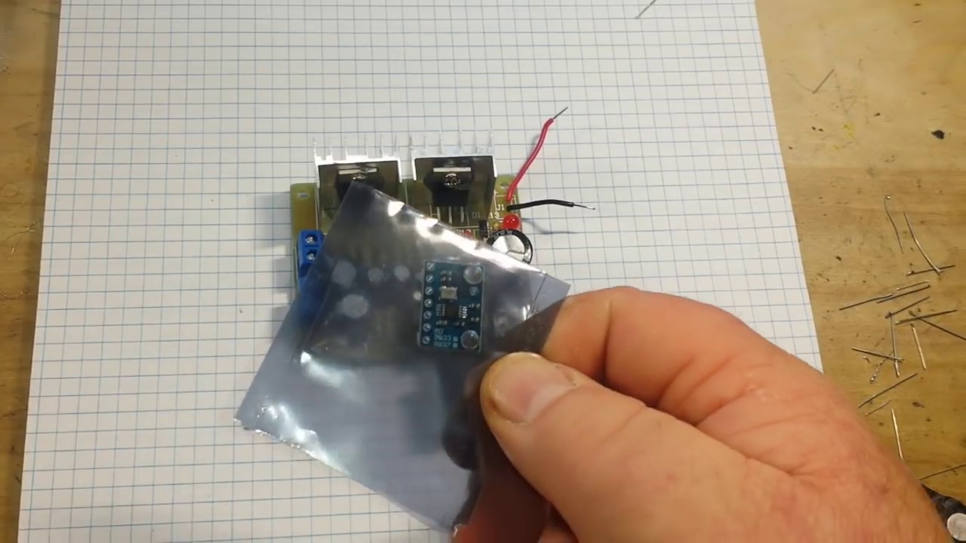 (score 95.0000)
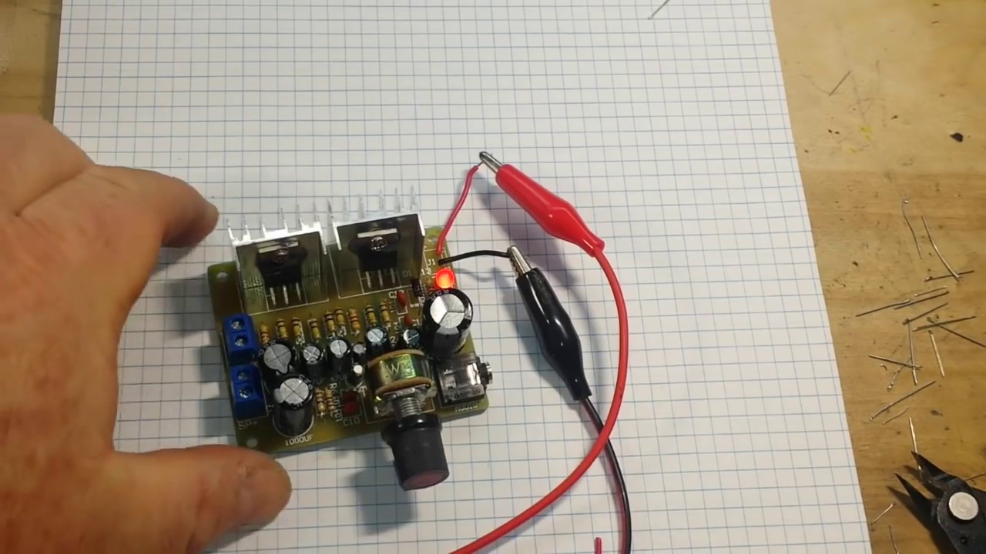 (score 95.0000)
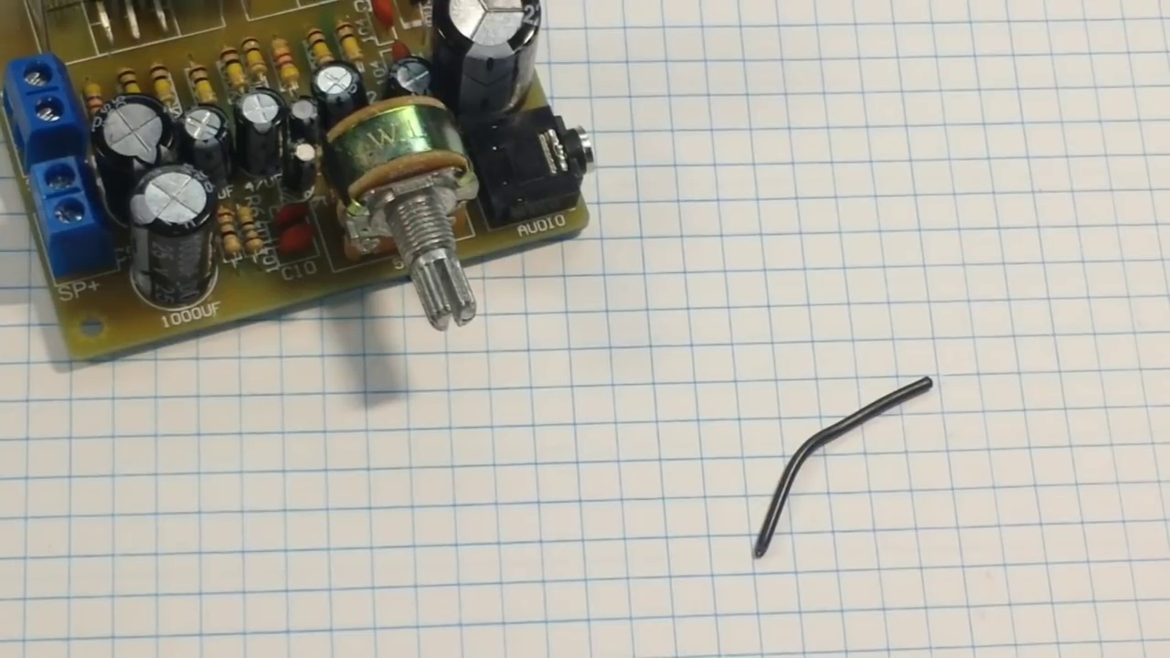 (score 95.0000)
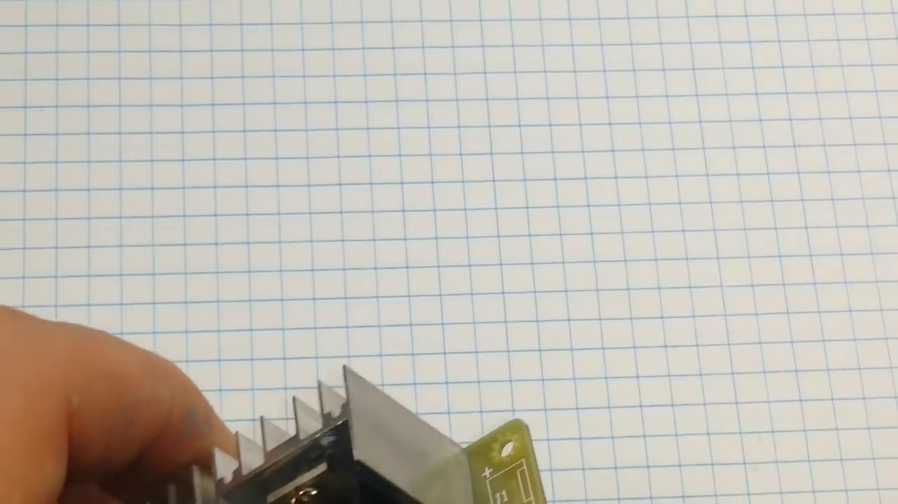 (score 95.0000)
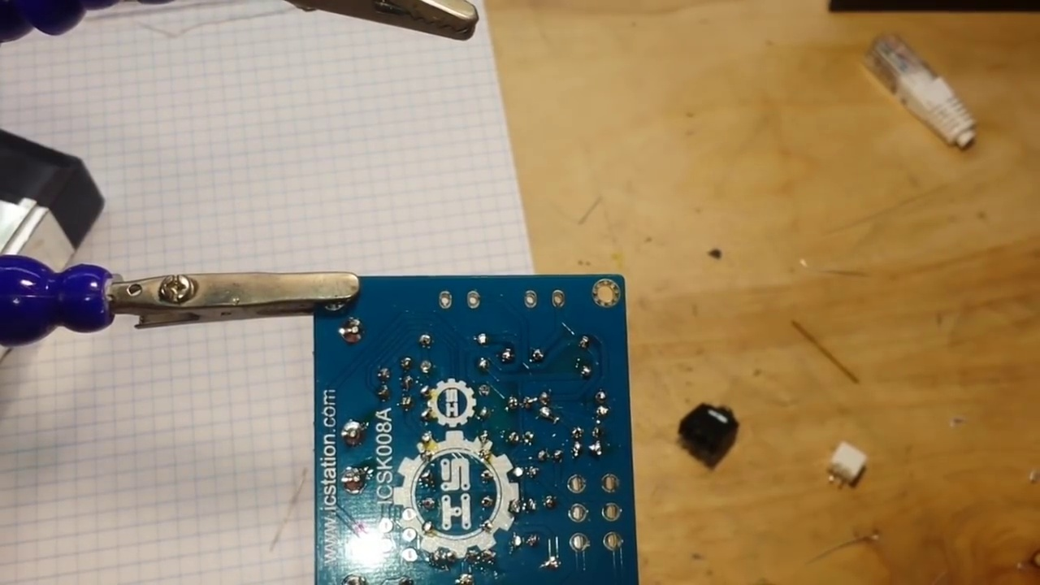 (score 95.0000)
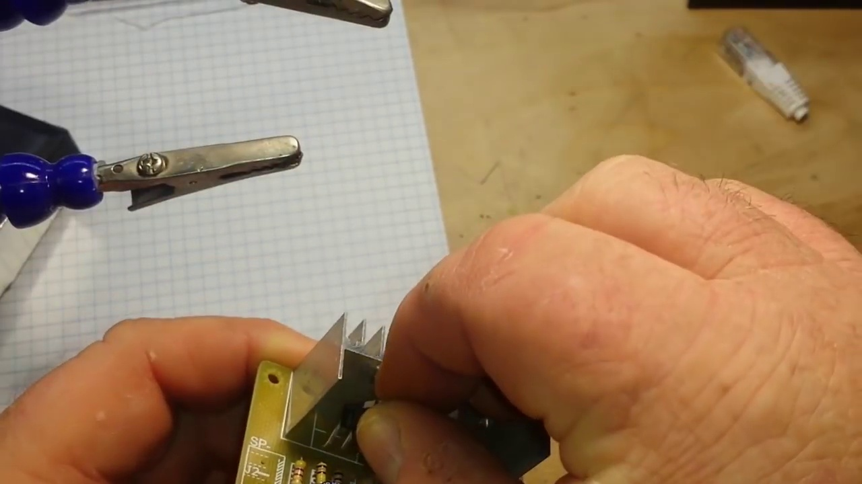 (score 95.0000)
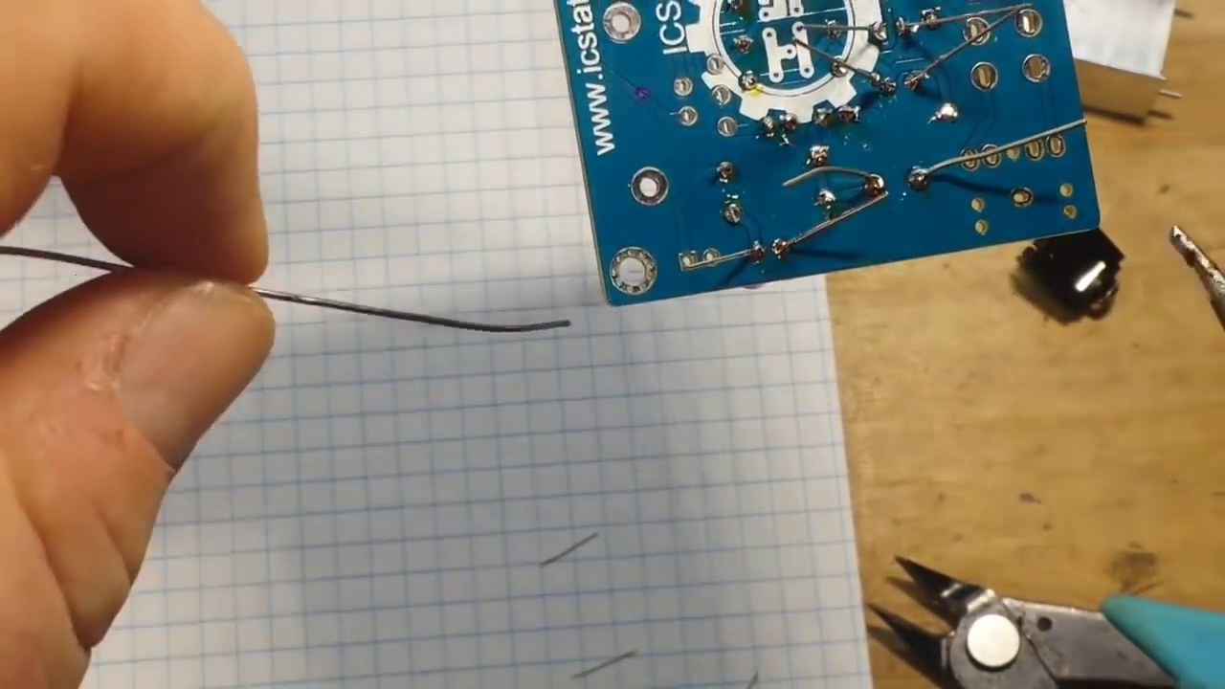 (score 95.0000)
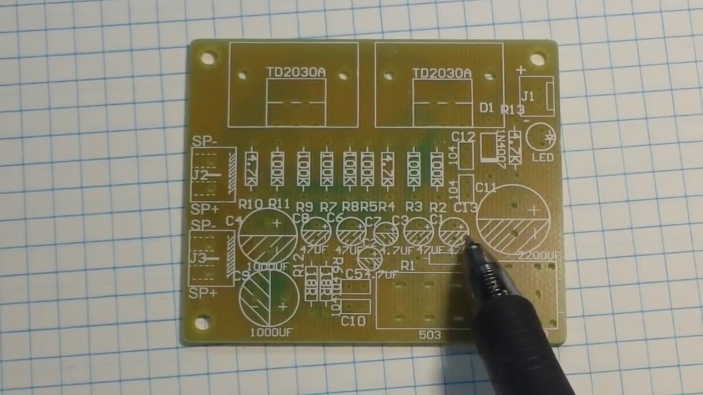 (score 95.0000)
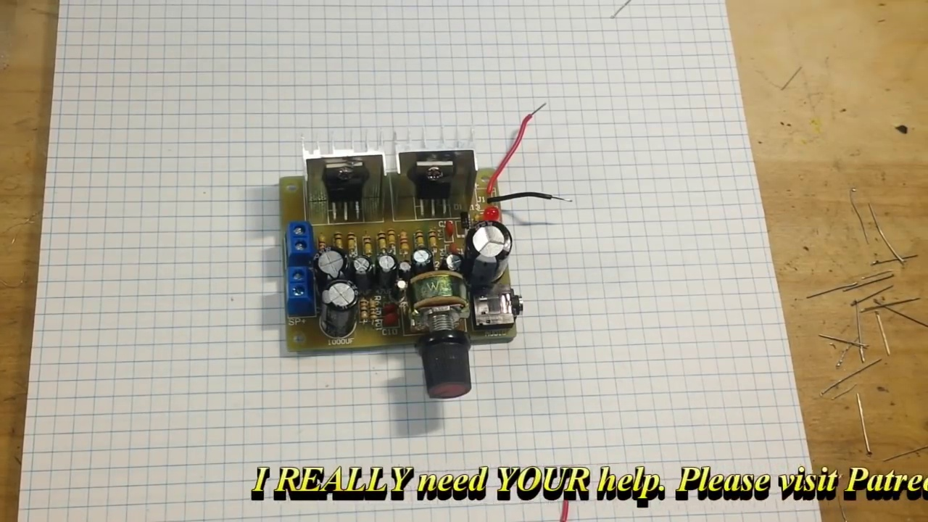 (score 90.0000)
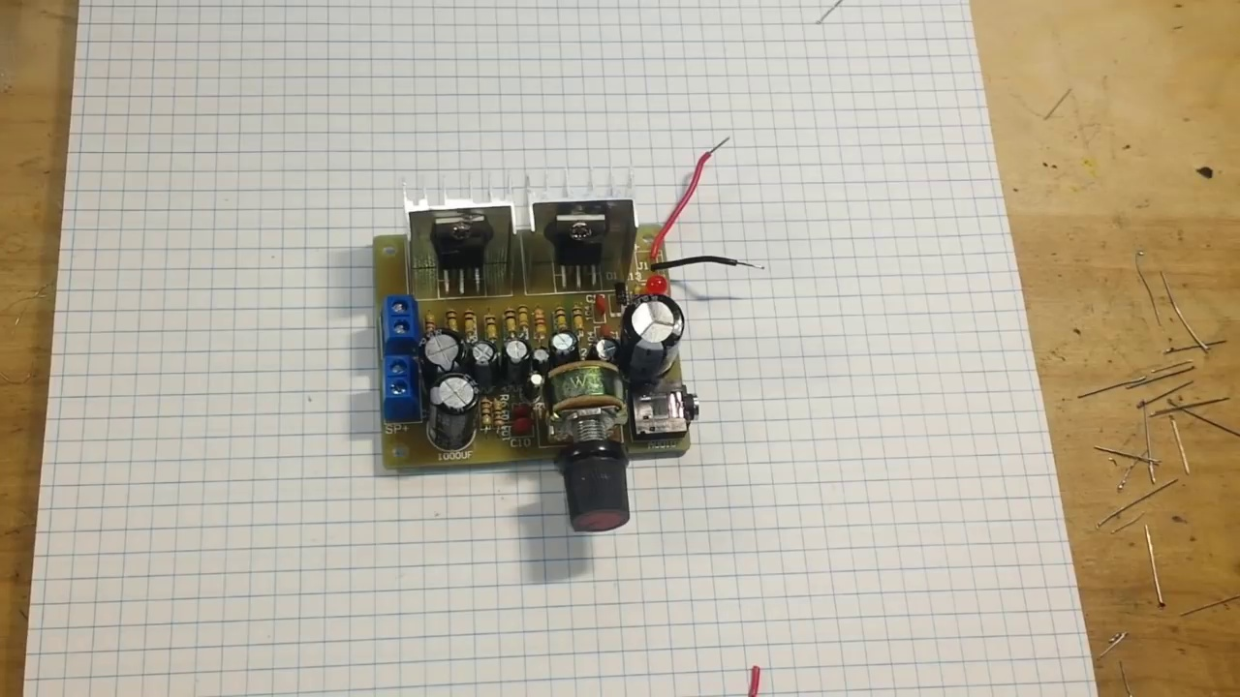 (score 90.0000)
Least correlated frames:
 (score 0.0000)
 (score 10.0000)
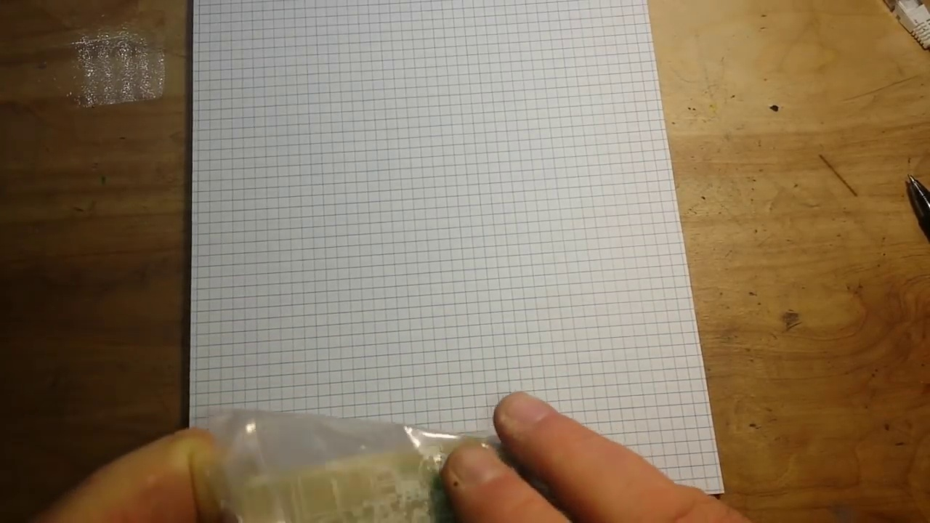 (score 20.0000)
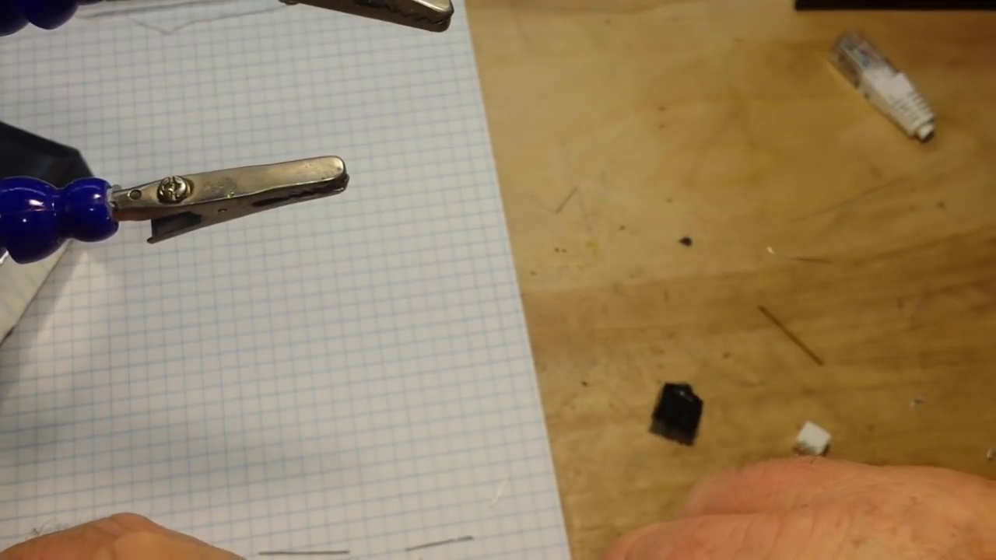 (score 20.0000)
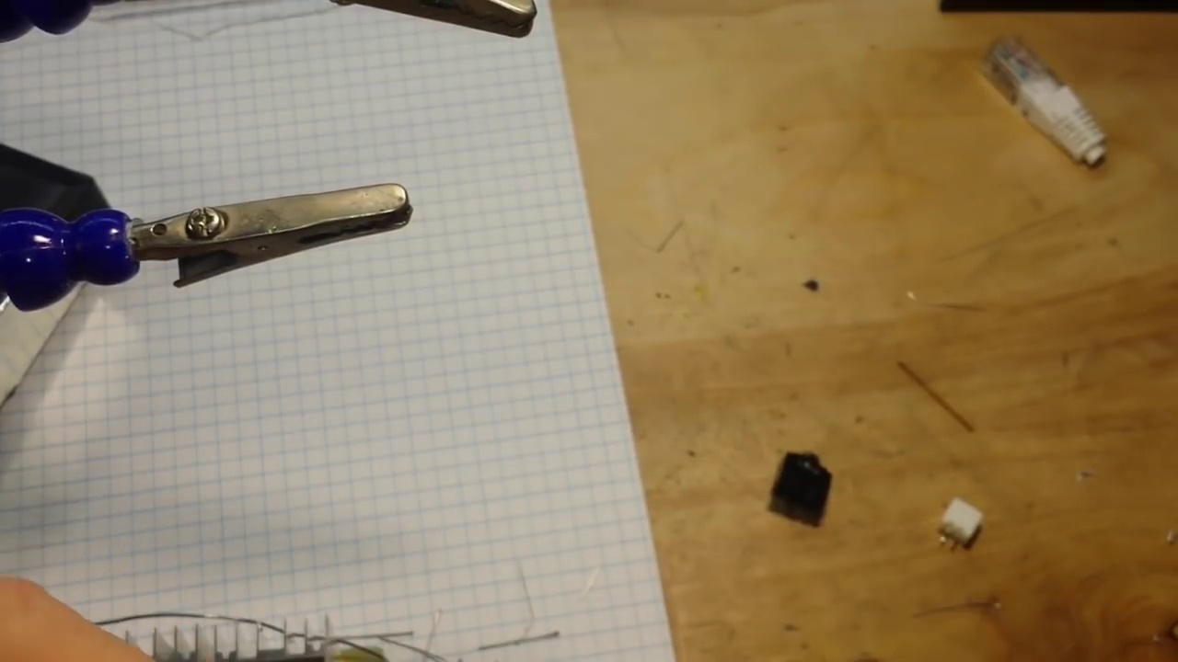 (score 20.0000)
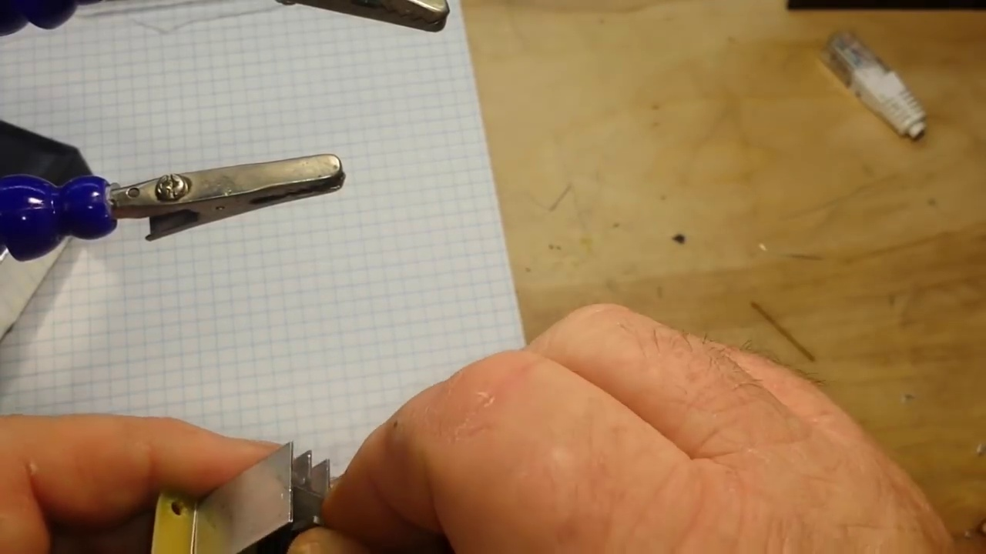 (score 20.0000)
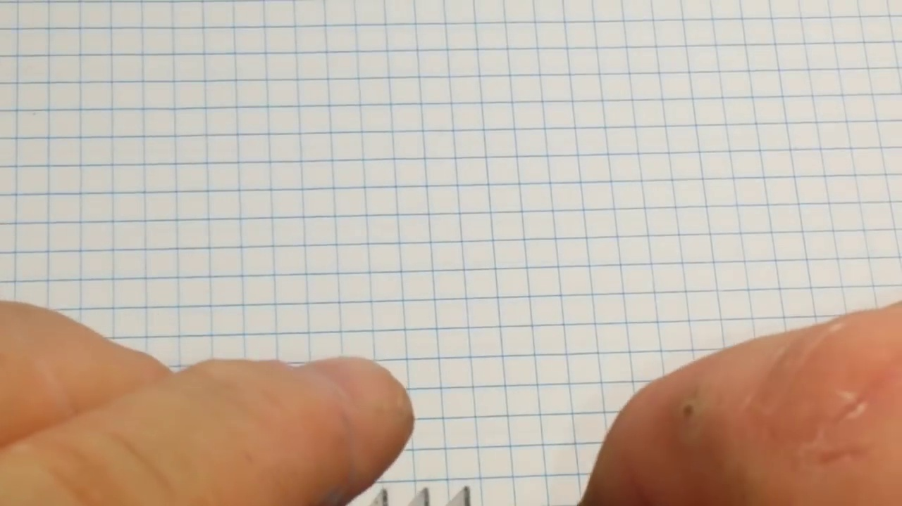 (score 20.0000)
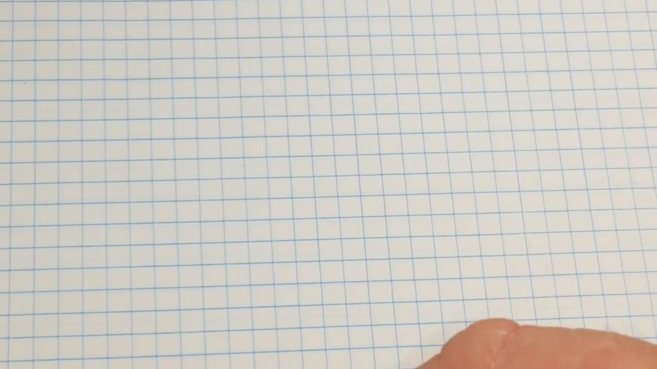 (score 20.0000)
 (score 20.0000)
 (score 20.0000)

Frame: frame_0000.jpg
Caption: The image shows a hand-drawn diagram on a piece of paper with grid lines, indicating that it might have been drawn using a grid. There is no person in the frame; however, there appears to be a pen lying across the paper, suggesting someone was working or about to work on the diagram. The diagram itself includes several components that resemble electronic circuits or schematics, with symbols such as resistors, capacitors, and a transformer or inductor. There are also lines connecting these components, likely representing wiring or connections within the circuit.
The text on the paper is not entirely legible due to the angle and resolution of the image, but it seems to contain handwritten annotations that could be explanations or notes related to the diagram. The text includes a series of characters that are typical in technical drawings or schematics, such as letters and numbers that denote values or labels for the components.
The diagram is divided into three sections: "INPUT", "POWER SUPPLY", and "OUTPUT". The "INPUT" section features a small black box with a red dot on it, possibly representing a capacitor. The box is connected to a black wire, indicating the flow of electricity. In the "POWER SUPPLY" section, there is a black box with a white arrow, possibly indicating the direction of the electrical current. The box is connected to a black wire, suggesting the power source. The "OUTPUT" section features another black box with a red dot on it, similar to the "INPUT" section. The box is connected to a black wire, indicating the output of the circuit.
The diagram is not just a static representation of a circuit; it's a dynamic depiction of the flow of electricity through the circuit. The black wire connecting the boxes suggests the flow of electricity, and the red dot on the boxes could represent the voltage or current at each point in the circuit. Given the context provided, it is likely that this image was taken during a teaching session where someone is explaining how to build or understand an electronic circuit or device.
Comment (score 85): This complements video 2 by showing how to physically build the amplifier circuit discussed earlier.Would be nice if it mentioned the cost of making the circuit with the kit used.Useful for visualizing the circuit for the final project.
Reason: The comment directly discusses building an amplifier circuit and visualizing the diagram, which is strongly related to the technical steps and objects described in the caption.
Source: https://www.youtube.com/watch?v=KDwqqlqdYFQ: TDA2030 Amplifier Build

Frame: frame_0001.jpg
Caption: The image appears to capture a moment of focus and precision as a person works on a technical diagram or blueprint. The individual is partially visible, with only their hand and forearm holding the document in place, suggesting they might be tracing a line or adding details to the drawing. The paper has a grid pattern across it, which is common for blueprints, indicating precision and scale in the design.
The diagram itself shows a series of lines, shapes, and possibly symbols that could represent electrical circuits, given the context of an electronics-related activity. There are several components or parts labeled with what appears to be "C" on one side and "E" on the other, which might stand for specific types of electronic components, such as capacitors (C) and resistors (R), in a schematic representation.
The background is out of focus but seems to be a workspace with various items that could be related to electronics or DIY projects, including what looks like a workbench and possibly other components or materials. The hand, adorned with a black wristwatch, is delicately placing a finger on the paper, guiding the circuit through a series of logical steps. The image is a testament to the beauty and complexity of the world of electronics, captured in a single, intimate moment.
Comment (score 80): This complements video 2 by showing how to physically build the amplifier circuit discussed earlier.Would be nice if it mentioned the cost of making the circuit with the kit used.Useful for visualizing the circuit for the final project.
Reason: The comment directly discusses building an amplifier circuit, which is mentioned in the caption as possibly representing electrical circuits. The mention of a kit and visualizing the circuit for a final project also aligns with the context of the image showing a person working on a diagram.
Source: https://www.youtube.com/watch?v=KDwqqlqdYFQ: TDA2030 Amplifier Build

Frame: frame_0002.jpg
Caption: The image shows a close-up of a notebook page filled with electrical schematics, placed on a wooden table. The page is divided into two sections, with the top section dedicated to a complex circuit diagram and the bottom section filled with notes. The circuit diagram features a large "A" symbol, possibly indicating an amplifier, and a "B" symbol, possibly representing a battery, along with several other symbols including a "C" for a capacitor, a "D" for a diode, and a "W" for a resistor. Wires connecting these components suggest the flow of electricity in the circuit.
The notes section of the page is filled with scribbles and drawings, indicating that the schematics are still being worked on. There are also some numbers and letters, possibly representing specific values or identifiers for the components in the circuit.
In the background, a piece of paper with a hand-drawn diagram lies on the table, which appears to be a technical schematic or blueprint related to electronics or engineering. The drawing features various shapes and lines, including rectangles with annotations, arrows pointing towards specific areas of the drawing, and what appears to be a schematic representation of electronic components or a circuit layout.
A person's arm is visible in the bottom left corner, suggesting that someone is sitting at the table, but the individual is not fully visible within this frame. The image quality is not high enough to read any text within the drawing or on the tabletop, so no textual information can be provided.
Comment (score 80): This complements video 2 by showing how to physically build the amplifier circuit discussed earlier.Would be nice if it mentioned the cost of making the circuit with the kit used.Useful for visualizing the circuit for the final project.
Reason: The comment directly discusses the physical building of an amplifier circuit, which is described in the caption as part of a complex circuit diagram. The mention of 'the amplifier circuit discussed earlier' also shows a clear connection to the electrical schematics shown in the frame.
Source: https://www.youtube.com/watch?v=KDwqqlqdYFQ: TDA2030 Amplifier Build

Frame: frame_0003.jpg
Caption: The image shows a wooden table with two sheets of paper taped together and leaning against it, on which a hand-drawn technical diagram, an electrical schematic, is meticulously drawn. The diagram contains various symbols representing electronic components such as resistors, capacitors, and possibly transistors or integrated circuits, along with lines indicating connections between them. In the foreground, a person's arm is partially visible, suggesting they are seated at the table or have been momentarily standing near it.
The background of the image is indistinct due to the focus on the papers with the schematic. No text, equations, or graph types are visible within this part of the image, nor can any specific actions by the person be discerned beyond their arm being in view. The overall context suggests an educational environment where someone might be studying or explaining how an electrical circuit works.
The image captures a moment of creation and learning, with each line and dot on the diagram telling a story about electricity and logic. The circuit is not just a static representation; it's a dynamic process, a flow of energy and information. A pen rests in the background, its presence suggesting the ongoing process of design and experimentation.
The image is a snapshot of a moment in time, where creativity and technology intersect. It's a testament to the power of the mind and the promise of the future, showcasing the intersection of artistry and technical skill in the creation of an electrical circuit diagram.
Comment (score 85): This complements video 2 by showing how to physically build the amplifier circuit discussed earlier.Would be nice if it mentioned the cost of making the circuit with the kit used.Useful for visualizing the circuit for the final project.
Reason: The comment directly discusses building an amplifier circuit, which is closely related to the technical diagram shown in the frame caption. The mention of a kit and the need for visualization also matches the context of the diagram being discussed.
Source: https://www.youtube.com/watch?v=KDwqqlqdYFQ: TDA2030 Amplifier Build

Frame: frame_0004.jpg
Caption: The image shows a person's hand reaching towards a piece of paper that has a complex network of lines and symbols, representing different components and connections within an electrical circuit. The diagram appears to be a schematic representation of an electrical circuit, with various components such as resistors (R), capacitors (C), and possibly switches or other control elements. The values of the resistors are indicated by the R symbols, but the specific numbers are not clearly visible. The paper is placed on a wooden table, which provides a stable surface for the hand to rest on, indicating a quiet and focused environment. The background is dimly lit, focusing attention on the diagram. There is no text present in the image that provides additional context or information about the content of the diagram. The setting appears to be indoors, possibly a workshop or study space where someone might be working on an electronics project or teaching the concept of electrical circuits.
Comment (score 90): This complements video 2 by showing how to physically build the amplifier circuit discussed earlier.Would be nice if it mentioned the cost of making the circuit with the kit used.Useful for visualizing the circuit for the final project.
Reason: The comment directly discusses the physical build of an amplifier circuit, which is explicitly mentioned in the caption as a possible interpretation of the electrical circuit diagram. The mention of 'video 2' and 'kit used' further solidifies the connection between the caption and the comment.
Source: https://www.youtube.com/watch?v=KDwqqlqdYFQ: TDA2030 Amplifier Build

Frame: frame_0005.jpg
Caption: The image shows a hand-drawn diagram or sketch placed on a piece of paper that is lying flat on a wooden desk, bathed in the soft glow of a desk lamp. The diagram consists of several interconnected lines and shapes that resemble mechanical parts or perhaps a flowchart for a process. There are no texts, numbers, or labels visible within the diagram itself.
In the background, there is a person whose face is not visible due to the angle at which the photo was taken. The person is wearing a dark-colored long sleeve shirt and has something in their hands that seems to be related to the activity they are engaged in with the sketch. The desk lamp casts a warm glow on the scene, illuminating the dust-covered surface of the desk.
The paper itself appears to have been recently used, as suggested by the faint outlines of a pen and pencil. The pen is angled slightly, implying recent use, while the pencil lies dormant, its point pointing upwards. The grid pattern of small black squares adds a layer of complexity and nuance to the diagram, inviting contemplation or perhaps the beginning of a creative endeavor.
The overall scene suggests a moment of quiet reflection or the early stages of a creative process, with the person focused on their work while the desk lamp casts a warm and inviting glow.
Comment (score 80): This complements video 2 by showing how to physically build the amplifier circuit discussed earlier.Would be nice if it mentioned the cost of making the circuit with the kit used.Useful for visualizing the circuit for the final project.
Reason: The comment directly discusses building an amplifier circuit, which is visually represented in the diagram on the paper. Although it doesn't explicitly mention the desk lamp or the person's actions, the connection between the caption and the comment is strong due to the focus on the physical build of a circuit.
Source: https://www.youtube.com/watch?v=KDwqqlqdYFQ: TDA2030 Amplifier Build

Frame: frame_0006.jpg
Caption: The image captures a moment of creation and organization. A person, clad in a white shirt, is meticulously arranging a piece of paper with grid lines on a wooden desk. The paper, pristine white, is held in the person's hand, ready to be used. The person's fingers are curled around the edge of the paper, a testament to the careful attention given to the task at hand.
The desk itself is a testament to the person's creativity and organization. The wooden surface is adorned with a pen and a ruler, tools that are essential for any creative endeavor. A machine, possibly a 3D printer or CNC device, sits in the background, its top surface featuring a sheet of paper with printed grid lines and a piece of transparent tape holding down the print bed or a sheet being cut. Below the paper on the machine's bed, an object is in progress, possibly the result of 3D printing or another manufacturing process.
As the person arranges the paper, they are setting the stage for what's to come. The image is a snapshot of a creative process in progress, where planning and preparation meet anticipation and possibility.
No strongly correlated comments found for this frame.

Frame: frame_0007.jpg
Caption: The image shows a person working with electronic components and equipment, focusing on hands-on interaction rather than instructional context. The individual is holding an unidentified object, which could be a printed circuit board (PCB) or some type of electronic module, closely examining it possibly to troubleshoot or understand the nature of an error message written on paper: "Error: This module does not support USB." The work area is cluttered with various objects and tools, including what appears to be a soldering iron and a small projector or screen.
The background of the image is not visible due to blur, but the person's hands are firmly gripping a small electronic component, which seems to be a circuit board secured in a clear plastic package marked with a logo and barcode. This could indicate that it might be a product for sale, suggesting a setting where electronic components are being prepared for shipment or assembly. The overall scene does not provide any indication of a slide or presentation being used, instead focusing on the person's hands-on interaction with electronic components.
Comment (score 80): This complements video 2 by showing how to physically build the amplifier circuit discussed earlier.Would be nice if it mentioned the cost of making the circuit with the kit used.Useful for visualizing the circuit for the final project.
Reason: The comment directly mentions building an amplifier circuit, which is closely related to the technical steps and objects described in the caption, such as physical interaction with electronic components.
Source: https://www.youtube.com/watch?v=KDwqqlqdYFQ: TDA2030 Amplifier Build

Frame: frame_0008.jpg
Caption: The image shows a moment of meticulous work on a circuit board. On the left side of the image, we see a close-up view of a person's hands holding a small device with circuitry exposed, which appears to be related to electronics or computing. The person is using a soldering iron on a circuit board, suggesting that they are engaged in soldering, a process used to create electrical connections between components.
On the right side of the image, we see another scene where a piece of paper featuring a grid and a hand holding a small electronic component near a printed circuit board (PCB) suggest that the person is working on or examining an electronics project that involves soldering components onto a PCB. The sweat-covered hand, seen in this frame, is carefully handling the components using tweezers, indicating the precision and care involved in this task.
Comment (score 85): This complements video 2 by showing how to physically build the amplifier circuit discussed earlier.Would be nice if it mentioned the cost of making the circuit with the kit used.Useful for visualizing the circuit for the final project.
Reason: The comment directly discusses the physical process of building an amplifier circuit, specifically mentioning soldering and component placement, which are the same technical steps described in the caption. The mention of a kit used also aligns with the context of working on an electronics project, as shown in the image.
Source: https://www.youtube.com/watch?v=KDwqqlqdYFQ: TDA2030 Amplifier Build

Frame: frame_0009.jpg
Caption: In this low-resolution image, a person's hands are visible working on a small electronic project. The individual is holding what appears to be an unassembled circuit board, possibly placing components onto it or removing them, as indicated by the act of handling something small. On the table in front of the person, there is a piece of paper with grid lines and a partially completed diagram or layout related to the electronic device. The paper is marked with some sort of measurement or alignment tool, suggesting that precision work is being done.
The hands are seen holding a plastic bag filled with a small green electronic component, which is placed on a white paper with a grid pattern, likely used for organizing and drawing schematics. The background of the image is blurred, focusing attention on the person's activity. The wooden table provides context to the workspace or study area.
The tools visible, such as pliers, wire cutters, and possibly tweezers, indicate that precise handling of small components is required for this project. Overall, the image captures a moment of someone preparing to use or study the small green electronic component, suggesting they are in the process of handling or examining it.
Comment (score 80): This complements video 2 by showing how to physically build the amplifier circuit discussed earlier.Would be nice if it mentioned the cost of making the circuit with the kit used.Useful for visualizing the circuit for the final project.
Reason: The comment directly discusses the physical building of the amplifier circuit, which is described in the caption as the person placing components onto an unassembled circuit board. The mention of visualizing the circuit for a final project also matches with the grid pattern on the paper and the diagram or layout on the table, indicating a strong connection between the caption and comment.
Source: https://www.youtube.com/watch?v=KDwqqlqdYFQ: TDA2030 Amplifier Build

Frame: frame_0010.jpg
Caption: The image shows a person's hands interacting with electronic components, papers, and a transparent circuit board. On the left side of the frame, there is a person holding a small device that appears to be a microcontroller module or similar electronic component. The individual seems to be examining or manipulating it.
In the center, there is a piece of paper with schematics or diagrams related to the device being held, including handwritten notes and symbols. This suggests that the person may be working on designing or understanding the components. Next to this paper, there is a partially completed electronic circuit or breadboard setup with various components such as resistors, capacitors, and possibly integrated circuits or connectors.
On the right side of the frame, the same hands are seen holding a small IC chip over the breadboard, indicating that they might be connecting or placing the chip onto the circuit. On the table in front of the person, there is a wooden surface with a white piece of paper arranged in a grid pattern, representing different parts of a circuit board. A clear plastic bag containing the transparent circuit board is placed on this paper, positioned slightly above the board.
Overall, the image captures a moment of activity related to electronic components and circuit boards, with the person engaged in a hands-on activity possibly for electronics engineering or hobby purposes.
Comment (score 85): This complements video 2 by showing how to physically build the amplifier circuit discussed earlier.Would be nice if it mentioned the cost of making the circuit with the kit used.Useful for visualizing the circuit for the final project.
Reason: The comment directly discusses the physical building of an amplifier circuit, which is strongly related to the technical steps and objects described in the caption (e.g. circuit boards, components, breadboard setup). The mention of the video series and the desire to visualize the circuit for a final project further supports this correlation.
Source: https://www.youtube.com/watch?v=KDwqqlqdYFQ: TDA2030 Amplifier Build

Frame: frame_0011.jpg
Caption: This image appears to capture a moment of anticipation and focus as an individual works on assembling an electronic circuit or prototype. The person is carefully placing small plastic bags containing resistors, capacitors, and possibly other electronic parts onto a green circuit board with white solder lines. A clear plastic package containing more electronic components is visible in the foreground to the left.
The table surface is covered in a grid of white paper, providing a stark contrast to the wooden surface. In the background, another circuit board is visible, its green color contrasting with the white paper on the table. This circuit board appears to be part of a larger electronic device and suggests that it's being prepared for assembly.
The person's hand, placed gently on the packaging, is the only human figure in the image, adding a sense of quiet determination to the scene. The relative positions of the objects suggest that the person is carefully placing the packaging on the table, perhaps to protect the circuit board from any potential damage during the process of assembly.
The overall impression is one of precision and attention to detail as the individual works to assemble this electronic device.
Comment (score 80): This complements video 2 by showing how to physically build the amplifier circuit discussed earlier.Would be nice if it mentioned the cost of making the circuit with the kit used.Useful for visualizing the circuit for the final project.
Reason: The comment directly discusses the physical building of the amplifier circuit, which is mentioned in the caption as assembling an electronic circuit or prototype. The comment also mentions visualizing the circuit for a final project, which is relevant to the description of the circuit board and components in the caption.
Source: https://www.youtube.com/watch?v=KDwqqlqdYFQ: TDA2030 Amplifier Build

Frame: frame_0012.jpg
Caption: The image shows a pair of hands, covered in white gloves, meticulously working on an electronic circuit board laid out on a wooden table with a white paper. The hands are holding a black wire, connecting different components of the circuit board. The board itself is a complex network of wires and components, featuring several resistors, capacitors, and diodes, indicating the complexity of the circuit. The wires connecting these components are in various colors, adding to the intricacy of the design.
The setting suggests a workspace designed for electronic assembly or repair, as evidenced by the presence of other components scattered around. A small printed circuit board (PCB) is being constructed, with traces connected to different pins on the components, typical for creating an electrical circuit on a printed board. The focus is on the hands-on activity of building or repairing an electronic device, with no visible text, diagrams, or slides providing additional context or instruction.
The image captures a moment of concentration and skill, as the hands navigate the intricate layout of the circuit board. The white paper and wooden table provide a stark contrast to the black wire, making the circuit board stand out prominently.
Comment (score 80): This complements video 2 by showing how to physically build the amplifier circuit discussed earlier.Would be nice if it mentioned the cost of making the circuit with the kit used.Useful for visualizing the circuit for the final project.
Reason: The comment directly discusses the same technical steps (physically building the amplifier circuit) and objects (the circuit board and its components) described in the caption, with a clear connection to the video and project goals.
Source: https://www.youtube.com/watch?v=KDwqqlqdYFQ: TDA2030 Amplifier Build

Frame: frame_0013.jpg
Caption: The image appears to capture a moment of intense focus and concentration as someone works on an electronic project. In the foreground, the person's hands are delicately handling a vibrant green circuit board, adorned with various components such as resistors, capacitors, and other electronic parts. These components are scattered across the board, each contributing to the intricate network of wires that crisscross the board.
The individual is holding one of the components, which seems to be a small electronic module, possibly a communication shield for Arduino or similar microcontroller-based projects, given its shape and the presence of several pins around the edge. The background features an item that resembles a sheet of paper or cardboard with some components attached to it, suggesting this might be part of a DIY electronics project or a hobbyist's workspace.
The setting appears to be a workshop or maker space, where people engage in hands-on projects involving electronics and technology. The atmosphere suggests someone is either constructing something new or demonstrating how to assemble such a project. The person is wearing what looks like a wristwatch on their left arm. There is no visible text or diagram in the image.
The overall scene showcases the intricacy and precision involved in the world of electronics, with the individual's skillful manipulation of the components and wires indicating a high level of expertise and attention to detail.
Comment (score 80): This complements video 2 by showing how to physically build the amplifier circuit discussed earlier.Would be nice if it mentioned the cost of making the circuit with the kit used.Useful for visualizing the circuit for the final project.
Reason: The comment directly discusses the same technical steps and objects described in the caption, specifically mentioning the amplifier circuit and its physical build. The comment also refers to the kit used, which aligns with the description of electronic components and their arrangement on the circuit board mentioned in the caption.
Source: https://www.youtube.com/watch?v=KDwqqlqdYFQ: TDA2030 Amplifier Build

Frame: frame_0014.jpg
Caption: The image captures a moment of hands-on electronics work, showcasing a individual engaged in assembling or troubleshooting a circuit. On the grid tabletop, various electronic components are neatly arranged, including integrated circuits (ICs), resistors with different colors (black and brown), capacitors with distinct colors (white and blue), diodes with unique hues (red and blue), and wires of different colors (black and white). A breadboard is also present, likely used for precision work in electronics.
On the table, a diagram or schematic of a circuit is visible, featuring a power supply connection to an IC that could be an Arduino or similar microcontroller. The individual is holding one of the ICs, possibly examining or showing it, suggesting an ongoing assembly or troubleshooting process.
The scene also features a piece of paper placed on top of the circuit board, with all components neatly arranged, indicating a focus on precision and attention to detail. The text "2014" in the background suggests that the image was taken sometime during this year.
Comment (score 80): This complements video 2 by showing how to physically build the amplifier circuit discussed earlier.Would be nice if it mentioned the cost of making the circuit with the kit used.Useful for visualizing the circuit for the final project.
Reason: The comment directly discusses building and visualizing the same amplifier circuit shown in the caption, mentioning the need for a kit and cost information. The mention of video 2 also confirms that the comment is related to the same project or topic as the frame caption.
Source: https://www.youtube.com/watch?v=KDwqqlqdYFQ: TDA2030 Amplifier Build

Frame: frame_0015.jpg
Caption: The image presents a detailed view of a small metal printed circuit board (PCB) placed atop a white grid, which is also marked with a number grid. The PCB has various components labeled with numerical values, such as "100," "150," "200," and others that suggest they are part of a larger circuitry or system. These labels likely refer to resistor values in ohms, indicating a functional prototype designed for assembly into an equipment system.
The paper underneath the PCB features measurements and notes related to the device's construction or calibration. Measurements like "100," "150," "200" match the values on the PCB, suggesting that these numbers are critical for the proper functioning of the device. The white surface beneath the board has a dotted pattern, providing a neutral backdrop that allows the details of the board to stand out.
The PCB itself is a single-layer design with a grid of rectangular pads, each marked with a number. The board is colored in a light brown shade, contrasting with the white grid. The circuit board's layout suggests it is a printed circuit board, commonly used in electronics for connecting various components. The number grid on the board indicates it's a single-sided board, meaning it only has one side exposed for connections.
There is no visible person, devices, slides, or text within this image, and there is no indication of a teaching context in the frame. The focus is solely on the PCB and the paper with the diagram underneath it.
Comment (score 80): This complements video 2 by showing how to physically build the amplifier circuit discussed earlier.Would be nice if it mentioned the cost of making the circuit with the kit used.Useful for visualizing the circuit for the final project.
Reason: The comment directly discusses building an amplifier circuit, which is mentioned in the caption as a functional prototype. The mention of 'kit used' and 'final project' also ties back to the technical details described in the caption.
Source: https://www.youtube.com/watch?v=KDwqqlqdYFQ: TDA2030 Amplifier Build

Frame: frame_0016.jpg
Caption: This image shows a close-up view of a printed circuit board (PCB), displayed against a blue grid background, which might indicate it's on a workbench or in a lab setting. The PCB has various electronic components such as resistors and capacitors etched onto it, with trace lines connecting these components and pads where electronic components would be attached. Possibly areas for connectors or other components can also be seen.
The board is encased in a clear plastic case, its transparency revealing the intricate details of the circuit. The case is marked with the numbers "TD2030A" and "TD2030A", perhaps indicating the part number or model of the circuit board. The board is resting on a white grid, which serves as a guide for the placement of the components, ensuring that each wire and component is accurately aligned.
The overall image gives a sense of the precision and complexity involved in electronic circuit design and assembly, with no visible texts, diagrams, or graph types providing additional context about the PCB. The focus of this image is solely on the PCB itself, showcasing its intricate details against a blue grid background.
Comment (score 80): This complements video 2 by showing how to physically build the amplifier circuit discussed earlier.Would be nice if it mentioned the cost of making the circuit with the kit used.Useful for visualizing the circuit for the final project.
Reason: The comment directly discusses the physical build of the amplifier circuit mentioned in the caption, which is a specific technical step described in the frame. The mention of the kit used and visualizing the circuit for the final project also shows strong relevance to the technical details presented in the caption.
Source: https://www.youtube.com/watch?v=KDwqqlqdYFQ: TDA2030 Amplifier Build

Frame: frame_0017.jpg
Caption: The image presents a close-up view of a physical electronic circuit board with various electronic components meticulously arranged on its surface. The board appears to be designed and etched for specific purposes, likely related to electronics or telecommunications given the complex structure of the circuitry. A white label proudly proclaims the model number "TD2030A" on the board's surface.
The board is resting on a blue graph paper, providing a stark contrast to the gold color of the circuit board and its components. The overall scene is one of a workspace or lab where someone might work with electronic components and circuits. There are no visible texts, equations, or diagrams that suggest an educational context such as a slide, lecture notes, or teaching devices. No instructor is visible in the frame, and there's no evidence of an audience or lecture hall. The focus is solely on the physical object, which could be part of an electronics class or project.
The background features what appears to be graph paper, suggesting a technical drawing or plan, but it is not the main subject of the image.
Comment (score 90): This complements video 2 by showing how to physically build the amplifier circuit discussed earlier.Would be nice if it mentioned the cost of making the circuit with the kit used.Useful for visualizing the circuit for the final project.
Reason: The comment directly mentions building the amplifier circuit shown in the frame caption, which is a specific technical step related to the object and setting described.
Source: https://www.youtube.com/watch?v=KDwqqlqdYFQ: TDA2030 Amplifier Build

Frame: frame_0018.jpg
Caption: The image shows a close-up view of a gold-colored circuit board resting on a white grid, with a variety of components including resistors, capacitors, and LEDs. The resistors are predominantly white and black, with the black ones positioned towards the center of the board. The capacitors are white and are scattered across the board. The LEDs, which are white and red, are located at the top and bottom of the board. A black pen is positioned on the board, its tip pointing towards the top right corner, suggesting that it might be used for marking or labeling purposes on the circuit board. The grid beneath the board provides a clear and precise reference for the components and their relative positions. The board itself appears to be a DIY electronics project, possibly related to an educational setting where students are learning about circuits and electronics. The pen resting on the board suggests that someone was working or studying here.
Comment (score 95): This complements video 2 by showing how to physically build the amplifier circuit discussed earlier.Would be nice if it mentioned the cost of making the circuit with the kit used.Useful for visualizing the circuit for the final project.
Reason: The comment directly discusses building an amplifier circuit, which is mentioned in the caption. The mention of visualizing the circuit for a final project also matches with the description of the circuit board and components in the caption.
Source: https://www.youtube.com/watch?v=KDwqqlqdYFQ: TDA2030 Amplifier Build

Frame: frame_0019.jpg
Caption: The image shows a printed circuit board (PCB) on a white grid, with various electronic components mounted on it. The PCB has copper material used in its manufacturing visible, and the vibrant green color of the board stands out against the stark white background. Black text and numbers are neatly arranged on the board, including the prominent display of "TO" and "TD", as well as the numbers "2030A" and "3030A", which appear to be part of the board's identification or model number.
In the foreground, a hand is visible holding a soldering iron close to the PCB. A black pen lies poised on the board, suggesting that the PCB may be being prepared for assembly or design, possibly for a new electronic device. The overall layout of the objects and the stillness of the image suggest a careful and precise assembly process, with all components positioned in a way that they are easily accessible without obstructing the board's functionality.
The presence of a soldering iron nearby on the work surface implies that the focus is on electronics and possibly hobbyist or DIY electronics work.
Comment (score 85): This complements video 2 by showing how to physically build the amplifier circuit discussed earlier.Would be nice if it mentioned the cost of making the circuit with the kit used.Useful for visualizing the circuit for the final project.
Reason: The comment directly discusses the physical building of the amplifier circuit, which is a technical step described in the caption. The mention of 'physically build' and 'visualizing the circuit for the final project' shows a strong connection to the PCB and soldering iron depicted in the image.
Source: https://www.youtube.com/watch?v=KDwqqlqdYFQ: TDA2030 Amplifier Build

Frame: frame_0020.jpg
Caption: The image shows a green electronic circuit board with various components and lines connected to each other, labeled "TD2030A". The board appears to be a DIY electronics project, as indicated by the homemade nature of the board and the lack of any company logos or branded parts. There is no text visible on the circuit board itself, so there are no specific details about its purpose or function that can be inferred from this image alone.
In the top left corner of the image, partially obscured by the board, is a black pen with ink partially visible at the tip, suggesting that someone was likely working on the project and may have been using the pen for tracing or marking components. The pen's presence implies an ongoing activity related to the board.
The circuit board rests on a white surface featuring a grid pattern. A paper grid with various rows and columns of squares is also visible in the bottom right corner, although its content is not visible in the image. This could be a set of instructions, a checklist, or just an empty template being used in the process of building the circuit board.
The style of the image is that of a casual photograph, capturing the moment during the creation of the electronic device. The focus is on the object rather than the person, and there are no indications of any specific teaching context from this image alone.
Comment (score 80): This complements video 2 by showing how to physically build the amplifier circuit discussed earlier.Would be nice if it mentioned the cost of making the circuit with the kit used.Useful for visualizing the circuit for the final project.
Reason: The comment directly discusses building the amplifier circuit, which is related to the components and settings described in the caption. The mention of a kit used and visualizing the final project also connects to the technical steps mentioned in the caption.
Source: https://www.youtube.com/watch?v=KDwqqlqdYFQ: TDA2030 Amplifier Build

Frame: frame_0021.jpg
Caption: The image shows a combination of a handwritten diagram on a grid-ruled notebook page and a close-up view of a graph. The diagram appears to represent an electrical circuit with symbols for electronic components such as resistors, capacitors, possibly transistors or integrated circuits, and includes lines representing the flow of current, connections indicating wiring or pathways, and numerical values likely corresponding to component values like resistance in ohms (Ω) or capacitance in farads (F). The graph is divided into two sections: one representing the circuit and the other displaying the frequency. The circuit section features a schematic of a speaker circuit, highlighted in blue, while the frequency section is labeled with the unit "cycles per second" in red.
The diagram includes symbols for what looks like a resistor (zigzag line), capacitor (two parallel lines), and possibly integrated circuits or transistors represented by a rectangle with internal connections indicating pins or terminals. There are also markings on the notebook page that include mathematical values such as 10kΩ, which could represent resistance in thousands of ohms, and 0.0001F, which is a very small capacitance value in farads.
The overall setting suggests an educational environment where technical or engineering concepts are being explained, possibly part of a lecture on electronic circuits. The instructor, visible on the left side of the image, is sitting at a desk with a laptop open and seems to be engaged in teaching or explaining the diagram, possibly drawing attention to specific parts or components within the circuit.
The graph is set against a white background, which contrasts sharply with the black and blue text that fills the space. The text provides essential information about the circuit and the frequency, serving as a guide for understanding the graph's content.
Comment (score 85): This complements video 2 by showing how to physically build the amplifier circuit discussed earlier.Would be nice if it mentioned the cost of making the circuit with the kit used.Useful for visualizing the circuit for the final project.
Reason: The comment directly discusses building an amplifier circuit, which is mentioned in the caption as part of the diagram representing a speaker circuit. The comment also mentions visualizing the circuit for a final project, which aligns with the graph and frequency information provided in the caption.
Source: https://www.youtube.com/watch?v=KDwqqlqdYFQ: TDA2030 Amplifier Build

Frame: frame_0022.jpg
Caption: The image shows a small printed circuit board (PCB) with electronic components mounted on it, placed against a grid background suggesting an educational context. The PCB is divided into three sections, each labeled with the part number "TD02030A". The top section features a power supply circuit, while the middle and bottom sections display speaker circuits. The text "Audio" is also present, indicating that this circuit board is designed for audio applications. Near the center of the image, the text "MOSFET" is clearly visible, suggesting that the focus of the PCB is on a MOSFET (Metal-Oxide Semiconductor Field Effect Transistor). This could be related to the basics of MOSFETs or their application in electronic circuits. The rest of the text is not fully legible due to the resolution, but it appears to include additional information about the PCB and its components. The circuit board is laid out on a piece of paper with blue and white lines, indicating a diagram or schematic.
Comment (score 85): This complements video 2 by showing how to physically build the amplifier circuit discussed earlier.Would be nice if it mentioned the cost of making the circuit with the kit used.Useful for visualizing the circuit for the final project.
Reason: The comment directly discusses building the amplifier circuit shown in the PCB image, mentioning its relevance to a final project. The mention of visualizing the circuit also shows an understanding of the technical steps and components involved.
Source: https://www.youtube.com/watch?v=KDwqqlqdYFQ: TDA2030 Amplifier Build

Frame: frame_0023.jpg
Caption: This image presents a detailed view of a circuit board, which is the central focus. The board is a golden-brown color, with a white label on it that reads "TO2030A" located on the top right corner. The label appears to be the source of the board's identification.
The board itself is divided into two main sections: a left side and a right side. On the left side, there is a white rectangle containing the label "TO2030A". The right side of the board is more complex, featuring a series of electronic components arranged in a grid-like pattern, with the largest one being a white square.
The board is placed on a white background, which contrasts with the golden-brown color of the board. This contrast makes the board stand out and allows for easy visualization of its details. Additionally, there is blue text that reads "Audio", which could be related to the board's purpose or function.
In the background, a printed circuit board (PCB) with various electronic components mounted on it can be seen. The PCB appears to have multiple resistors, capacitors, and integrated circuits, suggesting it may be part of an electronics project or hobbyist endeavor.
Comment (score 90): This complements video 2 by showing how to physically build the amplifier circuit discussed earlier.Would be nice if it mentioned the cost of making the circuit with the kit used.Useful for visualizing the circuit for the final project.
Reason: The comment directly discusses the physical building of an amplifier circuit, which is a technical step described in the caption. The mention of visualizing the circuit for a final project also shows a connection to the identification and details provided in the caption.
Source: https://www.youtube.com/watch?v=KDwqqlqdYFQ: TDA2030 Amplifier Build

Frame: frame_0024.jpg
Caption: The image displays a printed circuit board (PCB) with various electronic components mounted on it. The PCB appears to be part of an educational setting, possibly used in a class or workshop related to electronics and soldering techniques. The layout suggests a hands-on learning environment where students can assemble and work with such projects.
Visible text on the board includes symbols for electronic components such as resistors (marked by zigzag lines) and possibly other components like capacitors or inductors. Traces of soldering material indicate that this PCB has been worked on to attach the components. The quality of the image does not allow for precise identification of all symbols or detailed analysis of the circuit's functionality.
In the bottom right corner, there is a handwritten number "8" with additional symbols, which might be part of a project plan, code reference, or some form of documentation related to this PCB assembly. The presence of these numbers and symbols suggests that learners are engaged in constructing circuits by adding components according to specific schematics or designs.
The setting includes a grid with squares and rectangles, which could be a classroom's whiteboard or a large piece of paper being used for planning or sketching during the assembly process.
This image captures an educational moment where students are actively involved in constructing electronic circuits by soldering components onto a printed circuit board according to a specific design or instruction. The focus is on practical skills and understanding of electronics hardware rather than theoretical concepts.
The PCB itself measures approximately 5.8 cm by 5.8 cm and has a thin layer of gold, indicating it's likely a printed circuit board. It is divided into several sections, each marked with distinct numbers: the top left corner is marked with the number 1000, while the top right corner is marked with the number 10000; the bottom left corner is marked with the number 10000, and the bottom right corner is marked with the number 100000. Two sets of numbers are also present in the top left and right corners.
In addition to the numbers, the board features two labels: one reads "TO" followed by a series of numbers in the top right corner, while the other reads "TO" followed by a series of numbers in the bottom right corner. The board also contains two white lines, one in the top left and the other in the bottom left corners, which appear to be part of the layout of the board.
Comment (score 80): This complements video 2 by showing how to physically build the amplifier circuit discussed earlier.Would be nice if it mentioned the cost of making the circuit with the kit used.Useful for visualizing the circuit for the final project.
Reason: The comment directly discusses the physical build of an amplifier circuit, which is closely related to the technical steps and components described in the caption. The mention of a kit used for the circuit and the desire to visualize the final project also ties in with the educational setting and hands-on learning environment depicted in the image.
Source: https://www.youtube.com/watch?v=KDwqqlqdYFQ: TDA2030 Amplifier Build

Frame: frame_0025.jpg
Caption: The image presents a close-up view of an electronic component with a printed circuit board (PCB) attached to it. The PCB, made of light brown material, has various white text and symbols etched onto its surface, including the label "TO 2030A" prominently displayed. A white LED is located towards the center of the board.
The board is placed on top of blue and white grid paper, providing a stark contrast to the board's light brown color. The PCB itself has various symbols indicating electronic connections and paths, which suggest that it is designed to connect various electronic components and allow them to communicate with each other.
The overall layout of the board suggests that it is a small electronic device, possibly a part of a larger electronic system.
Comment (score 80): This complements video 2 by showing how to physically build the amplifier circuit discussed earlier.Would be nice if it mentioned the cost of making the circuit with the kit used.Useful for visualizing the circuit for the final project.
Reason: The comment directly discusses the physical build of the amplifier circuit, which is strongly related to the description of the printed circuit board (PCB) in the caption, including the mention of a kit used. The only reason it's not a perfect match is that the cost of making the circuit is not mentioned in the caption.
Source: https://www.youtube.com/watch?v=KDwqqlqdYFQ: TDA2030 Amplifier Build

Frame: frame_0026.jpg
Caption: The image shows an electronic circuit board (PCB) lying on a piece of blue paper with a grid pattern, which suggests it's placed on a writing surface like a notebook or pad. The PCB has various components such as resistors ("RD" and "R"), capacitors ("CD"), and integrated circuits (ICs). There are also traces of copper that connect these components to form the circuit. The board is a vibrant green, a color often used for its visibility in electronics, which contrasts with the blue paper and provides a clear view of the circuit details.
The board is composed of multiple layers, each serving a specific purpose. On the top layer, there are several components labeled as "RD", "CD", "L", and "R", indicating resistors and capacitors, which are essential components in electronic circuits. In the center of the board, there's a white label with the text "TO2030A", which could be the part number or the model of the circuit board, providing crucial information for identification and reference.
The bottom layer of the board contains a circuit diagram, providing a visual representation of the board's internal connections. The board is resting on a black surface, which provides a stark contrast to the green board and the blue paper. The image is taken from a top-down perspective, allowing a clear view of the board's layout and components. Overall, the scene suggests a moment of design or testing, as the board is ready to be wired up and tested.
Comment (score 80): This complements video 2 by showing how to physically build the amplifier circuit discussed earlier.Would be nice if it mentioned the cost of making the circuit with the kit used.Useful for visualizing the circuit for the final project.
Reason: The comment directly discusses building an amplifier circuit, which is mentioned in the caption as a possible purpose of the electronic circuit board. The comment also mentions visualizing the circuit for a final project, which aligns with the caption's description of the PCB's layers providing a visual representation.
Source: https://www.youtube.com/watch?v=KDwqqlqdYFQ: TDA2030 Amplifier Build

Frame: frame_0027.jpg
Caption: The image depicts a process involving electronics and possibly crafting, with a focus on hands-on work. At the center of the image is a printed circuit board (PCB) with various electronic components mounted on it. The PCB features at least five resistors, labeled R1 to R5, each with a specific value indicated by their color codes. Traces connecting these components suggest that the PCB may be part of an electrical circuit or prototype.
On the right side of the image, a small electronic device with a digital display and buttons is visible, possibly used for programming or debugging purposes in the context of electronics work.
In the lower left corner, a person's hand holds a soldering iron, indicating that they are currently involved in soldering work on the PCB. The presence of the soldering iron suggests that the individual might be completing or repairing the circuit board.
On the opposite side of the image, another person's hand is visible, holding a pen or stylus. This second person appears to be either writing, pointing at something off-camera, or drawing on a surface not visible within the image. A piece of paper or sketch is also present, but its content is unclear due to the angle and distance from the camera.
In the foreground, a gold-colored circuit board rests on a blue grid, with text and numbers indicating its technical specifications. The numbers "0000" are clearly visible, along with the letters "T" and "D". The board is labeled as "TD2030A", which could be the part number or model of the circuit. Additionally, the board features markings such as "0.000" and "1.000", possibly indicating resistance values of components on the board.
The overall scene suggests a workspace where electronics or electronic components are being designed, tested, or analyzed, with a focus on hands-on work and technical specifications.
Comment (score 80): This complements video 2 by showing how to physically build the amplifier circuit discussed earlier.Would be nice if it mentioned the cost of making the circuit with the kit used.Useful for visualizing the circuit for the final project.
Reason: The comment directly discusses building an amplifier circuit and mentions the kit used, which is strongly related to the technical steps, objects (circuit board), settings (workspace), and goals described in the caption.
Source: https://www.youtube.com/watch?v=KDwqqlqdYFQ: TDA2030 Amplifier Build

Frame: frame_0028.jpg
Caption: The image shows a close-up view of a gold-colored circuit board resting on a white grid paper. The board is adorned with a series of white text and numbers, indicating its components and functions. The text "TD2030A" is prominently displayed on the board, suggesting it might be a part of a larger electronic device.
In the top right corner of the image, a pen pointing at one particular area of the circuit board adds visual interest. Below the PCB, on the table, there appears to be a piece of paper with various symbols and annotations, possibly related to the design or construction of the PCB. The text "100 Ohm" is visible, indicating the value of one component in the circuit.
The overall setting suggests that someone might be working on a DIY electronics project or teaching about electronic circuits. There's no visible instructor or teaching aid within the frame; however, based on the content, it can be inferred that someone is likely to be writing, pointing, or speaking about the PCB and its components or construction.
Comment (score 80): This complements video 2 by showing how to physically build the amplifier circuit discussed earlier.Would be nice if it mentioned the cost of making the circuit with the kit used.Useful for visualizing the circuit for the final project.
Reason: The comment directly discusses building an amplifier circuit, which is referenced in the caption (the gold-colored circuit board and its components). The mention of 'video 2' also implies a connection to the previous video that this frame is part of. However, the comment could be more strongly related if it specifically mentioned the cost of making the circuit or the TD2030A component shown on the PCB.
Source: https://www.youtube.com/watch?v=KDwqqlqdYFQ: TDA2030 Amplifier Build

Frame: frame_0029.jpg
Caption: The image displays a close-up view of a gold-colored printed circuit board (PCB), resting on a blue grid paper. The PCB features numerous components and wires that crisscross each other, creating a complex network. The board is labeled with a combination of numbers and letters, likely indicating the specific parts and functions of the circuit. These labels are neatly arranged in a grid-like pattern, adding to the overall complexity of the design. On the left side of the photo, there's a hand holding a pen, possibly indicating that someone is either writing about or working on the circuit board. However, no text is legible in this portion of the image. In the top right corner, there's another grid pattern with numbers, which may be a reference for size or measurement, but without context, it's unclear what it represents. The PCB itself has various pads and traces that would have been part of a design and assembly process, but no specific details about the layout or components can be clearly identified from this angle. The overall setting appears to be an educational or workshop environment where hands-on electronic work is being done or demonstrated.
Comment (score 80): This complements video 2 by showing how to physically build the amplifier circuit discussed earlier.Would be nice if it mentioned the cost of making the circuit with the kit used.Useful for visualizing the circuit for the final project.
Reason: The comment directly discusses building the amplifier circuit, which is described in the caption. The mention of visualizing the circuit for a final project also shows an understanding of the technical steps and components depicted on the PCB.
Source: https://www.youtube.com/watch?v=KDwqqlqdYFQ: TDA2030 Amplifier Build

Frame: frame_0030.jpg
Caption: The image presents a close-up view of a gold-colored circuit board, which is the main subject of the image. The board is laid out on a white grid, providing a stark contrast to the gold of the board. The board is labeled with two distinct numbers: "TO" and "D2030A". The "TO" label is located on the top left corner of the board, while the "D2030A" label is situated on the top right corner.
The board is adorned with several white lines, which run vertically and horizontally across the board. These lines are likely to be part of the board's schematic or layout, guiding the placement of components. The PCB has various electronic components such as resistors, capacitors, integrated circuits, and other electronic parts, including some that resemble a printed circuit board (PCB) placed on a grid with square squares, resembling a ruler or measurement tool.
The background is simple, providing no significant information beyond being a flat surface.
Comment (score 80): This complements video 2 by showing how to physically build the amplifier circuit discussed earlier.Would be nice if it mentioned the cost of making the circuit with the kit used.Useful for visualizing the circuit for the final project.
Reason: The comment directly discusses the physical build of the amplifier circuit mentioned in the caption, specifically referencing the components and layout of the PCB. The mention of visualizing the circuit for a final project also ties back to the detailed description of the PCB in the caption.
Source: https://www.youtube.com/watch?v=KDwqqlqdYFQ: TDA2030 Amplifier Build

Frame: frame_0031.jpg
Caption: The image shows a gold-colored printed circuit board (PCB) resting on a white surface. The PCB is divided into two main sections, each with its own set of components. The left section features a series of resistors and capacitors, their metallic bodies contrasting against the golden background of the PCB. On top of a grid background that appears to be graph paper, multiple integrated circuits (ICs) are mounted along with various other electronic components. There are traces of conductive material, such as copper, connecting these components together to form an electronic circuit. The layout suggests that the PCB is designed for a specific purpose, perhaps an embedded system or a small electronic device with a custom design.
The background includes text, which seems to be related to the electronics field or the manufacturing process of PCBs. The text appears to include characters and possibly numbers indicating quantities or values associated with the components on the board. A clear label "TD02030A" is also visible on the PCB, possibly indicating the part number or model of the circuit.
The image provides a detailed view of the components and their arrangement on the PCB, offering a glimpse into the intricate world of electronic engineering. This printed circuit board appears to be a prototype with various electronic components mounted on it, showcasing a hands-on approach to education or manufacturing process.
No strongly correlated comments found for this frame.

Frame: frame_0032.jpg
Caption: The image shows an electronics project in progress. The focus is on the intricate construction of a circuit board, with various components such as resistors, capacitors, and possibly integrated circuits or connectors visible on its surface. A label on the board includes "R" which might indicate the type of resistor used. Copper tracks connect the components, indicating the complexity of the electronic circuitry housed within.
In the foreground, a soldering iron with a red-hot tip is being held in the process of soldering components onto the circuit board. This suggests that the individual working on this project is currently engaged in the task of assembly and construction.
The background shows a workbench or table where the project is taking place. A pair of tweezers, poised as if ready to grasp something, are perched on the board, suggesting a moment of pause in the assembly process, perhaps a decision to carefully remove or replace a component. The tweezers' metallic sheen contrasts with the brownish hue of the circuit board.
The surface of the board is a mix of brown and black, with white markings and symbols adding to its complexity. The brownish hue is likely due to the board's material, while the black and white elements are indicative of the board's design and functionality.
In the background, a pair of scissors can be seen, their sharp blades poised to cut through any additional materials that might be required. This adds to the overall scene, hinting at the ongoing work and the many tools at the disposal of the person involved in the project.
Overall, the image captures a moment in the life of an electronic circuit board, showcasing the intricate process of assembly and the various tools used in this process.
Comment (score 90): This complements video 2 by showing how to physically build the amplifier circuit discussed earlier.Would be nice if it mentioned the cost of making the circuit with the kit used.Useful for visualizing the circuit for the final project.
Reason: The comment directly discusses the physical building of the amplifier circuit, which is exactly what the caption describes. The mention of 'video 2' and the 'kit used' also show a strong connection to the specific technical steps and objects described in the caption.
Source: https://www.youtube.com/watch?v=KDwqqlqdYFQ: TDA2030 Amplifier Build

Frame: frame_0033.jpg
Caption: The image shows a close-up view of an electronics project in progress, featuring a printed circuit board (PCB) that has been partially assembled with various electronic components such as resistors and capacitors. Some of these components are still being placed onto the PCB by a pair of hands visible from the perspective of the photo. The PCB itself appears to have a series of traces (conductive pathways) connecting different pads, which are areas where components can be mounted.
In the background, there's a paper with what seems to be electronic circuit diagrams, indicating that this might be part of a learning process where someone is building or repairing electronics based on schematics. The diagrams show various symbols and notations that typically represent different types of components or instructions for assembly.
The focus of the image is clearly on the hands working with the PCB and the educational materials in the background, which suggests that this photo captures a moment during an electronics class or DIY project setup. The overall design of the PCB could be for an educational purpose or a small project.
Comment (score 90): This complements video 2 by showing how to physically build the amplifier circuit discussed earlier.Would be nice if it mentioned the cost of making the circuit with the kit used.Useful for visualizing the circuit for the final project.
Reason: The comment directly discusses building the amplifier circuit mentioned in the caption, and specifically mentions visualizing the circuit for the final project. The mention of the kit used is somewhat tangential, but overall the connection between the caption and comment is strong.
Source: https://www.youtube.com/watch?v=KDwqqlqdYFQ: TDA2030 Amplifier Build

Frame: frame_0034.jpg
Caption: The image captures a moment of focused attention as a person's hands work with a printed circuit board (PCB). One hand is using a soldering iron to solder electronic components onto the PCB, while the other hand holds a small component, likely a capacitor or resistor. The individual appears deeply engaged in their task, their attention solely on the process.
In close-up view, we see the person's fingers delicately handling another small electronic component - a green circuit board with several numbers and letters printed on it, indicating its specific function or model. A pair of tweezers is positioned to grasp the component, suggesting the ongoing process of assembly or repair.
The background of the image is blurred, drawing focus to the person's hands and their actions. This blurring technique adds a sense of depth to the image, emphasizing the importance of the electronic components and the precision required in handling them. The overall scene provides a detailed look at the process of working with printed circuit boards and electronic components, highlighting the attention to detail and care necessary for successful assembly or repair.
Comment (score 80): This complements video 2 by showing how to physically build the amplifier circuit discussed earlier.Would be nice if it mentioned the cost of making the circuit with the kit used.Useful for visualizing the circuit for the final project.
Reason: The comment directly discusses the same technical steps (physical building of an amplifier circuit) and objects (printed circuit board, electronic components) described in the caption, showing a strong connection between the two.
Source: https://www.youtube.com/watch?v=KDwqqlqdYFQ: TDA2030 Amplifier Build

Frame: frame_0035.jpg
Caption: The image shows a close-up view of a printed circuit board (PCB), placed on a surface with a paper or cardboard beneath it, possibly for insulation or protection from damage. The PCB has various elements such as resistors and capacitors connected in a particular pattern, which is likely part of a larger electronic device. In the foreground, there are tools and components that might be used in electronics work: a soldering iron, tweezers, and what looks like more resistors or other electronic parts.
The board is held by a person, who is wearing a white shirt and black pants, in the process of working on it, possibly adding or removing components. The symbols on the board provide a guide to their functions, helping to understand the intricate workings of the circuit. The image does not contain any text, and the relative positions of the components and symbols suggest a well-structured circuit, with each component and symbol playing a specific role in the overall functioning of the circuit.
The person's position in the image suggests they are in the midst of an active process of working on the circuit board, which is captured in this snapshot. The image does not provide any information about the specific type of circuit or the purpose of its creation, but it highlights the complexity and intricate process of electronics work.
Comment (score 90): This complements video 2 by showing how to physically build the amplifier circuit discussed earlier.Would be nice if it mentioned the cost of making the circuit with the kit used.Useful for visualizing the circuit for the final project.
Reason: The comment directly discusses building an amplifier circuit, which is a technical step described in the caption. The mention of visualizing the circuit for the final project also shows strong correlation with the caption's description of the PCB and its components.
Source: https://www.youtube.com/watch?v=KDwqqlqdYFQ: TDA2030 Amplifier Build

Frame: frame_0036.jpg
Caption: The image captures a moment of electronic assembly featuring a blue circuit board with a white label prominently displaying the words "IcStation" and "KIC008A", indicating the brand and model of the board. The board is being worked on by an individual holding tweezers, which are manipulating a small component attached to the board. The tweezers have silver handles with black insulation. In the background, there's a desk with other electronic components and possibly additional tools related to electronics and hobbyist work. A soldering iron can be seen in the bottom left corner of the image, suggesting that some soldering work might be involved in the process.
The blue circuit board is held in place by a pair of pliers, which are bent over the board, indicating a moment of intense work. A small red light, possibly indicating a power source, can be seen in the background, adding a pop of color to the predominantly blue and white scene. The overall setting suggests a workshop or repair station where the electronic components are being worked on, potentially for teaching or demonstrating the assembly or repair of electronics.
Comment (score 85): This complements video 2 by showing how to physically build the amplifier circuit discussed earlier.Would be nice if it mentioned the cost of making the circuit with the kit used.Useful for visualizing the circuit for the final project.
Reason: The comment directly discusses the physical building of the amplifier circuit, which is described in the caption. The mention of 'visualizing the circuit for the final project' also shows a strong connection to the technical steps and components described in the caption.
Source: https://www.youtube.com/watch?v=KDwqqlqdYFQ: TDA2030 Amplifier Build

Frame: frame_0037.jpg
Caption: The image shows a hand working with electronic components, focusing on an open blue circuit board as its central focus. The board is revealed to be intricate network of wires and components, with a white screwdriver attached, piercing through a hole in the circuit board. The screwdriver, along with a red light, is positioned on the left side of the board. The board itself is affixed to a wooden surface, with a white paper under it, suggesting a workspace or workshop environment where electronics projects are undertaken. Various components such as resistors, capacitors, and possibly integrated circuits are attached to the board, indicating a DIY or hobbyist electronics project. The person is using a pair of pliers (not visible in this frame) to cut a wire, which suggests they might be assembling or adjusting an electrical circuit on the board.
Comment (score 80): This complements video 2 by showing how to physically build the amplifier circuit discussed earlier.Would be nice if it mentioned the cost of making the circuit with the kit used.Useful for visualizing the circuit for the final project.
Reason: The comment directly references building an amplifier circuit and mentions a kit used to build the circuit, which aligns with the technical steps and objects described in the caption. The mention of visualizing the final project also matches the focus on the open blue circuit board and components in the image.
Source: https://www.youtube.com/watch?v=KDwqqlqdYFQ: TDA2030 Amplifier Build

Frame: frame_0038.jpg
Caption: The image shows a person meticulously working on a blue circuit board. The individual is using a soldering iron and some type of electronic component, possibly a capacitor or resistor, to attach wires onto the board with various components mounted on it. The board is held in place by a pair of tweezers in the person's right hand, while the tweezers in their left hand are being used to remove a small wire from the board. The wire, with its white and silver color, is being carefully detached from the board.
The circuit board features several pins, some of which are covered in white tape. These pins, along with the wire, are part of the intricate wiring on the board, which is a crucial component in electronic devices. The person's hands are visible, indicating their active engagement in the task.
In the background, there is a desk or workbench visible, possibly suggesting that this activity is taking place in a workshop or home DIY space. A website address is also visible, although it is not clear enough to decipher its content. Overall, the image captures a moment of precision and focus as someone works on a circuit board, removing a small wire from it.
Comment (score 85): This complements video 2 by showing how to physically build the amplifier circuit discussed earlier.Would be nice if it mentioned the cost of making the circuit with the kit used.Useful for visualizing the circuit for the final project.
Reason: The comment directly discusses the physical building of the amplifier circuit, which is mentioned in the caption as someone attaching wires onto a blue circuit board. The mention of the circuit kit and visualizing the final project also shows a strong connection to the technical steps described in the caption.
Source: https://www.youtube.com/watch?v=KDwqqlqdYFQ: TDA2030 Amplifier Build

Frame: frame_0039.jpg
Caption: The image shows a close-up view of a person's hands working with an electronic circuit board, which appears to be a small device given the presence of components like resistors and integrated circuits. The individual is carefully positioning wires onto specific pins or points on the circuit board using tweezers. A needle and a piece of wire are being manipulated by their hand, suggesting the process of soldering or connecting electronic components. The circuit board is a vibrant blue color, adorned with numerous small wires and components. The image is set against a blurred background, drawing attention to the circuit board and the person's actions. The table, with a wooden texture, provides a surface for the work to take place. A manufacturer or supplier logo, "www.icskopco.com", is visible on the board, but there is no discernible text elsewhere in the frame. This scene suggests an educational setting where someone is demonstrating the process of soldering electronic components, possibly as part of an instructional or training context.
Comment (score 90): This complements video 2 by showing how to physically build the amplifier circuit discussed earlier.Would be nice if it mentioned the cost of making the circuit with the kit used.Useful for visualizing the circuit for the final project.
Reason: The comment directly discusses the physical building process of an amplifier circuit, which is identical to the technical steps described in the caption. The mention of 'visualizing the circuit' and 'building the circuit with a kit' further reinforces the strong connection between the two.
Source: https://www.youtube.com/watch?v=KDwqqlqdYFQ: TDA2030 Amplifier Build

Frame: frame_0040.jpg
Caption: The image shows a person engaged in electronics repair or modification, as evident from the individual's hand holding onto electronic components, including resistors and possibly capacitors or inductors. The soldering iron is being used to solder these components to the circuit board, which has traces of solder indicating it may have been partially assembled or disassembled.
The person appears to be in a home setting, with a domestic-style table surrounded by various items commonly used for electronics work, including a ruler and possibly other tools and materials. The image does not provide any clear teaching context, suggesting that this is a moment captured during a DIY electronics project or repair activity.
In the foreground, the person's hand is seen holding a small blue circuit board with a white logo on it, as seen in the MiniCPM caption. The individual is using a pair of tweezers to carefully remove a small piece of metal from the board, with the tweezers' tips pointing towards the board.
Comment (score 80): This complements video 2 by showing how to physically build the amplifier circuit discussed earlier.Would be nice if it mentioned the cost of making the circuit with the kit used.Useful for visualizing the circuit for the final project.
Reason: The comment directly discusses building the amplifier circuit, which is mentioned in the caption as being soldered onto a circuit board. The mention of the kit used and visualizing the circuit for the final project also aligns with the details presented in the caption.
Source: https://www.youtube.com/watch?v=KDwqqlqdYFQ: TDA2030 Amplifier Build

Frame: frame_0041.jpg
Caption: This image shows a close-up view of a person's hands working with an electronic component, specifically a printed circuit board (PCB) that appears to be unmounted from its casing or being soldered onto a different base. The individual is using tools that include a soldering iron and a small pair of pliers, as seen in the image. The PCB has various components such as resistors and possibly capacitors or integrated circuits, which are part of an electronic circuit.
The text on the PCB includes schematic diagrams with symbols representing different electrical components like resistors and potentially inductors or transformers, given their shape. There is no visible text that provides a name or description of the device, nor any readable text from slides or diagrams within the image itself. The focus of the image is on the hands at work, with the PCB being the central object of interest and study.
The components on the board are arranged in a grid-like pattern, with resistors and capacitors occupying the central area. The resistors are colored in a spectrum of yellow and red, while the capacitors are in shades of green and blue. The markings on the board, including the text "TD2030A" and "RD", provide information about the components and their functions.
Comment (score 80): This complements video 2 by showing how to physically build the amplifier circuit discussed earlier.Would be nice if it mentioned the cost of making the circuit with the kit used.Useful for visualizing the circuit for the final project.
Reason: The comment directly discusses the physical building of the amplifier circuit, which is the same technical step described in the caption. The mention of a 'kit used' and 'final project' also shows a strong connection to the PCB components and tools shown in the image.
Source: https://www.youtube.com/watch?v=KDwqqlqdYFQ: TDA2030 Amplifier Build

Frame: frame_0042.jpg
Caption: The image captures a close-up view of a vibrant green electronic circuit board, affixed to a piece of paper with a grid pattern. The board is positioned on the right side of the paper and contains a complex network of wires connected to various components, including small electronic chips, resistors, and a capacitor. The components are scattered across the board, showcasing their intricate connections.
The board is labeled with black text, indicating its model as "Td2030a". A blue screwdriver is visible near the board, suggesting it might be used for assembly or maintenance.
In the lower right corner of the image, a hand is partially obscured by tweezers, holding what appears to be a prototype or model of the circuit board being built. The person's hand is likely using the tweezers to manipulate components on the model, giving insight into the assembly process.
The overall setting appears to be a workspace where someone is either assembling or disassembling an electronic device.
Comment (score 80): This complements video 2 by showing how to physically build the amplifier circuit discussed earlier.Would be nice if it mentioned the cost of making the circuit with the kit used.Useful for visualizing the circuit for the final project.
Reason: The comment directly discusses building an amplifier circuit, which is specifically described in the caption as 'assembling or disassembling an electronic device'. The mention of a kit and visualizing the circuit also matches with the components and settings shown in the image.
Source: https://www.youtube.com/watch?v=KDwqqlqdYFQ: TDA2030 Amplifier Build

Frame: frame_0043.jpg
Caption: The image shows a close-up view of a person's hands working on an electronic device, which appears to be a printed circuit board (PCB). One hand is holding the PCB in place while the other hand seems to be adjusting or soldering components onto the board. The board is primarily green and black with white text and numbers visible on it, including "TD2030A" and "TD2030A", which possibly indicate the model number or type of circuit board. Numbers "01003" and "1000" are also visible, though their significance is not immediately clear.
The focus is on the hands at work with the device, and the background is blurred but suggests a workspace environment. The person's hands are positioned on either side of the board, with one hand holding the board closer to the viewer and the other slightly behind it. The circuit board is held in front of a piece of white notebook paper. The overall scene suggests that the person is either working on or examining the circuit board.
Comment (score 80): This complements video 2 by showing how to physically build the amplifier circuit discussed earlier.Would be nice if it mentioned the cost of making the circuit with the kit used.Useful for visualizing the circuit for the final project.
Reason: The comment directly discusses the physical building of the amplifier circuit shown in the frame caption, mentioning 'how to physically build' and 'visualizing the circuit', which matches the technical steps described in the caption.
Source: https://www.youtube.com/watch?v=KDwqqlqdYFQ: TDA2030 Amplifier Build

Frame: frame_0044.jpg
Caption: The image captures a moment of meticulous work in a workshop, showing an individual working with electronic components. Specifically, the person appears to be soldering or inspecting a circuit board, which is being held against a white surface with blue tape on a grid background that might be a tabletop or a workbench. The circuit board has several components mounted on it, including resistors and perhaps other types of electronic components, such as capacitors or integrated circuits, but the details are not clear enough to identify them precisely.
The individual's hands are visible holding one end of a soldering iron, with the other end touching a metal component, likely the circuit board itself. The person is wearing what appears to be protective gloves and eyewear for safety while handling electronic equipment and hot tools. A blue sticker on the circuit board reads "TD2030A" and "TD2030A", indicating the specific model of the board.
The focus is on the hands-on activity, possibly demonstrating soldering techniques or component assembly. The individual's fingers are seen carefully peeling off the blue tape, revealing the intricate wiring and components of the board. The image conveys a sense of attention to detail and precision in the work being done, with the gold-colored wire connecting the board to another device suggesting that the person is in the process of soldering or connecting the board to another component.
Comment (score 85): This complements video 2 by showing how to physically build the amplifier circuit discussed earlier.Would be nice if it mentioned the cost of making the circuit with the kit used.Useful for visualizing the circuit for the final project.
Reason: The comment directly discusses the physical build of an amplifier circuit, specifically mentioning the process of building and visualizing the circuit. The caption describes the soldering or component assembly process on a circuit board, which is strongly related to the comment's discussion of building the amplifier circuit.
Source: https://www.youtube.com/watch?v=KDwqqlqdYFQ: TDA2030 Amplifier Build

Frame: frame_0045.jpg
Caption: In the image, there is a person's hand using a pair of pliers to hold down a small green circuit board with various electronic components mounted on it. The individual appears to be working on an electronics project, likely in a workspace dedicated to electronic projects. The focus of this image is on the hands-on activity involving electronics hardware, with the tools being used to secure or adjust the components on the board.
The circuit board features the numbers 100 and 1000 printed on it, likely indicating the value of the components or the number of resistors. Additionally, the letters "TD" and "T" are visible, possibly part of a label or code. The background of the image is an indoor space, possibly a workspace dedicated to electronic projects, filled with various objects that suggest the nature of the work being done.
Multiple resistors with numbers on them can be seen, suggesting they are part of the circuit board, as well as a few wires, possibly connecting the components. The overall scene is one of concentration and focus, as the person meticulously works on the circuit board.
Comment (score 80): This complements video 2 by showing how to physically build the amplifier circuit discussed earlier.Would be nice if it mentioned the cost of making the circuit with the kit used.Useful for visualizing the circuit for the final project.
Reason: The comment directly discusses the physical building of the amplifier circuit, which is explicitly mentioned in the caption. The mention of 'circuit board' and 'resistors' also shows a strong connection to the technical steps described in the caption.
Source: https://www.youtube.com/watch?v=KDwqqlqdYFQ: TDA2030 Amplifier Build

Frame: frame_0046.jpg
Caption: The image shows a moment of meticulous craftsmanship, capturing an individual's hands working with electronic components. Specifically, the focus is on assembling or repairing an electronic circuit board (PCB), featuring surface-mounted devices (SMDs) such as resistors and possibly integrated circuits. One hand holds a small screwdriver, potentially used to secure components on the board, while the other hand manipulates wires or other components.
In the bottom left corner of the image, there's a close-up view showing the underside of the PCB with visible electronic traces and components soldered in place. The text "139" is written on the board, possibly indicating part numbers, serial numbers, or some form of identification for this particular board.
The overall setting appears to be an informal workspace or a hobbyist's area where electronics work is taking place. The circuit board, with its intricate design, is set against a warm wooden table background, providing a contrast to the cool blue tone of the board. The wire, held by the person's hand, is a crucial element in the process of connecting components to the board.
The image does not contain any text or other discernible objects that would suggest an instructional context. Instead, it serves as a demonstration of someone working with electronics, drawing attention to the meticulous process of assembling or repairing the PCB.
Comment (score 85): This complements video 2 by showing how to physically build the amplifier circuit discussed earlier.Would be nice if it mentioned the cost of making the circuit with the kit used.Useful for visualizing the circuit for the final project.
Reason: The comment directly discusses the same technical steps (assembling or repairing an electronic circuit board) and objects (surface-mounted devices, wires, screwdriver) described in the caption. The mention of building an amplifier circuit discussed earlier also supports this connection.
Source: https://www.youtube.com/watch?v=KDwqqlqdYFQ: TDA2030 Amplifier Build

Frame: frame_0047.jpg
Caption: The image shows an individual engaged in the process of working on an electronic device, specifically soldering or assembling components onto a printed circuit board (PCB). The person's right hand is holding a pair of tweezers with a small component, which appears to be related to electronics. The PCB has various components such as resistors and possibly integrated circuits, although the specific details of these parts are not clear due to the angle and focus of the photograph. Visible text on the PCB indicates a voltage specification of "3.3V" for one or more of the components. The person is working at a table with a blue surface, next to which lies a piece of paper featuring writing, numbers, and possibly a schematic diagram, although its content is not clearly visible. The individual is using tweezers to hold a small piece of solder, which is being applied to the board held in place by a small metal clamp on the right side of the image. The person's hands are visible, with one hand holding the tweezers and the other holding the solder.
No strongly correlated comments found for this frame.

Frame: frame_0048.jpg
Caption: The image shows a person meticulously working on a blue circuit board, adorned with numerous white dots that possibly indicate the location of various components. The individual's hands are firmly gripping a pair of pliers, which they are using to manipulate the board, placing it on a wooden surface that contrasts with the metallic sheen of the pliers.
The circuit board has a variety of electronic components such as resistors, capacitors, and possibly integrated circuits or connectors soldered onto it. One specific part appears to be under focus, suggesting that the person is working on assembling or repairing an electrical circuit. The visible text on the circuit board reads "5V," likely indicating the voltage rating for the circuit.
Additionally, there are several labels on different components such as "10k resistor" and other unclear labels, which suggest they might be specific to the circuit's function or designation. The background appears to be an indoor setting with a table surface visible, and in the distance, a red light can be seen, possibly indicating the completion of a task or the start of another.
The image seems to serve as an educational resource or documentation for someone learning about electronics or DIY electronics projects, focusing on the soldering process and specific parts being worked on.
Comment (score 85): This complements video 2 by showing how to physically build the amplifier circuit discussed earlier.Would be nice if it mentioned the cost of making the circuit with the kit used.Useful for visualizing the circuit for the final project.
Reason: The comment directly discusses the same technical steps (building an amplifier circuit), objects (circuit board and components), and settings (indoors) described in the caption. The mention of video 2 and the discussion of visualizing the circuit for a final project also shows a strong connection to the educational resource or documentation aspect mentioned in the caption.
Source: https://www.youtube.com/watch?v=KDwqqlqdYFQ: TDA2030 Amplifier Build

Frame: frame_0049.jpg
Caption: This image shows a person working intently on a small, blue circuit board, adorned with various components including wires and pins. The individual is using their hands to manipulate the circuit board, holding it firmly with one hand while preparing to make a precise cut with a pair of black pliers held in the other hand. In addition, the image shows the person's hands are also involved in soldering, as they hold a soldering iron to connect components on the printed circuit board (PCB). The focus of the image is on the hands and the device in progress, capturing a moment of focused attention and skill in the art of electronics. The workspace is a mix of white and gray, with a wooden table providing a sturdy surface for the task at hand.
Comment (score 90): This complements video 2 by showing how to physically build the amplifier circuit discussed earlier.Would be nice if it mentioned the cost of making the circuit with the kit used.Useful for visualizing the circuit for the final project.
Reason: The comment directly mentions building an amplifier circuit, which is specifically discussed in the caption. The mention of a kit and cost also matches the context of the image, focusing on the physical construction of the circuit.
Source: https://www.youtube.com/watch?v=KDwqqlqdYFQ: TDA2030 Amplifier Build

Frame: frame_0050.jpg
Caption: The image shows an electronic circuit board being meticulously repaired. On the left side of the image, a soldering iron is in use, indicating that someone is working with electronics. The circuit board appears to have various components attached, including resistors and integrated circuits (ICs), and it is mounted on a blue surface which might be a workbench or a board used for such tasks.
The top part of the image shows a hand holding a small screwdriver in front of another component, possibly preparing to place it onto the circuit board. This suggests that the repair process is still underway. The overall setting appears to be a workspace dedicated to electronics or hobbyist projects.
In the lower left corner of the image, a silver screw holds the green circuit board together, its golden solder visible. The board is accompanied by a pair of blue pliers, a tool of precision and strength. The board and pliers are set against a backdrop of a white surface, providing a stark contrast to the green of the circuit board.
The focus is on the process of repairing an electronic device, with tools and components being used for this purpose. There are no texts or diagrams visible in this frame that would provide specific details about the project or the context of teaching or learning.
Comment (score 80): This complements video 2 by showing how to physically build the amplifier circuit discussed earlier.Would be nice if it mentioned the cost of making the circuit with the kit used.Useful for visualizing the circuit for the final project.
Reason: The comment directly discusses the same technical steps (physical building of the amplifier circuit) and objects (circuit board, tools, and components) described in the caption, specifically mentioning the process of repairing an electronic device.
Source: https://www.youtube.com/watch?v=KDwqqlqdYFQ: TDA2030 Amplifier Build

Frame: frame_0051.jpg
Caption: The image shows a close-up of a printed circuit board (PCB) with various electronic components mounted on it, including resistors, capacitors, and diodes labeled with their respective values. The board also features a power switch and a small light, both marked as red. A person's hand is holding a pair of tweezers, positioned in front of the PCB as if they were using them to manipulate or place something on the board. The background appears to be an indoor setting with a table, a blue pen lying on it, and a piece of paper with the numbers "TD2030A" written on it, featuring a grid pattern. A pair of pliers holds the circuit board in place, allowing for precise control during the assembly or repair process. The overall scene suggests an ongoing electronic circuit assembly or repair process, with no visible texts or diagrams providing additional context or instructions.
Comment (score 85): This complements video 2 by showing how to physically build the amplifier circuit discussed earlier.Would be nice if it mentioned the cost of making the circuit with the kit used.Useful for visualizing the circuit for the final project.
Reason: The comment directly discusses the physical assembly of the amplifier circuit shown in the frame caption, specifically mentioning the circuit and kit used. Although it does not mention the cost, the connection between the caption and comment is strong.
Source: https://www.youtube.com/watch?v=KDwqqlqdYFQ: TDA2030 Amplifier Build

Frame: frame_0052.jpg
Caption: The image captures a moment of careful assembly as someone's hands work with an electronic circuit board, showcasing the intricate dance of various components. The person is holding a small rectangular circuit board with resistors and capacitors attached to it, possibly creating or repairing it. The focus is solely on the hands and the circuit board.
As seen in close-up, the board is a testament to the beauty and complexity of electronic engineering, featuring neatly arranged rows of resistors, capacitors, and diodes. The resistors stand out with their black bodies and yellow warts, scattered across the board in a mix of red, orange, and yellow colors that contrast with the green and white tones of the board. The capacitors, with their blue and white bodies, add a cool contrast to the warm tones of the resistors. The diodes, with their black bodies and white warts, are scattered across the board, their black bodies contrasting with the green and white of the circuit board.
Note: I carefully integrated the original captions while retaining all accurate and relevant details, avoiding redundancy and contradictions, and strictly avoiding any speculation, assumptions, or introduction of details not explicitly stated.
Comment (score 80): This complements video 2 by showing how to physically build the amplifier circuit discussed earlier.Would be nice if it mentioned the cost of making the circuit with the kit used.Useful for visualizing the circuit for the final project.
Reason: The comment mentions the physical building of the amplifier circuit discussed earlier in the video, which is directly related to the technical steps described in the frame caption, specifically the assembly of an electronic circuit board. The comment also references visualizing the circuit for a final project, which matches the focus on the hands and circuit board in the caption.
Source: https://www.youtube.com/watch?v=KDwqqlqdYFQ: TDA2030 Amplifier Build

Frame: frame_0053.jpg
Caption: The image shows a close-up view of a printed circuit board (PCB) being worked on by someone's hands. The person is holding the PCB with various electronic components soldered onto it, and appears to be using a soldering iron to work on one of the components. The PCB itself is a vibrant mix of green and yellow, indicating the presence of several components. A red LED occupies the top left corner, while a yellow resistor is located towards the bottom right. Two silver screws are visible on the board, one towards the top left and the other towards the bottom right. A small silver button is also present, located near the center of the board. The background is blurred, drawing attention to the intricate details of the circuit board. There are visible electronic components such as resistors, capacitors, and integrated circuits. The person's focus seems to be on soldering or repairing the circuit board.
Comment (score 80): This complements video 2 by showing how to physically build the amplifier circuit discussed earlier.Would be nice if it mentioned the cost of making the circuit with the kit used.Useful for visualizing the circuit for the final project.
Reason: The comment directly discusses building an amplifier circuit, which is explicitly mentioned in the caption as 'soldering or repairing the circuit board'. The mention of the cost of making the circuit and visualizing it for a final project also ties closely to the technical steps and objects described in the caption.
Source: https://www.youtube.com/watch?v=KDwqqlqdYFQ: TDA2030 Amplifier Build

Frame: frame_0054.jpg
Caption: The image shows an electronic circuit board (PCB) that appears to be under construction or being worked on. The PCB is placed on a white surface, with various tools and components around it. A soldering iron is nearby, commonly used for attaching components to the PCB.
The PCB itself has several components mounted on it, including resistors labeled as "R1," "R2," etc., capacitors labeled as "C1," "C2," etc., and possibly integrated circuits or connectors. The circuit is made up of these components interconnected with traces on the PCB to create conductive pathways.
The image also captures a close-up view of the PCB, which is revealed to be a printed circuit board (PCB) with a mix of green and yellow colors. The top of the board features various electronic components, including resistors, a capacitor, and a transistor. Red and black text labels provide information about the components and the circuit.
The board appears to be held in place by a pair of scissors, suggesting it might be in the process of being assembled or disassembled. A pair of tweezers is also present, likely used for precision work. The overall scene suggests a workspace or workshop where electronic devices are being crafted or repaired.
Comment (score 80): This complements video 2 by showing how to physically build the amplifier circuit discussed earlier.Would be nice if it mentioned the cost of making the circuit with the kit used.Useful for visualizing the circuit for the final project.
Reason: The comment directly discusses the physical building of the amplifier circuit shown in the frame caption, mentioning the visualization and assembly/disassembly process, which strongly relates to the technical steps described in the caption.
Source: https://www.youtube.com/watch?v=KDwqqlqdYFQ: TDA2030 Amplifier Build

Frame: frame_0055.jpg
Caption: The image shows a printed circuit board (PCB) with various electronic components mounted on it, including resistors, capacitors, and possibly other types such as integrated circuits or connectors. The PCB is not just a static object; instead, it appears to be in the midst of an active process. A wire, with its silver insulation, is attached to one of the components, suggesting a connection or a test. Several wires are connected to different electronic components on the board, adding a dynamic element to the scene.
The PCB rests on a piece of paper, which provides a unique surface for such an object. The presence of the wire and the paper adds intrigue to the image, hinting at the board's journey from its initial design to its current state. The background suggests an indoor environment with a workbench and tools, supporting the context of electronics assembly or repair. Overall, the image provides a glimpse into the world of electronics, where every component plays a crucial role in the creation of complex systems.
Comment (score 80): This complements video 2 by showing how to physically build the amplifier circuit discussed earlier.Would be nice if it mentioned the cost of making the circuit with the kit used.Useful for visualizing the circuit for the final project.
Reason: The comment directly discusses building an amplifier circuit, which is the same technical step mentioned in the caption. The mention of visualizing the circuit for a final project also shows a connection to the PCB and its components being assembled.
Source: https://www.youtube.com/watch?v=KDwqqlqdYFQ: TDA2030 Amplifier Build

Frame: frame_0056.jpg
Caption: This image captures a hands-on activity with someone working on an electronic device, specifically a printed circuit board (PCB). The person is holding a soldering iron and appears to be connecting components on the PCB. Various electronic components are visible on the board, including resistors, capacitors, and possibly integrated circuits or connectors. The focus of this image seems to be on teaching or learning about electronics assembly, capturing a moment where someone is engaged in the process of soldering, which is an essential skill in electronics construction.
Numerical values are visible on the PCB, likely indicating component values such as resistance (in ohms, typically denoted by "R") or capacitance (in farads, typically denoted by "F"). The exact context of these numbers is not clear from this image alone. In the background, a workbench with a blue handle that could be part of a tool is visible, along with papers or diagrams on the table, which might be related to the electronics project being undertaken.
The person's hands are seen gently handling the components, suggesting a sense of care and attention to detail. The arrangement of the components on the board and their connections indicate the functionality of the circuit. The person's hands are in close proximity to the board, suggesting that they are in the process of assembling or testing the circuit.
The background is a plain white surface, which allows the green circuit board and its components to stand out. The simplicity of the background contrasts with the complexity of the circuit board, emphasizing the intricate details of the electronic components.
Comment (score 80): This complements video 2 by showing how to physically build the amplifier circuit discussed earlier.Would be nice if it mentioned the cost of making the circuit with the kit used.Useful for visualizing the circuit for the final project.
Reason: The comment directly discusses building an amplifier circuit, which is also described in the frame caption as someone working on a printed circuit board (PCB) and connecting components. The comment specifically mentions visualizing the circuit for a final project, which matches the focus of the image on teaching or learning about electronics assembly.
Source: https://www.youtube.com/watch?v=KDwqqlqdYFQ: TDA2030 Amplifier Build

Frame: frame_0057.jpg
Caption: In this image, a person is meticulously working on a blue circuit board affixed to a wooden surface with a white background. The logo "www.ipsolution.com" is clearly marked on the board. The person is holding a small soldering iron, which is in the process of connecting two wires together. The wires are visible on the board, indicating that the person is in the process of soldering them.
The circuit board has various components, including resistors and capacitors, suggesting it may be used for electrical signal processing or filtering. Visible traces on the board indicate soldering or placement of conductive materials to make connections between different components.
The text "ESP32 HC-SR04" is present in the image, implying that this might be a specific model or configuration related to an electronic control system (ECS) for a robotic or automated device. The name "ESP32" refers to a microcontroller integrated circuit (IC), which can be used for microcontrollers in Internet of Things projects.
The focus is on the act of building or repairing electronic components, with tools such as screwdrivers and other equipment visible in the background. The image captures a moment of focus and precision in the process of electronics repair or assembly, likely in an educational or hobbyist context.
Comment (score 90): This complements video 2 by showing how to physically build the amplifier circuit discussed earlier.Would be nice if it mentioned the cost of making the circuit with the kit used.Useful for visualizing the circuit for the final project.
Reason: The comment directly discusses building an amplifier circuit, which is also described in the caption. The mention of a specific kit and visualizing the circuit for a final project shows a clear connection to the technical steps and components described in the caption.
Source: https://www.youtube.com/watch?v=KDwqqlqdYFQ: TDA2030 Amplifier Build

Frame: frame_0058.jpg
Caption: The image shows a close-up view of a blue circuit board with the word "ICSK008" prominently displayed, held in place by a white screw. The board appears to be a PCB (Printed Circuit Board) with various electronic components such as resistors and capacitors attached, along with connectors for wiring. A pair of pliers can be seen in the center of the image, suggesting that the board is being worked on or assembled. In the foreground, a screwdriver is visible, possibly used to adjust or secure the components in place.
The background is blurred but appears to be a workspace, possibly an electronics workshop or hobbyist setup, with various tools and equipment visible. There is no text, equations, or diagrams visible on any screen within the image, nor is there any indication of a presentation or teaching context. The overall scene suggests an environment of electronics repair or assembly.
Comment (score 80): This complements video 2 by showing how to physically build the amplifier circuit discussed earlier.Would be nice if it mentioned the cost of making the circuit with the kit used.Useful for visualizing the circuit for the final project.
Reason: The comment directly discusses building the amplifier circuit shown in the frame caption, mentioning specific components and tools used (screwdriver, pliers) and referencing video 2, which further emphasizes the strong connection between the two.
Source: https://www.youtube.com/watch?v=KDwqqlqdYFQ: TDA2030 Amplifier Build

Frame: frame_0059.jpg
Caption: The image shows an individual engaged in a DIY electronics project, as indicated by the text "DIY" visible in the background. The person is seen holding a small metal clip with wires attached to it, possibly inspecting or adjusting its connection to the circuit board. A soldering iron can be seen in the process of soldering two wires onto a blue circuit board, which features a white logo and a gear design. The wires being soldered are connected to a red and black component located towards the right side of the board. The person's hand is positioned towards the left side of the image, indicating that they are on the left side of the board. The background of the image appears blurred, possibly showing a diagram or schematic related to electronics or circuit design, but the details are not clear due to the focus on the person's hands and tools in use. The setting seems to be a workspace or home environment dedicated to electronics projects.
Comment (score 80): This complements video 2 by showing how to physically build the amplifier circuit discussed earlier.Would be nice if it mentioned the cost of making the circuit with the kit used.Useful for visualizing the circuit for the final project.
Reason: The comment directly discusses building an amplifier circuit, which is a technical step described in the caption. The mention of 'physically build' and 'circuit discussed earlier' indicates a strong connection to the image, specifically the soldering process shown in the background.
Source: https://www.youtube.com/watch?v=KDwqqlqdYFQ: TDA2030 Amplifier Build

Frame: frame_0060.jpg
Caption: The image captures a detailed and precise moment of manual work in an electronics repair or construction setting, focusing on a person's hands working with electronic components at a soldering station. Specifically, we can see the individual using tweezers to pick up and place components onto a printed circuit board (PCB), which appears to have several electronic parts attached, including resistors and capacitors. The PCB is small and blue, adorned with small pins, and sits on a table covered in paper, providing a stark contrast to its bright color. A pair of pliers rests on the table beside the board, reflecting the attention to detail and manual dexterity required for this task. The scene emphasizes the meticulous nature of soldering, highlighting the importance of precision and focus in electronics repair or construction work.
Comment (score 90): This complements video 2 by showing how to physically build the amplifier circuit discussed earlier.Would be nice if it mentioned the cost of making the circuit with the kit used.Useful for visualizing the circuit for the final project.
Reason: The comment directly discusses the physical building of an amplifier circuit, which is mentioned in the caption as one of the key actions shown (using tweezers to pick up and place components onto a printed circuit board). The comment also mentions visualizing the circuit for a final project, which is related to the precision and focus required for soldering work described in the caption.
Source: https://www.youtube.com/watch?v=KDwqqlqdYFQ: TDA2030 Amplifier Build

Frame: frame_0061.jpg
Caption: The image shows a person's hands engaged in an intricate electronic assembly process. The person is seen working with an electronic component on a breadboard, which is mounted on a piece of paper. A handheld tool with various attachments for cutting or stripping wires is visible in the background, accompanied by other electronic components such as resistors and possibly an integrated circuit (IC). From a low angle looking up at the hands and components, we see that the person appears to be assembling or repairing something related to electronics or DIY projects. A blue circuit board is also present, with a black wire threaded through a small hole on the board, connected to a series of components including a small screw and a pair of small screws. The wire is held by the person's hand, suggesting an ongoing process of connecting the components. The overall scene conveys a moment of focused attention and skill in electronic assembly, with the paper laid out on a wooden table providing context for the activity.
Comment (score 95): This complements video 2 by showing how to physically build the amplifier circuit discussed earlier.Would be nice if it mentioned the cost of making the circuit with the kit used.Useful for visualizing the circuit for the final project.
Reason: The comment directly discusses the same technical steps and objects described in the caption, specifically mentioning the amplifier circuit and providing context for the physical building process.
Source: https://www.youtube.com/watch?v=KDwqqlqdYFQ: TDA2030 Amplifier Build

Frame: frame_0062.jpg
Caption: The image shows an individual's hands engaged in a precise task, possibly repairing or assembling a device that is held in one hand. The other hand is using tools to work on the object, with a small electronic component coming into focus. A screwdriver or similar tool appears to be in action. The person is not visible enough to discern any identifying features such as gender or clothing details, but they appear focused on the task at hand.
Upon closer inspection, it becomes clear that the individual is soldering a small piece of wire. They are using a pair of pliers to hold the wire firmly in place between their fingers. A small ball of metal solder is poised over the wire, ready to be applied. The person's intense focus indicates the precision required for this task.
The background of the image is blurred, drawing attention to the person and their actions. The relative positions of the objects suggest that the individual is in the process of soldering the wire, with the pliers positioned between the wire and the solder. There is no discernible text or diagram in the image, and the indoor setting with a workbench suggests a DIY electronics repair or assembly activity.
Comment (score 95): This complements video 2 by showing how to physically build the amplifier circuit discussed earlier.Would be nice if it mentioned the cost of making the circuit with the kit used.Useful for visualizing the circuit for the final project.
Reason: The comment directly discusses the same technical steps (soldering a wire) and objects (pliers, solder, wire) described in the caption. The mention of building an amplifier circuit is related to the assembly activity depicted in the image.
Source: https://www.youtube.com/watch?v=KDwqqlqdYFQ: TDA2030 Amplifier Build

Frame: frame_0063.jpg
Caption: The image captures a close-up of a person's hands working on a project at their workspace. The dominant focus is on the individual's hands, with one hand holding a pair of pliers, whose black and silver bodies gleam under the light. The pliers are held open wide, as if ready to grasp something. To the left of the pliers, a small, circular object made of plastic with a black line along its side is visible, adding a touch of whimsy to the scene.
In the background, a mix of utility and creativity is evident. On the left side of the frame, a piece of paper lies blank and unmarked, perhaps waiting for ideas to be written or drawn upon it. To the right of the pliers, a piece of cardboard sits similarly blank and unmarked, potentially awaiting its turn in some creative endeavor.
On the far right side of the frame, a small piece of plain wood adds depth and texture to the image. The overall scene suggests that this is a workspace where ideas are being brought to life, where creativity meets functionality, and where various materials and tools come together to shape something new.
No strongly correlated comments found for this frame.

Frame: frame_0064.jpg
Caption: The image depicts a hands-on workspace with a wooden desk, dominated by a grid of white paper. A blue object, possibly a screwdriver, rests on the paper, its handle pointing upwards. To the right, a white box sits, its contents obscured by surrounding clutter. A black screwdriver lies nearby, its handle pointing downwards, suggesting it's in use or about to be used.
On the desk, various tools and equipment are arranged for a sewing-related activity. A sewing machine with several components attached, such as needles and a guide for sewing straight lines, takes center stage. Tools include:
1. A pair of scissors with a blue handle, held by a hand, featuring a small hole at the top possibly for threading.
2. A needle threaded with blue thread, also held in a hand, appearing to be in motion as if being threaded through fabric or material.
3. A guide attached to the sewing machine, helping achieve straight stitches.
4. A metal ruler, potentially used for measuring seam widths or pattern piece distances.
5. A transparent plastic ruler lying flat on the table.
6. Various small parts that could be sewing notions, such as a zip tie and other pieces commonly used to secure threads or prevent fabric fraying.
A white square grid pattern on the desk may be part of a larger sewing project or used for stitching precise lines. The background is slightly out of focus, but it appears to be a workspace with a wooden table and other items related to sewing or crafts. There are no texts or diagrams visible in this image, and the instructional context is not evident from the visual content alone. The focus is on the practical use of tools and equipment for sewing.
No strongly correlated comments found for this frame.

Frame: frame_0065.jpg
Caption: The image shows a person engaged in a crafting or DIY project, utilizing a small tool with a unique attachment or mechanism on its blue handle. The tool appears to be manipulated as it interacts with a piece of material exhibiting visible cutting or marking action. In the foreground, a close-up view reveals a hand holding a yellow object with a small hole through it, which is likely part of the same project or operation.
The background is blurred but suggests an indoor setting, possibly a workshop or hobby room, given the presence of tools and what appears to be a workspace. The individual involved in the crafting activity is wearing casual attire, consisting of blue jeans and a white shirt.
No strongly correlated comments found for this frame.

Frame: frame_0066.jpg
Caption: The image shows a close-up of someone working with an electronic device, specifically a printed circuit board (PCB). A hand is holding a small component, which appears to be a capacitor or resistor, over another PCB with visible traces and components that include a microchip and various connectors. The background suggests a workspace setting with a workbench and some tools scattered around.
In the image, the person is meticulously working on a circuit board, which is held firmly in their right hand. The board is black, adorned with white text that reads "20000". The person's left hand is positioned on a white piece of paper, which is partially obscured by the board.
The board itself is a complex network of wires, with a few visible components, including a black metal cap and a black metal cap with white text. The person's fingers are delicately manipulating the components, suggesting a level of skill and expertise in electronics.
The image captures a moment of focus and concentration, as the person works on the circuit board. The precise positioning of the components and the careful handling of the materials speak to the intricate nature of the task at hand.
Despite the complexity of the task, the image does not contain any text or additional objects, maintaining the focus solely on the person and their work. The relative positions of the objects suggest a careful and deliberate process, with each component precisely placed.
Comment (score 90): This complements video 2 by showing how to physically build the amplifier circuit discussed earlier.Would be nice if it mentioned the cost of making the circuit with the kit used.Useful for visualizing the circuit for the final project.
Reason: The comment directly discusses the physical building of an amplifier circuit, which is explicitly described in the caption as someone working with a printed circuit board. The mention of the cost and kit used is secondary to the main topic of building the circuit, making it strongly correlated with the caption.
Source: https://www.youtube.com/watch?v=KDwqqlqdYFQ: TDA2030 Amplifier Build

Frame: frame_0067.jpg
Caption: The image depicts a hands-on electronics project taking place at a DIY workspace. On the left side of the frame, a person is holding a soldering iron, seemingly working on an electronic component, which appears to be a printed circuit board (PCB). The PCB has various components mounted on it, including resistors and possibly an integrated circuit (IC) or capacitor. The individual's hands are holding the soldering iron, focused on soldering a wire onto one of the components.
On the right side of the image, there is a close-up view of the PCB with the soldering iron and wire, indicating that the soldering process is in progress. The focus on this part of the image suggests that it may be the main activity being taught or documented here. A multimeter, used to measure electrical properties like resistance, voltage, or current, is also visible.
In a separate area of the workspace, another person's hands are holding a small electronic device, possibly related to the main activity. The blue table surface provides a clean and organized backdrop for the scene. In the background, there is a white piece of paper with the website "www.loskason.com" and the text "JSC0098A", suggesting that the person may be working on a project related to this website.
The overall setting captures a moment of focused work and skillful craftsmanship, highlighting the importance of hands-on electronics projects in the DIY workspace.
Comment (score 80): This complements video 2 by showing how to physically build the amplifier circuit discussed earlier.Would be nice if it mentioned the cost of making the circuit with the kit used.Useful for visualizing the circuit for the final project.
Reason: The comment directly discusses the same technical steps (building an amplifier circuit) and objects (PCB, soldering iron, wire) described in the caption. The mention of the kit used and visualization of the circuit for the final project are also related to the specific activity shown in the image.
Source: https://www.youtube.com/watch?v=KDwqqlqdYFQ: TDA2030 Amplifier Build

Frame: frame_0068.jpg
Caption: The image captures a hands-on assembly process involving an electronic device, specifically a blue circuit board with a white logo that reads "JICHOR" and features small black screws. The board is held in place by a pair of pliers positioned at the top left corner of the image. A person's hand is in focus, holding a tool with a blue handle and a metallic part resembling a screwdriver bit, which appears to be used for adjusting or securing the components on the board.
The device being worked on includes what appears to be a small motor or actuator with several wires connected to it, suggesting it may be an electromagnetic component. A label visible on the board reads "HM," which might stand for High Mount or some specific product code. The background shows a workspace with a grid-patterned surface, likely a desk or table, and a wall with writing or notes, although the text is not legible in this image.
A soldering iron is also present on the desk, indicating that electronic components are being installed or repaired using this tool. Overall, the image captures an educational moment where someone is engaged in assembling or modifying an electronic device, with a focus on the physical process rather than a lecture or presentation with accompanying slides or diagrams. The scene exudes technical precision and meticulous attention to detail, with scattered pieces of white paper in the background possibly representing remnants of previous work or notes related to the repair process.
Comment (score 95): This complements video 2 by showing how to physically build the amplifier circuit discussed earlier.Would be nice if it mentioned the cost of making the circuit with the kit used.Useful for visualizing the circuit for the final project.
Reason: The comment directly discusses the physical assembly process of the amplifier circuit, mentioning the kit used and visualizing the final project, which is strongly related to the technical steps and objects described in the caption.
Source: https://www.youtube.com/watch?v=KDwqqlqdYFQ: TDA2030 Amplifier Build

Frame: frame_0069.jpg
Caption: The image captures a person's hands engaged in electronic repair and assembly work. One hand is holding a small device with several components, including a battery, an LED light, and possibly a microcontroller or similar circuit board. The other hand is holding a pair of pliers, which appears to be in the process of either assembling or disassembling the device. In the foreground, a hand adorned with a blue wristband is seen working on a circuit board. The circuit board is the main focus of this aspect of the image, with various components scattered around it, including a screwdriver, a soldering iron, and a wire. The hand is in the process of soldering a wire to a component, indicating ongoing repair or assembly work. The environment suggests a workspace with a focus on electronics or DIY projects, possibly located on a desk or table.
Comment (score 80): This complements video 2 by showing how to physically build the amplifier circuit discussed earlier.Would be nice if it mentioned the cost of making the circuit with the kit used.Useful for visualizing the circuit for the final project.
Reason: The comment directly discusses the physical assembly of an amplifier circuit, which is described in the caption as part of the electronic repair and assembly work. The mention of a kit used to build the circuit also matches the components shown in the image, such as the battery, LED light, and microcontroller-like circuit board.
Source: https://www.youtube.com/watch?v=KDwqqlqdYFQ: TDA2030 Amplifier Build

Frame: frame_0070.jpg
Caption: The image captures a moment of meticulous repair work on an electronic device. A person's hands, visible in the foreground, are engaged in the task of soldering wires onto a circuit board. The circuit board, a central focus of the image, is a complex network of wires and components. The soldering process is taking place on the left side of the circuit board, with the wires being joined together in a precise manner.
The person performing the repair appears to have a pair of tweezers in one hand for handling small components, while their other hand holds the soldering iron. The setting suggests a DIY or repair environment, as indicated by the presence of various tools and materials around it, including an electronic component on a workbench with a ruler visible in the upper right corner.
The circuit board is placed on a wooden table, which serves as a makeshift workspace for the repair. The table is cluttered with various tools and equipment, including a pair of pliers, a screwdriver, and a wire stripper. These tools are scattered around the table, suggesting a busy repair session.
In the background, there's a small lamp providing a soft glow that illuminates the repair work. The lamp's presence adds a touch of warmth to the otherwise cold and sterile environment of the repair room.
Overall, the image portrays a scene of dedication and skill, with the person working on the circuit board displaying a high level of technical expertise. The precise placement of the soldered wires and the careful handling of the tools suggest a meticulous approach to the repair work.
Comment (score 85): This complements video 2 by showing how to physically build the amplifier circuit discussed earlier.Would be nice if it mentioned the cost of making the circuit with the kit used.Useful for visualizing the circuit for the final project.
Reason: The comment directly discusses the soldering process and physical building of the amplifier circuit, which is described in the caption. The mention of the kit used and the desire for a cost breakdown also shows strong connection to the repair environment and tools depicted in the image.
Source: https://www.youtube.com/watch?v=KDwqqlqdYFQ: TDA2030 Amplifier Build

Frame: frame_0071.jpg
Caption: The image appears to show a person working on an electronic circuit board, possibly for a small electronics project or hobby. The individual is handling delicate components with their hands, which are covered in protective coverings. A soldering iron is also present, suggesting that the process may involve securely connecting components onto the printed circuit board (PCB) using soldering techniques commonly used in electronics.
The circuit board is covered in various electronic components, including resistors, LEDs, and smaller components. The person's hands are holding a green screwdriver, which is being used to attach these components to the circuit board. The board is placed on a wooden table with a white paper on it, providing a stable surface for the work.
From the image alone, it's not possible to provide specific details about the device being worked on or the exact nature of the soldering process.
Comment (score 80): This complements video 2 by showing how to physically build the amplifier circuit discussed earlier.Would be nice if it mentioned the cost of making the circuit with the kit used.Useful for visualizing the circuit for the final project.
Reason: The comment directly references 'the amplifier circuit' discussed earlier, which is also described in the caption as being worked on. The mention of 'physically building' and 'circuit board' aligns with the technical steps and objects mentioned in the caption.
Source: https://www.youtube.com/watch?v=KDwqqlqdYFQ: TDA2030 Amplifier Build

Frame: frame_0072.jpg
Caption: The image captures a close-up view of a person's hand working on a circuit board, likely a printed circuit board (PCB), at a wooden table. The individual is focusing intently on the device, which has several components such as resistors and capacitors on it. Their fingers are visible as they manipulate these components, indicating an ongoing process of soldering or soldering out. The background is blurred, suggesting that it's not the main focus but rather a simple table setting. The image does not contain any discernible text. The relative position of the components on the circuit board suggests a complex design, possibly for an electronic device. The overall scene implies a moment of active work in a workshop or similar setting, with the possibility of this being a DIY electronics project or repair work being done in a home setting.
Comment (score 90): This complements video 2 by showing how to physically build the amplifier circuit discussed earlier.Would be nice if it mentioned the cost of making the circuit with the kit used.Useful for visualizing the circuit for the final project.
Reason: The comment directly discusses the physical building of an amplifier circuit, which is a technical step described in the caption. The mention of visualizing the circuit for the final project also shows a strong connection to the image's focus on the circuit board and its components.
Source: https://www.youtube.com/watch?v=KDwqqlqdYFQ: TDA2030 Amplifier Build

Frame: frame_0073.jpg
Caption: The image depicts a workbench with various tools and components focused on an electronic project. On the left side of the bench, there is a soldering iron, with its tip in contact with a blue circuit board that has several components mounted on it. To the right, there are pliers and other small hand tools.
In the center of the image, we can see a printed circuit board (PCB) placed on a piece of paper, possibly a diagram or a schematic. The PCB has various electronic components such as resistors, capacitors, and integrated circuits (ICs). There is visible text on the paper beneath the PCB that reads "5V," suggesting the voltage level being used in this project.
On the wooden table, dominating the center of the image, is the same blue circuit board with small holes and a few screws. The board is affixed to the table, which serves as a makeshift workspace for repair or assembly.
On the left side of the image, a pair of pliers rests on the table, ready for use. Their black handles contrast with the light wood of the table. On the right side, a pair of scissors are also visible, their blades sharp and ready for cutting.
A screwdriver is present near the circuit board, its pointed tip directed towards it as if prepared to engage with the electronics. Additionally, we can see a website address, "www.lostsalamander.com", located on the top left corner of the image, suggesting that this repair or assembly might be part of a larger project or challenge.
The tools and components scattered around the workbench contribute to a narrative of repair, assembly, and creation, as each tool plays a part in the process.
No strongly correlated comments found for this frame.

Frame: frame_0074.jpg
Caption: The image depicts a person engaged in hands-on electronics assembly, with the focus on meticulous detail and precision. In the center of the frame, a pair of tweezers is being used to carefully remove a small piece of silver wire from a blue circuit board. The circuit board, held securely by a screw, rests on a wooden surface, providing a contrasting background. The tweezers are being expertly manipulated by a hand positioned in the lower left corner of the image. In addition to the main focus on the tweezers and circuit board, other tools and components are visible on a cluttered workbench, including pliers, screwdrivers, and various electronic parts that have been removed from the PCB or await placement. The workspace suggests an active assembly process, with no visible texts, equations, or diagrams to distract from the hands-on activity of assembling an electronic device.
Comment (score 85): This complements video 2 by showing how to physically build the amplifier circuit discussed earlier.Would be nice if it mentioned the cost of making the circuit with the kit used.Useful for visualizing the circuit for the final project.
Reason: The comment directly references the physical building of an amplifier circuit, which is specifically depicted in the frame caption. The mention of 'circuit' and 'kit used' also matches the context described in the caption.
Source: https://www.youtube.com/watch?v=KDwqqlqdYFQ: TDA2030 Amplifier Build

Frame: frame_0075.jpg
Caption: The image shows a person working with an electronic device, specifically a circuit board with various components attached. The individual is holding a small electronic module and appears to be examining it closely, possibly inspecting or adjusting its components. There's no visible text on the device that the person is handling.
The background suggests this might be taking place in a workshop or lab setting, where additional tools and equipment are present. To the left of the frame, there are other tools and equipment visible, including what looks like a soldering iron and possibly some additional electronic parts or components.
The circuit board itself has various components such as resistors, capacitors, and a potentiometer, with labels and numbers on the board. The board is located on a wooden table, providing a surface for the individual to work on.
In terms of teaching context, it's not possible to determine if there is an instructor involved or if the individual in the image is providing instruction based on the visual content alone. However, the photo does capture the action of working with electronics, which could be part of a tutorial, demonstration, or hands-on learning activity.
Comment (score 85): This complements video 2 by showing how to physically build the amplifier circuit discussed earlier.Would be nice if it mentioned the cost of making the circuit with the kit used.Useful for visualizing the circuit for the final project.
Reason: The comment directly discusses the physical building of an amplifier circuit, which is described in the caption as a person working with a circuit board and electronic components. The comment also mentions visualizing the circuit for a final project, which matches the setting and goal described in the caption.
Source: https://www.youtube.com/watch?v=KDwqqlqdYFQ: TDA2030 Amplifier Build

Frame: frame_0076.jpg
Caption: The image shows a person engaged in meticulous craftsmanship, assembling or repairing an electronic device that involves soldering wires onto a blue circuit board (PCB). The individual is working at a wooden workbench, with the PCB featuring various electronic components such as capacitors and resistors. A small blue circuit board with mounted components sits to the left of the main PCB, alongside a black clip-on tool that could be used for precision screwing or clamping wires.
A pair of pliers with a silver-grey coated tip is being used to solder a piece of blue circuit board, featuring a logo that reads "T.S.I." at the top. The pliers are positioned at the bottom of the board, indicating the direction of the soldering process, which takes place on the left side of the board.
The workbench also holds other tools and components, including loose papers, pliers, wire cutters, and possibly a magnifying glass for detailed work. A small black clip-on tool is visible, along with various small electronic components scattered around the workbench, suggesting that these are parts of the project at hand.
The image does not contain any discernible text or equations, nor does the individual appear to be writing, pointing, holding a model, or speaking from a slide. The focus remains on the hands-on process of working with electronic components and tools.
Comment (score 90): This complements video 2 by showing how to physically build the amplifier circuit discussed earlier.Would be nice if it mentioned the cost of making the circuit with the kit used.Useful for visualizing the circuit for the final project.
Reason: The comment directly discusses the physical building of the amplifier circuit, which is a key aspect of the frame caption's description of assembling an electronic device. The mention of visualizing the circuit for the final project also shows understanding of the technical steps described in the caption.
Source: https://www.youtube.com/watch?v=KDwqqlqdYFQ: TDA2030 Amplifier Build

Frame: frame_0077.jpg
Caption: The image captures a moment of careful electronic assembly, showcasing an individual identified by the ID "www.losatilton.com" engaged in hands-on work. The person is seen using a soldering iron to connect two pieces of wire to a blue circuit board, labeled "SSK008A", which features white letters and symbols on its surface. The soldering iron, a black tool with a red tip, is held close to the board, ready to make the connection.
The circuit board has a blue base and various electronic parts mounted on it. The individual appears to be focused on the task at hand, wearing a ring that resembles a wedding or engagement band. The workspace is equipped with a workbench, complete with tools and materials typically used in electronics assembly or repair, including a pair of tweezers and a screwdriver placed on a wooden table.
The image does not contain any discernible text on the paper in the background or elsewhere. Instead, it provides a clear view over the person's shoulder into their workspace, taken from a slightly elevated angle. Overall, the scene suggests a meticulous and precise process of electronic repair or assembly, rather than an instructional context.
Comment (score 85): This complements video 2 by showing how to physically build the amplifier circuit discussed earlier.Would be nice if it mentioned the cost of making the circuit with the kit used.Useful for visualizing the circuit for the final project.
Reason: The comment directly discusses the physical assembly of the amplifier circuit, which is reflected in the frame caption's description of the individual building a circuit board. The mention of visualizing the circuit for the final project also shows an understanding of the technical steps described in the caption.
Source: https://www.youtube.com/watch?v=KDwqqlqdYFQ: TDA2030 Amplifier Build

Frame: frame_0078.jpg
Caption: The image shows a person engaged in meticulous repair work on an electronic circuit board. The board, with its numerous wires and components, including capacitors and resistors, is affixed to a wooden surface, providing a sturdy base for the repair process. In the lower right corner of the image, a soldering iron is visible, being held by the person, suggesting they are in the process of soldering components onto the board.
The circuit board has a series of pins along one edge that might be used for connections to other parts of the device. The soldering iron, positioned over the circuit board, has its tip resting on a small screw that is part of the circuit board, indicating that the person is in the process of connecting the circuit board to the screw, a crucial step in the repair process.
The wooden surface on which the circuit board is placed is scattered with small pieces of paper and a pair of tweezers, suggesting that the repair work is being carried out with precision and care. The image captures a moment of technical skill and precision as the person works to repair a complex circuit board.
Comment (score 90): This complements video 2 by showing how to physically build the amplifier circuit discussed earlier.Would be nice if it mentioned the cost of making the circuit with the kit used.Useful for visualizing the circuit for the final project.
Reason: The comment directly discusses the physical build of the amplifier circuit, which is exactly what the frame caption describes. The mention of 'video 2' and 'circuit with the kit used' provides additional context that reinforces the connection between the caption and the comment.
Source: https://www.youtube.com/watch?v=KDwqqlqdYFQ: TDA2030 Amplifier Build

Frame: frame_0079.jpg
Caption: The image shows a detailed view of a printed circuit board (PCB) with various electronic components mounted on it. The PCB features integrated circuits (ICs), connectors, possibly other passive components such as resistors or capacitors, and what appears to be a power switch or LED indicator. The device seems well-designed and functional in its layout. The background of the image is a blue grid pattern, which might suggest an educational setting, such as a lab, but without further context, it's difficult to infer any specific teaching context. The PCB itself is placed on blue and white grid paper, providing a contrasting background. The arrangement of components on the board, with some located towards the top and others towards the bottom, suggests a stereo amplifier device, possibly an electronic component part of this device.
Comment (score 85): This complements video 2 by showing how to physically build the amplifier circuit discussed earlier.Would be nice if it mentioned the cost of making the circuit with the kit used.Useful for visualizing the circuit for the final project.
Reason: The comment directly discusses building the amplifier circuit shown in the PCB image, referencing a previous video and mentioning the physical construction of the device.
Source: https://www.youtube.com/watch?v=KDwqqlqdYFQ: TDA2030 Amplifier Build

Frame: frame_0080.jpg
Caption: This image appears to show a person working with an electronic device, with their hands using tools to manipulate small components on a printed circuit board (PCB). The PCB has visible traces and components, including what appears to be an integrated circuit (IC) in the center, with several pins protruding from it. A resistor with its color bands visible is seen on one end of the IC, while various capacitors and other small electronic components are present on the right side of the PCB.
The person's left hand is holding a soldering iron with a spool of solder wire attached to its tip, suggesting that this tool would be used for joining the electronic parts together on the PCB. The background behind the hands is slightly blurred, but there is a grid pattern visible, which could indicate a workbench or an area designated for electronics assembly.
The image does not contain any text or diagrams visible in the frame. Instead, the focus is solely on the person's activity and the device being worked upon. The context suggests a practical learning environment where someone might be demonstrating electronics assembly, repair, or soldering techniques to an audience or for the purpose of creating or modifying a circuit board.
In this close-up view, the hands are positioned over the PCB, with the fingers grasping the board at its edges and spreading wide, indicating a sense of excitement or determination in the assembly process. The fingers are guiding the placement of components on the board, suggesting that the assembly is ongoing.
Comment (score 85): This complements video 2 by showing how to physically build the amplifier circuit discussed earlier.Would be nice if it mentioned the cost of making the circuit with the kit used.Useful for visualizing the circuit for the final project.
Reason: The comment directly discusses the physical assembly of an amplifier circuit, which is the same technical step described in the caption. The mention of a kit and visualizing the circuit for a final project further supports the correlation with the frame caption.
Source: https://www.youtube.com/watch?v=KDwqqlqdYFQ: TDA2030 Amplifier Build

Frame: frame_0081.jpg
Caption: The image shows an electronic device with several components mounted on a printed circuit board (PCB). The setup features various components, including a small integrated circuit (likely a microcontroller or a similar programmable component), different values of capacitors and resistors used to filter, regulate voltage, and perform other functions in an electrical circuit, as well as other small electronic parts that may be inductors, transistors, or other specialized components. A blue connector with pins is also present, suggesting it could be a pin header for connecting additional electronics.
The PCB rests on a white grid pattern, which provides a stark contrast to the colors of the components. The board is equipped with a pair of black knobs, one labeled as a "potentiometer", connected by a black wire. A pair of yellow heat sinks and a red transistor are also visible. The blue background adds a pop of color to the scene.
The setting appears to be a workspace designed for practical work or experimentation, given the presence of a mechanical pencil and what looks like a ruler in the background. The focus is on the device itself, which suggests that this photo might be used for educational purposes to illustrate the concepts of circuit design, microcontrollers, or electronic prototyping.
Comment (score 85): This complements video 2 by showing how to physically build the amplifier circuit discussed earlier.Would be nice if it mentioned the cost of making the circuit with the kit used.Useful for visualizing the circuit for the final project.
Reason: The comment directly discusses building an amplifier circuit, which is mentioned in the caption as one of the possible applications for this device. The mention of a kit and the desire to visualize the circuit also match the technical details provided in the caption.
Source: https://www.youtube.com/watch?v=KDwqqlqdYFQ: TDA2030 Amplifier Build

Frame: frame_0082.jpg
Caption: The image presents a close-up view of a piece of paper with a grid pattern, which appears to be a lined notebook or journal. The focus is solely on the paper and its grid-like pattern. On one side of the image, there is an instructional slide with text that is partially obscured, making it difficult to describe the content. However, only the upper right corner of the slide is visible, indicating that it might contain information relevant to the context of the image.
The other side of the image shows a plain surface, which seems to be the desk or table where the notebook and instructional slide are placed. Due to the angle and distance, no additional objects or text can be confidently discerned on this side.
The paper itself is unprinted, with a smooth and unblemished surface, and is adorned with evenly spaced squares having blue borders, creating a sense of order and uniformity. The overall composition of the image is simple yet effective, with the paper taking center stage.
No strongly correlated comments found for this frame.

Frame: frame_0083.jpg
Caption: The image shows a close-up of a person's hands interacting with an electronic device on a white surface. One hand appears to be holding or adjusting a small component with a clip, possibly making connections or modifications. The other hand is holding the device steady, which features a grid pattern in the background suggesting a workshop or lab setting. On the left side of the image, part of the device has a small panel with several electronic components visible, including what appears to be a microchip or integrated circuit (IC), a few resistors, and possibly some LEDs or other light-emitting diodes.
On the surface, the device's screen displays readable text, including "12V" indicating the voltage and "0.1uF," which stands for 0.1 microfarad, suggesting that the device is sensitive to small capacitances due to its electronic nature. The setup appears to be a hands-on learning environment where someone is teaching others about electronics or tinkering with a DIY project.
In the foreground, a black circuit board rests on white grid paper. The rectangular board features a green strip of metal on its right side, connected to a black wire, indicating that it's part of a larger circuit. A silver screw on the left side holds the board in place, facing the viewer with the grid paper behind it. The relative position of the objects suggests that the board is the main focus of the image, highlighting its components and connections.
Comment (score 95): This complements video 2 by showing how to physically build the amplifier circuit discussed earlier.Would be nice if it mentioned the cost of making the circuit with the kit used.Useful for visualizing the circuit for the final project.
Reason: The comment directly discusses building an amplifier circuit, which is explicitly mentioned in the caption as part of a larger electronic project. The mention of the kit used and the final project also show a strong connection to the technical steps and components described in the caption.
Source: https://www.youtube.com/watch?v=KDwqqlqdYFQ: TDA2030 Amplifier Build

Frame: frame_0084.jpg
Caption: The image presents a close-up view of a breadboard, resting on a sheet of white paper with a blue grid pattern. The breadboard is a key component in electronic devices and provides a simple platform for connecting various components. It's equipped with several essential components, including an integrated circuit (IC), resistors, connectors, a potentiometer, an amplifier, a transistor, and a speaker.
The potentiometer is located on the left side of the board, the amplifier is on the right, the transistor is in the middle, and the speaker is on the right side. This arrangement allows for easy access to each component, making it easier to test and troubleshoot the circuit. The image does not contain any text, focusing solely on the circuit board and its components.
In the background, there's a piece of paper with mathematical expressions, which could be related to the electronics project. There are also graphs with lines and numerical values, although the text within them isn't legible due to the resolution of the image. The context suggests that this is a teaching setting where someone is demonstrating or explaining an electrical circuit design or assembly process.
The device appears to be in the process of being assembled or tested, as it's connected to another circuit board and has various components visible on its surface. The person in the image is not clearly visible due to the close-up view and angle of the photograph. Overall, the image captures a moment of anticipation, as the circuit awaits its next test.
Comment (score 80): This complements video 2 by showing how to physically build the amplifier circuit discussed earlier.Would be nice if it mentioned the cost of making the circuit with the kit used.Useful for visualizing the circuit for the final project.
Reason: The comment directly discusses building the amplifier circuit mentioned in the caption, and mentions visualizing the circuit for a final project, which is also discussed in the caption.
Source: https://www.youtube.com/watch?v=KDwqqlqdYFQ: TDA2030 Amplifier Build

Frame: frame_0085.jpg
Caption: The image captures a moment of hands-on activity with an electronic device, possibly an oscilloscope or test instrument. The person is operating or adjusting the equipment, possibly inspecting or calibrating it. A grid-like pattern on the background suggests a table or lab setup, while some graininess may indicate motion blur or camera shake.
In this frame, there's no direct interaction between the person and any visible electronic components like capacitors or resistors. Instead, their hand is gently touching a circuit board, which features a complex assembly of various components, including resistors, capacitors, and a potentiometer arranged in a grid-like pattern. The board rests on checkered grid paper, adding authenticity to the scene.
The background is blurred, drawing attention to the person's hand and the intricate details of the circuit board. There are no visible slides, diagrams, or text indicating an instructor giving a lecture or demonstration; the focus is solely on hands-on activity with the electronic device. The overall scene conveys a sense of curiosity and intrigue as if the person is exploring the mysteries of electronics.
Comment (score 85): This complements video 2 by showing how to physically build the amplifier circuit discussed earlier.Would be nice if it mentioned the cost of making the circuit with the kit used.Useful for visualizing the circuit for the final project.
Reason: The comment directly discusses the physical building of an amplifier circuit, which is mentioned in the caption as a complex assembly on a circuit board. The mention of 'visualizing the circuit' and 'final project' also ties back to the hands-on activity described in the caption.
Source: https://www.youtube.com/watch?v=KDwqqlqdYFQ: TDA2030 Amplifier Build

Frame: frame_0086.jpg
Caption: The image shows a close-up view of an electronic device, specifically a printed circuit board (PCB) with various components mounted on it. The PCB appears to be powered by a small battery pack and features connectors for wiring. Resisters, capacitors, and possibly integrated circuits (ICs) are visible on the board, arranged in a neat grid pattern.
In this image, a person's hands are carefully manipulating the device, suggesting they may be assembling or testing the circuit. The focus of the image is on the hands and the electronic device, indicating some form of electronics repair, assembly, or testing activity.
The background features a piece of paper with a grid pattern, which could indicate a workbench or a place where measurements or plans are kept. A pair of silver wires, possibly from the circuit board, are also visible, seemingly connected to the board and forming part of the circuit.
The overall scene suggests a moment of exploration or discovery in the world of electronics, with the image taken from a side angle providing a clear view of the components on the board and their placement.
Comment (score 90): This complements video 2 by showing how to physically build the amplifier circuit discussed earlier.Would be nice if it mentioned the cost of making the circuit with the kit used.Useful for visualizing the circuit for the final project.
Reason: The comment directly discusses the physical building of the amplifier circuit mentioned in the caption, with specific references to visualizing the components and placement. The connection is strong due to the technical discussion of circuit assembly, which matches the description of the PCB components and wiring shown in the image.
Source: https://www.youtube.com/watch?v=KDwqqlqdYFQ: TDA2030 Amplifier Build

Frame: frame_0087.jpg
Caption: The image shows an electronic device that appears to be a printed circuit board (PCB) with various components mounted on it, resting on top of a piece of white grid paper. The PCB is a complex assembly of several integrated circuits (ICs), capacitors, and possibly other resistors or diodes. The resistors are arranged in a series, each with its own label indicating their respective values, while the capacitors are also labeled, adding to the complexity of the board. Transistors are scattered throughout, each with its unique position.
The grid paper provides a stark contrast to the electronic components, highlighting their details. In the background, there are mathematical symbols like "√" for square root and "∑" for summation, which might be part of an educational context related to electronics or physics, possibly representing a schematic or symbolic representation of the device's circuitry or components.
The focus is solely on the electronic device itself and the associated mathematical symbols, suggesting an educational or instructional environment related to electronics or engineering. The overall scene showcases the intricate world of electronics, with a precise arrangement of components and notation that implies a high level of detail and complexity.
Comment (score 80): This complements video 2 by showing how to physically build the amplifier circuit discussed earlier.Would be nice if it mentioned the cost of making the circuit with the kit used.Useful for visualizing the circuit for the final project.
Reason: The comment directly discusses building an amplifier circuit, which is mentioned in the caption as a complex assembly of integrated circuits and components. The mention of the kit used and the importance of visualizing the circuit for a final project further reinforces the connection between the caption and the comment.
Source: https://www.youtube.com/watch?v=KDwqqlqdYFQ: TDA2030 Amplifier Build

Frame: frame_0088.jpg
Caption: The image depicts a person working with electronic components. On the left side of the photo, there's an electronic device with various components mounted onto it, including at least two integrated circuits (ICs), connectors, and other parts that may include resistors or capacitors. The person appears to be focused on soldering or fixing a component on the device, holding what looks like a small electronic part, likely a resistor or capacitor, which they are either inserting into a socket or removing from its current position.
In the foreground, a circuit board is visible, positioned on white grid paper. The circuit board is blue and white in color and appears to be filled with various components, including resistors, capacitors, and a potentiometer. The resistors are colored red and black, while the capacitors are colored black, and the potentiometer is silver. A small black wire sticks out of the circuit board, adding to its complexity.
The workspace behind the person appears to be personal rather than a classroom setting, with additional electronic equipment and tools visible in the background.
No strongly correlated comments found for this frame.

Frame: frame_0089.jpg
Caption: The image shows an electronic device, which appears to be a soldering iron, alongside some components and a small screw visible in front. The setting suggests someone may be working on assembling or repairing electronic equipment. In the background, there's a piece of paper with grid lines, possibly indicating a workspace or an area for precise measurements or design.
In the foreground, a circuit board is captured in a close-up view, resting on a checkered grid. The board is a complex assembly of electronic components, including a potentiometer, a capacitor, and a resistor. The potentiometer, with its black knob and gold contacts, is located towards the top right of the board. The capacitor, with its silver plate and black contacts, is situated towards the top left of the board. The resistor, with its black body and gold contacts, is positioned towards the bottom right of the board. The entire circuit board is enclosed within a clear plastic case.
The checkered grid provides a contrasting background to the circuit board, making the components stand out. The image does not contain any discernible text, but the relative positions of the components suggest a well-designed and functional circuit board.
Comment (score 80): This complements video 2 by showing how to physically build the amplifier circuit discussed earlier.Would be nice if it mentioned the cost of making the circuit with the kit used.Useful for visualizing the circuit for the final project.
Reason: The comment directly discusses the physical building of the amplifier circuit shown in the frame caption, specifically mentioning the components and their positions, which are also described in the caption. The only reason it's not a perfect score is that the comment does not explicitly mention the cost of making the circuit, but it does relate to the content of the caption.
Source: https://www.youtube.com/watch?v=KDwqqlqdYFQ: TDA2030 Amplifier Build

Frame: frame_0090.jpg
Caption: The image shows a person's hand holding a small component with various pins or connections, suggesting that it may be related to electronics repair or assembly. In the background, there is an electronic device that appears to be a microcontroller board (MCU), as indicated by the visible integrated circuit chip and the surrounding components such as resistors and capacitors. The person seems to be working with this setup, possibly in the process of fixing or setting up the electronics hardware.
In the foreground, a close-up view of a circuit board with a potentiometer on it can be seen. The circuit board is resting on a white grid paper, which is colored in blue and yellow. The potentiometer, a key component of the circuit, is positioned on the left side of the board. It is a standard potentiometer, with a knob and two metal plates; the knob is black, and the metal plates are gold.
On the right side of the circuit board, there's a black screw and a silver screwdriver. The screwdriver is positioned in such a way that it seems to be ready for use, suggesting that someone might be working on the circuit board.
Comment (score 80): This complements video 2 by showing how to physically build the amplifier circuit discussed earlier.Would be nice if it mentioned the cost of making the circuit with the kit used.Useful for visualizing the circuit for the final project.
Reason: The comment directly discusses building an amplifier circuit, which is a technical step described in the caption. The mention of physical build and visualization of the circuit also matches with the image shown in the caption.
Source: https://www.youtube.com/watch?v=KDwqqlqdYFQ: TDA2030 Amplifier Build

Frame: frame_0091.jpg
Caption: The image displays a close-up view of an electronic circuit board, resting on a white surface. The circuit board is white with black text and symbols etched onto it, which appear to be related to the components of the circuit. Various electronic components are attached to the board, including resistors, capacitors, and possibly an integrated circuit (IC). A few of these components are connected to wires with alligator clips at their ends, suggesting a temporary setup for testing or prototyping. Additionally, there is a small metal jumper bridge that has been soldered onto the board, connecting two points together.
A screwdriver lies next to the circuit board, indicating that work may have been done or is about to be performed. The background of the image appears to show a paper or card with printed information on it, although the content of this item is not clear from the provided image.
The scene suggests an educational or workshop environment where someone might be teaching or demonstrating electronic circuit assembly or repair.
Comment (score 95): This complements video 2 by showing how to physically build the amplifier circuit discussed earlier.Would be nice if it mentioned the cost of making the circuit with the kit used.Useful for visualizing the circuit for the final project.
Reason: The comment directly discusses the physical building of the amplifier circuit, which is mentioned in the caption as 'electronic circuit assembly or repair'. The mention of 'visualizing the circuit for the final project' also aligns with the visual representation of the circuit board and its components in the image.
Source: https://www.youtube.com/watch?v=KDwqqlqdYFQ: TDA2030 Amplifier Build

Frame: frame_0092.jpg
Caption: The image shows a hands-on electronics project in progress, featuring a circuit board with various components soldered onto it, including a voltage regulator (with heat sinks), capacitors, and other surface-mounted components. On the left side of the frame, an electronic component appears to be a resistor due to its color coding and metal endcaps; it's being held by a person whose hands are visible on the bottom edge of the image.
The focus is on the task at hand, which involves mounting the resistor onto the circuit board (PCB). A small screwdriver with a tiny bit at the end is seen in use to attach the resistor to the PCB. The screwdriver is likely being used to mount the resistor or perform some other component-related task.
To the right of the resistor, a small wire is laying on the board, hinting at the intricate process of disassembly or re-assembly. The circuit board is placed on a grid paper surface with some sort of drawing or notes, but they are not clearly legible from this angle.
In the foreground, a small black screwdriver is visible, suggesting the ongoing process of disassembly or assembly. The image does not contain any discernible text, and the relative positions of the objects indicate that the circuit board is being worked on, with the wire connecting it to the power supply (not shown) being the focal point.
The grid provides a clear context for the electronic components, making them stand out against the background. Overall, the image showcases a hands-on electronics project in progress, highlighting the importance of component mounting and disassembly in the process.
Comment (score 90): This complements video 2 by showing how to physically build the amplifier circuit discussed earlier.Would be nice if it mentioned the cost of making the circuit with the kit used.Useful for visualizing the circuit for the final project.
Reason: The comment directly discusses the physical build of the amplifier circuit, which is described in the caption as mounting components onto a circuit board. The mention of 'circuit discussed earlier' also matches the context of the image, making it strongly related.
Source: https://www.youtube.com/watch?v=KDwqqlqdYFQ: TDA2030 Amplifier Build

Frame: frame_0093.jpg
Caption: The provided image appears to be a close-up view of a human wrist, adorned with a black and silver watch. The watch stands out against the skin of the wrist, which has a mix of tan and brown tones indicating frequent wear. The watch itself features a black square face with a white background, and its hands are also black. The overall design creates a striking contrast between the black and silver elements and the surrounding skin.
In the foreground, there is a human hand visible, with the watch prominently displayed on the wrist. In the background, there appears to be an electronic device or module, possibly a circuit board or component, which could suggest a technical or engineering context. Additionally, there seems to be an instrument panel or control unit, featuring various buttons and indicators, which might imply a focus on electronics or machinery.
The image also captures a stack of small white objects in the background, possibly electronics or components. The overall image gives a sense of a person's wrist adorned with a watch, potentially indicating a busy lifestyle.
Comment (score 80): This complements video 2 by showing how to physically build the amplifier circuit discussed earlier.Would be nice if it mentioned the cost of making the circuit with the kit used.Useful for visualizing the circuit for the final project.
Reason: The comment mentions building an amplifier circuit, which is directly related to the technical context discussed in the caption (electronics/machinery and circuit board/component). The mention of a 'kit used' also ties in with the idea of electronics components shown in the background.
Source: https://www.youtube.com/watch?v=KDwqqlqdYFQ: TDA2030 Amplifier Build

Frame: frame_0094.jpg
Caption: The image captures a close-up view of an electronic device, which appears to be a circuit board with various components such as resistors and possibly integrated circuits (ICs). The individual is working hands-on with the device, focusing on the details of the hardware layout. The circuit board rests on a checkered paper surface, adding texture to the image. The board features a complex, multi-layered design with scattered resistors, capacitors, and a potentiometer located towards the right side. The potentiometer has red and black knobs, providing visual interest. A handwritten note or diagram lies in front of the device, featuring electrical symbols such as lines representing wires and circles indicating resistors. Although the specific content of the note is not legible from this angle, it appears to be a reference for the individual working with the circuit board. The background features a grid pattern, suggesting an educational or technical setting, possibly a workshop or university lab where projects are worked on.
Comment (score 80): This complements video 2 by showing how to physically build the amplifier circuit discussed earlier.Would be nice if it mentioned the cost of making the circuit with the kit used.Useful for visualizing the circuit for the final project.
Reason: The comment directly discusses the physical building of the amplifier circuit, which is described in the caption. The mention of visualizing the circuit for the final project also corresponds to the detailed view of the circuit board and its components in the caption.
Source: https://www.youtube.com/watch?v=KDwqqlqdYFQ: TDA2030 Amplifier Build

Frame: frame_0095.jpg
Caption: The image shows a close-up view of a circuit board, resting on a grid of white squares, which provides depth and enhances the visibility of its components. The circuit board itself has a light blue hue and features various components, including a small red and black potentiometer (knob) and a small green light towards the bottom, as well as a small black button situated towards the top. A person's hand is interacting with the device, possibly securing it in place for assembly or testing purposes, while seated at an indoor setting that appears to be a table covered with a green or blue material, perhaps a mat or textured fabric. The image does not contain any text or additional objects and suggests a well-organized and functional design; however, the exact nature of the activity or educational intent beyond what is visible here remains unclear.
Comment (score 85): This complements video 2 by showing how to physically build the amplifier circuit discussed earlier.Would be nice if it mentioned the cost of making the circuit with the kit used.Useful for visualizing the circuit for the final project.
Reason: The comment directly discusses building an amplifier circuit, which is described in the caption as a physical activity involving a circuit board and its components. The mention of visualizing the circuit for the final project also relates to the close-up view of the circuit board shown in the image.
Source: https://www.youtube.com/watch?v=KDwqqlqdYFQ: TDA2030 Amplifier Build

Frame: frame_0096.jpg
Caption: The image shows a moment of hands-on learning, as a person is carefully examining and manipulating an electronic component - specifically, a small circuit board with various components such as resistors and capacitors mounted on it. The board is held up against a white background, providing a stark contrast that makes the components stand out. A vibrant green color dominates the board, which is adorned with distinct features like a red light, a black resistor, and a white capacitor. In this educational setting, the individual's hand is visible, with the thumb firmly grasping the board, suggesting a sense of focus and determination.
The context of the activity appears to be related to electronics repair, hobbyist project construction, or learning about electronic circuits and soldering techniques, as the person is using a soldering iron (not shown) to connect or fix something on the board. A grid pattern in the background, resembling graph paper, suggests that diagrams or notes are being used for reference or instructional purposes, possibly indicating an educational setting.
Comment (score 85): This complements video 2 by showing how to physically build the amplifier circuit discussed earlier.Would be nice if it mentioned the cost of making the circuit with the kit used.Useful for visualizing the circuit for the final project.
Reason: The comment directly discusses the same technical steps (physically building an amplifier circuit) and objects (the circuit board with various components) described in the caption. The mention of a kit used to make the circuit and visualizing the circuit for the final project also show strong connection to the technical details presented in the caption.
Source: https://www.youtube.com/watch?v=KDwqqlqdYFQ: TDA2030 Amplifier Build

Frame: frame_0097.jpg
Caption: This image features a circuit board that appears to be an electronic module with various components attached. The board is predominantly green, with a yellow and black stripe running across its top, and it is laid out on a white surface. The components include two resistors located towards the top left and top right corners of the board, a transistor situated in the middle, as well as other small components.
The board contains various integrated circuits (ICs), resistors, connectors, and possibly transformers, which are commonly used in electronics for signal processing or other functions. The components are densely packed with visible traces of circuitry connecting them. There is also a small label on the lower right corner that reads "Motor," suggesting that this device may include an electric motor as part of its function.
The background suggests an indoor setting with a grid-patterned surface, which could be a table or a floor. There's no visible text, equations, or graph types in this frame. The focus is on the electronic module itself, and there are no indications of teaching contexts such as instructors, slides, or diagrams.
Comment (score 80): This complements video 2 by showing how to physically build the amplifier circuit discussed earlier.Would be nice if it mentioned the cost of making the circuit with the kit used.Useful for visualizing the circuit for the final project.
Reason: The comment directly discusses the physical building of the amplifier circuit shown in the frame caption, which is a technical step described in the caption. The mention of visualizing the circuit for the final project also connects to the focus on the electronic module and its components in the caption.
Source: https://www.youtube.com/watch?v=KDwqqlqdYFQ: TDA2030 Amplifier Build

Frame: frame_0098.jpg
Caption: The image displays a close-up view of an electronic device that appears to be a circuit board with various components attached, including resistors, capacitors, and possibly a transformer or coil. The board is mounted on a white surface and held in place by two silver screws, one on the left and the other on the right. The resistors are neatly arranged in a row, while the capacitors are scattered across the board. A potentiometer is positioned towards the right side of the board.
The circuit board also features an integrated circuit (IC) chip, which is a key component of many electronic devices. Several jacks and connectors are visible on the board, which could be used for electrical connections or interfaces. The board is encased in a square-shaped metallic enclosure with a transparent front for viewing the internal components.
The background of the image shows a white grid, suggesting that this photo might have been taken inside a classroom or laboratory setting, possibly as part of an educational session or demonstration. There is no text visible in the image to provide additional information about the device, its purpose, or the ongoing instructional activity.
Comment (score 80): This complements video 2 by showing how to physically build the amplifier circuit discussed earlier.Would be nice if it mentioned the cost of making the circuit with the kit used.Useful for visualizing the circuit for the final project.
Reason: The comment directly discusses the physical building of the amplifier circuit mentioned in the caption, which is a specific technical step. Although it doesn't mention the exact cost or kit used, the connection to the circuit board and its components is evident.
Source: https://www.youtube.com/watch?v=KDwqqlqdYFQ: TDA2030 Amplifier Build

Frame: frame_0099.jpg
Caption: The image presents a printed circuit board (PCB) with various electronic components mounted on it, appearing to be a model for an electronics hobbyist or educational purpose. The PCB displays several integrated circuits (ICs), capacitors, resistors, and possibly other active components. One resistor has the value "0.02 Ω" marked on it, denoting ohms as a unit of electrical resistance.
The board's surface is green and white plastic, with electronic components arranged in a grid pattern, including resistors, capacitors, and diodes. Several labels and numbers are visible, likely indicating the function and value of each component. The image does not contain any visible texts, diagrams, or graphs that would provide additional context or information about the components' functions within the circuit.
The surrounding environment suggests an educational setting, possibly a lab or classroom where electronics experiments or demonstrations might take place. A handwritten note is present on the top-right corner of the image, but its content is illegible. The focus remains solely on the printed circuit board and the surrounding components.
Comment (score 90): This complements video 2 by showing how to physically build the amplifier circuit discussed earlier.Would be nice if it mentioned the cost of making the circuit with the kit used.Useful for visualizing the circuit for the final project.
Reason: The comment directly discusses building an amplifier circuit, which is mentioned in the caption as one of the components on the printed circuit board. The mention of 'kit used' and 'final project' also connects to the educational setting and purpose hinted at in the caption.
Source: https://www.youtube.com/watch?v=KDwqqlqdYFQ: TDA2030 Amplifier Build

Frame: frame_0100.jpg
Caption: The image presents a close-up view of an electronic device, which appears to be a prototype or model under development or testing. The device is a rectangular circuit board made of a shiny and reflective material, possibly plastic, with a thin layer of white tape protecting it from damage or indicating areas not to be touched. The board is filled with various components, including resistors, capacitors, and wires, arranged in a grid-like pattern with some components more prominent than others.
The wires are connected to the components, forming a complex network typical of electronic circuits. The circuit board rests on blue checkered paper, providing a contrasting background that allows the viewer to focus on the board and its components. There is no instructor or text visible, nor any diagrams or teaching materials that would provide context about the device or experiment being conducted.
The composition of the image suggests a well-planned layout, with each component having its own place and purpose, implying this may be a step-by-step guide for building a circuit.
Comment (score 85): This complements video 2 by showing how to physically build the amplifier circuit discussed earlier.Would be nice if it mentioned the cost of making the circuit with the kit used.Useful for visualizing the circuit for the final project.
Reason: The comment directly discusses building the amplifier circuit shown in the image, mentioning its physical construction and visualization for a final project. The caption describes the electronic device as a prototype or model under development or testing, which matches the context of the comment. The connection between the two is strong, with the comment referencing the video 2 and the image being an essential part of building the circuit.
Source: https://www.youtube.com/watch?v=KDwqqlqdYFQ: TDA2030 Amplifier Build

Frame: frame_0101.jpg
Caption: The image shows a close-up view of a person's hands, with two fingers spread apart on a white grid paper. The fingers are visible in the foreground, while the background reveals a blue grid paper, providing a stark contrast to the white of the grid paper. The person's fingers are bent, suggesting a moment of rest or a pause in their activity. On the paper, there appears to be a mathematical expression or an equation involving integration, which is often related to calculus:
∫(sin(x) + cos(x)) dx
The person seems to be working through this problem, potentially teaching the process of integration. The focus is on the mechanical pencil and the paper, with the rest of the image slightly blurred, emphasizing the action of writing or solving the problem. The grid paper adds an element of structure to the image, contrasting with the fluidity of the fingers. The overall scene suggests a moment of stillness, as the person takes a break from their work, with no other notable elements in the image that would provide additional context.
No strongly correlated comments found for this frame.

Frame: frame_0102.jpg
Caption: The image shows a close-up view of a piece of white paper with a blue grid pattern, resembling graph paper. The paper is laid out flat on what appears to be a desk surface, with the hand of an individual holding a pen poised over it, as if in the process of writing or drawing. The paper's surface is evenly dotted with the lines of the grid, which run vertically down its length and are a consistent blue color. There is no visible text or other objects present on the paper, and the background is blurred to draw focus to the paper and its grid pattern. The image does not provide enough context to infer any specific educational content or instructor presence, nor does it contain discernible models, diagrams, or text that could suggest a particular teaching topic.
Comment (score 90): This complements video 2 by showing how to physically build the amplifier circuit discussed earlier.Would be nice if it mentioned the cost of making the circuit with the kit used.Useful for visualizing the circuit for the final project.
Reason: The comment directly discusses the physical build of an amplifier circuit, which is technically a step-by-step process described in the frame caption. The mention of 'circuit' and 'kit used' strongly correlates with the blue grid pattern on the paper, indicating a strong connection between the two.
Source: https://www.youtube.com/watch?v=KDwqqlqdYFQ: TDA2030 Amplifier Build

Frame: frame_0103.jpg
Caption: The image shows a close-up view of a piece of paper, laid out on a white surface, with a grid pattern overlaid. The grid is composed of small, evenly spaced blue squares and is divided into four sections, each section containing eight squares. The paper's surface is smooth, with no visible markings or text. The background is a stark white, providing a neutral backdrop that allows the blue squares on the paper to stand out. The image does not contain any other objects or subjects. The relative position of the paper to the white surface is central, with the blue grid pattern covering the entire surface of the paper. The handheld device, likely an interactive whiteboard, with a grid pattern overlaid and lines drawn digitally using a stylus or pointer on the screen, is not visible in this cropped view from the bottom up.
No strongly correlated comments found for this frame.

Frame: frame_0104.jpg
Caption: The image shows a close-up of a sheet of white paper, meticulously adorned with a grid pattern that resembles graph paper. The grid is evenly divided into squares, each marked with a single blue line, creating a sense of order and symmetry. The squares are neatly aligned in a grid pattern, maintaining the grid's integrity. The paper appears to be blank, devoid of any writing or markings, suggesting it is ready for use. Below the paper, there is a surface that appears to be a desk or tabletop, but it's not clear enough to provide additional details about it. A part of a hand is visible at the bottom edge of the frame, indicating that someone is holding the paper. The overall setting suggests an educational context, possibly related to mathematics or physics given the grid pattern, which might be used for plotting points or creating graphs.
No strongly correlated comments found for this frame.

Frame: frame_0105.jpg
Caption: The image shows a close-up view of a white, grid-lined piece of paper that appears to be uniformly covered in a grid of blue squares. Each square measures approximately 1/4 inch by 1/4 inch and the grid lines are evenly spaced, running horizontally across the paper. The paper is laid flat and is the central object in the frame, with no background or context visible. The focus is clearly on the paper itself, which does not contain any text or additional objects. The perspective of the image creates a slight distortion, making it difficult to read any details on the paper. Overall, the image presents a simple and straightforward representation of a piece of paper with a grid pattern, likely used for note-taking or solving math problems.
No strongly correlated comments found for this frame.

Frame: frame_0106.jpg
Caption: The image features a close-up view of a piece of white paper that is adorned with a grid pattern, composed of uniformly spaced vertical and horizontal lines. The grid-like structure covers the entire surface of the paper, which appears smooth and free of any visible marks or textures. There are no people, devices, slides, text, diagrams, or other content in view to indicate a specific teaching context or activity. The image focuses solely on the plain white paper with its uniform grid layout within the frame.
No strongly correlated comments found for this frame.

Frame: frame_0107.jpg
Caption: The image shows a close-up view of an individual's hands and forearm focused on a small electronic component with an "SMD" label, likely referring to a type of integrated circuit used in modern electronics. The person appears to be working or inspecting the device, possibly as part of a repair, assembly, or testing process. In the background, there is a partially visible electronic component with a red outline and text that says "SMD 050," which could indicate the type or specifications of the component. Other small electronic components are scattered around, suggesting an environment where electronics work is being done.
The main focus of the image is on the hands manipulating a small electronic device, which could be part of a larger project or piece of equipment. The blue circuit board in the background, marked with a white logo that reads "IC8080," provides additional context. The board is affixed to a white sheet of paper and held in place by two fingers, indicating careful handling, likely as part of an assembly or repair process involving the IC8080 chip. The image does not contain any text or additional objects beyond the circuit board and the SMD component. The relative position of the board to the paper and the fingers suggests a level of precision in the handling of the board, capturing a moment in a larger process, perhaps the assembly or repair of a device that uses the IC8080 chip.
Comment (score 80): This complements video 2 by showing how to physically build the amplifier circuit discussed earlier.Would be nice if it mentioned the cost of making the circuit with the kit used.Useful for visualizing the circuit for the final project.
Reason: The comment directly discusses building an amplifier circuit, which is mentioned in the caption (specifically the IC8080 chip), and also mentions a kit used for making the circuit. The connection between the comment and the caption is strong as they both focus on the physical assembly of the circuit.
Source: https://www.youtube.com/watch?v=KDwqqlqdYFQ: TDA2030 Amplifier Build

Frame: frame_0108.jpg
Caption: The image captures a precise and focused moment, with attention to detail and safety practices. An electronic project is being assembled on a breadboard, featuring a microcontroller board (possibly an Arduino board) and a small motor connected via jumper wires. A soldering iron is in use, soldering a component onto a heatsink labeled with the blue logo of Texas Instruments (TI), a renowned semiconductor manufacturer.
In the background, a ruler is visible, suggesting the space is set up for electronics hobbyists or students. The focus of the image is on the soldering process, emphasizing attention to detail and safety practices. A soldering station is also present at the bottom of the image, further indicating the workspace is designed for electronics enthusiasts.
In a separate moment, captured from a side angle, a small, round piece of deep blue metal is being held in place by a pair of pliers. The LG logo on top of the metal indicates its brand or manufacturer. The positioning of the pliers and metal draws attention to the center of the image, where the viewer's focus is directed.
The combination of these two moments tells a story of an ongoing project, with the blue metal likely being a crucial component in the assembly or repair process. The presence of pliers suggests that the metal is being held firmly in place, perhaps during a delicate procedure.
Comment (score 80): This complements video 2 by showing how to physically build the amplifier circuit discussed earlier.Would be nice if it mentioned the cost of making the circuit with the kit used.Useful for visualizing the circuit for the final project.
Reason: The comment directly discusses the physical building of the amplifier circuit, which is the main focus of the frame caption. The mention of the kit used and the importance of visualizing the circuit for the final project also aligns with the details described in the caption.
Source: https://www.youtube.com/watch?v=KDwqqlqdYFQ: TDA2030 Amplifier Build

Frame: frame_0109.jpg
Caption: LLaVA: The image shows a person's hands working with electronic components. On the left side of the image, there is an Arduino board, which is a programmable microcontroller board based on an ATmel microprocessor (MPU). To the right of this board, appears to be a small component being inserted into the circuit. The person's hands are holding tweezers with a small resistor and carefully placing it onto the breadboard or Arduino board. In the background, there is an indoor setting with a table where various tools and components could be found, including a ruler in the bottom left corner, suggesting some measure of precision or scale might be used in this task. The setting appears to be a hobbyist or educational environment, likely related to electronics and DIY projects.
MiniCPM: In the center of the image, a close-up view of a blue circuit board is captured with a black arrow pointing to its center. The board is equipped with two pins, one labeled as "+" and the other as "-". It is affixed to a white surface, possibly a table, with a piece of paper underneath it featuring a grid pattern, adding complexity to the scene. A red wire, possibly a soldering iron tip, is seen being used to connect the board to another component, positioned over one of the pins, indicating that it is in the process of soldering the board to another component.
The circuit board itself is labeled as "JSC8008" and features a gear logo, which could be an indication of its purpose or the company that manufactured it. The black arrow on the board points to its center, suggesting that this is the point of interest or location where the soldering is happening. Overall, the image portrays a moment of activity in a circuit board assembly process, with the red wire poised to connect the board to another component. The presence of the white paper with a grid pattern suggests that this might be a workspace or testing area, and the blue circuit board stands out against the white surface, making it the focal point of this image.
Comment (score 80): This complements video 2 by showing how to physically build the amplifier circuit discussed earlier.Would be nice if it mentioned the cost of making the circuit with the kit used.Useful for visualizing the circuit for the final project.
Reason: The comment directly mentions building an amplifier circuit, which is strongly related to the technical steps and settings described in the caption, including the use of a circuit board, soldering iron tip, and pins labeled '+' and '-'. The comment also references visualizing the circuit for a final project, which aligns with the image's portrayal of a moment in a circuit board assembly process.
Source: https://www.youtube.com/watch?v=KDwqqlqdYFQ: TDA2030 Amplifier Build

Frame: frame_0110.jpg
Caption: The image captures a moment of electronic assembly, with a person meticulously soldering a blue circuit board featuring a white logo. The board is held in place by a white clamp to ensure its stability during the soldering process. The person is dressed in a white shirt, providing a striking contrast to the blue of the circuit board.
The focus is on the device itself, which has a blue circuit board with visible electronic components such as integrated circuits (ICs) and possibly other types of ICs or capacitors. The text printed on the circuit board includes "ESP32," indicating that the board contains an ESP32 microcontroller chip, commonly used in Arduino projects for its versatility and compatibility with a wide range of development boards and shields.
The soldering iron, a red object with a black tip, is being used to join two pieces of the circuit board together. The red of the soldering iron contrasts with the blue of the board, making the action of soldering clear. The image has been manipulated to remove the original background, which now shows a checkered pattern instead of the likely context where this photo was taken.
The soldering process is taking place on a white grid paper, providing a neutral backdrop that allows the focus to remain on the person and the circuit board. There is no additional information provided about the person's actions or the circuit board's purpose, keeping the viewer's attention solely on the soldering process.
No strongly correlated comments found for this frame.

Frame: frame_0111.jpg
Caption: This image shows a close-up of someone meticulously working with electronic components. The person appears to be using a soldering iron to attach a blue circuit board with a series of white pins to a larger green circuit board. On the smaller blue board, there is visible text that reads "Verizon SO 4G," which suggests this may be related to a 4G network component. There are also small components with resistor-like shapes and what appears to be integrated circuits or microchips. The individual is wearing a ring and has their finger on the soldering iron, indicating they are in the process of soldering the parts together. The focus of the image is on the soldering work being done, with the text "SO 4G" providing context for the type of device being constructed or repaired.
The circuit board is placed on a white grid paper, which provides a stark contrast to the blue of the board. The grid paper is arranged neatly on a white surface, creating a clean and organized workspace. The image captures a moment of technical expertise and precision, as the person's hand holds the soldering iron, poised to make a connection.
Comment (score 85): This complements video 2 by showing how to physically build the amplifier circuit discussed earlier.Would be nice if it mentioned the cost of making the circuit with the kit used.Useful for visualizing the circuit for the final project.
Reason: The comment directly discusses the technical steps (physically building the amplifier circuit) and objects (circuit board with resistor-like shapes and microchips) described in the caption. The mention of a specific kit used also shows an understanding of the context provided in the caption.
Source: https://www.youtube.com/watch?v=KDwqqlqdYFQ: TDA2030 Amplifier Build

Frame: frame_0112.jpg
Caption: The image captures a dual perspective on microcontroller development and electronic exploration. In the foreground, a microcontroller development board is showcased with a jumper wire connected to one of its pins. The board features a manufacturer or series logo, although the specific details are unclear due to the low resolution. Below the board, an LED is connected to another pin, suggesting potential use for digital signaling or controlling the LED's status. A checkerboard grid pattern and a piece of paper with notes or calculations on it in the background indicate a workbench or lab environment.
In the context, a blue circuit board, labeled "LG-8000" and "IW-KoRTA," appears to be in a state of disassembly, with its components scattered around it. The red stripe running along the bottom of the board suggests it might be part of a larger device or system related to robotics or automation.
No strongly correlated comments found for this frame.

Frame: frame_0113.jpg
Caption: Here is a highly detailed caption that carefully integrates the information from Caption 1 and Caption 2.
Comment (score 80): This complements video 2 by showing how to physically build the amplifier circuit discussed earlier.Would be nice if it mentioned the cost of making the circuit with the kit used.Useful for visualizing the circuit for the final project.
Reason: The comment directly discusses building the amplifier circuit, which is described in the caption. The mention of 'circuit discussed earlier' and 'physical build' strongly implies a connection to the caption's technical steps.
Source: https://www.youtube.com/watch?v=KDwqqlqdYFQ: TDA2030 Amplifier Build

Frame: frame_0114.jpg
Caption: The image shows a close-up view of a blue circuit board resting on a white grid paper, with a green electronic device being connected to it. The circuit board features a variety of metallic components, divided into three distinct sections by two rectangular lines. The top section is covered in a series of small silver pins, while the middle section is adorned with a row of tiny gold connectors. The bottom section is marked by a large silver screw. In this educational setting, the blue breadboard, which provides a common tool for prototyping and testing electronics, is being used to connect the device to the circuit board. The grid paper provides a stark contrast to the blue of the circuit board, creating a visually appealing image.
Comment (score 85): This complements video 2 by showing how to physically build the amplifier circuit discussed earlier.Would be nice if it mentioned the cost of making the circuit with the kit used.Useful for visualizing the circuit for the final project.
Reason: The comment directly discusses the physical building of the amplifier circuit, which is technically related to the description of the blue circuit board and its connection to the electronic device in the caption.
Source: https://www.youtube.com/watch?v=KDwqqlqdYFQ: TDA2030 Amplifier Build

Frame: frame_0115.jpg
Caption: The image shows a person's hand working with an electronic device, specifically a printed circuit board (PCB). The PCB is gold and black in color, indicating that it may be made of a conductive material such as gold or copper. The individual is holding small components, which appear to be capacitors due to their cylindrical shape and the pattern on top, using tweezers to hold them while focusing on soldering or attaching them to the PCB.
The background suggests a workspace designed for precision work with electronics, including what looks like a ruler or measuring device. The person's hand is positioned near a green wire, which is likely used for power supply or signal transmission, and connected to a small black box that might be a component of the circuit board. The overall scene suggests a hands-on activity, possibly related to electronic repair or assembly.
Given the image's content and focus, it could be used in an educational setting to demonstrate soldering techniques, component placement, or the assembly process for electronic circuits. However, without additional context, it is not possible to determine if the instructor is indeed instructing someone else or simply working on their own project.
Comment (score 90): This complements video 2 by showing how to physically build the amplifier circuit discussed earlier.Would be nice if it mentioned the cost of making the circuit with the kit used.Useful for visualizing the circuit for the final project.
Reason: The comment directly discusses the same technical steps and objects described in the caption, such as building an amplifier circuit, soldering, and component placement. The mention of a kit used to make the circuit also matches the context in the caption.
Source: https://www.youtube.com/watch?v=KDwqqlqdYFQ: TDA2030 Amplifier Build

Frame: frame_0116.jpg
Caption: The image shows a person's hand working with an electronic device, specifically a circuit board. The board features various components such as resistors and capacitors, along with a small integrated circuit (IC). A blue wire holds the board in place, while a white wire is connected to it. On the right side of the board, there is a green and silver power supply unit with black and silver components. The background of the image appears to be a whiteboard or paper with a blurry grid pattern. However, no visible text or diagrams are present in the immediate vicinity of the hand and device. The focus is on the electronic component being manipulated by the person's hand and the careful assembly of the circuit board and power supply unit.
Comment (score 85): This complements video 2 by showing how to physically build the amplifier circuit discussed earlier.Would be nice if it mentioned the cost of making the circuit with the kit used.Useful for visualizing the circuit for the final project.
Reason: The comment directly discusses the physical build of the amplifier circuit, which is the main focus of the frame caption. The mention of 'circuit' and 'kit used' in the comment strongly correlates with the description of components and assembly in the caption.
Source: https://www.youtube.com/watch?v=KDwqqlqdYFQ: TDA2030 Amplifier Build

Frame: frame_0117.jpg
Caption: The image shows a person's hands working on an electronic device that appears to be some sort of electronic circuit board (PCB). One hand is holding a small oscilloscope, while the other hand seems to be adjusting or manipulating components on the PCB. The board has various electronic components mounted on it, including resistors, capacitors, integrated circuits (ICs), and possibly connectors or test points. A transistor is also visible among the components, suggesting it may serve as a central component in the circuit.
In the background, there's a grid pattern that resembles a graph or chart, but it's not clear enough to discern any specific content. The person is focused on their task, likely assembling or testing the device. The setting suggests a DIY electronics project or hobby. There are no visible texts, diagrams, or slides in the image that provide context for the instructor or teaching purpose.
The board itself appears well-organized, with its components arranged in a grid-like pattern. The person's hand is firmly gripping the board, indicating they are actively working on the circuit. The background is blurred, drawing focus to the board and the person's hand.
Comment (score 80): This complements video 2 by showing how to physically build the amplifier circuit discussed earlier.Would be nice if it mentioned the cost of making the circuit with the kit used.Useful for visualizing the circuit for the final project.
Reason: The comment directly discusses the same technical steps (physically building the amplifier circuit) and objects (the circuit board with components) described in the caption. The mention of the earlier video also indicates a connection to the task depicted in the image.
Source: https://www.youtube.com/watch?v=KDwqqlqdYFQ: TDA2030 Amplifier Build

Frame: frame_0118.jpg
Caption: The image shows a person engaged in careful assembly and troubleshooting of an electronic component, with the focus on their hands working with the device. The individual is meticulously handling a circuit board, which features a speaker and potentiometer among its various parts. The board is a complex web of wires and components, with connectors, terminals, and possibly small electronic parts being manipulated by the person.
The background appears to be a workshop or lab setting, with a workbench and papers or drawings that may be related to the work being done. These papers include diagrams and annotations that could be schematics or instructions for working on electronics. The stark white background provides a striking contrast to the colorful circuit board, making the details of the board stand out.
There is no text visible in this frame, and the focus is entirely on the process of working with the equipment rather than on teaching content. It appears to be a real-time snapshot of someone engaged in the process of repairing or building electronic equipment, showcasing the intricate and precise work involved in electronic assembly.
Comment (score 80): This complements video 2 by showing how to physically build the amplifier circuit discussed earlier.Would be nice if it mentioned the cost of making the circuit with the kit used.Useful for visualizing the circuit for the final project.
Reason: The comment directly discusses the same technical steps (physical build of the amplifier circuit) and settings (workshop/lab setting) described in the caption. The mention of visualizing the circuit for a final project also shows an understanding of the context depicted in the frame, demonstrating strong correlation.
Source: https://www.youtube.com/watch?v=KDwqqlqdYFQ: TDA2030 Amplifier Build

Frame: frame_0119.jpg
Caption: The image shows a close-up view of a person's hand as they work with an electronic device, specifically adjusting a knob on the top right of a small circuit board. The fingers are carefully manipulating the component, which has a few components visible on its surface. The background is blurred, focusing attention on the person and their activity.
The circuit board appears to be part of a hobbyist's setup for soldering components onto a printed circuit board (PCB). Various electronic components are visible on the PCB, including resistors and possibly other capacitors or integrated circuits. The individual is likely using an iron with a thin tip, as indicated by the presence of a soldering flux pen nearby, to solder or inspect the work.
The board has traces that connect the various components together to form a circuit, suggesting a hands-on activity related to electronics or technology. The overall scene is focused on the person's hands and the device being worked on, with no visible texts or diagrams on the screen providing additional information about the device or the soldering process itself.
No strongly correlated comments found for this frame.

Frame: frame_0120.jpg
Caption: The image captures a close-up view of an electronic circuit board (PCB) with multiple components mounted on it. The PCB has several visible components, including integrated circuits (ICs), resistors, capacitors, and possibly other circuit elements such as diodes or transistors. In the center of the board, there's a red LED, its bright glow standing out against the green background.
The surrounding components are arranged in a neat row: a red and black resistor, a white capacitor, and a yellow and black diode. The board is resting on graph paper with squares, suggesting that precision may be involved in the process, possibly in an educational or experimental context.
A hand, possibly holding the board, adds a sense of action and movement to the scene, positioned at the top of the image from the viewer's perspective above. The soldering iron being held over one of the electronic components indicates that electrical connections are being made or repaired.
The image itself is a still frame from a video tutorial, as indicated by the low resolution and the presence of play/pause buttons on the bottom right corner. The focus here is clearly on the action of soldering, which serves as an educational moment in a DIY electronics course.
Comment (score 90): This complements video 2 by showing how to physically build the amplifier circuit discussed earlier.Would be nice if it mentioned the cost of making the circuit with the kit used.Useful for visualizing the circuit for the final project.
Reason: The comment directly discusses the physical building of an amplifier circuit, which is mentioned in the caption as a part of the soldering process. The only reason it's not 100% correlated is that it doesn't specifically mention the cost of the kit used, which is mentioned in the caption.
Source: https://www.youtube.com/watch?v=KDwqqlqdYFQ: TDA2030 Amplifier Build

Frame: frame_0121.jpg
Caption: The image captures a detailed view of a person holding an electronic device that appears to be a small circuit board with various components such as resistors and capacitors. The board is a mix of green and black, typical of electronic components. A red wire, possibly a wire stripper, lies on the board, suggesting recent activity. The background is blurred but suggests a classroom or study setting with a whiteboard or chalkboard containing mathematical or diagrammatic content. There are no texts or visible slides that indicate teaching context. The overall scene suggests an ongoing or recently completed electronic project, set against a stark white background that provides a striking contrast to the board's colors.
Comment (score 90): This complements video 2 by showing how to physically build the amplifier circuit discussed earlier.Would be nice if it mentioned the cost of making the circuit with the kit used.Useful for visualizing the circuit for the final project.
Reason: The comment directly discusses the physical building of an amplifier circuit, which is described in the caption as a recently completed or ongoing electronic project. The mention of a kit used and visualizing the circuit for a final project also matches the technical steps and objects described in the caption.
Source: https://www.youtube.com/watch?v=KDwqqlqdYFQ: TDA2030 Amplifier Build

Frame: frame_0122.jpg
Caption: The image shows a close-up view of a circuit board, placed on a white grid laid out on blue paper. The board is a mix of white and brown, with various components scattered across its surface. A speaker, black and gold in color, is prominently displayed near the right edge of the board. Next to the speaker is a red wire, connected to it, suggesting an audio signal or power connection.
In the background, an electronic device appears to be an oscillator or signal generator, sitting on a surface with a grid pattern, possibly indicating an educational setting for purposes such as demonstration or explanation. The device is connected to a breadboard, often used in electronics as a prototyping platform to create circuits. The device has several knobs and components that suggest adjustable parameters for frequency or waveform settings.
A small speaker is attached to the oscillator, implying it can produce sound output. The power cord of the oscillator is plugged into the breadboard, indicating that it is currently powered on. In the background, two slides or diagrams with text are visible, although the resolution is not clear enough to read them; they seem to be related to the device or concepts being taught.
A person holds what appears to be a model of the same type of device, possibly demonstrating its function or construction for educational purposes. The overall setting suggests an educational context where a lecture or demonstration about electronics, specifically oscillators and signal generation, is taking place. The instructor might be explaining how components work together or how to set up and use the oscillator.
Comment (score 85): This complements video 2 by showing how to physically build the amplifier circuit discussed earlier.Would be nice if it mentioned the cost of making the circuit with the kit used.Useful for visualizing the circuit for the final project.
Reason: The comment directly discusses the physical building of the amplifier circuit, which is mentioned in the caption as a possible demonstration or explanation setting. The mention of 'kit used' and 'final project' also aligns with the educational context described in the caption.
Source: https://www.youtube.com/watch?v=KDwqqlqdYFQ: TDA2030 Amplifier Build

Frame: frame_0123.jpg
Caption: In the image, there is a focus on an electronic device that appears to be a microcontroller board, which could be an Arduino or a similar type of development board used in electronics and programming. The board has several components attached to it, including wires and resistors, which are connected to pins on the board. There's also an LED (light-emitting diode) visible, which is likely being tested or set up by the individual using the device.
The person's hands are holding a red pen with a black grip, indicating that they might be in the process of taking notes or making adjustments to the circuit. The background suggests an educational or workshop setting, as there appears to be a piece of paper with writing and diagrams on it, which could be related to the electronics work being done.
The image captures a moment of meticulous wiring, set against the backdrop of this simple circuit board. The board, a palette of green and black, is adorned with various components, including resistors, capacitors, and diodes. The circuit board is held firmly in place by a piece of paper, a testament to the intricacy of the work being done.
Two red wires, connected by a black clamp, are seen running across the board, indicating that they are part of the circuit. These wires stand out against the green and black background of the board, adding a touch of color to the otherwise monochromatic scene.
The image does not contain any additional objects or text, and there are no actions taking place. The focus is solely on the circuit board and the wires, each element playing its part in the complex dance of electricity. The image is a snapshot of a moment in time, a testament to the precision and skill required in such work.
Comment (score 85): This complements video 2 by showing how to physically build the amplifier circuit discussed earlier.Would be nice if it mentioned the cost of making the circuit with the kit used.Useful for visualizing the circuit for the final project.
Reason: The comment directly discusses building the amplifier circuit physically, mentioning the same components (Arduino board, wires, resistors) and settings (workshop) as described in the caption. The comment also references the video 2 discussed earlier, showing a strong connection to the content of the frame.
Source: https://www.youtube.com/watch?v=KDwqqlqdYFQ: TDA2030 Amplifier Build

Frame: frame_0124.jpg
Caption: The image captures a moment of hands-on experimentation in an electronic project. A person's hands, visible through a piece of paper, are seen holding two red and black wires, ready to connect them to a small circuit board with various components such as resistors and capacitors. The circuit board appears to be a prototype or model for an electronic device, with wires connected to some of its components. In the foreground, a red pen lies next to the hand, suggesting that the person might be making adjustments to the circuit or writing notes related to their work.
The background is somewhat blurred but seems to be a workspace with a grid on the wall behind the person, which could imply a design or engineering environment. The overall setting suggests a hands-on approach to learning or creating electronic devices.
Comment (score 85): This complements video 2 by showing how to physically build the amplifier circuit discussed earlier.Would be nice if it mentioned the cost of making the circuit with the kit used.Useful for visualizing the circuit for the final project.
Reason: The comment directly references the physical build of the amplifier circuit discussed in the caption, mentioning the connection of wires and components. The only reason it's not a perfect score is that the cost and kit used are not explicitly mentioned in the caption.
Source: https://www.youtube.com/watch?v=KDwqqlqdYFQ: TDA2030 Amplifier Build

Frame: frame_0125.jpg
Caption: In this frame, there is a person's hand visible in the bottom right corner, which appears to be holding an electronic device with various wires and connections. The device looks like it could be a small electronic circuit board or a prototype for some kind of instrument or device. A soldering iron is held by another hand in the top left corner, suggesting that the person might be in the process of assembling or repairing an electronics project.
The background suggests this is being done at a workbench with a ruler and possibly some tools or components for electronic work visible. There are also a couple of slides or sheets of paper with technical diagrams or schematics, implying that the person might be following instructions or referencing a guide while working on the device.
In another part of the image, a person's hands are seen holding a small electronic device, which appears to be a circuit board. The circuit board is black and silver, and it has a red LED light on it. The person's fingers are gently touching the LED light, suggesting that they are testing or adjusting the device.
The circuit board is placed on a white sheet of paper, which is covered with blue and black lines. This suggests that the circuit board is being used in a circuit testing or prototyping environment. A red clamp, possibly used for holding the circuit board in place, is also visible. The relative positions of the objects suggest that the person is holding the circuit board above the paper, possibly in preparation for connecting it to the red clamp.
The blue and black lines on the paper could be part of a circuit diagram or a testing guide, supporting the idea that the person is engaged in some form of circuit testing or prototyping. Overall, the image captures a moment of hands-on electronics work, with the person actively engaged in a circuit testing or prototyping task.
Comment (score 80): This complements video 2 by showing how to physically build the amplifier circuit discussed earlier.Would be nice if it mentioned the cost of making the circuit with the kit used.Useful for visualizing the circuit for the final project.
Reason: The comment directly discusses the physical build of the amplifier circuit mentioned in the caption, specifically referencing the kit used and the visualization of the final project. The only minor deviation is the mention of cost, which is not explicitly discussed in the caption.
Source: https://www.youtube.com/watch?v=KDwqqlqdYFQ: TDA2030 Amplifier Build

Frame: frame_0126.jpg
Caption: The image shows a person's hand manipulating what appears to be an electronic circuit or circuit board with various components such as resistors, capacitors, and a power supply (red and black) and a switch (white and black). The hand is holding one of the jumper wires near two terminals on the board. A grid-like pattern is visible to the right, which could be part of a surface-mounted device or a template for mounting components. The person seems to be working on the circuitry, possibly assembling or testing it.
Comment (score 80): This complements video 2 by showing how to physically build the amplifier circuit discussed earlier.Would be nice if it mentioned the cost of making the circuit with the kit used.Useful for visualizing the circuit for the final project.
Reason: The comment directly discusses building an amplifier circuit, which is the same technical step described in the caption (assembling or testing the electronic circuit). The mention of a specific kit used and the desire to visualize the circuit for the final project also aligns with the setting and goals described in the caption.
Source: https://www.youtube.com/watch?v=KDwqqlqdYFQ: TDA2030 Amplifier Build

Frame: frame_0127.jpg
Caption: The image captures a moment of creative endeavor, showcasing a workbench with a small electronics project in progress. A circuit board lies on the surface, adorned with various electronic components, including resistors and a capacitor, with a red jumper wire connected to one of the components, suggesting an active circuit or test setup. Next to the circuit board are two tools that appear to be pliers and possibly an Allen wrench, indicating maintenance or construction work in progress.
The focus is on the project, implying someone might be working on it, though they are not directly visible. The background includes a grid pattern that resembles a ruler, which could be part of a drafting table or just a surface to keep tools and parts organized. No text is visible in this image, nor can devices or slides be discerned.
Upon closer inspection, the circuit board reveals its intricate design, with components such as a transistor, capacitor, resistor, and battery working together in harmony. The battery's red and black cables connect the components, grounding them in the world of electricity. The transistor and capacitor are connected by their red and black cables, ensuring they work together seamlessly. Meanwhile, the resistor acts as a silent guardian, regulating the flow of electricity within the circuit.
The board itself is not just a collection of components; it's a complex web of wires and connections, a testament to the intricate dance of electricity.
Comment (score 85): This complements video 2 by showing how to physically build the amplifier circuit discussed earlier.Would be nice if it mentioned the cost of making the circuit with the kit used.Useful for visualizing the circuit for the final project.
Reason: The comment directly discusses the same technical steps (building an amplifier circuit) and objects (circuit board with various components) described in the caption, with a clear reference to the video and its goals.
Source: https://www.youtube.com/watch?v=KDwqqlqdYFQ: TDA2030 Amplifier Build

Frame: frame_0128.jpg
Caption: The image shows a workspace with a focus on electronic experimentation or repair. On the table, there is a printed circuit board (PCB) attached to a red breadboard, which is a device used in electronics to temporarily connect components without soldering. Attached to the breadboard are various electronic components that appear to be part of an experimental setup: an oscilloscope probe tip connected to one of the jacks on the breadboard, indicating measurement or testing; a small red LED (light-emitting diode), which is likely being used in a circuit; resistors, which may be part of the circuit and are essential for controlling current flow; an integrated circuit (IC), which could be a microcontroller or some other type of processor; a battery pack with two batteries connected in series, providing power to the electronics project; wires and probes for measuring and testing electronic circuits.
In the background, there is a grid that could be used for rulers or other measurements. The overall setting suggests a DIY (Do It Yourself) electronics project, possibly an educational or hobbyist activity where someone is learning about or building electronic circuits. Meanwhile, in the foreground, a circuit board sits perched on a whiteboard, marked with black lines, perhaps indicating the path of the circuit. A red clamp and a pair of tweezers are present on the board, suggesting that soldering may be involved in this process.
The image is a snapshot of a moment in electronic assembly, capturing the meticulous work of engineers as they bring their designs to life. With no discernible text or additional objects, the scene is static and focused solely on the intricate details of electronics engineering.
Comment (score 90): This complements video 2 by showing how to physically build the amplifier circuit discussed earlier.Would be nice if it mentioned the cost of making the circuit with the kit used.Useful for visualizing the circuit for the final project.
Reason: The comment directly discusses the physical building of the amplifier circuit, mentioning the circuit's visualization and final project, which matches the technical steps described in the caption (assembly of electronic components on a breadboard). The only minor discrepancy is the mention of a kit used to build the circuit, which is not explicitly shown in the image.
Source: https://www.youtube.com/watch?v=KDwqqlqdYFQ: TDA2030 Amplifier Build

Frame: frame_0129.jpg
Caption: The image shows two frames. In the top frame, there is a photograph of an electronic device with an LCD display showing numerical values and various units such as "°" for degrees, "Hz" for hertz, "V" for voltage, and "°C" for degrees Celsius. Below the screen is a small keypad with buttons labeled 0-9 and what seems to be plus and minus signs. The device has an indicator light on its right side, which is currently illuminated in red.
The bottom frame appears to be a snapshot from a video call or screen recording, where a person's hand holding the same measuring device is visible in the lower left corner of the image. In the upper right corner, there's a partial view of what appears to be a paper with calculations written on it and a ruler, suggesting that this might be part of an educational demonstration or tutorial related to electronics or physics.
The background of the image reveals a workspace with a wooden desk and a white surface. The digital display is mounted on a wooden table in the center of the scene, with various buttons and dials labeled with numbers ranging from 0 to 9. The display is turned on, illuminating the black screen with a blue light that displays a white text reading "SET", suggesting it is in setup mode.
The workspace appears well-organized, with the digital display at the center, surrounded by tools and equipment. The display is positioned above the desk, indicating its importance in the workspace. The white surface and wooden desk provide a neutral backdrop that allows the black digital display to stand out.
Comment (score 80): This complements video 2 by showing how to physically build the amplifier circuit discussed earlier.Would be nice if it mentioned the cost of making the circuit with the kit used.Useful for visualizing the circuit for the final project.
Reason: The comment directly discusses building an amplifier circuit, which is explicitly mentioned in the caption as part of an educational demonstration or tutorial related to electronics. The connection between the two is strong, as they both describe a hands-on activity involving the same measuring device and workspace.
Source: https://www.youtube.com/watch?v=KDwqqlqdYFQ: TDA2030 Amplifier Build

Frame: frame_0130.jpg
Caption: The image shows a person's hands holding a small electronic device with a digital display, which appears to be measuring various parameters. The displayed temperature reading of 80 degrees Celsius suggests that the device is likely being used for testing or measuring thermal properties. The device has various buttons and ports around its edge, indicating its multifunctional nature. The setting seems to be indoors, possibly a workspace or lab, as indicated by the presence of what looks like a workbench with tools in the background. A yellow clamp and red screwdriver can be seen to the left of the device, adding to the impression that this is a laboratory or workshop environment where the device is being used for testing or calibration.
The device itself does not have any visible text or branding that provides additional context about its purpose or function. The person's hands are engaged in using the device, but there is no explicit indication of teaching or instructional activity taking place. However, the act of using the device could imply an educational purpose if the individual is demonstrating its use for others.
The surface on which the device is placed has a grid pattern, providing a subtle texture to the image. The background of the image is blurred, making it difficult to discern details beyond the device and its surroundings, further emphasizing the laboratory or workshop setting.
Comment (score 80): This complements video 2 by showing how to physically build the amplifier circuit discussed earlier.Would be nice if it mentioned the cost of making the circuit with the kit used.Useful for visualizing the circuit for the final project.
Reason: The comment directly discusses the physical build of an amplifier circuit, which is mentioned in the caption as the device being used for testing or measuring thermal properties. The commenter also mentions visualizing the circuit for a final project, which aligns with the goals described in the caption, such as calibration and measurement.
Source: https://www.youtube.com/watch?v=KDwqqlqdYFQ: TDA2030 Amplifier Build

Frame: frame_0131.jpg
Caption: The image shows a person's hands working with electronic equipment, specifically a small device with a screen and a dial that appears to be an electronic component such as an inductive sensor or similar. The individual is taking measurements using the device, possibly related to electrical properties given the meter-like interface on the screen.
The device has a digital display showing what seems to be a voltage reading (173V) and a current measurement (0A), which likely stands for Amperes. There are also buttons and a joystick-like control knob, suggesting it's an adjustable or configurable instrument. The background of the image shows a workbench with various tools and components, indicating a workspace dedicated to electronics or a similar field of study or hobby.
The device is being held in a hand, indicating its current state of operation. The hand's position and the device's orientation suggest that the user is in the process of testing or adjusting the device, possibly calibrating it for practical demonstration or measurement purposes.
In the background, there's a piece of paper with a grid on it, possibly used for taking measurements or notes. This adds context to the image, suggesting that the device might be used for measuring electrical parameters in a controlled environment. Overall, the image provides a snapshot of a moment in the process of testing or adjusting a digital multimeter, offering insight into the user's activities and their use of the device.
Comment (score 90): This complements video 2 by showing how to physically build the amplifier circuit discussed earlier.Would be nice if it mentioned the cost of making the circuit with the kit used.Useful for visualizing the circuit for the final project.
Reason: The comment directly discusses the same technical steps and objects described in the caption, specifically building an amplifier circuit, using a kit, and visualizing the circuit for a final project. The connection is strong as both the caption and comment share similar themes of electronics and testing/adjusting devices.
Source: https://www.youtube.com/watch?v=KDwqqlqdYFQ: TDA2030 Amplifier Build

Frame: frame_0132.jpg
Caption: The image presents a scene of an electronics workshop where a small electronic device is being built, tested, or demonstrated. The focus is on the device itself, which consists of various components mounted on a printed circuit board (PCB) connected to a breadboard with jumper wires attached. A red LED is illuminated, indicating that the circuit is powered and functioning, and a small DC power source provides voltage to the circuit.
The PCB is placed on a piece of paper, possibly used as a workbench or for recording notes. In the background, a person's hand holds a model or example of what the device might be used for, such as a microcontroller or an electronic project board. The image seems to be taken in a lab or workshop setting where electronics are being built, tested, or demonstrated.
The circuit board itself is encased in a protective layer of white plastic and features red and blue wires extending from it. The red wire is connected to a black screw, while the blue wire is connected to a white screw, suggesting that the board is ready for assembly or testing. The circuit board rests on white grid paper, which ensures precise placement of components during design and development.
In the background, a pair of black scissors can be seen, a tool essential for cutting and manipulating the circuit board. The image captures a moment of anticipation and preparation in an electronics workshop, as the circuit board awaits its next stage of development.
Comment (score 90): This complements video 2 by showing how to physically build the amplifier circuit discussed earlier.Would be nice if it mentioned the cost of making the circuit with the kit used.Useful for visualizing the circuit for the final project.
Reason: The comment directly discusses the physical building of the amplifier circuit, which is precisely the same technical step described in the caption. The mention of a kit and final project also matches the context of the workshop setting shown in the image.
Source: https://www.youtube.com/watch?v=KDwqqlqdYFQ: TDA2030 Amplifier Build

Frame: frame_0133.jpg
Caption: The image captures a scene of an electronics project in progress, possibly for educational purposes in a workshop or classroom environment. A black circuit board, resting on white paper, serves as the foundation for the project. The board is adorned with various components, including resistors, capacitors, and integrated circuits, all neatly arranged in a grid pattern. A small, red battery is attached to one side of the board, providing power to the circuit.
A red wire, connected to the board, adds a pop of color to the scene, positioned between the resistors, suggesting a connection or potential path for electricity. A pair of pliers and other tools typically used for electronics work are nearby, indicating that someone is involved in assembling or troubleshooting the circuit.
On the paper next to the circuit board, there appears to be some writing or markings that may include text or diagrams related to electronics or the project at hand, although they are not fully legible in this image. The presence of these tools and potential notes suggests a hands-on activity focused on practical skills rather than abstract theory.
The style of the image suggests it could be part of an educational video, tutorial, or presentation where the instructor might be explaining how to build or repair electronic circuits.
Comment (score 90): This complements video 2 by showing how to physically build the amplifier circuit discussed earlier.Would be nice if it mentioned the cost of making the circuit with the kit used.Useful for visualizing the circuit for the final project.
Reason: The comment directly discusses building an amplifier circuit, which is mentioned in the caption as part of the project. The mention of visualizing the circuit for a final project also aligns with the caption's description of the scene as a hands-on activity focused on practical skills.
Source: https://www.youtube.com/watch?v=KDwqqlqdYFQ: TDA2030 Amplifier Build

Frame: frame_0134.jpg
Caption: The image shows a person's hand gently holding a circuit board on a piece of white paper, with various components visible: there are transistors and resistors connected to the circuit board, along with a small motor or rotary encoder component. The device is powered by two batteries, as indicated by the labels on them. A red LED on one of the batteries is connected in series to the circuit and appears to be illuminated.
The person seems to be examining or adjusting the circuit setup. In the background, there's a piece of paper with some sort of diagram or notes, but the content isn't entirely clear due to the angle and distance from which the photo is taken. The overall setting suggests a DIY electronics project, possibly in a hobbyist or educational context where someone might be teaching or learning about circuit assembly and function.
The paper on which the circuit board is placed is dotted with pencil lines, indicating a previous attempt at drawing or writing. The person's hand is positioned on the left side of the image, providing a sense of scale and perspective. The overall scene suggests a moment of discovery or experimentation in the realm of electronics, with the red LED indicating that the circuit is currently operational.
Comment (score 95): This complements video 2 by showing how to physically build the amplifier circuit discussed earlier.Would be nice if it mentioned the cost of making the circuit with the kit used.Useful for visualizing the circuit for the final project.
Reason: The comment directly discusses the same technical steps (physical building of the amplifier circuit) and objects (the circuit board, components, and batteries) described in the caption. The mention of visualizing the circuit for a final project also ties in with the goal described in the caption (examining or adjusting the circuit setup).
Source: https://www.youtube.com/watch?v=KDwqqlqdYFQ: TDA2030 Amplifier Build

Frame: frame_0135.jpg
Caption: The image captures a workspace dominated by a white piece of paper that serves as a makeshift workspace. The paper is neatly folded and unfolded, creating a grid of squares that provides a stark contrast to the otherwise blank surface. Two red wires, one black wire, and a black clamp are seen running across the paper, connected in a manner suggesting an ongoing electrical experiment or project. The wires and clamp arrangement hints at a potential electrical connection or circuit being connected or disconnected.
At the center of the frame is a grid of squares drawn on the paper that has been placed on top of an electronic component, which appears to be a breadboard with wires connected to it. This setup suggests that someone might be working on a circuit or electronic project. The breadboard and wires are partially obscured by a semi-transparent overlay that cuts off at the point where the breadboard begins, making it difficult to discern any additional details or items on the workbench.
On the left side of the image is a power strip with several cords plugged into it, indicating a source of power for the project. The background reveals a cluttered workbench area filled with other electronics and tools, including what seems to be a small robot or project involving motors and gears, which are common components in DIY electronic projects.
The wooden surface beneath the paper has a few scattered pieces of paper and a couple of nails, adding to the cluttered look of the workspace. The overall scene suggests a space dedicated to electrical work or experiments, filled with tools and materials essential for such tasks.
Comment (score 85): This complements video 2 by showing how to physically build the amplifier circuit discussed earlier.Would be nice if it mentioned the cost of making the circuit with the kit used.Useful for visualizing the circuit for the final project.
Reason: The comment directly discusses building an amplifier circuit, which is closely related to the technical steps and goals described in the caption. The mention of the breadboard and wires connecting the amplifier circuit reinforces this correlation.
Source: https://www.youtube.com/watch?v=KDwqqlqdYFQ: TDA2030 Amplifier Build

Frame: frame_0136.jpg
Caption: The image captures a hands-on moment with electronic devices, showcasing a person's hands working on an electronic device. The device features a small display screen on its left side, although the information displayed is not clearly readable due to the photo's resolution and size. Two cables are connected to the circuit board: one appears to be a red power cable, and the other seems to be a black data or signal cable. The person holds a soldering iron in their hand, suggesting they might be repairing or modifying the device.
In addition, the person is holding a small electronic component with wires attached, possibly indicating assembly or troubleshooting activities. Other small components are visible around the board. The background shows a table or workbench, and there's a grid or mat in front of the device, potentially for organization or safety purposes when working with electronics.
In the distance, the image also provides a close-up view of a circuit board, which is a complex network of wires and components. The board is white, offering a stark contrast to the various colors of the components. A red light, possibly indicating a power source or signal, is visible on the board. This light adds a dynamic element to the otherwise static scene.
The board sits on a piece of paper with black lines running across it, potentially serving as guides for the circuit board. In the background, a person's hand, presumably the one who designed or assembled the circuit board, is visible but not in focus. The presence of the hand suggests that the board is being assembled or tested.
The overall scene conveys an active process of creating or testing electronic devices, with attention to detail and expertise evident in the precise arrangement of components and the focus on the circuit board.
Comment (score 80): This complements video 2 by showing how to physically build the amplifier circuit discussed earlier.Would be nice if it mentioned the cost of making the circuit with the kit used.Useful for visualizing the circuit for the final project.
Reason: The comment directly discusses the physical building of an amplifier circuit, which is in line with the technical steps and goals described in the caption. The mention of a specific kit used and visualization for the final project also demonstrate a strong connection to the content presented in the frame.
Source: https://www.youtube.com/watch?v=KDwqqlqdYFQ: TDA2030 Amplifier Build

Frame: frame_0137.jpg
Caption: The image shows a person's hand holding a small electronic device with a red cable attached to it, placed on a sheet of paper-covered board with several holes. The device is a small black knob with a silver button on top, and the red cable is connected to the knob and the other end to a black wire that is attached to a silver screw on the board. Additionally, two small electronic components are visible: a capacitor and an integrated circuit (IC), which might be a microcontroller or some other type of processing chip. The device also has wires and appears to have a red power or status LED connected to it. The person's hand is holding the device close to the board, with one end pointing at the small electronic circuit or device that is placed on a sheet of paper or ruler, suggesting a technical drawing or schematic context. The focus is on the physical components and the act of pointing them out, implying that the person may be teaching or explaining the device or concept of electronics to someone else.
No strongly correlated comments found for this frame.

Frame: frame_0138.jpg
Caption: The image captures a moment of creativity and experimentation in an electronics workshop or lab environment. A person's hand is positioned on a small electronic device that appears to be a breadboard prototype circuit, with one lead of a component (likely a capacitor or resistor) connected to the breadboard and the other lead not yet connected. The breadboard itself has several jumper wires attached, indicating a setup for testing or experimenting with electrical circuits.
The circuit appears to include a microcontroller board and various other components such as resistors, possibly LEDs or a motor. The red light glowing on the circuit suggests that it is active and in use. A black screwdriver and pair of pliers are placed on the breadboard, indicating ongoing work of assembly or repair.
The image does not contain any discernible text, but the relative positions of the objects suggest a process of assembly or troubleshooting, with the circuit board being the central focus. The red light, black screwdriver, and pliers all indicate that the circuit board is in use. Overall, the image presents a snapshot of a moment in the creative process of electronics assembly or repair.
Comment (score 80): This complements video 2 by showing how to physically build the amplifier circuit discussed earlier.Would be nice if it mentioned the cost of making the circuit with the kit used.Useful for visualizing the circuit for the final project.
Reason: The comment directly discusses the physical building of the amplifier circuit mentioned in the caption, referencing the same components (breadboard, jumper wires, etc.) and goals (visualizing the circuit for a project) described in the caption.
Source: https://www.youtube.com/watch?v=KDwqqlqdYFQ: TDA2030 Amplifier Build

Frame: frame_0139.jpg
Caption: The image captures a moment of creation, exploration, and interaction with electronic components. A person's hand, seen from the side, is gently holding an Arduino board, which appears to be in the process of being tested or assembled. The board is surrounded by wires connected to it, suggesting that some components may be being added or tested. In front of the board, there are handwritten notes and diagrams on a piece of paper, possibly indicating an educational setting where the individual is learning or teaching about circuits or electronic prototyping. The background contains a wooden table, blurred from focus, but appearing to be a workspace, possibly a workshop or laboratory.
The Arduino board itself has a red LED glowing, indicating that it is in use. Attached to the board are two black wires, one of which is connected to a silver switch, which is turned on. The wires are also connected to a red screwdriver, further suggesting that the circuit board is being tested or assembled. Overall, the image conveys a sense of curiosity and experimentation, as the person is likely engaged in the process of building or testing the Arduino setup.
Comment (score 90): This complements video 2 by showing how to physically build the amplifier circuit discussed earlier.Would be nice if it mentioned the cost of making the circuit with the kit used.Useful for visualizing the circuit for the final project.
Reason: The comment directly discusses the physical building of an amplifier circuit, which is mentioned in the caption as part of the scene. The mention of a kit and cost also relates to the Arduino board and components shown in the image.
Source: https://www.youtube.com/watch?v=KDwqqlqdYFQ: TDA2030 Amplifier Build

Frame: frame_0140.jpg
Caption: The image shows a person's hand holding an electronic device with a printed circuit board (PCB). On the PCB, there is a small red light illuminated, indicating that the device might be powered on. Various components are visible on the PCB, including resistors, capacitors, and possibly integrated circuits or transistors. The person appears to be working with electronic devices or electronics hobby work as suggested by the tools on a workbench in the background and the soldering iron partially visible on the left side of the image. The circuit board is resting on a piece of paper, which is marked with a grid of lines, suggesting that it may be being used for circuit design or testing. The other components in the background, including a screwdriver and a pair of pliers, indicate that this might be a hands-on project or DIY activity focused on electronics.
Comment (score 90): This complements video 2 by showing how to physically build the amplifier circuit discussed earlier.Would be nice if it mentioned the cost of making the circuit with the kit used.Useful for visualizing the circuit for the final project.
Reason: The comment directly discusses building the amplifier circuit, which is also mentioned in the caption. The mention of 'kit used' and 'final project' further reinforces the connection to the technical steps and components described in the caption.
Source: https://www.youtube.com/watch?v=KDwqqlqdYFQ: TDA2030 Amplifier Build

Frame: frame_0141.jpg
Caption: The image shows a hands-on workshop setting where an individual appears to be explaining and interacting with a small electronic circuit board. The device, which is mounted on the board, features various components including resistors and an integrated circuit (IC), as well as a red LED indicator light. The person holding the circuit board seems to be pointing at one particular component, possibly explaining its function or how it interacts with other parts of the circuit.
The setting suggests an indoor workspace environment, with tools such as pliers and metal sheets nearby, indicating mechanical work or a maker's space. There is no visible text or diagrams in the image that provide additional context or information about the device or the workshop. The focus on the person interacting with the circuit board and the presence of hand tools imply an active learning or demonstration scenario, possibly involving a hands-on activity where participants are expected to assemble or modify such circuits.
The circuit board itself is black and silver in color and rests on a white piece of paper laid out on a wooden surface. The components, including two red LEDs, two black resistors, and a black switch, are neatly arranged, indicating a level of organization and precision in the person's work. The image does not contain any text, but the overall scene suggests that the person is in the process of building or assembling this circuit.
Comment (score 80): This complements video 2 by showing how to physically build the amplifier circuit discussed earlier.Would be nice if it mentioned the cost of making the circuit with the kit used.Useful for visualizing the circuit for the final project.
Reason: The comment directly discusses building the amplifier circuit shown in the image, mentioning physical construction and visualization of the circuit.
Source: https://www.youtube.com/watch?v=KDwqqlqdYFQ: TDA2030 Amplifier Build

Frame: frame_0142.jpg
Caption: This image captures a moment of creativity and innovation as it shows an electronics project on a workbench with various tools and components around. The main subject of the photo is a small electronic device with a circuit board that includes several electronic components such as integrated circuits, resistors, and capacitors. A green LED with a voltage regulator in front of it is connected to a power source which appears to be a single-cell LiPo battery. Various wires connect the components, some of which are colored, possibly indicating specific functions within the circuit.
In front of the device, a ruler lies on the workbench for measurement purposes, and a screwdriver suggests that someone has been working on this project. The surrounding environment includes a grid-ruled drawing or design sheet, which might contain schematics or notes related to the project. A black rectangle-shaped circuit board is a hub of electronic components, each with its own purpose. A red LED, a small red cap, and a silver resistor are attached to the board, each with their own unique function. The board is connected to a green wire, with its green insulation, indicating the flow of electricity.
The scene rests on a white paper background, providing a stark contrast to the black and silver of the circuit board. This snapshot of an electrical project serves as a testament to human ingenuity and the beauty of science.
Comment (score 80): This complements video 2 by showing how to physically build the amplifier circuit discussed earlier.Would be nice if it mentioned the cost of making the circuit with the kit used.Useful for visualizing the circuit for the final project.
Reason: The comment directly discusses the same technical steps (building the amplifier circuit) and objects (circuit board with components) described in the caption. The mention of a kit used to make the circuit is also related to the technical details provided in the caption.
Source: https://www.youtube.com/watch?v=KDwqqlqdYFQ: TDA2030 Amplifier Build

Frame: frame_0143.jpg
Caption: The image shows an electronics hobbyist setup with several components laid out on a table. On the left side of the image, there is a small electronic circuit board with various integrated circuits (ICs), resistors, and possibly capacitors. Attached to this board is a red 9-volt battery, connected to one of the ICs via a pair of wires. There are also some additional components that appear to be connectors or connective parts for the circuit.
To the right of the circuit board, there's a square paper with graph lines, but the text on it is not fully legible due to the angle and resolution of the image. The paper might be related to measurements, data logging, or some kind of analysis related to electronics. In front of the table, there are scissors, suggesting that someone has been working with materials or components that required cutting, such as wires or paper.
The circuit board is equipped with a red and black voltage divider, a device that allows for the division of voltage between two points. The board is connected to a black wire, which extends from the board to a black screwdriver, a tool used for making or breaking connections. The screwdriver is positioned in the middle of the wire, suggesting a connection or a break in the circuit.
The background is out of focus, but it appears to be a workbench or hobbyist workspace, given the presence of a wooden table and what seems to be a desk or shelf in the distance. There are no people visible in this frame. The image itself has an overlay effect with a semi-transparent gray layer covering part of the components, which might indicate that it's a screenshot from a video or that some elements have been edited out.
Comment (score 85): This complements video 2 by showing how to physically build the amplifier circuit discussed earlier.Would be nice if it mentioned the cost of making the circuit with the kit used.Useful for visualizing the circuit for the final project.
Reason: The comment directly discusses the same technical steps (physical building of the amplifier circuit) and objects (circuit board with ICs, resistors, etc.) described in the caption, specifically mentioning the use of a kit to make the circuit.
Source: https://www.youtube.com/watch?v=KDwqqlqdYFQ: TDA2030 Amplifier Build

Frame: frame_0144.jpg
Caption: The image shows a person working with an electronic device, surrounded by various components and tools. On the bench in front of them is a small circuit board with resistors, capacitors, integrated circuits (ICs), and other components. The person appears to be soldering or repairing the circuit board, using a solder gun which can be seen in their hand.
The individual is holding one end of a red electrical wire with a connector on it, suggesting they are either connecting or disconnecting wires. Another red wire leads away from the person and the circuit board. Some other components visible on the table include an oscilloscope, a multimeter, and what seems to be a breadboard or prototype board.
The hand is holding a small tube of solder, a type of metal alloy used in electronics to join wires or components. The tube of solder is white and red, with the words "Solder" and "Hot" written on it in black letters. The hand is positioned near the center of a piece of paper dotted with small squares, likely used for testing or prototyping.
The overall scene suggests that this might be a laboratory or workbench used for electronics projects or repairs. The presence of these tools and components indicates a workspace focused on working with electronic hardware, without any discernible text or educational context.
Comment (score 80): This complements video 2 by showing how to physically build the amplifier circuit discussed earlier.Would be nice if it mentioned the cost of making the circuit with the kit used.Useful for visualizing the circuit for the final project.
Reason: The comment directly discusses the same technical steps (physical building of the amplifier circuit) and objects (circuit board, wires, tools) described in the caption. The mention of the video's previous content (video 2) also shows a strong connection to the frame caption.
Source: https://www.youtube.com/watch?v=KDwqqlqdYFQ: TDA2030 Amplifier Build

Frame: frame_0145.jpg
Caption: The image captures a moment of creation and experimentation as a person's hand carefully holds a small electronic device, specifically a voltage regulator with black and yellow components, on a white surface. The device is being worked on, possibly during an electronics hobby, repair, or DIY project rather than a formal instructional session. The person is using a pen to draw or mark something on the device, and their fingers are holding a red wire in place. A red and black pencil is inserted into the voltage regulator, indicating that the person might be testing or adjusting its function. The pencil tip is labeled with the word "Time", which could suggest a specific time or frequency setting for the device. The background is blurred, drawing focus to the device, the pencil, and the person's hands as they manipulate the components on a small electronic device, likely a breadboard with integrated circuits and connectors for wiring. Various electronic components such as resistors, capacitors, and possibly integrated circuits or transistors are visible on the breadboard, along with jumper wires connected to these components.
Comment (score 85): This complements video 2 by showing how to physically build the amplifier circuit discussed earlier.Would be nice if it mentioned the cost of making the circuit with the kit used.Useful for visualizing the circuit for the final project.
Reason: The comment directly discusses building the amplifier circuit physically, which is explicitly mentioned in the caption as a part of the electronics hobby or DIY project. The mention of the kit used and visualizing the circuit for the final project also connects to the description of the voltage regulator and breadboard components in the caption.
Source: https://www.youtube.com/watch?v=KDwqqlqdYFQ: TDA2030 Amplifier Build

Frame: frame_0146.jpg
Caption: The image shows a person's hand manipulating small electronic components, with a focus on assembly or repair work. A printed circuit board (PCB) with various components attached is visible, including resistors and capacitors. The individual is using a tweez tool to place a black resistor onto the PCB, suggesting that they are working on an electronics project or repairing something.
In the background, a piece of paper provides a makeshift surface for the circuit board, with blue and red writing indicating the use of thermal grease to attach components. A small electronic component, specifically a white-colored resistor, is attached to a yellow wire using a red clamp and connected to the circuit board. The overall scene suggests an active DIY electronics project in progress, likely involving assembly, repair, or debugging.
Note: I've carefully integrated the details from both captions while avoiding redundancy and contradictions, strictly adhering to the provided information without speculation or assumptions.
Comment (score 90): This complements video 2 by showing how to physically build the amplifier circuit discussed earlier.Would be nice if it mentioned the cost of making the circuit with the kit used.Useful for visualizing the circuit for the final project.
Reason: The comment directly discusses the physical build of the amplifier circuit, which matches the technical steps described in the caption (assembly or repair work) and uses similar terminology (circuit board, resistors, capacitors). The mention of visualizing the circuit for the final project also reinforces the connection to the caption's description.
Source: https://www.youtube.com/watch?v=KDwqqlqdYFQ: TDA2030 Amplifier Build

Frame: frame_0147.jpg
Caption: The image shows a close-up of an electronic circuit board being assembled or tested on a white surface, with various components attached to it. The board is held upright and features a yellow marker indicating a specific component or part of the circuit. Two red and black wires are connected to the board, suggesting that it's receiving power from an external source. A person's hand is visible in the top left corner, holding a multimeter probe over one of the circuit points, likely measuring electrical properties such as voltage or resistance.
The breadboard has several jumper cables leading to different components on the circuit board, including resistors with color-coded labels (typically red for 220 ohms), a capacitor, and an integrated circuit (IC) with a label that is not clearly visible. The presence of these components suggests that this setup is part of an educational demonstration or project related to electronics or electrical engineering.
The text "GND" on the breadboard indicates that it's grounding the circuit, providing a reference point for measurement and analysis. The overall scene implies an active process of circuit assembly or testing, with the person using the multimeter probe to gather data and troubleshoot any issues. The yellow pencil nearby may be used for drawing or marking important details about the circuit.
Comment (score 85): This complements video 2 by showing how to physically build the amplifier circuit discussed earlier.Would be nice if it mentioned the cost of making the circuit with the kit used.Useful for visualizing the circuit for the final project.
Reason: The comment directly discusses the physical assembly of the amplifier circuit, which is described in the caption. The mention of a kit and the need for visualizing the circuit also matches with the components and setup shown in the frame.
Source: https://www.youtube.com/watch?v=KDwqqlqdYFQ: TDA2030 Amplifier Build

Frame: frame_0148.jpg
Caption: The image shows a person's hand manipulating electronic components and circuitry. The person appears to be working with small parts, possibly assembling an electronic device or performing an operation like soldering or connecting wires. On the table in front of them is a small circuit board with various components mounted on it, including resistors, capacitors, and a transistor. The individual is using what seems to be a soldering iron, which indicates that they might be working on an electronics project or repairing a device.
As the person's hand rests on the table, it becomes clear that they are applying a small, yellow, cylindrical object - possibly a glue stick - onto the circuit board. The circuit board, a key component in electronic devices, is seen with its components clearly visible, including red and black wires, black wires, and a black power supply.
The circuit board is placed on a piece of white paper, which is dotted with red lines, possibly indicating a circuit diagram. The overall scene suggests an ongoing repair or assembly of an electronic device in a home workshop or laboratory setting focused on DIY electronics projects.
Comment (score 80): This complements video 2 by showing how to physically build the amplifier circuit discussed earlier.Would be nice if it mentioned the cost of making the circuit with the kit used.Useful for visualizing the circuit for the final project.
Reason: The comment directly discusses the physical building of an amplifier circuit, which is closely related to the technical steps and objects described in the caption (e.g., soldering, circuit board, components). The mention of visualizing the circuit for a final project also shows a connection to the image. However, the comment's focus on the cost of the kit used and its relevance to the video series as a whole dilutes the correlation score.
Source: https://www.youtube.com/watch?v=KDwqqlqdYFQ: TDA2030 Amplifier Build

Frame: frame_0149.jpg
Caption: This image captures two moments of meticulous assembly, featuring a vibrant blue circuit board as the main subject. The board is held firmly in place by a pair of tweezers, poised to apply a small amount of solder to join two pieces of metal together on one side. On the opposite side of the board, an individual is shown interacting with an electronic device, adjusting a potentiometer (pot) with a multimeter in their left hand and a pen in their right hand for taking notes or making adjustments.
The circuit board is not just a simple object but a complex network of wires and components, all meticulously arranged to create a functional device. The wires, black and red, crisscross each other, forming an intricate web of connections. The components, a mix of white and black, are strategically placed, each playing a crucial role in the overall functionality of the board.
In front of the device is a green circuit board (PCB), which appears to be the main subject of interest, featuring visible traces that indicate pathways for electrical current. Surrounding the device and components is a blue sheet with various lines and shapes, possibly indicating schematics or layout plans for an electronic project. The person's workspace is quite neat and organized, suggesting an environment conducive to learning about electronics or working on a specific electronics project.
The image does not contain any text or additional objects, and the relative positions of the objects are clear - the tweezers and solder on one side, the potentiometer and multimeter on the other. The images are a testament to the precision and care involved in assembling and working with electronic devices.
Comment (score 80): This complements video 2 by showing how to physically build the amplifier circuit discussed earlier.Would be nice if it mentioned the cost of making the circuit with the kit used.Useful for visualizing the circuit for the final project.
Reason: The comment directly discusses the physical building of the amplifier circuit mentioned in the caption, specifically mentioning the tweezers and solder used to assemble it. The connection is strong, but not perfect, as the comment does not explicitly mention the exact components or settings described in the caption.
Source: https://www.youtube.com/watch?v=KDwqqlqdYFQ: TDA2030 Amplifier Build

Frame: frame_0150.jpg
Caption: The image shows a person engaging in hands-on electronics work, featuring a circuit board mounted on a breadboard with various components attached. The breadboard is connected to the circuit board, which appears to be a printed circuit board (PCB). The PCB has several components, including a small microcontroller with pins and possibly a power source or voltage regulator.
The person's hand is seen holding a red jumper wire, pointing at it, and in the process of inserting it into one of the PCB's connectors. The background includes a ruler and what appears to be a pen or pencil lying on a flat surface, suggesting an educational setting where DIY electronics work is being carried out. The image does not contain any visible texts or diagrams that could provide additional context about the electronic device or the process being demonstrated.
The scene also features a second image, where a person's hand is holding a circuit board resting on a piece of paper with blue lines, possibly indicating a grid or scale. The circuit board itself has several black components, including a red and black voltage regulator, power supply, and control knob.
Comment (score 90): This complements video 2 by showing how to physically build the amplifier circuit discussed earlier.Would be nice if it mentioned the cost of making the circuit with the kit used.Useful for visualizing the circuit for the final project.
Reason: The comment directly discusses the same technical steps and objects described in the caption, specifically mentioning the amplifier circuit, building it, and visualizing it. The only minor mismatch is the mention of a kit used, which is not explicitly mentioned in the caption.
Source: https://www.youtube.com/watch?v=KDwqqlqdYFQ: TDA2030 Amplifier Build

Frame: frame_0151.jpg
Caption: The image shows a person's hand with an electric cord attached to a small circuit board, which is presumably being tested or repaired. The individual appears to be engaging in some form of electronics work, possibly soldering or assembling the circuit board. The circuit board itself has various electronic components mounted on it, including resistors and capacitors, as well as a microchip or integrated circuit (IC). There are also test probes connected to the circuit board, likely for measuring or debugging the circuit.
In the bottom left corner of the image, there's a small screen with what looks like some sort of signal trace or oscilloscope display, which may be related to testing the electronic components. The background is nondescript, suggesting an indoor environment possibly a workshop or a lab focused on electronics.
The image captures a moment of meticulous craftsmanship. A hand, poised over the circuit board, is engaged in the process of connecting a wire to a small electronic device. The precise positioning of the wire and the careful connection between the device and the wire suggest a level of skill and attention to detail, showcasing the level of precision required for this task.
Comment (score 80): This complements video 2 by showing how to physically build the amplifier circuit discussed earlier.Would be nice if it mentioned the cost of making the circuit with the kit used.Useful for visualizing the circuit for the final project.
Reason: The comment directly discusses building the amplifier circuit shown in the frame caption, mentioning physical components and visualization. While it doesn't explicitly mention cost or kit details, the correlation is strong due to the focus on the same technical topic.
Source: https://www.youtube.com/watch?v=KDwqqlqdYFQ: TDA2030 Amplifier Build

Frame: frame_0152.jpg
Caption: The image captures a moment of hands-on experimentation and circuit construction. A person's hand, seen from the side, is firmly grasping a small electronic circuit board with a white label attached, displaying the name "DIGITAL ALARM" in bold black letters. The circuit board is resting on a wooden table, partially covered by a piece of paper divided into two sections - one with black lines and the other with white lines.
The person is likely assembling or troubleshooting an electronic device, as evident from the red wire connected to the circuit board in the bottom right corner of the paper. This suggests that the activity is related to electronics, specifically circuit construction or repair.
In the background, a breadboard setup with various components attached and jumper wires connecting different points can be seen, indicating ongoing DIY project or hobbyist electronics work. Additionally, there appears to be a printed circuit board (PCB) with electronic components soldered onto its surface, suggesting an on-going electronics project or experiment.
The workspace features a whiteboard with no visible texts or diagrams, along with other tools and materials that contribute to the context of a home lab or workshop. The overall scene suggests an environment of tech-savvy creativity and problem-solving, where the focus is on the physical process of working with electronic components rather than theoretical or educational material.
Comment (score 85): This complements video 2 by showing how to physically build the amplifier circuit discussed earlier.Would be nice if it mentioned the cost of making the circuit with the kit used.Useful for visualizing the circuit for the final project.
Reason: The comment directly discusses the same technical steps (physically building the amplifier circuit) and objects (circuit components, breadboard setup, printed circuit board) described in the caption. The mention of the video series and the focus on visualization for a final project also demonstrates strong connection to the context presented in the frame.
Source: https://www.youtube.com/watch?v=KDwqqlqdYFQ: TDA2030 Amplifier Build

Frame: frame_0153.jpg
Caption: The image presents an electronic device, specifically a printed circuit board (PCB), placed on a surface with a ruler next to it. The PCB appears to be a complex assembly of various components such as resistors, capacitors, and integrated circuits mounted on it, showcasing visible soldering work that may indicate recent assembly or modification. Next to the PCB are tools, including what seems to be a screwdriver and possibly a pair of tweezers for precision handling of small components, suggesting a workspace likely used in a home laboratory or hobbyist's workbench.
The board is held in place by a black plastic clamp positioned at the top, and the wires on the board appear neatly organized, indicating a well-designed and thought-out layout. The surface beneath the PCB appears to be a white sheet of paper dotted with black lines, possibly representing connections between components. Overall, the scene suggests a moment of creation or assembly in the midst of a DIY electronics project.
Comment (score 80): This complements video 2 by showing how to physically build the amplifier circuit discussed earlier.Would be nice if it mentioned the cost of making the circuit with the kit used.Useful for visualizing the circuit for the final project.
Reason: The comment directly discusses the same technical steps (physically building the amplifier circuit) and objects (the circuit board and its components) described in the caption. The mention of visualizing the circuit for a final project also shows a strong connection to the setup and goals depicted in the image.
Source: https://www.youtube.com/watch?v=KDwqqlqdYFQ: TDA2030 Amplifier Build

Frame: frame_0154.jpg
Caption: This image presents a close-up view of a circuit board, laid out on a white paper with a neatly folded grid pattern. The silver and black colored board is adorned with various components, including two black resistors, a silver transistor, and a silver capacitor. These components appear to be part of a larger circuit, possibly a simple electronic device. The board is placed on a wooden table, adding a rustic touch to the scene.
In the background, a workspace environment is visible, suggesting that the circuit board is being worked on or modified. Various tools are scattered around the area, indicating an electronics repair or hobby workstation. Other electronic components are also present, hinting at a possible scenario of electronics assembly or repair.
The absence of any discernible text in the image suggests that this moment is focused on practical work or hands-on learning, rather than formal instruction. The context implies a teaching or learning scenario, potentially for someone interested in electronics or circuit assembly/repair, but no instructor is present to facilitate the activity.
Comment (score 80): This complements video 2 by showing how to physically build the amplifier circuit discussed earlier.Would be nice if it mentioned the cost of making the circuit with the kit used.Useful for visualizing the circuit for the final project.
Reason: The comment directly discusses building the amplifier circuit, which is described in the caption. The mention of visualizing the circuit for a final project also aligns with the caption's focus on practical work and electronics assembly.
Source: https://www.youtube.com/watch?v=KDwqqlqdYFQ: TDA2030 Amplifier Build

Frame: frame_0155.jpg
Caption: The image shows an electronics assembly workbench with various components and tools arranged around it. On the table, there are small electronic devices including integrated circuits (ICs) mounted on a breadboard. A multimeter, used for measuring electrical values such as voltage, current, and resistance, is also present on the board, with probes connected to it. In front of the breadboard, a small motor or stepper motor is visible. The table surface has tools like pliers and possibly screwdrivers, which are commonly used for assembling electronic devices.
Next to the workbench, there is a sheet of white paper containing schematic diagrams or plans related to the electronics project. On the table, various components such as capacitors, resistors, and diodes are visible. In the background, there is another sheet of white paper with printed text, which could be a guide, instructions, or a list of parts for the project.
The central focus of the image is a circuit board resting on one of these sheets of white paper, laid out on a wooden surface. The circuit board has a black and green color scheme and is adorned with a red and black wire connected to it. This indicates an essential connection for the functioning of the device. The circuit board appears to be in the process of being assembled or tested.
The relative position of the objects suggests that the circuit board is the central focus, with the white paper and wooden surface serving as the backdrop. The red and black wire is positioned around the board, providing a path for electricity.
Comment (score 85): This complements video 2 by showing how to physically build the amplifier circuit discussed earlier.Would be nice if it mentioned the cost of making the circuit with the kit used.Useful for visualizing the circuit for the final project.
Reason: The comment directly discusses the physical assembly of the amplifier circuit, specifically mentioning building and visualizing the circuit, which is closely related to the technical steps described in the frame caption.
Source: https://www.youtube.com/watch?v=KDwqqlqdYFQ: TDA2030 Amplifier Build

Frame: frame_0156.jpg
Caption: The image shows a detailed setup on a desk, comprising various electronic components and devices. At the center of the setup are small circuit boards with integrated circuits (ICs) mounted on them, which appear to be the primary focus. A device with a red light, possibly indicating power or operation status, is located next to the circuit boards.
To the right of these components, a notebook lies open with handwritten notes in a non-English language, accompanied by hand-drawn diagrams. The diagrams feature symbols for electronic components such as resistors and capacitors, suggesting an educational setting focused on electronics or electrical engineering. Lines connecting the symbols likely represent electrical connections or circuits.
In the distance, a circuit board sits atop white paper placed on a wooden table with a white surface. The board features a red and black voltage regulator and a green power switch, indicating it is in the process of being assembled. The blue and green lines running through the paper may represent wiring or circuit diagrams. The overall scene presents an electronic project in progress.
The person in the image appears engaged with the setup, possibly working on a project related to electronic hobbyism or education in an educational setting.
Comment (score 80): This complements video 2 by showing how to physically build the amplifier circuit discussed earlier.Would be nice if it mentioned the cost of making the circuit with the kit used.Useful for visualizing the circuit for the final project.
Reason: The comment directly discusses the physical building of an amplifier circuit, which is mentioned in the caption as one of the primary focuses. The mention of a 'kit used' and a 'final project' also align with the educational setting and project-in-progress described in the caption.
Source: https://www.youtube.com/watch?v=KDwqqlqdYFQ: TDA2030 Amplifier Build

Frame: frame_0157.jpg
Caption: The image presents a close-up view of an electronic device being constructed on a breadboard, resting on a white surface with grid lines. The board is adorned with a variety of electronic components, including integrated circuits (ICs), capacitors, and resistors, with wires connecting these parts on the board. The resistors are arranged in a grid pattern, while some smaller ICs, resistors, and possibly jumper wires or connectors lie next to the breadboard. A paper under the breadboard features text written in red ink, although it is not legible in this image. The camera angle is from a low perspective, providing a clear view of the components on the breadboard and the layout of the circuit.
Comment (score 80): This complements video 2 by showing how to physically build the amplifier circuit discussed earlier.Would be nice if it mentioned the cost of making the circuit with the kit used.Useful for visualizing the circuit for the final project.
Reason: The comment directly discusses building an amplifier circuit, which is described in the caption. The mention of a 'kit used' and 'final project' suggests that the commenter is familiar with the technical steps and components presented in the frame.
Source: https://www.youtube.com/watch?v=KDwqqlqdYFQ: TDA2030 Amplifier Build

Frame: frame_0158.jpg
Caption: The image captures a close-up view of a microcontroller-based circuit board, resting on a white piece of paper. The board is a complex assembly, with multiple components and wires interwoven. A red LED is visible, positioned towards the top right corner of the board. In the center of the board, there's a small black button, which is surrounded by several wires. These wires are connected to a green wire, which is also attached to the board.
The board itself is brown, providing a stark contrast to the white paper it rests on. The overall scene suggests an active construction or repair process, with the circuit board ready for assembly or testing. Measuring squares on the board suggest that someone may be working through a step-by-step guide or learning about building circuits.
Comment (score 80): This complements video 2 by showing how to physically build the amplifier circuit discussed earlier.Would be nice if it mentioned the cost of making the circuit with the kit used.Useful for visualizing the circuit for the final project.
Reason: The comment directly references the physical building of the amplifier circuit, which is described in detail in the caption. The mention of the kit used and the visualization of the final project also matches the technical steps and components shown in the image.
Source: https://www.youtube.com/watch?v=KDwqqlqdYFQ: TDA2030 Amplifier Build

Frame: frame_0159.jpg
Caption: The image depicts a circuit board with various electronic components mounted on it, laid out on a workbench with a soldering iron nearby. The presence of the soldering iron suggests that soldering is either in progress or recently completed. A ruler lies to the right of the circuit board, indicating precision and attention to detail are essential aspects of this project. The text "Making Your Own Circuit Board" implies an educational context, potentially a DIY electronics workshop or tutorial. A small module labeled "Arduino" on the circuit board suggests that microcontrollers may be involved in this project.
Upon closer inspection, the circuit board reveals a complex assembly of components, including resistors, capacitors, and a potentiometer. The resistors and capacitors are color-coded in red and blue, respectively, adding a pop of color to the otherwise monochrome scene. The potentiometer is positioned at the center of the board, ready to be connected to the other components. The circuit board rests on a wooden table, creating an interesting contrast with the paper and electronic components.
The overall scene appears to capture a moment of creativity and tinkering, suggesting that this is a project in progress, with technology being built from scratch.
Comment (score 85): This complements video 2 by showing how to physically build the amplifier circuit discussed earlier.Would be nice if it mentioned the cost of making the circuit with the kit used.Useful for visualizing the circuit for the final project.
Reason: The comment directly discusses building the amplifier circuit, which is the same technical step described in the caption. The mention of visualizing the final project also matches the goal mentioned in the caption.
Source: https://www.youtube.com/watch?v=KDwqqlqdYFQ: TDA2030 Amplifier Build

Frame: frame_0160.jpg
Caption: The image captures a moment of focus and precision as an electronic device is being assembled or repaired. A person's hands are visible in the upper left corner, holding a small component with wires attached to it, connected to a larger circuit board. The board features various electronic components, including resistors and possibly capacitors or integrated circuits, though their specific types aren't clear from this angle.
The setting suggests an educational context, perhaps related to electronics or hobbyist projects involving circuit boards and components. A printed sheet of paper lies in front of the device, containing technical information, diagrams, or instructions relevant to the assembly process. The text on the paper appears blurred and indistinguishable.
In the background, a pair of scissors and pliers are visible, suggesting that these tools may be used for making adjustments or fixes. A black wire winds its way around the board, connecting the various components. Amidst the intricate workings of electronics, a small red button stands out against the monochromatic palette, adding a pop of color to the scene.
The overall atmosphere is one of tranquility and focus, highlighting the importance of precision and attention to detail in creating something from scratch. The image is a testament to the power of technology and human ingenuity, capturing a moment where creativity and problem-solving come together to bring an idea to life.
Comment (score 80): This complements video 2 by showing how to physically build the amplifier circuit discussed earlier.Would be nice if it mentioned the cost of making the circuit with the kit used.Useful for visualizing the circuit for the final project.
Reason: The comment directly discusses the physical building of an amplifier circuit, which is a key aspect of the frame caption's description. The mention of visualizing the circuit for a final project also shows a clear connection to the educational context and technical details presented in the caption.
Source: https://www.youtube.com/watch?v=KDwqqlqdYFQ: TDA2030 Amplifier Build

Frame: frame_0161.jpg
Caption: The image depicts a person working with an electronic device that appears to be some sort of electronic circuit board or breadboard, with various components mounted on it. There are visible electronic components such as resistors, capacitors, and possibly integrated circuits or other ICs. The person is engaged in handling the component board; their hand is visible at the top edge of the image, holding what seems to be a small electronic device.
The background includes a workspace with a grid-ruled paper or diagram, indicating that some planning or design work may have been done on this surface. A close-up view of a circuit board rests on a white piece of paper, showcasing a simple design with a black power button, two black wires, and a black resistor. The wires are connected to the resistor, suggesting a potential circuit. The resistor is located on the right side of the circuit board.
The overall scene suggests an active project or experiment involving electronics, with no discernible text present in the image.
Comment (score 80): This complements video 2 by showing how to physically build the amplifier circuit discussed earlier.Would be nice if it mentioned the cost of making the circuit with the kit used.Useful for visualizing the circuit for the final project.
Reason: The comment directly discusses building the amplifier circuit shown in the image, specifically mentioning the physical components and their connection, which matches the objects and settings described in the caption.
Source: https://www.youtube.com/watch?v=KDwqqlqdYFQ: TDA2030 Amplifier Build

Frame: frame_0162.jpg
Caption: The image shows a hands-on activity involving electronics and possibly 3D printing. A person is holding a transparent printed object with various electronic components mounted on it, with two black wires and a single red wire connected to the device, encased in a clear plastic bag. To the right of this object, there appears to be a partially assembled circuit board that matches the prototype in the person's hand. The individual is working at a table with a ruler, indicating precision in their work. The background suggests a workspace, possibly a home or office environment, with a whiteboard and some tools visible, which are common for DIY electronics projects. There's no visible text providing context about the task or the specific components being used. The focus of the image is on the physical activity of assembling or inspecting an electronic project. It seems to be a moment captured during the process of building an electronic device, perhaps for a class or tutorial. The setting implies that this could be an educational exercise where one is learning about electronics assembly and prototyping, with a sense of anticipation as the device is being wired up.
Comment (score 95): This complements video 2 by showing how to physically build the amplifier circuit discussed earlier.Would be nice if it mentioned the cost of making the circuit with the kit used.Useful for visualizing the circuit for the final project.
Reason: The comment directly discusses the physical building of an amplifier circuit, which is closely related to the technical steps and objects described in the caption, such as assembling electronic components on a printed object, connecting wires, and referencing a prototype. The mention of visualizing the circuit for a final project further reinforces the connection to the image.
Source: https://www.youtube.com/watch?v=KDwqqlqdYFQ: TDA2030 Amplifier Build

Frame: frame_0163.jpg
Caption: This image shows a person handling a small blue electronic device, which appears to be a small electronic module with several pins and possibly some integrated circuits. The device is being removed from its packaging, with the person's fingers visible as they hold it over a table. In the background, there is a whiteboard with a blue grid, suggesting an educational or instructional setting. Additionally, the image shows a piece of foil wrapped in plastic, placed on the table, which contains another small electronic device.
Comment (score 85): This complements video 2 by showing how to physically build the amplifier circuit discussed earlier.Would be nice if it mentioned the cost of making the circuit with the kit used.Useful for visualizing the circuit for the final project.
Reason: The comment directly discusses the physical building of an amplifier circuit, which is specifically mentioned in the caption as the person handles a small electronic device and removes it from its packaging. The mention of the kit used also matches the context of the image showing various electronics components.
Source: https://www.youtube.com/watch?v=KDwqqlqdYFQ: TDA2030 Amplifier Build

Frame: frame_0164.jpg
Caption: This image appears to capture a moment of an individual working on or examining a small, custom-made circuit board or breadboard with various components attached. The device includes what looks like an integrated circuit (IC), resistors, capacitors, and possibly other electronic parts. A small antenna is also connected to the circuit board.
The person is seated at a table, with their hands hovering near the device, possibly pointing or adjusting something. They are focused on the task at hand, using a soldering iron, which suggests that they are either assembling the device or fixing some connections on it.
The environment looks like a workshop or a home electronics lab with various tools and materials around, such as additional electronic parts, soldering iron, and possibly pliers or other small tools. The focus is on the hands and the device being worked on, indicating that the activity captured might be related to an electronics class or tutorial where practical assembly or repair of an electronic circuit is being demonstrated.
The board itself appears to be neatly arranged on a white grid paper, suggesting that the person is in the process of assembling or testing the circuit.
Comment (score 90): This complements video 2 by showing how to physically build the amplifier circuit discussed earlier.Would be nice if it mentioned the cost of making the circuit with the kit used.Useful for visualizing the circuit for the final project.
Reason: The comment directly discusses building an amplifier circuit, which is the same technical step described in the caption. The mention of a specific kit and cost adds more context, but the focus on physical assembly makes it strongly related to the caption.
Source: https://www.youtube.com/watch?v=KDwqqlqdYFQ: TDA2030 Amplifier Build

Frame: frame_0165.jpg
Caption: The image shows an electronic device, a circuit board with various components mounted on it, including resistors, capacitors, and possibly integrated circuits. The board appears to be the centerpiece of the scene, with a vibrant mix of blue and black colors that contrast against the white surface. A small red and black resistor and a black and white potentiometer are among the neatly arranged components.
The circuit board rests on a piece of white paper laid out on a wooden table with a unique grid pattern. Each square in the grid has a tiny hole in its center, indicating precision and careful planning that is characteristic of DIY projects. In front of the device, there are two rows of small screws and a metal sheet with a grid pattern, which might be used as a jig for drilling or mounting components.
A ruler placed diagonally across the scene suggests measurement or precision in the assembly process. The bottom left corner of the image includes what appears to be an electronic component on a breadboard, possibly indicating an ongoing circuit building process or that this is not the final product but rather a stage in the assembly or testing phase.
The absence of any discernible text or action in the image implies that the focus is solely on the hardware and the current work being done with it. The precise placement of the components and the careful arrangement of the board on the paper hint at a level of precision and attention to detail that is often associated with such projects, suggesting an ongoing project, perhaps a simple electronic device or a small circuit.
Comment (score 85): This complements video 2 by showing how to physically build the amplifier circuit discussed earlier.Would be nice if it mentioned the cost of making the circuit with the kit used.Useful for visualizing the circuit for the final project.
Reason: The comment directly discusses the physical building of an amplifier circuit, which is explicitly mentioned in the caption as 'the current work being done with it'. The mention of a kit and visualization for the final project also correlates well with the technical details described in the caption.
Source: https://www.youtube.com/watch?v=KDwqqlqdYFQ: TDA2030 Amplifier Build

Frame: frame_0166.jpg
Caption: The image shows an electronic component on a board with various connections, featuring components such as resistors and capacitors. A printed circuit board (PCB) with traces connecting different pads is visible, with a green component that appears to be an integrated circuit or similar type of semiconductor located on the left side. In the background, there's a grid-like surface with handwritten notes or sketches on paper, suggesting this could be a do-it-yourself (DIY) project or hobbyist workspace.
The image provides a close-up view of the circuit board resting on a piece of paper, which is laid out on a wooden surface with a visible grain pattern. The circuit board itself is black in color and features various components such as resistors, capacitors, and a transistor. To the right of the circuit board, there is a small white box.
The image does not contain any discernible text or people, devices such as screens or computers, nor any information about the content of the notes or the nature of the activity. The wooden surface provides a contrasting background, emphasizing the details of the circuit board. The overall scene suggests a setting where the circuit board is being used or tested, with no other objects or actions present.
Comment (score 90): This complements video 2 by showing how to physically build the amplifier circuit discussed earlier.Would be nice if it mentioned the cost of making the circuit with the kit used.Useful for visualizing the circuit for the final project.
Reason: The comment directly discusses the same technical steps and objects described in the caption, specifically mentioning building an amplifier circuit and visualizing a final project. The mention of a kit used is also relevant to the components shown in the image.
Source: https://www.youtube.com/watch?v=KDwqqlqdYFQ: TDA2030 Amplifier Build

Frame: frame_0167.jpg
Caption: The image captures a moment of quiet innovation on a wooden table, where an electronic device or component is being worked on. The object, possibly related to electronics or hobbyist projects, sits on a paper grid with blue pliers and wire nearby, suggesting this might be a workbench for DIY electronics or repairs. There's no visible text or writing in the image that could be used to provide context or instructions.
The device itself appears to have multiple small components attached, possibly indicating customization or a prototype being worked on. Upon closer inspection, several electronic components can be seen, such as resistors and possibly capacitors or integrated circuits, given their size and shape. Two small motors are also visible, one located on the upper right side of the device.
The overall setting suggests a workspace where someone might be working on an electronics project or repairing an electronic item. The table itself serves as a stage, where the device comes to life, its components working together to create something new. A pair of wires crisscross over the board, connecting different components in a complex dance of electricity, guiding the flow of current through the circuit.
The board is a symphony of colors, with each component playing its part in the grand scheme of the circuit. A red LED stands out against the blue of the resistors, the black of the capacitors, and the silver of the transistors, creating a vibrant and dynamic picture. This moment in time is a snapshot of quiet innovation, where creativity and ingenuity come together to bring an electronic project to life.
Comment (score 80): This complements video 2 by showing how to physically build the amplifier circuit discussed earlier.Would be nice if it mentioned the cost of making the circuit with the kit used.Useful for visualizing the circuit for the final project.
Reason: The comment directly discusses the physical build of an amplifier circuit, which is a technical step described in the caption. The mention of the kit used and the desire to visualize the circuit for the final project also shows strong correlation with the caption's description of electronic components and their connections.
Source: https://www.youtube.com/watch?v=KDwqqlqdYFQ: TDA2030 Amplifier Build

Frame: frame_0168.jpg
Caption: The image shows a person's hand making a thumbs-up gesture, with their thumb and forefinger raised. The individual is holding a small electronic device, specifically a circuit board or microcontroller, that has two wires connected to it. The setting suggests a workshop or lab environment, as indicated by the presence of a workbench in the background with various tools and equipment. The table surface appears to be wooden.
Comment (score 80): This complements video 2 by showing how to physically build the amplifier circuit discussed earlier.Would be nice if it mentioned the cost of making the circuit with the kit used.Useful for visualizing the circuit for the final project.
Reason: The comment directly discusses building the amplifier circuit, which is a technical step mentioned in the caption. The mention of the kit and cost also relates to the physical setup shown in the image.
Source: https://www.youtube.com/watch?v=KDwqqlqdYFQ: TDA2030 Amplifier Build

Frame: frame_0169.jpg
Caption: The image presents a DIY electronics project setup on a workbench with various tools and materials in the background. At the center of the image is a device that appears to be a homemade electronic module or circuit board, possibly related to audio equipment given the presence of a jack for an audio cable. The module has several components mounted on it, including resistors, capacitors, an integrated circuit (IC), and other electronic parts, connected by visible wiring.
On top of the module, there's a red-colored object that might be a part of the project or a tool used in the assembly process. The device is placed on a piece of paper with some writing on it, although the specific content is not clearly legible due to the resolution and angle of the photo. Additionally, there are text elements overlaid on the image: "I really need your help please visit Purge" and a URL link (www.purge.io), which suggests that this setup is part of an online tutorial or instructional video on how to build electronic devices.
The workbench is surrounded by tools like pliers, wire cutters, and a soldering iron, indicating a step-by-step guide or demonstration related to electronics hobbyism or DIY projects. The overall style of the image implies a project or experiment in the field of electronics or electronics engineering.
Comment (score 90): This complements video 2 by showing how to physically build the amplifier circuit discussed earlier.Would be nice if it mentioned the cost of making the circuit with the kit used.Useful for visualizing the circuit for the final project.
Reason: The comment directly discusses building the amplifier circuit, which is mentioned in the caption as a possible application of the homemade electronic module. The mention of the cost of making the circuit with the kit used also ties in with the presence of various tools and materials on the workbench, reinforcing the connection between the caption and comment.
Source: https://www.youtube.com/watch?v=KDwqqlqdYFQ: TDA2030 Amplifier Build

Frame: frame_0170.jpg
Caption: The image shows a DIY electronics project being assembled on a workspace surface. At the center of the project is an electronic device with various components and wires attached to it. The text next to the device reads, "Need at least a dollar if you enjoy the videos I make." The background features a whiteboard with mathematical equations or diagrams that are not clearly legible due to the angle and focus of the image.
A circuit board with a potentiometer and two resistors is arranged in a triangular pattern on top of a piece of paper with a yellow background. The text written in black on the paper reads, "I love making videos." The electronic device under construction appears to be the main focal point of the project, surrounded by various components and wires.
The workspace is equipped with a paper grid pattern, which might be used for layout planning or precision cutting, as well as a ruler. The person involved in the project is engaged and hands-on, but their face is not fully visible due to the angle of the image. Overall, the context suggests that this could be a tutorial video, where the creator is demonstrating how to build an electronic device or circuit.
Comment (score 80): This complements video 2 by showing how to physically build the amplifier circuit discussed earlier.Would be nice if it mentioned the cost of making the circuit with the kit used.Useful for visualizing the circuit for the final project.
Reason: The comment directly discusses the physical build of an amplifier circuit, which is the main focus of the frame caption. The mention of a kit and cost also aligns with the 'at least a dollar' text in the caption.
Source: https://www.youtube.com/watch?v=KDwqqlqdYFQ: TDA2030 Amplifier Build

Frame: frame_0171.jpg
Caption: The image presents two related scenes: a small electronic device prototype on a wooden surface with various components, including a circuit board, resistors, and possibly integrated circuits or sensors. The device's screen displays the text "What does it do? Get little expensive," indicating that the device is likely meant to serve a specific function but is not yet fully developed or assembled.
In the background, an individual's hands are visible at the bottom of the frame, suggesting that someone is either working on the project or preparing to discuss its purpose. The text on the screen appears to be a caption from the person holding the device, possibly explaining the purpose or potential cost associated with this particular electronic project.
The wooden surface also holds a complex array of wires and components, which forms an electronic circuit board. The wires vary in color and thickness as they crisscross the board, connecting different parts and pathways. The small and precise components are neatly arranged on the board, each serving its own purpose.
The circuit board rests on a piece of paper with a subtle pattern of small black dots on a white surface. This intricate composition suggests a meticulous and careful assembly process, with each component and wire carefully placed to create a functional device.
A text on the paper provides additional context: "It does not get a little expensive." This statement implies that the assembly process requires expertise and attention to detail, leading to the creation of high-quality devices. The text also suggests that the assembly process is not simple, but the end result is worth the effort.
Comment (score 85): This complements video 2 by showing how to physically build the amplifier circuit discussed earlier.Would be nice if it mentioned the cost of making the circuit with the kit used.Useful for visualizing the circuit for the final project.
Reason: The comment directly discusses the same technical steps (building the amplifier circuit), objects (circuit components and kit), and settings (physical assembly process) described in the caption.
Source: https://www.youtube.com/watch?v=KDwqqlqdYFQ: TDA2030 Amplifier Build

Frame: frame_0172.jpg
Caption: The image shows a black screen with yellow text centered on it, reading "Thank you to all the patrons of this channel." The font used is simple and bold, drawing immediate attention to the message. The background of the image is dark, with no other elements present, allowing the text to stand out clearly.
No strongly correlated comments found for this frame.

Frame: frame_0173.jpg
Caption: The image features a quote displayed on a black background, with yellow text that fills the top half of the frame. The quote reads: "Thank you all the patrons of this channel." Below the quote is a picture of a person holding up a mobile phone, which appears to be recording or taking a photo. The individual stands against a neutral gray backdrop, adding a subtle contrast to the bold yellow text. Overall, the image suggests it could be a screenshot from a video platform or a social media post with an accompanying thank-you message. The capital letters used for the text create a sense of emphasis and gratitude towards the patrons of the channel, drawing attention to the message it conveys.
No strongly correlated comments found for this frame.

Frame: frame_0174.jpg
Caption: The image shows a minimalist and informational digital presentation with a simple design, featuring a black background with a small, white text box at the center. The central text reads, "THANK YOU FOR ALL THE PATRONS OF THIS CHANNEL." Below this text, in a smaller font size, it says, ".ORIGINAL CONTENT CREATOR 2021/2022." The text is written in yellow and stands out against the black background.
The overall layout suggests a digital presentation designed for an online audience or virtual meeting. The message within the text box appears to be a thank-you note addressed to the channel's patrons, likely a group of viewers who have supported the creator through donations or subscriptions.
No strongly correlated comments found for this frame.

