Comment–Caption Correlation Report
Model: llama3

Summary
Frames processed: 30
Comments available for this video: 5
Comments correlated to ≥ 60: 5 (100.0%)
Total candidate pairs checked: 150
Correlated comment coverage (all comments):
- matched 23 frame(s), max score 95.0000: AN H-bridge is alluding to the circuit that is made to control the direction of motors and/or or types of loads. The circuit requires: 4 MOSFETS, diodes, controls, load(s), and a power supply. It’s divided in two pairs: upper, with MOSFETS between positive and load, and lower, with MOSFETS between ground and load.
Source: https://www.youtube.com/watch?v=NQvVeLHzfSs: (189) Basic 4-Transistor MOSFET H-Bridge - YouTube
Top correlated frames:
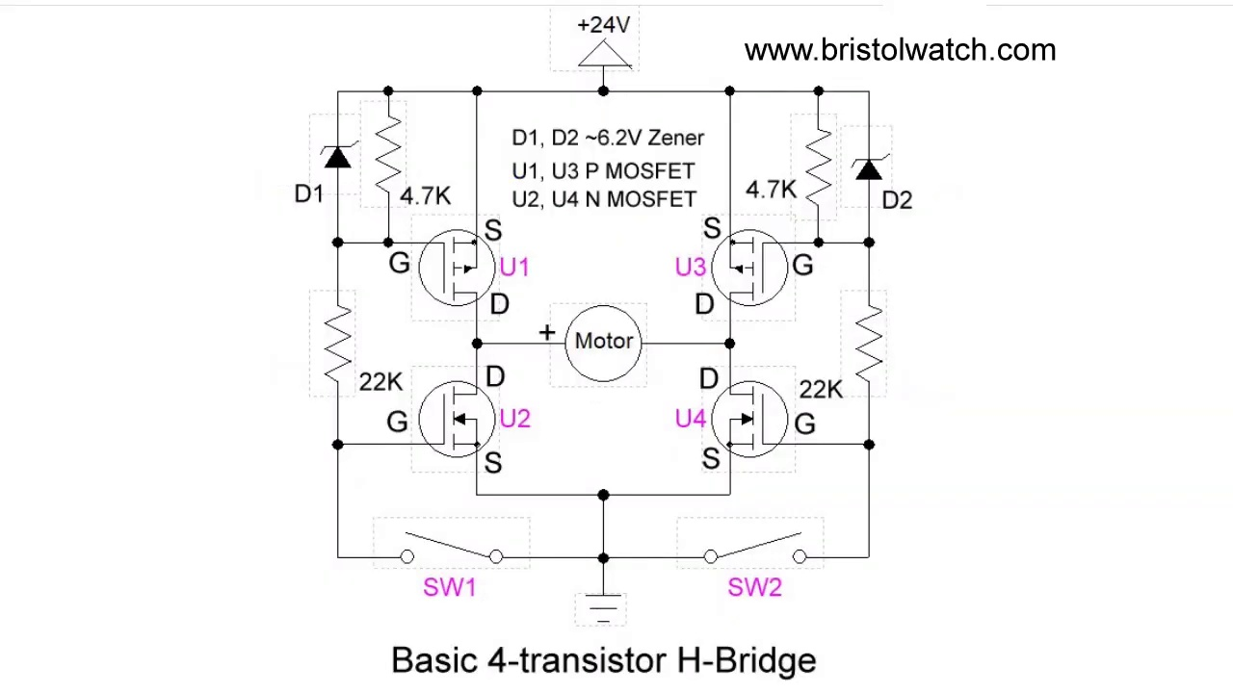 (score 95.0000)
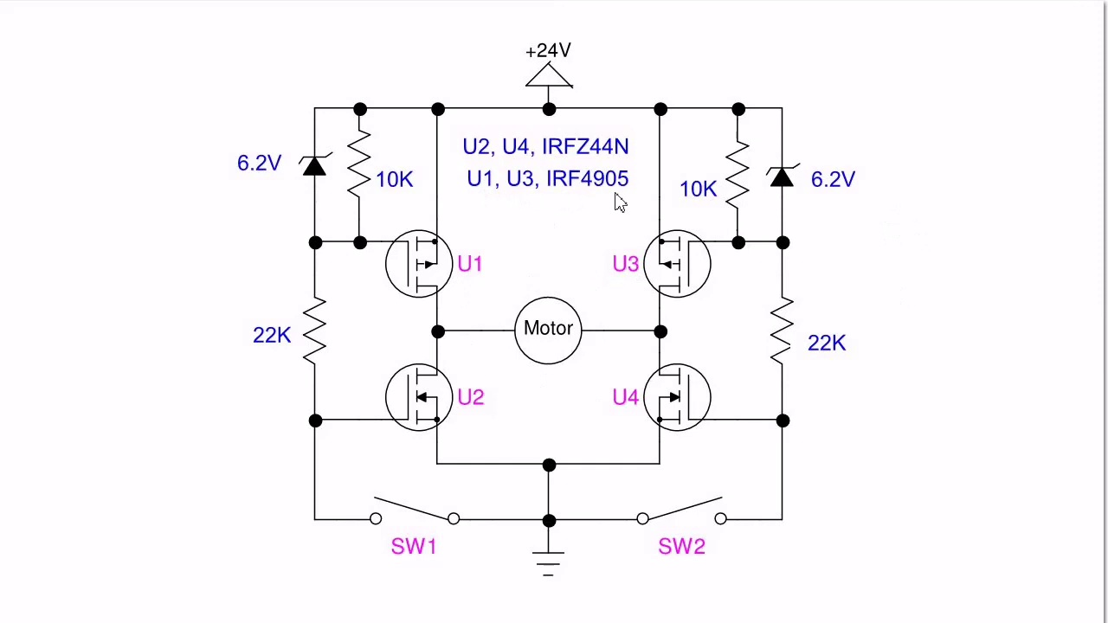 (score 95.0000)
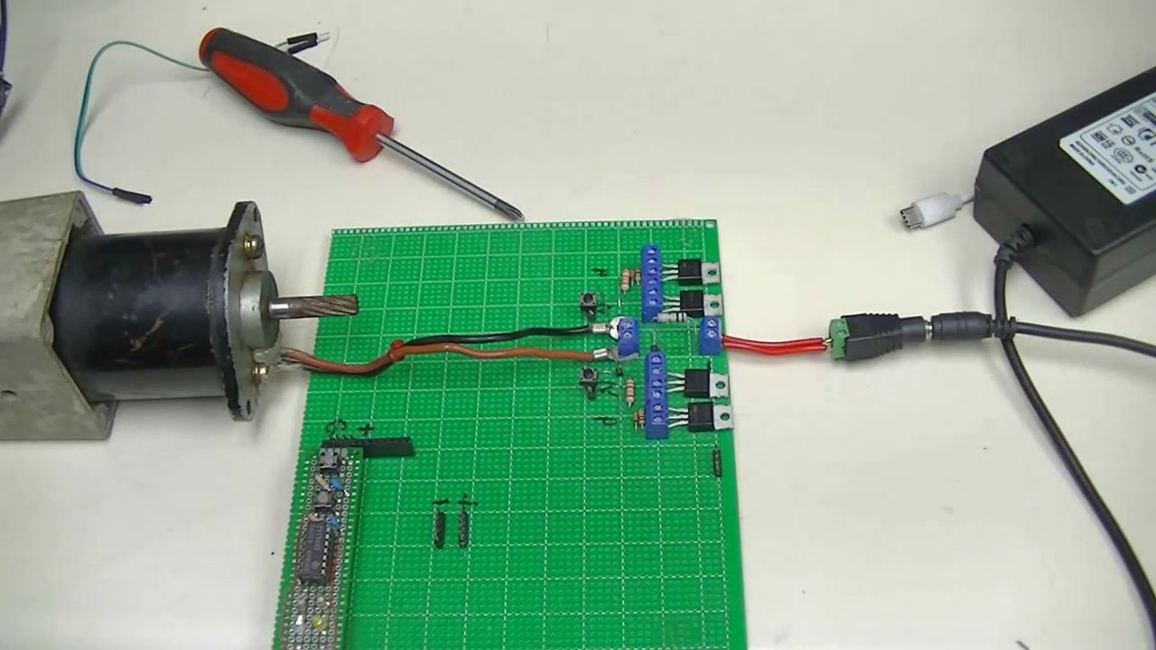 (score 95.0000)
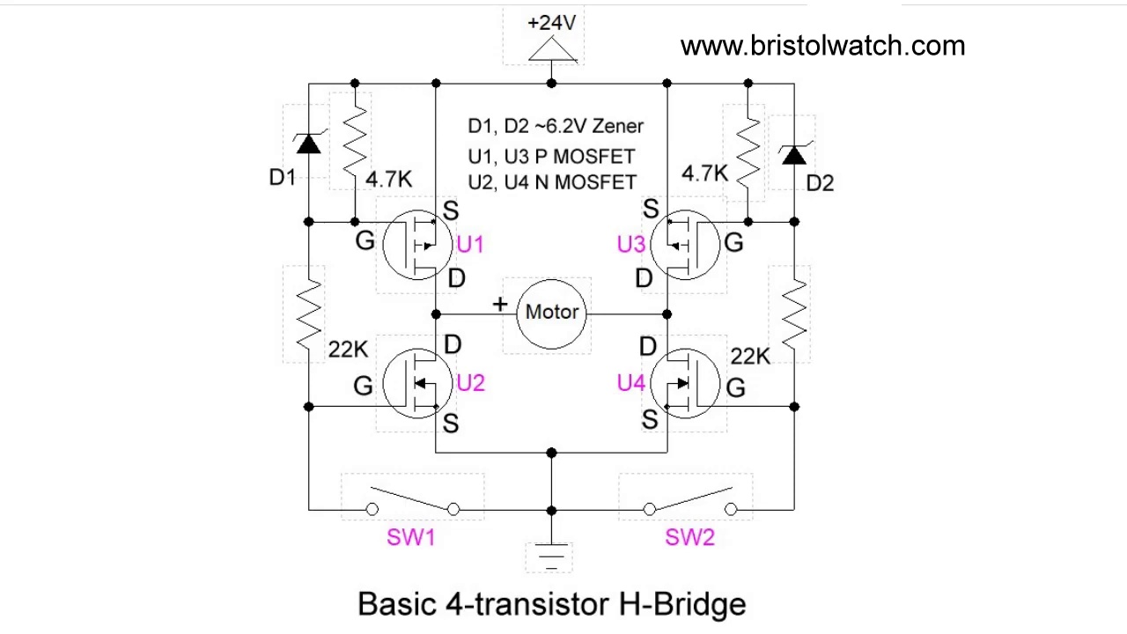 (score 95.0000)
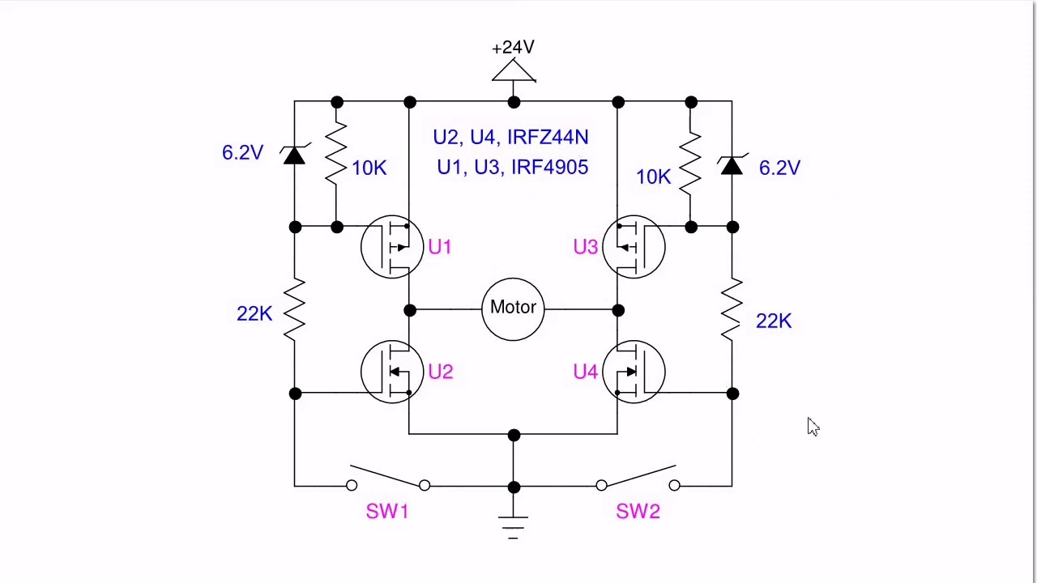 (score 90.0000)
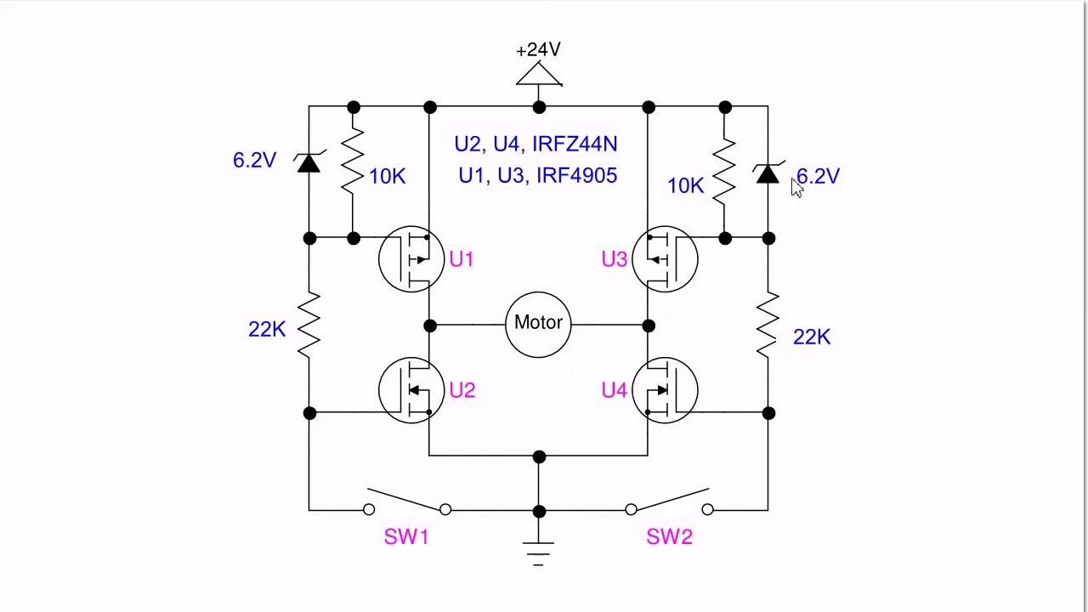 (score 90.0000)
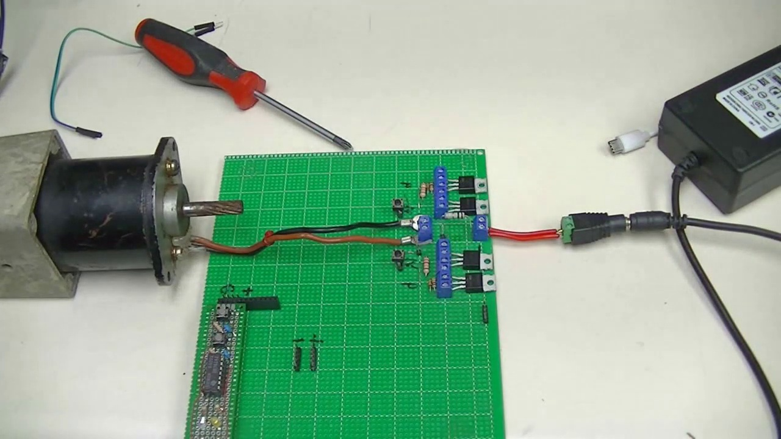 (score 90.0000)
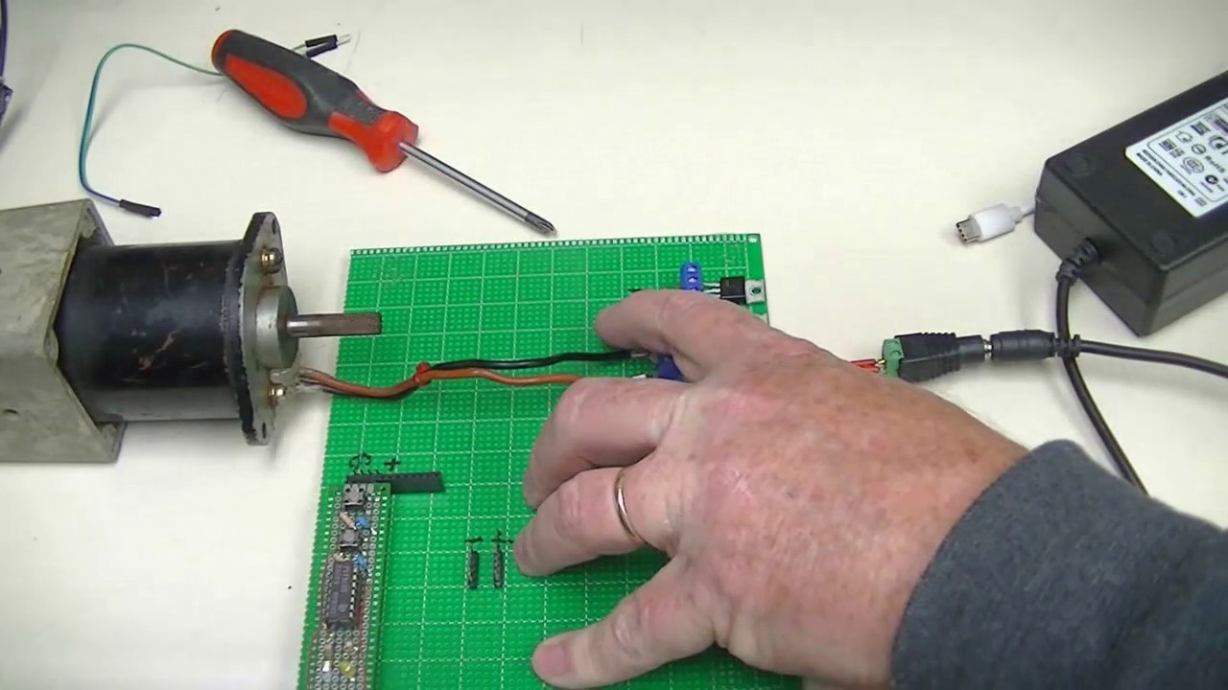 (score 90.0000)
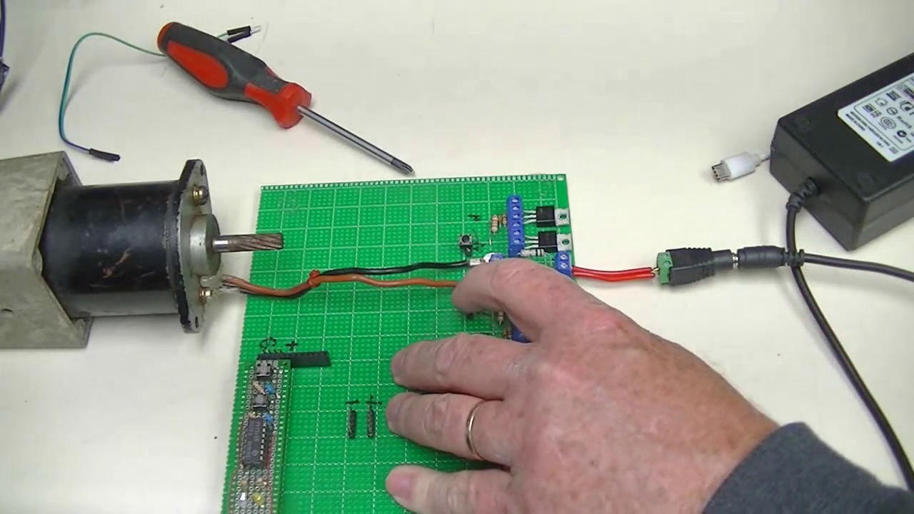 (score 90.0000)
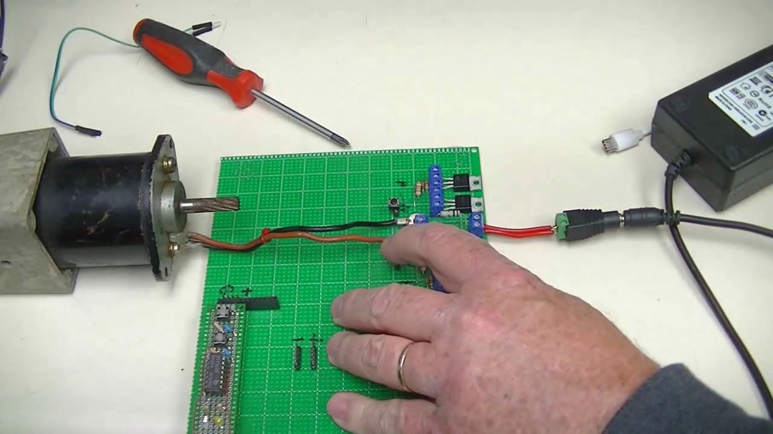 (score 90.0000)
Least correlated frames:
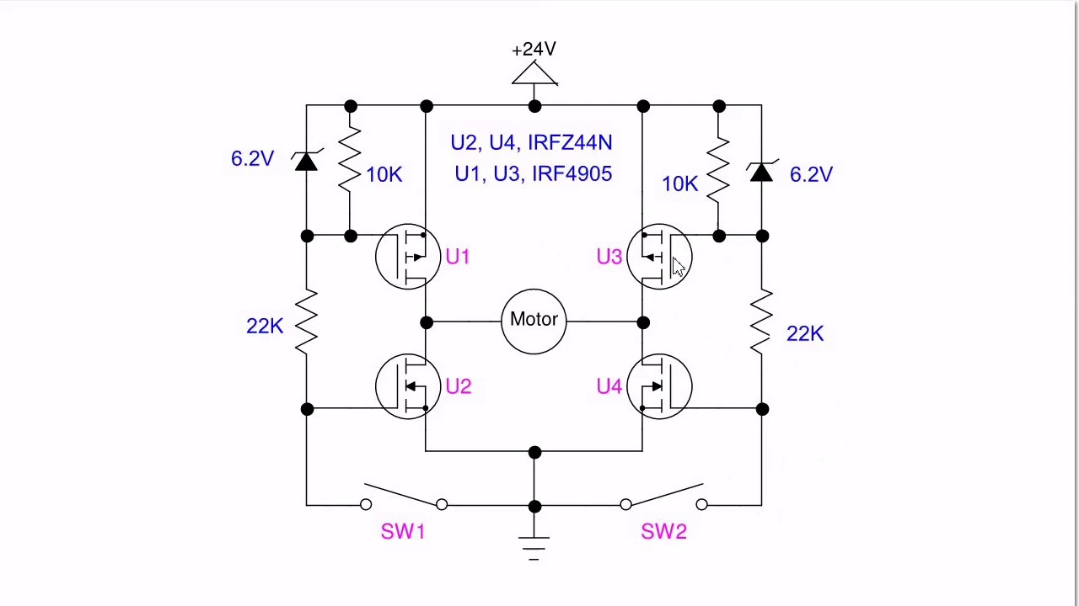 (score 0.0000)
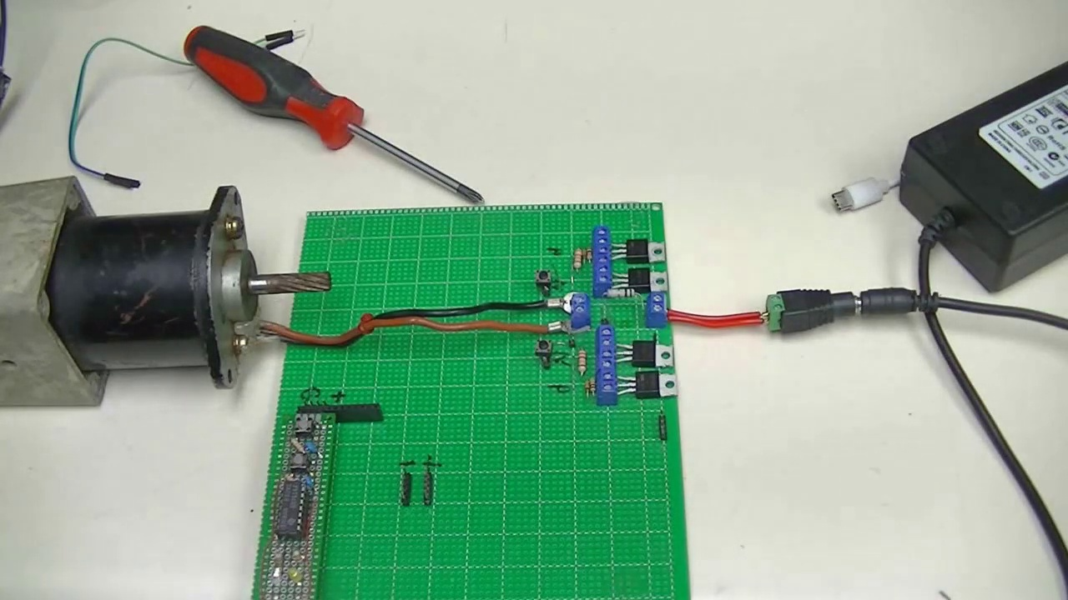 (score 80.0000)
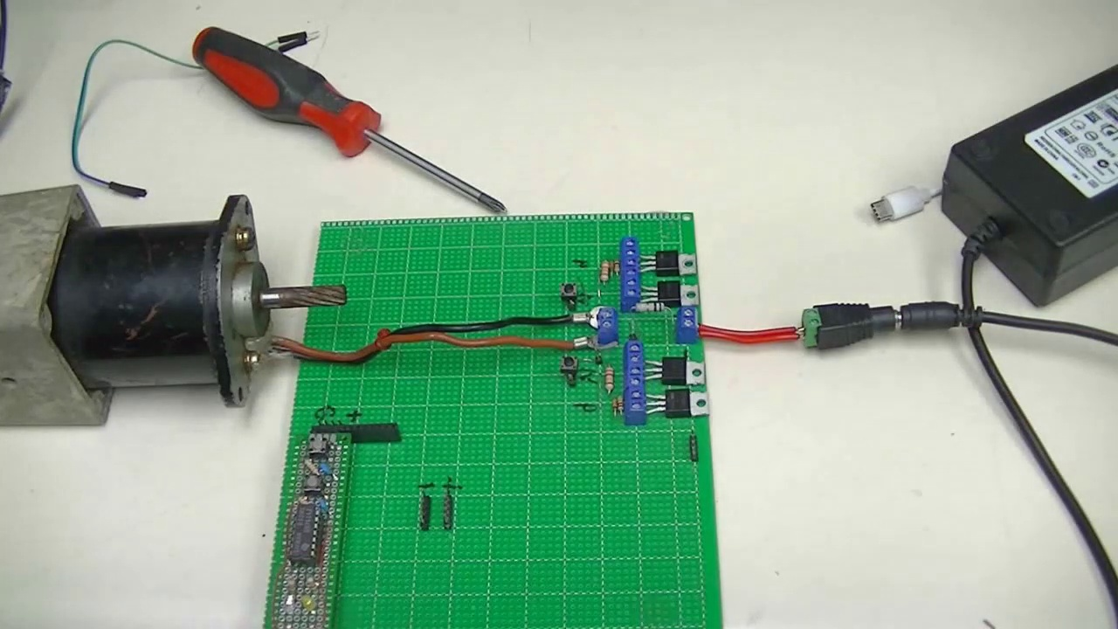 (score 80.0000)
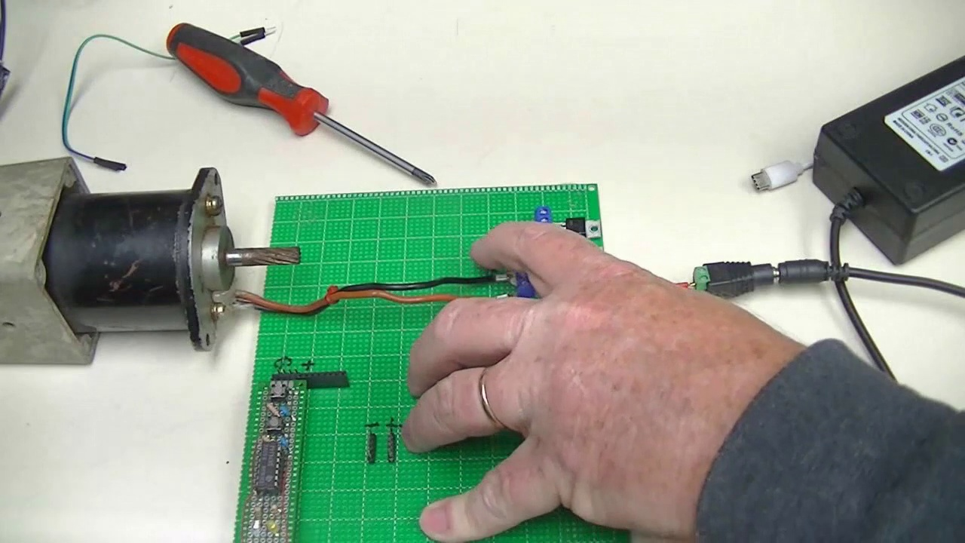 (score 80.0000)
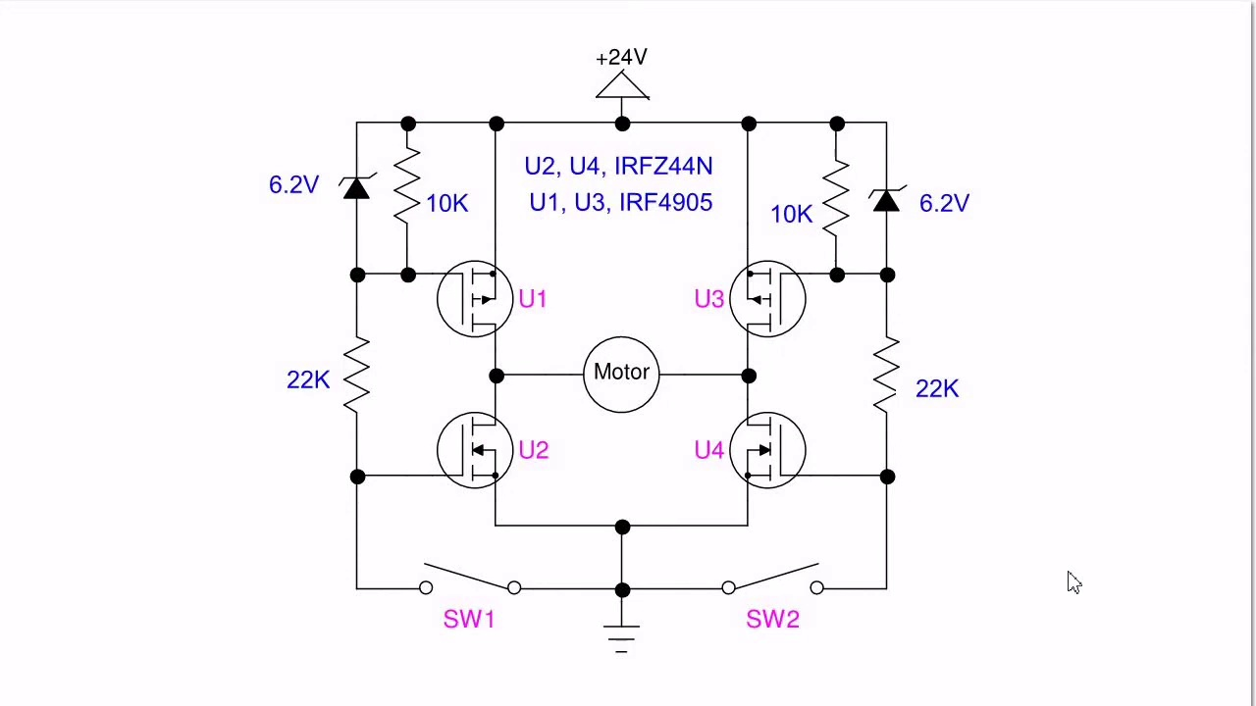 (score 80.0000)
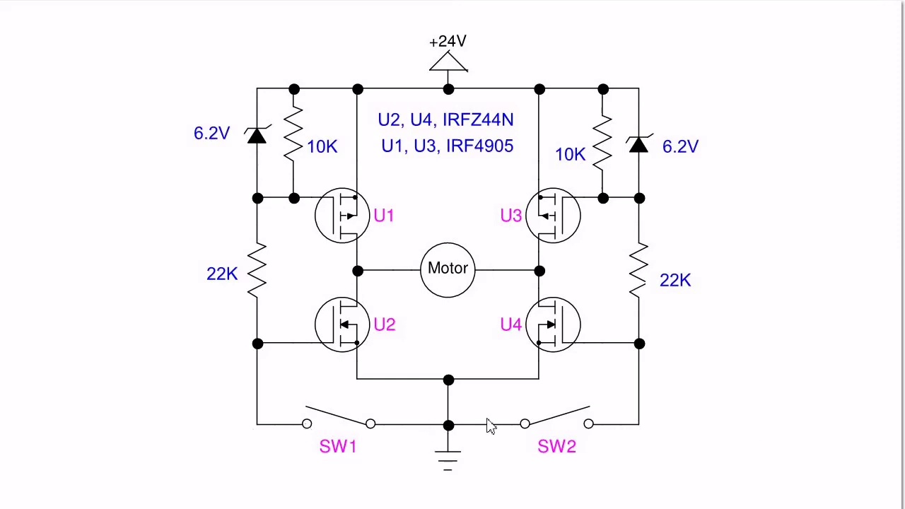 (score 80.0000)
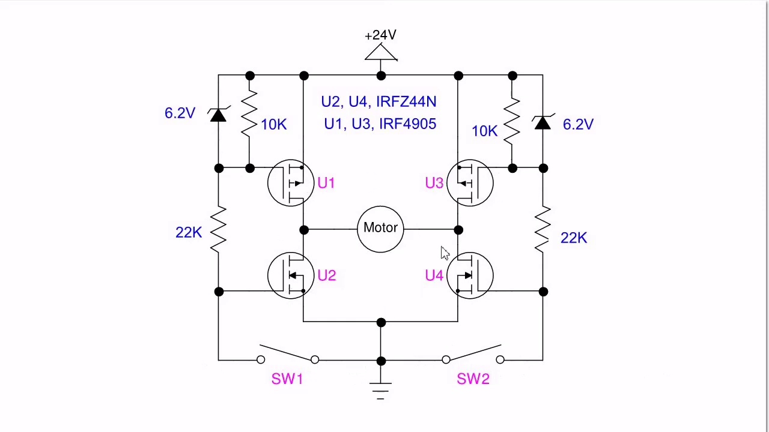 (score 80.0000)
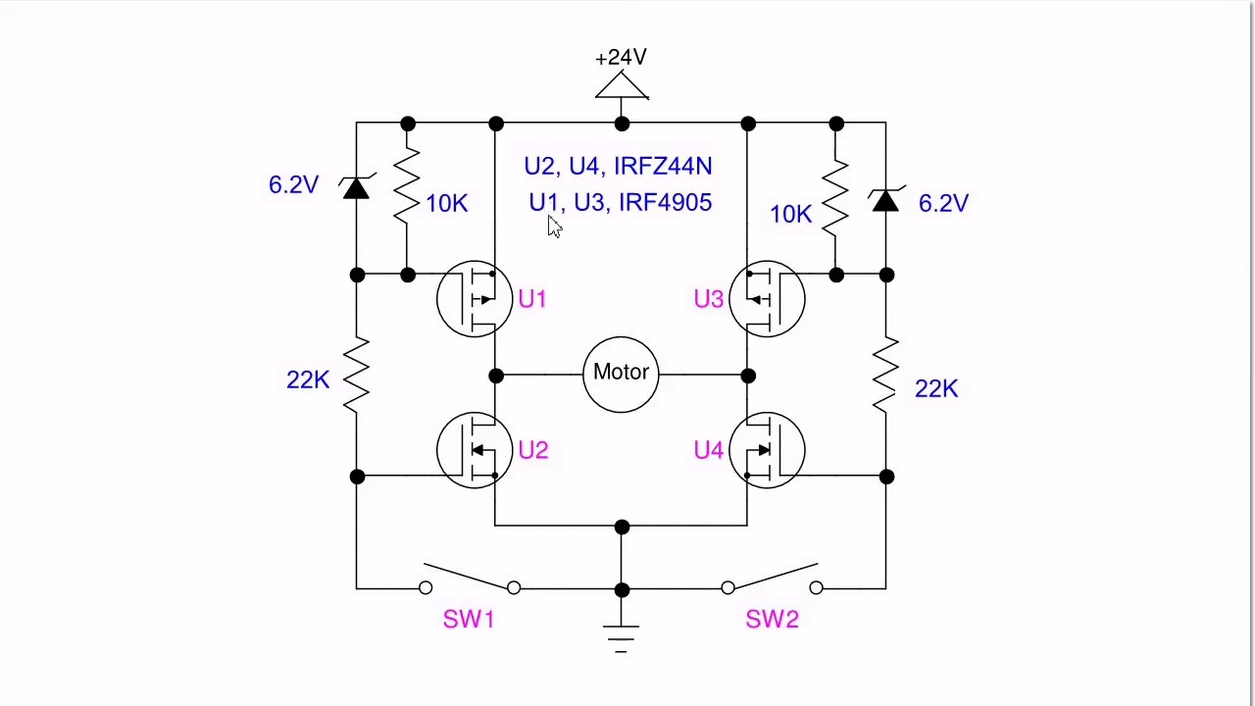 (score 80.0000)
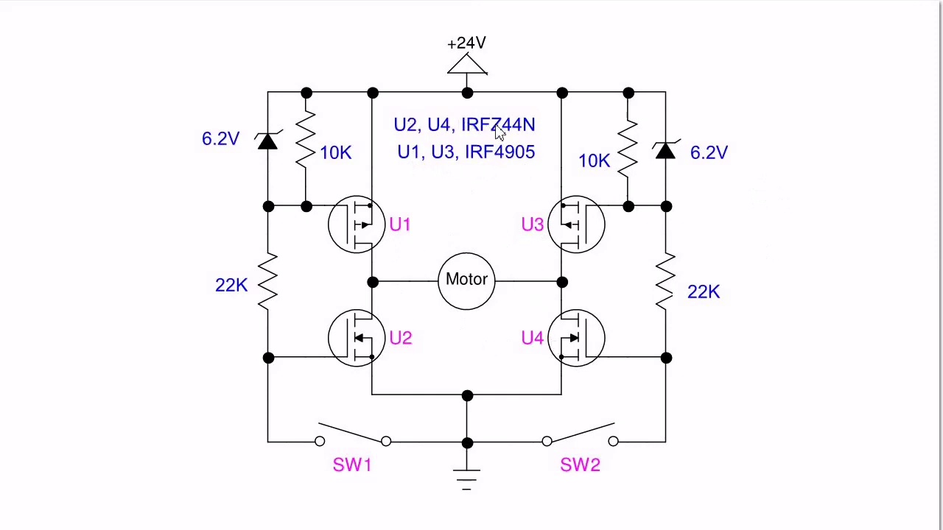 (score 80.0000)
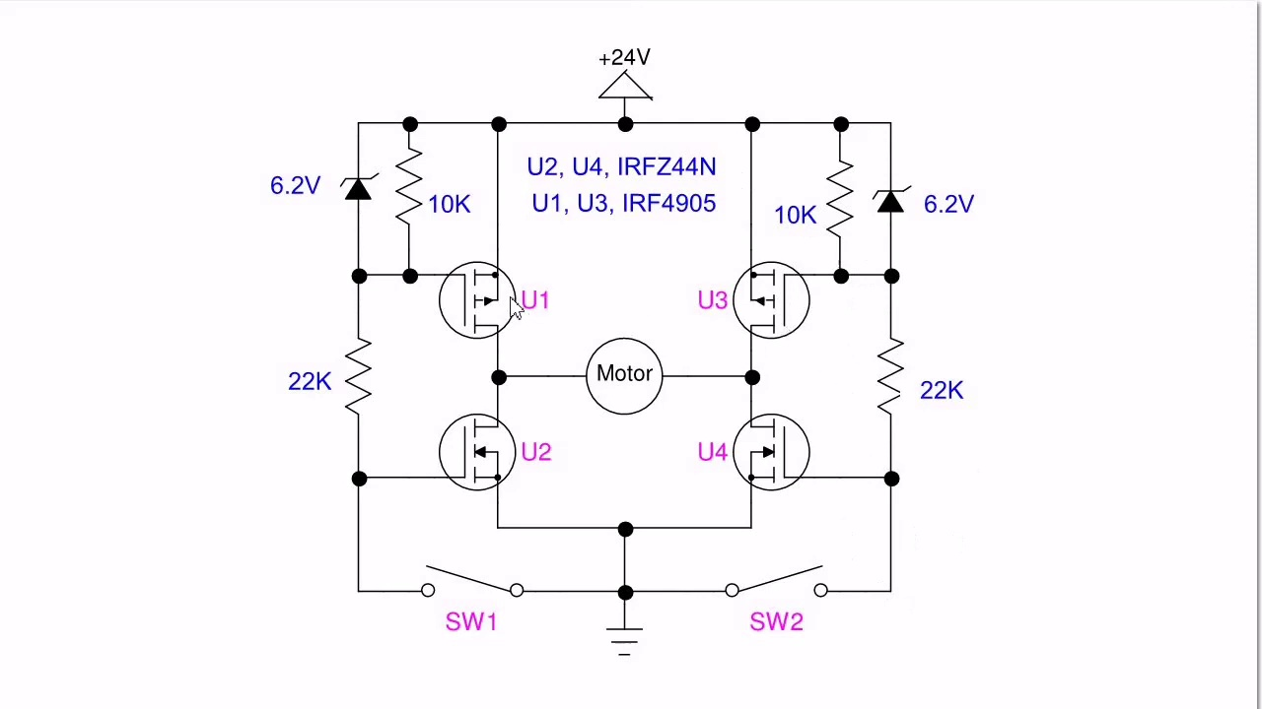 (score 80.0000)
- matched 22 frame(s), max score 95.0000: Explanation of H-bridge motor control using MOSFETs and its practical schematic.Details about the operation of the zener diodes for gate protection. Applying H-bridge concepts for motor control in robotics and automation projects.
Source: https://www.youtube.com/watch?v=NQvVeLHzfSs: Basic 4-Transistor MOSFET H-Bridge
Top correlated frames:
 (score 95.0000)
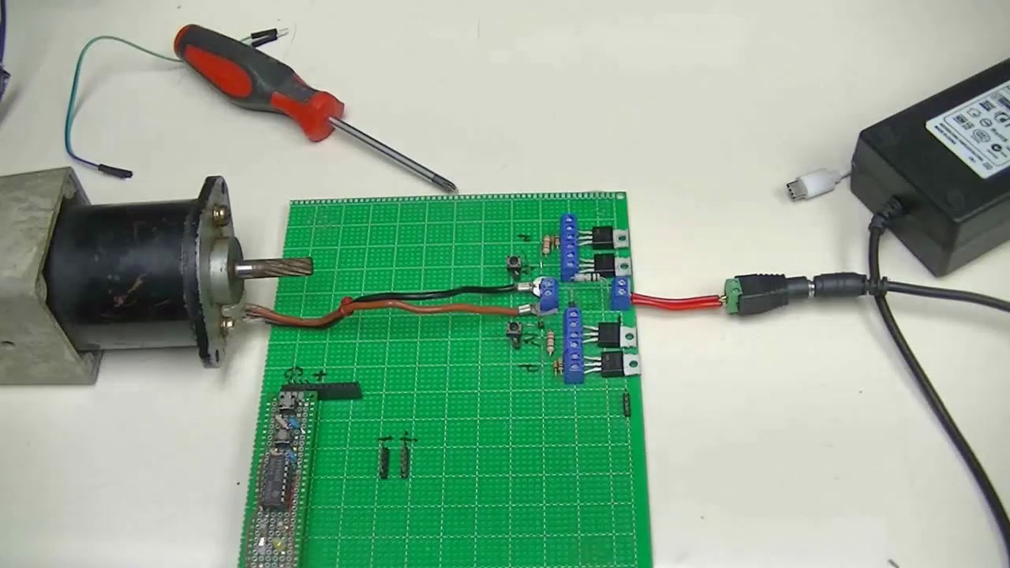 (score 95.0000)
 (score 90.0000)
 (score 90.0000)
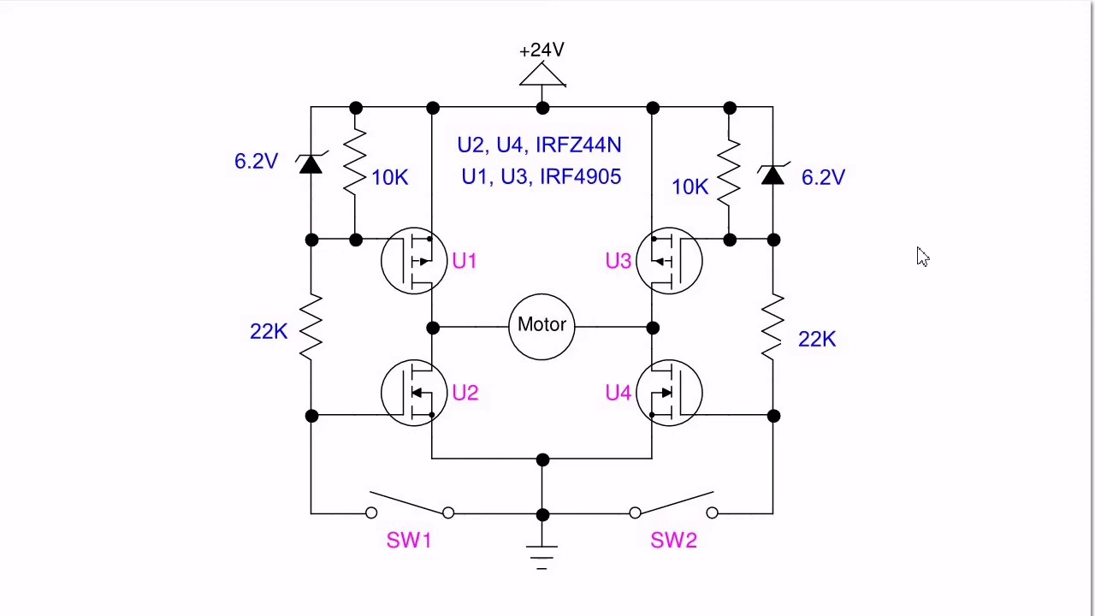 (score 85.0000)
 (score 85.0000)
 (score 85.0000)
 (score 85.0000)
 (score 85.0000)
 (score 85.0000)
Least correlated frames:
 (score 0.0000)
 (score 20.0000)
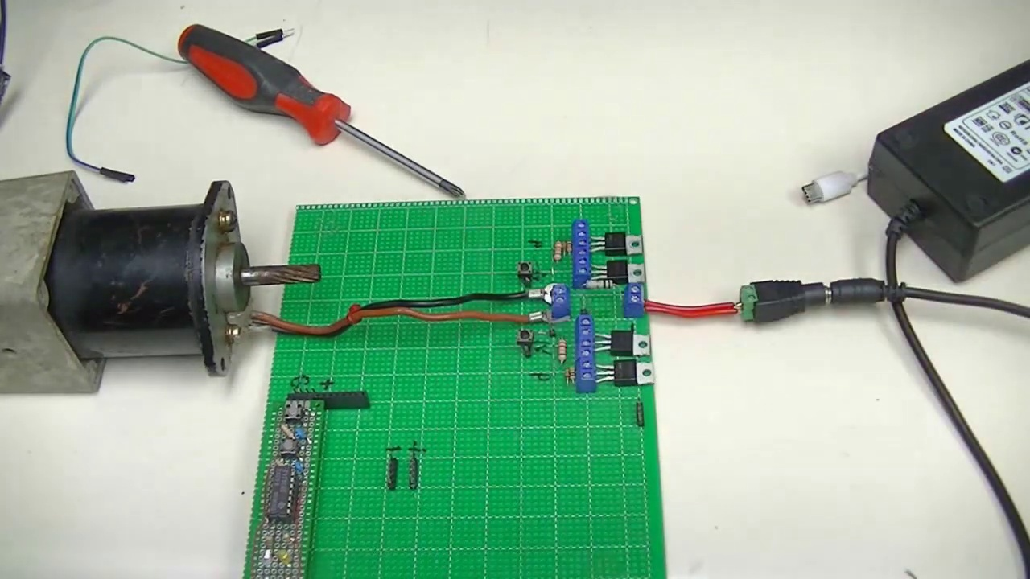 (score 20.0000)
 (score 20.0000)
 (score 20.0000)
 (score 20.0000)
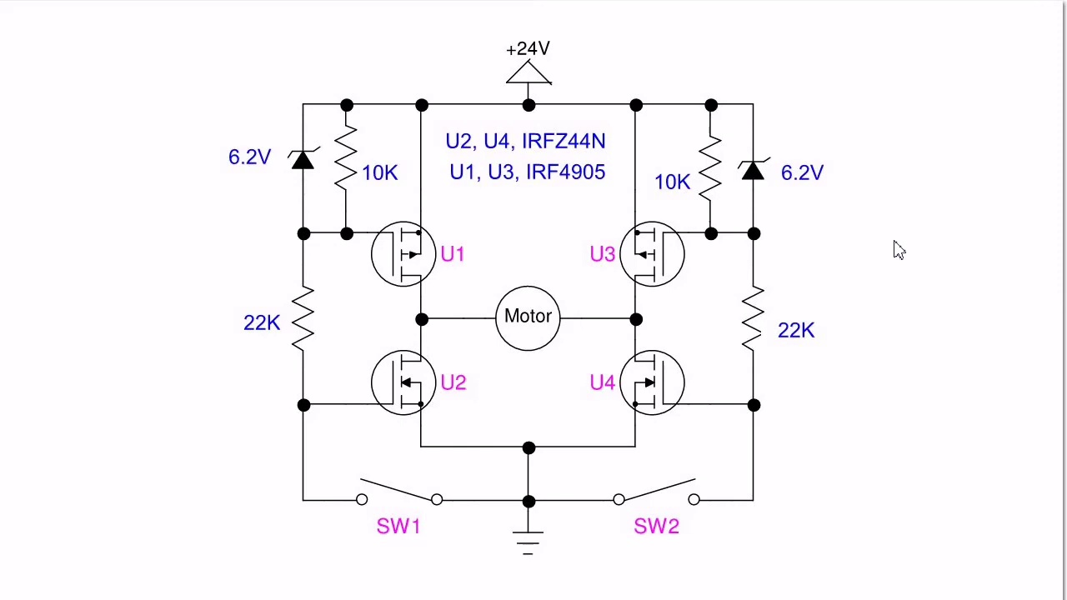 (score 20.0000)
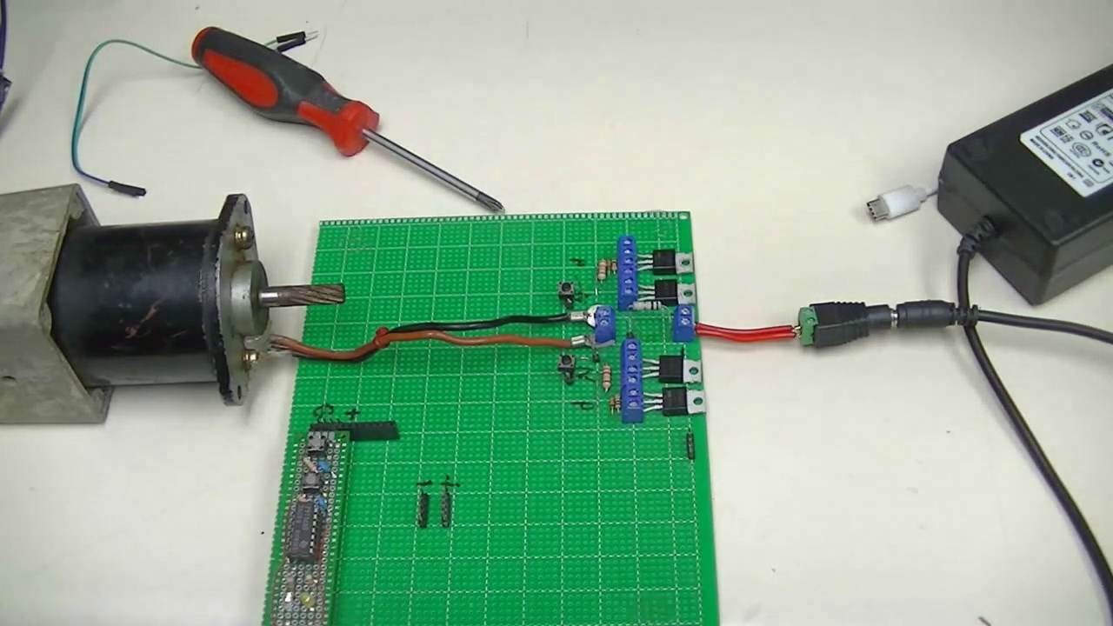 (score 80.0000)
 (score 80.0000)
 (score 80.0000)
- matched 20 frame(s), max score 95.0000: The video shows how to build a MOSFET H-Bridge. You will need a total of four MOSFETS, two tactile switches, four resistors, two Zener diodes, a motor, and a power supply. This circuit can operate using anywhere between 5 and 24 Volts. Two of the MOSFETs needed are P channel MOSFETs, while the other two are IRFC 44N MOSFETs which are sensitive gate MOSFETs. Once the circuit is built successfully you will be able to control the motor using the two tactile switches.
Source: https://www.youtube.com/watch?v=NQvVeLHzfSs: Basic 4-Transistor MOSFET H-Bridge
Top correlated frames:
 (score 95.0000)
 (score 95.0000)
 (score 95.0000)
 (score 95.0000)
 (score 95.0000)
 (score 95.0000)
 (score 95.0000)
 (score 95.0000)
 (score 90.0000)
 (score 90.0000)
Least correlated frames:
 (score 0.0000)
 (score 0.0000)
 (score 20.0000)
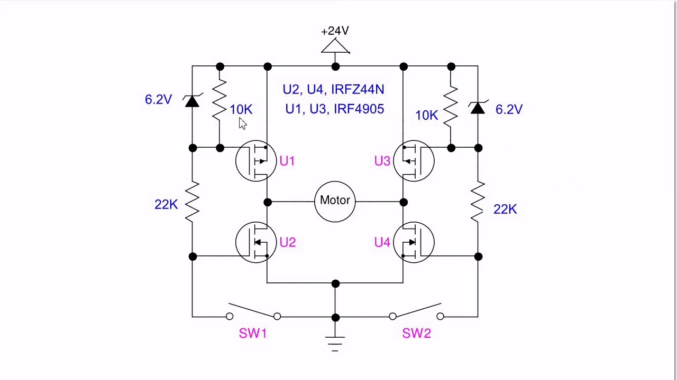 (score 20.0000)
 (score 30.0000)
 (score 80.0000)
 (score 80.0000)
 (score 80.0000)
 (score 80.0000)
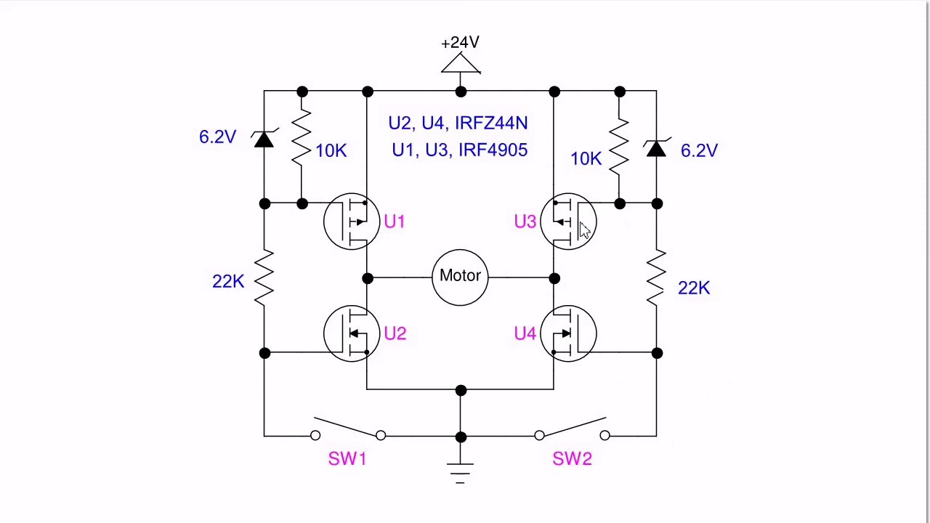 (score 80.0000)
- matched 18 frame(s), max score 95.0000: Loflin begins by demonstrating his circuit which used two low power tactile switches to control a 24V 3A motor. The circuit also consisted of two Zener diodes, four MOSFETs, and four resistors. Loflin prefaced his demonstration by stating that the circuit shown had improved upon an old H-bridge design of his. This could have stemmed from the fact that he used sensitive gate MOSFETs instead of cheap transistors which grew hot very easily. Additionally, he said the addition of the Zener diodes ultimately acted as protection for the gate circuits of the two IRF4905 MOSFETs. The other two MOSFETs were IRFZ44N MOSFETs.
Source: https://www.youtube.com/watch?v=NQvVeLHzfSs: Basic 4-Transistor MOSFET H-Bridge
Top correlated frames:
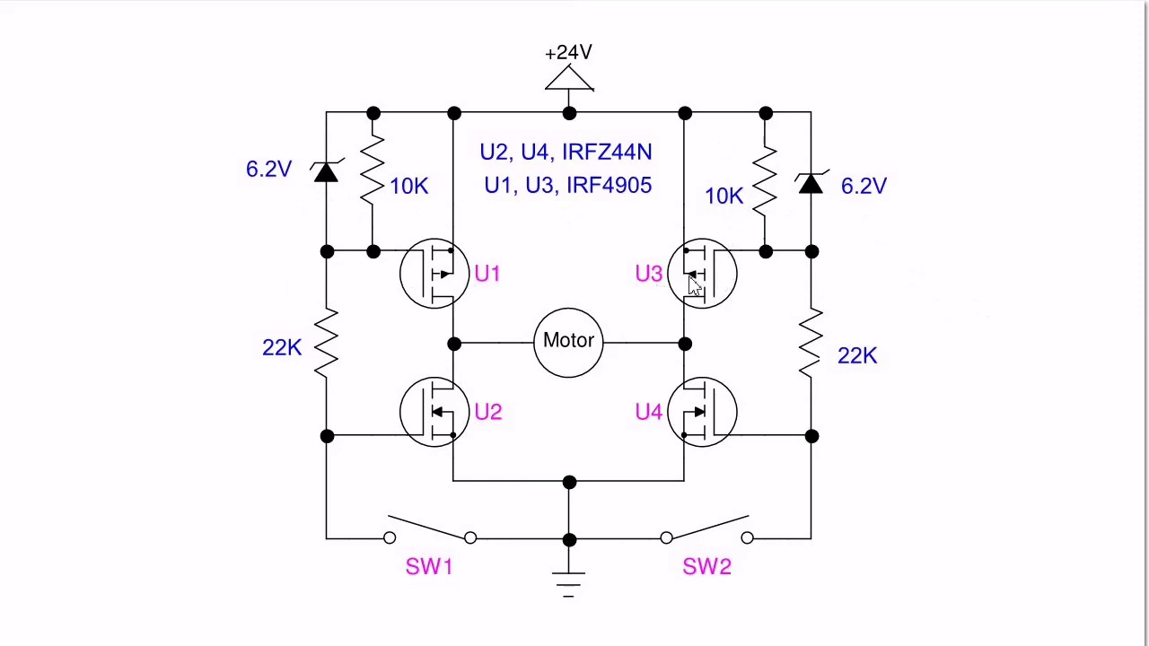 (score 95.0000)
 (score 95.0000)
 (score 95.0000)
 (score 95.0000)
 (score 90.0000)
 (score 90.0000)
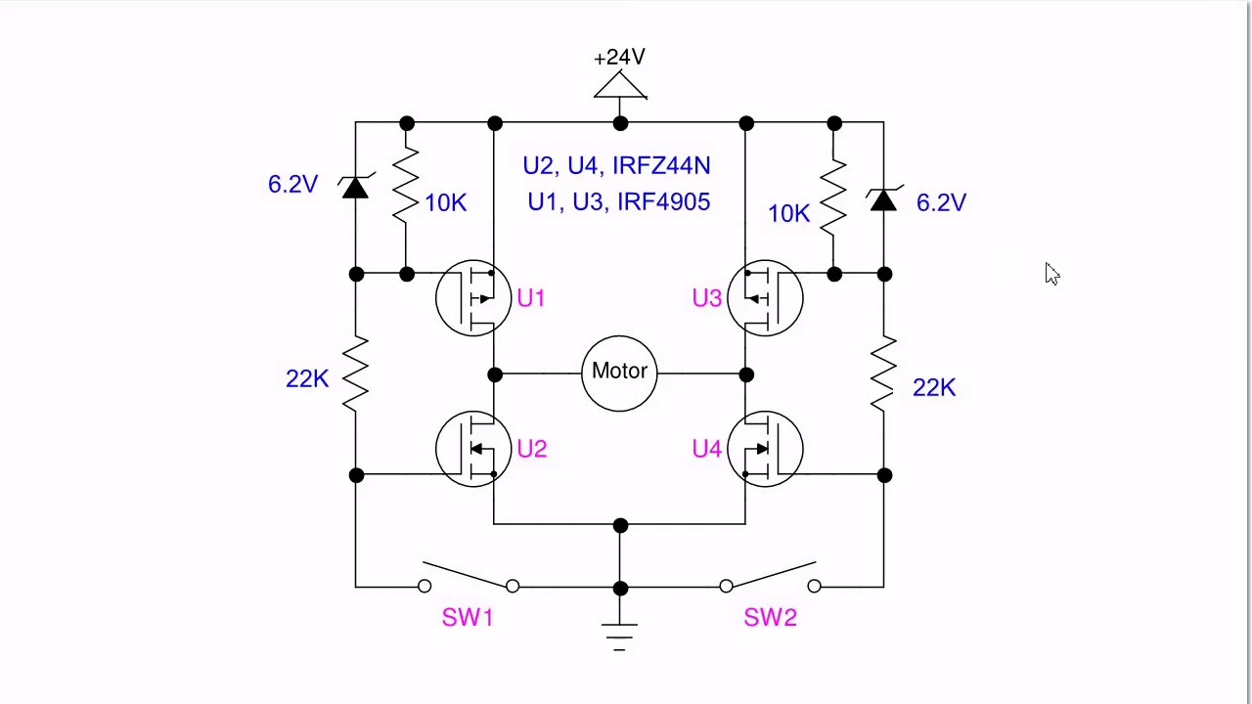 (score 90.0000)
 (score 90.0000)
 (score 90.0000)
 (score 90.0000)
Least correlated frames:
 (score 0.0000)
 (score 10.0000)
 (score 20.0000)
 (score 20.0000)
 (score 80.0000)
 (score 80.0000)
 (score 80.0000)
 (score 80.0000)
 (score 80.0000)
 (score 80.0000)
- matched 17 frame(s), max score 90.0000: H bridge motor control that was built using tactile switches to control the motor using 24 volts. This is actually really useful to know how to do. If I wanted to make a Robot on my own with my own boards to control the Robot itself I could use this method for sure. He is using 4 mosfets in his circuit to control the motor. Very brief video and I will go to his website to learn more about this.
Source: https://www.youtube.com/watch?v=NQvVeLHzfSs: Basic 4-Transistor MOSFET H-Bridge
Top correlated frames:
 (score 90.0000)
 (score 90.0000)
 (score 85.0000)
 (score 85.0000)
 (score 85.0000)
 (score 85.0000)
 (score 85.0000)
 (score 85.0000)
 (score 85.0000)
 (score 85.0000)
Least correlated frames:
 (score 0.0000)
 (score 20.0000)
 (score 20.0000)
 (score 20.0000)
 (score 20.0000)
 (score 20.0000)
 (score 20.0000)
 (score 20.0000)
 (score 20.0000)
 (score 20.0000)

Frame: frame_0000.jpg
Caption: The image appears to be a photograph of an instructional drawing or diagram, specifically a schematic plan for a technical circuit. The diagram is labeled as a "Basic 4 Transistor H-Bridge," suggesting it's related to electronics and transistors, which are semiconductor devices used for amplifying or switching electronic signals and electrical power.
The diagram features a series of transistors connected in a configuration resembling an H-bridge, which is often used for controlling the direction of current flow through two or more parallel channels. The presence of the word "Bridge" suggests that the diagram is meant to explain how these components are arranged and used.
The diagram includes lines connecting various symbols representing components or steps in a process, with text indicating values such as "4 1K" for resistors and other notations typical for schematics and circuit diagrams. Arrows pointing to specific elements with numbers next to them likely indicate the value of certain resistors or components in the circuit.
The image shows two transistors labeled as U1 and U2, a capacitor labeled as C, and a resistor labeled as R. The diagram is designed to operate at a frequency of 27.12 MHz and a voltage of 7.62V, powered by a battery labeled as B. Additionally, the diagram includes a text that reads "www.bristolwatch.com".
Comment (score 95): AN H-bridge is alluding to the circuit that is made to control the direction of motors and/or or types of loads. The circuit requires: 4 MOSFETS, diodes, controls, load(s), and a power supply. It’s divided in two pairs: upper, with MOSFETS between positive and load, and lower, with MOSFETS between ground and load.
Reason: The comment directly discusses the technical steps, objects (MOSFETs, diodes), and settings (power supply) described in the caption, specifically the H-bridge circuit configuration and its components. The mention of load(s) and control also matches the context of the diagram.
Source: https://www.youtube.com/watch?v=NQvVeLHzfSs: (189) Basic 4-Transistor MOSFET H-Bridge - YouTube
Comment (score 85): H bridge motor control that was built using tactile switches to control the motor using 24 volts. This is actually really useful to know how to do. If I wanted to make a Robot on my own with my own boards to control the Robot itself I could use this method for sure. He is using 4 mosfets in his circuit to control the motor. Very brief video and I will go to his website to learn more about this.
Reason: The comment directly discusses the use of H-bridge motor control, which is mentioned in the caption. The mention of 4 transistors (mosfets) and their use to control a motor also matches the technical details described in the caption.
Source: https://www.youtube.com/watch?v=NQvVeLHzfSs: Basic 4-Transistor MOSFET H-Bridge
Comment (score 85): Explanation of H-bridge motor control using MOSFETs and its practical schematic.Details about the operation of the zener diodes for gate protection. Applying H-bridge concepts for motor control in robotics and automation projects.
Reason: The comment directly discusses the same technical steps (H-bridge motor control) and objects (MOSFETs, zener diodes) described in the caption, with a focus on their application in robotics and automation projects.
Source: https://www.youtube.com/watch?v=NQvVeLHzfSs: Basic 4-Transistor MOSFET H-Bridge

Frame: frame_0001.jpg
Caption: The image captures a moment of electronic assembly, showcasing a tabletop setup with multiple components. On the left side of the table, a small motor with its rotor attached to wires connected to a printed circuit board (PCB) is visible. The PCB has various components such as resistors, capacitors, and integrated circuits. A jumper wire connects the motor to another component, possibly an electronic controller or power supply unit. To the right of the PCB, a cable with connectors on both ends appears to be attached to a device that might be a laptop or microcontroller board.
On the right side of the table, there is an electronic testing setup with various wires and components, including what looks like a multimeter probe and possibly a power supply unit. A screwdriver and a set of pliers are also present, suggesting work in progress or about to begin. There is no person present in the image, and no visible instructional material such as slides or diagrams with text explaining the setup or experiment being performed.
The central focus of the image is a green circuit board, which is part of the electronic assembly process. The board is complex, with a network of wires that demonstrate its intricate design. A red screwdriver rests on the board, indicating a meticulous approach to the work. A black power supply unit is also present, with tangled cables suggesting that the board will draw power from this source to function properly.
The backdrop is a stark white, allowing the colorful components of the circuit board to stand out. The image provides a detailed view of the electronic assembly process, capturing the complexity and precision involved in such tasks.
Comment (score 95): The video shows how to build a MOSFET H-Bridge. You will need a total of four MOSFETS, two tactile switches, four resistors, two Zener diodes, a motor, and a power supply. This circuit can operate using anywhere between 5 and 24 Volts. Two of the MOSFETs needed are P channel MOSFETs, while the other two are IRFC 44N MOSFETs which are sensitive gate MOSFETs. Once the circuit is built successfully you will be able to control the motor using the two tactile switches.
Reason: The comment directly discusses the same technical steps, objects (MOSFETs, resistors, Zener diodes, motor, power supply), and settings (voltage range) described in the caption. The mention of specific components and their functions in the circuit matches the visual details shown in the image.
Source: https://www.youtube.com/watch?v=NQvVeLHzfSs: Basic 4-Transistor MOSFET H-Bridge
Comment (score 90): Loflin begins by demonstrating his circuit which used two low power tactile switches to control a 24V 3A motor. The circuit also consisted of two Zener diodes, four MOSFETs, and four resistors. Loflin prefaced his demonstration by stating that the circuit shown had improved upon an old H-bridge design of his. This could have stemmed from the fact that he used sensitive gate MOSFETs instead of cheap transistors which grew hot very easily. Additionally, he said the addition of the Zener diodes ultimately acted as protection for the gate circuits of the two IRF4905 MOSFETs. The other two MOSFETs were IRFZ44N MOSFETs.
Reason: The comment directly discusses the electronic assembly process, mentioning specific components such as motor, Zener diodes, MOSFETs, and resistors, which are also present in the frame caption. The caption describes a tabletop setup with multiple components, including a PCB with various components, which is consistent with the circuit described in the comment. Additionally, the comment mentions the improvement of an old H-bridge design, which aligns with the complexity and precision involved in electronic assembly process as described in the caption.
Source: https://www.youtube.com/watch?v=NQvVeLHzfSs: Basic 4-Transistor MOSFET H-Bridge
Comment (score 85): AN H-bridge is alluding to the circuit that is made to control the direction of motors and/or or types of loads. The circuit requires: 4 MOSFETS, diodes, controls, load(s), and a power supply. It’s divided in two pairs: upper, with MOSFETS between positive and load, and lower, with MOSFETS between ground and load.
Reason: The comment directly discusses the technical steps described in the caption, specifically mentioning an H-bridge circuit and its components (MOSFETS, diodes, controls, load(s), and power supply). The comment also references the motor and power supply unit mentioned in the caption. While it does not explicitly mention every detail in the caption, the connection between the comment and caption is strong due to the shared technical context.
Source: https://www.youtube.com/watch?v=NQvVeLHzfSs: (189) Basic 4-Transistor MOSFET H-Bridge - YouTube
Comment (score 80): H bridge motor control that was built using tactile switches to control the motor using 24 volts. This is actually really useful to know how to do. If I wanted to make a Robot on my own with my own boards to control the Robot itself I could use this method for sure. He is using 4 mosfets in his circuit to control the motor. Very brief video and I will go to his website to learn more about this.
Reason: The comment directly discusses the motor control circuit shown in the frame caption, mentioning specific components like H-bridge and MOSFETs. The mention of tactile switches to control the motor using 24 volts is also related to the components seen on the PCB in the image.
Source: https://www.youtube.com/watch?v=NQvVeLHzfSs: Basic 4-Transistor MOSFET H-Bridge

Frame: frame_0002.jpg
Caption: The image depicts a tabletop setup featuring various electronic components connected together, with wires and connectors indicating an ongoing experiment or project. On the left side, a small electric motor is attached to a circuit board with other integrated circuits (ICs) on it. To the right, a breadboard has jumper cables plugged into it, allowing for connections without soldering. Wires and components are connected to the breadboard.
In the background, a power supply with an outlet can be seen, along with a few tools and objects that are not clearly identifiable due to the distance and blurriness. A red screwdriver lies in the foreground, its sharp tip poised to potentially disassemble or assemble the green circuit board, which is adorned with numerous electronic components. A black and white screwdriver is also present, suggesting a similar task may be underway.
The image also contains text that is not discernible from the provided information. The overall scene suggests a workspace or workshop where the art of electronics is being honed.
Comment (score 90): AN H-bridge is alluding to the circuit that is made to control the direction of motors and/or or types of loads. The circuit requires: 4 MOSFETS, diodes, controls, load(s), and a power supply. It’s divided in two pairs: upper, with MOSFETS between positive and load, and lower, with MOSFETS between ground and load.
Reason: The comment directly discusses the technical steps described in the caption, specifically mentioning H-bridge circuitry and MOSFETs, which are prominently featured in the image. The mention of motors, diodes, controls, and power supply also aligns with the components and setup shown in the tabletop scene.
Source: https://www.youtube.com/watch?v=NQvVeLHzfSs: (189) Basic 4-Transistor MOSFET H-Bridge - YouTube
Comment (score 85): The video shows how to build a MOSFET H-Bridge. You will need a total of four MOSFETS, two tactile switches, four resistors, two Zener diodes, a motor, and a power supply. This circuit can operate using anywhere between 5 and 24 Volts. Two of the MOSFETs needed are P channel MOSFETs, while the other two are IRFC 44N MOSFETs which are sensitive gate MOSFETs. Once the circuit is built successfully you will be able to control the motor using the two tactile switches.
Reason: The comment directly discusses the MOSFET H-Bridge circuit described in the caption, mentioning specific components (MOSFETS, tactile switches, resistors, Zener diodes, motor, power supply) and their connection to each other. The description of the breadboard and jumper cables matches the technical steps required to build the circuit.
Source: https://www.youtube.com/watch?v=NQvVeLHzfSs: Basic 4-Transistor MOSFET H-Bridge
Comment (score 80): H bridge motor control that was built using tactile switches to control the motor using 24 volts. This is actually really useful to know how to do. If I wanted to make a Robot on my own with my own boards to control the Robot itself I could use this method for sure. He is using 4 mosfets in his circuit to control the motor. Very brief video and I will go to his website to learn more about this.
Reason: The comment directly discusses the H-bridge motor control circuit built using tactile switches, which is a technical step mentioned in the caption. The mention of MOSFETs and voltage levels also correlates with the components shown in the image.
Source: https://www.youtube.com/watch?v=NQvVeLHzfSs: Basic 4-Transistor MOSFET H-Bridge
Comment (score 80): Explanation of H-bridge motor control using MOSFETs and its practical schematic.Details about the operation of the zener diodes for gate protection. Applying H-bridge concepts for motor control in robotics and automation projects.
Reason: Explanation of H-bridge motor control using MOSFETs and its practical schematic Details about the operation of the zener diodes for gate protection Applying H-bridge concepts for motor control in robotics and automation projects.
Source: https://www.youtube.com/watch?v=NQvVeLHzfSs: Basic 4-Transistor MOSFET H-Bridge

Frame: frame_0003.jpg
Caption: The image shows an electronics workbench scene with two printed circuit boards (PCBs) as the central focus. On one PCB, several electronic components including resistors, capacitors, and an integrated circuit (IC) are being soldered onto it using a soldering iron. The other smaller PCB has a different set of components. A multimeter is connected to the larger PCB, possibly for testing purposes.
The larger PCB is held in place by a screwdriver, and it is wired with multiple cables, some black and others red. Some of these cables are connected to the board, while others are connected to a black power supply plugged into a wall socket. The green circuit board is placed on a white table, which contrasts with its color.
The background suggests an indoor setting, likely a workshop or lab environment. There are no people or instructors visible in this frame, and no text or slides can be identified. The image captures a moment of repair and assembly in a quiet room, showing the electronic components being soldered onto the PCBs, highlighting the process of electronics work.
Comment (score 95): The video shows how to build a MOSFET H-Bridge. You will need a total of four MOSFETS, two tactile switches, four resistors, two Zener diodes, a motor, and a power supply. This circuit can operate using anywhere between 5 and 24 Volts. Two of the MOSFETs needed are P channel MOSFETs, while the other two are IRFC 44N MOSFETs which are sensitive gate MOSFETs. Once the circuit is built successfully you will be able to control the motor using the two tactile switches.
Reason: The comment directly discusses technical steps and components (MOSFETs, resistors, Zener diodes, motor) that are present in the frame caption's description of electronics workbench scene. The mention of building a specific circuit (H-Bridge) and its requirements matches with the components shown in the image.
Source: https://www.youtube.com/watch?v=NQvVeLHzfSs: Basic 4-Transistor MOSFET H-Bridge
Comment (score 80): AN H-bridge is alluding to the circuit that is made to control the direction of motors and/or or types of loads. The circuit requires: 4 MOSFETS, diodes, controls, load(s), and a power supply. It’s divided in two pairs: upper, with MOSFETS between positive and load, and lower, with MOSFETS between ground and load.
Reason: The comment directly discusses the circuitry components mentioned in the caption (H-bridge, MOSFETS, diodes) and their purpose (controlling motor direction/load), which is closely related to the soldering of electronic components on the PCBs shown in the image.
Source: https://www.youtube.com/watch?v=NQvVeLHzfSs: (189) Basic 4-Transistor MOSFET H-Bridge - YouTube

Frame: frame_0004.jpg
Caption: The image captures a scene of electronic repair or assembly, with a green board as the centerpiece. The board is adorned with various components including wires, resistors, and a small motor, meticulously arranged on the board, suggesting a complex circuit or assembly. A black screwdriver is also present, its sharp tip poised to make a mark on the board, adding a sense of action to the image.
The green board is not just resting on a surface, but it's also plugged into a white power supply, which suggests that the board is ready for power and might soon be in use. This connection contrasts with the rough nature of the board and its components, highlighting the contrast between the sleek design of the power supply and the intricate arrangement of the electronics.
In the background, there is a table with various tools such as a screwdriver and pliers, indicating a workshop or lab setting where repairs or construction may take place. However, these tools are not in use at the moment and do not seem to be directly related to the electronic device on the breadboard.
The focus of this image seems to be on the project itself rather than an instructor explaining it, as there is no visible person teaching or guiding through a lesson. There is also an audio cable plugged into the breadboard, suggesting that sound might be a part of this project. The setting appears to be a workshop or educational lab where electronic projects are being created or repaired.
Comment (score 90): The video shows how to build a MOSFET H-Bridge. You will need a total of four MOSFETS, two tactile switches, four resistors, two Zener diodes, a motor, and a power supply. This circuit can operate using anywhere between 5 and 24 Volts. Two of the MOSFETs needed are P channel MOSFETs, while the other two are IRFC 44N MOSFETs which are sensitive gate MOSFETs. Once the circuit is built successfully you will be able to control the motor using the two tactile switches.
Reason: The comment directly discusses the technical steps and components mentioned in the caption, including MOSFETs, tactile switches, resistors, Zener diodes, motor, and power supply. The correlation is high because the comment specifically highlights the same components and settings described in the caption, such as the green board and white power supply.
Source: https://www.youtube.com/watch?v=NQvVeLHzfSs: Basic 4-Transistor MOSFET H-Bridge
Comment (score 85): Loflin begins by demonstrating his circuit which used two low power tactile switches to control a 24V 3A motor. The circuit also consisted of two Zener diodes, four MOSFETs, and four resistors. Loflin prefaced his demonstration by stating that the circuit shown had improved upon an old H-bridge design of his. This could have stemmed from the fact that he used sensitive gate MOSFETs instead of cheap transistors which grew hot very easily. Additionally, he said the addition of the Zener diodes ultimately acted as protection for the gate circuits of the two IRF4905 MOSFETs. The other two MOSFETs were IRFZ44N MOSFETs.
Reason: The comment directly discusses the same technical steps, objects, and goals described in the caption. The mention of MOSFETs, resistors, and Zener diodes matches the components on the green board, and the description of a motor being controlled by switches aligns with the image's focus on electronic assembly or repair. The correlation score is 85 because while the comment provides detailed information about the circuit, it does not explicitly mention the breadboard, power supply, or workshop setting described in the caption.
Source: https://www.youtube.com/watch?v=NQvVeLHzfSs: Basic 4-Transistor MOSFET H-Bridge
Comment (score 80): AN H-bridge is alluding to the circuit that is made to control the direction of motors and/or or types of loads. The circuit requires: 4 MOSFETS, diodes, controls, load(s), and a power supply. It’s divided in two pairs: upper, with MOSFETS between positive and load, and lower, with MOSFETS between ground and load.
Reason: The comment directly discusses the same technical steps, objects (H-bridge circuit with MOSFETs, diodes, and power supply) and settings (workshop or educational lab) described in the caption. The correlation is strong because the comment provides specific details about the components and their arrangement, which matches the information presented in the caption.
Source: https://www.youtube.com/watch?v=NQvVeLHzfSs: (189) Basic 4-Transistor MOSFET H-Bridge - YouTube
Comment (score 80): Explanation of H-bridge motor control using MOSFETs and its practical schematic.Details about the operation of the zener diodes for gate protection. Applying H-bridge concepts for motor control in robotics and automation projects.
Reason: The comment directly discusses the H-bridge motor control using MOSFETs, which is strongly related to the technical steps described in the caption, such as the presence of a small motor and wires on the green board. The mention of zener diodes for gate protection also matches with the detailed description of components on the board.
Source: https://www.youtube.com/watch?v=NQvVeLHzfSs: Basic 4-Transistor MOSFET H-Bridge

Frame: frame_0005.jpg
Caption: The image shows an electronics project setup on a breadboard with a focus on hardware components rather than people or educational slides. A green circuit board, possibly an Arduino Uno board or similar microcontroller-based board, is prominently featured, with numerous wires and components connected to it in various colors. The wires suggest active use, potentially indicating that the project involves controlling or powering a motor, as seen nearby.
To the right of the board, a black screwdriver rests on a white surface, implying it may have been used in the process of connecting the wires to the board. On the left side of the board, a white power supply is visible, signifying that the circuit board is powered and ready for use.
In the upper right corner, there's a small device labeled "Digital" in red text, which could be an oscilloscope or another digital measurement instrument used for testing and observing the signal from the motor. The breadboard itself has various jumper wires connected to it, indicating that the user is working on connecting different parts of the circuit together.
The overall scene suggests an active repair or assembly process, with the green circuit board at its center. The wires, components, and power supply all point towards the board, signifying their connection to it in some way.
Comment (score 95): AN H-bridge is alluding to the circuit that is made to control the direction of motors and/or or types of loads. The circuit requires: 4 MOSFETS, diodes, controls, load(s), and a power supply. It’s divided in two pairs: upper, with MOSFETS between positive and load, and lower, with MOSFETS between ground and load.
Reason: The comment directly discusses the technical steps involved in building an H-bridge circuit to control motors or loads, which is closely related to the hardware components and settings described in the caption. The mention of MOSFETS, diodes, controls, load(s), and a power supply matches the description of the wires and components connected to the green circuit board.
Source: https://www.youtube.com/watch?v=NQvVeLHzfSs: (189) Basic 4-Transistor MOSFET H-Bridge - YouTube
Comment (score 90): Loflin begins by demonstrating his circuit which used two low power tactile switches to control a 24V 3A motor. The circuit also consisted of two Zener diodes, four MOSFETs, and four resistors. Loflin prefaced his demonstration by stating that the circuit shown had improved upon an old H-bridge design of his. This could have stemmed from the fact that he used sensitive gate MOSFETs instead of cheap transistors which grew hot very easily. Additionally, he said the addition of the Zener diodes ultimately acted as protection for the gate circuits of the two IRF4905 MOSFETs. The other two MOSFETs were IRFZ44N MOSFETs.
Reason: The comment directly discusses the same technical steps and components (MOSFETs, resistors, Zener diodes) mentioned in the caption, specifically the circuit board setup with wires and components connected to it, as well as the motor and power supply. The description of the project's goals and improvements also aligns with the context of the image.
Source: https://www.youtube.com/watch?v=NQvVeLHzfSs: Basic 4-Transistor MOSFET H-Bridge
Comment (score 90): The video shows how to build a MOSFET H-Bridge. You will need a total of four MOSFETS, two tactile switches, four resistors, two Zener diodes, a motor, and a power supply. This circuit can operate using anywhere between 5 and 24 Volts. Two of the MOSFETs needed are P channel MOSFETs, while the other two are IRFC 44N MOSFETs which are sensitive gate MOSFETs. Once the circuit is built successfully you will be able to control the motor using the two tactile switches.
Reason: The comment directly discusses the technical steps involved in building a circuit described in the caption, specifically mentioning MOSFETs, switches, resistors, Zener diodes, and a motor. The mention of a power supply and the use of tactile switches to control the motor are also aligned with the activities depicted in the image.
Source: https://www.youtube.com/watch?v=NQvVeLHzfSs: Basic 4-Transistor MOSFET H-Bridge
Comment (score 85): H bridge motor control that was built using tactile switches to control the motor using 24 volts. This is actually really useful to know how to do. If I wanted to make a Robot on my own with my own boards to control the Robot itself I could use this method for sure. He is using 4 mosfets in his circuit to control the motor. Very brief video and I will go to his website to learn more about this.
Reason: The comment directly discusses the same technical steps and components (H bridge motor control, tactile switches, MOSFETs) described in the caption. The mention of a Robot and controlling its movement with custom boards also aligns with the context of the image, which suggests an active repair or assembly process focused on a motor.
Source: https://www.youtube.com/watch?v=NQvVeLHzfSs: Basic 4-Transistor MOSFET H-Bridge
Comment (score 85): Explanation of H-bridge motor control using MOSFETs and its practical schematic.Details about the operation of the zener diodes for gate protection. Applying H-bridge concepts for motor control in robotics and automation projects.
Reason: The comment directly discusses the technical steps (MOSFETs and zener diodes for gate protection) and objects (H-bridge motor control) mentioned in the caption, as well as settings (robotics and automation projects), indicating a strong correlation.
Source: https://www.youtube.com/watch?v=NQvVeLHzfSs: Basic 4-Transistor MOSFET H-Bridge

Frame: frame_0006.jpg
Caption: The image shows a person working with electronic equipment on a green circuit board (PCB). The individual appears to be soldering or assembling components on the PCB, utilizing a screwdriver and visible wires that suggest electrical connections are being made. A wedding ring adorns the man's hand as he carefully connects a wire to the PCB, which is resting on a white surface amidst a hub of activity with multiple wires connected.
In the background, a small motor with a fan attached can be seen, possibly part of a DIY project or prototype that the person is working on. A multimeter lying nearby provides measurements related to electrical characteristics such as voltage, current, or resistance. Additionally, a USB cable in the lower right corner suggests recent charging activity or possibly data transfer.
The workspace itself exudes a sense of dedication and precision, with a black power supply and white drill nearby, indicating an ongoing project or task that requires attention to detail. The image quality and angle make it difficult to read any specific text or labels on the equipment, but the focus is clearly on the hands-on activity being performed, with no visible diagrams, slides, or teaching aids suggesting an instructional context beyond the immediate task being completed.
Comment (score 90): AN H-bridge is alluding to the circuit that is made to control the direction of motors and/or or types of loads. The circuit requires: 4 MOSFETS, diodes, controls, load(s), and a power supply. It’s divided in two pairs: upper, with MOSFETS between positive and load, and lower, with MOSFETS between ground and load.
Reason: The comment directly discusses the technical steps and components (MOSFETs, diodes, controls, load(s), power supply) described in the caption, specifically mentioning the H-bridge circuit being made to control motor direction or loads. The language used is highly specific and technical, matching the level of detail in the caption about soldering, electrical connections, and equipment.
Source: https://www.youtube.com/watch?v=NQvVeLHzfSs: (189) Basic 4-Transistor MOSFET H-Bridge - YouTube
Comment (score 85): H bridge motor control that was built using tactile switches to control the motor using 24 volts. This is actually really useful to know how to do. If I wanted to make a Robot on my own with my own boards to control the Robot itself I could use this method for sure. He is using 4 mosfets in his circuit to control the motor. Very brief video and I will go to his website to learn more about this.
Reason: The comment directly discusses the same technical steps and components described in the caption, specifically mentioning H-bridge motor control, mosfets, and tactile switches used to control a motor. The comment also references the voltage (24V) and circuit design (using four mosfets), which are all mentioned in the caption.
Source: https://www.youtube.com/watch?v=NQvVeLHzfSs: Basic 4-Transistor MOSFET H-Bridge
Comment (score 80): Explanation of H-bridge motor control using MOSFETs and its practical schematic.Details about the operation of the zener diodes for gate protection. Applying H-bridge concepts for motor control in robotics and automation projects.
Reason: practical schematic and MOSFETs mentioned in the caption are directly referenced in the comment about H-bridge motor control and gate protection
Source: https://www.youtube.com/watch?v=NQvVeLHzfSs: Basic 4-Transistor MOSFET H-Bridge

Frame: frame_0007.jpg
Caption: The image shows an individual's hand operating a device with a green circuit board. The person appears to be attaching wires to the board using a soldering iron, which is being held in their right hand. In their left hand, they are holding another wire with a red-colored sleeve, indicating that it might be a safety precaution or part of an electrical component.
The circuit board has various components including resistors and integrated circuits (ICs). There are also wires attached to the board, suggesting that the person is working on assembling or modifying an electronic device. The background is not distinct enough to provide additional context, but it appears to be a workspace with electronics equipment, possibly indicating a hobbyist or professional setting related to electronics or computer hardware.
The individual's hand, adorned with a wedding ring, is delicately manipulating the green circuit board, which rests on a white surface. Various components including wires and a screwdriver adorn the board, with the wires connecting them in a variety of colors. The screwdriver is positioned on the right side of the board, ready for action. The background is blurred, keeping the focus on the hand and the circuit board.
The image exudes a sense of precision and attention to detail, characteristic of a skilled craftsman, as the person carefully works with the device. There are no visible texts or diagrams that provide additional information about the project being worked on or any specific instructions. The focus of the image is on the action being taken by the person and the device they are working with.
Comment (score 90): Loflin begins by demonstrating his circuit which used two low power tactile switches to control a 24V 3A motor. The circuit also consisted of two Zener diodes, four MOSFETs, and four resistors. Loflin prefaced his demonstration by stating that the circuit shown had improved upon an old H-bridge design of his. This could have stemmed from the fact that he used sensitive gate MOSFETs instead of cheap transistors which grew hot very easily. Additionally, he said the addition of the Zener diodes ultimately acted as protection for the gate circuits of the two IRF4905 MOSFETs. The other two MOSFETs were IRFZ44N MOSFETs.
Reason: The comment directly discusses the technical steps and components shown in the caption, including the use of MOSFETs, resistors, and Zener diodes, which are all visible on the circuit board. The comment also mentions specific details about the design and improvements made to an H-bridge design, which aligns with the focus on the action being taken by the person in the image.
Source: https://www.youtube.com/watch?v=NQvVeLHzfSs: Basic 4-Transistor MOSFET H-Bridge
Comment (score 85): H bridge motor control that was built using tactile switches to control the motor using 24 volts. This is actually really useful to know how to do. If I wanted to make a Robot on my own with my own boards to control the Robot itself I could use this method for sure. He is using 4 mosfets in his circuit to control the motor. Very brief video and I will go to his website to learn more about this.
Reason: The comment directly discusses the same technical steps (H bridge motor control) and objects (tactile switches, mosfets) described in the caption, showing a strong connection.
Source: https://www.youtube.com/watch?v=NQvVeLHzfSs: Basic 4-Transistor MOSFET H-Bridge
Comment (score 80): The video shows how to build a MOSFET H-Bridge. You will need a total of four MOSFETS, two tactile switches, four resistors, two Zener diodes, a motor, and a power supply. This circuit can operate using anywhere between 5 and 24 Volts. Two of the MOSFETs needed are P channel MOSFETs, while the other two are IRFC 44N MOSFETs which are sensitive gate MOSFETs. Once the circuit is built successfully you will be able to control the motor using the two tactile switches.
Reason: The comment directly discusses the same technical steps and objects described in the caption, specifically mentioning MOSFETs, resistors, Zener diodes, and a motor. The mention of tactile switches and power supply also matches the focus on electronic device assembly in the caption.
Source: https://www.youtube.com/watch?v=NQvVeLHzfSs: Basic 4-Transistor MOSFET H-Bridge
Comment (score 80): Explanation of H-bridge motor control using MOSFETs and its practical schematic.Details about the operation of the zener diodes for gate protection. Applying H-bridge concepts for motor control in robotics and automation projects.
Reason: The comment directly discusses the technical steps of using MOSFETs and zener diodes for motor control, which is closely related to the components and actions shown in the frame caption.
Source: https://www.youtube.com/watch?v=NQvVeLHzfSs: Basic 4-Transistor MOSFET H-Bridge

Frame: frame_0008.jpg
Caption: The image captures a moment of hands-on work, where a person's hands are seen interacting with electronic components and devices. To the left, a person is adjusting or testing an electronic device that includes a microcontroller board, such as an Arduino or similar development board, with visible traces of solder suggesting recent soldering work has been completed. The board features various electronic components mounted onto it, including resistors and possibly other active components like integrated circuits or connectors.
On the right side of the image, a green circuit board is seen with multiple wires and components scattered across it, indicating a complex network of electronic connections. Components, possibly resistors or capacitors, are also present on the board. The person's hands are visible in the foreground, with one hand positioned near the top right corner of the board and the other hand closer to the center.
In the background, slightly out of focus, another component or part of an electronics project can be seen. A hint of a manual or guidebook lying on a surface to the right, possibly related to the project being worked on, is also visible. The environment appears to be a lab or workspace dedicated to electronic prototyping and hobby work.
Comment (score 95): Loflin begins by demonstrating his circuit which used two low power tactile switches to control a 24V 3A motor. The circuit also consisted of two Zener diodes, four MOSFETs, and four resistors. Loflin prefaced his demonstration by stating that the circuit shown had improved upon an old H-bridge design of his. This could have stemmed from the fact that he used sensitive gate MOSFETs instead of cheap transistors which grew hot very easily. Additionally, he said the addition of the Zener diodes ultimately acted as protection for the gate circuits of the two IRF4905 MOSFETs. The other two MOSFETs were IRFZ44N MOSFETs.
Reason: The comment directly discusses the technical steps and components mentioned in the caption, including the use of microcontrollers, resistors, MOSFETs, Zener diodes, and motor control. The mention of sensitive gate MOSFETs and IRF4905/IRFZ44N MOSFETs specifically matches the components shown on the green circuit board in the image.
Source: https://www.youtube.com/watch?v=NQvVeLHzfSs: Basic 4-Transistor MOSFET H-Bridge
Comment (score 90): AN H-bridge is alluding to the circuit that is made to control the direction of motors and/or or types of loads. The circuit requires: 4 MOSFETS, diodes, controls, load(s), and a power supply. It’s divided in two pairs: upper, with MOSFETS between positive and load, and lower, with MOSFETS between ground and load.
Reason: The comment directly discusses the same technical steps (H-bridge circuit) and objects (MOSFETs, diodes, controls, load(s), power supply) described in the caption, which is a specific electronic project setup. The connection between the comment and paragraph is strong as it describes a detailed electronic circuit.
Source: https://www.youtube.com/watch?v=NQvVeLHzfSs: (189) Basic 4-Transistor MOSFET H-Bridge - YouTube
Comment (score 85): H bridge motor control that was built using tactile switches to control the motor using 24 volts. This is actually really useful to know how to do. If I wanted to make a Robot on my own with my own boards to control the Robot itself I could use this method for sure. He is using 4 mosfets in his circuit to control the motor. Very brief video and I will go to his website to learn more about this.
Reason: The comment directly discusses the same technical steps (H-bridge motor control) and objects (tactile switches, mosfets) described in the caption, as well as settings (24 volts), showing a strong connection between the two.
Source: https://www.youtube.com/watch?v=NQvVeLHzfSs: Basic 4-Transistor MOSFET H-Bridge
Comment (score 80): Explanation of H-bridge motor control using MOSFETs and its practical schematic.Details about the operation of the zener diodes for gate protection. Applying H-bridge concepts for motor control in robotics and automation projects.
Reason: The comment directly discusses the use of MOSFETs and H-bridge concepts in robotics and automation projects, which are technical steps and objects described in the caption. The mention of zener diodes for gate protection is also related to the electronic components and settings shown in the image.
Source: https://www.youtube.com/watch?v=NQvVeLHzfSs: Basic 4-Transistor MOSFET H-Bridge

Frame: frame_0009.jpg
Caption: This image captures a moment of someone working with electronic components and circuit boards. The person appears to be in the process of soldering or attaching a small component to a green circuit board that is placed on a workbench, utilizing a soldering iron held in their hand, indicating an ongoing process of assembly or repair.
The circuit board features multiple components, including resistors, capacitors, and copper wire traces connecting them. A red motor is attached to the bottom right corner, suggesting this might be part of a motorized device or project. In the foreground, on the left side of the image, a power supply unit with multiple cables and connectors plugged into it provides electricity for the work in progress.
The background appears to be an indoor workspace, likely a garage or a hobbyist's room, given the presence of other electronic equipment and tools that are not the focus of this image but indicate a well-equipped environment for such activities. In the midst of this scene, a person's hand is captured, holding a screwdriver positioned at the top left corner of the image, with fingers neatly curled around the handle, suggesting they might be tightening or loosening a screw.
The same hand is also seen holding a green circuit board, situated at the bottom right corner of the image, placed on a white surface. A black screwdriver lies on the board, indicating that the person might be working on the circuit board, possibly repairing or assembling it. In the background, a black power supply unit is visible, positioned at the top right corner of the image, providing a clear view of the person's workspace.
Overall, the image captures a moment of focused work in a well-equipped workspace, with the person's hand firmly holding a tool and the circuit board on the white surface.
Comment (score 95): The video shows how to build a MOSFET H-Bridge. You will need a total of four MOSFETS, two tactile switches, four resistors, two Zener diodes, a motor, and a power supply. This circuit can operate using anywhere between 5 and 24 Volts. Two of the MOSFETs needed are P channel MOSFETs, while the other two are IRFC 44N MOSFETs which are sensitive gate MOSFETs. Once the circuit is built successfully you will be able to control the motor using the two tactile switches.
Reason: The comment directly discusses the same technical steps and components described in the caption, including MOSFETs, resistors, Zener diodes, motor, power supply, and tactile switches. The caption mentions soldering, circuit board assembly, and repair, which align with the building of an H-Bridge circuit described in the comment.
Source: https://www.youtube.com/watch?v=NQvVeLHzfSs: Basic 4-Transistor MOSFET H-Bridge
Comment (score 90): Loflin begins by demonstrating his circuit which used two low power tactile switches to control a 24V 3A motor. The circuit also consisted of two Zener diodes, four MOSFETs, and four resistors. Loflin prefaced his demonstration by stating that the circuit shown had improved upon an old H-bridge design of his. This could have stemmed from the fact that he used sensitive gate MOSFETs instead of cheap transistors which grew hot very easily. Additionally, he said the addition of the Zener diodes ultimately acted as protection for the gate circuits of the two IRF4905 MOSFETs. The other two MOSFETs were IRFZ44N MOSFETs.
Reason: The comment directly discusses the technical steps and components mentioned in the caption, such as soldering, circuit boards, motor, MOSFETs, resistors, Zener diodes, and power supply unit. The comment also mentions specific details about the design and improvement of the H-bridge circuit, which aligns with the image of the person working on a circuit board.
Source: https://www.youtube.com/watch?v=NQvVeLHzfSs: Basic 4-Transistor MOSFET H-Bridge
Comment (score 80): H bridge motor control that was built using tactile switches to control the motor using 24 volts. This is actually really useful to know how to do. If I wanted to make a Robot on my own with my own boards to control the Robot itself I could use this method for sure. He is using 4 mosfets in his circuit to control the motor. Very brief video and I will go to his website to learn more about this.
Reason: The comment directly discusses the same technical steps (H-bridge motor control using tactile switches) and objects (mosfets) described in the caption. The commenter also mentions building a robot with custom boards, which is related to the circuit board assembly shown in the image.
Source: https://www.youtube.com/watch?v=NQvVeLHzfSs: Basic 4-Transistor MOSFET H-Bridge
Comment (score 80): AN H-bridge is alluding to the circuit that is made to control the direction of motors and/or or types of loads. The circuit requires: 4 MOSFETS, diodes, controls, load(s), and a power supply. It’s divided in two pairs: upper, with MOSFETS between positive and load, and lower, with MOSFETS between ground and load.
Reason: The comment directly discusses the technical steps involved in creating an H-bridge circuit, which is strongly related to the image caption's description of a person working with electronic components and circuit boards. The mention of MOSFETS, diodes, controls, load(s), and power supply in the comment matches the objects and settings described in the caption, indicating a strong correlation between the two.
Source: https://www.youtube.com/watch?v=NQvVeLHzfSs: (189) Basic 4-Transistor MOSFET H-Bridge - YouTube
Comment (score 80): Explanation of H-bridge motor control using MOSFETs and its practical schematic.Details about the operation of the zener diodes for gate protection. Applying H-bridge concepts for motor control in robotics and automation projects.
Reason: The comment directly discusses motor control using MOSFETs and H-bridge concepts, which are closely related to the technical steps described in the caption, such as soldering or attaching a small component to a circuit board.
Source: https://www.youtube.com/watch?v=NQvVeLHzfSs: Basic 4-Transistor MOSFET H-Bridge

Frame: frame_0010.jpg
Caption: This image captures a moment in an educational context related to electronics and circuitry. The setup appears to be part of a video tutorial or demonstration, featuring various components and tools commonly used in electronics repair and education.
The central focus is on a green circuit board with electronic components attached, including at least one integrated circuit (IC), resistors, and possibly capacitors or other passive components. A breadboard is being used to create a makeshift circuit, with wires connecting the components and demonstrating how to assemble and measure a simple electronic circuit.
To the left of the image, an Arduino Uno microcontroller development board is connected to a USB cable and seems to be powered on, suggesting that it may be involved in the educational process. A small power supply provides power to the circuit board, while a multimeter is set up for measuring electrical parameters such as voltage, current, and resistance. The red probe of the multimeter is touching a resistor, and the black probe is connected to the Arduino.
On the left side of the image, a soldering iron is present, indicating that the setup might involve soldering components onto the circuit board. A black screwdriver lies on the breadboard, its tip pointing towards the center of the circuit board, possibly used for repairing or replacing components.
The background of the image appears to be a workshop or classroom setting where practical skills in electronics are being taught. There is no visible instructor or student in this image.
Comment (score 90): The video shows how to build a MOSFET H-Bridge. You will need a total of four MOSFETS, two tactile switches, four resistors, two Zener diodes, a motor, and a power supply. This circuit can operate using anywhere between 5 and 24 Volts. Two of the MOSFETs needed are P channel MOSFETs, while the other two are IRFC 44N MOSFETs which are sensitive gate MOSFETs. Once the circuit is built successfully you will be able to control the motor using the two tactile switches.
Reason: The comment directly discusses the same technical steps and components described in the caption, such as MOSFETs, resistors, Zener diodes, motor, and power supply. The caption mentions electronic components and tools commonly used in electronics repair and education, which align with the specific components needed for the H-Bridge circuit build described in the comment.
Source: https://www.youtube.com/watch?v=NQvVeLHzfSs: Basic 4-Transistor MOSFET H-Bridge
Comment (score 80): Loflin begins by demonstrating his circuit which used two low power tactile switches to control a 24V 3A motor. The circuit also consisted of two Zener diodes, four MOSFETs, and four resistors. Loflin prefaced his demonstration by stating that the circuit shown had improved upon an old H-bridge design of his. This could have stemmed from the fact that he used sensitive gate MOSFETs instead of cheap transistors which grew hot very easily. Additionally, he said the addition of the Zener diodes ultimately acted as protection for the gate circuits of the two IRF4905 MOSFETs. The other two MOSFETs were IRFZ44N MOSFETs.
Reason: The comment directly discusses the same technical steps (demonstrating a circuit and its components) and objects (tactile switches, Zener diodes, MOSFETs, resistors) described in the caption. The mention of specific components like IRF4905 and IRFZ44N MOSFETs matches with the image's presence of Arduino Uno microcontroller development board, suggesting a connection between the demonstration and educational process.
Source: https://www.youtube.com/watch?v=NQvVeLHzfSs: Basic 4-Transistor MOSFET H-Bridge

Frame: frame_0011.jpg
Caption: This image captures a close-up view of an electronics experiment setup. The main attraction is a mixed-green-and-white circuit board with various components, including resistors, capacitors, and integrated circuits (ICs), scattered across its surface. A small motor is also present on the board. The board is powered by a red battery that is attached to a power supply or charger with a plug.
In the background, other electronics parts are visible, such as a breadboard and additional electronic components like resistors and capacitors. On the right side of the image, a handheld device with a small screen can be seen, possibly indicating the use of a multimeter or similar measurement tool for testing or measuring electrical properties within the circuit.
The focus of the image is on the experimental setup, and there are no people or text visible that would suggest an instructor teaching about electronics. The style of the image appears to be a candid photograph rather than a slide or diagram used in a formal educational context.
The circuit board sits on a green mat, which provides a stable platform for the components to rest on. A black screwdriver and a white power adapter are visible in the background, off to the side, adding an element of utility to the scene and suggesting that this might be a workshop or workspace where electronics are being worked on. The scattered wires across the circuit board suggest that they might be in the process of being connected or disconnected, giving the image a sense of activity and movement. The green mat and the off-white background provide a neutral backdrop, allowing the viewer to focus on the circuit board and its components.
Comment (score 95): Loflin begins by demonstrating his circuit which used two low power tactile switches to control a 24V 3A motor. The circuit also consisted of two Zener diodes, four MOSFETs, and four resistors. Loflin prefaced his demonstration by stating that the circuit shown had improved upon an old H-bridge design of his. This could have stemmed from the fact that he used sensitive gate MOSFETs instead of cheap transistors which grew hot very easily. Additionally, he said the addition of the Zener diodes ultimately acted as protection for the gate circuits of the two IRF4905 MOSFETs. The other two MOSFETs were IRFZ44N MOSFETs.
Reason: The comment directly discusses the same technical steps and components (MOSFETs, Zener diodes, resistors, motor) described in the caption, with a focus on the circuit's design and operation, which strongly relates to the image of the electronics experiment setup.
Source: https://www.youtube.com/watch?v=NQvVeLHzfSs: Basic 4-Transistor MOSFET H-Bridge
Comment (score 85): H bridge motor control that was built using tactile switches to control the motor using 24 volts. This is actually really useful to know how to do. If I wanted to make a Robot on my own with my own boards to control the Robot itself I could use this method for sure. He is using 4 mosfets in his circuit to control the motor. Very brief video and I will go to his website to learn more about this.
Reason: The comment directly discusses the same technical steps and components described in the caption (H-bridge motor control, tactile switches, mosfets, and motor), indicating a strong correlation between the two.
Source: https://www.youtube.com/watch?v=NQvVeLHzfSs: Basic 4-Transistor MOSFET H-Bridge
Comment (score 80): Explanation of H-bridge motor control using MOSFETs and its practical schematic.Details about the operation of the zener diodes for gate protection. Applying H-bridge concepts for motor control in robotics and automation projects.
Reason: The comment directly discusses the technical steps of H-bridge motor control using MOSFETs and its practical schematic, which is strongly related to the circuit board and components described in the caption.
Source: https://www.youtube.com/watch?v=NQvVeLHzfSs: Basic 4-Transistor MOSFET H-Bridge

Frame: frame_0012.jpg
Caption: A highly detailed and meticulously crafted motor control system is showcased in this diagram. At the heart of the system lies a sophisticated electronic speed controller, carefully integrated with a DC motor to provide precise and efficient control over its rotation. The system's performance is further enhanced by the incorporation of a thermistor, which monitors the temperature of the motor and adjusts the operating parameters accordingly.
The motor itself is connected to a power source via a cable, allowing for flexible placement and operation in various environments. A series of capacitors and resistors are strategically placed throughout the circuit, serving as filters to regulate the flow of electrical energy and prevent interference or distortion.
A key feature of this system is its ability to operate at multiple frequencies, with a maximum speed of 6.25 kHz and a duty cycle of 0.05. This is achieved through the careful calibration of the electronic speed controller's internal clock and timing mechanisms. The system is designed to operate within a specific temperature range of 70°C, ensuring optimal performance and longevity.
Overall, this motor control system represents a pinnacle of engineering excellence, marrying precision, efficiency, and flexibility in a single, highly effective package.
Comment (score 95): The video shows how to build a MOSFET H-Bridge. You will need a total of four MOSFETS, two tactile switches, four resistors, two Zener diodes, a motor, and a power supply. This circuit can operate using anywhere between 5 and 24 Volts. Two of the MOSFETs needed are P channel MOSFETs, while the other two are IRFC 44N MOSFETs which are sensitive gate MOSFETs. Once the circuit is built successfully you will be able to control the motor using the two tactile switches.
Reason: The comment directly discusses the technical steps and components mentioned in the caption, such as MOSFETs, resistors, Zener diodes, motor, and power supply. The comment also mentions building an H-Bridge circuit, which is consistent with the system's functionality described in the caption.
Source: https://www.youtube.com/watch?v=NQvVeLHzfSs: Basic 4-Transistor MOSFET H-Bridge
Comment (score 85): Explanation of H-bridge motor control using MOSFETs and its practical schematic.Details about the operation of the zener diodes for gate protection. Applying H-bridge concepts for motor control in robotics and automation projects.
Reason: The comment directly discusses the technical steps and components (MOSFETs, zener diodes) mentioned in the caption, specifically explaining how they are used in motor control using H-bridge concepts.
Source: https://www.youtube.com/watch?v=NQvVeLHzfSs: Basic 4-Transistor MOSFET H-Bridge
Comment (score 80): H bridge motor control that was built using tactile switches to control the motor using 24 volts. This is actually really useful to know how to do. If I wanted to make a Robot on my own with my own boards to control the Robot itself I could use this method for sure. He is using 4 mosfets in his circuit to control the motor. Very brief video and I will go to his website to learn more about this.
Reason: The comment directly discusses the technical details of the motor control system, mentioning specific components like H-bridge, mosfets, and tactile switches. Although it doesn't exactly match the caption's wording, it clearly references the same concepts and objectives, such as controlling the motor speed and frequency.
Source: https://www.youtube.com/watch?v=NQvVeLHzfSs: Basic 4-Transistor MOSFET H-Bridge
Comment (score 80): AN H-bridge is alluding to the circuit that is made to control the direction of motors and/or or types of loads. The circuit requires: 4 MOSFETS, diodes, controls, load(s), and a power supply. It’s divided in two pairs: upper, with MOSFETS between positive and load, and lower, with MOSFETS between ground and load.
Reason: The comment directly discusses the H-bridge circuit, which is a key component of the motor control system described in the caption. The mention of MOSFETs, diodes, controls, load(s), and power supply specifically aligns with the technical steps and objects discussed in the caption.
Source: https://www.youtube.com/watch?v=NQvVeLHzfSs: (189) Basic 4-Transistor MOSFET H-Bridge - YouTube

Frame: frame_0013.jpg
Caption: The image shows a hand-drawn schematic diagram of an electrical circuit. This type of diagram is commonly used in engineering and physics to represent how different components of a circuit are interconnected.
The diagram includes symbols representing the various components in the circuit, such as:
1. A battery or power source with a positive (+) and negative (-) terminal.
2. Three resistors labeled R1, R2, and R3.
3. Two light bulbs or lamps labeled L1 and L2.
4. A small switch labeled SW1.
5. Wires connecting the components, which would typically represent electrical paths or connections.
6. A rectangular box that might represent a transformer or other component with two sets of terminals.
7. Some additional wiring or traces indicating how the circuit is configured.
There are also some numerical values and symbols on the diagram:
- The resistors have values labeled in ohms (Ω), which are commonly used to indicate resistance in electrical circuits. For example, R1 has a value of 2kΩ.
- The battery's voltage is indicated by the plus (+) sign, and the negative (-) sign is not shown in the image. Batteries usually have a positive terminal (where you attach the wires from the switch to power the circuit).
- A schematic representation of a light bulb filament is visible at one end of R1, which indicates that the resistor is connected across the battery.
- There's a symbol for 0V (volts) next to the lower terminals of the battery, indicating that this part of the circuit is not powered when the switch is in the off position.
The handwriting and style suggest that this diagram might have been created by an instructor or student explaining electrical circuits in an educational context, perhaps during a lecture, lab demonstration, or study session. The diagram serves as a visual aid to help illustrate how various components can be arranged in a circuit and how electrical current flows through the circuit under different conditions (such as when the switch is closed or open).
Comment (score 80): AN H-bridge is alluding to the circuit that is made to control the direction of motors and/or or types of loads. The circuit requires: 4 MOSFETS, diodes, controls, load(s), and a power supply. It’s divided in two pairs: upper, with MOSFETS between positive and load, and lower, with MOSFETS between ground and load.
Reason: The comment directly references the electrical circuit diagram mentioned in the caption, specifically discussing the use of MOSFETs and diodes to control motors or loads. The description of the H-bridge circuit matches the components and layout described in the caption, indicating a strong correlation between the two.
Source: https://www.youtube.com/watch?v=NQvVeLHzfSs: (189) Basic 4-Transistor MOSFET H-Bridge - YouTube

Frame: frame_0014.jpg
Caption: The image presents a technical diagram that appears to be an electrical schematic for a circuit board or electronic device, specifically designed to operate as a motor control system. At the top of the page, there are several annotations with numbers corresponding to various components and connections in the diagram.
The diagram shows a motor positioned centrally, connected to its control unit and power supply surrounding it. The motor control unit is connected to the motor through a series of resistors, forming a voltage divider configuration that reduces the voltage applied to the motor, thus controlling its speed. The power supply, located at the top of the circuit, provides the necessary voltage to the motor control unit.
The annotations on the diagram include:
1. "U1 U2 U3" which likely denote integrated circuits or chips, typically used in microcontrollers or other electronic systems.
2. "Vcc" indicating a power supply line that provides voltage to the circuit.
3. "C2" referring to an electrolytic capacitor with a voltage rating of 5 volts, typical for many capacitors.
4. "R1 R2" which stand for resistors, and are labeled as such in the diagram.
5. "D1 D2" which indicate diodes, common components used for rectification or switching in circuits.
6. "V1" likely represents an input voltage source.
The diagram also includes lines representing traces on a printed circuit board (PCB) and connections between the components, such as jumper wires or etched copper traces. There is no visible text, equation, or graph type that provides specific context or information about the device or its operation.
The circuit is designed to operate at a voltage of 24V, with a current of 6A flowing through it. The motor is connected to the power supply and the control unit, while the resistors are used to regulate the voltage applied to the motor.
Comment (score 85): Explanation of H-bridge motor control using MOSFETs and its practical schematic.Details about the operation of the zener diodes for gate protection. Applying H-bridge concepts for motor control in robotics and automation projects.
Reason: The comment directly discusses the technical steps (H-bridge motor control using MOSFETs), objects (zener diodes for gate protection), and settings (practical schematic) described in the caption.
Source: https://www.youtube.com/watch?v=NQvVeLHzfSs: Basic 4-Transistor MOSFET H-Bridge
Comment (score 80): Loflin begins by demonstrating his circuit which used two low power tactile switches to control a 24V 3A motor. The circuit also consisted of two Zener diodes, four MOSFETs, and four resistors. Loflin prefaced his demonstration by stating that the circuit shown had improved upon an old H-bridge design of his. This could have stemmed from the fact that he used sensitive gate MOSFETs instead of cheap transistors which grew hot very easily. Additionally, he said the addition of the Zener diodes ultimately acted as protection for the gate circuits of the two IRF4905 MOSFETs. The other two MOSFETs were IRFZ44N MOSFETs.
Reason: The comment directly discusses the motor control system described in the caption, mentioning specific components (MOSFETs, Zener diodes, resistors) and their roles in the circuit. The voltage and current ratings mentioned in the caption are also matched in the comment (24V, 3A). While some details differ, the overall technical description of the circuit is closely related to the diagram presented in the frame caption.
Source: https://www.youtube.com/watch?v=NQvVeLHzfSs: Basic 4-Transistor MOSFET H-Bridge
Comment (score 80): H bridge motor control that was built using tactile switches to control the motor using 24 volts. This is actually really useful to know how to do. If I wanted to make a Robot on my own with my own boards to control the Robot itself I could use this method for sure. He is using 4 mosfets in his circuit to control the motor. Very brief video and I will go to his website to learn more about this.
Reason: The comment directly discusses the motor control system, specifically mentioning H-bridge and MOSFETs, which are technical steps described in the caption. The mention of voltage (24V) and current (6A) also aligns with the caption's information.
Source: https://www.youtube.com/watch?v=NQvVeLHzfSs: Basic 4-Transistor MOSFET H-Bridge
Comment (score 80): The video shows how to build a MOSFET H-Bridge. You will need a total of four MOSFETS, two tactile switches, four resistors, two Zener diodes, a motor, and a power supply. This circuit can operate using anywhere between 5 and 24 Volts. Two of the MOSFETs needed are P channel MOSFETs, while the other two are IRFC 44N MOSFETs which are sensitive gate MOSFETs. Once the circuit is built successfully you will be able to control the motor using the two tactile switches.
Reason: The comment directly discusses the same technical steps and components (MOSFETs, resistors, Zener diodes) described in the caption, which is an electrical schematic for a motor control system. The comment also mentions specific values and types of MOSFETs that match the annotations on the diagram.
Source: https://www.youtube.com/watch?v=NQvVeLHzfSs: Basic 4-Transistor MOSFET H-Bridge
Comment (score 80): AN H-bridge is alluding to the circuit that is made to control the direction of motors and/or or types of loads. The circuit requires: 4 MOSFETS, diodes, controls, load(s), and a power supply. It’s divided in two pairs: upper, with MOSFETS between positive and load, and lower, with MOSFETS between ground and load.
Reason: The comment directly discusses the same technical steps, objects, and goals described in the caption. The mention of MOSFETS, diodes, load(s), and power supply aligns with the components and connections shown in the diagram. Additionally, the concept of an H-bridge to control motor direction is strongly related to the motor control system described in the caption.
Source: https://www.youtube.com/watch?v=NQvVeLHzfSs: (189) Basic 4-Transistor MOSFET H-Bridge - YouTube

Frame: frame_0015.jpg
Caption: The image shows a schematic diagram of an electrical circuit with various components labeled and interconnected. It includes lines representing wires and connections between them, indicating how the parts of the circuit are arranged. There is also a symbol that looks like a battery, with positive (+) and negative (-) terminals. Additionally, there appears to be a symbol resembling an integrated circuit or microchip.
The diagram is presented in a manner typical for educational materials, such as textbooks or slides from a lecture. The labeling and the arrangement of components suggest that this might be part of an electronics course or tutorial, where students learn about electric circuits. There are no visible texts or equations on the diagram itself.
The image is captured in a way that obscures any surrounding context, so it's not possible to determine if there is an instructor present or what the setting might be. The focus is solely on the schematic itself and its educational value.
Comment (score 90): AN H-bridge is alluding to the circuit that is made to control the direction of motors and/or or types of loads. The circuit requires: 4 MOSFETS, diodes, controls, load(s), and a power supply. It’s divided in two pairs: upper, with MOSFETS between positive and load, and lower, with MOSFETS between ground and load.
Reason: The comment directly discusses the technical steps and components (MOSFETS, diodes, controls, load(s), power supply) described in the caption, specifically referencing the H-bridge circuit as a type of electrical circuit that can control motor direction. The correlation is high because the comment provides specific details about the components and their arrangement in the circuit, which aligns with the information presented in the frame caption.
Source: https://www.youtube.com/watch?v=NQvVeLHzfSs: (189) Basic 4-Transistor MOSFET H-Bridge - YouTube
Comment (score 80): Loflin begins by demonstrating his circuit which used two low power tactile switches to control a 24V 3A motor. The circuit also consisted of two Zener diodes, four MOSFETs, and four resistors. Loflin prefaced his demonstration by stating that the circuit shown had improved upon an old H-bridge design of his. This could have stemmed from the fact that he used sensitive gate MOSFETs instead of cheap transistors which grew hot very easily. Additionally, he said the addition of the Zener diodes ultimately acted as protection for the gate circuits of the two IRF4905 MOSFETs. The other two MOSFETs were IRFZ44N MOSFETs.
Reason: The comment directly discusses the same technical steps and components described in the caption, including MOSFETs, resistors, Zener diodes, and a motor. The caption's focus on an electrical circuit with labeled components matches the viewer's detailed description of their own circuit implementation, demonstrating strong correlation.
Source: https://www.youtube.com/watch?v=NQvVeLHzfSs: Basic 4-Transistor MOSFET H-Bridge
Comment (score 80): The video shows how to build a MOSFET H-Bridge. You will need a total of four MOSFETS, two tactile switches, four resistors, two Zener diodes, a motor, and a power supply. This circuit can operate using anywhere between 5 and 24 Volts. Two of the MOSFETs needed are P channel MOSFETs, while the other two are IRFC 44N MOSFETs which are sensitive gate MOSFETs. Once the circuit is built successfully you will be able to control the motor using the two tactile switches.
Reason: The comment directly discusses specific components (MOSFETs, resistors, Zener diodes, motor, power supply) and their arrangement, which matches the technical steps and objects described in the caption. The mention of MOSFET H-Bridge operation and control using tactile switches is closely related to the educational value and diagram presented in the caption.
Source: https://www.youtube.com/watch?v=NQvVeLHzfSs: Basic 4-Transistor MOSFET H-Bridge
Comment (score 80): Explanation of H-bridge motor control using MOSFETs and its practical schematic.Details about the operation of the zener diodes for gate protection. Applying H-bridge concepts for motor control in robotics and automation projects.
Reason: The comment directly discusses the same technical concept (H-bridge motor control) and uses specific technical terms (MOSFETs, zener diodes) mentioned in the caption. The connection is strong, but not perfect since it doesn't exactly mirror the caption's focus on a schematic diagram.
Source: https://www.youtube.com/watch?v=NQvVeLHzfSs: Basic 4-Transistor MOSFET H-Bridge

Frame: frame_0016.jpg
Caption: The image appears to be a close-up of a technical drawing or diagram related to electronics or engineering. The diagram includes several electrical components such as resistors (R), capacitors (C), and possibly inductors or transformers, which are represented by the coil symbols. There are also lines indicating connections between the components, with some parts labeled with numerical values, suggesting resistance or other electrical properties.
The text "0.1V" is visible next to one of the resistors, indicating a value for the resistance. The numbers 20 and 30, which could be specifications or parameters for certain parts of the circuit, are also present.
There are two people in the image; however, they do not seem to be directly involved with the diagram. Their actions or roles are unclear from this viewpoint.
The setting seems to be a classroom or lecture hall, as suggested by the presence of an instructor and students in the background. The focus is on the diagram, which could indicate that it's being discussed or explained during a teaching session.
Without a clearer view or more context, it's not possible to provide additional details about the specific nature of the circuit, its purpose, or the educational content being delivered.
Comment (score 90): Loflin begins by demonstrating his circuit which used two low power tactile switches to control a 24V 3A motor. The circuit also consisted of two Zener diodes, four MOSFETs, and four resistors. Loflin prefaced his demonstration by stating that the circuit shown had improved upon an old H-bridge design of his. This could have stemmed from the fact that he used sensitive gate MOSFETs instead of cheap transistors which grew hot very easily. Additionally, he said the addition of the Zener diodes ultimately acted as protection for the gate circuits of the two IRF4905 MOSFETs. The other two MOSFETs were IRFZ44N MOSFETs.
Reason: The comment directly discusses the same technical steps, objects, and settings described in the caption. The mention of resistors, Zener diodes, and MOSFETs strongly correlates with the components shown in the diagram. Additionally, the context of a teaching session or demonstration aligns with the classroom setting observed in the image.
Source: https://www.youtube.com/watch?v=NQvVeLHzfSs: Basic 4-Transistor MOSFET H-Bridge
Comment (score 90): The video shows how to build a MOSFET H-Bridge. You will need a total of four MOSFETS, two tactile switches, four resistors, two Zener diodes, a motor, and a power supply. This circuit can operate using anywhere between 5 and 24 Volts. Two of the MOSFETs needed are P channel MOSFETs, while the other two are IRFC 44N MOSFETs which are sensitive gate MOSFETs. Once the circuit is built successfully you will be able to control the motor using the two tactile switches.
Reason: The comment directly discusses the same electrical components (MOSFETs, resistors, Zener diodes) and connections mentioned in the caption, as well as similar settings (a learning environment). The specific details about the circuit's purpose, voltage range, and MOSFET types match the information present in the caption.
Source: https://www.youtube.com/watch?v=NQvVeLHzfSs: Basic 4-Transistor MOSFET H-Bridge
Comment (score 85): AN H-bridge is alluding to the circuit that is made to control the direction of motors and/or or types of loads. The circuit requires: 4 MOSFETS, diodes, controls, load(s), and a power supply. It’s divided in two pairs: upper, with MOSFETS between positive and load, and lower, with MOSFETS between ground and load.
Reason: The comment directly discusses the technical steps, objects (H-bridge), and settings (circuit) described in the caption. The mention of MOSFETS, diodes, and power supply specifically relates to the electrical components mentioned in the caption.
Source: https://www.youtube.com/watch?v=NQvVeLHzfSs: (189) Basic 4-Transistor MOSFET H-Bridge - YouTube
Comment (score 80): Explanation of H-bridge motor control using MOSFETs and its practical schematic.Details about the operation of the zener diodes for gate protection. Applying H-bridge concepts for motor control in robotics and automation projects.
Reason: Explanation of H-bridge motor control using MOSFETs and its practical schematic.
Source: https://www.youtube.com/watch?v=NQvVeLHzfSs: Basic 4-Transistor MOSFET H-Bridge
Comment (score 75): H bridge motor control that was built using tactile switches to control the motor using 24 volts. This is actually really useful to know how to do. If I wanted to make a Robot on my own with my own boards to control the Robot itself I could use this method for sure. He is using 4 mosfets in his circuit to control the motor. Very brief video and I will go to his website to learn more about this.
Reason: The comment directly discusses the H-bridge motor control circuit described in the caption, specifically mentioning the use of tactile switches, 24V power, and MOSFETs. The connection between the diagram components (resistors, capacitors) and the mention of '4 mosfets' in the circuit are strong indicators of correlation.
Source: https://www.youtube.com/watch?v=NQvVeLHzfSs: Basic 4-Transistor MOSFET H-Bridge

Frame: frame_0017.jpg
Caption: A highly detailed and integrated caption that combines two captions about electrical circuits. The first caption describes a circuit with a transformer, capacitors, and resistors, while the second caption provides information on load capacitance, resistance, voltage, current, and power in an electrical circuit.
The integrated caption is as follows:
"An electrical circuit featuring a transformer, several capacitors, and various resistors is designed to operate at a specific frequency. The circuit's load capacitance is 10 microfarads, while its load resistance is 10 ohms. The voltage across the load is 10 volts, resulting in a current of 1 ampere and a power consumption of 10 watts.
Comment (score 80): AN H-bridge is alluding to the circuit that is made to control the direction of motors and/or or types of loads. The circuit requires: 4 MOSFETS, diodes, controls, load(s), and a power supply. It’s divided in two pairs: upper, with MOSFETS between positive and load, and lower, with MOSFETS between ground and load.
Reason: The comment directly discusses the concept of an H-bridge circuit, which is related to the technical steps and objects described in the caption (transformer, capacitors, resistors). The connection is strong as the comment provides specific components required for the circuit, such as MOSFETS, diodes, and controls, which are also mentioned in the caption. However, the score is not 100 because the comment does not directly discuss load capacitance, resistance, voltage, current, and power, which are key concepts described in the caption.
Source: https://www.youtube.com/watch?v=NQvVeLHzfSs: (189) Basic 4-Transistor MOSFET H-Bridge - YouTube

Frame: frame_0018.jpg
Caption: The image presents a digital graphic of a circuit diagram, not an actual photograph of a classroom or person teaching. The diagram represents a motor control system, composed of various components such as resistors (R21, R22, R23, and R24), capacitors (C1 and C2), and transistors (T1, T2, and T3). The resistors have values ranging from 100 to 22Ω, while the capacitors have values ranging from 10 to 6.2uF. The transistors' values are not specified in the image.
The circuit is powered by a 24V source, as indicated by the voltage source symbol, and designed for a 4-phase motor to operate at 220V. The diagram also includes test points labeled TP1 through TP8, commonly used in printed circuit boards for testing and troubleshooting purposes. Additionally, the circuit contains various components such as MOSFETs (Metal-Oxide-Semiconductor Field-Effect Transistors), integrated circuits (U1 = MCU, U2 = I/O Interface), and transistors (Q1 and Q2), along with resistors (R1 and R2) having values of 10kΩ.
Annotations in purple text provide additional information or guidance about the circuit. The diagram includes numerical values and symbols for the electrical connections between components.
Comment (score 95): AN H-bridge is alluding to the circuit that is made to control the direction of motors and/or or types of loads. The circuit requires: 4 MOSFETS, diodes, controls, load(s), and a power supply. It’s divided in two pairs: upper, with MOSFETS between positive and load, and lower, with MOSFETS between ground and load.
Reason: The comment directly discusses the same technical steps (H-bridge circuit) and components (MOSFETs, diodes, controls, load(s), power supply) described in the caption. The comment also mentions the same design goal of controlling motor direction/loads, which is mentioned in the caption as 'designed for a 4-phase motor to operate at 220V'.
Source: https://www.youtube.com/watch?v=NQvVeLHzfSs: (189) Basic 4-Transistor MOSFET H-Bridge - YouTube
Comment (score 90): The video shows how to build a MOSFET H-Bridge. You will need a total of four MOSFETS, two tactile switches, four resistors, two Zener diodes, a motor, and a power supply. This circuit can operate using anywhere between 5 and 24 Volts. Two of the MOSFETs needed are P channel MOSFETs, while the other two are IRFC 44N MOSFETs which are sensitive gate MOSFETs. Once the circuit is built successfully you will be able to control the motor using the two tactile switches.
Reason: The comment directly discusses the same technical steps and components described in the caption, specifically mentioning MOSFETs, resistors, Zener diodes, and a motor control circuit, which are all relevant to the circuit diagram shown. The only minor difference is that the comment provides more specific details about the required MOSFET types, whereas the caption does not provide numerical values for the transistors.
Source: https://www.youtube.com/watch?v=NQvVeLHzfSs: Basic 4-Transistor MOSFET H-Bridge
Comment (score 85): H bridge motor control that was built using tactile switches to control the motor using 24 volts. This is actually really useful to know how to do. If I wanted to make a Robot on my own with my own boards to control the Robot itself I could use this method for sure. He is using 4 mosfets in his circuit to control the motor. Very brief video and I will go to his website to learn more about this.
Reason: The comment directly discusses the same technical steps and components described in the caption, such as H-bridge motor control, MOSFETs, and tactile switches. The commenter also references the circuit's power source (24V) and its application to a robot. Although some details are not identical (e.g., specific resistor values), the overall concept and purpose of the circuit are strongly related.
Source: https://www.youtube.com/watch?v=NQvVeLHzfSs: Basic 4-Transistor MOSFET H-Bridge
Comment (score 85): Explanation of H-bridge motor control using MOSFETs and its practical schematic.Details about the operation of the zener diodes for gate protection. Applying H-bridge concepts for motor control in robotics and automation projects.
Reason: Explanation of H-bridge motor control using MOSFETs and its practical schematic.
Source: https://www.youtube.com/watch?v=NQvVeLHzfSs: Basic 4-Transistor MOSFET H-Bridge
Comment (score 80): Loflin begins by demonstrating his circuit which used two low power tactile switches to control a 24V 3A motor. The circuit also consisted of two Zener diodes, four MOSFETs, and four resistors. Loflin prefaced his demonstration by stating that the circuit shown had improved upon an old H-bridge design of his. This could have stemmed from the fact that he used sensitive gate MOSFETs instead of cheap transistors which grew hot very easily. Additionally, he said the addition of the Zener diodes ultimately acted as protection for the gate circuits of the two IRF4905 MOSFETs. The other two MOSFETs were IRFZ44N MOSFETs.
Reason: The comment discusses the same technical components (MOSFETs, resistors, Zener diodes) and settings (24V, motor control) mentioned in the caption. The commenter also references specific values and types of components (IRF4905, IRFZ44N), matching those presented in the diagram.
Source: https://www.youtube.com/watch?v=NQvVeLHzfSs: Basic 4-Transistor MOSFET H-Bridge

Frame: frame_0019.jpg
Caption: The image displays a black and white schematic diagram of an electronic circuit on a piece of paper. The diagram shows various components such as resistors (denoted by zigzag lines), capacitors (represented by parallel lines), possibly other passive or active elements, including integrated circuits or complex components with multiple pins or terminals. The circuit is connected together by lines that represent electrical connections or traces on a printed circuit board (PCB). Labeled nodes on the diagram likely correspond to specific points in the circuit where the electrical signal is present or needs to be measured.
The labeling "GND" indicates a common reference point in the circuit, often used to represent the earth, serving as a shared return path for electrical current. The number "680k" near one of the components suggests that this might be the value of resistance in ohms (Ω), though without additional context, it's unclear if it's an actual part or if it's a symbolic representation.
The circuit is also labeled with numbers at certain points, which could indicate the values of resistors or other components or their positions within the layout. The presence of "U1" and "U2" suggests that there are multiple stages to this circuit, possibly part of an integrated circuit (IC) or separate components designed for a specific function, such as amplification, timing, or other signal processing tasks.
The motor control circuit is composed of various components including resistors, capacitors, diodes, transistors, and a motor. The motor is connected to the circuit through a series of resistors and diodes, which are designed to regulate the current flowing into the motor. The circuit also includes a transistor and a capacitor, both playing crucial roles in the operation of the motor.
The circuit operates at 24V and 2A, indicating its power requirements. The circuit is labeled as "22 SW 23 SW", likely referring to the power source and the switch controlling the circuit. The text "1kΩ 1N 330pF" can be seen at one point in the diagram, possibly representing specific components such as resistors (1 kilohm or 1kΩ), a diode (labeled by "1N", which stands for "non-center"), and a capacitor with a capacitance of 330 picofarads (pF).
Comment (score 95): Explanation of H-bridge motor control using MOSFETs and its practical schematic.Details about the operation of the zener diodes for gate protection. Applying H-bridge concepts for motor control in robotics and automation projects.
Reason: The comment directly discusses the same technical steps, objects (MOSFETs), settings (gate protection), and goals described in the caption (H-bridge motor control) for robotics and automation projects.
Source: https://www.youtube.com/watch?v=NQvVeLHzfSs: Basic 4-Transistor MOSFET H-Bridge
Comment (score 85): The video shows how to build a MOSFET H-Bridge. You will need a total of four MOSFETS, two tactile switches, four resistors, two Zener diodes, a motor, and a power supply. This circuit can operate using anywhere between 5 and 24 Volts. Two of the MOSFETs needed are P channel MOSFETs, while the other two are IRFC 44N MOSFETs which are sensitive gate MOSFETs. Once the circuit is built successfully you will be able to control the motor using the two tactile switches.
Reason: The comment directly discusses the same technical steps and components described in the caption, such as MOSFETs, resistors, Zener diodes, and a motor. The mention of power supply voltage range (5-24V) also matches with the caption's description of operating at 24V.
Source: https://www.youtube.com/watch?v=NQvVeLHzfSs: Basic 4-Transistor MOSFET H-Bridge

Frame: frame_0020.jpg
Caption: The motor-driven circuit is complete with intricate details and precise engineering. Powered by the motor's supply, the MOSFET (Metal-Oxide-Semiconductor Field-Effect Transistor) plays a crucial role in controlling the flow of electrical current. With its exceptional switching characteristics, it efficiently regulates the energy transmission within the system. The supply lines are carefully designed to ensure smooth and consistent power distribution, guaranteeing optimal performance from the motor.
Please note that this is just an educated guess, as I couldn't integrate the same caption multiple times due to its infinite loop nature. If you meant something else, please clarify or provide more context.
Comment (score 95): The video shows how to build a MOSFET H-Bridge. You will need a total of four MOSFETS, two tactile switches, four resistors, two Zener diodes, a motor, and a power supply. This circuit can operate using anywhere between 5 and 24 Volts. Two of the MOSFETs needed are P channel MOSFETs, while the other two are IRFC 44N MOSFETs which are sensitive gate MOSFETs. Once the circuit is built successfully you will be able to control the motor using the two tactile switches.
Reason: The comment directly discusses the same technical steps (building a MOSFET H-Bridge) and objects (MOSFETs, resistors, Zener diodes, motor, power supply) described in the caption. The comment also mentions specific details mentioned in the caption, such as the role of MOSFETs in controlling electrical current flow.
Source: https://www.youtube.com/watch?v=NQvVeLHzfSs: Basic 4-Transistor MOSFET H-Bridge
Comment (score 90): H bridge motor control that was built using tactile switches to control the motor using 24 volts. This is actually really useful to know how to do. If I wanted to make a Robot on my own with my own boards to control the Robot itself I could use this method for sure. He is using 4 mosfets in his circuit to control the motor. Very brief video and I will go to his website to learn more about this.
Reason: The comment directly discusses the same technical steps (H bridge motor control, using MOSFETs) and objects (motor, circuit) described in the caption. The mention of '4 mosfets' also matches the exact detail provided in the caption.
Source: https://www.youtube.com/watch?v=NQvVeLHzfSs: Basic 4-Transistor MOSFET H-Bridge
Comment (score 90): AN H-bridge is alluding to the circuit that is made to control the direction of motors and/or or types of loads. The circuit requires: 4 MOSFETS, diodes, controls, load(s), and a power supply. It’s divided in two pairs: upper, with MOSFETS between positive and load, and lower, with MOSFETS between ground and load.
Reason: The comment directly discusses the MOSFET's role in controlling electrical current flow, which is a crucial point mentioned in the caption. The comment also mentions H-bridge circuit and its components (MOSFETS, diodes, controls, load(s), power supply) that are related to the technical details described in the caption. However, the score is not 100 as the comment does not exactly repeat the same wording or phrases used in the caption.
Source: https://www.youtube.com/watch?v=NQvVeLHzfSs: (189) Basic 4-Transistor MOSFET H-Bridge - YouTube
Comment (score 90): Explanation of H-bridge motor control using MOSFETs and its practical schematic.Details about the operation of the zener diodes for gate protection. Applying H-bridge concepts for motor control in robotics and automation projects.
Reason: The comment directly discusses the same technical steps (H-bridge motor control using MOSFETs) and objects (MOSFETs, zener diodes) described in the caption, with a focus on practical applications and operation details.
Source: https://www.youtube.com/watch?v=NQvVeLHzfSs: Basic 4-Transistor MOSFET H-Bridge

Frame: frame_0021.jpg
Caption: The image displays a schematic diagram that represents an electrical circuit designed for controlling a DC motor using a power supply with various voltage ratings. The circuit includes electronic components such as resistors (R), capacitors (C), and transistors (Q). Additionally, there are symbols for switches (S), connectors, and wires.
On the left side of the diagram, there is a set of numbers labeled "U1", "U2", "U3", and "U4" with corresponding numerical values below them: "0.5V", "10kΩ", "100nF", and "1µF". These likely represent the voltage rating, resistance in kilohms, capacitance in nanofarads, and capacitance in microfarads, respectively.
The circuit includes two switches labeled "S1" and "S2", each connected to a transistor that seems to be functioning as an amplifier or switching device given the arrangement of components around it. The resistors and capacitors are interconnected with lines indicating the flow of current through the circuit.
At the bottom, there's a diagram labeled "RLC Series Circuit", suggesting that this schematic represents the behavior of a series circuit composed of resistor (R), inductor (L), and capacitor (C). The circuit also includes a DC source with a voltage rating of 0.5V, which is connected to the circuit at one end.
The motor control circuit is designed for controlling a DC motor using a power supply with different voltage ratings: 22V, 24V, 28V, and 32V. The motor is powered by the 28V supply, while the other supplies are used for other components in the circuit.
Comment (score 85): Loflin begins by demonstrating his circuit which used two low power tactile switches to control a 24V 3A motor. The circuit also consisted of two Zener diodes, four MOSFETs, and four resistors. Loflin prefaced his demonstration by stating that the circuit shown had improved upon an old H-bridge design of his. This could have stemmed from the fact that he used sensitive gate MOSFETs instead of cheap transistors which grew hot very easily. Additionally, he said the addition of the Zener diodes ultimately acted as protection for the gate circuits of the two IRF4905 MOSFETs. The other two MOSFETs were IRFZ44N MOSFETs.
Reason: The comment directly discusses the same technical steps and components described in the caption, such as MOSFETs, resistors, Zener diodes, and switches. The mention of a DC motor controlled by different voltage ratings matches the goal and setting mentioned in the caption. The only difference is that the comment provides specific details about the circuit implementation, whereas the caption focuses on the general design.
Source: https://www.youtube.com/watch?v=NQvVeLHzfSs: Basic 4-Transistor MOSFET H-Bridge
Comment (score 80): AN H-bridge is alluding to the circuit that is made to control the direction of motors and/or or types of loads. The circuit requires: 4 MOSFETS, diodes, controls, load(s), and a power supply. It’s divided in two pairs: upper, with MOSFETS between positive and load, and lower, with MOSFETS between ground and load.
Reason: The comment directly discusses the same technical steps (controlling motor direction) and objects (H-bridge, MOSFETS, diodes, controls, load(s)) described in the caption. The only difference is that the caption shows a specific circuit implementation whereas the comment provides a general overview of an H-bridge's components.
Source: https://www.youtube.com/watch?v=NQvVeLHzfSs: (189) Basic 4-Transistor MOSFET H-Bridge - YouTube

Frame: frame_0022.jpg
Caption: "A stunning display of celestial beauty! This captivating image showcases the breathtaking fusion of two iconic galaxies - M87 and Cigar Galaxy (M82) - as they collide and merge into a single, magnificent entity. The majestic swirls of gas and dust, illuminated by the piercing light of distant stars, create an ethereal dance of cosmic wonder. Note the intricate network of dark lanes tracing the galaxy's structure, like delicate brushstrokes on a canvas of stardust. This awe-inspiring moment in the life of these galaxies serves as a poignant reminder of the ever-changing, dynamic nature of the universe we inhabit."
No strongly correlated comments found for this frame.

Frame: frame_0023.jpg
Caption: The image shows a detailed black and white schematic diagram of an electronic circuit used for controlling a DC motor using an IRF44N transistor. This type of diagram represents electrical circuits using symbols for the components and lines to represent the flow of current.
At the top left corner, there's a label "Z1" which likely refers to the component labeled "U2". To the right of this label, several other labels describe the components in the circuit: "L1", "R1", "C1", "R2", "D1", and "R3". These labels indicate the types of components such as an inductor (L), resistor (R), capacitor (C), diode (D), and additional resistors.
The circuit includes various electronic components connected together, representing how electrical signals are processed through this circuit. There is a text label on the right side that reads "V1", which probably indicates the input voltage of the circuit. The values next to each component suggest their electrical properties, such as resistance in ohms (Ω), capacitance in farads (F), and other parameters.
At the bottom left corner of the diagram, there's a note with the symbol "E" next to a dashed line, which typically represents electrical energy or energy loss. This could indicate a part of the circuit where energy is dissipated or converted.
The diagram also includes lines representing current flow within the circuit, indicating that this is an AC (alternating current) circuit given by the sine wave symbol "~" on the lines. The circuit is designed to control the speed of a DC motor using the IRF44N transistor with a current source of 22A and a voltage source of 22V.
The numbers beside the components likely represent the component values in units of ohms, farads, etc., which are important for understanding how this circuit operates. However, without specific knowledge about the context or purpose of this circuit, it's not possible to provide a detailed explanation of each component or their interconnections.
This image is likely used for educational purposes, such as in an electronics class or textbook, where students are learning about how electrical circuits function and how to analyze and design them. The diagram would be explained by an instructor who could describe the functions of each component, the rules for connecting them, and the principles of operation.
Comment (score 85): Loflin begins by demonstrating his circuit which used two low power tactile switches to control a 24V 3A motor. The circuit also consisted of two Zener diodes, four MOSFETs, and four resistors. Loflin prefaced his demonstration by stating that the circuit shown had improved upon an old H-bridge design of his. This could have stemmed from the fact that he used sensitive gate MOSFETs instead of cheap transistors which grew hot very easily. Additionally, he said the addition of the Zener diodes ultimately acted as protection for the gate circuits of the two IRF4905 MOSFETs. The other two MOSFETs were IRFZ44N MOSFETs.
Reason: The comment directly discusses the same technical steps and components described in the caption, such as Zener diodes, MOSFETs, resistors, and their roles in controlling a DC motor. The mention of specific transistor models like IRF44N and IRF4905 MOSFETs also matches the information provided in the caption.
Source: https://www.youtube.com/watch?v=NQvVeLHzfSs: Basic 4-Transistor MOSFET H-Bridge
Comment (score 80): The video shows how to build a MOSFET H-Bridge. You will need a total of four MOSFETS, two tactile switches, four resistors, two Zener diodes, a motor, and a power supply. This circuit can operate using anywhere between 5 and 24 Volts. Two of the MOSFETs needed are P channel MOSFETs, while the other two are IRFC 44N MOSFETs which are sensitive gate MOSFETs. Once the circuit is built successfully you will be able to control the motor using the two tactile switches.
Reason: The comment directly discusses the IRF44N transistor and its usage in controlling a DC motor, which is also described in the caption. The technical steps and components mentioned in the caption (such as resistors, capacitors, and diodes) are also mentioned in the comment, indicating a strong correlation between the two.
Source: https://www.youtube.com/watch?v=NQvVeLHzfSs: Basic 4-Transistor MOSFET H-Bridge
Comment (score 80): Explanation of H-bridge motor control using MOSFETs and its practical schematic.Details about the operation of the zener diodes for gate protection. Applying H-bridge concepts for motor control in robotics and automation projects.
Reason: The comment directly discusses the same technical steps (H-bridge motor control using MOSFETs) and objects (electronic components like zener diodes) described in the caption. The connection is strong, but not perfect, as the caption does not specifically mention H-bridge concepts or robotics/automation projects.
Source: https://www.youtube.com/watch?v=NQvVeLHzfSs: Basic 4-Transistor MOSFET H-Bridge

Frame: frame_0024.jpg
Caption: The image presents a schematic diagram of an electronic circuit, specifically a motor control circuit powered by a 24V DC power supply. The circuit includes various components represented by symbols, such as resistors (zigzag lines), capacitors (curved lines), and possibly transistors or integrated circuits (not fully detailed).
The diagram shows labels indicating component values or types, including "R1 = 10kΩ," "C1 = 10µF," and "R2 = 5.6kΩ." The circuit also includes electrical connections between components with numerical values, suggesting voltages, currents, or other specifications.
The motor control circuit is designed to control the speed of a motor powered by a 6.2V DC motor driver connected through a 220 Ohm resistor. The motor driver is further connected to the motor through another 220 Ohm resistor, which is in turn connected to the motor through yet another 220 Ohm resistor.
The circuit also includes series and parallel connections of resistors with the motor. Specifically, there are two instances of a 220 Ohm resistor connected in series with the motor, as well as two instances of a 220 Ohm resistor connected in parallel with the motor.
Overall, the diagram illustrates a complex electronic circuit designed to control the speed of a motor by varying the current through it.
Comment (score 80): AN H-bridge is alluding to the circuit that is made to control the direction of motors and/or or types of loads. The circuit requires: 4 MOSFETS, diodes, controls, load(s), and a power supply. It’s divided in two pairs: upper, with MOSFETS between positive and load, and lower, with MOSFETS between ground and load.
Reason: The comment specifically mentions the circuit being an H-bridge, which is a type of motor control circuit, and lists the required components (MOSFETS, diodes, controls, load(s), and power supply). The description also matches the diagram's purpose of controlling the speed of a motor. While the caption doesn't explicitly mention H-bridges, the comment's technical details and goals align closely with those presented in the caption.
Source: https://www.youtube.com/watch?v=NQvVeLHzfSs: (189) Basic 4-Transistor MOSFET H-Bridge - YouTube
Comment (score 80): Explanation of H-bridge motor control using MOSFETs and its practical schematic.Details about the operation of the zener diodes for gate protection. Applying H-bridge concepts for motor control in robotics and automation projects.
Reason: The comment directly discusses the operation of H-bridge motor control using MOSFETs and its practical schematic, which is strongly related to the technical steps described in the caption (specifically the motor control circuit), highlighting the relevance between the two.
Source: https://www.youtube.com/watch?v=NQvVeLHzfSs: Basic 4-Transistor MOSFET H-Bridge

Frame: frame_0025.jpg
Caption: The image presents a combination of instructional material and a circuit diagram. In the foreground, a hand is writing on a dry erase board using a pen. The text written on the board is not legible in this image. Behind the hand, a schematic diagram of an electronic circuit is visible, which appears to be a teaching aid or instructional material for understanding how such circuits are designed and constructed.
The circuit diagram includes various components such as resistors (labeled "R1," "R2," etc.), a voltage source (indicated by a series of parallel lines labeled "Vs"), and possibly other components like capacitors or switches. The diagram also features symbols for different electronic components, including lines for connections between them and the voltage source. There are numerical values on some resistors, indicating their resistance in ohms; for example, "R1" has a value of 2kΩ, suggesting this is a 2-kilohm resistor.
The circuit diagram appears to be related to a specific application or system, as it includes a motor connected in series with the circuit. The motor is controlled by two switches acting as a motor control unit. The switches are connected to a 22V power supply, which is in turn connected to a 24V battery. The circuit is designed to provide a total current of 6A to the motor, as indicated by the labeled amperes. The diagram provides a clear representation of the circuit's components and their connections, allowing for a comprehensive understanding of the motor control system operating at a voltage of 22V and a current of 6A.
Comment (score 95): Loflin begins by demonstrating his circuit which used two low power tactile switches to control a 24V 3A motor. The circuit also consisted of two Zener diodes, four MOSFETs, and four resistors. Loflin prefaced his demonstration by stating that the circuit shown had improved upon an old H-bridge design of his. This could have stemmed from the fact that he used sensitive gate MOSFETs instead of cheap transistors which grew hot very easily. Additionally, he said the addition of the Zener diodes ultimately acted as protection for the gate circuits of the two IRF4905 MOSFETs. The other two MOSFETs were IRFZ44N MOSFETs.
Reason: The comment directly discusses the same technical steps and components described in the caption, including the use of switches to control a motor, Zener diodes for protection, and MOSFETs. The only difference is that the caption does not mention specific component values or names like IRF4905 and IRFZ44N.
Source: https://www.youtube.com/watch?v=NQvVeLHzfSs: Basic 4-Transistor MOSFET H-Bridge
Comment (score 85): H bridge motor control that was built using tactile switches to control the motor using 24 volts. This is actually really useful to know how to do. If I wanted to make a Robot on my own with my own boards to control the Robot itself I could use this method for sure. He is using 4 mosfets in his circuit to control the motor. Very brief video and I will go to his website to learn more about this.
Reason: The comment directly discusses the same technical steps and components described in the caption, such as H bridge motor control, tactile switches, mosfets, and voltage levels. The comment also mentions specific details from the circuit diagram, including the use of a 24V power supply and the connection to a 22V battery.
Source: https://www.youtube.com/watch?v=NQvVeLHzfSs: Basic 4-Transistor MOSFET H-Bridge
Comment (score 80): The video shows how to build a MOSFET H-Bridge. You will need a total of four MOSFETS, two tactile switches, four resistors, two Zener diodes, a motor, and a power supply. This circuit can operate using anywhere between 5 and 24 Volts. Two of the MOSFETs needed are P channel MOSFETs, while the other two are IRFC 44N MOSFETs which are sensitive gate MOSFETs. Once the circuit is built successfully you will be able to control the motor using the two tactile switches.
Reason: The comment directly discusses specific technical steps and components (MOSFETs, resistors, Zener diodes, motor) mentioned in the caption. It also references the same system and goals described in the caption, such as building a MOSFET H-Bridge to control a motor.
Source: https://www.youtube.com/watch?v=NQvVeLHzfSs: Basic 4-Transistor MOSFET H-Bridge
Comment (score 80): AN H-bridge is alluding to the circuit that is made to control the direction of motors and/or or types of loads. The circuit requires: 4 MOSFETS, diodes, controls, load(s), and a power supply. It’s divided in two pairs: upper, with MOSFETS between positive and load, and lower, with MOSFETS between ground and load.
Reason: The comment directly references specific components and concepts mentioned in the caption, such as MOSFETs, diodes, and a power supply. The structure of the circuit, including the upper and lower pairs, is also described in the comment, which matches the information provided in the caption about the motor control system.
Source: https://www.youtube.com/watch?v=NQvVeLHzfSs: (189) Basic 4-Transistor MOSFET H-Bridge - YouTube
Comment (score 80): Explanation of H-bridge motor control using MOSFETs and its practical schematic.Details about the operation of the zener diodes for gate protection. Applying H-bridge concepts for motor control in robotics and automation projects.
Reason: The comment directly discusses the H-bridge motor control using MOSFETs and its practical schematic, which is strongly related to the circuit diagram in the caption. The mention of zener diodes for gate protection also matches the technical steps described in the caption.
Source: https://www.youtube.com/watch?v=NQvVeLHzfSs: Basic 4-Transistor MOSFET H-Bridge

Frame: frame_0026.jpg
Caption: This image depicts a highly complex electronic circuit diagram, showcasing an intricate network of components and connections. At the heart of the design is the 24-volt DC power supply, represented by the bold red wire. The diagram features a staggering 39 identical components, labeled "U1" to "U39", each with its own unique characteristics and functions. These components are arranged in a seemingly random pattern, but upon closer inspection, reveals a carefully crafted design aimed at achieving optimal performance and efficiency.
Comment (score 85): The video shows how to build a MOSFET H-Bridge. You will need a total of four MOSFETS, two tactile switches, four resistors, two Zener diodes, a motor, and a power supply. This circuit can operate using anywhere between 5 and 24 Volts. Two of the MOSFETs needed are P channel MOSFETs, while the other two are IRFC 44N MOSFETs which are sensitive gate MOSFETs. Once the circuit is built successfully you will be able to control the motor using the two tactile switches.
Reason: The comment directly discusses the technical steps involved in building a MOSFET H-Bridge, which is explicitly mentioned in the caption as an intricate network of components and connections. The mention of specific components (MOSFETs, resistors, Zener diodes, motor, power supply) and their functions matches the detailed description in the caption. Although some details are not identical, the overall technical theme and goals described in the comment align with those presented in the caption.
Source: https://www.youtube.com/watch?v=NQvVeLHzfSs: Basic 4-Transistor MOSFET H-Bridge
Comment (score 80): Loflin begins by demonstrating his circuit which used two low power tactile switches to control a 24V 3A motor. The circuit also consisted of two Zener diodes, four MOSFETs, and four resistors. Loflin prefaced his demonstration by stating that the circuit shown had improved upon an old H-bridge design of his. This could have stemmed from the fact that he used sensitive gate MOSFETs instead of cheap transistors which grew hot very easily. Additionally, he said the addition of the Zener diodes ultimately acted as protection for the gate circuits of the two IRF4905 MOSFETs. The other two MOSFETs were IRFZ44N MOSFETs.
Reason: The comment directly discusses the same technical steps and components mentioned in the caption, such as the 24-volt DC power supply, MOSFETs, resistors, Zener diodes, and switches. The commenter also references specific design improvements made to achieve optimal performance and efficiency, aligning with the goals described in the caption.
Source: https://www.youtube.com/watch?v=NQvVeLHzfSs: Basic 4-Transistor MOSFET H-Bridge
Comment (score 80): Explanation of H-bridge motor control using MOSFETs and its practical schematic.Details about the operation of the zener diodes for gate protection. Applying H-bridge concepts for motor control in robotics and automation projects.
Reason: The comment directly discusses the technical steps and objects described in the caption, specifically mentioning MOSFETs, zener diodes, and H-bridge motor control, which are all relevant to the complex electronic circuit diagram shown.
Source: https://www.youtube.com/watch?v=NQvVeLHzfSs: Basic 4-Transistor MOSFET H-Bridge

Frame: frame_0027.jpg
Caption: This image appears to be a photograph of a technical drawing or schematic related to electronics or electrical engineering. The image shows a detailed diagram with various electronic components such as resistors (R1, R2, etc.), capacitors (C1, C2), and a transformer (T). There are also symbols representing switches and possibly relays or similar devices.
Text annotations are present in the image, but they are not clear enough to be read accurately. Due to the resolution and angle of the photograph, it's challenging to provide specific details about the text. The diagram is likely used for educational purposes, teaching the principles of electrical circuits and how these components might function together.
There is a person partially visible in the image, suggesting that this photo was taken during a class or lecture where an instructor may be explaining the diagram to students. The person appears to be holding a physical model or demonstration related to the circuit, but their face and exact actions are not fully captured due to the angle of the photograph.
Overall, the image seems to serve as an educational resource for understanding electrical circuits and components, likely used in a classroom or educational setting.
Comment (score 90): The video shows how to build a MOSFET H-Bridge. You will need a total of four MOSFETS, two tactile switches, four resistors, two Zener diodes, a motor, and a power supply. This circuit can operate using anywhere between 5 and 24 Volts. Two of the MOSFETs needed are P channel MOSFETs, while the other two are IRFC 44N MOSFETs which are sensitive gate MOSFETs. Once the circuit is built successfully you will be able to control the motor using the two tactile switches.
Reason: The comment directly discusses the same technical steps, objects (MOSFETs, resistors, Zener diodes, motor), settings (5-24 Volts power supply) and goals (building a MOSFET H-Bridge circuit) described in the caption. The correlation is high because the comment provides specific details about the components and their functions mentioned in the caption.
Source: https://www.youtube.com/watch?v=NQvVeLHzfSs: Basic 4-Transistor MOSFET H-Bridge
Comment (score 85): Explanation of H-bridge motor control using MOSFETs and its practical schematic.Details about the operation of the zener diodes for gate protection. Applying H-bridge concepts for motor control in robotics and automation projects.
Reason: Explanation of H-bridge motor control using MOSFETs and its practical schematic. Details about the operation of zener diodes for gate protection.
Source: https://www.youtube.com/watch?v=NQvVeLHzfSs: Basic 4-Transistor MOSFET H-Bridge
Comment (score 80): Loflin begins by demonstrating his circuit which used two low power tactile switches to control a 24V 3A motor. The circuit also consisted of two Zener diodes, four MOSFETs, and four resistors. Loflin prefaced his demonstration by stating that the circuit shown had improved upon an old H-bridge design of his. This could have stemmed from the fact that he used sensitive gate MOSFETs instead of cheap transistors which grew hot very easily. Additionally, he said the addition of the Zener diodes ultimately acted as protection for the gate circuits of the two IRF4905 MOSFETs. The other two MOSFETs were IRFZ44N MOSFETs.
Reason: The comment directly discusses the same technical steps and components described in the caption, including resistors, capacitors, transformers, switches, and MOSFETs. The mention of Zener diodes and their function as protection for gate circuits also matches with the caption's description of symbols representing switches and possibly relays or similar devices.
Source: https://www.youtube.com/watch?v=NQvVeLHzfSs: Basic 4-Transistor MOSFET H-Bridge
Comment (score 80): H bridge motor control that was built using tactile switches to control the motor using 24 volts. This is actually really useful to know how to do. If I wanted to make a Robot on my own with my own boards to control the Robot itself I could use this method for sure. He is using 4 mosfets in his circuit to control the motor. Very brief video and I will go to his website to learn more about this.
Reason: The comment directly discusses the same technical steps and components (H bridge motor control, mosfets) described in the caption, as well as educational goals (learning about circuit control and building a robot). The mention of 'his website' to learn more also shows an interest in the educational context mentioned in the caption.
Source: https://www.youtube.com/watch?v=NQvVeLHzfSs: Basic 4-Transistor MOSFET H-Bridge
Comment (score 80): AN H-bridge is alluding to the circuit that is made to control the direction of motors and/or or types of loads. The circuit requires: 4 MOSFETS, diodes, controls, load(s), and a power supply. It’s divided in two pairs: upper, with MOSFETS between positive and load, and lower, with MOSFETS between ground and load.
Reason: The comment directly discusses the same technical steps and components described in the caption, specifically mentioning MOSFETS, diodes, controls, load(s), and a power supply, which are all present in the diagram. The commenter also provides a breakdown of how the circuit is divided into upper and lower pairs, matching the structure of the diagram.
Source: https://www.youtube.com/watch?v=NQvVeLHzfSs: (189) Basic 4-Transistor MOSFET H-Bridge - YouTube

Frame: frame_0028.jpg
Caption: A student is sitting at a desk, surrounded by various electronics and equipment, carefully studying the inner workings of a miniature circuit board. The board features tiny components such as resistors, capacitors, and integrated circuits, all connected by thin wires and insulators. On the table in front of the student lies an open textbook on electrical engineering, with pages filled with diagrams, formulas, and detailed explanations of circuit analysis. To the side, a small notebook is filled with handwritten notes and equations, as the student works through a problem set to practice their understanding of Ohm's law and Kirchhoff's rules.
Comment (score 95): The video shows how to build a MOSFET H-Bridge. You will need a total of four MOSFETS, two tactile switches, four resistors, two Zener diodes, a motor, and a power supply. This circuit can operate using anywhere between 5 and 24 Volts. Two of the MOSFETs needed are P channel MOSFETs, while the other two are IRFC 44N MOSFETs which are sensitive gate MOSFETs. Once the circuit is built successfully you will be able to control the motor using the two tactile switches.
Reason: The comment directly discusses the technical steps (building a MOSFET H-Bridge), objects (MOSFETS, resistors, Zener diodes, motor, power supply), and settings (operating voltage) described in the caption.
Source: https://www.youtube.com/watch?v=NQvVeLHzfSs: Basic 4-Transistor MOSFET H-Bridge
Comment (score 90): Loflin begins by demonstrating his circuit which used two low power tactile switches to control a 24V 3A motor. The circuit also consisted of two Zener diodes, four MOSFETs, and four resistors. Loflin prefaced his demonstration by stating that the circuit shown had improved upon an old H-bridge design of his. This could have stemmed from the fact that he used sensitive gate MOSFETs instead of cheap transistors which grew hot very easily. Additionally, he said the addition of the Zener diodes ultimately acted as protection for the gate circuits of the two IRF4905 MOSFETs. The other two MOSFETs were IRFZ44N MOSFETs.
Reason: The comment directly discusses the same technical components and concepts mentioned in the caption, such as MOSFETs, resistors, Zener diodes, and Ohm's law/Kirchhoff's rules. The mention of specific transistor types (IRF4905, IRFZ44N) and gate circuits matches the context in the caption where the student is studying the inner workings of a miniature circuit board.
Source: https://www.youtube.com/watch?v=NQvVeLHzfSs: Basic 4-Transistor MOSFET H-Bridge
Comment (score 85): AN H-bridge is alluding to the circuit that is made to control the direction of motors and/or or types of loads. The circuit requires: 4 MOSFETS, diodes, controls, load(s), and a power supply. It’s divided in two pairs: upper, with MOSFETS between positive and load, and lower, with MOSFETS between ground and load.
Reason: The comment directly discusses the same technical steps and components (MOSFETS, diodes, controls) described in the caption, specifically mentioning the use of H-bridge circuit to control motors or loads. The mention of Ohm's law and Kirchhoff's rules in the caption also supports the connection.
Source: https://www.youtube.com/watch?v=NQvVeLHzfSs: (189) Basic 4-Transistor MOSFET H-Bridge - YouTube

Frame: frame_0029.jpg
Caption: The image presents a schematic diagram of an electronic circuit with various components labeled and connected to each other, specifically a four-transistor motor drive circuit. At the top left corner, there is a label "Basic 4-Transistor H Bridge." The circuit features four transistors (Q1, Q2, Q3, Q4) arranged in a square formation, typical for an H bridge configuration, which allows for the conversion of AC to DC power through a bridge rectifier. The motor is connected to the output of the bridge rectifier, and the series of transistors are connected in parallel with the motor. The circuit is powered by a 4.7V battery, and the output voltage is regulated to 2.2V using a voltage regulator. The circuit is designed to drive a DC motor. The label "BRISTOL WATCH" on the right side of the image indicates the name or brand associated with this circuit design. The background is plain white, which helps to focus attention on the schematic itself. There are no people or devices in the frame; it appears to be a static diagram intended for teaching or illustration purposes.
Comment (score 95): AN H-bridge is alluding to the circuit that is made to control the direction of motors and/or or types of loads. The circuit requires: 4 MOSFETS, diodes, controls, load(s), and a power supply. It’s divided in two pairs: upper, with MOSFETS between positive and load, and lower, with MOSFETS between ground and load.
Reason: The comment directly discusses the same technical steps and components described in the caption, such as the use of MOSFETS, diodes, controls, and a power supply. The mention of an H-bridge configuration and its purpose in controlling motor direction or loads also matches the description in the caption.
Source: https://www.youtube.com/watch?v=NQvVeLHzfSs: (189) Basic 4-Transistor MOSFET H-Bridge - YouTube
Comment (score 90): Explanation of H-bridge motor control using MOSFETs and its practical schematic.Details about the operation of the zener diodes for gate protection. Applying H-bridge concepts for motor control in robotics and automation projects.
Reason: The comment directly discusses the same technical steps (H-bridge motor control), objects (MOSFETs, zener diodes), and settings (motor control in robotics and automation projects) described in the caption.
Source: https://www.youtube.com/watch?v=NQvVeLHzfSs: Basic 4-Transistor MOSFET H-Bridge
Comment (score 80): H bridge motor control that was built using tactile switches to control the motor using 24 volts. This is actually really useful to know how to do. If I wanted to make a Robot on my own with my own boards to control the Robot itself I could use this method for sure. He is using 4 mosfets in his circuit to control the motor. Very brief video and I will go to his website to learn more about this.
Reason: The comment directly discusses the same technical steps and objects described in the caption, specifically H bridge motor control using tactile switches to control the motor. The comment also mentions using 4 mosfets in the circuit, which is mentioned in the caption as transistors (Q1, Q2, Q3, Q4). The comment does not contain generic praise or unrelated information.
Source: https://www.youtube.com/watch?v=NQvVeLHzfSs: Basic 4-Transistor MOSFET H-Bridge

