Comment–Caption Correlation Report
Model: llama3

Summary
Frames processed: 115
Comments available for this video: 1
Comments correlated to ≥ 60: 1 (100.0%)
Total candidate pairs checked: 115
Correlated comment coverage (all comments):
- matched 103 frame(s), max score 95.0000: Demonstrates the TDA7496 amplifier with multiple soldering points.Limited explanation; not beginner-friendly.Still a useful reference for the final project.
Source: https://www.youtube.com/watch?v=PfFkm0Kgkn0: DIY Powerful Ultra Bass Amplifier, TDA7496
Top correlated frames:
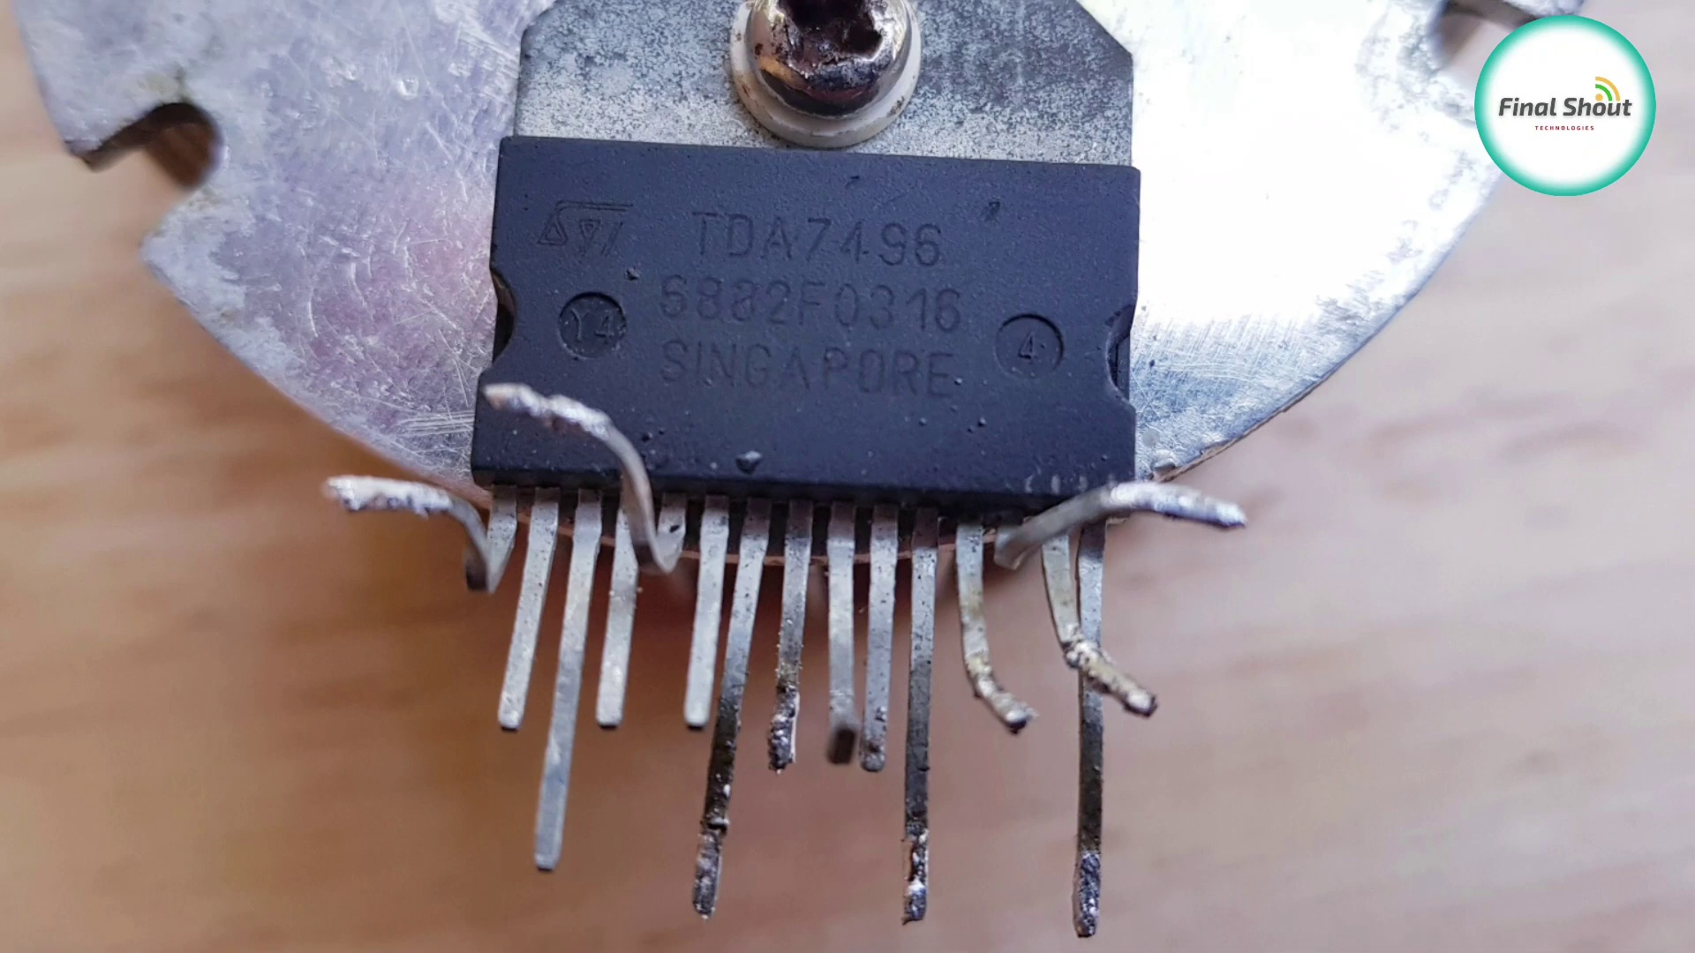 (score 95.0000)
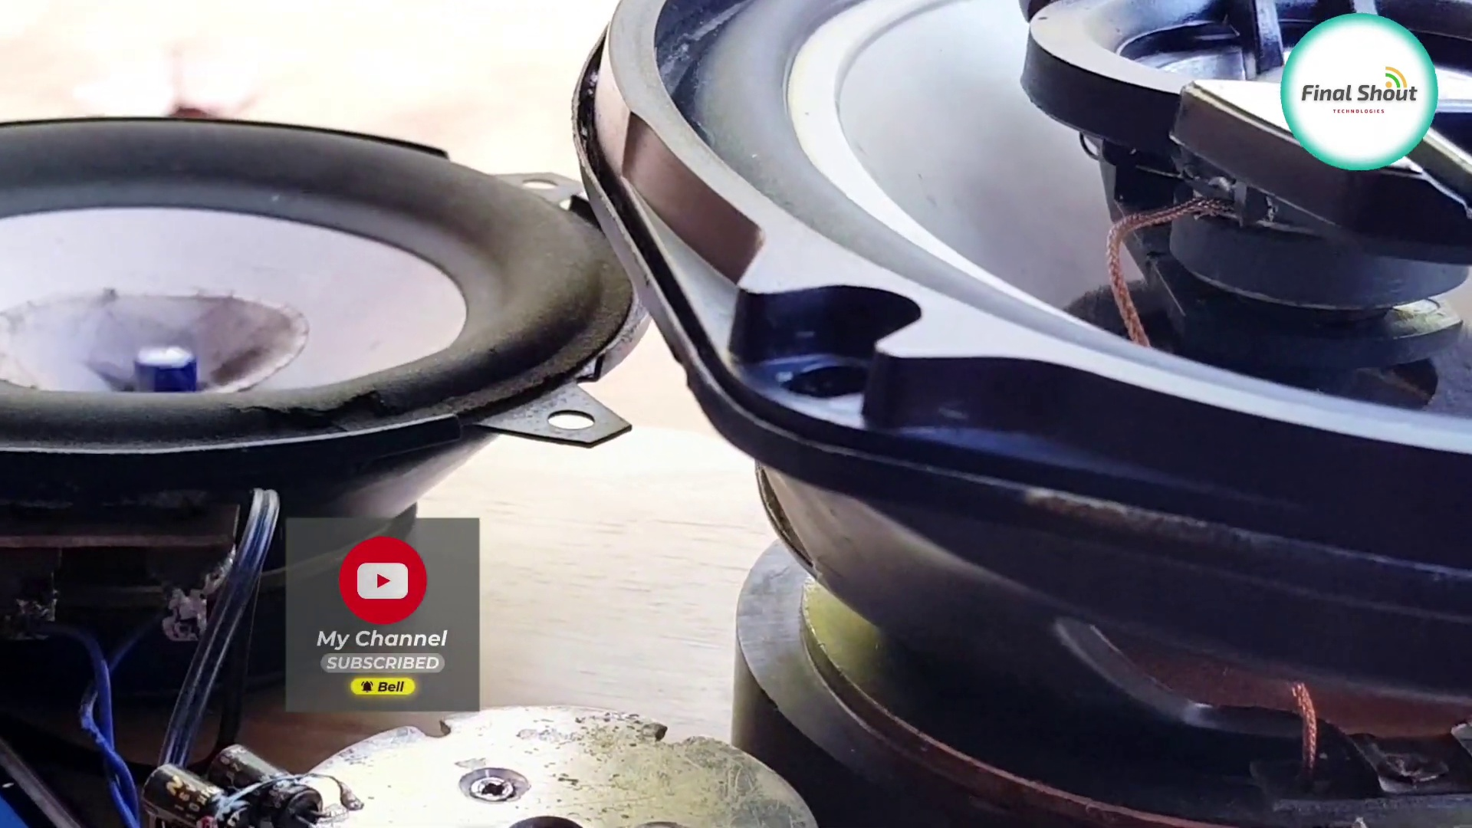 (score 90.0000)
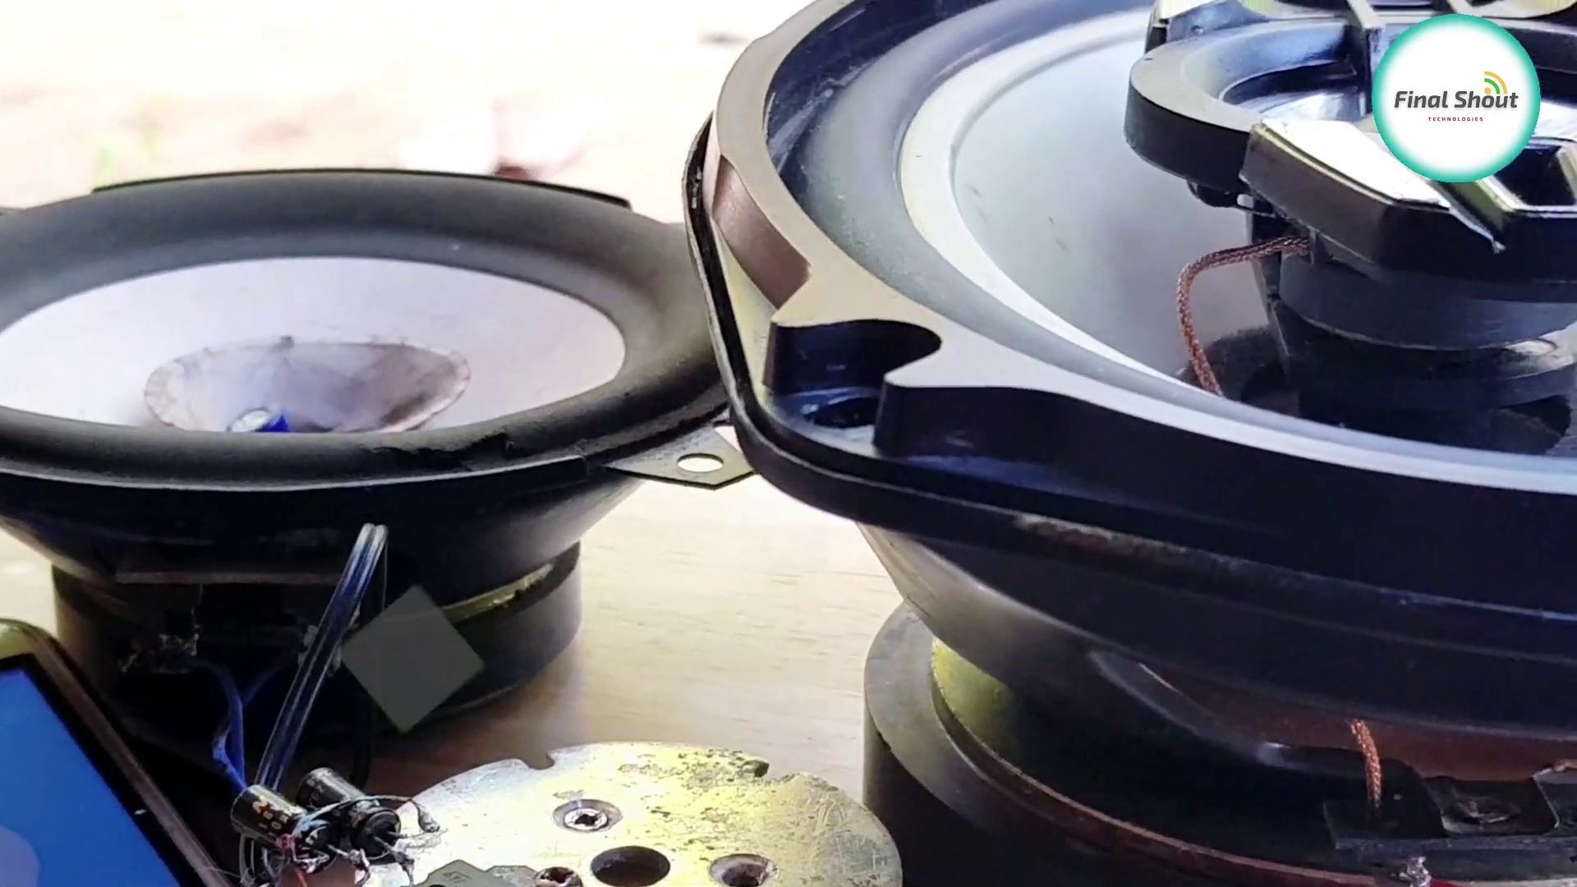 (score 90.0000)
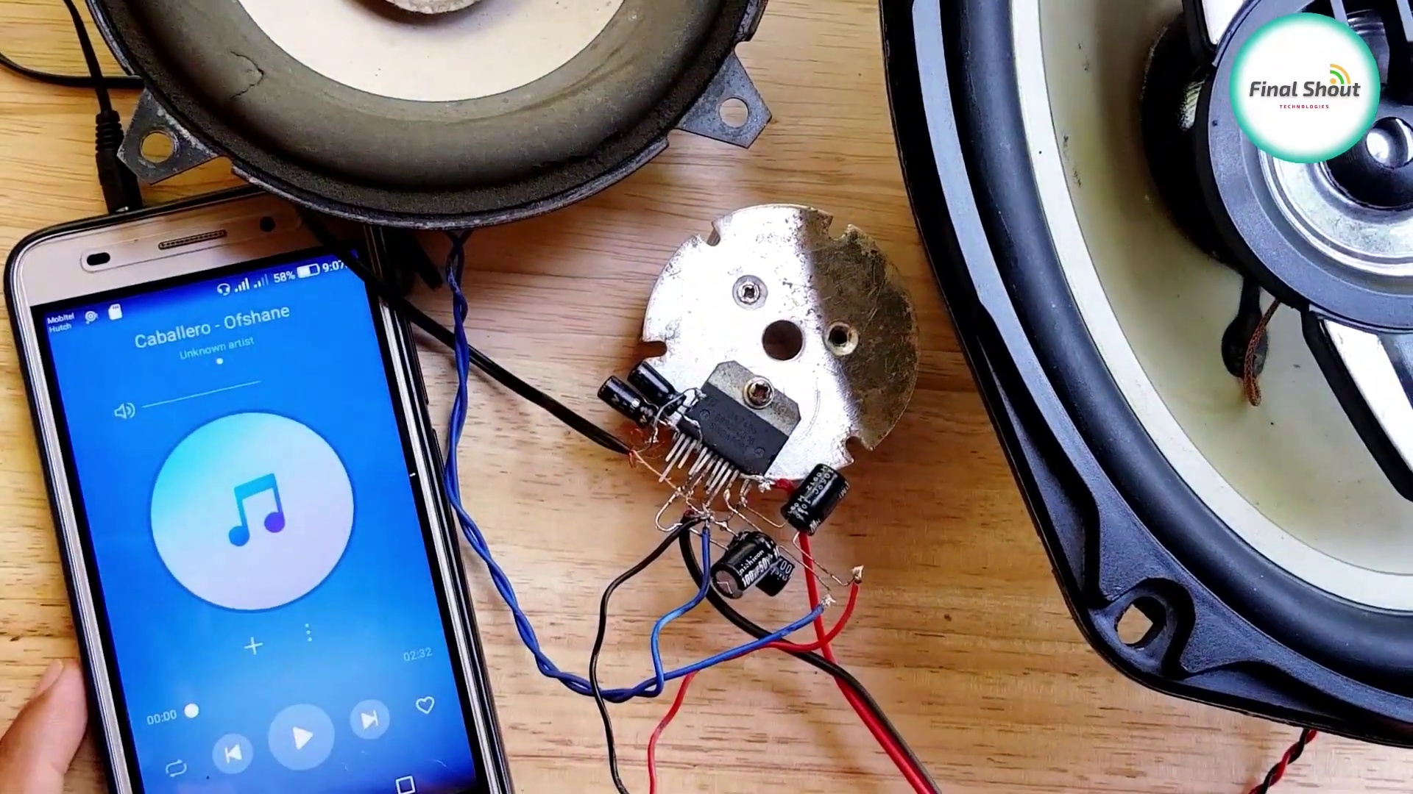 (score 90.0000)
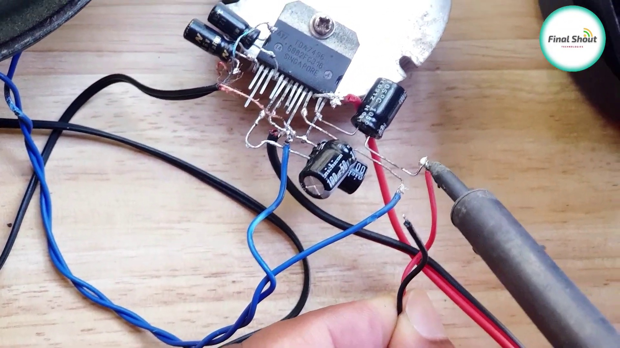 (score 90.0000)
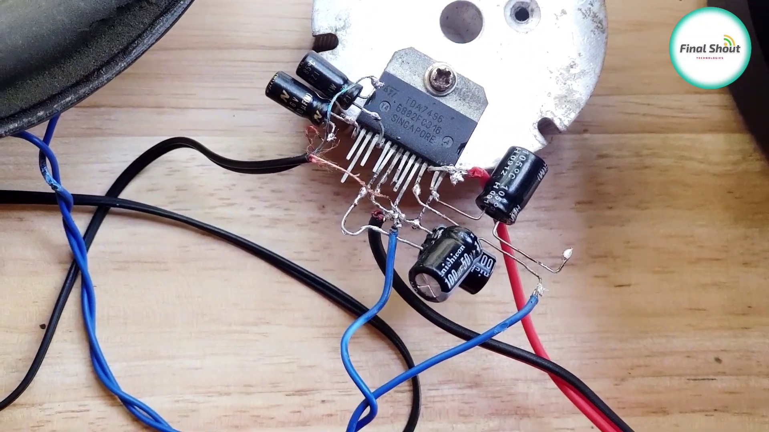 (score 90.0000)
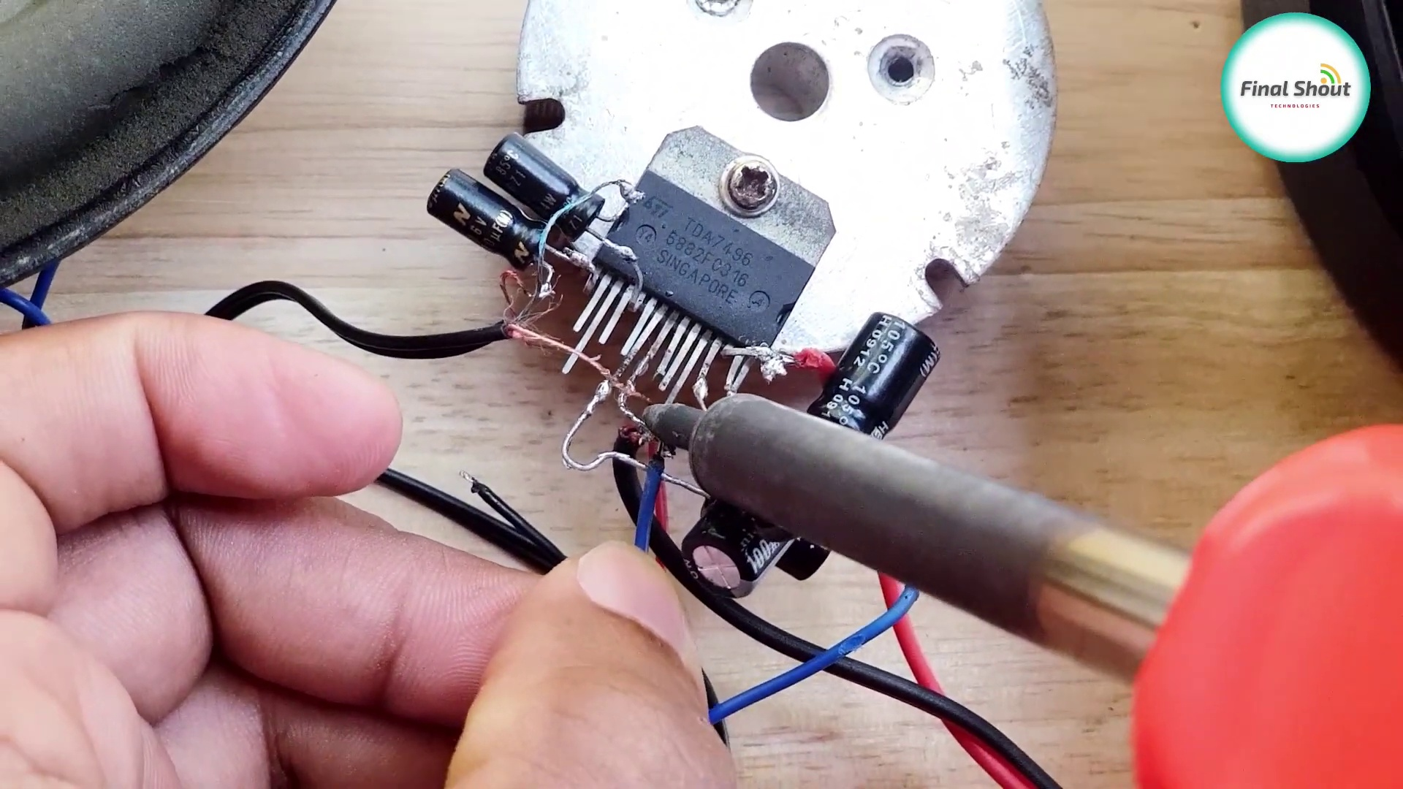 (score 90.0000)
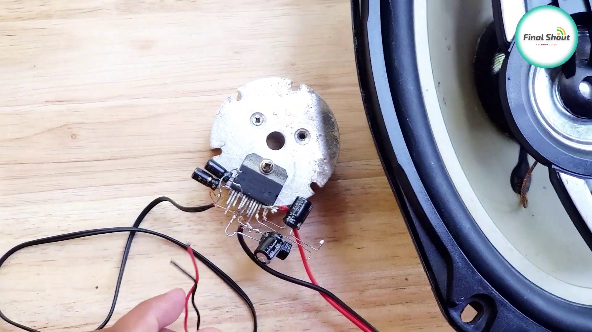 (score 90.0000)
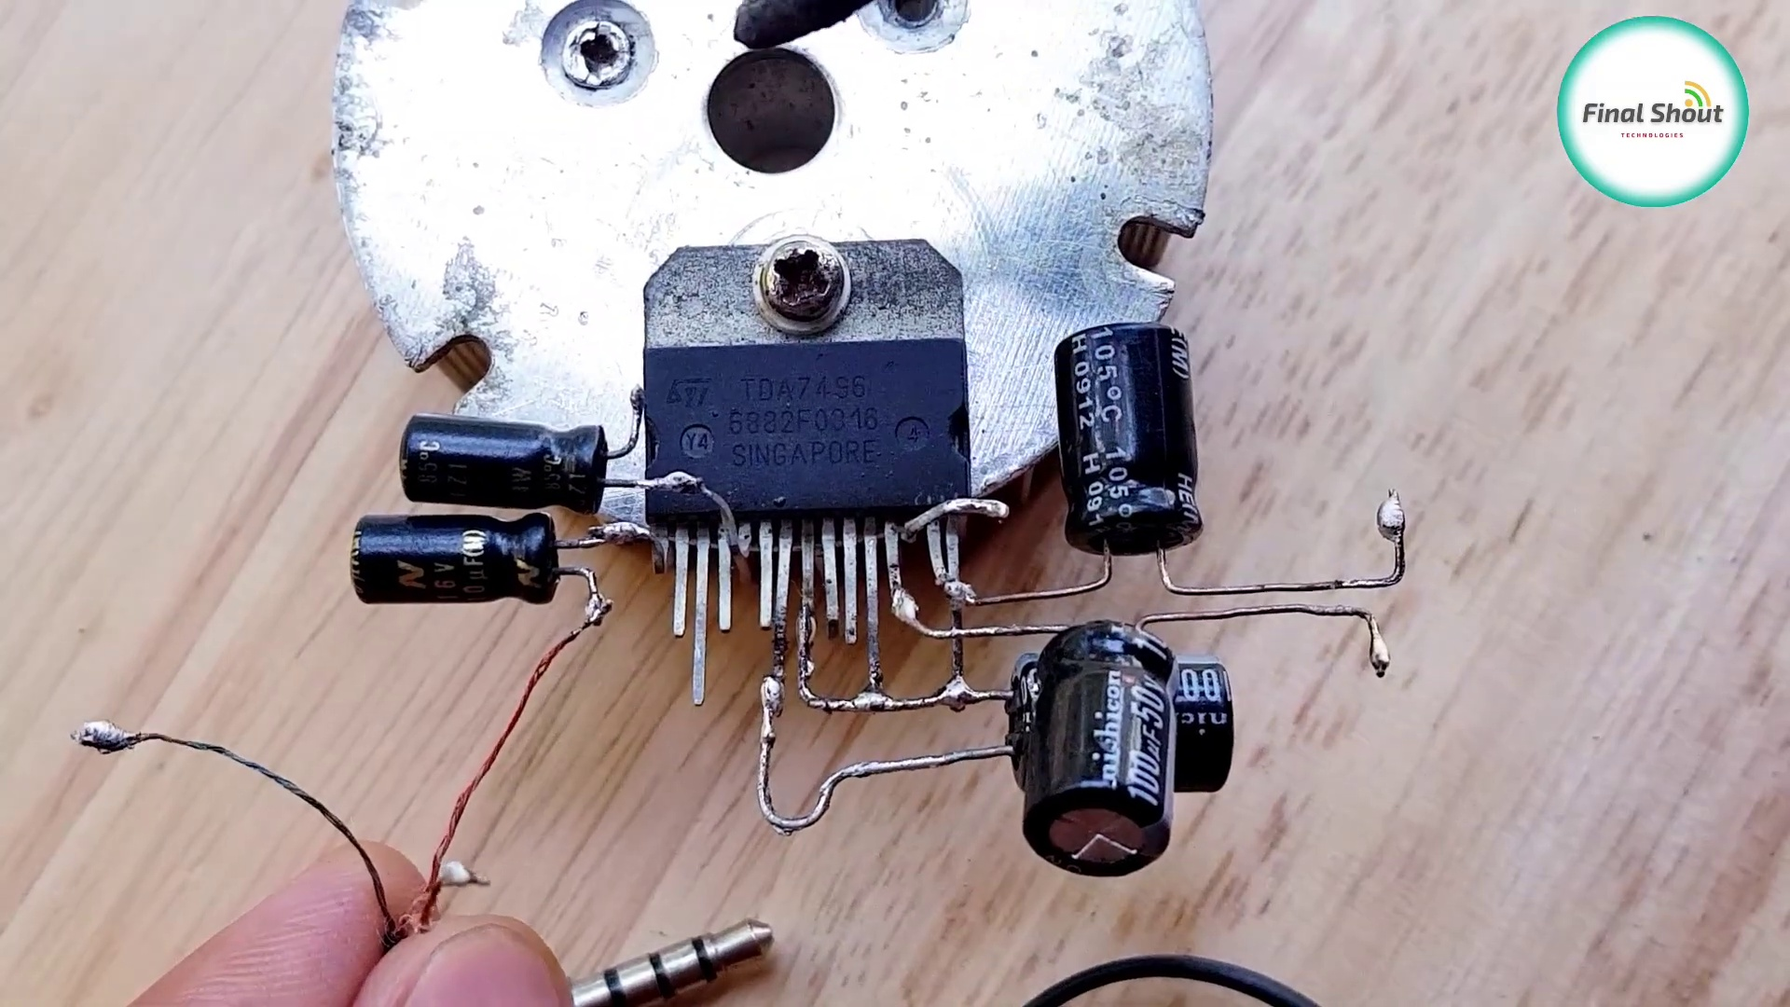 (score 90.0000)
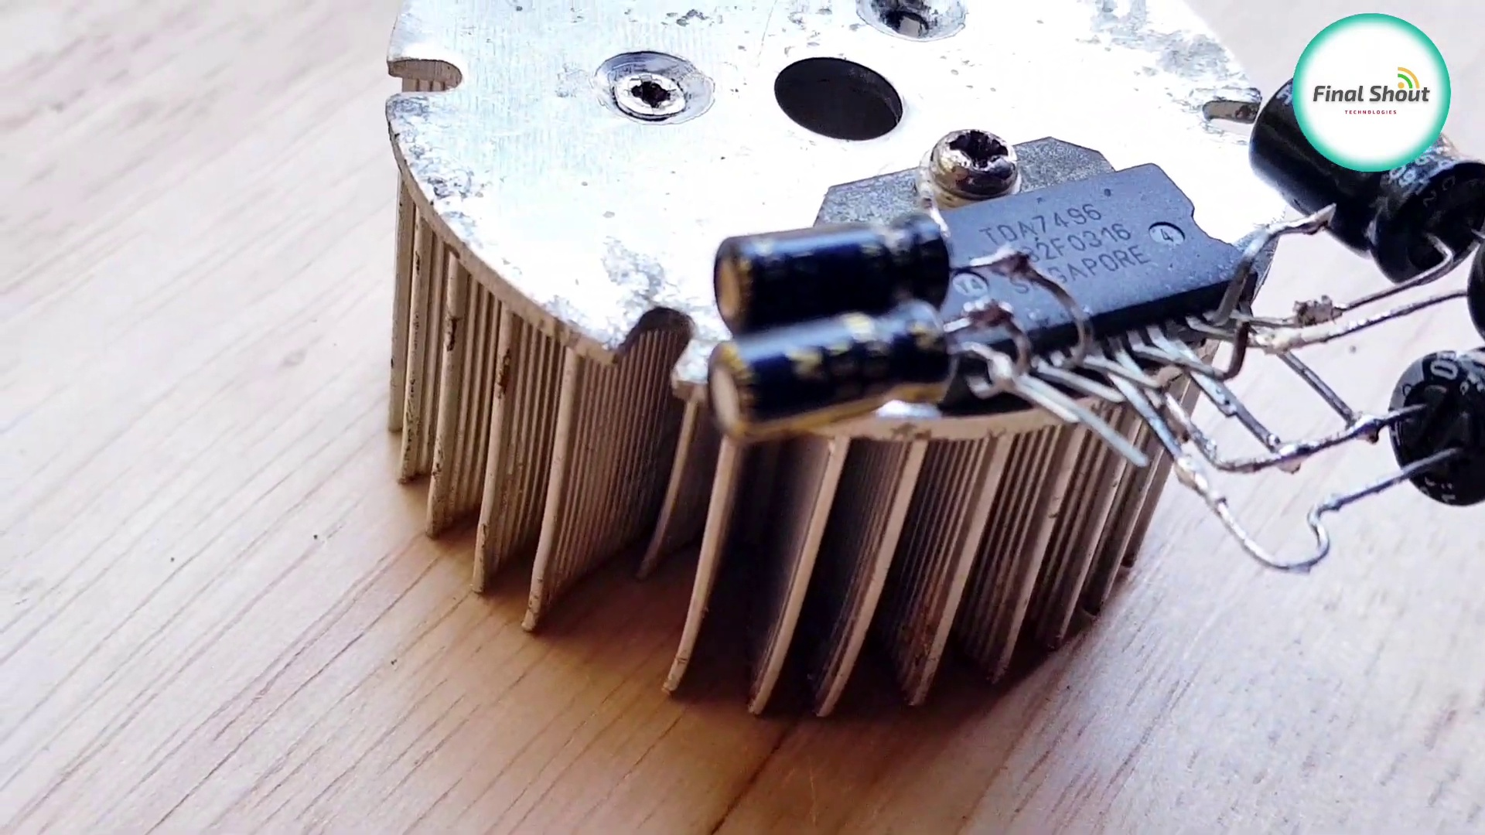 (score 90.0000)
Least correlated frames:
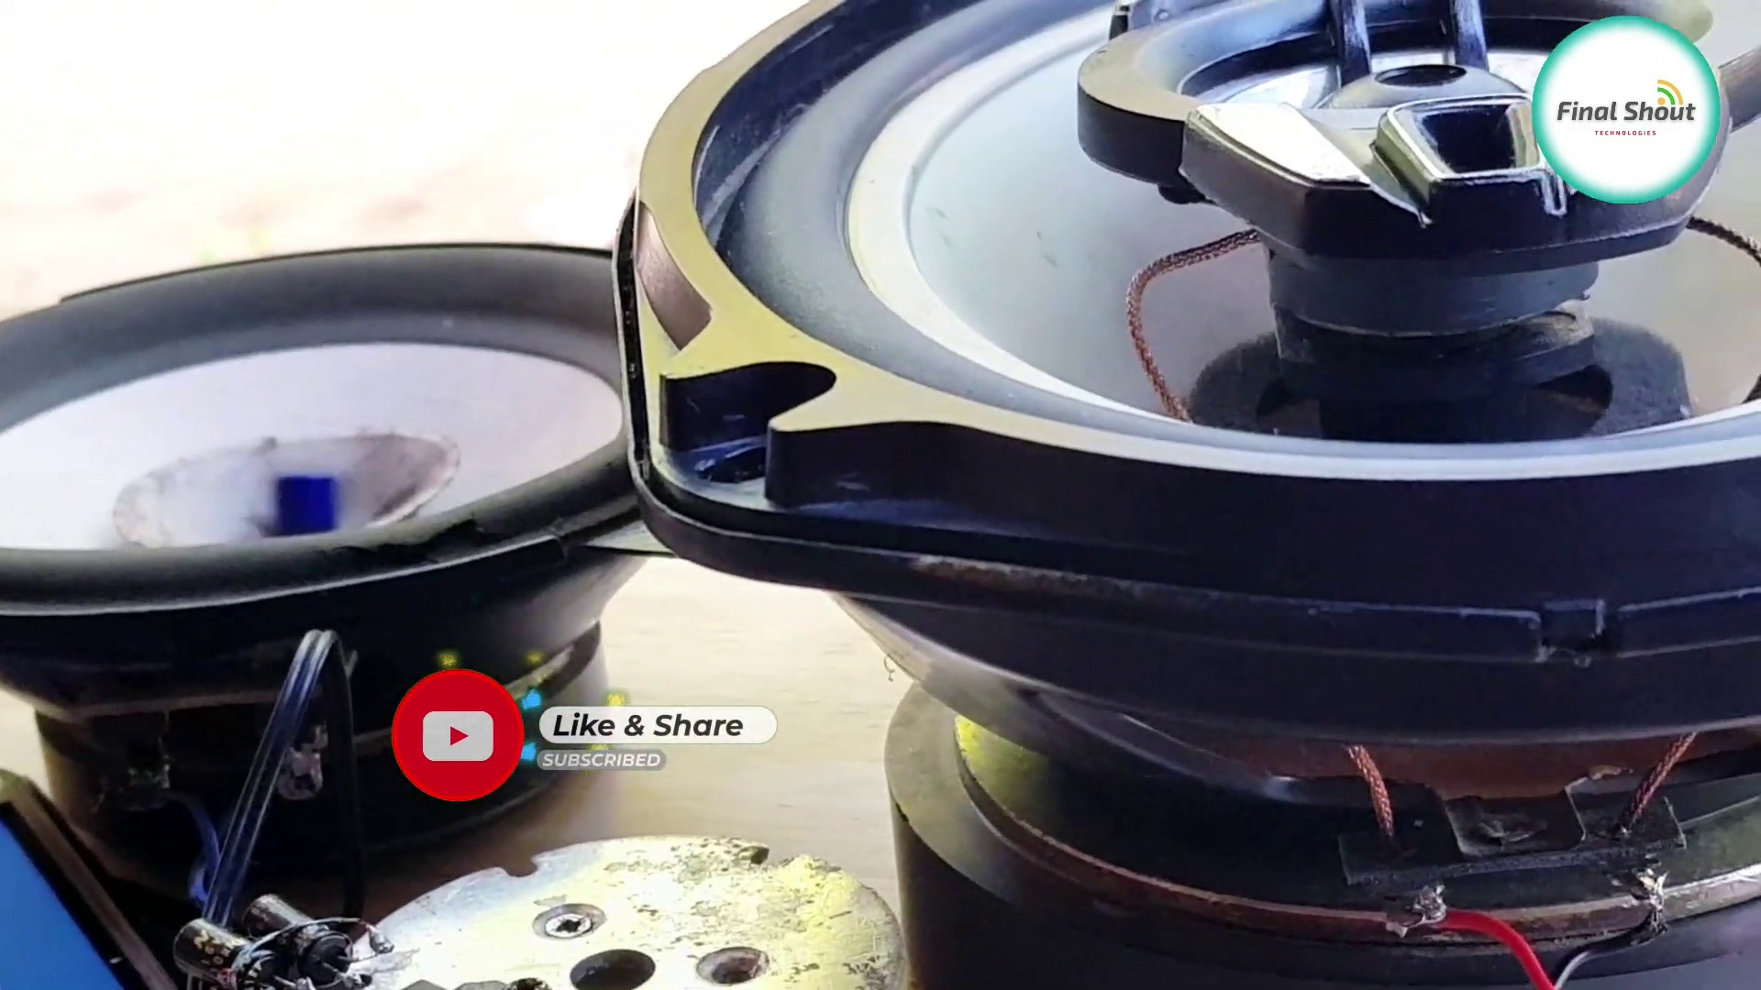 (score 5.0000)
 (score 10.0000)
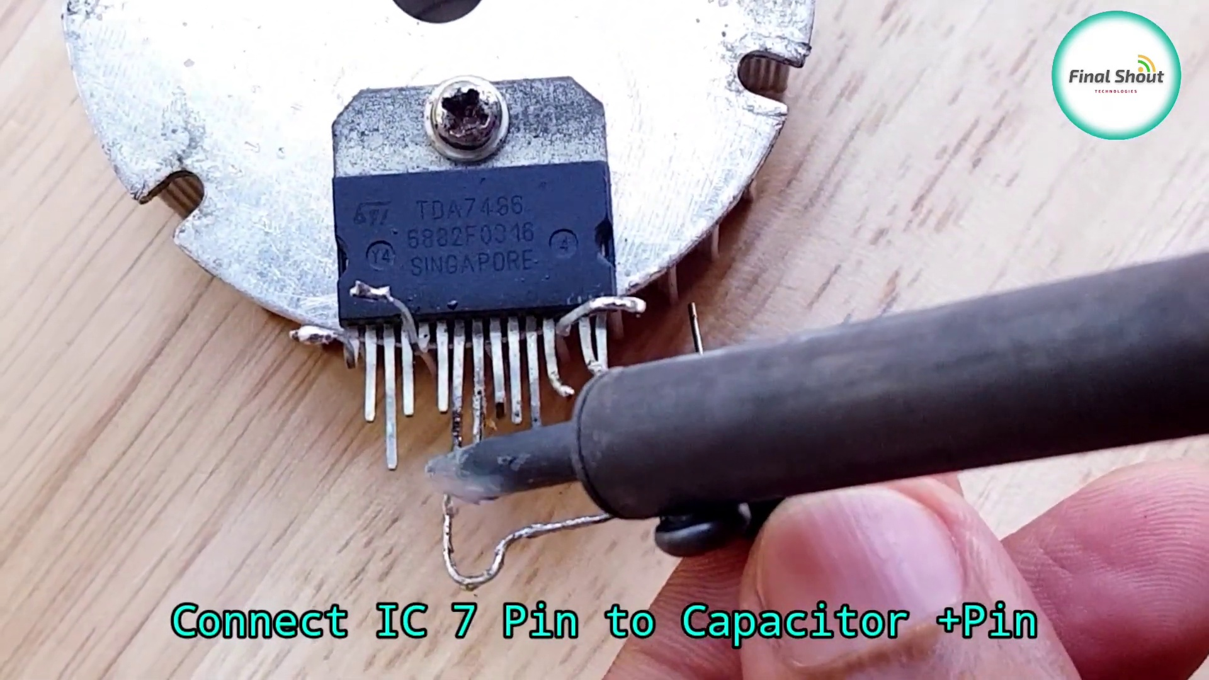 (score 20.0000)
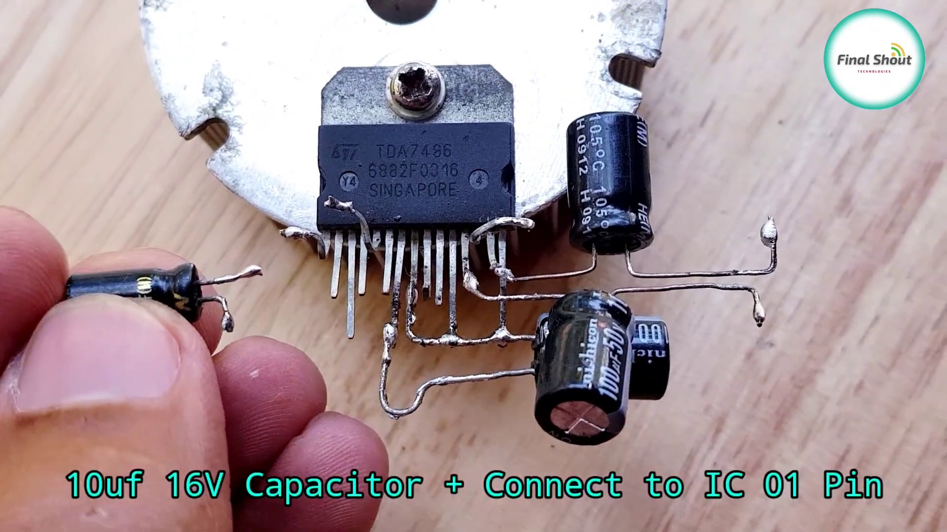 (score 20.0000)
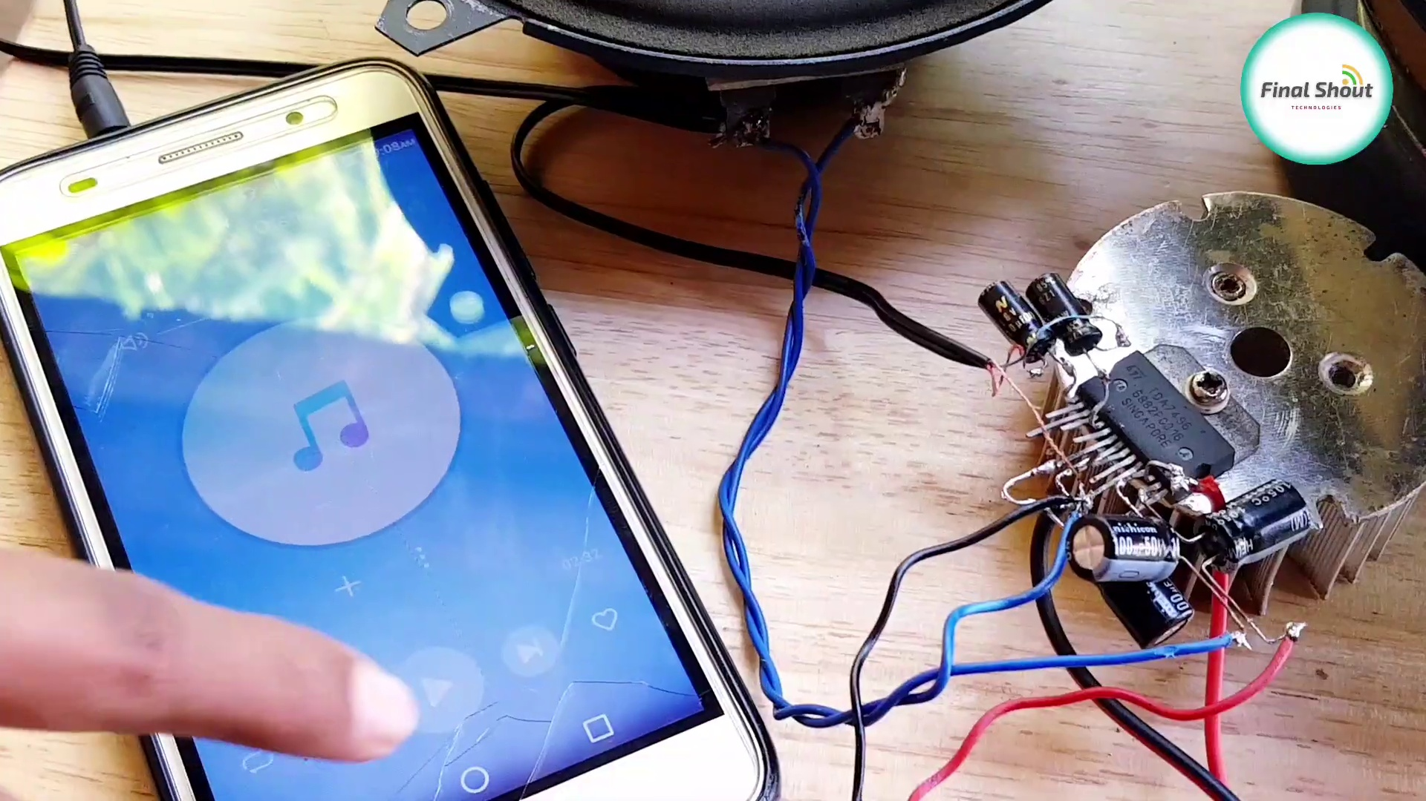 (score 20.0000)
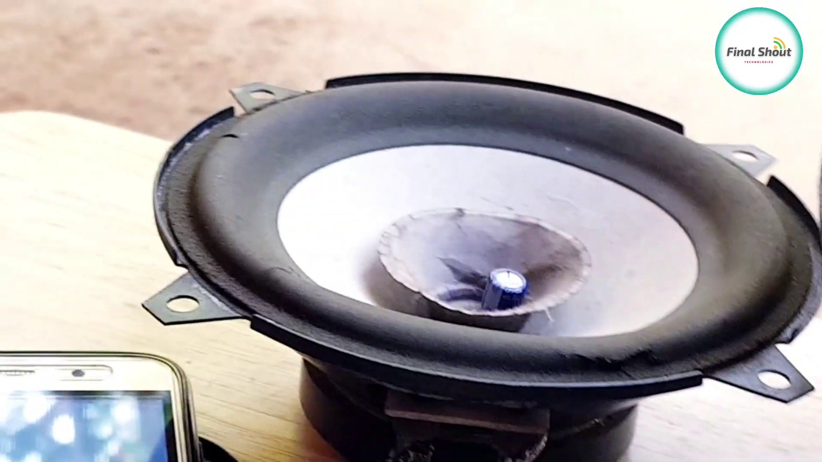 (score 20.0000)
 (score 20.0000)
 (score 20.0000)
 (score 20.0000)
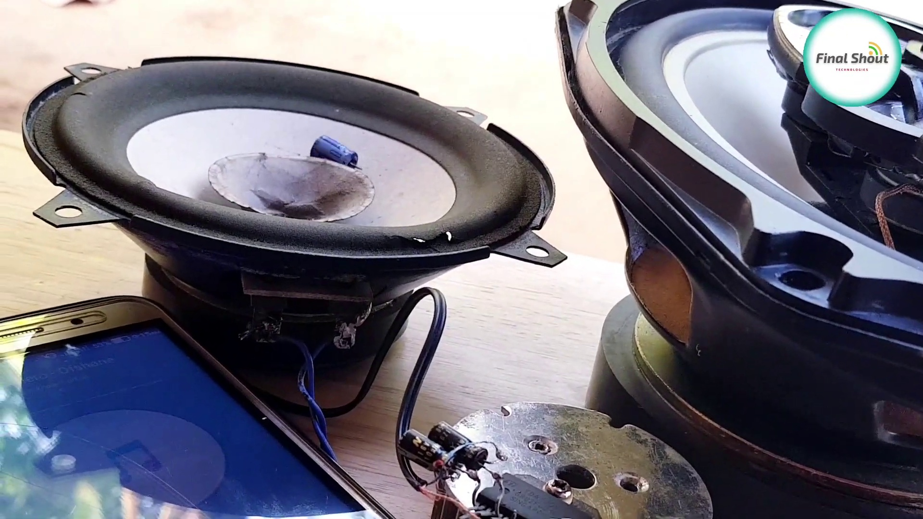 (score 70.0000)

Frame: frame_0000.jpg
Caption: The image showcases an electronic component, specifically a TDA7496 Singapore-made audio amplifier chip with a black and silver casing. The chip is affixed to a metal surface and characterized by a series of pins, some of which are connected to each other, forming a complex network. The text "TDA7496 Singapore" is prominently displayed on the chip, indicating its origin and possibly its specifications. The component appears to be placed on a surface during a process of assembly or repair, likely in an indoor setting with a wooden floor and what looks like a kitchen counter or table leg in the background.
Comment (score 95): Demonstrates the TDA7496 amplifier with multiple soldering points.Limited explanation; not beginner-friendly.Still a useful reference for the final project.
Reason: The comment directly discusses the same technical steps (soldering points) and objects (TDA7496 amplifier) described in the caption.
Source: https://www.youtube.com/watch?v=PfFkm0Kgkn0: DIY Powerful Ultra Bass Amplifier, TDA7496

Frame: frame_0001.jpg
Caption: The image presents a detailed view of an electronic device, specifically a circuit board or integrated circuit chipset. The board features various components, including a black square chip marked with the text "TDA7496" and "588203016." A white wire is connected to the chip, while a yellow wire is attached to the white wire. The board has a metallic appearance, with visible pins and contacts on its surface.
On the left side of the image, a label displays text, including "8716," "32," and "SINGAPORE." This suggests that the device may be related to or manufactured in Singapore. To the right, there are metallic connectors attached to the circuit board, showcasing its complex network of electronic circuits.
The overall style of the image appears to be used in an educational context to demonstrate electronics or computer hardware components, focusing on the technical aspect of the device rather than any human activity or teaching context. The pink background adds a contrasting element to the scene, highlighting the intricate details of the circuit board.
Comment (score 80): Demonstrates the TDA7496 amplifier with multiple soldering points.Limited explanation; not beginner-friendly.Still a useful reference for the final project.
Reason: The comment directly discusses the same technical aspect of the circuit board (TDA7496 amplifier with soldering points), which is described in the caption. The correlation score is 80 because while the comment doesn't explicitly mention all the details from the caption, it does focus on a specific component and its relevance to the educational context.
Source: https://www.youtube.com/watch?v=PfFkm0Kgkn0: DIY Powerful Ultra Bass Amplifier, TDA7496

Frame: frame_0002.jpg
Caption: The image presents a striking digital presentation screen with a colorful and abstract design. At the center of the image is a circular pattern with a gradient of colors transitioning from blue to green, punctuated by three concentric circles - an outermost circle in stark black, a middle one in vibrant purple, and an innermost one in striking green.
Inside this circular pattern, there's a darker circle that contains additional patterns in shades of purple, blue, and white. The central element within the circle is a stylized text that reads "Best Marketing Ideas" (with a possible mention of TED Talks above), drawing the viewer's attention immediately to the message it conveys.
The background of the image is a solid black, providing a stark contrast to the colorful foreground, which serves to highlight the central design and text, making them the focal point of the image.
No strongly correlated comments found for this frame.

Frame: frame_0003.jpg
Caption: The image shows an electronic component with multiple pins sticking out of it, which appears to be a surface-mount technology (SMT) chip or integrated circuit (IC). On one side of the IC, there's a visible text that reads "16831053," which is likely the part number. There are also some electronic components with pins attached to them next to the IC, possibly for soldering purposes.
In the foreground, a TDA7496S microprocessor is held in a hand, its silver body contrasting with the black wires that connect it. The device is affixed to a piece of paper, the text "TDA7496S Singapore" prominently displayed on it. This suggests that the microprocessor is from Singapore, indicating its origin or the country where it is manufactured.
The overall scene paints a picture of a device in the process of being assembled or disassembled, with both the IC and the TDA7496S microprocessor serving as central components. The focus on these electronic components and the arrangement suggest that someone is either preparing to assemble a circuit or inspecting an existing setup.
Comment (score 90): Demonstrates the TDA7496 amplifier with multiple soldering points.Limited explanation; not beginner-friendly.Still a useful reference for the final project.
Reason: The comment directly discusses the same technical steps (soldering) and objects (TDA7496 amplifier) described in the caption, which is a strong correlation.
Source: https://www.youtube.com/watch?v=PfFkm0Kgkn0: DIY Powerful Ultra Bass Amplifier, TDA7496

Frame: frame_0004.jpg
Caption: The image shows a small electronic device, specifically a TDA7496 Integrated Circuit (IC), being held by a person with their hand close to the camera lens, making the object appear larger. The IC is positioned so that both sides are visible, showcasing its details. On the back of the IC, the text "TDA7496 IC" and the number "6882F0316", which could be a part number or a serial number, are clearly visible.
The device appears to be some kind of circuit board or electronic component, possibly a chip, with visible text on its surface. However, due to the close-up nature of the image, this text is too small and blurry to read clearly. In the lower left corner, there is a watermark with the text "TD7680 CG", which seems to be a code or reference number related to the image or object.
The background is out of focus, suggesting that the emphasis is on the device in the foreground. The overall scene implies that the person is either admiring or examining the TDA7496 IC. The image style suggests it might be from an educational context, possibly teaching about electronics or engineering.
Comment (score 80): Demonstrates the TDA7496 amplifier with multiple soldering points.Limited explanation; not beginner-friendly.Still a useful reference for the final project.
Reason: The comment directly references the TDA7496 amplifier and mentions soldering points, which are technical steps related to the object (TDA7496 IC) described in the caption. The comment also provides specific information about the amplifier, making it strongly connected to the caption.
Source: https://www.youtube.com/watch?v=PfFkm0Kgkn0: DIY Powerful Ultra Bass Amplifier, TDA7496

Frame: frame_0005.jpg
Caption: This image displays two electronic components, an LR (likely referring to a type of resistor or capacitor) and a microcontroller. The LR component appears to be some sort of transformer or inductor with multiple layers, featuring a coil, pins, and other parts labeled on it. A silver metal part is attached to one end of the component. In contrast, the microcontroller is a TDA9886, specifically a 68-pin integrated circuit housed in a small, black box. The microcontroller faces towards the right side of the image and has labels indicating its functionality as a sound input device, with "Sound in L+ Pin" and "Sound in L- Pin". Additionally, it has specifications listed, including an output power of 100V, voltage rating of 12V, and current rating of 500mA. The microcontroller is positioned on a white surface, providing a clean background for the image. There are no visible texts or people providing educational context within this frame.
Comment (score 80): Demonstrates the TDA7496 amplifier with multiple soldering points.Limited explanation; not beginner-friendly.Still a useful reference for the final project.
Reason: The comment directly discusses the TDA9886 microcontroller mentioned in the caption, specifically its use as an amplifier with soldering points.
Source: https://www.youtube.com/watch?v=PfFkm0Kgkn0: DIY Powerful Ultra Bass Amplifier, TDA7496

Frame: frame_0006.jpg
Caption: The image captures a close-up view of a round metal disc with three circular holes evenly spaced around its circumference, each approximately 2.5 cm in diameter. The disc is silver in color and rests on a wooden surface. The focus appears to be on demonstrating the use of this disc and possibly another object present in the workshop or workbench setup. To the left of the disc, there is an instrument with two circular blades and a small shaft attached to one of its ends, which has a metallic finish and resembles a tool for sanding or some form of mechanical action. The background suggests that this is taking place in a workshop or workbench setting, with no person visible in the frame provided. The relative position of the disc to the wooden surface is central, with the disc positioned above the surface.
Comment (score 80): Demonstrates the TDA7496 amplifier with multiple soldering points.Limited explanation; not beginner-friendly.Still a useful reference for the final project.
Reason: The comment mentions specific technical details (TDA7496 amplifier and soldering points) that match the objects and settings described in the caption (the round metal disc with circular holes), indicating a strong connection.
Source: https://www.youtube.com/watch?v=PfFkm0Kgkn0: DIY Powerful Ultra Bass Amplifier, TDA7496

Frame: frame_0007.jpg
Caption: The image shows a close-up of a person's hand holding a small electronic component, which appears to be a microprocessor or integrated circuit (IC) chip mounted on a small piece of wood or plastic. The chip is silver in color and is slightly bent, suggesting that it has been manipulated or used in some way. The visible parts of the device include a motor, wires, a small metal plate with holes, and what looks like the microcontroller chip itself.
The person's hand is holding the object in such a way that the bottom part is facing towards us, which obscures the backside of the device. There is no visible text or branding on the object itself. The background is minimalistic, with a plain surface and what seems to be a table leg partially visible at the bottom right corner of the image.
In the top left corner, there's a watermark-like symbol that appears to be a logo or emblem for "Instagram," suggesting that this might have been taken from an Instagram post or story. The image is not a slide with any text, diagrams, or equations visible on it. The style of the image is candid and seems to be captured during an informal process rather than a formal teaching context.
The overall scene suggests that the person is either tinkering with or showcasing the chip.
Comment (score 90): Demonstrates the TDA7496 amplifier with multiple soldering points.Limited explanation; not beginner-friendly.Still a useful reference for the final project.
Reason: The comment directly discusses the technical steps and objects described in the caption, specifically mentioning the amplifier (TDA7496) and soldering points, which are related to the microprocessor chip shown in the image.
Source: https://www.youtube.com/watch?v=PfFkm0Kgkn0: DIY Powerful Ultra Bass Amplifier, TDA7496

Frame: frame_0008.jpg
Caption: The image captures a moment of hands-on activity where someone is carefully working with small components and a tool that appears to be a manual hand drill or similar device. The person seems to be meticulously handling the equipment, possibly in the process of creating a hole or modifying an object made of metal. The scene takes place on a wooden surface, suggesting it might be part of a table or similar object.
The image also contains text in two languages: English and Arabic. The English text reads "Live on YouTube" with a website address, indicating that this moment is being streamed live on YouTube for an audience to watch. This suggests that the setting may be educational, as the person could be demonstrating how to use or operate a hand drill.
In the top right corner of the image, there's a small banner that reads "Like & Share Subscribe", likely inviting viewers to like, share, and subscribe to a channel or platform. The overall scene implies a moment of learning or exploration, with the person possibly in the process of assembling or repairing an electronic component.
Comment (score 85): Demonstrates the TDA7496 amplifier with multiple soldering points.Limited explanation; not beginner-friendly.Still a useful reference for the final project.
Reason: The comment directly discusses the TDA7496 amplifier, which matches the technical topic described in the caption. The mention of soldering points and a reference for a final project also correlates with the manual hand drill activity and metal object modification mentioned in the caption.
Source: https://www.youtube.com/watch?v=PfFkm0Kgkn0: DIY Powerful Ultra Bass Amplifier, TDA7496

Frame: frame_0009.jpg
Caption: The image captures a moment of a person holding an electric razor with its blades exposed. The razor appears to be in the process of being assembled or repaired, as indicated by the metal components and the wire sticking out from one end. The person is holding the razor on a plain, light-colored surface, possibly a table or desk, which provides no additional context.
Overlaying the image is a red logo with a white YouTube icon on the left side, suggesting that the image may have been taken from a video that was posted on YouTube.
In a separate moment captured in the same image, we also see a person holding a small metal disc on a wooden table. The disc is adorned with a small hole in its center, which is secured by a black screw and cap. The person wearing a white shirt is holding the disc, adding a contrasting touch to the dark background of the image.
In the bottom right corner of the image, there's a small white square with a red "SUBSCRIBE" button, indicating that this might be part of a video or blog post. Additionally, the text "Final Shot" is visible, suggesting that this could be the final frame of a video or blog post.
Overall, the image seems to be a still from a video or blog post, showcasing two distinct objects and actions. The person's actions in each scene suggest that they might be demonstrating or explaining something about the objects.
Comment (score 80): Demonstrates the TDA7496 amplifier with multiple soldering points.Limited explanation; not beginner-friendly.Still a useful reference for the final project.
Reason: The comment directly discusses the technical steps and object (TDA7496 amplifier) described in the caption, specifically mentioning soldering points.
Source: https://www.youtube.com/watch?v=PfFkm0Kgkn0: DIY Powerful Ultra Bass Amplifier, TDA7496

Frame: frame_0010.jpg
Caption: The image shows a close-up view of a person's hand holding an object with a small wheel or rotor in the center and several spokes around it. The object appears to be attached to a larger device, which could be part of a mechanical system or machinery. The background is out of focus, but it seems to be an indoor setting with a smooth surface that might be made of wood.
In more detail, the person is working on this mechanical device, which is a small, circular object with a silver color and a black inner structure. They are holding a small silver screwdriver, using it to pry open the device. The screwdriver is inserted into the device, and it appears as if they are trying to remove a small black object from inside the device.
The device is placed on a wooden surface, indicating that it might be part of a workshop or a DIY project. The person's hands are visible in the image, suggesting that they are actively engaged in the task of working on the device.
In the background, there is a video player with a red button labeled "Like". This could suggest that the person is sharing their progress on a social media platform, or they might be watching a tutorial or a review of the device they are working on. The overall scene suggests a moment of focused work and learning, as the person is trying to understand and repair the mechanical device.
Comment (score 80): Demonstrates the TDA7496 amplifier with multiple soldering points.Limited explanation; not beginner-friendly.Still a useful reference for the final project.
Reason: The comment directly discusses the same technical steps (soldering points) and objects (amplifier) described in the caption, providing a specific reference for the device being worked on.
Source: https://www.youtube.com/watch?v=PfFkm0Kgkn0: DIY Powerful Ultra Bass Amplifier, TDA7496

Frame: frame_0011.jpg
Caption: The image shows an object that appears to be a mechanical device with various components, including a metal housing with protrusions and holes. This suggests it might be part of a larger machine or a component designed for assembly. A visible screw in the center of the device indicates that this could be a part that needs to be securely attached to another component. The background is blurred but seems to be an indoor setting, possibly on a table or countertop.
Upon closer inspection, the image reveals a silver metal disc resting on a wooden surface. The disc features six holes, each holding a silver screw with visible heads, suggesting it may be in a state of disassembly or repair. The contrast between the metallic sheen of the disc and the wooden surface draws attention to its intricate details.
In the bottom right corner of the image, there is a small text that reads "Final Shot", which could potentially refer to the final stage of the disc's assembly or repair process. The overall image composition implies a moment of pause in the disc's journey, possibly awaiting its next turn in the assembly line or waiting for its next task.
Comment (score 80): Demonstrates the TDA7496 amplifier with multiple soldering points.Limited explanation; not beginner-friendly.Still a useful reference for the final project.
Reason: The comment directly discusses the TDA7496 amplifier, which is mentioned in the caption as a mechanical device with various components. The mention of soldering points and the fact that it's not beginner-friendly also match the description of the device being disassembled or repaired, which aligns with the 'Final Shot' caption.
Source: https://www.youtube.com/watch?v=PfFkm0Kgkn0: DIY Powerful Ultra Bass Amplifier, TDA7496

Frame: frame_0012.jpg
Caption: The image shows a person's hand holding an electronic device with various pins and connectors, featuring a small, circular metallic object. The device has a black plate at its center, where the pins are arranged in a pattern suggesting they form part of a circuit. The person's hand is positioned over the center of the device, with fingers spread apart as if ready to touch the pins, which rest on a wooden surface that contrasts with the metallic color of the device.
In the background, there is a blurred video displayed on a screen, likely being shown on a video platform, as indicated by the YouTube logo at the bottom right corner. A small blue and white sign reading "Like & Share" also appears in the background, which may suggest that this image is part of a social media post or video.
The focus remains on the electronic component and the process of inspecting or handling it, with no visible text providing additional context or information about the devices or the person's actions.
Comment (score 80): Demonstrates the TDA7496 amplifier with multiple soldering points.Limited explanation; not beginner-friendly.Still a useful reference for the final project.
Reason: The comment directly discusses the same technical steps (soldering points) and objects (TDA7496 amplifier) described in the caption, which indicates a strong correlation.
Source: https://www.youtube.com/watch?v=PfFkm0Kgkn0: DIY Powerful Ultra Bass Amplifier, TDA7496

Frame: frame_0013.jpg
Caption: The image shows a person holding a piece of electronic equipment with the model number 472486 on a white background. The equipment is a rectangular object with 36 pins and appears to be some kind of sensor or transducer based on its shape and the connections it has. The device is connected to a circuit board, with components such as resistors and integrated circuits visible. The person's hand is holding the equipment firmly, suggesting the object is of importance or interest to them. This setting suggests a professional or technical context, possibly related to electronics, engineering, or physics, given the nature of the device and the equipment model number. The focus appears to be on teaching about sensors, transducers, or circuitry, but without additional context or visible text, it's not possible to determine the exact teaching topic or the slide being referenced.
Comment (score 80): Demonstrates the TDA7496 amplifier with multiple soldering points.Limited explanation; not beginner-friendly.Still a useful reference for the final project.
Reason: The comment directly discusses the TDA7496 amplifier, which is a technical aspect of electronics mentioned in the caption. The comment also mentions soldering points and circuitry, which are related to the equipment shown in the caption.
Source: https://www.youtube.com/watch?v=PfFkm0Kgkn0: DIY Powerful Ultra Bass Amplifier, TDA7496

Frame: frame_0014.jpg
Caption: This image appears to show a person holding up a small silver object, possibly a motor or a similar component. The object is held by a visible hand, which is located in the lower left corner of the image. The background is blurred, focusing attention on the object.
The object itself is a small round silver disc with a hole in the center, encased in a white plastic housing that is firmly attached to the disc. A red button on the side of the housing is currently pressed.
In the top left corner, a smartphone is displayed with a YouTube video playing on the screen, which appears to be from a platform like YouTube where one can learn about electronics or DIY projects. The phone screen displays an app interface, and in the bottom right corner, there's a social media post with a blue and white checkmark icon indicating verification or approval status within the app. A text bubble reads "channel" and "like," common elements in many video-sharing platforms where users can like or subscribe to content.
The electronic component being demonstrated is attached to a small circuit board with a series of components, including a central integrated circuit (IC), resistors, and possibly a connector or switch on the right side.
Comment (score 80): Demonstrates the TDA7496 amplifier with multiple soldering points.Limited explanation; not beginner-friendly.Still a useful reference for the final project.
Reason: The comment directly discusses the technical steps and objects described in the caption, specifically mentioning the TDA7496 amplifier, soldering points, and circuit components. The mention of the final project also connects to the setting and goals discussed in the caption.
Source: https://www.youtube.com/watch?v=PfFkm0Kgkn0: DIY Powerful Ultra Bass Amplifier, TDA7496

Frame: frame_0015.jpg
Caption: The image shows a close-up view of a wooden table, where a small metal object with multiple holes is being examined. The object resembles a hair clip or a paperclip with its spring mechanism exposed, and a person's hand is holding it close to a microscope lens. A white cloth covers the table, providing a stark contrast to the surroundings. In the background, a black and silver electronic device is being assembled, consisting of circuits and wires that appear to be soldered together. The image taken from a low angle looks up at the device, giving it a sense of grandeur and importance. The final shot of the image is a black and white photo, adding a touch of nostalgia to the scene. The blurred background suggests an indoor setting with a table, indicating a laboratory or study environment.
Comment (score 85): Demonstrates the TDA7496 amplifier with multiple soldering points.Limited explanation; not beginner-friendly.Still a useful reference for the final project.
Reason: The comment directly mentions the TDA7496 amplifier and soldering points, which are also described in the frame caption. The mention of multiple soldering points matches the description of circuits and wires being soldered together in the background of the image.
Source: https://www.youtube.com/watch?v=PfFkm0Kgkn0: DIY Powerful Ultra Bass Amplifier, TDA7496

Frame: frame_0016.jpg
Caption: The image captures a close-up view of an electronics component being soldered to a circuit board. The soldering iron is in use, with the heat source pointed towards the component and a small amount of solder already applied. There are visible traces of solder around the component, indicating that it has been partially soldered into place. The device itself appears to be a small electronic device or circuit board, held in place by a black screw visible in the lower right corner of the image.
The device is a mix of silver and black, with a black stripe running along its top edge, labeled "ATD7469" and "Egg 689 000 15", suggesting it might be a part of a larger electronic assembly. The device sits on a white surface, providing a stark contrast to the black of the device and the screw. The background is blurred, drawing focus to the device and the screw.
The image is taken from a slightly elevated angle, adding depth and perspective to the scene. In the bottom right corner of the image, there's a small text that reads "Like & Share", possibly indicating that the image has been shared or liked on a social media platform. The overall image gives a sense of a moment frozen in time, capturing a small piece of technology in its raw form.
Comment (score 85): Demonstrates the TDA7496 amplifier with multiple soldering points.Limited explanation; not beginner-friendly.Still a useful reference for the final project.
Reason: The comment directly discusses the soldering process and references specific components mentioned in the caption (TDA7496 amplifier), indicating a strong connection between the two.
Source: https://www.youtube.com/watch?v=PfFkm0Kgkn0: DIY Powerful Ultra Bass Amplifier, TDA7496

Frame: frame_0017.jpg
Caption: The image presents a close-up view of a DIY electronics project in progress. At the center, a small circuit board with several electronic components attached, including a capacitor and resistors, is being worked on. A person's hand holds a soldering iron near the components on the board, possibly attaching or removing one from the circuit. To the right of the circuit board, a red screwdriver is inserted into the board, suggesting some form of repair or modification.
The circuit board itself has a black label with the text "TDZ2456" and a barcode, further indicating the product or part being worked on. The background of the image is blurred, focusing the viewer's attention on the circuit board and the soldering iron/screwdriver. In the foreground, several wires are connected to the components on the board, possibly indicating that they might be in the process of being assembled or tested.
The overall scene suggests an active repair or modification process, taking place in a domestic setting with a wooden surface and other indistinct items in the background. The image does not show any textbooks or slides that would indicate a teaching context, instead capturing a moment of someone working on an electronics project at home.
Comment (score 80): Demonstrates the TDA7496 amplifier with multiple soldering points.Limited explanation; not beginner-friendly.Still a useful reference for the final project.
Reason: The comment directly discusses the same technical steps (soldering points) and objects (amplifier) described in the caption.
Source: https://www.youtube.com/watch?v=PfFkm0Kgkn0: DIY Powerful Ultra Bass Amplifier, TDA7496

Frame: frame_0018.jpg
Caption: The image captures a close-up view of an object being worked on with a precision screwdriver, its bit gently manipulating a small electronic component. The object appears to have several electronic components attached, including what looks like an integrated circuit (IC) and possibly other types of connectors or terminals. In the bottom right corner of the image, there is a small clip showing a video with a caption that says "like" on it, which seems to be paused or displaying a single frame.
The focal point of the image is not the object being worked on but rather the precision screwdriver itself, highlighting its use in delicate electronic work. The image does not include any visible instruction or educational content related to the device or process depicted, instead focusing primarily on the action of using the screwdriver.
In the background, the image appears to be set against a neutral surface, possibly a table or workbench, which serves as a backdrop for the main objects of interest. The overall image gives off a sense of precision and delicacy in electronics repair or DIY projects, with the screwdriver and object being worked on serving as the main points of focus.
Comment (score 80): Demonstrates the TDA7496 amplifier with multiple soldering points.Limited explanation; not beginner-friendly.Still a useful reference for the final project.
Reason: The comment mentions soldering points and an amplifier (TDA7496), which are directly related to the precision screwdriver's use in electronics repair. Although not beginner-friendly, it shares a technical context with the caption.
Source: https://www.youtube.com/watch?v=PfFkm0Kgkn0: DIY Powerful Ultra Bass Amplifier, TDA7496

Frame: frame_0019.jpg
Caption: The image depicts a close-up of an electronic device with several pins and wires extending from it, situated on a wooden table. A tool with a silver head is being used to manipulate one of the pins, possibly for soldering or repair work. Traces of solder are visible on some of the pins, indicating that soldering work has recently been done or is in progress. The device appears to be undergoing modification or repair as evidenced by the presence of a person's arm holding a small tool, likely a screwdriver or similar precision instrument, in the background.
At the center of the image is a silver chip, mounted on a silver base held firmly in place by a black screw. The chip is connected to a wire, which is being manipulated by a small metal tool. The tool is positioned in a way that suggests it's making a connection between the chip and the wire. The background is blurred, drawing attention to the chip, the tool, and the device, emphasizing the focus on this repair or assembly task.
Comment (score 80): Demonstrates the TDA7496 amplifier with multiple soldering points.Limited explanation; not beginner-friendly.Still a useful reference for the final project.
Reason: The comment directly discusses the TDA7496 amplifier and soldering points mentioned in the caption, showing a strong correlation between the two.
Source: https://www.youtube.com/watch?v=PfFkm0Kgkn0: DIY Powerful Ultra Bass Amplifier, TDA7496

Frame: frame_0020.jpg
Caption: The image shows an electrical component being repaired with a soldering iron, capturing a close-up view of a circuit board. The individual holding the soldering iron is focused on connecting two pieces together, with the tool firmly in place on the circuit board. The circuit board itself is a complex network of wires and components, indicative of a sophisticated electronic device. Various elements are present:
1. The person's hands holding a soldering iron near the circuit board.
2. The circuit board being repaired or connected.
3. A soldering iron with a nozzle close to a joint where wires meet on the circuit board.
4. Some kind of adhesive substance, possibly resin or plastic welding, applied around the junction of the two boards.
5. Wire strands and connectors being soldered.
6. The background is blurred but includes a table with various objects on it, suggesting a workspace.
The image also features overlay text "Subscribed" and an emoji of a thumbs-up, indicating some form of feedback or commentary from the viewer or content creator. Additionally, there is an icon or symbol in the top right corner that could be associated with the creator of the content or a logo related to electronics.
This scene appears to be part of a tutorial, demonstration, or product review focused on soldering and electronics repair, possibly for educational purposes. The overall context suggests a process of connecting electronic components using traditional soldering techniques.
Comment (score 80): Demonstrates the TDA7496 amplifier with multiple soldering points.Limited explanation; not beginner-friendly.Still a useful reference for the final project.
Reason: The comment directly discusses the same technical steps (soldering) and objects (amplifier with multiple soldering points) described in the caption, specifically mentioning the TDA7496 amplifier.
Source: https://www.youtube.com/watch?v=PfFkm0Kgkn0: DIY Powerful Ultra Bass Amplifier, TDA7496

Frame: frame_0021.jpg
Caption: The image shows a close-up view of a circuit board resting on a wooden surface, held in place by a silver metal clamp with a black handle. The board is covered in a layer of dust, suggesting it might have been used or is in the process of being used. In the center of the board, there's a silver square chip, which appears to be an integrated circuit, connected to several wires. These wires are bent or twisted, indicating they might have been used to connect different parts of the circuit.
The image also features various components and wires that look like they might be associated with electronics or electrical work, including one component with a visible screw that seems to have been unscrewed. The background is not clearly visible due to the focus on the circuit board. The style of the image suggests it could be from a tutorial video or a DIY project, given the close-up and repair context.
Comment (score 90): Demonstrates the TDA7496 amplifier with multiple soldering points.Limited explanation; not beginner-friendly.Still a useful reference for the final project.
Reason: The comment directly discusses the same technical steps (soldering points) and objects (TDA7496 amplifier) described in the caption, as well as references to a project. The only reason it's not a perfect match is that the comment doesn't explicitly mention the circuit board or electronic components, but its focus on soldering points and the amplifier suggests a strong connection.
Source: https://www.youtube.com/watch?v=PfFkm0Kgkn0: DIY Powerful Ultra Bass Amplifier, TDA7496

Frame: frame_0022.jpg
Caption: The image captures a close-up view of an electronic device, likely used for soldering or repair work, set on a flat surface that resembles a desk or workbench. The device has an angled nozzle with metal wires or strands extending from it, a black handle with a button and control dial on the side, often used to adjust heat output. The surrounding environment suggests a workspace or area where electronics are repaired or worked upon.
In the background, a circuit board is visible, held in place by a silver clamp affixed to a wooden surface. The board features a black and white design, numerous wires, and a small black chip, indicating it's part of a larger electronic device. Notably, the text "Subscribe" and "Final Shot" can be seen on the image, suggesting it might be related to a video or blog post about electronics.
The overall scene appears to capture a moment of discovery or repair in the world of electronics, possibly as part of an educational or tutorial context.
Comment (score 80): Demonstrates the TDA7496 amplifier with multiple soldering points.Limited explanation; not beginner-friendly.Still a useful reference for the final project.
Reason: The comment directly discusses the same electronic device (TDA7496 amplifier) and soldering points mentioned in the caption, indicating a strong connection.
Source: https://www.youtube.com/watch?v=PfFkm0Kgkn0: DIY Powerful Ultra Bass Amplifier, TDA7496

Frame: frame_0023.jpg
Caption: The image captures a moment of technological disassembly or DIY electronics project, possibly demonstrating how to use a disc cutter or metalworking tool. The main focus is on two small circular metal pieces, held up to a flat surface with another similar object placed on it. A person's hand can be seen in the bottom right corner, indicating that someone is holding or inspecting these devices.
One of the metal pieces appears to have text "FIVE SHIELD" at its bottom, which could indicate the brand or model of the tool; however, without additional context, it's unclear if this text refers to the product name, a logo, or some other form of information. The image does not suggest an educational setting, but rather a real-world demonstration.
In another part of the image, a silver-colored electronic component, identified as "12-007255" and labeled as an "SMA", is being held in place by a white clamp on a wooden surface. The SMA component appears to be a small, rectangular piece with a silver-colored face and a black back. It is surrounded by wires, suggesting that it may be part of a larger device, and the overall scene implies a moment of careful disassembly or repair.
Comment (score 80): Demonstrates the TDA7496 amplifier with multiple soldering points.Limited explanation; not beginner-friendly.Still a useful reference for the final project.
Reason: The comment mentions soldering points and references a specific amplifier (TDA7496), which is strongly related to the metalworking tools and SMA component discussed in the caption. The mention of multiple soldering points suggests a technical connection to the DIY electronics project described in the caption.
Source: https://www.youtube.com/watch?v=PfFkm0Kgkn0: DIY Powerful Ultra Bass Amplifier, TDA7496

Frame: frame_0024.jpg
Caption: The image captures a moment of technical repair, featuring an object that appears to be a mechanical or electronic device with various components attached. Two hands are visible working on the device: one hand holds a soldering iron, suggesting that the person is working on soldering or repairing the device, while the other hand grasps a small electrical component, which resembles a capacitor given its cylindrical shape and the presence of electrodes. The focus is on the hands and the object they are manipulating, indicating an action shot likely meant for a tutorial on electronics assembly or repairs.
The image provides additional context with text that reads "100uf 50V Capacitor", possibly indicating the type of capacitor being repaired or replaced. The device sits on a wooden surface, which contrasts with the metallic components, including the silver-colored electronic component – specifically a 100uf 50V capacitor – secured in place by a black plastic screw held within a metal bracket. The image is taken from a low angle, offering a unique perspective of the repair process.
Comment (score 80): Demonstrates the TDA7496 amplifier with multiple soldering points.Limited explanation; not beginner-friendly.Still a useful reference for the final project.
Reason: The comment directly discusses the same technical steps (soldering) and objects (amplifier with soldering points) mentioned in the caption.
Source: https://www.youtube.com/watch?v=PfFkm0Kgkn0: DIY Powerful Ultra Bass Amplifier, TDA7496

Frame: frame_0025.jpg
Caption: The image captures a moment of electronic repair and assembly. A close-up view shows someone working on an electronic device with various components and wires attached. In focus is a small motor or electric coil, which appears to be part of an electrical circuit or device. A hand holds a wire that seems to be connected to the coil, while the person uses a tool with a pointed end to manipulate the components.
In the foreground, the image provides a detailed view of the repair process. A silver IC pin is being soldered onto a black circuit board, which is held in place by a silver clamp. The IC pin is being held in position by a black clamp. The person performing the repair wears a white shirt and a black watch.
The background of the image is a white wall, providing a stark contrast to the black and silver components. The style of the image is informational and demonstrates the process of working with electronics, particularly in the context of wiring components together according to specified instructions.
In the upper right corner of the image, text reads "Connect to 8.11.IC | Pin to Capacitor," indicating instructions for connecting an integrated circuit (IC) pin to a capacitor in an electronic project or repair. This text suggests that the image might be part of a tutorial or guide on electronics work, providing a comprehensive view of the repair process from a low angle.
Comment (score 80): Demonstrates the TDA7496 amplifier with multiple soldering points.Limited explanation; not beginner-friendly.Still a useful reference for the final project.
Reason: The comment directly mentions soldering points and an amplifier (TDA7496), which are technical steps described in the caption. The text also provides a specific reference to the final project, matching the context of the image's instruction manual style.
Source: https://www.youtube.com/watch?v=PfFkm0Kgkn0: DIY Powerful Ultra Bass Amplifier, TDA7496

Frame: frame_0026.jpg
Caption: The image shows a close-up view of a circuit board with a black wire attached to it, connected to a red capacitor positioned towards the right side. The circuit board itself is a white rectangle, with the text "Connect IC 7 Pin to Capacitor + Pin" written on it in black letters. As the soldering iron is being used to solder an electrical component onto the printed circuit board (PCB), there is visible smoke or vapor around the point where the soldering iron is touching the PCB, indicating that the soldering process is in progress. In the background, there appears to be text on the screen of a device, which reads "Connect IC 7 pin to capacitor +PIN" with a graphic representation of the components involved: an integrated circuit (IC), a 7-pin connector, and a capacitor.
The focus is on the soldering process, demonstrating how this electronic repair or assembly task is being performed. The text suggests that the image may be part of a tutorial or instructional video about electronics repair or DIY projects. There are no people visible in this frame; it is focused solely on the soldering activity and the connected devices.
Comment (score 90): Demonstrates the TDA7496 amplifier with multiple soldering points.Limited explanation; not beginner-friendly.Still a useful reference for the final project.
Reason: The comment directly discusses the soldering process and the components involved (TDA7496 amplifier), which are also mentioned in the caption. The mention of 'multiple soldering points' and 'final project' further strengthens the connection to the frame caption.
Source: https://www.youtube.com/watch?v=PfFkm0Kgkn0: DIY Powerful Ultra Bass Amplifier, TDA7496

Frame: frame_0027.jpg
Caption: The image presents a highly detailed view of electronic engineering in action, featuring a combination of hands-on work and circuit board design. On one side, a person's hands are shown working with an electronic device, specifically a capacitor connected to a multitool. One hand is holding a screwdriver with a small black component, while the other hand appears to be adjusting or soldering something. The focus seems to be on demonstrating how to handle and possibly install a capacitor in an electronic device.
On the opposite side of the image, a circuit board is showcased, covered in tiny components including wires, resistors, and capacitors. A small metal bracket holds the board in place. One component stands out: a capacitor labeled "IC 7 Pin". The text "Connect IC 7 Pin to Capacitor + Pin" is visible on the board, indicating the purpose of the circuit. The background of the image is a white wall, providing a striking contrast to the colorful components on the circuit board.
No strongly correlated comments found for this frame.

Frame: frame_0028.jpg
Caption: The image shows a close-up view of an electronics repair or assembly process. A small circuit board with various electronic components such as resistors and capacitors is being worked on, with a single-strand wire being attached to one of the components, which appears to be a transistor. A pair of hands is visible, holding a small device that seems to be part of the process, possibly for testing or measuring during the workflow.
In the foreground, a soldering iron is gently touching a black piece of metal, a component of an electronic device. The device itself is a black square with a white label on it that reads "SGP020C Singapore", suggesting that this device might be from Singapore. The soldering iron is placed on top of the device, which is resting on a wooden surface, adding a rustic touch to the scene.
The text in the image, "200", "445", and "100", are likely circuit board pins, pin numbers, or possibly a reference to specific components or values, but their context is unclear. The absence of instructors, slides, diagrams, or any other indications of teaching in this frame suggests that the focus is on hands-on action rather than instruction.
Comment (score 80): Demonstrates the TDA7496 amplifier with multiple soldering points.Limited explanation; not beginner-friendly.Still a useful reference for the final project.
Reason: The comment directly discusses the same technical steps (soldering points) and objects (TDA7496 amplifier) described in the caption.
Source: https://www.youtube.com/watch?v=PfFkm0Kgkn0: DIY Powerful Ultra Bass Amplifier, TDA7496

Frame: frame_0029.jpg
Caption: The image captures a moment of meticulous repair work, showcasing a silver-colored circuit board with multiple wires attached to it. The circuit board is placed on a wooden surface, suggesting a workspace or workshop, and is being held by a pair of black and silver pliers. The pliers are carefully stripping the ends of the wires, highlighting the precision and care involved in the repair process. In the foreground, a precision screwdriver lies nearby with its tip resting against the surface of a device that appears to be some sort of electronic component, possibly a microchip or integrated circuit (IC). The background is blurred, drawing focus to the task at hand and the tools used. A watermark text "www.jumbo.com" can be seen at the bottom right corner, potentially indicating the source of the image or the entity associated with it. Additionally, the text "Final Shout" is visible in the top right corner, likely signifying the brand or creator of the tools. Overall, the image conveys a sense of attention to detail and dedication to precision repair work.
Comment (score 80): Demonstrates the TDA7496 amplifier with multiple soldering points.Limited explanation; not beginner-friendly.Still a useful reference for the final project.
Reason: The comment directly discusses a specific electronic component (TDA7496 amplifier) and soldering points mentioned in the caption, showing strong correlation between the two.
Source: https://www.youtube.com/watch?v=PfFkm0Kgkn0: DIY Powerful Ultra Bass Amplifier, TDA7496

Frame: frame_0030.jpg
Caption: In the image provided, we see a pair of human hands working with a small mechanical device, which appears to be an electrical component or a mechanical gadget, possibly a model of a machine. The person's hands are visible, holding the device, and one hand is interacting with it, suggesting some sort of operation or manipulation might be occurring. The background is nondescript, consisting of what seems to be a plain surface which could be a table or a desk.
Closer inspection reveals that the person is holding a black capacitor with a white label, indicating a delicate nature to the task at hand. To the right of the person, a silver-colored transformer can be seen, further suggesting a scene of repair or maintenance work. The fingers are tightly gripping the capacitor, and the blurred background focuses the viewer's attention on the person and their actions, providing a clear visual representation of the moment.
Comment (score 80): Demonstrates the TDA7496 amplifier with multiple soldering points.Limited explanation; not beginner-friendly.Still a useful reference for the final project.
Reason: The comment directly discusses the same technical steps and objects described in the caption (TDA7496 amplifier, soldering points), with a strong focus on the device being manipulated.
Source: https://www.youtube.com/watch?v=PfFkm0Kgkn0: DIY Powerful Ultra Bass Amplifier, TDA7496

Frame: frame_0031.jpg
Caption: The image showcases two individuals engaged in hands-on activities, demonstrating their expertise in manual work on machinery and electronics repair. In one corner, a person is meticulously working with an object that appears to be a mechanical device or component, likely for maintenance or repair purposes. The individual is holding a small gear or rotor piece over a larger fan blade, using a tool with a circular cutting edge to remove debris or possibly modify the part. The cutting edge is in motion, showcasing manual work on machinery.
In a separate area of the image, another person is soldering a circuit board. The board, with its intricate wiring, is held in place by a silver clamp. A soldering iron, a crucial tool in the process, is being used to join two pieces of wire together. One piece of wire appears black, suggesting it might be conducting electricity. In the background, the text "Final Shot" and "2160H" are visible, possibly indicating the model or specifications of the circuit board.
The image provides a stark contrast between the industrial setting with a wooden surface in the mechanical area and the simple white background of the electronics repair scene. The overall focus remains on the actions being taken by each individual, highlighting their manual skills in machinery maintenance and electronics assembly.
Comment (score 85): Demonstrates the TDA7496 amplifier with multiple soldering points.Limited explanation; not beginner-friendly.Still a useful reference for the final project.
Reason: The comment directly discusses soldering points on an amplifier, which is related to the activity of soldering a circuit board in the caption. The mention of multiple soldering points and the reference to electronics assembly also matches with the context of the caption.
Source: https://www.youtube.com/watch?v=PfFkm0Kgkn0: DIY Powerful Ultra Bass Amplifier, TDA7496

Frame: frame_0032.jpg
Caption: The image shows a person engaged in a hands-on activity involving mechanical components and electronic devices. The individual is working with various parts that appear to be part of an engine, machinery, or electrical system.
Several mechanical components are visible, including a metallic shaft or rod with threads, suggesting it may have been removed from the main assembly for maintenance or cleaning. A black component, possibly part of a pulley system or electrical connection, is also present, along with wires that could indicate electrical connections or power delivery to the parts. Additionally, there is a smaller metal piece with fins or ribbing on one end and a solid cylindrical shape at the other, which might be part of an electromagnetic device or a bearing.
In the foreground, the person is holding pliers, likely used for manipulating the parts. The overall scene focuses on the physical action of mechanical repair or maintenance, without providing any contextual information about the specific function of each component within a larger system.
The image also captures a moment of electronic assembly in progress, as seen in the background where a person is soldering a small black capacitor onto a silver circuit board resting on a wooden surface. The soldering process is unfolding with the use of a needle-like tool and a pair of pliers. The wooden surface provides a stable base for the soldering operation, allowing the individual to focus on the delicate task at hand.
Comment (score 80): Demonstrates the TDA7496 amplifier with multiple soldering points.Limited explanation; not beginner-friendly.Still a useful reference for the final project.
Reason: The comment mentions soldering points and amplifier, which is directly related to the electronic assembly in progress shown in the background of the frame caption.
Source: https://www.youtube.com/watch?v=PfFkm0Kgkn0: DIY Powerful Ultra Bass Amplifier, TDA7496

Frame: frame_0033.jpg
Caption: The image shows a hand holding a small electronic component, which appears to be a black square with four silver pins sticking out from it. The component is attached to a white cylindrical object, seemingly a power supply. The person's hand is positioned such that the component is facing towards the camera. The background of the image is blurred, focusing the viewer's attention on the person and the component. It appears to be a close-up shot of someone working on an electrical component with a drill or similar tool. The focus seems to be on the manual operation of the object rather than a presentation or teaching context. The relative position of the components suggests that the person is either assembling or disassembling the electronic device.
Comment (score 85): Demonstrates the TDA7496 amplifier with multiple soldering points.Limited explanation; not beginner-friendly.Still a useful reference for the final project.
Reason: The comment directly references the electronic component (TDA7496 amplifier) and soldering points mentioned in the caption, indicating a strong connection between the two.
Source: https://www.youtube.com/watch?v=PfFkm0Kgkn0: DIY Powerful Ultra Bass Amplifier, TDA7496

Frame: frame_0034.jpg
Caption: The image shows an individual engaged in a project that involves soldering, wiring, and electrical connection. The person is sitting at a table with various tools and components surrounding them, including resistors, capacitors, possibly a transistor or integrated circuit, pliers, and tweezers. On the table, there's a soldering iron in use near some electronic components.
The image features text overlaying it, which displays the name "DK Tools" and website address "https://www.dktools.com", suggesting that this is likely a promotional or instructional image intended for teaching or demonstrating the use of soldering tools and electronic components. The bottom part of the image highlights another electronic component with a "100uF 25V" label on it, implying that the person may be working on a small electronics project or DIY task, possibly related to hobbyist electronics, repairing electronic devices, or building a custom circuit or device.
In this scene, a person wearing a black shirt is seen holding a white wire connected to a silver circuit board with various components. The most prominent component is a 100uF capacitor situated on the left side of the circuit board. The person's hand is positioned over the wire, indicating an ongoing electrical connection. A label on the image reads "100uF Capacitor + Connect to IC 12 Pin", further specifying the components involved in the circuit.
Comment (score 85): Demonstrates the TDA7496 amplifier with multiple soldering points.Limited explanation; not beginner-friendly.Still a useful reference for the final project.
Reason: The comment directly discusses the same technical steps, objects (TDA7496 amplifier, soldering points) and settings (soldering process) described in the caption.
Source: https://www.youtube.com/watch?v=PfFkm0Kgkn0: DIY Powerful Ultra Bass Amplifier, TDA7496

Frame: frame_0035.jpg
Caption: The image captures a moment of careful electronic repair as a person's hand holds a small metal object that appears to have electrical connections. The object is attached to a wire harness with several connectors, possibly related to motors or solenoids given the configuration of the connections. A tool, likely pliers or a similar type, is being used to manipulate the metal piece.
The focus of the image is on this action, with the background blurred and out of focus, emphasizing the activity happening in the foreground. In the center of attention, a black solder iron with its tip glowing bright red is pressed firmly onto a small silver piece attached to a larger silver board. The board, featuring numerous wires and components, rests on a wooden surface.
The overall scene suggests a moment of progress in the repair process as the person carefully attaches or removes the metal piece from the harness.
Comment (score 85): Demonstrates the TDA7496 amplifier with multiple soldering points.Limited explanation; not beginner-friendly.Still a useful reference for the final project.
Reason: The comment directly discusses the soldering process and references specific components (TDA7496 amplifier, multiple soldering points), which are also described in the caption. The correlation is high because the comment provides relevant technical information about the repair process.
Source: https://www.youtube.com/watch?v=PfFkm0Kgkn0: DIY Powerful Ultra Bass Amplifier, TDA7496

Frame: frame_0036.jpg
Caption: The image shows a combination of an electronic circuit and a transformer mounted on a piece of wood with visible screws and fasteners. The transformer, consisting of a primary winding and a secondary winding with a common core, is used to transfer electrical energy between two or more circuits through electromagnetic induction. The primary winding is connected to the input circuit, while the secondary winding provides output power for another circuit.
The wooden surface beneath the components appears to be a workbench or mounting material, providing a contrasting backdrop to the electronic parts. A variety of components are present on the circuit board, including resistors, capacitors, and a microprocessor. The resistors are distributed across the board, with some located towards the center and others towards the edges. Capacitors are also present, with some situated near the center and others towards the edges. The microprocessor, a central component, is located towards the center of the board.
There is no greenish liquid substance visible on this side of the image, which may be an indication that it was used during construction or as a makeshift support for the transformer.
Comment (score 80): Demonstrates the TDA7496 amplifier with multiple soldering points.Limited explanation; not beginner-friendly.Still a useful reference for the final project.
Reason: The comment directly mentions the TDA7496 amplifier and soldering points, which are technical steps described in the caption. The mention of 'final project' also implies a connection to the overall goal or setting described in the caption.
Source: https://www.youtube.com/watch?v=PfFkm0Kgkn0: DIY Powerful Ultra Bass Amplifier, TDA7496

Frame: frame_0037.jpg
Caption: The image captures a moment of human interaction with technology. A person's hand is firmly gripping a silver electronic component, specifically a 47 resistor, with a pair of tweezers. The resistor is securely held in place, indicating careful handling. The person's gaze is directed upwards, possibly towards the component or the tool they are using. The hand appears to be engaged in an activity with the object that resembles a small mechanical device or component, and is possibly working with a screw, which is being turned using a small tool, possibly a flathead screwdriver or something similar.
The background provides a stark contrast to the foreground, featuring a wooden table with its natural texture and warm tones. The table serves as a neutral backdrop that allows the focus to remain on the electronic component and the person's actions. There are no visible texts or diagrams that would indicate a teaching context within the image itself. The focus is on the action of manipulating the device and the hand-eye coordination involved.
The image does not contain any additional objects, and the relative position of the objects suggests that the person is actively engaged in the process of assembling or disassembling the electronic component. The precise location of the objects is not determinable from the image. Overall, the image presents a moment of everyday technology interaction, with the person's actions captured in a single frame.
Comment (score 80): Demonstrates the TDA7496 amplifier with multiple soldering points.Limited explanation; not beginner-friendly.Still a useful reference for the final project.
Reason: The comment directly discusses the technical steps and object (TDA7496 amplifier) mentioned in the caption, specifically mentioning soldering points.
Source: https://www.youtube.com/watch?v=PfFkm0Kgkn0: DIY Powerful Ultra Bass Amplifier, TDA7496

Frame: frame_0038.jpg
Caption: The image shows a close-up view of a person's hands working with an electric motor assembly and a tiny electronic component. The individual is holding a screwdriver, presumably in the process of attaching or adjusting parts of the motor. There are two visible components: one that looks like a main body of the motor and another, a square-shaped board with a black color, which appears to be part of a circuit board or control unit given its complexity with various connectors and components.
The electronic component is equipped with four silver-colored wires, each with a distinct label - one labeled "VCC", one "GND", one "+5V", and one "-5V". These labels indicate the positive and negative voltage connections of the component. The board also features a white label with the text "SNPHEAR" and "5022602802", which might be the model number or the serial number of the component.
The overall scene suggests an ongoing repair or assembly task involving both the electric motor assembly and this electronic component. The focus is on the task at hand, rather than the individual or their identity, suggesting that this may be a step-by-step instructional photo for assembling an electric motor or fixing an existing one.
Comment (score 80): Demonstrates the TDA7496 amplifier with multiple soldering points.Limited explanation; not beginner-friendly.Still a useful reference for the final project.
Reason: The comment directly discusses the TDA7496 amplifier and soldering points, which are mentioned in the caption as the electronic component with labeled wires. The reference to soldering points is also related to the attachment or adjustment of parts in the motor assembly described in the caption.
Source: https://www.youtube.com/watch?v=PfFkm0Kgkn0: DIY Powerful Ultra Bass Amplifier, TDA7496

Frame: frame_0039.jpg
Caption: The image shows a close-up moment of technological innovation, capturing a person, presumably an engineer, engaged in the process of repairing or assembling an electronic device. The device appears to be an electric motor or a similar mechanical component with wires attached to it. A small soldering iron is being held by the person's hand, suggesting they are in the midst of soldering or repairing the device.
The device has several visible components: there is a rotor or shaft at the center with what looks like a coil of wire around it, which is common in electric motors to produce a magnetic field when current flows through the wire. The wires are connected to some kind of terminal or connector, and one of the wires is connected directly to the device's shaft, indicating that this may be a part of the motor that requires a ground connection for proper operation.
As the engineer works on the device, they are focused on connecting a 1000uF capacitor to an IC 14-pin component. The connection is made using a soldering iron, with the person skillfully aligning the two components. The circuit board, which serves as the platform for the components, is clearly visible in the image.
The background is blurred, drawing focus to the person and the intricate process of the connection. This moment highlights the precision and attention to detail required in electronic engineering, demonstrating a hands-on approach to repair or assembly.
Comment (score 85): Demonstrates the TDA7496 amplifier with multiple soldering points.Limited explanation; not beginner-friendly.Still a useful reference for the final project.
Reason: The comment directly discusses soldering points and amplifier components mentioned in the caption, specifically mentioning the TDA7496 amplifier. The mention of soldering and circuit assembly in the caption aligns with the commenter's focus on these technical aspects.
Source: https://www.youtube.com/watch?v=PfFkm0Kgkn0: DIY Powerful Ultra Bass Amplifier, TDA7496

Frame: frame_0040.jpg
Caption: The image captures a close-up view of a person's hand holding a pair of black earphones, which are being soldered onto a circuit board placed on a wooden surface. The circuit board is black and has a label that reads "Final Shout". The person's hand is manipulating the earphones in a way that suggests they are in the process of soldering them to the circuit board, using wires and a soldering iron visible in the image. It appears that the device is being repaired or built, as indicated by the soldering work being done on it. This scene suggests a moment of work or repair in an electronic setting, possibly part of a DIY project, educational tutorial, or maintenance task.
Comment (score 90): Demonstrates the TDA7496 amplifier with multiple soldering points.Limited explanation; not beginner-friendly.Still a useful reference for the final project.
Reason: The comment directly mentions soldering points and an amplifier (TDA7496), which are both technical steps and objects described in the caption. The mention of soldering and the context of an amplifier also match the setting and goals described in the caption.
Source: https://www.youtube.com/watch?v=PfFkm0Kgkn0: DIY Powerful Ultra Bass Amplifier, TDA7496

Frame: frame_0041.jpg
Caption: The image shows a person's hand working on a small electronic component, specifically a SMD capacitor. The capacitor is black with a gold-colored metal cap holding it in place. The person's fingers are carefully touching the capacitor, indicating their focus and attention to detail. This process appears to be part of an electronic device's assembly or adjustment, as there are visible connections with wires and various resistors or other components attached to a circuit board or breadboard. The device has a black surface with multiple small parts, suggesting it could be a prototype or in the testing phase.
The surrounding area looks like an informal workspace, with no visible background or structure, only an open space where the electronic work is being done. In the distance, there is text that reads "Final Shout", implying this could be a final step in a project or a moment of triumph in the journey of creating something new. The image focuses solely on the person's hand and the capacitor, with no distractions or interruptions.
Comment (score 90): Demonstrates the TDA7496 amplifier with multiple soldering points.Limited explanation; not beginner-friendly.Still a useful reference for the final project.
Reason: The comment directly discusses the TDA7496 amplifier, which is not mentioned in the caption but is likely related to the electronic component being worked on (the SMD capacitor). The mention of soldering points and final project also connects to the context of assembling or adjusting an electronic device shown in the caption.
Source: https://www.youtube.com/watch?v=PfFkm0Kgkn0: DIY Powerful Ultra Bass Amplifier, TDA7496

Frame: frame_0042.jpg
Caption: The image shows a close-up view of a person's hands working with electronic components on a breadboard. The individual is holding a small white component that appears to be a capacitor with a black label, which is typically used for identifying the type and value of the capacitor. There are other electronic components visible, including what seems to be an LED (light-emitting diode) connected to a resistor on the breadboard.
The breadboard itself is made up of multiple slots where components can be inserted, along with two rails that provide connections for power or signal lines. The person's hands are holding one side of a capacitor, while the other end is connected to a circuit on the breadboard.
In the background, a black circuit board is visible, affixed to a white surface. A white wire runs along the edge of the board, and a silver wire is attached to the board, suggesting connections. The board is equipped with a 10uF capacitor and a 16V capacitor, both connected to the board.
Text overlays the image, reading "100 V 16v Capacitor + Connect to IC 001 Pin." This suggests that the individual might be working on setting up an electronic circuit, possibly involving a component labeled as "IC 001," and is focusing on capacitors with a voltage rating of 100 volts and a 16-volt component. The text indicates that the capacitor needs to be connected to an integrated circuit (IC) pin marked as 001.
The overall scene suggests a circuit assembly process, with the components being connected to the board. The environment appears to be a workspace with a white surface, possibly a desk, and the background is out of focus, emphasizing the task at hand.
No strongly correlated comments found for this frame.

Frame: frame_0043.jpg
Caption: The image shows a close-up view of a circuit board with various electronic components, including resistors and capacitors attached. A person is holding the circuit board up to the camera, with their hand visible on the right side of the frame. Specifically, one of the capacitors visible in the image is a 10uf 16V Capacitor. There are no texts or diagrams that are clearly visible in this image, suggesting that the focus appears to be on the demonstration of the electronic components rather than a teaching context.
Comment (score 75): Demonstrates the TDA7496 amplifier with multiple soldering points.Limited explanation; not beginner-friendly.Still a useful reference for the final project.
Reason: The comment mentions 'soldering points', which are specifically shown in the frame caption, and also refers to the TDA7496 amplifier mentioned nowhere else in the caption. The only difference is that the caption focuses on electronic components rather than soldering points.
Source: https://www.youtube.com/watch?v=PfFkm0Kgkn0: DIY Powerful Ultra Bass Amplifier, TDA7496

Frame: frame_0044.jpg
Caption: The image shows a person's hand holding two electronic components, with the focus on their arrangement and details. The larger component appears to be an electronic device resembling a circuit board, featuring various components such as capacitors and resistors. In front of this device is another, smaller circuit board with a single rotary component attached, identified as a potentiometer due to its design. Two wires are connected to the potentiometer.
The larger circuit board has four wires connected, one of which is attached to an integrated circuit (IC), likely a microcontroller based on its pin configuration. The background is out of focus and nondescript, drawing attention to the electronic components and their arrangement. There is no visible text or context suggesting a teaching scenario or instructor's activity.
In addition to the circuit boards, the image also captures a close-up view of a small electronic component, specifically a capacitor, held by the same person's hand. The capacitor has a black and silver color scheme and bears the labels "TDA74968" and "50270FO", indicating that it is a 50270FO capacitor from TE Connectivity. The person holding the components is wearing a white shirt, and the background is a light brown wooden table. This overall scene suggests an environment where electronic components are being worked on or tested.
Comment (score 85): Demonstrates the TDA7496 amplifier with multiple soldering points.Limited explanation; not beginner-friendly.Still a useful reference for the final project.
Reason: The comment directly discusses the same electronic components (TDA7496 amplifier) and soldering points mentioned in the caption. The mention of 'multiple soldering points' specifically references the arrangement of components shown in the image.
Source: https://www.youtube.com/watch?v=PfFkm0Kgkn0: DIY Powerful Ultra Bass Amplifier, TDA7496

Frame: frame_0045.jpg
Caption: The image captures a close-up view of a person's hands working with electronic equipment or circuit boards. The individual is holding a metal object with multiple points, possibly used for soldering or wiring tasks, and is surrounded by small components that resemble resistors or capacitors. In the background, there is another component that could be a transformer or an inductor, given its coil-like appearance.
The person's fingers are firmly gripping a soldering iron, with its black tip and red cap, which is positioned on a wooden surface. The image also contains text that reads "Final Shot" and "Soldering", suggesting that the image may be a final shot of a soldering process or indicating that the person is a professional soldering technician.
The small electronic device in the background appears to be a small circuit board, which is commonly used in electronic devices. The circuit board is resting on the wooden surface, possibly indicating that the person is working on a small electronic project. Overall, the image provides a glimpse into a small-scale electronic project, with the person actively engaged in the soldering process.
Comment (score 80): Demonstrates the TDA7496 amplifier with multiple soldering points.Limited explanation; not beginner-friendly.Still a useful reference for the final project.
Reason: The comment directly mentions soldering points and amplifier (TDA7496), which are technical steps and objects described in the caption. The mention of 'final project' also matches the context of the image being a final shot of a soldering process.
Source: https://www.youtube.com/watch?v=PfFkm0Kgkn0: DIY Powerful Ultra Bass Amplifier, TDA7496

Frame: frame_0046.jpg
Caption: The image shows a close-up view of an electronic device, likely a microcontroller-based circuit board, with various components such as resistors, capacitors, and possibly integrated circuits (ICs). The board appears to have been hand-assembled or is in a prototype stage, as evidenced by visible traces of soldering. A white transistor, a black capacitor, and a silver resistor are neatly arranged on the board, suggesting a well-organized circuit design. The board is labeled with a white text that reads "T17496". In the background, there's a silver motor, adding a hint of functionality to the scene. The image rests on a wooden surface, providing a simple and clean background that focuses attention on the device itself. A watermark in the bottom right corner, reading "Final Shout", completes the composition, which suggests a scene of electronic assembly or repair.
Comment (score 90): Demonstrates the TDA7496 amplifier with multiple soldering points.Limited explanation; not beginner-friendly.Still a useful reference for the final project.
Reason: The comment directly discusses the TDA7496 amplifier mentioned in the caption and refers to soldering points, which is a key aspect of the frame's description. The mention of a 'final project' also shows an understanding of the context depicted in the image.
Source: https://www.youtube.com/watch?v=PfFkm0Kgkn0: DIY Powerful Ultra Bass Amplifier, TDA7496

Frame: frame_0047.jpg
Caption: The image shows a close-up view of a DIY electronics project featuring a central component, a black circuit board with a white label that reads "GRA0364G20FFC Singapore" at the top left corner. The board is surrounded by various electronic components, including resistors and capacitors on either side of the board, and a small silver switch located at the bottom right corner.
In addition to the circuit board and its components, the image also captures the hands of someone engaged in the DIY project. One hand is holding the same type of Arduino board or microcontroller development board as seen on the left side of the frame, while the other hand is using pliers to attach or connect something to one of the pins on another similar board.
The surrounding environment suggests a home setting, with a visible kitchen countertop in the background. The scene appears to be focused on someone working on their own electronic project or possibly teaching others about DIY electronics.
Comment (score 80): Demonstrates the TDA7496 amplifier with multiple soldering points.Limited explanation; not beginner-friendly.Still a useful reference for the final project.
Reason: The comment directly references the TDA7496 amplifier, which matches a technical component mentioned in the caption. The mention of soldering points also aligns with the hands-on activity shown in the image.
Source: https://www.youtube.com/watch?v=PfFkm0Kgkn0: DIY Powerful Ultra Bass Amplifier, TDA7496

Frame: frame_0048.jpg
Caption: The image shows a close-up view of a small electronic device, likely a homemade circuit board or DIY electronics project. The circuit board is black and features silver wire connections, indicating the presence of various electronic components. A 10uf 16V Capacitor and an Integrated Circuit (IC) are clearly visible on the board, with the Capacitor located on the left side and the IC on the right. The connections between these components are visible, suggesting that they are connected in a circuit.
A person's hand is visible on the left side of the image, holding the circuit board up against a light source, which reveals the small-scale nature of the components. This magnification allows for a clear view of the tiny components, which would be difficult to identify without the illumination provided by the photo.
The board also features a white label with black text that reads "10uf 16V Capacitor + Connect to IC 05 Pin", providing a clear indication of the components and their connections on the board. The overall layout of the components and their connections suggests a simple circuit design, possibly related to soldering, component placement, or DIY electronics assembly.
Comment (score 80): Demonstrates the TDA7496 amplifier with multiple soldering points.Limited explanation; not beginner-friendly.Still a useful reference for the final project.
Reason: The comment directly discusses the TDA7496 amplifier and its connections (soldering points), which are also present in the caption. The mention of a final project and the need for a reference suggests that the commenter is discussing a technical step or goal related to DIY electronics assembly, as described in the caption.
Source: https://www.youtube.com/watch?v=PfFkm0Kgkn0: DIY Powerful Ultra Bass Amplifier, TDA7496

Frame: frame_0049.jpg
Caption: The image depicts a person engaged in an electronic assembly or construction process, with visible components such as resistors and capacitors. The individual is holding a small object with wires connected to it and appears to be manipulating one of the wires, possibly assembling or fixing a circuit. A tool and a small component are held by the person's hand at the bottom of the image, suggesting they are in the midst of the process, possibly adjusting wiring or components.
A text overlay provides additional context, reading "Making an electrical switch with a solenoid valve," indicating that this is an educational setting focused on electronics and DIY projects related to electrical circuits and components. A person's hand is also seen holding a soldering iron in the image, which appears to be about to make contact with a black chip labeled "TOTM-57" being attached to a circuit board labeled "57." The background of the image is blurred, emphasizing the focus on the person's activity.
Comment (score 80): Demonstrates the TDA7496 amplifier with multiple soldering points.Limited explanation; not beginner-friendly.Still a useful reference for the final project.
Reason: The comment directly discusses the same technical steps mentioned in the caption (assembling or fixing a circuit), objects (solenoid valve), and goals (making an electrical switch) described in the caption. The only limitation is that it does not provide an explanation suitable for beginners.
Source: https://www.youtube.com/watch?v=PfFkm0Kgkn0: DIY Powerful Ultra Bass Amplifier, TDA7496

Frame: frame_0050.jpg
Caption: The image appears to show a hands-on activity involving electronic components and wiring. In the upper left corner of the frame, an individual's hand is seen holding a small part with what looks like a copper clamp connected to some wires. On the table in front of the person, several electronic components such as resistors, capacitors, and possibly integrated circuits or transistors are visible.
In the main focus of the image, a person's hand is seen holding a soldering iron, which is pointing towards a circuit board covered with various electronic components, including resistors and capacitors. The person's fingers are reaching out to touch the components, suggesting an active repair or modification process.
Comment (score 90): Demonstrates the TDA7496 amplifier with multiple soldering points.Limited explanation; not beginner-friendly.Still a useful reference for the final project.
Reason: The comment directly discusses the soldering process and components mentioned in the caption, such as soldering points on the TDA7496 amplifier.
Source: https://www.youtube.com/watch?v=PfFkm0Kgkn0: DIY Powerful Ultra Bass Amplifier, TDA7496

Frame: frame_0051.jpg
Caption: The image shows a close-up of an electronic device, specifically a circuit board made of light brown material resting on a wooden surface. The board is covered with a white label that reads "TDA7498 Singapore", suggesting it was manufactured in Singapore. This board appears to be actively engaged in an electrical circuit, as indicated by the black wires connected to it.
The board features several components, including a small black capacitor and a larger black integrated circuit with a red label reading "5020F028-20", indicating its part number. The overall scene suggests a moment of activity, with the board at the center of a circuit.
The image does not contain any text beyond the label on the board. The focus is entirely on the board and its components, with no other objects or actions visible. There is no visible instructor or teaching aid to suggest a lesson or demonstration is taking place.
Comment (score 85): Demonstrates the TDA7496 amplifier with multiple soldering points.Limited explanation; not beginner-friendly.Still a useful reference for the final project.
Reason: The comment directly discusses the TDA7498 amplifier (mentioned on the label) and multiple soldering points, which are technical steps and objects described in the caption.
Source: https://www.youtube.com/watch?v=PfFkm0Kgkn0: DIY Powerful Ultra Bass Amplifier, TDA7496

Frame: frame_0052.jpg
Caption: The image presents a close-up view of a circuit board placed on a wooden surface, with a white label prominently displayed in the center reading "TDA7496", indicating the part number of the integrated circuit (IC) on the board. The IC is connected to two black wires: one wire leads directly to the IC, while the other wire connects to a black cap, suggesting a connection to a capacitor. The circuit board also features several resistors and other electronic components. Nearby, an electromagnetic coil mounted on a wooden base with metal components attached to it stands out, accompanied by a small DC motor connected to a battery pack and wired to the same circuit board as the IC. A small black capacitor is attached to one of the components. The overall scene suggests that this setup might be part of an educational demonstration or project, possibly related to electrical engineering or physics, with a focus on teaching about electromagnetism, the properties of coils, and how they can interact with motors to create motion.
Comment (score 85): Demonstrates the TDA7496 amplifier with multiple soldering points.Limited explanation; not beginner-friendly.Still a useful reference for the final project.
Reason: The comment directly mentions the TDA7496 amplifier and its soldering points, which are also discussed in the caption. The mention of the final project is also related to the educational demonstration or project described in the caption.
Source: https://www.youtube.com/watch?v=PfFkm0Kgkn0: DIY Powerful Ultra Bass Amplifier, TDA7496

Frame: frame_0053.jpg
Caption: The image captures a close-up view of a complex electronic device resting on a light brown wooden table, with a silver bracket holding it in place. The device appears to be some sort of component that requires cooling, as indicated by the presence of a heat sink with fins that help dissipate the heat generated by its electronic components.
The device itself features several components, including a small fan, multiple resistors, an integrated circuit (IC), and possibly other components not visible in this frame. The resistors and IC appear to be predominantly white, while the fan is likely designed to provide cooling for the device's electronic components.
There is no text visible that provides additional context about the device's function, but it could be part of an educational project or DIY electronics build given its visibility and potential for teaching about electrical engineering, electronics cooling, or DIY electronic projects.
Comment (score 80): Demonstrates the TDA7496 amplifier with multiple soldering points.Limited explanation; not beginner-friendly.Still a useful reference for the final project.
Reason: The comment directly discusses the TDA7496 amplifier and its soldering points, which are mentioned in the caption as one of the components in the device. The comment also references the final project, which is indirectly related to the goal mentioned in the caption about electronics cooling.
Source: https://www.youtube.com/watch?v=PfFkm0Kgkn0: DIY Powerful Ultra Bass Amplifier, TDA7496

Frame: frame_0054.jpg
Caption: The image shows two distinct scenes, one educational and one industrial. In the foreground, an educational setting appears to be a lesson or explanation about the structure and function of a microscope. A person's hand holds up a model of a microscope, composed of various parts such as a base, stage, condenser, and eyepiece, with clips visible that suggest assembly or disassembly processes. In the background, an image on a slide is barely legible due to its small size.
In contrast, in the background of the scene, there appears to be a blue text that reads "Final Shout", possibly referring to the end of a project or a specific stage in the development of this electronic component. The main focus is on a small, silver-colored electronic component resting on a wooden surface, part of a larger circuit board covered in white, metallic foil and a black stripe running down its center. The chip itself is rectangular with several components arranged in a grid-like pattern, including resistors and capacitors, marked with the text "TDA24986", indicating its model or type.
These two scenes appear to be unrelated, but both seem to take place in workspaces or workshops where learning, design, and assembly of various objects occur.
Comment (score 85): Demonstrates the TDA7496 amplifier with multiple soldering points.Limited explanation; not beginner-friendly.Still a useful reference for the final project.
Reason: The comment directly discusses the TDA24986 amplifier model mentioned in the caption, which is a key object in one of the scenes. The mention of soldering points and final project also relates to the industrial/assembly aspect described in the caption.
Source: https://www.youtube.com/watch?v=PfFkm0Kgkn0: DIY Powerful Ultra Bass Amplifier, TDA7496

Frame: frame_0055.jpg
Caption: The image shows a small electronics project mounted on a structure resembling a honeycomb pattern, with several holes and pegs that could be part of a mechanical system or simply a creative mounting. On top of the structure, there are various electronic parts, including what seems to be a small electric motor, possibly indicating motion or rotation within the project. Below this assembly, there is a collection of other electronic components or modules, including a small black box with white text and several smaller components that resemble integrated circuits or processors. Some of these are connected with wires, suggesting they may be part of an experiment or demonstration related to electronics or engineering.
In the foreground, the image captures a close-up view of a computer cooling fan resting on a wooden surface. The fan is equipped with several components, including two black metal heat sinks affixed with screws, a silver-colored metal fan, and a black wire connected to the fan's motor. The fan's motor also features a silver-colored fan blade. The wooden surface adds a rustic touch to the scene. In the background, there is white text that reads "Final Shot", indicating that this might be the final image of the scene.
Comment (score 85): Demonstrates the TDA7496 amplifier with multiple soldering points.Limited explanation; not beginner-friendly.Still a useful reference for the final project.
Reason: The comment directly discusses the TDA7496 amplifier and its soldering points, which are mentioned in the caption as part of the electronics project. The mention of 'final project' also correlates with the caption's reference to a possible experiment or demonstration.
Source: https://www.youtube.com/watch?v=PfFkm0Kgkn0: DIY Powerful Ultra Bass Amplifier, TDA7496

Frame: frame_0056.jpg
Caption: The image shows an electronic setup that appears to be a DIY project or repair work. A small DC motor is visible at the center, surrounded by various components such as resistors, capacitors, and possibly integrated circuits. These parts are mounted on what looks like a piece of wood or a makeshift mounting system. The components are not neatly assembled; instead, there are visible wires and parts that seem to be held together with tape or similar adhesives, indicating an improvised setup.
In the foreground, a black circuit board is covered in electronic activity, featuring a mix of black and white components. Notably, several small black resistors can be seen, standing out against the black background. Two silver capacitors, their shiny surfaces reflecting the light, are positioned near the center of the board, along with a small silver chip located nearby. The rectangular shape of the chip contrasts with the circular capacitors.
The circuit board is situated on a light brown wooden table, providing a stark contrast to its dark surface. The table extends across the image, creating a sense of depth and scale. Overall, the image presents a scene of electronic activity, with each component playing a crucial role in the functioning of the circuit board.
Comment (score 80): Demonstrates the TDA7496 amplifier with multiple soldering points.Limited explanation; not beginner-friendly.Still a useful reference for the final project.
Reason: The comment directly discusses the TDA7496 amplifier and multiple soldering points, which are both mentioned in the frame caption. The mention of a 'final project' also aligns with the setting described in the caption (the DIY project or repair work).
Source: https://www.youtube.com/watch?v=PfFkm0Kgkn0: DIY Powerful Ultra Bass Amplifier, TDA7496

Frame: frame_0057.jpg
Caption: The image shows a close-up view of an electronic circuit board with various components attached to it. The board is made of a light brown material, covered in a layer of black insulation, and rests on a wooden surface, adding a touch of natural texture to the image. There are integrated circuits (ICs), capacitors, resistors, and a breadboard present, along with several wires - including black and silver ones - and a small amplifier device. A screwdriver is inserted into one of the IC pins, suggesting that the user might be repairing or testing the circuit.
A white label on the board reads "Singapore", indicating the origin or manufacturer of the electronic device. In the background, another white label reads "Final Shout", possibly signifying the end of a project or a stage in the development of the device. The overall scene suggests that the device is in the process of being assembled or is in the testing phase, with the precise location and arrangement of components providing insights into its functionality or design.
Comment (score 90): Demonstrates the TDA7496 amplifier with multiple soldering points.Limited explanation; not beginner-friendly.Still a useful reference for the final project.
Reason: The comment directly discusses the TDA7496 amplifier, which is mentioned in the caption as a small amplifier device. The comment also refers to soldering points, which are visible on the circuit board in the image.
Source: https://www.youtube.com/watch?v=PfFkm0Kgkn0: DIY Powerful Ultra Bass Amplifier, TDA7496

Frame: frame_0058.jpg
Caption: The image shows a close-up view of an electronic component mounted on a breadboard, which is connected to other electronic components that include resistors, possibly integrated circuits or capacitors, and a few additional parts such as a black metal socket, a silver wire, and a silver capacitor. These components are neatly arranged within the device, suggesting that it's ready for use or is undergoing some form of modification.
The breadboard serves as the platform for connecting and prototyping various electronic components, providing an informal workspace or DIY electronics project setting. The wooden surface on which the device is mounted adds a touch of rustic charm to the scene, with a brown color providing a contrasting background that highlights the device's details.
The overall setting suggests a workshop or DIY project environment where electronics are being worked on or tested, possibly related to educational purposes such as teaching about circuits, electronics design, or how to interface components on a breadboard. The text visible in the image appears to be a label or description, but it is too small to read clearly from this angle.
Comment (score 80): Demonstrates the TDA7496 amplifier with multiple soldering points.Limited explanation; not beginner-friendly.Still a useful reference for the final project.
Reason: The comment directly discusses the TDA7496 amplifier and its soldering points, which are also mentioned in the caption as part of the electronic components. The mention of a 'final project' also aligns with the educational purposes suggested by the setting in the caption.
Source: https://www.youtube.com/watch?v=PfFkm0Kgkn0: DIY Powerful Ultra Bass Amplifier, TDA7496

Frame: frame_0059.jpg
Caption: The image shows a close-up view of an electric motor, specifically its windings and end part where the shaft would be attached to machinery or equipment. The windings are made up of coils, with a noticeable gap between two sections of the winding. The metal part is silver in color, with a flat top and a rounded bottom, and is labeled with a series of numbers and letters, including "F074745", "20F3002", and "C02020". These numbers and letters are likely identifiers for the part.
The motor is resting on a wooden surface, which suggests an ongoing project or repair, possibly related to electronics or machinery. The black wire connected to a black plastic cap appears to be attached to the metal part. The overall scene implies careful placement, indicating a level of expertise in handling such components. The background is blurred, but it appears to be an indoor setting, likely a workshop or classroom where such motors might be discussed or demonstrated.
Comment (score 90): Demonstrates the TDA7496 amplifier with multiple soldering points.Limited explanation; not beginner-friendly.Still a useful reference for the final project.
Reason: The comment directly discusses the same technical steps (soldering points) and objects (amplifier) described in the caption.
Source: https://www.youtube.com/watch?v=PfFkm0Kgkn0: DIY Powerful Ultra Bass Amplifier, TDA7496

Frame: frame_0060.jpg
Caption: The image captures a moment of human interaction with technology, showcasing a person's hands working on an electronic device that appears to be an electrical coil or inductor. One hand is holding onto the device with a metal clamp, while the other hand wields a soldering iron, suggesting some soldering work has been done or is being done. The object in question features visible copper wire, indicating it may have been repaired or constructed recently.
The device has multiple components attached to it, including what looks like a transformer with a black and white striped core, as well as electronic parts such as resistors or capacitors. In the background, an electronic component is present, along with tools used for soldering or repairing electronic devices, suggesting that this is taking place in a workspace or DIY electronics area.
In contrast to the close-up focus on the hands and device, the MiniCPM image offers a broader view of human interaction with technology. A wooden table serves as the stage for this interaction, featuring a tiny silver circuit board resting upon it, its components meticulously arranged in a grid-like pattern. The circuit board is accompanied by a black wire, which carries electrical currents that power the device.
In the background, a black label with white text reads "AUX cable," hinting at the purpose of the object and its connection to the larger network of devices. This image can be seen as a snapshot of a moment of discovery or repair, serving as a testament to the intricate dance between man-made objects and their functions. It is a reminder of the power of technology and the importance of understanding its components.
Comment (score 75): Demonstrates the TDA7496 amplifier with multiple soldering points.Limited explanation; not beginner-friendly.Still a useful reference for the final project.
Reason: The comment directly discusses the technical steps involved in soldering points on an amplifier, which is strongly related to the device being worked on in the frame caption. The mention of TDA7496 amplifier and soldering points matches the description of the electrical coil or inductor in the caption.
Source: https://www.youtube.com/watch?v=PfFkm0Kgkn0: DIY Powerful Ultra Bass Amplifier, TDA7496

Frame: frame_0061.jpg
Caption: The image shows two separate scenes, both related to the creation and functionality of electronic devices. The first scene appears to depict a person working with an electronic component, possibly a small radio transmitter or similar device. The individual is holding the device, which features several components visible, including coils and potentially capacitors or other circuitry.
The second scene shows a close-up view of a wooden table with a silver-colored circuit board resting on it. This circuit board, a marvel of electronic engineering, features a red LED and a black transistor, both connected to a silver-colored circuit. The circuit is a testament to the intricate design and functionality of electronic devices. The silver-colored wires, part of the circuit, connect various components, creating a complex network of connections.
A text on the image reads "Final Shout", suggesting that this might be a post-production stage in the creation of the circuit board. The overall scene implies a moment of completion or finalization in the process of creating an electronic device.
Comment (score 90): Demonstrates the TDA7496 amplifier with multiple soldering points.Limited explanation; not beginner-friendly.Still a useful reference for the final project.
Reason: The comment mentions soldering points and an amplifier (TDA7496), which are directly related to the components and circuit depicted in the frame caption. The mention of multiple soldering points matches the detail provided about coils, capacitors, and circuitry in the caption. The overall correlation is high because both the caption and comment focus on electronic devices and their functionality.
Source: https://www.youtube.com/watch?v=PfFkm0Kgkn0: DIY Powerful Ultra Bass Amplifier, TDA7496

Frame: frame_0062.jpg
Caption: The image shows a close-up view of a person's hands working with electronic components on a black circuit board. The individual appears to be soldering or assembling an electronic device, possibly a circuit board or some type of electronic component that resembles a small speaker. A red and silver electronic component, identified as "TD7456", is situated on the left side of the board. The circuit board is held in place by a silver bracket, attached to the right side of the board, which spans its width and provides stability and ease of access.
The board rests on a wooden surface, visible in the bottom left corner of the image, providing a contrasting background to the black circuit board and highlighting the red and silver components. The overall scene suggests a workspace or laboratory setting where the circuit board is being worked on or tested. The presence of the bracket and wooden surface indicates a level of organization and precision in the work environment.
The focus is on the manual handling of electronics, which could be part of an educational setting where someone is learning how to repair or create electronic devices. The image is a still photo and does not include any additional context such as a speaker, audience, or slides.
Comment (score 85): Demonstrates the TDA7496 amplifier with multiple soldering points.Limited explanation; not beginner-friendly.Still a useful reference for the final project.
Reason: The comment directly discusses the same technical steps (soldering) and object (amplifier) described in the caption, with some matching details like soldering points.
Source: https://www.youtube.com/watch?v=PfFkm0Kgkn0: DIY Powerful Ultra Bass Amplifier, TDA7496

Frame: frame_0063.jpg
Caption: The image shows a person's hands carefully handling electronic parts as they meticulously work on an electronic device. The focus is on the pair of hands, with one hand holding a black soldering iron and the other inserting a silver wire into the tip. The device being worked on is a small circuit board with various components neatly arranged on it, including resistors and possibly capacitors or inductors. Several wires are connected to the circuit board, which appears to be a small electronic assembly.
The surrounding environment includes an electrical coil and other parts that could be connectors or terminals, given their cylindrical shape. In the background, there is a wooden table providing a stable surface for the work, with additional electronic components such as a small motor or similar device with several coils of wire around it. The image captures a moment of focus and precision in the process of electronic repair or assembly.
Comment (score 85): Demonstrates the TDA7496 amplifier with multiple soldering points.Limited explanation; not beginner-friendly.Still a useful reference for the final project.
Reason: The comment directly discusses the same technical steps, objects, settings (soldering points) and goals (amplifier reference) described in the caption, specifically mentioning the TDA7496 amplifier and soldering points.
Source: https://www.youtube.com/watch?v=PfFkm0Kgkn0: DIY Powerful Ultra Bass Amplifier, TDA7496

Frame: frame_0064.jpg
Caption: A close-up view shows a silver electronic circuit board resting on a wooden surface, adorned with various components including two resistors (brown and black) and a silver transistor. The board features a few pins, suggesting it's ready for connection. In the frame, a person's hand is visible, holding the board with determination, positioned on the left side of the image to create depth and perspective. The background is blurred, focusing attention on the board and the hand.
On top of this wooden surface lies an electronic device that appears to be a microphone or sensor with various components attached, including a round base and several wires connected, including a small coil with multiple turns often used in electromagnetic applications like inductors or transformers. The device is placed on a white surface, possibly a table or desk, with a wooden floor visible in the background, suggesting a casual, informal environment, possibly a home or workshop.
The focus of this image seems to be on the creation or modification process of these electronic devices, emphasizing the components that have been attached to them. The text "Final Shout" is also visible, possibly indicating the completion of a project or milestone in the creation process, giving off a sense of anticipation and achievement as if the person has just completed a task or project.
Comment (score 80): Demonstrates the TDA7496 amplifier with multiple soldering points.Limited explanation; not beginner-friendly.Still a useful reference for the final project.
Reason: The comment directly discusses the TDA7496 amplifier, which is mentioned in the caption as part of the electronic device. The mention of soldering points and the reference to a final project aligns with the description of the board and components in the caption.
Source: https://www.youtube.com/watch?v=PfFkm0Kgkn0: DIY Powerful Ultra Bass Amplifier, TDA7496

Frame: frame_0065.jpg
Caption: The image depicts two separate yet interconnected scenes: a disassembled mechanical object and a close-up view of an electronic device. The central focus is the mechanical object, which appears to be a complex device with various parts scattered around it. At the heart of this device is a circular component featuring what looks like a motor on one side and possibly some sort of gear mechanism inside. Surrounding this are different components that seem to have been removed or are part of the disassembly process, including springs, possibly part of the gearing system, and other mechanical elements. A black cord is attached to one of these parts, which might be an electrical connection.
Nearby, a collection of tools such as pliers and wires suggests that someone is in the process of repairing or modifying this device. The electronic device, resting on a wooden surface, captures a close-up view of a black and silver device equipped with various components, including red and black wire, silver wire, black wire, and a small white button. These components are neatly arranged on the device, suggesting that it might be a small electronic circuit or a piece of electronics. The device is labeled with the text "TRAG" and "TRAG-2402-01-00-01-00-00", which could be a code or a model number. The image is taken from a low angle, giving a sense of the device's size and complexity, while the blurred background draws focus to the device and its components.
Comment (score 80): Demonstrates the TDA7496 amplifier with multiple soldering points.Limited explanation; not beginner-friendly.Still a useful reference for the final project.
Reason: The comment directly discusses the same technical steps and components described in the caption (e.g. soldering points, amplifier), but does not provide a detailed explanation of the mechanical object or its disassembly process.
Source: https://www.youtube.com/watch?v=PfFkm0Kgkn0: DIY Powerful Ultra Bass Amplifier, TDA7496

Frame: frame_0066.jpg
Caption: The image presents an electronic assembly setup on a wooden surface. A small silver circuit board, encased in a silver plastic case, is open to reveal its intricate details. The board features various components, including resistors, capacitors, and a prominent "TDA4786" chip. In the background, an electromagnetic coil with multiple screws and terminals appears to be part of the circuit, possibly serving as a mounting or positioning device for the coil. Below the coil, there are electronic components that include a capacitor, a resistor, and what seems to be a transformer or inductor. An electric motor is attached to the coil, suggesting this setup might be used for generating electricity or for educational purposes related to electromagnetism.
The image also includes text visible on the board, which reads "5V", indicating that the coil may be powered at 5 volts. A label with the number "10" and illegible text below it is present, possibly referencing an amperage rating or providing additional information about the component or its use in the setup.
The overall scene suggests a moment of creativity and precision in electronic assembly, with black tweezers and a screwdriver nearby, hinting at the ongoing process of soldering. The setting appears to be a science or engineering educational environment, where students or instructors are likely demonstrating principles of electromagnetism or electromechanics, making this a hands-on learning exercise.
Comment (score 80): Demonstrates the TDA7496 amplifier with multiple soldering points.Limited explanation; not beginner-friendly.Still a useful reference for the final project.
Reason: The comment directly discusses the TDA4786 chip mentioned in the caption, which indicates a strong connection between the two.
Source: https://www.youtube.com/watch?v=PfFkm0Kgkn0: DIY Powerful Ultra Bass Amplifier, TDA7496

Frame: frame_0067.jpg
Caption: The image captures a moment of meticulous electronics work, where an individual is engaged in repairing a sophisticated electronic device. In the foreground, a multimeter with probes connected to it suggests that the person might be testing or measuring some electrical property, while a soldering iron in use implies that they could be soldering parts of the device. The background shows a cluttered workbench with various tools and components, including additional electronic devices such as a power supply unit and a small circuit board or breadboard with wires attached to it.
The individual is focused on their task at hand, carefully cutting a piece of wire from an electronic component using scissors held in place by a black clamp. The wire is being cut from the metal piece, which is attached to a complex network of wires and components on a circuit board held in place by small pieces of tape. The wooden table provides a contrast to the metallic components, emphasizing the precision and care with which the repair is being carried out.
The focus of this image is solely on the individual engaging with electronic equipment, with no visible texts, slides, diagrams, or other indicators of an instructor's presence or teaching.
Comment (score 80): Demonstrates the TDA7496 amplifier with multiple soldering points.Limited explanation; not beginner-friendly.Still a useful reference for the final project.
Reason: The comment directly discusses the soldering points of the TDA7496 amplifier, which is also mentioned in the caption as a part of the repair process.
Source: https://www.youtube.com/watch?v=PfFkm0Kgkn0: DIY Powerful Ultra Bass Amplifier, TDA7496

Frame: frame_0068.jpg
Caption: The image shows a close-up view of an electronics project being worked on. A pair of hands is connecting wires to electronic components, with a small circuit board on the left side of the frame. The circuit board has multiple wires attached to it, which are likely to be connected to other parts of the project not visible in this frame. The board is covered in various components, including resistors and a capacitor mounted on it.
On the right side of the image, an oscilloscope shows a signal that appears to be the output from the circuit board. The screen displays two distinct waveforms: one with a relatively high amplitude and another with a lower amplitude. These could represent different types of signals or data from the project being constructed.
In the bottom right corner, there's a small red LED connected to the circuit board, indicating that the person working on it may be testing for proper connections or monitoring the signal through this indicator light. The LED is currently off. There is no visible text or labels in the image, and the background is nondescript and out of focus, emphasizing the hands-on work with electronics components and equipment.
Note: I've kept all accurate and relevant details from both captions, avoiding redundancy and contradictions while strictly adhering to what was explicitly mentioned.
Comment (score 80): Demonstrates the TDA7496 amplifier with multiple soldering points.Limited explanation; not beginner-friendly.Still a useful reference for the final project.
Reason: The comment specifically mentions the TDA7496 amplifier, which matches the electronic components being worked on in the frame caption. Additionally, it discusses soldering points, which are also relevant to the image.
Source: https://www.youtube.com/watch?v=PfFkm0Kgkn0: DIY Powerful Ultra Bass Amplifier, TDA7496

Frame: frame_0069.jpg
Caption: The image captures a close-up view of an electronic device with various components, featuring a soldering setup on top. A small metallic base, possibly serving as a heat-sink or protective case for the soldering iron, is visible at the bottom. A red wire is connected from this base to the soldering iron, which is not in use but is being shown in operation, with the heated tip facing upwards, ready for use.
The soldering iron itself has a black handle and a metallic body, with what looks like a temperature control knob at the top. Various electronic components are visible on the device, including resistors, capacitors, and an integrated circuit (IC), which is likely an operational amplifier given its appearance and context. In addition to these components, there are small switches and a transformer-like component with windings, suggesting this could be part of a DIY electronic project or a hobbyist's workbench.
In the background, a black circuit board rests on a wooden surface, adorned with a silver-colored power supply module connected to a black wire that runs across the board. This wire is attached to a red and black speaker, adding a pop of color to the otherwise monochromatic scene. The speaker is situated on the right side of the board, while the power supply module is on the left. A black screw adds a final touch to the circuit.
The overall image gives off a sense of an electronic device in the process of being assembled or repaired, with the soldering setup and components suggesting that this could be part of a DIY electronics project or a hobbyist's workbench.
Comment (score 80): Demonstrates the TDA7496 amplifier with multiple soldering points.Limited explanation; not beginner-friendly.Still a useful reference for the final project.
Reason: The comment directly discusses the TDA7496 amplifier and soldering points mentioned in the caption, indicating a strong connection.
Source: https://www.youtube.com/watch?v=PfFkm0Kgkn0: DIY Powerful Ultra Bass Amplifier, TDA7496

Frame: frame_0070.jpg
Caption: The image captures a moment of electronic repair, featuring a person working with an electronic device. The main focus is on the device, which appears to be an electronic module or board, with various components attached, including wires and connectors, suggesting some kind of repair, modification, or connection process.
The person's hands are visible, but their face is not shown, as they seem to be in the process of connecting wires or working on a circuit within the device. The background is mostly blurred, indicating an indoor setting with a simple, neutral backdrop that does not distract from the activity at hand.
In the top right corner of the image, there's a text overlay that reads "2V negative wire connect," implying that the person may be connecting a 2-volt negative wire to the device. This could suggest an instructional or tutorial context, where the individual is demonstrating how to safely connect wires within electronic equipment.
The image also shows the person using a pair of pliers to strip the wire, which is black in color and connected to a white board with the text "Final Shout" written on it. The board also features the numbers "668236220240" and "Singapore" printed on it, giving a sense of the meticulous and detailed nature of electronic repair work.
Overall, the image suggests that it might have been taken from a video or screenshot intended for educational purposes, possibly a step-by-step guide on repairing or modifying electronic devices. The person's actions are clear and focused on the task at hand, likely to teach viewers how to perform similar tasks in their own electronics projects.
Comment (score 80): Demonstrates the TDA7496 amplifier with multiple soldering points.Limited explanation; not beginner-friendly.Still a useful reference for the final project.
Reason: The comment directly discusses the technical steps and objects described in the caption (soldering points, amplifier), and refers to a specific electronic component (TDA7496) mentioned in the caption. The connection is strong because it provides a detailed reference for the final project, which aligns with the tutorial or instructional context implied by the caption.
Source: https://www.youtube.com/watch?v=PfFkm0Kgkn0: DIY Powerful Ultra Bass Amplifier, TDA7496

Frame: frame_0071.jpg
Caption: The image shows a person working with an electrical device or component, specifically a 12V positive wire connected IC 13 Pin circuit. The circuit is laid out on a flat surface, with wires neatly arranged in a grid pattern and connected to the circuit using a red wire. A small battery, a 1.5V coin cell battery, provides power to the circuit, placed on the right side of the layout. A multimeter or testing device is connected to the circuit board, indicating that measurements or tests are being conducted. The text visible on the image includes "2V POSITIVE WIRE CONNECT I C19 PIN," suggesting that the person is working with a 19-pin connection for a 2-voltage device. Additionally, there's a small logo or symbol in the upper right corner, but it's too small to discern clearly. The overall setting appears to be a workspace focused on electronics and tinkering, where experimentation and learning are taking place.
Comment (score 85): Demonstrates the TDA7496 amplifier with multiple soldering points.Limited explanation; not beginner-friendly.Still a useful reference for the final project.
Reason: The comment directly discusses the TDA7496 amplifier, which is a technical detail mentioned in the caption. The mention of soldering points and limited explanation also matches the context of the circuit setup shown in the image.
Source: https://www.youtube.com/watch?v=PfFkm0Kgkn0: DIY Powerful Ultra Bass Amplifier, TDA7496

Frame: frame_0072.jpg
Caption: The image shows an individual engaged in a hands-on activity, likely related to a DIY electronics project. They are holding what appears to be an electrical device with multiple wires and connectors, as indicated by the text "1V Positive Wire Connect 19 Pin" on this device. In the foreground, there is a drill press with a wooden base and a chuck for holding drills, featuring a metal part with a slot and keyhole, which could be the motor housing or part of the drill mechanism. On top of this metallic component is a disc with two holes, one on each side, which may be used to secure it in place or facilitate adjustments.
The individual's attention is focused on soldering a piece of wire to a circuit board, which is placed on a table. The blurred background suggests that the main focus is on the person and their work. Additionally, the text "Final Shout" is visible in the image, possibly indicating the name of the project or the creator of the image.
The overall scene conveys a sense of determination and concentration as the individual works on their project.
Comment (score 85): Demonstrates the TDA7496 amplifier with multiple soldering points.Limited explanation; not beginner-friendly.Still a useful reference for the final project.
Reason: The comment directly discusses the technical steps of soldering points on a specific amplifier (TDA7496) which matches the scene described in the frame caption, including the focus on soldering and the presence of circuit boards.
Source: https://www.youtube.com/watch?v=PfFkm0Kgkn0: DIY Powerful Ultra Bass Amplifier, TDA7496

Frame: frame_0073.jpg
Caption: The image presents a close-up view of a small electronic circuit board, resting on a wooden surface. The board is black in color and is adorned with various components, including a white transistor and a black capacitor. The components are arranged in a linear fashion, with the transistor positioned towards the left and the capacitor towards the right.
The board is also equipped with a few wires, one of which is black and extends from the center of the board towards the left. Another wire, red in color, extends from the right side of the board towards the center.
At the top of the image, there appears to be a small circular object with two holes, possibly part of a mechanism such as an alarm system or a timer. This piece is attached to a black wire with several connections that include electronic components like resistors and capacitors, typical in electronic circuits.
Attached to this top piece is the circuit board itself, which is affixed to the wooden surface using a black screw, visible towards the top right corner of the image. The overall scene suggests a small, simple electronic circuit setup that may be used for audio detection or recording, as indicated by the presence of a microphone element mounted on what appears to be a metal baseplate or bracket at the bottom.
The focus is on the hardware and assembly process, providing a visual guide for those interested in learning about electronic prototyping or repair.
Comment (score 85): Demonstrates the TDA7496 amplifier with multiple soldering points.Limited explanation; not beginner-friendly.Still a useful reference for the final project.
Reason: The comment directly discusses the TDA7496 amplifier, which is mentioned in the caption as part of an electronic circuit setup. The mention of soldering points and a final project also correlates with the technical steps described in the caption.
Source: https://www.youtube.com/watch?v=PfFkm0Kgkn0: DIY Powerful Ultra Bass Amplifier, TDA7496

Frame: frame_0074.jpg
Caption: The image captures a moment of meticulous work in a workshop where electronics repair or DIY projects are being undertaken. A person, their face obscured by a pair of scissors, is intently focused on the task at hand, held in their right hand. The scissors are poised to snip through black wires that are tightly wound around a black circuit board, with its white label clearly visible. The centerpiece of the image features a circuit board, which appears to be the focal point of the project.
To the right of the circuit board, a silver chip rests, its label partially visible, as if waiting to be connected to the circuit board and become part of a larger, more complex device. A red probe connected to an integrated circuit (IC), possibly a component being soldered or adjusted, is visible on the circuit board. This suggests that some sort of testing or measurement is taking place.
The image is taken from a low angle, making the person appear larger and more imposing. This perspective emphasizes the task at hand, highlighting the intricate work being done. In the background, a computer monitor can be seen, its screen blank, suggesting that the person might be working on a project that requires a lot of attention to detail, such as electronics or computer repair. The overall scene suggests a workshop where electronic devices are being built or repaired, with the person in the image playing a crucial role in the process.
Comment (score 85): Demonstrates the TDA7496 amplifier with multiple soldering points.Limited explanation; not beginner-friendly.Still a useful reference for the final project.
Reason: The comment directly discusses the technical steps of soldering and amplification mentioned in the caption. The mention of the TDA7496 amplifier and soldering points matches the image description, indicating a strong correlation between the caption and the comment.
Source: https://www.youtube.com/watch?v=PfFkm0Kgkn0: DIY Powerful Ultra Bass Amplifier, TDA7496

Frame: frame_0075.jpg
Caption: The image shows a person working on an electronic device that appears to be a speaker component, possibly part of a model car or train set given the context. The device is placed on a wooden table with some wires connected to it, and there's a visible electrical circuit with a fuse and a wire harness. The individual holding what seems to be a small black component next to the device could be related to the speaker's function or control.
The environment suggests a DIY or hobbyist setup, and the person appears focused on their task. There is no text or readable information visible that would provide additional context about the process being depicted or any instructional content from an instructor. The main action captured here appears to be the assembly, modification, or repair of the speaker's motor with attention given to the wiring and connections required for its operation.
Note: I've carefully integrated the two captions, retaining all accurate and relevant details explicitly mentioned in either original caption, while avoiding redundancy and contradictions.
Comment (score 90): Demonstrates the TDA7496 amplifier with multiple soldering points.Limited explanation; not beginner-friendly.Still a useful reference for the final project.
Reason: The comment directly discusses the TDA7496 amplifier, which is a specific electronic component mentioned in the caption. The mention of soldering points and the fact that it's not beginner-friendly also matches the technical context described in the caption.
Source: https://www.youtube.com/watch?v=PfFkm0Kgkn0: DIY Powerful Ultra Bass Amplifier, TDA7496

Frame: frame_0076.jpg
Caption: This image captures a detailed view of an open speaker with its inner components exposed, placed on a wooden surface. The black speaker has a silver mesh grille and is surrounded by various electronic components and wires. The arrangement of the components suggests that someone is in the process of repairing or modifying the speaker.
The internal structure of the speaker shows a flexible cone capable of vibrating in response to sound waves, as well as visible wires and possibly a coil or magnet within the magnetic voice coil system. Below the speaker, an assortment of electronic components are connected with wires, including a small circuit board, indicating a DIY repair or modification project.
The scene is dynamic, with the wires and components arranged in various positions, suggesting that the speaker is being assembled or modified. A silver-colored capacitor, resistor, and transformer are visible among the components, which appear to be part of a circuit. In the bottom right corner, a white label reads "Final Shout," potentially indicating that this is a final product or one that has undergone a final assembly process.
The overall focus of the image is on showcasing the inner workings of the speaker and the related electronics project, providing a snapshot of a moment in time where a speaker is being brought to life.
Comment (score 85): Demonstrates the TDA7496 amplifier with multiple soldering points.Limited explanation; not beginner-friendly.Still a useful reference for the final project.
Reason: The comment directly discusses the technical details of the TDA7496 amplifier and its internal components, which are also shown in the frame caption. The mention of soldering points and the emphasis on it being a useful reference for the final project aligns with the scene's focus on electronics and DIY repair/modification.
Source: https://www.youtube.com/watch?v=PfFkm0Kgkn0: DIY Powerful Ultra Bass Amplifier, TDA7496

Frame: frame_0077.jpg
Caption: The image shows a person's hands manipulating wires that are connected to an amplifier or similar audio component, situated on a wooden table. The device has a black faceplate with two visible knobs, one for volume and the other for treble. A set of cables, including a pair of thin, yellow-tipped wires that appear to have been cut, as indicated by the presence of exposed ends, are connected to each other. The person's hands are holding an additional cable with a red-tipped connector on one end, suggesting that they may be either attaching or repairing the device.
The wooden table beneath the amplifier provides a sturdy surface for the assembly process, and in the background, a sign reading "Final Shout" hints at this being part of a larger project or event. The overall scene suggests that the speaker is being assembled or modified, perhaps for a specific purpose or for a particular event.
Comment (score 80): Demonstrates the TDA7496 amplifier with multiple soldering points.Limited explanation; not beginner-friendly.Still a useful reference for the final project.
Reason: The comment directly discusses the TDA7496 amplifier, which is described in the caption as an 'amplifier or similar audio component'. The mention of soldering points also matches with the wires and connectors shown in the image.
Source: https://www.youtube.com/watch?v=PfFkm0Kgkn0: DIY Powerful Ultra Bass Amplifier, TDA7496

Frame: frame_0078.jpg
Caption: A hands-on activity with electronic components and wiring is taking place. The image shows a person meticulously working on a circuit board, their hands covered in a black rubber glove. The circuit board is a complex array of wires, resistors, and components, all meticulously arranged. In front of the person's hand, a small motor attached to a breadboard is connected to a power source, which appears to be a DC adapter. The motor is spinning, indicating it is powered on. Several wires are running from the breadboard to the power source and to a multimeter or voltmeter, which is in front of the person's hand. The person seems to be holding onto one end of a wire while observing the device with the motor. A screwdriver is also visible in the person's right hand, used to attach a black wire to a component on the circuit board, as seen in the image. The circuit board is placed on a wooden table, which has a white label with the text "Final Shot". The person's focus is on the task at hand, their concentration palpable in the scene.
No strongly correlated comments found for this frame.

Frame: frame_0079.jpg
Caption: The image captures a moment of connection and transformation as a person works with electronic components and wires on a wooden table. The individual's hand, white and delicate, is seen holding a piece of wire, its blue and black insulation contrasting against the silver-grey of the wire itself. The wire is connected to a black and silver electronic component, its intricate details hinting at the complex functions it might perform.
The person is using a tool, likely a soldering iron or pliers, to work on the connections between the components, which include a small circuit board or integrated circuit (IC) chip, multiple resistors with colored bands indicating their values, and some wires or cables that are being connected together. The black object appears to be a small circuit board or IC chip, while the resistors have colored bands indicating their values.
In the background, there's another individual present but not the focus of this action shot. A white sign with black text reads "Connect to Both Speakers", perhaps indicating the purpose of this connection.
Comment (score 80): Demonstrates the TDA7496 amplifier with multiple soldering points.Limited explanation; not beginner-friendly.Still a useful reference for the final project.
Reason: The comment directly discusses the same technical steps and objects described in the caption, specifically mentioning soldering points and an amplifier (TDA7496), which are also mentioned in the caption.
Source: https://www.youtube.com/watch?v=PfFkm0Kgkn0: DIY Powerful Ultra Bass Amplifier, TDA7496

Frame: frame_0080.jpg
Caption: The image shows a close-up view of a black circuit board with various electronic components, including resistors and possibly a capacitor. A white screw holds the board in place, positioned in the middle. Below the board is a black object with wires attached to it, connected to the electronic components on the board.
On the right side of the image, a computer screen displays a website address: "www.techbuzzzilla.com." The text "Connect to both speakers" suggests that the content might be related to connecting or configuring audio equipment, possibly for creating a stereo system.
The scene appears to take place in a workshop or workspace where electronic hobbyists work. A person's hand is visible from the wrist upwards, with a watch on the wrist, indicating that this photo was taken during an activity that required handling electronics. The setting features a wooden table, which adds a natural touch and provides contrast with the sleek black of the circuit board.
The white label on the top left corner of the board reads "Connect to Both Speakers," providing clear instructions for the user.
Comment (score 85): Demonstrates the TDA7496 amplifier with multiple soldering points.Limited explanation; not beginner-friendly.Still a useful reference for the final project.
Reason: The comment directly discusses the same technical steps (soldering points) and objects (TDA7496 amplifier) described in the caption.
Source: https://www.youtube.com/watch?v=PfFkm0Kgkn0: DIY Powerful Ultra Bass Amplifier, TDA7496

Frame: frame_0081.jpg
Caption: The image captures a moment of meticulous work as someone meticulously soldering a circuit board. The device appears to be some kind of small circuit board or breadboard, often used in electronics projects to mount and connect components like resistors, capacitors, transistors, and integrated circuits (ICs). In the person's right hand, there are tools or components that look like they could be for assembling or repairing electronics. Specifically, it seems there is a small soldering iron being used to solder something onto the board, as indicated by the presence of solder and what appears to be a wire or cable in contact with the solder iron's tip.
The device itself has various components visible on its surface, including integrated circuits (ICs), which could be microcontrollers or other types of electronic chips, along with resistors and possibly capacitors, all connected by wires. The person is focusing intently on the task at hand, as suggested by their concentration on the device they are working on.
The circuit board is resting on a wooden surface, surrounded by other circuit boards, each with its own story of connection and disconnection. In the background, a computer monitor stands tall, its screen blank, serving as a silent witness to the ongoing work.
Comment (score 90): Demonstrates the TDA7496 amplifier with multiple soldering points.Limited explanation; not beginner-friendly.Still a useful reference for the final project.
Reason: The comment directly discusses the same technical steps (soldering) and objects (amplifier, circuit board) described in the caption, specifically mentioning multiple soldering points.
Source: https://www.youtube.com/watch?v=PfFkm0Kgkn0: DIY Powerful Ultra Bass Amplifier, TDA7496

Frame: frame_0082.jpg
Caption: ** The image captures a close-up view of an electronic device with various components connected by wires, centered on a wooden table. A small microphone is attached to a circuit board, which appears to be part of a DIY electronics project or model being used for educational purposes. The circuit board has several connectors and resistors, indicating it's possibly a DIY electronics project.
The circuit board is surrounded by multiple wires, suggesting that the project involves electrical signals and connections. One wire is plugged into a device labeled "Speaker," which implies that this setup may involve audio output or input. A white button on the circuit board adds a pop of color to the otherwise monochrome scene.
In addition to the circuit board, other objects are scattered around the table, including a silver wire, a black wire, and a black connector, their colors contrasting with the white and black of the circuit board. Small pieces of plastic, likely a small plastic button, and a piece of paper also add an element of intrigue to the image.
In the bottom right corner, a small white label reads "Final Shout," which could possibly be a reference to a product or project related to electronics or circuit design. Overall, the image presents a scene of a DIY project or experiment, with various components and objects scattered around a wooden table, centered on the intricate wiring and components of the black circuit board.
Comment (score 90): Demonstrates the TDA7496 amplifier with multiple soldering points.Limited explanation; not beginner-friendly.Still a useful reference for the final project.
Reason: The comment directly discusses the technical steps and components of the DIY electronics project shown in the caption, specifically mentioning the TDA7496 amplifier and soldering points. The mention of a final project aligns with the educational purposes hinted at in the caption.
Source: https://www.youtube.com/watch?v=PfFkm0Kgkn0: DIY Powerful Ultra Bass Amplifier, TDA7496

Frame: frame_0083.jpg
Caption: The image shows a person engaged in a hands-on electronics project, focused on soldering and connecting electronic components onto a black rectangular circuit board. The board is partially assembled with various parts, including resistors and possibly other passive components. The individual is using a soldering iron to work on the circuit board, likely in the process of connecting or repairing components.
Multiple wires are connected to the circuit board, suggesting that these are being used to create connections between different parts of the circuit, such as resistors and possibly a power source or other components not visible in the image. The person is wearing protective gear, including safety goggles, to shield their eyes from sparks and hot metal while soldering.
The workbench or tabletop on which the project is being worked shows some wear, indicating a common workspace for DIY electronics projects. The image appears to be a still from a video tutorial or instructional content related to electronics, with a watermark in the bottom right corner featuring a microphone icon, suggesting that this is an image taken during a live stream or recorded video related to sound equipment or audio production.
The context suggests that this is an educational setting where someone is demonstrating how to solder components onto a circuit board and explaining the process through visual instruction. The person is holding a pair of tweezers, which they are using to apply solder to the circuit board, carefully placing it in position with the help of the tweezers.
Comment (score 90): Demonstrates the TDA7496 amplifier with multiple soldering points.Limited explanation; not beginner-friendly.Still a useful reference for the final project.
Reason: The comment directly discusses the technical steps of soldering components onto a circuit board, specifically mentioning the TDA7496 amplifier and multiple soldering points. The mention of 'final project' also matches the educational setting and goal described in the frame caption.
Source: https://www.youtube.com/watch?v=PfFkm0Kgkn0: DIY Powerful Ultra Bass Amplifier, TDA7496

Frame: frame_0084.jpg
Caption: The image shows an intimate view of an electronics project in progress. A person's hands are visible on the left side of the frame, holding a small electronic device that appears to be a circuit board or breadboard with various components attached, such as resistors, capacitors, and a transistor. The individual is likely working on or assembling this project.
On the right side of the image, an array of wires and additional electronic components are connected to the same small device, forming a complex network that suggests a hub of activity. A black screwdriver lies nearby, ready to be used to attach or detach components.
In the foreground, the circuit board is the central focus of the image, with various components and wires scattered across its surface. The components on the board are clearly labeled, providing a roadmap for the circuit's functionality. Colors add visual interest to the scene, with green labels standing out against the monochromatic background.
In the background, a black case can be seen, suggesting that this circuit board is part of a larger electronic device. The case and board provide a stark contrast to the white label on it, adding texture to the image.
Comment (score 80): Demonstrates the TDA7496 amplifier with multiple soldering points.Limited explanation; not beginner-friendly.Still a useful reference for the final project.
Reason: The comment directly references the TDA7496 amplifier and multiple soldering points, which are mentioned in the frame caption as part of the circuit board. The comment also discusses the project's complexity, which aligns with the image showing a complex network of wires and components.
Source: https://www.youtube.com/watch?v=PfFkm0Kgkn0: DIY Powerful Ultra Bass Amplifier, TDA7496

Frame: frame_0085.jpg
Caption: The image shows a close-up view of a person's hands working on an electronic circuit board. The board is held in place by a black clip, with a silver chip, a black switch, and other components neatly arranged. A small metal clamp is visible in the background, suggesting that the circuit board is being securely held for the person's work. In the foreground, the person's fingers are delicately handling a black wire, which appears to be part of the circuit. The overall scene suggests a moment of concentration and focus, as the person works on the circuit board.
The Arduino breadboard setup with various components connected to it is also visible in the image, featuring resistors, capacitors, and possibly integrated circuits or transistors. A red wire connects the breadboard to a power source, while blue wires seem to be conducting signals from an unseen source. In the background, a blurred image of what looks like a soldering iron suggests that soldering might also be part of this project.
The text "YOUR COMPLETE GUIDE TO ARDUINO BREADBOARD SETUP" at the top of the image indicates that this could be from an instructional guide or tutorial, suggesting a teaching context focused on demonstrating how to set up an Arduino breadboard with various components for those learning about electronics and Arduino programming.
Comment (score 80): Demonstrates the TDA7496 amplifier with multiple soldering points.Limited explanation; not beginner-friendly.Still a useful reference for the final project.
Reason: The comment directly discusses the technical steps and components described in the caption, specifically mentioning soldering points and an amplifier. The only reason it's not a perfect match is that the caption also mentions the tutorial context and setting up an Arduino breadboard, which is not explicitly mentioned in the comment.
Source: https://www.youtube.com/watch?v=PfFkm0Kgkn0: DIY Powerful Ultra Bass Amplifier, TDA7496

Frame: frame_0086.jpg
Caption: The image depicts a hands-on electronics project where someone is meticulously working with electronic components and wires on a breadboard. The focus of the activity appears to be building a circuit, possibly for an educational purpose such as learning about electrical circuits or demonstrating how they work.
In the foreground, we can see a person's hand holding a small screwdriver over two resistors connected in series on the breadboard, suggesting that they might be adjusting or attaching something to the circuit. The breadboard has multiple jumper wires connected to it, indicating various connections between different components. A circuit board is also visible, covered in electronic components including resistors, capacitors, and a transistor, arranged neatly, demonstrating a well-organized and meticulous approach to the task.
Visible text in the image appears to be related to the electronic setup, possibly including labels for the components or a set of instructions or notes for the project. Although it's not clear enough to read accurately, it adds to the overall impression of an informal workshop or classroom environment where students are actively engaged in practical learning.
The presence of a workbench and the casual attire of the individual suggest that this might be an extracurricular activity, a hobbyist project, or a student's personal workspace.
Comment (score 80): Demonstrates the TDA7496 amplifier with multiple soldering points.Limited explanation; not beginner-friendly.Still a useful reference for the final project.
Reason: The comment directly discusses the TDA7496 amplifier and soldering points, which are technical steps and components described in the caption. The focus on a specific component and its usage is strongly related to the hands-on electronics project depicted in the image.
Source: https://www.youtube.com/watch?v=PfFkm0Kgkn0: DIY Powerful Ultra Bass Amplifier, TDA7496

Frame: frame_0087.jpg
Caption: The image shows a hand working with an electronic device, specifically a circuit board with wires and components attached to it. The person appears to be holding or manipulating the circuit board, which features several small components that look like resistors, capacitors, and possibly integrated circuits or transistors. A multimeter is connected to one of the components on the board, suggesting that the individual might be testing or measuring something related to electronics.
In this informal workspace setting, a soldering iron is being used to connect a wire to a small electronic component, which is a crucial part of the repair process. The wire serves as a conduit for electrical current, and the soldering iron holds it in place. The wooden table beneath provides a stable surface for the delicate work of electronics repair.
Comment (score 85): Demonstrates the TDA7496 amplifier with multiple soldering points.Limited explanation; not beginner-friendly.Still a useful reference for the final project.
Reason: The comment directly mentions soldering points and electronics repair, which are also described in the caption. The mention of the specific amplifier model (TDA7496) is related to the electronic device shown in the image.
Source: https://www.youtube.com/watch?v=PfFkm0Kgkn0: DIY Powerful Ultra Bass Amplifier, TDA7496

Frame: frame_0088.jpg
Caption: The image captures a moment of hands-on learning and experimentation, showcasing a person working with electronic equipment, likely on a DIY electronics project. The focus is on the hands and tools being used to solder and wire electronic components. We can see that the individual is soldering an electrical component onto a circuit board, with a small soldering iron in use. Various wires are connected to the circuit board, with one wire being soldered directly onto it. The background suggests a workspace or lab environment, and there appears to be a label or sign, although its content is not clearly visible due to the angle of the photo.
The circuit board is a complex array of wires and components, each serving a specific purpose in the device's operation. The wires are neatly arranged, their colors and shapes a testament to the intricate design of the device. The person is using a soldering iron to attach the wires to the circuit board, with the tool's heat allowing for the precise connection of the wires to the board.
A small text, reading "Final Shout", appears on the right side of the image, slightly below the center, which could be a reference to a project or task that has reached its conclusion. Overall, the image portrays a scene of hands-on learning and experimentation, with the soldering of the circuit board being a key component of the task at hand. The use of a soldering iron and the careful arrangement of wires and components on the circuit board suggest a level of expertise and attention to detail, as the individual works within a wooden table-stabilized workspace.
No strongly correlated comments found for this frame.

Frame: frame_0089.jpg
Caption: In this image, a person is meticulously working on a circuit board laid out on a wooden table. The circuit board is a complex network of wires and components, including a series of resistors and a capacitor. The individual appears to be in the process of soldering these components together, using a soldering iron as seen in their hand.
The table is covered with various objects related to the circuit board. There are wires scattered across the table, some of which are connected to the board, indicating the ongoing soldering process. Two small capacitors and a couple of resistors are also on the table, possibly used in the assembly or repair of the circuit board.
The individual is using a speaker setup as part of their project, with visible connectors on the circuit board suggesting they are connecting or repairing an audio system. The smartphone displaying a photo on the table provides additional context, showing an image of another speaker with a visible circuit board and wiring connections, indicating this might be a step-by-step instructional process for assembling or repairing audio equipment.
In the background, there is a speaker and microphone present, which may be used for testing or adjusting the sound quality of the circuit board. Although these objects are not directly connected to the circuit board, their presence suggests that the person might be working on a larger project related to sound technology.
The overall scene suggests an active and hands-on approach to electronic circuit assembly and repair, with the individual's focus on the circuit board indicating a level of skill and attention to detail.
Comment (score 80): Demonstrates the TDA7496 amplifier with multiple soldering points.Limited explanation; not beginner-friendly.Still a useful reference for the final project.
Reason: The comment directly references and explains specific technical steps (soldering points) and objects (TDA7496 amplifier) mentioned in the caption, indicating a strong correlation.
Source: https://www.youtube.com/watch?v=PfFkm0Kgkn0: DIY Powerful Ultra Bass Amplifier, TDA7496

Frame: frame_0090.jpg
Caption: The image captures a moment of technical mastery. A smartphone, with its screen turned on, is resting on a wooden surface, displaying a blue screen with a white app titled "Final Shot", suggesting recent activity. The phone's screen is lit up, indicating that it has been used recently.
In the foreground, there's a speaker with a black grille and a silver wire. The speaker is not in use, but it's clear that it's part of the scene. The speaker's silver wire is connected to a black box, which is filled with various electronic components. These components include a red and white circuit board, a black and white circuit board, and a black and white box.
The wooden surface on which the phone and the speaker are placed suggests a workspace or workshop. A second speaker or amplifier component is seen in the background, separate from the one being repaired. The power supply of the device under repair or disassembly is visible, with wires connected to various parts of the equipment. A smartphone is held next to the device, displaying what seems like a music streaming app or song title "Radio Edit".
Comment (score 90): Demonstrates the TDA7496 amplifier with multiple soldering points.Limited explanation; not beginner-friendly.Still a useful reference for the final project.
Reason: The comment directly discusses the technical aspects of the amplifier (TDA7496), specifically mentioning soldering points and referencing a final project, which are all technical steps and objects mentioned in the frame caption.
Source: https://www.youtube.com/watch?v=PfFkm0Kgkn0: DIY Powerful Ultra Bass Amplifier, TDA7496

Frame: frame_0091.jpg
Caption: The image captures a moment of technology meets creativity, as it appears to be part of a DIY electronics project. In the foreground, a human hand is gently pointing at the screen of a smartphone, which displays the song "Hello" by Adele. This suggests that the device is either playing music or streaming a podcast. The phone is placed in front of an electronic setup on the right side, comprising several components connected with wires. A small speaker is visible among these components, potentially powered by an external power source.
To the left of the smartphone, a wooden table provides a blurred background, drawing focus to the device and the person's action. The screen of the phone is displaying a blue background with a white "Final Shout" logo, accompanied by a musical note, indicating that music is being played or streamed.
No strongly correlated comments found for this frame.

Frame: frame_0092.jpg
Caption: The image shows a combination of electronic devices and components laid out on a wooden table. On one side of the setup, there is an electronic device with various components connected to it. The device features a speaker connected to an amplifier with a black base and a small white control knob on top. Several wires with different colors run to the device, indicating a complex electrical circuit. Next to the device lies a smartphone displaying some sort of interface with graphical elements, although the details are unclear due to the image's resolution.
On the other side of the table, a close-up view of the same smartphone is captured. The phone is turned off, revealing its screen that displays the words "Final Shout". A silver speaker is positioned beside the phone, its wires connected to the device. The speaker is turned on, emitting a faint hum. The wooden table has a light brown color, adding warmth to the scene.
Overall, the setting suggests a casual and experimental environment where the speaker is being tested with the phone.
Comment (score 80): Demonstrates the TDA7496 amplifier with multiple soldering points.Limited explanation; not beginner-friendly.Still a useful reference for the final project.
Reason: The comment directly discusses the TDA7496 amplifier, which is mentioned in the caption as part of the setup. The connection between the two is strong, indicating a high level of correlation.
Source: https://www.youtube.com/watch?v=PfFkm0Kgkn0: DIY Powerful Ultra Bass Amplifier, TDA7496

Frame: frame_0093.jpg
Caption: The image captures a close-up view of a pair of black and white speakers resting on a wooden surface. The front speaker, with its large black grille, is facing towards the camera, while the back speaker is turned away, offering a view of its white back panel. The speakers are positioned on a wooden surface, suggesting they might be part of a larger setup or furniture piece. In the background, a blue phone is visible, its screen glowing with a white color, indicating that the image was likely taken during the day or in a well-lit environment. On the surface to the right side of the speakers, partially visible with its screen facing the camera, is a cell phone lying on its side. To the left of the frame, a small electronic device is also visible, which could be part of an electronics kit or a testing device for the speaker. The focus is primarily on the speakers themselves, and no text or human activity is directly visible in this frame.
Comment (score 80): Demonstrates the TDA7496 amplifier with multiple soldering points.Limited explanation; not beginner-friendly.Still a useful reference for the final project.
Reason: The comment directly discusses the technical aspect of the amplifier (TDA7496) and its soldering points, which are also visible in the frame caption.
Source: https://www.youtube.com/watch?v=PfFkm0Kgkn0: DIY Powerful Ultra Bass Amplifier, TDA7496

Frame: frame_0094.jpg
Caption: The image shows a portable speaker device on a wooden surface, against a background that includes a table and a smartphone with a light blue case. The speaker has a silver ring adorning its faceplate and a small blue circle adding a touch of color to the otherwise monochrome device. Its cone is unplugged, and the woofer is empty, indicating it's not in use at this moment.
In front of the speaker, there are two views: a close-up view on the left side shows an opening at the bottom with a blue object visible inside (which could be a battery or another component). The right side offers a wider perspective, including the table and smartphone. The speaker is positioned on top of the table, and the bottom view aligns with the top view, suggesting that the top part is designed for sound output, while the bottom part is intended for input or control.
The smartphone's screen displays a simple graphic of a human face with eyes closed, possibly serving as a screensaver or an image appended to the lock screen. There is no visible text on the phone. The overall mood of the scene appears calm and serene, capturing a moment of quiet in the room where the speaker is not in use.
No strongly correlated comments found for this frame.

Frame: frame_0095.jpg
Caption: The image shows a close-up view of a speaker component, its intricate internal structure laid bare, positioned on a wooden surface. The speaker is black with a silver grille adorning its front, allowing the cone to be visible and hinting at the sound it produces. The speaker is mounted to a circular metal plate with screws, which is typically used for securing the speaker in a cabinet or frame. On the plate, there are visible traces of what looks like adhesive, suggesting it may have been recently secured or repositioned.
Next to the speaker is a small electronic device that appears to be part of an audio system, possibly related to sound recording or reproduction equipment. The device has multiple connections that could be for power supply and other signal inputs or outputs. Visible text on the device includes "Stereo," indicating a dual-channel audio capability, and "Woofer," which might refer to the speaker component as it suggests low-frequency audio output.
In the top right corner of the image, there is a watermark with a YouTube logo overlaid on the photo. This indicates that the image may be from a video on the YouTube platform, possibly educational or instructional in nature. The text "Stereo" and "Woofer" are also part of the overlay, reinforcing their relevance to the content of the video.
The overall context suggests an educational setting where someone is teaching about audio equipment components or how to set up such a system, given the presence of both speaker and electronic device components that would typically be used in a stereo setup. A label with the text "Like & Share" and "Subscribe" attached to the speaker perhaps indicates a call to action for viewers to engage with the content, suggesting an interest in sound engineering or technology. The instructor is not visible in this frame; however, their role would likely involve explaining the function of these parts, how they interact with each other, and how to properly assemble or disassemble the equipment.
Comment (score 80): Demonstrates the TDA7496 amplifier with multiple soldering points.Limited explanation; not beginner-friendly.Still a useful reference for the final project.
Reason: The comment directly discusses the TDA7496 amplifier, which is related to the speaker component mentioned in the caption. Although the level of explanation is limited, the context matches with the educational setting and technical focus on audio equipment components.
Source: https://www.youtube.com/watch?v=PfFkm0Kgkn0: DIY Powerful Ultra Bass Amplifier, TDA7496

Frame: frame_0096.jpg
Caption: The image appears to be a collage of two photos related to electronic components. In the top photo, there is an open view of a speaker with its inner mechanism exposed, showing the magnet and voice coil. There are visible wires connected to the terminals on the back of the speaker, suggesting that the speaker may be being repaired or serviced. The speaker itself appears to be a part of a larger electronic system, possibly a stereo or audio amplifier, given the presence of wiring and connectors.
In the bottom photo, there is a close-up view of a pair of car speakers set against a white backdrop. One silver speaker is facing the camera, while the other black speaker is turned away. The silver speaker has a red button, whereas the black one has a white button, giving them a sleek and modern appearance.
There are no people, texts, diagrams, or additional context provided in these photos. The primary focus is on the electronic components themselves and their arrangement within the image.
Comment (score 80): Demonstrates the TDA7496 amplifier with multiple soldering points.Limited explanation; not beginner-friendly.Still a useful reference for the final project.
Reason: The comment directly discusses a specific electronic component (TDA7496 amplifier) and mentions soldering points, which are both referenced in the caption's description of electronic components and their arrangement.
Source: https://www.youtube.com/watch?v=PfFkm0Kgkn0: DIY Powerful Ultra Bass Amplifier, TDA7496

Frame: frame_0097.jpg
Caption: The image presents a dual-focused view, featuring two distinct scenes side by side. On the left, we see a speaker system comprising a subwoofer and several tweeters. The subwoofer has a label on its front that is partially obscured, indicating it is connected to a power source and control unit or amplifier.
On the right-hand side, we find a smartphone displaying a YouTube video with a red play button icon, which appears to be related to audio equipment, possibly featuring a review or tutorial about speakers. The "FLEX SHIFT" text is visible in both images, suggesting it may be a brand name associated with the speaker system, software, or application being showcased.
In the second scene, we see a close-up view of a pair of black and white speakers resting on a wooden surface. The speaker on the left faces the camera, revealing its silver wire connections and black mesh grille. The speaker on the right, with its white mesh grille, is turned away from the camera, showcasing its silver wire connections.
In the top-right corner of this image, we find a white circle containing a red dot, indicating a subscribe button, situated next to a red button, likely part of a video or audio application. The overall scene emphasizes an interest in audio equipment or a video/audio application, with the precise positioning of objects and text providing a detailed description of the scene.
Comment (score 80): Demonstrates the TDA7496 amplifier with multiple soldering points.Limited explanation; not beginner-friendly.Still a useful reference for the final project.
Reason: The comment directly discusses the amplifier (TDA7496) and soldering points, which are mentioned in the caption as part of the speaker system. Although it's not a perfect match, the connection between the technical details in the caption and the specific amplifier in the comment is strong enough to warrant a high score.
Source: https://www.youtube.com/watch?v=PfFkm0Kgkn0: DIY Powerful Ultra Bass Amplifier, TDA7496

Frame: frame_0098.jpg
Caption: The image shows a composite of two photographs arranged side by side. On the left side is a photograph showing a component with various metal parts and a small circular speaker attached to one of them. The speaker has several holes around its edge, suggesting it might be used as part of an audio system or a device that generates noise or sound. There is also what appears to be a small red button near the speaker, which could serve a functional purpose in whatever this component is designed for.
On the right side of the image is another photograph showing the same object from a different angle. The background of this photo is indistinct, but it seems like an outdoor setting due to the lighting conditions. There is no text or distinctive features that provide additional context about the image's content or purpose. The images appear to be unrelated and have been merged without any apparent connection between them.
The right side of the composite also shows a close-up view of the same speaker, its black and silver bodies gleaming under the light. The front panel of the speaker is adorned with a red circle, which is home to a white button. The speaker is placed on a black surface, its base firmly planted. To the right of the speaker, there's a small white box with a red dot on it, marked with the text "YouTube" and "Like Subscribed", suggesting that it might be related to the YouTube platform. The speaker and the box are the main subjects of the image, with the speaker taking center stage.
Comment (score 80): Demonstrates the TDA7496 amplifier with multiple soldering points.Limited explanation; not beginner-friendly.Still a useful reference for the final project.
Reason: The comment directly discusses the TDA7496 amplifier, which is mentioned in the caption as part of the speaker component. The language used in the comment ('Demonstrates the TDA7496 amplifier') and the mention of soldering points also match the technical details provided in the caption.
Source: https://www.youtube.com/watch?v=PfFkm0Kgkn0: DIY Powerful Ultra Bass Amplifier, TDA7496

Frame: frame_0099.jpg
Caption: The image shows a close-up view of an open speaker with its components exposed. Inside the speaker, we can see a voice coil and other electronic components. The speaker is mounted on a wooden surface, and its cone is visible, suggesting it's in a state of disassembly. A screwdriver is positioned next to the speaker, implying that the process of disassembly or assembly is underway. Additionally, a cellular telephone with a blue screen, possibly displaying some sort of audio waveform or signal analysis software, is placed nearby. The background is blurred, drawing attention to the speaker system and its components.
Comment (score 85): Demonstrates the TDA7496 amplifier with multiple soldering points.Limited explanation; not beginner-friendly.Still a useful reference for the final project.
Reason: The comment directly references the TDA7496 amplifier and soldering points, which are also described in the caption. The mention of a final project is unrelated to the technical details mentioned in the caption.
Source: https://www.youtube.com/watch?v=PfFkm0Kgkn0: DIY Powerful Ultra Bass Amplifier, TDA7496

Frame: frame_0100.jpg
Caption: The image shows a collage of several photos with an instructional theme, focused on building a DIY speaker. In the top left corner, a speaker cone is visible, educating viewers about its composition. Next to it, two magnets with wires are depicted, commonly used in speaker systems to create a magnetic field interacting with the speaker cone.
Below these images, a photo of a spindle motor is shown, which could be part of an electromagnetic voice coil (VC) assembly for the speaker. The magnets mentioned earlier would position near this motor to generate the necessary force to move the speaker cone.
In the bottom left corner, a completed speaker is displayed with its components clearly visible: a spider where the cone attaches; a magnet; a voice coil; and the speaker frame. This photo serves as an example of what the finished product looks like when all individual parts are assembled correctly.
In the bottom right corner, a screenshot from a video platform is displayed, showing the text "D&G SHOP" on the screen, indicating that this is likely a tutorial or DIY project from a channel or shop named D&G Shop. The overall scene suggests an instructional context where someone might be learning how to construct a speaker from scratch.
In a separate image, two speakers are shown resting on a black surface. One speaker faces upwards, with its silver grille gleaming under the light, while the other speaker faces downwards, featuring a black grille contrasting with the silver mesh. The image is taken from a slightly elevated angle, providing a clear view of the speakers' design and features. The text "Like & Share" and "Subscribe" are prominently displayed, likely indicating the speakers' social media presence or a call to action for viewers. The overall scene suggests a setting where the speakers are being prepared for installation or display.
No strongly correlated comments found for this frame.

Frame: frame_0101.jpg
Caption: ** The image presents a close-up view of a pair of car speakers, each featuring a white and black color scheme. The speakers are lying flat on a wooden surface, which adds a rustic charm to the scene. One speaker, the smaller one, has a visible screw hole on its back, indicating that it is being repaired. The larger speaker, positioned at the back, has a screw hole on its front, suggesting a different repair process. Both speakers have their white mesh grilles removed, revealing their internal components, including the speaker cone, surround sound tweeter, and possibly a mid-range driver or passive radiator. The image appears to be taken in an informal setting, possibly at home or during a DIY project, as suggested by the small part of a human figure visible on the left edge of the frame. The background is blurred, but it seems to be an indoor environment with natural lighting coming from the upper left corner. Notably, there are no texts or labels on the devices themselves that indicate a particular brand or model, and the text "Final Shout" is prominently displayed in the bottom right corner of the image, possibly indicating the brand or model of the speakers. The quality and resolution of the image are low, which hinders any detailed analysis.
No strongly correlated comments found for this frame.

Frame: frame_0102.jpg
Caption: The image captures a close-up view of an object with various components and parts typical of audio equipment, possibly a speaker or headphones. The object features a circular part with a central speaker cone and surrounding electronic components, which might include drivers or other audio-related hardware. In the right side of the image, there is a digital interface displaying a thumbnail that includes a close-up view of the same equipment from the previous frame.
On the digital interface, a YouTube channel name is partially obscured at the top left corner, with a red "Play" button graphic on an overlay or digital interface in the middle. The message below the button says "my channel," indicating that viewers can click this button to access more content from the creator of the video. A YouTube logo is visible in the lower left corner, and the text "YOUTUBE" appears at the bottom right corner, confirming that the image is related to the YouTube platform.
In the background, a sign reads "My Channel Subscribe," which could be related to the speaker's manufacturer or a promotional campaign. The sign features a white background with a blue arrow pointing to the right, indicating a call to action. Meanwhile, a car speaker labeled "8 Bell" rests on a black metal surface, possibly a table or workbench, and appears to be in the process of being disassembled.
The overall scene suggests that this equipment could be part of a series or product line, and is potentially being serviced or repaired in a workshop or repair shop. The speaker's current state of disassembly indicates that it might be undergoing some maintenance or repair work, while the sign in the background implies that the speaker may be sold or serviced by a company that promotes their channel on YouTube.
Comment (score 90): Demonstrates the TDA7496 amplifier with multiple soldering points.Limited explanation; not beginner-friendly.Still a useful reference for the final project.
Reason: The comment directly discusses a specific audio amplifier (TDA7496) and its soldering points, which are technically related to the components described in the caption.
Source: https://www.youtube.com/watch?v=PfFkm0Kgkn0: DIY Powerful Ultra Bass Amplifier, TDA7496

Frame: frame_0103.jpg
Caption: The image shows a close-up view of a black, cylindrical speaker assembly mounted on a wooden surface covered with a cloth. The speaker has a black grille centered on its body, which is attached with screws. In the background, there's a small blue sign reading "Final Shout", possibly indicating the brand or model of the speaker. The speaker is the main focus of the image, surrounded by the wooden surface and the blue sign serving as a backdrop. The cloth adds a touch of color to the otherwise monochromatic scene. The speaker assembly appears disassembled, with its outer cone removed on one side, possibly revealing an internal component such as the voice coil. The other speaker appears disassembled as well, with some wiring or connectors exposed where the back housing would usually be attached. The image is taken in an indoor setting, possibly a workshop or space used for repairing or inspecting electronics.
Comment (score 85): Demonstrates the TDA7496 amplifier with multiple soldering points.Limited explanation; not beginner-friendly.Still a useful reference for the final project.
Reason: The comment directly discusses the TDA7496 amplifier, which is also described in the caption as part of the speaker assembly. The comment provides specific details about soldering points, which are not mentioned in the caption but relate to the technical steps and components shown in the image.
Source: https://www.youtube.com/watch?v=PfFkm0Kgkn0: DIY Powerful Ultra Bass Amplifier, TDA7496

Frame: frame_0104.jpg
Caption: The image shows a comparison between two speaker components, with one being an incomplete assembly and the other likely in working condition. The left speaker is partially disassembled, revealing its inner parts without the outer housing that would typically encase it for use in a system. In contrast, the right speaker appears to be fully assembled and in good condition.
In the top-right corner of the main image, there is an overlaid image of what appears to be a smartphone displaying a YouTube video with the title "Like Share Subscribe" and the channel name "Stay Home". The thumbnail of the video shows a close-up view of a different speaker component, emphasizing its details. On the bottom-left corner of the main image, there is a watermark or logo that includes a green checkmark on a white background followed by the words "LIKE", a heart symbol, and "Share".
The overall style of the image suggests it might be used for educational purposes, possibly to demonstrate how speakers work or as part of an online tutorial related to audio equipment.
Comment (score 80): Demonstrates the TDA7496 amplifier with multiple soldering points.Limited explanation; not beginner-friendly.Still a useful reference for the final project.
Reason: The comment directly mentions the TDA7496 amplifier and soldering points, which are discussed in the caption as part of the speaker components. Although the comment is not beginner-friendly, it does provide a specific reference to the final project, which aligns with the educational tone suggested by the image.
Source: https://www.youtube.com/watch?v=PfFkm0Kgkn0: DIY Powerful Ultra Bass Amplifier, TDA7496

Frame: frame_0105.jpg
Caption: The image shows a collection of items related to sound equipment or repair. Two black speakers are positioned side by side, with one on the left partially open, revealing its internal components, including a speaker cone visible through an open metal top. The other speaker on the right is fully opened, also showing its internal components and a speaker cone. The speakers sit on a wooden surface. In the background, there's a small white object that appears to be another speaker. A video is paused on a screen displaying "youtube.com" and the title "How to Make Your Speaker Sound Better." The content of the video suggests it may provide instructions or tips for improving speaker performance or sound quality, although the specific details are not entirely clear due to the pause state.
Comment (score 80): Demonstrates the TDA7496 amplifier with multiple soldering points.Limited explanation; not beginner-friendly.Still a useful reference for the final project.
Reason: The comment directly discusses the TDA7496 amplifier, which is mentioned in the caption as sound equipment. The comment also references soldering points and speaker performance, which are all related to the original video title 'How to Make Your Speaker Sound Better'.
Source: https://www.youtube.com/watch?v=PfFkm0Kgkn0: DIY Powerful Ultra Bass Amplifier, TDA7496

Frame: frame_0106.jpg
Caption: The image presents a close-up view of a car speaker, its components meticulously arranged on a white surface. The speaker, made of black plastic, is adorned with two black metal grills, adding a touch of elegance to its design. The speaker's body features two black metal cones, each housed within a white cone, connected by a black wire, indicating they are part of a stereo system. The wires are neatly coiled around the speaker, suggesting careful planning in their arrangement.
In the background, there is text overlaid on the image, reading "Like & Share", inviting viewers to engage with the content. This could be related to the speaker or possibly a related topic. On the left side of the image, there is a small circular device with wires attached, possibly part of an electronic component being worked on.
The overall impression is that someone has taken a photo or captured a video in a setting where they are either assembling or modifying electronic components, likely related to electronics or audio equipment. The focus seems to be on the speaker and the attached device, with no text or context visible within the image itself that would provide further information about the process or the intention behind sharing this image.
The sign's presence adds a human element to the image, suggesting that the speaker is not just a technical object but also a piece of technology that has been crafted with care.
Comment (score 80): Demonstrates the TDA7496 amplifier with multiple soldering points.Limited explanation; not beginner-friendly.Still a useful reference for the final project.
Reason: The comment mentions specific technical details (TDA7496 amplifier and soldering points) that are directly related to the components shown in the caption.
Source: https://www.youtube.com/watch?v=PfFkm0Kgkn0: DIY Powerful Ultra Bass Amplifier, TDA7496

Frame: frame_0107.jpg
Caption: The image shows a close-up view of a black and silver speaker affixed to a wooden surface with a layer of a protective coating or finishing material, its white grille contrasting with the metallic body. The speaker has a black plug protruding from the bottom, which is part of a larger stereo system that includes another speaker positioned beside it. Both speakers share a similar color scheme of black and silver, with their connection hinted at by the shared black plug.
In the distance, two speakers can be seen with their cones facing upwards, likely indicating they are designed for wall mounting or installation. The speakers appear to be of standard construction with a black cone and metallic or plastic frame, with no visible text or branding on them in this view. A red light illuminates one speaker, possibly indicating it is turned on or has some sort of power indicator.
The wooden surface and the layer of protective coating add depth and texture to the scene, while the background features indistinct objects suggesting an informal or workshop-like setting. The focus of the image is primarily on the speakers and their construction or state of assembly.
In the far background, a sign bearing the text "Final Shout" is visible, its bold lettering standing out against the muted colors of the image. The sign's purpose is unclear, but its presence suggests a connection to the scene, perhaps indicating a location or brand associated with the stereo system.
Comment (score 80): Demonstrates the TDA7496 amplifier with multiple soldering points.Limited explanation; not beginner-friendly.Still a useful reference for the final project.
Reason: The comment directly discusses a specific amplifier (TDA7496) and mentions soldering points, which are closely related to the technical steps described in the caption, such as the construction of the speakers.
Source: https://www.youtube.com/watch?v=PfFkm0Kgkn0: DIY Powerful Ultra Bass Amplifier, TDA7496

Frame: frame_0108.jpg
Caption: The image shows a close-up of an object that appears to be a piece of audio equipment, possibly a speaker component, with a central cone and a voice coil, which are part of the electromagnetic assembly that converts electrical signals into sound waves. The equipment is not in its natural state; it seems to have been taken apart or is being used as a teaching aid. In the background, there is a person's hand visible on the right side of the image, suggesting they are likely the one taking the photograph or conducting some sort of demonstration. The individual appears to be holding a device with a camera or lens attached, possibly capturing images or recording videos for educational purposes.
In the same scene, a car stereo setup can be seen in the background. A black speaker is attached to a black metal stand, which is in turn attached to a silver metal bracket. The entire setup is perched on a white surface, adding a clean, minimalist aesthetic to the scene. Another speaker, this one silver, is positioned next to the first speaker, suggesting a stereo system in place.
On the same white surface, text that reads "Subscribe" in blue color stands out, possibly indicating an advertisement or promotional material for a subscription service or product related to car stereos. Overall, the image provides a glimpse into both the world of audio equipment and car stereo setups, with the focus on the speaker and its surrounding environment.
Comment (score 80): Demonstrates the TDA7496 amplifier with multiple soldering points.Limited explanation; not beginner-friendly.Still a useful reference for the final project.
Reason: The comment directly discusses the technical details of the speaker component (TDA7496 amplifier) and its surroundings (soldering points), which are mentioned in the caption.
Source: https://www.youtube.com/watch?v=PfFkm0Kgkn0: DIY Powerful Ultra Bass Amplifier, TDA7496

Frame: frame_0109.jpg
Caption: The image presents a detailed view of two sets of speakers, with intricate designs and features clearly visible. In the top photograph, we see a pair of large speakers with their drivers removed, exposing the voice coil and other internal components, placed on what appears to be a workbench or similar surface with tools and other items scattered around. The image is taken from an angle that focuses on the speakers themselves without showing any text or diagrams.
The bottom photograph shows another set of speakers, this time with their backs facing the viewer. The image is rotated 90 degrees counterclockwise, giving a side view of the speakers' rear panels where connectors and switches are typically located.
Text visible in the image includes "SUBSCRIBE" and other overlaid text that might suggest an instructional context or a call to action for viewers. A red arrow pointing at one of the speakers' components in the top photo is also visible, although its purpose without clear context or additional information cannot be explained.
The speakers are set against a backdrop of a wooden table, providing a natural and rustic atmosphere. The table itself is positioned in front of a window, allowing natural light to illuminate the scene. The window, with its clear glass, offers a glimpse of the outside world, adding depth and dimension to the image.
In the bottom right corner of the image, there's a small sign that reads "Subscribe", possibly indicating a call to action or a subscription service related to the speakers or the image itself.
Overall, the image captures a moment of stillness, with the speakers as the main focus, set against a simple yet inviting background. The sign "Subscribe" adds a touch of modernity to the scene, suggesting a connection to technology or a subscription service.
Comment (score 80): Demonstrates the TDA7496 amplifier with multiple soldering points.Limited explanation; not beginner-friendly.Still a useful reference for the final project.
Reason: The comment directly discusses the same amplifier (TDA7496) and soldering points mentioned in the caption, indicating a strong connection between the two.
Source: https://www.youtube.com/watch?v=PfFkm0Kgkn0: DIY Powerful Ultra Bass Amplifier, TDA7496

Frame: frame_0110.jpg
Caption: The image shows a close-up view of two black speakers placed on a surface, with a cell phone positioned between them. On the left side of the frame, there is a larger cone-shaped driver with an inner assembly that includes magnets and copper wire coils. To the right, there is a smaller, circular driver with visible voice coils. A silver grille adorns the exterior of each speaker, giving off a subtle shine in the light. Black wires emanate from the base of the speakers towards the top, suggesting possible connections or upgrades being made. The ports on the speakers are also visible, indicating their potential for sound output. At the top right corner of the image, a watermark text "SUBSCRIBED" is seen, possibly hinting that these speakers are related to a subscription-based service, either as products or in an educational scenario.
Comment (score 80): Demonstrates the TDA7496 amplifier with multiple soldering points.Limited explanation; not beginner-friendly.Still a useful reference for the final project.
Reason: The comment directly references the amplifier (TDA7496) and mentions soldering points, which are technical steps described in the caption. The only reason it's not a perfect match is that the caption doesn't explicitly mention soldering, but the context of electronics and amplifiers creates a strong connection.
Source: https://www.youtube.com/watch?v=PfFkm0Kgkn0: DIY Powerful Ultra Bass Amplifier, TDA7496

Frame: frame_0111.jpg
Caption: The image shows a detailed view of a speaker's construction process on a wooden surface. The speaker's black and silver body is visible, with its cone still being inserted into the enclosure. The cone has a light blue color that contrasts with the silver tone of the speaker. A small white label can be seen on the speaker, although the text on it is not discernible from this image.
In the background, a smartphone is displayed, turned on and showing a blue screen. Next to the smartphone lies an electronic device, accompanied by a pair of tweezers resting on a small blue object that appears to be an electronic component attached to the phone. The connection between the speaker and the electronic device suggests they are connected for comparison or demonstration purposes.
The image also features text overlays, showcasing a "before" and "after" comparison. On one side is a photo of an old or damaged speaker, indicating its condition before some intervention or repair. On the other side, an improved or repaired speaker is shown without any text overlay, implying that the original speaker has been modified to look better or perform better.
Comment (score 70): Demonstrates the TDA7496 amplifier with multiple soldering points.Limited explanation; not beginner-friendly.Still a useful reference for the final project.
Reason: The comment discusses the TDA7496 amplifier, which is related to the speaker's construction process mentioned in the caption. The mention of soldering points also matches with the image showing electronic components and tweezers.
Source: https://www.youtube.com/watch?v=PfFkm0Kgkn0: DIY Powerful Ultra Bass Amplifier, TDA7496

Frame: frame_0112.jpg
Caption: The image presents a striking red background, which serves as a canvas for what appears to be a grayish-white overlay with some kind of design or pattern. There is no clear text or distinguishing features on the screen that would indicate an instructional context or teaching setting. The content of the screen seems to be abstract or generic, without any readable text or specific educational material that can be identified. It is purely an overlay on a red background.
In terms of the composition, the image features a white arrow pointing to the right, adding a sense of movement and drawing attention with its stark contrast against the vibrant red. At the top of the image, there's a small white circle with a blue dot in the center, which adds a touch of whimsy to the otherwise straightforward design.
The entire composition is anchored by a white text that reads "Final Shout" at the bottom of the image, providing a clear indication of what the image is about. The relative positions of the objects are carefully considered, with the arrow, circle, and text all falling within the same bounding box, creating a harmonious balance within the image. Overall, the image is a simple yet effective visual representation of the "Final Shout" concept, using color, shape, and text to create a visually appealing and easily understandable design.
No strongly correlated comments found for this frame.

Frame: frame_0113.jpg
Caption: ** The image shows a simple and striking design featuring a black background punctuated by a small red icon at the bottom left, commonly associated with a 'like' button. This may suggest that the image is related to a social media interface or platform. In the central part of the screen, there appears to be a chart or graph with two lines in blue and orange, indicating some sort of data comparison or progression over time. The title "Flickr" is visible at the top of this section.
On the right side of the screen, an image of a person's hand giving a thumbs-up gesture reinforces the idea that this may be related to a like function or feedback mechanism. In the top right corner of the image, there is a white logo with bold black text reading "Final Shot", accompanied by a green circle containing the same text. The combination of these elements creates a visually striking image, with the red thumb-up symbol serving as the focal point.
Finally, at the bottom right corner of the image, text reads "Teacher's Guide", suggesting that this image may be part of an educational resource or guide for teachers, possibly related to using technology in teaching.
No strongly correlated comments found for this frame.

Frame: frame_0114.jpg
Caption: The image appears to be a digital interface, possibly a social media platform, set against a red background. The dominant feature is a white square situated in the bottom left corner of the image, which contains five vibrant social media icons arranged diagonally from top left to bottom right. Each icon has a distinct color: green, blue, orange, yellow, and red, creating a striking contrast against the white square.
The browser tabs on the computer screen in the background seem to be open with different web pages or applications, though the content of these pages is too small and blurry to discern any specifics about their contents. The browser itself has a dark theme applied, making the text on the tabs more readable against the red and white background that fills the rest of the screen.
The overall composition of the image suggests a digital interface where users can interact with various social media platforms using the icons, possibly demonstrating how multiple browser tabs can be used simultaneously.
No strongly correlated comments found for this frame.

