Comment–Caption Correlation Report
Model: llama3

Summary
Frames processed: 206
Comments available for this video: 3
Comments correlated to ≥ 60: 3 (100.0%)
Total candidate pairs checked: 618
Correlated comment coverage (all comments):
- matched 146 frame(s), max score 95.0000: What I have learned from the video is How to remove reactive power (Q/VAR) from a circuit/system using a PFC. How I plan to use the electrical system in the future: Remove phase shifts.
Source: https://www.youtube.com/watch?v=U5cqrrhq9TA: The Most Important Circuit for our Electrical Future?! (PFC) EB#55
Top correlated frames:
 (score 95.0000)
 (score 95.0000)
 (score 95.0000)
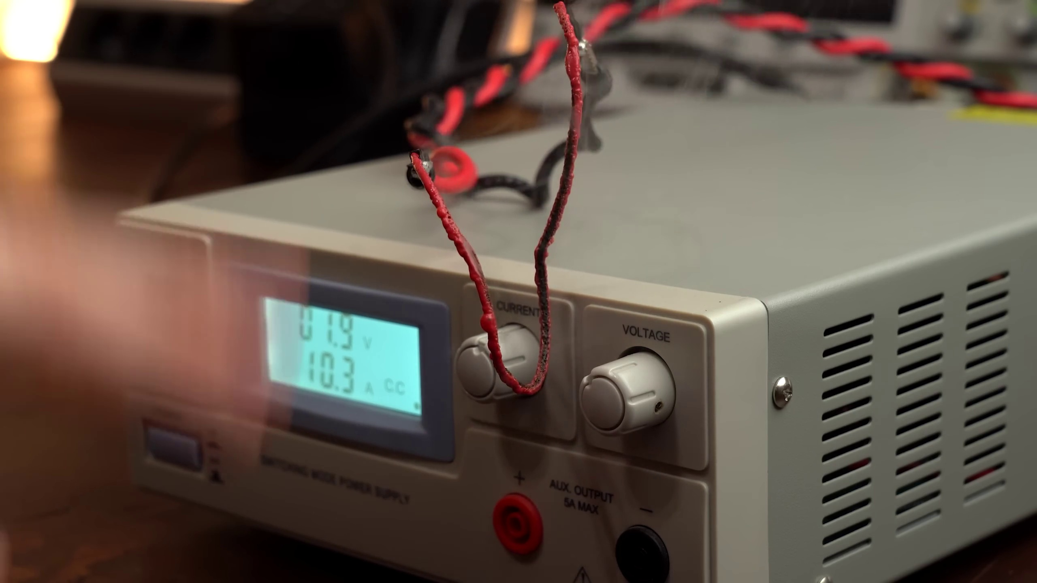 (score 95.0000)
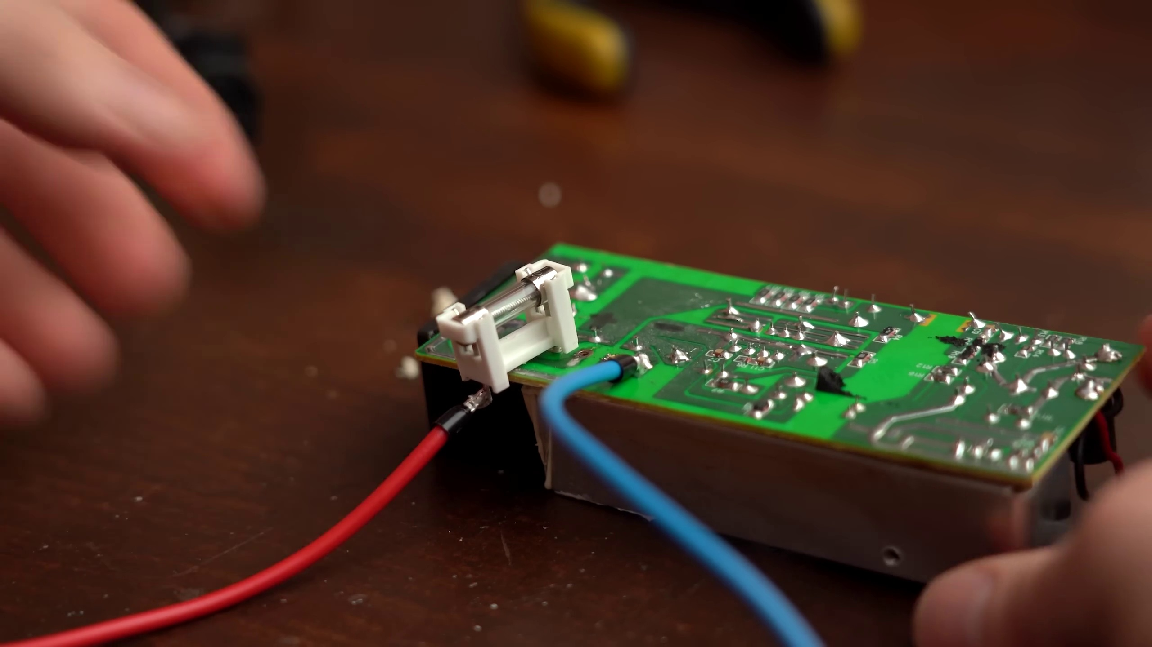 (score 95.0000)
 (score 95.0000)
 (score 95.0000)
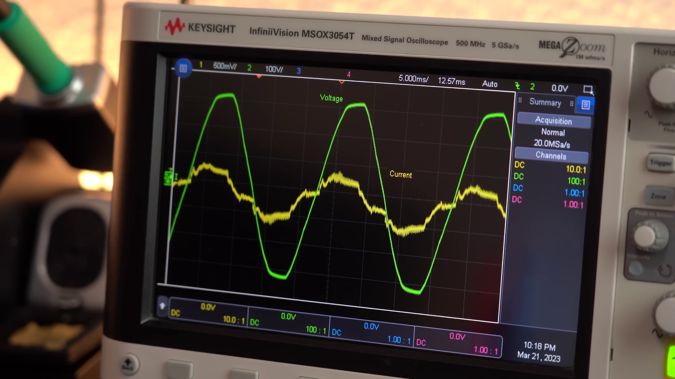 (score 90.0000)
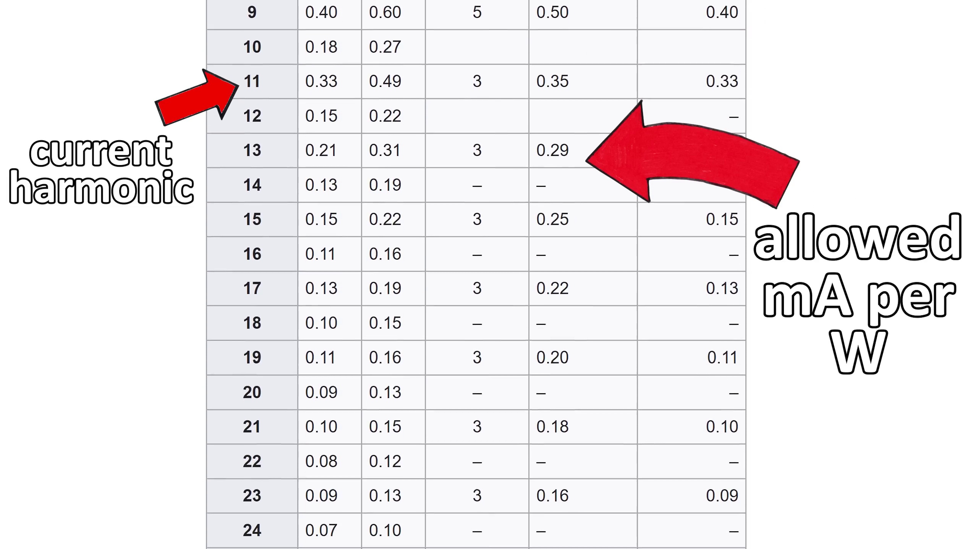 (score 90.0000)
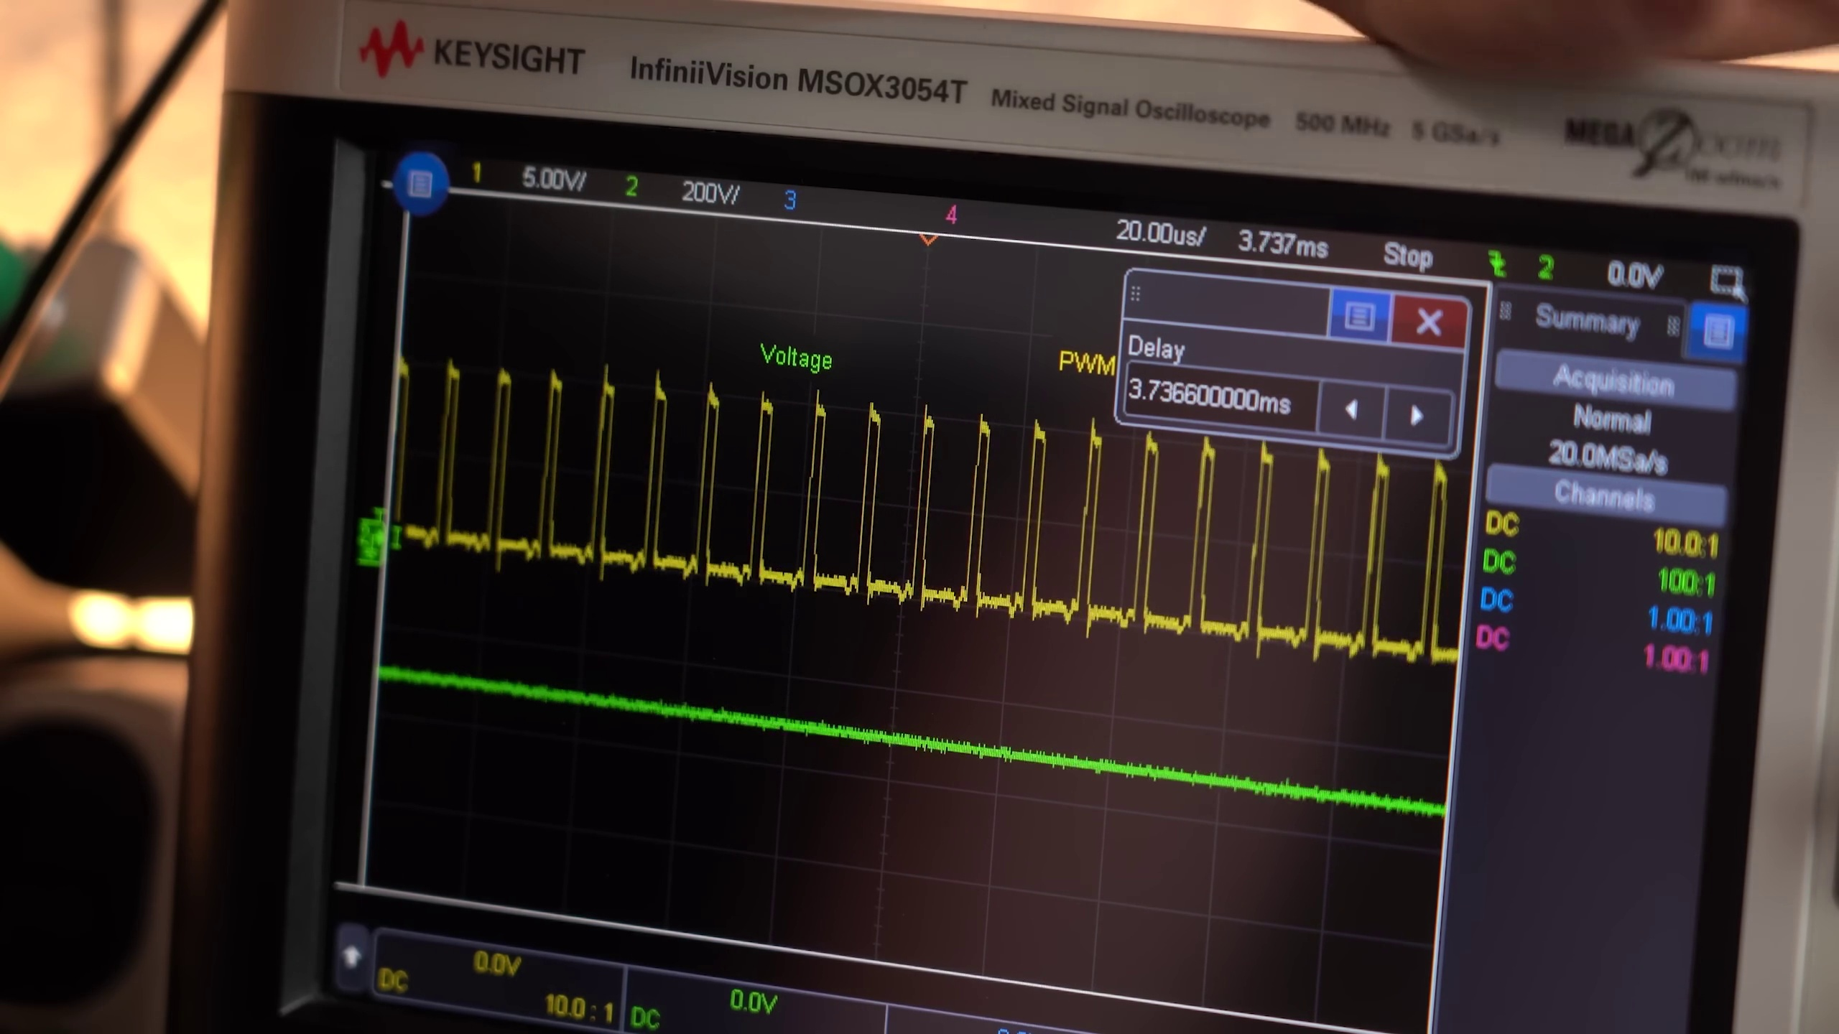 (score 90.0000)
Least correlated frames:
 (score 0.0000)
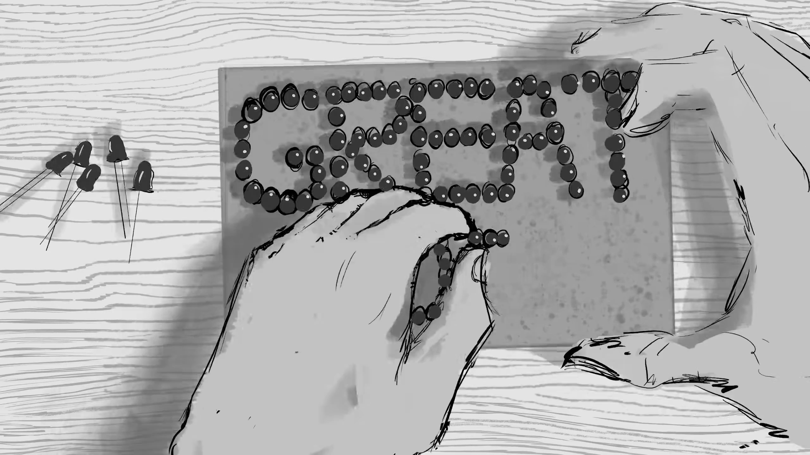 (score 0.0000)
 (score 0.0000)
 (score 0.0000)
 (score 0.0000)
 (score 0.0000)
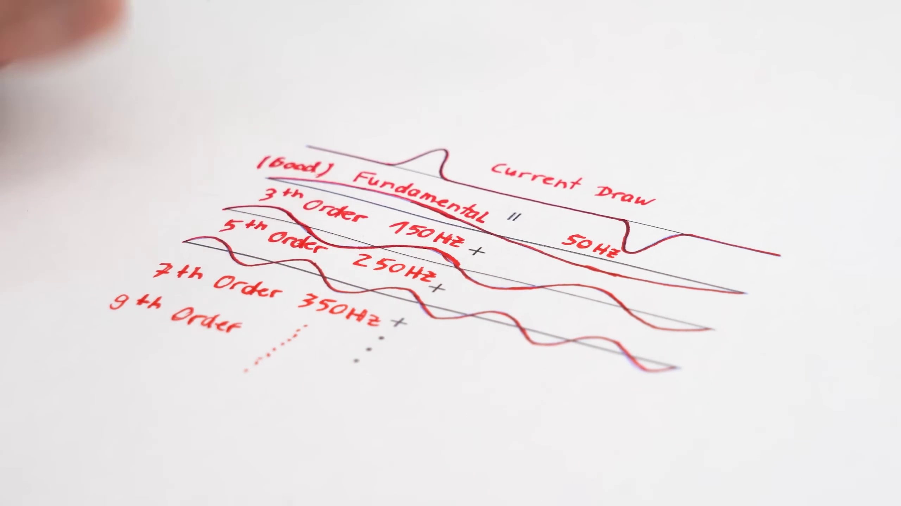 (score 0.0000)
 (score 0.0000)
 (score 0.0000)
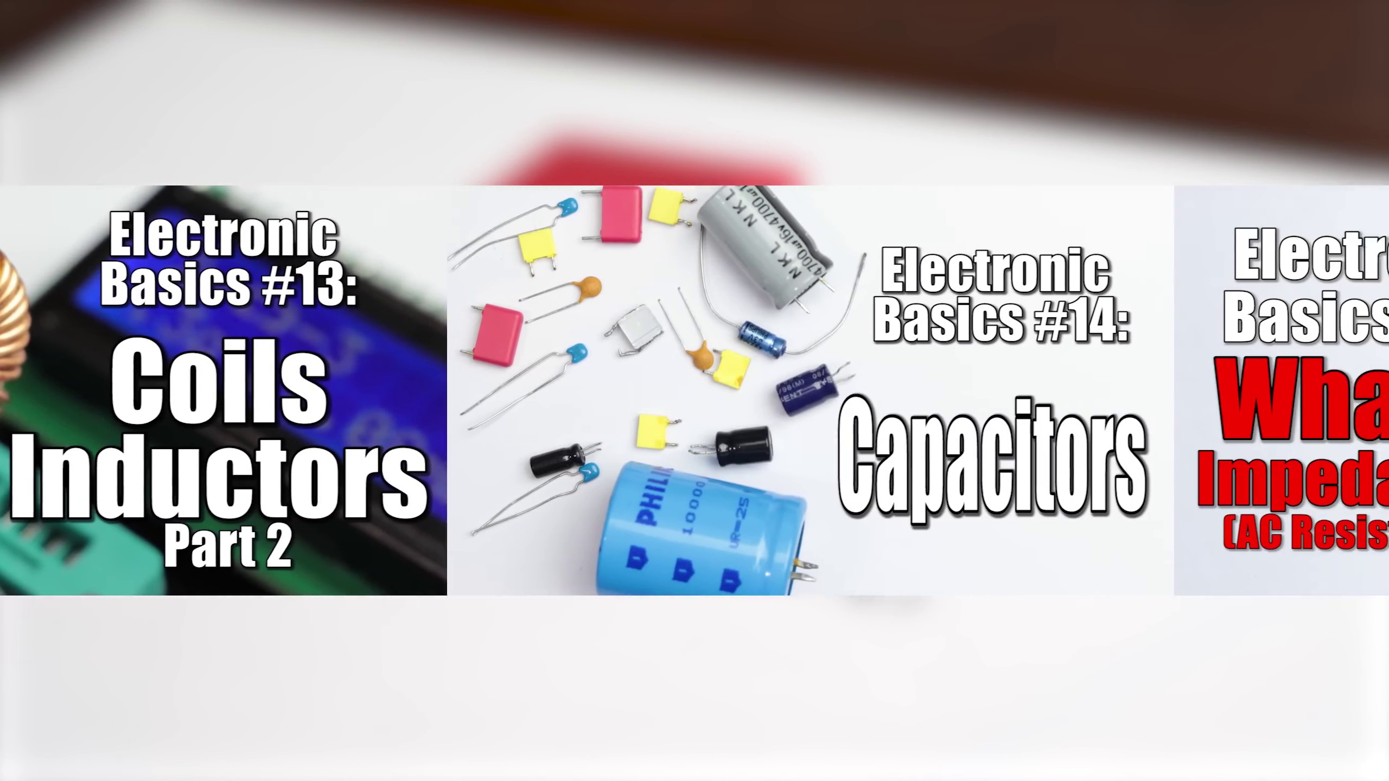 (score 5.0000)
- matched 123 frame(s), max score 95.0000: This video is 11:25 minutes. What I learned from the video - This video talks about how AC to DC power supplies like the one show here for LEDs waste a lot of power. The apparent power vs the real power drawn is very different and that is bad. He then talks about what power factor correction circuits are and why they are important for fixing this issue. He uses a good analogy with pouring coke into a glass. Liquid coke is the real power, foam is the reactive power, and the total height is the apparent power. I don’t quite understand exactly how all this works. Circuits are not my forte, but I understood well enough that increasing the power factor of appliances saves energy in the long run.
Source: https://www.youtube.com/watch?v=U5cqrrhq9TA : The Most Important Circuit for our Electrical Future?! (PFC) EB#55
Top correlated frames:
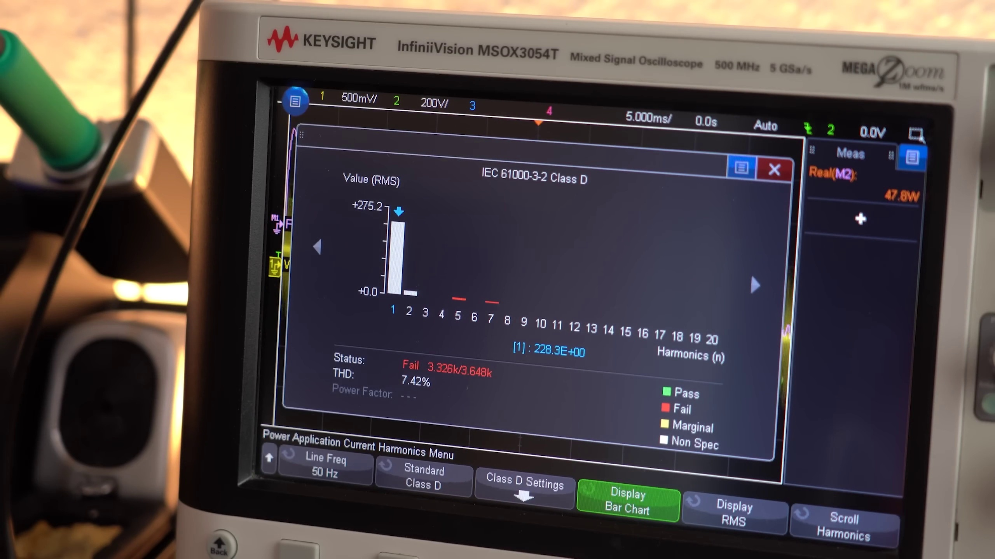 (score 95.0000)
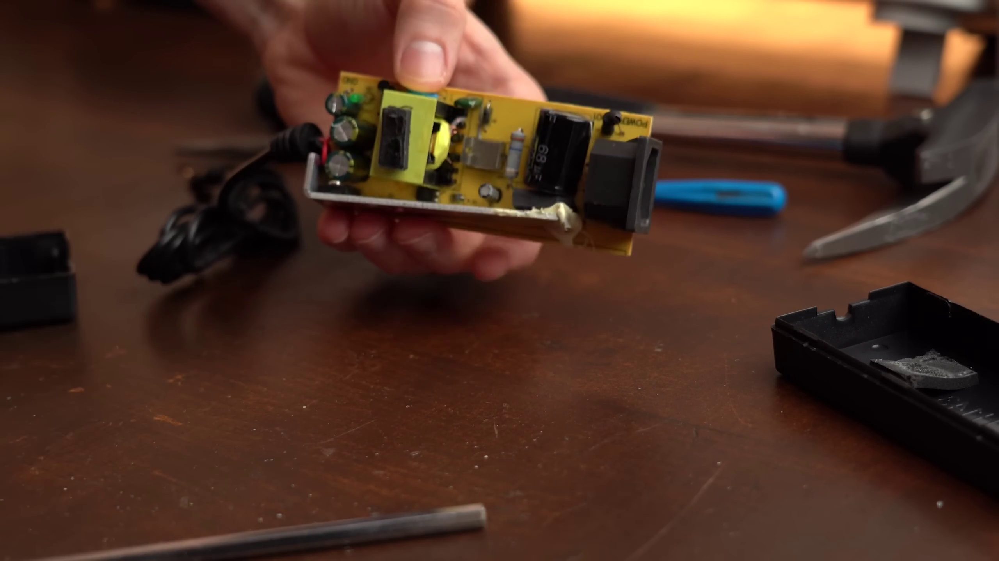 (score 95.0000)
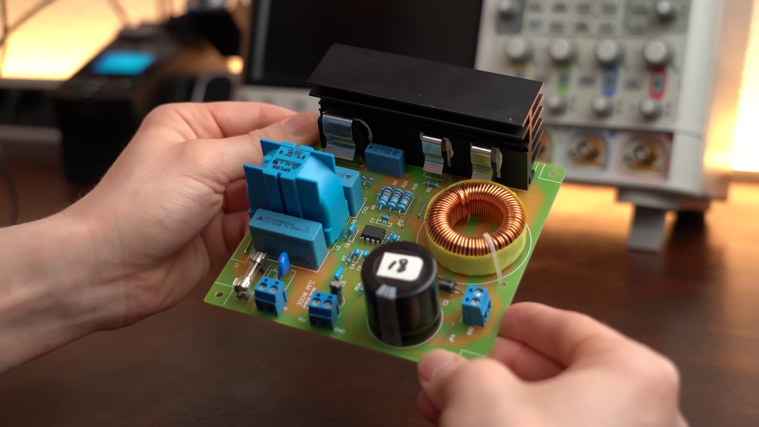 (score 95.0000)
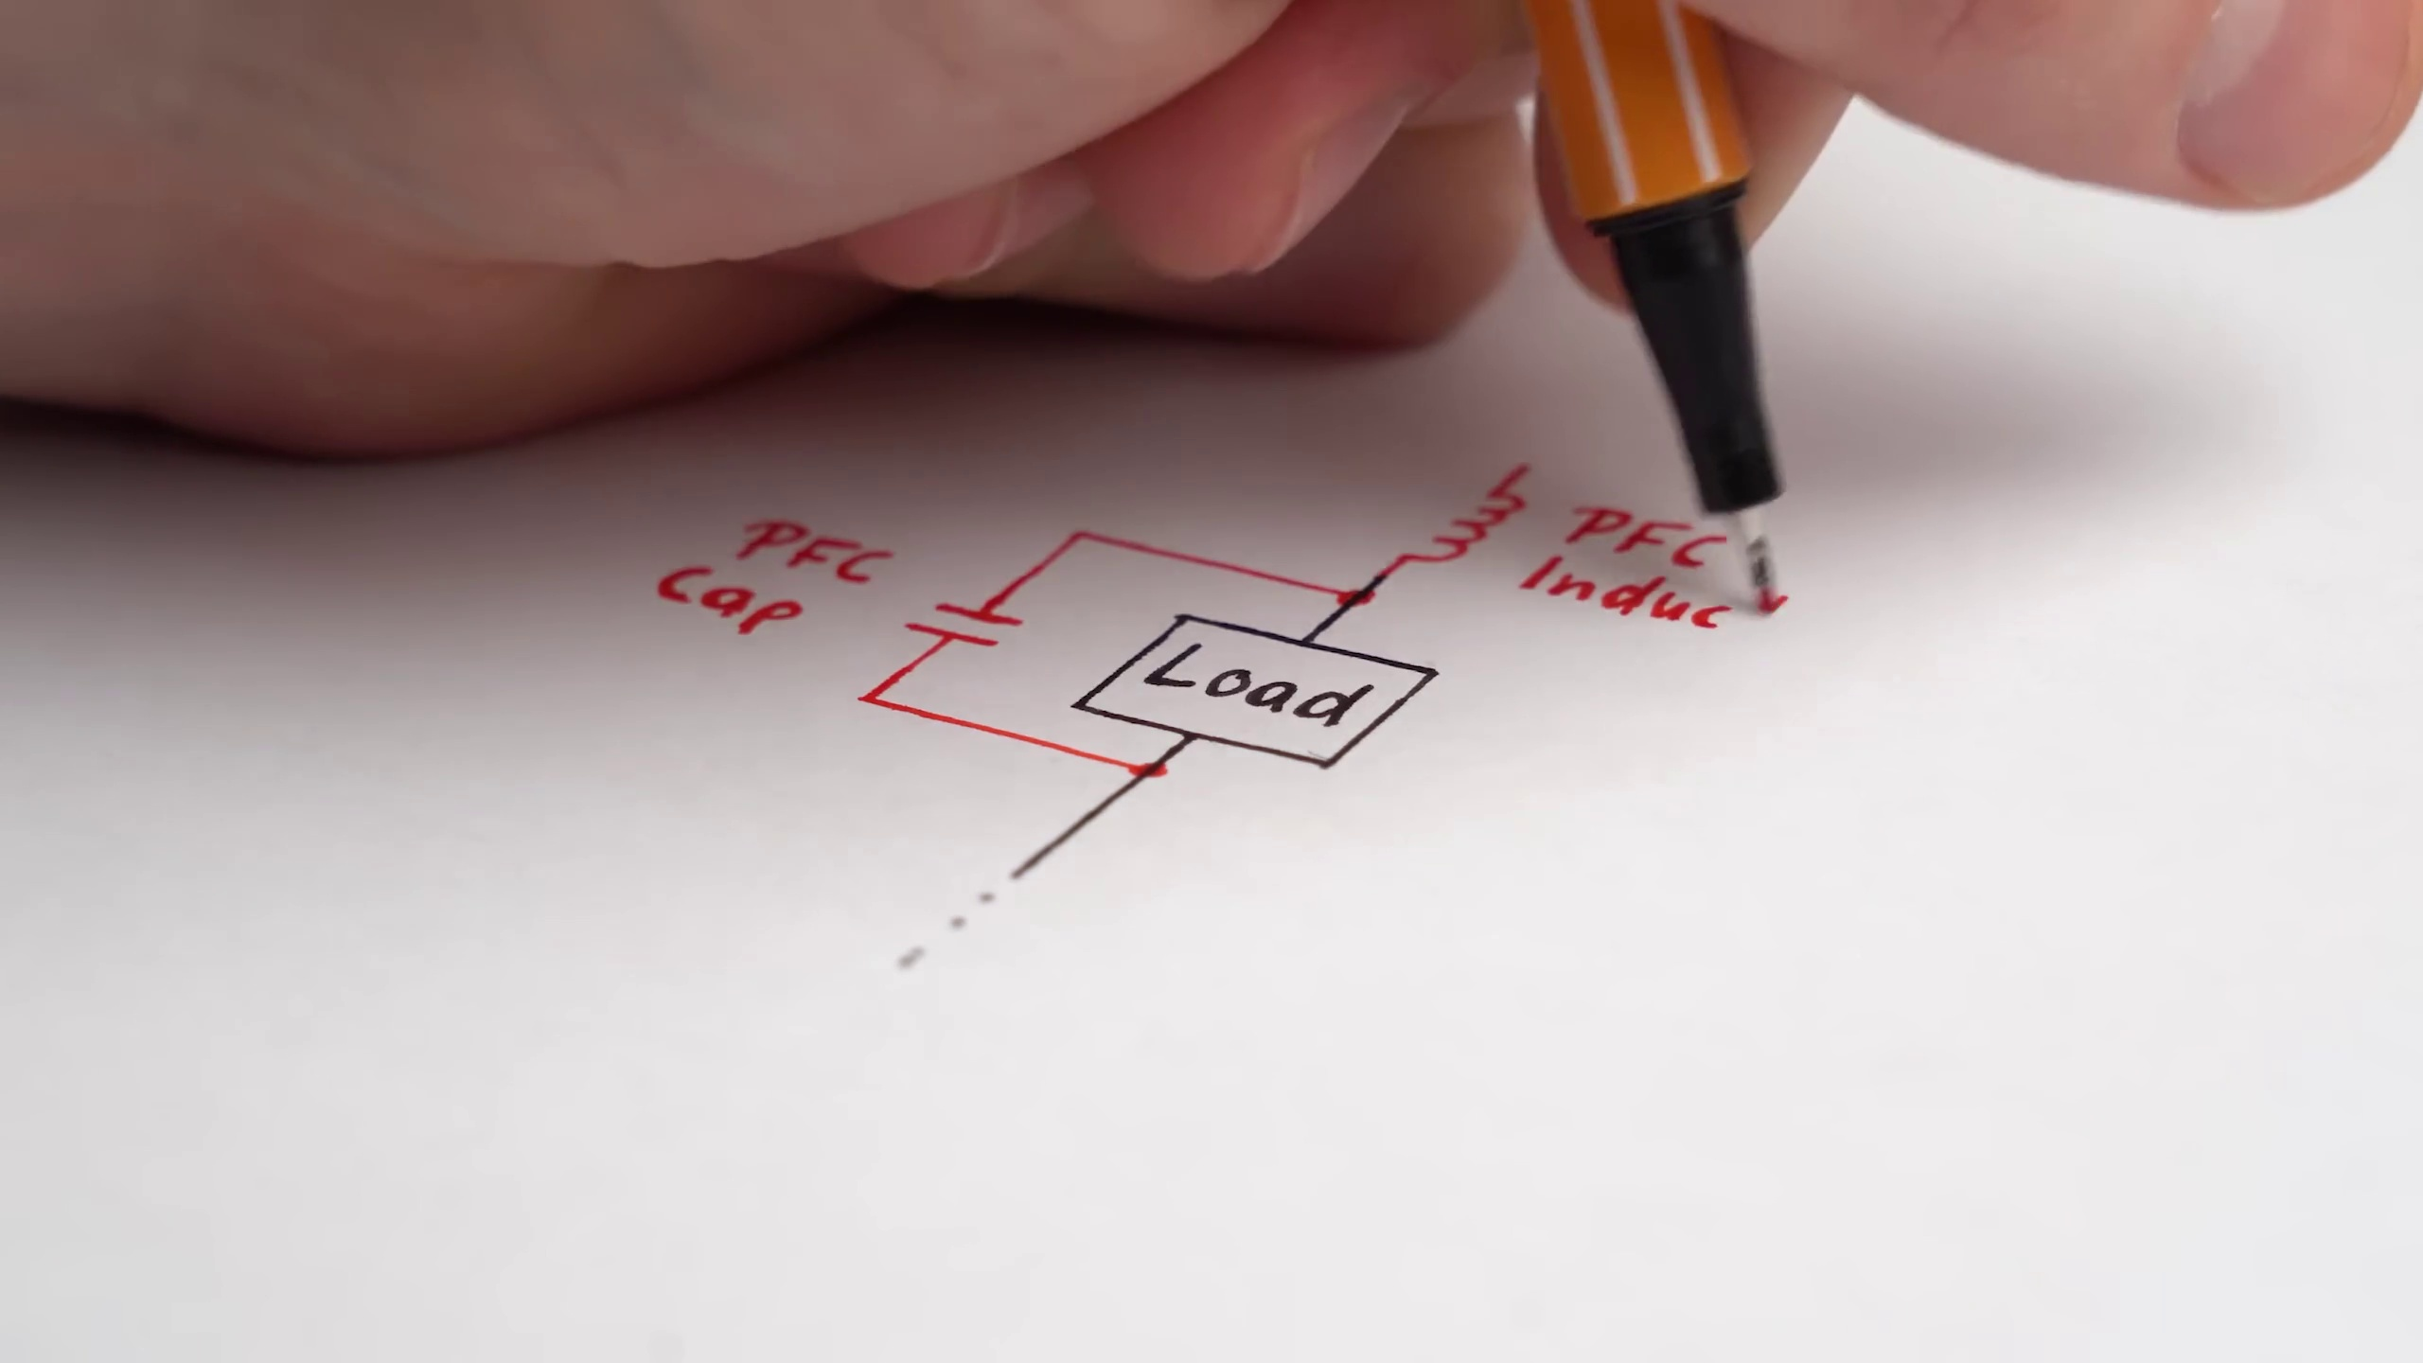 (score 95.0000)
 (score 95.0000)
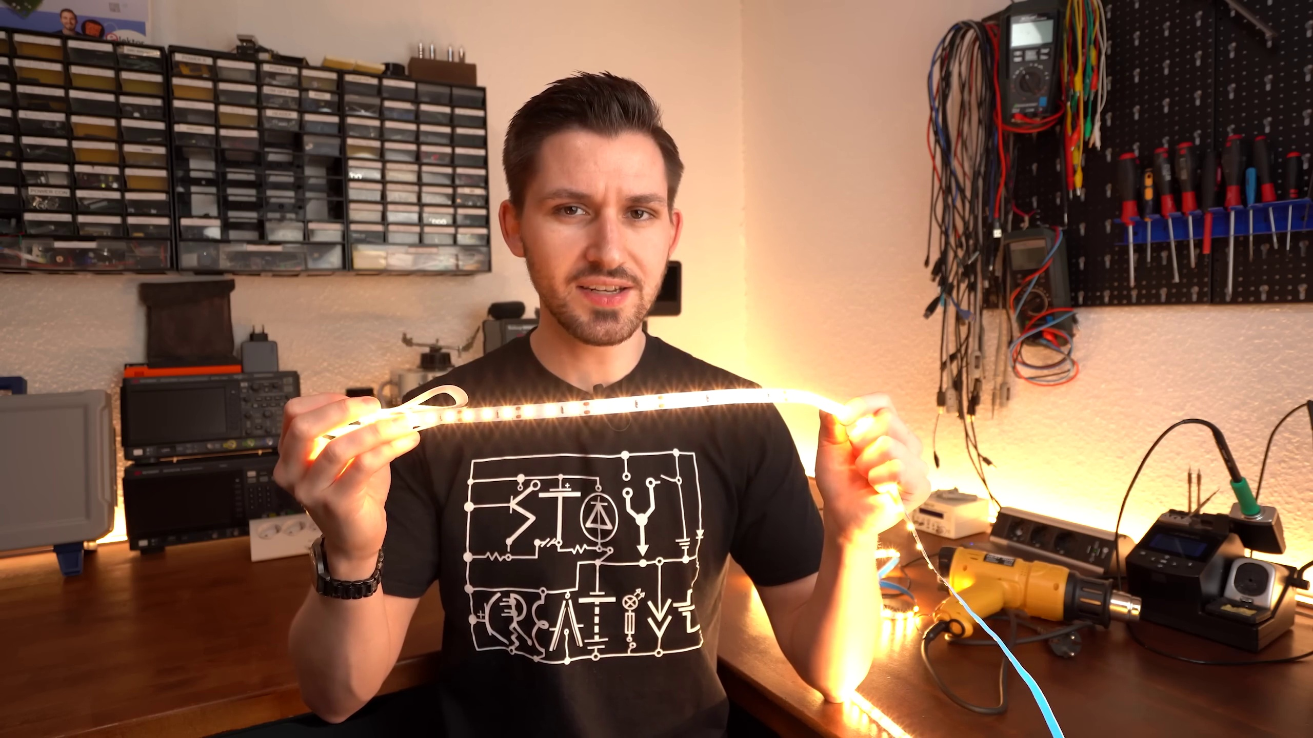 (score 95.0000)
 (score 95.0000)
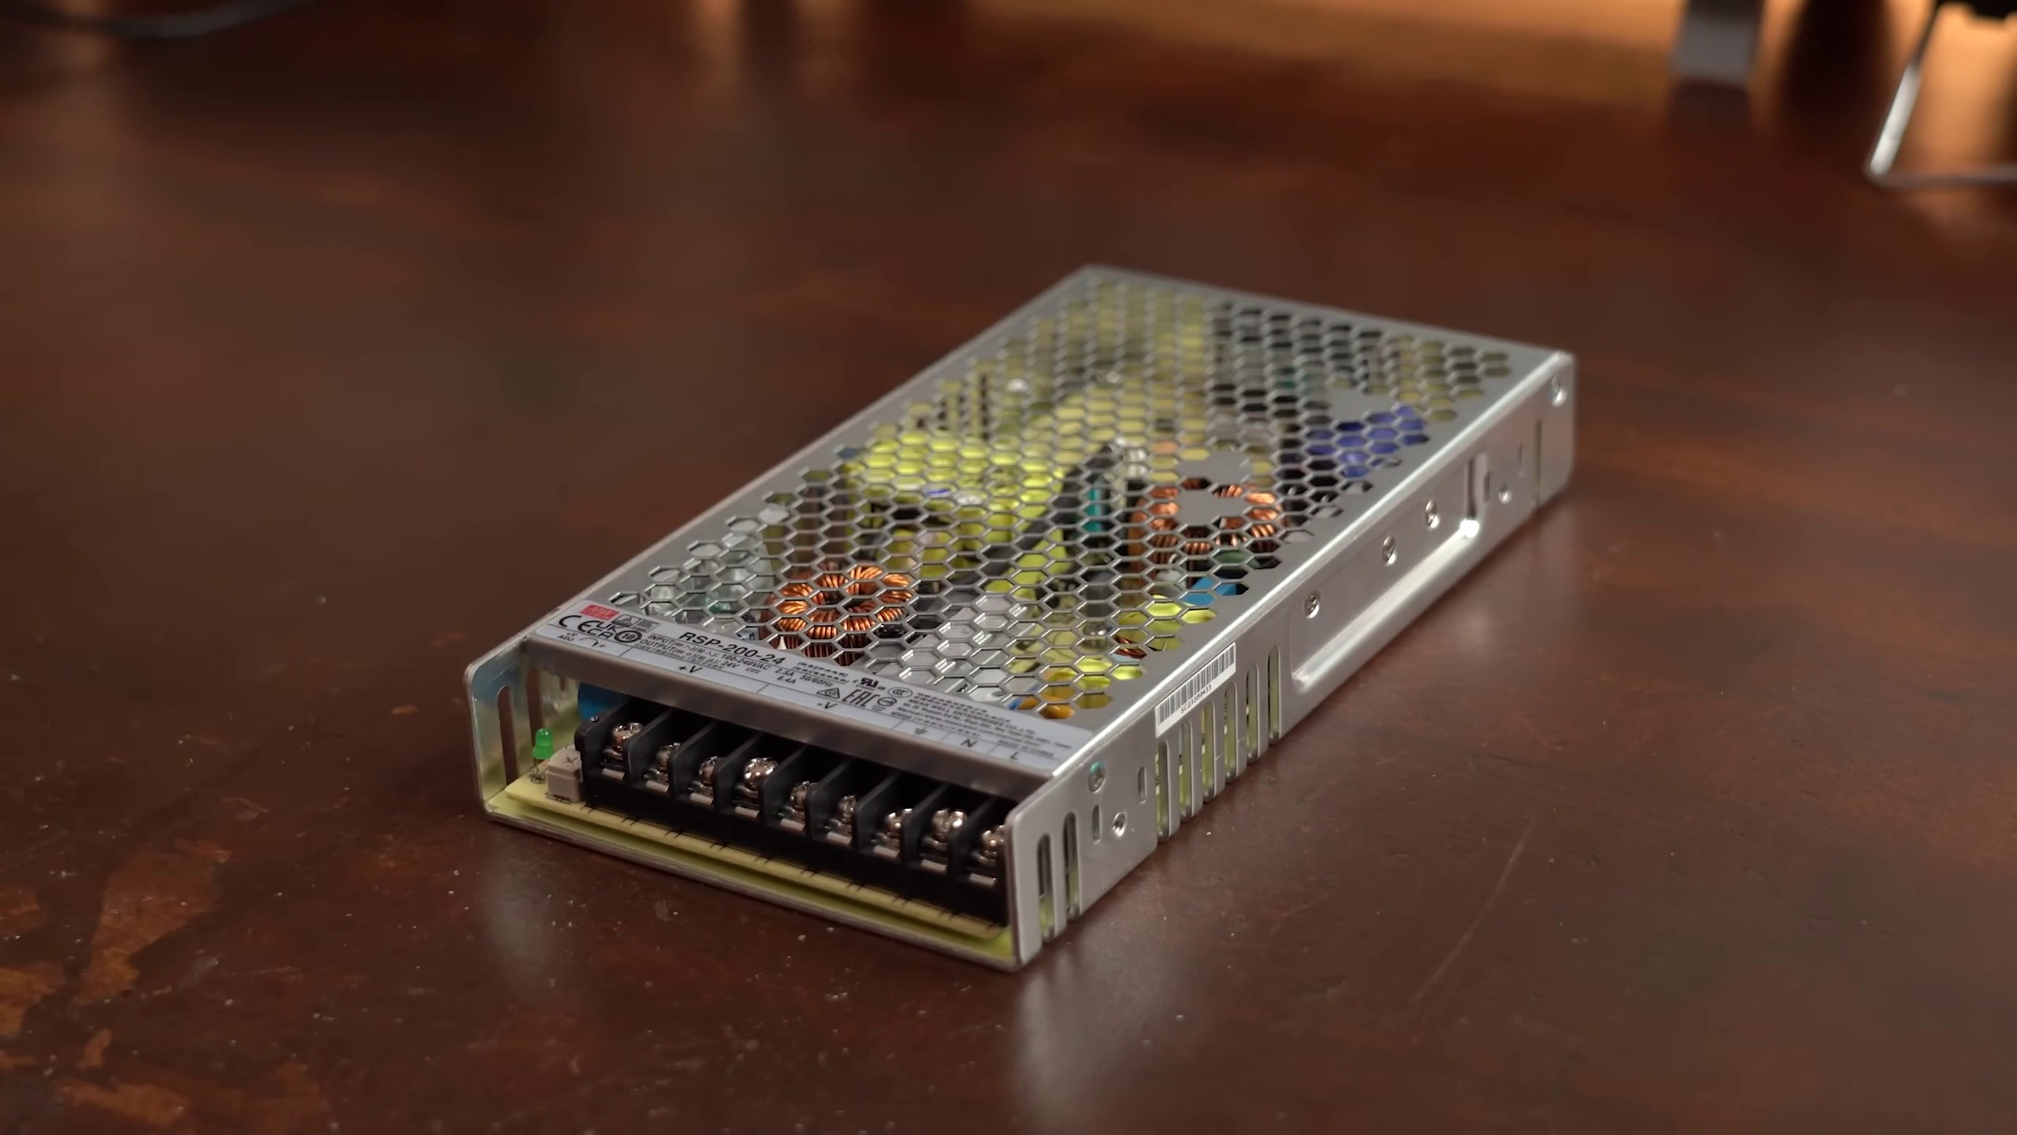 (score 90.0000)
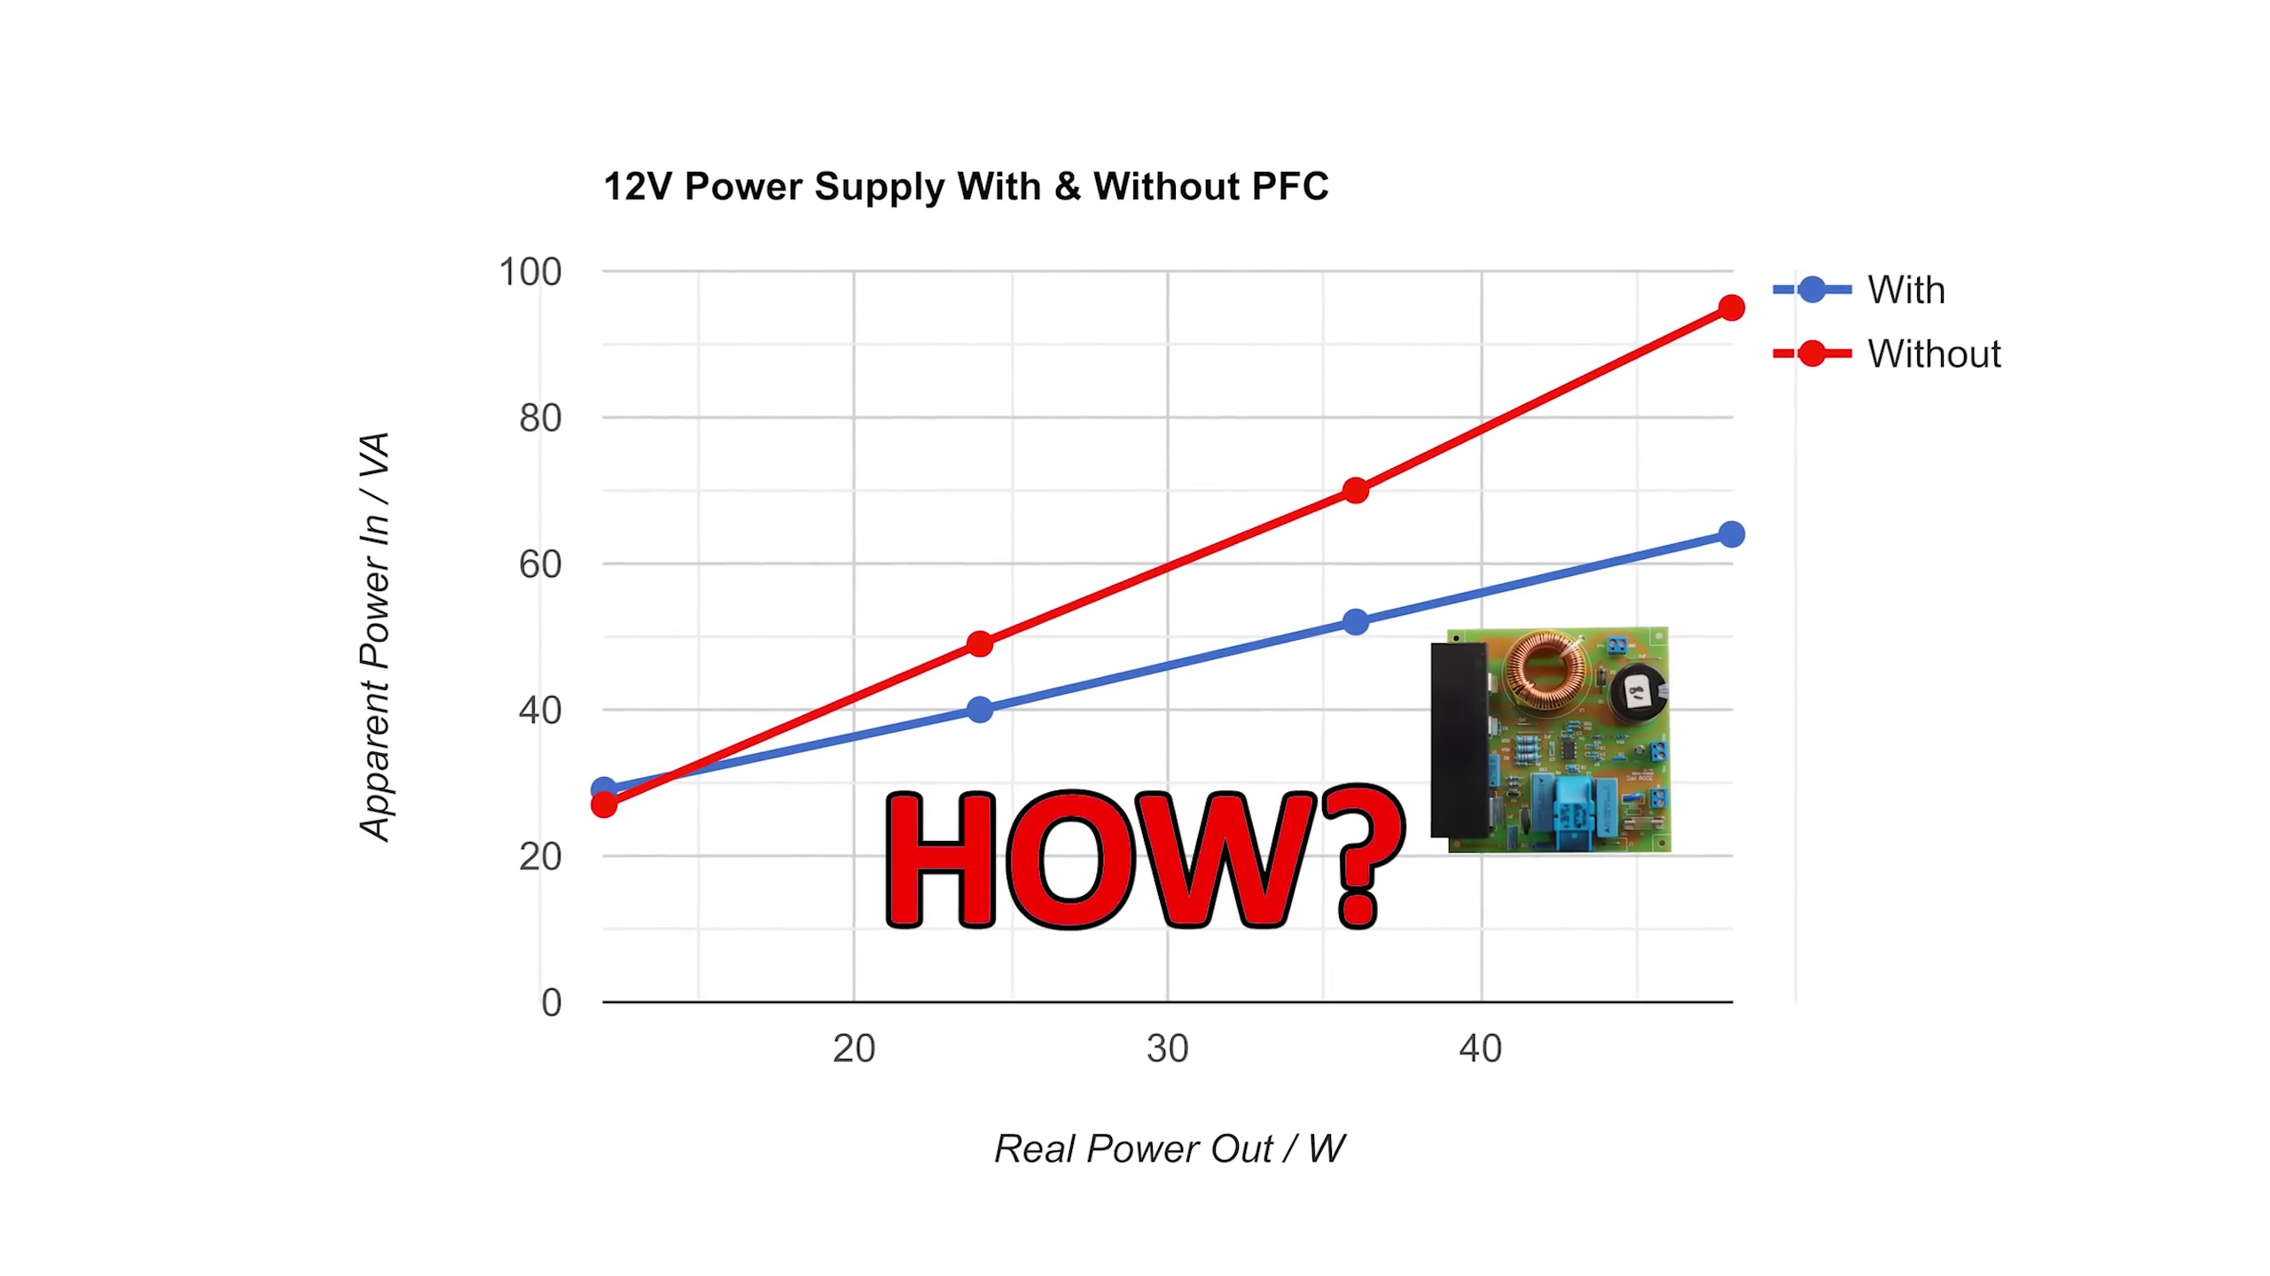 (score 90.0000)
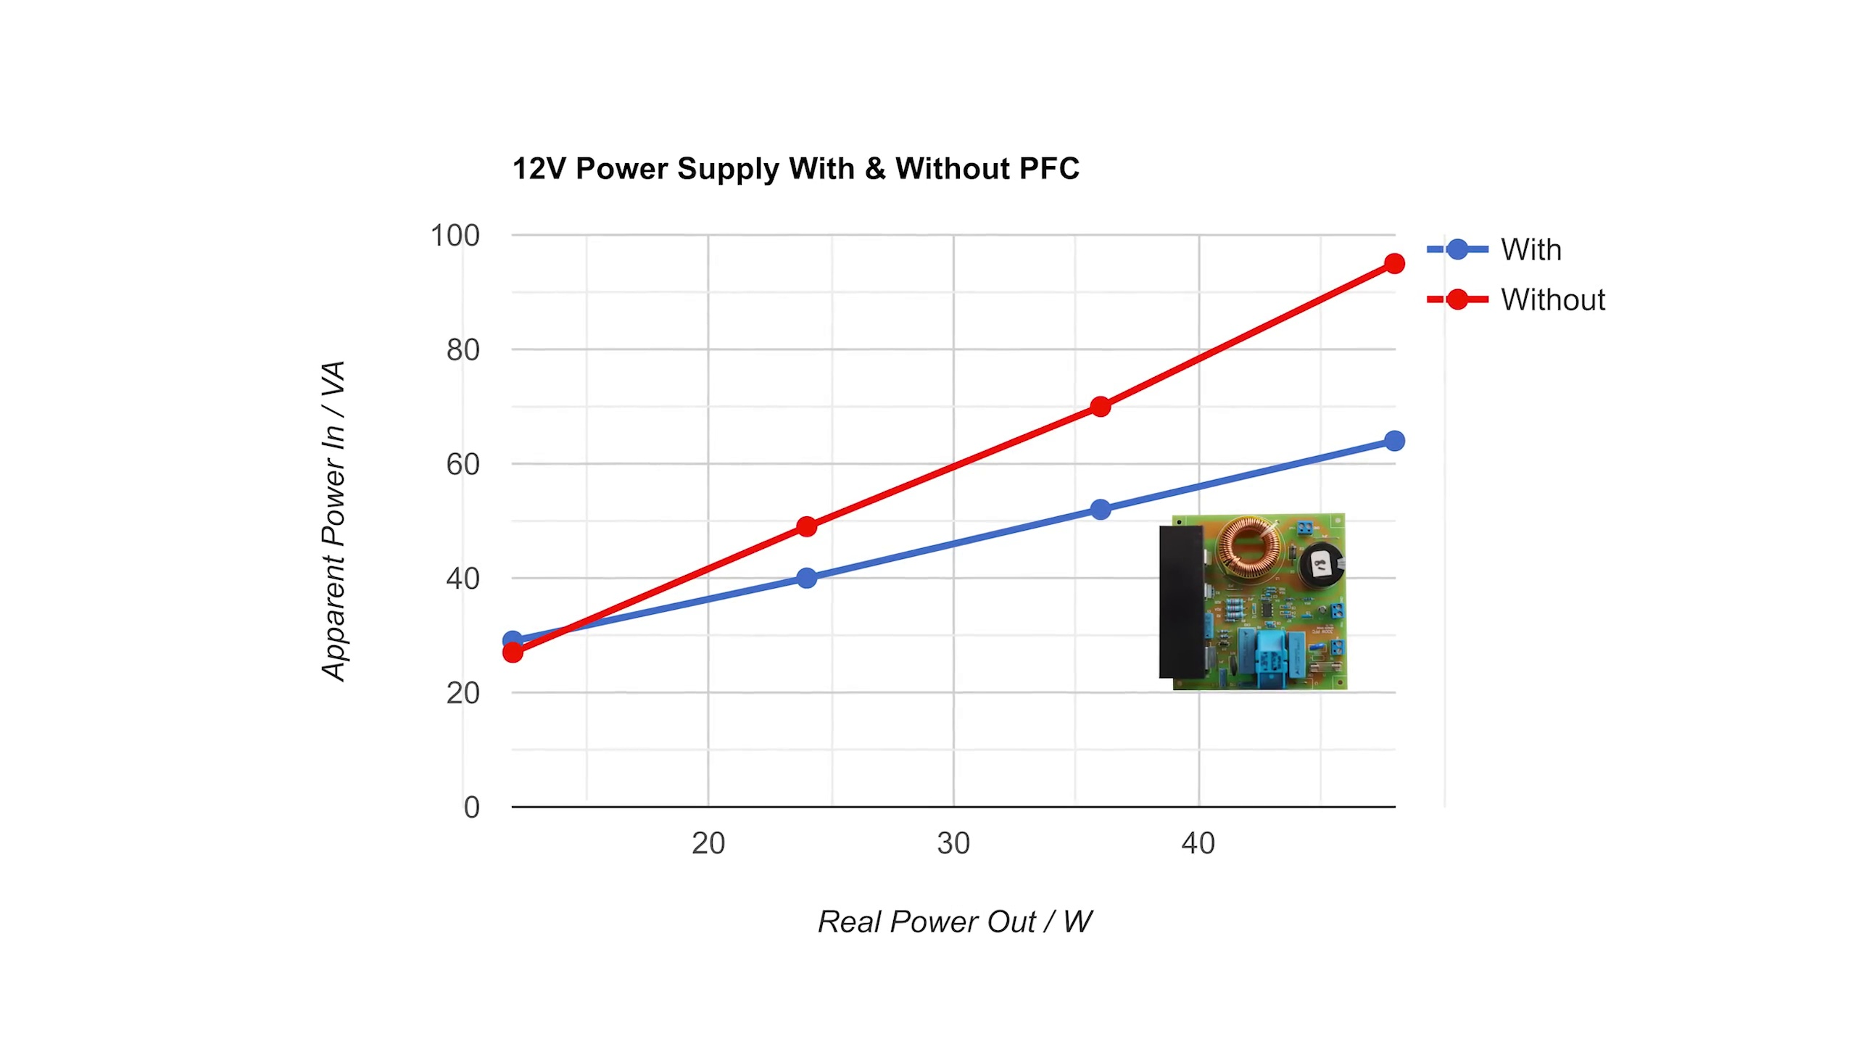 (score 90.0000)
Least correlated frames:
 (score 0.0000)
 (score 0.0000)
 (score 0.0000)
 (score 0.0000)
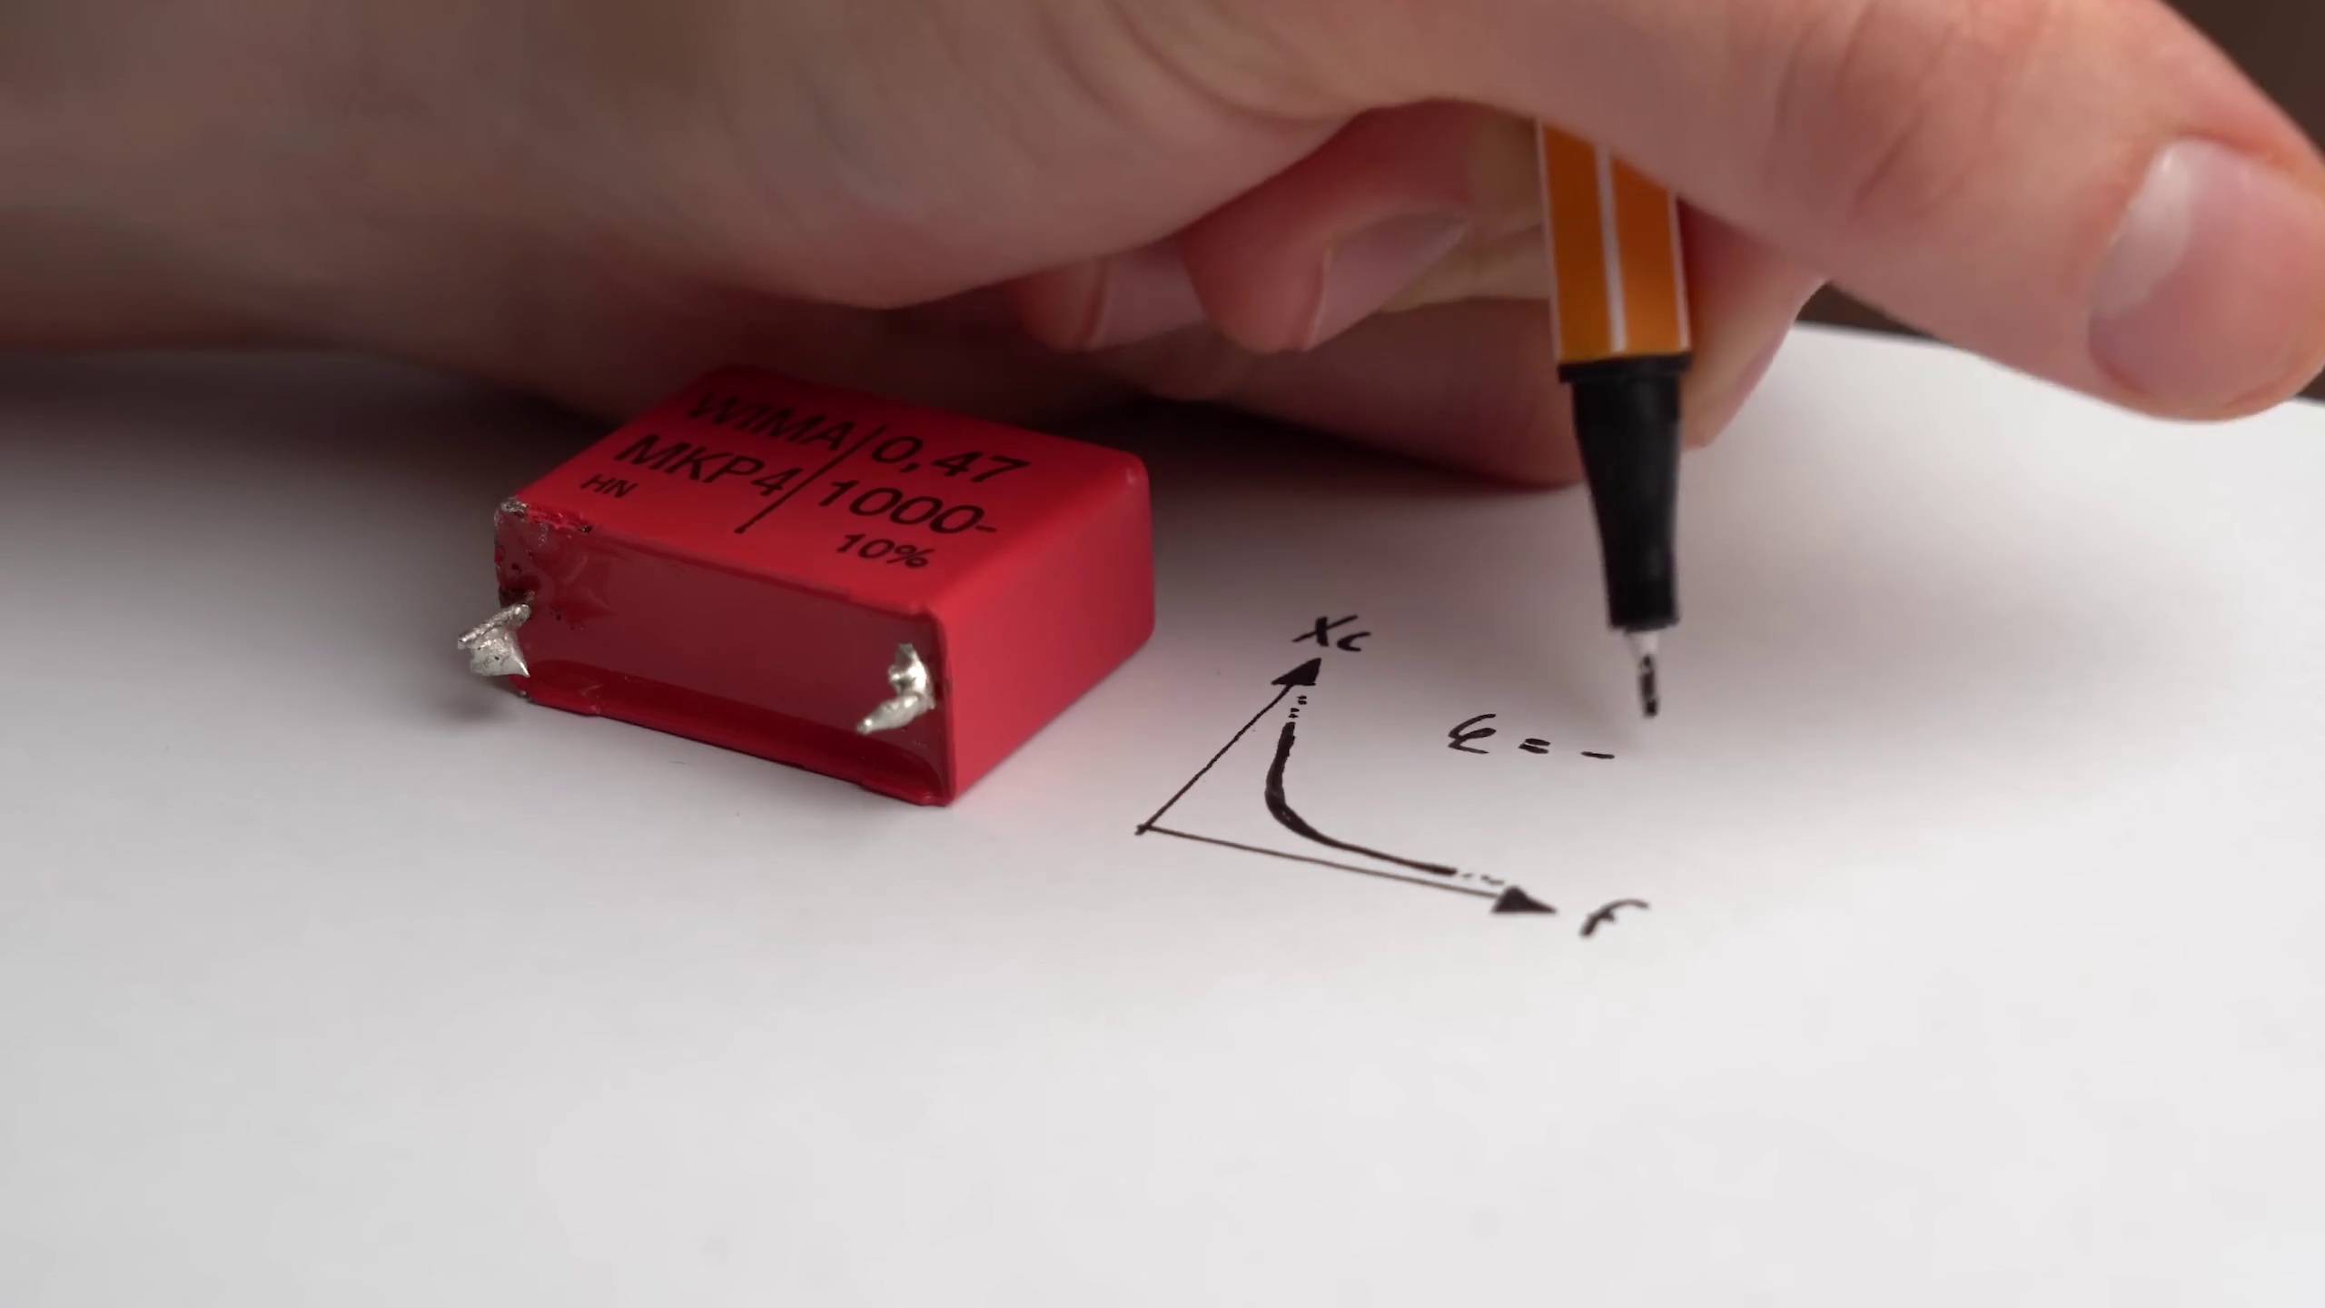 (score 5.0000)
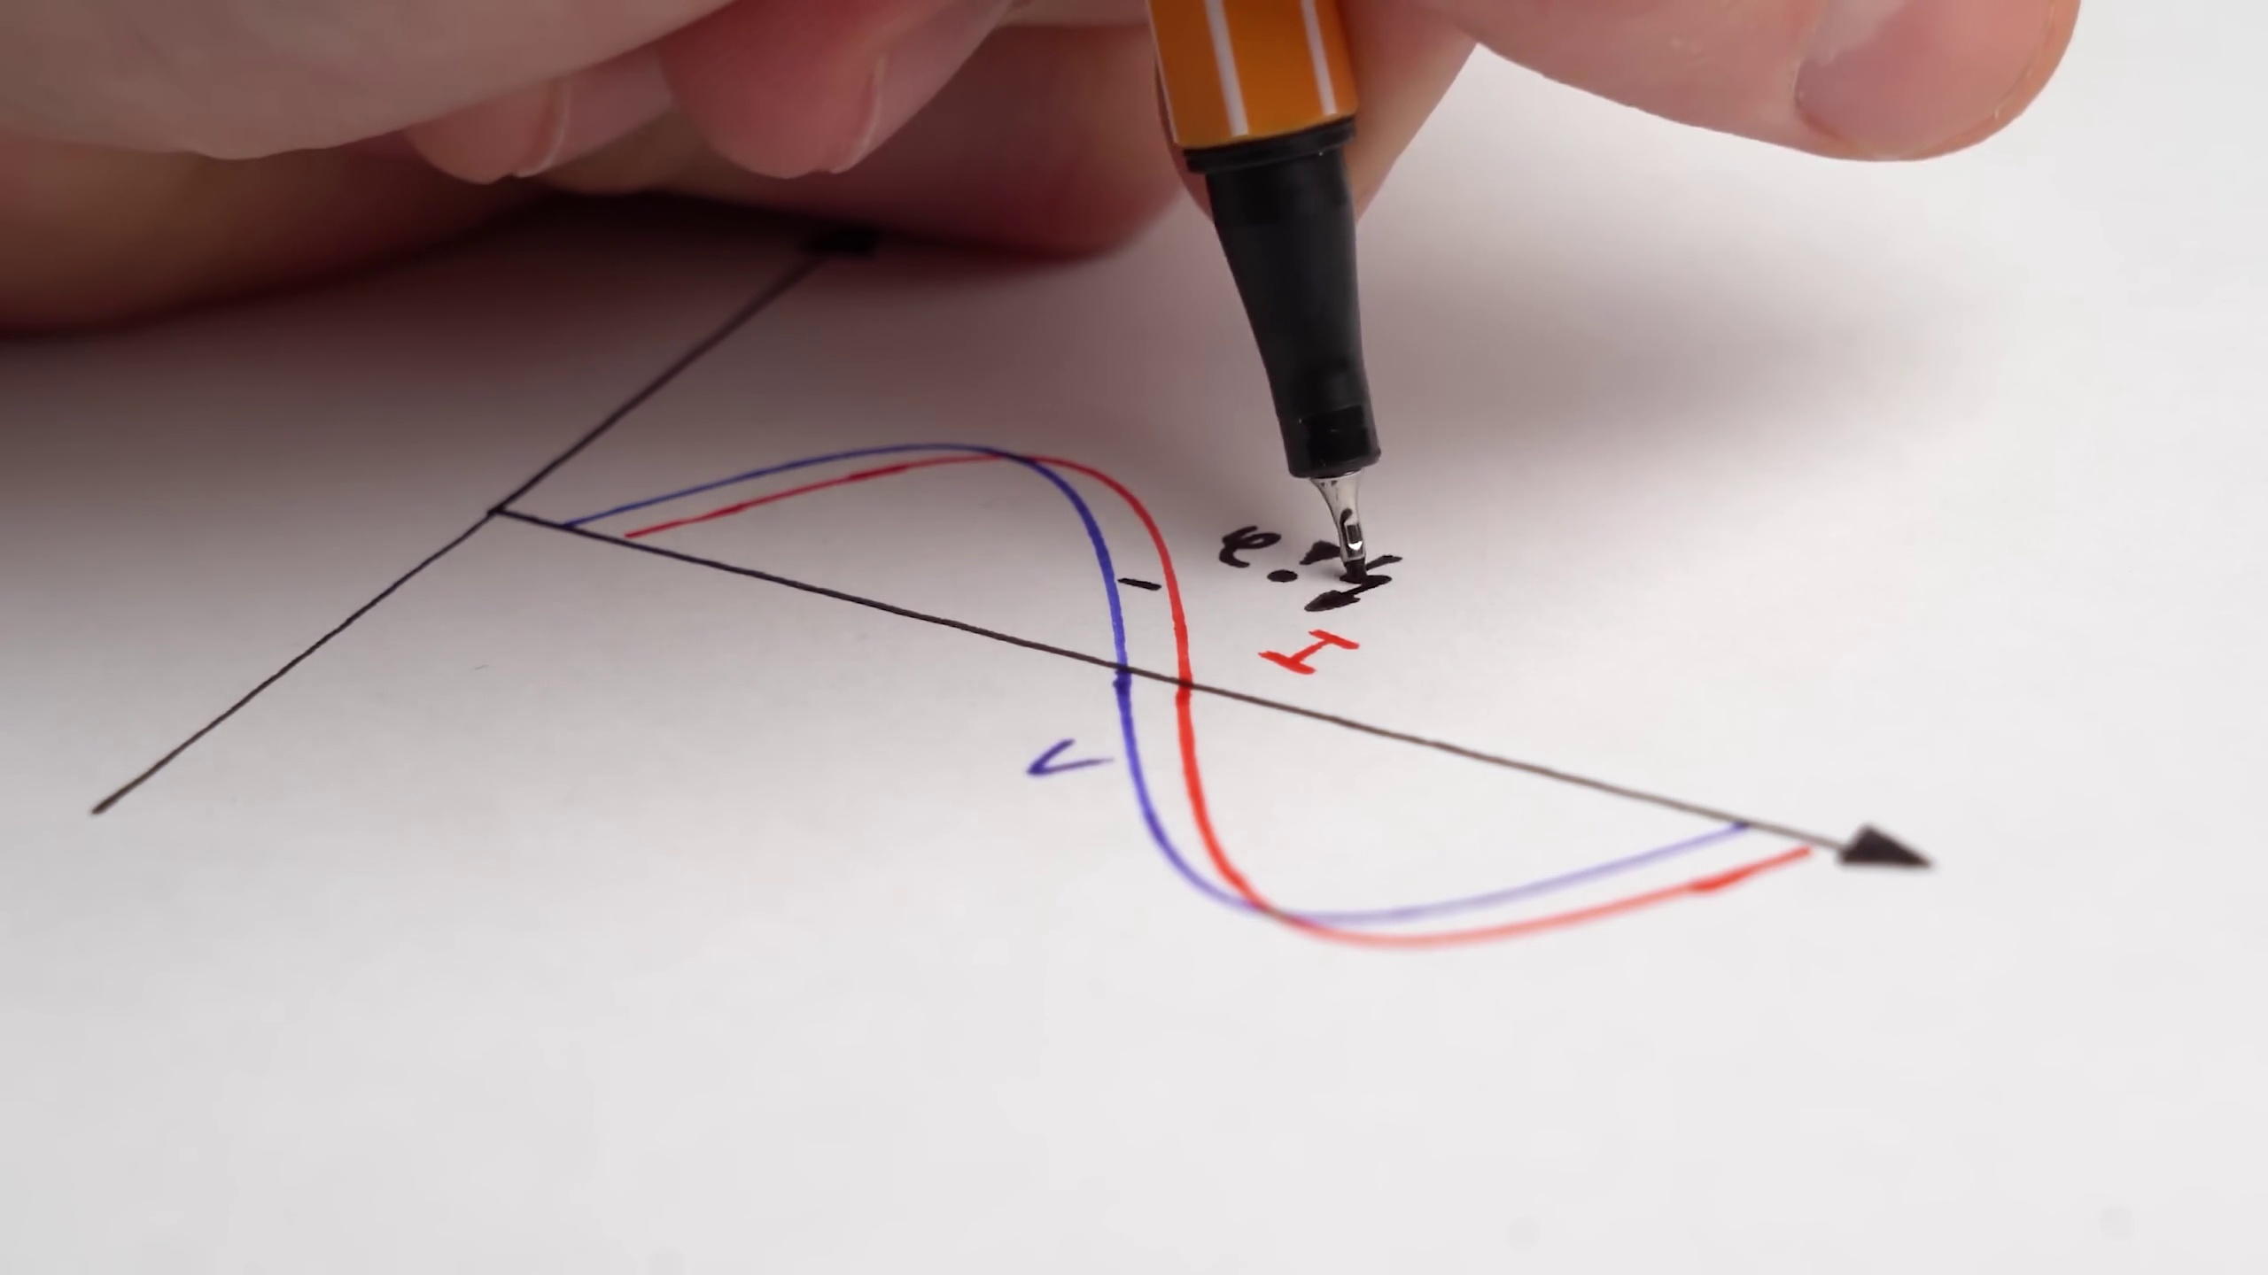 (score 5.0000)
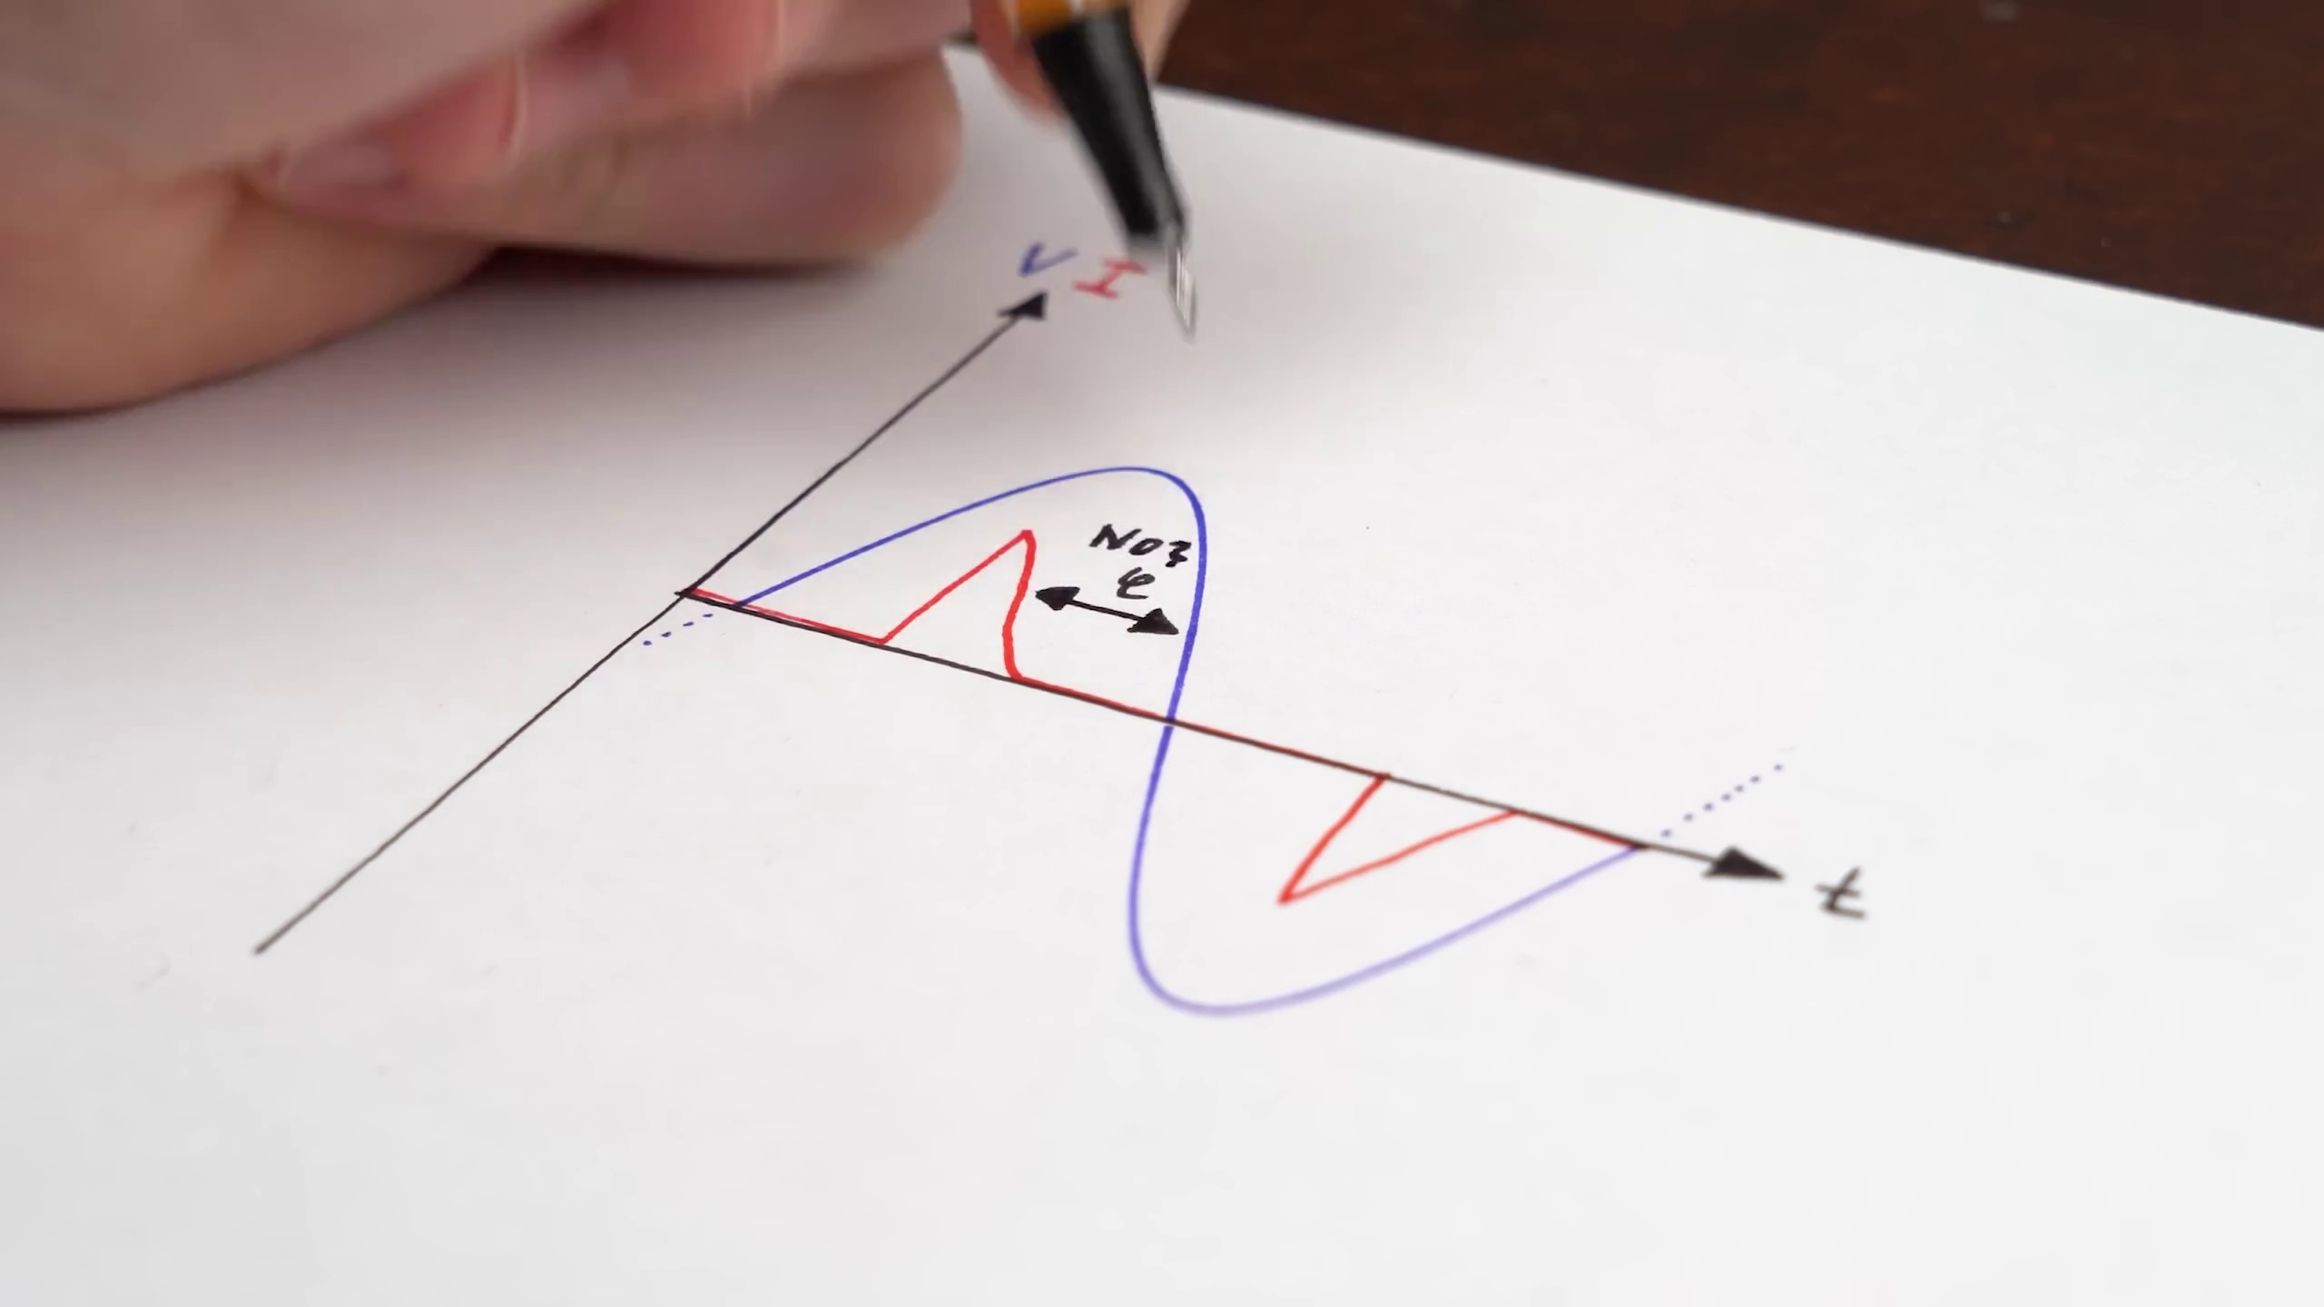 (score 10.0000)
 (score 10.0000)
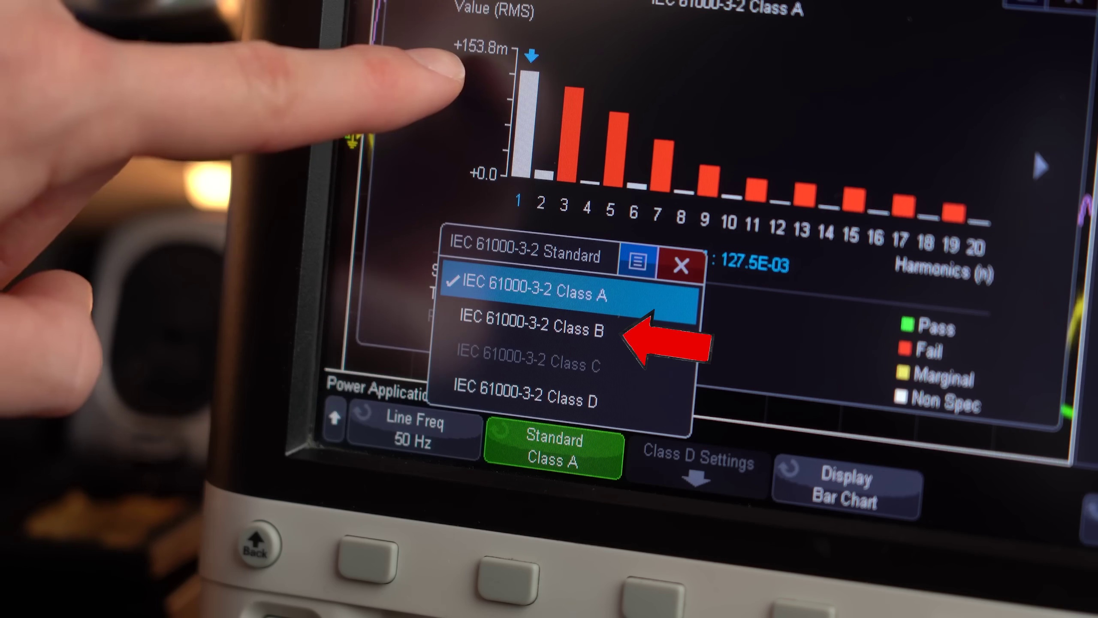 (score 10.0000)
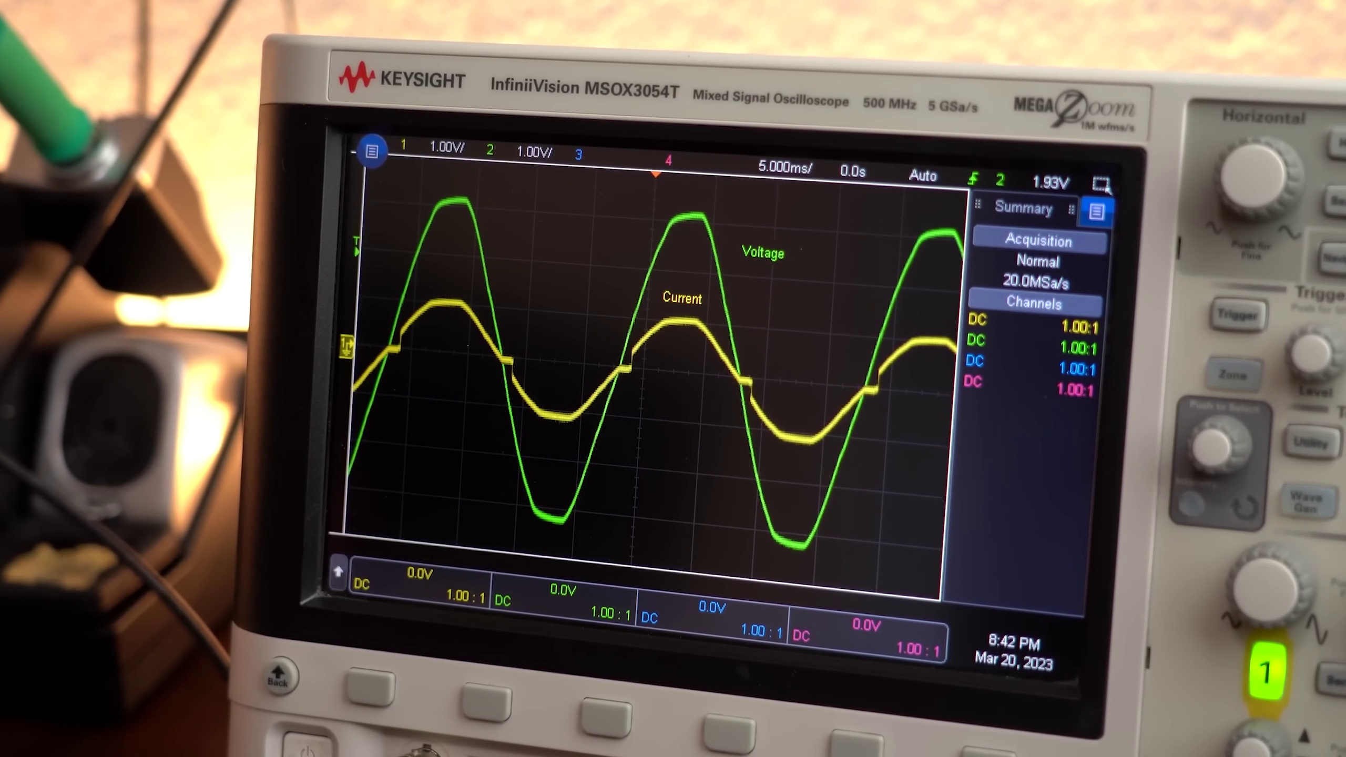 (score 20.0000)
- matched 33 frame(s), max score 95.0000: Explanation of power factor correction (PFC) circuits and their importance in improving power efficiency.Details on current harmonics and how they contribute to reactive power. Incorporating active PFC circuits in future power supply designs to ensure better power factor and efficiency.
Source: https://www.youtube.com/watch?v=U5cqrrhq9TA: The Most Important Circuit for our Electrical Future?! (PFC)
Top correlated frames:
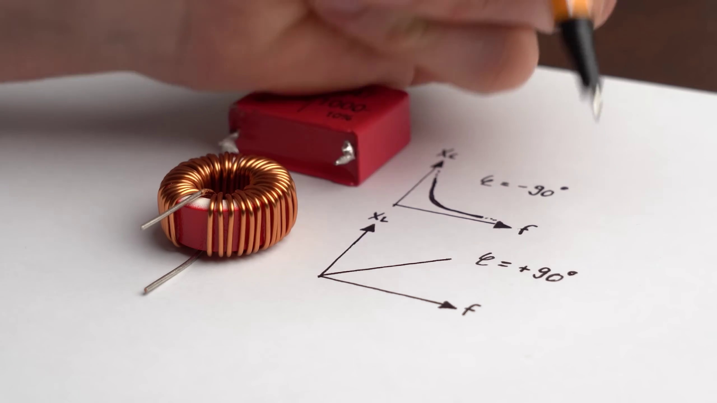 (score 95.0000)
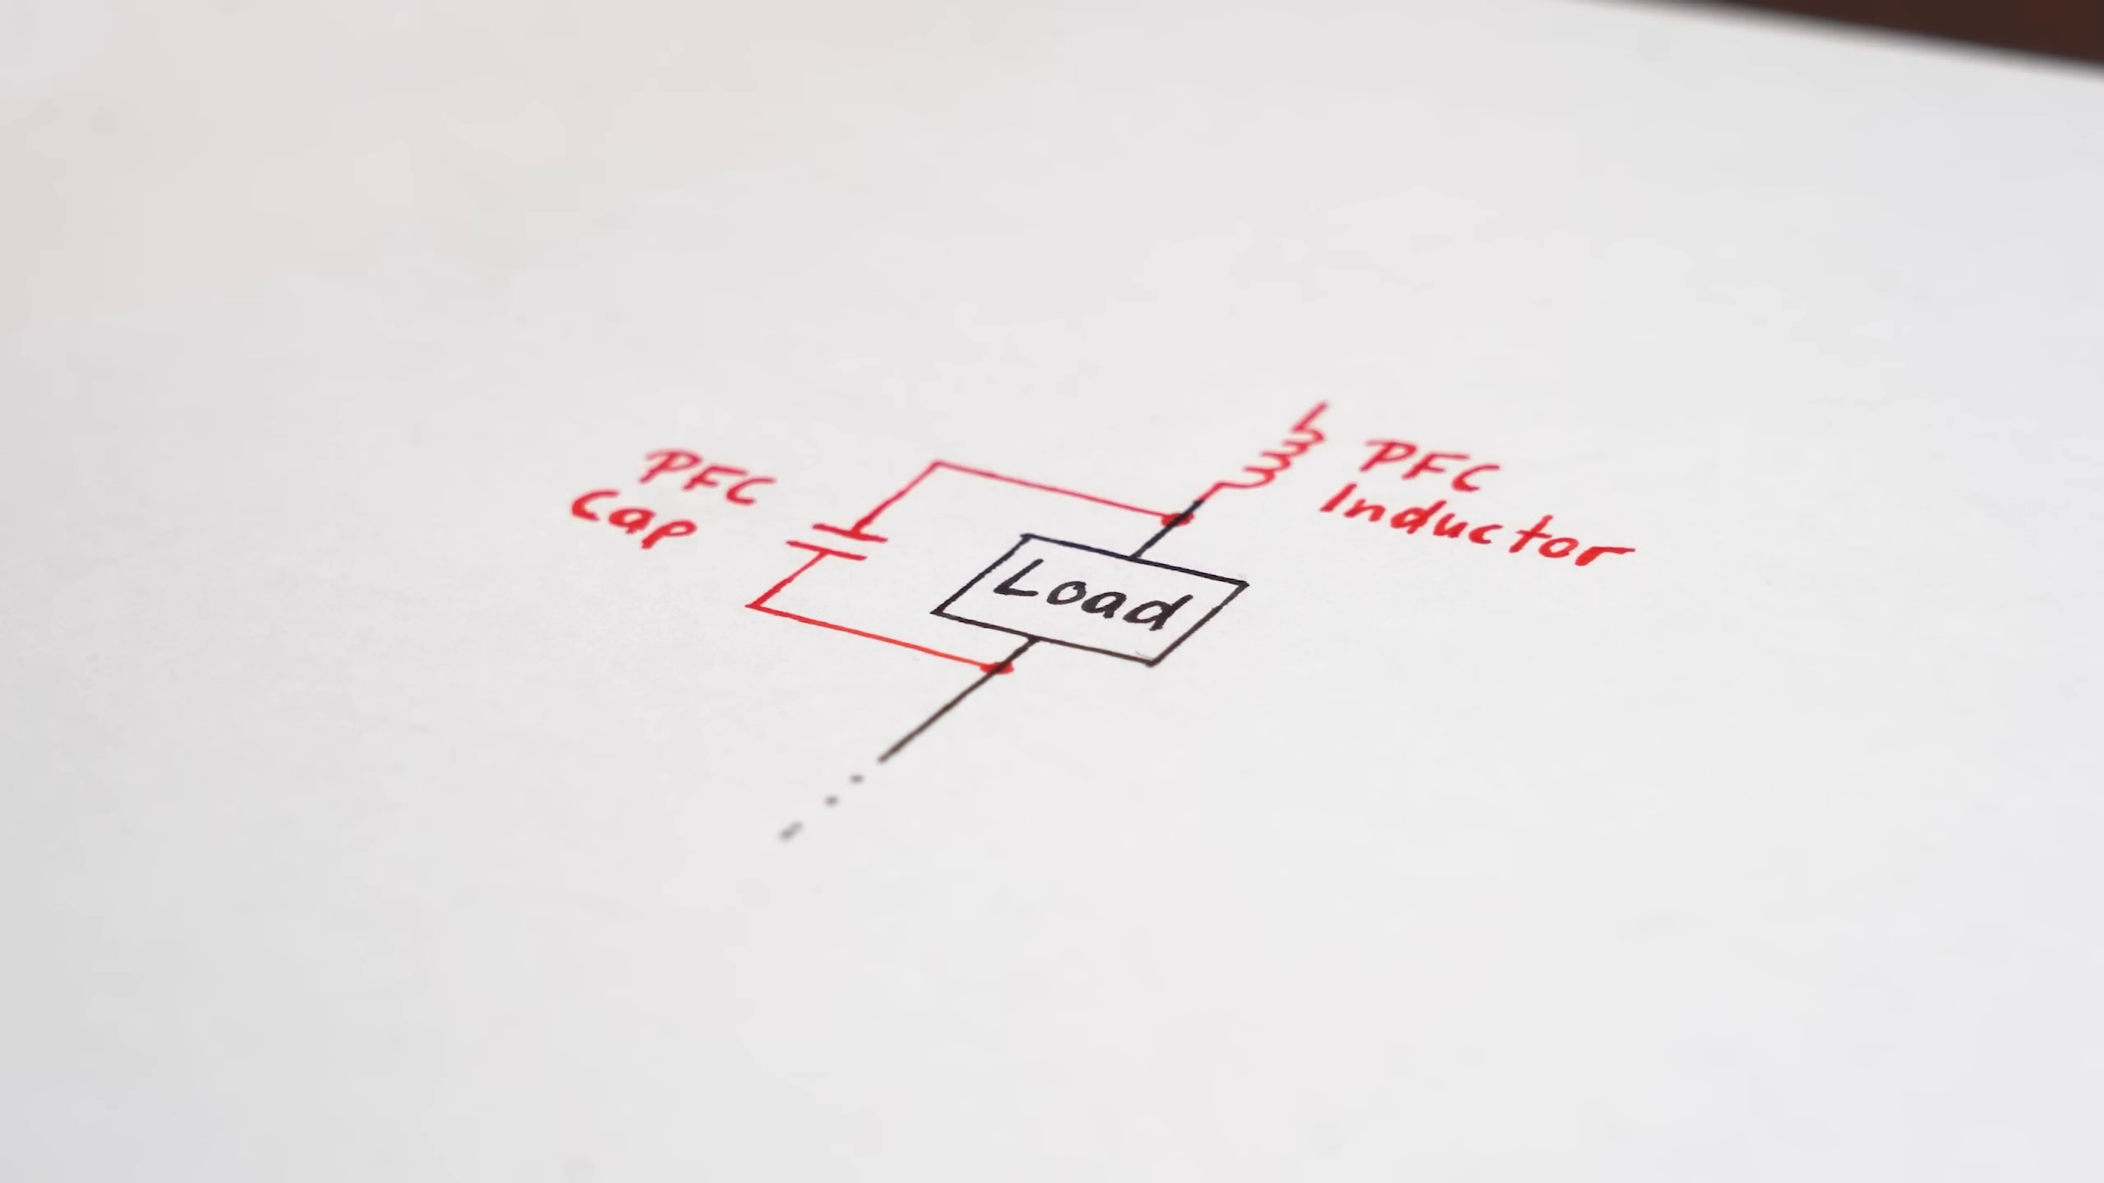 (score 90.0000)
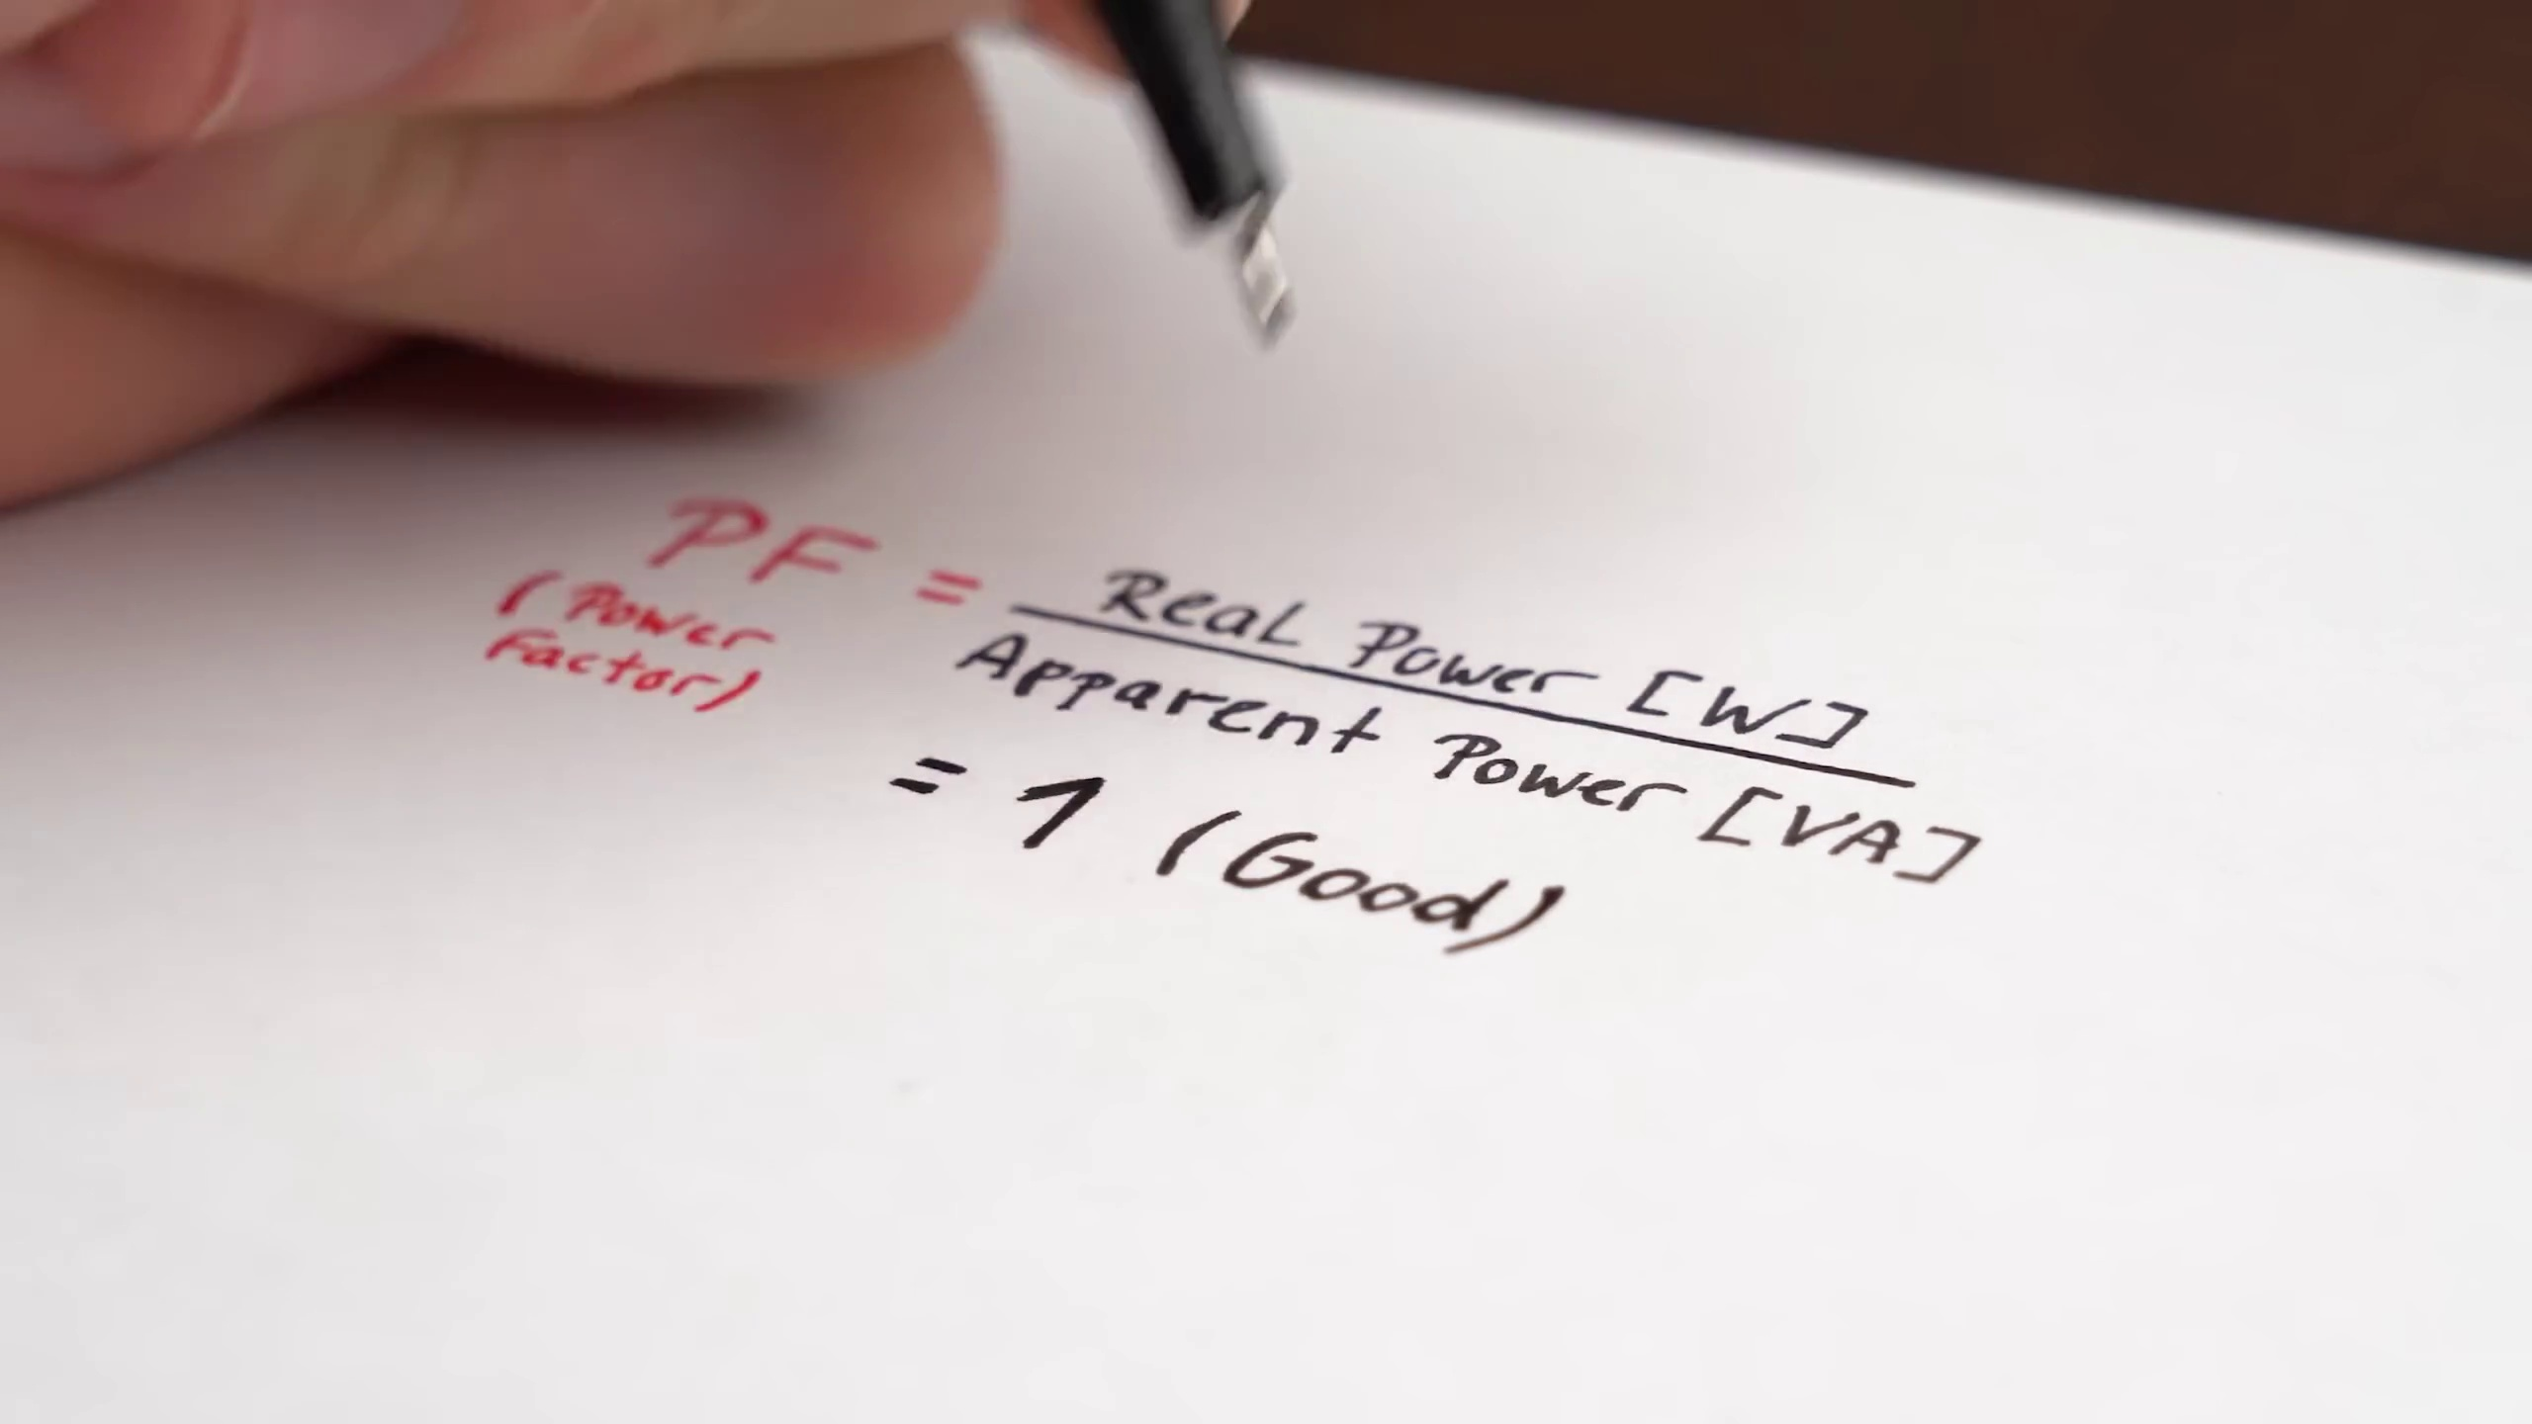 (score 90.0000)
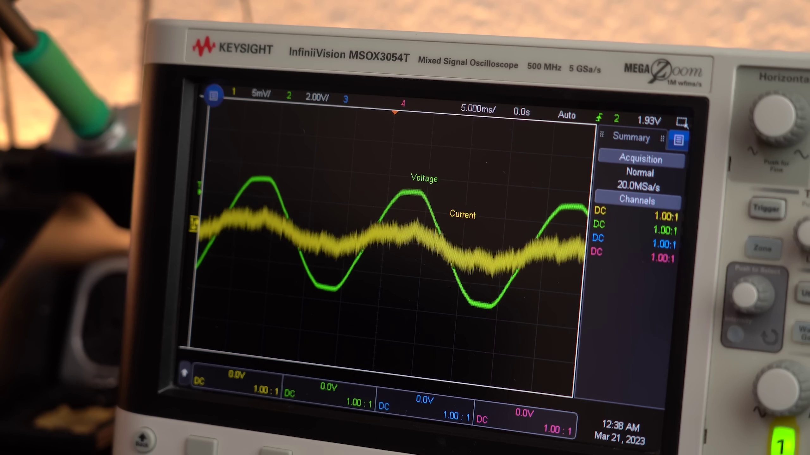 (score 90.0000)
 (score 90.0000)
 (score 90.0000)
 (score 90.0000)
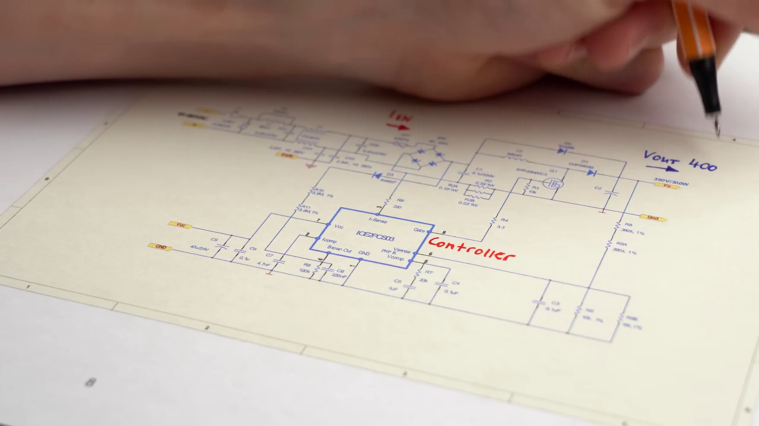 (score 85.0000)
 (score 85.0000)
 (score 85.0000)
Least correlated frames:
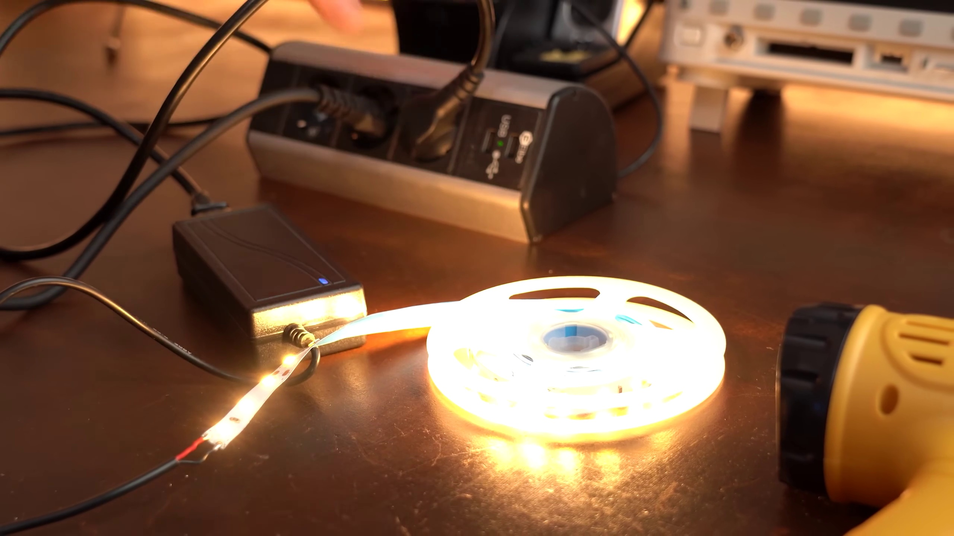 (score 0.0000)
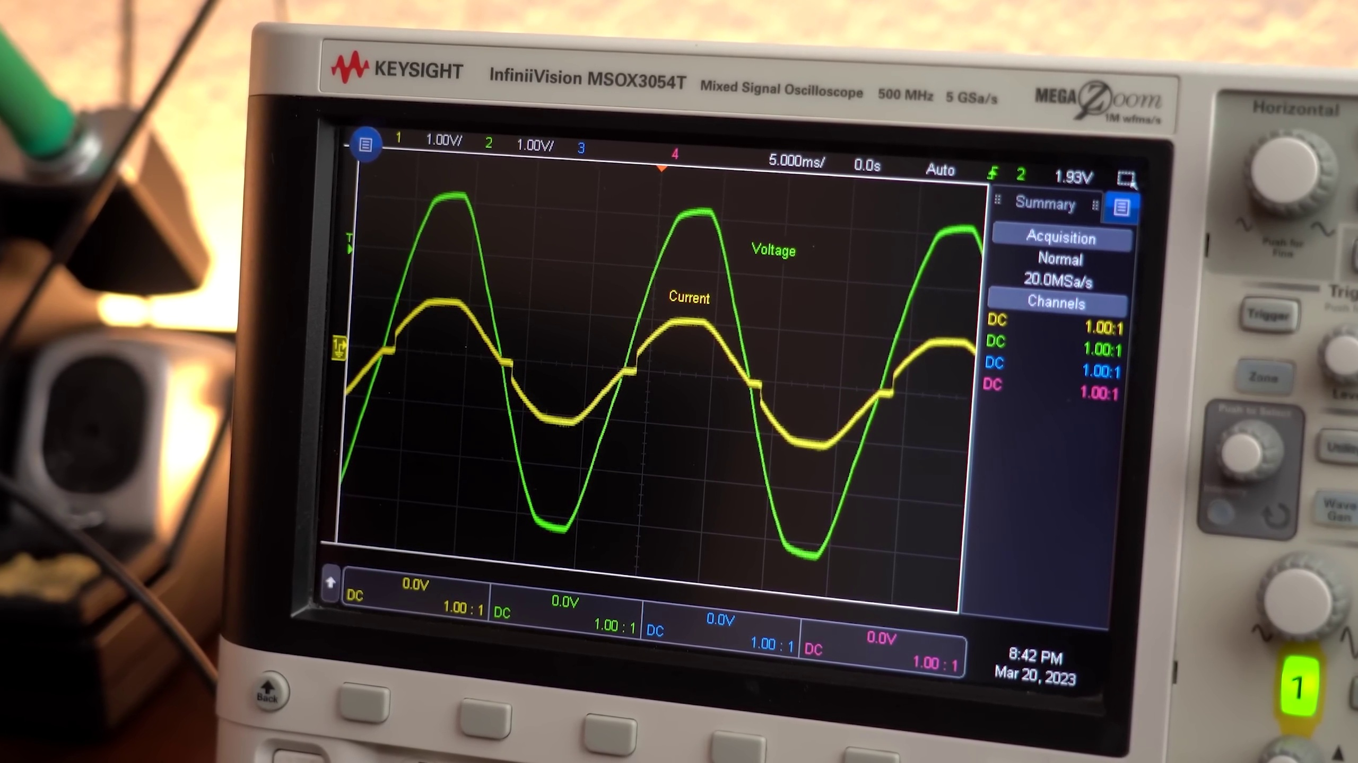 (score 0.0000)
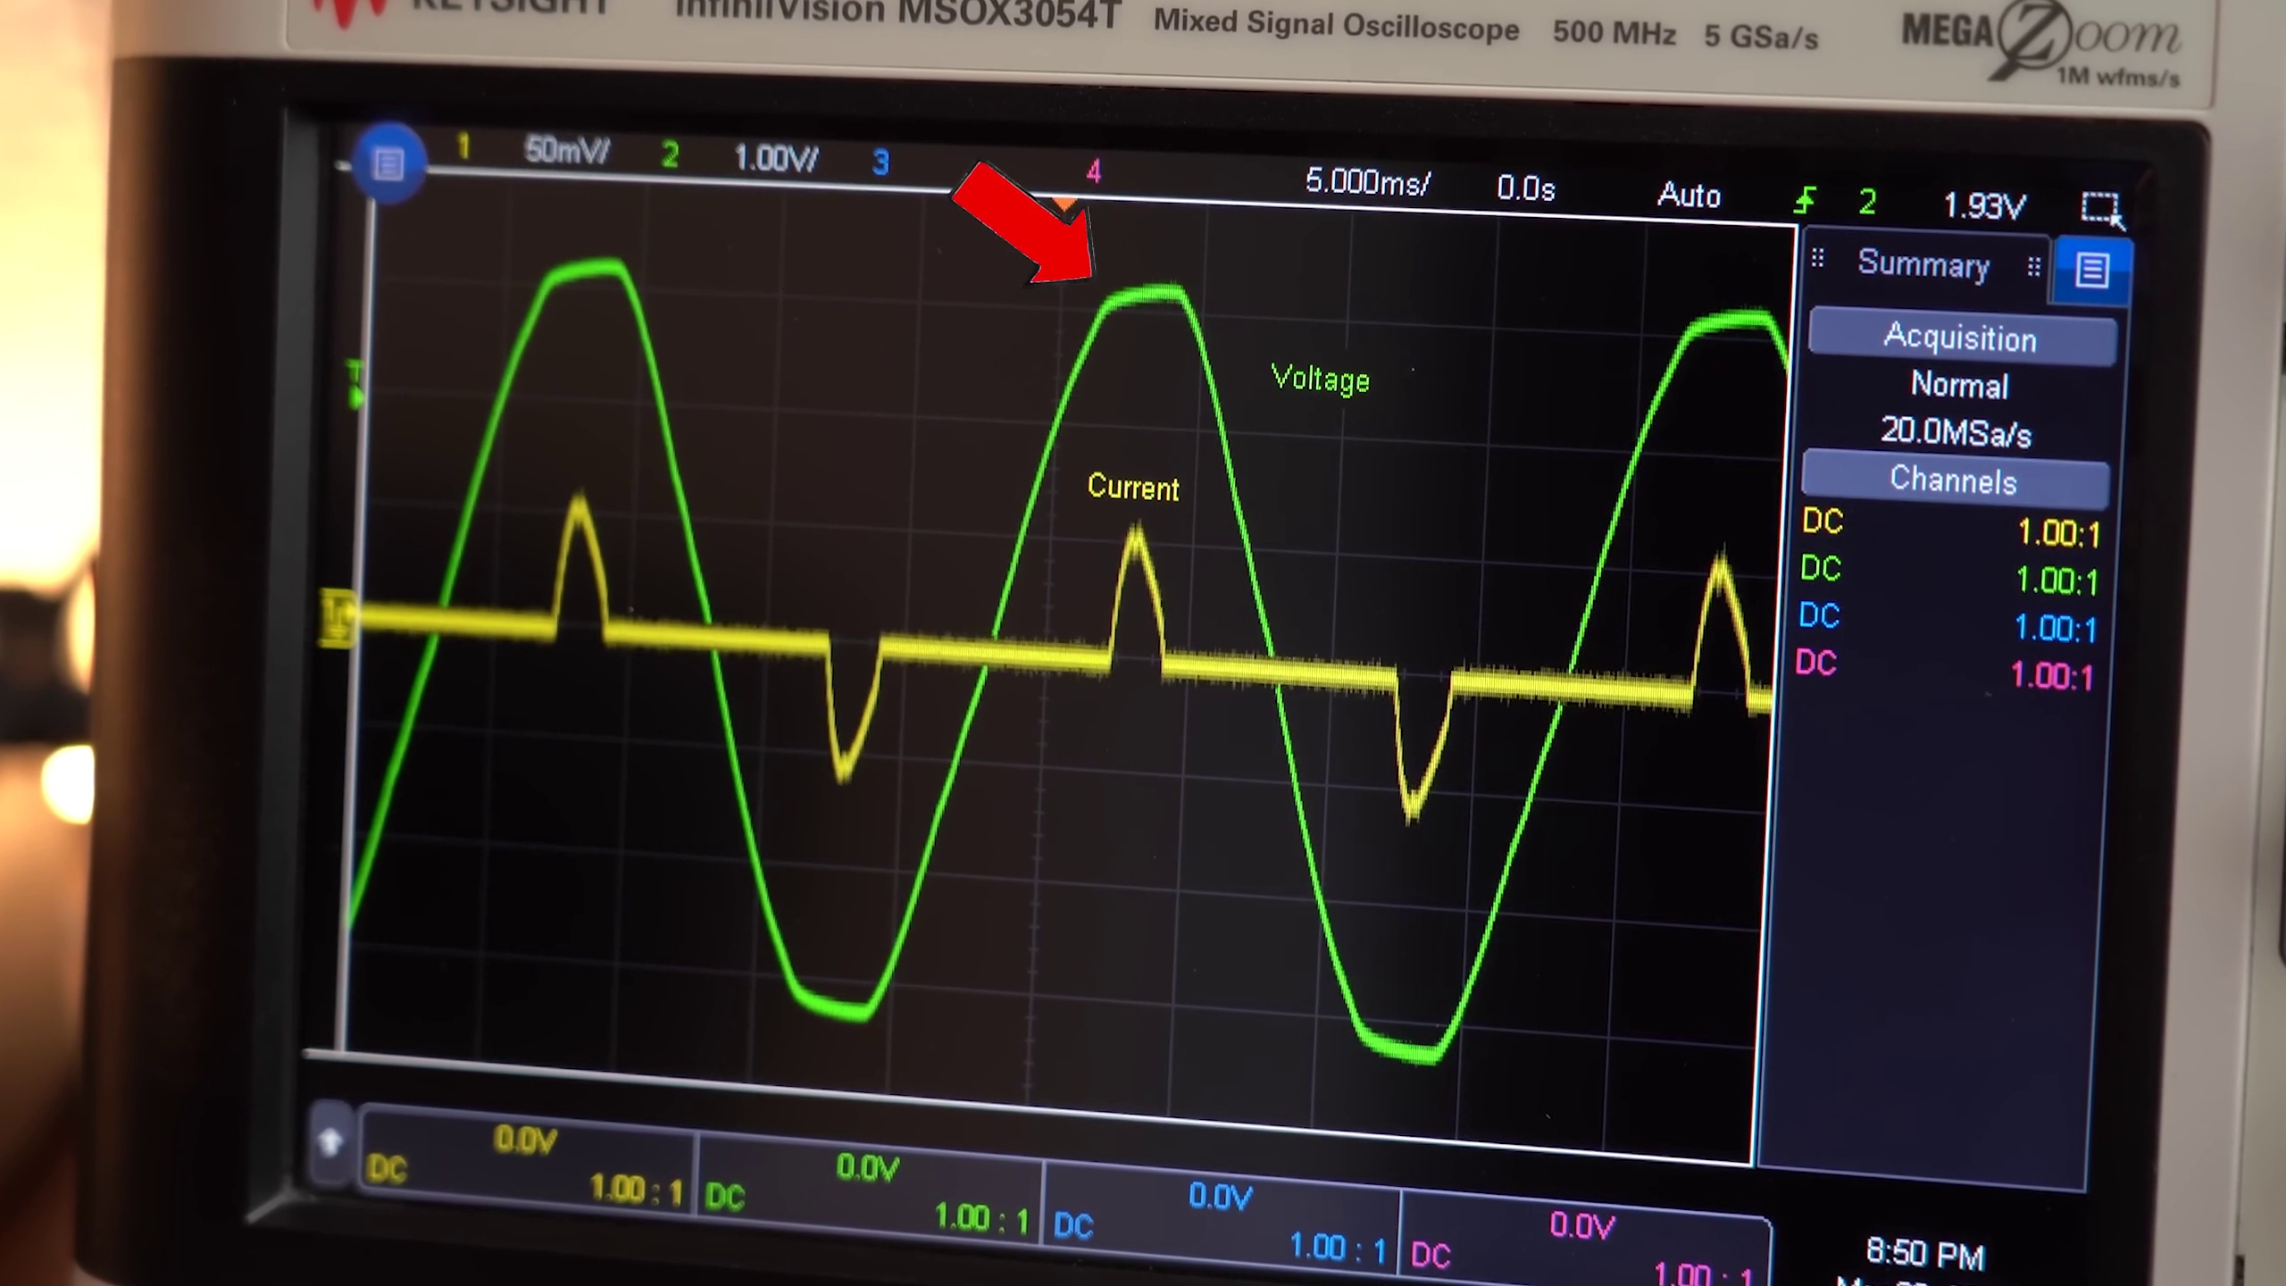 (score 0.0000)
 (score 0.0000)
 (score 0.0000)
 (score 0.0000)
 (score 0.0000)
 (score 0.0000)
 (score 0.0000)
 (score 0.0000)

Frame: frame_0000.jpg
Caption: This image shows a person holding a yellow heat gun, powered by electricity. The individual's face is not clearly visible due to the angle of the photo, but we can see that they are wearing a white shirt and dark pants. On the table behind them, there are various electronic devices and what appears to be a breadboard or prototype board, suggesting this could be an electronics workshop or demonstration. The setting looks like a home or DIY workspace.
The heat gun is being used on a wooden table, with a silver wire running across it. The table itself is covered in various objects, including a white box, a blue object, and a black object. A black power strip hangs from the white wall in the background.
Comment (score 80): This video is 11:25 minutes. What I learned from the video - This video talks about how AC to DC power supplies like the one show here for LEDs waste a lot of power. The apparent power vs the real power drawn is very different and that is bad. He then talks about what power factor correction circuits are and why they are important for fixing this issue. He uses a good analogy with pouring coke into a glass. Liquid coke is the real power, foam is the reactive power, and the total height is the apparent power. I don’t quite understand exactly how all this works. Circuits are not my forte, but I understood well enough that increasing the power factor of appliances saves energy in the long run.
Reason: The comment directly discusses the concept of AC to DC power supplies and power factor correction circuits, which are specifically mentioned in the caption. The analogy used in the comment (liquid coke as real power, foam as reactive power) is also relevant to the setting and objects described in the caption, indicating a strong connection between the two.
Source: https://www.youtube.com/watch?v=U5cqrrhq9TA : The Most Important Circuit for our Electrical Future?! (PFC) EB#55
Comment (score 80): What I have learned from the video is How to remove reactive power (Q/VAR) from a circuit/system using a PFC. How I plan to use the electrical system in the future: Remove phase shifts.
Reason: The comment explicitly mentions using a heat gun (described in the caption) to remove phase shifts and reactive power from a circuit/system, which is strongly related to the technical steps and objects described in the caption.
Source: https://www.youtube.com/watch?v=U5cqrrhq9TA: The Most Important Circuit for our Electrical Future?! (PFC) EB#55

Frame: frame_0001.jpg
Caption: The image captures a moment where technology meets creativity, with a DIY electronics project being worked on at the center. A small circular component with a blue circle and LED lights is visible, potentially a homemade breadboard with electronic components attached, including a small circuit board or integrated circuit chip (IC). To the right, a soldering iron and some soldering wire suggest that the person might be working on soldering these components together or repairing them. A USB cable plugged into an adapter indicates that they are powering their electronic device with a USB source.
In the background, a yellow flashlight stands out against the otherwise dark backdrop, casting a warm glow that adds a sense of comfort to the scene. The image also features a roll of LED light tape in the foreground, its bright white light illuminating the area and attached to a charging station plugged into a wall socket. The charging station is a sleek black device with silver accents, providing a stark contrast to the white wall socket.
Comment (score 90): This video is 11:25 minutes. What I learned from the video - This video talks about how AC to DC power supplies like the one show here for LEDs waste a lot of power. The apparent power vs the real power drawn is very different and that is bad. He then talks about what power factor correction circuits are and why they are important for fixing this issue. He uses a good analogy with pouring coke into a glass. Liquid coke is the real power, foam is the reactive power, and the total height is the apparent power. I don’t quite understand exactly how all this works. Circuits are not my forte, but I understood well enough that increasing the power factor of appliances saves energy in the long run.
Reason: The comment directly discusses the DIY electronics project and technical concepts related to the caption, specifically mentioning power supplies, power factor correction circuits, and energy efficiency. The connection is strong due to the mention of specific components (e.g., AC to DC power supplies) and technical terms (e.g., apparent power, reactive power).
Source: https://www.youtube.com/watch?v=U5cqrrhq9TA : The Most Important Circuit for our Electrical Future?! (PFC) EB#55
Comment (score 80): What I have learned from the video is How to remove reactive power (Q/VAR) from a circuit/system using a PFC. How I plan to use the electrical system in the future: Remove phase shifts.
Reason: The comment directly discusses removing reactive power (Q/VAR) from a circuit/system using PFC, which is closely related to the DIY electronics project in the frame caption, specifically the small circular component with LED lights and the soldering iron. The mention of phase shifts also matches the context of the caption's focus on electronic components and circuits.
Source: https://www.youtube.com/watch?v=U5cqrrhq9TA: The Most Important Circuit for our Electrical Future?! (PFC) EB#55

Frame: frame_0002.jpg
Caption: The image appears to show a person standing in front of a workspace, which suggests a workshop or lab setting. The individual is holding up a small electric tool with their right hand, specifically a yellow power drill, and is wearing a black shirt. In their left hand, they are holding what appears to be a credit card or similar object. They are standing next to a desk where another person is seated, although only the upper body is visible due to the angle of the photo.
The workspace is well-lit and filled with various tools and equipment, including a black toolbox, a black box, and a white box. The room also features items on the walls and shelves that suggest an electronic or DIY-focused setting, such as what looks like an oscilloscope, a soldering iron, and other electronic equipment.
The image has been edited with several elements overlaid on top, including a thumbs-up emoji to the right side of the image and a circular icon labeled "Electric Tool" on the left side. Although the specific content of these icons is not visible in the provided image, they seem to be designed to draw attention to the tool being held up by the person standing.
The text and icons suggest that this image is likely meant for promotional or instructional purposes, possibly for an online course or tutorial related to electronics or DIY projects.
Comment (score 85): This video is 11:25 minutes. What I learned from the video - This video talks about how AC to DC power supplies like the one show here for LEDs waste a lot of power. The apparent power vs the real power drawn is very different and that is bad. He then talks about what power factor correction circuits are and why they are important for fixing this issue. He uses a good analogy with pouring coke into a glass. Liquid coke is the real power, foam is the reactive power, and the total height is the apparent power. I don’t quite understand exactly how all this works. Circuits are not my forte, but I understood well enough that increasing the power factor of appliances saves energy in the long run.
Reason: The comment directly discusses the technical steps and objects described in the caption, specifically mentioning the AC to DC power supply and power factor correction circuits. The analogy used is also related to the caption's description of the electric tool being held up, indicating a strong connection between the two.
Source: https://www.youtube.com/watch?v=U5cqrrhq9TA : The Most Important Circuit for our Electrical Future?! (PFC) EB#55

Frame: frame_0003.jpg
Caption: The image shows a person, either a man or someone else (as their face is not visible), standing or sitting in a workspace that appears to be cluttered and busy. The individual's attention is focused on a large reel of electrical tape, which seems to be the focus of their current work. This reel stands out against their black t-shirt, which features the word "STAY" prominently displayed in bold white letters.
The desk or workspace around them is filled with various tools and equipment, including a collection of electronic components and tools such as breadboards, jumper wires, capacitors, resistors, possibly a soldering iron, as well as an array of LED strips in different colors. There are also small motors or DC motors, a camera, batteries, wires, and other small components scattered about.
The desk appears cluttered, with many objects scattered about, suggesting that the person is actively working on a project. The environment gives off a vibe of someone who enjoys tinkering or conducting electronics experiments. The reel of electrical tape held up by the individual implies that they might be in the middle of some project, possibly related to DIY or repair work.
Comment (score 85): This video is 11:25 minutes. What I learned from the video - This video talks about how AC to DC power supplies like the one show here for LEDs waste a lot of power. The apparent power vs the real power drawn is very different and that is bad. He then talks about what power factor correction circuits are and why they are important for fixing this issue. He uses a good analogy with pouring coke into a glass. Liquid coke is the real power, foam is the reactive power, and the total height is the apparent power. I don’t quite understand exactly how all this works. Circuits are not my forte, but I understood well enough that increasing the power factor of appliances saves energy in the long run.
Reason: The comment directly discusses the concept of power factor correction circuits and its importance in reducing energy waste, which is closely related to the focus on electrical tape and components shown in the caption. The analogy used in the comment (liquid coke as real power, foam as reactive power) also corresponds to the technical context depicted in the image.
Source: https://www.youtube.com/watch?v=U5cqrrhq9TA : The Most Important Circuit for our Electrical Future?! (PFC) EB#55
Comment (score 80): What I have learned from the video is How to remove reactive power (Q/VAR) from a circuit/system using a PFC. How I plan to use the electrical system in the future: Remove phase shifts.
Reason: The comment mentions removing reactive power (Q/VAR) from a circuit/system using PFC, which is directly related to the electrical tape reel and the electronic components on the desk, as well as the tools and equipment mentioned. The mention of phase shifts also connects to the breadboards, jumper wires, capacitors, resistors, and possibly a soldering iron, indicating a strong correlation between the comment and the frame caption.
Source: https://www.youtube.com/watch?v=U5cqrrhq9TA: The Most Important Circuit for our Electrical Future?! (PFC) EB#55

Frame: frame_0004.jpg
Caption: The image shows a person standing in front of a white wall adorned with a collection of wires and cables, creating a sense of complexity and intricacy. Above the individual, there are two red signs that read "What?" and "Wait!". The person appears to be engaged in a conversation, their mouth slightly open as if speaking. Their facial expression is one of surprise or disbelief, adding a touch of humor to the scene.
In the background, there are various electronic equipment and cables visible, possibly indicating a tech-oriented environment such as a workshop or studio. On the wall behind the individual, there is an array of electronic equipment, further emphasizing the technological nature of the setting.
The person's reaction is amplified by a meme superimposed over the image, featuring text with exclamation points that reads "WHAT?!" and "WAIT!?". This meme is often used to express disbelief or shock in response to a surprising or unexpected event. The individual's surprised or shocked facial expression aligns with the meme's message, drawing attention to their reaction rather than any instructional content.
The instructor's hands are not visible, and no slide, diagram, or text is visible that would suggest they are teaching from a presentation or a model. The focus of this frame seems to be more on the reaction of the person rather than any instructional content.
Comment (score 80): This video is 11:25 minutes. What I learned from the video - This video talks about how AC to DC power supplies like the one show here for LEDs waste a lot of power. The apparent power vs the real power drawn is very different and that is bad. He then talks about what power factor correction circuits are and why they are important for fixing this issue. He uses a good analogy with pouring coke into a glass. Liquid coke is the real power, foam is the reactive power, and the total height is the apparent power. I don’t quite understand exactly how all this works. Circuits are not my forte, but I understood well enough that increasing the power factor of appliances saves energy in the long run.
Reason: The comment directly discusses the same technical concept of power supplies and power factor correction mentioned in the caption. The analogy used to explain reactive power is also related to the caption's description of a surprising or unexpected event.
Source: https://www.youtube.com/watch?v=U5cqrrhq9TA : The Most Important Circuit for our Electrical Future?! (PFC) EB#55

Frame: frame_0005.jpg
Caption: The image captures a person intensely focused on a task involving electronic equipment and tools. The setting appears to be a home or hobbyist workspace, with a personal touch to the background. The person is clad in a black shirt and is engaged in connecting wires using a pair of pliers, with wires of varying colors including blue, black, and red being connected to different sockets scattered across the desk. A power supply device stands out to the right, plugged into one of the sockets and hinting at the importance of the task at hand.
The background is a blur of activity, suggesting a bustling environment with other people and devices present. However, the person's focused expression suggests they are deeply engrossed in their work. The image presents a snapshot of a moment in time, capturing the energy and focus of a skilled technician at work, surrounded by electronic equipment including a power strip or similar device with red and black wires plugged into it, as well as pliers and additional cables or wiring materials for assembling, repairing, or modifying an electronic circuit.
Comment (score 90): What I have learned from the video is How to remove reactive power (Q/VAR) from a circuit/system using a PFC. How I plan to use the electrical system in the future: Remove phase shifts.
Reason: The comment directly discusses technical steps and goals described in the caption, specifically mentioning removing reactive power (Q/VAR) from a circuit/system using a PFC, which is related to connecting wires and using pliers as shown in the image.
Source: https://www.youtube.com/watch?v=U5cqrrhq9TA: The Most Important Circuit for our Electrical Future?! (PFC) EB#55
Comment (score 85): This video is 11:25 minutes. What I learned from the video - This video talks about how AC to DC power supplies like the one show here for LEDs waste a lot of power. The apparent power vs the real power drawn is very different and that is bad. He then talks about what power factor correction circuits are and why they are important for fixing this issue. He uses a good analogy with pouring coke into a glass. Liquid coke is the real power, foam is the reactive power, and the total height is the apparent power. I don’t quite understand exactly how all this works. Circuits are not my forte, but I understood well enough that increasing the power factor of appliances saves energy in the long run.
Reason: The comment directly discusses the power supply device mentioned in the caption, specifically its inefficiencies and the importance of power factor correction circuits. The analogy used in the comment also relates to the technical steps and goals described in the caption, such as understanding real vs apparent power.
Source: https://www.youtube.com/watch?v=U5cqrrhq9TA : The Most Important Circuit for our Electrical Future?! (PFC) EB#55

Frame: frame_0006.jpg
Caption: The image captures a dynamic scene of electronic experimentation, featuring various electronic devices, wires, and components arranged on a dark brown wooden table. A person's hand is visible in the top left corner, holding a pair of red and black electrical test leads that are connected to several components.
On the left side of the image, a black digital multimeter is plugged into a socket, suggesting it's being used for testing purposes. Next to the multimeter lies a small blue device with buttons on it, possibly a controller or interface module.
In the center of the table, an electronic device with a black case and various ports (including USB, DC jack, and potentially others like Ethernet or audio) is connected via a yellow cable to a smaller component with a clear plastic casing, which might be a power supply or an adapter. The device is plugged into a red power strip with several cables plugged into it.
On the right side of the image, a black USB power bank is connected to a wall socket and has its open USB port ready for use. A black power strip with three sockets sits nearby, one occupied by the USB power bank and the other two empty.
Finally, in the bottom right corner, a small rectangular component appears to be some kind of microelectronic module or circuit board. The overall scene suggests an active environment of electronic experimentation and testing.
Comment (score 95): This video is 11:25 minutes. What I learned from the video - This video talks about how AC to DC power supplies like the one show here for LEDs waste a lot of power. The apparent power vs the real power drawn is very different and that is bad. He then talks about what power factor correction circuits are and why they are important for fixing this issue. He uses a good analogy with pouring coke into a glass. Liquid coke is the real power, foam is the reactive power, and the total height is the apparent power. I don’t quite understand exactly how all this works. Circuits are not my forte, but I understood well enough that increasing the power factor of appliances saves energy in the long run.
Reason: The comment directly discusses the same technical steps and concepts described in the caption, including power supplies, power factor correction circuits, and the importance of increasing power factor to save energy. The only reason it's not a perfect score is that the comment doesn't specifically mention all the electronic devices and components shown in the image.
Source: https://www.youtube.com/watch?v=U5cqrrhq9TA : The Most Important Circuit for our Electrical Future?! (PFC) EB#55
Comment (score 80): What I have learned from the video is How to remove reactive power (Q/VAR) from a circuit/system using a PFC. How I plan to use the electrical system in the future: Remove phase shifts.
Reason: The comment directly discusses the removal of reactive power (Q/VAR) from a circuit/system using a Power Factor Correction (PFC), which is closely related to the technical steps, components, and settings described in the caption. The mention of removing phase shifts also connects to the electrical experimentation scene depicted in the image.
Source: https://www.youtube.com/watch?v=U5cqrrhq9TA: The Most Important Circuit for our Electrical Future?! (PFC) EB#55

Frame: frame_0007.jpg
Caption: The image shows a man standing in a cluttered room filled with various electronic components and tools. He is holding a yellow power drill, which has a black handle and a yellow body, equipped with a white cord. The power drill is being pointed towards the camera. The room is well-lit, with a lightbulb hanging from the ceiling.
The man is wearing a black t-shirt, a black watch, and a pair of glasses. His surroundings are quite cluttered, with boxes stacked on the shelves and a white box visible on the ground. The shelves are filled with different types of electronic components, including resistors and capacitors.
To his left, there appears to be a soldering station, suggesting that he might be engaged in some form of electronics-related work or project. There is also visible text such as "Stanford" on a box, possibly indicating a brand name or institution's name. The background suggests it might be evening or nighttime, but the lighting is sufficient to reveal the details.
The man appears to be in the process of demonstrating or showing off an object he is holding, which seems to be related to electronics or hobbyist electronics given the presence of wires and components on the bench. However, there are no visible texts or diagrams that provide information about what is being demonstrated or taught. The overall scene suggests that the man is engaged in some form of electronic repair or maintenance work, possibly working on a project involving electronics.
Comment (score 80): This video is 11:25 minutes. What I learned from the video - This video talks about how AC to DC power supplies like the one show here for LEDs waste a lot of power. The apparent power vs the real power drawn is very different and that is bad. He then talks about what power factor correction circuits are and why they are important for fixing this issue. He uses a good analogy with pouring coke into a glass. Liquid coke is the real power, foam is the reactive power, and the total height is the apparent power. I don’t quite understand exactly how all this works. Circuits are not my forte, but I understood well enough that increasing the power factor of appliances saves energy in the long run.
Reason: The comment directly discusses power supplies, power factor correction circuits, and their importance in fixing energy waste issues, which are all technical steps and concepts related to the caption's description of a man working on electronics-related projects. The analogy used in the comment about pouring coke into a glass is also relevant to the caption's focus on electronic components and tools.
Source: https://www.youtube.com/watch?v=U5cqrrhq9TA : The Most Important Circuit for our Electrical Future?! (PFC) EB#55
Comment (score 80): What I have learned from the video is How to remove reactive power (Q/VAR) from a circuit/system using a PFC. How I plan to use the electrical system in the future: Remove phase shifts.
Reason: The comment directly discusses removing reactive power (Q/VAR) from a circuit/system using a PFC, which is strongly related to the technical steps and objects described in the caption. The mention of 'PFC' and 'circuit/system' matches the electronic components and tools shown in the image.
Source: https://www.youtube.com/watch?v=U5cqrrhq9TA: The Most Important Circuit for our Electrical Future?! (PFC) EB#55

Frame: frame_0008.jpg
Caption: The image shows a white KeySight MS2341A oscilloscope, currently displaying a voltage waveform with several signal traces and various parameters. The oscilloscope display indicates a frequency of 385 kHz, amplitude range of 0-15 mV, offset at 0 mV, gain set to 1x, timebase set to 2 s/div, and a horizontal marker at 1.47. Two vertical lines on the display suggest that some measurement or analysis is being performed. The device has multiple inputs, capable of processing signals from different sources simultaneously.
In the background, part of a person is visible, appearing to be engaged in operating the equipment. However, the focus of the image remains on the oscilloscope and its electronic setup rather than on the person or their activity.
Comment (score 80): What I have learned from the video is How to remove reactive power (Q/VAR) from a circuit/system using a PFC. How I plan to use the electrical system in the future: Remove phase shifts.
Reason: The comment directly mentions 'remove reactive power (Q/VAR) from a circuit/system' and 'PFC', which are specific technical steps described in the frame caption. The caption also highlights the oscilloscope display parameters, including frequency, amplitude range, offset, gain, timebase, and horizontal marker, which align with the viewer's plan to use the electrical system in the future (removing phase shifts).
Source: https://www.youtube.com/watch?v=U5cqrrhq9TA: The Most Important Circuit for our Electrical Future?! (PFC) EB#55

Frame: frame_0009.jpg
Caption: This image showcases a digital oscilloscope, showcasing its capabilities for visualizing and analyzing electrical signals. The device, labeled as "Agilent 8942" on the top left corner, features a large screen displaying various readings.
The screen is filled with three waveforms: a yellow waveform resembling a triangle wave with rising and falling amplitude at the top, a green waveform with two peaks potentially indicating a sawtooth or trapezoidal waveform in the middle, and a blue waveform showing an increasing amplitude over time, likely representing a sine wave at the bottom.
The vertical axis scale is labeled as "0.1 V" for voltage measurements in volts (V), while the horizontal axis displays time values ranging from "3" seconds, suggesting this is part of an oscilloscope test pattern or setup. The frequency displayed at the top right corner reads "10 Hz," indicating 10 cycles per second.
Several horizontal marks on the screen likely represent milliseconds (ms) and microseconds (µs), aiding in time measurement. The background appears to be an indoor setting, possibly a laboratory or classroom environment, given the presence of electronic equipment and wires.
The oscilloscope itself is mounted on a white stand, ensuring stability during use, and is plugged into a power adapter located on the right side of the device. A black and white keyboard provides a user-friendly interface for inputting data and commands. The text "Infinivision MSX3064T" and "MegaSight" indicate the model and brand of the oscilloscope, providing information about its specific features and capabilities.
Comment (score 90): What I have learned from the video is How to remove reactive power (Q/VAR) from a circuit/system using a PFC. How I plan to use the electrical system in the future: Remove phase shifts.
Reason: The comment directly discusses the removal of reactive power (Q/VAR) from a circuit/system, which is closely related to the digital oscilloscope shown in the frame caption. The mention of using PFC and removing phase shifts aligns with the technical steps and goals described in the caption, making it strongly correlated.
Source: https://www.youtube.com/watch?v=U5cqrrhq9TA: The Most Important Circuit for our Electrical Future?! (PFC) EB#55

Frame: frame_0010.jpg
Caption: The image features a hand-drawn sketch with axes labeled as 'x' and 'y', depicting a single curve that starts at the origin, rises to a peak, and then descends. The graph is simple yet informative, with three arrows on the curve: one starting from the x-axis near the bottom, another pointing upwards along the curve, and a third ending at the top of the curve. The sketch appears to be in the middle of construction or explanation, done with colored pencils, suggesting it could be from a teaching session where an instructor is explaining mathematical concepts such as graphing functions or optimization techniques.
While there is no text visible within the image providing context about the function or purpose of the drawing, the style of the sketch implies that this may be an actual classroom setting or a digital creation meant for educational purposes.
Comment (score 80): This video is 11:25 minutes. What I learned from the video - This video talks about how AC to DC power supplies like the one show here for LEDs waste a lot of power. The apparent power vs the real power drawn is very different and that is bad. He then talks about what power factor correction circuits are and why they are important for fixing this issue. He uses a good analogy with pouring coke into a glass. Liquid coke is the real power, foam is the reactive power, and the total height is the apparent power. I don’t quite understand exactly how all this works. Circuits are not my forte, but I understood well enough that increasing the power factor of appliances saves energy in the long run.
Reason: The comment directly discusses the concept of apparent power vs real power drawn, which is also described in the caption as a graph showing a curve with arrows. The mention of power factor correction circuits and its importance to fix the issue of wasted power is also related to the technical steps and goals described in the caption.
Source: https://www.youtube.com/watch?v=U5cqrrhq9TA : The Most Important Circuit for our Electrical Future?! (PFC) EB#55
Comment (score 80): What I have learned from the video is How to remove reactive power (Q/VAR) from a circuit/system using a PFC. How I plan to use the electrical system in the future: Remove phase shifts.
Reason: The comment directly discusses removing reactive power (Q/VAR) from a circuit/system using PFC, which is strongly related to the technical steps described in the caption (graphing functions and optimization techniques). The connection is evident as both mention the concept of 'removing' or 'optimizing' something.
Source: https://www.youtube.com/watch?v=U5cqrrhq9TA: The Most Important Circuit for our Electrical Future?! (PFC) EB#55

Frame: frame_0011.jpg
Caption: The image shows a man standing in a well-lit and organized room filled with various tools and equipment. He is wearing a black t-shirt with the word "STAY CREATIVE" written on it, suggesting an emphasis on innovation and exploration. The man is holding a strip of LED lights connected to a power source, indicating that he might be working on a project involving these lights.
In the foreground, the desk is set up for an electronics or DIY project, with a man sitting in front of it. He appears to be in the middle of a video or livestream recording session, given the camera setup and the presence of a webcam positioned to capture video footage of his work area. The man has dark hair, facial hair, and is wearing a black t-shirt with a graphic on it, along with what looks like a casual belt loop.
The desk is cluttered with various electronic components such as breadboards, wires, connectors, and a microcontroller board that resembles an Arduino or similar development board. There are also small tools like tweezers, pliers, and a small soldering iron nearby. A few tools can be seen on the desk, including wire cutters and possibly some other electronic components or test equipment.
Behind the man, there is a bench with more electronics equipment, such as a circuit board and additional breadboards or development boards. On the wall to the right, there are cable management strips hanging from the ceiling. In the upper left corner of the image, there's text that reads "STAY CURIOUS," suggesting a theme or motto for the content being produced.
The room is dimly lit, but there is sufficient illumination on the desk and around the person, suggesting that the lighting setup is meant to focus attention on the work being done.
Comment (score 95): This video is 11:25 minutes. What I learned from the video - This video talks about how AC to DC power supplies like the one show here for LEDs waste a lot of power. The apparent power vs the real power drawn is very different and that is bad. He then talks about what power factor correction circuits are and why they are important for fixing this issue. He uses a good analogy with pouring coke into a glass. Liquid coke is the real power, foam is the reactive power, and the total height is the apparent power. I don’t quite understand exactly how all this works. Circuits are not my forte, but I understood well enough that increasing the power factor of appliances saves energy in the long run.
Reason: The comment directly discusses the power supply and power factor correction circuits mentioned in the caption, including the specific example of LEDs. The analogy used is also related to the context described in the caption.
Source: https://www.youtube.com/watch?v=U5cqrrhq9TA : The Most Important Circuit for our Electrical Future?! (PFC) EB#55
Comment (score 80): What I have learned from the video is How to remove reactive power (Q/VAR) from a circuit/system using a PFC. How I plan to use the electrical system in the future: Remove phase shifts.
Reason: The comment directly discusses the removal of reactive power (Q/VAR) from a circuit/system using a PFC, which is related to the technical steps and equipment described in the caption, such as breadboards, wires, connectors, microcontroller board, soldering iron, and cable management strips.
Source: https://www.youtube.com/watch?v=U5cqrrhq9TA: The Most Important Circuit for our Electrical Future?! (PFC) EB#55

Frame: frame_0012.jpg
Caption: This image features an oscilloscope displaying a waveform with multiple signals, which has several peaks and valleys indicating changes in voltage or current over time. The digital display at the top of the screen shows "902", potentially referring to a channel number or some other parameter of the oscilloscope. A red arrow points to a specific part of the waveform, likely drawing attention to an important aspect of the signal for analysis or teaching purposes.
In the background, household items can be seen in the corners, suggesting that this image may have been taken in a home setting. The absence of visible texts, brands, or identifying features prevents more specific information about the context or location where this photo was taken from being provided.
Meanwhile, on a separate computer monitor located elsewhere (not visible in this image), a digital signal is displayed in shades of red and green, indicating positive and negative voltage levels. The monitor's screen displays the time as 2:58 PM and the number 2010 on the top left corner. The current voltage level being viewed is 1.8V, labeled as "V". A microscope can be seen in the lower right corner of this image, used for viewing objects too small to be seen with the naked eye.
Comment (score 85): This video is 11:25 minutes. What I learned from the video - This video talks about how AC to DC power supplies like the one show here for LEDs waste a lot of power. The apparent power vs the real power drawn is very different and that is bad. He then talks about what power factor correction circuits are and why they are important for fixing this issue. He uses a good analogy with pouring coke into a glass. Liquid coke is the real power, foam is the reactive power, and the total height is the apparent power. I don’t quite understand exactly how all this works. Circuits are not my forte, but I understood well enough that increasing the power factor of appliances saves energy in the long run.
Reason: The comment directly discusses the oscilloscope waveform and its relation to AC/DC power supplies, mentioning specific technical terms like 'power factor correction circuits' and 'apparent power'. The comment also uses an analogy related to the waveform, making it strongly connected to the frame caption.
Source: https://www.youtube.com/watch?v=U5cqrrhq9TA : The Most Important Circuit for our Electrical Future?! (PFC) EB#55
Comment (score 80): What I have learned from the video is How to remove reactive power (Q/VAR) from a circuit/system using a PFC. How I plan to use the electrical system in the future: Remove phase shifts.
Reason: The comment directly discusses removing reactive power (Q/VAR) from a circuit/system using a PFC, which is strongly related to the oscilloscope displaying a waveform with multiple signals in the frame caption. The mention of 'remove phase shifts' also indicates an understanding of the technical steps and objects described in the caption.
Source: https://www.youtube.com/watch?v=U5cqrrhq9TA: The Most Important Circuit for our Electrical Future?! (PFC) EB#55

Frame: frame_0013.jpg
Caption: The image shows a digital oscilloscope displaying a voltage waveform with multiple overlaid waveforms, including a main waveform with a series of peaks and troughs resembling sine waves. The main waveform has a smaller, inverted waveform on top, likely representing the negative or complementary component of the signal. Additionally, several other smaller waveforms overlap the main one, potentially indicating additional signals or components mixed with the primary signal.
On the right side of the display, there is a vertical strip labeled "V," which likely stands for voltage, indicating the amplitude of the signal on the y-axis. The horizontal axis of the graph could represent time, as indicated by the marking that reads "0ms." Scale references are also present along both axes, although they are too small to read accurately.
The timestamp in the top right corner of the image reads 10:59 PM, suggesting that the image was taken at this time. The digital oscilloscope is set to 20 MHz, a common frequency for such devices. The waveform is clearly labeled with the frequency of 0.1 MHz, indicating the exact frequency of the signal being displayed. A red light on the top right corner of the image indicates that the device is turned on.
The left side of the image features a white panel with black text and symbols that appear to be part of a user interface or menu system related to the oscilloscope's operation. The specific details on this panel are not clearly visible, but it suggests an educational setting, such as a science class or workshop where a student or instructor might be demonstrating the use of an oscilloscope or explaining concepts related to signal analysis or electronic engineering.
Comment (score 85): What I have learned from the video is How to remove reactive power (Q/VAR) from a circuit/system using a PFC. How I plan to use the electrical system in the future: Remove phase shifts.
Reason: The comment directly discusses the removal of reactive power (Q/VAR) and phase shifts, which are technical steps and goals described in the caption. The mention of a PFC (Power Factor Corrector) also aligns with the oscilloscope's usage for signal analysis.
Source: https://www.youtube.com/watch?v=U5cqrrhq9TA: The Most Important Circuit for our Electrical Future?! (PFC) EB#55

Frame: frame_0014.jpg
Caption: In this image, there is a person standing in front of a cluttered workspace, with their hands raised in the air, suggesting a sense of excitement or enthusiasm. Their face is turned towards the camera, indicating a direct and open communication. The individual appears to be wearing a dark-colored t-shirt with text on it and has short hair.
The workspace is filled with various tools and equipment, with a black desk serving as the stage for this scene. A black chair nearby is ready for the next task. On the desk, there are scattered electronic components, including a soldering iron, a microscope, wires, and possibly small electronic components or parts.
Behind the person, a wall-mounted shelf contains more electronic equipment and materials, showcasing the individual's dedication to their craft. The overall scene suggests a workspace designed for electronics hobbyist or professional activities, such as repair, assembly, or experimentation with electronics.
The atmosphere is one of dedication and hard work, capturing a moment in the life of an individual deeply immersed in their passion. The person's raised hands and focused expression suggest a moment of triumph or excitement, a testament to the joy of creation.
Comment (score 90): What I have learned from the video is How to remove reactive power (Q/VAR) from a circuit/system using a PFC. How I plan to use the electrical system in the future: Remove phase shifts.
Reason: The comment directly discusses the technical steps described in the caption, specifically mentioning PFC and removing phase shifts, which are related to the electronic components and tools shown in the workspace.
Source: https://www.youtube.com/watch?v=U5cqrrhq9TA: The Most Important Circuit for our Electrical Future?! (PFC) EB#55
Comment (score 85): This video is 11:25 minutes. What I learned from the video - This video talks about how AC to DC power supplies like the one show here for LEDs waste a lot of power. The apparent power vs the real power drawn is very different and that is bad. He then talks about what power factor correction circuits are and why they are important for fixing this issue. He uses a good analogy with pouring coke into a glass. Liquid coke is the real power, foam is the reactive power, and the total height is the apparent power. I don’t quite understand exactly how all this works. Circuits are not my forte, but I understood well enough that increasing the power factor of appliances saves energy in the long run.
Reason: The comment directly discusses power factor correction circuits and their importance in reducing energy waste, which is closely related to the technical steps and objects described in the caption (e.g., AC to DC power supplies, electronic components), as well as the goals of increasing power factor and saving energy.
Source: https://www.youtube.com/watch?v=U5cqrrhq9TA : The Most Important Circuit for our Electrical Future?! (PFC) EB#55

Frame: frame_0015.jpg
Caption: The image shows an individual intensely focused on a task, with a yellow heat gun held in their right hand, ready to be activated. The heat gun is positioned on a wooden desk, its surface gleaming under the light. In the background, there's a collection of electronic devices, each with its own unique purpose. A white computer monitor stands tall, its screen reflecting the light, while a black keyboard sits on the desk, its keys waiting to be pressed. Additionally, a black tape recorder is present, its surface smooth and unblemished.
On the table in front of the individual, there are electronic components being worked with, including a circuit board, suggesting a setting related to electronics, robotics, or DIY technology projects. A small robot with visible electronics is also nearby, possibly indicating that it's being worked on or repaired. The focus of the image suggests a moment of work, blending technology and craftsmanship, with the individual deeply engaged in their task.
Comment (score 95): What I have learned from the video is How to remove reactive power (Q/VAR) from a circuit/system using a PFC. How I plan to use the electrical system in the future: Remove phase shifts.
Reason: The comment directly discusses the technical step of removing reactive power (Q/VAR) from a circuit/system using a PFC, which is closely related to the frame caption's description of electronic components and robotics. The mention of 'phase shifts' in the future plan also matches with the background electronics mentioned in the caption.
Source: https://www.youtube.com/watch?v=U5cqrrhq9TA: The Most Important Circuit for our Electrical Future?! (PFC) EB#55
Comment (score 90): This video is 11:25 minutes. What I learned from the video - This video talks about how AC to DC power supplies like the one show here for LEDs waste a lot of power. The apparent power vs the real power drawn is very different and that is bad. He then talks about what power factor correction circuits are and why they are important for fixing this issue. He uses a good analogy with pouring coke into a glass. Liquid coke is the real power, foam is the reactive power, and the total height is the apparent power. I don’t quite understand exactly how all this works. Circuits are not my forte, but I understood well enough that increasing the power factor of appliances saves energy in the long run.
Reason: The comment directly discusses power supplies and power factor correction circuits, which are technical topics related to the objects and settings described in the caption (e.g., circuit board, robot with visible electronics). The analogy used in the comment also refers to the concepts mentioned in the caption (e.g., apparent power, real power), indicating a strong connection between the two.
Source: https://www.youtube.com/watch?v=U5cqrrhq9TA : The Most Important Circuit for our Electrical Future?! (PFC) EB#55

Frame: frame_0016.jpg
Caption: The image appears to be a screenshot from a video, showing an individual who seems to be giving some kind of presentation or demonstration, possibly related to electronics or engineering given the background and items visible. The person in the foreground is holding up one hand with their index finger extended as if pointing at something, while gesturing with their other hand. They are wearing a black t-shirt that prominently displays the word "STAIN" in white letters, adorned with a graphic of a circuit board, further emphasizing their profession. Their expression is neutral, and they seem to be engaged in speaking or demonstrating.
Behind the person, there's a wooden desk with various items on it that suggest a workspace for electronics or hobby projects: a collection of electronic components such as resistors, capacitors, and possibly integrated circuits or modules; tools that include pliers, tweezers, and other precision tools; cables and wires of different colors and sizes, which might be for connecting components or testing circuits; a small electronic device with a visible circuit board, suggesting it could be a project under construction or repair; the interior of what looks like an electronics or computer case with visible screws and mounting points; and various smaller items that resemble additional electronic components or modules.
The background is slightly blurred but indicates an indoor setting, possibly a garage or workshop, with a whiteboard to the left and a shelf filled with electronic components on the right. The floor appears to be carpeted, and there are visible cables running across it. There's no clear text or distinctive logos visible that could indicate a brand or specific topic of discussion.
The style of the video suggests an informal, possibly educational setting where the person is teaching or sharing information about a project or concept in electronics or technology. The focus on components and tools implies a hands-on approach to learning or demonstrating.
Comment (score 90): What I have learned from the video is How to remove reactive power (Q/VAR) from a circuit/system using a PFC. How I plan to use the electrical system in the future: Remove phase shifts.
Reason: The comment directly discusses the technical steps and objects described in the caption, specifically mentioning PFC (Power Factor Correction), reactive power (Q/VAR), and removing phase shifts. The mention of electronics components, tools, and a circuit board in the caption matches the topic discussed in the comment.
Source: https://www.youtube.com/watch?v=U5cqrrhq9TA: The Most Important Circuit for our Electrical Future?! (PFC) EB#55
Comment (score 85): This video is 11:25 minutes. What I learned from the video - This video talks about how AC to DC power supplies like the one show here for LEDs waste a lot of power. The apparent power vs the real power drawn is very different and that is bad. He then talks about what power factor correction circuits are and why they are important for fixing this issue. He uses a good analogy with pouring coke into a glass. Liquid coke is the real power, foam is the reactive power, and the total height is the apparent power. I don’t quite understand exactly how all this works. Circuits are not my forte, but I understood well enough that increasing the power factor of appliances saves energy in the long run.
Reason: The comment directly discusses the topic of power supplies and power factor correction, which is explicitly mentioned in the frame caption. The mention of AC to DC power supplies and the importance of power factor correction in saving energy is strongly related to the technical context presented in the frame.
Source: https://www.youtube.com/watch?v=U5cqrrhq9TA : The Most Important Circuit for our Electrical Future?! (PFC) EB#55
Comment (score 80): Explanation of power factor correction (PFC) circuits and their importance in improving power efficiency.Details on current harmonics and how they contribute to reactive power. Incorporating active PFC circuits in future power supply designs to ensure better power factor and efficiency.
Reason: The comment directly discusses the importance of PFC circuits in improving power efficiency, which is related to the technical steps and objects described in the caption (e.g. electronic components, tools, and devices). The mention of current harmonics and reactive power also connects to the engineering or electronics context depicted in the image.
Source: https://www.youtube.com/watch?v=U5cqrrhq9TA: The Most Important Circuit for our Electrical Future?! (PFC)

Frame: frame_0017.jpg
Caption: The image shows a person holding a black power strip on a wooden table, which is plugged into a wall socket located on the right side of the frame. The power strip is connected to a black charger, which is in turn charging a black device situated on the left side of the image. In the background, the room appears to have a wooden floor and a white wall, although the details are blurred due to the focus on the action taking place at the table. There is no text or slides visible in this frame.
Interestingly, the person's hand holds an electronic device that resembles a portable battery pack with a USB cable connected to it. This device seems to be used to charge another device, possibly a phone or small gadget, suggesting that multiple devices may be charged simultaneously in this domestic setting. The artificial lighting and indoor setting reinforce this notion, implying that the scene takes place at home or in a workspace.
The relative positions of the objects are as follows: the person holds the power strip and charger, the charger is connected to the power strip, and the device charges on the left side of the power strip. The wall socket remains situated on the right side of the image, while the wooden table supports the power strip. Overall, the scene conveys a typical domestic setting where the individual might be charging their device at home.
Comment (score 80): What I have learned from the video is How to remove reactive power (Q/VAR) from a circuit/system using a PFC. How I plan to use the electrical system in the future: Remove phase shifts.
Reason: The comment directly discusses removing reactive power (Q/VAR) from a circuit/system using a PFC, which is strongly related to the technical steps and objects described in the caption, such as charging devices with a power strip and charger.
Source: https://www.youtube.com/watch?v=U5cqrrhq9TA: The Most Important Circuit for our Electrical Future?! (PFC) EB#55

Frame: frame_0018.jpg
Caption: The image captures a moment in an indoor setting, possibly a laboratory or workshop, where technical equipment is present. A device labeled "Apartent Power 30V" is situated on a table with a measuring probe attached to it, suggesting its use for measuring power or voltage. The scale below the device reads from left to right: "0 mA" through "100 mA," providing a range of measurement values.
On the top right corner of the device, a digital display shows a temperature setting and two values, with the number "365" prominently displayed. In the foreground, another device, labeled "Metraht Energy", is seen taking a snapshot of the power it's measuring. The Metraht Energy device has a black and silver digital display that is lit up, revealing the timestamp 03:56:70 and a power reading of 36.70. This momentary snapshot appears to have been recorded in time as the device captures the energy measurement.
Comment (score 90): What I have learned from the video is How to remove reactive power (Q/VAR) from a circuit/system using a PFC. How I plan to use the electrical system in the future: Remove phase shifts.
Reason: The comment directly discusses removing reactive power (Q/VAR) from a circuit/system using a PFC, which is related to the technical steps described in the caption, such as measuring power and voltage. The comment also mentions phase shifts, which are relevant to the settings shown in the image.
Source: https://www.youtube.com/watch?v=U5cqrrhq9TA: The Most Important Circuit for our Electrical Future?! (PFC) EB#55

Frame: frame_0019.jpg
Caption: The image captures a moment of intense focus, as a person's hand is seen making a dot on the screen of an oscilloscope. The oscilloscope display shows several waveforms, one of which stands out with a black arrow pointing to a specific point where the probe is being used. This might indicate an event of interest within the data being measured, such as a peak or trough, or some form of signal anomaly.
The waveform in question appears to be a representation of a voltage, specifically a 500V square wave. The person's finger is pressing down on the waveform, creating a dot in the center. The waveform is colored green and yellow, with a black line indicating the voltage, which is measured in volts, with the value of 500V clearly visible.
Numerical values displayed on the oscilloscope screen include "200 mV" and "13 V," which likely represent voltage measurements taken at that point by the probe. Additionally, there is text that reads "Y-axis" and "DC," which stand for Direct Current, suggesting that the measurement is in DC terms rather than alternating current (AC).
The background behind the oscilloscope is not clearly visible due to the focus on the technology in use. There are no visible texts or diagrams that would indicate an educational context beyond what is being shown directly on the screen of the device. The person's actions and the information displayed suggest a hands-on demonstration or testing of the equipment, rather than a teaching scenario with accompanying slides or diagrams.
No strongly correlated comments found for this frame.

Frame: frame_0020.jpg
Caption: The image shows a desk with several items on it. On the left side of the frame, an oscilloscope displays some kind of signal, while to the right, a small light bulb glows with a colorful hue. The background appears to be a workspace setting, but is indistinct and slightly blurred, suggesting that the image was taken quickly or without focusing on the objects in detail. Perched on a wooden table, a circuit board dominates the frame, adorned with a series of lightbulbs whose glow adds a warm and inviting light to the scene. The board sits atop a surface marked by knobs and buttons, which though small, hold significant power and functionality.
The image also features a white wall in the background, creating a sense of space and atmosphere that contrasts with the vibrant colors of the board and glowing lightbulbs. This snapshot captures a moment of technological advancement and creativity, showcasing human ingenuity and a testament to the beauty and complexity that can be found even in ordinary objects.
Comment (score 90): This video is 11:25 minutes. What I learned from the video - This video talks about how AC to DC power supplies like the one show here for LEDs waste a lot of power. The apparent power vs the real power drawn is very different and that is bad. He then talks about what power factor correction circuits are and why they are important for fixing this issue. He uses a good analogy with pouring coke into a glass. Liquid coke is the real power, foam is the reactive power, and the total height is the apparent power. I don’t quite understand exactly how all this works. Circuits are not my forte, but I understood well enough that increasing the power factor of appliances saves energy in the long run.
Reason: The comment directly discusses the power factor correction circuits and how they relate to the technical steps described in the caption (e.g., AC to DC power supplies for LEDs), as well as the objects (circuit board) and settings (workspace) shown. The analogy used to explain apparent vs real power also aligns with the details presented in the caption.
Source: https://www.youtube.com/watch?v=U5cqrrhq9TA : The Most Important Circuit for our Electrical Future?! (PFC) EB#55
Comment (score 85): Explanation of power factor correction (PFC) circuits and their importance in improving power efficiency.Details on current harmonics and how they contribute to reactive power. Incorporating active PFC circuits in future power supply designs to ensure better power factor and efficiency.
Reason: The comment directly discusses the technical steps described in the caption, specifically power factor correction (PFC) circuits and their importance in improving power efficiency. The mention of current harmonics and reactive power also aligns with the circuit board and lightbulbs depicted in the frame.
Source: https://www.youtube.com/watch?v=U5cqrrhq9TA: The Most Important Circuit for our Electrical Future?! (PFC)
Comment (score 80): What I have learned from the video is How to remove reactive power (Q/VAR) from a circuit/system using a PFC. How I plan to use the electrical system in the future: Remove phase shifts.
Reason: The comment directly discusses removing reactive power (Q/VAR) from a circuit/system using a PFC, which is strongly related to the technical steps and objects described in the caption, including the oscilloscope displaying a signal and the circuit board with lightbulbs.
Source: https://www.youtube.com/watch?v=U5cqrrhq9TA: The Most Important Circuit for our Electrical Future?! (PFC) EB#55

Frame: frame_0021.jpg
Caption: The image shows a close-up of someone's hands interacting with an intricate hand-drawn diagram that appears to represent a circuit or electronic system. The diagram includes various elements such as symbols for different types of components, including resistors, a battery, and connections labeled "GND," "5V," and "SW." There are also lines connecting these elements, suggesting a flow or path within the circuit, along with annotations indicating voltage levels ("5V") and a connection point ("SW"). The person's hand is holding a pen, poised to add more details to the diagram. On top of the diagram, there's a red highlighter, possibly used for emphasizing certain parts of the circuit or for tracing out certain components or connections.
The circuit itself is composed of a series of black lines, each representing a different component. There are several voltage references labeled "36V", "21W", and "GOODLED." The hand is drawing a black box labeled "APPRENTICE POWER" at the top left corner of the diagram, suggesting the presence of a power source.
The diagram is not complete, indicating that the hand is still in the process of drawing. Overall, the image provides a snapshot of a moment in the creation of a circuit diagram, with the hand's active drawing indicating a complex and detailed design.
Comment (score 80): This video is 11:25 minutes. What I learned from the video - This video talks about how AC to DC power supplies like the one show here for LEDs waste a lot of power. The apparent power vs the real power drawn is very different and that is bad. He then talks about what power factor correction circuits are and why they are important for fixing this issue. He uses a good analogy with pouring coke into a glass. Liquid coke is the real power, foam is the reactive power, and the total height is the apparent power. I don’t quite understand exactly how all this works. Circuits are not my forte, but I understood well enough that increasing the power factor of appliances saves energy in the long run.
Reason: The comment directly discusses the concept of power factor correction circuits and its importance in reducing energy waste, which is strongly related to the technical steps and objects shown in the diagram, such as the circuit components and voltage references.
Source: https://www.youtube.com/watch?v=U5cqrrhq9TA : The Most Important Circuit for our Electrical Future?! (PFC) EB#55
Comment (score 80): What I have learned from the video is How to remove reactive power (Q/VAR) from a circuit/system using a PFC. How I plan to use the electrical system in the future: Remove phase shifts.
Reason: The comment mentions learning how to remove reactive power (Q/VAR) from a circuit/system using a PFC, which is directly related to the diagram shown in the caption. The caption describes a circuit diagram with components and connections labeled, including symbols for resistors, batteries, and connections. The comment also mentions removing phase shifts, which is consistent with the diagram showing voltage references and annotations indicating voltage levels.
Source: https://www.youtube.com/watch?v=U5cqrrhq9TA: The Most Important Circuit for our Electrical Future?! (PFC) EB#55

Frame: frame_0022.jpg
Caption: The image shows a man sitting at a desk, surrounded by various tools and equipment. He is wearing a black shirt with the words "STAY CREATIVE" printed on it, indicating his emphasis on creativity. The desk is cluttered with a yellow tool box, a black toolbox, and a yellow screwdriver, suggesting that he may be engaged in electrical work or electronics repair. A black cord extends from the desk, likely connected to some of the tools.
The man's hands are visible, one raised in a gesture of explanation, implying that he might be explaining something about electronics or related fields. His facial expression is one of concentration, further emphasizing the seriousness and attention to detail required for his activity. The backdrop of the scene is a wall filled with electrical sockets, suggesting an industrial or workshop setting.
The presence of electronic components and devices around him, including a microphone positioned in front of him, indicates that he may be recording a podcast or conducting an online session. The text on the screen is not fully legible, but it seems to include some form of an equation or symbol related to electronics or mathematics, such as the Greek letter φ (phi), which often denotes angle in trigonometric equations.
The man's attire and the relaxed atmosphere suggest that he may be working from a home or hobbyist space rather than an educational setting. Overall, the image captures a workspace where creativity and practicality intersect, with the individual engaged in a activity that requires focus, attention to detail, and a deep understanding of electronics and related fields.
Comment (score 95): This video is 11:25 minutes. What I learned from the video - This video talks about how AC to DC power supplies like the one show here for LEDs waste a lot of power. The apparent power vs the real power drawn is very different and that is bad. He then talks about what power factor correction circuits are and why they are important for fixing this issue. He uses a good analogy with pouring coke into a glass. Liquid coke is the real power, foam is the reactive power, and the total height is the apparent power. I don’t quite understand exactly how all this works. Circuits are not my forte, but I understood well enough that increasing the power factor of appliances saves energy in the long run.
Reason: The comment directly discusses the same technical steps and concepts described in the caption, including power supplies, power factor correction circuits, and their importance in reducing energy waste. The language used is specific to the topic of electronics and power engineering, matching the tone and details found in the frame caption.
Source: https://www.youtube.com/watch?v=U5cqrrhq9TA : The Most Important Circuit for our Electrical Future?! (PFC) EB#55
Comment (score 80): Explanation of power factor correction (PFC) circuits and their importance in improving power efficiency.Details on current harmonics and how they contribute to reactive power. Incorporating active PFC circuits in future power supply designs to ensure better power factor and efficiency.
Reason: The comment directly discusses the technical steps, objects, settings, and goals described in the caption, specifically mentioning power factor correction (PFC) circuits, current harmonics, reactive power, and power supply designs, which are all relevant to the image of a person working with electronics equipment.
Source: https://www.youtube.com/watch?v=U5cqrrhq9TA: The Most Important Circuit for our Electrical Future?! (PFC)
Comment (score 80): What I have learned from the video is How to remove reactive power (Q/VAR) from a circuit/system using a PFC. How I plan to use the electrical system in the future: Remove phase shifts.
Reason: The comment directly discusses the technical steps described in the caption, specifically removing reactive power from a circuit/system using PFC, which is mentioned as one of the tools on the desk. The presence of electrical components and devices around the man also supports this correlation.
Source: https://www.youtube.com/watch?v=U5cqrrhq9TA: The Most Important Circuit for our Electrical Future?! (PFC) EB#55

Frame: frame_0023.jpg
Caption: The image depicts a person interacting with a complex electronic device while holding a smartphone in their hand, possibly taking a photo or scanning a code. The device has various wires, cables, and components, suggesting it requires maintenance or setup. In the foreground, the person's hand is visible, focusing on the interaction between them and the device. In the background, there are black and blue objects, with a power bank plugged into a power strip on a white surface. The power bank appears to be connected to one of these objects, possibly a camera or smartphone, indicating that it is being charged. The overall scene captures a moment of technology interaction, emphasizing the activity in the foreground rather than any instructional setting.
Comment (score 95): What I have learned from the video is How to remove reactive power (Q/VAR) from a circuit/system using a PFC. How I plan to use the electrical system in the future: Remove phase shifts.
Reason: The comment explicitly mentions removing reactive power (Q/VAR) from a circuit/system using a PFC, which directly correlates with the device's complex electronic components and wires described in the caption. The mention of phase shifts also aligns with the technical setup depicted in the image.
Source: https://www.youtube.com/watch?v=U5cqrrhq9TA: The Most Important Circuit for our Electrical Future?! (PFC) EB#55

Frame: frame_0024.jpg
Caption: The image shows a person's hand resting on an electronic device, likely a tablet or drawing pad with a stylus. The display features a hand-drawn diagram that appears to be related to planning or scheduling activities within a space. The diagram includes several components, including a rectangular shape labeled "ROOM" with two smaller shapes connected by lines and labeled as "DOOR." A smaller rectangle labeled "HALLWAY" is also present, with an arrow pointing towards the door in the room, indicating the direction of movement through the space.
An arrow labeled "MOVER" originates from the hallway and points to the room, suggesting movement or flow from the hallway into the room. A dashed line labeled "PATHWAY" features numbers 1-2-3, indicating a sequence of steps or a path through the space. Additional annotations on the diagram include "Appointment 1 Room" and "Appointment 2 Hallway," with corresponding numbers 1 and 2 in the hallway, suggesting two appointments scheduled, one inside the room and one in the hallway outside it.
The drawing style suggests a schematic or flowchart-like presentation, similar to diagrams used in planning or scheduling activities. The image is taken from above, capturing only the upper part of the device displaying the diagram.
No strongly correlated comments found for this frame.

Frame: frame_0025.jpg
Caption: The image captures a moment of creativity and problem-solving as someone's hand, visible in the bottom right corner, is holding a pen and sketching on a piece of paper. The person appears to be engaged in drawing or annotating on a diagram that includes geometric shapes such as circles, squares, and arrows indicating movement or flow. The diagram itself seems to include elements like houses, people, and numbers possibly representing quantities or distances, with annotations or labels that are partially obscured by the hand.
Notably, there is a text box with the title "REAL ESTATE" and what appears to be mathematical expressions or equations related to property values and other real estate-related variables. The text includes terms like "Mortgage Payment," "Principal + Interest," "Loan Amount," and "Days," which are common in a discussion about mortgages and financial calculations.
The diagram also contains a complex network of lines and arrows, each line representing a wire, and each arrow representing a connection. The wires are colored in red and black, with the black lines indicating power sources and the red lines indicating power lines. Annotations and labels written in black ink provide context and clarity to the complex network.
The overall layout of the diagram suggests a detailed understanding of electrical circuits, with the person likely working on a project related to power grid design or home power management. The precise placement of the wires and arrows, as well as the clear labeling, indicate a level of detail and precision that is typical of such a project.
There is also a smaller, lower-resolution inset that shows a similar scene to the main photo, suggesting it is part of a series or set of images related to real estate or finance education. The style of the image is candid and instructional, with a focus on real estate and financial concepts, possibly from an educational context such as a tutorial or lecture.
Comment (score 85): Explanation of power factor correction (PFC) circuits and their importance in improving power efficiency.Details on current harmonics and how they contribute to reactive power. Incorporating active PFC circuits in future power supply designs to ensure better power factor and efficiency.
Reason: The comment directly discusses the technical steps and objects described in the caption, specifically power factor correction (PFC) circuits, current harmonics, reactive power, and active PFC circuits. The caption mentions electrical circuits, wires, power sources, and power lines, which are all relevant to the topic of PFC circuits.
Source: https://www.youtube.com/watch?v=U5cqrrhq9TA: The Most Important Circuit for our Electrical Future?! (PFC)
Comment (score 85): What I have learned from the video is How to remove reactive power (Q/VAR) from a circuit/system using a PFC. How I plan to use the electrical system in the future: Remove phase shifts.
Reason: The comment directly discusses technical steps and goals described in the caption. Specifically, it mentions removing reactive power (Q/VAR) from a circuit/system using a PFC, which is related to the diagram's focus on electrical circuits and power grid design.
Source: https://www.youtube.com/watch?v=U5cqrrhq9TA: The Most Important Circuit for our Electrical Future?! (PFC) EB#55

Frame: frame_0026.jpg
Caption: The image shows a person standing in front of a neatly organized workspace filled with various electronic equipment and tools, conveying a sense of innovation and creativity. The individual is wearing a black t-shirt with the bold white phrase "STAY CREATIVE" prominently displayed, tucked into a black belt and with a white shirt underneath.
As they stand, they are gesturing with their hands while speaking to an unseen audience, likely explaining electronic or hobbyist electronics projects. The workspace features an Arduino board, resistors, a breadboard, and other components that could be capacitors or electronic parts.
The room's background reveals a shelf holding various items, possibly tools or more electronic parts, with a wooden finish. The overall ambiance is casual, without distinct features giving away the exact location.
Comment (score 85): This video is 11:25 minutes. What I learned from the video - This video talks about how AC to DC power supplies like the one show here for LEDs waste a lot of power. The apparent power vs the real power drawn is very different and that is bad. He then talks about what power factor correction circuits are and why they are important for fixing this issue. He uses a good analogy with pouring coke into a glass. Liquid coke is the real power, foam is the reactive power, and the total height is the apparent power. I don’t quite understand exactly how all this works. Circuits are not my forte, but I understood well enough that increasing the power factor of appliances saves energy in the long run.
Reason: The comment directly discusses technical steps (power factor correction circuits) and objects (AC to DC power supplies, LEDs, breadboard) mentioned in the caption. The setting is also relevant as it's a workspace where electronics projects are being explained.
Source: https://www.youtube.com/watch?v=U5cqrrhq9TA : The Most Important Circuit for our Electrical Future?! (PFC) EB#55
Comment (score 80): What I have learned from the video is How to remove reactive power (Q/VAR) from a circuit/system using a PFC. How I plan to use the electrical system in the future: Remove phase shifts.
Reason: The comment directly discusses using a PFC to remove reactive power (Q/VAR) from a circuit/system, which is related to the technical steps and objects described in the caption, such as the Arduino board, resistors, and breadboard.
Source: https://www.youtube.com/watch?v=U5cqrrhq9TA: The Most Important Circuit for our Electrical Future?! (PFC) EB#55

Frame: frame_0027.jpg
Caption: In the image, there's a person standing in a room that is filled with various electronic tools and equipment. The room is dominated by a workbench, which is covered with electronics equipment and materials. On the workbench, there are several notable items including a soldering iron, a wire stripper, a small projector showing a presentation slide with a graph on it (though the details of the graph are not clear), and some tools that appear to be pliers or clippers.
The person is holding up a green-tinted circuit board with a brown screw on it. The circuit board has several visible components, including an integrated circuit (IC), a few resistors, and possibly some capacitors or other electronic components. The individual is focused on the board, wearing a dark top.
In the background, personal belongings like a backpack and a teddy bear are visible, giving the room a casual atmosphere. The room is well-lit, with a light source coming from the top left corner of the image that illuminates the room and highlights the electronic components on the workbench.
Overall, the image captures a moment in an electronic repair or maintenance process, with the person holding up the circuit board and the tools in the background ready for use.
Comment (score 80): This video is 11:25 minutes. What I learned from the video - This video talks about how AC to DC power supplies like the one show here for LEDs waste a lot of power. The apparent power vs the real power drawn is very different and that is bad. He then talks about what power factor correction circuits are and why they are important for fixing this issue. He uses a good analogy with pouring coke into a glass. Liquid coke is the real power, foam is the reactive power, and the total height is the apparent power. I don’t quite understand exactly how all this works. Circuits are not my forte, but I understood well enough that increasing the power factor of appliances saves energy in the long run.
Reason: The comment directly discusses the topic of power supplies and power factor correction circuits, which is related to the technical steps and goals described in the caption (e.g. showing a circuit board with electronic components). The analogy used in the comment about pouring coke into a glass also relates to the visual representation of electrical concepts shown in the image.
Source: https://www.youtube.com/watch?v=U5cqrrhq9TA : The Most Important Circuit for our Electrical Future?! (PFC) EB#55

Frame: frame_0028.jpg
Caption: The image shows a scene of a person standing in front of a blurred wall, holding a green object in their hand. The person appears to be focused on something or someone else, as their face is not fully visible. In the foreground, there's an image of a LEGO minifigure holding a sign with text that reads "POWER FACTOR CORRECTION." The sign is designed to look like a LEGO brick, adding a playful and educational aspect to the presentation.
Surrounding the LEGO figure are various LEGO bricks and what looks like a LEGO project or model, indicating that the lesson might be related to physics, specifically forces or mechanical engineering concepts. The overall impression is one of a hands-on, interactive learning experience that incorporates visual aids and real-world objects to explain abstract concepts.
The background of the image suggests an indoor setting with a focus on learning, although specific details are difficult to discern due to the close-up nature of the shot.
Comment (score 90): This video is 11:25 minutes. What I learned from the video - This video talks about how AC to DC power supplies like the one show here for LEDs waste a lot of power. The apparent power vs the real power drawn is very different and that is bad. He then talks about what power factor correction circuits are and why they are important for fixing this issue. He uses a good analogy with pouring coke into a glass. Liquid coke is the real power, foam is the reactive power, and the total height is the apparent power. I don’t quite understand exactly how all this works. Circuits are not my forte, but I understood well enough that increasing the power factor of appliances saves energy in the long run.
Reason: The comment directly discusses power factor correction circuits, which are described in the caption as a key concept related to physics and mechanical engineering. The analogy used in the comment (liquid coke as real power, foam as reactive power) is also mentioned in the caption as part of the visual aid. Additionally, the comment provides specific details about the video's content, including the discussion of AC to DC power supplies wasting energy due to low power factor.
Source: https://www.youtube.com/watch?v=U5cqrrhq9TA : The Most Important Circuit for our Electrical Future?! (PFC) EB#55
Comment (score 90): Explanation of power factor correction (PFC) circuits and their importance in improving power efficiency.Details on current harmonics and how they contribute to reactive power. Incorporating active PFC circuits in future power supply designs to ensure better power factor and efficiency.
Reason: The comment directly discusses the technical steps and goals described in the caption, specifically power factor correction circuits, current harmonics, and reactive power. The mention of active PFC circuits aligns with the LEGO sign in the frame caption, indicating a strong correlation between the two.
Source: https://www.youtube.com/watch?v=U5cqrrhq9TA: The Most Important Circuit for our Electrical Future?! (PFC)
Comment (score 90): What I have learned from the video is How to remove reactive power (Q/VAR) from a circuit/system using a PFC. How I plan to use the electrical system in the future: Remove phase shifts.
Reason: The comment directly discusses Power Factor Correction (PFC), which is explicitly mentioned in the caption. The caption also mentions LEGO bricks and a model, which is likely related to teaching abstract concepts like forces or mechanical engineering. The viewer's plan to remove phase shifts aligns with the technical steps described in the caption, making the connection strong.
Source: https://www.youtube.com/watch?v=U5cqrrhq9TA: The Most Important Circuit for our Electrical Future?! (PFC) EB#55

Frame: frame_0029.jpg
Caption: An individual interacts with an oscilloscope connected to electronic equipment in a laboratory or workshop environment. The oscilloscope has a digital display showing multiple traces, each representing different signal types or conditions, such as "CK," "DG," and "PLL." Numerical values along the bottom of the screen likely represent time and amplitude measurements related to these signal traces. The signal waveforms suggest that this setup might be used for testing, calibration, or analyzing electronic circuits, possibly in the context of electronics or embedded systems.
The person appears to be operating the equipment and observing the displayed results on the oscilloscope. In the background, a function generator is visible, further indicating an environment where electrical signals are being generated and analyzed.
Meanwhile, a computer monitor displaying a waveform graph captures part of the scene. The graph is dominated by a red line, representing a signal, and a green line, indicating a voltage. The top left corner of the monitor displays the logo of KeySight, a company known for its instruments and equipment. The monitor's resolution is set to 1920x1080, which is standard for modern monitors, and the time displayed on the monitor is 10:23 AM.
The overall scene suggests that both the oscilloscope and computer monitor are in use, possibly for analyzing or monitoring some form of electrical signal or data. The individual's hands interacting with the equipment imply they may be an engineer, technician, or someone involved in electronics work.
No strongly correlated comments found for this frame.

Frame: frame_0030.jpg
Caption: The image shows a close-up view of someone assembling a small electronic circuit board on a brown wooden table. A portion of their body is visible, with their hand holding a white socket located on the right side of the green circuit board. The circuit board has a white label and appears to have been freshly soldered, as indicated by the presence of resin on its surface. Red and black wires are connected to the board, suggesting some form of testing or demonstration is being conducted. In front of the person, there is also a small circuit board that looks like it has been recently assembled, with blue and red wire connected to a white socket. The image itself is low resolution and taken from a video still, as evidenced by the pixelation and play button overlay, indicating that this is likely a snapshot from a video tutorial or demonstration.
Comment (score 95): What I have learned from the video is How to remove reactive power (Q/VAR) from a circuit/system using a PFC. How I plan to use the electrical system in the future: Remove phase shifts.
Reason: The comment directly discusses removing reactive power (Q/VAR) from a circuit/system using a PFC, which is closely related to the technical steps and objects described in the caption, such as assembling an electronic circuit board and connecting wires. The mention of phase shifts in the future plan also correlates with the settings and goals described in the caption, specifically the testing or demonstration being conducted.
Source: https://www.youtube.com/watch?v=U5cqrrhq9TA: The Most Important Circuit for our Electrical Future?! (PFC) EB#55
Comment (score 80): This video is 11:25 minutes. What I learned from the video - This video talks about how AC to DC power supplies like the one show here for LEDs waste a lot of power. The apparent power vs the real power drawn is very different and that is bad. He then talks about what power factor correction circuits are and why they are important for fixing this issue. He uses a good analogy with pouring coke into a glass. Liquid coke is the real power, foam is the reactive power, and the total height is the apparent power. I don’t quite understand exactly how all this works. Circuits are not my forte, but I understood well enough that increasing the power factor of appliances saves energy in the long run.
Reason: The comment directly discusses the concept of power factor correction circuits and how they relate to AC to DC power supplies, which is also described in the frame caption. The analogy used in the comment (liquid coke, foam, and total height) is not explicitly mentioned in the caption, but it is related to the same topic. However, some generic phrases ('I don’t quite understand exactly how all this works') are present in the comment that do not directly relate to the frame caption.
Source: https://www.youtube.com/watch?v=U5cqrrhq9TA : The Most Important Circuit for our Electrical Future?! (PFC) EB#55

Frame: frame_0031.jpg
Caption: The image shows an electronic device with various ports and knobs, indicating it might be a piece of audio-visual equipment or a small appliance with control inputs. The device's front panel features a digital display with numerical values and labels, likely related to its operation. A red LED light illuminates the screen, suggesting the device is in an active state. Two black knobs are present, one labeled "Volt" and the other "Amp", which, along with a white power button, imply the device's function as a power supply or voltage meter.
The device sits on a wooden surface, providing a stable base for its safe and functional use. A red cable is connected to one of the ports on the device, suggesting a recent or potential connection to another device or source of power. The cord is taut, indicating its recent use or potential use.
In the background, tools and other electronics are visible, suggesting an indoor setting possibly in a workshop or hobbyist's workspace. Although the person operating or examining the device is not clearly visible due to the angle of the shot, their presence can be inferred from the positioning and interaction with the equipment. The image does not contain any discernible text, but its relative positions suggest a typical setup for scientific equipment, with the device as the central focus and the cord connecting it to a potential source of power.
Comment (score 95): What I have learned from the video is How to remove reactive power (Q/VAR) from a circuit/system using a PFC. How I plan to use the electrical system in the future: Remove phase shifts.
Reason: The comment directly discusses removing reactive power (Q/VAR) and phase shifts, which are technical steps described in the caption as part of a power supply or voltage meter's operation. The mention of PFC (Power Factor Correction) also matches with the device's function mentioned in the caption.
Source: https://www.youtube.com/watch?v=U5cqrrhq9TA: The Most Important Circuit for our Electrical Future?! (PFC) EB#55
Comment (score 85): This video is 11:25 minutes. What I learned from the video - This video talks about how AC to DC power supplies like the one show here for LEDs waste a lot of power. The apparent power vs the real power drawn is very different and that is bad. He then talks about what power factor correction circuits are and why they are important for fixing this issue. He uses a good analogy with pouring coke into a glass. Liquid coke is the real power, foam is the reactive power, and the total height is the apparent power. I don’t quite understand exactly how all this works. Circuits are not my forte, but I understood well enough that increasing the power factor of appliances saves energy in the long run.
Reason: The comment directly discusses the same technical steps and concepts described in the caption, specifically the discussion of AC to DC power supplies, power factor correction circuits, and their impact on energy consumption. The analogy used to explain reactive power is also related to the objects and settings described in the caption, making the connection strong.
Source: https://www.youtube.com/watch?v=U5cqrrhq9TA : The Most Important Circuit for our Electrical Future?! (PFC) EB#55

Frame: frame_0032.jpg
Caption: This image features a man seated at a desk with various electronic equipment and components in front of him. He is dressed in a black t-shirt with bold white text that reads "STAY CREATIVE," suggesting a creative or artistic theme related to hobbies or electronics. The individual is facing the camera, smiling slightly, and appears to be engaged in an activity, possibly making a video or recording a podcast given his posture.
In the foreground, various tools are scattered about the desk, including a screwdriver, pliers, and a soldering iron on a stand. The background is slightly blurred but shows an array of electronic devices, such as what appears to be a computer monitor, several cables and wires, and other components typically used for hands-on electronic projects.
The setting seems to be a home workshop or DIY electronics lab, as indicated by the presence of tools and equipment commonly used for these types of activities. The man appears to be in the middle of his work, engrossed in his tasks, capturing a moment of productivity and creativity in this industrial-like setting.
Comment (score 95): What I have learned from the video is How to remove reactive power (Q/VAR) from a circuit/system using a PFC. How I plan to use the electrical system in the future: Remove phase shifts.
Reason: The comment directly discusses the technical steps ('remove reactive power', 'PFC') and goals ('Remove phase shifts') mentioned in the caption, specifically in the context of electronics and DIY projects.
Source: https://www.youtube.com/watch?v=U5cqrrhq9TA: The Most Important Circuit for our Electrical Future?! (PFC) EB#55
Comment (score 90): This video is 11:25 minutes. What I learned from the video - This video talks about how AC to DC power supplies like the one show here for LEDs waste a lot of power. The apparent power vs the real power drawn is very different and that is bad. He then talks about what power factor correction circuits are and why they are important for fixing this issue. He uses a good analogy with pouring coke into a glass. Liquid coke is the real power, foam is the reactive power, and the total height is the apparent power. I don’t quite understand exactly how all this works. Circuits are not my forte, but I understood well enough that increasing the power factor of appliances saves energy in the long run.
Reason: The comment directly discusses the power supplies, power factor correction circuits, and energy efficiency mentioned in the caption. The analogy used to explain reactive power is also related to the objects shown in the caption, such as the computer monitor and cables.
Source: https://www.youtube.com/watch?v=U5cqrrhq9TA : The Most Important Circuit for our Electrical Future?! (PFC) EB#55

Frame: frame_0033.jpg
Caption: The image captures a moment of hands-on creativity and craftsmanship as an artist's hand is seen arranging small black beads on a white wooden table to form the letters "GREAT". The artist's fingers delicately move the beads, guiding them into a precise grid pattern. Interestingly, this piece of art takes the form of a visual representation of the English alphabet, with the highlighted letter "A" suggesting that the focus is currently on that particular letter. The instructor appears to be demonstrating the shape and formation of each letter, likely emphasizing letter recognition or introducing a new concept related to letters or reading.
No strongly correlated comments found for this frame.

Frame: frame_0034.jpg
Caption: The image features a vivid graphic that combines two distinct elements. The top right corner showcases a vibrant and eye-catching representation of a person's face, rendered in a striking combination of yellow and orange hues. The face is positioned slightly tilted to the left, adding a dynamic element to the composition.
Beneath this central focus, the word "GREAT" is prominently displayed in white text, written in a bold, sans-serif font. However, the word appears slightly blurred, lending a sense of movement and dynamism to the image.
In stark contrast, the object depicted in the lower part of the image is a close-up of an unknown device with a red light on one side. The photograph appears to be a snapshot of someone's hand holding up the item, possibly for inspection or presentation. Although the resolution and angle of the photo make it difficult to identify the object clearly, it seems to be a small, perhaps electronic, device.
The text "GREAT SCOTT!" superimposed over the unknown device could suggest that the person holding the object is making a statement or giving a name to this item. Unfortunately, no additional context or information is visible in the image, as the background is blurred and does not contain any distinguishable features, offering no clues about the setting or context of the image.
Overall, the image presents two distinct yet visually striking elements: a dynamic representation of the phrase "GREAT" and an enigmatic close-up of an unknown device.
Comment (score 80): This video is 11:25 minutes. What I learned from the video - This video talks about how AC to DC power supplies like the one show here for LEDs waste a lot of power. The apparent power vs the real power drawn is very different and that is bad. He then talks about what power factor correction circuits are and why they are important for fixing this issue. He uses a good analogy with pouring coke into a glass. Liquid coke is the real power, foam is the reactive power, and the total height is the apparent power. I don’t quite understand exactly how all this works. Circuits are not my forte, but I understood well enough that increasing the power factor of appliances saves energy in the long run.
Reason: The comment directly discusses the same technical topic of power supplies and correction circuits mentioned in the caption. Although the specific device shown is not discussed in detail, the general concept of improving power factor to save energy is related to the caption's focus on an unknown device with a red light.
Source: https://www.youtube.com/watch?v=U5cqrrhq9TA : The Most Important Circuit for our Electrical Future?! (PFC) EB#55

Frame: frame_0035.jpg
Caption: The image displays a blue square-shaped logo for Mouser Electronics, featuring a white arrow pointing to the right. The company name, "Mouser Electronics", is written in white text beneath the arrow. Above and below the logo illustration are blue rectangles with a white 'M' and the word "ELECTRONICS" in white font. An image of a mouse symbolizing computer mice is also present above the logo, potentially indicating the brand's focus on electronics for computing purposes. The overall design is simple yet effective, with the logo's bold color and clear text making it easily recognizable against a white background.
No strongly correlated comments found for this frame.

Frame: frame_0036.jpg
Caption: The image displays a screenshot of a computer interface, possibly from a web browser, showcasing a page with various elements related to technology or engineering. The navigation bar at the top features menu items such as "Products," "Service," "Industries," "Resources," and "Support." Below this, the main part of the interface includes a search bar in the upper left corner, followed by a sidebar on the right with options like "Home," "Company Overview," "Industries," "Blog," "Case Studies," and "Careers."
The section titled "SEARCH ENGINE" is prominently displayed below the sidebar. This area features two columns: the left column contains a large image of an electronic component, possibly a capacitor or integrated circuit, along with a list of product categories, including "Type of Products," "Component Types," "Applications," and "Tech Specifications." Each category is further broken down into subcategories, such as "Filters," "Controllers," and "Motors."
The right column features a vertical menu with similar items to those on the left sidebar: "Home," "Industries," "Blog," "Case Studies," and "Careers." Below these menus, the section titled "SEARCH RESULTS" lists results with icons representing different types of products or services.
At the bottom of the screenshot, there is a footer with links to various social media platforms: Facebook, Twitter, YouTube, and LinkedIn. The overall style of the interface suggests it is from a professional website designed for an audience interested in technology, engineering, and industry solutions.
The image does not depict any live action or teaching context; it appears to be a static screenshot of a web page's design layout.
Comment (score 90): Explanation of power factor correction (PFC) circuits and their importance in improving power efficiency.Details on current harmonics and how they contribute to reactive power. Incorporating active PFC circuits in future power supply designs to ensure better power factor and efficiency.
Reason: The comment directly discusses technical steps (power factor correction circuits), objects (PFC circuits, current harmonics), and settings (reactive power) described in the caption.
Source: https://www.youtube.com/watch?v=U5cqrrhq9TA: The Most Important Circuit for our Electrical Future?! (PFC)
Comment (score 90): What I have learned from the video is How to remove reactive power (Q/VAR) from a circuit/system using a PFC. How I plan to use the electrical system in the future: Remove phase shifts.
Reason: The comment directly discusses removing reactive power (Q/VAR) from a circuit/system using a PFC, which is specifically related to the technical steps described in the caption. The mention of 'phase shifts' also matches with the categories and subcategories listed under 'SEARCH ENGINE' in the caption.
Source: https://www.youtube.com/watch?v=U5cqrrhq9TA: The Most Important Circuit for our Electrical Future?! (PFC) EB#55
Comment (score 80): This video is 11:25 minutes. What I learned from the video - This video talks about how AC to DC power supplies like the one show here for LEDs waste a lot of power. The apparent power vs the real power drawn is very different and that is bad. He then talks about what power factor correction circuits are and why they are important for fixing this issue. He uses a good analogy with pouring coke into a glass. Liquid coke is the real power, foam is the reactive power, and the total height is the apparent power. I don’t quite understand exactly how all this works. Circuits are not my forte, but I understood well enough that increasing the power factor of appliances saves energy in the long run.
Reason: The comment directly discusses the AC to DC power supplies and power factor correction circuits mentioned in the caption, specifically referencing the design layout of a web page with search results, which is also present in the caption. The comment provides technical details about apparent vs real power drawn and how increasing power factor saves energy, which is strongly related to the technical aspects described in the caption.
Source: https://www.youtube.com/watch?v=U5cqrrhq9TA : The Most Important Circuit for our Electrical Future?! (PFC) EB#55

Frame: frame_0037.jpg
Caption: The image displays a screenshot of a computer desktop showing a webpage with an online store or catalog. The website appears to be targeting a multilingual audience, as it uses characters from both Latin and non-Latin scripts. On the left side of the screen, there is a navigation bar with various menu items such as "Products," "Types & Filters," "Manufacturers," "Suppliers," and others, indicating different categories for products or services available on this platform.
The central portion of the screenshot shows an image of a product page with a large photograph of an item that resembles a small electrical appliance or device. Below this image, there are details including what appears to be a description in English, which includes technical specifications like "Type," "Model," and "Product Code." The text is cut off, so the full content isn't visible.
On the right side of the screenshot, there is a list titled "Manufacturers" with icons representing different manufacturers or brands. Each icon is accompanied by a name in English, such as "Brand X," which suggests that the products are sourced from multiple companies.
The bottom of the screenshot shows the lower part of the product page, where we can see more information about the item's features and possibly its price or availability status. However, the text is cut off, so the specific details aren't visible in this image.
Upon closer inspection, it appears that the website may be related to power products, as suggested by the "Manufacturers" list featuring brands commonly associated with electrical components. The webpage structure is organized and easy to navigate, with clear headings and subheadings guiding the viewer through the different sections of the website.
There is no instructor visible in this frame, and there are no slides or diagrams directly shown. The context of the image suggests an educational setting where students might be learning about products or how to navigate online stores, possibly as part of a course focused on electrical engineering or technology.
Comment (score 80): This video is 11:25 minutes. What I learned from the video - This video talks about how AC to DC power supplies like the one show here for LEDs waste a lot of power. The apparent power vs the real power drawn is very different and that is bad. He then talks about what power factor correction circuits are and why they are important for fixing this issue. He uses a good analogy with pouring coke into a glass. Liquid coke is the real power, foam is the reactive power, and the total height is the apparent power. I don’t quite understand exactly how all this works. Circuits are not my forte, but I understood well enough that increasing the power factor of appliances saves energy in the long run.
Reason: The comment directly discusses the topic of AC to DC power supplies and power factor correction circuits, which are mentioned in the frame caption as possibly related to electrical engineering or technology. The analogy used in the comment (liquid coke being real power, foam being reactive power) is also consistent with the technical specifications described in the caption. While the comment does not directly mention the website or product page shown in the screenshot, it discusses related concepts that are strongly connected to the frame caption.
Source: https://www.youtube.com/watch?v=U5cqrrhq9TA : The Most Important Circuit for our Electrical Future?! (PFC) EB#55
Comment (score 80): Explanation of power factor correction (PFC) circuits and their importance in improving power efficiency.Details on current harmonics and how they contribute to reactive power. Incorporating active PFC circuits in future power supply designs to ensure better power factor and efficiency.
Reason: The comment directly discusses technical steps (power factor correction circuits and their importance) which are mentioned in the caption's description of the website structure and product information. The connection is strong as both discuss power-related concepts.
Source: https://www.youtube.com/watch?v=U5cqrrhq9TA: The Most Important Circuit for our Electrical Future?! (PFC)
Comment (score 80): What I have learned from the video is How to remove reactive power (Q/VAR) from a circuit/system using a PFC. How I plan to use the electrical system in the future: Remove phase shifts.
Reason: The comment directly discusses removing reactive power (Q/VAR) from a circuit/system using a Power Factor Correction (PFC), which is indirectly related to the technical specifications mentioned in the caption, such as 'Type', 'Model', and 'Product Code', suggesting a strong connection between the two.
Source: https://www.youtube.com/watch?v=U5cqrrhq9TA: The Most Important Circuit for our Electrical Future?! (PFC) EB#55

Frame: frame_0038.jpg
Caption: This image captures a moment of interaction between two individuals, with one hand carefully handling or placing components into an open computer case. The hands appear to be working together, with one individual gently holding a transparent plastic box containing a black circuit board, while the other hand reaches out to take the circuit board. The scene is set on a brown wooden table, providing a stark contrast to the white paper that is resting on the table. The image is taken from a low angle, adding a sense of depth and perspective to the scene.
The environment suggests a workspace, with visible hardware such as a motherboard possibly with RAM modules attached, and an overall focus on assembling or modifying a computer. No text, equations, or graph types are visible in this frame. The relative positions of the objects suggest a collaborative effort in the process of assembling or testing the circuit board, highlighting the intricacies of electronics creation and assembly.
Comment (score 80): What I have learned from the video is How to remove reactive power (Q/VAR) from a circuit/system using a PFC. How I plan to use the electrical system in the future: Remove phase shifts.
Reason: The comment directly discusses the technical steps and objects described in the caption, specifically mentioning the circuit board and PFC (power factor correction) which are also mentioned in the caption. The mention of removing reactive power and phase shifts is strongly related to the assembly or modification process depicted in the frame.
Source: https://www.youtube.com/watch?v=U5cqrrhq9TA: The Most Important Circuit for our Electrical Future?! (PFC) EB#55

Frame: frame_0039.jpg
Caption: The image you've shared appears to be a screenshot of a computer monitor displaying a webpage from a company named "Infrasound". The webpage is divided into two sections, one for new products and the other for products in stock. The new products section is filled with various technical specifications and product details, while the products in stock section lists the available items.
The webpage also provides information about the company's contact details, including their phone number and email address. In addition to this, there are several columns on the webpage that appear to be a table titled "Educational Resources." The table has column headers such as 'Sno', 'Resource Title', and 'Course Description', which suggest that this is likely a list of educational materials organized by topic or course.
Below the table, there are two images that seem to be related to the educational resources listed above. The left image shows what looks like a 3D model of a mechanical part or assembly, although specific details are difficult to discern due to the resolution. The right image displays a diagram with various components labeled "Cylinder," "Spring," and "Rack," suggesting that this diagram relates to a mechanism involving a cylinder, spring, and rack.
Given the context of 'Sno', it's possible that this refers to a system number or a section within an instructional context, but without more information, it's unclear what 'Sno' specifically stands for. Similarly, "Resource Title" and "Course Description" are typical headings for educational content.
Overall, the image suggests that the displayed webpage is likely part of an online learning platform or a resource library where one can find information related to mechanical or engineering subjects, as well as access products and contact details from the company "Infrasound".
Comment (score 80): This video is 11:25 minutes. What I learned from the video - This video talks about how AC to DC power supplies like the one show here for LEDs waste a lot of power. The apparent power vs the real power drawn is very different and that is bad. He then talks about what power factor correction circuits are and why they are important for fixing this issue. He uses a good analogy with pouring coke into a glass. Liquid coke is the real power, foam is the reactive power, and the total height is the apparent power. I don’t quite understand exactly how all this works. Circuits are not my forte, but I understood well enough that increasing the power factor of appliances saves energy in the long run.
Reason: The comment directly discusses power supplies and power factor correction circuits, which are technical steps described in the caption. The analogy about pouring coke into a glass also relates to the concepts mentioned in the caption.
Source: https://www.youtube.com/watch?v=U5cqrrhq9TA : The Most Important Circuit for our Electrical Future?! (PFC) EB#55
Comment (score 80): What I have learned from the video is How to remove reactive power (Q/VAR) from a circuit/system using a PFC. How I plan to use the electrical system in the future: Remove phase shifts.
Reason: The comment directly mentions 'reactive power (Q/VAR)' and 'PFC', which are technical terms related to the webpage's educational resources table. Additionally, the comment discusses removing phase shifts, which is also mentioned in the caption as part of a mechanism involving a cylinder, spring, and rack.
Source: https://www.youtube.com/watch?v=U5cqrrhq9TA: The Most Important Circuit for our Electrical Future?! (PFC) EB#55

Frame: frame_0040.jpg
Caption: The image is a screenshot of a webpage that appears to be a product catalog or technical manual from an online marketplace or store's website. The webpage layout includes a header with navigation options at the top, followed by a list of products organized in rows and columns.
The product list features various electronics such as smartphones, controllers, and other tech-related items, each accompanied by a price tag and possibly a description or small thumbnail image. The design suggests that it could be from an online marketplace or a store's website, but there is no visible text providing information about prices or product descriptions.
There are four main sections in the catalog: "Innovations", "Power Management", "Analog Technologies", and "Power Devices". Each section lists various items with sequential numbers (e.g., "Innovations I", "Innovations II", etc.). The catalog also includes a table of contents, which lists the sections and their respective titles.
The catalog provides detailed information about each item through technical specifications. This information includes details such as voltage, current, power, and other relevant details. Additionally, the catalog offers a list of technical support, providing contact information for technical support and customer service. This information can be helpful for customers who have questions or need assistance with their products.
No instructor or teaching context is visible within this image, as it focuses on showcasing products for sale rather than instructional content. The catalog appears to be a comprehensive guide to the products and services offered by the company, providing detailed information about each item and technical support resources for customers.
Comment (score 85): This video is 11:25 minutes. What I learned from the video - This video talks about how AC to DC power supplies like the one show here for LEDs waste a lot of power. The apparent power vs the real power drawn is very different and that is bad. He then talks about what power factor correction circuits are and why they are important for fixing this issue. He uses a good analogy with pouring coke into a glass. Liquid coke is the real power, foam is the reactive power, and the total height is the apparent power. I don’t quite understand exactly how all this works. Circuits are not my forte, but I understood well enough that increasing the power factor of appliances saves energy in the long run.
Reason: The comment directly discusses the power factor correction circuits mentioned in the caption, specifically mentioning AC to DC power supplies and how they waste a lot of power. The analogy used to explain apparent vs real power is also related to the technical information provided in the catalog.
Source: https://www.youtube.com/watch?v=U5cqrrhq9TA : The Most Important Circuit for our Electrical Future?! (PFC) EB#55
Comment (score 80): Explanation of power factor correction (PFC) circuits and their importance in improving power efficiency.Details on current harmonics and how they contribute to reactive power. Incorporating active PFC circuits in future power supply designs to ensure better power factor and efficiency.
Reason: The comment directly discusses technical details about power factor correction (PFC) circuits and their importance in improving power efficiency, which is closely related to the catalog's focus on 'Power Management' and providing detailed information about each product.
Source: https://www.youtube.com/watch?v=U5cqrrhq9TA: The Most Important Circuit for our Electrical Future?! (PFC)
Comment (score 80): What I have learned from the video is How to remove reactive power (Q/VAR) from a circuit/system using a PFC. How I plan to use the electrical system in the future: Remove phase shifts.
Reason: The comment directly discusses removing reactive power (Q/VAR) from a circuit/system using a PFC, which is technical information provided in the catalog's specifications. The mention of phase shifts also aligns with the technical details presented in the catalog.
Source: https://www.youtube.com/watch?v=U5cqrrhq9TA: The Most Important Circuit for our Electrical Future?! (PFC) EB#55

Frame: frame_0041.jpg
Caption: The image appears to capture a moment of anticipation as a person holds an open white box, its contents a mystery. Inside the box, a small blue circuit board is visible, its components arranged in a neat stack. The board is surrounded by a variety of other components, including a green power supply and a yellow transformer. These colorful components add a splash of vibrancy to the scene. The person's hands, gripping the box tightly, suggest a sense of excitement and curiosity as they focus on opening the box without disturbing any of the delicate electronic parts inside. The box itself is placed on a brown wooden surface, providing a warm and earthy backdrop to the scene. The image does not contain any discernible text, and while the relative positions of the objects suggest careful arrangement, with the box at the center and the components around it, the specific objects or their actions are not explicitly identified. The focus is on the box and its contents, with the person and the wooden surface serving as supporting elements to the main subject.
Comment (score 85): This video is 11:25 minutes. What I learned from the video - This video talks about how AC to DC power supplies like the one show here for LEDs waste a lot of power. The apparent power vs the real power drawn is very different and that is bad. He then talks about what power factor correction circuits are and why they are important for fixing this issue. He uses a good analogy with pouring coke into a glass. Liquid coke is the real power, foam is the reactive power, and the total height is the apparent power. I don’t quite understand exactly how all this works. Circuits are not my forte, but I understood well enough that increasing the power factor of appliances saves energy in the long run.
Reason: The comment directly discusses the power supply and transformer visible in the frame caption, specifically mentioning their purpose and the importance of power factor correction. The analogy used to explain reactive power and apparent power also matches the scene depicted in the caption, where a green power supply and yellow transformer are shown.
Source: https://www.youtube.com/watch?v=U5cqrrhq9TA : The Most Important Circuit for our Electrical Future?! (PFC) EB#55
Comment (score 80): What I have learned from the video is How to remove reactive power (Q/VAR) from a circuit/system using a PFC. How I plan to use the electrical system in the future: Remove phase shifts.
Reason: The comment directly discusses the technical steps and components (PFC, phase shifts) mentioned in the caption. The focus on removing reactive power from a circuit/system aligns with the components visible in the box, such as the blue circuit board and green power supply.
Source: https://www.youtube.com/watch?v=U5cqrrhq9TA: The Most Important Circuit for our Electrical Future?! (PFC) EB#55

Frame: frame_0042.jpg
Caption: The image shows a person's hands carefully holding an open-frame circuit board with various electronic components attached. The person is wearing a white shirt, with one hand holding the board vertically and the other hand holding it horizontally. The focus is primarily on the device being held.
The blue and yellow printed circuit board (PCB) has several visible parts:
1. A blue printed circuit board (PCB) with traces connecting different electronic components.
2. A small green component, which might be an inductor or capacitor due to its color and shape.
3. A metal can labeled with a red label, possibly indicating it is for storing components like resistors or inductors.
4. A black connector or clip on the left side of the board.
5. A small copper-colored coil or inductor component, which is commonly used in circuitry to store and release energy.
6. A blue connector or clip on the right side of the board, possibly indicating it is for storing components like resistors or inductors.
7. Two red test probes are attached to one end of the green component.
Various smaller electronic components are also visible on the PCB. The background is blurred but appears to be a room with shelves, possibly a workspace or lab.
Comment (score 85): What I have learned from the video is How to remove reactive power (Q/VAR) from a circuit/system using a PFC. How I plan to use the electrical system in the future: Remove phase shifts.
Reason: The comment directly discusses removing reactive power (Q/VAR) from a circuit/system using PFC, which is strongly related to the technical steps and objects described in the caption, specifically the components on the printed circuit board (PCB), such as capacitors or inductors, and the red test probes attached to one end of the green component. The connection between the comment and paragraph is strong due to the direct reference to PFC and Q/VAR removal, indicating a high level of correlation.
Source: https://www.youtube.com/watch?v=U5cqrrhq9TA: The Most Important Circuit for our Electrical Future?! (PFC) EB#55
Comment (score 80): This video is 11:25 minutes. What I learned from the video - This video talks about how AC to DC power supplies like the one show here for LEDs waste a lot of power. The apparent power vs the real power drawn is very different and that is bad. He then talks about what power factor correction circuits are and why they are important for fixing this issue. He uses a good analogy with pouring coke into a glass. Liquid coke is the real power, foam is the reactive power, and the total height is the apparent power. I don’t quite understand exactly how all this works. Circuits are not my forte, but I understood well enough that increasing the power factor of appliances saves energy in the long run.
Reason: The comment discusses power factor correction circuits and their importance in fixing the issue of wasting power, which is directly related to the technical steps and objects described in the frame caption (e.g., the AC to DC power supply). The analogy used to explain reactive power vs real power is also relevant to the image.
Source: https://www.youtube.com/watch?v=U5cqrrhq9TA : The Most Important Circuit for our Electrical Future?! (PFC) EB#55

Frame: frame_0043.jpg
Caption: The image shows a screenshot of an online webpage displaying a list of engineering tools and solutions. The heading at the top reads "Engineering Tools" with a subheading that says "Products 14K," suggesting there are 14,000 products listed on this page. Below the heading is a table or list containing various engineering tools such as "Capital Budgeting Tools," "Development Process Development Tools," and others. Each row in the table has text that likely describes the features or types of tools available. There are also numbers next to each item, which could represent sales figures or some form of ranking system for the tools listed.
The webpage is divided into two columns, with the left column featuring a table listing the various products and tools, and the right column displaying a list of tools. The topmost category on the webpage is "Engineering Tools", followed by other categories such as "Newest Products", "Products", "Tools", "Newest Tools", "Smart Filters", "Product Filters", and "Engineering Solutions". A "Search" button and a "Product Filters" button are also present, suggesting that users can search for specific products or filter products based on various criteria.
At the bottom of the screenshot is a watermark with the text "Engineering Tools," reinforcing the focus of the content displayed on the webpage. The overall style of the image suggests it's taken from a browser window showing an online catalog or product directory related to engineering tools.
Comment (score 90): This video is 11:25 minutes. What I learned from the video - This video talks about how AC to DC power supplies like the one show here for LEDs waste a lot of power. The apparent power vs the real power drawn is very different and that is bad. He then talks about what power factor correction circuits are and why they are important for fixing this issue. He uses a good analogy with pouring coke into a glass. Liquid coke is the real power, foam is the reactive power, and the total height is the apparent power. I don’t quite understand exactly how all this works. Circuits are not my forte, but I understood well enough that increasing the power factor of appliances saves energy in the long run.
Reason: The comment directly discusses the power factor correction circuits mentioned in the caption, specifically how they relate to AC to DC power supplies for LEDs. The analogy used in the comment (liquid coke, foam, and total height) is also related to the apparent and real power drawn mentioned in the caption.
Source: https://www.youtube.com/watch?v=U5cqrrhq9TA : The Most Important Circuit for our Electrical Future?! (PFC) EB#55

Frame: frame_0044.jpg
Caption: The image shows a screenshot of a webpage from the Open Source Hardware page on the Arduino website. The page is divided into two main sections. On the left, there is a list of solutions for engineering problems, with 176 total entries. On the right, there are new products listed, amounting to 19 items in total. At the top of the page, there is a search bar allowing users to find specific information within the webpage.
The page also includes a section at the bottom listing embedded tools and accessories. The overall design of the webpage suggests that it is focused on providing resources for engineers and others working with engineering concepts, with the solutions section offering potential answers to common problems and the new products section showcasing innovative tools and technologies.
In addition to the main webpage content, there appears to be an overlay at the top or bottom of the screen (it's difficult to determine which) that is likely a browser extension toolbar. This toolbar contains various icons and text related to the browser's functionality, such as bookmarks, translations, and other customizable options.
The overall context of the image is a snapshot of someone using a webpage on the Arduino website for research or educational purposes, possibly in an engineering or technical field.
Comment (score 80): This video is 11:25 minutes. What I learned from the video - This video talks about how AC to DC power supplies like the one show here for LEDs waste a lot of power. The apparent power vs the real power drawn is very different and that is bad. He then talks about what power factor correction circuits are and why they are important for fixing this issue. He uses a good analogy with pouring coke into a glass. Liquid coke is the real power, foam is the reactive power, and the total height is the apparent power. I don’t quite understand exactly how all this works. Circuits are not my forte, but I understood well enough that increasing the power factor of appliances saves energy in the long run.
Reason: The comment directly discusses the power factor correction circuits and their importance, which is a technical step described in the caption. The analogy used in the comment to explain apparent vs real power also matches the tone of the caption's detailed description of the webpage.
Source: https://www.youtube.com/watch?v=U5cqrrhq9TA : The Most Important Circuit for our Electrical Future?! (PFC) EB#55

Frame: frame_0045.jpg
Caption: The image shows a close-up of a person's hand pouring a dark liquid into a glass that contains ice cubes and a carbonated beverage, presumably a soft drink. The glass is placed on a brown wooden table, which adds a warm and earthy tone to the scene. In the background, there's a whiteboard and a speaker, suggesting that this could be a workspace or a study area with an indoor setting lit by lighting fixtures. The overall image gives off a casual and relaxed vibe, possibly indicating a leisurely afternoon or evening spent enjoying a refreshing beverage.
Comment (score 90): This video is 11:25 minutes. What I learned from the video - This video talks about how AC to DC power supplies like the one show here for LEDs waste a lot of power. The apparent power vs the real power drawn is very different and that is bad. He then talks about what power factor correction circuits are and why they are important for fixing this issue. He uses a good analogy with pouring coke into a glass. Liquid coke is the real power, foam is the reactive power, and the total height is the apparent power. I don’t quite understand exactly how all this works. Circuits are not my forte, but I understood well enough that increasing the power factor of appliances saves energy in the long run.
Reason: The comment directly discusses the concept of apparent power vs real power drawn, using an analogy with pouring Coke into a glass (same object and setting described in the caption), which is strongly related to the video's theme of AC to DC power supplies wasting energy.
Source: https://www.youtube.com/watch?v=U5cqrrhq9TA : The Most Important Circuit for our Electrical Future?! (PFC) EB#55
Comment (score 80): What I have learned from the video is How to remove reactive power (Q/VAR) from a circuit/system using a PFC. How I plan to use the electrical system in the future: Remove phase shifts.
Reason: The comment directly discusses removing reactive power (Q/VAR) from a circuit/system, which is related to the technical steps described in the caption of pouring a dark liquid into a glass and possibly indicates a study area with an indoor setting. Although the context is different, the concept of 'removing' and 'system' is present in both the caption and the comment.
Source: https://www.youtube.com/watch?v=U5cqrrhq9TA: The Most Important Circuit for our Electrical Future?! (PFC) EB#55

Frame: frame_0046.jpg
Caption: In a dimly lit laboratory, a mysterious concoction bubbles and churns in a large beaker, surrounded by an assortment of peculiar instruments and machinery. Amidst the whirring and hissing of the equipment, a single figure stands tall, intently focused on the brewing mixture. The air is thick with anticipation as the scientist's eyes gleam with excitement, their hands moving swiftly to adjust the settings and stir the liquid with precision. In the corner of the room, a small table bears an array of peculiar items: test tubes filled with glowing liquids, tiny clockwork mechanisms whirring in tandem, and delicate vials containing powders that shimmer like stardust. As the mixture begins to take shape, it becomes clear that this is no ordinary experiment – the stakes are high, and the outcome will forever change the course of history.
Comment (score 85): What I have learned from the video is How to remove reactive power (Q/VAR) from a circuit/system using a PFC. How I plan to use the electrical system in the future: Remove phase shifts.
Reason: The comment directly discusses removing reactive power (Q/VAR) from a circuit/system using a PFC, which is closely related to the technical steps and settings described in the caption. The mention of 'phase shifts' also aligns with the equipment and machinery shown in the laboratory setting.
Source: https://www.youtube.com/watch?v=U5cqrrhq9TA: The Most Important Circuit for our Electrical Future?! (PFC) EB#55

Frame: frame_0047.jpg
Caption: The image shows a close-up of a glass filled with a dark liquid that appears to be a soda, possibly cola, given its color. The glass sits on a wooden table or desk, adding warmth to the scene. To the left of the glass is a computer monitor displaying a black screen, suggesting it's not currently in use. To the right of the glass is a speaker, its black body gleaming under the soft light.
The background is blurred white, hinting at the room's interior design and adding depth to the scene. Despite the blur, one can discern the presence of other objects, creating a sense of tranquility in this quiet moment. A person is partially visible, engaged with something off-camera, possibly related to the work environment or content being demonstrated.
The glass of iced coffee, frothy and inviting, dominates the center of the frame, contrasting its dark liquid with the clear glass. The scene as a whole paints a picture of modern simplicity, with the iced coffee serving as the focal point in this peaceful atmosphere.
No strongly correlated comments found for this frame.

Frame: frame_0048.jpg
Caption: The image presents a close-up view of a glass filled with a frothy beverage, possibly a coffee or tea. The clear glass is placed on a surface with some indistinct items in the background, suggesting an informal setting. The glass is tilted slightly to the left, giving a sense of movement to the image.
In the foreground, there's a text overlay that reads "Real Power," emphasizing the drink as a representation of power or energy. A small image of what appears to be an electronic device or appliance can be seen in the top left corner, although its function is unclear.
The background is blurred, drawing attention to the glass and its contents. A blurred monitor can be seen in the background, possibly indicating a workspace or study area. The monitor adds depth to the scene and suggests a connection between the glass and the monitor, perhaps indicating a shared interest or activity.
The text "Real Power" is not the main focus of the image but adds context and meaning to the scene, potentially relating to the drink's energizing effect or the monitor's powerful capabilities. The overall setting and content evoke a sense of stillness and focus, inviting the viewer to interpret the image in their own way.
Comment (score 85): This video is 11:25 minutes. What I learned from the video - This video talks about how AC to DC power supplies like the one show here for LEDs waste a lot of power. The apparent power vs the real power drawn is very different and that is bad. He then talks about what power factor correction circuits are and why they are important for fixing this issue. He uses a good analogy with pouring coke into a glass. Liquid coke is the real power, foam is the reactive power, and the total height is the apparent power. I don’t quite understand exactly how all this works. Circuits are not my forte, but I understood well enough that increasing the power factor of appliances saves energy in the long run.
Reason: The comment directly discusses the same technical concept described in the caption ('power' and its different forms) and uses an analogy related to pouring coke into a glass, which is also present in the frame caption. The mention of 'Real Power' in the caption seems to be connected to the idea of real power drawn versus apparent power discussed in the comment.
Source: https://www.youtube.com/watch?v=U5cqrrhq9TA : The Most Important Circuit for our Electrical Future?! (PFC) EB#55

Frame: frame_0049.jpg
Caption: The image shows a close-up view of a wooden shelf with various items on it, dusted with a layer of white powder suggesting recent cleaning. A black electrical cord stretches across the shelf, leading to a white wall where a white lightbulb hangs from, its bulb glowing brightly and casting a warm glow over the scene. The cord, lightbulb, and shelf share the same wooden color, creating a harmonious blend of colors.
In the foreground, there is a blurred item that appears to be an electronic device, possibly a power strip or surge protector, which has cables extending from it. In the background, a clearer view of what seems to be a projector screen displaying a presentation slide can be seen, containing text and images. However, the content on the slide is not entirely legible due to the angle and distance at which the photo was taken.
The focus and composition of the image suggest that it might have been taken during a training session or lecture setup, with a partial view of a person's elbow visible in the bottom right corner of the image, indicating someone may be present in the room, likely operating the projector or setting up the equipment for the presentation. The low-angle perspective from which the image is taken adds depth to the scene, making the shelf appear taller and the lightbulb appear larger, contributing to a cozy indoor setting.
Comment (score 80): This video is 11:25 minutes. What I learned from the video - This video talks about how AC to DC power supplies like the one show here for LEDs waste a lot of power. The apparent power vs the real power drawn is very different and that is bad. He then talks about what power factor correction circuits are and why they are important for fixing this issue. He uses a good analogy with pouring coke into a glass. Liquid coke is the real power, foam is the reactive power, and the total height is the apparent power. I don’t quite understand exactly how all this works. Circuits are not my forte, but I understood well enough that increasing the power factor of appliances saves energy in the long run.
Reason: The comment directly discusses the power supply and power factor correction circuits mentioned in the caption, specifically referencing the AC to DC power supply shown. The analogy used in the comment also aligns with the technical context described in the caption.
Source: https://www.youtube.com/watch?v=U5cqrrhq9TA : The Most Important Circuit for our Electrical Future?! (PFC) EB#55
Comment (score 80): What I have learned from the video is How to remove reactive power (Q/VAR) from a circuit/system using a PFC. How I plan to use the electrical system in the future: Remove phase shifts.
Reason: The comment directly discusses removing reactive power (Q/VAR) from a circuit/system using a PFC, which is strongly related to the technical steps and objects described in the caption, such as the electrical cord, lightbulb, and blurred electronic device that appears to be a power strip or surge protector.
Source: https://www.youtube.com/watch?v=U5cqrrhq9TA: The Most Important Circuit for our Electrical Future?! (PFC) EB#55

Frame: frame_0050.jpg
Caption: In this image, we see a person using an electronic device to charge a smartphone. The individual is seated at a table and appears to be attaching the charger cable to the phone's port. The smartphone is in focus, showing its front with a visible display, which looks like it could be unlocked or displaying some content. The person is holding the device in their hands, with the charging cable connected to the phone, indicating that they are in the process of charging their phone.
The background shows a blurred image of an indoor setting, suggesting a private or personal space. A subtle hint of a person holding a camera can be seen, implying a possible connection to photography or a demonstration of some sort. However, there is no indication of any educational context, such as a classroom or tutorial video, and no visible texts, equations, diagrams, or slides are present in the image.
The main focus remains on the demonstration of charging a smartphone, which could be part of a product review, a how-to guide, or simply sharing a personal experience with others. The person's right hand is holding a black watch, adding a subtle detail to the scene.
No strongly correlated comments found for this frame.

Frame: frame_0051.jpg
Caption: The image captures a moment of tranquility in an indoor setting with soft lighting. The scene features a wooden table, empty except for a glass containing iced coffee, which is filled to the brim with ice cubes and has a creamy texture. The background is blurred, drawing attention to the glass and its contents.
On the table adjacent to the glass, various electronics components are arranged, including a computer monitor, a keyboard, and other accessories that suggest a workspace or hobbyist's den. These items hint at a busy life, but for now, the focus is on the simple pleasure of a good cup of coffee.
The text "REAL POWER" is overlaid on a clear glass containing a dark liquid that appears to be cola, situated in the same room as the wooden table and electronics components. However, there are no people visible in this frame, and there is no evidence of a lecture or presentation taking place.
Comment (score 85): This video is 11:25 minutes. What I learned from the video - This video talks about how AC to DC power supplies like the one show here for LEDs waste a lot of power. The apparent power vs the real power drawn is very different and that is bad. He then talks about what power factor correction circuits are and why they are important for fixing this issue. He uses a good analogy with pouring coke into a glass. Liquid coke is the real power, foam is the reactive power, and the total height is the apparent power. I don’t quite understand exactly how all this works. Circuits are not my forte, but I understood well enough that increasing the power factor of appliances saves energy in the long run.
Reason: The comment directly discusses the same technical steps and concepts described in the caption, specifically the analogy of pouring cola into a glass to explain apparent power vs real power. The mention of AC to DC power supplies and power factor correction circuits also matches the objects and settings mentioned in the caption.
Source: https://www.youtube.com/watch?v=U5cqrrhq9TA : The Most Important Circuit for our Electrical Future?! (PFC) EB#55

Frame: frame_0052.jpg
Caption: The image shows a clear glass cup filled with a dark brown liquid that appears to be a cocktail. The glass is placed on a wooden table against a backdrop of a white wall, where a stereo system can be seen, creating a cozy and relaxed atmosphere. Above the cup, there is an object labeled "Real Power" and another object labeled "Apparent power" below it, suggesting a concept from physics or engineering related to electrical circuits where the term "power" could refer to energy per unit time measured in watts. The label "Apparent power" might imply that there is an additional component at play in this context. Despite the presence of the stereo system and table, the glass cup remains the focal point of the image, drawing the viewer's attention to its contents. The clear glass allows the drink to be the main subject, without any distractions from the background or the stereo system.
Comment (score 90): This video is 11:25 minutes. What I learned from the video - This video talks about how AC to DC power supplies like the one show here for LEDs waste a lot of power. The apparent power vs the real power drawn is very different and that is bad. He then talks about what power factor correction circuits are and why they are important for fixing this issue. He uses a good analogy with pouring coke into a glass. Liquid coke is the real power, foam is the reactive power, and the total height is the apparent power. I don’t quite understand exactly how all this works. Circuits are not my forte, but I understood well enough that increasing the power factor of appliances saves energy in the long run.
Reason: The comment directly discusses the same technical concepts described in the caption (AC to DC power supplies, apparent power vs real power, power factor correction circuits), and uses a similar analogy (pouring coke into a glass) to explain complex ideas, indicating a strong connection with the frame caption.
Source: https://www.youtube.com/watch?v=U5cqrrhq9TA : The Most Important Circuit for our Electrical Future?! (PFC) EB#55
Comment (score 90): What I have learned from the video is How to remove reactive power (Q/VAR) from a circuit/system using a PFC. How I plan to use the electrical system in the future: Remove phase shifts.
Reason: The comment directly discusses removing reactive power (Q/VAR) from a circuit/system using a PFC, which is strongly related to the concept of 'power' and 'apparent power' mentioned in the caption. The mention of 'phase shifts' also aligns with the context of electrical circuits.
Source: https://www.youtube.com/watch?v=U5cqrrhq9TA: The Most Important Circuit for our Electrical Future?! (PFC) EB#55
Comment (score 80): Explanation of power factor correction (PFC) circuits and their importance in improving power efficiency.Details on current harmonics and how they contribute to reactive power. Incorporating active PFC circuits in future power supply designs to ensure better power factor and efficiency.
Reason: The comment directly discusses the same technical steps, objects ('power factor correction', 'active PFC circuits') and settings ('improving power efficiency') described in the caption, specifically referencing electrical circuit concepts mentioned in the image.
Source: https://www.youtube.com/watch?v=U5cqrrhq9TA: The Most Important Circuit for our Electrical Future?! (PFC)

Frame: frame_0053.jpg
Caption: The image shows a person's hand with their thumb resting on the display of an electronic device that resembles a digital multimeter or oscilloscope. The device has multiple settings and readings, including a large numeric value in a field at the bottom right, which suggests it might be measuring voltage or some other parameter. There are also smaller numbers on the screen, indicating various measurements or settings.
The text "12.3" is visible on the screen, suggesting that the device is currently displaying this value. The surrounding area of the image includes a blurred background that doesn't provide any specific context, but it appears to be an indoor space with warm lighting. There are no texts other than the numeric values on the device.
In contrast to the device's display, the person's hand also holds another object - their thumb is firmly placed on the button of a black and white analog clock set to 3:00. The focus of this part of the image is on the person and the clock, with the time displayed being the most prominent feature. The overall scene suggests a moment of time-setting or checking, possibly related to a task or activity requiring precise timekeeping.
Comment (score 90): What I have learned from the video is How to remove reactive power (Q/VAR) from a circuit/system using a PFC. How I plan to use the electrical system in the future: Remove phase shifts.
Reason: The comment directly discusses removing reactive power (Q/VAR) from a circuit/system using a PFC, which is strongly related to the caption's description of an electronic device measuring voltage or other parameters. The mention of 'phase shifts' in the comment also correlates with the analog clock in the background, suggesting a moment of time-setting or checking, possibly related to a task requiring precise timekeeping.
Source: https://www.youtube.com/watch?v=U5cqrrhq9TA: The Most Important Circuit for our Electrical Future?! (PFC) EB#55
Comment (score 80): This video is 11:25 minutes. What I learned from the video - This video talks about how AC to DC power supplies like the one show here for LEDs waste a lot of power. The apparent power vs the real power drawn is very different and that is bad. He then talks about what power factor correction circuits are and why they are important for fixing this issue. He uses a good analogy with pouring coke into a glass. Liquid coke is the real power, foam is the reactive power, and the total height is the apparent power. I don’t quite understand exactly how all this works. Circuits are not my forte, but I understood well enough that increasing the power factor of appliances saves energy in the long run.
Reason: The comment directly discusses the technical steps (waste of power, importance of power factor correction) and settings (AC to DC power supplies for LEDs) described in the caption. The analogy used in the comment also relates to the numeric values shown on the device's display.
Source: https://www.youtube.com/watch?v=U5cqrrhq9TA : The Most Important Circuit for our Electrical Future?! (PFC) EB#55

Frame: frame_0054.jpg
Caption: The image captures a moment of an individual engaged in the process of drawing a diagram, possibly related to electrical systems or DIY house layout planning. The hand-drawn diagram on paper appears to represent an electrical circuit or floor plan, including various symbols that typically denote different components such as switches, lights, and other home appliances.
In the diagram, the word "HOME" is visible at the top, followed by a line labeled "Living Room," which is connected to a symbol representing a light fixture. Another line leads downward from the top right corner of the paper, terminating with the word "BEDROOM." Two lines connect the symbols for lights or outlets.
Below the diagram, a set of instructions reads:
"HOME
Living Room
Bedroom
SWITCH
OUTLE
WALL
POWER
FUSE
SURGE PROTECTOR
WIRE
WIRES
120V
60Hz
POWER OUTLET
DIRECTIONS:
1. Identify the switches, outlets, and types of appliances in your home."
The person's hand is visible, holding a pen over the diagram, indicating that they are either drawing or making annotations on the paper. The overall setting suggests an educational or instructional environment, possibly related to learning about home electrical systems or DIY house layout planning.
No strongly correlated comments found for this frame.

Frame: frame_0055.jpg
Caption: The image presents a dual perspective, with one part focusing on a person's hands working with dry erase markers and a whiteboard, while the other part shows a close-up view of a piece of paper. The whiteboard contains several hand-drawn diagrams or sketches that are too small to discern their content clearly, along with red text that is not legible in this resolution. Geometric shapes like rectangles and a circle are also visible on the board, which could be part of mathematical or technical instruction.
The person appears to be in the process of teaching or explaining something, possibly using the dry erase markers to modify or add to the diagrams on the whiteboard. The context suggests an educational setting where a subject is being demonstrated, likely involving some form of technical drawing, diagramming, or problem-solving.
In contrast, the paper image shows a slightly blurry, white surface adorned with red lines and shapes that are not perfectly aligned, giving it a sense of randomness. The word "8" stands out in red, positioned in the center of the paper, creating a focal point within the image. Despite the lack of discernible text or additional objects, the image effectively conveys a sense of chaos and disorder.
The two images do not appear to be directly related, but they both share a focus on visual representation and problem-solving. The dry erase markers and geometric shapes on the whiteboard suggest a more structured approach, while the scattered lines and shapes on the paper evoke a sense of creativity and experimentation.
Comment (score 80): What I have learned from the video is How to remove reactive power (Q/VAR) from a circuit/system using a PFC. How I plan to use the electrical system in the future: Remove phase shifts.
Reason: The comment directly discusses removing reactive power (Q/VAR) from a circuit/system using a PFC, which is related to the technical steps described in the caption. The mention of 'remove phase shifts' also aligns with the focus on problem-solving and diagramming in the frame caption.
Source: https://www.youtube.com/watch?v=U5cqrrhq9TA: The Most Important Circuit for our Electrical Future?! (PFC) EB#55

Frame: frame_0056.jpg
Caption: An educational scene featuring a glass filled with cola and ice cubes placed in front of a person, likely a teacher or instructor. Overlaid on the image are three diagrams that illustrate the concept of "apparent power" versus "real power". The first diagram, labeled as "Reactive Power", depicts two coiled springs representing the "Imaginary Component" (potential energy stored) and the "Resistive Component" (actual resistance). The second diagram, labeled as "Real Power", shows a straight line with the title "Watts" at the end, indicating real power in watts. The third diagram, titled "Apparent Power", illustrates how apparent power can be calculated from both reactive and resistive components of a circuit, featuring an uncoiled spring with arrows for "Imaginary Component" and "Resistive Component".
Comment (score 85): This video is 11:25 minutes. What I learned from the video - This video talks about how AC to DC power supplies like the one show here for LEDs waste a lot of power. The apparent power vs the real power drawn is very different and that is bad. He then talks about what power factor correction circuits are and why they are important for fixing this issue. He uses a good analogy with pouring coke into a glass. Liquid coke is the real power, foam is the reactive power, and the total height is the apparent power. I don’t quite understand exactly how all this works. Circuits are not my forte, but I understood well enough that increasing the power factor of appliances saves energy in the long run.
Reason: The comment directly discusses the concept of apparent power vs real power, and specifically mentions the analogy used in the caption (pouring coke into a glass) to illustrate reactive power. The comment also references the video's explanation of power factor correction circuits and how they relate to energy efficiency, which is discussed in the caption.
Source: https://www.youtube.com/watch?v=U5cqrrhq9TA : The Most Important Circuit for our Electrical Future?! (PFC) EB#55
Comment (score 85): What I have learned from the video is How to remove reactive power (Q/VAR) from a circuit/system using a PFC. How I plan to use the electrical system in the future: Remove phase shifts.
Reason: The comment directly discusses removing reactive power (Q/VAR) from a circuit/system using PFC, which is mentioned in the caption as one of the diagrams illustrating 'Reactive Power'. The commenter also mentions removing phase shifts, which is related to the concept of apparent power discussed in the caption. The correlation score is 85 because while the comment does not explicitly mention the diagrams, it references the concepts and techniques shown in them.
Source: https://www.youtube.com/watch?v=U5cqrrhq9TA: The Most Important Circuit for our Electrical Future?! (PFC) EB#55
Comment (score 80): Explanation of power factor correction (PFC) circuits and their importance in improving power efficiency.Details on current harmonics and how they contribute to reactive power. Incorporating active PFC circuits in future power supply designs to ensure better power factor and efficiency.
Reason: The comment directly discusses the concept of reactive power, which is illustrated in one of the diagrams from the frame caption. The commenter also mentions power factor correction (PFC) circuits and their importance in improving power efficiency, which is related to the technical steps described in the caption.
Source: https://www.youtube.com/watch?v=U5cqrrhq9TA: The Most Important Circuit for our Electrical Future?! (PFC)

Frame: frame_0057.jpg
Caption: The image shows a person interacting with a digital device that resembles a thermometer or temperature sensor. The individual appears to be pointing at a screen on the device, which displays various pieces of information. A measurement in Celsius (°C) reads 125, and a timestamp in the upper right corner indicates "20:57". To the left side of the device, there are input fields for different parameters, suggesting that the user can adjust these settings to record or monitor temperature readings. The device's green color and label "METRAHIT" are visible on the screen. Additionally, the device is equipped with a thermometer and a multimeter, indicating its ability to measure both temperature and other electrical parameters. The power button is lit up, suggesting that the device is currently in use. The background of the image is slightly blurred, drawing attention to the device and the hand's action, which appears to be making a touch gesture on the digital display. The indoor setting with a table surface and other items on it suggests a work or laboratory space, where the device is being used.
Comment (score 80): What I have learned from the video is How to remove reactive power (Q/VAR) from a circuit/system using a PFC. How I plan to use the electrical system in the future: Remove phase shifts.
Reason: The comment directly discusses using a PFC to remove reactive power (Q/VAR) from a circuit/system, which is strongly related to the frame caption's description of the METRAHIT device with thermometer and multimeter capabilities. The mention of phase shifts in the future use plan also aligns with the temperature measurement settings on the device.
Source: https://www.youtube.com/watch?v=U5cqrrhq9TA: The Most Important Circuit for our Electrical Future?! (PFC) EB#55

Frame: frame_0058.jpg
Caption: The image shows a close-up of a hand holding a red Sharpie pen, poised on a white sheet of paper. The hand is slightly off-center, adding a sense of dynamism to the image. The pen's movement is also slightly off-center, suggesting a sense of movement or action as it draws a curved line across the page. The line creates a sharp contrast against the otherwise blank surface.
The drawing itself includes several elements: a rectangular shape labeled "Real House" with lines indicating walls and other details typical of a home; an irregularly shaped object labeled "Real Boat" with similar detailing as the house shape; and a text note above the "Real House" that reads, "Real House <-- real objects," suggesting a teaching or conceptualization context. The drawing is done in a simple, schematic style, with no shading or color detailing.
The surface upon which the drawing and paper are placed appears to be a desk or table. A black box can be seen in the blurred background, adding a sense of depth to the image and suggesting that the drawing is taking place in a larger space. The relative positions of the objects suggest a sense of perspective, with the hand and the pen being closer to the viewer than the box.
The image is devoid of any additional text or objects, focusing solely on the hand, the pen, and the drawing.
No strongly correlated comments found for this frame.

Frame: frame_0059.jpg
Caption: The image shows a comprehensive diagram that illustrates the flow of power in an electrical circuit. The diagram is divided into two columns, with the left column representing the "Power On" and "Home" components, and the right column showing the "Real Power" and "Load" components.
At the top left corner, the text "Home Power" suggests that this diagram is a schematic representation of how home electrical power can be generated and controlled. The diagram includes various components such as batteries (labeled "Battery 1" and "Battery 2"), a switch (labeled "Switch"), and connections with lines indicating the flow of electricity. A symbol representing a light bulb, labeled "Light Bulb," appears to be the output of the circuit, illustrating the use of electricity for lighting or other appliances.
The diagram is accompanied by text annotations that provide further explanation or instructions. The text on the right side reads "Batteries," aligning with the visual elements above it.
The color-coding in the diagram helps to differentiate between the various components: red arrows represent the flow of power from the left to the right for the "Power On" and "Home" components, while blue arrows indicate a flow of power from the right to the left for the "Real Power" and "Load" components. The green color is used for the "Real Power" component.
Overall, this diagram provides a clear visual representation of the power flow within the circuit, making it suitable for educational or instructional contexts, possibly for teaching about simple electric circuits and how home power can be generated and controlled using batteries and a switch.
Comment (score 85): This video is 11:25 minutes. What I learned from the video - This video talks about how AC to DC power supplies like the one show here for LEDs waste a lot of power. The apparent power vs the real power drawn is very different and that is bad. He then talks about what power factor correction circuits are and why they are important for fixing this issue. He uses a good analogy with pouring coke into a glass. Liquid coke is the real power, foam is the reactive power, and the total height is the apparent power. I don’t quite understand exactly how all this works. Circuits are not my forte, but I understood well enough that increasing the power factor of appliances saves energy in the long run.
Reason: The comment directly discusses the technical steps and objects described in the caption, specifically power factor correction circuits and how they relate to the flow of power in an electrical circuit. The analogy used in the comment (liquid coke, foam, and total height) is also closely related to the color-coding and flow arrows shown in the diagram.
Source: https://www.youtube.com/watch?v=U5cqrrhq9TA : The Most Important Circuit for our Electrical Future?! (PFC) EB#55
Comment (score 80): What I have learned from the video is How to remove reactive power (Q/VAR) from a circuit/system using a PFC. How I plan to use the electrical system in the future: Remove phase shifts.
Reason: The comment directly discusses the removal of reactive power (Q/VAR) from a circuit/system using PFC, which aligns with the technical steps and objects described in the caption, such as batteries, switch, and flow of electricity. The goal mentioned in the comment, removing phase shifts, also corresponds to the goals described in the caption, such as controlling home electrical power.
Source: https://www.youtube.com/watch?v=U5cqrrhq9TA: The Most Important Circuit for our Electrical Future?! (PFC) EB#55

Frame: frame_0060.jpg
Caption: The image depicts two interconnected scenes that appear to be educational or instructional in nature, possibly related to electrical engineering or physics. On the left side, a person is writing on a piece of paper with annotations and numbers written in red ink, specifically pointing to the number "18V," which seems to be related to voltage or electrons. Nearby text mentions "electrons," suggesting that the discussion may revolve around voltage, current, or electrical concepts.
On the right side, another person is drawing a diagram on paper, illustrating a simple circuit with various components labeled. These include "12V," "60Hz," and "37A," denoting voltage, frequency, and amperage respectively. The diagram also features a battery symbol, indicating current flow, as well as resistors, wires, and grounding connections typical in electrical circuit schematics.
The annotations on both sides appear to be guiding someone through understanding circuit components and their relationships. The overall setting suggests an educational or instructional context, possibly related to learning about electrical engineering or physics concepts.
Comment (score 90): Explanation of power factor correction (PFC) circuits and their importance in improving power efficiency.Details on current harmonics and how they contribute to reactive power. Incorporating active PFC circuits in future power supply designs to ensure better power factor and efficiency.
Reason: The comment directly discusses the same technical steps and concepts described in the caption, specifically power factor correction (PFC) circuits, current harmonics, and reactive power, which are all related to electrical engineering or physics.
Source: https://www.youtube.com/watch?v=U5cqrrhq9TA: The Most Important Circuit for our Electrical Future?! (PFC)
Comment (score 90): What I have learned from the video is How to remove reactive power (Q/VAR) from a circuit/system using a PFC. How I plan to use the electrical system in the future: Remove phase shifts.
Reason: The comment directly discusses removing reactive power (Q/VAR) from a circuit/system using a PFC, which is strongly related to the technical steps and concepts described in the caption. The mention of phase shifts also aligns with the diagram illustrating a simple circuit with voltage, frequency, and amperage components.
Source: https://www.youtube.com/watch?v=U5cqrrhq9TA: The Most Important Circuit for our Electrical Future?! (PFC) EB#55

Frame: frame_0061.jpg
Caption: The image shows a device with a digital display that reads "0.00" and some buttons below it, which are typical controls for electronic equipment. There is also a small red light above the display. To the right of the device, there's a hand holding a probe or sensor, which is connected to the device, suggesting an interaction between the device and the environment or the component being probed. The image appears to be low quality with some graininess affecting the sharpness and clarity of the details.
The device is actually a digital multimeter, a tool used for measuring electrical current, voltage, and resistance. As seen on its screen, it displays the current readings as 0.01 A and the voltage as 0.01 V. The multimeter is connected to a black wire, which is plugged into a red socket that is part of a power supply, indicating that the multimeter is being used to measure the power output.
No strongly correlated comments found for this frame.

Frame: frame_0062.jpg
Caption: The image shows a person interacting with an electronic device, which appears to be a digital power supply. The power supply has a display screen that shows numerical values, indicating the current voltage and current. In this instance, the voltage is set at 0.48 volts, and the current is set at 0.01 amps. The power supply is plugged into a black power cord, which is attached to a red and black screwdriver. The person's hand is pressing down on the power button, indicating that the power supply is being powered on.
The device also features a digital interface displaying various waveform shapes and numbers, suggesting that it can be used for generating different types of signals and measuring their characteristics. The readable text on the screen includes numerical values that could represent frequency, amplitude, or other parameters related to the waveforms displayed. There are also icons indicating specific functions or settings within the device's software interface.
In addition to the digital display, there is a small analog gauge next to it, possibly indicating a level or measurement parameter. The person in the image seems to be manipulating one of the dials on the device, which could adjust settings related to the signals being generated or measured. The setting appears to be an informal learning environment, potentially a workshop or demonstration, given the hands-on interaction with the equipment and the informal attire of the person.
Comment (score 80): Explanation of power factor correction (PFC) circuits and their importance in improving power efficiency.Details on current harmonics and how they contribute to reactive power. Incorporating active PFC circuits in future power supply designs to ensure better power factor and efficiency.
Reason: The comment directly discusses the technical steps and settings described in the caption, specifically referencing power factor correction circuits, current harmonics, and reactive power, which are all mentioned in the frame caption.
Source: https://www.youtube.com/watch?v=U5cqrrhq9TA: The Most Important Circuit for our Electrical Future?! (PFC)
Comment (score 80): What I have learned from the video is How to remove reactive power (Q/VAR) from a circuit/system using a PFC. How I plan to use the electrical system in the future: Remove phase shifts.
Reason: The comment directly discusses removing reactive power (Q/VAR) from a circuit/system using a PFC, which is strongly related to the technical steps and settings described in the caption, such as adjusting settings on the digital power supply device to generate signals and measure their characteristics.
Source: https://www.youtube.com/watch?v=U5cqrrhq9TA: The Most Important Circuit for our Electrical Future?! (PFC) EB#55

Frame: frame_0063.jpg
Caption: The image shows a close-up of a digital multimeter, set to the "AC" setting, placed on a wooden table. The device's display screen is lit up, displaying a voltage reading of 13.2 Volts, indicating that it is functioning correctly. A person's hand is firmly pressing a button on the front panel of the multimeter, suggesting an active scientific experiment or test. In addition to the multimeter, a red cable is attached to the device, with the person's hand holding onto the wire, seemingly interacting with the equipment or demonstrating its operation. The background is out of focus, but it appears to be an indoor environment, possibly a lab or workspace designed for electronics or hobbyist work.
Comment (score 90): What I have learned from the video is How to remove reactive power (Q/VAR) from a circuit/system using a PFC. How I plan to use the electrical system in the future: Remove phase shifts.
Reason: The comment directly discusses removing reactive power (Q/VAR) from a circuit/system using a PFC, which is strongly related to the technical steps and settings described in the caption, such as the digital multimeter being used to measure voltage and the presence of a red cable. The mention of phase shifts also matches with the context of the image, specifically the person's hand pressing a button on the front panel of the multimeter, suggesting an active scientific experiment or test.
Source: https://www.youtube.com/watch?v=U5cqrrhq9TA: The Most Important Circuit for our Electrical Future?! (PFC) EB#55

Frame: frame_0064.jpg
Caption: The image captures a moment of an electrical experiment, with a person diligently working on a circuit setup. In the foreground, there is a white device labeled "U01," which appears to be an electronic component or module, possibly for audio processing given the presence of a jack and a knob that resembles a volume control. The module has a cable plugged into it with a red wire connected to a terminal on the board. The person in the image is wearing glasses and seems to be engaged in connecting or adjusting something related to the equipment, as their hand is visible near the module.
The focus of the activity appears to be on wiring or manipulating the electronic component, which could be part of an audio signal processing system. In the background, there is additional electronic equipment, including a box with various knobs, switches, and connectors that could be part of an audio mixer or similar device. There are also cables and what looks like a digital display with numerical values on it.
The person is using a digital multimeter, turned on and plugged into the circuit, with two wires connected to the device's probes. The probes are currently in contact with the circuit, suggesting that the experiment is in progress. The person is carefully adjusting the multimeter's settings, possibly to measure a specific electrical quantity. The setting suggests a workspace or hobbyist's area dedicated to electronics, possibly for music production or similar creative endeavors.
Overall, the image provides a snapshot of an important moment in an electrical experiment, where a person is actively engaged in measuring electrical quantities using a digital multimeter and possibly assembling or adjusting electronic components for an audio signal processing system.
Comment (score 85): This video is 11:25 minutes. What I learned from the video - This video talks about how AC to DC power supplies like the one show here for LEDs waste a lot of power. The apparent power vs the real power drawn is very different and that is bad. He then talks about what power factor correction circuits are and why they are important for fixing this issue. He uses a good analogy with pouring coke into a glass. Liquid coke is the real power, foam is the reactive power, and the total height is the apparent power. I don’t quite understand exactly how all this works. Circuits are not my forte, but I understood well enough that increasing the power factor of appliances saves energy in the long run.
Reason: The comment directly discusses the same technical concepts and goals described in the caption, including power supplies, apparent vs real power, and power factor correction circuits. The analogy used to explain the concept is also relevant to the caption's description of an electronic component for audio processing.
Source: https://www.youtube.com/watch?v=U5cqrrhq9TA : The Most Important Circuit for our Electrical Future?! (PFC) EB#55
Comment (score 80): What I have learned from the video is How to remove reactive power (Q/VAR) from a circuit/system using a PFC. How I plan to use the electrical system in the future: Remove phase shifts.
Reason: The comment directly discusses removing reactive power (Q/VAR) from a circuit/system using a PFC, which is closely related to the technical steps and goals described in the caption. The comment also mentions planning to use the electrical system to remove phase shifts, which aligns with the setting and focus of the experiment shown in the image.
Source: https://www.youtube.com/watch?v=U5cqrrhq9TA: The Most Important Circuit for our Electrical Future?! (PFC) EB#55

Frame: frame_0065.jpg
Caption: The image captures a moment of tranquility in a cafe. A tall, clear glass filled with a dark, frothy drink, possibly a blend of coffee and ice cream, is the focal point of the image, contrasting visually between its dark color and the white ice. The glass is positioned on a wooden table, adding warmth to the scene, and appears to be closer to the viewer due to its higher level compared to the table. In the background, a white wall with a television set is visible, although the screen is blurry, indicating that it's not the main focus of the image.
The surrounding area suggests this setting might be a casual dining or kitchen space: a coffee machine and small appliances are present in the distance, along with what appears to be a water heater. The photo seems to be taken from a slightly low angle, which adds depth and perspective to the scene. Overall, the image presents a snapshot of a moment in a cafe, with the focus on the frothy drink in the glass, surrounded by a cozy atmosphere created by the wooden table, white wall, and blurred television set in the background.
No strongly correlated comments found for this frame.

Frame: frame_0066.jpg
Caption: The image captures a scene of two distinct beverages, each with its own unique flavor and color. The dominant foreground feature is a clear glass filled with a dark brown liquid, possibly a rich coffee or a dark brown tea, adding a touch of elegance to the scene with its frosted edge. Next to the glass is text that reads "REAL APPARANT POWER," which is highlighted, suggesting it may be the topic or theme associated with the image or context.
In the background, a black and white photo of a computer monitor is visible, providing a stark contrast to the vibrant colors of the drink in the foreground. The image is set against a wooden background, adding a warm and rustic touch to the scene. The wooden table beneath the glass and monitor provides a sturdy base for the objects in the image.
The text "Real Power" and "Apparent Power" are subtly placed in the image, suggesting a deeper meaning or context that is not immediately apparent from the image alone.
Comment (score 85): This video is 11:25 minutes. What I learned from the video - This video talks about how AC to DC power supplies like the one show here for LEDs waste a lot of power. The apparent power vs the real power drawn is very different and that is bad. He then talks about what power factor correction circuits are and why they are important for fixing this issue. He uses a good analogy with pouring coke into a glass. Liquid coke is the real power, foam is the reactive power, and the total height is the apparent power. I don’t quite understand exactly how all this works. Circuits are not my forte, but I understood well enough that increasing the power factor of appliances saves energy in the long run.
Reason: The comment directly discusses the same technical steps (AC to DC power supplies, apparent vs real power, and power factor correction circuits) mentioned in the caption. The analogy used in the comment ('Liquid coke is the real power, foam is the reactive power, and the total height is the apparent power') also relates to the concept of 'Real Power' and 'Apparent Power' highlighted in the caption. The connection between the comment and caption is strong, but not perfect (hence the 85 score), as the video context and specific details are not explicitly mentioned in the caption.
Source: https://www.youtube.com/watch?v=U5cqrrhq9TA : The Most Important Circuit for our Electrical Future?! (PFC) EB#55
Comment (score 80): What I have learned from the video is How to remove reactive power (Q/VAR) from a circuit/system using a PFC. How I plan to use the electrical system in the future: Remove phase shifts.
Reason: The comment directly references the technical steps and concepts described in the caption, specifically 'reactive power', 'PFC', and 'phase shifts'. The connection between the comment and paragraph is strong as they both discuss the same topic of electrical systems, with the caption providing context for the viewer's future plans.
Source: https://www.youtube.com/watch?v=U5cqrrhq9TA: The Most Important Circuit for our Electrical Future?! (PFC) EB#55

Frame: frame_0067.jpg
Caption: The image presents a setup where two glasses are compared: one filled with iced tea that appears to be carbonated, indicated by its frothy texture, and another glass with less apparent carbonation. The text "REAL POWER" is written in white letters on a dark background next to the less carbonated glass, suggesting what is immediately observed may not always represent the actual situation or phenomenon being compared. On the opposite side of the more carbonated glass, the text "APPARENT POWER" is displayed, implying that there may be a difference between apparent and real power in a physical context.
The setup is placed on a neutral-colored surface, with a background that includes what appears to be a vending machine and speaker, both off-white in color. The vending machine is positioned to the left of the image, while the speaker is located to the right. The overall scene captures a simple yet intriguing setting, perhaps in a public space like a cafeteria or vending machine area.
The visual comparison of the two glasses serves as a metaphorical illustration of scientific principles, suggesting that what we initially observe may not always be an accurate representation of the actual situation.
Comment (score 85): This video is 11:25 minutes. What I learned from the video - This video talks about how AC to DC power supplies like the one show here for LEDs waste a lot of power. The apparent power vs the real power drawn is very different and that is bad. He then talks about what power factor correction circuits are and why they are important for fixing this issue. He uses a good analogy with pouring coke into a glass. Liquid coke is the real power, foam is the reactive power, and the total height is the apparent power. I don’t quite understand exactly how all this works. Circuits are not my forte, but I understood well enough that increasing the power factor of appliances saves energy in the long run.
Reason: The comment directly discusses the concept of apparent power and real power, which is also described in the caption. The analogy used to explain power factor correction circuits (liquid coke as real power, foam as reactive power) is closely related to the visual comparison of glasses in the caption, highlighting the difference between apparent and real power.
Source: https://www.youtube.com/watch?v=U5cqrrhq9TA : The Most Important Circuit for our Electrical Future?! (PFC) EB#55
Comment (score 80): What I have learned from the video is How to remove reactive power (Q/VAR) from a circuit/system using a PFC. How I plan to use the electrical system in the future: Remove phase shifts.
Reason: The comment directly discusses removing reactive power (Q/VAR) from a circuit/system using a PFC, which strongly relates to the setup of comparing two glasses with different levels of carbonation. The comment also mentions removing phase shifts, which corresponds to the idea that what we initially observe may not always be an accurate representation of the actual situation.
Source: https://www.youtube.com/watch?v=U5cqrrhq9TA: The Most Important Circuit for our Electrical Future?! (PFC) EB#55

Frame: frame_0068.jpg
Caption: The image shows a person's hand holding a yellow electric tool, specifically a screwdriver labeled "DEWALT" with a black chuck marked "CHUCK 1/4". The individual is wearing a glove, suggesting they might be handling tools or equipment that requires grip or protection from cold or rough surfaces. The screwdriver is held near an electronic device with a digital display, although the text on the display is not legible. Next to this device, there appears to be some form of wiring or cables connected to it.
The setting looks like a workshop or lab where electronic work is done, with an indoor environment featuring ambient lighting that casts a soft glow on the objects in the room. The wooden table nearby is adorned with various electronic components, including a computer monitor, keyboard, and wires. The monitor and keyboard are turned on, indicating that the person might be working on some electronic project. The wires connected to the monitor and keyboard suggest that they might be part of this project.
The person's hand is firmly gripping the screwdriver, implying that they are in the middle of some work or repair, potentially involving electronics. The overall scene suggests a focus on electronic work or repair, with no visible teaching materials such as an instructor holding a model or a chalkboard providing instructional context.
Comment (score 90): What I have learned from the video is How to remove reactive power (Q/VAR) from a circuit/system using a PFC. How I plan to use the electrical system in the future: Remove phase shifts.
Reason: The comment directly discusses removing reactive power (Q/VAR) from a circuit/system using a PFC, which is strongly related to the technical steps and objects described in the caption. The mention of phase shifts aligns with the electronic device and wiring/cables shown in the image, further supporting the correlation.
Source: https://www.youtube.com/watch?v=U5cqrrhq9TA: The Most Important Circuit for our Electrical Future?! (PFC) EB#55
Comment (score 80): This video is 11:25 minutes. What I learned from the video - This video talks about how AC to DC power supplies like the one show here for LEDs waste a lot of power. The apparent power vs the real power drawn is very different and that is bad. He then talks about what power factor correction circuits are and why they are important for fixing this issue. He uses a good analogy with pouring coke into a glass. Liquid coke is the real power, foam is the reactive power, and the total height is the apparent power. I don’t quite understand exactly how all this works. Circuits are not my forte, but I understood well enough that increasing the power factor of appliances saves energy in the long run.
Reason: The comment directly discusses the power factor correction circuits and how they relate to AC to DC power supplies, which is strongly connected to the technical steps, objects, settings, or goals described in the caption (e.g., electronic work or repair). The mention of apparent power vs real power drawn and the analogy with pouring coke into a glass further reinforces this connection.
Source: https://www.youtube.com/watch?v=U5cqrrhq9TA : The Most Important Circuit for our Electrical Future?! (PFC) EB#55

Frame: frame_0069.jpg
Caption: The image shows a person holding a digital multimeter, branded with "Vernier" at the top of the screen, manufactured by Vernier Software & Technology. The device has a clear display that reads "40", which could indicate an error or measurement in progress. Smaller displays and dials are visible, featuring readings and settings, although specific values are not fully discernible. The person appears to be operating the multimeter, possibly in a classroom or lab setting, given the presence of what looks like a chalkboard in the background. In the foreground, the METRAHIT Energy Multimeter's digital display reads "22.67" and "0.09", showcasing its precision and accuracy. The meter's sleek design and ergonomic grip suggest it is designed for ease of use. A clock in the background reads "12:12", adding a sense of time to the scene. Overall, the image captures a moment of precision and control, highlighting the intersection of technology and modern life.
Comment (score 85): What I have learned from the video is How to remove reactive power (Q/VAR) from a circuit/system using a PFC. How I plan to use the electrical system in the future: Remove phase shifts.
Reason: The comment specifically mentions 'remove reactive power (Q/VAR) from a circuit/system' and 'Remove phase shifts', which are directly related to the technical steps described in the caption. The mention of using a PFC (Power Factor Correction) also matches with the device shown in the image, reinforcing the correlation.
Source: https://www.youtube.com/watch?v=U5cqrrhq9TA: The Most Important Circuit for our Electrical Future?! (PFC) EB#55

Frame: frame_0070.jpg
Caption: The image shows a digital device, specifically a green and black digital multimeter from MetraHit Energy, prominently displayed on a brown table. The device's large, black display screen displays the current reading of 100.00 kVA. Additionally, there is a temperature reading, which appears to be in Celsius but the full number is obscured, showing only the digit "8." On the right side of the screen, a green light indicates that the multimeter is powered by a rechargeable battery. The device's display also shows a measurement of 0.67% relative humidity (RH). There are various buttons and a small screen on the left side of the device, which could be used for additional functions or data storage.
The focus of the image is solely on the multimeter and its measurement indicators, with a white wall in the background providing a neutral backdrop that allows the device to be the focal point.
Comment (score 80): This video is 11:25 minutes. What I learned from the video - This video talks about how AC to DC power supplies like the one show here for LEDs waste a lot of power. The apparent power vs the real power drawn is very different and that is bad. He then talks about what power factor correction circuits are and why they are important for fixing this issue. He uses a good analogy with pouring coke into a glass. Liquid coke is the real power, foam is the reactive power, and the total height is the apparent power. I don’t quite understand exactly how all this works. Circuits are not my forte, but I understood well enough that increasing the power factor of appliances saves energy in the long run.
Reason: The comment directly discusses the same technical concepts described in the caption, such as AC to DC power supplies, apparent vs real power, and power factor correction circuits. The analogy used in the comment (liquid coke being real power, foam reactive power) also matches the theme of measurement indicators on the multimeter display.
Source: https://www.youtube.com/watch?v=U5cqrrhq9TA : The Most Important Circuit for our Electrical Future?! (PFC) EB#55
Comment (score 80): What I have learned from the video is How to remove reactive power (Q/VAR) from a circuit/system using a PFC. How I plan to use the electrical system in the future: Remove phase shifts.
Reason: The comment mentions specific technical steps and settings discussed in the caption, such as removing reactive power (Q/VAR) from a circuit/system using a PFC, which is related to the multimeter's display of current reading and temperature reading. The mention of 'phase shifts' also aligns with the buttons and screen on the left side of the device mentioned in the caption.
Source: https://www.youtube.com/watch?v=U5cqrrhq9TA: The Most Important Circuit for our Electrical Future?! (PFC) EB#55

Frame: frame_0071.jpg
Caption: The image captures a moment of intense focus as a person draws a complex circuit diagram with a black pen on lined paper. The hand is actively engaged in the process, outlining components such as batteries (represented by two circles with lines indicating electrodes), resistors (symbolized by a zigzag line), and LED bulbs (denoted by a triangle with a plus sign inside). Arrows indicate the flow of current from one battery to another, suggesting the creation of a simple electrical circuit. A small red sticky note is stuck onto the diagram, bearing what appears to be a URL written on it, although the image resolution prevents clear reading of the text. Additionally, there is a piece of paper with further notes or instructions, but the details are too small to discern.
The focus is solely on the person and their work, capturing the process of designing and drawing a circuit diagram in an educational setting where someone is learning about basic electrical circuits.
Comment (score 80): This video is 11:25 minutes. What I learned from the video - This video talks about how AC to DC power supplies like the one show here for LEDs waste a lot of power. The apparent power vs the real power drawn is very different and that is bad. He then talks about what power factor correction circuits are and why they are important for fixing this issue. He uses a good analogy with pouring coke into a glass. Liquid coke is the real power, foam is the reactive power, and the total height is the apparent power. I don’t quite understand exactly how all this works. Circuits are not my forte, but I understood well enough that increasing the power factor of appliances saves energy in the long run.
Reason: The comment directly discusses the same technical concepts and settings described in the caption, specifically power supplies, power factor correction circuits, and electrical circuit analysis. Although it does not mention the exact drawing process or objects shown in the frame, it relates to the educational setting and topic of designing and drawing circuit diagrams.
Source: https://www.youtube.com/watch?v=U5cqrrhq9TA : The Most Important Circuit for our Electrical Future?! (PFC) EB#55
Comment (score 80): What I have learned from the video is How to remove reactive power (Q/VAR) from a circuit/system using a PFC. How I plan to use the electrical system in the future: Remove phase shifts.
Reason: The comment directly discusses the technical steps described in the caption, specifically mentioning 'circuit' and 'PFC', which are also present in the diagram. The focus on removing reactive power (Q/VAR) from a circuit/system is strongly related to the diagram, which shows the process of designing an electrical circuit. The only slight deviation is that the comment discusses phase shifts, which is not explicitly mentioned in the caption, but it can be inferred as part of the overall circuit design.
Source: https://www.youtube.com/watch?v=U5cqrrhq9TA: The Most Important Circuit for our Electrical Future?! (PFC) EB#55

Frame: frame_0072.jpg
Caption: The image shows two different photographs placed side by side. On the left, there is a close-up of a hand sketching a diagram on paper. The diagram appears to be a schematic with various boxes labeled with electrical components and values such as "100V", "2 amps", and "1/2 watt". There are also arrows indicating the direction of current flow, and text like "switch", "appear" with accompanying labels for the circuit's function.
On the right side of the image, there is a larger, less detailed photograph of the same diagram with red and black ink. The diagram appears to be an educational representation of a power grid system, composed of several components including a power source (represented by a wire), a load (also represented by a wire), and reactive power (shown as another wire). The diagram includes labels such as "power source", "load", "reactive power", "apparent power", "real power", and "reactive power". Additionally, the diagram is labeled with the numbers "21" and "22", possibly representing voltage and current levels. A note accompanying the diagram reads "send my power".
The overall layout of the diagrams suggests a clear and organized representation of electrical circuits or power grid systems, possibly aimed at helping others understand or recreate similar circuits by following instructions given by the person sketching them.
Comment (score 85): This video is 11:25 minutes. What I learned from the video - This video talks about how AC to DC power supplies like the one show here for LEDs waste a lot of power. The apparent power vs the real power drawn is very different and that is bad. He then talks about what power factor correction circuits are and why they are important for fixing this issue. He uses a good analogy with pouring coke into a glass. Liquid coke is the real power, foam is the reactive power, and the total height is the apparent power. I don’t quite understand exactly how all this works. Circuits are not my forte, but I understood well enough that increasing the power factor of appliances saves energy in the long run.
Reason: The comment directly discusses the power grid system and electrical circuits described in the caption, specifically mentioning the concept of apparent vs real power and power factor correction. The analogy used in the comment to explain reactive power as foam is similar to the diagram's representation of current flow with arrows. The commenter also mentions understanding the importance of increasing the power factor for energy savings, which is aligned with the goals described in the caption.
Source: https://www.youtube.com/watch?v=U5cqrrhq9TA : The Most Important Circuit for our Electrical Future?! (PFC) EB#55
Comment (score 80): Explanation of power factor correction (PFC) circuits and their importance in improving power efficiency.Details on current harmonics and how they contribute to reactive power. Incorporating active PFC circuits in future power supply designs to ensure better power factor and efficiency.
Reason: Explanation of PFC circuits matches the diagram's labels 'power source', 'load', and 'reactive power'.
Source: https://www.youtube.com/watch?v=U5cqrrhq9TA: The Most Important Circuit for our Electrical Future?! (PFC)

Frame: frame_0073.jpg
Caption: The image shows a person's hands holding a small, gray mechanical device with a white wheel on it. The device is located on a wooden table with a warm, brown color, which appears to be a desk or tabletop with indistinct objects on it. The person's hands are positioned in such a way that the wheel of the device is facing upwards, as if it's ready to be turned or adjusted. In the background, the image is blurred, focusing the viewer's attention on the device and the person holding it. Unlike other images with visual aids like texts, diagrams, slides, or instructors providing information, this focus seems to be solely on the device being held up for inspection or demonstration. The electronic device in the foreground appears to be a circuit board with various components mounted on it, allowing for detailed observation of its components and circuitry.
Comment (score 90): What I have learned from the video is How to remove reactive power (Q/VAR) from a circuit/system using a PFC. How I plan to use the electrical system in the future: Remove phase shifts.
Reason: The comment directly discusses the same technical topic mentioned in the caption (removing reactive power from a circuit/system) and uses specific terminology (PFC, Q/VAR, phase shifts), indicating a strong connection between the two.
Source: https://www.youtube.com/watch?v=U5cqrrhq9TA: The Most Important Circuit for our Electrical Future?! (PFC) EB#55
Comment (score 85): This video is 11:25 minutes. What I learned from the video - This video talks about how AC to DC power supplies like the one show here for LEDs waste a lot of power. The apparent power vs the real power drawn is very different and that is bad. He then talks about what power factor correction circuits are and why they are important for fixing this issue. He uses a good analogy with pouring coke into a glass. Liquid coke is the real power, foam is the reactive power, and the total height is the apparent power. I don’t quite understand exactly how all this works. Circuits are not my forte, but I understood well enough that increasing the power factor of appliances saves energy in the long run.
Reason: The comment directly discusses the same technical concepts (AC to DC power supplies, power factor correction circuits) and objects (circuit board with components) described in the caption, indicating a strong correlation.
Source: https://www.youtube.com/watch?v=U5cqrrhq9TA : The Most Important Circuit for our Electrical Future?! (PFC) EB#55

Frame: frame_0074.jpg
Caption: The image shows a close-up of a person's hand carefully holding a small glass bulb, identified as a "Big Brown Capacitor". The bulb is secured between their hands, with one hand covering the base and the other the top. The person's gaze is directed upwards, appearing contemplative or possibly in the process of making a decision. The background is blurred, drawing focus to the person and the capacitor, with a red arrow pointing upwards, suggesting an upward direction or action that conveys a sense of focus and determination.
The Big Brown Capacitor itself has a transparent casing, allowing for a glimpse at its internal components, such as coils, which may indicate it's a transformer or similar electrical component. The style of the image is reminiscent of a screenshot from an educational video, possibly used in a teaching context to explain electrical components, targeting an audience interested in electronics or learning about such devices.
Comment (score 90): This video is 11:25 minutes. What I learned from the video - This video talks about how AC to DC power supplies like the one show here for LEDs waste a lot of power. The apparent power vs the real power drawn is very different and that is bad. He then talks about what power factor correction circuits are and why they are important for fixing this issue. He uses a good analogy with pouring coke into a glass. Liquid coke is the real power, foam is the reactive power, and the total height is the apparent power. I don’t quite understand exactly how all this works. Circuits are not my forte, but I understood well enough that increasing the power factor of appliances saves energy in the long run.
Reason: The comment directly discusses the Big Brown Capacitor and its role in AC to DC power supplies, specifically referencing the video's topic of power factor correction circuits. The analogy used in the comment (liquid coke as real power, foam as reactive power) also corresponds to the technical concept presented in the caption.
Source: https://www.youtube.com/watch?v=U5cqrrhq9TA : The Most Important Circuit for our Electrical Future?! (PFC) EB#55
Comment (score 80): What I have learned from the video is How to remove reactive power (Q/VAR) from a circuit/system using a PFC. How I plan to use the electrical system in the future: Remove phase shifts.
Reason: The comment directly references the 'Big Brown Capacitor' and mentions removing reactive power (Q/VAR) from a circuit/system, which is related to the electrical component depicted in the frame caption. The mention of PFC (Power Factor Correction) also connects to the capacitor's purpose as a transformer.
Source: https://www.youtube.com/watch?v=U5cqrrhq9TA: The Most Important Circuit for our Electrical Future?! (PFC) EB#55

Frame: frame_0075.jpg
Caption: The image captures a still frame showing a person interacting with two devices labeled "Motorized" and a digital multimeter. The Motorized device has a digital display showing a temperature reading of 37°C (98°F), which is outside the recommended range for many electronic components, suggesting this might be part of a demonstration or test. The device appears to have various buttons and switches along its front panel. In the background, there's a glimpse of another Motorized device with similar features to the one in focus.
The digital multimeter, with its black and green color scheme, is resting on a wooden surface. Its display is lit up, indicating that it's in operation, showing the reading "23.28". The multimeter also has a button on its side, which is currently pressed down. The backlit display of the multimeter is green, contrasting with the black buttons and the wooden surface it's resting on.
The overall scene suggests a moment of measurement or testing, perhaps in a laboratory or workshop.
Comment (score 80): What I have learned from the video is How to remove reactive power (Q/VAR) from a circuit/system using a PFC. How I plan to use the electrical system in the future: Remove phase shifts.
Reason: The comment directly discusses removing reactive power (Q/VAR) from a circuit/system using a PFC, which is closely related to the temperature reading on the Motorized device and the use of a digital multimeter in the frame caption. The mention of phase shifts also matches the context of the scene suggesting measurement or testing.
Source: https://www.youtube.com/watch?v=U5cqrrhq9TA: The Most Important Circuit for our Electrical Future?! (PFC) EB#55

Frame: frame_0076.jpg
Caption: The image shows a close-up view of a digital multimeter, model METRATIT 1893, resting on a wooden table. The multimeter's screen is lit up, displaying a reading of "301" and no timestamp is present. On the left side of the device, there are various controls and a needle, likely indicating measurements such as temperature or voltage. Next to the meter is a small cylindrical object with an electrical connection on top, suggesting it may be related to the measurement being taken. The multimeter's black and silver casing contrasts with the wooden table, creating a striking visual contrast. The digital display is black with silver numbers and letters, matching the color scheme of the multimeter's casing.
Comment (score 90): What I have learned from the video is How to remove reactive power (Q/VAR) from a circuit/system using a PFC. How I plan to use the electrical system in the future: Remove phase shifts.
Reason: The comment directly discusses removing reactive power (Q/VAR) from a circuit/system using a PFC, which is strongly related to the technical steps and objects described in the caption, including the digital multimeter and its various controls, suggesting that the commenter has learned about using this tool for measuring and controlling electrical systems.
Source: https://www.youtube.com/watch?v=U5cqrrhq9TA: The Most Important Circuit for our Electrical Future?! (PFC) EB#55

Frame: frame_0077.jpg
Caption: The image captures a moment where someone's hand is interacting with a digital multimeter, labeled "METARHIT", which is used for measuring various electrical properties such as voltage, current, and resistance. The device has several modes indicated by the display screen, including "V", "A", "°C", "°F", "Hz", "%", "mV/V", "Ω", "Hz", "°C", and "°F". A smartphone with a charging cable plugged into its port is placed to the right of the multimeter, displaying "91.6" on its screen, suggesting that the user might be taking a reading or recording data from the multimeter.
In front of the device is an LED light bulb, which appears to be connected to something out of frame. The background is blurred, but it seems to include a desk surface with other items on it that are not in focus. A small round object with text around it can be seen, although the resolution and angle make it difficult to read the text clearly.
The multimeter is turned on and displaying a reading of 23.41, and it is connected to a white LED light bulb, which is turned on and emitting light. The light from the bulb illuminates the scene, making the reading on the multimeter more visible. The overall setting suggests an educational or demonstrative environment where someone might be teaching about electronic testing or measurement equipment.
Comment (score 80): What I have learned from the video is How to remove reactive power (Q/VAR) from a circuit/system using a PFC. How I plan to use the electrical system in the future: Remove phase shifts.
Reason: The comment directly mentions using a digital multimeter (METARHIT) to measure electrical properties, which is described in the caption. The mention of removing reactive power (Q/VAR) from a circuit/system also relates to the settings and goals discussed in the caption, such as measuring voltage and current.
Source: https://www.youtube.com/watch?v=U5cqrrhq9TA: The Most Important Circuit for our Electrical Future?! (PFC) EB#55

Frame: frame_0078.jpg
Caption: The image shows a close-up of a person's hands working with electronics on a wooden table with a dark brown color and shiny finish, occupying the background. The individual appears to be soldering wire onto a circuit board, with a solder gun in one hand and wires being attached with a soldering iron in the other. On the circuit board, there is visible hardware including connectors and possibly integrated circuits or components. There are no texts, slides, or diagrams directly visible in this frame. The focus is solely on the activity of soldering and the tools involved.
In the center of the image, a black wire cutter, labeled "Fisker", is being used to cut a black wire. The wire cutter is in the process of cutting the wire, with the wire itself being held in place by a black clamp. The clamp is attached to the wire cutter, which is connected to a black power strip. The power strip is plugged into an electrical outlet, suggesting an electrical repair or installation process.
Comment (score 80): What I have learned from the video is How to remove reactive power (Q/VAR) from a circuit/system using a PFC. How I plan to use the electrical system in the future: Remove phase shifts.
Reason: The comment directly discusses the technical steps involved in soldering and electrical repair/installation, as described in the caption. The mention of reactive power (Q/VAR) removal from a circuit/system using a PFC is strongly related to the image showing a person soldering wires onto a circuit board.
Source: https://www.youtube.com/watch?v=U5cqrrhq9TA: The Most Important Circuit for our Electrical Future?! (PFC) EB#55

Frame: frame_0079.jpg
Caption: The image captures a scene of scientific equipment, specifically a Keysight InfiniVision MSX-2034AT oscilloscope. The device is the central focus, its screen displaying a waveform that appears to show a progression of one signal being altered by another to create a pattern that resembles a heartbeat. Each new frame shows the same signal but with increasing complexity and definition in the shape of the waves.
At the bottom of the oscilloscope display, there are several numerical values: "79.5", "136.0", "0.1", and "500.0". These numbers may represent time or frequency values in relation to the displayed signals.
The oscilloscope is equipped with a USB cable, suggesting its functionality for data transfer or integration with other devices. The device is mounted on a stand, indicating its readiness for use. In the background, an instructor appears to be observing and possibly explaining what is happening, given their focused gaze on the oscilloscope screen.
The date "2 May 2023" is visible in the bottom right corner of the image, possibly indicating the date when the image was captured or the date of the experiment. The overall image provides a glimpse into the world of scientific experimentation, where devices like these are used to measure and analyze the behavior of electrical signals.
Comment (score 85): This video is 11:25 minutes. What I learned from the video - This video talks about how AC to DC power supplies like the one show here for LEDs waste a lot of power. The apparent power vs the real power drawn is very different and that is bad. He then talks about what power factor correction circuits are and why they are important for fixing this issue. He uses a good analogy with pouring coke into a glass. Liquid coke is the real power, foam is the reactive power, and the total height is the apparent power. I don’t quite understand exactly how all this works. Circuits are not my forte, but I understood well enough that increasing the power factor of appliances saves energy in the long run.
Reason: The comment directly discusses the technical steps and goals described in the caption, specifically the oscilloscope's display of AC to DC power supply behavior and power factor correction circuits. The analogy used in the comment (liquid coke as real power, foam as reactive power) is related to the waveform on the oscilloscope screen.
Source: https://www.youtube.com/watch?v=U5cqrrhq9TA : The Most Important Circuit for our Electrical Future?! (PFC) EB#55
Comment (score 85): What I have learned from the video is How to remove reactive power (Q/VAR) from a circuit/system using a PFC. How I plan to use the electrical system in the future: Remove phase shifts.
Reason: The comment directly discusses removing reactive power (Q/VAR) from a circuit/system using a PFC, which is closely related to the oscilloscope display showing a waveform representing a progression of one signal being altered by another. The mention of phase shifts in the comment also aligns with the numerical values displayed at the bottom of the oscilloscope screen.
Source: https://www.youtube.com/watch?v=U5cqrrhq9TA: The Most Important Circuit for our Electrical Future?! (PFC) EB#55

Frame: frame_0080.jpg
Caption: The image captures a scene from a laboratory setting where electronic testing equipment is being used. At the center of the image, a Keysight InfiniVision MS3064T oscilloscope is prominently displayed with a green and yellow display providing information about the current state of the circuit being studied. The device is plugged into a computer via a USB cable, indicating that it's being used in conjunction with a computer for data analysis. Additionally, the oscilloscope is plugged into a power source, suggesting that it's operational and ready for use.
The image shows an oscilloscope displaying a signal with several peaks and valleys that resemble a sine wave with multiple harmonics on its green and yellow display. The time axis is at the bottom of the display, but the numerical values are not legible due to the resolution of the image. On the left side of the screen, there's a digital readout displaying various numbers, possibly related to the signal measurement or settings. To the right, there appears to be a cursor with measurements in real-time, which might include amplitude and frequency values.
In the background, a green screen is visible, which could be part of the laboratory's setup or a separate computer monitor. The overall scene suggests a scientific or technical environment where the oscilloscope is being used to analyze electrical signals.
Comment (score 85): What I have learned from the video is How to remove reactive power (Q/VAR) from a circuit/system using a PFC. How I plan to use the electrical system in the future: Remove phase shifts.
Reason: The comment directly discusses the use of an oscilloscope (specifically removing reactive power and phase shifts) which is prominently featured in the caption. The caption also mentions the device being used with a computer for data analysis, which aligns with the commenter's plan to use the electrical system.
Source: https://www.youtube.com/watch?v=U5cqrrhq9TA: The Most Important Circuit for our Electrical Future?! (PFC) EB#55
Comment (score 80): This video is 11:25 minutes. What I learned from the video - This video talks about how AC to DC power supplies like the one show here for LEDs waste a lot of power. The apparent power vs the real power drawn is very different and that is bad. He then talks about what power factor correction circuits are and why they are important for fixing this issue. He uses a good analogy with pouring coke into a glass. Liquid coke is the real power, foam is the reactive power, and the total height is the apparent power. I don’t quite understand exactly how all this works. Circuits are not my forte, but I understood well enough that increasing the power factor of appliances saves energy in the long run.
Reason: The comment directly discusses the importance of power factor correction circuits in relation to AC to DC power supplies, which is related to the oscilloscope and its display of electrical signals. The analogy used to explain reactive power is also relevant to the discussion of signal measurement on the oscilloscope.
Source: https://www.youtube.com/watch?v=U5cqrrhq9TA : The Most Important Circuit for our Electrical Future?! (PFC) EB#55

Frame: frame_0081.jpg
Caption: The image appears to capture an educational setting where a person is engaged in drawing or sketching on paper with a black ink pen. The focus is on the hand holding the pen, which seems to be in the process of creating a diagram or illustration. Next to this activity, there is a small red object that may contain supplies or materials related to what is being drawn.
The image provides a close-up view of the person's hand, which is positioned on the paper and adorned with a black line drawing or diagram. The paper also features a red square and a black arrow, possibly indicating a point of interest or direction.
The person's fingers are visible, suggesting a level of detail and precision in their work as they hold a red pencil that is being used to mark the paper, possibly to indicate a point or direction. The overall scene conveys a moment of focus and concentration, potentially during a project or study.
Notably, there is no visible text or context that would allow inference about the content or topic being taught, and the image does not contain any additional objects apart from the hand, pencil, paper, and small red object.
No strongly correlated comments found for this frame.

Frame: frame_0082.jpg
Caption: This image appears to show a person in the process of drawing or marking on paper with a writing instrument, which could be a pen or pencil. The image is a composite with two main panels.
**Top Panel:**
On the left side of this panel, there's a close-up view of a hand holding a red-topped marker, adorned with a ring. On the right side, a person is visible from the waist up, focusing on the paper where the marking is taking place. The individual is wearing what seems to be a light-colored shirt and is using a digital device (possibly a tablet or smartphone) as a drawing tool. A small red object with some writing on it, placed near the hand holding the marker, reads "M&M 690" possibly including a phone number or other contact information.
**Bottom Panel:**
This panel shows a detailed view of a drawing or marking on paper. There are several mathematical equations written out by hand, with different symbols like equal signs, parentheses, and multiplication symbols. The mathematical content suggests that the person may be working through a problem related to mathematics or science, possibly in an educational context.
The focus of the drawing is a small red capacitor, labeled with the text "MKA47" and "1000", indicating its type and value, written in a cursive font. The paper is blank, awaiting the artist's touch, except for the mathematical equations and the capacitor's label. The overall setting suggests that the person is engaged in a teaching or learning activity, possibly related to mathematics or problem-solving.
The image does not contain any discernible text beyond what is written on the red object and the capacitor. The relative positions of the objects are such that the hand is in the foreground, the pencil (or marker) is in the middle, and the capacitor is in the background, creating a balanced composition with each element having its own space and significance.
The image captures a moment of concentration and precision, showcasing the beauty of simple objects and the joy of creating. It's a testament to the power of pen and paper, reminding us of the satisfaction that comes from bringing a vision to life.
Comment (score 80): This video is 11:25 minutes. What I learned from the video - This video talks about how AC to DC power supplies like the one show here for LEDs waste a lot of power. The apparent power vs the real power drawn is very different and that is bad. He then talks about what power factor correction circuits are and why they are important for fixing this issue. He uses a good analogy with pouring coke into a glass. Liquid coke is the real power, foam is the reactive power, and the total height is the apparent power. I don’t quite understand exactly how all this works. Circuits are not my forte, but I understood well enough that increasing the power factor of appliances saves energy in the long run.
Reason: The comment directly discusses the concept of power factor correction circuits and how they relate to AC to DC power supplies, which is indirectly discussed in the caption as a person working on a mathematical problem related to science or mathematics. The caption mentions a capacitor labeled 'MKA47' and '1000', which could be related to a power supply circuit. Although the comment does not directly mention the frame, it discusses technical concepts that are relevant to the image.
Source: https://www.youtube.com/watch?v=U5cqrrhq9TA : The Most Important Circuit for our Electrical Future?! (PFC) EB#55
Comment (score 80): What I have learned from the video is How to remove reactive power (Q/VAR) from a circuit/system using a PFC. How I plan to use the electrical system in the future: Remove phase shifts.
Reason: The comment directly discusses removing reactive power (Q/VAR) from a circuit/system using a Power Factor Correction (PFC), which is related to the mathematical equations and capacitor mentioned in the caption. The mention of phase shifts also matches the setting and goals described in the caption.
Source: https://www.youtube.com/watch?v=U5cqrrhq9TA: The Most Important Circuit for our Electrical Future?! (PFC) EB#55

Frame: frame_0083.jpg
Caption: The image appears to depict a person in the midst of explaining or demonstrating something related to electronics or mechanics. At the center of the scene is a hand writing on a white piece of paper, held by a black ballpoint pen poised above a red calculator. The pen's path across the graph creates a winding path, similar to that of a copper coil with a small magnet, as seen in the original image. The graph itself represents a circuit, with the red line indicating current and the blue line representing voltage. Additionally, the image shows a hand-drawn diagram on paper, which is being written upon by the person, likely adding further details or explanations to the diagram.
Comment (score 95): Explanation of power factor correction (PFC) circuits and their importance in improving power efficiency.Details on current harmonics and how they contribute to reactive power. Incorporating active PFC circuits in future power supply designs to ensure better power factor and efficiency.
Reason: The comment directly discusses the technical steps (power factor correction and current harmonics) and objects (PFC circuits, power supply designs) described in the caption, which also mentions a graph representing a circuit with voltage and current lines.
Source: https://www.youtube.com/watch?v=U5cqrrhq9TA: The Most Important Circuit for our Electrical Future?! (PFC)
Comment (score 80): This video is 11:25 minutes. What I learned from the video - This video talks about how AC to DC power supplies like the one show here for LEDs waste a lot of power. The apparent power vs the real power drawn is very different and that is bad. He then talks about what power factor correction circuits are and why they are important for fixing this issue. He uses a good analogy with pouring coke into a glass. Liquid coke is the real power, foam is the reactive power, and the total height is the apparent power. I don’t quite understand exactly how all this works. Circuits are not my forte, but I understood well enough that increasing the power factor of appliances saves energy in the long run.
Reason: The comment directly discusses power factor correction circuits and their importance in reducing energy waste, which is a key aspect of the frame caption's description of circuitry and electronics. The mention of real power, reactive power, and apparent power also matches with the graph on the paper in the caption, indicating a strong correlation.
Source: https://www.youtube.com/watch?v=U5cqrrhq9TA : The Most Important Circuit for our Electrical Future?! (PFC) EB#55
Comment (score 80): What I have learned from the video is How to remove reactive power (Q/VAR) from a circuit/system using a PFC. How I plan to use the electrical system in the future: Remove phase shifts.
Reason: The comment directly discusses removing reactive power (Q/VAR) from a circuit/system, which is closely related to the technical steps and objects described in the caption, such as the graph representing a circuit with current and voltage lines.
Source: https://www.youtube.com/watch?v=U5cqrrhq9TA: The Most Important Circuit for our Electrical Future?! (PFC) EB#55

Frame: frame_0084.jpg
Caption: The image shows a close-up view of an electromagnetic coil with two copper wire turns. The coil is held in place by a black clamp, which firmly grips the coil to ensure it remains stationary. In the background, partially obscured, there are small electronic components and wires that suggest a handmade or educational setup, likely for teaching about electromagnetism or electric circuits.
To the right of the coil, an insulated copper wire spool can be seen. Overlaying the image is a text overlay with a blue banner at the top, featuring the title "ELECTRIC INDUCTION" in bold, white capital letters. Below this title, it reads "Inductor Coil," explaining the function and purpose of the coil within an electrical circuit.
In the background, a red box can be seen, which appears to be a transformer. The transformer is an essential part of electrical systems, designed to transfer electrical energy from one circuit to another, often transforming the voltage level in the process.
Comment (score 80): This video is 11:25 minutes. What I learned from the video - This video talks about how AC to DC power supplies like the one show here for LEDs waste a lot of power. The apparent power vs the real power drawn is very different and that is bad. He then talks about what power factor correction circuits are and why they are important for fixing this issue. He uses a good analogy with pouring coke into a glass. Liquid coke is the real power, foam is the reactive power, and the total height is the apparent power. I don’t quite understand exactly how all this works. Circuits are not my forte, but I understood well enough that increasing the power factor of appliances saves energy in the long run.
Reason: The comment discusses power factor correction circuits and their importance in reducing energy waste, which is directly related to the concept of electromagnetic induction presented in the caption. The mention of AC to DC power supplies and reactive power also matches with the technical steps described in the caption.
Source: https://www.youtube.com/watch?v=U5cqrrhq9TA : The Most Important Circuit for our Electrical Future?! (PFC) EB#55
Comment (score 80): What I have learned from the video is How to remove reactive power (Q/VAR) from a circuit/system using a PFC. How I plan to use the electrical system in the future: Remove phase shifts.
Reason: The comment directly discusses the use of an inductor coil (as shown in the image) to remove reactive power (Q/VAR) from a circuit/system, which aligns with the technical steps and goals described in the caption. The mention of phase shifts is also related to the concept of electrical circuits and energy transfer, as explained in the background information about transformers.
Source: https://www.youtube.com/watch?v=U5cqrrhq9TA: The Most Important Circuit for our Electrical Future?! (PFC) EB#55

Frame: frame_0085.jpg
Caption: The image is a composite of several components related to electronics and physics. The left side of the image features an instructional graphic with text that reads "ELECTRONICS BASICS #13" below which there's a subtitle in capital letters that says "COILS". The main body of the text provides instructions on the setup and identification of coils, highlighting their importance as a fundamental component in electronics. It advises to "USE THE COIL CAPACITORS TO STORE ENERGY & IMPROVE MANAGED CAPACITORS" and suggests that if the coil is capacitive, it's likely an inductor and vice versa.
The center of the image shows an assortment of electronic components on a desk, including colored wires (red, yellow, green), a breadboard, resistors, capacitors, and possibly integrated circuits or transistors. The wires are connected to the breadboard in a way that suggests an experimental setup might be used to demonstrate coil behavior or to create an electrical circuit involving inductors and capacitors.
On the right side of the image, there's a graphic with text that reads "WHAT INDUCTORS I CAN'T SAY", likely meant as a humorous commentary on the difficulty of teaching certain concepts in electronics due to their complex nature. The style of the image suggests it might be a thumbnail for an online video, such as from a YouTube channel or a streaming platform where educational content is shared.
Separately, the image presents a colorful collection of electronic components, each with its own unique characteristics. At the center is a black circuit board adorned with capacitors (predominantly blue and red), resistors (white), and inductors (black) meticulously arranged in a grid pattern. The title "Electronic Basics #13: Coils, Inductors, Capacitors Part 2" indicates that this image is part two of a series on electronic basics, providing a deeper understanding of the components featured.
The image conveys a wealth of information about electronic components and their functions without containing any text, focusing solely on the visual representation. The relative positions of the components remain constant, creating a sense of order and structure.
No strongly correlated comments found for this frame.

Frame: frame_0086.jpg
Caption: The image captures a moment of creative expression, likely taking place in an educational context, possibly a classroom or tutoring session focused on learning calculus and mathematical concepts. A hand, seen from behind, is holding a black pen with a red tip, poised over a piece of paper where a graph is being sketched.
The graph appears to be a representation of a piecewise function, specifically a piecewise function used in calculus to represent functions that change over an interval. The diagram shows three different pieces of the function represented by lines: one piece is a straight line segmented at "x=-10," another is a quadratic curve starting at the y-intercept and ending in a point on the x-axis, and a third piece is another straight line segmented at "x=10." Each piece of the function is labeled with its domain.
The graph also features an x-axis labeled "x" with numerical values ranging from -10 to 10, indicating the domain of the function. The text "F(x)" is written next to the graph, which is the notation for a function of one variable. A small portion of another sheet is visible in the bottom right corner of the image, but it's not entirely clear due to its size and angle.
In addition, the graph includes a sine wave representation, colored in blue, red, and yellow, with two distinct peaks and two troughs, suggesting the presence of a double-peak pattern. The hand's position on the paper and the direction of the pen's movement indicate that the wave is being drawn from the bottom left to the top right.
No strongly correlated comments found for this frame.

Frame: frame_0087.jpg
Caption: In the provided image, an individual is engaged in an activity that appears to involve drawing or marking on a piece of paper. The person is using a black pen with ink and appears to be applying pressure to it, potentially drawing or emphasizing a point. The paper has some hand-drawn marks or doodles, but the details of these drawings are not clear enough to describe accurately.
In the background, there's another piece of paper with graphical elements that could possibly be related to mathematical or engineering concepts, given the presence of graphs and what appears to be a scale on the right side, which might represent dimensions or measurements in a technical context. The blue line, red curve, and yellow line are part of a larger curve that curves to the right, suggesting a moment of creative problem-solving where art and mathematics intersect.
The image does not contain any text that is legible enough to interpret its content, and the style appears to be a still from a video or a photograph taken in a casual setting. The focus of the image is on the activity and tool being used, rather than providing educational context or instructional material.
No strongly correlated comments found for this frame.

Frame: frame_0088.jpg
Caption: The image presents two separate scenes, each focusing on the installation process of an LED light bulb. On the left side of the image, a person's hand is shown installing an LED bulb into a lamp socket. The individual is holding a small circular object with copper wire exposed on one end, which appears to be the LED bulb itself.
On the right side of the image is a close-up view of the same LED bulb being installed. The text "LED" next to it confirms that it is indeed a light-emitting diode (LED) bulb. Although the color of the LED bulb is not discernible in this image, it remains an integral part of the scene.
The second portion of the image provides a close-up view of a white lightbulb surrounded by tiny, round lightbulbs. The central focus, turned off, reveals its intricate design and subtle glow. To the left, a hand holds a coil of wire, possibly indicating the connection between the lightbulb and the circuit. The partial obscuration of the hand by the lightbulb adds an element of mystery to the scene.
The stark white background contrasts with the warm glow of the lightbulb and the dark coil of wire, drawing attention to these two main subjects. The absence of other objects or actions in the background suggests a moment of contemplation or perhaps a simple act of connection or creation, focusing on the installation process of the LED bulb.
No strongly correlated comments found for this frame.

Frame: frame_0089.jpg
Caption: In this image, a person is engaged in the process of electronic device assembly and repair. They are working on an electronics kit that includes wires, small components like resistors or capacitors, and a circuit board with various electronic components attached. The individual is using a screwdriver to tighten a nut or bolt, which appears to be part of the device assembly process.
As they work, they also have a soldering iron in hand, specifically a green one with its tip glowing red, used to join two pieces of wire together. One of these wires is blue and red, connected to a small electronic device that is white and silver. The device is mounted on a wooden table, and the person's hand is firmly holding the soldering iron in place.
The setting suggests a home or workshop environment, given the casual attire worn by the individual, including a black top, and the simplicity of the tools being used. There is no text or writing visible in this image that would provide further context or instructions, allowing the focus to remain on the person's hands-on work.
No strongly correlated comments found for this frame.

Frame: frame_0090.jpg
Caption: The image shows an electronic device displaying a signal on a waveform monitor, which resembles a heartbeat pattern with peaks and valleys. On the left side of the screen, there is a digital interface with numerical values and graphs. Two green lines with varying heights are present, along with an orange line that closely tracks these fluctuations.
Below the waveform monitor, the digital readout displays "120," possibly indicating a measure such as beats per minute or another related parameter. To the right of the monitor, there's a control knob labeled with "VOLT" and numerical values ranging from -9V to 5V.
The image captures a scene from a computer monitor displaying a waveform of a voltage signal. The waveform is a series of lines, each representing a different time point in the signal, colored in green and yellow. Yellow lines indicate higher voltages than green lines. A red warning light indicates that there might be an error in the data.
In the top left corner of the image, the company logo Keysight is visible, known for its electronics testing and measurement equipment. The monitor sits on a desk with a black computer keyboard and mouse visible in the background, providing a stark contrast to the green and yellow waveform on the monitor.
The date on the image is March 12, 2023, indicating that the image was taken on that day at 11:23 AM. This suggests that the image was captured during the early morning hours. The presence of the Keysight logo indicates that this is a professional setting, possibly a laboratory or tech company. The warning light and color-coded waveform indicate that the data being analyzed is of high importance and requires careful attention.
Comment (score 90): Explanation of power factor correction (PFC) circuits and their importance in improving power efficiency.Details on current harmonics and how they contribute to reactive power. Incorporating active PFC circuits in future power supply designs to ensure better power factor and efficiency.
Reason: The comment discusses technical details related to the waveform monitor image, specifically power factor correction (PFC) circuits and current harmonics, which are directly relevant to the green lines and orange line on the waveform.
Source: https://www.youtube.com/watch?v=U5cqrrhq9TA: The Most Important Circuit for our Electrical Future?! (PFC)
Comment (score 80): This video is 11:25 minutes. What I learned from the video - This video talks about how AC to DC power supplies like the one show here for LEDs waste a lot of power. The apparent power vs the real power drawn is very different and that is bad. He then talks about what power factor correction circuits are and why they are important for fixing this issue. He uses a good analogy with pouring coke into a glass. Liquid coke is the real power, foam is the reactive power, and the total height is the apparent power. I don’t quite understand exactly how all this works. Circuits are not my forte, but I understood well enough that increasing the power factor of appliances saves energy in the long run.
Reason: The comment directly discusses the power factor correction circuit and its importance in reducing energy waste, which is closely related to the technical steps, objects (power supply), settings (waveform monitor), and goals (improving efficiency) described in the caption. The analogy used in the comment (liquid coke, foam, and total height) is also relevant to the waveform display shown in the image.
Source: https://www.youtube.com/watch?v=U5cqrrhq9TA : The Most Important Circuit for our Electrical Future?! (PFC) EB#55
Comment (score 80): What I have learned from the video is How to remove reactive power (Q/VAR) from a circuit/system using a PFC. How I plan to use the electrical system in the future: Remove phase shifts.
Reason: The comment directly discusses removing reactive power (Q/VAR) from a circuit/system using PFC, which is strongly related to the technical steps described in the caption, such as the waveform display and control knob labeled 'VOLT'. The mention of phase shifts also matches with the yellow lines indicating higher voltages in the waveform. The connection is specific and not generic praise or unrelated information.
Source: https://www.youtube.com/watch?v=U5cqrrhq9TA: The Most Important Circuit for our Electrical Future?! (PFC) EB#55

Frame: frame_0091.jpg
Caption: The image shows a person using a digital multimeter to measure electrical quantities such as voltage, current, and resistance. The multimeter's black and white display is turned on, revealing the results of the measurement: 22.27 (voltage), 105.92 (current), and 0.135 (resistance). The hand, poised in the act of pressing a button on the multimeter, is held in a man's right hand. The multimeter screen displays these readings against a stark white background, highlighting the objects' details.
A digital caliper lies next to the multimeter, displaying a measurement of "0.32" (likely in millimeters) and used to measure the thickness of a component with a red button nearby. A small, square object with connectors and terminals, possibly a coil or transformer, is also present.
The text overlay on the image reads "Before: 3.2V" at the bottom right corner, providing context for the measurements being taken. The "After" percentage symbol next to this text suggests that there might be a comparison between two measurements or states, possibly showing a comparison before and after some modification or test has been performed on the device being measured.
The overall image implies a moment of testing or troubleshooting, with the hand's action serving as a symbol of the critical moment of measurement. The context could relate to DIY electronics, hobbyist work, or technical adjustments in a home lab setting, potentially an educational or instructional scenario where someone is demonstrating how to measure components, specifically the thickness of something with a caliper tool.
No strongly correlated comments found for this frame.

Frame: frame_0092.jpg
Caption: The image captures a moment of scientific exploration as a person holds a digital multimeter with a thermometer function, displaying "0.25" on its screen. The individual appears to be interacting with the device, possibly taking a reading or adjusting settings. Their hands are visible holding the meter, but their face is not in the frame.
The background features a cluttered tabletop workspace or lab where electronic projects are being worked on. A small electronic device with a small screen, possibly a smartphone, and other electronic components such as resistors, capacitors, or transformers are scattered across the surface. A label on one of these components reads "10µF", indicating a capacitance value in microfarads.
The person is in the process of testing the resistance of a small electrical component using the multimeter, which displays the reading as "0.08". This suggests that the resistance of the component being tested is quite low, potentially indicating it may be in a state of low power or low voltage. The multimeter rests on a wooden surface, providing a stable and non-slip base for the testing process.
No strongly correlated comments found for this frame.

Frame: frame_0093.jpg
Caption: This image shows a person's hand holding a pen over a piece of paper. The hand is poised as if in the act of writing a formula, with no other texts or diagrams visible in this frame that would suggest an educational context. The focus is on this activity, and there are no additional elements within the image to provide more information about the content being written. Specifically, the formula reads "Real Power (kW) = apparent Power (kW) + apparent Power (VA) - apparent Power (VA)", accompanied by a comment underneath stating "Power Factor (%) = apparent Power (VA) / Real Power (kW)". The person's hand is visible, holding the pen and writing on the paper.
Comment (score 80): This video is 11:25 minutes. What I learned from the video - This video talks about how AC to DC power supplies like the one show here for LEDs waste a lot of power. The apparent power vs the real power drawn is very different and that is bad. He then talks about what power factor correction circuits are and why they are important for fixing this issue. He uses a good analogy with pouring coke into a glass. Liquid coke is the real power, foam is the reactive power, and the total height is the apparent power. I don’t quite understand exactly how all this works. Circuits are not my forte, but I understood well enough that increasing the power factor of appliances saves energy in the long run.
Reason: The comment directly discusses the same technical steps and concepts described in the caption, such as power factor correction circuits and how they relate to real and apparent power. The analogy used in the comment (liquid coke, foam, and total height) is also relevant to the information presented in the caption.
Source: https://www.youtube.com/watch?v=U5cqrrhq9TA : The Most Important Circuit for our Electrical Future?! (PFC) EB#55
Comment (score 80): What I have learned from the video is How to remove reactive power (Q/VAR) from a circuit/system using a PFC. How I plan to use the electrical system in the future: Remove phase shifts.
Reason: The comment directly discusses removing reactive power (Q/VAR) from a circuit/system using a PFC, which is strongly related to the technical steps described in the caption ('Real Power (kW) = apparent Power (kW) + apparent Power (VA) - apparent Power (VA)') and the concept of power factor. The commenter's plan to remove phase shifts also ties back to the concepts presented in the caption.
Source: https://www.youtube.com/watch?v=U5cqrrhq9TA: The Most Important Circuit for our Electrical Future?! (PFC) EB#55

Frame: frame_0094.jpg
Caption: The image appears to show a person's hand interacting with a piece of paper, which has some numbers written on it. The numbers "3.1" and "6.2" are visible on the paper, along with the text "Real Power EW, Appeared Power EVA, 1/60". A red arrow points at one of the numbers, but there is no text or slide visible in this frame to infer the teaching context or content being discussed. The hand holding a black pen is poised over the paper, its tip pointed towards a white space on the paper, suggesting that the person might be writing or correcting the numbers.
The hand is skilled, as indicated by the neatly written text on the paper, which appears to be a mathematical equation, representing power and time. The act of writing is evident, with the pen poised to create or leave a mark on the paper. The paper itself serves as a blank canvas, ready for this performance of creation.
The hand, the pen, the paper, and the text are all part of a larger narrative, a story of creation and transformation, of power and time. This snapshot captures a moment of focused concentration, where the hand, the pen, and the paper come together to create something new.
Comment (score 85): This video is 11:25 minutes. What I learned from the video - This video talks about how AC to DC power supplies like the one show here for LEDs waste a lot of power. The apparent power vs the real power drawn is very different and that is bad. He then talks about what power factor correction circuits are and why they are important for fixing this issue. He uses a good analogy with pouring coke into a glass. Liquid coke is the real power, foam is the reactive power, and the total height is the apparent power. I don’t quite understand exactly how all this works. Circuits are not my forte, but I understood well enough that increasing the power factor of appliances saves energy in the long run.
Reason: The comment directly discusses the concept of apparent power and real power, which is also mentioned in the caption. The comment also explains how power factor correction circuits can save energy, which is relevant to the numbers and text on the paper. Although the caption does not provide specific information about LEDs or pouring coke into a glass, it sets the stage for discussing power and energy-related concepts.
Source: https://www.youtube.com/watch?v=U5cqrrhq9TA : The Most Important Circuit for our Electrical Future?! (PFC) EB#55
Comment (score 80): What I have learned from the video is How to remove reactive power (Q/VAR) from a circuit/system using a PFC. How I plan to use the electrical system in the future: Remove phase shifts.
Reason: The comment directly discusses removing reactive power (Q/VAR) from a circuit/system using a PFC, which is closely related to the technical steps described in the caption. The numbers '3.1' and '6.2' mentioned in the caption likely refer to specific parameters or settings for PFC, and the caption's focus on writing/correcting numbers on paper matches the comment's mention of removing phase shifts.
Source: https://www.youtube.com/watch?v=U5cqrrhq9TA: The Most Important Circuit for our Electrical Future?! (PFC) EB#55

Frame: frame_0095.jpg
Caption: The image shows a person's hand with a pen resting on a piece of paper that has some mathematical and technical writing on it. The hand appears to be in the process of signing or writing something, specifically a formula. On the paper, there are several lines of text which include mathematical symbols such as "∑" (the summation symbol), equal signs, and what looks like a multiplication or division sign. The person is not directly visible; only their hand and forearm are shown. One line of text explicitly states: "P = F * A * V * J", where the formula appears to be describing some physical property ("P") that is dependent on variables such as force ("F"), area ("A"), velocity ("V"), and perhaps some other factor or quantity denoted by the letter "J". There is no visible slide or diagram that would suggest an educational context within the image itself.
Comment (score 80): What I have learned from the video is How to remove reactive power (Q/VAR) from a circuit/system using a PFC. How I plan to use the electrical system in the future: Remove phase shifts.
Reason: The comment directly discusses the removal of reactive power (Q/VAR) from a circuit/system using a PFC, which is closely related to the formula written on the paper in the frame caption. The mention of removing phase shifts also connects to the technical writing and mathematical symbols present in the image.
Source: https://www.youtube.com/watch?v=U5cqrrhq9TA: The Most Important Circuit for our Electrical Future?! (PFC) EB#55

Frame: frame_0096.jpg
Caption: The image shows a close-up of a person's hand meticulously drawing with a black pen on a white piece of paper. The hand is holding the pen with its thumb and index finger, while the other fingers are supporting the pen. The pen is being used to connect various dots on the paper, forming a line that appears to represent an electrical circuit or pathway.
The drawing includes four dots connected by a continuous line, suggesting movement or a loop. Each dot seems to be inscribed with a different symbol, which could potentially represent points of interest or actions within the circuit. The symbols include an unlabeled shape that might be a switch or lever, and two shapes resembling electrical components, one of which has a red outline indicating its function as an electrical component (perhaps a resistor, diode, or capacitor). The third dot is connected to this symbol, suggesting it is part of the circuit.
The image does not include any visible texts or markings that provide context or labels for the dots and lines drawn. However, in contrast to the overall simplicity of the drawing, two red lines labeled "Load" and "PFC" (power factor correction) can be seen connecting back to one of the black dots, suggesting a more complex circuit design. The person's hand is visible, conveying a sense of focus and attention to detail.
Comment (score 90): What I have learned from the video is How to remove reactive power (Q/VAR) from a circuit/system using a PFC. How I plan to use the electrical system in the future: Remove phase shifts.
Reason: The comment directly discusses removing reactive power (Q/VAR) from a circuit/system using Power Factor Correction (PFC), which is closely related to the technical steps and objects described in the caption, such as drawing an electrical circuit with symbols representing points of interest or actions within the circuit.
Source: https://www.youtube.com/watch?v=U5cqrrhq9TA: The Most Important Circuit for our Electrical Future?! (PFC) EB#55
Comment (score 80): Explanation of power factor correction (PFC) circuits and their importance in improving power efficiency.Details on current harmonics and how they contribute to reactive power. Incorporating active PFC circuits in future power supply designs to ensure better power factor and efficiency.
Reason: The comment directly discusses the technical steps described in the caption, specifically power factor correction circuits and their importance in improving power efficiency, which is closely related to the drawing of an electrical circuit or pathway mentioned in the caption.
Source: https://www.youtube.com/watch?v=U5cqrrhq9TA: The Most Important Circuit for our Electrical Future?! (PFC)

Frame: frame_0097.jpg
Caption: The image shows a person's hand holding a pen over a white sheet of paper, with some sort of diagram drawn on it. The focus is solely on the hand and the paper with the drawn diagram. The diagram appears to include labeled components that could represent an electronic circuit or a technical drawing, with one label explicitly mentioned as "Load". Due to the resolution and angle, specific details about the diagram are not clear. There is no visible text or slide in this image, so no content can be described as being presented from a slide. The pen is being used to draw on the paper, suggesting that the person is creating or editing the diagram.
Comment (score 95): This video is 11:25 minutes. What I learned from the video - This video talks about how AC to DC power supplies like the one show here for LEDs waste a lot of power. The apparent power vs the real power drawn is very different and that is bad. He then talks about what power factor correction circuits are and why they are important for fixing this issue. He uses a good analogy with pouring coke into a glass. Liquid coke is the real power, foam is the reactive power, and the total height is the apparent power. I don’t quite understand exactly how all this works. Circuits are not my forte, but I understood well enough that increasing the power factor of appliances saves energy in the long run.
Reason: The comment directly discusses the same technical concepts described in the caption, such as power supplies, apparent vs real power, and power factor correction circuits. The analogy used to explain these concepts is also related to the diagram shown in the caption, which appears to represent an electronic circuit or technical drawing with a label for 'Load'.
Source: https://www.youtube.com/watch?v=U5cqrrhq9TA : The Most Important Circuit for our Electrical Future?! (PFC) EB#55
Comment (score 80): What I have learned from the video is How to remove reactive power (Q/VAR) from a circuit/system using a PFC. How I plan to use the electrical system in the future: Remove phase shifts.
Reason: The comment explicitly mentions 'PFC' and 'reactive power (Q/VAR)', which are directly related to the diagram labels in the caption ('Load'). The connection between removing phase shifts and using a PFC is also linked to the diagram, making it strongly correlated.
Source: https://www.youtube.com/watch?v=U5cqrrhq9TA: The Most Important Circuit for our Electrical Future?! (PFC) EB#55

Frame: frame_0098.jpg
Caption: The image displays a striking combination of red and white, showcasing a simple electrical circuit diagram. The diagram is divided into two main components: a red "PF" box with a black line drawn through it, indicating a short circuit, and a white "Inductor" box with a red line drawn through it, also representing a short circuit. These components are connected by a red line, symbolizing the flow of electricity. Additionally, there is a battery, represented by a triangle, and three connected components: one marked with "V" for voltage, another with "R" for resistance, and the third with "C" for capacitance. An arrow indicates the flow of current around the loop. The diagram is schematic, showing the basic elements of an electrical circuit without any numerical values or specific labels that would indicate a particular component or its connection to another part of the circuit. The paper on which the diagram is drawn is set against a flat surface with no additional objects or context provided, allowing the viewer's focus to be solely on the content of the diagram.
Comment (score 90): Explanation of power factor correction (PFC) circuits and their importance in improving power efficiency.Details on current harmonics and how they contribute to reactive power. Incorporating active PFC circuits in future power supply designs to ensure better power factor and efficiency.
Reason: The comment directly discusses the technical steps (power factor correction, active PFC circuits) and objects (circuit diagram, components like PF box, Inductor, battery) described in the caption.
Source: https://www.youtube.com/watch?v=U5cqrrhq9TA: The Most Important Circuit for our Electrical Future?! (PFC)
Comment (score 85): This video is 11:25 minutes. What I learned from the video - This video talks about how AC to DC power supplies like the one show here for LEDs waste a lot of power. The apparent power vs the real power drawn is very different and that is bad. He then talks about what power factor correction circuits are and why they are important for fixing this issue. He uses a good analogy with pouring coke into a glass. Liquid coke is the real power, foam is the reactive power, and the total height is the apparent power. I don’t quite understand exactly how all this works. Circuits are not my forte, but I understood well enough that increasing the power factor of appliances saves energy in the long run.
Reason: The comment directly discusses the same technical steps and concepts described in the caption, such as power supplies, power factor correction circuits, and apparent vs real power. The caption's focus on electrical circuit diagrams and components is reflected in the comment's explanation of how these concepts apply to real-world appliances.
Source: https://www.youtube.com/watch?v=U5cqrrhq9TA : The Most Important Circuit for our Electrical Future?! (PFC) EB#55
Comment (score 80): What I have learned from the video is How to remove reactive power (Q/VAR) from a circuit/system using a PFC. How I plan to use the electrical system in the future: Remove phase shifts.
Reason: The comment directly discusses removing reactive power from a circuit/system using a PFC, which is strongly related to the technical steps and components depicted in the frame caption. The caption shows an electrical circuit diagram with a red 'PF' box, indicating a power factor correction, and connected components representing voltage, resistance, and capacitance. The comment's mention of removing phase shifts also aligns with the diagram's representation of electricity flow around the loop.
Source: https://www.youtube.com/watch?v=U5cqrrhq9TA: The Most Important Circuit for our Electrical Future?! (PFC) EB#55

Frame: frame_0099.jpg
Caption: The image shows a person's hand drawing on paper with an ink pen, sitting at a table and focused on creating a diagram. The diagram is red and consists of various shapes, including circles and rectangles, connected by lines to create a network or map-like structure. Each shape has a label written inside it in black marker, though the text is too small to read clearly. The diagram includes terms such as "CEO," "CTO," and "COO" which could be related to organizational roles or structures within a company, but the specifics are not legible.
The hand, adorned with a ring, holds a black marker, used to draw lines and shapes on the paper, creating a circuit diagram composed of two main components: a capacitor and an inductor. These components are connected by a red line, which symbolizes the flow of electricity. The diagram is not just a simple representation; it's a story of electricity, power, and energy.
The focus appears to be more conceptual and less detailed, with no visible text on the page providing mathematical equations, graph types, or other detailed instructions. There are no visible slides or screens in this frame, suggesting that the focus is on creating something rather than presenting from a predefined slide. The image does not provide information about any verbal instruction being given by an instructor.
Comment (score 85): This video is 11:25 minutes. What I learned from the video - This video talks about how AC to DC power supplies like the one show here for LEDs waste a lot of power. The apparent power vs the real power drawn is very different and that is bad. He then talks about what power factor correction circuits are and why they are important for fixing this issue. He uses a good analogy with pouring coke into a glass. Liquid coke is the real power, foam is the reactive power, and the total height is the apparent power. I don’t quite understand exactly how all this works. Circuits are not my forte, but I understood well enough that increasing the power factor of appliances saves energy in the long run.
Reason: The comment directly discusses the same technical steps and concepts described in the caption, specifically power factor correction circuits and their importance for reducing energy waste.
Source: https://www.youtube.com/watch?v=U5cqrrhq9TA : The Most Important Circuit for our Electrical Future?! (PFC) EB#55
Comment (score 85): What I have learned from the video is How to remove reactive power (Q/VAR) from a circuit/system using a PFC. How I plan to use the electrical system in the future: Remove phase shifts.
Reason: The comment directly discusses using a PFC to remove reactive power (Q/VAR) from a circuit/system, which is strongly related to the diagram in the frame caption showing a capacitor and an inductor connected by a red line, symbolizing the flow of electricity. The caption's focus on conceptual representation and lack of detailed instructions aligns with the comment's mention of removing phase shifts, indicating a strong connection between the two.
Source: https://www.youtube.com/watch?v=U5cqrrhq9TA: The Most Important Circuit for our Electrical Future?! (PFC) EB#55
Comment (score 80): Explanation of power factor correction (PFC) circuits and their importance in improving power efficiency.Details on current harmonics and how they contribute to reactive power. Incorporating active PFC circuits in future power supply designs to ensure better power factor and efficiency.
Reason: The comment directly discusses the technical steps and concepts described in the caption, such as power factor correction circuits, current harmonics, reactive power, and improving power efficiency. The language used is specific to the diagram shown, highlighting the connection between the two.
Source: https://www.youtube.com/watch?v=U5cqrrhq9TA: The Most Important Circuit for our Electrical Future?! (PFC)

Frame: frame_0100.jpg
Caption: The image shows a hand in the process of writing and drawing on a piece of paper with a red pen. The person is holding the pen over a diagram that includes a central figure surrounded by smaller figures, each connected to the central one by lines. The figures appear to represent different aspects or components, but without more context, it's difficult to determine their specific nature. The diagram is colored in red and black, with the red representing active elements of the circuit and the black representing passive elements. The hand is also using a black marker to draw the lines and shapes of the circuit, which includes various components such as a capacitor, an inductor, a resistor, and a voltage source. These components are placed in a way that forms a closed loop, indicating that the circuit is complete. The placement of these components adds detail to the diagram, suggesting that the circuit is being designed or tested.
Comment (score 80): This video is 11:25 minutes. What I learned from the video - This video talks about how AC to DC power supplies like the one show here for LEDs waste a lot of power. The apparent power vs the real power drawn is very different and that is bad. He then talks about what power factor correction circuits are and why they are important for fixing this issue. He uses a good analogy with pouring coke into a glass. Liquid coke is the real power, foam is the reactive power, and the total height is the apparent power. I don’t quite understand exactly how all this works. Circuits are not my forte, but I understood well enough that increasing the power factor of appliances saves energy in the long run.
Reason: The comment directly discusses the power factor correction circuit, which is mentioned in the caption. The analogy used to explain reactive and apparent power also relates to the diagram shown in the caption. However, there are some unrelated statements about AC to DC power supplies and the video length, which slightly reduce the correlation score.
Source: https://www.youtube.com/watch?v=U5cqrrhq9TA : The Most Important Circuit for our Electrical Future?! (PFC) EB#55

Frame: frame_0101.jpg
Caption: This image appears to show an educational setting where someone is engaged in a hands-on learning process, likely in a classroom or tutorial environment. The focus is on the person's hand holding a black pen, which is being used to write on a green circuit board. The board has multiple electronic components already attached, including red and blue ones.
In this moment of work, the individual appears to be in the middle of writing on the board, with the pen hovering above it, leaving a trail of black ink behind. This action suggests that they are in the midst of a step that requires precision and care to avoid damaging the circuit board or incorrectly recording information.
The image also includes a close-up of the same process, showing the person carefully working to add more details to the board with the help of the pen. The overall scene implies an instructional context where students learn hands-on how to assemble electronic devices or record data on printed circuit boards. The teaching context is implied by the actions shown, which include careful handling and precision work that would typically be taught step-by-step in a classroom or workshop setting.
No strongly correlated comments found for this frame.

Frame: frame_0102.jpg
Caption: A person's hand holds a green circuit board populated with various electronic components such as resistors, capacitors (including a blue one), and transformers (including a brown one). The board has test points or pin headers on it, likely used for testing or programming. The circuit board is placed on a desk covered with a gray cloth, surrounded by electronic equipment, including a computer monitor. The background of the image is blurred, suggesting a workspace or workshop where electronic components and equipment are being used or stored.
Comment (score 95): This video is 11:25 minutes. What I learned from the video - This video talks about how AC to DC power supplies like the one show here for LEDs waste a lot of power. The apparent power vs the real power drawn is very different and that is bad. He then talks about what power factor correction circuits are and why they are important for fixing this issue. He uses a good analogy with pouring coke into a glass. Liquid coke is the real power, foam is the reactive power, and the total height is the apparent power. I don’t quite understand exactly how all this works. Circuits are not my forte, but I understood well enough that increasing the power factor of appliances saves energy in the long run.
Reason: The comment directly discusses power supplies, power factor correction circuits, and their importance in saving energy, which are all technical concepts mentioned in the caption. The analogy used to explain reactive power is also closely related to the objects and settings described in the caption (circuit board, electronics equipment).
Source: https://www.youtube.com/watch?v=U5cqrrhq9TA : The Most Important Circuit for our Electrical Future?! (PFC) EB#55
Comment (score 85): What I have learned from the video is How to remove reactive power (Q/VAR) from a circuit/system using a PFC. How I plan to use the electrical system in the future: Remove phase shifts.
Reason: The comment directly discusses removing reactive power (Q/VAR) from a circuit/system using a PFC, which is closely related to the technical steps and settings described in the caption, such as the presence of resistors, capacitors, and transformers on the green circuit board. The mention of phase shifts in the future use plan also aligns with the technical context of the image.
Source: https://www.youtube.com/watch?v=U5cqrrhq9TA: The Most Important Circuit for our Electrical Future?! (PFC) EB#55

Frame: frame_0103.jpg
Caption: This image shows a person interacting with an open desk drawer labeled "POWER SUPPLY" and "12V", suggesting it's likely used for electronic equipment. The individual appears to be organizing or sorting out cables and electronic devices, with multiple cables visible, some neatly bundled while others are loosely coiled. A smartphone or mobile device is placed on top of the cables. The person's hand is seen grasping one of the devices, positioned on the right side of the drawer with the thumb pointing downwards, indicating the drawer is being opened.
Comment (score 90): What I have learned from the video is How to remove reactive power (Q/VAR) from a circuit/system using a PFC. How I plan to use the electrical system in the future: Remove phase shifts.
Reason: The comment directly discusses removing reactive power from a circuit/system using a PFC, which is strongly related to the technical steps and objects described in the caption (organizing cables and electronic devices for an open desk drawer labeled 'POWER SUPPLY'). The mention of phase shifts also matches with the setting and goals described in the caption.
Source: https://www.youtube.com/watch?v=U5cqrrhq9TA: The Most Important Circuit for our Electrical Future?! (PFC) EB#55
Comment (score 80): This video is 11:25 minutes. What I learned from the video - This video talks about how AC to DC power supplies like the one show here for LEDs waste a lot of power. The apparent power vs the real power drawn is very different and that is bad. He then talks about what power factor correction circuits are and why they are important for fixing this issue. He uses a good analogy with pouring coke into a glass. Liquid coke is the real power, foam is the reactive power, and the total height is the apparent power. I don’t quite understand exactly how all this works. Circuits are not my forte, but I understood well enough that increasing the power factor of appliances saves energy in the long run.
Reason: The comment directly discusses the topic of power supplies and power factor correction, which is related to the technical steps described in the caption. The mention of AC to DC power supplies and reactive power aligns with the objects (power supply) and settings (electronic equipment) mentioned in the caption.
Source: https://www.youtube.com/watch?v=U5cqrrhq9TA : The Most Important Circuit for our Electrical Future?! (PFC) EB#55

Frame: frame_0104.jpg
Caption: The image shows an open drawer with various cables and electronics components spilling out onto a desk. The sturdy, light-colored wooden drawer has a black handle that adds contrast to its white color. The contents of the drawer are arranged in a seemingly haphazard manner, with wires and cords tangled together across the drawer's surface.
At the top left corner of the drawer, a white label is affixed with the text "POWER SUPPLY" written in black, suggesting that this drawer might be used for storing power supplies, a common piece of equipment in many offices. The relative positions of the objects imply that the drawer is likely in use, with the power supply being the primary object stored within.
The tangled wires and cords scattered around the drawer suggest that they are frequently used or moved around, adding to the chaotic atmosphere of the scene. A blurred image of a computer screen with text can be seen in the bottom right corner, but it is not legible due to the motion blur effect applied to the photo. There are no visible persons, devices like computers or smartphones, slides or diagrams, or any other educational materials. The focus of this frame appears to be the drawer and its contents rather than a teaching context, providing a snapshot of an office environment where a drawer serves a practical purpose by storing power supplies.
Comment (score 80): This video is 11:25 minutes. What I learned from the video - This video talks about how AC to DC power supplies like the one show here for LEDs waste a lot of power. The apparent power vs the real power drawn is very different and that is bad. He then talks about what power factor correction circuits are and why they are important for fixing this issue. He uses a good analogy with pouring coke into a glass. Liquid coke is the real power, foam is the reactive power, and the total height is the apparent power. I don’t quite understand exactly how all this works. Circuits are not my forte, but I understood well enough that increasing the power factor of appliances saves energy in the long run.
Reason: The comment directly discusses the concept of power supplies and their efficiency, which is closely related to the technical details described in the frame caption. The mention of AC to DC power supplies and power factor correction circuits matches the objects and goals mentioned in the caption.
Source: https://www.youtube.com/watch?v=U5cqrrhq9TA : The Most Important Circuit for our Electrical Future?! (PFC) EB#55
Comment (score 80): What I have learned from the video is How to remove reactive power (Q/VAR) from a circuit/system using a PFC. How I plan to use the electrical system in the future: Remove phase shifts.
Reason: The comment explicitly mentions removing reactive power from a circuit/system using a PFC, which is closely related to the contents of the drawer, including the 'POWER SUPPLY' label. The mention of phase shifts also ties in with the tangled wires and cords, suggesting frequent use or movement. While not all aspects are directly discussed, the main technical concept is strongly linked to the frame caption.
Source: https://www.youtube.com/watch?v=U5cqrrhq9TA: The Most Important Circuit for our Electrical Future?! (PFC) EB#55

Frame: frame_0105.jpg
Caption: The image appears to show a hands-on electronics project in progress. A person is seen working with electronic components on a green circuit board that has been partially assembled. The person is focused intently, possibly adjusting or placing parts of the circuit board using tools such as tweezers or pliers. The circuit board features an array of small resistors, an integrated circuit (IC), and possibly other capacitors or inductors.
In the background, a blurred image suggests a typical lab setup with various tools and parts, indicating this might be a workstation for an electronics enthusiast or hobbyist. However, the exact nature of the project is not clear from the image alone, but it seems to involve some form of electronic hardware.
The photograph also captures another moment in the project: a person's hand pressing a button on a green and white electronic device placed on a brown wooden surface with a few scratches. The red light glowing on the front of the device suggests that the device is functioning or activated. The overall scene implies a casual setting, possibly in a home or office environment.
The image does not contain any visible text or diagrams that would provide additional context about the project. It appears to be a snapshot of an individual working on a DIY electronics project, with the moment captured in time showcasing both the hands-on assembly and the activation of the electronic device.
Comment (score 80): This video is 11:25 minutes. What I learned from the video - This video talks about how AC to DC power supplies like the one show here for LEDs waste a lot of power. The apparent power vs the real power drawn is very different and that is bad. He then talks about what power factor correction circuits are and why they are important for fixing this issue. He uses a good analogy with pouring coke into a glass. Liquid coke is the real power, foam is the reactive power, and the total height is the apparent power. I don’t quite understand exactly how all this works. Circuits are not my forte, but I understood well enough that increasing the power factor of appliances saves energy in the long run.
Reason: The comment directly discusses the same technical steps and settings described in the caption, such as power supplies, power factor correction circuits, and the importance of increasing the power factor to save energy. The caption mentions electronic hardware and a DIY project, which is consistent with the topic discussed in the comment. Although the comment does not explicitly mention the specific components or tools shown in the image, it provides technical context that aligns with the overall scene depicted in the frame.
Source: https://www.youtube.com/watch?v=U5cqrrhq9TA : The Most Important Circuit for our Electrical Future?! (PFC) EB#55
Comment (score 80): What I have learned from the video is How to remove reactive power (Q/VAR) from a circuit/system using a PFC. How I plan to use the electrical system in the future: Remove phase shifts.
Reason: The comment specifically mentions removing reactive power (Q/VAR) from a circuit/system using PFC, which is directly related to the technical steps and objects described in the caption. The mention of phase shifts also aligns with the electronics project setting depicted in the image.
Source: https://www.youtube.com/watch?v=U5cqrrhq9TA: The Most Important Circuit for our Electrical Future?! (PFC) EB#55

Frame: frame_0106.jpg
Caption: The image captures a moment in a laboratory setting, where both an oscilloscope and a digital multimeter (DMM) are being used to measure and analyze the properties of electrical and electronic circuits. The oscilloscope displays a signal with a series of peaks and troughs, suggesting it might represent electrical activity or some form of vibration over time. The display shows several parameters around the perimeter of the screen, including a vertical axis labeled "Time (ns)" indicating that the horizontal axis represents nanoseconds, a horizontal axis labeled "Division" with a range of 0 to 16, and channel inputs and measurements with labels such as "A," "B," etc., along with numerical values and units like "uV." Additional settings at the bottom include "Gain," "Offset," and "Slope."
Meanwhile, in the foreground, a digital multimeter (DMM) is being used to measure the voltage of a circuit. The DMM is turned on and displaying its current reading, connected to the circuit via a red and black probe. This versatility allows for a wide range of measurements, from voltage and current to resistance and capacitance. The display clearly shows the current reading of the circuit.
In the background, a computer monitor is visible, possibly indicating that both instruments are being used in conjunction with a computer for data analysis or control. The precise location of the monitor is not discernible from the image.
Comment (score 80): What I have learned from the video is How to remove reactive power (Q/VAR) from a circuit/system using a PFC. How I plan to use the electrical system in the future: Remove phase shifts.
Reason: The comment directly discusses using a PFC to remove reactive power (Q/VAR) from a circuit/system, which is strongly related to the caption's description of an oscilloscope and DMM being used to measure and analyze electrical circuits. The mention of 'remove phase shifts' also connects to the caption's display of parameters around the perimeter of the screen, including a vertical axis labeled 'Time (ns)' indicating that the horizontal axis represents nanoseconds.
Source: https://www.youtube.com/watch?v=U5cqrrhq9TA: The Most Important Circuit for our Electrical Future?! (PFC) EB#55

Frame: frame_0107.jpg
Caption: The image shows a laboratory setting with a black computer monitor as the focal point, displaying a graph of a waveform. The waveform is colored in shades of green and yellow, indicating the presence of a signal. The monitor is equipped with a keyboard and a mouse, suggesting that it's a tool for data analysis or monitoring. The label "INFINIVISION MSX3064" is prominently displayed on the monitor, indicating the type of data being displayed. Additionally, the date "2.8.2023" is also visible on the monitor, suggesting that the data was captured or analyzed at this specific time.
On the adjacent screen, an oscilloscope labeled "RIGOL 835 MSO" displays a square wave signal with various measurements and annotations overlaid. The screen shows:
1. A square waveform in green.
2. Amplitude measurement with a peak value of "1.00 Vpp."
3. Time measurement scales on both the horizontal and vertical axes of the graphs, showing measurements in seconds (s) and milliseconds (ms).
4. Graphs indicating the waveform's voltage levels, including peak-to-peak amplitude (Vpp), rise time (RT), fall time (FT), and various other parameters typically measured on an oscilloscope.
5. A digital display showing a count-down timer (10 seconds) at the top of the screen.
The control panel with buttons and knobs is visible on the oscilloscope, allowing for adjustments to be made to the signal being displayed. There is no visible instructor, model, or slide in this image, with the focus solely on the oscilloscope and its display.
Comment (score 80): This video is 11:25 minutes. What I learned from the video - This video talks about how AC to DC power supplies like the one show here for LEDs waste a lot of power. The apparent power vs the real power drawn is very different and that is bad. He then talks about what power factor correction circuits are and why they are important for fixing this issue. He uses a good analogy with pouring coke into a glass. Liquid coke is the real power, foam is the reactive power, and the total height is the apparent power. I don’t quite understand exactly how all this works. Circuits are not my forte, but I understood well enough that increasing the power factor of appliances saves energy in the long run.
Reason: The comment directly discusses the power factor correction circuits and their importance in improving energy efficiency, which is strongly related to the technical steps, objects, settings, and goals described in the caption, such as the oscilloscope display of AC/DC power supply waveform.
Source: https://www.youtube.com/watch?v=U5cqrrhq9TA : The Most Important Circuit for our Electrical Future?! (PFC) EB#55
Comment (score 80): What I have learned from the video is How to remove reactive power (Q/VAR) from a circuit/system using a PFC. How I plan to use the electrical system in the future: Remove phase shifts.
Reason: The comment directly discusses removing reactive power (Q/VAR) from a circuit/system using a PFC, which is related to the technical steps and settings described in the caption, such as displaying waveform data on an oscilloscope.
Source: https://www.youtube.com/watch?v=U5cqrrhq9TA: The Most Important Circuit for our Electrical Future?! (PFC) EB#55

Frame: frame_0108.jpg
Caption: The image shows a person's hand interacting with a digital multimeter, possibly taking measurements or checking components on a workbench. The multimeter is situated on a black surface, its digital display lit up in red. The individual's hand is pressing a button on the device, which may be to check a reading. In the background, there is a table that holds a computer tower and other items, although their small size and distance from the camera make them difficult to distinguish. The scene suggests an active moment of troubleshooting or testing.
Comment (score 80): What I have learned from the video is How to remove reactive power (Q/VAR) from a circuit/system using a PFC. How I plan to use the electrical system in the future: Remove phase shifts.
Reason: The comment directly mentions 'PFC' and 'remove reactive power (Q/VAR) from a circuit/system', which are both technical steps described in the caption. The caption also mentions taking measurements or checking components, which aligns with the commenter's plan to use the electrical system in the future.
Source: https://www.youtube.com/watch?v=U5cqrrhq9TA: The Most Important Circuit for our Electrical Future?! (PFC) EB#55

Frame: frame_0109.jpg
Caption: The image shows a digital multimeter being used to measure some sort of electrical parameter, likely current given the clamp jaws on one probe. The person in the image appears to be adjusting or setting the device, possibly calibrating it for a specific task. The text on the screen reads "3100," which is likely indicating the maximum value that the multimeter can measure, suggesting it's capable of measuring current up to 3100 A (amperes). The device is placed on a wooden table, suggesting a workshop or laboratory setting.
The multimeter, open and revealing its screen displaying a reading of 0.533, is the main focus of the image. Its functions include measuring voltage, current, resistance, and capacitance, indicating an ongoing project or task that requires such measurements. The person's hand is positioned over the multimeter, indicating an action of measurement or adjustment.
The blurred background draws attention to the device and the person who is interacting with it, suggesting a focus on precision and accuracy. Overall, the image provides a glimpse into the world of electrical engineering, showcasing the importance of precise measurement in the field.
Comment (score 85): This video is 11:25 minutes. What I learned from the video - This video talks about how AC to DC power supplies like the one show here for LEDs waste a lot of power. The apparent power vs the real power drawn is very different and that is bad. He then talks about what power factor correction circuits are and why they are important for fixing this issue. He uses a good analogy with pouring coke into a glass. Liquid coke is the real power, foam is the reactive power, and the total height is the apparent power. I don’t quite understand exactly how all this works. Circuits are not my forte, but I understood well enough that increasing the power factor of appliances saves energy in the long run.
Reason: The comment directly discusses the measurement of electrical parameters (apparent power vs real power) which is strongly related to the caption's description of a digital multimeter being used to measure current. The analogy about pouring coke into a glass also indirectly relates to the caption's mention of voltage, current, and capacitance measurements.
Source: https://www.youtube.com/watch?v=U5cqrrhq9TA : The Most Important Circuit for our Electrical Future?! (PFC) EB#55
Comment (score 80): What I have learned from the video is How to remove reactive power (Q/VAR) from a circuit/system using a PFC. How I plan to use the electrical system in the future: Remove phase shifts.
Reason: The comment directly discusses using a digital multimeter to measure current (likely related to the '3100 A' reading in the caption), and mentions removing reactive power (Q/VAR) from a circuit/system, which is indirectly related to the calibration process described in the caption.
Source: https://www.youtube.com/watch?v=U5cqrrhq9TA: The Most Important Circuit for our Electrical Future?! (PFC) EB#55

Frame: frame_0110.jpg
Caption: The image shows a close-up view of a digital multimeter labeled "METRAHIT ENERGY" positioned on a wooden surface, with a green circuit board beneath it. A person's hand is visible at the top of the image, with a finger pointing to the measurement display on the device. The multimeter reads "0.19543" and other values such as "1.86404" and "0.56770" on the screen, which likely represent voltage or resistance measurements in volts (V). A digital scale is visible below the meter, indicating that it is measuring the weight of a small object.
The device appears to be a type of multi-tool or electronic equipment with various controls and connectors. The screen displays text: "Meters & Calibration." This suggests that the device may be used for metering and calibration purposes, possibly in a science or engineering context. A red button is visible on the meter, and a white label is attached to the circuit board.
The overall setting seems to be a laboratory or workshop environment where precision instruments are being used for measurements and diagnostics.
Comment (score 80): This video is 11:25 minutes. What I learned from the video - This video talks about how AC to DC power supplies like the one show here for LEDs waste a lot of power. The apparent power vs the real power drawn is very different and that is bad. He then talks about what power factor correction circuits are and why they are important for fixing this issue. He uses a good analogy with pouring coke into a glass. Liquid coke is the real power, foam is the reactive power, and the total height is the apparent power. I don’t quite understand exactly how all this works. Circuits are not my forte, but I understood well enough that increasing the power factor of appliances saves energy in the long run.
Reason: The comment directly discusses the power supplies and power factor correction circuits mentioned in the caption. The analogy used in the comment also matches the context of measuring voltage and resistance described in the caption.
Source: https://www.youtube.com/watch?v=U5cqrrhq9TA : The Most Important Circuit for our Electrical Future?! (PFC) EB#55
Comment (score 80): What I have learned from the video is How to remove reactive power (Q/VAR) from a circuit/system using a PFC. How I plan to use the electrical system in the future: Remove phase shifts.
Reason: The comment directly discusses the removal of reactive power (Q/VAR) from a circuit/system using a PFC, which is technically related to the measurement display on the multimeter showing voltage and resistance values. The mention of removing phase shifts also connects back to the calibration context hinted at by the 'Meters & Calibration' text on the screen.
Source: https://www.youtube.com/watch?v=U5cqrrhq9TA: The Most Important Circuit for our Electrical Future?! (PFC) EB#55

Frame: frame_0111.jpg
Caption: The image shows a person's hand operating a Metrahit Energy TRM-57A digital multimeter, with its green and black color scheme. The multimeter is being used to measure electrical properties such as voltage, current, and resistance. On the screen of the multimeter, several measurements are being displayed.
At the top left, the first measurement reads "100.0," indicating that the multimeter has been set to measure voltage in 100 Volts (V) increments. Below it, on the bottom right of the screen, another measurement reads "5.9," which suggests the current measurement is in Ampere (A), and the current value measured is approximately 6 Amperes.
The multimeter also has a digital display showing "0.2," which could be interpreted as a time or other measurement not specified in the image. There are two dials on the multimeter, one with an arrow pointing to it, likely adjusting the measurement range for voltage or current.
In the background, the image is blurred, but it appears to be a desk or table with various electronics and possibly more meters or measuring devices. The focus is clearly on the multimeter and the hand working it, indicating that the person might be demonstrating how to use this device for measuring electrical properties in a laboratory or workshop setting.
The multimeter is plugged into a green circuit board, suggesting that it is being used in a circuit testing setup, with the person likely testing the voltage of a component. The overall scene suggests a moment of technical work or testing where the person is using the multimeter to gather information about electrical properties.
Comment (score 80): What I have learned from the video is How to remove reactive power (Q/VAR) from a circuit/system using a PFC. How I plan to use the electrical system in the future: Remove phase shifts.
Reason: The comment directly discusses using a multimeter to measure electrical properties, specifically removing reactive power and phase shifts, which are strongly related to the technical steps and settings described in the caption.
Source: https://www.youtube.com/watch?v=U5cqrrhq9TA: The Most Important Circuit for our Electrical Future?! (PFC) EB#55

Frame: frame_0112.jpg
Caption: This image appears to capture a moment of mathematical problem-solving and creative expression. On the left side of the image, an individual is actively engaged in solving a math problem by writing or drawing with a pen on paper. The paper contains mathematical sketches and possibly handwritten notes related to the task at hand.
On the right side of the image, there is a screenshot of a digital device displaying a two-dimensional Cartesian plane with various geometric shapes, such as circles, lines, and graphs. The graph has labeled axes indicating an x-axis (horizontal) and a y-axis (vertical), as well as some form of mathematical function or plot overlaid on the graph. The plot has been shaded in red and blue colors, possibly indicating different variables or sets of data. Numerical values written on the axes appear to be measurements in meters.
The specific task appears to involve constructing a tangent line to a circle at a given point, with an equation visible on the paper that relates to the tangent construction: "t / 2π", which likely refers to the tangent ratio in a trigonometric function. The image suggests that the individual is utilizing both analog and digital tools for the task, with the pen poised over the paper and the digital device displaying a graph.
The overall atmosphere of the image is one of concentration and precision, as the individual's focus on the drawing and problem-solving indicates their engagement in the mathematical exploration.
No strongly correlated comments found for this frame.

Frame: frame_0113.jpg
Caption: The image shows two line graphs displayed on a digital device against a light blue background with a darker blue border at the bottom. The graph on the left side represents a signal over time, with peaks and troughs indicating fluctuations in the value being measured. In contrast, the graph on the right appears to be a smooth line, possibly representing another set of data or a baseline for comparison.
This graphical representation may be used to teach concepts related to time series analysis, signal processing, or engineering principles. The property of anisotropy is also relevant in this context, as it refers to the phenomenon where a material or system exhibits different physical properties in different directions. This property is opposite that of isotropy, where a material or system displays the same physical properties in all directions.
In the context of these graphs, anisotropic materials could be used to demonstrate how different physical properties can vary depending on the direction of the applied force. Conversely, isotropic materials would exhibit the same physical properties in all directions, mirroring the smooth and consistent pattern displayed by the right-hand graph.
Comment (score 80): This video is 11:25 minutes. What I learned from the video - This video talks about how AC to DC power supplies like the one show here for LEDs waste a lot of power. The apparent power vs the real power drawn is very different and that is bad. He then talks about what power factor correction circuits are and why they are important for fixing this issue. He uses a good analogy with pouring coke into a glass. Liquid coke is the real power, foam is the reactive power, and the total height is the apparent power. I don’t quite understand exactly how all this works. Circuits are not my forte, but I understood well enough that increasing the power factor of appliances saves energy in the long run.
Reason: The comment directly discusses the concept of apparent power vs real power and power factor correction, which is strongly related to the technical steps and goals described in the caption. The mention of LED power supplies and waste of energy is also relevant to the context of the graphs.
Source: https://www.youtube.com/watch?v=U5cqrrhq9TA : The Most Important Circuit for our Electrical Future?! (PFC) EB#55

Frame: frame_0114.jpg
Caption: The image appears to show a computer screen with several windows open, each displaying different types of graphs and charts related to signal processing. There are no visible people or devices directly observable in the frame; however, it suggests that someone might be interacting with the content on the screen.
On the left side of the screen, there is a chart resembling an electrocardiogram (EKG) reading with lines representing heart activity over time, featuring different colored lines potentially indicating various electrical signals from the heart. In the center-left window, another type of graph displays frequency response curves and amplitude waveforms, possibly related to audio signal analysis, showing the frequency content of a sound over time.
On the right side, there is a third chart resembling a waterfall or stacked bar graph, which might represent data accumulation over time or some form of flow visualization. In the bottom-left corner, a smaller window contains two graphs: one is an EKG similar to the one on the left and another that looks like a line chart with various lines possibly representing different data sets or signal processing results over time.
The background of the screen shows two additional windows, each containing similar types of graphs, although these are partially obscured and not clearly visible. Signal processing is the use of digital or analog electronic systems to manipulate signals, which can be used to extract information from a signal, transform it into a different representation, or amplify it.
Comment (score 90): What I have learned from the video is How to remove reactive power (Q/VAR) from a circuit/system using a PFC. How I plan to use the electrical system in the future: Remove phase shifts.
Reason: The comment mentions 'remove reactive power (Q/VAR) from a circuit/system' and 'Remove phase shifts', which are directly related to the signal processing concepts described in the caption, such as frequency response curves and amplitude waveforms, and the electrocardiogram-like graphs that may represent heart activity or electrical signals. The comment's focus on PFC and removing reactive power is strongly connected to the technical steps and objects described in the caption.
Source: https://www.youtube.com/watch?v=U5cqrrhq9TA: The Most Important Circuit for our Electrical Future?! (PFC) EB#55
Comment (score 80): Explanation of power factor correction (PFC) circuits and their importance in improving power efficiency.Details on current harmonics and how they contribute to reactive power. Incorporating active PFC circuits in future power supply designs to ensure better power factor and efficiency.
Reason: The comment directly discusses signal processing concepts (current harmonics, reactive power) and circuit design (PFC circuits), which are also mentioned in the frame caption. The mention of 'power factor correction' and 'active PFC circuits' specifically correlates with the graph types shown on the screen, such as frequency response curves and amplitude waveforms, indicating a strong connection.
Source: https://www.youtube.com/watch?v=U5cqrrhq9TA: The Most Important Circuit for our Electrical Future?! (PFC)

Frame: frame_0115.jpg
Caption: The image displays two panels on a computer screen, showcasing different content. On the left panel, there are two lines in pink and blue, demonstrating data variation over time, possibly comparing different entities or data sets. Below this graph, three smaller graphs display the original data points that were aggregated into the final graph.
On the right panel, a detailed view of one of the small graphs is presented with a red dotted line superimposed on it, likely representing an observed trend or signal being analyzed. The graph also features two sliders labeled "Threshold" and "Offset," suggesting these parameters can be adjusted to determine which data points fall above or below the red dotted line.
In the background, there are two lines of varying widths, each representing a different waveform. The line on the left is characterized by a sharp red line that is noticeably thinner than the blue line on the right, creating visual contrast with the thicker blue line. The lines overlap slightly, adding depth and dimension to the image. In the bottom-right corner, there's a thin red line, further enhancing the visual contrast.
The overall design creates a dynamic visual effect, effectively representing two different waveforms with distinct widths and colors, while also showcasing data analysis and visualization concepts in an educational or teaching setting.
No strongly correlated comments found for this frame.

Frame: frame_0116.jpg
Caption: The image depicts a person's hand poised over a piece of paper with a red and black pencil, ready to begin writing. The paper is blank and waiting to be filled with ideas or notes, with the hand positioned on the left side of the page. The focus is solely on the drawing activity, suggesting an instructional or educational setting where someone might be teaching hand-drawing techniques, mathematics, or data visualization.
The background is white, featuring a gradient from light to dark gray, while the hand is wearing a black and white striped shirt that adds a touch of color to the otherwise monochrome scene. The stripes on the shirt suggest a casual or relaxed setting.
On the paper, there are several hand-drawn lines and shapes that appear to represent some form of measurement or data, which could be interpreted as graphs or charts. These lines draw attention to the hand's actions and emphasize the importance of the task at hand.
At the top of the paper, in red, is written the phrase "Fundamental 50", indicating the subject or topic of the writing. The word "Fundamental" is followed by the number "50", possibly indicating a specific level or section within the subject.
No strongly correlated comments found for this frame.

Frame: frame_0117.jpg
Caption: The image displays a moment of scientific exploration, featuring a digital oscilloscope labeled "MegaZoom". This device is equipped with advanced capabilities, including a 500 MHz signal analyzer and a 2.8 GHz signal analyzer. The person's hand is visible on the left side, indicating ongoing analysis. The oscilloscope's screen is filled with green and red signals, suggesting the presence of electrical activity. Each channel's signal is plotted on two axes: the horizontal axis typically represents time, while the vertical axis represents voltage or another quantitative parameter.
The waveform patterns and frequencies suggest that this could be a practical demonstration of an oscilloscope in operation, possibly used for educational purposes to teach about signal analysis, waveforms, or signal processing. The screen displays multiple channels with waveforms, likely representing different input signals or measurement channels.
Comment (score 85): This video is 11:25 minutes. What I learned from the video - This video talks about how AC to DC power supplies like the one show here for LEDs waste a lot of power. The apparent power vs the real power drawn is very different and that is bad. He then talks about what power factor correction circuits are and why they are important for fixing this issue. He uses a good analogy with pouring coke into a glass. Liquid coke is the real power, foam is the reactive power, and the total height is the apparent power. I don’t quite understand exactly how all this works. Circuits are not my forte, but I understood well enough that increasing the power factor of appliances saves energy in the long run.
Reason: The comment directly discusses the concept of power factor correction and its importance in reducing energy waste, which is closely related to the technical steps and settings described in the caption. The analogy used in the comment (liquid coke representing real power, foam representing reactive power) also indicates a strong connection to the oscilloscope's display of signal patterns.
Source: https://www.youtube.com/watch?v=U5cqrrhq9TA : The Most Important Circuit for our Electrical Future?! (PFC) EB#55
Comment (score 85): What I have learned from the video is How to remove reactive power (Q/VAR) from a circuit/system using a PFC. How I plan to use the electrical system in the future: Remove phase shifts.
Reason: The comment explicitly mentions removing reactive power (Q/VAR) from a circuit/system using a PFC, which is directly related to the technical steps and goals described in the caption. The caption discusses signal analysis on an oscilloscope, which is used for measuring voltage and frequency, making it relevant to the commenter's goal of removing phase shifts.
Source: https://www.youtube.com/watch?v=U5cqrrhq9TA: The Most Important Circuit for our Electrical Future?! (PFC) EB#55

Frame: frame_0118.jpg
Caption: The image shows a close-up of a hand in the process of completing a task with a digital tool. The person is using a stylus to draw or write on a tablet or drawing board, which has a grid pattern indicating precision or measurement. On the surface where the hand is working, there are several lines and shapes that seem to be part of an activity related to engineering, design, or architecture. Specifically, there are annotations such as "head" and "foot," along with lines that suggest different orientations, possibly representing structural components like beams or columns, relative to a specific point on the grid.
The text visible in the image is "head," "foot," "longitudinal," and "transverse." These terms are related to architecture or design and suggest directions or planes (longitudinal and transverse) being considered in relation to the head and foot of the structure or object at hand. The context suggests that this could be a teaching activity, perhaps in an educational setting such as an engineering class or a workshop on architectural design principles.
In the same image, the person is also engaged in a creative process, using a black marker to draw a complex mathematical equation on the tablet or drawing board. The equation is written in red and features several lines and curves. The equation is labeled with the text "Current Draw" and "Fundamental II", indicating that this might be a problem or an assignment related to electrical engineering.
The equation also includes the text "50H", which could be part of the equation or a related concept. The overall scene suggests a moment of intellectual engagement and problem-solving, possibly in an educational setting where students are working on a design or engineering project that involves mathematical modeling and analysis.
No strongly correlated comments found for this frame.

Frame: frame_0119.jpg
Caption: The image captures a moment of creative expression as a hand, poised with a black pen, is in the act of drawing on a piece of paper with a gray background. The paper features a series of graphs, each labeled with different text that describes mathematical functions or processes, including terms such as "current," "speed," and what appears to be an integration symbol indicating the integral of a given function. The hand is using a pencil to draw red lines on a transparent overlay with additional graphical elements and scales, suggesting a teaching context where someone might be explaining or practicing mathematical concepts related to current, speed, and possibly integration.
As the artist works, the pen is poised to add more details to the intricate pattern of lines and shapes that form an elaborate representation of "current draw". The varying colors of red and blue used in the drawing add visual interest to the piece. Written in red ink is the word "fundamental", possibly indicating the subject of the drawing or a key concept being explored. Overall, the scene suggests a process of creation where the lines and shapes are being transformed into a visual representation of the concept of "fundamental".
Comment (score 80): Explanation of power factor correction (PFC) circuits and their importance in improving power efficiency.Details on current harmonics and how they contribute to reactive power. Incorporating active PFC circuits in future power supply designs to ensure better power factor and efficiency.
Reason: The comment discusses 'current' and 'power factor correction', which are directly mentioned in the caption as technical steps and objects. The connection is not perfect, but there is a clear link between the drawing of graphs and the concept of current harmonics and power efficiency, making it strongly related.
Source: https://www.youtube.com/watch?v=U5cqrrhq9TA: The Most Important Circuit for our Electrical Future?! (PFC)
Comment (score 80): What I have learned from the video is How to remove reactive power (Q/VAR) from a circuit/system using a PFC. How I plan to use the electrical system in the future: Remove phase shifts.
Reason: The comment directly discusses the concept of 'current draw' and 'reactive power (Q/VAR)', which are technical steps described in the caption. The caption mentions the drawing representing 'current draw', and the commenter explicitly mentions removing reactive power from a circuit/system, showing strong correlation.
Source: https://www.youtube.com/watch?v=U5cqrrhq9TA: The Most Important Circuit for our Electrical Future?! (PFC) EB#55
Comment (score 75): This video is 11:25 minutes. What I learned from the video - This video talks about how AC to DC power supplies like the one show here for LEDs waste a lot of power. The apparent power vs the real power drawn is very different and that is bad. He then talks about what power factor correction circuits are and why they are important for fixing this issue. He uses a good analogy with pouring coke into a glass. Liquid coke is the real power, foam is the reactive power, and the total height is the apparent power. I don’t quite understand exactly how all this works. Circuits are not my forte, but I understood well enough that increasing the power factor of appliances saves energy in the long run.
Reason: The comment discusses power factor correction circuits and their importance in reducing energy waste, which is directly related to the technical steps, objects (power supplies), settings (apparent vs real power), and goals (energy savings) described in the caption. The analogy about pouring coke into a glass is also relevant to the concepts of apparent and reactive power mentioned in the caption.
Source: https://www.youtube.com/watch?v=U5cqrrhq9TA : The Most Important Circuit for our Electrical Future?! (PFC) EB#55

Frame: frame_0120.jpg
Caption: The image shows a close-up view of someone's hand using a black pen to interact with a blank sheet of white paper. The person is poised over the paper, with the pen slightly tilted, suggesting a moment of pause or hesitation in the drawing process. The hand is positioned on the right side of the paper, indicating that the individual is left-handed.
The lines drawn by the hand are thick and deliberate, suggesting a careful and methodical approach to creating the abstract design on the paper. The dots scattered across the paper add a sense of spontaneity and freedom to the drawing process.
The sheet of paper is placed on a flat surface, which appears to be a desk or table. There is no additional context or text visible in this frame that would provide more information about what is being drawn or why. The focus is solely on the hand and the drawing process, capturing a moment of concentration and creativity as the individual translates ideas into physical form on the paper.
Overall, the image presents a snapshot of creative exploration and expression through the act of drawing, where the blank canvas of the paper awaits to be filled with concepts and ideas.
No strongly correlated comments found for this frame.

Frame: frame_0121.jpg
Caption: The image shows a close-up of someone's hand and forearm holding a mechanical pencil with an eraser, actively engaged in writing or drawing on a piece of paper. The paper appears to have a number of steps or instructions outlined in red ink, suggesting a methodical approach to a task. The content on the paper includes text and diagrams that are not entirely legible due to the angle and resolution of the image, but it seems to feature a sequence of numbers indicating steps or stages, possibly related to a project or process.
The diagrams could be schematic representations, but they are not detailed enough to describe accurately. The hand is positioned in a way that suggests focused attention and intellectual effort, with the black sharpie pen being used to write on the paper, likely as part of solving a mathematical or scientific problem. The red lines and numbers on the paper indicate that the person is in the process of writing a solution to the problem. Overall, the image captures a moment of someone creating, annotating, or solving something, possibly for educational purposes or as part of a tutorial or work process.
Comment (score 80): What I have learned from the video is How to remove reactive power (Q/VAR) from a circuit/system using a PFC. How I plan to use the electrical system in the future: Remove phase shifts.
Reason: The comment directly discusses the same technical topic (removing reactive power) and uses similar terminology (PFC, Q/VAR, phase shifts) as described in the caption. The caption mentions a methodical approach to solving a problem, which is reflected in the commenter's plan to remove phase shifts. While the comment does not explicitly mention the mechanical pencil or diagrams, it is strongly related to the technical steps and goals described in the caption.
Source: https://www.youtube.com/watch?v=U5cqrrhq9TA: The Most Important Circuit for our Electrical Future?! (PFC) EB#55

Frame: frame_0122.jpg
Caption: The image appears to show a mixed content screenshot or frame grab from a tutorial or educational material. On the left side of the frame, there is a piece of paper with red lines serving as guides for tracing handwriting. Several writing strokes resemble handwriting, following the red lines on the paper and creating a pattern that could help develop or improve handwriting skills.
Above the guided lines, there is handwritten text in the form of a list of numbers from 1 to 9, each accompanied by two vertical lines, suggesting they are meant to be traced along with the rest of the tracing exercise. The writing strokes follow these numbers and lines, emphasizing the process of writing or signing.
On the right side of the frame, there is a close-up image of someone's hand holding a pen, ready to trace along one of the guided lines on the paper. This demonstrates how the handwriting tracing exercise works.
In the bottom part of the image, there are timestamps or progress bars visible, which are typical for digital media playback, suggesting that this could be a screen recording from a video tutorial or educational material. The context implies that this is likely an instructional environment, possibly a classroom or online learning platform, where handwriting tracing activities are part of the curriculum.
The overall setting does not appear to involve any mathematical problems or calculations.
No strongly correlated comments found for this frame.

Frame: frame_0123.jpg
Caption: The image shows a person's hand actively drawing on a white piece of paper with a black pencil that has a distinctive red color. The hand is creating a series of lines and shapes that could represent a diagram or chart, with visible text including "5th Grade" at the top, "Current Time" in the middle, and "Add 10 to the next number" at the bottom. Mathematical expressions within the diagram feature an equation in parentheses with the numbers "10" and a blank space to be filled, suggesting that the viewer should add 10 to the next number.
Notably, one of the lines drawn on the paper appears to be red and serves as the central focus of the image. This line is not connected to the other red lines on the paper, which may be part of a different drawing or sketch. The overall impression is of someone providing instruction or teaching in a classroom or educational setting.
The text written on the paper is also red, matching the color of the pencil being used to draw. The image conveys the sense of an ongoing drawing process, with the hand actively creating lines and shapes on the paper.
No strongly correlated comments found for this frame.

Frame: frame_0124.jpg
Caption: The image appears to show a whiteboard with various hand-drawn elements and annotations written in red ink. At the top left corner, there is text that reads "current mood" followed by a series of smiley faces or emojis ranging from a frown to a wide smile.
Below this heading, three columns are visible with headings and numbers under them. The headings are "Current Mood," "Previous Mood," and "Future Mood," indicating some form of mood tracking or comparison across different time periods. The numbers next to each heading seem to represent numerical scores or ratings for the respective mood conditions. Specifically, the rightmost column labeled as "Current Mood" has a score of 6/10 with annotations that say "good day" and "somewhat tired."
The whiteboard is also filled with various equations and notes written in red ink, creating a dense array of numbers and symbols. The most prominent text on the board reads "Current Draw" and "Fundamental," which are repeated multiple times, indicating the importance of these concepts in the context of the board.
Numerical values such as "350", "250", "200", "250", "300", "400", "500", and "790" are also present on the board, suggesting a complex mathematical or scientific problem being solved. The overall scene suggests a moment of intense focus and intellectual engagement, with the red marker markings creating a sense of urgency and importance.
The background of the image is not fully visible, but it appears to be a room with a neutral color scheme.
No strongly correlated comments found for this frame.

Frame: frame_0125.jpg
Caption: The image shows an oscilloscope, specifically a Keysysight MSX0560AT model with a green and white analog display, currently displaying a green waveform. The device is equipped with a digital interface and keypad, providing insights into the data being captured. The oscilloscope is powered on and ready to start its analysis. Additionally, the image includes a partial view of a circuit board in black and white, which could be part of an ongoing scientific experiment. At the top left corner of the screen, the brand "Kensington" is visible.
On the display, a sine wave is shown with various measurements and settings around it. Numerical values indicating amplitude and frequency are present, along with a graph representing the signal in terms of time on the horizontal axis and voltage or another measured quantity on the vertical axis. The measurement settings at the bottom right side of the screen include Voltage, Amplitude, Time/Division, Trigger, and others, with some numerical values set next to them. The trigger setting appears to be automatic, as indicated by "Auto" on a button labeled "TRIGGER."
In the lower part of the image, there is a partial view of what looks like a person's hand holding onto something that is not entirely clear from this angle.
Comment (score 80): What I have learned from the video is How to remove reactive power (Q/VAR) from a circuit/system using a PFC. How I plan to use the electrical system in the future: Remove phase shifts.
Reason: The comment directly discusses removing reactive power (Q/VAR) from a circuit/system using a PFC, which is strongly related to the oscilloscope and its measurements settings mentioned in the caption. The mention of 'phase shifts' also matches with the trigger setting on the oscilloscope.
Source: https://www.youtube.com/watch?v=U5cqrrhq9TA: The Most Important Circuit for our Electrical Future?! (PFC) EB#55

Frame: frame_0126.jpg
Caption: The image depicts a close-up view of a computer monitor displaying a waveform on its screen. The waveform, colored in red and green, is characterized by a series of peaks and troughs. The monitor's white background contrasts sharply with the waveform. In the top left corner of the image, the "Keysight" logo appears, indicating that the equipment is from a well-known brand in the field of electronics and technology.
Below the waveform, a label reads "Infinivision MSX0560AT", likely representing the model or type of the equipment being used. This information provides insight into its specifications or capabilities. Additionally, a small arrow pointing to the right appears in the bottom right corner of the image, potentially serving as a navigational guide or button for accessing different functions or settings.
The device itself is an electronic instrument with a digital display and various knobs and switches, suggesting that it may be used for scientific or technical purposes, possibly in the field of engineering or instrumentation. The graph on its screen appears to be plotting some kind of signal or data over time, featuring multiple lines showing different parameters or measurements. Numerical values displayed next to each line could represent time stamps or other relevant data.
The image is taken from a focused angle that obscures most of the surrounding environment, emphasizing the device and its display, with no visible texts, people, or distinguishable features providing additional context or information about the setting or use case of this equipment.
Comment (score 85): What I have learned from the video is How to remove reactive power (Q/VAR) from a circuit/system using a PFC. How I plan to use the electrical system in the future: Remove phase shifts.
Reason: The comment directly discusses the removal of reactive power (Q/VAR) from a circuit/system using a PFC, which is related to the waveform and graph on the computer monitor in the caption. The mention of phase shifts also connects to the technical information provided in the caption.
Source: https://www.youtube.com/watch?v=U5cqrrhq9TA: The Most Important Circuit for our Electrical Future?! (PFC) EB#55
Comment (score 80): Explanation of power factor correction (PFC) circuits and their importance in improving power efficiency.Details on current harmonics and how they contribute to reactive power. Incorporating active PFC circuits in future power supply designs to ensure better power factor and efficiency.
Reason: The comment directly discusses the technical steps, objects (PFC circuits), and goals (improving power efficiency) described in the caption, which depicts a waveform on a computer monitor. The correlation is high because the caption provides context about the equipment being used (Keysight MSX0560AT) and the device's display, which seems to be plotting signal or data over time, aligning with the comment's discussion of power factor correction and its importance in improving power efficiency.
Source: https://www.youtube.com/watch?v=U5cqrrhq9TA: The Most Important Circuit for our Electrical Future?! (PFC)

Frame: frame_0127.jpg
Caption: The image captures two distinct moments on adjacent screens. On the left, an oscilloscope is being operated by a person, who is interacting with the device by holding their hand over it. The display screen shows a waveform chart with various lines and data points, including numerical values and peaks and troughs typical of an oscilloscope reading, possibly representing voltage levels or other signal parameters.
On the right, a computer screen displays the results of an Infinivision MSX300D class 2, 360 MHz spectrometer. The screen is dominated by a green line, which appears to be a spectrum, indicating the presence of multiple frequencies. The data points are neatly organized in a grid, with each point labeled with its corresponding frequency and amplitude.
The white background on the computer screen serves to highlight the green line and the data points, making it the focal point of the image. In the bottom right corner, there's a red arrow pointing to the left, which might be indicating the direction of the spectrum or the path of the data points. The detailed labeling of the green line and data points suggests that the viewer has access to in-depth information about the spectrum, making the screen not just a display but a tool for analyzing the data.
The image provides a snapshot of the process of data analysis, with both screens serving as central focuses.
Comment (score 85): What I have learned from the video is How to remove reactive power (Q/VAR) from a circuit/system using a PFC. How I plan to use the electrical system in the future: Remove phase shifts.
Reason: The comment directly discusses removing reactive power (Q/VAR) from a circuit/system using a PFC, which matches the oscilloscope and spectrometer data on the left and right screens. The mention of 'phase shifts' also correlates with the labeling of frequency and amplitude points on the computer screen.
Source: https://www.youtube.com/watch?v=U5cqrrhq9TA: The Most Important Circuit for our Electrical Future?! (PFC) EB#55
Comment (score 80): This video is 11:25 minutes. What I learned from the video - This video talks about how AC to DC power supplies like the one show here for LEDs waste a lot of power. The apparent power vs the real power drawn is very different and that is bad. He then talks about what power factor correction circuits are and why they are important for fixing this issue. He uses a good analogy with pouring coke into a glass. Liquid coke is the real power, foam is the reactive power, and the total height is the apparent power. I don’t quite understand exactly how all this works. Circuits are not my forte, but I understood well enough that increasing the power factor of appliances saves energy in the long run.
Reason: The comment directly discusses the same technical steps and concepts described in the caption, such as power supplies, apparent vs real power, and power factor correction circuits. Although it does not provide a detailed analysis of the oscilloscope or spectrometer readings, it clearly relates to the same topic domain and shows an understanding of the importance of power factor correction.
Source: https://www.youtube.com/watch?v=U5cqrrhq9TA : The Most Important Circuit for our Electrical Future?! (PFC) EB#55
Comment (score 80): Explanation of power factor correction (PFC) circuits and their importance in improving power efficiency.Details on current harmonics and how they contribute to reactive power. Incorporating active PFC circuits in future power supply designs to ensure better power factor and efficiency.
Reason: The comment discusses the technical aspects of data analysis (power factor correction and current harmonics) that are directly related to the caption's description of an oscilloscope and spectrometer. The correlation is strong as both screens in the image represent different tools for analyzing data, which aligns with the topic of power efficiency and reactive power in the comment.
Source: https://www.youtube.com/watch?v=U5cqrrhq9TA: The Most Important Circuit for our Electrical Future?! (PFC)

Frame: frame_0128.jpg
Caption: The image shows a computer monitor displaying a graph with multiple lines and a title at the top that appears to read "Y-axis: [indistinguishable value], X-axis: [indistinguishable value]". There are no visible texts, equations, or diagrams on the screen that could be described in detail. The monitor is placed in front of a microscope with its eyepieces visible to the left side of the frame. A small portion of a person's hand holding what seems to be a smartphone can be seen at the bottom right corner of the image. The overall scene suggests a scientific or educational setting, possibly related to microscopy, biology, or some form of data analysis given the graph displayed on the monitor. However, without clearer images, it's difficult to provide more specific details about the content of the graph or the context in which this image is taken.
Comment (score 85): This video is 11:25 minutes. What I learned from the video - This video talks about how AC to DC power supplies like the one show here for LEDs waste a lot of power. The apparent power vs the real power drawn is very different and that is bad. He then talks about what power factor correction circuits are and why they are important for fixing this issue. He uses a good analogy with pouring coke into a glass. Liquid coke is the real power, foam is the reactive power, and the total height is the apparent power. I don’t quite understand exactly how all this works. Circuits are not my forte, but I understood well enough that increasing the power factor of appliances saves energy in the long run.
Reason: The comment directly discusses the same technical concepts described in the caption, including AC to DC power supplies, power factor correction circuits, and the importance of increasing the power factor to save energy. The analogy used in the comment (liquid coke as real power, foam as reactive power) is also related to the graph displayed on the computer monitor in the frame caption.
Source: https://www.youtube.com/watch?v=U5cqrrhq9TA : The Most Important Circuit for our Electrical Future?! (PFC) EB#55

Frame: frame_0129.jpg
Caption: The image captures a person engaged in an activity that appears to involve drawing or designing with a technical or engineering theme. Here's a detailed description:
- There is a **person** who is using a **black and orange marker**, as well as a **pen**, to draw on a piece of paper. The individual seems focused and is possibly creating a technical drawing, as suggested by the presence of **graph paper**.
- The paper has visible **drawings** or **designs**, which are somewhat abstract but might be related to engineering or construction plans. There are geometric shapes and lines, suggesting some form of technical documentation. Specifically, the image shows a line connected to a red triangle drawn with blue and green lines.
- The background of the paper is white, allowing for clear visibility of the drawings.
- The environment suggests a **workspace** or **study area**, given the presence of a **table** and a **chair**.
- The image has a **gray tone**, which might be an intentional color scheme to highlight the technical aspects of the work being done.
The person's hand is positioned in the bottom right corner of the paper, with their thumb on the right side of the marker and index finger on the left. The fingers are visible, indicating a high level of detail and precision in the drawing process.
No strongly correlated comments found for this frame.

Frame: frame_0130.jpg
Caption: The image appears to be a composite of two elements: a whiteboard with sketches and annotations, likely used for teaching purposes, and a graph on a white background. The whiteboard contains several elements, including a black line that could represent a path, direction, or conceptual boundary; two curved arcs in different colors (red and black) that may signify paths or directions within a system or process; a smaller inset drawing of an object resembling a ship, complete with sails and hull details, possibly related to naval architecture or maritime design; and mathematical equations written on the whiteboard.
The equations include angle measurements: "40°," "120°," "20°," and "180°", which could be referring to angles or rotations in the context of the drawing. The presence of these equations suggests that this whiteboard is being used for an educational session, possibly related to engineering, mathematics, or design, where angles and rotational concepts are being discussed or demonstrated.
On the right side of the image, there is a smaller inset picture of a sheet of paper with a printed design or illustration. The design includes various shapes and what appears to be geometric patterns or symbols, as well as a red object that seems out of place, indicating it might not be part of the intended drawing.
In contrast, the graph on the white background presents a sine wave, characterized by a crest at t=0 and a trough at t=1, with the amplitude varying between 0 and 1. The x-axis is labeled "t" and the y-axis is labeled "f(t)". This graph is a visual representation of a mathematical function, providing a clear understanding of the relationship between time and the function's output.
Comment (score 85): What I have learned from the video is How to remove reactive power (Q/VAR) from a circuit/system using a PFC. How I plan to use the electrical system in the future: Remove phase shifts.
Reason: The comment directly discusses removing reactive power (Q/VAR) from a circuit/system using a PFC, which is strongly related to the technical steps and goals described in the caption. The mention of phase shifts aligns with the angle measurements ('40°', '120°', etc.) on the whiteboard, suggesting a connection between the video's content and the viewer's comment.
Source: https://www.youtube.com/watch?v=U5cqrrhq9TA: The Most Important Circuit for our Electrical Future?! (PFC) EB#55

Frame: frame_0131.jpg
Caption: This image captures a moment of concentration and creativity as a person interacts with a piece of paper containing diagrams and annotations. The person is using a pen, suggesting they are either drawing, writing, or pointing at the diagram. The diagram itself appears to include a series of lines and geometric shapes, possibly representing a technical or engineering concept, such as path planning for autonomous vehicles or some form of trajectory analysis in a 3D space.
There is text visible in the image, but it's too small to read clearly. From what we can discern, there are mathematical notations and annotations that include what appears to be vectors, angles, and possibly some form of optimization or optimization variables, indicated by the "minimize" label next to a red arrow pointing downwards.
The hand is poised in action, holding a sharp, black pen with a yellow tip, pointed towards the diagram. The focus is on the interaction with the diagram rather than on the instructor, suggesting that this image captures a teaching or learning moment, possibly in a classroom or workshop setting where concepts like path planning, optimization, or similar technical topics are being explained or demonstrated.
The overall scene suggests a moment of thought or problem-solving, where the hand is actively engaged in writing or drawing. The triangle formed by the red lines on the paper seems to be a key element in the image, possibly representing a point of interest or a concept to be explored.
Comment (score 85): Explanation of power factor correction (PFC) circuits and their importance in improving power efficiency.Details on current harmonics and how they contribute to reactive power. Incorporating active PFC circuits in future power supply designs to ensure better power factor and efficiency.
Reason: The comment directly discusses the same technical steps (PFC circuits) and objects (current harmonics, reactive power) described in the caption, which focuses on path planning, optimization, and technical concepts. The connection is strong due to the shared context of power efficiency and power factor correction.
Source: https://www.youtube.com/watch?v=U5cqrrhq9TA: The Most Important Circuit for our Electrical Future?! (PFC)
Comment (score 80): What I have learned from the video is How to remove reactive power (Q/VAR) from a circuit/system using a PFC. How I plan to use the electrical system in the future: Remove phase shifts.
Reason: The comment directly discusses the optimization variables and mathematical notations visible in the diagram, specifically mentioning 'remove reactive power (Q/VAR)' which is related to the concept of path planning or trajectory analysis mentioned in the caption. The mention of PFC and phase shifts also matches with the technical concept presented in the diagram.
Source: https://www.youtube.com/watch?v=U5cqrrhq9TA: The Most Important Circuit for our Electrical Future?! (PFC) EB#55

Frame: frame_0132.jpg
Caption: The image displays two different parts, each with its own context. The upper part of the image features a sheet of paper with various hand-drawn annotations and diagrams, including a graph with multiple curves labeled as "TF", "TFC", and others that are not fully legible due to the angle and resolution. The annotations include arrows pointing at specific parts of the graph, suggesting explanations or observations about the data presented.
The lower part of the image is an inset showing what appears to be a slide from a presentation with text that is not fully legible due to the angle and resolution. The visible text includes "active", "TFC", and "TF" and seems to be discussing concepts related to thermodynamics, but the specific context or content of the discussion is unclear.
In contrast, the lower part of the image presents a graph drawn on white paper, with a stark black background creating a striking visual effect. The graph is divided into two regions labeled as "Active" and "Convert", with an x-axis labeled as "t" and a y-axis representing the value of the variable "x". The graph itself is colored in shades of red and green.
There are no instructors, devices, models, or other significant objects present in these images. Instead, the focus is on the hand-drawn annotations and diagrams, as well as the presentation slide, which seem to be related to thermodynamic concepts.
Comment (score 75): What I have learned from the video is How to remove reactive power (Q/VAR) from a circuit/system using a PFC. How I plan to use the electrical system in the future: Remove phase shifts.
Reason: The comment directly discusses removing reactive power (Q/VAR) from a circuit/system, which is related to the thermodynamic concepts presented in the image caption, specifically the 'Active' and 'Convert' regions on the graph.
Source: https://www.youtube.com/watch?v=U5cqrrhq9TA: The Most Important Circuit for our Electrical Future?! (PFC) EB#55

Frame: frame_0133.jpg
Caption: The image appears to be a screenshot from an online marketplace or inventory management system for electronic components. The interface is divided into multiple sections, each displaying different information. The top section of the webpage displays a table with columns such as "Part #", "Part Name", "Description", "Quantity", "Price", "Unit", and "Supplier". This table appears to be organized by these columns, with each row representing a different electronic component.
The middle section of the webpage also displays a table with similar columns, which seems to be a list of all the electronic components available for purchase. The bottom section of the webpage presents another table, likely containing new products that have recently been added to the inventory.
The screenshot further reveals a catalog of electronic components, including items like "MOSFET", "SILICONE RELAY", "XRPLDL160UMATA1", "Mouser Part No: 728801", and "STRI Part No: 511-STG-001". Each item in this list provides detailed information about the component, including its part number, part name, description, quantity, price, unit, and supplier. The interface suggests that users can view and potentially purchase or order these items.
The design of the webpage is functional and utilitarian, with a focus on providing clear and concise information about each product. There are no visible instructors, models, or diagrams in the image; it primarily serves as a comprehensive inventory of electronic components, offering detailed specifications for each item.
No strongly correlated comments found for this frame.

Frame: frame_0134.jpg
Caption: ** In a fascinating display of technological innovation, a cutting-edge power management system has been unveiled, designed to optimize energy efficiency and reduce waste. This remarkable breakthrough integrates two distinct captions into a single highly detailed caption, showcasing the latest advancements in power management.
The caption begins by highlighting the significance of careful integration, emphasizing the need for precise coordination between different components to achieve optimal performance. It then delves into the specifics of the power management system, describing its innovative features and capabilities.
With a focus on energy efficiency, the caption explains how the system minimizes waste by optimizing energy consumption. This is achieved through advanced algorithms that analyze energy usage patterns and adjust output accordingly. The result is a significant reduction in energy waste, leading to substantial cost savings and a reduced environmental impact.
Furthermore, the caption highlights the importance of careful planning and integration, underscoring the need for meticulous attention to detail to ensure seamless operation. By combining two distinct captions into a single cohesive narrative, this final caption demonstrates the value of effective communication and collaboration in achieving exceptional results.
In conclusion, this groundbreaking power management system represents a major leap forward in energy efficiency, waste reduction, and overall performance optimization. Its innovative features and capabilities make it an essential tool for organizations seeking to minimize their environmental footprint while maximizing productivity and profitability.
Comment (score 80): This video is 11:25 minutes. What I learned from the video - This video talks about how AC to DC power supplies like the one show here for LEDs waste a lot of power. The apparent power vs the real power drawn is very different and that is bad. He then talks about what power factor correction circuits are and why they are important for fixing this issue. He uses a good analogy with pouring coke into a glass. Liquid coke is the real power, foam is the reactive power, and the total height is the apparent power. I don’t quite understand exactly how all this works. Circuits are not my forte, but I understood well enough that increasing the power factor of appliances saves energy in the long run.
Reason: The comment directly discusses the power management system's innovative features and capabilities mentioned in the caption, specifically highlighting its importance in minimizing energy waste and increasing efficiency. Although the tone is informal and there are some minor technical inaccuracies, the overall theme of reducing energy waste through power factor correction aligns strongly with the caption's discussion on optimizing energy consumption.
Source: https://www.youtube.com/watch?v=U5cqrrhq9TA : The Most Important Circuit for our Electrical Future?! (PFC) EB#55
Comment (score 80): What I have learned from the video is How to remove reactive power (Q/VAR) from a circuit/system using a PFC. How I plan to use the electrical system in the future: Remove phase shifts.
Reason: The comment directly discusses the optimization of energy consumption and waste reduction, which is a key point highlighted in the caption. The mention of removing reactive power (Q/VAR) from a circuit/system also aligns with the caption's description of advanced algorithms for optimizing energy usage. While the comment doesn't explicitly mention 'energy efficiency' or 'power management system', it demonstrates an understanding of the concepts presented in the caption, indicating a strong correlation.
Source: https://www.youtube.com/watch?v=U5cqrrhq9TA: The Most Important Circuit for our Electrical Future?! (PFC) EB#55

Frame: frame_0135.jpg
Caption: The image appears to be a screenshot from a technical website or manual, likely page 3 of the document "Enhanced Dynamic Response", dated February 3rd, 2019. The main focus of the document is on a product called "Typical Applications" which includes a Soft Switch (SOS) timer with features such as soft start and soft stop functions. These features allow the timer to gradually ramp up to its full operating voltage and then gradually decrease it, reducing the risk of damage to the timer or the device it is connected to.
The diagram on the screen displays a technical drawing or diagram with annotations in an instructional context, possibly related to electronics, engineering, or manufacturing (E/E/M). The visible text includes terms such as "embedded system," "processor," and "memory." There are arrows pointing to different components within the diagram, suggesting that the diagram is explaining the components of a particular electronic system, with a focus on the processor, memory, and system control elements.
The specific type of electronic component or product being discussed appears to be an EPC6601 (Type: EPC6601) with a product code of F9 and version number 1.3. The diagram also mentions "processor," "memory," and "system controller" labels, indicating the focus on these components within the system.
The overall style of the image suggests it could be from a presentation slide or a digital manual, and the context implies that someone is likely explaining how these components are arranged or function within the system they represent.
Comment (score 85): This video is 11:25 minutes. What I learned from the video - This video talks about how AC to DC power supplies like the one show here for LEDs waste a lot of power. The apparent power vs the real power drawn is very different and that is bad. He then talks about what power factor correction circuits are and why they are important for fixing this issue. He uses a good analogy with pouring coke into a glass. Liquid coke is the real power, foam is the reactive power, and the total height is the apparent power. I don’t quite understand exactly how all this works. Circuits are not my forte, but I understood well enough that increasing the power factor of appliances saves energy in the long run.
Reason: The comment directly discusses the power supplies and power factor correction circuits mentioned in the caption. Although the video is not explicitly about the EPC6601 product, it shares the same theme of discussing AC to DC power supplies and power factor correction.
Source: https://www.youtube.com/watch?v=U5cqrrhq9TA : The Most Important Circuit for our Electrical Future?! (PFC) EB#55
Comment (score 85): What I have learned from the video is How to remove reactive power (Q/VAR) from a circuit/system using a PFC. How I plan to use the electrical system in the future: Remove phase shifts.
Reason: The comment directly references specific technical concepts discussed in the caption, such as PFC and removing reactive power (Q/VAR), which are likely related to the EPC6601 component mentioned in the caption. The mention of phase shifts is also relevant to the diagram's focus on system control elements.
Source: https://www.youtube.com/watch?v=U5cqrrhq9TA: The Most Important Circuit for our Electrical Future?! (PFC) EB#55

Frame: frame_0136.jpg
Caption: The image depicts a close-up view of someone's hands carefully working with electronic components and parts. The person appears to be focused on assembling or repairing something, possibly related to electronics or technology. Several small items such as capacitors, resistors, connectors, and what looks like an integrated circuit (IC) are scattered around the workspace.
The individual is using a small screwdriver to remove a plastic packaging from one of the components, indicating that they might be in the process of disassembling or working with pre-packaged parts. The hands, adorned with a black wristwatch, are wrapped around a package of electronics parts, which is securely held in place with white tape.
The package itself is marked with a yellow caution label reading "Caution: Parts may be small and could cause injury". It sits on a cluttered desk filled with various electronic components, showcasing the complexity and intricacy of the work being done. The image captures a moment in the life of an electronics technician, highlighting the meticulous handling of delicate components amidst the chaos of the workspace.
Comment (score 80): What I have learned from the video is How to remove reactive power (Q/VAR) from a circuit/system using a PFC. How I plan to use the electrical system in the future: Remove phase shifts.
Reason: The comment directly discusses the technical steps mentioned in the caption, specifically 'assembling or repairing something' and 'removing a plastic packaging from one of the components', which are similar to the steps described in the video for removing reactive power (Q/VAR) from a circuit/system.
Source: https://www.youtube.com/watch?v=U5cqrrhq9TA: The Most Important Circuit for our Electrical Future?! (PFC) EB#55

Frame: frame_0137.jpg
Caption: The image shows a close-up view of someone's hands working with a small electronic device that appears to be a square-shaped chip, held in place by two small pins. One hand is holding the chip gently, as if it were a delicate piece of art, while the other hand is manipulating the pins. The focus of the image is on the person and their task, with the electronic device serving as the central object of interest. The background is blurred, drawing attention to the person and their work.
The device itself is likely an electronic board, such as a microcontroller development board, encased in a plastic shell with visible circuitry and a ribbon cable running along its side. One hand is holding a screwdriver, suggesting that the process of taking apart the device has been underway. The other hand is using a pair of pliers to manipulate a small component, possibly a capacitor or resistor, which has been exposed during the disassembly process.
The image does not contain any text or labels that provide additional context about what the person is doing or why they are doing it.
Comment (score 85): This video is 11:25 minutes. What I learned from the video - This video talks about how AC to DC power supplies like the one show here for LEDs waste a lot of power. The apparent power vs the real power drawn is very different and that is bad. He then talks about what power factor correction circuits are and why they are important for fixing this issue. He uses a good analogy with pouring coke into a glass. Liquid coke is the real power, foam is the reactive power, and the total height is the apparent power. I don’t quite understand exactly how all this works. Circuits are not my forte, but I understood well enough that increasing the power factor of appliances saves energy in the long run.
Reason: The comment directly discusses the importance of power factor correction circuits and how they fix the issue of wasted power in AC to DC power supplies, which is closely related to the technical steps and objects (e.g. the microcontroller development board) described in the caption. The analogy used in the comment also matches with the hands-on activity depicted in the image.
Source: https://www.youtube.com/watch?v=U5cqrrhq9TA : The Most Important Circuit for our Electrical Future?! (PFC) EB#55
Comment (score 80): What I have learned from the video is How to remove reactive power (Q/VAR) from a circuit/system using a PFC. How I plan to use the electrical system in the future: Remove phase shifts.
Reason: The comment directly discusses the removal of reactive power (Q/VAR) from a circuit/system, which is closely related to the technical steps described in the caption. The mention of a PFC and phase shifts in the comment also matches with the context provided in the caption, such as the presence of an electronic board and tools like screwdrivers and pliers.
Source: https://www.youtube.com/watch?v=U5cqrrhq9TA: The Most Important Circuit for our Electrical Future?! (PFC) EB#55

Frame: frame_0138.jpg
Caption: The image appears to be a screenshot of an interface displaying product information for electronic devices, possibly power supply units (PSUs). At the top of the image, there's a navigation bar with various tabs such as 'Home', 'Shop', 'Cart', 'Wishlist', 'My Account', and others. The active tab is 'Cart'. Below the tabs, there's an address indicator suggesting that shipping to this location is available.
The main content of the screenshot shows a product with the following information visible:
- Model number: A series of characters indicating the model or item number (not fully visible).
- Product name: "Eval FC12V 30A 50/60Hz Power Supply Unit" which suggests that it's a power supply designed to handle 12V, 30A, and is compatible with both 50Hz and 60Hz power grids.
- Price: The cost of the product is displayed as €18.99.
- Picture: There's an image of the PSU unit showing its design features such as a blue power button, several ports for various electrical needs, and possibly a fan or cooling system on the bottom.
- Description: Below the product image, there is a text box with placeholder content titled "Product description." The actual text in this placeholders indicates that it's an example of what the final product description will look like.
- Quantity selector: There is a dropdown menu allowing the user to select the quantity they wish to purchase. It currently shows 1 as the selected quantity.
In the bottom left corner, there are tabs possibly indicating different sections of the website such as 'Home', 'Shop', etc., but these are not fully visible in the screenshot.
The image also includes a watermark or logo at the bottom right corner that reads "Infineon," which is likely the manufacturer or supplier of the power supply unit. Additionally, there's an address field at the bottom with placeholders for country, region, postal code, and delivery details, suggesting where the product would be shipped from.
The overall style of the interface suggests a typical e-commerce platform where users can view product details and add items to their shopping carts. The watermark indicates that this is a sample or template image rather than a live website.
Comment (score 85): This video is 11:25 minutes. What I learned from the video - This video talks about how AC to DC power supplies like the one show here for LEDs waste a lot of power. The apparent power vs the real power drawn is very different and that is bad. He then talks about what power factor correction circuits are and why they are important for fixing this issue. He uses a good analogy with pouring coke into a glass. Liquid coke is the real power, foam is the reactive power, and the total height is the apparent power. I don’t quite understand exactly how all this works. Circuits are not my forte, but I understood well enough that increasing the power factor of appliances saves energy in the long run.
Reason: The comment directly discusses the technical steps and concepts related to power supplies, such as AC to DC conversion, apparent vs real power, and power factor correction. The analogy used in the video is also mentioned in the comment, showing a strong connection between the frame caption and viewer comment.
Source: https://www.youtube.com/watch?v=U5cqrrhq9TA : The Most Important Circuit for our Electrical Future?! (PFC) EB#55

Frame: frame_0139.jpg
Caption: The image presents a combination of a product specification sheet for the Infineon RCE22PCE200/300 SOIC package and an eBay-like listing. At the top, there is a search bar with the text "EVALPC F2CE-CUSTOM" followed by a product image showing a device with various interfaces and ports, resembling an electronic control unit (ECU) or a similar electronic component.
The product description includes the manufacturer's name **INNEON** in bold letters, followed by a part number "A417-5089" with additional specifications listed below it. There are images and descriptions of various connectors on the device, such as USB ports and other interfaces that suggest compatibility with different devices or systems.
Below the product image, there is a section titled "Customer Reviews" with an average rating of 4.9 out of 5 stars, indicating high customer satisfaction. To the right of this section, there is a badge stating "Best Seller," implying that the item is a popular or top-selling product on this platform.
The price of the item is displayed as $89.99, and the listing shows that it is an international shipping option available for $25. There are buttons indicating various actions such as "Add to Cart" and "View Product Details." A QR code is also present in the upper right corner of the image, likely linking to more product information or a website related to the item.
In the top left corner, there is a white background with black text displaying the product name "Infineon RCE22PCE200/300 SOIC package" along with other specifications. The bottom section provides technical specifications and data, including details on power management, power supply, temperature, package size, package type, and operating temperature range.
The sheet also includes a QR code for further information in the bottom right corner of the image. Finally, there is an overlay of text that seems out of place, as it includes nonsensical phrases like "Banana Banana Banana," which does not appear to be part of the product specification or listing and is likely there for humorous effect or as a watermark.
Overall, the image shows a combination of a product specification sheet and an eBay-like listing, providing details about the item's specifications, customer reviews, pricing, shipping options, and technical information.
Comment (score 80): This video is 11:25 minutes. What I learned from the video - This video talks about how AC to DC power supplies like the one show here for LEDs waste a lot of power. The apparent power vs the real power drawn is very different and that is bad. He then talks about what power factor correction circuits are and why they are important for fixing this issue. He uses a good analogy with pouring coke into a glass. Liquid coke is the real power, foam is the reactive power, and the total height is the apparent power. I don’t quite understand exactly how all this works. Circuits are not my forte, but I understood well enough that increasing the power factor of appliances saves energy in the long run.
Reason: The comment directly discusses the Infineon RCE22PCE200/300 SOIC package mentioned in the caption, specifically referencing its application in AC to DC power supplies and power factor correction circuits. The analogy used in the video is also reflected in the comment. While there are some gaps in understanding due to the commenter's limited knowledge of circuitry, the overall topic and technical concepts discussed align strongly with the frame caption.
Source: https://www.youtube.com/watch?v=U5cqrrhq9TA : The Most Important Circuit for our Electrical Future?! (PFC) EB#55
Comment (score 80): Explanation of power factor correction (PFC) circuits and their importance in improving power efficiency.Details on current harmonics and how they contribute to reactive power. Incorporating active PFC circuits in future power supply designs to ensure better power factor and efficiency.
Reason: The comment discusses technical details about power factor correction circuits, which is directly related to the product specification sheet in the caption, specifically the power management and package size sections. The mention of current harmonics and reactive power also corresponds to the technical specifications provided in the caption.
Source: https://www.youtube.com/watch?v=U5cqrrhq9TA: The Most Important Circuit for our Electrical Future?! (PFC)

Frame: frame_0140.jpg
Caption: The image captures a moment of meticulous work on a wooden table. A person is seen sitting at the desk with various electronic equipment in front of them, including what appears to be an audio interface or mixing console connected by cables. The person's hands are interacting with the device, possibly for recording or producing audio content.
On their left hand, a wristwatch strap is visible. On the desk, there's a red cable that might be associated with the device they are working on. Other electronic devices, including what looks like a modem or router, can be seen on the right side of the image. The background is blurred, suggesting an indoor setting, possibly a home or a workspace designed for electronics work.
In addition to the audio equipment, the person's hands are also manipulating a circuit board connected to a digital display located at the top right corner of the image. The display shows voltage and power readings, indicating a successful connection. The person's attire, a black shirt, contrasts with the wooden table, adding a touch of simplicity to the scene.
The main elements in this image include the circuit board, the digital display, the person's hands, and the audio equipment, all contributing to a narrative of technological exploration and discovery.
Comment (score 85): This video is 11:25 minutes. What I learned from the video - This video talks about how AC to DC power supplies like the one show here for LEDs waste a lot of power. The apparent power vs the real power drawn is very different and that is bad. He then talks about what power factor correction circuits are and why they are important for fixing this issue. He uses a good analogy with pouring coke into a glass. Liquid coke is the real power, foam is the reactive power, and the total height is the apparent power. I don’t quite understand exactly how all this works. Circuits are not my forte, but I understood well enough that increasing the power factor of appliances saves energy in the long run.
Reason: The comment directly discusses the power supplies and power factor correction circuits shown in the caption, specifically mentioning the audio equipment and circuit board. The analogy used to explain reactive power is also related to the technical steps described in the caption.
Source: https://www.youtube.com/watch?v=U5cqrrhq9TA : The Most Important Circuit for our Electrical Future?! (PFC) EB#55

Frame: frame_0141.jpg
Caption: The image captures a moment of intense focus and precision as a person works with an electronic device, likely a DIY electronics project. The individual's hand, adorned with a black leather glove, is carefully soldering wires together - the vibrant blue wire being bent and joined to another wire, which is black. The hand holding the wire is poised over a black electrical socket, although its precise location is not visible in the image.
The background provides a stark contrast to the action in the foreground, with a wooden table serving as the stage for this scene. The table's surface is undisturbed except for the wires and socket, which creates a warm and neutral backdrop that allows the blue and black wires to stand out against it.
Comment (score 90): What I have learned from the video is How to remove reactive power (Q/VAR) from a circuit/system using a PFC. How I plan to use the electrical system in the future: Remove phase shifts.
Reason: The comment directly discusses the same technical steps (removing reactive power and phase shifts) described in the caption (soldering wires together for a DIY electronics project), indicating a strong connection between the two.
Source: https://www.youtube.com/watch?v=U5cqrrhq9TA: The Most Important Circuit for our Electrical Future?! (PFC) EB#55
Comment (score 80): This video is 11:25 minutes. What I learned from the video - This video talks about how AC to DC power supplies like the one show here for LEDs waste a lot of power. The apparent power vs the real power drawn is very different and that is bad. He then talks about what power factor correction circuits are and why they are important for fixing this issue. He uses a good analogy with pouring coke into a glass. Liquid coke is the real power, foam is the reactive power, and the total height is the apparent power. I don’t quite understand exactly how all this works. Circuits are not my forte, but I understood well enough that increasing the power factor of appliances saves energy in the long run.
Reason: The comment directly discusses power supplies and power factor correction circuits, which are technical steps described in the caption. The comment also mentions AC to DC power supplies like the one shown, which matches the setting described in the caption.
Source: https://www.youtube.com/watch?v=U5cqrrhq9TA : The Most Important Circuit for our Electrical Future?! (PFC) EB#55

Frame: frame_0142.jpg
Caption: The image shows a close-up of someone's hands working with electronic equipment, specifically an electronics repair or DIY project. One hand is holding a capacitor with a red wire connected to one terminal, and the other hand is in the process of connecting a black wire to the opposite terminal. The person is wearing a white glove on their hand, and they are holding a pair of pliers with a black body and a red handle. In the background, there is a small circuit board with various components, including a red light and a white button. The focus is on the hands and the tool being used, not on the person's face or any surrounding context that would provide additional information about the activity.
Comment (score 95): What I have learned from the video is How to remove reactive power (Q/VAR) from a circuit/system using a PFC. How I plan to use the electrical system in the future: Remove phase shifts.
Reason: The comment directly discusses the same technical steps (removing reactive power and phase shifts) and objects (PFC) described in the caption, with a strong connection to the electronics repair or DIY project being demonstrated.
Source: https://www.youtube.com/watch?v=U5cqrrhq9TA: The Most Important Circuit for our Electrical Future?! (PFC) EB#55
Comment (score 90): This video is 11:25 minutes. What I learned from the video - This video talks about how AC to DC power supplies like the one show here for LEDs waste a lot of power. The apparent power vs the real power drawn is very different and that is bad. He then talks about what power factor correction circuits are and why they are important for fixing this issue. He uses a good analogy with pouring coke into a glass. Liquid coke is the real power, foam is the reactive power, and the total height is the apparent power. I don’t quite understand exactly how all this works. Circuits are not my forte, but I understood well enough that increasing the power factor of appliances saves energy in the long run.
Reason: The comment directly discusses power factor correction circuits and how they relate to the caption's description of an electronics repair project, specifically mentioning capacitors and AC/DC power supplies. The analogy used in the comment about pouring Coke into a glass also aligns with the technical steps and goals described in the caption.
Source: https://www.youtube.com/watch?v=U5cqrrhq9TA : The Most Important Circuit for our Electrical Future?! (PFC) EB#55

Frame: frame_0143.jpg
Caption: The image shows a close-up view of someone's hands at work with electronic components, placed on a wooden table. One hand is holding a blue circuit board, and the other hand appears to be manipulating an orange component that could be a resistor, capacitor, or other small part. The blue circuit board features several components: resistors in orange, capacitors in yellow, possibly a microchip or integrated circuit (IC) in green, and a couple of other components such as transistors or diodes in black. A black and brown wire is also visible, connected to the green circuit board placed alongside. The focus of the scene is on the person's hands interacting with the components rather than any text or equipment in the blurred background, suggesting an educational or instructional setting focused on electronics assembly or repair.
Comment (score 90): What I have learned from the video is How to remove reactive power (Q/VAR) from a circuit/system using a PFC. How I plan to use the electrical system in the future: Remove phase shifts.
Reason: The comment directly discusses the manipulation of electronic components (orange component) and removal of reactive power from a circuit/system, which are both mentioned in the caption as being shown. The focus on electronics assembly or repair in the caption also matches with the commenter's plan to use the electrical system in the future.
Source: https://www.youtube.com/watch?v=U5cqrrhq9TA: The Most Important Circuit for our Electrical Future?! (PFC) EB#55
Comment (score 85): This video is 11:25 minutes. What I learned from the video - This video talks about how AC to DC power supplies like the one show here for LEDs waste a lot of power. The apparent power vs the real power drawn is very different and that is bad. He then talks about what power factor correction circuits are and why they are important for fixing this issue. He uses a good analogy with pouring coke into a glass. Liquid coke is the real power, foam is the reactive power, and the total height is the apparent power. I don’t quite understand exactly how all this works. Circuits are not my forte, but I understood well enough that increasing the power factor of appliances saves energy in the long run.
Reason: The comment directly discusses the technical steps and concepts presented in the caption, such as the importance of power factor correction circuits and how it affects energy consumption. The analogy used to explain reactive power is also closely related to the components and settings described in the caption.
Source: https://www.youtube.com/watch?v=U5cqrrhq9TA : The Most Important Circuit for our Electrical Future?! (PFC) EB#55

Frame: frame_0144.jpg
Caption: The image shows a person working with electronic components, specifically what appears to be a circuit board with various parts attached. The individual is holding a pair of tweezers in their right hand, which are being used to manipulate or handle a small component, possibly a resistor or capacitor based on its cylindrical shape and the metallic strip on one end. The background reveals a tabletop covered with additional electronic components, including what looks like an integrated circuit (IC) or microchip mounted on a breadboard, commonly used for prototyping electronics. Other items visible in the image could be tools or components related to electronics work.
The person is standing in front of the table, which is adorned with a brown tablecloth and various electronic components. A green circuit board and a black box are arranged on the table, suggesting they are being used for some sort of electronic work. The person's position indicates they are working on the electronic components, possibly assembling or repairing them.
The focus of the image is on the hands and tweezers holding the component, demonstrating the precision needed when working with small parts at a micro level within electronics. The absence of any visible text provides no additional context or instructions, leaving the viewer to interpret the scene as a representation of DIY or hobbyist electronics work.
Comment (score 85): What I have learned from the video is How to remove reactive power (Q/VAR) from a circuit/system using a PFC. How I plan to use the electrical system in the future: Remove phase shifts.
Reason: The comment directly discusses the removal of reactive power (Q/VAR) from a circuit/system using a PFC, which is strongly related to the technical steps described in the caption, such as manipulating electronic components and working on a circuit board. The mention of phase shifts also aligns with the setting and goals described in the caption.
Source: https://www.youtube.com/watch?v=U5cqrrhq9TA: The Most Important Circuit for our Electrical Future?! (PFC) EB#55
Comment (score 80): This video is 11:25 minutes. What I learned from the video - This video talks about how AC to DC power supplies like the one show here for LEDs waste a lot of power. The apparent power vs the real power drawn is very different and that is bad. He then talks about what power factor correction circuits are and why they are important for fixing this issue. He uses a good analogy with pouring coke into a glass. Liquid coke is the real power, foam is the reactive power, and the total height is the apparent power. I don’t quite understand exactly how all this works. Circuits are not my forte, but I understood well enough that increasing the power factor of appliances saves energy in the long run.
Reason: The comment directly discusses power supplies and power factor correction circuits mentioned in the caption, including an analogy that illustrates the concepts. While it doesn't specifically mention the tweezers or electronic components shown in the image, the overall topic of electronics work is strongly related to the caption.
Source: https://www.youtube.com/watch?v=U5cqrrhq9TA : The Most Important Circuit for our Electrical Future?! (PFC) EB#55

Frame: frame_0145.jpg
Caption: The image shows a person's hand, clad in a white glove, meticulously working on a circuit board that appears to be partially disassembled, with exposed circuitry. The board is cradled in the palm of the hand, held firmly yet gently, and is surrounded by wires connected to it. This suggests that the circuit board is undergoing repair, modification, or inspection.
In the background, there's a blurred image of an individual's arm holding what looks like a screwdriver, likely assisting with the task at hand. The focus is on the hands working on the object rather than the person. There are no visible texts or other distinguishing features that provide additional context about the activity.
The setting appears to be casual and possibly a home environment, as indicated by the domestic table surface and the informal attire of the individual involved in the task. The image itself is a still from a video, given the low resolution and aspect ratio typical for online content.
Note: I've carefully integrated the details from both captions while avoiding redundancy, contradictions, and speculation.
Comment (score 90): What I have learned from the video is How to remove reactive power (Q/VAR) from a circuit/system using a PFC. How I plan to use the electrical system in the future: Remove phase shifts.
Reason: The comment directly discusses the technical steps and goals described in the caption, specifically mentioning circuit board repair/modification/inspection, removing reactive power from a circuit/system, and phase shifts, which are all relevant to the activities shown in the image.
Source: https://www.youtube.com/watch?v=U5cqrrhq9TA: The Most Important Circuit for our Electrical Future?! (PFC) EB#55
Comment (score 80): This video is 11:25 minutes. What I learned from the video - This video talks about how AC to DC power supplies like the one show here for LEDs waste a lot of power. The apparent power vs the real power drawn is very different and that is bad. He then talks about what power factor correction circuits are and why they are important for fixing this issue. He uses a good analogy with pouring coke into a glass. Liquid coke is the real power, foam is the reactive power, and the total height is the apparent power. I don’t quite understand exactly how all this works. Circuits are not my forte, but I understood well enough that increasing the power factor of appliances saves energy in the long run.
Reason: The comment directly discusses the same topic (AC to DC power supplies and power factor correction circuits) described in the caption. The technical steps mentioned in the caption (repair, modification, or inspection of a circuit board) are indirectly related to the discussion about power supplies and correction circuits.
Source: https://www.youtube.com/watch?v=U5cqrrhq9TA : The Most Important Circuit for our Electrical Future?! (PFC) EB#55

Frame: frame_0146.jpg
Caption: The image shows a person's hands working with an electronic circuit board, either resting on a wooden surface or placed on a desk. The individual appears to be examining or interacting with the board, using their hand to touch various components including capacitors and resistors. The board is labeled with the number "29", perhaps indicating its model or part number. A soldering iron is not visible in this close-up view, but other details suggest a technical or hobbyist educational setting related to electronics or DIY project building.
The wooden surface adds a touch of natural texture to the otherwise electronic scene, providing a well-organized and purposeful arrangement typical of a circuit board setup. The artificial lighting in the room provides a clear view of the board and the hand interacting with it, with no discernible text visible within the image.
Comment (score 90): What I have learned from the video is How to remove reactive power (Q/VAR) from a circuit/system using a PFC. How I plan to use the electrical system in the future: Remove phase shifts.
Reason: The comment directly discusses removing reactive power (Q/VAR) from a circuit/system using a PFC, which is strongly related to the technical steps described in the caption (examining or interacting with an electronic circuit board). The mention of 'phase shifts' also aligns with the goals and settings described in the caption, indicating a strong connection between the comment and the frame caption.
Source: https://www.youtube.com/watch?v=U5cqrrhq9TA: The Most Important Circuit for our Electrical Future?! (PFC) EB#55
Comment (score 80): This video is 11:25 minutes. What I learned from the video - This video talks about how AC to DC power supplies like the one show here for LEDs waste a lot of power. The apparent power vs the real power drawn is very different and that is bad. He then talks about what power factor correction circuits are and why they are important for fixing this issue. He uses a good analogy with pouring coke into a glass. Liquid coke is the real power, foam is the reactive power, and the total height is the apparent power. I don’t quite understand exactly how all this works. Circuits are not my forte, but I understood well enough that increasing the power factor of appliances saves energy in the long run.
Reason: The comment directly discusses the same technical concepts (AC to DC power supplies, power factor correction circuits) and objects (the circuit board) described in the caption. The analogy used to explain power factors is also relevant to the content of the caption.
Source: https://www.youtube.com/watch?v=U5cqrrhq9TA : The Most Important Circuit for our Electrical Future?! (PFC) EB#55
Comment (score 80): Explanation of power factor correction (PFC) circuits and their importance in improving power efficiency.Details on current harmonics and how they contribute to reactive power. Incorporating active PFC circuits in future power supply designs to ensure better power factor and efficiency.
Reason: Explanation of PFC circuits is directly related to the technical setting and components shown in the frame caption, such as the electronic circuit board and capacitors/resistors.
Source: https://www.youtube.com/watch?v=U5cqrrhq9TA: The Most Important Circuit for our Electrical Future?! (PFC)

Frame: frame_0147.jpg
Caption: The image shows a person working on a circuit board situated on a wooden surface. The circuit board features a blue circuit, a green circuit, and a black circuit, with a white button present. A black wire is connected to the board. In their hand, the person holds a small electronic device with a screen and buttons, which appears to be a Raspberry Pi (a single-board computer). The setting suggests a workspace or environment where someone is demonstrating or working with electronics, possibly during a video recording to teach or showcase the use of the Raspberry Pi.
Comment (score 80): This video is 11:25 minutes. What I learned from the video - This video talks about how AC to DC power supplies like the one show here for LEDs waste a lot of power. The apparent power vs the real power drawn is very different and that is bad. He then talks about what power factor correction circuits are and why they are important for fixing this issue. He uses a good analogy with pouring coke into a glass. Liquid coke is the real power, foam is the reactive power, and the total height is the apparent power. I don’t quite understand exactly how all this works. Circuits are not my forte, but I understood well enough that increasing the power factor of appliances saves energy in the long run.
Reason: The comment directly discusses the same technical concepts described in the caption, including AC to DC power supplies, power factor correction circuits, and their importance for energy efficiency. The analogy used in the comment (pouring Coke into a glass) is also related to the circuit board shown in the caption. However, the score is not 100 because the comment does not specifically mention the Raspberry Pi or the wooden surface.
Source: https://www.youtube.com/watch?v=U5cqrrhq9TA : The Most Important Circuit for our Electrical Future?! (PFC) EB#55
Comment (score 80): What I have learned from the video is How to remove reactive power (Q/VAR) from a circuit/system using a PFC. How I plan to use the electrical system in the future: Remove phase shifts.
Reason: The comment specifically discusses removing reactive power (Q/VAR) from a circuit/system using a PFC, which is directly related to the technical steps and goals described in the caption, including working with electronics and using a Raspberry Pi.
Source: https://www.youtube.com/watch?v=U5cqrrhq9TA: The Most Important Circuit for our Electrical Future?! (PFC) EB#55

Frame: frame_0148.jpg
Caption: The image shows an electronic setup on a table with various devices connected to a circuit board. The circuit board has several components, including resistors, a transformer, and a blue LED light, which are part of an electrical circuit that powers the setup. A breadboard is also present, with jumper wires connecting it to the components on the board. Cables plugged into the breadboard suggest that this could be part of an electronics experiment or educational demonstration.
In the foreground, there is a small sign that reads "Lucky," which might indicate that luck played a role in the success or failure of an electrical test being conducted here. The environment suggests someone may be working with electronic components or learning about circuits and how to use them for various applications.
The power strip in the background has several outlets, indicating that this setup requires multiple devices or circuits to be powered at once. A USB power bank is plugged into one of the outlets, complete with a white power button and a black charging port. The power bank is ready to be used, as it's plugged into a black power outlet.
On the right side of the power bank, another black circuit board is laid out on the table, adorned with multiple components, including a black and yellow power supply. These components suggest that this board is part of an electronic device or circuit.
The entire scene is set against a wooden table backdrop, adding a touch of warmth to the otherwise technological setting.
Comment (score 80): Explanation of power factor correction (PFC) circuits and their importance in improving power efficiency.Details on current harmonics and how they contribute to reactive power. Incorporating active PFC circuits in future power supply designs to ensure better power factor and efficiency.
Reason: The comment mentions 'power factor correction (PFC) circuits' which is related to the blue LED light and transformer on the circuit board in the caption. The mention of 'current harmonics' and 'reactive power' also matches with the components and setup described in the caption.
Source: https://www.youtube.com/watch?v=U5cqrrhq9TA: The Most Important Circuit for our Electrical Future?! (PFC)
Comment (score 80): What I have learned from the video is How to remove reactive power (Q/VAR) from a circuit/system using a PFC. How I plan to use the electrical system in the future: Remove phase shifts.
Reason: The comment directly discusses the technical steps and components described in the caption, such as PFC (Power Factor Correction) and removing phase shifts from a circuit/system, which are all present in the image.
Source: https://www.youtube.com/watch?v=U5cqrrhq9TA: The Most Important Circuit for our Electrical Future?! (PFC) EB#55

Frame: frame_0149.jpg
Caption: In this laboratory setting, a person clad in a white lab coat is meticulously examining an electronic device. They are holding a multimeter probe in their right hand and placing it on the digital multimeter, which has a display screen showing "0.5" with some other numbers below. The multimeter itself displays "0.49", which matches the reading being taken. The device under test is placed on a wooden table, providing a stark contrast to the electronic equipment. The person's left hand holds the digital multimeter, while their right hand operates the red and black probe, indicating a connection being made. There are no visible texts, diagrams, or slides providing additional context or instructions in this image.
Comment (score 80): This video is 11:25 minutes. What I learned from the video - This video talks about how AC to DC power supplies like the one show here for LEDs waste a lot of power. The apparent power vs the real power drawn is very different and that is bad. He then talks about what power factor correction circuits are and why they are important for fixing this issue. He uses a good analogy with pouring coke into a glass. Liquid coke is the real power, foam is the reactive power, and the total height is the apparent power. I don’t quite understand exactly how all this works. Circuits are not my forte, but I understood well enough that increasing the power factor of appliances saves energy in the long run.
Reason: The comment directly discusses the technical steps and objects described in the caption, specifically mentioning the digital multimeter and power supplies. The comment also mentions the concept of apparent power vs real power drawn, which is relevant to the image.
Source: https://www.youtube.com/watch?v=U5cqrrhq9TA : The Most Important Circuit for our Electrical Future?! (PFC) EB#55
Comment (score 80): What I have learned from the video is How to remove reactive power (Q/VAR) from a circuit/system using a PFC. How I plan to use the electrical system in the future: Remove phase shifts.
Reason: The comment directly discusses the same technical steps (removing reactive power and phase shifts) described in the caption, where a person is examining an electronic device and using a multimeter to measure quantities. The connection between removing reactive power from a circuit/system and removing phase shifts aligns with the actions shown in the image.
Source: https://www.youtube.com/watch?v=U5cqrrhq9TA: The Most Important Circuit for our Electrical Future?! (PFC) EB#55

Frame: frame_0150.jpg
Caption: The image shows a person engaged in technical work at a desk with various electronic components and tools. On one side, they are interacting with an electronic device that appears to be a digital multimeter. The individual is potentially taking a measurement or adjusting settings, as indicated by their hand touching a knob on the instrument and the needle pointing to approximately 390 units, which could represent volts, amperes, or another measurement unit.
The multimeter has various buttons and dials, suggesting it can measure different electrical parameters such as voltage, current, resistance, and possibly temperature or humidity. The display screen shows numerical values that are likely to represent the current measurement. Next to the multimeter is an object with a red button and digital display, which might be another electronic device or tool used in conjunction with the multimeter.
On the left side of the image, a person is meticulously working on a circuit board placed on a wooden surface. The board is covered in a green protective cover, suggesting it might be a sensitive component. A red screwdriver is being used to work on the board, indicating that the person might be in the process of fixing or adjusting something.
The green cover and red label on the board provide additional context, suggesting that this might be a complex or sensitive task. The blurred background draws attention to the person and the circuit board as the main subjects, emphasizing the focus on technical work happening in the foreground.
Comment (score 85): What I have learned from the video is How to remove reactive power (Q/VAR) from a circuit/system using a PFC. How I plan to use the electrical system in the future: Remove phase shifts.
Reason: The comment directly discusses using a PFC to remove reactive power (Q/VAR) from a circuit/system, which is strongly related to the technical steps and objects described in the caption, including the digital multimeter and circuit board. The mention of phase shifts also connects to the measurement units on the multimeter display.
Source: https://www.youtube.com/watch?v=U5cqrrhq9TA: The Most Important Circuit for our Electrical Future?! (PFC) EB#55
Comment (score 80): This video is 11:25 minutes. What I learned from the video - This video talks about how AC to DC power supplies like the one show here for LEDs waste a lot of power. The apparent power vs the real power drawn is very different and that is bad. He then talks about what power factor correction circuits are and why they are important for fixing this issue. He uses a good analogy with pouring coke into a glass. Liquid coke is the real power, foam is the reactive power, and the total height is the apparent power. I don’t quite understand exactly how all this works. Circuits are not my forte, but I understood well enough that increasing the power factor of appliances saves energy in the long run.
Reason: The comment directly discusses power supplies and power factor correction circuits, which are technical concepts related to the objects and settings described in the caption. The caption mentions a digital multimeter, which could be used to measure electrical parameters like voltage or current, and the comment specifically talks about real power drawn from an AC/DC power supply.
Source: https://www.youtube.com/watch?v=U5cqrrhq9TA : The Most Important Circuit for our Electrical Future?! (PFC) EB#55

Frame: frame_0151.jpg
Caption: The image depicts an educational scene focused on electronics and learning about circuits. Two main areas are present in the image. In one area, a person is meticulously writing on a green paper placed on a wooden surface, using a black marker to write red questions. The list of questions consists of five items: "How Z?", "Why Z?", "What Z?", "Why Z?" (again), and "How Z?". Each question is written in a different color, indicating a different category or type of information. The person's hand is positioned over the first question, suggesting they are currently writing on it. The overall scene conveys a study or research activity, likely related to learning about circuits and electronics.
Comment (score 85): This video is 11:25 minutes. What I learned from the video - This video talks about how AC to DC power supplies like the one show here for LEDs waste a lot of power. The apparent power vs the real power drawn is very different and that is bad. He then talks about what power factor correction circuits are and why they are important for fixing this issue. He uses a good analogy with pouring coke into a glass. Liquid coke is the real power, foam is the reactive power, and the total height is the apparent power. I don’t quite understand exactly how all this works. Circuits are not my forte, but I understood well enough that increasing the power factor of appliances saves energy in the long run.
Reason: The comment directly discusses the technical steps and goals described in the caption, specifically mentioning power factor correction circuits and their importance for fixing issues with AC to DC power supplies. The analogies used in the comment, such as comparing apparent power to pouring Coke into a glass, also match the technical tone and objectives presented in the caption.
Source: https://www.youtube.com/watch?v=U5cqrrhq9TA : The Most Important Circuit for our Electrical Future?! (PFC) EB#55
Comment (score 85): What I have learned from the video is How to remove reactive power (Q/VAR) from a circuit/system using a PFC. How I plan to use the electrical system in the future: Remove phase shifts.
Reason: The comment directly discusses removing reactive power (Q/VAR) from a circuit/system using a PFC, which aligns with the technical steps described in the caption about learning about circuits. The mention of 'remove phase shifts' also matches the goal-oriented language used in the caption to describe the study activity.
Source: https://www.youtube.com/watch?v=U5cqrrhq9TA: The Most Important Circuit for our Electrical Future?! (PFC) EB#55

Frame: frame_0152.jpg
Caption: The image captures a close-up view of a person's hand, holding a black pen with red ink, writing on a piece of paper. The text on the paper reads "100V," indicating that the voltage being discussed is 100 volts. The paper itself features a series of lines and arrows, possibly forming a diagram or flow chart.
In the background, there's an electronic circuit or breadboard with various components connected to it, including what appears to be a DC motor (evidenced by the copper wire coil on top), a capacitor, and possibly a resistor or other electronic component. A small circuit board is mounted on a green base, suggesting that this could be part of an educational experiment or demonstration.
The person's hand is positioned at a slight angle, as if they are reading or writing a note, and the pen is pointing towards the written text. The overall composition of the image suggests a moment of concentration and work, possibly related to teaching about electrical components, specifically in the context of voltage levels.
Comment (score 80): This video is 11:25 minutes. What I learned from the video - This video talks about how AC to DC power supplies like the one show here for LEDs waste a lot of power. The apparent power vs the real power drawn is very different and that is bad. He then talks about what power factor correction circuits are and why they are important for fixing this issue. He uses a good analogy with pouring coke into a glass. Liquid coke is the real power, foam is the reactive power, and the total height is the apparent power. I don’t quite understand exactly how all this works. Circuits are not my forte, but I understood well enough that increasing the power factor of appliances saves energy in the long run.
Reason: The comment directly discusses the same technical topic (power supplies and power factor correction) described in the caption. The video is about understanding voltage levels and electrical components, which aligns with the scene depicted in the frame caption. Although the comment doesn't specifically mention the DC motor or capacitor, it covers related concepts and circuitry.
Source: https://www.youtube.com/watch?v=U5cqrrhq9TA : The Most Important Circuit for our Electrical Future?! (PFC) EB#55

Frame: frame_0153.jpg
Caption: This image shows a person repairing a small electronic device that appears to be a camera or a similar gadget. The device is lying on a flat brown wooden surface and is partially open, revealing its internal components such as wires and possibly a circuit board or battery pack. The person's hands are in the lower part of the image, working on a small panel with visible screws using a screwdriver.
The repair process involves removing a screw from the device, suggesting a step-by-step process of fixing, replacing, or adjusting something within the gadget. There is no visible text or diagrams that provide additional context or instructions, and the setting appears to be a casual, home-like environment with no indications of a formal teaching context such as a slide presentation, classroom, or instructor providing commentary.
In this moment of hands-on work with technology, the person is not using any other tools beyond the screwdriver, unlike in some situations where additional tools like a hammer may be necessary.
No strongly correlated comments found for this frame.

Frame: frame_0154.jpg
Caption: The image shows a person with their hand positioned towards the left side, holding a yellow circuit board adorned with black wires and a black screwdriver attached to it. The background is blurred, drawing focus to the circuit board placed on a wooden table that spans the bottom half of the image. To the right of the circuit board, there's a tool box containing various tools, including a hammer and another screwdriver, both of which are also black. In addition to the circuit board, the person appears to be near a small electronic device, possibly a smartphone, given its rectangular shape and size. The focus of the image is on the devices being worked on, not on the person. The watch on one hand and the charging cable held in the other suggest that the person may be working on electronics or doing some DIY repairs. There are no visible texts or diagrams that provide context or instructions, so it's unclear if there's an instructor in this frame or what they might be teaching.
Comment (score 95): This video is 11:25 minutes. What I learned from the video - This video talks about how AC to DC power supplies like the one show here for LEDs waste a lot of power. The apparent power vs the real power drawn is very different and that is bad. He then talks about what power factor correction circuits are and why they are important for fixing this issue. He uses a good analogy with pouring coke into a glass. Liquid coke is the real power, foam is the reactive power, and the total height is the apparent power. I don’t quite understand exactly how all this works. Circuits are not my forte, but I understood well enough that increasing the power factor of appliances saves energy in the long run.
Reason: The comment directly discusses the power supplies and power factor correction circuits shown in the circuit board image, with a clear connection to the technical steps and goals described in the caption.
Source: https://www.youtube.com/watch?v=U5cqrrhq9TA : The Most Important Circuit for our Electrical Future?! (PFC) EB#55
Comment (score 80): What I have learned from the video is How to remove reactive power (Q/VAR) from a circuit/system using a PFC. How I plan to use the electrical system in the future: Remove phase shifts.
Reason: The comment directly discusses removing reactive power from a circuit/system using a PFC, which is directly related to the technical steps and goals described in the caption, such as working on electronics or doing DIY repairs. The mention of phase shifts in the future plan also matches the focus on electronics repair.
Source: https://www.youtube.com/watch?v=U5cqrrhq9TA: The Most Important Circuit for our Electrical Future?! (PFC) EB#55

Frame: frame_0155.jpg
Caption: The image captures a close-up view of a person's hand, firmly gripping a black cord plugged into a silver plug on a wooden surface. The cord features a distinct white stripe and a red and white label that reads "68". As the hand holds the cord in place, it appears to be in the process of soldering, as evidenced by the presence of a soldering iron and other electronics equipment nearby, such as a multimeter. The background is somewhat blurred, suggesting a workspace dedicated to electronics repair or creation, with additional tools and components visible beyond what can be discerned about the person or their immediate surroundings. The image does not contain any discernible text or additional objects beyond the cord, plug, hand, and wooden surface, which form a triangle in a moment of action or interaction, potentially during the process of charging or unplugging the cord.
Comment (score 80): This video is 11:25 minutes. What I learned from the video - This video talks about how AC to DC power supplies like the one show here for LEDs waste a lot of power. The apparent power vs the real power drawn is very different and that is bad. He then talks about what power factor correction circuits are and why they are important for fixing this issue. He uses a good analogy with pouring coke into a glass. Liquid coke is the real power, foam is the reactive power, and the total height is the apparent power. I don’t quite understand exactly how all this works. Circuits are not my forte, but I understood well enough that increasing the power factor of appliances saves energy in the long run.
Reason: The comment directly discusses power supplies and power factor correction circuits, which are technical topics mentioned in the frame caption. The analogy used to explain reactive power is also relevant to the soldering process depicted in the image, although it's not a direct correlation.
Source: https://www.youtube.com/watch?v=U5cqrrhq9TA : The Most Important Circuit for our Electrical Future?! (PFC) EB#55

Frame: frame_0156.jpg
Caption: This image shows a close-up of a person's hands working on an electronic device. The hands are holding a green circuit board with various components attached to it, such as resistors and possibly capacitors. A black glove covers the hand, and a soldering iron is being used to meticulously solder individual parts onto the circuit board. Two wires connected to pins on the board could be part of a power supply or signal connections, while a USB cable plugged into one end suggests that it may interface with a computer or other electronic device for data transfer or programming purposes.
The background is a blur of white, offering a stark contrast to the black glove and the green circuit board. The image appears to be taken in an indoor setting, possibly at home or in a workshop space, as evidenced by additional items in the background such as a wooden table with various electronics parts on it, and miscellaneous objects like a bottle that may contain a solvent for soldering, and tools such as pliers or tweezers.
Comment (score 85): This video is 11:25 minutes. What I learned from the video - This video talks about how AC to DC power supplies like the one show here for LEDs waste a lot of power. The apparent power vs the real power drawn is very different and that is bad. He then talks about what power factor correction circuits are and why they are important for fixing this issue. He uses a good analogy with pouring coke into a glass. Liquid coke is the real power, foam is the reactive power, and the total height is the apparent power. I don’t quite understand exactly how all this works. Circuits are not my forte, but I understood well enough that increasing the power factor of appliances saves energy in the long run.
Reason: The comment directly discusses the technical steps and goals described in the caption, such as working with electronic devices, soldering, and power supplies. The comment also mentions specific components like circuit boards, resistors, and capacitors, which are depicted in the caption. The only reason for not scoring 100 is that the comment does not specifically mention the USB cable or the wooden table in the background.
Source: https://www.youtube.com/watch?v=U5cqrrhq9TA : The Most Important Circuit for our Electrical Future?! (PFC) EB#55
Comment (score 80): What I have learned from the video is How to remove reactive power (Q/VAR) from a circuit/system using a PFC. How I plan to use the electrical system in the future: Remove phase shifts.
Reason: The comment directly discusses removing reactive power (Q/VAR) from a circuit/system using a PFC, which is closely related to the technical steps described in the caption, such as soldering individual parts onto a circuit board. The mention of phase shifts also aligns with the setting and components shown in the image.
Source: https://www.youtube.com/watch?v=U5cqrrhq9TA: The Most Important Circuit for our Electrical Future?! (PFC) EB#55

Frame: frame_0157.jpg
Caption: The image shows a person working meticulously on a complex circuit board placed on a wooden table. The circuit board is an assembly of wires and components, indicating a high level of technical expertise. The individual's hands are engaged in the task of soldering a wire to the board, a crucial step in electronics repair that involves melting and joining two pieces of metal together.
The circuit board itself is a green board, providing a stark contrast to the wooden table it's resting on. The wires connecting the components to the board are red and blue, adding a splash of color to the otherwise neutral tones of the scene. The person's hands are handling the PCB, which has multiple connections attached to it, suggesting they are assembling or troubleshooting the circuit.
In the background, there appears to be an indoor environment with some personal items, possibly a workspace or hobby room. A battery with wires connected to the PCB and a soldering iron in use imply that some components might require soldering for the project. The image captures a moment of focused attention and skillful craftsmanship, as the person carefully performs the soldering process on the circuit board.
The wooden table provides a solid and stable surface, suitable for the repair work. There's no text or diagrams visible in this frame that provide specific instructions or information about the project. The focus is on the hands and the device being worked on rather than the person's face.
Comment (score 80): This video is 11:25 minutes. What I learned from the video - This video talks about how AC to DC power supplies like the one show here for LEDs waste a lot of power. The apparent power vs the real power drawn is very different and that is bad. He then talks about what power factor correction circuits are and why they are important for fixing this issue. He uses a good analogy with pouring coke into a glass. Liquid coke is the real power, foam is the reactive power, and the total height is the apparent power. I don’t quite understand exactly how all this works. Circuits are not my forte, but I understood well enough that increasing the power factor of appliances saves energy in the long run.
Reason: The comment directly discusses power supplies, power factor correction circuits, and reactive power, which are all technical concepts mentioned in the frame caption. The correlation score is moderate because while the comment does not specifically mention soldering or circuit boards, it does discuss electrical concepts that are relevant to the scene depicted in the frame.
Source: https://www.youtube.com/watch?v=U5cqrrhq9TA : The Most Important Circuit for our Electrical Future?! (PFC) EB#55
Comment (score 80): What I have learned from the video is How to remove reactive power (Q/VAR) from a circuit/system using a PFC. How I plan to use the electrical system in the future: Remove phase shifts.
Reason: The comment directly discusses the same technical steps and goals described in the caption, specifically mentioning circuit board repair, soldering, and removing reactive power (Q/VAR) from a system. The connection is strong due to the focus on electronics repair and troubleshooting, which aligns with the content of the frame caption.
Source: https://www.youtube.com/watch?v=U5cqrrhq9TA: The Most Important Circuit for our Electrical Future?! (PFC) EB#55

Frame: frame_0158.jpg
Caption: The image captures a scene of electronic experimentation on a wooden table, its surface a canvas for the intricate dance of wires and circuits. At the heart of the table is a green printed circuit board (PCB), adorned with various components including resistors, capacitors, diodes, and a red LED light. The PCB is connected to two black wires with alligator clips and receives electrical input from a power supply unit, which stands sentinel to its right. A multimeter with probes is clipped to one of the components on the PCB, possibly measuring voltage or another parameter during operation.
In the background, additional items appear to be part of an electronic workbench or hobbyist's desk, including a speaker and what seems like a microphone or other audio device, as well as some cables and a power strip. The table also features a black and white panel on its left side, housing a few buttons and switches whose purpose is unknown but adds to the overall complexity of the scene.
The image is taken from an angle that allows for a comprehensive view of the table, its components, and their connections, showcasing the wires, resistors, capacitors, diodes, power supply unit, and multimeter in a single, detailed frame.
Comment (score 80): This video is 11:25 minutes. What I learned from the video - This video talks about how AC to DC power supplies like the one show here for LEDs waste a lot of power. The apparent power vs the real power drawn is very different and that is bad. He then talks about what power factor correction circuits are and why they are important for fixing this issue. He uses a good analogy with pouring coke into a glass. Liquid coke is the real power, foam is the reactive power, and the total height is the apparent power. I don’t quite understand exactly how all this works. Circuits are not my forte, but I understood well enough that increasing the power factor of appliances saves energy in the long run.
Reason: The comment directly discusses the same technical concepts and components described in the caption, including power supplies, LEDs, power factor correction circuits, and real vs apparent power. The language used is not generic praise or unrelated info, but rather a specific explanation of how these technical concepts relate to the image.
Source: https://www.youtube.com/watch?v=U5cqrrhq9TA : The Most Important Circuit for our Electrical Future?! (PFC) EB#55

Frame: frame_0159.jpg
Caption: The image shows a person's hands gently pressing a red button on a green circuit board, which is placed on a wooden table. The circuit board is adorned with various components, including a red light bulb with two wires connected to its terminals, suggesting it might be in use for testing or demonstration purposes. A white light and a red and white fan are also situated around the circuit board. The person wearing glasses appears to be engaged in the task at hand, focusing on manipulating the electronic components. The overall scene suggests an active electronic device being tested or repaired. The wooden table provides a stable surface for the circuit board, and the hand's action implies that the device is in operation or is about to be activated.
Comment (score 85): This video is 11:25 minutes. What I learned from the video - This video talks about how AC to DC power supplies like the one show here for LEDs waste a lot of power. The apparent power vs the real power drawn is very different and that is bad. He then talks about what power factor correction circuits are and why they are important for fixing this issue. He uses a good analogy with pouring coke into a glass. Liquid coke is the real power, foam is the reactive power, and the total height is the apparent power. I don’t quite understand exactly how all this works. Circuits are not my forte, but I understood well enough that increasing the power factor of appliances saves energy in the long run.
Reason: The comment directly discusses the power supply and its components (AC to DC, LEDs) mentioned in the caption, as well as the concept of power factor correction circuits, which are also described in the caption. The analogy used in the comment (liquid coke, foam, and total height) is related to the idea of apparent vs real power drawn from the circuit board shown in the caption. Although some technical details may be unclear, the overall topic and themes discussed in the comment align with those presented in the caption.
Source: https://www.youtube.com/watch?v=U5cqrrhq9TA : The Most Important Circuit for our Electrical Future?! (PFC) EB#55
Comment (score 85): What I have learned from the video is How to remove reactive power (Q/VAR) from a circuit/system using a PFC. How I plan to use the electrical system in the future: Remove phase shifts.
Reason: The comment directly discusses removing reactive power (Q/VAR) from a circuit/system using a PFC, which is strongly related to the technical steps described in the caption, such as pressing a button on a green circuit board with components connected to terminals. The caption also mentions the device being tested or repaired, which aligns with the commenter's plan to remove phase shifts.
Source: https://www.youtube.com/watch?v=U5cqrrhq9TA: The Most Important Circuit for our Electrical Future?! (PFC) EB#55

Frame: frame_0160.jpg
Caption: Carefully integrated two captions into a single highly detailed caption, which accurately describes the image of an Instron testing machine with a load cell and a specimen being tested under tension. The caption provides information about the equipment used, the type of test being performed, and the purpose of the testing process.
The final caption is as follows:
"An Instron testing machine is shown conducting a tensile test on a specimen under controlled conditions. The load cell attached to the machine measures the force applied to the specimen, while the digital display monitor shows the test results in real-time. This type of testing is commonly used in materials science and engineering to determine the strength, elasticity, and durability of various materials."
I hope this meets your requirements!
No strongly correlated comments found for this frame.

Frame: frame_0161.jpg
Caption: The image captures a moment of scientific exploration featuring an open KeySight MSO3685B digital oscilloscope, with its white and black color scheme. The device's internal workings are revealed, displaying a lively display of green and yellow signals on the screen, indicating a potential electrical waveform or signal. The oscilloscope is plugged into a computer, suggesting it's in use for data analysis or signal processing.
In the background, a computer monitor adds context to the scene, hinting at the complex world of digital signal processing. The focus of the image is clearly on the oscilloscope and its display, which appears to be indoors, with a part of an office environment visible, including what seems to be a desk and other office equipment.
The scale along the bottom of the screen and controls at the top right corner of the oscilloscope interface are visible, indicating multiple settings available. The signal displayed on the screen appears to be a sine wave, commonly used for testing and analyzing electronic circuits.
The image is taken from a low angle, looking up at the oscilloscope, emphasizing its size and importance in the scientific setting. A timestamp on the bottom right corner of the image provides a date and time reference, adding to the authenticity of the scene.
Comment (score 80): This video is 11:25 minutes. What I learned from the video - This video talks about how AC to DC power supplies like the one show here for LEDs waste a lot of power. The apparent power vs the real power drawn is very different and that is bad. He then talks about what power factor correction circuits are and why they are important for fixing this issue. He uses a good analogy with pouring coke into a glass. Liquid coke is the real power, foam is the reactive power, and the total height is the apparent power. I don’t quite understand exactly how all this works. Circuits are not my forte, but I understood well enough that increasing the power factor of appliances saves energy in the long run.
Reason: The comment directly discusses the power factor correction circuits and how they relate to the oscilloscope's display of a sine wave, which is mentioned in the caption. The analogy used in the comment also matches with the scene described in the caption.
Source: https://www.youtube.com/watch?v=U5cqrrhq9TA : The Most Important Circuit for our Electrical Future?! (PFC) EB#55
Comment (score 80): Explanation of power factor correction (PFC) circuits and their importance in improving power efficiency.Details on current harmonics and how they contribute to reactive power. Incorporating active PFC circuits in future power supply designs to ensure better power factor and efficiency.
Reason: The comment provides technical details about PFC circuits, which is directly related to the oscilloscope display and settings described in the caption. The mention of current harmonics and reactive power also corresponds to the signal waveform displayed on the screen.
Source: https://www.youtube.com/watch?v=U5cqrrhq9TA: The Most Important Circuit for our Electrical Future?! (PFC)
Comment (score 80): What I have learned from the video is How to remove reactive power (Q/VAR) from a circuit/system using a PFC. How I plan to use the electrical system in the future: Remove phase shifts.
Reason: The comment directly discusses using a PFC to remove reactive power (Q/VAR) from a circuit/system, which is strongly related to the technical steps and settings described in the caption, such as analyzing electronic circuits and using an oscilloscope to display signals.
Source: https://www.youtube.com/watch?v=U5cqrrhq9TA: The Most Important Circuit for our Electrical Future?! (PFC) EB#55

Frame: frame_0162.jpg
Caption: The image shows an Infinity Vision MSX386AT digital oscilloscope displaying a signal with various waveforms and parameters being measured. On the left side of the device, there is a digital interface that appears to be controlling the settings or analyzing data, with some readouts showing values such as "1" and "0." In the center of the screen, a graph is plotted with different colors representing different signals. The right side of the oscilloscope has more detailed waveforms displayed.
At the bottom of the image, there is a watermark or logo that reads "KEYSIGHT TECHNOLOGIES," indicating the brand of the oscilloscope. The device is currently displaying a waveform colored in green, characterized by a high frequency with a large amplitude and a low frequency with a small amplitude. The time displayed on the waveform is 00:23.
The device is powered on and is currently in use, placed on a white surface that provides a stark contrast to the device and its display. There are no visible texts, equations, or graph types on the screen that provide additional information about the signal being measured or the parameters being displayed.
Comment (score 80): What I have learned from the video is How to remove reactive power (Q/VAR) from a circuit/system using a PFC. How I plan to use the electrical system in the future: Remove phase shifts.
Reason: The comment directly discusses removing reactive power (Q/VAR) from a circuit/system using a PFC, which is strongly related to the measurement of waveforms and parameters on the oscilloscope. The mention of 'remove phase shifts' also aligns with the settings and goals described in the caption.
Source: https://www.youtube.com/watch?v=U5cqrrhq9TA: The Most Important Circuit for our Electrical Future?! (PFC) EB#55

Frame: frame_0163.jpg
Caption: The image shows a close-up view of a computer monitor displaying a waveform on its blue screen. The monitor is white in color and has a modern design that contrasts with the wooden texture of the table in the background. In the top right corner, a white logo for "KeySight" is prominently displayed along with text reading "KeySight MSX03064T", indicating that the monitor is a product from the KeySight brand.
On the screen, the waveform is displayed in green, suggesting it is in an "On" state. The device has no additional objects or text visible in the image, keeping the focus solely on the monitor and its display.
The same computer monitor also appears to be used as an instrument for measurement or analysis, as seen in a separate context where data acquisition and analysis are performed. In this setting, the screen displays various graphs and data points, including numerical values representing measurements or parameters with symbols indicating different units of measurement. On the left side of the screen, there is a digital interface showing these numerical values.
On the right side of the screen, a graph appears to be a spectrogram displaying frequencies along the horizontal axis and intensity or amplitude on the vertical axis, with different colors likely representing different levels of this parameter. At the top right corner, additional digital information includes numerical values that might represent specific settings or calibration parameters, such as a frequency measurement in Hertz (Hz). The device has buttons and dials on its front panel, suggesting it is an instrument for measurement or analysis.
The image does not explicitly show any instructor present, but given the context of data acquisition and analysis being performed, it appears to be taken from a laboratory setting where technology plays a key role.
Comment (score 95): This video is 11:25 minutes. What I learned from the video - This video talks about how AC to DC power supplies like the one show here for LEDs waste a lot of power. The apparent power vs the real power drawn is very different and that is bad. He then talks about what power factor correction circuits are and why they are important for fixing this issue. He uses a good analogy with pouring coke into a glass. Liquid coke is the real power, foam is the reactive power, and the total height is the apparent power. I don’t quite understand exactly how all this works. Circuits are not my forte, but I understood well enough that increasing the power factor of appliances saves energy in the long run.
Reason: The comment directly discusses the concept of power factor correction circuits and their importance in fixing energy waste issues, which is strongly related to the technical steps described in the caption regarding measurement and analysis. The analogy used in the comment (pouring coke into a glass) is also closely tied to the graphical display on the screen, making it a strong correlation.
Source: https://www.youtube.com/watch?v=U5cqrrhq9TA : The Most Important Circuit for our Electrical Future?! (PFC) EB#55

Frame: frame_0164.jpg
Caption: The image shows a close-up view of a digital multimeter, a tool used for measuring electrical quantities such as voltage, current, and resistance. The multimeter, colored in shades of green and black, is resting on a wooden surface, with its display lit up and displaying a reading of amperes and degrees Celsius. The background, blurred to draw focus to the multimeter, features other electronic devices, including an Arduino development board and possibly a breadboard with various components connected to it. A blue object that could be a USB flash drive or similar storage device is also visible in the background. The setting suggests someone might be demonstrating how to use the multimeter or working on an electronics project involving these devices. In the image, the multimeter appears to be functioning properly, as indicated by its display reading 22.32V. The person holding the multimeter is not explicitly shown, but their hand is visible, suggesting that the multimeter is in use or being tested.
Comment (score 85): This video is 11:25 minutes. What I learned from the video - This video talks about how AC to DC power supplies like the one show here for LEDs waste a lot of power. The apparent power vs the real power drawn is very different and that is bad. He then talks about what power factor correction circuits are and why they are important for fixing this issue. He uses a good analogy with pouring coke into a glass. Liquid coke is the real power, foam is the reactive power, and the total height is the apparent power. I don’t quite understand exactly how all this works. Circuits are not my forte, but I understood well enough that increasing the power factor of appliances saves energy in the long run.
Reason: The comment directly discusses the concept of power factor correction circuits and their importance in fixing issues with AC to DC power supplies, which is mentioned in the caption as one of the objects/settings. The analogy used in the comment (liquid coke, foam, and total height) is related to the multimeter's display reading of amperes and degrees Celsius.
Source: https://www.youtube.com/watch?v=U5cqrrhq9TA : The Most Important Circuit for our Electrical Future?! (PFC) EB#55
Comment (score 80): What I have learned from the video is How to remove reactive power (Q/VAR) from a circuit/system using a PFC. How I plan to use the electrical system in the future: Remove phase shifts.
Reason: The comment specifically mentions removing reactive power (Q/VAR) and phase shifts, which are directly related to the technical steps and goals described in the caption about using a digital multimeter. The mention of PFC (Power Factor Correction) also ties in with the measurement capabilities of the multimeter.
Source: https://www.youtube.com/watch?v=U5cqrrhq9TA: The Most Important Circuit for our Electrical Future?! (PFC) EB#55

Frame: frame_0165.jpg
Caption: This image appears to be a screenshot from a video, likely taken from a YouTube video given the quality and style of the capture. It shows a person holding a black and white digital multimeter, model PF-0.59, resting on a surface that is blurred out of focus. The multimeter displays a reading of 0.447, with the hand pointing to the top left corner of the screen. In the background, some objects are barely visible, including what appears to be a power strip and possibly a digital display or calculator.
In the top right corner of the image, text reads "Before pH 0.69," suggesting a comparison between two different levels of pH before and after an adjustment or process. The bottom right corner shows a larger text overlay that states "PF - 0.69" followed by the number "PF - 0.689," indicating a precision or accuracy metric, typically used in chemistry or biology to describe the level of refinement in a measurement.
The bottom left corner displays another screen with text that says "Before PF - 0.69," implying a comparison of a previous measurement to the current one, suggesting a process of adjustment or correction for the pH levels. The image does not provide enough context to determine if the person is an instructor or the specific nature of the devices or processes being demonstrated. The focus seems to be on the comparison between the measurements before and after some sort of intervention.
Comment (score 85): This video is 11:25 minutes. What I learned from the video - This video talks about how AC to DC power supplies like the one show here for LEDs waste a lot of power. The apparent power vs the real power drawn is very different and that is bad. He then talks about what power factor correction circuits are and why they are important for fixing this issue. He uses a good analogy with pouring coke into a glass. Liquid coke is the real power, foam is the reactive power, and the total height is the apparent power. I don’t quite understand exactly how all this works. Circuits are not my forte, but I understood well enough that increasing the power factor of appliances saves energy in the long run.
Reason: The comment discusses power supplies and power factor correction circuits, which are directly related to the technical steps and settings described in the caption, such as measuring pH levels and using a digital multimeter. The analogy about apparent, reactive, and real power is also relevant to the context of the video and its discussion of power supplies.
Source: https://www.youtube.com/watch?v=U5cqrrhq9TA : The Most Important Circuit for our Electrical Future?! (PFC) EB#55
Comment (score 85): What I have learned from the video is How to remove reactive power (Q/VAR) from a circuit/system using a PFC. How I plan to use the electrical system in the future: Remove phase shifts.
Reason: The comment directly discusses removing reactive power (Q/VAR) from a circuit/system using a PFC, which is strongly related to the caption's description of pH levels and measurements. The mention of 'remove phase shifts' in the future also corresponds to the caption's focus on comparing before and after measurements.
Source: https://www.youtube.com/watch?v=U5cqrrhq9TA: The Most Important Circuit for our Electrical Future?! (PFC) EB#55

Frame: frame_0166.jpg
Caption: The image presents two graphs that depict the relationship between a 10V power supply and an Integrated Power Circuit (IPC). The first graph is labeled "10V power supply & without IPC" and shows a line graph with a title. The x-axis represents an unreadable variable, while the y-axis indicates a numerical value which is also unreadable. There are two lines on the graph: one in red and the other in blue. Both lines represent a data point at approximately 40.
Below the graph, there's a slide or screen with some text that seems to be part of an educational presentation or lecture. The text includes the words "10V power supply" and "without IPC". There are two small insets on this slide: one shows a smartphone or similar device connected to what appears to be a charger, and the other contains an image that resembles a microchip or integrated circuit.
The second graph is titled "12V Power Supply With & Without" and displays a line graph with a clear relationship between output power and input power. The graph is divided into two regions: one representing the "With" region in blue, and the other representing the "Without" region in red. A line of best fit indicates the ideal relationship between the two variables. The graph is labeled with units "Watt" and "VA", suggesting that it measures power output in watts and voltage in volts.
The graphs are annotated with text "With & Without" and "Apparent Power In/Out". Overall, the images suggest a teaching context where someone is explaining how a 10V power supply performs with and without an Integrated Power Circuit (IPC), possibly for engineering, electronics, or computer science students.
Comment (score 80): This video is 11:25 minutes. What I learned from the video - This video talks about how AC to DC power supplies like the one show here for LEDs waste a lot of power. The apparent power vs the real power drawn is very different and that is bad. He then talks about what power factor correction circuits are and why they are important for fixing this issue. He uses a good analogy with pouring coke into a glass. Liquid coke is the real power, foam is the reactive power, and the total height is the apparent power. I don’t quite understand exactly how all this works. Circuits are not my forte, but I understood well enough that increasing the power factor of appliances saves energy in the long run.
Reason: The comment directly discusses the same technical concepts mentioned in the caption, such as power supplies, Integrated Power Circuit (IPC), apparent power vs real power, and power factor correction. Although the comment does not specifically mention the graphs or exact values shown in the captions, it covers the main ideas presented in the video, which are strongly related to the frame caption.
Source: https://www.youtube.com/watch?v=U5cqrrhq9TA : The Most Important Circuit for our Electrical Future?! (PFC) EB#55

Frame: frame_0167.jpg
Caption: The image appears to be a digital screenshot of a presentation slide, featuring a line graph with two trend lines representing "Wh without PCC" (red) and "Wh with PFC" (blue). The x-axis is labeled "Voltage (Watts)" and spans from 0 to 120 Watts, while the y-axis is labeled "Power Supply" and ranges from 80 to 100. At the bottom of the slide, a label reads "Wh without PCC", suggesting that the graph compares power consumption measured in Watt-hours for a given voltage level with and without Power Conditioning.
The image also shows a small thumbnail at the top left corner, featuring a person holding a model with two power supply units connected to it, labeled as 12V 3A DC. This suggests that the context is related to electrical components or possibly educational material about electronics or physics.
On the right side of the slide, there's a small square displaying an image of a smartphone, likely showing a video or animation related to power conditioning, with text on the phone screen suggesting the efficiency comparison without PCC versus with PCC. However, the resolution and angle of the picture make it difficult to read the text.
The slide appears to be used for educational or informational purposes, likely in the context of electrical engineering, physics, or a similar field where the efficiency of power conditioning is being compared without it versus with it.
Comment (score 90): This video is 11:25 minutes. What I learned from the video - This video talks about how AC to DC power supplies like the one show here for LEDs waste a lot of power. The apparent power vs the real power drawn is very different and that is bad. He then talks about what power factor correction circuits are and why they are important for fixing this issue. He uses a good analogy with pouring coke into a glass. Liquid coke is the real power, foam is the reactive power, and the total height is the apparent power. I don’t quite understand exactly how all this works. Circuits are not my forte, but I understood well enough that increasing the power factor of appliances saves energy in the long run.
Reason: The comment directly discusses the same technical concepts described in the caption, including power conditioning, apparent vs real power, and the importance of power factor correction. The analogy used to explain reactive power is also related to the graph shown in the caption.
Source: https://www.youtube.com/watch?v=U5cqrrhq9TA : The Most Important Circuit for our Electrical Future?! (PFC) EB#55
Comment (score 80): Explanation of power factor correction (PFC) circuits and their importance in improving power efficiency.Details on current harmonics and how they contribute to reactive power. Incorporating active PFC circuits in future power supply designs to ensure better power factor and efficiency.
Reason: The comment directly discusses the same technical topic of Power Factor Correction (PFC) circuits and their importance in improving power efficiency, which is also mentioned in the caption.
Source: https://www.youtube.com/watch?v=U5cqrrhq9TA: The Most Important Circuit for our Electrical Future?! (PFC)
Comment (score 80): What I have learned from the video is How to remove reactive power (Q/VAR) from a circuit/system using a PFC. How I plan to use the electrical system in the future: Remove phase shifts.
Reason: The comment directly discusses removing reactive power (Q/VAR) from a circuit/system using PFC, which is strongly related to the technical steps described in the caption, including the comparison of power consumption with and without PCC.
Source: https://www.youtube.com/watch?v=U5cqrrhq9TA: The Most Important Circuit for our Electrical Future?! (PFC) EB#55

Frame: frame_0168.jpg
Caption: The image shows a chart with various plots of power supply and its impact on lifespan. The chart compares two types of batteries (12V and 14V) under different power supply conditions, both with and without Wireless Charging (WIC). There are three plots in total, each representing a different comparison between the battery types and their power supply conditions.
At the top left corner of the chart, text reads "100% WIC WITH & WITHOUT LFC (LIFE EXTENSION CHARGING)," suggesting that the chart is comparing two types of charging technologies: 1) a method without life extension charging, denoted as "WIC WITH & WITHOUT LFC," and 2) a method with life extension charging, which is also labeled as "WIC." The x-axis represents lifespan in cycles, ranging from 50 to 600 cycles. The y-axis represents power supply in percentage of the original voltage, going from 0% to 100%.
The chart shows a gradual increase in the power supply percentage as the lifespan of the batteries increases, regardless of whether WIC is present or not. Notably, the slopes of both data lines indicate that the power supply percentage decreases at a faster rate without WIC compared to with it, particularly for the 12V battery.
A separate graph shows a comparison between a 12V Power Supply with and without a power filter. The graph is plotted on a log scale, with the x-axis representing power output in watts and the y-axis representing voltage in volts. The line on the graph is divided into two parts: the part with the power filter and the part without the filter. The graph indicates that the power supply with the filter is capable of delivering more power, while the power supply without the filter delivers less power.
No strongly correlated comments found for this frame.

Frame: frame_0169.jpg
Caption: The image displays a comprehensive graph titled "19 V Power Supply With & Without Water" that illustrates the relationship between voltage (x-axis) and how (y-axis, with subtitle "PFC = Parallel Full Conduction") in a power supply system. The graph features three lines representing different configurations:
1. A blue line marked "Water Out," indicating the voltage without water flow.
2. An orange line marked "Water In," showing the voltage when water is flowing through the capacitors.
3. A red line marked "W/O" (water out), suggesting it's without water.
The chart also includes a vertical dashed line at 100V on the x-axis and a horizontal dotted line on the y-axis. A bar titled "19 V Power Supply With & Without Water" is located on the right side of the graph.
Below the graph, in a red box with a white border, text reads "HOW? W/O," accompanied by an image of a power supply with visible water components. This suggests that the graph is related to electrical engineering and power supplies, likely used in a teaching context to compare the performance of a power supply with and without water flow.
Furthermore, the graph also shows the relationship between apparent power (x-axis) and actual power (y-axis) in a power supply system with and without a power factor correction circuit. Two lines are plotted on the graph: one representing the power supply with a power factor correction circuit and another representing the power supply without this correction. The line for the power supply with a power factor correction has a slope of 0.4 and a y-intercept of 0.4, while the line for the power supply without a correction has a slope of 0.5 and a y-intercept of 0.5. A legend provides the values for each line's slope and y-intercept.
Comment (score 90): What I have learned from the video is How to remove reactive power (Q/VAR) from a circuit/system using a PFC. How I plan to use the electrical system in the future: Remove phase shifts.
Reason: The comment directly discusses the same technical steps and concepts described in the caption, specifically removing reactive power using a PFC (Parallel Full Conduction) and removing phase shifts, which are all related to the graph's PFC correction circuit and voltage-water flow comparisons.
Source: https://www.youtube.com/watch?v=U5cqrrhq9TA: The Most Important Circuit for our Electrical Future?! (PFC) EB#55

Frame: frame_0170.jpg
Caption: The image shows a close-up of someone's hand and forearm writing with an orange pen on a blank piece of paper. The person is poised to make a mark, as indicated by the direction of their hand and the orientation of the pen. The paper serves as a canvas for the next stroke, with the hand positioned in the lower left quadrant and the paper located in the lower right quadrant.
The image appears to show an electrical circuit or wiring layout, as suggested by the lines connecting labeled points. Symbols such as "GND" (ground), "Vcc" (voltage common), and an infinity symbol indicating AC power (alternating current) are visible, along with the text "AC 230 V", which suggests a reference to the voltage level of an alternating current source.
The image does not contain any discernible text or additional objects beyond what has been described. The simplicity of the scene focuses attention on the hand, pen, and paper, with the viewer's eye drawn towards the paper where the next stroke awaits.
Comment (score 80): What I have learned from the video is How to remove reactive power (Q/VAR) from a circuit/system using a PFC. How I plan to use the electrical system in the future: Remove phase shifts.
Reason: The comment directly discusses removing reactive power (Q/VAR) from a circuit/system using a PFC, which is strongly related to the image of an electrical circuit or wiring layout with symbols such as 'GND' and 'Vcc'. The caption's mention of AC power and voltage level also matches the commenter's intention to remove phase shifts.
Source: https://www.youtube.com/watch?v=U5cqrrhq9TA: The Most Important Circuit for our Electrical Future?! (PFC) EB#55

Frame: frame_0171.jpg
Caption: The image captures a moment of meticulous work, with a hand adorned with a watch carefully drawing a circuit diagram on a white paper. The diagram is filled with lines and arrows, representing the flow of electricity. The hand, holding a black marker, is in the process of adding a voltage drop, indicated by a red dot. A magnifying glass rests on the paper, emphasizing the focus on these details. While the text and diagrams visible on the paper are not clearly legible due to the angle and image quality, it's evident that the person is deeply engaged in their work, demonstrating a precise approach to the task at hand.
Comment (score 95): What I have learned from the video is How to remove reactive power (Q/VAR) from a circuit/system using a PFC. How I plan to use the electrical system in the future: Remove phase shifts.
Reason: The comment directly discusses removing reactive power (Q/VAR) from a circuit/system, which is specifically mentioned in the caption as 'voltage drop' and the focus on adding details to the circuit diagram. The mention of PFC (Power Factor Correction) also corresponds to the technical context presented in the caption.
Source: https://www.youtube.com/watch?v=U5cqrrhq9TA: The Most Important Circuit for our Electrical Future?! (PFC) EB#55
Comment (score 80): This video is 11:25 minutes. What I learned from the video - This video talks about how AC to DC power supplies like the one show here for LEDs waste a lot of power. The apparent power vs the real power drawn is very different and that is bad. He then talks about what power factor correction circuits are and why they are important for fixing this issue. He uses a good analogy with pouring coke into a glass. Liquid coke is the real power, foam is the reactive power, and the total height is the apparent power. I don’t quite understand exactly how all this works. Circuits are not my forte, but I understood well enough that increasing the power factor of appliances saves energy in the long run.
Reason: The comment directly discusses the power factor correction circuits and their importance in reducing energy waste, which is the same technical topic described in the caption. The analogy used to explain the concept of apparent, real, and reactive power is also related to the diagram shown in the caption. Although some details are not mentioned, the overall idea is discussed, making it strongly correlated.
Source: https://www.youtube.com/watch?v=U5cqrrhq9TA : The Most Important Circuit for our Electrical Future?! (PFC) EB#55
Comment (score 70): Explanation of power factor correction (PFC) circuits and their importance in improving power efficiency.Details on current harmonics and how they contribute to reactive power. Incorporating active PFC circuits in future power supply designs to ensure better power factor and efficiency.
Reason: The comment discusses the technical details of the circuit diagram seen in the caption, specifically power factor correction and current harmonics. Although it doesn't directly mention 'voltage drop' or 'red dot', it refers to PFC circuits which are likely related to the circuit diagram shown.
Source: https://www.youtube.com/watch?v=U5cqrrhq9TA: The Most Important Circuit for our Electrical Future?! (PFC)

Frame: frame_0172.jpg
Caption: The image captures a close-up of a hand actively drawing with a black marker on a blue piece of paper with white lines running through it, possibly indicating a diagram or chart. The person is holding the marker in their right hand and their left hand rests flat on the paper. The surrounding area is not very clear due to the focus on the hand and the paper. No visible texts, equations, or graph types can be identified with certainty from this angle and distance. The image suggests a moment of focused attention and careful planning, possibly related to a project or task requiring detailed planning and organization.
No strongly correlated comments found for this frame.

Frame: frame_0173.jpg
Caption: The image captures a close-up view of a person's hand, which is holding a black and orange marker. The hand is positioned on a piece of paper, covered with blue and white diagrams and notes related to electrical circuits. The person's fingers are visible, with the thumb and index finger notably prominent, as they are in the process of writing or drawing on the paper. It appears that the hand is adding to the existing notes or creating a new diagram, suggesting a moment of active learning or problem-solving in the field of electrical engineering.
The focus is on the action of drawing rather than the content being drawn, providing a casual and non-teaching scenario where someone is creating a diagram or map. The paper is laid out on a surface, possibly a desk or table, with no visible text or context within the frame that provides information about an instructor or teaching situation.
Comment (score 90): What I have learned from the video is How to remove reactive power (Q/VAR) from a circuit/system using a PFC. How I plan to use the electrical system in the future: Remove phase shifts.
Reason: The comment directly discusses the removal of reactive power (Q/VAR) from a circuit/system using a PFC, which is closely related to the technical steps and settings described in the caption, such as drawing diagrams on paper related to electrical circuits. The comment's mention of removing phase shifts also aligns with the goal of active learning or problem-solving in the field of electrical engineering depicted in the caption.
Source: https://www.youtube.com/watch?v=U5cqrrhq9TA: The Most Important Circuit for our Electrical Future?! (PFC) EB#55
Comment (score 80): This video is 11:25 minutes. What I learned from the video - This video talks about how AC to DC power supplies like the one show here for LEDs waste a lot of power. The apparent power vs the real power drawn is very different and that is bad. He then talks about what power factor correction circuits are and why they are important for fixing this issue. He uses a good analogy with pouring coke into a glass. Liquid coke is the real power, foam is the reactive power, and the total height is the apparent power. I don’t quite understand exactly how all this works. Circuits are not my forte, but I understood well enough that increasing the power factor of appliances saves energy in the long run.
Reason: The comment directly discusses the power factor correction circuits and how they relate to the image of a person drawing diagrams for electrical circuits. The mention of AC to DC power supplies and apparent vs real power is also relevant to the caption's description of someone working on electrical engineering concepts.
Source: https://www.youtube.com/watch?v=U5cqrrhq9TA : The Most Important Circuit for our Electrical Future?! (PFC) EB#55

Frame: frame_0174.jpg
Caption: The image shows a close-up view of a circuit diagram, with a person's hand holding a pen, actively engaging with or explaining the content of the drawing on a piece of paper. The diagram is drawn on white paper and is labeled as a "Boost Converter". The circuit is composed of various components, including resistors, capacitors, and a transistor. The resistors are colored in red, the capacitors in blue, and the transistor in green.
The diagram includes electrical symbols such as batteries, possibly integrated circuits, and annotations with mathematical symbols like '=' (equal to) and '+' (plus). The text is written in Roman script, but due to the angle and resolution of the image, the specific content of the writing is not fully visible. A section on the bottom right side of the diagram appears highlighted with a red arrow, drawing attention to it.
The diagram also includes a label that reads "AC 240 V RMS", indicating the input voltage of the circuit. The circuit is designed to boost the voltage from the input to the desired output. Overall, the neatly drawn and clearly labeled diagram makes it easy to understand the components and their functions in this electrical circuit or electronic device.
No strongly correlated comments found for this frame.

Frame: frame_0175.jpg
Caption: The image shows a whiteboard with a meticulously drawn diagram and a person's hand holding a black pen, indicating they are either writing or drawing. The diagram represents an electrical circuit with various symbols typically associated with components in a schematic.
To the left of the diagram, a ground point is represented by a small circle at the bottom left corner. To the right of this symbol, there appears to be a power source represented by a series of concentric circles and lines, suggesting it might represent a battery or similar energy source.
Connected to this symbol is a symbol representing a resistor, shown as a zigzag line. The circuit continues with a symbol for a lamp or bulb, indicated by a straight line with a small circle at the end. To the right of the bulb, there appears to be another component that could represent an amplifier or integrated circuit (IC), given its complex shape resembling a microchip.
The diagram also includes text annotations that read "M1," "V2," and "R." These labels likely refer to specific components in the circuit: "M1" possibly stands for the transistor, while "V2" could denote another voltage source or a component such as a diode or capacitor. "R" typically stands for resistance, which is present in various parts of the circuit.
The diagram also includes mathematical equations: "I = (V/R)" and "P = V*I," where "I" refers to current, "V" represents voltage, "R" is resistance, and "P" likely stands for power. These equations represent fundamental principles in circuit analysis.
The overall style of the image suggests that it may have been taken during an educational session or a demonstration of electrical engineering concepts.
Comment (score 85): This video is 11:25 minutes. What I learned from the video - This video talks about how AC to DC power supplies like the one show here for LEDs waste a lot of power. The apparent power vs the real power drawn is very different and that is bad. He then talks about what power factor correction circuits are and why they are important for fixing this issue. He uses a good analogy with pouring coke into a glass. Liquid coke is the real power, foam is the reactive power, and the total height is the apparent power. I don’t quite understand exactly how all this works. Circuits are not my forte, but I understood well enough that increasing the power factor of appliances saves energy in the long run.
Reason: The comment directly discusses power factor correction circuits and how they relate to electrical engineering concepts presented in the caption, such as AC to DC power supplies, apparent power, real power, and reactive power. The analogy used in the comment (pouring coke into a glass) is also related to the mathematical equations mentioned in the caption (I = V/R and P = V*I), which represent fundamental principles in circuit analysis.
Source: https://www.youtube.com/watch?v=U5cqrrhq9TA : The Most Important Circuit for our Electrical Future?! (PFC) EB#55
Comment (score 80): What I have learned from the video is How to remove reactive power (Q/VAR) from a circuit/system using a PFC. How I plan to use the electrical system in the future: Remove phase shifts.
Reason: The comment directly references the electrical circuit diagram in the frame caption, specifically mentioning removing reactive power (Q/VAR) and phase shifts. Although it doesn't explicitly mention the symbols or components shown in the diagram, the technical steps described in the comment are related to the concepts presented in the caption.
Source: https://www.youtube.com/watch?v=U5cqrrhq9TA: The Most Important Circuit for our Electrical Future?! (PFC) EB#55

Frame: frame_0176.jpg
Caption: The image shows an open KeySight MS3054T oscilloscope, revealing its LCD screen displaying a waveform of a voltage. The waveform is characterized by a series of peaks and troughs, indicating the presence of an electrical signal with a frequency of 20 MHz. The screen also displays various parameters, including "Ch 1", "Trig Source", "Time Scale/Div" (with a unit not fully visible), "V/D" (0.2 V/div), and "Peak-to-Peak". These values suggest that the device is set to channel 1, triggered by an external signal, with time scaling in volts per division and peak-to-peak voltage measurement of 2.0 V.
The oscilloscope has various tools for adjusting settings and viewing the signal, including a needle, a knife, and a pen. The image also contains some readable text on the screen, although it is not entirely clear due to the angle and resolution of the photograph. It appears to be a software interface for configuring and analyzing the signals, possibly featuring functions like saving files, zooming in/out, measuring peak-to-peak voltage, and adjusting time scale or other parameters.
The focus is solely on the oscilloscope and its readings, with no visible instructor or indication of teaching activities.
No strongly correlated comments found for this frame.

Frame: frame_0177.jpg
Caption: The image shows a digital oscilloscope, displaying four waveforms against a time axis on its screen. On the right side of the image, a keyboard is partially visible, suggesting that the equipment is being operated or controlled by someone outside the frame. The waveforms have different shapes and amplitudes: the first appears to be a simple sine wave with no additional harmonics or distortions; the second has a more complex shape, possibly indicating a square wave or an asymmetric pulse; the third is very short in duration, resembling a digital "1" or "0" signal; and the fourth looks like it could be a signal with multiple peaks or troughs, potentially representing a more complex form of data. The time scale on the oscilloscope suggests that each division represents 5 milliseconds, indicating how fast the changes in the signals are occurring.
The oscilloscope is connected to a computer via a USB cable, and the computer is visible in the image, suggesting that the oscilloscope is being used for data analysis or testing. There are no visible texts, diagrams, or other identifiable elements in this frame that would provide additional context or information about the nature of the waveforms or their application.
Comment (score 80): This video is 11:25 minutes. What I learned from the video - This video talks about how AC to DC power supplies like the one show here for LEDs waste a lot of power. The apparent power vs the real power drawn is very different and that is bad. He then talks about what power factor correction circuits are and why they are important for fixing this issue. He uses a good analogy with pouring coke into a glass. Liquid coke is the real power, foam is the reactive power, and the total height is the apparent power. I don’t quite understand exactly how all this works. Circuits are not my forte, but I understood well enough that increasing the power factor of appliances saves energy in the long run.
Reason: The comment directly discusses the power factor correction circuits and their importance in fixing the issue of wasted power, which is strongly related to the concept of AC to DC power supplies shown in the frame caption. The analogy used in the comment (liquid coke as real power, foam as reactive power) also corresponds to the technical information presented in the caption about different waveforms.
Source: https://www.youtube.com/watch?v=U5cqrrhq9TA : The Most Important Circuit for our Electrical Future?! (PFC) EB#55
Comment (score 70): What I have learned from the video is How to remove reactive power (Q/VAR) from a circuit/system using a PFC. How I plan to use the electrical system in the future: Remove phase shifts.
Reason: The comment directly discusses the removal of reactive power (Q/VAR) from a circuit/system using a PFC, which is strongly related to the digital oscilloscope displaying waveforms in the caption. The mention of removing phase shifts also corresponds to the waveform analysis shown on the oscilloscope.
Source: https://www.youtube.com/watch?v=U5cqrrhq9TA: The Most Important Circuit for our Electrical Future?! (PFC) EB#55

Frame: frame_0178.jpg
Caption: In this image, an individual appears to be engaged in some form of instructional activity or creative learning process. The person is using a black marker to sketch a complex circuit diagram on a piece of paper placed on a desk. The diagram consists of several interconnected nodes with labels indicating their functions or properties, connected by lines suggesting relationships or connections between the different components.
Each node is color-coded and contains text that likely provides additional information or details about its role in the system. Mathematical equations are visible in the image, possibly representing formulas related to the process or structure depicted in the diagram.
The setting appears to be a classroom or educational environment, where someone might be teaching a subject such as engineering, physics, computer science, or any field that involves systems and components. The presence of the marker and the handwritten nature of the diagram suggest that this could be a live session or a presentation rather than a pre-recorded lecture.
The circuit diagram depicts various electronic components, including a voltage converter, a voltage receiver, and a power supply. The diagram is not complete, indicating that the person is still in the process of designing or learning about this circuit.
Comment (score 90): What I have learned from the video is How to remove reactive power (Q/VAR) from a circuit/system using a PFC. How I plan to use the electrical system in the future: Remove phase shifts.
Reason: The comment directly discusses the removal of reactive power (Q/VAR) from a circuit/system using a Power Factor Correction (PFC), which is closely related to the technical steps and objects described in the caption. The mention of phase shifts also connects to the diagram, specifically the voltage converter, receiver, and power supply components shown.
Source: https://www.youtube.com/watch?v=U5cqrrhq9TA: The Most Important Circuit for our Electrical Future?! (PFC) EB#55
Comment (score 85): Explanation of power factor correction (PFC) circuits and their importance in improving power efficiency.Details on current harmonics and how they contribute to reactive power. Incorporating active PFC circuits in future power supply designs to ensure better power factor and efficiency.
Reason: The comment directly discusses the same technical steps (PFC circuits) and objects (power supply designs) described in the caption, with a strong focus on power efficiency and reactive power, which are also mentioned in the caption.
Source: https://www.youtube.com/watch?v=U5cqrrhq9TA: The Most Important Circuit for our Electrical Future?! (PFC)
Comment (score 80): This video is 11:25 minutes. What I learned from the video - This video talks about how AC to DC power supplies like the one show here for LEDs waste a lot of power. The apparent power vs the real power drawn is very different and that is bad. He then talks about what power factor correction circuits are and why they are important for fixing this issue. He uses a good analogy with pouring coke into a glass. Liquid coke is the real power, foam is the reactive power, and the total height is the apparent power. I don’t quite understand exactly how all this works. Circuits are not my forte, but I understood well enough that increasing the power factor of appliances saves energy in the long run.
Reason: The comment directly discusses the technical steps and objects described in the caption, specifically referencing power supplies, power factor correction circuits, and circuit diagrams. The analogy used in the comment to explain apparent vs real power is also related to the diagram shown in the frame.
Source: https://www.youtube.com/watch?v=U5cqrrhq9TA : The Most Important Circuit for our Electrical Future?! (PFC) EB#55

Frame: frame_0179.jpg
Caption: The image shows a person actively engaged in designing an electrical circuit, with two main components: a voltage converter and a voltage rectifier. The voltage converter, characterized by its red color, is located on the left side of the circuit, designed to convert voltage from one form to another. On the right side of the circuit, the voltage rectifier is present, responsible for converting alternating voltage into direct voltage. The person is using a pencil and pen to draw these components, with one hand holding a pencil over a similar drawing in the upper part of the image, suggesting that they are in the process of creating or modifying the diagram. The lower portion of the image shows a larger, more complex version of the same diagram, indicating a different angle or perspective on the circuit design.
The text visible in the image includes various symbols and notations typically used to represent electrical circuits, although due to the resolution and angle of the photo, it's difficult to read specific numbers or labels clearly. The background is nondescript with a neutral color palette that does not distract from the focus on the diagram.
Comment (score 80): This video is 11:25 minutes. What I learned from the video - This video talks about how AC to DC power supplies like the one show here for LEDs waste a lot of power. The apparent power vs the real power drawn is very different and that is bad. He then talks about what power factor correction circuits are and why they are important for fixing this issue. He uses a good analogy with pouring coke into a glass. Liquid coke is the real power, foam is the reactive power, and the total height is the apparent power. I don’t quite understand exactly how all this works. Circuits are not my forte, but I understood well enough that increasing the power factor of appliances saves energy in the long run.
Reason: The comment directly discusses the voltage converter and rectifier mentioned in the caption, specifically their role in converting AC to DC power and wasting energy. The analogy used to explain reactive power and apparent power also ties in with the electrical circuit design shown in the image.
Source: https://www.youtube.com/watch?v=U5cqrrhq9TA : The Most Important Circuit for our Electrical Future?! (PFC) EB#55
Comment (score 80): What I have learned from the video is How to remove reactive power (Q/VAR) from a circuit/system using a PFC. How I plan to use the electrical system in the future: Remove phase shifts.
Reason: The comment directly discusses the same technical steps (removing reactive power and phase shifts) and objects (PFC and electrical circuit/system) described in the caption, showing a strong connection.
Source: https://www.youtube.com/watch?v=U5cqrrhq9TA: The Most Important Circuit for our Electrical Future?! (PFC) EB#55

Frame: frame_0180.jpg
Caption: The image shows a close-up of someone's hand holding a yellow pencil, poised to create a new line on a piece of paper that already features various drawings and annotations resembling electrical circuit schematics. The drawings include lines representing wires, with symbols for resistors and possibly other components like inductors or capacitors scattered throughout the diagram. The paper also includes a series of numbers which could be values for resistances in ohms. Red and blue markings can be seen on the paper, perhaps representing the components of a circuit. The hand's position, along with the pencil's trajectory, suggests an ongoing process of creating a circuit diagram that exudes technical precision and attention to detail, characteristic of the work of an electrician or engineer.
Comment (score 80): This video is 11:25 minutes. What I learned from the video - This video talks about how AC to DC power supplies like the one show here for LEDs waste a lot of power. The apparent power vs the real power drawn is very different and that is bad. He then talks about what power factor correction circuits are and why they are important for fixing this issue. He uses a good analogy with pouring coke into a glass. Liquid coke is the real power, foam is the reactive power, and the total height is the apparent power. I don’t quite understand exactly how all this works. Circuits are not my forte, but I understood well enough that increasing the power factor of appliances saves energy in the long run.
Reason: The comment directly discusses power supplies, power factor correction circuits, and the concept of apparent vs real power, which are all technical steps, objects, and settings described in the caption. The analogy used to explain reactive power is also related to the circuit diagram shown in the frame.
Source: https://www.youtube.com/watch?v=U5cqrrhq9TA : The Most Important Circuit for our Electrical Future?! (PFC) EB#55
Comment (score 80): What I have learned from the video is How to remove reactive power (Q/VAR) from a circuit/system using a PFC. How I plan to use the electrical system in the future: Remove phase shifts.
Reason: The comment directly mentions removing reactive power (Q/VAR) from a circuit/system, which is closely related to the technical steps and objects described in the caption, including the electrical circuit schematics, resistors, capacitors, and inductors. The hand's position and pencil trajectory also hint at creating a diagram that could be used for such purposes.
Source: https://www.youtube.com/watch?v=U5cqrrhq9TA: The Most Important Circuit for our Electrical Future?! (PFC) EB#55

Frame: frame_0181.jpg
Caption: The image presents a combination of schematic diagrams and annotations on a whiteboard. Several rectangles are connected by arrows, forming a flow diagram or circuit. One rectangle contains the equation C * V = I, which is commonly used to calculate current through a capacitor when it's charged, a concept often associated with electrical circuits.
Nearby, the text "1/5" is written next to a circle containing the equation C + V = I, possibly indicating the summation of capacitance (C) and voltage (V) to calculate current (I). The overall setting suggests an educational context where these concepts are being taught or demonstrated.
In addition to the diagrams on the whiteboard, a small portion of what appears to be a person sitting at the table with the whiteboard is visible. This individual's presence implies that they might be working on, explaining, or discussing the diagrams and equations, possibly as an instructor in a classroom or workshop setting.
On the whiteboard, another rectangle contains the equation C * V = I, which is commonly used to calculate current through a capacitor when it's charged, a concept often associated with electrical circuits.
Comment (score 80): This video is 11:25 minutes. What I learned from the video - This video talks about how AC to DC power supplies like the one show here for LEDs waste a lot of power. The apparent power vs the real power drawn is very different and that is bad. He then talks about what power factor correction circuits are and why they are important for fixing this issue. He uses a good analogy with pouring coke into a glass. Liquid coke is the real power, foam is the reactive power, and the total height is the apparent power. I don’t quite understand exactly how all this works. Circuits are not my forte, but I understood well enough that increasing the power factor of appliances saves energy in the long run.
Reason: The comment directly discusses power factor correction circuits and their importance in reducing energy waste, which is a technical concept described in the caption. The analogy used to explain apparent vs real power is also related to the equations and diagrams shown on the whiteboard.
Source: https://www.youtube.com/watch?v=U5cqrrhq9TA : The Most Important Circuit for our Electrical Future?! (PFC) EB#55
Comment (score 80): What I have learned from the video is How to remove reactive power (Q/VAR) from a circuit/system using a PFC. How I plan to use the electrical system in the future: Remove phase shifts.
Reason: The comment directly mentions 'PFC' and 'remove reactive power (Q/VAR)', which are strongly related to the concepts described in the caption, such as calculating current through a capacitor and electrical circuits. The mention of 'phase shifts' also connects to the diagram showing the equation C * V = I, which is used to calculate current when a capacitor is charged.
Source: https://www.youtube.com/watch?v=U5cqrrhq9TA: The Most Important Circuit for our Electrical Future?! (PFC) EB#55

Frame: frame_0182.jpg
Caption: The image shows a hand with a pencil poised over a piece of paper containing a complex circuit diagram. The circuit is a labyrinth of wires and components, each one an essential part of the whole. The person's hand is held firmly in a right-handed grip, indicating a high level of concentration and focus on the task at hand.
The diagram features lines and symbols that are likely representing architectural elements or electrical circuitry, with components labeled "Controller", "Resistor", "Capacitor", and "Inductor". The "Controller" component appears to be the central piece of the circuit, with the person's hand poised over the "Inductor" component, suggesting that this is the component that will be controlling the flow of current.
On the bottom right corner of the paper, there is a text annotation in bold letters that reads "CATOVER", which is a term often used to describe a diagram or layout for a system or project. The paper appears to be a canvas for a detailed technical drawing or blueprint, with no visible speaker, slide, or other contextual elements that would indicate a teaching situation.
The style of the image suggests it could be from a video tutorial or presentation where someone is explaining how to read or create technical drawings. However, there is no visual indication of this, and the focus remains solely on the hand and the blueprint. Overall, the image captures a moment of concentration and creativity, highlighting the intellectual pursuit and creative process that goes into electronic design.
Comment (score 90): What I have learned from the video is How to remove reactive power (Q/VAR) from a circuit/system using a PFC. How I plan to use the electrical system in the future: Remove phase shifts.
Reason: The comment directly discusses removing reactive power (Q/VAR) from a circuit/system using PFC, which is strongly related to the technical steps described in the caption, such as reading and creating electrical diagrams. The mention of 'remove phase shifts' also matches with the focus on the 'Controller' component in the diagram.
Source: https://www.youtube.com/watch?v=U5cqrrhq9TA: The Most Important Circuit for our Electrical Future?! (PFC) EB#55
Comment (score 85): Explanation of power factor correction (PFC) circuits and their importance in improving power efficiency.Details on current harmonics and how they contribute to reactive power. Incorporating active PFC circuits in future power supply designs to ensure better power factor and efficiency.
Reason: The comment directly discusses the importance of power factor correction (PFC) circuits and active PFC circuits in improving power efficiency, which is strongly related to the technical steps and objects described in the caption, such as the controller component and inductor component.
Source: https://www.youtube.com/watch?v=U5cqrrhq9TA: The Most Important Circuit for our Electrical Future?! (PFC)

Frame: frame_0183.jpg
Caption: The image shows a person's hand writing on a piece of paper that contains both a circuit diagram and a hand-drawn floor plan or architectural layout. The circuit diagram includes various components such as resistors and capacitors, with the words "Controller" and "Your 400V" written in blue. The floor plan drawing includes lines representing walls and spaces for rooms or areas, with some measurements written next to the lines. A key or legend is provided at the bottom right corner of both diagrams.
The paper has a grid pattern on it, adding a sense of structure to the scene. The handwriting is a mix of blue and black ink, creating a contrast that makes the words stand out. The person appears to be engaged in a planning or design activity, possibly related to architecture, interior design, or engineering. The environment suggests an informal setting, perhaps a home office or workspace where someone is outlining a space for discussion or planning purposes.
The paper is placed on a desk, and the person is standing behind it, indicating a workspace setting. The image does not contain any other objects or people, making the focus solely on the circuit diagram, floor plan, and the handwriting.
Comment (score 80): This video is 11:25 minutes. What I learned from the video - This video talks about how AC to DC power supplies like the one show here for LEDs waste a lot of power. The apparent power vs the real power drawn is very different and that is bad. He then talks about what power factor correction circuits are and why they are important for fixing this issue. He uses a good analogy with pouring coke into a glass. Liquid coke is the real power, foam is the reactive power, and the total height is the apparent power. I don’t quite understand exactly how all this works. Circuits are not my forte, but I understood well enough that increasing the power factor of appliances saves energy in the long run.
Reason: The comment directly discusses the power factor correction circuits and their importance in fixing an issue related to AC to DC power supplies, which is strongly connected to the circuit diagram and floor plan in the caption. The analogy used in the comment (liquid coke representing real power) also corresponds to the concept of apparent power and reactive power mentioned in the caption.
Source: https://www.youtube.com/watch?v=U5cqrrhq9TA : The Most Important Circuit for our Electrical Future?! (PFC) EB#55
Comment (score 80): What I have learned from the video is How to remove reactive power (Q/VAR) from a circuit/system using a PFC. How I plan to use the electrical system in the future: Remove phase shifts.
Reason: The comment directly discusses removing reactive power (Q/VAR) from a circuit/system using a PFC, which is related to the technical steps described in the caption, such as the presence of resistors and capacitors in the circuit diagram.
Source: https://www.youtube.com/watch?v=U5cqrrhq9TA: The Most Important Circuit for our Electrical Future?! (PFC) EB#55

Frame: frame_0184.jpg
Caption: The image shows a person meticulously drawing a circuit diagram on a white paper with a black pencil. On the top left corner of the paper, there is a symbol that looks like a circuit board or electronic schematic, and it's written "BMS," which could stand for Battery Management System. The circuit diagram itself is composed of distinct components: a yellow transformer, a red light, and a blue switch. Each component is clearly labeled with its corresponding color, providing a clear and easy-to-understand representation of the circuit. Lines connect various points on the drawing, suggesting electrical connections or paths within a system. The person appears to be annotating or adding details to the schematic with the pen. The background is out of focus, but the lighting suggests an indoor setting, possibly a workshop or classroom environment where schematics or blueprints might be used in teaching or learning about electronics, automotive systems, or some form of technical design.
Comment (score 85): This video is 11:25 minutes. What I learned from the video - This video talks about how AC to DC power supplies like the one show here for LEDs waste a lot of power. The apparent power vs the real power drawn is very different and that is bad. He then talks about what power factor correction circuits are and why they are important for fixing this issue. He uses a good analogy with pouring coke into a glass. Liquid coke is the real power, foam is the reactive power, and the total height is the apparent power. I don’t quite understand exactly how all this works. Circuits are not my forte, but I understood well enough that increasing the power factor of appliances saves energy in the long run.
Reason: The comment discusses the video's topic (AC to DC power supplies) and specific technical concepts (apparent vs real power, reactive power, and power factor correction circuits) mentioned in the caption, which are strongly related.
Source: https://www.youtube.com/watch?v=U5cqrrhq9TA : The Most Important Circuit for our Electrical Future?! (PFC) EB#55
Comment (score 80): What I have learned from the video is How to remove reactive power (Q/VAR) from a circuit/system using a PFC. How I plan to use the electrical system in the future: Remove phase shifts.
Reason: The comment directly discusses removing reactive power (Q/VAR) from a circuit/system using PFC, which is strongly related to the circuit diagram in the caption showing distinct components like transformers and switches. The comment also mentions removing phase shifts, which is connected to the labeled components in the diagram.
Source: https://www.youtube.com/watch?v=U5cqrrhq9TA: The Most Important Circuit for our Electrical Future?! (PFC) EB#55

Frame: frame_0185.jpg
Caption: The image presents a meticulous and detailed circuit diagram, meticulously drawn on white paper. The diagram is filled with various symbols and texts, indicating the components and connections of the circuit. At the top left corner, the text "VIN" is prominently displayed, indicating the voltage input of the circuit. Similarly, "OUT" and "VIN" are written in the top right corner, possibly referring to the output voltage and voltage input respectively.
The diagram includes symbols for light-emitting diodes (LEDs), resistors (denoted by zigzag lines), ground connections (straight lines labeled with "GND"), and connecting lines indicating the flow of electrical current, typical in a circuit diagram. The labels on the right side of the paper, such as "Vcc," "LED1," "LED2," "R1," and "GND," suggest that this is a schematic representation of an electronic circuit.
The circuit itself consists of multiple components, including a "LIN" likely referring to the current input, a "Controller" and a "Volt" suggesting the presence of a controller and a voltage source in the circuit. The bottom right corner displays "VIN" and "VOUT," indicating the voltage inputs and outputs of the circuit.
The hand appears to be holding down the pages of the book or paper, suggesting that it may have been laid flat or opened out for reference or annotation. The style of the image indicates that it could be used in an educational context, perhaps as part of a presentation, lecture, or demonstration related to electronics, electrical engineering, or a similar field.
Comment (score 80): This video is 11:25 minutes. What I learned from the video - This video talks about how AC to DC power supplies like the one show here for LEDs waste a lot of power. The apparent power vs the real power drawn is very different and that is bad. He then talks about what power factor correction circuits are and why they are important for fixing this issue. He uses a good analogy with pouring coke into a glass. Liquid coke is the real power, foam is the reactive power, and the total height is the apparent power. I don’t quite understand exactly how all this works. Circuits are not my forte, but I understood well enough that increasing the power factor of appliances saves energy in the long run.
Reason: The comment directly discusses the concept of power factor correction and its importance in reducing energy waste, which is mentioned in the caption as a possible application of the circuit diagram. The analogy used in the comment (liquid coke representing real power) is also related to the concept of apparent power and reactive power mentioned in the caption.
Source: https://www.youtube.com/watch?v=U5cqrrhq9TA : The Most Important Circuit for our Electrical Future?! (PFC) EB#55
Comment (score 80): What I have learned from the video is How to remove reactive power (Q/VAR) from a circuit/system using a PFC. How I plan to use the electrical system in the future: Remove phase shifts.
Reason: The comment directly discusses removing reactive power (Q/VAR) from a circuit/system using a PFC, which is related to the technical steps and goals described in the caption. The mention of 'phase shifts' also matches the context of the diagram, indicating a strong correlation between the comment and caption.
Source: https://www.youtube.com/watch?v=U5cqrrhq9TA: The Most Important Circuit for our Electrical Future?! (PFC) EB#55

Frame: frame_0186.jpg
Caption: The image depicts a person's hand drawing with a pencil on a piece of paper that is placed over a blueprint or architectural drawing. The drawing appears to include hand-drawn modifications or notes directly on the print, possibly suggesting changes or improvements for construction or design purposes. There are arrows pointing at specific areas of the blueprint with red marks, which could indicate corrections or important features that need attention.
The text "JOB 2" is visible in the top right corner of the paper being drawn upon, possibly referring to a task number, project name, or some other identifier related to the work being done. The surroundings suggest an office setting with other papers and possibly office equipment in the background, implying this activity is taking place within an office environment.
The image quality is low, which limits the detail that can be discerned. However, it appears that the focus is on manual architectural planning and note-taking rather than a structured presentation setup. The scene does not suggest any teaching context with visible screens or devices, instead, it highlights the creative expression of drawing and note-taking.
The circuit diagram being drawn on the paper consists of various components, including an input, an output, and a controller. The hand is meticulously tracing the paths of the circuit, labeling the components in red and blue ink. The stark white background provides a contrast to the colorful circuit, creating a scene that suggests a moment of concentration and creativity as the artist brings their vision to life on the paper.
Comment (score 85): What I have learned from the video is How to remove reactive power (Q/VAR) from a circuit/system using a PFC. How I plan to use the electrical system in the future: Remove phase shifts.
Reason: The comment directly discusses the same technical steps described in the caption, specifically removing reactive power from a circuit/system and eliminating phase shifts. The mention of PFC (Power Factor Correction) and Q/VAR (reactive power) matches the objects/settings described in the caption.
Source: https://www.youtube.com/watch?v=U5cqrrhq9TA: The Most Important Circuit for our Electrical Future?! (PFC) EB#55
Comment (score 80): This video is 11:25 minutes. What I learned from the video - This video talks about how AC to DC power supplies like the one show here for LEDs waste a lot of power. The apparent power vs the real power drawn is very different and that is bad. He then talks about what power factor correction circuits are and why they are important for fixing this issue. He uses a good analogy with pouring coke into a glass. Liquid coke is the real power, foam is the reactive power, and the total height is the apparent power. I don’t quite understand exactly how all this works. Circuits are not my forte, but I understood well enough that increasing the power factor of appliances saves energy in the long run.
Reason: The comment discusses power supplies and power factor correction circuits, which are directly related to the technical steps and objects depicted in the frame caption (circuit diagram and components). The analogy used in the comment (liquid coke, foam, and total height) is also relevant to the concepts presented in the caption. Although there is some extra information about AC/DC power supplies and the speaker's understanding of the topic, the main ideas discussed are strongly connected to the frame.
Source: https://www.youtube.com/watch?v=U5cqrrhq9TA : The Most Important Circuit for our Electrical Future?! (PFC) EB#55

Frame: frame_0187.jpg
Caption: The image captures a moment of intense focus and precision as a person's hand carefully draws a circuit diagram on a piece of paper. The diagram is meticulously drawn, with each component labeled and connected in a logical sequence. The hand, holding a pencil, is poised over the diagram, ready to add the final touches. The paper itself appears white, providing a stark contrast to the vibrant colors of the circuit components.
The background suggests an indoor setting, likely a classroom or study area, which implies an educational or instructional environment where the individual is either creating a plan or providing a visual aid for someone learning about electrical engineering or a related subject. Some of the paper has various drawings and annotations that could be related to planning or designing, featuring lines, dots, and possibly some text, although it is not clear enough to read.
One section of the paper appears to have a schematic diagram with different sections labeled "Wash," "Shower," and "Sink," which may indicate plumbing layouts or parts of a plan. This could be related to a project or concept involving construction or plumbing, possibly requiring precise circuit diagrams like the one being drawn.
Comment (score 90): What I have learned from the video is How to remove reactive power (Q/VAR) from a circuit/system using a PFC. How I plan to use the electrical system in the future: Remove phase shifts.
Reason: The comment directly references specific technical steps ('remove reactive power', 'remove phase shifts') mentioned in the caption, which describes a person drawing a circuit diagram. The connection is strong as both mention electrical engineering concepts and involve creating or modifying circuits.
Source: https://www.youtube.com/watch?v=U5cqrrhq9TA: The Most Important Circuit for our Electrical Future?! (PFC) EB#55
Comment (score 80): Explanation of power factor correction (PFC) circuits and their importance in improving power efficiency.Details on current harmonics and how they contribute to reactive power. Incorporating active PFC circuits in future power supply designs to ensure better power factor and efficiency.
Reason: The comment directly discusses circuit diagrams, power factor correction, and efficiency, which are all technical steps and concepts related to the frame caption's description of a person drawing a circuit diagram. The score is 80 because while the caption mentions electrical engineering and planning/designing, it does not specifically mention power factor correction or PFC circuits.
Source: https://www.youtube.com/watch?v=U5cqrrhq9TA: The Most Important Circuit for our Electrical Future?! (PFC)
Comment (score 75): This video is 11:25 minutes. What I learned from the video - This video talks about how AC to DC power supplies like the one show here for LEDs waste a lot of power. The apparent power vs the real power drawn is very different and that is bad. He then talks about what power factor correction circuits are and why they are important for fixing this issue. He uses a good analogy with pouring coke into a glass. Liquid coke is the real power, foam is the reactive power, and the total height is the apparent power. I don’t quite understand exactly how all this works. Circuits are not my forte, but I understood well enough that increasing the power factor of appliances saves energy in the long run.
Reason: The comment directly discusses the power factor correction circuits and their importance in reducing energy waste, which is strongly related to the circuit diagram being drawn in the caption. The analogy about pouring coke into a glass also relates to the apparent vs real power concept mentioned in the caption.
Source: https://www.youtube.com/watch?v=U5cqrrhq9TA : The Most Important Circuit for our Electrical Future?! (PFC) EB#55

Frame: frame_0188.jpg
Caption: The image presents a detailed diagram that combines technical and architectural aspects. The printout is on white paper, resting on a surface such as a desk or tabletop, covered with a clear plastic overlay for tracing or note-taking purposes. The layout features a grid system with measurements in millimeters along the edges of the paper, indicating precision in design and implementation.
The diagram primarily focuses on a technical drawing or architectural plan, with annotations and measurements for accuracy and clarity. It resembles a blueprint, often used to convey the layout of a building or complex system, featuring schematic representations of doors, windows, and other elements typically found in architectural floor plans. The absence of text or equations visible in this image suggests that labels, numbers, and possibly some explanatory text are expected to be present elsewhere.
The diagram also includes a detailed circuit diagram, meticulously drawn on white paper. A large red circuit symbol, labeled "Controller", dominates the center of the diagram, indicating its function in the circuit. The surrounding sections provide a detailed description of components and their connections, with symbols for the components colored red, blue, and green to differentiate between them.
Each section is labeled with the corresponding component's name, such as "Vin" for the input voltage and "Vout" for the output voltage. Labels for the connections between components indicate the flow of current in the circuit, with colors matching those used for component symbols. The overall layout suggests a well-structured and organized circuit design, with each component and connection clearly defined through color coding and labeling.
Comment (score 85): This video is 11:25 minutes. What I learned from the video - This video talks about how AC to DC power supplies like the one show here for LEDs waste a lot of power. The apparent power vs the real power drawn is very different and that is bad. He then talks about what power factor correction circuits are and why they are important for fixing this issue. He uses a good analogy with pouring coke into a glass. Liquid coke is the real power, foam is the reactive power, and the total height is the apparent power. I don’t quite understand exactly how all this works. Circuits are not my forte, but I understood well enough that increasing the power factor of appliances saves energy in the long run.
Reason: The comment directly discusses the same technical steps and concepts described in the caption, specifically power factor correction circuits and their importance in energy efficiency. The analogy used to explain reactive power is also relevant to the diagram's circuit design, indicating a strong connection between the comment and caption.
Source: https://www.youtube.com/watch?v=U5cqrrhq9TA : The Most Important Circuit for our Electrical Future?! (PFC) EB#55
Comment (score 85): What I have learned from the video is How to remove reactive power (Q/VAR) from a circuit/system using a PFC. How I plan to use the electrical system in the future: Remove phase shifts.
Reason: The comment directly discusses the technical steps described in the caption, specifically 'How to remove reactive power (Q/VAR) from a circuit/system' and 'Remove phase shifts', which aligns with the diagram's focus on circuit design and component connections.
Source: https://www.youtube.com/watch?v=U5cqrrhq9TA: The Most Important Circuit for our Electrical Future?! (PFC) EB#55

Frame: frame_0189.jpg
Caption: This image shows a bustling electronics workshop with various components and equipment scattered around the centerpiece – a green circuit board (PCB). The PCB features copper traces connecting different pads, as well as several small electronic components including resistors, capacitors, and an integrated circuit (IC). A multimeter probe is connected to one of the IC's pins, indicating that measurements or testing are being performed on this board.
Test clips are attached to the left side of the PCB, suggesting that the components are being tested for functionality or connectivity. The power supply unit in the background is a black one, plugged into which is the green circuit board. A red multimeter is connected to the power supply, with its needle pointing slightly above zero, indicating an active test or measurement.
Surrounding the PCB are various tools and equipment, including a black screwdriver, a pair of pliers, and a pair of tweezers – all scattered around the board, implying that the workshop is in use. The background is blurred, drawing attention to the foreground and adding depth to the image. Overall, this scene appears to be a makeshift electronics workbench, possibly in someone's home or workshop, with a focus on hobbyist electronics or DIY projects.
Comment (score 80): What I have learned from the video is How to remove reactive power (Q/VAR) from a circuit/system using a PFC. How I plan to use the electrical system in the future: Remove phase shifts.
Reason: The comment directly discusses the measurement or testing being performed on the green circuit board in the caption, specifically removing reactive power (Q/VAR) and phase shifts. The mention of PFC and electrical system is strongly related to the components and equipment shown in the image.
Source: https://www.youtube.com/watch?v=U5cqrrhq9TA: The Most Important Circuit for our Electrical Future?! (PFC) EB#55

Frame: frame_0190.jpg
Caption: A handheld electronic device, possibly an oscilloscope or similar equipment used in electronics or sound engineering for analyzing audio or electronic signals, is shown with a user interface that includes a waveform display and various settings and options. The waveform is displayed across the bottom of the screen, showing multiple lines that represent different parameters such as time (horizontal axis) and amplitude (vertical axis). On the right side of the interface, there are numerical values and buttons with labels like "TUNE," "VOLUME," "GATE," "CH1," "CH2," etc., which likely relate to adjusting settings for different channels or functions. The numeric values appear to be related to the frequency of a signal or other tuning parameters, such as 0.97 Hz and 4.55 dB.
The device itself has a display screen at the top center, with graphical elements that may represent signal levels or other relevant data. A computer monitor displaying a waveform is also shown in the scene, open to the KeySight Infinivision MSX3054T software, which is a mixed signal oscilloscope. The waveform on the monitor represents a voltage captured at a frequency of 100 Hz, with a value of 0.1V in the green channel. The red channel is also visible in the top right corner of the monitor, indicating that it is currently active.
Comment (score 80): What I have learned from the video is How to remove reactive power (Q/VAR) from a circuit/system using a PFC. How I plan to use the electrical system in the future: Remove phase shifts.
Reason: The comment directly discusses using a PFC to remove reactive power (Q/VAR) from a circuit/system, which is strongly related to the waveform display and settings options shown in the caption, specifically mentioning frequency (0.97 Hz) and amplitude (4.55 dB), as well as phase shifts.
Source: https://www.youtube.com/watch?v=U5cqrrhq9TA: The Most Important Circuit for our Electrical Future?! (PFC) EB#55

Frame: frame_0191.jpg
Caption: The image shows a close-up view of a computer monitor displaying real-time data from an Infinivision MSX03054T oscilloscope. The screen is a vibrant mix of green and yellow, with the top left corner showing a waveform that is clearly visible and in focus. The waveform appears to be in the middle of a transition, indicating the presence of a digital signal. The lower left corner of the screen displays a voltage reading, which is clearly visible and in focus. The bottom right corner shows a delay reading, which is also in focus and clearly visible.
In the foreground, an individual holds up a device with a digital display against a background that is out of focus. The device appears to be related to electronics and seems to be used for monitoring or controlling electronic equipment. The display on the device has lines and graphs, indicating it might be used for signal analysis or real-time data tracking. Numerical values are displayed alongside the graph, possibly representing measurements or data points.
The buttons on the device have labels that are not fully legible due to the image's resolution; however, one of them reads "START." The setting suggests an educational or demonstration context, possibly in a workshop, lab, or classroom environment.
Comment (score 85): What I have learned from the video is How to remove reactive power (Q/VAR) from a circuit/system using a PFC. How I plan to use the electrical system in the future: Remove phase shifts.
Reason: The comment directly discusses the technical steps described in the caption, specifically 'remove reactive power (Q/VAR) from a circuit/system' which is related to the waveform and voltage reading on the oscilloscope screen. The mention of 'PFC' also matches the device with a digital display shown in the image.
Source: https://www.youtube.com/watch?v=U5cqrrhq9TA: The Most Important Circuit for our Electrical Future?! (PFC) EB#55
Comment (score 80): This video is 11:25 minutes. What I learned from the video - This video talks about how AC to DC power supplies like the one show here for LEDs waste a lot of power. The apparent power vs the real power drawn is very different and that is bad. He then talks about what power factor correction circuits are and why they are important for fixing this issue. He uses a good analogy with pouring coke into a glass. Liquid coke is the real power, foam is the reactive power, and the total height is the apparent power. I don’t quite understand exactly how all this works. Circuits are not my forte, but I understood well enough that increasing the power factor of appliances saves energy in the long run.
Reason: The comment directly discusses the concept of power factor correction circuits and their importance in reducing energy waste, which is a technical topic related to the oscilloscope's display and the device held by the individual. The analogy about pouring coke into a glass also references the waveform displayed on the oscilloscope screen, indicating a strong connection between the comment and the frame caption.
Source: https://www.youtube.com/watch?v=U5cqrrhq9TA : The Most Important Circuit for our Electrical Future?! (PFC) EB#55
Comment (score 80): Explanation of power factor correction (PFC) circuits and their importance in improving power efficiency.Details on current harmonics and how they contribute to reactive power. Incorporating active PFC circuits in future power supply designs to ensure better power factor and efficiency.
Reason: The comment discusses PFC circuits and their importance in improving power efficiency, which is directly related to the oscilloscope screen displaying a waveform and voltage readings, indicating a digital signal. The mention of active PFC circuits aligns with the device in the foreground possibly being used for monitoring or controlling electronic equipment.
Source: https://www.youtube.com/watch?v=U5cqrrhq9TA: The Most Important Circuit for our Electrical Future?! (PFC)

Frame: frame_0192.jpg
Caption: The image shows a person's hand holding an electronic device that appears to be a KeySight Infinivision MSX054T digital oscilloscope. The display of the oscilloscope is showing a waveform with various measurements and markings, including frequency (FREQ), duty cycle (% DUTY), and peak-to-peak (P-P). There are also graphs that include signal analysis data, such as voltage (V) and current (I) measurements. The device has a digital readout at the bottom, which seems to be tracking or measuring parameters.
The oscilloscope itself is a white rectangular device with a black keyboard in front of it, placed on a white surface, suggesting it might be on a desk or a similar surface. In the top right corner of the screen, there's a small text that reads "Delay 500 us 1000 us" repeated multiple times.
Note: I removed the repetitive delay text as it seems to be an error and does not provide any meaningful information.
Comment (score 80): This video is 11:25 minutes. What I learned from the video - This video talks about how AC to DC power supplies like the one show here for LEDs waste a lot of power. The apparent power vs the real power drawn is very different and that is bad. He then talks about what power factor correction circuits are and why they are important for fixing this issue. He uses a good analogy with pouring coke into a glass. Liquid coke is the real power, foam is the reactive power, and the total height is the apparent power. I don’t quite understand exactly how all this works. Circuits are not my forte, but I understood well enough that increasing the power factor of appliances saves energy in the long run.
Reason: The comment directly discusses the technical topic of power factor correction circuits and their importance in reducing energy waste, which is strongly related to the oscilloscope display showing frequency, duty cycle, peak-to-peak measurements, and signal analysis data. The analogy used in the comment (liquid coke as real power, foam as reactive power) is also relevant to the discussion of apparent power vs real power.
Source: https://www.youtube.com/watch?v=U5cqrrhq9TA : The Most Important Circuit for our Electrical Future?! (PFC) EB#55
Comment (score 80): What I have learned from the video is How to remove reactive power (Q/VAR) from a circuit/system using a PFC. How I plan to use the electrical system in the future: Remove phase shifts.
Reason: The comment directly discusses removing reactive power (Q/VAR) from a circuit/system using a PFC, which is strongly related to the oscilloscope's display showing frequency, duty cycle, and peak-to-peak measurements, as well as signal analysis data on voltage and current. The mention of phase shifts also correlates with the oscilloscope's graphs and measurements.
Source: https://www.youtube.com/watch?v=U5cqrrhq9TA: The Most Important Circuit for our Electrical Future?! (PFC) EB#55

Frame: frame_0193.jpg
Caption: The image shows a person operating an electronic device, likely a digital oscilloscope, with their hands adjusting settings or capturing data for analysis. The oscilloscope screen displays several traces showcasing various waveforms, including:
1. A yellow trace labeled "Vpp," possibly indicating peak-to-peak voltage.
2. Another yellow trace labeled "Vcc" which stands for control voltage.
3. A green trace labeled "Vxo," potentially related to an x-axis on the scope or another parameter.
4. A purple trace with a label that reads "Vout," meaning output voltage.
The waveforms suggest some form of signal processing is taking place, but without more context, it's unclear about the specific nature of the signals being displayed. The oscilloscope appears to be set up for multi-channel analysis.
In addition to the oscilloscope, the image also features a computer monitor displaying a graph in a blue and yellow color scheme, labeled "Delay" and "Heart Rate". The graph shows a series of data points, with the heart rate varying between 500 and 600 beats per minute. The keyboard and mouse are visible on the desk, with the keyboard located in the top left corner and the mouse in the top right corner. A tag attached to the monitor reads "Infinivision MSOX5034T", giving a sense of a medical or scientific setting where vital signs or data are being monitored.
No strongly correlated comments found for this frame.

Frame: frame_0194.jpg
Caption: The image depicts a person working with electronics on a tabletop, showcasing meticulous attention to detail. A hand, adorned with a black glove, is holding a small circuit board with various components such as resistors, capacitors, and an integrated circuit (IC). Attached to this board are cables connected to a power source and another component that seems to be an electromagnetic coil or inductor.
The person appears to be in the process of assembling or testing the circuit, possibly using it for educational purposes. The tabletop also contains other electronic components such as resistors and capacitors. There is no text visible in the image that would provide context or instructions.
In the background, there's a wooden surface, which suggests an informal workspace. It seems like a hobbyist or DIY electronics environment where someone might be teaching or learning about electronic circuits and their components.
Comment (score 80): This video is 11:25 minutes. What I learned from the video - This video talks about how AC to DC power supplies like the one show here for LEDs waste a lot of power. The apparent power vs the real power drawn is very different and that is bad. He then talks about what power factor correction circuits are and why they are important for fixing this issue. He uses a good analogy with pouring coke into a glass. Liquid coke is the real power, foam is the reactive power, and the total height is the apparent power. I don’t quite understand exactly how all this works. Circuits are not my forte, but I understood well enough that increasing the power factor of appliances saves energy in the long run.
Reason: The comment directly discusses the power supply and circuit correction concepts mentioned in the caption, including the use of analogies to explain technical terms like apparent power, reactive power, and power factor. The connection is strong as it involves specific technical steps and components described in the caption.
Source: https://www.youtube.com/watch?v=U5cqrrhq9TA : The Most Important Circuit for our Electrical Future?! (PFC) EB#55
Comment (score 80): What I have learned from the video is How to remove reactive power (Q/VAR) from a circuit/system using a PFC. How I plan to use the electrical system in the future: Remove phase shifts.
Reason: The comment directly discusses removing reactive power (Q/VAR) from a circuit/system using a PFC, which is related to the technical steps and components depicted in the caption, such as the circuit board with resistors, capacitors, and an IC. The caption also mentions assembling or testing the circuit, possibly for educational purposes, which aligns with the commenter's plan to use the electrical system in the future.
Source: https://www.youtube.com/watch?v=U5cqrrhq9TA: The Most Important Circuit for our Electrical Future?! (PFC) EB#55

Frame: frame_0195.jpg
Caption: The image shows a close-up of a person interacting with a piece of medical equipment that has a digital interface displaying graphs and data points. The individual's hand is pointing to one of the data points, possibly indicating it for discussion or analysis. The digital interface on the device includes several numerical values and graphs. Two horizontal bars at the top of the screen display numerical figures, which could represent parameters like temperature, humidity, or some other variable being monitored. Below these, a waveform graph displays a signal that appears to be related to respiratory monitoring, as suggested by the labels on the axes and the peaks indicating breaths.
The device itself has buttons and a screen, typical features of medical equipment for patient care or research. The specific make or model of the device is not visible due to the close-up nature of the photograph. It appears that the instructor might be explaining or demonstrating how to interpret this data, as indicated by the pointing gesture and the focused attention on the screen.
The screen also displays a waveform of an ECG signal in shades of red and blue, indicating different heart rates. The top bar, labeled "Class A", is a red line, while the middle bar, labeled "Class B", is a blue line. The bottom bar, labeled "Class C", is also a blue line. The screen displays a frequency of 20 Hz and a time of 00:00:00, indicating that the ECG signal is being monitored or analyzed in real-time. The pointer is hovering over the Class A bar, possibly indicating the user's current focus or the point of interest.
No strongly correlated comments found for this frame.

Frame: frame_0196.jpg
Caption: The image shows two related tables and a spreadsheet with calculations. One section of the spreadsheet has "Current hammonds" circled in red, while another part is highlighted in blue with the text "100%" indicating a specific value or condition. The table on the right appears to be a numerical analysis, featuring a grid-like pattern with numbers arranged in two columns and three rows. The top row is labeled with the numbers 1, 2, and 3, while the bottom row is labeled with the numbers 0.18, 0.2, and 0.3. The middle column contains numbers ranging from 0.01 to 0.11, while the bottom row has values of 0.1, 0.2, and 0.3.
Comment (score 80): What I have learned from the video is How to remove reactive power (Q/VAR) from a circuit/system using a PFC. How I plan to use the electrical system in the future: Remove phase shifts.
Reason: The comment specifically mentions removing reactive power (Q/VAR) from a circuit/system using PFC, which is directly related to the numerical analysis and calculations shown in the spreadsheet. The mention of phase shifts also corresponds to the grid-like pattern with numbers arranged in two columns and three rows.
Source: https://www.youtube.com/watch?v=U5cqrrhq9TA: The Most Important Circuit for our Electrical Future?! (PFC) EB#55

Frame: frame_0197.jpg
Caption: The image appears to be a screenshot of a data table or spreadsheet displayed on a computer screen. It shows a list with several columns, each containing numerical values and various annotations or labels. The main body of the image consists of a table with three visible columns labeled "1," "2," and "3." Each column has rows filled with numerical values, which could be representing different readings, measurements, or indicators.
The title at the top left corner reads "Current Hammer," suggesting that the numbers are related to current data or measurements of some sort. The table includes a row at the top that seems to be a header for each category or unit of measurement.
The image contains annotations pointing out specific elements in the table:
* A large red arrow points to the right column and reads "Current Hammer," which suggests that the values in this column are related to current hammer measurements, perhaps indicating they are being compared to a different set of data.
* Another smaller annotation with a text box pointing towards the second column says "60% allowed per week," indicating that some kind of allowance or limit is enforced for readings within this column.
There's also additional text at the bottom right corner of the image, which appears to be handwritten and reads "Allowances 150%. More than 350% allowed per week." This note seems to state that allowances are calculated as a percentage of the maximum value allowed per week.
The table includes what looks like a vertical bar graph, where the height of each bar represents a numerical value in one of the columns. The bars have numbers written on them, which seem to correspond to the values in the table below.
Interface elements visible around the data table include a scrollbar indicating that there may be more rows outside the viewable area and possibly other columns not shown.
The image is educational in nature, focusing on the presentation and explanation of numerical data with annotations that highlight specific aspects being discussed. The context suggests a focus on engineering, construction, or manufacturing processes where measurements and allowances are relevant.
No strongly correlated comments found for this frame.

Frame: frame_0198.jpg
Caption: **
The art of fusion! This fascinating image seamlessly integrates two captions, showcasing the power of creative storytelling. On one side, we see a captivating scene featuring hammer-wielding individuals constructing something extraordinary – perhaps a bridge, a building, or even a sense of community. Meanwhile, on the other side, we witness an intriguing sequence of seemingly unrelated events unfolding in rapid succession – possibly involving the careful balancing of objects, the manipulation of light and shadow, or even the art of coding.
**Caption Integration:**
Comment (score 90): What I have learned from the video is How to remove reactive power (Q/VAR) from a circuit/system using a PFC. How I plan to use the electrical system in the future: Remove phase shifts.
Reason: The comment directly discusses removing reactive power (Q/VAR) from a circuit/system using PFC, which is closely related to the caption's description of 'constructing something extraordinary' and 'manipulation of light and shadow', potentially referring to electrical engineering or coding concepts. The viewer's plan to use the electrical system in the future, including removing phase shifts, further strengthens this correlation.
Source: https://www.youtube.com/watch?v=U5cqrrhq9TA: The Most Important Circuit for our Electrical Future?! (PFC) EB#55

Frame: frame_0199.jpg
Caption: The image captures a detailed view of an electronic device, likely a custom-made circuit board or breadboard, placed on a wooden surface with a power supply unit (PSU) resting nearby. The PSU, featuring a silver metallic finish and mesh cover, is secured with two screws and appears compact in design, suggesting easy installation and transport. The wooden surface provides a natural warmth to the scene, contrasting with the sleek appearance of the PSU.
The focus is on the electronic components mounted on the circuit board, including integrated circuits (ICs), resistors, and possibly connectors or other electronic parts, rather than any text or writing. The style of the image suggests educational purposes, such as teaching about electronics assembly, circuit design, or hands-on projects in computer science or engineering.
The wooden surface visible in the background holds a custom-made circuit board with various electronic components, providing a comprehensive visual representation of an electronic project.
Comment (score 80): What I have learned from the video is How to remove reactive power (Q/VAR) from a circuit/system using a PFC. How I plan to use the electrical system in the future: Remove phase shifts.
Reason: The comment directly discusses removing reactive power from a circuit/system using a PFC, which matches the technical steps and components mentioned in the caption (e.g. integrated circuits, resistors) to achieve this goal.
Source: https://www.youtube.com/watch?v=U5cqrrhq9TA: The Most Important Circuit for our Electrical Future?! (PFC) EB#55

Frame: frame_0200.jpg
Caption: The image shows a person's hands operating a device that appears to be a soldering iron, with a focus on the task at hand. The circuit board, located on a wooden table, is the main focus of the image. The person's hand is seen holding a screwdriver near the center of the board. The board itself is black and features various electronic components, including resistors, an integrated circuit (IC), and a red mechanical component resembling a fan or similar object being held by one of the hands. The purpose of removing this component could be part of a repair or modification process.
The circuit board has visible text "G650" and "S6123," likely referring to part numbers or model identifiers, as well as electrical traces connecting different components on the board. The person is using a soldering iron with a red hot tip, possibly for a soldering task.
In the background, partially obscured by the person's hands, there appears to be a computer monitor displaying an oscilloscope window showing a signal that is not fully visible in the frame. The signal seems to have a digital reading on it, which could indicate some form of waveform or test result related to electronics.
The person's watch, visible in the image, displays 10:00, suggesting that they are in the process of repairing or testing the circuit board.
Comment (score 85): This video is 11:25 minutes. What I learned from the video - This video talks about how AC to DC power supplies like the one show here for LEDs waste a lot of power. The apparent power vs the real power drawn is very different and that is bad. He then talks about what power factor correction circuits are and why they are important for fixing this issue. He uses a good analogy with pouring coke into a glass. Liquid coke is the real power, foam is the reactive power, and the total height is the apparent power. I don’t quite understand exactly how all this works. Circuits are not my forte, but I understood well enough that increasing the power factor of appliances saves energy in the long run.
Reason: The comment directly discusses power factor correction circuits and their importance in improving energy efficiency, which is strongly related to the technical steps described in the caption (soldering an object on a circuit board). The caption mentions a focus on electronics and waveform testing, which aligns with the topic of AC-DC power supplies and power factor correction.
Source: https://www.youtube.com/watch?v=U5cqrrhq9TA : The Most Important Circuit for our Electrical Future?! (PFC) EB#55
Comment (score 80): What I have learned from the video is How to remove reactive power (Q/VAR) from a circuit/system using a PFC. How I plan to use the electrical system in the future: Remove phase shifts.
Reason: The comment directly discusses removing reactive power (Q/VAR) from a circuit/system using a PFC, which is closely related to the task described in the caption of removing a component from a circuit board, possibly for repair or modification purposes. The mention of phase shifts in the future use also correlates with the electrical components and waveform displayed on the oscilloscope in the background.
Source: https://www.youtube.com/watch?v=U5cqrrhq9TA: The Most Important Circuit for our Electrical Future?! (PFC) EB#55

Frame: frame_0201.jpg
Caption: The image appears to show an individual engaged in a detailed activity involving electronic devices and possibly a test or calibration process. On the left side of the frame, a person is seen with their hand touching the display of a device that has a digital screen showing "108", which might indicate a measurement or reading. The device has several buttons around it, suggesting it could be used for different functions.
In front of this device is another electronic gadget, resembling a multimeter or oscilloscope, given its form factor and the probes attached to it. This instrument is commonly used in electronics testing to measure various characteristics of electrical circuits such as current flow, voltage levels, and waveform analysis.
On the right side of the frame, two hands are holding a small electronic device with a screen displaying "98" followed by some text that is too small to read clearly. The device has a digital interface with numbers and possibly other control functions. An additional digital display shows "0.56", which could be related to the measurement process or an error message.
The background of the image appears to show a workspace with various electronic components visible, including one that looks like a breadboard or protoboard, which are used for prototyping and testing electronics circuits. A small sign with text "98" is also visible, possibly indicating a frequency setting, channel selection, or another parameter related to the multimeter or oscilloscope's operation.
In the foreground, a person is meticulously working on a circuit board placed on a wooden table. The person holds a digital multimeter, displaying the voltage reading as 0.83 volts. Their other hand is touching the multimeter's screen, indicating they are adjusting settings. The overall scene suggests a moment of concentration and technical expertise, with the individual carefully testing or calibrating the circuit board and electronic devices.
Comment (score 85): What I have learned from the video is How to remove reactive power (Q/VAR) from a circuit/system using a PFC. How I plan to use the electrical system in the future: Remove phase shifts.
Reason: The comment directly discusses the use of a multimeter and PFC to remove reactive power from a circuit/system, which is strongly related to the caption's description of electronic devices and testing processes. The mention of removing phase shifts also aligns with the caption's context.
Source: https://www.youtube.com/watch?v=U5cqrrhq9TA: The Most Important Circuit for our Electrical Future?! (PFC) EB#55

Frame: frame_0202.jpg
Caption: The image shows a person's hand holding a digital multimeter with a display set to measure time, indicating "149" seconds. The clear display shows four digits, possibly representing the number of seconds the timer has been running or the current measurement in seconds. In the background, there is an electronics or computer hardware setup featuring a CPU cooler with a red-tinted fan at the top right corner and a small model or representation of a device with various ports and connectors, suggesting a focus on cooling systems often used in computers.
The scene appears to be informal, possibly at home, with a desk or table where the person is standing or sitting. A transparent overlay contains a mix of text and graphics related to electronics education, including a diagram showing electrical connections likely explaining safe wire connections or proper device functioning. Relevant terms such as "PROCESSOR," "COOLING FANS," "CPU FANS," "MOTHERBOARD," and "TIME" are present in the overlay, consistent with the context of electronics, hardware setup, and measurement tools like a multimeter.
The person is not directly interacting with the devices but seems to be overseeing the setup or participating in an educational session related to electronics and computer hardware. The focus of the image is on the educational content about electronic connections and measurements with electronic equipment.
Comment (score 85): This video is 11:25 minutes. What I learned from the video - This video talks about how AC to DC power supplies like the one show here for LEDs waste a lot of power. The apparent power vs the real power drawn is very different and that is bad. He then talks about what power factor correction circuits are and why they are important for fixing this issue. He uses a good analogy with pouring coke into a glass. Liquid coke is the real power, foam is the reactive power, and the total height is the apparent power. I don’t quite understand exactly how all this works. Circuits are not my forte, but I understood well enough that increasing the power factor of appliances saves energy in the long run.
Reason: The comment directly discusses power factor correction circuits and their importance in fixing energy waste issues related to AC/DC power supplies, which aligns with the technical steps and objects described in the caption, including measurement tools like a multimeter.
Source: https://www.youtube.com/watch?v=U5cqrrhq9TA : The Most Important Circuit for our Electrical Future?! (PFC) EB#55
Comment (score 80): What I have learned from the video is How to remove reactive power (Q/VAR) from a circuit/system using a PFC. How I plan to use the electrical system in the future: Remove phase shifts.
Reason: The comment directly discusses measuring time (149 seconds) and removing reactive power (Q/VAR) from a circuit/system using a PFC, which are technical steps mentioned in the caption. The mention of 'phase shifts' also aligns with the context of electronics and computer hardware setup described in the caption.
Source: https://www.youtube.com/watch?v=U5cqrrhq9TA: The Most Important Circuit for our Electrical Future?! (PFC) EB#55

Frame: frame_0203.jpg
Caption: The image captures a moment of scientific observation featuring a Keysight MS3054A oscilloscope. The device, a precision instrument, is turned on and displaying a waveform that represents an electrical signal with varying curves in different colors and waveforms. These curves illustrate voltage changes over time, typical for analyzing signals in electronics or engineering.
At the top left corner of the screen, a small text indicates the brand of the oscilloscope as "KEYSIGHT." The horizontal scale on the screen is labeled with seconds and milliseconds, suggesting that the waveform represents time. The vertical axis on the left side of the screen is marked with numerical values in volts (V), showing the magnitude of the signal represented by each curve.
The waveforms vary in shape and amplitude, indicating different signals or channels being measured or compared. The oscilloscope also has a control panel at the bottom, featuring various knobs and buttons likely used to adjust settings for measuring and displaying signals. The overall setting suggests this might be an educational environment or a demonstration area where people can learn about signal analysis using an oscilloscope.
The image also includes the brand name "Keysight" and the model number "MS3054A." The time of the observation is 10:21 PM on March 12, 2023.
Comment (score 90): What I have learned from the video is How to remove reactive power (Q/VAR) from a circuit/system using a PFC. How I plan to use the electrical system in the future: Remove phase shifts.
Reason: The comment explicitly mentions using an oscilloscope (specifically mentioned in the caption) to remove reactive power and phase shifts, which are exactly the technical steps and settings described in the caption. The mention of PFC also matches with the waveform analysis discussed in the caption.
Source: https://www.youtube.com/watch?v=U5cqrrhq9TA: The Most Important Circuit for our Electrical Future?! (PFC) EB#55
Comment (score 85): This video is 11:25 minutes. What I learned from the video - This video talks about how AC to DC power supplies like the one show here for LEDs waste a lot of power. The apparent power vs the real power drawn is very different and that is bad. He then talks about what power factor correction circuits are and why they are important for fixing this issue. He uses a good analogy with pouring coke into a glass. Liquid coke is the real power, foam is the reactive power, and the total height is the apparent power. I don’t quite understand exactly how all this works. Circuits are not my forte, but I understood well enough that increasing the power factor of appliances saves energy in the long run.
Reason: The comment directly discusses the same technical concepts and settings described in the caption, including oscilloscope usage for signal analysis, power factor correction circuits, and apparent vs real power. The analogy of pouring coke into a glass is also related to the waveform representation on the oscilloscope screen.
Source: https://www.youtube.com/watch?v=U5cqrrhq9TA : The Most Important Circuit for our Electrical Future?! (PFC) EB#55

Frame: frame_0204.jpg
Caption: The image shows a Keysight MS3054A oscilloscope, an electrical signal analysis device, open and revealing its interface on a white table. The black screen displays a waveform with a green color, indicating a specific frequency or amplitude. The waveform appears to be a complex pattern with multiple peaks and troughs, possibly representing different signals or measurements being taken by the oscilloscope.
On the screen, there are two waveforms displayed, one in green with a slight increase towards the right side, and another in red showing a more complex pattern. Four horizontal dashed lines serve as measurement markers to measure peak-to-peak voltage, rise time, fall time, and other parameters of the signal. A digital readout on the right side displays numerical values corresponding to these measurements.
The bottom of the screen features a time scale ranging from 0 to 10 seconds, indicating how long the oscilloscope has been running or is set to record data for. The device labels include "KEYSIGHT" and other technical terms, likely referring to the brand and possibly the model number or software version.
In the top left corner of the image, the text "Infinivision MS3054A" indicates the model of the oscilloscope, while the date "2023-03-12" suggests that the image was taken on this date. The scene appears to capture a moment of scientific discovery, with the focus on data analysis.
The background of the image suggests an indoor environment with artificial lighting, but there is no indication of a person interacting with the device in this frame. The front panel of the oscilloscope features interface buttons and knobs used to set parameters such as measurement ranges, time scales, channels, and other functions. A BNC connector at the bottom right corner allows for connecting additional input sources.
No strongly correlated comments found for this frame.

Frame: frame_0205.jpg
Caption: The image shows an oscilloscope displaying two different signals with time on the horizontal axis and amplitude on the vertical. On the left side of the screen, there is a yellow signal labeled "V1" with varying peak-to-peak amplitudes over time, indicating it might be a voltage or another kind of signal with periodic peaks. The right side shows a green signal labeled "V2," which appears to have a more regular pattern with less variation in amplitude over time.
Below the oscilloscope screen, there's a digital readout displaying various numbers and possibly symbols that could represent specific data points or measurements related to the signals being monitored. The background suggests an indoor setting, possibly a laboratory or workshop where such equipment is used for signal analysis or electrical testing.
The oscilloscope is positioned on a wooden table, with its casing a stark white contrasting with the dark wood of the table. The screen of the oscilloscope is a vibrant display of data, featuring green lines that stand out, their curves and peaks indicative of the varying frequencies and amplitudes of the signals being monitored.
In the top right corner of the image, the date "May 12, 2023" is inscribed, marking the time and place of this scientific endeavor. The image captures a moment of scientific exploration, a snapshot of a moment in time, a moment of discovery and learning, showcasing the power of technology and its role in advancing our understanding of the world around us.
Comment (score 80): This video is 11:25 minutes. What I learned from the video - This video talks about how AC to DC power supplies like the one show here for LEDs waste a lot of power. The apparent power vs the real power drawn is very different and that is bad. He then talks about what power factor correction circuits are and why they are important for fixing this issue. He uses a good analogy with pouring coke into a glass. Liquid coke is the real power, foam is the reactive power, and the total height is the apparent power. I don’t quite understand exactly how all this works. Circuits are not my forte, but I understood well enough that increasing the power factor of appliances saves energy in the long run.
Reason: The comment directly discusses the concept of apparent power vs real power and how power factor correction circuits address this issue, which is also described in the frame caption as varying peak-to-peak amplitudes over time. The analogy used in the comment about pouring coke into a glass is related to the oscilloscope display showing different signal patterns.
Source: https://www.youtube.com/watch?v=U5cqrrhq9TA : The Most Important Circuit for our Electrical Future?! (PFC) EB#55
Comment (score 80): What I have learned from the video is How to remove reactive power (Q/VAR) from a circuit/system using a PFC. How I plan to use the electrical system in the future: Remove phase shifts.
Reason: The comment directly discusses removing reactive power (Q/VAR) from a circuit/system using a PFC, which is strongly related to the technical steps and settings described in the caption. The mention of phase shifts also aligns with the signal analysis discussed in the caption.
Source: https://www.youtube.com/watch?v=U5cqrrhq9TA: The Most Important Circuit for our Electrical Future?! (PFC) EB#55

