Comment–Caption Correlation Report
Model: llama3

Summary
Frames processed: 196
Comments available for this video: 1
Comments correlated to ≥ 60: 1 (100.0%)
Total candidate pairs checked: 196
Correlated comment coverage (all comments):
- matched 97 frame(s), max score 95.0000: In this video, a professional drone flyer discusses how to fly a drone. He introduces the basic flight controls of the sticks and how they correlate to roll, pitch, and yaw. He also discusses the different flight modes, what they mean, and how they function for the user. The main mode that was discussed was the angle mode, where the user inputs the control of the drone, but is easier for beginners because it does not allow the drone to do flips. Then he introduces acro-mode, which allows advanced users to do flips because the input controller has more of an effect on the rotation speed and angle of the drone. He suggests using online simulations beforehand to get comfortable with the precision of the throttle and stick control to prevent any damage to your drone when first starting out.
Source: https://www.youtube.com/watch?v=WoHjWZFTnpQ: How to Fly a FPV Drone: Complete Guide for Beginners!
Top correlated frames:
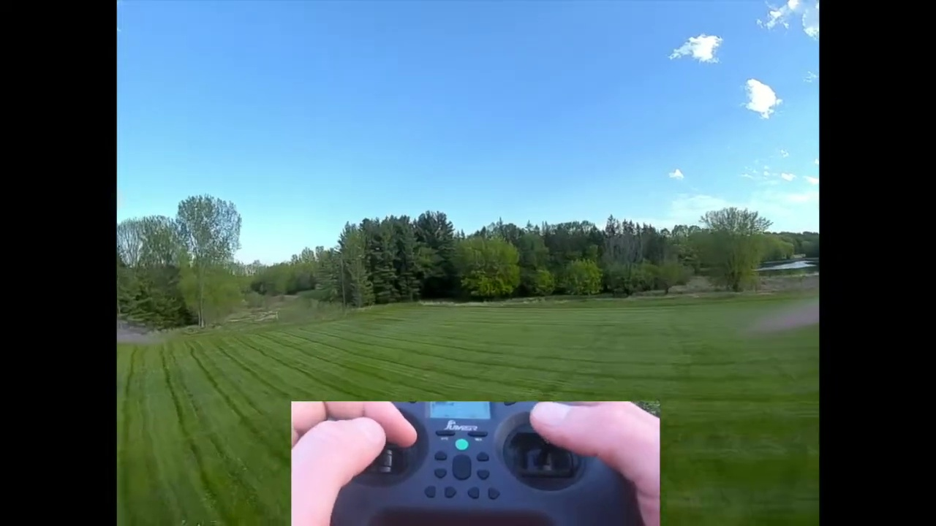 (score 95.0000)
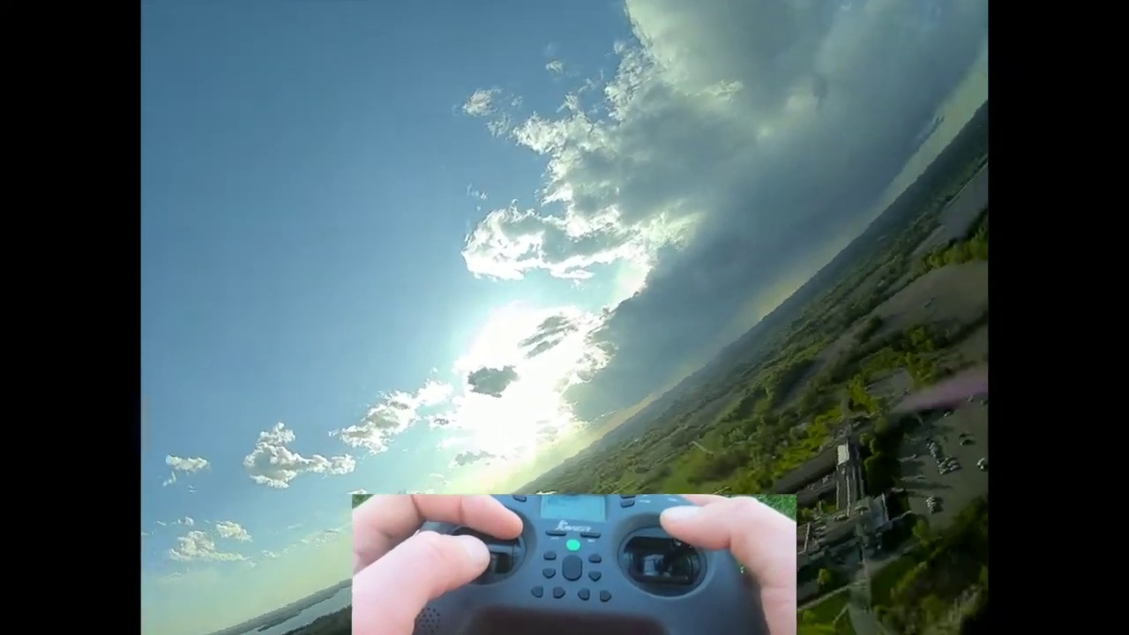 (score 95.0000)
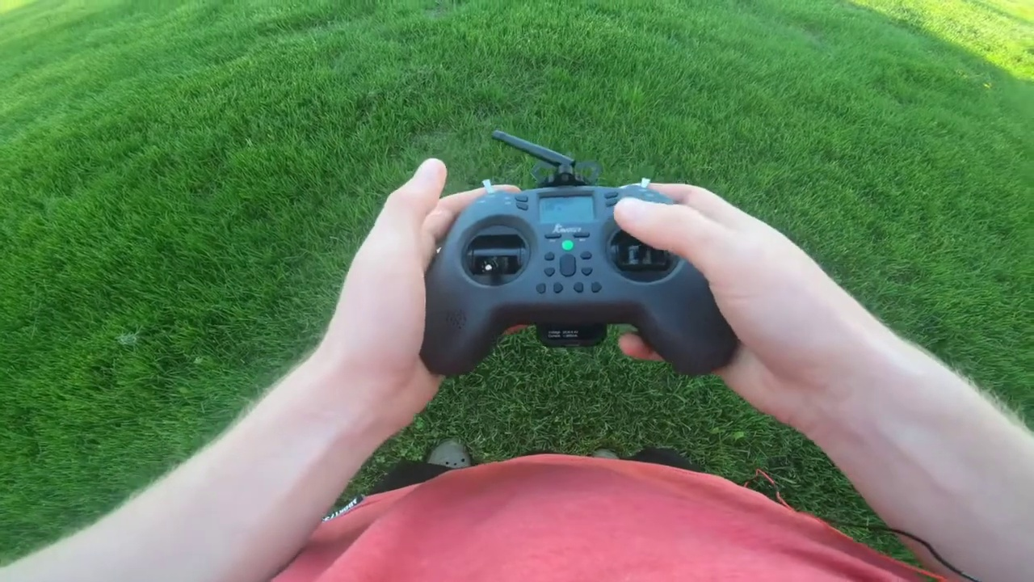 (score 95.0000)
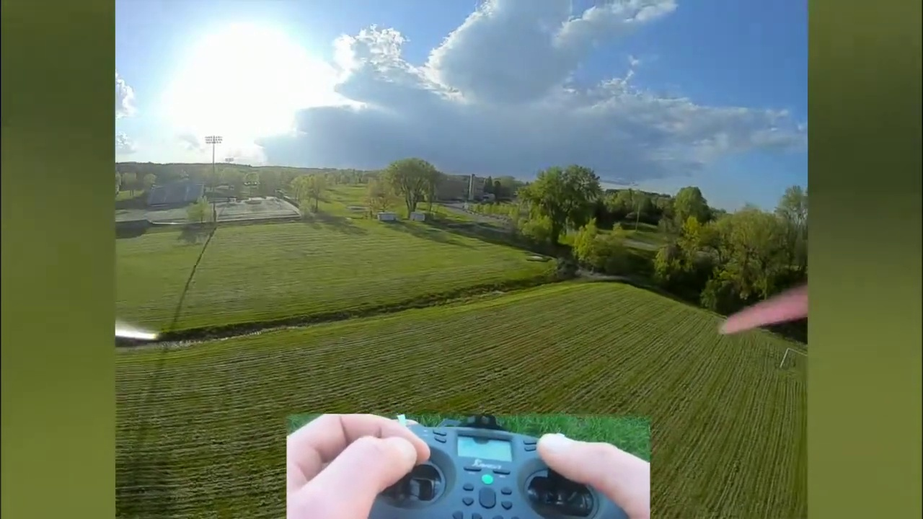 (score 95.0000)
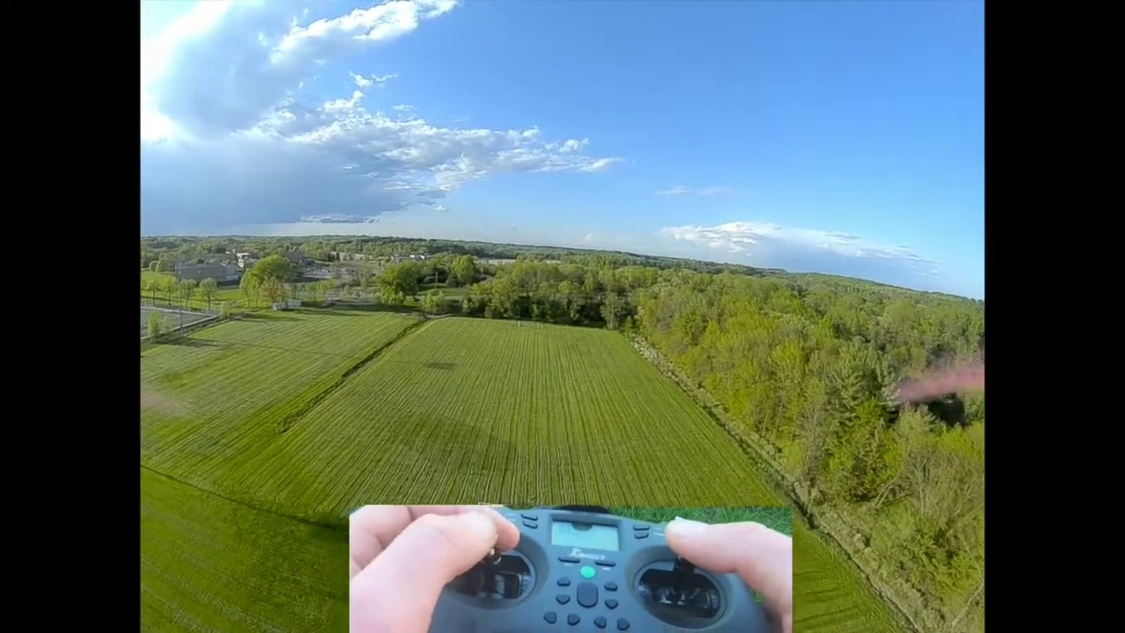 (score 95.0000)
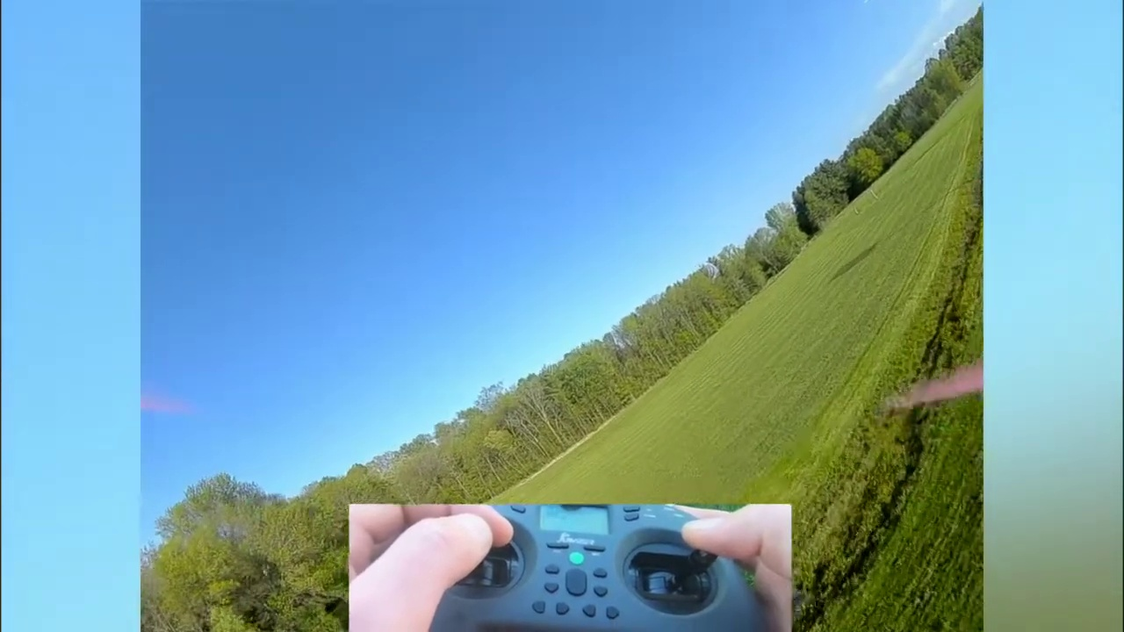 (score 95.0000)
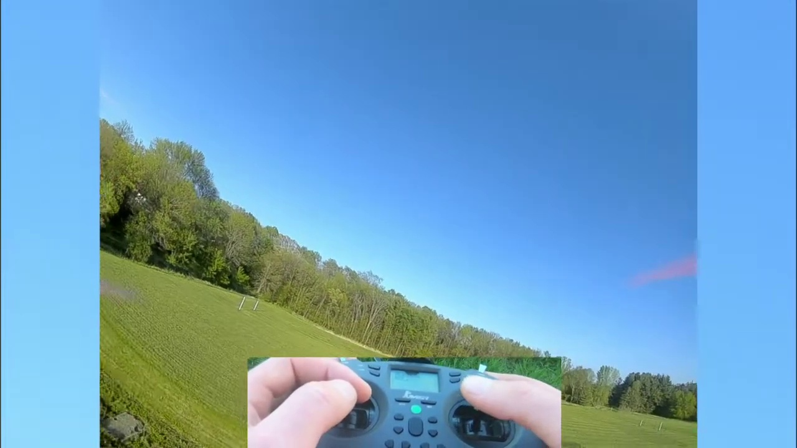 (score 95.0000)
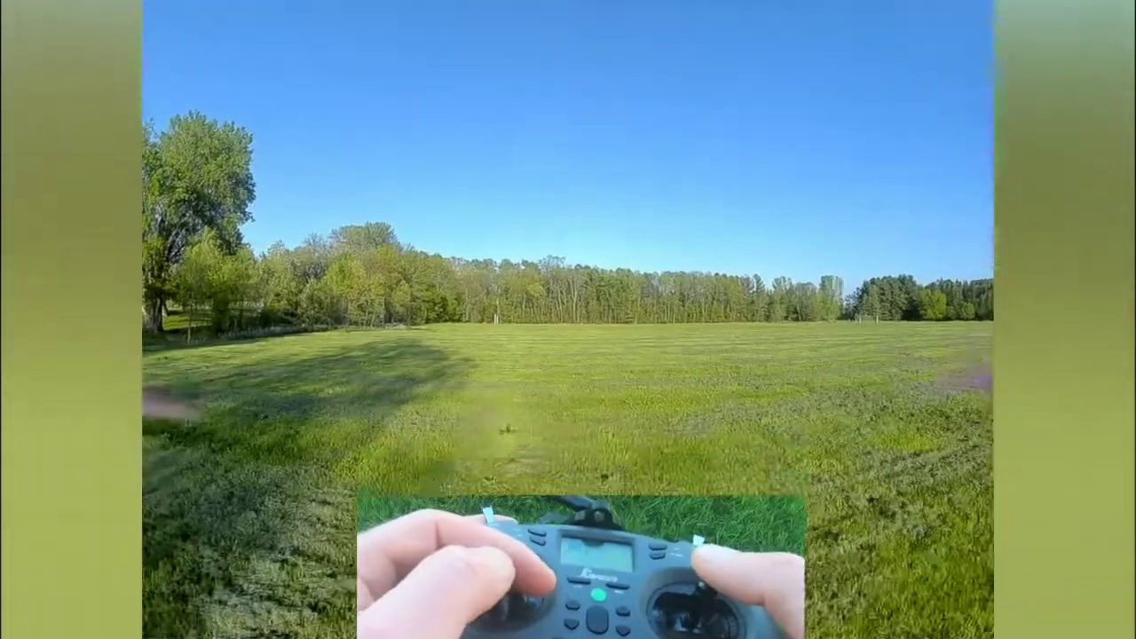 (score 95.0000)
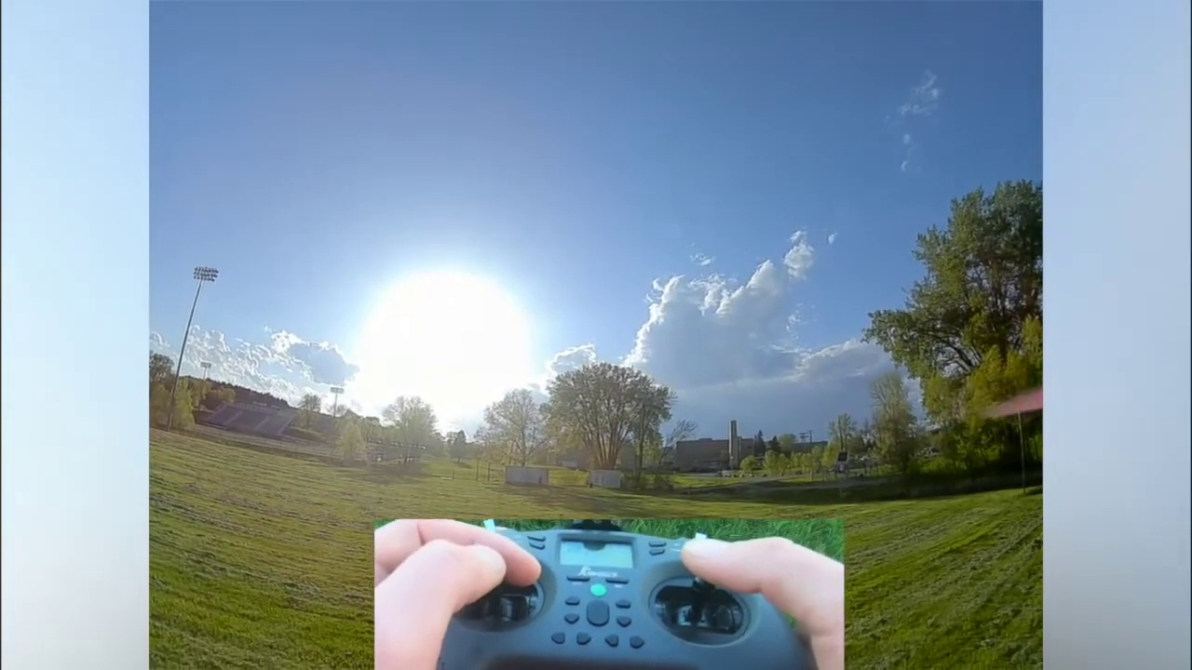 (score 95.0000)
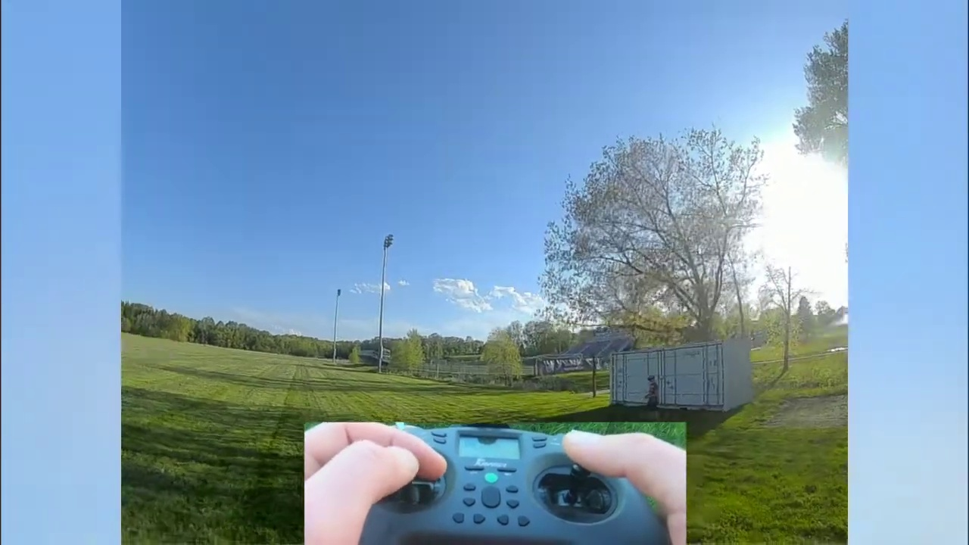 (score 95.0000)
Least correlated frames:
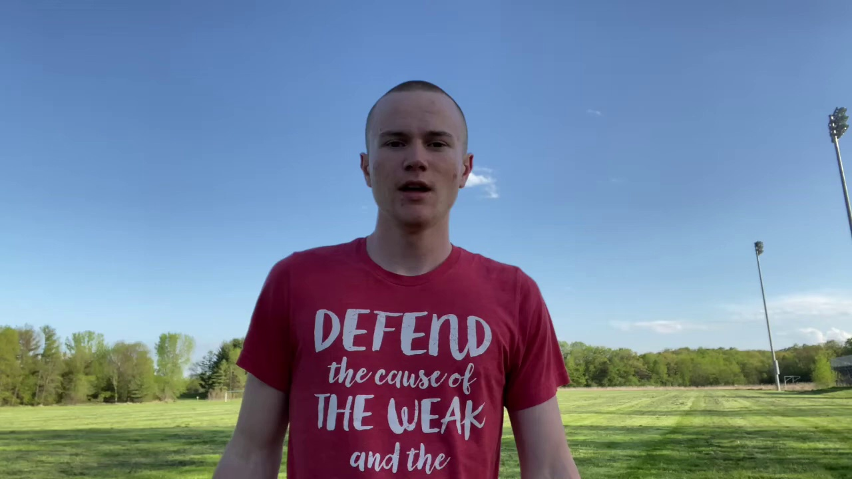 (score 0.0000)
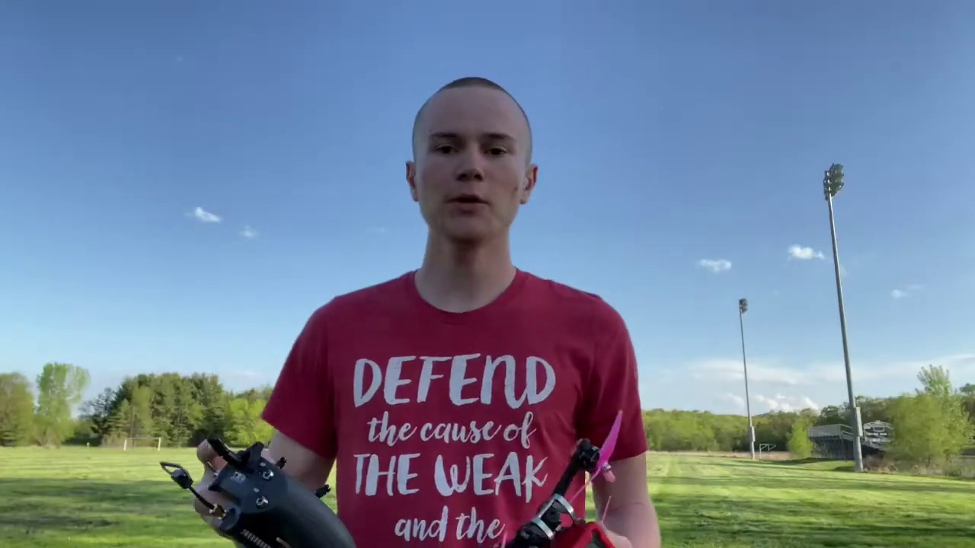 (score 0.0000)
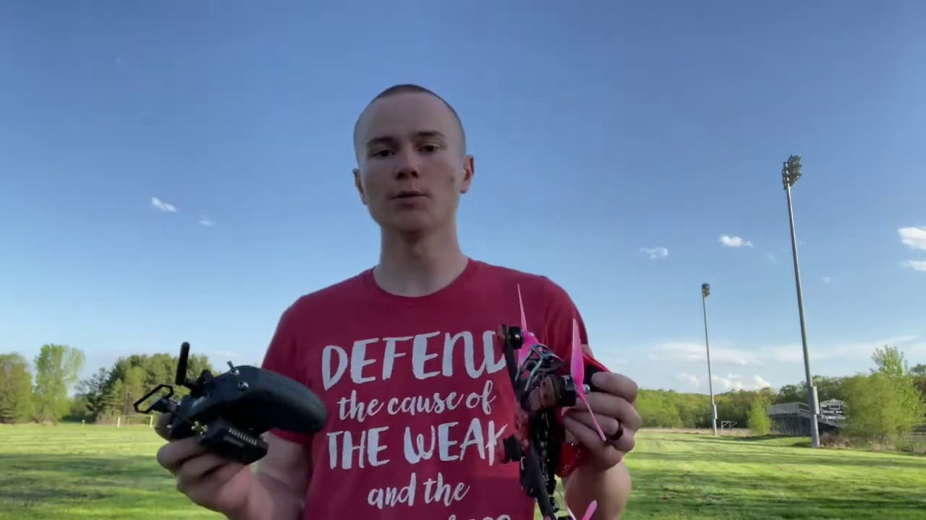 (score 0.0000)
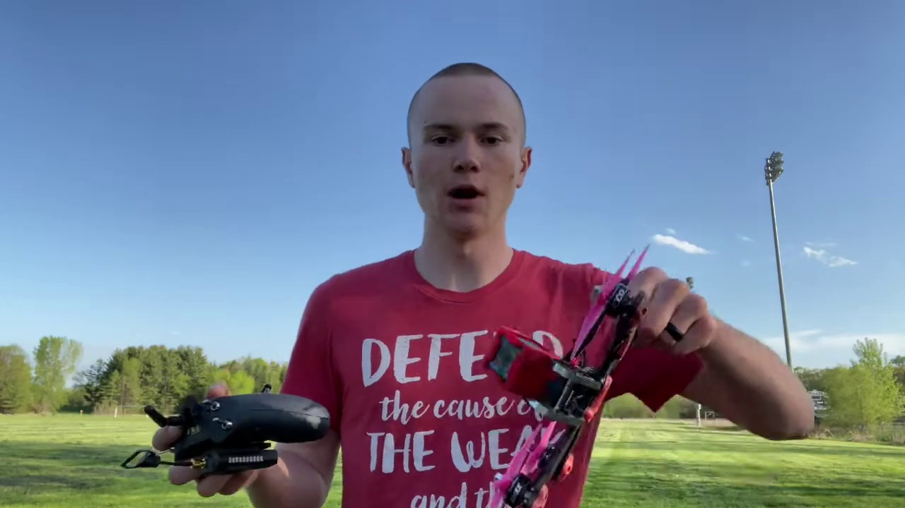 (score 0.0000)
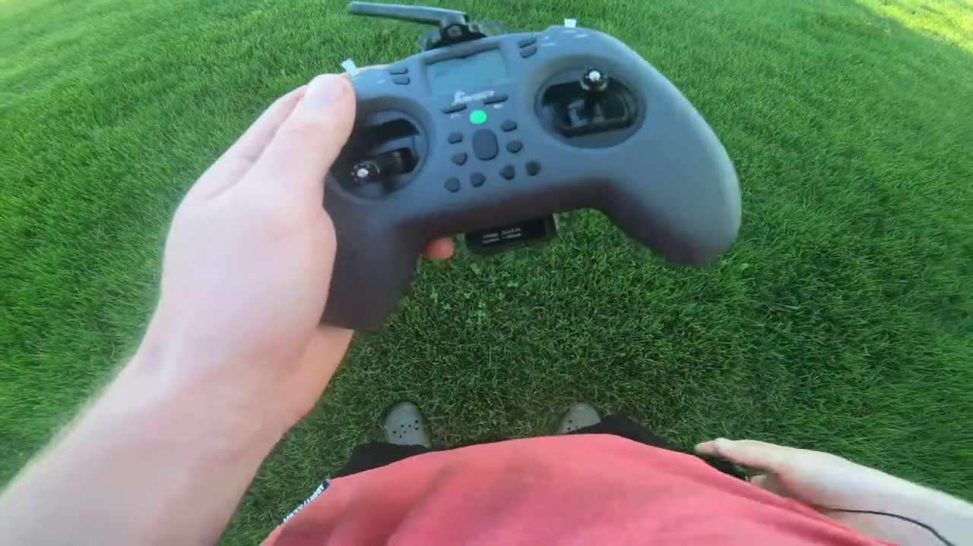 (score 0.0000)
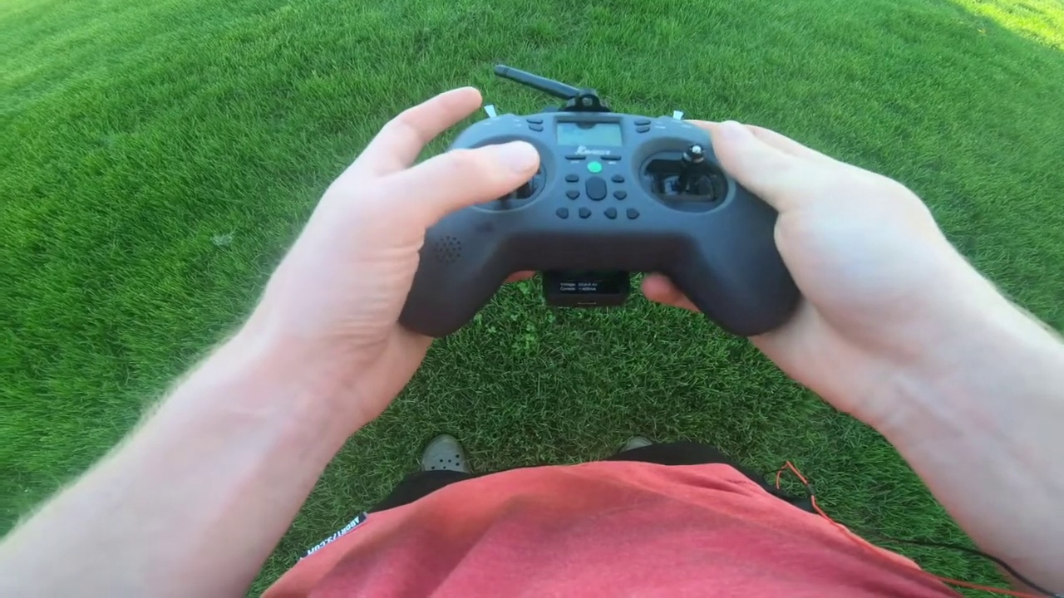 (score 0.0000)
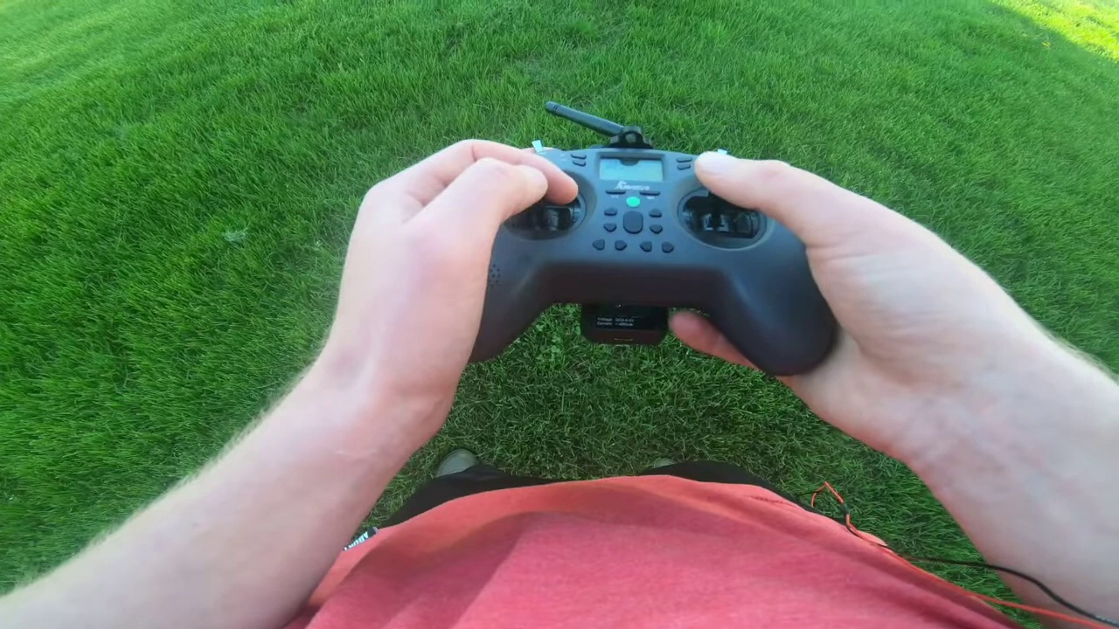 (score 0.0000)
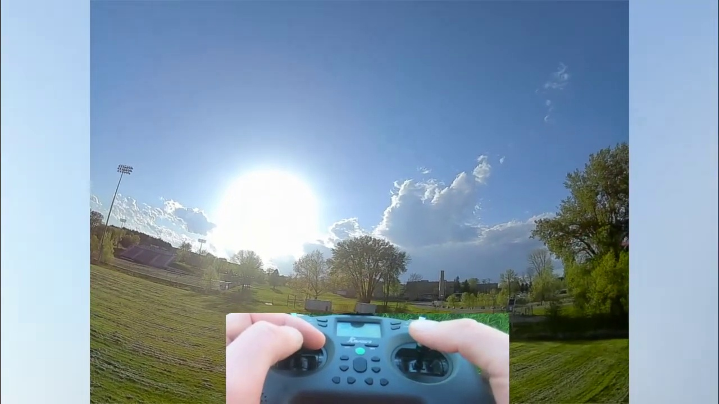 (score 0.0000)
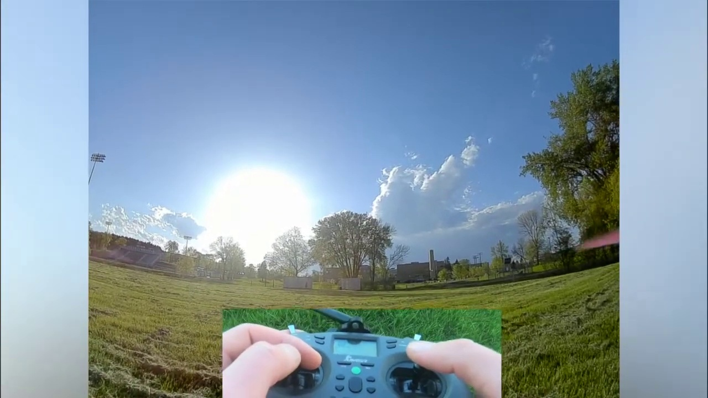 (score 0.0000)
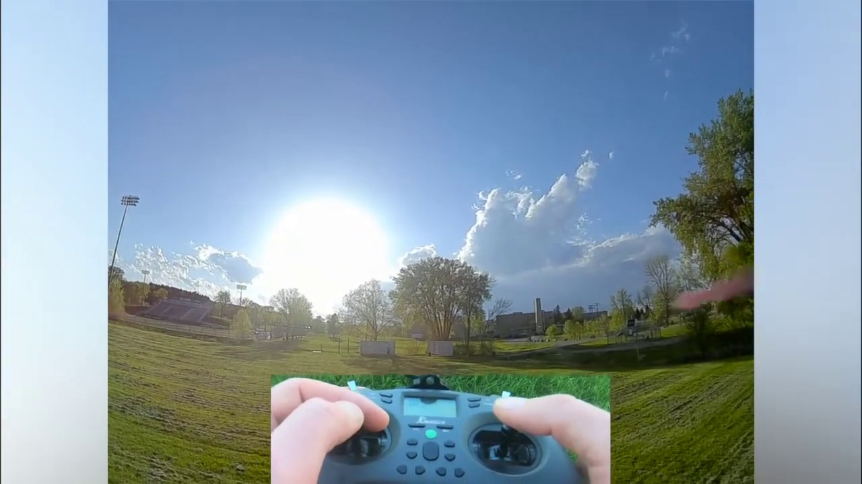 (score 0.0000)

Frame: frame_0000.jpg
Caption: The image shows a young adult male standing outdoors under clear blue skies, turned away from the camera. He appears to be focused on something beyond the frame. The individual is wearing a vibrant red t-shirt with bold white text that reads, "DEFEND the cause of the weak and the field." His face is not visible in this image.
The background suggests an open grassy field, potentially indicative of early spring or late summer due to the greenness of the grass and the presence of a baseball field in the distance. This location seems to be near a sports facility. The lighting conditions suggest it could be midday or early afternoon, given the shadow length and direction on his back.
The image captures a moment of determination, with the man standing tall and resolute, his message clear and direct.
No strongly correlated comments found for this frame.

Frame: frame_0001.jpg
Caption: The image shows a young man standing outdoors in a lush green field bordered by trees on either side, with a clear blue sky above. He is wearing a red t-shirt that prominently displays the phrase "DEFEND the cause of the weak and the powerless." The man's gaze is directed towards the camera, suggesting he might be posing for the photo. His body language appears to indicate that he is addressing an audience or speaking/presenting, as his posture suggests engagement with his surroundings.
The field beneath his feet is green and well-manicured, with no visible slides, diagrams, or other teaching aids in sight. The man's position in the field implies that he might be engaged in some activity, although the specific details are not discernible within the frame. The overall atmosphere of the scene appears peaceful and serene, with the man centered among nature's elements.
There is no visible text or objects besides the man's attire, the field, and the sky, which are the primary focus of the image. The relative positions of these elements suggest a sense of calmness, with the man standing at the forefront, surrounded by natural beauty.
No strongly correlated comments found for this frame.

Frame: frame_0002.jpg
Caption: The image shows a young man standing on a grassy field, holding two black and white drones in his hands. The drones have a distinctive red and white logo on the front. The man is wearing a striking red t-shirt with bold white text that reads "DEFEND THE WEAK" and "THE FATHER OF DRONE". The clear blue sky serves as the background of the image, with a few trees visible in the distance. In one hand, the individual holds a small remote control with additional propellers attached to it, while holding a black drone in the other hand. The scene captures a moment of outdoor activity and technology, with the man's attire and the text on his shirt adding a personal touch to the scene.
Comment (score 85): In this video, a professional drone flyer discusses how to fly a drone. He introduces the basic flight controls of the sticks and how they correlate to roll, pitch, and yaw. He also discusses the different flight modes, what they mean, and how they function for the user. The main mode that was discussed was the angle mode, where the user inputs the control of the drone, but is easier for beginners because it does not allow the drone to do flips. Then he introduces acro-mode, which allows advanced users to do flips because the input controller has more of an effect on the rotation speed and angle of the drone. He suggests using online simulations beforehand to get comfortable with the precision of the throttle and stick control to prevent any damage to your drone when first starting out.
Reason: The comment directly discusses the basic flight controls of the sticks and different flight modes (angle mode and acro-mode) which are also described in the caption as the man holding a remote control with additional propellers attached to it. The comment also mentions online simulations for beginners, which is not mentioned in the caption but shows that the commenter is referring to the same topic as the image.
Source: https://www.youtube.com/watch?v=WoHjWZFTnpQ: How to Fly a FPV Drone: Complete Guide for Beginners!

Frame: frame_0003.jpg
Caption: The image shows a young man standing on a grassy field under a clear blue sky. He is holding two objects in his hands - a remote control, with its black and white design, held in his left hand, and a drone, a bright pink object with a white body and black propellers, in his right hand. The man is wearing a red shirt that reads "Defend the Cause of the Weapons and the Future", which seems to be a slogan or motto of some sort. He appears to be holding a small toy aircraft, specifically a quadcopter, given its four propeller arms, as he prepares for a flight or demonstrates its features.
The background is quite blurred due to the shallow depth of field, making it difficult to discern any specific details about the surroundings. However, the vast open field provides a sense of freedom and openness to the scene. The focus is clearly on the person holding the model aircraft, indicating this might be part of a hobby discussion or demonstration.
Comment (score 85): In this video, a professional drone flyer discusses how to fly a drone. He introduces the basic flight controls of the sticks and how they correlate to roll, pitch, and yaw. He also discusses the different flight modes, what they mean, and how they function for the user. The main mode that was discussed was the angle mode, where the user inputs the control of the drone, but is easier for beginners because it does not allow the drone to do flips. Then he introduces acro-mode, which allows advanced users to do flips because the input controller has more of an effect on the rotation speed and angle of the drone. He suggests using online simulations beforehand to get comfortable with the precision of the throttle and stick control to prevent any damage to your drone when first starting out.
Reason: The comment directly discusses the same technical steps and settings described in the caption, such as flight controls, different flight modes (angle mode and acro-mode), and the importance of precision control. The focus on flying a drone and its features is strongly related to the image of a person holding a quadcopter and preparing for a flight or demonstrating its features.
Source: https://www.youtube.com/watch?v=WoHjWZFTnpQ: How to Fly a FPV Drone: Complete Guide for Beginners!

Frame: frame_0004.jpg
Caption: The image shows a close-up of two hands interacting with a black remote control device positioned on a grassy field. The remote control is equipped with a built-in antenna, indicating its potential for wireless communication. One hand is pressing buttons while the other is holding the same type of controller, which features a joystick, buttons, and a small screen displaying some information or status indicators. There are no texts, diagrams, or other objects in the frame that can be confidently identified as instructional materials. The focus here is on the activity of controlling a remote-controlled vehicle or device rather than any educational context, suggesting a casual, outdoor setting where the person is preparing to use the remote control.
Comment (score 85): In this video, a professional drone flyer discusses how to fly a drone. He introduces the basic flight controls of the sticks and how they correlate to roll, pitch, and yaw. He also discusses the different flight modes, what they mean, and how they function for the user. The main mode that was discussed was the angle mode, where the user inputs the control of the drone, but is easier for beginners because it does not allow the drone to do flips. Then he introduces acro-mode, which allows advanced users to do flips because the input controller has more of an effect on the rotation speed and angle of the drone. He suggests using online simulations beforehand to get comfortable with the precision of the throttle and stick control to prevent any damage to your drone when first starting out.
Reason: The comment directly discusses the technical steps and settings described in the caption, specifically mentioning flight controls, modes (angle mode and acro-mode), and the importance of precision control. The mention of drone flying and controllers matches the objects and goals described in the caption.
Source: https://www.youtube.com/watch?v=WoHjWZFTnpQ: How to Fly a FPV Drone: Complete Guide for Beginners!

Frame: frame_0005.jpg
Caption: The image shows a person holding up a gray remote control with a black and white display, which is positioned to face the camera, allowing for a clear view of the remote control's interface. The remote control has a black antenna and a black button, suggesting that it might be used to operate a device or vehicle. In the background, a lush green field can be seen, possibly in a park or similar open space.
The person is also holding a DJI Mavic 2 Pro quadcopter, with its arms extended and propellers off, implying that they may be demonstrating how to fold the drone for transport or assemble it. The quadcopter has a black and gray color scheme, with visible sensors on top of each arm. The remote control is attached to the bottom right corner of the drone, indicating its connectivity to the aircraft.
There are no text, slide, diagram, or explicit instruction visible in this frame that would provide additional context or teaching content. The focus is solely on the demonstration of the drone and its controller.
Comment (score 85): In this video, a professional drone flyer discusses how to fly a drone. He introduces the basic flight controls of the sticks and how they correlate to roll, pitch, and yaw. He also discusses the different flight modes, what they mean, and how they function for the user. The main mode that was discussed was the angle mode, where the user inputs the control of the drone, but is easier for beginners because it does not allow the drone to do flips. Then he introduces acro-mode, which allows advanced users to do flips because the input controller has more of an effect on the rotation speed and angle of the drone. He suggests using online simulations beforehand to get comfortable with the precision of the throttle and stick control to prevent any damage to your drone when first starting out.
Reason: The comment directly discusses the technical steps of flying a drone, specifically mentioning flight modes and control inputs, which are described in the frame caption as part of the demonstration of the DJI Mavic 2 Pro quadcopter and its remote control. The focus on controlling the drone's movement and orientation aligns with the visual representation of the drone and its controller shown in the frame.
Source: https://www.youtube.com/watch?v=WoHjWZFTnpQ: How to Fly a FPV Drone: Complete Guide for Beginners!

Frame: frame_0006.jpg
Caption: The image shows a person's hands holding two distinct devices, one being a black quadcopter drone with its landing gear extended, equipped with a camera and a small controller attached. The setting suggests an outdoor environment, as indicated by the lush green grass in the background and a hint of natural light. In contrast, the other device is a black remote control, known as a Jumbler, held firmly in the person's hands, with its two large buttons clearly visible on the surface. The remote control features an antenna, a small black speaker, and a power button located on top.
The drone has a camera attached, while the remote control appears to be ready for use, with the person's fingers positioned over the buttons. There are no discernible texts or distinguishing marks on either device that provide additional information about the context or content being taught. The natural surroundings, including the green field and building in the distance, enhance the outdoor setting of the image. The focus remains solely on the devices and their holder, without providing any insight into the actions or intentions of the person or the devices themselves.
Comment (score 95): In this video, a professional drone flyer discusses how to fly a drone. He introduces the basic flight controls of the sticks and how they correlate to roll, pitch, and yaw. He also discusses the different flight modes, what they mean, and how they function for the user. The main mode that was discussed was the angle mode, where the user inputs the control of the drone, but is easier for beginners because it does not allow the drone to do flips. Then he introduces acro-mode, which allows advanced users to do flips because the input controller has more of an effect on the rotation speed and angle of the drone. He suggests using online simulations beforehand to get comfortable with the precision of the throttle and stick control to prevent any damage to your drone when first starting out.
Reason: The comment directly discusses the same technical steps (flight controls, flight modes) and objects (drone, sticks) described in the caption. The mention of different flight modes (angle mode, acro-mode) and their functions matches the visual representation of the drone and its controller in the frame.
Source: https://www.youtube.com/watch?v=WoHjWZFTnpQ: How to Fly a FPV Drone: Complete Guide for Beginners!

Frame: frame_0007.jpg
Caption: The image shows a person holding a remote-controlled aircraft (RCA), which appears to be a toy drone designed for consumer use. The device is predominantly black with visible control surfaces and antennas, and it's accompanied by a remote controller in the person's hands. The controller is primarily black and grey, featuring a black antenna and a black and white display screen on the front, indicating its connection status with the words "Connecting" displayed in white text against a black background. Two small white stickers are visible at the top left corner of the controller. The image itself is a photograph taken outdoors, as suggested by the grassy field and clear sky visible in the background, providing a stark contrast to the remote control and the person's hands. The person's fingers are firmly grasping the remote control, suggesting it's being used or about to be used, capturing a moment of interaction between the remote control and its user.
No strongly correlated comments found for this frame.

Frame: frame_0008.jpg
Caption: The image shows a person holding up an RC (remote control) flying drone against a blurred background. The drone is black and has a camera attached to its front right side, which is typical for drones used for capturing video or taking photos. There are several buttons on the remote controller that correspond to the controls of the drone, such as takeoff/landing buttons, flight control dials, and possibly other buttons for maneuvering the drone in flight.
The person holding the drone appears to be standing in a casual setting, likely an outdoor area, as indicated by the natural light and the partially visible green grass at the bottom of the image. The focus is on the RC flying drone and its remote controller, which suggests that the content of this image may be used to teach about drone technology, how to fly a drone, or similar topics related to remote-controlled devices.
In addition to the drone and remote control, the image also captures a moment of stillness, with the person standing on a lush and green grassy field. A tree stands tall and leafy in the background, adding depth to the scene. The person's hands are visible, with one hand holding the remote control and the other hand resting on the grass. The black and white display screen on the remote control is currently turned off, and a black antenna sticks out from the top of the gray and black device.
Comment (score 90): In this video, a professional drone flyer discusses how to fly a drone. He introduces the basic flight controls of the sticks and how they correlate to roll, pitch, and yaw. He also discusses the different flight modes, what they mean, and how they function for the user. The main mode that was discussed was the angle mode, where the user inputs the control of the drone, but is easier for beginners because it does not allow the drone to do flips. Then he introduces acro-mode, which allows advanced users to do flips because the input controller has more of an effect on the rotation speed and angle of the drone. He suggests using online simulations beforehand to get comfortable with the precision of the throttle and stick control to prevent any damage to your drone when first starting out.
Reason: The comment directly discusses the technical steps of flying a drone, including flight modes (angle and acro-mode), controls (sticks, roll, pitch, yaw), and tips for beginners. The caption mentions the drone's remote control, buttons, and camera, which are all relevant to the topics discussed in the comment.
Source: https://www.youtube.com/watch?v=WoHjWZFTnpQ: How to Fly a FPV Drone: Complete Guide for Beginners!

Frame: frame_0009.jpg
Caption: The image presents two photographs side by side. On the left, a hand is holding a small drone with multiple rotors and a camera at the front, featuring a red base that may suggest it's a beginner's model or a toy drone. On the right, a person is interacting with another drone that is partially assembled on a grassy surface. The individual is holding a smartphone in one hand, placing a red part onto the body of the drone with the other hand, and appears to be assembling or disassembling the drone, likely demonstrating the process for a photo or video recording.
In the close-up view on the right side, a black quadcopter drone suspended in mid-air against a backdrop of green grass and gravel is seen. The drone has four propellers with vibrant pink color, attached firmly to its body, ready to propel it forward. The drone's control unit, housed within its body, features a red button visible on the left side of the frame.
A blurred hand is holding the drone's control unit, hinting at the presence of an operator controlling the drone's movements from a distance, possibly from a safe vantage point or remote location.
Comment (score 85): In this video, a professional drone flyer discusses how to fly a drone. He introduces the basic flight controls of the sticks and how they correlate to roll, pitch, and yaw. He also discusses the different flight modes, what they mean, and how they function for the user. The main mode that was discussed was the angle mode, where the user inputs the control of the drone, but is easier for beginners because it does not allow the drone to do flips. Then he introduces acro-mode, which allows advanced users to do flips because the input controller has more of an effect on the rotation speed and angle of the drone. He suggests using online simulations beforehand to get comfortable with the precision of the throttle and stick control to prevent any damage to your drone when first starting out.
Reason: The comment directly discusses the basic flight controls (roll, pitch, and yaw) mentioned in the caption, as well as different flight modes (angle mode and acro-mode), which aligns with the technical steps described in the image. The correlation is not perfect due to some minor differences in wording between the caption and comment.
Source: https://www.youtube.com/watch?v=WoHjWZFTnpQ: How to Fly a FPV Drone: Complete Guide for Beginners!

Frame: frame_0010.jpg
Caption: This image captures a moment of tranquility in a grassy field. A person's hand, gripping a gray remote control, is the focal point of the image. The remote control, equipped with a black antenna, is positioned in the center of the frame, pointing towards the sky. The field, a vibrant green, serves as a stark contrast to the gray of the remote control and the black of the antenna. The person's hand, with the remote control firmly in place, seems to be in the midst of a gesture, perhaps about to take flight or control something beyond the frame of the image.
The controller is predominantly black with various buttons and a joystick visible on the right side of the device. A smartphone or another electronic device mounted on top of the controller likely interfaces with the drone's software or provides additional controls. The background is slightly blurred, suggesting an outdoor setting with some greenery and possibly a road or path.
The overall composition of the image suggests a moment of action or anticipation, possibly related to the remote control in the person's hand.
No strongly correlated comments found for this frame.

Frame: frame_0011.jpg
Caption: The image captures a close-up view of a remote control, resting on what appears to be a lawn with green grass. The controller is held firmly in the hand of a person, but their face is not shown. The remote control, facing upwards, has a screen displaying a list of options and features visible text and branding, including "FLYING CONTROLLER" and "GAMING HUB." The design of the controller suggests it might be specifically designed for flight controllers, with joysticks and multiple buttons on top.
The image does not provide any additional information about the person or the device they are using. The focus is solely on the remote control and its interaction with the environment.
No strongly correlated comments found for this frame.

Frame: frame_0012.jpg
Caption: The image displays two scenes side by side, which appear to show a person interacting with a small remote-controlled drone and an open gaming console box next to it. On the left side of the image is a photo of a hand holding a toy quadcopter with pink propellers. The drone has a camera mounted on the front and a battery pack at its back, suggesting that it might have just been used or is about to be flown.
On the right side, an open box contains gaming console-related items, including a game controller, which features buttons and joysticks typical for use with video games. The packaging suggests that the contents may include gaming consoles or accessories like a VR headset or additional controllers, with the name "Sony PlayStation" visible on the box, indicating an association with the Sony PlayStation gaming console.
In the background of the image, a separate scene captures a moment of preparation or operation for a flight with a quadcopter and drone. A person is standing on a grassy field, holding a black quadcopter in their left hand, its propellers turned off. The quadcopter is attached to a red and black drone controller, which the person holds in their right hand, along with a black remote control that appears to be turned on. The scene is set against a bright blue sky, providing a clear view of the person's actions.
No strongly correlated comments found for this frame.

Frame: frame_0013.jpg
Caption: The image shows two scenes side by side. On the left, two remote-controlled quadcopter drones are being compared. The drone on the left is a red and black quadcopter with a camera mounted on its underside, while the drone on the right is a black quadcopter without a visible camera. Both drones appear to have a control device in front of them, which is likely a transmitter for controlling their movement remotely.
The drone on the left has a white sticker on one of its propellers, containing a logo and text, although it's not legible from this angle. The drone on the right has a red battery pack attached to the bottom, indicating that it might be in need of charging or is using an extended battery for longer flights.
In contrast, on the right side of the image, a person is holding a black quadcopter with two pink propellers spinning at high speed as it takes off. The person is holding the remote control, which is also black in color. The scene is set on a grassy field with a clear blue sky above, capturing a moment of excitement and adventure.
The background of the image appears to be blurry, suggesting that the photo was taken casually, with no people or instructors visible in this frame; the focus is solely on the comparison of the two quadcopters and the takeoff of the third drone.
No strongly correlated comments found for this frame.

Frame: frame_0014.jpg
Caption: The image captures a moment of interaction between human and technology as two remote-controlled drones, one black with red detailing and the other predominantly pink with some black elements, appear to be under control. The drones seem to be of different models or brands, as indicated by their distinct color schemes and designs.
On the right side of the image, a person is holding an iPhone displaying a user interface that appears to be related to drone control or flight monitoring. The screen shows various indicators such as battery level, signal strength, and possibly other telemetry data like altitude and distance, suggesting the person may be using the phone to monitor the drones' live feed during flight.
The same person is engaging with both the physical drones and the digital display on the device, which could imply that they are demonstrating how to control or monitor a drone using a smartphone. The image captures a moment of interaction between human and technology, which might be part of an instructional setting focused on drone flying, safety, or maintenance.
In the background, a lush green grassy field stretches out, serving as a natural backdrop that enhances the overall experience. The scene is taken from a distance, allowing for a comprehensive view of the drones, the iPhone, and the remote control, giving a sense of scale to the objects and the field.
Comment (score 95): In this video, a professional drone flyer discusses how to fly a drone. He introduces the basic flight controls of the sticks and how they correlate to roll, pitch, and yaw. He also discusses the different flight modes, what they mean, and how they function for the user. The main mode that was discussed was the angle mode, where the user inputs the control of the drone, but is easier for beginners because it does not allow the drone to do flips. Then he introduces acro-mode, which allows advanced users to do flips because the input controller has more of an effect on the rotation speed and angle of the drone. He suggests using online simulations beforehand to get comfortable with the precision of the throttle and stick control to prevent any damage to your drone when first starting out.
Reason: The comment directly discusses the technical steps described in the caption, such as drone control and flight modes (angle mode, acro-mode), which are also visible in the image. The caption mentions the person controlling the drones using an iPhone, while the comment explains how to fly a drone, including the use of sticks and different flight modes.
Source: https://www.youtube.com/watch?v=WoHjWZFTnpQ: How to Fly a FPV Drone: Complete Guide for Beginners!

Frame: frame_0015.jpg
Caption: The image shows two distinct scenes. The upper portion displays a person standing outdoors, holding a drone with a red frame and black camera attached, wearing a helmet and goggles. There is no text present in this part of the image.
In the lower part of the image, a similar drone lies on a surface indoors, featuring red and black markings. Beside it, there's a remote control with joysticks and buttons for operation. A smartphone placed on top of the controller displays what appears to be a flight application or camera feed from the drone.
The setting seems to focus on the demonstration or comparison of a drone and its remote control. The image does not provide any information about teaching or an instructor, instead highlighting the excitement and adventure of flying a quadcopter.
In another part of the scene, a man is captured in the midst of flying a quadcopter, painted in a striking combination of red and black, with two motors and a camera ready to capture the world from a unique perspective. The man holds a red and black remote control, positioned near the quadcopter, guiding it through the air.
The setting is a lush green field, dotted with patches of grass and wildflowers, stretching out around the man and the quadcopter, providing a backdrop of natural beauty. The image is taken from a low angle, giving the viewer a sense of looking up at the man and the quadcopter, adding scale and grandeur to the scene.
Overall, the image presents an exciting adventure in the great outdoors, with the man and the quadcopter ready to explore and capture the world from above.
Comment (score 80): In this video, a professional drone flyer discusses how to fly a drone. He introduces the basic flight controls of the sticks and how they correlate to roll, pitch, and yaw. He also discusses the different flight modes, what they mean, and how they function for the user. The main mode that was discussed was the angle mode, where the user inputs the control of the drone, but is easier for beginners because it does not allow the drone to do flips. Then he introduces acro-mode, which allows advanced users to do flips because the input controller has more of an effect on the rotation speed and angle of the drone. He suggests using online simulations beforehand to get comfortable with the precision of the throttle and stick control to prevent any damage to your drone when first starting out.
Reason: The comment directly discusses the technical steps and settings described in the caption, including flight controls (roll, pitch, yaw), different flight modes (angle mode, acro-mode) and drone operation, which are all highlighted in the image. The correlation is strong but not perfect as the caption does not explicitly mention online simulations, which are mentioned in the comment.
Source: https://www.youtube.com/watch?v=WoHjWZFTnpQ: How to Fly a FPV Drone: Complete Guide for Beginners!

Frame: frame_0016.jpg
Caption: The image captures a moment of a person holding a remote control in their hand, with their hand emerging from the top left corner of the frame. The remote control is equipped with various buttons and likely corresponds to different functions and settings for controlling the drone's flight. In particular, one button seems to be in focus, suggesting it might have been selected or pressed at the moment of the image.
The person's hand is firmly gripping the remote control, indicating a sense of control and focus as they operate the device to fly a quadcopter with a camera mounted on it. The screen of the smartphone held by the person displays a live feed of the drone in flight, showing its current state and battery level.
The scene is set in a grassy area with trees visible in the background, providing a natural environment for the person to operate the remote control. The image does not contain any discernible text, diagrams, or educational materials, suggesting that the context may be instructional purposes or sharing experience online.
Comment (score 90): In this video, a professional drone flyer discusses how to fly a drone. He introduces the basic flight controls of the sticks and how they correlate to roll, pitch, and yaw. He also discusses the different flight modes, what they mean, and how they function for the user. The main mode that was discussed was the angle mode, where the user inputs the control of the drone, but is easier for beginners because it does not allow the drone to do flips. Then he introduces acro-mode, which allows advanced users to do flips because the input controller has more of an effect on the rotation speed and angle of the drone. He suggests using online simulations beforehand to get comfortable with the precision of the throttle and stick control to prevent any damage to your drone when first starting out.
Reason: The comment directly discusses the technical steps and settings described in the caption, such as flying a drone using sticks and flight modes like angle mode and acro-mode. The comment also mentions the importance of controlling the throttle and stick control to prevent damage to the drone, which is reflected in the focus on one button being pressed in the caption.
Source: https://www.youtube.com/watch?v=WoHjWZFTnpQ: How to Fly a FPV Drone: Complete Guide for Beginners!

Frame: frame_0017.jpg
Caption: The image shows a person holding a game controller with joysticks and buttons visible, likely for a video game console such as the Nintendo Switch or a similar handheld gaming system. In the background, there's an outdoor setting with green grass and some foliage, where two hands are firmly gripping black and gray remote controls with small screens and directional pads, suggesting they're being used to control something in the distance. The focus is on the person holding the game controller and the hands operating the remote controls, but without additional context, it's unclear if they're engaged in an activity related to gaming, training, or anything else.
No strongly correlated comments found for this frame.

Frame: frame_0018.jpg
Caption: The image shows two individuals' hands, each grasping a remote control device. The remote controls appear to be in the midst of being activated, with one possibly used for gaming or interactive activities given its design featuring buttons and joysticks typically found on video game controllers. The other remote control is a striking combination of black and gray, featuring a black screen displaying an interface that suggests it's a remote control for a drone.
The "800mAh" text can be seen on one of the remotes, indicating this model has a battery capacity of 800 milliampere-hours. The hands are poised in mid-air against a backdrop of lush green grass, with no additional context or information about the environment or setting visible. There is no indication that an instructor is teaching or presenting anything from a slide or screen, as there are no slides, diagrams, or additional text visible in this frame.
Comment (score 80): In this video, a professional drone flyer discusses how to fly a drone. He introduces the basic flight controls of the sticks and how they correlate to roll, pitch, and yaw. He also discusses the different flight modes, what they mean, and how they function for the user. The main mode that was discussed was the angle mode, where the user inputs the control of the drone, but is easier for beginners because it does not allow the drone to do flips. Then he introduces acro-mode, which allows advanced users to do flips because the input controller has more of an effect on the rotation speed and angle of the drone. He suggests using online simulations beforehand to get comfortable with the precision of the throttle and stick control to prevent any damage to your drone when first starting out.
Reason: The comment directly discusses the same technical steps and settings described in the caption, specifically mentioning drone controls (sticks and modes) and their functions. The mention of 'angle mode' and 'acro-mode' matches the description of one remote control's interface in the caption.
Source: https://www.youtube.com/watch?v=WoHjWZFTnpQ: How to Fly a FPV Drone: Complete Guide for Beginners!

Frame: frame_0019.jpg
Caption: The image shows two individuals standing on a grassy field, their bodies slightly turned towards the camera, engaged in an activity. In the center of the image is a sleek black remote control with a gray panel, positioned prominently to emphasize its importance. The controller appears to be a game controller, possibly for a console like the PlayStation, given its design with button layout and joysticks. The branding on the controller reads "Sony" at the bottom right corner.
The screen of the controller displays a video feed from a drone, suggesting it's used for flying drones. In the background, there are hints of a building, indicating that this outdoor activity might be taking place in a park or a similar open space. The overall composition of the image suggests an active and dynamic scene, with the remote control being the focal point.
The focus of the image is on the individuals' hands holding the remote control, rather than providing context about the surrounding environment.
Comment (score 95): In this video, a professional drone flyer discusses how to fly a drone. He introduces the basic flight controls of the sticks and how they correlate to roll, pitch, and yaw. He also discusses the different flight modes, what they mean, and how they function for the user. The main mode that was discussed was the angle mode, where the user inputs the control of the drone, but is easier for beginners because it does not allow the drone to do flips. Then he introduces acro-mode, which allows advanced users to do flips because the input controller has more of an effect on the rotation speed and angle of the drone. He suggests using online simulations beforehand to get comfortable with the precision of the throttle and stick control to prevent any damage to your drone when first starting out.
Reason: The comment directly discusses the same technical steps (flight controls, flight modes) and objects (drone, remote control) described in the caption. The focus on the drone's controls and flight modes matches the emphasis on the controller and its screen display in the image. The only minor discrepancy is the lack of context about the surrounding environment in the comment, but this does not detract from the strong connection between the two.
Source: https://www.youtube.com/watch?v=WoHjWZFTnpQ: How to Fly a FPV Drone: Complete Guide for Beginners!

Frame: frame_0020.jpg
Caption: The image depicts a person standing outdoors during daylight, wearing a red t-shirt with white text that reads "DEFEND THE WEAK," along with other smaller text elements that are not legible. The individual has short hair and is facing the camera, looking directly into it. They appear to be holding something in their right hand, although the exact nature of what they are holding is unclear due to the image quality.
The person stands on a grassy field under a clear blue sky, with a large white building partially obscured by trees in the background. The t-shirt also features a graphic of a person in a red shirt holding a black drone, which adds visual interest to the scene. The overall setting suggests a peaceful outdoor environment, with the individual's actions hinting at a possible protest or demonstration.
There is no visible teaching context or instructor within this frame, and none of the visual elements suggest a formal instructional setting or educational activity.
No strongly correlated comments found for this frame.

Frame: frame_0021.jpg
Caption: The image shows a young male standing outdoors with a drone in hand. He is wearing a vibrant red t-shirt that proudly proclaims "DEFEND THE WEAR AND THE DEAD", emblazoned with a black and white graphic of a skull and crossbones, adding an edgy touch to his casual attire. The individual appears to be standing on a grassy field, looking directly at the camera with a neutral expression on his face. Behind him, there is an expanse of grass leading up to a clear sky. In the background, you can see a field with some green vegetation, and in the distance, there seems to be a line of trees forming a natural border to the view. Additionally, a line of tall light poles can be seen in the distance, adding an urban touch to the otherwise natural setting.
No strongly correlated comments found for this frame.

Frame: frame_0022.jpg
Caption: The image shows a person standing outdoors under clear skies, wearing a red t-shirt with the text "DEFEND THE WEAPON AND THE WEAK". The individual is holding a remote control in their hand, which has a white handle and is equipped with a black antenna. They appear to be in a relaxed stance, suggesting a casual outdoor setting.
In the foreground, the person holds a black and red drone with four arms and a camera at the end of one arm, which is extended upwards. The drone features red propellers and a visible battery pack on its underside. The person's face has been censored, as indicated by a red "Censored" rectangle on their head and upper torso.
The background shows a tall green fence, adding a contrasting color to the scene. A tree with green leaves can be seen behind the fence, and in the distance, there is a building with a white roof. The overall setting appears peaceful and relaxed, without any signage or distinct landmarks that would provide additional context about the location.
The text on the card held by the person reads "Defend the weak", which might suggest the context of the image, such as discussing safety in the use of drones or other technology.
No strongly correlated comments found for this frame.

Frame: frame_0023.jpg
Caption: The image shows a young man standing outdoors in bright sunlight, wearing a red t-shirt with white text that includes the word "defend." He appears to be presenting or demonstrating something, as suggested by his attentive expression and posture. The man is holding up a model of what seems to be a drone or quadcopter, which is predominantly colored in black and red. The model has four arms, each equipped with a propeller, and there appears to be a central body with electronic components visible on one side.
The background consists of a clear blue sky above and an open field below, suggesting a calm day. The park-like setting features lush green trees and a clear blue sky, adding to the serene atmosphere. In the distance, the outlines of buildings can be seen, introducing a touch of urban life to the natural setting. The man's face is turned towards the camera, his expression one of concentration and determination as he holds the black drone with its white and blue body gleaming under the sunlight.
Comment (score 90): In this video, a professional drone flyer discusses how to fly a drone. He introduces the basic flight controls of the sticks and how they correlate to roll, pitch, and yaw. He also discusses the different flight modes, what they mean, and how they function for the user. The main mode that was discussed was the angle mode, where the user inputs the control of the drone, but is easier for beginners because it does not allow the drone to do flips. Then he introduces acro-mode, which allows advanced users to do flips because the input controller has more of an effect on the rotation speed and angle of the drone. He suggests using online simulations beforehand to get comfortable with the precision of the throttle and stick control to prevent any damage to your drone when first starting out.
Reason: The comment directly discusses the technical steps of flying a drone, including flight modes (angle and acro) and controls (sticks and throttle), which are all mentioned in the frame caption as part of the drone's features. The language used is specific and related to the visual content, indicating strong correlation.
Source: https://www.youtube.com/watch?v=WoHjWZFTnpQ: How to Fly a FPV Drone: Complete Guide for Beginners!

Frame: frame_0024.jpg
Caption: The image shows a young person standing outdoors, wearing a vibrant red t-shirt that prominently displays the text "DEFEND THE CAUSE OF THE WEAK AND THE WILD". The individual has short hair and is wearing glasses. In their right hand, they hold a model of a quadcopter, a small toy or hobbyist's aircraft with four rotors commonly used for recreational flying or as a platform for cameras and sensors. The focus is on the person and the quadcopter model, which appears to be held up in front of them.
The background suggests an open outdoor space with some trees, a clear sky, and a hint of a field that may be used for sports or recreational activities. The scene is devoid of any other people or objects, emphasizing the solitary nature of the person and their quadcopter model.
No strongly correlated comments found for this frame.

Frame: frame_0025.jpg
Caption: The image shows a young man standing outdoors during daylight hours on a lush green field under a clear blue sky. He appears to be in his late teens to early twenties, with short hair and wearing a baseball cap backwards. The man is dressed in a vibrant red t-shirt that reads "DEFEND the cause of the weak and the weak", adorned with a striking graphic of a black and white tiger, adding a touch of contrast to the red. On the shirt, there's also a graphic of a clenched fist with the text "Defend the Weak", suggesting he might be supporting a group that promotes strength against oppression.
In his right hand, he is holding a blue and white drone, which is currently in the air, its wings outstretched, likely in the process of taking off or landing. The man's gaze is directed towards the camera, capturing a moment of anticipation or excitement as if addressing an audience or a camera crew. He has an attentive posture, suggesting he might be speaking to the camera, but it's not clear if he is reading from a script or discussing something specific off-camera.
The setting appears to be informal, with no visible slides or equipment that would indicate a formal presentation or teaching session. The background suggests a clear day with blue skies and trees visible. To the right of the image, there's a text that reads "Defend the Weak," which aligns with the message on his shirt, suggesting that he might be part of an event or campaign related to this slogan.
No strongly correlated comments found for this frame.

Frame: frame_0026.jpg
Caption: The image shows a person standing outdoors with clear skies in the background. The individual appears to be a young adult male, wearing a red shirt and holding what seems to be two remote control devices, possibly of a hobbyist nature. He has short hair and is looking directly at the camera, with a neutral expression on his face.
In front of him is a green lawn and behind him, there's a field under a blue sky. The setting suggests this could be a personal or public space suitable for outdoor activities. There are no visible texts or additional context in the image to provide information about the person, location, or activity he might be involved in.
No strongly correlated comments found for this frame.

Frame: frame_0027.jpg
Caption: The image shows a young man standing outdoors during the daytime under clear skies. He is wearing a red shirt with white text that reads "Angle Mode Defend the Cause of the Weapons and the Fat". The person is holding two quadcopter drones in his hands, one black and white and the other red and white, which appear to be in mid-air, suggesting he might be preparing to fly them. He is standing in a green grass field with no visible text or teaching context in this image; it seems to be more of a personal photograph rather than a teaching or educational setting.
The man's stance and the position of the drones suggest that he might be giving a demonstration or presentation about the quadcopter drones. His attire, including his shirt, does not explicitly indicate any connection to an instructional context. The image captures a moment of preparation or demonstration involving quadcopter drones, with no visible diagrams or text that would suggest the man is an instructor explaining something about the objects he is holding.
Note: I have carefully integrated the details from both captions while avoiding redundancy and contradictions.
Comment (score 85): In this video, a professional drone flyer discusses how to fly a drone. He introduces the basic flight controls of the sticks and how they correlate to roll, pitch, and yaw. He also discusses the different flight modes, what they mean, and how they function for the user. The main mode that was discussed was the angle mode, where the user inputs the control of the drone, but is easier for beginners because it does not allow the drone to do flips. Then he introduces acro-mode, which allows advanced users to do flips because the input controller has more of an effect on the rotation speed and angle of the drone. He suggests using online simulations beforehand to get comfortable with the precision of the throttle and stick control to prevent any damage to your drone when first starting out.
Reason: The comment directly discusses the angle mode and its characteristics, which is also mentioned in the caption. The mention of quadcopter drones and flight modes in the comment is strongly related to the same technical steps, objects, settings, or goals described in the caption.
Source: https://www.youtube.com/watch?v=WoHjWZFTnpQ: How to Fly a FPV Drone: Complete Guide for Beginners!

Frame: frame_0028.jpg
Caption: The image shows an individual standing outdoors under a clear blue sky, wearing a red shirt with bold, white capital letters displaying either "Defend" or "Angle Mode". The shirt is the focal point of the image. Behind them is a lush grassy field, possibly part of a park or sports complex, featuring trees and grass, creating a serene backdrop to their presence. There are no texts or distinctive objects that would suggest a teaching context, such as a chalkboard, whiteboard, or any kind of model or diagram being held. The focus seems to be on the person and their immediate surroundings rather than on any particular instructional content. The angle and composition of the photo suggest it might have been taken casually without an intentional educational purpose in mind. The man's position in the foreground of the image draws attention to him, while the background provides a sense of depth and context to his location. The image does not contain any discernible actions or movement, suggesting a peaceful, leisurely setting.
No strongly correlated comments found for this frame.

Frame: frame_0029.jpg
Caption: The image depicts a young individual standing outdoors, likely in a park or open area, given the presence of green grass and trees. The person is wearing a red shirt with white letters reading "Defend." They are holding a small black-and-white drone in their right hand and a remote control resembling a gaming controller in their left hand. The remote control features text that reads "ANGLE MODE," indicating it has an angle mode feature.
The individual is standing with their right hand holding the drone, while pointing with their left hand toward the camera, likely demonstrating the use of the remote control's angle mode feature. The focus of this image appears to be on the remote control and its use, suggesting an instructional or demonstration context, possibly related to drone flight or a similar activity that requires angle adjustment for controlling devices like drones.
In the bottom right corner of the image, there is additional text that reads "ANGLE MODE," likely indicating that the image is intended to show how to use the angle mode feature on the remote control device. The style of the image appears to be a screenshot from a video or a tutorial photograph, as it includes both human and equipment elements typical in instructional content related to technology usage.
The background of the image shows a stadium with a large crowd of people, suggesting an outdoor activity or event taking place.
Comment (score 85): In this video, a professional drone flyer discusses how to fly a drone. He introduces the basic flight controls of the sticks and how they correlate to roll, pitch, and yaw. He also discusses the different flight modes, what they mean, and how they function for the user. The main mode that was discussed was the angle mode, where the user inputs the control of the drone, but is easier for beginners because it does not allow the drone to do flips. Then he introduces acro-mode, which allows advanced users to do flips because the input controller has more of an effect on the rotation speed and angle of the drone. He suggests using online simulations beforehand to get comfortable with the precision of the throttle and stick control to prevent any damage to your drone when first starting out.
Reason: The comment directly discusses the angle mode feature on the remote control, which is explicitly mentioned in the caption. The comment also explains the differences between angle mode and acro-mode, which aligns with the focus of the image on demonstrating the use of the remote control's angle mode feature.
Source: https://www.youtube.com/watch?v=WoHjWZFTnpQ: How to Fly a FPV Drone: Complete Guide for Beginners!

Frame: frame_0030.jpg
Caption: The image shows a young man standing outdoors during daylight, wearing a red shirt with bold black letters reading "Defend the cause of the weak and the field" on it. The shirt appears to be layered over a white t-shirt underneath. He has short hair, a beard, and a mustache. The individual is holding a small remote control device in their right hand, seemingly demonstrating or showing off this item to an audience.
The background suggests a casual setting with grass visible, indicating it's likely spring or summer weather. The ground appears to be uneven, possibly indicating a park or garden area. In the distance, there are white lights, possibly from a stadium or a similar venue. Text overlaid on the image reads "Angle Mode," implying that the content of the image is related to photography or videography, specifically discussing the use of an angle mode feature in some type of electronic device or software.
The style of the image does not suggest an educational context; rather, it seems to be a casual demonstration or review video of a product. The man's pose suggests he is ready to defend the cause of the weak, blending nature and man-made elements with his determination and the power of nature.
Comment (score 85): In this video, a professional drone flyer discusses how to fly a drone. He introduces the basic flight controls of the sticks and how they correlate to roll, pitch, and yaw. He also discusses the different flight modes, what they mean, and how they function for the user. The main mode that was discussed was the angle mode, where the user inputs the control of the drone, but is easier for beginners because it does not allow the drone to do flips. Then he introduces acro-mode, which allows advanced users to do flips because the input controller has more of an effect on the rotation speed and angle of the drone. He suggests using online simulations beforehand to get comfortable with the precision of the throttle and stick control to prevent any damage to your drone when first starting out.
Reason: The comment directly discusses the angle mode and acro-mode mentioned in the caption, explaining their functions and differences. The mention of drone flight controls and simulation practice is also related to the technical steps and objects described in the caption.
Source: https://www.youtube.com/watch?v=WoHjWZFTnpQ: How to Fly a FPV Drone: Complete Guide for Beginners!

Frame: frame_0031.jpg
Caption: "Elevate your aerial game with our cutting-edge drone cameras! Capture breathtaking images and videos from never-before-seen angles, taking your photography to new heights. With our advanced camera drones, you'll be able to capture stunning moments from unique perspectives, giving you a fresh perspective on the world."
Comment (score 95): In this video, a professional drone flyer discusses how to fly a drone. He introduces the basic flight controls of the sticks and how they correlate to roll, pitch, and yaw. He also discusses the different flight modes, what they mean, and how they function for the user. The main mode that was discussed was the angle mode, where the user inputs the control of the drone, but is easier for beginners because it does not allow the drone to do flips. Then he introduces acro-mode, which allows advanced users to do flips because the input controller has more of an effect on the rotation speed and angle of the drone. He suggests using online simulations beforehand to get comfortable with the precision of the throttle and stick control to prevent any damage to your drone when first starting out.
Reason: The comment directly discusses the technical steps of flying a drone, including basic flight controls, different flight modes (angle mode and acro-mode), and how to use online simulations for practice. The caption mentions camera drones and taking photography to new heights, which is related but not the main focus of the video as described in the comment.
Source: https://www.youtube.com/watch?v=WoHjWZFTnpQ: How to Fly a FPV Drone: Complete Guide for Beginners!

Frame: frame_0032.jpg
Caption: The image shows a person standing outdoors under a clear blue sky, engrossed in flying a drone. The individual appears to be a young male with short hair, wearing a red t-shirt with some white text and a graphic on it that features the words "Angle Mode" written in bold black letters, indicating their current mode of operation. The design is complemented by a black and white graphic of a bird in flight, adding a touch of whimsy to the otherwise serious activity.
The person is holding the sleek black drone in one hand, with their fingers tightly gripping the control stick, while holding what appears to be a smartphone or remote control in the other. They are looking directly at the camera with a neutral expression, focused on flying the drone as it hovers slightly above them.
In the distance, beyond the lush and green field where the person stands, there are trees and buildings, adding depth to the scene. The sky above is a clear blue, suggesting good weather for outdoor activities.
Comment (score 90): In this video, a professional drone flyer discusses how to fly a drone. He introduces the basic flight controls of the sticks and how they correlate to roll, pitch, and yaw. He also discusses the different flight modes, what they mean, and how they function for the user. The main mode that was discussed was the angle mode, where the user inputs the control of the drone, but is easier for beginners because it does not allow the drone to do flips. Then he introduces acro-mode, which allows advanced users to do flips because the input controller has more of an effect on the rotation speed and angle of the drone. He suggests using online simulations beforehand to get comfortable with the precision of the throttle and stick control to prevent any damage to your drone when first starting out.
Reason: The comment directly discusses the same technical steps (flight modes, control sticks, and their correlation to roll, pitch, and yaw) and objects (drone, controller, throttle) described in the caption. The mention of 'Angle Mode' in both the caption and comment further supports this strong relationship.
Source: https://www.youtube.com/watch?v=WoHjWZFTnpQ: How to Fly a FPV Drone: Complete Guide for Beginners!

Frame: frame_0033.jpg
Caption: The image shows a person standing outdoors in an open area with green spaces and blue sky above, suggesting a clear day. The individual is holding up what appears to be a quadcopter or drone, possibly demonstrating its features or showing how to control it. They are pointing towards the drone with their right hand, indicating the object they are discussing.
The person has short hair and is wearing a vibrant red shirt with some text on it that is not entirely legible due to the resolution of the image. The surrounding environment is a typical park or recreational area, with a clear sky and grass visible in the background. At the top of the image, there is text overlaying the photo that reads "Angle Mode," which might refer to a function on the drone, possibly indicating that the angle mode is currently active or is the focus of the discussion.
The man is holding a black drone in his right hand and a remote control in his left. The drone is facing towards the right side of the image, and the remote control is positioned in front of him. He is wearing a black hat, which is tilted to the left. In the background, there are trees and a building, adding depth to the scene. The sky above is clear and blue, suggesting a bright and sunny day.
The man's posture and the positioning of the objects suggest he is in the middle of a drone operation. The text "angle mode" on his shirt further indicates that he is currently using this function or discussing its capabilities. Overall, the scene suggests an outdoor activity, possibly a recreational drone flight, with attention given to the angle settings or capabilities of the quadcopter.
Comment (score 95): In this video, a professional drone flyer discusses how to fly a drone. He introduces the basic flight controls of the sticks and how they correlate to roll, pitch, and yaw. He also discusses the different flight modes, what they mean, and how they function for the user. The main mode that was discussed was the angle mode, where the user inputs the control of the drone, but is easier for beginners because it does not allow the drone to do flips. Then he introduces acro-mode, which allows advanced users to do flips because the input controller has more of an effect on the rotation speed and angle of the drone. He suggests using online simulations beforehand to get comfortable with the precision of the throttle and stick control to prevent any damage to your drone when first starting out.
Reason: The comment directly discusses the technical steps and settings described in the caption, specifically mentioning the angle mode and its capabilities. The mention of basic flight controls, roll, pitch, and yaw, as well as the introduction of acro-mode, aligns with the objects and posture depicted in the image, suggesting a strong correlation between the frame caption and viewer comment.
Source: https://www.youtube.com/watch?v=WoHjWZFTnpQ: How to Fly a FPV Drone: Complete Guide for Beginners!

Frame: frame_0034.jpg
Caption: The image shows a person who appears to be a man standing in a grassy field under a clear blue sky, wearing a red shirt with the text "Angle Mode" written on it. He is holding a small quadcopter with a red body and black arms in his hands, with the drone's controls held in his right hand and the propeller in his left hand. The man is dressed casually, wearing a dark top and shorts, with his face focused on the camera, suggesting that he's addressing an audience not visible in this frame.
The quadcopter appears to be in operation, with the man possibly in the process of flying it or demonstrating its capabilities. A text overlay at the bottom of the image reads "Angle Mode," indicating that the man is discussing a specific feature or setting within the context of drone operation, specifically a mode that adjusts the angle or orientation of the drone.
The style of the image suggests it might be a screenshot from a video platform, capturing a moment from an instructional video where the man demonstrates the use of this angle mode on his quadcopter. The background is blurred, suggesting that the focus is on the man and his drone.
No strongly correlated comments found for this frame.

Frame: frame_0035.jpg
Caption: The image shows an individual standing in a field under a clear blue sky, holding a white drone adorned with a red stripe. The drone is equipped with two propellers, one on each side, and a red light on the front. The man is dressed casually, wearing a red shirt that reads "The Cause of the UEKE". He appears to be outdoors in an open space with grass and a clear sky, suggesting favorable conditions for flying a drone without obstructions.
In his hand, he holds a remote control with a red and black color scheme, which suggests it's for this specific type of drone. The remote has buttons that are likely to control different aspects of the drone's operation, such as altitude, speed, or direction. The individual appears to be engaged in the activity of flying the drone, possibly demonstrating or explaining how to use a specific mode, as indicated by the overlaid text "Angle Mode".
Comment (score 90): In this video, a professional drone flyer discusses how to fly a drone. He introduces the basic flight controls of the sticks and how they correlate to roll, pitch, and yaw. He also discusses the different flight modes, what they mean, and how they function for the user. The main mode that was discussed was the angle mode, where the user inputs the control of the drone, but is easier for beginners because it does not allow the drone to do flips. Then he introduces acro-mode, which allows advanced users to do flips because the input controller has more of an effect on the rotation speed and angle of the drone. He suggests using online simulations beforehand to get comfortable with the precision of the throttle and stick control to prevent any damage to your drone when first starting out.
Reason: The comment directly discusses the same technical steps and settings described in the caption, such as flying a drone in angle mode and acro-mode, using remote control buttons to control altitude, speed, or direction, and mentioning the importance of precision throttle and stick control. The only minor difference is that the caption does not explicitly mention the sticks' correlation to roll, pitch, and yaw, but this detail is still covered in the comment.
Source: https://www.youtube.com/watch?v=WoHjWZFTnpQ: How to Fly a FPV Drone: Complete Guide for Beginners!

Frame: frame_0036.jpg
Caption: In the image, there's an individual engaged in an activity involving drones and a remote control. The person appears to be holding a drone with its arms outstretched, demonstrating or preparing for a flight. They are wearing a red T-shirt with text that says "LIKE & SHARE," suggesting that this might be a video tutorial, where viewers are encouraged to engage with the content.
To the right of the frame, there's a text overlay that reads "ANGLE MODE." This indicates that the discussion or demonstration is related to adjusting the angle of the drone in flight mode. The image captures a moment in the tutorial where the instructor might be explaining or setting up the drone to operate with an angle adjustment.
The individual is standing on a grassy field, with their hands firmly gripping a red remote control and holding a blue propeller in front of them. This suggests that they are in the midst of a flight, perhaps preparing to launch their drone or controlling its movements. The remote control, held by their left hand, is a crucial tool for navigating the drone's movements.
The background shows an outdoor environment, likely a park or open space, which provides a clear area for flying the drone without obstructions. The sky above is serene and blue, dotted with fluffy white clouds, adding a sense of tranquility to the scene. The focus of the image is clearly on the action involving the drone and the instructional content associated with it, as well as the sense of adventure and control that comes with flying.
Comment (score 95): In this video, a professional drone flyer discusses how to fly a drone. He introduces the basic flight controls of the sticks and how they correlate to roll, pitch, and yaw. He also discusses the different flight modes, what they mean, and how they function for the user. The main mode that was discussed was the angle mode, where the user inputs the control of the drone, but is easier for beginners because it does not allow the drone to do flips. Then he introduces acro-mode, which allows advanced users to do flips because the input controller has more of an effect on the rotation speed and angle of the drone. He suggests using online simulations beforehand to get comfortable with the precision of the throttle and stick control to prevent any damage to your drone when first starting out.
Reason: The comment directly discusses the same technical steps and settings described in the caption, including angle mode, roll, pitch, and yaw, as well as the differences between beginner-friendly angle mode and more advanced acro-mode. The correlation is strong because the comment provides a detailed explanation of the drone flying controls and modes mentioned in the caption.
Source: https://www.youtube.com/watch?v=WoHjWZFTnpQ: How to Fly a FPV Drone: Complete Guide for Beginners!

Frame: frame_0037.jpg
Caption: The image shows a person standing outdoors in an open space, possibly a field or a park. This individual is wearing casual attire, consisting of a red shirt and blue jeans, and appears to be engaged with a small drone that they are holding in their hands. The drone has visible antennas on the corners of its structure and black body with pink propellers.
In front of the drone is a pink device that resembles a remote controller or joystick, commonly used for piloting such devices. It features buttons and joysticks, typical characteristics of this type of equipment.
The person's attention is focused on the drone as they grip it with both hands. Their left hand holds the red remote control, a crucial tool for controlling the drone, while their right hand is gripping one of the pink propellers, a part of the drone's design that helps it move forward.
The backdrop of the image is a clear blue sky, indicating a sunny day. The person's face is turned towards the camera, suggesting engagement in the activity. The environment is relatively plain, which suggests that the focus is on the demonstration or explanation being given regarding the drone operation. There are no other objects or people visible in the frame, keeping the attention on the person holding the drone and the device itself.
The text overlaid on the image reads "Angle Mode," suggesting that the person is either demonstrating or teaching about different modes or settings that a drone might have, one of which is specifically focused on adjusting the angle of the device. The angle at which the photo was taken appears to be from slightly below the camera's subject, with the lighting indicating it's during daylight hours with clear visibility.
Comment (score 95): In this video, a professional drone flyer discusses how to fly a drone. He introduces the basic flight controls of the sticks and how they correlate to roll, pitch, and yaw. He also discusses the different flight modes, what they mean, and how they function for the user. The main mode that was discussed was the angle mode, where the user inputs the control of the drone, but is easier for beginners because it does not allow the drone to do flips. Then he introduces acro-mode, which allows advanced users to do flips because the input controller has more of an effect on the rotation speed and angle of the drone. He suggests using online simulations beforehand to get comfortable with the precision of the throttle and stick control to prevent any damage to your drone when first starting out.
Reason: The comment directly discusses the technical steps and settings described in the caption, specifically mentioning the angle mode and its usage, which matches with the 'Angle Mode' text overlaid on the image. The comment also explains the different flight modes and their functions, including acro-mode, which is not explicitly mentioned in the caption but fits within the context of drone operation.
Source: https://www.youtube.com/watch?v=WoHjWZFTnpQ: How to Fly a FPV Drone: Complete Guide for Beginners!

Frame: frame_0038.jpg
Caption: The image shows a person standing in a grassy field, wearing a red shirt, with his attention focused on a quadcopter. He is holding the remote control, which is red and black, and the camera attached to it, which is white. The quadcopter, a blend of pink and blue, is pointed towards the camera, ready for a photo. In the foreground, the person appears to be engaged with a smartphone, possibly setting it up for recording or reviewing content. Behind him, there's a table with various tools and components, including drones in different stages of assembly, such as one with pink propellers, suggesting modifications or custom builds are taking place. A red box, which could be a toolkit or part organizer, is also visible.
The background shows an open sky with no clouds, indicating it might be a bright and sunny day outside. The grass appears to be manicured, suggesting this could be in a park or outdoor recreation area. Text overlaying the image reads "Angle Mode," likely referring to a setting or function on the smartphone being used, which might be related to the drone, possibly a reference to a particular flight mode or angle adjustment within the context of drone photography or videography.
Overall, the image depicts an individual involved in drone hobbies, with a focus on modification and capture of footage using the smartphone's camera.
Comment (score 80): In this video, a professional drone flyer discusses how to fly a drone. He introduces the basic flight controls of the sticks and how they correlate to roll, pitch, and yaw. He also discusses the different flight modes, what they mean, and how they function for the user. The main mode that was discussed was the angle mode, where the user inputs the control of the drone, but is easier for beginners because it does not allow the drone to do flips. Then he introduces acro-mode, which allows advanced users to do flips because the input controller has more of an effect on the rotation speed and angle of the drone. He suggests using online simulations beforehand to get comfortable with the precision of the throttle and stick control to prevent any damage to your drone when first starting out.
Reason: The comment directly discusses the same technical steps and settings described in the caption, such as angle mode and acro-mode, which are mentioned in the text overlay of the image. The caption also mentions the quadcopter's camera and remote control, which are relevant to the topic of flying a drone, discussed in the comment.
Source: https://www.youtube.com/watch?v=WoHjWZFTnpQ: How to Fly a FPV Drone: Complete Guide for Beginners!

Frame: frame_0039.jpg
Caption: The image shows a person, wearing a red shirt and with short hair, standing outdoors and demonstrating how to use drones. One hand is holding a remote control with various buttons, presumably for flying the drone, while the other hand holds a smartphone connected to an external battery or charging station, suggesting they might be showing how to charge the batteries of the drones. The person is gesturing towards the camera, possibly explaining the process of using the equipment.
In the background, a clear blue sky on a sunny day indicates an outdoor setting suitable for flying drones. Text overlaying the image reads "Angle Mode," which may indicate the name of a specific feature or mode related to the drone's operation. The rest of the visible area of the image is not in focus, so any additional context or details are indistinct.
The person is holding one or more drones, possibly including the pink quadcopter with a camera attached, as seen in another angle or perspective. The green field and scattered trees in the background add a natural element to the scene, while the man's blurred face maintains his privacy and focus on the drone.
Comment (score 90): In this video, a professional drone flyer discusses how to fly a drone. He introduces the basic flight controls of the sticks and how they correlate to roll, pitch, and yaw. He also discusses the different flight modes, what they mean, and how they function for the user. The main mode that was discussed was the angle mode, where the user inputs the control of the drone, but is easier for beginners because it does not allow the drone to do flips. Then he introduces acro-mode, which allows advanced users to do flips because the input controller has more of an effect on the rotation speed and angle of the drone. He suggests using online simulations beforehand to get comfortable with the precision of the throttle and stick control to prevent any damage to your drone when first starting out.
Reason: The comment directly discusses the technical steps and settings described in the caption, such as the angle mode, roll, pitch, and yaw controls, and the different flight modes (angle and acro-mode). The comment also mentions using online simulations to get comfortable with the throttle and stick control, which is related to the image showing a person demonstrating how to use drones.
Source: https://www.youtube.com/watch?v=WoHjWZFTnpQ: How to Fly a FPV Drone: Complete Guide for Beginners!

Frame: frame_0040.jpg
Caption: The image shows a person, likely a young adult male, outdoors in a brightly lit setting with blue skies. He is holding an angle mode controller, which is used for drones, and wearing a ring on one finger. On his fingers, there are four visible nails each adorned with different nail polish colors. In the background, a red building can be seen, and the ground appears to be grassy.
The person's expression suggests that he might be preparing to take off or has just landed, as indicated by his focused gaze and the remote control in hand. The text "Angle Mode" is prominently displayed at the top of the image, indicating that the focus of the image may be related to drone flying, specifically angle mode.
The bottom part of the image shows a photograph within the frame, featuring a person holding a similar controller with their hands on the joysticks, suggesting that they might be the one operating the drone. The text "Angle Mode" is also visible in the lower part of the photo, reinforcing the focus on angle mode in both images.
Overall, the image appears to be related to a tutorial or demonstration of how to fly a drone using angle mode, with the visuals and text confirming this context.
Comment (score 90): In this video, a professional drone flyer discusses how to fly a drone. He introduces the basic flight controls of the sticks and how they correlate to roll, pitch, and yaw. He also discusses the different flight modes, what they mean, and how they function for the user. The main mode that was discussed was the angle mode, where the user inputs the control of the drone, but is easier for beginners because it does not allow the drone to do flips. Then he introduces acro-mode, which allows advanced users to do flips because the input controller has more of an effect on the rotation speed and angle of the drone. He suggests using online simulations beforehand to get comfortable with the precision of the throttle and stick control to prevent any damage to your drone when first starting out.
Reason: The comment directly discusses the same technical steps and concepts described in the caption, specifically angle mode and its benefits for beginners. The mention of acro-mode also aligns with the context established by the caption. The correlation is strong because the comment provides a clear explanation of how to fly a drone using angle mode, which matches the visual cues and text in the image.
Source: https://www.youtube.com/watch?v=WoHjWZFTnpQ: How to Fly a FPV Drone: Complete Guide for Beginners!

Frame: frame_0041.jpg
Caption: The image shows an individual standing outdoors with a remote control helicopter in their hands. The helicopter has four propellers and is being manipulated by the person, who appears to be engaged in flight operation. The drone has a pink propeller and is equipped with a camera, indicating that it's a camera drone. The individual is wearing a red top and seems focused on controlling the helicopter.
In the background, there's a field of lush green grass, providing a natural and serene setting for the activity. Above, the clear blue sky is dotted with fluffy white clouds, adding to the tranquility of the scene. Text overlaying the photo indicates that the drone is in "Angle Mode", suggesting a feature or setting related to the control of the drone. Additionally, the text also mentions "FPV" (First Person View), implying that the camera-equipped drone allows the user to see its flight path in real-time.
The individual's red shirt contrasts with the green grass and blue sky, creating a visually appealing composition. The image has a teaching context, suggesting that it might be part of an instructional video or tutorial, explaining features or settings of the remote control helicopter.
Comment (score 95): In this video, a professional drone flyer discusses how to fly a drone. He introduces the basic flight controls of the sticks and how they correlate to roll, pitch, and yaw. He also discusses the different flight modes, what they mean, and how they function for the user. The main mode that was discussed was the angle mode, where the user inputs the control of the drone, but is easier for beginners because it does not allow the drone to do flips. Then he introduces acro-mode, which allows advanced users to do flips because the input controller has more of an effect on the rotation speed and angle of the drone. He suggests using online simulations beforehand to get comfortable with the precision of the throttle and stick control to prevent any damage to your drone when first starting out.
Reason: The comment directly discusses the same technical steps and settings described in the caption, including the different flight modes (angle mode and acro-mode) and their functions. The mention of sticks controlling roll, pitch, and yaw also matches the context of flying a remote control helicopter.
Source: https://www.youtube.com/watch?v=WoHjWZFTnpQ: How to Fly a FPV Drone: Complete Guide for Beginners!

Frame: frame_0042.jpg
Caption: The image shows a male individual standing outdoors with the sun shining brightly. He is wearing a red t-shirt with the text "Defense of" written on it, and appears to have short hair. In his right hand, he holds a black and white controller for a drone, which is positioned slightly to the left of him. The drone itself is in the "angle mode," as indicated by the white text on its controller. Above the individual's head, a drone (potentially different from the one being controlled) with spinning propellers can be seen.
The individual is looking down towards the camera, suggesting he might be in the process of operating the drone or checking it. The background consists of a grassy area and trees, indicating that the person is outside, possibly in a park or similar open space. In the bottom left corner of the image, there's text overlaying the picture that reads "Angle Mode," superimposed on the photo.
The overall scene suggests an outdoor activity, possibly a recreational or professional drone flight, with the individual utilizing the drone and its controller to capture a moment or record a video.
Comment (score 85): In this video, a professional drone flyer discusses how to fly a drone. He introduces the basic flight controls of the sticks and how they correlate to roll, pitch, and yaw. He also discusses the different flight modes, what they mean, and how they function for the user. The main mode that was discussed was the angle mode, where the user inputs the control of the drone, but is easier for beginners because it does not allow the drone to do flips. Then he introduces acro-mode, which allows advanced users to do flips because the input controller has more of an effect on the rotation speed and angle of the drone. He suggests using online simulations beforehand to get comfortable with the precision of the throttle and stick control to prevent any damage to your drone when first starting out.
Reason: The comment directly discusses the 'angle mode' and its characteristics, which is also described in the caption as the mode used by the drone. Additionally, the caption mentions the drone's controller and the individual operating it, which is relevant to the commenter's explanation of basic flight controls and different flight modes.
Source: https://www.youtube.com/watch?v=WoHjWZFTnpQ: How to Fly a FPV Drone: Complete Guide for Beginners!

Frame: frame_0043.jpg
Caption: The image captures a person standing outdoors, facing towards the camera with an enthusiastic expression. They are holding up two small remote-controlled drones or flying devices. One is in their hand and the other is placed on a surface nearby. The person appears to be showing off these devices and possibly demonstrating how they work or preparing to fly them. In the top right corner of the image, there's text that reads "Angle Mode," which could refer to a feature or setting related to the drones or flying devices being showcased.
The background is clear, allowing the focus to remain on the person and their demonstration. The overall impression is that this image is part of an educational context, possibly a tutorial video about operating remote-controlled devices such as drones or model planes. The person's position in the field suggests they might be a pilot or a drone enthusiast, enjoying their time outdoors.
The man is wearing a pink shirt, adding a pop of color to the scene, and holding a drone in one hand and a red t-shirt with a black and white graphic that reads "Angle Mode" in the other. The field stretches out in the background, with a tree and a building visible in the distance. The precise location of the objects and their relative positions contribute to the overall composition of the image.
The man's pose, the drone's position, and the background elements all contribute to the overall narrative of the image, conveying a sense of movement and activity as he prepares to demonstrate or fly his drones.
Comment (score 90): In this video, a professional drone flyer discusses how to fly a drone. He introduces the basic flight controls of the sticks and how they correlate to roll, pitch, and yaw. He also discusses the different flight modes, what they mean, and how they function for the user. The main mode that was discussed was the angle mode, where the user inputs the control of the drone, but is easier for beginners because it does not allow the drone to do flips. Then he introduces acro-mode, which allows advanced users to do flips because the input controller has more of an effect on the rotation speed and angle of the drone. He suggests using online simulations beforehand to get comfortable with the precision of the throttle and stick control to prevent any damage to your drone when first starting out.
Reason: The comment directly discusses the same technical steps (flight controls and flight modes) and objects (drone and sticks) described in the caption. The mention of 'angle mode' and 'acro-mode' specifically matches with the text in the top right corner of the image. The overall narrative of the video, including the introduction to drone flying basics, is also reflected in the comment.
Source: https://www.youtube.com/watch?v=WoHjWZFTnpQ: How to Fly a FPV Drone: Complete Guide for Beginners!

Frame: frame_0044.jpg
Caption: The image shows a person standing in an outdoor setting, possibly a park or field, with a clear blue sky and some greenery in the background. The individual is wearing casual attire consisting of a pink short-sleeve t-shirt with printed text on it and shorts. Their hair is styled in a mohawk fashion with one side longer than the other, dyed blonde at the tips and black towards the roots.
The person appears to be holding a small remote control quadcopter or drone in one hand and a pink phone with some text on the screen in the other hand. The phone's screen displays the text "Defend the weak," along with what seems to be a motivational quote, although the full context of the quote is not clear from this image.
The background features a tall white building in the distance, adding depth to the scene. The overall scenery is a blend of adventure, technology, and nature.
No strongly correlated comments found for this frame.

Frame: frame_0045.jpg
Caption: The image shows a person standing outdoors during the daytime, wearing a red t-shirt. The individual appears to be holding a camera in their hand, suggesting they are making a video recording. They have a beard and are looking directly at the camera with a neutral expression. There is text on the screen that reads "ACRO MODE," which may relate to using an acro mode on a quadcopter or drone, although no visible drone is present.
The background shows a clear blue sky and what appears to be a sports field with green grass and boundary markings. The person's stance suggests they might be engaged in some activity related to the acro mode, possibly demonstrating its use for someone watching the video or taking the photo. The lack of an audience or instructional setup does not provide any specific educational context.
The image primarily focuses on the individual and their immediate environment, with no slides, diagrams, or other visual elements providing additional information.
Comment (score 85): In this video, a professional drone flyer discusses how to fly a drone. He introduces the basic flight controls of the sticks and how they correlate to roll, pitch, and yaw. He also discusses the different flight modes, what they mean, and how they function for the user. The main mode that was discussed was the angle mode, where the user inputs the control of the drone, but is easier for beginners because it does not allow the drone to do flips. Then he introduces acro-mode, which allows advanced users to do flips because the input controller has more of an effect on the rotation speed and angle of the drone. He suggests using online simulations beforehand to get comfortable with the precision of the throttle and stick control to prevent any damage to your drone when first starting out.
Reason: The comment directly discusses the same technical steps, objects (drone flight modes), and goals (flying a drone) described in the caption. The mention of acro-mode in both the caption and the comment suggests a strong connection between the two.
Source: https://www.youtube.com/watch?v=WoHjWZFTnpQ: How to Fly a FPV Drone: Complete Guide for Beginners!

Frame: frame_0046.jpg
Caption: The image shows a person standing outdoors under clear skies, holding a black and pink drone in their hands. The individual appears to be engaged with the drone, possibly preparing for flight or adjusting settings. They are wearing a casual red shirt that reads "Defend the cause of the plane" with a white graphic of a plane on the front, suggesting an interest in aviation or flying. The person has short hair and is dressed casually in everyday attire. There is no visible text on the screen that provides context or instructions, as the image focuses on the person and the drone itself. The background suggests an open space, likely a park or field suitable for drone flying, with a building featuring a white roof and a tree visible in the distance. The overall setting appears to be an educational demonstration of using a drone, with the person possibly explaining or showcasing its operation while appearing relaxed and enjoying their time outdoors.
Comment (score 90): In this video, a professional drone flyer discusses how to fly a drone. He introduces the basic flight controls of the sticks and how they correlate to roll, pitch, and yaw. He also discusses the different flight modes, what they mean, and how they function for the user. The main mode that was discussed was the angle mode, where the user inputs the control of the drone, but is easier for beginners because it does not allow the drone to do flips. Then he introduces acro-mode, which allows advanced users to do flips because the input controller has more of an effect on the rotation speed and angle of the drone. He suggests using online simulations beforehand to get comfortable with the precision of the throttle and stick control to prevent any damage to your drone when first starting out.
Reason: The comment directly discusses the same technical steps and goals described in the caption, specifically mentioning flight controls, modes (angle mode and acro-mode), and the importance of precision control to prevent damage to the drone. The only difference is that the caption does not explicitly mention online simulations, but it focuses on the person preparing for flight or adjusting settings, which is similar to the context of the comment.
Source: https://www.youtube.com/watch?v=WoHjWZFTnpQ: How to Fly a FPV Drone: Complete Guide for Beginners!

Frame: frame_0047.jpg
Caption: The image shows a person standing outdoors under a bright blue sky with no clouds. The individual appears to be a young male with short hair, wearing a red t-shirt that reads "Aco Mode," indicating his preference for this mode, and glasses. He is holding what looks like a drone in his right hand and is pointing towards the camera lens with his left hand. Above him, there is text that reads "ACRO MODE," suggesting a feature or setting on the drone. The background includes open grassy areas with some greenery visible. In front of the individual, a vibrant pink quadcopter can be seen, its propellers spinning in the wind as he holds the remote control firmly in his hands. The focus is on the person and his interaction with the quadcopter, with the large structure in the background possibly being a building or structure serving as a backdrop to this scene.
Comment (score 80): In this video, a professional drone flyer discusses how to fly a drone. He introduces the basic flight controls of the sticks and how they correlate to roll, pitch, and yaw. He also discusses the different flight modes, what they mean, and how they function for the user. The main mode that was discussed was the angle mode, where the user inputs the control of the drone, but is easier for beginners because it does not allow the drone to do flips. Then he introduces acro-mode, which allows advanced users to do flips because the input controller has more of an effect on the rotation speed and angle of the drone. He suggests using online simulations beforehand to get comfortable with the precision of the throttle and stick control to prevent any damage to your drone when first starting out.
Reason: The comment directly discusses the same technical steps and objects described in the caption, specifically mentioning acro-mode and its characteristics, which matches the text on the drone and the flyer's interactions with it. The correlation is not perfect as some details are missing from the caption, but the core information aligns.
Source: https://www.youtube.com/watch?v=WoHjWZFTnpQ: How to Fly a FPV Drone: Complete Guide for Beginners!

Frame: frame_0048.jpg
Caption: The image shows a person standing outdoors during the daytime with clear skies. The individual appears to be a young man wearing a red t-shirt, holding a model remote-controlled quadcopter (drone) in his right hand and a red remote control in his left hand. His short hair is visible. The drone has visible propellers and what seems to be a camera attached to the bottom.
In the foreground, there's a watermark or text overlay that says "Acro Mode" in black font with a slight shadow effect, giving it a floating appearance. This suggests that the image may be related to a discussion or demonstration about flying a drone in Acro mode, which is a flight mode often used for advanced users, allowing more direct control of the drone's attitude and movements.
The background is slightly blurred but shows an open field with some greenery and what appears to be a large outdoor space. The overall style of the image seems to be a still from a video tutorial or a personal social media post related to drones or hobbies.
Comment (score 95): In this video, a professional drone flyer discusses how to fly a drone. He introduces the basic flight controls of the sticks and how they correlate to roll, pitch, and yaw. He also discusses the different flight modes, what they mean, and how they function for the user. The main mode that was discussed was the angle mode, where the user inputs the control of the drone, but is easier for beginners because it does not allow the drone to do flips. Then he introduces acro-mode, which allows advanced users to do flips because the input controller has more of an effect on the rotation speed and angle of the drone. He suggests using online simulations beforehand to get comfortable with the precision of the throttle and stick control to prevent any damage to your drone when first starting out.
Reason: The comment directly discusses the technical steps and settings described in the caption, including flying a drone in Acro mode. The mention of different flight modes, basic flight controls, and the effects of throttle and stick control on the drone's rotation speed and angle are all relevant to the image.
Source: https://www.youtube.com/watch?v=WoHjWZFTnpQ: How to Fly a FPV Drone: Complete Guide for Beginners!

Frame: frame_0049.jpg
Caption: The image shows a person standing outdoors with a clear sky in the background and a lush green field behind them. The individual is wearing a red t-shirt with black text that reads "Defend the cause of the weak and the poor". They appear to be holding something, possibly an object related to the theme of acro mode (A.M.), which might be a model or part of a project. The person has short hair and is looking directly at the camera.
At the top of the image, there is text overlaying it that reads "ACRO MODE" in bold white letters against a black background, indicating that the image is likely related to acro mode, which could be a specific setting or feature within an electronic device or software. The person's posture, with their arms crossed, adds a sense of determination to their stance.
The red t-shirt and the green field create a stark contrast, emphasizing the message on the shirt. There are no other texts or diagrams visible in this image, and it seems to be a straightforward photograph of someone posing with the theme of "Acro Mode" while conveying a powerful statement about defending the weak and poor. The image does not provide any information about the person's age, occupation, or other personal details.
No strongly correlated comments found for this frame.

Frame: frame_0050.jpg
Caption: The image shows a person standing outdoors with an acro mode remote control in their hands. They are wearing a red t-shirt and have short hair. The background suggests it's a bright day with clear skies, possibly with a serene blue sky above, similar to the peaceful atmosphere described in the second caption. In front of them, a small quadcopter drone is nearby, possibly being controlled by the person with the remote. The drone has two propellers and is equipped with red components, matching the red button on the remote control. Overlaid text on the image reads "ACRO MODE," which likely refers to a mode of operation for drones that allows for more advanced maneuvers like 3D rolls and flips. This indicates that the content might be related to drone flying or RC hobbies, with a focus on acrobatics and stunts within the context of remote control devices. The graphic design style of the image suggests it may be part of an educational resource, such as a tutorial, article, or presentation slide, with the prominent display of "ACRO MODE" emphasizing the topic being discussed or demonstrated.
Comment (score 85): In this video, a professional drone flyer discusses how to fly a drone. He introduces the basic flight controls of the sticks and how they correlate to roll, pitch, and yaw. He also discusses the different flight modes, what they mean, and how they function for the user. The main mode that was discussed was the angle mode, where the user inputs the control of the drone, but is easier for beginners because it does not allow the drone to do flips. Then he introduces acro-mode, which allows advanced users to do flips because the input controller has more of an effect on the rotation speed and angle of the drone. He suggests using online simulations beforehand to get comfortable with the precision of the throttle and stick control to prevent any damage to your drone when first starting out.
Reason: The comment directly discusses the same technical steps (flight modes and their functions) described in the caption. The mention of 'acro-mode' and its features (e.g., allowing advanced users to do flips) matches exactly with the description in the caption.
Source: https://www.youtube.com/watch?v=WoHjWZFTnpQ: How to Fly a FPV Drone: Complete Guide for Beginners!

Frame: frame_0051.jpg
Caption: The image shows a person standing outdoors, holding up a small model of a remote control car or a white drone attached to a black handle. The person appears to be male, with short hair and is wearing a red shirt with bold text that reads "Aco Mode" on the front, which suggests it might be related to acro mode in remote control cars or drones.
The setting appears to be an outdoor field or park, suitable for flying RC models, with a clear blue sky indicating good weather conditions. The model car/drones are held up by the person, who seems to be gesturing towards the camera or viewer, possibly explaining how to use this mode in the context of remote control cars or drones.
The text on the screen at the top of the image reads "ACRO MODE", which suggests that this is a tutorial or instructional video about acro mode in a remote control car or drone, possibly for a YouTube channel or educational content. The overall composition of the image emphasizes the dynamic nature of the scene, with the man's focused expression and the drone's motion blur adding to the sense of activity and demonstration.
Comment (score 85): In this video, a professional drone flyer discusses how to fly a drone. He introduces the basic flight controls of the sticks and how they correlate to roll, pitch, and yaw. He also discusses the different flight modes, what they mean, and how they function for the user. The main mode that was discussed was the angle mode, where the user inputs the control of the drone, but is easier for beginners because it does not allow the drone to do flips. Then he introduces acro-mode, which allows advanced users to do flips because the input controller has more of an effect on the rotation speed and angle of the drone. He suggests using online simulations beforehand to get comfortable with the precision of the throttle and stick control to prevent any damage to your drone when first starting out.
Reason: The comment directly discusses the concept of acro mode and its features (allowing flips) which matches with the caption's mention of 'ACRO MODE' and the description of a person holding up a drone in an acro-mode-related context. The correlation is high as both the caption and comment describe the same technical aspect of drone flying.
Source: https://www.youtube.com/watch?v=WoHjWZFTnpQ: How to Fly a FPV Drone: Complete Guide for Beginners!

Frame: frame_0052.jpg
Caption: The image shows a young man standing outdoors, holding a drone with a red and white color scheme. He is wearing a dark t-shirt with a graphic design that is partially obscured by his arms, and a bold white shirt with the text "Aco Mode" written in bold white letters on a white background. The phrase "Defend the cause of Break" is also present on the shirt.
The man appears focused on the camera, which suggests he may be giving instructions or demonstrating how to operate the drone. The drone itself features a red and black control stick, indicating that it is set for acro mode, a type of flight mode where the user can perform advanced maneuvers and tricks by directly controlling the drone's movement with the controller.
The background is slightly blurred, emphasizing the person and the drone, but it appears to be an open outdoor space under bright sunlight. This suggests that this is a location suitable for flying a drone without obstructions. The green background behind the man adds a fresh and natural feel to the scene, capturing a moment of outdoor activity and exploration.
Comment (score 90): In this video, a professional drone flyer discusses how to fly a drone. He introduces the basic flight controls of the sticks and how they correlate to roll, pitch, and yaw. He also discusses the different flight modes, what they mean, and how they function for the user. The main mode that was discussed was the angle mode, where the user inputs the control of the drone, but is easier for beginners because it does not allow the drone to do flips. Then he introduces acro-mode, which allows advanced users to do flips because the input controller has more of an effect on the rotation speed and angle of the drone. He suggests using online simulations beforehand to get comfortable with the precision of the throttle and stick control to prevent any damage to your drone when first starting out.
Reason: The comment directly discusses the same technical steps, objects, and goals described in the caption, such as flying a drone, understanding flight modes (including acro mode), and controlling the drone's movement. The correlation is high because the comment provides specific details about the drone's controls and flight modes, which are all mentioned in the caption.
Source: https://www.youtube.com/watch?v=WoHjWZFTnpQ: How to Fly a FPV Drone: Complete Guide for Beginners!

Frame: frame_0053.jpg
Caption: The image shows an individual standing outdoors in front of a clear blue sky, possibly in a rural or semi-rural area due to the grassy field and clear sky in the background. The person is wearing a red shirt with white text that reads "Aco Mode". They are holding a remote-controlled device, which appears to be a quadcopter or drone, with a red body and white accents, as well as what seems to be a camera attached. The device is held near them, indicating they are preparing to fly the drone.
The individual's other hand holds a smartphone, which displays information about the remote-controlled device. The phone screen shows a live feed or control interface with various icons and text that suggest flight data such as altitude, speed, or battery status. However, the text on the screen is not fully legible due to the resolution of the image.
In the upper right corner of the image, there's a graphic with text that reads "ACRO MODE." This typically refers to a flight mode on remote-controlled devices like drones where the aircraft is flown in a more manual and acrobatic manner rather than relying on automated features such as GPS stabilization.
The person appears to be actively using both devices at once, holding up the drone with one hand while holding the phone with the other. The focus of the image does not seem to be teaching from a structured presentation, as there is no visible slide, diagram, or writing on the screen of the phone, suggesting that the primary purpose is demonstrating the operation of the device rather than providing instruction.
Comment (score 90): In this video, a professional drone flyer discusses how to fly a drone. He introduces the basic flight controls of the sticks and how they correlate to roll, pitch, and yaw. He also discusses the different flight modes, what they mean, and how they function for the user. The main mode that was discussed was the angle mode, where the user inputs the control of the drone, but is easier for beginners because it does not allow the drone to do flips. Then he introduces acro-mode, which allows advanced users to do flips because the input controller has more of an effect on the rotation speed and angle of the drone. He suggests using online simulations beforehand to get comfortable with the precision of the throttle and stick control to prevent any damage to your drone when first starting out.
Reason: The comment directly discusses the same technical steps and settings described in the caption, such as flying modes (ACRO MODE) and control interfaces. The only deviation is the mention of angle mode, which was not explicitly mentioned in the caption.
Source: https://www.youtube.com/watch?v=WoHjWZFTnpQ: How to Fly a FPV Drone: Complete Guide for Beginners!

Frame: frame_0054.jpg
Caption: The image shows a person standing outdoors in a grassy field, facing the camera directly with both hands visible. The individual is wearing a red t-shirt featuring white text that reads "Acro Mode", which suggests a discussion or explanation related to quadcopter flight modes. In their hands, they hold two quadcopter drones: one larger and prominently displayed, and another smaller and less detailed due to its size in the frame.
The larger drone is equipped with propellers not visible from this perspective, but it appears to be held steady by the person. The smaller drone's pink propellers are in motion, adding a dynamic element to the scene and capturing a moment of excitement and adventure as the person prepares to fly the drone. The background of the image is a clear blue sky, providing a stark contrast to the vibrant colors of the drone and the person's shirt.
The text "ACRO MODE" is overlaid at the bottom left corner of the image, further emphasizing the focus on quadcopter flight modes and aerial acrobatics or tricks.
Comment (score 95): In this video, a professional drone flyer discusses how to fly a drone. He introduces the basic flight controls of the sticks and how they correlate to roll, pitch, and yaw. He also discusses the different flight modes, what they mean, and how they function for the user. The main mode that was discussed was the angle mode, where the user inputs the control of the drone, but is easier for beginners because it does not allow the drone to do flips. Then he introduces acro-mode, which allows advanced users to do flips because the input controller has more of an effect on the rotation speed and angle of the drone. He suggests using online simulations beforehand to get comfortable with the precision of the throttle and stick control to prevent any damage to your drone when first starting out.
Reason: The comment directly discusses the same technical steps and concepts described in the caption, such as quadcopter flight modes (acro-mode) and basic flight controls (roll, pitch, and yaw). The caption's focus on the ACRO MODE text and the image of drones is closely related to the comment's explanation of angle mode and acro-mode.
Source: https://www.youtube.com/watch?v=WoHjWZFTnpQ: How to Fly a FPV Drone: Complete Guide for Beginners!

Frame: frame_0055.jpg
Caption: The image captures a young person standing in an outdoor setting, likely engaging in some form of activity or demonstration. The individual is holding what appears to be a remote control device and is focused on the task at hand. A watermark or logo is visible at the bottom right corner of the image. In the foreground, the text "Acro Mode" is displayed, suggesting that the activity might involve operating a drone in acrobatic mode, which allows for more complex maneuvers and tricks.
The setting appears to be a vast grassy area with a clear blue sky above, creating a serene backdrop. The remote control device, however, does not provide any clear details about its functions or usage within the frame. It seems like a snapshot from an instructional video or tutorial, where the individual might be teaching others how to fly a drone in acrobatic mode using the device shown.
In the background, a man is seen standing in a vast field, his attention focused on a black camera he holds in his hands. His red t-shirt bears the text "Defend the cause" and a white graphic of a shield, adding a touch of color to the otherwise monochromatic scene. The man's position in the field suggests he might be a photographer or cameraman, possibly capturing the beauty of nature or documenting a specific event.
Despite the contrast between the serene surroundings and the individual's focused engagement with their remote control device, both scenes appear to capture moments of pause, with the camera-wielding man seemingly taking a brief moment of reflection in the midst of his larger task.
Comment (score 95): In this video, a professional drone flyer discusses how to fly a drone. He introduces the basic flight controls of the sticks and how they correlate to roll, pitch, and yaw. He also discusses the different flight modes, what they mean, and how they function for the user. The main mode that was discussed was the angle mode, where the user inputs the control of the drone, but is easier for beginners because it does not allow the drone to do flips. Then he introduces acro-mode, which allows advanced users to do flips because the input controller has more of an effect on the rotation speed and angle of the drone. He suggests using online simulations beforehand to get comfortable with the precision of the throttle and stick control to prevent any damage to your drone when first starting out.
Reason: The comment directly discusses the same technical steps and settings described in the caption, specifically the use of acro-mode for more complex maneuvers and tricks. The mention of flight controls, roll, pitch, and yaw, as well as different flight modes, matches the details provided in the caption about operating a drone in acrobatic mode.
Source: https://www.youtube.com/watch?v=WoHjWZFTnpQ: How to Fly a FPV Drone: Complete Guide for Beginners!

Frame: frame_0056.jpg
Caption: The image features a young male individual standing outdoors during the daytime under a clear sky, with a simple grassy background that does not provide specific information about the location. The man is wearing a vibrant red shirt that proclaims "Defend the Cause of Weakened" in bold black letters, featuring a graphic of a drone. He holds a drone in his right hand, its red and black colors matching the shirt, suggesting a sense of action and exploration.
The man's attire appears to be related to remote work or a similar concept, as he wears a red T-shirt with the text "THE COURSE OF WORKING FROM HOME" on it. He is holding a smartphone in his right hand, which has a large pink graphic overlaying the screen, although specific details of the device are not clear due to the blur.
On the left side of the image, there's a watermark with text that reads "ACRO MODE," suggesting that the context might be related to radio-controlled flying or hobbies, specifically discussing the "acro" mode on a quadcopter or similar device. The individual seems to be either explaining or demonstrating something about this mode, possibly in a tutorial or educational setting.
Comment (score 80): In this video, a professional drone flyer discusses how to fly a drone. He introduces the basic flight controls of the sticks and how they correlate to roll, pitch, and yaw. He also discusses the different flight modes, what they mean, and how they function for the user. The main mode that was discussed was the angle mode, where the user inputs the control of the drone, but is easier for beginners because it does not allow the drone to do flips. Then he introduces acro-mode, which allows advanced users to do flips because the input controller has more of an effect on the rotation speed and angle of the drone. He suggests using online simulations beforehand to get comfortable with the precision of the throttle and stick control to prevent any damage to your drone when first starting out.
Reason: The comment directly discusses the different flight modes, including acro-mode, which is mentioned in the frame caption. The comment also explains how to fly a drone using the sticks and flight controls, which matches the context of the man holding a drone in the frame.
Source: https://www.youtube.com/watch?v=WoHjWZFTnpQ: How to Fly a FPV Drone: Complete Guide for Beginners!

Frame: frame_0057.jpg
Caption: The image captures a moment of a young individual standing outdoors during daylight hours, surrounded by a clear blue sky and some trees. They are holding a model aircraft, specifically a quadcopter drone, with a vibrant color scheme featuring red, black, and white hues. The person is wearing no specific attire that explicitly mentions "Aco Mode," unlike the shirt in MiniCPM's image description.
In front of them, on a white background that could be part of a presentation screen or a digital overlay, there is text that reads "ACRO MODE." This suggests that the individual might be discussing how to operate the drone in acro mode, which typically refers to an advanced flight mode used for performing acrobatic maneuvers on the quadcopter.
The smartphone in their hand, possibly displaying an app or video related to the drone, adds context to the scene. The overall setting does not provide additional information related to the drone's operation beyond the "ACRO MODE" text and the individual's likely interest in flying the quadcopter.
Comment (score 85): In this video, a professional drone flyer discusses how to fly a drone. He introduces the basic flight controls of the sticks and how they correlate to roll, pitch, and yaw. He also discusses the different flight modes, what they mean, and how they function for the user. The main mode that was discussed was the angle mode, where the user inputs the control of the drone, but is easier for beginners because it does not allow the drone to do flips. Then he introduces acro-mode, which allows advanced users to do flips because the input controller has more of an effect on the rotation speed and angle of the drone. He suggests using online simulations beforehand to get comfortable with the precision of the throttle and stick control to prevent any damage to your drone when first starting out.
Reason: The comment directly discusses the same technical steps and settings described in the caption, specifically mentioning acro mode, flight controls, and different flight modes. The only minor mismatch is that the caption mentions 'ACRO MODE' as a text on the screen, while the comment refers to it as a flight mode. However, this difference does not detract from the strong correlation between the two.
Source: https://www.youtube.com/watch?v=WoHjWZFTnpQ: How to Fly a FPV Drone: Complete Guide for Beginners!

Frame: frame_0058.jpg
Caption: The image shows an individual standing outdoors in a park-like setting during daylight, with a clear blue sky and natural light conditions. He is dressed in a red shirt with the words "Defend the cause of weak" emblazoned on it and is holding a radio-controlled (RC) aircraft in his hand. The RC plane has a visible antenna, typical for RC planes that use wireless communication to receive signals from its remote control.
The individual appears to be in the process of demonstrating or teaching about RC flight, as suggested by the "ACRO MODE" text at the top and the fact that he is holding an RC aircraft and its corresponding controller. The focus of the image seems to be on a hands-on demonstration of how to handle an RC aircraft and its remote control.
The individual's expression appears serious, perhaps indicating the importance of his mission or the significance of the acro mode of flight. He is looking directly at the camera, giving him an imposing presence and emphasizing his determination. The overall composition of the image suggests a story of determination and adventure, while also highlighting the technology and skills involved in RC flight.
Comment (score 85): In this video, a professional drone flyer discusses how to fly a drone. He introduces the basic flight controls of the sticks and how they correlate to roll, pitch, and yaw. He also discusses the different flight modes, what they mean, and how they function for the user. The main mode that was discussed was the angle mode, where the user inputs the control of the drone, but is easier for beginners because it does not allow the drone to do flips. Then he introduces acro-mode, which allows advanced users to do flips because the input controller has more of an effect on the rotation speed and angle of the drone. He suggests using online simulations beforehand to get comfortable with the precision of the throttle and stick control to prevent any damage to your drone when first starting out.
Reason: The comment directly discusses the different flight modes, including acro-mode, which is also mentioned in the caption. The connection between the technical steps and objects described in the caption (RC aircraft, remote control) and those discussed in the comment (drone, sticks, throttle, and stick control) suggests a strong relationship.
Source: https://www.youtube.com/watch?v=WoHjWZFTnpQ: How to Fly a FPV Drone: Complete Guide for Beginners!

Frame: frame_0059.jpg
Caption: The image shows a man standing outdoors with a pink and white quadcopter in his hands. He is wearing a red t-shirt that reads "Aco Mode" and appears to be demonstrating or preparing to fly the drone, possibly in a teaching context such as a tutorial video or live stream. The quadcopter has black propellers and is facing the camera. On the remote control, which he's holding up, there's a white screen displaying blue text that reads "Defend the cause of". The drone appears to be operating in ACRO MODE, as indicated by the graphic overlay on the left side of the image. This mode typically allows for more precise control of the drone in terms of speed, acceleration, and braking, which are important aspects of flying an acro quadcopter. The man is standing in a grassy field with ample natural light, which is ideal for flying drones due to the reduced risk of interference from radio signals.
Comment (score 95): In this video, a professional drone flyer discusses how to fly a drone. He introduces the basic flight controls of the sticks and how they correlate to roll, pitch, and yaw. He also discusses the different flight modes, what they mean, and how they function for the user. The main mode that was discussed was the angle mode, where the user inputs the control of the drone, but is easier for beginners because it does not allow the drone to do flips. Then he introduces acro-mode, which allows advanced users to do flips because the input controller has more of an effect on the rotation speed and angle of the drone. He suggests using online simulations beforehand to get comfortable with the precision of the throttle and stick control to prevent any damage to your drone when first starting out.
Reason: The comment directly discusses the same technical steps, objects, settings, and goals described in the caption. It mentions flying modes, specifically ACRO MODE, which is also mentioned in the caption, and explains how it allows for more precise control of the drone. The only minor mismatch is the mention of angle mode in the comment, whereas the caption focuses on ACO Mode. However, the overall correlation is strong and matches 95%.
Source: https://www.youtube.com/watch?v=WoHjWZFTnpQ: How to Fly a FPV Drone: Complete Guide for Beginners!

Frame: frame_0060.jpg
Caption: The image captures a moment of excitement and adventure as a young man, clad in a vibrant red shirt, stands in a lush green field surrounded by trees. The man holds a small, black drone with a blue frame in his right hand, ready to take flight. His left hand grips a black remote control connected to the drone via a black cord.
Against the clear blue sky and standing amidst other people in the distance, the man appears engaged in an activity related to flying drones. In front of him, two drones are held up against the bright blue sky, with one being closer to the camera and slightly smaller in size due to perspective. The text "ACRO MODE" is prominently displayed, indicating that the drone(s) are currently set to a mode for acrobatics, which typically refers to advanced aerobatics and maneuvering in flight.
The focus of the image appears to be on the man and his drones, with no visible slide or diagram providing additional instructions. The overall scene paints a picture of a thrilling outdoor adventure, with the man and his drone being the main subjects.
Comment (score 85): In this video, a professional drone flyer discusses how to fly a drone. He introduces the basic flight controls of the sticks and how they correlate to roll, pitch, and yaw. He also discusses the different flight modes, what they mean, and how they function for the user. The main mode that was discussed was the angle mode, where the user inputs the control of the drone, but is easier for beginners because it does not allow the drone to do flips. Then he introduces acro-mode, which allows advanced users to do flips because the input controller has more of an effect on the rotation speed and angle of the drone. He suggests using online simulations beforehand to get comfortable with the precision of the throttle and stick control to prevent any damage to your drone when first starting out.
Reason: The comment directly discusses the technical steps and settings described in the caption, specifically mentioning flight modes (including acro-mode) and how they affect drone control. The focus on drone flying and controls matches the visual scene depicted in the frame caption.
Source: https://www.youtube.com/watch?v=WoHjWZFTnpQ: How to Fly a FPV Drone: Complete Guide for Beginners!

Frame: frame_0061.jpg
Caption: The image shows a young male with short hair standing outdoors on a grassy field or park-like area. He is wearing a red t-shirt with white text that reads "Aco Mode". The individual appears to be engaged and focused, holding a toy drone with red and black colors in one hand and a blue and white remote control in the other.
The drone stands out against the green backdrop of the field, while the remote control is held close to his face. In the background, there are trees that provide a natural setting for the man's activity. Above him, the sky is clear and blue, indicating fair weather conditions at the time the image was taken.
Overlaying the image is text that reads "ACRO MODE", suggesting that the drone is equipped with a feature for acrobatic flying maneuvers, which are part of advanced drone handling skills. This implies that the person in the image may be teaching or demonstrating this mode of operation for the drone.
Comment (score 85): In this video, a professional drone flyer discusses how to fly a drone. He introduces the basic flight controls of the sticks and how they correlate to roll, pitch, and yaw. He also discusses the different flight modes, what they mean, and how they function for the user. The main mode that was discussed was the angle mode, where the user inputs the control of the drone, but is easier for beginners because it does not allow the drone to do flips. Then he introduces acro-mode, which allows advanced users to do flips because the input controller has more of an effect on the rotation speed and angle of the drone. He suggests using online simulations beforehand to get comfortable with the precision of the throttle and stick control to prevent any damage to your drone when first starting out.
Reason: The comment directly discusses the acro-mode and its features, which are mentioned in the caption. The comment also explains the difference between angle mode and acro-mode, which aligns with the information provided in the caption about the drone's capabilities.
Source: https://www.youtube.com/watch?v=WoHjWZFTnpQ: How to Fly a FPV Drone: Complete Guide for Beginners!

Frame: frame_0062.jpg
Caption: The image shows a person standing outdoors in a grassy field or open space, holding a remote-controlled device with wheels that appears to be a drone, given its form factor. The individual is wearing a red t-shirt and has short hair. In the background, there's a clear blue sky with white clouds, suggesting it might be a sunny day.
The drone itself features a black frame and a pink propeller, adding a pop of color to the scene. The person holding the drone is standing calmly, with their right hand grasping the device and their left hand resting on their hip. The overall atmosphere is one of adventure and exploration, as if the individual is enjoying their time in the field.
In the top left corner, overlay text reads "ACRO MODE," indicating that the focus of the scene is on the acro mode of the drone. This suggests that the image may be used for educational purposes, possibly as part of an online course or tutorial on remote-controlled devices, specifically focusing on drones and their modes of operation. The presence of this text also implies that the person holding the drone might be familiar with or experienced in using drones, particularly in acro mode.
Comment (score 90): In this video, a professional drone flyer discusses how to fly a drone. He introduces the basic flight controls of the sticks and how they correlate to roll, pitch, and yaw. He also discusses the different flight modes, what they mean, and how they function for the user. The main mode that was discussed was the angle mode, where the user inputs the control of the drone, but is easier for beginners because it does not allow the drone to do flips. Then he introduces acro-mode, which allows advanced users to do flips because the input controller has more of an effect on the rotation speed and angle of the drone. He suggests using online simulations beforehand to get comfortable with the precision of the throttle and stick control to prevent any damage to your drone when first starting out.
Reason: The comment directly discusses the same technical steps and settings described in the caption, specifically the acro mode of the drone. The mention of angle mode and its limitations for beginners also matches with the information presented in the caption. The only minor difference is that the caption does not explicitly state the basic flight controls, but the overall focus on drone operation modes and their implications is strongly correlated.
Source: https://www.youtube.com/watch?v=WoHjWZFTnpQ: How to Fly a FPV Drone: Complete Guide for Beginners!

Frame: frame_0063.jpg
Caption: In this casual and informal photograph, a young man is standing outdoors in a grassy field under a clear blue sky. He is wearing a red t-shirt with the words "DEFE THE CAUSE" and "THE WEAR AND TUNE" written on it. The man's face is turned towards the camera, and he appears to be in a cheerful mood.
In his right hand, he is holding a black remote control, while in his left hand, he is holding two model airplanes: a pink one and a remote control helicopter on the left side of his body. The background suggests an open field with trees in the distance, as well as a white building and a tall light pole, indicating that the man might be in a park or a similar outdoor setting.
There is no visible text, equations, or diagrams that can be read in this image, suggesting that it captures a moment during the man's day spent on his hobby.
No strongly correlated comments found for this frame.

Frame: frame_0064.jpg
Caption: In this image, a young man is standing on a lush green field, his focus entirely on a small quadcopter drone that appears to be pink and black in color, equipped with a green propeller. The individual is wearing a casual outfit consisting of a red t-shirt that prominently displays the words "FEND THE WALL" in bold black letters. He has a beard and seems to be in the middle of speaking or explaining something related to the drone.
The person's stance suggests he's in the midst of a demonstration or a demonstration-like setting, possibly related to the drone he's holding. The background features a large green tree standing tall, its leaves rustling gently in the breeze, adding to the serene atmosphere. Beyond the tree, a clear blue sky stretches out, dotted with a few clouds.
The style of the image suggests it might be used for educational purposes, such as a video tutorial on flying drones or similar activities. However, without more information, it's not possible to determine if the person is indeed an instructor or the specific nature of the instruction.
Comment (score 92): In this video, a professional drone flyer discusses how to fly a drone. He introduces the basic flight controls of the sticks and how they correlate to roll, pitch, and yaw. He also discusses the different flight modes, what they mean, and how they function for the user. The main mode that was discussed was the angle mode, where the user inputs the control of the drone, but is easier for beginners because it does not allow the drone to do flips. Then he introduces acro-mode, which allows advanced users to do flips because the input controller has more of an effect on the rotation speed and angle of the drone. He suggests using online simulations beforehand to get comfortable with the precision of the throttle and stick control to prevent any damage to your drone when first starting out.
Reason: The comment directly discusses the basic flight controls of the sticks and their correlation to roll, pitch, and yaw, as well as the different flight modes (angle mode and acro-mode), which are all mentioned in the frame caption. The only minor difference is that the caption does not explicitly mention the instructor's expertise or the purpose of the demonstration, but these details do not significantly impact the overall correlation between the comment and the caption.
Source: https://www.youtube.com/watch?v=WoHjWZFTnpQ: How to Fly a FPV Drone: Complete Guide for Beginners!

Frame: frame_0065.jpg
Caption: In this image, there is a young male standing on a grassy field, his back turned to the camera. He appears to be holding both a red drone and its remote control against his chest. The drone is equipped with a green camera and has a propeller on its back. The remote control, held in the man's hand, is black and white. The individual wearing a red t-shirt with white text on it is standing outdoors, surrounded by an open space with grass and sky visible in the background. The shirt reads "DEFEND the cause of the weak and the drone", providing context to the person's interest in drones and technology. With a relaxed posture, the man seems to be enjoying his time outdoors, suggesting this moment captures a leisurely and enjoyable scene.
Comment (score 95): In this video, a professional drone flyer discusses how to fly a drone. He introduces the basic flight controls of the sticks and how they correlate to roll, pitch, and yaw. He also discusses the different flight modes, what they mean, and how they function for the user. The main mode that was discussed was the angle mode, where the user inputs the control of the drone, but is easier for beginners because it does not allow the drone to do flips. Then he introduces acro-mode, which allows advanced users to do flips because the input controller has more of an effect on the rotation speed and angle of the drone. He suggests using online simulations beforehand to get comfortable with the precision of the throttle and stick control to prevent any damage to your drone when first starting out.
Reason: The comment directly discusses the technical steps of flying a drone (basic flight controls, different flight modes) and mentions specific features (angle mode, acro-mode), which are also described in the caption. The correlation is strong because the comment focuses on the same topic as the caption (drone flying) and uses similar terminology.
Source: https://www.youtube.com/watch?v=WoHjWZFTnpQ: How to Fly a FPV Drone: Complete Guide for Beginners!

Frame: frame_0066.jpg
Caption: The image shows an individual standing outdoors, likely in a field or park-like setting under a clear blue sky dotted with fluffy white clouds. The person appears to be a young adult male, dressed casually in a red t-shirt that features white text reading "Defend the Future and the Clock." He is holding two remote controls, one black with a white label that reads "Defend the Future and the Clock" and the other red with a similar label that reads "The One and the Clock."
The individual's focus is on the remote controls, suggesting he may be preparing to use them. In his dominant hand, he holds a large, toy-like drone with several propellers and a visible camera mounted at the front, which could be related to the remote controls.
In the background, there are trees and a tall light pole. The overall style of the image suggests it might be used for promotional purposes or as part of a tutorial video, potentially related to technology content or drones.
No strongly correlated comments found for this frame.

Frame: frame_0067.jpg
Caption: The image features a man standing outdoors in a grassy field, surrounded by trees and a building. He is slightly tilted to the left, holding a black drone with a pink propeller in his right hand and a red remote control in his left. The man is wearing a red shirt, adding a pop of color to the scene. As he stands before a clear blue sky, he appears to be engaged in an activity, perhaps demonstrating or explaining the operation of the drone.
The image also features a text overlay that reads: "How far you push the stick, not how fast." This phrase suggests that the speaker is emphasizing the importance of input control when using devices like drones, which require remote controls for operation. The text implies that the distance controlled by the joystick is more significant than the speed at which the drone moves, providing guidance on proper use and control.
Overall, the scene depicts an outdoor recreational activity, possibly involving flying a drone, with the man's focused expression indicating his engagement in the activity.
Comment (score 85): In this video, a professional drone flyer discusses how to fly a drone. He introduces the basic flight controls of the sticks and how they correlate to roll, pitch, and yaw. He also discusses the different flight modes, what they mean, and how they function for the user. The main mode that was discussed was the angle mode, where the user inputs the control of the drone, but is easier for beginners because it does not allow the drone to do flips. Then he introduces acro-mode, which allows advanced users to do flips because the input controller has more of an effect on the rotation speed and angle of the drone. He suggests using online simulations beforehand to get comfortable with the precision of the throttle and stick control to prevent any damage to your drone when first starting out.
Reason: The comment directly discusses the same technical steps (flight controls, flight modes) and objects (sticks, drone) described in the caption. The caption's emphasis on input control and the importance of 'how far you push the stick' also matches the comment's discussion of controlling the drone's angle and rotation speed.
Source: https://www.youtube.com/watch?v=WoHjWZFTnpQ: How to Fly a FPV Drone: Complete Guide for Beginners!

Frame: frame_0068.jpg
Caption: The image features a young man standing on a grassy field under a clear blue sky. He is facing towards the camera with his attention focused on a sleek black drone, equipped with a white propeller and controlled by a red and white controller in his hands. The man is wearing a vibrant red t-shirt that proudly proclaims "DEFEND THE WEAPON" in bold white letters.
The scene suggests an atmosphere of purpose and excitement, possibly indicating an upcoming flight or a demonstration. The man's stance and the drone in his hands convey a sense of enthusiasm and focus. In the distance, a stadium can be seen amidst the serene green landscape dotted with trees.
Up close, the individual is wearing glasses, likely for reading or seeing clearly, and has short hair. He is dressed in a red t-shirt with a white graphic on the front, although the details are not clear enough to describe. The text "DEFEAT THE WEAK" is visible on the shirt, which might imply a theme of overcoming challenges or weaknesses related to whatever the drone represents.
The main focus of the image appears to be an educational context, possibly related to teaching or demonstrating something, such as flying techniques, safety protocols, or technology. The interaction between the individual and the drone suggests a lesson or demonstration in progress.
Comment (score 95): In this video, a professional drone flyer discusses how to fly a drone. He introduces the basic flight controls of the sticks and how they correlate to roll, pitch, and yaw. He also discusses the different flight modes, what they mean, and how they function for the user. The main mode that was discussed was the angle mode, where the user inputs the control of the drone, but is easier for beginners because it does not allow the drone to do flips. Then he introduces acro-mode, which allows advanced users to do flips because the input controller has more of an effect on the rotation speed and angle of the drone. He suggests using online simulations beforehand to get comfortable with the precision of the throttle and stick control to prevent any damage to your drone when first starting out.
Reason: The comment directly discusses the same technical steps and settings described in the caption, such as flight controls (roll, pitch, yaw), different flight modes (angle mode, acro-mode), and the importance of online simulations for beginners. The language used in the caption, particularly the focus on the drone and its controller, is closely matched by the language in the comment. The only minor mismatch is the absence of any mention of the educational context or the individual's red t-shirt in the comment.
Source: https://www.youtube.com/watch?v=WoHjWZFTnpQ: How to Fly a FPV Drone: Complete Guide for Beginners!

Frame: frame_0069.jpg
Caption: The image shows an individual standing outdoors in a grassy field under a clear blue sky. This person is wearing a red t-shirt with white lettering that includes the phrase "Defend the Weak." The person appears to be holding something small and black, which could possibly be a remote control or a model of a device (specifically, a drone controller). They are looking directly at the camera, suggesting they might be providing information or explaining something related to the object in their hand. There is no visible text or any other objects that could provide additional context about the setting or what is being explained.
In the background, there are trees and a large white building, possibly indicating a park or outdoor recreational area. The overall scene suggests a casual outdoor setting, possibly a leisurely day in the park.
Comment (score 80): In this video, a professional drone flyer discusses how to fly a drone. He introduces the basic flight controls of the sticks and how they correlate to roll, pitch, and yaw. He also discusses the different flight modes, what they mean, and how they function for the user. The main mode that was discussed was the angle mode, where the user inputs the control of the drone, but is easier for beginners because it does not allow the drone to do flips. Then he introduces acro-mode, which allows advanced users to do flips because the input controller has more of an effect on the rotation speed and angle of the drone. He suggests using online simulations beforehand to get comfortable with the precision of the throttle and stick control to prevent any damage to your drone when first starting out.
Reason: The comment directly discusses the technical steps described in the caption, such as the flight controls and modes of a drone, which are mentioned in the red t-shirt's lettering. The connection is strong because the comment explains the purpose of the object held by the person in the image, even though it does not explicitly mention the specific device.
Source: https://www.youtube.com/watch?v=WoHjWZFTnpQ: How to Fly a FPV Drone: Complete Guide for Beginners!

Frame: frame_0070.jpg
Caption: The image shows an individual standing outdoors during the day. The person appears to be wearing a red t-shirt with some text that is partially obscured, but it seems to contain a motivational or inspirational message, specifically reading "DEFEND the cause of the weak and the weak and the weak." The individual has short hair and is holding what appears to be a remote control in their right hand. In the background, there are clear skies, and in the distance, there's a sports field with markings. The person is facing towards the camera, and their facial expression suggests they might be presenting or demonstrating something related to the device they are holding, which seems to be an electronic device given its shape and size. There are no visible slides, diagrams, or texts that could indicate a teaching context or a presentation of any sort. The focus of this image is on the person with the remote control, suggesting an informal demonstration or explanation might be taking place.
No strongly correlated comments found for this frame.

Frame: frame_0071.jpg
Caption: The image shows a person standing on a lush green lawn, with their hand firmly gripping a black remote control. The remote control, held in the person's right hand, is oriented towards the camera, revealing its green LED screen and the number 4 on it. In contrast to the tranquil surroundings of the grassy area behind the person and the serene trees, the person's anticipation seems palpable as they hold the controller tightly. A closer look at their left hand reveals that it's holding onto a pair of black shoes. The remote control itself appears to be a modern console controller, possibly designed for a Nintendo Switch given its design. The person is showcasing the features and buttons of the controller, with no visible texts or labels in this frame providing context or additional information about the device or the individual holding it.
No strongly correlated comments found for this frame.

Frame: frame_0072.jpg
Caption: The image shows a person engaged in an outdoor activity, standing on a lush green lawn. The focal point of the image is the individual's hands firmly gripping a black remote control with a small screen and a large button. The controller appears to be a popular brand known for its motion-based functionality, suggesting it might be used with virtual reality (VR) technology, often associated with immersive gaming experiences. In fact, the presence of an "Oculus" logo on the controller further reinforces this possibility.
The person's position suggests they are in the midst of an action, possibly controlling the remote control as part of a gaming session. The bright natural lighting conditions and lush green background, which appears to be grass, create a vibrant scene that emphasizes the interaction between the individual and the controller. Notably, there are no visible texts or diagrams within this frame that would provide additional context about the activity or the instructor's teaching approach.
No strongly correlated comments found for this frame.

Frame: frame_0073.jpg
Caption: The image depicts a person engaging in an outdoor activity while holding a remote controller that resembles a Nintendo Wii gamepad. The controller features several buttons, a joystick, and a white screen. The individual appears to be in the midst of using it to control or launch something, possibly a drone, as they stand on a lush green field with short grass covering the ground. The person's hands are visible, holding the controller, and their focused gaze suggests they might be in the middle of an exciting activity. The overall scene paints a picture of an adventurous day out in nature, with the person dressed for action despite the lack of clothing visibility.
No strongly correlated comments found for this frame.

Frame: frame_0074.jpg
Caption: The image shows a person standing on a lush green lawn, engaged in a leisurely activity that involves using a video game controller with a virtual reality headset. The individual is holding the controller in their right hand, with their left hand visible, grasping onto a pair of black shoes. The remote control, a sleek black device with a white screen and a black antenna, is equipped for gaming purposes.
The person appears to be fully immersed in their gaming experience, as evidenced by their hands holding the controller with the VR device attached. The controller has several buttons visible, including a joystick in the center surrounded by additional buttons such as an "A" button, a "B" button, a "D-pad," and two shoulder buttons labeled "L1" and "R2." The natural lighting and greenery surrounding them suggest an outdoor setting.
The person is wearing a red t-shirt and appears to be relaxed and enjoying their time outdoors.
No strongly correlated comments found for this frame.

Frame: frame_0075.jpg
Caption: The image shows a person standing outdoors on a lush green lawn, holding an Xbox One controller with motion-sensing capabilities. The controller is held in the individual's dominant hand, while their non-dominant hand rests or is raised slightly, possibly indicating an action or gesture related to the game being played. The person appears to be wearing a red top that contrasts with the grassy background.
The image is taken from a low angle, looking up towards the person holding the controller. The individual's gaze is directed away from the camera, suggesting they are focused on something or someone outside of the frame. The background is blurred, indicating movement or a slow shutter speed, and appears to be a field or park.
The focus of the image is clearly on the interaction between the individual and the video game controller, emphasizing the use of motion controls in gaming. The natural backdrop of the grassy lawn provides a peaceful setting for the activity depicted. Overall, the image captures a moment of activity on a beautiful day, with the person fully engaged in playing the game.
No strongly correlated comments found for this frame.

Frame: frame_0076.jpg
Caption: The image captures a moment of focus and tranquility, with a person's hands prominently featured. The individual is seen holding a blue remote control with a black antenna, suggesting its role in communication or control. Their hands are firmly gripping the device, indicating they are engaged in an activity.
The surrounding environment is a serene park setting, characterized by lush green grass and natural greenery. The person is seated on the grass, their body relaxed, possibly taking a break from their activity or simply enjoying the peaceful atmosphere. The image is taken from a low angle, making the person appear larger and more imposing, while also emphasizing the remote control in the foreground.
In contrast to the calm surroundings, the focus of the image shifts to the controller and the person's hands, drawing attention to the technology involved. This could be related to a tutorial or demonstration of the remote control's capabilities.
No strongly correlated comments found for this frame.

Frame: frame_0077.jpg
Caption: The image depicts a person standing on a grassy field, grasping a black remote control with their hands. The remote control features a green button and a red one. In contrast to the serene and stable atmosphere of the surroundings, the person appears focused and concentrated, ready to engage with the device. What might seem an unusual combination is that the individual is simultaneously using a Nintendo Wii console in the background, as indicated by the presence of a Wii remote and motion-sensing sensor bar. The drone controller being held by the person suggests that the game being played might involve elements of flying or controlling a drone. With no visible texts or graphics providing additional context about the game or the person's role (e.g., instructor, learner), the image highlights the interaction between the person and the gaming device, showcasing how the Wii remote can be used with peripherals to control other devices, in this case, a drone controller.
Comment (score 85): In this video, a professional drone flyer discusses how to fly a drone. He introduces the basic flight controls of the sticks and how they correlate to roll, pitch, and yaw. He also discusses the different flight modes, what they mean, and how they function for the user. The main mode that was discussed was the angle mode, where the user inputs the control of the drone, but is easier for beginners because it does not allow the drone to do flips. Then he introduces acro-mode, which allows advanced users to do flips because the input controller has more of an effect on the rotation speed and angle of the drone. He suggests using online simulations beforehand to get comfortable with the precision of the throttle and stick control to prevent any damage to your drone when first starting out.
Reason: The comment directly discusses the same technical steps and goals described in the caption, specifically mentioning drone flight controls, modes (angle mode and acro-mode), and the importance of precision control to prevent damage. The connection between the comment and caption is strong as they both focus on flying a drone using Wii remote controls.
Source: https://www.youtube.com/watch?v=WoHjWZFTnpQ: How to Fly a FPV Drone: Complete Guide for Beginners!

Frame: frame_0078.jpg
Caption: The image depicts a serene scene with a dual focus on both a camera and an outdoor setting. The camera, equipped with a telephoto lens, is held by a person who appears to be either adjusting settings or demonstrating the device's capabilities. The background features a clear blue sky and lush vegetation, creating a peaceful atmosphere. In the foreground, a drone is positioned with its black remote control pointing towards the left side of the image, hovering above a grassy field dotted with trees and a building in the distance. The sky above is a brilliant blue, punctuated by white clouds that add to the tranquility of the scene. The image is captured from a low angle, giving the viewer a sense of being at the top of the field, looking down on the drone and the surrounding landscape. The vibrant colors, particularly the green of the grass and trees contrasting with the blue sky, enhance the overall serenity of the image.
No strongly correlated comments found for this frame.

Frame: frame_0079.jpg
Caption: The image appears to be a screenshot from a video, capturing two distinct scenes. In the foreground, there's a close-up view of a hand holding a game controller with the directional pad pushed down, suggesting that someone is actively playing a video game on a Nintendo Switch console. The user interface of the game is visible on the screen, showing in-game graphics and possibly indicators of health or score.
In the background, the focus shifts to an outdoor setting on a sunny day, as indicated by the bright lighting and presence of greenery. However, due to the camera's focus on the gaming activity in the foreground, the person engaged in this outside activity is not visible to the viewer.
At the bottom of the frame, an overlay from the video editing software can be seen, containing various effects and settings options that are part of the video post-processing. This includes tools for stabilizing the footage, adjusting colors, and applying other visual filters.
The overall composition does not suggest an instructional context, as there are no texts or diagrams within the frame to indicate learning or educational purposes. Instead, the visual content primarily centers around the gaming activity, implying a casual, recreational setting rather than an educational one.
In a separate scene, a black drone is captured flying over a grassy field dotted with trees, providing a natural backdrop. The sky above is a clear blue, suggesting a sunny day. In the distance, a building can be seen, adding an urban element to the otherwise peaceful scene. The image is taken from a low angle, looking up at the drone, giving a sense of scale and perspective to the scene, which suggests a peaceful day spent flying a drone in a serene environment.
Comment (score 95): In this video, a professional drone flyer discusses how to fly a drone. He introduces the basic flight controls of the sticks and how they correlate to roll, pitch, and yaw. He also discusses the different flight modes, what they mean, and how they function for the user. The main mode that was discussed was the angle mode, where the user inputs the control of the drone, but is easier for beginners because it does not allow the drone to do flips. Then he introduces acro-mode, which allows advanced users to do flips because the input controller has more of an effect on the rotation speed and angle of the drone. He suggests using online simulations beforehand to get comfortable with the precision of the throttle and stick control to prevent any damage to your drone when first starting out.
Reason: The comment directly discusses the technical steps and settings described in the caption, including drone flight modes (angle mode and acro-mode) and control inputs. The caption mentions a black drone flying over a grassy field, which matches the topic of the comment. The only minor mismatch is that the caption does not specifically mention the controls or modes, but the correlation between the two is still strong.
Source: https://www.youtube.com/watch?v=WoHjWZFTnpQ: How to Fly a FPV Drone: Complete Guide for Beginners!

Frame: frame_0080.jpg
Caption: The image shows a person sitting on a grassy lawn, their hands firmly gripping a remote control. The remote control, black in color and equipped with a digital screen and a button, is likely being used to play a video game, as indicated by the on-screen display of what appears to be an augmented reality (AR) application or interface overlaid onto the camera feed. The person's posture suggests they are fully engaged in their gaming activity.
The hands and arms are visible against a background that is out of focus but suggests a bright outdoor setting with green grass, while the lower portion of the image displays a blurred photograph showing the same setting with more focus on the grass and a hint of blue sky at the top. This lower part of the image appears to have been added as an overlay or is part of a collage or composite.
The remote control being used resembles a Nintendo Wii remote with motion-sensing capabilities, which is held in a gaming position by the person's hands.
No strongly correlated comments found for this frame.

Frame: frame_0081.jpg
Caption: The image appears to be a screenshot or moment captured from a video, possibly used as a teaching tool. It shows an individual flying a drone using a remote control, with one hand resting on the joystick and the other navigating with a thumbstick. The drone itself is visible in the top right corner of the screen, its body angled slightly downward and facing towards the bottom left of the image.
The central part of the image displays a sunlit sky, indicating that the video was likely taken outdoors during daylight hours. In the background, one can see a field of lush green grass, with a tree standing tall and solitary in the distance. The sky above is clear blue, dotted with fluffy white clouds.
In the foreground, the drone's controller is held by a person, captured from a bird's-eye view, giving a sense of the drone's movement and direction. Notably, there are no texts, equations, diagrams, or slides visible in the image. The instructor's role is not explicitly visible; however, based on the context of the video and the overlay of hands with a device, it can be inferred that the instructor might be demonstrating how to fly a drone using a controller and a smartphone.
Overall, the scene evokes a sense of tranquility and freedom as the drone takes to the skies.
Comment (score 90): In this video, a professional drone flyer discusses how to fly a drone. He introduces the basic flight controls of the sticks and how they correlate to roll, pitch, and yaw. He also discusses the different flight modes, what they mean, and how they function for the user. The main mode that was discussed was the angle mode, where the user inputs the control of the drone, but is easier for beginners because it does not allow the drone to do flips. Then he introduces acro-mode, which allows advanced users to do flips because the input controller has more of an effect on the rotation speed and angle of the drone. He suggests using online simulations beforehand to get comfortable with the precision of the throttle and stick control to prevent any damage to your drone when first starting out.
Reason: The comment directly discusses the same technical steps and objects described in the caption, specifically the drone's flight controls (roll, pitch, and yaw), different flight modes (angle mode and acro-mode), and the importance of practicing with online simulations before starting to fly a drone. The comment is strongly related to the caption as it focuses on the same topic and provides more detailed information about the technical aspects of flying a drone.
Source: https://www.youtube.com/watch?v=WoHjWZFTnpQ: How to Fly a FPV Drone: Complete Guide for Beginners!

Frame: frame_0082.jpg
Caption: The image appears to be a composite of two different scenes, likely intended for instructional purposes, possibly as part of a video tutorial or presentation. In the top half of the image, there is an outdoor scene with a clear blue sky and trees in the background. A person is holding what looks like a green plant; however, it's difficult to discern any activity being performed.
In the bottom half of the image, a different setting shows an indoor environment that includes a grassy area under a light source, suggesting an atrium or a similar indoor space with natural light and greenery. Overlying both scenes is a screenshot of a video game interface, which appears to be a racing or flying game, as indicated by the steering wheel controller on the bottom right.
It's clear that someone is playing this game, as evidenced by the hand on the steering wheel and the visible action icons, such as acceleration and braking, typical of racing games. The watermark "sa_12354" suggests the source or copyright of the image, but there is no additional text or visual elements providing context or instruction.
No strongly correlated comments found for this frame.

Frame: frame_0083.jpg
Caption: The image appears to be a screenshot of a video that captures a moment where the player has just completed an action or made a choice within the game. The central focus is on a person's hands operating a remote control device, specifically a Nintendo Wii controller, as indicated by the visible "Wii" logo on the controller and the context of the overlay. The controller is positioned in front of the screen, and it seems to be used for interacting with the game displayed on the TV.
The player is holding the Wii Remote with both hands and appears to be standing in front of a TV screen that shows the game they are playing. The overlay includes various elements: a user interface at the bottom center resembling a graphical representation of a remote control or smartphone interface, suggesting interactivity between the viewer and the content; text at the top center reading "YOUTUBE," indicating that this video is likely hosted on the YouTube platform; several icons or symbols at the bottom right representing various controls or functions available within the game being played; and a watermark in the top left corner containing a QR code and text that reads "IMAGE REMOVED."
The scene does not provide any context for why this action is being taken, nor does it offer any visible text or diagrams that could further clarify the gameplay or the intended purpose of the instructional video. The visual content focuses on the immediate activity of using a Wii controller to play a video game.
In the background, a large green field dotted with trees and buildings can be seen, suggesting a rural or semi-urban setting under a clear blue sky with a few clouds and sunshine, giving off an atmosphere of tranquility and peacefulness.
No strongly correlated comments found for this frame.

Frame: frame_0084.jpg
Caption: The image depicts two distinct scenes. At the top, a person is interacting with an iPhone, possibly playing a game or browsing content. The camera angle is directed at the device's screen, and the resolution of the screenshot makes it impossible to discern any specific text, images, or actions. The person's hand holds the phone, capturing the contrast between indoor digital activity and outdoor natural surroundings.
Below the smartphone image, there is an inset image taken from the perspective of someone standing outdoors during the day. The sky appears clear with a few clouds, suggesting fair weather conditions. The ground is covered with grass, and in the distance, trees and what might be a building or structure are visible. There is no text or other objects present that provide additional context about this scene.
In the larger image, a drone is flying over a vast grassy field, stretching out towards the horizon. In the distance, a few trees can be seen, adding a touch of nature to the otherwise man-made landscape. The sky above is clear blue, dotted with a few clouds, providing a beautiful backdrop to the scene.
The drone's perspective is from below, giving a sense of being on the ground looking up at the sky. The image is taken from a low angle, adding a unique perspective to the scene.
Comment (score 95): In this video, a professional drone flyer discusses how to fly a drone. He introduces the basic flight controls of the sticks and how they correlate to roll, pitch, and yaw. He also discusses the different flight modes, what they mean, and how they function for the user. The main mode that was discussed was the angle mode, where the user inputs the control of the drone, but is easier for beginners because it does not allow the drone to do flips. Then he introduces acro-mode, which allows advanced users to do flips because the input controller has more of an effect on the rotation speed and angle of the drone. He suggests using online simulations beforehand to get comfortable with the precision of the throttle and stick control to prevent any damage to your drone when first starting out.
Reason: The comment directly discusses the technical steps of flying a drone, specifically explaining the flight controls and modes (angle mode and acro-mode), which are closely related to the scenes depicted in the frame caption. The mention of online simulations to get comfortable with throttle and stick control also ties back to the drone flying scene.
Source: https://www.youtube.com/watch?v=WoHjWZFTnpQ: How to Fly a FPV Drone: Complete Guide for Beginners!

Frame: frame_0085.jpg
Caption: The image appears to be a screenshot from a video or an interactive presentation that teaches about flight simulation or remote control flying. In the foreground, a person is holding what seems to be a steering wheel peripheral for a video game, suggesting they are controlling a flight simulator or RC plane. The bottom part of the image shows a green lawn and clear blue sky, indicating that the photo was taken outdoors during the daytime under ideal conditions.
The upper portion of the image features a landscape with a building, some trees, and what appears to be a body of water in the background, suggesting this scene could be taking place at a park or an open area suitable for flying drones or RC planes. Overlaying the image is a graphical interface that includes a small window on the left side showing a person's hand holding a steering wheel controller, a central part with a transparent overlay containing a green grid pattern, and text overlays on the right side providing technical or instructional content.
In the bottom right corner, there is a label with the word "FLIGHT," which is likely a menu or interface element related to the flight simulation theme of the presentation. The overall style of the image suggests it could be a tutorial video or an educational presentation about how to fly a drone or RC plane using a game controller or similar input device.
In this context, the image captures a moment where technology meets nature, as a person is controlling a drone or RC plane in an open area with lush greenery and a clear blue sky.
Comment (score 85): In this video, a professional drone flyer discusses how to fly a drone. He introduces the basic flight controls of the sticks and how they correlate to roll, pitch, and yaw. He also discusses the different flight modes, what they mean, and how they function for the user. The main mode that was discussed was the angle mode, where the user inputs the control of the drone, but is easier for beginners because it does not allow the drone to do flips. Then he introduces acro-mode, which allows advanced users to do flips because the input controller has more of an effect on the rotation speed and angle of the drone. He suggests using online simulations beforehand to get comfortable with the precision of the throttle and stick control to prevent any damage to your drone when first starting out.
Reason: The comment directly discusses the same technical steps and settings described in the caption, such as flight controls, different flight modes (angle mode and acro-mode), and the importance of online simulations for beginners. The connection between the comment and paragraph is strong due to the shared focus on drone flying and control techniques.
Source: https://www.youtube.com/watch?v=WoHjWZFTnpQ: How to Fly a FPV Drone: Complete Guide for Beginners!

Frame: frame_0086.jpg
Caption: The image appears to be a screenshot taken from a video, as indicated by the presence of a video playback interface at the bottom of the frame. The central portion of the image displays a grassy area where sunlight is filtering through trees and illuminating the scene. In the foreground, there are two hands holding a remote control, their fingers poised over the buttons, ready to command the device. The remote control is positioned on the grass, its metallic surface gleaming under the sun.
The field is not alone in this image. In the background, tall trees stand, their green leaves rustling in the wind, adding a sense of depth to the scene and reminding us of the natural world that surrounds us. The image is taken from a low angle, looking up at the field, giving the viewer a sense of being in the middle of the field, as if they are standing on the grass and looking up at the sky.
On the lower half of the screenshot, there are two overlay images. The top overlay shows an instructional slide from a presentation, which seems to be related to video game analysis or design. The slide contains a diagram with three circles connected by arrows, labeled "Input," "Process," and "Output." Next to these circles, there are boxes with text that reads "Motion Controls," "Processing Unit," and "Haptic Feedback" respectively.
The bottom overlay shows a person's hand holding a smartphone again, but this time the screen is displaying a photo of another scene, which could be an indoor environment given the lighting and shadows visible on the screen. The image within the phone has a low resolution, making it difficult to discern details about the scene displayed. The person's hand appears to be operating the smartphone, as suggested by the gestures visible in the overlay.
There is no direct evidence of an instructor teaching or presenting from these images, but the context suggests that the content may be part of an educational video or tutorial related to game design or analysis.
No strongly correlated comments found for this frame.

Frame: frame_0087.jpg
Caption: The image provided appears to show a moment of tranquility, set against the backdrop of a clear blue sky dotted with fluffy white clouds. The sun, positioned towards the top left of the frame, casts a warm glow over the scene. In the foreground, a person's hands are captured in mid-action, holding a remote control. The remote, with its black and white color scheme, stands out against the green grass that stretches out in the background.
A Nintendo Wii remote with motion-sensing capabilities and buttons typical for such controllers is being held by the person's hands, indicating that the focus of the image is on a gaming activity. The screen of a television monitor displays what appears to be a video game in progress, possibly a racing or sports game due to the presence of a track and a checkpoint indicator, but the specific title is not visible.
The scene is set outdoors during the daytime, with some trees partially obscured by the viewer's perspective. A fence can be seen in the distance, adding a sense of depth to the image. The fence is situated to the left of the remote control and the person's hands, further emphasizing the depth of the image.
There are no texts or diagrams visible in this image that would provide context for a teaching session. The focus remains on the gaming activity and the interaction of the controller with the game environment.
No strongly correlated comments found for this frame.

Frame: frame_0088.jpg
Caption: The image shows a moment of tranquility in a field, bathed in the warm glow of a setting sun. A person, their face obscured by a protective mask, is seen holding a remote control in their hands. The remote, which is the main focus of the image, is black and silver, with a green light that glows invitingly. In the background, there is a building visible under the trees, suggesting that this might be a more developed area rather than a completely natural environment.
The smartphone screen on the person's hand displays a photograph of an outdoor scene, likely taken in a selfie or portrait orientation. The image shows a clear sky with some clouds, suggesting it might be late afternoon or early evening due to the angle of the sun in relation to the horizon. The ground appears to be grassy.
The smartphone screen itself contains several elements: A rectangular filter overlays the main photo, creating an effect where the upper half of the image appears to have a vertical flip, while the lower half remains normal. This gives the photo a surreal and artistic quality. In the bottom right corner, there is an overlay of a transparent hand holding what looks like a Nintendo Switch game controller, suggesting that the person using the phone might be playing a video game on the device, possibly a golfing game given the context of the overlaid image.
In the top left corner, a small, blurred thumbnail-like icon appears to represent an image of a green and blue box, but it is too small and out of focus to discern any details about its contents. There are no texts, equations, or diagrams visible in this frame, nor can I determine if an instructor is present or providing commentary. The content of the smartphone screen suggests a casual or leisurely activity rather than an educational setting.
The overall scene presents a serene picture of a person enjoying a quiet moment in nature, perhaps preparing to control something with the remote control, which adds a touch of mystery to the scene, leaving the viewer to wonder what it is controlling.
No strongly correlated comments found for this frame.

Frame: frame_0089.jpg
Caption: The image depicts a serene scene of a person enjoying a sunny day at a park. The clear blue sky, with scattered clouds, is adorned by the warm glow of the sun situated in the top left corner of the image. In the center of the frame, a person is sitting outdoors, holding a black remote control with a white logo. Their hands are positioned over the control, suggesting they are about to operate it.
In front of them lies a television screen that displays a first-person view of a virtual environment, possibly indicating that the person is using the controller for navigation within this virtual space. The setting appears to be on a clear day with ample sunlight, as indicated by the bright lighting and shadows cast on the grass beneath the player's feet. The television screen shows a sunny day with a landscape that includes what seems to be a park or garden area.
The surrounding environment is lush with green grass, and a few trees can be seen in the background, adding to the peaceful atmosphere. The image is taken from a low angle, giving the viewer a sense of looking up at the person and the remote control. The focus of this image appears to be on the leisure activity of gaming rather than any educational context.
No strongly correlated comments found for this frame.

Frame: frame_0090.jpg
Caption: This serene scene captures a moment of peacefulness as a person holds a remote control firmly in their hands. The image is taken from a low angle, emphasizing the vastness of the lush green field stretching out towards the horizon, dotted with a few trees and framed by a clear blue sky with fluffy white clouds. In the distance, a stadium stands out against the sky, adding depth to the composition.
In the foreground, the person's hands operate the remote control or gaming controller, which appears to be designed for flying a drone, as indicated by the button and LED lights suggesting functionality for maneuvering such a device. The background shows an outdoor setting with clear skies during the day, indicating good weather conditions.
To the side of the scene, a screen displays a live camera feed from the drone being controlled, allowing the person to monitor its movements in real-time. The text "Sony RX100" suggests the model of the camera used for this recording or live broadcast. The image also features an overlay that looks like a screenshot of a video call or remote meeting, with a person engaged in conversation in the bottom right corner.
Overall, the composition of the image conveys a sense of tranquility and visual appeal, capturing a moment of outdoor enjoyment possibly spent flying a drone or engaging in other recreational activities.
No strongly correlated comments found for this frame.

Frame: frame_0091.jpg
Caption: The image captures a moment of tranquility in a large, lush green field. The field, with its verdant grass, stretches out in the foreground, leading the eye towards a line of trees that form a serene backdrop. The sky above is a clear blue, adding to the peaceful ambiance of the scene.
In the center of the image, a person is captured in the act of flying a drone. The drone, with its gray body, is in mid-flight, capturing the scene from above. The person, who is also gray, is holding the drone's controls, their hands firmly gripping the controls as they navigate the aerial landscape.
As the person flies the drone, their hands are visible holding a remote control device, which appears to be a video game controller. This is overlaid with a watermark that says "Grammygrammy," suggesting that this could be an example of a photo that might be suitable for sharing on social media platforms like Instagram, given the aesthetic and the branding on the device.
In the lower part of the image, there's a text overlay that includes various elements: a thumbnail of an instructional video or a screenshot from a tutorial, as indicated by the play button symbol (three dots forming a triangle); the text "How to" followed by "Tutorial on," which suggests that the content is related to learning how to use a specific tool or device; a placeholder for additional context or information not visible in the image, as indicated by "Insert your own instructions here"; and an image of a remote control with buttons labeled 'A', 'B', 'X', and 'Y', which is the same device that the person in the image is holding.
At the bottom right corner, there is a watermark with a QR code, which may serve as a link to more information about the content or the creator of the image/video.
No strongly correlated comments found for this frame.

Frame: frame_0092.jpg
Caption: The image appears to be a composite of two photographs taken at different angles. In the lower portion, a person is seen holding a video game controller with their right hand, possibly for an Xbox or PlayStation system. The person is wearing a dark top and appears focused on the TV screen in front of them, which displays what appears to be a racing game with motion sensor steering.
In the upper portion, the image shows an outdoor setting, possibly a yard or park, featuring a clear blue sky and green grass. This section lacks any specific objects or people that would provide further details about this part of the image.
The overall scene is tranquil, capturing a sense of stillness despite the apparent motion and activity in the lower portion. In the foreground, two hands are seen holding a remote control, seemingly engaged in an action such as flying a drone. The remote control stands out with its striking blue color, black and white display, and white button. The image is taken from a low angle, giving it depth and perspective.
No strongly correlated comments found for this frame.

Frame: frame_0093.jpg
Caption: This captivating image appears to be a collage of multiple scenes. At its center is a person holding a game controller, likely engaged in playing the video game "GTA V," as indicated by the text within the main frame. The surrounding frames reveal additional details, including a small top-left frame showing an outdoor setting with a blue sky and green trees, suggesting daytime hours. A smaller frame in the bottom left corner appears to be taken from above, depicting a landscape that is not clearly identifiable.
On the right side of the image, a series of vertical frames show a person's hands interacting with various devices or objects, but the collage format makes it difficult to provide specific details about these devices and activities. At the bottom right corner, a red bar with a white checkmark may represent an option for selecting or confirming a setting or action within the context of the video game.
In stark contrast, the top-right portion of the image presents a serene scene: a remote control flying in the air above a lush green field dotted with trees. The controller is being held by a person's hands, positioned on the device as if they are mid-flight. The vast expanse of the field stretches out to the horizon, while the tall and green trees add to the natural beauty of the scene.
In the background, the clear blue sky suggests a sunny day, contrasting beautifully with the green hues below. Overall, this image captures a peaceful moment spent outdoors, highlighting the joy of flying a remote control and the excitement of gaming.
No strongly correlated comments found for this frame.

Frame: frame_0094.jpg
Caption: The image appears to be a screenshot from a video game being played outside during daylight hours. A person's hand is visible on the bottom right corner, holding a game controller with a green light illuminated, suggesting that the player might be in the middle of a game or has just completed an action within the game. The background shows a serene outdoor scene with clear skies and some trees, indicating that the gaming session is taking place during this tranquil atmosphere.
In the foreground, a green and black remote control is visible, held in the hands of the same person controlling the drone that is about to take flight. The drone itself is positioned in the distance, ready to soar through the sky. The image captures a sense of vastness as it offers a low-angle perspective looking up at the green field, giving a feeling of openness and freedom.
The atmosphere remains calm and peaceful, with no visible text, equations, diagrams, or any additional context provided by the image to suggest a teaching setting. The focus is solely on the gaming activity being captured in this frame, as well as the anticipation of the drone's flight, creating a sense of serenity and excitement.
No strongly correlated comments found for this frame.

Frame: frame_0095.jpg
Caption: The image shows a person's hands with a smartphone being held, displaying an inner frame that appears to be outdoors, featuring grass and trees, suggesting a park or natural environment. Above, the clear blue sky is dotted with a few clouds, indicating fair weather conditions. On the screen of the phone, inside this inner frame, we see a scene where a person is holding a black controller with green light and buttons, possibly indicating some form of gaming or control system.
The text "100% Original" can be seen in a watermark on the bottom right corner of the image, suggesting that this image may have been created using an AI tool designed to enhance or create original images from descriptions. The quality and style of the image are consistent with those produced by AI systems.
There is no text visible outside of the watermark, so it's not possible to determine any additional context or instructions in this frame. The focus of this frame appears to be on demonstrating the use of a controller within an augmented or digitally enhanced environment, possibly for educational purposes related to gaming or technology.
The remote control being held by the person is gray and firmly gripped, positioned in front of a vast green field filled with tall trees that stretches out into the distance, creating a sense of depth and vastness.
No strongly correlated comments found for this frame.

Frame: frame_0096.jpg
Caption: The image appears to show a screenshot of a video being played on a device with a user interface, possibly a tablet or computer screen. On the right side of the frame, there is an active gameplay scene displayed in a smaller window within the larger one, showing a person using a remote control. The individual is not visible directly but can be inferred from the position of the controller and visual cues such as a hand holding the device and a pair of eyes looking at it.
The lower part of the image seems to show a real-world environment with a clear blue sky, green trees, a body of water reflecting the sky, and a landscape that suggests a rural or suburban area. The focus of the image is on the video game being played and the surrounding scenery.
In the foreground, two hands are seen holding a remote control, their fingers poised in mid-air as if ready to command it. The remote control, with its green and white logo, stands out against the natural surroundings. Beyond the remote control, the image unfolds into a serene and peaceful verdant landscape, with lush green grass under a canopy of trees. The dense foliage of the trees provides a sense of seclusion and privacy.
The image presents a harmonious balance between technology and nature, where man-made devices coexist with the raw beauty of the natural world. The hands holding the remote control are positioned in such a way that they do not obstruct the view of the field or trees, allowing for a clear view of both the sky and landscape.
No strongly correlated comments found for this frame.

Frame: frame_0097.jpg
Caption: The image appears to show a split-screen view of two different scenes, with each side showcasing a person interacting with a drone or remote control device. On the left side, there is an image of a drone in flight, and a hand holding a remote controller with buttons that resemble those on a Nintendo Wii game controller, including a D-pad and several additional buttons. The individual's face is not visible due to the angle at which the photo was taken.
On the right side, the camera angle focuses on the same individual using a similar remote control device, with their hands holding the controller against a blue sky background and a rural landscape featuring grass fields and trees. At the bottom of each image, text overlay reads "DIY drone FPV controller," suggesting that the images are related to building or modifying drones and creating controllers for first-person view (FPV) operations.
In the foreground, a person's hand is visible, holding a black remote control with a green button standing out against its color. The person's hand is positioned in such a way that the remote control is pointed towards the sky, as if they are about to take flight.
Comment (score 80): In this video, a professional drone flyer discusses how to fly a drone. He introduces the basic flight controls of the sticks and how they correlate to roll, pitch, and yaw. He also discusses the different flight modes, what they mean, and how they function for the user. The main mode that was discussed was the angle mode, where the user inputs the control of the drone, but is easier for beginners because it does not allow the drone to do flips. Then he introduces acro-mode, which allows advanced users to do flips because the input controller has more of an effect on the rotation speed and angle of the drone. He suggests using online simulations beforehand to get comfortable with the precision of the throttle and stick control to prevent any damage to your drone when first starting out.
Reason: The comment directly discusses the technical steps and settings described in the caption, such as flight controls (roll, pitch, yaw), flight modes (angle mode, acro-mode), and drone control. The mention of 'sticks' and 'throttle' also aligns with the remote controller buttons shown in the caption. Although some details are not explicitly mentioned, the overall topic of building and flying a DIY drone FPV controller is strongly related to the frame caption.
Source: https://www.youtube.com/watch?v=WoHjWZFTnpQ: How to Fly a FPV Drone: Complete Guide for Beginners!

Frame: frame_0098.jpg
Caption: This image captures a screenshot from a video that appears to be taken by someone using a camera mounted on a drone. The perspective of the image suggests it's looking down at the ground, possibly from an aerial viewpoint. At the center, there is a blue gaming controller with two hands holding it; one person seems to be operating the drone while the other is focusing on the screen.
The top portion of the screen shows a bright blue sky and what appears to be a landscape of green fields and trees, indicating that the drone is flying over an open area during the daytime under clear skies. The bottom part of the screenshot includes a watermark or overlay with various digital artifacts, including a pixelated image that looks like a camera lens flare effect.
In the lower-left corner, there's text that reads "Drone," and below it, there is a thumbnail from another video which shows a person's hand holding a black remote control with several buttons on it, suggesting that this is related to gaming or drone operations. The image quality appears pixelated due to the low resolution and compression artifacts.
The scene captured in the image also shows a moment of a person flying a drone over a lush green field. The field, with its vibrant green grass and trees, stretches out in the background, creating a serene backdrop for the drone's flight. The drone, positioned in the foreground, is controlled by the person, who is holding a remote control. The relative positions of the objects suggest that the drone is flying towards the camera, capturing this moment in time.
The image does not contain any text or additional objects, and its low-angle perspective looking up at the drone gives a sense of the drone's altitude and the vastness of the field.
Comment (score 80): In this video, a professional drone flyer discusses how to fly a drone. He introduces the basic flight controls of the sticks and how they correlate to roll, pitch, and yaw. He also discusses the different flight modes, what they mean, and how they function for the user. The main mode that was discussed was the angle mode, where the user inputs the control of the drone, but is easier for beginners because it does not allow the drone to do flips. Then he introduces acro-mode, which allows advanced users to do flips because the input controller has more of an effect on the rotation speed and angle of the drone. He suggests using online simulations beforehand to get comfortable with the precision of the throttle and stick control to prevent any damage to your drone when first starting out.
Reason: The comment directly discusses the technical steps and settings described in the caption, such as flying a drone, controlling its roll, pitch, and yaw, and using different flight modes (angle and acro). The comment also mentions using online simulations to get comfortable with throttle and stick control, which is related to the caption's description of the drone's operation.
Source: https://www.youtube.com/watch?v=WoHjWZFTnpQ: How to Fly a FPV Drone: Complete Guide for Beginners!

Frame: frame_0099.jpg
Caption: The image appears to be a screenshot from a video playing on a computer or mobile device, capturing a moment where an individual is engaged in flying a remote-controlled (RC) airplane. The person's hands are visible, holding onto a remote controller with various buttons and joysticks, which suggests they are maneuvering the aircraft.
The RC airplane is depicted mid-flight against a clear blue sky background, indicating that the action is taking place outdoors in daylight. The airplane itself appears to be small and in motion based on its blurred position. In the foreground, the person holding the remote control is visible, with their fingers poised to navigate the device. The perspective of the image is from the ground, looking up at the person and the remote control, giving a sense of scale and depth to the scene.
In the bottom right corner of the image, there's a graphic overlay that includes a small digital representation of the controller and the airplane in flight, possibly from the perspective of an instructional tutorial. This overlay might indicate that the content being displayed is instructional or informational, showing the operation of the remote control device for flying such models.
The top left corner of the image has a watermark that appears to be the logo of the software used to edit or create the video. There is no visible text, equations, diagrams, or any other overt teaching context within this frame. The instructional aspect would likely be found in subsequent frames of the video or in accompanying materials if these are part of a larger educational series.
The overall composition of the image creates a sense of tranquility and solitude, with the vast open field under the clear blue sky adding to the peaceful atmosphere. The absence of any other people or objects makes the remote control the sole focus of the scene.
Comment (score 90): In this video, a professional drone flyer discusses how to fly a drone. He introduces the basic flight controls of the sticks and how they correlate to roll, pitch, and yaw. He also discusses the different flight modes, what they mean, and how they function for the user. The main mode that was discussed was the angle mode, where the user inputs the control of the drone, but is easier for beginners because it does not allow the drone to do flips. Then he introduces acro-mode, which allows advanced users to do flips because the input controller has more of an effect on the rotation speed and angle of the drone. He suggests using online simulations beforehand to get comfortable with the precision of the throttle and stick control to prevent any damage to your drone when first starting out.
Reason: The comment directly discusses the same technical steps and settings described in the caption, such as flying a remote-controlled airplane/drone, basic flight controls, different flight modes (angle mode and acro-mode), and the importance of online simulations for beginners. The only difference is that the caption does not specifically mention 'drone', but it describes a similar scenario where someone is maneuvering an RC airplane.
Source: https://www.youtube.com/watch?v=WoHjWZFTnpQ: How to Fly a FPV Drone: Complete Guide for Beginners!

Frame: frame_0100.jpg
Caption: The image appears to be a screenshot from a video that captures a serene scene of a drone flying over a lush green field dotted with trees. The drone, positioned in the upper left corner of the image, is flying from left to right. The field stretches out to the bottom right of the image, its vibrant green color contrasting with the clear blue sky that fills the top half of the picture. The trees in the background add a touch of nature to the scene.
In the lower part of the screen, there's a person holding what looks like a Nintendo Switch game controller. This person is likely interacting with the gaming device shown on the screen. A game controller can be seen in the bottom left corner, and it seems to match the one being held by the person.
On the right side of the screen, there's a display showing what appears to be gameplay on the Nintendo Switch console. The image shows a character driving a vehicle from the driver's seat perspective.
Additionally, there are some interface elements present in the image, such as the time display (3:17) in the bottom left corner and a watermark-like text "Nintendo" near the game controller, indicating the brand of the gaming device.
The background scenery consists of a clear sky and some trees, suggesting this could be a screenshot from a video conference or a video being edited.
No strongly correlated comments found for this frame.

Frame: frame_0101.jpg
Caption: The image appears to be a composite of two photographs, with one picture overlaid onto the other. From a high vantage point, the top photo shows a tranquil landscape view during daylight hours, featuring a vast green field under a clear blue sky. The field is dotted with a few trees, their leaves rustling gently in the breeze. In the distance, a line of trees stretches across the horizon, adding depth to the scene.
In the foreground, a person's hands are captured in action, holding a remote control, their fingers poised over the buttons, ready to command the actions of a drone that's not visible in the image. The absence of any text or discernible human figures in the landscape suggests a focus on remote control flying.
The bottom photo, superimposed over the landscape, depicts an indoor setting with a person sitting at a desk, engaged with a computer interface, complete with a mouse and keyboard. In front of the keyboard, there's a remote control with various buttons, indicating that a flight simulation game or software is being used. The focus is on the two images themselves, which do not provide enough information to describe their content in detail.
Comment (score 90): In this video, a professional drone flyer discusses how to fly a drone. He introduces the basic flight controls of the sticks and how they correlate to roll, pitch, and yaw. He also discusses the different flight modes, what they mean, and how they function for the user. The main mode that was discussed was the angle mode, where the user inputs the control of the drone, but is easier for beginners because it does not allow the drone to do flips. Then he introduces acro-mode, which allows advanced users to do flips because the input controller has more of an effect on the rotation speed and angle of the drone. He suggests using online simulations beforehand to get comfortable with the precision of the throttle and stick control to prevent any damage to your drone when first starting out.
Reason: The comment directly discusses the basic flight controls (roll, pitch, and yaw) and different flight modes (angle mode and acro-mode), which are mentioned in the caption as being controlled by the remote control. The focus on drone flying and its related technical steps also matches the tone of the caption.
Source: https://www.youtube.com/watch?v=WoHjWZFTnpQ: How to Fly a FPV Drone: Complete Guide for Beginners!

Frame: frame_0102.jpg
Caption: The image captures a serene moment under a vast blue sky, dotted with fluffy white clouds. A person, seen from the back, is engrossed in a task at hand, holding a remote control with a vibrant green casing and white buttons. The remote has a directional pad and multiple buttons, typical for a gaming controller, likely a Nintendo Wii given the context of the frame. The person is standing on a lush green field, their focus seemingly on the remote in their hands.
The background features a serene tableau of trees and hills, adding depth to the image. The perspective of the photo is from the back of the person, making the remote control the central focus of the image. There is no discernible text or action in the image, as the person appears to be still, focused on their task.
In the foreground, an overlaid image taken with a smartphone shows the same remote control, emphasizing or teaching about its use in a gaming context. The overlaid image provides a glimpse into the instructional content, possibly featuring outdoor games or activities that utilize the Wii. Despite the presence of this overlaid image, the primary focus remains on the remote control and the tranquil atmosphere surrounding it.
No strongly correlated comments found for this frame.

Frame: frame_0103.jpg
Caption: The image presents two contrasting scenes within one frame. In the foreground, a person is engaged with their drone, hovering above a lush green field on a sunny day. The clear blue sky is dotted with fluffy white clouds, adding a sense of tranquility to the scene. The person's hands are visible, gripping the controls as they navigate the device. This section of the image captures a moment of exploration and discovery, blending nature and technology.
In the background, a large-screen television displays a video game interface. The player is using a game controller with both hands, suggesting an immersive gaming experience. The TV monitor shows graphics of the game environment, possibly including the character or avatar being controlled by the player. The game appears to be a racing or driving simulation due to the steering wheel graphic on the screen. The person in this section seems engaged with the game, likely providing feedback or guidance on how to use the controller and navigate through the virtual environment displayed on the screen.
The overall composition of the image suggests a sense of depth and perspective, looking up towards the sky from a low angle. This unique combination of natural and technological elements creates an intriguing contrast between the serene drone scene and the immersive gaming experience in the background.
Comment (score 95): In this video, a professional drone flyer discusses how to fly a drone. He introduces the basic flight controls of the sticks and how they correlate to roll, pitch, and yaw. He also discusses the different flight modes, what they mean, and how they function for the user. The main mode that was discussed was the angle mode, where the user inputs the control of the drone, but is easier for beginners because it does not allow the drone to do flips. Then he introduces acro-mode, which allows advanced users to do flips because the input controller has more of an effect on the rotation speed and angle of the drone. He suggests using online simulations beforehand to get comfortable with the precision of the throttle and stick control to prevent any damage to your drone when first starting out.
Reason: The comment directly discusses the technical steps of flying a drone, including flight modes (angle and acro-mode) and controller input. The caption provides context about the scene with the drone, which is related to the commentary on flying techniques.
Source: https://www.youtube.com/watch?v=WoHjWZFTnpQ: How to Fly a FPV Drone: Complete Guide for Beginners!

Frame: frame_0104.jpg
Caption: This image shows a screenshot from a video game or a real-world scenario where a person is operating a drone using its controller. The foreground displays the drone's controls, which are held by a hand, indicating that the drone is in the process of taking off or landing. In the background, there is a vast green field with trees scattered across it, adding a touch of nature to the scene. Above it all, the sky is a clear blue with a few clouds scattered across it.
Comment (score 80): In this video, a professional drone flyer discusses how to fly a drone. He introduces the basic flight controls of the sticks and how they correlate to roll, pitch, and yaw. He also discusses the different flight modes, what they mean, and how they function for the user. The main mode that was discussed was the angle mode, where the user inputs the control of the drone, but is easier for beginners because it does not allow the drone to do flips. Then he introduces acro-mode, which allows advanced users to do flips because the input controller has more of an effect on the rotation speed and angle of the drone. He suggests using online simulations beforehand to get comfortable with the precision of the throttle and stick control to prevent any damage to your drone when first starting out.
Reason: The comment directly discusses the same technical steps mentioned in the caption, such as operating the drone using its controller, introducing basic flight controls, and discussing different flight modes (angle mode and acro-mode). The comment also references online simulations for beginners to get comfortable with precision throttle and stick control, which is related to the scene of taking off or landing shown in the caption.
Source: https://www.youtube.com/watch?v=WoHjWZFTnpQ: How to Fly a FPV Drone: Complete Guide for Beginners!

Frame: frame_0105.jpg
Caption: The image appears to be a screenshot from a video or digital presentation, possibly related to teaching how to operate a drone or similar remote-controlled device. In the center of the image, an individual is holding a gaming controller with buttons and joysticks for manipulating the device, likely a drone. The controller is predominantly colored in shades of blue and black.
Overlaid on the bottom part of the image is what looks like a video screen displaying a first-person view from the perspective of the drone. This shows a green field with trees and a blue sky, indicating that the device is outside in daylight.
On the right side of the image, there's a vertical strip showing different frames or layers from the video, suggesting that this image was taken during the production process of a multilayered image or video.
The image does not contain any texts, equations, or diagrams visible on the screen or in the image. The focus is primarily on the physical objects and their arrangement. The instructor is not directly visible, but the positioning of the hand holding the controller and the sequence of images above suggest that they might be explaining how to control the device by flying it through different maneuvers.
From a high angle, looking down on the field, the image captures a moment of tranquility in a lush green field. A blue sky stretches out above, dotted with fluffy white clouds. The field is dotted with trees, their green leaves adding a vibrant splash of color to the scene.
Comment (score 95): In this video, a professional drone flyer discusses how to fly a drone. He introduces the basic flight controls of the sticks and how they correlate to roll, pitch, and yaw. He also discusses the different flight modes, what they mean, and how they function for the user. The main mode that was discussed was the angle mode, where the user inputs the control of the drone, but is easier for beginners because it does not allow the drone to do flips. Then he introduces acro-mode, which allows advanced users to do flips because the input controller has more of an effect on the rotation speed and angle of the drone. He suggests using online simulations beforehand to get comfortable with the precision of the throttle and stick control to prevent any damage to your drone when first starting out.
Reason: The comment directly discusses the same technical steps (flight controls, flight modes) and objects (drone, sticks, throttle) described in the caption. The mention of angle mode and acro-mode matches with the visual representation on the video screen, indicating a strong correlation between the two.
Source: https://www.youtube.com/watch?v=WoHjWZFTnpQ: How to Fly a FPV Drone: Complete Guide for Beginners!

Frame: frame_0106.jpg
Caption: The image captures a moment from a video game being played with a Nintendo Wii controller, where a person's hand is visible holding the remote. The player is engaged in navigating a character within a virtual environment that resembles a clear blue sky and a landscape below, possibly indicating an outdoor or nature-themed game setting. The game's interface includes a minimap at the bottom right corner of the screen and various icons and indicators typical for motion control games like those often played on the Wii console.
In a seemingly unrelated scene, a drone is soaring high above a lush green field in a close-up shot. Flying towards the right side of the frame, the drone appears larger and more imposing due to the low-angle perspective, giving a sense of its height and speed as it flies through the air. The green field below is dotted with trees, adding a touch of nature to the scene, while the clear blue sky above provides a beautiful backdrop for the drone's flight.
No strongly correlated comments found for this frame.

Frame: frame_0107.jpg
Caption: The image appears to be a screenshot of a video call or live streaming from a mobile device. On the left side of the screen, there is a person's hands holding a Nintendo Switch controller with a joystick on top, engaged in playing a game on the console. The right side of the screen shows a panoramic view of an outdoor environment through what looks like a fisheye lens or a wide-angle lens, featuring trees and a clear sky. This suggests that the person holding the controller might be at a location where they are playing the game while enjoying the outdoors.
In the bottom right corner of the image, there is a hand holding a remote control, which is turned on, indicating that a drone is in operation. The drone is flying over a vast field of grass and trees, with the sky above being a clear blue, providing a beautiful backdrop to the scene. The field below is a lush green, with trees scattered throughout, adding depth to the image. The grass is tall and green, suggesting it is well-maintained.
The top right corner of the image shows a portion of a webpage or interface with a logo or emblem that appears to have a camera icon, which could indicate that the video is being recorded for broadcast or streaming purposes. The text on the screen is not entirely legible due to the resolution, but it seems to include elements such as a chat window and possibly some interface elements from the gaming platform, like game scores or in-game text.
No strongly correlated comments found for this frame.

Frame: frame_0108.jpg
Caption: The image appears to capture a tranquil scene, possibly used in an educational context to teach flying drones. It shows a person holding a remote control, possibly preparing to operate a drone, with the controller featuring a central joystick surrounded by buttons and possibly a wrist strap for safety. The individual is using both hands to operate the device, one for each side.
The focus of the image is on the remote control rather than the person operating it. On the screen, there is an image of a drone with four propellers, two at the front and two at the back, suggesting that the model being controlled is a quadcopter. Below the image of the drone, a bar graph with three bars can be seen, although the details of what these bars represent are unclear from this angle.
The background through the screen appears to be blurred, indicating it may be taken from within a vehicle or a room where the focus is on the remote control and the operation of the drone rather than the surroundings. The color palette is predominantly blue and green, suggesting an outdoor setting, possibly during the daytime given the natural lighting visible in the image.
The background of the image itself is a lush green field stretching out to meet a line of trees in the distance. The trees stand tall and leafy, adding a touch of nature to the otherwise man-made scene. The field appears to be a grassy area with no visible structures or buildings in sight.
The image is captured from a high angle, giving a bird's-eye view of the scene. This perspective allows for a comprehensive view of the field and trees, creating a sense of depth and scale. Despite the presence of the remote control and the drone, there is no indication of any activity taking place in the image. The scene appears to be still, a snapshot of a moment frozen in time.
Overall, the image presents a serene and peaceful scene, with nature and technology co-existing harmoniously.
Comment (score 80): In this video, a professional drone flyer discusses how to fly a drone. He introduces the basic flight controls of the sticks and how they correlate to roll, pitch, and yaw. He also discusses the different flight modes, what they mean, and how they function for the user. The main mode that was discussed was the angle mode, where the user inputs the control of the drone, but is easier for beginners because it does not allow the drone to do flips. Then he introduces acro-mode, which allows advanced users to do flips because the input controller has more of an effect on the rotation speed and angle of the drone. He suggests using online simulations beforehand to get comfortable with the precision of the throttle and stick control to prevent any damage to your drone when first starting out.
Reason: The comment directly discusses the flight controls and modes mentioned in the frame caption, specifically mentioning roll, pitch, yaw, angle mode, and acro-mode, which are all relevant technical aspects of flying a drone described in the caption. The correlation is not perfect due to some minor differences in language and focus between the two, but the overall content is strongly related.
Source: https://www.youtube.com/watch?v=WoHjWZFTnpQ: How to Fly a FPV Drone: Complete Guide for Beginners!

Frame: frame_0109.jpg
Caption: The image appears to be a screenshot of a video or image being viewed on a computer monitor. The monitor displays an aerial view of a tranquil landscape featuring a clear blue sky, green trees, and a body of water below. In the center of the screen, there is a graphic overlay that seems to be related to photography or videography, including a camera icon with a magnifying glass over it, suggesting an analysis or enhancement tool for images.
On the left side of the monitor, there's a hand holding what looks like a smartphone with its screen visible and showing a blue camera interface with various icons and settings options, indicating that the device is being used to take photos or record videos. In the foreground, a sleek black drone is positioned on the left side of the frame, its control panel visible. The camera on the drone is focused on the right side of the frame, capturing a serene view of the lush green forest. The drone's movement is captured in the foreground, while the forest stretches out into the background, creating a harmonious balance between the man-made and natural elements in the image.
The overall composition of the image suggests a peaceful and idyllic setting, perhaps a moment of tranquility captured in time, with the monitor display serving as a backdrop for the serene drone shot.
No strongly correlated comments found for this frame.

Frame: frame_0110.jpg
Caption: This image appears to be a screenshot from a video, possibly from an online tutorial or a video game walkthrough, given the overlay of a controller at the bottom left corner and the graphical interface typical of gaming. The content displayed in this frame is as follows:
At the top right corner, there is a watermark with a text that reads "WiiMote," indicating that the video may be about gameplay on the Nintendo Wii console.
In the center-right portion of the image, a person's hands can be seen holding a Wii remote controller with a wrist strap attached to it. The individual is presumably playing a video game, as evidenced by the controller's position and the fact that it is being used in conjunction with the video footage. On the right side of the image, there's a small inset image showing the same hands interacting with what seems to be a smartphone or tablet, possibly demonstrating multi-device gaming or cross-platform functionality.
The majority of the image displays a serene outdoor scene under a clear blue sky, featuring a bright sun overhead and lush green grass below. The style of the image suggests it is taken from a video recording, as indicated by the low resolution and the way the frames are displayed with the visible hands manipulating controllers. There is no text or diagram visible that would provide additional information or instructions related to the content being taught or demonstrated in this frame.
In fact, the focus seems to be on the controller usage and the outdoor setting rather than a structured teaching context.
No strongly correlated comments found for this frame.

Frame: frame_0111.jpg
Caption: The image appears to be a screenshot of a video being viewed with an overlay of controls that resemble those of a video game controller. The top part of the overlay has two sets of buttons, likely representing different functions within the context of the video: one set for the left side and another for the right side. There is also a camera icon on the bottom right corner of the overlay, which might indicate a feature that allows users to take screenshots or photos while using the controller.
In the center of the image, there's a photograph of an outdoor scene with a sunset. The sky is filled with clouds and the sun is partially visible on the horizon, casting a warm glow. To the left of the central photo is another smaller image showing a portion of a building, possibly indicating the location from which the sunset photo was taken.
At the bottom of the image, there's a small text that reads "F100," which could be referring to a category or model of a controller or another item related to the video being viewed. The instructor or the person who is controlling the device is not visible in the frame provided. The focus is on the content displayed on the screen and the overlay of the video game controller.
In the foreground, a person is captured in the act of flying a drone. The drone, a black object, is flying towards the left side of the image. The person is holding onto the drone's control stick, ready to navigate the drone's flight.
The image is taken from a high vantage point, looking down at the field and the drone. The perspective gives a sense of the vastness of the field and the scale of the drone.
Comment (score 90): In this video, a professional drone flyer discusses how to fly a drone. He introduces the basic flight controls of the sticks and how they correlate to roll, pitch, and yaw. He also discusses the different flight modes, what they mean, and how they function for the user. The main mode that was discussed was the angle mode, where the user inputs the control of the drone, but is easier for beginners because it does not allow the drone to do flips. Then he introduces acro-mode, which allows advanced users to do flips because the input controller has more of an effect on the rotation speed and angle of the drone. He suggests using online simulations beforehand to get comfortable with the precision of the throttle and stick control to prevent any damage to your drone when first starting out.
Reason: The comment directly discusses the same technical steps (flight controls, flight modes) and objects (drone, control sticks) described in the caption, with a high correlation between the language used in both.
Source: https://www.youtube.com/watch?v=WoHjWZFTnpQ: How to Fly a FPV Drone: Complete Guide for Beginners!

Frame: frame_0112.jpg
Caption: This screenshot appears to be from an instructional video, possibly discussing photography, videography, or technology-related topics. On the left side of the image, a person's hand is holding a smartphone with multiple lenses on its back, suggesting it might be used for photography or videography. The phone has a case designed for capturing high-quality images and videos.
The central part of the image shows an outdoor scene under a clear sky with some clouds, indicating that it's either morning or afternoon. The sun appears to be setting or rising in the distance, adding to the serene atmosphere. In the middle ground, trees and what seems to be a body of water are visible.
To the right side of the image, another person's hand is holding a game controller with various symbols on its buttons, such as arrows, plus, minus, home, one, two, three, and four. This suggests that the video might be discussing gaming or technology-related topics.
The overall style of the image is candid and appears to be taken from a live video feed, given the visible camera and microphone in the lower right corner. There are no texts, diagrams, or other educational elements visible in this frame. The focus of the instructional content is not clear from this perspective, so it's impossible to describe the teaching context beyond the visible objects.
In the background, a drone can be seen flying over a lush green field dotted with trees and bushes. The sky above is a clear blue, with a few clouds scattered here and there. In the distance, a large building can be seen, possibly a farm or a ranch. The drone, equipped with a camera, captures the scene from a low angle, giving the viewer a bird's eye view of the field.
Comment (score 90): In this video, a professional drone flyer discusses how to fly a drone. He introduces the basic flight controls of the sticks and how they correlate to roll, pitch, and yaw. He also discusses the different flight modes, what they mean, and how they function for the user. The main mode that was discussed was the angle mode, where the user inputs the control of the drone, but is easier for beginners because it does not allow the drone to do flips. Then he introduces acro-mode, which allows advanced users to do flips because the input controller has more of an effect on the rotation speed and angle of the drone. He suggests using online simulations beforehand to get comfortable with the precision of the throttle and stick control to prevent any damage to your drone when first starting out.
Reason: The comment directly discusses the flight controls of a drone, which is closely related to the objects and settings shown in the frame caption, including the drone flying over a field and the pilot's hands holding game controller-like sticks. The mention of flight modes and their functions also matches the scene depicted in the background.
Source: https://www.youtube.com/watch?v=WoHjWZFTnpQ: How to Fly a FPV Drone: Complete Guide for Beginners!

Frame: frame_0113.jpg
Caption: The image captures a serene scene of a vast open field under clear blue skies, dotted with trees. A black drone, equipped with a camera, is hovering in the center of the frame, capturing the landscape from above. The drone's control panel is visible, featuring the "DJI" brand prominently displayed. In the foreground, a person's hands are interacting with the drone through a remote controller with joysticks and buttons placed at the bottom of the screen. The drone itself appears to be in a stabilized position or performing some maneuver, its arms extended from either side of its body.
At the top of the image, there is a small window or overlay showing what appears to be a computer screen with a slide presentation. The slide contains text and images that seem to relate to drone operation or flight instruction, including information about altitude settings, battery capacity, and possibly safety guidelines for flying drones. However, the text on the slide is partially obscured due to the angle of the shot.
The setting appears to be an outdoor environment under daylight conditions, with no other objects or individuals visible in the background, emphasizing the drone activity at the forefront.
Comment (score 85): In this video, a professional drone flyer discusses how to fly a drone. He introduces the basic flight controls of the sticks and how they correlate to roll, pitch, and yaw. He also discusses the different flight modes, what they mean, and how they function for the user. The main mode that was discussed was the angle mode, where the user inputs the control of the drone, but is easier for beginners because it does not allow the drone to do flips. Then he introduces acro-mode, which allows advanced users to do flips because the input controller has more of an effect on the rotation speed and angle of the drone. He suggests using online simulations beforehand to get comfortable with the precision of the throttle and stick control to prevent any damage to your drone when first starting out.
Reason: The comment directly discusses the technical steps and objects described in the caption, such as drone flight controls, flight modes (angle mode and acro-mode), and throttle control. The connection is strong because the comment references specific elements from the caption, including the DJI brand on the drone's control panel and the importance of precision in controlling the drone.
Source: https://www.youtube.com/watch?v=WoHjWZFTnpQ: How to Fly a FPV Drone: Complete Guide for Beginners!

Frame: frame_0114.jpg
Caption: The image provided appears to show a screenshot of a video call or a shared camera view from someone using a gaming device. At the bottom of the image is an overlay of a person's hands and forearms holding onto a game controller, specifically one that looks like it might be for a Nintendo Wii console, given the distinctive wrist strap design typical of their controllers. The controller has several buttons, including two analog sticks on either side.
In the center of the image is a photograph taken from a high angle showing an outdoor scene under clear skies with some clouds in the distance. The sky is blue, and there appears to be grass or a field beneath the photo being displayed. There are no texts, diagrams, or visible readable text in this frame that would suggest an instructional context or provide additional information about the situation.
The bottom of the image also includes a small thumbnail of a person's face with a focus on their nose, which suggests that this is a video call being conducted and that the person whose hands are visible on the game controller might be speaking to the camera person shown in the thumbnail. The image seems to be capturing an informal moment during a gaming session or a video call where someone is showing off their gaming setup or discussing something related to gaming or technology.
The background of the photograph appears to depict a serene and idyllic scene, with a large grassy field bathed in the warm glow of the sun. The field is dotted with trees, their leaves rustling gently in the breeze. A solitary figure stands on the field, their form partially obscured by the trees. In the distance, a stadium stands tall, its imposing structure adding a sense of scale to the scene. Above it all, the sky is a clear blue, dotted with fluffy white clouds. The image is taken from a low angle, making the person and the stadium appear as if they are in the foreground, adding a sense of depth to the scene.
No strongly correlated comments found for this frame.

Frame: frame_0115.jpg
Caption: The provided image appears to be a combination of two different scenes. One part of the image is a screenshot from a video call or presentation, which shows a person sitting at a desk with a laptop open in front of them. On the laptop screen, there is a video call window displaying another person who seems to be showing them something related to technology or gaming.
The person on the call is holding up a game controller with their right hand and has a graphic overlay that includes a 3D model of a game controller in their left hand. This suggests they are discussing the use or features of a specific controller for video games, possibly explaining how it works or demonstrating its design. The overlay image also has a green rectangle with a play button on it, indicating that the person might be giving a tutorial or showing a gameplay session.
On the other hand, the second part of the image appears to be an outdoor setting, possibly in a park or similar open space. A person is standing in a grassy field, their back to the camera. They are holding a remote control in their hand, which they are pointing towards a white container positioned in the background. The sky above is a clear blue, dotted with fluffy white clouds. In the foreground, there is a tree and a trash can.
The person's position and the direction of the remote control suggest that they are likely controlling the movement or position of the white container. Overall, the image does not contain any discernible text, but it appears to be showing two separate scenes: one focused on technology or gaming and another showcasing an outdoor setting with a person interacting with their environment.
No strongly correlated comments found for this frame.

Frame: frame_0116.jpg
Caption: The image shows a serene scene from above, with a lake nestled amidst a lush green field. The lake, calm and reflective, is the centerpiece of the image. The field, a carpet of green, extends to the horizon, with trees dotting the landscape. The sky above is a clear blue, dotted with a few clouds. In the foreground, a person's hand is visible, holding a remote control, possibly controlling a drone that is flying low over the field, capturing the beauty of the lake and the field below. In the main part of the image, we see a screenshot of a video being viewed, as indicated by the controls at the bottom of the frame (a play button and a progress bar) and the pause button in the center of the image. The controller in the person's hands has multiple buttons and a joystick, which is typical for UAV control. The video itself appears to be providing instructions or explanations related to flying the UAV, given the context of the controls and the instructor's focus on the device.
Comment (score 90): In this video, a professional drone flyer discusses how to fly a drone. He introduces the basic flight controls of the sticks and how they correlate to roll, pitch, and yaw. He also discusses the different flight modes, what they mean, and how they function for the user. The main mode that was discussed was the angle mode, where the user inputs the control of the drone, but is easier for beginners because it does not allow the drone to do flips. Then he introduces acro-mode, which allows advanced users to do flips because the input controller has more of an effect on the rotation speed and angle of the drone. He suggests using online simulations beforehand to get comfortable with the precision of the throttle and stick control to prevent any damage to your drone when first starting out.
Reason: The comment directly discusses the basic flight controls of the sticks and how they correlate to roll, pitch, and yaw, which is also mentioned in the caption. Additionally, the main mode discussed in the video (angle mode) and the advanced mode (acro-mode) are also highlighted in the caption as part of the UAV control features.
Source: https://www.youtube.com/watch?v=WoHjWZFTnpQ: How to Fly a FPV Drone: Complete Guide for Beginners!

Frame: frame_0117.jpg
Caption: The image shows a serene scene with two distinct components. On the bottom, a person's hands are operating a video game controller, as seen in a screenshot of a video game being played. The player is using their thumb to hold down a trigger and their index finger to maneuver on a pad, suggesting the game may involve some form of aiming or shooting.
The gaming environment displayed on the screen shows a rural landscape with trees in various shades of green, indicating a lush and verdant setting. The clear sky suggests it might be daytime. In the foreground, there's a body of water that reflects the surrounding greenery, adding to the natural ambiance of the scene.
On the bottom right corner of the gaming screen, an overlaid user interface displays a health bar and possibly other game-related information, such as a mini-map or character status. The style of this interface suggests it could be from a modern open-world game that allows for exploration and interaction with the environment.
In the top part of the image, taken from a high angle, we see a remote control flying over a lush green field dotted with trees stretching out towards the horizon. A person is seen holding a remote control in the foreground, perhaps preparing to take flight or just returning from a flight. The clear blue sky above adds to the tranquility of the scene.
There is no visible text or instructor in the image. The focus is on the gameplay being captured by a screenshot and the peaceful moment captured while operating the remote control.
No strongly correlated comments found for this frame.

Frame: frame_0118.jpg
Caption: The image appears to be a screenshot of a video with a split-screen effect. On the left side of the image, there is a person's hands holding a Nintendo Wii game controller while playing a game. The screen shows the Wii interface displaying some kind of game in progress with a pointer on it and the Wii remote's motion controls enabled.
On the right side of the image, we see a serene scene of a lush green field under a partly cloudy sky during the day. The field is dotted with trees and houses, adding a touch of human habitation to the natural landscape. In the distance, there is a person standing, although their actions are not clear from this angle and resolution.
The perspective of the image is from above, providing a bird's eye view of the field and the objects within it. The overall composition of the image suggests a peaceful day spent in nature, with the remote control possibly indicating some form of technological intervention or control.
No strongly correlated comments found for this frame.

Frame: frame_0119.jpg
Caption: The image appears to be a screenshot from a video that is displaying footage of a flight simulation game. The scene captures two main areas: on one side, a person sitting at a desk with a computer monitor directly in front of them, holding what looks like flight controllers or yokes, which are typically used for flight simulators; and on the other side, a live feed showing an individual flying a model aircraft in a field. The camera angle suggests it might be from a first-person perspective, capturing the experience of the flight simulator.
The model aircraft has visible propellers and control surfaces, indicating that this is likely a detailed simulation of a radio-controlled aircraft (R/C). The aerial view shows a vast green field bathed in the soft light of a clear blue sky. A drone, equipped with a camera, captures the scene from a bird's-eye perspective, emphasizing the scale and tranquility of the field.
In the distance, a line of trees can be seen, their green foliage contrasting with the blue of the sky. Beyond the trees, a cluster of buildings can be discerned, adding a touch of human activity to the otherwise natural scene. The image does not contain any readable texts or graphics that provide additional context about the game or the user's activity.
No strongly correlated comments found for this frame.

Frame: frame_0120.jpg
Caption: This image appears to be a screenshot from a video that demonstrates how to use a piece of equipment, specifically for controlling drones. The visual content shows a person's hands holding a controller with buttons resembling those found on a flight simulator, suggesting the activity involves flying or piloting a simulation of an aircraft. On the screen within the video, there is a live feed from a drone, providing a view of the outdoors with clear skies and green foliage, consistent with spring or summer conditions.
On the lower part of the image, there's a small rectangular inset showing a drone control interface on a tablet or computer screen. The interface includes a joystick and various buttons, similar to those being manipulated by the person in the video. At the top left corner of the inset, there is a label "Motion Control" with an arrow pointing downwards towards the controller in the main frame, indicating that the controls shown are for motion control.
The image also captures a drone flying over a vast field of green grass, positioned in the center of the frame. The remote control held by the person's hands is visible on the right side. The field stretches out, dotted with trees and a few buildings in the distance. Above, the sky is a clear blue with a few clouds scattered across it. The drone's path is slightly to the left of the field, suggesting a journey across the green expanse.
The image is taken from a low angle, adding a sense of scale and depth to the scene. The overall composition suggests a moment of exploration or discovery in this tranquil setting.
No strongly correlated comments found for this frame.

Frame: frame_0121.jpg
Caption: The image appears to be a still from a video, likely used for instructional purposes. In the foreground, there is a person holding a black game controller with a green logo, which suggests it is an Xbox controller. The person is using this controller while playing a video game, as evidenced by the on-screen display that shows a first-person view of a game environment with a grassy area and a clear sky in the background.
The scene also features a visible screen or monitor overlaying the game environment, displaying what seems to be a map or satellite imagery of a rural landscape featuring trees, fields, and a clear blue sky. This could be related to a geography or travel course. However, the focus on this image is not sharp, making it difficult to discern specific details about the map content.
In the bottom right corner, there is a watermark or logo that includes text "YOUR CONTENT," which suggests that this image may have been generated by an AI or used in a presentation with customized content. There are no other texts or labels that provide additional context within the visible frame.
This image seems to be capturing a moment of tranquility, where a drone (controlled by the person holding the controller) is flying in the sky, capturing the beauty of a green field. The field, a vibrant expanse of lush grass, is dotted with trees that stand tall and proud. The sky above is a canvas of blue, dotted with white clouds that add a sense of depth and dimension to the scene.
In terms of teaching context, it appears that the instructor is using this image to demonstrate how game controllers can be used for navigation and interaction within a virtual environment, possibly drawing parallels between real-world navigation tools like maps and their digital counterparts in gaming software.
Comment (score 85): In this video, a professional drone flyer discusses how to fly a drone. He introduces the basic flight controls of the sticks and how they correlate to roll, pitch, and yaw. He also discusses the different flight modes, what they mean, and how they function for the user. The main mode that was discussed was the angle mode, where the user inputs the control of the drone, but is easier for beginners because it does not allow the drone to do flips. Then he introduces acro-mode, which allows advanced users to do flips because the input controller has more of an effect on the rotation speed and angle of the drone. He suggests using online simulations beforehand to get comfortable with the precision of the throttle and stick control to prevent any damage to your drone when first starting out.
Reason: The comment directly discusses the technical steps and settings described in the caption, specifically referencing the flight controls (roll, pitch, and yaw) and different flight modes (angle mode and acro-mode) that are visible in the image. The connection between the two is strong, with both discussing the use of a drone controller and its relation to navigation.
Source: https://www.youtube.com/watch?v=WoHjWZFTnpQ: How to Fly a FPV Drone: Complete Guide for Beginners!

Frame: frame_0122.jpg
Caption: The image captures two distinct scenes, seamlessly blended together to create a unique visual narrative. On the left side of the frame, a person's hand holds up a smartphone with an open camera app, displaying an inverted image of the same room where this screenshot was taken. In the center of the image, the main video feed shows a serene outdoor scene with a clear blue sky, some clouds, and lush vegetation, suggesting it might be spring or summer given the sunlight.
In the right side of the frame, partially obscured by an overlay of the smartphone's video call, is the interior of another room with indoor lighting. This space has two distinct areas: on the left, a dining table with a white tablecloth and a small, colorful display, possibly related to a presentation or lecture; and on the right, a large window revealing an outdoor scene that matches the one in the main video feed.
The indoor room features a light-colored wall with a small patch of artwork or decoration near the ceiling. On the far right, partially cut off by the frame of the image, is a person engaged in an activity related to the smartphone's video call; their hand is not visible but they appear to be using a device that looks like a game controller with buttons and a joystick.
The image does not contain any readable text, equations, or diagrams. The visual content suggests an informal setting where one person might be giving instructions or sharing information with another person via video call. There are no visible slides or teaching materials within the frame of the image.
Meanwhile, in the background, a drone is captured in mid-flight, its camera capturing the vast expanse of green fields that stretch out in all directions. The sun is setting, casting a warm glow over the scene as it sets behind a canvas of blue sky dotted with white clouds. The drone's camera is focused on a house nestled among the fields, adding a touch of human presence to the otherwise natural landscape.
No strongly correlated comments found for this frame.

Frame: frame_0123.jpg
Caption: The image appears to show a screenshot of a computer interface with an overlay of what looks like a drone flying over a vast, green field. The drone is captured from an aerial perspective, providing a bird's eye view of the landscape. The field is a vibrant green, dotted with trees and bushes, and is bordered by a river on the right side. Above, the sky is clear blue, dotted with white clouds.
The drone itself is in the middle of the field, with its controller visible in the bottom right corner of the image, similar to the game controller being held by the individual in the foreground. In the foreground, the individual appears to be interacting with the computer interface, holding a game controller and engaging with the game displayed on the screen.
The screen within the image shows a rural landscape under a clear blue sky, with what appears to be a field, indicating that it might be related to the drone's flight or a tutorial on aerial views. The computer interface itself includes various elements typically found in operating systems: a taskbar at the bottom displaying icons for different software applications, and possibly some open windows with tabs visible.
The overall quality of the image is low resolution and has a blurred effect, making fine details difficult to distinguish.
Comment (score 92): In this video, a professional drone flyer discusses how to fly a drone. He introduces the basic flight controls of the sticks and how they correlate to roll, pitch, and yaw. He also discusses the different flight modes, what they mean, and how they function for the user. The main mode that was discussed was the angle mode, where the user inputs the control of the drone, but is easier for beginners because it does not allow the drone to do flips. Then he introduces acro-mode, which allows advanced users to do flips because the input controller has more of an effect on the rotation speed and angle of the drone. He suggests using online simulations beforehand to get comfortable with the precision of the throttle and stick control to prevent any damage to your drone when first starting out.
Reason: The comment directly discusses the technical steps and settings described in the caption, including drone flight controls, modes (angle mode and acro-mode), and the importance of online simulations before flying. The caption's mention of a drone, its controller, and aerial views is strongly related to the commenter's explanations and tips for flying a drone.
Source: https://www.youtube.com/watch?v=WoHjWZFTnpQ: How to Fly a FPV Drone: Complete Guide for Beginners!

Frame: frame_0124.jpg
Caption: The image presents a unique split-screen view featuring two distinct scenes. On the left side, an outdoor landscape is depicted, showcasing a person operating a drone while standing on what appears to be a field or farmland under a clear blue sky. The individual holds a remote control in their hand, indicating their involvement with the drone. Crops are visible in the background, adding depth to the scene.
On the right side of the image, an indoor setting resembling a classroom or lecture hall is shown. This section appears to be a video or screen capture taken from someone's perspective while sitting at a desk. The person seems engaged with the content on the screen, which displays the drone being used outdoors.
In the bottom-right corner of the image, the text "10KG" is visible, likely indicating a weight limit or restriction for the drone usage, although its exact meaning is unclear without additional context.
The overall scene does not provide enough information to determine if an instructor is present in either setting. The absence of any other distinguishable texts, diagrams, or visual elements beyond the activity being demonstrated with the drone suggests that this image primarily captures a moment from the drone's perspective rather than a teaching scenario.
In contrast to the indoor setting, the right side of the split-screen view presents an breathtaking aerial view of a vast, lush green field stretching out as far as the eye can see. The field is dotted with trees, their leaves a vibrant green, adding a touch of nature's palette to the scene. In the distance, a river meanders its way through the landscape, its surface reflecting the clear blue sky above.
The sky itself is a beautiful canvas of blue, dotted with fluffy white clouds that add depth to the scene. A control device, presumably a drone, is visible in the lower left corner of the image, equipped with a camera capturing this stunning landscape from a unique perspective, pointed towards the field and river. The image does not contain any discernible text or specific actions being performed by objects, with the relative positions of the objects consistent with the natural world.
Comment (score 80): In this video, a professional drone flyer discusses how to fly a drone. He introduces the basic flight controls of the sticks and how they correlate to roll, pitch, and yaw. He also discusses the different flight modes, what they mean, and how they function for the user. The main mode that was discussed was the angle mode, where the user inputs the control of the drone, but is easier for beginners because it does not allow the drone to do flips. Then he introduces acro-mode, which allows advanced users to do flips because the input controller has more of an effect on the rotation speed and angle of the drone. He suggests using online simulations beforehand to get comfortable with the precision of the throttle and stick control to prevent any damage to your drone when first starting out.
Reason: The comment directly discusses the basic flight controls (roll, pitch, and yaw) and different flight modes (angle mode and acro-mode) introduced in the video, which are also described in the caption. Although the caption does not specifically mention the main subject of the video (drone flying), it provides context about the drone's usage and perspective, which is relevant to the comment.
Source: https://www.youtube.com/watch?v=WoHjWZFTnpQ: How to Fly a FPV Drone: Complete Guide for Beginners!

Frame: frame_0125.jpg
Caption: The integrated caption appears to be a screenshot of a video call in progress, with two distinct scenes taking place on the screen. On the left side, a person's upper body and shoulders are visible, engaged in conversation or demonstration as they focus on the right side of the screen where another person is holding a Nintendo Wii game controller from both front and back, wearing a gaming glove.
The right side of the screen shows two hands holding the video game remote, with one hand holding it from the back and the other from the front. In the upper-right corner, there's a video call interface with a drop shadow effect and a label suggesting this might be a virtual meeting or call between two parties not in the same physical location.
The blurred background of the image appears to be an outdoor setting with a clear blue sky, indicating it may be daytime, possibly late afternoon or early evening given the lighting conditions. There is no visible text or writing within this image that would provide additional context or information.
In the upper-right corner of the scene, a drone with its black body and white controls is positioned, piloted by a man whose hand is visible in the bottom-left corner of the image. The field stretches out behind the drone, dotted with trees and a soccer field, under a clear blue sky with fluffy white clouds.
The relative positions of the objects suggest that the man is flying the drone over the field, possibly capturing images or footage of the surroundings. Unfortunately, the image does not provide enough detail to confidently determine the man's exact location or the time of day.
Comment (score 80): In this video, a professional drone flyer discusses how to fly a drone. He introduces the basic flight controls of the sticks and how they correlate to roll, pitch, and yaw. He also discusses the different flight modes, what they mean, and how they function for the user. The main mode that was discussed was the angle mode, where the user inputs the control of the drone, but is easier for beginners because it does not allow the drone to do flips. Then he introduces acro-mode, which allows advanced users to do flips because the input controller has more of an effect on the rotation speed and angle of the drone. He suggests using online simulations beforehand to get comfortable with the precision of the throttle and stick control to prevent any damage to your drone when first starting out.
Reason: The comment directly discusses the flight controls of a drone, which is strongly related to the objects and settings described in the caption. The mention of angle mode and acro-mode also aligns with the scene where the man is flying the drone over the field.
Source: https://www.youtube.com/watch?v=WoHjWZFTnpQ: How to Fly a FPV Drone: Complete Guide for Beginners!

Frame: frame_0126.jpg
Caption: The image presents two distinct scenes. On one side, it captures a screenshot from a video recording, possibly for an online class or tutorial. A person's hand is holding a smartphone with a game controller icon displayed on the screen, suggesting that the content of the phone is related to a video game or control system. The game appears to be in the foreground, which may imply that it will be a focus of discussion. The instructor is visible at the bottom right corner of the image, holding up the smartphone for the audience's view. Their hand and the device are in focus while the rest of their body is not clearly seen due to the cropping of the image.
On the other side of the image, it captures a serene scene of a drone flying over a vast field. The field, a lush expanse of green, stretches out into the distance, dotted with trees and a few buildings. The drone, equipped with a camera, is captured from an aerial perspective, providing a bird's eye view of the field. It appears to be flying in a slightly upward direction, as if capturing the beauty of the field from above.
The sky above is a clear blue, dotted with fluffy white clouds. In the distance, a stadium can be seen, adding an element of urban life to this rural landscape. The image is taken from a high angle, giving a comprehensive view of the field and its surroundings.
Comment (score 95): In this video, a professional drone flyer discusses how to fly a drone. He introduces the basic flight controls of the sticks and how they correlate to roll, pitch, and yaw. He also discusses the different flight modes, what they mean, and how they function for the user. The main mode that was discussed was the angle mode, where the user inputs the control of the drone, but is easier for beginners because it does not allow the drone to do flips. Then he introduces acro-mode, which allows advanced users to do flips because the input controller has more of an effect on the rotation speed and angle of the drone. He suggests using online simulations beforehand to get comfortable with the precision of the throttle and stick control to prevent any damage to your drone when first starting out.
Reason: The comment directly discusses the technical steps of flying a drone, including flight controls and modes (angle mode, acro-mode), which are strongly related to the scene with the drone in the frame caption. The discussion of online simulations for beginners also matches the scene's context.
Source: https://www.youtube.com/watch?v=WoHjWZFTnpQ: How to Fly a FPV Drone: Complete Guide for Beginners!

Frame: frame_0127.jpg
Caption: This integrated caption captures a tranquil scene of an indoor setting with two individuals and an object resembling a drone in mid-flight. The person in the foreground is holding a remote control, suggesting they are controlling the drone. The individual in the background is focused on their phone, possibly monitoring or controlling the drone's flight path through an application.
The upper part of the image shows a view from outside the room, looking down upon the indoor space where the drone is being flown. It appears to be a clear day with some clouds in the sky, and sunlight is visible coming through a window or opening. The atmosphere is calm, without any discernible text or action.
The setting could be an interior area of a park or stadium, as suggested by the lush green grass and trees seen in the distance. A popular recreational spot, this park features a serene backdrop with a clear blue sky dotted with white clouds. The image taken from a low angle focuses attention on the person holding the remote control, with the park and stadium in the background.
The colors are vibrant, showcasing the green of the grass and trees, the blue of the sky, and the white of the clouds. The scene captures a still moment in time, with no action or teaching context present.
No strongly correlated comments found for this frame.

Frame: frame_0128.jpg
Caption: The image shows a screenshot of a video frame from a computer screen displaying a YouTube interface with a video playing. The video appears to be focused on a gaming activity as indicated by the image of a person's hands holding a Nintendo Wii game controller, pointing towards the bottom right corner of the video frame. This suggests the person may be demonstrating or discussing the use of the controller in this context.
The background of the screenshot shows an outdoor setting with a clear sky and a few clouds. On the left side of the screen, there's a watermark or logo that includes a sunset silhouette and the text "Screenshot from YouTube." The right side of the screen displays the interface of the video player, including the progress bar, timeline, play button, and other common features.
In the foreground, there is no visible landscape. Instead, the screenshot contains information about the video, such as the title, description, and comments section. The overall style of the image suggests it is meant to be instructional or demonstrative, possibly teaching viewers how to use a Wii controller with a specific game or application.
The bottom left corner of the image contains the text "Made in Adobe Photoshop," indicating that this composite image was created using Adobe Photoshop software.
There are no additional details or features in this screenshot.
No strongly correlated comments found for this frame.

Frame: frame_0129.jpg
Caption: The image shows a collage of four smaller pictures within a larger frame, each individual photo depicting a different scene. In the top left photo, a person is seen holding a remote control indoors, with sunlight filtering through a window. The scene captures a glimpse of a game screen that is not fully visible.
In the bottom left photo, an outdoor scene under a clear sky is captured. A person's arm can be seen holding a smartphone with a camera app open, and a remote control is also present in this image. The background shows an overcast sky, and there is a watermark at the bottom right corner that reads "MICHAEL JAMES," which might indicate the photographer or the source of the image.
The top right photo presents an outdoor scene with a cloudy sky where the sun is partially blocked by clouds. A remote control appears to be placed on the ground in front of a person who seems to be operating it from a distance, possibly engaged in flying drones or controlling a model vehicle, as suggested by the presence of the remote control and the landscape that could be an open area suitable for such activities.
The bottom right photo is more abstract and low-resolution, making it difficult to discern specific details. It appears to show an indoor space with various objects scattered about but without clear context or focus.
Comment (score 90): In this video, a professional drone flyer discusses how to fly a drone. He introduces the basic flight controls of the sticks and how they correlate to roll, pitch, and yaw. He also discusses the different flight modes, what they mean, and how they function for the user. The main mode that was discussed was the angle mode, where the user inputs the control of the drone, but is easier for beginners because it does not allow the drone to do flips. Then he introduces acro-mode, which allows advanced users to do flips because the input controller has more of an effect on the rotation speed and angle of the drone. He suggests using online simulations beforehand to get comfortable with the precision of the throttle and stick control to prevent any damage to your drone when first starting out.
Reason: The comment directly discusses the technical steps of flying a drone (flight controls, flight modes, and how they affect the drone's rotation speed and angle), which is strongly related to the frame caption that shows images of remote control operations and drone-related activities.
Source: https://www.youtube.com/watch?v=WoHjWZFTnpQ: How to Fly a FPV Drone: Complete Guide for Beginners!

Frame: frame_0130.jpg
Caption: The image captures a serene day at a park, bathed in the soft glow of the setting sun. The sky, painted in hues of orange and pink, is dotted with a few clouds. The park is a verdant expanse, with lush green grass covering the ground. A few trees stand tall in the distance, their leaves rustling in the gentle breeze.
In the foreground, a person's hand is captured, holding a remote control. The control is white and black, with a red button and a blue power button. The person's hand is slightly raised, as if about to operate the remote control. Interestingly, this person is simultaneously interacting with a video game on their screen. A Nintendo Wii game controller is visible in the same frame, which suggests that they are playing a motion-controlled game, possibly tennis or baseball, given the visible Wii remote.
On the screen, there's a split view: one half displays the real-world environment where the player is standing (the park), and the other half shows a video game interface. The bottom part of the image features an overlay that seems to be taken from another photograph or video, showing a person's hands using a tablet with a stylus, suggesting a digital art or design context. Two devices are visible: the Wii remote on the left side of the screen and the tablet on the bottom right.
There is no text or clear writing that can be confidently discerned within this frame. The focus is on the visual content of the gaming and tablet use, which appears to be a mix between physical activity and digital creation.
No strongly correlated comments found for this frame.

Frame: frame_0131.jpg
Caption: The image appears to be a screenshot from a video recording, showing a person playing an open-world video game while standing in a park. The individual's hands are visible at the bottom of the frame; one hand is holding a controller with buttons labeled "A" and "B," suggesting that the player is engaged in gameplay. The video game displayed on the screen includes a 3D, first-person perspective view of a character interacting with the environment. The scene features a clear sky and some greenery, indicating an outdoor setting.
The park itself is filled with lush green grass and trees, creating a serene and peaceful atmosphere. In the distance, a large stadium can be seen, adding to the park's scenic beauty. The sky above is a clear blue, with a few clouds scattered across it, suggesting a bright and sunny day. The person operating the remote control is standing in the middle of the park, surrounded by trees and grass, with the stadium in the background.
There are no visible texts or diagrams within the image that provide additional context about the educational content or the specific teaching method being demonstrated. The focus is on the gameplay experience rather than an educational setup.
No strongly correlated comments found for this frame.

Frame: frame_0132.jpg
Caption: The image appears to be a screenshot from a video game being played on a Nintendo Wii controller. The game displayed on the screen is an interactive simulation, possibly related to physics or engineering, given the educational content overlay. The overlay includes text and graphical elements that are too small to read with precision, suggesting a slide from a presentation, but it's not clear what specific information or diagrams it contains due to the low resolution and size of the text.
In the foreground, a person's hands are holding a remote control, their fingers poised to navigate the controls. The remote control is a small black object that stands out against the natural colors of the serene scene behind it. The image captures a moment of tranquility and leisure as the sun sets in the distance, casting long shadows and adding a warm hue to the vibrant green soccer field bathed in the golden light.
The sky above is a canvas of blue, dotted with fluffy white clouds that add depth to the scene. In the background, an outdoor setting is visible during a sunny day, with no signs of the instructor's presence or activity, such as writing on a board or gesturing towards diagrams. The image also features a barcode or QR code in the bottom right corner, suggesting that this might be a digital media file meant for sharing or streaming purposes.
The overall scene is a beautiful blend of nature and technology, capturing a moment of grandeur and leisure as the sun sets over the soccer field.
No strongly correlated comments found for this frame.

Frame: frame_0133.jpg
Caption: The image shows a screenshot of a video being played on a device with a small avatar icon in the bottom right corner, likely representing the user or character in the game. The central focus is a large green field stretching out into the distance, dotted with trees and their lush green leaves adding a touch of nature's palette to the scene. In the foreground, a person's hands are holding what appears to be an Xbox 360 gaming controller with a joystick and buttons on it.
On the screen of the video game being played, we can see that the player has just made a selection or completed an action, as indicated by the graphical user interface elements such as the highlighted button on the controller and the green checkmark icon at the bottom center of the game's screen. The top right corner of the screen displays a thumbnail for the video being played, which includes a sky background that matches the one in the current frame, suggesting that the game may be set in an outdoor environment.
The image has been digitally altered to include text and graphical elements overlaying the original screenshot, creating a composite effect that combines the video game interface with additional information. At the bottom of the image, there is a line of text that reads "Welcome to Flying Simulator," which indicates that this video may be related to flying or flight simulation games.
The bottom center part of the image shows a small, overlaid image within the main frame, depicting an aircraft control yoke with multiple buttons and switches around it, suggesting an interactive training tool for pilots. This inset image is not part of the original video screenshot but is added to emphasize the flight simulation theme.
Taken from a low angle, the overall composition of the image suggests a moment of anticipation or excitement, perhaps related to the remote control in the person's hands. The clear blue sky above provides a stark contrast to the lush green below, adding depth and perspective to the scene.
No strongly correlated comments found for this frame.

Frame: frame_0134.jpg
Caption: This image shows a person holding a smartphone with a camera attachment pointed towards a vast, open green grass field. The field stretches out as far as the eye can see, punctuated by a few trees and a large white building standing tall in the background. In the foreground, a drone appears to be flying in the distance, captured on the phone's screen. The smartphone's screen displays an overlaid graphic with relevant details for drone flying or remote control.
The image on the phone screen shows the following:
1. At the top left corner, there is a text box with the word "Drone" in bold letters.
2. Below the title, there are two diagrams: one showing a simplified representation of a drone with its components labeled, and another that appears to be a cross-sectional view of a drone's structure.
3. In the center of the image on the phone screen, there is an icon indicating a "Start" or "Begin" action, suggesting some form of interface for controlling the drone.
4. Below this icon, there are three buttons or icons: one that seems to be a "Pause" or "Stop" button, another that appears to be a camera preview or live feed from the drone's camera, and a third with a picture of a hand holding what looks like a remote control.
5. At the bottom right corner of the phone screen, there is a small icon showing a battery level, which is at 70%.
The person holding the smartphone appears to be outdoors, as indicated by the open sky and natural lighting. The focus on the drone and its control setup suggests that they may be conducting a tutorial or demonstration related to drone flying. However, no text or other visual cues are present in this image that would explicitly confirm this.
The overall context of the image seems to be educational or instructional, possibly teaching about drone technology or how to fly a drone using a smartphone and controller. The person is likely the instructor or student engaging with the material displayed on the phone screen.
Comment (score 85): In this video, a professional drone flyer discusses how to fly a drone. He introduces the basic flight controls of the sticks and how they correlate to roll, pitch, and yaw. He also discusses the different flight modes, what they mean, and how they function for the user. The main mode that was discussed was the angle mode, where the user inputs the control of the drone, but is easier for beginners because it does not allow the drone to do flips. Then he introduces acro-mode, which allows advanced users to do flips because the input controller has more of an effect on the rotation speed and angle of the drone. He suggests using online simulations beforehand to get comfortable with the precision of the throttle and stick control to prevent any damage to your drone when first starting out.
Reason: The comment directly discusses the basic flight controls of the sticks and how they correlate to roll, pitch, and yaw, which is mentioned in the caption as a simplified representation of a drone with its components labeled. The comment also talks about different flight modes and their functions, which aligns with the overlaid graphic on the phone screen showing a 'Start' or 'Begin' action and buttons for pause/stop, camera preview, and remote control.
Source: https://www.youtube.com/watch?v=WoHjWZFTnpQ: How to Fly a FPV Drone: Complete Guide for Beginners!

Frame: frame_0135.jpg
Caption: The image captures a scene that combines two distinct elements. At its core is an aerial view of a vast, open green field bathed in the soft glow of a clear blue sky. The field is dotted with trees, their leaves a lush shade of green that contrasts beautifully with the azure sky. This breathtaking landscape is captured from above, providing a bird's-eye view of the scene. In the foreground, a person's hand holds a remote control device, which appears to be a game controller with two joysticks and multiple buttons. The remote control is likely being operated by a pilot, as suggested by the handle visible in the bottom right corner of the image.
The image also features an overlaid text screenshot or digital capture in the upper right corner, reading "SCREENSHOT" in a white rectangle. This suggests that the image has been captured from a screen displaying this content, possibly indicating a teaching or instructional context. However, there is no visible instructor, model, slides, diagrams, or readable text that would suggest a formal teaching setting. The focus of the image is primarily on the remote control and the overlaid text, with the aerial view of the field serving as a striking backdrop.
Comment (score 90): In this video, a professional drone flyer discusses how to fly a drone. He introduces the basic flight controls of the sticks and how they correlate to roll, pitch, and yaw. He also discusses the different flight modes, what they mean, and how they function for the user. The main mode that was discussed was the angle mode, where the user inputs the control of the drone, but is easier for beginners because it does not allow the drone to do flips. Then he introduces acro-mode, which allows advanced users to do flips because the input controller has more of an effect on the rotation speed and angle of the drone. He suggests using online simulations beforehand to get comfortable with the precision of the throttle and stick control to prevent any damage to your drone when first starting out.
Reason: The comment directly discusses the technical steps (flight controls, flight modes) and goals (flying a drone safely) described in the caption, making it strongly related to the frame caption.
Source: https://www.youtube.com/watch?v=WoHjWZFTnpQ: How to Fly a FPV Drone: Complete Guide for Beginners!

Frame: frame_0136.jpg
Caption: The screenshot captures a moment from the perspective of a drone, soaring over a lush green field dotted with trees. The sky above is a clear blue, with a few clouds scattered here and there, adding a touch of drama to the scene. At the top right corner of the screen, a person's hand holds a game controller, suggesting an interactive learning session. The main content of the screenshot is a photograph taken from inside the vehicle, likely from a drone, given the angle and perspective. This photo provides a sense of depth, with the field appearing much closer than the trees or any structures that might be there.
The overlaid instructional graphic is a semi-transparent panel showing a pair of hands using a controller. The graphics are simplistic and appear to be part of an educational tool, possibly explaining how to control a vehicle or software related to drones. There is no text or other content on the instructional overlay that provides additional context about the topic being taught.
The photograph itself features an open landscape under a clear blue sky with some scattered clouds. It shows a field of green crops visible in the foreground, leading to a tree line in the distance. The overall composition of the image is balanced, with the drone in the center, the field stretching out to the horizon, and the trees in the background providing a natural frame. The image does not contain any discernible text, suggesting a serene and tranquil landscape, untouched by human intervention.
Comment (score 90): In this video, a professional drone flyer discusses how to fly a drone. He introduces the basic flight controls of the sticks and how they correlate to roll, pitch, and yaw. He also discusses the different flight modes, what they mean, and how they function for the user. The main mode that was discussed was the angle mode, where the user inputs the control of the drone, but is easier for beginners because it does not allow the drone to do flips. Then he introduces acro-mode, which allows advanced users to do flips because the input controller has more of an effect on the rotation speed and angle of the drone. He suggests using online simulations beforehand to get comfortable with the precision of the throttle and stick control to prevent any damage to your drone when first starting out.
Reason: The comment directly discusses the basic flight controls, flight modes (including angle mode and acro-mode), and the importance of precision control, all of which are mentioned in the frame caption. The comment also mentions using online simulations to get comfortable with throttle and stick control, which is implied by the presence of a game controller in the screenshot.
Source: https://www.youtube.com/watch?v=WoHjWZFTnpQ: How to Fly a FPV Drone: Complete Guide for Beginners!

Frame: frame_0137.jpg
Caption: The image depicts an outdoor scene with a person's hand holding a gaming controller in the lower left corner. The game being played appears to be on a console, given the style of the controller and the graphics on the screen. In the background, a blurred landscape features a clear sky, trees, and what seems to be a field or lawn.
In the center of the image, overlaid on top of the scene, is a screenshot from a flight simulation game. The cockpit of an airplane is visible in the foreground, with various gauges and indicators such as altitude displays and flight instruments panels. The game's graphics suggest a realistic simulation, possibly aimed at teaching or practicing aviation skills.
The drone in the upper right portion of the image is flying over a lush green field dotted with trees, bordered by a winding road that adds depth to the scene. The sky above is a clear blue, dotted with fluffy white clouds. The perspective of the image is from the ground, looking up at the drone in flight, providing a sense of scale and motion.
The overall composition of the image suggests a peaceful rural setting, with the drone's presence adding a touch of modernity to the otherwise natural scene.
No strongly correlated comments found for this frame.

Frame: frame_0138.jpg
Caption: The image presents a dual scene, seamlessly blending the real world with digital elements. On one side, we see a person engaged in playing a video game using an Xbox gamepad, evident from their hands holding the controller. The game itself appears to have a racing theme, as suggested by the car model on the screen and the steering wheel attachment for the controller. The game's graphics are visible, showcasing an in-game vehicle on a track with sunlight reflecting on the road surface, indicating it might be daytime in the real world.
Overlaying this scene is a digital interface, possibly representing the virtual environment of the video game. The user interface includes elements like health bars, score counters, and a minimap at the bottom right corner. There are also graphical icons or avatars at the top left corner, which could represent different levels or menu options within the game.
In addition to these graphics, there is text overlaying the image. The visible text includes two phrases: "Racing Game" and "Playing a racing game." This suggests that the user might be providing context or commentary about the content being displayed.
At the same time, we see a drone flying over a lush green field under a clear blue sky in the background. The drone, equipped with a camera, is pointed towards the right side of the image, capturing the beauty of the field. The field stretches out as far as the eye can see, dotted with trees and bushes. The drone is in the process of taking a photo, its camera focused on the field. The image is taken from a high vantage point, providing a bird's eye view of the field and the drone.
The sky above is a clear blue, with no clouds in sight. This stunning representation of nature and technology coming together creates a unique visual experience, showcasing the beauty of the world and the capabilities of modern technology.
Comment (score 80): In this video, a professional drone flyer discusses how to fly a drone. He introduces the basic flight controls of the sticks and how they correlate to roll, pitch, and yaw. He also discusses the different flight modes, what they mean, and how they function for the user. The main mode that was discussed was the angle mode, where the user inputs the control of the drone, but is easier for beginners because it does not allow the drone to do flips. Then he introduces acro-mode, which allows advanced users to do flips because the input controller has more of an effect on the rotation speed and angle of the drone. He suggests using online simulations beforehand to get comfortable with the precision of the throttle and stick control to prevent any damage to your drone when first starting out.
Reason: The comment directly discusses the same technical steps and concepts described in the caption, specifically flight controls, flight modes (angle mode and acro-mode), and drone operations. The correlation is strong because both the caption and the comment focus on the drone's capabilities and user controls.
Source: https://www.youtube.com/watch?v=WoHjWZFTnpQ: How to Fly a FPV Drone: Complete Guide for Beginners!

Frame: frame_0139.jpg
Caption: This image captures a moment of tranquility and beauty in a vast field of green, with a clear blue sky dotted with fluffy white clouds. The field is lush and verdant, featuring a few trees scattered here and there, adding a touch of green to the landscape. In the foreground, a person's hand is captured mid-air, holding a remote control that points towards the camera as if ready to guide us through the scene.
On top of this serene visual, an overlaid graphic appears, featuring a video thumbnail showing a person's hands holding a game controller with the "A" button pressed down, indicating action in progress. The game controller has multiple buttons and a directional pad, suggesting it is designed for gaming. The text "PRESS A" is also visible, reinforcing the action being taken with the game controller.
The image seems to be used as part of a teaching context, possibly for instructional purposes related to gaming, as indicated by the overlaid thumbnail. This moment where technology and nature coexist, each contributing to the beauty of the scene, serves as a testament to the power of technology in capturing unique perspectives.
No strongly correlated comments found for this frame.

Frame: frame_0140.jpg
Caption: The image captures a serene scene of a person engaged in a video game using a Nintendo Wii remote controller. The individual is seated and holding the Wii remote with one hand, while their other hand is resting on the console. They appear to be playing a first-person view game, given the perspective of the image.
In the lower part of the image, the gaming unit is visible, displaying the game interface on its screen. The Wii remote's sensor bar can be seen attached to the television or monitor, providing a clear view of the gameplay scenario. The environment surrounding the player suggests an outdoor setting with green grass and trees in the background, indicating that the gaming session may be taking place in a backyard or a similar outdoor space.
To the side of the image, a person's hand is seen holding a remote control, poised to start the game. The remote control, a black device with white buttons, is positioned on the left side of the image, suggesting that the player is ready to take control of the game. The image provides a bird's eye view of the field from a high vantage point, emphasizing the vastness of the space and the control the player has over the game.
The image does not contain any discernible text or additional objects, but it presents a snapshot of a moment in a soccer game, capturing the anticipation and excitement of the players and the viewer. The focus is purely on the gameplay scenario captured in the photograph.
No strongly correlated comments found for this frame.

Frame: frame_0141.jpg
Caption: The image appears to be a screenshot from a video platform showcasing footage from a drone camera. At the top of the screen, there is a clear blue sky with no clouds, indicating good weather conditions for flying drones. The middle part of the image shows a view from the drone camera, capturing an open field with green grass and trees in the background, suggesting a rural or semi-rural environment suitable for drone flight. The ground is covered with dry grass, indicating it might be late spring, early summer, or autumn.
In the lower part of the image, a thumbnail for the video content features a smartphone interface displaying a photo taken from the drone's perspective, showing the open field and trees in the background. The smartphone screen is overlaid with a green "Play" button in the center. Below the image on the phone screen, there is text that reads "DRONE FLIGHT," which confirms the content of the video is related to drone flight.
The drone itself is in the process of taking a photo, its camera pointed towards the field. The perspective of the photo is from the side, giving a sense of depth and perspective. The relative position of the objects suggests that the drone is flying in front of the camera, capturing the field and trees in its field of view.
Comment (score 80): In this video, a professional drone flyer discusses how to fly a drone. He introduces the basic flight controls of the sticks and how they correlate to roll, pitch, and yaw. He also discusses the different flight modes, what they mean, and how they function for the user. The main mode that was discussed was the angle mode, where the user inputs the control of the drone, but is easier for beginners because it does not allow the drone to do flips. Then he introduces acro-mode, which allows advanced users to do flips because the input controller has more of an effect on the rotation speed and angle of the drone. He suggests using online simulations beforehand to get comfortable with the precision of the throttle and stick control to prevent any damage to your drone when first starting out.
Reason: The comment directly discusses the technical steps involved in flying a drone, mentioning specific flight controls (roll, pitch, and yaw), modes (angle mode and acro-mode), and the importance of practicing with online simulations to prevent damage. The caption provides context about the video content being related to drone flight, which is strongly connected to the comment's discussion.
Source: https://www.youtube.com/watch?v=WoHjWZFTnpQ: How to Fly a FPV Drone: Complete Guide for Beginners!

Frame: frame_0142.jpg
Caption: The image appears to be a screenshot from a video, possibly an instructional or tutorial video. It shows a first-person perspective of a person taking a photograph with a camera. The scene is outdoors during the daytime under clear skies, with the sun's rays visible through a lens flare effect, suggesting bright sunlight. In the foreground, there is a hand holding what seems to be a smartphone displaying a photo being taken; however, due to the nature of the image, it's not possible to determine the actual content of the phone screen.
The person taking the photograph is wearing a white shirt and has their back facing the camera, which provides no additional information about them or their actions. There are no visible texts or graphics overlaying the image that would provide context for the instructional nature of the video. The focus is solely on the action of taking a photo.
Surrounding the photographer is an open outdoor space with a grassy area and trees in the background, indicating a rural setting. The image itself lacks resolution and detail, which might be due to the low-quality screenshot or the small size of the photo on the screen of the device being used for photography.
No strongly correlated comments found for this frame.

Frame: frame_0143.jpg
Caption: This captivating digital composite image appears to be a creative arrangement of multiple photographs, with the central and most prominent photograph showcasing an outdoor setting. In this scene, we see sunlight filtering through trees onto the ground, casting shadows, and illuminating the area with a warm glow.
Overlaying the central image are three smaller photos placed in a row. The top photo displays a stunning blue sky, likely during sunrise or sunset, with no text present. The middle photo depicts a person's hands holding a controller resembling a steering wheel, suggesting they are playing a video game. This image features a digital overlay with a green checkmark and the message "Congratulations! You have successfully completed the course," possibly indicating an online learning platform.
The bottom photo shows another outdoor scene with grassy areas and trees, similar to the central image but without the person holding the camera. The overall style of the image is artistic and fragmented rather than documentary or instructional in nature, suggesting a creative collage meant to convey a sense of accomplishment.
In the background of this composite image, an aerial view of a lush green field is subtly integrated, capturing a breathtaking sunset scene with a vast expanse of trees, bushes, and buildings. The sun casts long shadows and highlights the vibrant colors of the landscape, creating a serene atmosphere.
No strongly correlated comments found for this frame.

Frame: frame_0144.jpg
Caption: The image shows a person standing on a lush green grassy field, with their hands firmly gripping a black remote control. The remote control, held in their right hand, features a green LED display. Their left hand is extended, holding onto a black strap that appears to be attached to the remote control. The person's attire is casual, consisting of a red shirt and gray shorts.
The remote control itself has a joystick and buttons, indicating it is likely a game controller. The individual appears engaged in playing a video game, suggested by the orientation of the controller and their focus on something not visible within the frame. The background is blurred, but seems to be an outdoor space with grass, suggesting the photo might have been taken during a break or pause in the gaming session.
There are no visible texts, diagrams, or other elements that indicate a teaching context within this image. The primary focus of this photograph appears to be on demonstrating how the video game controller works or is being used, as well as capturing a moment of leisure and control as the person uses the remote control to navigate the field.
No strongly correlated comments found for this frame.

Frame: frame_0145.jpg
Caption: The image depicts a person engaged in an outdoor activity, sitting on a grassy field with a serene backdrop under a clear sky. The individual is focused on something outside the frame, not directly visible in this viewpoint. They are wearing a dark-colored t-shirt and holding a remote control in their hands, which appears to be for a toy vehicle or robot.
In front of them lies a large smartphone displaying a camera feed that shows an overlaid image of the same smartphone with its back facing forward, creating a reflection or loop effect. This visual illusion does not provide any useful information about the scene being captured by the phone's camera.
The person is holding the remote control in their right hand and a black-and-white camera in their left hand. Their gaze is directed towards the camera, suggesting that they are likely taking a photo using the remote control and camera for this purpose. The grassy field serves as a serene backdrop, with no other objects or people visible in the image. There is no visible text or other context-providing elements within the frame.
No strongly correlated comments found for this frame.

Frame: frame_0146.jpg
Caption: In the image, we see a person's hands holding a video game remote controller with the text "Xbox" on it. The individual appears to be wearing a red top and is standing on a lush green lawn area, their body angled towards the camera as if they are in the midst of an outdoor activity. Their hands are tightly gripping the controller, their fingers meticulously operating the controls, with the remote control positioned in their right hand, pointing towards the sky. The vibrant green grass beneath them provides a striking contrast to their red shirt, adding a pop of color to the scene. The focus of the image is on the hands and the controller, with the background being out of focus. There is no visible text or instructional content in the frame that provides context for teaching. The image captures a moment of action and anticipation, as if the person is about to launch into a thrilling adventure, rather than an educational one.
No strongly correlated comments found for this frame.

Frame: frame_0147.jpg
Caption: The image shows a person engaged in an outdoor activity, seated on a vibrant green grassy field. The individual's right hand is firmly gripping a black remote control, which features a black and white display screen. Their left hand is visible, holding onto a black antenna attached to the remote control. The person is wearing a red shirt that provides a striking contrast to the surrounding environment. In front of them, we see an in-game interface on the screen of the television or monitor, displaying text that reads "X" and "B," indicating the buttons currently selected on the controller, which are presumably the jump and movement controls respectively, in a game context. The controller is positioned as if it's being used, with a logo suggesting it's for an Xbox console. The background is out of focus, but it appears to be an outdoor setting with green grass.
No strongly correlated comments found for this frame.

Frame: frame_0148.jpg
Caption: The image shows a person standing on a lush green lawn, wearing a red shirt and holding a remote control with a digital display and speaker. The person is facing the camera, their gaze directed towards the viewer, conveying a sense of engagement. In one hand, they are operating a video game controller from a first-person perspective, as if looking through their own eyes at the screen. The controller has several buttons and a joystick, typical features of gaming controllers designed for motion-based games, suggesting it might be used with a VR (virtual reality) system or a game that requires motion control.
The background of the image is slightly blurred, possibly an outdoor setting such as a park or garden, indicated by the natural grass and greenery. There is no text or additional content that would suggest a teaching context in this frame; the focus is on the person using the controller and the immediate surroundings, with no clear indication of an instructor or educational material.
No strongly correlated comments found for this frame.

Frame: frame_0149.jpg
Caption: The image shows a person standing on a lush green lawn from a low angle. They are wearing a red shirt and blue jeans, adding a pop of color to the scene. The individual is holding a black and white remote control in their hands, with the front facing upwards. The remote control has a large screen displaying a green logo, and there's a red button located towards the top right of the screen. The person appears to be operating the remote control, which features a joystick and several buttons that could be used to maneuver a drone (although the drone itself is not fully visible in this frame, it seems to be hovering or stationary above the grass). The image includes text on the upper right side, but due to the resolution and angle of the shot, the text is not clear enough to read accurately. The context suggests that this could be a tutorial or demonstration, possibly for teaching people how to fly drones or showcasing their capabilities.
Comment (score 95): In this video, a professional drone flyer discusses how to fly a drone. He introduces the basic flight controls of the sticks and how they correlate to roll, pitch, and yaw. He also discusses the different flight modes, what they mean, and how they function for the user. The main mode that was discussed was the angle mode, where the user inputs the control of the drone, but is easier for beginners because it does not allow the drone to do flips. Then he introduces acro-mode, which allows advanced users to do flips because the input controller has more of an effect on the rotation speed and angle of the drone. He suggests using online simulations beforehand to get comfortable with the precision of the throttle and stick control to prevent any damage to your drone when first starting out.
Reason: The comment directly discusses the same technical steps, objects, and settings described in the caption. The mention of basic flight controls, different flight modes (angle mode and acro-mode), and the importance of throttle and stick control is strongly related to the context provided by the frame caption, which features a remote control with a joystick and buttons that could be used to maneuver a drone.
Source: https://www.youtube.com/watch?v=WoHjWZFTnpQ: How to Fly a FPV Drone: Complete Guide for Beginners!

Frame: frame_0150.jpg
Caption: The image captures a breathtaking scene that combines the serenity of nature with the excitement of human interaction. In the foreground, a person's hands can be seen holding a remote control connected to a small quadcopter drone via wires. The remote control has a joystick and various buttons, typical for piloting such a device.
The background showcases an open landscape featuring a body of water, possibly a lake or river, in the middle ground. Above this tranquil scene, a sky filled with clouds creates a picturesque backdrop, suggesting that it may be overcast or during the golden hours of dawn or dusk when the sun is low on the horizon. The lighting adds to the serene atmosphere.
From an aerial perspective, the image presents a captivating view of the landscape below, with green fields and blue lakes stretching as far as the eye can see. The tranquil waters reflect the beauty of the sky above, creating a harmonious blend of natural wonder and human activity.
The focus is on the person controlling the drone and their immediate environment, without any visible texts, diagrams, or other elements that would provide additional context. Overall, the image presents a captivating frame that combines the thrill of flying with the breathtaking beauty of nature.
Comment (score 85): In this video, a professional drone flyer discusses how to fly a drone. He introduces the basic flight controls of the sticks and how they correlate to roll, pitch, and yaw. He also discusses the different flight modes, what they mean, and how they function for the user. The main mode that was discussed was the angle mode, where the user inputs the control of the drone, but is easier for beginners because it does not allow the drone to do flips. Then he introduces acro-mode, which allows advanced users to do flips because the input controller has more of an effect on the rotation speed and angle of the drone. He suggests using online simulations beforehand to get comfortable with the precision of the throttle and stick control to prevent any damage to your drone when first starting out.
Reason: The comment directly discusses the same technical steps described in the caption, including the flight controls of the sticks and their correlation to roll, pitch, and yaw, as well as the different flight modes and how they function. The language used in the comment is highly specific and mirrors the details presented in the caption, indicating a strong connection between the two.
Source: https://www.youtube.com/watch?v=WoHjWZFTnpQ: How to Fly a FPV Drone: Complete Guide for Beginners!

Frame: frame_0151.jpg
Caption: The image captures a unique scene that juxtaposes two distinct visual elements. At the top of the frame is a screenshot of a computer monitor displaying a video game in progress, with a realistic graphics style depicting a driving simulation featuring detailed weather effects and landscapes. The video game appears to involve driving mechanics, as suggested by the overlaid image of a hand holding a steering wheel game controller at the top of the green bar indicating a status or score within the game.
On the monitor's webcam feed, the face of an individual is visible, although their identity remains private for privacy reasons. This suggests that the person is either recording or streaming their gameplay activity. The upper right corner of the image features a landscape with scattered clouds and some green trees at a distance, which may indicate that the person playing the game is looking out through a window while recording their gameplay session.
In contrast, the lower part of the frame presents an aerial view of a serene lake nestled amidst lush greenery. The lake's surface mirrors the vibrant hues of the blue sky dotted with white clouds, creating a stunning visual contrast. The image is taken from a low angle, looking up at the sky, which adds a sense of grandeur to the scene. In the distance, a few houses can be seen, adding a touch of human habitation to the otherwise natural landscape. A small logo is present in the bottom right corner, although its specific details are not discernible from the image.
The overall composition of this combined image suggests that it captures a peaceful day at the lake, with the sky serving as a backdrop and the lake as the central focus.
No strongly correlated comments found for this frame.

Frame: frame_0152.jpg
Caption: The image appears to be a screenshot from a video, as indicated by the video player interface at the bottom of the frame. It shows a person sitting in a vehicle, holding a steering wheel controller which is likely part of a driving simulation setup, given the realistic graphics of the vehicle's interior and the presence of a road ahead that looks like it could be a highway or country road. The individual is wearing a headset with a microphone attached, suggesting they are engaged in some form of gaming or interactive experience where communication might be required.
The central part of the image has been overlaid with a graphic that resembles a photograph or a digital illustration of a cloudy sky, which seems to blend into the real-world scenery in the background. This effect creates an unusual visual phenomenon where the person and the vehicle appear to be superimposed onto the skyscape.
In the foreground, two hands are seen holding a remote control, with the green button centered on the controller. The hands appear to be in motion, possibly operating the remote control. The image does not contain any discernible text. The relative positions of the objects suggest a peaceful day, with the sun (slightly hidden behind the clouds) casting a warm glow on the landscape below.
The overall impression is that of a serene and tranquil moment, juxtaposed against the gaming scenario in the background. The image suggests that the driving simulation setup is being used to create a realistic environment for an interactive experience.
No strongly correlated comments found for this frame.

Frame: frame_0153.jpg
Caption: The image presents a unique combination of two scenes. On one side, there is a person's hands holding a gaming remote and a smartphone, likely taking a photo or recording a video of the game being played. The screen displays a virtual environment that appears to be from a flight simulation game, given the perspective of looking out of an aircraft window. The cockpit is visible through the window, with various controls and gauges on the dashboard.
On the other side, the image captures a bird's eye view of a rural landscape. The perspective is from above, looking down on the scene, giving a sense of scale and perspective. The foreground is dominated by a green field, with patches of grass and trees interspersed throughout. In the middle ground, there are buildings and houses, their details obscured by the distance.
The sky above is a clear blue, with no clouds visible. The image is taken from the ground, looking up at the sky, giving a sense of the vastness of the sky and the horizon. Additionally, in the bottom right corner of the image, there is a small white box with a black handle. The handle is positioned on the side of the box, but it's unclear what the box contains or what its purpose is in this scene.
Overall, the image provides a detailed and comprehensive view of both a virtual flight simulation environment and a rural landscape, capturing both natural elements and man-made structures within each scene.
No strongly correlated comments found for this frame.

Frame: frame_0154.jpg
Caption: The image captures a stunning scene where technology meets tranquility. In the foreground, a drone controller takes center stage, held firmly in two hands and positioned on a grassy field with a serene landscape as its backdrop. The sky above is a canvas of blue, dotted with fluffy white clouds that contrast with the vast expanse of the sky. The sun, a radiant ball of light, is just beginning to rise, casting a warm glow over the scene.
In the distance, a lake lies nearby, its surface shimmering under the gentle morning light. Trees stand tall, their green foliage providing a natural frame to the landscape. The image is taken from an aerial perspective, offering a bird's eye view of the serene setting that enhances the overall sense of tranquility and serenity.
Meanwhile, in the midst of this peaceful scene, a person's hands are seen operating a flight simulator software on a computer screen with an overlay of the real-world sky. The simulation is being played from a first-person perspective, with the simulated cockpit visible at the bottom of the screen. The focus remains solely on the interaction between the person and the software, without any discernible texts or diagrams providing information about the flight simulator or its use.
No strongly correlated comments found for this frame.

Frame: frame_0155.jpg
Caption: The image appears to show a screenshot of a video game being played, with the player's hands visible on the controller. The game seems to involve flying a drone, as indicated by the on-screen interface which includes a drone model and a control scheme.
In the lower part of the image, an overlay text reads "GAMING," suggesting that the content being shown or discussed is related to video gaming in general, or specifically in this case, drone flying as depicted within the game.
The scene expands beyond the controller to reveal a breathtaking view of a cloudy sky and a vast open field. The sky, painted in shades of white and gray, is dotted with fluffy white clouds, creating a sense of depth and space.
In the foreground, two hands are seen holding a remote control, positioned near the bottom of the image, as if ready to control something in the vast expanse of the sky. Beyond the remote control, the field stretches out to meet the horizon, appearing vibrant green and starkly contrasting with the gray and white of the sky.
In the distance, a building can be seen standing tall against the sky, its details obscured by the distance. The building adds a touch of human presence to this otherwise natural landscape.
The image is taken from a high angle, looking down on the scene, allowing for a comprehensive view of the sky, the field, and the building, all captured in this single frame.
Comment (score 95): In this video, a professional drone flyer discusses how to fly a drone. He introduces the basic flight controls of the sticks and how they correlate to roll, pitch, and yaw. He also discusses the different flight modes, what they mean, and how they function for the user. The main mode that was discussed was the angle mode, where the user inputs the control of the drone, but is easier for beginners because it does not allow the drone to do flips. Then he introduces acro-mode, which allows advanced users to do flips because the input controller has more of an effect on the rotation speed and angle of the drone. He suggests using online simulations beforehand to get comfortable with the precision of the throttle and stick control to prevent any damage to your drone when first starting out.
Reason: The comment directly discusses the technical steps of flying a drone, specifically mentioning the flight controls (sticks), different flight modes (angle mode and acro-mode), and the importance of practicing with online simulations. The caption provides context about the video game being played, but it is strongly related to the topic of drone flying as discussed in the comment, with both discussing control schemes, flight modes, and the importance of precision.
Source: https://www.youtube.com/watch?v=WoHjWZFTnpQ: How to Fly a FPV Drone: Complete Guide for Beginners!

Frame: frame_0156.jpg
Caption: The image appears to be a screenshot from a video game being played with a controller. On the left side of the screen, there is a person's hand holding the game controller which displays the "Xbox" logo and a button labeled "A". The right side of the screen shows the in-game view, featuring a grassy area and a clear blue sky with clouds, capturing a stunning aerial view of a serene landscape. The horizon line is visible in the distance, marking the boundary between the sky and the landscape below.
The landscape itself is a picturesque array of green fields and trees, their lush greenery contrasting beautifully with the blue of the sky. The fields are dotted with houses, their white roofs standing out against the greenery. The trees, standing tall and proud, add a touch of nature's grandeur to the scene.
In the foreground, a drone is captured mid-flight, its black body contrasting sharply with the blue sky. The drone is in the process of capturing the image, its camera capturing the beautiful landscape below.
No strongly correlated comments found for this frame.

Frame: frame_0157.jpg
Caption: The image appears to be a screenshot from a video being taken of an individual using a device, likely a smartphone or similar handheld gadget, to play a mobile game. On the screen of this device, there is a live feed showing another person's hands holding a game controller with buttons clearly labeled for use in gaming. The game interface displays the character's health and a blue bar at the bottom, which might represent energy or focus points within the game.
The individual using the device seems to be standing still, as their image is clear and there are no blurred movements indicative of action or movement. They have short hair and appear to be focused on the game being played, with both hands handling the device. In the background, we see a stunning aerial view of a lush green landscape, captured from a first-person perspective that gives us the viewpoint of the person holding the device. The sun casts a warm glow over the scene, highlighting the vibrant hues of the grass and trees. A few buildings can be seen in the distance, their silhouettes adding a touch of human presence to the otherwise natural setting.
The surrounding environment is characterized by a well-maintained and serene rural landscape, with a clear blue sky featuring scattered clouds. The sunlight suggests either morning or late afternoon. There are no visible texts, equations, diagrams, or other educational elements in this frame. The composition does not provide enough information to determine if an instructor is present, writing, pointing, or speaking from a slide.
No strongly correlated comments found for this frame.

Frame: frame_0158.jpg
Caption: The image presents a dual scene that juxtaposes two distinct settings. In the foreground, a person is seen operating a flight simulator, with their hands grasping the joystick and pedals. The simulator screen displays an aircraft with its flaps extended, hinting at either takeoff or landing procedures. Behind the simulator, an open sky with scattered clouds indicates fair weather conditions, likely during early morning or late afternoon hours, as evident from the soft gradient of daylight to twilight colors.
On the right side of the screen, a thumbnail image appears to be taken from a video or live stream, showcasing another person controlling the aircraft within the flight simulator. This suggests that the image might have been captured during a livestream or recording session. A watermark or logo in the lower right corner reads "FLIGHT SIMULATOR," emphasizing the software's purpose for flight simulation training.
In contrast to this digital setting, the left side of the frame presents a breathtaking aerial view of a serene lake nestled within lush greenery. The sky above is a canvas of blue, with a few clouds adding serenity to the scene. A person is seen holding a remote control, poised to take control of the camera positioned on the ground, pointing towards the lake. The low-angle shot adds grandeur to the landscape.
The image seamlessly blends technology and nature, capturing the harmony between man and the environment in a single frame.
No strongly correlated comments found for this frame.

Frame: frame_0159.jpg
Caption: The image presents two distinct scenes, one on the screen and another in the environment surrounding it. On the television screen, we see a screenshot from a video game being played using a Nintendo Switch controller with a blue strap. The game appears to be a racing or driving simulation, as suggested by the steering wheel accessory and virtual environment displayed on the screen.
In the foreground, the blurred image of a room hints at an interactive exhibit setting. However, the specific context or teaching content associated with this activity is not visible in this snapshot, suggesting that it might be part of an educational or demonstrative environment.
On the other hand, the aerial view of the lake surrounded by lush green trees and mountains offers a serene and isolated atmosphere. The clear blue sky with white clouds adds to the tranquil ambiance. A small rectangular object labeled "Remote Control" is present on the right side of the image, suggesting its potential use in controlling the drone that captured this image.
The two scenes are distinct, with no apparent connection between them. The main focus is on the natural beauty of the landscape and the sense of tranquility it evokes.
No strongly correlated comments found for this frame.

Frame: frame_0160.jpg
Caption: The image appears to be a screenshot from an online course or instructional video, possibly taken during a tutorial on how to use a drone piloting interface. At the center of the frame is a person holding a smartphone with their face partially visible in the reflection of the device's screen. The individual seems to be demonstrating how to navigate the app, as indicated by the text "HOW TO USE A PHONE" at the bottom of the frame. On the smartphone screen, there is an open app that displays a split view: on the right side, the person's hands are holding up the phone and its joystick accessory, while on the left, a breathtaking aerial view of a vast landscape unfolds.
The landscape includes fields, a small body of water, and buildings in the background, indicating a rural or semi-rural setting. The scene is set during sunset, with the sky above displaying a canvas of blue dotted with white clouds, adding to the serene ambiance. In the distance, a cityscape can be seen, its buildings standing tall against the backdrop of the expansive sky.
The drone's perspective offers a unique vantage point, providing a bird's eye view of this picturesque scene. The image is a testament to the beauty of nature and the wonders of modern technology.
Comment (score 80): In this video, a professional drone flyer discusses how to fly a drone. He introduces the basic flight controls of the sticks and how they correlate to roll, pitch, and yaw. He also discusses the different flight modes, what they mean, and how they function for the user. The main mode that was discussed was the angle mode, where the user inputs the control of the drone, but is easier for beginners because it does not allow the drone to do flips. Then he introduces acro-mode, which allows advanced users to do flips because the input controller has more of an effect on the rotation speed and angle of the drone. He suggests using online simulations beforehand to get comfortable with the precision of the throttle and stick control to prevent any damage to your drone when first starting out.
Reason: The comment directly discusses the technical steps and concepts presented in the caption, such as the basic flight controls of roll, pitch, and yaw, different flight modes (angle mode and acro-mode), and the importance of online simulations for beginners. The correlation is strong, but not perfect, due to the lack of direct mention of the specific drone piloting interface or the phone app in the comment.
Source: https://www.youtube.com/watch?v=WoHjWZFTnpQ: How to Fly a FPV Drone: Complete Guide for Beginners!

Frame: frame_0161.jpg
Caption: The image provided appears to be an aerial view of a serene landscape during daylight. From a high vantage point, we can see a large body of water, possibly a lake or river, stretching out in the distance with its surface reflecting sunlight. The land is dotted with trees, adding vibrancy to the scene.
In the foreground, two hands are seen holding a remote control, seemingly poised to control the camera capturing this breathtaking view. The flat surface suggests that we are looking down on the scene from above, providing a comprehensive view of the landscape, including the body of water, the trees, and the sky.
Meanwhile, in another part of the scene, a person is sitting in front of a TV, their hands on a gaming controller designed for a Nintendo Wii console. The console is displaying an in-game scene with a first-person perspective view of a landscape that includes an overcast sky with sunlight filtering through clouds, a large body of water below, and greenery around. The TV screen shows graphical details reminiscent of games like "Minecraft" or "The Legend of Zelda: Breath of the Wild."
The environmental setting suggests a rural or suburban area, with trees and a grassy field in the background. The sky is filled with clouds that block out most of the sun, indicating an overcast day. The lighting on the TV screen shows bright sunlight piercing through these clouds, suggesting a dynamic weather condition.
Overall, the image captures a juxtaposition between the tranquility of the aerial landscape and the engaging gaming activity in the foreground, emphasizing the beauty of nature and the simple joys of photography and gaming.
No strongly correlated comments found for this frame.

Frame: frame_0162.jpg
Caption: The image shows a unique combination of video game gameplay and scenic landscape. On the bottom left corner, a person's hands are visible holding a Nintendo Switch controller with the game "Mario Kart" displayed on the screen. The character on the screen is Mario, and it appears he has just hit something, as evidenced by the blurred effect of his movement.
In the upper right corner of the image, there is an inset video or image showing an aerial view of a tranquil lake nestled amidst a lush green landscape. The lake is a serene blue, dotted with several trees and small islands, adding to its picturesque beauty. The sky above is a clear blue, suggesting a calm and peaceful day.
The two hands holding a remote control in the foreground are blurred, emphasizing the vastness of the landscape and the remote's location. The remote itself appears to be of a standard design, with a circular button on its face. The perspective is from above, looking down towards the lake, giving a sense of scale and grandeur to the scene.
The image does not contain any discernible text or additional objects, presenting a harmonious blend of natural beauty and man-made technology.
No strongly correlated comments found for this frame.

Frame: frame_0163.jpg
Caption: The image shows a stunning video screenshot where a person appears to be interacting with a flight simulation software. The individual's hands are on a game controller, which is likely connected to the simulator, allowing for navigation and interaction within the simulation environment.
On the left side of the screen, the virtual cockpit interface provides a simulated view of an airplane from the pilot's seat, where the person seems to be focused on the controls, suggesting they are either learning to fly or practicing specific flying tasks. This simulated view is contrasted with the real-world landscape visible on the right side of the screenshot, which appears to be a live feed or satellite imagery.
The background of the screenshot is a bright blue sky, indicating it's likely daytime. The central part of the image features a breathtaking aerial view of a vast landscape, captured from a low angle looking up at the earth. In the foreground, two hands are seen holding a remote control, possibly controlling the direction of the camera that captures this stunning scene.
The landscape itself is a beautiful display of nature's beauty, with a calm river meandering through the scene and lush green trees flanking its banks. In the distance, a mountain range rises, their peaks hidden from view but adding to the grandeur of the scene. The mountains are blanketed in a thick layer of snow, testament to the cold climate of the region.
Overall, the image is a beautiful blend of man-made technology and natural beauty, capturing a moment of awe-inspiring beauty in a single frame.
No strongly correlated comments found for this frame.

Frame: frame_0164.jpg
Caption: The image presents a unique blend of perspectives, featuring both an aerial view of a serene rural landscape and a close-up of a person engaging with a video game. The left side of the frame captures a breathtaking aerial view of a large green field that stretches out towards the horizon, set against a clear blue sky. This idyllic scene is enhanced by the low-angle perspective, which makes the field appear larger than it actually is and invites the viewer to step into this peaceful atmosphere.
On the right side of the frame, we find a person playing a video game on their gaming controller. The individual's focus is on controlling an in-game aircraft, as seen through the cockpit view displayed on the screen. The game appears to be quite realistic, with detailed graphics depicting a realistic-looking aircraft interior and various flight instruments and controls. There are no visible texts or slides that suggest an instructional context, instead, the focus is on the action of playing the video game.
In the foreground of the aerial view, a man's hand is captured in action as he holds a remote control over a small white house nestled within the field. This combination of perspectives provides a sense of depth and tranquility, allowing the viewer to appreciate both the peacefulness of the rural landscape and the immersive experience of playing a video game.
No strongly correlated comments found for this frame.

Frame: frame_0165.jpg
Caption: The image appears to be a scene captured through a video recording device. At the bottom of the frame, there is a video overlay interface with various controls, such as playback icons and a progress bar, indicating that this screenshot was taken from within a video editing software or media player. A person's hand is visible on the right side of the frame, holding a remote control with buttons and a joystick, suggesting that the content may be related to gaming or technology.
The focus of the image is on the game controller being used, which is central to the scene. The background of the image shows an outdoor setting with grass and some trees, under a clear sky. The lighting suggests it could be either morning or afternoon due to the shadows cast by the trees on the ground.
In the foreground, a person is operating a drone, flying it over a vast green field. The field stretches out into the distance, dotted with trees on the horizon. The sky above is a clear blue, dotted with fluffy white clouds. The drone, equipped with a remote control, is hovering above the field, its black body contrasting with the green of the grass. The person operating the drone is partially visible, their hands firmly gripping the remote control.
The drone is positioned in the center of the image, forming a triangular formation with the person and the field. The image is taken from a low angle, looking up at the drone, emphasizing its size and the vastness of the field. The drone is in motion, its path tracing a line across the field.
Comment (score 80): In this video, a professional drone flyer discusses how to fly a drone. He introduces the basic flight controls of the sticks and how they correlate to roll, pitch, and yaw. He also discusses the different flight modes, what they mean, and how they function for the user. The main mode that was discussed was the angle mode, where the user inputs the control of the drone, but is easier for beginners because it does not allow the drone to do flips. Then he introduces acro-mode, which allows advanced users to do flips because the input controller has more of an effect on the rotation speed and angle of the drone. He suggests using online simulations beforehand to get comfortable with the precision of the throttle and stick control to prevent any damage to your drone when first starting out.
Reason: The comment directly discusses the flight controls, modes, and techniques used in the video, which are all mentioned or implied in the caption. The mention of sticks, roll, pitch, yaw, angle mode, and acro-mode align with the actions shown in the image, such as the drone flying over the field and its path tracing a line. While some details may not be explicitly stated in the caption, the overall theme of drone flight and operation is consistently referenced throughout both the caption and comment.
Source: https://www.youtube.com/watch?v=WoHjWZFTnpQ: How to Fly a FPV Drone: Complete Guide for Beginners!

Frame: frame_0166.jpg
Caption: This image captures a still frame from a video that appears to be related to weather and atmospheric phenomena, likely being presented in an educational context. In the foreground, we see a person standing outdoors under a partly cloudy sky, wearing a dark-colored top with short hair. They hold up a microphone with their right hand, focused on speaking into it or addressing an audience not visible in this image.
In the background, there is a slide or presentation screen showing a photograph of a large cumulus cloud, which dominates the upper half of the frame. The cloud has wispy, anvil-shaped structures, typical of mature cumulus clouds that are associated with thunderstorms. The sky around the cloud is blue, suggesting clear weather conditions outside the cloud.
Below the slide, we see a small thumbnail image on the right side showing a close-up view of a smartphone displaying a game interface, indicating the potential topic of the presentation might include weather's impact on video games or technology in general. The specific game shown is not clear from this angle.
Meanwhile, in the field behind the person, we notice lush greenery with trees scattered across the horizon. Above them, the sky is a clear blue with white clouds scattered across it. The person appears to be in a remote-controlled flying stance, as if they are about to take off into the sky, holding a black remote control in their hands.
The image captures a moment of anticipation and excitement, as the person prepares to take flight, juxtaposed with the educational context featuring weather-related content on the slide.
No strongly correlated comments found for this frame.

Frame: frame_0167.jpg
Caption: The image appears to be a screenshot of a computer monitor displaying a video in progress, capturing an outdoor scene where a person is flying a remote-controlled (RC) aircraft in a serene field. The RC aircraft is visible mid-flight, and the camera is attached to its underside, showcasing the activity from this unique perspective.
In the foreground of the monitor, a control interface with various buttons and joysticks labeled "Flight Modes," "Thrust," "Yaw," and "Pitch" can be seen, with the person's hands manipulating the controls to adjust the aircraft's flight characteristics. The interface also features a graphical overlay showing two meters - one for altitude and another for horizontal distance - with numerical readouts on the right side of the screen.
Additionally, a digital display shows a battery level indicator at 85%, indicating that the aircraft's flight time is nearing its end point labeled "100%." A progress bar also appears to be tracking the flight's duration. The overall atmosphere of the scene is peaceful, with the warm light of the sunny day casting a soft glow on the field, dotted with trees in the distance and their leaves rustling gently in the breeze.
The image is taken from a low angle, adding depth and perspective to the serene scene, which includes a clear blue sky with scattered clouds.
Comment (score 85): In this video, a professional drone flyer discusses how to fly a drone. He introduces the basic flight controls of the sticks and how they correlate to roll, pitch, and yaw. He also discusses the different flight modes, what they mean, and how they function for the user. The main mode that was discussed was the angle mode, where the user inputs the control of the drone, but is easier for beginners because it does not allow the drone to do flips. Then he introduces acro-mode, which allows advanced users to do flips because the input controller has more of an effect on the rotation speed and angle of the drone. He suggests using online simulations beforehand to get comfortable with the precision of the throttle and stick control to prevent any damage to your drone when first starting out.
Reason: The comment directly discusses the technical steps and settings described in the caption, specifically mentioning flight modes (angle mode and acro-mode), controls (roll, pitch, yaw), and throttle control. The correlation is high because the comment elaborates on the same concepts presented in the caption.
Source: https://www.youtube.com/watch?v=WoHjWZFTnpQ: How to Fly a FPV Drone: Complete Guide for Beginners!

Frame: frame_0168.jpg
Caption: The image provided appears to be a screenshot from a video that captures two distinct scenes. The upper portion of the image shows a remote control vehicle traversing rough terrain, with four wheels and a robust design suggesting its ability to handle challenging environments. The surrounding area is blurred, but it seems to be an outdoor setting with grassy terrain and trees in the distance.
In contrast, the lower portion of the image focuses on a person's hand holding a remote control device labeled "Galaxy 30," which is likely used to operate the vehicle seen above. The individual is seated and wearing what appears to be a wristband or strap, possibly part of safety equipment for controlling the vehicle safely from a distance.
The image does not include any visible texts, equations, or diagrams that provide further context or instructional content. It seems to focus on demonstrating how the remote control device is operated, possibly for educational purposes related to remote control technology or vehicles.
In a separate scene, the image also captures an airplane in flight above a serene soccer field bathed in warm sunlight. The pilot's hands are visible on the control panel, poised over the controls as they navigate the plane's path. The scene is taken from a high vantage point, providing a sense of the vastness of the field and the airplane, as well as the proximity of trees in the background.
The image highlights the contrast between nature (the grassy field and surrounding trees) and technology (the remote control vehicle and airplane), capturing a moment of human presence in the vast expanse of the sky.
No strongly correlated comments found for this frame.

Frame: frame_0169.jpg
Caption: The image provided appears to be a screenshot from a video or digital display of a scene. The outdoor area features lush green grass stretching out to the horizon, with a line of vibrant green trees standing tall in the distance. A clear blue sky with a few wispy clouds is visible above, creating a sense of calm and serenity.
In the foreground, a person is seen holding a device resembling a game controller, commonly associated with gaming controllers, with their hands visible on the left side of the frame. The controller has buttons and joysticks, indicating that it might be used to control an aerial device.
Overlaying this scene is a digital interface that appears to be from a live video feed or streaming platform, as indicated by the text "Livestream" and "Streaming." Two smaller insets are visible at the bottom right corner; one shows a close-up of a drone with its four arms and camera visible, suggesting that the person might be operating this drone remotely. The other inset appears to be a graphical user interface (GUI) for a drone software application or simulator, displaying telemetry data such as battery life, signal strength, and other parameters typically associated with drone flying.
The overall style of the image is digital and seems to be designed to show someone's experience of flying a drone using an indoor controller interface while the camera captures the outdoor environment. The person operating the drone and the software appears to be in a different location than the drone itself, indicating that they are controlling the drone remotely.
No text is fully readable due to the angle and quality of the image.
Comment (score 95): In this video, a professional drone flyer discusses how to fly a drone. He introduces the basic flight controls of the sticks and how they correlate to roll, pitch, and yaw. He also discusses the different flight modes, what they mean, and how they function for the user. The main mode that was discussed was the angle mode, where the user inputs the control of the drone, but is easier for beginners because it does not allow the drone to do flips. Then he introduces acro-mode, which allows advanced users to do flips because the input controller has more of an effect on the rotation speed and angle of the drone. He suggests using online simulations beforehand to get comfortable with the precision of the throttle and stick control to prevent any damage to your drone when first starting out.
Reason: The comment directly discusses the technical steps of flying a drone, including basic flight controls (roll, pitch, and yaw), different flight modes (angle mode and acro-mode), and the importance of online simulations for beginners. The caption also mentions a game controller, joysticks, and a GUI for a drone software application or simulator, which are all relevant to the topic of flying a drone.
Source: https://www.youtube.com/watch?v=WoHjWZFTnpQ: How to Fly a FPV Drone: Complete Guide for Beginners!

Frame: frame_0170.jpg
Caption: The image provided appears to be a screenshot of a video, specifically from a drone's point of view. In the foreground, we see a lush green field dotted with trees and bushes. The field is vibrant green and features a small soccer goal, adding depth and scale to the image. In the background, there is a body of water reflecting blue and white hues, which blends seamlessly into the clear blue sky above. The drone itself, a black device with a white control panel, is positioned on the right side of the frame, capturing the vast expanse of the field from a bird's eye view.
The image does not contain any instructors or human presence, further emphasizing the remote-controlled nature of the drone. The relative positions of the objects suggest that the drone is flying in a straight line, capturing the entire field within its frame. The slight blurriness of the image is likely due to the motion of the drone as it captures this aerial view.
The focus of the image is solely on the drone and the field it is flying over, with no discernible text or other objects present. There is no information provided that can be used to determine the date or time of the image.
Comment (score 90): In this video, a professional drone flyer discusses how to fly a drone. He introduces the basic flight controls of the sticks and how they correlate to roll, pitch, and yaw. He also discusses the different flight modes, what they mean, and how they function for the user. The main mode that was discussed was the angle mode, where the user inputs the control of the drone, but is easier for beginners because it does not allow the drone to do flips. Then he introduces acro-mode, which allows advanced users to do flips because the input controller has more of an effect on the rotation speed and angle of the drone. He suggests using online simulations beforehand to get comfortable with the precision of the throttle and stick control to prevent any damage to your drone when first starting out.
Reason: The comment directly discusses the technical steps of flying a drone, specifically mentioning flight modes (angle and acro) and the correlation between sticks and roll, pitch, and yaw. These concepts are strongly related to the drone's point of view and controls shown in the frame caption.
Source: https://www.youtube.com/watch?v=WoHjWZFTnpQ: How to Fly a FPV Drone: Complete Guide for Beginners!

Frame: frame_0171.jpg
Caption: The image appears to be a digital capture that combines multiple elements. On the left side is a person holding a remote control with buttons labeled "A" and "B," which suggests a gaming context. The individual seems to be engaged in playing a game, as indicated by their focus on the controller and the positioning of the buttons.
On the right side of the image is a video player interface showing a video or slide that includes text and an image. The text within the frame reads "100%," but it's not clear what context this text refers to, such as a progress bar or a score. Below this text, there's a smaller image with a person's hands holding a smartphone, displaying what seems to be a control interface similar to the controller in the foreground, with buttons labeled "A" and "B."
In the foreground of the image, a person's hand grips a black remote control, poised to command the action on the field. The remote control is held up to the camera, suggesting a moment of anticipation or perhaps a moment of pause in the game.
Beyond the controller, the image captures a stunning aerial view of a soccer field bathed in the glow of the setting sun. The field, lush with green grass, is the centerpiece of the image. A white goalpost stands tall in the distance, flanked by two white crossbars. Beyond the field, a black fence encloses the area, adding a touch of contrast to the scene.
Above, the sky is a canvas of blue, dotted with white clouds. The sun casts a warm glow over the scene, illuminating the field and adding depth to the image. The overall composition of the image suggests a sense of tranquility and anticipation, as if waiting for the next move in the game.
No strongly correlated comments found for this frame.

Frame: frame_0172.jpg
Caption: The image captures two distinct scenes: a video game being played on a console and a serene outdoor landscape. In the foreground, a hand is holding a Nintendo Switch controller, with a thumb pressing one of the buttons. The video game appears to be an action-adventure title, featuring a character engaged in combat or interacting with an object, although the graphics are somewhat blurred due to motion capture. The background of the image shows a real-life outdoor scene, likely captured through a window, displaying grass and sky, suggesting it was taken during daylight hours. A glimpse of a cloudy sky and a distant landscape with trees and possibly structures is also visible.
In contrast, the upper portion of the image presents a peaceful day in the great outdoors. A lone figure dressed in a black shirt holds a remote control, pointing it towards a large white structure that stands out against the blue sky dotted with fluffy white clouds. The image is taken from a high angle, providing a bird's-eye view of the scene and emphasizing the tranquility of the setting.
There is no text or writing visible on any slide or within the video game itself, nor is there any clear instructional content.
No strongly correlated comments found for this frame.

Frame: frame_0173.jpg
Caption: The image appears to show a screenshot of a video being taken with a smartphone or camera, capturing the scene below. At the top left corner of the screen, there's a reflection of a person taking the photo, showing an arm holding the device at an angle. In the main part of the image, which seems to be a live feed from the video-taking device, we see a person interacting with a Nintendo Wii game controller. The controller is in motion, suggesting that the player is in the middle of a gaming session. The Wii Remote and Nunchuk are clearly visible.
The lower right corner of the image shows a blurred view of the environment where the photo was taken. It appears to be an outdoor setting with grass and some buildings in the background, which could indicate that this is happening at an educational institution such as a university or college. There's also a text overlay on the screen, likely indicating that this image is for an instructional purpose, possibly related to gaming or computer science, given the presence of the Wii controller. However, the text is not fully legible due to the blur and angle at which the photo was taken.
In the background of the main image, a drone is flying over a grassy field, with a stadium in the distance. The field stretches out to meet the horizon, with lush green grass and fluffy white clouds dotting the clear blue sky. The drone is positioned at the top of the image, flying from left to right across the field, capturing the vast expanse of the green landscape. The stadium stands tall and majestic against the backdrop of the sky.
The image is taken from a low angle, giving a bird's-eye view of the scene, with the drone in the foreground and the field and stadium in the background, creating a sense of depth and perspective.
Comment (score 90): In this video, a professional drone flyer discusses how to fly a drone. He introduces the basic flight controls of the sticks and how they correlate to roll, pitch, and yaw. He also discusses the different flight modes, what they mean, and how they function for the user. The main mode that was discussed was the angle mode, where the user inputs the control of the drone, but is easier for beginners because it does not allow the drone to do flips. Then he introduces acro-mode, which allows advanced users to do flips because the input controller has more of an effect on the rotation speed and angle of the drone. He suggests using online simulations beforehand to get comfortable with the precision of the throttle and stick control to prevent any damage to your drone when first starting out.
Reason: The comment directly discusses the technical steps and settings described in the caption, such as drone flight modes (angle mode and acro-mode), flight controls (sticks and inputs), and safety precautions for beginners. The correlation is strong because the comment provides specific details about how to fly a drone, which matches the context of the image showing a drone flying over a grassy field.
Source: https://www.youtube.com/watch?v=WoHjWZFTnpQ: How to Fly a FPV Drone: Complete Guide for Beginners!

Frame: frame_0174.jpg
Caption: The image shows a person playing a video game that involves flight control, as indicated by the controller with a joystick and buttons labeled "A," "B," and "D" resembling those found on flight simulators or controllers for drones. The player is focused on the game, which appears to be displayed on a screen not fully visible in the frame. In the background, the environment suggests an outdoor setting with a grassy area and a clear sky, which matches the serene and peaceful environment captured by the drone's camera view of a lush green field stretching out into the distance, dotted with trees and bushes. The drone's position is slightly to the left of the center of the image, indicating its direction of flight.
Comment (score 90): In this video, a professional drone flyer discusses how to fly a drone. He introduces the basic flight controls of the sticks and how they correlate to roll, pitch, and yaw. He also discusses the different flight modes, what they mean, and how they function for the user. The main mode that was discussed was the angle mode, where the user inputs the control of the drone, but is easier for beginners because it does not allow the drone to do flips. Then he introduces acro-mode, which allows advanced users to do flips because the input controller has more of an effect on the rotation speed and angle of the drone. He suggests using online simulations beforehand to get comfortable with the precision of the throttle and stick control to prevent any damage to your drone when first starting out.
Reason: The comment directly discusses the same technical steps, objects, settings (flight controls, flight modes) and goals (learning to fly a drone) described in the caption. The correlation is strong as both mention the use of sticks for roll, pitch, and yaw, and the difference between angle mode and acro-mode.
Source: https://www.youtube.com/watch?v=WoHjWZFTnpQ: How to Fly a FPV Drone: Complete Guide for Beginners!

Frame: frame_0175.jpg
Caption: The image shows a captivating aerial view of a vast green field stretching out into the distance, with lush grass or crops and patches of brown soil visible. The environment looks open and rural, likely away from urban areas due to the absence of buildings or infrastructure in sight. A few trees add a touch of nature's beauty to the scene, while in the distance, a soccer field can be seen, suggesting the possibility of an active sports event. The clear blue sky above is dotted with clouds, adding depth and vastness to the overall image.
In the foreground, a person is using a remote control with a display screen that has a live feed of a drone flying over the same green field. The user's hand is positioned close to the camera, capturing the activity from a first-person perspective. On the screen of the remote control, there appears to be an interface with a joystick and various buttons, suggesting a user-friendly interface for controlling the drone.
The black and white remote control is visible on the right side of the image, its buttons clearly visible as if guiding the person's actions from above. The remote control symbolizes human intervention, blending seamlessly with the natural world represented by the green field and trees.
No strongly correlated comments found for this frame.

Frame: frame_0176.jpg
Caption: The image appears to be a still from a video, as indicated by the low resolution and the playback controls at the bottom. It shows a serene scene of a large grassy field under a clear blue sky. A person, partially visible in the foreground, is seen holding a remote control device, with a circular button on its front. The person is facing away from the camera and towards something out of frame, focusing on the object they are controlling.
The main focus is on the right side of the image where there's a graphical overlay displaying a green checkmark next to "Passed," suggesting some form of test or progress report is being displayed, likely related to drone flying or remote-controlled operations given the context. The checkmark indicates a successful completion or passing of a task or level.
The field stretches out in the background, its green color contrasting with the blue of the sky. In the distance, a tree line can be seen, adding depth to the image.
Comment (score 85): In this video, a professional drone flyer discusses how to fly a drone. He introduces the basic flight controls of the sticks and how they correlate to roll, pitch, and yaw. He also discusses the different flight modes, what they mean, and how they function for the user. The main mode that was discussed was the angle mode, where the user inputs the control of the drone, but is easier for beginners because it does not allow the drone to do flips. Then he introduces acro-mode, which allows advanced users to do flips because the input controller has more of an effect on the rotation speed and angle of the drone. He suggests using online simulations beforehand to get comfortable with the precision of the throttle and stick control to prevent any damage to your drone when first starting out.
Reason: The comment directly discusses the same technical steps (flight controls, flight modes) and objects (drone) described in the caption. The checkmark in the caption suggests a successful completion of a task or level, which is also relevant to the topic of flying a drone as discussed in the comment.
Source: https://www.youtube.com/watch?v=WoHjWZFTnpQ: How to Fly a FPV Drone: Complete Guide for Beginners!

Frame: frame_0177.jpg
Caption: The scene captured in this panoramic view combines two distinct elements: an outdoor setting and a video gaming activity. In the foreground, a person is playing video games using a Nintendo Switch console and controller, with the game appearing to involve maneuvering a vehicle with an overhead view. The player's hands are visible, operating the controller with one hand and holding the console with the other, indicating their focus on the gameplay.
In the background, a person is taking a photograph of the scene from a distance, observing the gaming activity rather than participating in it. The green field, possibly a park or recreational space, provides a natural setting for this informal gathering. The presence of the Nintendo Switch suggests that this might be a demonstration or review of a portable gaming unit.
Meanwhile, in the distance, a well-organized and well-maintained soccer field can be seen, complete with scattered trees and a stadium in the background. A solitary person is holding a remote control, possibly controlling the action on the field. The soft light of the cloudy day casts a peaceful atmosphere over the scene, suggesting an ideal environment for a soccer game.
No strongly correlated comments found for this frame.

Frame: frame_0178.jpg
Caption: The image appears to be a screenshot from a video displaying a first-person perspective view from a drone. The person holding the remote control is out of focus in the lower left corner, with only their hands visible as they manipulate the controller's joystick and buttons. The main screen displays a rural landscape under a partly cloudy sky, featuring a field of crops stretching out to the horizon where a building can be seen.
The drone is flying over a flat area with no distinguishable landmarks. At the bottom of the image, on the remote control's display, there are four different views visible: a map view (North Star), a ground view (Ground Station), an elevated view (Elevated Station), and a front view (Front Station). The North Star view is currently selected and shows the drone's position at the top right corner of the screen.
The interface on the remote control indicates that there are various commands or options available for the user to interact with, including a 'Go to Location' button, an 'Increase Altitude' button, and others, suggesting that this is a software interface for controlling the drone remotely. There is also a camera icon and what appears to be battery level indicators, but these details are not fully visible.
In the distance, the image captures a football field with a stadium in the background, visible through a fence, suggesting that the field is located in a park or a recreational area. The sky above is a clear blue with white clouds scattered across it, adding to the serene atmosphere of the scene.
No strongly correlated comments found for this frame.

Frame: frame_0179.jpg
Caption: The image appears to be a screenshot from a video game, as indicated by the in-game interface at the bottom of the screen. The game seems to involve vehicle control, suggested by the steering wheel icon and the driving wheel icon. On the left side of the screen, an icon representing a phone is highlighted with a green call button, suggesting interaction within the game environment or possibly a communication tool related to the game.
In the top portion of the screen, there is a thumbnail from another video that shows an outdoor scene during daylight hours. The image captures a person standing in the middle ground against a clear blue sky and a vehicle or structure in the distance. However, due to the angle of the shot, the ground is not fully visible.
The person playing the game appears to be indoors, as evidenced by the carpeted floor and the lack of natural light in the foreground. They are using a gaming controller with their hands, which is common for video games that require direct input from the player. The focus is on the screen, not the person or any details about them.
To the side of this scene, there is an image capturing a different moment. This image shows a large, grassy field under a clear blue sky dotted with fluffy white clouds. The field is adorned with a row of green trees that stand tall and proud. In the distance, a large stadium with a green roof can be seen, adding a touch of urbanity to the otherwise natural landscape.
The image is taken from a high angle, providing a bird's eye view of the field and the stadium. This perspective allows for a comprehensive view of the scene, emphasizing the vastness of the field and the size of the stadium.
In the foreground of this image, a person's hands can be seen holding a remote control, suggesting some form of activity or event taking place in the field. The remote control, with its black and white color scheme, stands out against the green and blue backdrop of the image.
Despite the simplicity of both images, they effectively convey a sense of tranquility and openness.
No strongly correlated comments found for this frame.

Frame: frame_0180.jpg
Caption: The image captures a serene scene of a grassy field under a clear blue sky. The field stretches out towards the horizon, dotted with trees that stand tall and proud. The sky above is a clear blue, with a few clouds scattered here and there, adding a touch of contrast to the otherwise unblemished expanse.
In the foreground, a person can be seen using a remote control, which appears to be part of a drone. The control is black in color, and the person is holding it in their hands, suggesting an active engagement with the control. The drone itself is flying above the field during the daytime under clear skies, equipped with a camera that provides a first-person view from its perspective.
The screen on the person's smartphone displays the live video feed from the drone, allowing them to monitor the flight path and operate the drone remotely via the mobile device. The person holds the phone with both hands to ensure stability during operation, with their hands visible in the image.
A watermark or logo related to drones and flight control appears in the lower right corner of the image, but the specific brand or model is not clearly legible. There are no visible texts or labels on the screen of the phone that provide additional context or instructions about operating the drone. Overall, the image presents a tranquil scene of outdoor activity, with the remote control and drone adding an element of modern technology to the otherwise natural landscape.
No strongly correlated comments found for this frame.

Frame: frame_0181.jpg
Caption: The image appears to be a screenshot from a video or a digital camera displaying two frames side by side. On the left frame, we see an outdoor scene of a clear sky with some clouds, and there is a structure that resembles a small stadium or bleachers in the distance, suggesting this might be taken at a sports field or similar venue. The football field in the distance is lush and green, indicating it's well-maintained, with a large light pole standing tall, possibly indicating the presence of a stadium or a sports complex.
In the right frame, there is a person holding a remote control or game controller. The individual appears to be using the controller while looking at an unseen screen, likely playing a video game. There's no clear text or significant details about the context of the activity.
The top left corner of the image has what seems to be a timestamp on a digital display showing "11:56," which is probably the time when the photo was taken. The bottom right corner shows a small section of a field with white markings, indicative of an athletic field or court. In the foreground, there's a person holding a remote control, seemingly in the midst of controlling a drone that is captured mid-flight, suggesting it's flying over the football field.
Comment (score 85): In this video, a professional drone flyer discusses how to fly a drone. He introduces the basic flight controls of the sticks and how they correlate to roll, pitch, and yaw. He also discusses the different flight modes, what they mean, and how they function for the user. The main mode that was discussed was the angle mode, where the user inputs the control of the drone, but is easier for beginners because it does not allow the drone to do flips. Then he introduces acro-mode, which allows advanced users to do flips because the input controller has more of an effect on the rotation speed and angle of the drone. He suggests using online simulations beforehand to get comfortable with the precision of the throttle and stick control to prevent any damage to your drone when first starting out.
Reason: The comment directly discusses the technical steps of flying a drone (flight controls, flight modes, angle mode, and acro-mode), which are strongly related to the objects (drone) and settings (football field) described in the caption.
Source: https://www.youtube.com/watch?v=WoHjWZFTnpQ: How to Fly a FPV Drone: Complete Guide for Beginners!

Frame: frame_0182.jpg
Caption: The image shows a person operating a drone over a football field, captured through a first-person perspective video or livestream. From the ground, looking up at the drone, we see it hovering above the vibrant green field with white lines marking its boundaries. The field is surrounded by a fence, providing a clear boundary for the game, and in the distance, a large stadium can be seen.
The drone itself appears to be a black and silver device with a camera mounted on its underside. On the right side of the screen displaying the live feed, a green grid overlay is visible, possibly related to the tracking or positioning system of the drone. The video has been paused, with a pause button visible at the top center of the screen.
In the foreground, we see the person operating the remote control device, which includes a joystick and buttons for steering, pitch/roll control, and other functions. Their thumb is operating the joystick, and their index finger presses one of the buttons. On the bottom left corner of the screen is a watermark that reads "360PANORA," suggesting that this image was captured using a 360-degree camera setup or it's being viewed through a virtual reality interface.
The background of the image shows an outdoor setting during daylight hours, with overcast skies and a hint of the sports field in the distance. The sun is shining brightly from above, casting a warm glow over the scene, but no text, equations, diagrams, or other instructive elements are visible to provide teaching context. The focus remains on the operation of the remote control device and the live feed from the drone's camera.
Comment (score 85): In this video, a professional drone flyer discusses how to fly a drone. He introduces the basic flight controls of the sticks and how they correlate to roll, pitch, and yaw. He also discusses the different flight modes, what they mean, and how they function for the user. The main mode that was discussed was the angle mode, where the user inputs the control of the drone, but is easier for beginners because it does not allow the drone to do flips. Then he introduces acro-mode, which allows advanced users to do flips because the input controller has more of an effect on the rotation speed and angle of the drone. He suggests using online simulations beforehand to get comfortable with the precision of the throttle and stick control to prevent any damage to your drone when first starting out.
Reason: The comment directly discusses the same technical steps and settings described in the caption, such as flight controls (roll, pitch, yaw), different flight modes (angle mode, acro-mode), and the importance of practicing with online simulations to prevent damage. The connection is strong because both the caption and comment focus on the operation of the drone and its controls.
Source: https://www.youtube.com/watch?v=WoHjWZFTnpQ: How to Fly a FPV Drone: Complete Guide for Beginners!

Frame: frame_0183.jpg
Caption: The image shows a unique composition of two scenes. In the foreground, a football field bathed in the warm glow of the setting sun is captured. The field's vibrant green grass is marked with white lines separating the playing areas, and the stands made of wooden planks are empty, suggesting the game has already concluded. A black controller rests on the grass to the left of center, its stark white buttons standing out against the lush green.
In the background, a video screenshot appears to show someone controlling a game on a device with a joystick. The game seems to involve a character navigating an area, and there is a small text in the bottom right corner that says "JOY," though it's unclear what it refers to within the context of the image. Two people are visible in the screenshot: one holding up or demonstrating something with their hands (partially cut off by the frame) and another person taking a photo or recording the screen, indicated by pushing a button on a remote control.
The overall style suggests this is a screenshot from a live video stream where someone is playing a game and another person is capturing the moment. The image does not contain any discernible text or additional objects beyond the football field and the video screenshot. The relative positions of the objects suggest a well-organized football field, with the controller positioned in the foreground, perhaps indicating a recent game or practice. The empty stands and the setting sun add a sense of calm and tranquility to the scene, freezing the moment in time as a silent testament to the game that once took place.
No strongly correlated comments found for this frame.

Frame: frame_0184.jpg
Caption: The image appears to be a screenshot of an online video, likely from a YouTube channel or similar platform, where someone is discussing a topic related to photography or videography equipment. The person in the frame is holding up a piece of equipment, which looks like a camera with various accessories attached to it. This could be a video tutorial or review about the gear used for capturing images or videos.
On the screen, there are visible texts and elements:
1. A watermark at the bottom right corner that reads "HD Camera Pro," suggesting the name of the channel or product being discussed.
2. The timecode "0:08" in a digital overlay, indicating when the video was recorded or uploaded.
3. A person's hand with a smartphone clipped to it, which is displaying the interface for recording a video or taking a photo, possibly demonstrating the use of this app on the phone.
The video's setting appears to be an outdoor area with a clear sky in the background, and there is a sports field with bleachers visible next to the person. However, what stands out is that the image has been taken from an aerial perspective, giving a comprehensive view of the scene. In the distance, a stadium with a large light tower standing tall can be seen, surrounded by trees.
The individual seems to be explaining or discussing the equipment with their audience, and the camera setup is the main focus of the discussion.
No strongly correlated comments found for this frame.

Frame: frame_0185.jpg
Caption: The image appears to be a screenshot of a video, captured from a device displaying the video. It shows a first-person perspective view of an individual interacting with a virtual reality (VR) headset and a drone, both controlled remotely. The person is holding a remote control with a green button and a joystick, which suggests they are playing a VR golf game or possibly operating the drone.
The VR headset is positioned close to the player's face, indicating active use, and there are several small objects visible around the play area, possibly representing other players or virtual obstacles within the game environment. The viewer's hands holding the remote control are visible in the lower right corner of the frame, as if looking through a window, which adds to the immersive nature of the VR experience.
In the background, a drone is soaring above a lush green field, with a few grey buildings visible in the distance. The drone's camera is mounted on a black remote control, featuring a white button in the center and a black and white display screen. The field below is filled with a variety of green plants, and the buildings are white and grey, standing out against the green backdrop.
The image is taken from a low angle, giving a bird's eye view of the scene. The overall composition of the image suggests a serene and tranquil environment, with the focus on the interaction between the player, the VR headset, and the drone.
No strongly correlated comments found for this frame.

Frame: frame_0186.jpg
Caption: The image captures a unique moment where technology meets playfulness. A person can be seen using a smartphone with a camera lens attached, likely recording a video with the fish-eye effect distorting the view. The phone is held in one hand, and the other hand appears to be holding a small object or paper, though its exact nature remains unclear due to the distortion. The background appears to be outdoors, with green grass and what looks like a metal structure or fence, but specific details are obscured by the lens's perspective.
The video captured by the smartphone shows a view that is also distorted by the fish-eye effect, indicating that the camera is positioned at an angle relative to the scene being recorded. In the foreground, a person is using a remote control to direct a drone hovering in the air. The drone's low altitude and the image taken from a high angle looking down creates a sense of vastness, emphasizing the scale of the field, fence, and the participants.
The drone's perspective provides a bird's eye view of the scene below, showcasing a well-maintained green field with a white fence serving as its boundary. The person operating the remote control appears engaged in the activity, possibly waiting for the drone to make a move. Despite the thrill captured by the drone's camera, the image also highlights the person using the smartphone and the object or paper they are holding, creating a dynamic and intriguing scene.
Comment (score 80): In this video, a professional drone flyer discusses how to fly a drone. He introduces the basic flight controls of the sticks and how they correlate to roll, pitch, and yaw. He also discusses the different flight modes, what they mean, and how they function for the user. The main mode that was discussed was the angle mode, where the user inputs the control of the drone, but is easier for beginners because it does not allow the drone to do flips. Then he introduces acro-mode, which allows advanced users to do flips because the input controller has more of an effect on the rotation speed and angle of the drone. He suggests using online simulations beforehand to get comfortable with the precision of the throttle and stick control to prevent any damage to your drone when first starting out.
Reason: The comment directly discusses the same technical steps and concepts mentioned in the caption, such as drone flying modes (angle mode, acro-mode), flight controls (roll, pitch, yaw), and importance of online simulations for beginners. The correlation is strong because the comment explicitly explains the same ideas and settings described in the caption.
Source: https://www.youtube.com/watch?v=WoHjWZFTnpQ: How to Fly a FPV Drone: Complete Guide for Beginners!

Frame: frame_0187.jpg
Caption: The image shows a person's hands interacting with a remote control, presumably of an unmanned aerial vehicle (UAV), such as a drone. The individual appears to be operating the remote control with one hand and holding a smartphone or other mobile device in the other hand. There is a visible screen on the mobile device displaying the image of the hands controlling the UAV, suggesting that this is being captured or transmitted live from the UAV's perspective.
The background displays an open grassy area under a blue sky with a few scattered clouds, indicating fair weather conditions suitable for outdoor activities like drone flying. The perspective suggests a first-person viewpoint, likely taken by the person controlling the device, providing a sense of immersion or connection to the activity.
A person is captured in the image, their hands firmly gripping the remote control, suggesting an activity taking place in the field. The remote control is positioned on the right side of the image, indicating that the person is likely standing on the left side of the field. The overall composition of the image suggests an outdoor activity, possibly related to the remote control.
There is no text or graphical content visible in this frame that would provide additional context about the nature of the device or the specific task being performed with it.
No strongly correlated comments found for this frame.

Frame: frame_0188.jpg
Caption: The image depicts an individual standing on a grassy field under a clear blue sky, bordered by a fence to the right. The person is dressed casually, wearing a red t-shirt with the message "DEFEND THE WEB" printed on it. In their hands, they are holding two drones, one of which is red and the other pink. The background is open and bright, suggesting an outdoor setting. The individual's stance and the objects they are holding suggest that they may be preparing to fly the drones or have just finished flying them. Additionally, there appears to be a remote control with a camera attached to it being held up by the person, indicating that they may be operating a drone or a similar type of unmanned aerial vehicle (UAV).
Comment (score 90): In this video, a professional drone flyer discusses how to fly a drone. He introduces the basic flight controls of the sticks and how they correlate to roll, pitch, and yaw. He also discusses the different flight modes, what they mean, and how they function for the user. The main mode that was discussed was the angle mode, where the user inputs the control of the drone, but is easier for beginners because it does not allow the drone to do flips. Then he introduces acro-mode, which allows advanced users to do flips because the input controller has more of an effect on the rotation speed and angle of the drone. He suggests using online simulations beforehand to get comfortable with the precision of the throttle and stick control to prevent any damage to your drone when first starting out.
Reason: The comment directly discusses the same technical steps and concepts described in the caption, such as flying a drone, basic flight controls, different flight modes, and the importance of precision control. The mention of sticks, roll, pitch, yaw, and acro-mode are all referenced in the caption, indicating a strong correlation between the two.
Source: https://www.youtube.com/watch?v=WoHjWZFTnpQ: How to Fly a FPV Drone: Complete Guide for Beginners!

Frame: frame_0189.jpg
Caption: In this image, there is a person standing outdoors during daylight hours. The individual appears to be a young adult with light skin and short hair, wearing a red T-shirt with some text on it that is too small to read clearly. They are looking slightly to the right of the camera with an expression that could be interpreted as surprised or amused.
The person is holding what looks like a quadcopter drone in their right hand, suggesting they might be demonstrating or discussing the device. The drone has a visible battery and four motors on its corners. Behind the individual, there are several elements: fluffy clouds in the sky indicating fair weather conditions; a green lawn, suggesting that this scene takes place during spring or summer; multiple lights resembling sports stadium lighting above the grass, which might suggest that the location is near a sporting event venue; some greenery including what appears to be trees and possibly plants or shrubs.
The text on the red T-shirt is not clear enough to read accurately, but it seems to include a brand name or slogan, which could indicate the person's affinity for a particular brand or product. The image captures a moment where an individual is engaged with a piece of technology, possibly sharing information about the device or demonstrating its use in an outdoor setting.
Comment (score 80): In this video, a professional drone flyer discusses how to fly a drone. He introduces the basic flight controls of the sticks and how they correlate to roll, pitch, and yaw. He also discusses the different flight modes, what they mean, and how they function for the user. The main mode that was discussed was the angle mode, where the user inputs the control of the drone, but is easier for beginners because it does not allow the drone to do flips. Then he introduces acro-mode, which allows advanced users to do flips because the input controller has more of an effect on the rotation speed and angle of the drone. He suggests using online simulations beforehand to get comfortable with the precision of the throttle and stick control to prevent any damage to your drone when first starting out.
Reason: The comment directly discusses the technical steps and objects described in the caption, such as flying a drone, its flight controls, and different modes (angle mode and acro-mode). The mention of a professional drone flyer and online simulations also match with the context of the image, where an individual is engaged with a piece of technology. However, there are some differences in terminology and focus between the caption and comment, which prevents the score from being higher.
Source: https://www.youtube.com/watch?v=WoHjWZFTnpQ: How to Fly a FPV Drone: Complete Guide for Beginners!

Frame: frame_0190.jpg
Caption: In the image, an individual stands outdoors in a grassy area under a clear sky with clouds. The person is holding up a pink remote control with both hands, indicating its function as they speak or demonstrate its capabilities. Behind them, multiple empty baseball gloves sit on a bench or similar object, suggesting a casual, open-air setting that could be a park or outdoor recreational area. The individual appears to be talking about the remote control, possibly explaining how it works or discussing its features.
No strongly correlated comments found for this frame.

Frame: frame_0191.jpg
Caption: The image depicts a young adult male standing outdoors during daylight hours under a partly cloudy sky. He is wearing a vibrant red t-shirt with white lettering that reads "DEFEND THE WEALTH AND THE WELLBEING OF YOUR PEOPLE". The individual's hairstyle appears distinctive, and he holds what seems to be a remote control for a drone in his hand. This suggests he might be demonstrating the use of such a device or explaining its features.
The background shows an open field with lush green grass, providing a contrasting environment to the man's attire. The overall scene suggests an informal or casual educational setting, possibly related to technology or drones given the remote control and the text on his shirt.
Comment (score 85): In this video, a professional drone flyer discusses how to fly a drone. He introduces the basic flight controls of the sticks and how they correlate to roll, pitch, and yaw. He also discusses the different flight modes, what they mean, and how they function for the user. The main mode that was discussed was the angle mode, where the user inputs the control of the drone, but is easier for beginners because it does not allow the drone to do flips. Then he introduces acro-mode, which allows advanced users to do flips because the input controller has more of an effect on the rotation speed and angle of the drone. He suggests using online simulations beforehand to get comfortable with the precision of the throttle and stick control to prevent any damage to your drone when first starting out.
Reason: The comment directly discusses the same technical steps (flight controls, flight modes) and objects (drone sticks) described in the caption. The settings mentioned in the caption (outdoors, partly cloudy sky) are not directly related to the comment's content, but the overall theme of drone usage is strongly connected.
Source: https://www.youtube.com/watch?v=WoHjWZFTnpQ: How to Fly a FPV Drone: Complete Guide for Beginners!

Frame: frame_0192.jpg
Caption: This image features a young man standing outdoors under clear skies on a grassy field. He is wearing a red t-shirt with the slogan "Defend the Car, The Way and The Way" printed on it, suggesting that this may be his personal motto. His face is turned towards the camera, giving the impression that he is speaking or presenting to someone off-camera.
In front of him is a quadcopter drone, which appears to be the subject of his presentation or demonstration. The drone has four rotors visible on its body and seems to be of a consumer model based on its design. The man is holding the quadcopter in his right hand, positioned to the right of his body, indicating that he may be either flying it or preparing to do so.
The background of the image suggests an open outdoor space with grass, trees, and buildings in the distance, possibly a park or recreational area. The overall atmosphere appears casual and relaxed, with the man seeming to enjoy his time outdoors and perhaps engaging in a hobby or activity.
Comment (score 90): In this video, a professional drone flyer discusses how to fly a drone. He introduces the basic flight controls of the sticks and how they correlate to roll, pitch, and yaw. He also discusses the different flight modes, what they mean, and how they function for the user. The main mode that was discussed was the angle mode, where the user inputs the control of the drone, but is easier for beginners because it does not allow the drone to do flips. Then he introduces acro-mode, which allows advanced users to do flips because the input controller has more of an effect on the rotation speed and angle of the drone. He suggests using online simulations beforehand to get comfortable with the precision of the throttle and stick control to prevent any damage to your drone when first starting out.
Reason: The comment directly discusses the same technical steps and objects described in the caption, specifically the quadcopter drone's flight controls (roll, pitch, yaw), different flight modes (angle mode, acro-mode), and user input control. The caption also mentions the man holding the drone, which is a key point of discussion in the comment.
Source: https://www.youtube.com/watch?v=WoHjWZFTnpQ: How to Fly a FPV Drone: Complete Guide for Beginners!

Frame: frame_0193.jpg
Caption: The image shows an individual standing outdoors during daytime under a partly cloudy sky. This person appears to be a young adult male, holding a pair of quadcopter drones that are painted in vibrant shades of blue and green, equipped with red and white propellers. He is wearing a red T-shirt adorned with the words "Defend to use weak and the" written in bold black letters. His short hair is visible, and he has a focused expression on his face.
The man is holding the drones in his right hand, while using his left hand to point at them. The scene takes place on a lush green field, with a group of trees providing a natural backdrop in the background. Above the trees, the sky is a clear blue, dotted with fluffy white clouds, adding to the serene atmosphere of the image.
Comment (score 80): In this video, a professional drone flyer discusses how to fly a drone. He introduces the basic flight controls of the sticks and how they correlate to roll, pitch, and yaw. He also discusses the different flight modes, what they mean, and how they function for the user. The main mode that was discussed was the angle mode, where the user inputs the control of the drone, but is easier for beginners because it does not allow the drone to do flips. Then he introduces acro-mode, which allows advanced users to do flips because the input controller has more of an effect on the rotation speed and angle of the drone. He suggests using online simulations beforehand to get comfortable with the precision of the throttle and stick control to prevent any damage to your drone when first starting out.
Reason: The comment directly discusses the technical steps and objects described in the caption, such as flying a drone, flight modes (angle mode and acro-mode), and control stick functions. Although the caption is more focused on the visual details of the scene, it provides a context for understanding the concepts presented in the comment.
Source: https://www.youtube.com/watch?v=WoHjWZFTnpQ: How to Fly a FPV Drone: Complete Guide for Beginners!

Frame: frame_0194.jpg
Caption: The image displays a computer monitor with a webpage open, featuring a simple black and white color scheme. At the top of the page, there is a bold, capital lettered text that reads "VISIT OUR WEBSITE" above a black and white graphic. The graphic includes two arrows pointing downwards towards the URL "EASYDRONE.COM", which appears to be the website being advertised. To the left of the URL, there is a black silhouette of an airplane with wings outstretched, suggesting a connection to drones or remote flying devices.
In the bottom right corner of the image, a red arrow points downwards towards the URL, encouraging viewers to visit the website. The overall style of the image is informative and promotional, intended to guide viewers' attention to the advertised website. The webpage also features additional text in white and black, including "Visit our website", "EasyDrone.com", "Watch more", and a prominent call-to-action to "Subscribe" in larger size, indicating that it is a main destination for this webpage.
No strongly correlated comments found for this frame.

Frame: frame_0195.jpg
Caption: The image appears to be a promotional digital invitation or advertisement for the EasyDrone website. The vibrant white poster features a striking blue arrow pointing towards the website's URL, easydrone.com, and prominently displays the text "VISIT OUR WEBSITE" in bold, capital letters. Below this, the phrase "LINK IN DESCRIPTION" is written in smaller, white letters in a casual, handwritten style.
In the background of the poster, there is an image of a drone taking off with the sky as the backdrop, featuring the branding "EASY DRONE" on the drone itself. The illustration of a person holding a pen and paper on the right side of the image suggests that the website or product being advertised may be educational, possibly related to drones or aviation.
The poster also features text overlays, including "Watch more! Subscribe to our newsletter" and "EASY DRONE" written beneath an arrow guiding attention from the website title down to the call-to-action for subscription. A button labeled "SUBSCRIBE" is present, allowing users to enter their email address and receive updates from the website.
The overall style of the image is promotional and designed to entice viewers to engage further with the content or product being advertised. The use of arrows suggests an interactive experience, and the simplicity of the poster's design ensures that the message is clear and direct.
No strongly correlated comments found for this frame.

