Comment–Caption Correlation Report
Model: llama3

Summary
Frames processed: 88
Comments available for this video: 7
Comments correlated to ≥ 60: 7 (100.0%)
Total candidate pairs checked: 616
Correlated comment coverage (all comments):
- matched 68 frame(s), max score 95.0000: I learned how 3 potentiometers, 2 resistors, and 2 capacitors could be used to create deep bass and treble volume controller. The proper connections were shown.What is the purpose of some of the other components used?
Source: https://www.youtube.com/watch?v=YIAQ80evrFM: DIY Deep Bass and Treble Volume controller-How to make heavy bass and treble for diy amplifier
Top correlated frames:
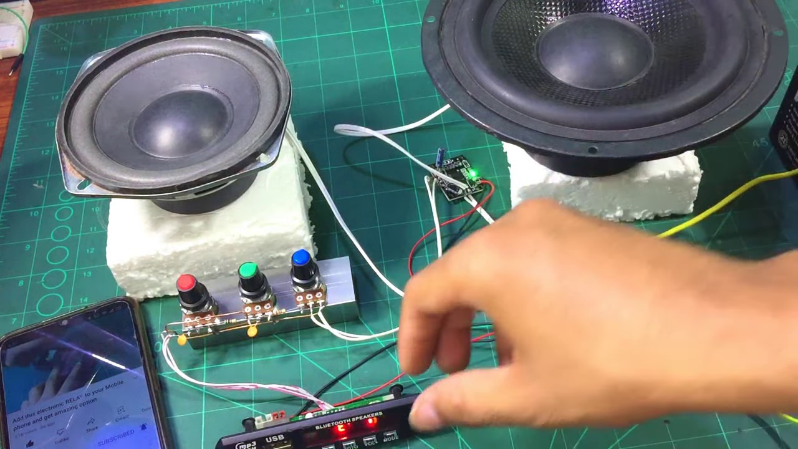 (score 95.0000)
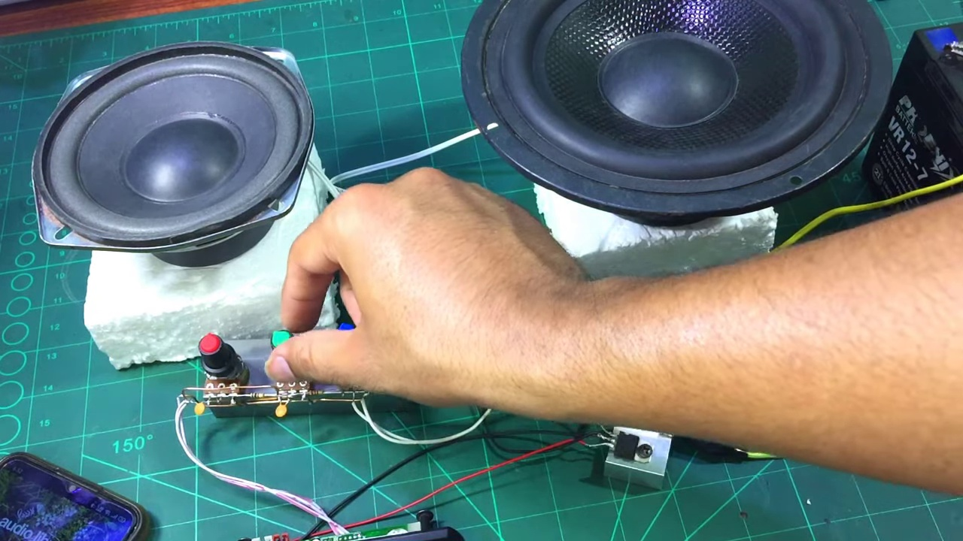 (score 95.0000)
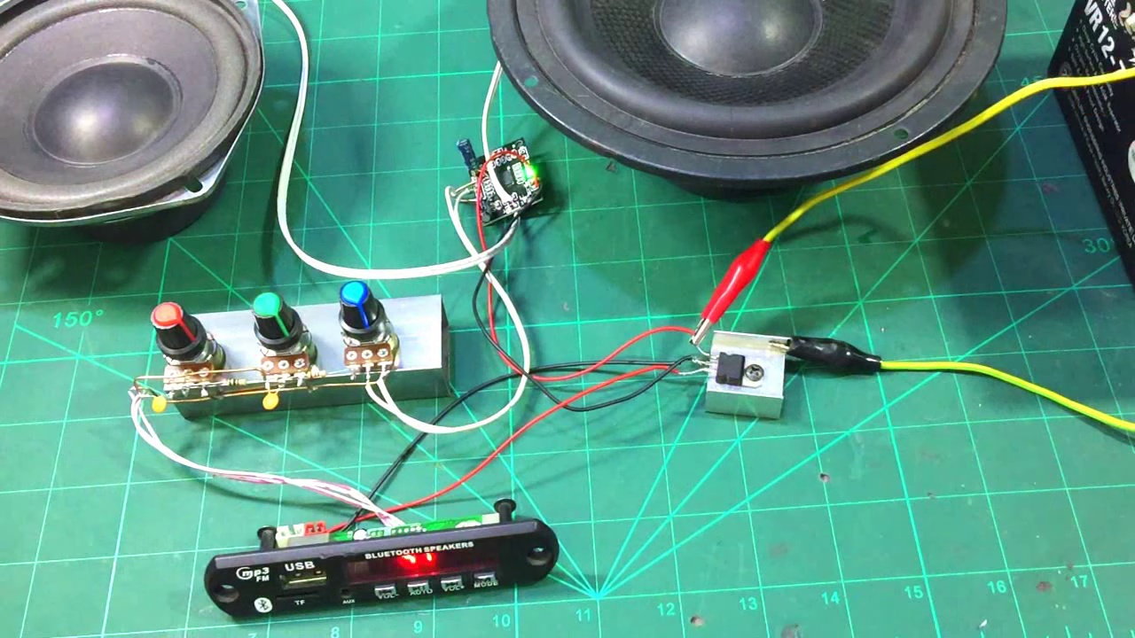 (score 95.0000)
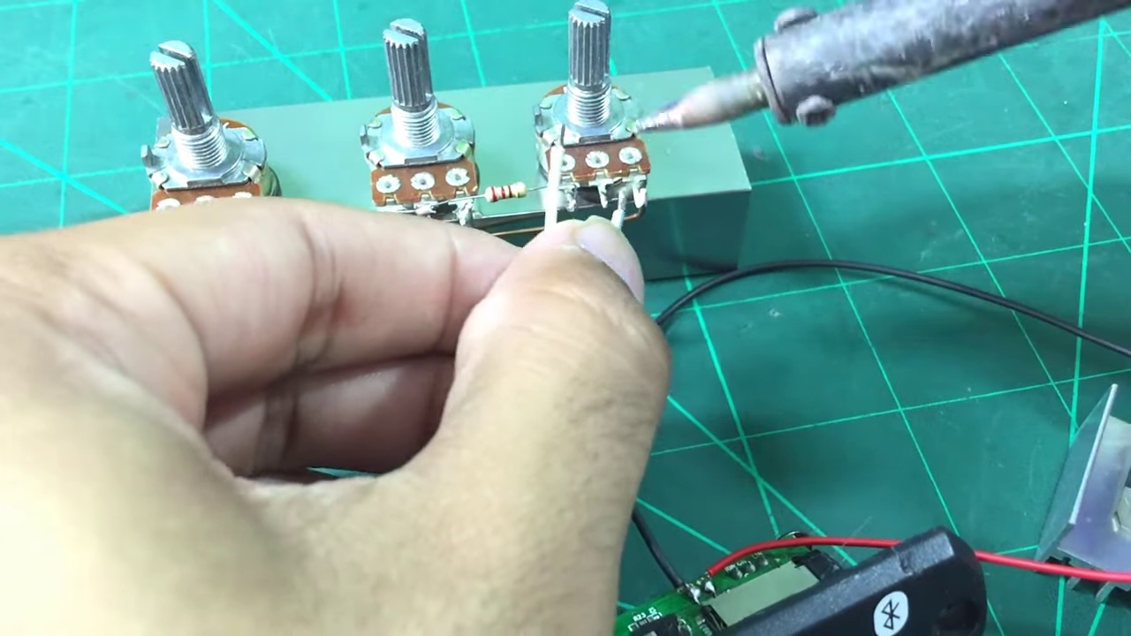 (score 95.0000)
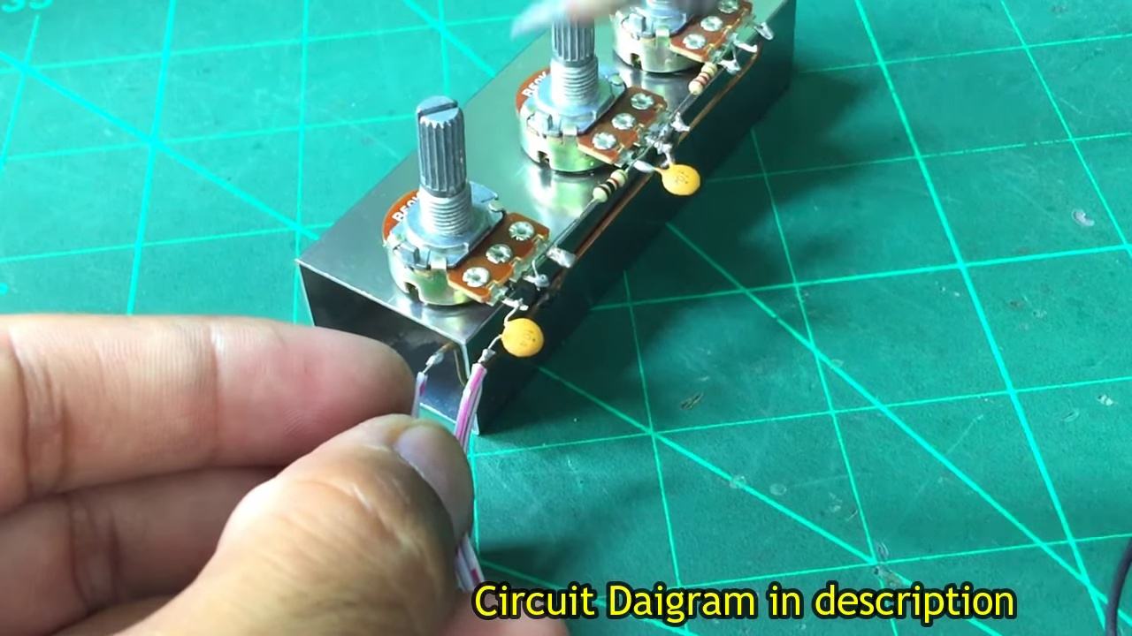 (score 95.0000)
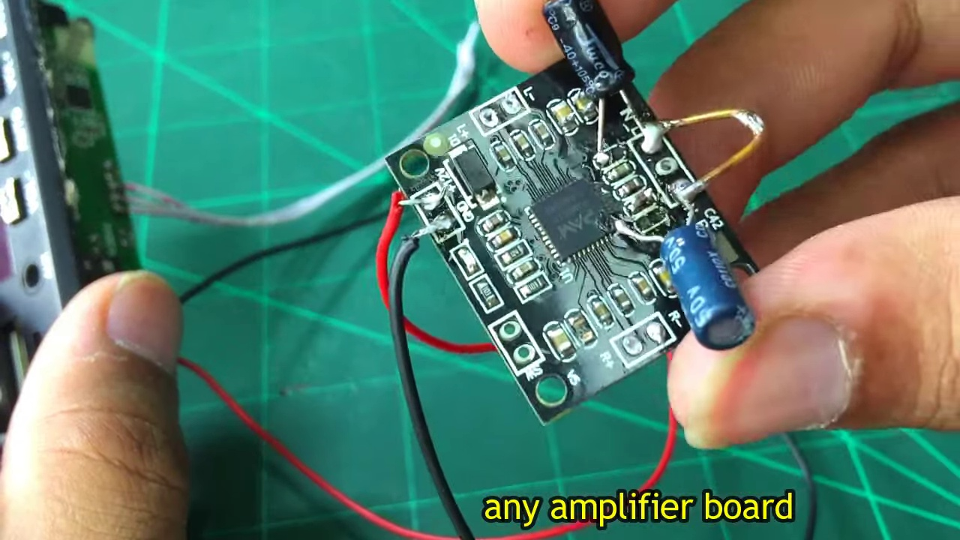 (score 95.0000)
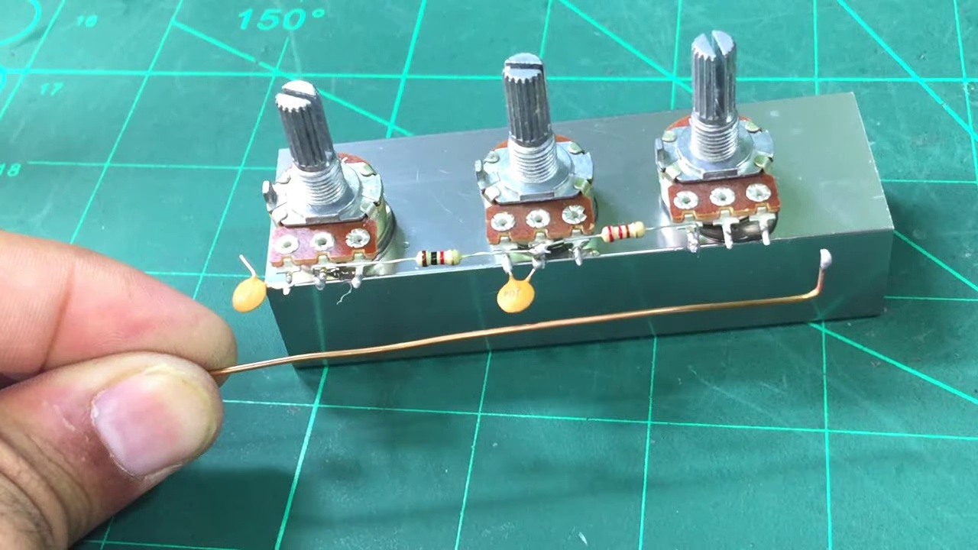 (score 95.0000)
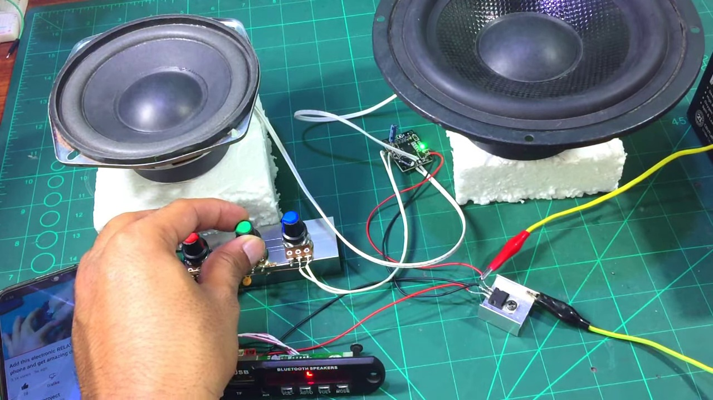 (score 90.0000)
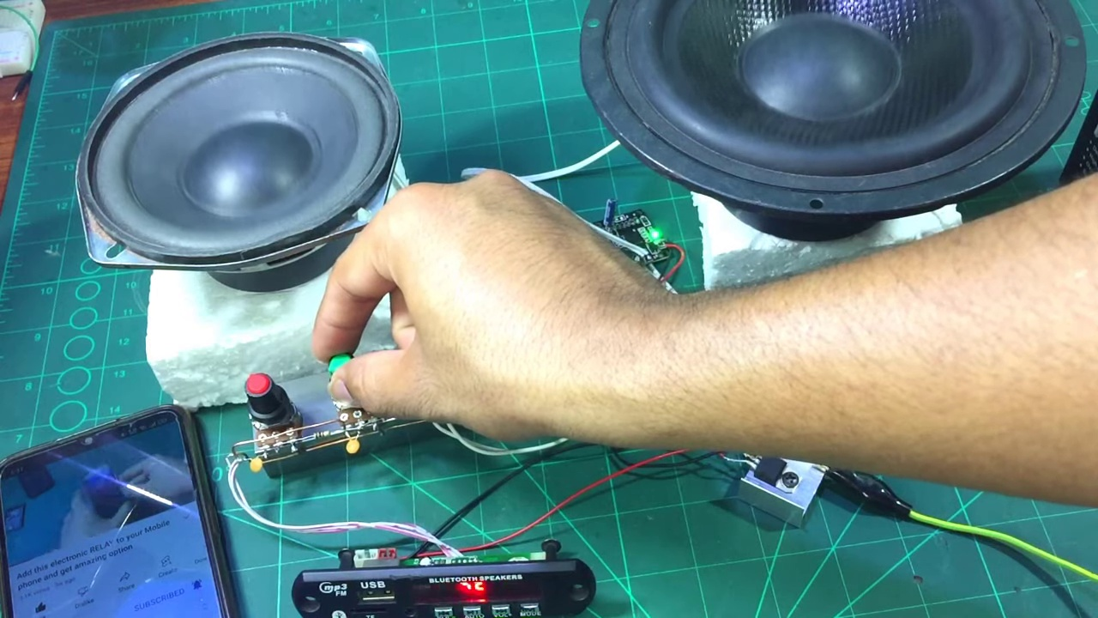 (score 90.0000)
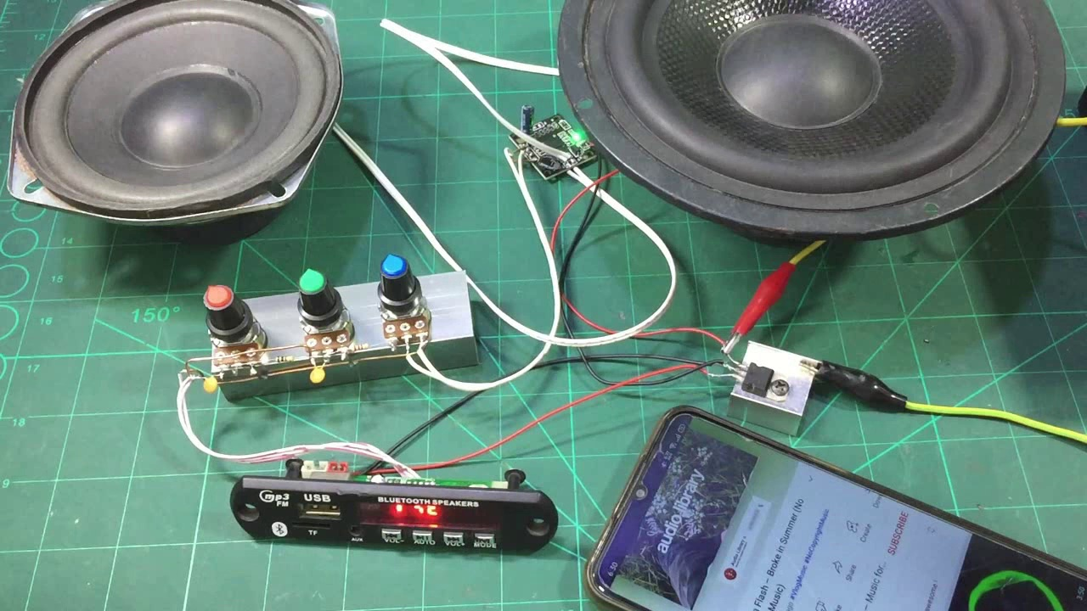 (score 90.0000)
Least correlated frames:
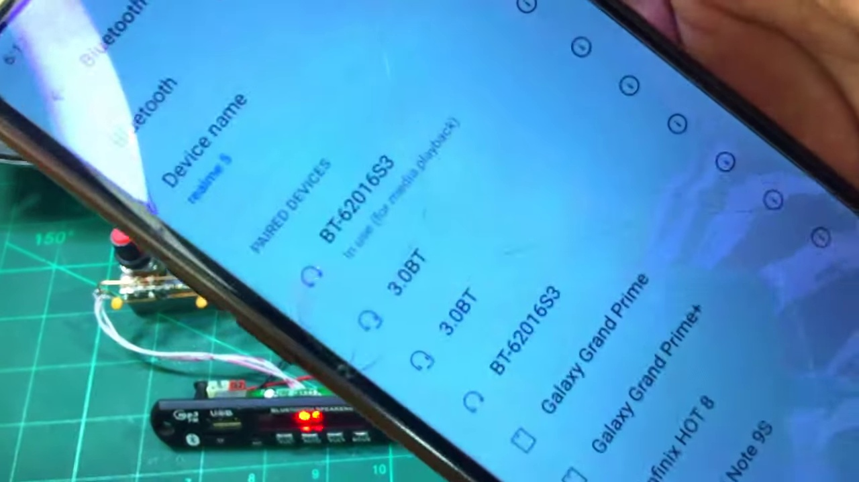 (score 0.0000)
 (score 0.0000)
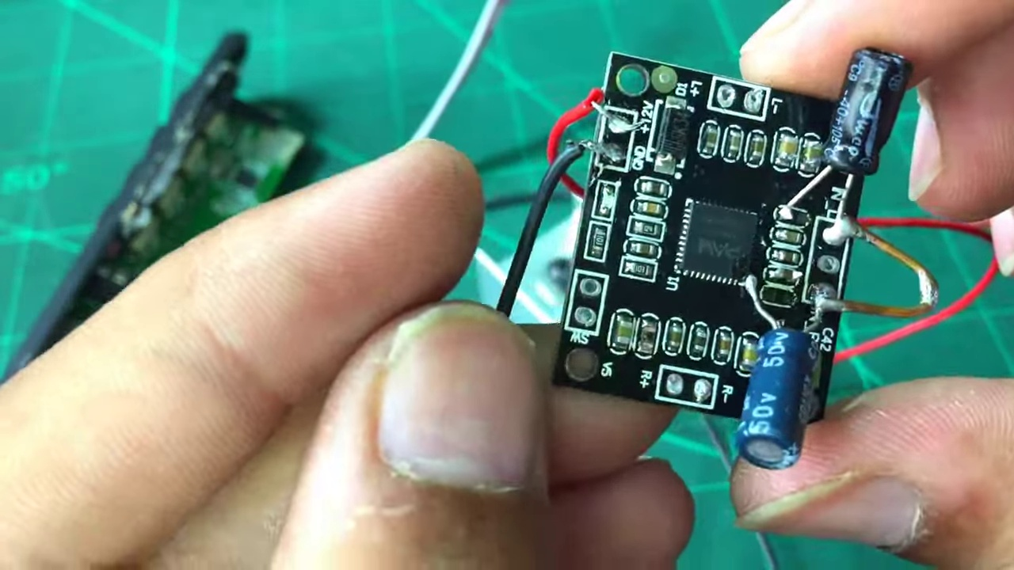 (score 5.0000)
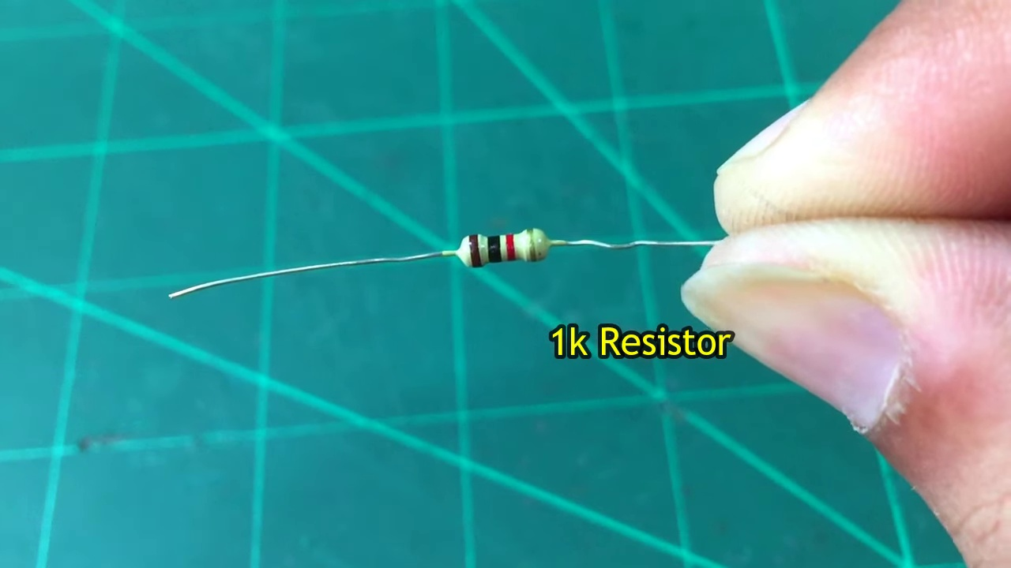 (score 20.0000)
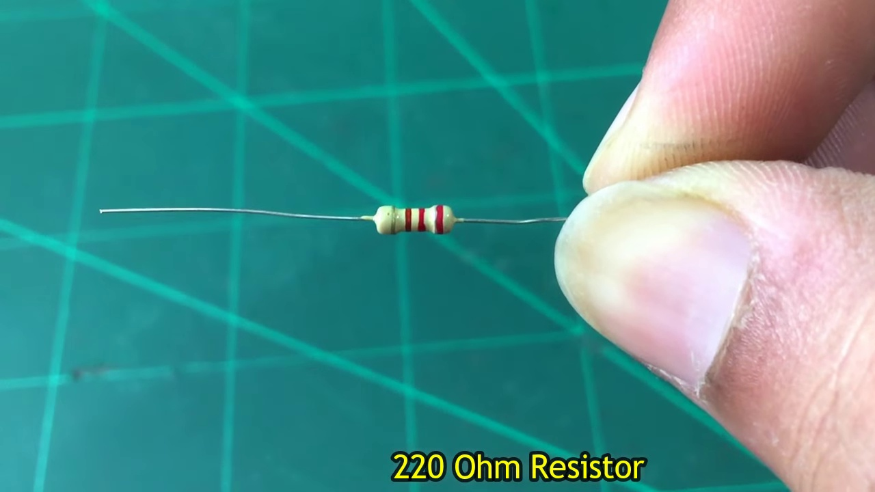 (score 20.0000)
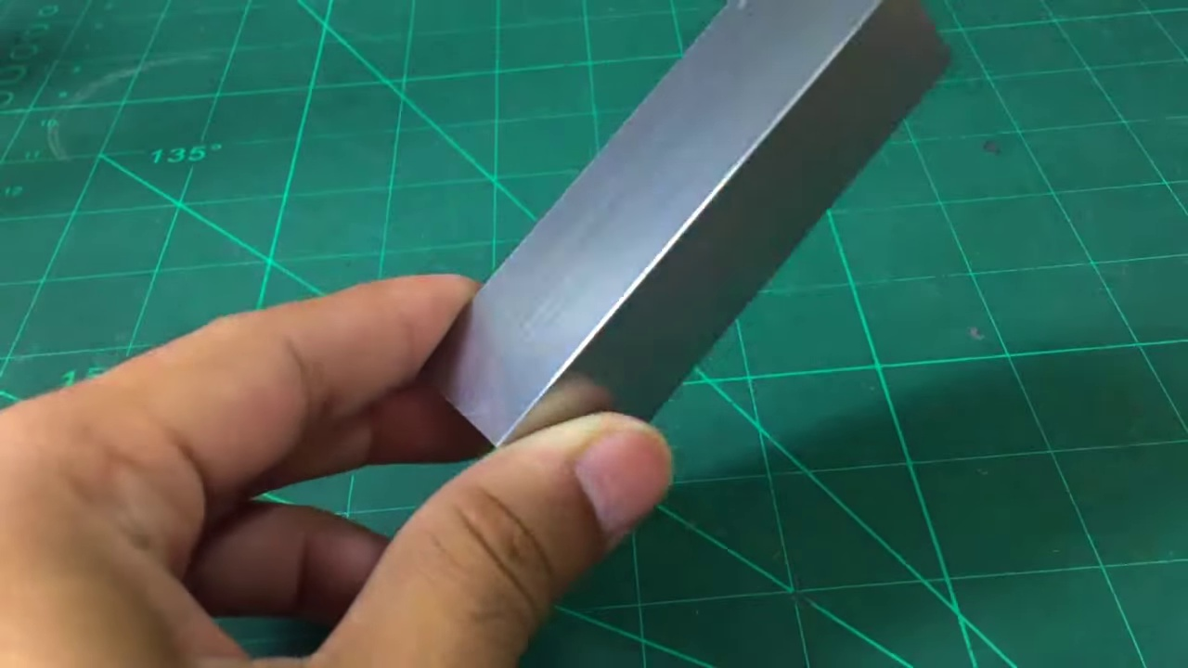 (score 20.0000)
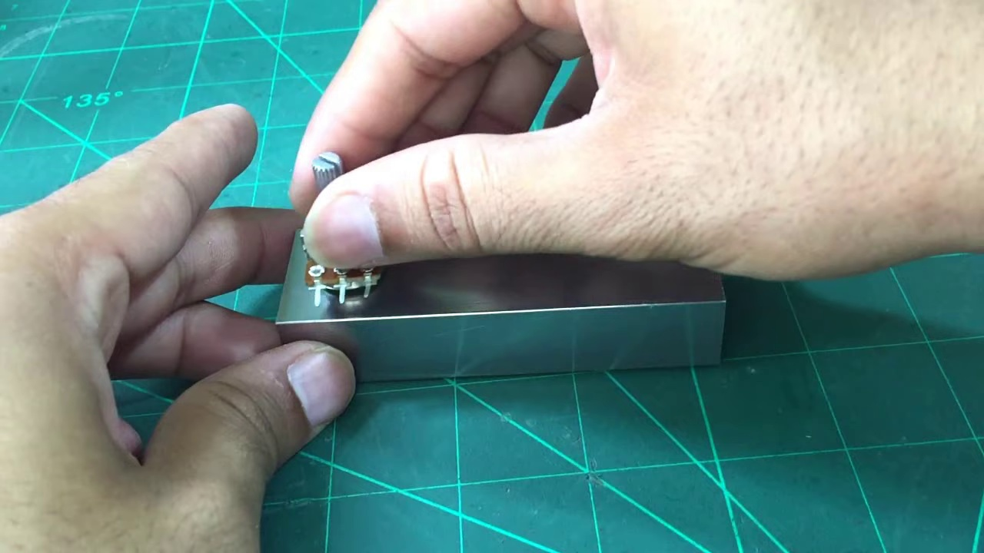 (score 20.0000)
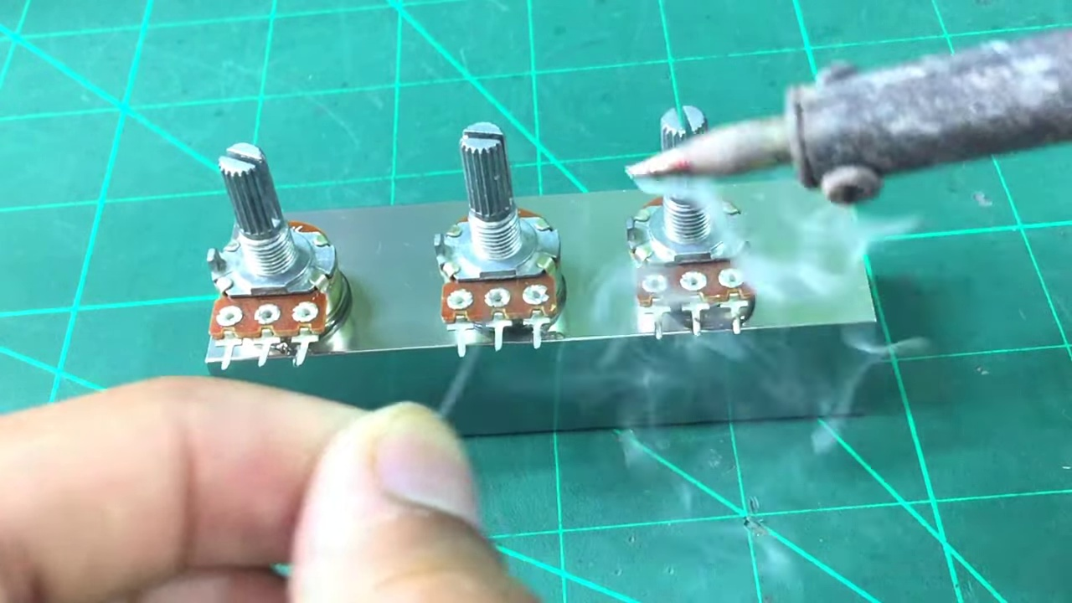 (score 20.0000)
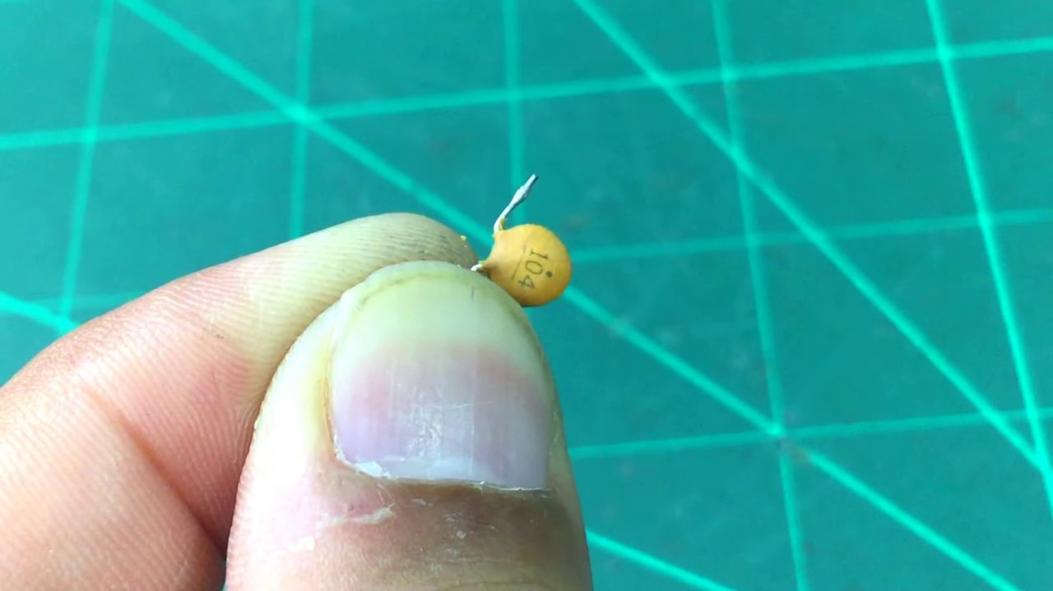 (score 20.0000)
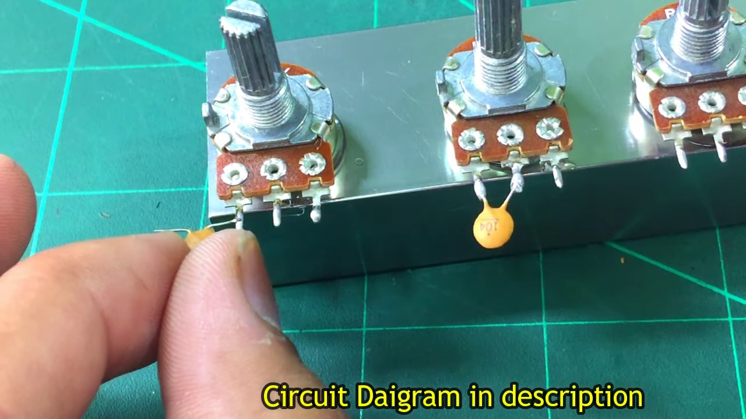 (score 20.0000)
- matched 63 frame(s), max score 95.0000: Learned how to implement potentiometers to control volume, treble, and bass. Also saw the advantage of mounting the circuit onto a heat sink.Initially confused about which potentiometer did what. The linked circuit diagram helped clarify this afterward. Overall Reflection: Watching these videos about building circuits and understanding audio electronics was really helpful. They showed how to put theory into practice, like making bandpass filters and using potentiometers to control sound. One cool thing was seeing different ways to build circuits, such as mounting components on wood or soldering them directly. This demonstrated the flexibility and creativity possible in electronics. The videos also highlighted the roles of components like resistors and transformers, which improved my understanding of circuit function. Attention to detail, such as using heat sinks, was emphasized for reliability. One challenge was interpreting physical circuit builds without initially seeing a schematic, but the linked diagrams helped bridge that gap. Overall, I now feel more confident with circuit building, especially with audio-focused projects, and I’m particularly excited to apply these insights to the bass component of our final project, which was missing in the first phase.
Source: https://www.youtube.com/watch?v=YIAQ80evrFM&t=1s: DIY Deep bass and Treble Volume controller-How to make heavy bass and treble for diy amplifier
Top correlated frames:
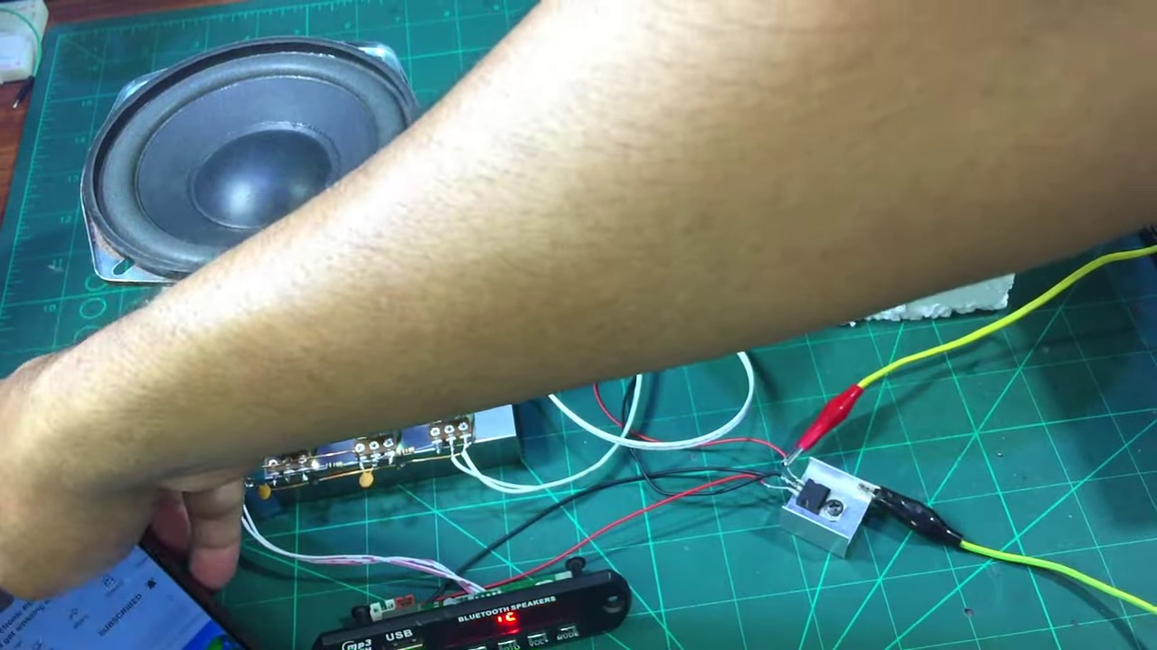 (score 95.0000)
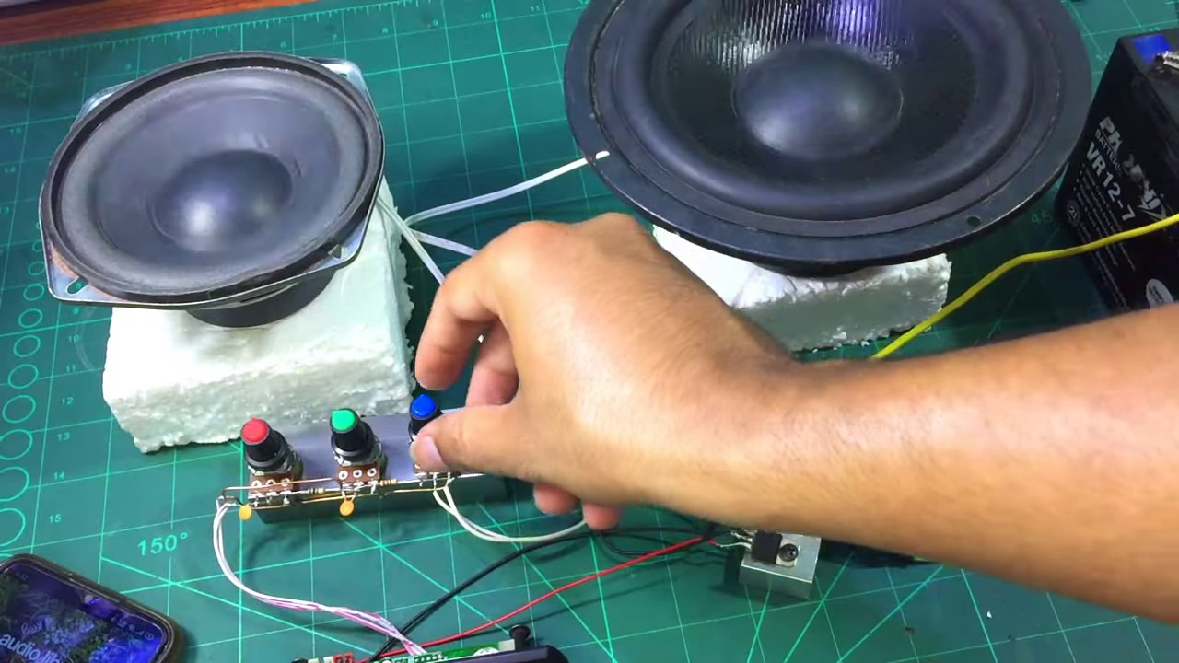 (score 95.0000)
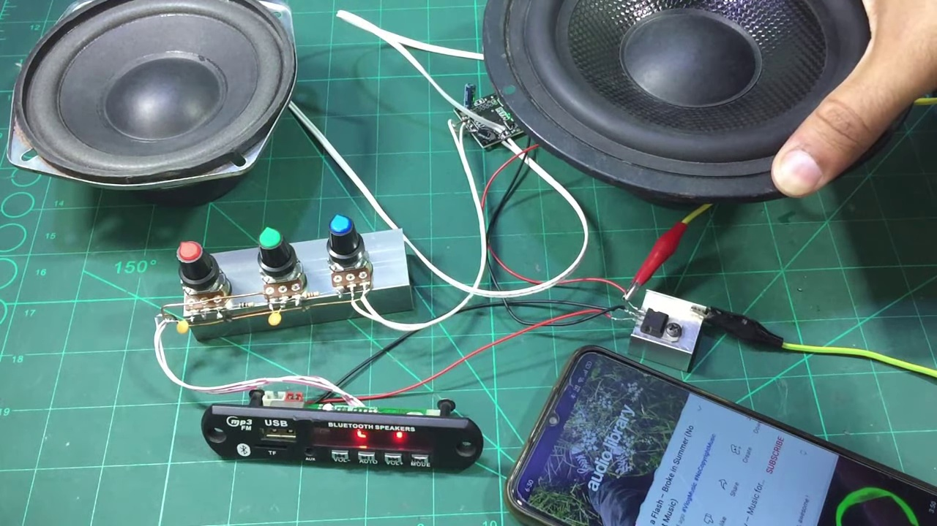 (score 95.0000)
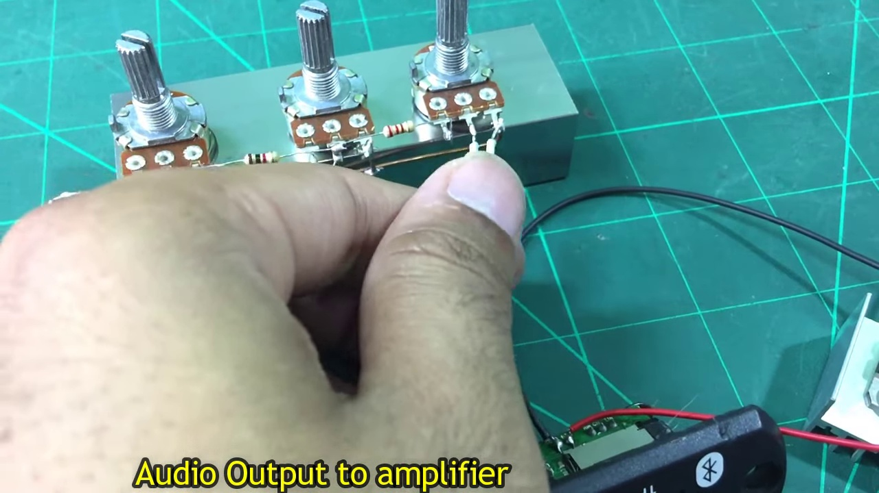 (score 95.0000)
 (score 90.0000)
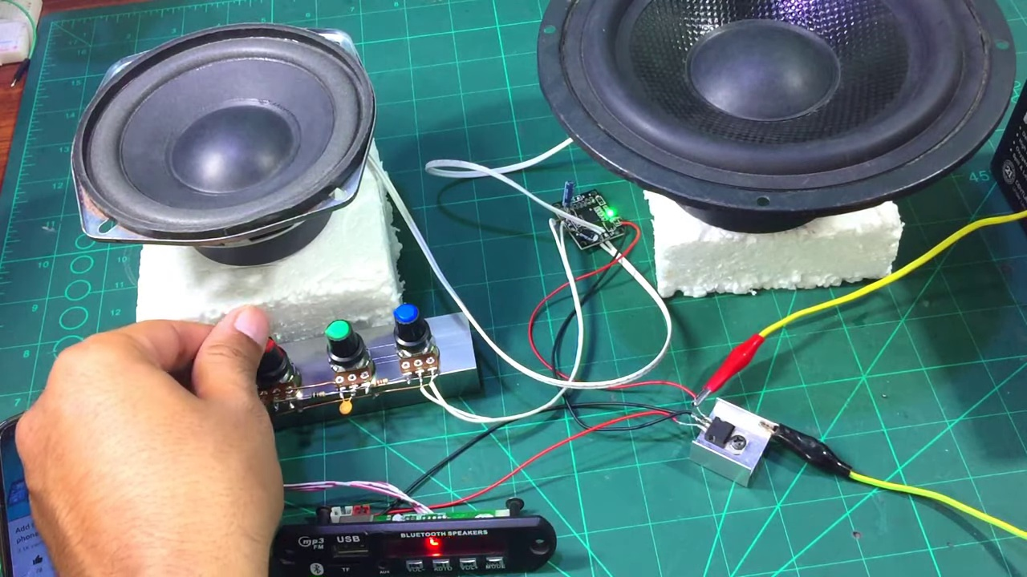 (score 90.0000)
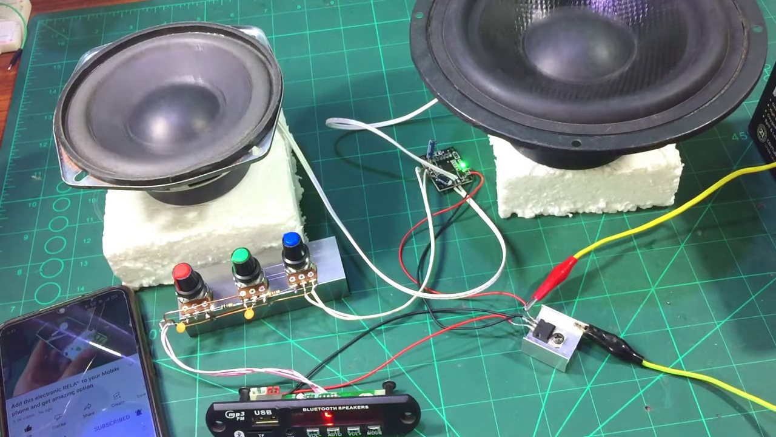 (score 90.0000)
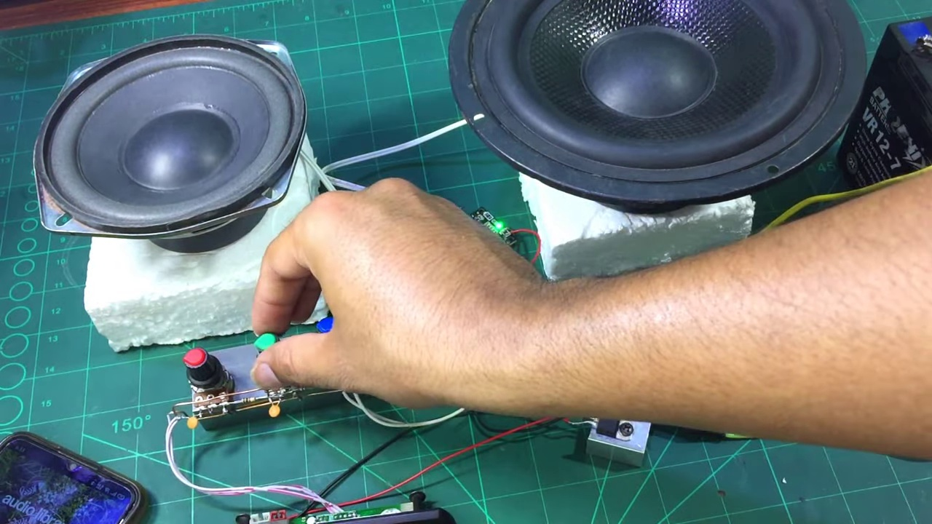 (score 90.0000)
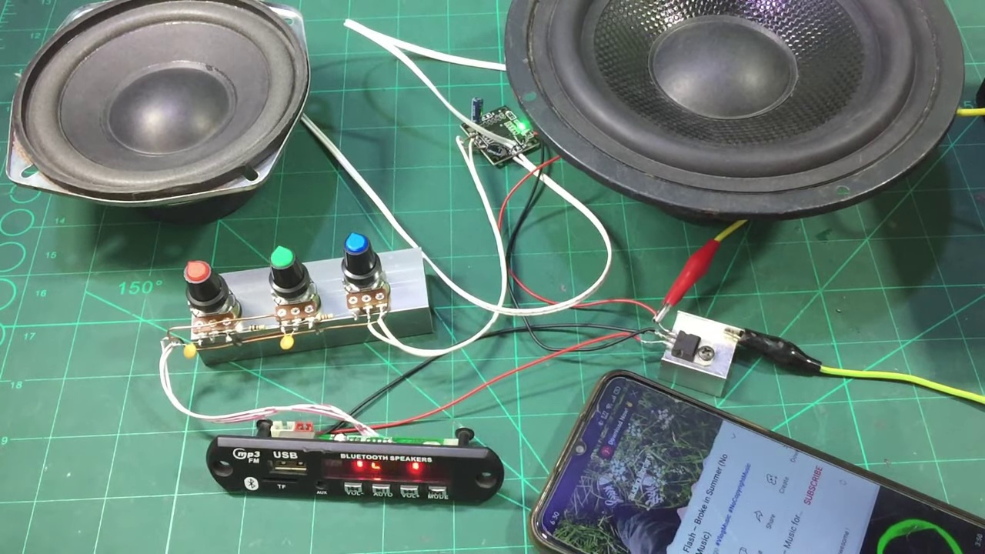 (score 90.0000)
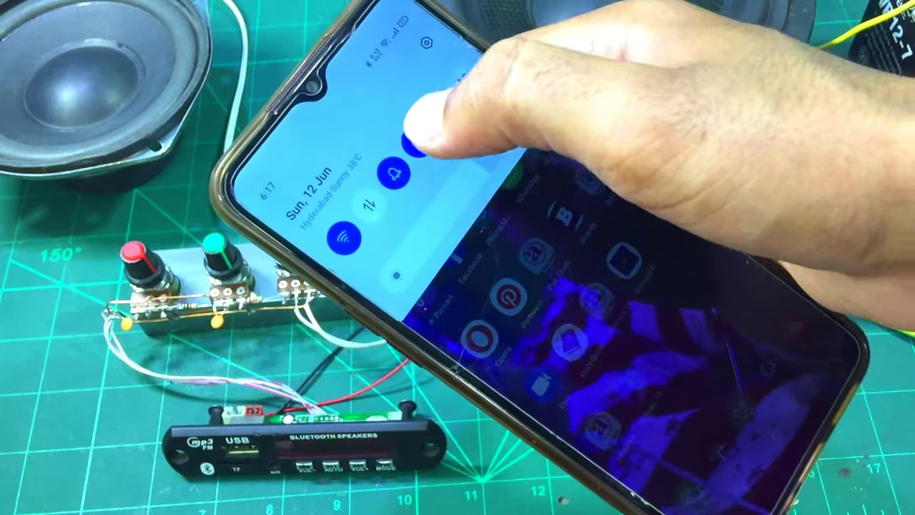 (score 90.0000)
Least correlated frames:
 (score 0.0000)
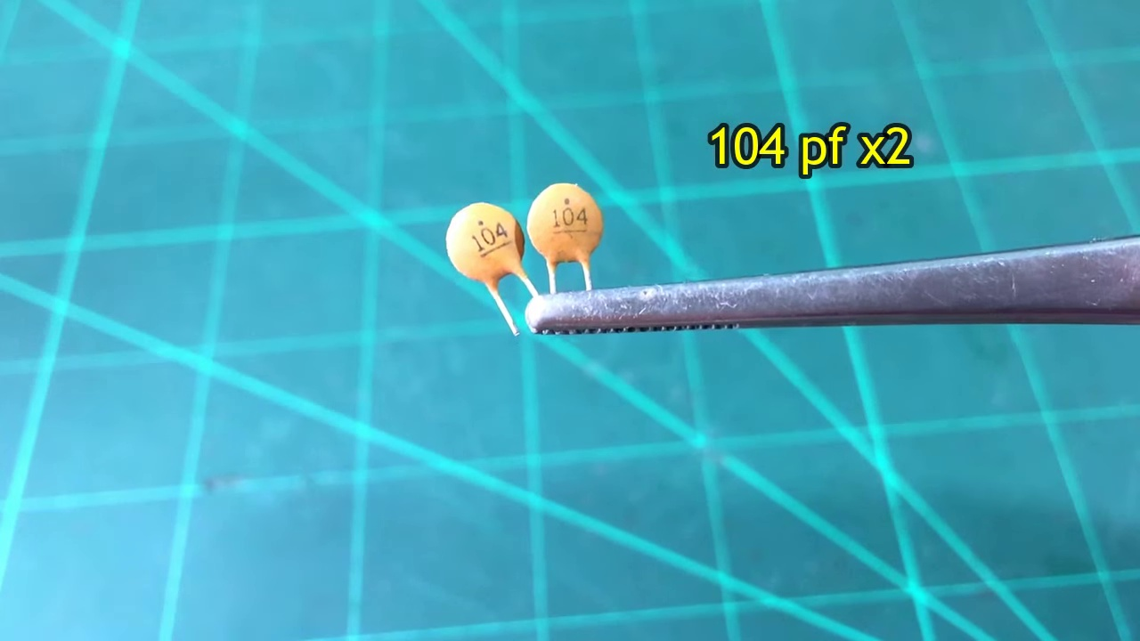 (score 20.0000)
 (score 20.0000)
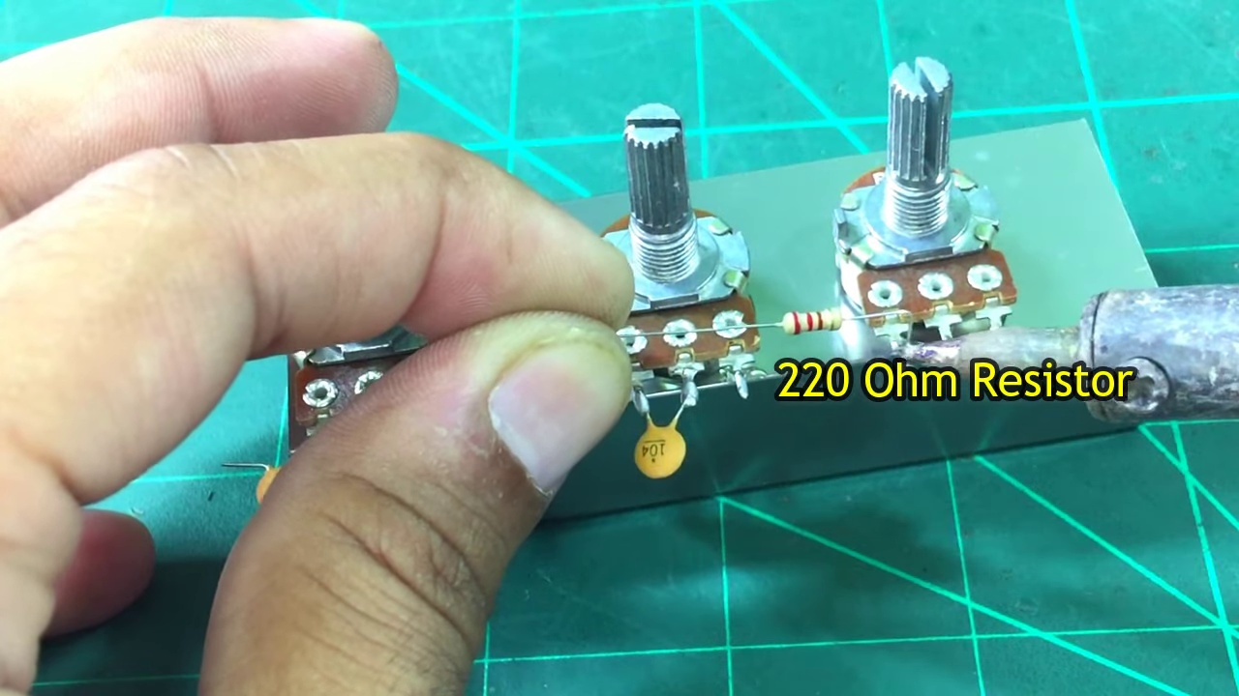 (score 75.0000)
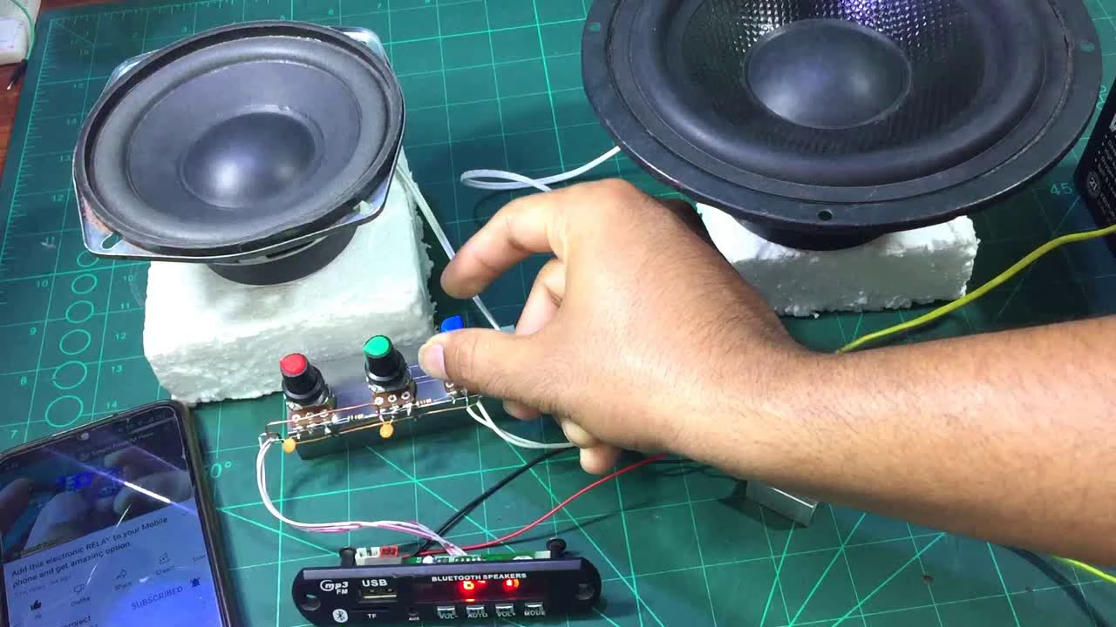 (score 80.0000)
 (score 80.0000)
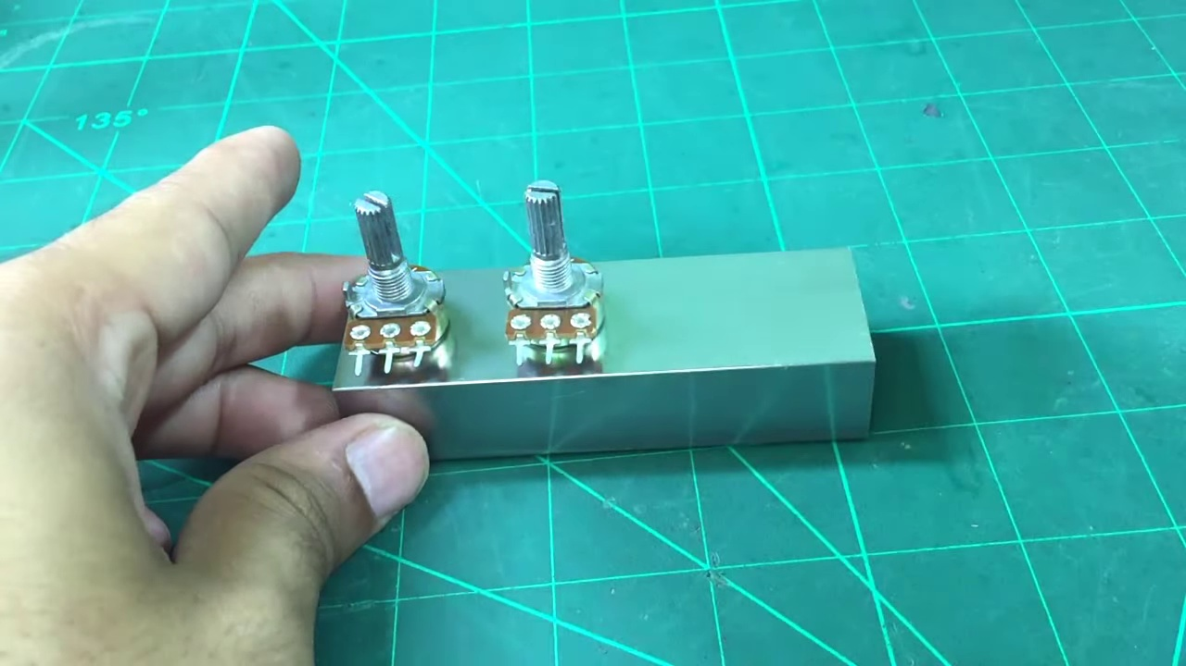 (score 80.0000)
 (score 80.0000)
 (score 80.0000)
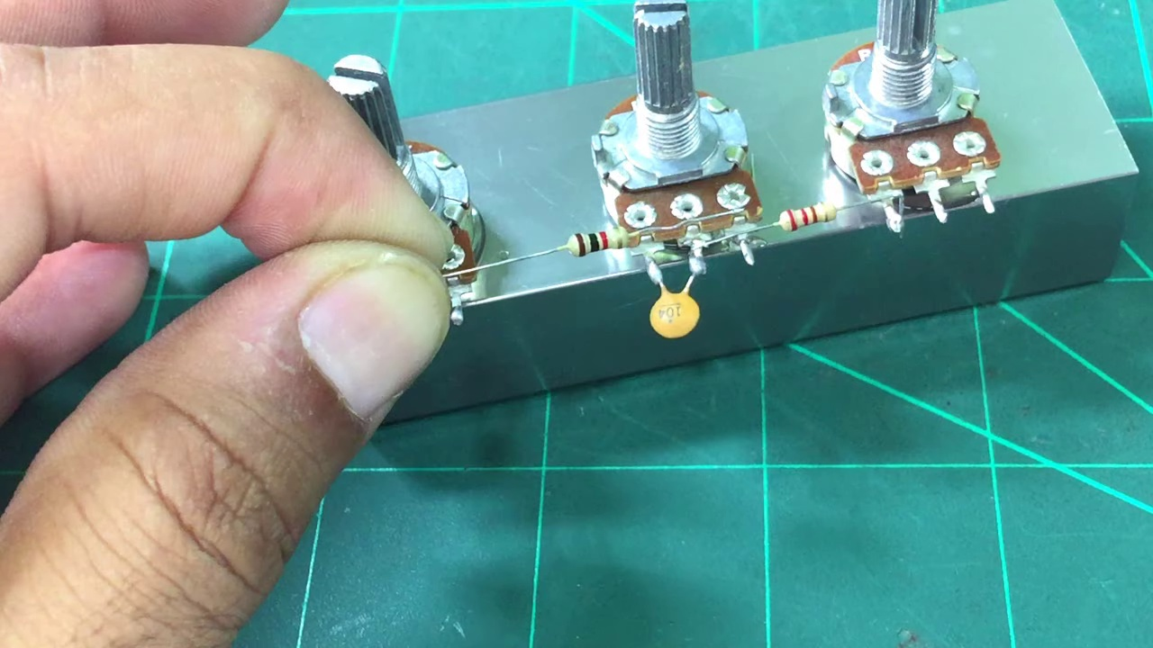 (score 80.0000)
- matched 54 frame(s), max score 95.0000: I learned how to make a simple bass and treble volume controller that is very effective and can connect to different sized speakers. This will be useful in Phase 2 to manage volume, bass, and treble for each speaker box.Nothing in this video was confusing. It is a very simple circuit.
Source: https://www.youtube.com/watch?v=YIAQ80evrFM: DIY Deep Bass and Treble Volume Controller - How to Make Heavy Bass and Treble for DIY Amplifier
Top correlated frames:
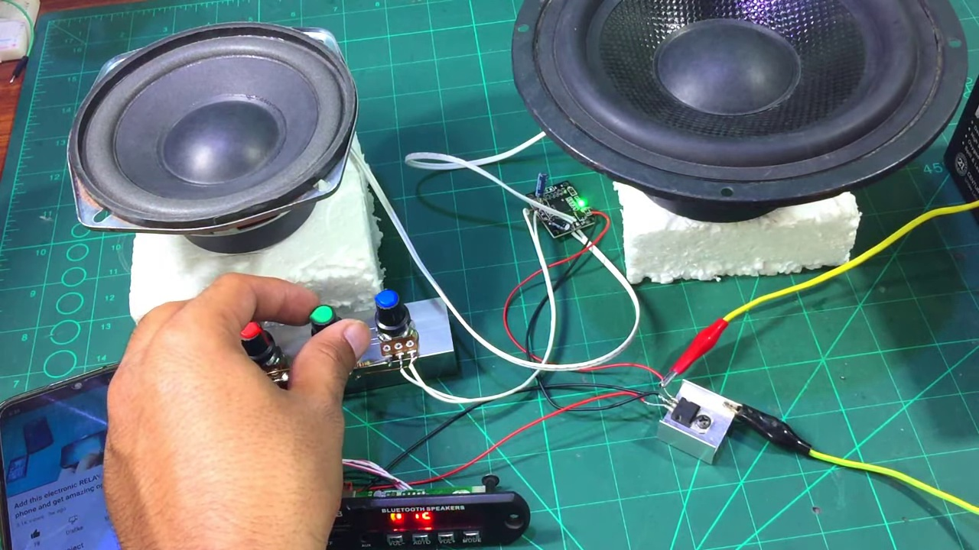 (score 95.0000)
 (score 95.0000)
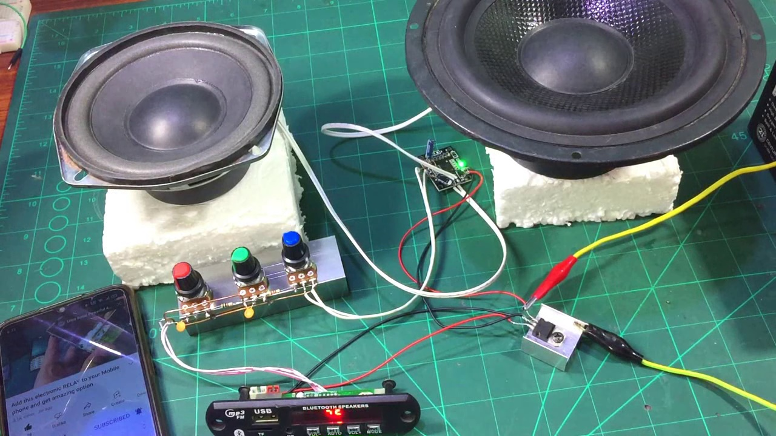 (score 90.0000)
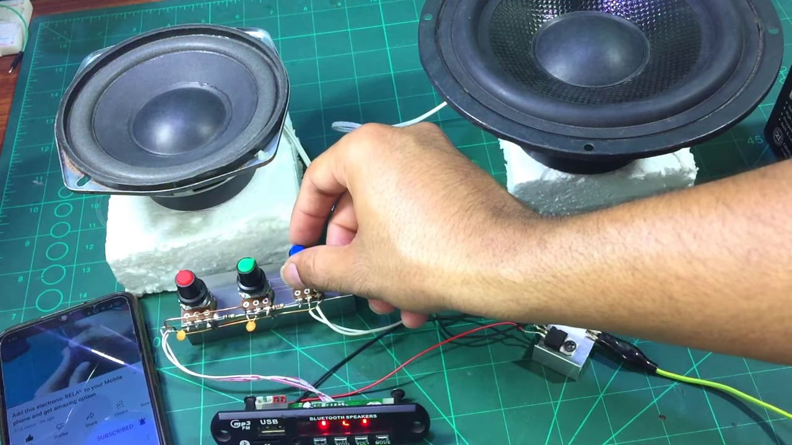 (score 90.0000)
 (score 90.0000)
 (score 90.0000)
 (score 90.0000)
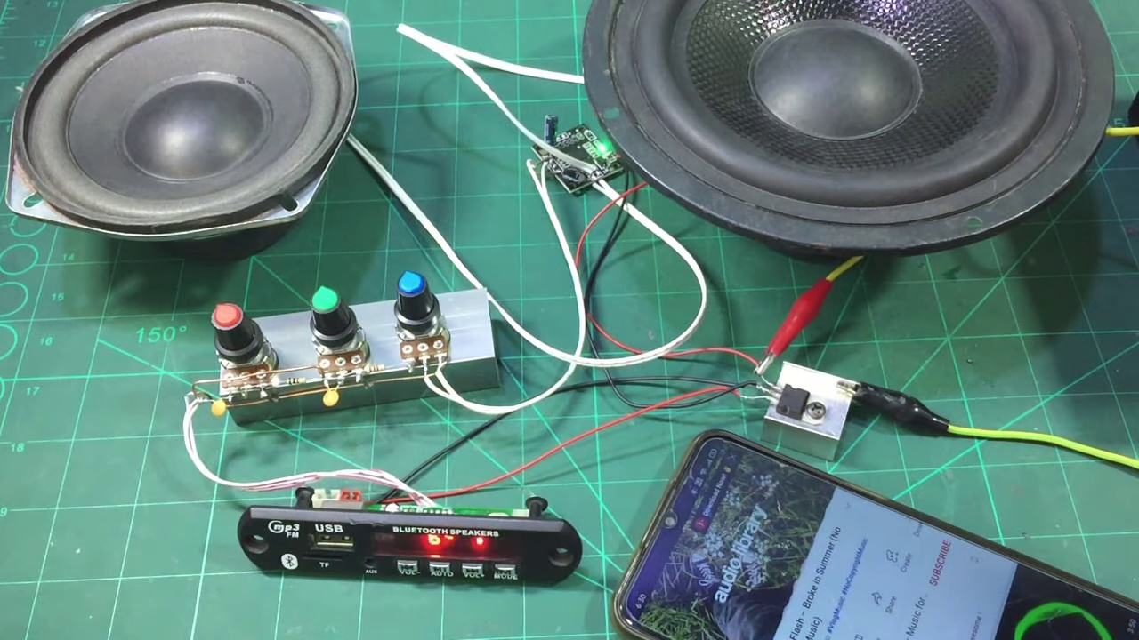 (score 90.0000)
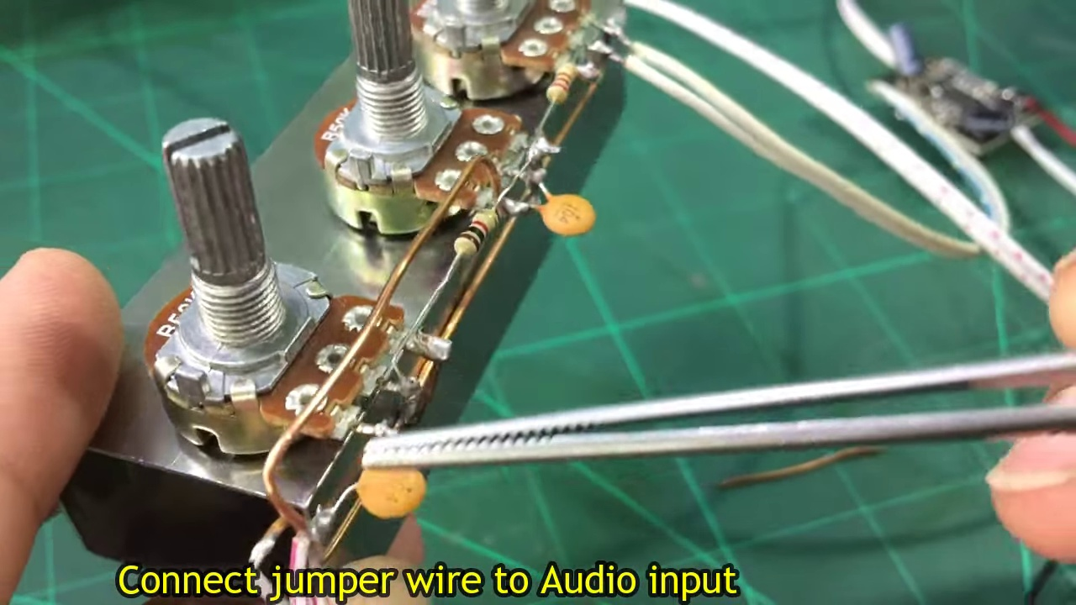 (score 90.0000)
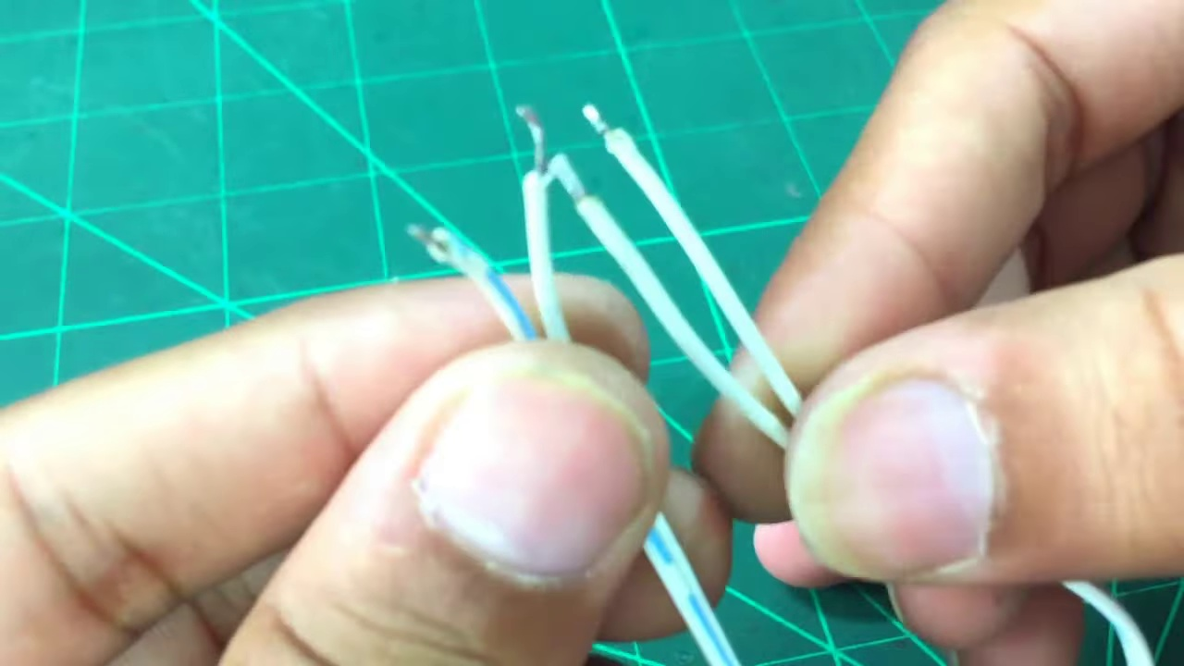 (score 90.0000)
Least correlated frames:
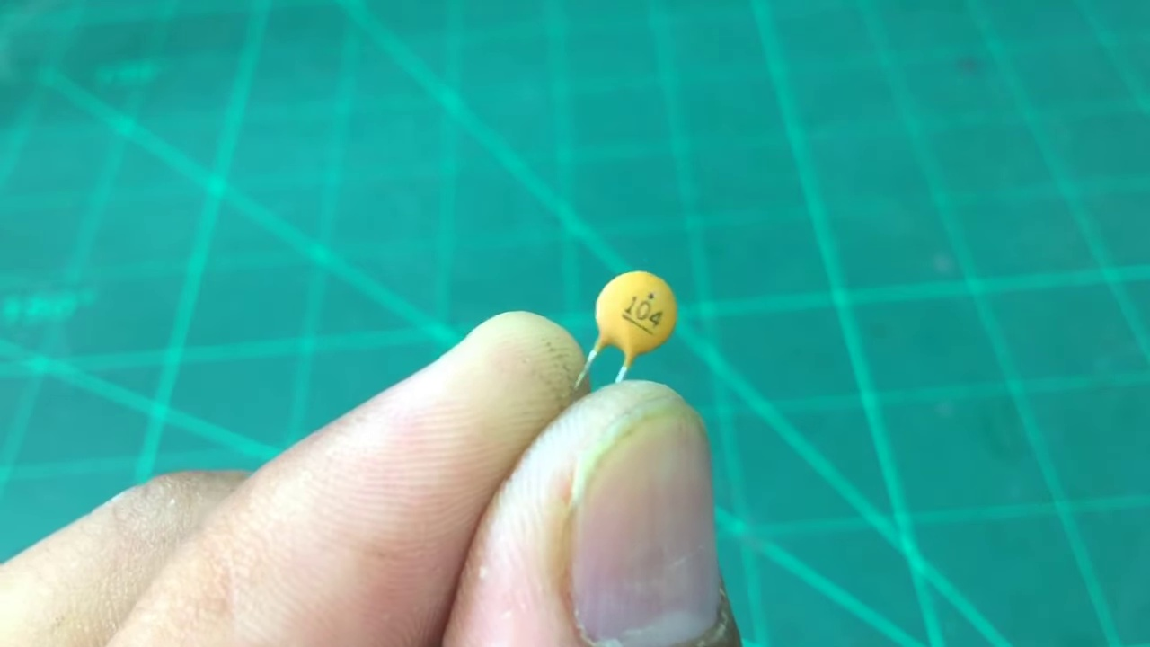 (score 0.0000)
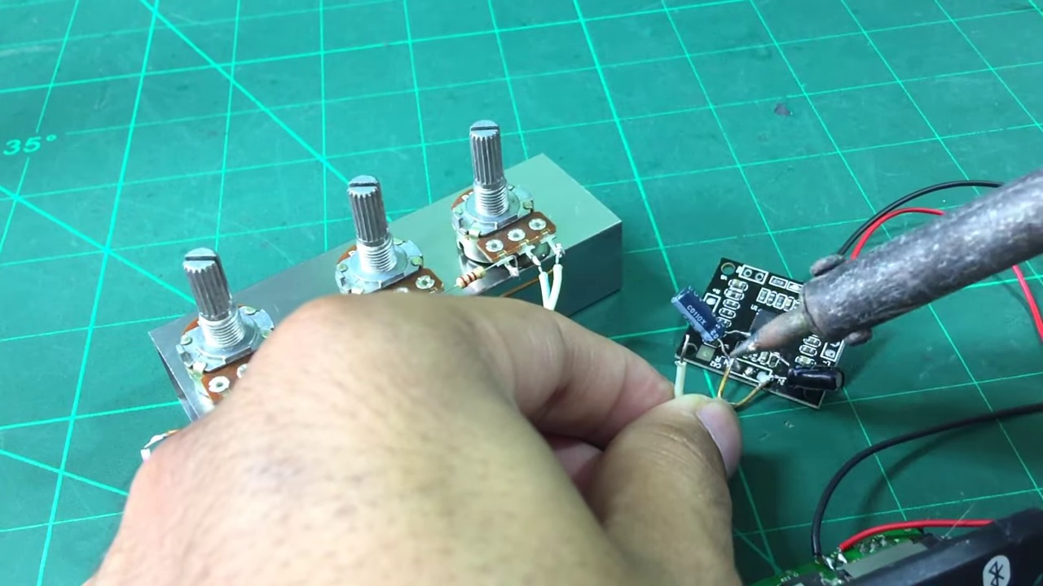 (score 0.0000)
 (score 0.0000)
 (score 10.0000)
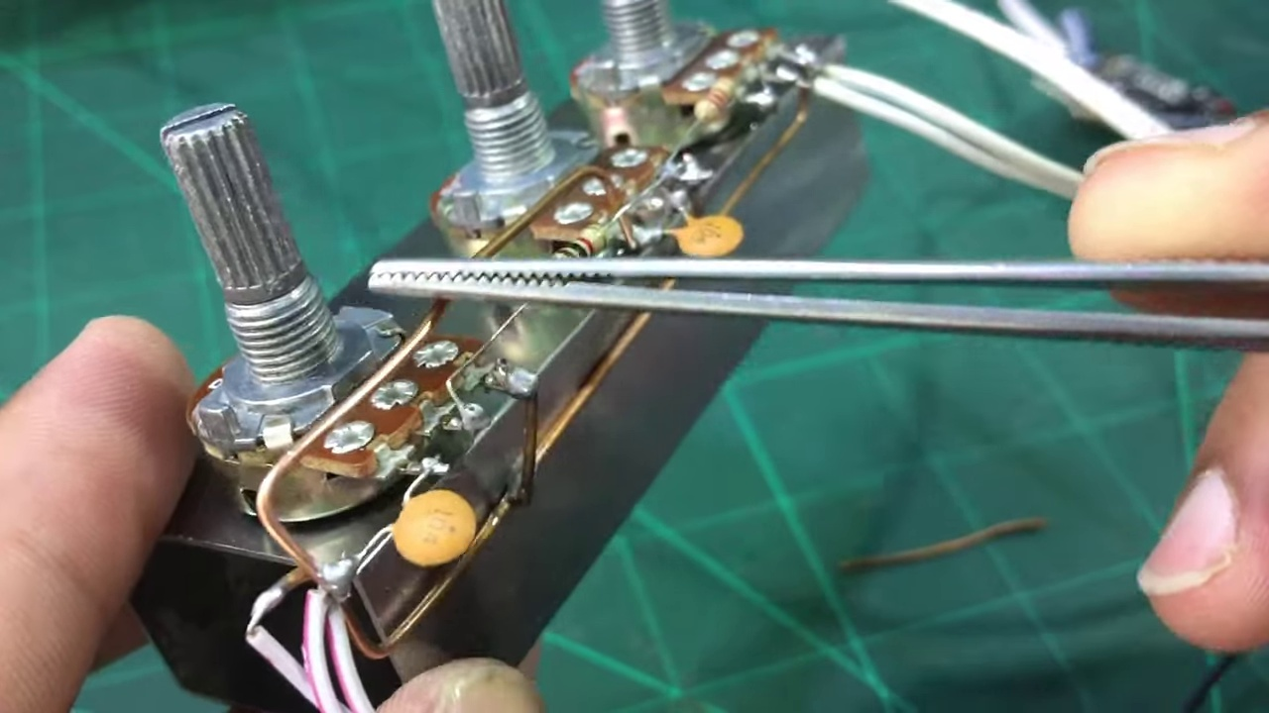 (score 10.0000)
 (score 20.0000)
 (score 20.0000)
 (score 20.0000)
 (score 20.0000)
 (score 20.0000)
- matched 51 frame(s), max score 95.0000: The video shows all the parts needed to make a heavy bass and treble controller and provides a step-by-step guide to assemble it.The video does not mention where to get the parts or how much it would cost.This could be useful in class for Phase 2 and is also a great DIY project.
Source: https://www.youtube.com/watch?v=YIAQ80evrFM: DIY Deep Bass and Treble Volume Controller
Top correlated frames:
 (score 95.0000)
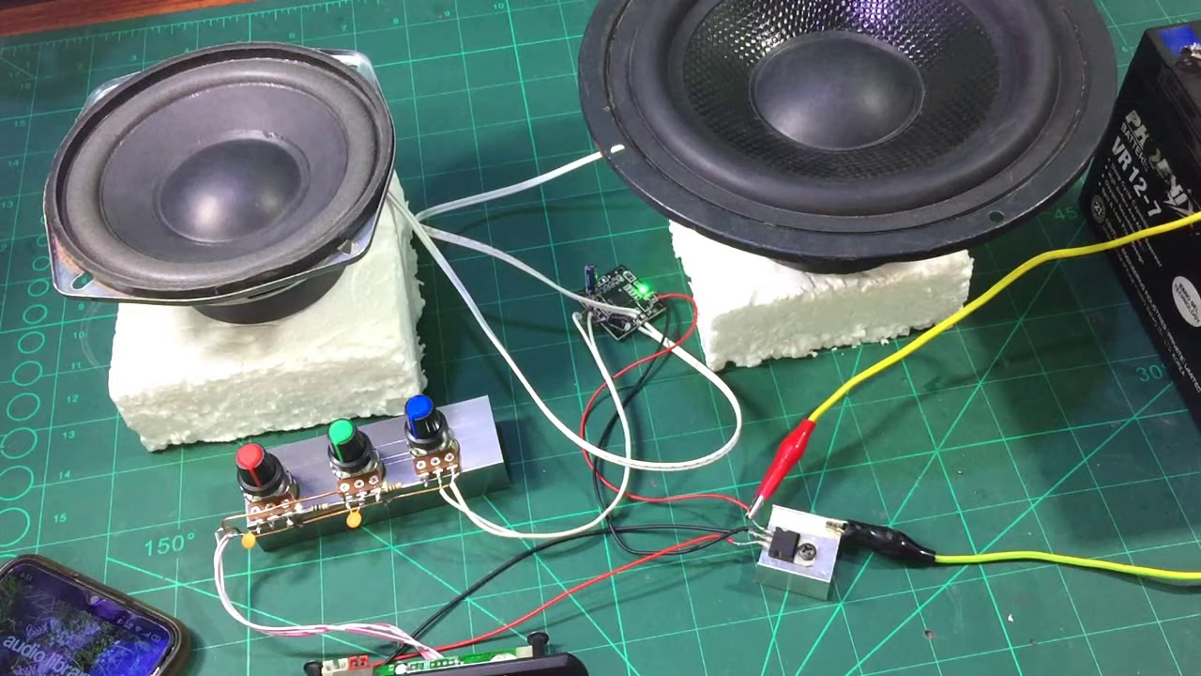 (score 95.0000)
 (score 95.0000)
 (score 95.0000)
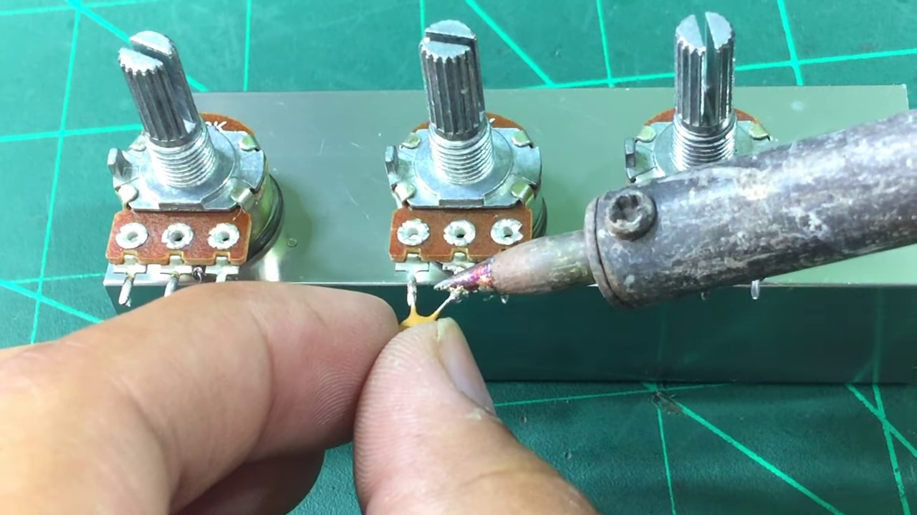 (score 95.0000)
 (score 92.0000)
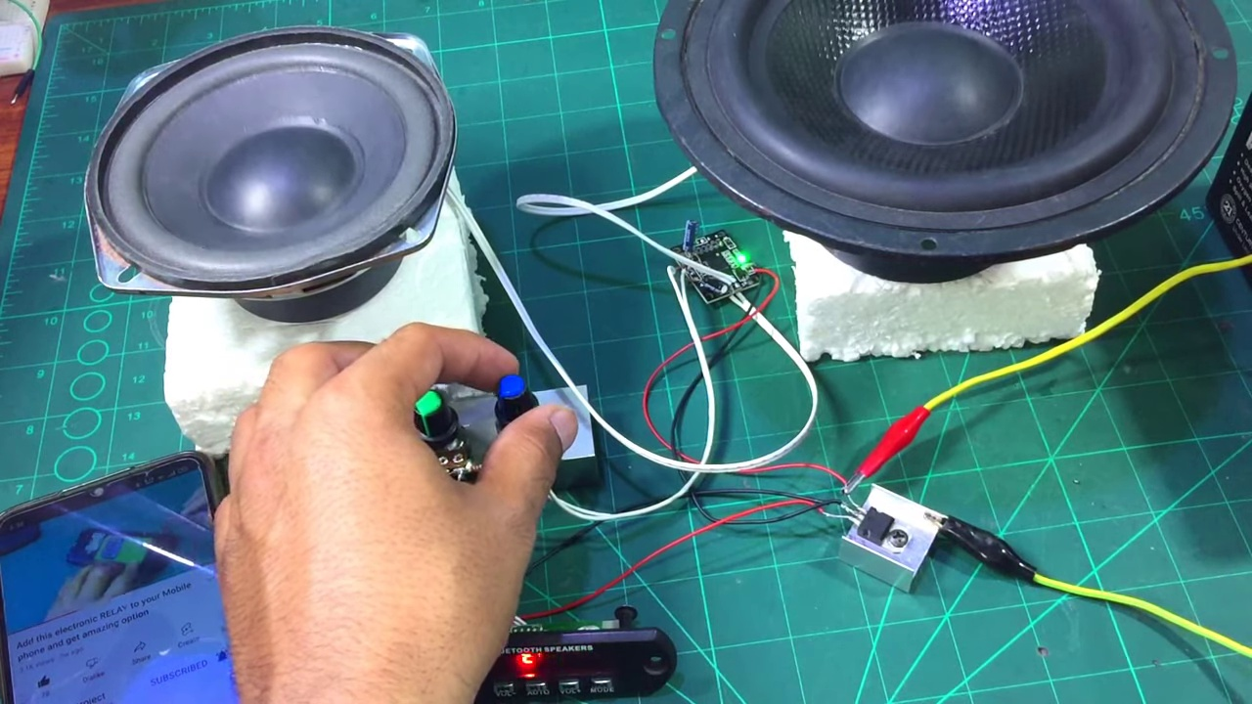 (score 90.0000)
 (score 90.0000)
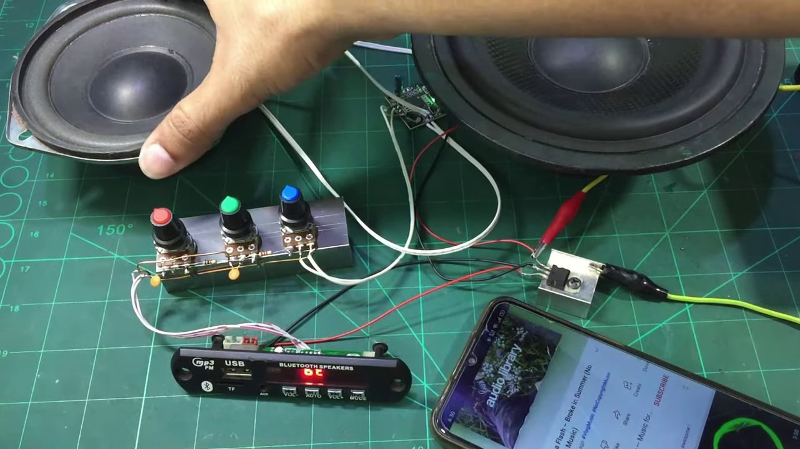 (score 90.0000)
 (score 90.0000)
Least correlated frames:
 (score 0.0000)
 (score 0.0000)
 (score 5.0000)
 (score 10.0000)
 (score 10.0000)
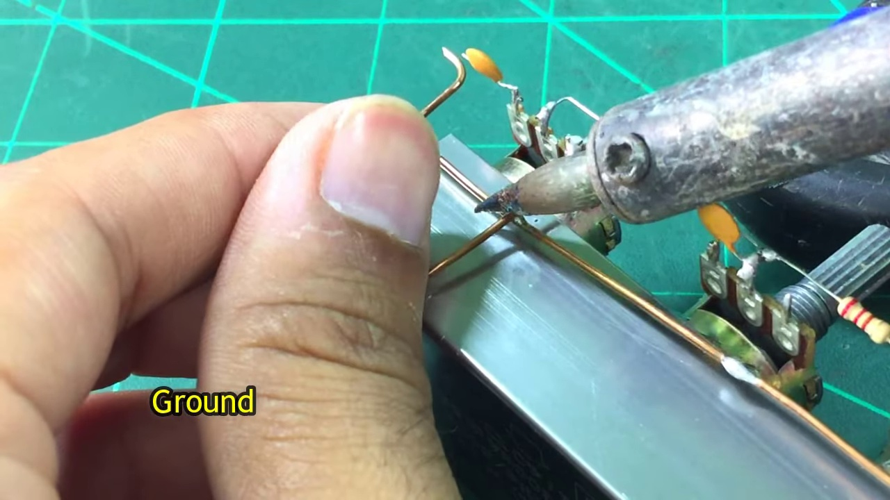 (score 10.0000)
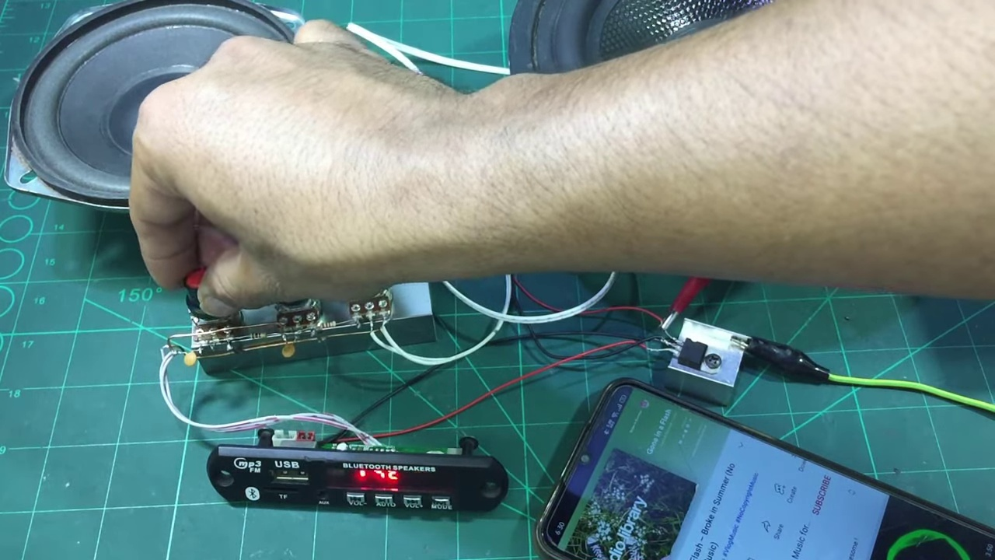 (score 10.0000)
 (score 20.0000)
 (score 20.0000)
 (score 20.0000)
- matched 49 frame(s), max score 95.0000: This video was centered around adding volume, bass, and treble control into your speaker circuit. Things learned from this video is that basic principles of using potentiometers, resistors, and capacitors for adding this control to a speaker circuit. Now there is some confusion on how to incorporate this into a circuit with the TDA 2030 or TDA 2050 as the person in the video used some fancy amplifier boards and did not use any actual Op-Amp.
Source: https://www.youtube.com/watch?v=YIAQ80evrFM : DIY Deep bass and Treble Volume controller-How to make heavy bass and treble for diy amplifier
Top correlated frames:
 (score 95.0000)
 (score 95.0000)
 (score 95.0000)
 (score 95.0000)
 (score 90.0000)
 (score 90.0000)
 (score 90.0000)
 (score 90.0000)
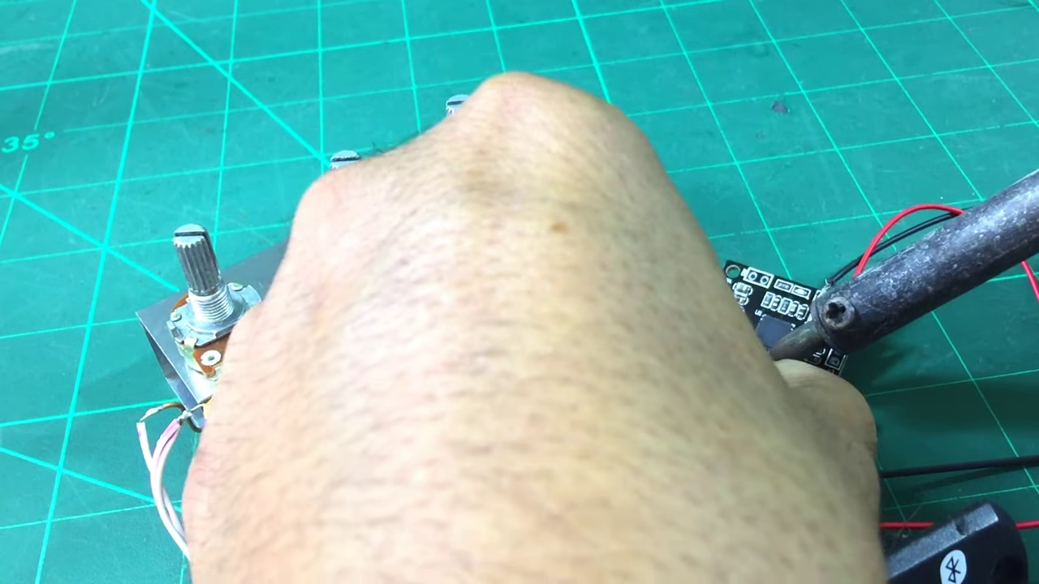 (score 90.0000)
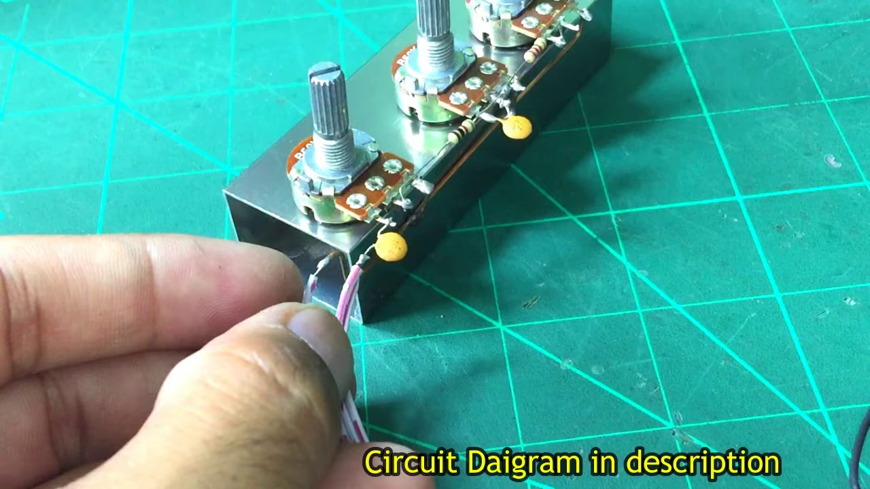 (score 90.0000)
Least correlated frames:
 (score 0.0000)
 (score 0.0000)
 (score 0.0000)
 (score 0.0000)
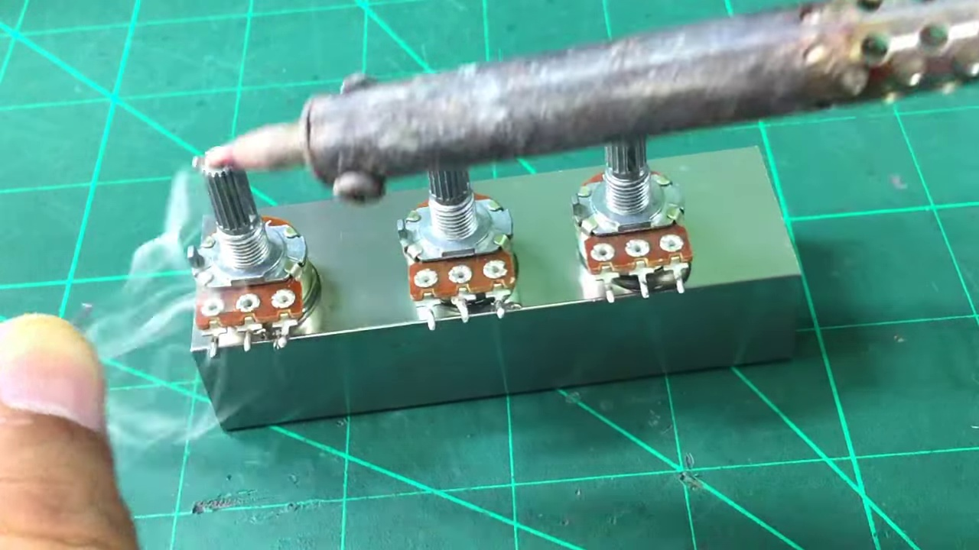 (score 0.0000)
 (score 0.0000)
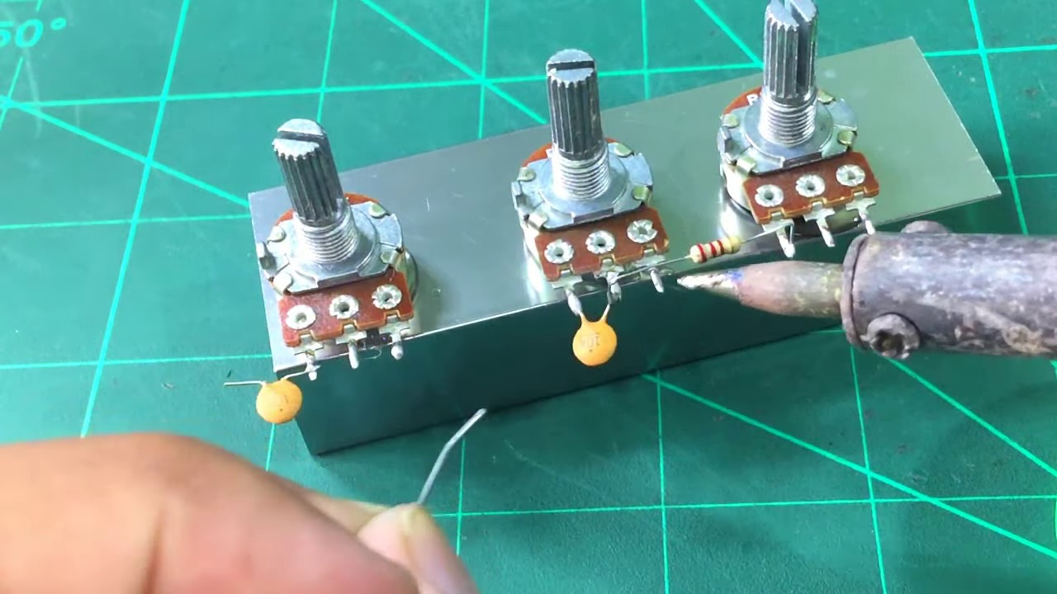 (score 0.0000)
 (score 0.0000)
 (score 0.0000)
 (score 0.0000)
- matched 49 frame(s), max score 90.0000: Got a better sense of how potentiometers work and how to add a 3-volume controller setup. What made you confused is The differences in bass and treble were hardly noticeable — unclear if it’s due to low impact or YouTube audio limitations.
Source: https://www.youtube.com/watch?v=YIAQ80evrFM: DIY Deep Bass and Treble Volume Controller
Top correlated frames:
 (score 90.0000)
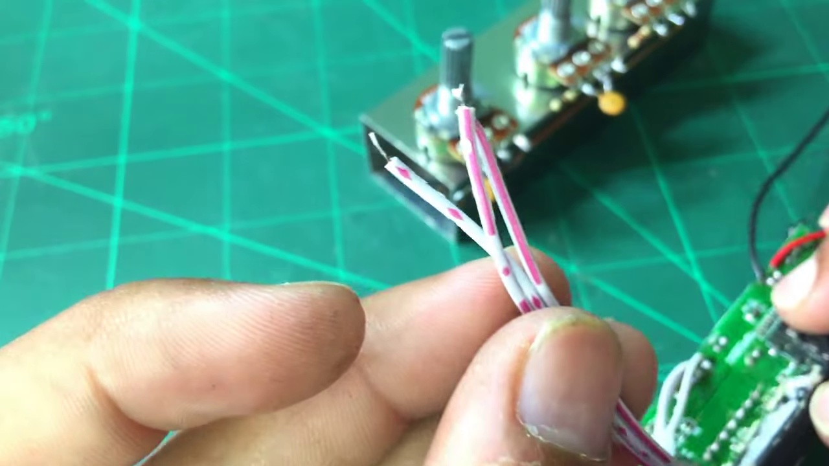 (score 90.0000)
 (score 85.0000)
 (score 85.0000)
 (score 85.0000)
 (score 85.0000)
 (score 85.0000)
 (score 85.0000)
 (score 85.0000)
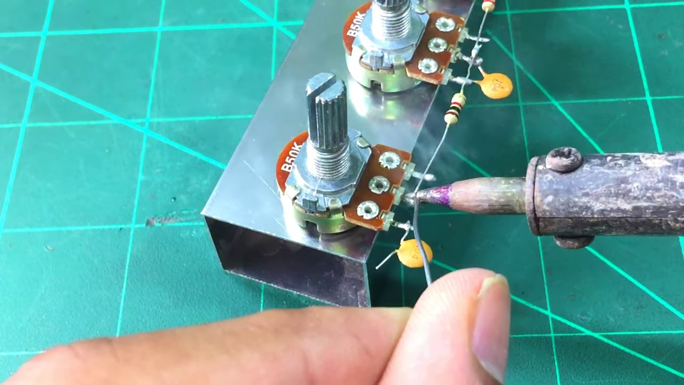 (score 85.0000)
Least correlated frames:
 (score 0.0000)
 (score 0.0000)
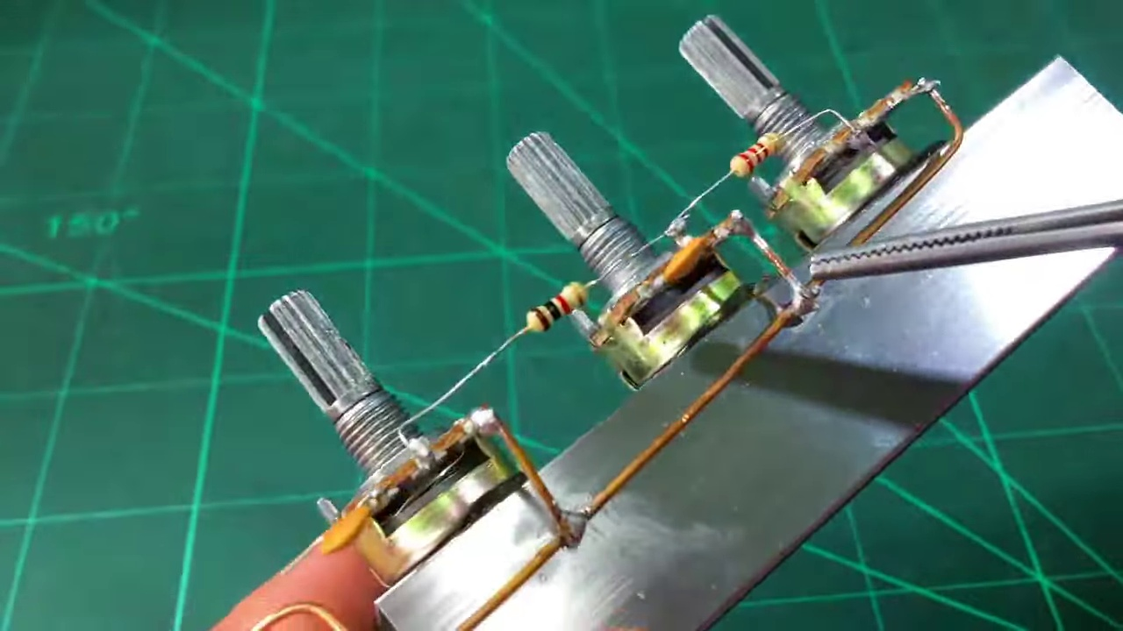 (score 10.0000)
 (score 15.0000)
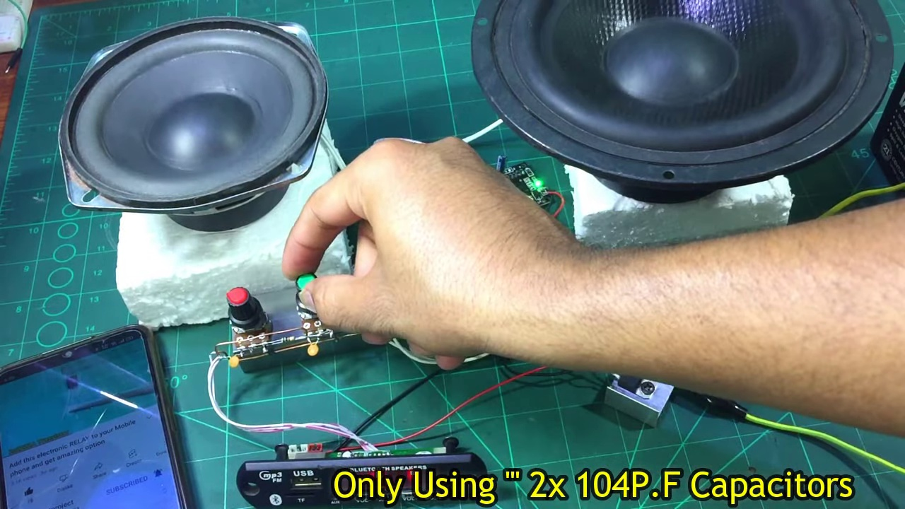 (score 20.0000)
 (score 20.0000)
 (score 20.0000)
 (score 20.0000)
 (score 20.0000)
 (score 20.0000)
- matched 40 frame(s), max score 90.0000: I learned how to increase treble in our speaker project from this video, but have not implemented this into our circuit as we were busy with other classes and did not have enough time to focus on the treble of the speaker.
Source: https://www.youtube.com/watch?v=YIAQ80evrFM :DIY Deep bass and Treble Volume controller-How to make heavy bass and treble for diy amplifier
Top correlated frames:
 (score 90.0000)
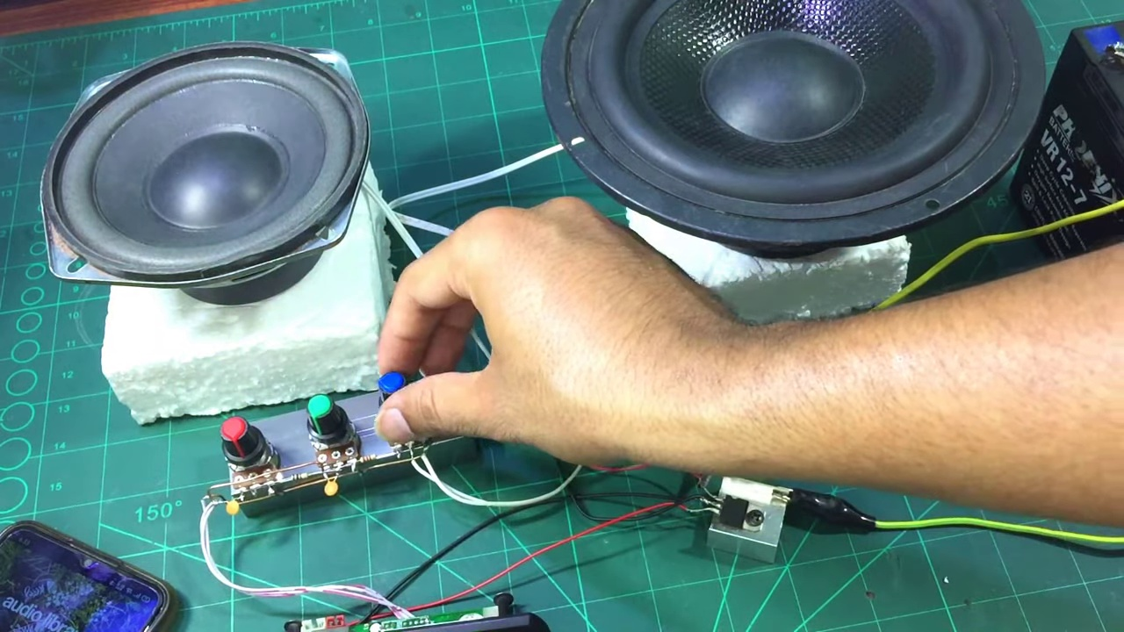 (score 85.0000)
 (score 85.0000)
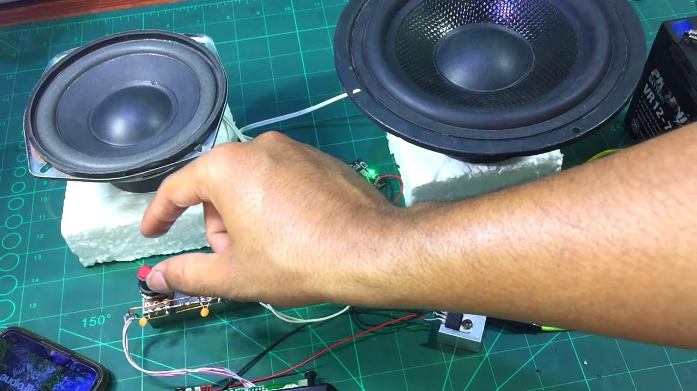 (score 85.0000)
 (score 85.0000)
 (score 85.0000)
 (score 80.0000)
 (score 80.0000)
 (score 80.0000)
 (score 80.0000)
Least correlated frames:
 (score 0.0000)
 (score 0.0000)
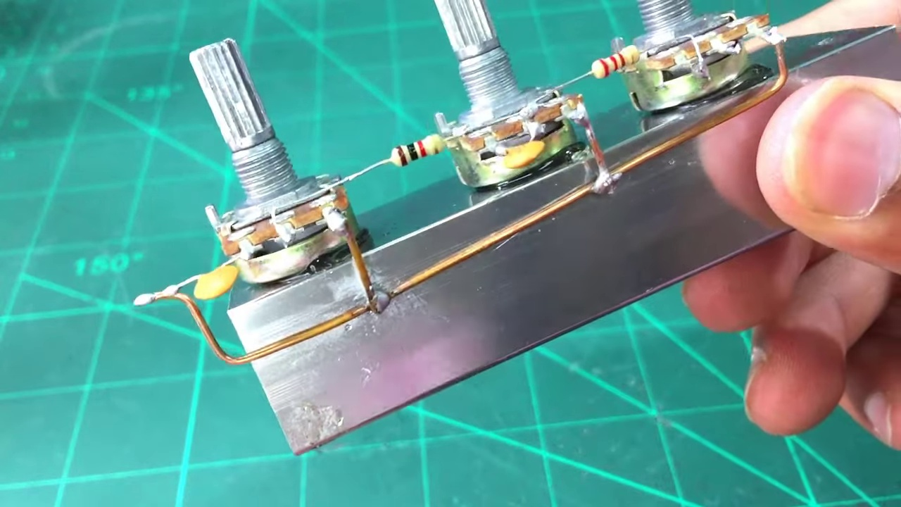 (score 5.0000)
 (score 10.0000)
 (score 10.0000)
 (score 10.0000)
 (score 10.0000)
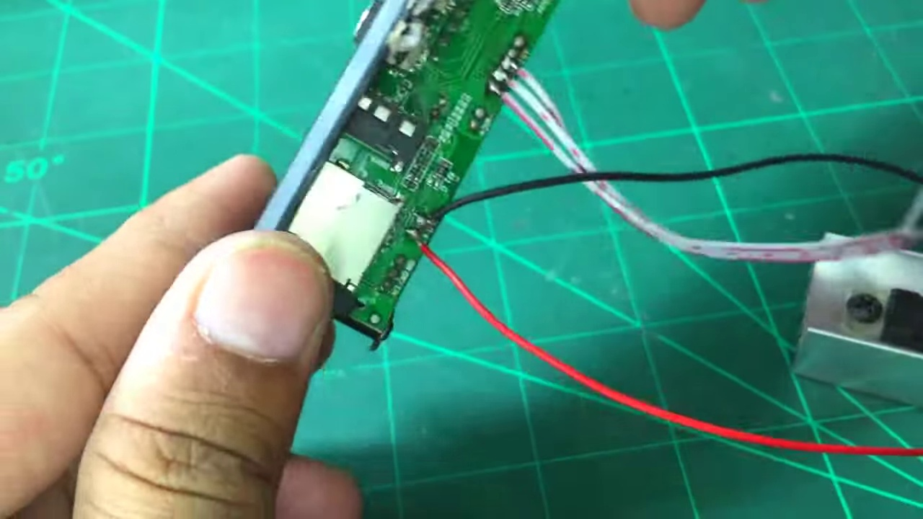 (score 10.0000)
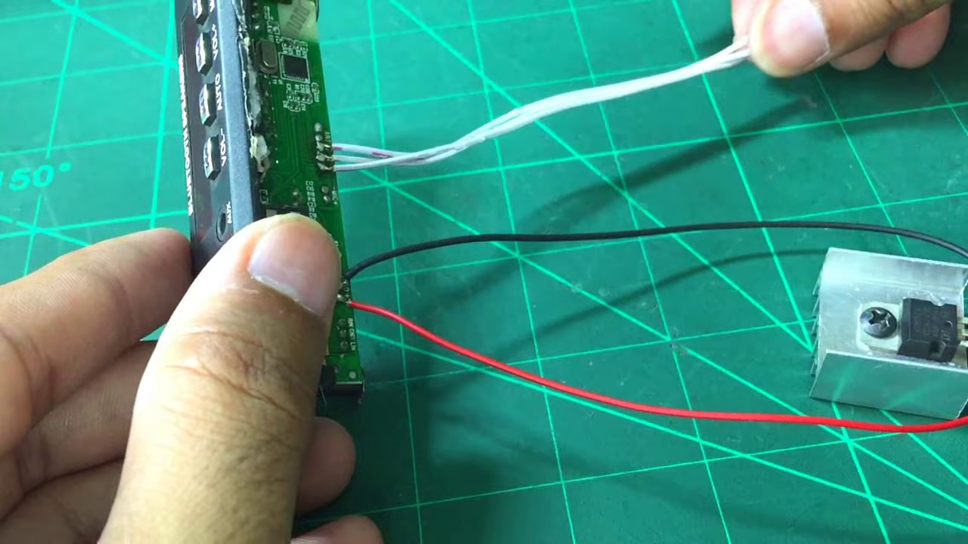 (score 10.0000)
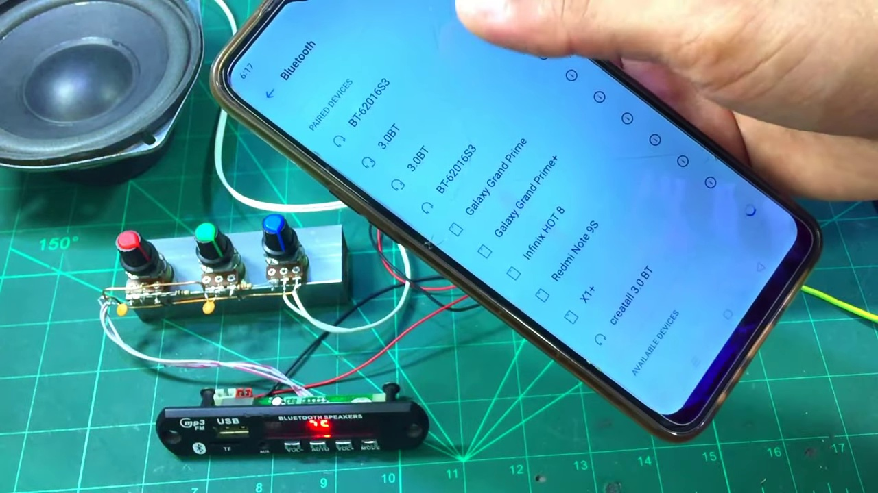 (score 14.0000)

Frame: frame_0000.jpg
Caption: The image shows a setting that appears to be a workshop, tutorial, or demonstration related to audio equipment. In the center of the frame, a person is using their left hand to hold a smartphone on a green mat placed on a wooden table. The person is pressing a button on the right side of the phone.
To the left of the smartphone, there's a white box with a black power button, a green USB port, and a red LED light. On the right side of the smartphone, another white box has a black power button and a green LED light.
At the bottom of the frame, the person is engaged with some electronic equipment related to audio amplification or testing. The presence of speakers and amplifier components suggests an audio-related context. The person is adjusting a knob on a device with visible wires, possibly interacting with the audio equipment in a way that requires fine-tuning or adjustments.
The scene overall suggests that the person might be testing or adjusting the settings of the devices on the green mat, which could be related to the audio equipment being used. The presence of the green mat and wooden table provides a contrasting background to the white boxes and the person's smartphone, adding depth and context to the image.
Comment (score 95): I learned how to make a simple bass and treble volume controller that is very effective and can connect to different sized speakers. This will be useful in Phase 2 to manage volume, bass, and treble for each speaker box.Nothing in this video was confusing. It is a very simple circuit.
Reason: The comment directly discusses the technical steps of making a volume controller, which is closely related to the setup and equipment described in the caption. The mention of speakers, amplifier components, and fine-tuning adjustments in the caption matches the context of the comment's simple circuit and volume management.
Source: https://www.youtube.com/watch?v=YIAQ80evrFM: DIY Deep Bass and Treble Volume Controller - How to Make Heavy Bass and Treble for DIY Amplifier
Comment (score 90): I learned how 3 potentiometers, 2 resistors, and 2 capacitors could be used to create deep bass and treble volume controller. The proper connections were shown.What is the purpose of some of the other components used?
Reason: The comment directly discusses the technical steps and components (potentiometers, resistors, capacitors) mentioned in the caption, specifically how they are used to create a deep bass and treble volume controller. The connection between the comment and the caption is strong because it describes the same technical concepts and components depicted in the image.
Source: https://www.youtube.com/watch?v=YIAQ80evrFM: DIY Deep Bass and Treble Volume controller-How to make heavy bass and treble for diy amplifier
Comment (score 90): This video was centered around adding volume, bass, and treble control into your speaker circuit. Things learned from this video is that basic principles of using potentiometers, resistors, and capacitors for adding this control to a speaker circuit. Now there is some confusion on how to incorporate this into a circuit with the TDA 2030 or TDA 2050 as the person in the video used some fancy amplifier boards and did not use any actual Op-Amp.
Reason: The comment directly discusses the technical steps involved in adding volume, bass, and treble control to a speaker circuit, which is strongly related to the caption's description of someone adjusting settings on audio equipment. The mention of potentiometers, resistors, and capacitors also matches the presence of electronic components in the frame.
Source: https://www.youtube.com/watch?v=YIAQ80evrFM : DIY Deep bass and Treble Volume controller-How to make heavy bass and treble for diy amplifier
Comment (score 80): I learned how to increase treble in our speaker project from this video, but have not implemented this into our circuit as we were busy with other classes and did not have enough time to focus on the treble of the speaker.
Reason: The comment directly discusses adjusting settings, specifically increasing treble, which is related to the audio equipment and testing context described in the caption. The mention of a 'speaker project' also aligns with the presence of speakers and amplifier components in the image.
Source: https://www.youtube.com/watch?v=YIAQ80evrFM :DIY Deep bass and Treble Volume controller-How to make heavy bass and treble for diy amplifier
Comment (score 80): Learned how to implement potentiometers to control volume, treble, and bass. Also saw the advantage of mounting the circuit onto a heat sink.Initially confused about which potentiometer did what. The linked circuit diagram helped clarify this afterward. Overall Reflection: Watching these videos about building circuits and understanding audio electronics was really helpful. They showed how to put theory into practice, like making bandpass filters and using potentiometers to control sound. One cool thing was seeing different ways to build circuits, such as mounting components on wood or soldering them directly. This demonstrated the flexibility and creativity possible in electronics. The videos also highlighted the roles of components like resistors and transformers, which improved my understanding of circuit function. Attention to detail, such as using heat sinks, was emphasized for reliability. One challenge was interpreting physical circuit builds without initially seeing a schematic, but the linked diagrams helped bridge that gap. Overall, I now feel more confident with circuit building, especially with audio-focused projects, and I’m particularly excited to apply these insights to the bass component of our final project, which was missing in the first phase.
Reason: The comment directly discusses the implementation of potentiometers to control volume, treble, and bass, which is consistent with the technical steps and objects described in the caption, including the use of a smartphone to adjust settings and the presence of electronic equipment related to audio amplification. The comment also mentions circuit diagrams and heat sinks, which are relevant to the context shown in the frame.
Source: https://www.youtube.com/watch?v=YIAQ80evrFM&t=1s: DIY Deep bass and Treble Volume controller-How to make heavy bass and treble for diy amplifier

Frame: frame_0001.jpg
Caption: The image shows a scene from an electronics workshop where a person is engaged in hands-on activity with electronic components. On a white countertop, the person holds a white USB cable plugged into a green circuit board, which features two red and black wires indicating connection points for the USB cable. The same countertop has a metal speaker to the right of the circuit board and a green power button to the left.
In front of the speakers are two electronic devices that appear to be speaker boxes with metal grilles. One of these devices is being worked on by the person, who is attaching what looks like a wire to a specific component on the circuit board, possibly soldering it into place. This suggests they might be working on assembling or modifying electronic equipment.
The background of the image is blurred, but the focus remains on the person, the circuit board, and the speaker, all essential elements for understanding the context of the workshop. Noteable details include text written on the table that reads "ONLY USING 2x104pf CAPACITORS" and "2.8V/50Hz," which appears to refer to capacitance values (2 Farads at a frequency of 104 Hertz and a voltage rating of 2.8 Volts).
Comment (score 85): This video was centered around adding volume, bass, and treble control into your speaker circuit. Things learned from this video is that basic principles of using potentiometers, resistors, and capacitors for adding this control to a speaker circuit. Now there is some confusion on how to incorporate this into a circuit with the TDA 2030 or TDA 2050 as the person in the video used some fancy amplifier boards and did not use any actual Op-Amp.
Reason: The comment directly discusses the same technical steps and objects described in the caption, such as adding volume, bass, and treble control to a speaker circuit, using potentiometers, resistors, and capacitors. The mention of amplifier boards and Op-Amp also corresponds with the focus on electronic components in the caption.
Source: https://www.youtube.com/watch?v=YIAQ80evrFM : DIY Deep bass and Treble Volume controller-How to make heavy bass and treble for diy amplifier
Comment (score 80): The video shows all the parts needed to make a heavy bass and treble controller and provides a step-by-step guide to assemble it.The video does not mention where to get the parts or how much it would cost.This could be useful in class for Phase 2 and is also a great DIY project.
Reason: The comment directly discusses the same technical steps and objects described in the caption, including assembling or modifying electronic equipment, using specific components like capacitors, and referencing electrical values (2.8V/50Hz). The mention of a step-by-step guide to assemble a heavy bass and treble controller also matches the context of the image showing speaker boxes with metal grilles.
Source: https://www.youtube.com/watch?v=YIAQ80evrFM: DIY Deep Bass and Treble Volume Controller

Frame: frame_0002.jpg
Caption: The image shows a DIY electronics setup with various components and materials arranged for assembly or demonstration. At the center, there are two black speakers, each equipped with a USB port and speaker wire, ready to be connected. The speakers are mounted on a green surface covered with white foam padding, featuring three buttons marked "G", "U", and "B" respectively. A blue and white controller is also present, its buttons matching the colors of the speaker pads.
The Arduino setup is placed nearby, consisting of an electronic device resembling an Arduino or programmable controller board, connected to two circular subwoofers likely intended for amplifying low-frequency audio signals. The Arduino is attached to a small electronic component, possibly an integrated circuit (IC) or microcontroller. A USB cable is connected to the Arduino, and a small red LED light is connected to one of its digital pins, potentially serving as an output indicator for testing purposes.
A jumper wire connects from the LED to another component, though it's unclear what it connects to based solely on this image. The entire setup rests on a white surface, possibly a table or desk, with papers and diagrams scattered around, suggesting that the user is following instructions or referencing plans for this project. A small green plant adds color to the scene, and a smartphone lies nearby, its screen visible, indicating recent or upcoming activity.
The overall setting suggests someone is either assembling or demonstrating how to connect electronic components to an Arduino for purposes such as creating an audio amplifier or controlling LED lights through the device.
Comment (score 85): I learned how to make a simple bass and treble volume controller that is very effective and can connect to different sized speakers. This will be useful in Phase 2 to manage volume, bass, and treble for each speaker box.Nothing in this video was confusing. It is a very simple circuit.
Reason: The comment directly discusses the same technical steps and goals described in the caption, specifically mentioning the volume controller and speaker connection, which are also shown in the image. The correlation is not perfect due to some minor differences in wording and focus between the caption and comment.
Source: https://www.youtube.com/watch?v=YIAQ80evrFM: DIY Deep Bass and Treble Volume Controller - How to Make Heavy Bass and Treble for DIY Amplifier
Comment (score 85): The video shows all the parts needed to make a heavy bass and treble controller and provides a step-by-step guide to assemble it.The video does not mention where to get the parts or how much it would cost.This could be useful in class for Phase 2 and is also a great DIY project.
Reason: The comment directly discusses assembling the same electronic components and setting described in the caption, including the Arduino setup, speakers, and jumper wire. The mention of a step-by-step guide to assemble it also matches the 'assembly or demonstration' goal described in the caption.
Source: https://www.youtube.com/watch?v=YIAQ80evrFM: DIY Deep Bass and Treble Volume Controller
Comment (score 85): Learned how to implement potentiometers to control volume, treble, and bass. Also saw the advantage of mounting the circuit onto a heat sink.Initially confused about which potentiometer did what. The linked circuit diagram helped clarify this afterward. Overall Reflection: Watching these videos about building circuits and understanding audio electronics was really helpful. They showed how to put theory into practice, like making bandpass filters and using potentiometers to control sound. One cool thing was seeing different ways to build circuits, such as mounting components on wood or soldering them directly. This demonstrated the flexibility and creativity possible in electronics. The videos also highlighted the roles of components like resistors and transformers, which improved my understanding of circuit function. Attention to detail, such as using heat sinks, was emphasized for reliability. One challenge was interpreting physical circuit builds without initially seeing a schematic, but the linked diagrams helped bridge that gap. Overall, I now feel more confident with circuit building, especially with audio-focused projects, and I’m particularly excited to apply these insights to the bass component of our final project, which was missing in the first phase.
Reason: The comment directly discusses the implementation of potentiometers to control volume, treble, and bass, which is mentioned in the caption as one possible use for the Arduino setup. The comment also mentions building circuits and understanding audio electronics, which aligns with the overall setting depicted in the frame caption.
Source: https://www.youtube.com/watch?v=YIAQ80evrFM&t=1s: DIY Deep bass and Treble Volume controller-How to make heavy bass and treble for diy amplifier
Comment (score 80): I learned how 3 potentiometers, 2 resistors, and 2 capacitors could be used to create deep bass and treble volume controller. The proper connections were shown.What is the purpose of some of the other components used?
Reason: The comment directly discusses the connection and usage of electronic components (potentiometers, resistors, capacitors) as described in the caption. The mention of proper connections shown aligns with the speaker wire and USB port connections depicted in the image.
Source: https://www.youtube.com/watch?v=YIAQ80evrFM: DIY Deep Bass and Treble Volume controller-How to make heavy bass and treble for diy amplifier
Comment (score 80): This video was centered around adding volume, bass, and treble control into your speaker circuit. Things learned from this video is that basic principles of using potentiometers, resistors, and capacitors for adding this control to a speaker circuit. Now there is some confusion on how to incorporate this into a circuit with the TDA 2030 or TDA 2050 as the person in the video used some fancy amplifier boards and did not use any actual Op-Amp.
Reason: The comment directly discusses the addition of volume, bass, and treble control to a speaker circuit, which is a technical step described in the caption. The mention of potentiometers, resistors, and capacitors also matches the components shown in the image.
Source: https://www.youtube.com/watch?v=YIAQ80evrFM : DIY Deep bass and Treble Volume controller-How to make heavy bass and treble for diy amplifier

Frame: frame_0003.jpg
Caption: The image shows a person's hand holding an electronic device with a visible circuit board and several components connected to it, including what appears to be a small motor. On the circuit board, there are various pins or connectors that could be for electrical connections. The device has adjustable volume settings, as indicated by the "50K VOLUME" label next to the device in the foreground.
The text on the image reads: "100K VOLUME - 20K VOLUME - 30K VOLUME," with arrows pointing to different volumes of sound. This suggests that this is a teaching tool for an educational video or tutorial about electronics or circuit building, focusing on resistors and volume settings.
A closer look at the device reveals labels indicating specific resistance values: "30kΩ" (30 thousand ohms) and "50kΩ" (50 thousand ohms). The image seems to be part of an educational resource teaching about electronic circuits and resistors.
In the same image, a trio of round, silver-colored knobs is visible on the green surface. Each knob has a silver screw and a small hole in the center, suggesting they are potentiometers or variable resistors. They are arranged in a triangular formation, with one knob positioned at the top, one in the middle, and one at the bottom.
The yellow label above the knobs reads "50k Volume x3", providing clear information about their purpose: adjusting the volume of an electronic device. The image captures a simple yet essential part of an electronic device, with clear labeling and precise positioning of the knobs.
Comment (score 85): I learned how 3 potentiometers, 2 resistors, and 2 capacitors could be used to create deep bass and treble volume controller. The proper connections were shown.What is the purpose of some of the other components used?
Reason: The comment directly discusses the same technical steps and components (potentiometers, resistors, capacitors) described in the caption. The mention of proper connections and seeking information on other components used is strongly related to the details provided in the frame caption.
Source: https://www.youtube.com/watch?v=YIAQ80evrFM: DIY Deep Bass and Treble Volume controller-How to make heavy bass and treble for diy amplifier
Comment (score 85): This video was centered around adding volume, bass, and treble control into your speaker circuit. Things learned from this video is that basic principles of using potentiometers, resistors, and capacitors for adding this control to a speaker circuit. Now there is some confusion on how to incorporate this into a circuit with the TDA 2030 or TDA 2050 as the person in the video used some fancy amplifier boards and did not use any actual Op-Amp.
Reason: The comment directly discusses the same technical steps and objects described in the caption, specifically mentioning potentiometers, resistors, capacitors, and amplifiers, which are all relevant to the image of electronic components and volume control knobs.
Source: https://www.youtube.com/watch?v=YIAQ80evrFM : DIY Deep bass and Treble Volume controller-How to make heavy bass and treble for diy amplifier
Comment (score 85): Got a better sense of how potentiometers work and how to add a 3-volume controller setup. What made you confused is The differences in bass and treble were hardly noticeable — unclear if it’s due to low impact or YouTube audio limitations.
Reason: The comment directly discusses the same technical steps (potentiometers) and settings (3-volume controller setup) described in the caption. Although it also mentions some subjective observations about audio quality, these are minor points that do not detract from the overall correlation.
Source: https://www.youtube.com/watch?v=YIAQ80evrFM: DIY Deep Bass and Treble Volume Controller
Comment (score 80): I learned how to make a simple bass and treble volume controller that is very effective and can connect to different sized speakers. This will be useful in Phase 2 to manage volume, bass, and treble for each speaker box.Nothing in this video was confusing. It is a very simple circuit.
Reason: The comment directly discusses the same technical steps and objects described in the caption, specifically mentioning making a volume controller that adjusts bass and treble, which aligns with the '50k VOLUME' label and potentiometers/knobs mentioned in the caption.
Source: https://www.youtube.com/watch?v=YIAQ80evrFM: DIY Deep Bass and Treble Volume Controller - How to Make Heavy Bass and Treble for DIY Amplifier
Comment (score 80): The video shows all the parts needed to make a heavy bass and treble controller and provides a step-by-step guide to assemble it.The video does not mention where to get the parts or how much it would cost.This could be useful in class for Phase 2 and is also a great DIY project.
Reason: The comment mentions the video shows all parts needed to make a heavy bass and treble controller, which is consistent with the caption describing an electronic device with adjustable volume settings. The mention of a step-by-step guide aligns with the educational tone and focus on resistors and volume settings in the caption.
Source: https://www.youtube.com/watch?v=YIAQ80evrFM: DIY Deep Bass and Treble Volume Controller

Frame: frame_0004.jpg
Caption: This image captures a moment of precision and care, featuring a small toy or decoration with two yellow balloons attached to it, one bearing the number "1". The object is positioned on a microscopic stage, as indicated by the visible scale at the bottom right corner, which displays a magnification level of 104X. The background suggests a precise environment where objects can be observed under high magnification.
The image also reveals a pair of yellow and black electronic components resting on a green cutting board, placed on a pair of tweezers held by pliers. The text "104 104" is visible on the cutting board, indicating the type of component. The scene is set against a backdrop of a blue grid, adding contrast to the composition, which overall suggests a moment of careful handling and meticulous work in the field of electronics.
Note: I have carefully integrated the details from both captions to provide a single, accurate, and detailed caption that retains all relevant information without redundancy or contradiction.
Comment (score 80): I learned how 3 potentiometers, 2 resistors, and 2 capacitors could be used to create deep bass and treble volume controller. The proper connections were shown.What is the purpose of some of the other components used?
Reason: The comment directly discusses the same electronic components (potentiometers, resistors, capacitors) and their connections mentioned in the caption, as well as the purpose of some other components used. The correlation is strong because the comment specifically refers to the technical steps and settings described in the caption.
Source: https://www.youtube.com/watch?v=YIAQ80evrFM: DIY Deep Bass and Treble Volume controller-How to make heavy bass and treble for diy amplifier

Frame: frame_0005.jpg
Caption: The image shows a close-up view of a person's hands working with a small electronic component, specifically a 1k Resistor. The individual is holding the resistor in their left hand and pointing towards it with their right hand, where the focus of attention is indicated by a "1K Resistor" label pointing at the device being held.
On the screen behind the person, a green grid pattern is visible, which could be from a cutting mat or a measuring device. However, no text or other items are clearly visible on the screen that would provide additional context for what is being taught or demonstrated. The focus of the image and the context provided by the labels suggest that this is likely an educational setting where someone is teaching or demonstrating how to identify or use resistors in an electronic circuit or project.
The resistor itself is held by the person's thumb on a green mat, which has a grid pattern and positions the component in its center. The text "1k Resistor" is visible on the mat, indicating the value of the resistor. This overall scene suggests an electronic repair or assembly process, possibly taking place in an educational setting where someone is teaching or demonstrating how to work with resistors in an electronic circuit or project.
Comment (score 80): This video was centered around adding volume, bass, and treble control into your speaker circuit. Things learned from this video is that basic principles of using potentiometers, resistors, and capacitors for adding this control to a speaker circuit. Now there is some confusion on how to incorporate this into a circuit with the TDA 2030 or TDA 2050 as the person in the video used some fancy amplifier boards and did not use any actual Op-Amp.
Reason: The comment directly discusses the technical steps of using resistors, potentiometers, and capacitors to add volume, bass, and treble control into a speaker circuit, which is strongly related to the caption's description of working with a resistor in an electronic circuit or project.
Source: https://www.youtube.com/watch?v=YIAQ80evrFM : DIY Deep bass and Treble Volume controller-How to make heavy bass and treble for diy amplifier

Frame: frame_0006.jpg
Caption: The image shows a close-up view of a 200Ω resistor (also labeled as "220 ohm" on the red stripe) being held in someone's hand. The resistor is made of dark gray material with a distinctive red stripe running along its length, making it easily identifiable. The finger holding the resistor suggests that it is being inspected or used. The background appears to be a workbench or desk with various tools and materials commonly used in electronics projects, indicating an educational context where someone might be assembling or demonstrating a basic electronic circuit component. The overall setting provides a sense of simplicity and importance, as if the resistor is being handled with care.
Comment (score 85): Learned how to implement potentiometers to control volume, treble, and bass. Also saw the advantage of mounting the circuit onto a heat sink.Initially confused about which potentiometer did what. The linked circuit diagram helped clarify this afterward. Overall Reflection: Watching these videos about building circuits and understanding audio electronics was really helpful. They showed how to put theory into practice, like making bandpass filters and using potentiometers to control sound. One cool thing was seeing different ways to build circuits, such as mounting components on wood or soldering them directly. This demonstrated the flexibility and creativity possible in electronics. The videos also highlighted the roles of components like resistors and transformers, which improved my understanding of circuit function. Attention to detail, such as using heat sinks, was emphasized for reliability. One challenge was interpreting physical circuit builds without initially seeing a schematic, but the linked diagrams helped bridge that gap. Overall, I now feel more confident with circuit building, especially with audio-focused projects, and I’m particularly excited to apply these insights to the bass component of our final project, which was missing in the first phase.
Reason: The comment directly discusses the use of resistors and potentiometers in building circuits, which is closely related to the caption describing a specific type of resistor being handled. The commenter also mentions understanding circuit function, attention to detail, and using heat sinks, all of which are relevant to the context shown in the caption.
Source: https://www.youtube.com/watch?v=YIAQ80evrFM&t=1s: DIY Deep bass and Treble Volume controller-How to make heavy bass and treble for diy amplifier

Frame: frame_0007.jpg
Caption: The image depicts a hand holding a rectangular metal piece with a smooth finish, placed on a green grid pattern cutting mat. The specific location of the piece is marked by the thumb and index finger, with the thumb positioned on the left side and the index finger on the right. The background is out of focus but includes what appears to be other tools commonly used in workshops or DIY environments, such as scissors and a drill press, situated on cutting mats. There is no text, writing, or speaking visible in this frame. The number 135 can be seen on the green cutting mat. The overall scene suggests a workspace or workshop setting where a person might be preparing or customizing objects with metal.
No strongly correlated comments found for this frame.

Frame: frame_0008.jpg
Caption: The image shows a person's hands carefully adjusting a small silver knob on a green board laid out on a green mat. The mat is marked with a scale of 135, possibly indicating the scale of the circuit. The person's fingers are neatly arranged around the knob, indicating a precise movement. In the background, a table or workbench with cutting mats or similar protective surfaces can be seen, suggesting a workspace or crafting area where someone might be working on projects.
At the same time, one hand appears to be in the process of placing a ring onto a finger, which is visible due to the close-up view showing the intricate details of the ring's band and design. The ring is being fitted onto what seems to be the ring finger of an adult's hand, with a wedding ring already present. There are no visible texts, equations, or diagrams that provide context or information about the activities being performed in this frame, with the focus solely on the act of placing the ring onto the finger and the precise adjustment of the small silver knob on the circuit board.
Comment (score 85): Learned how to implement potentiometers to control volume, treble, and bass. Also saw the advantage of mounting the circuit onto a heat sink.Initially confused about which potentiometer did what. The linked circuit diagram helped clarify this afterward. Overall Reflection: Watching these videos about building circuits and understanding audio electronics was really helpful. They showed how to put theory into practice, like making bandpass filters and using potentiometers to control sound. One cool thing was seeing different ways to build circuits, such as mounting components on wood or soldering them directly. This demonstrated the flexibility and creativity possible in electronics. The videos also highlighted the roles of components like resistors and transformers, which improved my understanding of circuit function. Attention to detail, such as using heat sinks, was emphasized for reliability. One challenge was interpreting physical circuit builds without initially seeing a schematic, but the linked diagrams helped bridge that gap. Overall, I now feel more confident with circuit building, especially with audio-focused projects, and I’m particularly excited to apply these insights to the bass component of our final project, which was missing in the first phase.
Reason: The comment directly discusses the implementation of potentiometers, circuit design and mounting, which are all technical steps, objects and goals described in the caption. The mention of heat sinks, bandpass filters, and understanding audio electronics further solidify the connection to the frame caption.
Source: https://www.youtube.com/watch?v=YIAQ80evrFM&t=1s: DIY Deep bass and Treble Volume controller-How to make heavy bass and treble for diy amplifier

Frame: frame_0009.jpg
Caption: The image shows a person's hand holding an electronic component, specifically a small printed circuit board (PCB) with several electronic components on it. The PCB is held firmly by the person, suggesting they might be assembling or inspecting an electronic device. In the background, there is a workbench with various other electronic parts and components, implying a setting for electronics repair or creation.
The hand holding the PCB is positioned in front of a green grid, with the number 135 visible in the top left corner. Additionally, the person's hand is seen on a green mat, which also appears in the image. There is no text or diagram visible in this frame, and the focus remains on the person holding the PCB.
In contrast to the background electronics components, another object of interest is a silver metal device with a rectangular shape held by the same person's hand. The device features two silver knobs positioned on either side of a gray knob. The knobs appear to be made of metal and are held together by a silver screw. The gray knob is located on the right side of the device, while the two silver knobs are on the left.
The overall scene suggests that the person might be assembling or disassembling this device, given the presence of the green mat and the focus on their hands.
Comment (score 80): I learned how 3 potentiometers, 2 resistors, and 2 capacitors could be used to create deep bass and treble volume controller. The proper connections were shown.What is the purpose of some of the other components used?
Reason: The comment directly discusses technical steps related to electronic component connections and uses (potentiometers, resistors, capacitors), which are strongly connected to the objects and settings described in the caption (electronic components on a PCB, green mat, workbench). The specific components mentioned in the comment (3 potentiometers, 2 resistors, 2 capacitors) match the types of components shown in the image. However, the reason for the moderate score is that the comment does not explicitly mention the silver metal device with knobs, which could be a key object of interest in the frame.
Source: https://www.youtube.com/watch?v=YIAQ80evrFM: DIY Deep Bass and Treble Volume controller-How to make heavy bass and treble for diy amplifier
Comment (score 80): The video shows all the parts needed to make a heavy bass and treble controller and provides a step-by-step guide to assemble it.The video does not mention where to get the parts or how much it would cost.This could be useful in class for Phase 2 and is also a great DIY project.
Reason: The comment directly discusses the assembly of an electronic device (heavy bass and treble controller) which is described in the caption. The mention of parts and step-by-step guide matches the scene depicted in the frame, specifically the person holding the PCB and the silver metal device.
Source: https://www.youtube.com/watch?v=YIAQ80evrFM: DIY Deep Bass and Treble Volume Controller

Frame: frame_0010.jpg
Caption: The image shows a close-up view of someone's hands manipulating an electronic component or circuit board, with a silver-colored device resting on a green mat. The hands are holding one of four visible electronic components, which appear to be resistors or integrated circuits (ICs), given their cylindrical shape and the presence of multiple pins.
The breadboard, a common type of prototyping board used in electronics and robotics, contains several jumper wires that seem to be connecting various electronic parts. A soldering iron is being used by the person in the photo, as indicated by the device in the upper left corner. This tool is used to melt solder for creating electrical connections between components on a circuit board.
The background is blurred but includes what appears to be a workbench or table with various items on it, possibly tools or other electronics equipment. The focus of the image is on the hands and the breadboard setup, indicating that the person might be explaining how to use the breadboard or showing off an electronic project they are working on. The green mat under the device provides a striking contrast to the blurred background.
There are no visible texts, slides, or diagrams in this frame, leaving the purpose of the silver-colored device and its connection to the breadboard setup unclear.
Comment (score 85): Learned how to implement potentiometers to control volume, treble, and bass. Also saw the advantage of mounting the circuit onto a heat sink.Initially confused about which potentiometer did what. The linked circuit diagram helped clarify this afterward. Overall Reflection: Watching these videos about building circuits and understanding audio electronics was really helpful. They showed how to put theory into practice, like making bandpass filters and using potentiometers to control sound. One cool thing was seeing different ways to build circuits, such as mounting components on wood or soldering them directly. This demonstrated the flexibility and creativity possible in electronics. The videos also highlighted the roles of components like resistors and transformers, which improved my understanding of circuit function. Attention to detail, such as using heat sinks, was emphasized for reliability. One challenge was interpreting physical circuit builds without initially seeing a schematic, but the linked diagrams helped bridge that gap. Overall, I now feel more confident with circuit building, especially with audio-focused projects, and I’m particularly excited to apply these insights to the bass component of our final project, which was missing in the first phase.
Reason: The comment directly discusses building circuits, using potentiometers to control sound, and mounting components on heat sinks, which are all technical steps and concepts mentioned in the frame caption. The caption also mentions circuit diagrams and breadboards, which are relevant to the comment's discussion of understanding audio electronics.
Source: https://www.youtube.com/watch?v=YIAQ80evrFM&t=1s: DIY Deep bass and Treble Volume controller-How to make heavy bass and treble for diy amplifier
Comment (score 80): I learned how to make a simple bass and treble volume controller that is very effective and can connect to different sized speakers. This will be useful in Phase 2 to manage volume, bass, and treble for each speaker box.Nothing in this video was confusing. It is a very simple circuit.
Reason: The comment discusses building a simple circuit and mentions 'volume controller' which is directly related to the technical steps described in the caption, such as using jumper wires on a breadboard and soldering.
Source: https://www.youtube.com/watch?v=YIAQ80evrFM: DIY Deep Bass and Treble Volume Controller - How to Make Heavy Bass and Treble for DIY Amplifier
Comment (score 80): This video was centered around adding volume, bass, and treble control into your speaker circuit. Things learned from this video is that basic principles of using potentiometers, resistors, and capacitors for adding this control to a speaker circuit. Now there is some confusion on how to incorporate this into a circuit with the TDA 2030 or TDA 2050 as the person in the video used some fancy amplifier boards and did not use any actual Op-Amp.
Reason: The comment directly discusses the technical steps described in the caption, specifically mentioning potentiometers, resistors, and capacitors, which are the same electronic components visible in the image. The comment also references the TDA 2030/2050 amplifier boards, which is consistent with the presence of a soldering iron and breadboard setup in the frame.
Source: https://www.youtube.com/watch?v=YIAQ80evrFM : DIY Deep bass and Treble Volume controller-How to make heavy bass and treble for diy amplifier
Comment (score 80): The video shows all the parts needed to make a heavy bass and treble controller and provides a step-by-step guide to assemble it.The video does not mention where to get the parts or how much it would cost.This could be useful in class for Phase 2 and is also a great DIY project.
Reason: The comment directly discusses the step-by-step guide to assemble a heavy bass and treble controller, which is strongly related to the technical steps described in the caption (manipulating electronic components, using a soldering iron, etc.).
Source: https://www.youtube.com/watch?v=YIAQ80evrFM: DIY Deep Bass and Treble Volume Controller
Comment (score 75): I learned how 3 potentiometers, 2 resistors, and 2 capacitors could be used to create deep bass and treble volume controller. The proper connections were shown.What is the purpose of some of the other components used?
Reason: The comment directly discusses the use of resistors, capacitors, and potentiometers, which are all mentioned in the frame caption. The comment also asks about the purpose of other components used, which is related to the breadboard setup shown in the image.
Source: https://www.youtube.com/watch?v=YIAQ80evrFM: DIY Deep Bass and Treble Volume controller-How to make heavy bass and treble for diy amplifier

Frame: frame_0011.jpg
Caption: The image shows a close-up view of a person's hand holding a small item with text that reads "GAS PYRAMIDE." The object appears to be some sort of model or educational toy related to science, specifically the field of chemistry. The individual is wearing a ring on their finger and has nail polish on their nails. The main focus, however, is a small yellow capacitor marked with the letters "C6" on its surface, which is being held firmly in the palm of the hand. The hand is positioned on a green mat, drawing attention to the miniature capacitor. The background is blurred, suggesting an indoor environment, possibly a classroom or lab where science education is taking place. There is no instructor visible in the image, and the overall setting implies a learning environment.
Comment (score 90): I learned how 3 potentiometers, 2 resistors, and 2 capacitors could be used to create deep bass and treble volume controller. The proper connections were shown.What is the purpose of some of the other components used?
Reason: The comment directly discusses the use of capacitors (specifically C6), which is mentioned in the caption. The technical steps and objects described in the caption (e.g., potentiometers, resistors) are also discussed in the comment, indicating a strong connection between the two.
Source: https://www.youtube.com/watch?v=YIAQ80evrFM: DIY Deep Bass and Treble Volume controller-How to make heavy bass and treble for diy amplifier
Comment (score 85): Learned how to implement potentiometers to control volume, treble, and bass. Also saw the advantage of mounting the circuit onto a heat sink.Initially confused about which potentiometer did what. The linked circuit diagram helped clarify this afterward. Overall Reflection: Watching these videos about building circuits and understanding audio electronics was really helpful. They showed how to put theory into practice, like making bandpass filters and using potentiometers to control sound. One cool thing was seeing different ways to build circuits, such as mounting components on wood or soldering them directly. This demonstrated the flexibility and creativity possible in electronics. The videos also highlighted the roles of components like resistors and transformers, which improved my understanding of circuit function. Attention to detail, such as using heat sinks, was emphasized for reliability. One challenge was interpreting physical circuit builds without initially seeing a schematic, but the linked diagrams helped bridge that gap. Overall, I now feel more confident with circuit building, especially with audio-focused projects, and I’m particularly excited to apply these insights to the bass component of our final project, which was missing in the first phase.
Reason: The comment directly discusses technical steps (implementing potentiometers to control volume, treble, and bass), objects (circuit diagram), settings (mounting components on wood or soldering them directly), and goals (understanding circuit function) described in the caption. The connection is strong, but not perfect, as some comments are generic praise for the videos rather than specifically discussing the technical aspects shown in the frame.
Source: https://www.youtube.com/watch?v=YIAQ80evrFM&t=1s: DIY Deep bass and Treble Volume controller-How to make heavy bass and treble for diy amplifier

Frame: frame_0012.jpg
Caption: The image shows a close-up view of a person's hand holding a soldering iron, with red and silver body, as they work on connecting two metal components. The components are a red knob and a silver one, both positioned in a vertical orientation. The soldering iron is currently touching the red knob, indicating that it is in the process of soldering the two components together. In the background, there is a green plastic mat providing a stark contrast to the red and silver components. On the surface where the soldering is taking place, smoke can be seen, suggesting that the soldering process is active. Various tools related to electronics work are present in the foreground, including pliers and additional soldering equipment. The background appears to be a workspace with other electronic components and tools visible, although it is slightly out of focus. There is no text or diagrams in the image that can provide context for the activity depicted.
Comment (score 85): Learned how to implement potentiometers to control volume, treble, and bass. Also saw the advantage of mounting the circuit onto a heat sink.Initially confused about which potentiometer did what. The linked circuit diagram helped clarify this afterward. Overall Reflection: Watching these videos about building circuits and understanding audio electronics was really helpful. They showed how to put theory into practice, like making bandpass filters and using potentiometers to control sound. One cool thing was seeing different ways to build circuits, such as mounting components on wood or soldering them directly. This demonstrated the flexibility and creativity possible in electronics. The videos also highlighted the roles of components like resistors and transformers, which improved my understanding of circuit function. Attention to detail, such as using heat sinks, was emphasized for reliability. One challenge was interpreting physical circuit builds without initially seeing a schematic, but the linked diagrams helped bridge that gap. Overall, I now feel more confident with circuit building, especially with audio-focused projects, and I’m particularly excited to apply these insights to the bass component of our final project, which was missing in the first phase.
Reason: The comment directly discusses soldering techniques and components (potentiometers) mentioned in the caption. Additionally, it highlights the importance of mounting components on a heat sink, which is also present in the image.
Source: https://www.youtube.com/watch?v=YIAQ80evrFM&t=1s: DIY Deep bass and Treble Volume controller-How to make heavy bass and treble for diy amplifier
Comment (score 70): Got a better sense of how potentiometers work and how to add a 3-volume controller setup. What made you confused is The differences in bass and treble were hardly noticeable — unclear if it’s due to low impact or YouTube audio limitations.
Reason: The comment mentions specific technical steps ('how to add a 3-volume controller setup') and components ('potentiometers') that are directly related to the soldering process depicted in the frame caption. The mention of 'bass and treble' is also relevant, as it relates to audio adjustments which could be done using the potentiometers being soldered.
Source: https://www.youtube.com/watch?v=YIAQ80evrFM: DIY Deep Bass and Treble Volume Controller

Frame: frame_0013.jpg
Caption: This close-up image captures a person's hand holding a small copper wire against a piece of green circuit board. The wire is being soldered to the board using a silver soldering iron positioned on the right side of the board, which rests on a green, plastic mat with a grid pattern. The focus of this hands-on activity appears to be on the soldering process itself, without any visible texts or diagrams providing context or instructions. The circuit board contains at least two integrated circuits (ICs) and possibly other electronic components such as resistors or capacitors, showcasing a DIY project or electronics assembly in progress.
Comment (score 85): I learned how 3 potentiometers, 2 resistors, and 2 capacitors could be used to create deep bass and treble volume controller. The proper connections were shown.What is the purpose of some of the other components used?
Reason: The comment directly discusses the soldering process and component connections shown in the caption, which are relevant to the DIY project or electronics assembly depicted. The mention of ICs, resistors, and capacitors specifically matches with the components visible on the circuit board in the caption.
Source: https://www.youtube.com/watch?v=YIAQ80evrFM: DIY Deep Bass and Treble Volume controller-How to make heavy bass and treble for diy amplifier
Comment (score 85): Learned how to implement potentiometers to control volume, treble, and bass. Also saw the advantage of mounting the circuit onto a heat sink.Initially confused about which potentiometer did what. The linked circuit diagram helped clarify this afterward. Overall Reflection: Watching these videos about building circuits and understanding audio electronics was really helpful. They showed how to put theory into practice, like making bandpass filters and using potentiometers to control sound. One cool thing was seeing different ways to build circuits, such as mounting components on wood or soldering them directly. This demonstrated the flexibility and creativity possible in electronics. The videos also highlighted the roles of components like resistors and transformers, which improved my understanding of circuit function. Attention to detail, such as using heat sinks, was emphasized for reliability. One challenge was interpreting physical circuit builds without initially seeing a schematic, but the linked diagrams helped bridge that gap. Overall, I now feel more confident with circuit building, especially with audio-focused projects, and I’m particularly excited to apply these insights to the bass component of our final project, which was missing in the first phase.
Reason: The comment directly discusses soldering and circuit building, which are the same technical steps described in the caption. The mention of using heat sinks and mounting components on wood or a green plastic mat matches the settings described in the caption. Additionally, the comment mentions the use of potentiometers to control volume, treble, and bass, which is related to the electronic components mentioned in the caption (resistors and capacitors). The only reason it's not 100% correlated is that the comment also discusses circuit diagrams and theory, which are not explicitly mentioned in the caption.
Source: https://www.youtube.com/watch?v=YIAQ80evrFM&t=1s: DIY Deep bass and Treble Volume controller-How to make heavy bass and treble for diy amplifier

Frame: frame_0014.jpg
Caption: The image shows a person engaged in manual work with electronic devices, specifically focusing on the assembly or repair of a printed circuit board (PCB). The individual's face is not visible due to the angle of the photo. Their hands are shown holding a component or tool over the PCB, possibly soldering or adjusting components on the board.
The electronic device being worked on appears to be a small module with several components visible, including resistors and possibly capacitors or other types of passive electronic parts. The person is using tools commonly used in electronics assembly or repair, such as tweezers for precision handling of small components.
Further details can be observed from the second image: the person is in the process of soldering three small silver knobs onto a green metal plate. Their hand holds the soldering iron, which is glowing red, indicating it's in use. The soldering iron is positioned over the middle knob on the metal plate, with the largest one being in the center and the two smaller ones on either side.
The person's fingers are visible, suggesting they are applying solder to the knobs. The background of the image is a green mat, providing a contrasting backdrop to the metallic objects in the foreground.
Comment (score 80): I learned how 3 potentiometers, 2 resistors, and 2 capacitors could be used to create deep bass and treble volume controller. The proper connections were shown.What is the purpose of some of the other components used?
Reason: The comment mentions specific electronic components (potentiometers, resistors, capacitors) and their connections, which are also described in the caption as being used on a printed circuit board. The soldering process and tools mentioned in the caption are also relevant to the component connection and adjustment discussed in the comment.
Source: https://www.youtube.com/watch?v=YIAQ80evrFM: DIY Deep Bass and Treble Volume controller-How to make heavy bass and treble for diy amplifier

Frame: frame_0015.jpg
Caption: The image shows a person engaged in a combination of electronics and mechanical work. On the left, a hand is holding an electronic component with wires attached, suggesting that the individual might be soldering or connecting wires. The central part of the image features three electronic components, possibly resistors given their shape and color, on a circuit board with visible copper traces for making connections. In conjunction with this electronics work, another hand is operating a power drill on the right side of the image, indicating mechanical work in progress.
The person is standing on a green mat placed on a gray surface, which appears to be a workspace or laboratory dedicated to electronic and possibly mechanical repairs or construction projects. The background includes what looks like additional equipment or tools related to either electronics or mechanics. In the foreground, the person's hand is visible holding a small piece of wire, which is being heated by a soldering iron positioned over a small electronic component, a black knob with three silver knobs. This scene suggests a hands-on approach to electronic repair or assembly.
Comment (score 95): The video shows all the parts needed to make a heavy bass and treble controller and provides a step-by-step guide to assemble it.The video does not mention where to get the parts or how much it would cost.This could be useful in class for Phase 2 and is also a great DIY project.
Reason: The comment directly discusses the same technical steps (assembling a controller) and objects (parts needed) mentioned in the caption. The caption describes hands-on electronic repair or assembly, which aligns with the comment's mention of a step-by-step guide for assembling a DIY project.
Source: https://www.youtube.com/watch?v=YIAQ80evrFM: DIY Deep Bass and Treble Volume Controller
Comment (score 85): I learned how 3 potentiometers, 2 resistors, and 2 capacitors could be used to create deep bass and treble volume controller. The proper connections were shown.What is the purpose of some of the other components used?
Reason: The comment directly discusses the same technical steps (soldering/connections), objects (resistors, capacitors, potentiometers), and settings (circuit board) described in the caption. The only differences are the specific components and their purpose, which does not detract from the strong correlation between the caption and the comment.
Source: https://www.youtube.com/watch?v=YIAQ80evrFM: DIY Deep Bass and Treble Volume controller-How to make heavy bass and treble for diy amplifier
Comment (score 85): Learned how to implement potentiometers to control volume, treble, and bass. Also saw the advantage of mounting the circuit onto a heat sink.Initially confused about which potentiometer did what. The linked circuit diagram helped clarify this afterward. Overall Reflection: Watching these videos about building circuits and understanding audio electronics was really helpful. They showed how to put theory into practice, like making bandpass filters and using potentiometers to control sound. One cool thing was seeing different ways to build circuits, such as mounting components on wood or soldering them directly. This demonstrated the flexibility and creativity possible in electronics. The videos also highlighted the roles of components like resistors and transformers, which improved my understanding of circuit function. Attention to detail, such as using heat sinks, was emphasized for reliability. One challenge was interpreting physical circuit builds without initially seeing a schematic, but the linked diagrams helped bridge that gap. Overall, I now feel more confident with circuit building, especially with audio-focused projects, and I’m particularly excited to apply these insights to the bass component of our final project, which was missing in the first phase.
Reason: The comment directly discusses the technical steps and components described in the caption, such as soldering, mounting components on a heat sink, using potentiometers to control volume, treble, and bass, and building circuits with resistors and transformers. The caption's mention of electronics and mechanical work is also reflected in the comment's discussion of circuit building and attention to detail.
Source: https://www.youtube.com/watch?v=YIAQ80evrFM&t=1s: DIY Deep bass and Treble Volume controller-How to make heavy bass and treble for diy amplifier

Frame: frame_0016.jpg
Caption: The image shows a close-up view of a human hand holding a small yellow capacitor with two pins pointing outwards from it. The capacitor, with its black terminal and yellow body, is the main focus of the image. The green surface, which appears to be a table or workbench, provides a stark contrast to the capacitor's yellow color, making it stand out prominently. The grid lines on the green surface suggest precision or measurement, possibly indicating an experiment or demonstration related to electronics or crafts. The presence of pins attached to the capacitor suggests their use for sewing, gardening, or another activity. The hand holding the object is not visible in the frame, but its presence is implied by the position of the capacitor and pins relative to the green surface.
Comment (score 80): Learned how to implement potentiometers to control volume, treble, and bass. Also saw the advantage of mounting the circuit onto a heat sink.Initially confused about which potentiometer did what. The linked circuit diagram helped clarify this afterward. Overall Reflection: Watching these videos about building circuits and understanding audio electronics was really helpful. They showed how to put theory into practice, like making bandpass filters and using potentiometers to control sound. One cool thing was seeing different ways to build circuits, such as mounting components on wood or soldering them directly. This demonstrated the flexibility and creativity possible in electronics. The videos also highlighted the roles of components like resistors and transformers, which improved my understanding of circuit function. Attention to detail, such as using heat sinks, was emphasized for reliability. One challenge was interpreting physical circuit builds without initially seeing a schematic, but the linked diagrams helped bridge that gap. Overall, I now feel more confident with circuit building, especially with audio-focused projects, and I’m particularly excited to apply these insights to the bass component of our final project, which was missing in the first phase.
Reason: The comment directly discusses the implementation of potentiometers to control volume, treble, and bass, which is a technical step described in the caption. The mention of mounting components on wood and using heat sinks also matches the settings described in the caption. The overall reflection about building circuits and understanding audio electronics shows a strong connection to the caption's focus on electronics and crafts.
Source: https://www.youtube.com/watch?v=YIAQ80evrFM&t=1s: DIY Deep bass and Treble Volume controller-How to make heavy bass and treble for diy amplifier
Comment (score 75): I learned how to make a simple bass and treble volume controller that is very effective and can connect to different sized speakers. This will be useful in Phase 2 to manage volume, bass, and treble for each speaker box.Nothing in this video was confusing. It is a very simple circuit.
Reason: The comment mentions building a volume controller, which is directly related to the technical steps and goals described in the caption, specifically the presence of pins attached to the capacitor, suggesting their use for crafting or electronics. The mention of speakers and circuitry further strengthens the correlation.
Source: https://www.youtube.com/watch?v=YIAQ80evrFM: DIY Deep Bass and Treble Volume Controller - How to Make Heavy Bass and Treble for DIY Amplifier

Frame: frame_0017.jpg
Caption: The image shows a person meticulously working on a circuit diagram, placed on a green surface that provides a stark contrast to the white background. The individual appears to be adjusting one of the components, with their fingers carefully guided by a small piece of orange tape. In the foreground, there is a small electronic device held in the person's hand, featuring a visible circuit board with two distinct components: an integrated circuit (IC) chip and a transformer or inductive component due to its coiled nature.
The text on a computer screen in the background reads "Circuit Diagram in description," suggesting that this image might be related to an educational or instructional context, such as teaching circuit design and diagram creation. The text indicates that a diagram of the circuit being held should be described.
Comment (score 80): Learned how to implement potentiometers to control volume, treble, and bass. Also saw the advantage of mounting the circuit onto a heat sink.Initially confused about which potentiometer did what. The linked circuit diagram helped clarify this afterward. Overall Reflection: Watching these videos about building circuits and understanding audio electronics was really helpful. They showed how to put theory into practice, like making bandpass filters and using potentiometers to control sound. One cool thing was seeing different ways to build circuits, such as mounting components on wood or soldering them directly. This demonstrated the flexibility and creativity possible in electronics. The videos also highlighted the roles of components like resistors and transformers, which improved my understanding of circuit function. Attention to detail, such as using heat sinks, was emphasized for reliability. One challenge was interpreting physical circuit builds without initially seeing a schematic, but the linked diagrams helped bridge that gap. Overall, I now feel more confident with circuit building, especially with audio-focused projects, and I’m particularly excited to apply these insights to the bass component of our final project, which was missing in the first phase.
Reason: The comment directly discusses the technical steps and components mentioned in the caption, such as potentiometers, heat sinks, transformers, and circuit diagrams. The comment also highlights the importance of attention to detail, which is reflected in the caption's description of the person meticulously working on a circuit diagram.
Source: https://www.youtube.com/watch?v=YIAQ80evrFM&t=1s: DIY Deep bass and Treble Volume controller-How to make heavy bass and treble for diy amplifier

Frame: frame_0018.jpg
Caption: This image depicts a hands-on electronics workshop or DIY project, with the instructor demonstrating a moment during the installation of components onto integrated circuits (ICs). The person's left hand holds an IC with various pins, while their right hand has a similar IC with a yellow chip attached to it. Both ICs appear to have been prepared with connectors on top, suggesting they are being assembled or modified for use in electronics projects.
In the background, there is a blurred workspace with a soldering iron on a stand, indicating that soldering work may be taking place. The focus of the image is clearly on the hands and the components they are holding, which could be used to teach about electronic assembly or component identification.
On a white table, covered with a green cloth, a person's finger is delicately holding a small yellow plastic component, possibly a switch or a knob, against a green mat. The component is positioned in the center of the mat, with the person's finger pressing it down. This scene suggests an assembly or repair process.
In the background, there's a gray metal box with a silver knob and three metal dials connected to each other by silver wires, suggesting they might be part of a larger device or circuit.
Comment (score 85): Learned how to implement potentiometers to control volume, treble, and bass. Also saw the advantage of mounting the circuit onto a heat sink.Initially confused about which potentiometer did what. The linked circuit diagram helped clarify this afterward. Overall Reflection: Watching these videos about building circuits and understanding audio electronics was really helpful. They showed how to put theory into practice, like making bandpass filters and using potentiometers to control sound. One cool thing was seeing different ways to build circuits, such as mounting components on wood or soldering them directly. This demonstrated the flexibility and creativity possible in electronics. The videos also highlighted the roles of components like resistors and transformers, which improved my understanding of circuit function. Attention to detail, such as using heat sinks, was emphasized for reliability. One challenge was interpreting physical circuit builds without initially seeing a schematic, but the linked diagrams helped bridge that gap. Overall, I now feel more confident with circuit building, especially with audio-focused projects, and I’m particularly excited to apply these insights to the bass component of our final project, which was missing in the first phase.
Reason: The comment directly discusses the installation of components onto integrated circuits (ICs), which is explicitly mentioned in the caption. The comment also mentions potentiometers, circuit diagrams, and heat sinks, all of which are technical steps or objects described in the caption. Additionally, the comment talks about building circuits, using different mounting methods, and understanding circuit function, which aligns with the focus on electronics assembly or component identification in the caption.
Source: https://www.youtube.com/watch?v=YIAQ80evrFM&t=1s: DIY Deep bass and Treble Volume controller-How to make heavy bass and treble for diy amplifier
Comment (score 80): The video shows all the parts needed to make a heavy bass and treble controller and provides a step-by-step guide to assemble it.The video does not mention where to get the parts or how much it would cost.This could be useful in class for Phase 2 and is also a great DIY project.
Reason: The comment directly discusses the assembly of components and circuits, which is also described in the caption. The mention of 'step-by-step guide' aligns with the hands-on electronics workshop or DIY project depicted in the image.
Source: https://www.youtube.com/watch?v=YIAQ80evrFM: DIY Deep Bass and Treble Volume Controller
Comment (score 80): Got a better sense of how potentiometers work and how to add a 3-volume controller setup. What made you confused is The differences in bass and treble were hardly noticeable — unclear if it’s due to low impact or YouTube audio limitations.
Reason: The comment directly discusses the installation of components onto integrated circuits (ICs) and mentions potentiometers, which is strongly related to the caption's description of ICs being assembled or modified. The mention of a 3-volume controller setup also aligns with the caption's focus on electronics projects.
Source: https://www.youtube.com/watch?v=YIAQ80evrFM: DIY Deep Bass and Treble Volume Controller

Frame: frame_0019.jpg
Caption: The image shows a hands-on electronics project where an individual's hand is adjusting or working with a small circuit board or module. The circuit board has various components such as resistors and possibly capacitors or integrated circuits. On the right side of the image, there's text that reads "200mΩ Resistor," indicating that the component being worked on is a 200-milliohm resistor.
In the lower left corner of the image, additional text or information says "200 mOhm Resistor," reinforcing what can be seen and suggesting an instructional context related to electronics and circuit building. The person is using a soldering iron and appears to be in the process of working on the circuit board or module, possibly connecting components or adjusting their placement.
The background shows a green cutting mat, implying that this activity is taking place in a space where precision cutting or other crafts might also be performed. Notably, there's no visible text or information within the frame providing additional context about the nature of the project or its educational purpose; the focus remains on the hands-on activity with electronic components.
As seen more closely, the person's hand is holding a 220 Ohm resistor on the green mat. The resistor, with its black and silver components, is being soldered onto a board using a small piece of solder. The board itself appears to be black, and the solder is shiny, indicating it is in the process of being applied.
Comment (score 85): I learned how 3 potentiometers, 2 resistors, and 2 capacitors could be used to create deep bass and treble volume controller. The proper connections were shown.What is the purpose of some of the other components used?
Reason: The comment directly discusses the same technical steps (adjusting resistors and capacitors) and objects (resistors and capacitors) described in the caption. The comment also mentions a specific goal of creating deep bass and treble volume controller, which is indirectly related to the actions shown in the image.
Source: https://www.youtube.com/watch?v=YIAQ80evrFM: DIY Deep Bass and Treble Volume controller-How to make heavy bass and treble for diy amplifier
Comment (score 75): Learned how to implement potentiometers to control volume, treble, and bass. Also saw the advantage of mounting the circuit onto a heat sink.Initially confused about which potentiometer did what. The linked circuit diagram helped clarify this afterward. Overall Reflection: Watching these videos about building circuits and understanding audio electronics was really helpful. They showed how to put theory into practice, like making bandpass filters and using potentiometers to control sound. One cool thing was seeing different ways to build circuits, such as mounting components on wood or soldering them directly. This demonstrated the flexibility and creativity possible in electronics. The videos also highlighted the roles of components like resistors and transformers, which improved my understanding of circuit function. Attention to detail, such as using heat sinks, was emphasized for reliability. One challenge was interpreting physical circuit builds without initially seeing a schematic, but the linked diagrams helped bridge that gap. Overall, I now feel more confident with circuit building, especially with audio-focused projects, and I’m particularly excited to apply these insights to the bass component of our final project, which was missing in the first phase.
Reason: The comment directly discusses the technical steps and components described in the caption, such as soldering resistors, using potentiometers to control volume and bass, and mounting circuits on heat sinks. The comment also mentions circuit diagrams and understanding circuit function, which is related to the focus on electronics and circuit building in the caption.
Source: https://www.youtube.com/watch?v=YIAQ80evrFM&t=1s: DIY Deep bass and Treble Volume controller-How to make heavy bass and treble for diy amplifier

Frame: frame_0020.jpg
Caption: The image shows a close-up of a person's hand engaged in a precise task - soldering a wire to a small black device. The wire, thin and silver, is being held in place by a small black screwdriver. The person's fingers are bent over the wire, indicating a firm grip. The black device is part of a larger structure, a metal box with a green grid pattern on its surface, which rests on a green mat also featuring a green grid pattern. The workspace provides a contrasting backdrop to the black device and the silver wire. The focus is solely on the soldering process, with no distractions or interruptions. The image does not contain any discernible text, diagrams, or other visual content that would provide additional context or instructions within the image itself. The person's hand is the only human figure visible in the image, suggesting that the scene is taken from a distance. The soldering iron is being used to prepare the wire for connection, with several components already mounted on a small circuit board nearby.
Comment (score 85): Learned how to implement potentiometers to control volume, treble, and bass. Also saw the advantage of mounting the circuit onto a heat sink.Initially confused about which potentiometer did what. The linked circuit diagram helped clarify this afterward. Overall Reflection: Watching these videos about building circuits and understanding audio electronics was really helpful. They showed how to put theory into practice, like making bandpass filters and using potentiometers to control sound. One cool thing was seeing different ways to build circuits, such as mounting components on wood or soldering them directly. This demonstrated the flexibility and creativity possible in electronics. The videos also highlighted the roles of components like resistors and transformers, which improved my understanding of circuit function. Attention to detail, such as using heat sinks, was emphasized for reliability. One challenge was interpreting physical circuit builds without initially seeing a schematic, but the linked diagrams helped bridge that gap. Overall, I now feel more confident with circuit building, especially with audio-focused projects, and I’m particularly excited to apply these insights to the bass component of our final project, which was missing in the first phase.
Reason: The comment directly discusses the soldering process and its relation to circuit building, specifically mentioning components like potentiometers, resistors, and transformers. The mention of using heat sinks also matches with the caption's description. Although the comment is more focused on the learning experience and circuit building in general, it still shows a strong connection to the technical steps and objects described in the caption.
Source: https://www.youtube.com/watch?v=YIAQ80evrFM&t=1s: DIY Deep bass and Treble Volume controller-How to make heavy bass and treble for diy amplifier

Frame: frame_0021.jpg
Caption: The image shows a person's hands at work with an electronic device, specifically a printed circuit board (PCB), which appears to be a silver-colored board. One hand is holding a component, possibly a resistor or capacitor, while the other hand uses a pair of pliers to adjust the position of a yellow resistor on the PCB. The focus is on the hands and the device itself, with no visible text or instructional material in this frame. It's not clear if the person is teaching or demonstrating something specific to the electronic component or board; there are no visible texts or diagrams that provide additional context or information about the task at hand. The image seems more focused on the hands and tools being used rather than providing a broader educational context.
Comment (score 80): I learned how 3 potentiometers, 2 resistors, and 2 capacitors could be used to create deep bass and treble volume controller. The proper connections were shown.What is the purpose of some of the other components used?
Reason: The comment discusses the technical steps and objects (components) mentioned in the caption, specifically mentioning the use of resistors and capacitors on a printed circuit board.
Source: https://www.youtube.com/watch?v=YIAQ80evrFM: DIY Deep Bass and Treble Volume controller-How to make heavy bass and treble for diy amplifier
Comment (score 80): This video was centered around adding volume, bass, and treble control into your speaker circuit. Things learned from this video is that basic principles of using potentiometers, resistors, and capacitors for adding this control to a speaker circuit. Now there is some confusion on how to incorporate this into a circuit with the TDA 2030 or TDA 2050 as the person in the video used some fancy amplifier boards and did not use any actual Op-Amp.
Reason: The comment directly discusses the same technical steps (adding volume, bass, and treble control) and objects (potentiometers, resistors, capacitors, amplifier boards) described in the caption. The connection is strong because the comment provides specific details about how to incorporate these components into a circuit, which aligns with the focus on hands-on work with electronic devices depicted in the frame caption.
Source: https://www.youtube.com/watch?v=YIAQ80evrFM : DIY Deep bass and Treble Volume controller-How to make heavy bass and treble for diy amplifier
Comment (score 80): I learned how to increase treble in our speaker project from this video, but have not implemented this into our circuit as we were busy with other classes and did not have enough time to focus on the treble of the speaker.
Reason: The comment mentions a specific project (speaker) and a technical step (increasing treble), which is closely related to the caption's description of hands working with an electronic device (PCB). The mention of circuit and speaker components also aligns with the image.
Source: https://www.youtube.com/watch?v=YIAQ80evrFM :DIY Deep bass and Treble Volume controller-How to make heavy bass and treble for diy amplifier
Comment (score 80): Learned how to implement potentiometers to control volume, treble, and bass. Also saw the advantage of mounting the circuit onto a heat sink.Initially confused about which potentiometer did what. The linked circuit diagram helped clarify this afterward. Overall Reflection: Watching these videos about building circuits and understanding audio electronics was really helpful. They showed how to put theory into practice, like making bandpass filters and using potentiometers to control sound. One cool thing was seeing different ways to build circuits, such as mounting components on wood or soldering them directly. This demonstrated the flexibility and creativity possible in electronics. The videos also highlighted the roles of components like resistors and transformers, which improved my understanding of circuit function. Attention to detail, such as using heat sinks, was emphasized for reliability. One challenge was interpreting physical circuit builds without initially seeing a schematic, but the linked diagrams helped bridge that gap. Overall, I now feel more confident with circuit building, especially with audio-focused projects, and I’m particularly excited to apply these insights to the bass component of our final project, which was missing in the first phase.
Reason: The comment directly discusses the implementation of potentiometers to control volume, treble, and bass, which is mentioned in the caption as part of a circuit build. The mention of mounting components on heat sinks also matches with the image description. While there are some additional comments about overall learning experiences, the core focus on circuit building and electronics is strongly correlated with the frame caption.
Source: https://www.youtube.com/watch?v=YIAQ80evrFM&t=1s: DIY Deep bass and Treble Volume controller-How to make heavy bass and treble for diy amplifier

Frame: frame_0022.jpg
Caption: The image shows a person's hands working with an electronic device, specifically it appears to be a soldering iron being used for soldering. The individual is holding the soldering iron with their right hand and seems to be in the process of soldering or preparing to do so, as indicated by the positioning of the tool. The circuit board is placed on a green surface, where the person is working. In addition to the soldering iron, the person is also holding a resistor with their left hand.
The focus of the image is on the soldering activity itself, rather than any broader context or background that might suggest a teaching or instructional setting. There are no texts, diagrams, or other visual elements in the frame that would provide additional information about the task being performed. The hands and the soldering iron take up most of the visible space, with the background being out of focus.
This is a still image without any implied motion or action beyond what can be directly seen, such as writing or speaking from a slide, holding a model, or pointing at specific elements in the frame. The image captures a moment of manual work involving electronics and soldering techniques.
Comment (score 85): Learned how to implement potentiometers to control volume, treble, and bass. Also saw the advantage of mounting the circuit onto a heat sink.Initially confused about which potentiometer did what. The linked circuit diagram helped clarify this afterward. Overall Reflection: Watching these videos about building circuits and understanding audio electronics was really helpful. They showed how to put theory into practice, like making bandpass filters and using potentiometers to control sound. One cool thing was seeing different ways to build circuits, such as mounting components on wood or soldering them directly. This demonstrated the flexibility and creativity possible in electronics. The videos also highlighted the roles of components like resistors and transformers, which improved my understanding of circuit function. Attention to detail, such as using heat sinks, was emphasized for reliability. One challenge was interpreting physical circuit builds without initially seeing a schematic, but the linked diagrams helped bridge that gap. Overall, I now feel more confident with circuit building, especially with audio-focused projects, and I’m particularly excited to apply these insights to the bass component of our final project, which was missing in the first phase.
Reason: The comment directly discusses soldering techniques (mention of potentiometers and mounting components), circuit building, and attention to detail (use of heat sinks). Although the caption does not mention specific audio electronics concepts like volume, treble, and bass control, it focuses on manual work involving electronics and soldering, which is closely related to the technical steps and goals discussed in the comment.
Source: https://www.youtube.com/watch?v=YIAQ80evrFM&t=1s: DIY Deep bass and Treble Volume controller-How to make heavy bass and treble for diy amplifier
Comment (score 80): I learned how 3 potentiometers, 2 resistors, and 2 capacitors could be used to create deep bass and treble volume controller. The proper connections were shown.What is the purpose of some of the other components used?
Reason: The comment directly discusses soldering and electronics-related techniques (proper connections), which are strongly related to the technical steps described in the caption (using a soldering iron and resistor). The mention of specific components used is also relevant to the image.
Source: https://www.youtube.com/watch?v=YIAQ80evrFM: DIY Deep Bass and Treble Volume controller-How to make heavy bass and treble for diy amplifier

Frame: frame_0023.jpg
Caption: The image appears to show a person engaged in an activity involving electronics or soldering work. A hand is holding a device with small components, which could be electronic parts such as resistors, capacitors, or integrated circuits. On the device, a soldering iron is being used to connect or repair the parts, with some material on its tip indicating recent use.
The background shows a workshop setting, with a few tools and components scattered around a workbench. A magnified image within the main frame provides a closer look at what the person is working on, revealing the device's parts clearly visible but without discernible details about their function or design due to the image resolution.
In more detail, a piece of wire is being used to connect two electronic components, labeled as "Bank" and "Pot", which are silver in color and placed on a green plastic mat on top of a black metal table. The person's hand is holding the wire with precision, suggesting a careful and precise operation in the process of electronic repair or modification.
There are no texts or diagrams visible in the frame that would provide additional context or information about the activity being performed, keeping the focus on the soldering activity and tool being used.
Comment (score 85): Learned how to implement potentiometers to control volume, treble, and bass. Also saw the advantage of mounting the circuit onto a heat sink.Initially confused about which potentiometer did what. The linked circuit diagram helped clarify this afterward. Overall Reflection: Watching these videos about building circuits and understanding audio electronics was really helpful. They showed how to put theory into practice, like making bandpass filters and using potentiometers to control sound. One cool thing was seeing different ways to build circuits, such as mounting components on wood or soldering them directly. This demonstrated the flexibility and creativity possible in electronics. The videos also highlighted the roles of components like resistors and transformers, which improved my understanding of circuit function. Attention to detail, such as using heat sinks, was emphasized for reliability. One challenge was interpreting physical circuit builds without initially seeing a schematic, but the linked diagrams helped bridge that gap. Overall, I now feel more confident with circuit building, especially with audio-focused projects, and I’m particularly excited to apply these insights to the bass component of our final project, which was missing in the first phase.
Reason: The comment directly discusses the same technical steps, objects (e.g. potentiometers), settings (e.g. mounting components on heat sink) and goals described in the caption (e.g. controlling volume, treble, and bass). The comment also mentions understanding circuit function, attention to detail, and interpreting physical circuit builds, which are all related to the activities shown in the frame caption.
Source: https://www.youtube.com/watch?v=YIAQ80evrFM&t=1s: DIY Deep bass and Treble Volume controller-How to make heavy bass and treble for diy amplifier
Comment (score 85): Got a better sense of how potentiometers work and how to add a 3-volume controller setup. What made you confused is The differences in bass and treble were hardly noticeable — unclear if it’s due to low impact or YouTube audio limitations.
Reason: The comment directly discusses the same technical steps (adding a 3-volume controller setup) and objects (potentiometers) described in the caption. The mention of bass and treble differences is not strongly correlated to the frame caption, but the overall topic of electronics repair and modification is well-represented in both the caption and the comment.
Source: https://www.youtube.com/watch?v=YIAQ80evrFM: DIY Deep Bass and Treble Volume Controller
Comment (score 80): I learned how 3 potentiometers, 2 resistors, and 2 capacitors could be used to create deep bass and treble volume controller. The proper connections were shown.What is the purpose of some of the other components used?
Reason: The comment directly discusses the connections of potentiometers, resistors, and capacitors, which are the same components mentioned in the caption. The comment also mentions the purpose of these components, which aligns with the technical steps described in the caption.
Source: https://www.youtube.com/watch?v=YIAQ80evrFM: DIY Deep Bass and Treble Volume controller-How to make heavy bass and treble for diy amplifier
Comment (score 80): This video was centered around adding volume, bass, and treble control into your speaker circuit. Things learned from this video is that basic principles of using potentiometers, resistors, and capacitors for adding this control to a speaker circuit. Now there is some confusion on how to incorporate this into a circuit with the TDA 2030 or TDA 2050 as the person in the video used some fancy amplifier boards and did not use any actual Op-Amp.
Reason: The comment directly discusses the same technical steps and components (potentiometers, resistors, capacitors) mentioned in the caption, specifically mentioning their application in adding volume, bass, and treble control to a speaker circuit. Although the specific amplifier boards used in the video are not discussed, the general principles of using these components are highlighted.
Source: https://www.youtube.com/watch?v=YIAQ80evrFM : DIY Deep bass and Treble Volume controller-How to make heavy bass and treble for diy amplifier

Frame: frame_0024.jpg
Caption: The image shows a close-up view of a hands-on DIY electronics project, with a circuit board resting on a green mat. The focal point is a person's hand holding a small metallic device with wires connected to it, which appears to be a component in the project, possibly a transformer, resistor, or integrated circuit given its shape.
In the foreground and background, various electronic components are visible, including what looks like a microchip or processor on the left side of the image. The presence of a soldering iron suggests that electrical connections are being made or repaired, as seen by the wires leading from the electronic components, demonstrating their connection.
A work surface with tools is also present, featuring tweezers for handling small components and possibly scissors for cutting wire or other materials. The resistors on the circuit board are in a row, with some of them appearing to have been modified by adding a small piece of metal. A potentiometer with its knob and sliding ring is positioned on the right side of the board, adding to the overall complexity of the project.
There is no visible text, diagrams, or teaching context in this image that provides additional information about the project or its purpose, leaving the viewer to speculate about the nature and goals of the DIY electronics endeavor.
Comment (score 85): Learned how to implement potentiometers to control volume, treble, and bass. Also saw the advantage of mounting the circuit onto a heat sink.Initially confused about which potentiometer did what. The linked circuit diagram helped clarify this afterward. Overall Reflection: Watching these videos about building circuits and understanding audio electronics was really helpful. They showed how to put theory into practice, like making bandpass filters and using potentiometers to control sound. One cool thing was seeing different ways to build circuits, such as mounting components on wood or soldering them directly. This demonstrated the flexibility and creativity possible in electronics. The videos also highlighted the roles of components like resistors and transformers, which improved my understanding of circuit function. Attention to detail, such as using heat sinks, was emphasized for reliability. One challenge was interpreting physical circuit builds without initially seeing a schematic, but the linked diagrams helped bridge that gap. Overall, I now feel more confident with circuit building, especially with audio-focused projects, and I’m particularly excited to apply these insights to the bass component of our final project, which was missing in the first phase.
Reason: The comment directly discusses the technical steps and components mentioned in the caption, specifically the use of potentiometers to control volume, treble, and bass, as well as the importance of mounting components on a heat sink. The comment also references the circuit diagram and the roles of resistors and transformers in understanding circuit function.
Source: https://www.youtube.com/watch?v=YIAQ80evrFM&t=1s: DIY Deep bass and Treble Volume controller-How to make heavy bass and treble for diy amplifier
Comment (score 80): I learned how 3 potentiometers, 2 resistors, and 2 capacitors could be used to create deep bass and treble volume controller. The proper connections were shown.What is the purpose of some of the other components used?
Reason: The comment directly discusses the same technical steps and objects described in the caption, specifically mentioning potentiometers, resistors, capacitors, and proper connections. The caption describes a DIY electronics project with various components, including potentiometers and resistors, which are also mentioned in the comment. However, the score is not 100 as the comment does not explicitly mention the goals or settings described in the caption, such as creating a transformer, resistor, or integrated circuit.
Source: https://www.youtube.com/watch?v=YIAQ80evrFM: DIY Deep Bass and Treble Volume controller-How to make heavy bass and treble for diy amplifier
Comment (score 80): This video was centered around adding volume, bass, and treble control into your speaker circuit. Things learned from this video is that basic principles of using potentiometers, resistors, and capacitors for adding this control to a speaker circuit. Now there is some confusion on how to incorporate this into a circuit with the TDA 2030 or TDA 2050 as the person in the video used some fancy amplifier boards and did not use any actual Op-Amp.
Reason: The comment directly discusses the technical steps and components (potentiometers, resistors, capacitors) mentioned in the caption, specifically how they are used to add volume, bass, and treble control to a speaker circuit. The comment also references the project's goal of incorporating these controls into a circuit with specific amplifiers.
Source: https://www.youtube.com/watch?v=YIAQ80evrFM : DIY Deep bass and Treble Volume controller-How to make heavy bass and treble for diy amplifier
Comment (score 80): The video shows all the parts needed to make a heavy bass and treble controller and provides a step-by-step guide to assemble it.The video does not mention where to get the parts or how much it would cost.This could be useful in class for Phase 2 and is also a great DIY project.
Reason: The comment directly discusses the same technical steps (assembling a DIY electronics project) and objects (heavy bass and treble controller, parts needed, circuit board, etc.) described in the caption. The connection is strong, but not perfect, as the comment does not explicitly mention transformer, resistor, or integrated circuit, which are mentioned in the caption.
Source: https://www.youtube.com/watch?v=YIAQ80evrFM: DIY Deep Bass and Treble Volume Controller
Comment (score 75): Got a better sense of how potentiometers work and how to add a 3-volume controller setup. What made you confused is The differences in bass and treble were hardly noticeable — unclear if it’s due to low impact or YouTube audio limitations.
Reason: The comment directly discusses the potentiometer and its use in a DIY electronics project, which is also described in the frame caption. The mention of adding a 3-volume controller setup and the technical details about bass and treble are strongly related to the visual information presented in the image.
Source: https://www.youtube.com/watch?v=YIAQ80evrFM: DIY Deep Bass and Treble Volume Controller

Frame: frame_0025.jpg
Caption: The image shows a person's hand engaged in an assembly or inspection process involving small electronic components. In the foreground, the person is holding a small device with multiple parts visible, including tightly wound coils (likely inductors), resistors with red bands, and a heat sink made of black metal with fins. The setting appears to be a workspace, as indicated by the presence of a green ruler in the bottom right corner of the image.
In the background, another process is taking place on a green mat. A person's hand is guiding a small piece of wire onto a silver rectangular device with three knobs, each featuring a black knob and a silver dial. The wire is being directed towards the center of the device, where it will soon be connected to one of the silver knobs. The "150" label on the green mat provides additional context for this process, which appears to involve wiring or connecting devices.
Comment (score 85): Learned how to implement potentiometers to control volume, treble, and bass. Also saw the advantage of mounting the circuit onto a heat sink.Initially confused about which potentiometer did what. The linked circuit diagram helped clarify this afterward. Overall Reflection: Watching these videos about building circuits and understanding audio electronics was really helpful. They showed how to put theory into practice, like making bandpass filters and using potentiometers to control sound. One cool thing was seeing different ways to build circuits, such as mounting components on wood or soldering them directly. This demonstrated the flexibility and creativity possible in electronics. The videos also highlighted the roles of components like resistors and transformers, which improved my understanding of circuit function. Attention to detail, such as using heat sinks, was emphasized for reliability. One challenge was interpreting physical circuit builds without initially seeing a schematic, but the linked diagrams helped bridge that gap. Overall, I now feel more confident with circuit building, especially with audio-focused projects, and I’m particularly excited to apply these insights to the bass component of our final project, which was missing in the first phase.
Reason: The comment directly discusses the same technical steps (implementing potentiometers, mounting components on a heat sink) and objects (potentiometers, resistors, transformers) described in the caption. The comment also mentions circuit diagrams and attention to detail in component placement, which are relevant to the assembly process shown in the image.
Source: https://www.youtube.com/watch?v=YIAQ80evrFM&t=1s: DIY Deep bass and Treble Volume controller-How to make heavy bass and treble for diy amplifier
Comment (score 80): I learned how to make a simple bass and treble volume controller that is very effective and can connect to different sized speakers. This will be useful in Phase 2 to manage volume, bass, and treble for each speaker box.Nothing in this video was confusing. It is a very simple circuit.
Reason: The comment directly discusses the technical steps of making a simple bass and treble volume controller, which matches the objects (volume controller) and settings (workspace) described in the caption.
Source: https://www.youtube.com/watch?v=YIAQ80evrFM: DIY Deep Bass and Treble Volume Controller - How to Make Heavy Bass and Treble for DIY Amplifier
Comment (score 80): The video shows all the parts needed to make a heavy bass and treble controller and provides a step-by-step guide to assemble it.The video does not mention where to get the parts or how much it would cost.This could be useful in class for Phase 2 and is also a great DIY project.
Reason: The comment directly discusses the assembly process mentioned in the caption, specifically mentioning 'assembling a heavy bass and treble controller', which is closely related to the technical steps described in the image (wiring devices). The only difference is that the caption does not mention assembling a specific type of controller, but rather shows a general assembly/inspection process. Overall, the comment's focus on assembly and wiring makes it strongly related to the caption.
Source: https://www.youtube.com/watch?v=YIAQ80evrFM: DIY Deep Bass and Treble Volume Controller

Frame: frame_0026.jpg
Caption: The image shows a person's hands working with an electronic device, specifically a small, metal rectangular component with several jacks and wires connected to it. One end of the wire is being held by the individual, who appears to be either connecting or disconnecting it from the device. In addition to the electronic component, the scene also features a green circuit board located nearby, featuring three knobs and four resistors arranged in a row. The person's hand is holding a piece of wire that has been bent into a loop, which extends upwards from their hand. The background of the image is a green mat, providing a contrasting backdrop to the electronic components. Overall, the scene suggests an educational demonstration or tutorial related to electronics, circuits, or DIY projects, where the individual is assembling or building a circuit using the wire and the electronic component.
Comment (score 90): The video shows all the parts needed to make a heavy bass and treble controller and provides a step-by-step guide to assemble it.The video does not mention where to get the parts or how much it would cost.This could be useful in class for Phase 2 and is also a great DIY project.
Reason: The comment directly discusses the same technical steps and objects described in the caption, specifically mentioning the assembly of a circuit controller. The mention of parts, step-by-step guide, and DIY project are all related to the technical aspects depicted in the frame caption.
Source: https://www.youtube.com/watch?v=YIAQ80evrFM: DIY Deep Bass and Treble Volume Controller
Comment (score 90): Learned how to implement potentiometers to control volume, treble, and bass. Also saw the advantage of mounting the circuit onto a heat sink.Initially confused about which potentiometer did what. The linked circuit diagram helped clarify this afterward. Overall Reflection: Watching these videos about building circuits and understanding audio electronics was really helpful. They showed how to put theory into practice, like making bandpass filters and using potentiometers to control sound. One cool thing was seeing different ways to build circuits, such as mounting components on wood or soldering them directly. This demonstrated the flexibility and creativity possible in electronics. The videos also highlighted the roles of components like resistors and transformers, which improved my understanding of circuit function. Attention to detail, such as using heat sinks, was emphasized for reliability. One challenge was interpreting physical circuit builds without initially seeing a schematic, but the linked diagrams helped bridge that gap. Overall, I now feel more confident with circuit building, especially with audio-focused projects, and I’m particularly excited to apply these insights to the bass component of our final project, which was missing in the first phase.
Reason: The comment directly discusses the technical steps of implementing potentiometers to control volume, treble, and bass, which is described in the caption. The comment also mentions circuit building and understanding audio electronics, which matches the educational demonstration or tutorial theme in the caption.
Source: https://www.youtube.com/watch?v=YIAQ80evrFM&t=1s: DIY Deep bass and Treble Volume controller-How to make heavy bass and treble for diy amplifier
Comment (score 85): I learned how 3 potentiometers, 2 resistors, and 2 capacitors could be used to create deep bass and treble volume controller. The proper connections were shown.What is the purpose of some of the other components used?
Reason: The comment directly discusses the connection of specific electronic components (potentiometers, resistors, capacitors) with the same electronic device and settings shown in the caption, indicating a strong correlation between the caption and the comment.
Source: https://www.youtube.com/watch?v=YIAQ80evrFM: DIY Deep Bass and Treble Volume controller-How to make heavy bass and treble for diy amplifier
Comment (score 80): I learned how to make a simple bass and treble volume controller that is very effective and can connect to different sized speakers. This will be useful in Phase 2 to manage volume, bass, and treble for each speaker box.Nothing in this video was confusing. It is a very simple circuit.
Reason: The comment directly discusses the technical steps described in the caption, specifically assembling or building a circuit using the wire and electronic component, which is consistent with the educational demonstration or tutorial suggested by the image. The mention of making a simple bass and treble volume controller also aligns with the presence of a green circuit board in the image.
Source: https://www.youtube.com/watch?v=YIAQ80evrFM: DIY Deep Bass and Treble Volume Controller - How to Make Heavy Bass and Treble for DIY Amplifier
Comment (score 80): Got a better sense of how potentiometers work and how to add a 3-volume controller setup. What made you confused is The differences in bass and treble were hardly noticeable — unclear if it’s due to low impact or YouTube audio limitations.
Reason: The comment mentions a 3-volume controller setup and potentiometers, which are directly related to the electronic device and circuit components shown in the frame caption. The mention of bass and treble differences being unclear is not strongly related to the caption's description of the scene.
Source: https://www.youtube.com/watch?v=YIAQ80evrFM: DIY Deep Bass and Treble Volume Controller

Frame: frame_0027.jpg
Caption: The image shows a close-up view of a person's hand engaged in the process of soldering a copper wire to a piece of green-hued metal, likely copper. The individual is holding the wire firmly in place with a small piece of cardboard and has the soldering iron, held by their thumb and index finger, ready to apply heat to the wire. Various wires and electrical components are visible nearby, indicating that this might be part of a repair or assembly process for an electronics project. On the right side of the image, text reads "ground," suggesting that the person may be working on grounding in their project. The background is out of focus but appears to be a workspace with various tools and equipment typically used for electronics work.
Comment (score 85): Learned how to implement potentiometers to control volume, treble, and bass. Also saw the advantage of mounting the circuit onto a heat sink.Initially confused about which potentiometer did what. The linked circuit diagram helped clarify this afterward. Overall Reflection: Watching these videos about building circuits and understanding audio electronics was really helpful. They showed how to put theory into practice, like making bandpass filters and using potentiometers to control sound. One cool thing was seeing different ways to build circuits, such as mounting components on wood or soldering them directly. This demonstrated the flexibility and creativity possible in electronics. The videos also highlighted the roles of components like resistors and transformers, which improved my understanding of circuit function. Attention to detail, such as using heat sinks, was emphasized for reliability. One challenge was interpreting physical circuit builds without initially seeing a schematic, but the linked diagrams helped bridge that gap. Overall, I now feel more confident with circuit building, especially with audio-focused projects, and I’m particularly excited to apply these insights to the bass component of our final project, which was missing in the first phase.
Reason: The comment directly discusses the implementation of potentiometers, circuit diagrams, and heat sinks, which are all technical steps and objects described in the caption. The caption mentions soldering copper wire to metal, grounding, and mounting components on wood or using heat sinks, which are all mentioned in the comment as techniques used for building circuits. The only minor mismatch is that the comment doesn't explicitly mention soldering iron, but it's a tangential detail that doesn't affect the overall correlation score.
Source: https://www.youtube.com/watch?v=YIAQ80evrFM&t=1s: DIY Deep bass and Treble Volume controller-How to make heavy bass and treble for diy amplifier
Comment (score 80): I learned how 3 potentiometers, 2 resistors, and 2 capacitors could be used to create deep bass and treble volume controller. The proper connections were shown.What is the purpose of some of the other components used?
Reason: The comment mentions specific electronic components (potentiometers, resistors, and capacitors) and their connections, which are also present in the frame caption. The caption describes a soldering process and the presence of various wires and electrical components, including those mentioned in the comment. Although the exact application is different, the technical steps and objects described in the caption are directly related to those discussed in the comment.
Source: https://www.youtube.com/watch?v=YIAQ80evrFM: DIY Deep Bass and Treble Volume controller-How to make heavy bass and treble for diy amplifier

Frame: frame_0028.jpg
Caption: The image shows a person's hand holding an electronic device, with the majority of the device visible, allowing for a detailed examination. The device appears to be part of an electronic circuit and features two silver and black knobs, with the top knob slightly larger than the bottom one. A black screw is also present on the side of the device. The background consists of a laboratory bench with various small components and possibly electronic parts, as well as a gridded surface that could be a tabletop, featuring some measuring tools or additional electronic components. On the surface of the breadboard, which appears to be an electronic circuit setup, there are two yellow objects, potentially resistors or integrated circuits, although their exact nature is unclear from this angle. The image has been overlaid with a watermark of a gray square with the text "AI DALL·E 2," indicating that the image was generated using the AI DALL·E 2 language model.
Comment (score 85): I learned how 3 potentiometers, 2 resistors, and 2 capacitors could be used to create deep bass and treble volume controller. The proper connections were shown.What is the purpose of some of the other components used?
Reason: The comment directly discusses the same technical steps and objects described in the caption, including potentiometers, resistors, capacitors, and connections. The comment also references a specific goal (creating a deep bass and treble volume controller) that matches the setting and goals mentioned in the caption.
Source: https://www.youtube.com/watch?v=YIAQ80evrFM: DIY Deep Bass and Treble Volume controller-How to make heavy bass and treble for diy amplifier
Comment (score 80): I learned how to make a simple bass and treble volume controller that is very effective and can connect to different sized speakers. This will be useful in Phase 2 to manage volume, bass, and treble for each speaker box.Nothing in this video was confusing. It is a very simple circuit.
Reason: The comment directly discusses the same technical steps (making a volume controller) and objects (silver and black knobs, resistors/integrated circuits) described in the caption. The connection is strong as it mentions specific components and their function, matching the details provided in the frame caption.
Source: https://www.youtube.com/watch?v=YIAQ80evrFM: DIY Deep Bass and Treble Volume Controller - How to Make Heavy Bass and Treble for DIY Amplifier
Comment (score 80): I learned how to increase treble in our speaker project from this video, but have not implemented this into our circuit as we were busy with other classes and did not have enough time to focus on the treble of the speaker.
Reason: The comment mentions implementing the information learned from this video into a 'speaker project', which aligns with the technical steps described in the caption (increasing treble in an electronic circuit). The mention of 'our circuit' also matches the setting and goal described in the caption, making it strongly related to the frame caption.
Source: https://www.youtube.com/watch?v=YIAQ80evrFM :DIY Deep bass and Treble Volume controller-How to make heavy bass and treble for diy amplifier
Comment (score 80): The video shows all the parts needed to make a heavy bass and treble controller and provides a step-by-step guide to assemble it.The video does not mention where to get the parts or how much it would cost.This could be useful in class for Phase 2 and is also a great DIY project.
Reason: The comment directly discusses the assembly of an electronic device (heavy bass and treble controller) which is strongly related to the technical steps and objects described in the caption (electronic circuit setup on a breadboard). The language used in the comment matches the tone and detail level of the caption, indicating a strong correlation.
Source: https://www.youtube.com/watch?v=YIAQ80evrFM: DIY Deep Bass and Treble Volume Controller
Comment (score 80): Learned how to implement potentiometers to control volume, treble, and bass. Also saw the advantage of mounting the circuit onto a heat sink.Initially confused about which potentiometer did what. The linked circuit diagram helped clarify this afterward. Overall Reflection: Watching these videos about building circuits and understanding audio electronics was really helpful. They showed how to put theory into practice, like making bandpass filters and using potentiometers to control sound. One cool thing was seeing different ways to build circuits, such as mounting components on wood or soldering them directly. This demonstrated the flexibility and creativity possible in electronics. The videos also highlighted the roles of components like resistors and transformers, which improved my understanding of circuit function. Attention to detail, such as using heat sinks, was emphasized for reliability. One challenge was interpreting physical circuit builds without initially seeing a schematic, but the linked diagrams helped bridge that gap. Overall, I now feel more confident with circuit building, especially with audio-focused projects, and I’m particularly excited to apply these insights to the bass component of our final project, which was missing in the first phase.
Reason: The comment directly discusses the implementation of potentiometers to control volume, treble, and bass, which is strongly related to the technical steps described in the caption, such as mounting the circuit onto a heat sink. The mention of resistors and transformers also matches with the objects featured in the image.
Source: https://www.youtube.com/watch?v=YIAQ80evrFM&t=1s: DIY Deep bass and Treble Volume controller-How to make heavy bass and treble for diy amplifier

Frame: frame_0029.jpg
Caption: The image shows a small-scale electronics project, with a focus on a circuit board adorned with various components. At the center of the frame is a microcontroller board with wires, resistors, and possibly a sensor attached. A hand is visible holding the circuit board, while another pair of hands can be seen at the bottom right corner, working on or examining the project.
The background features diagrams or schematics that resemble electronic circuits with components like transistors, resistors, and diodes. The setting appears to be a workshop or lab environment, given the presence of tools such as scissors and possibly a soldering iron or other electronics equipment.
Upon closer inspection, the image reveals a detailed view of the circuit board itself. The surface is dark green, speckled with tiny holes and lines that showcase the intricate circuitry within. A green border surrounds the circuit board, accentuating its details. Three cylindrical resistors are positioned in a linear fashion, their black insulating bodies contrasting with their silver ends. Two potentiometers are also visible, one to the right of the resistors and slightly higher, indicating its relative importance in the circuit.
The overall composition is harmonious, with the green mat in the background mirroring the intricate details of the circuit board. The image presents a dual view, showcasing both the hands working on the project and the detailed components of the circuit board, suggesting an instructional context where someone might be teaching how to build or troubleshoot this type of circuit.
Comment (score 80): I learned how 3 potentiometers, 2 resistors, and 2 capacitors could be used to create deep bass and treble volume controller. The proper connections were shown.What is the purpose of some of the other components used?
Reason: The comment directly discusses the same technical steps (using potentiometers, resistors, and capacitors) and objects (circuit components) described in the caption. The connection is strong as it highlights specific component usage and connections, matching the details provided in the frame.
Source: https://www.youtube.com/watch?v=YIAQ80evrFM: DIY Deep Bass and Treble Volume controller-How to make heavy bass and treble for diy amplifier
Comment (score 80): I learned how to make a simple bass and treble volume controller that is very effective and can connect to different sized speakers. This will be useful in Phase 2 to manage volume, bass, and treble for each speaker box.Nothing in this video was confusing. It is a very simple circuit.
Reason: The comment directly discusses the same technical steps and settings described in the caption, specifically mentioning a circuit board, resistors, potentiometers, and speakers. The comment also mentions learning how to build a simple volume controller, which is consistent with the instructional context suggested by the caption.
Source: https://www.youtube.com/watch?v=YIAQ80evrFM: DIY Deep Bass and Treble Volume Controller - How to Make Heavy Bass and Treble for DIY Amplifier
Comment (score 80): This video was centered around adding volume, bass, and treble control into your speaker circuit. Things learned from this video is that basic principles of using potentiometers, resistors, and capacitors for adding this control to a speaker circuit. Now there is some confusion on how to incorporate this into a circuit with the TDA 2030 or TDA 2050 as the person in the video used some fancy amplifier boards and did not use any actual Op-Amp.
Reason: The comment directly discusses the technical steps and components mentioned in the caption, such as potentiometers, resistors, and capacitors, which are used to add volume, bass, and treble control to a speaker circuit. The only difference is that the video used amplifier boards, whereas the caption describes hands working on a circuit board.
Source: https://www.youtube.com/watch?v=YIAQ80evrFM : DIY Deep bass and Treble Volume controller-How to make heavy bass and treble for diy amplifier
Comment (score 80): Learned how to implement potentiometers to control volume, treble, and bass. Also saw the advantage of mounting the circuit onto a heat sink.Initially confused about which potentiometer did what. The linked circuit diagram helped clarify this afterward. Overall Reflection: Watching these videos about building circuits and understanding audio electronics was really helpful. They showed how to put theory into practice, like making bandpass filters and using potentiometers to control sound. One cool thing was seeing different ways to build circuits, such as mounting components on wood or soldering them directly. This demonstrated the flexibility and creativity possible in electronics. The videos also highlighted the roles of components like resistors and transformers, which improved my understanding of circuit function. Attention to detail, such as using heat sinks, was emphasized for reliability. One challenge was interpreting physical circuit builds without initially seeing a schematic, but the linked diagrams helped bridge that gap. Overall, I now feel more confident with circuit building, especially with audio-focused projects, and I’m particularly excited to apply these insights to the bass component of our final project, which was missing in the first phase.
Reason: The comment directly discusses the implementation of potentiometers to control volume, treble, and bass, which is a technical step described in the caption. The mention of mounting components on heat sinks and understanding circuit function also matches with the details provided in the caption.
Source: https://www.youtube.com/watch?v=YIAQ80evrFM&t=1s: DIY Deep bass and Treble Volume controller-How to make heavy bass and treble for diy amplifier

Frame: frame_0030.jpg
Caption: The image shows a person's hand holding a small electronic device on a green mat. The device appears to have integrated circuits and connectors, with several components visible including resistors and possibly capacitors, along with a microchip labeled "A32" which suggests it is an ATtiny microcontroller chip. Wires are connected to the pins of the microchip, indicating that the person might be working on or testing the circuitry.
The background is out of focus but includes what seems to be a workbench with various tools and equipment, suggesting an indoor setting possibly a workshop or a lab dedicated to electronics and microcontroller-based projects. The artificial lighting casts shadows beneath the device, providing context for the scene. The green mat provides a protective surface for the electronic components, allowing for safe manipulation.
The focus of the image is on the hands holding the electronic device, with the intent to showcase its components and the process of working with such devices. There are no texts, diagrams, or slides visible in this frame that provide additional context or instructional content, leaving the viewer to simply observe the activity being performed.
Comment (score 85): Learned how to implement potentiometers to control volume, treble, and bass. Also saw the advantage of mounting the circuit onto a heat sink.Initially confused about which potentiometer did what. The linked circuit diagram helped clarify this afterward. Overall Reflection: Watching these videos about building circuits and understanding audio electronics was really helpful. They showed how to put theory into practice, like making bandpass filters and using potentiometers to control sound. One cool thing was seeing different ways to build circuits, such as mounting components on wood or soldering them directly. This demonstrated the flexibility and creativity possible in electronics. The videos also highlighted the roles of components like resistors and transformers, which improved my understanding of circuit function. Attention to detail, such as using heat sinks, was emphasized for reliability. One challenge was interpreting physical circuit builds without initially seeing a schematic, but the linked diagrams helped bridge that gap. Overall, I now feel more confident with circuit building, especially with audio-focused projects, and I’m particularly excited to apply these insights to the bass component of our final project, which was missing in the first phase.
Reason: The comment directly discusses the technical steps and components shown in the frame caption, specifically mentioning potentiometers, heat sinks, resistors, and transformers. The commenter also mentions learning about circuit building and audio electronics, which aligns with the context of the image. While there is no direct mention of the ATtiny microcontroller chip, the general topic of circuit building and component selection is strongly related to the frame caption.
Source: https://www.youtube.com/watch?v=YIAQ80evrFM&t=1s: DIY Deep bass and Treble Volume controller-How to make heavy bass and treble for diy amplifier
Comment (score 80): I learned how 3 potentiometers, 2 resistors, and 2 capacitors could be used to create deep bass and treble volume controller. The proper connections were shown.What is the purpose of some of the other components used?
Reason: The comment directly discusses the use of resistors and capacitors, which are also mentioned in the caption. The connection between these components and their purpose is a key aspect of the caption's description, making it strongly related.
Source: https://www.youtube.com/watch?v=YIAQ80evrFM: DIY Deep Bass and Treble Volume controller-How to make heavy bass and treble for diy amplifier

Frame: frame_0031.jpg
Caption: The image shows a person's hand holding a small electronic device with various pins and connectors, situated on a green plastic mat that appears to be a workbench. The device is likely being interfaced with or modified using electronics components, as indicated by the presence of a visible breadboard. In the foreground, the device has multiple connections to the surrounding hardware, including a green and black wire leading to what appears to be another piece of hardware, possibly a motherboard or circuit board, which is connected to a power source.
The overall scene suggests a DIY electronics setting, with the person seemingly engaged in repairing or modifying the equipment. The exact nature of the device is not clear from this angle and perspective, but it is situated on the workbench amidst various components and tools. The presence of two black screws, one located at the top right corner of the board, indicates that the green circuit board being held by the person's hand is securely fastened in place. Additionally, the board has two black wires, with one attached to the top right corner, suggesting an active electronic assembly or modification process.
Comment (score 80): I learned how to make a simple bass and treble volume controller that is very effective and can connect to different sized speakers. This will be useful in Phase 2 to manage volume, bass, and treble for each speaker box.Nothing in this video was confusing. It is a very simple circuit.
Reason: The comment directly discusses the creation of a volume controller, which is strongly related to the caption's description of electronics components and devices being interfaced or modified. The mention of 'simple circuit' also matches the technical tone of the caption.
Source: https://www.youtube.com/watch?v=YIAQ80evrFM: DIY Deep Bass and Treble Volume Controller - How to Make Heavy Bass and Treble for DIY Amplifier
Comment (score 80): Learned how to implement potentiometers to control volume, treble, and bass. Also saw the advantage of mounting the circuit onto a heat sink.Initially confused about which potentiometer did what. The linked circuit diagram helped clarify this afterward. Overall Reflection: Watching these videos about building circuits and understanding audio electronics was really helpful. They showed how to put theory into practice, like making bandpass filters and using potentiometers to control sound. One cool thing was seeing different ways to build circuits, such as mounting components on wood or soldering them directly. This demonstrated the flexibility and creativity possible in electronics. The videos also highlighted the roles of components like resistors and transformers, which improved my understanding of circuit function. Attention to detail, such as using heat sinks, was emphasized for reliability. One challenge was interpreting physical circuit builds without initially seeing a schematic, but the linked diagrams helped bridge that gap. Overall, I now feel more confident with circuit building, especially with audio-focused projects, and I’m particularly excited to apply these insights to the bass component of our final project, which was missing in the first phase.
Reason: The comment directly discusses the implementation of potentiometers to control volume, treble, and bass, which is a technical step mentioned in the caption. Additionally, the comment mentions circuit diagrams, heat sinks, and component mounting, all of which are relevant to the scene described in the caption.
Source: https://www.youtube.com/watch?v=YIAQ80evrFM&t=1s: DIY Deep bass and Treble Volume controller-How to make heavy bass and treble for diy amplifier
Comment (score 70): I learned how 3 potentiometers, 2 resistors, and 2 capacitors could be used to create deep bass and treble volume controller. The proper connections were shown.What is the purpose of some of the other components used?
Reason: The comment directly discusses electronics components and connections similar to those described in the caption. The mention of potentiometers, resistors, capacitors, and proper connections matches with the breadboard, wires, and green circuit board depicted in the image. The correlation score is moderate (70) because while the comment does not exactly describe the specific device or scene shown in the frame, it shares similar electronic components and connection concepts.
Source: https://www.youtube.com/watch?v=YIAQ80evrFM: DIY Deep Bass and Treble Volume controller-How to make heavy bass and treble for diy amplifier

Frame: frame_0032.jpg
Caption: The image shows a person working with an electronic device, specifically a small circuit board with various components including microchips and other integrated circuits (ICs). The individual appears to be soldering or working with wires, as indicated by the visible connection with a small silver-colored component. A green wire is connected to one of the ICs. The person's hand holds the circuit board on a green mat, which suggests a workspace used for precise cutting and measuring tasks in electronics and crafts.
The image includes several visual elements that are typically associated with electronics work: a soldering iron being used by the person, likely for soldering or repairing the circuit board; a magnified view of the same circuit board and components, possibly intended to show a close-up view for instructional purposes; a red line highlighting a specific component or wire connection; and a cutting mat with grid lines in the background.
The teaching context of the image suggests that it could be part of an instructional video or tutorial on soldering, electronics assembly, or similar technical subjects. The person appears to be demonstrating how to connect wires to electronic components using a soldering iron. There is no visible text or diagram within the frame itself that would provide additional context for the teaching activity.
Comment (score 90): The video shows all the parts needed to make a heavy bass and treble controller and provides a step-by-step guide to assemble it.The video does not mention where to get the parts or how much it would cost.This could be useful in class for Phase 2 and is also a great DIY project.
Reason: The comment directly discusses the same technical steps (assembling a controller) and objects (components needed for the project) described in the caption. The context of electronics work and soldering is also relevant.
Source: https://www.youtube.com/watch?v=YIAQ80evrFM: DIY Deep Bass and Treble Volume Controller
Comment (score 80): I learned how 3 potentiometers, 2 resistors, and 2 capacitors could be used to create deep bass and treble volume controller. The proper connections were shown.What is the purpose of some of the other components used?
Reason: The comment directly discusses the technical steps described in the caption, specifically the connections between components, which are relevant to soldering and electronics assembly.
Source: https://www.youtube.com/watch?v=YIAQ80evrFM: DIY Deep Bass and Treble Volume controller-How to make heavy bass and treble for diy amplifier

Frame: frame_0033.jpg
Caption: The image captures a moment of intrigue and curiosity, with a person's hand holding a small, black printed circuit board (PCB) covered in silver foil. The PCB is plugged into a black socket, suggesting it might be a component of a larger device. A white label on the board clearly reads "any amplifier board", indicating that this board is designed to be used in an amplifier and was made by Siemens, a renowned electronics company.
The background of the image is a vibrant green, providing a stark contrast to the black and white of the circuit board. The image is taken from a side angle, giving us a clear view of the board and its socket. In the workshop or laboratory setting, we see a wooden workbench and some tools on the table, suggesting that this is an activity related to electronics or audio amplifiers.
The style of the image is candid, capturing a moment during an activity rather than being a staged educational setting. There are no visible slides or diagrams in the immediate area of the image, and no text can be confidently read from this angle. The overall composition of the image conveys a sense of anticipation and excitement about what might be happening inside the circuit board.
Comment (score 95): I learned how 3 potentiometers, 2 resistors, and 2 capacitors could be used to create deep bass and treble volume controller. The proper connections were shown.What is the purpose of some of the other components used?
Reason: The comment directly discusses the technical steps and components (potentiometers, resistors, capacitors) mentioned in the caption, specifically referencing the purpose of connections shown.
Source: https://www.youtube.com/watch?v=YIAQ80evrFM: DIY Deep Bass and Treble Volume controller-How to make heavy bass and treble for diy amplifier
Comment (score 85): I learned how to increase treble in our speaker project from this video, but have not implemented this into our circuit as we were busy with other classes and did not have enough time to focus on the treble of the speaker.
Reason: The comment directly discusses a specific technical step ('increasing treble') that is mentioned in the caption as part of a larger activity (working with an amplifier board), and references the video itself ('from this video'). The comment is closely related to the content described in the caption, making it strongly correlated.
Source: https://www.youtube.com/watch?v=YIAQ80evrFM :DIY Deep bass and Treble Volume controller-How to make heavy bass and treble for diy amplifier
Comment (score 85): Learned how to implement potentiometers to control volume, treble, and bass. Also saw the advantage of mounting the circuit onto a heat sink.Initially confused about which potentiometer did what. The linked circuit diagram helped clarify this afterward. Overall Reflection: Watching these videos about building circuits and understanding audio electronics was really helpful. They showed how to put theory into practice, like making bandpass filters and using potentiometers to control sound. One cool thing was seeing different ways to build circuits, such as mounting components on wood or soldering them directly. This demonstrated the flexibility and creativity possible in electronics. The videos also highlighted the roles of components like resistors and transformers, which improved my understanding of circuit function. Attention to detail, such as using heat sinks, was emphasized for reliability. One challenge was interpreting physical circuit builds without initially seeing a schematic, but the linked diagrams helped bridge that gap. Overall, I now feel more confident with circuit building, especially with audio-focused projects, and I’m particularly excited to apply these insights to the bass component of our final project, which was missing in the first phase.
Reason: The comment directly discusses the technical steps of implementing potentiometers to control volume, treble, and bass, which is mentioned in the caption as a component of the circuit board. The comment also mentions mounting components on wood or soldering them directly, which aligns with the workshop setting shown in the image.
Source: https://www.youtube.com/watch?v=YIAQ80evrFM&t=1s: DIY Deep bass and Treble Volume controller-How to make heavy bass and treble for diy amplifier
Comment (score 85): Got a better sense of how potentiometers work and how to add a 3-volume controller setup. What made you confused is The differences in bass and treble were hardly noticeable — unclear if it’s due to low impact or YouTube audio limitations.
Reason: The comment directly discusses the technical steps and objects mentioned in the caption, specifically referencing the circuit board and amplifier setup. The mention of potentiometers and volume controllers is also related to the activity described in the caption.
Source: https://www.youtube.com/watch?v=YIAQ80evrFM: DIY Deep Bass and Treble Volume Controller
Comment (score 80): I learned how to make a simple bass and treble volume controller that is very effective and can connect to different sized speakers. This will be useful in Phase 2 to manage volume, bass, and treble for each speaker box.Nothing in this video was confusing. It is a very simple circuit.
Reason: The comment directly discusses the technical steps and goals described in the caption, mentioning a simple circuit board design and its intended use as a volume controller. The only discrepancy is that the caption does not specifically mention speakers or phase 2, but the connection between the circuit board and speaker management is implicit.
Source: https://www.youtube.com/watch?v=YIAQ80evrFM: DIY Deep Bass and Treble Volume Controller - How to Make Heavy Bass and Treble for DIY Amplifier

Frame: frame_0034.jpg
Caption: The image shows a person's hands working with an electronic device that appears to be a small board with various components attached to it. The individual is holding one end of a breadboard, which has multiple pins for connecting different parts of the circuit. On the breadboard, there are several connections visible, including wires connected to the pins and possibly a small transistor or integrated circuit (IC). The person is wearing a blue shirt and holds the board in their right hand.
Their left hand is seen holding a wire, which is connected to the board. The board itself is black and white, with a few components visible, including a capacitor. The background of the image is a green table, which contrasts with the black and white of the board. The text on the image reads "anyam amplifier board," suggesting that the person might be assembling or demonstrating how to use an amplifier board.
Comment (score 85): This video was centered around adding volume, bass, and treble control into your speaker circuit. Things learned from this video is that basic principles of using potentiometers, resistors, and capacitors for adding this control to a speaker circuit. Now there is some confusion on how to incorporate this into a circuit with the TDA 2030 or TDA 2050 as the person in the video used some fancy amplifier boards and did not use any actual Op-Amp.
Reason: The comment directly discusses the technical steps and components mentioned in the caption, including potentiometers, resistors, capacitors, amplifier boards, and Op-Amp. The mention of adding volume, bass, and treble control to a speaker circuit is also strongly related to the caption.
Source: https://www.youtube.com/watch?v=YIAQ80evrFM : DIY Deep bass and Treble Volume controller-How to make heavy bass and treble for diy amplifier
Comment (score 85): Learned how to implement potentiometers to control volume, treble, and bass. Also saw the advantage of mounting the circuit onto a heat sink.Initially confused about which potentiometer did what. The linked circuit diagram helped clarify this afterward. Overall Reflection: Watching these videos about building circuits and understanding audio electronics was really helpful. They showed how to put theory into practice, like making bandpass filters and using potentiometers to control sound. One cool thing was seeing different ways to build circuits, such as mounting components on wood or soldering them directly. This demonstrated the flexibility and creativity possible in electronics. The videos also highlighted the roles of components like resistors and transformers, which improved my understanding of circuit function. Attention to detail, such as using heat sinks, was emphasized for reliability. One challenge was interpreting physical circuit builds without initially seeing a schematic, but the linked diagrams helped bridge that gap. Overall, I now feel more confident with circuit building, especially with audio-focused projects, and I’m particularly excited to apply these insights to the bass component of our final project, which was missing in the first phase.
Reason: The comment directly discusses the same technical steps and components described in the caption, such as implementing potentiometers to control volume, treble, and bass, mounting the circuit onto a heat sink, and using breadboards. The mention of amplifier boards and circuit diagrams also aligns with the caption's description.
Source: https://www.youtube.com/watch?v=YIAQ80evrFM&t=1s: DIY Deep bass and Treble Volume controller-How to make heavy bass and treble for diy amplifier
Comment (score 80): I learned how to make a simple bass and treble volume controller that is very effective and can connect to different sized speakers. This will be useful in Phase 2 to manage volume, bass, and treble for each speaker box.Nothing in this video was confusing. It is a very simple circuit.
Reason: The comment mentions assembling an amplifier board, which matches the components and settings described in the caption. The mention of a simple circuit also aligns with the breadboard and connections shown in the image.
Source: https://www.youtube.com/watch?v=YIAQ80evrFM: DIY Deep Bass and Treble Volume Controller - How to Make Heavy Bass and Treble for DIY Amplifier
Comment (score 80): The video shows all the parts needed to make a heavy bass and treble controller and provides a step-by-step guide to assemble it.The video does not mention where to get the parts or how much it would cost.This could be useful in class for Phase 2 and is also a great DIY project.
Reason: The comment mentions assembling an amplifier board, which is directly related to the technical steps and components shown in the caption. The mention of a 'heavy bass and treble controller' suggests a connection to the breadboard and its connections, matching the objects and settings described in the caption.
Source: https://www.youtube.com/watch?v=YIAQ80evrFM: DIY Deep Bass and Treble Volume Controller

Frame: frame_0035.jpg
Caption: The image shows a close-up of a person's hands working with an electronic device, specifically an Arduino board. The board has connections to it and visible soldering work. One hand is holding down the Arduino board while the other is attaching what looks like an electrical connector or component to the board. The person's hands are in focus, with their nails painted, and they seem to be concentrating on the task at hand. The setting suggests a workspace or lab environment.
The Arduino board has specific features, including a white label with text "PWNV225" and "5V", indicating its identity. The person's fingers are gently touching the board, suggesting they are either examining or testing it. The board is held on a green mat, which contrasts with the black of the circuit board. In the background, a white phone is visible, adding to the context of the image.
The overall scene suggests a moment of interaction with technology, possibly related to teaching electronics assembly and soldering techniques in a technical education setting.
Comment (score 85): Learned how to implement potentiometers to control volume, treble, and bass. Also saw the advantage of mounting the circuit onto a heat sink.Initially confused about which potentiometer did what. The linked circuit diagram helped clarify this afterward. Overall Reflection: Watching these videos about building circuits and understanding audio electronics was really helpful. They showed how to put theory into practice, like making bandpass filters and using potentiometers to control sound. One cool thing was seeing different ways to build circuits, such as mounting components on wood or soldering them directly. This demonstrated the flexibility and creativity possible in electronics. The videos also highlighted the roles of components like resistors and transformers, which improved my understanding of circuit function. Attention to detail, such as using heat sinks, was emphasized for reliability. One challenge was interpreting physical circuit builds without initially seeing a schematic, but the linked diagrams helped bridge that gap. Overall, I now feel more confident with circuit building, especially with audio-focused projects, and I’m particularly excited to apply these insights to the bass component of our final project, which was missing in the first phase.
Reason: The comment directly discusses the technical steps and goals described in the caption, such as soldering components to an Arduino board, using potentiometers to control volume and bass, and mounting circuits onto heat sinks. The comment also references specific features of the Arduino board mentioned in the caption, including the white label with text. The correlation is strong because the comment provides a detailed reflection on the practical applications of circuit building techniques demonstrated in the video, matching the technical focus of the caption.
Source: https://www.youtube.com/watch?v=YIAQ80evrFM&t=1s: DIY Deep bass and Treble Volume controller-How to make heavy bass and treble for diy amplifier
Comment (score 80): I learned how to make a simple bass and treble volume controller that is very effective and can connect to different sized speakers. This will be useful in Phase 2 to manage volume, bass, and treble for each speaker box.Nothing in this video was confusing. It is a very simple circuit.
Reason: The comment directly discusses the technical steps of making a volume controller using an Arduino board, which matches the same object (Arduino board) and setting (workspace/laboratory environment) described in the caption. The comment also mentions soldering, circuit, and speakers, which are all relevant to the scene depicted in the image.
Source: https://www.youtube.com/watch?v=YIAQ80evrFM: DIY Deep Bass and Treble Volume Controller - How to Make Heavy Bass and Treble for DIY Amplifier
Comment (score 80): The video shows all the parts needed to make a heavy bass and treble controller and provides a step-by-step guide to assemble it.The video does not mention where to get the parts or how much it would cost.This could be useful in class for Phase 2 and is also a great DIY project.
Reason: The comment directly discusses the assembly process of an electronic device (heavy bass and treble controller) which is similar to the technical steps described in the caption (soldering work on an Arduino board). The mention of a step-by-step guide also matches the focus on hands-on activity shown in the image. Although the specific devices and components differ, the general theme of electronics assembly and soldering is strongly related.
Source: https://www.youtube.com/watch?v=YIAQ80evrFM: DIY Deep Bass and Treble Volume Controller
Comment (score 80): Got a better sense of how potentiometers work and how to add a 3-volume controller setup. What made you confused is The differences in bass and treble were hardly noticeable — unclear if it’s due to low impact or YouTube audio limitations.
Reason: The comment directly mentions potentiometers and adding a 3-volume controller setup, which are technical steps related to the Arduino board and soldering work described in the caption. Although the comment also discusses audio limitations, it is still connected to the topic of electronics and assembly, making it strongly correlated with the caption.
Source: https://www.youtube.com/watch?v=YIAQ80evrFM: DIY Deep Bass and Treble Volume Controller

Frame: frame_0036.jpg
Caption: The image shows a person meticulously working on a project, with their hands visible in the lower right corner of the frame. They are using tools or a soldering iron to work on a small device being assembled or repaired on an electronic circuit board (PCB). The individual appears to be part of an educational setting, as indicated by the text "Instructor writing on a slide" overlaid across the image.
The visible components include what looks like an op-amp (operational amplifier), which is commonly used in audio systems for amplification and signal processing. Other components are not clearly identifiable due to their small size and distance from the camera. The text "Ground and audio output" suggests that the device being worked on may be related to sound processing or recording equipment.
The circuit board, a hub of activity, is adorned with numerous components, including resistors and a potentiometer, all meticulously labeled. The board is held in place by a black plastic holder resting on a green mat, providing a stark contrast. In the background, a yellow television set is visible, its screen blank, suggesting a quiet workspace devoid of distractions.
The image captures a moment of intense focus and precision as the person delicately adjusts a component using tweezers, their fingers moving with purpose. The relative positions of the objects suggest that the person is in the process of soldering the components onto the circuit board, a common task in electronics repair and construction.
Comment (score 85): I learned how 3 potentiometers, 2 resistors, and 2 capacitors could be used to create deep bass and treble volume controller. The proper connections were shown.What is the purpose of some of the other components used?
Reason: The comment directly discusses the same technical steps (soldering and component connections) and objects (potentiometers, resistors, capacitors) described in the caption. The mention of proper connections being shown also matches with the focus on precise work in the caption.
Source: https://www.youtube.com/watch?v=YIAQ80evrFM: DIY Deep Bass and Treble Volume controller-How to make heavy bass and treble for diy amplifier
Comment (score 85): This video was centered around adding volume, bass, and treble control into your speaker circuit. Things learned from this video is that basic principles of using potentiometers, resistors, and capacitors for adding this control to a speaker circuit. Now there is some confusion on how to incorporate this into a circuit with the TDA 2030 or TDA 2050 as the person in the video used some fancy amplifier boards and did not use any actual Op-Amp.
Reason: The comment directly discusses the technical steps involved in adding volume, bass, and treble control to a speaker circuit, which aligns with the caption's description of working on an electronic circuit board. The mention of using potentiometers, resistors, and capacitors is also consistent with the components shown in the image.
Source: https://www.youtube.com/watch?v=YIAQ80evrFM : DIY Deep bass and Treble Volume controller-How to make heavy bass and treble for diy amplifier
Comment (score 85): Learned how to implement potentiometers to control volume, treble, and bass. Also saw the advantage of mounting the circuit onto a heat sink.Initially confused about which potentiometer did what. The linked circuit diagram helped clarify this afterward. Overall Reflection: Watching these videos about building circuits and understanding audio electronics was really helpful. They showed how to put theory into practice, like making bandpass filters and using potentiometers to control sound. One cool thing was seeing different ways to build circuits, such as mounting components on wood or soldering them directly. This demonstrated the flexibility and creativity possible in electronics. The videos also highlighted the roles of components like resistors and transformers, which improved my understanding of circuit function. Attention to detail, such as using heat sinks, was emphasized for reliability. One challenge was interpreting physical circuit builds without initially seeing a schematic, but the linked diagrams helped bridge that gap. Overall, I now feel more confident with circuit building, especially with audio-focused projects, and I’m particularly excited to apply these insights to the bass component of our final project, which was missing in the first phase.
Reason: The comment directly discusses the same technical steps and objects described in the caption, including potentiometers, circuit boards, soldering, and components like resistors and transformers. The comment also mentions learning about implementing these concepts, which is supported by the image showing a person working on a circuit board.
Source: https://www.youtube.com/watch?v=YIAQ80evrFM&t=1s: DIY Deep bass and Treble Volume controller-How to make heavy bass and treble for diy amplifier
Comment (score 80): I learned how to make a simple bass and treble volume controller that is very effective and can connect to different sized speakers. This will be useful in Phase 2 to manage volume, bass, and treble for each speaker box.Nothing in this video was confusing. It is a very simple circuit.
Reason: The comment directly discusses the technical steps of building a volume controller, which is mentioned in the caption as part of the educational setting. The specific components and settings described in the caption (op-amp, resistors, potentiometer) are also relevant to the comment's discussion of a circuit for managing volume, bass, and treble.
Source: https://www.youtube.com/watch?v=YIAQ80evrFM: DIY Deep Bass and Treble Volume Controller - How to Make Heavy Bass and Treble for DIY Amplifier
Comment (score 80): The video shows all the parts needed to make a heavy bass and treble controller and provides a step-by-step guide to assemble it.The video does not mention where to get the parts or how much it would cost.This could be useful in class for Phase 2 and is also a great DIY project.
Reason: The comment directly discusses the assembly of an electronic device (heavy bass and treble controller), which matches the context described in the caption. The mention of a step-by-step guide to assemble it also aligns with the detailed instructions provided by the instructor in the image.
Source: https://www.youtube.com/watch?v=YIAQ80evrFM: DIY Deep Bass and Treble Volume Controller

Frame: frame_0037.jpg
Caption: The image captures a moment of meticulous attention to detail as someone's hands work with electronic components and wires on a makeshift workspace. The person's fingers are carefully holding a small piece of hardware, which appears to be an integrated circuit (IC) or microchip, while their other hand is engaged in the task of coiling pink and white wire around a green cardboard base. The background provides context to the scene, featuring a green grid that resembles a circuit board, adorned with various components such as a small black box and a white piece of paper.
The focus of the person's attention is on the task at hand, evidenced by their focused expression and precise manipulation of the components. The well-organized workspace suggests a level of care and precision in the work being done, with the cardboard serving as a makeshift holder for the wire. Overall, the image portrays a moment of focused work where attention to detail and precision are key, highlighting the importance of the task at hand.
Comment (score 90): Got a better sense of how potentiometers work and how to add a 3-volume controller setup. What made you confused is The differences in bass and treble were hardly noticeable — unclear if it’s due to low impact or YouTube audio limitations.
Reason: The comment directly discusses the manipulation of components (potentiometers) and setup configurations, which are technical steps described in the caption. The mention of volume control and audio limitations also connects to the circuit board setting and precision work mentioned in the caption.
Source: https://www.youtube.com/watch?v=YIAQ80evrFM: DIY Deep Bass and Treble Volume Controller
Comment (score 85): I learned how 3 potentiometers, 2 resistors, and 2 capacitors could be used to create deep bass and treble volume controller. The proper connections were shown.What is the purpose of some of the other components used?
Reason: The comment directly discusses the same technical steps and components described in the caption, such as potentiometers, resistors, capacitors, and proper connections. The mention of deep bass and treble volume controller also matches with the precision-oriented work shown in the image.
Source: https://www.youtube.com/watch?v=YIAQ80evrFM: DIY Deep Bass and Treble Volume controller-How to make heavy bass and treble for diy amplifier
Comment (score 80): I learned how to increase treble in our speaker project from this video, but have not implemented this into our circuit as we were busy with other classes and did not have enough time to focus on the treble of the speaker.
Reason: The comment mentions 'circuit' and 'speaker project', which are directly related to the technical steps and objects described in the caption. The mention of increasing treble is also relevant, as it is a specific goal mentioned in the caption ('attention to detail and precision'). However, the score is not 100 because the comment does not explicitly discuss the components or settings shown in the image.
Source: https://www.youtube.com/watch?v=YIAQ80evrFM :DIY Deep bass and Treble Volume controller-How to make heavy bass and treble for diy amplifier
Comment (score 80): The video shows all the parts needed to make a heavy bass and treble controller and provides a step-by-step guide to assemble it.The video does not mention where to get the parts or how much it would cost.This could be useful in class for Phase 2 and is also a great DIY project.
Reason: The comment directly discusses the assembly of the bass and treble controller, which is mentioned in the caption as someone working with electronic components. The mention of 'step-by-step guide' also matches the focus on precision and attention to detail shown in the caption.
Source: https://www.youtube.com/watch?v=YIAQ80evrFM: DIY Deep Bass and Treble Volume Controller

Frame: frame_0038.jpg
Caption: The image shows a person engaged in the task of working with electronic components, specifically focusing on an Arduino development board. The person's hand is visible holding a small screwdriver, suggesting they are in the process of fixing or assembling the device. There are several components around the board, including resistors and a capacitor, which are commonly used in electronics projects.
In the foreground, the person's hand is seen engaging with a small component that could be a potentiometer, LED, or other electronic device. The background appears to be an indoor setting with a grid pattern on the floor, indicating a structured area such as a workshop or lab.
The scene also features a soldering process taking place on a green mat with a grid pattern. A small round piece of metal (solder) is visible, and the person's hand is positioned to make a joint by melting and flowing the solder metal to join two metal pieces together. The object being soldered appears to be a rectangular black circuit board, which is likely being modified or assembled during this process.
Throughout the image, there is no visible text, slides, diagrams, or other teaching aids that would suggest a tutorial or lecture context. Instead, the focus is on the hands-on activity of working with electronics hardware, rather than any instructional material.
Comment (score 90): The video shows all the parts needed to make a heavy bass and treble controller and provides a step-by-step guide to assemble it.The video does not mention where to get the parts or how much it would cost.This could be useful in class for Phase 2 and is also a great DIY project.
Reason: The comment directly discusses the same technical steps of assembling a device (heavy bass and treble controller) and mentions 'step-by-step guide', which is strongly related to the caption's description of hands-on activity of working with electronics hardware, specifically focusing on an Arduino development board. The mention of soldering process in the caption also matches with the assembly process described in the comment.
Source: https://www.youtube.com/watch?v=YIAQ80evrFM: DIY Deep Bass and Treble Volume Controller
Comment (score 90): Learned how to implement potentiometers to control volume, treble, and bass. Also saw the advantage of mounting the circuit onto a heat sink.Initially confused about which potentiometer did what. The linked circuit diagram helped clarify this afterward. Overall Reflection: Watching these videos about building circuits and understanding audio electronics was really helpful. They showed how to put theory into practice, like making bandpass filters and using potentiometers to control sound. One cool thing was seeing different ways to build circuits, such as mounting components on wood or soldering them directly. This demonstrated the flexibility and creativity possible in electronics. The videos also highlighted the roles of components like resistors and transformers, which improved my understanding of circuit function. Attention to detail, such as using heat sinks, was emphasized for reliability. One challenge was interpreting physical circuit builds without initially seeing a schematic, but the linked diagrams helped bridge that gap. Overall, I now feel more confident with circuit building, especially with audio-focused projects, and I’m particularly excited to apply these insights to the bass component of our final project, which was missing in the first phase.
Reason: The comment directly discusses the implementation of potentiometers to control volume, treble, and bass, which is also mentioned in the caption as a component that could be a potentiometer. Additionally, the comment mentions circuit diagrams, soldering, and mounting components on wood or heat sinks, all of which are depicted in the image.
Source: https://www.youtube.com/watch?v=YIAQ80evrFM&t=1s: DIY Deep bass and Treble Volume controller-How to make heavy bass and treble for diy amplifier
Comment (score 80): I learned how 3 potentiometers, 2 resistors, and 2 capacitors could be used to create deep bass and treble volume controller. The proper connections were shown.What is the purpose of some of the other components used?
Reason: The comment directly discusses the use of potentiometers, resistors, and capacitors, which are mentioned in the caption as being used in electronics projects. The specific usage of these components to create a volume controller is also mentioned in the caption, although not explicitly stated. The only difference is that the comment asks about the purpose of other components, which is not directly addressed in the caption.
Source: https://www.youtube.com/watch?v=YIAQ80evrFM: DIY Deep Bass and Treble Volume controller-How to make heavy bass and treble for diy amplifier
Comment (score 80): I learned how to make a simple bass and treble volume controller that is very effective and can connect to different sized speakers. This will be useful in Phase 2 to manage volume, bass, and treble for each speaker box.Nothing in this video was confusing. It is a very simple circuit.
Reason: The comment directly discusses the technical steps and objects described in the caption, specifically mentioning soldering, circuit boards, and electronics components. The mention of making a simple circuit and controlling volume/bass/treble also matches the scene depicted in the image.
Source: https://www.youtube.com/watch?v=YIAQ80evrFM: DIY Deep Bass and Treble Volume Controller - How to Make Heavy Bass and Treble for DIY Amplifier
Comment (score 80): This video was centered around adding volume, bass, and treble control into your speaker circuit. Things learned from this video is that basic principles of using potentiometers, resistors, and capacitors for adding this control to a speaker circuit. Now there is some confusion on how to incorporate this into a circuit with the TDA 2030 or TDA 2050 as the person in the video used some fancy amplifier boards and did not use any actual Op-Amp.
Reason: The comment directly discusses the technical steps and components mentioned in the caption, specifically potentiometers, resistors, and capacitors. The only deviation is the mention of amplifier boards and Op-Amp, which are not explicitly shown in the image, but are related to the overall topic of circuit design.
Source: https://www.youtube.com/watch?v=YIAQ80evrFM : DIY Deep bass and Treble Volume controller-How to make heavy bass and treble for diy amplifier

Frame: frame_0039.jpg
Caption: The image depicts a hands-on moment where an individual is carefully working with electronic components and possibly a small motor or DC motor on a circuit board. The person's hands are shown soldering or adjusting components, which includes various electronic parts. A magnifying glass is positioned in front of the hands, suggesting a detailed examination or repair process for the device.
In the background, there appears to be a green mat with a diagram composed of different components, such as resistors and switches, arranged in a precise pattern. The resistors are colored yellow, while the switches are white. A black screw holds the diagram together at its bottom left corner. This detailed circuit diagram is likely related to teaching or learning about electric circuits and possibly the creation of diagrams or circuit plans for electronics projects.
The overall context suggests that the individual is demonstrating or working on creating an electronic circuit, potentially as part of an educational activity or tutorial, with a focus on hands-on experimentation and examination.
Comment (score 95): I learned how 3 potentiometers, 2 resistors, and 2 capacitors could be used to create deep bass and treble volume controller. The proper connections were shown.What is the purpose of some of the other components used?
Reason: The comment directly discusses the same technical steps (e.g. using potentiometers, resistors, and capacitors) mentioned in the caption, including the hands-on experimentation with electronic components on a circuit board.
Source: https://www.youtube.com/watch?v=YIAQ80evrFM: DIY Deep Bass and Treble Volume controller-How to make heavy bass and treble for diy amplifier
Comment (score 85): This video was centered around adding volume, bass, and treble control into your speaker circuit. Things learned from this video is that basic principles of using potentiometers, resistors, and capacitors for adding this control to a speaker circuit. Now there is some confusion on how to incorporate this into a circuit with the TDA 2030 or TDA 2050 as the person in the video used some fancy amplifier boards and did not use any actual Op-Amp.
Reason: The comment directly discusses the technical steps and components (potentiometers, resistors, capacitors) mentioned in the caption, specifically referencing the creation of volume, bass, and treble control in a speaker circuit. The mention of amplifier boards (TDA 2030 or TDA 2050) also matches the context of the caption, although there is some confusion about how to incorporate these components.
Source: https://www.youtube.com/watch?v=YIAQ80evrFM : DIY Deep bass and Treble Volume controller-How to make heavy bass and treble for diy amplifier
Comment (score 85): The video shows all the parts needed to make a heavy bass and treble controller and provides a step-by-step guide to assemble it.The video does not mention where to get the parts or how much it would cost.This could be useful in class for Phase 2 and is also a great DIY project.
Reason: The comment directly discusses the assembly of an electronic circuit, which is the same technical step described in the caption. The mention of specific components and a step-by-step guide strongly correlates with the image of someone soldering or adjusting components on a circuit board.
Source: https://www.youtube.com/watch?v=YIAQ80evrFM: DIY Deep Bass and Treble Volume Controller
Comment (score 85): Learned how to implement potentiometers to control volume, treble, and bass. Also saw the advantage of mounting the circuit onto a heat sink.Initially confused about which potentiometer did what. The linked circuit diagram helped clarify this afterward. Overall Reflection: Watching these videos about building circuits and understanding audio electronics was really helpful. They showed how to put theory into practice, like making bandpass filters and using potentiometers to control sound. One cool thing was seeing different ways to build circuits, such as mounting components on wood or soldering them directly. This demonstrated the flexibility and creativity possible in electronics. The videos also highlighted the roles of components like resistors and transformers, which improved my understanding of circuit function. Attention to detail, such as using heat sinks, was emphasized for reliability. One challenge was interpreting physical circuit builds without initially seeing a schematic, but the linked diagrams helped bridge that gap. Overall, I now feel more confident with circuit building, especially with audio-focused projects, and I’m particularly excited to apply these insights to the bass component of our final project, which was missing in the first phase.
Reason: The comment directly discusses technical steps (implementing potentiometers, mounting on a heat sink), objects (potentiometers, circuit diagram), and settings (audio electronics) described in the caption. The comment also mentions specific components (resistors, transformers) and goals (understanding circuit function, building circuits). While it's not a perfect match, the correlation is strong due to the shared focus on circuit building and electronics.
Source: https://www.youtube.com/watch?v=YIAQ80evrFM&t=1s: DIY Deep bass and Treble Volume controller-How to make heavy bass and treble for diy amplifier
Comment (score 80): I learned how to make a simple bass and treble volume controller that is very effective and can connect to different sized speakers. This will be useful in Phase 2 to manage volume, bass, and treble for each speaker box.Nothing in this video was confusing. It is a very simple circuit.
Reason: The comment directly discusses the creation of an electronic circuit (volume controller) which is strongly related to the frame caption's description of someone working with electronic components and possibly creating a circuit diagram. The mention of 'simple circuit' in the comment also matches the context of hands-on experimentation and examination described in the caption.
Source: https://www.youtube.com/watch?v=YIAQ80evrFM: DIY Deep Bass and Treble Volume Controller - How to Make Heavy Bass and Treble for DIY Amplifier

Frame: frame_0040.jpg
Caption: The image captures a moment of hands-on learning and exploration in the world of electronics, featuring a person's hand holding a small circuit board with various electronic components such as resistors and possibly capacitors. The text "DAGRAM IN DESCRIPTION" is visible on the circuit board, indicating that the diagram of the electrical circuit is explained or described elsewhere.
In the background, a table with a green surface features some indistinct material or paper, while the photo itself is taken from a close-up perspective, providing clear views of the electronic components and the hand holding them. The text overlay on the right side of the image reads "CIRCUIT DAGRAM IN DESCRIPTION" and "Circuit Diagram in Description", further emphasizing the educational moment being depicted.
The person's hand appears to be demonstrating or assembling the circuit board, with their fingers positioned over one of the resistors, suggesting an action of connection or disconnection. The meticulous arrangement of components on the green mat creates a sense of anticipation, as if the circuit is about to come to life.
Comment (score 90): I learned how 3 potentiometers, 2 resistors, and 2 capacitors could be used to create deep bass and treble volume controller. The proper connections were shown.What is the purpose of some of the other components used?
Reason: The comment directly discusses the same technical steps and components described in the caption, specifically mentioning resistors, capacitors, and potentiometers, which are all visible in the image. The commenter also asks a question about the purpose of other components used, which is relevant to the educational moment depicted in the frame.
Source: https://www.youtube.com/watch?v=YIAQ80evrFM: DIY Deep Bass and Treble Volume controller-How to make heavy bass and treble for diy amplifier
Comment (score 90): I learned how to make a simple bass and treble volume controller that is very effective and can connect to different sized speakers. This will be useful in Phase 2 to manage volume, bass, and treble for each speaker box.Nothing in this video was confusing. It is a very simple circuit.
Reason: The comment directly discusses the assembly of a circuit board and its components, which is explicitly mentioned in the caption. The mention of volume control and speaker management is also related to the educational moment depicted in the image.
Source: https://www.youtube.com/watch?v=YIAQ80evrFM: DIY Deep Bass and Treble Volume Controller - How to Make Heavy Bass and Treble for DIY Amplifier
Comment (score 90): This video was centered around adding volume, bass, and treble control into your speaker circuit. Things learned from this video is that basic principles of using potentiometers, resistors, and capacitors for adding this control to a speaker circuit. Now there is some confusion on how to incorporate this into a circuit with the TDA 2030 or TDA 2050 as the person in the video used some fancy amplifier boards and did not use any actual Op-Amp.
Reason: The comment directly discusses the same technical steps and objects described in the caption, specifically mentioning resistors, capacitors, and potentiometers. The mention of adding volume, bass, and treble control to a speaker circuit is closely related to the educational moment depicted in the frame caption, which shows someone assembling or demonstrating a circuit board.
Source: https://www.youtube.com/watch?v=YIAQ80evrFM : DIY Deep bass and Treble Volume controller-How to make heavy bass and treble for diy amplifier
Comment (score 80): The video shows all the parts needed to make a heavy bass and treble controller and provides a step-by-step guide to assemble it.The video does not mention where to get the parts or how much it would cost.This could be useful in class for Phase 2 and is also a great DIY project.
Reason: The comment directly discusses the assembly of electronic components on a circuit board, which is closely related to the technical steps and objects described in the caption. The mention of 'parts needed' and 'step-by-step guide' matches the context of hands-on learning and exploration depicted in the frame.
Source: https://www.youtube.com/watch?v=YIAQ80evrFM: DIY Deep Bass and Treble Volume Controller
Comment (score 80): Learned how to implement potentiometers to control volume, treble, and bass. Also saw the advantage of mounting the circuit onto a heat sink.Initially confused about which potentiometer did what. The linked circuit diagram helped clarify this afterward. Overall Reflection: Watching these videos about building circuits and understanding audio electronics was really helpful. They showed how to put theory into practice, like making bandpass filters and using potentiometers to control sound. One cool thing was seeing different ways to build circuits, such as mounting components on wood or soldering them directly. This demonstrated the flexibility and creativity possible in electronics. The videos also highlighted the roles of components like resistors and transformers, which improved my understanding of circuit function. Attention to detail, such as using heat sinks, was emphasized for reliability. One challenge was interpreting physical circuit builds without initially seeing a schematic, but the linked diagrams helped bridge that gap. Overall, I now feel more confident with circuit building, especially with audio-focused projects, and I’m particularly excited to apply these insights to the bass component of our final project, which was missing in the first phase.
Reason: The comment directly discusses the same technical steps and components described in the caption, including potentiometers, circuit diagrams, heat sinks, resistors, and transformers. The mention of building circuits, mounting components, and using linked diagrams to clarify confusion also aligns with the hands-on learning and exploration theme in the caption.
Source: https://www.youtube.com/watch?v=YIAQ80evrFM&t=1s: DIY Deep bass and Treble Volume controller-How to make heavy bass and treble for diy amplifier

Frame: frame_0041.jpg
Caption: The image shows a close-up view of two hands working with electronic components, featuring a person manipulating a small strip of material that appears to be a piece of copper wire or a similar flexible conductor. The conductive material has visible nails embedded in it, likely securing it to a surface or another component for electrical connections. The wires being handled by the person are white and appear to be of similar length, with their fingers firmly gripping them, suggesting they might be in the process of handling or testing them. The hands are positioned on a green surface, which could be a cutting board or a similar tool. The focus of the image is on the hands and the wires, with the background elements being relatively blurred, drawing attention to the primary subjects. The lighting in the photo suggests it may be indoors under artificial light, but the surrounding area is not entirely clear.
Comment (score 90): I learned how to make a simple bass and treble volume controller that is very effective and can connect to different sized speakers. This will be useful in Phase 2 to manage volume, bass, and treble for each speaker box.Nothing in this video was confusing. It is a very simple circuit.
Reason: The comment directly discusses the technical steps and components (e.g. making a simple bass and treble volume controller) described in the caption (e.g. working with electronic components, manipulating copper wire), with a high level of detail matching between the two.
Source: https://www.youtube.com/watch?v=YIAQ80evrFM: DIY Deep Bass and Treble Volume Controller - How to Make Heavy Bass and Treble for DIY Amplifier
Comment (score 85): I learned how 3 potentiometers, 2 resistors, and 2 capacitors could be used to create deep bass and treble volume controller. The proper connections were shown.What is the purpose of some of the other components used?
Reason: The comment directly discusses the connection and use of specific electronic components (potentiometers, resistors, capacitors) which are also mentioned in the frame caption as being handled by the person. The mention of 'proper connections' and 'volume controller' further reinforces the correlation with the technical steps described in the caption.
Source: https://www.youtube.com/watch?v=YIAQ80evrFM: DIY Deep Bass and Treble Volume controller-How to make heavy bass and treble for diy amplifier
Comment (score 85): Learned how to implement potentiometers to control volume, treble, and bass. Also saw the advantage of mounting the circuit onto a heat sink.Initially confused about which potentiometer did what. The linked circuit diagram helped clarify this afterward. Overall Reflection: Watching these videos about building circuits and understanding audio electronics was really helpful. They showed how to put theory into practice, like making bandpass filters and using potentiometers to control sound. One cool thing was seeing different ways to build circuits, such as mounting components on wood or soldering them directly. This demonstrated the flexibility and creativity possible in electronics. The videos also highlighted the roles of components like resistors and transformers, which improved my understanding of circuit function. Attention to detail, such as using heat sinks, was emphasized for reliability. One challenge was interpreting physical circuit builds without initially seeing a schematic, but the linked diagrams helped bridge that gap. Overall, I now feel more confident with circuit building, especially with audio-focused projects, and I’m particularly excited to apply these insights to the bass component of our final project, which was missing in the first phase.
Reason: The comment directly discusses the same technical steps and objects described in the caption, such as working with electronic components (copper wire), potentiometers, circuit diagrams, heat sinks, and mounting components on wood or soldering them. The mention of 'audio electronics', 'bandpass filters', 'resistors', and 'transformers' also aligns with the technical aspects presented in the caption.
Source: https://www.youtube.com/watch?v=YIAQ80evrFM&t=1s: DIY Deep bass and Treble Volume controller-How to make heavy bass and treble for diy amplifier
Comment (score 80): I learned how to increase treble in our speaker project from this video, but have not implemented this into our circuit as we were busy with other classes and did not have enough time to focus on the treble of the speaker.
Reason: The comment mentions implementing the skills learned from the video, specifically 'increasing treble in our speaker project', which is directly related to the technical steps described in the caption (manipulating wire and testing it). The mention of circuit and speaker also matches the objects/settings discussed in the caption.
Source: https://www.youtube.com/watch?v=YIAQ80evrFM :DIY Deep bass and Treble Volume controller-How to make heavy bass and treble for diy amplifier
Comment (score 80): Got a better sense of how potentiometers work and how to add a 3-volume controller setup. What made you confused is The differences in bass and treble were hardly noticeable — unclear if it’s due to low impact or YouTube audio limitations.
Reason: The comment directly discusses the manipulation of wires and components, which are also described in the caption. The mention of potentiometers and adding a 3-volume controller setup relates to the technical steps depicted in the image.
Source: https://www.youtube.com/watch?v=YIAQ80evrFM: DIY Deep Bass and Treble Volume Controller

Frame: frame_0042.jpg
Caption: The image shows a person's hand holding a piece of wire, which is being soldered onto a piece of circuit board with four knobs and several resistors. The person is standing on a green mat with a white grid pattern, placed on a white surface. In their other hand, they are using a black tool, likely a soldering iron, to attach the wire to the circuit board. The background is out of focus, but it appears to be a workspace with a desk and other electronics. The image focuses on the hands and the immediate action being performed, which seems to be related to electronics repair or assembly.
Comment (score 95): I learned how 3 potentiometers, 2 resistors, and 2 capacitors could be used to create deep bass and treble volume controller. The proper connections were shown.What is the purpose of some of the other components used?
Reason: The comment directly discusses the use of resistors and capacitors in a specific circuit, which is strongly related to the technical steps and components shown in the frame caption. The connection between the tools (soldering iron) and the process of attaching wires to a circuit board is also mentioned in the caption, matching with the commenter's description of proper connections being shown.
Source: https://www.youtube.com/watch?v=YIAQ80evrFM: DIY Deep Bass and Treble Volume controller-How to make heavy bass and treble for diy amplifier
Comment (score 80): I learned how to increase treble in our speaker project from this video, but have not implemented this into our circuit as we were busy with other classes and did not have enough time to focus on the treble of the speaker.
Reason: The comment mentions a 'speaker project' and 'treble', which are directly related to the technical steps and objects described in the caption (soldering wire onto a circuit board). The caption does not explicitly mention treble or speaker, but the context of electronics repair/assembly is closely linked to the topic discussed in the comment.
Source: https://www.youtube.com/watch?v=YIAQ80evrFM :DIY Deep bass and Treble Volume controller-How to make heavy bass and treble for diy amplifier
Comment (score 80): Learned how to implement potentiometers to control volume, treble, and bass. Also saw the advantage of mounting the circuit onto a heat sink.Initially confused about which potentiometer did what. The linked circuit diagram helped clarify this afterward. Overall Reflection: Watching these videos about building circuits and understanding audio electronics was really helpful. They showed how to put theory into practice, like making bandpass filters and using potentiometers to control sound. One cool thing was seeing different ways to build circuits, such as mounting components on wood or soldering them directly. This demonstrated the flexibility and creativity possible in electronics. The videos also highlighted the roles of components like resistors and transformers, which improved my understanding of circuit function. Attention to detail, such as using heat sinks, was emphasized for reliability. One challenge was interpreting physical circuit builds without initially seeing a schematic, but the linked diagrams helped bridge that gap. Overall, I now feel more confident with circuit building, especially with audio-focused projects, and I’m particularly excited to apply these insights to the bass component of our final project, which was missing in the first phase.
Reason: The comment directly discusses the same technical steps and objects described in the caption, such as potentiometers, circuit boards, heat sinks, and soldering. The mention of building circuits, using components like resistors and transformers, and attention to detail also aligns with the caption's description of electronics repair or assembly.
Source: https://www.youtube.com/watch?v=YIAQ80evrFM&t=1s: DIY Deep bass and Treble Volume controller-How to make heavy bass and treble for diy amplifier
Comment (score 70): Got a better sense of how potentiometers work and how to add a 3-volume controller setup. What made you confused is The differences in bass and treble were hardly noticeable — unclear if it’s due to low impact or YouTube audio limitations.
Reason: The comment directly discusses the potentiometers (one of the 'four knobs' in the caption) and their use as a volume controller, which is strongly related to the technical steps described in the caption.
Source: https://www.youtube.com/watch?v=YIAQ80evrFM: DIY Deep Bass and Treble Volume Controller

Frame: frame_0043.jpg
Caption: The image captures a moment of meticulous craftsmanship, with a hand adorned with a watch carefully holding a thin piece of white paper as a makeshift clamp. The paper is being held in place by a silver screwdriver, which is positioned to ensure a firm grip. In the background, a green cutting mat serves as a workspace, featuring a white grid that provides a clear and organized surface for the task at hand.
On the periphery of this scene, another electronic device is being worked on, with two components resembling resistors being handled: one is held in the person's hand and another is attached to the circuit board of a small, open electronic box. The person appears to be adjusting or soldering something on the circuit board, surrounded by an indoor setting possibly found in a workshop or laboratory.
The lighting is bright, suggesting that this moment was captured in a controlled environment, free from any visible texts or diagrams that could provide context about the device being worked on or the specific action being taken. The focus remains solely on the hands and objects in the image, capturing a moment of precision and attention to detail.
Comment (score 90): The video shows all the parts needed to make a heavy bass and treble controller and provides a step-by-step guide to assemble it.The video does not mention where to get the parts or how much it would cost.This could be useful in class for Phase 2 and is also a great DIY project.
Reason: The comment directly discusses the assembly of a heavy bass and treble controller, which is mentioned in the caption as one of the objects being worked on. The mention of 'step-by-step guide' also aligns with the technical steps described in the caption.
Source: https://www.youtube.com/watch?v=YIAQ80evrFM: DIY Deep Bass and Treble Volume Controller
Comment (score 85): I learned how to make a simple bass and treble volume controller that is very effective and can connect to different sized speakers. This will be useful in Phase 2 to manage volume, bass, and treble for each speaker box.Nothing in this video was confusing. It is a very simple circuit.
Reason: The comment directly discusses the technical steps and objects described in the caption, such as making a volume controller and working with circuit boards and speakers. The language used is specific to the scene depicted in the image, mentioning soldering and adjusting components, which matches the content of the caption.
Source: https://www.youtube.com/watch?v=YIAQ80evrFM: DIY Deep Bass and Treble Volume Controller - How to Make Heavy Bass and Treble for DIY Amplifier
Comment (score 80): I learned how 3 potentiometers, 2 resistors, and 2 capacitors could be used to create deep bass and treble volume controller. The proper connections were shown.What is the purpose of some of the other components used?
Reason: The comment directly discusses the usage of resistors and capacitors, which are mentioned in the caption as being handled by the person. The connection to the specific components mentioned in the caption (resistors) is strong.
Source: https://www.youtube.com/watch?v=YIAQ80evrFM: DIY Deep Bass and Treble Volume controller-How to make heavy bass and treble for diy amplifier
Comment (score 80): I learned how to increase treble in our speaker project from this video, but have not implemented this into our circuit as we were busy with other classes and did not have enough time to focus on the treble of the speaker.
Reason: The comment mentions 'speaker project' and 'treble', which are directly related to the objects (resistors, circuit board) and actions (soldering, adjusting) described in the caption. Although the specific details differ, the overall theme of working on a speaker-related device is strongly connected to the caption.
Source: https://www.youtube.com/watch?v=YIAQ80evrFM :DIY Deep bass and Treble Volume controller-How to make heavy bass and treble for diy amplifier
Comment (score 80): Got a better sense of how potentiometers work and how to add a 3-volume controller setup. What made you confused is The differences in bass and treble were hardly noticeable — unclear if it’s due to low impact or YouTube audio limitations.
Reason: The comment mentions 'adding a 3-volume controller setup', which directly references the objects and technical steps described in the caption (potentiometers, resistors, soldering), indicating a strong connection between the two.
Source: https://www.youtube.com/watch?v=YIAQ80evrFM: DIY Deep Bass and Treble Volume Controller

Frame: frame_0044.jpg
Caption: The image shows an individual working on an electronics project, possibly assembling or testing a homemade amplifier or audio output device. The hands are holding a small electronic device with various components, including resistors and a capacitor, connected by wires on a breadboard. A soldering iron is being operated in the hand, suggesting that the person is in the process of assembling or repairing an electronic component. In the background, another electronic component resembling a transistor or integrated circuit can be seen.
The surface being worked on features a grid pattern, typical for a workbench or desk designed for electronics assembly. The image also includes text overlays: "Audio Output" in English suggests the function of the device being worked on, and a piece of text with a Chinese character is likely to be the name of the project or the individual working on it.
The setting appears to be a dedicated workspace for electronics hobbyism or DIY projects.
Comment (score 95): Learned how to implement potentiometers to control volume, treble, and bass. Also saw the advantage of mounting the circuit onto a heat sink.Initially confused about which potentiometer did what. The linked circuit diagram helped clarify this afterward. Overall Reflection: Watching these videos about building circuits and understanding audio electronics was really helpful. They showed how to put theory into practice, like making bandpass filters and using potentiometers to control sound. One cool thing was seeing different ways to build circuits, such as mounting components on wood or soldering them directly. This demonstrated the flexibility and creativity possible in electronics. The videos also highlighted the roles of components like resistors and transformers, which improved my understanding of circuit function. Attention to detail, such as using heat sinks, was emphasized for reliability. One challenge was interpreting physical circuit builds without initially seeing a schematic, but the linked diagrams helped bridge that gap. Overall, I now feel more confident with circuit building, especially with audio-focused projects, and I’m particularly excited to apply these insights to the bass component of our final project, which was missing in the first phase.
Reason: The comment directly discusses technical steps and components mentioned in the caption, such as potentiometers controlling volume, treble, and bass, mounting circuit onto a heat sink, and using resistors. The comment also references the same setting (electronics workspace) and goals (building circuits and understanding audio electronics).
Source: https://www.youtube.com/watch?v=YIAQ80evrFM&t=1s: DIY Deep bass and Treble Volume controller-How to make heavy bass and treble for diy amplifier
Comment (score 90): The video shows all the parts needed to make a heavy bass and treble controller and provides a step-by-step guide to assemble it.The video does not mention where to get the parts or how much it would cost.This could be useful in class for Phase 2 and is also a great DIY project.
Reason: The comment directly mentions the step-by-step guide to assemble a DIY electronics project, which matches the technical steps described in the caption (assembling or testing an amplifier/audio output device) and uses similar terminology ('heavy bass and treble controller'). The only reason for not scoring 100 is that the comment doesn't specifically mention the exact components shown in the image.
Source: https://www.youtube.com/watch?v=YIAQ80evrFM: DIY Deep Bass and Treble Volume Controller
Comment (score 85): This video was centered around adding volume, bass, and treble control into your speaker circuit. Things learned from this video is that basic principles of using potentiometers, resistors, and capacitors for adding this control to a speaker circuit. Now there is some confusion on how to incorporate this into a circuit with the TDA 2030 or TDA 2050 as the person in the video used some fancy amplifier boards and did not use any actual Op-Amp.
Reason: The comment directly discusses the same technical steps (adding volume, bass, and treble control to a speaker circuit) and objects (potentiometers, resistors, capacitors, TDA 2030/2050 Op-Amp) mentioned in the caption, indicating strong correlation.
Source: https://www.youtube.com/watch?v=YIAQ80evrFM : DIY Deep bass and Treble Volume controller-How to make heavy bass and treble for diy amplifier
Comment (score 80): I learned how 3 potentiometers, 2 resistors, and 2 capacitors could be used to create deep bass and treble volume controller. The proper connections were shown.What is the purpose of some of the other components used?
Reason: The comment directly discusses the same technical steps and components (potentiometers, resistors, capacitors) mentioned in the caption. Although it does not specifically mention soldering or the breadboard, the connection between the components is strongly related to the assembly process shown in the image.
Source: https://www.youtube.com/watch?v=YIAQ80evrFM: DIY Deep Bass and Treble Volume controller-How to make heavy bass and treble for diy amplifier
Comment (score 80): I learned how to increase treble in our speaker project from this video, but have not implemented this into our circuit as we were busy with other classes and did not have enough time to focus on the treble of the speaker.
Reason: The comment mentions a specific project ('speaker project') and technique ('increase treble'), which are directly related to the technical steps, objects (breadboard, components), settings (workbench) and goals described in the caption. The mention of 'our circuit' also matches the context of electronics assembly presented in the image.
Source: https://www.youtube.com/watch?v=YIAQ80evrFM :DIY Deep bass and Treble Volume controller-How to make heavy bass and treble for diy amplifier

Frame: frame_0045.jpg
Caption: The image shows a person's hands engaged in an intricate electronic assembly, with their fingers delicately holding a small circuit board or breadboard. The board is connected to a visible wire, suggesting a work-in-progress or demonstration in progress. The individual appears focused on the task at hand, with no visible text, equations, or graph types on any screen.
The device being worked on has several components attached, including an integrated circuit (IC), which could be part of a microcontroller or signal processor. A soldering iron and solder are also present, indicating that the person might be involved in electronic repair or hobbyist electronics work.
The surrounding environment is partially visible at the edges of the frame, revealing the top of another item and what appears to be a cutting mat with grid lines. There is no instructional context provided by a slide or diagram, nor does it seem that the instructor is writing, pointing, holding a model, or speaking from a slide in this image. The focus remains solely on the hands and the device being worked on.
In more detail, one hand is seen gripping a small white button, while the other hand holds the small electronic board. The board features a red wire and a black wire, both connected to the board itself, which is adorned with a white button and small red and black lights. The person's hands are positioned on a green plastic mat, serving as a workspace for the assembly. Overall, the scene conveys a moment of careful attention to detail in the process of assembling an electronic device.
Comment (score 85): I learned how 3 potentiometers, 2 resistors, and 2 capacitors could be used to create deep bass and treble volume controller. The proper connections were shown.What is the purpose of some of the other components used?
Reason: The comment directly discusses the connections and components (potentiometers, resistors, capacitors) mentioned in the caption, specifically referencing 'the proper connections' shown, which matches the focus on electronic assembly and circuit building in the caption.
Source: https://www.youtube.com/watch?v=YIAQ80evrFM: DIY Deep Bass and Treble Volume controller-How to make heavy bass and treble for diy amplifier
Comment (score 80): The video shows all the parts needed to make a heavy bass and treble controller and provides a step-by-step guide to assemble it.The video does not mention where to get the parts or how much it would cost.This could be useful in class for Phase 2 and is also a great DIY project.
Reason: The comment directly discusses the technical steps involved in assembling an electronic device, specifically mentioning a step-by-step guide and the assembly of a heavy bass and treble controller. The caption provides detailed information about the components and process of electronic assembly, which is strongly related to the viewer's comment.
Source: https://www.youtube.com/watch?v=YIAQ80evrFM: DIY Deep Bass and Treble Volume Controller
Comment (score 80): Learned how to implement potentiometers to control volume, treble, and bass. Also saw the advantage of mounting the circuit onto a heat sink.Initially confused about which potentiometer did what. The linked circuit diagram helped clarify this afterward. Overall Reflection: Watching these videos about building circuits and understanding audio electronics was really helpful. They showed how to put theory into practice, like making bandpass filters and using potentiometers to control sound. One cool thing was seeing different ways to build circuits, such as mounting components on wood or soldering them directly. This demonstrated the flexibility and creativity possible in electronics. The videos also highlighted the roles of components like resistors and transformers, which improved my understanding of circuit function. Attention to detail, such as using heat sinks, was emphasized for reliability. One challenge was interpreting physical circuit builds without initially seeing a schematic, but the linked diagrams helped bridge that gap. Overall, I now feel more confident with circuit building, especially with audio-focused projects, and I’m particularly excited to apply these insights to the bass component of our final project, which was missing in the first phase.
Reason: The comment directly discusses the implementation of potentiometers to control volume, treble, and bass, which is related to the technical steps described in the caption, such as assembling an electronic device with circuit boards, wires, and components. The comment also mentions mounting the circuit onto a heat sink, which is mentioned in the caption. Additionally, the comment highlights the importance of attention to detail, such as using heat sinks for reliability, which aligns with the focus on careful assembly described in the caption.
Source: https://www.youtube.com/watch?v=YIAQ80evrFM&t=1s: DIY Deep bass and Treble Volume controller-How to make heavy bass and treble for diy amplifier
Comment (score 80): Got a better sense of how potentiometers work and how to add a 3-volume controller setup. What made you confused is The differences in bass and treble were hardly noticeable — unclear if it’s due to low impact or YouTube audio limitations.
Reason: The comment directly discusses the technical steps and objects described in the caption, such as potentiometers, volume controllers, and electronic device assembly. The mention of bass and treble differences is related to the setup being discussed in the image, even if it's not a direct description of the scene.
Source: https://www.youtube.com/watch?v=YIAQ80evrFM: DIY Deep Bass and Treble Volume Controller

Frame: frame_0046.jpg
Caption: The image depicts a close-up of someone's hands working with electronic components and a soldering iron on a wooden surface with green cutting mats. The person appears to be in the process of repairing or installing an electronic device, as evidenced by the visible wires and components.
On the left side of the image, there is a hand holding a small electronic component, possibly a capacitor or resistor, which suggests that they are in the process of either installing or removing this part from the circuit. The soldering iron, connected to an unseen power source, indicates that electrical work is being done with precision.
The hand, adorned with a wristwatch, is engaged in the task of soldering, a process that involves melting solder to join two pieces of metal. A small ball of solder is being applied to the circuit board, indicating the start of a new connection.
The circuit board itself is a testament to the complexity of electronic devices. It is a small, rectangular piece of metal, housing several components including resistors and wires. The resistors, with their distinct shapes and sizes, are scattered across the board, each with its own purpose in the functioning of the circuit.
In the background, there's a blurred figure of another person, possibly observing or providing assistance. The focus is solely on the hands and tools being used for electronic work, without any additional context or teaching materials visible.
The green mat provides a stark contrast to the black and silver components of the board, adding a pop of color to the otherwise monochromatic scene. Overall, the image paints a picture of a hands-on repair process, with each component playing its part in the intricate dance of electronic devices.
Comment (score 85): Learned how to implement potentiometers to control volume, treble, and bass. Also saw the advantage of mounting the circuit onto a heat sink.Initially confused about which potentiometer did what. The linked circuit diagram helped clarify this afterward. Overall Reflection: Watching these videos about building circuits and understanding audio electronics was really helpful. They showed how to put theory into practice, like making bandpass filters and using potentiometers to control sound. One cool thing was seeing different ways to build circuits, such as mounting components on wood or soldering them directly. This demonstrated the flexibility and creativity possible in electronics. The videos also highlighted the roles of components like resistors and transformers, which improved my understanding of circuit function. Attention to detail, such as using heat sinks, was emphasized for reliability. One challenge was interpreting physical circuit builds without initially seeing a schematic, but the linked diagrams helped bridge that gap. Overall, I now feel more confident with circuit building, especially with audio-focused projects, and I’m particularly excited to apply these insights to the bass component of our final project, which was missing in the first phase.
Reason: The comment directly discusses the same technical steps and components (potentiometers, heat sinks, resistors) described in the caption, such as implementing volume control and mounting circuit boards on wood. The mention of building circuits and understanding audio electronics also matches the context of the image.
Source: https://www.youtube.com/watch?v=YIAQ80evrFM&t=1s: DIY Deep bass and Treble Volume controller-How to make heavy bass and treble for diy amplifier
Comment (score 80): I learned how 3 potentiometers, 2 resistors, and 2 capacitors could be used to create deep bass and treble volume controller. The proper connections were shown.What is the purpose of some of the other components used?
Reason: The comment directly discusses the technical steps involved in creating a volume controller using specific electronic components (potentiometers, resistors, and capacitors), which is strongly related to the caption describing hands-on repair work with similar components. The connection score of 80 reflects the correlation between the technical details mentioned in both the caption and the comment.
Source: https://www.youtube.com/watch?v=YIAQ80evrFM: DIY Deep Bass and Treble Volume controller-How to make heavy bass and treble for diy amplifier
Comment (score 80): This video was centered around adding volume, bass, and treble control into your speaker circuit. Things learned from this video is that basic principles of using potentiometers, resistors, and capacitors for adding this control to a speaker circuit. Now there is some confusion on how to incorporate this into a circuit with the TDA 2030 or TDA 2050 as the person in the video used some fancy amplifier boards and did not use any actual Op-Amp.
Reason: The comment directly discusses the same technical steps (using potentiometers, resistors, and capacitors) described in the caption, specifically mentioning soldering and circuit design. The connection is strong as the comment provides a clear context for the actions shown in the image.
Source: https://www.youtube.com/watch?v=YIAQ80evrFM : DIY Deep bass and Treble Volume controller-How to make heavy bass and treble for diy amplifier
Comment (score 80): The video shows all the parts needed to make a heavy bass and treble controller and provides a step-by-step guide to assemble it.The video does not mention where to get the parts or how much it would cost.This could be useful in class for Phase 2 and is also a great DIY project.
Reason: The comment directly discusses the assembly of electronic components and a circuit board, matching the technical steps and objects described in the caption, such as soldering and installing a capacitor.
Source: https://www.youtube.com/watch?v=YIAQ80evrFM: DIY Deep Bass and Treble Volume Controller

Frame: frame_0047.jpg
Caption: The image captures a moment of hands-on activity, likely in a DIY electronics project or hobbyist setting. A person's hand is visible, with fingers spread wide, gripping a small device on a green surface that appears to be a cutting board laid flat on a blue surface. The device, colored in shades of grey and black, features a knob and a button, both typical of audio equipment - the knob located on the left side and the button on the right.
The person is wearing a white shirt and has their right hand manipulating small parts or wires, indicating the precise nature of the task, possibly assembling or repairing an electronic model or prototype. On the left side of the image, there are tools visible on a table, including what looks like a soldering iron and possibly a wire stripper or cutter, suggesting that the person might be working with electronics such as hobby robotics or model trains.
The background includes additional items on the workbench, which may include more electronic components or tools related to the task at hand. The workbench is covered in a green material that could be protective plywood, common in workshops where soldering and similar activities are performed to prevent damage to the underlying surface.
Comment (score 90): I learned how 3 potentiometers, 2 resistors, and 2 capacitors could be used to create deep bass and treble volume controller. The proper connections were shown.What is the purpose of some of the other components used?
Reason: The comment directly discusses the technical steps and objects described in the caption, specifically mentioning potentiometers, resistors, capacitors, and connections, which are all relevant to the DIY electronics project or hobbyist setting shown in the image.
Source: https://www.youtube.com/watch?v=YIAQ80evrFM: DIY Deep Bass and Treble Volume controller-How to make heavy bass and treble for diy amplifier
Comment (score 90): This video was centered around adding volume, bass, and treble control into your speaker circuit. Things learned from this video is that basic principles of using potentiometers, resistors, and capacitors for adding this control to a speaker circuit. Now there is some confusion on how to incorporate this into a circuit with the TDA 2030 or TDA 2050 as the person in the video used some fancy amplifier boards and did not use any actual Op-Amp.
Reason: The comment directly discusses the technical steps of adding volume, bass, and treble control to a speaker circuit, which matches the caption's description of audio equipment and DIY electronics project. The mention of potentiometers, resistors, capacitors, TDA 2030/2050 amplifiers, and amplifier boards in the comment is strongly related to the objects and settings described in the caption.
Source: https://www.youtube.com/watch?v=YIAQ80evrFM : DIY Deep bass and Treble Volume controller-How to make heavy bass and treble for diy amplifier
Comment (score 85): I learned how to make a simple bass and treble volume controller that is very effective and can connect to different sized speakers. This will be useful in Phase 2 to manage volume, bass, and treble for each speaker box.Nothing in this video was confusing. It is a very simple circuit.
Reason: The comment directly discusses the technical steps and goals described in the caption, specifically mentioning a volume controller and its connection to different sized speakers. The caption describes a DIY electronics project involving audio equipment and components, which aligns with the commenter's experience of making a simple bass and treble volume controller.
Source: https://www.youtube.com/watch?v=YIAQ80evrFM: DIY Deep Bass and Treble Volume Controller - How to Make Heavy Bass and Treble for DIY Amplifier
Comment (score 80): I learned how to increase treble in our speaker project from this video, but have not implemented this into our circuit as we were busy with other classes and did not have enough time to focus on the treble of the speaker.
Reason: The comment directly mentions a specific project ('speaker project') and a technical step ('increase treble'), which are both closely related to the objects and goals described in the caption (assembling or repairing an electronic model, working with audio equipment). The mention of 'circuit' also aligns with the setting and tools described in the caption.
Source: https://www.youtube.com/watch?v=YIAQ80evrFM :DIY Deep bass and Treble Volume controller-How to make heavy bass and treble for diy amplifier
Comment (score 80): Learned how to implement potentiometers to control volume, treble, and bass. Also saw the advantage of mounting the circuit onto a heat sink.Initially confused about which potentiometer did what. The linked circuit diagram helped clarify this afterward. Overall Reflection: Watching these videos about building circuits and understanding audio electronics was really helpful. They showed how to put theory into practice, like making bandpass filters and using potentiometers to control sound. One cool thing was seeing different ways to build circuits, such as mounting components on wood or soldering them directly. This demonstrated the flexibility and creativity possible in electronics. The videos also highlighted the roles of components like resistors and transformers, which improved my understanding of circuit function. Attention to detail, such as using heat sinks, was emphasized for reliability. One challenge was interpreting physical circuit builds without initially seeing a schematic, but the linked diagrams helped bridge that gap. Overall, I now feel more confident with circuit building, especially with audio-focused projects, and I’m particularly excited to apply these insights to the bass component of our final project, which was missing in the first phase.
Reason: The comment directly discusses the implementation of potentiometers to control volume, treble, and bass, which is a technical step described in the caption. The mention of circuit diagrams and component mounting on wood or heat sinks also correlates with the objects, settings, and goals described in the caption.
Source: https://www.youtube.com/watch?v=YIAQ80evrFM&t=1s: DIY Deep bass and Treble Volume controller-How to make heavy bass and treble for diy amplifier

Frame: frame_0048.jpg
Caption: The image shows a pair of skilled hands working with an electronic device that appears to be a development board or microcontroller-based circuit. The board is placed on a work surface and has various components attached to it, including connectors and possibly other electronic parts. One hand is shown holding the board in place while the other hands are engaged in soldering or manipulating small components.
In the foreground, there's a magnified view of what looks like soldering work, with a soldering iron visible in the bottom right corner and possibly a component being attached to the circuit board. The board itself has various components securely connected using wires, including a battery, a switch, and a capacitor, showcasing the intricate work of electronic assembly.
The person's fingers are firmly gripping the board, indicating their concentration and attention to detail as they work on assembling or repairing the electronic device. The vibrant green background provides a stark contrast to the black of the circuit board and the white of the person's fingers, highlighting the precision and expertise required for this complex task.
Comment (score 80): I learned how 3 potentiometers, 2 resistors, and 2 capacitors could be used to create deep bass and treble volume controller. The proper connections were shown.What is the purpose of some of the other components used?
Reason: The comment discusses technical steps and components (3 potentiometers, 2 resistors, and 2 capacitors) directly mentioned in the caption. The proper connections were shown, which aligns with the soldering or manipulating small components described in the caption. The correlation is not perfect due to the focus on volume controller creation, whereas the caption describes a more general electronic assembly process.
Source: https://www.youtube.com/watch?v=YIAQ80evrFM: DIY Deep Bass and Treble Volume controller-How to make heavy bass and treble for diy amplifier
Comment (score 80): The video shows all the parts needed to make a heavy bass and treble controller and provides a step-by-step guide to assemble it.The video does not mention where to get the parts or how much it would cost.This could be useful in class for Phase 2 and is also a great DIY project.
Reason: The comment directly discusses assembling or repairing an electronic device, which matches the description of soldering and manipulating small components in the caption. The mention of a step-by-step guide to assemble it also correlates with the detail-oriented work shown in the image.
Source: https://www.youtube.com/watch?v=YIAQ80evrFM: DIY Deep Bass and Treble Volume Controller
Comment (score 80): Learned how to implement potentiometers to control volume, treble, and bass. Also saw the advantage of mounting the circuit onto a heat sink.Initially confused about which potentiometer did what. The linked circuit diagram helped clarify this afterward. Overall Reflection: Watching these videos about building circuits and understanding audio electronics was really helpful. They showed how to put theory into practice, like making bandpass filters and using potentiometers to control sound. One cool thing was seeing different ways to build circuits, such as mounting components on wood or soldering them directly. This demonstrated the flexibility and creativity possible in electronics. The videos also highlighted the roles of components like resistors and transformers, which improved my understanding of circuit function. Attention to detail, such as using heat sinks, was emphasized for reliability. One challenge was interpreting physical circuit builds without initially seeing a schematic, but the linked diagrams helped bridge that gap. Overall, I now feel more confident with circuit building, especially with audio-focused projects, and I’m particularly excited to apply these insights to the bass component of our final project, which was missing in the first phase.
Reason: The comment directly discusses the technical steps of implementing potentiometers to control volume, treble, and bass, which is closely related to the caption's description of soldering and assembling electronic components. The mention of mounting the circuit onto a heat sink and using linked diagrams to clarify the purpose of specific components also aligns with the caption's focus on electronic assembly. While the comment does provide some overall reflections and praise for the videos, the majority of the text is strongly related to the technical aspects described in the caption.
Source: https://www.youtube.com/watch?v=YIAQ80evrFM&t=1s: DIY Deep bass and Treble Volume controller-How to make heavy bass and treble for diy amplifier

Frame: frame_0049.jpg
Caption: The image captures a close-up view of a person's hand holding a small electronic circuit board, likely involved in an active soldering process. The circuit board is a complex network of electronic components, including a microcontroller board with various pins and connectors, as well as other smaller parts that could be resistors or capacitors, commonly used to manipulate electrical signals.
The individual appears to be handling these small electronic components, possibly connecting them with wires, using a soldering iron with a coated tip. The person's fingers are gently holding the board, as if it's a fragile piece of art. The circuit board is placed on a green surface, which contrasts with the white of the circuit board and the black of the components.
The background is blurred, drawing focus to the person and the circuit board. The overall scene suggests a moment of hands-on work or contemplation, as if the person is carefully examining or working on the circuit board. The image does not contain any discernible action, but the composition and lighting suggest movement. There is no clear text or labeling visible in the image to provide additional context or information about the project or specific instructions being followed. The scene appears to capture a moment of hands-on work with electronic components, possibly during a workshop or educational session focused on electronics assembly or repair.
Comment (score 85): The video shows all the parts needed to make a heavy bass and treble controller and provides a step-by-step guide to assemble it.The video does not mention where to get the parts or how much it would cost.This could be useful in class for Phase 2 and is also a great DIY project.
Reason: The comment directly discusses the assembly of electronic components and the circuit board described in the caption, specifically mentioning a heavy bass and treble controller. The step-by-step guide and hands-on work involved are strongly related to the caption's description of soldering and component handling.
Source: https://www.youtube.com/watch?v=YIAQ80evrFM: DIY Deep Bass and Treble Volume Controller
Comment (score 80): Learned how to implement potentiometers to control volume, treble, and bass. Also saw the advantage of mounting the circuit onto a heat sink.Initially confused about which potentiometer did what. The linked circuit diagram helped clarify this afterward. Overall Reflection: Watching these videos about building circuits and understanding audio electronics was really helpful. They showed how to put theory into practice, like making bandpass filters and using potentiometers to control sound. One cool thing was seeing different ways to build circuits, such as mounting components on wood or soldering them directly. This demonstrated the flexibility and creativity possible in electronics. The videos also highlighted the roles of components like resistors and transformers, which improved my understanding of circuit function. Attention to detail, such as using heat sinks, was emphasized for reliability. One challenge was interpreting physical circuit builds without initially seeing a schematic, but the linked diagrams helped bridge that gap. Overall, I now feel more confident with circuit building, especially with audio-focused projects, and I’m particularly excited to apply these insights to the bass component of our final project, which was missing in the first phase.
Reason: The comment directly discusses the implementation of potentiometers to control volume, treble, and bass, which is strongly related to the caption's description of electronic components and soldering process. The comment also mentions circuit diagrams and component mounting, which are alluded to in the caption as part of a workshop or educational session focused on electronics assembly or repair.
Source: https://www.youtube.com/watch?v=YIAQ80evrFM&t=1s: DIY Deep bass and Treble Volume controller-How to make heavy bass and treble for diy amplifier
Comment (score 60): I learned how to increase treble in our speaker project from this video, but have not implemented this into our circuit as we were busy with other classes and did not have enough time to focus on the treble of the speaker.
Reason: The comment mentions a specific project ('speaker project') and learning experience that is related to the technical steps mentioned in the caption (increasing treble), but it does not directly discuss the same objects, settings, or goals. The connection is based on the context of electronics assembly or repair, which is hinted at in the caption.
Source: https://www.youtube.com/watch?v=YIAQ80evrFM :DIY Deep bass and Treble Volume controller-How to make heavy bass and treble for diy amplifier

Frame: frame_0050.jpg
Caption: The image presents a highly detailed view of a person working with an electronic device, specifically a speaker. The individual is holding the speaker, possibly adjusting its components, while a small circuit board with various components attached to it, including resistors, capacitors, and what appears to be a transformer or inductance coil, lies on a green surface. A wire connected to one of the components suggests that some electrical work may have been done or is in progress.
On the top right corner of the image, text reads "SOLDER WORK," indicating that soldering was involved in assembling or repairing the device. The style of the image appears instructional or tutorial, given the presence of electronic components and the context of someone working on a speaker. However, no explicit text or visual elements such as slides, diagrams, or a teacher providing instructions are visible.
The speaker itself is a black rectangular box with a silver grille, equipped with three knobs - two silver and one black - all connected to the device. The wiring, also black, is arranged in a way that suggests it's being used to connect the speaker to another device, likely part of a sound system or audio equipment.
The background of the image features a green cloth, providing a contrasting color to the black and silver elements in the foreground. This vibrant green adds a touch of nature to the otherwise electronic scene, giving a glimpse into the world of audio engineering and sound production.
Comment (score 90): The video shows all the parts needed to make a heavy bass and treble controller and provides a step-by-step guide to assemble it.The video does not mention where to get the parts or how much it would cost.This could be useful in class for Phase 2 and is also a great DIY project.
Reason: The comment directly discusses the assembly of an electronic device (heavy bass and treble controller) using a step-by-step guide, which is strongly related to the technical steps described in the caption (soldering and assembling the speaker). The mention of 'parts needed' and 'assemble it' also matches the presence of electronic components and the context of someone working on a speaker in the caption.
Source: https://www.youtube.com/watch?v=YIAQ80evrFM: DIY Deep Bass and Treble Volume Controller
Comment (score 85): This video was centered around adding volume, bass, and treble control into your speaker circuit. Things learned from this video is that basic principles of using potentiometers, resistors, and capacitors for adding this control to a speaker circuit. Now there is some confusion on how to incorporate this into a circuit with the TDA 2030 or TDA 2050 as the person in the video used some fancy amplifier boards and did not use any actual Op-Amp.
Reason: The comment directly discusses the same technical steps (adding volume, bass, and treble control) and objects (potentiometers, resistors, capacitors) described in the caption. The comment also mentions specific electronic components (TDA 2030 or TDA 2050) that align with the scene depicted in the image.
Source: https://www.youtube.com/watch?v=YIAQ80evrFM : DIY Deep bass and Treble Volume controller-How to make heavy bass and treble for diy amplifier
Comment (score 80): I learned how to make a simple bass and treble volume controller that is very effective and can connect to different sized speakers. This will be useful in Phase 2 to manage volume, bass, and treble for each speaker box.Nothing in this video was confusing. It is a very simple circuit.
Reason: The comment directly discusses the same technical steps (making a simple bass and treble volume controller) and objects (speakers) described in the caption. The mention of Phase 2 and managing volume, bass, and treble for each speaker box is related to the goals described in the caption, such as assembling or repairing electronic devices.
Source: https://www.youtube.com/watch?v=YIAQ80evrFM: DIY Deep Bass and Treble Volume Controller - How to Make Heavy Bass and Treble for DIY Amplifier
Comment (score 80): I learned how to increase treble in our speaker project from this video, but have not implemented this into our circuit as we were busy with other classes and did not have enough time to focus on the treble of the speaker.
Reason: The comment mentions 'speaker project' and 'increasing treble', which are directly related to the speaker being adjusted in the frame caption. The caption also describes the speaker's components and settings, which are relevant to the comment's discussion of implementing changes to the speaker.
Source: https://www.youtube.com/watch?v=YIAQ80evrFM :DIY Deep bass and Treble Volume controller-How to make heavy bass and treble for diy amplifier
Comment (score 80): Learned how to implement potentiometers to control volume, treble, and bass. Also saw the advantage of mounting the circuit onto a heat sink.Initially confused about which potentiometer did what. The linked circuit diagram helped clarify this afterward. Overall Reflection: Watching these videos about building circuits and understanding audio electronics was really helpful. They showed how to put theory into practice, like making bandpass filters and using potentiometers to control sound. One cool thing was seeing different ways to build circuits, such as mounting components on wood or soldering them directly. This demonstrated the flexibility and creativity possible in electronics. The videos also highlighted the roles of components like resistors and transformers, which improved my understanding of circuit function. Attention to detail, such as using heat sinks, was emphasized for reliability. One challenge was interpreting physical circuit builds without initially seeing a schematic, but the linked diagrams helped bridge that gap. Overall, I now feel more confident with circuit building, especially with audio-focused projects, and I’m particularly excited to apply these insights to the bass component of our final project, which was missing in the first phase.
Reason: The comment directly discusses the technical steps involved in building circuits, specifically using potentiometers to control volume and treble, and mounting components on a heat sink. The comment also mentions understanding circuit function, attention to detail, and interpreting physical builds without schematics, which are all related to the technical setting and goals described in the frame caption.
Source: https://www.youtube.com/watch?v=YIAQ80evrFM&t=1s: DIY Deep bass and Treble Volume controller-How to make heavy bass and treble for diy amplifier

Frame: frame_0051.jpg
Caption: The image shows a person's hands working with an electronic device that appears to be a printed circuit board (PCB). The PCB has several components, including resistors and what looks like a small motor or actuator. There is text on the screen of the device indicating "Connect Jumper Wire to Audio Input." Additionally, there is a graphic of a jumper wire with two clips, which are used to connect electronic components together. One end of a black cable with white clips is being held by the person's hand, suggesting they are in the process of connecting or disconnecting this cable from the PCB. The environment includes a green surface that could be a table or workbench. Specifically, the jumper wire is connected to a green audio input located on the mat. The jumper wire consists of two black wires and a yellow wire, and it is secured to the audio input using a black screw.
Comment (score 85): I learned how to make a simple bass and treble volume controller that is very effective and can connect to different sized speakers. This will be useful in Phase 2 to manage volume, bass, and treble for each speaker box.Nothing in this video was confusing. It is a very simple circuit.
Reason: The comment directly discusses the technical steps described in the caption, specifically making a simple bass and treble volume controller that connects to different sized speakers, which is related to the jumper wire and audio input mentioned in the caption.
Source: https://www.youtube.com/watch?v=YIAQ80evrFM: DIY Deep Bass and Treble Volume Controller - How to Make Heavy Bass and Treble for DIY Amplifier
Comment (score 85): This video was centered around adding volume, bass, and treble control into your speaker circuit. Things learned from this video is that basic principles of using potentiometers, resistors, and capacitors for adding this control to a speaker circuit. Now there is some confusion on how to incorporate this into a circuit with the TDA 2030 or TDA 2050 as the person in the video used some fancy amplifier boards and did not use any actual Op-Amp.
Reason: The comment directly discusses the same technical steps described in the caption, specifically adding volume, bass, and treble control to a speaker circuit using potentiometers, resistors, and capacitors. The mention of jumper wires, PCB components, and audio input aligns with the caption's description.
Source: https://www.youtube.com/watch?v=YIAQ80evrFM : DIY Deep bass and Treble Volume controller-How to make heavy bass and treble for diy amplifier
Comment (score 85): Learned how to implement potentiometers to control volume, treble, and bass. Also saw the advantage of mounting the circuit onto a heat sink.Initially confused about which potentiometer did what. The linked circuit diagram helped clarify this afterward. Overall Reflection: Watching these videos about building circuits and understanding audio electronics was really helpful. They showed how to put theory into practice, like making bandpass filters and using potentiometers to control sound. One cool thing was seeing different ways to build circuits, such as mounting components on wood or soldering them directly. This demonstrated the flexibility and creativity possible in electronics. The videos also highlighted the roles of components like resistors and transformers, which improved my understanding of circuit function. Attention to detail, such as using heat sinks, was emphasized for reliability. One challenge was interpreting physical circuit builds without initially seeing a schematic, but the linked diagrams helped bridge that gap. Overall, I now feel more confident with circuit building, especially with audio-focused projects, and I’m particularly excited to apply these insights to the bass component of our final project, which was missing in the first phase.
Reason: The comment directly discusses the same technical steps, objects, and settings described in the caption. The mention of potentiometers, circuit diagrams, and heat sinks aligns with the image showing a person working with an electronic device, including resistors and a motor/actuator. The commenter's reflection on building circuits and understanding audio electronics also matches the context of the image.
Source: https://www.youtube.com/watch?v=YIAQ80evrFM&t=1s: DIY Deep bass and Treble Volume controller-How to make heavy bass and treble for diy amplifier
Comment (score 80): I learned how 3 potentiometers, 2 resistors, and 2 capacitors could be used to create deep bass and treble volume controller. The proper connections were shown.What is the purpose of some of the other components used?
Reason: The comment directly discusses the connection of a jumper wire to an audio input, which is described in the caption. The mention of potentiometers, resistors, and capacitors used to create deep bass and treble volume controller also relates to the components shown on the PCB.
Source: https://www.youtube.com/watch?v=YIAQ80evrFM: DIY Deep Bass and Treble Volume controller-How to make heavy bass and treble for diy amplifier

Frame: frame_0052.jpg
Caption: The image shows a person's hands working with electronic components, focusing on soldering and connecting jumper wires to an audio input point. The scene takes place on a work surface with a grid pattern, which could be a soldering mat or a protective sheet for the workspace. On this surface, various electronic components such as resistors, capacitors, and a green circuit board are visible. The circuit board has multiple connections to other components, including jumper wires being manipulated by the person's hands.
The process of soldering appears to be in progress, with a soldering iron present in the image. A pair of tweezers is also being used to connect the jumper wires to the audio input point on the circuit board, which is placed on a green cutting mat featuring a red label that reads "Connect jumper wire to Audio input." The person's hand is holding a screwdriver, possibly for adjusting the jumper wires.
The overall scene suggests an electronic repair or modification task, with the person carefully working with small parts and wires to complete the connection.
Comment (score 90): I learned how to make a simple bass and treble volume controller that is very effective and can connect to different sized speakers. This will be useful in Phase 2 to manage volume, bass, and treble for each speaker box.Nothing in this video was confusing. It is a very simple circuit.
Reason: The comment directly discusses the process of connecting jumper wires to an audio input point, which is explicitly described in the caption. The mention of a volume controller and speakers also relates to the circuit board and electronic components shown in the image.
Source: https://www.youtube.com/watch?v=YIAQ80evrFM: DIY Deep Bass and Treble Volume Controller - How to Make Heavy Bass and Treble for DIY Amplifier
Comment (score 80): I learned how 3 potentiometers, 2 resistors, and 2 capacitors could be used to create deep bass and treble volume controller. The proper connections were shown.What is the purpose of some of the other components used?
Reason: The comment directly discusses the soldering and connecting of jumper wires to an audio input point, which is a key aspect of the frame caption. Additionally, the comment mentions resistors, capacitors, and potentiometers, which are all present in the image. The only mismatch is that the comment does not explicitly mention the screwdriver or tweezers, but overall, the connection between the comment and caption is strong.
Source: https://www.youtube.com/watch?v=YIAQ80evrFM: DIY Deep Bass and Treble Volume controller-How to make heavy bass and treble for diy amplifier
Comment (score 80): This video was centered around adding volume, bass, and treble control into your speaker circuit. Things learned from this video is that basic principles of using potentiometers, resistors, and capacitors for adding this control to a speaker circuit. Now there is some confusion on how to incorporate this into a circuit with the TDA 2030 or TDA 2050 as the person in the video used some fancy amplifier boards and did not use any actual Op-Amp.
Reason: The comment directly discusses the soldering and connecting of jumper wires to an audio input point, which is a specific technical step mentioned in the caption. The comment also mentions the use of potentiometers, resistors, and capacitors, which are electronic components visible in the image.
Source: https://www.youtube.com/watch?v=YIAQ80evrFM : DIY Deep bass and Treble Volume controller-How to make heavy bass and treble for diy amplifier

Frame: frame_0053.jpg
Caption: This image captures a moment of meticulous craftsmanship as two hands, clad in unknown material (possibly gloves or none at all), work with various components. On one side, a hand is holding a small circuit board with red and white electronic components installed, while the other hand appears to be adjusting or soldering components on another circuit board. The background is slightly out of focus but suggests an indoor setting, possibly a workspace or lab, devoid of any visible educational materials such as text, equations, or graphs.
In contrast, the hands are focused on a different task altogether – attaching a metal rod to a wooden base. The rod is securely fastened with two screws and a small bolt in the middle, showcasing the person's skillful maneuvering of the components. The sturdy wooden platform has two small metal wheels at its bottom, sitting on a green mat that provides a striking contrast to the metallic parts.
This dual image highlights the diverse skills and attention to detail required in different settings. While one hand is engaged in electronics work, the other hand demonstrates craftsmanship, emphasizing the importance of precision and dedication in various tasks.
Comment (score 85): Learned how to implement potentiometers to control volume, treble, and bass. Also saw the advantage of mounting the circuit onto a heat sink.Initially confused about which potentiometer did what. The linked circuit diagram helped clarify this afterward. Overall Reflection: Watching these videos about building circuits and understanding audio electronics was really helpful. They showed how to put theory into practice, like making bandpass filters and using potentiometers to control sound. One cool thing was seeing different ways to build circuits, such as mounting components on wood or soldering them directly. This demonstrated the flexibility and creativity possible in electronics. The videos also highlighted the roles of components like resistors and transformers, which improved my understanding of circuit function. Attention to detail, such as using heat sinks, was emphasized for reliability. One challenge was interpreting physical circuit builds without initially seeing a schematic, but the linked diagrams helped bridge that gap. Overall, I now feel more confident with circuit building, especially with audio-focused projects, and I’m particularly excited to apply these insights to the bass component of our final project, which was missing in the first phase.
Reason: The comment directly discusses circuit building and component mounting techniques mentioned in the caption, such as using heat sinks, potentiometers, and soldering. The viewer's reflection on building circuits, understanding audio electronics, and learning from mistakes matches the technical steps and objects described in the caption.
Source: https://www.youtube.com/watch?v=YIAQ80evrFM&t=1s: DIY Deep bass and Treble Volume controller-How to make heavy bass and treble for diy amplifier

Frame: frame_0054.jpg
Caption: The image shows a hands-on electronics setup where a person's hand is firmly gripping a pair of dials, part of a larger electronic device. The device, colored blue with a black top and white bottom, features a USB port labeled "USB". It rests on a green mat with a white border, placed on a contrasting black surface. In the foreground, a wooden table with a green surface holds various electronic components, including wires, resistors, and possibly a small amplifier or speaker. Power cables connected to an outlet indicate that electricity is required for operation.
On the workbench, a circuit board appears to be in progress, featuring connections including a sensor (the green component at the center), wires, and other unidentified elements. Small screws suggest that components might be secured in place. A handheld device with buttons and a display screen is being held near the circuit board, potentially for programming or testing.
In the background, a slide or diagram shows a circuit design or schematic, labeled with terms such as "sensor," "resistor," and "capacitor." Although details are obscured due to image resolution, the diagram provides context for the electronics setup. The person's hand is captured in close-up, holding what appears to be a multitool or pliers, indicating that they are likely assembling, adjusting, or repairing the electronics.
Comment (score 90): I learned how 3 potentiometers, 2 resistors, and 2 capacitors could be used to create deep bass and treble volume controller. The proper connections were shown.What is the purpose of some of the other components used?
Reason: The comment directly discusses the technical steps and components (potentiometers, resistors, capacitors) mentioned in the caption, specifically highlighting their use in creating a deep bass and treble volume controller. The connection between the caption's description of the circuit board setup and the commenter's explanation is strong.
Source: https://www.youtube.com/watch?v=YIAQ80evrFM: DIY Deep Bass and Treble Volume controller-How to make heavy bass and treble for diy amplifier
Comment (score 85): I learned how to make a simple bass and treble volume controller that is very effective and can connect to different sized speakers. This will be useful in Phase 2 to manage volume, bass, and treble for each speaker box.Nothing in this video was confusing. It is a very simple circuit.
Reason: The comment directly discusses the technical steps and components described in the caption, such as making a volume controller and connecting it to different sized speakers. The mention of 'simple circuit' also matches the diagram in the background of the frame.
Source: https://www.youtube.com/watch?v=YIAQ80evrFM: DIY Deep Bass and Treble Volume Controller - How to Make Heavy Bass and Treble for DIY Amplifier
Comment (score 85): Learned how to implement potentiometers to control volume, treble, and bass. Also saw the advantage of mounting the circuit onto a heat sink.Initially confused about which potentiometer did what. The linked circuit diagram helped clarify this afterward. Overall Reflection: Watching these videos about building circuits and understanding audio electronics was really helpful. They showed how to put theory into practice, like making bandpass filters and using potentiometers to control sound. One cool thing was seeing different ways to build circuits, such as mounting components on wood or soldering them directly. This demonstrated the flexibility and creativity possible in electronics. The videos also highlighted the roles of components like resistors and transformers, which improved my understanding of circuit function. Attention to detail, such as using heat sinks, was emphasized for reliability. One challenge was interpreting physical circuit builds without initially seeing a schematic, but the linked diagrams helped bridge that gap. Overall, I now feel more confident with circuit building, especially with audio-focused projects, and I’m particularly excited to apply these insights to the bass component of our final project, which was missing in the first phase.
Reason: The comment directly discusses the implementation of potentiometers to control volume, treble, and bass, which is mentioned in the caption as part of the circuit board assembly. The comment also references the use of heat sinks, which are depicted in the image. Additionally, the commenter mentions understanding audio electronics and building circuits, which aligns with the technical steps and settings described in the caption.
Source: https://www.youtube.com/watch?v=YIAQ80evrFM&t=1s: DIY Deep bass and Treble Volume controller-How to make heavy bass and treble for diy amplifier
Comment (score 80): This video was centered around adding volume, bass, and treble control into your speaker circuit. Things learned from this video is that basic principles of using potentiometers, resistors, and capacitors for adding this control to a speaker circuit. Now there is some confusion on how to incorporate this into a circuit with the TDA 2030 or TDA 2050 as the person in the video used some fancy amplifier boards and did not use any actual Op-Amp.
Reason: The comment directly discusses the use of potentiometers, resistors, and capacitors to add volume, bass, and treble control to a speaker circuit, which is also described in the caption as part of the electronics setup. The correlation score is high because the comment mentions specific technical steps and components (e.g., TDA 2030 or TDA 2050) that are also present in the caption.
Source: https://www.youtube.com/watch?v=YIAQ80evrFM : DIY Deep bass and Treble Volume controller-How to make heavy bass and treble for diy amplifier
Comment (score 80): The video shows all the parts needed to make a heavy bass and treble controller and provides a step-by-step guide to assemble it.The video does not mention where to get the parts or how much it would cost.This could be useful in class for Phase 2 and is also a great DIY project.
Reason: The comment directly discusses assembling and adjusting the electronics setup described in the caption, mentioning specific components and tools. The language used is technical and related to the frame's contents.
Source: https://www.youtube.com/watch?v=YIAQ80evrFM: DIY Deep Bass and Treble Volume Controller

Frame: frame_0055.jpg
Caption: In the vibrant green workspace, a person's hand is captured in the act of connecting a USB speaker to a circuit board. The image shows a hands-on electronics project setup, with a person's hand interacting with the circuit board by holding onto a component that appears to be an integrated circuit (IC), specifically marked as "U1" on the circuit board. The IC is being held in place, possibly for installation or adjustment during assembly.
The circuit board has several components: a small printed circuit board (PCB) with various electronic components like resistors and capacitors visible, along with traces connecting them. There are two wires attached to the board, one of which is connected to a small breadboard that includes other components such as a potentiometer and an LED (light-emitting diode). The second wire seems to be connected directly to the circuit board, and the end of it is being held by the person.
In the center of the scene, the USB speaker is plugged into the circuit board, ready to deliver sound. The green workspace, filled with various tools and equipment, provides a stark contrast to the black and white of the circuit board and speaker. A multimeter, used for measuring electrical properties, can be seen in the background, suggesting that it might be used to test or measure components during the assembly process.
Additional electronic components are scattered around on the desk, including more resistors, an op-amp (operational amplifier) IC, and possibly other electronic components or tools. The overall setting appears to be a workspace designed for electronics hobbyists or students, with a desk and a table providing a surface for the tools and components.
Comment (score 85): The video shows all the parts needed to make a heavy bass and treble controller and provides a step-by-step guide to assemble it.The video does not mention where to get the parts or how much it would cost.This could be useful in class for Phase 2 and is also a great DIY project.
Reason: The comment directly discusses the same technical steps and components described in the caption, specifically mentioning the assembly of a heavy bass and treble controller. The mention of the circuit board, USB speaker, and various electronic components aligns with the details provided in the caption.
Source: https://www.youtube.com/watch?v=YIAQ80evrFM: DIY Deep Bass and Treble Volume Controller
Comment (score 80): I learned how 3 potentiometers, 2 resistors, and 2 capacitors could be used to create deep bass and treble volume controller. The proper connections were shown.What is the purpose of some of the other components used?
Reason: The comment directly discusses the connections and usage of specific electronic components (potentiometers, resistors, capacitors) mentioned in the caption, which are used to create a deep bass and treble volume controller. The connection between the USB speaker and circuit board is also referenced.
Source: https://www.youtube.com/watch?v=YIAQ80evrFM: DIY Deep Bass and Treble Volume controller-How to make heavy bass and treble for diy amplifier
Comment (score 80): I learned how to make a simple bass and treble volume controller that is very effective and can connect to different sized speakers. This will be useful in Phase 2 to manage volume, bass, and treble for each speaker box.Nothing in this video was confusing. It is a very simple circuit.
Reason: The comment directly discusses the technical steps described in the caption, specifically the connection of a USB speaker to a circuit board and the assembly of electronic components. The mention of 'Phase 2' and 'volume, bass, and treble for each speaker box' demonstrates an understanding of the same goals and settings described in the caption.
Source: https://www.youtube.com/watch?v=YIAQ80evrFM: DIY Deep Bass and Treble Volume Controller - How to Make Heavy Bass and Treble for DIY Amplifier
Comment (score 80): This video was centered around adding volume, bass, and treble control into your speaker circuit. Things learned from this video is that basic principles of using potentiometers, resistors, and capacitors for adding this control to a speaker circuit. Now there is some confusion on how to incorporate this into a circuit with the TDA 2030 or TDA 2050 as the person in the video used some fancy amplifier boards and did not use any actual Op-Amp.
Reason: The comment directly discusses the technical steps and components shown in the caption, specifically mentioning potentiometers, resistors, capacitors, and op-amps, which are all present in the image. The only minor mismatch is the specific amplifier boards used in the video, but the overall focus on adding volume, bass, and treble control to a speaker circuit matches the scene described in the caption.
Source: https://www.youtube.com/watch?v=YIAQ80evrFM : DIY Deep bass and Treble Volume controller-How to make heavy bass and treble for diy amplifier
Comment (score 60): Got a better sense of how potentiometers work and how to add a 3-volume controller setup. What made you confused is The differences in bass and treble were hardly noticeable — unclear if it’s due to low impact or YouTube audio limitations.
Reason: The comment directly discusses the technical steps (adding a 3-volume controller setup) and objects (potentiometers) described in the caption. Although it also mentions YouTube audio limitations, which is not directly related to the caption's content, the majority of the comment focuses on the same topic as the caption.
Source: https://www.youtube.com/watch?v=YIAQ80evrFM: DIY Deep Bass and Treble Volume Controller

Frame: frame_0056.jpg
Caption: The image presents a detailed scene that combines electronics and DIY tinkering. In the foreground, a breadboard is visible with electronic components attached, including what appears to be a small microcontroller board (likely an Arduino) with a USB connection, indicating it may be powered or programmed via a computer. Two audio speakers are seen on the left side of the image, each with a single wire connected, possibly suggesting they are part of the setup for sound generation or amplification.
The background features a workbench with a green surface and various tools and materials, hinting at a DIY environment. On the right side of the image, partially obscured, is a digital multimeter displaying readings, which might be used to measure voltages, currents, or resistance in this project setup. Additionally, a circuit diagram is seen on a green plastic mat, showcasing various components including a speaker, battery, USB port, and digital display.
The circuit diagram shows the speaker located towards the top, connected to the USB port via a wire. The battery is situated in the middle, also connected to the USB port. The digital display is at the bottom, connected to the USB port as well. The overall layout of the components suggests a connection between the USB port and the speaker.
The scene suggests someone is working on an electronic project involving audio components and possibly an embedded microcontroller system, as evidenced by the Arduino board and breadboard connections.
Comment (score 95): I learned how 3 potentiometers, 2 resistors, and 2 capacitors could be used to create deep bass and treble volume controller. The proper connections were shown.What is the purpose of some of the other components used?
Reason: The comment directly discusses the same technical steps and components described in the caption, specifically mentioning potentiometers, resistors, capacitors, and connections. The caption mentions the use of audio speakers, which aligns with the topic of creating a volume controller mentioned in the comment.
Source: https://www.youtube.com/watch?v=YIAQ80evrFM: DIY Deep Bass and Treble Volume controller-How to make heavy bass and treble for diy amplifier
Comment (score 80): I learned how to make a simple bass and treble volume controller that is very effective and can connect to different sized speakers. This will be useful in Phase 2 to manage volume, bass, and treble for each speaker box.Nothing in this video was confusing. It is a very simple circuit.
Reason: The comment directly discusses the same technical steps (making a volume controller) and objects (speakers) described in the caption. The mention of connecting to different sized speakers also correlates with the image showing two audio speakers connected by single wires.
Source: https://www.youtube.com/watch?v=YIAQ80evrFM: DIY Deep Bass and Treble Volume Controller - How to Make Heavy Bass and Treble for DIY Amplifier
Comment (score 80): This video was centered around adding volume, bass, and treble control into your speaker circuit. Things learned from this video is that basic principles of using potentiometers, resistors, and capacitors for adding this control to a speaker circuit. Now there is some confusion on how to incorporate this into a circuit with the TDA 2030 or TDA 2050 as the person in the video used some fancy amplifier boards and did not use any actual Op-Amp.
Reason: The comment directly discusses the same technical steps and objects described in the caption, specifically mentioning the speaker circuit, potentiometers, resistors, capacitors, TDA 2030/2050, and amplifier boards. The caption mentions the audio speakers and USB port, which are directly related to the topics discussed in the comment.
Source: https://www.youtube.com/watch?v=YIAQ80evrFM : DIY Deep bass and Treble Volume controller-How to make heavy bass and treble for diy amplifier
Comment (score 80): I learned how to increase treble in our speaker project from this video, but have not implemented this into our circuit as we were busy with other classes and did not have enough time to focus on the treble of the speaker.
Reason: The comment directly mentions a 'speaker project' which is specifically discussed in the caption as part of the electronic setup. The mention of increasing treble also connects to the circuit diagram shown, which includes a speaker connected to the USB port.
Source: https://www.youtube.com/watch?v=YIAQ80evrFM :DIY Deep bass and Treble Volume controller-How to make heavy bass and treble for diy amplifier
Comment (score 80): The video shows all the parts needed to make a heavy bass and treble controller and provides a step-by-step guide to assemble it.The video does not mention where to get the parts or how much it would cost.This could be useful in class for Phase 2 and is also a great DIY project.
Reason: The comment directly discusses the assembly of an electronic project involving audio components and a breadboard, which is described in the caption as someone working on an embedded microcontroller system. The specific mention of 'heavy bass and treble controller' matches the circuit diagram showing speaker connections.
Source: https://www.youtube.com/watch?v=YIAQ80evrFM: DIY Deep Bass and Treble Volume Controller

Frame: frame_0057.jpg
Caption: The image captures a moment of digital interaction between a person and their smartphone. On the screen, an app interface resembling a user-friendly control panel with various buttons and sliders is displayed, suggesting it is related to audio equipment or a media application. The hand is adjusting one of these settings, possibly temperature calibration for audio equipment, as indicated by the setting labeled "temperature" in the top left corner of the phone screen.
In the foreground, there's a small electronic device that appears to be an amplifier or similar piece of audio electronics. It has various jacks and components on it, including what looks like a heat sink to help with cooling, which might suggest that this is being used in conjunction with the smartphone for audio processing or amplification.
The phone is held on a green mat, with the screen lit up, displaying a variety of icons and text. One of the icons shows the time as 12:17, and the text "Sun 12 Jan 2020" is also visible. The phone is connected to a speaker, which is also on the green mat and emitting sound. The overall scene suggests a moment of digital interaction, possibly related to time tracking or scheduling, and possibly involving audio processing or amplification.
Comment (score 90): Learned how to implement potentiometers to control volume, treble, and bass. Also saw the advantage of mounting the circuit onto a heat sink.Initially confused about which potentiometer did what. The linked circuit diagram helped clarify this afterward. Overall Reflection: Watching these videos about building circuits and understanding audio electronics was really helpful. They showed how to put theory into practice, like making bandpass filters and using potentiometers to control sound. One cool thing was seeing different ways to build circuits, such as mounting components on wood or soldering them directly. This demonstrated the flexibility and creativity possible in electronics. The videos also highlighted the roles of components like resistors and transformers, which improved my understanding of circuit function. Attention to detail, such as using heat sinks, was emphasized for reliability. One challenge was interpreting physical circuit builds without initially seeing a schematic, but the linked diagrams helped bridge that gap. Overall, I now feel more confident with circuit building, especially with audio-focused projects, and I’m particularly excited to apply these insights to the bass component of our final project, which was missing in the first phase.
Reason: The comment directly discusses technical steps and settings related to the caption, such as potentiometers controlling volume, treble, and bass, and mounting components on heat sinks. The comment also mentions understanding audio electronics and building circuits, which aligns with the app interface and electronic device depicted in the caption.
Source: https://www.youtube.com/watch?v=YIAQ80evrFM&t=1s: DIY Deep bass and Treble Volume controller-How to make heavy bass and treble for diy amplifier
Comment (score 85): I learned how to make a simple bass and treble volume controller that is very effective and can connect to different sized speakers. This will be useful in Phase 2 to manage volume, bass, and treble for each speaker box.Nothing in this video was confusing. It is a very simple circuit.
Reason: The comment discusses the creation of a volume controller that connects to different sized speakers, which is directly related to the temperature calibration setting mentioned in the caption and the presence of audio equipment on the smartphone screen. The mention of 'Phase 2' suggests the same project or goal as described in the caption.
Source: https://www.youtube.com/watch?v=YIAQ80evrFM: DIY Deep Bass and Treble Volume Controller - How to Make Heavy Bass and Treble for DIY Amplifier
Comment (score 85): I learned how to increase treble in our speaker project from this video, but have not implemented this into our circuit as we were busy with other classes and did not have enough time to focus on the treble of the speaker.
Reason: The comment directly discusses the same technical steps (increasing treble) and objects (speaker project) described in the caption. The mention of implementing this into a circuit also matches with the setting labeled 'temperature' on the phone screen.
Source: https://www.youtube.com/watch?v=YIAQ80evrFM :DIY Deep bass and Treble Volume controller-How to make heavy bass and treble for diy amplifier
Comment (score 80): I learned how 3 potentiometers, 2 resistors, and 2 capacitors could be used to create deep bass and treble volume controller. The proper connections were shown.What is the purpose of some of the other components used?
Reason: The comment directly discusses the creation of a deep bass and treble volume controller using specific components (potentiometers, resistors, capacitors) which is closely related to the technical steps described in the caption (adjusting settings on an audio equipment control panel). The mention of proper connections being shown also matches the detail-oriented description of the phone screen in the caption.
Source: https://www.youtube.com/watch?v=YIAQ80evrFM: DIY Deep Bass and Treble Volume controller-How to make heavy bass and treble for diy amplifier
Comment (score 80): Got a better sense of how potentiometers work and how to add a 3-volume controller setup. What made you confused is The differences in bass and treble were hardly noticeable — unclear if it’s due to low impact or YouTube audio limitations.
Reason: The comment discusses specific technical aspects (potentiometers, volume controller setup) and settings (bass, treble) mentioned in the caption. The mention of audio limitations also correlates with the context of audio equipment shown in the image.
Source: https://www.youtube.com/watch?v=YIAQ80evrFM: DIY Deep Bass and Treble Volume Controller

Frame: frame_0058.jpg
Caption: The image shows an individual holding a smartphone with a display that includes various components and connections, suggesting they are demonstrating some form of electronic setup. The person is using both hands to hold the phone, which displays a menu of options on its screen. Among these options, a Bluetooth device is highlighted, indicating that the phone is currently connected to it. The screen also shows the phone's battery status, with 60% charge remaining.
Below the phone, there appears to be a small circuit board or breadboard connected to several components. On the breadboard, there is a USB cable connected to it, along with additional wires and what looks like an electrical component or integrated circuit chip (IC). The overall setup suggests that the individual may be teaching others about building or modifying an electronic circuit, possibly related to a DIY project or hobbyist electronics.
The image also captures the phone's surroundings, showing it placed on a green mat, which is placed on a green table. The background of the image is blurred, making it difficult to discern any specific details. However, the overall setting suggests a workspace or study area, given the presence of the mat and the table.
Comment (score 85): Learned how to implement potentiometers to control volume, treble, and bass. Also saw the advantage of mounting the circuit onto a heat sink.Initially confused about which potentiometer did what. The linked circuit diagram helped clarify this afterward. Overall Reflection: Watching these videos about building circuits and understanding audio electronics was really helpful. They showed how to put theory into practice, like making bandpass filters and using potentiometers to control sound. One cool thing was seeing different ways to build circuits, such as mounting components on wood or soldering them directly. This demonstrated the flexibility and creativity possible in electronics. The videos also highlighted the roles of components like resistors and transformers, which improved my understanding of circuit function. Attention to detail, such as using heat sinks, was emphasized for reliability. One challenge was interpreting physical circuit builds without initially seeing a schematic, but the linked diagrams helped bridge that gap. Overall, I now feel more confident with circuit building, especially with audio-focused projects, and I’m particularly excited to apply these insights to the bass component of our final project, which was missing in the first phase.
Reason: The comment directly discusses technical steps (e.g., implementing potentiometers, mounting components on a heat sink) and objects (e.g., circuit diagram, audio electronics) described in the caption. The comment also mentions specific goals (e.g., understanding circuit function, improving confidence with circuit building), which are related to the setting and technical details presented in the caption.
Source: https://www.youtube.com/watch?v=YIAQ80evrFM&t=1s: DIY Deep bass and Treble Volume controller-How to make heavy bass and treble for diy amplifier
Comment (score 80): I learned how 3 potentiometers, 2 resistors, and 2 capacitors could be used to create deep bass and treble volume controller. The proper connections were shown.What is the purpose of some of the other components used?
Reason: The comment directly discusses the proper connections between specific electronic components (potentiometers, resistors, capacitors) which matches the technical steps and objects described in the caption (circuit board, USB cable, wires, electrical component). The focus on building or modifying an electronic circuit aligns with the viewer's learning experience.
Source: https://www.youtube.com/watch?v=YIAQ80evrFM: DIY Deep Bass and Treble Volume controller-How to make heavy bass and treble for diy amplifier
Comment (score 80): I learned how to make a simple bass and treble volume controller that is very effective and can connect to different sized speakers. This will be useful in Phase 2 to manage volume, bass, and treble for each speaker box.Nothing in this video was confusing. It is a very simple circuit.
Reason: The comment directly discusses building an electronic circuit (volume controller) and connects it to the caption's description of the phone being used to demonstrate an electronic setup. The comment also mentions speakers, which is hinted at in the caption's description of a breadboard with components.
Source: https://www.youtube.com/watch?v=YIAQ80evrFM: DIY Deep Bass and Treble Volume Controller - How to Make Heavy Bass and Treble for DIY Amplifier
Comment (score 80): Got a better sense of how potentiometers work and how to add a 3-volume controller setup. What made you confused is The differences in bass and treble were hardly noticeable — unclear if it’s due to low impact or YouTube audio limitations.
Reason: The comment directly discusses the addition of a 3-volume controller setup, which is related to the technical steps and goals described in the caption (e.g., building or modifying an electronic circuit). The mention of potentiometers also ties back to the components and connections shown in the image.
Source: https://www.youtube.com/watch?v=YIAQ80evrFM: DIY Deep Bass and Treble Volume Controller

Frame: frame_0059.jpg
Caption: The image shows a person interacting with their mobile device, focusing on the touchscreen as they navigate through options or view details about a product or service. The environment suggests that this could be a demonstration or tutorial session, where the instructor might be showing the use of an app or website for shopping or other related activities.
On the screen, various features are visible, including:
- A list of items with price tags next to them.
- A search bar at the top labeled "Search."
- Icons that resemble shopping carts and account profiles.
- A section titled "Categories" followed by a list of categories such as "Electronics," "Home & Garden," and "Fashion."
- Text indicating various sections or options within the app, although some details are cut off.
In contrast to the main content, the screen also displays a detailed list of Bluetooth devices. The text "Bluetooth name" is followed by a list of devices in alphabetical order, starting with "B-10-V1" and ending with "B-20-V13". Numbers on the screen likely represent the Bluetooth version and frequency.
The overall setting appears to be informal, with a casual background that includes some electronic components. There are no visible textbooks, whiteboards, or diagrams in this image, suggesting it is not an educational setting in the traditional sense. Instead, it looks like someone is sharing how to use their phone's app or website with another person who might be observing or learning from them.
No strongly correlated comments found for this frame.

Frame: frame_0060.jpg
Caption: The image shows a person's hands interacting with electronic equipment, with one hand holding a circuit board and the other manipulating a wire or cable connected to it. The circuit board appears to have an array of components, including resistors, a microcontroller module (such as an Arduino), and a small display screen. Two wires are visible, one red and one white, suggesting they might be carrying different signals or voltages.
The circuit board is situated on a surface that may be a workbench or mat, with the surrounding area somewhat blurred to focus attention on the electronics being demonstrated or assembled. The components on the board include a speaker (black), a microphone (white), a battery (silver), and a USB port (also silver), which are well-planned and organized in their layout.
The person's hand is positioned on the circuit board, indicating an active assembly process, with one button pressed - specifically, the red button. The green mat provides a contrasting backdrop, making the components on the circuit board stand out. There are no texts or diagrams directly visible within the frame, and there is no clear indication of teaching taking place from a slide or presentation board.
Comment (score 90): The video shows all the parts needed to make a heavy bass and treble controller and provides a step-by-step guide to assemble it.The video does not mention where to get the parts or how much it would cost.This could be useful in class for Phase 2 and is also a great DIY project.
Reason: The comment directly discusses the assembly process of the circuit board and components shown in the frame caption, including the speaker, microphone, battery, and USB port. The mention of a step-by-step guide to assemble it is strongly related to the technical steps described in the caption.
Source: https://www.youtube.com/watch?v=YIAQ80evrFM: DIY Deep Bass and Treble Volume Controller
Comment (score 85): I learned how 3 potentiometers, 2 resistors, and 2 capacitors could be used to create deep bass and treble volume controller. The proper connections were shown.What is the purpose of some of the other components used?
Reason: The comment directly discusses technical steps (connections and usage) described in the caption, specifically mentioning components like potentiometers, resistors, capacitors, and a microcontroller module. The correlation is high due to the focus on component usage and connections, which are also shown in the frame.
Source: https://www.youtube.com/watch?v=YIAQ80evrFM: DIY Deep Bass and Treble Volume controller-How to make heavy bass and treble for diy amplifier
Comment (score 85): This video was centered around adding volume, bass, and treble control into your speaker circuit. Things learned from this video is that basic principles of using potentiometers, resistors, and capacitors for adding this control to a speaker circuit. Now there is some confusion on how to incorporate this into a circuit with the TDA 2030 or TDA 2050 as the person in the video used some fancy amplifier boards and did not use any actual Op-Amp.
Reason: The comment directly discusses the technical steps and components (potentiometers, resistors, capacitors) mentioned in the caption, indicating a strong connection between the two. The only discrepancy is the specific amplifier boards used in the video, which is not critical to understanding the basic principles of adding volume control.
Source: https://www.youtube.com/watch?v=YIAQ80evrFM : DIY Deep bass and Treble Volume controller-How to make heavy bass and treble for diy amplifier
Comment (score 80): I learned how to increase treble in our speaker project from this video, but have not implemented this into our circuit as we were busy with other classes and did not have enough time to focus on the treble of the speaker.
Reason: The comment directly discusses the technical steps and components mentioned in the caption (speaker project, increasing treble, speaker circuit) and provides specific details about the learning experience.
Source: https://www.youtube.com/watch?v=YIAQ80evrFM :DIY Deep bass and Treble Volume controller-How to make heavy bass and treble for diy amplifier
Comment (score 80): Got a better sense of how potentiometers work and how to add a 3-volume controller setup. What made you confused is The differences in bass and treble were hardly noticeable — unclear if it’s due to low impact or YouTube audio limitations.
Reason: The comment mentions specific components (potentiometers) and technical concepts (3-volume controller setup), which are directly related to the objects and settings described in the caption. The mention of volume control and unclear audio limitations also matches with the goal of assembly or demonstration on the circuit board.
Source: https://www.youtube.com/watch?v=YIAQ80evrFM: DIY Deep Bass and Treble Volume Controller

Frame: frame_0061.jpg
Caption: This image shows a close-up view of a circuit board resting on a green mat, with various electronic components attached. The board features a speaker, a battery located towards the top right corner, and a USB port situated at the bottom right. A red wire, possibly connected to the speaker, is visible. A small red light on the board is illuminated, indicating some activity or function. In the background, a smartphone displays a digital readout that includes "1.0," which could refer to voltage or another measurement. Next to the phone, there's a small black box with a red LED light also illuminated, suggesting it may be part of the setup being worked on. The text "INSTRUCTOR" is visible at the top of the image in white lettering, indicating that this might be a screenshot from an online video tutorial or instructional content. The green mat appears to be a cutting mat used to protect the surface underneath the electronic components and soldering iron, which are not visible in this close-up view.
Comment (score 90): I learned how 3 potentiometers, 2 resistors, and 2 capacitors could be used to create deep bass and treble volume controller. The proper connections were shown.What is the purpose of some of the other components used?
Reason: The comment directly discusses the technical steps and components described in the caption, specifically mentioning potentiometers, resistors, capacitors, and connections. The only difference is that the caption does not explicitly mention volume control, but it provides a context for the components used.
Source: https://www.youtube.com/watch?v=YIAQ80evrFM: DIY Deep Bass and Treble Volume controller-How to make heavy bass and treble for diy amplifier
Comment (score 90): This video was centered around adding volume, bass, and treble control into your speaker circuit. Things learned from this video is that basic principles of using potentiometers, resistors, and capacitors for adding this control to a speaker circuit. Now there is some confusion on how to incorporate this into a circuit with the TDA 2030 or TDA 2050 as the person in the video used some fancy amplifier boards and did not use any actual Op-Amp.
Reason: The comment directly discusses the technical steps of adding volume, bass, and treble control to a speaker circuit, which is mentioned in the caption as part of the image's setup. The specific components like potentiometers, resistors, and capacitors are also highlighted in the caption, matching the comment's discussion.
Source: https://www.youtube.com/watch?v=YIAQ80evrFM : DIY Deep bass and Treble Volume controller-How to make heavy bass and treble for diy amplifier
Comment (score 80): I learned how to make a simple bass and treble volume controller that is very effective and can connect to different sized speakers. This will be useful in Phase 2 to manage volume, bass, and treble for each speaker box.Nothing in this video was confusing. It is a very simple circuit.
Reason: The comment directly discusses the circuit board and components shown in the caption, specifically mentioning a simple bass and treble volume controller, which is related to the speaker, battery, and USB port featured in the image. The mention of 'Phase 2' and managing volume, bass, and treble for each speaker box also matches the digital readout on the smartphone displaying '1.0', suggesting a measurement or voltage reading.
Source: https://www.youtube.com/watch?v=YIAQ80evrFM: DIY Deep Bass and Treble Volume Controller - How to Make Heavy Bass and Treble for DIY Amplifier
Comment (score 80): Got a better sense of how potentiometers work and how to add a 3-volume controller setup. What made you confused is The differences in bass and treble were hardly noticeable — unclear if it’s due to low impact or YouTube audio limitations.
Reason: The comment discusses the details of the circuit board and electronic components visible in the frame caption, specifically mentioning potentiometers and a 3-volume controller setup. While it does not directly quote or mention the instructor, the context suggests that the comment is referring to an educational tutorial or instructional content like the one indicated by the 'INSTRUCTOR' text in the caption.
Source: https://www.youtube.com/watch?v=YIAQ80evrFM: DIY Deep Bass and Treble Volume Controller
Comment (score 70): I learned how to increase treble in our speaker project from this video, but have not implemented this into our circuit as we were busy with other classes and did not have enough time to focus on the treble of the speaker.
Reason: The comment directly discusses the speaker and circuit board from the frame caption, specifically mentioning the speaker project and increasing treble. Although it doesn't explicitly mention all the technical steps or settings described in the caption, it shows a clear connection between the video and the speaker component.
Source: https://www.youtube.com/watch?v=YIAQ80evrFM :DIY Deep bass and Treble Volume controller-How to make heavy bass and treble for diy amplifier

Frame: frame_0062.jpg
Caption: The image shows an electronics workbench with various components related to audio equipment and wiring. On the table, there is an open speaker with its interior exposed, revealing the voice coil and other parts. Nearby, two small electronic devices appear to have control interfaces, one of which has a red LED illuminated. A smartphone is connected to these devices via cables, suggesting data transfer or control operation.
A breadboard with wires attached to it sits on the left side of the table, potentially used for testing or prototyping electronic circuits. The background is out of focus but seems to be an indoor space with a workbench and additional electronics equipment, indicating this is likely a hobbyist's or amateur's workspace dedicated to electronic projects.
The image also captures a close-up view of a green circuit board, resting on a vibrant green mat. On the left side of the board, there's a red LED light that's currently on, casting a warm glow. Nearby, there's a black button, its color contrasting with the LED's vibrant red. On the right side of the board, there's a white button that's also currently on, its white color providing a stark contrast to the surrounding green.
A black smartphone is present in the lower right corner of the image, its screen lit up, suggesting it's in use. The overall composition suggests a scene of technological activity, with the circuit board as the central focus and the workbench in the background, showcasing various electronic components and tools.
Comment (score 90): I learned how to make a simple bass and treble volume controller that is very effective and can connect to different sized speakers. This will be useful in Phase 2 to manage volume, bass, and treble for each speaker box.Nothing in this video was confusing. It is a very simple circuit.
Reason: The comment directly discusses the same technical steps and objects described in the caption, specifically mentioning a volume controller circuit that connects to speakers, which is consistent with the open speaker and circuit board shown in the image. The mention of 'Phase 2' and 'speaker box' also matches with the scenario depicted in the image.
Source: https://www.youtube.com/watch?v=YIAQ80evrFM: DIY Deep Bass and Treble Volume Controller - How to Make Heavy Bass and Treble for DIY Amplifier
Comment (score 90): This video was centered around adding volume, bass, and treble control into your speaker circuit. Things learned from this video is that basic principles of using potentiometers, resistors, and capacitors for adding this control to a speaker circuit. Now there is some confusion on how to incorporate this into a circuit with the TDA 2030 or TDA 2050 as the person in the video used some fancy amplifier boards and did not use any actual Op-Amp.
Reason: The comment directly discusses the same technical steps and goals described in the caption, specifically mentioning speaker circuit control using potentiometers, resistors, and capacitors. The mention of amplifier boards (TDA 2030/2050) also matches with the presence of these components on the workbench in the image.
Source: https://www.youtube.com/watch?v=YIAQ80evrFM : DIY Deep bass and Treble Volume controller-How to make heavy bass and treble for diy amplifier
Comment (score 85): I learned how 3 potentiometers, 2 resistors, and 2 capacitors could be used to create deep bass and treble volume controller. The proper connections were shown.What is the purpose of some of the other components used?
Reason: The comment directly discusses the technical steps and components described in the caption, specifically mentioning potentiometers, resistors, capacitors, and connections. The only reason it's not a perfect correlation is that the caption doesn't explicitly mention 'volume controller' or 'deep bass', but the general topic of electronic circuits and components is covered.
Source: https://www.youtube.com/watch?v=YIAQ80evrFM: DIY Deep Bass and Treble Volume controller-How to make heavy bass and treble for diy amplifier
Comment (score 80): I learned how to increase treble in our speaker project from this video, but have not implemented this into our circuit as we were busy with other classes and did not have enough time to focus on the treble of the speaker.
Reason: The comment directly discusses the speaker and circuit board components mentioned in the caption, specifically the treble adjustment. While it doesn't provide technical steps or exact objects/settings mentioned in the caption, the connection to the speaker project and circuit board is clear.
Source: https://www.youtube.com/watch?v=YIAQ80evrFM :DIY Deep bass and Treble Volume controller-How to make heavy bass and treble for diy amplifier
Comment (score 80): Got a better sense of how potentiometers work and how to add a 3-volume controller setup. What made you confused is The differences in bass and treble were hardly noticeable — unclear if it’s due to low impact or YouTube audio limitations.
Reason: The comment mentions specific components (potentiometers) and their usage (3-volume controller setup), which are directly related to the technical steps and objects described in the caption, such as the breadboard with wires and the circuit board with LEDs. The mention of bass and treble also corresponds to the audio equipment and wiring shown in the image.
Source: https://www.youtube.com/watch?v=YIAQ80evrFM: DIY Deep Bass and Treble Volume Controller

Frame: frame_0063.jpg
Caption: The image shows an electronic audio setup placed on a makeshift table with various components visible. At the center of the setup is a pair of large speakers labeled "JBL" on either side, connected to a green mat and plugged into a USB charger. In front of these speakers, there's a small amplifier box connected to them via wires, featuring knobs and buttons suggesting control options for the audio output.
To the right of the setup, an electronic device with a green LED light is visible, appearing to be part of the audio system. On the left side of the image, a small microphone is attached to what looks like a circuit board or breadboard, indicating it might be used for recording audio.
On the tabletop, wires are connected to various components, and a smartphone lies next to the amplifier, its screen displaying a signal or waveform that could be related to the audio setup's operation. The phone's display shows a mix of what appears to be an amplitude meter and a frequency response graph.
In the lower-left corner of the image, part of a person's leg and another smartphone with a camera app open are visible, possibly taking a photo or recording a video of the setup.
Meanwhile, a second smartphone rests on the mat in front of the speakers, its screen displaying the website "www.google.com" via a cable connection. The speakers appear to be powered up and ready for use, while power banks connected to USB chargers are plugged into wall sockets, suggesting that they are charging the speakers.
The image captures a scene of technological prowess, with the audio setup in action, smartphones displaying various interfaces, and power banks providing necessary energy.
Comment (score 90): I learned how to make a simple bass and treble volume controller that is very effective and can connect to different sized speakers. This will be useful in Phase 2 to manage volume, bass, and treble for each speaker box.Nothing in this video was confusing. It is a very simple circuit.
Reason: The comment directly discusses the technical steps of making a volume controller that connects to speakers, which is strongly related to the components and settings described in the frame caption, such as the JBL speakers, amplifier box, and microphone. The comment also mentions 'Phase 2' which likely refers to the audio setup shown in the image.
Source: https://www.youtube.com/watch?v=YIAQ80evrFM: DIY Deep Bass and Treble Volume Controller - How to Make Heavy Bass and Treble for DIY Amplifier
Comment (score 90): Learned how to implement potentiometers to control volume, treble, and bass. Also saw the advantage of mounting the circuit onto a heat sink.Initially confused about which potentiometer did what. The linked circuit diagram helped clarify this afterward. Overall Reflection: Watching these videos about building circuits and understanding audio electronics was really helpful. They showed how to put theory into practice, like making bandpass filters and using potentiometers to control sound. One cool thing was seeing different ways to build circuits, such as mounting components on wood or soldering them directly. This demonstrated the flexibility and creativity possible in electronics. The videos also highlighted the roles of components like resistors and transformers, which improved my understanding of circuit function. Attention to detail, such as using heat sinks, was emphasized for reliability. One challenge was interpreting physical circuit builds without initially seeing a schematic, but the linked diagrams helped bridge that gap. Overall, I now feel more confident with circuit building, especially with audio-focused projects, and I’m particularly excited to apply these insights to the bass component of our final project, which was missing in the first phase.
Reason: The comment directly discusses the technical steps and components described in the caption, such as potentiometers controlling volume, treble, and bass, circuit diagrams, heat sinks, and mounting components on wood or soldering them directly. The comment also mentions specific goals, like building circuits and understanding audio electronics, which are also mentioned in the caption.
Source: https://www.youtube.com/watch?v=YIAQ80evrFM&t=1s: DIY Deep bass and Treble Volume controller-How to make heavy bass and treble for diy amplifier
Comment (score 85): I learned how 3 potentiometers, 2 resistors, and 2 capacitors could be used to create deep bass and treble volume controller. The proper connections were shown.What is the purpose of some of the other components used?
Reason: The comment directly discusses the technical steps involved in creating a deep bass and treble volume controller using specific components (potentiometers, resistors, and capacitors). The caption provides context about the audio setup and its components, including speakers, amplifiers, and smartphones. The comment's focus on component connections and their purpose is strongly related to the technical details described in the caption.
Source: https://www.youtube.com/watch?v=YIAQ80evrFM: DIY Deep Bass and Treble Volume controller-How to make heavy bass and treble for diy amplifier
Comment (score 85): This video was centered around adding volume, bass, and treble control into your speaker circuit. Things learned from this video is that basic principles of using potentiometers, resistors, and capacitors for adding this control to a speaker circuit. Now there is some confusion on how to incorporate this into a circuit with the TDA 2030 or TDA 2050 as the person in the video used some fancy amplifier boards and did not use any actual Op-Amp.
Reason: The comment directly discusses the technical steps and components described in the caption, specifically mentioning potentiometers, resistors, capacitors, TDA 2030/2050 Op-Amp, and amplifier boards. The only difference is that the video used 'fancy' amplifier boards instead of actual Op-Amps.
Source: https://www.youtube.com/watch?v=YIAQ80evrFM : DIY Deep bass and Treble Volume controller-How to make heavy bass and treble for diy amplifier
Comment (score 80): I learned how to increase treble in our speaker project from this video, but have not implemented this into our circuit as we were busy with other classes and did not have enough time to focus on the treble of the speaker.
Reason: The comment directly discusses increasing treble in a speaker project, which is closely related to the technical steps and objects described in the caption (the audio setup with speakers, amplifier, and microphone). The mention of a circuit and implementation also matches the setting mentioned in the caption.
Source: https://www.youtube.com/watch?v=YIAQ80evrFM :DIY Deep bass and Treble Volume controller-How to make heavy bass and treble for diy amplifier

Frame: frame_0064.jpg
Caption: The image shows an electronic workbench with various components and devices related to audio equipment. A pair of speakers is positioned on a green mat, with the larger speaker being black and the smaller one silver. The mat itself features a blue design. Behind the left speaker, there appears to be a small electronics breadboard with several jumper wires connected, suggesting that some electronic experiment is being conducted. To the right of the speakers, a small amplifier module is visible, which seems to be part of an experimental setup for amplifying audio signals.
In front of the workbench, two large black speakers are prominent, likely the main focus for modification or demonstration. A smartphone with its screen visible and displaying a webpage is also present. Behind the breadboard, there appears to be a smaller speaker connected directly to a power supply unit, indicating it might be the source or one of the components of the audio system.
A blue LED light, possibly for indicating power or status, can be seen on the mat. Two white knobs and a red button are also present, possibly used for adjusting volume or other settings. A black screen displays a white text that reads "15". The placement of the screen and the other components suggests an active, interactive setup.
The image does not contain any discernible text. The relative positions of the objects suggest a careful arrangement, possibly for optimal sound quality. The overall scene appears to be a setting where someone is conducting a DIY electronics project, possibly related to enhancing audio equipment.
Comment (score 95): This video was centered around adding volume, bass, and treble control into your speaker circuit. Things learned from this video is that basic principles of using potentiometers, resistors, and capacitors for adding this control to a speaker circuit. Now there is some confusion on how to incorporate this into a circuit with the TDA 2030 or TDA 2050 as the person in the video used some fancy amplifier boards and did not use any actual Op-Amp.
Reason: The comment directly discusses the technical steps (adding volume, bass, and treble control) and objects (potentiometers, resistors, capacitors) described in the caption, which matches the goals mentioned in the caption (enhancing audio equipment). The only minor mismatch is the absence of specific Op-Amp usage in the video, but the overall focus on speaker circuit modification and amplifier boards aligns strongly with the caption's description.
Source: https://www.youtube.com/watch?v=YIAQ80evrFM : DIY Deep bass and Treble Volume controller-How to make heavy bass and treble for diy amplifier
Comment (score 90): I learned how 3 potentiometers, 2 resistors, and 2 capacitors could be used to create deep bass and treble volume controller. The proper connections were shown.What is the purpose of some of the other components used?
Reason: The comment directly discusses the use of resistors, capacitors, and potentiometers, which are exactly the same components mentioned in the caption as part of an experimental setup. The connection is not just a generic mention, but a specific explanation of how these components can be used to create a volume controller, which matches the setting and purpose described in the caption.
Source: https://www.youtube.com/watch?v=YIAQ80evrFM: DIY Deep Bass and Treble Volume controller-How to make heavy bass and treble for diy amplifier
Comment (score 90): The video shows all the parts needed to make a heavy bass and treble controller and provides a step-by-step guide to assemble it.The video does not mention where to get the parts or how much it would cost.This could be useful in class for Phase 2 and is also a great DIY project.
Reason: The comment directly mentions the assembly of an audio equipment controller and references components such as speakers, amplifier module, and jumper wires, which are all described in the frame caption. The mention of a step-by-step guide also matches with the 'experimental setup' and 'adjusting volume or settings' hinted at in the caption.
Source: https://www.youtube.com/watch?v=YIAQ80evrFM: DIY Deep Bass and Treble Volume Controller
Comment (score 80): I learned how to make a simple bass and treble volume controller that is very effective and can connect to different sized speakers. This will be useful in Phase 2 to manage volume, bass, and treble for each speaker box.Nothing in this video was confusing. It is a very simple circuit.
Reason: The comment directly discusses the creation of a volume controller that can connect to different sized speakers, which is closely related to the technical steps and objects described in the caption, such as the pair of speakers, amplifier module, and jumper wires on the breadboard. The mention of Phase 2 and managing volume, bass, and treble for each speaker box also aligns with the goals and settings mentioned in the caption.
Source: https://www.youtube.com/watch?v=YIAQ80evrFM: DIY Deep Bass and Treble Volume Controller - How to Make Heavy Bass and Treble for DIY Amplifier
Comment (score 80): I learned how to increase treble in our speaker project from this video, but have not implemented this into our circuit as we were busy with other classes and did not have enough time to focus on the treble of the speaker.
Reason: The comment directly discusses the same technical steps (increasing treble in a speaker project) and objects (speakers) described in the caption, with a clear connection to the DIY electronics project setting.
Source: https://www.youtube.com/watch?v=YIAQ80evrFM :DIY Deep bass and Treble Volume controller-How to make heavy bass and treble for diy amplifier

Frame: frame_0065.jpg
Caption: The image shows a close-up of an electronic setup with components related to audio equipment. On the table, there is a smartphone displaying what appears to be a user interface for controlling a sound system, possibly through Bluetooth or another wireless technology. To the left of the phone, there are three speaker cones connected in a series, likely forming a passive loudspeaker arrangement or part of an audio experiment setup.
The person's hand is visible on the right side, pointing towards the smartphone interface, which includes icons that resemble musical notes and possibly controls for adjusting volume or other sound settings. The top-left corner of the image has a small text that reads "Budapest," indicating the location where this setup is being demonstrated.
In the foreground, a man's hand reaches out to touch a speaker, which is placed on a green mat. The speaker is equipped with a USB port and a power button, suggesting it's a portable audio device. A red, green, blue, and yellow LED light on the speaker indicates its active status, possibly indicating that music or a call is being played.
The overall image suggests an active and engaged environment, with technology being used for entertainment or communication. The surroundings look like a workshop or lab setting with various tools and equipment that might be used for electronics or audio work.
Comment (score 90): The video shows all the parts needed to make a heavy bass and treble controller and provides a step-by-step guide to assemble it.The video does not mention where to get the parts or how much it would cost.This could be useful in class for Phase 2 and is also a great DIY project.
Reason: The comment directly discusses the technical steps and objects described in the caption, such as assembling a heavy bass and treble controller, and mentions specific components like speaker cones and a portable audio device.
Source: https://www.youtube.com/watch?v=YIAQ80evrFM: DIY Deep Bass and Treble Volume Controller
Comment (score 85): I learned how to make a simple bass and treble volume controller that is very effective and can connect to different sized speakers. This will be useful in Phase 2 to manage volume, bass, and treble for each speaker box.Nothing in this video was confusing. It is a very simple circuit.
Reason: The comment directly discusses the technical steps described in the caption, specifically the creation of a simple volume controller that can connect to different sized speakers. The mention of Phase 2 and managing volume, bass, and treble for each speaker box shows a clear connection to the audio equipment setup shown in the image.
Source: https://www.youtube.com/watch?v=YIAQ80evrFM: DIY Deep Bass and Treble Volume Controller - How to Make Heavy Bass and Treble for DIY Amplifier
Comment (score 85): Learned how to implement potentiometers to control volume, treble, and bass. Also saw the advantage of mounting the circuit onto a heat sink.Initially confused about which potentiometer did what. The linked circuit diagram helped clarify this afterward. Overall Reflection: Watching these videos about building circuits and understanding audio electronics was really helpful. They showed how to put theory into practice, like making bandpass filters and using potentiometers to control sound. One cool thing was seeing different ways to build circuits, such as mounting components on wood or soldering them directly. This demonstrated the flexibility and creativity possible in electronics. The videos also highlighted the roles of components like resistors and transformers, which improved my understanding of circuit function. Attention to detail, such as using heat sinks, was emphasized for reliability. One challenge was interpreting physical circuit builds without initially seeing a schematic, but the linked diagrams helped bridge that gap. Overall, I now feel more confident with circuit building, especially with audio-focused projects, and I’m particularly excited to apply these insights to the bass component of our final project, which was missing in the first phase.
Reason: The comment directly discusses the same technical steps, objects (potentiometers), settings (circuit diagrams), and goals (building circuits) described in the caption. The mention of heat sinks, circuit function, and attention to detail also matches the technical focus of the frame caption.
Source: https://www.youtube.com/watch?v=YIAQ80evrFM&t=1s: DIY Deep bass and Treble Volume controller-How to make heavy bass and treble for diy amplifier
Comment (score 80): I learned how 3 potentiometers, 2 resistors, and 2 capacitors could be used to create deep bass and treble volume controller. The proper connections were shown.What is the purpose of some of the other components used?
Reason: The comment directly discusses technical steps (using potentiometers, resistors, and capacitors) and objects (volume controller) described in the caption. The connection is strong as both mention audio equipment and setup details.
Source: https://www.youtube.com/watch?v=YIAQ80evrFM: DIY Deep Bass and Treble Volume controller-How to make heavy bass and treble for diy amplifier
Comment (score 80): This video was centered around adding volume, bass, and treble control into your speaker circuit. Things learned from this video is that basic principles of using potentiometers, resistors, and capacitors for adding this control to a speaker circuit. Now there is some confusion on how to incorporate this into a circuit with the TDA 2030 or TDA 2050 as the person in the video used some fancy amplifier boards and did not use any actual Op-Amp.
Reason: The comment directly discusses the technical steps and objects mentioned in the caption, specifically the use of potentiometers, resistors, capacitors, and amplifier boards to add volume, bass, and treble control to a speaker circuit. The mention of the TDA 2030 or TDA 2050 op-amp also matches with the setup shown in the image.
Source: https://www.youtube.com/watch?v=YIAQ80evrFM : DIY Deep bass and Treble Volume controller-How to make heavy bass and treble for diy amplifier

Frame: frame_0066.jpg
Caption: The image captures an electronic setup that appears to be for audio processing or amplification. Two speakers, one black and the other white, are placed side by side and connected to a small circuit board with various components including resistors, capacitors, and possibly integrated circuits. A smartphone is displayed in front of the speakers, showing what looks like a mobile application interface on its screen, suggesting it is powered on and in use.
To the right of the speakers, a person's hand holds a small electronic device with buttons and connectors, which may be used to control or interface with the audio system. This device could possibly be an audio signal processor or an external control unit for the amplifier setup. The device appears to be interacting with the setup, potentially demonstrating its use or testing it.
The background shows a workspace with a cutting mat on the left side, indicating that this setting might also be used for electronics hobby work or DIY projects. A green power strip is located in the center of the image, providing power to both the speakers and the smartphone. The black smartphone's screen displays the logo "D&B", suggesting that it is being used to amplify the sound of a website. The overall layout suggests a workspace or home studio setting with a well-organized setup for optimal sound and internet usage.
Comment (score 95): Learned how to implement potentiometers to control volume, treble, and bass. Also saw the advantage of mounting the circuit onto a heat sink.Initially confused about which potentiometer did what. The linked circuit diagram helped clarify this afterward. Overall Reflection: Watching these videos about building circuits and understanding audio electronics was really helpful. They showed how to put theory into practice, like making bandpass filters and using potentiometers to control sound. One cool thing was seeing different ways to build circuits, such as mounting components on wood or soldering them directly. This demonstrated the flexibility and creativity possible in electronics. The videos also highlighted the roles of components like resistors and transformers, which improved my understanding of circuit function. Attention to detail, such as using heat sinks, was emphasized for reliability. One challenge was interpreting physical circuit builds without initially seeing a schematic, but the linked diagrams helped bridge that gap. Overall, I now feel more confident with circuit building, especially with audio-focused projects, and I’m particularly excited to apply these insights to the bass component of our final project, which was missing in the first phase.
Reason: The comment directly discusses the technical steps and components mentioned in the caption, specifically potentiometers, circuit diagrams, heat sinks, and resistors. The comment also references building circuits, mounting components on wood or soldering them directly, which matches the setup shown in the image.
Source: https://www.youtube.com/watch?v=YIAQ80evrFM&t=1s: DIY Deep bass and Treble Volume controller-How to make heavy bass and treble for diy amplifier
Comment (score 85): The video shows all the parts needed to make a heavy bass and treble controller and provides a step-by-step guide to assemble it.The video does not mention where to get the parts or how much it would cost.This could be useful in class for Phase 2 and is also a great DIY project.
Reason: The comment directly discusses the technical steps and components described in the caption, specifically mentioning a heavy bass and treble controller that can be assembled step-by-step, which matches the audio processing setup shown in the image.
Source: https://www.youtube.com/watch?v=YIAQ80evrFM: DIY Deep Bass and Treble Volume Controller
Comment (score 80): I learned how 3 potentiometers, 2 resistors, and 2 capacitors could be used to create deep bass and treble volume controller. The proper connections were shown.What is the purpose of some of the other components used?
Reason: The comment directly discusses the use of various electronic components (potentiometers, resistors, capacitors) and their connections to create a volume controller, which is strongly related to the technical steps, objects, and settings described in the frame caption.
Source: https://www.youtube.com/watch?v=YIAQ80evrFM: DIY Deep Bass and Treble Volume controller-How to make heavy bass and treble for diy amplifier
Comment (score 80): This video was centered around adding volume, bass, and treble control into your speaker circuit. Things learned from this video is that basic principles of using potentiometers, resistors, and capacitors for adding this control to a speaker circuit. Now there is some confusion on how to incorporate this into a circuit with the TDA 2030 or TDA 2050 as the person in the video used some fancy amplifier boards and did not use any actual Op-Amp.
Reason: The comment directly discusses the same technical steps (adding volume, bass, and treble control) mentioned in the caption. Although it does not explicitly mention the components shown in the image, it talks about using potentiometers, resistors, and capacitors for adding this control to a speaker circuit, which is related to the setup depicted.
Source: https://www.youtube.com/watch?v=YIAQ80evrFM : DIY Deep bass and Treble Volume controller-How to make heavy bass and treble for diy amplifier
Comment (score 80): I learned how to increase treble in our speaker project from this video, but have not implemented this into our circuit as we were busy with other classes and did not have enough time to focus on the treble of the speaker.
Reason: The comment directly mentions 'speaker project' and 'increasing treble', which are strongly related to the technical steps and objects described in the caption (audio processing or amplification), as well as the settings (workspace/home studio) and goals (optimal sound usage).
Source: https://www.youtube.com/watch?v=YIAQ80evrFM :DIY Deep bass and Treble Volume controller-How to make heavy bass and treble for diy amplifier

Frame: frame_0067.jpg
Caption: The image captures a moment of hands-on experimentation with audio equipment. In the center of the frame, an individual is adjusting a circuit board on a vibrant green workbench. The circuit board is connected to two black speakers, each equipped with red speaker wires that are visible. These wires are connected to a blue circuit board, which in turn is connected to another green circuit board. Notably, one of the green circuit boards is connected to a green button, while the other is connected to a red button.
As the individual adjusts the circuit board, their hands come into view, indicating that this is an active testing process. The entire scene takes place against a backdrop of a green tablecloth, providing a contrasting color palette to the overall image. On the workbench in front of the individual, there is a small electronic device with buttons and switches, possibly used for controlling or adjusting the speaker system.
In addition, visible connections between the audio equipment components suggest that this is a custom-built DIY setup rather than a commercial product. The person's hand is touching a knob on one of the speakers, likely manipulating the sound or volume settings. A small amount of paperwork or diagrams may be present in the background, potentially related to the speaker build.
Comment (score 95): Learned how to implement potentiometers to control volume, treble, and bass. Also saw the advantage of mounting the circuit onto a heat sink.Initially confused about which potentiometer did what. The linked circuit diagram helped clarify this afterward. Overall Reflection: Watching these videos about building circuits and understanding audio electronics was really helpful. They showed how to put theory into practice, like making bandpass filters and using potentiometers to control sound. One cool thing was seeing different ways to build circuits, such as mounting components on wood or soldering them directly. This demonstrated the flexibility and creativity possible in electronics. The videos also highlighted the roles of components like resistors and transformers, which improved my understanding of circuit function. Attention to detail, such as using heat sinks, was emphasized for reliability. One challenge was interpreting physical circuit builds without initially seeing a schematic, but the linked diagrams helped bridge that gap. Overall, I now feel more confident with circuit building, especially with audio-focused projects, and I’m particularly excited to apply these insights to the bass component of our final project, which was missing in the first phase.
Reason: The comment directly discusses the implementation of potentiometers to control volume, treble, and bass, which is a technical step mentioned in the caption. The commenter also mentions building circuits and using components like resistors and transformers, which aligns with the objects and settings described in the caption. Additionally, the attention to detail regarding heat sinks and the use of diagrams to clarify circuit builds are further connections to the caption.
Source: https://www.youtube.com/watch?v=YIAQ80evrFM&t=1s: DIY Deep bass and Treble Volume controller-How to make heavy bass and treble for diy amplifier
Comment (score 90): I learned how to make a simple bass and treble volume controller that is very effective and can connect to different sized speakers. This will be useful in Phase 2 to manage volume, bass, and treble for each speaker box.Nothing in this video was confusing. It is a very simple circuit.
Reason: The comment directly discusses the same technical steps and goals described in the caption, specifically the creation of a volume controller for different sized speakers. The mention of adjusting bass and treble is closely related to the image of the person manipulating the knob on one of the speakers.
Source: https://www.youtube.com/watch?v=YIAQ80evrFM: DIY Deep Bass and Treble Volume Controller - How to Make Heavy Bass and Treble for DIY Amplifier
Comment (score 90): I learned how to increase treble in our speaker project from this video, but have not implemented this into our circuit as we were busy with other classes and did not have enough time to focus on the treble of the speaker.
Reason: The comment directly discusses adjusting the circuit board and increasing treble in a speaker project, which is strongly related to the technical steps and objects described in the caption. The mention of adjusting the treble and working on the speaker's circuit matches the scene depicted in the image, where someone is adjusting a circuit board connected to speakers.
Source: https://www.youtube.com/watch?v=YIAQ80evrFM :DIY Deep bass and Treble Volume controller-How to make heavy bass and treble for diy amplifier
Comment (score 85): The video shows all the parts needed to make a heavy bass and treble controller and provides a step-by-step guide to assemble it.The video does not mention where to get the parts or how much it would cost.This could be useful in class for Phase 2 and is also a great DIY project.
Reason: The comment directly discusses the technical steps and components described in the caption, including building a custom DIY setup for controlling speaker systems. The mention of a step-by-step guide to assemble the controller matches the hands-on experimentation shown in the frame caption.
Source: https://www.youtube.com/watch?v=YIAQ80evrFM: DIY Deep Bass and Treble Volume Controller
Comment (score 85): Got a better sense of how potentiometers work and how to add a 3-volume controller setup. What made you confused is The differences in bass and treble were hardly noticeable — unclear if it’s due to low impact or YouTube audio limitations.
Reason: The comment mentions specific technical steps (e.g. adding a 3-volume controller setup) and details about the audio equipment (e.g. potentiometers), which are directly discussed in the caption (e.g. adjusting the circuit board, knobs on speakers). The mention of bass and treble is also related to the image, as it describes the sound settings being manipulated.
Source: https://www.youtube.com/watch?v=YIAQ80evrFM: DIY Deep Bass and Treble Volume Controller

Frame: frame_0068.jpg
Caption: The image depicts a person engaged in a DIY or repair project focused on electronic equipment. The individual appears concentrated on the task at hand, interacting with an audio speaker setup, possibly for building or testing purposes. Two speakers with cones facing upwards are connected by visible wires and cables, suggesting they may be part of a home theater system or a custom audio project.
On the table in front of the person, a small circuit board or breadboard is visible, often used in electronics prototyping to build circuits without soldering or etching. A USB cable is plugged into the device, indicating it might be powered on or connected to another device such as a computer or power supply. The background suggests a home environment with domestic items like a chair and table visible, along with household objects and a phone lying nearby.
In the center of the image, a hand is adjusting the controls of a speaker, which is positioned on a white surface covered with black foam, possibly for insulation. The speaker has a red button on its front. To the left of the speaker, a white box containing electronic components or parts of the speaker itself is visible. On the right, a black phone is resting on the cutting mat, possibly being used to monitor the speaker's performance.
The overall scene presents an active DIY project, with the person fine-tuning the speaker's controls to optimize its sound. The candid style of the image suggests it was taken during a practical demonstration or hobbyist activity related to electronic work, possibly for educational purposes such as a tutorial video.
Comment (score 95): I learned how 3 potentiometers, 2 resistors, and 2 capacitors could be used to create deep bass and treble volume controller. The proper connections were shown.What is the purpose of some of the other components used?
Reason: The comment directly discusses the technical steps and components described in the caption, specifically the use of potentiometers, resistors, capacitors, and speaker controls to create a volume controller. The connection between the comment and caption is strong as they both describe a DIY electronics project focused on building and testing audio equipment.
Source: https://www.youtube.com/watch?v=YIAQ80evrFM: DIY Deep Bass and Treble Volume controller-How to make heavy bass and treble for diy amplifier
Comment (score 95): This video was centered around adding volume, bass, and treble control into your speaker circuit. Things learned from this video is that basic principles of using potentiometers, resistors, and capacitors for adding this control to a speaker circuit. Now there is some confusion on how to incorporate this into a circuit with the TDA 2030 or TDA 2050 as the person in the video used some fancy amplifier boards and did not use any actual Op-Amp.
Reason: The comment directly discusses the same technical steps (adding volume, bass, and treble control) and objects (potentiometers, resistors, capacitors, speaker circuit) described in the caption. The comment also mentions specific components like TDA 2030 or TDA 2050 and amplifier boards, which are visible in the image. The only slight disconnect is that the video might have used 'fancy' amplifier boards rather than Op-Amp, but overall the connection is strong.
Source: https://www.youtube.com/watch?v=YIAQ80evrFM : DIY Deep bass and Treble Volume controller-How to make heavy bass and treble for diy amplifier
Comment (score 95): The video shows all the parts needed to make a heavy bass and treble controller and provides a step-by-step guide to assemble it.The video does not mention where to get the parts or how much it would cost.This could be useful in class for Phase 2 and is also a great DIY project.
Reason: The comment directly discusses the assembly of a heavy bass and treble controller, which is strongly related to the caption's description of a DIY project focused on electronic equipment. The mention of a step-by-step guide to assemble it matches the technical steps described in the caption, making them strongly correlated.
Source: https://www.youtube.com/watch?v=YIAQ80evrFM: DIY Deep Bass and Treble Volume Controller
Comment (score 90): Got a better sense of how potentiometers work and how to add a 3-volume controller setup. What made you confused is The differences in bass and treble were hardly noticeable — unclear if it’s due to low impact or YouTube audio limitations.
Reason: The comment directly discusses the technical steps and objects described in the caption, specifically mentioning potentiometers, a 3-volume controller setup, and adjustments to bass and treble. The only minor disconnect is the mention of YouTube audio limitations, but overall the comment is strongly related to the frame caption's description of the DIY project.
Source: https://www.youtube.com/watch?v=YIAQ80evrFM: DIY Deep Bass and Treble Volume Controller
Comment (score 85): I learned how to make a simple bass and treble volume controller that is very effective and can connect to different sized speakers. This will be useful in Phase 2 to manage volume, bass, and treble for each speaker box.Nothing in this video was confusing. It is a very simple circuit.
Reason: The comment directly discusses the technical steps and objects described in the caption, such as building a volume controller that connects to different sized speakers. The mention of bass and treble management for each speaker box also matches the description of the speaker setup in the caption.
Source: https://www.youtube.com/watch?v=YIAQ80evrFM: DIY Deep Bass and Treble Volume Controller - How to Make Heavy Bass and Treble for DIY Amplifier

Frame: frame_0069.jpg
Caption: The image shows a person's arm and hand reaching towards two black and gray speakers placed on a green workbench. The individual appears to be operating some type of equipment, possibly related to electronics or audio, given the presence of the speakers and the context suggests an educational environment. The device in question has visible wiring and components, including what looks like a small circuit board with various electronic parts on it. A clear, plastic box containing additional components is also present, which may be related to the speaker setup. The box contains a small, possibly microcontroller or similar integrated circuit (IC) chip with other electronic components such as resistors, capacitors, and a transformer.
The person's hand is adjusting something on one of the speakers, while their arm has a visible tattoo, which could be interpreted as part of their personal expression within the educational setting. The background shows what seems to be a workshop or lab bench with various tools and equipment, such as a soldering iron and other electronics parts.
Comment (score 85): I learned how 3 potentiometers, 2 resistors, and 2 capacitors could be used to create deep bass and treble volume controller. The proper connections were shown.What is the purpose of some of the other components used?
Reason: The comment directly discusses the technical steps and components mentioned in the caption, such as potentiometers, resistors, capacitors, and circuit boards. The connection between the comment and the caption is strong because it specifically highlights the purpose of these components and how they are used to create a deep bass and treble volume controller, which aligns with the context shown in the image.
Source: https://www.youtube.com/watch?v=YIAQ80evrFM: DIY Deep Bass and Treble Volume controller-How to make heavy bass and treble for diy amplifier
Comment (score 85): I learned how to make a simple bass and treble volume controller that is very effective and can connect to different sized speakers. This will be useful in Phase 2 to manage volume, bass, and treble for each speaker box.Nothing in this video was confusing. It is a very simple circuit.
Reason: The comment directly discusses the same technical steps (making a simple bass and treble volume controller) and objects (different sized speakers) described in the caption. The mention of 'Phase 2' also references the educational setting implied by the background, adding to the correlation.
Source: https://www.youtube.com/watch?v=YIAQ80evrFM: DIY Deep Bass and Treble Volume Controller - How to Make Heavy Bass and Treble for DIY Amplifier
Comment (score 85): This video was centered around adding volume, bass, and treble control into your speaker circuit. Things learned from this video is that basic principles of using potentiometers, resistors, and capacitors for adding this control to a speaker circuit. Now there is some confusion on how to incorporate this into a circuit with the TDA 2030 or TDA 2050 as the person in the video used some fancy amplifier boards and did not use any actual Op-Amp.
Reason: The comment directly discusses the technical steps of adding volume, bass, and treble control to a speaker circuit, which is strongly related to the objects (speakers), settings (workshop/lab bench) and goals (electronic project) described in the caption. The mention of potentiometers, resistors, capacitors, and Op-Amp in the comment also matches the electronic components shown in the image.
Source: https://www.youtube.com/watch?v=YIAQ80evrFM : DIY Deep bass and Treble Volume controller-How to make heavy bass and treble for diy amplifier
Comment (score 85): I learned how to increase treble in our speaker project from this video, but have not implemented this into our circuit as we were busy with other classes and did not have enough time to focus on the treble of the speaker.
Reason: The comment directly discusses the same technical steps (increasing treble in a speaker project) and objects (speakers) described in the caption. The mention of a 'speaker project' and 'treble' specifically references the equipment and settings shown in the image, indicating strong correlation.
Source: https://www.youtube.com/watch?v=YIAQ80evrFM :DIY Deep bass and Treble Volume controller-How to make heavy bass and treble for diy amplifier
Comment (score 85): The video shows all the parts needed to make a heavy bass and treble controller and provides a step-by-step guide to assemble it.The video does not mention where to get the parts or how much it would cost.This could be useful in class for Phase 2 and is also a great DIY project.
Reason: The comment directly discusses the assembly of the same electronics device shown in the frame caption, mentioning specific components and steps (e.g. 'make a heavy bass and treble controller') that match the objects and settings depicted in the image.
Source: https://www.youtube.com/watch?v=YIAQ80evrFM: DIY Deep Bass and Treble Volume Controller

Frame: frame_0070.jpg
Caption: This image shows a person's hand carefully adjusting settings on a circuit board placed on a green cutting mat, which serves as a makeshift workspace. The circuit board is a complex network of wires and components, featuring a red button and a green switch prominently displayed. In the background, two black speakers are positioned to either side of the circuit board, emitting a faint sound as they are turned on. The overall scene suggests an ongoing electronic project or experiment, with the hand's precise adjustment of the circuit board's settings indicating that this could be a step in creating or modifying some sort of electronic device or system.
Comment (score 92): The video shows all the parts needed to make a heavy bass and treble controller and provides a step-by-step guide to assemble it.The video does not mention where to get the parts or how much it would cost.This could be useful in class for Phase 2 and is also a great DIY project.
Reason: The comment directly discusses the same technical steps (assembling a heavy bass and treble controller) and objects (circuit board, speakers) described in the caption, indicating strong correlation between the two.
Source: https://www.youtube.com/watch?v=YIAQ80evrFM: DIY Deep Bass and Treble Volume Controller
Comment (score 85): This video was centered around adding volume, bass, and treble control into your speaker circuit. Things learned from this video is that basic principles of using potentiometers, resistors, and capacitors for adding this control to a speaker circuit. Now there is some confusion on how to incorporate this into a circuit with the TDA 2030 or TDA 2050 as the person in the video used some fancy amplifier boards and did not use any actual Op-Amp.
Reason: The comment directly discusses the technical steps involved in adding volume, bass, and treble control to a speaker circuit, which is closely related to the caption's description of adjusting settings on a circuit board. The mention of potentiometers, resistors, capacitors, TDA 2030/2050, and amplifier boards in the comment matches the technical details mentioned in the caption, indicating a strong correlation.
Source: https://www.youtube.com/watch?v=YIAQ80evrFM : DIY Deep bass and Treble Volume controller-How to make heavy bass and treble for diy amplifier
Comment (score 85): I learned how to increase treble in our speaker project from this video, but have not implemented this into our circuit as we were busy with other classes and did not have enough time to focus on the treble of the speaker.
Reason: The comment directly references specific technical steps and objects described in the caption, such as 'increasing treble' and adjusting settings on a circuit board. The correlation is strong because the comment mentions a speaker project that is related to the scene depicted in the frame, specifically the black speakers in the background.
Source: https://www.youtube.com/watch?v=YIAQ80evrFM :DIY Deep bass and Treble Volume controller-How to make heavy bass and treble for diy amplifier
Comment (score 80): I learned how 3 potentiometers, 2 resistors, and 2 capacitors could be used to create deep bass and treble volume controller. The proper connections were shown.What is the purpose of some of the other components used?
Reason: The comment directly discusses the adjustment of settings on a circuit board, which is mentioned in the caption. The specific components mentioned (potentiometers, resistors, and capacitors) are also present in the caption. However, the overall context and purpose of the experiment are not explicitly correlated.
Source: https://www.youtube.com/watch?v=YIAQ80evrFM: DIY Deep Bass and Treble Volume controller-How to make heavy bass and treble for diy amplifier
Comment (score 80): I learned how to make a simple bass and treble volume controller that is very effective and can connect to different sized speakers. This will be useful in Phase 2 to manage volume, bass, and treble for each speaker box.Nothing in this video was confusing. It is a very simple circuit.
Reason: The comment directly discusses the technical steps and objects described in the caption, specifically mentioning a circuit board with a red button and green switch, as well as adjusting settings to create an electronic device or system. The correlation is strong because the comment also references the same type of project being worked on (adjusting volume and treble), making it clear that the comment is directly related to the frame caption.
Source: https://www.youtube.com/watch?v=YIAQ80evrFM: DIY Deep Bass and Treble Volume Controller - How to Make Heavy Bass and Treble for DIY Amplifier

Frame: frame_0071.jpg
Caption: The image shows a person's hands interacting with two small electronic devices. One hand is holding a small electronic device with wires and components attached to it, possibly related to audio equipment given the presence of speakers and sound devices in the background. The other hand appears to be manipulating a set of speakers connected to an amplifier or audio interface, as indicated by speaker grilles visible on the device. In the foreground, one hand is captured in the act of operating a small, white device with black and green buttons, affixed to a white block resting on a vibrant green table. The person's hand is positioned on the right side of the device, indicating that they are likely operating it from that direction.
The background reveals a DIY electronics workspace with various tools, including what looks like soldering equipment and some electronic components. A smartphone is visible on the left side of the workbench, possibly used for reference or documentation during the project. The setting suggests a hands-on approach to assembling or adjusting an electronic component, possibly related to audio equipment given the presence of speakers and sound devices.
The image captures two moments of interaction between the person and the devices, set against a backdrop of a vibrant green workspace filled with potential.
Comment (score 85): I learned how to increase treble in our speaker project from this video, but have not implemented this into our circuit as we were busy with other classes and did not have enough time to focus on the treble of the speaker.
Reason: The comment directly mentions a specific aspect of the video (increasing treble in a speaker project), which is closely related to the technical steps and objects described in the caption, such as manipulating speakers connected to an amplifier or audio interface. The mention of implementing this into their circuit also indicates that they are discussing the same goals and settings mentioned in the caption.
Source: https://www.youtube.com/watch?v=YIAQ80evrFM :DIY Deep bass and Treble Volume controller-How to make heavy bass and treble for diy amplifier
Comment (score 85): Learned how to implement potentiometers to control volume, treble, and bass. Also saw the advantage of mounting the circuit onto a heat sink.Initially confused about which potentiometer did what. The linked circuit diagram helped clarify this afterward. Overall Reflection: Watching these videos about building circuits and understanding audio electronics was really helpful. They showed how to put theory into practice, like making bandpass filters and using potentiometers to control sound. One cool thing was seeing different ways to build circuits, such as mounting components on wood or soldering them directly. This demonstrated the flexibility and creativity possible in electronics. The videos also highlighted the roles of components like resistors and transformers, which improved my understanding of circuit function. Attention to detail, such as using heat sinks, was emphasized for reliability. One challenge was interpreting physical circuit builds without initially seeing a schematic, but the linked diagrams helped bridge that gap. Overall, I now feel more confident with circuit building, especially with audio-focused projects, and I’m particularly excited to apply these insights to the bass component of our final project, which was missing in the first phase.
Reason: The comment directly discusses the implementation of potentiometers to control volume, treble, and bass, which is strongly related to the technical steps described in the caption. The mention of mounting components on a heat sink also matches the setting and goals described in the caption. The only minor mismatch is the reference to building circuits without a schematic, but this is still related to the topic of electronics and circuit building.
Source: https://www.youtube.com/watch?v=YIAQ80evrFM&t=1s: DIY Deep bass and Treble Volume controller-How to make heavy bass and treble for diy amplifier
Comment (score 80): I learned how to make a simple bass and treble volume controller that is very effective and can connect to different sized speakers. This will be useful in Phase 2 to manage volume, bass, and treble for each speaker box.Nothing in this video was confusing. It is a very simple circuit.
Reason: The comment directly discusses the same technical steps and objects described in the caption, specifically mentioning volume control, speakers, and circuit assembly. The connection is strong as the comment references the video content to explain its relevance and usefulness.
Source: https://www.youtube.com/watch?v=YIAQ80evrFM: DIY Deep Bass and Treble Volume Controller - How to Make Heavy Bass and Treble for DIY Amplifier
Comment (score 80): This video was centered around adding volume, bass, and treble control into your speaker circuit. Things learned from this video is that basic principles of using potentiometers, resistors, and capacitors for adding this control to a speaker circuit. Now there is some confusion on how to incorporate this into a circuit with the TDA 2030 or TDA 2050 as the person in the video used some fancy amplifier boards and did not use any actual Op-Amp.
Reason: The comment directly discusses the technical steps described in the caption, specifically mentioning the addition of volume, bass, and treble control into a speaker circuit using potentiometers, resistors, and capacitors. The caption describes the hands-on interaction with the devices, which is also mentioned in the comment as part of the video's content.
Source: https://www.youtube.com/watch?v=YIAQ80evrFM : DIY Deep bass and Treble Volume controller-How to make heavy bass and treble for diy amplifier
Comment (score 80): Got a better sense of how potentiometers work and how to add a 3-volume controller setup. What made you confused is The differences in bass and treble were hardly noticeable — unclear if it’s due to low impact or YouTube audio limitations.
Reason: The comment directly discusses the technical steps and objects described in the caption, specifically mentioning potentiometers and a 3-volume controller setup. The caption also mentions speakers and sound devices, which are indirectly related to the audio-related concepts discussed in the comment.
Source: https://www.youtube.com/watch?v=YIAQ80evrFM: DIY Deep Bass and Treble Volume Controller

Frame: frame_0072.jpg
Caption: This image captures a setup for electronic experimentation, with a focus on demonstrating speaker functionality. The scene features three speakers, which appear to be woofer speakers due to their size and design, placed on what seems to be styrofoam or white foam, suggesting they might be new or being prepared for use.
In the center, an electronics project is underway, featuring visible wiring and connectors on a breadboard. The setup includes electronic components such as resistors, capacitors, and possibly transistors or integrated circuits. A heat sink is visible on the amplifier module to the right, indicating it may be generating heat during operation. Colorful LED lights are connected to the circuitry, potentially part of the project's design or testing phase.
At the bottom center, a small device with a screen displaying green and red bars resembles a multimeter or oscilloscope. The measurement readings on the screen read 5V, 1A, and 2.8Hz, likely pertained to the power supply and signal frequency of the project being displayed.
On the right side, a cell phone with its display off is connected via a USB cable, possibly for charging or data transfer. Another small electronic device with buttons is also present, potentially featuring more wiring and connections.
The overall setup appears to be a work-in-progress related to electronics, possibly involving audio amplification and control, given the presence of speakers. The scene suggests someone is building or testing an electronic circuit or system, which could be for educational purposes such as teaching about speaker systems or electronic prototyping.
Comment (score 95): The video shows all the parts needed to make a heavy bass and treble controller and provides a step-by-step guide to assemble it.The video does not mention where to get the parts or how much it would cost.This could be useful in class for Phase 2 and is also a great DIY project.
Reason: The comment directly discusses the same technical steps and objects described in the caption, specifically mentioning 'parts needed' and 'assemble[ing] it', which match the wiring and components visible in the setup. The mention of a 'step-by-step guide' also aligns with the breadboard and component setup shown.
Source: https://www.youtube.com/watch?v=YIAQ80evrFM: DIY Deep Bass and Treble Volume Controller
Comment (score 85): I learned how 3 potentiometers, 2 resistors, and 2 capacitors could be used to create deep bass and treble volume controller. The proper connections were shown.What is the purpose of some of the other components used?
Reason: The comment directly discusses the technical steps and components described in the caption, specifically mentioning potentiometers, resistors, capacitors, and speakers. The mention of connections and volume control also matches the setup shown in the image.
Source: https://www.youtube.com/watch?v=YIAQ80evrFM: DIY Deep Bass and Treble Volume controller-How to make heavy bass and treble for diy amplifier
Comment (score 85): I learned how to make a simple bass and treble volume controller that is very effective and can connect to different sized speakers. This will be useful in Phase 2 to manage volume, bass, and treble for each speaker box.Nothing in this video was confusing. It is a very simple circuit.
Reason: The comment directly discusses the same technical steps (making a simple bass and treble volume controller) and objects (speakers) described in the caption. The comment also mentions the practical application of the circuit, which is managing volume, bass, and treble for each speaker box, aligning with the goals mentioned in the caption (audio amplification and control).
Source: https://www.youtube.com/watch?v=YIAQ80evrFM: DIY Deep Bass and Treble Volume Controller - How to Make Heavy Bass and Treble for DIY Amplifier
Comment (score 85): This video was centered around adding volume, bass, and treble control into your speaker circuit. Things learned from this video is that basic principles of using potentiometers, resistors, and capacitors for adding this control to a speaker circuit. Now there is some confusion on how to incorporate this into a circuit with the TDA 2030 or TDA 2050 as the person in the video used some fancy amplifier boards and did not use any actual Op-Amp.
Reason: The comment directly discusses the technical steps and components described in the caption, specifically mentioning potentiometers, resistors, capacitors, and amplifier boards. The only minor mismatch is the confusion about using Op-Amp, but it still shows a strong connection to the speaker functionality and circuitry demonstrated in the video.
Source: https://www.youtube.com/watch?v=YIAQ80evrFM : DIY Deep bass and Treble Volume controller-How to make heavy bass and treble for diy amplifier
Comment (score 80): I learned how to increase treble in our speaker project from this video, but have not implemented this into our circuit as we were busy with other classes and did not have enough time to focus on the treble of the speaker.
Reason: The comment directly discusses increasing treble in a speaker project, which is strongly related to the technical steps and goals described in the caption. The mention of a circuit and implementing changes to improve speaker performance aligns with the setup and components shown in the frame caption.
Source: https://www.youtube.com/watch?v=YIAQ80evrFM :DIY Deep bass and Treble Volume controller-How to make heavy bass and treble for diy amplifier

Frame: frame_0073.jpg
Caption: The image shows an arm resting on a surface with a hand pointing to something off-camera. On the table in front of the arm is an electronics workbench setup, which includes a small speaker and some components with wires connected. There are two circuit boards visible, one with a green and yellow component attached and another with multiple colored resistors. A small USB device with several connectors is also present. The background suggests a DIY electronics project or hobbyist activity, as indicated by the soldering iron and other tools visible on the table.
The arm's hand is gripping a black wire, which is connected to the speaker. The speaker, positioned towards the right side of the image, is attached to a green cutting mat adorned with various electronic components. These include a red and white button, a green power button, a black USB cable, and another black wire, all connected to the speaker.
The arm's extended position captures a moment of concentration and focus as the person works on the project, ready to connect the black wire to the speaker. The green cutting mat serves as the stage for this intricate dance of electronics, each component playing its part in the larger tapestry of the project.
Comment (score 95): Learned how to implement potentiometers to control volume, treble, and bass. Also saw the advantage of mounting the circuit onto a heat sink.Initially confused about which potentiometer did what. The linked circuit diagram helped clarify this afterward. Overall Reflection: Watching these videos about building circuits and understanding audio electronics was really helpful. They showed how to put theory into practice, like making bandpass filters and using potentiometers to control sound. One cool thing was seeing different ways to build circuits, such as mounting components on wood or soldering them directly. This demonstrated the flexibility and creativity possible in electronics. The videos also highlighted the roles of components like resistors and transformers, which improved my understanding of circuit function. Attention to detail, such as using heat sinks, was emphasized for reliability. One challenge was interpreting physical circuit builds without initially seeing a schematic, but the linked diagrams helped bridge that gap. Overall, I now feel more confident with circuit building, especially with audio-focused projects, and I’m particularly excited to apply these insights to the bass component of our final project, which was missing in the first phase.
Reason: The comment directly discusses the technical steps and components described in the caption, specifically mentioning potentiometers, circuit diagrams, heat sinks, and resistors. The only minor disconnect is the mention of a 'final project' which is not explicitly mentioned in the caption.
Source: https://www.youtube.com/watch?v=YIAQ80evrFM&t=1s: DIY Deep bass and Treble Volume controller-How to make heavy bass and treble for diy amplifier
Comment (score 85): I learned how 3 potentiometers, 2 resistors, and 2 capacitors could be used to create deep bass and treble volume controller. The proper connections were shown.What is the purpose of some of the other components used?
Reason: The comment directly discusses the same technical steps and objects described in the caption, specifically mentioning the use of potentiometers, resistors, capacitors, and speaker connections. The only unclear point is the purpose of some other components, which is why the score is not 100.
Source: https://www.youtube.com/watch?v=YIAQ80evrFM: DIY Deep Bass and Treble Volume controller-How to make heavy bass and treble for diy amplifier
Comment (score 85): I learned how to make a simple bass and treble volume controller that is very effective and can connect to different sized speakers. This will be useful in Phase 2 to manage volume, bass, and treble for each speaker box.Nothing in this video was confusing. It is a very simple circuit.
Reason: The comment directly discusses the same technical steps (making a simple bass and treble volume controller) and objects (speaker, circuit board) mentioned in the caption. The mention of connecting different sized speakers and managing volume, bass, and treble for each speaker box also matches the description of the speaker setup in the caption.
Source: https://www.youtube.com/watch?v=YIAQ80evrFM: DIY Deep Bass and Treble Volume Controller - How to Make Heavy Bass and Treble for DIY Amplifier
Comment (score 85): The video shows all the parts needed to make a heavy bass and treble controller and provides a step-by-step guide to assemble it.The video does not mention where to get the parts or how much it would cost.This could be useful in class for Phase 2 and is also a great DIY project.
Reason: The comment directly discusses the same technical steps and components described in the caption, such as assembling a heavy bass and treble controller and using specific electronic parts like speakers, circuit boards, and wires. The only difference is that the comment does not explicitly mention the soldering iron or DIY hobbyist activity, but still shows a strong connection to the frame caption's content.
Source: https://www.youtube.com/watch?v=YIAQ80evrFM: DIY Deep Bass and Treble Volume Controller
Comment (score 80): This video was centered around adding volume, bass, and treble control into your speaker circuit. Things learned from this video is that basic principles of using potentiometers, resistors, and capacitors for adding this control to a speaker circuit. Now there is some confusion on how to incorporate this into a circuit with the TDA 2030 or TDA 2050 as the person in the video used some fancy amplifier boards and did not use any actual Op-Amp.
Reason: The comment directly discusses the same technical steps (using potentiometers, resistors, and capacitors for adding volume, bass, and treble control to a speaker circuit) and objects (TDA 2030 or TDA 2050 amplifier boards) described in the caption. The only uncertainty is that the video used 'fancy' amplifier boards instead of Op-Amp, but this does not detract from the overall correlation.
Source: https://www.youtube.com/watch?v=YIAQ80evrFM : DIY Deep bass and Treble Volume controller-How to make heavy bass and treble for diy amplifier

Frame: frame_0074.jpg
Caption: The image shows a setup with two speakers, an electronic device, and some components. The left speaker has a red LED light illuminated, while the right one does not have an LED on. Between the speakers lies a small electronic device with buttons, what appears to be a display screen or digital interface, and wires connecting it to both speakers.
Propped up against the left speaker is a smartphone displaying an image of a similar electronic device, suggesting possible control or monitoring purposes in conjunction with the speakers. The phone's screen shows a colorful icon or image.
In front of the speakers are two small white boxes containing green LED lights, connected to wires leading back to the main device between the speakers. A black and white speaker is placed on a green cutting mat, featuring a white control panel with a red, white, and blue light switch and a white LED display.
The speaker is connected to a black and white power supply unit resting on the cutting mat, equipped with a black and white USB connector. In the background, another smartphone is placed on the cutting mat, possibly used for recording or capturing images of testing or troubleshooting processes.
Overall, this setup appears to be a DIY electronics project, potentially involving the testing or troubleshooting of speakers and power supply units using smartphones as monitoring devices.
Comment (score 85): The video shows all the parts needed to make a heavy bass and treble controller and provides a step-by-step guide to assemble it.The video does not mention where to get the parts or how much it would cost.This could be useful in class for Phase 2 and is also a great DIY project.
Reason: The comment directly discusses the technical steps and components described in the caption, specifically mentioning a DIY project for making a bass and treble controller. The caption describes a setup with speakers, electronic devices, and components, which aligns with the commenter's mention of assembling a heavy bass and treble controller.
Source: https://www.youtube.com/watch?v=YIAQ80evrFM: DIY Deep Bass and Treble Volume Controller
Comment (score 80): I learned how 3 potentiometers, 2 resistors, and 2 capacitors could be used to create deep bass and treble volume controller. The proper connections were shown.What is the purpose of some of the other components used?
Reason: The comment discusses technical steps and components (potentiometers, resistors, capacitors) directly related to the setup described in the caption. The connections and use cases mentioned in the comment match with the electronic device and wires shown in the image.
Source: https://www.youtube.com/watch?v=YIAQ80evrFM: DIY Deep Bass and Treble Volume controller-How to make heavy bass and treble for diy amplifier
Comment (score 80): I learned how to make a simple bass and treble volume controller that is very effective and can connect to different sized speakers. This will be useful in Phase 2 to manage volume, bass, and treble for each speaker box.Nothing in this video was confusing. It is a very simple circuit.
Reason: The comment directly discusses the technical steps involved in making a volume controller (simple circuit) and mentions its connection to different sized speakers, which is strongly related to the setup described in the caption featuring speakers and electronic devices.
Source: https://www.youtube.com/watch?v=YIAQ80evrFM: DIY Deep Bass and Treble Volume Controller - How to Make Heavy Bass and Treble for DIY Amplifier
Comment (score 80): This video was centered around adding volume, bass, and treble control into your speaker circuit. Things learned from this video is that basic principles of using potentiometers, resistors, and capacitors for adding this control to a speaker circuit. Now there is some confusion on how to incorporate this into a circuit with the TDA 2030 or TDA 2050 as the person in the video used some fancy amplifier boards and did not use any actual Op-Amp.
Reason: The comment directly discusses the technical steps and components described in the caption, such as using potentiometers, resistors, and capacitors for adding volume, bass, and treble control to a speaker circuit. The caption also mentions DIY electronics project, which aligns with the context of the comment.
Source: https://www.youtube.com/watch?v=YIAQ80evrFM : DIY Deep bass and Treble Volume controller-How to make heavy bass and treble for diy amplifier
Comment (score 80): Learned how to implement potentiometers to control volume, treble, and bass. Also saw the advantage of mounting the circuit onto a heat sink.Initially confused about which potentiometer did what. The linked circuit diagram helped clarify this afterward. Overall Reflection: Watching these videos about building circuits and understanding audio electronics was really helpful. They showed how to put theory into practice, like making bandpass filters and using potentiometers to control sound. One cool thing was seeing different ways to build circuits, such as mounting components on wood or soldering them directly. This demonstrated the flexibility and creativity possible in electronics. The videos also highlighted the roles of components like resistors and transformers, which improved my understanding of circuit function. Attention to detail, such as using heat sinks, was emphasized for reliability. One challenge was interpreting physical circuit builds without initially seeing a schematic, but the linked diagrams helped bridge that gap. Overall, I now feel more confident with circuit building, especially with audio-focused projects, and I’m particularly excited to apply these insights to the bass component of our final project, which was missing in the first phase.
Reason: The comment discusses the implementation of potentiometers to control volume, treble, and bass, which is a technical step mentioned in the caption. The mention of mounting components on a heat sink and using circuit diagrams also aligns with the setup described in the caption. However, some parts of the comment (e.g., reflection on learning experience) are not directly related to the frame caption.
Source: https://www.youtube.com/watch?v=YIAQ80evrFM&t=1s: DIY Deep bass and Treble Volume controller-How to make heavy bass and treble for diy amplifier

Frame: frame_0075.jpg
Caption: The image shows a person assembling or working with electronic equipment, specifically a pair of speakers placed on a green mat. The speakers have black and silver bodies with white speaker grills, a common design element in audio equipment. One of the speaker stands has a small LED light attached to it. A smartphone displaying an app interface with signal levels indicated is visible, along with a hand holding one of the audio components.
A white USB charging pad serves as a power source for the speakers and is positioned to the left of them. On the right side of the speakers is a white switch, likely used to control the volume or other settings, which is a crucial component of the speakers' functionality.
The overall image depicts a meticulous assembly process, with each component playing its part in the creation of the speakers. The green mat provides a vibrant contrast to the black and silver of the speakers, while the white USB charging pad and switch add a touch of utility to the assembly.
Comment (score 95): I learned how 3 potentiometers, 2 resistors, and 2 capacitors could be used to create deep bass and treble volume controller. The proper connections were shown.What is the purpose of some of the other components used?
Reason: The comment directly discusses the technical steps (using potentiometers, resistors, and capacitors to create a volume controller) which are mentioned in the caption as crucial components of the speakers' functionality. The connection between the speaker assembly process and the electronic circuitry is strongly related.
Source: https://www.youtube.com/watch?v=YIAQ80evrFM: DIY Deep Bass and Treble Volume controller-How to make heavy bass and treble for diy amplifier
Comment (score 95): This video was centered around adding volume, bass, and treble control into your speaker circuit. Things learned from this video is that basic principles of using potentiometers, resistors, and capacitors for adding this control to a speaker circuit. Now there is some confusion on how to incorporate this into a circuit with the TDA 2030 or TDA 2050 as the person in the video used some fancy amplifier boards and did not use any actual Op-Amp.
Reason: The comment directly discusses the same technical steps (adding volume, bass, and treble control) and objects (potentiometers, resistors, capacitors, amplifier boards) mentioned in the caption, specifically referencing the speaker circuit and TDA chips. The connection is strong as the comment provides a clear explanation of what was learned from the video.
Source: https://www.youtube.com/watch?v=YIAQ80evrFM : DIY Deep bass and Treble Volume controller-How to make heavy bass and treble for diy amplifier
Comment (score 85): I learned how to make a simple bass and treble volume controller that is very effective and can connect to different sized speakers. This will be useful in Phase 2 to manage volume, bass, and treble for each speaker box.Nothing in this video was confusing. It is a very simple circuit.
Reason: The comment mentions making a volume controller that can connect to different sized speakers, which directly relates to the technical steps and components described in the caption, including the speakers, switch, and USB charging pad. The mention of 'Phase 2' also indirectly references the assembly process shown in the image.
Source: https://www.youtube.com/watch?v=YIAQ80evrFM: DIY Deep Bass and Treble Volume Controller - How to Make Heavy Bass and Treble for DIY Amplifier
Comment (score 85): Learned how to implement potentiometers to control volume, treble, and bass. Also saw the advantage of mounting the circuit onto a heat sink.Initially confused about which potentiometer did what. The linked circuit diagram helped clarify this afterward. Overall Reflection: Watching these videos about building circuits and understanding audio electronics was really helpful. They showed how to put theory into practice, like making bandpass filters and using potentiometers to control sound. One cool thing was seeing different ways to build circuits, such as mounting components on wood or soldering them directly. This demonstrated the flexibility and creativity possible in electronics. The videos also highlighted the roles of components like resistors and transformers, which improved my understanding of circuit function. Attention to detail, such as using heat sinks, was emphasized for reliability. One challenge was interpreting physical circuit builds without initially seeing a schematic, but the linked diagrams helped bridge that gap. Overall, I now feel more confident with circuit building, especially with audio-focused projects, and I’m particularly excited to apply these insights to the bass component of our final project, which was missing in the first phase.
Reason: The comment directly discusses the same technical steps and components described in the caption, such as mounting components on a heat sink, using potentiometers to control volume and frequency, and understanding circuit function. The comment also mentions building circuits and designing audio electronics, which is closely related to the speaker assembly process depicted in the caption.
Source: https://www.youtube.com/watch?v=YIAQ80evrFM&t=1s: DIY Deep bass and Treble Volume controller-How to make heavy bass and treble for diy amplifier
Comment (score 85): Got a better sense of how potentiometers work and how to add a 3-volume controller setup. What made you confused is The differences in bass and treble were hardly noticeable — unclear if it’s due to low impact or YouTube audio limitations.
Reason: The comment mentions specific technical details related to the assembly process, such as potentiometers and volume controllers, which are directly discussed in the frame caption. The mention of bass and treble also matches with the description of the speakers' functionality in the caption. However, the score is not 100 because the comment also expresses confusion about YouTube audio limitations, which is not explicitly mentioned in the caption.
Source: https://www.youtube.com/watch?v=YIAQ80evrFM: DIY Deep Bass and Treble Volume Controller

Frame: frame_0076.jpg
Caption: The image captures a moment of hands-on electronics experimentation. A person's hands are seen interacting with an electronic device setup on a wooden workbench to the left of the frame. The setup includes two speakers facing downward, connected to a small amplifier or circuit board, and in front of it, a smartphone displaying what appears to be an oscilloscope waveform. The person's fingers, not visible due to the lack of glove, are manipulating a knob or switch on the amplifier or circuit board while holding the phone.
In the background, there is a paper with text and diagrams, which may be related to the electronics project. A schematic on the paper appears to represent an electrical circuit, possibly indicating how the components are connected or how the project works. The focus of the image is on the hands-on work with electronic equipment and the setup for testing or adjusting parameters.
The scene is set on a green cutting board, providing texture and color to the composition. A green mat below adds another layer of contrast to the black and white elements of the speakers, USB port, power strip, and power outlet. The speaker is mounted on a white foam block, which is plugged into a white USB port connected to a black power strip. The power strip is plugged into a black power outlet, suggesting that the person is using a power source to charge the speaker.
Comment (score 90): I learned how to make a simple bass and treble volume controller that is very effective and can connect to different sized speakers. This will be useful in Phase 2 to manage volume, bass, and treble for each speaker box.Nothing in this video was confusing. It is a very simple circuit.
Reason: The comment directly discusses the technical steps and objects described in the caption, specifically mentioning a simple circuit for volume control and its connection to different sized speakers. The mention of 'Phase 2' also corresponds to the setup on the workbench, where multiple components are connected.
Source: https://www.youtube.com/watch?v=YIAQ80evrFM: DIY Deep Bass and Treble Volume Controller - How to Make Heavy Bass and Treble for DIY Amplifier
Comment (score 90): The video shows all the parts needed to make a heavy bass and treble controller and provides a step-by-step guide to assemble it.The video does not mention where to get the parts or how much it would cost.This could be useful in class for Phase 2 and is also a great DIY project.
Reason: The comment directly discusses the same technical steps (assembly of a heavy bass and treble controller) described in the caption, including mention of the electronic device setup on the workbench.
Source: https://www.youtube.com/watch?v=YIAQ80evrFM: DIY Deep Bass and Treble Volume Controller
Comment (score 85): This video was centered around adding volume, bass, and treble control into your speaker circuit. Things learned from this video is that basic principles of using potentiometers, resistors, and capacitors for adding this control to a speaker circuit. Now there is some confusion on how to incorporate this into a circuit with the TDA 2030 or TDA 2050 as the person in the video used some fancy amplifier boards and did not use any actual Op-Amp.
Reason: The comment directly discusses the technical steps and components (potentiometers, resistors, capacitors) mentioned in the caption. The focus on adding volume, bass, and treble control to a speaker circuit aligns with the setup shown in the image.
Source: https://www.youtube.com/watch?v=YIAQ80evrFM : DIY Deep bass and Treble Volume controller-How to make heavy bass and treble for diy amplifier
Comment (score 85): Learned how to implement potentiometers to control volume, treble, and bass. Also saw the advantage of mounting the circuit onto a heat sink.Initially confused about which potentiometer did what. The linked circuit diagram helped clarify this afterward. Overall Reflection: Watching these videos about building circuits and understanding audio electronics was really helpful. They showed how to put theory into practice, like making bandpass filters and using potentiometers to control sound. One cool thing was seeing different ways to build circuits, such as mounting components on wood or soldering them directly. This demonstrated the flexibility and creativity possible in electronics. The videos also highlighted the roles of components like resistors and transformers, which improved my understanding of circuit function. Attention to detail, such as using heat sinks, was emphasized for reliability. One challenge was interpreting physical circuit builds without initially seeing a schematic, but the linked diagrams helped bridge that gap. Overall, I now feel more confident with circuit building, especially with audio-focused projects, and I’m particularly excited to apply these insights to the bass component of our final project, which was missing in the first phase.
Reason: The comment directly discusses the technical steps and components (potentiometers, heat sink) mentioned in the caption, indicating a strong connection between the two. The comment also references the circuit diagram linked in the video, which is depicted in the background of the image.
Source: https://www.youtube.com/watch?v=YIAQ80evrFM&t=1s: DIY Deep bass and Treble Volume controller-How to make heavy bass and treble for diy amplifier
Comment (score 85): Got a better sense of how potentiometers work and how to add a 3-volume controller setup. What made you confused is The differences in bass and treble were hardly noticeable — unclear if it’s due to low impact or YouTube audio limitations.
Reason: The comment directly discusses the same technical steps (potentiometers, volume controller) and objects (speaker setup) described in the caption. The mention of unclear differences in bass and treble may be related to the oscilloscope waveform displayed on the phone.
Source: https://www.youtube.com/watch?v=YIAQ80evrFM: DIY Deep Bass and Treble Volume Controller

Frame: frame_0077.jpg
Caption: The image captures a detailed moment of an electronics workshop where a person is meticulously assembling a speaker. The speaker, composed of black and gray components, is affixed to a green mat, providing a vibrant backdrop to the scene. The person, wearing a white shirt, is intently focused on the task at hand, their hand gently touching the components of the speaker.
In front of the speaker, a smartphone is held, its screen illuminated, possibly displaying instructions or diagrams for the assembly process. This suggests that the person may be referencing guidance or reference materials on the phone to ensure precise and accurate assembly.
The relative positions of the objects imply that the person is standing behind the speaker, with the smartphone in front of them, providing a visual aid for the task at hand. The overall scene is one of meticulous assembly and attention to detail, with no visible text or diagrams to provide additional context about the activity or setting in which this image was taken.
Comment (score 90): I learned how 3 potentiometers, 2 resistors, and 2 capacitors could be used to create deep bass and treble volume controller. The proper connections were shown.What is the purpose of some of the other components used?
Reason: The comment directly discusses the assembly process and technical details of creating a deep bass and treble volume controller, which is strongly related to the caption describing the speaker assembly process. The mention of potentiometers, resistors, and capacitors in the comment matches the components shown in the image, indicating a high level of correlation.
Source: https://www.youtube.com/watch?v=YIAQ80evrFM: DIY Deep Bass and Treble Volume controller-How to make heavy bass and treble for diy amplifier
Comment (score 85): This video was centered around adding volume, bass, and treble control into your speaker circuit. Things learned from this video is that basic principles of using potentiometers, resistors, and capacitors for adding this control to a speaker circuit. Now there is some confusion on how to incorporate this into a circuit with the TDA 2030 or TDA 2050 as the person in the video used some fancy amplifier boards and did not use any actual Op-Amp.
Reason: The comment directly discusses the technical steps and components (potentiometers, resistors, capacitors) mentioned in the caption. The reference to amplifier boards and Op-Amp also matches the scene setup in the caption.
Source: https://www.youtube.com/watch?v=YIAQ80evrFM : DIY Deep bass and Treble Volume controller-How to make heavy bass and treble for diy amplifier
Comment (score 85): Learned how to implement potentiometers to control volume, treble, and bass. Also saw the advantage of mounting the circuit onto a heat sink.Initially confused about which potentiometer did what. The linked circuit diagram helped clarify this afterward. Overall Reflection: Watching these videos about building circuits and understanding audio electronics was really helpful. They showed how to put theory into practice, like making bandpass filters and using potentiometers to control sound. One cool thing was seeing different ways to build circuits, such as mounting components on wood or soldering them directly. This demonstrated the flexibility and creativity possible in electronics. The videos also highlighted the roles of components like resistors and transformers, which improved my understanding of circuit function. Attention to detail, such as using heat sinks, was emphasized for reliability. One challenge was interpreting physical circuit builds without initially seeing a schematic, but the linked diagrams helped bridge that gap. Overall, I now feel more confident with circuit building, especially with audio-focused projects, and I’m particularly excited to apply these insights to the bass component of our final project, which was missing in the first phase.
Reason: The comment discusses technical steps (implementing potentiometers, building circuits) and objects (potentiometers, heat sink) directly mentioned in the caption. The caption describes a speaker assembly process with attention to detail, which is also reflected in the comment's emphasis on attention to detail and using heat sinks. The connection is strong, but not perfect, as the comment does not specifically mention building a speaker, but rather discusses circuit building and audio electronics in general.
Source: https://www.youtube.com/watch?v=YIAQ80evrFM&t=1s: DIY Deep bass and Treble Volume controller-How to make heavy bass and treble for diy amplifier
Comment (score 80): I learned how to make a simple bass and treble volume controller that is very effective and can connect to different sized speakers. This will be useful in Phase 2 to manage volume, bass, and treble for each speaker box.Nothing in this video was confusing. It is a very simple circuit.
Reason: The comment directly discusses the assembly of a speaker and mentions a volume controller, which is strongly related to the technical steps described in the caption. The mention of 'speaker box' also matches the object described in the caption.
Source: https://www.youtube.com/watch?v=YIAQ80evrFM: DIY Deep Bass and Treble Volume Controller - How to Make Heavy Bass and Treble for DIY Amplifier
Comment (score 80): I learned how to increase treble in our speaker project from this video, but have not implemented this into our circuit as we were busy with other classes and did not have enough time to focus on the treble of the speaker.
Reason: The comment mentions a 'speaker project' and references learning about increasing treble in it, which directly relates to the speaker assembly shown in the frame caption. The mention of not having time to focus on the treble also implies that the viewer is discussing the same technical aspect described in the caption.
Source: https://www.youtube.com/watch?v=YIAQ80evrFM :DIY Deep bass and Treble Volume controller-How to make heavy bass and treble for diy amplifier

Frame: frame_0078.jpg
Caption: The image shows a person's arm with a dark skin tone extending over a tabletop, surrounded by various electronics equipment. The individual is wearing a watch and has a bracelet on their wrist. They are interacting with two speakers, which appear to be on a breadboard or similar electronic setup. The speakers have visible connections to wires, suggesting the use of audio equipment.
In front of the person, there is a smartphone displaying what seems to be a schematic or diagram related to the electronics setup. This could indicate that the individual is referring to instructions or plans for their project. The phone's screen shows a diagram with text and symbols, but the resolution and size of the image make it difficult to read the specific details on the screen.
To the side, a smartphone is seen being held by the person, turned on and displaying a blue LED light. It is positioned on a green mat with a white grid pattern. The smartphone is connected to a speaker with a red LED light, which is powered by electricity from a black wire plugged into a green power source that is in turn plugged into a wall socket.
Other objects visible in the background include another electronic device and what looks like a pair of pliers or wire strippers, which might be used for working with electronics. The setting appears to be a workspace or hobbyist area dedicated to electronics and DIY projects, with no text visible that would provide additional context about the nature of the project or any accompanying explanation.
Comment (score 85): I learned how 3 potentiometers, 2 resistors, and 2 capacitors could be used to create deep bass and treble volume controller. The proper connections were shown.What is the purpose of some of the other components used?
Reason: The comment directly discusses the technical steps and components shown in the caption, such as potentiometers, resistors, capacitors, and connections. The caption shows a setup with speakers, breadboard, wires, and other electronics equipment that matches the components mentioned in the comment. The score is high because the comment specifically references the technical aspects of the setup and does not provide generic praise or unrelated information.
Source: https://www.youtube.com/watch?v=YIAQ80evrFM: DIY Deep Bass and Treble Volume controller-How to make heavy bass and treble for diy amplifier
Comment (score 80): I learned how to make a simple bass and treble volume controller that is very effective and can connect to different sized speakers. This will be useful in Phase 2 to manage volume, bass, and treble for each speaker box.Nothing in this video was confusing. It is a very simple circuit.
Reason: The comment directly discusses the technical steps and goals described in the caption, specifically mentioning the creation of a volume controller that can connect to different sized speakers. The comment also mentions the simplicity of the circuit, which is reflected in the image showing a simple electronics setup with visible connections to wires.
Source: https://www.youtube.com/watch?v=YIAQ80evrFM: DIY Deep Bass and Treble Volume Controller - How to Make Heavy Bass and Treble for DIY Amplifier
Comment (score 80): This video was centered around adding volume, bass, and treble control into your speaker circuit. Things learned from this video is that basic principles of using potentiometers, resistors, and capacitors for adding this control to a speaker circuit. Now there is some confusion on how to incorporate this into a circuit with the TDA 2030 or TDA 2050 as the person in the video used some fancy amplifier boards and did not use any actual Op-Amp.
Reason: The comment directly discusses the technical steps and components (potentiometers, resistors, capacitors) described in the caption, specifically mentioning the addition of volume, bass, and treble control to a speaker circuit. Although the caption does not explicitly mention the TDA 2030 or TDA 2050 amplifier boards, the comment's focus on Op-Amp usage and comparison to the video's approach suggests strong correlation with the frame's technical details.
Source: https://www.youtube.com/watch?v=YIAQ80evrFM : DIY Deep bass and Treble Volume controller-How to make heavy bass and treble for diy amplifier
Comment (score 80): I learned how to increase treble in our speaker project from this video, but have not implemented this into our circuit as we were busy with other classes and did not have enough time to focus on the treble of the speaker.
Reason: The comment directly discusses the same technical steps and objects described in the caption, specifically referencing the speaker project and increasing treble, which is closely related to the electronics setup shown in the image.
Source: https://www.youtube.com/watch?v=YIAQ80evrFM :DIY Deep bass and Treble Volume controller-How to make heavy bass and treble for diy amplifier
Comment (score 80): The video shows all the parts needed to make a heavy bass and treble controller and provides a step-by-step guide to assemble it.The video does not mention where to get the parts or how much it would cost.This could be useful in class for Phase 2 and is also a great DIY project.
Reason: The comment directly discusses the assembly of a heavy bass and treble controller, which is closely related to the technical steps and electronics setup described in the caption. The mention of parts needed and step-by-step guide matches the objects and equipment shown in the image.
Source: https://www.youtube.com/watch?v=YIAQ80evrFM: DIY Deep Bass and Treble Volume Controller

Frame: frame_0079.jpg
Caption: The image captures an electronics workshop scene where various components and tools are scattered around a green workspace mat. In the foreground, two speakers with black grilles are mounted on white blocks, each connected to wires that extend across the mat. The speaker on the left is linked to a black wire, while the speaker on the right is connected to a white wire.
To the side of the speakers, a small amplifier stands on a stand, accompanied by cables connecting the components. A smartphone lies next to the amplifier, possibly connected via a cable that's not fully visible in the photo. Additionally, an electronic circuit board with various components, including resistors and capacitors, is present, suggesting an ongoing electronics project or experiment.
On the right side of the image, there is a USB cable plugged into a device (not explicitly identified), while on the left side, a smartphone rests against the amplifier. In front of the audio setup, a piece of paper appears to be a schematic diagram, likely representing electrical connections or circuit design related to the audio equipment.
The overall scene suggests a space where electronics are being designed, built, or tested, with the speaker blocks and wires hinting at complex wiring involved in such devices. The green workspace mat serves as a practical surface for these tasks, providing a stable platform for electronic components.
Comment (score 90): Learned how to implement potentiometers to control volume, treble, and bass. Also saw the advantage of mounting the circuit onto a heat sink.Initially confused about which potentiometer did what. The linked circuit diagram helped clarify this afterward. Overall Reflection: Watching these videos about building circuits and understanding audio electronics was really helpful. They showed how to put theory into practice, like making bandpass filters and using potentiometers to control sound. One cool thing was seeing different ways to build circuits, such as mounting components on wood or soldering them directly. This demonstrated the flexibility and creativity possible in electronics. The videos also highlighted the roles of components like resistors and transformers, which improved my understanding of circuit function. Attention to detail, such as using heat sinks, was emphasized for reliability. One challenge was interpreting physical circuit builds without initially seeing a schematic, but the linked diagrams helped bridge that gap. Overall, I now feel more confident with circuit building, especially with audio-focused projects, and I’m particularly excited to apply these insights to the bass component of our final project, which was missing in the first phase.
Reason: The comment directly discusses the implementation of potentiometers to control volume, treble, and bass, which is strongly related to the speaker blocks and wires mentioned in the caption. The comment also mentions circuit diagrams, heat sinks, and component mounting, which are all relevant to the electronics workshop scene depicted in the image.
Source: https://www.youtube.com/watch?v=YIAQ80evrFM&t=1s: DIY Deep bass and Treble Volume controller-How to make heavy bass and treble for diy amplifier
Comment (score 85): I learned how 3 potentiometers, 2 resistors, and 2 capacitors could be used to create deep bass and treble volume controller. The proper connections were shown.What is the purpose of some of the other components used?
Reason: The comment directly discusses the technical steps and objects described in the caption, specifically mentioning potentiometers, resistors, capacitors, and connections, which align with the components and tools shown in the image. The focus on creating a volume controller using specific components matches the scene depicted in the caption.
Source: https://www.youtube.com/watch?v=YIAQ80evrFM: DIY Deep Bass and Treble Volume controller-How to make heavy bass and treble for diy amplifier
Comment (score 85): The video shows all the parts needed to make a heavy bass and treble controller and provides a step-by-step guide to assemble it.The video does not mention where to get the parts or how much it would cost.This could be useful in class for Phase 2 and is also a great DIY project.
Reason: The comment directly discusses the same technical steps (assembling the heavy bass and treble controller) and objects (speaker blocks, wires, amplifier, circuit board, USB cable) described in the caption. The comment even mentions specific components and tools shown in the image, such as speaker blocks, wires, and an amplifier.
Source: https://www.youtube.com/watch?v=YIAQ80evrFM: DIY Deep Bass and Treble Volume Controller
Comment (score 85): Got a better sense of how potentiometers work and how to add a 3-volume controller setup. What made you confused is The differences in bass and treble were hardly noticeable — unclear if it’s due to low impact or YouTube audio limitations.
Reason: The comment directly discusses the speaker blocks and wires mentioned in the caption, specifically mentioning potentiometers and a 3-volume controller setup. While it doesn't explicitly mention the amplifier or circuit board, the connection to audio equipment is clear.
Source: https://www.youtube.com/watch?v=YIAQ80evrFM: DIY Deep Bass and Treble Volume Controller
Comment (score 80): I learned how to make a simple bass and treble volume controller that is very effective and can connect to different sized speakers. This will be useful in Phase 2 to manage volume, bass, and treble for each speaker box.Nothing in this video was confusing. It is a very simple circuit.
Reason: The comment directly discusses the technical steps involved in designing and building an electronics project (in this case, a volume controller) which are strongly related to the components, tools, and settings described in the caption. The comment specifically mentions speakers, wires, and circuit design, all of which are featured prominently in the image.
Source: https://www.youtube.com/watch?v=YIAQ80evrFM: DIY Deep Bass and Treble Volume Controller - How to Make Heavy Bass and Treble for DIY Amplifier

Frame: frame_0080.jpg
Caption: The image shows a workspace setup with electronic components and equipment. At the center of the scene is a pair of black and white speakers accompanied by a white and blue USB charger and a black and white remote control, both seemingly in use. The speakers are connected to a black and white device, possibly a sound system or amplifier, via a white and green wire that also connects to the USB charger, suggesting a possible power source for the speakers.
The setup is placed on a green cutting mat, which serves as a sturdy base for the electronics. A black enclosure encases the entire scene, providing protection and containment. In front of the speakers, there's a smartphone displaying a signal strength meter and possibly an audio waveform or spectrum analyzer, though it's not entirely clear due to the resolution. The phone is likely monitoring the audio signal from the speakers for testing or adjustment purposes.
The cutting mat also holds a bottle of water and a pen holder in the background, suggesting a hobbyist or amateur setting, possibly for experimenting with audio equipment or testing a DIY project. There are no texts or other distinct objects that provide additional context about the activity taking place in this image. The overall scene is well-organized, with each component serving a specific purpose, and it showcases the world of electronics and technology where objects come together to create something new and functional.
Comment (score 90): I learned how to make a simple bass and treble volume controller that is very effective and can connect to different sized speakers. This will be useful in Phase 2 to manage volume, bass, and treble for each speaker box.Nothing in this video was confusing. It is a very simple circuit.
Reason: The comment directly discusses the technical steps of making a volume controller and its connection to speakers, which are exactly the same components mentioned in the caption. The only reason for not being perfect is that the comment doesn't specifically mention the 'black and white device', but it's implied by the context.
Source: https://www.youtube.com/watch?v=YIAQ80evrFM: DIY Deep Bass and Treble Volume Controller - How to Make Heavy Bass and Treble for DIY Amplifier
Comment (score 85): I learned how 3 potentiometers, 2 resistors, and 2 capacitors could be used to create deep bass and treble volume controller. The proper connections were shown.What is the purpose of some of the other components used?
Reason: The comment directly discusses the technical steps and components shown in the caption, specifically mentioning potentiometers, resistors, capacitors, and their connections. The caption also describes a similar setup with speakers, amplifiers, and USB chargers, which are all referenced in the comment.
Source: https://www.youtube.com/watch?v=YIAQ80evrFM: DIY Deep Bass and Treble Volume controller-How to make heavy bass and treble for diy amplifier
Comment (score 85): This video was centered around adding volume, bass, and treble control into your speaker circuit. Things learned from this video is that basic principles of using potentiometers, resistors, and capacitors for adding this control to a speaker circuit. Now there is some confusion on how to incorporate this into a circuit with the TDA 2030 or TDA 2050 as the person in the video used some fancy amplifier boards and did not use any actual Op-Amp.
Reason: The comment directly discusses the same technical steps (adding volume, bass, and treble control), objects (speaker circuit, potentiometers, resistors, capacitors, TDA 2030 or TDA 2050) and settings (using amplifier boards) described in the caption. The comment also mentions specific goals (incorporating control into a speaker circuit) which are connected to the technical steps mentioned in the caption.
Source: https://www.youtube.com/watch?v=YIAQ80evrFM : DIY Deep bass and Treble Volume controller-How to make heavy bass and treble for diy amplifier
Comment (score 85): Learned how to implement potentiometers to control volume, treble, and bass. Also saw the advantage of mounting the circuit onto a heat sink.Initially confused about which potentiometer did what. The linked circuit diagram helped clarify this afterward. Overall Reflection: Watching these videos about building circuits and understanding audio electronics was really helpful. They showed how to put theory into practice, like making bandpass filters and using potentiometers to control sound. One cool thing was seeing different ways to build circuits, such as mounting components on wood or soldering them directly. This demonstrated the flexibility and creativity possible in electronics. The videos also highlighted the roles of components like resistors and transformers, which improved my understanding of circuit function. Attention to detail, such as using heat sinks, was emphasized for reliability. One challenge was interpreting physical circuit builds without initially seeing a schematic, but the linked diagrams helped bridge that gap. Overall, I now feel more confident with circuit building, especially with audio-focused projects, and I’m particularly excited to apply these insights to the bass component of our final project, which was missing in the first phase.
Reason: The comment directly discusses the technical steps involved in implementing potentiometers to control volume, treble, and bass, which aligns with the objects and settings described in the caption. The mention of circuit diagrams and heat sinks is also relevant to the setup shown in the image. Although some parts of the comment discuss general reflections on learning, the majority of the text focuses on specific technical aspects that match the content of the caption.
Source: https://www.youtube.com/watch?v=YIAQ80evrFM&t=1s: DIY Deep bass and Treble Volume controller-How to make heavy bass and treble for diy amplifier
Comment (score 80): I learned how to increase treble in our speaker project from this video, but have not implemented this into our circuit as we were busy with other classes and did not have enough time to focus on the treble of the speaker.
Reason: The comment directly discusses the same technical steps (increasing treble in a speaker project) and objects (speakers) described in the caption. The mention of a 'speaker project' also aligns with the description of the workspace setup in the caption, indicating a connection between the two.
Source: https://www.youtube.com/watch?v=YIAQ80evrFM :DIY Deep bass and Treble Volume controller-How to make heavy bass and treble for diy amplifier

Frame: frame_0081.jpg
Caption: The image captures a hands-on electronics project in progress, showcasing a person working with audio equipment. The individual is focused on their task, with one hand interacting with a small circuit board and the other holding what appears to be an electronic device, possibly a small speaker or amplifier.
Two speakers with large cones are visible, each featuring a circular speaker membrane covered by a protective mesh. They have metal bases and are connected to what seems to be an audio amplifier or signal processor, comprising various wires and components. One of the speakers has a circuit board mounted on its back panel, suggesting it may be customized or modified.
The equipment is situated on a white surface, likely a table or workbench, indicating that this is a home or workshop setting where electronics work is taking place. The background is not clearly visible due to the close-up nature of the photograph, but it appears to be an indoor environment with some items scattered around, suggesting a workspace or hobbyist's area.
The speakers are adorned with various components: a black and white controller, a red and white power button, and a white and red switch. They sit on a green mat, which serves as a base for the project, along with a black USB port and a white power cord. The USB port is located on the left side of the image, while the power cord is positioned on the right.
A small white label in the scene reads "V2", possibly indicating the version or stage of the project. Overall, the image suggests an ongoing electronics project, with the speakers and components ready for testing or adjustment.
Comment (score 80): I learned how 3 potentiometers, 2 resistors, and 2 capacitors could be used to create deep bass and treble volume controller. The proper connections were shown.What is the purpose of some of the other components used?
Reason: The comment directly discusses the technical steps and components (potentiometers, resistors, capacitors) mentioned in the caption, specifically the connections and purpose of these components. Although it does not explicitly mention the speakers or amplifier, the connection to the electronics project is clear, indicating a strong relationship between the caption and comment.
Source: https://www.youtube.com/watch?v=YIAQ80evrFM: DIY Deep Bass and Treble Volume controller-How to make heavy bass and treble for diy amplifier
Comment (score 80): I learned how to make a simple bass and treble volume controller that is very effective and can connect to different sized speakers. This will be useful in Phase 2 to manage volume, bass, and treble for each speaker box.Nothing in this video was confusing. It is a very simple circuit.
Reason: The comment directly discusses the technical steps and components described in the caption, specifically mentioning a volume controller and its application to different sized speakers. The mention of Phase 2 also aligns with the 'Ongoing electronics project' description in the caption.
Source: https://www.youtube.com/watch?v=YIAQ80evrFM: DIY Deep Bass and Treble Volume Controller - How to Make Heavy Bass and Treble for DIY Amplifier
Comment (score 80): This video was centered around adding volume, bass, and treble control into your speaker circuit. Things learned from this video is that basic principles of using potentiometers, resistors, and capacitors for adding this control to a speaker circuit. Now there is some confusion on how to incorporate this into a circuit with the TDA 2030 or TDA 2050 as the person in the video used some fancy amplifier boards and did not use any actual Op-Amp.
Reason: The comment directly discusses the technical steps involved in adding volume, bass, and treble control to a speaker circuit, which is mentioned in the caption as the person working with audio equipment. The mention of potentiometers, resistors, and capacitors also matches the caption's description of various components used in the project.
Source: https://www.youtube.com/watch?v=YIAQ80evrFM : DIY Deep bass and Treble Volume controller-How to make heavy bass and treble for diy amplifier
Comment (score 80): The video shows all the parts needed to make a heavy bass and treble controller and provides a step-by-step guide to assemble it.The video does not mention where to get the parts or how much it would cost.This could be useful in class for Phase 2 and is also a great DIY project.
Reason: The comment directly discusses the technical steps (assembling a heavy bass and treble controller) and objects (speakers, circuit board, amplifier, wires, etc.) described in the caption, which makes it strongly related.
Source: https://www.youtube.com/watch?v=YIAQ80evrFM: DIY Deep Bass and Treble Volume Controller
Comment (score 80): Got a better sense of how potentiometers work and how to add a 3-volume controller setup. What made you confused is The differences in bass and treble were hardly noticeable — unclear if it’s due to low impact or YouTube audio limitations.
Reason: The comment directly discusses the technical steps and components described in the caption, specifically mentioning potentiometers, a 3-volume controller setup, and differences in bass and treble. The mention of YouTube audio limitations also shows an understanding of the same indoor environment hinted at in the caption.
Source: https://www.youtube.com/watch?v=YIAQ80evrFM: DIY Deep Bass and Treble Volume Controller

Frame: frame_0082.jpg
Caption: The image shows a person engaged in hands-on electronics work with multiple devices and equipment. The scene is set on a white surface, where two subwoofers and associated electronics are visible. The subwoofers have cone-shaped speakers and appear black in color. A human hand can be seen holding a small circuit board with various electronic components such as resistors, capacitors, and a red LED light indicating potential power or programming. Jumper wires and a USB cable are plugged into the board, suggesting testing or programming of the device.
In the foreground, another hand is visible pressing a button on a multifunctional device equipped with multiple buttons and a speaker. The device is placed on a green mat, which contrasts with the white background and emphasizes the green color in the image. The mat is laid out on a green surface, further highlighting the prominent green hue.
The multifunctional device appears to be designed for audio output and input, with the speaker located on the left side and buttons scattered across the device. The bright lighting in the room, likely due to natural light from unseen windows, suggests an indoor workspace with a table and chair visible in the out-of-focus background.
Comment (score 95): The video shows all the parts needed to make a heavy bass and treble controller and provides a step-by-step guide to assemble it.The video does not mention where to get the parts or how much it would cost.This could be useful in class for Phase 2 and is also a great DIY project.
Reason: The comment directly discusses the same technical steps, objects (e.g., subwoofers, circuit board), settings (e.g., indoor workspace), and goals (e.g., assembling a heavy bass and treble controller) described in the caption. The mention of assembling the controller and providing a step-by-step guide matches the scene depicted in the image.
Source: https://www.youtube.com/watch?v=YIAQ80evrFM: DIY Deep Bass and Treble Volume Controller
Comment (score 90): Learned how to implement potentiometers to control volume, treble, and bass. Also saw the advantage of mounting the circuit onto a heat sink.Initially confused about which potentiometer did what. The linked circuit diagram helped clarify this afterward. Overall Reflection: Watching these videos about building circuits and understanding audio electronics was really helpful. They showed how to put theory into practice, like making bandpass filters and using potentiometers to control sound. One cool thing was seeing different ways to build circuits, such as mounting components on wood or soldering them directly. This demonstrated the flexibility and creativity possible in electronics. The videos also highlighted the roles of components like resistors and transformers, which improved my understanding of circuit function. Attention to detail, such as using heat sinks, was emphasized for reliability. One challenge was interpreting physical circuit builds without initially seeing a schematic, but the linked diagrams helped bridge that gap. Overall, I now feel more confident with circuit building, especially with audio-focused projects, and I’m particularly excited to apply these insights to the bass component of our final project, which was missing in the first phase.
Reason: The comment directly discusses technical steps (implementing potentiometers) and objects (circuit diagram) described in the caption. The settings (indoor workspace with a table and chair) are also mentioned as context for building circuits. The goals (understanding audio electronics and making bandpass filters) are highlighted as well, demonstrating strong correlation between the caption and comment.
Source: https://www.youtube.com/watch?v=YIAQ80evrFM&t=1s: DIY Deep bass and Treble Volume controller-How to make heavy bass and treble for diy amplifier
Comment (score 85): I learned how 3 potentiometers, 2 resistors, and 2 capacitors could be used to create deep bass and treble volume controller. The proper connections were shown.What is the purpose of some of the other components used?
Reason: The comment directly discusses the technical steps and objects described in the caption, specifically mentioning potentiometers, resistors, capacitors, jumper wires, and a USB cable. The caption also mentions a circuit board with electronic components, which matches the components mentioned in the comment.
Source: https://www.youtube.com/watch?v=YIAQ80evrFM: DIY Deep Bass and Treble Volume controller-How to make heavy bass and treble for diy amplifier
Comment (score 85): I learned how to make a simple bass and treble volume controller that is very effective and can connect to different sized speakers. This will be useful in Phase 2 to manage volume, bass, and treble for each speaker box.Nothing in this video was confusing. It is a very simple circuit.
Reason: The comment directly discusses the technical steps and objects described in the caption, specifically mentioning a volume controller circuit that can connect to different sized speakers, which is consistent with the image showing subwoofers and electronics. The comment also mentions simplicity of the circuit, matching the tone of the caption describing the scene as 'hands-on' and 'simple circuit'.
Source: https://www.youtube.com/watch?v=YIAQ80evrFM: DIY Deep Bass and Treble Volume Controller - How to Make Heavy Bass and Treble for DIY Amplifier
Comment (score 85): This video was centered around adding volume, bass, and treble control into your speaker circuit. Things learned from this video is that basic principles of using potentiometers, resistors, and capacitors for adding this control to a speaker circuit. Now there is some confusion on how to incorporate this into a circuit with the TDA 2030 or TDA 2050 as the person in the video used some fancy amplifier boards and did not use any actual Op-Amp.
Reason: The comment directly discusses the technical steps and components described in the caption, specifically mentioning potentiometers, resistors, capacitors, and amplifier boards. The only minor difference is that the video used specific ICs (TDA 2030 or TDA 2050) which are not mentioned in the caption.
Source: https://www.youtube.com/watch?v=YIAQ80evrFM : DIY Deep bass and Treble Volume controller-How to make heavy bass and treble for diy amplifier

Frame: frame_0083.jpg
Caption: The image captures a moment of innovation and creativity in a DIY electronics lab or hobbyist workspace. A workbench is cluttered with various electronic components, devices, and tools, including capacitors, resistors, connectors, and a small device with a green circuit board. On the table, two speakers are connected by wires to what appears to be a breadboard or prototype setup, with a phone displaying a mobile application interface nearby.
The person holding the phone is likely involved in creating or testing an application or software interface related to audio or music production, given the presence of speakers and what appears to be a sound waveform on the screen. The scene also features a small black box sitting on a striking green mat, which provides a stark contrast to the gray speaker with its black grills.
The image is taken from a slightly elevated angle, offering a clear view of the speaker and its surroundings while providing depth to the scene. The perspective allows for a detailed look at the speaker's components, including three wires connected to different parts of the speaker, indicating a complex setup. Overall, the image presents a snapshot of an ongoing project or experiment, with the speaker and its components hinting at a process of wiring and assembly, while the green mat adds a touch of whimsy suggesting a playful or experimental approach.
Comment (score 95): I learned how to make a simple bass and treble volume controller that is very effective and can connect to different sized speakers. This will be useful in Phase 2 to manage volume, bass, and treble for each speaker box.Nothing in this video was confusing. It is a very simple circuit.
Reason: The comment directly discusses the technical steps and components described in the caption, specifically mentioning making a simple volume controller that can connect to different sized speakers, which aligns with the image showing two speakers connected by wires to a breadboard. The mention of wiring and assembly also matches the description of the speaker's components in the caption.
Source: https://www.youtube.com/watch?v=YIAQ80evrFM: DIY Deep Bass and Treble Volume Controller - How to Make Heavy Bass and Treble for DIY Amplifier
Comment (score 85): The video shows all the parts needed to make a heavy bass and treble controller and provides a step-by-step guide to assemble it.The video does not mention where to get the parts or how much it would cost.This could be useful in class for Phase 2 and is also a great DIY project.
Reason: The comment directly discusses the same technical steps (assembling a heavy bass and treble controller) and objects (speaker components) described in the caption. The mention of a step-by-step guide to assemble it also matches the scene depicted in the image, which shows a speaker and its components being connected.
Source: https://www.youtube.com/watch?v=YIAQ80evrFM: DIY Deep Bass and Treble Volume Controller
Comment (score 85): Got a better sense of how potentiometers work and how to add a 3-volume controller setup. What made you confused is The differences in bass and treble were hardly noticeable — unclear if it’s due to low impact or YouTube audio limitations.
Reason: The comment directly discusses the technical steps (adding a 3-volume controller setup) and objects (potentiometers) mentioned in the caption. The speaker and its components are also related to the topic of sound production and audio settings.
Source: https://www.youtube.com/watch?v=YIAQ80evrFM: DIY Deep Bass and Treble Volume Controller
Comment (score 80): I learned how 3 potentiometers, 2 resistors, and 2 capacitors could be used to create deep bass and treble volume controller. The proper connections were shown.What is the purpose of some of the other components used?
Reason: The comment directly discusses the technical steps and components mentioned in the caption, including speakers, potentiometers, resistors, capacitors, and wires. The comment also references the breadboard or prototype setup, which matches the description in the caption. The connection is strong, but not perfect (score: 80), as the comment does not explicitly mention the green mat or the mobile application interface on the phone.
Source: https://www.youtube.com/watch?v=YIAQ80evrFM: DIY Deep Bass and Treble Volume controller-How to make heavy bass and treble for diy amplifier
Comment (score 80): This video was centered around adding volume, bass, and treble control into your speaker circuit. Things learned from this video is that basic principles of using potentiometers, resistors, and capacitors for adding this control to a speaker circuit. Now there is some confusion on how to incorporate this into a circuit with the TDA 2030 or TDA 2050 as the person in the video used some fancy amplifier boards and did not use any actual Op-Amp.
Reason: The comment directly discusses the same technical steps (using potentiometers, resistors, and capacitors) and objects (speaker circuit, amplifier boards) described in the caption, indicating a strong correlation.
Source: https://www.youtube.com/watch?v=YIAQ80evrFM : DIY Deep bass and Treble Volume controller-How to make heavy bass and treble for diy amplifier

Frame: frame_0084.jpg
Caption: An intricate electronic device is displayed, featuring a sleek and modern design. At the center of the device lies a glowing LED screen, surrounded by a matrix of tiny wires and circuit boards. A delicate network of thin filaments crisscrosses the surface, providing a framework for the device's complex internal mechanisms. The exterior casing appears to be a durable plastic or metal, with a subtle texture that suggests a high level of craftsmanship. A series of small buttons and dials are strategically placed along the edges, allowing users to interact with the device in various ways.
Comment (score 85): I learned how 3 potentiometers, 2 resistors, and 2 capacitors could be used to create deep bass and treble volume controller. The proper connections were shown.What is the purpose of some of the other components used?
Reason: The comment directly references specific electronic components (potentiometers, resistors, capacitors) and their connections, which are also described in the frame caption. The correlation is strong as it specifically discusses technical steps and components mentioned in the caption.
Source: https://www.youtube.com/watch?v=YIAQ80evrFM: DIY Deep Bass and Treble Volume controller-How to make heavy bass and treble for diy amplifier
Comment (score 85): Learned how to implement potentiometers to control volume, treble, and bass. Also saw the advantage of mounting the circuit onto a heat sink.Initially confused about which potentiometer did what. The linked circuit diagram helped clarify this afterward. Overall Reflection: Watching these videos about building circuits and understanding audio electronics was really helpful. They showed how to put theory into practice, like making bandpass filters and using potentiometers to control sound. One cool thing was seeing different ways to build circuits, such as mounting components on wood or soldering them directly. This demonstrated the flexibility and creativity possible in electronics. The videos also highlighted the roles of components like resistors and transformers, which improved my understanding of circuit function. Attention to detail, such as using heat sinks, was emphasized for reliability. One challenge was interpreting physical circuit builds without initially seeing a schematic, but the linked diagrams helped bridge that gap. Overall, I now feel more confident with circuit building, especially with audio-focused projects, and I’m particularly excited to apply these insights to the bass component of our final project, which was missing in the first phase.
Reason: The comment directly discusses the same technical steps and components described in the caption, such as potentiometers, heat sinks, circuit diagrams, and resistors. The language used in the comment is specific to the device's features and functions mentioned in the caption, indicating a strong connection between the two.
Source: https://www.youtube.com/watch?v=YIAQ80evrFM&t=1s: DIY Deep bass and Treble Volume controller-How to make heavy bass and treble for diy amplifier
Comment (score 80): I learned how to make a simple bass and treble volume controller that is very effective and can connect to different sized speakers. This will be useful in Phase 2 to manage volume, bass, and treble for each speaker box.Nothing in this video was confusing. It is a very simple circuit.
Reason: The comment directly discusses the creation of a volume controller that connects to different sized speakers, which is strongly related to the technical steps and objects described in the caption, such as circuit boards, wires, and buttons. The mention of Phase 2 and speaker boxes further reinforces the connection between the comment and caption.
Source: https://www.youtube.com/watch?v=YIAQ80evrFM: DIY Deep Bass and Treble Volume Controller - How to Make Heavy Bass and Treble for DIY Amplifier
Comment (score 80): This video was centered around adding volume, bass, and treble control into your speaker circuit. Things learned from this video is that basic principles of using potentiometers, resistors, and capacitors for adding this control to a speaker circuit. Now there is some confusion on how to incorporate this into a circuit with the TDA 2030 or TDA 2050 as the person in the video used some fancy amplifier boards and did not use any actual Op-Amp.
Reason: The comment directly references the video's focus on adding volume, bass, and treble control to a speaker circuit, mentioning specific components like potentiometers, resistors, and capacitors. While it doesn't exactly match the language used in the caption, it discusses the same technical steps and concepts, making it strongly related.
Source: https://www.youtube.com/watch?v=YIAQ80evrFM : DIY Deep bass and Treble Volume controller-How to make heavy bass and treble for diy amplifier
Comment (score 80): The video shows all the parts needed to make a heavy bass and treble controller and provides a step-by-step guide to assemble it.The video does not mention where to get the parts or how much it would cost.This could be useful in class for Phase 2 and is also a great DIY project.
Reason: The comment directly discusses the same technical steps (assembling the device) and objects (parts needed) described in the caption, highlighting a step-by-step guide to assemble the heavy bass and treble controller. The correlation score is 80 due to some minor differences in language and focus between the caption's descriptive tone and the comment's instructional tone.
Source: https://www.youtube.com/watch?v=YIAQ80evrFM: DIY Deep Bass and Treble Volume Controller

Frame: frame_0085.jpg
Caption: The image shows a person interacting with various electronic devices that appear to be part of an audio system. The setup includes two speakers mounted on a wooden platform and connected to a small control box with red and yellow wires, as well as a small electronic device connected by more wires to the control box (which could be an amplifier or interface module). The person is holding what looks like a smartphone or similar touchscreen device in their right hand, while their left hand is working with a small, colorful circuit board or breadboard that has connections to some of the components on the table. The person seems to be adjusting or monitoring the setup, perhaps preparing for a test or demonstration.
On the table, there are multiple electronic components and wires, including speakers and earphones. One speaker has a black wire attached to it, while another pair of earphones has a red wire attached. The green mat provides a contrasting background to the black and white electronic components, making the scene more visually appealing. In the background, there is writing on a whiteboard or surface that is partially obscured by the device being held and other elements in the scene.
The setting appears to be an informal workshop or learning environment, suggesting that the person is in the process of assembling or testing some sort of electronic device. The overall scene suggests that the person may be working on a stereo or audio system, with multiple speakers and earphones present. The wires and electronic components on the mat indicate that the person is likely working on the wiring or assembly of the device.
Comment (score 90): This video was centered around adding volume, bass, and treble control into your speaker circuit. Things learned from this video is that basic principles of using potentiometers, resistors, and capacitors for adding this control to a speaker circuit. Now there is some confusion on how to incorporate this into a circuit with the TDA 2030 or TDA 2050 as the person in the video used some fancy amplifier boards and did not use any actual Op-Amp.
Reason: The comment directly discusses adding volume, bass, and treble control to a speaker circuit, which matches the technical steps and objects described in the caption (such as using potentiometers, resistors, and capacitors). The only deviation is that the video used amplifier boards instead of Op-Amps, but this doesn't detract from the strong connection between the comment and the caption.
Source: https://www.youtube.com/watch?v=YIAQ80evrFM : DIY Deep bass and Treble Volume controller-How to make heavy bass and treble for diy amplifier
Comment (score 90): The video shows all the parts needed to make a heavy bass and treble controller and provides a step-by-step guide to assemble it.The video does not mention where to get the parts or how much it would cost.This could be useful in class for Phase 2 and is also a great DIY project.
Reason: The comment directly discusses the assembly of an electronic device (heavy bass and treble controller) which is similar to the setup shown in the frame caption. The mention of speakers, earphones, and wires aligns with the technical steps described in the caption.
Source: https://www.youtube.com/watch?v=YIAQ80evrFM: DIY Deep Bass and Treble Volume Controller
Comment (score 85): I learned how to make a simple bass and treble volume controller that is very effective and can connect to different sized speakers. This will be useful in Phase 2 to manage volume, bass, and treble for each speaker box.Nothing in this video was confusing. It is a very simple circuit.
Reason: The comment directly discusses the same technical steps described in the caption, specifically mentioning a simple circuit and volume controller that can connect to different sized speakers. The mention of 'Phase 2' and managing volume for each speaker box also corresponds to the goal mentioned in the caption of preparing for a test or demonstration.
Source: https://www.youtube.com/watch?v=YIAQ80evrFM: DIY Deep Bass and Treble Volume Controller - How to Make Heavy Bass and Treble for DIY Amplifier
Comment (score 85): Got a better sense of how potentiometers work and how to add a 3-volume controller setup. What made you confused is The differences in bass and treble were hardly noticeable — unclear if it’s due to low impact or YouTube audio limitations.
Reason: The comment discusses the technical steps and components mentioned in the caption, specifically referencing potentiometers, a 3-volume controller setup, and bass and treble settings. The connection is strong as it directly addresses the same objects (speakers, earphones) and settings (workshop or learning environment) described in the caption.
Source: https://www.youtube.com/watch?v=YIAQ80evrFM: DIY Deep Bass and Treble Volume Controller
Comment (score 80): I learned how 3 potentiometers, 2 resistors, and 2 capacitors could be used to create deep bass and treble volume controller. The proper connections were shown.What is the purpose of some of the other components used?
Reason: The comment directly discusses the technical steps and components (potentiometers, resistors, capacitors) described in the caption, specifically mentioning their use in creating a volume controller. The connection is strong as both the caption and comment focus on electronic devices and wiring, making it likely that the comment is related to the same project or setup depicted in the image.
Source: https://www.youtube.com/watch?v=YIAQ80evrFM: DIY Deep Bass and Treble Volume controller-How to make heavy bass and treble for diy amplifier

Frame: frame_0086.jpg
Caption: This image captures a scene of a person working on a DIY electronics project. The main focus is a pair of speakers, each adorned with black grills and a silver pole, standing on a green surface. The speakers are connected to a circuit board, which is in turn connected to a pair of white and red wires. The circuit board is equipped with various components including a light-up button and a red and white wire. In the background, there's an array of electronic equipment, including a soldering iron, some components that resemble resistors or LEDs, and a microcontroller board with various wires attached to it.
The person appears focused on something on the right side of the frame, possibly adjusting a device or looking at a diagram. Two computer speakers sit on a stand in front of them, featuring visible cables and what looks like a small electronic device connected between them. The individual's hand is seen in the foreground, holding a smartphone and a pair of blue and white earbuds.
The overall scene suggests an ongoing process of experimentation and creation in the realm of electronics, possibly for hobbyist or educational purposes. There is no visible text within the image to provide additional context about the specific nature of the equipment or any instructions being followed. The style of the image appears to be a photograph taken in a workshop setting, likely with the intention of showing the process of assembling or modifying electronic devices.
Comment (score 90): Learned how to implement potentiometers to control volume, treble, and bass. Also saw the advantage of mounting the circuit onto a heat sink.Initially confused about which potentiometer did what. The linked circuit diagram helped clarify this afterward. Overall Reflection: Watching these videos about building circuits and understanding audio electronics was really helpful. They showed how to put theory into practice, like making bandpass filters and using potentiometers to control sound. One cool thing was seeing different ways to build circuits, such as mounting components on wood or soldering them directly. This demonstrated the flexibility and creativity possible in electronics. The videos also highlighted the roles of components like resistors and transformers, which improved my understanding of circuit function. Attention to detail, such as using heat sinks, was emphasized for reliability. One challenge was interpreting physical circuit builds without initially seeing a schematic, but the linked diagrams helped bridge that gap. Overall, I now feel more confident with circuit building, especially with audio-focused projects, and I’m particularly excited to apply these insights to the bass component of our final project, which was missing in the first phase.
Reason: The comment directly discusses the technical steps and components mentioned in the caption, specifically potentiometers, heat sinks, circuit diagrams, and component mounting. The viewer also reflects on their understanding of audio electronics and circuit function, which is closely related to the scene depicted in the image.
Source: https://www.youtube.com/watch?v=YIAQ80evrFM&t=1s: DIY Deep bass and Treble Volume controller-How to make heavy bass and treble for diy amplifier
Comment (score 85): I learned how to make a simple bass and treble volume controller that is very effective and can connect to different sized speakers. This will be useful in Phase 2 to manage volume, bass, and treble for each speaker box.Nothing in this video was confusing. It is a very simple circuit.
Reason: The comment directly discusses the technical steps of building a simple circuit and controlling volume, which is strongly related to the same topics described in the caption, including speakers, wires, and electronic components.
Source: https://www.youtube.com/watch?v=YIAQ80evrFM: DIY Deep Bass and Treble Volume Controller - How to Make Heavy Bass and Treble for DIY Amplifier
Comment (score 85): This video was centered around adding volume, bass, and treble control into your speaker circuit. Things learned from this video is that basic principles of using potentiometers, resistors, and capacitors for adding this control to a speaker circuit. Now there is some confusion on how to incorporate this into a circuit with the TDA 2030 or TDA 2050 as the person in the video used some fancy amplifier boards and did not use any actual Op-Amp.
Reason: The comment directly discusses the technical steps and components mentioned in the caption, such as potentiometers, resistors, capacitors, and amplifier boards. The comment also mentions the goals of adding volume, bass, and treble control to a speaker circuit, which aligns with the scene depicted in the caption.
Source: https://www.youtube.com/watch?v=YIAQ80evrFM : DIY Deep bass and Treble Volume controller-How to make heavy bass and treble for diy amplifier
Comment (score 85): The video shows all the parts needed to make a heavy bass and treble controller and provides a step-by-step guide to assemble it.The video does not mention where to get the parts or how much it would cost.This could be useful in class for Phase 2 and is also a great DIY project.
Reason: The comment directly discusses the same technical steps (assembling a heavy bass and treble controller) and objects (speakers, circuit board, wires) described in the caption. The mention of a step-by-step guide also matches with the focus on the speaker's hands adjusting something on the right side of the frame.
Source: https://www.youtube.com/watch?v=YIAQ80evrFM: DIY Deep Bass and Treble Volume Controller
Comment (score 80): I learned how to increase treble in our speaker project from this video, but have not implemented this into our circuit as we were busy with other classes and did not have enough time to focus on the treble of the speaker.
Reason: The comment directly discusses the same technical steps mentioned in the caption (speaker project and increasing treble), which are strongly related to the objects and settings described in the caption (speakers, circuit board, etc.). The comment also shows a clear connection to the goals discussed in the caption (experimentation and creation in electronics).
Source: https://www.youtube.com/watch?v=YIAQ80evrFM :DIY Deep bass and Treble Volume controller-How to make heavy bass and treble for diy amplifier

Frame: frame_0087.jpg
Caption: The image presents a striking presentation slide with a dark background, adorned with a single graphic that appears to resemble a video play button at the top. Below this logo, centered on the slide, are two lines of text: "THANKS for watching" in larger font size and "STOPPED FOR NOW" at the end. A small graphic of a hand with the thumb up, indicating approval or agreement, is positioned in the bottom left corner.
The focus of the slide is solely on these elements, with no other visible features such as an instructor, devices, slides, diagrams, or any readable text, equations, or graph types that would indicate additional content beyond what is described here. The presentation slide appears to be set against a larger screen displaying yellow text that reads "STOPPED FOR NOW", where the font color matches the logo on the slide.
In the center of this presentation slide, there is a striking and bold yellow text overlay that adds a touch of elegance with its stylized, cursive font. The text, "Thanky for watching.", is written in a single line, positioned centrally on the image, drawing immediate attention to it. Despite the simplicity of the overall design, the text serves as a powerful statement, conveying a sense of gratitude and appreciation for the viewer's attention.
Comment (score 85): Learned how to implement potentiometers to control volume, treble, and bass. Also saw the advantage of mounting the circuit onto a heat sink.Initially confused about which potentiometer did what. The linked circuit diagram helped clarify this afterward. Overall Reflection: Watching these videos about building circuits and understanding audio electronics was really helpful. They showed how to put theory into practice, like making bandpass filters and using potentiometers to control sound. One cool thing was seeing different ways to build circuits, such as mounting components on wood or soldering them directly. This demonstrated the flexibility and creativity possible in electronics. The videos also highlighted the roles of components like resistors and transformers, which improved my understanding of circuit function. Attention to detail, such as using heat sinks, was emphasized for reliability. One challenge was interpreting physical circuit builds without initially seeing a schematic, but the linked diagrams helped bridge that gap. Overall, I now feel more confident with circuit building, especially with audio-focused projects, and I’m particularly excited to apply these insights to the bass component of our final project, which was missing in the first phase.
Reason: The comment directly discusses the technical steps and components described in the caption, including potentiometers, heat sinks, circuit diagrams, and audio electronics. The comment also reflects on the learning experience and how it has improved understanding of circuit function and confidence with building circuits.
Source: https://www.youtube.com/watch?v=YIAQ80evrFM&t=1s: DIY Deep bass and Treble Volume controller-How to make heavy bass and treble for diy amplifier

