Comment–Caption Correlation Report
Model: llama3

Summary
Frames processed: 58
Comments available for this video: 1
Comments correlated to ≥ 60: 1 (100.0%)
Total candidate pairs checked: 58
Correlated comment coverage (all comments):
- matched 15 frame(s), max score 90.0000: Because, umm, fun!Flips and rolls. Add throttle flip, drop throttle. Keeps motion more linear. Loops, add throttle pull back on the stick let off on the throttle. Fuuuun
Source: https://www.youtube.com/watch?v=YQ8ZhHBraZg : Basics of Drone Flight – Aerobatics
Top correlated frames:
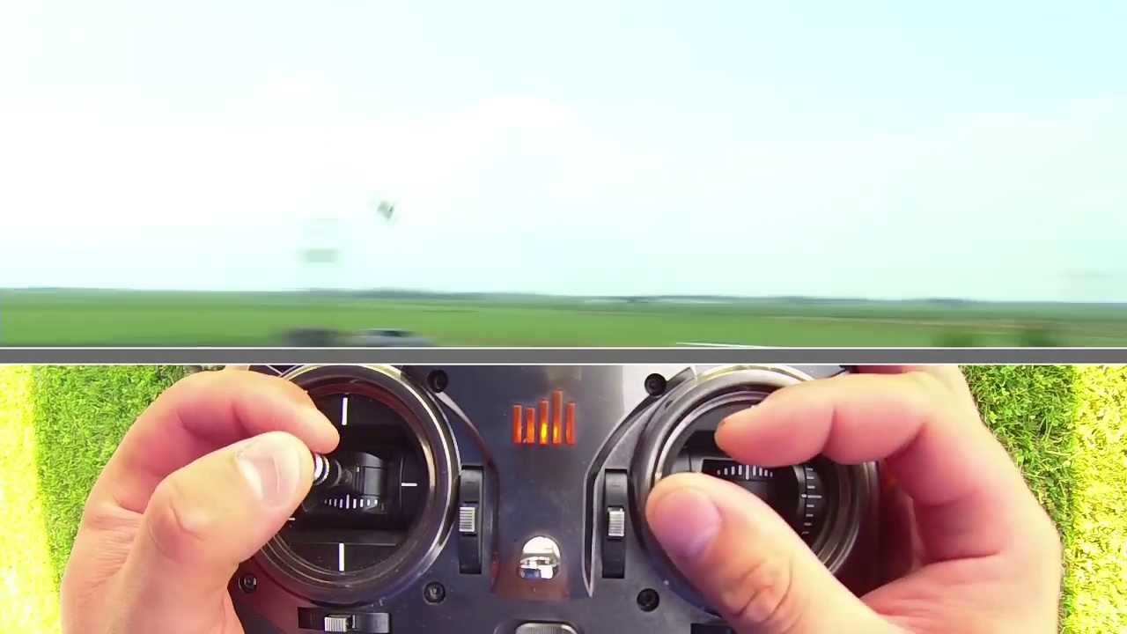 (score 90.0000)
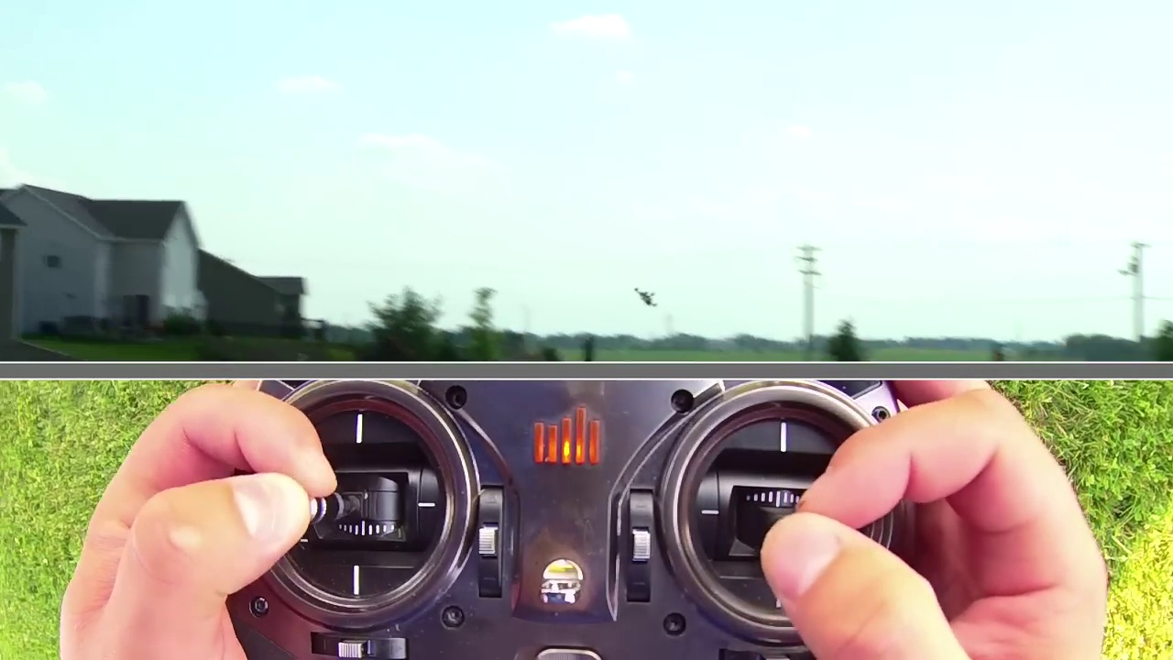 (score 90.0000)
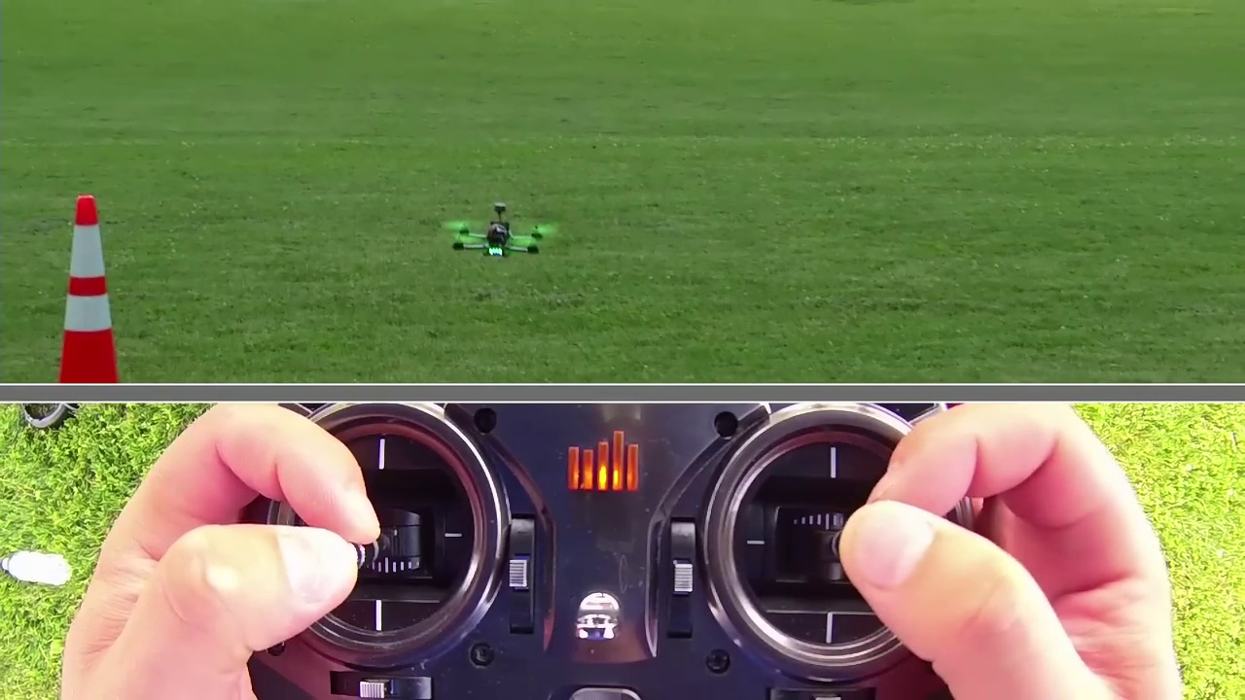 (score 90.0000)
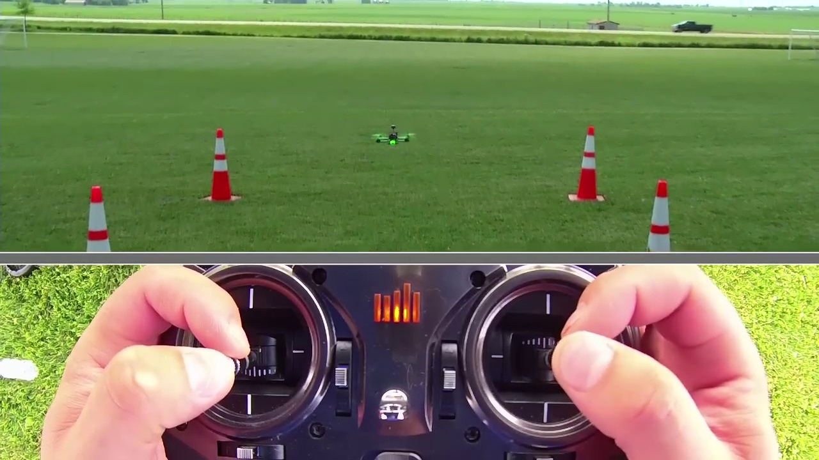 (score 90.0000)
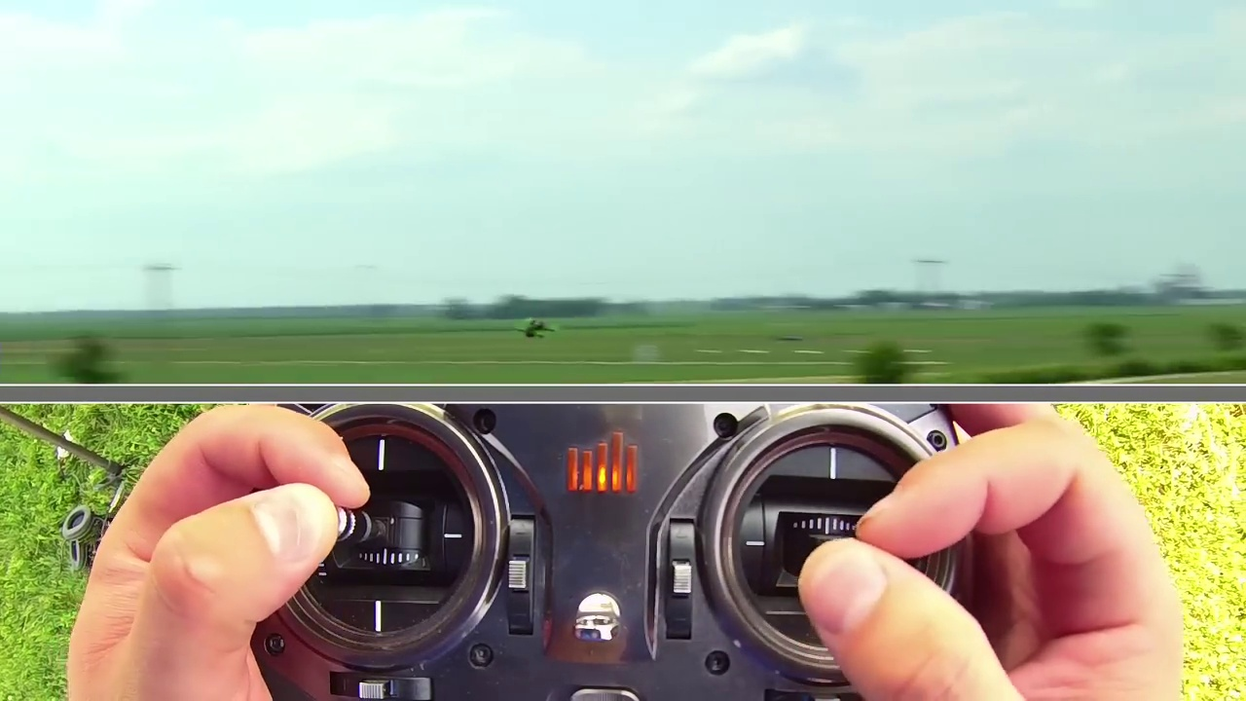 (score 85.0000)
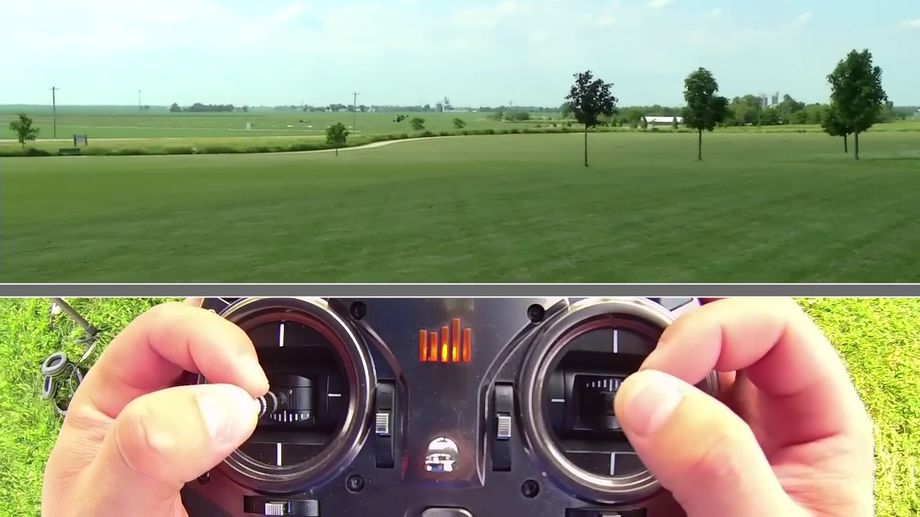 (score 85.0000)
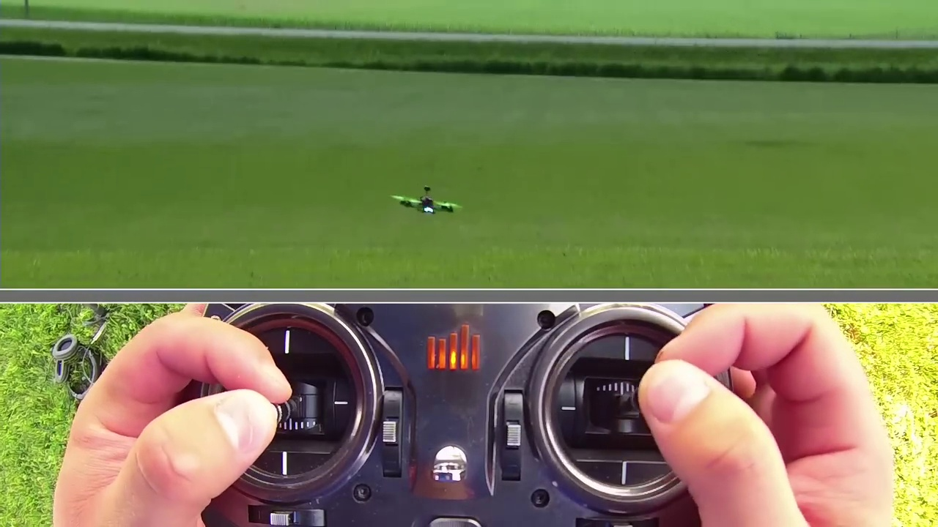 (score 80.0000)
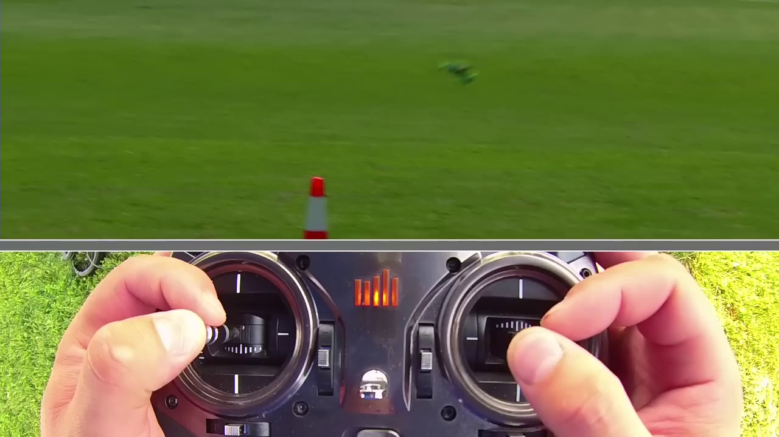 (score 80.0000)
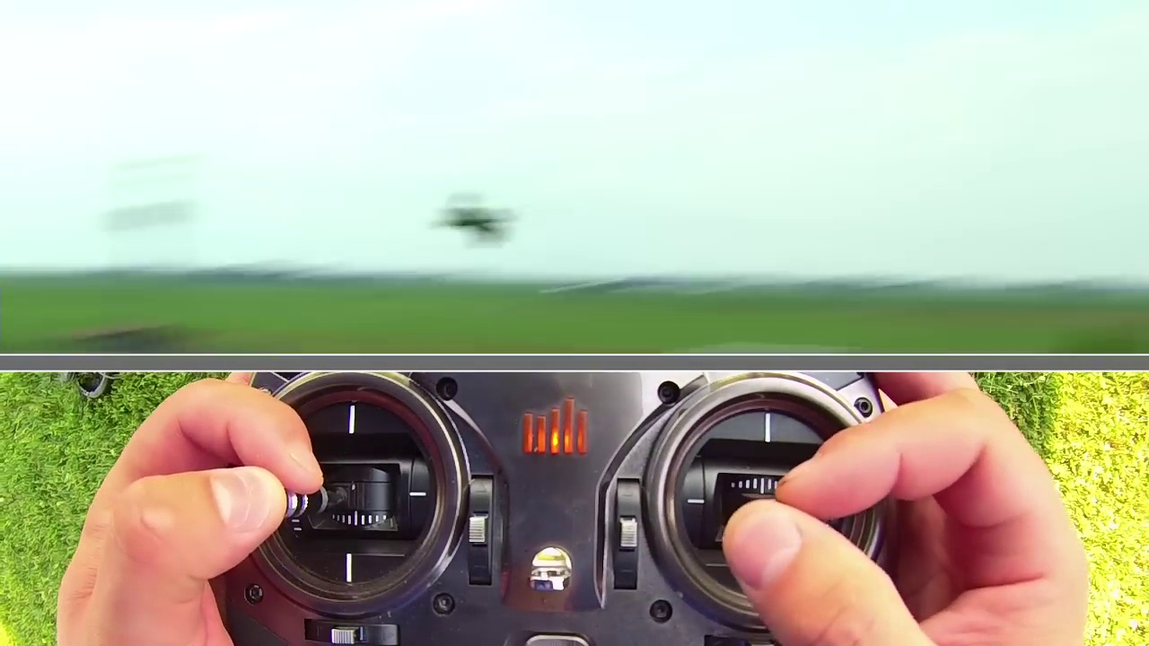 (score 80.0000)
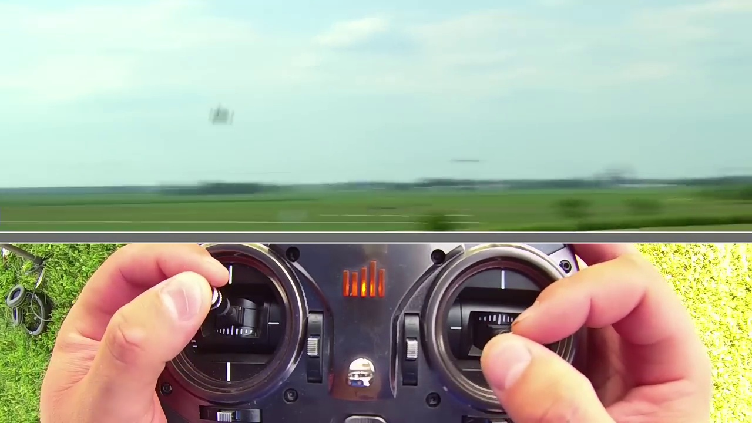 (score 80.0000)
Least correlated frames:
 (score 0.0000)
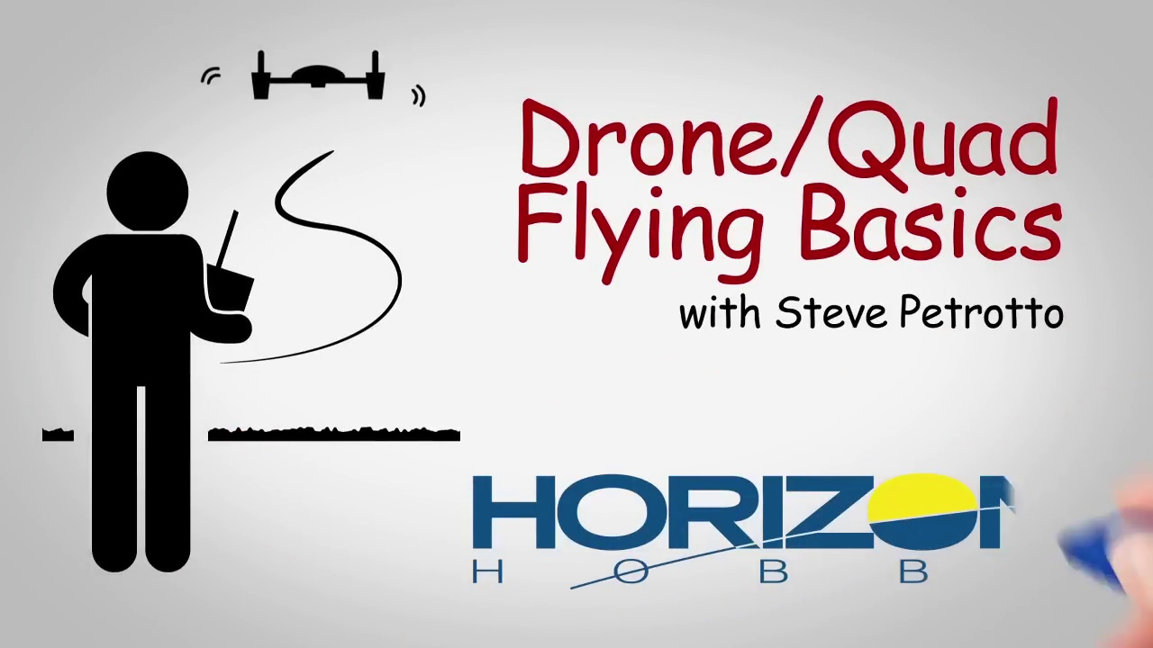 (score 0.0000)
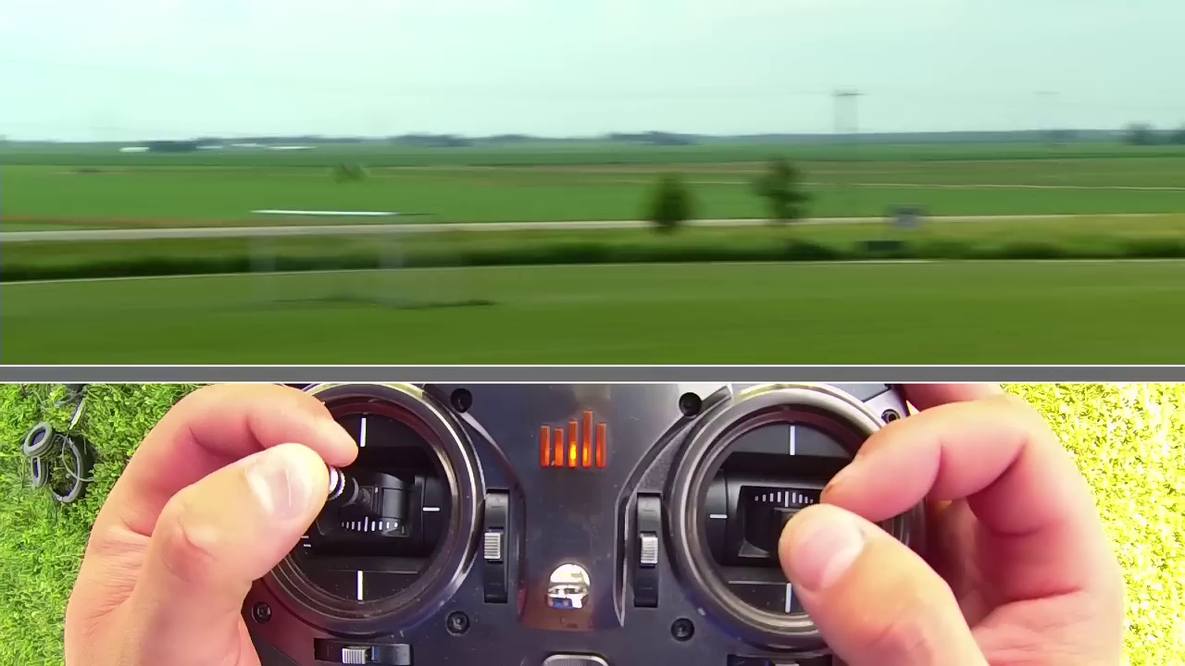 (score 0.0000)
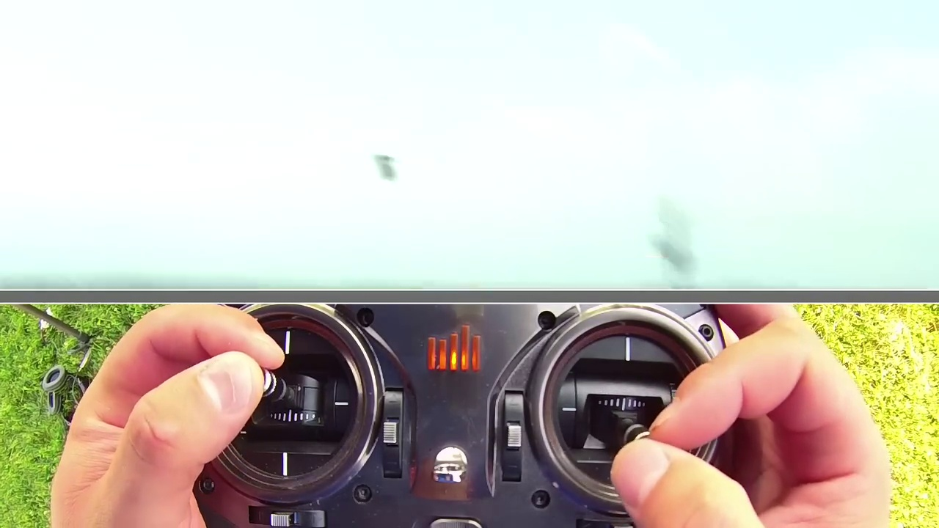 (score 0.0000)
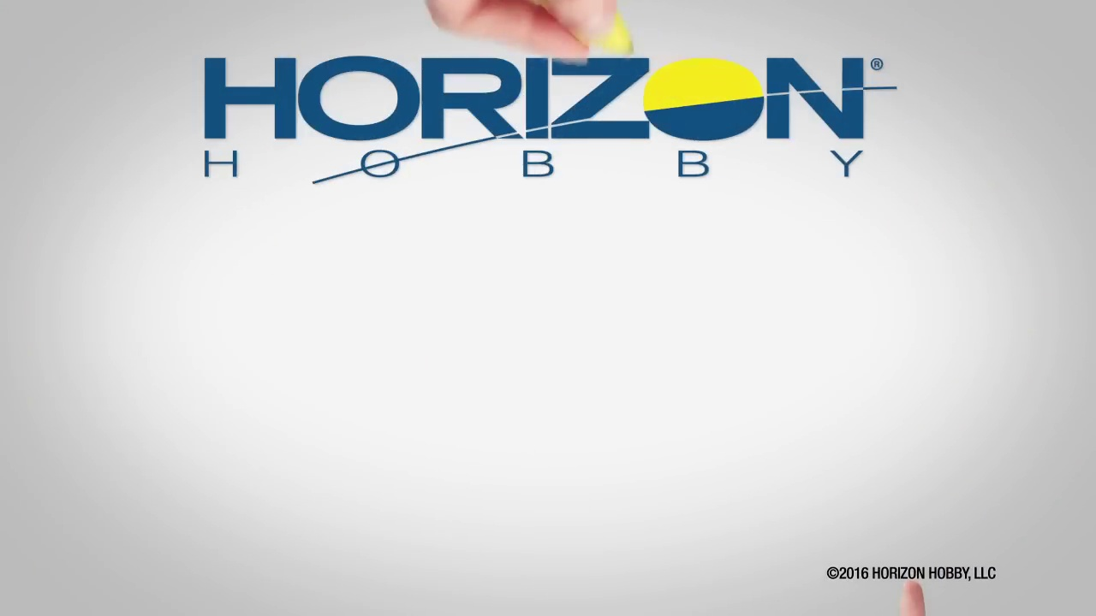 (score 0.0000)
 (score 0.0000)
 (score 0.0000)
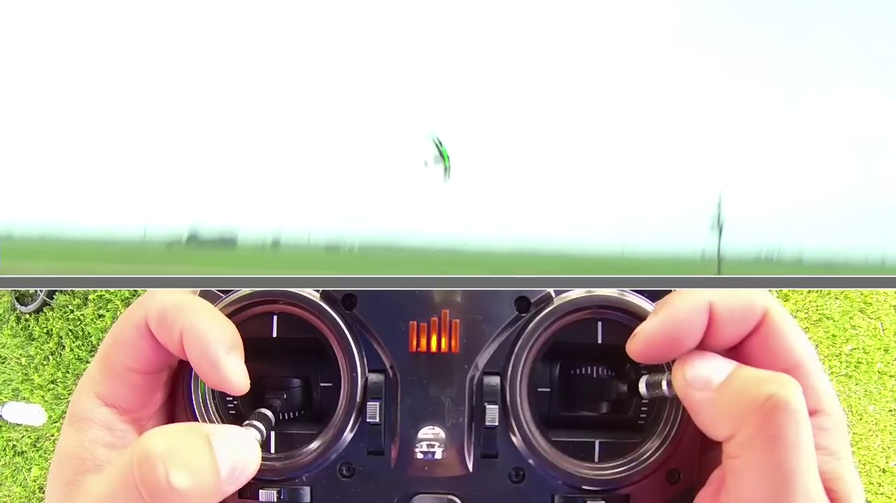 (score 10.0000)
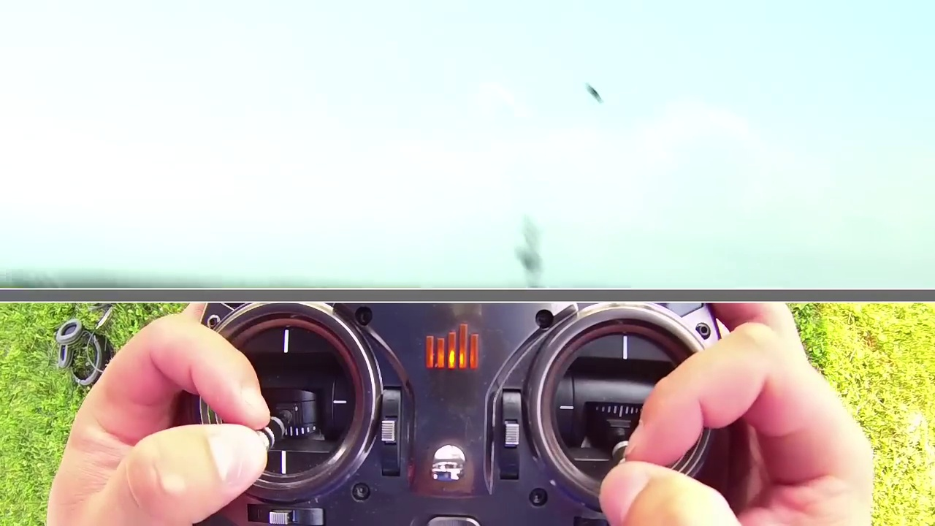 (score 10.0000)
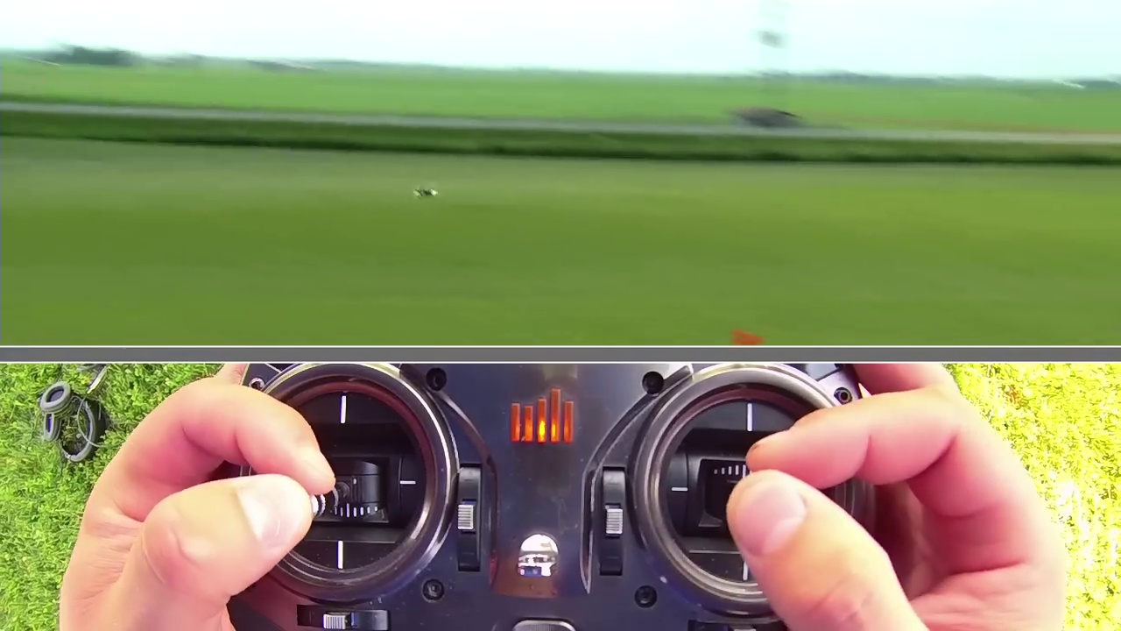 (score 10.0000)

Frame: frame_0000.jpg
Caption: The image presents a simple yet striking scene that focuses on a vertical transition between two colors. The dominant feature is a smooth gradient that seamlessly blends from a light gray-green shade on the left side to a deeper teal tone on the right. The uniform background throughout both sections adds to the visual interest, suggesting a focus on color transitions or comparisons of shades and tones. Unlike other images that might include text, objects, or people for added context, this image relies solely on its color palette, making it an effective tool for exploring the properties of gradients.
No strongly correlated comments found for this frame.

Frame: frame_0001.jpg
Caption: The image features a striking combination of the Horizon Hobby logo with a graphic of a yellow sun and partial blue sky to the right side of the banner. The logo itself consists of the word "Horizon" in white, stylized font, against a dark background, accompanied by the additional line of text that reads "HORIZON HOBBY." In the foreground on the left side, there is a gray rectangular block containing text in white, with the upper part reading "HORIZON HOBBY" in a larger font size compared to the rest of the visible text.
The overall design suggests a sense of warmth and optimism, reflecting the brand's mission and values. The sun graphic centrally positioned may represent a connection to outdoor activities or leisure, while the bold white letters writing out "Horizon" against the blue backdrop stand out prominently, emphasizing the company's identity as Horizon Hobby.
No strongly correlated comments found for this frame.

Frame: frame_0002.jpg
Caption: The image features a graphic design with educational content, likely serving as a slide from a presentation or educational material. On the left side of the image is an illustration of a person holding a pen, seemingly engaged in writing or drawing, which may be related to creating a drawing or writing notes about drone flying basics.
The central part of the image displays the text "DRONE / QUAD FLYING BASICS" in large, bold letters against a white background. Below this title is an icon depicting a quadcopter drone flying, suggesting that the content pertains to basic skills related to quadcopter drones or other forms of unmanned flying vehicles.
On the right side of the image is a logo with the text "HORIZON HOSPITAL." This indicates that the content might be related to health or medical education, as suggested by the hospital's name. The overall style of the image suggests a straightforward design with clear text and simple icons to convey its educational purpose.
Furthermore, this image may also be connected to a flyer for a drone quad flying basics class. The flyer is colored in blue and white, featuring the title "Drone Quad Flying Basics" written in white at the top. Below the title is a description of the class in white text, taught by Steve Petrotto, who is depicted in a cartoon form holding a drone, suggesting his expertise in flying drones.
The flyer also includes a picture of a drone, which is the main focus of the flyer, as well as a logo for the organization "Horizon" featuring a blue and white circle with a red dot in the center, matching the color scheme of the flyer. The overall design of the flyer is simple and clean, with a focus on the content of the class, making it easy to read and understand.
No strongly correlated comments found for this frame.

Frame: frame_0003.jpg
Caption: The image presents a combination of digital and textual elements. On one side, there is a screenshot of a digital learning interface with a red background, featuring white uppercase letters that read "LESSON 4 BASIC & ADVANCED AEROBATICS". Below this title, the text "TEACHING GUIDE" suggests a structured approach to teaching aerobatics, although the full content of this guide is not visible. To the right side of the interface, there is an additional text overlaying the screenshot, which is too small to read clearly in this image.
On the opposite side, a black and white image features a simple design with white text on a black background. The text is presented in two languages: English and Chinese. The English text reads "Lesson #4 Basic & Advanced Aerobatics", while the Chinese text translates to "课程第4节基本及高级空中运动". The overall image has a clean and clear appearance, with the text being the main focus.
The style of both images suggests that they are related to aviation or aerobatic sports, and it appears that they are part of an online course or educational program aimed at teaching about aerobatics.
No strongly correlated comments found for this frame.

Frame: frame_0004.jpg
Caption: The image shows a person flying a remote-controlled helicopter over a grassy field, with a striking green helicopter as the centerpiece. The helicopter's red and black controls are attached to the person's hands, indicating precise control over its movements. The field is flanked by two orange traffic cones on either side of the helicopter, creating a sense of balance and symmetry in the image.
In the foreground, the person holds a device resembling a drone controller with multiple joysticks and buttons. A small screen displays an infrared camera feed, which appears to show the grassy area with cones set up, possibly for drone flight practice or training. A blurred text reading "REAL", "GAME", "FAKE" can be seen in the foreground, potentially part of a graphic overlay or watermark on the photo.
The image is framed within a black border, adding contrast to the scene and capturing the sense of adventure and control as the person navigates the helicopter through the field.
Comment (score 80): Because, umm, fun!Flips and rolls. Add throttle flip, drop throttle. Keeps motion more linear. Loops, add throttle pull back on the stick let off on the throttle. Fuuuun
Reason: The comment directly discusses the technical steps and goals described in the caption, specifically mentioning flying techniques (flips, rolls, throttle control) that match the actions seen in the image. The mention of 'fuuuun' also aligns with the sense of adventure and excitement depicted in the frame.
Source: https://www.youtube.com/watch?v=YQ8ZhHBraZg : Basics of Drone Flight – Aerobatics

Frame: frame_0005.jpg
Caption: The image captures two moments in time. On the left side is a photograph of an unmanned aerial vehicle (UAV), commonly known as a drone, on a grassy field with traffic cones in the background, indicating a testing or practice area for flying the drone. The drone itself appears to be a quadcopter type, with four visible motors, suggesting it might be equipped with cameras or other sensors.
On the right side of the image is a photo showing a person's hands operating a remote control that seems to be for the same drone. The individual is adjusting or manipulating the controller in an indoor setting with a green carpet visible beneath it. No text, diagrams, or other educational elements are visible in this frame that would suggest a teaching context beyond what has been described above.
In another moment captured by the image, the drone is shown in flight, capturing the vibrant green and black colors of the drone against the backdrop of the same grassy field. The drone is positioned in the center of the image, its two circular controllers on either side of its body. The controllers, in black and white, are a stark contrast to the drone's vibrant colors.
The drone is flying over a series of red and white traffic cones, which are scattered across the grassy field. The cones, in their traditional colors, add a touch of order to the otherwise chaotic scene. In the top right corner of the image, there's a text that reads "FINAL SHOT", suggesting that this moment captures the final moment of the drone's flight, possibly as it prepares to land or has just taken off.
The image is a snapshot of two moments in time, a testament to the drone's flight and the orderly chaos of the field it's flying over.
No strongly correlated comments found for this frame.

Frame: frame_0006.jpg
Caption: The image captures a moment of exhilaration and precision, showcasing a green quadcopter mid-flight, equipped with a red and black remote control. In the foreground, a pair of hands holds the remote control poised over a green lawn, with white lines marking the path of the quadcopter. The remote control features a joystick for maneuvering the drone and two buttons for different functions in controlling it.
In the background, a series of orange and white traffic cones are scattered, forming a course for the quadcopter to follow. The cones are positioned at regular intervals, creating a clear path for the pilot to navigate through an obstacle course. To the side of the remote control, a slide or diagram from a presentation or instructional material is visible, featuring a mathematical equation: \( I = \int P(x,y) dx \). This equation appears to be related to a discussion of integration in calculus, potentially highlighting the mathematical aspect of flight trajectories or the integration of position data over time. The overall impression is that this image may be part of a tutorial or instructional video about flying a drone using a remote control, emphasizing the thrill and precision required for navigation.
No strongly correlated comments found for this frame.

Frame: frame_0007.jpg
Caption: The image captures a moment of excitement and control as a person stands in front of a flight simulator, ready to take off. The simulator includes a joystick and various controls with labels such as "Yaw," "Pitch," and "Roll." The individual appears to be actively engaged in flying the simulated aircraft, given their focused expression and the position of their hands on the controls.
In the background, orange safety cones are arranged on a grassy area, suggesting that this activity might be taking place outdoors or at an event where safety precautions are in place. A photograph or screenshot in the foreground depicts a real-world flying field with various aircraft models. The flight field includes multiple areas marked for different activities, and there's a model plane taking off from one of these zones.
The simulator controls being used by the person are sleek and modern, with clear markings and buttons for the user to interact with. The image does not provide enough detail to make out any specific brands or model names. There is no visible instructor or teaching context within this frame, as the focus is solely on the flight simulator activity being conducted by the person shown.
The overall scene conveys a sense of control and precision involved in flying, whether it's a simulated aircraft or a real-world drone. The image is a snapshot of a moment of anticipation, as the person prepares to launch their aircraft and take flight.
No strongly correlated comments found for this frame.

Frame: frame_0008.jpg
Caption: The image captures a moment of excitement and anticipation as it shows a close-up view of an individual's hands manipulating a drone remote control. The hands are positioned to simulate flying controls for the drone, which is shown in a small, live feed on the lower right corner of the image, hovering over a lush green field against a clear blue sky background. The person appears to be sitting indoors with a light-colored surface beneath them, possibly an indoor sports field or an area designed for hobbies and activities. They are wearing a white top and have short hair.
The drone, equipped with a camera, is captured mid-flight, hovering above the green field. The remote control, with its black and white buttons, is positioned on the left side of the image. The contrast between the green light on the drone, the black and white buttons on the remote control, and the green field creates a striking visual effect against the blue sky in the background.
Comment (score 90): Because, umm, fun!Flips and rolls. Add throttle flip, drop throttle. Keeps motion more linear. Loops, add throttle pull back on the stick let off on the throttle. Fuuuun
Reason: The comment directly discusses technical steps for controlling a drone, such as flips and rolls, throttle manipulation, and adjusting throttle to achieve linear motion. The mentioned actions are directly related to the scene depicted in the frame caption, specifically the person's hands manipulating the remote control and the drone flying above the green field.
Source: https://www.youtube.com/watch?v=YQ8ZhHBraZg : Basics of Drone Flight – Aerobatics

Frame: frame_0009.jpg
Caption: The image showcases a moment of exhilaration and precision as a person's hands manipulate control sticks to fly a green drone. The drone, equipped with a green camera, is captured in mid-flight, its green color contrasting sharply with the blue sky above and the lush green grass beneath. The drone's flight path adds a sense of motion and dynamism to the scene.
In the background, a large field stretches out, dotted with trees and houses, providing a stark contrast to the blue sky. The image is taken from a low angle, looking up at the drone, which adds a sense of scale and grandeur to the scene.
The main visual element of the image is a split screen composition. On the left side of the split screen, there's a real-world setting showing a field under a clear sky. The right side of the split screen includes an indoor flight simulation environment with the person flying the drone using virtual controls that mimic those in the real world.
The image likely teaches or demonstrates the use and operation of drones, either for educational purposes or as part of a product demonstration, highlighting the precision required to control the drone and the breathtaking scenery that surrounds it.
No strongly correlated comments found for this frame.

Frame: frame_0010.jpg
Caption: The image captures a thrilling moment in a drone race, with two remote-controlled aircraft competing against each other on a grassy field. In the foreground, a person's hands are expertly operating a remote control, likely a drone controller, to maneuver one of the racing drones. The focus is on the hands and controller, with an overlaid digital interface that resembles the dashboard of the device being controlled. The interface includes various indicators, such as battery life, signal strength, and possibly GPS coordinates or speed, with icons for different functionalities of the drone.
The field they're racing on is marked with white lines and orange traffic cones, adding a sense of order to the chaotic race. The image is taken from a low angle, looking up at the drones, emphasizing their speed and the thrill of the competition. One drone, in green, is flying ahead, while the other, in white, trails behind, its cockpit closed, indicating it's the trailing drone.
Comment (score 80): Because, umm, fun!Flips and rolls. Add throttle flip, drop throttle. Keeps motion more linear. Loops, add throttle pull back on the stick let off on the throttle. Fuuuun
Reason: The comment directly discusses specific drone racing techniques mentioned in the caption, such as flips, rolls, throttle control, and loops, indicating a strong connection to the frame caption.
Source: https://www.youtube.com/watch?v=YQ8ZhHBraZg : Basics of Drone Flight – Aerobatics

Frame: frame_0011.jpg
Caption: The image shows two hands, each gripping a black and white remote control with a red light that shimmers with an electric blue hue, poised over two joysticks in a flight simulator setup. Behind the hands, there is a view of a grassy field with three orange traffic cones, suggesting a training exercise or obstacle course for flying drones or remote-controlled vehicles. The field is outdoors under natural light.
In the foreground, on the bottom left corner of the image, there is text that reads "FUEL CONSUMPTION," which appears to be part of an educational context where the person might be teaching about fuel consumption in drones or remote-controlled vehicles. The text is white and contrasts with the background, making it easy to read.
The hands are in the midst of maneuvering the remote controls, their movements precise and controlled, capturing a moment of exhilaration and precision. The two traffic cones in the background stand as silent observers to the remote control's dance, their red and orange colors contrasting sharply with the green of the field, drawing attention to their presence.
The overall impression is that of a classroom or tutorial environment where practical demonstration meets theoretical lesson, suggesting a combination of a real-world scenario and a visual aid for instructional purposes.
No strongly correlated comments found for this frame.

Frame: frame_0012.jpg
Caption: The image appears to show a person interacting with a remote-control (RC) vehicle, specifically a quadcopter. On the left side of the frame, there is a close-up of a human hand holding an RC controller, featuring buttons and a joystick typical for such devices. The right side of the frame provides a wider view of the individual controlling the vehicle in a grassy area with green vegetation. The person is partially visible from behind, indicating they might be adjusting the controls or taking control momentarily.
A small white cone is situated next to the person, suggesting that this could be an outdoor activity such as remote control racing or maneuvering exercises. In the background, the clear sky indicates it might be late afternoon or early evening, with no visible texts, equations, diagrams, or slides, focusing attention on the hands-on activity of remote control vehicle operation rather than an instructional context.
The quadcopter itself is adorned with green and white colors and appears to be in the midst of a sharp turn, as indicated by the red arrow on its control panel. The man, standing in the foreground, holds the control stick firmly, his eyes focused intently on the quadcopter, demonstrating his attention to the flight.
Comment (score 80): Because, umm, fun!Flips and rolls. Add throttle flip, drop throttle. Keeps motion more linear. Loops, add throttle pull back on the stick let off on the throttle. Fuuuun
Reason: The comment directly discusses technical steps and actions related to the quadcopter flight, such as 'flips and rolls', 'add throttle flip', 'drop throttle', and 'loops'. These actions are specifically mentioned in the frame caption and describe the same technical aspects of RC vehicle operation.
Source: https://www.youtube.com/watch?v=YQ8ZhHBraZg : Basics of Drone Flight – Aerobatics

Frame: frame_0013.jpg
Caption: The image displays two distinct scenes that appear to be connected by a theme of vehicle control and racing. On the left side of the frame, we see a person operating a remote-controlled car (RC car) with a first-person perspective, possibly using a steering wheel controller visible on the right side of the image. This scene suggests a comparison or teaching context between controlling a physical vehicle and its remote-controlled counterpart.
On the right side of the frame, there is a photograph showing an actual car on a track with cones placed at the corners, further emphasizing this theme. The focus appears to be on the comparison of controlling a physical vehicle versus an RC car, evident from the different environments and devices shown.
In a separate scene, the image captures a thrilling moment in an aerial race. A drone, equipped with a camera, is flying at high speed, capturing the race in real-time. The drone has two controls, one on each hand, suggesting a two-handed flying setup. The drone is flying over a lush green field, with a red and white traffic cone visible in the distance, adding an element of challenge to the race. The image is taken from a high angle, providing a comprehensive view of the drone's trajectory and the surrounding environment.
No strongly correlated comments found for this frame.

Frame: frame_0014.jpg
Caption: The image shows a close-up view of a remote control, held by two hands on a grassy surface. The remote control is black in color and features a large display screen that displays a green color, filled with a series of red and yellow lines, suggesting it might be currently in use. One hand holds onto the top of the device, while the other hand manipulates the joystick, which appears to be used for steering. The focus is on the remote control, with the hands and grassy surface serving as a background. The image does not contain any discernible text or provide enough information to confidently determine the exact location or context of the scene.
No strongly correlated comments found for this frame.

Frame: frame_0015.jpg
Caption: The image appears to be a screenshot from a video, likely from an instructional video or tutorial, given the overlay of interface elements such as progress bars and playback controls. In the center of the image is a man's hand holding what looks like a remote control device with two joysticks, labeled "LEFT" and "RIGHT." The man seems to be demonstrating how to use the controller, possibly in relation to flight or driving simulation.
On the screen, there is an overlay of a graphic representation of a plane cockpit with various gauges and switches visible, suggesting a focus on aviation or aircraft control systems. There are no texts or labels within this overlay that provide additional context or instructions.
The bottom right corner of the image shows a blurred view of a grassy field with cars parked in the distance, indicating an outdoor environment possibly used for testing or practicing the skills being demonstrated in the video. The overall style of the image suggests it is designed to teach viewers how to operate a flight simulation system using a controller with joysticks and buttons.
In the top half of the image, the viewer can see the person's hands holding the remote control, with its two knobs prominently displayed. This close-up shot provides a clear view of the controller being used to navigate the drone in the bottom half of the image.
The bottom half of the image is a wide shot of a remote-controlled drone soaring through the air, its propellers spinning in a blur of motion. The drone is painted in a vibrant green and black and is equipped with a camera, capturing a landscape of green grass and trees. A small white car on the road adds depth and scale to the image.
The relative positions of the objects are as follows: the drone is in flight, the person's hands are holding the remote control, and the remote control is positioned in the foreground. The image does not contain any text or additional objects, but it is a testament to the skill and precision involved in controlling a drone.
No strongly correlated comments found for this frame.

Frame: frame_0016.jpg
Caption: The image appears to show a hands-on activity involving the operation of a drone with a camera attached to it. The individual is using a control unit with multiple buttons, suggesting different functions are available to control the drone's flight, such as takeoff, landing, forward/backward movement, turning, and elevation. The screen in front of them shows a live feed from the camera on the drone, which is hovering at a low altitude just above what appears to be grassy terrain.
The person's fingers are firmly grasping the control, indicating a sense of focus and concentration as they demonstrate how to fly a drone. The background beyond the drone and control panel provides a glimpse into an outdoor setting due to the natural light and open space, featuring a field of green grass that appears lush and well-maintained.
In the distance, the drone is captured mid-flight, its green body contrasting with the green grass, adding an element of adventure and exploration to the scene.
No strongly correlated comments found for this frame.

Frame: frame_0017.jpg
Caption: The image displays two distinct scenes that are juxtaposed in a split-screen format, showcasing the operation and control of a flying device. On the left side of the image, we see an outdoor scene with a grassy field and a few orange traffic cones arranged in a line. In the foreground, there is a person's hand holding a smartphone with the screen displaying a control interface that resembles the controls of a drone or a remote-controlled device, but the specific nature of the device isn't clear from this angle. The individual appears to be interacting with the phone, possibly adjusting settings or preparing for flight.
On the right side of the image, we see a close-up view of a hand holding a small, black model or remote control that closely resembles a real drone, suggesting that the person is practicing flying a drone by using this model as a stand-in. There are two joysticks with buttons and switches on the right side of the image, which are part of the model or remote control, indicating its complexity and mimicking the controls one might use to fly a real drone.
In the main scene, we see a man operating a drone in a grassy field, with the drone navigating through a series of red and white traffic cones. The man is intently focused on the drone, his hands tightly gripping the controls as he guides the device through the pattern set by the cones.
No strongly correlated comments found for this frame.

Frame: frame_0018.jpg
Caption: The image shows a split-screen composition with two distinct scenes. On the left side of the screen, there is an open field covered in lush green grass where several orange traffic cones are arranged, possibly setting up for some kind of activity related to remote control or drone flying. A drone is visible near the cones.
On the right side, a close-up view of a person's hands holding a black and white drone controller with two joysticks, commonly known as a gamepad, reveals them controlling the drone through this remote. The person appears to be operating the drone in an open field, with the camera-equipped drone flying in the air, capturing the vast expanse of the green field below.
The image does not contain any visible text or graphics, and it is not possible to determine if an instructor is present or if any teaching is taking place. The style of the image suggests a personal photograph used possibly for instructional purposes, showcasing the equipment and its use within an educational context such as a hobbyist class on drone flying or similar activities that require the use of a remote controller.
Comment (score 75): Because, umm, fun!Flips and rolls. Add throttle flip, drop throttle. Keeps motion more linear. Loops, add throttle pull back on the stick let off on the throttle. Fuuuun
Reason: The comment directly discusses technical steps related to controlling a drone, specifically 'flips and rolls', 'throttle flip', 'loops', and adjusting the throttle and stick. These actions are also depicted in the frame caption, showing a person operating a drone controller.
Source: https://www.youtube.com/watch?v=YQ8ZhHBraZg : Basics of Drone Flight – Aerobatics

Frame: frame_0019.jpg
Caption: The image captures a thrilling moment of a remote-controlled vehicle (RCV) in action. The RCV, painted in vibrant colors, is racing on a grassy track marked with white lines and dotted with green traffic cones. The car's trajectory is defined by the track, moving from left to right as it navigates around obstacles. In the background, a person's hands are operating a control system resembling a cockpit, complete with gauges and screens. The controls are designed for controlling an RCV, likely including a remote-controlled plane or glider visible in the field behind the operator. A small cone is visible in the grassy area, suggesting that the flight path may be navigating around obstacles. The person's focus is on the race, their hands firmly gripping the controls, ready to steer the car or plane to victory.
No strongly correlated comments found for this frame.

Frame: frame_0020.jpg
Caption: The image appears to be a composite of several different photos related to a hobby or activity involving remote control (RC) vehicles. On the left side, there is an individual holding a controller with joysticks, likely for an RC car or truck, as indicated by the visible screen and control knobs. The person's hands are on the controller, which has a variety of buttons and dials.
In the upper right corner, there is a photo showing a remote control vehicle (possibly a car or truck) on what appears to be an off-road track with obstacles in the background. There are orange cones placed around the area, suggesting that this might be used for navigation or precision driving exercises. In the foreground, two hands, one on the left and one on the right, are seen holding the controls of a small drone, which is equipped with a camera on its front. The drone is in the process of taking off.
The backdrop is a lush green field, dotted with white and red traffic cones, suggesting a track or course for the drone. The cones are arranged in a triangular pattern, adding a sense of direction and purpose to the scene. On the bottom right corner, there's another image showing the same type of RC vehicle from a different angle, possibly highlighting its features or functionality.
The top left corner of the composite contains a slide with text "How to fly a drone," which indicates that this image may be part of an instructional video or presentation about flying RC vehicles in general. This implies a teaching context where the instructor is demonstrating how to control an RC vehicle using a controller and potentially explaining the operation of cameras on such vehicles, rather than focusing on theoretical aspects of flight mechanics.
No strongly correlated comments found for this frame.

Frame: frame_0021.jpg
Caption: This image appears to depict a scene of competition or racing, where two individuals are operating remote controls, each positioned facing the other. The remote controls themselves are black with white buttons and appear to be connected to a small drone flying in the background. The drone is situated in the middle of a grassy field, surrounded by a fence and trees in the distance.
Notably, four red and white traffic cones, numbered 1, 2, and 3, are placed around the field, possibly serving as obstacles or markers for the competition. The focus of the image shifts to show an indoor view on one side, where the person operating the remote control is manipulating various controls and settings on a dashboard. This dashboard has labeled features such as "Motor" and "Camera," suggesting that this might be a device used for controlling the movement or camera of a vehicle, possibly a small-scale model used in hobbyist activities like radio-controlled cars or drones.
The individual operating the remote control is visible, wearing a ring on one finger, with their hands positioned on either side of the dashboard as they manipulate the buttons and knobs. There is no additional context or text provided within this image that would suggest an instructor or teaching scenario; instead, the focus remains on the devices themselves and their possible functions in the competitive setting.
No strongly correlated comments found for this frame.

Frame: frame_0022.jpg
Caption: This image appears to capture a thrilling moment in a simulated drone racing experience. The scene is divided into two halves, each showcasing a different aspect of the activity.
On the top half, we see a video game controller with several buttons and a joystick being operated by human hands on the right side. In the background, there is a green field with a few traffic cones placed in a straight line. This could suggest that the image is capturing someone engaging in a driving simulation video game, possibly for educational purposes to demonstrate how to control a vehicle in such a game.
The bottom half of the image shows a person's hands playing the same game as indicated by the joystick and button positions. The person is seated at a table or desk, with the game controller in front of them. This could imply that the individual is participating in the simulation from a stationary position, using the controller to navigate the virtual environment.
The drone itself, with its green and black body, is shown in mid-manuever, passing a series of red and white traffic cones arranged in a semi-circle. The backdrop of the image is a lush green field, providing a stark contrast to the stark black of the drone and the vibrant colors of the cones.
No strongly correlated comments found for this frame.

Frame: frame_0023.jpg
Caption: The image presents a scene of two individuals operating remote-controlled vehicles on a lush green field. On the left side of the frame is a photo of an outdoor obstacle course, marked by orange cones, suggesting a challenging environment for drone flying or racing. In contrast, the right side of the frame features a close-up picture of a person operating a remote control, using a joystick controller to navigate their vehicle. The individual's hands firmly grip the sticks, indicating a high level of concentration and skill.
The background field is dotted with orange and white traffic cones, adding visual interest to the scene. The image appears to be part of an instructional guide or tutorial, as indicated by the overlaid text "How to fly a drone" at the top left corner, suggesting that the content is educational in nature.
No strongly correlated comments found for this frame.

Frame: frame_0024.jpg
Caption: The image presents a captivating scene that juxtaposes indoor and outdoor settings. In the foreground, a person is holding a black flight controller for a drone, with its camera facing downward, likely recording an indoor setting or a specific activity. The controller's various switches and buttons suggest it's being operated or used for demonstration purposes. The person's hands are positioned on the top side of the controller, where batteries are usually stored.
In the background, a lush green field stretches out, dotted with several orange traffic cones, adding depth to the image. This outdoor environment contrasts with the indoor setting of the flight controller. Meanwhile, in the distance, a remote-controlled plane soars through the sky, captured in two different perspectives: a low-angle shot from the foreground and a wider view that includes the person holding the remote control.
The remote control, featuring a black and silver color scheme, is held tightly by the person's hands, with their figure small but distinct against the vast expanse of the field. The vibrant green and white body of the plane contrasts against the blue sky as it flies through the air. The overall scene captures a moment of excitement and freedom, showcasing the adventure and skill required to navigate the remote-controlled plane.
The image highlights the connection between indoor and outdoor settings, emphasizing the importance of precise control and precision in operating drones or remote-controlled planes. Despite the simplicity of the objects involved, the image is rich in detail and emotion, telling a story of exploration and mastery.
No strongly correlated comments found for this frame.

Frame: frame_0025.jpg
Caption: The image appears to show a person's hands manipulating a flight control system, specifically a joystick with levers, which is indicative of a simulation setup for flight training. It looks like an interactive flight simulator, where the individual might be practicing or demonstrating controls for a flight simulation. In front of the control setup, there's a large screen displaying a live video feed of an outdoor landscape featuring a field and some greenery under a clear blue sky with minimal clouds. This suggests that the simulation is either using real-time weather data to provide a more realistic training environment or that the person is engaged in a specific mission where the flight path closely resembles the area shown on the screen.
The focus of the image is on the control setup and the live video feed, which is used to provide context for the simulation activity. A person's hand can be seen in the foreground, holding onto one of the controls, demonstrating its use. The remote control, which features a red light against its metallic body, is not present in this frame, but the overall composition of the image suggests a peaceful outdoor setting, with the control setup and video feed serving as the focal point.
No strongly correlated comments found for this frame.

Frame: frame_0026.jpg
Caption: The image appears to be a screenshot from an instructional video, showcasing the operation of a remote-controlled aircraft (RCA). In the foreground, we see a person's hands manipulating the controls of the RCA, with their fingers on two joysticks. The joystick on the left is labeled "RUDDER," and the one on the right indicates "THROTTLE." Both are part of a handheld controller that seems to be used for piloting the model airplane.
The close-up composition captures the hands operating the remote control, with their fingers dancing over the buttons against a serene backdrop of a field of grass, dotted with trees and a solitary bird in flight. The image is captured from a low angle, making the control and its controllers appear as if they are floating above the field. The clear blue sky with fluffy white clouds adds to the quiet anticipation atmosphere.
The background shows the top view of an unmanned aerial vehicle (UAV), commonly known as a drone, with its four propellers and arms extended outward, typical of quadcopter designs. The UAV has a predominantly white color scheme, with some black detailing, suggesting it is in flight mode.
No strongly correlated comments found for this frame.

Frame: frame_0027.jpg
Caption: The image appears to capture a tranquil moment as a person operates a remote control vehicle (RCV), likely an RC car or truck, in an outdoor setting with lush green grass and a clear blue sky. The environment suggests a field or backyard, with no visible texts or diagrams on the screen providing additional context about the activity or instruction being given. The focus is solely on the RC car and the person controlling it.
The scene is divided into two parts, each presenting a different perspective. The left side of the image features the expansive green field, which stretches out towards a distant hill, creating a beautiful contrast with the clear blue sky above. On the opposite side of the image, a pair of hands is captured mid-action, holding a remote control with black and white design. The remote, oriented towards the right side of the image, has circular controls that suggest an action in progress.
Despite the simplicity of the image, it evokes a sense of calmness and tranquility, as if the viewer is witnessing a moment of pause in the midst of an ongoing activity. The precise positioning of the remote control and the hands suggests an action in progress, yet the image as a whole conveys a sense of peace and serenity. Overall, the image presents a captivating blend of nature and technology, capturing a moment that is both ordinary and extraordinary.
Comment (score 80): Because, umm, fun!Flips and rolls. Add throttle flip, drop throttle. Keeps motion more linear. Loops, add throttle pull back on the stick let off on the throttle. Fuuuun
Reason: The comment directly discusses the technical steps of operating an RC car, such as adding throttle flip, dropping throttle, and pulling back on the stick, which are all mentioned in the caption. The language used is specific to the activity described in the caption.
Source: https://www.youtube.com/watch?v=YQ8ZhHBraZg : Basics of Drone Flight – Aerobatics

Frame: frame_0028.jpg
Caption: The image captures a serene moment where a person is interacting with two distinct devices. In the foreground, the individual appears to be operating a flight simulator setup, which includes a joystick with multiple buttons and two foot pedals. The overall focus of this part of the scene is on the person engaging with the flight simulator equipment, likely demonstrating its use or functionality. The background suggests an outdoor setting, possibly a backyard or a rural area, as indicated by the field and the clear sky above.
In contrast, the person is also holding a remote control in their hands, which displays a green waveform on its screen. This device seems to be operating independently of the flight simulator equipment, suggesting that it might be controlling a separate device or vehicle. The park itself is a vast expanse of green grass, dotted with trees that add a touch of nature to the scene. In the distance, a building can be seen, perhaps a recreational facility or a playground. The sky above is a clear blue, with a few clouds scattered across it, suggesting a pleasant day.
The image does not contain any discernible text, and the relative positions of the objects suggest that the person is in the park, possibly enjoying a day out. The overall scene paints a picture of a peaceful day in a park, with the person potentially enjoying outdoor activities or perhaps taking a break from their day.
Comment (score 85): Because, umm, fun!Flips and rolls. Add throttle flip, drop throttle. Keeps motion more linear. Loops, add throttle pull back on the stick let off on the throttle. Fuuuun
Reason: The comment directly discusses specific flight simulator controls and actions ('Flips and rolls', 'Add throttle flip', 'Drop throttle', etc.) that match the technical steps described in the caption. The mention of 'stick' and 'throttle' also correlates with the joystick and foot pedals seen in the image.
Source: https://www.youtube.com/watch?v=YQ8ZhHBraZg : Basics of Drone Flight – Aerobatics

Frame: frame_0029.jpg
Caption: The image appears to be a screenshot from a video or presentation, likely related to drone piloting or flight simulation given the controls depicted. On the left side of the frame, there is an overlaid image of a person's hands holding a remote control with two joysticks and multiple buttons, which are typical for controlling a quadcopter. To the right, the image shows a real-world outdoor scene with a flat grassy area, trees in the distance, and a clear sky.
The lower portion of the screen includes a drone's first-person view (FPV), showcasing what the drone sees as it flies. The FPV perspective is from the cockpit of the drone, with the person's hands holding the remote control still visible over the image of the outdoor scene.
In this moment, a person is controlling a remote-controlled plane or quadcopter from a grassy field. The plane, likely orange in color, is soaring in the distance, adding a splash of color to the serene landscape unfolding in the background. The person, dressed in a black shirt, stands firmly on the grass, their hands gripping the sleek black remote control positioned in front of them.
The image is taken from a low angle, looking up at the plane, emphasizing its height and the person's control over it. This snapshot captures a thrilling moment of remote-controlled aviation, with the pilot navigating the aircraft through the open sky.
Comment (score 80): Because, umm, fun!Flips and rolls. Add throttle flip, drop throttle. Keeps motion more linear. Loops, add throttle pull back on the stick let off on the throttle. Fuuuun
Reason: The comment directly discusses drone flight techniques and maneuvers (flips, rolls, throttle control) which are strongly related to the technical steps described in the caption, such as controlling a remote-controlled plane or quadcopter.
Source: https://www.youtube.com/watch?v=YQ8ZhHBraZg : Basics of Drone Flight – Aerobatics

Frame: frame_0030.jpg
Caption: This composite image appears to be taken from a video recording and captures a thrilling moment of flight simulation or remote-controlled airplane activity. In the center frame, an individual's hands are positioned as if they are playing a flight simulation game or piloting an aircraft, with their left hand controlling the yoke and right hand on the throttle. The person appears to be engaged in the activity depicted.
The background of this frame shows a lush green landscape with a clear sky above. Above the individual's hands, there is a green bar indicating some form of progress or score, suggesting that this is an interactive element of the game or simulation being played. Overlaying the image is text that reads "Flight Simulation" in white and black colors.
The overall style of the image suggests it may be used for educational purposes, possibly as part of a tutorial on flight simulation games or procedures, given the interactive nature of the controls displayed by the individual.
Split-screen details reveal a remote-controlled airplane mid-flight against a backdrop of a lush green field dotted with trees. The airplane is flying in a straight line, its path clearly visible through the screen. On one half of the screen, the airplane is seen flying above the field, and on the other half, it's captured in mid-air, its wings spread wide as it soars above the trees.
The image is taken from a low angle, giving a sense of the airplane's height and speed. The text "Remote Control Plane" clearly indicates the type of aircraft being flown, emphasizing the thrill and excitement of remote-controlled flying.
No strongly correlated comments found for this frame.

Frame: frame_0031.jpg
Caption: The image appears to be a composite of two photos. The top photo shows a person using a radio control (RC) device, while the bottom photo displays hands manipulating an RC model, which resembles a quadcopter with multiple propellers and a central body. In the bottom photo, we see a pair of human hands holding onto the controller for an RC vehicle or drone. The fingers are pressing buttons that likely control the movement and functions of the device.
The setting suggests an outdoor, possibly recreational environment with green grass indicating it might be spring or summer. Meanwhile, in the distant background of the bottom photo, we see a lush green field stretches out, dotted with trees and bushes. The field appears to be in the midst of a gentle breeze, adding a sense of motion to the otherwise still image.
The top half of the image highlights the operation of an RC vehicle using a remote controller, while the bottom half showcases the vibrant colors of an orange and black RC airplane in mid-flight. The airplane is equipped with a control panel on its left side, filled with various buttons and dials. This split composition allows for a clear contrast between the active airplane and the serene field, creating a visually appealing image.
The overall scene presents a snapshot of a moment in time, capturing the excitement of flying an RC airplane and the tranquility of a field in the distance.
Comment (score 80): Because, umm, fun!Flips and rolls. Add throttle flip, drop throttle. Keeps motion more linear. Loops, add throttle pull back on the stick let off on the throttle. Fuuuun
Reason: The comment directly discusses the same technical steps and actions mentioned in the caption, such as flips, rolls, throttle control, and stick movements. Although it's not a perfect match due to some colloquial language and casual tone, the core information about RC flying is strongly related to the frame caption.
Source: https://www.youtube.com/watch?v=YQ8ZhHBraZg : Basics of Drone Flight – Aerobatics

Frame: frame_0032.jpg
Caption: The image captures an exciting moment where someone is operating a remote-controlled vehicle, likely a racing car or helicopter, given the presence of two joysticks. The person appears to be actively engaged with the controls, possibly in an educational setting as indicated by the instructional overlays and green field background with a truck and traffic sign visible. On the left side of the image, there is a green field with a truck and a traffic sign, suggesting an outdoor environment.
The right side of the image has a split-screen effect where the lower part shows a blurry background that seems to be an indoor environment, possibly a classroom or hobby space, with a desk and various items on it. The upper part of this split screen displays a slide with text "Congratulations! Your car is ready for action," indicating some sort of achievement in a model racing context.
The bottom right corner of the image shows a person's hand holding a small remote control vehicle, likely a model racing car given the context. The middle part of the image has a green field background with another truck and traffic sign, which is the same location as seen on the left side but from a different angle or distance.
The text "Congratulations! Your car is ready for action" implies that this scene may be part of an educational program teaching model racing or similar hobby activities. The overall image conveys a sense of excitement and adventure, possibly in a setting where people are learning to operate remote-controlled vehicles.
No strongly correlated comments found for this frame.

Frame: frame_0033.jpg
Caption: The image shows a person's hands manipulating a remote control car, with the individual appearing to be seated, as evidenced by the back of a seat and chair visible. The primary focus is on the controller with joysticks and buttons being used. In the lower part of the screen, an overlaid graphic includes elements that provide context about the remote control car.
A partial view of a real remote control car is shown on grass, indicating that the person is controlling a toy car from afar. The vehicle has two antennas on top and a red light on the front, suggesting it's in operation mode or possibly a signal status indicator.
The controller features four buttons: two located between the joysticks, likely for additional functions such as steering or throttle control, while the other two are situated at the top corners of the controller. The design and layout suggest this is a model of a real car's dashboard with steering wheel controls. Additionally, the text "5D CRAW" appears in the lower right corner, possibly referring to the type or version of the remote control car being used.
In the background of the image, an outdoor setting is faintly visible, which might be a park or garden where one would play with remote control cars. The style of the image is a combination of a real photograph for the upper part and a graphic or digital overlay for the lower part, intended to explain how the toy car works.
To the right of the screen, an alternate scene captures a moment of excitement and anticipation as a person watches a small green remote-controlled car racing down a grassy track. The car is moving in a straight line, with a white line marking the track, adding to the sense of speed and motion. In the background, the same person is seen holding a black remote control, ready to steer the car to the finish line.
No strongly correlated comments found for this frame.

Frame: frame_0034.jpg
Caption: The image consists of two main parts. On the top half, there's an overlay with a blurred background that appears to be a grassy field with a clear sky and some green foliage, suggesting it might be outdoors during daytime. In the foreground, there is a blurred object that looks like a remote-controlled car or drone being controlled by a person whose hands are visible on the bottom right corner of the image.
On the bottom half, there is an unmistakable view of a remote control (RC) car with its wheels and body visible. The car's design suggests it might be for off-road use or have specialized features designed to navigate various terrains. Someone's hands are holding an RC car with its front facing upwards, likely used for steering and controlling the car remotely. A visible joystick on the right side of the bottom half is likely used for controlling the car's movement in different directions.
In this scene, a remote-controlled quadcopter is captured mid-flight, its propellers spinning at a rapid pace, flying in the same grassy field. The camera angle is from the perspective of someone on the ground, providing a clear view of the quadcopter's trajectory. Two sets of hands are seen controlling the quadcopter, with fingers meticulously adjusting the controls.
The image presents a captivating blend of technology and nature, as the remote-controlled quadcopter symbolizes the intersection of human ingenuity and the natural world. The green and black quadcopter, the green and white traffic cones, and the lush green grass all contribute to this harmonious blend of man-made and natural elements. The image captures a moment of excitement and control, as the quadcopter soars through the air under the guidance of its human operators.
No strongly correlated comments found for this frame.

Frame: frame_0035.jpg
Caption: This image appears to capture a moment where a person's hands are operating a flight control simulator or remote control. The individual is using a joystick with two handles, which suggests they are engaged in a flying simulation or controlling an aircraft remotely. Each hand is grasping a different lever or handle on the control device, with one hand holding the main handle and the other operating a secondary control.
The background outside the window shows a rural landscape with fields and trees, which provides context for the outdoor setting. The focus of the image remains on the hands and controls inside the simulator or remote control, indicating that the content is related to flight training or the use of flight simulators. Notably, there are no visible texts, diagrams, or additional visual elements within this frame that could provide more information about the context or subject matter beyond what has been described.
The image also provides a close-up view of the remote control itself, which features a digital display screen lit up with a vibrant orange color, indicating it is currently in use. The remote control sits on a grassy field, bordered by trees and surrounded by a clear blue sky, suggesting a sunny day. In the top left corner, there's a white rectangle with a red line inside it, which appears to be part of a larger image that represents a drone's flight path.
The overall image presents a snapshot of technology interacting with nature, showcasing the person's hands controlling the remote control or simulator while surrounded by the natural environment. The relative positions of the objects suggest a well-organized and clear view of the remote control and its surroundings.
No strongly correlated comments found for this frame.

Frame: frame_0036.jpg
Caption: The image shows a person's hands manipulating a remote control device with two joysticks and several buttons. The controller has wires extending from it, suggesting that it is connected to an unseen device or system. In the background, there appears to be a blurred photograph of a flight simulator setup, which includes a steering wheel attachment and other equipment typically used for flight simulation. However, due to the blur, specific details about this setup are not clear.
The remote control itself is a sleek black device with a white LED screen that displays a vibrant red signal, symbolizing control and command. The image conveys a sense of anticipation and excitement, as the two hands tightly grip the controller, poised in anticipation. The serene backdrop of a clear blue sky and lush green grass provides a stark contrast to the dynamic action in the foreground, adding a touch of nature's vibrancy to the scene.
Despite the absence of any text or discernible actions, the image effectively conveys a sense of control and freedom intersecting.
No strongly correlated comments found for this frame.

Frame: frame_0037.jpg
Caption: The image captures two distinct scenes that are unrelated to each other, but both feature a person interacting with a device. In one scene, a person's hands operate a flight simulator software on a computer monitor, which is displayed in portrait mode. The person manipulates controls resembling an aircraft yoke and throttle lever, indicating engagement with the simulation. On the screen, visible text indicates that the software is "Flight Sim" version 1.0. There are no other objects or indicators in this frame to provide additional context.
In a separate scene, a man stands in front of a large house, partially visible in the background, and uses a remote control. The remote control is colored black and orange, with a red and orange LED screen indicating it's currently in use. The man's hands firmly grip the remote control as he stands on a grassy lawn surrounded by trees in the distance. The image is taken from a slightly elevated angle, providing a clear view of the man and his remote control.
These two scenes are unrelated, with no textual context or objects present to provide additional information. The primary focus of each scene is on the person interacting with their respective devices.
Comment (score 90): Because, umm, fun!Flips and rolls. Add throttle flip, drop throttle. Keeps motion more linear. Loops, add throttle pull back on the stick let off on the throttle. Fuuuun
Reason: The comment directly discusses the flight simulator software mentioned in the caption, specifically mentioning 'throttle flip', 'drop throttle', and 'pull back on the stick let off on the throttle', which are all technical steps related to the flight simulation activity shown in the frame. The comment does not discuss the unrelated scene with the remote control.
Source: https://www.youtube.com/watch?v=YQ8ZhHBraZg : Basics of Drone Flight – Aerobatics

Frame: frame_0038.jpg
Caption: The image captures a person seated at a flight simulator station with their hands on the yoke and throttle control handles. In front of them, a computer monitor displays the cockpit interface typical for flight simulation games, showing a first-person perspective inside the virtual cockpit of an airplane. The person is controlling the yoke and throttle as if flying the aircraft in the simulation environment.
Various flight instruments and gauges typical of an aircraft cockpit are visible on the screen, including the primary flight display (PFD) showing altitude, airspeed, heading indicator (HSI), attitude indicator (AI), and vertical speed indicator (VSI). The focus is primarily on the person using the flight simulator rather than the outdoor environment or any additional text or elements.
In a separate moment, the image also captures a close-up view of a remote control, held in the hands of the same person. The control features a black and silver color scheme with two orange and white buttons, as well as a central dial surrounded by two black buttons. The person's hands are positioned over the control, with their fingers slightly curled, suggesting a firm grip.
The background of this image is a lush green field, with a blue sky overhead, providing a stark contrast to the control and the person's hands. The relative positions of the objects suggest that the person is holding the control in a way that allows them to operate it comfortably.
No strongly correlated comments found for this frame.

Frame: frame_0039.jpg
Caption: The image shows a person operating flight simulation software on a computer. The individual appears to be in a simulated flying environment and is holding a joystick, which suggests they are controlling the aircraft within the simulation. There are no visible texts, equations, or diagrams in this frame that could indicate teaching or instructional content. The focus is solely on the person interacting with the software.
No strongly correlated comments found for this frame.

Frame: frame_0040.jpg
Caption: The image displays a sequence of four photographs, showcasing the process of operating a remote-controlled vehicle. The top left photo features a person's hands manipulating a joystick and buttons on a remote control, presumably controlling a quadcopter that is flying outside. The field with green crops is visible through the drone's camera feed.
In the top right photo, we see a close-up view of the remote control, emphasizing its complexity and operation. The person's hands are still in contact with it, but there are no clear texts or graphics visible on the screen.
The bottom left photo provides a unique perspective from the quadcopter's point of view, focusing on the hands holding the remote control, showing them from a low angle.
The final photo captures the drone's camera feed from an overhead perspective, allowing us to see the landscape below, including a road and what appears to be a truck. The hands controlling the drone are still visible at the bottom of the image.
In a separate but equally thrilling moment, we see a remote-controlled car racing on a grassy field in the bottom right corner of the image. The car, adorned with a black and white body, is captured in the midst of a swift turn, its wheels spinning rapidly as it navigates the terrain. The driver's hands, gripping the steering wheel, are visible in the foreground, their fingers deftly maneuvering the controls.
In the background, a car and a truck can be seen, adding scale to the scene. The white car is on the left side of the image, while the gray truck is on the right. Both vehicles are in motion, their paths diverging from the main focus of the image. The low angle of the shot gives a sense of speed and power, emphasizing the dynamic nature of the scene. The grassy field beneath the car and its wheels adds a touch of green to the otherwise black and white image.
Comment (score 80): Because, umm, fun!Flips and rolls. Add throttle flip, drop throttle. Keeps motion more linear. Loops, add throttle pull back on the stick let off on the throttle. Fuuuun
Reason: The comment directly discusses the technical steps and goals described in the caption, such as 'add throttle flip', 'drop throttle', 'loop', and 'pull back on the stick let off on the throttle'. The mention of 'flips and rolls' also relates to the sequence of photographs showing a quadcopter performing aerial stunts.
Source: https://www.youtube.com/watch?v=YQ8ZhHBraZg : Basics of Drone Flight – Aerobatics

Frame: frame_0041.jpg
Caption: The image shows a person's hands operating two joysticks, which appear to be flight controls, set against a background that looks like an open outdoor space with green grass and some indistinct structures in the distance. The right hand is on the left joystick, while the left hand is on the right one. There are no visible texts, diagrams, or slides indicating teaching content. The style of the image seems to be a still from a video, given its quality and composition, which suggests movement or action, as indicated by the blurred background.
In the foreground, a close-up view of a remote control is captured in the person's hands. The control is a black and white remote with two dials and two buttons. The dials are located on the right side of the control, while the buttons are on the left. The person's hands are firmly gripping the control, suggesting they are in the middle of a game or activity.
In the background, there's a grassy field stretching out into the distance, adorned with a few trees, adding a touch of nature to the scene. Above, the sky is a clear blue, with a few clouds scattered here and there, suggesting a bright and sunny day. The image does not contain any discernible text or other objects. The relative positions of the objects suggest a typical setting for using a remote control, with the person holding it in their hands and the remote control in their immediate vicinity. The field and trees in the background provide a sense of location and context, while the clear blue sky above adds to the overall serene atmosphere of the image.
Comment (score 80): Because, umm, fun!Flips and rolls. Add throttle flip, drop throttle. Keeps motion more linear. Loops, add throttle pull back on the stick let off on the throttle. Fuuuun
Reason: The comment directly discusses the technical steps of using a remote control (flips and rolls, throttle flip, etc.), which are strongly related to the objects and settings described in the caption (joysticks, remote control, and grassy field).
Source: https://www.youtube.com/watch?v=YQ8ZhHBraZg : Basics of Drone Flight – Aerobatics

Frame: frame_0042.jpg
Caption: The image depicts a person sitting comfortably in front of a flight simulator with a realistic cockpit and yoke controls, surrounded by a peaceful rural landscape with fields and trees. The individual appears to be operating the simulator, as suggested by their hand on the yoke and the presence of various control buttons around it. On the screen displaying the flight training or simulation software interface, there is visible text: "TRUST NO ONE" and "FLIGHT CONTROLS." This suggests that the focus of the training is on trust building within an aviation context and understanding flight control systems.
The software interface also features diagrams showing the relationship between various flight controls, such as ailerons, elevator, and rudder, and how they affect the aircraft's movement. Additional text labels on the screen include "INSTRUCTOR," "FLIGHT CONTROLS," "DIRECTIONAL CONTROLS," "PITCH CONTROLS," "YAW CONTROLS," "ROLL CONTROLS," and "THROTTLE," indicating the different types of flight controls being demonstrated or trained.
In the background, a grassy field stretches out, punctuated by a few trees. The field is devoid of any other objects, creating a sense of tranquility and isolation.
No strongly correlated comments found for this frame.

Frame: frame_0043.jpg
Caption: The image shows a person deeply engaged with two remote controls, each held by one hand. The remote controls are grey and feature two knobs situated towards the top and two buttons located towards the bottom. In the background, there is green grass, suggesting an outdoor setting. On the right side of the image, a small television screen displays an overlay of instructions or guidance for using what appears to be a joystick or flight stick prominently visible in front of the individual. The joystick has multiple buttons and what looks like a lever for additional input, possibly related to controlling a simulation or remote-controlled vehicle, possibly related to aviation or drone flying. The text on the screen is not fully legible due to the angle and resolution but appears to be providing information related to controls for flight, with buttons labeled "Pitch," "Roll," etc., typical terms used in flight simulations or remote-controlled aircraft.
Comment (score 80): Because, umm, fun!Flips and rolls. Add throttle flip, drop throttle. Keeps motion more linear. Loops, add throttle pull back on the stick let off on the throttle. Fuuuun
Reason: The comment directly mentions and explains specific actions related to flight controls (e.g. 'add throttle', 'pull back on the stick', 'let off on the throttle') which are also described in the caption as part of the simulation or remote-controlled vehicle control.
Source: https://www.youtube.com/watch?v=YQ8ZhHBraZg : Basics of Drone Flight – Aerobatics

Frame: frame_0044.jpg
Caption: The image appears to show a person controlling an unmanned aerial vehicle (UAV), commonly known as a drone, using remote controllers with joysticks and buttons for navigation and operation. The screens on these controllers display a live video feed from the drone's camera, showing a clear sky above and some greenery below, suggesting that the drone is flying outdoors. The person's hands are visible on the controls, and they seem focused on maneuvering the UAV.
The background behind the controllers shows an open space with what appears to be a rural or suburban setting, possibly a park or a field, with trees and grass visible. There is no text or additional information present in this frame that would indicate a teaching context or specific devices being used beyond the remote controls of the drone. The focus here is on the activity of flying a drone and the control interface for doing so.
The scene is set against a backdrop of a vast green field, dotted with trees that stand tall and proud. The field stretches out into the distance, meeting the horizon where the drone is visible, its wings folded against the wind. The drone is positioned slightly to the right of the field, adding a sense of depth to the image.
The sky above is a clear blue, dotted with fluffy white clouds. The overall composition of the image suggests a sense of freedom and exhilaration, as the person prepares to take control of the drone and soar through the sky. The image is a snapshot of a moment filled with anticipation and adventure.
No strongly correlated comments found for this frame.

Frame: frame_0045.jpg
Caption: The image captures a close-up view of someone's hands operating a device with two joysticks, resembling a remote control or possibly a flight simulator controller. The person is holding the controller with both hands, and it appears to be connected to something not fully visible in the frame. The focus is on the hands and the controller itself, which has buttons and dials that suggest various controls for a game or simulation. The background is blurred but looks like an indoor setting with a window, indicating it might be taken indoors.
In this close-up view, the device's black body is adorned with orange buttons, poised to be operated by the person's fingers. The control is positioned on a grassy field, its surface speckled with patches of green. In the background, a blue sky stretches out, dotted with fluffy white clouds, suggesting a tranquil outdoor setting. The image is taken from a low angle, placing the control in the foreground and the person and the field in the background, implying a moment of anticipation or action as if the remote control is about to be used to control an unseen object or event.
No strongly correlated comments found for this frame.

Frame: frame_0046.jpg
Caption: The image shows a moment of excitement and anticipation, with two hands holding a remote control poised to control a small red and white drone in flight. The drone is captured mid-air, its body slightly tilted as it maneuvers through the green grassy field. On the right side of the frame, a red and white traffic cone stands out against the green backdrop, adding an element of suspense to the scene. The image is taken from a low angle, looking up at the drone and the cone, further emphasizing the height of the drone in the frame. In the foreground, the remote control with a joystick and several buttons is visible, set against a blurred background that seems to be an outdoor scene. The person's hands are positioned as if they are using the controller, capturing the moment from a perspective where the controller is held in front of the viewer. The text "Remote Control" is clearly visible, suggesting that the image is a still from a larger video or movie.
No strongly correlated comments found for this frame.

Frame: frame_0047.jpg
Caption: The image captures a moment of tranquility in a park, where technology meets nature. A person is seated at a simulator with two game controllers in their hands, each featuring an analog stick and several buttons, designed with a joystick on top. The controllers are placed amidst a serene green lawn, suggesting that this setup is outdoors for some activity. In the foreground, two hands hold a remote control, ready to command the action. This black and white remote control has a vibrant orange-red LED display, adding a pop of color to the scene.
The remote control rests on the lush green grassy field, dotted with trees and a small pond. The trees stand tall, forming a natural boundary around the park, while in the background, a white building adds a touch of urban life to this peaceful setting. The image is taken from a low angle, looking up at the remote control, emphasizing its importance and scale.
The overall composition of the image suggests a harmonious coexistence of nature and technology, where the tranquil atmosphere is preserved despite the presence of controllers and a simulator.
No strongly correlated comments found for this frame.

Frame: frame_0048.jpg
Caption: The image captures two distinct scenes simultaneously, with a flight simulator operation taking center stage and a remote-controlled car racing on a grassy track in the background. A person is seated at a desk, operating the flight simulator with both hands, using controls labeled "Yaw" and "Pitch." The monitor displays a graphical interface for the simulator, featuring a green field that could represent an aircraft's environment.
The overall setting appears to be a classroom or training room, suggested by the informal learning environment and the presence of educational materials on the desk. The instructor's hands are actively engaged with the controls, indicating an interactive teaching session focused on flight simulation.
To the left of the monitor, two small images or thumbnails are displayed side-by-side, but their content is unclear due to their size and resolution. In the background, a lush green field stretches out, providing a stark contrast to the intense action taking place in the foreground. A few trees can be seen, their leaves rustling gently in the breeze.
Above, the sky is a clear blue, suggesting a bright and sunny day. The image is taken from a high angle, looking down at the track and car, which emphasizes the speed and motion of the remote-controlled vehicle, making it seem as if it's hurtling down the track at breakneck speed.
No strongly correlated comments found for this frame.

Frame: frame_0049.jpg
Caption: The image appears to capture a moment of excitement and adventure, with a person operating a quadcopter drone. The individual is holding two joysticks, which are likely the control inputs for the device, and is adjusting the control stick on the remote controller. The remote control, a sleek black device, is equipped with two buttons, one of which is glowing orange. The person's hands are positioned in such a way that the remote control is pointing towards the sky, suggesting an impending launch or flight.
The background features a serene green field, providing a tranquil contrast to the action in the foreground. Above it all, a clear blue sky stretches out, adding to the sense of freedom and possibility. The image is a blend of action and tranquility, capturing the anticipation of an aerial adventure.
Comment (score 90): Because, umm, fun!Flips and rolls. Add throttle flip, drop throttle. Keeps motion more linear. Loops, add throttle pull back on the stick let off on the throttle. Fuuuun
Reason: The comment directly discusses the same technical steps and actions described in the caption, such as adjusting control sticks, flipping, rolling, adding throttle, and dropping throttle. The mention of 'throttle flip' and 'pull back on the stick let off on the throttle' specifically relates to the quadcopter drone operation depicted in the caption.
Source: https://www.youtube.com/watch?v=YQ8ZhHBraZg : Basics of Drone Flight – Aerobatics

Frame: frame_0050.jpg
Caption: The image shows a moment where a person is engaging with two distinct activities simultaneously. On one hand, it appears that the individual is operating a remote-controlled airplane hovering in the air, which is equipped with two propellers and situated against a serene backdrop of a lush green field with distant trees and a clear blue sky. The person's hands are tightly gripping the controls of the airplane, demonstrating their focus and control.
On the other hand, the same individual is also operating a flight simulator, as evident from the close-up view of their hands interacting with the controls that include joysticks and other buttons, likely representing a flight control panel. Multiple screens within the frame display various graphical interfaces, possibly representing different views or instrument panels commonly found in aircraft cockpits.
The bottom screen is visible, featuring what appears to be an altimeter and airspeed indicator (ASI), which are typical flight instruments used for situational awareness during flight. The instructor seems to be demonstrating how the controls work by engaging with them directly, providing a hands-on approach to teaching. There is no text, equations, or graph types visible within the image that would provide additional information about the device or its operation.
No strongly correlated comments found for this frame.

Frame: frame_0051.jpg
Caption: The image shows two distinct perspectives that capture the thrilling moment of a remote-controlled airplane soaring through the sky. On one side, we see the cockpit view from the pilot's perspective, where they are gripping a black remote control with white buttons, connected to the airplane via a white cable. The other half of the image presents a bird's-eye view from the airplane's perspective, showcasing its path over a lush green field streaked with white clouds.
In the foreground, a person is seated in front of a gaming setup consisting of a steering wheel controller and a joystick with buttons, suggesting that they are engaged in playing a driving simulation video game. The focus remains on the gaming equipment rather than any teaching context or instructor.
The image does not contain any text or other visual content besides these two scenes, which beautifully capture the exhilarating experience of flying a remote-controlled airplane and the immersive gameplay of a driving simulation video game.
Comment (score 80): Because, umm, fun!Flips and rolls. Add throttle flip, drop throttle. Keeps motion more linear. Loops, add throttle pull back on the stick let off on the throttle. Fuuuun
Reason: The comment directly references technical steps (e.g. 'add throttle flip', 'drop throttle', 'pull back on the stick') and objects ('stick', 'throttle') that are also mentioned in the frame caption. The language used is specific to flying a remote-controlled airplane, which matches the scene depicted in the image.
Source: https://www.youtube.com/watch?v=YQ8ZhHBraZg : Basics of Drone Flight – Aerobatics

Frame: frame_0052.jpg
Caption: The image presents a dual perspective, showcasing a real-world scenario on the left and its simulated counterpart on the right. On the left side, a person is depicted operating electronic equipment resembling flight controllers or joysticks, possibly for remote-controlled flight simulations. Their fingers are positioned on the knobs, suggesting they are actively controlling the device. In front of them, a pair of flying goggles rests on a flat surface.
In contrast, the right side features a composite image comprising a screenshot from a video game interface. This appears to be from a flight simulation video game, as indicated by the controls and flight path displayed on the screen. The interface includes multiple buttons that could represent throttle, rudder, pitch, and other flight control inputs.
The bottom of the image bears the text "A FUTURE IN THE MAKING", hinting at a focus on aviation, drones, or remote-controlled flight technology. The overall style is educational, aiming to compare the real-world experience with its simulated counterpart to demonstrate the effectiveness of the simulation software or hardware.
In a separate and contrasting scene, the image captures a thrilling moment of a remote-controlled car racing on a grassy field. The car, with a green body and red wheels, is in full motion, zipping past a series of red and white traffic cones that dot the field. The blurred movement of its wheels against the green backdrop adds dynamism to the scene.
In the background, two hands are visible, each gripping a remote control. These controls appear to be adjusting the car's speed and direction, as if the drivers are in the midst of a high-stakes race. The image is taken from a low angle, further amplifying the sense of excitement.
On the right side of this image, a digital display reads "20/20", indicating that the moment was captured at a precise point in time. This detail heightens the urgency and excitement of the scene, encapsulating the thrill and intensity of a remote-controlled car race with the drivers' hands firmly gripping the controls, ready to steer the car towards victory.
No strongly correlated comments found for this frame.

Frame: frame_0053.jpg
Caption: The image shows two distinct frames:
1. Top Frame:
This frame is taken from an outdoor setting with grass visible in the background, similar to a lush green field.
In the center of the frame, there's a person sitting on the ground holding what appears to be a small remote-controlled car or drone (vibrant green with a black frame) in their hands. The device has wheels and seems to have a control yoke on top for steering purposes. It is not clear if this is an actual toy or a miniature model of a vehicle used for instructional purposes.
The person's hands are holding the controls of the device, with their fingers gripping the edges of the device. They seem to be preparing to operate it.
2. Bottom Frame:
This frame is a composite or collage of several images related to a drone, likely meant for educational or instructional purposes. It's divided into two main sections.
On the left side, there's a picture of a person holding and operating a remote-controlled car or drone in an outdoor setting similar to the top frame. The device appears to be in motion, racing on a green field with a red building in the distance.
On the right side, there's a diagram of a quadcopter drone with visible internal parts like the motors and electronic components. It seems to be a breakdown view for educational purposes, showing how different parts are connected.
The bottom right corner has a text "WILL BE REVEALED" in white letters, suggesting that there is more content planned or missing from this portion of the image.
The overall impression is that of an instructional video or tutorial related to remote-controlled devices, specifically drones, with a focus on hands-on experience and a breakdown view for understanding their mechanics and operation. The text "WILL BE REVEALED" indicates that there might be additional content in the following slides or parts of the video that are not visible in this frame.
No strongly correlated comments found for this frame.

Frame: frame_0054.jpg
Caption: The image shows a person's hand holding a pen near a digital tablet displaying the Horizon Hobby logo. The logo, prominently displayed on the screen, features a large "H" and a smaller "B" in a blue and yellow color scheme. The "H" is positioned to the left of the "B", creating a diagonal line. Below the logo is placeholder text in a font that resembles handwriting, typically used as a template or example. The background behind the tablet and the person's hand has a gradient that goes from dark to light, suggesting a professional setting. There are no other objects or people visible in this frame, and the focus is on the logo and the activity of writing or pointing with the pen. The white background of the logo provides a stark contrast, making it stand out against the darker gradient.
No strongly correlated comments found for this frame.

Frame: frame_0055.jpg
Caption: The image is a digital advertisement with an overlay of text designed to capture attention. In the background, the logo "HORIZON Hobby" is prominently displayed at the top left corner, accompanied by a photograph showing a sign that reads "Bade Helis." To the right of this sign, blurred images appear to be models of helicopters or drones. The main text overlaying the advertisement states "See lots more DRONE & HEEL Flying Lessons!" indicating that the promotion is for flying lessons related to both drones and model aircraft.
The company's logo, a circle with a black and white arrow, is also displayed prominently at the top of the image, consistent with the MiniCPM advertisement. Below this logo, the text "See Lots More" is written in a larger, bold font, while the text "BladeHelis.com" appears in a smaller, italic font below. The background of the image is not black and white as suggested by the MiniCPM caption, but rather features a color scheme designed to emphasize action and variety in the educational offerings. Overall, the style of the image is promotional, intended to attract potential students interested in learning more about drone and heel flying.
No strongly correlated comments found for this frame.

Frame: frame_0056.jpg
Caption: The image is a digital advertisement or banner featuring a promotional graphic for Horizon Hobby. In the center, a black circle-shaped logo with white text reads "Horizon HOBBY" in all capital letters. The logo sits on a white background, drawing attention to its circular shape and bold color scheme. Below the logo, an overlaid text states "100+ drones in stock and ready to fly!" accompanied by an image of a drone. On the right side of the graphic, a text box displays the URL "bladeheli.com" in smaller text. The top part of the image features a badge for "HORIZON HOBBY," which seems to be associated with this promotion, along with the statement "see lots more drone & heli flying lessons @ bladeheli.com."
No strongly correlated comments found for this frame.

Frame: frame_0057.jpg
Caption: The image shows a graphic design that combines photographic elements with overlaid text. At its center is a large image of a red and white blade, with the words "Blade Helis" superimposed across it, suggesting this could be a logo or emblem for an organization related to bladed flying devices, possibly helicopters given the context provided by the text.
The text within the graphic is designed to attract attention through its contrasting colors and fonts. It reads "See Lots More," followed by three bullet points with different activities: "DONE & DONE & DONE." The next line states "DRONE & HELICOPTER LESSONS" in capital letters, indicating the content of the courses or training sessions offered by this entity.
The design also features a circle with the text "Horizon Hobby" in the center, surrounded by a black border. The circle is filled with a white background, which contrasts with the black text written in a cursive font. This adds a touch of elegance to the design.
In the bottom right corner of the circle and outside the border, there's a logo for "Blade Helis", which features a simple yet striking black and white design that includes a stylized letter "H". This logo is placed in a way that it stands out against the rest of the image, making it easily recognizable.
The text within the circle reads "See Lots More & Heli Flying Lessons" in a larger font size than the surrounding text. The text is positioned in a way that it appears to be inviting the viewer to explore the content within the circle.
Finally, there's a website address at the bottom of the image: "www.bladeheli.com". This address is written in a smaller font size but is still legible and placed in a way that it's easy to read. The website address is written in black, which matches the black border of the circle.
Overall, the image is an effective promotional piece for "Blade Helis" or "Horizon Hobby", showcasing their training courses and services related to flying lessons for drones and helicopters.
No strongly correlated comments found for this frame.

