Comment–Caption Correlation Report
Model: llama3

Summary
Frames processed: 190
Comments available for this video: 1
Comments correlated to ≥ 60: 1 (100.0%)
Total candidate pairs checked: 190
Correlated comment coverage (all comments):
- matched 46 frame(s), max score 95.0000: Rank 5, In my study of the instructional video, I have deepened my comprehension of GPS technology's integral role in enhancing the operational efficacy of quadcopters, particularly for long-range and recovery applications. The detailed exposition of the GPS rescue feature, a failsafe mechanism that autonomously guides the drone back to a predefined home point upon control signal loss, was particularly instructive. The video, supported by Vaunt, also provided practical insights into selecting cost-efficient GPS modules like the HLRC M80 and their integration with the drone's flight controller. It included a meticulous step-by-step guide for setting up and configuring GPS in Betaflight, ensuring optimal performance through correct wiring and voltage supply. Additionally, the tutorial covered advanced settings such as failsafe parameters and on- screen display elements, reinforcing the importance of thorough testing protocols for safe drone operation. This knowledge is directly applicable to the second phase of our drone project, where incorporating such advanced navigational features could be a significant enhancement.
Source: https://www.youtube.com/watch?v=YQeOmeMGpvE : “Betaflight GPS Rescue Mode - All You Need To Know”
Top correlated frames:
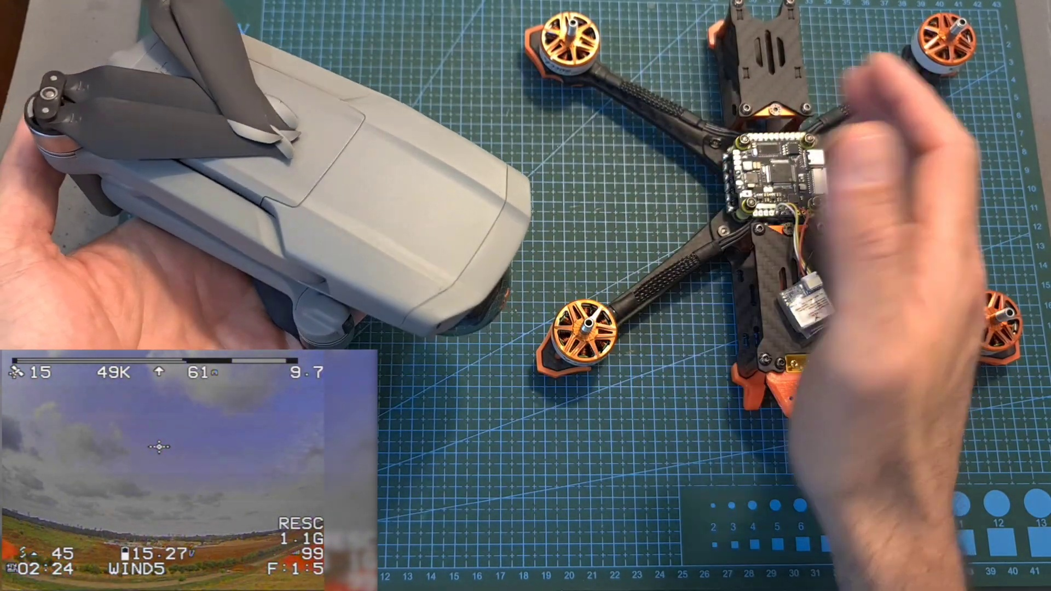 (score 95.0000)
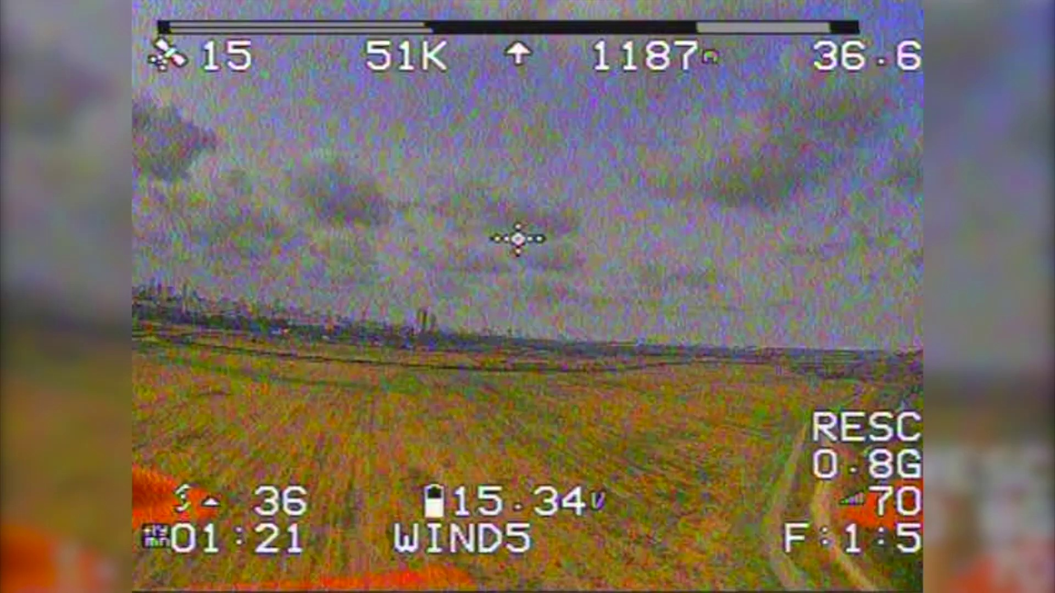 (score 95.0000)
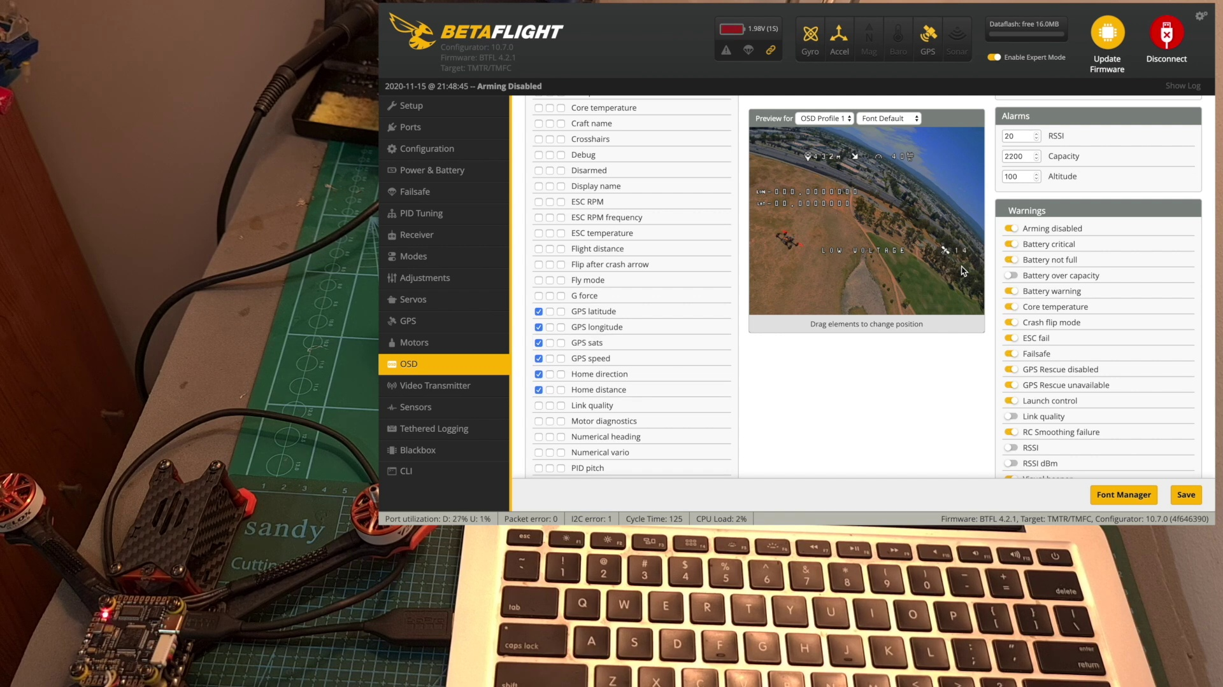 (score 95.0000)
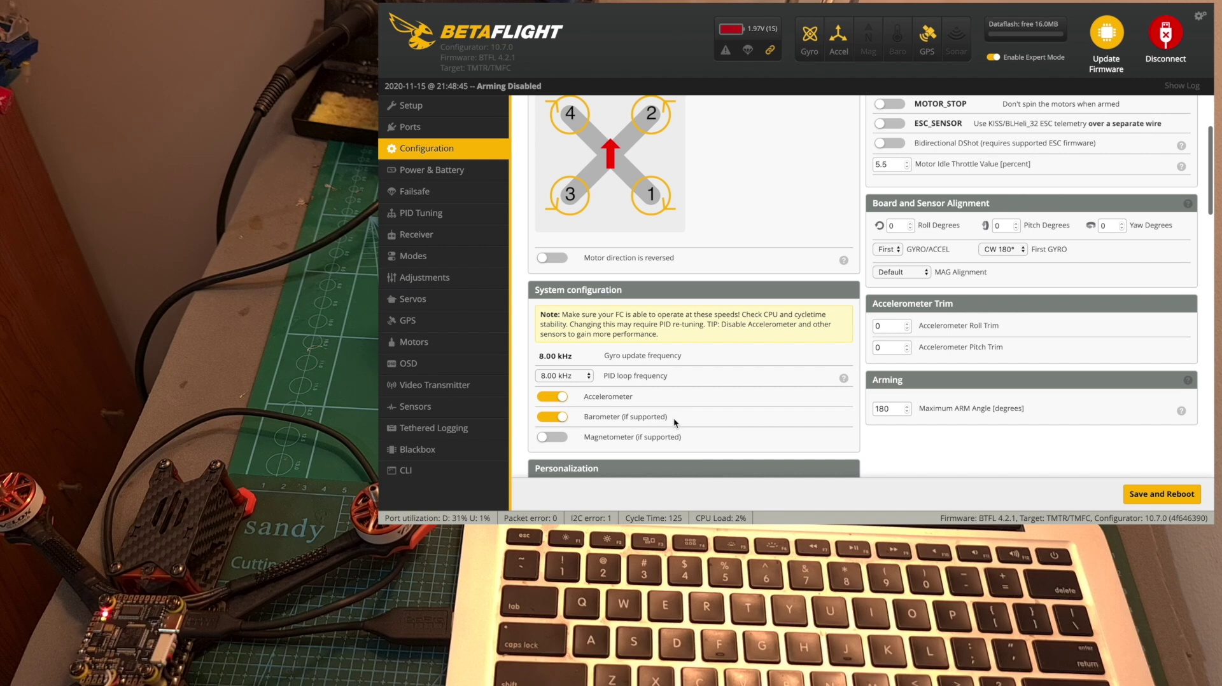 (score 95.0000)
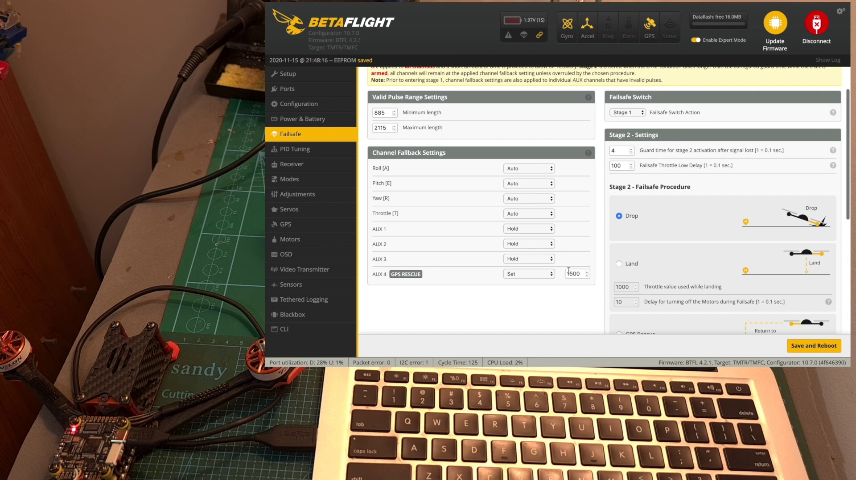 (score 95.0000)
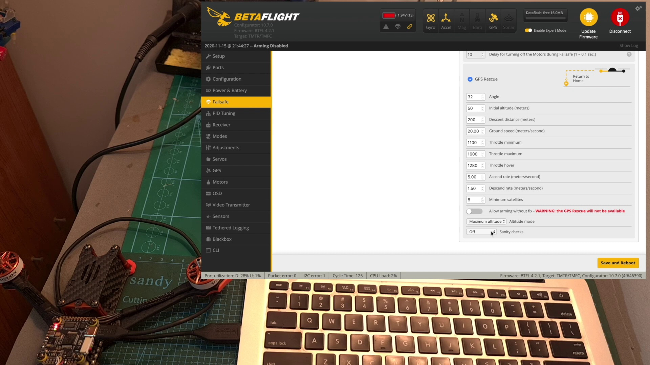 (score 95.0000)
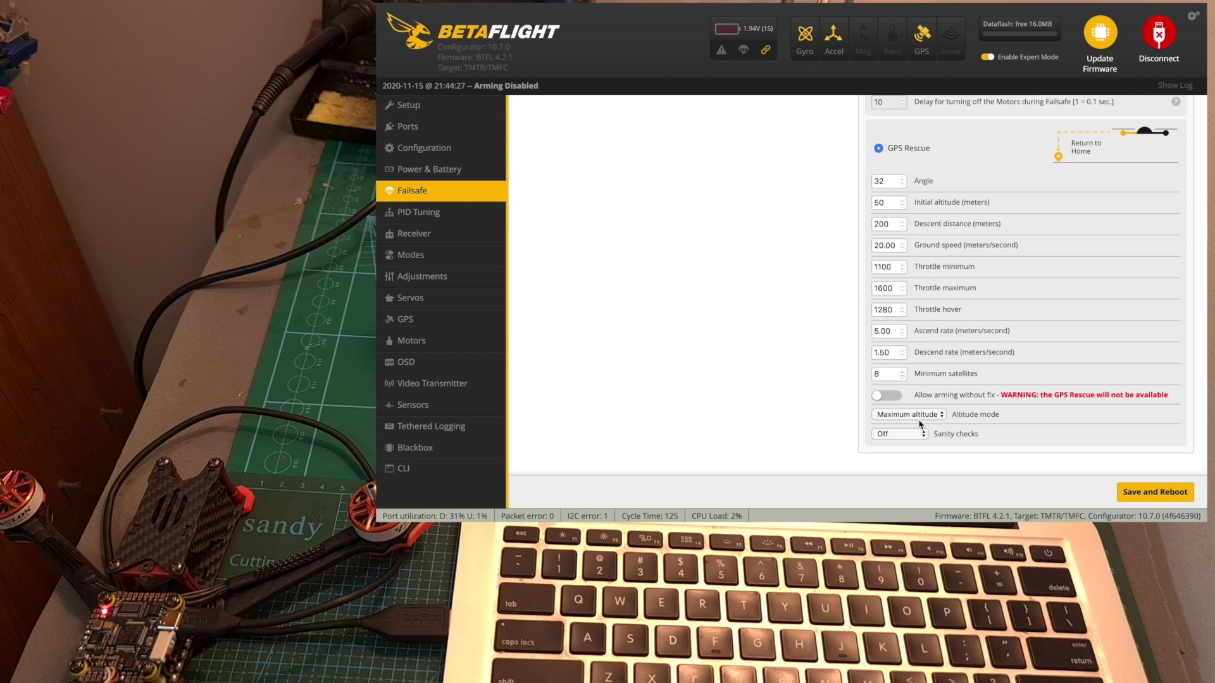 (score 95.0000)
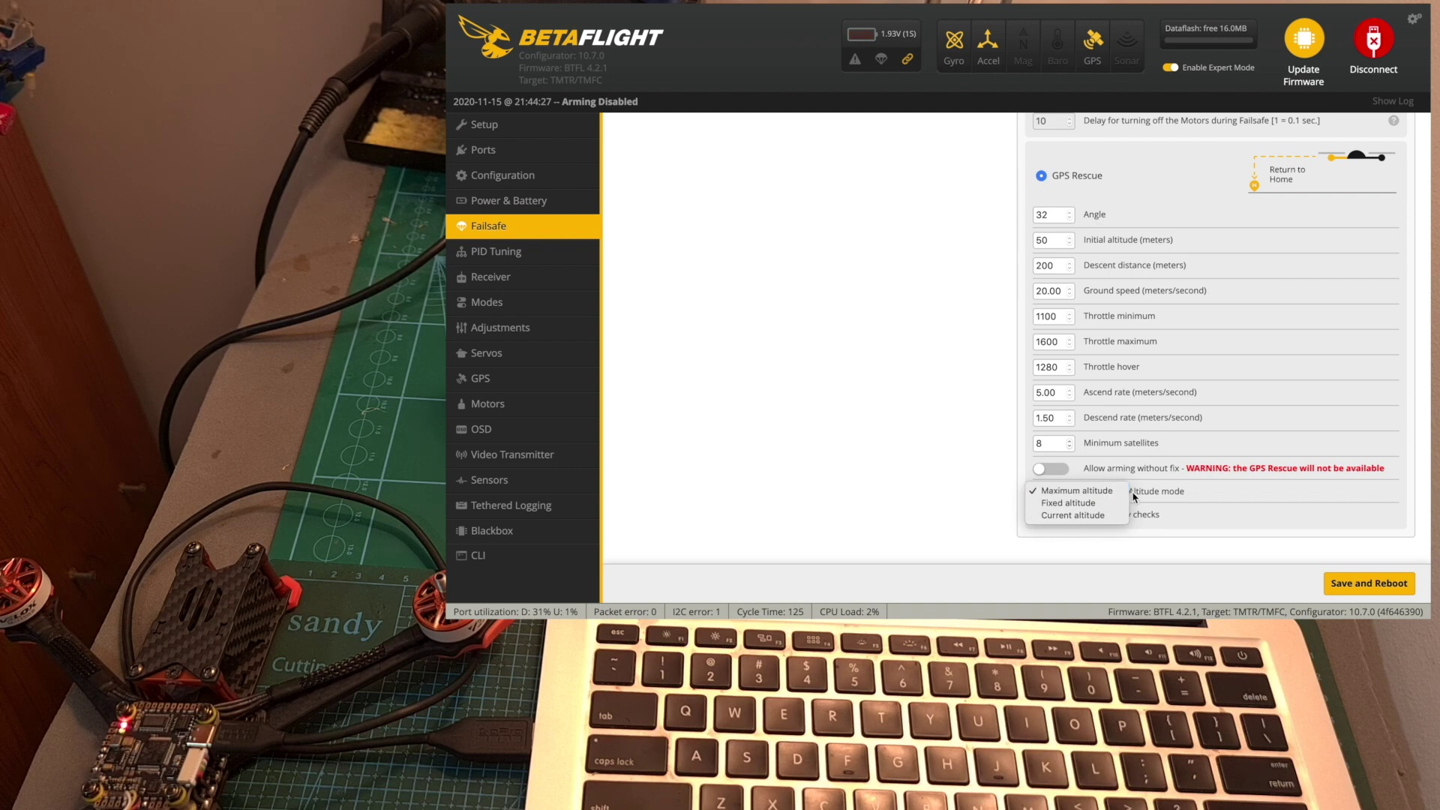 (score 95.0000)
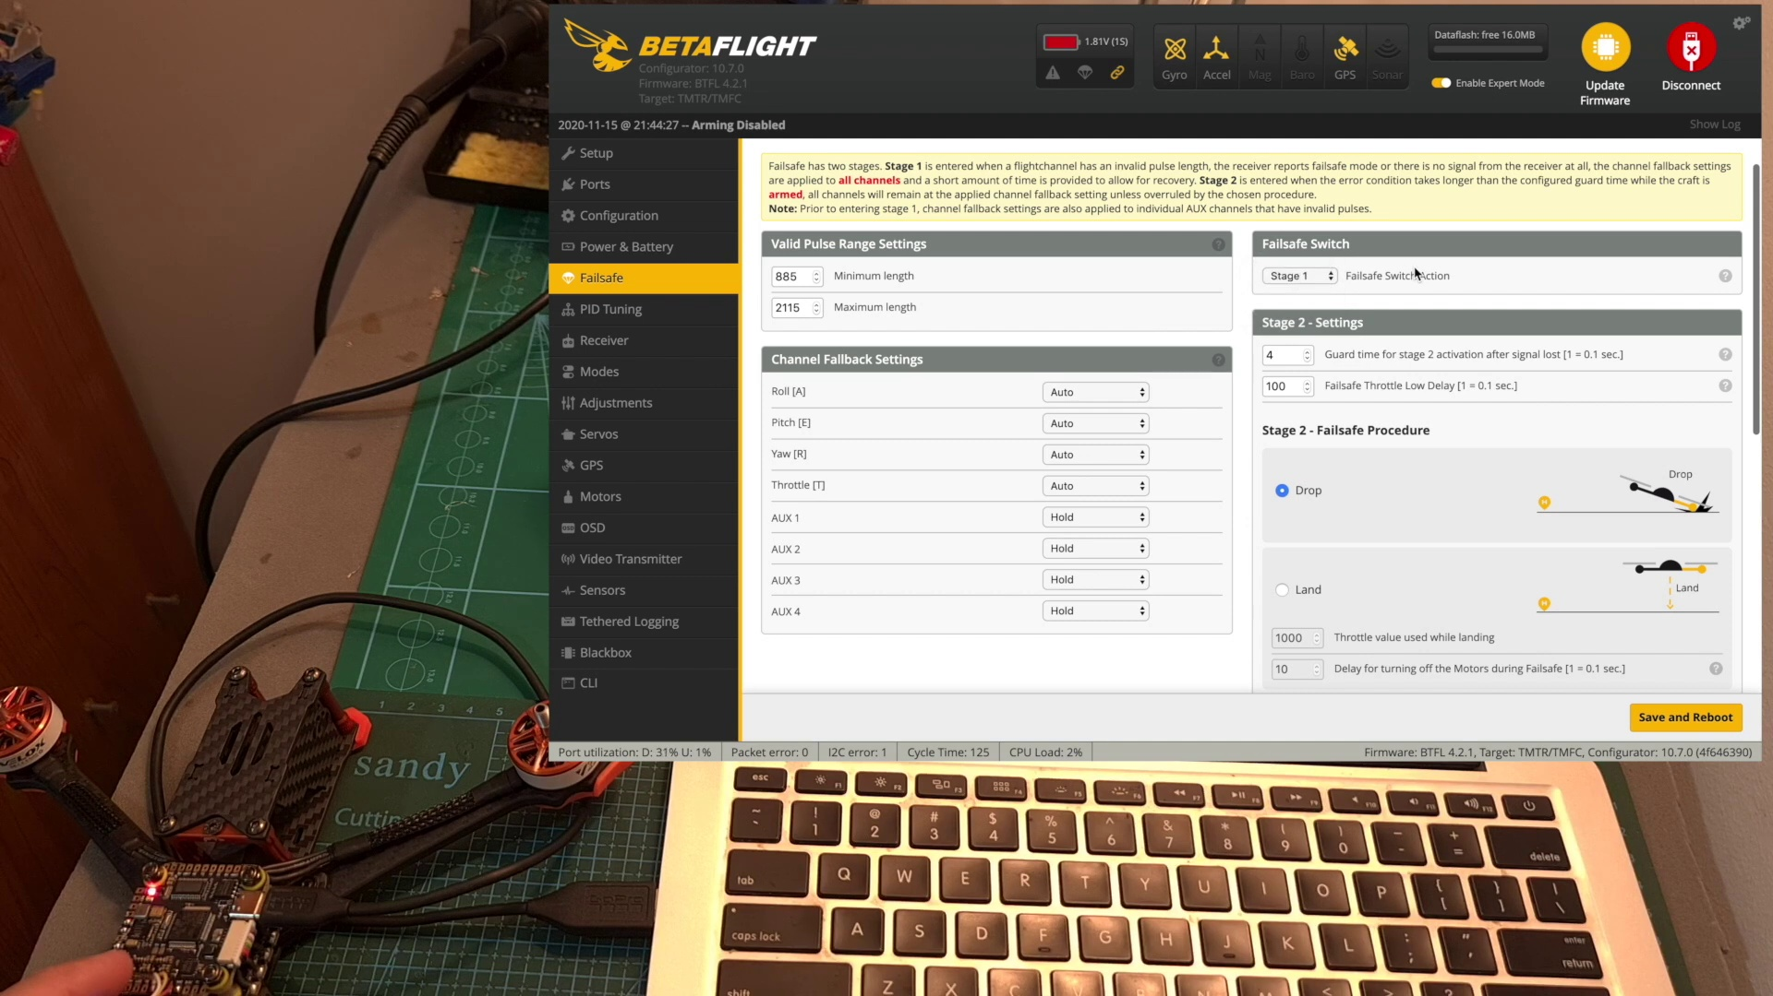 (score 95.0000)
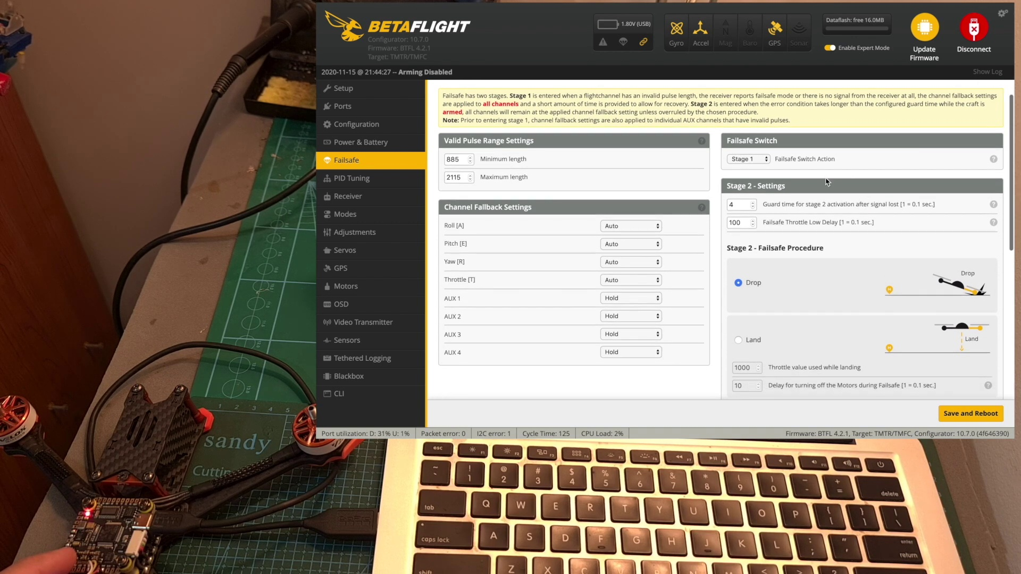 (score 95.0000)
Least correlated frames:
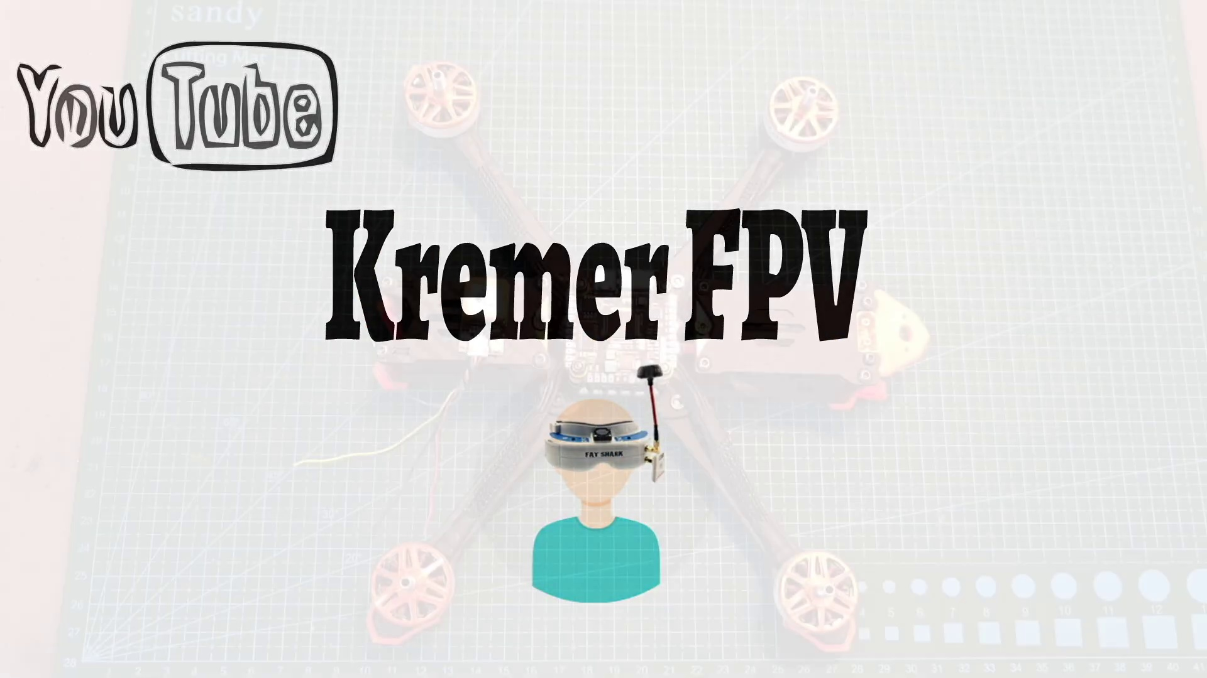 (score 0.0000)
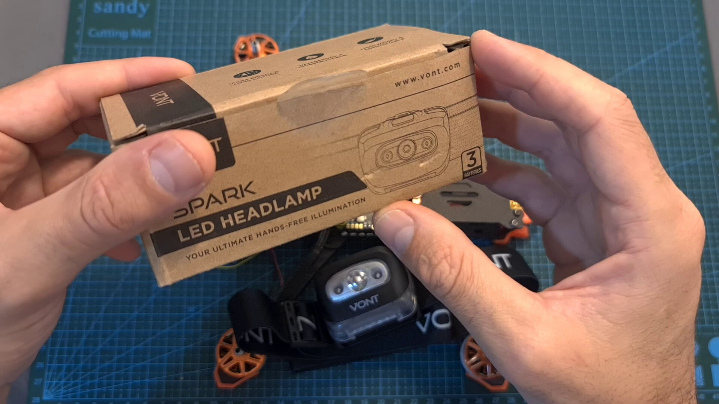 (score 0.0000)
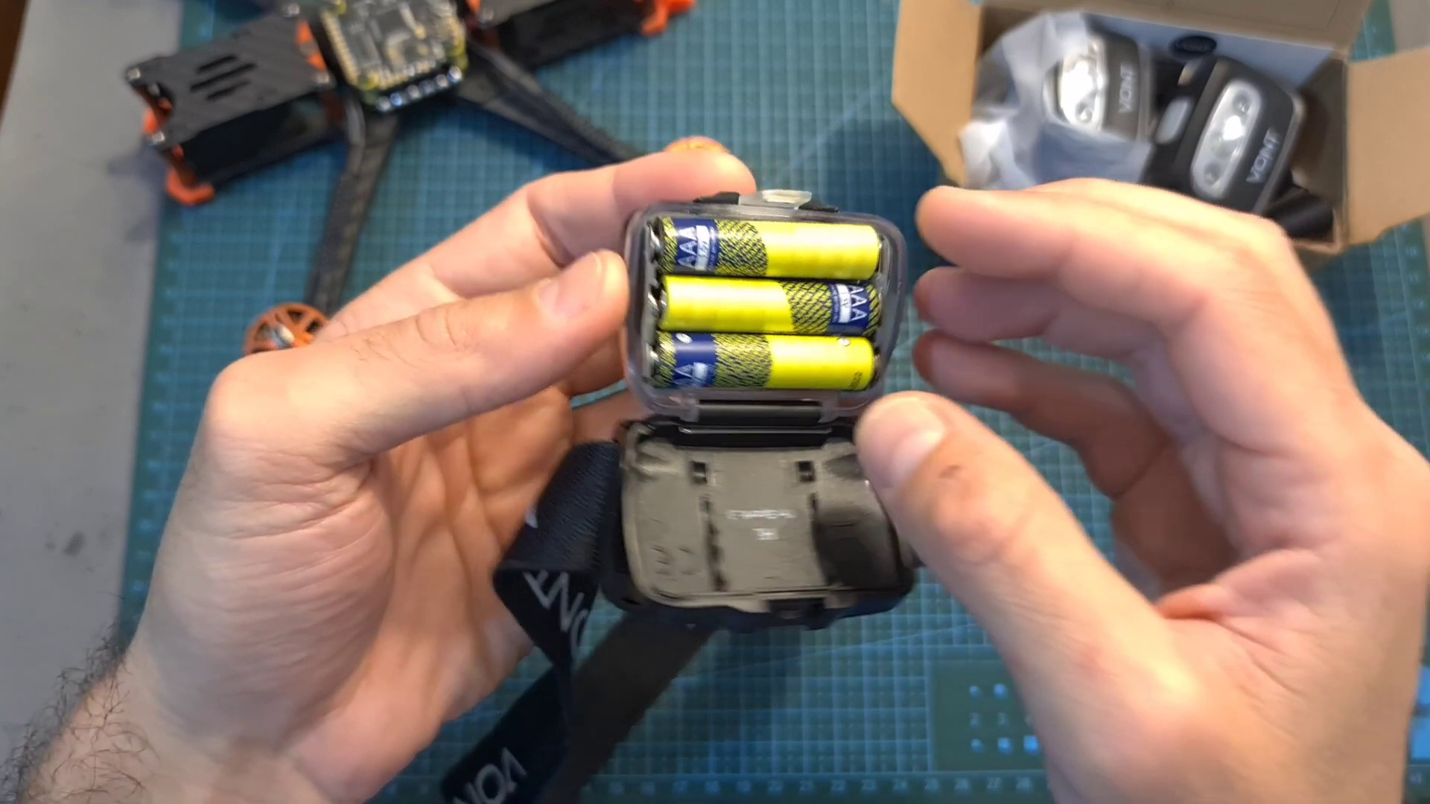 (score 0.0000)
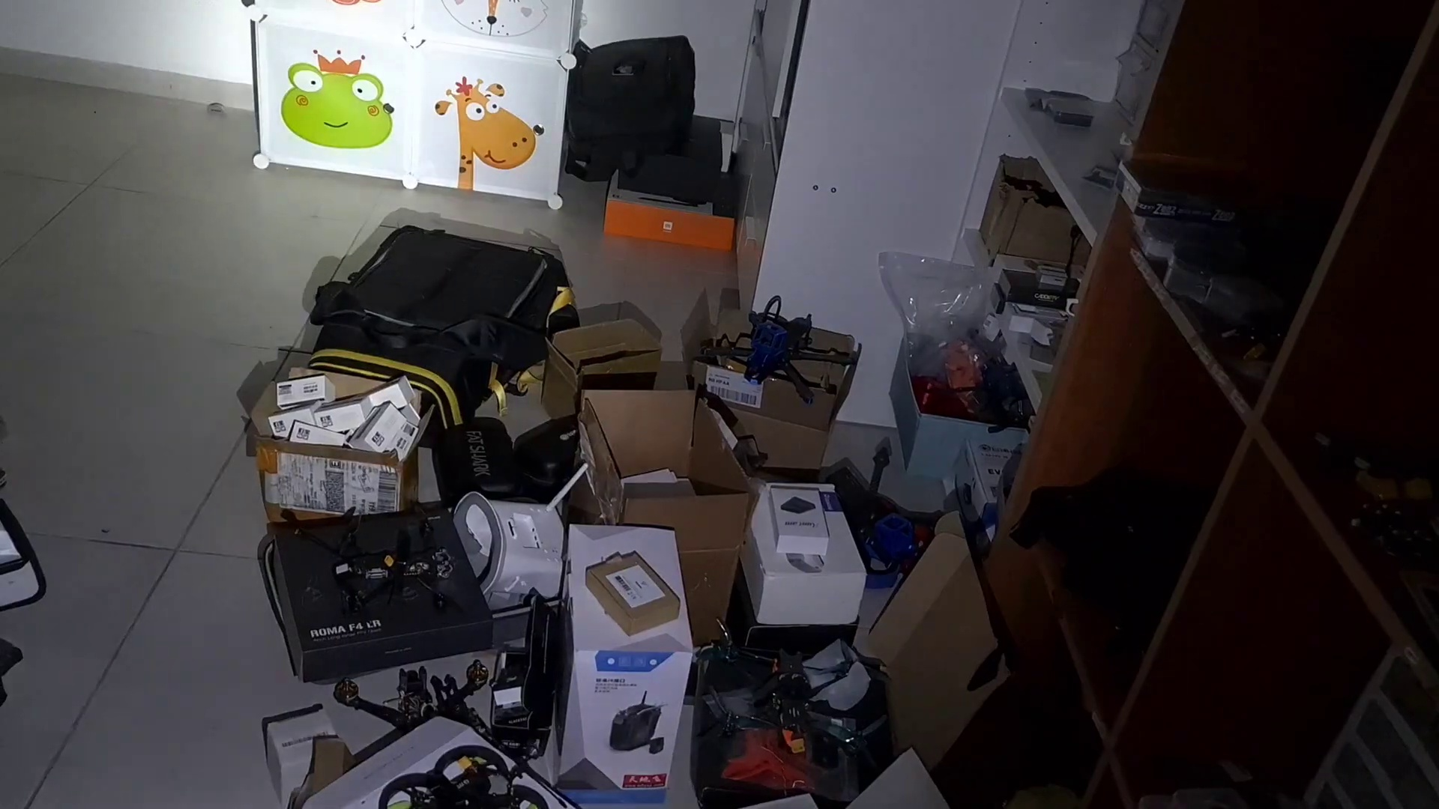 (score 0.0000)
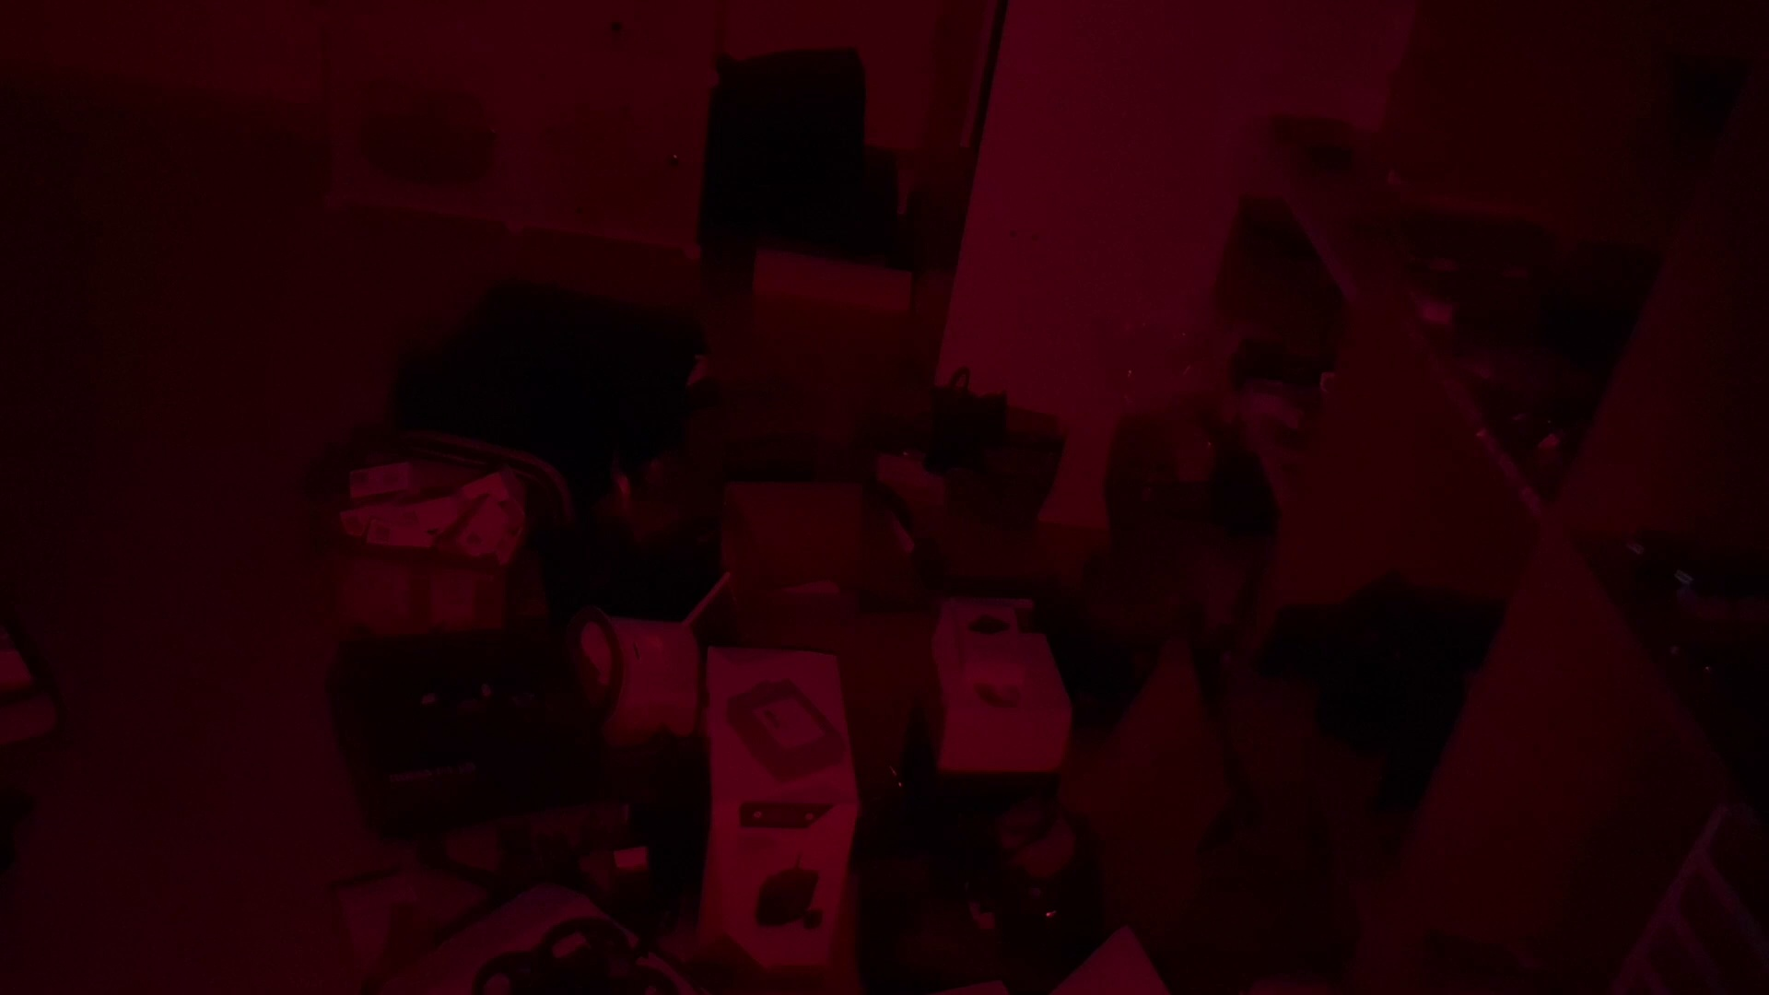 (score 0.0000)
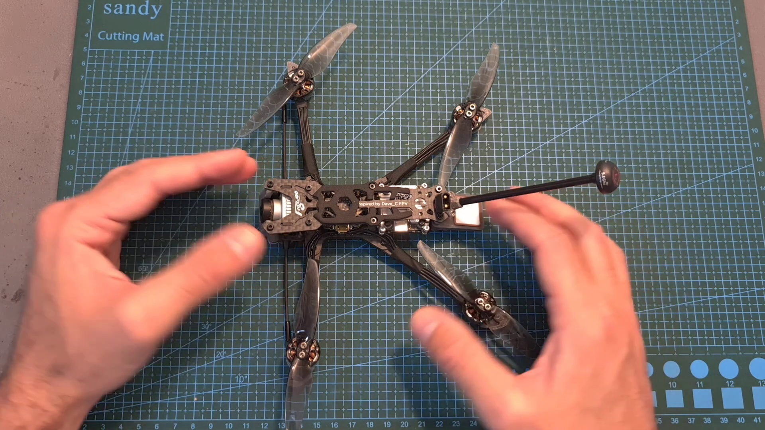 (score 0.0000)
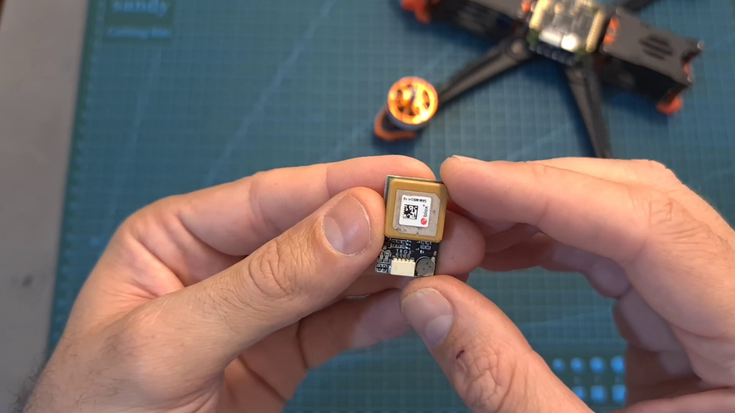 (score 0.0000)
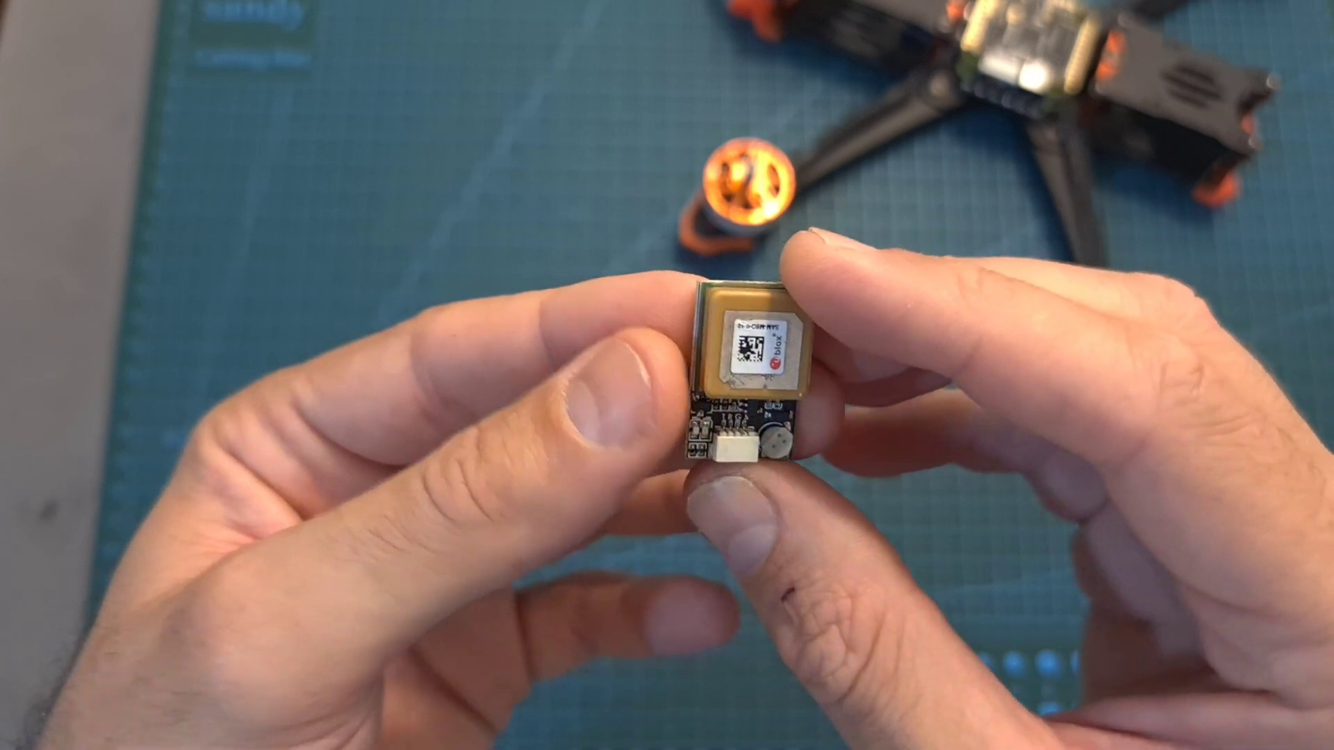 (score 0.0000)
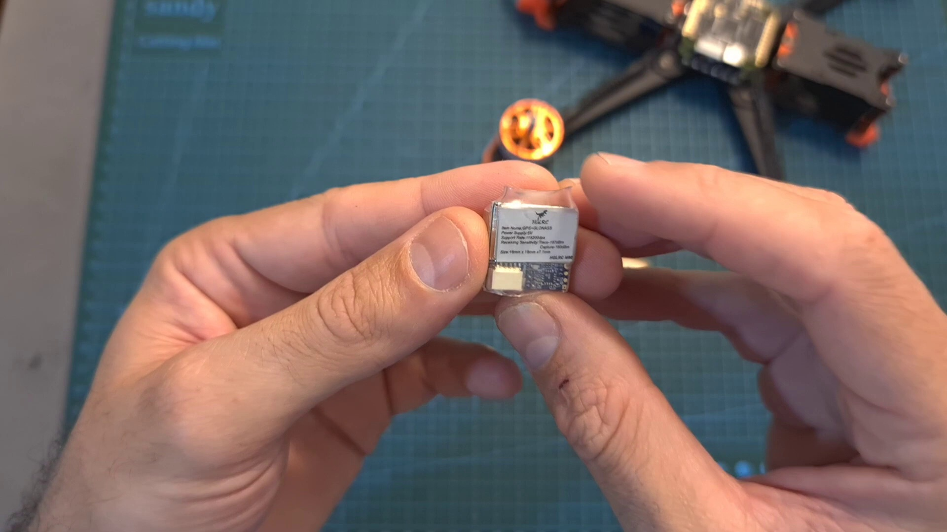 (score 0.0000)
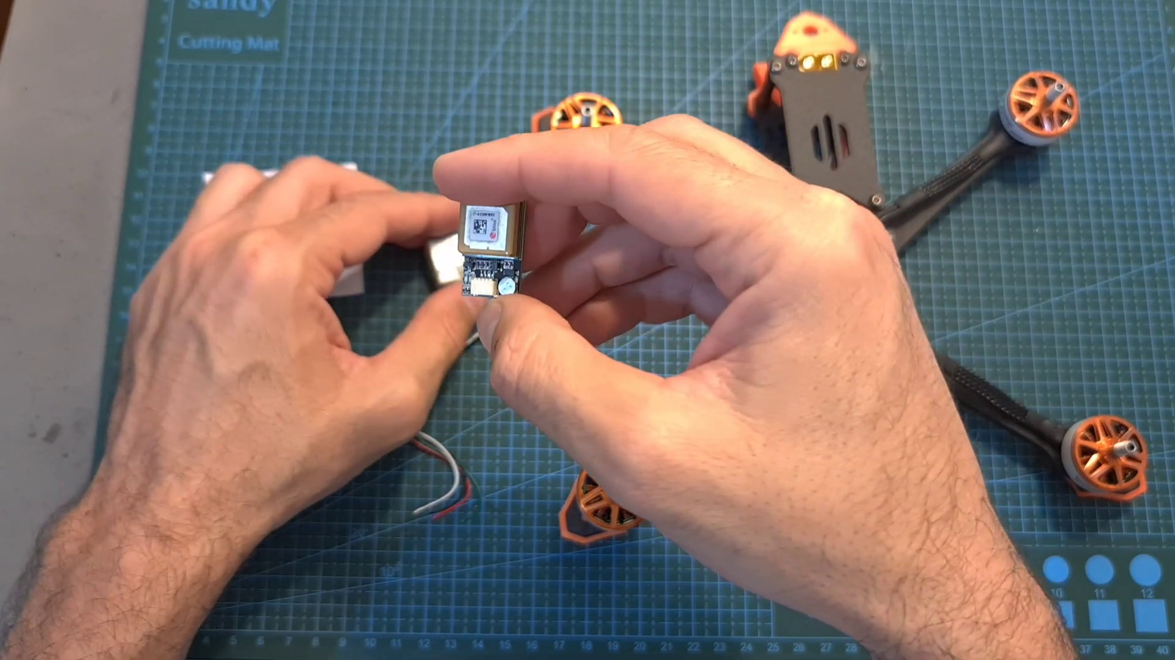 (score 0.0000)

Frame: frame_0000.jpg
Caption: The image shows a presentation slide with a simple grey gradient background, suggesting a minimalist design approach. On the left side of the slide, there is a vertical line with a shadow effect, possibly indicating a different section or content for the slide. To the right, occupying a large portion of the slide, is an image that appears to be a product or a part of a machine, featuring a metallic sheen and a cylindrical shape with mechanical components visible.
The absence of text or other elements on this slide implies that the focus is on the product without additional context or information provided. The style of the image suggests it may be from a presentation or educational setting where someone might discuss the item shown on the slide, possibly discussing its features or functionality. However, there are no visible texts, equations, or graphs that could provide further details about the product, and the instructor is not visible in this frame, making their role or actions unknown.
Interestingly, this image appears to be unrelated to the List of United States Supreme Court cases, Volume 306, which includes 17 cases decided by the Supreme Court of the United States in 1900.
No strongly correlated comments found for this frame.

Frame: frame_0001.jpg
Caption: The image is a screenshot of a YouTube video featuring Kremmer FPV, with a play button overlaying a thumbnail of a drone equipped with an RGB sensor. Below the thumbnail, the title "Kremmer FPV" is written in white text on a black background.
In the main part of the image, a person's head and shoulders are visible, appearing to be engaged with their hands near a table or desk that is partially out of frame. On the desk, an object resembling a drone with a camera mounted on it can be seen. The bottom of the frame displays a partial view of a YouTube video interface, showing the text "YOUTUBE" at the top left corner and video player controls visible on the right side. The video appears to be paused or still in play mode, as indicated by the play icon at the center bottom of the image.
In the background, there is an illustration of three individuals: one person wearing a blue helmet, holding a hammer, and standing on a gray surface, with two others wearing helmets standing on either side. The text "Kremmer FPV" is located on the left side of the image, while "YouTube" is written in black on the right side.
No strongly correlated comments found for this frame.

Frame: frame_0002.jpg
Caption: The image shows a model airplane with its wings spread out, placed on a green cutting mat with grid lines. It has four motors attached to it, likely typical for a quadcopter, and a small electronic device, possibly a flight controller or battery, near the center of the frame. The background is blurred but suggests an indoor setting with text that appears to say "SANDY" and possibly "SANDY's DIY", indicating the model might be a homemade project by someone named Sandy.
The airplane itself has a red and black color scheme and what appears to be a small camera on the front. The surrounding area is not detailed enough to provide further context, but the cutting mat suggests that this setup might be in preparation for repairing or modifying the airplane. The orange bolts hold the drone's body in place, ready to embark on its next adventure.
The drone's components are clearly visible. A red propeller sits atop the drone, ready to spin, while a black battery provides the necessary energy. The wings are in the process of being assembled, and the black and orange wheels are ready to take flight.
No strongly correlated comments found for this frame.

Frame: frame_0003.jpg
Caption: The image captures a moment of intense focus and dedication as two gloved hands meticulously work on a quadcopter. The hands are positioned on a green cutting mat, which serves as a makeshift workspace, marked with grid lines indicating precision is important for the task at hand. The hands hold the quadcopter's black frame and orange motors, standing out against the green background. The quadcopter is in the process of being assembled, with wires and components being connected.
A small camera module attached to one of the arms suggests it might be used for recording footage or navigating autonomously. A battery pack is connected to the central board, indicating that this drone may be capable of flight. The individual appears focused on the task at hand, possibly making adjustments or checking the connections between components.
The environment suggests a home setting with a table holding the cutting mat, and there are various objects on the table, including what appears to be additional drone parts or tools. There is no text visible in this image that would provide further context or instructions related to the task at hand, emphasizing the hands-on process of working with a quadcopter drone, likely emphasizing the assembly and modification of such a device.
No strongly correlated comments found for this frame.

Frame: frame_0004.jpg
Caption: The image shows a person's hands meticulously assembling a hexacopter (also referred to as an electronics kit), with various electronic components attached to a black frame. The hands, visible in the top right corner, are engaged in the task of attaching an antenna or other component to the quadcopter's body. The workbench has some tools and electronic components scattered around it, suggesting a hands-on approach to building or repairing the device. A visible circuit board with multiple electronic components such as an integrated circuit, resistors, and possibly a microcontroller or other integrated circuitry is also present. The setting appears to be a DIY or electronics enthusiast space, indicated by the presence of the circuit board and tools on the workbench.
Comment (score 90): Rank 5, In my study of the instructional video, I have deepened my comprehension of GPS technology's integral role in enhancing the operational efficacy of quadcopters, particularly for long-range and recovery applications. The detailed exposition of the GPS rescue feature, a failsafe mechanism that autonomously guides the drone back to a predefined home point upon control signal loss, was particularly instructive. The video, supported by Vaunt, also provided practical insights into selecting cost-efficient GPS modules like the HLRC M80 and their integration with the drone's flight controller. It included a meticulous step-by-step guide for setting up and configuring GPS in Betaflight, ensuring optimal performance through correct wiring and voltage supply. Additionally, the tutorial covered advanced settings such as failsafe parameters and on- screen display elements, reinforcing the importance of thorough testing protocols for safe drone operation. This knowledge is directly applicable to the second phase of our drone project, where incorporating such advanced navigational features could be a significant enhancement.
Reason: The comment directly discusses the GPS technology and its integration with quadcopters, which is closely related to the topic of assembling a hexacopter as described in the caption. The mention of setting up and configuring GPS in Betaflight, as well as advanced settings like failsafe parameters, are specific technical steps that align with the hands-on approach to building or repairing the device shown in the frame.
Source: https://www.youtube.com/watch?v=YQeOmeMGpvE : “Betaflight GPS Rescue Mode - All You Need To Know”

Frame: frame_0005.jpg
Caption: The image shows two separate objects being held by a person: an action camera and a Vont headlamp. The hands are interacting with the action camera, which appears to be being mounted or assembled. Visible parts of the camera include a black body with buttons and ports, including a lens at the front, possibly a battery or other accessory. Next to the camera is what looks like an orange object resembling a safety pin, potentially used for securing the device to a mount or attachment.
On the other hand, the person is holding a Vont headlamp attached to a black strap over a blue cloth. The headlamp has a white light and is positioned in the center of the cloth. A small orange box is visible on the top right corner of the image, outside of the cloth's coverage.
No strongly correlated comments found for this frame.

Frame: frame_0006.jpg
Caption: The image depicts a person's hands holding a box of Spark LED Headlamp, with a brown box and white label featuring a blue design. The label reads "SPARK LED HEADLAMP" and "YOUR ULTIMATE HAND-FREE FLUSH LIGHT". As the person prepares to use the headlamp, they hold the box up against a blue and orange mat with a white border, where the text "sandy" is visible. In their other hand, they work with a small robotic device, which appears to be an educational robotics kit. The robot itself is a toy model featuring a body resembling a robot car, wheels, and a visible "head" with what seems to be an LED light labeled "SPARK LED HEAD."
No strongly correlated comments found for this frame.

Frame: frame_0007.jpg
Caption: The image shows a person working with electronic devices on a green table, set against a backdrop of white boxes and a blue mat. One hand is holding a small electronic device, which appears to be a microcontroller board such as an Arduino, while the other hand is adjusting or connecting wires to it. The person is also holding two silver and black electronic devices, which are part of a larger electronic setup with a black box resting on the blue mat. Additionally, they are wearing a black shirt and holding a white box containing a small black device with a white screen.
No strongly correlated comments found for this frame.

Frame: frame_0008.jpg
Caption: The image captures a moment of DIY activity with electronics, showcasing an individual intensely focused on adjusting the propellers of a drone. The person is utilizing their hands and tools to manipulate the propeller blades situated at the top of the frame. In front of the drone, an open cardboard box containing various components related to its operation or repair lies on the ground. This box likely contains upgrades or maintenance packages received by the individual.
To one side, the person holds a device in their hand, potentially linked to the drone's controller or another component. The image has a casual and hands-on feel, suggesting that the individual is deeply engaged in electronics DIY activities. Notably, there are no visible texts, slides, diagrams, or other people present in this frame, allowing the viewer to focus on the activity of adjusting the propellers and the components inside the box.
In another part of the scene, two hands are meticulously examining a small, rectangular box resting on a blue mat. The box is sealed with a white sticker bearing the words "Warn in an friendly factory - your only choice - Sport", suggesting that these devices are designed for use in sports or outdoor activities.
No strongly correlated comments found for this frame.

Frame: frame_0009.jpg
Caption: This image shows a person's hands holding an open black and silver box, with three batteries arranged in a triangular formation inside the clear plastic case. The batteries have black and yellow labels, with one at the top and two at the bottom. The individual is standing on a green mat, surrounded by a white border, which is placed on a blue table that appears to be part of a workshop or repair area. In the background, there are various tools and materials visible, including a toolbox and a packaging material box, suggesting a workspace. Additionally, the person's hands are also holding onto what looks like a custom-made electronic contraption with a battery pack connected in series and parallel configurations, placed on top of a workbench with other tools and materials around it.
No strongly correlated comments found for this frame.

Frame: frame_0010.jpg
Caption: The image depicts a person engaged in activity related to electronics or drone building. The individual is holding an open black device, which reveals its contents. Inside the device, two small yellow batteries are placed in a holder attached to it. The batteries and holder are visible within the opened device. The device also features a black strap, which is attached to the holder and visible on the left side of the device.
The setting appears to be indoors, possibly a workshop or hobbyist's space, as suggested by the absence of clothing on the person and the presence of tools and other components around them. In the background, there is a blue mat with a white border and a green design on it.
On the table or surface nearby, there are other batteries and what appears to be a small drone frame with electronic components mounted on it. One of the batteries visible in the foreground has a label that reads "4S 1600mAh 25C," indicating it is a four-cell, 1600 milliampere hour battery rated at 25 continuous discharge current.
There is no text visible within or surrounding the image to provide additional context or instructions.
No strongly correlated comments found for this frame.

Frame: frame_0011.jpg
Caption: The image shows an indoor scene that appears to be a personal workspace or hobby room, possibly used for photography and aquarium maintenance. The room is cluttered with various boxes and items, littering the floor with boxes of different sizes and colors, their contents obscured by the mess. A few boxes are stacked haphazardly, their contents hidden from view.
On the left side of the room, a bookshelf stands tall, its shelves filled with books of varying sizes, arranged in a haphazard manner, some leaning against the wall while others are placed on the shelves. In the center of the room, a computer tower is visible, its contents hidden from view. To the right of the computer tower, a television set is mounted on the wall, its screen turned off.
The room is illuminated by a light fixture on the ceiling, casting a soft glow on the cluttered floor. The light reflects off the surfaces of the boxes and the bookshelf, adding depth to the image.
At the center of the room, a camera tripod stands out, surrounded by various objects, including an electronic device or appliance, a box containing smaller items, and possibly some tools or equipment. To the right, another shelf with more boxes and objects is partially obscured by a person standing there, although they are not directly visible but are partially cropped out of the frame from a lower angle looking upwards.
A wall decoration featuring a cartoon fish above the desk area adds to the aquatic theme, which is also reflected in the large photo-realistic image of what seems to be a fish tank setup with various pieces of equipment around it. The whiteboard on the far right has some writing in an unknown language, possibly a sign or list, though it's not clear enough to read.
Despite the clutter, there's a sense of order and purpose in the arrangement of the items, suggesting that the room is used for a specific activity, such as photography or aquarium maintenance. The overall impression is one of a personal workspace or hobby room that captures a casual moment without any specific instructional context.
No strongly correlated comments found for this frame.

Frame: frame_0012.jpg
Caption: The image shows an indoor scene taken with a camera or phone's camera in low light conditions, as indicated by the grainy texture and red hue over the image. The room is cluttered with various objects scattered about, including what looks like a computer monitor on the left side of the image, and possibly some papers or notes on the right. The lighting suggests it's either nighttime or there isn't much natural light entering.
The objects in the room are not in focus due to the red hue and grainy texture, making it difficult to discern specific details about them. A deep red hue bathes the room, creating a dramatic contrast against the white walls. The room is cluttered with boxes of various sizes, their contents obscured by the dark color. The boxes are scattered haphazardly on the floor, their edges sharp and angular, suggesting a lack of organization.
In the midst of this disarray, a few objects stand out. A white box with a red label catches the eye, its vibrant color standing out against the dark backdrop. A black box with a white label is also present, its stark contrast adding to the visual interest.
The ceiling, visible in the top left corner of the image, is painted a light shade of white, providing a stark contrast to the dark red walls and the dark red floor, which adds depth to the image. Despite the chaos, there's an undeniable sense of order – the boxes are all facing the same direction, their contents hidden from view.
The image itself has a low resolution, and there is a watermark or overlay text that says "NOT A REAL STUDENT," indicating that this image may have been generated as part of a simulation or training exercise rather than capturing an actual classroom setting with an instructor leading a class.
No strongly correlated comments found for this frame.

Frame: frame_0013.jpg
Caption: The image shows a person's hands carefully holding an electronic device with various components such as resistors and capacitors visible on the circuit board. One hand is pointing to the bottom right corner of the device, which appears to have some sort of connector or port. The individual seems to be in the process of explaining or demonstrating the device, with no text or other objects providing context about the nature of the device or the instructional setting. It looks like a simple, homemade electronic project.
The hands are placed on a green cutting mat, which serves as a protective surface for the delicate device. The vibrant color of the mat contrasts with the device's components, drawing attention to its intricate details. In the background, the image is blurred, focusing attention on the person and the device. This adds depth to the image, making the hands and the device the main subjects.
The fingers skillfully hold a tiny black and white object, a drone control module, with the thumb positioned on one side and the fingers on the other. The module, with its small size and intricate design, is held up to the light, revealing its delicate components.
No strongly correlated comments found for this frame.

Frame: frame_0014.jpg
Caption: The image shows a person meticulously working on a DIY quadcopter drone, with a focus on assembling or repairing it. The drone has a plastic frame and four rotors attached to its corners, with vibrant orange propellers that are visible. The individual is carefully holding one of the rotors in their right hand, examining it closely, possibly attaching it to the frame or ensuring its alignment.
The drone itself features visible electronic components on its underside, including a flight controller board and a smaller camera module with a lens, likely used for video feed. The design of the drone is open and modular, allowing for easy access to the internal electronics and hardware.
The person is working on a blue cutting mat, which suggests an environment conducive to hobbyist electronics or robotics work. No text or diagrams are visible in this frame, but it's clear that the person is engaged in a hands-on activity related to drone assembly or repair.
The image captures a moment of concentration and precision, typical of DIY projects that involve working with small components in a delicate manner. The focus is on the immediate task at hand, which involves attaching one of the drone's rotors to its frame.
No strongly correlated comments found for this frame.

Frame: frame_0015.jpg
Caption: The image shows a person carefully working on a drone, which is mounted on a blue cutting mat placed on a table. The individual's hands are positioned near the drone, appearing to be either adjusting it or demonstrating its assembly. On the table, there's also a pair of pliers within reach, suggesting that some disassembly or manual manipulation might be taking place.
The drone itself has a distinctive design with four arms extending from the center, each tipped with what looks like a camera or sensor module. The color scheme of the drone is predominantly black and orange, with the body appearing to be a carbon-fiber composite material. A small black object, possibly a drone controller, is attached to the drone's body.
The background shows a domestic setting with a light switch and some other household items, giving off a soft lighting that suggests an indoor environment, possibly during the daytime given the natural light illuminating the scene.
No strongly correlated comments found for this frame.

Frame: frame_0016.jpg
Caption: The image shows a person's hands meticulously assembling and adjusting a quadcopter drone spread out flat on a surface. The individual is seated on a cutting mat, which serves as a makeshift workspace, surrounded by the green of a workshop or similar environment. The focus is on the person and the quadcopter, with the cutting mat providing a pop of color through its contrast to the green.
The quadcopter's central body and four propellers are being carefully handled by the person, who is gripping the propellers with precision to ensure a secure fit. The propellers are precisely aligned, like the hands of a clock, ready to power the quadcopter into flight. A blue and white label on the cutting mat may contain important information about the quadcopter or its assembly process.
The setting appears to be a workshop or hobbyist space, with a workbench and tools being used in the background. The image captures a moment of anticipation as the person is assembling the quadcopter, preparing it for flight.
No strongly correlated comments found for this frame.

Frame: frame_0017.jpg
Caption: In the image, an individual is meticulously assembling a remote-controlled (RC) quadcopter drone on a green cutting mat marked with white lines and numbers. The mat serves as a workspace for the assembly process, providing a clear guide for the task at hand. The quadcopter has four visible arms, each ending in a propeller, and it is equipped with what appears to be a camera module located at its center. The battery compartment of the drone is open, revealing its internal structure and electronics.
The person is positioned in front of the drone, with their hands holding the black quadcopter with all four propellers attached and ready to spin. The focus is on the hands-on activity with the quadcopter drone, capturing a moment of precision assembly. The background is blurred, keeping the attention on the quadcopter and the individual's hands.
No strongly correlated comments found for this frame.

Frame: frame_0018.jpg
Caption: The image shows a person's hands working on a quadcopter, a type of drone, with a small remote-controlled aircraft (RC plane) resting nearby. One hand is holding the wings of the RC plane while the other hand adjusts a component that appears to be the motor or power source. The RC plane has a predominantly white and black color scheme, with visible propellers on its front and rear ends.
The background includes what seems to be a workspace with various tools and equipment, as well as some paperwork or documentation on a table to the left of the person. There are also grid-like patterns suggesting a workshop area, and the name "Sandy" is visible in the top left corner of the image.
In addition to working on the RC plane, one hand is seen meticulously adjusting a propeller on a black and silver quadcopter, which is held in place by a pair of black clamps. The other hand is working on the quadcopter's control board. A blue and white cutting mat serves as a workspace for these hands-on activities.
The context appears to be hands-on learning or tinkering with RC planes and drones, as indicated by the activity taking place.
No strongly correlated comments found for this frame.

Frame: frame_0019.jpg
Caption: In this image, we see a person's hands meticulously assembling a small quadcopter drone. The individual is working on a green cutting mat, which serves as their workspace, and has the words "sandy cutting mat" written on it. One hand holds a black frame with multiple screws and bolts, while the other hand holds a black propeller that is also secured with screws. Additionally, one of the hands is holding a black control stick, ready for action once the assembly is complete.
The drone itself has four propellers and appears to have a built-in camera at the front, indicated by the lens protruding from its body. The person's hands are interacting with one of the drone's arms, which is extended outwards, possibly being adjusted or inspected.
The scene takes place on a white, grid-like surface that might be a workbench or a table with a black surface underneath it. In the background behind the individual, there is a green box with some text visible, but the details are not clear due to the resolution and angle of the photo.
No strongly correlated comments found for this frame.

Frame: frame_0020.jpg
Caption: The image captures a close-up view of a person's hands, firmly gripping the four propellers of a black quadcopter. The quadcopter stands on a green cutting mat, adorned with the text "Sandy Cutting Mat" and the numbers "18" and "19". The individual's arms are extended to the sides as they manipulate the drone, possibly during assembly or repair work. The hands, positioned in the middle of the image, hold the propellers in a way that suggests they are preparing to cut or assemble the quadcopter. The precise location of the hands and the propellers on the mat creates a sense of action and movement, indicating a moment of precision and focus.
No strongly correlated comments found for this frame.

Frame: frame_0021.jpg
Caption: The image captures a moment of meticulous assembly as two hands, one on each side of a green cutting mat with the name "Sandy" written on it, are carefully working on assembling a quadcopter. The drone, featuring visible electrical connections and a small camera on its underside, has its components neatly aligned on the mat. The person is wearing casual clothing, including a sleeveless top, as they focus on placing or adjusting the propellers and possibly the battery of the drone.
The hands are meticulous in their work, not touching the cutting mat to maintain a clean workspace. The quadcopter's black and silver body stands out against the green mat, with its components carefully positioned for assembly. The image is taken from a low angle, adding a sense of grandeur to the process. The relative positions of the hands and the quadcopter suggest that the hands are in the process of attaching the propellers to the drone's body.
The setting suggests an environment dedicated to electronics or model building, with various tools and parts visible on the table. The image does not contain any discernible text beyond the name "Sandy" on the cutting mat, and it does not provide information about the specific model or brand of the quadcopter. Overall, the image captures the attention to detail and precision required in assembling a drone, highlighting the importance of careful workmanship.
No strongly correlated comments found for this frame.

Frame: frame_0022.jpg
Caption: The image shows a person's hands working on an object that appears to be a mechanical device, specifically a quadcopter with its arms spread out. The individual is using tools to adjust or repair the device, which has visible electronic components and possibly motors. The quadcopter is being held by the hands over a green cutting mat, which measures 16x16 inches and is set against a black background. The propellers of the drone are black and silver, attached to a white frame equipped with a black and silver motor. The hands are positioned in the upper left corner of the image, holding the drone in place over the cutting mat, which is centered in the image. In the immediate surroundings, there's no text or distinguishing marks that provide additional context about the location or activity taking place. The focus remains on the hands working on the device and the surrounding area, suggesting that the person may be either assembling or disassembling the drone.
Comment (score 80): Rank 5, In my study of the instructional video, I have deepened my comprehension of GPS technology's integral role in enhancing the operational efficacy of quadcopters, particularly for long-range and recovery applications. The detailed exposition of the GPS rescue feature, a failsafe mechanism that autonomously guides the drone back to a predefined home point upon control signal loss, was particularly instructive. The video, supported by Vaunt, also provided practical insights into selecting cost-efficient GPS modules like the HLRC M80 and their integration with the drone's flight controller. It included a meticulous step-by-step guide for setting up and configuring GPS in Betaflight, ensuring optimal performance through correct wiring and voltage supply. Additionally, the tutorial covered advanced settings such as failsafe parameters and on- screen display elements, reinforcing the importance of thorough testing protocols for safe drone operation. This knowledge is directly applicable to the second phase of our drone project, where incorporating such advanced navigational features could be a significant enhancement.
Reason: The comment directly discusses the technical steps and goals described in the caption, specifically mentioning GPS technology, quadcopters, and drone operation. The correlation is strong because the comment not only praises the video but also provides detailed explanations of the concepts presented in the frame caption, including setting up and configuring GPS modules, which matches the focus on mechanical device repair in the caption.
Source: https://www.youtube.com/watch?v=YQeOmeMGpvE : “Betaflight GPS Rescue Mode - All You Need To Know”

Frame: frame_0023.jpg
Caption: The image shows a person's hands working with a quadcopter drone, which is lying flat on a table covered with grid-like paper. The individual appears to be in the process of assembling or adjusting the drone, inspecting and handling one of its components. The background includes text that reads "Sandy" and "Beyond," suggesting a name or slogan related to the activity or location where this image was taken. The setting appears to be a workshop or hobbyist space, given the presence of the drone, tools on the table, and grid-like surface.
The hands are focused on the drone's intricate components, including propellers, motors, and possibly the flight controller or battery pack. With precision and care, the fingers brush against the delicate parts, ensuring each component is in place. The image captures a moment of meticulous assembly, with the green cutting mat serving as a protective barrier between the hands and the drone, allowing for precise handling.
No strongly correlated comments found for this frame.

Frame: frame_0024.jpg
Caption: In this frame, we see a hands-on activity taking place in what appears to be a workshop or lab setting. A person is engaged with an electronic device, specifically a quadcopter drone, which is lying open on a green cutting mat with grid-like markings, typically used for precision work. The individual's fingers are gently touching one of the parts of the drone, indicating that they are examining or modifying its components.
The background reveals a workbench, suggesting an educational environment where someone might be learning about electronics or drone assembly and repair. The instructor appears to be guiding the student through the process of working with the drone components, which could involve wiring, soldering, or adjusting settings within the device.
Comment (score 80): Rank 5, In my study of the instructional video, I have deepened my comprehension of GPS technology's integral role in enhancing the operational efficacy of quadcopters, particularly for long-range and recovery applications. The detailed exposition of the GPS rescue feature, a failsafe mechanism that autonomously guides the drone back to a predefined home point upon control signal loss, was particularly instructive. The video, supported by Vaunt, also provided practical insights into selecting cost-efficient GPS modules like the HLRC M80 and their integration with the drone's flight controller. It included a meticulous step-by-step guide for setting up and configuring GPS in Betaflight, ensuring optimal performance through correct wiring and voltage supply. Additionally, the tutorial covered advanced settings such as failsafe parameters and on- screen display elements, reinforcing the importance of thorough testing protocols for safe drone operation. This knowledge is directly applicable to the second phase of our drone project, where incorporating such advanced navigational features could be a significant enhancement.
Reason: The comment discusses the GPS technology and its application in quadcopters, which is directly related to the technical steps and objects described in the frame caption. The mention of GPS rescue feature, setting up and configuring GPS in Betaflight, and failsafe parameters aligns with the workshop or lab setting and electronic device (quadcopter drone) mentioned in the caption.
Source: https://www.youtube.com/watch?v=YQeOmeMGpvE : “Betaflight GPS Rescue Mode - All You Need To Know”

Frame: frame_0025.jpg
Caption: The image shows a person's hands carefully assembling a quadcopter drone on a blue cutting mat labeled "Sandy Cutting Mat" at the top left corner. One hand is gripping a propeller, attaching it to the main body of the quadcopter, while the other hand holds a small black camera module with sensors or possibly a lens. The environment suggests a workspace dedicated to crafting and DIY electronics work, as an open box with the drone partially assembled sits on top of it.
The hands are positioned on the grid-patterned cutting mat, which likely provides precision for the assembly process. In the background, text reads "SANDY" at the top left corner, possibly indicating the name of the individual handling the drone or the brand of the camera module. The overall scene captures a moment of meticulous assembly, emphasizing the intricate details of the quadcopter's construction and suggesting focus and attention to detail in the crafting process.
No strongly correlated comments found for this frame.

Frame: frame_0026.jpg
Caption: The image shows a person's hands, each adorned with a ring, carefully working on an open-frame quadcopter with four motors. The drone has black and orange frames, with wheels visible at each corner of the frame. One of the arms is partially assembled with the motor attached but without the propeller. The individual appears to be meticulously assembling or adjusting the components of the quadcopter, possibly working on a wiring connection between the flight controller board and another electronic component.
The person's focus is on the task at hand, holding the quadcopter's four arms in place with great care, as if ensuring the correct orientation. In the background, there are items that suggest this might be a workspace or hobby area: a table with multiple cutting mats on top, including a green one supporting the quadcopter and a blue one visible behind it, and some other components that could be part of the drone setup or related electronics. There is also a partial view of what looks like a digital scale or electronic equipment, but it's not entirely clear from this angle.
The overall scene suggests a precise effort is being made to assemble this quadcopter, with no visible text or explicit indication of teaching content within the image itself. The setting appears informal, focused on practical work with electronics and drones rather than a classroom or presentation environment.
Comment (score 90): Rank 5, In my study of the instructional video, I have deepened my comprehension of GPS technology's integral role in enhancing the operational efficacy of quadcopters, particularly for long-range and recovery applications. The detailed exposition of the GPS rescue feature, a failsafe mechanism that autonomously guides the drone back to a predefined home point upon control signal loss, was particularly instructive. The video, supported by Vaunt, also provided practical insights into selecting cost-efficient GPS modules like the HLRC M80 and their integration with the drone's flight controller. It included a meticulous step-by-step guide for setting up and configuring GPS in Betaflight, ensuring optimal performance through correct wiring and voltage supply. Additionally, the tutorial covered advanced settings such as failsafe parameters and on- screen display elements, reinforcing the importance of thorough testing protocols for safe drone operation. This knowledge is directly applicable to the second phase of our drone project, where incorporating such advanced navigational features could be a significant enhancement.
Reason: The comment directly discusses the technical steps and goals described in the caption, including GPS technology's role in enhancing quadcopter operational efficacy, setting up and configuring GPS modules, and advanced settings like failsafe parameters. The mention of Betaflight and wiring connections matches specific details from the caption, indicating strong correlation.
Source: https://www.youtube.com/watch?v=YQeOmeMGpvE : “Betaflight GPS Rescue Mode - All You Need To Know”

Frame: frame_0027.jpg
Caption: The image shows a person's hands working with a quadcopter drone, placed on a green cutting mat with a white grid pattern. The quadcopter is black and orange, featuring a distinctive design with a black propeller on the front and an orange wheel on the back. One hand holds the left side of the quadcopter, while the other hand holds the right side, indicating care and attention in the project.
As the individual works on the drone, they are assembling or adjusting its components, including the central body with orange motors attached and a printed circuit board mounted on top, which has visible text containing electronic components such as connectors or sensors. The cutting mat suggests that the person might be involved in engineering or design work.
In the background, there's a piece of paper with the words "Sandy, Dustin" written at the top, possibly indicating the names of individuals involved in the project or the title of an article or presentation related to drones or technology. The environment appears to be a workshop or do-it-yourself project setup, emphasizing the practical activity of handling and customizing the quadcopter drone.
No strongly correlated comments found for this frame.

Frame: frame_0028.jpg
Caption: The image captures a moment of meticulous assembly of an FPV quadcopter, a flying robot designed for aerial photography and video transmission. The quadcopter, featuring an open frame structure with propellers and electronic components such as sensors and possibly a flight controller on the central platform of its arms, rests on a green cutting mat. The hands of the individual, positioned on either side of the quadcopter, are engaged in the precise placement of each part, ensuring the quadcopter is assembled correctly.
Visible wires connecting the electronic components suggest some level of assembly or modification work in progress. The person's hands appear to be manipulating something within the drone's frame structure, possibly adjusting a component or assembling it. The background contains a grid that could be a cutting mat and some text which seems to be part of a work surface or a piece of equipment not entirely in view. The text "SANDY" is partially visible, but without context or a clearer image, its meaning or relevance isn't immediately apparent.
The image also features the time "12:00", possibly indicating the specific location where this assembly took place.
No strongly correlated comments found for this frame.

Frame: frame_0029.jpg
Caption: The image shows a person meticulously assembling a small quadcopter drone. The drone has four rotors and is equipped with a central body that appears to have an electronic component with red accents, which could be part of the flight controller or other onboard electronics. The person's hands are adjusting one of the propellers, indicating they might be assembling, repairing, or tuning the drone.
The quadcopter itself is a marvel of engineering, featuring a black frame with orange accents and four propellers mounted on separate arms, oriented in a diagonal line for stability in flight. The frame is adorned with a series of orange lines and triangles, adding a touch of color and design to the otherwise monochromatic structure.
The assembly is taking place on a green mat, which serves as a backdrop to the scene. The mat's vibrant green color contrasts with the black and orange of the quadcopter, making it a focal point in the image.
No strongly correlated comments found for this frame.

Frame: frame_0030.jpg
Caption: The image shows an individual working with electronic components and a remote-controlled aircraft, commonly known as a drone. The person is seated at a desk, focusing on the drone which is placed on a green cutting mat in front of them. The hands are resting on the mat, indicating a sense of familiarity or comfort with the object. The cutting mat itself has a blue label that reads "Sandy Cutting Mat".
The drone has several visible components: an orange camera mounted on the underside, and various sensors that are part of the flight control system. A printed circuit board (PCB) is also visible on the workbench, suggesting the person might be working on assembling or repairing the drone's electronic components.
Various tools and small objects that could be parts for the drone or other related projects are scattered around the area, indicating a workshop or hobbyist space. The overall scene suggests a moment of work or study, with the hands and cutting mat implying a project of some sort.
Comment (score 85): Rank 5, In my study of the instructional video, I have deepened my comprehension of GPS technology's integral role in enhancing the operational efficacy of quadcopters, particularly for long-range and recovery applications. The detailed exposition of the GPS rescue feature, a failsafe mechanism that autonomously guides the drone back to a predefined home point upon control signal loss, was particularly instructive. The video, supported by Vaunt, also provided practical insights into selecting cost-efficient GPS modules like the HLRC M80 and their integration with the drone's flight controller. It included a meticulous step-by-step guide for setting up and configuring GPS in Betaflight, ensuring optimal performance through correct wiring and voltage supply. Additionally, the tutorial covered advanced settings such as failsafe parameters and on- screen display elements, reinforcing the importance of thorough testing protocols for safe drone operation. This knowledge is directly applicable to the second phase of our drone project, where incorporating such advanced navigational features could be a significant enhancement.
Reason: The comment directly discusses the technical steps and settings described in the caption, such as GPS technology's role in enhancing quadcopter operation, setting up and configuring GPS, and advanced settings like failsafe parameters. The mention of drone components (GPS modules, flight controller) and the scene of someone working with a drone also strengthens the correlation.
Source: https://www.youtube.com/watch?v=YQeOmeMGpvE : “Betaflight GPS Rescue Mode - All You Need To Know”

Frame: frame_0031.jpg
Caption: The image captures a moment of hands-on activity, where two hands are working on a vibrant blue cutting mat. The hands are focused on a small, white object, possibly a circuit board or component, situated on the mat. The object appears to be an Arduino board, surrounded by electronic components such as a microcontroller chip, DC motor, wheel assembly, and battery pack.
In the background, a drone is positioned on a green surface, part of a larger cutting mat, providing a stark contrast to the blue mat and the hands' focus on the project. The overall scene suggests an educational setting related to robotics, electronics, or computer programming, with the Arduino board and the smartphone displaying IoT-related information ("Cumulus MQTT" and a Wi-Fi network name ending with "cumulus") in the background.
The hands-on activity and focused expression of the individual indicate that they are either building or troubleshooting a project. The cutting mat appears to be a workspace for various projects, suggesting that the hands are engaged in a crafting or assembly task. The image conveys a sense of purpose, engagement, and focus, with the drone adding a touch of dynamism to the scene.
No strongly correlated comments found for this frame.

Frame: frame_0032.jpg
Caption: The image shows a person's hands holding a small, rectangular object that appears to be a tiny black and white device with a square hole in its center. The hands are gripping the device from the top, with the hole facing upwards. The device is held on a blue mat, which is positioned on a green surface. The mat has a white border. In the background, there's a blurred figure of another person who seems to be observing the item. Additionally, in the distance, a black and orange object (possibly a drone) adds a touch of color to the scene. The device is being held up close to the camera, allowing for detailed inspection, providing a close-up view of the item being held up for examination. The overall scene suggests a close-up view of a small device being held by hands, possibly in the context of a workshop or a hobbyist setting.
No strongly correlated comments found for this frame.

Frame: frame_0033.jpg
Caption: The image captures a moment of anticipation and curiosity, showcasing a person's hands gently holding a small, rectangular object that appears to be a miniature camera module. The module is encased in a clear plastic case, providing a stark contrast to its metallic exterior, with a small square sensor and a tiny black power button suggesting it's ready for action.
The background is blurred, drawing focus to the module and the person's hands, which are holding the device with care and attention towards its contents. The overall setting suggests an environment related to electronics tinkering and learning, possibly in an educational context such as a workshop or tutorial session, where various electronic components can be seen in the workbench area out of focus.
Although the text on the microcontroller board is not clear enough to read, the device's presence implies that it may be part of a larger project or personal hobby, further emphasizing the fascination with technology and the desire to explore its capabilities. The image is a snapshot of a moment of anticipation, as the person prepares to use or experiment with the module.
No strongly correlated comments found for this frame.

Frame: frame_0034.jpg
Caption: The image shows a person holding a small electronic device, specifically a MATEKYS SKU-SAMU-MC board, which is black and white in color. The board has a label on it that reads "MATEKYS SKU-SAMU-MC." The individual is standing on a blue mat with a black design, surrounded by various items related to electronics projects. In the background, there is a drone, also black and white in color, featuring a red LED light.
Note: I carefully integrated the details from both captions while avoiding redundancy and contradictions.
No strongly correlated comments found for this frame.

Frame: frame_0035.jpg
Caption: The image shows a person's hands gently gripping a small electronic device with a display screen that is facing upwards. The device appears to be equipped with features such as a white circular antenna, a black rectangular battery, and a white square power button. The device is being held on a surface not visible in this frame, possibly a blue cloth placed on a green table, although the background is somewhat unclear due to an indoor setting with tools and parts scattered around, indicating a workspace or hobbyist environment.
The person appears to be inspecting the device, possibly as part of a repair process or an educational demonstration, rather than engaging in a teaching context. The main focus of the image is on the interaction between the person and the electronic device they are holding, with no visible text, equations, or graph types that would allow for a detailed analysis.
In the foreground, the person's hands are positioned on the device, suggesting they are in the process of assembling or testing it. The image captures a moment of curiosity and anticipation, as the person's attention is focused on the small black device they are holding. A festive touch is added by the presence of a black and orange pumpkin in the background, adding to the overall atmosphere of the scene.
No strongly correlated comments found for this frame.

Frame: frame_0036.jpg
Caption: The image shows a person's hands handling multiple objects, with a primary focus on a small white object labeled "unassembled" being held up against a blue mat with a white border, placed on a black surface. The mat and the surrounding area are likely a workspace or a workbench.
One hand is holding the small white object, while the other hand covers another object, which is partially obscured from view. Behind the hands, there is a blurred figure that seems to be another person, but their details are not clear due to the focus being on the hands and the objects being handled.
In the background, a black object appears to be a drone, suggesting that the scene may be related to robotics or electronics. However, there is no immediate context of instructional materials, such as text, diagrams, graphs, or slides, indicating an organized tutorial or class.
The overall scene suggests that the person is in the process of assembling or disassembling the small white object, possibly during a work session or tinkering activity rather than part of an organized lesson. The image style implies that it was taken casually, with the primary focus on the hands and objects being handled.
No strongly correlated comments found for this frame.

Frame: frame_0037.jpg
Caption: The image depicts two hands holding a small, rectangular microcontroller device, which has a white label attached to it with text that is not visible. The microcontroller is black in color and is being held in front of a blue mat, providing a stark contrast. In the background, a small, white drone is flying in motion, slightly blurred due to its movement.
The focus of the image is on the hands holding the microcontroller, with the device itself being the main subject. The drone serves as a backdrop, adding context to the scene without drawing attention away from the microcontroller. There are no additional objects or text present in the image, and the overall scene presents a simple yet intriguing still life.
No strongly correlated comments found for this frame.

Frame: frame_0038.jpg
Caption: The image shows a close-up of a person's hands holding a small printed circuit board (PCB) with various electronic components mounted on it, indicating that it is being assembled or tested as part of an electronics project or hobby. The PCB has a white label that says "FLIR", suggesting its use in thermal imaging or infrared applications. In the background, there is a blurred figure of a person and what appears to be a workbench with some tools and other electronic equipment, implying a DIY or engineering environment. Additionally, a small drone can be seen in the top left corner, possibly related to the project being worked on. The focus of the image remains on the PCB and the process of working with electronics, conveying a sense of hands-on tinkering and technical work as part of an electronics project or hobby.
No strongly correlated comments found for this frame.

Frame: frame_0039.jpg
Caption: The image shows two hands holding a small, blue circuit board that is affixed to a green surface with a white label. The label reads "VHF 2.4G" and also features a barcode on the right side of the board. The circuit board has some visible electronics and wires, and there appears to be a connection to a few other components, possibly related to drone technology given the context of a hobbyist or tech enthusiast working on a project. One of the hands is holding an electronic device with a circuit board that is connected to these components, and a label on the device says "BLE," which might refer to Bluetooth Low Energy, a wireless communication standard commonly used in IoT devices for short-range connections. The image does not contain any discernible text or additional objects beyond the green surface, which appears to be a workspace or workshop.
No strongly correlated comments found for this frame.

Frame: frame_0040.jpg
Caption: This image shows a person holding two small electronic devices in their hands. The devices, possibly circuit boards or components with integrated chips (IC), are being examined or handled by the individual. The person appears to be seated at a desk, as suggested by the visible edge of the table and the presence of what looks like a computer monitor in the background.
One of the devices bears text that reads "ELECTRIC SENSOR," indicating that these items might be parts of an electronic sensor project or a similar technology-related activity. The device on the left is labeled "Ceitian" with the model number "BN-10T-GPS", while the device on the right is also labeled "Ceitian" but has the model number "BN-220-GPS". Both devices are black and white, suggesting they are likely electronic components.
The individual's hands are firmly gripping the devices, indicating that they may be in the process of handling or examining them. The setting suggests a home environment, possibly used as a workspace for hobbyist electronics or DIY projects. There is no distinct clothing worn by the individual, and their face is not visible in the image.
No strongly correlated comments found for this frame.

Frame: frame_0041.jpg
Caption: The image shows a person's hands working with an electronic device, possibly disassembling or examining it for repair, modification, or maintenance. In their hands are small components and wires, suggesting they are engaged in some form of electronics work. The device in question is a small gadget that might be related to drones or remote-controlled devices due to the presence of a black remote control with buttons and joysticks commonly used for controlling such devices.
On the screen behind the hands, there is a partial view of what appears to be a presentation slide with text on it, although the content is not entirely legible. However, the slide seems to contain text related to electronics or engineering, indicating that this activity might be part of an educational setting, such as a workshop or class about tinkering with electronics.
The presence of soldering irons and other small electronic parts suggests that the task at hand involves handling delicate components and may require skill in soldering or electronic repair. The person is standing on a blue mat with a white square cutout, which adds to the overall context suggesting an educational setting where hands-on experience is provided to learn about tinkering with electronics.
In the background, there's a red pumpkin and a green apple, adding a festive touch to the scene, although this doesn't seem directly related to the main activity.
No strongly correlated comments found for this frame.

Frame: frame_0042.jpg
Caption: The image appears to be a close-up photo of someone holding a small electronic device with a visible chip or circuit board. The device, labeled "Certainian" and "BN-220GPS", indicates that it's a GPS module, which provides location information to another device. The person is carefully handling the device above a blue cutting mat, which serves as a backdrop for the scene. The mat is covered in white text and symbols, although their meaning is unclear.
In the background, an orange object, possibly a small drone or a drone part, adds a pop of color to the scene, positioned next to the cutting mat. The overall atmosphere conveys a sense of anticipation and excitement as the person prepares to work with the GPS module. The precise positioning of the objects and the careful handling of the device suggest a level of detail and care, indicating a moment of preparation leading to a potential adventure in the world of electronics and GPS technology.
Comment (score 85): Rank 5, In my study of the instructional video, I have deepened my comprehension of GPS technology's integral role in enhancing the operational efficacy of quadcopters, particularly for long-range and recovery applications. The detailed exposition of the GPS rescue feature, a failsafe mechanism that autonomously guides the drone back to a predefined home point upon control signal loss, was particularly instructive. The video, supported by Vaunt, also provided practical insights into selecting cost-efficient GPS modules like the HLRC M80 and their integration with the drone's flight controller. It included a meticulous step-by-step guide for setting up and configuring GPS in Betaflight, ensuring optimal performance through correct wiring and voltage supply. Additionally, the tutorial covered advanced settings such as failsafe parameters and on- screen display elements, reinforcing the importance of thorough testing protocols for safe drone operation. This knowledge is directly applicable to the second phase of our drone project, where incorporating such advanced navigational features could be a significant enhancement.
Reason: The comment directly discusses the technical steps and settings related to GPS technology and its integration with quadcopters, which is strongly connected to the caption's description of a GPS module. The mention of specific modules (HLRC M80), flight controllers, and advanced settings like failsafe parameters and on-screen display elements closely matches the information in the caption about the device and its purpose.
Source: https://www.youtube.com/watch?v=YQeOmeMGpvE : “Betaflight GPS Rescue Mode - All You Need To Know”

Frame: frame_0043.jpg
Caption: The image captures a moment of meticulous assembly as a person, clad in white gloves, works on a quadcopter drone. The drone is held in place by a black metal stand and has four visible arms, each equipped with what appears to be a motor and a propeller. The body of the drone is predominantly black with red accents, suggesting it may be a quadcopter type of drone. An electronic component resembling a microcontroller board is mounted on the body of the drone.
The person is sitting at a table with various tools and components scattered around, including an electronic breadboard for assembling circuits, a battery pack, and possibly some other electronic parts such as resistors or capacitors. A piece of paper or cardboard lies in front of the drone, featuring a diagram or drawing that may provide guidance for the assembly process.
The atmosphere is one of concentration and perhaps troubleshooting or maintenance, with the person focused on the device and tools at hand. The setting appears to be a workshop or hobbyist space, and the overall scene exudes a sense of anticipation as if the drone is about to take flight.
Comment (score 90): Rank 5, In my study of the instructional video, I have deepened my comprehension of GPS technology's integral role in enhancing the operational efficacy of quadcopters, particularly for long-range and recovery applications. The detailed exposition of the GPS rescue feature, a failsafe mechanism that autonomously guides the drone back to a predefined home point upon control signal loss, was particularly instructive. The video, supported by Vaunt, also provided practical insights into selecting cost-efficient GPS modules like the HLRC M80 and their integration with the drone's flight controller. It included a meticulous step-by-step guide for setting up and configuring GPS in Betaflight, ensuring optimal performance through correct wiring and voltage supply. Additionally, the tutorial covered advanced settings such as failsafe parameters and on- screen display elements, reinforcing the importance of thorough testing protocols for safe drone operation. This knowledge is directly applicable to the second phase of our drone project, where incorporating such advanced navigational features could be a significant enhancement.
Reason: The comment directly discusses the technical steps and goals described in the caption, such as GPS technology's role in enhancing operational efficacy of quadcopters, setting up and configuring GPS in Betaflight, and incorporating advanced navigational features. The only reason it doesn't get a perfect score is that the comment does not explicitly mention the drone assembly process or the tools used, but its focus on GPS technology and its application in drone operation is strongly related to the caption's description of the drone and the person assembling it.
Source: https://www.youtube.com/watch?v=YQeOmeMGpvE : “Betaflight GPS Rescue Mode - All You Need To Know”

Frame: frame_0044.jpg
Caption: In this image, two individuals are engaged in a moment of meticulous assembly. The right hand, notably larger than the left, is carefully working on a small, black and orange remote control airplane (drone) held in place by a black clamp. The frame and motor of the drone are clearly visible as it rests on a green cutting mat with its components meticulously organized.
One individual is holding scissors, using one hand to cut a piece of paper while the other hand attaches a black and orange piece to the drone. The table appears to be a workspace for hobbies or repairing electronics, with various tools and equipment scattered around, suggesting a DIY or tinkering atmosphere.
The focus of both individuals is on the task at hand, adjusting and modifying the small remote control airplane rather than teaching or providing formal educational context within this single image. The setting is informal, and the activities shown are about creating or modifying a small remote control airplane, not depicted as an instructional scenario.
No strongly correlated comments found for this frame.

Frame: frame_0045.jpg
Caption: The image appears to show a hands-on activity related to electronics or hobbyist projects. A person is visible in the frame, engaged with a small electronic device that seems to have a USB cable plugged into it. The individual's hands are focused on this device, which has a small screen displaying what looks like a user interface or program running on it. This could be an Arduino board, given the distinctive shape and the presence of a USB cable, which is commonly used for programming and powering these boards.
In the foreground, the person's hand holds a small object that resembles a model car or an electronic device with a similar form factor. The focus of the photo is on this object and the activity it seems to represent. The background shows other electronics equipment, including what appears to be another Arduino board or a similar type of development board. Loose components, such as resistors or small circuit boards, are also present but not the primary focus of the image.
The scene takes place on a green mat with a cutting line in the center, surrounded by additional mats with similar cutting lines on the background. This setup suggests that the project may involve prototyping, testing, or assembly, and the various parts and tools strewn about hint the person is working on some form of DIY electronics project.
No strongly correlated comments found for this frame.

Frame: frame_0046.jpg
Caption: This image captures a moment of hands-on electronics work, where a person is meticulously handling wires on a small, rectangular device - specifically, it appears to be a printed circuit board (PCB) from an electronic gadget designed for wireless flight, likely equipped with motors, sensors, and control electronics. The PCB has several components visible, including a microcontroller or integrated circuit (IC), motor controllers for managing power distribution to each motor, Electronic Speed Controllers (ESCs) that regulate the speed of each motor, and additional ICs and connectors for communication or control purposes.
The person is holding a small component with red and white wires connected to it, which are likely responsible for transmitting data between various parts of the device. The focus of the image appears to be on the hands-on assembly or repair process rather than a teaching context, as there is no visible text and no readable diagrams or slides that could provide more context about the device or its operation.
The backdrop is a green plastic mat, providing a stark contrast to the metallic elements of the device and wires. The overall scene suggests a sense of focus and dedication to the task at hand, with two hands carefully handling the wires to ensure a secure connection.
No strongly correlated comments found for this frame.

Frame: frame_0047.jpg
Caption: The image shows a person working with a quadcopter drone that has been disassembled and is in pieces on a cutting mat. The individual appears focused on assembling or fixing the drone, carefully handling its various parts, including an electronic control board (ECB) at its core, surrounded by motors, arms, and propellers. The hands, both left and right, are working together to reassemble the drone, with precision and care evident in their movements. The dark green cutting mat provides a stark contrast to the black and orange drone, making it stand out as the center of attention. The relative positions of the hands and the drone suggest a sense of motion, as if the drone is being prepared for flight.
No strongly correlated comments found for this frame.

Frame: frame_0048.jpg
Caption: The image shows a person meticulously assembling a drone on a cutting mat. The drone, with a quadcopter design featuring four rotors, is predominantly black and has a small camera on one side and a red battery pack attached to the bottom. On the top of the drone, visible electronic components include a circuit board with what looks like a USB connector and some small resistors or capacitors.
The person handling the drone appears focused on the task at hand, looking down at the device rather than interacting with it directly. The background includes a surface that appears to be a desk or table with some items scattered around, including what looks like a small breadboard and other electronic components.
A piece of paper lies next to the drone, possibly containing instructions or diagrams related to electronics or drones; however, the text on the paper is not fully legible. The cutting mat beneath the drone serves as a protective layer during the assembly process.
No instructor is visible in this frame, and there's no indication of teaching being taken place. The setting suggests a workspace or home lab where someone might be working on drone technology or electronic projects.
No strongly correlated comments found for this frame.

Frame: frame_0049.jpg
Caption: The image shows two hands working on a cutting mat, carefully handling components to assemble a black and orange remote control quadcopter drone. The quadcopter is equipped with several key parts, including a camera, propellers, and a battery, which are all visible as the assembly process unfolds. One hand appears to be focused on adjusting the electronics of the drone, as evidenced by its proximity to a circuit board with various components attached, including what looks like a battery pack for powering the device.
The hands are positioned over the circuit board and some wires, suggesting that the person is working on a specific area of the drone or making adjustments to its flight controls. In the background, there is a surface with grid lines visible, which might be a workbench or table used for this project. Additionally, a small device that appears to be an electronic control module (ECM) or similar component is present, potentially interfacing with the drone's flight controls.
The image captures a moment of concentration and precision as the hands work diligently on the quadcopter, indicating that the focus is on practical hands-on work rather than teaching from a slide.
No strongly correlated comments found for this frame.

Frame: frame_0050.jpg
Caption: The image shows two hands, each adorned with a watch, assembled around a cutting mat as they work on a drone or quadcopter assembly in progress. The right hand holds the drone's complex structure of metal and wires firmly in place, while the left hand carefully places a small circuit board, its components neatly arranged in a pattern that speaks to meticulous planning. The surface of the cutting mat beneath them is marked by lines and shapes, guiding the assembly process with precision. One propeller motor features TDM (The Drone Movement) branding, suggesting a brand or company associated with the product. The individual appears to be assembling or adjusting parts of the drone, possibly fine-tuning components for optimal flight performance.
Comment (score 95): Rank 5, In my study of the instructional video, I have deepened my comprehension of GPS technology's integral role in enhancing the operational efficacy of quadcopters, particularly for long-range and recovery applications. The detailed exposition of the GPS rescue feature, a failsafe mechanism that autonomously guides the drone back to a predefined home point upon control signal loss, was particularly instructive. The video, supported by Vaunt, also provided practical insights into selecting cost-efficient GPS modules like the HLRC M80 and their integration with the drone's flight controller. It included a meticulous step-by-step guide for setting up and configuring GPS in Betaflight, ensuring optimal performance through correct wiring and voltage supply. Additionally, the tutorial covered advanced settings such as failsafe parameters and on- screen display elements, reinforcing the importance of thorough testing protocols for safe drone operation. This knowledge is directly applicable to the second phase of our drone project, where incorporating such advanced navigational features could be a significant enhancement.
Reason: The comment directly discusses the technical steps and settings described in the caption, specifically mentioning GPS technology, flight controllers, wiring, and voltage supply. The language used is highly specific and matches the details presented in the caption, indicating a strong correlation between the two.
Source: https://www.youtube.com/watch?v=YQeOmeMGpvE : “Betaflight GPS Rescue Mode - All You Need To Know”

Frame: frame_0051.jpg
Caption: The image shows a person carefully working on a black and orange quadcopter drone, held in their hands. The individual is using a pair of tweezers to meticulously remove a piece of black circuit board from the quadcopter, which is attached to the drone using a black connector. The quadcopter is positioned against a blue and white cutting mat, creating a striking contrast between the colors.
In the background, a small screwdriver can be seen, possibly being used for securing parts or components that attach to the arms of the drone. The drone itself has a carbon fiber frame, common in many DIY drones, and is equipped with an electronic control board (ECB) housing various sensors and electronics. Several wires are connected to the ECB, indicating the setup of various components such as the battery, motors, or other electronic parts.
The battery pack is visible, bearing a few stickers for identification or aesthetic purposes. The focus is very close to the drone, providing detailed views of the assembly process and hardware components being used.
This image captures a moment of careful disassembly, highlighting the intricate details of the quadcopter's design and the precision required in its construction. The tools and electronics visible in the background suggest that this could be part of an educational tutorial, a demonstration of DIY drone building, or a project for hobbyists interested in robotics or drone technology.
No strongly correlated comments found for this frame.

Frame: frame_0052.jpg
Caption: The image shows a person meticulously working on a quadcopter drone that has been taken apart for maintenance or repair. The individual is reassembling the device, with the components laid out on a surface. One hand is holding an electronic module with visible circuitry, suggesting it might be the main flight controller (FCU) or another crucial component of the drone's electronic system.
The quadcopter itself has a visible carbon fiber frame with four brushless motors attached, each with an Electronic Speed Controller (ESC) board connected for managing their speed and direction. The drone is held in place by a pair of tweezers, allowing the person to work on it with precision. A small black tool is being used, likely for soldering or other precise tasks.
The control board of the drone is visible, indicating that the person is in the process of assembling or repairing it. The text "NLY YOU ESD-16" is visible on the drone, indicating the model or brand of the drone. The background of the image is blurred, drawing attention to the person and their work.
The image captures a moment of hands-on engineering, with the person's focus and attention directed towards the task at hand, demonstrating technical expertise in working with electronic systems and possibly drones.
No strongly correlated comments found for this frame.

Frame: frame_0053.jpg
Caption: The image depicts a person working on an electronic device that appears to be a remote control for a quadcopter drone. The individual is holding the device and inspecting it closely, possibly to attach a small piece of wire using tweezers as suggested by their presence on a green mat. The person is wearing a white shirt and has no visible texts, equations, or graph types in view. This close-up shot captures a mechanical or electronics project in progress, showcasing the intricacies of this DIY endeavor.
No strongly correlated comments found for this frame.

Frame: frame_0054.jpg
Caption: The image shows a person carefully working with a remote control quadcopter drone, holding a small electronic green board that appears to be part of the drone's electronics. The individual is in the process of assembling or repairing the device, and the moment captured just before or during assembly exudes precision as the components are being handled. In the background, the main body of the drone is visible, featuring a carbon fiber frame with orange accents and what looks like an orange battery pack attached to it. Several visible components, including motors mounted on the arms of the quadcopter, are also noticeable.
No strongly correlated comments found for this frame.

Frame: frame_0055.jpg
Caption: In the image, a person is meticulously working on a quadcopter drone with a black and orange color scheme. The drone is resting on a green plastic mat, and the person is holding it with both hands. One hand is grasping the body of the drone while the other hand is using tweezers to make precise adjustments, attaching a small black connector to the quadcopter as part of its wiring. The connector appears to be made of black plastic. The person's hands are covered in a white substance, possibly a protective coating or cleaning agent. The focus seems to be on connecting the device, suggesting that the person might be working on the electronics setup for the drone. There are no visible texts, slides, diagrams, or other instructional materials within the image itself, implying that the individual is relying on their own expertise and skill to complete the task. The setting appears to be a workshop or hobbyist space where such work would take place, with various components of the drone's electronic control board (ECU) visible, including wires and connectors attached for assembling or repairing.
No strongly correlated comments found for this frame.

Frame: frame_0056.jpg
Caption: The image shows an individual meticulously assembling and repairing a NLY You ESD-16 quadcopter. The drone is held in place by a black plastic stand on a green mat, which provides a contrasting background to the predominantly black with orange accents of the quadcopter. The person is using their hands to work on the assembly or repair of the drone's internal components, including the main board (also known as the flight controller) with various electronic components attached to it. One of these components appears to have a battery connection, suggesting that the drone may be in the process of being prepared for a flight or just serviced.
In close-up detail, the person is using a pair of tweezers to carefully attach a yellow wire to the quadcopter's circuit board, which is clearly labeled with the text "NLY You ESD-16". In the top left corner of the image, there's a small white piece of paper, possibly containing instructions or a diagram related to the assembly process. A blurred figure of another individual holding the same type of quadcopter is visible in the background, providing context to the activity taking place in the foreground. The focus here is on the hands-on activity related to the assembly and repair of a remote-controlled NLY You ESD-16 quadcopter drone.
No strongly correlated comments found for this frame.

Frame: frame_0057.jpg
Caption: The image shows a hands-on activity involving the meticulous assembly of a small quadcopter. A person is working on this project with their hands, focusing intently on the task at hand. The quadcopter has visible components such as propellers and gears, suggesting it may function like a toy or a real quadcopter. In the foreground, there are also several small, orange mechanical parts that could be part of the kit being assembled.
The background is blurred, emphasizing the activity in the front, but it seems to be an indoor setting with a table surface and what appears to be some sort of diagram or instructional material on the upper right side. The person is using these materials while working on the quadcopter. No text is clearly visible in the image that would provide additional context or information about the activity.
The overall impression is one of concentration, engagement, and precision as the hands guide the quadcopter towards completion. It's a snapshot of a process, a journey from a raw, unassembled piece of technology to a fully functional, ready-to-fly machine.
No strongly correlated comments found for this frame.

Frame: frame_0058.jpg
Caption: The image shows two hands, each adorned with a ring, working on a cutting mat with intricate details. The blue square mat is labeled "Sandy Cutting Mat". The hands are meticulously crafting a small white drone, positioned in the center of the mat, by attaching its orange and white propellers. One hand is carefully manipulating a small metal or plastic component, possibly a wheel or part of the drone's frame, while the other hand holds what appears to be a printed circuit board (PCB), potentially related to the electronic components of the device.
The background features a workspace with various tools and materials such as a soldering iron, wire cutters, and possibly a screwdriver or other hand tools. The individual is deeply focused on their task, indicating a DIY or hobbyist context where someone is working on a personal project or repairing a device. There is no text or clear indication of an instructor in this particular frame, suggesting a self-guided learning process.
No strongly correlated comments found for this frame.

Frame: frame_0059.jpg
Caption: The image captures a moment during a setup or demonstration, as suggested by the presence of a person and electronic equipment. A desktop computer is set up with a web browser open, displaying the website for "BetaFlight" (also referred to as "Fly Delta") on a yellow and black color scheme. The main heading reads "Fly Delta," with a subheading that says "Delta's First-Person Flight." The website features an image of a person wearing a headset, holding what appears to be a remote control for a drone.
Below this image is a section titled "THE CONTROL STATION," which includes text explaining the components involved in flying a drone and a photograph of various electronics and a laptop. The main body of the website contains more information about the Delta flight system, including details about the hardware and software used. There's an area with the heading "THE CRAFT" showcasing the actual drone, which has a prominent red stripe on its underside.
On the right side of the screen, there is a photo showing a person holding a drone controller and the drone itself, which is white with black markings and a camera in the center. The background of this photo is blurred but appears to be an indoor space with shelves. A laptop is placed on a green and white desk, suggesting a workspace or study area, open and displaying the same "BetaFlight" website.
Comment (score 95): Rank 5, In my study of the instructional video, I have deepened my comprehension of GPS technology's integral role in enhancing the operational efficacy of quadcopters, particularly for long-range and recovery applications. The detailed exposition of the GPS rescue feature, a failsafe mechanism that autonomously guides the drone back to a predefined home point upon control signal loss, was particularly instructive. The video, supported by Vaunt, also provided practical insights into selecting cost-efficient GPS modules like the HLRC M80 and their integration with the drone's flight controller. It included a meticulous step-by-step guide for setting up and configuring GPS in Betaflight, ensuring optimal performance through correct wiring and voltage supply. Additionally, the tutorial covered advanced settings such as failsafe parameters and on- screen display elements, reinforcing the importance of thorough testing protocols for safe drone operation. This knowledge is directly applicable to the second phase of our drone project, where incorporating such advanced navigational features could be a significant enhancement.
Reason: The comment directly discusses the technical steps and settings described in the caption, such as GPS rescue feature, selecting cost-efficient GPS modules, setting up and configuring GPS in Betaflight, and advanced settings like failsafe parameters. The mention of drone project phases and navigational features also shows a strong connection to the caption's content.
Source: https://www.youtube.com/watch?v=YQeOmeMGpvE : “Betaflight GPS Rescue Mode - All You Need To Know”

Frame: frame_0060.jpg
Caption: The image captures a moment of digital creativity as a person, possibly a hobbyist or professional, is engrossed in the world of flight. They are using a computer, its screen lit up with the website of "Betaflight", which displays a vibrant display of colors and text, along with a prominently displayed logo and the tagline "Be the master of your flight". The page is set against a backdrop of a green table, adding a touch of nature to the digital scene. In another part of the room, an individual is seen working on an electronic device that resembles a drone or quadcopter, given its four arms and the presence of a small camera at the front. This person appears to be soldering or working on the circuit board of the device, focusing intently on their task. Nearby, the laptop screen displays information about "Delta Flight", which contains text that includes phrases like "Beta Flight" and mentions "Community", suggesting it may be a page dedicated to a community or forum related to flight, possibly drones or similar. The design of the website suggests it's an informational platform with various menu items such as "Blog," "Forum," and "Wiki," indicating different sections for users to explore.
Comment (score 80): Rank 5, In my study of the instructional video, I have deepened my comprehension of GPS technology's integral role in enhancing the operational efficacy of quadcopters, particularly for long-range and recovery applications. The detailed exposition of the GPS rescue feature, a failsafe mechanism that autonomously guides the drone back to a predefined home point upon control signal loss, was particularly instructive. The video, supported by Vaunt, also provided practical insights into selecting cost-efficient GPS modules like the HLRC M80 and their integration with the drone's flight controller. It included a meticulous step-by-step guide for setting up and configuring GPS in Betaflight, ensuring optimal performance through correct wiring and voltage supply. Additionally, the tutorial covered advanced settings such as failsafe parameters and on- screen display elements, reinforcing the importance of thorough testing protocols for safe drone operation. This knowledge is directly applicable to the second phase of our drone project, where incorporating such advanced navigational features could be a significant enhancement.
Reason: The comment directly discusses the technical steps and settings described in the caption, specifically mentioning Betaflight, GPS technology, and drone operation. The comment also references specific features mentioned in the caption, such as the failsafe mechanism and setting up GPS in Betaflight.
Source: https://www.youtube.com/watch?v=YQeOmeMGpvE : “Betaflight GPS Rescue Mode - All You Need To Know”

Frame: frame_0061.jpg
Caption: The image shows a desktop computer screen with a web browser displaying a website for "Drift", an organization associated with the sport of drone racing. On the right side of the screen, there's a person's hands and forearms, possibly those using the computer or taking the photo.
The webpage features a header with a logo and a navigation bar, providing information about an event related to drone racing, "Deltaflight", scheduled for October 19-20. The main content includes bullet points with details about the event. The website has a clean layout with a mix of white and yellow colors, along with images or illustrations that are likely related to drone racing.
In the same workspace, a person is actively engaged in a task using a laptop computer placed on a green desk. The laptop screen displays the website "betaFlight", featuring a simple and clean interface with a white background and a black and yellow logo at the top, which includes a stylized bird, suggesting a connection to aviation or drone technology.
The laptop is not just a tool for work but also a platform for creativity. A small black drone sits on top of the laptop, equipped with a camera, indicating potential use for video recording or live streaming. The desk itself is a mix of utility and artistry, featuring a green cord coiled neatly and a black and yellow controller, possibly used for controlling the drone.
Overall, the image portrays a workspace that is both functional and visually appealing, with the laptop, drone, and other elements serving as symbols of technology, creativity, and innovation.
No strongly correlated comments found for this frame.

Frame: frame_0062.jpg
Caption: The image shows a computer setup with a monitor displaying a webpage from the "BetaFlight" website. The screen is filled with various buttons and options at the top, including a "Settings" button and a "Help" button, as well as a text that reads "Configure your setup". Below this section, there's a list of settings for "Airframe", "Firmware", and "Mode".
The webpage also features a navigation bar with links to different pages or sections of the website at the top, followed by a large header section with a title and subtitle in English. The text is too small to read clearly.
Beneath the header, there's a central content area that appears to contain a list of items or products. The items are arranged in columns and rows, with each item having a name, quantity, and a numerical value next to it. There are also images of some of these items displayed on the webpage.
In the lower-left corner of the screen, there is an image of a small drone with visible propellers, attached to what looks like a charging station or docking station. The device is not fully in view, but it seems to be a handheld remote control with various buttons and joysticks.
The bottom part of the computer screen shows the desktop of the computer, which includes a file explorer window and a couple of icons on the taskbar. There's also a small, blurred image of a person holding the same model of drone that is visible in the background, suggesting they are either demonstrating the product or actively using it for some purpose related to the content displayed on the screen.
The overall impression is of a computer setup with someone working on a website and possibly engaging with a small robot or drone. The image suggests an interactive session where technology and possibly e-commerce are being demonstrated or managed.
No strongly correlated comments found for this frame.

Frame: frame_0063.jpg
Caption: This image captures a moment of intense focus as someone works on their computer. The central focus is a window displaying a control interface for a drone, from software called "Drone Deploy," which appears to be a central part of the person's work. The interface includes a map on the left side, possibly representing flight paths or areas of interest, along with numerical data points labeled with various types of drone sensors such as "RGB," "RADAR," and "INFRARED," each corresponding to a section of the map.
To the right of this interface is a live feed from the drone's camera, showing an outdoor scene with trees and what seems to be a body of water or reflective surface. The person operating the software is partially visible in the lower left corner of the image; their hands are poised over a keyboard, which has a blue glow, suggesting that it might be illuminated by some form of backlighting.
The computer itself is set up on a green table, adding a touch of color to the otherwise monochromatic scene. The table is cluttered with various electronic components, including a USB hub and a USB cable, indicating that the person is in the midst of some sort of technical work related to unmanned aerial vehicles (UAVs).
Comment (score 85): Rank 5, In my study of the instructional video, I have deepened my comprehension of GPS technology's integral role in enhancing the operational efficacy of quadcopters, particularly for long-range and recovery applications. The detailed exposition of the GPS rescue feature, a failsafe mechanism that autonomously guides the drone back to a predefined home point upon control signal loss, was particularly instructive. The video, supported by Vaunt, also provided practical insights into selecting cost-efficient GPS modules like the HLRC M80 and their integration with the drone's flight controller. It included a meticulous step-by-step guide for setting up and configuring GPS in Betaflight, ensuring optimal performance through correct wiring and voltage supply. Additionally, the tutorial covered advanced settings such as failsafe parameters and on- screen display elements, reinforcing the importance of thorough testing protocols for safe drone operation. This knowledge is directly applicable to the second phase of our drone project, where incorporating such advanced navigational features could be a significant enhancement.
Reason: The comment directly discusses the technical steps and settings related to GPS technology in drone operation, which are also described in the caption. The mention of specific software (Drone Deploy) and components (GPS modules like HLRC M80) supports the correlation. However, the score is not 100 as the comment does not explicitly discuss the drone's camera or interface, but rather focuses on GPS technology and its applications.
Source: https://www.youtube.com/watch?v=YQeOmeMGpvE : “Betaflight GPS Rescue Mode - All You Need To Know”

Frame: frame_0064.jpg
Caption: The image shows a desktop computer with a monitor displaying the "BetaFlight" software. The screen presents a grid-like interface with various options and settings available, suggesting that the user is configuring the software for some type of drone or similar equipment setup. On the form on the screen, fields are labeled as "Flight Controller," "Connect," and include placeholder text like "Serial Port," "Baud Rate," and "Protocol." This indicates where specific configuration details would be entered.
To the right of the screen is a keyboard with visible keys. A person is partially visible in the background, though their role or activity isn't clear from this angle and distance. The laptop is placed on a green mat, which is situated on a black desk, providing a sturdy surface for the workspace.
In the background, other tools and equipment are visible, including a green circuit board and a blue remote control. These items add context to the image, suggesting that the person might be working on an electronics or robotics project, possibly related to the drone setup being configured on the screen.
The overall scene depicts a typical workshop environment where someone is intently working on their computer, configuring settings for a specific device or system, surrounded by various tools and equipment relevant to their work.
No strongly correlated comments found for this frame.

Frame: frame_0065.jpg
Caption: The image captures a moment in the world of drone racing, where a person, wearing a black t-shirt, is seated at a green desk, surrounded by various objects. The person's hands are busy with a BetaFlight model drone, which is powered on and displaying a green light on its control panel. The individual is seen adjusting the throttle settings on the control panel, indicating a moment of intense focus and concentration.
In front of the computer setup, there is a hand holding a small object with electronic components attached to it, which looks like a custom-made drone or remote control vehicle. The person appears to be examining this device while using the laptop. The primary focus of the image seems to be on setting up or managing the inventory of such devices, as indicated by the context provided in the image.
The desk is cluttered with various objects, including a black laptop that is open, displaying a dashboard with several settings and options. The laptop is the center of attention, suggesting it's being used for data analysis or flight control. A green tablecloth can be seen in the background, adding a touch of color to the scene. The overall scene suggests an active and engaged environment, possibly a workshop or training facility for drone racing enthusiasts.
The relative positions of the objects suggest a well-organized and efficient workspace. The person's position in front of the laptop and the drone in front of the control panel indicates a workflow where the person is both the controller and the data analyst. The image does not contain any text, and the table appears to be an informal setting, possibly located in a home or workshop environment.
No strongly correlated comments found for this frame.

Frame: frame_0066.jpg
Caption: The image shows a workspace where a person's hand is resting on a green mat, with a black laptop and a black computer keyboard nearby. The laptop is open, displaying the "BetaFlight" screen, which features a predominantly green background. A list of items appears on the screen, including a black box labeled "Parts", indicating that the individual is likely working on an electronics-related project.
To the left of the laptop, a computer monitor displays a spreadsheet with various columns such as "Item", "Serial Number", "Price", and others. Each row contains data that seems to be inventory or financial information, including what appears to be a total sum at the bottom of the screen. A few rows have barcode symbols next to them, often associated with tracking items or products.
The room appears to feature a workbench or desk in the background, suggesting an office or study space. However, due to the focus on the laptop and computer monitor, no significant details about the room's environment are visible. The person interacting with the devices seems focused on something off-camera, possibly related to the content displayed on the screen.
No strongly correlated comments found for this frame.

Frame: frame_0067.jpg
Caption: The image shows a computer-based setup featuring a software interface displaying various pieces of data on the laptop screen. The interface appears to contain numerical values related to statistics or analytics, and is open and active, suggesting the user might be analyzing these figures or configuring settings. A keyboard with the "F12" key highlighted is visible, possibly indicating that the individual using the computer has paused a video. The person operating the computer is partially visible, but their details are not clearly discernible due to the angle and focus of the photo.
The laptop itself rests on a green mat, connected to a BetaFlight computer board via a black cable. The screen displays BetaFlight settings, indicating a state of operation. The overall scene suggests a workspace or workshop, perhaps a dedicated area for hobbyists or enthusiasts to tinker with their electronics, as it features a stark contrast between the laptop's silver keyboard and black screen against the green mat and table.
The setup does not appear to be part of an educational environment, as there are no visible slides, diagrams, or texts that suggest teaching context. Instead, the image provides a snapshot of a computer-based activity with a focus on data analysis or management.
Comment (score 85): Rank 5, In my study of the instructional video, I have deepened my comprehension of GPS technology's integral role in enhancing the operational efficacy of quadcopters, particularly for long-range and recovery applications. The detailed exposition of the GPS rescue feature, a failsafe mechanism that autonomously guides the drone back to a predefined home point upon control signal loss, was particularly instructive. The video, supported by Vaunt, also provided practical insights into selecting cost-efficient GPS modules like the HLRC M80 and their integration with the drone's flight controller. It included a meticulous step-by-step guide for setting up and configuring GPS in Betaflight, ensuring optimal performance through correct wiring and voltage supply. Additionally, the tutorial covered advanced settings such as failsafe parameters and on- screen display elements, reinforcing the importance of thorough testing protocols for safe drone operation. This knowledge is directly applicable to the second phase of our drone project, where incorporating such advanced navigational features could be a significant enhancement.
Reason: The comment directly discusses the GPS rescue feature and its integration with Betaflight, which is mentioned in the caption. The mention of specific settings like wiring and voltage supply also correlates with the technical steps described in the caption.
Source: https://www.youtube.com/watch?v=YQeOmeMGpvE : “Betaflight GPS Rescue Mode - All You Need To Know”

Frame: frame_0068.jpg
Caption: The image captures a moment of technological exploration, featuring both digital and physical elements. On one side of the scene, a computer screen displays multiple open windows, including a web browser on the left displaying information about a drone or remote-controlled device. The website appears to be in English and includes sections titled "Overview," "Specs," and "Price." On the right side, another web browser window shows a different website focused on electronics, with a prominent navigation bar at the top.
In the center of the image, a person's hand is visible, interacting with the computer possibly navigating between the two browser windows. The overall setting appears to be an informal workspace or home office environment, as there is a desk with items like a laptop (on which the browser windows are open), a keyboard (not fully visible but part of the desk setup), and what seems to be a soldering iron or similar tool lying on the desk.
On the other side of the scene, a small black drone sits on a green tablecloth, its frame adorned with white LED lights. The drone is equipped with a camera and situated near an open control panel, revealing various settings. A particular setting stands out – the camera settings page – which provides options for resolution, frame rate, color, and white balance, suggesting the possibility of adjusting captured image colors and brightness.
To the right of the control panel, a laptop is open on the tablecloth, displaying the word "BetaFlight," indicating that the person might be working on a project related to this software. The laptop's screen also shows a white screen, perhaps indicating that it's in use but the specific application isn't visible.
The scene is set against a backdrop of a green tablecloth, adding a touch of color to the otherwise tech-focused environment. Overall, the image encapsulates a moment of concentration and curiosity, as the person navigates through the settings of their drone, preparing to capture images with their camera.
Comment (score 80): Rank 5, In my study of the instructional video, I have deepened my comprehension of GPS technology's integral role in enhancing the operational efficacy of quadcopters, particularly for long-range and recovery applications. The detailed exposition of the GPS rescue feature, a failsafe mechanism that autonomously guides the drone back to a predefined home point upon control signal loss, was particularly instructive. The video, supported by Vaunt, also provided practical insights into selecting cost-efficient GPS modules like the HLRC M80 and their integration with the drone's flight controller. It included a meticulous step-by-step guide for setting up and configuring GPS in Betaflight, ensuring optimal performance through correct wiring and voltage supply. Additionally, the tutorial covered advanced settings such as failsafe parameters and on- screen display elements, reinforcing the importance of thorough testing protocols for safe drone operation. This knowledge is directly applicable to the second phase of our drone project, where incorporating such advanced navigational features could be a significant enhancement.
Reason: The comment directly discusses the GPS technology and its application in quadcopters, specifically mentioning the Betaflight software and the settings for configuring GPS. The caption describes a scene with a drone and its control panel, which is directly related to the technical steps and settings discussed in the comment.
Source: https://www.youtube.com/watch?v=YQeOmeMGpvE : “Betaflight GPS Rescue Mode - All You Need To Know”

Frame: frame_0069.jpg
Caption: The image captures a computer setup dominated by a laptop and various electronic equipment. The laptop, with its screen turned on, is the central focus of the image, placed on a green mat that contrasts with the white surface beneath it. The screen displays the "BETAFLIGHT" logo at the top left corner, indicating that the setup is likely for flying drones, with the text "BETAFLIGHT" visible at the top right corner.
The laptop is accompanied by a drone to its right, its camera pointing upwards, suggesting it's part of the same flying activity. The details of the drone are not visible in the image. In the background, there's a green table providing a neutral backdrop that doesn't distract from the main elements of the image. The table also hosts a green mat, adding another layer of green to the scene.
On the laptop screen, an application appears to be open, possibly a flight simulator or remote control application with a video feed of a quadcopter or drone in use. On the right side of the screen, there's an interface monitoring the performance of the device in the video feed, possibly displaying data such as battery level, speed, and altitude.
The left side of the screen shows a control interface with various buttons and sliders, likely for controlling the flight of the drone. A user is interacting with this interface, possibly adjusting settings or maneuvering the device through the application.
Comment (score 95): Rank 5, In my study of the instructional video, I have deepened my comprehension of GPS technology's integral role in enhancing the operational efficacy of quadcopters, particularly for long-range and recovery applications. The detailed exposition of the GPS rescue feature, a failsafe mechanism that autonomously guides the drone back to a predefined home point upon control signal loss, was particularly instructive. The video, supported by Vaunt, also provided practical insights into selecting cost-efficient GPS modules like the HLRC M80 and their integration with the drone's flight controller. It included a meticulous step-by-step guide for setting up and configuring GPS in Betaflight, ensuring optimal performance through correct wiring and voltage supply. Additionally, the tutorial covered advanced settings such as failsafe parameters and on- screen display elements, reinforcing the importance of thorough testing protocols for safe drone operation. This knowledge is directly applicable to the second phase of our drone project, where incorporating such advanced navigational features could be a significant enhancement.
Reason: The comment directly discusses the GPS technology and its integral role in enhancing the operational efficacy of quadcopters, which is strongly related to the caption's description of a computer setup for flying drones using Betaflight. The mention of GPS rescue feature, correct wiring and voltage supply, and advanced settings in the comment are all connected to the technical steps, objects, and settings described in the caption.
Source: https://www.youtube.com/watch?v=YQeOmeMGpvE : “Betaflight GPS Rescue Mode - All You Need To Know”

Frame: frame_0070.jpg
Caption: The image appears to be a photograph of a person interacting with a laptop that has several windows open, sitting on a green desk. The laptop's screen glows with a software interface for drone control or flight simulation, featuring graphical elements such as a 3D model of a drone on a flight path, and various buttons and sliders suggesting adjusting settings for flight. On the screen, we can see a "FlightController" window title, likely related to drone operations or software.
The top left window of the computer shows a webpage with some content obscured by the laptop's interface, but visible text reads "FlightController," which is likely related to drone operations or software. Tabs are open in the browser, labeled "Control" and "Sim," possibly indicating different functions within the software being used.
The person's hands are visible at the bottom right corner of the image, suggesting they might be operating the drone through the software interface, as indicated by the buttons on the screen. Textual elements in the interface include flight status indicators such as battery level, signal strength, and flight modes that can be toggled from the interface.
A black camera-equipped green drone is positioned next to the laptop, its body resembling a bird, ready for action or potential flight. The desk provides a neutral background, with a blue wall serving as a backdrop. The image captures a moment of technological innovation and precision, where man and machine work together to explore the skies.
Comment (score 80): Rank 5, In my study of the instructional video, I have deepened my comprehension of GPS technology's integral role in enhancing the operational efficacy of quadcopters, particularly for long-range and recovery applications. The detailed exposition of the GPS rescue feature, a failsafe mechanism that autonomously guides the drone back to a predefined home point upon control signal loss, was particularly instructive. The video, supported by Vaunt, also provided practical insights into selecting cost-efficient GPS modules like the HLRC M80 and their integration with the drone's flight controller. It included a meticulous step-by-step guide for setting up and configuring GPS in Betaflight, ensuring optimal performance through correct wiring and voltage supply. Additionally, the tutorial covered advanced settings such as failsafe parameters and on- screen display elements, reinforcing the importance of thorough testing protocols for safe drone operation. This knowledge is directly applicable to the second phase of our drone project, where incorporating such advanced navigational features could be a significant enhancement.
Reason: The comment directly discusses the GPS technology and its applications in drone operation, which are explicitly mentioned in the caption as 'FlightController' and 'GPS rescue feature'. The mention of specific settings, modules, and protocols also matches with the technical details presented in the caption.
Source: https://www.youtube.com/watch?v=YQeOmeMGpvE : “Betaflight GPS Rescue Mode - All You Need To Know”

Frame: frame_0071.jpg
Caption: The image captures a scene of a workspace dominated by a laptop and a desktop computer monitor. The laptop, with its vibrant screen displaying various settings for "BetaFlight" software, is positioned on a green mat next to the drone, a sleek black and white model. The drone's camera is clearly visible, pointing upwards. On the desktop computer monitor, there is a web interface with a dashboard that resembles an electrical schematic or circuit board design. The interface has various components represented by blocks and lines, typically used in engineering or electronics to diagram circuits or systems.
The laptop screen displays settings for "BetaFlight" software, indicating that the user might be working on flight control or customization for the drone. The software's interface is neatly organized with different sections, including "Camera", "Settings", and "GPS", suggesting that the user is likely engaged in adjusting the drone's camera settings or exploring its GPS capabilities.
On the desktop computer monitor screen, there are text indications of options such as "Add" on the left side, a section labeled "Pins" with pin numbers listed under different categories like "DIGITAL" and "ANALOG", and a table with columns like "Pin Name", "Pin Number", and rows showing data. The content is not fully visible.
In the upper right corner of the desktop computer monitor screen, there is an open window displaying what appears to be a spreadsheet or database structure, with columns labeled "ID", "Name", and "Value". This interface seems to be a schematic design tool or software for designing electronic circuits, potentially integrated with an online database for storing information related to pins.
The overall setting suggests a workstation used for electrical engineering tasks, possibly in an educational context due to the schematic design software being used. The presence of both laptops and desktop computer monitors implies that the user might be multitasking or working on multiple projects simultaneously.
Comment (score 85): Rank 5, In my study of the instructional video, I have deepened my comprehension of GPS technology's integral role in enhancing the operational efficacy of quadcopters, particularly for long-range and recovery applications. The detailed exposition of the GPS rescue feature, a failsafe mechanism that autonomously guides the drone back to a predefined home point upon control signal loss, was particularly instructive. The video, supported by Vaunt, also provided practical insights into selecting cost-efficient GPS modules like the HLRC M80 and their integration with the drone's flight controller. It included a meticulous step-by-step guide for setting up and configuring GPS in Betaflight, ensuring optimal performance through correct wiring and voltage supply. Additionally, the tutorial covered advanced settings such as failsafe parameters and on- screen display elements, reinforcing the importance of thorough testing protocols for safe drone operation. This knowledge is directly applicable to the second phase of our drone project, where incorporating such advanced navigational features could be a significant enhancement.
Reason: The comment directly discusses the GPS rescue feature and setting up GPS in Betaflight, which are mentioned in the frame caption as settings for the drone's flight control or customization. The comment also references 'Betaflight', 'GPS modules', and 'flight controller' which are all technical terms related to the scene described in the caption.
Source: https://www.youtube.com/watch?v=YQeOmeMGpvE : “Betaflight GPS Rescue Mode - All You Need To Know”

Frame: frame_0072.jpg
Caption: The image shows a person working on their computer, which is open and turned on. The screen displays various open applications and windows. On the left side of the screen, there's an email application with several emails open. In the center, there is a web page open with a form partially filled out; it appears to be an online registration or purchase form. To the right, the screen shows what looks like a CMS (Content Management System) interface for managing pages or content on a website.
On the desk in front of the computer, there's a keyboard and mouse present but not in use at the moment the image was taken. The background of the workspace is cluttered with various items, including a black phone, a red box, and a green mat positioned under the keyboard. This suggests a professional or hobbyist environment dedicated to drone operations or maintenance.
The computer screen also displays a partially visible model of an electronic device, possibly a drone or a remote-controlled vehicle, with cables attached to it in the bottom right corner. The text visible on the CMS interface includes "Pages," "Categories," and some sort of content management system interface elements, but the specific details are not fully visible due to the resolution of the image.
The laptop computer open on the desk behind the main computer screen is not visible from this angle, with no readable content that can be accurately described. The focus of the image is on the interaction between the user and their computer, rather than any teaching context.
No strongly correlated comments found for this frame.

Frame: frame_0073.jpg
Caption: The image shows a computer monitor displaying a webpage with various sections highlighted in yellow, featuring a dashboard-like layout that appears to be related to drone control and setup. The webpage is titled "Drone Flight Control" and includes multiple tabs labeled "Flight Modes," "Radio Control," and others. The GUI suggests configuring parameters such as flight mode, battery level, radio control settings, and more, with fields for setting flight modes like "Stabilize" and other adjustable parameters within the drone's software interface.
At the bottom of the screen, a laptop keyboard is visible, with a person's hand resting on it, indicating someone is interacting with the computer or the drone control software. The text visible in the image includes the title "Drone Flight Control," as well as various settings options within the GUI.
A black laptop sits open on a green tablecloth, revealing a white screen displaying the "BetaFlight" logo and a menu of options. The screen is filled with a variety of settings and options, indicating the user's engagement in a project involving flight control.
On the left side of the screen, there's a gray box labeled "Settings," suggesting the user has access to various configuration settings. On the right, a gray box labeled "Log" indicates the user might be keeping track of flight logs or performance data. A white keyboard is visible in the foreground, suggesting the user is actively engaged in typing or navigating through the settings on the laptop.
The overall scene suggests a workspace dedicated to flight control and data analysis, possibly used for learning how to configure drones or demonstrating these settings for an educational or instructional purpose related to drone technology and its control systems.
No strongly correlated comments found for this frame.

Frame: frame_0074.jpg
Caption: The image captures a moment in a workspace where a person is working on a computer setup. The computer, a black laptop, is open and positioned on a green desk, accompanied by a black keyboard and a black mouse, both of which are in use. The laptop screen is turned on, displaying the "BetaFlight" website with a white background and a black logo at the top left corner. The website's navigation bar is visible on the left side of the screen, featuring options such as "Settings", "Logs", "Projects", and "More".
In the foreground, the person is using the laptop to control a drone, which is displayed on the screen in the "Settings" section, suggesting that they are configuring or adjusting the drone's settings. The desk also features a desktop computer with its screen displaying a form on a software platform, likely used for inventory or database purposes. The form appears to be for an electronic device or component, as indicated by fields such as "Model", "Brand", "Type", and other product information or inventory management system sections.
The text in the form indicates that the user has filled out the "Model" field with "Nano Drone" and the "Type" field with "Hobbyist". An image of a device, seemingly a small drone, is placed on top of the form. In the background, there is a person partially visible, but their face and identity are not the focus of this description.
The overall scene suggests an active and engaged work environment, with the person immersed in the task of controlling a drone using technology, both physically (through the laptop) and digitally (through the "BetaFlight" website).
Comment (score 95): Rank 5, In my study of the instructional video, I have deepened my comprehension of GPS technology's integral role in enhancing the operational efficacy of quadcopters, particularly for long-range and recovery applications. The detailed exposition of the GPS rescue feature, a failsafe mechanism that autonomously guides the drone back to a predefined home point upon control signal loss, was particularly instructive. The video, supported by Vaunt, also provided practical insights into selecting cost-efficient GPS modules like the HLRC M80 and their integration with the drone's flight controller. It included a meticulous step-by-step guide for setting up and configuring GPS in Betaflight, ensuring optimal performance through correct wiring and voltage supply. Additionally, the tutorial covered advanced settings such as failsafe parameters and on- screen display elements, reinforcing the importance of thorough testing protocols for safe drone operation. This knowledge is directly applicable to the second phase of our drone project, where incorporating such advanced navigational features could be a significant enhancement.
Reason: The comment directly discusses the technical steps and settings described in the caption, specifically mentioning Betaflight, GPS technology, and quadcopters. The mention of setting up and configuring GPS in Betaflight is a strong connection to the frame caption's description of the 'Settings' section on the laptop screen.
Source: https://www.youtube.com/watch?v=YQeOmeMGpvE : “Betaflight GPS Rescue Mode - All You Need To Know”

Frame: frame_0075.jpg
Caption: In this frame, there are three main elements:
1. A person's hand holding a small white piece of paper with black text that reads "M802", repeatedly written for several lines.
2. A laptop computer screen displaying a webpage labeled "www.goplay.com", indicating the person is browsing the website, but the content of the cells is not legible due to the resolution.
3. In the background, there appears to be a green cloth providing a contrasting background, and behind it, a workbench or desk where various items are present. Among these items, we can see what looks like a soldering iron on one side, possibly indicating some form of electronics work being done. On the other side, there's a digital device with a bright screen displaying a webpage, but the content of the webpage is not visible in this frame.
The image does not provide enough information to determine if there's an instructor involved or the context of the activity taking place. The focus seems to be on demonstrating or examining the small piece of paper held by the person, with the other elements serving as a backdrop to the main subject of interest.
No strongly correlated comments found for this frame.

Frame: frame_0076.jpg
Caption: The image captures a moment of digital interaction as a person, adorned with a black ring on their hand, sits at a table with an open laptop. The laptop display shows a spreadsheet or data management interface with several columns of numbers and currency amounts ("EUR" column headers) visible, suggesting that the person might be analyzing financial data or managing budgets. Graphs and charts are also visible, indicating possible analysis or budgeting activities.
On the left side of the table, a small electronic device is connected to the laptop via a USB cable. The device features a red LED light illuminated, which could imply communication between the device and the computer, possibly related to the data being processed on the laptop.
The person's hand, gripping a silver computer mouse, appears poised over the laptop as if inputting data or adjusting settings for the connected device. A green mat provides a contrasting background to the black surface beneath the laptop, while the sleek design of the laptop itself catches the eye.
Prominently displayed on the screen is the "BETAFLIGHT" brand logo, hinting that the user is engaged in a beta testing session. The overall scene presents a picture of a tech-savvy individual immersed in their work, with the vibrant red background adding an extra layer of visual interest.
No strongly correlated comments found for this frame.

Frame: frame_0077.jpg
Caption: This image shows a person engaged in a project involving electronics and possibly drone technology. In one hand, they are manipulating an electronic device with drone-like components, including a board with a microcontroller and wires connected to various parts. The device is being held while the other hand points at something not visible in the frame. On the screen of the device, there appears to be a graphical user interface displaying tables and lists, possibly related to data analysis or project management, as suggested by the columns labeled "Status" and "Assigned." There are also figures that resemble pie charts or flow diagrams.
In the background, there is a laptop with an open application window that seems to be related to software development or programming, as indicated by the visible code editor. The room looks like a workshop or lab environment with various other electronic components and tools. Next to the person stands a white drone with a black and orange frame, equipped with a red propeller currently spinning.
The laptop in front of the person is turned on and displaying a black screen, suggesting that they might be working on some programming or control tasks related to the drone. The visible keyboard suggests that the person might be assembling or repairing the drone, possibly using software development tools to customize its functionality.
Comment (score 90): Rank 5, In my study of the instructional video, I have deepened my comprehension of GPS technology's integral role in enhancing the operational efficacy of quadcopters, particularly for long-range and recovery applications. The detailed exposition of the GPS rescue feature, a failsafe mechanism that autonomously guides the drone back to a predefined home point upon control signal loss, was particularly instructive. The video, supported by Vaunt, also provided practical insights into selecting cost-efficient GPS modules like the HLRC M80 and their integration with the drone's flight controller. It included a meticulous step-by-step guide for setting up and configuring GPS in Betaflight, ensuring optimal performance through correct wiring and voltage supply. Additionally, the tutorial covered advanced settings such as failsafe parameters and on- screen display elements, reinforcing the importance of thorough testing protocols for safe drone operation. This knowledge is directly applicable to the second phase of our drone project, where incorporating such advanced navigational features could be a significant enhancement.
Reason: The comment directly discusses the GPS technology and its integration with drone flight controllers, which is mentioned in the caption as a possible application of the device being manipulated. The mention of Betaflight and setting up GPS parameters also aligns with the graphical user interface displayed on the device's screen.
Source: https://www.youtube.com/watch?v=YQeOmeMGpvE : “Betaflight GPS Rescue Mode - All You Need To Know”

Frame: frame_0078.jpg
Caption: The image depicts a person meticulously working on a toy quadcopter drone, with the central focus being the drone itself. The drone has four arms, each equipped with a propeller and motor, visible electronic components on its underside, and is either being worked on or prepared for flight. A human hand holds up the bottom of the drone, indicating that the person may be working on it or showing its internal parts.
The drone's colors include red, black, orange, yellow, and green, with four motors attached through a network of wires in corresponding colors. The motors are securely fastened, and the wires are neatly organized as the drone is being reassembled on a green table with a white plastic mat.
In the background, a laptop screen displays flight data or telemetry information, including altitude, speed, and direction. The scene suggests an educational context where the person might be learning about how to fly a quadcopter, possibly through a tutorial on a computer screen, given that they are closely examining the drone and there's data graph open.
Notably, the image does not contain any visible text or labels, and the content of the laptop screen is not legible due to the resolution.
No strongly correlated comments found for this frame.

Frame: frame_0079.jpg
Caption: The image shows a person working intensely with a small quadcopter, made of carbon fiber with a black and red color scheme. The drone features orange propellers that are turned on, illuminating the workspace with a soft blue light. The person is holding onto the quadcopter's frame while inspecting or assembling the device.
In the background, there is a laptop screen displaying data under various columns, which might be related to the flight performance or logs of the drone's operation. A keyboard is partially visible to the left of the laptop, suggesting that the person may be using it for controlling the drone or monitoring its performance.
The quadcopter is connected to a small blue device that appears to be an electronic control board, and it has an overlay text in the lower right corner reading "AI Flight Controller." This suggests that the technology used in this quadcopter involves advanced artificial intelligence flight control systems, possibly utilizing machine learning or complex algorithms for autonomous flight.
The workspace itself is meticulously organized, with a green mat covering the desk, providing a stark contrast to the white laptop. The laptop screen displays the DataPlug website, indicating that the person is working on a project related to this platform. Overall, the image captures a moment of intense focus and dedication as the person works on their project, blending creativity, technology, and hands-on expertise.
Comment (score 85): Rank 5, In my study of the instructional video, I have deepened my comprehension of GPS technology's integral role in enhancing the operational efficacy of quadcopters, particularly for long-range and recovery applications. The detailed exposition of the GPS rescue feature, a failsafe mechanism that autonomously guides the drone back to a predefined home point upon control signal loss, was particularly instructive. The video, supported by Vaunt, also provided practical insights into selecting cost-efficient GPS modules like the HLRC M80 and their integration with the drone's flight controller. It included a meticulous step-by-step guide for setting up and configuring GPS in Betaflight, ensuring optimal performance through correct wiring and voltage supply. Additionally, the tutorial covered advanced settings such as failsafe parameters and on- screen display elements, reinforcing the importance of thorough testing protocols for safe drone operation. This knowledge is directly applicable to the second phase of our drone project, where incorporating such advanced navigational features could be a significant enhancement.
Reason: The comment directly discusses the same technical steps and settings described in the caption, such as GPS technology, its role in enhancing quadcopter operation, and the importance of setting up and configuring GPS correctly. The mention of specific GPS modules like HLRC M80 and their integration with the drone's flight controller further reinforces the correlation between the comment and caption.
Source: https://www.youtube.com/watch?v=YQeOmeMGpvE : “Betaflight GPS Rescue Mode - All You Need To Know”

Frame: frame_0080.jpg
Caption: In this image, we see a person's hands carefully assembling the frame of a drone, constructed from black carbon fiber with orange accents. The frame is being connected to its control board, a small but powerful device that sits in the center of the frame, ready to receive commands from its pilot. The control board features an electronic board with various components typically associated with drone electronics, including a motors module attached to it.
The person's hands are firmly gripping the frame as they work on securing or aligning parts, possibly during a DIY drone build or repair process. An orange clipboard with papers or notes attached to it lies nearby, potentially containing instructions, design plans, or other relevant information related to the drone project. The background of the image is a green mat that provides a neutral backdrop, allowing the viewer to focus solely on the meticulous assembly process.
Note: I've carefully integrated the two captions while avoiding redundancy and contradictions, strictly following the guidelines provided.
No strongly correlated comments found for this frame.

Frame: frame_0081.jpg
Caption: The image shows an individual's hands holding a large quadcopter drone, predominantly black with orange accents, featuring a camera module mounted to the center of its arms. The person appears to be in the process of assembling or inspecting the drone, given their focus on one of the arms which has an open compartment, possibly for a battery or electronic component. In the background, there is a workbench with various tools and materials, including what looks like a soldering iron and some electronic components, suggesting that electronics repair or construction may be involved in this activity. On the tabletop, there is a pair of pliers near the drone's frame. The scene takes place against a green mat in the background.
Comment (score 90): Rank 5, In my study of the instructional video, I have deepened my comprehension of GPS technology's integral role in enhancing the operational efficacy of quadcopters, particularly for long-range and recovery applications. The detailed exposition of the GPS rescue feature, a failsafe mechanism that autonomously guides the drone back to a predefined home point upon control signal loss, was particularly instructive. The video, supported by Vaunt, also provided practical insights into selecting cost-efficient GPS modules like the HLRC M80 and their integration with the drone's flight controller. It included a meticulous step-by-step guide for setting up and configuring GPS in Betaflight, ensuring optimal performance through correct wiring and voltage supply. Additionally, the tutorial covered advanced settings such as failsafe parameters and on- screen display elements, reinforcing the importance of thorough testing protocols for safe drone operation. This knowledge is directly applicable to the second phase of our drone project, where incorporating such advanced navigational features could be a significant enhancement.
Reason: The comment directly discusses the GPS technology and its integral role in enhancing quadcopter operational efficacy, which is closely related to the technical details presented in the caption about the drone's GPS module and flight controller setup. The comment also mentions specific settings and parameters discussed in the video tutorial, making it strongly correlated with the frame caption.
Source: https://www.youtube.com/watch?v=YQeOmeMGpvE : “Betaflight GPS Rescue Mode - All You Need To Know”

Frame: frame_0082.jpg
Caption: The image shows a moment of careful assembly as a person works on building a quadcopter drone with a focus on its underside. The hands are holding onto the body of the drone, and one hand is holding a printed circuit board (PCB) that seems to be part of the assembly process or a recent repair. An orange connector is visible, which might be related to the electronics setup. The environment suggests a workspace with tools like scissors on a cutting mat, and there's a piece of paper on the table with some writing, although it's not entirely clear due to the angle and resolution. The quadcopter itself consists of several components, including a black and orange frame, a white controller, and an orange propeller, which are being carefully attached by the person's hands positioned over the frame.
No strongly correlated comments found for this frame.

Frame: frame_0083.jpg
Caption: The image shows a workspace with a desktop computer as the central focus. On the monitor, there is a screenshot of a software interface displaying various elements related to fleet management or tracking, including tables and columns labeled "Vehicle," "Date," and "Odometer." The window title reads "MiniFMS" and has functionalities such as "Add Vehicle," "View Vehicles," "Edit Vehicles," and an "Export Data" button in the upper right corner. The data visible includes entries like "Vehicle 1" with corresponding information under the columns.
In front of the computer, a keyboard is placed, suggesting active use or demonstration of the software. In the background, there are items that suggest an office environment: a workbench with electronic components and tools, and what appears to be a small robot or project on the table. The text "Astro" is visible near the edge of the frame.
To the left of the computer setup, a laptop computer is open and turned on, displaying the "Betaflight" website. This suggests that the user is engaged in flying a drone using this software. The laptop is accompanied by a black keyboard and a green mouse, both placed on a black desk. The desk itself is placed on a green mat, which is on top of a green table. The overall arrangement of the objects suggests a well-organized and professional workspace.
In the background, there's a white wall, providing a stark contrast to the colorful objects in the foreground. The wall is devoid of any other objects, allowing the viewer to focus solely on the computer setup.
Comment (score 90): Rank 5, In my study of the instructional video, I have deepened my comprehension of GPS technology's integral role in enhancing the operational efficacy of quadcopters, particularly for long-range and recovery applications. The detailed exposition of the GPS rescue feature, a failsafe mechanism that autonomously guides the drone back to a predefined home point upon control signal loss, was particularly instructive. The video, supported by Vaunt, also provided practical insights into selecting cost-efficient GPS modules like the HLRC M80 and their integration with the drone's flight controller. It included a meticulous step-by-step guide for setting up and configuring GPS in Betaflight, ensuring optimal performance through correct wiring and voltage supply. Additionally, the tutorial covered advanced settings such as failsafe parameters and on- screen display elements, reinforcing the importance of thorough testing protocols for safe drone operation. This knowledge is directly applicable to the second phase of our drone project, where incorporating such advanced navigational features could be a significant enhancement.
Reason: The comment directly discusses the GPS rescue feature and its integration with Betaflight, which is mentioned in the caption as a functionality available in the 'Export Data' button. The comment also mentions setting up and configuring GPS in Betaflight, which matches the screenshot of the software interface in the caption.
Source: https://www.youtube.com/watch?v=YQeOmeMGpvE : “Betaflight GPS Rescue Mode - All You Need To Know”

Frame: frame_0084.jpg
Caption: The image captures a moment of activity in a workspace where electronics and technology come together. On the screen of a desktop computer, an open program displays a schematic of an electrical circuit, with various electronic components like resistors and capacitors, as well as labels indicating connections between them. The software interface suggests it's a tool used for designing or analyzing electronic circuits, and the user appears to be interacting with the software, perhaps editing or reviewing the circuit design.
On the screen, text reads "5V DC POWER SUPPLY" with some values and additional information related to the power supply, indicating this may be part of an educational or training session on how to create or analyze electronic circuits. A watermark in the bottom left corner says "STARTED FROM IMAGES", suggesting the image was generated using AI technology.
In front of the computer, physical components of the circuit are visible: two resistors and a capacitor placed on a workbench, possibly as part of an experiment or demonstration related to the content displayed on the screen. The presence of these physical components indicates that this could be a hands-on learning environment where students are taught about electronics through practical exercises.
In the background, a green workspace mat stretches across the desk, providing a contrasting backdrop to the objects on it. A white marker lies on the mat, its purpose unknown but adding to the overall ambiance of the workspace.
No strongly correlated comments found for this frame.

Frame: frame_0085.jpg
Caption: The image captures a scene of a computer setup focused on the screen. The screen displays the user interface of an electronics hobbyist's software platform, which appears to be used for designing and simulating electronic circuits or prototypes. The interface includes various sections: a menu with options such as "File," "Edit," "Tools," and "Window" on the left side; icons representing different tools or functions below this menu; a grid-like interface in the center for routing or configuring electronic circuits or layouts, displaying a pattern with symbols and lines connecting them; and a section titled "Simulation" to the right with numerical values and graphs that may represent test results or simulation data. The graph shows a curve with multiple data points.
At the top center of the screen are tabs labeled "Sheet," "Diodes," "Capacitors," "Inductors," and "Resistors," suggesting that the software is used for designing circuits involving these components. A text box prompts the user to add a new object or select from a list, which includes "Objects," "Lines," "Arcs," "Pins," and possibly other items not fully visible in this image.
In the lower left corner of the screen, an image of a person's hands working with a small electronic device or component is visible, indicating that the software being used may involve physical prototyping or assembly. In the bottom right corner, a keyboard with the "Shift" key pressed and a red exclamation mark on it suggests an error or warning message is being displayed.
The overall setting of the scene suggests that someone is using this software to design, simulate, and possibly create electronic circuits or prototypes. The computer is placed on a desk covered with a green cloth, accompanied by a white keyboard and black mouse. In the background, the "BETAFLIGHT" software appears on a green screen, with the word "SETUP" written in white text.
No strongly correlated comments found for this frame.

Frame: frame_0086.jpg
Caption: The image captures a computer setup featuring a laptop screen displaying the "Betaflight" application on an open and active interface. The software interface is dominated by a black background, with the "Betaflight" logo prominently displayed in the top left corner. Below this logo, various windows and sections are highlighted, suggesting a project or task management system.
On the left side of the screen, an image of a laptop keyboard appears, indicating that the computer is being used to run the software interface displayed on the monitor. The text visible in the software interface is too small and blurry to read clearly, but it seems to be part of a dashboard or project management tool with sections featuring headings like "Project," "Task," and "Status."
In addition to the laptop screen, the image also shows a keyboard and mouse placed on a green mat to the right of the laptop. These peripherals are positioned in a slightly raised area, suggesting that the user is seated at a desk or table.
The overall setup gives off a professional and organized vibe, with all necessary equipment neatly arranged. The presence of the green mat adds a touch of color to the scene, contrasting with the mostly black and white elements.
No strongly correlated comments found for this frame.

Frame: frame_0087.jpg
Caption: The image captures a scene of a workspace, dominated by a computer monitor displaying the "BETAFLIGHT" logo. The screen is a hub of activity, with several applications open, each with its own window. A red banner at the top of the screen stands out against the black background, bearing the logo "BETAFLIGHT". In the center of the screen, a blue box labeled "FAILSAFE" stands out, likely a tool for managing failures in the flight of an aircraft being controlled by the computer. The box is accompanied by a red circle, possibly indicating a critical area of focus.
To the right of the screen, a green box labeled "Step 2" can be seen, which could be a step in the process of flying the aircraft or a tool for managing the second stage of the flight.
In front of the monitor, a computer keyboard is laid out ready for use. A mouse is also present, suggesting that the user is actively engaged in controlling the aircraft. The overall setup suggests a professional or serious hobbyist's workspace.
In the background, there are various items related to electronics or technology setup, including what appears to be a microcontroller board (like an Arduino) with cables attached to it, which is a common device used in electronics prototyping. A keyboard and a mouse are also present, suggesting that this might be a workspace where someone is troubleshooting or trying to resolve an issue related to technology setup, possibly on a computer or device connected to the microcontroller board.
Note: I have carefully integrated the two captions without adding any new details, while ensuring that all accurate and relevant details from both captions are retained.
Comment (score 95): Rank 5, In my study of the instructional video, I have deepened my comprehension of GPS technology's integral role in enhancing the operational efficacy of quadcopters, particularly for long-range and recovery applications. The detailed exposition of the GPS rescue feature, a failsafe mechanism that autonomously guides the drone back to a predefined home point upon control signal loss, was particularly instructive. The video, supported by Vaunt, also provided practical insights into selecting cost-efficient GPS modules like the HLRC M80 and their integration with the drone's flight controller. It included a meticulous step-by-step guide for setting up and configuring GPS in Betaflight, ensuring optimal performance through correct wiring and voltage supply. Additionally, the tutorial covered advanced settings such as failsafe parameters and on- screen display elements, reinforcing the importance of thorough testing protocols for safe drone operation. This knowledge is directly applicable to the second phase of our drone project, where incorporating such advanced navigational features could be a significant enhancement.
Reason: The comment directly discusses the GPS technology and its integration with the drone's flight controller in Betaflight, which is mentioned in the frame caption. The comment also mentions specific technical steps, such as setting up and configuring GPS, and advanced settings like failsafe parameters, which are relevant to the frame caption's description of the 'FAILSAFE' box and 'Step 2' green box.
Source: https://www.youtube.com/watch?v=YQeOmeMGpvE : “Betaflight GPS Rescue Mode - All You Need To Know”

Frame: frame_0088.jpg
Caption: The image captures a moment in a workspace where a computer monitor is open and displaying the "BetaFlight" interface. The monitor is positioned on a green mat, which contrasts with the black keyboard and mouse that are visible on the desk. In the background, a person appears to be seated at a desk with a laptop to their right. They are holding a small electronic device with an antenna or aerial attached to it, which could be related to radio communication equipment or other electronics. The individual seems focused on setting up or configuring this device.
The computer monitor displaying the "BetaFlight" interface suggests a professional or technical environment, possibly related to aviation or robotics. The screen is dominated by the "BetaFlight" logo, which is white with a blue border, set against a blue background that adds a touch of color to the otherwise monochrome scene. The text "BetaFlight" is prominently displayed on the screen, indicating the software being used.
On the computer screen in front of the individual, an open browser displays a webpage featuring a form for signing up for some sort of account or service, likely related to a telecommunications or technology company given the design and color scheme. The form includes fields for entering personal details such as name, email address, and phone number. There are also checkboxes for selecting terms of use and consenting to receive marketing communications.
No strongly correlated comments found for this frame.

Frame: frame_0089.jpg
Caption: The image captures a moment in a workspace dominated by a computer screen displaying the "BETAFLIGHT" logo, standing out against a white background. Below the logo, the screen is divided into two sections. On the left, there's a menu bar that lists various options and settings, including "Settings", "Options", "Help", and "About", each clearly labeled for easy navigation.
On the right side of the screen, there's a workspace that displays a series of objects, including a drone with its black and orange body positioned in the center, flanked by a remote control and computer mouse. The overall layout suggests a workspace dedicated to flying drones, with the computer screen serving as the central hub for navigation and control.
To the right of the computer screen, an electronic device with multiple wires connected to it is visible, although its exact function or purpose is difficult to determine without more context. In the foreground at the bottom of the image, a blurred image of a person sitting in front of the computer screen can be seen, but their features are not distinguishable due to the focus on the computer screen.
The overall setting suggests someone working with electronic devices or equipment, possibly for educational or research purposes, and the presence of the remote control and computer mouse indicates a user-friendly interface, making it easy for anyone to operate the drone.
Comment (score 95): Rank 5, In my study of the instructional video, I have deepened my comprehension of GPS technology's integral role in enhancing the operational efficacy of quadcopters, particularly for long-range and recovery applications. The detailed exposition of the GPS rescue feature, a failsafe mechanism that autonomously guides the drone back to a predefined home point upon control signal loss, was particularly instructive. The video, supported by Vaunt, also provided practical insights into selecting cost-efficient GPS modules like the HLRC M80 and their integration with the drone's flight controller. It included a meticulous step-by-step guide for setting up and configuring GPS in Betaflight, ensuring optimal performance through correct wiring and voltage supply. Additionally, the tutorial covered advanced settings such as failsafe parameters and on- screen display elements, reinforcing the importance of thorough testing protocols for safe drone operation. This knowledge is directly applicable to the second phase of our drone project, where incorporating such advanced navigational features could be a significant enhancement.
Reason: The comment directly discusses the technical steps and settings described in the caption, specifically mentioning Betaflight, GPS technology, and its integration with drone flight controllers. The mention of configuring GPS in Betaflight, setting up failsafe parameters, and ensuring optimal performance through correct wiring and voltage supply closely matches the details presented in the frame caption.
Source: https://www.youtube.com/watch?v=YQeOmeMGpvE : “Betaflight GPS Rescue Mode - All You Need To Know”

Frame: frame_0090.jpg
Caption: The image captures a scene of a computer setup, dominated by a black keyboard and a black computer monitor. The keyboard, placed on a green mat, is positioned side by side with the monitor. On the monitor, a white window displays the website "BetaFlight", which appears to be open, indicating that the user has recently visited or is currently using the website. The website is a prominent feature of the image, suggesting that the user might be involved in aviation or related activities.
In the center of the screen, several open windows are visible, including a web browser displaying a form that seems to be a registration or subscription page for an entity called "Nomad Aviation." Below the web browser window, there is a smaller inset window labeled "Screenshot," which also displays this webpage. The text on the screen is too small to read clearly, but it appears to contain a list with some items highlighted and possibly a form for entering or modifying information related to aviation.
The overall image suggests that someone may be taking a screenshot of their interaction with the Nomad Aviation website, which could be related to their work or a project they are involved in. A black and white robot is also visible in the background, adding an element of intrigue. It's unclear what the robot is doing or why it's present in the image.
No strongly correlated comments found for this frame.

Frame: frame_0091.jpg
Caption: The image captures a moment in a home office setting, where someone appears to be working on a computer setup. The main focus is a laptop screen, which displays an open browser with a webpage from the "betaFlight" website for F4-iF4U FPV racing drones, currently showing a page titled "settings". This suggests that the user might be in the process of adjusting settings for their drone.
To the right of the laptop screen is a partially visible keyboard, indicating that the person using the computer has their hands on it. The keyboard, a black mechanical keyboard sitting on a green mat, suggests a workspace setup and is in the process of being used, with a grey controller attached to it. This could mean that the user is adjusting settings or testing their drone.
In the background, there's a desk with various items such as what appears to be a notepad and pens, which could suggest that this is a workspace for tasks other than just using the computer. There are also tools that look like wires or cables, hinting at an interest in electronics or technology.
On the right side of the image, there's a partial view of a person sitting at the desk with the laptop. The individual seems to be focused on the screen and may be working on the project displayed on the computer.
There is no visible text or any other readable content that could provide additional context about the activity or task at hand. The image does not show an instructor or a teaching context, such as a classroom or lecture hall with students or an audience. The setting appears to be a personal workspace rather than an educational environment.
No strongly correlated comments found for this frame.

Frame: frame_0092.jpg
Caption: A stunning drone's-eye view of a vast, rolling landscape! In the foreground, a sleek and modern vehicle is speeding along the winding road, leaving a trail of dust behind it. The camera pans up to reveal the breathtaking scenery, with towering mountains and lush green forests stretching as far as the eye can see. But wait - what's that in the distance? It looks like a group of people gathered around something... could it be a mysterious object or a hidden treasure?! The suspense is killing us!
No strongly correlated comments found for this frame.

Frame: frame_0093.jpg
Caption: The image shows a laptop computer setup on a green mat, with various tools and components scattered around it. The laptop's screen displays the "BETAFLIGHT" logo. To the left of the laptop, a black keyboard lies ready for use. To the right, a black and white controller is placed, possibly indicating recent or upcoming flight activities.
In the foreground, a login page is open in a web browser on the laptop's screen, displaying an error message stating "Error: Could not connect. Please try again." There are no specific details about the error such as the website URL, error code, or any additional information that might suggest what caused the error.
On the top left corner of the image, a black box labeled "SANDY" can be spotted, possibly containing additional equipment or supplies for the workspace. The overall setting suggests someone is attempting to access an online resource or service related to flying drones or other activities, but due to the error message, they are unable to do so at the moment the photo was taken.
No strongly correlated comments found for this frame.

Frame: frame_0094.jpg
Caption: This image captures a computer setup featuring both a desktop and laptop component. The center of the frame is occupied by an open laptop, its screen displaying a menu bar at the top with a page from "BETAFLIGHT" software. To the right of the laptop, a computer mouse lies ready for use, its cord trailing behind it.
To the left side of the laptop, a black keyboard can be seen, awaiting input. In front of the monitor, a separate desktop setup is visible, showcasing a computer monitor displaying a webpage with a form and a list of options related to customizing or configuring something. The top-right corner features a heading that reads "Customizat," indicating a focus on personalization or settings.
The form fields include text boxes, drop-down menus, and radio buttons, accompanied by two sections below the form. On the left side, under the heading "Your current settings," there are six categories with corresponding options: "Color scheme," "Theme," "Language," "Time zone," "Region," and "Currency." Notably, the selected option for "Time zone" is set to "New York."
On the right side of the screen, a note or warning reads, "You need to confirm your actions to continue," suggesting an interactive interface where users can change settings but must confirm their choices before proceeding. In the lower left corner of the monitor, a keyboard with several visible keys and a USB device plugged into it is seen.
The backdrop to this computer setup is a green desk mat, adding a pop of color to the scene. The overall setting appears to be a workspace or dedicated area for computer-related tasks.
No strongly correlated comments found for this frame.

Frame: frame_0095.jpg
Caption: The image shows a combination of digital and physical elements on a desk. A computer monitor displays an application interface featuring a search bar at the top, a form with fields for "Name," "Email," "Password," and "Confirm Password" on the right side, and a "Sign Up" button below these fields. This user interface suggests it might be related to account registration or creation.
In the background of the image, there is a desk with various items on it, including a keyboard partially visible at the bottom of the frame, small electronic devices, and printed documents, possibly technical schematics or manuals. A laptop computer, with its black screen and silver keyboard, sits on the desk, accompanied by a green monitor.
On the laptop screen, the word "BETAFLIGHT" is prominently displayed, indicating that the device is likely a flight controller for drones. The screen is set to a black background with white text, suggesting that it's in a dark room or under low light conditions. A small box next to the laptop could be related to the flight controller in some way.
The desk also features a few physical items, including a white keyboard and a black mouse placed next to the laptop, ready for use, as well as a black and white controller suggesting that this could be a multi-device setup for controlling drones.
No strongly correlated comments found for this frame.

Frame: frame_0096.jpg
Caption: The image captures a scene of a computer-equipped workspace, dominated by a laptop setup. The laptop's screen displays the "BetaFlight" software, accompanied by a keyboard and mouse placed on a green carpeted desk. A controller is also visible, suggesting that the user might be involved in some form of video game or simulation.
On the left side of the desk, there's a green and white box, possibly containing electronic components or equipment. Next to the box, various electronics components are scattered, including a breadboard, jumper wires, and other electronic items on a wooden surface.
The webpage displayed on the laptop screen shows a search bar at the top with "Breadboard" visible in the dropdown menu, implying that the user might be searching for breadboards or related products. Below this, several product listings are shown, each featuring an image of the item, its name, and price. The listed items include "Jumper wires," "Breadboard," and "Soldering iron."
The overall context suggests that someone is either shopping for electronics parts or managing their inventory related to these items.
No strongly correlated comments found for this frame.

Frame: frame_0097.jpg
Caption: The image shows a scene of a workspace, dominated by a laptop screen displaying the "BetaFlight" software on a green mat. The software interface is a vibrant display of colors, with white text and icons scattered across the screen. To the right of the laptop, a black keyboard and a black mouse are visible, indicating the presence of a computer setup. The laptop and the computer setup are the main focus of the image, but the background reveals a glimpse of the workspace, including a white desk and a black chair, suggesting that this is a dedicated workspace for coding and programming.
In the foreground, a computer monitor with a screen displaying an application interface for a device or system labeled "Dashboard" is also present. The interface has various sections and menus, including "Network" and "Control," with entries under the network section that read "WiFi," "LAN," and "USB," each accompanied by status indicators and possibly other parameters or settings.
A chat window is open in the lower right corner of the screen, displaying a message that says: "Hello! How can I assist you today?" The name of the user is redacted for privacy. There's also an image attachment from a camera in the chat window, which appears to be a photo taken from a person's perspective looking down on the keyboard and other electronics components on a desk or workbench.
The overall context suggests that this is an instructional session, possibly through a video call or remote support, where the instructor is providing assistance related to computer networking or system configuration. The instructor's presence is implied by their interaction with the user via the chat window and the demonstration of the device or system on the workbench.
Comment (score 85): Rank 5, In my study of the instructional video, I have deepened my comprehension of GPS technology's integral role in enhancing the operational efficacy of quadcopters, particularly for long-range and recovery applications. The detailed exposition of the GPS rescue feature, a failsafe mechanism that autonomously guides the drone back to a predefined home point upon control signal loss, was particularly instructive. The video, supported by Vaunt, also provided practical insights into selecting cost-efficient GPS modules like the HLRC M80 and their integration with the drone's flight controller. It included a meticulous step-by-step guide for setting up and configuring GPS in Betaflight, ensuring optimal performance through correct wiring and voltage supply. Additionally, the tutorial covered advanced settings such as failsafe parameters and on- screen display elements, reinforcing the importance of thorough testing protocols for safe drone operation. This knowledge is directly applicable to the second phase of our drone project, where incorporating such advanced navigational features could be a significant enhancement.
Reason: The comment directly discusses the technical steps and settings described in the caption, specifically mentioning Betaflight, GPS modules, and setting up GPS features. The mention of 'Betaflight' in the caption matches the context in the comment, indicating a strong connection.
Source: https://www.youtube.com/watch?v=YQeOmeMGpvE : “Betaflight GPS Rescue Mode - All You Need To Know”

Frame: frame_0098.jpg
Caption: The image captures a moment of technological prowess, featuring a computer screen displaying an application related to network monitoring or configuration. The application is open to a section that appears to be related to configuring devices, with fields for entering a device's IP address, username, password, and other details related to SSH connections or remote management of network devices.
The user interface features various options and fields, including sections titled "Config," "Monitor," and "Alerts." There are also tabs labeled "Home," "Sites," "Devices," "Alarms," and "Logs," suggesting that the software provides different modules for managing network devices and settings. The selected tab is "Config," indicating a focus on device configuration.
In the background, partially out of focus, appears to be a person seated at a desk with a laptop, surrounded by various cables, another device (possibly a modem or router), and paperwork or notes that are not legible from this image. The overall setting suggests that the user might be working on configuring network devices or troubleshooting an issue with their network setup.
The desk itself is not green in this scene, but the overall image presents a snapshot of a moment of technical work, with the computer screen serving as a symbol of the software's capabilities and precision in managing network devices.
No strongly correlated comments found for this frame.

Frame: frame_0099.jpg
Caption: The image shows a person working at a desk with a laptop computer displaying an interface labeled "Arduino IDE," software used for programming and developing electronics projects, particularly involving the Arduino platform. The Arduino IDE window is open to a code editor with a sketch that includes several `#define` statements defining constants, as well as `setup()` and `loop()` functions, which are typically used in Arduino programming. On the right side of the laptop screen, there's a USB cable connected to an Arduino Uno board on a breadboard, suggesting that the person might be working on a DIY electronics project or prototyping new hardware ideas.
In the background, various items are visible that suggest a personal workspace or hobby room, including another partially visible laptop, scissors, and what looks like a power strip with multiple cables plugged into it. The environment suggests a space where electronics or other DIY projects might be worked on regularly.
To the left of the laptop, a green mat provides a contrasting background to the laptop's black and white tones. To the right of the laptop, a white keyboard is visible, suggesting a workspace dedicated to computer-related tasks.
No strongly correlated comments found for this frame.

Frame: frame_0100.jpg
Caption: The image presents a scene of digital creation and technical exploration. A laptop sits open on a green desk, its screen aglow with vibrant colors from the BetaFlight software. The laptop is equipped with a white keyboard and a black trackpad, ready for use. A black and white drone, the central focus of the software, rests nearby on the desk, awaiting its next flight. A white cord stretches across the desk, connecting the drone to the laptop, signifying a potential launch sequence.
In the background, an office environment is faintly visible, with various objects such as another monitor, cables, and possibly some electronics equipment out of focus. A watermark or logo in the bottom right corner of the screen resembles a person holding a tablet, potentially indicating a branding or company symbol.
The login page on the laptop's screen displays fields for user ID and password, with "Upsat" written above them, suggesting it may be an application or system specific to this device or organization. The overall setting suggests a technical or computer-related environment, where digital creations and flights are being planned and executed.
Comment (score 80): Rank 5, In my study of the instructional video, I have deepened my comprehension of GPS technology's integral role in enhancing the operational efficacy of quadcopters, particularly for long-range and recovery applications. The detailed exposition of the GPS rescue feature, a failsafe mechanism that autonomously guides the drone back to a predefined home point upon control signal loss, was particularly instructive. The video, supported by Vaunt, also provided practical insights into selecting cost-efficient GPS modules like the HLRC M80 and their integration with the drone's flight controller. It included a meticulous step-by-step guide for setting up and configuring GPS in Betaflight, ensuring optimal performance through correct wiring and voltage supply. Additionally, the tutorial covered advanced settings such as failsafe parameters and on- screen display elements, reinforcing the importance of thorough testing protocols for safe drone operation. This knowledge is directly applicable to the second phase of our drone project, where incorporating such advanced navigational features could be a significant enhancement.
Reason: The comment directly discusses the technical steps and settings described in the caption, specifically mentioning BetaFlight software, GPS technology, and configuring GPS in Betaflight. The mention of specific features like failsafe mechanism and correct wiring for optimal performance shows a strong connection to the frame caption.
Source: https://www.youtube.com/watch?v=YQeOmeMGpvE : “Betaflight GPS Rescue Mode - All You Need To Know”

Frame: frame_0101.jpg
Caption: The image shows a computer setup with an attached keyboard and mouse, indicating active use. On the desktop, there is an open browser window displaying a webpage titled "Arduino". The website appears to include various sections such as "Products", "Blog", and others, but the exact content is not visible in this frame.
To the left of the monitor, two cables are plugged into devices connected to the laptop's USB ports. The screen displays a form with fields for "Name", "Email", and a text field labeled "Message". There is a checkbox indicating that the user has agreed to terms and conditions. A "Submit" button is present at the bottom of the form, suggesting an interactive element on the webpage.
The background includes a desk area with some tools and items that are not clearly distinguishable. The image is taken from an angle where part of the person's arm is visible, holding up the laptop, indicating that they might be taking a picture or recording a video, possibly for educational purposes.
On the desk, a green and white mat provides a contrast to the other colors in the image, possibly serving as a surface for the laptop. A black box can be seen in the background, its purpose unclear from the image but potentially related to the drone control software or some other tool the user is using.
No strongly correlated comments found for this frame.

Frame: frame_0102.jpg
Caption: The image captures a scene of a workspace or home lab focused on electronics and technology. A computer screen displaying an open web browser with a search engine result page dominates the center of the image. The search results include a link to "Ask.io" and a list of options related to this service. An error message is visible, indicated by a red exclamation mark, suggesting that there may be an issue with the URL.
Below the computer screen, a laptop with its keyboard visible and connected wires suggests it might be in use or being charged. On the table to the right of the laptop, several electronic devices are arranged, including what appears to be an Arduino board, some cables, and possibly more electronic components.
The laptop's screen is open to a webpage displaying the "BETAFLIGHT" logo, suggesting that someone may be involved in drone-related activities. The webpage appears to be a control panel for a drone, with various settings and options available for customization. A computer keyboard and mouse are visible to the right of the laptop.
In the background, a green mat is seen, perhaps indicating a dedicated area for computer-related activities or a workspace. The overall setup suggests that someone may be troubleshooting or working with electronics and using search engines to find information related to their work or hobby.
No strongly correlated comments found for this frame.

Frame: frame_0103.jpg
Caption: This image captures a scene of a computer setup, dominated by a black laptop displaying an open webpage labeled "AutoTrader" on its screen. The page is predominantly in English and contains various sections, including a dashboard, charts, and a trading history summary with numbers. There are also dropdown menus, input fields, and tabs for different functions or data sets.
To the right of the laptop screen, there is a desk area where you can see what appears to be a small breadboard with electronic components connected to it. The image does not provide enough detail about these components or the project being worked on.
In front of the computer and desk, there is a person's forearm partially visible, suggesting that someone might be present in front of the laptop but their full body or face is out of frame.
The laptop is placed on a neutral-colored surface, possibly a green mat, which is itself resting on a black desk. The laptop's keyboard is visible, with the space bar clearly visible. A pair of headphones is also present on the desk, possibly indicating that the user is in the middle of a video call or listening to music.
The overall setting suggests a workspace or study area, possibly for computer-related tasks. The presence of the laptop and headphones indicates a user who might be engaged in activities like coding, programming, or video editing. The neutral-colored mat and black desk provide a backdrop that allows the laptop's black color to stand out, with the white space bar on the keyboard being a subtle detail that adds to the simplicity of the scene.
The image itself has a watermark or logo at the bottom right corner with a textured background; however, the specific content of this logo is not legible due to the angle and resolution of the photograph.
No strongly correlated comments found for this frame.

Frame: frame_0104.jpg
Caption: The image captures a scene of a workspace, dominated by a computer setup. The main focus is a laptop computer, its screen glowing with the logo of "BETAFLIGHT". The laptop is open, revealing a user interface that is filled with various settings and options, including a section titled "Aqui" followed by a list of items which are likely steps or settings within the software:
- Uninstalling old versions
- Reinstalling new versions
- Disabling unnecessary services
- Configuring proxy settings
To the right of the laptop, there's a computer mouse and a keyboard, both placed on a desk adorned with a green mat. The focus is primarily on the content displayed on the laptop screen, which pertains to some form of network configuration or software installation process.
On the left side of the laptop, there's a drone controller. The controller is equipped with various sensors and is currently connected to the laptop, suggesting that it's being used for some form of drone operation.
The overall scene suggests a workspace where drone operations or other computer-related tasks are being carried out.
No strongly correlated comments found for this frame.

Frame: frame_0105.jpg
Caption: The image captures a moment in a workspace dominated by a laptop and a computer monitor. The laptop, open and resting on a green desk, is the centerpiece of the scene. Its screen is alive with the colorful logo of the software program "Aeroproject", suggesting it's currently in use, displaying an open web browser showing a form or registration page for something called "Aeroproject". The form fields are visible, but specific details such as personal information and payment method are not filled in, implying that the form has yet to be completed or submitted.
To the left of the laptop, a black USB drive stands out against the green background, labeled as a "Sandy" drive, adding a personal touch to the workspace. A desk with various electronic devices is visible below the laptop screen, including what appears to be a small electronics kit or project with wires and components, and a soldering iron on the left side of the desk.
The computer monitor, displaying a white screen, is positioned to the right of the laptop. It's a stark contrast to the vibrant colors of the laptop's screen, yet it complements the overall setting. A chair with wheels sits to the right of the desk, providing a functional and aesthetically pleasing space for work.
The desk itself is neatly organized with a white ruler placed in the foreground, suggesting it's ready for use, and a white notebook scattered around in the background, perhaps waiting to be filled with notes or ideas. The overall setting suggests a hobbyist or DIY enthusiast's workspace, possibly involved in electronics projects or hobbies such as amateur radio, robotics, or similar activities that require assembly and soldering.
No strongly correlated comments found for this frame.

Frame: frame_0106.jpg
Caption: The image shows a computer setup featuring a laptop screen displaying the website "betaFlight" in a white and black color scheme with a blue and yellow logo. The laptop is placed on a green mat, serving as its base, with a green keyboard and black and white mouse positioned next to it. On the left side of the scene, a web interface is open on the computer screen, displaying a form for filling out information, including fields for first name, last name, email address, and password. There is also an option to select a region from a drop-down menu.
The background behind the laptop appears out of focus but may suggest a workspace with technology or electronics-related tasks, possibly indicating someone setting up an account for a website or service, or troubleshooting a technical issue. The overall layout of the image presents a well-organized and functional computer setup, with the laptop screen serving as the central point of focus. The green mat adds a pop of color to the scene, providing a contrast to the white laptop screen and the other devices.
No strongly correlated comments found for this frame.

Frame: frame_0107.jpg
Caption: The image captures a scene of a computer setup with multiple devices and tools arranged on a desk. A laptop, its screen displaying the "BetaFlight" website, is placed on a green mat, adding a pop of color to the monochromatic setup. The laptop is plugged into a computer monitor and a keyboard, which are both turned off, suggesting recent or ongoing activity.
On the monitor, a web interface with the title "StockXpert" at the top appears to be related to stock trading or analysis software. The interface features various tabs and sections, including multiple charts and graphs, as well as a list of stock symbols. A prominent search bar labeled "Search" is also visible. The central area of the monitor is occupied by a blank document or spreadsheet that seems to be in the process of being filled out or prepared.
The document has rows with headers such as "Company," "Ticker," "Price," "Volume," and "Change." There are also columns labeled "Bid" and "Ask," typical for financial data representation. On the left side of the monitor, a sidebar or navigation panel offers options like "Dashboard," "Watchlist," "Trading," and "More." The selected tab appears to be "Dashboard."
To the right of the screen, partially visible, is a physical keyboard, and in the foreground, there is another laptop computer keyboard on a desk, with what looks like a USB cable leading from it to another device. An object resembling a cat toy is also seen in the lower left corner.
The overall scene suggests that someone may be setting up or organizing their stock trading tools and data, possibly preparing for a trading session or conducting some form of analysis on market trends. The environment appears to be a personal workspace, as indicated by the presence of a kitchen cabinet in the background and what seems to be a dining table at the bottom of the image.
Additionally, the laptop's connection to the drone controller and the "BetaFlight" website suggests that the user might be involved in drone-related activities, such as racing or flying. The green mat adds a touch of personality to the setup, making it more than just a workspace.
No strongly correlated comments found for this frame.

Frame: frame_0108.jpg
Caption: The image captures a moment of technological innovation, featuring a computer setup. Dominating the scene is a computer monitor displaying a user interface for a device setup or configuration process. The screen shows a step-by-step guide with a series of steps outlined in a list format on the left side of the screen, each including an instructional message and an icon representing the action to be performed.
The monitor is nestled on a sturdy green mat, providing a stark contrast to its metallic surface. To the left of the monitor, a laptop keyboard partially visible at the bottom is waiting for user input. The keyboard keys are not detailed enough to identify specific key presses.
On the right side of the monitor, part of a person's arm is visible holding what appears to be a pair of pliers or some form of small electronic device, suggesting they might be involved in setting up or troubleshooting the device in question. A black computer mouse is perched above this arm, its cursor poised to navigate the digital world.
The green mat provides a grounding element, while the black keyboard and mouse add a touch of contrast. The absence of any other objects in the frame further emphasizes the focus on the computer setup. Overall, the image presents a snapshot of a moment in the life of a tech enthusiast, with the device configuration process serving as the central focus.
No strongly correlated comments found for this frame.

Frame: frame_0109.jpg
Caption: The image shows a computer setup, dominated by a laptop placed on a green mat. The laptop screen is turned on, displaying the BetaFlight software interface in black and white, with various icons and text scattered across the screen. The interface appears to be in the middle of a flight, suggesting that the user may have been engaged in some sort of flight simulation or control.
On the screen, there is a section titled "Configure," which seems to be a form or settings panel with various options and fields such as "Profile," "General," "Network," and "Advanced." The fields are partially obscured by the cursor, suggesting that someone might be interacting with these settings. The interface elements include input fields for text entry, dropdown menus, and radio buttons, consistent with a user-friendly configuration interface.
An area on the screen displays some sort of status or error message in a speech bubble format, but the contents are not fully visible due to the cursor overlap. On the keyboard, there are sticky notes attached, although their content is not legible from this angle.
The background behind the computer suggests it might be a workspace or home office setting, given the presence of a desk and what appears to be some sort of device connected to the computer, possibly related to the configuration being done on the screen. In addition to the laptop, there's a black drone controller and a pair of black earphones on the table, hinting at the user's involvement in drone-related activities.
The laptop and the drone controller are close to each other, indicating a possible connection or interaction between them. The green mat on which the laptop is placed adds a touch of color to the scene, contrasting with the black and white of the laptop and the white of the earphones. The overall setup suggests a workspace dedicated to drone-related activities.
Comment (score 85): Rank 5, In my study of the instructional video, I have deepened my comprehension of GPS technology's integral role in enhancing the operational efficacy of quadcopters, particularly for long-range and recovery applications. The detailed exposition of the GPS rescue feature, a failsafe mechanism that autonomously guides the drone back to a predefined home point upon control signal loss, was particularly instructive. The video, supported by Vaunt, also provided practical insights into selecting cost-efficient GPS modules like the HLRC M80 and their integration with the drone's flight controller. It included a meticulous step-by-step guide for setting up and configuring GPS in Betaflight, ensuring optimal performance through correct wiring and voltage supply. Additionally, the tutorial covered advanced settings such as failsafe parameters and on- screen display elements, reinforcing the importance of thorough testing protocols for safe drone operation. This knowledge is directly applicable to the second phase of our drone project, where incorporating such advanced navigational features could be a significant enhancement.
Reason: The comment directly discusses the GPS technology and its integration with quadcopters, specifically mentioning Betaflight, which is mentioned in the caption. The comment also talks about setting up and configuring GPS, which aligns with the 'Configure' section in the screenshot.
Source: https://www.youtube.com/watch?v=YQeOmeMGpvE : “Betaflight GPS Rescue Mode - All You Need To Know”

Frame: frame_0110.jpg
Caption: The image shows a computer workspace with a laptop and a desktop computer, both powered on. The laptop's screen displays the "BETAFLIGHT" logo, suggesting it is the primary focus of the workspace. The desktop computer, located to the right of the laptop, also has a window displaying the "BETAFLIGHT" logo, indicating it is ready for use.
On the desk, there is a keyboard resting on the right side of the laptop and a mouse placed on the left side. A small white box adds to the clutter-free look of the workspace. In front of the laptop, a computer monitor displays a user interface with the title "Moodle" at the top, which is an open-source learning platform. Below this, there are various sections and links such as "Home," "Courses," "Profile," and others.
A person with their back to the camera seems to be engaged in an activity involving the computer. The image does not provide clear indications of teaching, learning, or any educational activity taking place. It simply shows a typical computer setup with a person using a Moodle platform and two computers displaying the "BETAFLIGHT" logo.
No strongly correlated comments found for this frame.

Frame: frame_0111.jpg
Caption: The image shows a computer setup with various items around it. On the left side of the image, there is a laptop open to a software interface labeled "Speed Test." The interface displays a graphical representation of speed test results and allows users to input their location and start the test. There are tabs at the top with labels such as "Wi-Fi," "Mobile," and "Ethernet."
On the right side, there is a physical keyboard and a USB device, which appears to be a power strip or charger. The background of the image shows a desk with various items on it, including what looks like another computer monitor or TV displaying a similar interface as the laptop. There are no people visible in this frame.
The laptop is placed on a green and white checkerboard mat, which adds a pop of color to the scene. The mat appears to be made of a durable material, suggesting that it's intended for frequent use.
In the background, a black keyboard and a black mouse are visible. The keyboard and mouse are placed on the desk, ready for use.
The image also contains text, including "BETAFLIGHT" and "SANDY", which may be related to the software or hardware being used. At the center of the frame is a computer setup, with a laptop open displaying the "BETAFLIGHT" logo, suggesting that the laptop is in use or has been recently used.
On the left side of the laptop, a black and silver drone controller is resting on the desk, connected to the laptop via a black USB cable. The controller is likely being used to control a drone, indicating that this workspace is dedicated to drone control and programming.
Overall, the image portrays a workspace focused on efficiency, functionality, and creativity, with a emphasis on testing and refining new software or hardware for drone control.
No strongly correlated comments found for this frame.

Frame: frame_0112.jpg
Caption: The image shows a computer workstation with a monitor displaying a webpage with an application related to device configuration or diagnostics. The interface includes tabs and sections labeled "Dashboard," "Overview," "Device Status," "Alerts," and "Logs." There are icons and indicators, including what seems to be a graph or chart, possibly representing performance metrics or statuses.
To the right of the monitor is an actual keyboard with some keys pressed down, suggesting that someone was actively using the computer. The environment suggests a workspace setting with various electronic devices and cables in the background, implying a technology-focused environment that might involve electronics repair or experimentation.
On the right side of the screen, a computer keyboard is neatly arranged, while the mouse is slightly tilted, indicating that it may have been used recently. In the center of the image, the computer monitor displays the "BetaFlight" screen in bold white letters against a soothing green background. The computer appears to be active, with no discernible text or action on the screen.
No strongly correlated comments found for this frame.

Frame: frame_0113.jpg
Caption: The image captures a moment of a computer setup dominated by a desktop computer with a monitor displaying the interface labeled "DroneSentry," which appears to be a software application related to drone operations and monitoring. The keyboard in front of the monitor suggests use of the computer for controlling or interacting with the DroneSentry system. The interface includes sections titled "Devices," "Logs," "Mission," and "Settings," with some sections expanded, showing options such as "Choose Drone" under Devices.
The Logs section is currently open, displaying a single entry with timestamps, a timestamped message that reads "12:05:47 - Started mission," and a status indicator for the drone operation indicating "Successfully Completed." A small window on the left side of the screen displays a list titled "Devices," followed by a single entry associated with the log entry.
The right side of the screen displays another smaller window labeled "Mission" whose contents are not clearly visible due to the resolution and angle of the photo. A text box is also present, featuring fields for "Start time," "End time," and "Status." The "Status" field has an option selected that reads "Successfully Completed," accompanied by a small icon resembling a battery or power indicator.
Below the monitor, various items are placed on a surface, including what appears to be electronic equipment possibly related to drone operations such as a control board or a battery pack. In the background, a person's torso is visible; however, their face and identity are not shown due to privacy concerns. The text "DroneSentry" on the screen indicates that this is likely a screenshot from the DroneSentry application used for managing drones, missions, and logs related to those operations.
To provide context, a laptop with the home screen of the BetaFlight software, a drone control system, is situated nearby. The software's interface is filled with various settings and options, with a green bar at the top displaying the current settings. White headphones rest beside the laptop, possibly indicating that the user is in the middle of a flight or recording. A green screwdriver lies on the left side of the laptop, perhaps suggesting recent activity or a need for maintenance. The background is a stark white, providing a neutral backdrop that allows the laptop and its surroundings to stand out, hinting at a workspace dedicated to drone control and recording.
No strongly correlated comments found for this frame.

Frame: frame_0114.jpg
Caption: The image shows a computer setup with a laptop positioned on a black desk, resting on a green mat. The laptop's screen is filled with various text and icons, indicating it is open to the website "BetaFlight". To the right of the laptop, a black keyboard is visible, suggesting user interaction. A green and white controller is also present, implying involvement in gaming or simulation.
In front of the laptop, an open laptop keyboard is displayed on the screen, providing insight into the user's computing experience. The background of the image appears blurred, drawing attention to the laptop and its surroundings, adding a sense of depth. The computer screen displays a webpage with a form titled "Login" that shows an error message, indicating an issue with the login process.
The specific details of the items on the desk are not clear due to the low resolution and angle of the photo. However, it appears there may be electronic equipment and possibly a person's legs from their lower body in the background. Overall, the image presents a typical workspace setup with a laptop, keyboard, and controller set up on a desk, suggesting the user might be involved in aviation or drone-related activities.
Comment (score 85): Rank 5, In my study of the instructional video, I have deepened my comprehension of GPS technology's integral role in enhancing the operational efficacy of quadcopters, particularly for long-range and recovery applications. The detailed exposition of the GPS rescue feature, a failsafe mechanism that autonomously guides the drone back to a predefined home point upon control signal loss, was particularly instructive. The video, supported by Vaunt, also provided practical insights into selecting cost-efficient GPS modules like the HLRC M80 and their integration with the drone's flight controller. It included a meticulous step-by-step guide for setting up and configuring GPS in Betaflight, ensuring optimal performance through correct wiring and voltage supply. Additionally, the tutorial covered advanced settings such as failsafe parameters and on- screen display elements, reinforcing the importance of thorough testing protocols for safe drone operation. This knowledge is directly applicable to the second phase of our drone project, where incorporating such advanced navigational features could be a significant enhancement.
Reason: The comment directly discusses the technical steps and goals described in the caption, such as setting up GPS features in Betaflight, configuring failsafe parameters, and ensuring optimal performance. The mention of specific technology (HLRC M80) and systems (quadcopters) reinforces the strong connection between the comment and the frame caption.
Source: https://www.youtube.com/watch?v=YQeOmeMGpvE : “Betaflight GPS Rescue Mode - All You Need To Know”

Frame: frame_0115.jpg
Caption: The image shows a wooden desk with a laptop, labeled "BETAFLIGHT", as its centerpiece. The software's interface is alive with vibrant colors, displaying a map that appears to be crucial to its function. A small black drone sits in the foreground, accompanied by its remote control resting on the desk. The white arrow on the map points towards the drone, suggesting its direction of movement.
In the background, a computer monitor displays a screenshot of a website open on the browser. The website appears to be part of a web-based platform or software application, possibly for managing inventory or tasks, given fields like "Item," "Quantity," "Location," and others that might pertain to stock management or project tracking. A person's hand is visible in the lower left corner, suggesting they are interacting with the computer or taking the photo.
The background is somewhat blurred but shows what appears to be a workspace with some electronic equipment on the desk. There's a keyboard and a cable running along the desk, which may indicate that this setup is used for work requiring computers or electronics. The absence of any text or human presence in the image allows the viewer to focus solely on the objects and their arrangement.
The laptop, keyboard, and mouse are all within easy reach of each other, hinting at a workflow that prioritizes efficiency and ease of use. Overall, the image presents a snapshot of a moment in the life of someone who uses this workspace for tasks or projects related to inventory management or task tracking, while also showcasing their interest in flying drones. The quietness of the scene adds to the sense of tranquility and focus inherent in the image.
Comment (score 95): Rank 5, In my study of the instructional video, I have deepened my comprehension of GPS technology's integral role in enhancing the operational efficacy of quadcopters, particularly for long-range and recovery applications. The detailed exposition of the GPS rescue feature, a failsafe mechanism that autonomously guides the drone back to a predefined home point upon control signal loss, was particularly instructive. The video, supported by Vaunt, also provided practical insights into selecting cost-efficient GPS modules like the HLRC M80 and their integration with the drone's flight controller. It included a meticulous step-by-step guide for setting up and configuring GPS in Betaflight, ensuring optimal performance through correct wiring and voltage supply. Additionally, the tutorial covered advanced settings such as failsafe parameters and on- screen display elements, reinforcing the importance of thorough testing protocols for safe drone operation. This knowledge is directly applicable to the second phase of our drone project, where incorporating such advanced navigational features could be a significant enhancement.
Reason: The comment directly discusses the technical steps and settings described in the caption, specifically the GPS technology, its integral role in quadcopter operation, and the setup and configuration of GPS in Betaflight. The mention of specific components like the HLRC M80 and features like failsafe parameters and on-screen display elements further supports the strong correlation between the comment and caption.
Source: https://www.youtube.com/watch?v=YQeOmeMGpvE : “Betaflight GPS Rescue Mode - All You Need To Know”

Frame: frame_0116.jpg
Caption: The image captures a moment of tranquility in a workspace, showcasing a laptop with an open tutorial on the screen. The laptop's interface features the logo "BetaFlight", indicating a user-friendly and innovative environment. A green mat sits under the laptop, providing a soft surface for the equipment, accompanied by a black and white remote control perched nearby. In the distance, a red lightbulb casts a warm glow, suggesting a recent power-up or moment of inspiration.
The backdrop is a simple black wall, devoid of any distractions, allowing the focus to be on the laptop and its surroundings. The overall scene suggests a workspace where technology and creativity coexist harmoniously. The tutorial on the screen stands as a beacon of learning and innovation, while the remote control and lightbulb hint at the user's creative pursuits.
In the corner of the frame, a computer monitor displays a web interface open to a form with various fields for user input. The form appears to be part of an international shipping or data entry process, with sections for entering personal information, address details, and payment options. A section labeled "Payment Options" includes checkboxes for "Pay by Check" and "Pay by Credit Card", as well as a note warning against entering credit card details. Below the form, there's a button that says "Next". The overall design of the web interface suggests it is intended for user interaction, likely as part of an online service or application.
The environment around the laptop suggests a personal workspace with various other items scattered about, indicating an active work session. A card reader lies next to the laptop, and various peripherals such as a keyboard and what appears to be a mouse are nearby. The image itself seems to have been taken casually, possibly in an educational setting or someone working through data entry or shipping tasks.
No strongly correlated comments found for this frame.

Frame: frame_0117.jpg
Caption: The image shows a scene of a workspace dominated by electronic devices. A computer monitor displays a webpage titled "AstroQuiz" with a menu item "Quiz". On the right side of the screen, there is a text box with a prompt "Enter your answer below:" followed by input fields for text entry. Below the webpage, on the left side of the screen, there's a keyboard indicating that it's ready to proceed with the quiz.
In front of the monitor, a wooden desk surface provides a clean and organized workspace. A black laptop, open and facing towards the viewer, displays the screen of a website titled "BetaFlight", which appears to be related to drone control. The background of the image is a greenish-blue color, suggesting a workspace setting.
On the desk, a black keyboard and mouse are placed on a green mat, adding a touch of color to the workspace. The laptop screen displays a black bar at the top, possibly a menu or navigation bar. Below this bar, white text reads "BetaFlight", indicating the website being browsed.
The overall image depicts someone working on drone control or related tasks in a well-organized and tidy workspace, with their computer and laptop open to useful websites for completing their tasks.
No strongly correlated comments found for this frame.

Frame: frame_0118.jpg
Caption: The image shows a computer setup dominated by a white laptop with a black keyboard. The laptop screen, displaying the title "BetaFlight", is a vibrant blue and appears to be open to various menu options and settings related to a software application. Several tabs are visible, indicating multiple sections of the program being used. In the foreground, partially obscuring the view of the screen, there is a laptop keyboard. A black computer mouse rests on a green mat to the right of the laptop, alongside a green and black controller, hinting at some form of gaming or programming activity. The background is a stark white, providing a clean contrast to the objects in the foreground, and suggests an indoor environment with items that might be found in a workspace or office, such as papers or documents and what appears to be a small electronic device or tool.
No strongly correlated comments found for this frame.

Frame: frame_0119.jpg
Caption: The image captures a scene from a computer screen, which is a combination of the LLaVA software interface and the MiniCPM's BetaFlight software. The screen is set to a black background, providing a stark contrast to the white text and icons that populate the BetaFlight software interface. The screen is dominated by a large blue box, which is the main interface for BetaFlight, centrally located on the screen, drawing the viewer's attention.
Inside this box, a series of text and icons are arranged in a grid-like pattern. The text and icons are in white, making them stand out against the black background. It is organized into three rows of four icons each, with the top row being the most prominent. The icons themselves are also white, matching the text and adding to the uniformity of the interface.
On the left side of the screen, there's a laptop keyboard and trackpad, indicating that the computer is active and being used. A visible USB cable connected to the computer suggests that an external device might have been recently used or connected. The web browser window has several tabs open, with one in focus showing a login page for a system named "Spector." The interface is in English and includes fields for username and password. There's also a Captcha image to verify the human nature of the user attempting to log in.
In the bottom right corner of the laptop, there's an orange warning sign with a red cross over it, which typically indicates an error or exception in programming, suggesting that there might have been an issue with the login process or the software. A text box is visible with some text written inside it, but it's partially obscured by the browser window and not fully legible. The text is likely related to the tasks being performed on the computer.
To the left of the laptop, another keyboard is present, suggesting that there may have been additional peripherals used or available in this space. The overall setting seems to be a casual workspace.
No strongly correlated comments found for this frame.

Frame: frame_0120.jpg
Caption: The image shows a computer monitor displaying a vibrant blue screen with a program named "BETAFLIGHT" running on it. The interface appears to be a flight simulation or control system, with a mix of text and graphics indicating that the user is actively engaged in a simulated flight or drone operation.
On the left side of the screen is a menu labeled "Menu," suggesting options for navigation within this dashboard interface. Below the menu, there appears to be a search bar or input field. The right side of the screen displays a section titled "Configurations" with sub-categories such as "Devices," "Slides," and "Diagrams." Under "Devices," we can see entries for devices like "Laptop," "Keyboard," "Mouse," and "Smartphone."
Behind the monitor, a green desk provides a contrasting backdrop to the blue screen. A computer keyboard and mouse are present on the desk, indicating that the user is actively working on this task. To the right of the monitor, a black and white drone sits on the desk, its body standing out against the colorful monitor. The drone's position suggests it might be ready for flight or has just been used for a simulation.
At the bottom of the screen, a login form with fields for entering an email address, password, and CAPTCHA verification code is displayed. Additional options related to the session are also present, including "Remember Me" and a "Forgot Password?" link. The overall style of the interface suggests it may be a custom-built dashboard for configuring and managing devices, possibly in conjunction with a content management system or project management tool given the presence of "Slides" and "Diagrams."
Comment (score 95): Rank 5, In my study of the instructional video, I have deepened my comprehension of GPS technology's integral role in enhancing the operational efficacy of quadcopters, particularly for long-range and recovery applications. The detailed exposition of the GPS rescue feature, a failsafe mechanism that autonomously guides the drone back to a predefined home point upon control signal loss, was particularly instructive. The video, supported by Vaunt, also provided practical insights into selecting cost-efficient GPS modules like the HLRC M80 and their integration with the drone's flight controller. It included a meticulous step-by-step guide for setting up and configuring GPS in Betaflight, ensuring optimal performance through correct wiring and voltage supply. Additionally, the tutorial covered advanced settings such as failsafe parameters and on- screen display elements, reinforcing the importance of thorough testing protocols for safe drone operation. This knowledge is directly applicable to the second phase of our drone project, where incorporating such advanced navigational features could be a significant enhancement.
Reason: The comment directly discusses the technical steps and settings described in the caption, specifically mentioning Betaflight, GPS technology, and drone operation. The mention of 'setting up and configuring GPS' in Betaflight matches the interface displayed in the caption, indicating a strong connection between the two.
Source: https://www.youtube.com/watch?v=YQeOmeMGpvE : “Betaflight GPS Rescue Mode - All You Need To Know”

Frame: frame_0121.jpg
Caption: The image shows a computer setup featuring a laptop displaying an application named "BetaFlight" with a black screen. The title suggests it might be a flight simulator software, although the context of the app and visible items on the screen also imply a connection to drones or similar devices. The window contains various menu options such as "Flight," "Camera," "Settings," and others, along with icons representing different functionalities.
In the main area of the application's window, there is a list of devices connected to the system, with one device selected and highlighted in blue text. Details about this device are visible on the right side of the window: it is identified as "Drone 1," has a battery status indicator showing "56%," and includes an IP address for remote access or communication.
To the right of the laptop, there's a keyboard being actively used by the user. The green mat in the background provides a contrasting color to the white laptop and keyboard, adding a touch of nature to the scene and suggesting this might be a workspace or study area.
No strongly correlated comments found for this frame.

Frame: frame_0122.jpg
Caption: The image shows a computer setup on a green mat, featuring a blue laptop open for use alongside a white keyboard and black mouse. A drone is also present on the desk, its black and white color scheme matching the laptop. The laptop screen displays the "BetaFlight" software, suggesting that the user might be involved in flight simulation or control.
On the right side of the image, an open laptop with a webpage or application displayed on its screen catches attention. The website appears to be related to a survey or form-filling process, as indicated by text input boxes labeled "Question," "Answer," and "Submit." A keyboard is partially visible below the laptop screen.
On the left side of the image, a person's hands work on another laptop, with one hand holding a USB cable connected to the laptop screen and the other operating a mechanical device that resembles a 3D printer or CNC machine. The background suggests a workspace environment, possibly a home office or garage lab setup, with various electronic components and tools visible.
The overall scene conveys a sense of productivity and purpose, with a focus on technical aspects of computer interfaces and human interaction with technology. The precise location of the objects and their relative positions suggest an organized and intentional workspace, perhaps related to flight simulation, drone control, or other advanced technological applications.
Comment (score 90): Rank 5, In my study of the instructional video, I have deepened my comprehension of GPS technology's integral role in enhancing the operational efficacy of quadcopters, particularly for long-range and recovery applications. The detailed exposition of the GPS rescue feature, a failsafe mechanism that autonomously guides the drone back to a predefined home point upon control signal loss, was particularly instructive. The video, supported by Vaunt, also provided practical insights into selecting cost-efficient GPS modules like the HLRC M80 and their integration with the drone's flight controller. It included a meticulous step-by-step guide for setting up and configuring GPS in Betaflight, ensuring optimal performance through correct wiring and voltage supply. Additionally, the tutorial covered advanced settings such as failsafe parameters and on- screen display elements, reinforcing the importance of thorough testing protocols for safe drone operation. This knowledge is directly applicable to the second phase of our drone project, where incorporating such advanced navigational features could be a significant enhancement.
Reason: The comment directly discusses the technical steps and settings described in the caption, including GPS technology, drone control, and Betaflight software. The mention of specific components like HLRC M80 and flight controller, as well as configuration and testing protocols, strongly correlates with the objects and goals presented in the frame caption.
Source: https://www.youtube.com/watch?v=YQeOmeMGpvE : “Betaflight GPS Rescue Mode - All You Need To Know”

Frame: frame_0123.jpg
Caption: The image captures a moment of focus and tranquility on a work desk. A computer monitor, the central figure of the scene, displays an electronic component on a breadboard along with a user interface for a software tool labeled "EasyScreen". The software appears to be used for configuring or programming some sort of hardware, as indicated by the options such as "Motors", "Servos", and "Pumps" in a sidebar. An active window with tabs titled "Hardware", "Software", and "Settings" is visible on the right side of the screen, with the current tab appearing to be "Hardware".
The breadboard has a single component connected: a small motor or servo, which can be identified by its cylindrical shape with a series of wires extending from one end. A computer keyboard and mouse are positioned in front of the monitor, hinting at the user's recent or impending activities.
In the bottom right corner of the image, there's a partial view of a person's hands holding what appears to be a model of the component (motor/servo) on the breadboard, indicating that they might be demonstrating its use or explaining how it works in relation to the software. The rest of their body and the setting is not visible within this frame.
The desk itself is adorned with a green mat, adding a touch of life to the scene. A computer monitor displaying the website "betaFlight" sits on the desk, providing information on various aspects of flight. A red button stands out on the screen, its purpose unclear from the image alone. The background is a simple white wall, allowing the colors and details of the objects in the foreground to stand out.
No strongly correlated comments found for this frame.

Frame: frame_0124.jpg
Caption: The image shows a computer setup with a laptop screen displaying an electronic device setup process. The user interface is overlaid with a semi-transparent window showing a live video feed of a room with various items, including electronics and a person partially visible in the background. On the laptop screen, there are several sections visible: an orange banner indicating an error or warning message on the left side; a table or configuration menu below this banner with obscured contents; settings at the bottom with checkboxes and fields for inputting text or selecting options; and a modal dialog box to the right with additional settings or instructions. The laptop interface shows a series of steps, each step represented by an icon and text description, likely outlining a process for setting up or configuring the device. On the top right corner of the laptop screen, there's a webcam feed of a room with various electronics on tables, shelves, and desks. In the lower part of the interface, there's a keyboard and mouse to interact with the device or software setup process.
In the background, a computer monitor is open to the BetaFlight website, filled with options that proudly declare "BetaFlight" in vibrant green text. A black keyboard lies in front of it, its keys silent for now, along with a black mouse resting nearby with its cord coiled neatly. The monitor is positioned on a green mat, adding a splash of color to the otherwise monochrome setup.
A black drone sits nearby, its black body gleaming under the light and equipped with a red propeller ready to take flight at a moment's notice. The overall scene is one of organized chaos, blending technology and creativity, capturing someone's passion for flight in the form of a computer monitor displaying the world of BetaFlight.
Comment (score 95): Rank 5, In my study of the instructional video, I have deepened my comprehension of GPS technology's integral role in enhancing the operational efficacy of quadcopters, particularly for long-range and recovery applications. The detailed exposition of the GPS rescue feature, a failsafe mechanism that autonomously guides the drone back to a predefined home point upon control signal loss, was particularly instructive. The video, supported by Vaunt, also provided practical insights into selecting cost-efficient GPS modules like the HLRC M80 and their integration with the drone's flight controller. It included a meticulous step-by-step guide for setting up and configuring GPS in Betaflight, ensuring optimal performance through correct wiring and voltage supply. Additionally, the tutorial covered advanced settings such as failsafe parameters and on- screen display elements, reinforcing the importance of thorough testing protocols for safe drone operation. This knowledge is directly applicable to the second phase of our drone project, where incorporating such advanced navigational features could be a significant enhancement.
Reason: The comment directly discusses the technical steps and settings described in the caption, specifically mentioning GPS technology, quadcopters, Betaflight, and setting up GPS modules. The mention of 'step-by-step guide for setting up and configuring GPS' and 'advanced settings such as failsafe parameters and on-screen display elements' matches the captions description of multiple steps with icon and text descriptions.
Source: https://www.youtube.com/watch?v=YQeOmeMGpvE : “Betaflight GPS Rescue Mode - All You Need To Know”

Frame: frame_0125.jpg
Caption: The image shows a computer monitor displaying two different software interfaces. The top section appears to be for tracking a shipment, with fields such as "Consignment Number," "Tracking ID," and various buttons for status updates, including options like "In Transit" and "Delivered." The website has a simple interface and uses icons and text to convey information about the shipment's status.
Below the shipment tracking form, there is another software interface that appears to be the BetaFlight software. This interface is divided into two main sections: the top and bottom. In the top section, there are various options and settings available, with a modern and sleek design featuring clear labels and icons guiding the user through the software.
The bottom section of the interface is dedicated to the actual flight controls, allowing the user to adjust settings like altitude, speed, and orientation of the drone. A black keyboard and mouse are present in the background, suggesting that the user may be interacting with the computer.
In front of the monitor, there appears to be an electronic device or equipment related to electronics or computer hardware, but the details are not clear due to the angle and focus of the image. The room has various items on it that suggest an office or workspace environment, although they are not clearly distinguishable due to the focus being on the computer screen and keyboard.
A blurred figure of a person is partially visible in the background, likely taking the photo or not present at the moment the photo was taken.
No strongly correlated comments found for this frame.

Frame: frame_0126.jpg
Caption: The image depicts a computer setup featuring a laptop and a keyboard prominently displayed. The laptop, which is open, displays the website "BetaFlight", with its interface dominated by a series of text boxes labeled with different settings or options. The laptop's screen is predominantly black, with the website taking up the majority of the display. In the background, there is a computer monitor displaying an interface related to software configuration or deployment. This interface includes sections with dropdown menus, text fields, and input areas likely used for configuring or managing the software.
A section labeled "Configuration" on the left side of the screen suggests that the current context may be about setting up the software. The overall setup appears to be an active computing environment, possibly related to flight simulation or control. A keyboard is located to the right of the laptop, although it is turned off in this image. There are no visible texts, equations, or diagrams on the screen, and no people or actions are depicted.
No strongly correlated comments found for this frame.

Frame: frame_0127.jpg
Caption: The image captures a moment of a computer setup, dominated by a laptop screen displaying the "BetaFlight" page. The vibrant green and white display shows various settings and options, indicating an active workspace. In the upper left corner of the screen, the logo "Arduino" is visible, suggesting that the software application is related to electronics or robotics.
The main window on the computer screen displays a configuration panel with technical specifications for an Arduino project, including fields labeled with parameters such as baud rate, stop bits, parity bit, and other settings typically associated with serial communication between an Arduino board and another device or software application. On the left side of the screen, a menu bar with options like "File," "Edit," "View," "Go" is visible, indicating that this is a modern operating system, possibly Windows.
In the upper right corner of the screen, there is an icon of a power button, which is commonly used to shut down the computer or application. Below the computer screen, various electronic components and wiring are visible, including what appears to be an Arduino board, a small breadboard, wires, and possibly other electronic components. At the bottom of the image, part of a desk or table is visible, with a keyboard partially visible on the right side, as well as a cable running from the laptop to another device that is not fully visible.
The scene also features a small robot sitting on the desk, identifiable by its red and black color, seemingly ready for action. The desk itself has a green surface, providing a stark contrast to the white laptop. A white keyboard is visible in the background, suggesting a well-equipped workspace. Overall, the image suggests that the person involved is tech-savvy and perhaps working on robotics or programming projects using the Arduino platform.
No strongly correlated comments found for this frame.

Frame: frame_0128.jpg
Caption: The image captures a moment of technological prowess as it showcases a desktop computer screen displaying an open-source electronics platform or integrated development environment (IDE). On the screen, there's a web page interface displaying what seems to be a schematic or diagram of electronic components connected to a microcontroller. The diagram includes labels such as "GND," "VCC," "5V," and "DIGITAL PIN."
The menu or toolbar on the left side of the screen features various icons and text fields that suggest functions related to editing schematics or code, while the status bar at the top indicates some sort of connectivity or project status. The desktop computer itself is partially visible on the right, showing a keyboard and what appears to be an external hard drive connected to it.
In the background, there's a blurred view of someone sitting in front of the monitor, but the focus remains mainly on the screen content, which is related to electronics design or coding. Notably, the computer screen also features the logo "BETAFLIGHT", suggesting a connection to drone-related activities.
On the desk, a drone controller, plugged into the computer, sits alongside various other items. A pair of scissors lies nearby, possibly used for cutting wires or papers, while a screwdriver is also present, indicating a need for maintenance or repair. The image is a snapshot of a moment, offering a glimpse into the world of flying drones and the user's dedication and passion for this hobby.
Comment (score 85): Rank 5, In my study of the instructional video, I have deepened my comprehension of GPS technology's integral role in enhancing the operational efficacy of quadcopters, particularly for long-range and recovery applications. The detailed exposition of the GPS rescue feature, a failsafe mechanism that autonomously guides the drone back to a predefined home point upon control signal loss, was particularly instructive. The video, supported by Vaunt, also provided practical insights into selecting cost-efficient GPS modules like the HLRC M80 and their integration with the drone's flight controller. It included a meticulous step-by-step guide for setting up and configuring GPS in Betaflight, ensuring optimal performance through correct wiring and voltage supply. Additionally, the tutorial covered advanced settings such as failsafe parameters and on- screen display elements, reinforcing the importance of thorough testing protocols for safe drone operation. This knowledge is directly applicable to the second phase of our drone project, where incorporating such advanced navigational features could be a significant enhancement.
Reason: The comment directly discusses the technical steps and settings described in the caption, specifically mentioning Betaflight, GPS technology, and its integration with the drone's flight controller. The commenter also references a step-by-step guide for setting up and configuring GPS in Betaflight, which matches the content of the frame caption.
Source: https://www.youtube.com/watch?v=YQeOmeMGpvE : “Betaflight GPS Rescue Mode - All You Need To Know”

Frame: frame_0129.jpg
Caption: The image captures a scene of a tech or repair space, dominated by a computer screen displaying an interface related to setting up or configuring a device. The central window shows a configuration page with various options and input fields, including a field for entering a serial number and a "Device Status" section featuring a green checkmark next to what appears to be a battery life indicator. Tabs for different sections like "Connect," "Configure," and "More" are also present.
On the left side of the screen, a vertical menu offers options such as "Home," "Dashboard," "Profile," "Settings," and others, suggesting a user-friendly navigation system within the application. Behind the computer screen is a workspace setting with various items including a laptop, a keyboard, cables, what looks like a soldering iron, and other electronics components.
In the same workspace, a black laptop computer (with an open screen reading "BETAFLIGHT" in vibrant blue) sits as the focal point of the image. The laptop is not alone, accompanied by a black keyboard resting on a green mat to its right, which appears to be closed and unused. A black controller lies on a white mat to the left of the laptop, also unplugged and not currently in use.
The workspace itself is set against a backdrop of a clean and minimalistic white wall, contributing to a sense of order and efficiency in the scene. The precise arrangement of objects and their relative positions create a snapshot of a workspace where everything is ready for use.
No strongly correlated comments found for this frame.

Frame: frame_0130.jpg
Caption: The image captures a scene of a workspace dominated by two computer monitors. The primary monitor displays a web page with an interface for managing user accounts, featuring a sign-in field and the URL "https://dnsmanager.co" in the browser's address bar. This suggests that the user is currently on the DNSManager application, possibly engaged in system administration or account management.
To the left of the monitors, a person is partially visible, sitting at a desk with various items, including a mechanical device and electronic components. They appear to be unrelated to the computer activity, but their presence hints at a technical or software development setting.
On the right side of the primary monitor, a close-up view of a keyboard is visible, possibly indicating manual data entry or work on a project involving both digital and physical components.
The secondary monitor, which displays a laptop screen with the title "BETAFLIGHT" at the top, appears to be focused on flight control or customization. The options listed, including "GPX settings", suggest that the user may be engaged in this activity. A black keyboard lies adjacent to the laptop, hinting at ongoing work or navigation through these options.
The overall setting suggests a workspace dedicated to technology, electronics, software development, and possibly even flight control or customization. The presence of multiple computer monitors, keyboards, and electronic components implies a professional or technical environment. The title "BETAFLIGHT" on the laptop screen might indicate that this is a testing or development environment, while the green mat in the background could suggest a preference for a clean or organized workspace.
Comment (score 80): Rank 5, In my study of the instructional video, I have deepened my comprehension of GPS technology's integral role in enhancing the operational efficacy of quadcopters, particularly for long-range and recovery applications. The detailed exposition of the GPS rescue feature, a failsafe mechanism that autonomously guides the drone back to a predefined home point upon control signal loss, was particularly instructive. The video, supported by Vaunt, also provided practical insights into selecting cost-efficient GPS modules like the HLRC M80 and their integration with the drone's flight controller. It included a meticulous step-by-step guide for setting up and configuring GPS in Betaflight, ensuring optimal performance through correct wiring and voltage supply. Additionally, the tutorial covered advanced settings such as failsafe parameters and on- screen display elements, reinforcing the importance of thorough testing protocols for safe drone operation. This knowledge is directly applicable to the second phase of our drone project, where incorporating such advanced navigational features could be a significant enhancement.
Reason: The comment directly discusses the setup and configuration of GPS in Betaflight, which is mentioned in the frame caption as the focus of the secondary monitor. The mention of 'GPS rescue feature' and 'failsafe mechanism' also correlates with the technical steps described in the caption.
Source: https://www.youtube.com/watch?v=YQeOmeMGpvE : “Betaflight GPS Rescue Mode - All You Need To Know”

Frame: frame_0131.jpg
Caption: The image shows a laptop screen displaying a form with various fields and buttons, potentially related to data entry or configuration for a virtual reality (VR) environment. The VR interface on the right side of the screen features a 3D model of what appears to be a space or room, including objects such as a desk, keyboard, mouse, and other unidentifiable items due to the angle and distance of the photograph. A physical keyboard lies in front of the laptop, suggesting this setup might be used for both regular computer use and VR interaction.
The top left corner of the screen is occupied by a VR headset, indicating that the user is working with technology that involves both traditional computing and VR. The form includes fields that might be used for inputting information, such as boxes for writing text, selectable dropdown menus, checkboxes, and possibly some numerical or rating scales. A small icon indicating a check mark is visible within the VR interface.
In the foreground, various objects can be seen around the room, including what appears to be an electronic device or control panel with buttons and knobs, some papers pinned to a surface, and other unidentifiable items. The overall context suggests someone is working with technology that involves both traditional computing and VR, possibly related to a project setup or calibration process.
In the background of the image, the laptop screen's home page displays the website "BetaFlight", indicating a comprehensive flight simulator or control system. The top left corner features a green button labeled "Settings" which is currently highlighted in white, suggesting that the user might be adjusting or configuring settings. A white button labeled "Help" can be seen to the right of the "Settings" bar, potentially indicating a need for assistance or guidance.
The background of the image is a stark white, providing a stark contrast to the colorful display of the screen and highlighting the user's actions. Overall, the image provides a glimpse into the world of flight simulators and control systems, as well as VR technology, where every component and setting has its own place and purpose.
No strongly correlated comments found for this frame.

Frame: frame_0132.jpg
Caption: The image captures a scene where technology meets creativity. A person is actively working on their computer, with their hands visible in the lower left corner, setting up an Arduino Uno board. The focus is on the computer monitor, which displays a web page with instructions for assembling or configuring the hardware. The webpage includes various sections: "Introduction," "Hardware," "Software," and "FAQs." Each section has subcategories. Under "Hardware," there are bullet points labeled "1. Jumper wires" and "2. USB cable." Additionally, there is an image of the Arduino Uno board with jumper wires connected to it.
In the lower right corner of the screen, a keyboard is partially visible, indicating that the person is actively interacting with the computer. The desk itself appears to be dedicated to various projects, with a drone lying idle on it. The drone's propellers are visible, suggesting its active state. A laptop, open on the desk, has its screen glowing with the logo of the "BetaFlight" software and is equipped with a keyboard and mouse ready for use. To the right of the laptop, a pair of scissors lies idle, perhaps waiting for its next task.
The image does not contain any discernible text that provides information about the individual or the context of their work. The relative positions of the objects suggest a workspace dedicated to flight control, drone operation, and possibly other projects.
No strongly correlated comments found for this frame.

Frame: frame_0133.jpg
Caption: The image displays a scene of an electronic workspace, with the main focus being on a computer screen that appears to show an online form or application. On the screen, there is a yellow banner at the top with "Ask for Help" written in white text. Below this, the interface of the platform is visible, featuring fields where information is likely to be entered or selected. There are buttons and tabs, suggesting interactive elements such as navigation menus. The bottom right corner of the screen shows a QR code scanner application with a camera image capturing the environment in front of it, indicating that the user may be using a smartphone to scan the QR code for further assistance.
The visible part of the computer monitor displays an email field where a recipient is to be selected and a subject line input field. There's also a section where additional information can be added in text form. The interface design suggests that this application is intended for customer support or some form of direct communication, possibly with a technical assistance team.
In the background behind the monitor, a cluttered workspace with various items is visible, including what looks like computer equipment and cables, as well as some personal belongings. However, the focus of the image remains on the digital content, particularly the application interface, rather than the physical setting in which the photograph was taken.
To the side of the computer screen, a laptop is positioned, its screen displaying a white page with black text and graphics that read "BETAFLIGHT", indicating the laptop's connection to a flight controller. The laptop appears to be connected to the same workspace as the computer monitor, possibly serving as a hub for flight control and data analysis.
The overall scene suggests an environment dedicated to electronics and flight, with both the computer screen and laptop screens providing a focus on data entry, control, or communication. The green mat and black surface surrounding the laptop provide a neutral background, allowing the white screens of the devices to stand out.
No strongly correlated comments found for this frame.

Frame: frame_0134.jpg
Caption: The image captures a moment of focus and technical expertise, featuring a computer screen displaying a webpage with a form titled "SOLICITATION OF EVIDENCE IN COURT." The form requires information such as the name of the defendant, their address, and an option to attach a document. Below the title, several fields are available for input.
On the right side of the screen, a keyboard is partially visible on a table, suggesting that someone is actively using this computer. In the top right corner of the image, a person's arm is visible, indicating that they are likely seated in front of the computer. The environment around the computer is not clearly visible due to the focus on the screen.
The webpage itself has a user-friendly interface with clear instructions and fields for input, appearing to be a standard form for online legal proceedings or court purposes. Meanwhile, the laptop open on a green table behind the computer suggests that it may have been used previously for flying a drone, as evident from the "Betaflight" interface displayed on its screen.
The complex settings and options on the laptop's interface imply an advanced level of technical expertise in controlling a drone, further suggesting a professional or serious hobbyist's workspace. The presence of a keyboard and mouse (not visible in the image) likely indicates that the user is well-equipped to handle the technical aspects of flying the drone.
The overall scene emphasizes the importance of this workspace in the context of the image, with the green table and open laptop computer serving as a testament to the focus and dedication required for mastering the art of drone flying.
Comment (score 90): Rank 5, In my study of the instructional video, I have deepened my comprehension of GPS technology's integral role in enhancing the operational efficacy of quadcopters, particularly for long-range and recovery applications. The detailed exposition of the GPS rescue feature, a failsafe mechanism that autonomously guides the drone back to a predefined home point upon control signal loss, was particularly instructive. The video, supported by Vaunt, also provided practical insights into selecting cost-efficient GPS modules like the HLRC M80 and their integration with the drone's flight controller. It included a meticulous step-by-step guide for setting up and configuring GPS in Betaflight, ensuring optimal performance through correct wiring and voltage supply. Additionally, the tutorial covered advanced settings such as failsafe parameters and on- screen display elements, reinforcing the importance of thorough testing protocols for safe drone operation. This knowledge is directly applicable to the second phase of our drone project, where incorporating such advanced navigational features could be a significant enhancement.
Reason: The comment directly discusses the technical steps and settings described in the caption, specifically mentioning GPS technology, quadcopters, Betaflight, and configuring GPS. The comment also references the instructional video and its practical insights, which are relevant to the image's focus on drone flying.
Source: https://www.youtube.com/watch?v=YQeOmeMGpvE : “Betaflight GPS Rescue Mode - All You Need To Know”

Frame: frame_0135.jpg
Caption: The image captures a workspace dominated by a computer screen displaying the "BetaFlight" logo on a black background with white text. The screen is situated on a green surface, adding a pop of color to the scene. To the left of the screen, there's an open white computer keyboard, ready for use. On the right side of the screen, a black computer mouse is visible, suggesting that the user has paused their work.
On the computer screen, there is an application with a web interface displaying a form related to electronics or hardware setup. The form includes input fields and buttons labeled "Choose your device," "Serial Number," and "Install Software." There's also a section with checkboxes and what seems to be a field for entering numbers, though the exact context of these fields is not clear from the image.
A notice in red text at the top of the form states, "Please select the correct option," suggesting an error or missing information in the current setup. The application window has tabs labeled "Dashboard," "Devices," and "Users" at the top, as well as a vertical navigation bar with menu items on the left side.
In the background, part of a laptop is visible on the left side, with its screen facing away from the camera. On the right side, there's a table with various electronics devices placed on it, including what appears to be a microcontroller or development board, a USB cable, and other electronic components. There are also additional items on the table like a smartphone holder and possibly some tools or accessories related to electronics work.
The overall setting suggests a workspace used for technical tasks, such as computer programming, hardware setup, or electronics hobbyist activities.
No strongly correlated comments found for this frame.

Frame: frame_0136.jpg
Caption: The image shows a laptop monitor displaying an online course platform interface with course content. On the screen is a registration form with fields for personal information such as first name, last name, and email address. There are checkboxes next to terms and conditions that need to be agreed upon. Additionally, there's a section where learners can select from a list of available courses or modules.
In the background, a portion of a workspace is visible, including a computer tower, a keyboard, and what appears to be a soldering iron on a desk, suggesting someone working with electronics or tinkering. The presence of various electronic components hints at an environment conducive to technical work or hobbyist projects.
A black computer mouse rests nearby, perhaps indicating recent activity, next to the green computer mouse pad providing a surface for the mouse to rest. A white laptop sits on the desk, its screen blank. A black computer tower stands behind it, silently operating as the computer's guardian.
The image does not contain any text that is clearly readable due to the resolution and angle of the photograph. However, given the context, it's possible that the course content includes instructions for a particular task, possibly related to electronics or technology. The focus of the image seems to be on the registration process of an online course rather than the teaching context or instructor.
No strongly correlated comments found for this frame.

Frame: frame_0137.jpg
Caption: The image captures a moment of digital innovation on a computer monitor, showcasing a vibrant beta flight setup. The screen is alive with colorful diagrams, icons, and text that likely provide instructions or troubleshooting steps for configuring electronic devices. At the heart of the setup is a drone in flight, its movement captured in the image as it "dances" with the colors on the screen.
The monitor serves not only as a display but also as a hub for controlling the drone's flight. A white keyboard sits on a green mat, ready for use, accompanied by a green joystick that directs the drone's movements. A white controller is also present, awaiting pickup to take control of the drone's flight.
The overall setting suggests that someone may be following these instructions to set up or configure electronic devices, possibly for entertainment or technical purposes. The image is a snapshot of a moment, where human-machine interaction and digital innovation come together in a symphony of motion and color.
Comment (score 90): Rank 5, In my study of the instructional video, I have deepened my comprehension of GPS technology's integral role in enhancing the operational efficacy of quadcopters, particularly for long-range and recovery applications. The detailed exposition of the GPS rescue feature, a failsafe mechanism that autonomously guides the drone back to a predefined home point upon control signal loss, was particularly instructive. The video, supported by Vaunt, also provided practical insights into selecting cost-efficient GPS modules like the HLRC M80 and their integration with the drone's flight controller. It included a meticulous step-by-step guide for setting up and configuring GPS in Betaflight, ensuring optimal performance through correct wiring and voltage supply. Additionally, the tutorial covered advanced settings such as failsafe parameters and on- screen display elements, reinforcing the importance of thorough testing protocols for safe drone operation. This knowledge is directly applicable to the second phase of our drone project, where incorporating such advanced navigational features could be a significant enhancement.
Reason: The comment directly discusses the setup and configuration of GPS technology in relation to drone flight, which is explicitly mentioned in the caption as part of the beta flight setup. The mention of Betaflight, a specific software used for configuring electronic devices, also aligns with the caption's description. While some technical terms may not be exactly identical, the overall context and topics discussed are strongly related.
Source: https://www.youtube.com/watch?v=YQeOmeMGpvE : “Betaflight GPS Rescue Mode - All You Need To Know”

Frame: frame_0138.jpg
Caption: The image captures a scene of a computer setup, dominated by a laptop computer placed on a green mat. The laptop screen is open, displaying a website with a window open to an online form related to tracking electronic devices, possibly in a retail or e-commerce context. The form appears to be used for customer service, inventory management, or sales purposes.
The online form includes fields for customer information such as first name, last name, email address, and phone number, as well as product information including serial number, model number, color, and a text field presumably for the description of the product or an additional note. There is also a section where an image can be uploaded, presumably of the device being tracked, and a button labeled "Save" which implies that the user can submit the form after filling out the required information.
In the upper right corner of the screen, there is a watermark or logo that seems to be related to Drone Inspection (DI), although it is not clear if this is part of the online form interface or an overlay from another source. The overall setting appears to be an office environment given the presence of the desk setup and green mat.
To the left of the laptop, there is a keyboard with some keys showing as highlighted, which suggests that the computer user may have just completed tasks related to data input or tracking. On the right side of the frame, there is also a keyboard with highlighted keys, indicating possible use for programming or other computer-related tasks.
The presence of the laptop, keyboards, mouse (positioned on the right side of the left keyboard), and the open website suggests an active and engaged user working in a workspace, possibly for programming, data input, or tracking electronic devices.
No strongly correlated comments found for this frame.

Frame: frame_0139.jpg
Caption: The image captures a detailed computer setup, with a keyboard and mouse prominently displayed on a green mat. The keyboard, a black and silver model, is positioned on the mat, accompanied by a white mouse with a black scroll wheel situated to its right. The main focus of the image is the computer screen, which is turned on and displaying the website "betaflight.com". This suggests that the user might be engaged in some form of aviation or drone-related activity.
On the screen, a small window labeled "Settings" is visible in the top-right corner, indicating that the user might be configuring settings for their flight. Below the screen, the laptop keyboard continues with additional devices plugged into it. The surroundings suggest an indoor setting, possibly a home or office environment, but no specific details are discernible due to the focus on the computer screen and the watermark.
The computer screen itself is partially obscured by a watermark that includes the text "AI-TREATING" and what looks like a digital fingerprint icon. Despite this obstruction, the content on the screen remains visible, providing insight into some technical information likely related to electronics or hardware setup.
Comment (score 90): Rank 5, In my study of the instructional video, I have deepened my comprehension of GPS technology's integral role in enhancing the operational efficacy of quadcopters, particularly for long-range and recovery applications. The detailed exposition of the GPS rescue feature, a failsafe mechanism that autonomously guides the drone back to a predefined home point upon control signal loss, was particularly instructive. The video, supported by Vaunt, also provided practical insights into selecting cost-efficient GPS modules like the HLRC M80 and their integration with the drone's flight controller. It included a meticulous step-by-step guide for setting up and configuring GPS in Betaflight, ensuring optimal performance through correct wiring and voltage supply. Additionally, the tutorial covered advanced settings such as failsafe parameters and on- screen display elements, reinforcing the importance of thorough testing protocols for safe drone operation. This knowledge is directly applicable to the second phase of our drone project, where incorporating such advanced navigational features could be a significant enhancement.
Reason: The comment directly discusses the technical steps and settings described in the caption, such as GPS technology, drone operation, and Betaflight configuration. The mention of specific devices (HLRC M80) and settings (failsafe parameters) also match with the technical information visible on the computer screen.
Source: https://www.youtube.com/watch?v=YQeOmeMGpvE : “Betaflight GPS Rescue Mode - All You Need To Know”

Frame: frame_0140.jpg
Caption: The image shows a laptop computer with its display open, featuring a webpage titled "BetaFlight" from the LLaVA project. The webpage has a user interface with various sections and options, including a search bar at the top center, a sidebar menu on the left, and tabs such as "Dashboard," "Users," "Projects," and "Settings." On the screen, there is a form with fields for entering information: First Name, Last Name, Email Address, a dropdown menu labeled "Role," and a button labeled "Add User." Additionally, there is an area for "Photo ID" with an icon and a field to enter a value.
Below the form, there is a section titled "Users," displaying a list of users with avatars and usernames. Each listing includes options such as "Edit," "Delete," "View Details," "Add User," and "Import Users." In the background, there are two figures that appear to be people or dolls placed on top of what looks like a workspace or lab bench with various items such as electronics equipment and tools.
The backdrop of the image is a green mat, adding a touch of color to the otherwise monochromatic scene. The mat is laid out neatly on a desk, providing a clean and organized space for the laptop and the drone control panel. There is no visible text on the screen that provides additional context about the content being viewed or the activity taking place.
The overall appearance presents a snapshot of modern technology in action, with the laptop serving as the main character in this digital drama. The precise positioning of the objects and the clear layout of the webpage suggest a well-organized and efficient workflow, highlighting the user-friendly nature of this technology.
Comment (score 95): Rank 5, In my study of the instructional video, I have deepened my comprehension of GPS technology's integral role in enhancing the operational efficacy of quadcopters, particularly for long-range and recovery applications. The detailed exposition of the GPS rescue feature, a failsafe mechanism that autonomously guides the drone back to a predefined home point upon control signal loss, was particularly instructive. The video, supported by Vaunt, also provided practical insights into selecting cost-efficient GPS modules like the HLRC M80 and their integration with the drone's flight controller. It included a meticulous step-by-step guide for setting up and configuring GPS in Betaflight, ensuring optimal performance through correct wiring and voltage supply. Additionally, the tutorial covered advanced settings such as failsafe parameters and on- screen display elements, reinforcing the importance of thorough testing protocols for safe drone operation. This knowledge is directly applicable to the second phase of our drone project, where incorporating such advanced navigational features could be a significant enhancement.
Reason: The comment directly discusses the same technical steps and settings described in the caption, specifically GPS technology, Betaflight, drone control, and configuration. The language used is technical and precise, matching the level of detail found in the frame caption.
Source: https://www.youtube.com/watch?v=YQeOmeMGpvE : “Betaflight GPS Rescue Mode - All You Need To Know”

Frame: frame_0141.jpg
Caption: The image captures a detailed scene of a computer setup, with a black computer keyboard visible against a green desk. To the right of the keyboard, a black computer mouse is resting, its cord snaking its way to the edge of the frame. The centerpiece of the image is a white computer monitor displaying a page from the "BetaFlight" software, showcasing a technical interface with predominantly black text and graphics in shades of white and blue.
To the left side of the screen, an extension cord with several plugs connected is visible, suggesting that the computer setup requires additional power sources or outlets. In the foreground at the bottom, a laptop keyboard is visible, indicating that this image was taken while looking down at the laptop and its accessories.
The desk itself is wooden in color, providing a neutral backdrop for the computer equipment. A green workspace mat can be seen to the right of the monitor, adding a pop of color to the overall scene. The entire setup presents a typical workspace environment, complete with a computer monitor, keyboard, mouse, and workspace mat all placed on a wooden desk. The "BetaFlight" software on the monitor hints at a possible interest in aviation or related fields, while the green workspace mat adds a touch of vibrancy to the otherwise neutral palette.
No strongly correlated comments found for this frame.

Frame: frame_0142.jpg
Caption: The image captures a moment of digital creation and electronics learning. A computer monitor displays a user interface with a schematic diagram of an electronic circuit, featuring various components such as resistors, diodes, and integrated circuits (ICs). The screen also contains a text box with partially obscured instructions, seemingly related to the circuit assembly or repair process.
The user interface has several sections: there's a menu bar at the top with typical website navigation items like "Home," "Forum," and "Contact." The main area of the screen shows a schematic diagram, with each component highlighted in different colors. Arrows indicate the flow or direction of the circuit.
To the right side of the monitor, a wooden desk is visible, holding some components that appear to be related to the circuit being displayed on the screen. This setting suggests someone might be working on a DIY electronics project or repairing an electronic device.
In the same frame, but partially outside of the main scene, a laptop computer is open and active, displaying the same "BETAFLIGHT" website as the monitor. The website's logo, a stylized bird, is prominently displayed at the top left corner, along with a search bar inviting users to search for their desired content.
The main page of the website features a mix of text and graphics. The text, in a vibrant shade of green, provides instructions on how to fly a quadcopter. The graphics, in bold red and yellow, depict a quadcopter in flight, adding a dynamic element to the page.
The overall scene presents a snapshot of digital creativity, collaboration, and learning, with the user actively engaged in the process of exploring electronics and flying a quadcopter.
No strongly correlated comments found for this frame.

Frame: frame_0143.jpg
Caption: The image shows a computer monitor displaying a software interface with various options and settings related to drone control. The interface includes a series of tabs at the bottom, each labeled with text that is not clearly readable due to the image's resolution and size. On the left side of the screen, there's a section titled "Wire" with several wires or connections depicted in a schematic format. To the right, there is a section labeled "Config," which likely pertains to configuration settings for the drone or system.
A green bar graph is prominently displayed on the left side of the screen, likely representing the drone's battery level and providing a visual representation of how much power the drone has left. The right side of the screen is dominated by a white text box, which likely contains instructions or settings related to the drone's operation.
In the bottom left corner of the image, a laptop computer is casually placed on a green desk. The laptop, with its black keyboard and mouse, suggests that this scene is set in a workspace or a home office.
The background behind the computer monitor shows a table with various items including what looks like electronic components, wires, and possibly a small model of a project or device under construction.
No strongly correlated comments found for this frame.

Frame: frame_0144.jpg
Caption: The image captures a moment of technological innovation, showcasing a computer screen displaying an application interface possibly related to electronics or software development. On the left side of the screen, a person is working on a project, surrounded by electronic components such as a breadboard, microcontroller board (which could be an Arduino), and wires connected to them.
The application interface displays various tabs and sections with text and icons, including a "Project" tab selected, indicating that the user is working on a specific project. Within this project section, there are sub-tabs labeled "Breadboard," "Microcontroller," "Wires," and other electronic components like resistors, suggesting a comprehensive set of tools for working with electronics.
The text visible in the interface includes what appears to be a diagram of a breadboard with labeled pins, indicating that the user is either designing or analyzing an electrical circuit using this software. The interface also has options for adding components, choosing from different types of electronic components, and performing simulations or analysis on the circuit layout displayed.
On the right side of the screen, a desktop environment features a keyboard in the foreground, with a green mat providing a neutral backdrop that allows the vibrant colors of the monitor and keyboard to stand out. A black and white logo is present on the mat, possibly representing the brand or company operating the website "BetaFlight," which dominates the computer monitor's screen.
The overall scene suggests that someone is teaching or learning about electronics, with a focus on practical hands-on work alongside software tools to assist with design and analysis, while also highlighting the potential for technology to bring people together, inspire creativity, and drive innovation.
No strongly correlated comments found for this frame.

Frame: frame_0145.jpg
Caption: The [Brand Name] app is revolutionizing the way we stay connected with friends and family. With a sleek and intuitive design, this innovative platform allows users to share their thoughts, memories, and experiences through engaging stories and captivating visuals. Whether you're looking for inspiration, seeking support, or simply want to stay up-to-date on what's trending in your social circle, [Brand Name] has got you covered. By integrating cutting-edge technology with a user-friendly interface, this trailblazing app is poised to transform the way we interact online.
No strongly correlated comments found for this frame.

Frame: frame_0146.jpg
Caption: This image captures a moment of a computer setup, likely from a workspace or home office. A laptop with an attached keyboard and mouse is visible on a desk, indicating a dual-screen setup that can be used for multitasking or enhanced productivity. The laptop screen displays a video editing interface, possibly from a software application such as Adobe Premiere Pro, suggesting the user is working with video footage and may be in the process of editing or organizing content.
The computer setup appears to have a dark theme, which is common for night-time usage or personal preference. However, there are no readable texts or specific details about the instructor's actions or the context of their work that would indicate they are teaching or guiding someone through the process of editing video content.
To the right of the laptop, a white and black computer keyboard is positioned on a green desk, adding a pop of color to the scene. The desk itself is covered with a green mat, which is patterned with white lines. A vibrant mix of blue and orange colors from the website "BETAFLIGHT" (displayed on the laptop screen) suggests a futuristic or tech-oriented theme.
The overall scene appears to be related to drone or aviation technology, as evidenced by the presence of the laptop and the drone on the screen saver. The green desk and mat add a touch of color and contrast to the otherwise tech-oriented setup.
No strongly correlated comments found for this frame.

Frame: frame_0147.jpg
Caption: The image captures a moment in a workspace where technology meets aviation. A computer screen dominates the center of the frame, displaying a web browser with multiple windows open to various sections of a website or software application related to security or surveillance systems. The screen shows:
1. A login screen with fields for entering a username and password, along with buttons for "Log In" and "Forgot your password?"
2. An account creation page featuring input fields for personal information such as name, email address, phone number, and password, accompanied by a "Create Account" button.
3. A section titled "Add Device," which seems to be related to adding security cameras or other devices to the system, with two thumbnail images of camera devices on the screen.
4. A webcam feed from one of the cameras, showing an outdoor scene with a clear blue sky and some trees.
5. A control panel interface where users can monitor and interact with multiple video feeds, featuring icons representing different cameras, each with its own section displaying live video and possibly other controls for managing camera settings or viewing recorded footage.
6. The user interface also includes a sidebar menu with options like "Dashboard," "Devices," "Users," and others, indicating different sections of the website or software application.
On the left side of the image, part of a person's arm with a wristwatch is visible, suggesting that the individual is seated at the desk using the computer. There are no visible texts on the screen providing context or information about the activities taking place.
In the lower half of the frame, a laptop computer is open and turned on, displaying the "BetaFlight" software interface. The interface is divided into two sections: the top left corner dedicated to displaying flight status, while the bottom section used for flight controls and settings. A black drone rests on a green desk, ready for its next flight. The word "Sandy" is visible in the top right corner of the laptop screen, which could be the name of the person using the laptop or a reference to a specific program or application.
The image presents a workspace where technology and aviation intersect, with the computer serving as a tool for monitoring surveillance systems and the laptop used for flying drones. The green desk, black drone, and "BetaFlight" software interface all contribute to this scene, each element playing a role in the story it tells.
No strongly correlated comments found for this frame.

Frame: frame_0148.jpg
Caption: The image shows a laptop screen displaying an image of the same laptop being used to take the photo. The laptop has a screenshot open that shows its own interface, featuring various windows with different software open, and it appears as if the user is multitasking with multiple applications running simultaneously. In the background, there's a workspace setup with various items, including electronic components possibly related to a project or hobby, such as visible wires, a small circuit board, and tools like tweezers and pliers, suggesting a focus on electronics or hardware projects. The laptop is placed on a desk adorned with a green mat and a white keyboard.
Dominating the screen display is the "Betaflight" interface, which is a hub of information displaying multiple graphs and charts indicative of flight data. In the background, a drone is visible, its red and black colors contrasting with the surrounding environment, appearing to be in a state of rest, waiting for its next flight. A computer mouse, its black body contrasting with the white keyboard, is positioned to the right of the laptop, ready to navigate the digital landscape of flight control. The overall setting suggests a well-organized workspace, with each item serving a specific purpose in the process of flight control or electronics work.
Comment (score 80): Rank 5, In my study of the instructional video, I have deepened my comprehension of GPS technology's integral role in enhancing the operational efficacy of quadcopters, particularly for long-range and recovery applications. The detailed exposition of the GPS rescue feature, a failsafe mechanism that autonomously guides the drone back to a predefined home point upon control signal loss, was particularly instructive. The video, supported by Vaunt, also provided practical insights into selecting cost-efficient GPS modules like the HLRC M80 and their integration with the drone's flight controller. It included a meticulous step-by-step guide for setting up and configuring GPS in Betaflight, ensuring optimal performance through correct wiring and voltage supply. Additionally, the tutorial covered advanced settings such as failsafe parameters and on- screen display elements, reinforcing the importance of thorough testing protocols for safe drone operation. This knowledge is directly applicable to the second phase of our drone project, where incorporating such advanced navigational features could be a significant enhancement.
Reason: The comment directly discusses the same technical steps and settings described in the caption, specifically mentioning Betaflight, GPS technology, quadcopters, and advanced navigational features. The language used is technical and specific to the topic of drone operation and control.
Source: https://www.youtube.com/watch?v=YQeOmeMGpvE : “Betaflight GPS Rescue Mode - All You Need To Know”

Frame: frame_0149.jpg
Caption: The image shows a computer setup dominated by a laptop screen displaying the website "BETAFLIGHT", a hub for flying drones. The grid-format layout features various tabs and sections providing information about drones, controllers, and more. The laptop is placed on a green desk with a blue and white striped mat, adding a pop of color to the workspace.
In front of the laptop, a drone controller is visible, suggesting the user's interest in flying drones. The controller, a black and white device, appears ready for use, hinting at the user's readiness to take flight.
The surrounding environment reveals a cluttered desktop with various items, including a keyboard, mouse, and some papers, indicating an active workspace dedicated to drone operations and software use. A computer screen displaying a training session or tutorial related to drones is visible in the background, featuring a green rectangle overlaid on a video feed indicating it's connected and ready for use.
The right side of the screen shows the user interface of a computer program with several sections: Camera Controls, Video Controls, Live Stream Feed, Training Material or Guide, Video Thumbnail Selection, Map View, Satellite Imagery, and Software Information Panel. The image does not contain any text or discernible actions, but it provides a snapshot of a user's workspace, immersed in the world of drones and flight.
Comment (score 85): Rank 5, In my study of the instructional video, I have deepened my comprehension of GPS technology's integral role in enhancing the operational efficacy of quadcopters, particularly for long-range and recovery applications. The detailed exposition of the GPS rescue feature, a failsafe mechanism that autonomously guides the drone back to a predefined home point upon control signal loss, was particularly instructive. The video, supported by Vaunt, also provided practical insights into selecting cost-efficient GPS modules like the HLRC M80 and their integration with the drone's flight controller. It included a meticulous step-by-step guide for setting up and configuring GPS in Betaflight, ensuring optimal performance through correct wiring and voltage supply. Additionally, the tutorial covered advanced settings such as failsafe parameters and on- screen display elements, reinforcing the importance of thorough testing protocols for safe drone operation. This knowledge is directly applicable to the second phase of our drone project, where incorporating such advanced navigational features could be a significant enhancement.
Reason: The comment directly discusses the technical steps and settings described in the caption, such as GPS technology, quadcopters, flight controllers, and configuring GPS in Betaflight. The mention of specific modules like the HLRC M80 and advanced settings like failsafe parameters is also strongly related to the frame caption's depiction of a drone controller and computer setup for flying drones.
Source: https://www.youtube.com/watch?v=YQeOmeMGpvE : “Betaflight GPS Rescue Mode - All You Need To Know”

Frame: frame_0150.jpg
Caption: The image shows a computer setup featuring a laptop and a desktop computer placed on a green desk covered with a black and white striped cloth. The laptop's screen is turned on, displaying the website "betaFlight" with the prominent display of the word "Betaflight" in large font and a small logo for the software. A secondary monitor to the left of the laptop displays a webpage with multiple tabs or options for configuring a device or system, including what appears to be a chatbot feature with a "Chat" button at the top right corner.
The primary window on the laptop's screen shows a video editing application, indicated by visible timeline, clip thumbnails, and playback controls at the bottom of the screen. The taskbar at the bottom of the laptop's screen indicates several open applications including Google Chrome and a remote desktop client (WinSCP). Additionally, an image of a person with a laptop and other equipment is displayed, suggesting that this setup could be related to technology repair or electronics work.
The overall scene suggests someone working on a computer system, possibly in a tech-related field such as software development, video editing, or electronic repairs, given the various open applications and windows. The blurred background of the image draws attention to the laptop and desktop computers, emphasizing their prominence in the workspace setup.
No strongly correlated comments found for this frame.

Frame: frame_0151.jpg
Caption: The image shows a computer screen displaying a web browser with a login page for "BKA," which appears to be a business or organization related to "RJ-Tech." There is a user interface with input fields for username and password, as well as a 'Forgot Password' option. Additionally, there are options to change the language from English.
The laptop on which this screen is displayed sits on a table covered with various items, including a keyboard and tools or materials that are not in focus. The extension cord connected to the laptop suggests that it may be being used for technical equipment or electronics repair work. The environment appears to be a workspace with a green mat under the laptop, adding a pop of color to the scene.
The table also holds a keyboard and mouse, indicating that the user is likely engaged in some task or activity. In the background, the image captures another computer screen displaying the "BetaFlight" interface, which is a popular software for controlling drones. The software is running on a Windows 10 operating system.
No strongly correlated comments found for this frame.

Frame: frame_0152.jpg
Caption: The image captures a moment of technological advancement in an IT-related work environment. A computer monitor displays a webpage with the title "Spectrum" at the top center, featuring a dark theme and various sections with headings such as "Devices," "Users," "Settings," "Inventory," and "Add." The website appears to be related to enterprise resource planning (ERP) software, suggesting that the user is likely managing inventory, users, devices, or similar within an organization.
On the left side of the screen, a microscope or device connected by cables to another piece of equipment, possibly a computer or electronic hardware, catches attention. Additional wires and accessories are nearby. The desk surroundings appear cluttered with various items, including what looks like additional electronic equipment and possible wires or cables. This suggests that the user is working in a technical or IT-related field.
In the foreground, a laptop computer dominates the scene, its screen glowing with the vibrant colors of a beta flight control software interface. The interface is a complex web of buttons and sliders, each one a potential tool for the pilot at their fingertips. The laptop is situated on a green desk, surrounded by tools of the trade: a black keyboard lies nearby, ready for use, while a yellow mouse sits in the background, waiting to guide the flight. The overall scene implies a moment of preparation or review, as if the pilot is about to take off into the skies.
No strongly correlated comments found for this frame.

Frame: frame_0153.jpg
Caption: This image captures a computer setup featuring a laptop open to the screen of a flight controller program named "BetaFlight". The program's settings page displays various options and settings, indicating that the user is likely preparing for or engaged in flying or controlling a drone. The laptop is situated on a green mat, placed on a wooden desk, which provides a contrast to the green color of the mat. A keyboard and mouse are present but not in use, suggesting that the user might be taking a break or about to start a flight.
On the side of the laptop screen, a webpage for "SATASTAT" is visible, with a login page featuring fields for username and password, as well as an option to "Remember me". The keyboard on the left side of the screen appears to be a standard QWERTY layout. Although no text is fully legible due to the angle and resolution of the image, URLs and text fields are visible, indicating where users might enter their credentials or interact with the platform.
No strongly correlated comments found for this frame.

Frame: frame_0154.jpg
Caption: This dual-image captures two moments of hands-on tinkering with electronic equipment, possibly part of a STEM education program or hobbyist projects. In one scenario, a person is meticulously working on a quadcopter drone, partially assembled with an electronic controller board attached. The individual appears to be in the process of assembling or modifying the drone, likely focusing on the electronics or control system.
In front of the drone, two visible components catch attention: a small camera module and what looks like a motor driver module. The camera module suggests that this drone may be equipped with a high-quality camera for recording video or taking photos during flight. The motor driver module is responsible for controlling the electric motors that provide thrust to the drone, allowing it to move in different directions as commanded by the controller board.
In another scenario, a person is meticulously working on a black and orange RC airplane, its body adorned with orange stripes. The individual's hands firmly grip the remote control of the airplane, positioned in front of them, ready for action. The remote control, equipped with two black and orange buttons, sits atop a blue and green patterned mat, providing a contrasting backdrop to the objects on it.
On the mat, there's an open black and orange box, revealing the inner workings of the aircraft. This comprehensive view captures a moment of anticipation and focus as the person prepares to fly the airplane, guided by the remote control in their hands.
No strongly correlated comments found for this frame.

Frame: frame_0155.jpg
Caption: The image shows an individual in the process of building or examining a drone and interacting with a Radius controller. The person is seated at a workshop environment dedicated to electronic projects and hobbies, surrounded by various tools such as a soldering iron and pliers.
The drone itself has a black, carbon-fiber-like body with visible electronic components such as connectors and possibly motors or sensors. A red LED strip is mounted along one side of the frame, suggesting an educational project or demonstration related to electronics or hobbyist drones.
In front of the individual, a green mat provides a workspace for assembling or repairing the Radius controller. The controller, black with a green stripe, is open, revealing its internal components. Two orange and black sticks are attached to the controller with screws, accompanied by a white and black power switch, a red and white throttle, and a white and black throttle switch.
The individual's hands are positioned on the controller, indicating they are in the process of assembling or repairing the device, highlighting a moment of hands-on interaction with the Radius controller, known for its simplicity and ease of use.
No strongly correlated comments found for this frame.

Frame: frame_0156.jpg
Caption: The image shows a person working on an electronic project, likely a DIY or custom build, in a garage or workshop environment. The individual is seated at a workbench with various tools and electronics components nearby, including pliers and possibly resistors or capacitors. A small quadcopter drone, featuring a black frame with orange accents, sits in front of them on the workbench.
The drone appears to be under construction or modification, with several parts exposed indicating either a build-from-scratch project or repair/maintenance. The flight control board (FCB) is visible at the bottom of the drone, along with electronic components such as an electronic speed controller (ESC) and other circuitry, suggesting an ArduPilot flight controller.
The drone has four arms with motors attached to the ends, typical for quadcopters that use this layout for stabilization and maneuverability in flight. A small text label on the bottom right corner of the image reads "DYI," indicating the project is a do-it-yourself endeavor.
In the background, a pair of black and gold radio-controlled helicopter controllers sit on top of a white grid-covered black surface, near a green mat with a white border where the helicopter rests. The helicopter itself is equipped with two black and gold controllers, each featuring a red button, which are connected to a black board with a white logo. The board is secured to the helicopter via black wires.
The blurred background allows the viewer's focus to remain on the drone and its controllers, while the overall setting appears to be a workshop or garage environment common for hobbyists and makers working on electronic projects.
No strongly correlated comments found for this frame.

Frame: frame_0157.jpg
Caption: The image shows a moment of meticulous repair work on a radio-controlled aircraft, with two individuals working together to fix a remote control. The focus is on the "TX15S" remote control, proudly held firmly in their hands as they meticulously trace the contours of its buttons and dials. On the side, a green workspace provides a stark contrast to the black and orange of the control, showcasing the precision and care taken in this repair task. The workspace is equipped with various tools, including a screwdriver and a pair of pliers, ready to tackle the task at hand.
In the background, there appears to be a workshop or hobbyist's space, indicated by the presence of a cutting mat with the word "Safety" visible. On a nearby tabletop, various screws and possibly electronic components are laid out, which could be parts for the drone or related electronics. A partially assembled drone with a similar color scheme and design is also visible, suggesting that it is being repaired or assembled.
The central focus of the frame is a DJI Mavic Pro drone with its arms extended, revealing its internal workings. The logo on the remote control, along with the presence of a battery, suggests that this is a functioning device, requiring precise repair and attention to get back in working order. The image paints a picture of dedication and expertise in the field of radio-controlled aircraft repair, showcasing the attention to detail and care taken by the individuals involved.
No strongly correlated comments found for this frame.

Frame: frame_0158.jpg
Caption: The image shows a person working on an electronic device that appears to be a DIY drone, specifically a RadioMaster TX15S. The individual is holding up the top cover of the drone frame, which is open, revealing internal components and electronics. Visible parts include a flight control board (FCB) with integrated circuits (ICs) and connectors, as well as motors and wiring. The frame itself is black with orange accents, possibly for aesthetic purposes or to indicate specific areas of the build.
The person's hands are holding up the top cover that seems to be partially assembled. Both hands are gloved, with the left hand handling the drone's controller, a black device with a white screen, and the right hand working on the drone's electronics. The controller is positioned on the right side of the image, while the electronics are on the left. A green mat beneath the drone provides a stable surface for the repair work.
The overall scene suggests a professional repair process, with attention to detail and precision, rather than an instructional context or any visible text, slides, or diagrams that would provide further details about the project. The focus is on the hands-on assembly and demonstration of the device.
No strongly correlated comments found for this frame.

Frame: frame_0159.jpg
Caption: The image captures a person's hands working on an electronic device, which appears to be a drone. The drone has a black and white color scheme with a camera module at the front, visible components such as a printed circuit board (PCB) with soldered connectors, wires, and a battery pack. On the PCB, there are electronic components like resistors, capacitors, and possibly integrated circuits.
The individual's hands are operating on one part of the device while another part is being assembled or prepared for assembly. The person is wearing a ring that might indicate a wedding band, suggesting they could be an adult male or female. In the background, another person's hands seem to be holding a similar component with red and black accents, adding context to the setting.
Interestingly, the image also shows a separate scene in the foreground, featuring the same person's hands gently holding a RadioMaster TX1S remote control on a green mat. The remote control, with its black and silver design, has a pair of black and orange buttons, a silver power button, and a black antenna. The intricate details of the remote control are highlighted by the person's fingers, showcasing a sense of care and attention.
The overall scene conveys a moment of meticulous attention to detail, suggesting a deep understanding of both the drone components and the remote control's design. The absence of any visible text or labels emphasizes the focus on the assembly process and the careful handling of these electronic devices.
No strongly correlated comments found for this frame.

Frame: frame_0160.jpg
Caption: The image shows a person meticulously working on an electronic device, which appears to be a radio-controlled vehicle (RC vehicle). The device is black and silver, with the name "RadioMaster" emblazoned on its body. It has two white and black controls and two antennas attached to its top.
The person is holding the vehicle in one hand, resting it on a green mat, while the other hand holds a small black screwdriver. The vehicle's body is covered in a green protective covering, which is peeled back to reveal the interior lined with gold wires. This suggests that the device is fully functional and ready-to-fly.
The person's hands are seen actively engaging with the device, with one holding the vehicle's controls and the other holding the screwdriver. The image captures a moment of intense focus and dedication to the task of assembling the RC vehicle. The green mat under the vehicle provides a contrasting background, making the black and silver vehicle stand out.
Notably, the electronic components of the device are exposed, including motors and other hardware at the bottom. Visible connectors and wiring suggest that the person is either assembling or troubleshooting the device. Additionally, there is a small red and orange wheel on the bottom left corner of the frame, possibly part of the device's landing gear.
The scene is set on a table with a cutting mat on top, indicating precision tasks such as trimming wires or securing components in place are being performed.
No strongly correlated comments found for this frame.

Frame: frame_0161.jpg
Caption: A person is actively engaged with a small white screen, holding it up to display text that appears to be instructions or code. The text is written in black and arranged in a way that suggests it's a programming or coding prompt. In the background, a computer keyboard is visible but not being used, implying that the person might be waiting for the instructions to be executed. The overall scene suggests an environment where coding or programming might be taking place.
The person is sitting at a desk with a laptop in front of them, possibly working on this project or preparing to run it. There are various objects around, including what seems to be a circuit board or electronic device on the right side of the image. The setting appears to be a workspace or classroom environment focused on computer programming or electronics.
The screen display shows code with text and comments annotating different parts of the code, which appears to be related to Node.js, as indicated by the file extension `node.js` and references to functions such as `app.listen()`. The code snippet is too small to read specific details, but it's clear that the person is demonstrating or teaching how to use this particular script to build a web application or perform some function related to Node.js. The comments mention "complete", "exit", "help", "build", and "start".
No strongly correlated comments found for this frame.

Frame: frame_0162.jpg
Caption: The image captures a moment in a workshop or classroom where a person is working on a Raspberry Pi computer, possibly with an electronics project or programming task. The person is holding a small robot with wheels and what appears to be a camera module attached to the top, facing towards them. The robot has a black casing and is positioned on its side, with one wheel visible in front of it.
On the screen of the Raspberry Pi, there is a message in white text against a black background that reads:
```
$ python3 my_script.py
```
This suggests that the person is running a Python script named `my_script.py`. The device appears to be a Raspberry Pi or a similar single-board computer (SBC), as indicated by the visible USB ports and GPIO pins on the right side. There are also some LEDs, suggesting that this could be related to an electronics project or hobby.
In their hands, they are working with an electronic device displaying a command prompt, which is written in both English and Chinese, similar to the text on a white card they are holding. The card contains symbols and text in two languages, indicating that this could be a bilingual workshop or class. The person is also holding a pair of scissors, positioned in the lower right corner of the image.
In the bottom right corner, there's a small text bubble containing a web address or URL: `https://www.raspberrypi.org/documentation/tutorials/robotics/raspicam-piggyback.md`, which suggests that the person is possibly following a tutorial related to the Raspberry Pi's camera module (RaspiCam). The background is not clearly visible due to the close-up focus on the hands and device. Overall, the image depicts a scene of learning and problem-solving, with the person actively engaged in a programming project, possibly with an electronics or robotics task.
No strongly correlated comments found for this frame.

Frame: frame_0163.jpg
Caption: The image captures a moment of intricate assembly as a person works with an unmanned aerial vehicle (UAV) or drone. The drone is partially disassembled, with its frame and electronic components exposed. The individual's hands, covered in black tape, are seen holding a remote control, which is affixed to a green mat placed on a blue surface.
The drone itself has a black and white color scheme, with several orange accents on the frame. It features a camera mount and various electronic modules, including a battery pack and a control board with connectors for power and data transmission. The board also has visible electronic components such as capacitors and integrated circuits.
The person is focused on the task at hand, possibly assembling or repairing the UAV. The remote control is part of a larger structure, the black and orange quadcopter, which is also affixed to the mat. The mat is placed on a green surface, further supported by a white table. The overall scene suggests a meticulous process of assembly and repair, with each element precisely placed and secured.
No strongly correlated comments found for this frame.

Frame: frame_0164.jpg
Caption: The image shows a person holding a red and black remote control, with the body made of black plastic and buttons/dials in red, labeled "TX1S" and "TX1S" in white text. The remote control is open, revealing its intricate internal components. This is placed on a blue and white grid, used for measuring and calculating the size of objects in the image.
In the background, there is a white box labeled "REDEEMING", likely used for packaging or storage purposes. No other texts or diagrams provide additional information about the device's operation or assembly process. The person appears focused on their task, seated with various tools and components scattered around them, suggesting a workspace dedicated to hobbyist electronics or DIY projects.
In the foreground, an electronic device resembling a drone or quadcopter is being assembled or adjusted. This device features a black frame with a camera module on top, secured by straps and screws, and a small orange-tinted propulsion system attached to the rear, indicating it's an electric model that relies on battery power for flight.
The person is seated and appears to be manipulating a controller, which has various buttons and dials used for piloting the device. The image does not provide any information about the actions of the hands or the remote control; its focus is solely on the objects and their arrangement.
No strongly correlated comments found for this frame.

Frame: frame_0165.jpg
Caption: The image captures a moment of meticulous assembly as two hands, adorned with black gloves, work on an electronic device that resembles an airplane with propellers. This appears to be a model or prototype of an RC (Remote Controlled) aircraft, possibly designed for indoor flight. The individual is focused on the task at hand, holding a small part of the model in one hand while working with tools and tweezers in the other.
The device has various visible components such as electronic circuits, a battery pack, and a control board with connectors that suggest it is designed to interface with motors or servos typically used in RC aircraft. There are also visible wires and components of the model's bodywork, including what looks like a small camera or sensor on top.
The hands are carefully removing a component from the controller using a pair of orange tweezers, indicating a focus on detail and precision. The TX1S drone controller itself is held in place by a silver clamp and has a black and gold color scheme. Its display screen is turned off, suggesting the individual's attention is focused on the internal components.
The controller rests on a green cutting mat, which serves as a makeshift workspace. The image is taken from the perspective of the controller, with the hands and the controller as the main subjects. The hands are positioned in such a way that they are seen from the side, with the controller in front of them.
The overall scene suggests a professional assembly process, with attention to detail and precision.
No strongly correlated comments found for this frame.

Frame: frame_0166.jpg
Caption: The image shows a photograph taken through a first-person perspective camera mount, typically used for drones or small UAVs (Unmanned Aerial Vehicles) to provide a live video feed from above ground. In this case, the aerial view appears to be of an agricultural field or rural landscape. The camera's screen displays a range of data relevant to the flight and environment:
1. **Distance**: 150 meters, indicating how far the aircraft is from the point of view.
2. **Altitude**: 980 feet above ground level (AGL), showing the height of the aircraft.
3. **Battery Level**: 76% charged, suggesting that there's ample power for the flight.
4. **Wind Speed and Direction**: 1 m/s from the South West, indicating the current wind conditions at the time of the photograph.
5. **Barometric Pressure**: 1013 hPa, a measure of atmospheric pressure that can affect weather conditions.
6. **Temperature**: 22 degrees Celsius, which is the ambient temperature at the location.
7. **Humidity**: 43%, indicating the amount of moisture in the air.
The image also captures a dynamic aerial view of a field, with a vibrant green landscape featuring patches of brown grass and trees scattered throughout. The sky above is a clear blue, dotted with a few clouds. The camera is positioned at a height of approximately 15 meters, giving the viewer a sense of being above the ground. The angle of the shot is slightly tilted to the left, adding a sense of depth to the image.
The photograph was taken during the day, with the sun casting shadows on the ground. The shadows are cast in a direction that suggests the sun is positioned in the upper left quadrant of the image. The timestamp "15:05" indicates when the photo was taken, and the text "15 8K 1250 1.25 1.55 15 57 F1 5" likely relates to the camera settings or the image's technical specifications.
The visual feed on the central part of the screen shows a live video feed from the camera mounted on the drone, including the landscape below and possibly the pilot's hands holding the remote control unit if this is a handheld device being used for flight simulation or training purposes.
Comment (score 90): Rank 5, In my study of the instructional video, I have deepened my comprehension of GPS technology's integral role in enhancing the operational efficacy of quadcopters, particularly for long-range and recovery applications. The detailed exposition of the GPS rescue feature, a failsafe mechanism that autonomously guides the drone back to a predefined home point upon control signal loss, was particularly instructive. The video, supported by Vaunt, also provided practical insights into selecting cost-efficient GPS modules like the HLRC M80 and their integration with the drone's flight controller. It included a meticulous step-by-step guide for setting up and configuring GPS in Betaflight, ensuring optimal performance through correct wiring and voltage supply. Additionally, the tutorial covered advanced settings such as failsafe parameters and on- screen display elements, reinforcing the importance of thorough testing protocols for safe drone operation. This knowledge is directly applicable to the second phase of our drone project, where incorporating such advanced navigational features could be a significant enhancement.
Reason: The comment directly discusses the technical steps and settings described in the caption, specifically mentioning GPS technology, quadcopters, and drone operation. The mention of specific features like the 'GPS rescue feature' and 'Betaflight' indicates a strong connection to the frame caption's description of camera settings and aerial view.
Source: https://www.youtube.com/watch?v=YQeOmeMGpvE : “Betaflight GPS Rescue Mode - All You Need To Know”

Frame: frame_0167.jpg
Caption: The image shows a screenshot from an instructional video or presentation with overlaid text and a live feed from a camera mounted on a vehicle. On the top left corner, there's a digital display indicating "95 KM" which likely refers to the distance covered in a vehicle. In the upper right corner, a compass rose is visible, but specific angles or directions are not legible due to resolution constraints.
The main content of the image appears to be a still from a live feed, showing an outdoor scene with a grassy area and some distant hills or mountains. A road with a vehicle is also visible in the background, suggesting that the camera is mounted on this vehicle during operation.
At the bottom right corner of the image, there's a large text overlay that reads "TURNING ON RESCUE MODE" which indicates the current state or action the camera operator is performing. This suggests that the video may be related to vehicle operation, specifically in a rescue or emergency response context.
The overall style of the image seems educational or informative, as indicated by the text overlay and the way the live feed is being used to illustrate how to turn on a rescue mode within a vehicle's software. The instructor is not visible in this frame; however, their presence might be implied by the instructional nature of the content displayed.
In this moment, a drone is providing an immersive view of the rescue operation from its perspective. The drone is flying at a low altitude, hovering over a vast field of tall green grass, with its front camera pointed towards the ground, capturing the scene in detail. The text "Turning on Rescue Mode" is superimposed over the image in bold, white font against a black background.
The GPS coordinates are displayed, providing a location for the rescue operation. This information adds to the overall contrast of the image, with white text against a black background.
Comment (score 85): Rank 5, In my study of the instructional video, I have deepened my comprehension of GPS technology's integral role in enhancing the operational efficacy of quadcopters, particularly for long-range and recovery applications. The detailed exposition of the GPS rescue feature, a failsafe mechanism that autonomously guides the drone back to a predefined home point upon control signal loss, was particularly instructive. The video, supported by Vaunt, also provided practical insights into selecting cost-efficient GPS modules like the HLRC M80 and their integration with the drone's flight controller. It included a meticulous step-by-step guide for setting up and configuring GPS in Betaflight, ensuring optimal performance through correct wiring and voltage supply. Additionally, the tutorial covered advanced settings such as failsafe parameters and on- screen display elements, reinforcing the importance of thorough testing protocols for safe drone operation. This knowledge is directly applicable to the second phase of our drone project, where incorporating such advanced navigational features could be a significant enhancement.
Reason: The comment directly discusses the GPS technology and its integral role in enhancing the operational efficacy of quadcopters, which is also mentioned in the frame caption as a key aspect of the rescue operation. The comment provides specific details about setting up and configuring GPS in Betaflight, which aligns with the technical steps discussed in the caption.
Source: https://www.youtube.com/watch?v=YQeOmeMGpvE : “Betaflight GPS Rescue Mode - All You Need To Know”

Frame: frame_0168.jpg
Caption: The image appears to be a screenshot from a video or photo recording device, displaying a view of an agricultural field with a hazy sky. The scene suggests it might be early morning or late afternoon when the sun is low in the sky and light conditions are not optimal for photography. The device's interface includes various overlay elements that provide information about the location and possibly environmental conditions.
In the upper right corner, there's a digital display showing the recording time as "0:56," likely referring to the timestamp on the video file rather than actual elapsed time. Below that, an icon indicates a GPS location of "41.381709, 39.282124," which corresponds to a latitude and longitude coordinate for a point near or within the frame.
The bottom right corner shows a digital scale with measurements of "20" meters in one direction and "15" meters in another, indicating that the device may be equipped with a GPS sensor capable of measuring distances. On the left side of the interface, there's an icon resembling a wind indicator with values ranging from 0 to 16, possibly representing speed, distance, or some other parameter related to the device's operation.
A drone, equipped with a camera, is flying in the sky, capturing the stunning view of a landscape. The drone's camera is pointed towards the ground, revealing a vast expanse of green fields and hills. The drone's altitude is high enough to capture the clouds in the sky, adding depth to the scene. The camera is also equipped with a zoom lens, allowing the viewer to see the details of the landscape.
The drone's speed is indicated by the green line on the screen, suggesting it is moving at a steady pace. Text in the bottom right corner provides information about the drone or the location it is flying over. Overall, the scene is a testament to the beauty of nature and the thrill of aerial photography.
Comment (score 95): Rank 5, In my study of the instructional video, I have deepened my comprehension of GPS technology's integral role in enhancing the operational efficacy of quadcopters, particularly for long-range and recovery applications. The detailed exposition of the GPS rescue feature, a failsafe mechanism that autonomously guides the drone back to a predefined home point upon control signal loss, was particularly instructive. The video, supported by Vaunt, also provided practical insights into selecting cost-efficient GPS modules like the HLRC M80 and their integration with the drone's flight controller. It included a meticulous step-by-step guide for setting up and configuring GPS in Betaflight, ensuring optimal performance through correct wiring and voltage supply. Additionally, the tutorial covered advanced settings such as failsafe parameters and on- screen display elements, reinforcing the importance of thorough testing protocols for safe drone operation. This knowledge is directly applicable to the second phase of our drone project, where incorporating such advanced navigational features could be a significant enhancement.
Reason: The comment directly discusses the GPS technology and its role in enhancing the operational efficacy of quadcopters, which is closely related to the technical details presented in the frame caption, including the GPS coordinates and distance measurements.
Source: https://www.youtube.com/watch?v=YQeOmeMGpvE : “Betaflight GPS Rescue Mode - All You Need To Know”

Frame: frame_0169.jpg
Caption: The image shows a screenshot of a computer screen displaying an unmanned aerial vehicle (UAV) flight log and footage. On the left side of the screen, a flight path visualization indicates the UAV's trajectory with a series of colored waypoints marked along its flight path. The right side of the screen displays the image taken by the UAV's camera, which appears to be overlooking a rural landscape with fields and trees.
In the lower part of the image, a text overlay provides information about the flight, including details such as altitude (150 feet), location (coordinates 34.69141° N, 87.22658° W), and other data relevant for understanding the flight parameters or quality assurance.
The UAV's footage shows a cloudy sky with visible clouds, and the ground below is not clearly distinguishable due to the image resolution. The text on the screen is too small to read in detail. However, it can be seen that the drone is capturing a wide shot of the landscape, which includes a field and a tree.
The overall style of the screenshot suggests it might be used in an educational context, such as teaching UAV flight operations or flight data analysis.
No strongly correlated comments found for this frame.

Frame: frame_0170.jpg
Caption: The image captures a moment of meticulous assembly in a workshop or hobbyist space dedicated to drone building and flying. A person's hand, adorned with a watch and a bracelet, is seen holding a gray drone being assembled on a green mat with the words "Sandy" and "2015", suggesting it may be a personal project or memorabilia. The mat provides a stark contrast to the gray drone, while the green background adds to the overall aesthetic of the scene.
The drone itself is a marvel of modern engineering, equipped with orange and black propellers, a camera positioned on its front, ready to capture the world from a new perspective, and a green power source attached to its bottom, providing it with the necessary energy to fly. On the left side of the photo, another individual's hands can be seen adjusting or connecting parts of a different drone that is lying face down on a table, indicating it might be a work-in-progress or under repair.
In the background, a television screen displays a video feed showing a landscape scene with an overlaid drone flight path, likely being used for navigation or mapping purposes. The person in the foreground does not appear to be directly interacting with this TV content, but rather focused on reassembling or inspecting one of the drones.
No strongly correlated comments found for this frame.

Frame: frame_0171.jpg
Caption: The image shows a person engaging in a hands-on assembly process with a quadcopter drone. The drone, a gray and black model, is being assembled on a green mat with a black border, providing a stable surface for the task. The person's hands are busy assembling the drone, holding a propeller and an orange and black controller, indicating the ongoing assembly process. In the background, there's a television screen displaying a real-time feed of the drone in flight, along with a control interface featuring sliders and other controls, suggesting that the drone is being flown remotely.
The desk where the person is working has a green tabletop with a ruler and what appears to be a soldering iron on it. Various small components are scattered around the work area, hinting at a repair or construction process. The TV screen does not display any visible texts, leaving the context of the drone's remote flight unclear.
The image also shows electronic components attached to the drone, including what looks like a flight controller and possibly some sensors or additional hardware. The words "REC" and "REC 1" are visible on the mat, which could be related to the drone's settings or the person's actions. Overall, the scene depicts a moment of hands-on learning and exploration in the world of drone technology, where someone is working with and possibly troubleshooting their drone.
Comment (score 90): Rank 5, In my study of the instructional video, I have deepened my comprehension of GPS technology's integral role in enhancing the operational efficacy of quadcopters, particularly for long-range and recovery applications. The detailed exposition of the GPS rescue feature, a failsafe mechanism that autonomously guides the drone back to a predefined home point upon control signal loss, was particularly instructive. The video, supported by Vaunt, also provided practical insights into selecting cost-efficient GPS modules like the HLRC M80 and their integration with the drone's flight controller. It included a meticulous step-by-step guide for setting up and configuring GPS in Betaflight, ensuring optimal performance through correct wiring and voltage supply. Additionally, the tutorial covered advanced settings such as failsafe parameters and on- screen display elements, reinforcing the importance of thorough testing protocols for safe drone operation. This knowledge is directly applicable to the second phase of our drone project, where incorporating such advanced navigational features could be a significant enhancement.
Reason: The comment directly discusses the technical steps and settings described in the caption, specifically mentioning GPS technology, flight controllers, and setting up GPS modules. The language used is technical and specific to drone operation, aligning with the details presented in the frame caption.
Source: https://www.youtube.com/watch?v=YQeOmeMGpvE : “Betaflight GPS Rescue Mode - All You Need To Know”

Frame: frame_0172.jpg
Caption: The image shows a hands-on activity where someone is meticulously assembling a quadcopter drone. In the foreground, there's a partially built or disassembled quadcopter with black propellers and an electronic board mounted on it. A person is shown at the bottom of the frame, carefully adjusting or attaching a component to the drone, with their hands visible.
The person is standing in front of a workbench with a cutting mat on top, which appears to be used for electronics or model building-related activities. The bench also features a soldering iron and possibly some components related to these activities. In the background, there's an image of another type of drone, this one with wheels, suggesting a different design or functionality.
Two overlays are present on the image: one showing a computer screen with what appears to be a video game interface (with the text "FPS" visible), and another overlay at the top right corner with graphical elements that are not clearly legible due to the image's resolution. The bottom right corner of the image features a watermark reading "NoCopyright," indicating that the photo may have been edited or taken from an online source where no copyright claim is made.
The overall setting suggests an educational context, possibly a tutorial on building or modifying quadcopters. The person appears to be demonstrating the assembly process and providing guidance for viewers, although there are no visible texts or diagrams in this image that provide specific details about the drone's construction or functioning.
Comment (score 95): Rank 5, In my study of the instructional video, I have deepened my comprehension of GPS technology's integral role in enhancing the operational efficacy of quadcopters, particularly for long-range and recovery applications. The detailed exposition of the GPS rescue feature, a failsafe mechanism that autonomously guides the drone back to a predefined home point upon control signal loss, was particularly instructive. The video, supported by Vaunt, also provided practical insights into selecting cost-efficient GPS modules like the HLRC M80 and their integration with the drone's flight controller. It included a meticulous step-by-step guide for setting up and configuring GPS in Betaflight, ensuring optimal performance through correct wiring and voltage supply. Additionally, the tutorial covered advanced settings such as failsafe parameters and on- screen display elements, reinforcing the importance of thorough testing protocols for safe drone operation. This knowledge is directly applicable to the second phase of our drone project, where incorporating such advanced navigational features could be a significant enhancement.
Reason: The comment directly discusses the technical steps and goals described in the caption, specifically mentioning GPS technology and its integral role in enhancing quadcopter operational efficacy. The comment also references specific components like the HLRC M80 GPS module and flight controllers, which are relevant to the assembly process shown in the image.
Source: https://www.youtube.com/watch?v=YQeOmeMGpvE : “Betaflight GPS Rescue Mode - All You Need To Know”

Frame: frame_0173.jpg
Caption: The image shows a person intensely focused on assembling or adjusting the components of a small remote-controlled quadcopter. The drone itself is predominantly red and black in color. One hand holds one of the drone's arms with an attached motor and wheel assembly, inspecting it closely.
In the background, a computer monitor displays a live camera feed showing a different perspective of the same quadcopter, suggesting that the person may be controlling or monitoring its operation via a video feed. The monitor also shows some numerical values, which could be related to the drone's control settings or performance statistics.
The scene is set on a green mat, where the drone is perched and ready for action. A small camera is stationed on the mat, capturing the scene and displaying a live feed of the drone's movements in real-time.
The remote control, a sleek white device, is held by one hand, while the other hand is poised to control the drone's movements. The image highlights the precision and control required in drone operation, where the operator's hand movements translate into the drone's flight path. The stark white background allows the viewer to focus solely on the hands and the drone, emphasizing the blend of technology and human skill required for this hobbyist project.
No strongly correlated comments found for this frame.

Frame: frame_0174.jpg
Caption: The image shows a person working on a hobbyist drone that resembles an insect, possibly a fly or similar. The drone appears to be a model designed for flying and is being assembled or repaired. The person is using tweezers, which suggests they are handling small parts or fixing something on the drone's body.
To the right of the drone, there is a partially assembled model car with wheels attached to its base. This model car has a red body and black detailing, and it seems to be in the early stages of assembly. The person appears to be multitasking between the two projects, indicating an interest in both remote-controlled flight and ground-based automotive models.
In the foreground, a quadcopter is lying on a green mat placed on a blue table. The quadcopter, which is black in color, is being controlled using a black remote control attached to it. The person holds the remote control in their right hand and the quadcopter in their left hand, suggesting they are actively operating the device.
The quadcopter is equipped with several sensors, including GPS, accelerometer, gyro, and infrared sensor, which play important roles in its navigation and control. It also features a camera attached to its front, used for capturing images and videos, as well as an antenna likely used for communication with the remote control.
The background of the image shows a workspace with various items such as tools, additional models or parts, and possibly a benchtop with a computer monitor displaying what appears to be an image taken from the drone's perspective, showing a rural landscape with greenery and a road in the distance. The person seems engaged in their task, possibly working on one of these projects while overseeing the other.
Comment (score 90): Rank 5, In my study of the instructional video, I have deepened my comprehension of GPS technology's integral role in enhancing the operational efficacy of quadcopters, particularly for long-range and recovery applications. The detailed exposition of the GPS rescue feature, a failsafe mechanism that autonomously guides the drone back to a predefined home point upon control signal loss, was particularly instructive. The video, supported by Vaunt, also provided practical insights into selecting cost-efficient GPS modules like the HLRC M80 and their integration with the drone's flight controller. It included a meticulous step-by-step guide for setting up and configuring GPS in Betaflight, ensuring optimal performance through correct wiring and voltage supply. Additionally, the tutorial covered advanced settings such as failsafe parameters and on- screen display elements, reinforcing the importance of thorough testing protocols for safe drone operation. This knowledge is directly applicable to the second phase of our drone project, where incorporating such advanced navigational features could be a significant enhancement.
Reason: The comment directly discusses the technical steps and settings described in the caption, specifically GPS technology's integral role in enhancing quadcopter operational efficacy. The mention of 'GPS rescue feature', 'Betaflight', 'correct wiring and voltage supply' and 'failsafe parameters' closely relates to the paragraph's description of sensors on the quadcopter and their importance for navigation and control.
Source: https://www.youtube.com/watch?v=YQeOmeMGpvE : “Betaflight GPS Rescue Mode - All You Need To Know”

Frame: frame_0175.jpg
Caption: This image shows a person's hands meticulously assembling an open-frame quadcopter, with the focus on the physical assembly or examination of the device. The drone has four arms, each fitted with motors and props, characteristic of unmanned aerial vehicles (UAVs). The main body of the drone contains electronic components such as the control board, battery, and possibly other sensors or modules. The frame appears to be made from a plastic material, common in DIY drone builds.
The person's hands work with precision to attach various components, including a white circuit board securely fastened to the quadcopter, ready to power its movements. The arms of the quadcopter are equipped with red propellers, symbolizing speed and agility. The image is taken from a side angle, providing a clear view of the quadcopter's structure and the intricate work being done.
The background is blurred, drawing focus to the quadcopter and the person working on it. There is no visible text, equations, diagrams, or additional context provided that would suggest an instructor is teaching or explaining the operation of the drone. The image captures a moment of hands-on creation, showcasing the skill and dedication of the person assembling the quadcopter.
No strongly correlated comments found for this frame.

Frame: frame_0176.jpg
Caption: The image shows a person meticulously assembling an open-frame quadcopter with a camera attached to its center. The quadcopter is predominantly black and red, with orange accents, and appears to have been partially assembled or disassembled as the arms and legs are spread out in different directions rather than being securely fastened together.
The person's hands hold one of the arms of the quadcopter, which has a small electronic module affixed to it, presumably for control or navigation purposes. The individual seems focused on the task at hand, standing on a green cutting mat positioned on a black table that provides a stable surface for the assembly process.
In the background, there are various tools and components related to electronics or robotics, including what looks like a soldering iron and some additional electronic modules, possibly for other drones or projects. There are also wires and small components scattered about the workspace.
The person is using tweezers to attach a small white control board to the front section of the drone, which is made of carbon fiber and adorned with a black and orange propeller. The control board is covered in tiny black and orange wires, indicating it's likely for the drone's control system. In their other hand, they hold a small black and orange battery connected to the control board.
The image captures a moment of concentration and skill as the person carefully attaches the control board to the drone. The precise placement of the wires and the careful handling of the battery suggest a level of expertise and attention to detail.
No strongly correlated comments found for this frame.

Frame: frame_0177.jpg
Caption: The image shows a person's hands working with an open-frame quadcopter drone. The drone has four motors and its internal components are partially exposed to show the wiring and electronic parts such as an ESC (Electronic Speed Controller) and possibly a flight controller, with a small camera or sensor mounted on the front of the frame. One hand holds the top part of the drone, while the other hand is holding a component like a battery or a propeller.
The background appears to be a workshop or lab setting with various tools and equipment, including what looks like a soldering iron and some components on a workbench. The person's hands are busy, holding a small black board that is the heart of the quadcopter. This board is crucial for powering the quadcopter and controlling its movements, as they wire it up to connect it to the drone's other components.
In the background, there's a cutting mat and a cutting tool, suggesting that the person might be in the process of cutting carbon fiber for the quadcopter's body or arms. The presence of these tools indicates a professional setting where the assembly of the quadcopter is being carried out with precision and care. Overall, the image presents a snapshot of a skilled artisan at work, meticulously assembling a quadcopter, with the precise arrangement of objects and focused attention suggesting a process that requires patience, precision, and expertise.
No strongly correlated comments found for this frame.

Frame: frame_0178.jpg
Caption: The image shows a person holding a black and orange quadcopter with their hands, with the front of the drone visible. The quadcopter is equipped with a camera, a battery, and a control board. One hand is placed on top of the drone, while the other is underneath, revealing part of the printed circuit board (PCB). The person is examining the drone closely, possibly working on it or inspecting its components. They are wearing a green shirt and standing on a green cutting mat with the text "sand" and "cutting" written on it.
No strongly correlated comments found for this frame.

Frame: frame_0179.jpg
Caption: The image shows a person's hands working on a quadcopter drone. The individual is in the process of assembling or maintaining the drone, with the focus on the central part where the motors and electronics are visible. The drone frame is predominantly black with orange accents, designed for flight with four rotors, a battery compartment, and various connectors and wires.
The person's fingers are spread over the electronic components, possibly examining or adjusting them. In the background, there's an object that appears to be a small model of a plane or similar device with wings and a body, suggesting a comparison or connection between different types of flying devices.
The quadcopter is made of a predominantly black material with orange accents, with four motors attached to propellers positioned on the wings. The drone also features a camera mounted on top of its body. The person's hands are holding the quadcopter in place, ensuring it is properly aligned and ready for assembly or maintenance.
The background of the image is a green mat placed on a cutting board, which provides a clear and unobstructed view of the quadcopter being assembled.
No strongly correlated comments found for this frame.

Frame: frame_0180.jpg
Caption: The image shows a person's hands engaged with an electric quadcopter, possibly in the process of assembling or inspecting it. The individual is holding the quadcopter frame and is looking down at the components such as the motors, arms, and other parts. The person is wearing a black top and orange wheels are visible on the frame. The image also contains some text that is partially obscured by the frame, but what can be read indicates a step-by-step process or instructions: "Step 12" and "Fold," which might suggest a specific task to complete in the assembly or configuration of the quadcopter.
The hands are positioned over the frame, suggesting that the person is in the midst of assembling or disassembling the drone. The blue and green cutting mat in the background suggests a setting where someone is engaged in a DIY project. The overall composition of the image implies that the person is working on a cutting mat with a black and orange drone frame, which is being assembled or disassembled, with several screws visible on its surface.
No strongly correlated comments found for this frame.

Frame: frame_0181.jpg
Caption: The image shows a person working with a drone mounted on a workbench, surrounded by various components and tools. The individual is focused on assembling or testing the drone, which appears to have a modular design, possibly indicating that it can be configured for various tasks or setups.
The drone itself has a central black frame with orange accents and wheels, suggesting it's designed for movement or lifting objects. Red elements are attached to the underside of the body, which could be sensors or components related to the drone's function. A camera is mounted on top of the front part of the drone. Various cables and connectors can be seen, indicating that the drone is in the process of being assembled or repaired.
Nearby on the workbench, small components such as screws and possibly gears or other mechanical parts are laid out. The person's hands are visible as they manipulate a component or button related to the drone, clad in gloves. The environment suggests an educational or hobbyist setting, with a workbench and tools present, including pliers.
The image does not contain any discernible text, and the relative positions of the objects suggest a well-organized workspace, with the drone as the central focus.
No strongly correlated comments found for this frame.

Frame: frame_0182.jpg
Caption: The image captures a moment of hands working on an electric drone equipped with four motors and a central processing unit (CPU). The person appears to be in the process of assembling or adjusting the components, possibly during construction or repair. The environment suggests a workshop or hobbyist space, indicated by the presence of a power saw and other tools in the background, as well as a bench with various mechanical parts.
The hands are positioned on a green cutting mat, indicating an active work process. The drone's body is predominantly black, with orange and gold accents. The drone's legs are orange, adding a vibrant touch to its overall design. The drone's body is encased in a black frame, which houses the drone's internal components.
The hands are performing a cutting operation on the drone's body, suggesting a careful and methodical approach to the drone's assembly. The precise cutting action implies a focus on precision and attention to detail. The image does not contain any text or additional objects, focusing solely on the hands, the cutting mat, and the drone.
The relative positions of the hands and the drone suggest a hands-on approach to the drone's assembly, with the hands directly impacting the drone's assembly process. The green surface beneath the cutting mat provides a neutral background for the image, allowing the focus to remain on the drone and the hands working on it.
No strongly correlated comments found for this frame.

Frame: frame_0183.jpg
Caption: The image captures a moment of hands working on a complex electronic device, a quadcopter drone, which is being assembled on a green cutting mat. The hands are positioned on the left side of the image, their fingers delicately handling the components of the drone. In front of them lies a partially assembled quadcopter frame with four motors attached, one of which has a small red device attached to its arm. The person is adjusting or assembling the drone, specifically focusing on the bottom of the frame. The workspace appears well-lit and suggests a hobbyist or educational setting for learning about and building quadcopter drones. The drone itself features six propellers, each attached to an orange wheel, providing a stark contrast to the black body of the drone. The hands and the drone are the only objects in the image, creating a sense of focus and detail in the scene. The green cutting mat beneath the drone and the hands adds a sense of depth and dimension to the image. The relative position of the hands and the drone suggest a level of skill and precision in the assembly process, highlighting the intricate details and careful assembly required in the construction of such devices.
Comment (score 80): Rank 5, In my study of the instructional video, I have deepened my comprehension of GPS technology's integral role in enhancing the operational efficacy of quadcopters, particularly for long-range and recovery applications. The detailed exposition of the GPS rescue feature, a failsafe mechanism that autonomously guides the drone back to a predefined home point upon control signal loss, was particularly instructive. The video, supported by Vaunt, also provided practical insights into selecting cost-efficient GPS modules like the HLRC M80 and their integration with the drone's flight controller. It included a meticulous step-by-step guide for setting up and configuring GPS in Betaflight, ensuring optimal performance through correct wiring and voltage supply. Additionally, the tutorial covered advanced settings such as failsafe parameters and on- screen display elements, reinforcing the importance of thorough testing protocols for safe drone operation. This knowledge is directly applicable to the second phase of our drone project, where incorporating such advanced navigational features could be a significant enhancement.
Reason: The comment directly discusses the GPS technology and its integration with the drone's flight controller, which is mentioned in the caption as one of the components being handled by the hands. The mention of 'GPS rescue feature' and 'Betaflight' also indicates a connection to the technical steps described in the caption.
Source: https://www.youtube.com/watch?v=YQeOmeMGpvE : “Betaflight GPS Rescue Mode - All You Need To Know”

Frame: frame_0184.jpg
Caption: In this frame, we see a person's hands working on a remote-controlled aircraft. The individual appears to be adjusting components of the model plane, possibly preparing it for flight or repairing a damaged part. There are visible gears and mechanisms that suggest internal complexity for the plane's operation. The image also includes an overlaid text which reads "SANDY THE DRONE", indicating the name given to this particular remote-controlled aircraft.
As the hands work on the model plane, they are positioned on a cutting mat, where the quadcopter is being assembled or disassembled. The quadcopter features a black body and an orange propeller, which is attached to a black arm connected by a black strap. The orange color of the propeller stands out against the black body and background of the image.
The cutting mat provides a contrasting blue and green backdrop to the black and orange components of the quadcopter. The relative positions of the objects suggest a well-organized workspace, with the cutting mat serving as a neutral surface for the assembly or disassembly of the remote-controlled aircraft.
No strongly correlated comments found for this frame.

Frame: frame_0185.jpg
Caption: The image presents a close-up view of a person's hands, with their fingers delicately touching an open quadcopter frame with its arms extended outward. On the right side of the frame, a small electronic component is visible, being examined or assembled by the individual, who holds it with one hand while using the other to touch the top and bottom of the drone. The cutting mat, featuring a grid pattern, serves as a protective surface for the work.
In the background, a variety of tools and materials related to electronics or hobbyist projects are visible on a workbench, including pliers, wires, a soldering iron, and additional parts for the quadcopter. A collection of electronic components is also arranged on another cutting mat nearby. The setting suggests a DIY or repair environment where the person is focused on building or modifying the drone.
There is no visible text in this image to provide further context or instructions.
No strongly correlated comments found for this frame.

Frame: frame_0186.jpg
Caption: The image shows a scene where a person is working with a computer and a pen, situated in an office or study environment. The individual's face is partially obscured due to the angle of the photo, but they appear to be focused on the task at hand. On the computer screen in front of them, there are two distinct sections.
The top section displays a presentation slide or text document with a title that says "THANK YOU FOR WATCHING," followed by a request "PLEASE SUGGEST." The text is not clear enough to read in detail. Below this section, another area of the screen features handwritten text that appears to say "GIVE THANKS TO:" followed by an underscore and a word that is partially obscured due to resolution, with a casual and informal tone.
In conjunction with the computer setup, a black and white graphic takes center stage on the right side of the image. A hand, holding a black marker, is poised to write, suggesting movement or direction. Below this hand, a message written in black text stands out clearly against the white background, reading "Thank You For Watching! Please Sub". This suggests that the image is likely an advertisement or a message from a content creator thanking their viewers for watching their work.
The overall layout of the image conveys a sense of direction, with the hand pointing towards the viewer, inviting them to engage with the message. The black marker and pen on the desk add dynamic elements to the image, implying action or progress. The stark contrast between the white background and the black text and markers makes the message stand out even more, drawing attention to the content creator's appreciation for their audience.
No strongly correlated comments found for this frame.

Frame: frame_0187.jpg
Caption: The image presents a digital illustration of a hand holding a black pen, writing the phrase "Thank you for your kind words please subscribe" in a playful, cursive font that is predominantly white, with the word "V" in blue. The entire composition is set against a stark white background, which serves to highlight the text and the hand's action. The pen is positioned in the lower left quadrant of the image, suggesting that it is being used to write the message. The focus of this frame is on the action of writing the message for subscription promotion, with no other significant elements that would suggest a teaching context. The plain white background, possibly resembling a wall or projection screen, adds to the simplicity and effectiveness of the composition, placing the hand and pen as the primary elements in the image.
No strongly correlated comments found for this frame.

Frame: frame_0188.jpg
Caption: The image presents a screenshot with multiple elements that suggest a broadcast or stream context. In the top right corner, a watermark reads "THANK YOU FOR WATCHING" followed by "PLEASE SUBSCRIBE." Below this, an avatar of a person wearing a blue t-shirt and a black headset with a microphone attached is visible, implying recording or broadcasting activity. The digital overlay also hints at streaming or live video services.
At the center of the image is a cartoon character, wearing a blue helmet, positioned above a white box that reads "Thank You for Watching!". This character stands upright, drawing attention to the message. Below the character, in bold white letters, is a call to action: "Please Subscribe". The text is positioned to emphasize the importance of the message.
The background of the image is a solid white, providing stark contrast to the black and white elements. This contrast highlights the message and character, making them stand out in the image. Overall, the image effectively conveys gratitude and encourages viewers to subscribe, with its simple yet impactful design featuring bold text, a cartoon character, and a readable white background.
No strongly correlated comments found for this frame.

Frame: frame_0189.jpg
Caption: The image displays a computer screen with a unique design that appears to be part of an educational video series. At the top right corner, there is a message encouraging viewers to subscribe and thanking them for watching. This suggests that the content on the screen may be part of an ongoing series where the viewer is prompted to engage further.
Below this message, a text input field invites the viewer to write their thoughts or leave a comment after watching the content. The placeholder text "WRITE YOUR MESSAGE HERE" indicates that leaving feedback is encouraged.
At the bottom right corner of the screen, there is additional text that reads "PAYLOAD IS SUBSCRIBE," which appears to be an association with subscribing to the content provider's channel or service. This provides further context for the viewer regarding how they can engage with the content creators.
The design is simple yet effective, featuring a blue face, wearing a blue helmet and goggles, looking upwards as if thanking the viewer for watching. The text "Thank You For Watching!" is prominently displayed in white above the circle, while the black text "P Please Subscribe" appears below.
No strongly correlated comments found for this frame.

