Comment–Caption Correlation Report
Model: llama3

Summary
Frames processed: 139
Comments available for this video: 2
Comments correlated to ≥ 60: 2 (100.0%)
Total candidate pairs checked: 278
Correlated comment coverage (all comments):
- matched 119 frame(s), max score 95.0000: I really like the tip of using sockets to install chips on the board instead of soldering them directly. I hadn’t considered this before and it seems like a great way to protect components and make chip replacement easier.I’m confused about what exactly the flux pen is used for.How I plan to use the electrical system in the future: I will use sockets from now on when applicable.
Source: https://www.youtube.com/watch?v=a3wDEcORRR4: Arduino Prototyping Techniques #104: Perfboard
Top correlated frames:
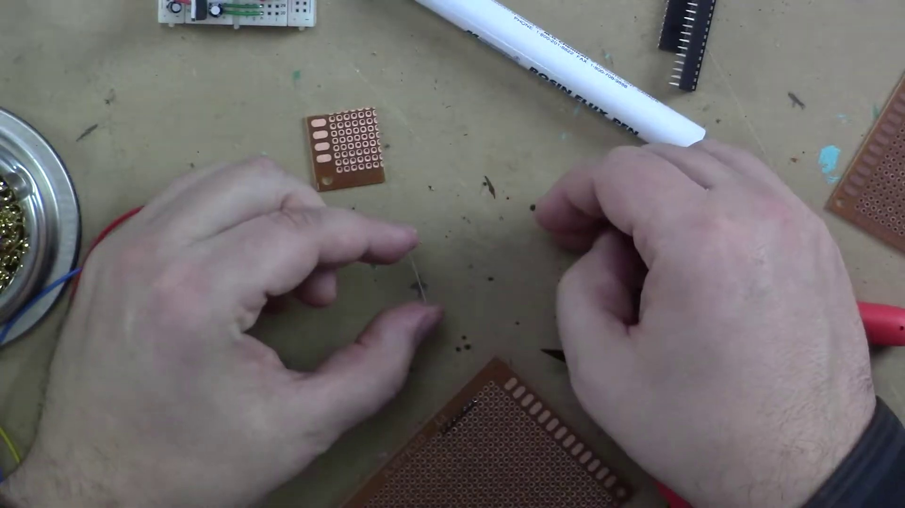 (score 95.0000)
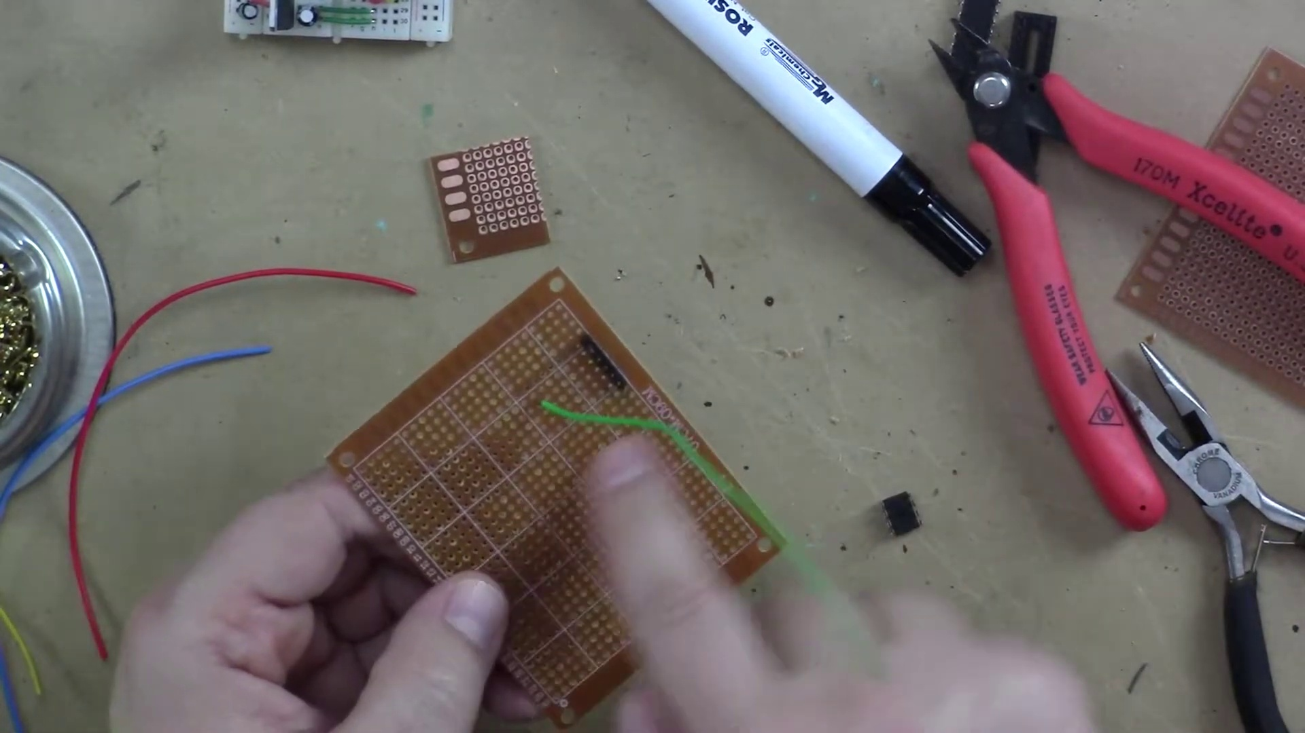 (score 90.0000)
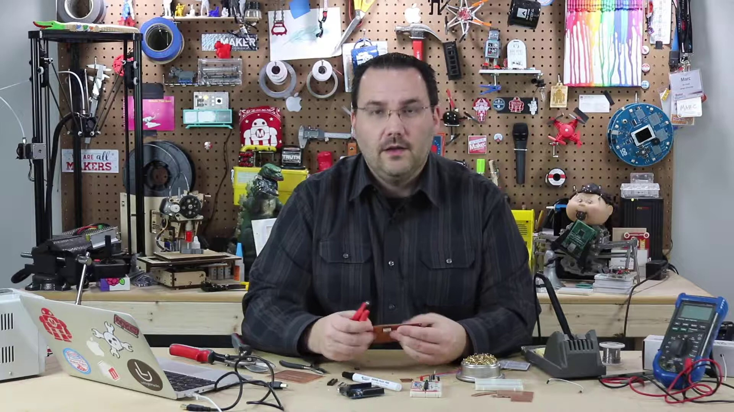 (score 90.0000)
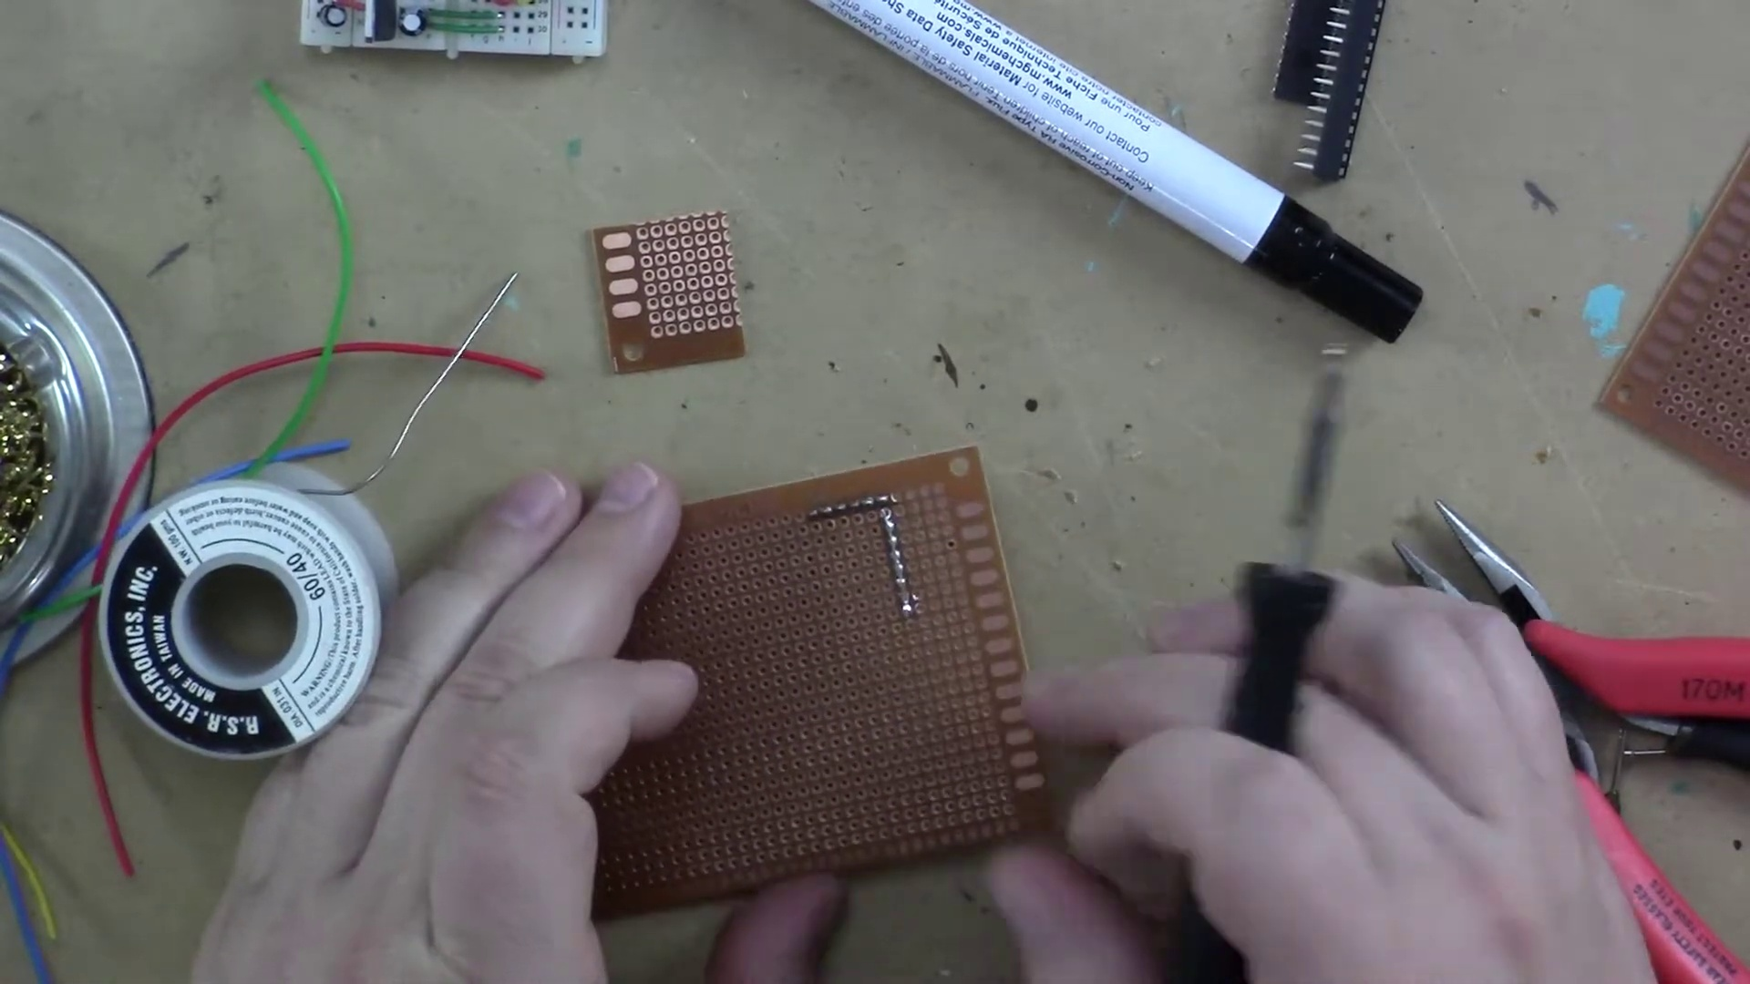 (score 90.0000)
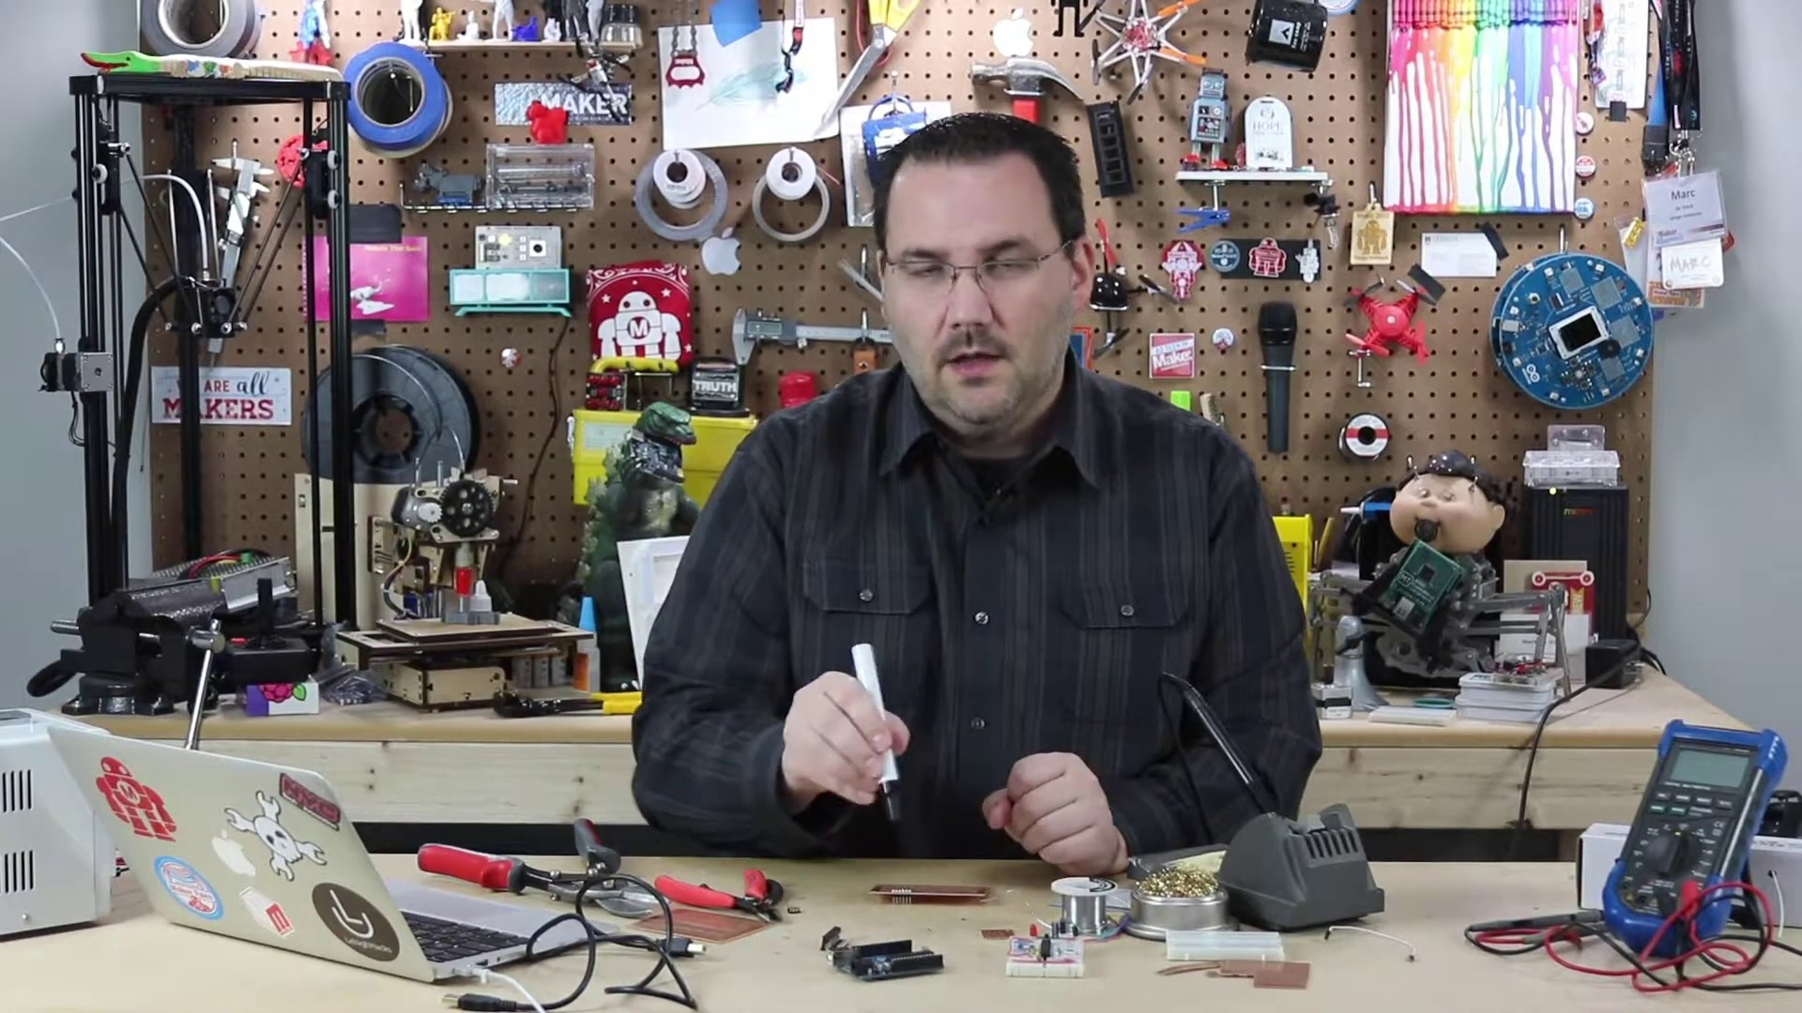 (score 90.0000)
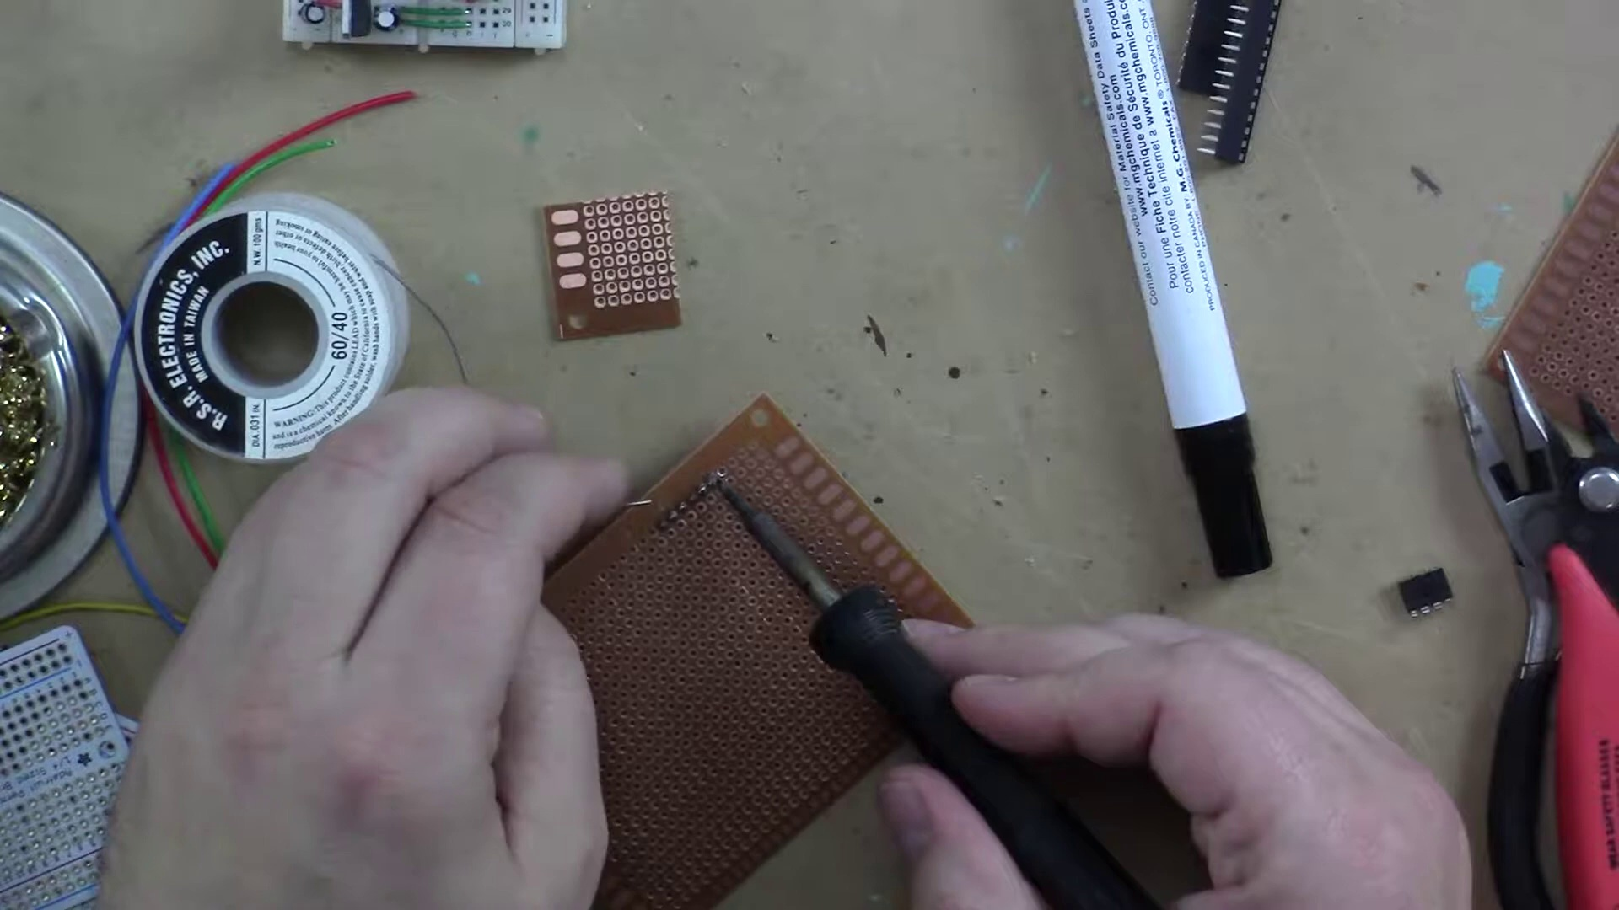 (score 90.0000)
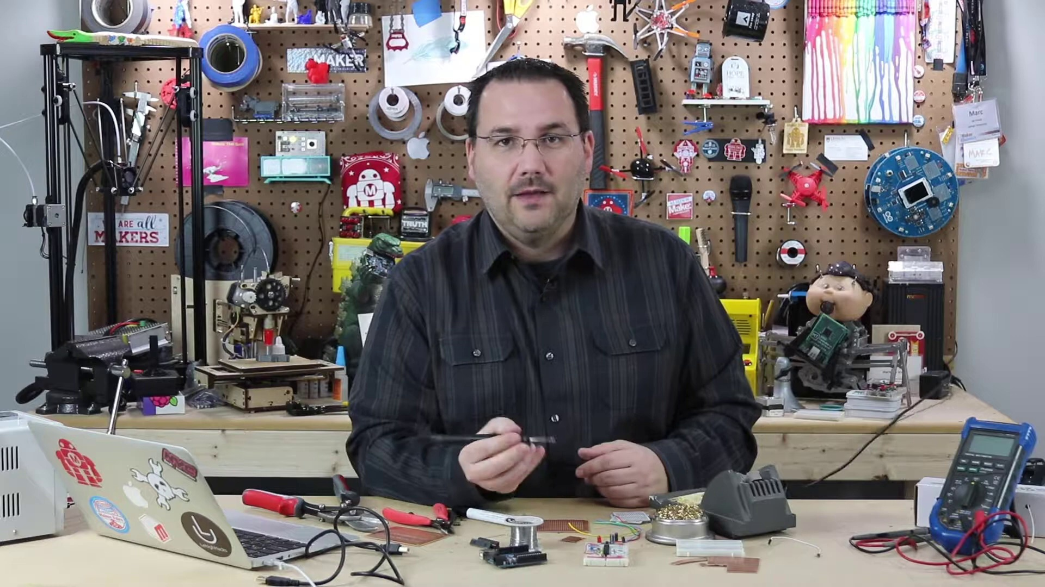 (score 90.0000)
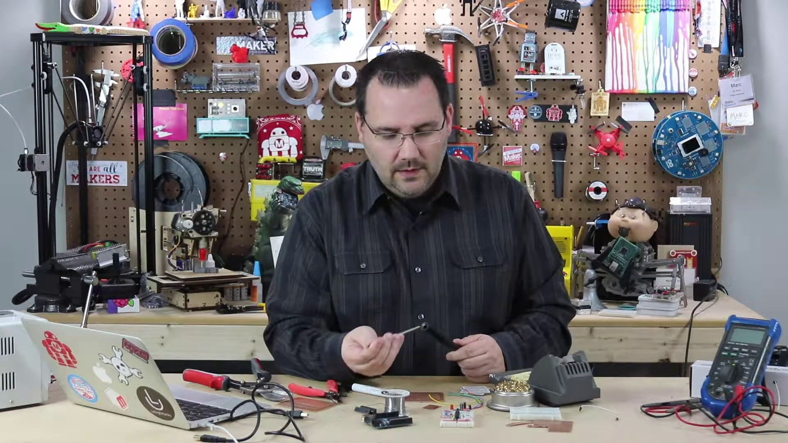 (score 90.0000)
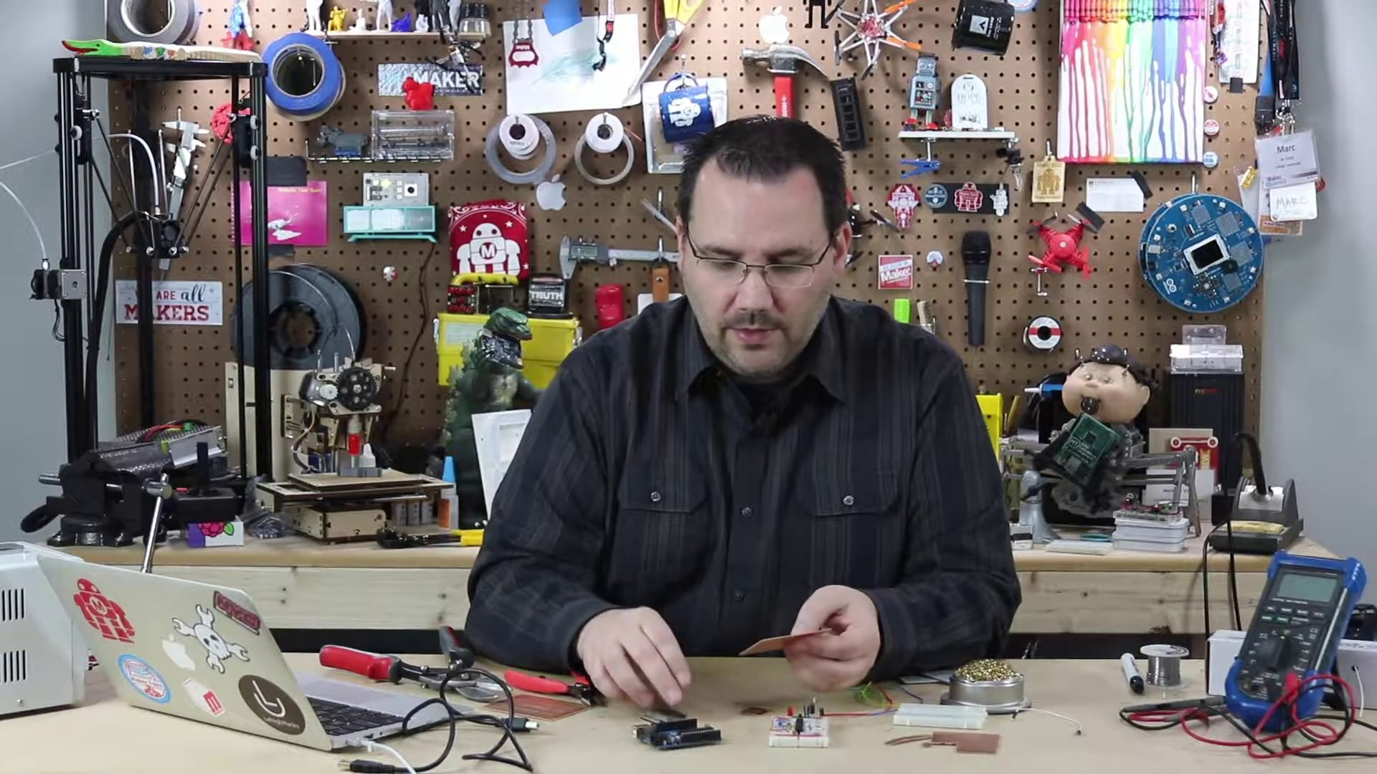 (score 90.0000)
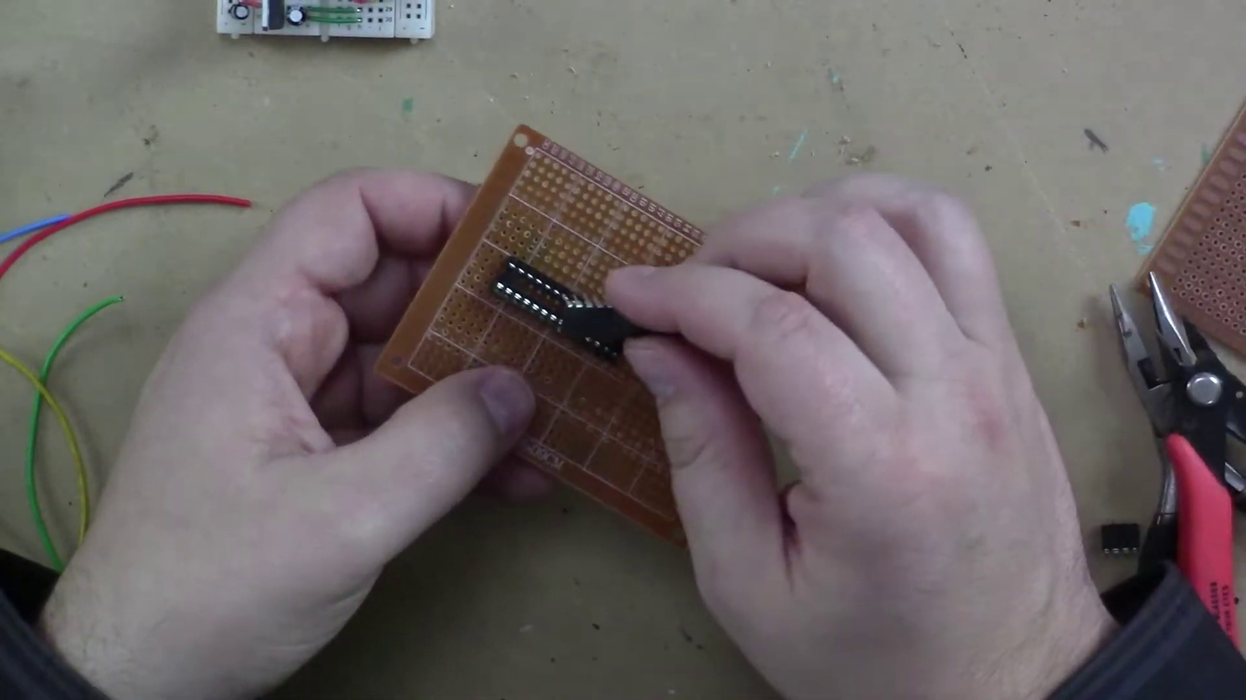 (score 90.0000)
Least correlated frames:
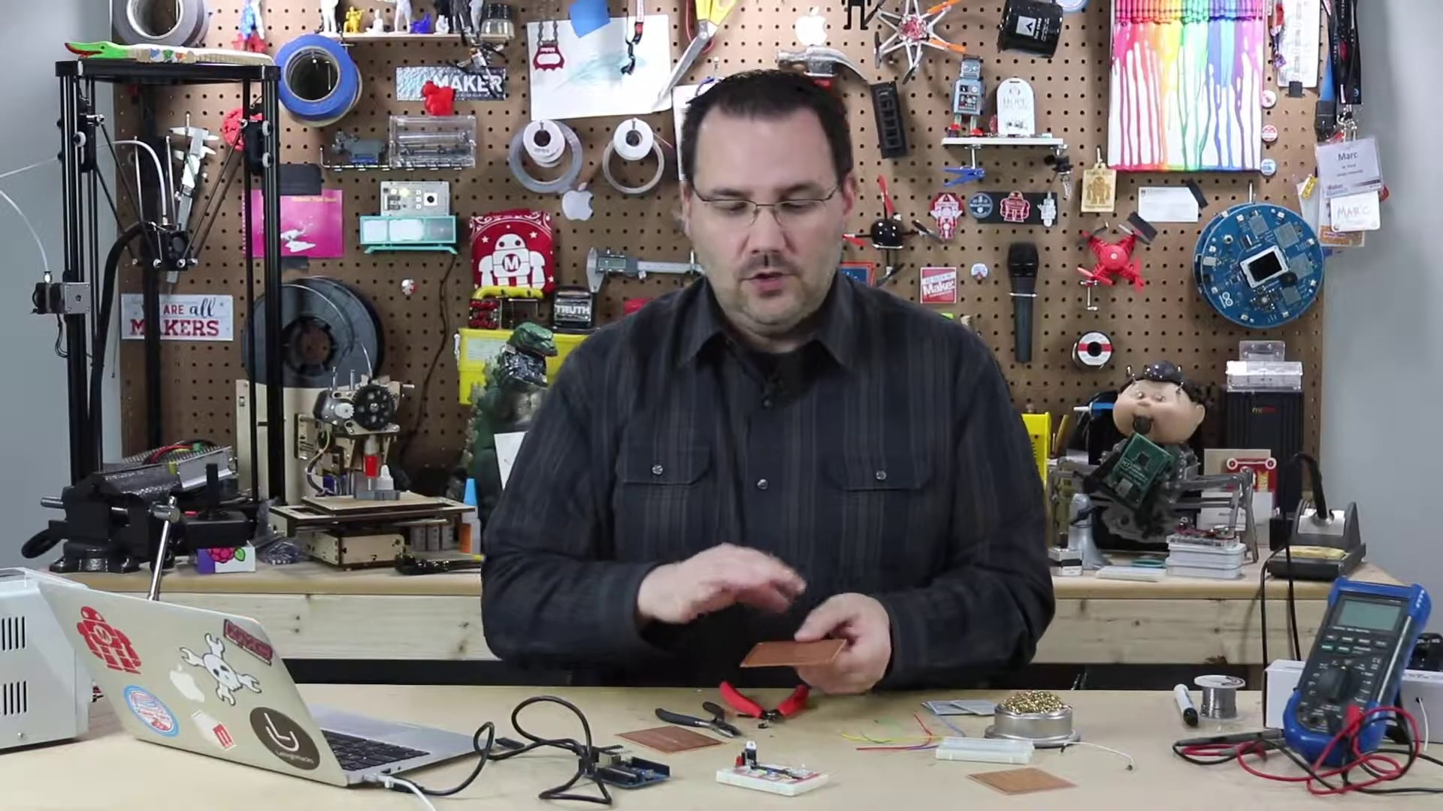 (score 20.0000)
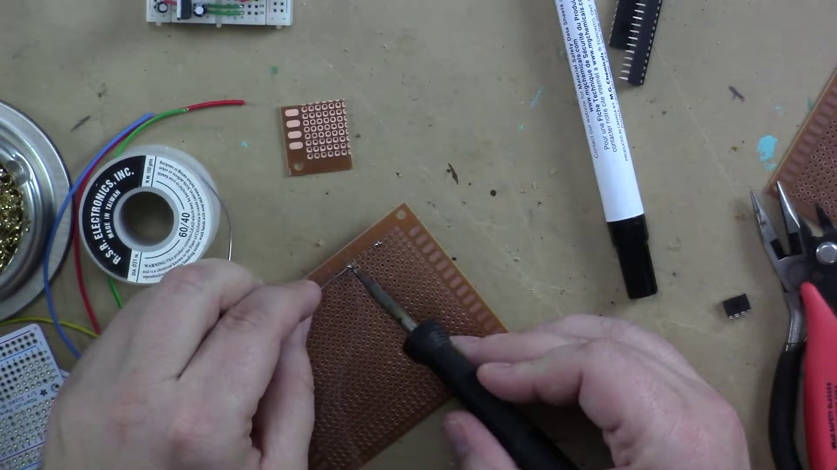 (score 20.0000)
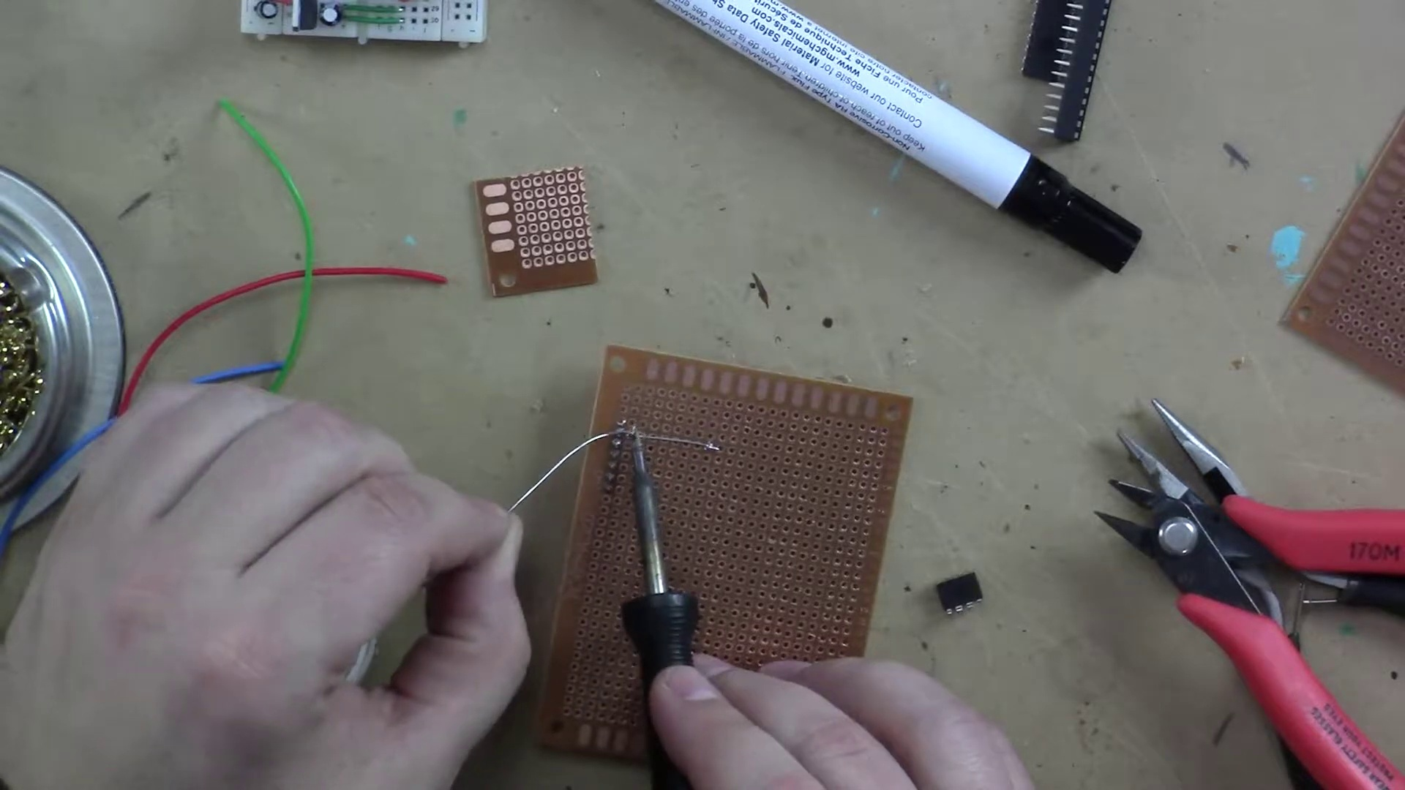 (score 20.0000)
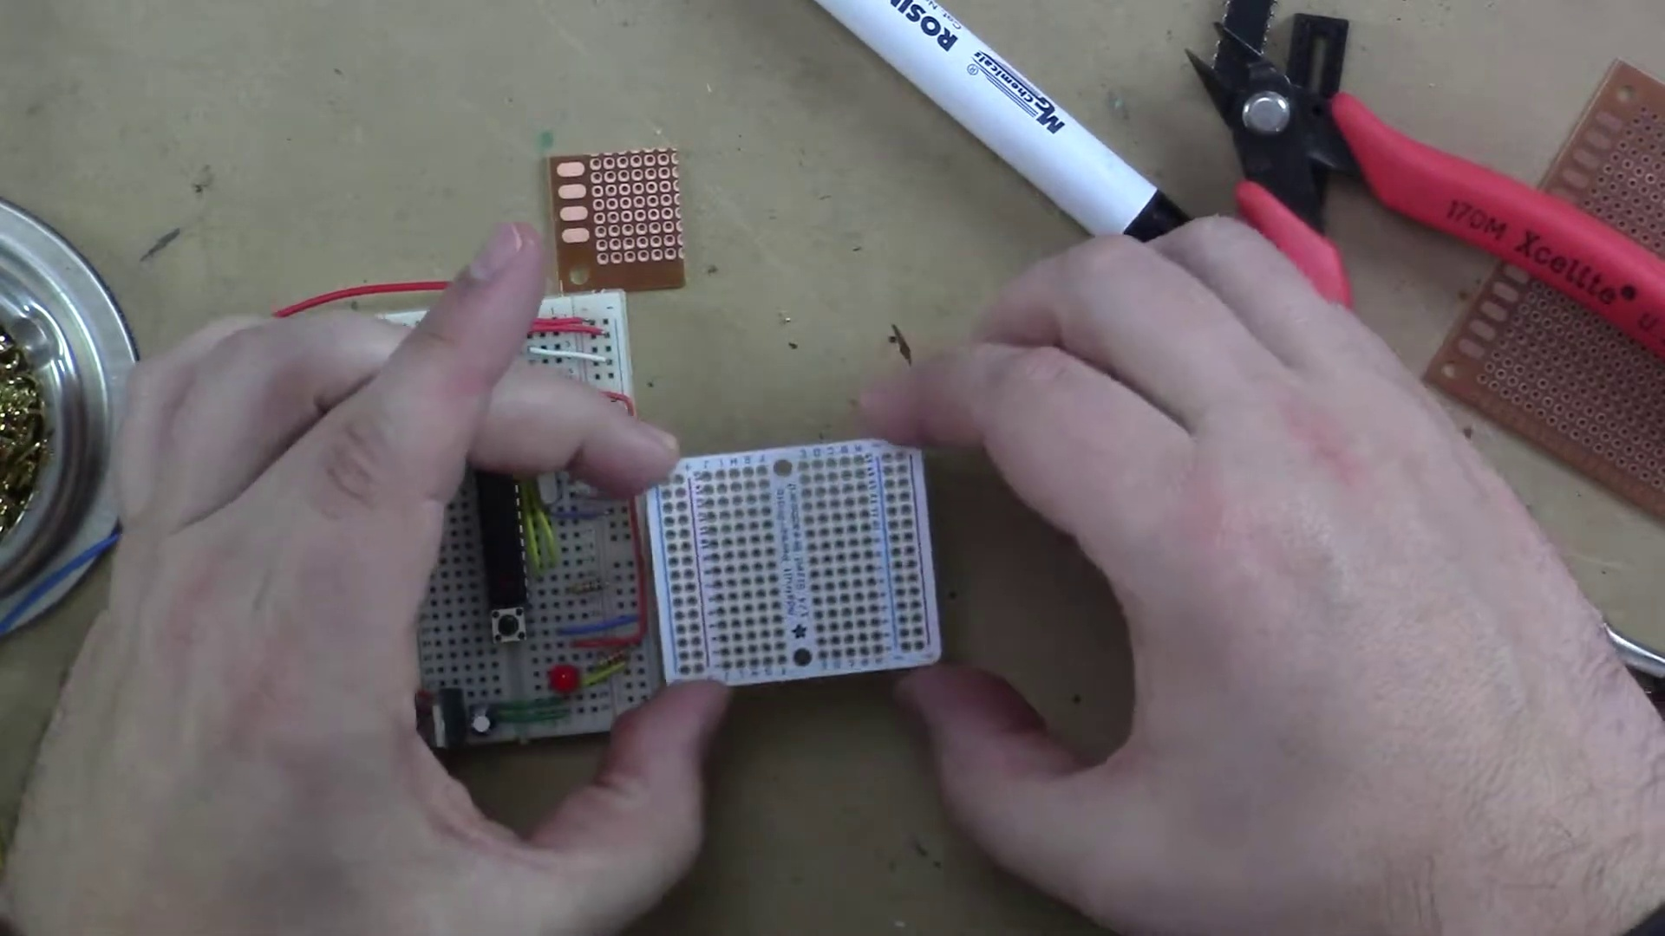 (score 20.0000)
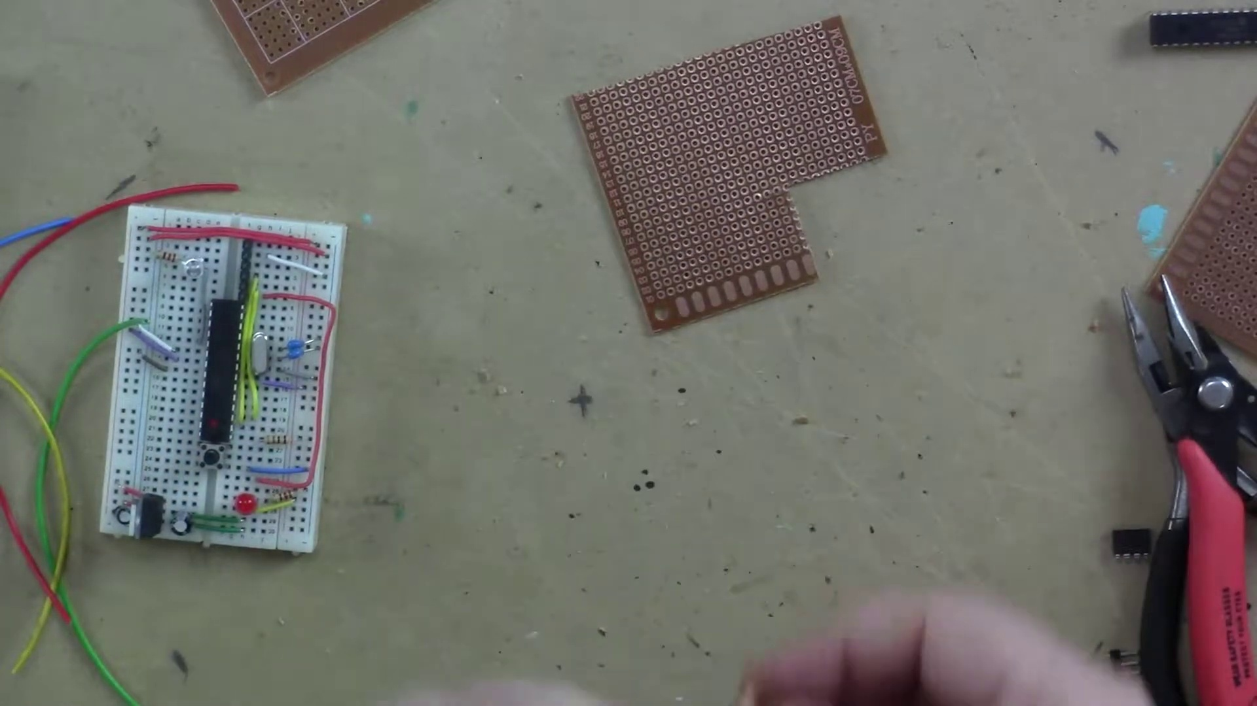 (score 25.0000)
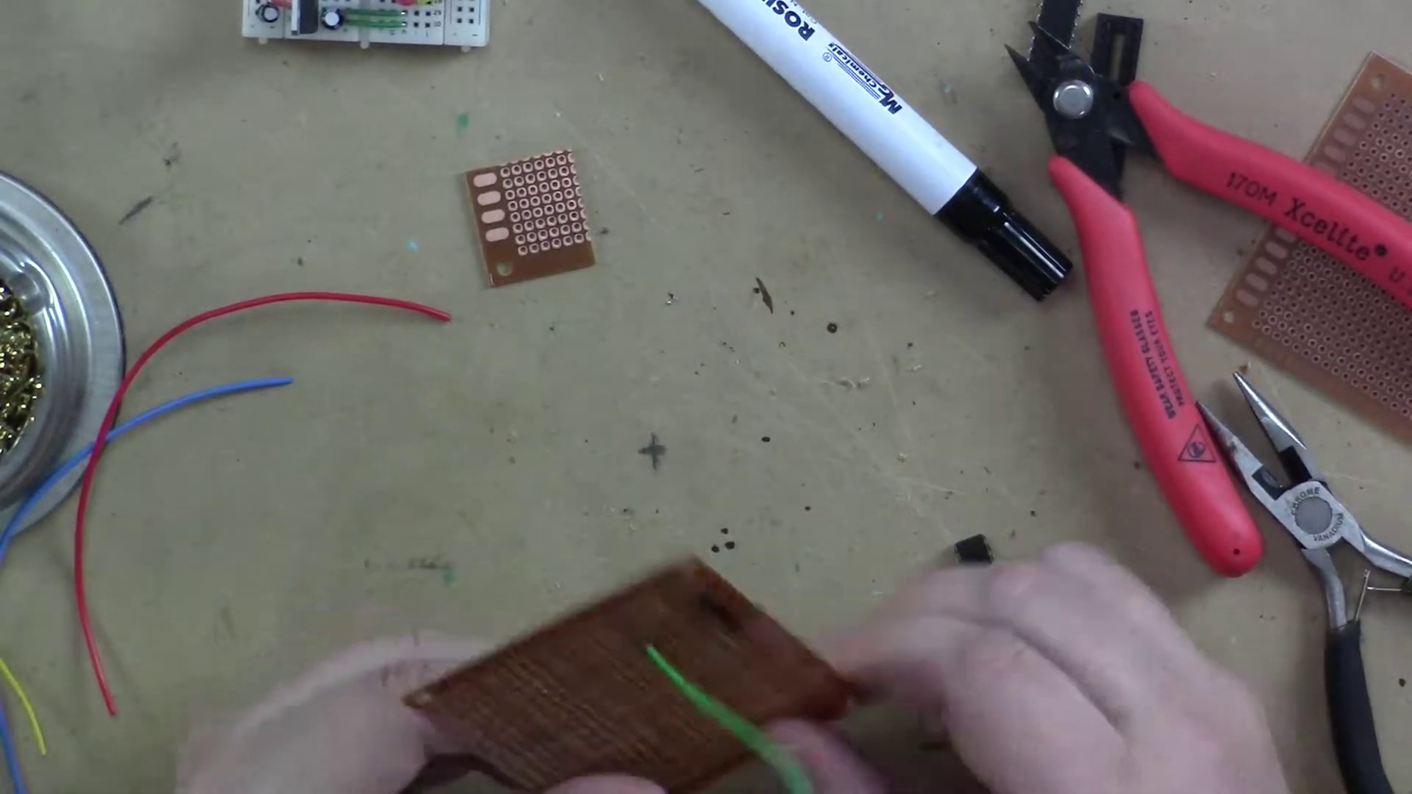 (score 70.0000)
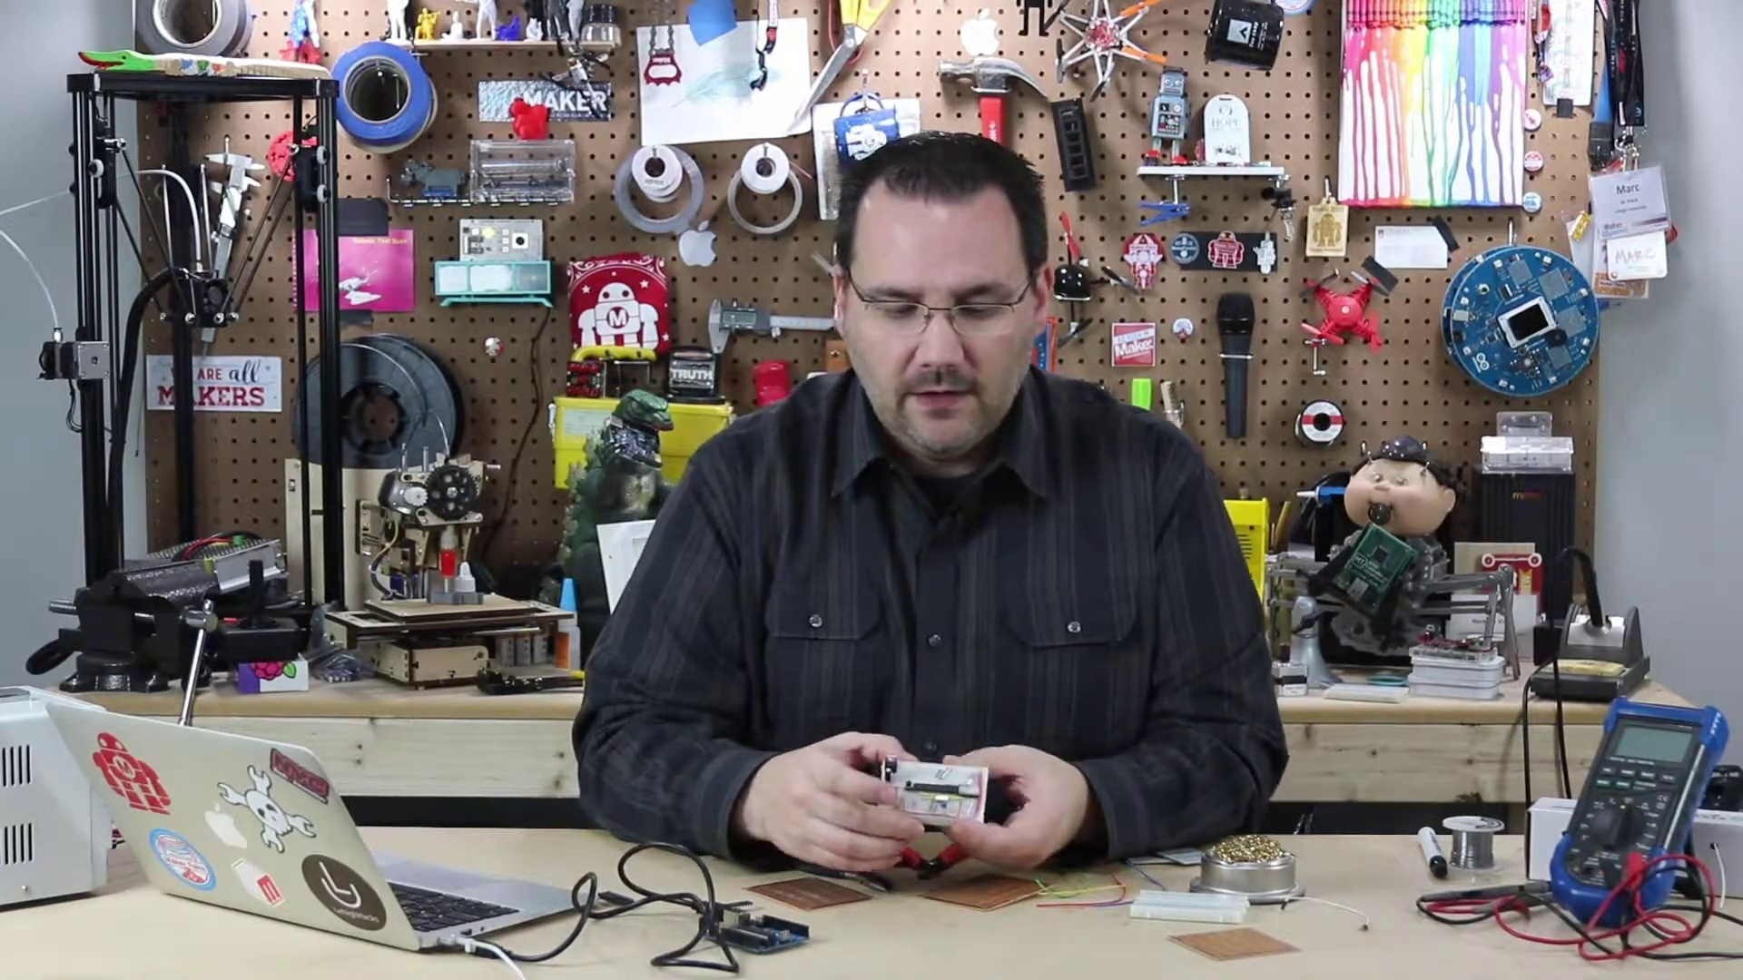 (score 75.0000)
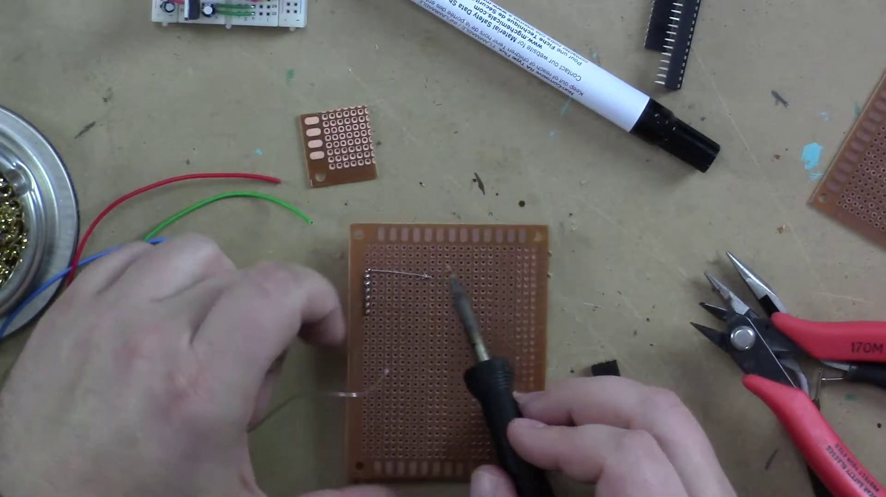 (score 75.0000)
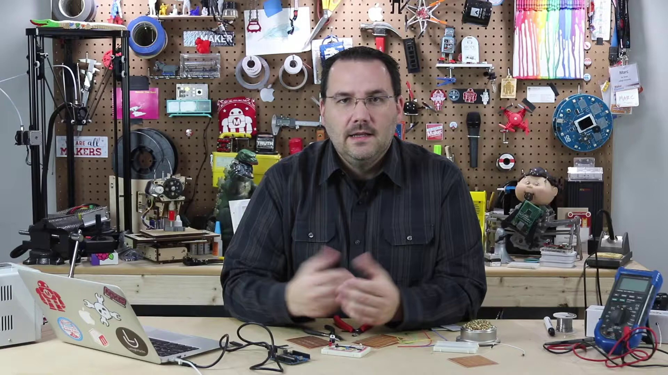 (score 80.0000)
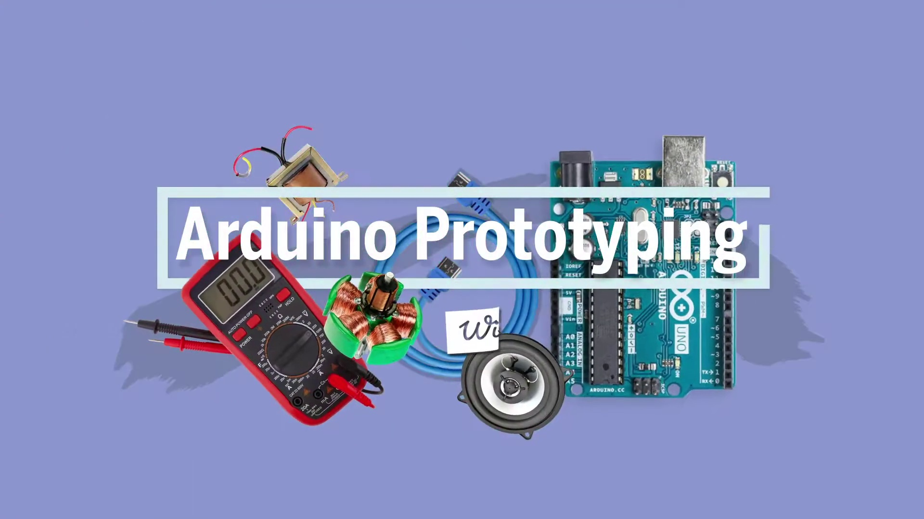 (score 80.0000)
- matched 105 frame(s), max score 95.0000: Perfboards are used as a long-term solution for connections made on a breadboard. They are perforated boards where all connections are soldered in place and are easily cuttable. It's advised not to solder a microcontroller or IC directly to the perfboard but use a socket instead. Perma perf boards can mimic breadboard layouts, allowing direct soldering once layout is finalized.What is an example of a circuit built on a perfboard?
Source: https://www.youtube.com/watch?v=a3wDEcORRR4: Arduino Prototyping Techniques #104: Perfboard
Top correlated frames:
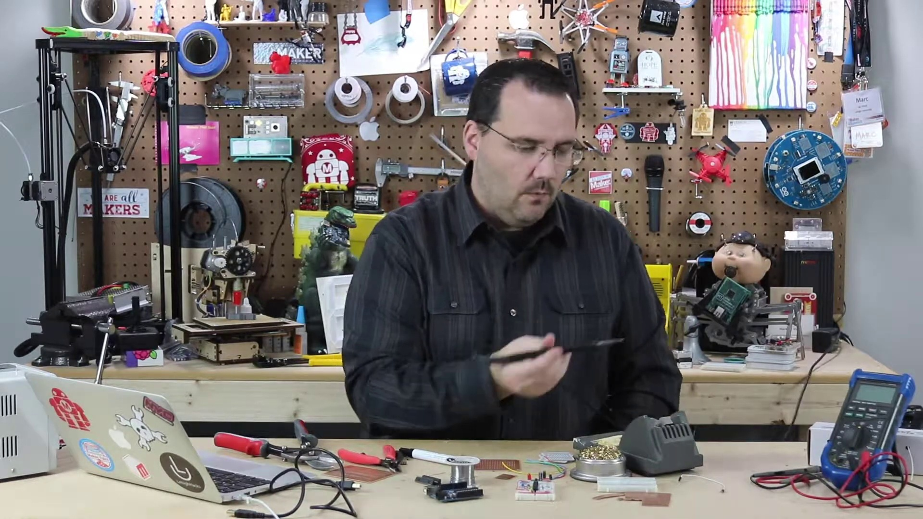 (score 95.0000)
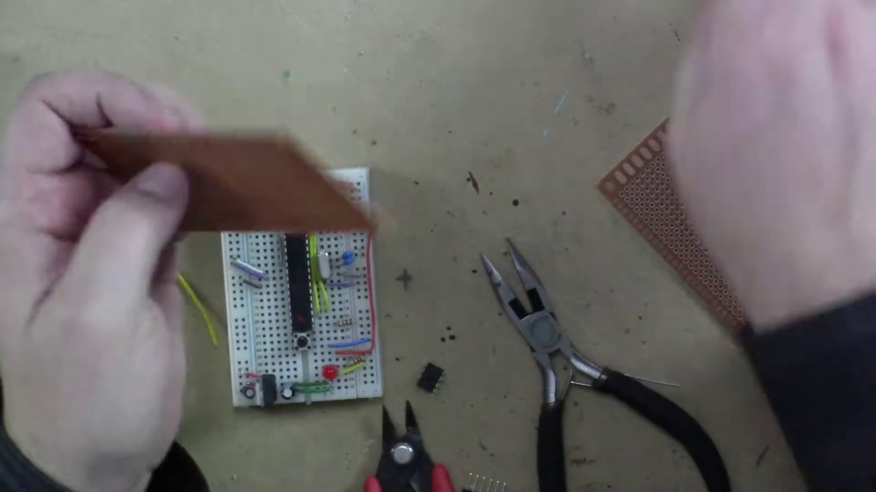 (score 95.0000)
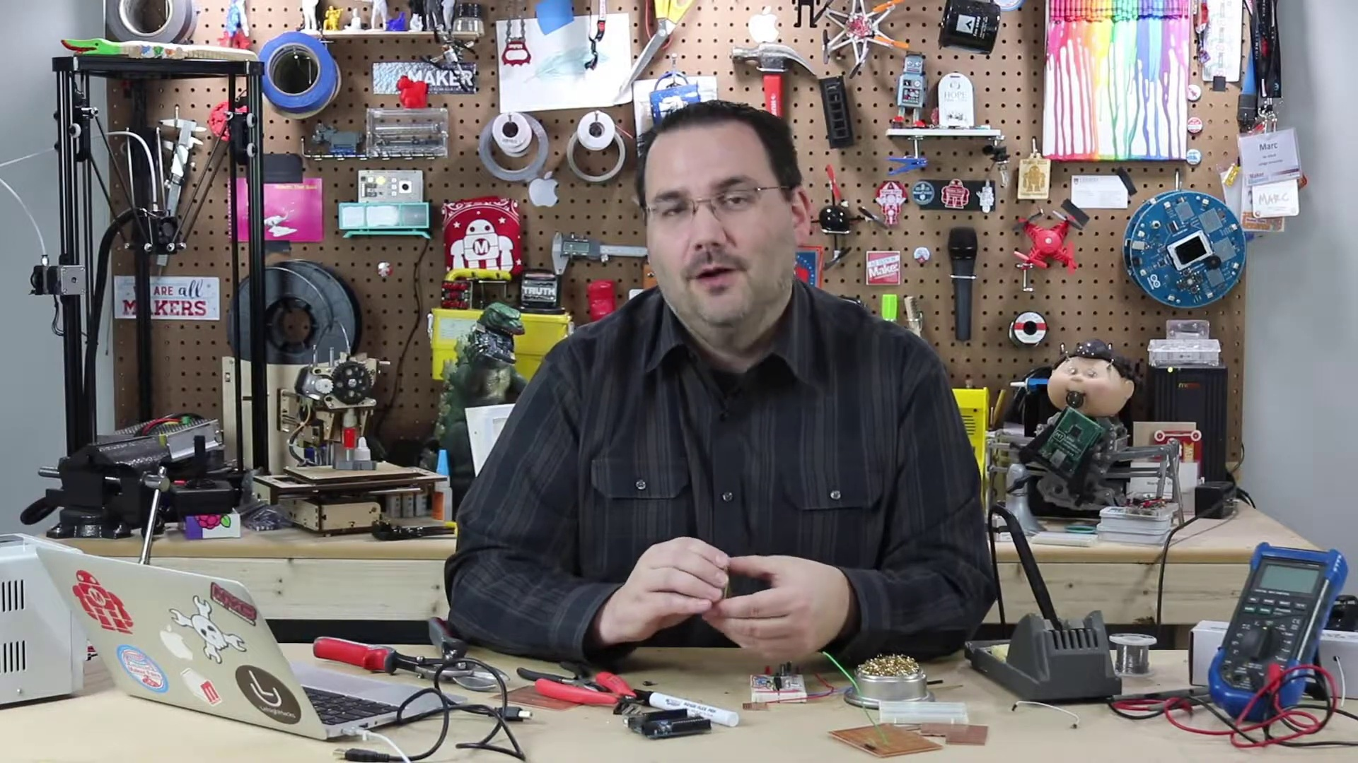 (score 90.0000)
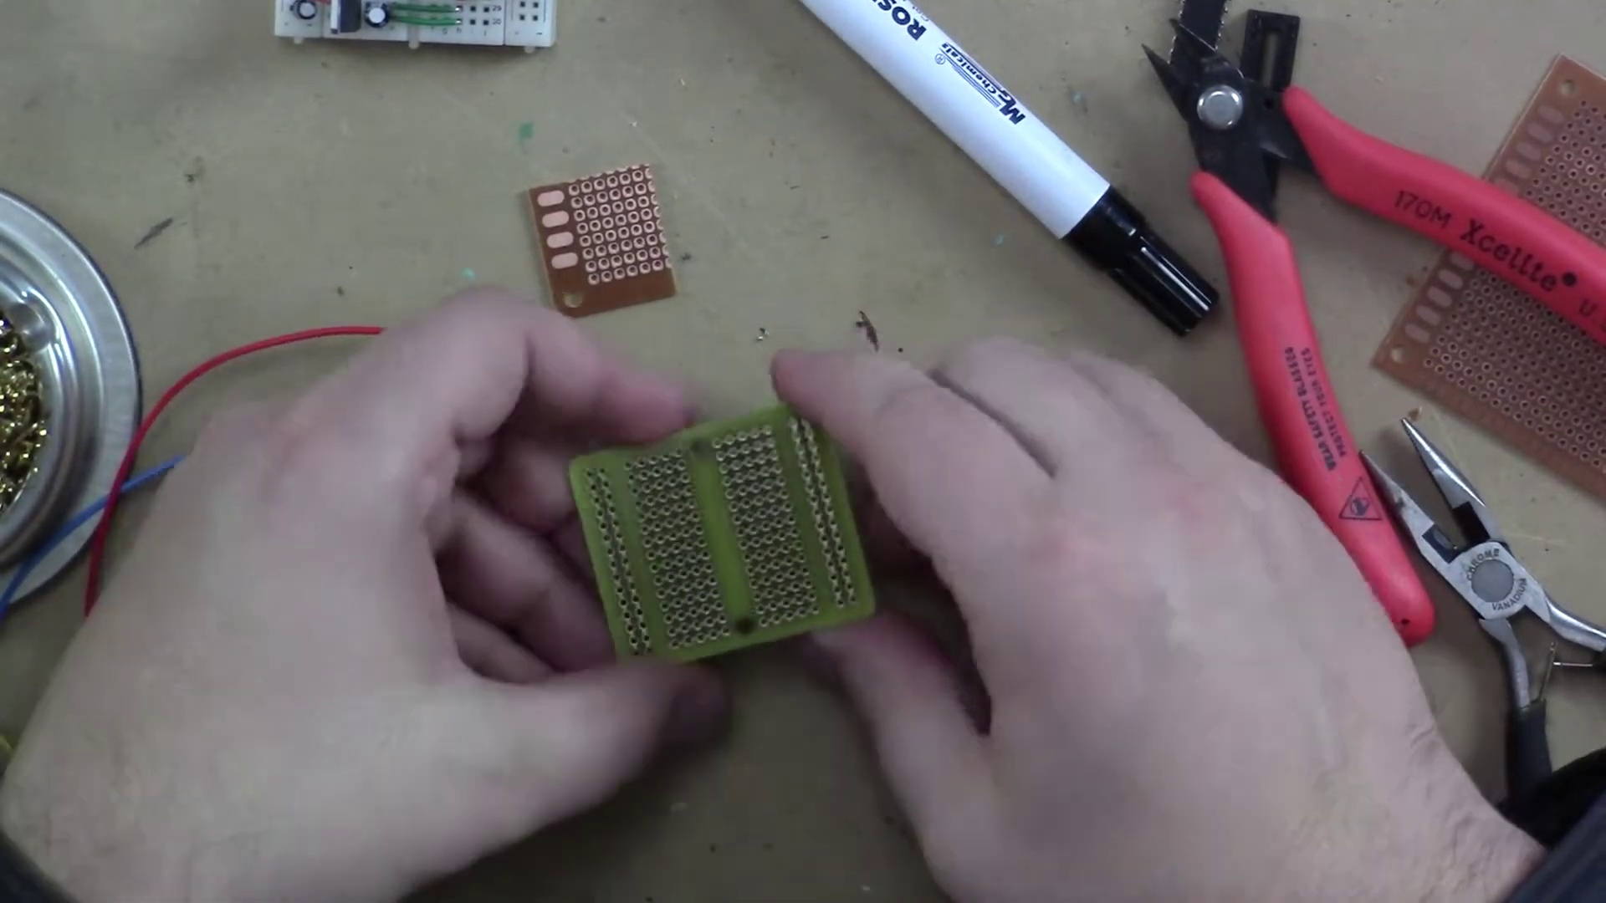 (score 90.0000)
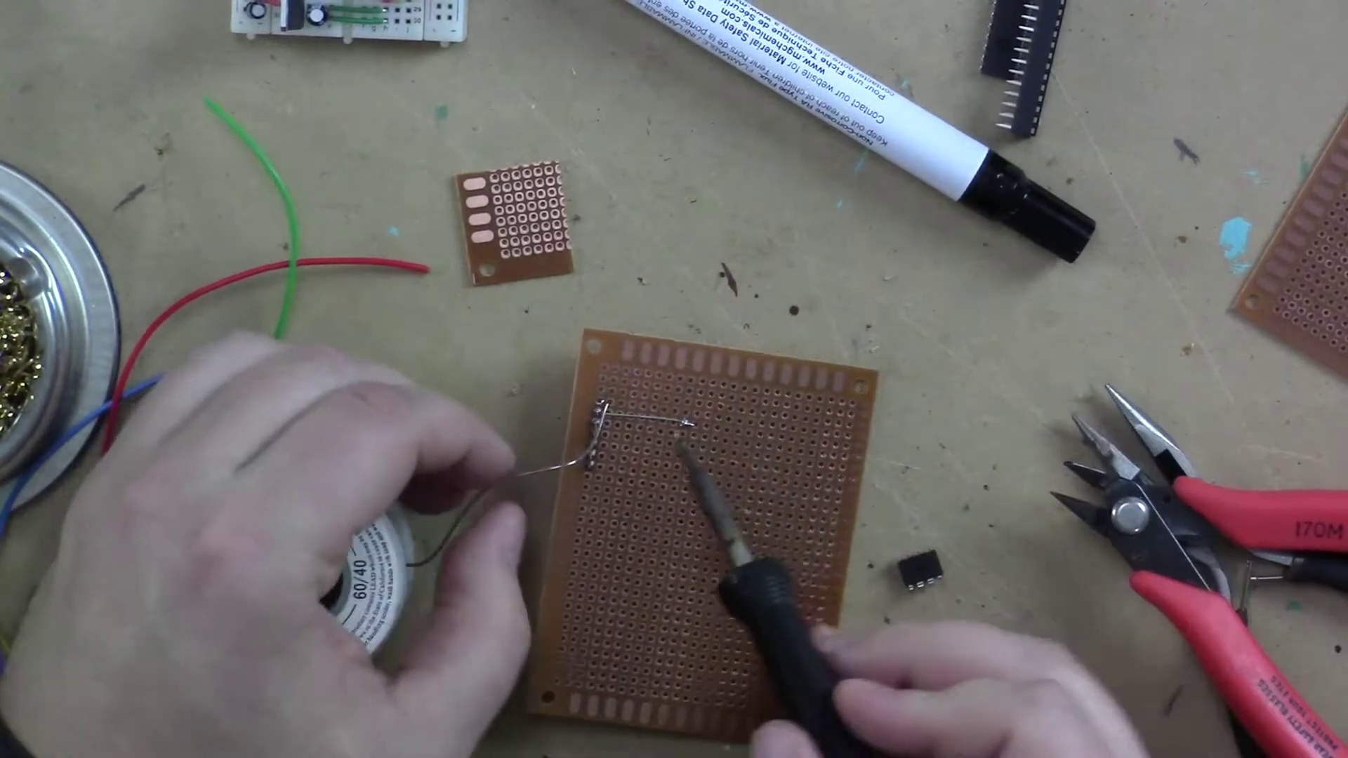 (score 90.0000)
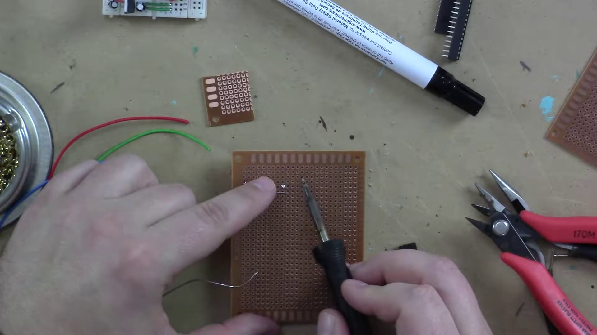 (score 90.0000)
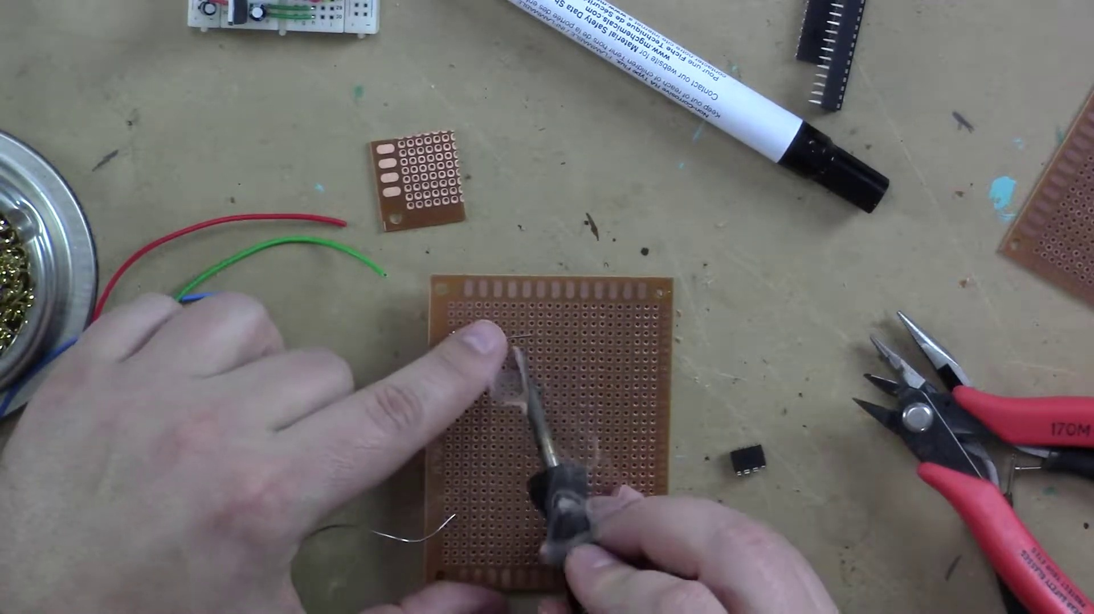 (score 90.0000)
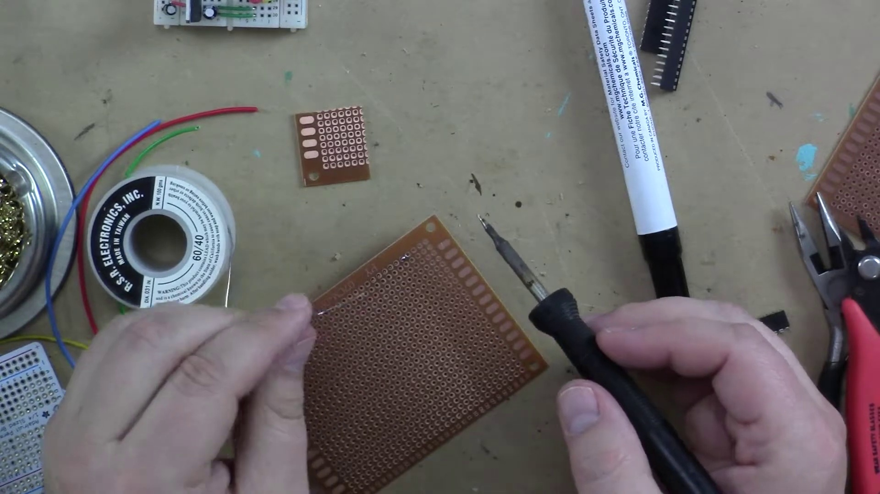 (score 90.0000)
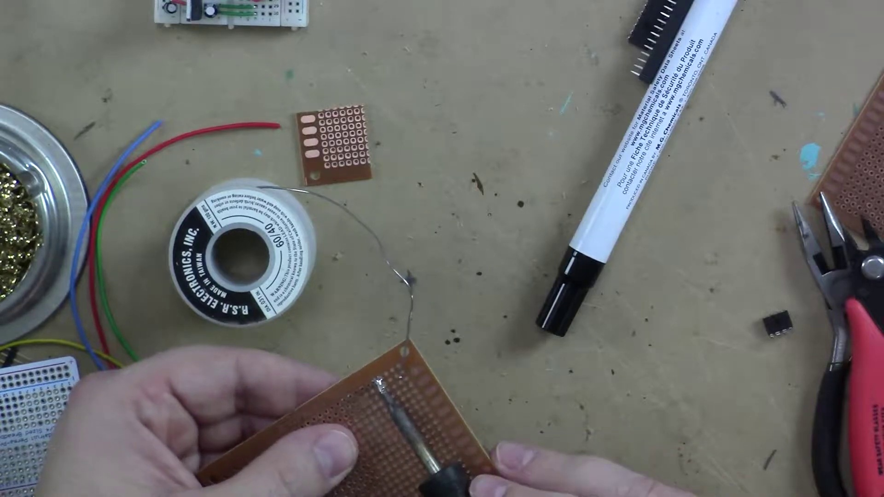 (score 90.0000)
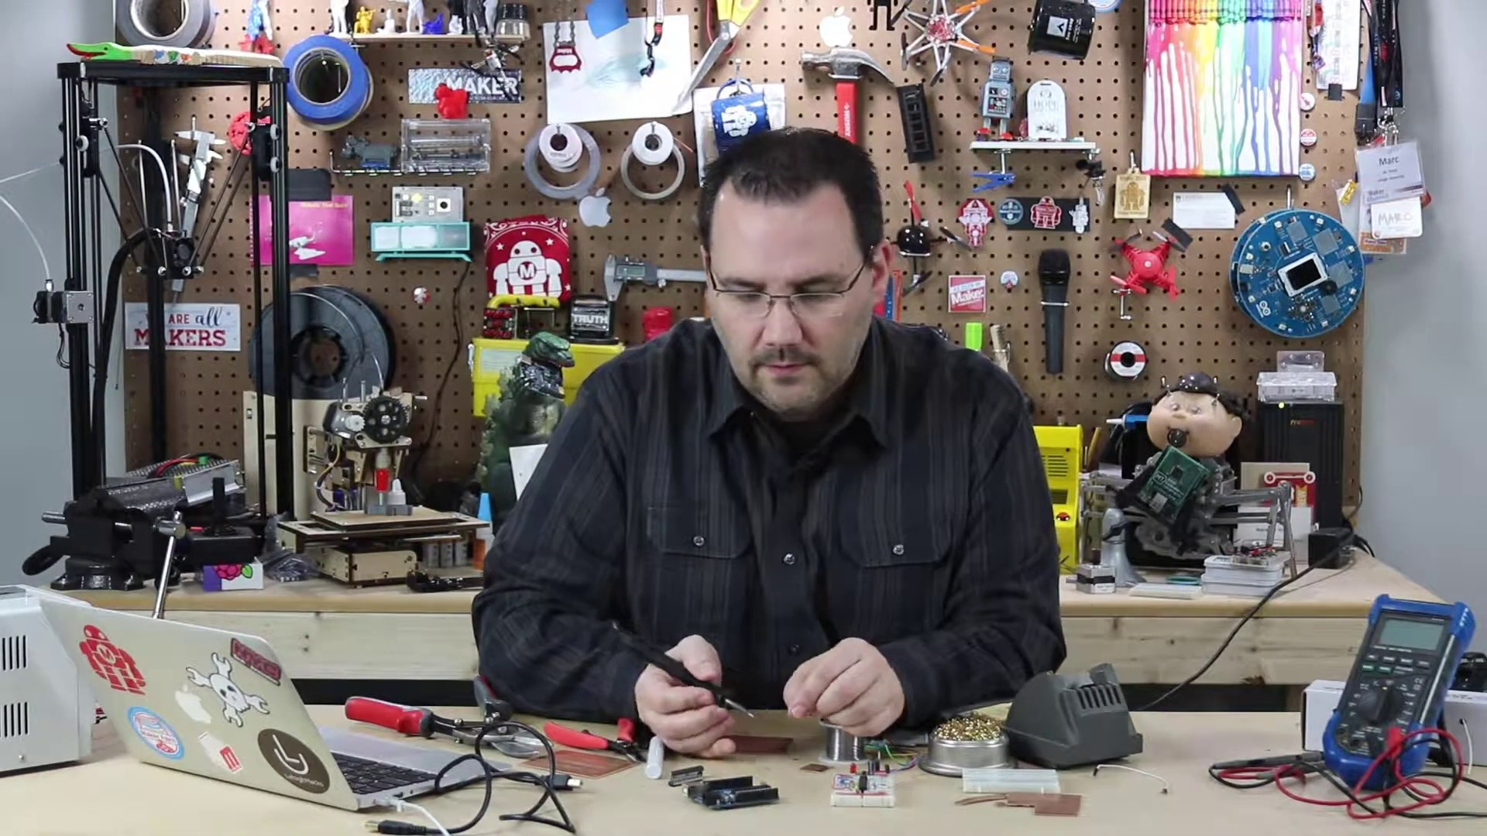 (score 90.0000)
Least correlated frames:
 (score 10.0000)
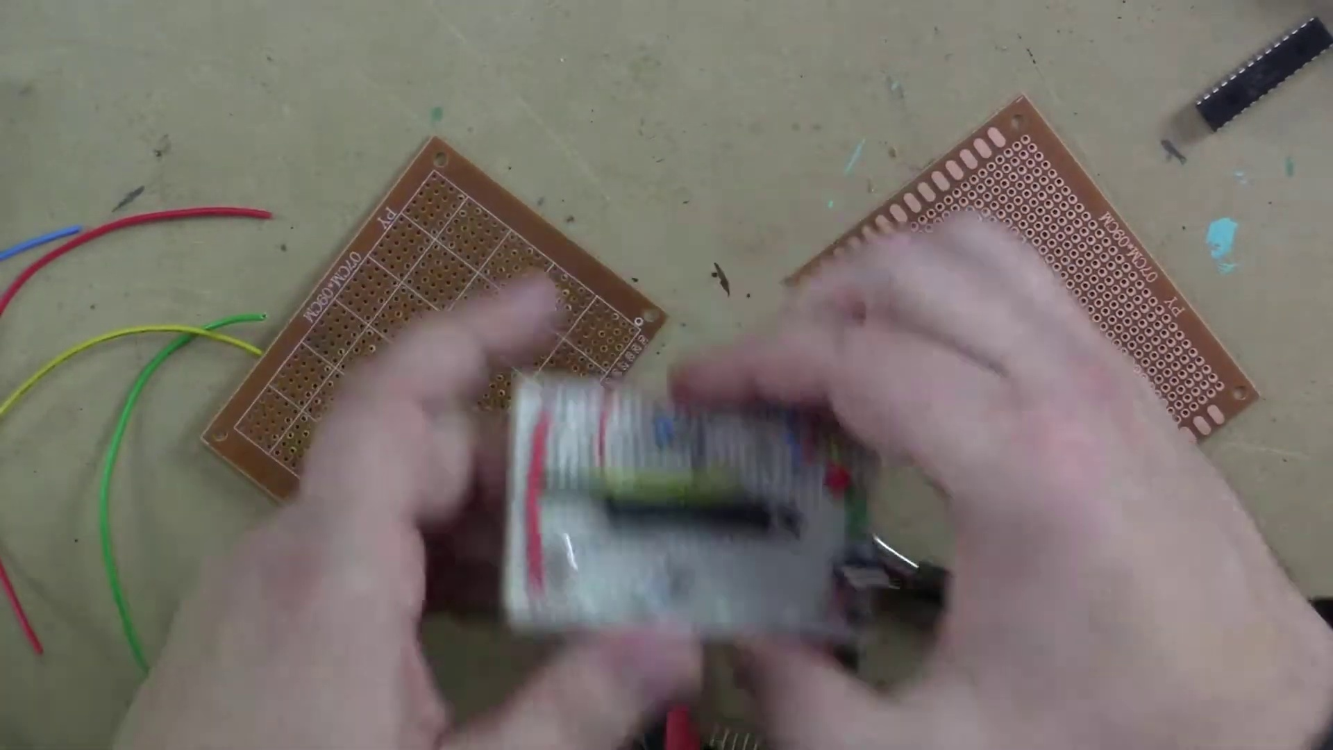 (score 20.0000)
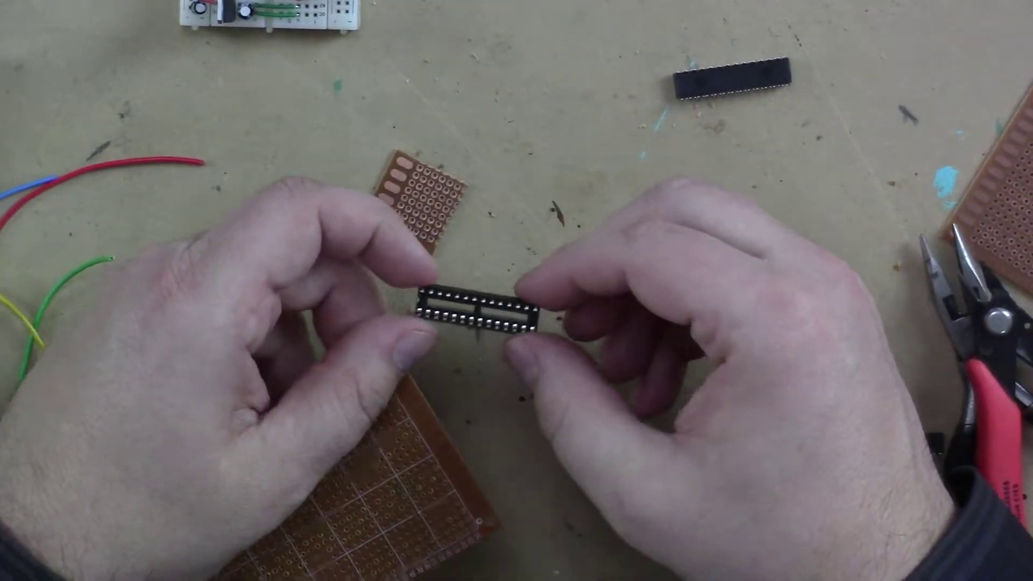 (score 20.0000)
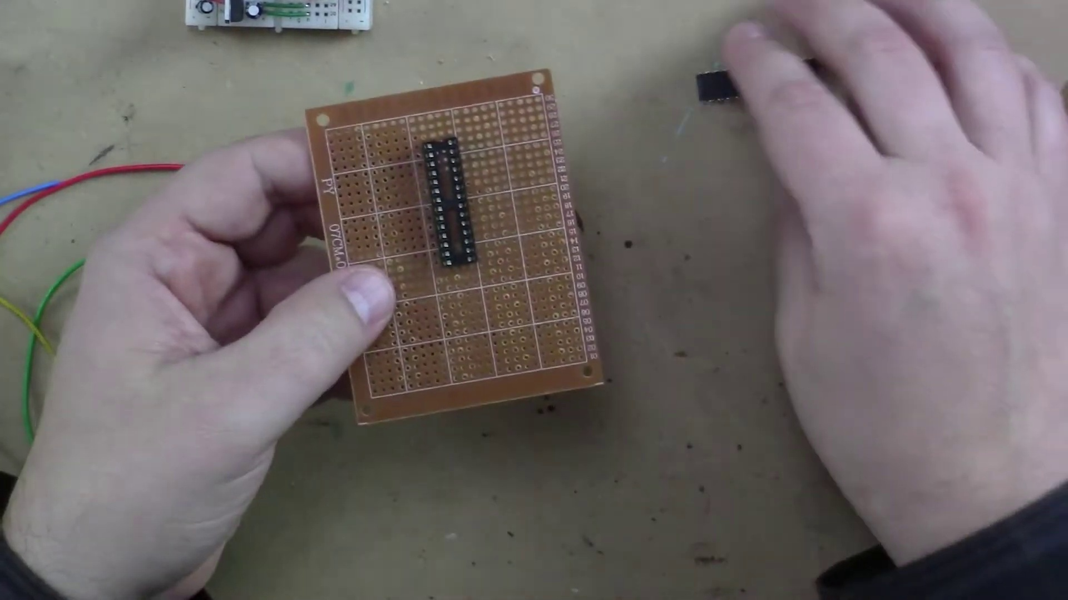 (score 20.0000)
 (score 20.0000)
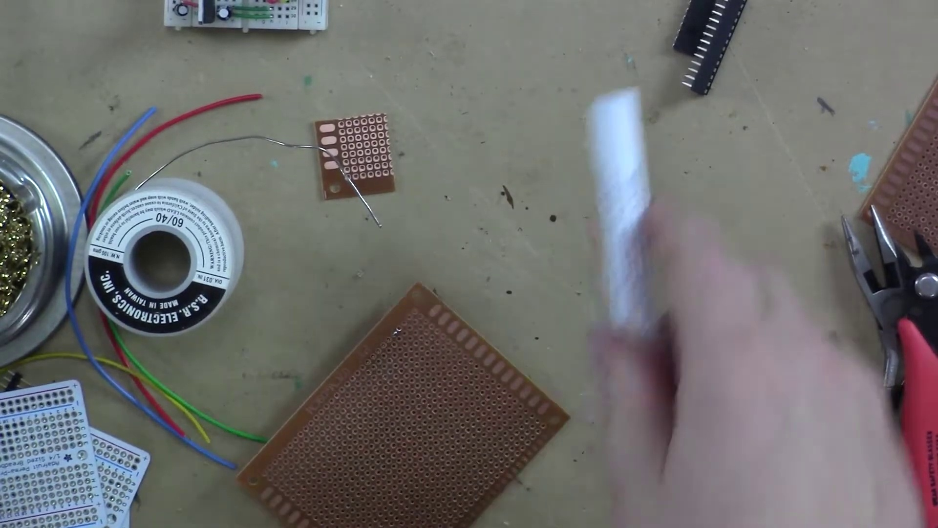 (score 20.0000)
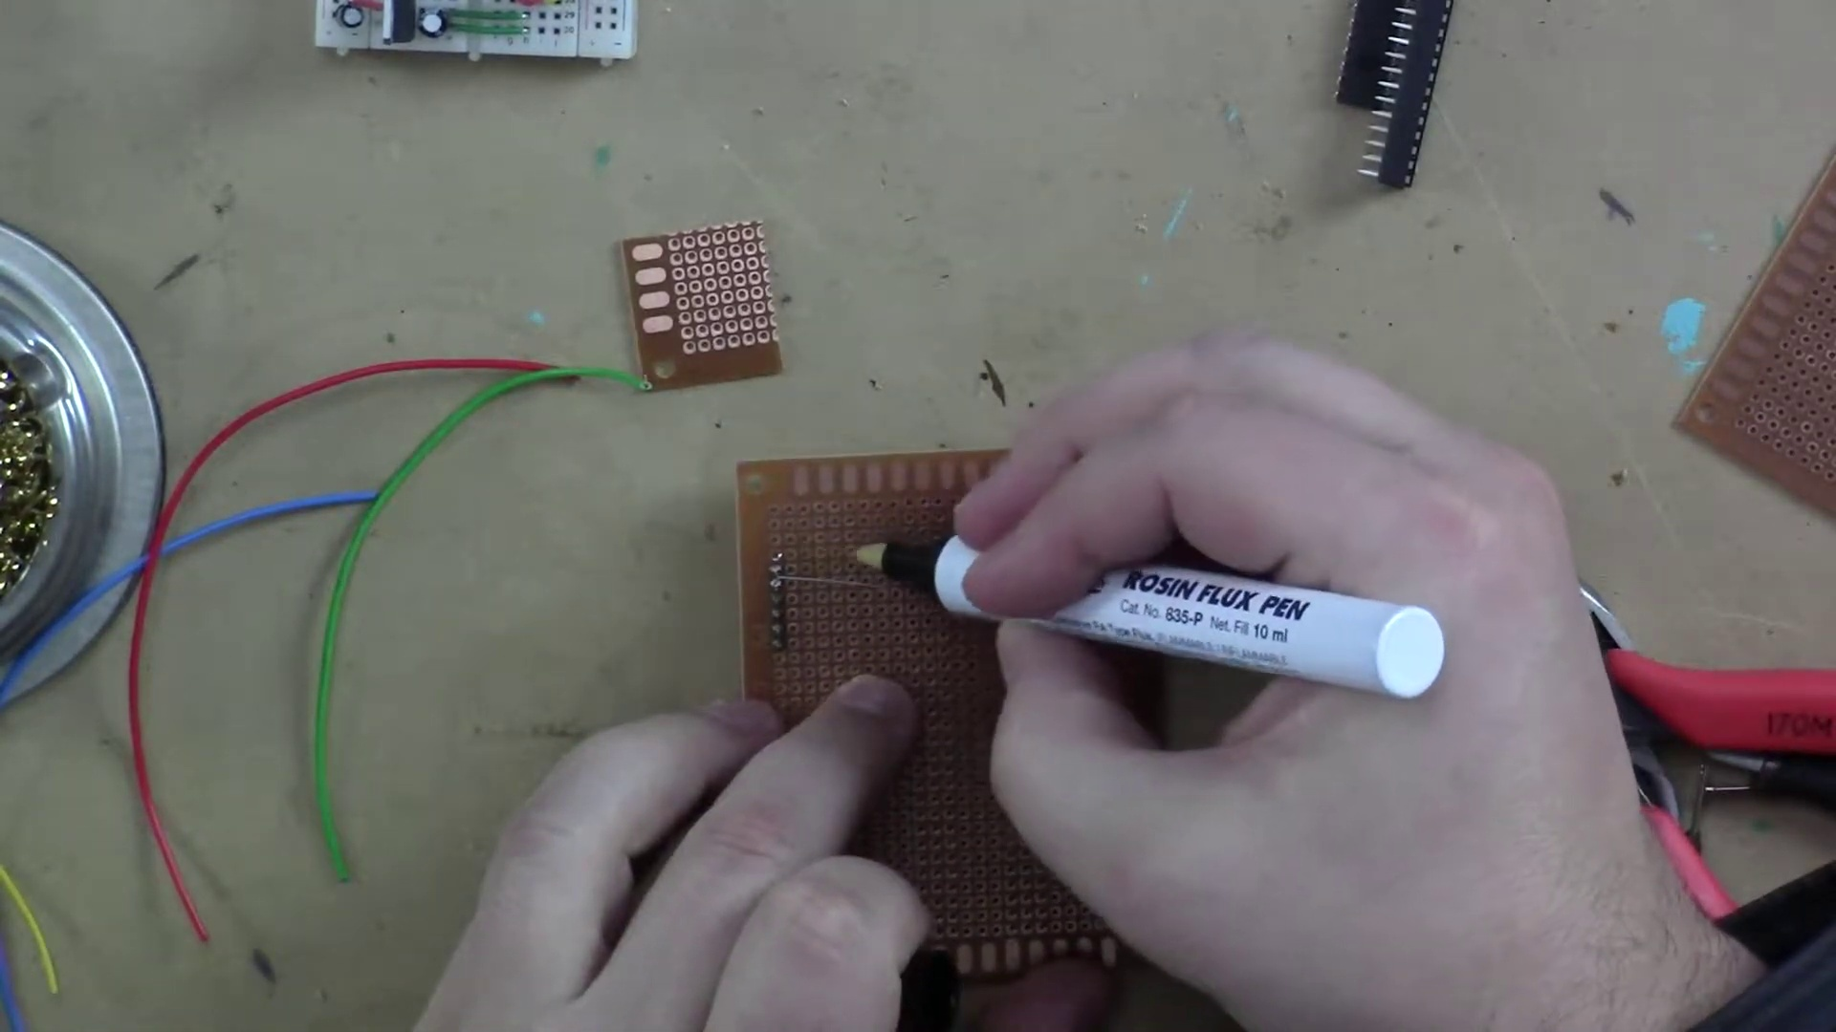 (score 20.0000)
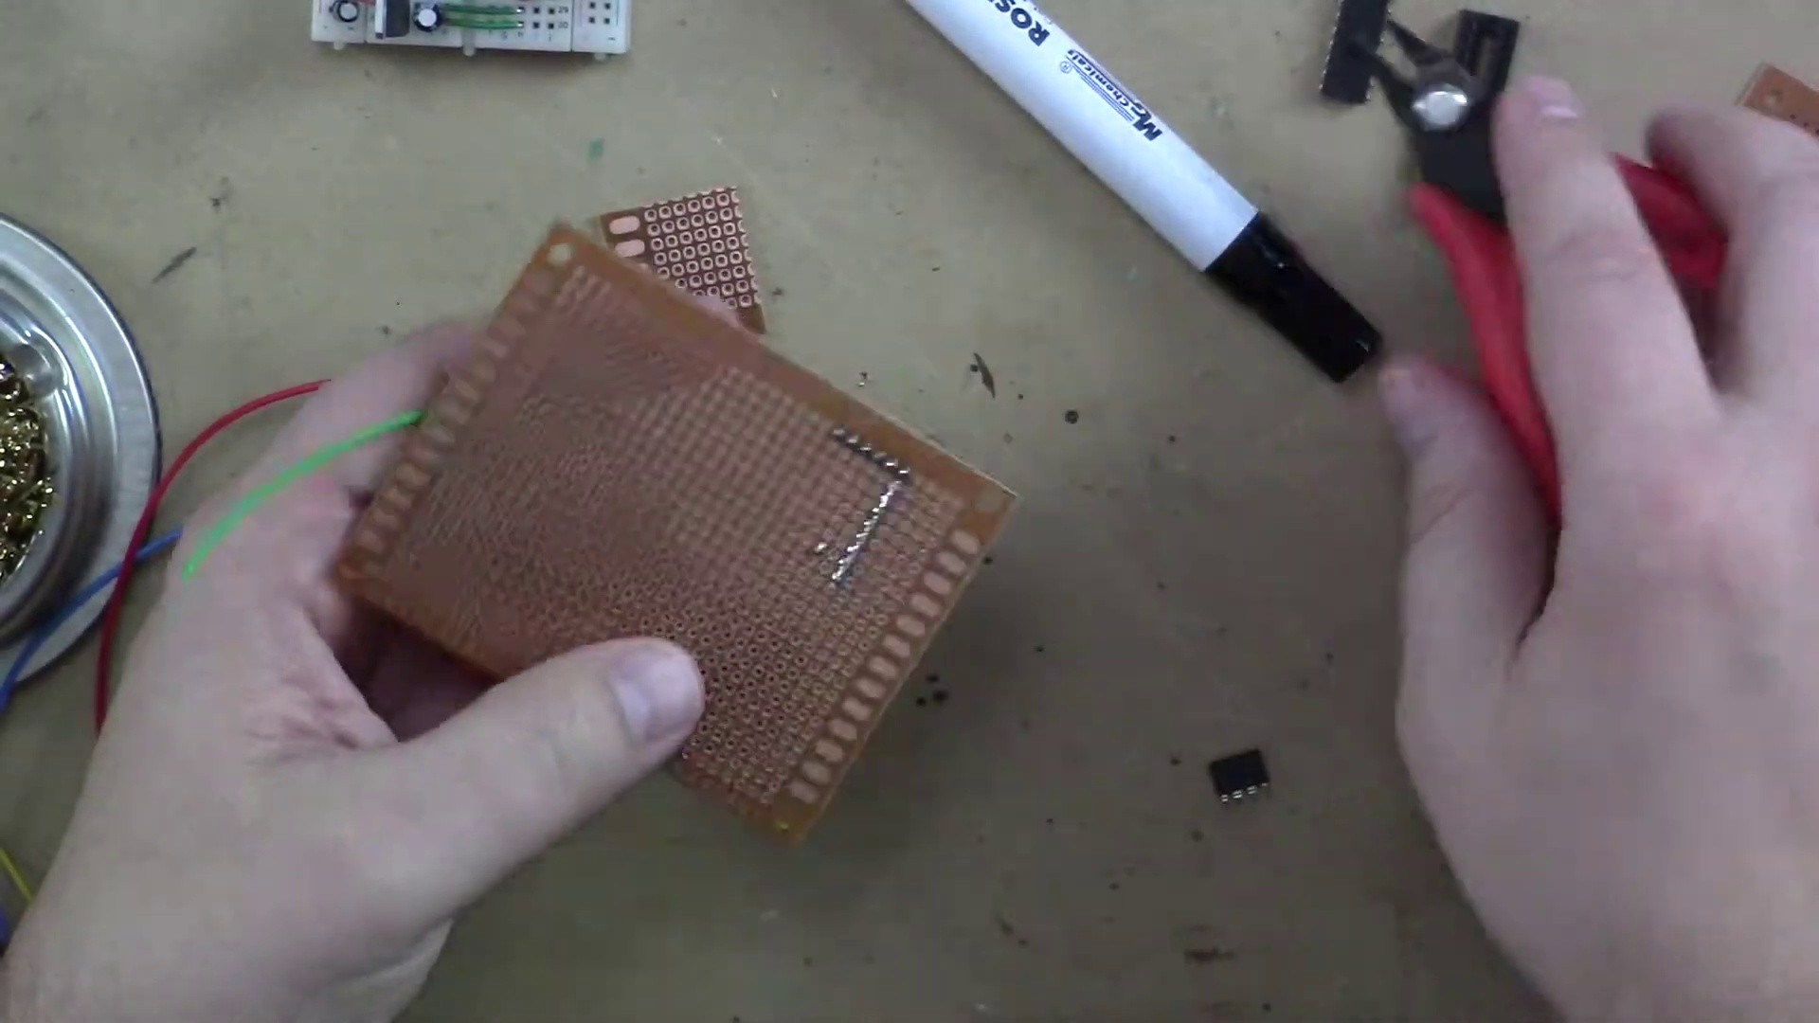 (score 20.0000)
 (score 20.0000)
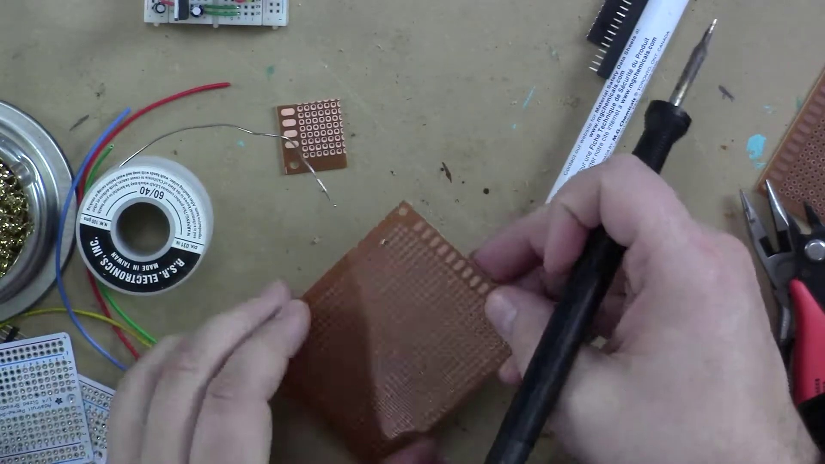 (score 50.0000)

Frame: frame_0000.jpg
Caption: The image appears to show a man sitting at a desk with various electronic components, tools, and objects around him. He is engaged in some form of activity that involves electronics, as indicated by the presence of a soldering iron and other tools. The desk is cluttered with items such as a laptop, cell phone, toy robot, wires, screwdriver, wrench, and hammer, suggesting a workshop or DIY environment.
On the desk, there are electronic devices visible, including a laptop and microphone, which may imply that he is recording or conducting a workshop related to electronics. The man is also gesturing towards something on the desk or in front of him with his right hand, possibly explaining or demonstrating an aspect of the activity at hand.
Behind him, a whiteboard with text written in black marker is visible, although the resolution of the image makes it difficult to read the text clearly. The overall setting suggests an informal educational environment or a hobbyist's workspace focused on electronics projects.
Comment (score 80): I really like the tip of using sockets to install chips on the board instead of soldering them directly. I hadn’t considered this before and it seems like a great way to protect components and make chip replacement easier.I’m confused about what exactly the flux pen is used for.How I plan to use the electrical system in the future: I will use sockets from now on when applicable.
Reason: The comment specifically references the use of sockets to install chips on a board, which is mentioned in the caption as one of the objects present on the desk. Additionally, the commenter mentions using electrical systems in the future and plans to use sockets when applicable, which aligns with the goal or setting described in the caption.
Source: https://www.youtube.com/watch?v=a3wDEcORRR4: Arduino Prototyping Techniques #104: Perfboard
Comment (score 80): Perfboards are used as a long-term solution for connections made on a breadboard. They are perforated boards where all connections are soldered in place and are easily cuttable. It's advised not to solder a microcontroller or IC directly to the perfboard but use a socket instead. Perma perf boards can mimic breadboard layouts, allowing direct soldering once layout is finalized.What is an example of a circuit built on a perfboard?
Reason: The comment directly discusses the use of 'perforated boards' (perfboards) and soldering connections in place, which is strongly related to the technical steps described in the caption, such as using a soldering iron and various tools. The mention of breadboards and perma perf boards also matches the context of an electronics workshop or DIY environment shown in the image.
Source: https://www.youtube.com/watch?v=a3wDEcORRR4: Arduino Prototyping Techniques #104: Perfboard

Frame: frame_0001.jpg
Caption: The image captures a man deeply engrossed in his work, seated at a wooden desk surrounded by various tools and equipment. He is manipulating a small electronic device with great skill, wearing white gloves to ensure precision. The desk is filled with items such as a laptop, open on its screen glowing blue, a computer mouse and keyboard arranged neatly for use, and a printer standing out against the wooden surface.
In front of him, various objects are scattered around, including what appears to be a soldering iron, wire spools, and a small electronic device he is holding up, possibly explaining its components or function. The setting resembles a workspace or hobbyist's area dedicated to DIY electronics projects or demonstrations.
The background is blurred, but includes a shelf with various items resembling DIY electronics kits or components. There's no text visible in the image that would provide additional context for what is being discussed or shown. A white board behind him features the words "KERS" written on it, which could possibly indicate a company or brand name associated with the workspace.
Overall, the scene suggests an environment where DIY electronics projects are undertaken or demonstrated, with the man fully immersed in his work.
Comment (score 80): Perfboards are used as a long-term solution for connections made on a breadboard. They are perforated boards where all connections are soldered in place and are easily cuttable. It's advised not to solder a microcontroller or IC directly to the perfboard but use a socket instead. Perma perf boards can mimic breadboard layouts, allowing direct soldering once layout is finalized.What is an example of a circuit built on a perfboard?
Reason: The comment directly discusses the technical steps and objects described in the caption, such as perfboards, soldering, and circuit building. The mention of breadboards and microcontrollers also aligns with the setting and scene depicted in the image.
Source: https://www.youtube.com/watch?v=a3wDEcORRR4: Arduino Prototyping Techniques #104: Perfboard

Frame: frame_0002.jpg
Caption: The image shows two individuals engaged in the process of assembling a circuit board, with one hand skillfully working on the board, connecting wires and components with precision. The other hand is holding a can, possibly containing a component or source of inspiration for the project. The circuit board is set against a backdrop of a workspace, adorned with various tools and materials, including a pair of pliers and a screwdriver within easy reach, indicating the hands-on nature of the work. A pair of scissors lies nearby, suggesting the possibility of cutting or shaping materials as needed.
The focus seems to be on hands-on creativity rather than formal instruction, with no text or explicit instructions visible in the image. The setting appears to be an indoor workspace, possibly a lab or workshop environment, where electronic components and soldering are involved. In fact, the Arduino board, based on the ATmega328P microcontroller, is prominently featured in the image, suggesting that it might have been recently assembled or modified.
Comment (score 85): I really like the tip of using sockets to install chips on the board instead of soldering them directly. I hadn’t considered this before and it seems like a great way to protect components and make chip replacement easier.I’m confused about what exactly the flux pen is used for.How I plan to use the electrical system in the future: I will use sockets from now on when applicable.
Reason: The comment directly discusses the technical step of using sockets to install chips on the board instead of soldering them directly, which is mentioned in the caption as part of the hands-on assembly process.
Source: https://www.youtube.com/watch?v=a3wDEcORRR4: Arduino Prototyping Techniques #104: Perfboard

Frame: frame_0003.jpg
Caption: The image displays an assortment of electronic components and tools on a blue wall, showcasing a vibrant collage of items all centered around Arduino prototyping. The collection includes:
1. A red, plastic Arduino Uno board, which is an open-source electronics platform based on ATmega328P microcontrollers.
2. An electronic breadboard, commonly used for prototyping circuits by allowing the user to make connections between different components without soldering or wiring.
3. A USB cable connected to a small rectangular device, possibly a computer or power supply.
4. A black multimeter, which is an essential tool for measuring electrical properties in circuits and systems.
5. An electronic component with a black body and white markings, likely a resistor or capacitor, though the exact type is not clear from this angle.
6. A small blue device labeled "Arduino," suggesting it might be an Arduino board accessory or shield.
7. A pair of red-handled pliers, commonly used in electronics work to grip and bend wires.
8. An electronic component with a white body and red markings, which could be a transistor, diode, or other semiconductor component.
9. A small green device labeled "WiFi," possibly an Arduino board accessory for Wi-Fi connectivity.
10. A red screwdriver, typically used to adjust or remove screws in electronic devices and projects.
11. A small black component with a rectangular shape, which could be a microcontroller module or another type of integrated circuit.
The text overlay on the image reads "Arduino Prototyping" in bold, capital letters, suggesting that this is related to an educational resource or tutorial on how to prototype projects using Arduino. The overall composition of the collage suggests a space dedicated to electronic prototyping and experimentation, making it instructional and aimed at a technical audience, likely those interested in learning about electronics and microcontroller programming.
Comment (score 80): I really like the tip of using sockets to install chips on the board instead of soldering them directly. I hadn’t considered this before and it seems like a great way to protect components and make chip replacement easier.I’m confused about what exactly the flux pen is used for.How I plan to use the electrical system in the future: I will use sockets from now on when applicable.
Reason: The comment directly discusses using sockets to install chips on the board instead of soldering them directly, which is a technical step mentioned in the caption (using an electronic breadboard for prototyping circuits). Although the flux pen is not discussed, the comment's focus on chip replacement and protection aligns with the overall theme of Arduino prototyping presented in the caption.
Source: https://www.youtube.com/watch?v=a3wDEcORRR4: Arduino Prototyping Techniques #104: Perfboard
Comment (score 80): Perfboards are used as a long-term solution for connections made on a breadboard. They are perforated boards where all connections are soldered in place and are easily cuttable. It's advised not to solder a microcontroller or IC directly to the perfboard but use a socket instead. Perma perf boards can mimic breadboard layouts, allowing direct soldering once layout is finalized.What is an example of a circuit built on a perfboard?
Reason: The comment directly discusses the use of breadboards and perfboards in electronic prototyping, which is mentioned in the caption as part of the Arduino prototyping setup. The mention of soldering and socket usage also aligns with the components and tools shown in the image.
Source: https://www.youtube.com/watch?v=a3wDEcORRR4: Arduino Prototyping Techniques #104: Perfboard

Frame: frame_0004.jpg
Caption: The image depicts an individual seated at a wooden desk with a cluttered workspace, surrounded by various tools and equipment. The person appears to be engrossed in their work, wearing a black shirt and glasses, with their attention focused on a white object in their hands. The desk is filled with items such as a laptop, pliers, and other tools that suggest an environment for creation or repair.
The background reveals a wall adorned with various tools and supplies, suggesting a workshop or a maker space. Behind the individual, there are several items pinned or attached to the wall, including magnets that seem to hold up diagrams or notes. A whiteboard in the background also has some writing on it, although it is not legible from this angle.
The individual's posture and facial expression indicate focus and concentration as they work, possibly explaining a process or demonstrating how to use one of the devices. The presence of a microscope and what appears to be a small drone on the desk suggests an environment for hands-on learning or demonstration related to electronics or robotics. Overall, the scene presents a space dedicated to creation, repair, or innovation, with the individual deeply engaged in their work.
Comment (score 80): I really like the tip of using sockets to install chips on the board instead of soldering them directly. I hadn’t considered this before and it seems like a great way to protect components and make chip replacement easier.I’m confused about what exactly the flux pen is used for.How I plan to use the electrical system in the future: I will use sockets from now on when applicable.
Reason: The comment directly discusses using sockets to install chips on a board, which is mentioned in the caption as one of the tools present. The commenter also mentions planning to use sockets in the future, which correlates with the creative or innovative environment depicted in the frame.
Source: https://www.youtube.com/watch?v=a3wDEcORRR4: Arduino Prototyping Techniques #104: Perfboard

Frame: frame_0005.jpg
Caption: The image appears to show a video recording with an individual sitting at a desk, engrossed in their work. The person is wearing glasses and has short hair, holding a small white object in their hand. The desk is covered in various tools and equipment, including a laptop computer open on the screen displaying a blue screen, a smartphone, and what appears to be a 3D printer or a similar device with extruded filament visible.
To the right of the individual, there's a black printer and a white box, possibly filled with supplies or tools. The person's position suggests they might be working on a project, possibly related to the items on the desk.
The background includes a shelf of items, possibly related to electronics or DIY projects. To the left, there are various objects like a small model car, a remote control, and a few other electronic devices. On the right, there is a collection of what looks like crafting supplies, including scissors and possibly other tools. A sign reading "KITS" is prominently displayed on a large wall with various labels and posters, indicating a place of learning or innovation.
Overall, the image captures a moment of focus and dedication in a workspace filled with tools and resources, suggesting that it could be a tutorial or demonstration video related to technology, electronics, or DIY projects.
Comment (score 85): Perfboards are used as a long-term solution for connections made on a breadboard. They are perforated boards where all connections are soldered in place and are easily cuttable. It's advised not to solder a microcontroller or IC directly to the perfboard but use a socket instead. Perma perf boards can mimic breadboard layouts, allowing direct soldering once layout is finalized.What is an example of a circuit built on a perfboard?
Reason: The comment directly discusses the technical steps and objects described in the caption, specifically perfboards, breadboards, sockets, microcontrollers, ICs, and soldering. The caption mentions a desk with various tools and equipment, including a laptop open on the screen displaying a blue screen, which may be related to electronics or DIY projects. The comment provides specific details about perfboards and their uses, matching the technical tone of the caption.
Source: https://www.youtube.com/watch?v=a3wDEcORRR4: Arduino Prototyping Techniques #104: Perfboard
Comment (score 80): I really like the tip of using sockets to install chips on the board instead of soldering them directly. I hadn’t considered this before and it seems like a great way to protect components and make chip replacement easier.I’m confused about what exactly the flux pen is used for.How I plan to use the electrical system in the future: I will use sockets from now on when applicable.
Reason: The comment directly discusses technical steps (using sockets to install chips) and objects (flux pen) mentioned in the caption. The mention of 'chips' and 'board' also matches the description of a computer component in the caption.
Source: https://www.youtube.com/watch?v=a3wDEcORRR4: Arduino Prototyping Techniques #104: Perfboard

Frame: frame_0006.jpg
Caption: This image depicts an individual seated at a desk, surrounded by various tools and equipment. The person, wearing glasses, appears to be engrossed in their work. Behind them, the wall is adorned with hooks holding different items such as screwdrivers, tweezers, and pliers, suggesting a workspace for repair or maintenance.
On the table, there are multiple items including cables, an SD card, and other small components that could be related to hobbyist electronics or model making. A laptop, open displaying a web page or digital document, is also present, although the content cannot be discerned due to resolution limitations. Additionally, a smartphone lies on the desk alongside a few unidentifiable objects.
In front of the individual, there is a circuit board with a resistor attached, suggesting they might be discussing electrical circuits or components. The overall setting suggests an informal learning environment, possibly a YouTube video setup given the presence of recording equipment and the backdrop that could be used as a background for online videos.
The KORS sign above the desk adds to the workspace atmosphere, hinting at possible maintenance or repair activities taking place.
Comment (score 80): I really like the tip of using sockets to install chips on the board instead of soldering them directly. I hadn’t considered this before and it seems like a great way to protect components and make chip replacement easier.I’m confused about what exactly the flux pen is used for.How I plan to use the electrical system in the future: I will use sockets from now on when applicable.
Reason: The comment directly discusses the same technical steps and objects described in the caption, specifically mentioning the use of sockets to install chips on a circuit board, which is depicted in the image. The comment also shows an understanding of the components and their purpose, matching the details presented in the caption.
Source: https://www.youtube.com/watch?v=a3wDEcORRR4: Arduino Prototyping Techniques #104: Perfboard
Comment (score 80): Perfboards are used as a long-term solution for connections made on a breadboard. They are perforated boards where all connections are soldered in place and are easily cuttable. It's advised not to solder a microcontroller or IC directly to the perfboard but use a socket instead. Perma perf boards can mimic breadboard layouts, allowing direct soldering once layout is finalized.What is an example of a circuit built on a perfboard?
Reason: The comment directly discusses the use of perfboards, which is mentioned in the caption. The context of soldering and circuit building matches the objects and settings described in the caption.
Source: https://www.youtube.com/watch?v=a3wDEcORRR4: Arduino Prototyping Techniques #104: Perfboard

Frame: frame_0007.jpg
Caption: The image shows a person's hands interacting with an electronic device, specifically manipulating a small circuit board that features various components such as resistors and integrated circuits. The individual is holding two wires, which appear to be connecting different parts of the circuit. The background suggests a lab or workshop environment, with additional electronic equipment visible on the bench. One hand holds the circuit board in front of a table, which is covered with a piece of paper likely containing instructions or a diagram for the circuit. The other hand is holding a pair of pliers and a screwdriver, with the pliers positioned on the left side of the board and the screwdriver on the right. The person's fingers are visible, indicating the level of detail and precision involved in this activity. The overall scene suggests a moment of hands-on learning and experimentation as the person navigates through the complex world of electronics, possibly demonstrating the process of assembling or testing an electronic circuit.
Comment (score 80): I really like the tip of using sockets to install chips on the board instead of soldering them directly. I hadn’t considered this before and it seems like a great way to protect components and make chip replacement easier.I’m confused about what exactly the flux pen is used for.How I plan to use the electrical system in the future: I will use sockets from now on when applicable.
Reason: The comment mentions specific technical details (using sockets to install chips, flux pen) and goals (making chip replacement easier, protecting components), which are strongly related to the steps described in the caption (manipulating a circuit board, using pliers and screwdriver). The correlation is strong because the comment discusses specific objects, settings, and techniques mentioned in the caption.
Source: https://www.youtube.com/watch?v=a3wDEcORRR4: Arduino Prototyping Techniques #104: Perfboard
Comment (score 80): Perfboards are used as a long-term solution for connections made on a breadboard. They are perforated boards where all connections are soldered in place and are easily cuttable. It's advised not to solder a microcontroller or IC directly to the perfboard but use a socket instead. Perma perf boards can mimic breadboard layouts, allowing direct soldering once layout is finalized.What is an example of a circuit built on a perfboard?
Reason: The comment directly discusses the use of perforated boards (perfboards) for connections, which is a technical step mentioned in the caption. The mention of soldering and using sockets also aligns with the image, making this correlation strong.
Source: https://www.youtube.com/watch?v=a3wDEcORRR4: Arduino Prototyping Techniques #104: Perfboard

Frame: frame_0008.jpg
Caption: The image captures a moment of precision and dedication as two hands work on electronic components. One hand is positioned on top of a small, circular board with a red background, while the other hand is placed on a larger, rectangular board with a blue background. The fingers of the right hand delicately touch the edges of both boards, showcasing the intricacy involved in this type of work.
The boards are situated on a table covered in a grey cloth, adding a touch of color to the scene. In the background, there is a white wall that provides a stark contrast to the vibrant colors of the boards and the electronic components surrounding them. These components, including resistors and capacitors, suggest that this is related to electronics repair or construction.
The hands are positioned as if they are securing the components of a device, with one hand attaching a small, green circuit board to a silver metal base on a nearby table. This area appears to be a workshop or DIY project space, complete with additional objects and electronic components scattered about.
The overall composition of the image, with the hands and boards as the main subjects, creates a sense of focus and dedication, highlighting the meticulous process involved in electronics work.
No strongly correlated comments found for this frame.

Frame: frame_0009.jpg
Caption: The image shows a person's hands interacting with an object, which appears to be a small electronic device or circuit board that has been assembled or is in the process of being assembled. The focus of the image is on the act of assembling or inspecting a piece of electronics. The hands are positioned on either side of the board, with one hand firmly gripping the top edge and the other holding the bottom. The board is copper-colored and adorned with various components, their details hidden from view.
The background is a stark contrast to the board, filled with a dull gray color. This serves as a neutral backdrop that allows the attention to remain on the hands and the board. There are no texts, slides, or diagrams visible in this frame that provide information on teaching or instructions. The image does not contain any discernible text, nor do they include any other objects or people, making the hands and the board the sole subjects of the image.
The relative positions of the hands and the board suggest a sense of motion, perhaps indicating the process of assembling or disassembling the circuit board. Overall, the image provides a clear and detailed view of the hands holding a piece of circuit board, suggesting a moment of work or assembly.
Comment (score 85): Perfboards are used as a long-term solution for connections made on a breadboard. They are perforated boards where all connections are soldered in place and are easily cuttable. It's advised not to solder a microcontroller or IC directly to the perfboard but use a socket instead. Perma perf boards can mimic breadboard layouts, allowing direct soldering once layout is finalized.What is an example of a circuit built on a perfboard?
Reason: The comment directly discusses the technical steps and goals described in the caption, specifically mentioning perfboards as a long-term solution for connections made on breadboards and highlighting the importance of using sockets instead of soldering microcontrollers or ICs directly. The focus on perfboards and circuit assembly aligns with the image's description of hands interacting with an electronic device or circuit board.
Source: https://www.youtube.com/watch?v=a3wDEcORRR4: Arduino Prototyping Techniques #104: Perfboard
Comment (score 80): I really like the tip of using sockets to install chips on the board instead of soldering them directly. I hadn’t considered this before and it seems like a great way to protect components and make chip replacement easier.I’m confused about what exactly the flux pen is used for.How I plan to use the electrical system in the future: I will use sockets from now on when applicable.
Reason: The comment directly discusses the technical steps involved in assembling a circuit board (using sockets to install chips) and refers to specific objects/components mentioned in the caption (flux pen), showing strong connection to the frame caption.
Source: https://www.youtube.com/watch?v=a3wDEcORRR4: Arduino Prototyping Techniques #104: Perfboard

Frame: frame_0010.jpg
Caption: The image shows a person sitting at a desk with various items around, including electronic equipment, a laptop, and some other personal belongings that are not clearly identifiable. The individual appears to be engaged in an activity that involves electronics or hobbyist projects. The setting seems to be a home or a casual workspace, and the person is dressed casually without any visible text or instructional materials on the screen.
In greater detail, the man is engrossed in his work, sitting at a wooden desk in what appears to be a workshop or maker space. The desk is adorned with various tools and equipment, suggesting a well-organized workspace where each tool has its designated space. A laptop, open and turned on, rests on the desk, indicating recent or ongoing work.
The man is focused on a project, his hands firmly gripping a pair of pliers as he works intently. His attention is completely absorbed in his task, his eyes fixed on the project in front of him. The wooden paneling on the wall behind him adds to the rustic charm of the workspace, while a whiteboard hangs on the wall, possibly used for jotting down ideas or reminders.
A poster of a robot can be seen on the wall, perhaps indicating the man's interest in robotics or related fields. Overall, the image captures a moment of focused work in a maker space, with the man at the center, surrounded by tools and equipment, and a poster of a robot adding a touch of personal interest to the workspace.
No strongly correlated comments found for this frame.

Frame: frame_0011.jpg
Caption: The image shows a person, dressed in a black shirt and wearing glasses, standing in front of a well-organized workspace that reflects their diverse interests. The individual appears to be engaged in an activity related to electronics or hardware, as various components and tools are spread out before them. Their right hand is raised, possibly gesturing to something off-camera.
Behind the person, there's a whiteboard with text written on it, although the angle of the image and the photo resolution make the text difficult to decipher. The room has an informal work or study space feel, with items such as a soldering iron and electronic components scattered around.
The individual is not directly teaching from a presentation, as there are no slides, diagrams, or text visible on the screen. Instead, the context suggests a hands-on workspace rather than a formal classroom setting. In their left hand, they hold a black pen, possibly indicating their role as a writer or designer.
The workspace itself is divided into sections, featuring tools for woodworking, electronics, and writing. The woodworking area includes a saw, drill, and hammer, while the electronics section contains various components and a circuit board ready for assembly. The writing table is covered with papers and a laptop, indicating that the individual is also involved in writing or design work.
The workspace also showcases a variety of objects, including a toy robot, miniature model, and toy car, which add a touch of whimsy to the otherwise professional setting. A wall behind the person features a board filled with labels and pictures, adding a personal touch to their workspace. The predominantly black, white, and brown color scheme creates a stark contrast that makes the individual and their tools stand out.
Comment (score 85): Perfboards are used as a long-term solution for connections made on a breadboard. They are perforated boards where all connections are soldered in place and are easily cuttable. It's advised not to solder a microcontroller or IC directly to the perfboard but use a socket instead. Perma perf boards can mimic breadboard layouts, allowing direct soldering once layout is finalized.What is an example of a circuit built on a perfboard?
Reason: The comment discusses the use of perma perf boards, which is directly related to the technical steps and objects described in the caption (perfboards, soldering, microcontrollers). The mention of breadboards and sockets also aligns with the caption's description of electronics components and tools.
Source: https://www.youtube.com/watch?v=a3wDEcORRR4: Arduino Prototyping Techniques #104: Perfboard
Comment (score 80): I really like the tip of using sockets to install chips on the board instead of soldering them directly. I hadn’t considered this before and it seems like a great way to protect components and make chip replacement easier.I’m confused about what exactly the flux pen is used for.How I plan to use the electrical system in the future: I will use sockets from now on when applicable.
Reason: The comment directly discusses technical steps (using sockets to install chips) and objects (sockets, flux pen) mentioned in the caption, showing a strong connection between the two.
Source: https://www.youtube.com/watch?v=a3wDEcORRR4: Arduino Prototyping Techniques #104: Perfboard

Frame: frame_0012.jpg
Caption: In this frame, there is a person meticulously working on electronic components. The individual is holding up two printed circuit boards (PCBs), one of which is made of a light brown material and covered in a substance that appears to be glue or adhesive, securing the components together. The other PCB is green with various traces and pads indicating circuitry connections.
The person is using their right hand to adjust or test a component on one of the PCBs with a screwdriver, while holding up the other PCB against it. Their left hand is free, possibly to hold a tool or material not visible in this frame. The hands are covered in the same light brown substance as the circuit boards, suggesting that they have been handling the components for some time.
The background of the image is blurred, drawing focus to the person and their activity. However, it is clear that there is a workspace or table behind the person, which appears to be made of wood, with wires, resistors, capacitors, and other electronics components scattered about. The overall environment suggests an informal working setting.
The image captures a moment of focused work in the process of creating, repairing, or inspecting electronic devices or components.
Comment (score 80): I really like the tip of using sockets to install chips on the board instead of soldering them directly. I hadn’t considered this before and it seems like a great way to protect components and make chip replacement easier.I’m confused about what exactly the flux pen is used for.How I plan to use the electrical system in the future: I will use sockets from now on when applicable.
Reason: The comment directly discusses the same technical steps (using sockets to install chips on the board) and objects (sockets, boards) described in the caption. The comment also mentions using a flux pen, which is not explicitly mentioned in the caption, but is relevant to the topic of electronics repair and component handling.
Source: https://www.youtube.com/watch?v=a3wDEcORRR4: Arduino Prototyping Techniques #104: Perfboard
Comment (score 80): Perfboards are used as a long-term solution for connections made on a breadboard. They are perforated boards where all connections are soldered in place and are easily cuttable. It's advised not to solder a microcontroller or IC directly to the perfboard but use a socket instead. Perma perf boards can mimic breadboard layouts, allowing direct soldering once layout is finalized.What is an example of a circuit built on a perfboard?
Reason: The comment directly discusses the same technical steps and objects described in the caption, specifically mentioning perfboards, connections, soldering, and sockets. The context of the image matches the content of the comment, with the person working on electronic components and adjusting a component with a screwdriver.
Source: https://www.youtube.com/watch?v=a3wDEcORRR4: Arduino Prototyping Techniques #104: Perfboard

Frame: frame_0013.jpg
Caption: The image captures a moment of hands-on activity as a person, wearing a white shirt, carefully assembles a circuit board. The small rectangle of brown material is held in the right hand, while the left hand is busy with a pair of scissors, cutting a strip of brown material to be attached to the circuit board. Various electronic components, including wires, chips, and resistors, are scattered across a table with a mixed white and brown surface, providing a view of the tools in use.
The person's back is turned to the camera, and they appear to be using a soldering iron on what appears to be an electronic device or component. A small board or circuit lies nearby, suggesting that the project may involve assembly or repair. The background is out of focus, but a table with additional tools and materials can be seen, indicating an active workspace for electronics.
The image is taken from a side angle, providing a clear view of the hands and the tools in use, conveying a sense of precision and care in the assembly process. Overall, the scene suggests a moment of learning and experimentation in the world of electronics.
Comment (score 90): Perfboards are used as a long-term solution for connections made on a breadboard. They are perforated boards where all connections are soldered in place and are easily cuttable. It's advised not to solder a microcontroller or IC directly to the perfboard but use a socket instead. Perma perf boards can mimic breadboard layouts, allowing direct soldering once layout is finalized.What is an example of a circuit built on a perfboard?
Reason: The comment directly discusses the technical steps involved in assembling a circuit board, specifically mentioning perfboards and soldering. The caption's description of hands-on activity with a circuit board and electronic components matches the commenter's discussion of building a circuit on a perfboard.
Source: https://www.youtube.com/watch?v=a3wDEcORRR4: Arduino Prototyping Techniques #104: Perfboard

Frame: frame_0014.jpg
Caption: The image shows a person with their hands working on an electronic device, specifically a small printed circuit board (PCB) with various components such as resistors and integrated circuits visible. The individual is examining the PCB closely, possibly placing or adjusting components. A white label on the board reads "04". The board is held firmly in place by a pair of black pliers.
The work area is a cluttered table, filled with various tools and materials. The tools are scattered across the table, suggesting a busy and productive workspace. The materials include wires, a small electronic component, and a pair of scissors. The wires are connected to the circuit board, adding to the complexity of the task at hand.
The person is meticulously working on the circuit board, with their fingers in close proximity to the board, indicating a level of skill and attention to detail. The background of the image is blurred, focusing the viewer's attention on the hands and the circuit board. This blur adds a sense of depth and context to the image, suggesting that the person is deeply engrossed in their work.
Comment (score 80): I really like the tip of using sockets to install chips on the board instead of soldering them directly. I hadn’t considered this before and it seems like a great way to protect components and make chip replacement easier.I’m confused about what exactly the flux pen is used for.How I plan to use the electrical system in the future: I will use sockets from now on when applicable.
Reason: The comment directly discusses the same technical steps (using sockets to install chips) and objects (sockets, flux pen) described in the caption. It also mentions a goal (making chip replacement easier), which is related to the work depicted in the image.
Source: https://www.youtube.com/watch?v=a3wDEcORRR4: Arduino Prototyping Techniques #104: Perfboard
Comment (score 80): Perfboards are used as a long-term solution for connections made on a breadboard. They are perforated boards where all connections are soldered in place and are easily cuttable. It's advised not to solder a microcontroller or IC directly to the perfboard but use a socket instead. Perma perf boards can mimic breadboard layouts, allowing direct soldering once layout is finalized.What is an example of a circuit built on a perfboard?
Reason: The comment directly discusses the use of perfboards and soldering connections, which is strongly related to the technical steps shown in the frame caption, specifically the person working on a printed circuit board (PCB) with various components and possibly placing or adjusting them.
Source: https://www.youtube.com/watch?v=a3wDEcORRR4: Arduino Prototyping Techniques #104: Perfboard

Frame: frame_0015.jpg
Caption: The image shows a person engaged in hands-on activity with electronic components. In the foreground, the individual is working on a circuit board or printed circuit board (PCB) with various components such as resistors, capacitors, and possibly integrated circuits. They are using a pair of tweezers to handle a small PCB, which has components in their appropriate positions.
In addition, another PCB is being worked on in the foreground, featuring visible tracks for electrical connections and various electronic components like resistors in place. The background appears to be a workspace or lab with a workbench covered with tools and materials, suggesting a practical demonstration or tutorial related to electronics assembly or repair.
As the individual works on one of the PCBs, they are soldering a piece of circuit board using a pair of pliers. The board is held in place by another pair of tweezers located towards the right side of the image. The board itself appears to be made of a brown material, which is a common material used in electronic circuit boards. The blurred background indicates that the focus is on the person and their hands-on activity with the soldering process.
Comment (score 80): I really like the tip of using sockets to install chips on the board instead of soldering them directly. I hadn’t considered this before and it seems like a great way to protect components and make chip replacement easier.I’m confused about what exactly the flux pen is used for.How I plan to use the electrical system in the future: I will use sockets from now on when applicable.
Reason: The comment directly discusses the same technical steps (using sockets instead of soldering) and objects (flux pen) mentioned in the caption. The connection is strong as it specifically references the soldering process and components described in the image.
Source: https://www.youtube.com/watch?v=a3wDEcORRR4: Arduino Prototyping Techniques #104: Perfboard
Comment (score 80): Perfboards are used as a long-term solution for connections made on a breadboard. They are perforated boards where all connections are soldered in place and are easily cuttable. It's advised not to solder a microcontroller or IC directly to the perfboard but use a socket instead. Perma perf boards can mimic breadboard layouts, allowing direct soldering once layout is finalized.What is an example of a circuit built on a perfboard?
Reason: The comment discusses the use of perma perf boards for connections made on a breadboard and mentions soldering, which is directly related to the technical steps described in the caption. The comment also mentions circuit boards, components, and soldering, which are all present in the image.
Source: https://www.youtube.com/watch?v=a3wDEcORRR4: Arduino Prototyping Techniques #104: Perfboard

Frame: frame_0016.jpg
Caption: The image captures a moment of activity in an electronics workshop. A person sits at a table with various electronic components and tools surrounding them. Their focus is on a small, silver-colored electronic piece that may be a microchip or similar component. Their hands hold two pieces of circuitry, possibly being compared or worked on.
In the background, another table is filled with more electronic components and tools, suggesting this might be a workspace for electronics hobbyists or professionals. The room appears to be a workshop or home laboratory setup, with various items such as wires, soldering irons, test equipment, and other related items within reach.
The hands of the person are engaged in the task of soldering, gripping a pair of pliers and a soldering iron. The soldering iron is melting solder onto the electronic piece, which is small and circular. The table, covered with a blue tablecloth, provides a neutral-toned background to the otherwise neutral-toned workshop.
The image does not contain any text or information about the location of the workshop or the identity of the person taking the photo. However, the relative positions of the objects suggest that the soldering process is in progress, capturing the hands-on nature of this process.
Comment (score 80): I really like the tip of using sockets to install chips on the board instead of soldering them directly. I hadn’t considered this before and it seems like a great way to protect components and make chip replacement easier.I’m confused about what exactly the flux pen is used for.How I plan to use the electrical system in the future: I will use sockets from now on when applicable.
Reason: The comment directly discusses the same technical steps and objects described in the caption, specifically mentioning soldering, sockets, and chip replacement. The caption provides context for the hands-on process of soldering, which is also mentioned in the comment as something to be done with caution (using sockets instead).
Source: https://www.youtube.com/watch?v=a3wDEcORRR4: Arduino Prototyping Techniques #104: Perfboard
Comment (score 80): Perfboards are used as a long-term solution for connections made on a breadboard. They are perforated boards where all connections are soldered in place and are easily cuttable. It's advised not to solder a microcontroller or IC directly to the perfboard but use a socket instead. Perma perf boards can mimic breadboard layouts, allowing direct soldering once layout is finalized.What is an example of a circuit built on a perfboard?
Reason: The comment mentions soldering and perfboards, which are directly related to the technical steps shown in the frame caption. The mention of microcontrollers and ICs also matches the small electronic piece being worked on in the caption.
Source: https://www.youtube.com/watch?v=a3wDEcORRR4: Arduino Prototyping Techniques #104: Perfboard

Frame: frame_0017.jpg
Caption: The image shows an individual sitting at a desk with various electronic equipment and components surrounding them. The person, dressed casually in a black shirt, is facing towards the camera with a slight smile, appearing to be speaking or presenting something. They are holding what appears to be a small model or device, possibly demonstrating a product or technology.
Behind the person, there's a collection of items that suggest an environment focused on electronics or tinkering. Shelves contain various electronic components such as resistors, capacitors, and integrated circuits, as well as technical devices like a 3D printer and soldering equipment. A laptop is open on the desk, suggesting it might be used for their presentation or as part of their work setup.
The man's attention is directed towards a small robot that is part of his project, standing out against the otherwise muted tones of the workspace with its red and blue colors. The backdrop of the workspace features a wall covered in tools and equipment, creating a sense of a well-equipped workshop.
Comment (score 85): Perfboards are used as a long-term solution for connections made on a breadboard. They are perforated boards where all connections are soldered in place and are easily cuttable. It's advised not to solder a microcontroller or IC directly to the perfboard but use a socket instead. Perma perf boards can mimic breadboard layouts, allowing direct soldering once layout is finalized.What is an example of a circuit built on a perfboard?
Reason: The comment discusses the specific use of 'perfboards' and how they are used in electronics projects, which is directly related to the technical steps and objects described in the caption (e.g. breadboard, soldering, microcontroller). The mention of perfboards as a long-term solution for connections made on a breadboard matches the environment depicted in the frame caption with various electronic components and equipment.
Source: https://www.youtube.com/watch?v=a3wDEcORRR4: Arduino Prototyping Techniques #104: Perfboard
Comment (score 80): I really like the tip of using sockets to install chips on the board instead of soldering them directly. I hadn’t considered this before and it seems like a great way to protect components and make chip replacement easier.I’m confused about what exactly the flux pen is used for.How I plan to use the electrical system in the future: I will use sockets from now on when applicable.
Reason: The comment directly discusses the technical steps mentioned in the caption (using sockets to install chips and flux pen usage), and also references the same project (electrical system) described in the caption. The mention of chip replacement and sockets is strongly related to the image showing a person holding what appears to be a small model or device, possibly demonstrating a product or technology.
Source: https://www.youtube.com/watch?v=a3wDEcORRR4: Arduino Prototyping Techniques #104: Perfboard

Frame: frame_0018.jpg
Caption: The image shows an individual seated at a workbench with various electronics and components spread out around them. The person appears to be engrossed in some sort of technical activity or explanation, looking directly at the camera as if they may be in the middle of a video recording or tutorial session. In their hands, they are holding what looks like a small electronic device, possibly a microcontroller or circuit board.
The workbench is cluttered with an assortment of colorful items such as badges, stickers, and possibly other electronics or trinkets on a wooden panel behind them, contributing to a creative atmosphere. The wall behind the individual is also covered in various objects that add to the cluttered but well-organized workspace.
A microphone on a boom arm lies on the table in front of them, suggesting they may be conducting a recording or live stream session. A pair of tweezers and other tools are scattered around the desk, possibly indicating a need for precision in their work. A small robot toy adds a touch of whimsy to the otherwise utilitarian scene.
A laptop is open on the desk, possibly used for research or design, with a pair of glasses resting on the individual's face, suggesting they are deeply focused on their task. The backdrop to this scene is a wall adorned with various tools and equipment, suggesting a workspace dedicated to the individual's hobby or profession.
Comment (score 80): I really like the tip of using sockets to install chips on the board instead of soldering them directly. I hadn’t considered this before and it seems like a great way to protect components and make chip replacement easier.I’m confused about what exactly the flux pen is used for.How I plan to use the electrical system in the future: I will use sockets from now on when applicable.
Reason: The comment directly discusses the same technical steps (using sockets to install chips) and objects (flux pen) mentioned in the caption, as well as the setting (workspace with electronic components) and goal (protecting components and making chip replacement easier). The connection is strong because it specifically mentions the technique described in the caption and its benefits.
Source: https://www.youtube.com/watch?v=a3wDEcORRR4: Arduino Prototyping Techniques #104: Perfboard

Frame: frame_0019.jpg
Caption: The image shows a man seated at a wooden desk, surrounded by various electronic equipment and tools. He is wearing glasses and appears to be engaged in some activity involving electronics. The desk is cluttered with a laptop, microscope, and printer, suggesting a workspace filled with experimentation and creativity.
In front of him, a whiteboard is adorned with colorful stickers, possibly representing his progress or ideas. His hands are actively manipulating a black and red object, which could be a circuit board or other electronic component. The presence of various cables plugged into the laptop, including those connected to a microphone and headphones, implies an exploration of connectivity and hardware setup.
The backdrop to this scene is a wall adorned with a blackboard, featuring the word "Makers" prominently displayed. This suggests that the man is part of a maker community, possibly involved in creating or modifying various devices or objects.
On the screen behind him, there is an open laptop with its keyboard facing upwards, displaying a potential presentation or lecture notes. The text visible in the bottom right corner of the image appears to be part of a script or slide, further hinting at an educational setting where he may be teaching others about electronics or hardware setup.
The overall environment suggests that this man is not only a maker but also an educator, sharing his knowledge and expertise with others. The combination of electronic equipment, tools, and creative materials creates a vibrant workspace filled with the pursuit of innovation and learning.
Comment (score 80): I really like the tip of using sockets to install chips on the board instead of soldering them directly. I hadn’t considered this before and it seems like a great way to protect components and make chip replacement easier.I’m confused about what exactly the flux pen is used for.How I plan to use the electrical system in the future: I will use sockets from now on when applicable.
Reason: The comment directly discusses the same technical steps (using sockets to install chips) and objects (sockets, chips, flux pen) described in the caption, specifically highlighting a new approach to chip installation and expressing intent to apply this method in the future.
Source: https://www.youtube.com/watch?v=a3wDEcORRR4: Arduino Prototyping Techniques #104: Perfboard
Comment (score 80): Perfboards are used as a long-term solution for connections made on a breadboard. They are perforated boards where all connections are soldered in place and are easily cuttable. It's advised not to solder a microcontroller or IC directly to the perfboard but use a socket instead. Perma perf boards can mimic breadboard layouts, allowing direct soldering once layout is finalized.What is an example of a circuit built on a perfboard?
Reason: The comment directly discusses the technical steps and objects described in the caption, such as perfboards, soldering, microcontrollers, and ICs. The mention of breadboards and sockets also aligns with the equipment shown in the image. However, the score is not 100 because the comment does not explicitly discuss the setting or goals mentioned in the caption, such as an educational setting or sharing expertise.
Source: https://www.youtube.com/watch?v=a3wDEcORRR4: Arduino Prototyping Techniques #104: Perfboard

Frame: frame_0020.jpg
Caption: The image shows a person sitting at a wooden desk, engrossed in an activity involving electronic components and wiring. The individual appears to be working on a DIY electronics project or demonstration, with various items scattered around the desk, including wires, resistors, and a battery. A small laptop is open in front of them.
In the background, there is a wall adorned with tools and gadgets, including a vinyl record collection and possibly some DIY project materials. The wall features a whiteboard with writing that includes the word "Electronics," which aligns with the activities shown on the desk. Camera equipment is visible on the left side of the image, suggesting a potential online video tutorial setup.
The room itself has a professional atmosphere, with the man wearing glasses and a black shirt. The wooden wall is decorated with a variety of tools and gadgets, including a notepad, bulletin board, and display case filled with more tools and gadgets. This well-organized workspace suggests a dedicated area for electronic work and projects.
Comment (score 80): I really like the tip of using sockets to install chips on the board instead of soldering them directly. I hadn’t considered this before and it seems like a great way to protect components and make chip replacement easier.I’m confused about what exactly the flux pen is used for.How I plan to use the electrical system in the future: I will use sockets from now on when applicable.
Reason: The comment directly discusses the same technical steps and objects described in the caption, specifically mentioning sockets for installing chips on a board, which aligns with the DIY electronics project or demonstration shown in the image.
Source: https://www.youtube.com/watch?v=a3wDEcORRR4: Arduino Prototyping Techniques #104: Perfboard

Frame: frame_0021.jpg
Caption: The image captures a moment of hands-on creativity and problem-solving as a person works on an electronics project in a workshop or hobbyist's space. The scene features a table with a wooden surface, providing a stable base for the various components and tools. On the table, a breadboard with a white background is visible, serving as a crucial tool to connect various components of an electronic circuit. The breadboard is attached to a small piece of brown cardboard, which appears to be a prototype or a small circuit board.
The project involves manual work with electronic components, as suggested by the presence of tools such as a soldering iron and a pair of pliers. The wires, resistors, and small electronic device scattered on the table are likely used to connect and regulate the flow of electricity in the circuit. The person's hands hold a pair of pliers, which could be used for tasks like bending wires or opening circuit boards.
The image portrays a scene of hands-on learning and experimentation, where the person is working on building or testing an electronic circuit or device. The presence of various components and tools suggests a level of technical knowledge and skill.
Comment (score 95): Perfboards are used as a long-term solution for connections made on a breadboard. They are perforated boards where all connections are soldered in place and are easily cuttable. It's advised not to solder a microcontroller or IC directly to the perfboard but use a socket instead. Perma perf boards can mimic breadboard layouts, allowing direct soldering once layout is finalized.What is an example of a circuit built on a perfboard?
Reason: The comment directly discusses the technical steps and objects described in the caption, specifically mentioning breadboards, perfboards, and soldering. The connection between the comment and caption is strong as they both describe electronic circuits and components.
Source: https://www.youtube.com/watch?v=a3wDEcORRR4: Arduino Prototyping Techniques #104: Perfboard
Comment (score 80): I really like the tip of using sockets to install chips on the board instead of soldering them directly. I hadn’t considered this before and it seems like a great way to protect components and make chip replacement easier.I’m confused about what exactly the flux pen is used for.How I plan to use the electrical system in the future: I will use sockets from now on when applicable.
Reason: The comment directly discusses the use of sockets to install chips on a board, which is mentioned in the caption as one of the tools used in the electronics project. The comment also references the flux pen and its potential uses, which are indirectly related to the breadboard and components mentioned in the caption.
Source: https://www.youtube.com/watch?v=a3wDEcORRR4: Arduino Prototyping Techniques #104: Perfboard

Frame: frame_0022.jpg
Caption: This image captures a moment of hands-on interaction with electronics as an individual works with various components and equipment. The person's hands are busy manipulating items, including a small blue circuit board that appears to be a Raspberry Pi, based on the visible USB ports and other indicators. The board is connected to several connectors, possibly wires or cables, which seem to be in use. Additionally, a breadboard, resistors, capacitors, and other electronic components are present.
One hand holds the Raspberry Pi, while the other grasps an Arduino board with a white logo, indicating familiarity and comfort with both devices. The person's fingers are firmly gripping each board, suggesting a high level of focus and precision in their work.
Behind the hands lies a workspace or workshop, perhaps a place where electronics are often worked on. A brown cloth covers the table, adding warmth and homeliness to the scene. In the background, a computer monitor or television displays what appears to be a circuit diagram or schematic, providing visual reference for the individual's work.
The overall environment suggests a DIY or hobbyist setting, with various cables and wires connected to both boards, indicating an ongoing electronic project or experiment. The image captures a moment of focused work or study in the field of electronics or programming, where the individual is carefully handling each device to achieve their goals.
Comment (score 80): I really like the tip of using sockets to install chips on the board instead of soldering them directly. I hadn’t considered this before and it seems like a great way to protect components and make chip replacement easier.I’m confused about what exactly the flux pen is used for.How I plan to use the electrical system in the future: I will use sockets from now on when applicable.
Reason: The comment directly discusses the use of sockets and chip replacement, which is mentioned in the caption as part of the electronics project. The mention of flux pen is unrelated to the main topic of the image, but the rest of the comment focuses on the technical steps and goals described in the caption.
Source: https://www.youtube.com/watch?v=a3wDEcORRR4: Arduino Prototyping Techniques #104: Perfboard
Comment (score 80): Perfboards are used as a long-term solution for connections made on a breadboard. They are perforated boards where all connections are soldered in place and are easily cuttable. It's advised not to solder a microcontroller or IC directly to the perfboard but use a socket instead. Perma perf boards can mimic breadboard layouts, allowing direct soldering once layout is finalized.What is an example of a circuit built on a perfboard?
Reason: The comment directly discusses the technical steps and objects described in the caption, specifically mentioning perfboards, soldering, and sockets, which are all relevant to the image of an individual working with electronic components.
Source: https://www.youtube.com/watch?v=a3wDEcORRR4: Arduino Prototyping Techniques #104: Perfboard

Frame: frame_0023.jpg
Caption: The image shows a pair of hands holding a small, rectangular object with a brown top, which is affixed to a wooden surface covered in various electronic components and wires. The hands are positioned such that the object is held in front of the viewer, with the brown top facing upwards. In the background, a workbench is visible, indicating a workshop or personal electronics workstation. The focus of the image is on the hands working with the rectangular object, which appears to be some sort of circuit board or electronic component.
The individual is using tools such as a screwdriver and a soldering iron, suggesting they might be performing maintenance or modification on the electronic device. No text or other objects are clearly visible in the frame to provide additional context or details about the subject matter. The style of the image appears to be a candid photograph taken during an activity, rather than a staged or educational setup typically associated with instructional content.
Comment (score 90): I really like the tip of using sockets to install chips on the board instead of soldering them directly. I hadn’t considered this before and it seems like a great way to protect components and make chip replacement easier.I’m confused about what exactly the flux pen is used for.How I plan to use the electrical system in the future: I will use sockets from now on when applicable.
Reason: The comment directly discusses the same technical steps (using sockets to install chips) and objects (sockets, flux pen) described in the caption. The mention of protecting components and making chip replacement easier also aligns with the context of the image.
Source: https://www.youtube.com/watch?v=a3wDEcORRR4: Arduino Prototyping Techniques #104: Perfboard
Comment (score 90): Perfboards are used as a long-term solution for connections made on a breadboard. They are perforated boards where all connections are soldered in place and are easily cuttable. It's advised not to solder a microcontroller or IC directly to the perfboard but use a socket instead. Perma perf boards can mimic breadboard layouts, allowing direct soldering once layout is finalized.What is an example of a circuit built on a perfboard?
Reason: The comment directly discusses the use of perforated boards (perfboards) and soldering connections in place, which is related to the technical steps described in the caption, such as using tools like screwdrivers and soldering irons. The mention of perfboards and soldering also matches the objects and settings depicted in the image.
Source: https://www.youtube.com/watch?v=a3wDEcORRR4: Arduino Prototyping Techniques #104: Perfboard

Frame: frame_0024.jpg
Caption: The image captures a moment of intense focus and creativity as a person works on a circuit board. The board, a testament to electronic engineering, is a colorful mosaic of wires and components. On the table, an Arduino board is connected to a breadboard, suggesting that the individual might be building or troubleshooting an electronics project, possibly related to the Internet of Things (IoT), given the Arduino's use in IoT applications. Wires and additional electronic components are visible around the breadboard, including what appears to be a microcontroller unit (MCU) and other circuitry elements like resistors and capacitors.
The person is handling a small, printed circuit board (PCB) that has been assembled with electronic components, inspecting or adjusting it. A pair of scissors lies on the table, waiting to cut through wires, freeing them to connect with the board. The background is a stark contrast to the board, filled with a white table and a black desk, providing a stable base for the work.
Despite the complexity of the task at hand, there's a sense of order and precision in the image. The person is focused on their task, their hand poised over the board, ready to bring the circuit to life. The image is a snapshot of a moment in the life of an engineer, a moment of creation and innovation.
Comment (score 85): I really like the tip of using sockets to install chips on the board instead of soldering them directly. I hadn’t considered this before and it seems like a great way to protect components and make chip replacement easier.I’m confused about what exactly the flux pen is used for.How I plan to use the electrical system in the future: I will use sockets from now on when applicable.
Reason: The comment directly discusses the technical steps and components described in the caption, specifically mentioning sockets for installing chips on the board, which is mentioned in the caption as part of the circuitry elements. The comment also shows an understanding of the functionality of the circuit, indicating a strong connection to the frame caption.
Source: https://www.youtube.com/watch?v=a3wDEcORRR4: Arduino Prototyping Techniques #104: Perfboard
Comment (score 85): Perfboards are used as a long-term solution for connections made on a breadboard. They are perforated boards where all connections are soldered in place and are easily cuttable. It's advised not to solder a microcontroller or IC directly to the perfboard but use a socket instead. Perma perf boards can mimic breadboard layouts, allowing direct soldering once layout is finalized.What is an example of a circuit built on a perfboard?
Reason: The comment directly discusses the same technical steps and objects described in the caption, specifically mentioning breadboards, perfboards, microcontrollers, and sockets. The comment also provides additional information about soldering and circuit design, which is related to the topics mentioned in the caption.
Source: https://www.youtube.com/watch?v=a3wDEcORRR4: Arduino Prototyping Techniques #104: Perfboard

Frame: frame_0025.jpg
Caption: The image shows a person, wearing glasses, seated in front of a wooden desk that appears to be set up as a workshop or demonstration station. The individual is engaged in some activity, although it's unclear whether they are speaking, writing, holding something, or simply looking at the camera. The background of the image reveals a room filled with various objects suggesting electronics or hobby work: small components such as LEDs, resistors, and possibly a microcontroller board like an Arduino, as well as cables and wires connected to them. Shelves behind the person hold toys, items, and miscellaneous goods that may be related to hobbies or electronics projects.
The desk itself is adorned with a laptop, computer mouse, keyboard, and scissors, indicating a workspace for both digital and physical tasks. The man is holding a piece of paper in his hands, possibly a plan or diagram related to his work. His posture and the objects around him suggest he is actively engaged in some form of work or study. The tools on the wall behind him, including a screwdriver, wrench, and pliers, hint at the person's interests or profession.
The overall scene suggests a workspace where the individual is engaged in their work or study, with no visible slide, diagram, or text that would indicate a teaching context or specific activity being demonstrated.
Comment (score 85): I really like the tip of using sockets to install chips on the board instead of soldering them directly. I hadn’t considered this before and it seems like a great way to protect components and make chip replacement easier.I’m confused about what exactly the flux pen is used for.How I plan to use the electrical system in the future: I will use sockets from now on when applicable.
Reason: The comment directly discusses the same technical steps (using sockets to install chips) and objects (sockets, chip board, flux pen) described in the caption. The commenter also mentions how they plan to use this technique in the future, which is related to the workspace and activities shown in the image.
Source: https://www.youtube.com/watch?v=a3wDEcORRR4: Arduino Prototyping Techniques #104: Perfboard
Comment (score 80): Perfboards are used as a long-term solution for connections made on a breadboard. They are perforated boards where all connections are soldered in place and are easily cuttable. It's advised not to solder a microcontroller or IC directly to the perfboard but use a socket instead. Perma perf boards can mimic breadboard layouts, allowing direct soldering once layout is finalized.What is an example of a circuit built on a perfboard?
Reason: The comment mentions specific technical steps and objects (perforated boards, soldering, microcontrollers, ICs) that are directly related to the setup and activities described in the frame caption. The mention of perfboards, breadboards, and direct soldering suggests a strong connection to the workshop or demonstration station shown in the image.
Source: https://www.youtube.com/watch?v=a3wDEcORRR4: Arduino Prototyping Techniques #104: Perfboard

Frame: frame_0026.jpg
Caption: The image appears to show a man sitting at a cluttered desk, surrounded by various tools and materials. He is wearing glasses and a black shirt, and is holding his hands together in front of him, possibly engaged in conversation or explanation. Behind the person, there's a shelf with a mix of electronic equipment, toys, personal items, and possibly other materials. On the wall behind the shelf, there are some decorations and what looks like an organization board or bulletin board with papers attached to it. The setting suggests a casual, informal environment, such as a workshop, hobbyist space, or room dedicated to various activities.
The desk itself is cluttered with an array of objects including a laptop, a screwdriver, a screw, a pair of scissors, a box of batteries, and a box of wires. The wooden wall behind the desk features various hooks and pegs, implying that the man might be working in a workshop or similar environment. There are also several stickers on the wall, one of which reads "KERS". The overall scene suggests a busy and productive workspace where the individual is likely involved in hands-on activities or projects.
Comment (score 80): I really like the tip of using sockets to install chips on the board instead of soldering them directly. I hadn’t considered this before and it seems like a great way to protect components and make chip replacement easier.I’m confused about what exactly the flux pen is used for.How I plan to use the electrical system in the future: I will use sockets from now on when applicable.
Reason: The comment directly discusses using sockets to install chips on a board, which is mentioned in the caption as part of the cluttered desk items. The commenter also mentions a flux pen and its purpose, which is not explicitly described in the caption but can be inferred from the scene description (e.g., the screwdriver and screws on the desk).
Source: https://www.youtube.com/watch?v=a3wDEcORRR4: Arduino Prototyping Techniques #104: Perfboard
Comment (score 80): Perfboards are used as a long-term solution for connections made on a breadboard. They are perforated boards where all connections are soldered in place and are easily cuttable. It's advised not to solder a microcontroller or IC directly to the perfboard but use a socket instead. Perma perf boards can mimic breadboard layouts, allowing direct soldering once layout is finalized.What is an example of a circuit built on a perfboard?
Reason: The comment directly discusses the use of 'perfboards', which is related to the objects and settings described in the caption. The mention of soldering and circuit building on a perfboard matches with the presence of electronics equipment, tools, and materials on the desk and shelf.
Source: https://www.youtube.com/watch?v=a3wDEcORRR4: Arduino Prototyping Techniques #104: Perfboard

Frame: frame_0027.jpg
Caption: The image captures a male individual deeply engaged in his work at a makeshift workshop. He is seated at a wooden desk that appears to be set up for electronic repair or demonstration, with a collection of various electronics equipment and items scattered across the wooden shelf above the desk behind him.
He is holding something small in his hands, possibly a circuit board or an electronic component, with focus and attention. His serious expression suggests he is explaining or showing the object he's holding to someone, as indicated by his posture and the items he's handling. The black tool belt hanging over the desk and the black tool box sitting nearby indicate that this individual is skilled in working with tools and equipment.
In front of him, a white laptop is open, and he has a black hammer in his left hand, ready to strike a metal object. His intense focus suggests he is in the midst of a complex task. The background wall is adorned with various tools and equipment, including a white power drill and a black screwdriver. A white sign that reads "Makers" on the wall indicates that this is a space dedicated to creativity and innovation.
The overall impression is one of a well-organized workspace, with the tools and equipment arranged for easy access and use. The individual's position in front of the desk, and his direct interaction with the objects, further emphasize his role as the primary user of this workspace.
Comment (score 85): I really like the tip of using sockets to install chips on the board instead of soldering them directly. I hadn’t considered this before and it seems like a great way to protect components and make chip replacement easier.I’m confused about what exactly the flux pen is used for.How I plan to use the electrical system in the future: I will use sockets from now on when applicable.
Reason: The comment directly discusses the same technical steps and goals described in the caption, such as using sockets to install chips on a board. The mention of soldering and chip replacement also aligns with the image's focus on electronic repair or demonstration.
Source: https://www.youtube.com/watch?v=a3wDEcORRR4: Arduino Prototyping Techniques #104: Perfboard

Frame: frame_0028.jpg
Caption: The image features a person, likely a male individual wearing a black shirt and glasses, seated at a wooden desk cluttered with various tools and equipment. The tools include a screwdriver, a plunger, and a pair of pliers, suggesting that the person is working on some mechanical or construction task. On the desk, there are multiple items including what looks like an electronic component or model being held by their gesturing hand, as well as soldering iron, resistors, breadboard, jumper wires, and other small components commonly used in electronics hobbyist or educational settings. Behind the person, there is a backdrop with various objects that could be related to electronics, such as circuit boards, electronic components, and possibly some models or prototypes.
The overall ambiance suggests an informal learning environment, likely a workshop or a YouTube tutorial session, with bright lighting illuminating the workspace. The relative positions of the objects and the person suggest a well-organized and efficient workspace, with the individual actively involved in their DIY project.
Comment (score 85): Perfboards are used as a long-term solution for connections made on a breadboard. They are perforated boards where all connections are soldered in place and are easily cuttable. It's advised not to solder a microcontroller or IC directly to the perfboard but use a socket instead. Perma perf boards can mimic breadboard layouts, allowing direct soldering once layout is finalized.What is an example of a circuit built on a perfboard?
Reason: The comment directly discusses the use of 'perforated boards' (perfboards) and 'breadboard', which are mentioned in the caption as being part of the setup on the desk. The comment also provides technical information about soldering and circuit layouts, which is consistent with the setting and objects described in the caption.
Source: https://www.youtube.com/watch?v=a3wDEcORRR4: Arduino Prototyping Techniques #104: Perfboard

Frame: frame_0029.jpg
Caption: This image depicts an individual, likely a man, seated at a wooden table with various items surrounding him. He is engrossed in his work, holding a piece of paper covered in notes and sketches. The table is cluttered with tools and objects, including scissors, pliers, and a small toy. Behind him, the workspace is filled with equipment such as a computer and printer.
In front of the individual is a desk area that appears to be dedicated to tinkering with electronic devices and gadgets. There are shelves with various electronic components, like resistors, capacitors, and integrated circuits. A small projector or screen in the background shows a presentation or diagram related to electronics or computer hardware.
On the table, multiple small electronic devices are placed, some of which are labeled with their names, such as "Wireless Router" and "Voice Control." A laptop is open to one side, and a smartphone lies on top. The individual's glasses suggest that he may be focused on something in his hands or on the paper.
On the wall behind him, stickers and logos from various brands are visible, including Amazon and others not clearly identifiable. This overall setting suggests a space dedicated to tinkering with electronic devices and gadgets, where creativity and problem-solving are taking place.
Comment (score 85): I really like the tip of using sockets to install chips on the board instead of soldering them directly. I hadn’t considered this before and it seems like a great way to protect components and make chip replacement easier.I’m confused about what exactly the flux pen is used for.How I plan to use the electrical system in the future: I will use sockets from now on when applicable.
Reason: The comment discusses specific technical steps (using sockets instead of soldering), objects (sockets, flux pen, chips), and goals (protecting components, making chip replacement easier) that are described in the caption. The mention of electronics and chip installation also matches the setting depicted in the image.
Source: https://www.youtube.com/watch?v=a3wDEcORRR4: Arduino Prototyping Techniques #104: Perfboard
Comment (score 80): Perfboards are used as a long-term solution for connections made on a breadboard. They are perforated boards where all connections are soldered in place and are easily cuttable. It's advised not to solder a microcontroller or IC directly to the perfboard but use a socket instead. Perma perf boards can mimic breadboard layouts, allowing direct soldering once layout is finalized.What is an example of a circuit built on a perfboard?
Reason: The comment directly discusses the same technical steps and objects described in the caption, specifically mentioning perfboards, breadboards, and soldering. The mention of microcontrollers and ICs also matches with the electronic devices shown on the table.
Source: https://www.youtube.com/watch?v=a3wDEcORRR4: Arduino Prototyping Techniques #104: Perfboard

Frame: frame_0030.jpg
Caption: The image shows a man sitting at a wooden table in his workshop, engrossed in his work. He is wearing a black shirt and glasses, giving the scene a casual yet focused atmosphere. The table serves as a hub of activity, with tools such as tweezers and screwdrivers scattered around, indicating his ongoing project or demonstration. Various electronic components are also present, suggesting that he may be working on an electronics-related project.
The workshop itself is a testament to his interest in electronics, with walls covered in tools and equipment, including a tool box and a computer monitor. A sign reading "Kakers" is visible, possibly indicating the name of his workshop or the brand of his tools. On the desk in front of him, there are various electronics components, including a soldering iron, which suggests that he may be working on an electronic project.
A microscope is also present, possibly indicating that he is examining a small object or component at close range. The background includes shelves with electronics parts, pots, and what looks like a workbench with more equipment. On the wall behind him is a bulletin board with various papers, stickers, and items attached to it, adding depth to the scene.
The man appears focused on his task, possibly explaining or demonstrating something related to electronics, microscopy, or tinkering in general. The precise location of objects and their relative positions to each other add depth to the scene, creating a sense of a well-organized and productive workspace.
Comment (score 85): I really like the tip of using sockets to install chips on the board instead of soldering them directly. I hadn’t considered this before and it seems like a great way to protect components and make chip replacement easier.I’m confused about what exactly the flux pen is used for.How I plan to use the electrical system in the future: I will use sockets from now on when applicable.
Reason: The comment directly discusses the same technical steps and objects described in the caption, specifically mentioning sockets, soldering, and chip replacement. The correlation is strong because the comment is explaining a technique used in the workshop setting depicted in the caption.
Source: https://www.youtube.com/watch?v=a3wDEcORRR4: Arduino Prototyping Techniques #104: Perfboard

Frame: frame_0031.jpg
Caption: The image shows a cluttered workspace with a focus on electronics and DIY projects. In the foreground, a person's hand is holding a pair of scissors, ready to cut through a piece of brown circuit board attached to a white circuit board with several wires. This may be part of a larger electronic device being repaired or assembled. On the workbench, various tools and equipment are scattered, including a computer monitor, laptop, keyboard, wires, soldering iron, pliers, resistors, capacitors, possibly integrated circuits on a breadboard, and other items related to electronics hobbyist or DIY work. In the background, there is also a partially visible person holding a small circuit board, likely demonstrating or working on an electronics project. The overall scene suggests a hands-on learning environment for teaching or demonstrating basic electronics concepts, as well as a workspace dedicated to electronic repair or assembly.
Comment (score 80): Perfboards are used as a long-term solution for connections made on a breadboard. They are perforated boards where all connections are soldered in place and are easily cuttable. It's advised not to solder a microcontroller or IC directly to the perfboard but use a socket instead. Perma perf boards can mimic breadboard layouts, allowing direct soldering once layout is finalized.What is an example of a circuit built on a perfboard?
Reason: The comment directly discusses the use of a 'perfboard' and mentions connections being soldered in place, which is mentioned in the caption as part of the electronics project on the workbench. The mention of breadboards and direct soldering also matches the context of the scene.
Source: https://www.youtube.com/watch?v=a3wDEcORRR4: Arduino Prototyping Techniques #104: Perfboard

Frame: frame_0032.jpg
Caption: The image shows a person's hands working on an electronic project at a workbench. On the left side of the photo, there is a breadboard with various components connected to it, including wires and electronic modules. The components appear to be part of a DIY electronics kit or hobbyist project.
The person seems to be adjusting or working on the breadboard setup. They are wearing what looks like work gloves, suggesting they are handling tools or equipment related to electronics. In their left hand, there is a tool with two metal ends that could possibly be for gripping small components securely during assembly.
To the right of the breadboard, the person's hands are focused on soldering a small circuit board. The circuit board, a vibrant mix of red, black, and white, is held firmly between the hands of the person, ready for the next step in the process. The hands are equipped with a pair of precision soldering irons, their heat ready to melt the solder and connect the components. A small screw secures the circuit board, highlighting the attention to detail that goes into this craft.
In the background, a small box sits on the table, its contents a mystery. A wire stretches across the table, connecting the components of the circuit board. The overall scene is one of concentration and skill, a testament to the art of electronics crafting.
Comment (score 85): Perfboards are used as a long-term solution for connections made on a breadboard. They are perforated boards where all connections are soldered in place and are easily cuttable. It's advised not to solder a microcontroller or IC directly to the perfboard but use a socket instead. Perma perf boards can mimic breadboard layouts, allowing direct soldering once layout is finalized.What is an example of a circuit built on a perfboard?
Reason: The comment directly discusses the same technical steps and objects described in the caption, specifically mentioning breadboards, perfboards, soldering, and sockets. The mention of soldering a circuit board and connecting components matches the scene depicted in the caption.
Source: https://www.youtube.com/watch?v=a3wDEcORRR4: Arduino Prototyping Techniques #104: Perfboard
Comment (score 80): I really like the tip of using sockets to install chips on the board instead of soldering them directly. I hadn’t considered this before and it seems like a great way to protect components and make chip replacement easier.I’m confused about what exactly the flux pen is used for.How I plan to use the electrical system in the future: I will use sockets from now on when applicable.
Reason: The comment discusses the soldering process (installation of chips on the board) and mentions sockets as an alternative method, which is directly related to the technical steps described in the caption, such as using a breadboard and precision soldering irons.
Source: https://www.youtube.com/watch?v=a3wDEcORRR4: Arduino Prototyping Techniques #104: Perfboard

Frame: frame_0033.jpg
Caption: The image shows a hands-on electronics workspace with various tools and components. In the foreground, a person's hands are seen holding a pair of black and silver pliers, positioned at the center of the frame, with one hand gripping the tip and the other holding the other end. The person is also holding a small brown circuit board in their other hand, placed on a table covered with a white cloth. Nearby, there are various tools arranged to facilitate electronic work or repair, including a pair of scissors located to the left of the table and another pair of pliers situated to the right.
In the background, a close-up view reveals a person working with electronic components. Soldering tools and a piece of circuit board being worked on are visible, as well as an unpopulated integrated circuit (IC) chip being examined closely. A breadboard is connected to various wires and components, including a microcontroller board which appears to be an Arduino due to its shape and the presence of jumper pins. Other electronic components like resistors and capacitors are also present.
The overall scene suggests that the focus is on teaching electronics, specifically soldering and assembling circuit boards, as hinted by the hands-on nature of the image.
Comment (score 90): Perfboards are used as a long-term solution for connections made on a breadboard. They are perforated boards where all connections are soldered in place and are easily cuttable. It's advised not to solder a microcontroller or IC directly to the perfboard but use a socket instead. Perma perf boards can mimic breadboard layouts, allowing direct soldering once layout is finalized.What is an example of a circuit built on a perfboard?
Reason: The comment discusses the use of perfboards in circuit building, which is directly related to the caption's focus on soldering and assembling circuit boards. The mention of breadboards and microcontrollers also matches the scene depicted in the image.
Source: https://www.youtube.com/watch?v=a3wDEcORRR4: Arduino Prototyping Techniques #104: Perfboard
Comment (score 85): I really like the tip of using sockets to install chips on the board instead of soldering them directly. I hadn’t considered this before and it seems like a great way to protect components and make chip replacement easier.I’m confused about what exactly the flux pen is used for.How I plan to use the electrical system in the future: I will use sockets from now on when applicable.
Reason: The comment directly discusses the same technical steps and components mentioned in the caption, specifically using sockets to install chips instead of soldering them directly. The mention of flux pen is also related to the image, as it could be a part of the soldering process.
Source: https://www.youtube.com/watch?v=a3wDEcORRR4: Arduino Prototyping Techniques #104: Perfboard

Frame: frame_0034.jpg
Caption: The image shows a workspace with electronic components, captured in a moment of meticulous craftsmanship. A hand, poised in the act of cutting, holds a pair of scissors resting on a white surface - a breadboard. The breadboard is a common tool in electronics, featuring various components scattered across it, connected by wires of different colors (red, black, and white). Some wires appear to be arranged in a seemingly random pattern, yet each one is essential to the functioning of the circuit.
In the central figure, a person's hands hold a small circuit board or breadboard, which appears to have various electronic components mounted on it. The person is using pliers and seems to be assembling or adjusting the connections on the breadboard, wearing headphones with a visible microphone. To the right, there are electronic components and wires, including what looks like a transistor or integrated circuit.
In the background, a desk surface holds several items that suggest an electronics-related project or activity. On the left side of the photo, there's another breadboard with wires connected to it, suggesting that the project involves making electrical connections between components. The environment looks like a home or hobbyist electronics setup, where someone is tinkering with electronic circuits.
The image appears to be taken from above and is slightly rotated, giving a diagonal perspective of the workspace.
Comment (score 80): Perfboards are used as a long-term solution for connections made on a breadboard. They are perforated boards where all connections are soldered in place and are easily cuttable. It's advised not to solder a microcontroller or IC directly to the perfboard but use a socket instead. Perma perf boards can mimic breadboard layouts, allowing direct soldering once layout is finalized.What is an example of a circuit built on a perfboard?
Reason: The comment directly discusses the use of breadboards and perma perf boards in electronics projects, which is a topic mentioned in the frame caption. The mention of soldering and socket usage also aligns with the technical steps described in the caption.
Source: https://www.youtube.com/watch?v=a3wDEcORRR4: Arduino Prototyping Techniques #104: Perfboard

Frame: frame_0035.jpg
Caption: The image shows a workspace filled with various electronic components and tools, suggesting an ongoing project involving electronics and wiring. In the center of the workspace is a white circuit board covered in a layer of brown circuit trace, with several wires attached, including some that appear to be red and blue, possibly part of a circuit or connection.
To the right of the circuit board, a pair of red pliers are placed, ready for use, alongside a pair of green scissors, indicating the possibility of cutting or trimming wires or other materials. A layer of green tape covers parts of the workspace, possibly used to hold components in place or mark specific areas.
A small electronic device, appearing to be an electronics project or prototype, is being assembled or tested on a breadboard. The breadboard has multiple jumper cables on top, suggesting connections to other components that are not visible in the image. A green circuit board mounted on the breadboard has wires connected to it, indicating ongoing work.
A person's hand is visible from the wrist down, holding what appears to be a small component, likely a capacitor or resistor given its cylindrical shape and color. The person seems to be working on the project, focusing on the device on the breadboard.
The table also contains other components, including a soldering iron, indicating recent or ongoing soldering work, as well as electronic devices with visible LEDs, which could be prototypes of modules for this project. A few pieces of paper with what looks like circuit diagrams or notes related to the electronics project are also present.
The setting appears informal, resembling a hobbyist's workspace, as suggested by the casual attire and personal tools visible on the table. The focus appears to be on hands-on electronics work, possibly educational, given the presence of the electronic device on the breadboard which might be used for teaching or demonstration purposes.
Comment (score 85): Perfboards are used as a long-term solution for connections made on a breadboard. They are perforated boards where all connections are soldered in place and are easily cuttable. It's advised not to solder a microcontroller or IC directly to the perfboard but use a socket instead. Perma perf boards can mimic breadboard layouts, allowing direct soldering once layout is finalized.What is an example of a circuit built on a perfboard?
Reason: The comment directly discusses the technical steps and goals described in the caption, specifically mentioning perfboards, soldering, and circuit connections, which aligns with the image's focus on electronics work and breadboard assemblies.
Source: https://www.youtube.com/watch?v=a3wDEcORRR4: Arduino Prototyping Techniques #104: Perfboard

Frame: frame_0036.jpg
Caption: The image captures a moment of meticulous craftsmanship as a person engages in hands-on electronics assembly or repair. The individual is holding an Arduino Uno board with various electronic components attached to it, including a breadboard and what appears to be a small shield or expansion board with additional electronic components mounted on it. The board is placed on a wooden table, surrounded by other electronics equipment and tools such as a soldering iron, wire cutters, pliers, and possibly more electronic devices or components.
In front of the Arduino board, there are wires connected to an electronic component or breadboard on the table surface, suggesting that the person is actively working on the project. A pair of pliers is also present, hinting at the possibility of making a connection or adjustment. The overall scene conveys a sense of focus and attention to detail as the person works meticulously to create or repair an electronic device.
Comment (score 90): I really like the tip of using sockets to install chips on the board instead of soldering them directly. I hadn’t considered this before and it seems like a great way to protect components and make chip replacement easier.I’m confused about what exactly the flux pen is used for.How I plan to use the electrical system in the future: I will use sockets from now on when applicable.
Reason: The comment directly discusses the use of sockets (mentioned in the caption) to install chips on the board and mentions its benefits, including protection of components and ease of chip replacement. The only confusion mentioned is about the flux pen's usage, which is not explicitly discussed in the caption.
Source: https://www.youtube.com/watch?v=a3wDEcORRR4: Arduino Prototyping Techniques #104: Perfboard
Comment (score 85): Perfboards are used as a long-term solution for connections made on a breadboard. They are perforated boards where all connections are soldered in place and are easily cuttable. It's advised not to solder a microcontroller or IC directly to the perfboard but use a socket instead. Perma perf boards can mimic breadboard layouts, allowing direct soldering once layout is finalized.What is an example of a circuit built on a perfboard?
Reason: The comment explicitly discusses the technical steps and components present in the caption, such as perfboards, breadboards, soldering, and sockets. The mention of building a circuit on a perfboard is directly related to the electronics assembly or repair described in the caption.
Source: https://www.youtube.com/watch?v=a3wDEcORRR4: Arduino Prototyping Techniques #104: Perfboard

Frame: frame_0037.jpg
Caption: The image shows a person working intently on an electronic project, surrounded by various components and wiring. The individual appears to be focused on soldering or assembling the circuitry, possibly using a soldering iron (visible in the upper part of the image). The table is covered with components that could be used for creating an electronic project.
In the foreground, two hands are visible, each holding a small electronic circuit board. The left hand is holding a small electronic circuit board, while the right hand is holding a small white circuit board. The circuit boards are held together by a small piece of tape, suggesting a moment of assembly or connection.
The tablecloth provides a stark contrast to the black electronic components and the hands working on the project. In the background, there's a white board with black writing, adding another layer of complexity to the scene. However, no discernible text is visible, leaving the purpose and context of the assembly unknown.
The image focuses solely on the hands and their interaction with the electronic equipment, capturing a moment of intense focus and creativity. The person appears to be working alone, without an instructor or teaching aids, suggesting a DIY or hobbyist setting where hands-on activity takes precedence over formal instruction.
Comment (score 80): I really like the tip of using sockets to install chips on the board instead of soldering them directly. I hadn’t considered this before and it seems like a great way to protect components and make chip replacement easier.I’m confused about what exactly the flux pen is used for.How I plan to use the electrical system in the future: I will use sockets from now on when applicable.
Reason: The comment directly discusses the same technical steps (using sockets instead of soldering) and objects (sockets, chips, boards) described in the caption, indicating a strong connection between the two.
Source: https://www.youtube.com/watch?v=a3wDEcORRR4: Arduino Prototyping Techniques #104: Perfboard

Frame: frame_0038.jpg
Caption: The image captures a scene of a person engrossed in their work at a table or desk. The individual is facing towards the camera, seemingly engaged with various tools and components on the surface. The table appears to be set up for electronic work or hobby activities, cluttered with items such as an electronic breadboard, a small motor, a soldering iron, pliers, wires, and other electronics parts.
In the background, there are toy-like figures, possibly action figures, adding a playful or personal touch to the scene. On the table, a small sign reads "ELECTRICITY," suggesting that the activity being demonstrated or discussed relates to electricity and electronics. A whiteboard on the wall nearby has various drawings and texts, although the text is too small and blurry to read clearly.
The person in the image seems to be speaking or demonstrating something related to electronics, as indicated by the context provided by the visible tools and the "ELECTRICITY" sign on the table. The presence of electronic components like a breadboard suggests that they might be discussing or demonstrating how to build or modify an electronic circuit or device.
The overall setting is industrial, with a backdrop of a wall adorned with various objects, including a whiteboard and a sign that reads "MAKERS". A poster with the word "KERS" written on it adds to this theme. The desk or table is cluttered with various objects, including a laptop, cell phone, screwdriver, and jar, which seem to be part of the person's work.
Comment (score 90): Perfboards are used as a long-term solution for connections made on a breadboard. They are perforated boards where all connections are soldered in place and are easily cuttable. It's advised not to solder a microcontroller or IC directly to the perfboard but use a socket instead. Perma perf boards can mimic breadboard layouts, allowing direct soldering once layout is finalized.What is an example of a circuit built on a perfboard?
Reason: The comment directly discusses the same technical steps and objects described in the caption, specifically mentioning breadboards, perfboards, and soldering techniques, which are all relevant to the scene depicted. The mention of using sockets instead of soldering microcontrollers or ICs also aligns with the presence of a soldering iron and various electronic components on the table.
Source: https://www.youtube.com/watch?v=a3wDEcORRR4: Arduino Prototyping Techniques #104: Perfboard

Frame: frame_0039.jpg
Caption: The image shows an individual seated at a wooden desk, engrossed in their work. They are wearing a black jacket and glasses, with their hands busy with a small electronic device that appears to be a custom circuit board or microcontroller development board, such as an Arduino or a Raspberry Pi. The person is holding the device and seems to be working on it, possibly demonstrating its functionality or setting it up for use.
The desk is cluttered with various electronic components, including capacitors, resistors, transistors, and integrated circuits, as well as wires and cables that are likely connecting these components together. Multiple tools, potentially used for soldering or circuit assembly, are also scattered across the surface. A laptop with multiple open applications, including a spreadsheet and a text editor, is visible on the desk, suggesting that research or project development may be taking place.
A smartphone displaying a web page with colorful graphics is also present, indicating that the individual may be referencing online resources or exploring different ideas. In the background, a small, illuminated sign with the word "Gaming" can be seen, implying that the space may be dedicated to gaming activities as well. The overall atmosphere of the image is one of concentration and dedication to their craft.
The setting appears to be a workshop or laboratory where electronic projects are undertaken, with a focus on practical application rather than theoretical concepts.
Comment (score 90): I really like the tip of using sockets to install chips on the board instead of soldering them directly. I hadn’t considered this before and it seems like a great way to protect components and make chip replacement easier.I’m confused about what exactly the flux pen is used for.How I plan to use the electrical system in the future: I will use sockets from now on when applicable.
Reason: The comment directly discusses the same technical steps (using sockets to install chips) and objects (sockets, flux pen) described in the caption. The mention of chip replacement and protection also aligns with the goals and settings presented in the caption.
Source: https://www.youtube.com/watch?v=a3wDEcORRR4: Arduino Prototyping Techniques #104: Perfboard

Frame: frame_0040.jpg
Caption: This image shows a person engaged in the process of soldering a brown-colored circuit board, which is placed on a wooden surface. The individual is holding the circuit board in a way that suggests they are preparing to solder a component onto it, as indicated by the presence of a soldering iron in their hand.
The circuit board features several electronic components mounted on it, including integrated circuits (ICs), resistors, and possibly capacitors. These components are arranged with some spacing between them, suggesting this could be a hobbyist project or an educational setup for teaching electronics or soldering techniques.
In the background, there are more electronic parts and tools scattered across the bench, including another circuit board and additional electronic components. A multimeter is also visible, commonly used to measure electrical properties such as voltage, current, and resistance.
The presence of the letters "IC" and "DRV" on the circuit board indicates that it contains an integrated circuit and a digital-to-analog converter. The person's hands are equipped with silver-colored pliers, which they are using to attach the component to the circuit board. The overall scene suggests a hands-on approach to electronic assembly or repair work, possibly part of a tutorial or demonstration of electronics assembly or repair techniques.
No strongly correlated comments found for this frame.

Frame: frame_0041.jpg
Caption: The image captures a scene from a home workspace or hobby room where a person is engrossed in their work. The individual sits at a desk, dressed in casual attire, with a neutral expression focused on a black box that sits open in front of them, revealing a small device inside. The desk itself is a hive of activity, with various tools and equipment scattered across its surface. A computer monitor sits on the left side, while a stack of books is placed on the right side. A whiteboard is also visible, with tools and equipment propped up against it.
The background reveals a workspace filled with various objects and tools, including what appears to be a laptop, a smartphone, and possibly other electronic equipment or kits on a nearby shelf. The walls are adorned with posters of varying sizes and colors, adding to the overall aesthetic of the workshop. The image does not contain any discernible text.
The relative positions of the objects suggest a well-organized workspace, with each tool and piece of equipment having its designated place. The individual's focused gaze on the black box in front of them suggests they are engaged in some form of work or project. A soldering iron and what looks like an electronic circuit board are visible on the desk, suggesting that the person might be working on building or repairing electronic components.
The image provides a glimpse into a day in the life of a workshop, with the individual at the center of their work. The tools and equipment around them hint at the diverse nature of their work, while the open black box and the stack of books suggest a focus on specific tasks or projects.
Comment (score 85): I really like the tip of using sockets to install chips on the board instead of soldering them directly. I hadn’t considered this before and it seems like a great way to protect components and make chip replacement easier.I’m confused about what exactly the flux pen is used for.How I plan to use the electrical system in the future: I will use sockets from now on when applicable.
Reason: The comment directly references specific technical steps and objects mentioned in the caption, such as using sockets to install chips on a board, and the presence of a flux pen. The commenter also explicitly mentions their intention to apply this technique in the future, which further strengthens the correlation.
Source: https://www.youtube.com/watch?v=a3wDEcORRR4: Arduino Prototyping Techniques #104: Perfboard

Frame: frame_0042.jpg
Caption: The image appears to show a person sitting at a desk or workbench that has been meticulously organized with various electronics equipment and items scattered across it. The individual is dressed casually, wearing a black shirt and glasses, and they are engrossed in their work, with one hand on their chin as if contemplating something.
On the desk, there are visible electronic components such as resistors, capacitors, and possibly integrated circuits or other microchips, indicating that electronic repair or construction might be taking place. A soldering iron with some solder on its tip is also present, suggesting hands-on work.
In front of the person lies an array of cables and wires connected to devices that include what looks like an oscilloscope, a multimeter, and possibly other testing equipment. The desk also has various accessories like screwdrivers, pliers, and small tools used in electronics work, hinting at the versatility of the workspace.
Behind the person is a bulletin board with numerous items pinned to it, including badges, certificates, or other papers, suggesting recognition for their skills and achievements. The background includes a shelf displaying more electronic parts and tools, as well as a pinboard wall that contains more badges or awards and what appears to be a desk lamp providing illumination.
The setting seems to be an informal or personal workspace, likely used for hobbyist electronics projects or repair work. A white laptop rests on the desk, perhaps for reference or to keep notes, and a white keyboard and black mouse suggest a digital workspace. In front of the man, a black and white circuit board lies, its components scattered around it, hinting at the nature of his work.
The workspace is adorned with various signs and posters, each with its own message. One of the signs reads "KERS", perhaps a reference to the person's work or a personal interest. The pegboards in the background are filled with tools and equipment, testifying to the person's craftsmanship and the variety of their work.
Overall, the image paints a picture of a dedicated worker, immersed in their craft amidst a well-organized workspace that reflects their passion for electronics.
Comment (score 80): I really like the tip of using sockets to install chips on the board instead of soldering them directly. I hadn’t considered this before and it seems like a great way to protect components and make chip replacement easier.I’m confused about what exactly the flux pen is used for.How I plan to use the electrical system in the future: I will use sockets from now on when applicable.
Reason: The comment directly discusses the same technical steps and objects described in the caption, specifically mentioning sockets for installing chips on a board, which is reflected in the image. The mention of flux pen usage and the plan to use electrical systems in the future also aligns with the components and tools shown in the caption.
Source: https://www.youtube.com/watch?v=a3wDEcORRR4: Arduino Prototyping Techniques #104: Perfboard

Frame: frame_0043.jpg
Caption: The image captures an indoor setting where a person appears to be engaged in electronics work or demonstration. Seated at a table, they are surrounded by various electronic equipment and tools. The individual is wearing a dark shirt and glasses, exuding a focused and dedicated attitude towards their work.
In the foreground, an array of items can be seen, including what looks like an electronic device connected to a breadboard, small electronic components, and other tools that might be used for soldering or circuit construction. The person's hand is visible with a soldering iron, suggesting they are in the process of working on a project.
Behind the individual, a wall-mounted whiteboard can be seen, adorned with various items attached to it, including small models that might represent electronic circuits or projects. There are also several magnets and what appear to be miniature models of robotic toys or models. The person's identity is not revealed due to their facing away from the camera.
The background suggests an informal or DIY workspace, possibly a hobbyist's garage or dedicated electronics work area. The overall atmosphere is one of focused activity in the field of electronics or robotics.
Comment (score 80): I really like the tip of using sockets to install chips on the board instead of soldering them directly. I hadn’t considered this before and it seems like a great way to protect components and make chip replacement easier.I’m confused about what exactly the flux pen is used for.How I plan to use the electrical system in the future: I will use sockets from now on when applicable.
Reason: The comment directly discusses technical steps (using sockets to install chips) and objects (flux pen) described in the caption. The comment also mentions using sockets as a method for chip replacement, which is hinted at in the caption's description of electronic components on the breadboard. However, the comment does not explicitly mention the soldering iron or robotic models, so the score is 80 rather than 100.
Source: https://www.youtube.com/watch?v=a3wDEcORRR4: Arduino Prototyping Techniques #104: Perfboard
Comment (score 80): Perfboards are used as a long-term solution for connections made on a breadboard. They are perforated boards where all connections are soldered in place and are easily cuttable. It's advised not to solder a microcontroller or IC directly to the perfboard but use a socket instead. Perma perf boards can mimic breadboard layouts, allowing direct soldering once layout is finalized.What is an example of a circuit built on a perfboard?
Reason: The comment directly discusses the use of perfboards, which is mentioned in the caption as part of the electronic equipment and tools. The comment also references soldering, a technical step mentioned in the caption, and the connection to breadboards, which is depicted in the image.
Source: https://www.youtube.com/watch?v=a3wDEcORRR4: Arduino Prototyping Techniques #104: Perfboard

Frame: frame_0044.jpg
Caption: The image shows a man sitting at a desk in a cluttered workspace filled with various tools, equipment, and materials. He appears to be in the middle of explaining or demonstrating something related to electronics or DIY projects, possibly in an informal setting given the presence of items typically used for such tasks.
He is holding an electronic component, specifically what looks like a breadboard, which is often used as a prototyping board to connect various electronic parts together. His hands are together, with one hand holding the breadboard and the other pointing towards it, indicating that he might be discussing or demonstrating its use.
The background of the image reveals a wall covered in tools, suggesting that this is a workshop or maker space. The desk itself is cluttered with papers, books, and tools, adding to the sense of activity and productivity. A laptop is open on the desk, perhaps indicating recent or ongoing work.
A small toy robot is also present, adding a touch of whimsy to the otherwise serious atmosphere. Bottles containing chemicals or liquids used in electronics projects are scattered around the area, along with a collection of circuit boards and other miscellaneous objects related to hobbyist electronics.
There is no visible text in the image that could provide further context about the topic being discussed or any specific instructions or information being conveyed. The overall scene conveys a sense of activity, productivity, and possibly community-based sharing of knowledge or experience.
Comment (score 90): Perfboards are used as a long-term solution for connections made on a breadboard. They are perforated boards where all connections are soldered in place and are easily cuttable. It's advised not to solder a microcontroller or IC directly to the perfboard but use a socket instead. Perma perf boards can mimic breadboard layouts, allowing direct soldering once layout is finalized.What is an example of a circuit built on a perfboard?
Reason: The comment directly discusses the use of breadboards, specifically perfboards, which is also mentioned in the caption. The comment provides technical details about the use and limitations of perfboards, which are relevant to the image description.
Source: https://www.youtube.com/watch?v=a3wDEcORRR4: Arduino Prototyping Techniques #104: Perfboard
Comment (score 80): I really like the tip of using sockets to install chips on the board instead of soldering them directly. I hadn’t considered this before and it seems like a great way to protect components and make chip replacement easier.I’m confused about what exactly the flux pen is used for.How I plan to use the electrical system in the future: I will use sockets from now on when applicable.
Reason: The comment directly discusses the use of sockets for installing chips on a board, which is closely related to the topic of electronics and DIY projects depicted in the frame caption. The mention of flux pen is slightly unrelated but does not detract from the overall correlation between the comment and caption.
Source: https://www.youtube.com/watch?v=a3wDEcORRR4: Arduino Prototyping Techniques #104: Perfboard

Frame: frame_0045.jpg
Caption: The image shows a person sitting at a desk with various items around them. On the desk, there is an electronic device that appears to be a microcontroller board with some connectors and components attached, along with small parts like resistors, capacitors, and possibly integrated circuits or transistors. The person's face is turned towards the camera, giving a sense of engagement with the viewer. They are dressed in a black shirt and appear engrossed in their work.
Behind the person is a wall adorned with many pinned-up items, including what looks like a pinboard with notes, drawings, and assorted objects such as badges, stickers, and a 3D printer. One sign on the wall prominently displays the word "makers", suggesting that the person might be part of a maker space or community where creativity and innovation are encouraged.
The desk itself is cluttered with various tools and objects, indicating the person's active engagement in their work, which is likely related to electronics or programming. The relative positions of the objects suggest a typical workspace setup, with the tools and items scattered around the person, indicating a busy and productive environment. The image does not contain any discernible text or diagrams that would indicate a formal presentation or educational context. Instead, it suggests a casual, home-like environment rather than a professional classroom or lecture hall.
Comment (score 80): I really like the tip of using sockets to install chips on the board instead of soldering them directly. I hadn’t considered this before and it seems like a great way to protect components and make chip replacement easier.I’m confused about what exactly the flux pen is used for.How I plan to use the electrical system in the future: I will use sockets from now on when applicable.
Reason: The comment directly discusses the same technical steps (using sockets to install chips) and objects (sockets, flux pen) described in the caption. The connection is strong as it mentions specific components and techniques mentioned in the image.
Source: https://www.youtube.com/watch?v=a3wDEcORRR4: Arduino Prototyping Techniques #104: Perfboard
Comment (score 80): Perfboards are used as a long-term solution for connections made on a breadboard. They are perforated boards where all connections are soldered in place and are easily cuttable. It's advised not to solder a microcontroller or IC directly to the perfboard but use a socket instead. Perma perf boards can mimic breadboard layouts, allowing direct soldering once layout is finalized.What is an example of a circuit built on a perfboard?
Reason: The comment directly discusses the use of perforated boards (perfboards) and how they are used as a long-term solution for connections made on a breadboard. The caption mentions a microcontroller board with connectors and components attached, which is related to the discussion of soldering and perfboards in the comment.
Source: https://www.youtube.com/watch?v=a3wDEcORRR4: Arduino Prototyping Techniques #104: Perfboard

Frame: frame_0046.jpg
Caption: The image depicts a person seated at a desk with various electronic components, devices, and tools scattered across its surface. The individual is engaged with one of the devices, possibly manipulating it with their hands. Behind them is a wall lined with shelves holding more electronics, including what appears to be a 3D printer on one of the upper shelves. On the desk itself, a black laptop sits on the left side, suggesting that the person may be working on a digital project. To the right are various tools and materials, such as a soldering iron and breadboard, indicating a space for hands-on work.
The backdrop to this scene is a wall covered in a variety of tools and materials, including screwdrivers, wrenches, drills, red boxes, black boxes, and white boxes, each with its own unique purpose. This suggests a workshop setting where the person may be demonstrating or working on a project involving electronics, possibly related to hobbies like DIY electronics, 3D printing, or robotics.
The room appears to be a dedicated space for tinkering or working with electronics and other technical projects, conveying an educational or workshop atmosphere. The man in the image is wearing glasses and a black shirt, adding a casual touch to his workspace. Overall, the image captures a moment of focused work in a workshop setting, with the person at the center of it all.
Comment (score 80): I really like the tip of using sockets to install chips on the board instead of soldering them directly. I hadn’t considered this before and it seems like a great way to protect components and make chip replacement easier.I’m confused about what exactly the flux pen is used for.How I plan to use the electrical system in the future: I will use sockets from now on when applicable.
Reason: The comment directly discusses the same technical steps (using sockets to install chips) and objects (sockets, flux pen) described in the caption. It also mentions a specific goal (protecting components and making chip replacement easier), which is related to the workshop setting depicted in the image.
Source: https://www.youtube.com/watch?v=a3wDEcORRR4: Arduino Prototyping Techniques #104: Perfboard
Comment (score 80): Perfboards are used as a long-term solution for connections made on a breadboard. They are perforated boards where all connections are soldered in place and are easily cuttable. It's advised not to solder a microcontroller or IC directly to the perfboard but use a socket instead. Perma perf boards can mimic breadboard layouts, allowing direct soldering once layout is finalized.What is an example of a circuit built on a perfboard?
Reason: The comment directly discusses the technical steps of using perfboards and breadboards, which are mentioned in the caption as tools and materials on the desk. The commenter also provides specific details about soldering and socket usage, which aligns with the workshop setting described in the caption.
Source: https://www.youtube.com/watch?v=a3wDEcORRR4: Arduino Prototyping Techniques #104: Perfboard

Frame: frame_0047.jpg
Caption: The image shows a person sitting at a desk, engrossed in their work. He is wearing glasses and a black shirt, adding a touch of sophistication to his appearance. In his hands, he holds a small object, perhaps a tool or a part, suggesting that he might be involved in some sort of craft or DIY project related to electronics or technology.
The desk is cluttered with various objects, including a laptop, a printer, a phone, and electronics-related items such as a soldering iron, a breadboard, a small circuit board, and various components like resistors, capacitors, and integrated circuits. A microphone points towards the person, indicating that they may be speaking to a camera or conducting a live stream.
A computer monitor is situated in front of the person, but it's unclear if anything is displayed on the screen or if any specific content related to teaching context is visible. The background features a wall with numerous stickers and posters, including one that seems to be a "Maker" badge, which suggests a creative or DIY environment.
The overall scene indicates an educational setting where hands-on technology work might be taking place.
Comment (score 80): I really like the tip of using sockets to install chips on the board instead of soldering them directly. I hadn’t considered this before and it seems like a great way to protect components and make chip replacement easier.I’m confused about what exactly the flux pen is used for.How I plan to use the electrical system in the future: I will use sockets from now on when applicable.
Reason: The comment directly discusses the technical step of using sockets to install chips on a board, which is mentioned in the caption as part of the electronics-related items. The mention of flux pen and its usage is also related to the soldering iron and components shown in the image.
Source: https://www.youtube.com/watch?v=a3wDEcORRR4: Arduino Prototyping Techniques #104: Perfboard
Comment (score 80): Perfboards are used as a long-term solution for connections made on a breadboard. They are perforated boards where all connections are soldered in place and are easily cuttable. It's advised not to solder a microcontroller or IC directly to the perfboard but use a socket instead. Perma perf boards can mimic breadboard layouts, allowing direct soldering once layout is finalized.What is an example of a circuit built on a perfboard?
Reason: The comment directly discusses the use of perfboards and breadboards in a technical context, which is consistent with the objects and settings described in the caption. The mention of soldering and circuit boards also aligns with the technical steps mentioned in the caption.
Source: https://www.youtube.com/watch?v=a3wDEcORRR4: Arduino Prototyping Techniques #104: Perfboard

Frame: frame_0048.jpg
Caption: In this image, there is a person sitting at a workspace filled with various electronics and equipment. The individual appears to be engaged in an activity related to electronics or DIY projects. They are holding a small device that looks like it could be part of an electronic circuit or gadget. Behind the person, a bulletin board displays a variety of items, including badges, patches, stickers, and what appears to be electronic components such as resistors, capacitors, and integrated circuits. The setting suggests a workspace that might be used for tinkering with electronics or a small lab.
The individual is seated at a desk cluttered with various objects, including a laptop, a cellular telephone, and a variety of tools such as a screwdriver, a screw, and a pair of pliers. The backdrop is a wall adorned with a multitude of tools, including a saw, a hammer, and a wrench, suggesting a workshop or garage setting. A window is visible behind the person, through which a tree can be seen, adding a touch of nature to the industrial setting.
The overall scene paints a picture of a person immersed in their work, surrounded by electronics, tools, and gadgets, with the tree in the background providing a stark contrast to the industrial setting.
Comment (score 85): Perfboards are used as a long-term solution for connections made on a breadboard. They are perforated boards where all connections are soldered in place and are easily cuttable. It's advised not to solder a microcontroller or IC directly to the perfboard but use a socket instead. Perma perf boards can mimic breadboard layouts, allowing direct soldering once layout is finalized.What is an example of a circuit built on a perfboard?
Reason: The comment directly discusses the use of 'perforated boards' (perfboards) and the importance of using sockets instead of soldering microcontrollers or ICs to the board, which is closely related to the technical steps and objects described in the caption, such as electronics and circuit components.
Source: https://www.youtube.com/watch?v=a3wDEcORRR4: Arduino Prototyping Techniques #104: Perfboard
Comment (score 80): I really like the tip of using sockets to install chips on the board instead of soldering them directly. I hadn’t considered this before and it seems like a great way to protect components and make chip replacement easier.I’m confused about what exactly the flux pen is used for.How I plan to use the electrical system in the future: I will use sockets from now on when applicable.
Reason: The comment directly discusses the use of sockets to install chips on a board, which is mentioned in the caption as part of the electronics or DIY projects being worked on. The comment also references the flux pen, which is not explicitly mentioned in the caption but fits with the theme of working with electronics. However, the overall correlation could be higher if the comment more directly referred to specific objects or settings described in the caption.
Source: https://www.youtube.com/watch?v=a3wDEcORRR4: Arduino Prototyping Techniques #104: Perfboard

Frame: frame_0049.jpg
Caption: The image captures a moment of meticulous craftsmanship as one person meticulously assembles a circuit board. The individual is seated at a workbench and appears to be wearing a dark jacket, blue jeans, and is focused on the task at hand. Their hands are working together with precision, with the left hand gripping a tiny component using a pair of pliers, while the right hand holds the circuit board. On the workbench, various electronic components are visible, including an integrated circuit (IC), copper tape, and other small parts that could be resistors or capacitors. The soldering iron is being used on the circuit board, indicating that the person is in the process of soldering components onto the board. A green circuit board is also visible, likely being assembled or repaired. The background shows a cluttered table with more electronic components and tools, including tweezers, possibly some electronic testing equipment, and what appears to be another breadboard. There are no clearly readable texts or labels providing additional context or instructions related to the activity being performed.
Comment (score 80): I really like the tip of using sockets to install chips on the board instead of soldering them directly. I hadn’t considered this before and it seems like a great way to protect components and make chip replacement easier.I’m confused about what exactly the flux pen is used for.How I plan to use the electrical system in the future: I will use sockets from now on when applicable.
Reason: The comment directly discusses the same technical steps (using sockets to install chips) and objects (circuit board) described in the caption. Although it doesn't explicitly mention soldering, which is mentioned in the caption, the idea of using sockets as an alternative is strongly related to the image.
Source: https://www.youtube.com/watch?v=a3wDEcORRR4: Arduino Prototyping Techniques #104: Perfboard

Frame: frame_0050.jpg
Caption: The image shows a person's hands interacting with an electronic device, specifically a printed circuit board (PCB) that appears to be part of an electronic system. The PCB has surface-mounted devices (SMDs) and traces, suggesting it could be related to hobbyist electronics, DIY projects, or even a prototype for a specific piece of equipment. One end of the PCB seems to have some sort of interface or connector on it, possibly for mounting or testing purposes.
The hands are meticulously holding the PCB, with one hand gently holding the board in place and the other carefully aligning pins and a chip. The PCB is placed on a cluttered table, surrounded by various tools and parts, hinting at the complexity of the task at hand. The image captures a moment of meticulous craftsmanship, showcasing human skill and precision as they assemble or repair the electronic device.
The background appears to be a workspace with tools and components scattered about, indicating that this could be a home laboratory or workshop environment where electronic tinkering is common. Overall, the focus of the image is on the hands holding the PCB, suggesting that the person may be explaining or demonstrating how to work with such devices.
Comment (score 85): I really like the tip of using sockets to install chips on the board instead of soldering them directly. I hadn’t considered this before and it seems like a great way to protect components and make chip replacement easier.I’m confused about what exactly the flux pen is used for.How I plan to use the electrical system in the future: I will use sockets from now on when applicable.
Reason: The comment directly discusses the technical steps of using sockets to install chips on the board, which is mentioned in the caption. The mention of flux pen and its usage is also related to the PCB and the hands interacting with it, as described in the caption.
Source: https://www.youtube.com/watch?v=a3wDEcORRR4: Arduino Prototyping Techniques #104: Perfboard
Comment (score 85): Perfboards are used as a long-term solution for connections made on a breadboard. They are perforated boards where all connections are soldered in place and are easily cuttable. It's advised not to solder a microcontroller or IC directly to the perfboard but use a socket instead. Perma perf boards can mimic breadboard layouts, allowing direct soldering once layout is finalized.What is an example of a circuit built on a perfboard?
Reason: The comment directly discusses the technical steps and objects described in the caption, specifically mentioning perfboards, soldering, and circuit building, which are all relevant to the image of a person working with an electronic device.
Source: https://www.youtube.com/watch?v=a3wDEcORRR4: Arduino Prototyping Techniques #104: Perfboard

Frame: frame_0051.jpg
Caption: The image captures a moment of hands-on work with electronics, featuring an individual intensely focused on assembling or repairing a printed circuit board (PCB). The PCB, made visible through the person's hand, includes a series of integrated circuits (ICs) and other electronic components. Visible traces and pads on the PCB suggest it is in the process of being assembled or repaired.
The individual's hands are closely engaged with the PCB, with their fingers tightly gripping the board and possibly working on attaching additional components. The background indicates that this is a workspace or lab, as there are other electronics and parts visible. However, the image does not provide specific details about the project being undertaken or the context beyond what can be described.
The teaching context appears to involve practical demonstration and hands-on learning in the field of electronics or electronics repair, given the person's focused attention on the task. The overall scene suggests a moment of intense focus and concentration as the person works on their electronic project.
Comment (score 80): I really like the tip of using sockets to install chips on the board instead of soldering them directly. I hadn’t considered this before and it seems like a great way to protect components and make chip replacement easier.I’m confused about what exactly the flux pen is used for.How I plan to use the electrical system in the future: I will use sockets from now on when applicable.
Reason: The comment directly discusses the technical steps and objects described in the caption, specifically mentioning the use of sockets to install chips on the board and their benefits. The mention of flux pens is also related to the caption's description of the PCB assembly process.
Source: https://www.youtube.com/watch?v=a3wDEcORRR4: Arduino Prototyping Techniques #104: Perfboard

Frame: frame_0052.jpg
Caption: The image captures a moment of intense focus and concentration as a person works on a circuit board at a table, surrounded by various electronic components and tools. The individual is engaged in soldering work with a small circuit board, carefully holding a small component, possibly an integrated circuit (IC), with tweezers to ensure precision handling.
The circuit board itself is covered with tiny components, including at least one IC and some passive components such as resistors and capacitors. A soldering iron is also visible, being used to apply heat for soldering purposes. The person's hands are meticulously handling the small chip on the left side of the board, suggesting that they are working on this section of the circuit.
The table serves as a stage for this intricate act of creation, with other tools and equipment in the background indicating a professional workspace or workshop where such delicate work is done. This suggests that the person is not just a hobbyist but someone who takes pride in their work.
Comment (score 90): I really like the tip of using sockets to install chips on the board instead of soldering them directly. I hadn’t considered this before and it seems like a great way to protect components and make chip replacement easier.I’m confused about what exactly the flux pen is used for.How I plan to use the electrical system in the future: I will use sockets from now on when applicable.
Reason: The comment directly discusses the same technical steps and objects described in the caption, specifically referencing the use of sockets to install chips on the board (matching the scene where someone is carefully handling a small component), and mentions the flux pen without providing further explanation (consistent with the presence of a soldering iron in the caption).
Source: https://www.youtube.com/watch?v=a3wDEcORRR4: Arduino Prototyping Techniques #104: Perfboard

Frame: frame_0053.jpg
Caption: The image shows an individual seated at a desk with various electronic equipment, tools, and parts surrounding them. The person appears to be interacting with the camera, likely providing commentary or instructions related to the electronics on the table. The desk is cluttered with items such as soldering tools, a microscope, a small 3D printer, and other electronics and components, suggesting that the person is engaged in some form of electronics hobby or project.
The individual is wearing glasses and holds a piece of paper, possibly a design or plan for their project. The computer monitor, laptop, and phone on the desk suggest that they might be working on a project that requires a lot of data or communication.
The workspace also features various personal touches, including a jar, a toy, and a book, which add to the overall ambiance of the environment. Around the desk, there are several other objects, such as posters, a sign, and a box, hanging on the wooden wall behind the subject. These items contribute to the cluttered but busy atmosphere of the workspace.
The focus is primarily on the person and their workspace, with the aim likely being instructional or demonstrative, such as teaching a skill or showcasing a completed project related to electronics or hobbies. The style of the image indicates it may have been taken from a video recording, given the presence of a webcam in front of the subject.
Comment (score 80): I really like the tip of using sockets to install chips on the board instead of soldering them directly. I hadn’t considered this before and it seems like a great way to protect components and make chip replacement easier.I’m confused about what exactly the flux pen is used for.How I plan to use the electrical system in the future: I will use sockets from now on when applicable.
Reason: The comment discusses specific technical steps (using sockets to install chips) and objects (flux pen) mentioned in the caption, showing a strong connection between the two.
Source: https://www.youtube.com/watch?v=a3wDEcORRR4: Arduino Prototyping Techniques #104: Perfboard
Comment (score 80): Perfboards are used as a long-term solution for connections made on a breadboard. They are perforated boards where all connections are soldered in place and are easily cuttable. It's advised not to solder a microcontroller or IC directly to the perfboard but use a socket instead. Perma perf boards can mimic breadboard layouts, allowing direct soldering once layout is finalized.What is an example of a circuit built on a perfboard?
Reason: The comment directly discusses the use of 'perfboards' and their connection to breadboards, which is mentioned in the caption as one of the objects on the desk. The mention of soldering and ICs also matches the tools and components shown in the image.
Source: https://www.youtube.com/watch?v=a3wDEcORRR4: Arduino Prototyping Techniques #104: Perfboard

Frame: frame_0054.jpg
Caption: The image shows an individual seated at a wooden desk, engrossed in their work. They are wearing a black shirt and glasses, adding to their focused demeanor. The desk is cluttered with various electronic components, indicating that they may be involved in hardware modification or repair. On the desk, there are tools such as pliers and a screwdriver, suggesting a hands-on approach to electronics projects. A small breadboard with wires connected to it, commonly used for prototyping electronics circuits, is also visible.
The individual appears to be addressing an audience or interacting with someone not visible in the image, looking off-camera. Behind them, there's a shelf with various items on display; among these items are what appear to be DIY project parts like LED strips and small motors, adding to the overall electronics theme.
To the right of the desk, a computer monitor stands, possibly displaying a design or blueprint for the current project. A few feet away, a laptop is open, perhaps showing another part of the project or providing reference materials. On the left side of the desk, a small robot toy is perched, adding a touch of whimsy to the otherwise serious setting.
The backdrop of the image is a wall adorned with a large bulletin board, filled with notes, drawings, and pictures that add to the overall narrative of the project. This riot of colors speaks volumes about the world of electronics and design, where every piece of equipment has a story to tell. A webcam set up on the desk indicates that this might be a live video stream or recording session, allowing others to share in the creative process.
Comment (score 90): Perfboards are used as a long-term solution for connections made on a breadboard. They are perforated boards where all connections are soldered in place and are easily cuttable. It's advised not to solder a microcontroller or IC directly to the perfboard but use a socket instead. Perma perf boards can mimic breadboard layouts, allowing direct soldering once layout is finalized.What is an example of a circuit built on a perfboard?
Reason: The comment directly discusses the use of perfboards, which is mentioned in the caption as a 'small breadboard with wires connected to it', and provides technical steps for working with them, such as soldering connections and using sockets.
Source: https://www.youtube.com/watch?v=a3wDEcORRR4: Arduino Prototyping Techniques #104: Perfboard
Comment (score 80): I really like the tip of using sockets to install chips on the board instead of soldering them directly. I hadn’t considered this before and it seems like a great way to protect components and make chip replacement easier.I’m confused about what exactly the flux pen is used for.How I plan to use the electrical system in the future: I will use sockets from now on when applicable.
Reason: The comment directly discusses the technical steps mentioned in the caption, specifically using sockets to install chips and protecting components. The mention of a flux pen is an indirect reference to the tools and materials visible on the desk, which supports the strong correlation between the comment and caption.
Source: https://www.youtube.com/watch?v=a3wDEcORRR4: Arduino Prototyping Techniques #104: Perfboard

Frame: frame_0055.jpg
Caption: The image shows a person sitting at a table with various electronic components and equipment in front of them. It appears to be a video recording setup with a camera mounted above the person's head, while the individual is looking down at the table and seems to be engaged in some sort of work or experiment, possibly related to electronics or hobbyist projects.
The table has several items on it, including electronic modules, breadboards, wires, jumper cables, a soldering iron, and a small model car that might be used as a prototype or for learning purposes. There are also a few cards with text on them, which could be instructional or explanatory material related to the electronics work being done.
Behind the person, there is a wooden wall-mounted shelf with various items including what appears to be a 3D printer, additional electronic components, and possibly more tools and materials. The background also features some decorative items such as stickers and badges that might hold sentimental or personal significance to the individual involved in the activity.
To the side of the table, the person is seated at a wooden desk adorned with a laptop, keyboard, and phone, which suggests that this workspace is not limited to electronics work alone. Various tools and materials, including a screwdriver, drill, saw, and wires, are scattered across the desk, hinting at the intricate tasks being undertaken.
The background of the desk is a wall of tools, a testament to the person's passion for crafting. Each tool is labeled with its name, making it clear that this is not just a workspace but a sanctuary for their creations. The person's attire, a black shirt, contrasts with the array of tools around them, adding a touch of formality to the otherwise casual setting.
The image does not contain any discernible text, and the relative positions of the objects suggest a well-organized workspace, with the tools and materials neatly arranged for easy access. The person's focus on their work is palpable, suggesting a deep appreciation for the craft and an unwavering commitment to their craft. Overall, the image paints a vivid picture of someone deeply immersed in their work, surrounded by the tools and materials that are essential to their craft.
Comment (score 90): I really like the tip of using sockets to install chips on the board instead of soldering them directly. I hadn’t considered this before and it seems like a great way to protect components and make chip replacement easier.I’m confused about what exactly the flux pen is used for.How I plan to use the electrical system in the future: I will use sockets from now on when applicable.
Reason: The comment directly discusses the same technical steps and objects described in the caption, specifically mentioning sockets, chip installation, and flux pens. The commenter also mentions their plan to use sockets in the future, which is related to the electronics work being done in the setup shown in the image.
Source: https://www.youtube.com/watch?v=a3wDEcORRR4: Arduino Prototyping Techniques #104: Perfboard

Frame: frame_0056.jpg
Caption: The image shows a person seated at a wooden table, engrossed in their work. They are wearing a black shirt and appear focused on the task at hand, with their hands busy using a pair of pliers. The table is cluttered with various objects that serve as their workspace, including electronic components, tools such as a soldering iron, and small parts. A computer monitor sits to the left of the table, displaying a website's content which cannot be discerned from the image.
The table not only serves as a workspace but also displays a selection of tools, with the pair of pliers prominently displayed alongside other equipment likely used for the person's work. In the background, a wall adorned with various tools can be seen, featuring a wooden pegboard that provides a space for hanging tools.
The image captures a moment of intense concentration and focus as the individual works on their project. The precise placement of objects and their relative positions to each other reveal a well-organized workspace.
Comment (score 80): I really like the tip of using sockets to install chips on the board instead of soldering them directly. I hadn’t considered this before and it seems like a great way to protect components and make chip replacement easier.I’m confused about what exactly the flux pen is used for.How I plan to use the electrical system in the future: I will use sockets from now on when applicable.
Reason: The comment directly discusses the same technical steps (using sockets instead of soldering) and objects (sockets, flux pen) described in the caption. The mention of a specific tool (flux pen) is also relevant to the image. However, the comment does not explicitly discuss the settings or goals depicted in the image, which is why the score is not 100.
Source: https://www.youtube.com/watch?v=a3wDEcORRR4: Arduino Prototyping Techniques #104: Perfboard

Frame: frame_0057.jpg
Caption: The image depicts an individual seated at a wooden desk, surrounded by various tools and equipment. The desk is a hive of activity with a laptop, screwdriver, pliers, and multimeter scattered about. The person is focused on the multimeter, their hands firmly gripping it.
In front of them lies a workbench filled with electronic components and tools, including circuit boards, wires, resistors, and other electronic parts. A small electronics project on a breadboard with jumper wires connected is also visible, along with a soldering iron nearby. The background shows more of the workspace, including shelves holding various items related to electronics hobby or DIY projects, such as a 3D printer, another circuit board, and more electronic parts.
A wall-mounted board behind the desk is filled with tools and gadgets, each one a testament to the individual's passion for tinkering and building. A sign reading "KERS" hangs proudly on the board, perhaps indicating a brand or project. The workspace itself is a testament to creativity and innovation, featuring a robot crafted from various pieces of metal, prominently displayed on the desk.
The overall setting suggests a personal electronics workshop or hobby space, where the individual is engaged in some sort of electronics project or demonstration. There is no text clearly readable in this frame, and there are no slides, diagrams, or visible signs of writing or speaking. The focus is on the individual and their hands working with the electronic components, indicating that they might be teaching or demonstrating a process related to electronics assembly or repair.
Comment (score 90): Perfboards are used as a long-term solution for connections made on a breadboard. They are perforated boards where all connections are soldered in place and are easily cuttable. It's advised not to solder a microcontroller or IC directly to the perfboard but use a socket instead. Perma perf boards can mimic breadboard layouts, allowing direct soldering once layout is finalized.What is an example of a circuit built on a perfboard?
Reason: The comment directly discusses the use of perfboards, which is mentioned in the frame caption. The caption shows a small electronics project on a breadboard with jumper wires connected, and the comment explains that perfboards are used as a long-term solution for connections made on a breadboard.
Source: https://www.youtube.com/watch?v=a3wDEcORRR4: Arduino Prototyping Techniques #104: Perfboard
Comment (score 85): I really like the tip of using sockets to install chips on the board instead of soldering them directly. I hadn’t considered this before and it seems like a great way to protect components and make chip replacement easier.I’m confused about what exactly the flux pen is used for.How I plan to use the electrical system in the future: I will use sockets from now on when applicable.
Reason: The comment directly discusses the technique of using sockets to install chips on a board, which is explicitly shown in the frame caption as part of the individual's electronics project. The mention of flux pen and its use is also related to the electronics assembly process depicted in the frame.
Source: https://www.youtube.com/watch?v=a3wDEcORRR4: Arduino Prototyping Techniques #104: Perfboard

Frame: frame_0058.jpg
Caption: The image appears to show an individual, possibly middle-aged, seated at a wooden desk in a workshop or personal workspace. The person is engrossed in their work, focusing on something out of frame, perhaps working with electronic components. On the desk, there are various items including electronic parts such as resistors and capacitors, a laptop open, and what looks like a soldering iron or similar tool.
The background is cluttered with a variety of objects that suggest a workspace dedicated to electronics or hobbyist projects. There are numerous cables, tools, and items related to technology or crafting. The person is wearing glasses and a black shirt, adding to the professional ambiance of the workspace.
The desk is a hub of activity, with various tools scattered across it. There are screwdrivers, wrenches, and a soldering iron, indicating the individual's involvement in some form of electronics work. A laptop is also present on the desk, suggesting that the person might be working on a project that requires extensive research or programming.
The workspace itself is well-organized with a whiteboard and a bulletin board. The whiteboard is filled with notes and diagrams, possibly outlining the progress of the individual's project. The bulletin board is adorned with stickers and notes, indicating that it's a place for the person to keep track of their tasks and ideas.
The backdrop of the image is a wooden wall, adorned with various stickers and labels. The wall serves as a canvas for the individual's creativity, with each sticker and label adding a unique touch to the overall ambiance of the workspace.
Comment (score 85): I really like the tip of using sockets to install chips on the board instead of soldering them directly. I hadn’t considered this before and it seems like a great way to protect components and make chip replacement easier.I’m confused about what exactly the flux pen is used for.How I plan to use the electrical system in the future: I will use sockets from now on when applicable.
Reason: The comment directly discusses specific technical steps (using sockets to install chips) and objects (flux pen) mentioned in the caption, as well as goals (protecting components and making chip replacement easier), indicating a strong connection between the two.
Source: https://www.youtube.com/watch?v=a3wDEcORRR4: Arduino Prototyping Techniques #104: Perfboard
Comment (score 80): Perfboards are used as a long-term solution for connections made on a breadboard. They are perforated boards where all connections are soldered in place and are easily cuttable. It's advised not to solder a microcontroller or IC directly to the perfboard but use a socket instead. Perma perf boards can mimic breadboard layouts, allowing direct soldering once layout is finalized.What is an example of a circuit built on a perfboard?
Reason: The comment directly discusses the use of 'perforated boards' (perfboards) and how to connect microcontrollers or ICs using sockets on perfboards, which is strongly related to the technical steps described in the caption, such as working with electronic components and soldering irons.
Source: https://www.youtube.com/watch?v=a3wDEcORRR4: Arduino Prototyping Techniques #104: Perfboard

Frame: frame_0059.jpg
Caption: This image captures an indoor setting that appears to be a workshop or hobby room. In the foreground, there is a person sitting at a desk with various electronics and components laid out in front of him. He seems to be engaged in a project or tutorial, possibly related to electronics, as suggested by the presence of breadboards, jumper wires, and other electronic parts.
Behind him, against the wall, there is a shelf holding numerous items that suggest hobbies or interests in technology, engineering, or crafts. The visible items include what appears to be a 3D printer on the left side, along with its filament spools, some small electronics like an Arduino board and electronic modules, as well as various other hobbyist-related objects that are not clearly identifiable due to their distance from the camera.
The desk itself is cluttered with various items including a laptop, a cell phone, and a pair of scissors. The person is wearing glasses and a black shirt, adding to the overall professional ambiance of the scene. A wooden board with a cork board attached to it is mounted on the wall, displaying a variety of items including a sign that reads "MAKERS" and another that says "BOBBY". The cork board is filled with a variety of items, including a yellow sticker that reads "WELL", and a red and white sticker that reads "MAKERS".
The person appears to be working on a project, with various tools and equipment spread out around him. Despite the clutter, there is a sense of order and purpose in the scene. The image does not contain any text or additional objects that can be confidently identified. The relative positions of the objects suggest a well-organized workspace, with the person in the center, surrounded by his tools and equipment.
Comment (score 85): I really like the tip of using sockets to install chips on the board instead of soldering them directly. I hadn’t considered this before and it seems like a great way to protect components and make chip replacement easier.I’m confused about what exactly the flux pen is used for.How I plan to use the electrical system in the future: I will use sockets from now on when applicable.
Reason: The comment directly discusses the same technical steps described in the caption, specifically the use of sockets to install chips on a board. The commenter also mentions their plan to apply this technique in the future, which is strongly related to the setting and objects depicted in the caption.
Source: https://www.youtube.com/watch?v=a3wDEcORRR4: Arduino Prototyping Techniques #104: Perfboard
Comment (score 80): Perfboards are used as a long-term solution for connections made on a breadboard. They are perforated boards where all connections are soldered in place and are easily cuttable. It's advised not to solder a microcontroller or IC directly to the perfboard but use a socket instead. Perma perf boards can mimic breadboard layouts, allowing direct soldering once layout is finalized.What is an example of a circuit built on a perfboard?
Reason: The comment directly discusses the use of perfboards and breadboards, which are mentioned in the caption as 'various electronic parts' laid out on the desk. The comment also provides technical information about using perfboards, such as soldering and cutting, which is consistent with the workshop or hobby room setting described in the caption.
Source: https://www.youtube.com/watch?v=a3wDEcORRR4: Arduino Prototyping Techniques #104: Perfboard

Frame: frame_0060.jpg
Caption: The image shows a person seated at a wooden desk, surrounded by various electronic equipment and components. The individual is engrossed in their work, holding a small model of what appears to be an electronic device or project related to the surrounding gear. In front of them, there's a collection of items including cables, tools like pliers and wires, and possibly electronic components or a small circuit board.
On the desk, a laptop is open, perhaps displaying a design or blueprint, next to which a computer mouse is ready for use. A computer monitor is also present, possibly showing some software or video. Additionally, a soldering iron and set of tools are available, indicating that the person might be involved in electronic or mechanical work.
The desk is not just for computing, but also for crafting and play. A stuffed animal is present on the desk, suggesting that the individual might also enjoy leisure activities. The workspace is well-organized and clutter-free, with each item having its own place, and the person's focused expression indicates they are deeply engaged in their work.
The setting appears to be a studio or workspace designed for electronics projects or hobby work. On the wall behind the individual, there's a board with various items attached to it, which could include items related to the electronics project or personal decorations and interests. The environment suggests an educational or tutorial setting, possibly focused on electronics assembly or repair, given the presence of tools and the context of the person's activity.
Comment (score 95): Perfboards are used as a long-term solution for connections made on a breadboard. They are perforated boards where all connections are soldered in place and are easily cuttable. It's advised not to solder a microcontroller or IC directly to the perfboard but use a socket instead. Perma perf boards can mimic breadboard layouts, allowing direct soldering once layout is finalized.What is an example of a circuit built on a perfboard?
Reason: The comment directly discusses the use of perforated boards (perfboards) and soldering techniques mentioned in the caption. The mention of perfboards as a long-term solution for connections made on a breadboard matches the presence of soldering iron and tools in the caption, indicating a strong correlation.
Source: https://www.youtube.com/watch?v=a3wDEcORRR4: Arduino Prototyping Techniques #104: Perfboard
Comment (score 80): I really like the tip of using sockets to install chips on the board instead of soldering them directly. I hadn’t considered this before and it seems like a great way to protect components and make chip replacement easier.I’m confused about what exactly the flux pen is used for.How I plan to use the electrical system in the future: I will use sockets from now on when applicable.
Reason: The comment directly discusses the same technical steps (using sockets to install chips) and objects (flux pen) described in the caption. The mention of applying this technique in the future also shows a connection to the setting and goals depicted in the caption.
Source: https://www.youtube.com/watch?v=a3wDEcORRR4: Arduino Prototyping Techniques #104: Perfboard

Frame: frame_0061.jpg
Caption: The image shows a person, wearing a black shirt and glasses, sitting at a wooden desk surrounded by various electronic devices and tools. The desk is cluttered with components, screwdrivers, soldering irons, and other miscellaneous items, suggesting a workspace focused on electronics or computer hardware repair and assembly. In front of the person, there is a laptop displaying what appears to be a circuit board design or layout on its screen.
The individual is engrossed in their work, holding up a component to the camera, possibly explaining how it works or demonstrating a part of an electronics project. The background features a shelf with more electronic components and tools, including what looks like a 3D printer, router or modem, and other miscellaneous equipment.
The wall behind the desk is adorned with various stickers, each with its own unique design, and houses a variety of tools, such as screwdrivers and soldering irons. The image captures a moment of focus and dedication, as the person works diligently on their project, with their posture suggesting they're in the middle of an important task.
Despite the cluttered desk, everything appears to be in its place, reflecting the person's organized approach to their work. There is no visible text on the screen or anywhere else in the image that would provide context about the content of the video or the person's identity. The style of the image suggests a screenshot from a video, likely taken during a live stream or recording session.
Comment (score 85): I really like the tip of using sockets to install chips on the board instead of soldering them directly. I hadn’t considered this before and it seems like a great way to protect components and make chip replacement easier.I’m confused about what exactly the flux pen is used for.How I plan to use the electrical system in the future: I will use sockets from now on when applicable.
Reason: The comment directly discusses the same technical steps and components (sockets, chip replacement) described in the caption. The mention of flux pen is also related to the discussion of soldering irons and electronics project in the caption.
Source: https://www.youtube.com/watch?v=a3wDEcORRR4: Arduino Prototyping Techniques #104: Perfboard

Frame: frame_0062.jpg
Caption: The image shows a person, wearing a black shirt and glasses, sitting at a desk surrounded by various electronic equipment and supplies. On the desk, there are electronic components such as resistors, capacitors, and wires, suggesting that electronics repair or assembly is being demonstrated or discussed. A soldering iron is visible near a small circuit board, indicating hands-on activity. The individual appears to be speaking about something related to electronics, possibly giving instructions or explaining the components.
The environment looks like a casual workspace or classroom setting designed to teach electronics skills. A small sign with text saying "Beyond Repair" is visible, suggesting that the focus of the session might be on repairing or modifying electronic devices rather than creating new ones from scratch.
The wall behind the person is adorned with various stickers, each with its own unique design. One sticker stands out with the words "Kickers" written on it, possibly indicating the brand or type of components being used. The blurred background also includes other items, but they are not as prominent as the person and their tools.
Overall, the image captures a moment in the person's workday, filled with focus and attention to detail as they work on a complex task involving electronic components and tools.
Comment (score 85): I really like the tip of using sockets to install chips on the board instead of soldering them directly. I hadn’t considered this before and it seems like a great way to protect components and make chip replacement easier.I’m confused about what exactly the flux pen is used for.How I plan to use the electrical system in the future: I will use sockets from now on when applicable.
Reason: The comment directly discusses the same technical steps (using sockets to install chips) and objects (flux pen) described in the caption. The comment also mentions the goal of protecting components and making chip replacement easier, which is consistent with the setting and focus of the image.
Source: https://www.youtube.com/watch?v=a3wDEcORRR4: Arduino Prototyping Techniques #104: Perfboard

Frame: frame_0063.jpg
Caption: The image appears to show a man sitting at a desk with various electronics and equipment around him. On his left, there is an array of electronic components and tools, including a microcontroller board and jumper wires, indicating that he might be engaged in a project related to electronics or tinkering.
He is holding up what appears to be a small circuit board with several integrated circuits (ICs) mounted on it, possibly explaining or demonstrating its function to an audience. The man is not speaking from a slide but seems to be gesturing towards the circuit board he's holding. There is no visible text or diagram that provides additional context about the content of his explanation.
The desk is cluttered with various tools and objects, indicative of a workspace filled with creativity and invention. A laptop is visible on the left side of the desk, possibly used for research or design. On the right, a computer mouse is present, perhaps for navigation or control of the tools.
A variety of tools are also scattered across the desk, including a screwdriver, a hammer, and a wrench, all suggesting the man's involvement in mechanical work. A pair of scissors is nearby, perhaps used for cutting or precision work.
In the background, a wall adorned with various items provides context to the setting. There's a bulletin board filled with pictures and notes, a shelf holding tools and other items, and a display case showcasing various objects. These elements hint at a space dedicated to learning, experimentation, and the creation of objects.
Overall, the image captures a moment of focused work in a space dedicated to creativity and invention, where electronics, mechanical work, and experimentation come together.
Comment (score 90): I really like the tip of using sockets to install chips on the board instead of soldering them directly. I hadn’t considered this before and it seems like a great way to protect components and make chip replacement easier.I’m confused about what exactly the flux pen is used for.How I plan to use the electrical system in the future: I will use sockets from now on when applicable.
Reason: The comment directly discusses the same technical steps and objects described in the caption (using sockets to install chips, protecting components, making chip replacement easier), with a strong connection between the mention of flux pen use and the description of electronics and equipment in the caption.
Source: https://www.youtube.com/watch?v=a3wDEcORRR4: Arduino Prototyping Techniques #104: Perfboard
Comment (score 90): Perfboards are used as a long-term solution for connections made on a breadboard. They are perforated boards where all connections are soldered in place and are easily cuttable. It's advised not to solder a microcontroller or IC directly to the perfboard but use a socket instead. Perma perf boards can mimic breadboard layouts, allowing direct soldering once layout is finalized.What is an example of a circuit built on a perfboard?
Reason: The comment directly discusses the technical steps and objects described in the caption, specifically mentioning perfboards, soldering, and microcontrollers, which are all present in the image. The commenter also provides advice on how to use perfboards, which is closely related to the activity shown in the image.
Source: https://www.youtube.com/watch?v=a3wDEcORRR4: Arduino Prototyping Techniques #104: Perfboard

Frame: frame_0064.jpg
Caption: In this image, a person is seated at a wooden desk, engrossed in their work. The desk is cluttered with various objects that reflect their interest in electronics and crafting activities. To the left of the person, tools and components related to electronics repair or hobbyist projects are visible, including wires, connectors, and small electronic modules or components.
On the desk, construction materials and crafting supplies are also present, suggesting a creative space dedicated to making and problem-solving. The person is holding a small device with buttons and an antenna, which could be related to radio communication or hobbyist electronics.
Behind the desk, a shelf holds more items, including electronic components, tools, and possibly other crafting supplies. A wall clock can be seen on the left side of the image. On the wall behind the desk, a large corkboard is filled with various items, including a box labeled "makers", a sign that reads "WALKERS", and a poster with a robot on it.
The overall scene suggests a space dedicated to creativity, learning, and problem-solving, where the person can engage in their hobbies and interests. The presence of a laptop, open and active, as well as scissors, tweezers, and screwdriver, indicates that this is a workspace where ideas are being developed and projects are being worked on.
Comment (score 90): I really like the tip of using sockets to install chips on the board instead of soldering them directly. I hadn’t considered this before and it seems like a great way to protect components and make chip replacement easier.I’m confused about what exactly the flux pen is used for.How I plan to use the electrical system in the future: I will use sockets from now on when applicable.
Reason: The comment directly discusses the same technical steps (using sockets to install chips) and objects (sockets, chips, board) described in the caption. The caption also mentions electronic components and tools, which are mentioned in the comment as well.
Source: https://www.youtube.com/watch?v=a3wDEcORRR4: Arduino Prototyping Techniques #104: Perfboard
Comment (score 85): Perfboards are used as a long-term solution for connections made on a breadboard. They are perforated boards where all connections are soldered in place and are easily cuttable. It's advised not to solder a microcontroller or IC directly to the perfboard but use a socket instead. Perma perf boards can mimic breadboard layouts, allowing direct soldering once layout is finalized.What is an example of a circuit built on a perfboard?
Reason: The comment directly discusses the use of perforated boards (perfboards) and their characteristics, which is a technical detail mentioned in the caption as part of the electronic components and tools visible on the desk. The comment also provides specific guidance on using perfboards, which is strongly related to the image.
Source: https://www.youtube.com/watch?v=a3wDEcORRR4: Arduino Prototyping Techniques #104: Perfboard

Frame: frame_0065.jpg
Caption: The image captures a man deeply engaged in a hands-on project in a workshop. He is seated at a wooden desk, wearing glasses and having dark hair, with a concentrated expression on his face. His casual attire, consisting of a black shirt and blue jeans, suggests he is fully immersed in the task at hand.
The desk is cluttered with various tools and equipment, each designed for a specific purpose. A pair of scissors lies next to a drill, while a screwdriver rests nearby, its sharp tip poised to make a mark. A pair of pliers is also present, its jaws open wide, ready to grip and maneuver. Amidst the tools, a white laptop is open on the desk, its screen lit up, potentially displaying design or diagram information.
In his hand, the man holds a pen, which could indicate that he is explaining or demonstrating something related to his workstation. Behind him, a bulletin board on the wall features various pins holding items such as paperwork, magnets, and what appears to be a badge or award. A shelf on the right side of the photo contains small electronic devices, tools like scissors, and possibly parts for building or repairing something.
The backdrop to this scene is a wall adorned with signs and posters that create an atmosphere dedicated to creativity and innovation. A prominent sign reads "MAKERS," which may suggest the nature of the workshop or the skills of the man. Overall, the image portrays a moment of intense focus and concentration, as the man works on his project in the heart of his workshop.
Comment (score 85): I really like the tip of using sockets to install chips on the board instead of soldering them directly. I hadn’t considered this before and it seems like a great way to protect components and make chip replacement easier.I’m confused about what exactly the flux pen is used for.How I plan to use the electrical system in the future: I will use sockets from now on when applicable.
Reason: The comment directly discusses the technical steps and goals described in the caption, specifically mentioning sockets for installing chips and protecting components, which is related to the tools and equipment shown on the desk.
Source: https://www.youtube.com/watch?v=a3wDEcORRR4: Arduino Prototyping Techniques #104: Perfboard

Frame: frame_0066.jpg
Caption: The image shows a person, dressed in a black shirt and wearing glasses, sitting at a desk with various items surrounding them. The individual appears to be engaged in an active discussion or explanation of something related to electronics or DIY projects, as they are gesturing with their hands while speaking.
On the desk, there are several objects that provide insight into the person's work:
1. A small 3D printer or similar device.
2. An Arduino board, which is part of a microcontroller-based system.
3. Several other electronic components that are not clearly identifiable due to the angle and distance of the image.
4. Some paperwork or notes.
5. A small figurine, which could be related to the project being discussed.
6. Parts of what seems like a mechanical model or prototype.
7. An assortment of wires and other cables.
Additionally, there is an object that looks like a small motor or an electromagnetic coil on the desk. The desk also has several shelves above it, holding more items but too distant to discern the details.
On the left side of the desk, a laptop computer sits with its screen facing towards the viewer, although no text is visible in the image that would provide additional context or information. The style of the image suggests it could be from a video or live stream, given the presence of what appears to be a webcam and the informal setting.
The backdrop of the image features a whiteboard standing tall, its surface covered in scribbles and drawings, as well as a wall adorned with various posters and pictures. Overall, the scene presents a man immersed in his work, surrounded by the tools of his trade.
Comment (score 80): I really like the tip of using sockets to install chips on the board instead of soldering them directly. I hadn’t considered this before and it seems like a great way to protect components and make chip replacement easier.I’m confused about what exactly the flux pen is used for.How I plan to use the electrical system in the future: I will use sockets from now on when applicable.
Reason: The comment directly discusses the same technical steps (using sockets to install chips) and objects (sockets, chip replacement) described in the caption.
Source: https://www.youtube.com/watch?v=a3wDEcORRR4: Arduino Prototyping Techniques #104: Perfboard

Frame: frame_0067.jpg
Caption: The image shows an indoor setting where a person is engaged in hands-on work at a wooden table. The individual appears to be focused on a repair or assembly task involving electronic components and tools. Various items are scattered across the table, including screwdrivers, cables, and small parts that suggest mechanical work or tinkering.
To the right of the person, a display case with shelves is stocked with an assortment of electronics components and tools, such as reels of cable, batteries, and other related items. Some objects have labels attached to them, although the text on these labels is not legible due to the image resolution.
In front of the display case, there are shelves holding various objects that may be parts for a project or possibly finished projects. These shelves contain items such as gears, mechanical components with attached labels, and other miscellaneous components.
The person's actions appear focused on their hands and the tool they are using rather than instructing or teaching, suggesting an informal and hands-on setting rather than a structured educational environment. The image does not include any visible slides, diagrams, or models that would indicate formal education or instruction.
In the background, the wall is adorned with labels and a sign that reads "makers", providing context about the workshop's focus on creativity and ingenuity.
Comment (score 80): Perfboards are used as a long-term solution for connections made on a breadboard. They are perforated boards where all connections are soldered in place and are easily cuttable. It's advised not to solder a microcontroller or IC directly to the perfboard but use a socket instead. Perma perf boards can mimic breadboard layouts, allowing direct soldering once layout is finalized.What is an example of a circuit built on a perfboard?
Reason: The comment directly discusses the technical steps and objects described in the caption, such as perfboards, soldering, and microcontrollers. The mention of breadboard layouts and perma perf boards correlates with the image showing a person working on a repair or assembly task involving electronic components and tools.
Source: https://www.youtube.com/watch?v=a3wDEcORRR4: Arduino Prototyping Techniques #104: Perfboard

Frame: frame_0068.jpg
Caption: The image shows a person, likely a tech enthusiast or DIY enthusiast, seated at a wooden desk cluttered with various tools and electronics. The tools include a screwdriver, soldering iron, and computer mouse, suggesting that the individual is engaged in hands-on activities such as tinkering with small electronic components or building projects. In front of them lies a laptop, computer monitor, and smartphone, indicating access to a range of digital resources and potential communication devices.
The background features a wall adorned with various gadgets and tools, adding to the overall theme of the workspace. The person is seated in a setting that appears to be a workshop or hobbyist's space dedicated to electronics or DIY projects. Items such as a camera, microphone, and additional electronic equipment are scattered around, suggesting this might be a home or personal lab setup for someone who enjoys working on projects.
The individual looks directly at the camera, possibly addressing an audience or recording a tutorial or demonstration. However, without clear audio cues, it's not possible to determine if they are speaking or simply looking into the lens of the camera. The overall atmosphere suggests a practical, hands-on approach to teaching or learning about electronics.
Comment (score 80): I really like the tip of using sockets to install chips on the board instead of soldering them directly. I hadn’t considered this before and it seems like a great way to protect components and make chip replacement easier.I’m confused about what exactly the flux pen is used for.How I plan to use the electrical system in the future: I will use sockets from now on when applicable.
Reason: The comment discusses technical steps (using sockets to install chips) and objects (flux pen) mentioned in the caption. The connection is strong as it refers to specific tools and methods described in the frame caption.
Source: https://www.youtube.com/watch?v=a3wDEcORRR4: Arduino Prototyping Techniques #104: Perfboard
Comment (score 80): Perfboards are used as a long-term solution for connections made on a breadboard. They are perforated boards where all connections are soldered in place and are easily cuttable. It's advised not to solder a microcontroller or IC directly to the perfboard but use a socket instead. Perma perf boards can mimic breadboard layouts, allowing direct soldering once layout is finalized.What is an example of a circuit built on a perfboard?
Reason: The comment directly discusses the use of perfboards in electronics projects, which is specifically mentioned in the caption as a tool used in a workshop or hobbyist's space dedicated to DIY and electronics projects.
Source: https://www.youtube.com/watch?v=a3wDEcORRR4: Arduino Prototyping Techniques #104: Perfboard

Frame: frame_0069.jpg
Caption: The image shows an individual seated at a wooden desk, engrossed in their work. The desk is cluttered with various tools and objects, including electronic devices, components, and DIY supplies. The person is holding an electronic component, possibly a microchip or integrated circuit (IC), and appears to be involved in some sort of electronics project or tutorial.
In the background, a bulletin board is visible, adorned with stickers, magnets, and notes that hint at the individual's interests and projects. The stickers feature logos that might represent different companies or brands, while DIY electronic components like resistors and transistors are also present. A computer monitor lies next to the person on the desk, but its screen is not visible in this image.
The workspace itself reflects the individual's skills and interests, with a jar of batteries, box of wires, and toy robot adding to the cluttered yet organized atmosphere. The wall behind them features posters and notes that suggest their current project or area of focus.
The image captures a moment of intense focus and concentration as the individual works on their project. Despite the chaos surrounding them, it's clear that they are deeply involved in their work, with each tool and object seemingly in its place. There is no discernible text within the visible part of the image, but the array of objects and components provides insight into the person's passion for electronics and hands-on learning.
Comment (score 80): I really like the tip of using sockets to install chips on the board instead of soldering them directly. I hadn’t considered this before and it seems like a great way to protect components and make chip replacement easier.I’m confused about what exactly the flux pen is used for.How I plan to use the electrical system in the future: I will use sockets from now on when applicable.
Reason: The comment directly discusses the same technical steps (using sockets to install chips) and objects (chips, boards, flux pen) described in the caption. The mention of chip replacement and protection also aligns with the image's focus on electronics project or tutorial.
Source: https://www.youtube.com/watch?v=a3wDEcORRR4: Arduino Prototyping Techniques #104: Perfboard
Comment (score 80): Perfboards are used as a long-term solution for connections made on a breadboard. They are perforated boards where all connections are soldered in place and are easily cuttable. It's advised not to solder a microcontroller or IC directly to the perfboard but use a socket instead. Perma perf boards can mimic breadboard layouts, allowing direct soldering once layout is finalized.What is an example of a circuit built on a perfboard?
Reason: The comment directly discusses the use of perfboards and soldering ICs to a board, which is mentioned in the caption as the individual working with electronic components. The mention of microcontrollers and sockets also matches with the caption's description of the individual handling an electronic component.
Source: https://www.youtube.com/watch?v=a3wDEcORRR4: Arduino Prototyping Techniques #104: Perfboard

Frame: frame_0070.jpg
Caption: The image depicts a person seated at a desk, fully engaged in their work. Wearing glasses, they appear focused on a task, possibly fixing or building something. In front of them lies an assortment of electronics components, including circuit boards, wires, and small parts, with a soldering iron nearby suggesting that soldering might be part of the process. The desk is cluttered with various items, such as a 3D printer, tools, and possibly more electronic components or kits.
To the left of the person, there is a collection of small devices, including a laptop, camera, and other electronic equipment. On the right side of the desk, a cardboard box containing additional electronics or tools adds to the workshop's inventory. Pegboards in the background feature various items hanging from them, such as tools, parts, and possibly more 3D printing supplies or components for building or repairing electronics.
The room is well-lit, providing good visibility and focus on the task at hand. The setting appears to be a home office or workshop dedicated to electronic projects and hobbies, with visible texts and logos including "Maker Movement," "Arduino," and other brand names associated with the maker community. A bulletin board adorns one wall, filled with pictures, notes, and scattered pens, pencils, and other items, creating a hub of creative activity.
The atmosphere is one of creativity and craftsmanship, as the individual is fully immersed in their project, surrounded by the tools and equipment necessary to bring their ideas to life.
Comment (score 85): I really like the tip of using sockets to install chips on the board instead of soldering them directly. I hadn’t considered this before and it seems like a great way to protect components and make chip replacement easier.I’m confused about what exactly the flux pen is used for.How I plan to use the electrical system in the future: I will use sockets from now on when applicable.
Reason: The comment directly discusses the same technical steps and components mentioned in the caption, specifically using sockets for installing chips instead of soldering, which is a key aspect of the scene depicted. The commenter also expresses confusion about the flux pen's purpose, suggesting they are focusing on specific details from the image.
Source: https://www.youtube.com/watch?v=a3wDEcORRR4: Arduino Prototyping Techniques #104: Perfboard

Frame: frame_0071.jpg
Caption: The image shows a workspace with various items scattered across a table and a person engrossed in the process of working. A partially visible person is seen in the bottom left corner, their hand and forearm holding what appears to be an electronic device or component, possibly a circuit board or breadboard given its shape and size.
On the table, there are various electronic components including resistors, capacitors, and possibly integrated circuits (ICs), along with what could be a microcontroller board such as an Arduino, based on its shape and pin layout. Additionally, wires and connectors are visible. A screwdriver is held by the person in the foreground, suggesting they may be working with electronic components that require assembly or disassembly.
A black ink pen with a white cap rests on the table to the right of the person's hand, indicating some writing or marking activity might have taken place there. To the right of the pen, what appears to be a piece of paper or worksheet is visible, but the content is not clearly legible due to the angle and resolution of the image.
The background of the photo consists of an indoor setting with what looks like a brown surface that could be a table or desk. A window is visible in the background, suggesting the person is working in a well-lit room, possibly in a dedicated workspace for electronic work.
Comment (score 80): Perfboards are used as a long-term solution for connections made on a breadboard. They are perforated boards where all connections are soldered in place and are easily cuttable. It's advised not to solder a microcontroller or IC directly to the perfboard but use a socket instead. Perma perf boards can mimic breadboard layouts, allowing direct soldering once layout is finalized.What is an example of a circuit built on a perfboard?
Reason: The comment directly discusses the use of a 'perfboard', which is mentioned in the caption as possibly being held by the person in the bottom left corner. The mention of soldering and sockets also correlates with the presence of electronic components, wires, and connectors on the table, suggesting a strong connection between the comment and the frame caption.
Source: https://www.youtube.com/watch?v=a3wDEcORRR4: Arduino Prototyping Techniques #104: Perfboard

Frame: frame_0072.jpg
Caption: The image shows a person sitting at a desk with various electronic devices and tools surrounding them. The individual appears to be engaged in some sort of electronics-related activity, possibly repairing, building, or demonstrating a project. On the tabletop, several items are visible, including: a laptop computer with an open case showing internal components; an electronic device under repair or construction due to its disassembled state; a soldering iron and soldering wire suggesting soldering work is being done; other electronic components like resistors, capacitors, and possibly integrated circuits; various tools such as pliers, screwdrivers, and a small vise for holding parts securely during work; and several smaller items resembling microcontrollers or small electronics boards. Additionally, the desk holds a mouse with a scroll wheel, a keyboard, cables, and wires connecting components. Personal items like a phone, watch, and what appears to be a small robot or model are also present.
The individual is wearing glasses, has dark hair, and seems focused on the task at hand. They are not speaking from a slide or pointing at a diagram but rather working directly with the components. The overall setting suggests a workspace designed for electronics hobbyists or professionals.
Comment (score 85): I really like the tip of using sockets to install chips on the board instead of soldering them directly. I hadn’t considered this before and it seems like a great way to protect components and make chip replacement easier.I’m confused about what exactly the flux pen is used for.How I plan to use the electrical system in the future: I will use sockets from now on when applicable.
Reason: The comment directly discusses the same technical steps (using sockets to install chips) and objects (soldering iron, soldering wire, flux pen, sockets) described in the caption. The connection between the comment and paragraph is strong as it mentions specific components and techniques used in the image, indicating a high level of correlation.
Source: https://www.youtube.com/watch?v=a3wDEcORRR4: Arduino Prototyping Techniques #104: Perfboard
Comment (score 80): Perfboards are used as a long-term solution for connections made on a breadboard. They are perforated boards where all connections are soldered in place and are easily cuttable. It's advised not to solder a microcontroller or IC directly to the perfboard but use a socket instead. Perma perf boards can mimic breadboard layouts, allowing direct soldering once layout is finalized.What is an example of a circuit built on a perfboard?
Reason: The comment directly discusses the use of perforated boards (perfboards) and their application in electronics projects, which is closely related to the technical steps and objects described in the caption. The mention of soldering, microcontrollers, and ICs also matches the equipment shown in the image.
Source: https://www.youtube.com/watch?v=a3wDEcORRR4: Arduino Prototyping Techniques #104: Perfboard

Frame: frame_0073.jpg
Caption: The image shows a person sitting at a desk with various objects around them, engaged in an activity that involves electronics or DIY projects. The individual appears to be focused on the task at hand, possibly related to building electronic devices or antennas. They are wearing a black shirt and holding what appears to be a small electronic device or component.
The desk is cluttered with items such as a laptop open to its screen (although the content is not clear from this angle), various electronics components like capacitors and resistors, and possibly other hardware related to DIY electronics projects. Next to the laptop lies a screwdriver, adding to the sense of hands-on activity.
In the background, a wall displays an assortment of items that resemble electronic components or tools, including wires, pliers, and other pieces of hardware. Decorative elements such as magnets with various designs attached to the wall also add visual interest.
Notably, a photograph has been superimposed over the image in the foreground, showing an individual standing in front of a microphone, surrounded by electronic equipment and accessories. This layer suggests that this might be a screenshot from a video tutorial or instructional content, as evidenced by the text overlay, which reads "How to build a homemade antenna." The text and visual content together imply that this could be a tutorial or demonstration about constructing a homemade antenna.
Although the person in the foreground is not directly speaking to the camera, they appear focused on the task at hand, possibly relating to the instructional context provided by the superimposed image. The setting appears to be an indoor space designed for hobbyist or DIY activities, given the presence of tools and equipment typically associated with electronics projects. Overall, the image captures a moment during what seems to be an educational activity related to building electronic devices or antennas in a workshop dedicated to such pursuits.
Comment (score 80): I really like the tip of using sockets to install chips on the board instead of soldering them directly. I hadn’t considered this before and it seems like a great way to protect components and make chip replacement easier.I’m confused about what exactly the flux pen is used for.How I plan to use the electrical system in the future: I will use sockets from now on when applicable.
Reason: The comment specifically mentions using sockets to install chips on the board, which is directly related to the technical steps and goals described in the caption. The mention of soldering and chip replacement also aligns with the caption's description of building electronic devices or antennas.
Source: https://www.youtube.com/watch?v=a3wDEcORRR4: Arduino Prototyping Techniques #104: Perfboard
Comment (score 80): Perfboards are used as a long-term solution for connections made on a breadboard. They are perforated boards where all connections are soldered in place and are easily cuttable. It's advised not to solder a microcontroller or IC directly to the perfboard but use a socket instead. Perma perf boards can mimic breadboard layouts, allowing direct soldering once layout is finalized.What is an example of a circuit built on a perfboard?
Reason: The comment directly discusses the use of perma perf boards and breadboards, which is closely related to the caption's description of electronics components and DIY projects. The mention of soldering and sockets also matches the technical steps described in the caption.
Source: https://www.youtube.com/watch?v=a3wDEcORRR4: Arduino Prototyping Techniques #104: Perfboard

Frame: frame_0074.jpg
Caption: The image shows a person intensely focused on soldering and component assembly tasks at a well-equipped workbench. The individual's hands are occupied with soldering components onto a printed circuit board (PCB), which is partially visible, with traces where electronic components have been or will be placed. A soldering iron is being used for this task, and the PCB appears to be held in place by wire strips.
The work area is organized with small electronic components such as resistors, capacitors, and integrated circuits (ICs), along with hand tools including pliers, a screwdriver, and tweezers. Around the work area, there are wires connected to different parts of the circuit, suggesting that the individual is in the process of assembling the circuit and ensuring connections between various components.
In the background, a white label with some text on it can be seen, although the resolution of the image makes it difficult to read; however, the visible part shows "12" and "10," possibly indicating pin numbers or electrical values. Other labels include "5V" and "3.3V," which could refer to voltage levels within the circuit.
The person is holding a white paper with "ROSIEN FLUX PEN", a product likely used for cleaning or testing the soldered circuit board, as well as a white plastic bag, possibly containing additional components or tools for the soldering process. The beige circuit board and dark gray soldering iron provide contrast to each other, while the white paper adds an element of cleanliness to the scene.
The image captures a moment of focus and precision in the process of electronic circuit assembly, with the soldering iron, circuit board, and soldering iron holder playing crucial roles in this intricate process.
Comment (score 80): I really like the tip of using sockets to install chips on the board instead of soldering them directly. I hadn’t considered this before and it seems like a great way to protect components and make chip replacement easier.I’m confused about what exactly the flux pen is used for.How I plan to use the electrical system in the future: I will use sockets from now on when applicable.
Reason: The comment directly discusses the technical steps and components described in the caption, specifically mentioning sockets for chip installation, flux pen usage, and electrical system planning, which are all related to the soldering and component assembly tasks shown in the image.
Source: https://www.youtube.com/watch?v=a3wDEcORRR4: Arduino Prototyping Techniques #104: Perfboard
Comment (score 80): Perfboards are used as a long-term solution for connections made on a breadboard. They are perforated boards where all connections are soldered in place and are easily cuttable. It's advised not to solder a microcontroller or IC directly to the perfboard but use a socket instead. Perma perf boards can mimic breadboard layouts, allowing direct soldering once layout is finalized.What is an example of a circuit built on a perfboard?
Reason: The comment discusses soldering and component assembly tasks directly related to the steps and objects described in the caption, such as perfboards, soldering iron, and circuit boards. The mention of socket usage for ICs is also relevant to the caption's description of a person soldering components onto a PCB.
Source: https://www.youtube.com/watch?v=a3wDEcORRR4: Arduino Prototyping Techniques #104: Perfboard

Frame: frame_0075.jpg
Caption: The image shows an individual engaged in meticulous work with electronic components on a workbench. The person is focused on assembling or repairing something, possibly related to electronics or hobbyist projects like model trains or remote control models, given the presence of small gears and wires visible on the bench. They are using pliers to manipulate a small component, which appears to be a piece of brass or another type of conductive material, with visible circuitry around it.
In the background, there's a breadboard set up with various electronic components connected to it, suggesting that they might be working on a project requiring integration of different electronic parts. A soldering iron is present in the lower right corner, indicating that soldering or modifying metal components may also be part of the activity.
The bench itself has various tools and components scattered across its surface. There are wires, small gears, and possibly other unidentified parts that could be electronic or mechanical components. A roll of tape is visible on the right side of the bench, which could be used for insulating connections or securing components during assembly.
In addition to these activities, a separate process is taking place where the individual is meticulously soldering a circuit board using a soldering iron. The circuit board is a complex assembly of various components, including a transistor, a capacitor, and a resistor. The person is wearing a pair of white gloves, suggesting a level of precision and care in their work.
The soldering iron is being held by the person's right hand, with its tip touching the circuit board, indicating the process of soldering is underway. The circuit board is placed on a white desk, providing a stark contrast to the surrounding components. A white label with black text can be seen on the desk, although the content of the label is not discernible from the image.
In the background, a white box labeled "Rosin Flux Pen" can also be seen, which might contain the flux required for the soldering process, a crucial component in the assembly of the circuit board. Overall, the image captures moments of precision and care in the assembly of complex electronic circuits.
Comment (score 85): I really like the tip of using sockets to install chips on the board instead of soldering them directly. I hadn’t considered this before and it seems like a great way to protect components and make chip replacement easier.I’m confused about what exactly the flux pen is used for.How I plan to use the electrical system in the future: I will use sockets from now on when applicable.
Reason: The comment directly discusses technical steps (using sockets to install chips) and objects (sockets, chips) described in the caption. The comment also references settings (assembly of complex electronic circuits) and goals (protecting components and making chip replacement easier).
Source: https://www.youtube.com/watch?v=a3wDEcORRR4: Arduino Prototyping Techniques #104: Perfboard
Comment (score 85): Perfboards are used as a long-term solution for connections made on a breadboard. They are perforated boards where all connections are soldered in place and are easily cuttable. It's advised not to solder a microcontroller or IC directly to the perfboard but use a socket instead. Perma perf boards can mimic breadboard layouts, allowing direct soldering once layout is finalized.What is an example of a circuit built on a perfboard?
Reason: The comment discusses the assembly of complex electronic circuits, specifically mentioning perfboards and soldering techniques. This is directly related to the technical steps and settings described in the caption, such as assembling or repairing electronics projects, using a breadboard, and soldering components.
Source: https://www.youtube.com/watch?v=a3wDEcORRR4: Arduino Prototyping Techniques #104: Perfboard

Frame: frame_0076.jpg
Caption: The image shows a hands-on activity in progress at a workbench, capturing a moment of meticulous electronic repair work. A person, dressed in a black shirt and white pants, is seated at a wooden table, their hands engaged in the task of soldering a small circuit board. The board, a canvas of tiny components, is covered in solder, the sticky substance used to connect the components together. The person's hands are busy, with the tip of the soldering iron in their right hand, guiding the flow of solder onto the board. The soldering iron, a symbol of precision and skill, is held in place by a small white box. As they work, the individual appears steady, wearing a white sleeved shirt, their focus on the task at hand suggesting a sense of accomplishment and concentration. On the right side of the image, there is a person's hand holding the soldering iron, with various electronic components visible on the left side, including resistors and capacitors, along with coils of wire. These components suggest that the person is working on a circuit or an electronic device. The workspace has an assortment of tools typically used in electronic repair or construction, such as pliers and screwdrivers, which are laid out on the tabletop for easy access. The setting appears to be a home workshop or a do-it-yourself electronics project area, with no visible texts, diagrams, or slides within this frame that would provide additional context about the activity or the specific device being constructed.
Comment (score 80): Perfboards are used as a long-term solution for connections made on a breadboard. They are perforated boards where all connections are soldered in place and are easily cuttable. It's advised not to solder a microcontroller or IC directly to the perfboard but use a socket instead. Perma perf boards can mimic breadboard layouts, allowing direct soldering once layout is finalized.What is an example of a circuit built on a perfboard?
Reason: The comment directly discusses the technical steps involved in using perfboards for connections, which is a key aspect of the caption's description of electronic repair work. The mention of soldering and direct soldering to a perfboard matches the activity depicted in the frame.
Source: https://www.youtube.com/watch?v=a3wDEcORRR4: Arduino Prototyping Techniques #104: Perfboard

Frame: frame_0077.jpg
Caption: The image captures a moment of meticulous craftsmanship as a person's hands, clad in white gloves, work with electronic components on a workbench. On the left side of the bench, an electronic device with visible circuitry and various components like resistors and capacitors is connected by wires, suggesting it might be part of a larger project or assembly.
The individual's hands are handling a small circuit board with mounted electronic parts as they use a soldering iron to repair or assemble the board. In the background, tools and materials related to electronics work, such as screwdrivers for securing components, and possibly a small electronic component on the table, are strewn about.
The image focuses on the hands and electronic components being worked with, with no visible slides, diagrams, or text suggesting an educational context. The moment is captured in a way that does not show the person's face or the surrounding environment beyond the immediate area of the workbench.
Alternatively, if you'd like to combine the two captions in a more narrative style:
Final Caption:
As the camera zooms in on the hands at work, we see a person clad in white gloves meticulously soldering a small electronic component onto a piece of bare wire coiled neatly around a spool of solder. The task requires precision and attention to detail, much like the tools scattered about the table - tweezers, a small screwdriver, and pliers each bearing witness to the intricate work being performed.
In the background, an electronic device with visible circuitry and various components is connected by wires, perhaps part of a larger project or assembly. The focus remains on the hands and electronic components, without distraction from the surrounding environment beyond the immediate area of the workbench.
Comment (score 90): Perfboards are used as a long-term solution for connections made on a breadboard. They are perforated boards where all connections are soldered in place and are easily cuttable. It's advised not to solder a microcontroller or IC directly to the perfboard but use a socket instead. Perma perf boards can mimic breadboard layouts, allowing direct soldering once layout is finalized.What is an example of a circuit built on a perfboard?
Reason: The comment directly discusses the same technical steps (soldering) and objects (perforated boards) described in the caption. The mention of perfboards, breadboards, and sockets matches the electronic components shown in the image.
Source: https://www.youtube.com/watch?v=a3wDEcORRR4: Arduino Prototyping Techniques #104: Perfboard
Comment (score 80): I really like the tip of using sockets to install chips on the board instead of soldering them directly. I hadn’t considered this before and it seems like a great way to protect components and make chip replacement easier.I’m confused about what exactly the flux pen is used for.How I plan to use the electrical system in the future: I will use sockets from now on when applicable.
Reason: The comment directly discusses the same technical steps and tools mentioned in the caption, specifically socket-based chip installation, soldering, and flux pens. Although it doesn't mention electronic components or project assembly, it is related to the work being performed on the workbench.
Source: https://www.youtube.com/watch?v=a3wDEcORRR4: Arduino Prototyping Techniques #104: Perfboard

Frame: frame_0078.jpg
Caption: This image captures a moment of meticulous electronic repair, showcasing an individual working on a circuit board. The person's hands, both gloved and ungloved, are busy manipulating the components on the board, which is held securely in place by a black clamp. A black screwdriver is being used to make precise adjustments, indicating a high level of care and attention to detail in the repair process.
The circuit board itself is a patchwork of wires, some black and others silver, connecting various electronic components. The wires are neatly organized, revealing a sense of precision and craftsmanship typical for someone working on an electronics project. A copper-colored component with a chip-like surface can be seen on the table, possibly under repair or construction.
The background suggests a workshop or lab environment, characterized by a concrete floor and what appears to be a wooden board or shelf. The atmosphere is one of concentration and craftsmanship, typical for someone working on an electronics project. In the distance, white paper with black text can be seen, reading "Electronics", "Wireless", and "Wire", hinting at the type of repair being performed. A black arrow pointing towards the circuit board on the paper may indicate the direction of the repair process.
Overall, this image presents a scene of focused craftsmanship, showcasing an individual's skillful hands at work, meticulously repairing an electronic circuit board in a workshop or lab setting.
Comment (score 85): I really like the tip of using sockets to install chips on the board instead of soldering them directly. I hadn’t considered this before and it seems like a great way to protect components and make chip replacement easier.I’m confused about what exactly the flux pen is used for.How I plan to use the electrical system in the future: I will use sockets from now on when applicable.
Reason: The comment directly references the technique of using sockets to install chips on the board, which is discussed in the caption as part of the meticulous repair process. The mention of chip replacement and protection also matches the description of the copper-colored component being repaired or constructed.
Source: https://www.youtube.com/watch?v=a3wDEcORRR4: Arduino Prototyping Techniques #104: Perfboard

Frame: frame_0079.jpg
Caption: The image shows a workshop setting where an individual is engaged in an electronic project or repair. The scene is dominated by a black circuit board with small holes, suggesting the presence of tiny components. The board is adjacent to a white piece of paper labeled "ENIG - 10-10". A variety of wires, some black and others white, are wound around the board and the paper, showcasing the meticulous nature of electronic work. In the foreground, a close-up view reveals some electronics components and tools on a tabletop, indicating that some kind of electronic assembly or repair is taking place.
On the left side of the photo, small circuit boards with visible electronic components such as resistors and capacitors are seen. Wires with connectors attached are also present, suggesting they might be part of an electronics project or hobby. In the background, other typical workshop items are visible, including a soldering iron and additional electronic parts that may include integrated circuits (ICs), transistors, or other components.
The individual working on the project is seated at the table, with only their upper body visible. There is no text, equation, or diagram visible in this frame to provide additional context or information about the process or topic being taught. The focus is on showing a practical scenario of electronic work, highlighting the attention to detail and precision required for such projects.
Comment (score 85): I really like the tip of using sockets to install chips on the board instead of soldering them directly. I hadn’t considered this before and it seems like a great way to protect components and make chip replacement easier.I’m confused about what exactly the flux pen is used for.How I plan to use the electrical system in the future: I will use sockets from now on when applicable.
Reason: The comment directly discusses the technical steps described in the caption, such as using sockets to install chips on the board and highlighting its benefits. The mention of a flux pen is related to the soldering iron seen in the background of the photo, indicating that the commenter is referring to specific components shown in the frame.
Source: https://www.youtube.com/watch?v=a3wDEcORRR4: Arduino Prototyping Techniques #104: Perfboard
Comment (score 85): Perfboards are used as a long-term solution for connections made on a breadboard. They are perforated boards where all connections are soldered in place and are easily cuttable. It's advised not to solder a microcontroller or IC directly to the perfboard but use a socket instead. Perma perf boards can mimic breadboard layouts, allowing direct soldering once layout is finalized.What is an example of a circuit built on a perfboard?
Reason: The comment directly discusses the use of perfboards in electronic projects, which is strongly related to the workshop setting and electronic components visible in the frame caption. The mention of soldering connections and direct soldering to a socket or perfboard matches the attention to detail and precision required for electronic work shown in the caption.
Source: https://www.youtube.com/watch?v=a3wDEcORRR4: Arduino Prototyping Techniques #104: Perfboard

Frame: frame_0080.jpg
Caption: The image shows an individual sitting at a desk that serves as their workspace, engrossed in some sort of electronics-related activity or discussion. The desk is cluttered with various tools and equipment, including electronic components such as resistors, capacitors, wires, possibly a breadboard, pliers, soldering iron tips, and handheld electronic equipment. A white computer monitor sits to his left, while a black computer keyboard and mouse are placed to his right. A black laptop is also present on the desk.
In front of him, there is a microphone suggesting he might be recording a video or participating in a podcast or webinar. The table is filled with various electronic devices and equipment, including text and diagrams that seem related to electronics projects or hobbies. A whiteboard in the background features more text and diagrams, possibly indicating an educational setting or that the person is teaching or explaining something related to electronics.
The individual is wearing a black shirt and glasses, and he's holding a small white object in his hand. The backdrop to this scene is a wall covered in various tools and equipment, showcasing his passion for electronics and DIY projects. This mixed collection of tools and equipment speaks to his expertise and interest in electronic work.
Comment (score 80): I really like the tip of using sockets to install chips on the board instead of soldering them directly. I hadn’t considered this before and it seems like a great way to protect components and make chip replacement easier.I’m confused about what exactly the flux pen is used for.How I plan to use the electrical system in the future: I will use sockets from now on when applicable.
Reason: The comment directly discusses the same technical steps and objects described in the caption, specifically using sockets to install chips on a board, which is mentioned in the description of the equipment on the desk. The comment also mentions the flux pen, which could be referring to one of the soldering iron tips present on the desk.
Source: https://www.youtube.com/watch?v=a3wDEcORRR4: Arduino Prototyping Techniques #104: Perfboard
Comment (score 80): Perfboards are used as a long-term solution for connections made on a breadboard. They are perforated boards where all connections are soldered in place and are easily cuttable. It's advised not to solder a microcontroller or IC directly to the perfboard but use a socket instead. Perma perf boards can mimic breadboard layouts, allowing direct soldering once layout is finalized.What is an example of a circuit built on a perfboard?
Reason: The comment directly discusses the use of perma perf boards and breadboards, which is related to the electronic components and equipment shown in the frame caption. The mention of soldering and sockets also matches with the presence of a soldering iron tip and other electronics-related tools on the desk.
Source: https://www.youtube.com/watch?v=a3wDEcORRR4: Arduino Prototyping Techniques #104: Perfboard

Frame: frame_0081.jpg
Caption: The image depicts a person in the midst of a DIY or electronics hobbyist project. The individual is holding a soldering iron in their hands, with a small tube containing solder wire visible next to it. They appear to be applying the solder to an electronic circuit board, which features various components including resistors, capacitors, and possibly other integrated circuits or connectors. A breadboard with jumper wires plugged into it can be seen nearby, likely used for prototyping electronics.
In the background, a table covered in a grey cloth is cluttered with tools and parts, such as a multimeter, wires, and additional electronic components like integrated circuits and transistors. This suggests that the person is working on an electronics project or has been working on one recently.
On the opposite side of the frame, a person can be seen holding a white permanent marker in their hand, ready to write something on a piece of paper placed on the same table. The paper is positioned with the person's hand on the left side, indicating that they are writing from the left side. The presence of wires and components scattered around the table further reinforces the idea that the person is engaged in some form of electronics work, possibly a DIY project or hobby.
Comment (score 85): Perfboards are used as a long-term solution for connections made on a breadboard. They are perforated boards where all connections are soldered in place and are easily cuttable. It's advised not to solder a microcontroller or IC directly to the perfboard but use a socket instead. Perma perf boards can mimic breadboard layouts, allowing direct soldering once layout is finalized.What is an example of a circuit built on a perfboard?
Reason: The comment directly discusses the technical steps involved in using a perfboard, which is explicitly mentioned in the frame caption as a tool used for prototyping electronics. The mention of soldering and circuit boards also aligns with the scene depicted in the image.
Source: https://www.youtube.com/watch?v=a3wDEcORRR4: Arduino Prototyping Techniques #104: Perfboard

Frame: frame_0082.jpg
Caption: The image shows a person deeply engaged in the process of soldering an electronic circuit board. The individual appears to be tracing lines on the board using a white pen, presumably to guide the soldering process. A variety of electronic components, including resistors, capacitors, and possibly integrated circuits, are visible on the square plastic PCB.
The circuit board is situated on a wooden table, scattered with various tools and components commonly used in electronics assembly or repair. These tools include a soldering iron, pliers, scissors, and possibly tweezers for handling small components. A piece of wire is also being held by the individual, potentially for connecting components to the circuit board.
The background of the image reveals a well-lit workspace, suggesting that this might be a dedicated area for electronic work. The table and surrounding environment appear to be designed for hands-on activity, with no clear educational content or instructions provided. The overall scene captures a moment of focused work in the world of electronics, highlighting the process of circuit board assembly or modification rather than teaching content.
Comment (score 80): I really like the tip of using sockets to install chips on the board instead of soldering them directly. I hadn’t considered this before and it seems like a great way to protect components and make chip replacement easier.I’m confused about what exactly the flux pen is used for.How I plan to use the electrical system in the future: I will use sockets from now on when applicable.
Reason: The comment directly discusses the same technical steps (using sockets instead of soldering) and objects (sockets, flux pen) described in the caption. The mention of circuit board assembly and component replacement also ties back to the scene depicted.
Source: https://www.youtube.com/watch?v=a3wDEcORRR4: Arduino Prototyping Techniques #104: Perfboard
Comment (score 80): Perfboards are used as a long-term solution for connections made on a breadboard. They are perforated boards where all connections are soldered in place and are easily cuttable. It's advised not to solder a microcontroller or IC directly to the perfboard but use a socket instead. Perma perf boards can mimic breadboard layouts, allowing direct soldering once layout is finalized.What is an example of a circuit built on a perfboard?
Reason: The comment discusses the process of soldering and uses technical terms like 'perfboards', 'perma perf boards', and 'socket' which are also mentioned in the caption. The mention of direct soldering and using a socket is directly related to the technical steps described in the caption.
Source: https://www.youtube.com/watch?v=a3wDEcORRR4: Arduino Prototyping Techniques #104: Perfboard

Frame: frame_0083.jpg
Caption: In this image, we see a person working with electronic components at a table cluttered with various tools and materials. The individual appears to be engaged in a process of assembling or modifying an electronic circuit board (PCB). A soldering iron is visible, suggesting that the person might be adding components or repairing a connection on the PCB.
The table contains a variety of tools and materials relevant to electronics assembly:
1. An electronic component holder with several small resistors or capacitors, indicating an ongoing process of placing components onto the board.
2. A roll of wire, which may be used for connecting different parts of the circuit.
3. A screwdriver, which could be used for securing components in place.
4. A multimeter, an essential tool for measuring electrical properties such as resistance, current, and voltage, placed within easy reach on the table.
5. A spool of wire with red and black leads, commonly used for soldering.
6. The electronic component board itself, which serves as the base for mounting and connecting all the parts of an electronic circuit.
7. A strip of heatsink tubing, likely being used to insulate or protect components from heat during soldering operations.
8. A piece of copper tape, which could be used for creating a conductive path on the PCB.
9. There are also what appear to be small electronic components such as resistors and possibly integrated circuits or transistors in various stages of assembly on the table.
A piece of paper with the number 1018 is visible, perhaps indicating a circuit diagram or a part number. The person's hand is visible, holding a pair of scissors, ready to cut wires, suggesting that they are in the process of assembling or disassembling a circuit.
The image captures a moment of creation and exploration, emphasizing the process of working with electronics rather than providing a detailed view of the surroundings. The focus is clearly on the hands and tools involved in this particular electronic project.
Comment (score 80): I really like the tip of using sockets to install chips on the board instead of soldering them directly. I hadn’t considered this before and it seems like a great way to protect components and make chip replacement easier.I’m confused about what exactly the flux pen is used for.How I plan to use the electrical system in the future: I will use sockets from now on when applicable.
Reason: The comment directly discusses the use of sockets to install chips on the board, which is a technical step mentioned in the caption as an alternative to soldering. The comment also expresses a desire to use this method in the future, showing a strong connection between the two.
Source: https://www.youtube.com/watch?v=a3wDEcORRR4: Arduino Prototyping Techniques #104: Perfboard

Frame: frame_0084.jpg
Caption: The image shows a person seated at a wooden desk in a workshop, engrossed in their hands-on project. The individual is dressed in a black shirt and glasses, adding a touch of formality to the otherwise casual setting. The desk is cluttered with various tools, including a screwdriver, soldering iron, and tweezers, suggesting the person's hands-on approach.
In front of them lies an open laptop displaying code, possibly indicating that they are programming or debugging. A small electronic device, potentially an Arduino microcontroller board, is being worked on by the individual. The presence of cables and wires connected to the microcontroller and other electronic components suggests electronics repair or construction. A soldering iron is also visible, further emphasizing the DIY nature of the project.
A microphone stand is set up in front of the laptop, potentially for recording a podcast, live stream, or instructional video. On the desk, a small projector displays a slide partially visible, adding to the impression that this is a space dedicated to hobbies or tinkering activities. A pinboard filled with various items related to electronics and crafting hangs on the wall in the background, featuring stickers, papers, and small objects that could be electronic components or tools.
The workshop itself is a testament to creativity and innovation, with walls adorned by tools and equipment such as a laser cutter and 3D printer. A sign reading "MAKE" prominently displayed on the wall further emphasizes the creative environment. The overall impression is one of hands-on learning or tinkering with electronics.
Comment (score 85): Perfboards are used as a long-term solution for connections made on a breadboard. They are perforated boards where all connections are soldered in place and are easily cuttable. It's advised not to solder a microcontroller or IC directly to the perfboard but use a socket instead. Perma perf boards can mimic breadboard layouts, allowing direct soldering once layout is finalized.What is an example of a circuit built on a perfboard?
Reason: The comment directly discusses the same technical steps and objects described in the caption, such as perfboards, soldering, microcontrollers, and ICs. The mention of using a socket instead of directly soldering to the perfboard also matches the description of the workshop environment in the caption.
Source: https://www.youtube.com/watch?v=a3wDEcORRR4: Arduino Prototyping Techniques #104: Perfboard
Comment (score 80): I really like the tip of using sockets to install chips on the board instead of soldering them directly. I hadn’t considered this before and it seems like a great way to protect components and make chip replacement easier.I’m confused about what exactly the flux pen is used for.How I plan to use the electrical system in the future: I will use sockets from now on when applicable.
Reason: The comment directly discusses using sockets to install chips on a board, which matches the technical steps described in the caption. The mention of protecting components and making chip replacement easier also aligns with the goals mentioned in the caption (e.g., DIY electronics repair or construction).
Source: https://www.youtube.com/watch?v=a3wDEcORRR4: Arduino Prototyping Techniques #104: Perfboard

Frame: frame_0085.jpg
Caption: In this hands-on electronics project, we see a person meticulously working on a circuit board. The board is a complex network of electronic components, including resistors and capacitors, arranged in a grid pattern. The person's left hand holds an electronic component with copper pins, which appears to be an integrated circuit (IC) such as a microcontroller or transistor. Meanwhile, their right hand is poised to make a connection using a soldering iron on a stand in the foreground.
The circuit board rests on a table covered in various tools and materials, including a ruler, a pair of pliers, screwdriver, and wire strippers. The person's attention is focused on attaching a small electronic component to the board using the soldering iron, with a white heat-shrink wrap and other components nearby.
In the background, we can see what looks like an Arduino or a similar programmable board, suggesting that this project might be related to building or repairing an electronic device using a microcontroller or other programmable component. A few people are observing from behind, possibly in a workshop or collaborative environment, indicating that this is not a solo effort.
Overall, the image captures a moment of precision and focus as someone works on a complex electronic circuit board, demonstrating specific steps or tool usage related to their project.
Comment (score 90): Perfboards are used as a long-term solution for connections made on a breadboard. They are perforated boards where all connections are soldered in place and are easily cuttable. It's advised not to solder a microcontroller or IC directly to the perfboard but use a socket instead. Perma perf boards can mimic breadboard layouts, allowing direct soldering once layout is finalized.What is an example of a circuit built on a perfboard?
Reason: The comment directly discusses the same technical steps and objects described in the caption, such as soldering connections on a perfboard, using microcontrollers or ICs, and working with circuit boards. The mention of socket usage and direct soldering once the layout is finalized also matches the context of the caption.
Source: https://www.youtube.com/watch?v=a3wDEcORRR4: Arduino Prototyping Techniques #104: Perfboard
Comment (score 85): I really like the tip of using sockets to install chips on the board instead of soldering them directly. I hadn’t considered this before and it seems like a great way to protect components and make chip replacement easier.I’m confused about what exactly the flux pen is used for.How I plan to use the electrical system in the future: I will use sockets from now on when applicable.
Reason: The comment directly discusses the same technical steps (using sockets to install chips) and objects (sockets, flux pen) described in the caption. The mention of chip replacement and protection also aligns with the focus on attaching a small electronic component to the board shown in the image.
Source: https://www.youtube.com/watch?v=a3wDEcORRR4: Arduino Prototyping Techniques #104: Perfboard

Frame: frame_0086.jpg
Caption: The image shows a person's hands at work with an electronic device, specifically soldering or working on a circuit board. The individual appears to be adjusting or fixing something on the circuit board. Here are the details that can be observed:
1. **Person**: A close-up of a hand holding a soldering iron is visible, with the person seemingly adjusting or fixing something on the circuit board. The hands are visible from the side.
2. **Soldering Iron**: In the bottom left corner of the image, there is a soldering iron being used by the person, featuring a black handle and a red-hot tip.
3. **Circuit Board**: A circuit board is visible in the foreground, with various electronic components attached to it. These include resistors, possibly other integrated circuits or capacitors, and markings that could be for labeling during assembly or troubleshooting.
4. **Tools and Materials**: Next to the circuit board, there is a reel of soldering wire, indicating that more wire might be needed for the task at hand.
5. **Wires and Components**: Various electronic components are scattered around the workbench, including small resistors and possibly other parts or tools related to electronics or hobbyist electronics projects.
6. **Environment**: The background is out of focus, but it appears to be a typical workshop environment with a workbench and various items scattered about.
7. **Text and Labels**: Although there is text present in the image, it is not clear enough to read or understand its context. It could be instructions, notes, or labels on the electronic components.
The workspace is also home to essential tools for soldering, including a white pen and silver pliers. A red screwdriver, black wire, and additional tools are scattered around the board, demonstrating the intricate process of electronics assembly. The image is taken from a low angle, focusing attention on the person's hands and the soldering process.
Comment (score 80): Perfboards are used as a long-term solution for connections made on a breadboard. They are perforated boards where all connections are soldered in place and are easily cuttable. It's advised not to solder a microcontroller or IC directly to the perfboard but use a socket instead. Perma perf boards can mimic breadboard layouts, allowing direct soldering once layout is finalized.What is an example of a circuit built on a perfboard?
Reason: The comment directly discusses the use of 'perma perf boards' and soldering connections, which is strongly related to the technical steps and objects described in the caption, such as the circuit board, soldering iron, and wires. The connection between the two is strong, but not perfect, due to some minor differences in terminology (e.g., 'perfboards' vs. 'circuit board').
Source: https://www.youtube.com/watch?v=a3wDEcORRR4: Arduino Prototyping Techniques #104: Perfboard

Frame: frame_0087.jpg
Caption: The image shows a person working on an electronics project on a table, surrounded by various electronic components and tools. The individual appears to be examining a circuit board with components such as resistors and capacitors attached. One hand is holding a piece of breadboard while the other is pointing or touching another component. The soldering iron is currently in use, with the tip of the iron touching the brown wooden board, which is covered in wires, small components, and possibly additional circuit boards. Printed sheets or instruction manuals are visible on the table, but their content isn't clear from this angle. The person wearing a white shirt is engaged in the process of soldering a small electronic component, with one hand holding the board and the other hand holding the soldering iron. The background of the image is blurred, suggesting that the focus is on the person and the board. The environment suggests a hobbyist or DIY setting where someone is creating or modifying electronic devices.
Comment (score 85): Perfboards are used as a long-term solution for connections made on a breadboard. They are perforated boards where all connections are soldered in place and are easily cuttable. It's advised not to solder a microcontroller or IC directly to the perfboard but use a socket instead. Perma perf boards can mimic breadboard layouts, allowing direct soldering once layout is finalized.What is an example of a circuit built on a perfboard?
Reason: The comment directly discusses the same technical steps and objects described in the caption, specifically mentioning perfboards, breadboards, soldering, and microcontrollers. The connection between the comment and caption is strong as they both relate to electronics projects and DIY settings.
Source: https://www.youtube.com/watch?v=a3wDEcORRR4: Arduino Prototyping Techniques #104: Perfboard
Comment (score 80): I really like the tip of using sockets to install chips on the board instead of soldering them directly. I hadn’t considered this before and it seems like a great way to protect components and make chip replacement easier.I’m confused about what exactly the flux pen is used for.How I plan to use the electrical system in the future: I will use sockets from now on when applicable.
Reason: The comment directly discusses the same technical steps and components (sockets, chip replacement) described in the caption, with a specific reference to soldering and circuit boards.
Source: https://www.youtube.com/watch?v=a3wDEcORRR4: Arduino Prototyping Techniques #104: Perfboard

Frame: frame_0088.jpg
Caption: The image depicts a person engaged in the task of soldering a circuit board, with their hands firmly wrapped around a black soldering iron. The circuit board, a brown object with a silver stripe running along its edge, is held securely in place by a black clamp. In the cluttered workspace surrounding them, various tools and materials are scattered about, each playing a crucial role in the process.
A small container of electronic components sits on the workbench, alongside a larger kit filled with more parts that could be related to the project at hand. The individual appears to be in the midst of soldering or attaching an electronic component to a wooden-looking structure with components attached, which is also present on the workbench. Visible wires, solder, and what looks like a breadboard or similar circuit board are evident.
Tools typically used for electronics work, such as pliers and wire cutters, lie nearby. A white marker rests close by, ready for use in labeling or marking purposes. A black box of solder and a black box of wire are also present, essential components for the soldering process.
Comment (score 90): I really like the tip of using sockets to install chips on the board instead of soldering them directly. I hadn’t considered this before and it seems like a great way to protect components and make chip replacement easier.I’m confused about what exactly the flux pen is used for.How I plan to use the electrical system in the future: I will use sockets from now on when applicable.
Reason: The comment directly discusses the same technical steps (using sockets instead of soldering), objects (sockets, flux pen), and goals (protecting components, making chip replacement easier) described in the caption.
Source: https://www.youtube.com/watch?v=a3wDEcORRR4: Arduino Prototyping Techniques #104: Perfboard
Comment (score 85): Perfboards are used as a long-term solution for connections made on a breadboard. They are perforated boards where all connections are soldered in place and are easily cuttable. It's advised not to solder a microcontroller or IC directly to the perfboard but use a socket instead. Perma perf boards can mimic breadboard layouts, allowing direct soldering once layout is finalized.What is an example of a circuit built on a perfboard?
Reason: The comment directly discusses the use of perfboards in soldering and circuit building, which is strongly related to the technical steps described in the caption. The mention of breadboards, soldering, and ICs also matches the objects and settings mentioned in the caption.
Source: https://www.youtube.com/watch?v=a3wDEcORRR4: Arduino Prototyping Techniques #104: Perfboard

Frame: frame_0089.jpg
Caption: This image shows a person working meticulously on a circuit board, engaging in an activity that appears to involve soldering or adjusting something. They are using a soldering iron, which is being held by the person, and appear to be either soldering or making connections on the circuit board.
The circuit board itself has various electronic components attached, including what looks like integrated circuits (ICs), resistors, and possibly other types of resistive components or capacitors. One component has a visible label with white text that reads "24M", which could refer to its frequency range or some other identifier related to the component.
In the foreground, an IC and a small breadboard or protoboard with jumper wires attached can be seen, suggesting that this might be a testing platform or part of a DIY electronics project. The background is out of focus but indicates a workspace environment with other tools and materials, including what looks like components on reels, possibly indicating they have been used in the current task.
The person's left hand is holding a silver wire, which appears to be part of the circuit, while their right hand is using a pair of pliers to manipulate the wire, likely making a connection. The workspace is cluttered with various tools and components, including spools of wire, each a different color, scattered around the area, as well as several essential components such as resistors and capacitors.
The person is standing in front of a table covered in various objects, including wires, resistors, and other components, indicating that this is a busy and active workspace. The image captures a moment of intense focus and precision, showcasing the intricate and meticulous process of electronic circuit design and assembly.
Comment (score 85): I really like the tip of using sockets to install chips on the board instead of soldering them directly. I hadn’t considered this before and it seems like a great way to protect components and make chip replacement easier.I’m confused about what exactly the flux pen is used for.How I plan to use the electrical system in the future: I will use sockets from now on when applicable.
Reason: The comment mentions socket installation and component protection, which are directly related to the caption's description of circuit board assembly and soldering. Additionally, the comment discusses chip replacement, which is also mentioned in the caption as part of the DIY electronics project.
Source: https://www.youtube.com/watch?v=a3wDEcORRR4: Arduino Prototyping Techniques #104: Perfboard
Comment (score 85): Perfboards are used as a long-term solution for connections made on a breadboard. They are perforated boards where all connections are soldered in place and are easily cuttable. It's advised not to solder a microcontroller or IC directly to the perfboard but use a socket instead. Perma perf boards can mimic breadboard layouts, allowing direct soldering once layout is finalized.What is an example of a circuit built on a perfboard?
Reason: The comment discusses the use of perfboards and direct soldering, which is directly related to the circuit board and soldering iron shown in the caption. The mention of microcontrollers, ICs, and sockets also matches the components seen on the circuit board.
Source: https://www.youtube.com/watch?v=a3wDEcORRR4: Arduino Prototyping Techniques #104: Perfboard

Frame: frame_0090.jpg
Caption: The image captures a moment of meticulous work on a circuit board. A person is focused on the task at hand, holding an object that looks like a small electronic board and wearing safety glasses to ensure their safety while working with electronic components and tools. The workstation appears to be set up for electronics hobbyists or professionals, with a table to hold the tools and parts, and possibly some documentation or notes for reference.
Various electronic components can be seen, including a circuit board with connectors and traces, what seems to be a microcontroller or integrated circuit (IC), a coil of some kind, possibly an inductor, and a capacitor. A soldering iron is being used, suggesting that the person is in the process of soldering components together or repairing something.
A multimeter is also visible, commonly used in electronics work to measure voltage, current, and resistance, which may indicate that this person is performing diagnostics or calibration on the circuit board. Although it's not clearly readable, there seems to be some form of documentation or notes nearby, which could contain schematics, instructions, or notes related to the project being worked on.
The background is a cluttered table, with various tools and supplies visible, including a spool of wire, a screwdriver, and a pair of pliers. The overall scene suggests a process of creation, with the person at the center, engaged in the intricate task of assembling or repairing the circuit board.
Comment (score 85): I really like the tip of using sockets to install chips on the board instead of soldering them directly. I hadn’t considered this before and it seems like a great way to protect components and make chip replacement easier.I’m confused about what exactly the flux pen is used for.How I plan to use the electrical system in the future: I will use sockets from now on when applicable.
Reason: The comment directly discusses the same technical steps (using sockets to install chips) and objects (soldering iron, flux pen, sockets) described in the caption. The mention of applying this technique in the future also suggests a strong connection to the scene depicted.
Source: https://www.youtube.com/watch?v=a3wDEcORRR4: Arduino Prototyping Techniques #104: Perfboard

Frame: frame_0091.jpg
Caption: The image shows a person seated at a cluttered wooden table, engrossed in his work. He is wearing glasses and a black shirt, adding a touch of professionalism to his appearance. The table is a hub of activity, with various objects scattered about that hint at the nature of the work being done. In his hands, he holds a small white object, potentially a tool or component for his project.
A laptop rests on the table, suggesting that the person might be working on some kind of digital project. Beside it lies a white circuit board, indicating the possibility of electronic work. On the desk in front of him, there is a small microphone with a pop filter, implying he may be recording a podcast or video.
The surrounding environment provides insight into the person's interests and hobbies. A shelving unit behind him features various items, including model rockets, some assembled and others disassembled, suggesting an interest in robotics or model aviation. The wall behind him is filled with more model rockets, hinting at his passion for this hobby.
To one side of the table, several devices resembling computer parts such as motherboards, CPU coolers, and possibly RAM modules are scattered about, further indicating the person's involvement in electronics projects. The backdrop to this scene is a wall adorned with stickers bearing the word "makers", suggesting that this might be a space dedicated to creative and innovative work.
Overall, the image captures a moment of focused work in a space dedicated to creativity and innovation, providing a glimpse into the individual's interests, hobbies, and work environment.
Comment (score 80): I really like the tip of using sockets to install chips on the board instead of soldering them directly. I hadn’t considered this before and it seems like a great way to protect components and make chip replacement easier.I’m confused about what exactly the flux pen is used for.How I plan to use the electrical system in the future: I will use sockets from now on when applicable.
Reason: The comment directly discusses technical steps (using sockets to install chips) and objects (sockets, chip board) described in the caption, showing a strong connection between the two.
Source: https://www.youtube.com/watch?v=a3wDEcORRR4: Arduino Prototyping Techniques #104: Perfboard
Comment (score 80): Perfboards are used as a long-term solution for connections made on a breadboard. They are perforated boards where all connections are soldered in place and are easily cuttable. It's advised not to solder a microcontroller or IC directly to the perfboard but use a socket instead. Perma perf boards can mimic breadboard layouts, allowing direct soldering once layout is finalized.What is an example of a circuit built on a perfboard?
Reason: The comment directly discusses the use of 'perma' perfboards, which is a specific technical topic mentioned in the caption. The mention of soldering and circuit layouts also aligns with the context described in the caption, particularly the presence of a white circuit board on the table.
Source: https://www.youtube.com/watch?v=a3wDEcORRR4: Arduino Prototyping Techniques #104: Perfboard

Frame: frame_0092.jpg
Caption: The image shows a person seated at a desk, wearing glasses and a black shirt, engrossed in their work. The desk is cluttered with various tools and equipment, including a screwdriver, soldering iron, wire stripper, resistors, capacitors, a breadboard, and possibly a microcontroller board. The individual seems to be engaged in an activity, possibly drawing or writing, and is pointing towards the tabletop with their right hand.
The background behind the person is cluttered but includes several objects that suggest an electronics workshop or hobby space. There are more electronic parts and tools visible, as well as some sort of model or kit that could be related to the work at hand. On the wall behind them, there are various posters with texts, one of which clearly displays the text "ELECTRICITY" prominently.
The overall setting suggests a teaching or instructional context, possibly an online tutorial or demonstration about electronics. The person seems to be guiding viewers through a project or explaining a concept related to electronics, such as the function of the breadboard or the construction of an electronic circuit. The image is clear and well-lit, with a focus on providing a glimpse into the activity taking place at the desk.
Comment (score 90): I really like the tip of using sockets to install chips on the board instead of soldering them directly. I hadn’t considered this before and it seems like a great way to protect components and make chip replacement easier.I’m confused about what exactly the flux pen is used for.How I plan to use the electrical system in the future: I will use sockets from now on when applicable.
Reason: The comment directly discusses using sockets to install chips on the board, which is a technical step mentioned in the caption. The mention of flux pen usage is also related to electronics and the breadboard setup shown in the image.
Source: https://www.youtube.com/watch?v=a3wDEcORRR4: Arduino Prototyping Techniques #104: Perfboard
Comment (score 85): Perfboards are used as a long-term solution for connections made on a breadboard. They are perforated boards where all connections are soldered in place and are easily cuttable. It's advised not to solder a microcontroller or IC directly to the perfboard but use a socket instead. Perma perf boards can mimic breadboard layouts, allowing direct soldering once layout is finalized.What is an example of a circuit built on a perfboard?
Reason: The comment directly discusses the use of breadboards and perfboards in electronic circuit construction, which is mentioned in the frame caption as a key element on the desk. The caption also hints at the concept of soldering connections, which is specifically addressed in the comment.
Source: https://www.youtube.com/watch?v=a3wDEcORRR4: Arduino Prototyping Techniques #104: Perfboard

Frame: frame_0093.jpg
Caption: The image depicts a person engaged in their work at a wooden desk, surrounded by various electronics and items related to technology. The individual is seated in front of a microphone, likely recording a video or conducting a live session, while appearing to be focused on some electronic device in their hands.
On the desk, there's an open laptop, a camera mounted on a tripod, and a smartphone connected to a charger. Additionally, a small drone that seems to be either charging or being repaired is present. The person is using a tool, possibly a soldering iron, to work with the electronics on the table, possibly soldering components onto a circuit board.
In the background, there's a shelf filled with various items, including model cars and figurines, books, and what appears to be a 3D printer. There are also some DIY electronics projects such as circuit boards, resistors, LED lights, and wires. The wall behind the desk is adorned with stickers and posters related to technology or hobbies like photography and music, along with a clock hanging on the wall.
The scene suggests a home or personal workspace where the individual might be demonstrating electronics projects, giving tips on DIY tech, or conducting an online class. A poster with the word "makers" prominently displayed adds to the creative atmosphere of this workspace, indicating that it is a place where innovation and experimentation thrive.
Comment (score 80): I really like the tip of using sockets to install chips on the board instead of soldering them directly. I hadn’t considered this before and it seems like a great way to protect components and make chip replacement easier.I’m confused about what exactly the flux pen is used for.How I plan to use the electrical system in the future: I will use sockets from now on when applicable.
Reason: The comment directly discusses the same technical steps (using sockets instead of soldering) and objects (chips on the board, flux pen) mentioned in the caption. The score is 80 because while the comment does not explicitly mention the specific electronics projects or settings described in the caption, it is closely related to the technology-related activities depicted.
Source: https://www.youtube.com/watch?v=a3wDEcORRR4: Arduino Prototyping Techniques #104: Perfboard
Comment (score 80): Perfboards are used as a long-term solution for connections made on a breadboard. They are perforated boards where all connections are soldered in place and are easily cuttable. It's advised not to solder a microcontroller or IC directly to the perfboard but use a socket instead. Perma perf boards can mimic breadboard layouts, allowing direct soldering once layout is finalized.What is an example of a circuit built on a perfboard?
Reason: The comment directly discusses technical steps and objects (perfboards, soldering, sockets) mentioned in the caption. The context of a workspace with electronics projects and DIY tech is also relevant to the topic of perfboards.
Source: https://www.youtube.com/watch?v=a3wDEcORRR4: Arduino Prototyping Techniques #104: Perfboard

Frame: frame_0094.jpg
Caption: The image shows a person sitting at a wooden table, engrossed in their work with electronics or hobby projects. The individual appears focused on something out of frame, possibly examining or working on a small object. The table is cluttered with various objects that suggest a workspace where creativity and innovation are the norm.
To the right of the person, a laptop sits open, its screen displaying what seems to be a software interface for CAD modeling or similar tasks. Nearby, a smartphone lies face down on the table. The collection of electronic components and tools on the table includes small resistors, wires, a soldering iron, a multimeter, and other hobbyist equipment.
A cardboard cutout of an Arduino Uno board sits on the table, along with various small items that could be electronics projects or parts of a kit. A model, possibly part of the project or device being worked on, is also present. The table is adorned with stickers and labels, possibly with branding or instructional text, as well as a small figure or action figure placed near some tools or electronic parts.
In the person's hand, they hold a piece of paper, perhaps a design or plan for their project. A Dremel tool, battery holder, and other equipment are also scattered across the table. An item that looks like an ink cartridge or printer part is also visible.
The room itself appears to be a workshop or hobbyist's workspace, with a sense of order and purpose despite the apparent chaos. The person, with their tools and papers, is at the heart of it all, reflecting their work, passion, and creativity in every object and tool around them.
Comment (score 80): I really like the tip of using sockets to install chips on the board instead of soldering them directly. I hadn’t considered this before and it seems like a great way to protect components and make chip replacement easier.I’m confused about what exactly the flux pen is used for.How I plan to use the electrical system in the future: I will use sockets from now on when applicable.
Reason: The comment directly discusses the same technical steps (using sockets to install chips) and objects (sockets, chip board) described in the caption. The comment also mentions a specific tool (flux pen), which is present in the caption as well.
Source: https://www.youtube.com/watch?v=a3wDEcORRR4: Arduino Prototyping Techniques #104: Perfboard
Comment (score 80): Perfboards are used as a long-term solution for connections made on a breadboard. They are perforated boards where all connections are soldered in place and are easily cuttable. It's advised not to solder a microcontroller or IC directly to the perfboard but use a socket instead. Perma perf boards can mimic breadboard layouts, allowing direct soldering once layout is finalized.What is an example of a circuit built on a perfboard?
Reason: The comment directly discusses the use of perfboards, which is a technical step mentioned in the caption. The connection between soldering and perfboards is also referenced, matching the objects and settings described in the caption.
Source: https://www.youtube.com/watch?v=a3wDEcORRR4: Arduino Prototyping Techniques #104: Perfboard

Frame: frame_0095.jpg
Caption: The image appears to show a person working at a workbench with various items around them. The individual is focused on something they are holding in their hands, which seems to be related to electronics or repair work. They are wearing glasses and have short hair.
The workbench has a few visible tools and components such as screwdrivers, wires, and small electronic devices that could be parts of a project or repairs. There's also a laptop computer on the bench. In the background, there is a collection of electronics equipment, including what looks like a soldering iron and other electronic tools.
The person in the image has their hands busy with various tools scattered around them. A soldering iron, positioned on their lap, is held with precision, indicating intense focus on their work. The workspace itself is a testament to their passion for electronics, with multiple circuit boards and electronic components scattered around them, featuring a mix of blue, white, and red colors.
The walls of the workshop are adorned with various electronics and tools, each one telling its own story. A pegboard hangs on the wall, displaying more tools and parts. The overall scene suggests an environment dedicated to electronics projects, possibly a hobbyist's workspace or a place where electronic repairs or assembly take place. There is no text present in the image that can be confidently read, and there are no visible diagrams or slides that indicate an educational context.
Comment (score 85): I really like the tip of using sockets to install chips on the board instead of soldering them directly. I hadn’t considered this before and it seems like a great way to protect components and make chip replacement easier.I’m confused about what exactly the flux pen is used for.How I plan to use the electrical system in the future: I will use sockets from now on when applicable.
Reason: The comment directly discusses using sockets to install chips on the board, which is mentioned in the caption as one of the tools scattered around the workbench. The comment also mentions planning to use sockets in the future, which is related to the electronic components and projects described in the caption.
Source: https://www.youtube.com/watch?v=a3wDEcORRR4: Arduino Prototyping Techniques #104: Perfboard
Comment (score 80): Perfboards are used as a long-term solution for connections made on a breadboard. They are perforated boards where all connections are soldered in place and are easily cuttable. It's advised not to solder a microcontroller or IC directly to the perfboard but use a socket instead. Perma perf boards can mimic breadboard layouts, allowing direct soldering once layout is finalized.What is an example of a circuit built on a perfboard?
Reason: The comment directly discusses the use of perforated boards (perfboards) and soldering, which are technical steps mentioned in the caption as part of the electronics or repair work being done. The mention of breadboards and sockets also aligns with the tools and components visible in the workspace described in the caption.
Source: https://www.youtube.com/watch?v=a3wDEcORRR4: Arduino Prototyping Techniques #104: Perfboard

Frame: frame_0096.jpg
Caption: The image shows a person seated at a desk with various electronic devices and components, as well as tools and objects, spread out in front of them. The individual appears to be engaged in some sort of technical activity or project, using a soldering iron on a circuit board. Other items on the desk include cables, small electronics parts, and what looks like a digital device or microcontroller.
Behind the person, there is a shelf with various objects, including a 3D printer, more electronic equipment, and a collection of items that could be related to hobbies or DIY projects. The environment suggests a workspace dedicated to electronics or technical projects.
The focus of this image is on the activity being performed by the individual, with attention given to the soldering iron and the circuit board being worked on. The person is wearing a [insert clothing description from MiniCPM caption] and appears to be fully engaged in their work, looking down at the table as they complete their task.
The desk is set against a wall adorned with a wooden board and a bulletin board. The wooden board is decorated with stickers and labels, adding a personal touch to the workspace. The bulletin board is filled with more stickers and labels, indicating that it's a place where important information or reminders are posted.
Comment (score 85): Perfboards are used as a long-term solution for connections made on a breadboard. They are perforated boards where all connections are soldered in place and are easily cuttable. It's advised not to solder a microcontroller or IC directly to the perfboard but use a socket instead. Perma perf boards can mimic breadboard layouts, allowing direct soldering once layout is finalized.What is an example of a circuit built on a perfboard?
Reason: The comment directly discusses the use of perforated boards (perfboards) and soldering connections in place, which is strongly related to the caption's description of a person soldering on a circuit board. The mention of microcontrollers and ICs also matches with the objects visible in the background of the desk.
Source: https://www.youtube.com/watch?v=a3wDEcORRR4: Arduino Prototyping Techniques #104: Perfboard

Frame: frame_0097.jpg
Caption: The image captures an individual engaged in electronics work, seated at a desk with various electronic devices and components spread out before them. The person is wearing glasses, a black shirt, and has short hair, focusing intently on the task at hand. Tools such as pliers and wires are used in conjunction with a soldering iron, suggesting involvement in soldering tasks.
The desk surface is cluttered with electronic components like resistors, capacitors, integrated circuits (IC), and possibly other parts needed for building or repairing electronic devices, hinting at an educational video focused on electronics assembly or repair. A bulletin board behind the individual features various items pinned to it, although some text may be partially legible due to the angle and distance from the camera.
The setting appears to be a workshop or hobby space dedicated to electronics work, with a wooden pegboard adorning one wall, showcasing a riot of colors and shapes as tools and equipment hang from it. The wall behind the individual is also covered in various tools and objects, contributing to the industrial ambiance.
A laptop and keyboard sit on the desk, suggesting the individual might be working on a project that requires these tools. Wires and tools are scattered around the desk, indicating a space that's been used for work. Overall, the image presents a picture of an individual deeply involved in their work, surrounded by the tools and equipment necessary to carry out their tasks, with a well-organized workspace that appears to nurture creativity and innovation.
Comment (score 80): I really like the tip of using sockets to install chips on the board instead of soldering them directly. I hadn’t considered this before and it seems like a great way to protect components and make chip replacement easier.I’m confused about what exactly the flux pen is used for.How I plan to use the electrical system in the future: I will use sockets from now on when applicable.
Reason: The comment directly discusses the technical steps mentioned in the caption, specifically using sockets to install chips on a board instead of soldering them directly. The mention of flux pen usage and plan for future electrical system use is also relevant to the electronics work described in the caption.
Source: https://www.youtube.com/watch?v=a3wDEcORRR4: Arduino Prototyping Techniques #104: Perfboard
Comment (score 80): Perfboards are used as a long-term solution for connections made on a breadboard. They are perforated boards where all connections are soldered in place and are easily cuttable. It's advised not to solder a microcontroller or IC directly to the perfboard but use a socket instead. Perma perf boards can mimic breadboard layouts, allowing direct soldering once layout is finalized.What is an example of a circuit built on a perfboard?
Reason: The comment directly discusses the technical steps involved in soldering connections on a perfboard and mentions specific components like microcontrollers and ICs, which are also present in the caption. The mention of perma perf boards and their use for direct soldering aligns with the tools and equipment shown in the image.
Source: https://www.youtube.com/watch?v=a3wDEcORRR4: Arduino Prototyping Techniques #104: Perfboard

Frame: frame_0098.jpg
Caption: The image shows an individual seated at a desk with a cluttered workspace in front of them. The desktop features a monitor displaying a blurred image of the person, along with some text that is too small to read clearly. Other components visible on the desk include what appears to be a laptop and additional electronics.
To the right of the desk, there's a shelf or tabletop with various objects on it, including more electronics, a 3D printer, and some figurines or collectibles. Behind this table, there's a wooden wall adorned with a variety of posters and notes that are not neatly arranged, adding to the overall disorganized feel of the workspace.
The person in the image is facing away from the camera, so their identity and exact activity are not visible. They are focused on something off-camera, perhaps related to their work with electronics or construction. The setting appears to be a personal workspace used for projects involving 3D printing, electronics repair or DIY, or content creation given the presence of the camera set up on the table.
The man himself is dressed in a black shirt and glasses perched on the bridge of his nose, suggesting he is deeply focused on his task. His hands are working diligently on tools at his side. The background features a wooden wall with various items, including what appears to be a screwdriver, hammer, and pair of pliers placed in a disorganized manner, alongside materials such as scissors, a box of tissues, and a small toy car.
The overall atmosphere is one of intense focus and simplicity, capturing the moment where the individual is immersed in their work, seemingly oblivious to the surrounding chaos. The image style appears candid, suggesting it was taken during an activity session possibly in a workshop or hobbyist setting. The lighting in the room suggests indoor artificial light, with no people visible besides the person whose back is facing the camera.
Comment (score 85): I really like the tip of using sockets to install chips on the board instead of soldering them directly. I hadn’t considered this before and it seems like a great way to protect components and make chip replacement easier.I’m confused about what exactly the flux pen is used for.How I plan to use the electrical system in the future: I will use sockets from now on when applicable.
Reason: The comment directly discusses the same technical steps (using sockets to install chips) and goals (protecting components and making chip replacement easier) described in the caption. The mention of a flux pen is related to the setup and electronics repair activities shown in the image.
Source: https://www.youtube.com/watch?v=a3wDEcORRR4: Arduino Prototyping Techniques #104: Perfboard
Comment (score 85): Perfboards are used as a long-term solution for connections made on a breadboard. They are perforated boards where all connections are soldered in place and are easily cuttable. It's advised not to solder a microcontroller or IC directly to the perfboard but use a socket instead. Perma perf boards can mimic breadboard layouts, allowing direct soldering once layout is finalized.What is an example of a circuit built on a perfboard?
Reason: The comment directly discusses the technical steps and objects mentioned in the caption, specifically perfboards, soldering, and sockets. The mention of breadboard layouts and direct soldering also matches the visual elements shown in the image.
Source: https://www.youtube.com/watch?v=a3wDEcORRR4: Arduino Prototyping Techniques #104: Perfboard

Frame: frame_0099.jpg
Caption: The image shows a person's hands engaged in electronics work, with one hand positioned over a circuit board. The brown-colored circuit board has a white label divided into three sections: "L", "N", and a blank section. One of the person's hands is holding scissors, while the other hand appears to be working on the circuit board.
The background reveals a table covered with a brown cloth, with only a small portion visible in the frame. A white pen and ruler are placed on the table to the right of the circuit board, suggesting that these tools are being used for the task at hand. The setting suggests a workspace or hobby room with various electronics components scattered around, including what appears to be a breadboard and additional integrated circuits (ICs). Soldering wire is also visible near the person's hands.
The individual appears to be focused on the task at hand, possibly involving soldering or working with small electronic components. The presence of other electronic components nearby indicates that this is likely a DIY electronics project or repair work.
Comment (score 95): I really like the tip of using sockets to install chips on the board instead of soldering them directly. I hadn’t considered this before and it seems like a great way to protect components and make chip replacement easier.I’m confused about what exactly the flux pen is used for.How I plan to use the electrical system in the future: I will use sockets from now on when applicable.
Reason: The comment directly discusses the technical steps (using sockets) and objects (sockets, chips, board) mentioned in the caption, indicating a strong correlation between the two.
Source: https://www.youtube.com/watch?v=a3wDEcORRR4: Arduino Prototyping Techniques #104: Perfboard
Comment (score 85): Perfboards are used as a long-term solution for connections made on a breadboard. They are perforated boards where all connections are soldered in place and are easily cuttable. It's advised not to solder a microcontroller or IC directly to the perfboard but use a socket instead. Perma perf boards can mimic breadboard layouts, allowing direct soldering once layout is finalized.What is an example of a circuit built on a perfboard?
Reason: The comment directly discusses the same technical steps and objects described in the caption, specifically mentioning perfboards, breadboards, soldering, and ICs. The connection is strong because the comment provides detailed information about using perfboards for connections made on a breadboard, which is related to the electronics work shown in the frame caption.
Source: https://www.youtube.com/watch?v=a3wDEcORRR4: Arduino Prototyping Techniques #104: Perfboard

Frame: frame_0100.jpg
Caption: The image shows an individual engaged in meticulous assembly on a wooden table. A circuit board, housed in a small piece of brown cardboard with three small red and black wires, is affixed to the table with white tape. The surface of the board is marked with the words "DOOM+PLUS". The person appears to be working closely with electronic components and tools, including a microcontroller board (with a USB connector), resistors of different colors, a small breadboard for prototyping circuits, and some form of printed circuit board (PCB) with surface-mount devices (SMDs). Soldering or working with electronic connections on the components is also visible.
On the table, a multitool or Swiss Army knife, pliers, and wire spools are present, suggesting that wire management and cutting are part of this activity. The tools indicate a DIY electronics project or hobbyist work, possibly involving circuit building, soldering, and working with microcontrollers and other small electronic components. The person is handling these components, which could imply they are assembling a prototype or repairing an existing electronic device.
The scene is one of precision and care, requiring skill and attention to detail in electronic assembly. A pair of red and white pliers rests nearby, their sharp points facing upwards, alongside a white Sharpie pen poised to add a final touch to the circuit board.
Comment (score 80): I really like the tip of using sockets to install chips on the board instead of soldering them directly. I hadn’t considered this before and it seems like a great way to protect components and make chip replacement easier.I’m confused about what exactly the flux pen is used for.How I plan to use the electrical system in the future: I will use sockets from now on when applicable.
Reason: The comment directly discusses the same technical steps and components mentioned in the caption (e.g., sockets for chip installation), with a specific focus on soldering and electronic assembly. The mention of using sockets to install chips and protecting components is strongly related to the activities shown in the frame caption, making it a strong correlation.
Source: https://www.youtube.com/watch?v=a3wDEcORRR4: Arduino Prototyping Techniques #104: Perfboard
Comment (score 80): Perfboards are used as a long-term solution for connections made on a breadboard. They are perforated boards where all connections are soldered in place and are easily cuttable. It's advised not to solder a microcontroller or IC directly to the perfboard but use a socket instead. Perma perf boards can mimic breadboard layouts, allowing direct soldering once layout is finalized.What is an example of a circuit built on a perfboard?
Reason: The comment directly discusses the same technical steps (using perfboards as a long-term solution) and objects (perfboards, breadboards, microcontrollers) described in the caption. The mention of soldering and direct connections also matches the activity shown in the image.
Source: https://www.youtube.com/watch?v=a3wDEcORRR4: Arduino Prototyping Techniques #104: Perfboard

Frame: frame_0101.jpg
Caption: The image shows a hands-on scene of someone working with electronic components and printed circuit boards (PCBs). The individual appears to be engaged in a DIY electronics project or experiment, possibly related to soldering or electronic testing. They are interacting with the circuit board by holding a soldering iron and working on it while wearing a white glove, which suggests they might be handling sensitive components that require insulation from electrical currents.
The PCB has several electronic components mounted on it, including resistors, capacitors, and integrated circuits (ICs). A breadboard with jumper wires connected to the circuit board indicates that connections are being made or tested. Various tools and items can be seen in the background, such as additional electronic components, a hot glue gun, and some soldering wire. A pair of pliers can also be seen on the table, possibly for handling small parts or crimping wire ends.
The image captures a close-up view of the workspace, dominated by a table covered in various electronic components. The table hosts a pair of wires, a circuit board, and a white marker. The circuit board is a trio of copper-colored boards, each with a small hole in the center. The wires, with their vibrant green, red, and blue colors, are neatly coiled around the board, ready for assembly. The white marker, held in the hand of a person, stands ready to write or draw on the circuit board.
The overall scene suggests an active workshop, perhaps in the midst of an electronic project.
Comment (score 80): I really like the tip of using sockets to install chips on the board instead of soldering them directly. I hadn’t considered this before and it seems like a great way to protect components and make chip replacement easier.I’m confused about what exactly the flux pen is used for.How I plan to use the electrical system in the future: I will use sockets from now on when applicable.
Reason: The comment directly discusses the same technical steps (using sockets to install chips) and objects (sockets, chip replacement) described in the caption. Additionally, it mentions the circuit board and components, which are also mentioned in the caption.
Source: https://www.youtube.com/watch?v=a3wDEcORRR4: Arduino Prototyping Techniques #104: Perfboard

Frame: frame_0102.jpg
Caption: In this image, we see a person's hand, adorned with a ring on their thumb, busy with a white Sharpie pen poised over a piece of circuit board. The fingers are intricate electronic work, as suggested by the wires and components scattered across the board. The wires, in various colors, crisscross over the board, forming a network of connections, while small and intricate components are scattered across the board, each playing a vital role in the functionality of the device.
The person is seated at a table with various electronic components and tools, including a soldering iron, wires, and a multimeter. There are also small, bare circuit boards (PCBs) nearby that are being worked on, one held by the hand and another sitting on the table. The focus of this activity appears to be on soldering or assembling an electronic circuit.
The individual is using a tool, possibly a pen or marker with a blue cap, to mark or draw on one of the PCBs. They wear a ring with what appears to be an identification badge, although it is not clearly visible. The image captures a moment of creation and skill application in the field of electronics, potentially within an educational context such as a workshop or tutorial session where participants are learning how to build electronic circuits.
Comment (score 85): I really like the tip of using sockets to install chips on the board instead of soldering them directly. I hadn’t considered this before and it seems like a great way to protect components and make chip replacement easier.I’m confused about what exactly the flux pen is used for.How I plan to use the electrical system in the future: I will use sockets from now on when applicable.
Reason: The comment discusses specific technical steps (using sockets to install chips) and objects (flux pen) mentioned in the caption, demonstrating a strong connection between the two.
Source: https://www.youtube.com/watch?v=a3wDEcORRR4: Arduino Prototyping Techniques #104: Perfboard

Frame: frame_0103.jpg
Caption: The image appears to show an educational or demonstration setting involving electronic components and a printed circuit board (PCB). A detailed description reveals:
* **Electronic Components**: Several electronic components, including resistors with color bands indicating their resistance value, capacitors, and possibly other types are visible. Some of these components are in the process of being soldered onto the PCB.
* **Printed Circuit Board (PCB)**: The PCB is present on a workspace, featuring various holes where electronic components can be mounted. Some components are already attached to the board.
* **Soldering Equipment**: Soldering equipment is visible in the background, suggesting that soldering work is being done or is about to commence. This includes what appears to be a soldering iron and a small amount of solder.
* **Tools and Supplies**: Various tools and supplies are on the workspace, including pliers, wire cutters, and possibly other electronic components or equipment.
* **Workspace Surface**: The surface where the work is being done features several wires with different colors, which may be for connecting electronic components to the PCB or for power supply purposes.
* **Background Activity**: The background is a blur of activity, hinting at ongoing work in progress. More electronic components and tools are visible, including scissors lying idle next to a pen resting on the table.
Note: There is no visible instructor, model, slide, or text that would indicate a teaching context in this frame. The focus is on the hands-on work being done with electronics.
Comment (score 85): Perfboards are used as a long-term solution for connections made on a breadboard. They are perforated boards where all connections are soldered in place and are easily cuttable. It's advised not to solder a microcontroller or IC directly to the perfboard but use a socket instead. Perma perf boards can mimic breadboard layouts, allowing direct soldering once layout is finalized.What is an example of a circuit built on a perfboard?
Reason: The comment discusses soldering and electronic components on a perfboard, which is directly related to the technical steps and objects described in the caption. The mention of soldered connections, microcontrollers, and ICs aligns with the soldering equipment and electronic components visible in the frame.
Source: https://www.youtube.com/watch?v=a3wDEcORRR4: Arduino Prototyping Techniques #104: Perfboard

Frame: frame_0104.jpg
Caption: The image shows a person working with electronic components with intense focus and precision. The individual is centered on a small circuit board that appears to have an Arduino microcontroller at its center, using a soldering iron connected to a battery pack to solder or repair components onto the board. Various electronic parts such as resistors, capacitors, and possibly integrated circuits can be seen in the process.
The person has their hands working with these components, with wires visible on the circuit board indicating connections between different elements of the electronics project. In the background, there's a bottle that might contain a chemical substance used for soldering or cleaning electronic parts.
On the right side of the image, there is a pair of red-handled pliers and a wire spool, suggesting a workspace designed for electrical work. A white ruler stands as a silent observer in the background, its straight lines and precise measurements serving as a reminder of the meticulous nature of this task. The overall setting seems to be an informal workshop or lab where individuals can work on electronics projects.
The image is taken from a low angle, placing the hands in the foreground and the board in the background, creating a sense of scale and importance. The focus on the soldering process suggests the hands' dedication and expertise, their actions a testament to the intricate dance of electronics.
Comment (score 80): I really like the tip of using sockets to install chips on the board instead of soldering them directly. I hadn’t considered this before and it seems like a great way to protect components and make chip replacement easier.I’m confused about what exactly the flux pen is used for.How I plan to use the electrical system in the future: I will use sockets from now on when applicable.
Reason: The comment directly discusses the same technical steps and objects described in the caption, specifically mentioning sockets for installing chips on the board and soldering, which are mentioned in the caption. The reason for using sockets is also discussed, and the commenter explicitly states their intention to use this method in the future.
Source: https://www.youtube.com/watch?v=a3wDEcORRR4: Arduino Prototyping Techniques #104: Perfboard
Comment (score 80): Perfboards are used as a long-term solution for connections made on a breadboard. They are perforated boards where all connections are soldered in place and are easily cuttable. It's advised not to solder a microcontroller or IC directly to the perfboard but use a socket instead. Perma perf boards can mimic breadboard layouts, allowing direct soldering once layout is finalized.What is an example of a circuit built on a perfboard?
Reason: The comment directly discusses the same technical steps (soldering) and objects (perfboards, microcontrollers, ICs) described in the caption. The mention of socket usage to avoid direct soldering is also related to the caption's focus on hands soldering components onto a circuit board.
Source: https://www.youtube.com/watch?v=a3wDEcORRR4: Arduino Prototyping Techniques #104: Perfboard

Frame: frame_0105.jpg
Caption: The image shows a person engrossed in the process of assembling or inspecting an electronic component at a workbench. The individual is holding up a small printed circuit board (PCB) with various components attached to it, appearing to be in the midst of assembly or inspection. The PCB is held in place by a hand, while other items on the workbench include a soldering iron commonly used for attaching electronic components; a small set of tools comprising tweezers, pliers, and possibly an X-Acto knife or similar cutting tool; a roll of wire or cable likely intended for use with electronic circuits; and several small electronic components such as resistors and capacitors typically used in electronics assembly.
The workspace appears to be a DIY or hobbyist setting where someone is working on an electronics project. The focus of the image is on the process of assembling or inspecting the PCB, which could be related to any number of electronic devices or projects. In the foreground, the person is wearing a black shirt, contrasting with the white board and black and white soldering iron visible in the background. The white pen possibly used for marking soldering points and a white board with black writing containing instructions or diagrams are also present, suggesting an activity that requires skill and attention to detail likely in the field of electronics or circuit design.
Comment (score 90): Perfboards are used as a long-term solution for connections made on a breadboard. They are perforated boards where all connections are soldered in place and are easily cuttable. It's advised not to solder a microcontroller or IC directly to the perfboard but use a socket instead. Perma perf boards can mimic breadboard layouts, allowing direct soldering once layout is finalized.What is an example of a circuit built on a perfboard?
Reason: The comment directly discusses the assembly and inspection of an electronic component on a PCB, which matches the technical steps and objects described in the caption. The mention of perfboards, soldering, and ICs indicates a strong connection to the electronics project being worked on in the image.
Source: https://www.youtube.com/watch?v=a3wDEcORRR4: Arduino Prototyping Techniques #104: Perfboard
Comment (score 85): I really like the tip of using sockets to install chips on the board instead of soldering them directly. I hadn’t considered this before and it seems like a great way to protect components and make chip replacement easier.I’m confused about what exactly the flux pen is used for.How I plan to use the electrical system in the future: I will use sockets from now on when applicable.
Reason: The comment directly discusses the same technical steps (using sockets to install chips) and objects (soldering iron, flux pen) described in the caption. The commenter also references the PCB and its components, as well as the goal of protecting components and making chip replacement easier.
Source: https://www.youtube.com/watch?v=a3wDEcORRR4: Arduino Prototyping Techniques #104: Perfboard

Frame: frame_0106.jpg
Caption: This image shows an individual engaged in a hands-on project, surrounded by various tools and components. The person's hands are busy with a pair of pliers on the left side of the image, while a pair of scissors lies on the right side. A small circuit board is the central focus of the image, with multiple electronic components mounted on it, including resistors and integrated circuits.
In the foreground, an array of electronic components, such as capacitors and other parts, is visible, some of which appear to be in progress of being soldered or connected to the printed circuit board (PCB) that the person is working on. A red wire is used to connect a single red component to the board, indicating the ongoing process of soldering.
The work area is a table, covered with a white tablecloth. On the table, there are additional PCBs and various components, including a black and white component, a green component, and a white component. These components are scattered around the table, suggesting that the person is in the process of assembling or disassembling the circuit board.
A wooden workbench with tools like pliers, tweezers, and a screwdriver visible in the background. The screwdriver may be used for securing components to the PCB. The image captures a moment of active work, with the person deeply involved in the task at hand. The tools and components on the table suggest that this is a complex project, requiring careful attention to detail.
Comment (score 90): Perfboards are used as a long-term solution for connections made on a breadboard. They are perforated boards where all connections are soldered in place and are easily cuttable. It's advised not to solder a microcontroller or IC directly to the perfboard but use a socket instead. Perma perf boards can mimic breadboard layouts, allowing direct soldering once layout is finalized.What is an example of a circuit built on a perfboard?
Reason: The comment directly discusses the technical steps and objects described in the caption, specifically mentioning perfboards, soldering, and breadboard layouts. The mention of components like microcontrollers and ICs also matches with the image.
Source: https://www.youtube.com/watch?v=a3wDEcORRR4: Arduino Prototyping Techniques #104: Perfboard
Comment (score 80): I really like the tip of using sockets to install chips on the board instead of soldering them directly. I hadn’t considered this before and it seems like a great way to protect components and make chip replacement easier.I’m confused about what exactly the flux pen is used for.How I plan to use the electrical system in the future: I will use sockets from now on when applicable.
Reason: The comment directly discusses the technical steps and objects described in the caption, specifically mentioning sockets for installing chips on the board, flux pen usage, and chip replacement. The comment is closely related to the hands-on project being shown, highlighting a specific technique used in the image.
Source: https://www.youtube.com/watch?v=a3wDEcORRR4: Arduino Prototyping Techniques #104: Perfboard

Frame: frame_0107.jpg
Caption: In this detailed workspace, an individual is deeply engaged in an electronics project. At the center of the frame, the person appears to be working on an electronic component or device, possibly soldering or assembling something given the presence of soldering equipment and a small soldering iron in their hand.
On the workbench, several electronic components are visible, including a breadboard and a printed circuit board (PCB) with traces connecting various pads. A multitool with extended tools is also present, suggesting that the project may involve multiple connections. Various cables and wires are scattered around the workspace, indicating the complexity of the project.
In the foreground, a small circuit board, light brown in color, rests on a white table. The person is using a black soldering iron to attach black-colored components onto the board. Their left hand is positioned on the board, guiding the soldering process. Additionally, the person is using a white pen to draw a line on the board, possibly indicating where a particular component should be placed.
The worktable itself is covered with various tools and equipment, including a pair of black pliers and a white screwdriver. These tools suggest that the person is working on a complex project that requires precision and attention to detail. In the background, a whiteboard features writing that is not fully legible due to the angle of the photo, possibly containing technical or engineering notes related to the electronics work being done.
Overall, this image captures a moment of focused work in electronics assembly, with the person demonstrating their expertise in soldering and assembly. The workspace appears to be a DIY or hobbyist's space dedicated to electronic projects and tinkering.
Comment (score 85): Perfboards are used as a long-term solution for connections made on a breadboard. They are perforated boards where all connections are soldered in place and are easily cuttable. It's advised not to solder a microcontroller or IC directly to the perfboard but use a socket instead. Perma perf boards can mimic breadboard layouts, allowing direct soldering once layout is finalized.What is an example of a circuit built on a perfboard?
Reason: The comment directly discusses the same technical steps and objects described in the caption, specifically mentioning perfboards, soldering, and breadboards. The comment provides a detailed explanation of how to use perfboards, which is strongly related to the electronics project shown in the caption.
Source: https://www.youtube.com/watch?v=a3wDEcORRR4: Arduino Prototyping Techniques #104: Perfboard
Comment (score 75): I really like the tip of using sockets to install chips on the board instead of soldering them directly. I hadn’t considered this before and it seems like a great way to protect components and make chip replacement easier.I’m confused about what exactly the flux pen is used for.How I plan to use the electrical system in the future: I will use sockets from now on when applicable.
Reason: The comment directly discusses the same technical steps (using sockets instead of soldering chips) and objects (flux pen) described in the caption. The commenter also mentions their plan to apply this technique in the future, which is strongly related to the project being worked on in the frame.
Source: https://www.youtube.com/watch?v=a3wDEcORRR4: Arduino Prototyping Techniques #104: Perfboard

Frame: frame_0108.jpg
Caption: The image depicts a person deeply engaged in an electronic project on a workbench with various tools and components. On the bench, there is a breadboard with electrical components attached, suggesting that the individual may be assembling or testing an electronic circuit. To the right, another person holds a small piece of circuit board with components mounted on it, indicating a homemade or DIY project possibly related to electronics or hobbyist engineering.
The main focus of the image is on the person who appears to be soldering or placing components onto the circuit board. They are holding a pair of pliers and a wire cutter in their hands, confirming that they are in the middle of a soldering task. The brown circuit board rests on a white surface, adorned with several small components, including resistors and capacitors, which are attached using solder.
The person's attention is concentrated on these components, indicating that they are working on a specific part of the circuit. In the background, there are other tools commonly used in electronic work, such as a marker and a screwdriver, providing context to the person's activity.
Overall, the image captures a moment of focused work, with the person's actions clearly indicating their engagement in the task at hand, likely within a maker space or personal workshop environment.
Comment (score 85): I really like the tip of using sockets to install chips on the board instead of soldering them directly. I hadn’t considered this before and it seems like a great way to protect components and make chip replacement easier.I’m confused about what exactly the flux pen is used for.How I plan to use the electrical system in the future: I will use sockets from now on when applicable.
Reason: The comment directly references the soldering task described in the caption and discusses specific technical aspects (using sockets instead of direct soldering) and components (flux pen), indicating a strong connection to the frame caption.
Source: https://www.youtube.com/watch?v=a3wDEcORRR4: Arduino Prototyping Techniques #104: Perfboard

Frame: frame_0109.jpg
Caption: The image depicts a person engaged in the hands-on activity of soldering electronic components onto a circuit board. The individual is using a soldering iron, with its white tip currently involved in the process of joining wires to various components on the board, such as resistors, capacitors, and integrated circuits. The circuit board is affixed to a white surface, providing a stark contrast to its vibrant copper and red colors.
To the right of the soldering iron, a white pen is poised, ready to draw a circuit. The pen is slightly angled, indicating that the person is in the process of adding a new element to the board. To the left of the soldering iron, a pair of open red pliers are visible, ready to grip and manipulate the board if needed.
The person's hands are busy, each one holding a different tool - the soldering iron, the pen, and the pliers. Their actions suggest a meticulous and precise process, a testament to the intricate world of electronics. In the background, there is a small electronic device, possibly an oscilloscope or similar test equipment, suggesting a workspace that could be used for electronics hobbyist work or educational purposes related to electronics and circuit design.
No strongly correlated comments found for this frame.

Frame: frame_0110.jpg
Caption: The image appears to show a person working on an electronic assembly or repair project at a workbench. The individual is seated and seems to be focused on the task at hand, holding a soldering iron poised to make contact with the circuit board. The hands, covered in black grease, are positioned near the circuit board, which is a complex network of wires and components.
The circuit board features visible resistors and what appears to be a microcontroller or integrated circuit (IC), indicated by its packaging and pin configuration. A person's hands are captured in the process of placing components onto the board. A pair of pliers is positioned nearby, ready for use.
In the background, various components and tools are scattered around the workbench, including a bottle of white spirit or similar solvent, possibly used in electronics work for cleaning. A small green plant adds a touch of greenery to the workspace, which could be serving as an indoor air purifier.
The overall scene is one of hands-on work, a testament to the intricate process of electronics repair and assembly. There is no text or diagram immediately visible that might suggest a specific teaching context or lesson being conducted at this moment, with the focus instead on the practical aspect of electronics assembly or repair.
Comment (score 85): Perfboards are used as a long-term solution for connections made on a breadboard. They are perforated boards where all connections are soldered in place and are easily cuttable. It's advised not to solder a microcontroller or IC directly to the perfboard but use a socket instead. Perma perf boards can mimic breadboard layouts, allowing direct soldering once layout is finalized.What is an example of a circuit built on a perfboard?
Reason: The comment directly discusses the same technical steps (soldering connections) and objects (perfboards, microcontrollers/ICs) described in the caption. The mention of perfboards, soldering, and microcontrollers/ICs matches the information provided in the caption about electronics assembly or repair.
Source: https://www.youtube.com/watch?v=a3wDEcORRR4: Arduino Prototyping Techniques #104: Perfboard
Comment (score 80): I really like the tip of using sockets to install chips on the board instead of soldering them directly. I hadn’t considered this before and it seems like a great way to protect components and make chip replacement easier.I’m confused about what exactly the flux pen is used for.How I plan to use the electrical system in the future: I will use sockets from now on when applicable.
Reason: The comment directly discusses the same technical steps and components mentioned in the caption, specifically the use of sockets for installing chips on the board, which is a key aspect of electronics assembly or repair as shown in the image. The mention of flux pen is also relevant to the caption's description of the workbench scene.
Source: https://www.youtube.com/watch?v=a3wDEcORRR4: Arduino Prototyping Techniques #104: Perfboard

Frame: frame_0111.jpg
Caption: The image depicts a person engaged in the process of electronics work, specifically soldering an electronic device or assembling a small circuit board. The individual is seated at a well-equipped workspace, surrounded by various tools and components such as resistors, capacitors, integrated circuits, and connectors.
In the foreground, the person's hands are busy manipulating wires and components using wire-cutting pliers, with a soldering iron nearby, its tip glowing red to suggest it's in use. On the workbench, there is also a small circuit board or breadboard visible, along with coils that might be inductors or transformers.
A piece of paper with instructions can be seen in the background, possibly providing guidance for the soldering process. The overall scene presents a meticulous and precise task, implying that the person is either following a tutorial or working on their own project.
The setting appears to be informal, perhaps a home workshop or hobbyist's space, given the personal nature of the items present.
Comment (score 90): I really like the tip of using sockets to install chips on the board instead of soldering them directly. I hadn’t considered this before and it seems like a great way to protect components and make chip replacement easier.I’m confused about what exactly the flux pen is used for.How I plan to use the electrical system in the future: I will use sockets from now on when applicable.
Reason: The comment directly discusses the use of sockets to install chips on a board, which is a technical step mentioned in the caption. Additionally, it mentions soldering and chip replacement, which are also part of the scene described in the caption.
Source: https://www.youtube.com/watch?v=a3wDEcORRR4: Arduino Prototyping Techniques #104: Perfboard
Comment (score 85): Perfboards are used as a long-term solution for connections made on a breadboard. They are perforated boards where all connections are soldered in place and are easily cuttable. It's advised not to solder a microcontroller or IC directly to the perfboard but use a socket instead. Perma perf boards can mimic breadboard layouts, allowing direct soldering once layout is finalized.What is an example of a circuit built on a perfboard?
Reason: The comment directly discusses the technical steps and objects described in the caption, specifically mentioning perfboards, breadboards, soldering, and sockets. The mention of 'perma perf boards' and 'perfboard layouts' is also strongly related to the components and settings depicted in the frame caption.
Source: https://www.youtube.com/watch?v=a3wDEcORRR4: Arduino Prototyping Techniques #104: Perfboard

Frame: frame_0112.jpg
Caption: The image depicts a hands-on electronics workstation where a person, likely an instructor or enthusiast, is seated and intensely focused on their work. The individual's hands are seen holding a small circuit board (PCB), which appears to be in the process of being assembled or has recently been assembled. The PCB features various electronic components such as resistors and integrated circuits.
To the right of the person, a well-stocked workbench is visible, equipped with an array of tools and components used for electronic assembly and repair. These include small pliers, tweezers, soldering iron, wires, and additional circuit boards. The background shows various electronics equipment and supplies, including reels of circuit boards, more electronic components, and a device with a visible internal structure that suggests it might be related to radio communication or signal processing.
The image has a grainy quality, possibly taken with a camera phone or similar device under low light conditions. Although the focus is not sharp enough to read any text, the setting appears to be well-equipped for someone interested in electronics hobbies or tinkering. Notably, there are no visible slides, diagrams, or text that would indicate teaching content or instructions.
In the midst of this electronics project, the person's hands, covered by a white glove, are seen holding tweezers and manipulating a tiny wire as it is being inserted into a hole on the circuit board. A pair of scissors and a white pen are also visible, suggesting that the person is engaged in a precise cutting and writing process. The overall scene suggests a professional or hobbyist working on a complex electronic project with meticulous attention to detail.
Comment (score 80): I really like the tip of using sockets to install chips on the board instead of soldering them directly. I hadn’t considered this before and it seems like a great way to protect components and make chip replacement easier.I’m confused about what exactly the flux pen is used for.How I plan to use the electrical system in the future: I will use sockets from now on when applicable.
Reason: The comment directly discusses the technical steps and objects described in the caption, specifically mentioning sockets for installing chips on the board and flux pens, which are both visible in the image. The commenter also expresses plans to use sockets in the future, further solidifying the connection between the caption and comment.
Source: https://www.youtube.com/watch?v=a3wDEcORRR4: Arduino Prototyping Techniques #104: Perfboard
Comment (score 80): Perfboards are used as a long-term solution for connections made on a breadboard. They are perforated boards where all connections are soldered in place and are easily cuttable. It's advised not to solder a microcontroller or IC directly to the perfboard but use a socket instead. Perma perf boards can mimic breadboard layouts, allowing direct soldering once layout is finalized.What is an example of a circuit built on a perfboard?
Reason: The comment directly discusses the technical steps and components mentioned in the caption, specifically mentioning perfboards, soldering, and socket usage, which matches the scene of assembling or repairing a circuit board.
Source: https://www.youtube.com/watch?v=a3wDEcORRR4: Arduino Prototyping Techniques #104: Perfboard

Frame: frame_0113.jpg
Caption: The image appears to show a workshop or project setup involving electronic components. Two hands are meticulously working on a circuit board, holding a pair of scissors ready to cut through the board's layers. The board itself is a complex web of wires and components, each one playing a crucial role in the overall functionality of the circuit.
In the foreground, an individual is engaged in soldering, as evidenced by the hot soldering iron, wires, and components being manipulated. Various integrated circuits (ICs) and resistors are mounted on the microcontroller board, with other electronics equipment such as resistors, capacitors, an oscilloscope, and possibly a breadboard or other prototyping tools visible in the background.
A roll of adhesive tape is also visible in the bottom left corner of the image. The setup suggests that the person is either building or repairing electronic hardware, perhaps in a do-it-yourself (DIY) electronics hobbyist context or as part of an educational demonstration.
Comment (score 85): Perfboards are used as a long-term solution for connections made on a breadboard. They are perforated boards where all connections are soldered in place and are easily cuttable. It's advised not to solder a microcontroller or IC directly to the perfboard but use a socket instead. Perma perf boards can mimic breadboard layouts, allowing direct soldering once layout is finalized.What is an example of a circuit built on a perfboard?
Reason: The comment discusses technical details about perfboards, which are directly mentioned in the caption. The comment also talks about soldering microcontrollers and ICs, which is a key aspect of the image.
Source: https://www.youtube.com/watch?v=a3wDEcORRR4: Arduino Prototyping Techniques #104: Perfboard
Comment (score 80): I really like the tip of using sockets to install chips on the board instead of soldering them directly. I hadn’t considered this before and it seems like a great way to protect components and make chip replacement easier.I’m confused about what exactly the flux pen is used for.How I plan to use the electrical system in the future: I will use sockets from now on when applicable.
Reason: The comment mentions using sockets to install chips on the board, which is a specific technical step described in the caption. Additionally, the comment asks about the flux pen's purpose and plans to use sockets in the future, both of which are related to the workshop setup depicted in the caption.
Source: https://www.youtube.com/watch?v=a3wDEcORRR4: Arduino Prototyping Techniques #104: Perfboard

Frame: frame_0114.jpg
Caption: The image shows a person seated at a wooden desk, surrounded by various electronic components and equipment. The individual appears to be engaged in an activity related to electronics or computer hardware, possibly working on a project or giving a tutorial. They are holding what looks like a small electronic device, which could be a chip or circuit board.
The wall behind the person features shelves with items associated with electronics and hobbyist projects, such as batteries, cables, a soldering iron, and various other components. A sign hangs above their head, listing products or names that include "DJI," "Samsung," and "Apple," suggesting a connection to these companies or work on projects related to drones, smartphones, or computers.
In front of the person is an open laptop displaying what appears to be a computer program with text and symbols related to the electronics work. However, due to the image's resolution and angle, it's not possible to read the specific content on the laptop screen.
The setting appears to be a personal workspace or hobbyist workshop rather than an educational classroom or lecture hall, as there is no visible slide or text within the frame that indicates teaching context or activity. The desk itself is cluttered with a laptop, screwdriver, pliers, and scissors, suggesting an active workshop or repair area.
The background of the image features wooden paneling on the wall, adorned with objects including a poster with the word "MAKERS" in bold red letters, blue and white signs, and a black and white sign with a white arrow. A white sticker with the word "WORK" in black letters is also present.
The overall scene suggests a space dedicated to crafting, repair, or other creative activities. The person's focused expression and the scattered tools on the desk hint at a moment of intense work or perhaps a recent project in progress.
Comment (score 85): Perfboards are used as a long-term solution for connections made on a breadboard. They are perforated boards where all connections are soldered in place and are easily cuttable. It's advised not to solder a microcontroller or IC directly to the perfboard but use a socket instead. Perma perf boards can mimic breadboard layouts, allowing direct soldering once layout is finalized.What is an example of a circuit built on a perfboard?
Reason: The comment directly discusses the technical steps and objects described in the caption, specifically mentioning perfboards, breadboards, soldering, and microcontrollers. The caption mentions electronic components and equipment, which are closely related to the topic of circuit building on a perfboard.
Source: https://www.youtube.com/watch?v=a3wDEcORRR4: Arduino Prototyping Techniques #104: Perfboard
Comment (score 80): I really like the tip of using sockets to install chips on the board instead of soldering them directly. I hadn’t considered this before and it seems like a great way to protect components and make chip replacement easier.I’m confused about what exactly the flux pen is used for.How I plan to use the electrical system in the future: I will use sockets from now on when applicable.
Reason: The comment directly discusses the same technical steps and objects described in the caption, specifically mentioning sockets for installing chips on a board, which is consistent with the image showing a person working on electronics or computer hardware. The mention of using sockets to protect components and make chip replacement easier also aligns with the cluttered workshop setting shown in the frame.
Source: https://www.youtube.com/watch?v=a3wDEcORRR4: Arduino Prototyping Techniques #104: Perfboard

Frame: frame_0115.jpg
Caption: In this image, we see an individual seated at a desk in front of a computer monitor and various electronic devices. The person appears to be focused on something not directly visible. On the desk, there are numerous items including electronic components such as resistors, capacitors, and integrated circuits, and tools like pliers, tweezers, and soldering irons. There's also a laptop open in front of them.
Behind the seated individual, there is a bulletin board with various sticky notes and pinned items, which seem to be related to electronics or DIY projects. The wall behind the person is covered in what appears to be a pegboard with various tools and parts hanging on it. Additionally, electronic kits are visible, suggesting this could be a workspace for hobbyists or professionals involved in electronics tinkering or repair.
The room around him is filled with a variety of objects. A shelf behind him is lined with various items, including a toy robot and a box labeled "MAKERS". The wall behind him is adorned with a bulletin board filled with sticky notes and posters, suggesting a workspace that is both functional and inspiring.
Comment (score 80): I really like the tip of using sockets to install chips on the board instead of soldering them directly. I hadn’t considered this before and it seems like a great way to protect components and make chip replacement easier.I’m confused about what exactly the flux pen is used for.How I plan to use the electrical system in the future: I will use sockets from now on when applicable.
Reason: The comment discusses the use of sockets to install chips on a board, which is directly related to the electronic components and tools mentioned in the caption. The mention of soldering irons and flux pens also matches the technical steps described in the caption.
Source: https://www.youtube.com/watch?v=a3wDEcORRR4: Arduino Prototyping Techniques #104: Perfboard
Comment (score 80): Perfboards are used as a long-term solution for connections made on a breadboard. They are perforated boards where all connections are soldered in place and are easily cuttable. It's advised not to solder a microcontroller or IC directly to the perfboard but use a socket instead. Perma perf boards can mimic breadboard layouts, allowing direct soldering once layout is finalized.What is an example of a circuit built on a perfboard?
Reason: The comment directly discusses the use of perfboards (mentioned in the caption) and provides specific technical steps for using them. The mention of soldering, sockets, and breadboard layouts is also present in the caption, making the connection strong.
Source: https://www.youtube.com/watch?v=a3wDEcORRR4: Arduino Prototyping Techniques #104: Perfboard

Frame: frame_0116.jpg
Caption: This image captures a close-up view of a person's hands as they carefully handle a small green printed circuit board (PCB) with exposed copper traces and visible components such as resistors and capacitors. The individual appears to be focused on assembling or repairing the PCB, possibly in the process of soldering or trimming wires to complete their work. In the foreground, the person's hand is shown holding a small component with wires attached to it, carefully placing or checking the connection between the component and the PCB.
The background features a blurred view of a workspace that might contain additional tools, equipment, or other electronics projects. A set of tools, including tweezers, wire cutters, and a soldering iron, is visible on the table, suggesting an electronics repair or assembly task. In the distance, a pair of scissors and a pair of pliers are seen, commonly used in electronics work.
The circuit board is not just any ordinary board; it's a prototype board, a crucial step in the development of electronic devices. The presence of multiple components and wires on the board indicates that it's in the early stages of design and testing.
Comment (score 80): I really like the tip of using sockets to install chips on the board instead of soldering them directly. I hadn’t considered this before and it seems like a great way to protect components and make chip replacement easier.I’m confused about what exactly the flux pen is used for.How I plan to use the electrical system in the future: I will use sockets from now on when applicable.
Reason: The comment directly discusses the same technical steps (using sockets instead of soldering chips) and objects (flux pen) described in the caption. The mention of using sockets from now on is a direct application of the technical concept presented in the caption, indicating strong correlation.
Source: https://www.youtube.com/watch?v=a3wDEcORRR4: Arduino Prototyping Techniques #104: Perfboard
Comment (score 75): Perfboards are used as a long-term solution for connections made on a breadboard. They are perforated boards where all connections are soldered in place and are easily cuttable. It's advised not to solder a microcontroller or IC directly to the perfboard but use a socket instead. Perma perf boards can mimic breadboard layouts, allowing direct soldering once layout is finalized.What is an example of a circuit built on a perfboard?
Reason: The comment discusses the technical steps of using a perfboard (prototype board) for assembling electronic devices, which is directly related to the caption's description of handling a small green printed circuit board. The comment also mentions soldering and components, which are present in the caption.
Source: https://www.youtube.com/watch?v=a3wDEcORRR4: Arduino Prototyping Techniques #104: Perfboard

Frame: frame_0117.jpg
Caption: The image depicts a person engrossed in the process of working on an electronic device that resembles a microprocessor board. The individual is holding onto a green circuit board and appears to be soldering or wiring components onto it, using pliers and a screwdriver. This suggests they might be in the process of assembling or repairing the circuit board.
The person's hands are busy manipulating a wire connected to the circuit board, with red pliers adorned on their fingers. The circuit board itself is a complex network of lines and components, indicating the complexity of the task at hand. The individual is also holding a black soldering iron with a white tip, an essential tool in the process of soldering.
The person's posture suggests concentration and focus, indicative of the intricate nature of the task. The background reveals other electronic components and tools commonly found in a workspace for electronics hobbyists or professionals, suggesting a DIY or repair environment. Overall, the atmosphere implies an interest in tinkering with electronics or assembling projects from scratch.
Comment (score 85): I really like the tip of using sockets to install chips on the board instead of soldering them directly. I hadn’t considered this before and it seems like a great way to protect components and make chip replacement easier.I’m confused about what exactly the flux pen is used for.How I plan to use the electrical system in the future: I will use sockets from now on when applicable.
Reason: The comment directly discusses the same technical steps and objects described in the caption, such as using sockets to install chips on the board, soldering, and chip replacement. The mention of flux pen is also related to the caption's description of soldering. The commenter's plan to use sockets in the future is a direct application of the skills or techniques shown in the caption.
Source: https://www.youtube.com/watch?v=a3wDEcORRR4: Arduino Prototyping Techniques #104: Perfboard
Comment (score 80): Perfboards are used as a long-term solution for connections made on a breadboard. They are perforated boards where all connections are soldered in place and are easily cuttable. It's advised not to solder a microcontroller or IC directly to the perfboard but use a socket instead. Perma perf boards can mimic breadboard layouts, allowing direct soldering once layout is finalized.What is an example of a circuit built on a perfboard?
Reason: The comment directly discusses the same technical steps (soldering) and objects (perfboards, microcontrollers, ICs, sockets) mentioned in the caption. The context of assembling or repairing a circuit board is also relevant to the comment's advice on using perfboards as a long-term solution.
Source: https://www.youtube.com/watch?v=a3wDEcORRR4: Arduino Prototyping Techniques #104: Perfboard

Frame: frame_0118.jpg
Caption: The image shows a person working meticulously on an electronic device, specifically an Arduino board based on the ATmega series of microcontrollers. The individual is soldering components onto the board using a soldering iron and holding a small circuit board with red solder wire attached to it, indicating they are in the process of soldering wires or other components onto the device.
On the tabletop, various electronic components are visible, including resistors, a capacitor, and a multimeter, suggesting that the person may be testing the circuit or measuring electrical parameters such as resistance, voltage, or current. The setting appears to be a DIY electronics workspace or hobbyist's lab, given the presence of tools and components commonly used for soldering and electronic assembly.
The board itself is a work of art, with tiny components meticulously arranged in a neat grid pattern across the board, painted in a vibrant shade of green. A pair of pliers with red handles and wire cutters are resting nearby, ready to be used as needed. In the background, a person can be seen, their hands poised over the board, about to add the finishing touches to the circuit.
The overall image conveys a sense of concentration and skill, as someone works on a complex circuit board using a variety of tools to bring it to life.
Comment (score 80): I really like the tip of using sockets to install chips on the board instead of soldering them directly. I hadn’t considered this before and it seems like a great way to protect components and make chip replacement easier.I’m confused about what exactly the flux pen is used for.How I plan to use the electrical system in the future: I will use sockets from now on when applicable.
Reason: The comment directly references specific technical steps (using sockets) and objects (flux pen) described in the caption, indicating a strong correlation.
Source: https://www.youtube.com/watch?v=a3wDEcORRR4: Arduino Prototyping Techniques #104: Perfboard
Comment (score 80): Perfboards are used as a long-term solution for connections made on a breadboard. They are perforated boards where all connections are soldered in place and are easily cuttable. It's advised not to solder a microcontroller or IC directly to the perfboard but use a socket instead. Perma perf boards can mimic breadboard layouts, allowing direct soldering once layout is finalized.What is an example of a circuit built on a perfboard?
Reason: The comment directly discusses the same technical steps and objects described in the caption, specifically perfboards, soldering, and circuit connections. The comment provides specific advice on using perfboards and mentions microcontrollers and ICs, which are mentioned in the caption as well.
Source: https://www.youtube.com/watch?v=a3wDEcORRR4: Arduino Prototyping Techniques #104: Perfboard

Frame: frame_0119.jpg
Caption: The image depicts an individual seated at a desk, engrossed in their work. The person is wearing a black shirt and glasses, with fingers busy working on a circuit board. The desk is cluttered with various tools and gadgets, including circuit boards, wires, and other electronic components. To the left of the person, there's a collection of items that includes a camera with a microphone attached to it, some paperwork or documents, and what appears to be a small robot or model being assembled or worked on. The individual is holding a tool, possibly a screwdriver or a similar small hand tool.
In the background, shelves are visible, stocked with various objects and items related to electronics or crafting, such as additional tools, parts, and possibly other electronic devices or models. The setting suggests a workshop or hobbyist space where electronics or DIY projects are being carried out. A wooden board on the wall behind the desk features a sign that reads "MAKERS", further emphasizing the space's purpose.
Comment (score 85): Perfboards are used as a long-term solution for connections made on a breadboard. They are perforated boards where all connections are soldered in place and are easily cuttable. It's advised not to solder a microcontroller or IC directly to the perfboard but use a socket instead. Perma perf boards can mimic breadboard layouts, allowing direct soldering once layout is finalized.What is an example of a circuit built on a perfboard?
Reason: The comment discusses the use of perforated boards (perfboards) for connections made on a breadboard, which matches the objects shown in the caption, such as circuit boards and wires. The caption also mentions tools like screwdrivers that could be used to solder components onto the perfboard.
Source: https://www.youtube.com/watch?v=a3wDEcORRR4: Arduino Prototyping Techniques #104: Perfboard
Comment (score 80): I really like the tip of using sockets to install chips on the board instead of soldering them directly. I hadn’t considered this before and it seems like a great way to protect components and make chip replacement easier.I’m confused about what exactly the flux pen is used for.How I plan to use the electrical system in the future: I will use sockets from now on when applicable.
Reason: The comment directly discusses the technical steps and objects described in the caption, specifically mentioning sockets for installing chips on a board, which is reflected in the image of the circuit board and various components on the desk. The mention of flux pen and its usage also ties back to the tools and gadgets present in the frame.
Source: https://www.youtube.com/watch?v=a3wDEcORRR4: Arduino Prototyping Techniques #104: Perfboard

Frame: frame_0120.jpg
Caption: The image shows a person sitting at a desk or table, wearing glasses and a black shirt. He appears to be engrossed in his work, with his right hand poised over a black pen, ready to write or draw something.
In front of him on the desk or table are several small electronic devices, possibly parts for a project or tools for electronics work. To his left, there's a collection of items including what looks like a microphone with a stand, various electronics components such as resistors and capacitors, and possibly some sort of projector or monitor showing a presentation or screen displaying text and images.
The wall behind him is adorned with sticky notes and other miscellaneous items, which could indicate that this space is used for creative or technical work. The floor beneath the desk has visible cables or wires, which may be part of an electrical setup or project.
To his left, a white laptop rests on the table, its screen glowing with a mysterious code. On the right side of the table, a white lamp casts a soft glow that illuminates the workspace. Posters adorn the wall behind him, adding to the overall ambiance of the workspace and suggesting a creative and productive environment.
Comment (score 90): I really like the tip of using sockets to install chips on the board instead of soldering them directly. I hadn’t considered this before and it seems like a great way to protect components and make chip replacement easier.I’m confused about what exactly the flux pen is used for.How I plan to use the electrical system in the future: I will use sockets from now on when applicable.
Reason: The comment directly discusses the same technical steps (using sockets to install chips) and objects (sockets, flux pen) described in the caption, showing a strong connection between the two.
Source: https://www.youtube.com/watch?v=a3wDEcORRR4: Arduino Prototyping Techniques #104: Perfboard
Comment (score 80): Perfboards are used as a long-term solution for connections made on a breadboard. They are perforated boards where all connections are soldered in place and are easily cuttable. It's advised not to solder a microcontroller or IC directly to the perfboard but use a socket instead. Perma perf boards can mimic breadboard layouts, allowing direct soldering once layout is finalized.What is an example of a circuit built on a perfboard?
Reason: The comment directly discusses the use of perfboards, which is mentioned in the caption as a type of electronic device on the desk. The mention of soldering and microcontrollers also matches with the caption's description of electronics components.
Source: https://www.youtube.com/watch?v=a3wDEcORRR4: Arduino Prototyping Techniques #104: Perfboard

Frame: frame_0121.jpg
Caption: The image depicts a person working on a small circuit board at a workbench, utilizing a pair of pliers to manipulate a component on the board. The circuit board appears to have various electronic components and visible traces suggesting pathways for electrical signals. In the foreground, the individual is holding a piece of brown-colored circuit board attached to a white surface, with the same pair of pliers used to handle the board. A white marker lies nearby, possibly being used to mark the circuit board for identification or troubleshooting purposes.
In the background, a white box contains additional components or tools for the electronic device being worked on. The overall scene suggests an active work environment, likely in a workshop or laboratory where electronic devices are assembled or repaired. The person's focused expression and the detailed nature of the scene indicate that they are engaged in a complex task requiring precision and attention to detail.
Comment (score 85): I really like the tip of using sockets to install chips on the board instead of soldering them directly. I hadn’t considered this before and it seems like a great way to protect components and make chip replacement easier.I’m confused about what exactly the flux pen is used for.How I plan to use the electrical system in the future: I will use sockets from now on when applicable.
Reason: The comment directly discusses the same technical steps (using sockets to install chips) and objects (flux pen) described in the caption. The commenter also mentions a specific goal (protecting components and making chip replacement easier), which is implied in the caption.
Source: https://www.youtube.com/watch?v=a3wDEcORRR4: Arduino Prototyping Techniques #104: Perfboard

Frame: frame_0122.jpg
Caption: This image captures a moment of hands-on work with electronic components. An individual is meticulously assembling or repairing a brown circuit board, using a soldering iron and red pliers to manipulate various electronic components, including a small capacitor. The focus appears to be on the assembly process rather than teaching or presenting information.
In the background, an assortment of tools and materials commonly found in an electronics workbench are visible. A multicolored cable bundle with individual wires is seen on the right side, suggesting possible use for testing or prototyping purposes. To the left, there are more circuit boards and electronic components, indicating a workspace dedicated to electronic hobbyist activities or small-scale electronics manufacturing or repair.
The person is holding a red marker, poised to make a mark on the circuit board, potentially marking a specific component or a crucial point in the assembly process. A pair of pliers and a screwdriver are visible in the background, ready to assist in the task at hand. The table is covered with various tools and materials, including black, white, and red boards, each with its own purpose in the assembly process.
A white box adds complexity to the scene, its contents unknown but suggesting the assembly process might be part of a larger project or experiment. Overall, the image is a snapshot of a moment of focused work, showcasing the intricate process of circuit board assembly.
No strongly correlated comments found for this frame.

Frame: frame_0123.jpg
Caption: The image captures a moment of creativity and craftsmanship as a person meticulously assembles an electronic circuit board at their workbench. The individual appears to be in the process of assembling or repairing a circuit board, using tools such as tweezers to handle small parts and having a pair of pliers nearby, commonly used for electrical work. A soldering iron is also present on the table, indicating that some components may need soldering to complete the assembly.
The workspace is dedicated to electronics repair or construction, with various tools and materials scattered around, including surface-mounted devices (SMDs), wires, and possibly other integrated circuits (ICs) or discrete electronic parts. The board is a marvel of precision, with its components neatly arranged in a grid of squares, each contributing to the overall functionality of the circuit.
A pair of scissors lies on the table, perhaps for trimming excess wires or connecting components, while a marker and pen are nearby, ready to write labels or notes for the circuit. The background is blurred, drawing focus to the person and their work, although the presence of a computer monitor suggests that this might be a work-from-home scenario or a hobbyist's workshop.
Comment (score 90): I really like the tip of using sockets to install chips on the board instead of soldering them directly. I hadn’t considered this before and it seems like a great way to protect components and make chip replacement easier.I’m confused about what exactly the flux pen is used for.How I plan to use the electrical system in the future: I will use sockets from now on when applicable.
Reason: The comment directly discusses the technical steps described in the caption, specifically mentioning sockets for installing chips on the board and protecting components. The comment also references the flux pen, which is mentioned in the caption as a tool present on the table. Additionally, the commenter explicitly states that they will use sockets from now on when applicable, further solidifying the connection between the comment and caption.
Source: https://www.youtube.com/watch?v=a3wDEcORRR4: Arduino Prototyping Techniques #104: Perfboard

Frame: frame_0124.jpg
Caption: The image appears to show a man engrossed in his work at a desk in a well-equipped workspace. He is wearing a black shirt and glasses, suggesting he might be a professional or someone who spends a lot of time working. His hands are busy with a pair of pliers, indicating he might be doing some repair or construction work.
The desk is cluttered with various tools and materials, including electronic equipment such as a camera, cables, and small components like resistors and capacitors, suggesting this could be a workspace for electronics repair, hobby, or even small-scale manufacturing. Wires are scattered across the desk, possibly indicating some sort of electrical work.
The man is holding a coin between his fingers and has a focused expression on his face, as if he is deeply engaged in his task. Behind him is a shelf with an assortment of items that include various tools such as pliers and soldering irons, further supporting the idea that this is a dedicated space for someone who works with electronics regularly.
The background of the image features a wall with a corkboard displaying various items, including a poster with the word "MAKERS", suggesting that the man might be part of a larger community or group that shares his interests. A stuffed animal and a toy robot are also present on the desk, indicating that this man might have a playful side or enjoys working with toys and models.
A laptop and printer are situated nearby, implying that the man might be involved in some form of digital work or documentation. The overall image captures a moment of focused work and creativity in a well-equipped and busy workspace.
Comment (score 85): Perfboards are used as a long-term solution for connections made on a breadboard. They are perforated boards where all connections are soldered in place and are easily cuttable. It's advised not to solder a microcontroller or IC directly to the perfboard but use a socket instead. Perma perf boards can mimic breadboard layouts, allowing direct soldering once layout is finalized.What is an example of a circuit built on a perfboard?
Reason: The comment directly discusses the use of perma perf boards and their applications, which is strongly related to the caption's description of a workspace with electronics equipment, including perfboards.
Source: https://www.youtube.com/watch?v=a3wDEcORRR4: Arduino Prototyping Techniques #104: Perfboard
Comment (score 80): I really like the tip of using sockets to install chips on the board instead of soldering them directly. I hadn’t considered this before and it seems like a great way to protect components and make chip replacement easier.I’m confused about what exactly the flux pen is used for.How I plan to use the electrical system in the future: I will use sockets from now on when applicable.
Reason: The comment specifically discusses using sockets to install chips, which is a technical step described in the caption. The mention of protecting components and making chip replacement easier also aligns with the caption's description of the workspace as suitable for electronics repair or manufacturing. While there are some minor differences between the two (e.g., flux pen), the overall theme of electronics work and component management is consistent.
Source: https://www.youtube.com/watch?v=a3wDEcORRR4: Arduino Prototyping Techniques #104: Perfboard

Frame: frame_0125.jpg
Caption: The image shows an individual seated at a wooden desk, engrossed in their work, surrounded by a plethora of tools and equipment. They are wearing glasses and appear to be deeply focused on the task at hand. The desk is laden with various items, including a screwdriver, a pair of pliers, a soldering iron, and other tools, all scattered across the surface. A laptop is also present on the desk, suggesting that this might be a workspace for their hobby or professional activity.
The background suggests an indoor setting with a brown panel-covered wall serving as the backdrop, adding to the overall industrial feel of the scene. On the workbench in front of them, there are several items such as circuit boards, wires, and small components like resistors and capacitors. The individual is holding a small device that could be related to their work or hobby.
They appear to be wearing a black shirt and seem to be working or possibly teaching about electronics or similar topics. Their gaze is directed towards the right side of the image, perhaps focused on the task at hand. Overall, the image exudes a sense of dedication and focus, testifying to the individual's passion for their work or hobby.
Comment (score 85): Perfboards are used as a long-term solution for connections made on a breadboard. They are perforated boards where all connections are soldered in place and are easily cuttable. It's advised not to solder a microcontroller or IC directly to the perfboard but use a socket instead. Perma perf boards can mimic breadboard layouts, allowing direct soldering once layout is finalized.What is an example of a circuit built on a perfboard?
Reason: The comment directly discusses the use of perfboards, which is mentioned in the caption as one of the items on the workbench. The specific mention of soldering and connections also matches the technical steps described in the caption.
Source: https://www.youtube.com/watch?v=a3wDEcORRR4: Arduino Prototyping Techniques #104: Perfboard
Comment (score 80): I really like the tip of using sockets to install chips on the board instead of soldering them directly. I hadn’t considered this before and it seems like a great way to protect components and make chip replacement easier.I’m confused about what exactly the flux pen is used for.How I plan to use the electrical system in the future: I will use sockets from now on when applicable.
Reason: The comment directly discusses the same technical steps and objects described in the caption, specifically referencing sockets for installing chips on a board, which is mentioned in the caption as one of the items on the workbench. The comment also mentions the flux pen, which is not explicitly mentioned in the caption but is part of the electronics or similar topics being worked on. Overall, the comment is strongly related to the frame caption.
Source: https://www.youtube.com/watch?v=a3wDEcORRR4: Arduino Prototyping Techniques #104: Perfboard

Frame: frame_0126.jpg
Caption: The image depicts a hands-on activity involving electronics work, with a person's right hand focused on a small circuit board. The thumb and index finger are touching the board, suggesting that they are inspecting or manipulating its components. In the background, there is a workspace with various electronic parts, including surface-mount technology (SMT) components, an integrated circuit (IC), and what appears to be an Arduino board.
On the left side of the image, a blurred text "WRITE" overlaid on the photo suggests that the activity may involve writing or labeling, possibly indicating the action being performed. A green object with printed circuit board (PCB) patterns and components is also present, which could be related to an educational or experimental project in electronics.
The setting appears to be a hobbyist's workshop or classroom where practical electronic projects are undertaken, with a focus on learning about electronic circuits, possibly emphasizing soldering or hands-on assembly work.
Comment (score 90): Perfboards are used as a long-term solution for connections made on a breadboard. They are perforated boards where all connections are soldered in place and are easily cuttable. It's advised not to solder a microcontroller or IC directly to the perfboard but use a socket instead. Perma perf boards can mimic breadboard layouts, allowing direct soldering once layout is finalized.What is an example of a circuit built on a perfboard?
Reason: The comment directly discusses the use of perma perf boards and soldering techniques, which are closely related to the technical steps and settings described in the caption. The mention of soldering a microcontroller or IC and using sockets matches the description of electronics work and circuit assembly in the caption.
Source: https://www.youtube.com/watch?v=a3wDEcORRR4: Arduino Prototyping Techniques #104: Perfboard
Comment (score 80): I really like the tip of using sockets to install chips on the board instead of soldering them directly. I hadn’t considered this before and it seems like a great way to protect components and make chip replacement easier.I’m confused about what exactly the flux pen is used for.How I plan to use the electrical system in the future: I will use sockets from now on when applicable.
Reason: The comment directly discusses the same technical steps and components (sockets for installing chips) described in the caption. The mention of soldering and chip replacement also matches the setting and goals mentioned in the caption.
Source: https://www.youtube.com/watch?v=a3wDEcORRR4: Arduino Prototyping Techniques #104: Perfboard

Frame: frame_0127.jpg
Caption: The image depicts an individual engaged in an electronics repair or modification task at a workbench. The person is holding a green circuit board with focus on one particular component, which appears to be a chip or integrated circuit (IC) with metallic pins. Nearby, a soldering iron lies ready for use, suggesting that soldering may be part of the process. In addition to the soldering iron, a pair of pliers and some wire are also present, implying other manual tasks are being performed.
The workbench is surrounded by various electronic components, possibly including resistors or capacitors. The background features a white surface with a few pieces of paper, one of which contains text and diagrams that may be related to the electronics work. The soft illumination in the image suggests diffused lighting from fluorescent lights.
In the foreground, a person's hand is seen holding the small, green circuit board, intricately designed with various components and wires, indicating a complex electronic device. To the right of the circuit board, a black marker and a pair of pliers can be seen, poised for use in marking or modifying the circuit board. The pliers' sharp edges suggest that the person is ready to make a cut or shape the circuit board.
The overall scene reveals a workspace filled with various tools and components, including screwdrivers, soldering irons, resistors, capacitors, and more. This hands-on, creative process of electronics assembly and modification is evident throughout the image.
Comment (score 85): Perfboards are used as a long-term solution for connections made on a breadboard. They are perforated boards where all connections are soldered in place and are easily cuttable. It's advised not to solder a microcontroller or IC directly to the perfboard but use a socket instead. Perma perf boards can mimic breadboard layouts, allowing direct soldering once layout is finalized.What is an example of a circuit built on a perfboard?
Reason: The comment directly discusses the technical steps and components described in the caption, specifically mentioning perfboards, soldering, ICs, and sockets. The mention of circuit layouts and direct soldering aligns with the scene depicted in the image.
Source: https://www.youtube.com/watch?v=a3wDEcORRR4: Arduino Prototyping Techniques #104: Perfboard
Comment (score 80): I really like the tip of using sockets to install chips on the board instead of soldering them directly. I hadn’t considered this before and it seems like a great way to protect components and make chip replacement easier.I’m confused about what exactly the flux pen is used for.How I plan to use the electrical system in the future: I will use sockets from now on when applicable.
Reason: The comment directly discusses the same technical steps (using sockets to install chips) and objects (flux pen, sockets) described in the caption, indicating a strong correlation.
Source: https://www.youtube.com/watch?v=a3wDEcORRR4: Arduino Prototyping Techniques #104: Perfboard

Frame: frame_0128.jpg
Caption: The image shows a person engaged in a craft activity, meticulously working on a small electronic circuit board. The board, a breadboard covered in tiny holes, is held firmly in their hands, suggesting a sense of control and focus.
The individual is wearing a dark top and appears to be deeply focused on the task at hand. In front of them, a soldering iron lies nearby, implying that they might be soldering wires or repairing an electrical component. A pair of scissors can be seen near the edge of the frame, which could be used for cutting wire or other materials related to electronics projects.
The circuit board itself features small components, possibly including resistors, capacitors, or integrated circuits, which are typically used in electronic circuitry. A white marker is poised to make a mark on the circuit board, perhaps to indicate a specific part or step in the process. Nearby, a pair of pliers and a red marker are also present, hinting at the intricate work that lies ahead.
The background is blurred but appears to be a workspace with various items that suggest an interest in electronics or tinkering activities. The instructor seems to be demonstrating a specific skill related to electronics repair or assembly, capturing a moment of intense focus and concentration as they navigate the complexities of the electronic circuit board. Despite the complexity of the task at hand, the person appears calm and confident, their hands steady on the board.
Comment (score 85): Perfboards are used as a long-term solution for connections made on a breadboard. They are perforated boards where all connections are soldered in place and are easily cuttable. It's advised not to solder a microcontroller or IC directly to the perfboard but use a socket instead. Perma perf boards can mimic breadboard layouts, allowing direct soldering once layout is finalized.What is an example of a circuit built on a perfboard?
Reason: The comment directly discusses the same technical steps (soldering connections on a perfboard) and objects (perfboards, breadboards, microcontrollers, ICs, sockets) described in the caption. The mention of soldering and direct connection to the circuit board matches the focus and setting depicted in the image.
Source: https://www.youtube.com/watch?v=a3wDEcORRR4: Arduino Prototyping Techniques #104: Perfboard
Comment (score 80): I really like the tip of using sockets to install chips on the board instead of soldering them directly. I hadn’t considered this before and it seems like a great way to protect components and make chip replacement easier.I’m confused about what exactly the flux pen is used for.How I plan to use the electrical system in the future: I will use sockets from now on when applicable.
Reason: The comment directly discusses the technical steps described in the caption, specifically using sockets to install chips on the board and protecting components. The mention of flux pen is not clearly correlated with the caption, but the overall tone and content of the comment are strongly related to the activities shown in the image.
Source: https://www.youtube.com/watch?v=a3wDEcORRR4: Arduino Prototyping Techniques #104: Perfboard

Frame: frame_0129.jpg
Caption: The image shows a person working meticulously on an electronic circuit board. The board, which is white and covered with a piece of paper, appears to be the focal point of the scene. The person is holding the paper up to the board, possibly checking or testing something.
As they work, various components are visible on the board, including resistors located towards the bottom, LEDs positioned towards the top, and other electronic parts. Tweezers are being used to place these components onto the board, which is also equipped with wires indicating connections between different elements of the circuit.
The person is also holding a pair of pliers, suggesting they might be using them to handle the components or attach/detach something from the board. The entire scene is set on a wooden table, providing a stable surface for the circuit board and the person's tools. This rustic setting adds a charming atmosphere to the image.
Overall, the image captures a moment of hands-on work, where a person is actively engaged in building or testing a small electronic circuit in a workshop or maker space environment focused on electronics hobbyism or education.
Comment (score 80): I really like the tip of using sockets to install chips on the board instead of soldering them directly. I hadn’t considered this before and it seems like a great way to protect components and make chip replacement easier.I’m confused about what exactly the flux pen is used for.How I plan to use the electrical system in the future: I will use sockets from now on when applicable.
Reason: The comment directly discusses the same technical steps (using sockets to install chips) and objects (sockets, flux pen) described in the caption. The mention of protecting components and making chip replacement easier is also related to the goal of building or testing a small electronic circuit in the workshop/maker space environment.
Source: https://www.youtube.com/watch?v=a3wDEcORRR4: Arduino Prototyping Techniques #104: Perfboard
Comment (score 80): Perfboards are used as a long-term solution for connections made on a breadboard. They are perforated boards where all connections are soldered in place and are easily cuttable. It's advised not to solder a microcontroller or IC directly to the perfboard but use a socket instead. Perma perf boards can mimic breadboard layouts, allowing direct soldering once layout is finalized.What is an example of a circuit built on a perfboard?
Reason: The comment directly discusses the technical steps involved in working with a perfboard, specifically mentioning soldering and connection methods, which are alluded to in the caption's description of someone using tweezers and pliers on an electronic circuit board. The mention of breadboards and sockets also connects back to the overall theme of electronics hobbyism or education presented in the caption.
Source: https://www.youtube.com/watch?v=a3wDEcORRR4: Arduino Prototyping Techniques #104: Perfboard

Frame: frame_0130.jpg
Caption: The image shows a person deeply engaged in the process of electronics work, specifically soldering. The individual is holding a breadboard, which appears to be being examined or assembled, and their hands are skillfully manipulating a small piece of circuit board. The circuit board, a white rectangular object with a grid of holes, is being soldered onto another object, likely a larger circuit board. The person's hands are firmly gripping the circuit board, demonstrating their expertise in the task at hand.
In the background, tools typically used in electronics work, such as a soldering iron and pliers, suggest that this might be a workshop environment focused on electronics hobby or education. Additionally, a whiteboard is visible, indicating that this could be a workspace or workshop. The person's attention is entirely focused on the task at hand, their hands moving with precision and control, exemplifying the art of soldering, which requires not just technical knowledge but also a keen eye and steady hand.
Comment (score 85): Perfboards are used as a long-term solution for connections made on a breadboard. They are perforated boards where all connections are soldered in place and are easily cuttable. It's advised not to solder a microcontroller or IC directly to the perfboard but use a socket instead. Perma perf boards can mimic breadboard layouts, allowing direct soldering once layout is finalized.What is an example of a circuit built on a perfboard?
Reason: The comment directly discusses the same technical steps (soldering) and objects (perfboards, breadboard, microcontrollers) described in the caption. The comment also mentions specific settings (soldering connections made on a perfboard) and goals (building a circuit). The connection is strong as it provides additional information about the topic of soldering, which is relevant to the caption.
Source: https://www.youtube.com/watch?v=a3wDEcORRR4: Arduino Prototyping Techniques #104: Perfboard

Frame: frame_0131.jpg
Caption: The image shows a person working on an electronics project, with a focus on a small electronic circuit board. The individual is holding a breadboard with several components attached, possibly a prototype or test circuit for an experiment or repair. A screwdriver lies nearby, suggesting the person might be performing repairs or assembling components. In front of the workbench, there is a small white and green plastic box containing electronic parts such as resistors.
The close-up view also shows the person's hands manipulating the circuit board, adjusting the placement of various components connected by wires. A pair of pliers holds the board in place on the right side, indicating that the person is currently working on it. The blurred background draws attention to the person and their work, making it unclear what specific activity they are engaged in, but it appears to be related to electronics or circuit design.
Comment (score 85): Perfboards are used as a long-term solution for connections made on a breadboard. They are perforated boards where all connections are soldered in place and are easily cuttable. It's advised not to solder a microcontroller or IC directly to the perfboard but use a socket instead. Perma perf boards can mimic breadboard layouts, allowing direct soldering once layout is finalized.What is an example of a circuit built on a perfboard?
Reason: The comment directly discusses the use of perma perf boards for connections made on a breadboard, which is a technical step and setting mentioned in the caption. The mention of soldering, sockets, and microcontrollers also aligns with the activities described in the caption.
Source: https://www.youtube.com/watch?v=a3wDEcORRR4: Arduino Prototyping Techniques #104: Perfboard
Comment (score 80): I really like the tip of using sockets to install chips on the board instead of soldering them directly. I hadn’t considered this before and it seems like a great way to protect components and make chip replacement easier.I’m confused about what exactly the flux pen is used for.How I plan to use the electrical system in the future: I will use sockets from now on when applicable.
Reason: The comment directly discusses using sockets to install chips, which is explicitly mentioned in the caption as part of the electronics project. The mention of flux pen and its unclear use are not strongly related to the frame caption.
Source: https://www.youtube.com/watch?v=a3wDEcORRR4: Arduino Prototyping Techniques #104: Perfboard

Frame: frame_0132.jpg
Caption: This image shows a man seated at a wooden desk, surrounded by various tools and gadgets. He appears to be engaged in an instructional or explanatory video, as suggested by his calm and focused expression. The man is wearing glasses, a black shirt, and has short, graying hair.
He holds a small electronic device with multiple LEDs in one hand, while the other hand rests on the table near some electronics equipment. On the desk, there are visible tools such as pliers, a soldering iron, and various components including resistors, capacitors, and integrated circuits (ICs). A small circuit board is also present, which he seems to be working with or explaining.
The man looks directly at the camera, suggesting engagement with the viewer. The background behind him is filled with items related to electronics hobbyist activities such as wires, breadboards, and small electronic projects, indicating that this might be a tutorial on electronics assembly or repair. There are no readable texts, equations, or diagrams visible in this frame.
The workspace itself is well-organized, with tools such as a screwdriver, a pair of pliers, and a screw neatly arranged on the desk. Gadgets like a computer mouse, a laptop, and a small toy add a touch of whimsy to the scene. The wall behind him features various tools and objects, including a large screwdriver hanging from the wall and a pair of pliers resting nearby.
In the foreground, the man holds a small toy, perhaps a robot or a toy car, which adds a playful element to the scene. His posture suggests he is engaged in his work, possibly examining or working on the small toy. The overall image depicts a functional and creative workspace that is well-organized and conducive to the man's work.
Comment (score 85): Perfboards are used as a long-term solution for connections made on a breadboard. They are perforated boards where all connections are soldered in place and are easily cuttable. It's advised not to solder a microcontroller or IC directly to the perfboard but use a socket instead. Perma perf boards can mimic breadboard layouts, allowing direct soldering once layout is finalized.What is an example of a circuit built on a perfboard?
Reason: The comment directly discusses the use of perfboards (also mentioned in the caption) and provides technical information about soldering connections on them. The mention of breadboard layouts, sockets, and microcontrollers/ICs also matches the electronic components seen on the desk in the frame.
Source: https://www.youtube.com/watch?v=a3wDEcORRR4: Arduino Prototyping Techniques #104: Perfboard
Comment (score 80): I really like the tip of using sockets to install chips on the board instead of soldering them directly. I hadn’t considered this before and it seems like a great way to protect components and make chip replacement easier.I’m confused about what exactly the flux pen is used for.How I plan to use the electrical system in the future: I will use sockets from now on when applicable.
Reason: The comment specifically mentions using sockets to install chips, which is a technical step described in the caption. Additionally, it shows an understanding of the benefits of this approach (protecting components and making chip replacement easier) and expresses plans for future application, demonstrating strong correlation with the frame caption.
Source: https://www.youtube.com/watch?v=a3wDEcORRR4: Arduino Prototyping Techniques #104: Perfboard

Frame: frame_0133.jpg
Caption: In this bustling workshop, a person with glasses and a black shirt is engrossed in their work. They're seated at a desk cluttered with various tools and parts, their hands deftly maneuvering a small black object. The backdrop is a wall adorned with a variety of tools and gadgets, each one a testament to the individual's expertise. A sign on the wall proudly proclaims "Makers", indicating a space dedicated to creativity and innovation.
In front of them, a table has several items spread out for easy access. These include an unassembled model car or robotics project, which looks like a kit for building electronics projects; a soldering iron and solder wire; multiple electronic components such as resistors, capacitors, and possibly integrated circuits or microcontrollers; wires and cables of various types; and a small computer with what appears to be a monitor screen attached. Near the central area where they're seated, several keyboards are placed.
The bulletin board on the wall behind them features various items pinned to it, including badges or stickers that seem to represent different hobbies or interests. A small collection of bottles and cups on the table suggests that the individual has been at this station for some time. The overall setting suggests an informal, creative space where hands-on electronic work takes place.
On the screen in the background, a slide with text is visible, although the resolution is not high enough to read the text.
Comment (score 80): I really like the tip of using sockets to install chips on the board instead of soldering them directly. I hadn’t considered this before and it seems like a great way to protect components and make chip replacement easier.I’m confused about what exactly the flux pen is used for.How I plan to use the electrical system in the future: I will use sockets from now on when applicable.
Reason: The comment directly discusses the use of sockets to install chips on a board, which is specifically mentioned in the caption as one of the electronic components on the table. Additionally, the commenter mentions planning to use sockets in their future projects, showing a direct connection to the technical steps and objects described in the caption.
Source: https://www.youtube.com/watch?v=a3wDEcORRR4: Arduino Prototyping Techniques #104: Perfboard
Comment (score 80): Perfboards are used as a long-term solution for connections made on a breadboard. They are perforated boards where all connections are soldered in place and are easily cuttable. It's advised not to solder a microcontroller or IC directly to the perfboard but use a socket instead. Perma perf boards can mimic breadboard layouts, allowing direct soldering once layout is finalized.What is an example of a circuit built on a perfboard?
Reason: The comment directly discusses the use of perfboards and soldering techniques mentioned in the caption. The mention of microcontrollers, ICs, and sockets also matches the electronic components shown on the table.
Source: https://www.youtube.com/watch?v=a3wDEcORRR4: Arduino Prototyping Techniques #104: Perfboard

Frame: frame_0134.jpg
Caption: The image captures a person engrossed in their work at a desk, surrounded by various objects that suggest a workshop or personal space dedicated to electronic work or hobby. The individual is seated with a small device resembling an electronic board, possibly related to electronics or hobbyist work, and appears focused on something in front of them.
On the desk, there are several notable items: a laptop computer with its screen open but not clearly visible from this angle; various tools and components associated with electronics, including a soldering iron, circuit boards, wires, and other electronic parts; a small collection of badges or stickers with text on them (although details are not legible from this distance); a webcam positioned above the laptop; and a desktop microphone located next to the laptop's webcam.
The backdrop to this scene is a wall adorned with various tools and gadgets, each one a silent witness to the person's work. The attire of the individual is casual, with a black shirt and a pair of glasses perched on their nose.
To the person's right lies the laptop, its screen glowing with digital activity. A computer keyboard is positioned in front of them, its keys a testament to the digital world they navigate. A computer mouse waits patiently on their left, ready to guide them through their tasks. A printer stands nearby, a silent companion in their work.
This image is a snapshot of a moment in time, capturing the person's concentration as they work on their computer. It provides a glimpse into their world, where technology and creativity intersect.
Comment (score 80): I really like the tip of using sockets to install chips on the board instead of soldering them directly. I hadn’t considered this before and it seems like a great way to protect components and make chip replacement easier.I’m confused about what exactly the flux pen is used for.How I plan to use the electrical system in the future: I will use sockets from now on when applicable.
Reason: The comment directly references specific technical steps mentioned in the caption (using sockets to install chips instead of soldering) and objects described in the scene (sockets, board). The viewer is discussing their understanding of the image's content, including the use of a flux pen, which is also depicted in the frame.
Source: https://www.youtube.com/watch?v=a3wDEcORRR4: Arduino Prototyping Techniques #104: Perfboard
Comment (score 80): Perfboards are used as a long-term solution for connections made on a breadboard. They are perforated boards where all connections are soldered in place and are easily cuttable. It's advised not to solder a microcontroller or IC directly to the perfboard but use a socket instead. Perma perf boards can mimic breadboard layouts, allowing direct soldering once layout is finalized.What is an example of a circuit built on a perfboard?
Reason: The comment directly discusses the technical steps and objects described in the caption, specifically mentioning perfboards, soldering, and connections made on a breadboard. The mention of perfboards is strongly related to the caption's description of electronic components and tools on the desk.
Source: https://www.youtube.com/watch?v=a3wDEcORRR4: Arduino Prototyping Techniques #104: Perfboard

Frame: frame_0135.jpg
Caption: This image shows a person seated at a desk with various electronics and tools around them, suggesting an indoor setting likely a home office or workshop space. In front of the individual are several items including a desk cluttered with assorted electronic devices, electrical circuit board, small model car with visible internal mechanics, and various tools that look like they might be used for electronics work or crafting.
The person is holding a card or tag with a QR code and some text on it, although the text is not clearly legible in the image provided. The computer monitor turned on and displaying a webpage suggests an active online presence, possibly related to DIY electronics or sharing tips/demonstrating a project. Wires and cables strewn across the desk, along with a computer mouse and keyboard, add to the utilitarian setup.
A bottle of nail polish adds a touch of color to the otherwise cluttered workspace, which also features a wooden pegboard on the wall behind them, adorned with various labels and signs in multiple languages. The overall impression is that of someone engaged in DIY electronics or programming, possibly sharing their expertise or showcasing a project.
Comment (score 80): I really like the tip of using sockets to install chips on the board instead of soldering them directly. I hadn’t considered this before and it seems like a great way to protect components and make chip replacement easier.I’m confused about what exactly the flux pen is used for.How I plan to use the electrical system in the future: I will use sockets from now on when applicable.
Reason: The comment discusses specific technical steps (using sockets to install chips) and objects (sockets, flux pen) described in the caption. The language used is also related to the setting mentioned in the caption (DIY electronics or programming).
Source: https://www.youtube.com/watch?v=a3wDEcORRR4: Arduino Prototyping Techniques #104: Perfboard

Frame: frame_0136.jpg
Caption: The image shows a person, dressed casually with glasses and a short beard, sitting at a table with a view of an electronics workbench in the background. The individual is holding up one finger as if emphasizing a point or indicating one item among many. In front of them is a tabletop with various objects on it, including what appears to be an electronic device with a screen displaying text and graphical representations, a small toy car, and other items not clearly identifiable due to the resolution of the image.
The workbench in the background has shelves containing various items, such as electronics parts, tools, and possibly toys or models. The desk itself is a hub of activity, with a laptop, smartphone, and computer mouse all within reach. The laptop is open, indicating that the person is likely working on a project or document, while the smartphone is positioned next to the laptop, suggesting possible research or communication.
The computer mouse is on the desk, ready for use. The desk also serves as a display case for the person's creations, with tools and objects laid out, including a screwdriver, drill, and wrench. These tools suggest that they might be involved in some form of crafting or DIY project.
The backdrop to this scene is a wall covered with a wooden board adorned with various labels, including one that reads "MAKERS", suggesting the person's involvement in a group or community of makers or DIY enthusiasts. The overall atmosphere of the image is one of dedication and creativity.
Comment (score 85): I really like the tip of using sockets to install chips on the board instead of soldering them directly. I hadn’t considered this before and it seems like a great way to protect components and make chip replacement easier.I’m confused about what exactly the flux pen is used for.How I plan to use the electrical system in the future: I will use sockets from now on when applicable.
Reason: The comment directly discusses the technical steps of using sockets to install chips on a board and protecting components, which is mentioned in the caption as part of the scene's description. The commenter also mentions planning to use sockets in the future, which further supports the correlation between the caption and the comment.
Source: https://www.youtube.com/watch?v=a3wDEcORRR4: Arduino Prototyping Techniques #104: Perfboard
Comment (score 80): Perfboards are used as a long-term solution for connections made on a breadboard. They are perforated boards where all connections are soldered in place and are easily cuttable. It's advised not to solder a microcontroller or IC directly to the perfboard but use a socket instead. Perma perf boards can mimic breadboard layouts, allowing direct soldering once layout is finalized.What is an example of a circuit built on a perfboard?
Reason: The comment directly discusses the use of 'perforated boards' (perfboards) and provides technical steps on how to connect microcontrollers or ICs using sockets, which is strongly related to the frame caption's description of a workbench with electronic devices and tools. The mention of soldering and circuit layouts also matches the context of the image.
Source: https://www.youtube.com/watch?v=a3wDEcORRR4: Arduino Prototyping Techniques #104: Perfboard

Frame: frame_0137.jpg
Caption: This image shows a man seated at a cluttered wooden desk, engrossed in his work. He's wearing a black shirt and glasses, suggesting a professional or academic setting. The desk is a hive of activity, with various tools and equipment scattered around. A laptop is open in front of him, its screen illuminated, perhaps displaying a project or document. A pair of scissors lies next to the laptop, ready for use. A screwdriver rests on the desk, another tool at his disposal.
The desk itself is a testament to the man's work, with various components and parts strewn about. There's a small white box, a black wire, and a white plastic container, each contributing to the complexity of the scene. The background of the image reveals a wall adorned with various signs and labels, including a sign that reads "MAKERS", which may indicate a workshop or workspace dedicated to makers or DIY enthusiasts.
The man is sitting in front of a microphone and webcam setup, suggesting that he is engaged in some form of video recording or live streaming. The background also reveals personal items such as a cup and what appears to be a smartphone. On the wall behind him, there are pins with different objects attached, which seem to be related to hobbies or DIY projects, but the specific details are not clear due to the angle and distance from the camera.
Despite the chaos, the man seems focused and determined, his posture suggesting he's deeply engaged in his work. The image captures a moment in time in his life, a snapshot of his professional or academic journey.
Comment (score 80): I really like the tip of using sockets to install chips on the board instead of soldering them directly. I hadn’t considered this before and it seems like a great way to protect components and make chip replacement easier.I’m confused about what exactly the flux pen is used for.How I plan to use the electrical system in the future: I will use sockets from now on when applicable.
Reason: The comment directly discusses the same technical step (using sockets to install chips) mentioned in the caption. The language and tone are also consistent with a technical or academic setting described in the caption.
Source: https://www.youtube.com/watch?v=a3wDEcORRR4: Arduino Prototyping Techniques #104: Perfboard
Comment (score 80): Perfboards are used as a long-term solution for connections made on a breadboard. They are perforated boards where all connections are soldered in place and are easily cuttable. It's advised not to solder a microcontroller or IC directly to the perfboard but use a socket instead. Perma perf boards can mimic breadboard layouts, allowing direct soldering once layout is finalized.What is an example of a circuit built on a perfboard?
Reason: The comment directly discusses the use of perfboards and soldering connections, which are described in the caption as part of the man's work. The mention of perfboards and soldering matches the technical steps and objects shown in the image.
Source: https://www.youtube.com/watch?v=a3wDEcORRR4: Arduino Prototyping Techniques #104: Perfboard

Frame: frame_0138.jpg
Caption: This image features a person sitting at a desk with various items around them, engaged in an activity involving electronics or DIY projects. The individual appears to be holding a small device in their hands while gesturing towards it, surrounded by components such as an Arduino board and other electronic components on the table. Visible text includes "Arduino" on the board, "Electronics" written on a green circuit board, and "Maker" written on another item related to DIY electronics projects.
The setting looks like a workshop or maker space, given the variety of electronic components and tools scattered around the workspace. The lighting is bright, with natural light coming in from above, enhancing the visibility of the items on the desk. The person's hands are occupied with a small device, suggesting an interactive session where they might be explaining how something works or demonstrating a project in progress.
In the background, a wall adorned with various objects tells its own story. A sign bearing the words "Makers" hangs proudly, perhaps indicating the individual's involvement in the local maker community. Other signs, each unique in their design, add to the eclectic nature of the workspace, giving a glimpse into the world of this person behind the desk.
Comment (score 90): Perfboards are used as a long-term solution for connections made on a breadboard. They are perforated boards where all connections are soldered in place and are easily cuttable. It's advised not to solder a microcontroller or IC directly to the perfboard but use a socket instead. Perma perf boards can mimic breadboard layouts, allowing direct soldering once layout is finalized.What is an example of a circuit built on a perfboard?
Reason: The comment directly discusses the use of perma perf boards in electronics projects, which is a technical step and setting described in the caption. The mention of soldering, microcontrollers, and ICs matches the objects and goals mentioned in the caption.
Source: https://www.youtube.com/watch?v=a3wDEcORRR4: Arduino Prototyping Techniques #104: Perfboard
Comment (score 80): I really like the tip of using sockets to install chips on the board instead of soldering them directly. I hadn’t considered this before and it seems like a great way to protect components and make chip replacement easier.I’m confused about what exactly the flux pen is used for.How I plan to use the electrical system in the future: I will use sockets from now on when applicable.
Reason: The comment directly discusses the technical step of using sockets to install chips on a board, which is mentioned in the caption as part of the Arduino project. The commenter also references a specific component (flux pen) and mentions how they plan to apply this technique in their future projects, showing strong correlation with the frame caption.
Source: https://www.youtube.com/watch?v=a3wDEcORRR4: Arduino Prototyping Techniques #104: Perfboard

