Comment–Caption Correlation Report
Model: llama3

Summary
Frames processed: 279
Comments available for this video: 4
Comments correlated to ≥ 60: 4 (100.0%)
Total candidate pairs checked: 1116
Correlated comment coverage (all comments):
- matched 247 frame(s), max score 95.0000: This video is 9:16 minutes. What I learned from this video – This video taught how to make a simple audio amplifier using a TDA 2030. My group will use this amplifier circuit in phase two of the project as the initial prototype for our design. I don’t have any questions about this. The video clearly shows how to make the amplifier, but it doesn’t explain how it works.
Source: https://www.youtube.com/watch?v=cggDZE7gZNw : DIY simple Powerful Amplifier using TDA2030, Homemade Amplifier 12V
Top correlated frames:
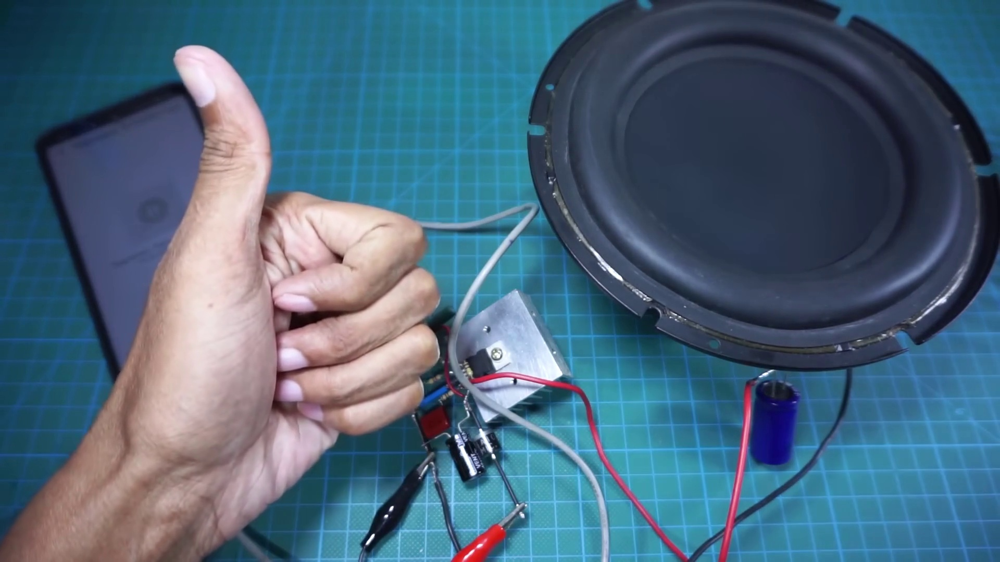 (score 95.0000)
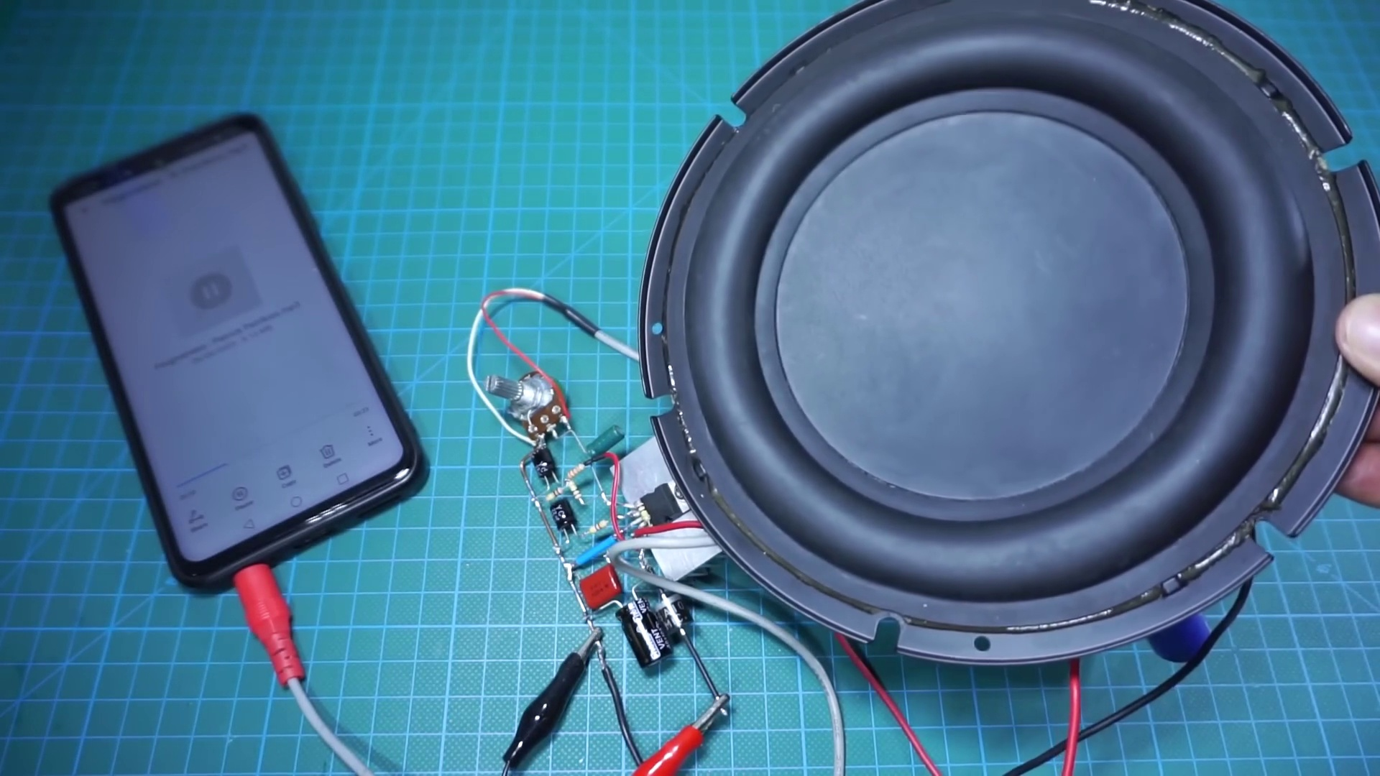 (score 95.0000)
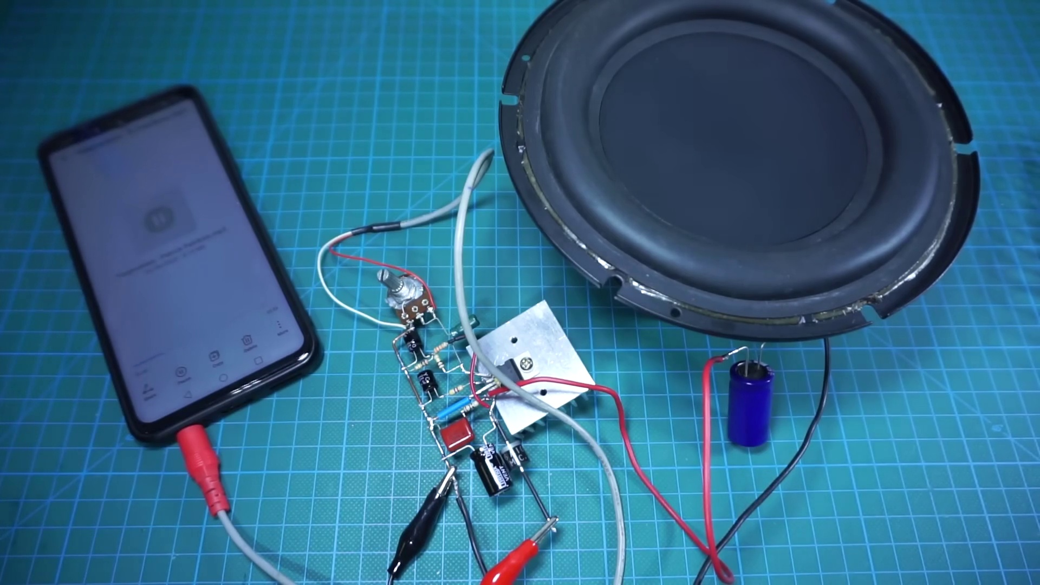 (score 95.0000)
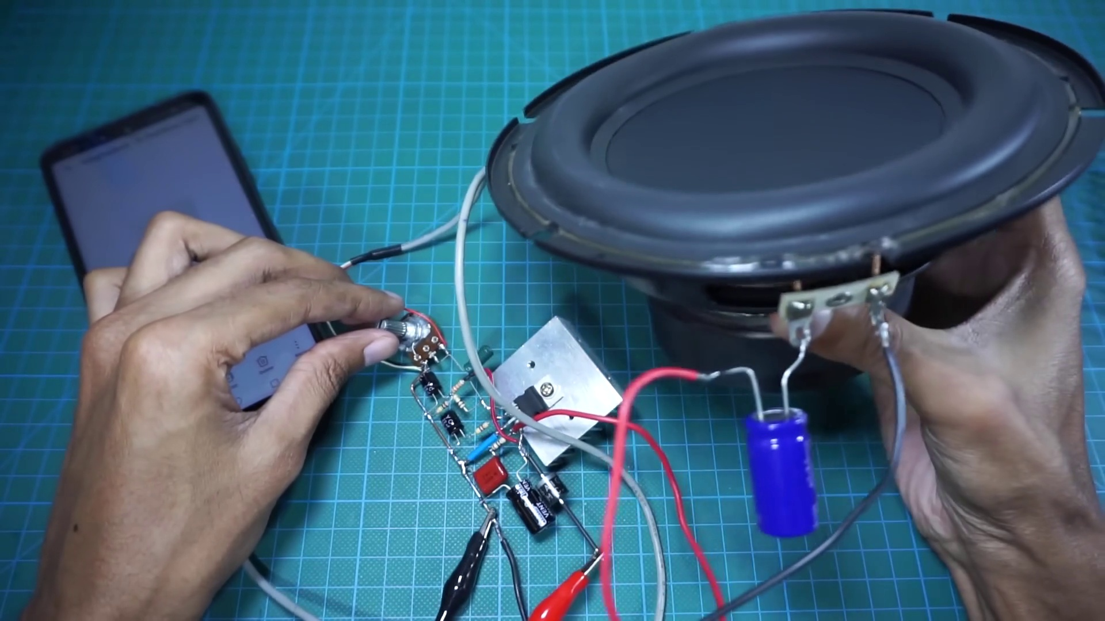 (score 95.0000)
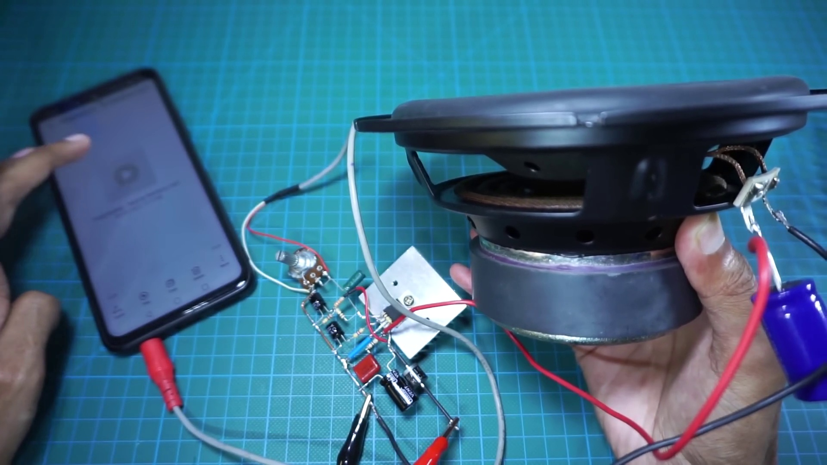 (score 95.0000)
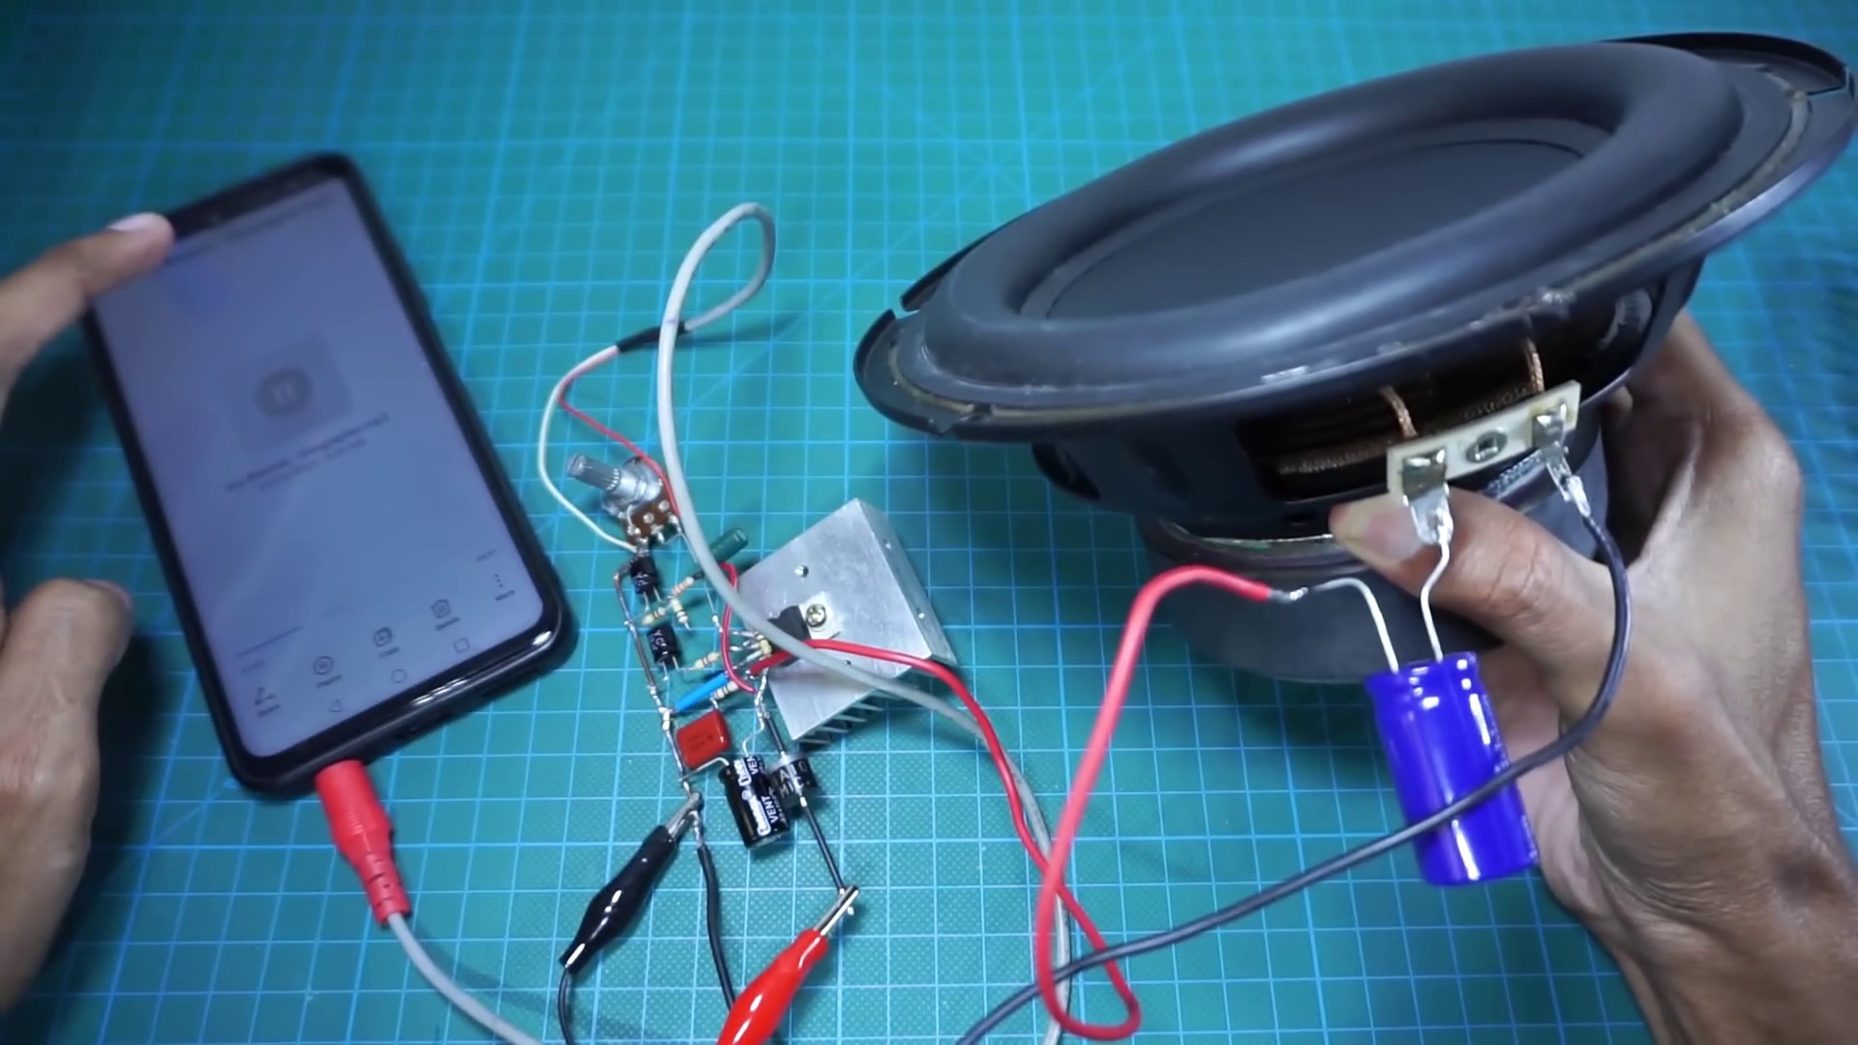 (score 95.0000)
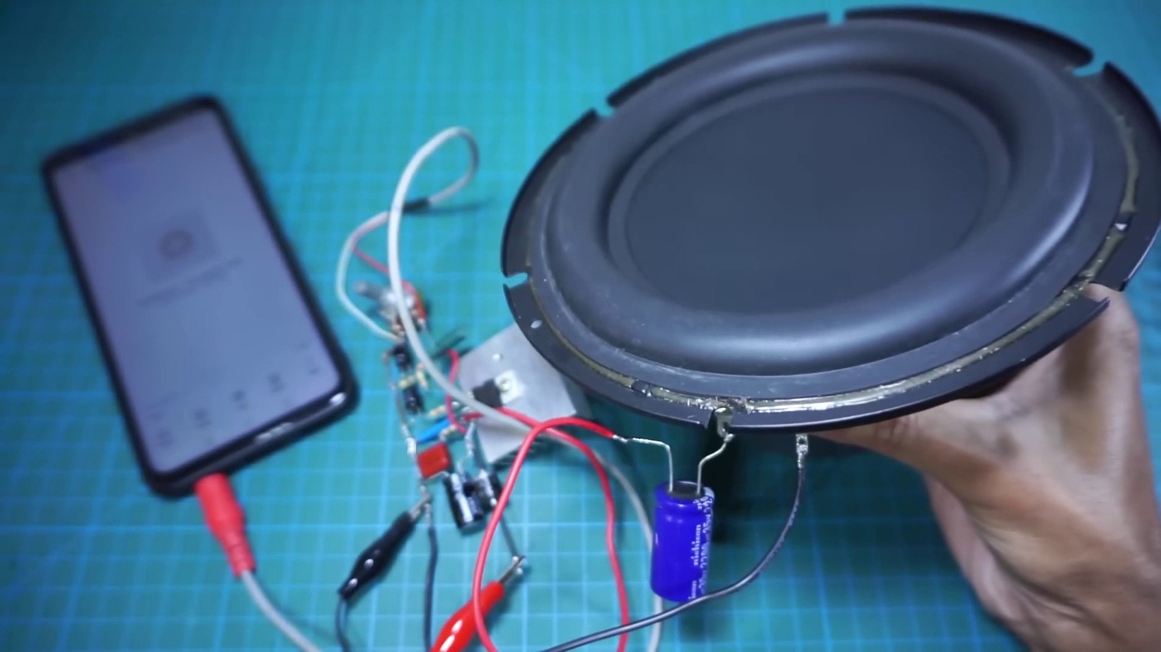 (score 95.0000)
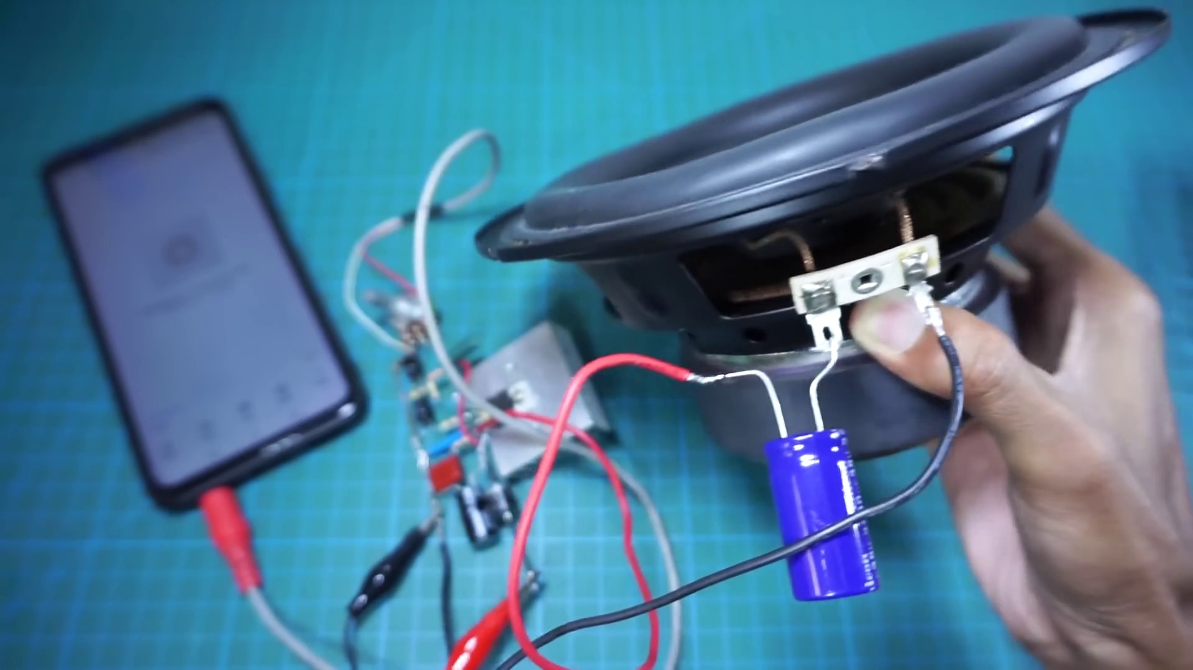 (score 95.0000)
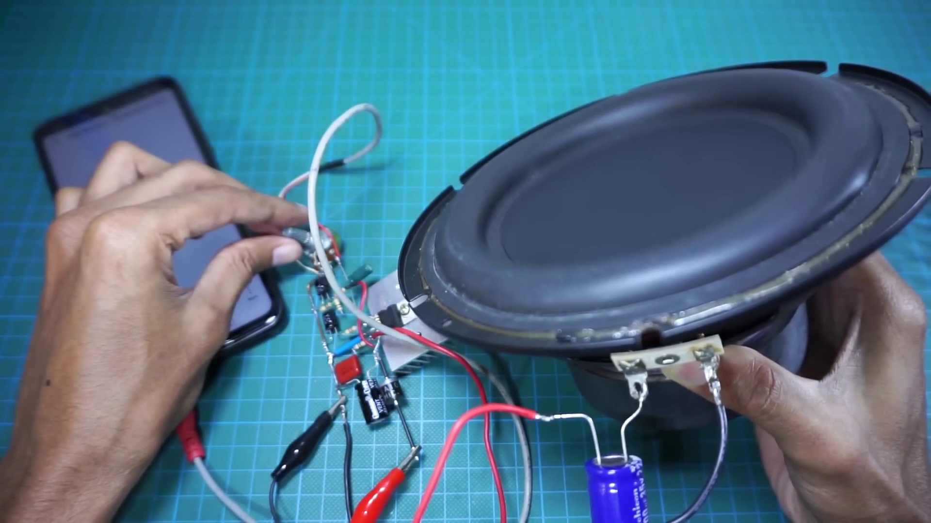 (score 95.0000)
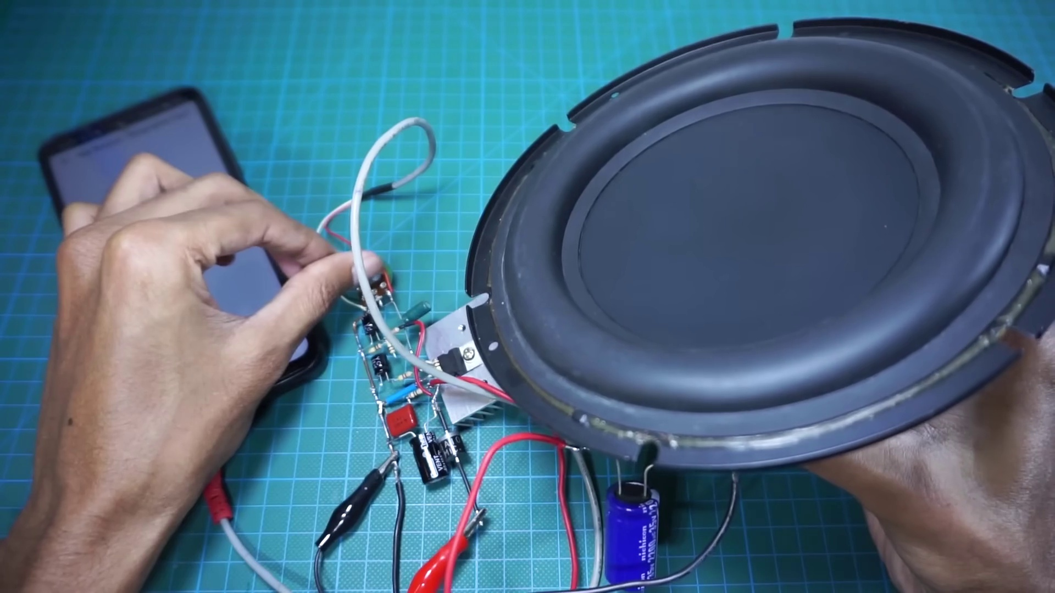 (score 95.0000)
Least correlated frames:
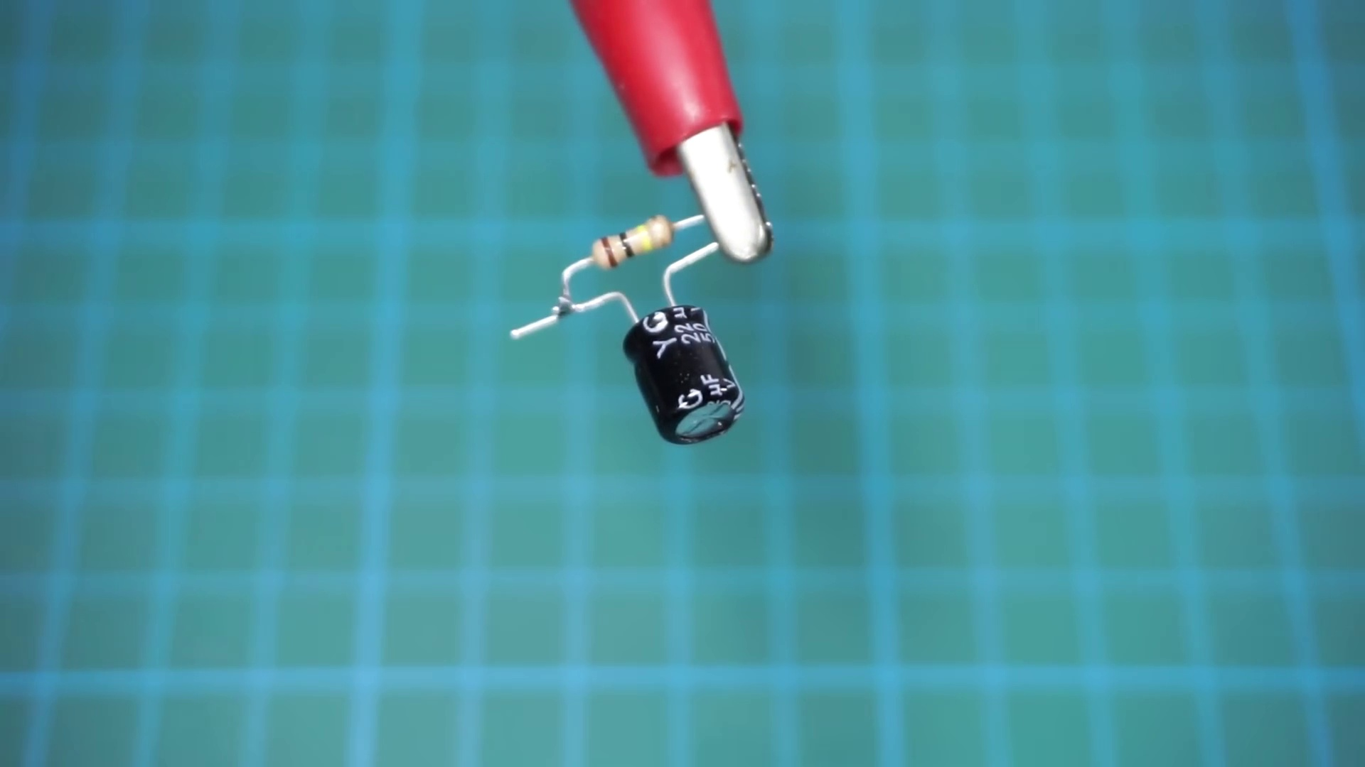 (score 5.0000)
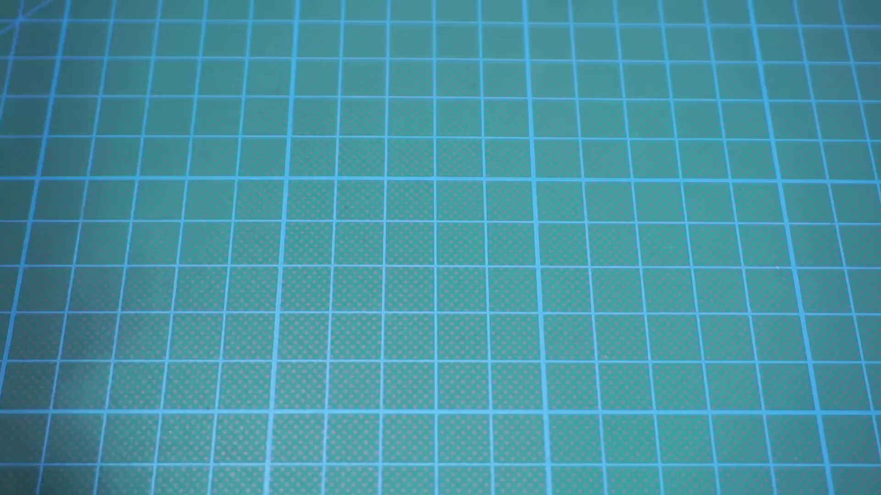 (score 20.0000)
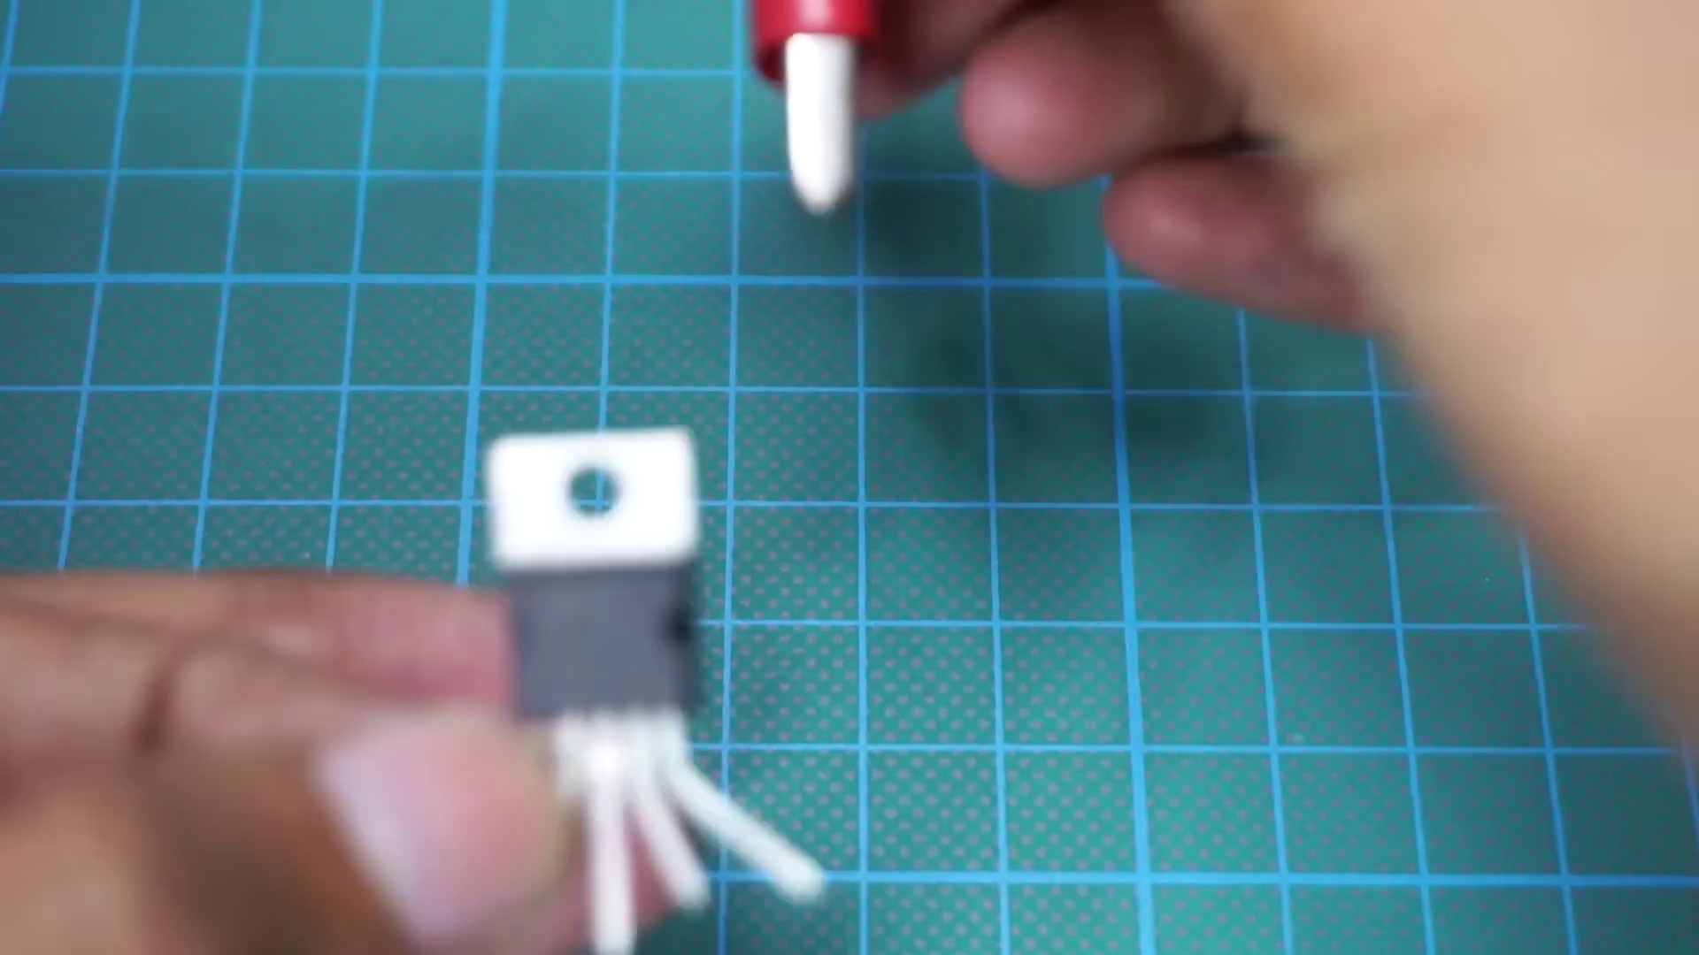 (score 20.0000)
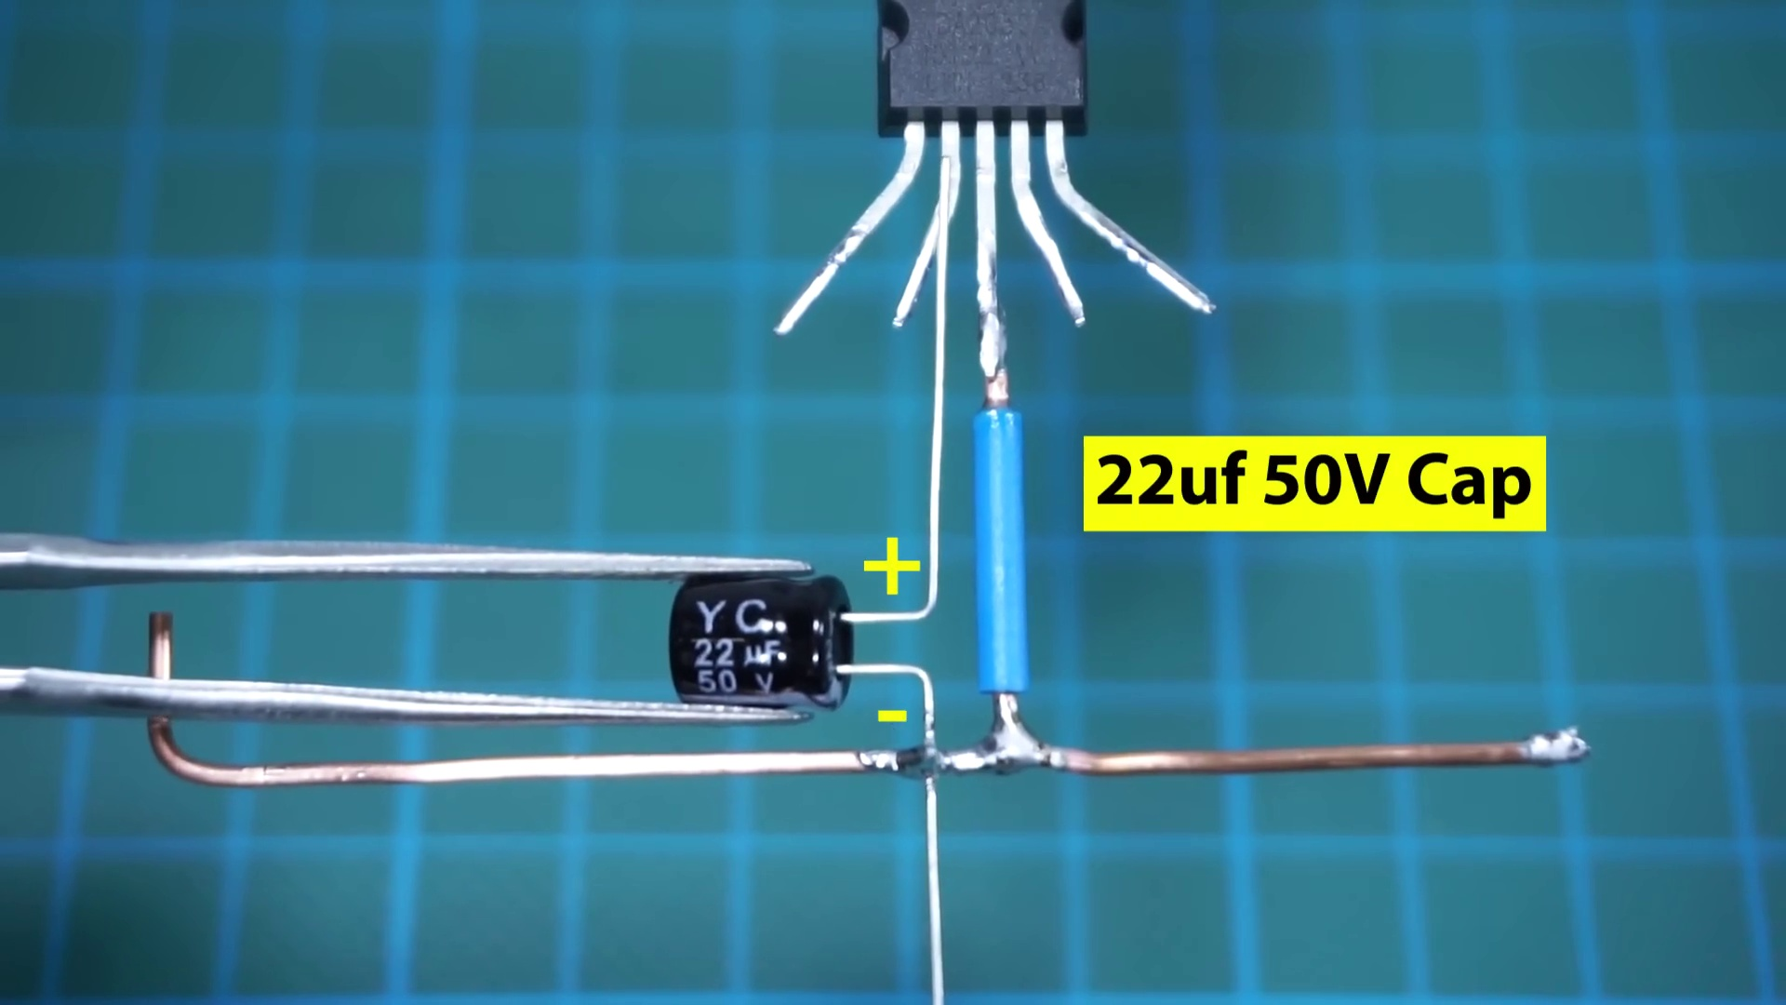 (score 20.0000)
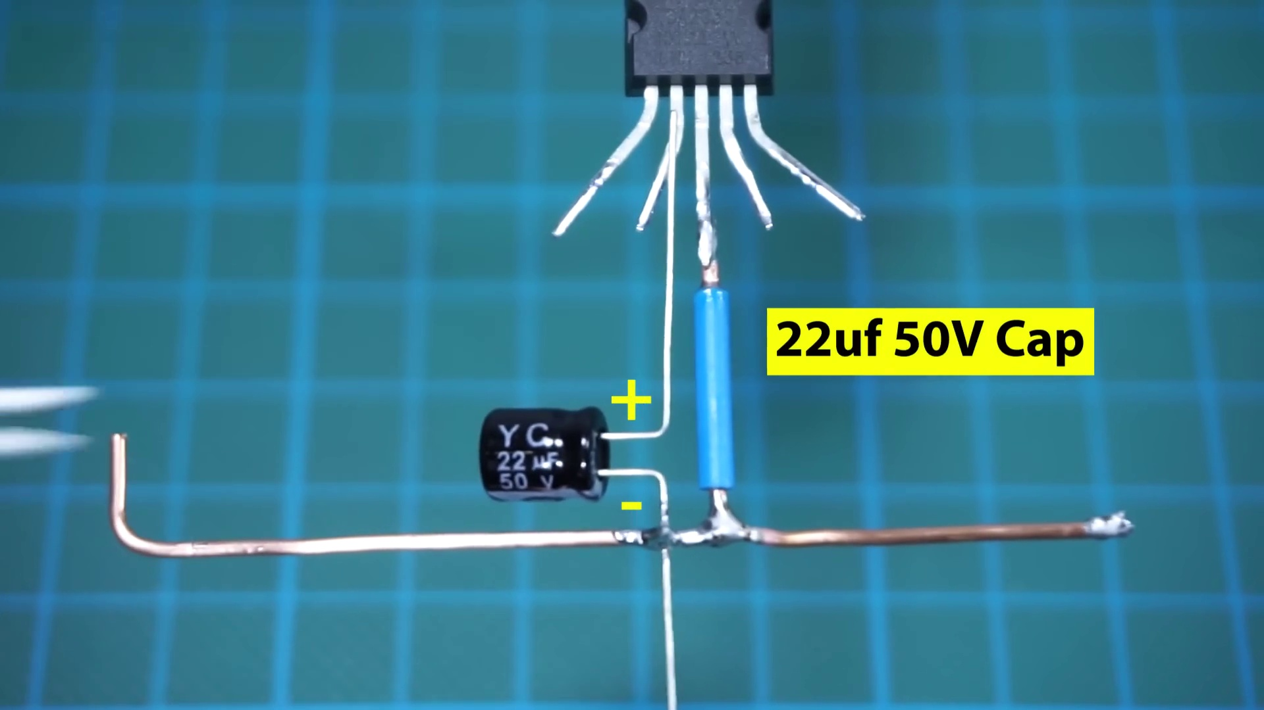 (score 20.0000)
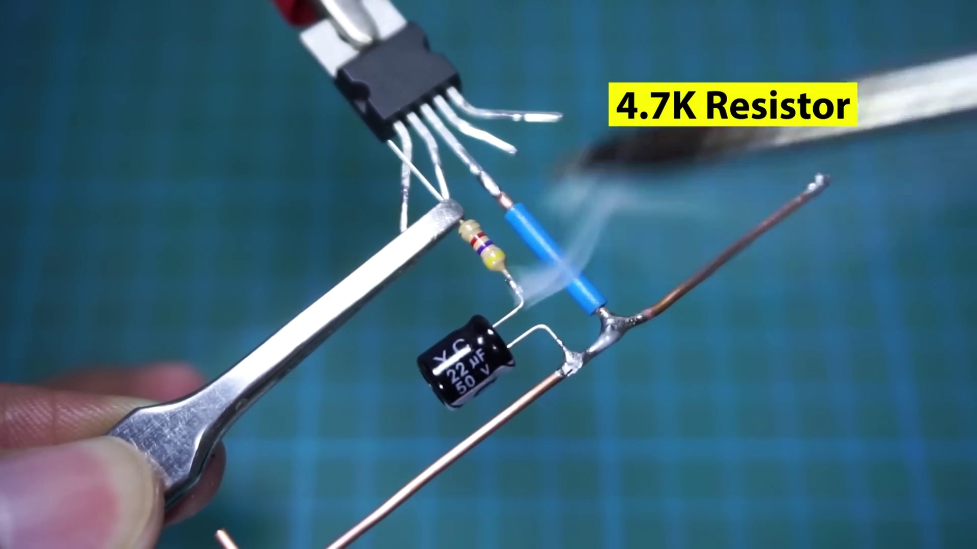 (score 20.0000)
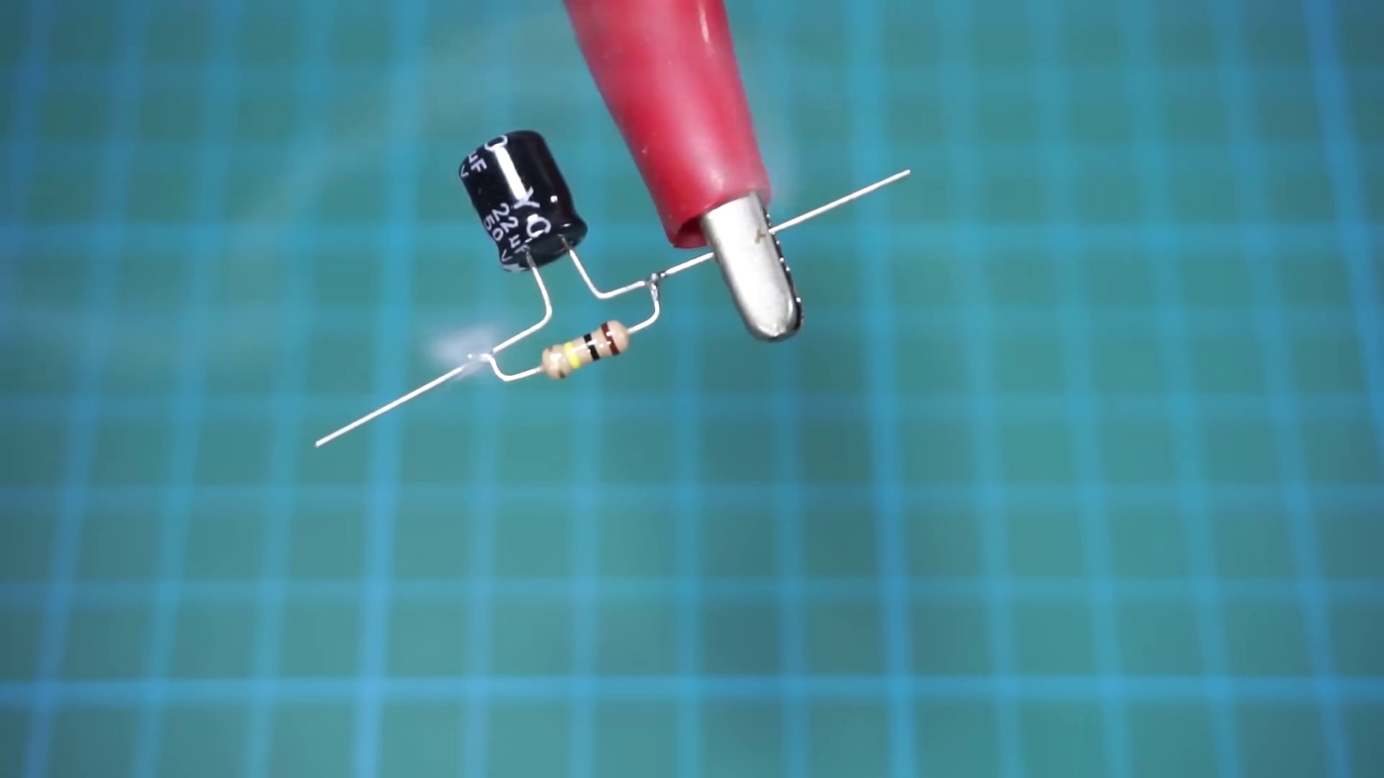 (score 20.0000)
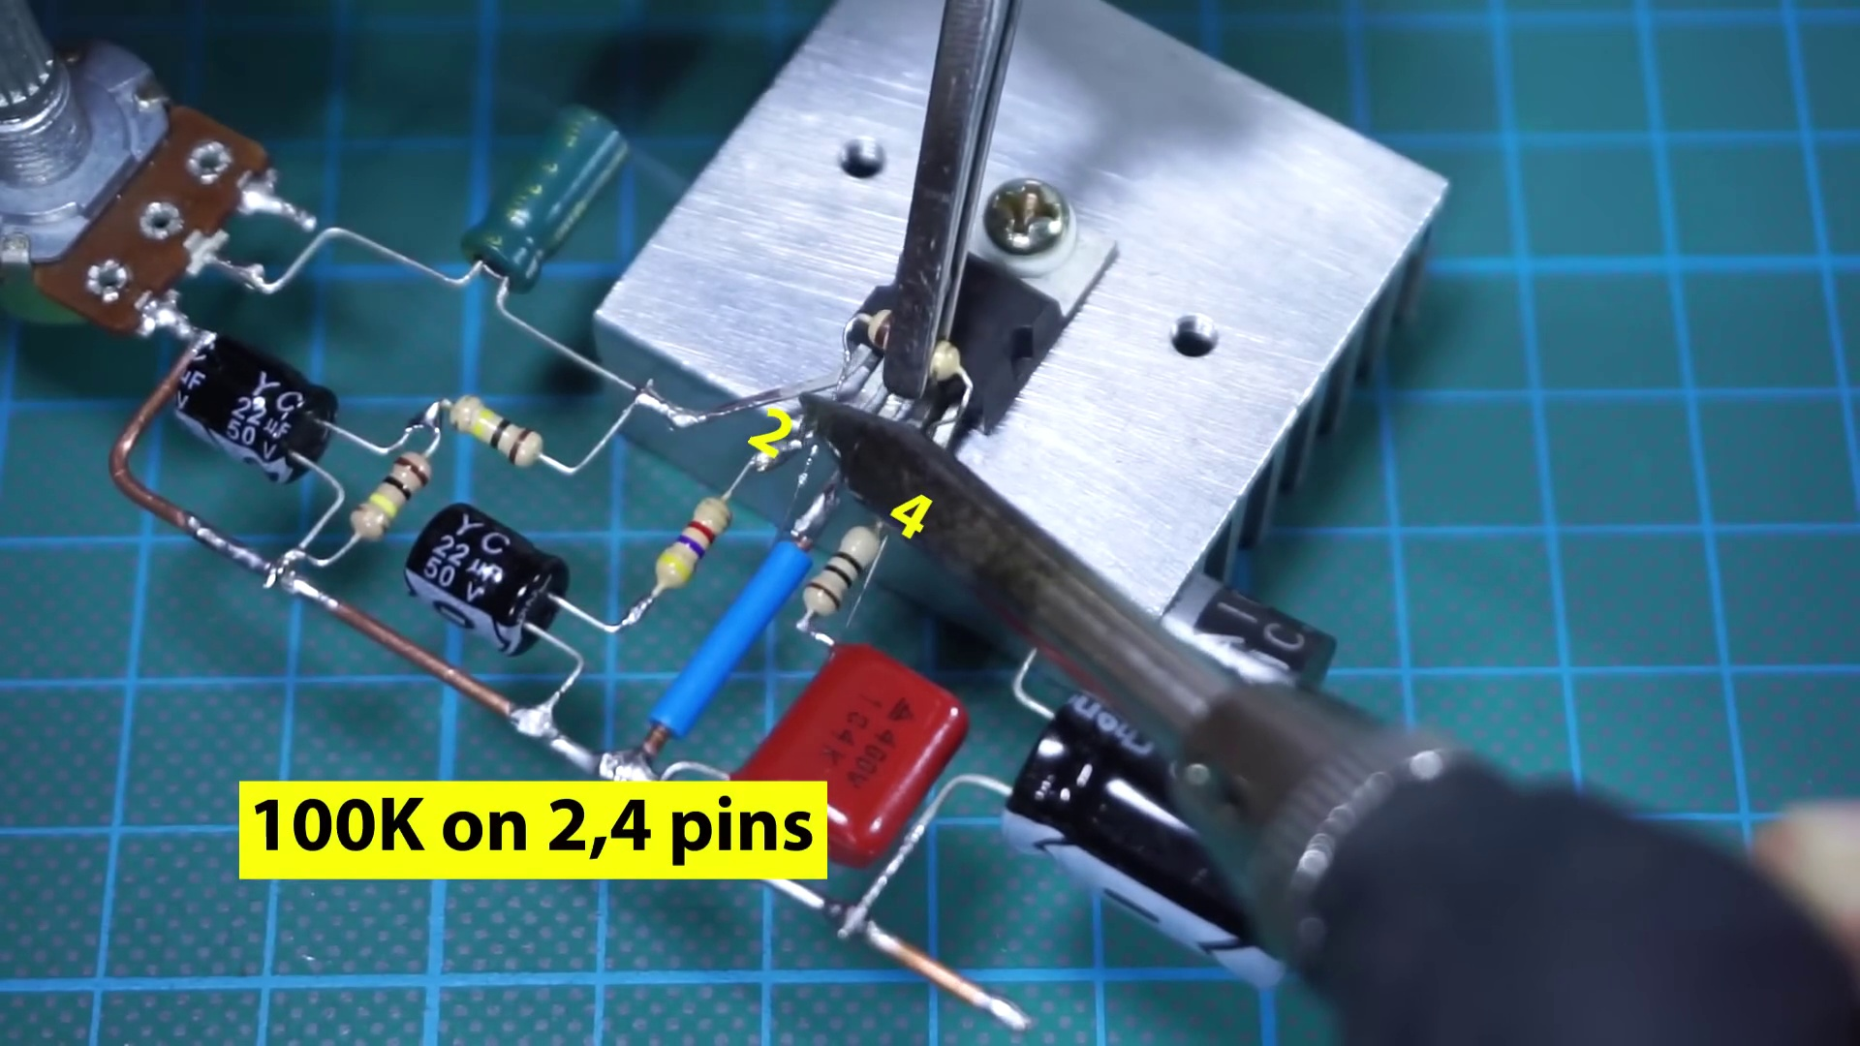 (score 20.0000)
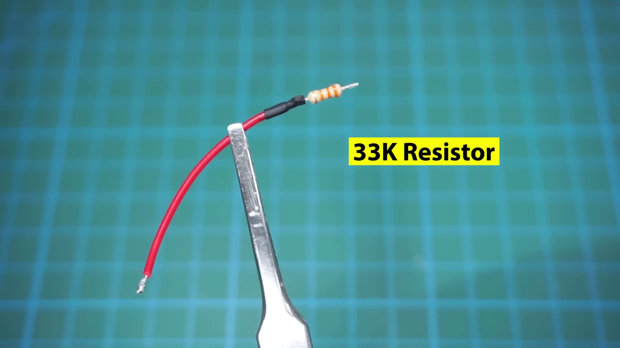 (score 20.0000)
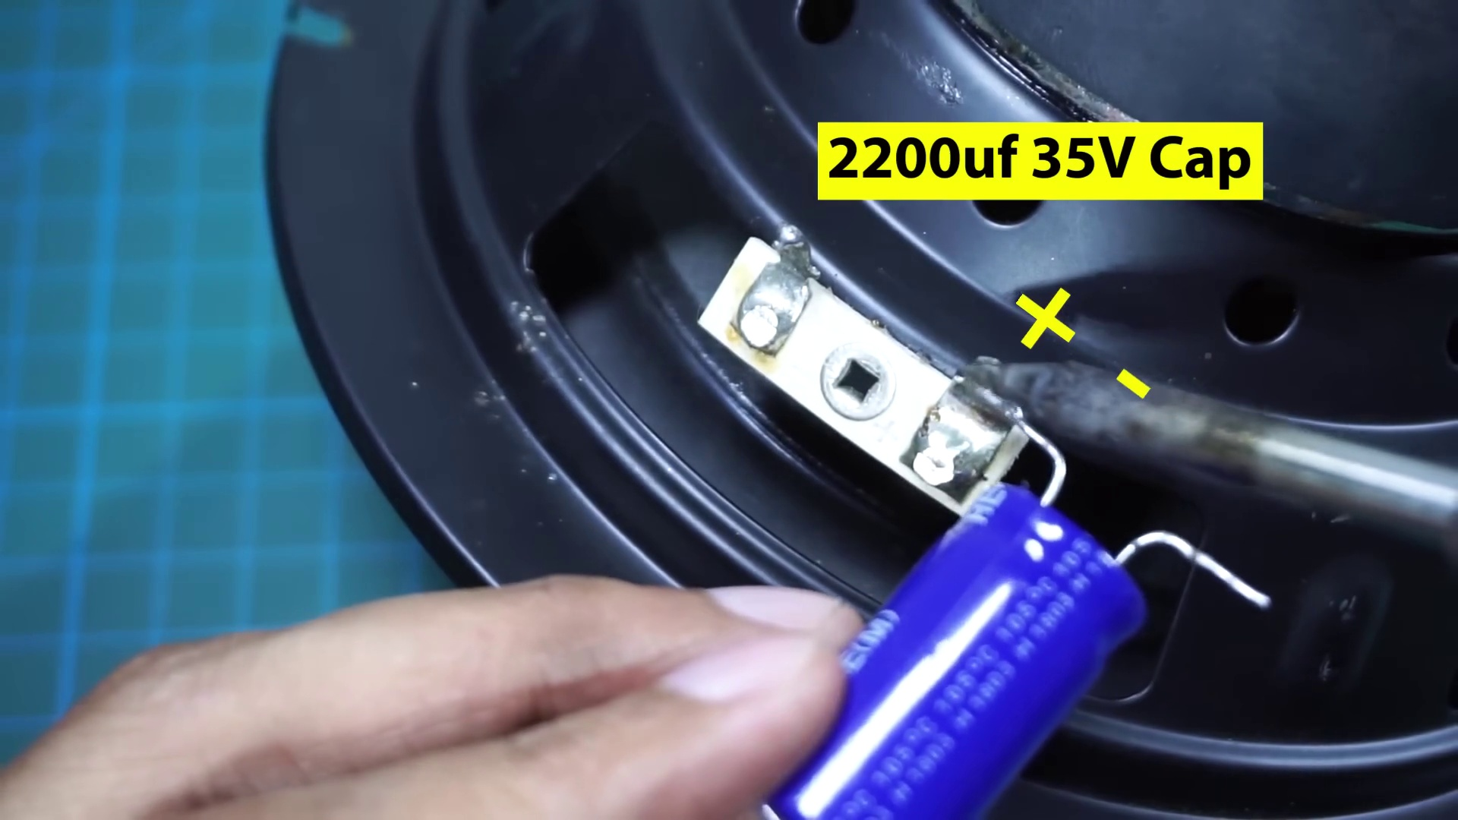 (score 20.0000)
- matched 237 frame(s), max score 95.0000: Demonstrates another circuit using the TDA2030 amplifier.No captions or explanations; viewer must figure out component placement.Looks like a good circuit for the final project.
Source: https://www.youtube.com/watch?v=cggDZE7gZNw: DIY Simple Powerful Amplifier Using TDA2030, Homemade Amplifier 12V
Top correlated frames:
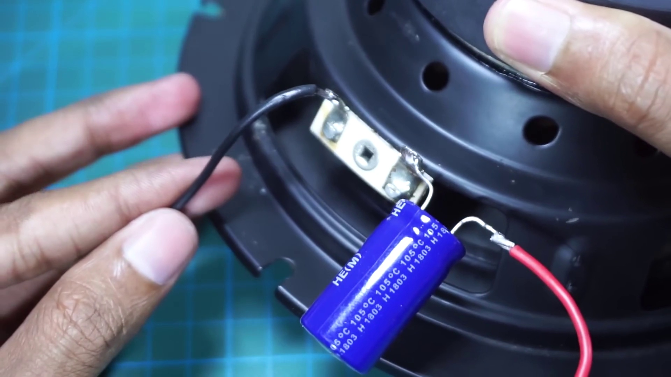 (score 95.0000)
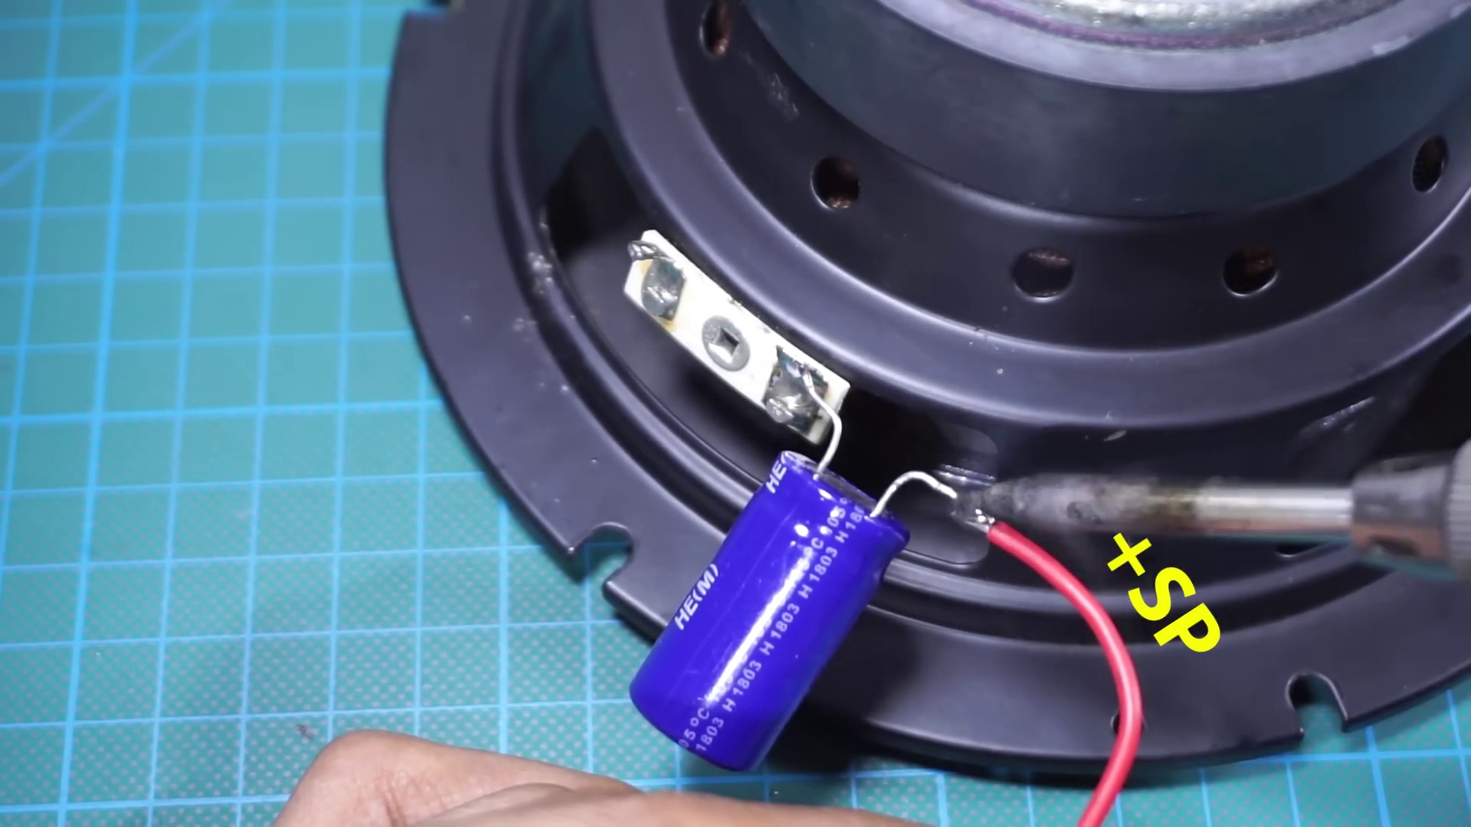 (score 95.0000)
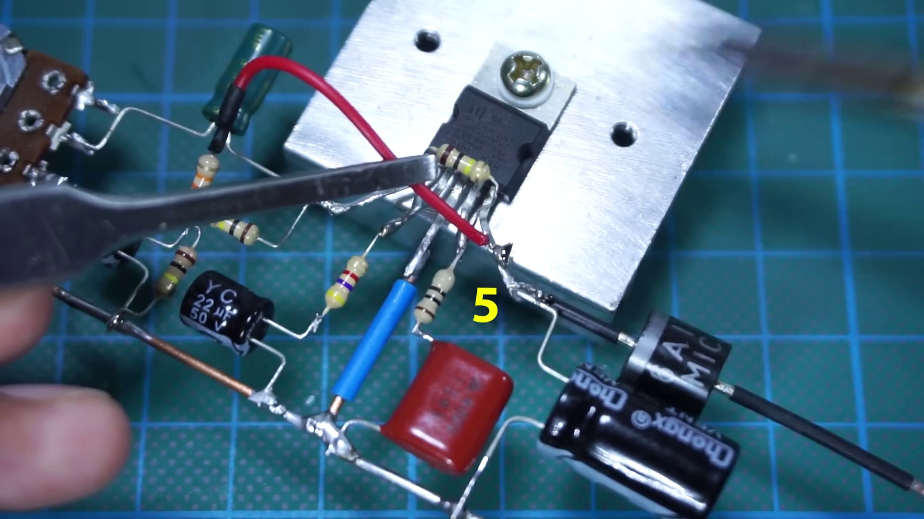 (score 95.0000)
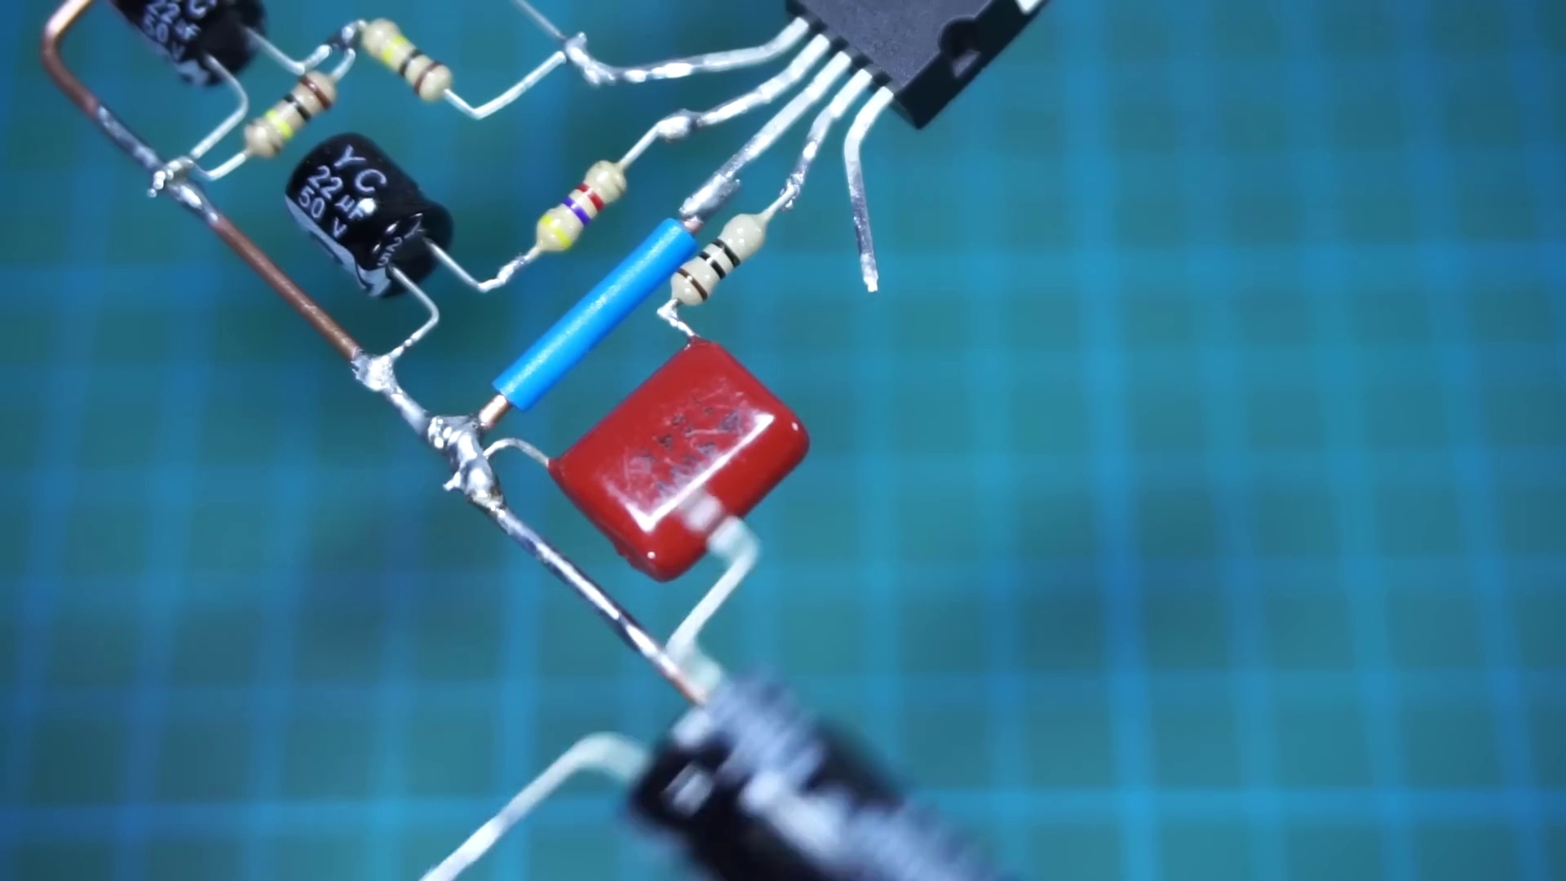 (score 95.0000)
 (score 90.0000)
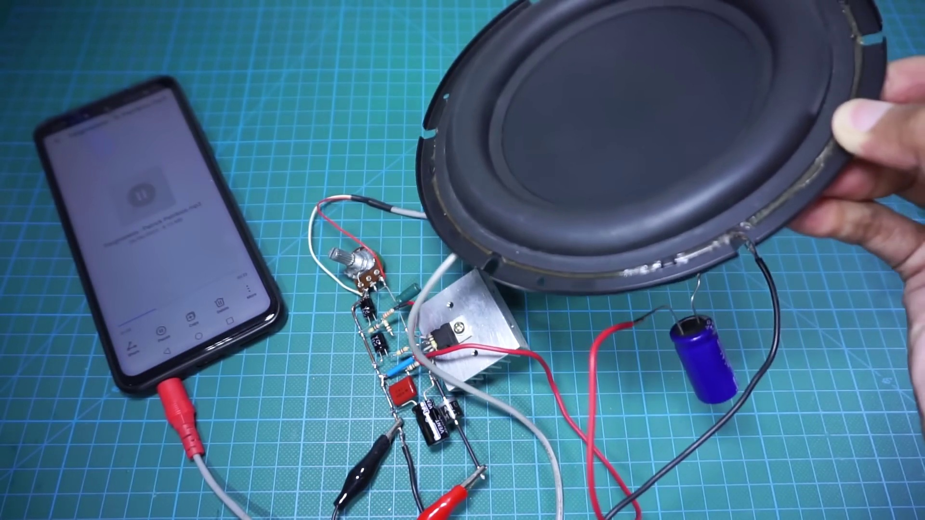 (score 90.0000)
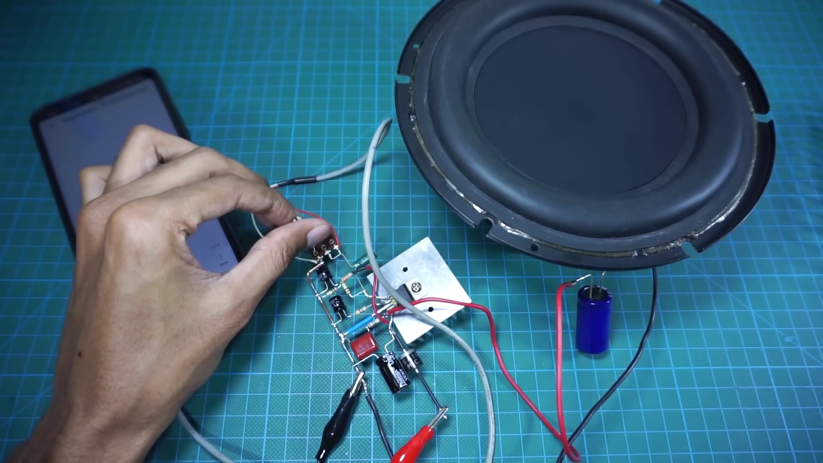 (score 90.0000)
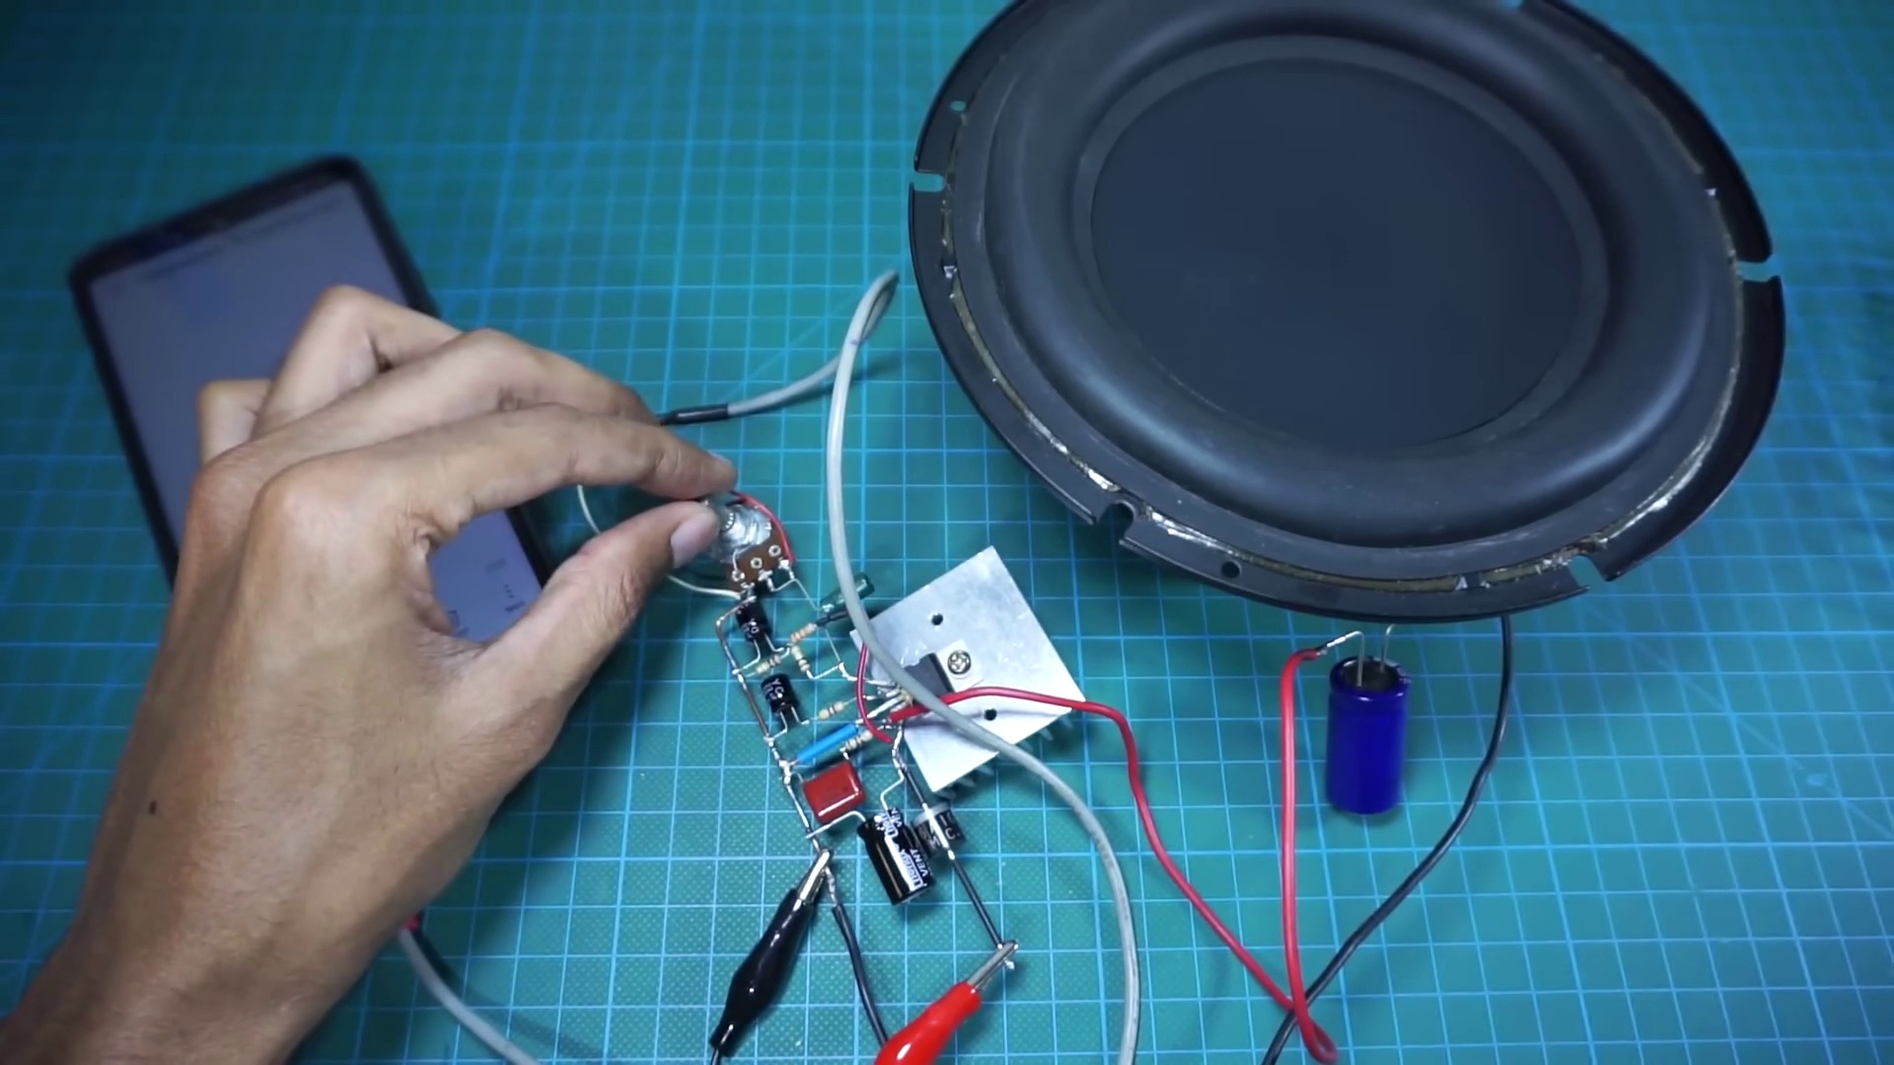 (score 90.0000)
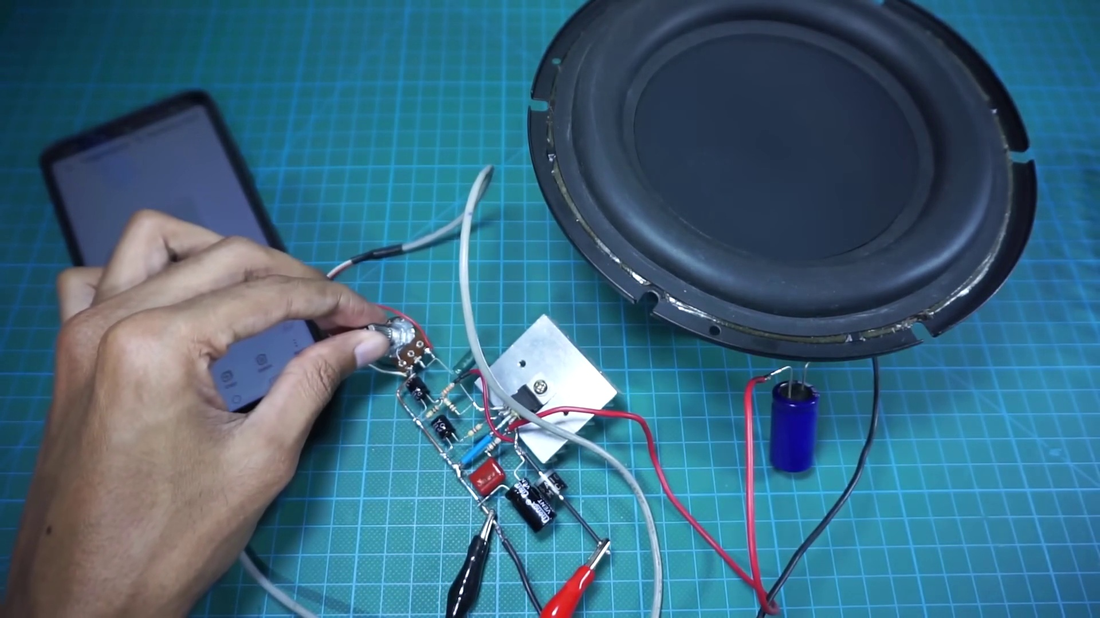 (score 90.0000)
 (score 90.0000)
Least correlated frames:
 (score 0.0000)
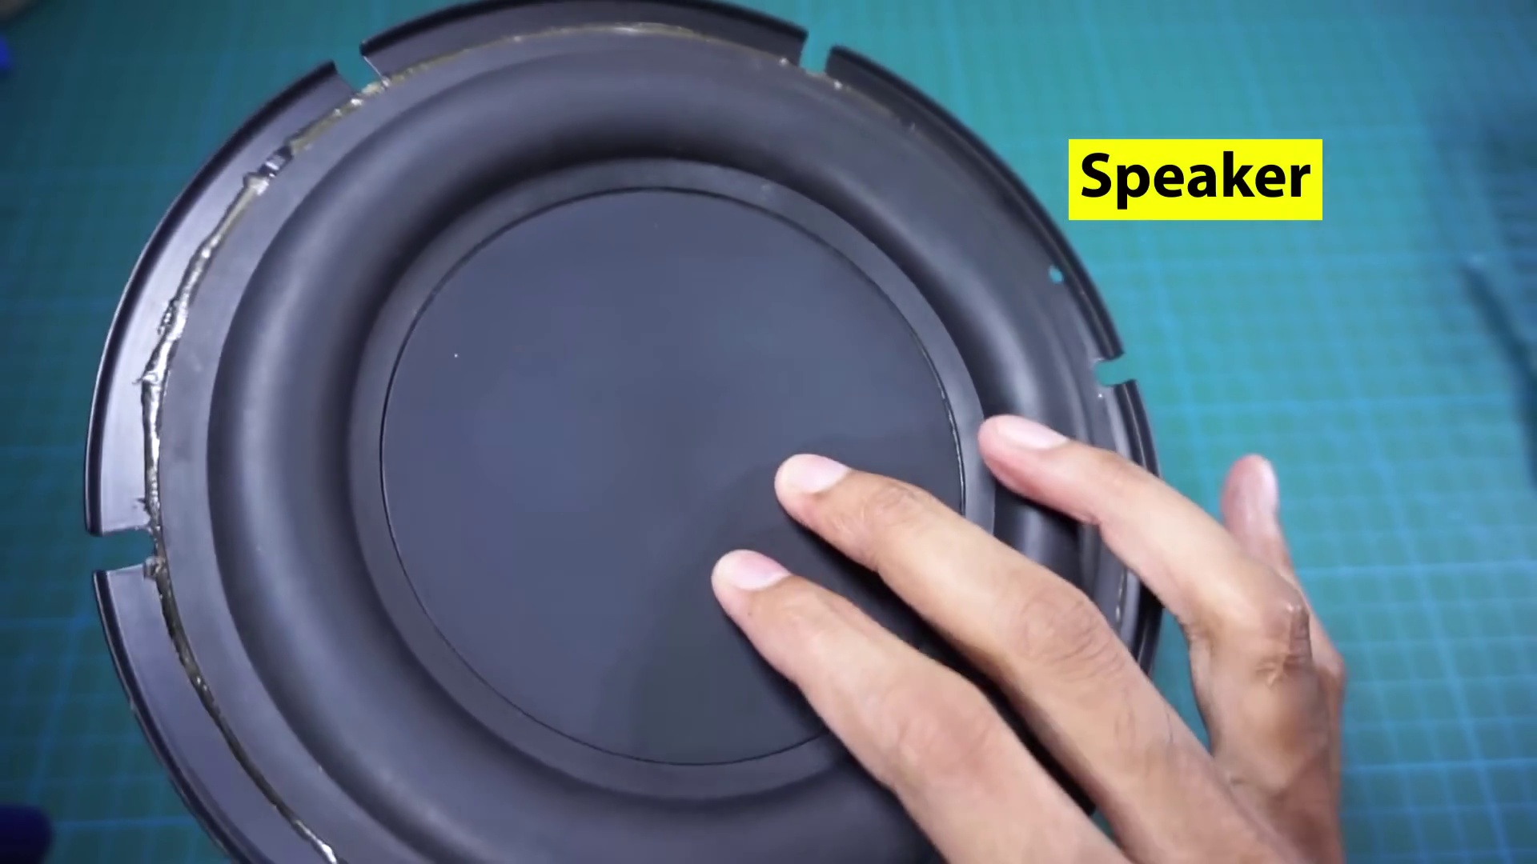 (score 0.0000)
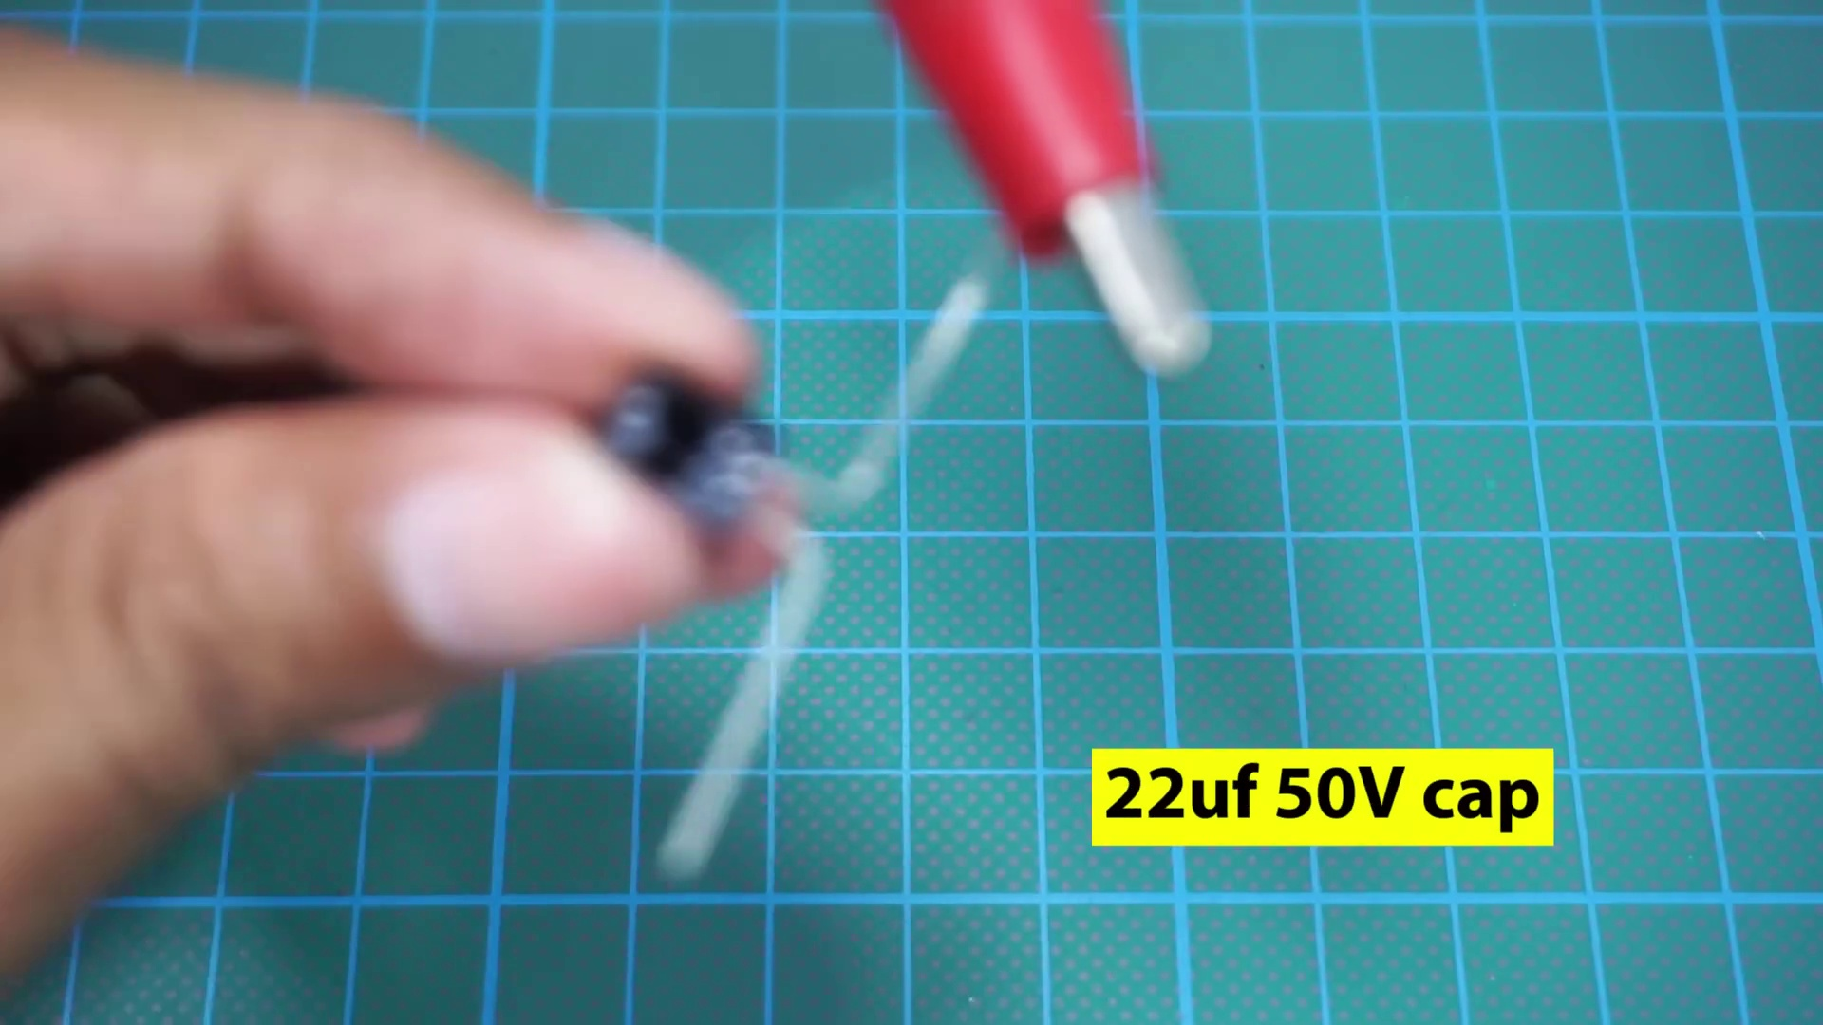 (score 5.0000)
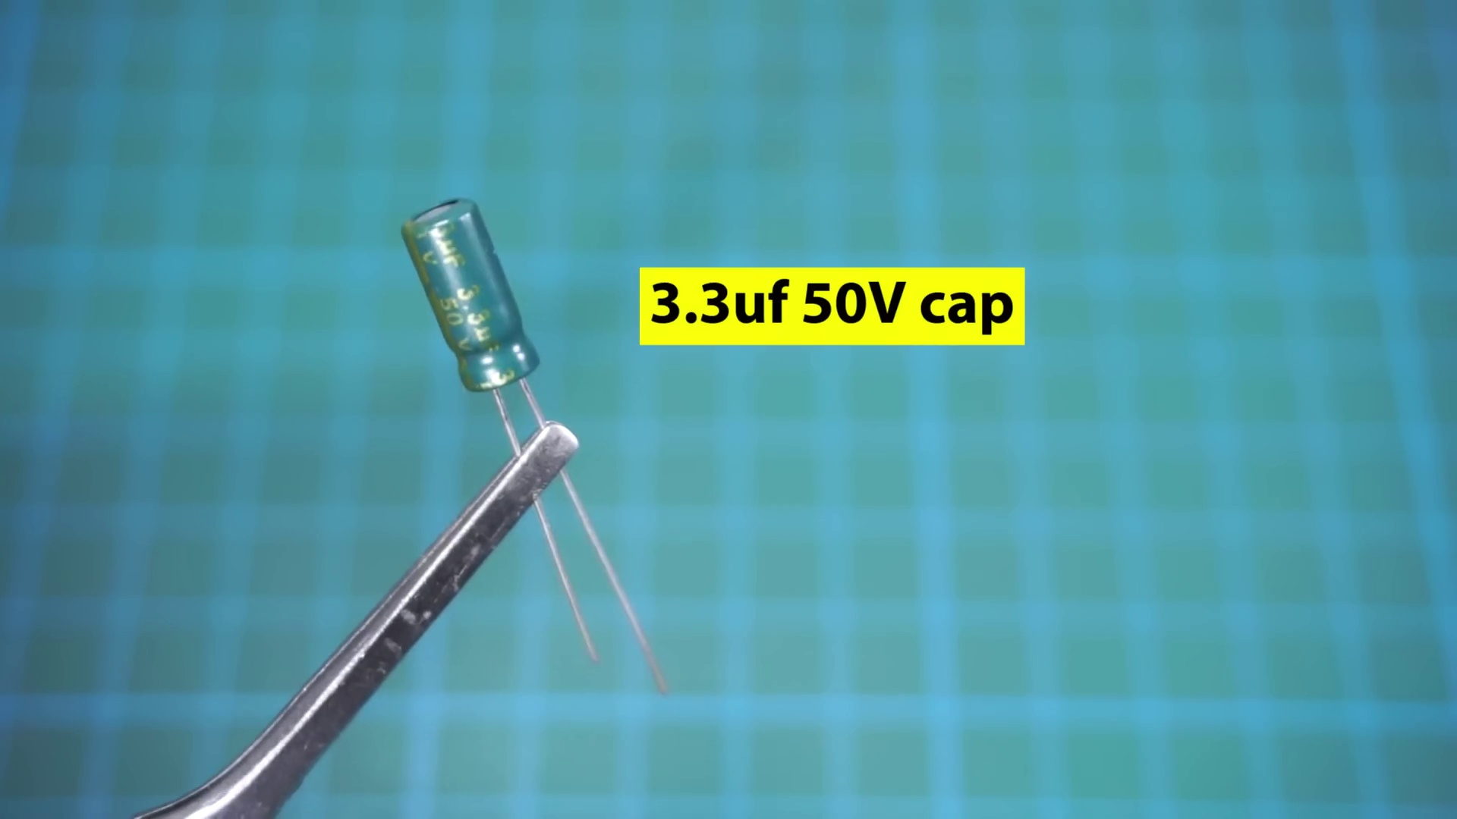 (score 10.0000)
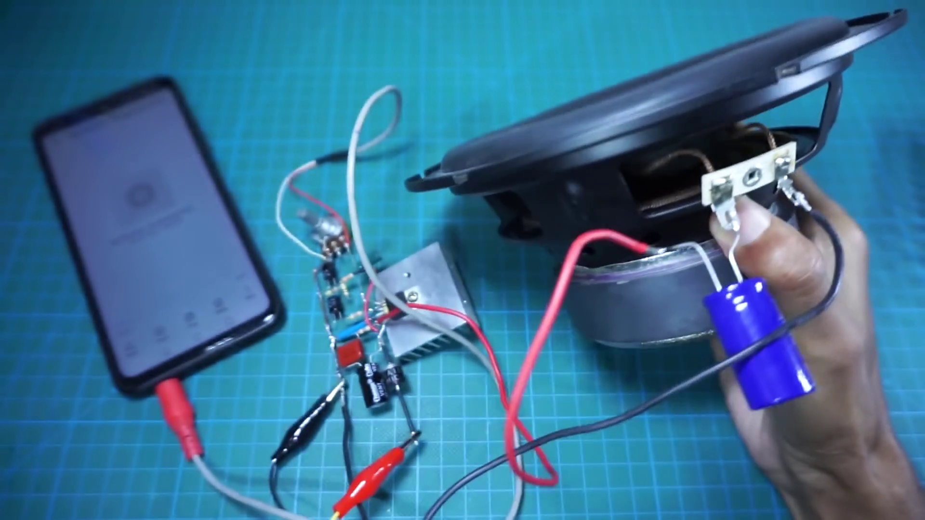 (score 10.0000)
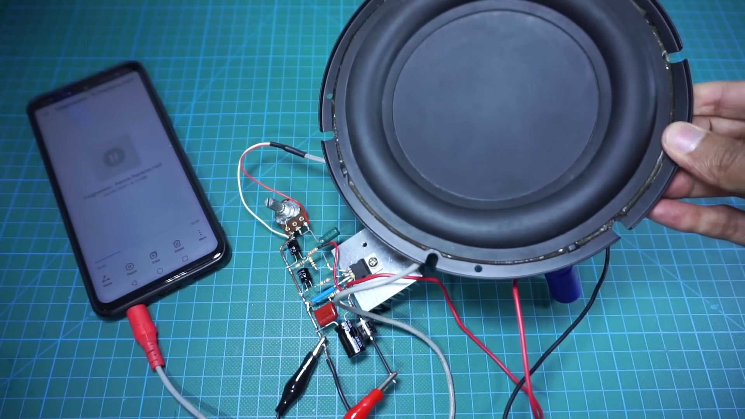 (score 10.0000)
 (score 20.0000)
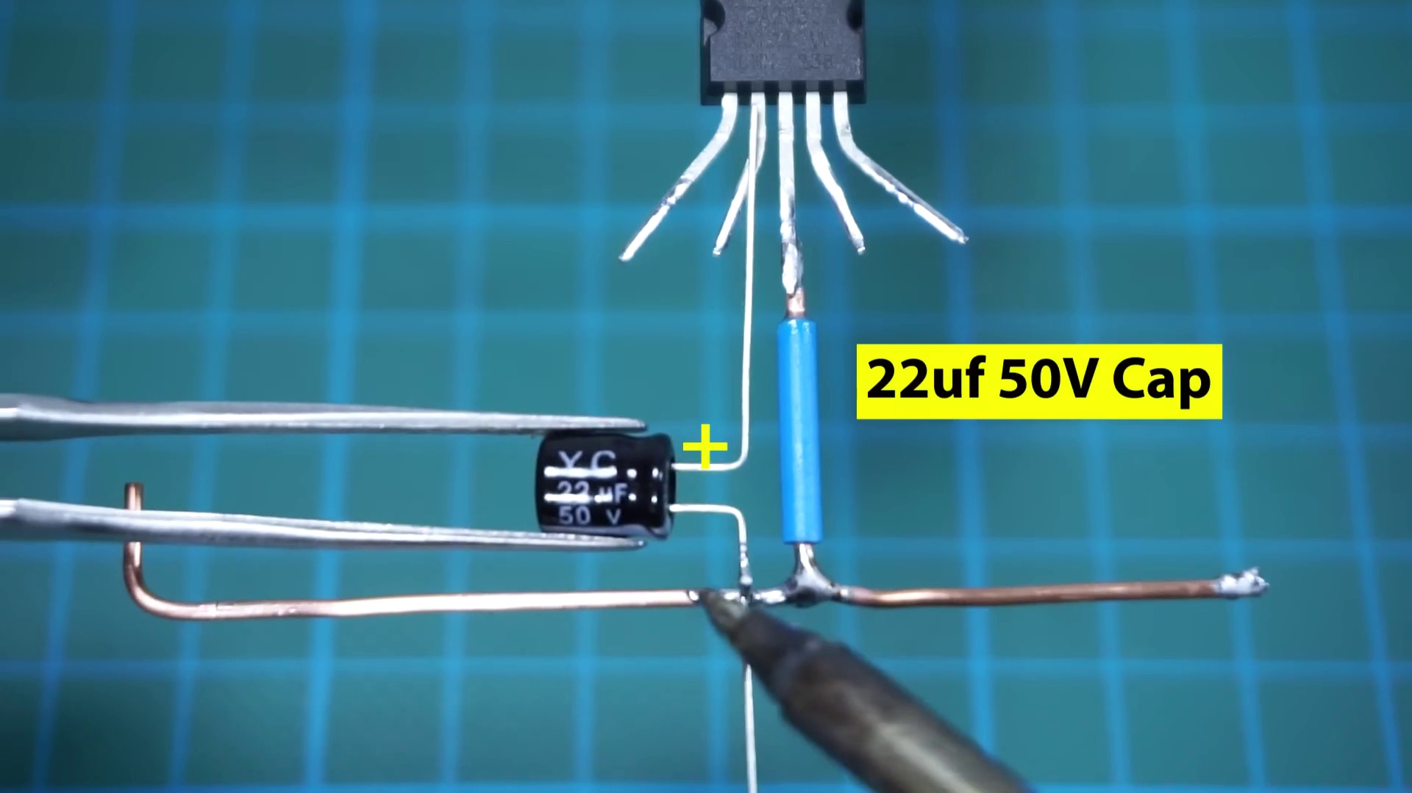 (score 20.0000)
 (score 20.0000)
 (score 20.0000)
- matched 215 frame(s), max score 95.0000: This video showed a TDA2030 amplifier being hooked up using a 12V, 2A power supply like I have. I think this video is a decent example, but his method of hooking it up without a breadboard is pretty fragile for phase II. I do know now that I need a large heatsink for the chip as the one I have will likely be too small for the chip. I will also likely borrow the idea of using a 2200uF capacitor on the speaker to further clean noise.
Source: https://www.youtube.com/watch?v=cggDZE7gZNw: DIY simple Powerful Amplifier using TDA2030, Homemade Amplifier 12V
Top correlated frames:
 (score 95.0000)
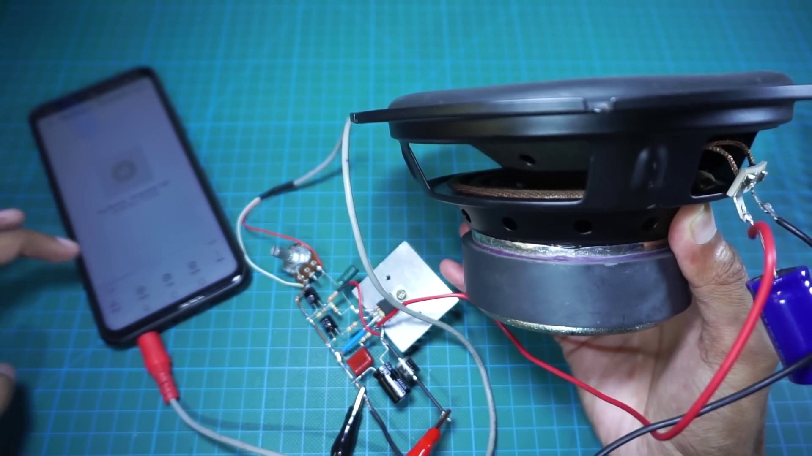 (score 95.0000)
 (score 95.0000)
 (score 95.0000)
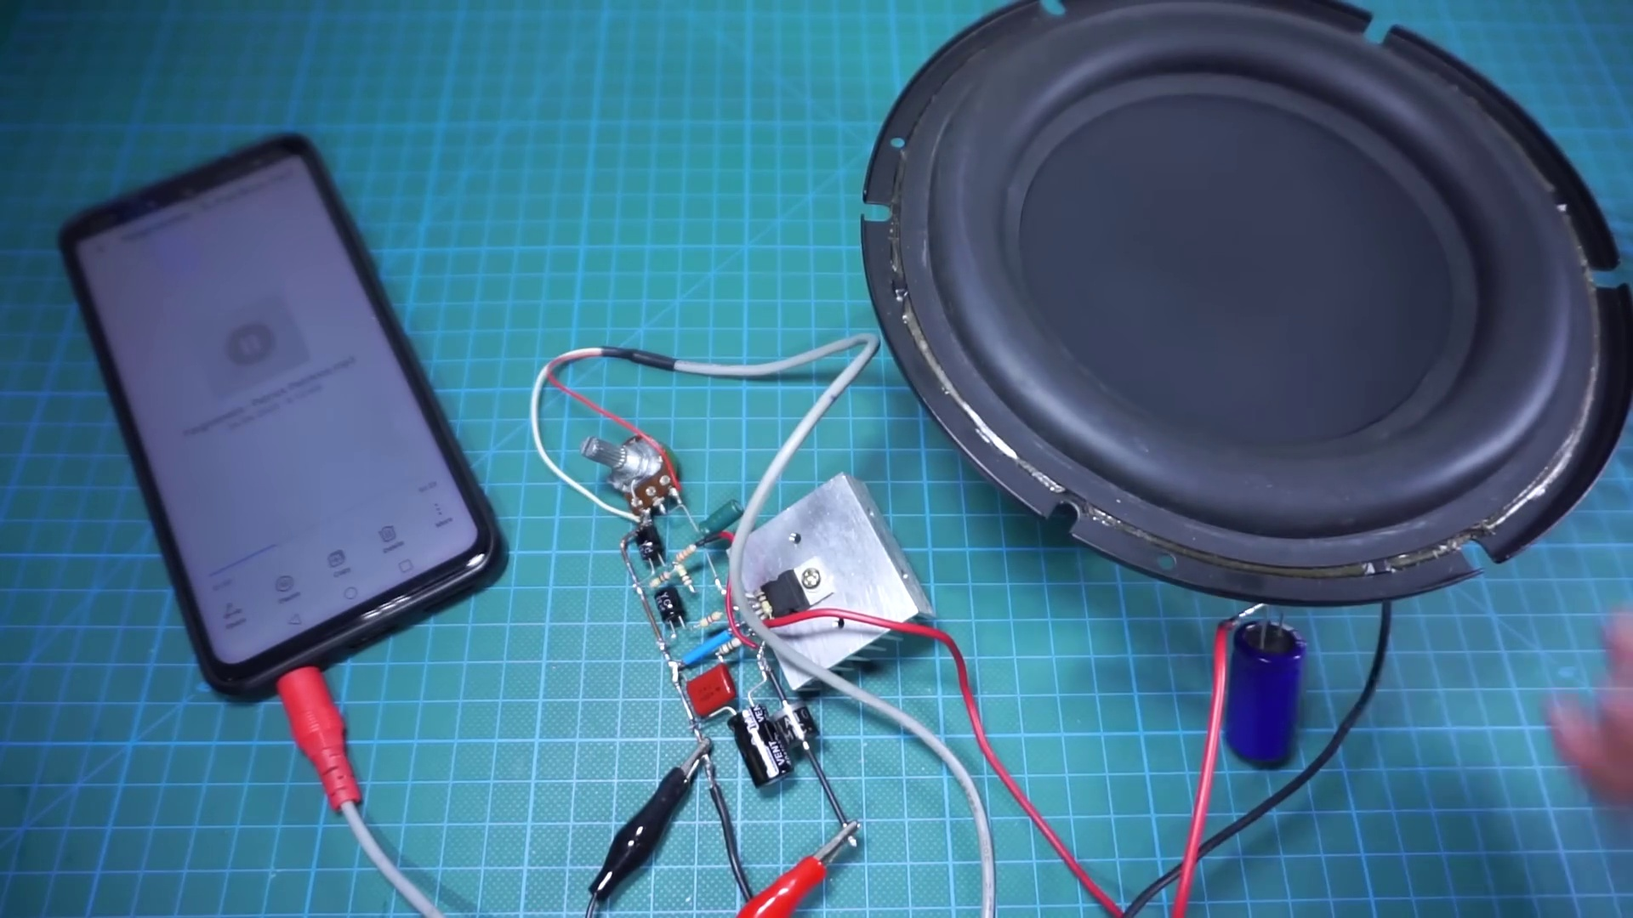 (score 90.0000)
 (score 90.0000)
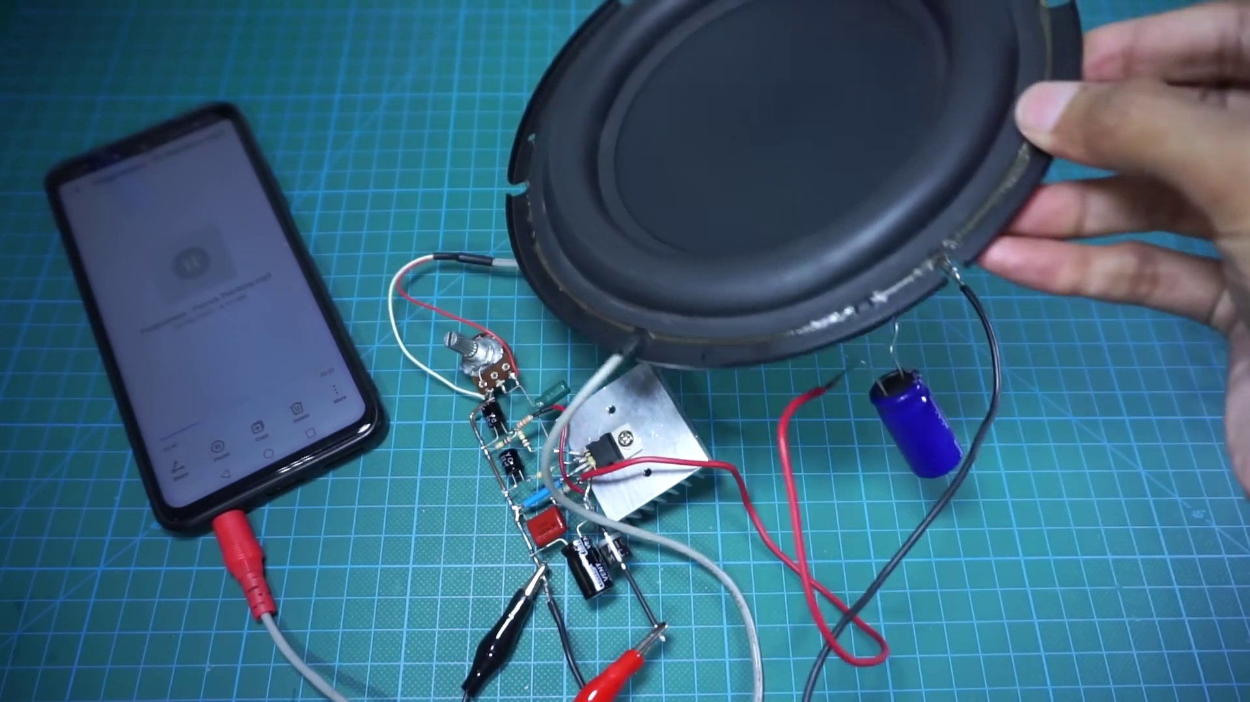 (score 90.0000)
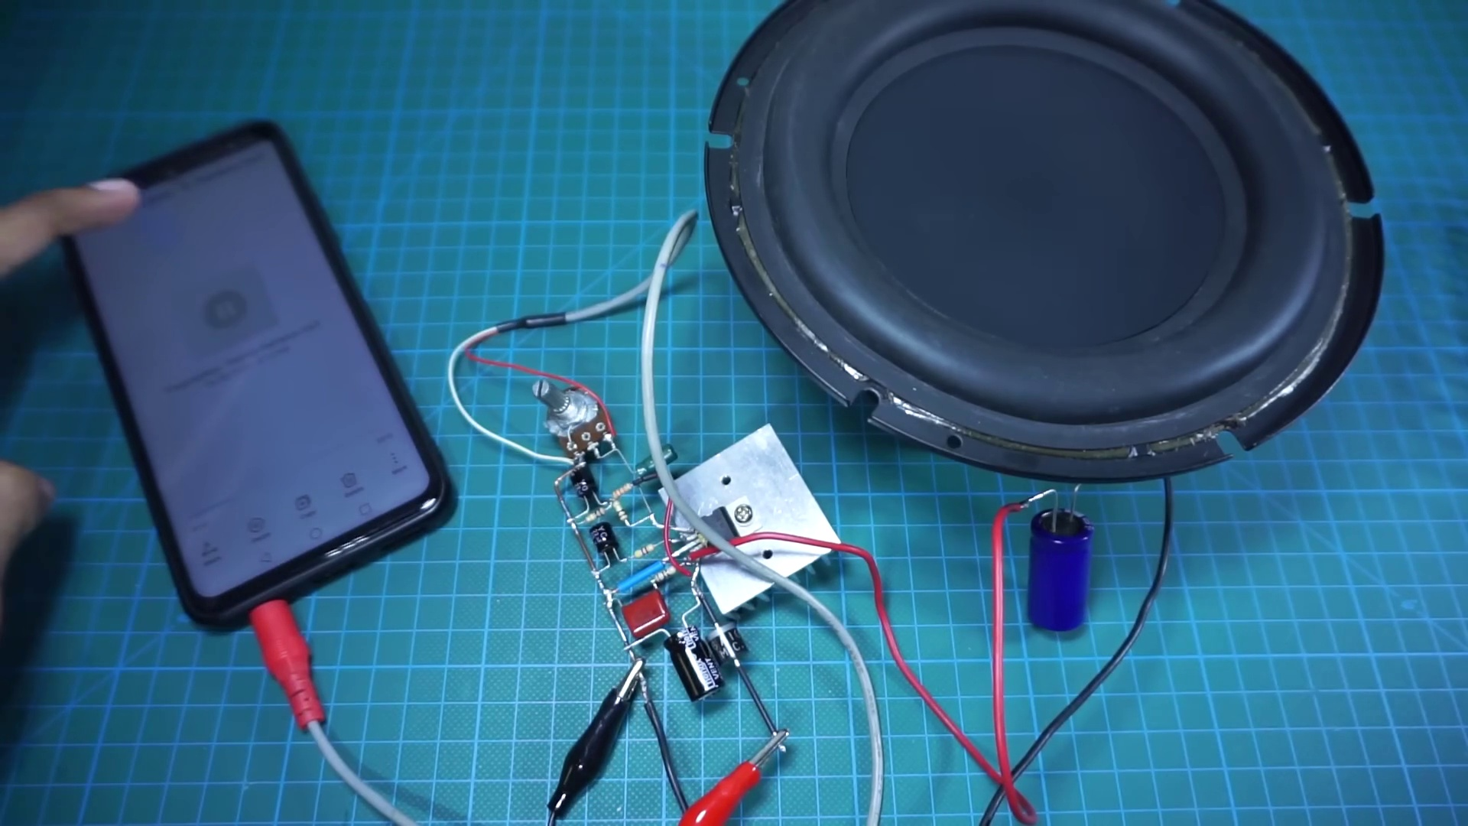 (score 90.0000)
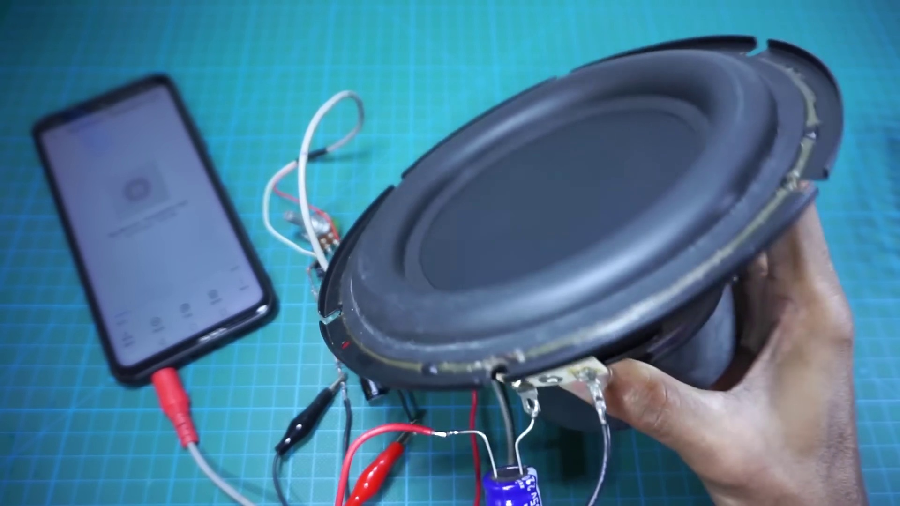 (score 90.0000)
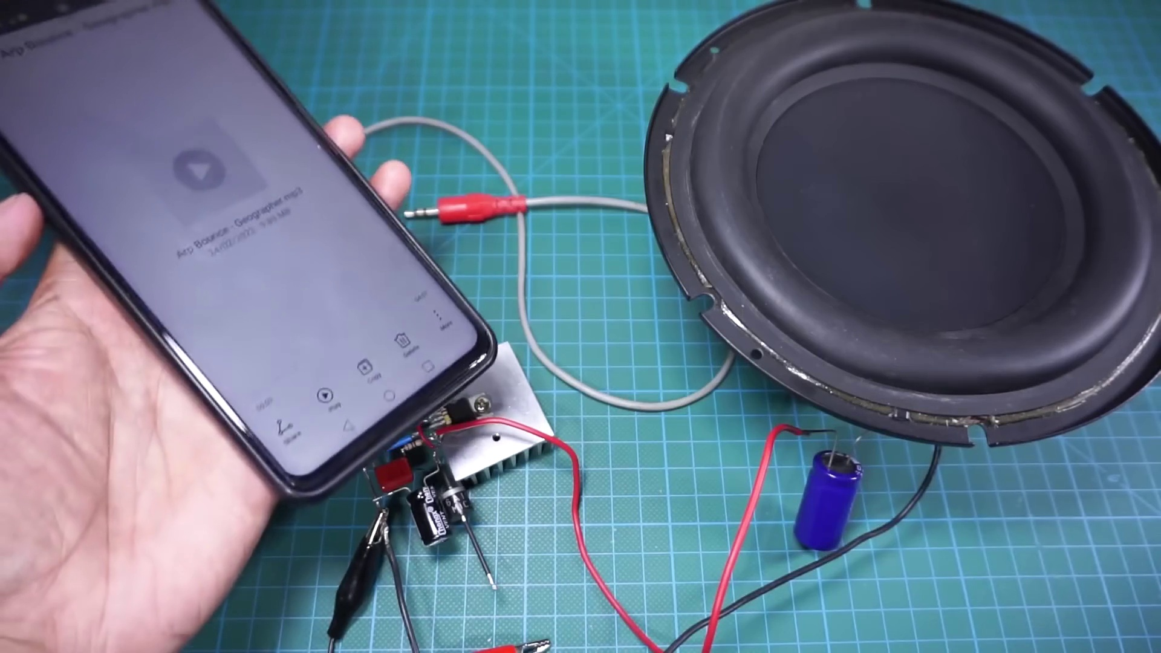 (score 90.0000)
Least correlated frames:
 (score 10.0000)
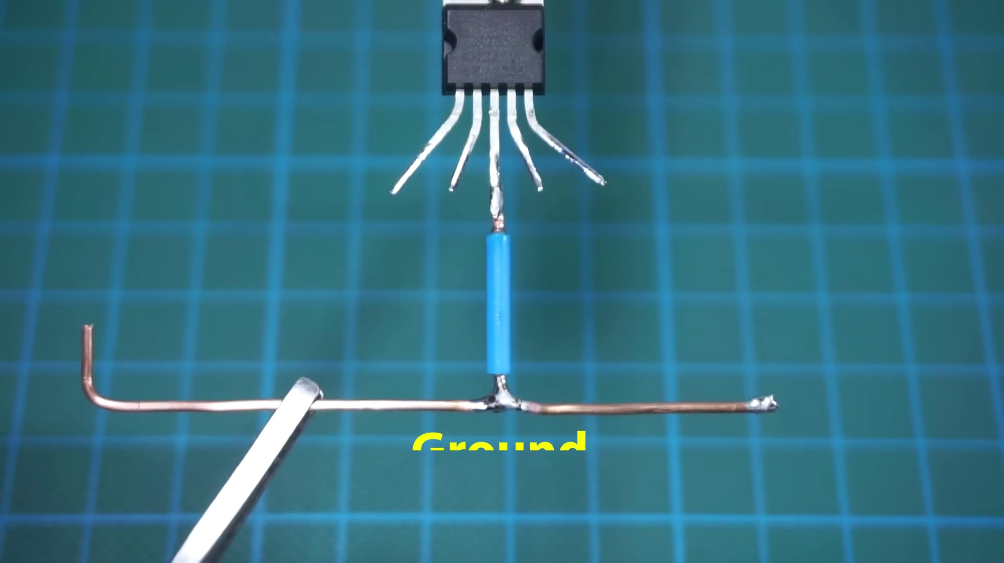 (score 20.0000)
 (score 20.0000)
 (score 20.0000)
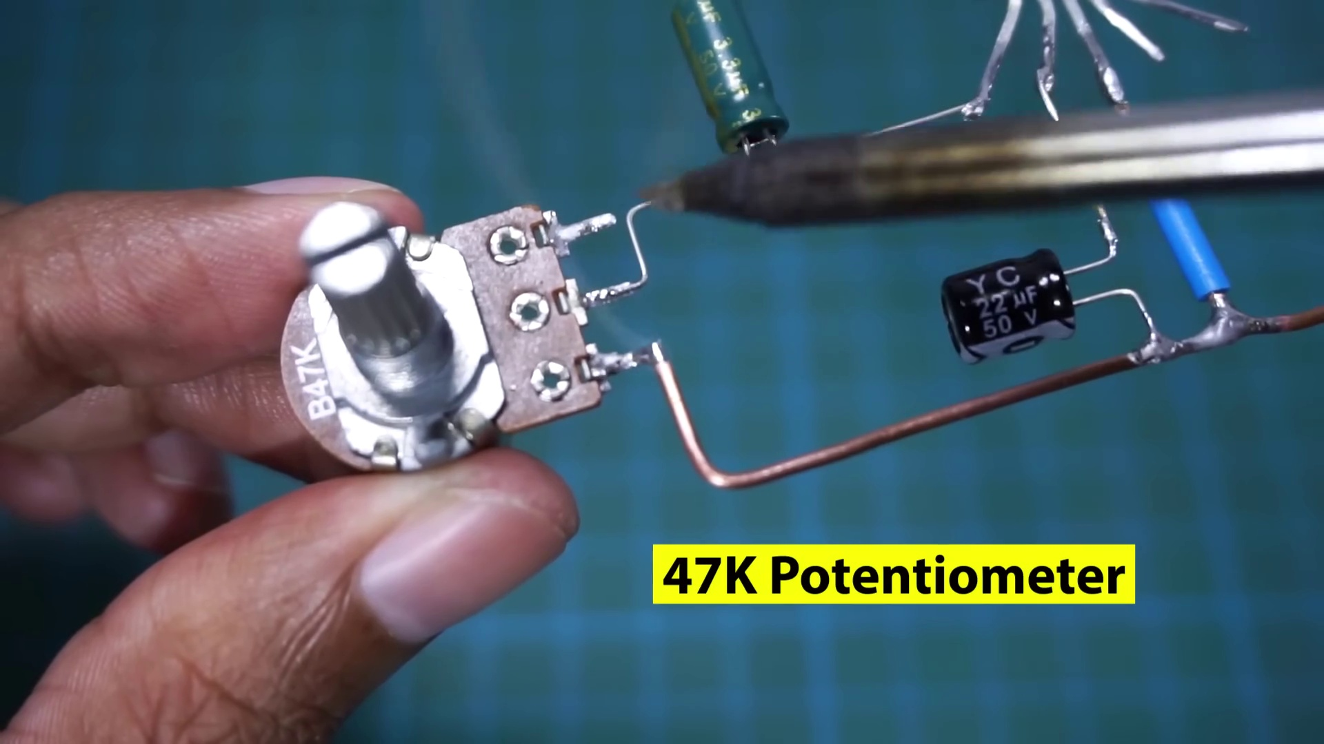 (score 20.0000)
 (score 20.0000)
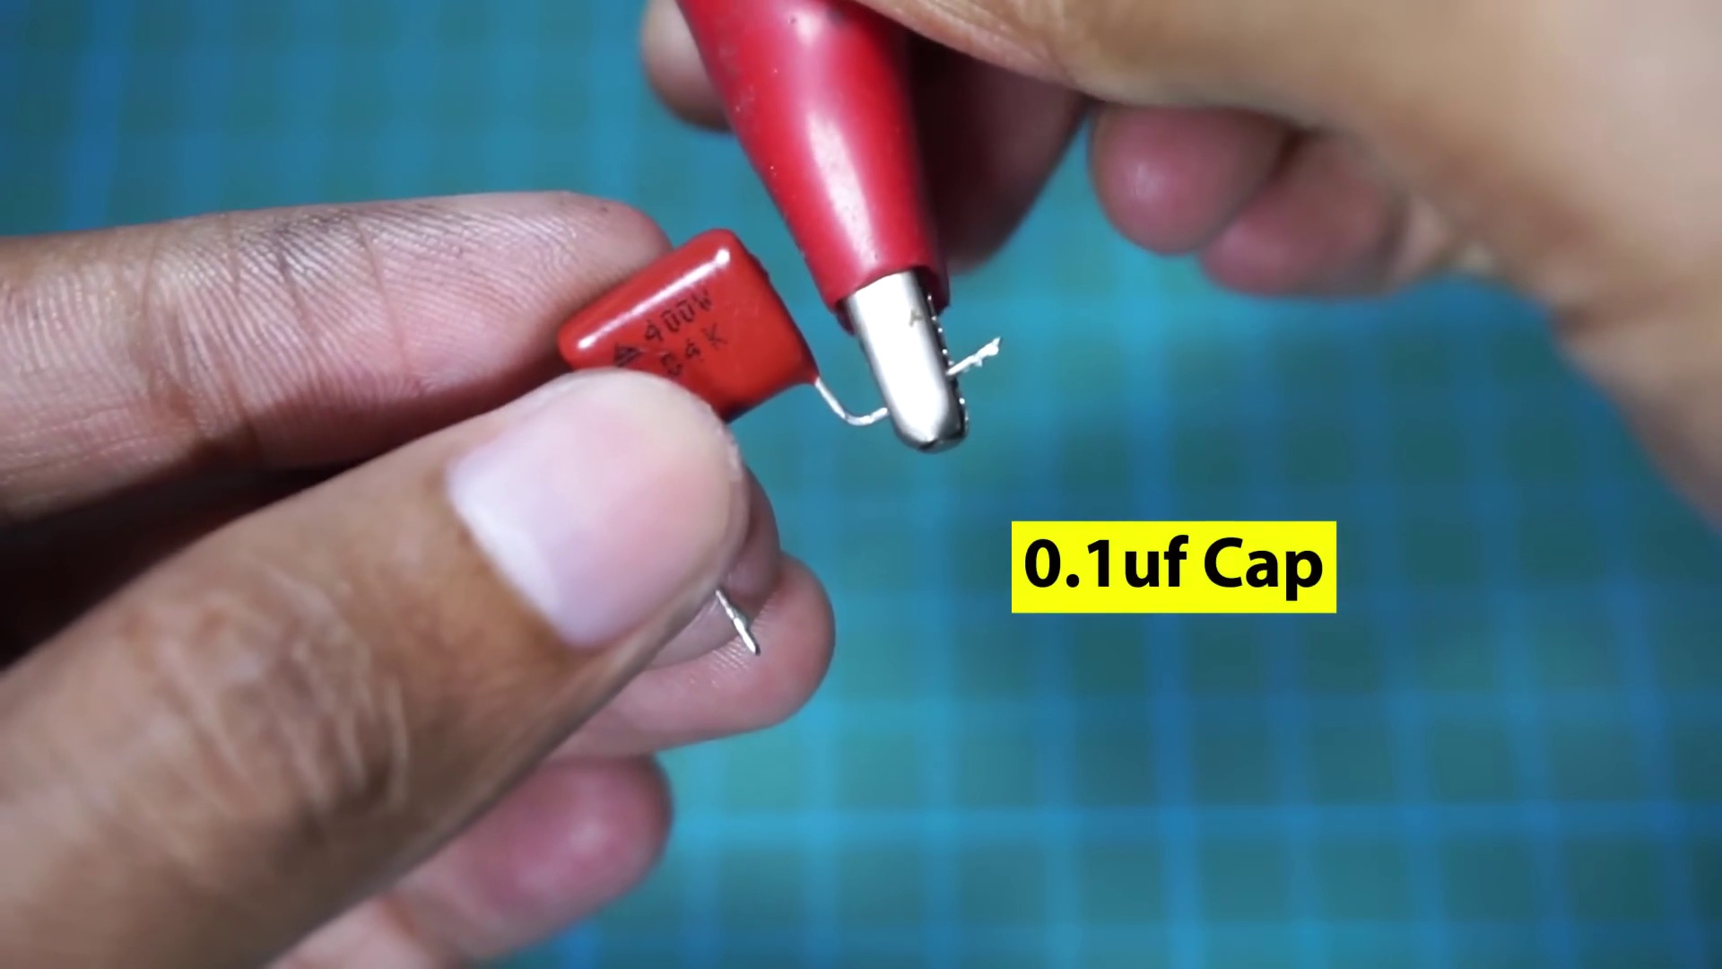 (score 20.0000)
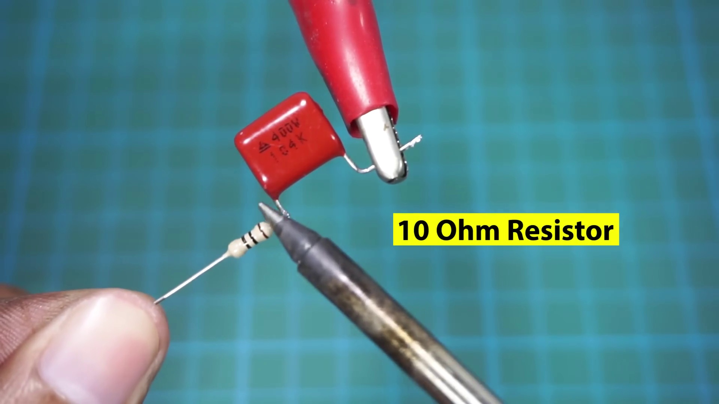 (score 20.0000)
 (score 20.0000)
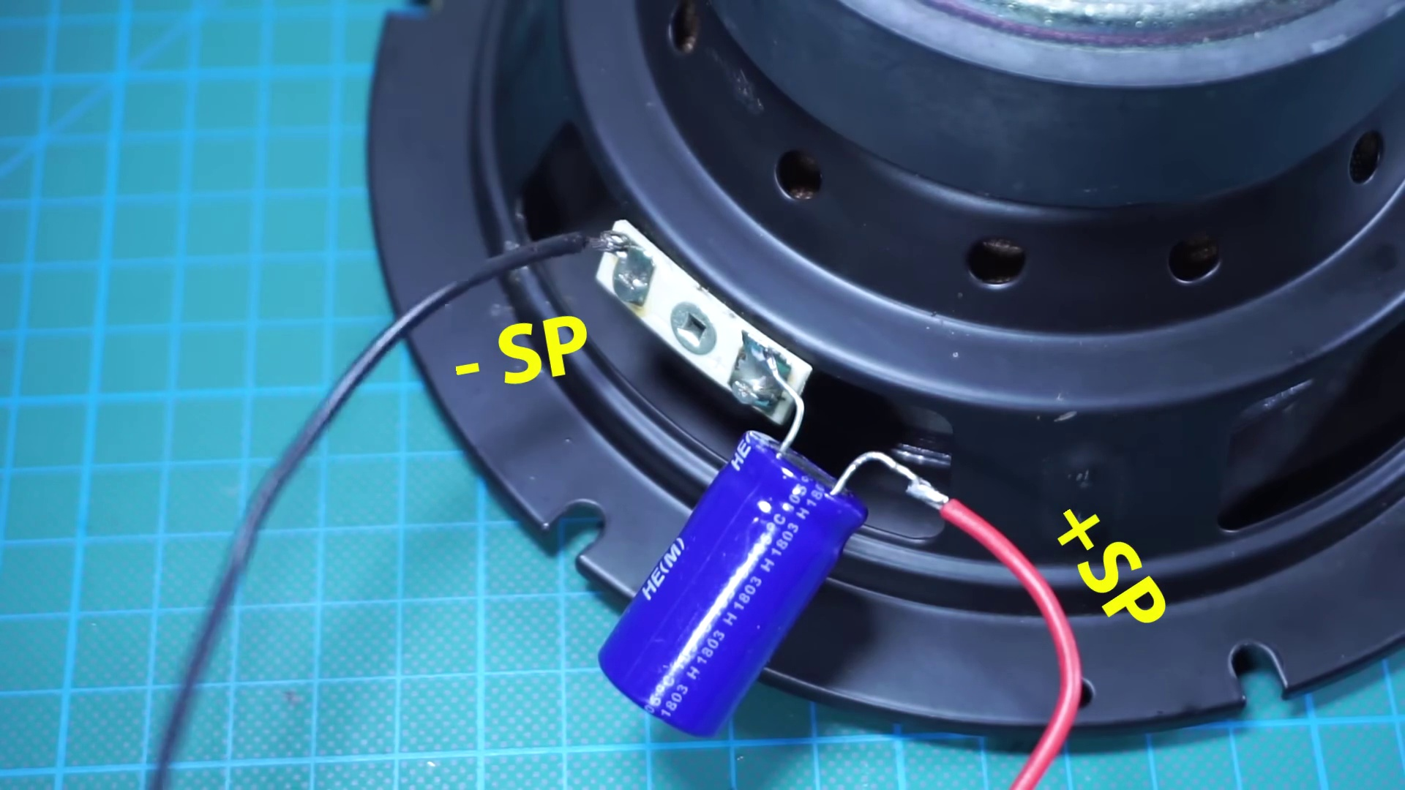 (score 20.0000)
- matched 164 frame(s), max score 95.0000: After I decided to use the TDA2050 for the tweeter and the TDA2030 for the subwoofer, I watched two videos on circuit construction of amplifiers using the TDA2030. Each of these videos provides in-depth step by step process on how to set up an amplifier using TDA2030. These videos are extremely helpful for when I am constructing the speaker circuit as I can easily follow along with the videos to create my own speaker.
Source: https://www.youtube.com/watch?v=cggDZE7gZNw: DIY simple Powerful Amplifier using TDA2030, Homemade Amplifier 12V
Top correlated frames:
 (score 95.0000)
 (score 95.0000)
 (score 95.0000)
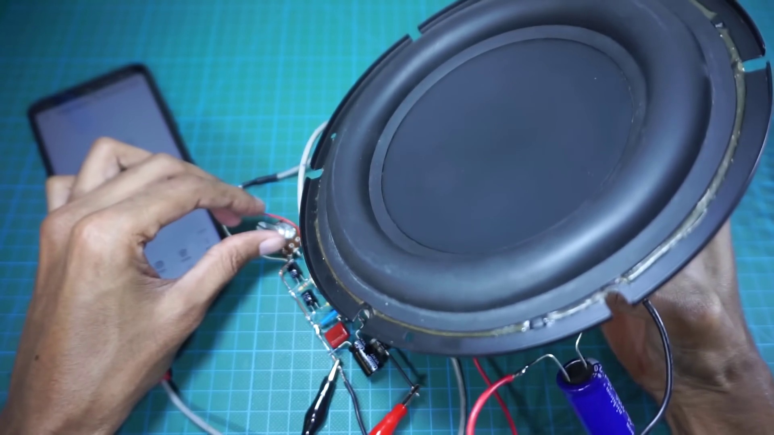 (score 95.0000)
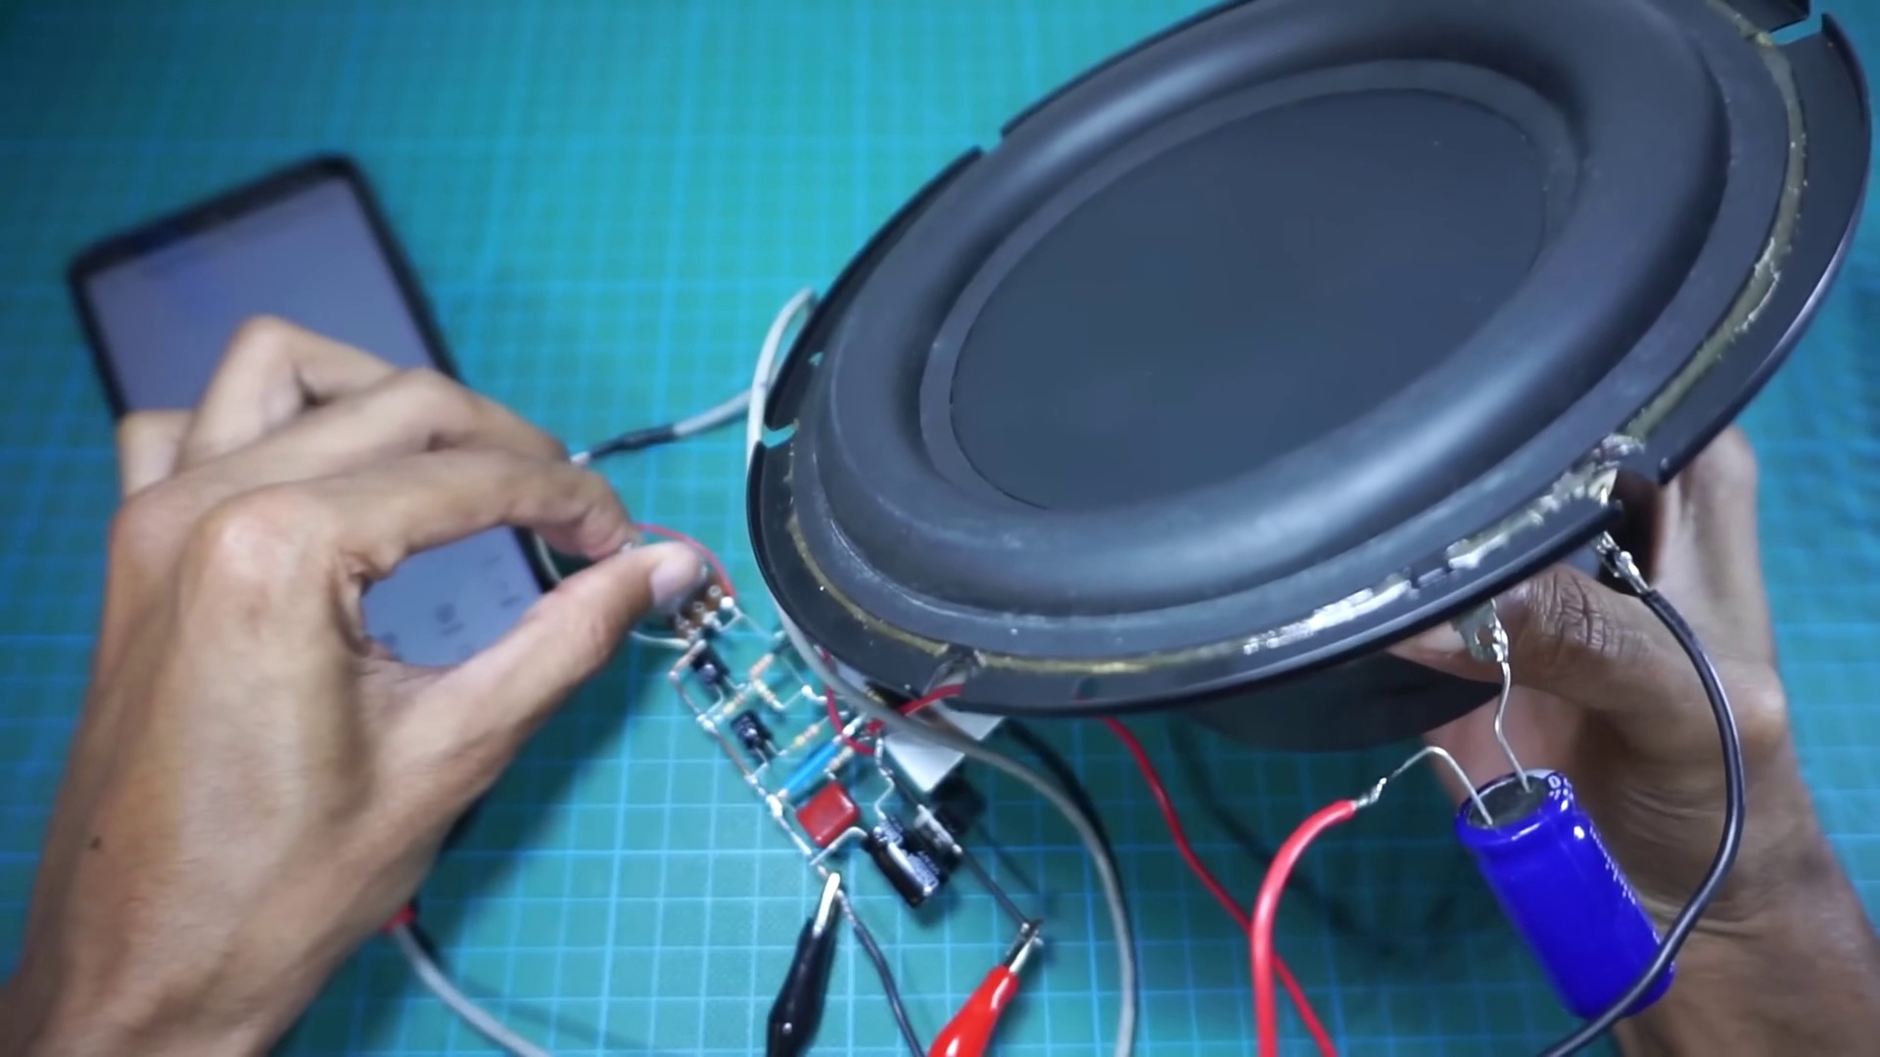 (score 95.0000)
 (score 95.0000)
 (score 95.0000)
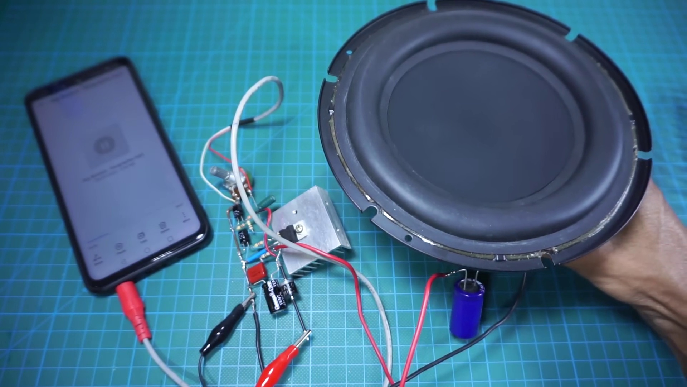 (score 95.0000)
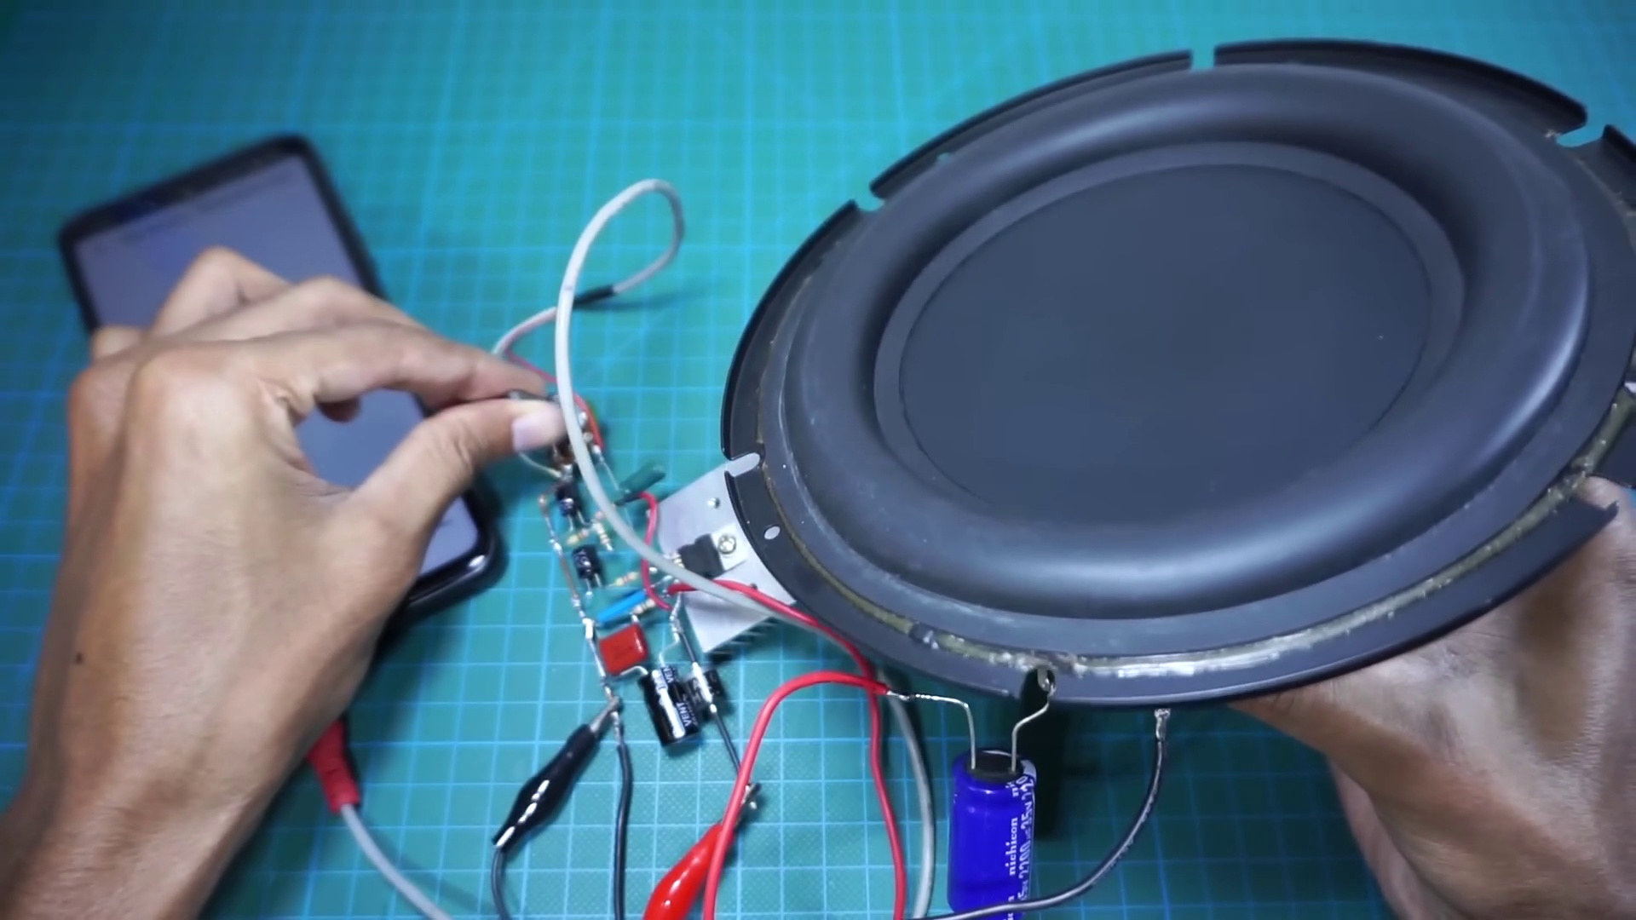 (score 95.0000)
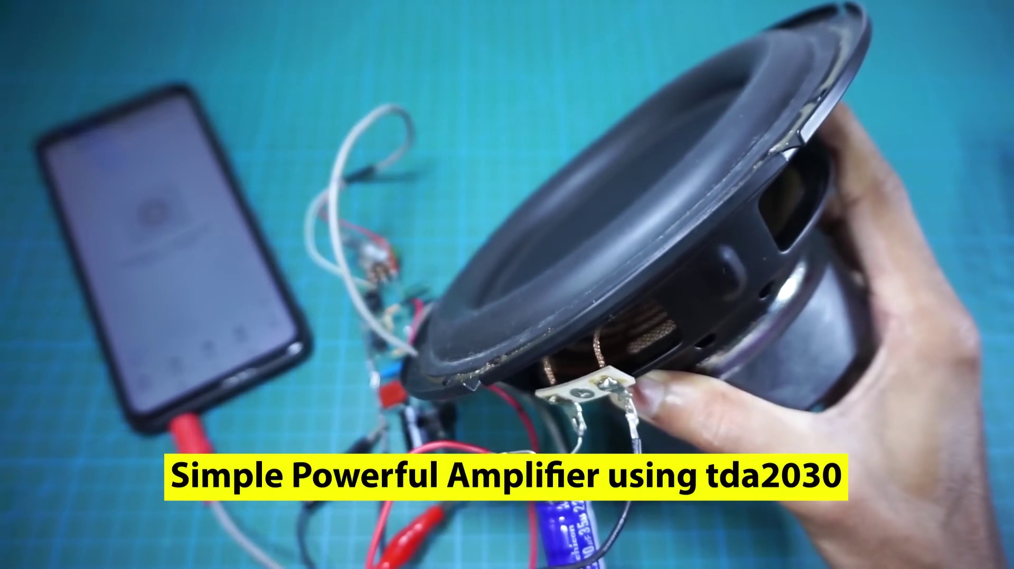 (score 95.0000)
Least correlated frames:
 (score 0.0000)
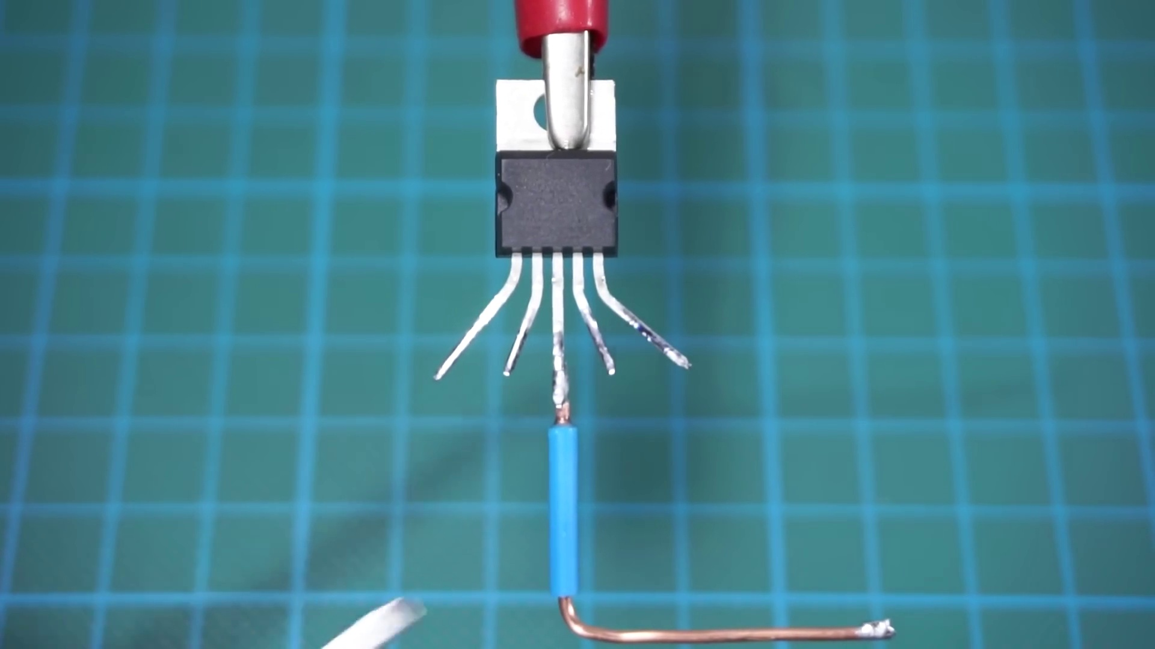 (score 0.0000)
 (score 0.0000)
 (score 0.0000)
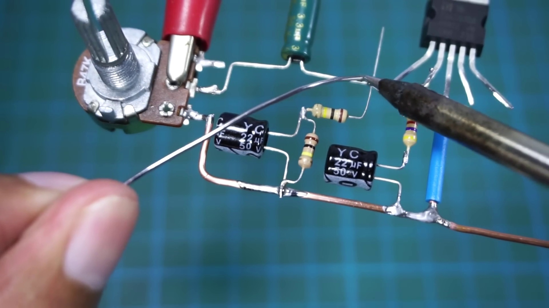 (score 0.0000)
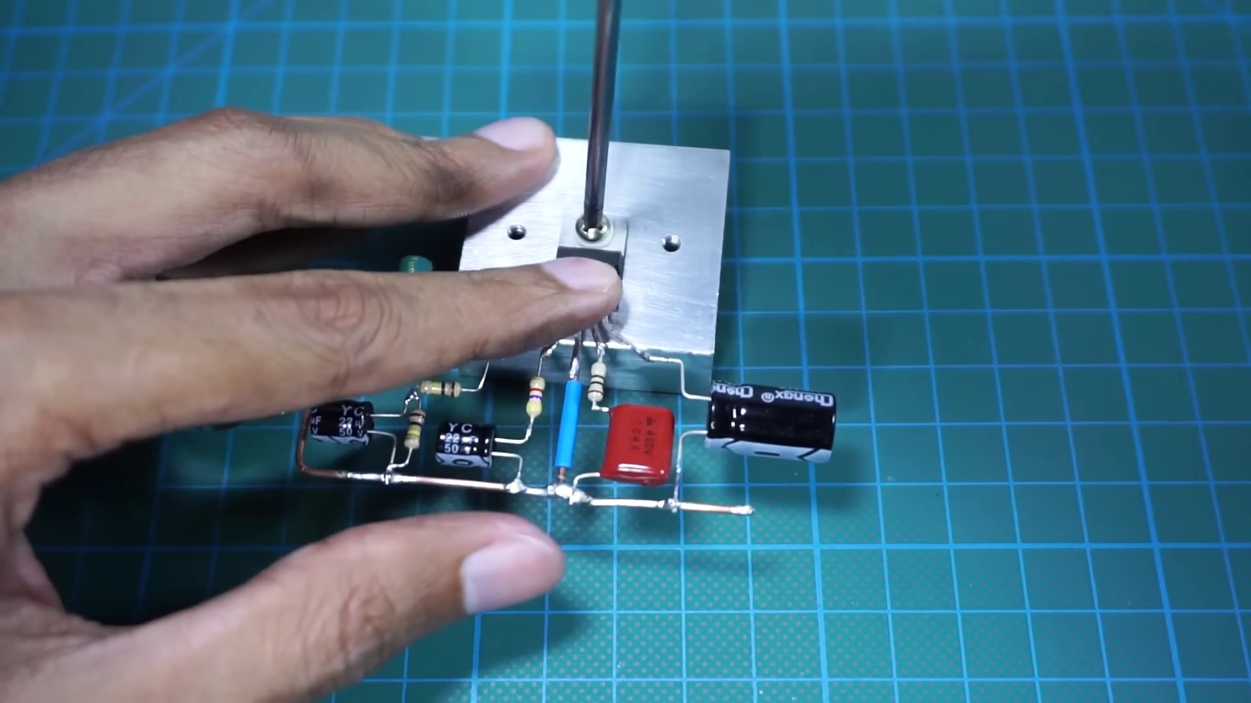 (score 0.0000)
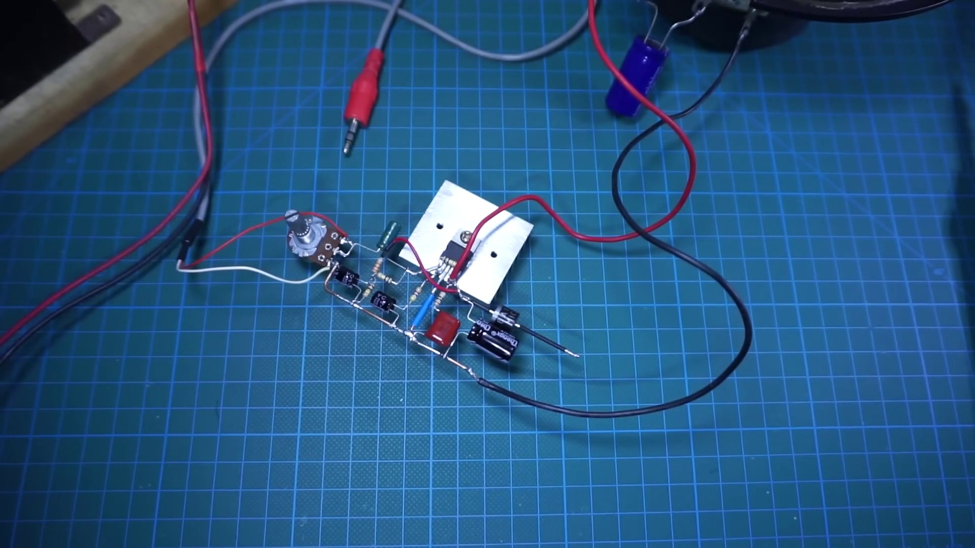 (score 0.0000)
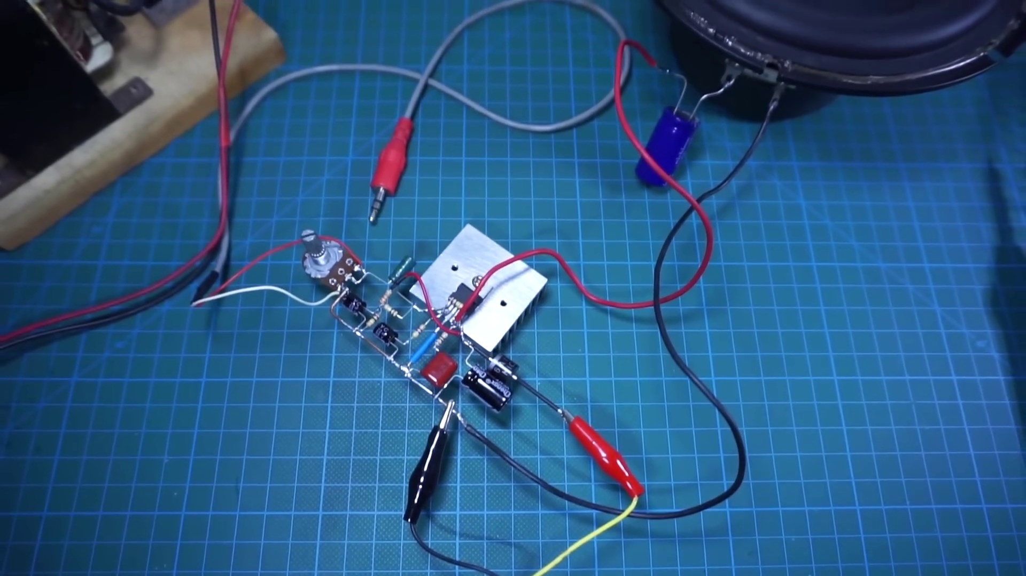 (score 0.0000)
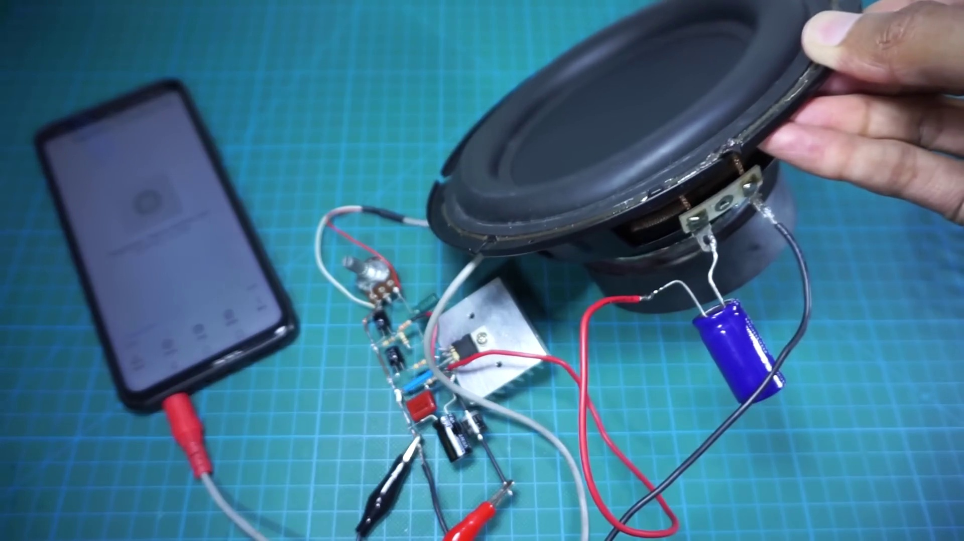 (score 0.0000)
 (score 0.0000)

Frame: frame_0000.jpg
Caption: The image presents a close-up view of a blue grid pattern on a green surface. The grid, which is the main focus of the image, is made up of squares that are evenly spaced and have a square shape. The squares are filled with a blue line, which contrasts sharply with the green surface. The grid is located on a green surface, which has a slightly rough texture. There is no text, instructor, or any other objects visible in the frame, allowing the focus to be solely on the surface and its patterned arrangement. The patterned lines appear to be made of a material with a grid pattern, possibly plastic or wood, suggesting that they might be part of a table or desk used for activities requiring precision or alignment. The context of teaching or learning is not evident from this image alone, but the simplicity and straightforwardness of the image, with the grid being the primary focus, invites the viewer to explore the significance and purpose of the patterned arrangement.
Comment (score 80): This video showed a TDA2030 amplifier being hooked up using a 12V, 2A power supply like I have. I think this video is a decent example, but his method of hooking it up without a breadboard is pretty fragile for phase II. I do know now that I need a large heatsink for the chip as the one I have will likely be too small for the chip. I will also likely borrow the idea of using a 2200uF capacitor on the speaker to further clean noise.
Reason: The comment directly discusses the technical steps involved in setting up an amplifier (hooking it up without a breadboard) and mentions specific components (TDA2030, 12V power supply, heatsink, capacitor), which are all mentioned or implied in the frame caption's description of the grid pattern on a green surface. The correlation is strong because the comment is focused on the same technical aspects described in the caption, rather than making generic praise or unrelated comments.
Source: https://www.youtube.com/watch?v=cggDZE7gZNw: DIY simple Powerful Amplifier using TDA2030, Homemade Amplifier 12V

Frame: frame_0001.jpg
Caption: The image appears to show a close-up of an electronic component, specifically a transistor identified as "TDA2030IC" displayed on a yellow rectangle at the top of the image. The transistor is held in place by a metal fork attached to its left side, with the fork's tip pointing towards the top right corner of the image. On the left side of the image, there is a small circuit board featuring a green component labeled "TD1032C", which may be an integrated circuit or microchip with model TD1032C. The background on the right is out of focus and doesn't provide any specific information about the context. There is no visible text that provides additional details or context, suggesting a simple image without an instructor, slide, or diagram. Overall, the scene suggests a setting related to electronics or circuit-building.
Comment (score 85): This video is 9:16 minutes. What I learned from this video – This video taught how to make a simple audio amplifier using a TDA 2030. My group will use this amplifier circuit in phase two of the project as the initial prototype for our design. I don’t have any questions about this. The video clearly shows how to make the amplifier, but it doesn’t explain how it works.
Reason: The comment directly discusses the TDA2030IC transistor and amplifier circuit shown in the frame caption, indicating a strong connection between the two.
Source: https://www.youtube.com/watch?v=cggDZE7gZNw : DIY simple Powerful Amplifier using TDA2030, Homemade Amplifier 12V
Comment (score 85): After I decided to use the TDA2050 for the tweeter and the TDA2030 for the subwoofer, I watched two videos on circuit construction of amplifiers using the TDA2030. Each of these videos provides in-depth step by step process on how to set up an amplifier using TDA2030. These videos are extremely helpful for when I am constructing the speaker circuit as I can easily follow along with the videos to create my own speaker.
Reason: The comment directly discusses the TDA2030 transistor and its usage in amplifier construction, which is a specific technical step mentioned in the caption. The mention of circuit construction and setting up an amplifier also aligns with the overall setting described in the caption.
Source: https://www.youtube.com/watch?v=cggDZE7gZNw: DIY simple Powerful Amplifier using TDA2030, Homemade Amplifier 12V
Comment (score 80): This video showed a TDA2030 amplifier being hooked up using a 12V, 2A power supply like I have. I think this video is a decent example, but his method of hooking it up without a breadboard is pretty fragile for phase II. I do know now that I need a large heatsink for the chip as the one I have will likely be too small for the chip. I will also likely borrow the idea of using a 2200uF capacitor on the speaker to further clean noise.
Reason: The comment directly discusses the TDA2030 amplifier and its usage, which is specifically mentioned in the caption. The mention of a 12V power supply and heatsink for the chip also matches the technical details described in the caption. While some general commentary on method and noise cleaning is present, it is still strongly related to the technical steps and objects described in the caption.
Source: https://www.youtube.com/watch?v=cggDZE7gZNw: DIY simple Powerful Amplifier using TDA2030, Homemade Amplifier 12V
Comment (score 80): Demonstrates another circuit using the TDA2030 amplifier.No captions or explanations; viewer must figure out component placement.Looks like a good circuit for the final project.
Reason: The comment directly discusses the same technical steps (component placement) described in the caption, specifically mentioning the TDA2030 amplifier and the final project goal.
Source: https://www.youtube.com/watch?v=cggDZE7gZNw: DIY Simple Powerful Amplifier Using TDA2030, Homemade Amplifier 12V

Frame: frame_0002.jpg
Caption: The image shows a close-up view of an object, specifically a TDA2030IC integrated circuit (IC), resting on a green plastic mat. The IC has multiple pins and appears to be a chip that could be used in electronic devices such as computers or other circuits. On the IC itself, there is a label "DA0203 IC" suggesting its model or designation. In the background, a transparent overlay with grid lines indicates a measurement or alignment tool, possibly for calibration or inspection of the IC. The text "TD 023C" on this overlay might be referring to a specific model or designation of the IC. The image has a teaching context as it seems to be part of an educational material or demonstration, possibly explaining the functionality or structure of integrated circuits in electronics. The focus is on the object itself and its features, which could be used for teaching purposes such as a lecture, presentation, or lab activity.
Comment (score 95): This video is 9:16 minutes. What I learned from this video – This video taught how to make a simple audio amplifier using a TDA 2030. My group will use this amplifier circuit in phase two of the project as the initial prototype for our design. I don’t have any questions about this. The video clearly shows how to make the amplifier, but it doesn’t explain how it works.
Reason: The comment directly discusses the technical steps and objects described in the caption, specifically mentioning the TDA2030 IC and its use in making a simple audio amplifier. The comment also references the video's content as being instructional, which aligns with the teaching context of the frame caption.
Source: https://www.youtube.com/watch?v=cggDZE7gZNw : DIY simple Powerful Amplifier using TDA2030, Homemade Amplifier 12V
Comment (score 85): After I decided to use the TDA2050 for the tweeter and the TDA2030 for the subwoofer, I watched two videos on circuit construction of amplifiers using the TDA2030. Each of these videos provides in-depth step by step process on how to set up an amplifier using TDA2030. These videos are extremely helpful for when I am constructing the speaker circuit as I can easily follow along with the videos to create my own speaker.
Reason: The comment directly discusses the technical steps and object (TDA2030 IC) described in the caption, specifically mentioning the use of TDA2030 for setting up an amplifier. The mention of circuit construction and speaker circuit also matches with the educational context of the caption.
Source: https://www.youtube.com/watch?v=cggDZE7gZNw: DIY simple Powerful Amplifier using TDA2030, Homemade Amplifier 12V
Comment (score 85): This video showed a TDA2030 amplifier being hooked up using a 12V, 2A power supply like I have. I think this video is a decent example, but his method of hooking it up without a breadboard is pretty fragile for phase II. I do know now that I need a large heatsink for the chip as the one I have will likely be too small for the chip. I will also likely borrow the idea of using a 2200uF capacitor on the speaker to further clean noise.
Reason: The comment directly discusses the same technical steps, objects (TDA2030 amplifier, power supply, breadboard, chip), and settings (12V, 2A) described in the caption. The comment also mentions specific features of the IC (heatsink, capacitor) and its functionality (amplifier), which are all closely related to the information presented in the caption.
Source: https://www.youtube.com/watch?v=cggDZE7gZNw: DIY simple Powerful Amplifier using TDA2030, Homemade Amplifier 12V
Comment (score 80): Demonstrates another circuit using the TDA2030 amplifier.No captions or explanations; viewer must figure out component placement.Looks like a good circuit for the final project.
Reason: The comment directly references the TDA2030 amplifier and its usage in another circuit, which is a specific technical step described in the caption. The mention of 'component placement' also aligns with the focus on the object's features and structure in the caption.
Source: https://www.youtube.com/watch?v=cggDZE7gZNw: DIY Simple Powerful Amplifier Using TDA2030, Homemade Amplifier 12V

Frame: frame_0003.jpg
Caption: The image shows a person's hands working with a small electronic device that appears to be an Arduino or similar microcontroller board. One hand is holding what looks like a USB cable connected to the board, while the other hand is using a soldering iron, suggesting the process of soldering or repairing connections on the board. The focus of this activity seems to be on assembling or modifying electronics, possibly in an educational setting given the presence of what could be a slide or diagram in the background that shows the same device with a USB cable attached, and an accompanying text which is not fully legible. The text reads "USB CABLE TO 5V POWER SUPPLY," indicating that the person may be attaching the cable to provide power.
The setting appears to be a classroom or lab environment, as indicated by the green grid background typical in educational settings and the fact that the person is demonstrating or teaching a task related to electronics assembly or repair. The image captures a moment of hands-on activity, likely for the purpose of learning or demonstrating how to properly connect components in an electronic project.
Comment (score 85): This video showed a TDA2030 amplifier being hooked up using a 12V, 2A power supply like I have. I think this video is a decent example, but his method of hooking it up without a breadboard is pretty fragile for phase II. I do know now that I need a large heatsink for the chip as the one I have will likely be too small for the chip. I will also likely borrow the idea of using a 2200uF capacitor on the speaker to further clean noise.
Reason: The comment directly discusses the soldering process shown in the frame caption, mentioning the use of a USB cable and power supply. The mention of hooking up an amplifier and using a heatsink also matches the electronics assembly context described in the caption.
Source: https://www.youtube.com/watch?v=cggDZE7gZNw: DIY simple Powerful Amplifier using TDA2030, Homemade Amplifier 12V
Comment (score 80): Demonstrates another circuit using the TDA2030 amplifier.No captions or explanations; viewer must figure out component placement.Looks like a good circuit for the final project.
Reason: The comment directly discusses the same technical steps (component placement) and goals (final project) described in the caption, indicating a strong relationship.
Source: https://www.youtube.com/watch?v=cggDZE7gZNw: DIY Simple Powerful Amplifier Using TDA2030, Homemade Amplifier 12V

Frame: frame_0004.jpg
Caption: The image captures a close-up view of a circuit board, resting on a green mat, with a person's hands working on it. The board is adorned with a red handle and white text, indicating it's a potentiometer, which features the numbers "1" and "2", suggesting a range of adjustable values. The focus is on the hands and the task at hand rather than the person themselves, with the individual appearing to be either soldering, connecting wires, or manipulating some component within the plastic enclosure of the gadget. The green mat under the board provides a stark contrast to the black circuit board, making it stand out even more.
Comment (score 95): This video is 9:16 minutes. What I learned from this video – This video taught how to make a simple audio amplifier using a TDA 2030. My group will use this amplifier circuit in phase two of the project as the initial prototype for our design. I don’t have any questions about this. The video clearly shows how to make the amplifier, but it doesn’t explain how it works.
Reason: The comment directly discusses the same technical steps and objects described in the caption, specifically the audio amplifier circuit using a TDA 2030, which is also depicted in the image. The caption mentions the potentiometer and its adjustable values, which are likely used in the amplifier circuit.
Source: https://www.youtube.com/watch?v=cggDZE7gZNw : DIY simple Powerful Amplifier using TDA2030, Homemade Amplifier 12V
Comment (score 85): After I decided to use the TDA2050 for the tweeter and the TDA2030 for the subwoofer, I watched two videos on circuit construction of amplifiers using the TDA2030. Each of these videos provides in-depth step by step process on how to set up an amplifier using TDA2030. These videos are extremely helpful for when I am constructing the speaker circuit as I can easily follow along with the videos to create my own speaker.
Reason: The comment directly discusses circuit construction and amplifier setup using TDA2030, which matches the technical steps, objects (circuit board), and settings (green mat) described in the caption. The mention of specific components (TDA2050, TDA2030) and actions (soldering, connecting wires) also supports a strong correlation between the two.
Source: https://www.youtube.com/watch?v=cggDZE7gZNw: DIY simple Powerful Amplifier using TDA2030, Homemade Amplifier 12V
Comment (score 80): This video showed a TDA2030 amplifier being hooked up using a 12V, 2A power supply like I have. I think this video is a decent example, but his method of hooking it up without a breadboard is pretty fragile for phase II. I do know now that I need a large heatsink for the chip as the one I have will likely be too small for the chip. I will also likely borrow the idea of using a 2200uF capacitor on the speaker to further clean noise.
Reason: The comment directly discusses the technical steps and objects described in the caption, such as hooking up an amplifier using a power supply, using a heatsink for the chip, and borrowing ideas from the video. The mention of a TDA2030 amplifier and a breadboard also matches the content of the caption, indicating a strong connection.
Source: https://www.youtube.com/watch?v=cggDZE7gZNw: DIY simple Powerful Amplifier using TDA2030, Homemade Amplifier 12V
Comment (score 80): Demonstrates another circuit using the TDA2030 amplifier.No captions or explanations; viewer must figure out component placement.Looks like a good circuit for the final project.
Reason: The comment directly discusses the TDA2030 amplifier and circuit placement, which are both mentioned in the frame caption. The focus on circuit design and component placement is strongly related to the technical steps and objects described in the caption.
Source: https://www.youtube.com/watch?v=cggDZE7gZNw: DIY Simple Powerful Amplifier Using TDA2030, Homemade Amplifier 12V

Frame: frame_0005.jpg
Caption: The image shows a close-up view of a person's hands working with electronic components. On one side, there is a person holding what appears to be a small circuit board or electronic component. They are using a soldering iron, and a wire is attached to one end of the component. The soldering iron is not heated in this frame.
The other side of the image provides a magnified view of the component in question, which has several visible terminals with numbers indicating their positions from 1 to 6. Specifically, terminal number 3 is highlighted. There is no text or visible teaching context in this frame, such as a slide or diagram. The main focus is on the hands and tools being used for soldering or electronic work.
The background of the image appears to be a green mat, which is placed on top of a blue table. The person's hands are engaged in soldering wires together, with one hand holding a red wire connected to a piece of metal (also red) and the other hand holding the soldering iron.
Comment (score 95): This video is 9:16 minutes. What I learned from this video – This video taught how to make a simple audio amplifier using a TDA 2030. My group will use this amplifier circuit in phase two of the project as the initial prototype for our design. I don’t have any questions about this. The video clearly shows how to make the amplifier, but it doesn’t explain how it works.
Reason: The comment directly discusses the technical steps and components (TDA 2030) described in the caption, specifically mentioning soldering wires together as part of the audio amplifier circuit.
Source: https://www.youtube.com/watch?v=cggDZE7gZNw : DIY simple Powerful Amplifier using TDA2030, Homemade Amplifier 12V
Comment (score 90): This video showed a TDA2030 amplifier being hooked up using a 12V, 2A power supply like I have. I think this video is a decent example, but his method of hooking it up without a breadboard is pretty fragile for phase II. I do know now that I need a large heatsink for the chip as the one I have will likely be too small for the chip. I will also likely borrow the idea of using a 2200uF capacitor on the speaker to further clean noise.
Reason: The comment directly discusses the same technical steps and components (TDA2030 amplifier, 12V power supply, breadboard, heatsink, capacitor) described in the caption, showing a strong connection between the two.
Source: https://www.youtube.com/watch?v=cggDZE7gZNw: DIY simple Powerful Amplifier using TDA2030, Homemade Amplifier 12V
Comment (score 80): After I decided to use the TDA2050 for the tweeter and the TDA2030 for the subwoofer, I watched two videos on circuit construction of amplifiers using the TDA2030. Each of these videos provides in-depth step by step process on how to set up an amplifier using TDA2030. These videos are extremely helpful for when I am constructing the speaker circuit as I can easily follow along with the videos to create my own speaker.
Reason: The comment directly discusses the process of setting up an amplifier using TDA2030, which is strongly related to the technical steps described in the caption, such as soldering wires together and working with electronic components.
Source: https://www.youtube.com/watch?v=cggDZE7gZNw: DIY simple Powerful Amplifier using TDA2030, Homemade Amplifier 12V
Comment (score 80): Demonstrates another circuit using the TDA2030 amplifier.No captions or explanations; viewer must figure out component placement.Looks like a good circuit for the final project.
Reason: The comment directly discusses the TDA2030 amplifier, which is a specific component mentioned in the caption. Additionally, the comment mentions circuit placement, which aligns with the focus on soldering and electronic work described in the caption.
Source: https://www.youtube.com/watch?v=cggDZE7gZNw: DIY Simple Powerful Amplifier Using TDA2030, Homemade Amplifier 12V

Frame: frame_0006.jpg
Caption: The image captures a moment of precision and focus in a workshop. A soldering iron is being used to connect two components together, with its tip in contact with a small piece of circuit board featuring traces that need to be connected. Below the soldering iron, numbers from 1 to 5 are marked on the ground surface, possibly indicating the steps involved in soldering or a guide for someone learning how to solder.
In the same workshop setting, a black screwdriver, its handle glowing a vibrant red, is poised to insert a silver wire into a black socket. The socket, a tiny chip with four wires attached, is securely held in place by a green grid on a blue surface. The grid is a testament to the meticulous work that has gone into this assembly.
The wires are clearly marked with numbers, guiding the path of the screwdriver's movement as it prepares to make contact with the socket. The image is a snapshot of the intricate dance between the tool and the object, a testament to the skill and attention to detail required in this task.
Comment (score 85): Demonstrates another circuit using the TDA2030 amplifier.No captions or explanations; viewer must figure out component placement.Looks like a good circuit for the final project.
Reason: The comment directly discusses the TDA2030 amplifier and circuit component placement, which is closely related to the technical steps and objects described in the caption (soldering iron, circuit board, wires), indicating a strong correlation.
Source: https://www.youtube.com/watch?v=cggDZE7gZNw: DIY Simple Powerful Amplifier Using TDA2030, Homemade Amplifier 12V
Comment (score 80): This video is 9:16 minutes. What I learned from this video – This video taught how to make a simple audio amplifier using a TDA 2030. My group will use this amplifier circuit in phase two of the project as the initial prototype for our design. I don’t have any questions about this. The video clearly shows how to make the amplifier, but it doesn’t explain how it works.
Reason: The comment directly discusses the soldering process and the components involved, matching the technical steps and objects described in the caption.
Source: https://www.youtube.com/watch?v=cggDZE7gZNw : DIY simple Powerful Amplifier using TDA2030, Homemade Amplifier 12V
Comment (score 80): This video showed a TDA2030 amplifier being hooked up using a 12V, 2A power supply like I have. I think this video is a decent example, but his method of hooking it up without a breadboard is pretty fragile for phase II. I do know now that I need a large heatsink for the chip as the one I have will likely be too small for the chip. I will also likely borrow the idea of using a 2200uF capacitor on the speaker to further clean noise.
Reason: The comment directly discusses the same technical steps and objects described in the caption, such as soldering, using a power supply, hooking up an amplifier, and using a heatsink. The mention of a breadboard and capacitor also aligns with the setting and tools shown in the caption.
Source: https://www.youtube.com/watch?v=cggDZE7gZNw: DIY simple Powerful Amplifier using TDA2030, Homemade Amplifier 12V

Frame: frame_0007.jpg
Caption: The image captures a moment of intricate electronic assembly on a green mat that serves as a workspace for the task at hand. A red soldering iron, with its tip glowing, is positioned on the mat and connected to a black socket. The socket is equipped with a white wire, which appears to be part of the assembly process, and this wire is connected to a black wire, indicating a connection point in the process. Additionally, the socket has a red wire attached to it, likely part of the circuit being assembled. A small amount of molten solder can be seen on the tip of the soldering iron, suggesting that a soldering process is underway. Several thin wires appear to be part of an electrical circuit or connection, adding to the complexity and precision of the assembly process.
Comment (score 85): Demonstrates another circuit using the TDA2030 amplifier.No captions or explanations; viewer must figure out component placement.Looks like a good circuit for the final project.
Reason: The comment directly discusses the same technical steps and components described in the caption, specifically mentioning the TDA2030 amplifier and component placement, which are both mentioned in the caption.
Source: https://www.youtube.com/watch?v=cggDZE7gZNw: DIY Simple Powerful Amplifier Using TDA2030, Homemade Amplifier 12V
Comment (score 80): This video is 9:16 minutes. What I learned from this video – This video taught how to make a simple audio amplifier using a TDA 2030. My group will use this amplifier circuit in phase two of the project as the initial prototype for our design. I don’t have any questions about this. The video clearly shows how to make the amplifier, but it doesn’t explain how it works.
Reason: The comment directly discusses the technical steps described in the caption, specifically mentioning the TDA 2030 amplifier circuit and its assembly process.
Source: https://www.youtube.com/watch?v=cggDZE7gZNw : DIY simple Powerful Amplifier using TDA2030, Homemade Amplifier 12V
Comment (score 80): This video showed a TDA2030 amplifier being hooked up using a 12V, 2A power supply like I have. I think this video is a decent example, but his method of hooking it up without a breadboard is pretty fragile for phase II. I do know now that I need a large heatsink for the chip as the one I have will likely be too small for the chip. I will also likely borrow the idea of using a 2200uF capacitor on the speaker to further clean noise.
Reason: The comment directly discusses the technical steps and components described in the caption, such as the TDA2030 amplifier, power supply, breadboard, heatsink, and capacitor. The commenter also references the soldering process and wire connections depicted in the frame, indicating a strong connection to the caption.
Source: https://www.youtube.com/watch?v=cggDZE7gZNw: DIY simple Powerful Amplifier using TDA2030, Homemade Amplifier 12V

Frame: frame_0008.jpg
Caption: This image captures a moment of creation where a small electronic component is being assembled on a green plastic mat, likely in a laboratory or educational environment. The component, a black chip with a red tip, is securely attached to a copper wire using a blue connector. The wire is coiled around the chip, indicating a tight connection. The mat, with its checkerboard pattern, provides a sturdy base for the assembly.
In this setting, someone is utilizing an electronic component tester or analyzer (LLaVA), which has a clear plastic casing and features a red button on top, likely for operation. This device appears to be in use, as it's being held by hands holding various connectors and cables.
On the screen visible behind the device, there's an image of another electronic component or connector, with the text "GND" displayed near it, suggesting it represents a ground connection. This could imply that the person using the tester is performing a test to check the functionality or integrity of the ground path within an electronic assembly or system.
The overall scene showcases the meticulous work involved in electronic component assembly and possibly serves as a teaching or demonstration tool for electronic testing and troubleshooting techniques.
Comment (score 85): This video showed a TDA2030 amplifier being hooked up using a 12V, 2A power supply like I have. I think this video is a decent example, but his method of hooking it up without a breadboard is pretty fragile for phase II. I do know now that I need a large heatsink for the chip as the one I have will likely be too small for the chip. I will also likely borrow the idea of using a 2200uF capacitor on the speaker to further clean noise.
Reason: The comment directly discusses the assembly of an electronic component (TDA2030 amplifier) and mentions specific details like power supply, heatsink, and capacitor usage, which are all mentioned in the frame caption. The only minor difference is that the comment focuses on a specific application whereas the caption provides a more general description.
Source: https://www.youtube.com/watch?v=cggDZE7gZNw: DIY simple Powerful Amplifier using TDA2030, Homemade Amplifier 12V
Comment (score 80): This video is 9:16 minutes. What I learned from this video – This video taught how to make a simple audio amplifier using a TDA 2030. My group will use this amplifier circuit in phase two of the project as the initial prototype for our design. I don’t have any questions about this. The video clearly shows how to make the amplifier, but it doesn’t explain how it works.
Reason: The comment directly discusses the assembly of an electronic component (TDA 2030) mentioned in the caption, specifically referencing a device used to test its functionality.
Source: https://www.youtube.com/watch?v=cggDZE7gZNw : DIY simple Powerful Amplifier using TDA2030, Homemade Amplifier 12V

Frame: frame_0009.jpg
Caption: The image displays a close-up view of someone working with electronic components. On the left side of the image, there is a small circuit board adorned with various resistors and an integrated circuit (IC). A soldering iron is being used to connect or repair the circuit, as evidenced by the person's hand holding the tip of the iron.
The main focus of the image is on the soldering process in progress, with a close-up view showing solder wire being applied to a component on the board. The solder has not yet solidified, indicating that the soldering process is ongoing. In the foreground, a person's hand is seen holding a wire, its blue insulation contrasting with the metallic sheen of the wire. The wire is in the process of being soldered to the board.
The circuit board itself features a complex network of connections created by meticulously arranged components, including a red and white IC, a black and white transistor, and a silver and black capacitor. The background of the image is a vibrant green, providing a stark contrast to the white and blue of the circuit board and the black and white of the components.
The image captures a moment of manual skill and precision, emphasizing the fine work involved in soldering electronic components. It seems to be part of an instructional context, as suggested by the style of the image and the focus on the hands and tools at work. However, without additional visual content or text, it is not possible to determine the broader context or the specific goals of this particular soldering task. Overall, the image provides a glimpse into the world of electronics, capturing the intricate process of soldering and the meticulous assembly of a circuit board.
Comment (score 95): This video is 9:16 minutes. What I learned from this video – This video taught how to make a simple audio amplifier using a TDA 2030. My group will use this amplifier circuit in phase two of the project as the initial prototype for our design. I don’t have any questions about this. The video clearly shows how to make the amplifier, but it doesn’t explain how it works.
Reason: The comment directly discusses the same technical steps and objects described in the caption (making a simple audio amplifier using a TDA 2030), highlighting the correlation between the video's content and the viewer's takeaway.
Source: https://www.youtube.com/watch?v=cggDZE7gZNw : DIY simple Powerful Amplifier using TDA2030, Homemade Amplifier 12V
Comment (score 85): This video showed a TDA2030 amplifier being hooked up using a 12V, 2A power supply like I have. I think this video is a decent example, but his method of hooking it up without a breadboard is pretty fragile for phase II. I do know now that I need a large heatsink for the chip as the one I have will likely be too small for the chip. I will also likely borrow the idea of using a 2200uF capacitor on the speaker to further clean noise.
Reason: The comment directly discusses the soldering process and circuit board components shown in the frame caption, specifically mentioning the TDA2030 amplifier, power supply, breadboard, heatsink, and capacitor. The language used in the comment is technical and descriptive, mirroring the focus on manual skill and precision in the caption.
Source: https://www.youtube.com/watch?v=cggDZE7gZNw: DIY simple Powerful Amplifier using TDA2030, Homemade Amplifier 12V
Comment (score 80): After I decided to use the TDA2050 for the tweeter and the TDA2030 for the subwoofer, I watched two videos on circuit construction of amplifiers using the TDA2030. Each of these videos provides in-depth step by step process on how to set up an amplifier using TDA2030. These videos are extremely helpful for when I am constructing the speaker circuit as I can easily follow along with the videos to create my own speaker.
Reason: The comment directly discusses the same technical steps (circuit construction, amplifier setup) and objects (TDA2030, TDA2050) described in the caption. Although the specific context is different (speaker circuit vs. soldering electronic components), the mention of soldering and circuit boards in the caption aligns with the commenter's experience constructing a speaker circuit.
Source: https://www.youtube.com/watch?v=cggDZE7gZNw: DIY simple Powerful Amplifier using TDA2030, Homemade Amplifier 12V
Comment (score 70): Demonstrates another circuit using the TDA2030 amplifier.No captions or explanations; viewer must figure out component placement.Looks like a good circuit for the final project.
Reason: The comment directly discusses another circuit using a specific amplifier (TDA2030), which is related to the technical steps and objects described in the caption (soldering electronic components, circuit board). The mention of 'component placement' also indicates a connection to the goal of building a circuit.
Source: https://www.youtube.com/watch?v=cggDZE7gZNw: DIY Simple Powerful Amplifier Using TDA2030, Homemade Amplifier 12V

Frame: frame_0010.jpg
Caption: The image shows a close-up view of an electronic device with multiple wires and components connected to it, appearing to be a microcontroller or similar integrated circuit (IC) with pins in rows. The IC is commonly used for programming small computers for automation or embedded systems. A blue line indicates the path or signal flow between some of the components.
The background is blurred but suggests a workbench or lab setting, possibly a classroom or makerspace environment. On the right side of the image, there's a grid pattern which could be used for alignment, measurement, or visual organization. The bottom left corner of the photo is slightly out of focus and appears to show a white surface with some indistinct markings on it, suggesting that the workbench might have whiteboard-like properties for writing instructions or notes.
The image captures a circuit board resting on a green grid surface, adorned with a black chip and four white wires, each connected to a corresponding component. The wires are neatly arranged, suggesting careful planning and assembly. The rectangular board has the black chip located centrally, surrounded by the white wires. The green grid surface beneath the board provides a stark contrast, highlighting the components and wires.
Comment (score 80): This video is 9:16 minutes. What I learned from this video – This video taught how to make a simple audio amplifier using a TDA 2030. My group will use this amplifier circuit in phase two of the project as the initial prototype for our design. I don’t have any questions about this. The video clearly shows how to make the amplifier, but it doesn’t explain how it works.
Reason: The comment directly discusses the same technical steps (making a simple audio amplifier using TDA 2030) and objects (circuit board, black chip, white wires) described in the caption. The settings (workbench or lab setting) are also mentioned as relevant to the project.
Source: https://www.youtube.com/watch?v=cggDZE7gZNw : DIY simple Powerful Amplifier using TDA2030, Homemade Amplifier 12V
Comment (score 80): This video showed a TDA2030 amplifier being hooked up using a 12V, 2A power supply like I have. I think this video is a decent example, but his method of hooking it up without a breadboard is pretty fragile for phase II. I do know now that I need a large heatsink for the chip as the one I have will likely be too small for the chip. I will also likely borrow the idea of using a 2200uF capacitor on the speaker to further clean noise.
Reason: The comment directly discusses the same technical steps and components described in the caption, such as the amplifier (TDA2030), power supply (12V, 2A), breadboard, heatsink, and capacitor. The language used is specific to the details shown in the image, indicating a strong connection between the comment and caption.
Source: https://www.youtube.com/watch?v=cggDZE7gZNw: DIY simple Powerful Amplifier using TDA2030, Homemade Amplifier 12V
Comment (score 80): Demonstrates another circuit using the TDA2030 amplifier.No captions or explanations; viewer must figure out component placement.Looks like a good circuit for the final project.
Reason: The comment directly discusses a circuit using the TDA2030 amplifier, which is strongly related to the caption's description of a microcontroller with multiple wires and components connected. The mention of component placement and a good circuit for a final project also correlates well with the technical steps and objects described in the caption.
Source: https://www.youtube.com/watch?v=cggDZE7gZNw: DIY Simple Powerful Amplifier Using TDA2030, Homemade Amplifier 12V

Frame: frame_0011.jpg
Caption: The image shows a close-up view of an educational setting where someone is conducting a demonstration related to electronics or circuit building. The central focus is on a piece of transparent material with various components and wires laid out. Starting from the top, there's a single black wire that seems to be connected to a small, metallic object with two wires emerging from it. Below this, there are several other wires, including one coiled up neatly, which connect to what looks like an unidentified electronic device or component, featuring a green circuit board and accompanied by a few resistors of varying colors: white, yellow, and orange.
The focal point is a black chip mounted on a blue board, surrounded by a network of wires arranged in a grid-like pattern, suggesting a complex circuit design. A soldering iron, held in place by a metal clamp, is being used to connect the wires to the chip, with its tip pointing towards the chip, ready to make the connection. The assembly takes place on a green table, providing a contrasting backdrop to the black chip and blue board. The table's surface is smooth, reflecting the light in the room and adding depth to the image.
In the background, there's a hint of a person's silhouette, suggesting that the assembly is being performed by a human. This adds a sense of scale to the image, emphasizing the complexity of the electronic circuit being assembled. The overall style of the image suggests a teaching context, likely from a video or a photograph capturing an educational moment where someone is explaining how to build circuits or demonstrate some aspect of electronic components and wiring.
Comment (score 90): This video is 9:16 minutes. What I learned from this video – This video taught how to make a simple audio amplifier using a TDA 2030. My group will use this amplifier circuit in phase two of the project as the initial prototype for our design. I don’t have any questions about this. The video clearly shows how to make the amplifier, but it doesn’t explain how it works.
Reason: The comment directly discusses the same technical steps and objects described in the caption, specifically mentioning the TDA 2030 amplifier circuit and the process of building it. The connection between the comment and paragraph is strong.
Source: https://www.youtube.com/watch?v=cggDZE7gZNw : DIY simple Powerful Amplifier using TDA2030, Homemade Amplifier 12V
Comment (score 90): Demonstrates another circuit using the TDA2030 amplifier.No captions or explanations; viewer must figure out component placement.Looks like a good circuit for the final project.
Reason: The comment directly discusses the same technical steps (component placement) and objects (TDA2030 amplifier) described in the caption.
Source: https://www.youtube.com/watch?v=cggDZE7gZNw: DIY Simple Powerful Amplifier Using TDA2030, Homemade Amplifier 12V
Comment (score 80): After I decided to use the TDA2050 for the tweeter and the TDA2030 for the subwoofer, I watched two videos on circuit construction of amplifiers using the TDA2030. Each of these videos provides in-depth step by step process on how to set up an amplifier using TDA2030. These videos are extremely helpful for when I am constructing the speaker circuit as I can easily follow along with the videos to create my own speaker.
Reason: The comment directly discusses the technical steps and objects (TDA2050, TDA2030) described in the caption, specifically mentioning circuit construction and amplifier setup, which are related to the electronics demonstration shown in the image.
Source: https://www.youtube.com/watch?v=cggDZE7gZNw: DIY simple Powerful Amplifier using TDA2030, Homemade Amplifier 12V

Frame: frame_0012.jpg
Caption: The image presents an instructional setup with a focus on teaching electrical concepts. It features two main elements: a real-world component and an illustration or diagram. The real-world component appears to be a copper wire with several exposed ends, indicating its use for electrical conductivity. This component takes up a significant portion of the right side of the frame.
On the left side, there is an illustration or diagram depicting a similar wire with two ends connected to what looks like a terminal or contact point. The wire in the illustration has been marked with blue arrows pointing from one end to another along its length, which likely corresponds to the flow of electricity through the wire.
The image is overlaid with text that reads "GND," which stands for Ground in electronics and refers to a reference point or common electrical return. This term helps in understanding how the circuit works and where the current flows when it completes its path within an electronic device.
In the background, there is a grid-like pattern, which might be a tabletop with a checkered surface, providing a contrasting backdrop for the teaching materials. Notably, no person is visible, nor are there any devices or models being held up. The image does not show any additional text or diagrams that could provide further context or explanation.
Additionally, the image presents a close-up view of a circuit board with various components laid out on a green tablecloth with a checkered pattern. The components include a white IC, a black wire, and a blue wire. The white IC is located towards the left side of the board, while the black wire is positioned towards the right side. The blue wire is situated towards the top of the board. The arrangement of the components suggests a connection being made between them, indicating a complex electronic circuit.
Comment (score 85): This video is 9:16 minutes. What I learned from this video – This video taught how to make a simple audio amplifier using a TDA 2030. My group will use this amplifier circuit in phase two of the project as the initial prototype for our design. I don’t have any questions about this. The video clearly shows how to make the amplifier, but it doesn’t explain how it works.
Reason: The comment directly discusses making a simple audio amplifier using a TDA 2030, which is related to the technical steps and objects described in the caption (e.g., circuit board, components, blue wire).
Source: https://www.youtube.com/watch?v=cggDZE7gZNw : DIY simple Powerful Amplifier using TDA2030, Homemade Amplifier 12V
Comment (score 80): Demonstrates another circuit using the TDA2030 amplifier.No captions or explanations; viewer must figure out component placement.Looks like a good circuit for the final project.
Reason: The comment directly references the TDA2030 amplifier and mentions component placement, which is strongly related to the caption's description of a circuit board with various components.
Source: https://www.youtube.com/watch?v=cggDZE7gZNw: DIY Simple Powerful Amplifier Using TDA2030, Homemade Amplifier 12V

Frame: frame_0013.jpg
Caption: The image captures a moment of electronics repair or assembly process. A person's hand holds a multimeter, which appears to be testing or diagnosing an electronic component on a circuit board with various components such as resistors and capacitors. The circuit board features text that reads "215 200V" along with a plus (+) symbol, indicating the positive terminal of a capacitor or battery. Additionally, there's a voltage reading of 221 uF (microfarad), which is a unit of electrical capacity.
The multimeter displays "215 V," suggesting it is measuring the voltage at one point on the circuit board. The person's focus seems to be on this measurement, possibly to determine if the component needs to be replaced or if the circuit is functioning correctly. The image also reveals a 22uf 50V capacitor connected to the board using a wire. This capacitor is a key component in electronic circuits, used to store and release electrical energy.
The wire provides a path for current to flow between the capacitor and other components on the board. The presence of the wire and the circuit board together suggests that this board is part of a larger electronic device or system.
Comment (score 85): This video showed a TDA2030 amplifier being hooked up using a 12V, 2A power supply like I have. I think this video is a decent example, but his method of hooking it up without a breadboard is pretty fragile for phase II. I do know now that I need a large heatsink for the chip as the one I have will likely be too small for the chip. I will also likely borrow the idea of using a 2200uF capacitor on the speaker to further clean noise.
Reason: The comment directly discusses the same technical steps and components (TDA2030 amplifier, power supply, breadboard, heatsink, capacitor) mentioned in the caption. The mention of voltage and capacity units (uF) also shows a strong connection to the topic described in the caption.
Source: https://www.youtube.com/watch?v=cggDZE7gZNw: DIY simple Powerful Amplifier using TDA2030, Homemade Amplifier 12V
Comment (score 80): This video is 9:16 minutes. What I learned from this video – This video taught how to make a simple audio amplifier using a TDA 2030. My group will use this amplifier circuit in phase two of the project as the initial prototype for our design. I don’t have any questions about this. The video clearly shows how to make the amplifier, but it doesn’t explain how it works.
Reason: The comment directly discusses the same technical steps and objects described in the caption, specifically mentioning a simple audio amplifier circuit using a TDA 2030, which is related to the electronics repair or assembly process shown in the image.
Source: https://www.youtube.com/watch?v=cggDZE7gZNw : DIY simple Powerful Amplifier using TDA2030, Homemade Amplifier 12V

Frame: frame_0014.jpg
Caption: The image shows an electronic setup with various components laid out, suggesting a demonstration or educational context. At the top of the image, there is text that reads "200 V CAP" with an arrow pointing from the text to a capacitor on the left side of the photo. This indicates that the capacitance of the capacitor shown is 200 volts per farad.
In addition to the capacitor, the main focus is on the components in front of a grid that might represent a workspace or testing area. From left to right, there are two resistors (the cylindrical components), connected by what appears to be a wire. The resistors have markings indicating their resistance value, which is not fully visible due to the angle and perspective of the image.
In the middle of the setup, there is a small breadboard or jumper block with two wires inserted into it. This is commonly used in electronics to make temporary connections between components without soldering them together. One end of the wire that leads from the breadboard is connected to a multimeter or digital voltmeter (DVM), which displays "20V," suggesting that the voltage being measured or supplied is 20 volts.
On the right side of the image, there is an additional component, specifically a 22uf 50V capacitor securely mounted on a blue circuit board. A silver wire, connected to this capacitor, is threaded through a small hole in the board and forms a loop, suggesting a connection to another component. The circuit board is resting on a green mat, which provides a contrasting backdrop to the blue of the circuit board and the silver of the wire.
In the bottom right corner of the image, there's a yellow label with the text "22uf 50V Cap", providing a clear indication of the capacitor's specifications. Overall, the image provides a detailed view of an electronic circuit, with a particular focus on two capacitors (200 V CAP and 22uf 50V) and various components, suggesting a practical demonstration or hands-on learning environment related to electronics and circuit design.
No strongly correlated comments found for this frame.

Frame: frame_0015.jpg
Caption: The image presents a setup for creating an electrical circuit using a breadboard, battery, and wires. At the center of the image is a white breadboard with two rows of holes, allowing for multiple connections to be made. Three wires are connected to the breadboard: one connects from one side of the battery (210V 60 mAh) to a hole labeled "+" on the breadboard (red), another connects from the other side of the battery to a hole labeled "-" on the breadboard (black), and a third wire connects two holes in the middle row of the breadboard. The battery terminals are attached to the wires, with labels indicating "+", "-", "GND" (ground), and "Vcc." In the top right corner, a text overlay reads "+ 210V 60 mAh," likely indicating the voltage and capacity of the battery used in this circuit. Although an instructor is not visible, the presence of labeled components and instructions implies a teaching setup for setting up the circuit. Surrounding materials appear to be sheets or adhesive tabs, possibly part of a DIY electronics project or class activity.
Comment (score 80): This video showed a TDA2030 amplifier being hooked up using a 12V, 2A power supply like I have. I think this video is a decent example, but his method of hooking it up without a breadboard is pretty fragile for phase II. I do know now that I need a large heatsink for the chip as the one I have will likely be too small for the chip. I will also likely borrow the idea of using a 2200uF capacitor on the speaker to further clean noise.
Reason: The comment directly discusses technical details related to the circuit setup and components shown in the caption, specifically mentioning the amplifier (TDA2030), power supply, breadboard, heatsink, and capacitor. The only disconnect is the mention of phase II and speaker noise reduction, which are not explicitly described in the caption.
Source: https://www.youtube.com/watch?v=cggDZE7gZNw: DIY simple Powerful Amplifier using TDA2030, Homemade Amplifier 12V

Frame: frame_0016.jpg
Caption: The image shows a person's hand carefully handling a small electronic device with pins, which appears to be connected to a larger circuit board via an adapter or connector. The device features a series of pins on one end, attached to what looks like a circuit board, and is equipped with visible wiring or traces suggesting the presence of electronic components.
The surrounding environment appears to be an indoor setting, likely a worktable or desk, although it's out of focus. The person holding the device is not in sharp focus, but their hand and the device they're handling are clear.
In contrast, the capacitor at the center of the image is held firmly in place by a thin blue wire, which is connected to a black wire wrapped around its top. This black wire then connects to a black and silver wire, which forms part of a terminal that's connected to another blue wire, ultimately linking back to a black wire. The entire setup is secured by a silver clamp, capturing the moment when static electricity begins to build as the components are brought together in a circuit.
Comment (score 80): This video is 9:16 minutes. What I learned from this video – This video taught how to make a simple audio amplifier using a TDA 2030. My group will use this amplifier circuit in phase two of the project as the initial prototype for our design. I don’t have any questions about this. The video clearly shows how to make the amplifier, but it doesn’t explain how it works.
Reason: The comment directly discusses the same technical steps and components described in the caption, such as the TDA 2030 amplifier circuit, pins, wiring, and wires. The correlation is high because the comment specifically mentions how to make a simple audio amplifier using this video, which matches the description of the device in the caption.
Source: https://www.youtube.com/watch?v=cggDZE7gZNw : DIY simple Powerful Amplifier using TDA2030, Homemade Amplifier 12V
Comment (score 80): After I decided to use the TDA2050 for the tweeter and the TDA2030 for the subwoofer, I watched two videos on circuit construction of amplifiers using the TDA2030. Each of these videos provides in-depth step by step process on how to set up an amplifier using TDA2030. These videos are extremely helpful for when I am constructing the speaker circuit as I can easily follow along with the videos to create my own speaker.
Reason: The comment mentions specific components (TDA2050, TDA2030) and describes setting up an amplifier using these components, which matches the technical steps discussed in the caption (e.g. handling electronic devices with pins, connecting them to a circuit board). The reason for correlation is that the comment provides step-by-step process information that aligns with the technical details presented in the caption.
Source: https://www.youtube.com/watch?v=cggDZE7gZNw: DIY simple Powerful Amplifier using TDA2030, Homemade Amplifier 12V
Comment (score 80): This video showed a TDA2030 amplifier being hooked up using a 12V, 2A power supply like I have. I think this video is a decent example, but his method of hooking it up without a breadboard is pretty fragile for phase II. I do know now that I need a large heatsink for the chip as the one I have will likely be too small for the chip. I will also likely borrow the idea of using a 2200uF capacitor on the speaker to further clean noise.
Reason: The comment directly references specific technical details from the caption, including the use of a TDA2030 amplifier, 12V power supply, and 2200uF capacitor. The mention of 'hooking it up' and 'fragile for phase II' suggests a direct connection to the steps described in the caption.
Source: https://www.youtube.com/watch?v=cggDZE7gZNw: DIY simple Powerful Amplifier using TDA2030, Homemade Amplifier 12V
Comment (score 80): Demonstrates another circuit using the TDA2030 amplifier.No captions or explanations; viewer must figure out component placement.Looks like a good circuit for the final project.
Reason: The comment directly discusses the TDA2030 amplifier, which is not explicitly mentioned in the caption, but the description of the circuit and components matches the image. The viewer's mention of a 'good circuit for the final project' also indicates that they are referencing specific technical steps described in the caption.
Source: https://www.youtube.com/watch?v=cggDZE7gZNw: DIY Simple Powerful Amplifier Using TDA2030, Homemade Amplifier 12V

Frame: frame_0017.jpg
Caption: The image shows two different scenes, capturing a moment of focused work with electronic components. On the left side, a person is seen working with a small electronic component using a soldering iron. The component appears to be an integrated circuit (IC), possibly a microcontroller, given its pin layout and the presence of crystal oscillators (XTAL) nearby, which are often used in such devices for timing functions.
On the right side, the same person is working with other electronic components on a breadboard. This setup suggests that they might be prototyping or assembling an electronics project. The focus is on the hands and the tools being used, including wires, an LED, resistors, and a soldering iron.
In another part of the image, the same person is meticulously working on a circuit board. The circuit board is a complex network of wires and components, with a series of small components scattered across it, including resistors, capacitors, and transistors. The person is holding a pair of pliers in their hands, which they are using to manipulate the components on the circuit board.
The circuit board is placed on a green mat, providing a stable surface for the board and making it easier to see the components and their placement. The image captures a moment of focused work, with the person's attention fully directed towards the circuit board and the components on it, suggesting a level of skill and expertise in electronics work.
Comment (score 85): This video showed a TDA2030 amplifier being hooked up using a 12V, 2A power supply like I have. I think this video is a decent example, but his method of hooking it up without a breadboard is pretty fragile for phase II. I do know now that I need a large heatsink for the chip as the one I have will likely be too small for the chip. I will also likely borrow the idea of using a 2200uF capacitor on the speaker to further clean noise.
Reason: The comment directly discusses the same technical steps and objects described in the caption, specifically mentioning a TDA2030 amplifier, power supply, breadboard, heatsink, and capacitor. The language used is highly specific to the electronics project shown in the image.
Source: https://www.youtube.com/watch?v=cggDZE7gZNw: DIY simple Powerful Amplifier using TDA2030, Homemade Amplifier 12V
Comment (score 80): This video is 9:16 minutes. What I learned from this video – This video taught how to make a simple audio amplifier using a TDA 2030. My group will use this amplifier circuit in phase two of the project as the initial prototype for our design. I don’t have any questions about this. The video clearly shows how to make the amplifier, but it doesn’t explain how it works.
Reason: The comment directly discusses a specific electronic component (TDA 2030) and an amplifier circuit shown in the frame caption. The caption describes the person working with components on a breadboard and circuit board, which matches the topic of making an audio amplifier.
Source: https://www.youtube.com/watch?v=cggDZE7gZNw : DIY simple Powerful Amplifier using TDA2030, Homemade Amplifier 12V
Comment (score 80): After I decided to use the TDA2050 for the tweeter and the TDA2030 for the subwoofer, I watched two videos on circuit construction of amplifiers using the TDA2030. Each of these videos provides in-depth step by step process on how to set up an amplifier using TDA2030. These videos are extremely helpful for when I am constructing the speaker circuit as I can easily follow along with the videos to create my own speaker.
Reason: The comment mentions specific ICs (TDA2050 and TDA2030) used in the caption's description of electronics work. The steps mentioned in the video are similar to those described in the caption, such as setting up an amplifier using a specific IC. Although not identical, the connection between the comment and caption is strong.
Source: https://www.youtube.com/watch?v=cggDZE7gZNw: DIY simple Powerful Amplifier using TDA2030, Homemade Amplifier 12V
Comment (score 80): Demonstrates another circuit using the TDA2030 amplifier.No captions or explanations; viewer must figure out component placement.Looks like a good circuit for the final project.
Reason: The comment directly discusses the technical steps and components described in the caption, specifically mentioning a circuit using the TDA2030 amplifier and referencing component placement, which matches the scene of someone working on a circuit board.
Source: https://www.youtube.com/watch?v=cggDZE7gZNw: DIY Simple Powerful Amplifier Using TDA2030, Homemade Amplifier 12V

Frame: frame_0018.jpg
Caption: The image shows a person's hands working with electronic components against a blurred background that suggests an indoor setting possibly intended for teaching or demonstration purposes. The individual appears to be wiring, soldering, or assembling a circuit board or similar electronics project. The visible components include a small, single-chip microcontroller (possibly an ATTiny85 or a similar chip) with its pins exposed and connected with jumper wires, as well as several electronic components such as resistors, capacitors, and possibly integrated circuits like the aforementioned microcontroller chip. Wires are being soldered to the components, and there are also jumper wires visible on the board. A small white breadboard with a few of its pins connected to the circuit components is present, along with various jumper wires connected to it, which are part of the circuit setup being demonstrated or constructed. The text on the screen reads "10K," likely indicating one of the resistor values in use in the project, suggesting a 10 kilohm resistor is being used in this setup. The image shows only a small portion of what appears to be a larger circuit board, with various electronic components attached to it.
In the background, the circuit board rests on a green mat, providing a contrasting background to the blue and white components. A pair of pliers are visible in the top left corner, likely being used to manipulate the components on the board, ensuring the precise placement of each part.
Comment (score 80): This video is 9:16 minutes. What I learned from this video – This video taught how to make a simple audio amplifier using a TDA 2030. My group will use this amplifier circuit in phase two of the project as the initial prototype for our design. I don’t have any questions about this. The video clearly shows how to make the amplifier, but it doesn’t explain how it works.
Reason: The comment directly discusses the same technical steps (making a simple audio amplifier using TDA 2030) and objects (circuit board, electronic components) described in the caption. The connection is strong as it specifically mentions the amplifier circuit being demonstrated in the video.
Source: https://www.youtube.com/watch?v=cggDZE7gZNw : DIY simple Powerful Amplifier using TDA2030, Homemade Amplifier 12V
Comment (score 80): This video showed a TDA2030 amplifier being hooked up using a 12V, 2A power supply like I have. I think this video is a decent example, but his method of hooking it up without a breadboard is pretty fragile for phase II. I do know now that I need a large heatsink for the chip as the one I have will likely be too small for the chip. I will also likely borrow the idea of using a 2200uF capacitor on the speaker to further clean noise.
Reason: The comment directly discusses the same electronic components (TDA2030 amplifier), power supply (12V, 2A) and a breadboard mentioned in the caption. The viewer also mentions using a specific capacitor (2200uF) on the speaker, which is mentioned in the caption as being part of the circuit setup.
Source: https://www.youtube.com/watch?v=cggDZE7gZNw: DIY simple Powerful Amplifier using TDA2030, Homemade Amplifier 12V
Comment (score 80): Demonstrates another circuit using the TDA2030 amplifier.No captions or explanations; viewer must figure out component placement.Looks like a good circuit for the final project.
Reason: The comment directly discusses the same technical steps (component placement) and goals (final project) described in the caption, specifically mentioning the TDA2030 amplifier, which is a key component in the circuit board shown.
Source: https://www.youtube.com/watch?v=cggDZE7gZNw: DIY Simple Powerful Amplifier Using TDA2030, Homemade Amplifier 12V

Frame: frame_0019.jpg
Caption: This image shows a close-up view of an electronic project in progress. A person's hand is holding an electronic device that appears to be a microcontroller board (such as an Arduino) with various components attached, including a breadboard and jumper wires. The focus is primarily on the breadboard, where a 4.5K resistor is being used or discussed. An overlay provides additional information, including a label "4.5kΩ Resistor" with an arrow pointing to the resistor on the breadboard, and another component that looks like a small electronic device or module (though its specific type or function are unclear). The image also features text overlays at the bottom right corner, reading "4.5kΩ Resistor", which reinforces the focus on this particular component in the context of electronics assembly or teaching.
On the circuit board itself, a 4.7K resistor is being soldered to a component. The resistor, with its color code of black, brown, and silver, is located on the right side of the circuit board, near a green wire. The text "4.7K Resistor" is clearly visible on the circuit board, indicating the specific resistor being used. The circuit board sits on a blue mat, which in turn rests on a green surface.
No strongly correlated comments found for this frame.

Frame: frame_0020.jpg
Caption: The image presents a close-up view of a person's hands working with electronic components, likely for building or assembling an electronic device or circuit. The main focus is on the hands holding a small electronic board or breadboard with various components attached. One hand carefully places a blue wire into one of the slots on the breadboard, which has a white label indicating a 3.3V input, and possibly other labels as well.
The board is composed of various electronic parts, including wires, resistors, and an integrated circuit (IC), which appears to be an Arduino board or similar programmable microcontroller unit. The background is blurred but suggests a workbench or workspace with some tools and components scattered around.
Comment (score 85): This video showed a TDA2030 amplifier being hooked up using a 12V, 2A power supply like I have. I think this video is a decent example, but his method of hooking it up without a breadboard is pretty fragile for phase II. I do know now that I need a large heatsink for the chip as the one I have will likely be too small for the chip. I will also likely borrow the idea of using a 2200uF capacitor on the speaker to further clean noise.
Reason: The comment directly discusses the same technical steps and objects described in the caption, specifically mentioning a breadboard, electronic components, and a programmable microcontroller unit (likely an Arduino board). The mention of a TDA2030 amplifier being hooked up with a 12V power supply is also related to the contents of the frame caption. However, the score is not 100 as the comment does not provide an exact repetition of the same goals or settings described in the caption.
Source: https://www.youtube.com/watch?v=cggDZE7gZNw: DIY simple Powerful Amplifier using TDA2030, Homemade Amplifier 12V
Comment (score 85): Demonstrates another circuit using the TDA2030 amplifier.No captions or explanations; viewer must figure out component placement.Looks like a good circuit for the final project.
Reason: The comment directly discusses the technical steps involved in building a circuit (using the TDA2030 amplifier) and mentions component placement, which is also described in the caption.
Source: https://www.youtube.com/watch?v=cggDZE7gZNw: DIY Simple Powerful Amplifier Using TDA2030, Homemade Amplifier 12V
Comment (score 80): This video is 9:16 minutes. What I learned from this video – This video taught how to make a simple audio amplifier using a TDA 2030. My group will use this amplifier circuit in phase two of the project as the initial prototype for our design. I don’t have any questions about this. The video clearly shows how to make the amplifier, but it doesn’t explain how it works.
Reason: The comment directly discusses the same technical steps (making an audio amplifier) and objects (TDA 2030) described in the caption, with a high degree of specificity.
Source: https://www.youtube.com/watch?v=cggDZE7gZNw : DIY simple Powerful Amplifier using TDA2030, Homemade Amplifier 12V

Frame: frame_0021.jpg
Caption: The image presents a detailed, schematic representation of an electronic device being constructed. On the left side, there's a close-up view of various components that are part of the device: a resistor, an LED (light-emitting diode), and two wires with one end connected to the LED and the other end attached to a small circuit board. The circuit board has traces connecting different components and is likely part of a breadboard setup used for prototyping or demonstrating concepts in electronics.
On the right side, there's an overhead view of the same device with the components connected as shown on the left. The text "LED" is visible next to the LED on the circuit board, indicating what the component is. There are also three wires extending from the circuit board: one is connected to the positive leg of the LED, another is connected to the ground or common connection on the breadboard (which is also indicated by the word "GND" for ground), and the third seems to be going to a power source or another point of interest.
In the background, the image appears to have been created using a computer-aided design (CAD) software, as it features clean lines and a structured grid that could represent a virtual workspace or an engineering layout. The focus is solely on the schematic representation and construction of the electronic device, emphasizing the connections and assembly process rather than an educational setting.
The image also provides a close-up view of a circuit board suspended from a blue wire by a small blue clip held in place by a black screw. The circuit board features a series of electronic components, including a capacitor (blue), an inductor, and a transistor (black). This intricate electronic setup may be intended for experimentation or repair purposes.
Comment (score 90): This video is 9:16 minutes. What I learned from this video – This video taught how to make a simple audio amplifier using a TDA 2030. My group will use this amplifier circuit in phase two of the project as the initial prototype for our design. I don’t have any questions about this. The video clearly shows how to make the amplifier, but it doesn’t explain how it works.
Reason: The comment directly discusses the same technical steps and objects described in the caption, specifically mentioning the TDA 2030 amplifier circuit, which is relevant to the electronic device being constructed in the image.
Source: https://www.youtube.com/watch?v=cggDZE7gZNw : DIY simple Powerful Amplifier using TDA2030, Homemade Amplifier 12V
Comment (score 85): This video showed a TDA2030 amplifier being hooked up using a 12V, 2A power supply like I have. I think this video is a decent example, but his method of hooking it up without a breadboard is pretty fragile for phase II. I do know now that I need a large heatsink for the chip as the one I have will likely be too small for the chip. I will also likely borrow the idea of using a 2200uF capacitor on the speaker to further clean noise.
Reason: The comment discusses the specific components and assembly process mentioned in the caption, including the use of a breadboard, a power supply, and a capacitor. The mention of a TDA2030 amplifier and its heat sink requirement also directly relates to the technical details presented in the caption.
Source: https://www.youtube.com/watch?v=cggDZE7gZNw: DIY simple Powerful Amplifier using TDA2030, Homemade Amplifier 12V
Comment (score 85): Demonstrates another circuit using the TDA2030 amplifier.No captions or explanations; viewer must figure out component placement.Looks like a good circuit for the final project.
Reason: The comment directly discusses the same technical steps (component placement) and objects (TDA2030 amplifier, circuit components) described in the caption. The mention of a 'good circuit for the final project' also indicates that the viewer is focusing on the specific electronic device being constructed.
Source: https://www.youtube.com/watch?v=cggDZE7gZNw: DIY Simple Powerful Amplifier Using TDA2030, Homemade Amplifier 12V

Frame: frame_0022.jpg
Caption: The image shows a close-up view of an electronic device being worked on. A person's hand is visible in the top left corner, holding a small screwdriver and manipulating some wires or components on the device. The device appears to have multiple electronic parts attached to it with wires connecting them, suggesting it may be undergoing repair or modification. In the foreground, a black soldering iron is being used to join two components - a resistor and a capacitor - on a blue circuit board. The soldering iron's black tip is currently in contact with a wire, indicating the process of soldering as it connects the components. The circuit board is set against a green background, which contrasts with the black and blue of the soldering iron and the components.
Comment (score 95): This video is 9:16 minutes. What I learned from this video – This video taught how to make a simple audio amplifier using a TDA 2030. My group will use this amplifier circuit in phase two of the project as the initial prototype for our design. I don’t have any questions about this. The video clearly shows how to make the amplifier, but it doesn’t explain how it works.
Reason: The comment directly discusses the same technical steps (making a simple audio amplifier using a TDA 2030) and objects (TDA 2030, amplifier circuit, resistor, capacitor, soldering iron) described in the caption.
Source: https://www.youtube.com/watch?v=cggDZE7gZNw : DIY simple Powerful Amplifier using TDA2030, Homemade Amplifier 12V
Comment (score 85): After I decided to use the TDA2050 for the tweeter and the TDA2030 for the subwoofer, I watched two videos on circuit construction of amplifiers using the TDA2030. Each of these videos provides in-depth step by step process on how to set up an amplifier using TDA2030. These videos are extremely helpful for when I am constructing the speaker circuit as I can easily follow along with the videos to create my own speaker.
Reason: The comment mentions specific technical steps and components (TDA2050, TDA2030) that are also present in the caption's description of a circuit board setup. The connection between the two is strong due to the presence of amplifier-related terminology and the mention of step-by-step processes.
Source: https://www.youtube.com/watch?v=cggDZE7gZNw: DIY simple Powerful Amplifier using TDA2030, Homemade Amplifier 12V
Comment (score 80): This video showed a TDA2030 amplifier being hooked up using a 12V, 2A power supply like I have. I think this video is a decent example, but his method of hooking it up without a breadboard is pretty fragile for phase II. I do know now that I need a large heatsink for the chip as the one I have will likely be too small for the chip. I will also likely borrow the idea of using a 2200uF capacitor on the speaker to further clean noise.
Reason: The comment directly discusses specific components (TDA2030 amplifier, 12V power supply) and technical steps (hooking up the amplifier without a breadboard) mentioned in the caption. The commenter also references similar ideas presented in the video (using a heatsink for the chip, adding a capacitor on the speaker), showing strong connections to the frame caption's description of the electronics work being done.
Source: https://www.youtube.com/watch?v=cggDZE7gZNw: DIY simple Powerful Amplifier using TDA2030, Homemade Amplifier 12V
Comment (score 80): Demonstrates another circuit using the TDA2030 amplifier.No captions or explanations; viewer must figure out component placement.Looks like a good circuit for the final project.
Reason: The comment directly discusses the use of a TDA2030 amplifier, which is not mentioned in the caption but can be inferred from the circuit board and components being soldered. The mention of a 'good circuit for the final project' also suggests that the commenter is referencing the same technical steps or goals described in the caption.
Source: https://www.youtube.com/watch?v=cggDZE7gZNw: DIY Simple Powerful Amplifier Using TDA2030, Homemade Amplifier 12V

Frame: frame_0023.jpg
Caption: The image shows a close-up view of a 3.3uF 50V capacitor with a yellow label prominently displayed, indicating its capacitance and voltage rating. The capacitor appears to be being used or modified, as a pair of scissors is positioned on top of it, bent over the component in a way that suggests it may be being removed or replaced. The background of the image is a vibrant green, providing a stark contrast to the metallic silver of the capacitor and the scissors. A text overlay indicates that the capacitor is part of an electronics-related discussion or demonstration, with an instructor seemingly presenting or explaining the component to an audience.
Comment (score 80): This video is 9:16 minutes. What I learned from this video – This video taught how to make a simple audio amplifier using a TDA 2030. My group will use this amplifier circuit in phase two of the project as the initial prototype for our design. I don’t have any questions about this. The video clearly shows how to make the amplifier, but it doesn’t explain how it works.
Reason: The comment mentions the specific capacitor (3.3uF 50V) and its use in a simple audio amplifier circuit (TDA 2030), which is directly related to the technical steps described in the caption.
Source: https://www.youtube.com/watch?v=cggDZE7gZNw : DIY simple Powerful Amplifier using TDA2030, Homemade Amplifier 12V

Frame: frame_0024.jpg
Caption: The image shows a DIY electronics project in progress, laid out on a green tablecloth. A variety of components are present, including an Arduino board with an expansion shield, a breadboard for making connections between the components, and several other electronic components that could be resistors, capacitors, or integrated circuits. The Arduino board is connected to a USB cable, suggesting it might be powered by a computer or charged via USB.
A wire connects a black component marked "K" and "C" to a white resistor marked with the number "50". Another wire also connects this component to a blue component marked with the number "230". The circuit board appears to be in the process of being wired together, suggesting a complex electronic circuit is being assembled.
The scene is set against an educational or tutorial background, as indicated by the presence of diagrams and labels on the screen overlaying the project image. The screen contains schematic representations of electronic circuits with labels indicating how each component should be connected. Text on the screen reads "Arduino" alongside the Arduino board, likely referring to the brand of microcontroller being used in this project.
The instructor appears to be pointing or explaining a particular step in the assembly process, suggesting that the image is captured from an instructional video.
Comment (score 85): This video showed a TDA2030 amplifier being hooked up using a 12V, 2A power supply like I have. I think this video is a decent example, but his method of hooking it up without a breadboard is pretty fragile for phase II. I do know now that I need a large heatsink for the chip as the one I have will likely be too small for the chip. I will also likely borrow the idea of using a 2200uF capacitor on the speaker to further clean noise.
Reason: The comment directly discusses the same technical steps and components described in the caption, including the TDA2030 amplifier, power supply, breadboard, and capacitor. The comment also mentions specific component values (12V, 2A; 2200uF) and assembly methods (hooking up without a breadboard), which are all referenced in the caption.
Source: https://www.youtube.com/watch?v=cggDZE7gZNw: DIY simple Powerful Amplifier using TDA2030, Homemade Amplifier 12V
Comment (score 80): This video is 9:16 minutes. What I learned from this video – This video taught how to make a simple audio amplifier using a TDA 2030. My group will use this amplifier circuit in phase two of the project as the initial prototype for our design. I don’t have any questions about this. The video clearly shows how to make the amplifier, but it doesn’t explain how it works.
Reason: The comment directly discusses the technical steps and components described in the caption, specifically mentioning the Arduino board, TDA 2030, and amplifier circuit being assembled.
Source: https://www.youtube.com/watch?v=cggDZE7gZNw : DIY simple Powerful Amplifier using TDA2030, Homemade Amplifier 12V
Comment (score 80): Demonstrates another circuit using the TDA2030 amplifier.No captions or explanations; viewer must figure out component placement.Looks like a good circuit for the final project.
Reason: The comment directly references another circuit using a specific component (TDA2030 amplifier), which is related to the technical steps and components discussed in the caption. The mention of 'component placement' and 'good circuit for the final project' suggests that the viewer is discussing the same project and goals described in the caption.
Source: https://www.youtube.com/watch?v=cggDZE7gZNw: DIY Simple Powerful Amplifier Using TDA2030, Homemade Amplifier 12V

Frame: frame_0025.jpg
Caption: This image captures a moment of hands-on learning related to electronics and circuitry. The scene shows an electrical circuit being assembled or demonstrated using various components such as resistors, capacitors, and possibly other electronic parts. The circuit is laid out on a surface with clear, plastic grating underneath, likely providing stability during the assembly process. A metal tool, likely pliers or tweezers, is visible at the bottom of the image, suggesting its use in working with small electronic components.
The image also provides a close-up view of the circuit board, where the components are carefully arranged. The board is adorned with various electronic components, including resistors, capacitors, and a transistor. The resistors are visible in different positions on the board, with some standing tall and others lying flat. The capacitors are present, with some placed near the center and others towards the edges of the board. A small screw is seen attached to one of the components, adding to the complexity of the circuit.
The circuit board itself has a vibrant shade of blue, contrasting with the silver components. There is no discernible text in the image, but the precise arrangement of the components and the careful placement of the resistors and capacitors suggest a well-thought-out design, indicating a level of expertise in electronic work.
Comment (score 85): This video is 9:16 minutes. What I learned from this video – This video taught how to make a simple audio amplifier using a TDA 2030. My group will use this amplifier circuit in phase two of the project as the initial prototype for our design. I don’t have any questions about this. The video clearly shows how to make the amplifier, but it doesn’t explain how it works.
Reason: The comment directly discusses the same technical steps and objects described in the caption, specifically mentioning the TDA 2030 amplifier circuit and its components, which are also shown in the image.
Source: https://www.youtube.com/watch?v=cggDZE7gZNw : DIY simple Powerful Amplifier using TDA2030, Homemade Amplifier 12V
Comment (score 85): After I decided to use the TDA2050 for the tweeter and the TDA2030 for the subwoofer, I watched two videos on circuit construction of amplifiers using the TDA2030. Each of these videos provides in-depth step by step process on how to set up an amplifier using TDA2030. These videos are extremely helpful for when I am constructing the speaker circuit as I can easily follow along with the videos to create my own speaker.
Reason: The comment directly discusses the technical steps of setting up an amplifier using TDA2030, which is strongly related to the caption's description of assembling or demonstrating an electrical circuit. The mention of specific components like resistors and capacitors, as well as the circuit board design, aligns with the content in the frame caption.
Source: https://www.youtube.com/watch?v=cggDZE7gZNw: DIY simple Powerful Amplifier using TDA2030, Homemade Amplifier 12V
Comment (score 85): This video showed a TDA2030 amplifier being hooked up using a 12V, 2A power supply like I have. I think this video is a decent example, but his method of hooking it up without a breadboard is pretty fragile for phase II. I do know now that I need a large heatsink for the chip as the one I have will likely be too small for the chip. I will also likely borrow the idea of using a 2200uF capacitor on the speaker to further clean noise.
Reason: The comment directly discusses the TDA2030 amplifier being hooked up, which is a technical step described in the caption. The mention of using a breadboard and a 2200uF capacitor on the speaker also matches the components shown in the image.
Source: https://www.youtube.com/watch?v=cggDZE7gZNw: DIY simple Powerful Amplifier using TDA2030, Homemade Amplifier 12V
Comment (score 80): Demonstrates another circuit using the TDA2030 amplifier.No captions or explanations; viewer must figure out component placement.Looks like a good circuit for the final project.
Reason: The comment directly discusses the technical steps and components described in the caption, specifically mentioning the TDA2030 amplifier, component placement, and a final project. The correlation is high because the comment focuses on the same electronic circuit and components mentioned in the caption.
Source: https://www.youtube.com/watch?v=cggDZE7gZNw: DIY Simple Powerful Amplifier Using TDA2030, Homemade Amplifier 12V

Frame: frame_0026.jpg
Caption: The image presents an electronic setup laid out on a blue cloth, showcasing a wiring diagram connected to various components. At the center, there is a small electronic device with a green circuit board and multiple connections to its pins. This device is powered by a yellow battery hooked up to it, using two wires: one black wire labeled with a plus sign (indicating positive) and one white wire labeled with a minus sign (indicating negative). These wires connect to terminals on the device, forming part of an electrical circuit.
On the right side of the image, there is a small model or illustration showing a completed circuit, serving as a basic educational example for how to properly connect a battery in a circuit. The illustration features a green cable with multiple ends labeled "+" and "-" (positive and negative poles), respectively. Above this model, text reads "+", "-", and "0" (possibly indicating the positive, negative, and ground points in the circuit).
In addition to the electronic device and wiring diagram, the image also depicts a circuit board with various components and wires. A red LED is connected to a black battery, which is then wired to a silver transistor, further connected to a yellow resistor. The resistor is linked to a black wire, which in turn connects to a blue wire. This blue wire is joined to a green wire, which is connected to another black wire. All these wires are attached to a silver board, while the circuit board itself is connected to a black board and a green board. These boards are all situated on the blue cloth, suggesting a complex electronic circuit.
Comment (score 85): After I decided to use the TDA2050 for the tweeter and the TDA2030 for the subwoofer, I watched two videos on circuit construction of amplifiers using the TDA2030. Each of these videos provides in-depth step by step process on how to set up an amplifier using TDA2030. These videos are extremely helpful for when I am constructing the speaker circuit as I can easily follow along with the videos to create my own speaker.
Reason: The comment directly discusses the construction of an amplifier using TDA2030 and mentions following along with videos on circuit construction, which strongly relates to the technical steps described in the caption regarding wiring diagrams, electrical circuits, and components like transistors and resistors.
Source: https://www.youtube.com/watch?v=cggDZE7gZNw: DIY simple Powerful Amplifier using TDA2030, Homemade Amplifier 12V
Comment (score 80): This video is 9:16 minutes. What I learned from this video – This video taught how to make a simple audio amplifier using a TDA 2030. My group will use this amplifier circuit in phase two of the project as the initial prototype for our design. I don’t have any questions about this. The video clearly shows how to make the amplifier, but it doesn’t explain how it works.
Reason: The comment directly discusses the TDA 2030 amplifier circuit and its connection to the electronic setup shown in the frame caption, mentioning specific components like the battery, wires, and resistor.
Source: https://www.youtube.com/watch?v=cggDZE7gZNw : DIY simple Powerful Amplifier using TDA2030, Homemade Amplifier 12V
Comment (score 80): This video showed a TDA2030 amplifier being hooked up using a 12V, 2A power supply like I have. I think this video is a decent example, but his method of hooking it up without a breadboard is pretty fragile for phase II. I do know now that I need a large heatsink for the chip as the one I have will likely be too small for the chip. I will also likely borrow the idea of using a 2200uF capacitor on the speaker to further clean noise.
Reason: The comment directly discusses the same electronic setup and components described in the caption, specifically mentioning the TDA2030 amplifier, power supply, breadboard, heatsink, and capacitor. While not directly referencing the wiring diagram or illustration, it appears to be discussing the same technical steps and goals.
Source: https://www.youtube.com/watch?v=cggDZE7gZNw: DIY simple Powerful Amplifier using TDA2030, Homemade Amplifier 12V
Comment (score 80): Demonstrates another circuit using the TDA2030 amplifier.No captions or explanations; viewer must figure out component placement.Looks like a good circuit for the final project.
Reason: The comment directly discusses the same amplifier component (TDA2030) and circuit setup mentioned in the caption, specifically stating that it's a good circuit for the final project.
Source: https://www.youtube.com/watch?v=cggDZE7gZNw: DIY Simple Powerful Amplifier Using TDA2030, Homemade Amplifier 12V

Frame: frame_0027.jpg
Caption: The image shows a close-up view of a person's hand holding a 47K potentiometer, an electronic component used to adjust resistance in an electrical circuit. The potentiometer is black and silver with a gold-colored knob and a red cap. It is placed on a green mat, accompanied by a yellow label that reads "47K Potentiometer". The focus is on the potentiometer itself, which appears connected to a circuit board or breadboard with several wires and electronic components in the background. The image features a workbench with tools and other electronics-related items, indicating an educational setting or experiment involving light or optics. The image is in color and appears to be a still shot from a video, given its 4K resolution.
Comment (score 80): This video is 9:16 minutes. What I learned from this video – This video taught how to make a simple audio amplifier using a TDA 2030. My group will use this amplifier circuit in phase two of the project as the initial prototype for our design. I don’t have any questions about this. The video clearly shows how to make the amplifier, but it doesn’t explain how it works.
Reason: The comment directly discusses the TDA 2030 amplifier circuit, which is a technical topic strongly related to the description of the potentiometer and circuit components in the caption.
Source: https://www.youtube.com/watch?v=cggDZE7gZNw : DIY simple Powerful Amplifier using TDA2030, Homemade Amplifier 12V
Comment (score 80): This video showed a TDA2030 amplifier being hooked up using a 12V, 2A power supply like I have. I think this video is a decent example, but his method of hooking it up without a breadboard is pretty fragile for phase II. I do know now that I need a large heatsink for the chip as the one I have will likely be too small for the chip. I will also likely borrow the idea of using a 2200uF capacitor on the speaker to further clean noise.
Reason: The comment directly discusses a specific electronic component (TDA2030 amplifier) and its setup (12V power supply), which is closely related to the caption's description of a potentiometer being used in an electrical circuit. The comment also mentions using a breadboard, heatsink, and capacitor, all of which are technical steps or objects described in the caption.
Source: https://www.youtube.com/watch?v=cggDZE7gZNw: DIY simple Powerful Amplifier using TDA2030, Homemade Amplifier 12V
Comment (score 80): Demonstrates another circuit using the TDA2030 amplifier.No captions or explanations; viewer must figure out component placement.Looks like a good circuit for the final project.
Reason: The comment directly references the TDA2030 amplifier, which is not mentioned in the caption, but is a component related to circuit-building, which is the main focus of the frame.
Source: https://www.youtube.com/watch?v=cggDZE7gZNw: DIY Simple Powerful Amplifier Using TDA2030, Homemade Amplifier 12V

Frame: frame_0028.jpg
Caption: The image shows a person's hand holding an electronic device that appears to be a homemade breadboard circuit with various components attached, including wires connecting different elements such as resistors, an LED (light-emitting diode), and possibly a transistor or integrated circuit. On the right side of the image, text overlaying the image reads: "4K potentiometry", suggesting a focus on potentiometry, which involves the use of resistors to measure or control voltage, typically in audio devices and other circuits.
The person's hand is positioned to hold a 47K potentiometer, silver in color with a black knob. The knob is slightly turned to the right, indicating that it is currently in use. The person's thumb is on the left side of the knob and their fingers are on the right side, suggesting a firm grip on the potentiometer.
The background is a nondescript blue and white checkerboard pattern, which adds a contrasting element to the image. The main focus remains on the 47K potentiometer held by the person's hand. The relative position of the person's hand and the potentiometer indicates that the image was likely taken from a slightly elevated angle, looking down on the person's hand and the potentiometer.
Comment (score 85): This video showed a TDA2030 amplifier being hooked up using a 12V, 2A power supply like I have. I think this video is a decent example, but his method of hooking it up without a breadboard is pretty fragile for phase II. I do know now that I need a large heatsink for the chip as the one I have will likely be too small for the chip. I will also likely borrow the idea of using a 2200uF capacitor on the speaker to further clean noise.
Reason: The comment mentions specific components (TDA2030 amplifier, 12V power supply), techniques (hooking up without a breadboard), and considerations (using a heatsink, 2200uF capacitor) that are also described in the caption. The connection is strong because these details relate to the technical steps and settings shown in the image, rather than generic praise or unrelated information.
Source: https://www.youtube.com/watch?v=cggDZE7gZNw: DIY simple Powerful Amplifier using TDA2030, Homemade Amplifier 12V
Comment (score 80): This video is 9:16 minutes. What I learned from this video – This video taught how to make a simple audio amplifier using a TDA 2030. My group will use this amplifier circuit in phase two of the project as the initial prototype for our design. I don’t have any questions about this. The video clearly shows how to make the amplifier, but it doesn’t explain how it works.
Reason: The comment directly discusses the TDA 2030 audio amplifier circuit, which is strongly related to the frame caption's description of a breadboard circuit with resistors, an LED, and possibly a transistor or integrated circuit. The caption mentions potentiometry, which is relevant to the amplifier circuit.
Source: https://www.youtube.com/watch?v=cggDZE7gZNw : DIY simple Powerful Amplifier using TDA2030, Homemade Amplifier 12V

Frame: frame_0029.jpg
Caption: The image shows a close-up view of someone's hands working with an electronic component, specifically a potentiometer. The device is encased in a brown plastic casing and has a white knob and a silver button on its face. The knob is turned to the left, indicating that it is in the "off" position. A label on the potentiometer reads "47K Potentiometer" with a yellow arrow pointing to the right, indicating the direction of the potentiometer's movement.
The component appears to be being carefully inspected or handled by the person, possibly for assembly, repair, or testing purposes. Various other electronic components are visible around the main circuit board, including resistors and wires, suggesting that this image may be related to an educational video or tutorial on electronics or repair, possibly focusing on assembling a 4k poste ntométer with a 64.0k component.
The overall setting of the image suggests a lab or workspace, indicated by the presence of a workbench, soldering iron, and various electronic parts such as resistors, connectors, and wires. The style of the image is consistent with an online tutorial video, focusing on teaching viewers how to work with electronics in a hands-on manner.
Comment (score 85): This video is 9:16 minutes. What I learned from this video – This video taught how to make a simple audio amplifier using a TDA 2030. My group will use this amplifier circuit in phase two of the project as the initial prototype for our design. I don’t have any questions about this. The video clearly shows how to make the amplifier, but it doesn’t explain how it works.
Reason: The comment directly discusses the same technical steps and objects described in the caption, specifically referencing the TDA 2030 amplifier circuit, which is not mentioned in the caption but is related to the potentiometer shown. The comment also mentions the video's focus on teaching viewers how to make a simple audio amplifier, which aligns with the context of the image.
Source: https://www.youtube.com/watch?v=cggDZE7gZNw : DIY simple Powerful Amplifier using TDA2030, Homemade Amplifier 12V
Comment (score 80): Demonstrates another circuit using the TDA2030 amplifier.No captions or explanations; viewer must figure out component placement.Looks like a good circuit for the final project.
Reason: The comment mentions a specific component (TDA2030 amplifier) and circuit details, which directly relate to the technical steps and objects described in the caption, such as working with an electronic component, assembly, and repair. The comment does not provide generic praise or unrelated information, making it strongly correlated with the frame caption.
Source: https://www.youtube.com/watch?v=cggDZE7gZNw: DIY Simple Powerful Amplifier Using TDA2030, Homemade Amplifier 12V

Frame: frame_0030.jpg
Caption: The image captures a close-up view of a person's hand holding an electronic device that appears to be a small circuit board. The board features various components such as resistors, capacitors, and integrated circuits (ICs), connected by copper wire traces. A black knob with a silver label reading "BARK" is the primary focus of the image, accompanied by a small black box also labeled "BARK", which seems to be part of the same device. The overall scene suggests a moment of hands-on experimentation or repair, possibly for educational purposes given the context of "teaching".
Comment (score 90): This video is 9:16 minutes. What I learned from this video – This video taught how to make a simple audio amplifier using a TDA 2030. My group will use this amplifier circuit in phase two of the project as the initial prototype for our design. I don’t have any questions about this. The video clearly shows how to make the amplifier, but it doesn’t explain how it works.
Reason: The comment directly discusses the same technical steps (making a simple audio amplifier) and objects (TDA 2030 circuit board) described in the caption, showing strong correlation between the two.
Source: https://www.youtube.com/watch?v=cggDZE7gZNw : DIY simple Powerful Amplifier using TDA2030, Homemade Amplifier 12V
Comment (score 85): After I decided to use the TDA2050 for the tweeter and the TDA2030 for the subwoofer, I watched two videos on circuit construction of amplifiers using the TDA2030. Each of these videos provides in-depth step by step process on how to set up an amplifier using TDA2030. These videos are extremely helpful for when I am constructing the speaker circuit as I can easily follow along with the videos to create my own speaker.
Reason: The comment directly discusses the same technical steps (setting up an amplifier using TDA2030) and objects (TDA2050, TDA2030) described in the caption, which is a strong correlation.
Source: https://www.youtube.com/watch?v=cggDZE7gZNw: DIY simple Powerful Amplifier using TDA2030, Homemade Amplifier 12V
Comment (score 80): This video showed a TDA2030 amplifier being hooked up using a 12V, 2A power supply like I have. I think this video is a decent example, but his method of hooking it up without a breadboard is pretty fragile for phase II. I do know now that I need a large heatsink for the chip as the one I have will likely be too small for the chip. I will also likely borrow the idea of using a 2200uF capacitor on the speaker to further clean noise.
Reason: The comment directly discusses technical steps (hooking up the amplifier using a power supply) and objects (TDA2030 amplifier, breadboard, heatsink, capacitor) described in the caption, which suggests hands-on experimentation or repair. The comment also mentions specific settings (using a 12V, 2A power supply) and goals (cleaning noise), all of which are strongly related to the content of the frame caption.
Source: https://www.youtube.com/watch?v=cggDZE7gZNw: DIY simple Powerful Amplifier using TDA2030, Homemade Amplifier 12V
Comment (score 80): Demonstrates another circuit using the TDA2030 amplifier.No captions or explanations; viewer must figure out component placement.Looks like a good circuit for the final project.
Reason: The comment directly discusses the same technical steps (using the TDA2030 amplifier) and objects (component placement) described in the caption, indicating a strong connection between the two.
Source: https://www.youtube.com/watch?v=cggDZE7gZNw: DIY Simple Powerful Amplifier Using TDA2030, Homemade Amplifier 12V

Frame: frame_0031.jpg
Caption: The image shows a close-up of someone's hands holding an electronic circuit board with various components attached. The circuit board, which appears to be made of plastic and has a blue and white color scheme, features components including resistors, capacitors, and a potentiometer. The resistors and capacitors are arranged in a linear fashion, while the potentiometer is placed in the center. The person's fingers are gently curled around the bottom edge of the circuit board, which rests on what appears to be a textured surface that could be a table or workbench. A solenoid valve is visible on the right side of the board. The person holding the circuit board is wearing a blue shirt and is either working on or has just finished working on the circuit board, as it rests on a green surface, which appears to be a cutting board.
Comment (score 95): This video is 9:16 minutes. What I learned from this video – This video taught how to make a simple audio amplifier using a TDA 2030. My group will use this amplifier circuit in phase two of the project as the initial prototype for our design. I don’t have any questions about this. The video clearly shows how to make the amplifier, but it doesn’t explain how it works.
Reason: The comment directly discusses the technical steps described in the caption, specifically the circuit board components and amplifier circuit, which are clearly visible in the image.
Source: https://www.youtube.com/watch?v=cggDZE7gZNw : DIY simple Powerful Amplifier using TDA2030, Homemade Amplifier 12V
Comment (score 85): This video showed a TDA2030 amplifier being hooked up using a 12V, 2A power supply like I have. I think this video is a decent example, but his method of hooking it up without a breadboard is pretty fragile for phase II. I do know now that I need a large heatsink for the chip as the one I have will likely be too small for the chip. I will also likely borrow the idea of using a 2200uF capacitor on the speaker to further clean noise.
Reason: The comment directly discusses the same technical components and settings described in the caption (TDA2030 amplifier, 12V power supply, breadboard, heatsink, and capacitor), as well as the person's actions on the circuit board.
Source: https://www.youtube.com/watch?v=cggDZE7gZNw: DIY simple Powerful Amplifier using TDA2030, Homemade Amplifier 12V
Comment (score 80): After I decided to use the TDA2050 for the tweeter and the TDA2030 for the subwoofer, I watched two videos on circuit construction of amplifiers using the TDA2030. Each of these videos provides in-depth step by step process on how to set up an amplifier using TDA2030. These videos are extremely helpful for when I am constructing the speaker circuit as I can easily follow along with the videos to create my own speaker.
Reason: The comment directly discusses circuit construction and component selection (TDA2050 and TDA2030) which are mentioned in the caption as part of the electronic circuit board. The comment also mentions step-by-step processes and videos on amplifier setup using TDA2030, which matches the technical information present in the caption about the circuit board components.
Source: https://www.youtube.com/watch?v=cggDZE7gZNw: DIY simple Powerful Amplifier using TDA2030, Homemade Amplifier 12V
Comment (score 80): Demonstrates another circuit using the TDA2030 amplifier.No captions or explanations; viewer must figure out component placement.Looks like a good circuit for the final project.
Reason: The comment directly discusses the use of the TDA2030 amplifier and component placement on a circuit board, which are both mentioned in the frame caption. The mention of 'another circuit' implies that it is related to the one shown in the image.
Source: https://www.youtube.com/watch?v=cggDZE7gZNw: DIY Simple Powerful Amplifier Using TDA2030, Homemade Amplifier 12V

Frame: frame_0032.jpg
Caption: The image captures a moment of meticulous assembly as two hands, each adorned with a watch, work together to build and repair an electronic device. The transparent surface before them is a canvas of electronic components, including what appears to be a microcontroller board with various peripherals connected to it. A jumper wire is being held between two points on the circuit board, suggesting that it might be in use for testing or assembling the circuit.
One hand is holding a red-handled tool, possibly a screwdriver or pliers, focused on attaching or adjusting a component. The other hand is holding a wire, ready to connect the components and create a circuit. The circuit board is laid out on a green mat, which provides a stark contrast to the white components.
The image is set against a blurred background that appears to be an electronics hobbyist or professional setting, with scattered electronic components and tools visible. There is no visible text, equations, or diagrams in the image, indicating an informal teaching context where the instructor is directly showing the process on the transparent surface rather than from a slide or presentation.
The image captures a moment of interaction between the person and their workbench, providing a glimpse into the hands-on nature of electronic work. The use of color adds another layer of detail to the scene, with the green mat standing out against the blue surface, creating a visually appealing snapshot of a moment of creation, a testament to the power of human ingenuity.
Comment (score 95): This video is 9:16 minutes. What I learned from this video – This video taught how to make a simple audio amplifier using a TDA 2030. My group will use this amplifier circuit in phase two of the project as the initial prototype for our design. I don’t have any questions about this. The video clearly shows how to make the amplifier, but it doesn’t explain how it works.
Reason: The comment directly discusses the same technical steps and objects described in the caption (assembly of electronic components, use of jumper wire, attachment of components), with a strong connection to the image's setting (electronics hobbyist or professional environment) and goals (creation of an amplifier circuit). The only slight mismatch is that the caption doesn't explicitly mention the TDA 2030 chip, but it describes the overall process of building an electronic device, which aligns well with the comment's discussion of the amplifier circuit.
Source: https://www.youtube.com/watch?v=cggDZE7gZNw : DIY simple Powerful Amplifier using TDA2030, Homemade Amplifier 12V
Comment (score 80): After I decided to use the TDA2050 for the tweeter and the TDA2030 for the subwoofer, I watched two videos on circuit construction of amplifiers using the TDA2030. Each of these videos provides in-depth step by step process on how to set up an amplifier using TDA2030. These videos are extremely helpful for when I am constructing the speaker circuit as I can easily follow along with the videos to create my own speaker.
Reason: The comment discusses specific technical steps and components (TDA2050 and TDA2030) mentioned in the caption, indicating a direct connection between the two.
Source: https://www.youtube.com/watch?v=cggDZE7gZNw: DIY simple Powerful Amplifier using TDA2030, Homemade Amplifier 12V
Comment (score 80): This video showed a TDA2030 amplifier being hooked up using a 12V, 2A power supply like I have. I think this video is a decent example, but his method of hooking it up without a breadboard is pretty fragile for phase II. I do know now that I need a large heatsink for the chip as the one I have will likely be too small for the chip. I will also likely borrow the idea of using a 2200uF capacitor on the speaker to further clean noise.
Reason: The comment directly references specific components (TDA2030 amplifier, 12V power supply) and techniques (using a heatsink, adding a capacitor) mentioned in the frame caption. The mention of 'phase II' also suggests that the commenter is discussing the same technical steps or goals described in the caption.
Source: https://www.youtube.com/watch?v=cggDZE7gZNw: DIY simple Powerful Amplifier using TDA2030, Homemade Amplifier 12V
Comment (score 80): Demonstrates another circuit using the TDA2030 amplifier.No captions or explanations; viewer must figure out component placement.Looks like a good circuit for the final project.
Reason: The comment directly discusses the technical steps of component placement and circuit assembly described in the caption, specifically mentioning the TDA2030 amplifier and a final project.
Source: https://www.youtube.com/watch?v=cggDZE7gZNw: DIY Simple Powerful Amplifier Using TDA2030, Homemade Amplifier 12V

Frame: frame_0033.jpg
Caption: The image shows a person meticulously assembling or repairing an electronic device using various tools and components. The person is carefully handling small parts, indicating that they may have some experience with electronics. A soldering iron is being used to attach wires or connect small electronic parts. On the table, there are multiple components, including resistors and possibly other electronic components such as capacitors or integrated circuits.
The person's hands, visible in the foreground, are holding various electronic components, including a black switch, a red and black potentiometer, and a white and black power supply. The circuit board, placed on a blue mat, serves as the workspace for this assembly. The components are carefully aligned on the board, indicating the precision involved in this task.
The image captures a moment of concentration and skill, as the person works to connect the components to form a functional circuit.
Comment (score 85): After I decided to use the TDA2050 for the tweeter and the TDA2030 for the subwoofer, I watched two videos on circuit construction of amplifiers using the TDA2030. Each of these videos provides in-depth step by step process on how to set up an amplifier using TDA2030. These videos are extremely helpful for when I am constructing the speaker circuit as I can easily follow along with the videos to create my own speaker.
Reason: The comment directly discusses assembling an amplifier using the TDA2030, which is specifically mentioned in the caption as one of the components being used. The mention of step-by-step processes and videos aligns with the technical steps described in the caption.
Source: https://www.youtube.com/watch?v=cggDZE7gZNw: DIY simple Powerful Amplifier using TDA2030, Homemade Amplifier 12V
Comment (score 80): This video showed a TDA2030 amplifier being hooked up using a 12V, 2A power supply like I have. I think this video is a decent example, but his method of hooking it up without a breadboard is pretty fragile for phase II. I do know now that I need a large heatsink for the chip as the one I have will likely be too small for the chip. I will also likely borrow the idea of using a 2200uF capacitor on the speaker to further clean noise.
Reason: The comment directly references specific components (TDA2030 amplifier, power supply, heatsink, capacitor) and techniques (using a 12V, 2A power supply, attaching the component to form a functional circuit) mentioned in the caption. The comment also mentions the same assembly process described in the caption.
Source: https://www.youtube.com/watch?v=cggDZE7gZNw: DIY simple Powerful Amplifier using TDA2030, Homemade Amplifier 12V
Comment (score 80): Demonstrates another circuit using the TDA2030 amplifier.No captions or explanations; viewer must figure out component placement.Looks like a good circuit for the final project.
Reason: The comment directly discusses the technical steps of assembling a circuit using the TDA2030 amplifier, which is strongly related to the caption's description of assembling electronic components and attaching wires.
Source: https://www.youtube.com/watch?v=cggDZE7gZNw: DIY Simple Powerful Amplifier Using TDA2030, Homemade Amplifier 12V

Frame: frame_0034.jpg
Caption: The image shows a person's hand carefully working with an electronic device, which appears to be a small circuit board or module that includes various components such as resistors, capacitors, and possibly integrated circuits (ICs). The individual is using a pair of tweezers to handle a small piece of equipment, likely a component like a capacitor. The hands are gently holding the circuit board, resting on a blue grid, providing a stark contrast to its metallic sheen. The focus of the image is on the activity being performed rather than a presentation or lecture.
The background is blurred but suggests an indoor setting with a desk or workbench. There are no visible texts, slides, diagrams, or any other distinctive features that indicate a teaching context or instructions for assembling or working with the device. The meticulous nature of the work being done is evident from the hands' positioning on the board, ready to make the next move, suggesting that the circuit board may be in the process of being assembled or repaired.
Comment (score 85): This video showed a TDA2030 amplifier being hooked up using a 12V, 2A power supply like I have. I think this video is a decent example, but his method of hooking it up without a breadboard is pretty fragile for phase II. I do know now that I need a large heatsink for the chip as the one I have will likely be too small for the chip. I will also likely borrow the idea of using a 2200uF capacitor on the speaker to further clean noise.
Reason: The comment directly discusses the same technical steps (hooking up the TDA2030 amplifier, using a power supply) and objects (circuit board, components like resistors and capacitors, heatsink for the chip) described in the caption. The mention of the speaker and 2200uF capacitor also suggests a connection to the activities depicted in the image.
Source: https://www.youtube.com/watch?v=cggDZE7gZNw: DIY simple Powerful Amplifier using TDA2030, Homemade Amplifier 12V
Comment (score 85): Demonstrates another circuit using the TDA2030 amplifier.No captions or explanations; viewer must figure out component placement.Looks like a good circuit for the final project.
Reason: The comment directly discusses the same technical steps (component placement) and objects (circuit board with TDA2030 amplifier) described in the caption.
Source: https://www.youtube.com/watch?v=cggDZE7gZNw: DIY Simple Powerful Amplifier Using TDA2030, Homemade Amplifier 12V
Comment (score 80): This video is 9:16 minutes. What I learned from this video – This video taught how to make a simple audio amplifier using a TDA 2030. My group will use this amplifier circuit in phase two of the project as the initial prototype for our design. I don’t have any questions about this. The video clearly shows how to make the amplifier, but it doesn’t explain how it works.
Reason: The comment directly discusses the technical steps and objects described in the caption (assembly or repair of a circuit board), including specific components like capacitors and ICs, as well as the goal of making an audio amplifier.
Source: https://www.youtube.com/watch?v=cggDZE7gZNw : DIY simple Powerful Amplifier using TDA2030, Homemade Amplifier 12V
Comment (score 80): After I decided to use the TDA2050 for the tweeter and the TDA2030 for the subwoofer, I watched two videos on circuit construction of amplifiers using the TDA2030. Each of these videos provides in-depth step by step process on how to set up an amplifier using TDA2030. These videos are extremely helpful for when I am constructing the speaker circuit as I can easily follow along with the videos to create my own speaker.
Reason: The comment directly discusses circuit construction and amplifier setup using TDA2030, which is strongly related to the frame caption that shows a person working with an electronic device resembling a small circuit board or module. The comment's step-by-step process of setting up an amplifier matches the technical steps described in the caption, such as handling components like capacitors.
Source: https://www.youtube.com/watch?v=cggDZE7gZNw: DIY simple Powerful Amplifier using TDA2030, Homemade Amplifier 12V

Frame: frame_0035.jpg
Caption: The image depicts a hands-on activity where someone is working with an electronic component, specifically a 22uf 50V capacitor, onto a surface. The individual appears to be focused on the task at hand. In this close-up view, the person's hand is positioned in such a way that the cap is being held at the top, suggesting it may be being held in place by the hand.
The background is blurred, drawing focus to the hand and the cap. The green surface under the cap adds a contrasting color to the otherwise black and silver components. This image captures the moment when the person is adjusting or securing the component, demonstrating the process of handling and working with electronic components.
Comment (score 80): This video is 9:16 minutes. What I learned from this video – This video taught how to make a simple audio amplifier using a TDA 2030. My group will use this amplifier circuit in phase two of the project as the initial prototype for our design. I don’t have any questions about this. The video clearly shows how to make the amplifier, but it doesn’t explain how it works.
Reason: The comment directly discusses the same technical steps (making a simple audio amplifier using a TDA 2030) and objects (22uf 50V capacitor) described in the caption.
Source: https://www.youtube.com/watch?v=cggDZE7gZNw : DIY simple Powerful Amplifier using TDA2030, Homemade Amplifier 12V
Comment (score 80): This video showed a TDA2030 amplifier being hooked up using a 12V, 2A power supply like I have. I think this video is a decent example, but his method of hooking it up without a breadboard is pretty fragile for phase II. I do know now that I need a large heatsink for the chip as the one I have will likely be too small for the chip. I will also likely borrow the idea of using a 2200uF capacitor on the speaker to further clean noise.
Reason: The comment directly discusses the same technical steps (hooking up an amplifier and using a specific capacitor) and objects (TDA2030 amplifier, 12V power supply, breadboard, heatsink, chip, speaker) described in the caption. The comment also mentions adjusting or securing components, which aligns with the process demonstrated in the caption.
Source: https://www.youtube.com/watch?v=cggDZE7gZNw: DIY simple Powerful Amplifier using TDA2030, Homemade Amplifier 12V

Frame: frame_0036.jpg
Caption: The image shows a close-up of two hands working with an electronic device, which appears to be a small board with electronic components such as resistors and possibly integrated circuits or other semiconductors. One hand is using a soldering iron to attach a component to the board. Another hand is holding a capacitor, identified by its cylindrical shape with two terminals at either end, near a red ruler marked "22uf" on a green surface. The hands are positioned in a way that suggests they are measuring or checking the capacitance value of the capacitor, with one hand holding it near the 22uf mark on the ruler. The image is likely being used as an educational resource, possibly for teaching soldering techniques, electronic assembly skills, or measurement procedures.
Comment (score 90): Demonstrates another circuit using the TDA2030 amplifier.No captions or explanations; viewer must figure out component placement.Looks like a good circuit for the final project.
Reason: The comment directly discusses the TDA2030 amplifier used in the circuit depicted in the image, which matches the electronic device and components mentioned in the caption. The mention of component placement and a potential final project also ties to the educational context described in the caption.
Source: https://www.youtube.com/watch?v=cggDZE7gZNw: DIY Simple Powerful Amplifier Using TDA2030, Homemade Amplifier 12V
Comment (score 80): This video showed a TDA2030 amplifier being hooked up using a 12V, 2A power supply like I have. I think this video is a decent example, but his method of hooking it up without a breadboard is pretty fragile for phase II. I do know now that I need a large heatsink for the chip as the one I have will likely be too small for the chip. I will also likely borrow the idea of using a 2200uF capacitor on the speaker to further clean noise.
Reason: The comment directly discusses the same electronic device (TDA2030 amplifier) and components (2200uF capacitor) mentioned in the caption. The commenter also mentions using a similar power supply and speaker setup, indicating a strong connection to the frame caption.
Source: https://www.youtube.com/watch?v=cggDZE7gZNw: DIY simple Powerful Amplifier using TDA2030, Homemade Amplifier 12V

Frame: frame_0037.jpg
Caption: The image shows a person's hand manipulating a device that appears to be some kind of electrical component, possibly a transformer or a similar piece of electronics, with wires connected to it. On top of the device is a red and black wire pair, commonly known as the positive and negative wires of a battery or power source. The text on the image indicates a "220uF 50V" rating, which refers to a capacitor's capacity (farads, typically abbreviated as F) and voltage rating. In this moment, the person is using a red tool with a black tip to remove the 22uf 50V capacitor from its blue plastic base, which sits on a green mat providing a contrasting background. The hands are positioned such that the red tool is pointing towards the base, indicating the direction of the removal process.
Comment (score 90): This video is 9:16 minutes. What I learned from this video – This video taught how to make a simple audio amplifier using a TDA 2030. My group will use this amplifier circuit in phase two of the project as the initial prototype for our design. I don’t have any questions about this. The video clearly shows how to make the amplifier, but it doesn’t explain how it works.
Reason: The comment directly discusses the same technical steps (making an audio amplifier) and objects (TDA 2030) described in the caption, with a specific reference to the video's content (showing how to make the amplifier). The only reason for not being 100% correlated is that the comment does not explicitly mention the capacitor removal process described in the caption.
Source: https://www.youtube.com/watch?v=cggDZE7gZNw : DIY simple Powerful Amplifier using TDA2030, Homemade Amplifier 12V
Comment (score 90): This video showed a TDA2030 amplifier being hooked up using a 12V, 2A power supply like I have. I think this video is a decent example, but his method of hooking it up without a breadboard is pretty fragile for phase II. I do know now that I need a large heatsink for the chip as the one I have will likely be too small for the chip. I will also likely borrow the idea of using a 2200uF capacitor on the speaker to further clean noise.
Reason: The comment directly discusses the same technical steps (removing a capacitor and using it on a speaker to clean noise) and objects (220uF capacitor) described in the caption. The mention of a similar power supply and amplifier chip also matches the context of the caption.
Source: https://www.youtube.com/watch?v=cggDZE7gZNw: DIY simple Powerful Amplifier using TDA2030, Homemade Amplifier 12V

Frame: frame_0038.jpg
Caption: This image captures a detailed moment in the process of electronic assembly. A red pen with a silver wire attached is seen in the center, with the wire bent to suggest connection between two other objects. One of these objects is a black capacitor positioned on the left side of the image, placed on a green mat laid out on a white surface. The other object is a black screw located on the right side of the image, also situated on the green mat. A close-up view reveals an electrical component being soldered onto a circuit board using a soldering iron with a red tip and a clear cap. The circuit board features various lines, possibly indicating traces or vias where components are to be placed or connected. Text overlay indicates the resistance value "10K" in bold letters, suggesting a resistor being soldered. Below this, a diagram or schematic features a red line pointing to the point on the circuit board being soldered, with the numbers "100 KΩ" visible under the arrow, reinforcing the resistance value. At the bottom left corner of the image, another piece of text reads "10K," likely referring to a resistor with 10 kilohms of resistance, accompanied by an illustration of such a resistor featuring a white body and a black band around its middle part. The overall scene is instructional or demonstrative in nature, possibly for teaching electronics or soldering techniques.
Comment (score 90): This video is 9:16 minutes. What I learned from this video – This video taught how to make a simple audio amplifier using a TDA 2030. My group will use this amplifier circuit in phase two of the project as the initial prototype for our design. I don’t have any questions about this. The video clearly shows how to make the amplifier, but it doesn’t explain how it works.
Reason: The comment directly discusses the technical steps and objects described in the caption, specifically mentioning a TDA 2030 amplifier circuit and its application in the project. The correlation is high because the comment focuses on the same electronic assembly process and components mentioned in the caption, such as resistors and capacitors.
Source: https://www.youtube.com/watch?v=cggDZE7gZNw : DIY simple Powerful Amplifier using TDA2030, Homemade Amplifier 12V
Comment (score 80): Demonstrates another circuit using the TDA2030 amplifier.No captions or explanations; viewer must figure out component placement.Looks like a good circuit for the final project.
Reason: The comment directly discusses the same amplifier (TDA2030) mentioned in the caption and references a circuit being built, which aligns with the instructional/demonstrative nature of the image.
Source: https://www.youtube.com/watch?v=cggDZE7gZNw: DIY Simple Powerful Amplifier Using TDA2030, Homemade Amplifier 12V

Frame: frame_0039.jpg
Caption: The image appears to capture a moment of precision and skill, showcasing an intricate process in electronics or engineering. On the left side of the frame, a close-up of a device is visible, featuring a red button and a needle sticking out of a small hole, suggesting that it might be some kind of mechanical device or sensor. The text overlay above this device reads "100K," which could be referencing resistance in ohms, specifically 100 kilohms, a common value used in electronics.
On the right side of the image, two main objects are visible: a person's hand wearing a red glove holding a small tool or instrument, and another device or sensor with a needle sticking out of it. The needle on this device has an electrical component attached to its end, which could indicate that this is part of an electrical circuit or setup.
The background appears to be a workbench or place where experiments are conducted, as indicated by the grid pattern on the surface and the presence of tools and equipment. The overall setting suggests that someone might be demonstrating how to set up a circuit or how components interact in a given device. The image also beautifully encapsulates the essence of electronic repair and maintenance.
In this moment, it seems that the person is engaged in soldering, using a red soldering iron with its needle-like tip to join two metallic components together. One component appears to be a small black wire, while the other is a brown ceramic component. The soldering iron is positioned on a green surface, which serves as a backdrop to the action. Again, the text "100K" is visible on the surface, possibly indicating the resistance of the components being joined.
Comment (score 80): This video is 9:16 minutes. What I learned from this video – This video taught how to make a simple audio amplifier using a TDA 2030. My group will use this amplifier circuit in phase two of the project as the initial prototype for our design. I don’t have any questions about this. The video clearly shows how to make the amplifier, but it doesn’t explain how it works.
Reason: The comment directly discusses the technical steps and objects described in the caption, specifically mentioning soldering, an audio amplifier circuit using a TDA 2030, and components like wire and ceramic materials. The correlation is strong because the comment refers to the same setting (workbench) and tools (soldering iron) mentioned in the caption.
Source: https://www.youtube.com/watch?v=cggDZE7gZNw : DIY simple Powerful Amplifier using TDA2030, Homemade Amplifier 12V
Comment (score 80): This video showed a TDA2030 amplifier being hooked up using a 12V, 2A power supply like I have. I think this video is a decent example, but his method of hooking it up without a breadboard is pretty fragile for phase II. I do know now that I need a large heatsink for the chip as the one I have will likely be too small for the chip. I will also likely borrow the idea of using a 2200uF capacitor on the speaker to further clean noise.
Reason: The comment directly references the TDA2030 amplifier, power supply, and heatsink mentioned in the caption. It also discusses specific technical steps, such as using a capacitor on the speaker to clean noise, which aligns with the soldering process described in the caption.
Source: https://www.youtube.com/watch?v=cggDZE7gZNw: DIY simple Powerful Amplifier using TDA2030, Homemade Amplifier 12V
Comment (score 80): Demonstrates another circuit using the TDA2030 amplifier.No captions or explanations; viewer must figure out component placement.Looks like a good circuit for the final project.
Reason: The comment directly discusses the same technical steps (soldering) and settings (circuit setup) described in the caption, with specific references to components (TDA2030 amplifier, black wire, brown ceramic component) and goals (component placement for a final project). The correlation is high because the comment provides concrete details that align with the actions shown in the frame.
Source: https://www.youtube.com/watch?v=cggDZE7gZNw: DIY Simple Powerful Amplifier Using TDA2030, Homemade Amplifier 12V

Frame: frame_0040.jpg
Caption: The image appears to be a screenshot from an educational video or online teaching session related to electronics or DIY projects. The scene captures a moment during an activity that involves soldering and working with electronic components.
In the foreground, a person is holding a **red soldering iron**, which is active as indicated by its glowing tip. To the left of the soldering iron, there's an object with a small black component on it, possibly a circuit board or electronic device being worked on.
On the right side of the image, there is **white text** with the number "10K" written in bold letters above a black object that resembles a resistor or capacitor. Below this object, there's a white label with a red border and what appears to be an arrow pointing to it, although the full context of this label is not clear from this angle.
The background features a **green grid pattern**, which could suggest a laboratory or workbench setting. Two **red lines** on either side of the white text may indicate measurement ranges or safety zones in an educational or instructional context.
In the bottom right corner, there is an emoji of a person with their hand raised, and next to it, a small icon of what looks like a pencil or pen, suggesting that this might be a live streaming or online teaching session where questions or comments are being invited.
At the same time, the image also captures a close-up view of a circuit board resting on a green grid surface. The board is adorned with a **red screwdriver** and a black electrical component, which appears to be a resistor affixed to the board with a red screw.
Comment (score 85): After I decided to use the TDA2050 for the tweeter and the TDA2030 for the subwoofer, I watched two videos on circuit construction of amplifiers using the TDA2030. Each of these videos provides in-depth step by step process on how to set up an amplifier using TDA2030. These videos are extremely helpful for when I am constructing the speaker circuit as I can easily follow along with the videos to create my own speaker.
Reason: The comment directly discusses setting up an amplifier using TDA2030, which is closely related to the soldering and electronic components mentioned in the caption. The mention of circuit construction and step-by-step processes aligns with the technical steps and objects depicted in the image.
Source: https://www.youtube.com/watch?v=cggDZE7gZNw: DIY simple Powerful Amplifier using TDA2030, Homemade Amplifier 12V
Comment (score 85): Demonstrates another circuit using the TDA2030 amplifier.No captions or explanations; viewer must figure out component placement.Looks like a good circuit for the final project.
Reason: The comment directly mentions the TDA2030 amplifier and circuit board component placement, which are both featured in the frame caption. The mention of a 'final project' also ties in with the educational or instructional context described in the caption.
Source: https://www.youtube.com/watch?v=cggDZE7gZNw: DIY Simple Powerful Amplifier Using TDA2030, Homemade Amplifier 12V
Comment (score 80): This video is 9:16 minutes. What I learned from this video – This video taught how to make a simple audio amplifier using a TDA 2030. My group will use this amplifier circuit in phase two of the project as the initial prototype for our design. I don’t have any questions about this. The video clearly shows how to make the amplifier, but it doesn’t explain how it works.
Reason: The comment directly discusses the TDA 2030 amplifier circuit, which is related to the soldering and electronic components seen in the frame caption. The caption mentions a resistor or capacitor with '10K' written on it, which matches the component used in the amplifier circuit mentioned in the comment.
Source: https://www.youtube.com/watch?v=cggDZE7gZNw : DIY simple Powerful Amplifier using TDA2030, Homemade Amplifier 12V
Comment (score 80): This video showed a TDA2030 amplifier being hooked up using a 12V, 2A power supply like I have. I think this video is a decent example, but his method of hooking it up without a breadboard is pretty fragile for phase II. I do know now that I need a large heatsink for the chip as the one I have will likely be too small for the chip. I will also likely borrow the idea of using a 2200uF capacitor on the speaker to further clean noise.
Reason: The comment directly discusses the soldering and electronics activities seen in the frame caption, mentioning specific components like the TDA2030 amplifier, 12V power supply, heat sink, and capacitor. The language used is technical and relevant to the scene depicted, indicating a strong connection between the caption and comment.
Source: https://www.youtube.com/watch?v=cggDZE7gZNw: DIY simple Powerful Amplifier using TDA2030, Homemade Amplifier 12V

Frame: frame_0041.jpg
Caption: The image captures a moment of precision and focus as a person works on soldering a wire to a small electronic component. In the foreground, a hand is holding a small electronic device with a battery and a wire connected to it, featuring a microchip component mounted on it with wires soldered to the pins. The focus is on the device, which appears to be undergoing some sort of assembly or modification. In the background, a blurred view of a person's hands can be seen holding an electronic component, possibly a resistor or capacitor. Notably, there are no texts, diagrams, or slides visible in this frame that provide contextual information about the device or any instructions being given. The image is captured from a video or photograph meant to illustrate a process related to electronics or DIY projects, although the specific context of teaching or demonstration is not clear from the content visible here.
The wire, held in place by a small black screwdriver, stands out due to its vibrant red color against the green surface on which it is being worked. The person's hand, wearing a white glove, is seen in the foreground, indicating their careful attention to detail as they focus on soldering the wire to the electronic component. The component itself, a small black box with a red label, is held in place by a small silver screw. The image is taken from a low angle, adding a sense of depth and perspective to the scene. Overall, the composition suggests a careful and precise process of soldering, with the person's focused gaze and the careful placement of the wire and component.
Comment (score 80): This video is 9:16 minutes. What I learned from this video – This video taught how to make a simple audio amplifier using a TDA 2030. My group will use this amplifier circuit in phase two of the project as the initial prototype for our design. I don’t have any questions about this. The video clearly shows how to make the amplifier, but it doesn’t explain how it works.
Reason: The comment directly discusses the same technical steps (making an audio amplifier) and objects (TDA 2030, amplifier circuit) described in the caption. The caption mentions soldering a wire to an electronic component, which is relevant to making an audio amplifier.
Source: https://www.youtube.com/watch?v=cggDZE7gZNw : DIY simple Powerful Amplifier using TDA2030, Homemade Amplifier 12V
Comment (score 80): This video showed a TDA2030 amplifier being hooked up using a 12V, 2A power supply like I have. I think this video is a decent example, but his method of hooking it up without a breadboard is pretty fragile for phase II. I do know now that I need a large heatsink for the chip as the one I have will likely be too small for the chip. I will also likely borrow the idea of using a 2200uF capacitor on the speaker to further clean noise.
Reason: The comment directly discusses the TDA2030 amplifier and its hook-up process, which is technically related to the soldering of a wire to an electronic component described in the caption. The mention of specific components like 12V power supply, breadboard, heatsink, and capacitor also matches the technical context presented in the caption.
Source: https://www.youtube.com/watch?v=cggDZE7gZNw: DIY simple Powerful Amplifier using TDA2030, Homemade Amplifier 12V
Comment (score 70): Demonstrates another circuit using the TDA2030 amplifier.No captions or explanations; viewer must figure out component placement.Looks like a good circuit for the final project.
Reason: The comment directly discusses the same technical steps (component placement) and objects (TDA2030 amplifier) described in the caption, indicating a strong correlation.
Source: https://www.youtube.com/watch?v=cggDZE7gZNw: DIY Simple Powerful Amplifier Using TDA2030, Homemade Amplifier 12V

Frame: frame_0042.jpg
Caption: The image shows a close-up view of a laboratory setting with a focus on an educational tool or device used to explain a scientific concept. A small red robot appears to have a sensor or camera, as there's a visible lens in front of it. The background includes what looks like a table surface with a greenish tint, possibly due to the lighting conditions or post-processing effects.
The robot has a simple design with two cylindrical elements, one at each end, which may be part of its functionality or structure. An object resembling a small electric motor is attached to one side of the robot, suggesting that it might be used for demonstrating concepts related to robotics, sensors, or automation.
In a separate area of the image, a red screwdriver is positioned between two components of an electrical circuit. One component is a black wire with a red label on it, and the other is a small red component with a black wire connected to it. The circuit is set against a blue background, providing a stark contrast that highlights the components.
The overall impression is of a teaching scenario where the instructor might be explaining how robots interact with their environment using sensors and actuators like motors. The setting implies that there might be someone interacting with the equipment, possibly explaining how the robot works or demonstrating its capabilities.
No strongly correlated comments found for this frame.

Frame: frame_0043.jpg
Caption: The image depicts a person's hands engaged in an electronics-related activity. One hand is holding a small circuit board with several resistors connected to it, while the other hand is holding a screwdriver and is poised to adjust or insert a component into a breadboard. The breadboard features multiple jumper wires connecting various points, suggesting that this is part of an educational demonstration or step-by-step tutorial about electronics assembly.
In the foreground, a person's hand is captured in the act of performing a task involving electrical components. The hand is holding a pair of scissors, ready to cut a wire attached to a small electronic component held in place by a red clamp. The clamp is connected to a silver wire, which is in turn attached to a black resistor. The entire scene is set against a green background, providing a contrasting backdrop to the electronic components.
The image captures a moment of action, with both hands poised for different actions: one hand is adjusting or inserting a component into the breadboard, while the other hand is prepared to cut a wire.
Comment (score 90): This video is 9:16 minutes. What I learned from this video – This video taught how to make a simple audio amplifier using a TDA 2030. My group will use this amplifier circuit in phase two of the project as the initial prototype for our design. I don’t have any questions about this. The video clearly shows how to make the amplifier, but it doesn’t explain how it works.
Reason: The comment directly discusses the technical steps described in the caption, specifically mentioning the TDA 2030 amplifier circuit and how it was used to make a simple audio amplifier. The correlation score of 90 indicates that the comment is strongly related to the frame caption.
Source: https://www.youtube.com/watch?v=cggDZE7gZNw : DIY simple Powerful Amplifier using TDA2030, Homemade Amplifier 12V
Comment (score 85): This video showed a TDA2030 amplifier being hooked up using a 12V, 2A power supply like I have. I think this video is a decent example, but his method of hooking it up without a breadboard is pretty fragile for phase II. I do know now that I need a large heatsink for the chip as the one I have will likely be too small for the chip. I will also likely borrow the idea of using a 2200uF capacitor on the speaker to further clean noise.
Reason: The comment mentions specific electronic components (TDA2030 amplifier, 12V power supply, breadboard, heatsink, and capacitor) and actions (hooking up the amplifier, using a breadboard) that are directly related to the technical steps and objects described in the frame caption. The score is 85 because while the comment does not precisely match the exact scene depicted in the image, it does discuss similar electronic assembly activities and concepts.
Source: https://www.youtube.com/watch?v=cggDZE7gZNw: DIY simple Powerful Amplifier using TDA2030, Homemade Amplifier 12V
Comment (score 80): After I decided to use the TDA2050 for the tweeter and the TDA2030 for the subwoofer, I watched two videos on circuit construction of amplifiers using the TDA2030. Each of these videos provides in-depth step by step process on how to set up an amplifier using TDA2030. These videos are extremely helpful for when I am constructing the speaker circuit as I can easily follow along with the videos to create my own speaker.
Reason: The comment discusses step-by-step process of setting up an amplifier using TDA2030, which is strongly related to the technical steps and objects described in the caption (e.g. breadboard, resistors, jumper wires), indicating a strong connection between the two.
Source: https://www.youtube.com/watch?v=cggDZE7gZNw: DIY simple Powerful Amplifier using TDA2030, Homemade Amplifier 12V
Comment (score 80): Demonstrates another circuit using the TDA2030 amplifier.No captions or explanations; viewer must figure out component placement.Looks like a good circuit for the final project.
Reason: The comment directly discusses the same technical steps (component placement) and settings (TDA2030 amplifier) described in the caption, indicating a strong connection.
Source: https://www.youtube.com/watch?v=cggDZE7gZNw: DIY Simple Powerful Amplifier Using TDA2030, Homemade Amplifier 12V

Frame: frame_0044.jpg
Caption: The image shows two hands working on an electronics project. One hand, visible from the wrist down, is holding a small circuit board with some components soldered onto it. The individual appears to be in the process of assembling the electronic device. A red heat-shrink tubing covers one end of the board, suggesting that it has been prepared for soldering.
Visible electrical connections on the board include what looks like a USB cable plugged into a header, possibly for programming or power supply. In the background, there is a blurred indoor setting with a blue floor and possibly another person present.
The other hand, not fully visible from the wrist down, holds a red screwdriver in its left thumb and a black wire coiled around a silver wire in its right thumb. The image provides a unique view of hands working together on a project, with no texts, equations, or diagrams visible to provide additional context or information about the activity being performed. The focus is on the process of soldering components onto an electronics project, with the blue grid background providing a stark contrast to the hands and objects they are interacting with.
Comment (score 90): This video is 9:16 minutes. What I learned from this video – This video taught how to make a simple audio amplifier using a TDA 2030. My group will use this amplifier circuit in phase two of the project as the initial prototype for our design. I don’t have any questions about this. The video clearly shows how to make the amplifier, but it doesn’t explain how it works.
Reason: The comment directly discusses the same technical steps described in the caption, specifically the assembly of an electronics project and the use of a TDA 2030 amplifier circuit. The caption mentions soldering components onto an electronics project, which is also mentioned in the comment as 'making a simple audio amplifier'.
Source: https://www.youtube.com/watch?v=cggDZE7gZNw : DIY simple Powerful Amplifier using TDA2030, Homemade Amplifier 12V
Comment (score 80): This video showed a TDA2030 amplifier being hooked up using a 12V, 2A power supply like I have. I think this video is a decent example, but his method of hooking it up without a breadboard is pretty fragile for phase II. I do know now that I need a large heatsink for the chip as the one I have will likely be too small for the chip. I will also likely borrow the idea of using a 2200uF capacitor on the speaker to further clean noise.
Reason: The comment directly references specific components (TDA2030 amplifier, 12V power supply, breadboard) and techniques (using a heatsink, adding a capacitor on the speaker) mentioned in the caption, showing strong connection between the two.
Source: https://www.youtube.com/watch?v=cggDZE7gZNw: DIY simple Powerful Amplifier using TDA2030, Homemade Amplifier 12V
Comment (score 80): Demonstrates another circuit using the TDA2030 amplifier.No captions or explanations; viewer must figure out component placement.Looks like a good circuit for the final project.
Reason: The comment directly discusses the same technical steps (component placement) and objects (circuit board, TDA2030 amplifier) described in the caption, with a specific focus on the process of assembling an electronics project.
Source: https://www.youtube.com/watch?v=cggDZE7gZNw: DIY Simple Powerful Amplifier Using TDA2030, Homemade Amplifier 12V

Frame: frame_0045.jpg
Caption: The image shows a scene of manual labor as two hands work with electronic components. One hand appears to be soldering an integrated circuit (IC) onto a printed circuit board (PCB), with the soldering iron in use and applying solder to one end of the IC. The person's fingernails are painted, and they are wearing a watch on their left wrist.
In the background, there seems to be a slide or diagram with text that reads "SOLDERING," although only a portion of it is visible. This image may be from a tutorial or educational content related to electronics repair or assembly. Meanwhile, in the foreground, another hand holds a black plastic capacitor, which is being held in place by two silver wires, one red and the other black. The person is using a red pen to mark the capacitor with a specific value or setting. The blue background provides a stark contrast to the black plastic of the capacitor, capturing a moment of careful attention as the individual selects and marks the capacitor for use.
Comment (score 90): This video is 9:16 minutes. What I learned from this video – This video taught how to make a simple audio amplifier using a TDA 2030. My group will use this amplifier circuit in phase two of the project as the initial prototype for our design. I don’t have any questions about this. The video clearly shows how to make the amplifier, but it doesn’t explain how it works.
Reason: The comment mentions a specific project and the use of a TDA 2030 audio amplifier circuit, which is directly related to the soldering steps shown in the frame caption. The connection between the two is strong.
Source: https://www.youtube.com/watch?v=cggDZE7gZNw : DIY simple Powerful Amplifier using TDA2030, Homemade Amplifier 12V
Comment (score 80): This video showed a TDA2030 amplifier being hooked up using a 12V, 2A power supply like I have. I think this video is a decent example, but his method of hooking it up without a breadboard is pretty fragile for phase II. I do know now that I need a large heatsink for the chip as the one I have will likely be too small for the chip. I will also likely borrow the idea of using a 2200uF capacitor on the speaker to further clean noise.
Reason: The comment directly discusses the soldering process (hooked up without a breadboard) and mentions specific components like capacitor (2200uF) and chip, which are all referenced in the caption. Although it's not a perfect correlation as the comment is discussing a different project, it still shows a strong connection to the technical steps and objects described in the caption.
Source: https://www.youtube.com/watch?v=cggDZE7gZNw: DIY simple Powerful Amplifier using TDA2030, Homemade Amplifier 12V
Comment (score 80): Demonstrates another circuit using the TDA2030 amplifier.No captions or explanations; viewer must figure out component placement.Looks like a good circuit for the final project.
Reason: The comment mentions a specific circuit component (TDA2030 amplifier) and references component placement, which is directly related to the technical steps described in the caption (soldering an IC onto a PCB). The mention of a 'final project' also suggests that the viewer is considering the same goal or setting as the caption.
Source: https://www.youtube.com/watch?v=cggDZE7gZNw: DIY Simple Powerful Amplifier Using TDA2030, Homemade Amplifier 12V

Frame: frame_0046.jpg
Caption: The image shows a close-up view of someone's hands working with a small electronic component, specifically a black capacitor. The person's fingers are visible, indicating precise control over the operation. A red clamp holds the capacitor in place. In the foreground, a soldering iron is being used to assemble or repair something, as indicated by the molten solder around the tip of the iron. A small component, possibly a microchip or integrated circuit, is held by the person with the soldering iron's tip touching it. The background is somewhat blurred, but a table surface with a green fabric or material on it is visible. The blue checkered surface behind the hands provides a stark contrast to the black and red of the capacitor. There are no readable texts or other identifiable elements in this frame, suggesting that the image may be taken from an instructional context, possibly teaching about soldering or electronics repair, as the hands-on nature of the activity shown indicates.
Comment (score 90): This video showed a TDA2030 amplifier being hooked up using a 12V, 2A power supply like I have. I think this video is a decent example, but his method of hooking it up without a breadboard is pretty fragile for phase II. I do know now that I need a large heatsink for the chip as the one I have will likely be too small for the chip. I will also likely borrow the idea of using a 2200uF capacitor on the speaker to further clean noise.
Reason: The comment directly discusses the technical steps (hooking up an amplifier using a power supply), objects (TDA2030 amplifier, 12V power supply, breadboard, heatsink, capacitor, speaker) and settings (using a specific power supply) described in the caption, indicating a strong correlation between the two.
Source: https://www.youtube.com/watch?v=cggDZE7gZNw: DIY simple Powerful Amplifier using TDA2030, Homemade Amplifier 12V
Comment (score 90): Demonstrates another circuit using the TDA2030 amplifier.No captions or explanations; viewer must figure out component placement.Looks like a good circuit for the final project.
Reason: The comment directly discusses the same technical steps (component placement) and objects (TDA2030 amplifier) described in the caption.
Source: https://www.youtube.com/watch?v=cggDZE7gZNw: DIY Simple Powerful Amplifier Using TDA2030, Homemade Amplifier 12V
Comment (score 80): This video is 9:16 minutes. What I learned from this video – This video taught how to make a simple audio amplifier using a TDA 2030. My group will use this amplifier circuit in phase two of the project as the initial prototype for our design. I don’t have any questions about this. The video clearly shows how to make the amplifier, but it doesn’t explain how it works.
Reason: The comment directly discusses the same technical steps (making a simple audio amplifier using a TDA 2030) and objects (amplifier circuit) described in the caption, which indicates strong correlation.
Source: https://www.youtube.com/watch?v=cggDZE7gZNw : DIY simple Powerful Amplifier using TDA2030, Homemade Amplifier 12V

Frame: frame_0047.jpg
Caption: The image depicts a person working on an electronics-related project, with their hands occupied with various tools and components. Their right hand holds a pair of tweezers over a tiny electronic component, likely featuring circuitry, which may be being assembled or repaired. The focus is on this delicate object and the assembly process, possibly involving soldering or inserting it into a micro-electronic device.
In their left hand, the person is using a pair of pliers to hold a wire connected to a capacitor. This wire is also attached to a red screwdriver, which is being held by the thumb of the same hand. The person's blue shirt provides a clear visual cue about their attire. The background appears to be a blue and green striped fabric, possibly indicating a makeshift or temporary workspace.
Notably, there are no visible text, equations, or diagrams in the frame that provide additional context or instructions for the project. Instead, the image presents a snapshot of the person's hands-on work, with attention drawn to the delicate electronic component being manipulated.
Comment (score 90): After I decided to use the TDA2050 for the tweeter and the TDA2030 for the subwoofer, I watched two videos on circuit construction of amplifiers using the TDA2030. Each of these videos provides in-depth step by step process on how to set up an amplifier using TDA2030. These videos are extremely helpful for when I am constructing the speaker circuit as I can easily follow along with the videos to create my own speaker.
Reason: The comment directly discusses the same technical steps (circuit construction of amplifiers using TDA2030) and objects (TDA2050, TDA2030, tweeter, subwoofer, speaker circuit) described in the caption. The focus on hands-on work with tweezers and pliers, as well as the mention of specific components like capacitors, matches the technical details in the comment.
Source: https://www.youtube.com/watch?v=cggDZE7gZNw: DIY simple Powerful Amplifier using TDA2030, Homemade Amplifier 12V
Comment (score 85): This video showed a TDA2030 amplifier being hooked up using a 12V, 2A power supply like I have. I think this video is a decent example, but his method of hooking it up without a breadboard is pretty fragile for phase II. I do know now that I need a large heatsink for the chip as the one I have will likely be too small for the chip. I will also likely borrow the idea of using a 2200uF capacitor on the speaker to further clean noise.
Reason: The comment directly discusses the assembly process of the electronic component (TDA2030 amplifier) and mentions specific components used (12V power supply, breadboard, heatsink, capacitor), which are all mentioned in the frame caption. The only deviation from a perfect correlation is that the comment provides additional context and personal experience, but still focuses on the same technical steps and objects described in the caption.
Source: https://www.youtube.com/watch?v=cggDZE7gZNw: DIY simple Powerful Amplifier using TDA2030, Homemade Amplifier 12V
Comment (score 85): Demonstrates another circuit using the TDA2030 amplifier.No captions or explanations; viewer must figure out component placement.Looks like a good circuit for the final project.
Reason: directly discusses component placement and amplifier usage described in the caption
Source: https://www.youtube.com/watch?v=cggDZE7gZNw: DIY Simple Powerful Amplifier Using TDA2030, Homemade Amplifier 12V
Comment (score 80): This video is 9:16 minutes. What I learned from this video – This video taught how to make a simple audio amplifier using a TDA 2030. My group will use this amplifier circuit in phase two of the project as the initial prototype for our design. I don’t have any questions about this. The video clearly shows how to make the amplifier, but it doesn’t explain how it works.
Reason: The comment directly discusses the assembly process of an electronics project (audio amplifier) and mentions specific components (TDA 2030), which are described in the caption. The focus on hands-on work and attention to delicate electronic components also matches.
Source: https://www.youtube.com/watch?v=cggDZE7gZNw : DIY simple Powerful Amplifier using TDA2030, Homemade Amplifier 12V

Frame: frame_0048.jpg
Caption: The image shows a 3D printing process being demonstrated in an educational or demonstration environment focused on 3D printing technology. A person's hands are visible in the bottom left corner of the frame, holding a model of an object that appears to be partially printed and still on the printer bed. The person is using a tool to assist with the removal or manipulation of the print.
The printing bed has a grid pattern, indicating it might be a type of 3D printer designed for precision work. The focus of the image is the model being held, but there's no visible text or diagrams that provide additional context about the 3D printing process.
In contrast, another scene takes place outside the educational environment, capturing a close-up view of a black electrical component, possibly an earphone or speaker, suspended from a red wire. The wire is attached to a metal clamp, which is affixed to a green surface. The component itself has a black casing with white letters, possibly indicating the brand or model.
Overall, the two scenes appear unrelated, with one focused on 3D printing technology and the other on electrical or electronic repair or assembly processes.
No strongly correlated comments found for this frame.

Frame: frame_0049.jpg
Caption: The image captures a moment of electrical work involving a soldering iron and various electronic components. A soldering iron is being used to connect a small electronic component, specifically an LED (light-emitting diode), with some wires. One wire is being soldered by the person in the foreground using the right hand, while the left hand appears to be steadying the component or wire. The background is blurred, but it features a red-handled tool, possibly a vice grip or pliers, and what looks like a workbench or table with tools and other electronics parts on it.
The text "100K" is visible near the soldering iron, likely referring to a resistor value. This suggests that the person might be working on an educational project, possibly teaching about electronic circuits and components. The setting appears to be a DIY electronics or hobbyist workspace, where individuals may work on projects involving circuit boards and component connections.
The image also captures a moment of electrical repair, featuring a soldering iron in the process of soldering a component onto a board. The soldering iron is being used to apply heat to the component, which is a resistor, to help it adhere to the board. The resistor is black and is being held in place by a small piece of wire. The board on which the component is being soldered is green and has a grid pattern, indicating that it is a printed circuit board (PCB).
Comment (score 85): This video showed a TDA2030 amplifier being hooked up using a 12V, 2A power supply like I have. I think this video is a decent example, but his method of hooking it up without a breadboard is pretty fragile for phase II. I do know now that I need a large heatsink for the chip as the one I have will likely be too small for the chip. I will also likely borrow the idea of using a 2200uF capacitor on the speaker to further clean noise.
Reason: The comment directly discusses the same technical steps (soldering and component connection) and objects (soldering iron, resistor, PCB) described in the caption. Although it doesn't explicitly mention the LED or wires mentioned in the caption, its focus on amplifier setup and heatsink requirements shows a strong connection to the electrical work depicted in the frame.
Source: https://www.youtube.com/watch?v=cggDZE7gZNw: DIY simple Powerful Amplifier using TDA2030, Homemade Amplifier 12V
Comment (score 80): Demonstrates another circuit using the TDA2030 amplifier.No captions or explanations; viewer must figure out component placement.Looks like a good circuit for the final project.
Reason: The comment mentions 'another circuit' which is directly related to the technical steps and components (TDA2030 amplifier) described in the caption. The mention of component placement also matches the soldering process shown in the caption.
Source: https://www.youtube.com/watch?v=cggDZE7gZNw: DIY Simple Powerful Amplifier Using TDA2030, Homemade Amplifier 12V

Frame: frame_0050.jpg
Caption: The image appears to show a device in use, with a focus on the process of calibration or adjustment. It is likely a teaching or demonstration context due to the presence of an instructor interacting with the device and possibly explaining its function or operation.
In the center of the image, there is a hand holding a small cylindrical object that seems to be part of the calibration setup, which includes a transparent base with what appears to be measuring tools or probes. The probes are attached to some sort of mechanical or adjustable arm, which could be used to measure distances or angles in this context.
The background is out of focus but shows a surface that looks like it might be a table or workbench, suggesting a laboratory or workshop setting. There is also a transparent grid that provides a reference for alignment or positioning, further indicating a technical or calibration-related process.
Meanwhile, on the edge of the image, a close-up view reveals a circuit board with various components. The centerpiece of this view is a red screwdriver, its tip pointing towards the board. Adjacent to the screwdriver, there are three black wires, each with a yellow stripe, connected to a black capacitor, which bears a positive sign. The blue grid pattern in the background provides a stark contrast to the components on the board.
The overall image suggests a process of wiring or soldering, with the components being connected by the wires. The black wires, with their yellow stripes, are likely used for grounding or connecting to other components. The black capacitor, with its positive sign, is likely a component of the circuit. The red screwdriver, with its tip pointing towards the board, could be used for inserting or removing the components. There are no visible texts, equations, or graph types that provide additional context in this image; the focus seems to be on the practical demonstration of using the device rather than theoretical explanations.
Comment (score 95): This video is 9:16 minutes. What I learned from this video – This video taught how to make a simple audio amplifier using a TDA 2030. My group will use this amplifier circuit in phase two of the project as the initial prototype for our design. I don’t have any questions about this. The video clearly shows how to make the amplifier, but it doesn’t explain how it works.
Reason: The comment directly discusses the technical steps and components described in the caption, specifically mentioning the TDA 2030 amplifier circuit and its use in a project. The correlation is high because the comment mentions the practical application of the device shown in the image, which aligns with the caption's description of wiring or soldering.
Source: https://www.youtube.com/watch?v=cggDZE7gZNw : DIY simple Powerful Amplifier using TDA2030, Homemade Amplifier 12V
Comment (score 80): This video showed a TDA2030 amplifier being hooked up using a 12V, 2A power supply like I have. I think this video is a decent example, but his method of hooking it up without a breadboard is pretty fragile for phase II. I do know now that I need a large heatsink for the chip as the one I have will likely be too small for the chip. I will also likely borrow the idea of using a 2200uF capacitor on the speaker to further clean noise.
Reason: The comment directly discusses the TDA2030 amplifier and its components (12V power supply, breadboard), which are also mentioned in the caption. The caption provides a general overview of the calibration process, while the comment focuses on specific technical steps and goals.
Source: https://www.youtube.com/watch?v=cggDZE7gZNw: DIY simple Powerful Amplifier using TDA2030, Homemade Amplifier 12V
Comment (score 80): Demonstrates another circuit using the TDA2030 amplifier.No captions or explanations; viewer must figure out component placement.Looks like a good circuit for the final project.
Reason: The comment directly discusses the use of the TDA2030 amplifier, which is not explicitly mentioned in the caption but is relevant to the circuit board and components shown. The mention of 'component placement' and 'final project' also aligns with the technical steps described in the caption, such as wiring or soldering.
Source: https://www.youtube.com/watch?v=cggDZE7gZNw: DIY Simple Powerful Amplifier Using TDA2030, Homemade Amplifier 12V

Frame: frame_0051.jpg
Caption: This image depicts a close-up of a person's hand holding a small, black circuit board with multiple components, including resistors and a capacitor. The resistors are black and white, while the capacitor is black and yellow. The circuit board appears to be suspended from a thin wire connected to a green surface, indicating that it is in the process of being assembled. There are no visible texts or labels on the device itself.
The background suggests an informal learning environment, possibly a maker space or a classroom where hands-on activities occur. The focus is on the process of building or demonstrating the device, which seems to be related to electronics or electrical engineering.
Comment (score 90): This video is 9:16 minutes. What I learned from this video – This video taught how to make a simple audio amplifier using a TDA 2030. My group will use this amplifier circuit in phase two of the project as the initial prototype for our design. I don’t have any questions about this. The video clearly shows how to make the amplifier, but it doesn’t explain how it works.
Reason: The comment directly discusses the same technical steps (making a simple audio amplifier using a TDA 2030) and objects (circuit board with resistors, capacitor, and components) described in the caption. The comment also mentions the goal of the video (to show how to make an amplifier), which is consistent with the focus on building or demonstrating the device in the caption.
Source: https://www.youtube.com/watch?v=cggDZE7gZNw : DIY simple Powerful Amplifier using TDA2030, Homemade Amplifier 12V
Comment (score 85): After I decided to use the TDA2050 for the tweeter and the TDA2030 for the subwoofer, I watched two videos on circuit construction of amplifiers using the TDA2030. Each of these videos provides in-depth step by step process on how to set up an amplifier using TDA2030. These videos are extremely helpful for when I am constructing the speaker circuit as I can easily follow along with the videos to create my own speaker.
Reason: The comment directly discusses the technical steps of setting up an amplifier using TDA2030, which is closely related to the circuit board and components described in the caption. The mention of specific components (TDA2050, TDA2030) and step-by-step process aligns with the content of the frame caption.
Source: https://www.youtube.com/watch?v=cggDZE7gZNw: DIY simple Powerful Amplifier using TDA2030, Homemade Amplifier 12V
Comment (score 85): This video showed a TDA2030 amplifier being hooked up using a 12V, 2A power supply like I have. I think this video is a decent example, but his method of hooking it up without a breadboard is pretty fragile for phase II. I do know now that I need a large heatsink for the chip as the one I have will likely be too small for the chip. I will also likely borrow the idea of using a 2200uF capacitor on the speaker to further clean noise.
Reason: The comment directly references technical aspects of the circuit board and its components (TDA2030 amplifier, 12V power supply, breadboard, heatsink, capacitor) which are also described in the caption. The commenter's discussion of hooking up the amplifier and using a large heatsink for the chip is strongly related to the steps and settings depicted in the image.
Source: https://www.youtube.com/watch?v=cggDZE7gZNw: DIY simple Powerful Amplifier using TDA2030, Homemade Amplifier 12V
Comment (score 85): Demonstrates another circuit using the TDA2030 amplifier.No captions or explanations; viewer must figure out component placement.Looks like a good circuit for the final project.
Reason: The comment directly discusses the use of the TDA2030 amplifier and the component placement in the circuit board, which is a direct reference to the technical steps described in the caption.
Source: https://www.youtube.com/watch?v=cggDZE7gZNw: DIY Simple Powerful Amplifier Using TDA2030, Homemade Amplifier 12V

Frame: frame_0052.jpg
Caption: The image shows a close-up view of a person's hand holding a small electronic component. The hand is positioned in the top right corner of the frame, with the component in the center. The component itself is either an integrated circuit (IC) or microchip, appearing as a small IC chip with two pins and two white wires connected to it. This detail is highlighted against a background that resembles a wooden surface.
The image has been edited to add text at the bottom right corner: "2023" and "AI", suggesting that the image might have been taken or edited during the year 2023, possibly including an AI-related element. However, the significance of this AI aspect is unclear from the image alone.
The style of the image is casual and informal, with a direct focus on the object being held without any additional context or explanation provided by text or diagrams in the frame. The setting appears to be indoors, and there are no other individuals or objects that draw attention away from the electronic component. The blue grid beneath the component provides a contrasting background, drawing further attention to the small electronic part and its connection to the wires.
The gold wire attached to the black cap is connected to a yellow wire, emphasizing the focus on the component's connection to the wires rather than the person's hand holding it. Overall, the composition of the image suggests a clear emphasis on the small electronic component and its placement on the grid, making it the primary subject of the image.
Comment (score 85): This video is 9:16 minutes. What I learned from this video – This video taught how to make a simple audio amplifier using a TDA 2030. My group will use this amplifier circuit in phase two of the project as the initial prototype for our design. I don’t have any questions about this. The video clearly shows how to make the amplifier, but it doesn’t explain how it works.
Reason: The comment directly discusses the TDA 2030 amplifier circuit, which is closely related to the technical steps described in the caption (holding an IC chip with pins and wires) and the goals mentioned (making an audio amplifier).
Source: https://www.youtube.com/watch?v=cggDZE7gZNw : DIY simple Powerful Amplifier using TDA2030, Homemade Amplifier 12V
Comment (score 85): After I decided to use the TDA2050 for the tweeter and the TDA2030 for the subwoofer, I watched two videos on circuit construction of amplifiers using the TDA2030. Each of these videos provides in-depth step by step process on how to set up an amplifier using TDA2030. These videos are extremely helpful for when I am constructing the speaker circuit as I can easily follow along with the videos to create my own speaker.
Reason: The comment directly discusses the TDA2030 amplifier and its construction process, which is strongly related to the frame caption that shows a close-up view of an electronic component resembling a microchip. The mention of step-by-step processes in the videos matches the detailed description of the component's connection to wires in the caption.
Source: https://www.youtube.com/watch?v=cggDZE7gZNw: DIY simple Powerful Amplifier using TDA2030, Homemade Amplifier 12V
Comment (score 80): This video showed a TDA2030 amplifier being hooked up using a 12V, 2A power supply like I have. I think this video is a decent example, but his method of hooking it up without a breadboard is pretty fragile for phase II. I do know now that I need a large heatsink for the chip as the one I have will likely be too small for the chip. I will also likely borrow the idea of using a 2200uF capacitor on the speaker to further clean noise.
Reason: The comment directly discusses the TDA2030 amplifier and its connection to a power supply, which is closely related to the electronic component shown in the frame caption. The mention of a breadboard and heatsink for the chip also ties in with the focus on the small electronic part in the image.
Source: https://www.youtube.com/watch?v=cggDZE7gZNw: DIY simple Powerful Amplifier using TDA2030, Homemade Amplifier 12V

Frame: frame_0053.jpg
Caption: The image shows a person's hand holding an integrated circuit (IC) with several pins placed against a blue grid pattern. The background suggests a workspace with tools such as pliers visible, indicating a home or workshop setting where the component is being examined or assembled. In contrast to the casual and informal style of the image, the main object in focus is actually a resistor with a black casing and yellow label that reads "100K". The resistor is attached to a green wire, creating a stark visual contrast with the blue plastic mat serving as the background.
Comment (score 85): After I decided to use the TDA2050 for the tweeter and the TDA2030 for the subwoofer, I watched two videos on circuit construction of amplifiers using the TDA2030. Each of these videos provides in-depth step by step process on how to set up an amplifier using TDA2030. These videos are extremely helpful for when I am constructing the speaker circuit as I can easily follow along with the videos to create my own speaker.
Reason: The comment discusses step-by-step processes for setting up an amplifier using TDA2030, which is directly related to the technical steps described in the caption (handling ICs, resistors, and wires), showing a strong connection between the two.
Source: https://www.youtube.com/watch?v=cggDZE7gZNw: DIY simple Powerful Amplifier using TDA2030, Homemade Amplifier 12V
Comment (score 85): This video showed a TDA2030 amplifier being hooked up using a 12V, 2A power supply like I have. I think this video is a decent example, but his method of hooking it up without a breadboard is pretty fragile for phase II. I do know now that I need a large heatsink for the chip as the one I have will likely be too small for the chip. I will also likely borrow the idea of using a 2200uF capacitor on the speaker to further clean noise.
Reason: The comment directly discusses the same technical steps and objects described in the caption, such as hooking up an amplifier using a power supply, and mentions specific components like the TDA2030 chip, heatsink, and capacitor. The language used is also related to the context of the image, mentioning a workspace with tools and a breadboard.
Source: https://www.youtube.com/watch?v=cggDZE7gZNw: DIY simple Powerful Amplifier using TDA2030, Homemade Amplifier 12V
Comment (score 80): This video is 9:16 minutes. What I learned from this video – This video taught how to make a simple audio amplifier using a TDA 2030. My group will use this amplifier circuit in phase two of the project as the initial prototype for our design. I don’t have any questions about this. The video clearly shows how to make the amplifier, but it doesn’t explain how it works.
Reason: The comment directly discusses the same technical steps (making an audio amplifier using a TDA 2030) and objects (the resistor and circuit), as described in the caption. The comment also mentions the video showing how to make the amplifier, which is consistent with the visual details of the image, such as the IC and wire.
Source: https://www.youtube.com/watch?v=cggDZE7gZNw : DIY simple Powerful Amplifier using TDA2030, Homemade Amplifier 12V
Comment (score 70): Demonstrates another circuit using the TDA2030 amplifier.No captions or explanations; viewer must figure out component placement.Looks like a good circuit for the final project.
Reason: The comment directly discusses the same amplifier (TDA2030) and component placement mentioned in the caption.
Source: https://www.youtube.com/watch?v=cggDZE7gZNw: DIY Simple Powerful Amplifier Using TDA2030, Homemade Amplifier 12V

Frame: frame_0054.jpg
Caption: The image shows a close-up view of someone's hands working with an electronic circuit board, meticulously crafted with various components. The board is mounted on a blue mat, providing a stark contrast to the green and white components. The centerpiece of the board appears to be a potentiometer, a device that allows for the adjustment of a variable resistance, encased in a black housing.
Surrounding the potentiometer are multiple resistors arranged in a grid-like pattern, each colored in green and white, adding to the complexity of the circuit. A red wire, possibly a power supply, is connected to the potentiometer, standing out against the more muted tones of the board. Additionally, wires connect these components to form the circuit, with multiple components visible including resistors (brown), capacitors (blue), and possibly integrated circuits (silver rectangles).
The individual appears to be assembling or repairing the circuit board, which is mounted on a table with a checkerboard pattern. The text in the image provides a schematic diagram of the circuit, showing how each component would be connected. There are two main pathways indicated by the lines: one leading to the center and another going to a particular point on the right side.
A black screwdriver is perched on the board, ready to engage with the potentiometer, adding a human touch to this mechanical marvel. The background of the image suggests an indoor setting, likely a workshop or laboratory due to the workbench and tools in view.
Comment (score 80): This video is 9:16 minutes. What I learned from this video – This video taught how to make a simple audio amplifier using a TDA 2030. My group will use this amplifier circuit in phase two of the project as the initial prototype for our design. I don’t have any questions about this. The video clearly shows how to make the amplifier, but it doesn’t explain how it works.
Reason: The comment directly discusses the technical steps described in the caption, specifically referencing the TDA 2030 audio amplifier circuit and how it was used as a prototype for the project. The mention of the potentiometer, resistors, and capacitors matches the details provided in the caption, indicating a strong connection between the two.
Source: https://www.youtube.com/watch?v=cggDZE7gZNw : DIY simple Powerful Amplifier using TDA2030, Homemade Amplifier 12V
Comment (score 80): After I decided to use the TDA2050 for the tweeter and the TDA2030 for the subwoofer, I watched two videos on circuit construction of amplifiers using the TDA2030. Each of these videos provides in-depth step by step process on how to set up an amplifier using TDA2030. These videos are extremely helpful for when I am constructing the speaker circuit as I can easily follow along with the videos to create my own speaker.
Reason: The comment directly discusses the same technical steps (e.g. setting up an amplifier using TDA2030) and objects (e.g. TDA2050, TDA2030) described in the caption, specifically mentioning circuit construction and speaker circuits, which are relevant to the image of electronic components and tools.
Source: https://www.youtube.com/watch?v=cggDZE7gZNw: DIY simple Powerful Amplifier using TDA2030, Homemade Amplifier 12V
Comment (score 80): This video showed a TDA2030 amplifier being hooked up using a 12V, 2A power supply like I have. I think this video is a decent example, but his method of hooking it up without a breadboard is pretty fragile for phase II. I do know now that I need a large heatsink for the chip as the one I have will likely be too small for the chip. I will also likely borrow the idea of using a 2200uF capacitor on the speaker to further clean noise.
Reason: The comment directly discusses technical steps mentioned in the caption, specifically the use of a 12V power supply and the importance of using a large heatsink for the chip. The comment also references specific components (TDA2030 amplifier, breadboard) and settings (workshop/laboratory).
Source: https://www.youtube.com/watch?v=cggDZE7gZNw: DIY simple Powerful Amplifier using TDA2030, Homemade Amplifier 12V
Comment (score 80): Demonstrates another circuit using the TDA2030 amplifier.No captions or explanations; viewer must figure out component placement.Looks like a good circuit for the final project.
Reason: The comment directly discusses the same technical steps (component placement) and objects (TDA2030 amplifier, circuit board) described in the caption.
Source: https://www.youtube.com/watch?v=cggDZE7gZNw: DIY Simple Powerful Amplifier Using TDA2030, Homemade Amplifier 12V

Frame: frame_0055.jpg
Caption: The image displays a close-up view of an electronics circuit being meticulously repaired or assembled. A person's right hand is visible, holding pliers to manipulate a small metal screw, while their left hand holds a soldering iron in the top left corner of the frame. Various electronic components such as resistors, capacitors, and possibly integrated circuits are present on the circuit board, arranged in a complex network of connections. The background appears to be an indoor setting with a table or workspace, but is slightly out of focus.
The bottom right part of the image shows another component, which seems to be a small motor or rotary encoder, providing insight into how it fits into the electronics project. There are no visible texts, equations, or slides in this frame, allowing the focus to remain on the hands-on activity of repairing and assembling an electronic circuit.
Comment (score 80): This video is 9:16 minutes. What I learned from this video – This video taught how to make a simple audio amplifier using a TDA 2030. My group will use this amplifier circuit in phase two of the project as the initial prototype for our design. I don’t have any questions about this. The video clearly shows how to make the amplifier, but it doesn’t explain how it works.
Reason: The comment directly discusses the technical steps and components described in the caption, specifically mentioning the TDA 2030 audio amplifier circuit, which is visible in the bottom right part of the image.
Source: https://www.youtube.com/watch?v=cggDZE7gZNw : DIY simple Powerful Amplifier using TDA2030, Homemade Amplifier 12V
Comment (score 75): Demonstrates another circuit using the TDA2030 amplifier.No captions or explanations; viewer must figure out component placement.Looks like a good circuit for the final project.
Reason: The comment directly mentions 'another circuit' and 'component placement', which are strongly related to the technical steps and objects described in the frame caption.
Source: https://www.youtube.com/watch?v=cggDZE7gZNw: DIY Simple Powerful Amplifier Using TDA2030, Homemade Amplifier 12V

Frame: frame_0056.jpg
Caption: The image captures a meticulous electronics project, with a person's hands holding an electronic device with various components such as resistors, capacitors, and integrated circuits. The circuit appears to be a DIY or hobbyist electronics project, possibly related to microcontrollers or embedded systems, set in a workshop or lab environment. The presence of tools like tweezers, typically used in electronics assembly and soldering, further reinforces this assumption.
A close-up view of the circuit board reveals the intricate wiring of its components. The board is covered in a green mat, providing a contrasting backdrop to the metallic components. Resistors with black bodies and white markings are scattered across the board, their intricate patterns adding depth to the image. Capacitors with blue bodies and white markings are also present, their smooth surfaces reflecting light. A potentiometer, a round black device with a white knob, is located towards the right side of the board.
The wiring on the board is done with care, with the black wires neatly arranged to connect the components. The wires contrast with the lighter tones of the board and components, drawing attention to their intricate details.
Comment (score 95): After I decided to use the TDA2050 for the tweeter and the TDA2030 for the subwoofer, I watched two videos on circuit construction of amplifiers using the TDA2030. Each of these videos provides in-depth step by step process on how to set up an amplifier using TDA2030. These videos are extremely helpful for when I am constructing the speaker circuit as I can easily follow along with the videos to create my own speaker.
Reason: The comment directly discusses the same technical steps and components (TDA2050, TDA2030) mentioned in the caption, as well as circuit construction and amplifier setup, which are also described in the caption. The similarity between the comment's step-by-step process and the caption's description of the wiring on the board further supports a strong correlation.
Source: https://www.youtube.com/watch?v=cggDZE7gZNw: DIY simple Powerful Amplifier using TDA2030, Homemade Amplifier 12V
Comment (score 80): This video is 9:16 minutes. What I learned from this video – This video taught how to make a simple audio amplifier using a TDA 2030. My group will use this amplifier circuit in phase two of the project as the initial prototype for our design. I don’t have any questions about this. The video clearly shows how to make the amplifier, but it doesn’t explain how it works.
Reason: The comment directly discusses the same technical steps and objects described in the caption, specifically mentioning a DIY electronics project using TDA 2030 and an audio amplifier circuit. The connection between the comment and caption is strong, but not perfect due to the lack of discussion on how the amplifier works.
Source: https://www.youtube.com/watch?v=cggDZE7gZNw : DIY simple Powerful Amplifier using TDA2030, Homemade Amplifier 12V
Comment (score 80): This video showed a TDA2030 amplifier being hooked up using a 12V, 2A power supply like I have. I think this video is a decent example, but his method of hooking it up without a breadboard is pretty fragile for phase II. I do know now that I need a large heatsink for the chip as the one I have will likely be too small for the chip. I will also likely borrow the idea of using a 2200uF capacitor on the speaker to further clean noise.
Reason: The comment directly discusses the same technical steps and components described in the caption, such as the TDA2030 amplifier, power supply, and capacitors. The commenter also references specific objects like breadboards and heatsinks, which are mentioned in the caption. However, there is no direct mention of the exact circuit board or wiring, which prevents a perfect correlation score.
Source: https://www.youtube.com/watch?v=cggDZE7gZNw: DIY simple Powerful Amplifier using TDA2030, Homemade Amplifier 12V
Comment (score 80): Demonstrates another circuit using the TDA2030 amplifier.No captions or explanations; viewer must figure out component placement.Looks like a good circuit for the final project.
Reason: The comment directly discusses the same technical steps (component placement) and objects (TDA2030 amplifier) described in the caption.
Source: https://www.youtube.com/watch?v=cggDZE7gZNw: DIY Simple Powerful Amplifier Using TDA2030, Homemade Amplifier 12V

Frame: frame_0057.jpg
Caption: The image shows a person's hands working on an electronic circuit board (PCB) and components. The individual is holding two wires, with one wire connected to a brown rotary potentiometer and the other wire connected to a green resistor and a black resistor. In the background, there are several components including resistors, capacitors, integrated circuits (IC), and what looks like microcontrollers or other silicon chips with multiple pins on the PCB.
The focus is on the hands and the immediate area around the workbench where the soldering iron is in use, suggesting that the person might be in the process of attaching the wires to the PCB or making connections between components. The wire appears to be bent and twisted, indicating adjustments are being made to the circuit.
The image captures a moment of hands-on electronics work, likely in the context of an educational setting teaching about circuit construction and electronic troubleshooting. The green mat provides a contrast to the black and white elements of the circuit, making it stand out in the image.
Comment (score 80): This video is 9:16 minutes. What I learned from this video – This video taught how to make a simple audio amplifier using a TDA 2030. My group will use this amplifier circuit in phase two of the project as the initial prototype for our design. I don’t have any questions about this. The video clearly shows how to make the amplifier, but it doesn’t explain how it works.
Reason: The comment directly discusses the same technical steps (making a simple audio amplifier using TDA 2030) and objects (circuit board, wires, resistors, etc.) described in the caption.
Source: https://www.youtube.com/watch?v=cggDZE7gZNw : DIY simple Powerful Amplifier using TDA2030, Homemade Amplifier 12V
Comment (score 80): Demonstrates another circuit using the TDA2030 amplifier.No captions or explanations; viewer must figure out component placement.Looks like a good circuit for the final project.
Reason: The comment directly discusses the same technical steps, specifically component placement, which is also described in the caption. The mention of a specific amplifier (TDA2030) and the reference to a final project aligns with the context of circuit construction and troubleshooting depicted in the image.
Source: https://www.youtube.com/watch?v=cggDZE7gZNw: DIY Simple Powerful Amplifier Using TDA2030, Homemade Amplifier 12V

Frame: frame_0058.jpg
Caption: The image shows a person's hands holding an electronic device with a soldered breadboard and various components such as resistors, a diode, possibly some integrated circuits (ICs), and a red knob attached to the board. The background is blurred but seems to be an indoor space with a table surface. Upon closer inspection, a separate image captures a circuit board meticulously crafted with various electronic components laid out on a green surface. The board features resistors, capacitors, and a transistor, all crucial for the operation of the circuit.
The resistors, with their distinctive red and black colors, are arranged in a complex network of connections. The capacitors, with their white and blue colors, are scattered throughout the board, each contributing to the overall functionality of the device. The transistor, positioned towards the top right of the board, stands out against the green background due to its black color, serving as a focal point.
The precise arrangement of the components and their colors creates a sense of order and precision, indicative of the complexity and intricacy of electronic devices. Despite the complexity of the circuit, there is no indication of any damage or malfunction; the components are firmly attached to the board, suggesting that the circuit is fully functional.
Comment (score 95): This video is 9:16 minutes. What I learned from this video – This video taught how to make a simple audio amplifier using a TDA 2030. My group will use this amplifier circuit in phase two of the project as the initial prototype for our design. I don’t have any questions about this. The video clearly shows how to make the amplifier, but it doesn’t explain how it works.
Reason: The comment directly discusses the technical steps and components (TDA 2030) described in the caption, specifically mentioning the circuit's functionality and its use as a prototype for their project.
Source: https://www.youtube.com/watch?v=cggDZE7gZNw : DIY simple Powerful Amplifier using TDA2030, Homemade Amplifier 12V
Comment (score 90): Demonstrates another circuit using the TDA2030 amplifier.No captions or explanations; viewer must figure out component placement.Looks like a good circuit for the final project.
Reason: The comment directly discusses the TDA2030 amplifier and component placement, which are both mentioned in the frame caption as part of the electronic circuit.
Source: https://www.youtube.com/watch?v=cggDZE7gZNw: DIY Simple Powerful Amplifier Using TDA2030, Homemade Amplifier 12V
Comment (score 80): After I decided to use the TDA2050 for the tweeter and the TDA2030 for the subwoofer, I watched two videos on circuit construction of amplifiers using the TDA2030. Each of these videos provides in-depth step by step process on how to set up an amplifier using TDA2030. These videos are extremely helpful for when I am constructing the speaker circuit as I can easily follow along with the videos to create my own speaker.
Reason: The comment directly discusses the technical steps involved in setting up an amplifier using TDA2030, which is strongly related to the objects (TDA2050 and TDA2030) and settings (circuit construction) mentioned in the frame caption. The correlation score is 80 because while the comment does not explicitly mention soldering or circuit boards, it shares similar themes of electronics and amplifier setup with the caption.
Source: https://www.youtube.com/watch?v=cggDZE7gZNw: DIY simple Powerful Amplifier using TDA2030, Homemade Amplifier 12V
Comment (score 80): This video showed a TDA2030 amplifier being hooked up using a 12V, 2A power supply like I have. I think this video is a decent example, but his method of hooking it up without a breadboard is pretty fragile for phase II. I do know now that I need a large heatsink for the chip as the one I have will likely be too small for the chip. I will also likely borrow the idea of using a 2200uF capacitor on the speaker to further clean noise.
Reason: The comment directly discusses the same technical steps and components (TDA2030 amplifier, power supply, breadboard, heatsink, capacitor) described in the caption. The commenter also references specific settings (12V, 2A power supply) and goals (cleaning noise), indicating a strong connection between the caption and comment.
Source: https://www.youtube.com/watch?v=cggDZE7gZNw: DIY simple Powerful Amplifier using TDA2030, Homemade Amplifier 12V

Frame: frame_0059.jpg
Caption: The image shows a hand holding an electronic circuit board with various components including resistors, capacitors, and other electronics components such as integrated circuits (ICs) or connectors. The person is focused on the circuit board, and it appears they are manipulating or adjusting one of the components. The resistors, recognizable by their familiar red and black color, provide a controlled resistance to the flow of electricity, while the capacitors, with their distinctive blue and black color, store and release electrical energy. A transistor, a small but powerful component, controls the flow of current in the circuit. The board is placed on a green surface, providing a stark contrast to the components within it. This moment captures the intricate work of electronics, inviting viewers to imagine the complex dance of electricity that unfolds within this small, yet powerful, device, possibly in an educational or demonstration setting, such as a workshop or classroom where electronics projects or experiments might be conducted.
Comment (score 85): After I decided to use the TDA2050 for the tweeter and the TDA2030 for the subwoofer, I watched two videos on circuit construction of amplifiers using the TDA2030. Each of these videos provides in-depth step by step process on how to set up an amplifier using TDA2030. These videos are extremely helpful for when I am constructing the speaker circuit as I can easily follow along with the videos to create my own speaker.
Reason: The comment directly discusses the same technical steps described in the caption, specifically using TDA2050 and TDA2030 amplifiers, mentioning circuit construction and setting up an amplifier. The comment is closely related to the components (resistors, capacitors, transistor) and settings (green surface) mentioned in the caption.
Source: https://www.youtube.com/watch?v=cggDZE7gZNw: DIY simple Powerful Amplifier using TDA2030, Homemade Amplifier 12V
Comment (score 85): This video showed a TDA2030 amplifier being hooked up using a 12V, 2A power supply like I have. I think this video is a decent example, but his method of hooking it up without a breadboard is pretty fragile for phase II. I do know now that I need a large heatsink for the chip as the one I have will likely be too small for the chip. I will also likely borrow the idea of using a 2200uF capacitor on the speaker to further clean noise.
Reason: The comment directly discusses technical steps and components described in the caption, including the TDA2030 amplifier, power supply, breadboard, heatsink, and capacitors. The commenter also references the same electrical concepts and goals mentioned in the caption, such as controlling current flow and reducing noise.
Source: https://www.youtube.com/watch?v=cggDZE7gZNw: DIY simple Powerful Amplifier using TDA2030, Homemade Amplifier 12V
Comment (score 85): Demonstrates another circuit using the TDA2030 amplifier.No captions or explanations; viewer must figure out component placement.Looks like a good circuit for the final project.
Reason: The comment directly discusses a circuit using the TDA2030 amplifier, which is mentioned in the caption as an example of a small but powerful component. The comment also mentions component placement, which is depicted in the caption as the person manipulating or adjusting one of the components on the circuit board.
Source: https://www.youtube.com/watch?v=cggDZE7gZNw: DIY Simple Powerful Amplifier Using TDA2030, Homemade Amplifier 12V
Comment (score 80): This video is 9:16 minutes. What I learned from this video – This video taught how to make a simple audio amplifier using a TDA 2030. My group will use this amplifier circuit in phase two of the project as the initial prototype for our design. I don’t have any questions about this. The video clearly shows how to make the amplifier, but it doesn’t explain how it works.
Reason: The comment directly discusses the same technical steps and objects described in the caption, specifically mentioning the TDA 2030 amplifier circuit and its use in a project. The caption describes various electronics components, including resistors, capacitors, and transistors, which are all relevant to the comment's discussion of building an audio amplifier.
Source: https://www.youtube.com/watch?v=cggDZE7gZNw : DIY simple Powerful Amplifier using TDA2030, Homemade Amplifier 12V

Frame: frame_0060.jpg
Caption: The image shows a close-up view of an electronic circuit board with various components attached, including resistors, capacitors, and integrated circuits (ICs). The components are connected by wires, indicating that the individual is working on assembling or modifying the circuit. A magnified view of one side of the circuit board is visible on the table in front of the person, featuring additional electronic components. The background appears to be an indoor setting with a table and some items that might be tools or parts related to electronics assembly. Notably, there are no texts or slides visible in this frame.
The focus of the image is on the electronic device being held up by the person, which suggests a professional or technical context, possibly related to electronics or engineering. The components on the circuit board are arranged in a grid-like pattern, with a transistor positioned towards the right side, and the wires connecting them are neatly coiled around the board, indicating a well-organized and functional circuit design.
Comment (score 80): This video is 9:16 minutes. What I learned from this video – This video taught how to make a simple audio amplifier using a TDA 2030. My group will use this amplifier circuit in phase two of the project as the initial prototype for our design. I don’t have any questions about this. The video clearly shows how to make the amplifier, but it doesn’t explain how it works.
Reason: The comment directly discusses technical steps (making a simple audio amplifier) and objects (TDA 2030 circuit board) described in the caption.
Source: https://www.youtube.com/watch?v=cggDZE7gZNw : DIY simple Powerful Amplifier using TDA2030, Homemade Amplifier 12V
Comment (score 80): Demonstrates another circuit using the TDA2030 amplifier.No captions or explanations; viewer must figure out component placement.Looks like a good circuit for the final project.
Reason: The comment directly references the TDA2030 amplifier mentioned in the caption, and also mentions building a circuit (similar to the one shown) for a final project. While it doesn't specifically describe the technical steps or components shown in the image, the context is strongly related.
Source: https://www.youtube.com/watch?v=cggDZE7gZNw: DIY Simple Powerful Amplifier Using TDA2030, Homemade Amplifier 12V

Frame: frame_0061.jpg
Caption: The image shows a person's hands meticulously assembling a circuit on a small electronic device with various components such as resistors, capacitors, and an integrated circuit (IC). The IC appears to be an Arduino or a similar microcontroller board, based on its shape and the presence of a USB connection. Two resistors, one black and one brown, are seen connected to the board, their components clearly visible. A silver capacitor is also part of the circuit, its silver body contrasting with the black and red of the board.
The person's hands, a mix of blue and white, hold the piece of circuit board, which is a canvas of black and red, contrasting with the white wires that crisscross its surface. The image captures a moment of intense focus as the individual carefully assembles the circuit, connecting the components to create a functional circuit.
The scene is set against a neutral blue background, allowing the circuit board and its components to stand out. The overall atmosphere suggests a moment of learning and creation, as the person demonstrates their technical skills by assembling and potentially testing the circuit on the Arduino or microcontroller board.
Comment (score 85): This video is 9:16 minutes. What I learned from this video – This video taught how to make a simple audio amplifier using a TDA 2030. My group will use this amplifier circuit in phase two of the project as the initial prototype for our design. I don’t have any questions about this. The video clearly shows how to make the amplifier, but it doesn’t explain how it works.
Reason: The comment directly discusses the same technical steps (assembling a circuit) and objects (Arduino or microcontroller board, resistors, capacitors, etc.) described in the caption. The mention of TDA 2030 specifically highlights the connection to the circuit assembly shown in the image.
Source: https://www.youtube.com/watch?v=cggDZE7gZNw : DIY simple Powerful Amplifier using TDA2030, Homemade Amplifier 12V
Comment (score 80): This video showed a TDA2030 amplifier being hooked up using a 12V, 2A power supply like I have. I think this video is a decent example, but his method of hooking it up without a breadboard is pretty fragile for phase II. I do know now that I need a large heatsink for the chip as the one I have will likely be too small for the chip. I will also likely borrow the idea of using a 2200uF capacitor on the speaker to further clean noise.
Reason: The comment directly discusses the same technical steps (assembling a circuit), objects (Arduino or microcontroller board, resistors, capacitor), and goals (creating a functional circuit) described in the caption. Although it's not an exact replica, the video is used as a reference point to discuss specific components and their application.
Source: https://www.youtube.com/watch?v=cggDZE7gZNw: DIY simple Powerful Amplifier using TDA2030, Homemade Amplifier 12V
Comment (score 80): Demonstrates another circuit using the TDA2030 amplifier.No captions or explanations; viewer must figure out component placement.Looks like a good circuit for the final project.
Reason: The comment mentions the same type of circuit assembly and component placement (TDA2030 amplifier) as described in the caption, although it's a different specific project. The mention of 'component placement' also matches the technical steps mentioned in the caption.
Source: https://www.youtube.com/watch?v=cggDZE7gZNw: DIY Simple Powerful Amplifier Using TDA2030, Homemade Amplifier 12V

Frame: frame_0062.jpg
Caption: The image shows a person's hands working with electronic components on a workbench. They are holding a small blue and white circuit board, which features the word "potentiometer" written on it in black. The circuit board has various components attached, including multiple resistors of different colors - red, yellow, and blue - as well as a capacitor. One hand holds the circuit board, with fingers wrapped around it, while the other hand grips a soldering iron with a tip, suggesting that the person might be assembling or modifying an electronics project. The background features additional electronic components, including a microcontroller module with visible pins, indicating a DIY, hobbyist, or educational context. The blue component connected to the circuit board with soldered wire could be a resistor or capacitor. The scene suggests an ongoing electronic project or repair, taking place on a green surface that provides a contrasting backdrop to the blue and white circuit board.
Comment (score 90): After I decided to use the TDA2050 for the tweeter and the TDA2030 for the subwoofer, I watched two videos on circuit construction of amplifiers using the TDA2030. Each of these videos provides in-depth step by step process on how to set up an amplifier using TDA2030. These videos are extremely helpful for when I am constructing the speaker circuit as I can easily follow along with the videos to create my own speaker.
Reason: The comment directly discusses setting up an amplifier using the TDA2030, which is a technical step mentioned in the caption (using the circuit board and soldering iron to assemble or modify an electronics project). The connection between the comment and paragraph is strong as they both describe similar technical steps.
Source: https://www.youtube.com/watch?v=cggDZE7gZNw: DIY simple Powerful Amplifier using TDA2030, Homemade Amplifier 12V
Comment (score 85): Demonstrates another circuit using the TDA2030 amplifier.No captions or explanations; viewer must figure out component placement.Looks like a good circuit for the final project.
Reason: The comment directly discusses the same technical steps and components described in the caption (TDA2030 amplifier, circuit component placement), with a specific reference to a project or final product.
Source: https://www.youtube.com/watch?v=cggDZE7gZNw: DIY Simple Powerful Amplifier Using TDA2030, Homemade Amplifier 12V
Comment (score 80): This video is 9:16 minutes. What I learned from this video – This video taught how to make a simple audio amplifier using a TDA 2030. My group will use this amplifier circuit in phase two of the project as the initial prototype for our design. I don’t have any questions about this. The video clearly shows how to make the amplifier, but it doesn’t explain how it works.
Reason: The comment directly discusses the same technical steps (making an audio amplifier) and objects (TDA 2030, circuit board) described in the caption.
Source: https://www.youtube.com/watch?v=cggDZE7gZNw : DIY simple Powerful Amplifier using TDA2030, Homemade Amplifier 12V
Comment (score 80): This video showed a TDA2030 amplifier being hooked up using a 12V, 2A power supply like I have. I think this video is a decent example, but his method of hooking it up without a breadboard is pretty fragile for phase II. I do know now that I need a large heatsink for the chip as the one I have will likely be too small for the chip. I will also likely borrow the idea of using a 2200uF capacitor on the speaker to further clean noise.
Reason: The comment directly discusses technical steps (hooking up an amplifier without a breadboard), objects (TDA2030 amplifier, 12V power supply, breadboard, heatsink, capacitor) and settings (speaker) described in the caption, indicating a strong correlation.
Source: https://www.youtube.com/watch?v=cggDZE7gZNw: DIY simple Powerful Amplifier using TDA2030, Homemade Amplifier 12V

Frame: frame_0063.jpg
Caption: The image shows a close-up view of a circuit board, held in someone's hands, with various components mounted on it, including resistors, capacitors, and other electronic parts. The potentiometer, a circular component with a knob labeled as "B47K" and "Y", is the centerpiece of the circuit board. A blue and yellow wire appears to be connected to the potentiometer, wrapped around it, suggesting that it's being used to make a connection. The person holding the board is possibly inspecting or adjusting something on the device, although the exact nature of their actions cannot be discerned from this angle. The background indicates a workspace with a tabletop where additional equipment or materials might be placed, featuring a blue and white checkered pattern that provides contrast to the black and white of the circuit board.
Comment (score 95): After I decided to use the TDA2050 for the tweeter and the TDA2030 for the subwoofer, I watched two videos on circuit construction of amplifiers using the TDA2030. Each of these videos provides in-depth step by step process on how to set up an amplifier using TDA2030. These videos are extremely helpful for when I am constructing the speaker circuit as I can easily follow along with the videos to create my own speaker.
Reason: The comment directly discusses using the TDA2030 amplifier and circuit construction, which is strongly related to the description of the circuit board components in the caption, including the potentiometer, resistors, capacitors, and wires. The mention of step-by-step process on how to set up an amplifier matches the technical steps implied by the image.
Source: https://www.youtube.com/watch?v=cggDZE7gZNw: DIY simple Powerful Amplifier using TDA2030, Homemade Amplifier 12V
Comment (score 80): This video is 9:16 minutes. What I learned from this video – This video taught how to make a simple audio amplifier using a TDA 2030. My group will use this amplifier circuit in phase two of the project as the initial prototype for our design. I don’t have any questions about this. The video clearly shows how to make the amplifier, but it doesn’t explain how it works.
Reason: The comment directly discusses the same technical steps (making a simple audio amplifier using TDA 2030) and objects (the circuit board with potentiometer, resistors, capacitors, etc.) described in the caption.
Source: https://www.youtube.com/watch?v=cggDZE7gZNw : DIY simple Powerful Amplifier using TDA2030, Homemade Amplifier 12V
Comment (score 80): Demonstrates another circuit using the TDA2030 amplifier.No captions or explanations; viewer must figure out component placement.Looks like a good circuit for the final project.
Reason: The comment directly discusses using the TDA2030 amplifier and mentions component placement, which is strongly related to the technical steps and objects described in the caption.
Source: https://www.youtube.com/watch?v=cggDZE7gZNw: DIY Simple Powerful Amplifier Using TDA2030, Homemade Amplifier 12V

Frame: frame_0064.jpg
Caption: The image shows a hands-on electronics setup. A person's hand can be seen on the left side of the frame, holding an electronic component with a small motor mounted on it. There are two wires connected to a breadboard with multiple jumper wires, which appears to be the main circuit board. The breadboard and its components are being displayed, suggesting that this could be part of an educational activity or demonstration related to electronics and DIY projects.
There is no visible text or writing in the image, and no external devices or screens are discernible. The focus is on the physical setup and the hands manipulating it, which indicates a teaching or learning context where someone might be explaining how an electronic circuit works or demonstrating the construction of one.
Comment (score 90): This video is 9:16 minutes. What I learned from this video – This video taught how to make a simple audio amplifier using a TDA 2030. My group will use this amplifier circuit in phase two of the project as the initial prototype for our design. I don’t have any questions about this. The video clearly shows how to make the amplifier, but it doesn’t explain how it works.
Reason: The comment directly discusses the same technical steps and objects described in the caption (making a simple audio amplifier using TDA 2030) and provides specific details about how to make the amplifier, which matches the hands-on electronics setup shown in the frame.
Source: https://www.youtube.com/watch?v=cggDZE7gZNw : DIY simple Powerful Amplifier using TDA2030, Homemade Amplifier 12V
Comment (score 80): After I decided to use the TDA2050 for the tweeter and the TDA2030 for the subwoofer, I watched two videos on circuit construction of amplifiers using the TDA2030. Each of these videos provides in-depth step by step process on how to set up an amplifier using TDA2030. These videos are extremely helpful for when I am constructing the speaker circuit as I can easily follow along with the videos to create my own speaker.
Reason: The comment directly discusses setting up an amplifier using TDA2030, which is strongly related to the technical steps and objects described in the caption, such as the breadboard with jumper wires.
Source: https://www.youtube.com/watch?v=cggDZE7gZNw: DIY simple Powerful Amplifier using TDA2030, Homemade Amplifier 12V
Comment (score 80): This video showed a TDA2030 amplifier being hooked up using a 12V, 2A power supply like I have. I think this video is a decent example, but his method of hooking it up without a breadboard is pretty fragile for phase II. I do know now that I need a large heatsink for the chip as the one I have will likely be too small for the chip. I will also likely borrow the idea of using a 2200uF capacitor on the speaker to further clean noise.
Reason: The comment directly discusses specific technical steps (hooking up the amplifier using a power supply), objects (breadboard, 12V power supply, heatsink, capacitor) and settings (phase II) mentioned in the caption. The goal of using a large heatsink for the chip is also related to the setting described in the caption.
Source: https://www.youtube.com/watch?v=cggDZE7gZNw: DIY simple Powerful Amplifier using TDA2030, Homemade Amplifier 12V
Comment (score 80): Demonstrates another circuit using the TDA2030 amplifier.No captions or explanations; viewer must figure out component placement.Looks like a good circuit for the final project.
Reason: The comment directly discusses the same technical steps (component placement) and objects (TDA2030 amplifier, circuit board) described in the caption.
Source: https://www.youtube.com/watch?v=cggDZE7gZNw: DIY Simple Powerful Amplifier Using TDA2030, Homemade Amplifier 12V

Frame: frame_0065.jpg
Caption: The image shows a dark background with a brightly lit, intricate machine or device in the center. The machine is complex with various components and wires connected to it. In the foreground on the left side, there is a person's arm holding up a white panel with what appears to be circuit diagrams or schematics, possibly from a presentation or teaching context. On the right side of the image, there is an overlay of a transparent slide with text on it. The text is not clearly legible due to the quality and angle of the photo.
The main focus of the image appears to be on explaining the machine in question, as suggested by the diagrams and the person's gesture. However, if we zoom in on the right side of the image, we can see a close-up view of a circuit board, bathed in a dark hue. The board is a complex network of electronic components, each with its own unique color. Red, white, black, and yellow wires, some of which are connected to the components, weave their way through the board, creating an intricate web of connections.
The board itself is mounted on a black surface, providing a stark contrast to the vibrant colors of the circuit. The background is a dark, unlit space, further emphasizing the focus on the circuit board. Despite the absence of any text or additional objects, the image provides a clear view of the board's components and connections, offering a glimpse into the world of electronics.
The relative positions of the components are not clear, but the wires and components appear to be interconnected, forming a complex network that is the heart of the circuit board. Overall, the image provides a detailed and close-up view of a circuit board, offering a glimpse into the intricate world of electronics.
Comment (score 90): After I decided to use the TDA2050 for the tweeter and the TDA2030 for the subwoofer, I watched two videos on circuit construction of amplifiers using the TDA2030. Each of these videos provides in-depth step by step process on how to set up an amplifier using TDA2030. These videos are extremely helpful for when I am constructing the speaker circuit as I can easily follow along with the videos to create my own speaker.
Reason: The comment mentions specific ICs (TDA2050 and TDA2030) used in the amplifier circuit, which is directly related to the technical steps, objects, settings, or goals described in the caption, focusing on a circuit board and its components.
Source: https://www.youtube.com/watch?v=cggDZE7gZNw: DIY simple Powerful Amplifier using TDA2030, Homemade Amplifier 12V
Comment (score 85): This video showed a TDA2030 amplifier being hooked up using a 12V, 2A power supply like I have. I think this video is a decent example, but his method of hooking it up without a breadboard is pretty fragile for phase II. I do know now that I need a large heatsink for the chip as the one I have will likely be too small for the chip. I will also likely borrow the idea of using a 2200uF capacitor on the speaker to further clean noise.
Reason: The comment directly discusses the technical steps and components described in the caption, specifically mentioning the TDA2030 amplifier, power supply, breadboard, heatsink, and capacitor, which are all related to the circuit board shown in the image.
Source: https://www.youtube.com/watch?v=cggDZE7gZNw: DIY simple Powerful Amplifier using TDA2030, Homemade Amplifier 12V
Comment (score 80): This video is 9:16 minutes. What I learned from this video – This video taught how to make a simple audio amplifier using a TDA 2030. My group will use this amplifier circuit in phase two of the project as the initial prototype for our design. I don’t have any questions about this. The video clearly shows how to make the amplifier, but it doesn’t explain how it works.
Reason: The comment directly discusses the same technical steps and components described in the caption, specifically mentioning the TDA 2030 circuit and its use as an audio amplifier. The comment also mentions the video showing how to make the amplifier, which aligns with the focus on explaining the machine in the caption.
Source: https://www.youtube.com/watch?v=cggDZE7gZNw : DIY simple Powerful Amplifier using TDA2030, Homemade Amplifier 12V
Comment (score 80): Demonstrates another circuit using the TDA2030 amplifier.No captions or explanations; viewer must figure out component placement.Looks like a good circuit for the final project.
Reason: The comment directly discusses the same technical steps and components described in the caption, specifically the use of the TDA2030 amplifier and the placement of components on a circuit board, which matches the focus of the image.
Source: https://www.youtube.com/watch?v=cggDZE7gZNw: DIY Simple Powerful Amplifier Using TDA2030, Homemade Amplifier 12V

Frame: frame_0066.jpg
Caption: The image appears to show a person meticulously assembling a circuit, with a focus on soldering a small electronic component onto a circuit board. The text "0.1uf cap" is visible, indicating that the capacitor being used has a capacitance value of 0.1 microfarad.
On one side of the image, we can see a hand holding a soldering iron near a small electronic component with visible leads or pins, ready to be connected by the person's hand. The background shows a blue surface, possibly made of acrylic or another material commonly used in hobbyist electronics workspaces for cleanliness and protection from static electricity.
On the other side of the image, there is a close-up view of a small electronic component that has been soldered onto a circuit board. The soldering has created a bridge across the two leads of the component, completing the circuit.
The person is holding a red screwdriver in their left hand and a tiny red cap in their right, with the cap being held in place by the screwdriver, indicating that it is part of the circuit. Additionally, they are holding a tiny red wire, which appears to be connecting the cap to another component in the circuit.
The background of the image is a blue-green checkered pattern, providing a stark contrast to the red objects in the foreground. The overall scene captures a moment of precision and care in the process of circuit assembly, possibly from a tutorial or instructional video where soldering is being demonstrated as part of an electronics project.
Comment (score 80): This video is 9:16 minutes. What I learned from this video – This video taught how to make a simple audio amplifier using a TDA 2030. My group will use this amplifier circuit in phase two of the project as the initial prototype for our design. I don’t have any questions about this. The video clearly shows how to make the amplifier, but it doesn’t explain how it works.
Reason: The comment mentions the specific component (TDA 2030) and circuit being assembled in the frame caption, which strongly relates to the technical steps described in the caption.
Source: https://www.youtube.com/watch?v=cggDZE7gZNw : DIY simple Powerful Amplifier using TDA2030, Homemade Amplifier 12V
Comment (score 80): Demonstrates another circuit using the TDA2030 amplifier.No captions or explanations; viewer must figure out component placement.Looks like a good circuit for the final project.
Reason: The comment directly discusses the TDA2030 amplifier and the component placement in a circuit assembly process, which is strongly related to the frame caption's description of soldering electronic components onto a circuit board.
Source: https://www.youtube.com/watch?v=cggDZE7gZNw: DIY Simple Powerful Amplifier Using TDA2030, Homemade Amplifier 12V

Frame: frame_0067.jpg
Caption: The image shows two hands in the process of performing an electronic task, likely related to DIY electronics or repair. One hand holds a small screwdriver over an electrical component that appears to be being soldered or connected to something, suggesting a moment of action and activity. The other hand is gripping a pair of red and white pliers, with the index finger and thumb poised to make contact with a red wire held in place by a pair of scissors on the right side of the image. The wire is positioned near the edge of a green plastic mat, providing a contrasting background to the action taking place in the foreground. The focus of the image is on the precision and attention required to complete the task at hand, with no visible texts, diagrams, or slides providing additional context about the activity or instructions being followed.
Comment (score 85): This video is 9:16 minutes. What I learned from this video – This video taught how to make a simple audio amplifier using a TDA 2030. My group will use this amplifier circuit in phase two of the project as the initial prototype for our design. I don’t have any questions about this. The video clearly shows how to make the amplifier, but it doesn’t explain how it works.
Reason: The comment directly discusses the same technical steps (making an audio amplifier using a TDA 2030) and objects (TDA 2030, amplifier circuit, pliers, screwdriver) described in the caption.
Source: https://www.youtube.com/watch?v=cggDZE7gZNw : DIY simple Powerful Amplifier using TDA2030, Homemade Amplifier 12V
Comment (score 85): After I decided to use the TDA2050 for the tweeter and the TDA2030 for the subwoofer, I watched two videos on circuit construction of amplifiers using the TDA2030. Each of these videos provides in-depth step by step process on how to set up an amplifier using TDA2030. These videos are extremely helpful for when I am constructing the speaker circuit as I can easily follow along with the videos to create my own speaker.
Reason: The comment directly discusses circuit construction of amplifiers using TDA2030 and mentions step-by-step processes, which are strongly related to the technical steps described in the caption, such as soldering, connecting wires, and using pliers.
Source: https://www.youtube.com/watch?v=cggDZE7gZNw: DIY simple Powerful Amplifier using TDA2030, Homemade Amplifier 12V
Comment (score 80): This video showed a TDA2030 amplifier being hooked up using a 12V, 2A power supply like I have. I think this video is a decent example, but his method of hooking it up without a breadboard is pretty fragile for phase II. I do know now that I need a large heatsink for the chip as the one I have will likely be too small for the chip. I will also likely borrow the idea of using a 2200uF capacitor on the speaker to further clean noise.
Reason: The comment directly discusses the same technical steps and objects described in the caption, specifically mentioning the TDA2030 amplifier, power supply, heatsink, capacitor, and speaker. The only difference is that the comment provides more specific details about the components used, but still remains strongly related to the caption's description of the electronics repair process.
Source: https://www.youtube.com/watch?v=cggDZE7gZNw: DIY simple Powerful Amplifier using TDA2030, Homemade Amplifier 12V
Comment (score 80): Demonstrates another circuit using the TDA2030 amplifier.No captions or explanations; viewer must figure out component placement.Looks like a good circuit for the final project.
Reason: The comment directly discusses the same technical steps and components (TDA2030 amplifier) described in the caption, specifically mentioning component placement, which is also depicted in the image.
Source: https://www.youtube.com/watch?v=cggDZE7gZNw: DIY Simple Powerful Amplifier Using TDA2030, Homemade Amplifier 12V

Frame: frame_0068.jpg
Caption: This image captures two distinct scenes that appear to be related to electronics and electrical work. The main focus is on an electronic component, possibly a type of integrated circuit (IC), held by a pair of tweezers against a greenish background suggesting a laboratory or educational setting. However, there is no person visible in the frame; instead, the space where a person might stand appears empty with a greenish hue.
In a separate section of the image, a red plastic capacitor with its white top is suspended mid-air by a thin silver wire connected to a black metal screwdriver. The capacitor is labeled "250V 100", indicating its voltage rating and capacitance. The wire and screwdriver suggest an electrical connection, while the green checkered tablecloth provides a pop of color against the otherwise monochrome image. The scene is taken from a low angle, looking up at the capacitor, emphasizing its size and importance in the context. Additionally, the text "GZ" is visible but its meaning is unclear without further context.
Both scenes appear to be related to electrical work or experimentation, possibly a DIY project or laboratory experiment, with no educational materials, diagrams, or texts that would typically accompany an instructional setting.
Comment (score 80): This video is 9:16 minutes. What I learned from this video – This video taught how to make a simple audio amplifier using a TDA 2030. My group will use this amplifier circuit in phase two of the project as the initial prototype for our design. I don’t have any questions about this. The video clearly shows how to make the amplifier, but it doesn’t explain how it works.
Reason: The comment directly discusses the same technical steps (making a simple audio amplifier using TDA 2030) and objects (the amplifier circuit) described in the caption, with no generic praise or unrelated information.
Source: https://www.youtube.com/watch?v=cggDZE7gZNw : DIY simple Powerful Amplifier using TDA2030, Homemade Amplifier 12V
Comment (score 80): This video showed a TDA2030 amplifier being hooked up using a 12V, 2A power supply like I have. I think this video is a decent example, but his method of hooking it up without a breadboard is pretty fragile for phase II. I do know now that I need a large heatsink for the chip as the one I have will likely be too small for the chip. I will also likely borrow the idea of using a 2200uF capacitor on the speaker to further clean noise.
Reason: The comment directly discusses the technical steps and components shown in the frame caption, specifically mentioning the amplifier (TDA2030), power supply, breadboard, heatsink, capacitor, and speaker. The language used is technical and focused on the experiment being described, which strongly correlates with the scene depicted in the frame caption.
Source: https://www.youtube.com/watch?v=cggDZE7gZNw: DIY simple Powerful Amplifier using TDA2030, Homemade Amplifier 12V
Comment (score 80): Demonstrates another circuit using the TDA2030 amplifier.No captions or explanations; viewer must figure out component placement.Looks like a good circuit for the final project.
Reason: The comment directly discusses the same technical steps (component placement) and objects (TDA2030 amplifier) described in the caption, indicating a strong relationship between the two.
Source: https://www.youtube.com/watch?v=cggDZE7gZNw: DIY Simple Powerful Amplifier Using TDA2030, Homemade Amplifier 12V

Frame: frame_0069.jpg
Caption: The image shows a close-up of hands working on an electronic device, specifically soldering wires to a circuit board. One hand is holding a small red heat shrink tube that's being used to insulate and secure the electrical connections. The other hand appears to be manipulating a tool, possibly a screwdriver or pliers with a soldering tip, which is in contact with the metal components of the device. In the center of the image, a red soldering iron is seen, with a black tip that is bent slightly. The soldering iron is being used to attach a red wire to a green capacitor, which is attached to the soldering iron using a red clamp.
The circuit board has several electronic components on it, including what looks like resistors, capacitors, and possibly transistors or integrated circuits, though the specific type isn't clearly distinguishable. The device being worked on appears to be a small project that may involve electromagnets given the presence of copper wire coils typically used for induction heating.
The background is somewhat blurred, but it seems to be a workbench or lab space, indicated by the surface that might be made of wood, and there's a pattern on the floor resembling a grid which could be a part of a lab table. The green plastic grid in the background serves as a workspace for the soldering process.
Comment (score 95): This video is 9:16 minutes. What I learned from this video – This video taught how to make a simple audio amplifier using a TDA 2030. My group will use this amplifier circuit in phase two of the project as the initial prototype for our design. I don’t have any questions about this. The video clearly shows how to make the amplifier, but it doesn’t explain how it works.
Reason: The comment directly references the circuit being soldered in the frame caption, specifically mentioning a TDA 2030 amplifier circuit. This matches the description of electronic components and the soldering process in the caption.
Source: https://www.youtube.com/watch?v=cggDZE7gZNw : DIY simple Powerful Amplifier using TDA2030, Homemade Amplifier 12V
Comment (score 90): This video showed a TDA2030 amplifier being hooked up using a 12V, 2A power supply like I have. I think this video is a decent example, but his method of hooking it up without a breadboard is pretty fragile for phase II. I do know now that I need a large heatsink for the chip as the one I have will likely be too small for the chip. I will also likely borrow the idea of using a 2200uF capacitor on the speaker to further clean noise.
Reason: The comment directly discusses the soldering process, mentioning specific components (TDA2030 amplifier, 12V power supply, breadboard) and techniques (using a heatsink, adding a capacitor to clean noise), which are all referenced in the frame caption. The only minor discrepancy is that the caption does not specifically mention the TDA2030 amplifier or the speaker, but the overall theme of soldering and electronics work is strongly correlated.
Source: https://www.youtube.com/watch?v=cggDZE7gZNw: DIY simple Powerful Amplifier using TDA2030, Homemade Amplifier 12V
Comment (score 85): Demonstrates another circuit using the TDA2030 amplifier.No captions or explanations; viewer must figure out component placement.Looks like a good circuit for the final project.
Reason: The comment directly discusses the TDA2030 amplifier, which is mentioned in the caption as a possible component on the circuit board. The commenter also refers to 'another circuit' and mentions the idea of 'component placement', which corresponds to the soldering process shown in the image.
Source: https://www.youtube.com/watch?v=cggDZE7gZNw: DIY Simple Powerful Amplifier Using TDA2030, Homemade Amplifier 12V

Frame: frame_0070.jpg
Caption: The image presents a close-up view of an electronic component being assembled or repaired using a soldering iron and solder wire. The component appears to be a small electrical part, possibly a resistor given its cylindrical shape with a color-coded band around it, which is typically used to identify the resistance value in electronic components. On the right side of the image, there's a text that reads **"10 OHM Resistor"**, indicating the type or value of the resistor being worked on.
The soldering iron is being used to hold the component in place while the solder wire is applied to make a secure electrical connection. The work surface looks like it's made of metal with various markings that could be measurements, guides for assembling the circuit, or simply scratches and tools. This setup suggests a moment of hands-on electronics assembly or troubleshooting, likely from an instructional video or a tutorial intended to teach about electronic components and soldering techniques.
In the context of DIY electronics or hobbyist projects, this image captures a crucial step in working with small parts like resistors, demonstrating the process of assembling or repairing electronic circuits. The focus is on showcasing the assembly process rather than highlighting the entire circuit board.
Comment (score 85): Demonstrates another circuit using the TDA2030 amplifier.No captions or explanations; viewer must figure out component placement.Looks like a good circuit for the final project.
Reason: The comment directly discusses the same technical steps (component placement) and objects (TDA2030 amplifier, circuit board) described in the caption, indicating a strong correlation.
Source: https://www.youtube.com/watch?v=cggDZE7gZNw: DIY Simple Powerful Amplifier Using TDA2030, Homemade Amplifier 12V
Comment (score 80): This video is 9:16 minutes. What I learned from this video – This video taught how to make a simple audio amplifier using a TDA 2030. My group will use this amplifier circuit in phase two of the project as the initial prototype for our design. I don’t have any questions about this. The video clearly shows how to make the amplifier, but it doesn’t explain how it works.
Reason: The comment directly discusses the same technical steps (soldering and assembly) and objects (electronic component, soldering iron, and solder wire) described in the caption. The mention of TDA 2030 amplifier circuit also connects to the caption's context of electronics assembly and troubleshooting.
Source: https://www.youtube.com/watch?v=cggDZE7gZNw : DIY simple Powerful Amplifier using TDA2030, Homemade Amplifier 12V

Frame: frame_0071.jpg
Caption: The image shows a close-up view of a person's hand holding a red wire that appears to be connected to a small electronic component, specifically a resistor. The resistor is placed on a green plastic mat that is laid out on a blue checkered surface in the bottom right corner of the image. In the top left corner, the person's hand is visible, with the wire extending from it and seemingly connecting to external circuits or components.
The background is blurred but suggests an indoor setting, possibly a workshop or lab space, given the table with a green surface that has some indistinct items on it. The focus is sharp on the resistor and the surrounding mat, indicating that they are likely the subject of discussion or demonstration. There is no text visible in the image, and the context does not provide any information about the content of a lecture or the person's actions beyond holding the wire and component.
Comment (score 80): This video is 9:16 minutes. What I learned from this video – This video taught how to make a simple audio amplifier using a TDA 2030. My group will use this amplifier circuit in phase two of the project as the initial prototype for our design. I don’t have any questions about this. The video clearly shows how to make the amplifier, but it doesn’t explain how it works.
Reason: The comment directly discusses the TDA 2030 amplifier circuit and its application in the project, which is closely related to the technical steps described in the caption, specifically the resistor and wire connection, indicating a strong correlation between the two.
Source: https://www.youtube.com/watch?v=cggDZE7gZNw : DIY simple Powerful Amplifier using TDA2030, Homemade Amplifier 12V
Comment (score 80): After I decided to use the TDA2050 for the tweeter and the TDA2030 for the subwoofer, I watched two videos on circuit construction of amplifiers using the TDA2030. Each of these videos provides in-depth step by step process on how to set up an amplifier using TDA2030. These videos are extremely helpful for when I am constructing the speaker circuit as I can easily follow along with the videos to create my own speaker.
Reason: The comment directly discusses circuit construction using the TDA2030, which is strongly related to the caption's description of a resistor and wire connections. The correlation score is lowered because the comment does not explicitly mention the specific resistor or electronic component shown in the image, but rather focuses on the broader topic of amplifier construction.
Source: https://www.youtube.com/watch?v=cggDZE7gZNw: DIY simple Powerful Amplifier using TDA2030, Homemade Amplifier 12V
Comment (score 80): This video showed a TDA2030 amplifier being hooked up using a 12V, 2A power supply like I have. I think this video is a decent example, but his method of hooking it up without a breadboard is pretty fragile for phase II. I do know now that I need a large heatsink for the chip as the one I have will likely be too small for the chip. I will also likely borrow the idea of using a 2200uF capacitor on the speaker to further clean noise.
Reason: The comment mentions specific components (TDA2030 amplifier, 12V power supply, breadboard) and techniques (using a heatsink, adding a capacitor) that are directly related to the technical steps described in the caption. The mention of a red wire and resistor in the caption matches the context of the commenter's setup, indicating a strong connection between the two.
Source: https://www.youtube.com/watch?v=cggDZE7gZNw: DIY simple Powerful Amplifier using TDA2030, Homemade Amplifier 12V
Comment (score 80): Demonstrates another circuit using the TDA2030 amplifier.No captions or explanations; viewer must figure out component placement.Looks like a good circuit for the final project.
Reason: The comment directly discusses the use of a specific component (TDA2030 amplifier) and circuit placement, which is also described in the caption as the subject of discussion or demonstration.
Source: https://www.youtube.com/watch?v=cggDZE7gZNw: DIY Simple Powerful Amplifier Using TDA2030, Homemade Amplifier 12V

Frame: frame_0072.jpg
Caption: This image shows a person's hand working with various electronic components, using either a soldering iron or hot glue gun to attach small parts to a circuit board or breadboard. The device is held close to the components, likely securing them for a reliable connection. The components in question appear to include resistors and possibly capacitors or integrated circuits.
In front of the circuit board or breadboard lies an orange test clip, commonly used to quickly connect and disconnect wires for testing purposes. The background, although not clearly discernible, appears to be an indoor environment with a table or workbench visible, offering no additional context beyond the described activity.
Meanwhile, in the foreground, a red screwdriver with a needle-nose tip is being utilized by the same person's hand to attach a red wire to a red capacitor. The capacitor is temporarily secured by a small piece of tape. The positioning of the person's hand over the capacitor indicates the action of attaching the wire.
The contrasting blue cloth in the background provides a visually appealing backdrop for the red objects in the foreground, capturing a moment of activity in a workshop or repair environment.
Comment (score 80): This video is 9:16 minutes. What I learned from this video – This video taught how to make a simple audio amplifier using a TDA 2030. My group will use this amplifier circuit in phase two of the project as the initial prototype for our design. I don’t have any questions about this. The video clearly shows how to make the amplifier, but it doesn’t explain how it works.
Reason: The comment directly discusses the same technical steps (making a simple audio amplifier) and objects (TDA 2030 circuit board) described in the caption, showing a strong correlation.
Source: https://www.youtube.com/watch?v=cggDZE7gZNw : DIY simple Powerful Amplifier using TDA2030, Homemade Amplifier 12V
Comment (score 80): After I decided to use the TDA2050 for the tweeter and the TDA2030 for the subwoofer, I watched two videos on circuit construction of amplifiers using the TDA2030. Each of these videos provides in-depth step by step process on how to set up an amplifier using TDA2030. These videos are extremely helpful for when I am constructing the speaker circuit as I can easily follow along with the videos to create my own speaker.
Reason: The comment directly discusses the TDA2030 amplifier setup process, which is mentioned in the caption as one of the possible components being used. The step-by-step process and video tutorials are also discussed in the comment, matching the technical steps described in the caption.
Source: https://www.youtube.com/watch?v=cggDZE7gZNw: DIY simple Powerful Amplifier using TDA2030, Homemade Amplifier 12V
Comment (score 80): This video showed a TDA2030 amplifier being hooked up using a 12V, 2A power supply like I have. I think this video is a decent example, but his method of hooking it up without a breadboard is pretty fragile for phase II. I do know now that I need a large heatsink for the chip as the one I have will likely be too small for the chip. I will also likely borrow the idea of using a 2200uF capacitor on the speaker to further clean noise.
Reason: The comment directly references technical steps and objects described in the caption, such as the TDA2030 amplifier, power supply, breadboard, and capacitor. The mention of hooking up the amplifier and using a heatsink and 2200uF capacitor is strongly related to the technical details presented in the caption.
Source: https://www.youtube.com/watch?v=cggDZE7gZNw: DIY simple Powerful Amplifier using TDA2030, Homemade Amplifier 12V
Comment (score 80): Demonstrates another circuit using the TDA2030 amplifier.No captions or explanations; viewer must figure out component placement.Looks like a good circuit for the final project.
Reason: The comment directly discusses the same technical steps (using a circuit and amplifier) described in the caption, with no additional context or generic praise.
Source: https://www.youtube.com/watch?v=cggDZE7gZNw: DIY Simple Powerful Amplifier Using TDA2030, Homemade Amplifier 12V

Frame: frame_0073.jpg
Caption: The image shows a close-up of a small electronic device with various components, including a red resistor labeled as 40V DC. The resistor is attached to a white wire that is twisted around it and secured with a small black screw. The device also features an integrated circuit (IC) with a red LED (Light Emitting Diode) connected to one of its pins, possibly indicating that the device is powered on, as evidenced by the illuminated LED. Additionally, there's a resistor attached to one of the pins on the IC, with the text "100 ohm" visible near it, indicating its resistance value in ohms.
The image is taken against a translucent blue and white grid pattern background, which might be used for photography or electronics work. The device appears to be placed against this background, with the hands holding a model of what appears to be the same device visible in the image. This suggests that the image may have been taken during an online tutorial or workshop, where someone is demonstrating the construction or operation of the electronic device, possibly instructing others on how to build or repair similar devices. The focus is clearly on the technical details and components visible in the image.
Comment (score 85): This video is 9:16 minutes. What I learned from this video – This video taught how to make a simple audio amplifier using a TDA 2030. My group will use this amplifier circuit in phase two of the project as the initial prototype for our design. I don’t have any questions about this. The video clearly shows how to make the amplifier, but it doesn’t explain how it works.
Reason: The comment directly discusses the same technical steps and components described in the caption (TDA 2030 amplifier circuit), including the red resistor and IC with a red LED. The connection is strong, but not perfect, as the comment does not explicitly mention the '40V DC' or '100 ohm' details mentioned in the caption.
Source: https://www.youtube.com/watch?v=cggDZE7gZNw : DIY simple Powerful Amplifier using TDA2030, Homemade Amplifier 12V

Frame: frame_0074.jpg
Caption: The image shows a detailed view of an electronic circuit under construction, featuring a microcontroller board, various components, and wires connected. The microcontroller board is accompanied by capacitors, resistors, and possibly some integrated circuits (ICs). A breadboard used for prototyping the circuit is also visible. In the right-hand corner, a small soldering iron is being used by an unseen hand. The background suggests that the photo was taken indoors during an electronics project or workshop where someone is learning about circuit building and repair. The close-up view provides a detailed look at the components, including resistors, capacitors, and a transistor, which are colored in red, blue, and black respectively. The circuit board is set against a green backdrop that contrasts with the blue and green colors of the board.
Comment (score 90): This video is 9:16 minutes. What I learned from this video – This video taught how to make a simple audio amplifier using a TDA 2030. My group will use this amplifier circuit in phase two of the project as the initial prototype for our design. I don’t have any questions about this. The video clearly shows how to make the amplifier, but it doesn’t explain how it works.
Reason: The comment directly discusses the same technical steps and objects described in the caption, specifically mentioning a TDA 2030 audio amplifier circuit that was shown in the video.
Source: https://www.youtube.com/watch?v=cggDZE7gZNw : DIY simple Powerful Amplifier using TDA2030, Homemade Amplifier 12V
Comment (score 80): After I decided to use the TDA2050 for the tweeter and the TDA2030 for the subwoofer, I watched two videos on circuit construction of amplifiers using the TDA2030. Each of these videos provides in-depth step by step process on how to set up an amplifier using TDA2030. These videos are extremely helpful for when I am constructing the speaker circuit as I can easily follow along with the videos to create my own speaker.
Reason: The comment directly discusses circuit construction using TDA2030, which is specifically mentioned in the caption as a component on the microcontroller board. The mention of step-by-step processes and setting up an amplifier also matches the technical steps described in the caption.
Source: https://www.youtube.com/watch?v=cggDZE7gZNw: DIY simple Powerful Amplifier using TDA2030, Homemade Amplifier 12V
Comment (score 80): This video showed a TDA2030 amplifier being hooked up using a 12V, 2A power supply like I have. I think this video is a decent example, but his method of hooking it up without a breadboard is pretty fragile for phase II. I do know now that I need a large heatsink for the chip as the one I have will likely be too small for the chip. I will also likely borrow the idea of using a 2200uF capacitor on the speaker to further clean noise.
Reason: The comment directly discusses the TDA2030 amplifier, power supply, and circuit components (such as breadboard, 2200uF capacitor) mentioned in the caption. The comment also references specific technical steps and goals described in the caption, such as hooking up the amplifier and using a heatsink.
Source: https://www.youtube.com/watch?v=cggDZE7gZNw: DIY simple Powerful Amplifier using TDA2030, Homemade Amplifier 12V
Comment (score 80): Demonstrates another circuit using the TDA2030 amplifier.No captions or explanations; viewer must figure out component placement.Looks like a good circuit for the final project.
Reason: The comment directly discusses the same technical steps (component placement) and objects (TDA2030 amplifier) described in the caption.
Source: https://www.youtube.com/watch?v=cggDZE7gZNw: DIY Simple Powerful Amplifier Using TDA2030, Homemade Amplifier 12V

Frame: frame_0075.jpg
Caption: The image shows a close-up view of an electronic project in progress. The circuit board is a vibrant mix of blue and green, with a variety of components arranged in a precise pattern. A red capacitor stands out against the blue background, its vibrant color contrasting with the more muted tones of the board. A yellow transistor, a vital part of many electronic devices, sits at the center of the board, surrounded by other components. The circuit appears to be complex with multiple connections between the components.
A white wire, perhaps a part of the circuit's control system, extends from the center of the board, adding a sense of movement and purpose to the scene. Some of these components are being soldered, as indicated by the presence of a soldering iron and some solder being used on the board. The blue mat in the background provides a stark contrast to the vibrant colors of the circuit board, serving as a backdrop that emphasizes the board's intricate details.
The image does not contain any discernible text or human figures, focusing solely on the circuit board and its components. The relative positions of the objects suggest a well-organized and thoughtfully designed circuit. Overall, the image is a snapshot of an electronic device in the process of being assembled, a testament to human ingenuity and the intricate world of electronics.
Comment (score 90): This video is 9:16 minutes. What I learned from this video – This video taught how to make a simple audio amplifier using a TDA 2030. My group will use this amplifier circuit in phase two of the project as the initial prototype for our design. I don’t have any questions about this. The video clearly shows how to make the amplifier, but it doesn’t explain how it works.
Reason: The comment directly discusses the same technical steps and objects described in the caption, specifically mentioning the TDA 2030 amplifier circuit and its application in the project.
Source: https://www.youtube.com/watch?v=cggDZE7gZNw : DIY simple Powerful Amplifier using TDA2030, Homemade Amplifier 12V
Comment (score 90): This video showed a TDA2030 amplifier being hooked up using a 12V, 2A power supply like I have. I think this video is a decent example, but his method of hooking it up without a breadboard is pretty fragile for phase II. I do know now that I need a large heatsink for the chip as the one I have will likely be too small for the chip. I will also likely borrow the idea of using a 2200uF capacitor on the speaker to further clean noise.
Reason: The comment directly discusses the same technical steps and components described in the caption, specifically mentioning the TDA2030 amplifier, power supply, heatsink, and capacitor. The comment also references the circuit board and its organization, matching the details provided in the caption.
Source: https://www.youtube.com/watch?v=cggDZE7gZNw: DIY simple Powerful Amplifier using TDA2030, Homemade Amplifier 12V
Comment (score 85): After I decided to use the TDA2050 for the tweeter and the TDA2030 for the subwoofer, I watched two videos on circuit construction of amplifiers using the TDA2030. Each of these videos provides in-depth step by step process on how to set up an amplifier using TDA2030. These videos are extremely helpful for when I am constructing the speaker circuit as I can easily follow along with the videos to create my own speaker.
Reason: The comment directly discusses setting up an amplifier using TDA2030, which is mentioned in the caption as one of the possible uses for the circuit. The step-by-step process described in the videos aligns with the technical steps and objects described in the caption.
Source: https://www.youtube.com/watch?v=cggDZE7gZNw: DIY simple Powerful Amplifier using TDA2030, Homemade Amplifier 12V
Comment (score 80): Demonstrates another circuit using the TDA2030 amplifier.No captions or explanations; viewer must figure out component placement.Looks like a good circuit for the final project.
Reason: The comment directly discusses the same technical steps (component placement) and objects (TDA2030 amplifier, circuit board) described in the caption.
Source: https://www.youtube.com/watch?v=cggDZE7gZNw: DIY Simple Powerful Amplifier Using TDA2030, Homemade Amplifier 12V

Frame: frame_0076.jpg
Caption: The image shows an electronics project that appears to involve various electronic components, including resistors, capacitors, and possibly a transformer or other electrical device. The project is centered around a meticulously assembled circuit board laid out on a green surface, which contrasts with the black, blue, and white components that populate it.
Four distinct resistors in colors red, black, blue, and white are scattered across the board, controlling the flow of electricity as the heartbeat of the circuit. A transistor, its black and white components contrasting with the surrounding blue circuit, is also visible on the board, acting as an electronic switch or amplifier.
Several capacitors, their blue and black bodies standing out against the green background, store electrical energy, a crucial element in many electronic circuits. The board is also adorned with a few wires, connecting the components and completing the circuit. These wires are black, matching the color of the resistors and adding to the overall black and blue theme of the board.
In the top left corner, there's an object resembling a motor, connected to what seems to be a control box or power source. The control box has additional circuitry and is likely designed to interface with the motor, featuring a small red button that could serve as a switch or control input for the project.
The circuit board has wires connecting it to the control box and other components, indicating that it is part of the electrical system being created. The components are arranged in a way that suggests an understanding of basic electronics principles, such as series vs parallel connections and pathways for electrical current.
Comment (score 85): After I decided to use the TDA2050 for the tweeter and the TDA2030 for the subwoofer, I watched two videos on circuit construction of amplifiers using the TDA2030. Each of these videos provides in-depth step by step process on how to set up an amplifier using TDA2030. These videos are extremely helpful for when I am constructing the speaker circuit as I can easily follow along with the videos to create my own speaker.
Reason: The comment directly discusses the technical steps and components described in the caption, specifically mentioning the TDA2030 amplifier chip and circuit construction, which aligns with the electronics project shown in the frame.
Source: https://www.youtube.com/watch?v=cggDZE7gZNw: DIY simple Powerful Amplifier using TDA2030, Homemade Amplifier 12V
Comment (score 85): This video showed a TDA2030 amplifier being hooked up using a 12V, 2A power supply like I have. I think this video is a decent example, but his method of hooking it up without a breadboard is pretty fragile for phase II. I do know now that I need a large heatsink for the chip as the one I have will likely be too small for the chip. I will also likely borrow the idea of using a 2200uF capacitor on the speaker to further clean noise.
Reason: The comment directly discusses the technical steps and components described in the caption, including the TDA2030 amplifier, power supply, resistors, capacitors, and circuit board. The commenter also mentions specific details like the need for a large heatsink and a breadboard, which are discussed in the caption as well.
Source: https://www.youtube.com/watch?v=cggDZE7gZNw: DIY simple Powerful Amplifier using TDA2030, Homemade Amplifier 12V
Comment (score 80): Demonstrates another circuit using the TDA2030 amplifier.No captions or explanations; viewer must figure out component placement.Looks like a good circuit for the final project.
Reason: The comment directly mentions 'another circuit' and specifically the TDA2030 amplifier, which is mentioned in the caption as an electronic switch or amplifier. The comment also describes component placement, matching the detail provided in the caption about resistor colors, capacitor bodies, and wire connections.
Source: https://www.youtube.com/watch?v=cggDZE7gZNw: DIY Simple Powerful Amplifier Using TDA2030, Homemade Amplifier 12V

Frame: frame_0077.jpg
Caption: The image shows an up-close view of a circuit board being assembled or repaired. The board is laid out on a blue mat, with various electronic components meticulously arranged in a grid pattern. Resistors, capacitors, and diodes are scattered across the board, each with its own unique color code.
A person's hands are visible, working with small components such as these resistors, capacitors, and possibly integrated circuits or semiconductors. A soldering iron is present, indicating that the individual might be soldering these parts to the board or connecting them using wires. The green solder gun suggests that connections are being secured.
The mat provides a vibrant blue contrast to the metallic components on the board, while the black wire affixing the board adds an element of visual interest. The overall image presents a scene of electronic assembly, with each component playing its part in the complex dance of circuits.
Comment (score 85): This video showed a TDA2030 amplifier being hooked up using a 12V, 2A power supply like I have. I think this video is a decent example, but his method of hooking it up without a breadboard is pretty fragile for phase II. I do know now that I need a large heatsink for the chip as the one I have will likely be too small for the chip. I will also likely borrow the idea of using a 2200uF capacitor on the speaker to further clean noise.
Reason: The comment directly discusses technical steps (hooking up the amplifier using a power supply) and objects (TDA2030 amplifier, breadboard, heatsink, capacitor on speaker) mentioned in the caption. The goal of using a large heatsink for the chip is also related to the assembly process shown in the image.
Source: https://www.youtube.com/watch?v=cggDZE7gZNw: DIY simple Powerful Amplifier using TDA2030, Homemade Amplifier 12V
Comment (score 80): This video is 9:16 minutes. What I learned from this video – This video taught how to make a simple audio amplifier using a TDA 2030. My group will use this amplifier circuit in phase two of the project as the initial prototype for our design. I don’t have any questions about this. The video clearly shows how to make the amplifier, but it doesn’t explain how it works.
Reason: The comment directly discusses the technical steps of making a simple audio amplifier using a TDA 2030, which are related to the components and settings described in the caption, such as resistors, capacitors, diodes, soldering iron, and wires.
Source: https://www.youtube.com/watch?v=cggDZE7gZNw : DIY simple Powerful Amplifier using TDA2030, Homemade Amplifier 12V
Comment (score 80): After I decided to use the TDA2050 for the tweeter and the TDA2030 for the subwoofer, I watched two videos on circuit construction of amplifiers using the TDA2030. Each of these videos provides in-depth step by step process on how to set up an amplifier using TDA2030. These videos are extremely helpful for when I am constructing the speaker circuit as I can easily follow along with the videos to create my own speaker.
Reason: The comment directly discusses the technical steps involved in setting up an amplifier using the TDA2030, which is closely related to the components and settings described in the frame caption. The mention of circuit construction and step-by-step processes aligns with the assembly or repair process depicted in the image.
Source: https://www.youtube.com/watch?v=cggDZE7gZNw: DIY simple Powerful Amplifier using TDA2030, Homemade Amplifier 12V
Comment (score 80): Demonstrates another circuit using the TDA2030 amplifier.No captions or explanations; viewer must figure out component placement.Looks like a good circuit for the final project.
Reason: The comment directly discusses the same technical steps (component placement) and objects (TDA2030 amplifier) described in the caption, indicating a strong correlation.
Source: https://www.youtube.com/watch?v=cggDZE7gZNw: DIY Simple Powerful Amplifier Using TDA2030, Homemade Amplifier 12V

Frame: frame_0078.jpg
Caption: The image shows a complex electronic circuit setup on a surface with a blue background. The circuit includes various components such as resistors, capacitors, wires, and possibly integrated circuits (ICs). A breadboard is also present, featuring several small components attached directly to it. Two red blocks are attached to the circuit, which might represent LEDs, but their exact function without context remains unclear.
The circuit is powered by a 9-volt battery, as indicated by the label on one of the wires. A switch or button is connected to part of the circuit, and some small components are attached directly to the breadboard. The setup appears to be an educational demonstration of basic electronics principles.
In the midst of these larger components, a tiny transistor stands out with its "NPN" label, indicating its type. Other notable components include resistors with black bodies and white or blue labels, and capacitors with white bodies and black or blue labels. A red component, its purpose unknown, adds a pop of color to the board.
The wires on the circuit board are arranged in a complex network, suggesting a sophisticated circuit design. The image provides a detailed view of an electronic circuit board, showcasing its complexity and the variety of components that make it up.
Comment (score 85): This video is 9:16 minutes. What I learned from this video – This video taught how to make a simple audio amplifier using a TDA 2030. My group will use this amplifier circuit in phase two of the project as the initial prototype for our design. I don’t have any questions about this. The video clearly shows how to make the amplifier, but it doesn’t explain how it works.
Reason: The comment directly discusses the same technical steps and objects described in the caption, such as the TDA 2030 amplifier circuit. The caption's mention of resistors, capacitors, wires, and possibly integrated circuits also aligns with the commenter's explanation of building an audio amplifier.
Source: https://www.youtube.com/watch?v=cggDZE7gZNw : DIY simple Powerful Amplifier using TDA2030, Homemade Amplifier 12V

Frame: frame_0079.jpg
Caption: The image shows a hand holding an electronic component or circuit board, which appears to be part of an electronics project. The focus is on the object itself, with no texts or diagrams present that provide context or instruction. The circuit board is predominantly blue, featuring white text and symbols scattered across it. A red component, possibly a resistor, is prominently displayed on the board. The person's fingers are visible, indicating active engagement in the task of assembling or working on the circuit board. In the background, the image features a vibrant green color that provides a stark contrast to the blue circuit board and the person's hand. Overall, the image conveys a sense of hands-on activity, possibly related to electronics or circuit building.
Comment (score 95): After I decided to use the TDA2050 for the tweeter and the TDA2030 for the subwoofer, I watched two videos on circuit construction of amplifiers using the TDA2030. Each of these videos provides in-depth step by step process on how to set up an amplifier using TDA2030. These videos are extremely helpful for when I am constructing the speaker circuit as I can easily follow along with the videos to create my own speaker.
Reason: The comment directly discusses the same technical steps (using TDA2050 and TDA2030 for tweeter and subwoofer) and objects (circuit construction of amplifiers using TDA2030) mentioned in the caption, which is a strong correlation.
Source: https://www.youtube.com/watch?v=cggDZE7gZNw: DIY simple Powerful Amplifier using TDA2030, Homemade Amplifier 12V
Comment (score 90): This video is 9:16 minutes. What I learned from this video – This video taught how to make a simple audio amplifier using a TDA 2030. My group will use this amplifier circuit in phase two of the project as the initial prototype for our design. I don’t have any questions about this. The video clearly shows how to make the amplifier, but it doesn’t explain how it works.
Reason: The comment directly discusses the same technical steps (making a simple audio amplifier using a TDA 2030) and objects (the circuit board and components) described in the caption.
Source: https://www.youtube.com/watch?v=cggDZE7gZNw : DIY simple Powerful Amplifier using TDA2030, Homemade Amplifier 12V
Comment (score 80): This video showed a TDA2030 amplifier being hooked up using a 12V, 2A power supply like I have. I think this video is a decent example, but his method of hooking it up without a breadboard is pretty fragile for phase II. I do know now that I need a large heatsink for the chip as the one I have will likely be too small for the chip. I will also likely borrow the idea of using a 2200uF capacitor on the speaker to further clean noise.
Reason: The comment directly discusses the same technical steps and components (TDA2030 amplifier, 12V power supply, breadboard, heatsink, capacitor) mentioned in the caption. The language used in the comment is specific to the video's content, with phrases like 'hooked up using a 12V, 2A power supply' and 'using a 2200uF capacitor on the speaker', which match the description of the circuit board and its components in the caption.
Source: https://www.youtube.com/watch?v=cggDZE7gZNw: DIY simple Powerful Amplifier using TDA2030, Homemade Amplifier 12V
Comment (score 80): Demonstrates another circuit using the TDA2030 amplifier.No captions or explanations; viewer must figure out component placement.Looks like a good circuit for the final project.
Reason: The comment directly discusses a specific electronics project using the TDA2030 amplifier, which is strongly related to the circuit board and components shown in the image. The comment provides technical details about the project, including component placement, which matches the description of hands-on activity in the frame caption.
Source: https://www.youtube.com/watch?v=cggDZE7gZNw: DIY Simple Powerful Amplifier Using TDA2030, Homemade Amplifier 12V

Frame: frame_0080.jpg
Caption: The image presents a close-up view of a small black electronic component placed on top of a transparent surface with a grid pattern, which may resemble a circuit board or a similar testing setup. To the right of the component, there's a text overlay in yellow font reading "100 2V Cap," suggesting that the device is a capacitor rated for 100 volts at a maximum of 2 volts. The text on the component itself reads "1000uf 25V Cap", indicating its specifications as a 1000 microfarad 25-volt capacitor. The transparent surface with a grid pattern and the yellow text overlay imply that this might be an educational context, possibly teaching about electrical components such as capacitors, their voltage and current ratings, or their usage in circuits.
Comment (score 85): This video is 9:16 minutes. What I learned from this video – This video taught how to make a simple audio amplifier using a TDA 2030. My group will use this amplifier circuit in phase two of the project as the initial prototype for our design. I don’t have any questions about this. The video clearly shows how to make the amplifier, but it doesn’t explain how it works.
Reason: The comment directly discusses the same technical steps and objects described in the caption, mentioning a specific component (TDA 2030) and its usage in an amplifier circuit. The caption's focus on electrical components and ratings is also reflected in the comment.
Source: https://www.youtube.com/watch?v=cggDZE7gZNw : DIY simple Powerful Amplifier using TDA2030, Homemade Amplifier 12V

Frame: frame_0081.jpg
Caption: The image shows an electronic circuit being constructed or displayed on a canvas of white and blue, punctuated by black outlines of various components. The board is meticulously designed with a symphony of colors - red, blue, and black. A prominent red capacitor stands out, surrounded by other components. Blue components are also scattered around the board, adding a splash of color to the design.
The circuit features a breadboard with multiple jumper wires connected, suggesting a DIY or prototype setup. Integrated circuits (ICs) mounted on a base are visible, possibly a microcontroller or some other type of IC, given the presence of digital pins. Resistors in different colors indicate an educational context related to electronics and color-coding for values.
A transistor with its flat side facing upwards is also present, along with two red LEDs connected to a power source or circuit. Several other electronic components are not clearly identifiable from this angle. In the background, a blurred figure of a person appears to be working on the circuit or observing it, but their face and upper body are out of focus.
The components are arranged in a pattern that resembles a cross, suggesting a complex network of connections. The image does not provide any text or additional context, leaving the viewer to imagine the intricate workings of this circuit board.
Comment (score 95): Demonstrates another circuit using the TDA2030 amplifier.No captions or explanations; viewer must figure out component placement.Looks like a good circuit for the final project.
Reason: The comment directly discusses the technical steps (component placement) and components (TDA2030 amplifier) described in the caption.
Source: https://www.youtube.com/watch?v=cggDZE7gZNw: DIY Simple Powerful Amplifier Using TDA2030, Homemade Amplifier 12V
Comment (score 80): This video is 9:16 minutes. What I learned from this video – This video taught how to make a simple audio amplifier using a TDA 2030. My group will use this amplifier circuit in phase two of the project as the initial prototype for our design. I don’t have any questions about this. The video clearly shows how to make the amplifier, but it doesn’t explain how it works.
Reason: The comment directly discusses the same technical steps and objects described in the caption, specifically mentioning the TDA 2030 amplifier circuit and its use in a project.
Source: https://www.youtube.com/watch?v=cggDZE7gZNw : DIY simple Powerful Amplifier using TDA2030, Homemade Amplifier 12V

Frame: frame_0082.jpg
Caption: The image captures a moment of intricate electronic assembly, showcasing a skilled technician adjusting or manipulating an electronic circuit board. The focus is on the detailed assembly and adjustment process, with no visible texts or diagrams providing additional context within the image itself. The setting appears to be a laboratory or workshop.
In the foreground, a soldering iron is poised over a red wire, its tip ready to make contact with the wire. The wire, adorned with red and black bands, tells the story of its journey through the process of soldering. The soldering iron is not alone; it's accompanied by other tools of the trade, each with their own purpose in this intricate dance of electricity.
A black wire, also present, has been marked by the process of soldering, featuring a black band wrapped around it. The blue background provides a neutral canvas that allows the focus to remain on the objects in the foreground, creating a striking contrast with the red and black wires.
This snapshot of a moment in time is a testament to the art of soldering, a craft that requires precision and patience. It's a reminder of the beauty that can be created through the simple act of connecting two objects, highlighting the importance of attention to detail and skilled craftsmanship in the world of electronics.
Comment (score 85): After I decided to use the TDA2050 for the tweeter and the TDA2030 for the subwoofer, I watched two videos on circuit construction of amplifiers using the TDA2030. Each of these videos provides in-depth step by step process on how to set up an amplifier using TDA2030. These videos are extremely helpful for when I am constructing the speaker circuit as I can easily follow along with the videos to create my own speaker.
Reason: The comment directly discusses the technical steps involved in setting up an amplifier using TDA2030, which is strongly related to the caption's description of soldering and assembling electronic circuit boards. The mention of specific components (TDA2050, TDA2030) and processes (step-by-step instructions) aligns with the caption's focus on the assembly process.
Source: https://www.youtube.com/watch?v=cggDZE7gZNw: DIY simple Powerful Amplifier using TDA2030, Homemade Amplifier 12V
Comment (score 80): This video is 9:16 minutes. What I learned from this video – This video taught how to make a simple audio amplifier using a TDA 2030. My group will use this amplifier circuit in phase two of the project as the initial prototype for our design. I don’t have any questions about this. The video clearly shows how to make the amplifier, but it doesn’t explain how it works.
Reason: The comment directly discusses the soldering process and the creation of an audio amplifier circuit using a TDA 2030, which is strongly related to the frame caption's description of electronic assembly and adjustment.
Source: https://www.youtube.com/watch?v=cggDZE7gZNw : DIY simple Powerful Amplifier using TDA2030, Homemade Amplifier 12V
Comment (score 80): This video showed a TDA2030 amplifier being hooked up using a 12V, 2A power supply like I have. I think this video is a decent example, but his method of hooking it up without a breadboard is pretty fragile for phase II. I do know now that I need a large heatsink for the chip as the one I have will likely be too small for the chip. I will also likely borrow the idea of using a 2200uF capacitor on the speaker to further clean noise.
Reason: The comment directly discusses the soldering process and specific components shown in the caption, such as the TDA2030 amplifier, power supply, heatsink, and capacitor. The comment also references the techniques used in the video, like not using a breadboard, which are all mentioned in the caption.
Source: https://www.youtube.com/watch?v=cggDZE7gZNw: DIY simple Powerful Amplifier using TDA2030, Homemade Amplifier 12V
Comment (score 80): Demonstrates another circuit using the TDA2030 amplifier.No captions or explanations; viewer must figure out component placement.Looks like a good circuit for the final project.
Reason: The comment directly discusses the technical steps involved in soldering a circuit board, specifically mentioning component placement and referencing the TDA2030 amplifier, which is also described in the caption.
Source: https://www.youtube.com/watch?v=cggDZE7gZNw: DIY Simple Powerful Amplifier Using TDA2030, Homemade Amplifier 12V

Frame: frame_0083.jpg
Caption: This image captures a candid moment during an electronics project, showcasing various components including capacitors, resistors, and possibly integrated circuits or microcontrollers. The device appears to be a homemade prototype, demonstrating how to assemble or test a circuit. In the lower left corner, a person's hand is holding a small black component, which could be a USB port or similar electrical interface, suggesting that the individual might be showing the device's functionality or explaining its operation.
The image focuses on a soldering iron with its red tip, placed on a blue and green soldering board adorned with various components in a grid-like pattern. The background is blurred, drawing attention to the soldering iron and its surroundings. There is no discernible text in the image. The relative positions of the objects suggest a meticulous and precise process of soldering. The overall style of the image captures a moment during building, testing, or demonstrating electronic components on a workbench or dedicated space for electronics or tinkering.
Comment (score 85): This video showed a TDA2030 amplifier being hooked up using a 12V, 2A power supply like I have. I think this video is a decent example, but his method of hooking it up without a breadboard is pretty fragile for phase II. I do know now that I need a large heatsink for the chip as the one I have will likely be too small for the chip. I will also likely borrow the idea of using a 2200uF capacitor on the speaker to further clean noise.
Reason: The comment directly discusses the TDA2030 amplifier and its components (12V power supply, breadboard, heatsink), which are mentioned in the caption as possible electronic components. The comment also mentions a speaker and a capacitor, which are shown in the image as part of the soldering process.
Source: https://www.youtube.com/watch?v=cggDZE7gZNw: DIY simple Powerful Amplifier using TDA2030, Homemade Amplifier 12V
Comment (score 80): Demonstrates another circuit using the TDA2030 amplifier.No captions or explanations; viewer must figure out component placement.Looks like a good circuit for the final project.
Reason: The comment directly discusses the use of a specific component (TDA2030 amplifier) and mentions building or demonstrating electronic components on a workbench, which is also described in the caption. The mention of figuring out component placement matches the idea of assembling or testing a circuit presented in the caption.
Source: https://www.youtube.com/watch?v=cggDZE7gZNw: DIY Simple Powerful Amplifier Using TDA2030, Homemade Amplifier 12V
Comment (score 75): This video is 9:16 minutes. What I learned from this video – This video taught how to make a simple audio amplifier using a TDA 2030. My group will use this amplifier circuit in phase two of the project as the initial prototype for our design. I don’t have any questions about this. The video clearly shows how to make the amplifier, but it doesn’t explain how it works.
Reason: The comment directly discusses the same technical steps and objects described in the caption, specifically mentioning the TDA 2030 amplifier circuit and soldering process, which is depicted in the image.
Source: https://www.youtube.com/watch?v=cggDZE7gZNw : DIY simple Powerful Amplifier using TDA2030, Homemade Amplifier 12V

Frame: frame_0084.jpg
Caption: The image shows an intricate electronic device being worked on under a microscope, with a person whose face is not visible. The device appears to be a small electronic circuit board with various components and wires, including integrated circuits, resistors, capacitors, connectors, and possibly sensors or actuators. At the bottom of the image, there's a text that reads "360 degree camera," suggesting that this might be an educational video about electronics or technology where different views of objects are being taught. The text implies that the device is part of a 360-degree camera setup, which might indicate that the camera itself is being demonstrated in this context.
The overall setting seems to be a laboratory environment, as indicated by the bench and the microscope, and there's a wooden table with some tools or components on it. The focus is clearly on the electronics work taking place, as well as the educational component of showcasing how a camera like this works from multiple angles. The circuit board itself is a canvas of black, white, and blue, punctuated by the presence of several red and black components.
The resistors, with their distinct black bodies, are scattered across the board, some nestled in the corners and others more centrally located. They are connected to the circuit in a way that suggests a complex network of circuits and pathways. The capacitors, with their shiny black bodies, are also dispersed across the board, connected to the circuit in a way that mirrors the resistors.
The diodes, with their red bodies, are scattered throughout the board, adding a splash of color to the otherwise monochrome ensemble. They are connected to the circuit in a way that mirrors the resistors and capacitors, creating a harmonious balance of black, white, and blue.
Despite the complexity of the circuit, there is a sense of order and harmony in the arrangement of the components. Each component has its place, contributing to the overall functionality of the circuit. The image does not contain any text or additional objects, making the circuit board the sole focus of the composition.
Comment (score 80): Demonstrates another circuit using the TDA2030 amplifier.No captions or explanations; viewer must figure out component placement.Looks like a good circuit for the final project.
Reason: The comment directly discusses the same technical steps (component placement) and objects (TDA2030 amplifier, circuit board) described in the caption. The focus on figuring out component placement matches the attention to detail in the image.
Source: https://www.youtube.com/watch?v=cggDZE7gZNw: DIY Simple Powerful Amplifier Using TDA2030, Homemade Amplifier 12V

Frame: frame_0085.jpg
Caption: The image shows an electronic circuit board with various components attached, mounted on a breadboard that allows for easy prototyping and adjustment of connections. The board has three rows of components: the top row features two integrated circuits (ICs), while the middle row includes a resistor, capacitors, and a transistor or possibly an op-amp, given its number of input and output pins. The bottom row contains additional ICs, another resistor, and wires connecting them.
On the left side of the image, there's a black component that appears to be an integrated circuit (IC) with some pins labeled. To its right is another IC with more pins visible. Below these ICs are components that include capacitors, resistors, and what looks like a transistor or possibly an op-amp.
The blue surface of the board is punctuated by a cluster of black components, including resistors, capacitors, and a transistor, each playing a crucial role in the functionality of the circuit. The components are not just static objects but dynamic ones, with their paths and connections forming intricate patterns across the board.
Comment (score 80): This video is 9:16 minutes. What I learned from this video – This video taught how to make a simple audio amplifier using a TDA 2030. My group will use this amplifier circuit in phase two of the project as the initial prototype for our design. I don’t have any questions about this. The video clearly shows how to make the amplifier, but it doesn’t explain how it works.
Reason: The comment directly discusses the same technical steps and objects described in the caption, specifically the TDA 2030 audio amplifier circuit and its components.
Source: https://www.youtube.com/watch?v=cggDZE7gZNw : DIY simple Powerful Amplifier using TDA2030, Homemade Amplifier 12V
Comment (score 80): This video showed a TDA2030 amplifier being hooked up using a 12V, 2A power supply like I have. I think this video is a decent example, but his method of hooking it up without a breadboard is pretty fragile for phase II. I do know now that I need a large heatsink for the chip as the one I have will likely be too small for the chip. I will also likely borrow the idea of using a 2200uF capacitor on the speaker to further clean noise.
Reason: The comment directly discusses technical steps and components mentioned in the caption, such as hooking up a TDA2030 amplifier, using a breadboard, and applying a heatsink. Although it's not an exact replica, it shares similar concepts and objectives described in the caption.
Source: https://www.youtube.com/watch?v=cggDZE7gZNw: DIY simple Powerful Amplifier using TDA2030, Homemade Amplifier 12V
Comment (score 80): Demonstrates another circuit using the TDA2030 amplifier.No captions or explanations; viewer must figure out component placement.Looks like a good circuit for the final project.
Reason: The comment directly mentions another circuit using a specific amplifier (TDA2030), which is mentioned in the caption as part of the electronic circuit board. The comment also discusses component placement, which is described in the caption as 'connections' and 'paths' across the board.
Source: https://www.youtube.com/watch?v=cggDZE7gZNw: DIY Simple Powerful Amplifier Using TDA2030, Homemade Amplifier 12V

Frame: frame_0086.jpg
Caption: The image shows a detailed view of a DIY electronic circuit being constructed on a green surface. The circuit appears to consist of various electronic components mounted on a small metal base, which could serve as a breadboard for prototyping purposes.
On the left side of the image, there is a collection of electronic components including resistors (indicated by colored bands), capacitors (the cylindrical components with two terminals), and a transistor (the three-terminal device often used to amplify or switch electronic signals). Each component is connected to other components via jumper wires, which are typically used for making connections between points on a circuit board.
The right side of the image shows another component that resembles an electric motor or a small DC motor. This suggests that the circuit might be intended to drive this motor, possibly using the transistor as a switch to control its operation.
The components are meticulously arranged in a grid pattern, each connected to its neighboring component by wires. The board is not just a collection of components and wires, but a symphony of electrical connections. The wires, in various colors and sizes, crisscross the board, forming intricate patterns that represent the flow of electricity. Each wire is connected to its corresponding component, forming a complex network of electrical connections.
The circuit board itself is set against a green background, drawing attention to the intricate details and connections of the electronic components. The components come in different shapes and sizes, each with its own unique characteristics. Some are small and round, while others are larger and more rectangular. They are all connected to each other, forming a complex network of electrical connections.
Overall, the image presents a detailed view of a complex electronic circuit board, showcasing the intricate details and intricate connections that make up the electrical world. It's a testament to the precision and complexity of electronics, where every component plays a crucial role in the overall functioning of the circuit.
Comment (score 90): This video is 9:16 minutes. What I learned from this video – This video taught how to make a simple audio amplifier using a TDA 2030. My group will use this amplifier circuit in phase two of the project as the initial prototype for our design. I don’t have any questions about this. The video clearly shows how to make the amplifier, but it doesn’t explain how it works.
Reason: The comment directly discusses the technical steps described in the caption, specifically mentioning the TDA 2030 amplifier circuit and how to make it, which is closely related to the description of the electronic components and connections in the image.
Source: https://www.youtube.com/watch?v=cggDZE7gZNw : DIY simple Powerful Amplifier using TDA2030, Homemade Amplifier 12V
Comment (score 85): This video showed a TDA2030 amplifier being hooked up using a 12V, 2A power supply like I have. I think this video is a decent example, but his method of hooking it up without a breadboard is pretty fragile for phase II. I do know now that I need a large heatsink for the chip as the one I have will likely be too small for the chip. I will also likely borrow the idea of using a 2200uF capacitor on the speaker to further clean noise.
Reason: The comment directly references specific components (TDA2030 amplifier, 12V power supply, breadboard) and technical steps (hooking up the circuit without a breadboard) described in the caption. The mention of a heat sink for the chip and using a 2200uF capacitor on the speaker also demonstrates an understanding of the technical details presented in the caption.
Source: https://www.youtube.com/watch?v=cggDZE7gZNw: DIY simple Powerful Amplifier using TDA2030, Homemade Amplifier 12V
Comment (score 80): Demonstrates another circuit using the TDA2030 amplifier.No captions or explanations; viewer must figure out component placement.Looks like a good circuit for the final project.
Reason: The comment directly discusses the TDA2030 amplifier, which is mentioned in the caption as a possible component used to amplify or switch electronic signals. The comment also references 'component placement', which matches the description of the components being carefully arranged on the circuit board in the caption.
Source: https://www.youtube.com/watch?v=cggDZE7gZNw: DIY Simple Powerful Amplifier Using TDA2030, Homemade Amplifier 12V

Frame: frame_0087.jpg
Caption: The image shows a person engaged in hands-on electronics experimentation or assembly, holding up a small electronic setup with one hand while using the other hand to hold various electronic components. These components include resistors (brown), capacitors (blue), and an integrated circuit (IC) chip. The IC chip is prominently displayed with its pins exposed, suggesting it might be a microcontroller or a similar type of chip often used in DIY electronics projects.
The image also captures a larger project or setup on the bottom left corner of the frame, featuring a wooden board with more electronic components and breadboard connectors. This suggests that the individual is working on a complex project rather than simply experimenting with individual components. The background appears to be a workshop or maker space environment, as indicated by the tools and workbench visible in the image.
In another part of the image, a hand holds a circuit board predominantly green in color, composed of various electronic components including resistors (primarily black and white), capacitors (blue and red), and a transistor (black with the label "NexFET"). The resistors have labels on them, specifically one labeled "402", while the capacitor has the label "470". The circuit board is set against a green backdrop that contrasts with the colors of the electronic components.
The hand holding the circuit board provides a sense of scale and perspective in the image. While there are no texts or diagrams within the frame to provide additional context, the relative positions of the components on the board suggest a well-designed circuit, with each component strategically placed for optimal performance. The overall scene captures a moment of anticipation, as if someone is about to connect the circuit board and bring it to life.
Comment (score 85): After I decided to use the TDA2050 for the tweeter and the TDA2030 for the subwoofer, I watched two videos on circuit construction of amplifiers using the TDA2030. Each of these videos provides in-depth step by step process on how to set up an amplifier using TDA2030. These videos are extremely helpful for when I am constructing the speaker circuit as I can easily follow along with the videos to create my own speaker.
Reason: The comment directly discusses circuit construction using TDA2030, which is specifically mentioned in the caption as one of the components on the circuit board. The step-by-step process described in the videos watched by the commenter matches the technical steps and objects discussed in the caption, such as setting up an amplifier using TDA2030, making a strong connection between the comment and the caption.
Source: https://www.youtube.com/watch?v=cggDZE7gZNw: DIY simple Powerful Amplifier using TDA2030, Homemade Amplifier 12V
Comment (score 85): This video showed a TDA2030 amplifier being hooked up using a 12V, 2A power supply like I have. I think this video is a decent example, but his method of hooking it up without a breadboard is pretty fragile for phase II. I do know now that I need a large heatsink for the chip as the one I have will likely be too small for the chip. I will also likely borrow the idea of using a 2200uF capacitor on the speaker to further clean noise.
Reason: The comment directly discusses the TDA2030 amplifier being hooked up, which is specifically mentioned in the caption as part of a larger project. The commenter also mentions using a power supply and a capacitor, both of which are shown in the image. The only discrepancy is that the video does not show a breadboard, but this is not a major deviation from the technical steps described in the caption.
Source: https://www.youtube.com/watch?v=cggDZE7gZNw: DIY simple Powerful Amplifier using TDA2030, Homemade Amplifier 12V
Comment (score 85): Demonstrates another circuit using the TDA2030 amplifier.No captions or explanations; viewer must figure out component placement.Looks like a good circuit for the final project.
Reason: The comment directly discusses the same technical steps and objects described in the caption, specifically mentioning the TDA2030 amplifier and component placement.
Source: https://www.youtube.com/watch?v=cggDZE7gZNw: DIY Simple Powerful Amplifier Using TDA2030, Homemade Amplifier 12V
Comment (score 80): This video is 9:16 minutes. What I learned from this video – This video taught how to make a simple audio amplifier using a TDA 2030. My group will use this amplifier circuit in phase two of the project as the initial prototype for our design. I don’t have any questions about this. The video clearly shows how to make the amplifier, but it doesn’t explain how it works.
Reason: The comment directly discusses the same technical steps (making a simple audio amplifier using TDA 2030) and objects (circuit board, resistors, capacitors, transistor) described in the caption. The comment also mentions the specific components used in the circuit, which is consistent with the information presented in the caption.
Source: https://www.youtube.com/watch?v=cggDZE7gZNw : DIY simple Powerful Amplifier using TDA2030, Homemade Amplifier 12V

Frame: frame_0088.jpg
Caption: The image depicts a close-up view of an electronic circuit laid out on a surface. The circuit appears to be composed of various components such as resistors, capacitors, and possibly other passive elements like inductors or transformers. Active components are also present, which could be integrated circuits or transistors, but it is not possible to confirm their nature from the image alone. The style of the circuit suggests a DIY or hobbyist approach to electronics, as opposed to a professional or industrial setting.
The circuit itself is not fully assembled; some components are connected to others, while others are yet to be attached. There's no visible text on the circuit that would provide information about its function, purpose, or intended outcome. The background is nondescript and does not contribute any additional context to the scene. The image presents a detailed view of the circuit, highlighting its components and the paths they follow.
The board is predominantly blue, with a white line running across its center, potentially representing the paths that electrical current takes as it connects the components. Resistors are scattered across the board, placed in clusters or individually, while capacitors are also present, their blue bodies contrasting with the blue background. An integrated circuit (IC) is centrally located on the board, standing out against the blue background.
The relative positions of the components suggest a well-designed circuit, with each component strategically placed to ensure efficient flow of electricity. The image provides a snapshot of a moment in the creation of an electronic device, capturing the essence of its design and function.
Comment (score 90): This video is 9:16 minutes. What I learned from this video – This video taught how to make a simple audio amplifier using a TDA 2030. My group will use this amplifier circuit in phase two of the project as the initial prototype for our design. I don’t have any questions about this. The video clearly shows how to make the amplifier, but it doesn’t explain how it works.
Reason: The comment directly discusses the same technical steps and components described in the caption, specifically mentioning the TDA 2030 amplifier circuit and its use in a project. The only reason for not giving it a perfect score is that it does not explicitly explain how the amplifier works.
Source: https://www.youtube.com/watch?v=cggDZE7gZNw : DIY simple Powerful Amplifier using TDA2030, Homemade Amplifier 12V
Comment (score 90): This video showed a TDA2030 amplifier being hooked up using a 12V, 2A power supply like I have. I think this video is a decent example, but his method of hooking it up without a breadboard is pretty fragile for phase II. I do know now that I need a large heatsink for the chip as the one I have will likely be too small for the chip. I will also likely borrow the idea of using a 2200uF capacitor on the speaker to further clean noise.
Reason: The comment directly discusses the same technical steps and components described in the caption, specifically mentioning the TDA2030 amplifier, power supply, heatsink, and capacitor. The language used is technical and detailed, mirroring the description of the circuit in the caption.
Source: https://www.youtube.com/watch?v=cggDZE7gZNw: DIY simple Powerful Amplifier using TDA2030, Homemade Amplifier 12V
Comment (score 80): Demonstrates another circuit using the TDA2030 amplifier.No captions or explanations; viewer must figure out component placement.Looks like a good circuit for the final project.
Reason: The comment directly discusses the same technical steps (component placement) and objects (TDA2030 amplifier, circuit) described in the caption.
Source: https://www.youtube.com/watch?v=cggDZE7gZNw: DIY Simple Powerful Amplifier Using TDA2030, Homemade Amplifier 12V

Frame: frame_0089.jpg
Caption: This image displays a rectangular object that appears to be an electronic component, specifically a printed circuit board (PCB) mounted on a breadboard. The breadboard is lying on a surface with blue grid lines, which suggests it might be used for an electronics project or experiment.
The PCB has at least one connection point, which could be a pin or a pad on the breadboard, suggesting that it may have been connected to other components not visible in this frame. In the background, there is text and images, but due to the resolution of the image and the angle, the specific content of the text and the context of the images are not clear enough to accurately describe.
In contrast, a square of metal dominates the center of the frame, its surface gleaming under the light. The metal, a shiny silver, is punctuated by three small holes, their purpose unknown. This metal square is set against a backdrop of a green grid, creating a stark contrast that makes it stand out. The grid is made up of squares of different sizes, each one identical to the next, creating a sense of order and symmetry.
The overall composition suggests a calm and orderly environment, perhaps a workspace or laboratory. The image does not contain any discernible text, nor do other objects appear in the frame, leaving the focus solely on the metal square and its surroundings.
Comment (score 80): This video is 9:16 minutes. What I learned from this video – This video taught how to make a simple audio amplifier using a TDA 2030. My group will use this amplifier circuit in phase two of the project as the initial prototype for our design. I don’t have any questions about this. The video clearly shows how to make the amplifier, but it doesn’t explain how it works.
Reason: The comment directly discusses the same technical steps and objects described in the caption, specifically mentioning the TDA 2030 audio amplifier circuit and referencing the video's instructional content.
Source: https://www.youtube.com/watch?v=cggDZE7gZNw : DIY simple Powerful Amplifier using TDA2030, Homemade Amplifier 12V
Comment (score 80): Demonstrates another circuit using the TDA2030 amplifier.No captions or explanations; viewer must figure out component placement.Looks like a good circuit for the final project.
Reason: The comment directly discusses another circuit using a specific amplifier (TDA2030), which relates to the technical information about electronics components and placement in the frame caption. The focus on component placement and circuit design in both the caption and comment suggests a strong connection between the two.
Source: https://www.youtube.com/watch?v=cggDZE7gZNw: DIY Simple Powerful Amplifier Using TDA2030, Homemade Amplifier 12V

Frame: frame_0090.jpg
Caption: The image shows a person skillfully operating an electronic device that appears to be a microcontroller-based circuit board, possibly a development kit or prototype setup for an electronics project. The individual is using a small screwdriver to attach a red wire to the device, which is resting on a green mat. The wire is connected to a small black electronic component that is part of the device.
The device itself is a mix of components, including a black transistor and a red resistor, as well as other electronic components visible on the circuit board. The person's hands are carefully manipulating the screwdriver to make adjustments or connections on the board. In the background, a cutting mat on which rests another similar circuit board can be seen, along with a soldering iron suggesting that components are being soldered onto these boards. The overall setting appears to be a home or hobbyist electronics lab.
There's no visible text in the image to provide additional context or information, leaving the viewer to focus on the hands-on work and repair being done by the individual in the scene.
Comment (score 95): This video is 9:16 minutes. What I learned from this video – This video taught how to make a simple audio amplifier using a TDA 2030. My group will use this amplifier circuit in phase two of the project as the initial prototype for our design. I don’t have any questions about this. The video clearly shows how to make the amplifier, but it doesn’t explain how it works.
Reason: The comment directly discusses the same technical steps (making a simple audio amplifier using TDA 2030) and objects (the circuit board and components) described in the caption. The setting of the home/hobbyist electronics lab is also mentioned. The connection between the comment and paragraph is strong, with no generic praise or unrelated information.
Source: https://www.youtube.com/watch?v=cggDZE7gZNw : DIY simple Powerful Amplifier using TDA2030, Homemade Amplifier 12V
Comment (score 90): Demonstrates another circuit using the TDA2030 amplifier.No captions or explanations; viewer must figure out component placement.Looks like a good circuit for the final project.
Reason: The comment directly discusses the same technical steps (component placement) and objects (TDA2030 amplifier) described in the caption. The mention of a 'good circuit for the final project' suggests that the viewer is analyzing the scene, which strengthens the correlation.
Source: https://www.youtube.com/watch?v=cggDZE7gZNw: DIY Simple Powerful Amplifier Using TDA2030, Homemade Amplifier 12V
Comment (score 80): This video showed a TDA2030 amplifier being hooked up using a 12V, 2A power supply like I have. I think this video is a decent example, but his method of hooking it up without a breadboard is pretty fragile for phase II. I do know now that I need a large heatsink for the chip as the one I have will likely be too small for the chip. I will also likely borrow the idea of using a 2200uF capacitor on the speaker to further clean noise.
Reason: The comment directly discusses technical steps and objects described in the caption, such as the TDA2030 amplifier being hooked up using a power supply. The mention of components like heatsink and capacitor also match the ones shown in the image.
Source: https://www.youtube.com/watch?v=cggDZE7gZNw: DIY simple Powerful Amplifier using TDA2030, Homemade Amplifier 12V

Frame: frame_0091.jpg
Caption: The image shows a person's hand holding a small electronic device, composed of a square-shaped board affixed to a green surface. The board features several components, including a small black transistor, a red and black capacitor, and a black and silver resistor. These components are neatly arranged on the board, with the transistor positioned in the center and the capacitor and resistor surrounding it. The person's hand is holding the board firmly, indicating an ongoing or completed assembly process.
In the top left corner of the image, a small mechanical component is being manipulated using a screwdriver, suggesting an educational or demonstrative activity. Below this, we can see a close-up of a small electronic circuit board, which includes various components such as resistors, capacitors, and a transformer. There are also colorful wires connected to the circuit board.
In the top right corner, there is a small square image within a larger frame that shows an identical setup but with different wiring connections. This could be a visual aid for comparison or demonstration purposes. The specific details of the components and their functions are not clearly visible due to the focus on the hands and tools.
The overall context appears to be related to electronics or mechanics, perhaps teaching about circuits, soldering, or mechanical assembly.
Comment (score 80): This video is 9:16 minutes. What I learned from this video – This video taught how to make a simple audio amplifier using a TDA 2030. My group will use this amplifier circuit in phase two of the project as the initial prototype for our design. I don’t have any questions about this. The video clearly shows how to make the amplifier, but it doesn’t explain how it works.
Reason: The comment directly discusses the same technical steps and objects described in the caption, specifically mentioning the TDA 2030 amplifier circuit and its components. The caption provides visual aids for understanding how to make a simple audio amplifier, which is exactly what the commenter learned from the video.
Source: https://www.youtube.com/watch?v=cggDZE7gZNw : DIY simple Powerful Amplifier using TDA2030, Homemade Amplifier 12V
Comment (score 80): After I decided to use the TDA2050 for the tweeter and the TDA2030 for the subwoofer, I watched two videos on circuit construction of amplifiers using the TDA2030. Each of these videos provides in-depth step by step process on how to set up an amplifier using TDA2030. These videos are extremely helpful for when I am constructing the speaker circuit as I can easily follow along with the videos to create my own speaker.
Reason: The comment directly discusses the TDA2030 amplifier and its construction process, which is related to the technical steps described in the frame caption. The mention of specific components (TDA2050, TDA2030) and processes (step-by-step instructions) matches the details presented in the caption.
Source: https://www.youtube.com/watch?v=cggDZE7gZNw: DIY simple Powerful Amplifier using TDA2030, Homemade Amplifier 12V
Comment (score 80): This video showed a TDA2030 amplifier being hooked up using a 12V, 2A power supply like I have. I think this video is a decent example, but his method of hooking it up without a breadboard is pretty fragile for phase II. I do know now that I need a large heatsink for the chip as the one I have will likely be too small for the chip. I will also likely borrow the idea of using a 2200uF capacitor on the speaker to further clean noise.
Reason: The comment directly discusses specific technical steps and components mentioned in the caption, such as the TDA2030 amplifier, 12V power supply, breadboard, heatsink, and capacitor. The commenter also references the speaker and its noise-cleaning capabilities, which are hinted at in the caption. Although not all details match exactly, the overall theme of electronics assembly and circuit design is shared between the two.
Source: https://www.youtube.com/watch?v=cggDZE7gZNw: DIY simple Powerful Amplifier using TDA2030, Homemade Amplifier 12V
Comment (score 80): Demonstrates another circuit using the TDA2030 amplifier.No captions or explanations; viewer must figure out component placement.Looks like a good circuit for the final project.
Reason: The comment directly discusses the same technical steps (component placement) and objects (TDA2030 amplifier) described in the caption, which describes an electronic circuit assembly process.
Source: https://www.youtube.com/watch?v=cggDZE7gZNw: DIY Simple Powerful Amplifier Using TDA2030, Homemade Amplifier 12V

Frame: frame_0092.jpg
Caption: The image captures a moment of physical interaction with electronic components, showcasing a person's hand interacting with a small metal box and its contents. The box is resting on a green surface, which provides a striking contrast to the metal and black wires connecting various components, including resistors, a potentiometer, and a switch. These elements are carefully arranged within the box, suggesting a well-organized and thoughtfully designed circuit.
The person's hand appears to be reaching towards the box, with fingers stretched out as if inspecting or assembling the device. A coin lies on top of the box, potentially indicating a discussion about weight measurements or balance in electronic design or assembly. In the background, there is an inset photo showing another aspect of the device, possibly its underside or a different stage of assembly, featuring additional wires and components.
The image does not contain any text, equations, diagrams, or instructional materials that would suggest an educational context. Instead, the focus is on the physical interaction with the electronic components, highlighting the importance of hands-on manipulation in designing and assembling complex circuits.
Comment (score 90): Demonstrates another circuit using the TDA2030 amplifier.No captions or explanations; viewer must figure out component placement.Looks like a good circuit for the final project.
Reason: The comment directly discusses the same technical steps and components (TDA2030 amplifier) mentioned in the caption, with a clear connection to circuit design and assembly.
Source: https://www.youtube.com/watch?v=cggDZE7gZNw: DIY Simple Powerful Amplifier Using TDA2030, Homemade Amplifier 12V
Comment (score 80): This video is 9:16 minutes. What I learned from this video – This video taught how to make a simple audio amplifier using a TDA 2030. My group will use this amplifier circuit in phase two of the project as the initial prototype for our design. I don’t have any questions about this. The video clearly shows how to make the amplifier, but it doesn’t explain how it works.
Reason: The comment directly discusses the same technical steps (making a simple audio amplifier) and objects (TDA 2030) described in the caption, with specific reference to the video's contents.
Source: https://www.youtube.com/watch?v=cggDZE7gZNw : DIY simple Powerful Amplifier using TDA2030, Homemade Amplifier 12V
Comment (score 80): After I decided to use the TDA2050 for the tweeter and the TDA2030 for the subwoofer, I watched two videos on circuit construction of amplifiers using the TDA2030. Each of these videos provides in-depth step by step process on how to set up an amplifier using TDA2030. These videos are extremely helpful for when I am constructing the speaker circuit as I can easily follow along with the videos to create my own speaker.
Reason: The comment directly discusses the assembly and construction of an amplifier using TDA2030, which matches the technical steps and components described in the caption. The mention of 'step-by-step process' and 'setting up an amplifier' aligns with the physical interaction with electronic components shown in the image.
Source: https://www.youtube.com/watch?v=cggDZE7gZNw: DIY simple Powerful Amplifier using TDA2030, Homemade Amplifier 12V
Comment (score 80): This video showed a TDA2030 amplifier being hooked up using a 12V, 2A power supply like I have. I think this video is a decent example, but his method of hooking it up without a breadboard is pretty fragile for phase II. I do know now that I need a large heatsink for the chip as the one I have will likely be too small for the chip. I will also likely borrow the idea of using a 2200uF capacitor on the speaker to further clean noise.
Reason: The comment directly discusses the same technical steps and components described in the caption, including the use of a power supply, amplifier chip, heatsink, capacitor, and speaker. The comment also mentions the physical interaction with electronic components, which matches the focus of the caption.
Source: https://www.youtube.com/watch?v=cggDZE7gZNw: DIY simple Powerful Amplifier using TDA2030, Homemade Amplifier 12V

Frame: frame_0093.jpg
Caption: The image captures a hands-on electronics project in progress. A person's fingers are gently holding a small, square-shaped circuit board, which is affixed to a green surface with a grid pattern. The circuit board is the centerpiece of the image, with various components neatly arranged on it. The board is equipped with a potentiometer, a type of rotary switch, and a few resistors. These components are connected to a black Integrated Circuit (IC), positioned in the middle of the board. The potentiometer, a knob-like device, is located on the right side of the board, while the resistors are scattered around it.
The overall layout of the components suggests a complex yet intricate electronic circuit design. The precise placement of the components and their connections hint at a thoughtful and deliberate design process. The person's hand appears to be adjusting or manipulating one of the components on the PCB, which may indicate that they are testing or troubleshooting the device.
In the background, there is a workbench with additional electronic equipment and parts, indicating an environment dedicated to electronics hobbyism or repair. This setting suggests a home or workshop where someone is working on their own electronic projects, rather than a teaching context.
Comment (score 90): This video is 9:16 minutes. What I learned from this video – This video taught how to make a simple audio amplifier using a TDA 2030. My group will use this amplifier circuit in phase two of the project as the initial prototype for our design. I don’t have any questions about this. The video clearly shows how to make the amplifier, but it doesn’t explain how it works.
Reason: The comment directly discusses the same technical steps (making a simple audio amplifier using TDA 2030) and objects (circuit board with potentiometer, resistors, and IC) described in the caption. The only difference is that the caption provides more context about the components and design process, while the comment focuses on the video's content and its practical application.
Source: https://www.youtube.com/watch?v=cggDZE7gZNw : DIY simple Powerful Amplifier using TDA2030, Homemade Amplifier 12V
Comment (score 85): This video showed a TDA2030 amplifier being hooked up using a 12V, 2A power supply like I have. I think this video is a decent example, but his method of hooking it up without a breadboard is pretty fragile for phase II. I do know now that I need a large heatsink for the chip as the one I have will likely be too small for the chip. I will also likely borrow the idea of using a 2200uF capacitor on the speaker to further clean noise.
Reason: The comment directly discusses the components on the circuit board (TDA2030 amplifier, power supply, breadboard) and their connections, which are all described in the caption. The mention of a heatsink and capacitor also matches the technical details presented in the image.
Source: https://www.youtube.com/watch?v=cggDZE7gZNw: DIY simple Powerful Amplifier using TDA2030, Homemade Amplifier 12V
Comment (score 80): Demonstrates another circuit using the TDA2030 amplifier.No captions or explanations; viewer must figure out component placement.Looks like a good circuit for the final project.
Reason: The comment directly discusses the same amplifier component (TDA2030) and the complexity of the circuit design mentioned in the caption, indicating a strong correlation.
Source: https://www.youtube.com/watch?v=cggDZE7gZNw: DIY Simple Powerful Amplifier Using TDA2030, Homemade Amplifier 12V

Frame: frame_0094.jpg
Caption: The image shows a hands-on learning activity with an electronic component being demonstrated by someone whose face and arms are not visible due to the angle of the shot. The person is using a pair of tweezers to pick up one of the circuit components on a small electronic device or model, which includes a green circuit board with various components mounted on it. The components include a capacitor, an integrated circuit (IC), resistors, and possibly other parts such as a small transformer or inductor. In the foreground, we can see the person holding the tweezers over the component they are inspecting, which could be a microchip or integrated circuit.
The environment suggests a classroom setting with a green grid floor and a whiteboard in the background that may have been used for teaching earlier. A table with various materials and tools is also present, providing a practical demonstration or workshop related to electronics and circuit building. The electronic device or model appears to be placed on this table, as it is held together with two small screws, one of which is located at the top right corner of the board.
Comment (score 90): After I decided to use the TDA2050 for the tweeter and the TDA2030 for the subwoofer, I watched two videos on circuit construction of amplifiers using the TDA2030. Each of these videos provides in-depth step by step process on how to set up an amplifier using TDA2030. These videos are extremely helpful for when I am constructing the speaker circuit as I can easily follow along with the videos to create my own speaker.
Reason: The comment directly discusses using TDA2030 for an amplifier setup, which is closely related to the circuit components and demonstration of tweezers picking up a component on the green circuit board in the caption. The step-by-step process mentioned in the comment also matches with the hands-on learning activity shown in the image.
Source: https://www.youtube.com/watch?v=cggDZE7gZNw: DIY simple Powerful Amplifier using TDA2030, Homemade Amplifier 12V
Comment (score 80): This video is 9:16 minutes. What I learned from this video – This video taught how to make a simple audio amplifier using a TDA 2030. My group will use this amplifier circuit in phase two of the project as the initial prototype for our design. I don’t have any questions about this. The video clearly shows how to make the amplifier, but it doesn’t explain how it works.
Reason: The comment directly discusses the TDA 2030 amplifier circuit and how to make it, which are technical steps described in the caption. The mention of the tweezers picking up a circuit component also matches with the technical details shared in the comment.
Source: https://www.youtube.com/watch?v=cggDZE7gZNw : DIY simple Powerful Amplifier using TDA2030, Homemade Amplifier 12V
Comment (score 80): Demonstrates another circuit using the TDA2030 amplifier.No captions or explanations; viewer must figure out component placement.Looks like a good circuit for the final project.
Reason: The comment directly discusses the same technical steps (component placement) and objects (TDA2030 amplifier) described in the caption.
Source: https://www.youtube.com/watch?v=cggDZE7gZNw: DIY Simple Powerful Amplifier Using TDA2030, Homemade Amplifier 12V

Frame: frame_0095.jpg
Caption: The image shows a person's hand holding an electronic device, which consists of a black square base and a white square on top, both connected by a blue wire. The wire extends from the top of the device to a small red component located on the right side of the device. The hand is positioned on the left side of the device, indicating that it is being held in a horizontal orientation.
The device is being connected to a piece of equipment that could be a digital multimeter or some other type of testing instrument, indicated by the presence of two probes in contact with the device. The person appears to be conducting a test or examination of the device.
The background suggests an educational setting, likely a university or technology class lab. A green cutting mat is visible, on which some electronic parts are scattered, and the environment looks like it could be used for various electronics projects or hobbyist work.
Comment (score 90): This video is 9:16 minutes. What I learned from this video – This video taught how to make a simple audio amplifier using a TDA 2030. My group will use this amplifier circuit in phase two of the project as the initial prototype for our design. I don’t have any questions about this. The video clearly shows how to make the amplifier, but it doesn’t explain how it works.
Reason: The comment directly discusses the same technical steps and goals described in the caption, specifically the use of a TDA 2030 amplifier circuit. The mention of making an audio amplifier using this component is strongly related to the objects and settings shown in the image.
Source: https://www.youtube.com/watch?v=cggDZE7gZNw : DIY simple Powerful Amplifier using TDA2030, Homemade Amplifier 12V
Comment (score 85): This video showed a TDA2030 amplifier being hooked up using a 12V, 2A power supply like I have. I think this video is a decent example, but his method of hooking it up without a breadboard is pretty fragile for phase II. I do know now that I need a large heatsink for the chip as the one I have will likely be too small for the chip. I will also likely borrow the idea of using a 2200uF capacitor on the speaker to further clean noise.
Reason: The comment directly discusses the same electronic device (TDA2030 amplifier) and components (12V power supply, breadboard, heatsink, capacitor) described in the caption. The comment also mentions specific technical steps (hooking up the amplifier without a breadboard) and settings (using a 2200uF capacitor on the speaker), which are strongly related to the content of the caption.
Source: https://www.youtube.com/watch?v=cggDZE7gZNw: DIY simple Powerful Amplifier using TDA2030, Homemade Amplifier 12V
Comment (score 80): Demonstrates another circuit using the TDA2030 amplifier.No captions or explanations; viewer must figure out component placement.Looks like a good circuit for the final project.
Reason: The comment directly discusses the use of the TDA2030 amplifier and mentions component placement, which is specifically related to the technical steps described in the caption.
Source: https://www.youtube.com/watch?v=cggDZE7gZNw: DIY Simple Powerful Amplifier Using TDA2030, Homemade Amplifier 12V

Frame: frame_0096.jpg
Caption: The image captures two distinct scenes that provide insight into a person's engagement with electronic components. The main focus is on the circuit board, which is held by two hands, indicating a process of assembly or disassembly. The board is affixed to a green surface with a silver square frame and features various components, including a black circuit board, a red wire, and a silver power supply.
In the adjacent scene, a person is seated at a table, engaged in soldering or repair work on an electronic device. They are using small tools and handling parts as they work on the device, which has visible components such as resistors, capacitors, and a heat sink. Their left hand holds a soldering iron, suggesting that they are in the process of soldering or applying it to one of the components.
The image does not contain any visible texts, diagrams, or slides that provide information about the task at hand or specific instructions being followed. The focus is on the action of working with electronic parts rather than a teaching context where an instructor is providing a lesson or lecture. The text "Circuit Board" and "Circuit Board" appears in the image, but it is not clear enough to provide any additional information about the scene.
Comment (score 85): This video is 9:16 minutes. What I learned from this video – This video taught how to make a simple audio amplifier using a TDA 2030. My group will use this amplifier circuit in phase two of the project as the initial prototype for our design. I don’t have any questions about this. The video clearly shows how to make the amplifier, but it doesn’t explain how it works.
Reason: The comment directly discusses the assembly of electronic components, specifically a circuit board, which is described in the caption. The video's focus on working with electronic parts and soldering is also mentioned in the comment.
Source: https://www.youtube.com/watch?v=cggDZE7gZNw : DIY simple Powerful Amplifier using TDA2030, Homemade Amplifier 12V
Comment (score 80): Demonstrates another circuit using the TDA2030 amplifier.No captions or explanations; viewer must figure out component placement.Looks like a good circuit for the final project.
Reason: The comment directly discusses component placement on a circuit board, which is described in the caption as part of the assembly or disassembly process.
Source: https://www.youtube.com/watch?v=cggDZE7gZNw: DIY Simple Powerful Amplifier Using TDA2030, Homemade Amplifier 12V

Frame: frame_0097.jpg
Caption: The image shows a close-up of two hands, one on each side of the rectangular board, meticulously handling the circuitry component. The board, covered in a layer of silver-colored tape, is the centerpiece of the scene and features several components, including resistors, a transistor, and a capacitor, all clearly labeled. One hand appears to be adjusting or fixing components on the partially assembled or disassembled circuit board, which is situated on a cutting mat with a blue grid pattern. A screwdriver and a few wires connected to the circuit board suggest that the process may involve building or testing an electronic device.
The background is out of focus, making it difficult to discern any additional context or details about the setting where this photo was taken. The small text reading "DIDN'T TAKE THE PICTURE" suggests that the photo might not have been taken with the intended result in mind. Despite this, the image captures a moment of hands-on activity, likely related to electronics, DIY projects, or hobbyist work on electronic devices or kits.
Comment (score 90): This video is 9:16 minutes. What I learned from this video – This video taught how to make a simple audio amplifier using a TDA 2030. My group will use this amplifier circuit in phase two of the project as the initial prototype for our design. I don’t have any questions about this. The video clearly shows how to make the amplifier, but it doesn’t explain how it works.
Reason: The comment directly discusses the same technical steps and objects described in the caption, specifically mentioning the TDA 2030 audio amplifier circuit and its application in a project. The caption's focus on electronics and DIY projects aligns with the viewer's experience and understanding of the video content.
Source: https://www.youtube.com/watch?v=cggDZE7gZNw : DIY simple Powerful Amplifier using TDA2030, Homemade Amplifier 12V
Comment (score 90): Demonstrates another circuit using the TDA2030 amplifier.No captions or explanations; viewer must figure out component placement.Looks like a good circuit for the final project.
Reason: The comment directly discusses the same technical steps (component placement) and objects (TDA2030 amplifier, circuit board) described in the caption.
Source: https://www.youtube.com/watch?v=cggDZE7gZNw: DIY Simple Powerful Amplifier Using TDA2030, Homemade Amplifier 12V
Comment (score 80): After I decided to use the TDA2050 for the tweeter and the TDA2030 for the subwoofer, I watched two videos on circuit construction of amplifiers using the TDA2030. Each of these videos provides in-depth step by step process on how to set up an amplifier using TDA2030. These videos are extremely helpful for when I am constructing the speaker circuit as I can easily follow along with the videos to create my own speaker.
Reason: The comment directly discusses circuit construction and amplifier setup using TDA2030, which is mentioned in the caption as one of the components on the circuit board. The connection is strong because the comment provides step-by-step process information, which matches the technical steps described in the caption.
Source: https://www.youtube.com/watch?v=cggDZE7gZNw: DIY simple Powerful Amplifier using TDA2030, Homemade Amplifier 12V
Comment (score 80): This video showed a TDA2030 amplifier being hooked up using a 12V, 2A power supply like I have. I think this video is a decent example, but his method of hooking it up without a breadboard is pretty fragile for phase II. I do know now that I need a large heatsink for the chip as the one I have will likely be too small for the chip. I will also likely borrow the idea of using a 2200uF capacitor on the speaker to further clean noise.
Reason: The comment directly discusses the TDA2030 amplifier being hooked up using a power supply and mentions specific components like breadboards, heatsinks, and capacitors, which are all referenced in the frame caption. The only discrepancy is that the caption does not specifically mention phase II, but the overall technical focus of the comment aligns strongly with the caption.
Source: https://www.youtube.com/watch?v=cggDZE7gZNw: DIY simple Powerful Amplifier using TDA2030, Homemade Amplifier 12V

Frame: frame_0098.jpg
Caption: The image shows a person's hands working with an electronic component, specifically a circuit board. The individual is manipulating or placing a small object onto the circuit board, which is encased in a clear plastic casing and features a variety of electronic components, including a small white button, a red and black switch, and a black and red screw. These components are arranged in a neat row on the board, suggesting a well-designed and organized circuit.
The background has a blue grid pattern, suggesting this might be a table or a workspace, with no texts, diagrams, or slides visible in the frame. There's no indication of an instructor teaching; however, it could be assumed that someone is demonstrating the use of the circuit board to another person off-camera. The image does not provide enough context to determine if this is a professional setting, like a tutorial video or a DIY workshop, or a casual hobbyist scenario.
The green surface beneath the circuit board adds a vibrant pop of color to the scene, as the person's fingers firmly grip the board, indicating their intent to manipulate the components.
Comment (score 80): This video is 9:16 minutes. What I learned from this video – This video taught how to make a simple audio amplifier using a TDA 2030. My group will use this amplifier circuit in phase two of the project as the initial prototype for our design. I don’t have any questions about this. The video clearly shows how to make the amplifier, but it doesn’t explain how it works.
Reason: The comment directly discusses the same technical steps and goals described in the caption (making a simple audio amplifier using a TDA 2030), with clear references to the video's content.
Source: https://www.youtube.com/watch?v=cggDZE7gZNw : DIY simple Powerful Amplifier using TDA2030, Homemade Amplifier 12V
Comment (score 80): This video showed a TDA2030 amplifier being hooked up using a 12V, 2A power supply like I have. I think this video is a decent example, but his method of hooking it up without a breadboard is pretty fragile for phase II. I do know now that I need a large heatsink for the chip as the one I have will likely be too small for the chip. I will also likely borrow the idea of using a 2200uF capacitor on the speaker to further clean noise.
Reason: The comment directly references specific technical steps and components mentioned in the caption (TDA2030 amplifier, 12V power supply, breadboard, heat sink, capacitor), demonstrating a strong connection between the two.
Source: https://www.youtube.com/watch?v=cggDZE7gZNw: DIY simple Powerful Amplifier using TDA2030, Homemade Amplifier 12V
Comment (score 80): Demonstrates another circuit using the TDA2030 amplifier.No captions or explanations; viewer must figure out component placement.Looks like a good circuit for the final project.
Reason: The comment directly discusses the use of a specific amplifier (TDA2030) and references component placement on a circuit board, which are both technical steps described in the caption.
Source: https://www.youtube.com/watch?v=cggDZE7gZNw: DIY Simple Powerful Amplifier Using TDA2030, Homemade Amplifier 12V
Comment (score 75): After I decided to use the TDA2050 for the tweeter and the TDA2030 for the subwoofer, I watched two videos on circuit construction of amplifiers using the TDA2030. Each of these videos provides in-depth step by step process on how to set up an amplifier using TDA2030. These videos are extremely helpful for when I am constructing the speaker circuit as I can easily follow along with the videos to create my own speaker.
Reason: The comment directly discusses using a specific IC (TDA2030) for amplifiers and mentions circuit construction steps, which are strongly related to the technical details described in the frame caption, such as setting up an amplifier on a circuit board.
Source: https://www.youtube.com/watch?v=cggDZE7gZNw: DIY simple Powerful Amplifier using TDA2030, Homemade Amplifier 12V

Frame: frame_0099.jpg
Caption: The image shows a person's hand holding a small device that appears to be a resistor, specifically marked with the letter "A" and the number "100". The resistor has a cylindrical shape and black and silver coloration. The background is out of focus but features a blue grid pattern on a transparent surface, suggesting the photo might have been taken in a classroom or workshop setting where measurements or calibration are important. The image captures a moment of meticulous attention to detail, with the hand poised in a steady grip around the resistor, its components neatly aligned. The vibrant blue background provides a stark contrast to the black and silver of the resistor, drawing the viewer's eye to the object of focus. Overall, the image exudes a sense of precision and care, a testament to the intricate work that goes into building electronic devices.
Comment (score 90): This video showed a TDA2030 amplifier being hooked up using a 12V, 2A power supply like I have. I think this video is a decent example, but his method of hooking it up without a breadboard is pretty fragile for phase II. I do know now that I need a large heatsink for the chip as the one I have will likely be too small for the chip. I will also likely borrow the idea of using a 2200uF capacitor on the speaker to further clean noise.
Reason: The comment directly references specific components (TDA2030 amplifier, 12V power supply, breadboard) and technical steps (hooking up the amp, using a heatsink) mentioned in the caption. The mention of a capacitor on the speaker also matches the focus on precision and attention to detail described in the caption.
Source: https://www.youtube.com/watch?v=cggDZE7gZNw: DIY simple Powerful Amplifier using TDA2030, Homemade Amplifier 12V
Comment (score 85): Demonstrates another circuit using the TDA2030 amplifier.No captions or explanations; viewer must figure out component placement.Looks like a good circuit for the final project.
Reason: The comment directly discusses another circuit using the TDA2030 amplifier, which is strongly related to the technical details described in the caption (resistor marked 'A' and '100', blue grid pattern, precision and care).
Source: https://www.youtube.com/watch?v=cggDZE7gZNw: DIY Simple Powerful Amplifier Using TDA2030, Homemade Amplifier 12V
Comment (score 80): This video is 9:16 minutes. What I learned from this video – This video taught how to make a simple audio amplifier using a TDA 2030. My group will use this amplifier circuit in phase two of the project as the initial prototype for our design. I don’t have any questions about this. The video clearly shows how to make the amplifier, but it doesn’t explain how it works.
Reason: The comment directly discusses the same technical steps and objects described in the caption, specifically mentioning the TDA 2030 amplifier circuit, which matches the focus on the resistor in the caption.
Source: https://www.youtube.com/watch?v=cggDZE7gZNw : DIY simple Powerful Amplifier using TDA2030, Homemade Amplifier 12V

Frame: frame_0100.jpg
Caption: This image shows two separate photographs placed side by side. The left photo captures a small electronic device with multiple components, including resistors, capacitors, and a transformer. Notably, the device features an integrated circuit (IC) labeled "U1" on the top right corner. Additionally, the text "MCP56" is visible in the left photo, likely indicating the specific model of the integrated circuit used in this device, which is commonly associated with microcontrollers from Microchip Technology Inc.
The right photo provides a different perspective on the same device, showing its bottom view where intricate details such as traces connecting various components, a small heatsink, and additional electronic parts like a diode and possibly an op-amp or other integrated circuit are visible. The slight distortion in the image suggests that it was taken with a smartphone or camera held at an angle.
In contrast, the right-hand side of the combined image shows a different scene altogether: a close-up view of a circuit board resting on a green mat. This board is home to several components, including a red and black transistor, a silver power transistor, and a blue and silver capacitor. These components are neatly arranged in a line on the board, creating a sense of symmetry and order. The green mat provides a cohesive visual background that matches the color of some of the components on the board.
Notably, neither image contains any discernible text providing context about the purpose or function of the devices or circuits depicted. While the relative positions of the components suggest that they are part of larger systems, the images do not provide additional information regarding their intended use or functionality.
Comment (score 90): This video is 9:16 minutes. What I learned from this video – This video taught how to make a simple audio amplifier using a TDA 2030. My group will use this amplifier circuit in phase two of the project as the initial prototype for our design. I don’t have any questions about this. The video clearly shows how to make the amplifier, but it doesn’t explain how it works.
Reason: The comment directly discusses a specific technical step (making an audio amplifier) and mentions the same integrated circuit ('TDA 2030') mentioned in the caption, as well as referencing the video's content and mentioning 'phase two of the project', which indicates a strong connection to the frame caption.
Source: https://www.youtube.com/watch?v=cggDZE7gZNw : DIY simple Powerful Amplifier using TDA2030, Homemade Amplifier 12V
Comment (score 80): This video showed a TDA2030 amplifier being hooked up using a 12V, 2A power supply like I have. I think this video is a decent example, but his method of hooking it up without a breadboard is pretty fragile for phase II. I do know now that I need a large heatsink for the chip as the one I have will likely be too small for the chip. I will also likely borrow the idea of using a 2200uF capacitor on the speaker to further clean noise.
Reason: The comment discusses the same electronic device (TDA2030 amplifier) and its components (power supply, heatsink, capacitor), which are also mentioned in the caption. The comment also mentions using a specific component (2200uF capacitor) on the speaker, which is similar to the details provided in the caption about the small electronic device.
Source: https://www.youtube.com/watch?v=cggDZE7gZNw: DIY simple Powerful Amplifier using TDA2030, Homemade Amplifier 12V
Comment (score 75): Demonstrates another circuit using the TDA2030 amplifier.No captions or explanations; viewer must figure out component placement.Looks like a good circuit for the final project.
Reason: The comment directly discusses another circuit using a specific amplifier (TDA2030) and mentions component placement, which is strongly related to the technical steps, objects, and settings described in the caption.
Source: https://www.youtube.com/watch?v=cggDZE7gZNw: DIY Simple Powerful Amplifier Using TDA2030, Homemade Amplifier 12V

Frame: frame_0101.jpg
Caption: The image captures a moment of meticulous work on a circuit board, with a soldering iron being used to connect electronic components. A person, likely an instructor, is carefully holding the soldering iron and focused on the task at hand, demonstrating the process of soldering components onto a printed circuit board (PCB). The PCB features various electronic components, including resistors, capacitors, and possibly other components such as microcontrollers or integrated circuits (ICs), with their pins exposed for soldering. The components are carefully placed on the board, their positions meticulously arranged. The scene is set against a blue mat, which provides a stark contrast to the black of the soldering iron and the gray of the circuit board. The image is taken from a low angle, giving a sense of the complexity and intricacy of the circuit board, with attention to detail and precision evident throughout the scene.
Comment (score 90): This video is 9:16 minutes. What I learned from this video – This video taught how to make a simple audio amplifier using a TDA 2030. My group will use this amplifier circuit in phase two of the project as the initial prototype for our design. I don’t have any questions about this. The video clearly shows how to make the amplifier, but it doesn’t explain how it works.
Reason: The comment directly discusses the same technical steps (soldering components onto a PCB) and objects (TDA 2030 audio amplifier circuit) described in the caption.
Source: https://www.youtube.com/watch?v=cggDZE7gZNw : DIY simple Powerful Amplifier using TDA2030, Homemade Amplifier 12V
Comment (score 80): This video showed a TDA2030 amplifier being hooked up using a 12V, 2A power supply like I have. I think this video is a decent example, but his method of hooking it up without a breadboard is pretty fragile for phase II. I do know now that I need a large heatsink for the chip as the one I have will likely be too small for the chip. I will also likely borrow the idea of using a 2200uF capacitor on the speaker to further clean noise.
Reason: The comment specifically mentions technical steps and components described in the caption, such as soldering a TDA2030 amplifier using a power supply, and references to electronic components (e.g. capacitors) and settings (e.g. heatsink). The language used is similar to the caption's description of the circuit board, PCB, resistors, capacitors, and ICs.
Source: https://www.youtube.com/watch?v=cggDZE7gZNw: DIY simple Powerful Amplifier using TDA2030, Homemade Amplifier 12V
Comment (score 80): Demonstrates another circuit using the TDA2030 amplifier.No captions or explanations; viewer must figure out component placement.Looks like a good circuit for the final project.
Reason: The comment directly discusses the same technical steps (component placement) and settings (circuit board) described in the caption, indicating a strong correlation.
Source: https://www.youtube.com/watch?v=cggDZE7gZNw: DIY Simple Powerful Amplifier Using TDA2030, Homemade Amplifier 12V

Frame: frame_0102.jpg
Caption: The image captures a close-up view of a complex electronic device, which appears to be a DIY project or custom-made gadget. The device has a metal base with various components and wires connected to it, including an integrated circuit (IC), a small motor, a red LED light, resistors, and connectors. A few of these components are visible in detail, such as the red resistor, black transistor, and white capacitor. These components are interconnected by wires, creating a complex web of electrical connections.
The device is held in place by a silver bracket, which is attached to the base with screws, providing stability and support for the components. The background appears to be a workspace with tools like a wrench and screwdrivers visible, suggesting that this could be a hobbyist's or tinkerer's workbench. There are no people or slides in the frame; the focus is solely on the device itself and its components.
The overall design of the device suggests that it might have some sort of electronic function, possibly related to automation or control systems, given the presence of a DC motor and an IC commonly used in motor control applications.
Comment (score 85): This video is 9:16 minutes. What I learned from this video – This video taught how to make a simple audio amplifier using a TDA 2030. My group will use this amplifier circuit in phase two of the project as the initial prototype for our design. I don’t have any questions about this. The video clearly shows how to make the amplifier, but it doesn’t explain how it works.
Reason: The comment directly discusses the same technical steps and objects described in the caption, specifically mentioning the TDA 2030 amplifier circuit and its use in a DIY project. The correlation is strong because the comment refers to the same components (e.g., DC motor, IC) and settings (e.g., workspace with tools) mentioned in the caption.
Source: https://www.youtube.com/watch?v=cggDZE7gZNw : DIY simple Powerful Amplifier using TDA2030, Homemade Amplifier 12V
Comment (score 85): This video showed a TDA2030 amplifier being hooked up using a 12V, 2A power supply like I have. I think this video is a decent example, but his method of hooking it up without a breadboard is pretty fragile for phase II. I do know now that I need a large heatsink for the chip as the one I have will likely be too small for the chip. I will also likely borrow the idea of using a 2200uF capacitor on the speaker to further clean noise.
Reason: The comment directly discusses the same technical components (TDA2030 amplifier, power supply), settings (12V, 2A), and goals (cleaning noise) described in the caption. The connection is strong as it provides specific details about the device's functionality and how to improve its performance.
Source: https://www.youtube.com/watch?v=cggDZE7gZNw: DIY simple Powerful Amplifier using TDA2030, Homemade Amplifier 12V
Comment (score 80): Demonstrates another circuit using the TDA2030 amplifier.No captions or explanations; viewer must figure out component placement.Looks like a good circuit for the final project.
Reason: The comment directly discusses the use of a specific amplifier (TDA2030) mentioned in the caption, as well as referencing 'another circuit', which implies a connection to the device and components shown in the frame.
Source: https://www.youtube.com/watch?v=cggDZE7gZNw: DIY Simple Powerful Amplifier Using TDA2030, Homemade Amplifier 12V

Frame: frame_0103.jpg
Caption: The image shows an electronic device with various components, featuring a close-up view of its circuit board. The board is mounted in a metal frame and contains multiple integrated circuits (ICs), resistors, and possibly capacitors or other passive components. The style of the image appears to be a close-up photograph with a focus on the device's construction and components.
The board is resting on a blue grid-patterned surface, showcasing a complex network of wires and components arranged in a grid-like pattern. A number of components are present, including resistors, capacitors, and a transistor. The resistors, characterized by their dark color, are scattered throughout the board, densely packed together to create a network of connections.
In contrast, the capacitors are smaller in size and positioned more towards the edges of the board. They are also connected in a grid-like pattern, but their placement is less dense than that of the resistors. The transistor, a key component in many electronic devices, is centrally located on the board, surrounded by a cluster of other components further emphasizing its importance in the overall circuit.
The image does not contain any text or additional objects, providing a detailed view of the circuit board and allowing one to appreciate the intricate details of the electronic device. The relative positions of the components suggest a well-designed circuit, with each component playing a specific role in the overall functionality of the device.
Comment (score 80): This video is 9:16 minutes. What I learned from this video – This video taught how to make a simple audio amplifier using a TDA 2030. My group will use this amplifier circuit in phase two of the project as the initial prototype for our design. I don’t have any questions about this. The video clearly shows how to make the amplifier, but it doesn’t explain how it works.
Reason: The comment directly discusses the same technical steps (making a simple audio amplifier using TDA 2030) and objects (circuit board, components, transistor) described in the caption.
Source: https://www.youtube.com/watch?v=cggDZE7gZNw : DIY simple Powerful Amplifier using TDA2030, Homemade Amplifier 12V
Comment (score 80): After I decided to use the TDA2050 for the tweeter and the TDA2030 for the subwoofer, I watched two videos on circuit construction of amplifiers using the TDA2030. Each of these videos provides in-depth step by step process on how to set up an amplifier using TDA2030. These videos are extremely helpful for when I am constructing the speaker circuit as I can easily follow along with the videos to create my own speaker.
Reason: The comment directly discusses the technical steps and components (TDA2050, TDA2030) mentioned in the caption, specifically referencing circuit construction of amplifiers using TDA2030, which matches the description of the circuit board and its components.
Source: https://www.youtube.com/watch?v=cggDZE7gZNw: DIY simple Powerful Amplifier using TDA2030, Homemade Amplifier 12V
Comment (score 80): Demonstrates another circuit using the TDA2030 amplifier.No captions or explanations; viewer must figure out component placement.Looks like a good circuit for the final project.
Reason: The comment directly discusses the same technical steps and components described in the caption (TDA2030 amplifier, component placement), demonstrating a strong correlation between the two.
Source: https://www.youtube.com/watch?v=cggDZE7gZNw: DIY Simple Powerful Amplifier Using TDA2030, Homemade Amplifier 12V

Frame: frame_0104.jpg
Caption: The image shows an electronic circuit with various components soldered onto a printed circuit board (PCB). The PCB features resistors, diodes, and possibly capacitors or integrated circuits that resemble microcontrollers or transistors. A breadboard is being used to connect the components together, which allows for prototyping and experimentation without soldering them permanently to the PCB.
In the background, a workspace is visible with a ruler and various other electronic components. There is also a piece of paper that appears to be a shopping list or parts inventory, although it is not entirely clear from this angle. The text "100k 2.4pins" on the screen indicates one of the resistor values in the circuit.
The board itself is well-organized, with resistors spread across the surface, some closer to the center and others towards the edges. Capacitors are located in the middle and towards the right side of the board, while a transistor is positioned on the left side. The board is affixed to a green mat, which provides a contrasting background to the components and complements their colors, making them stand out.
Comment (score 85): This video showed a TDA2030 amplifier being hooked up using a 12V, 2A power supply like I have. I think this video is a decent example, but his method of hooking it up without a breadboard is pretty fragile for phase II. I do know now that I need a large heatsink for the chip as the one I have will likely be too small for the chip. I will also likely borrow the idea of using a 2200uF capacitor on the speaker to further clean noise.
Reason: The comment directly discusses the same technical steps and objects described in the caption, such as hooking up an amplifier using a breadboard, using a specific power supply, and employing a large heatsink for the chip. The comment also mentions using a capacitor on the speaker to clean noise, which is similar to the components shown in the PCB image.
Source: https://www.youtube.com/watch?v=cggDZE7gZNw: DIY simple Powerful Amplifier using TDA2030, Homemade Amplifier 12V
Comment (score 80): This video is 9:16 minutes. What I learned from this video – This video taught how to make a simple audio amplifier using a TDA 2030. My group will use this amplifier circuit in phase two of the project as the initial prototype for our design. I don’t have any questions about this. The video clearly shows how to make the amplifier, but it doesn’t explain how it works.
Reason: The comment directly discusses the technical steps described in the caption (making a simple audio amplifier) and mentions specific components like TDA 2030 and the circuit itself, showing strong correlation with the frame caption.
Source: https://www.youtube.com/watch?v=cggDZE7gZNw : DIY simple Powerful Amplifier using TDA2030, Homemade Amplifier 12V
Comment (score 80): Demonstrates another circuit using the TDA2030 amplifier.No captions or explanations; viewer must figure out component placement.Looks like a good circuit for the final project.
Reason: The comment directly discusses the same technical steps (component placement) and objects (TDA2030 amplifier) described in the caption.
Source: https://www.youtube.com/watch?v=cggDZE7gZNw: DIY Simple Powerful Amplifier Using TDA2030, Homemade Amplifier 12V

Frame: frame_0105.jpg
Caption: The image shows a close-up view of a soldering iron with its needle-like tip pointing towards a series of 2.4-pin connectors arranged in a grid-like pattern on a blue background. The connectors, which are black and red, are ready to be populated with components. The soldering iron, with its yellow handle and black tip, is positioned in the center of the connectors, suggesting an active electronics repair or assembly process.
To the left side of the image, a person wearing black gloves (possibly due to cold environmental conditions or safety precautions) is assembling or modifying an electronic device using a microcontroller board. The board appears to be a breadboard with integrated circuits (ICs), some of which have resistors attached to them. One IC looks like it could be a motor driver given its configuration.
The text "100k 2.4v" indicates the components on the board have voltage ratings of 100 kilovolts and 2.4 volts, respectively. Additionally, the text "10K 2.4V" is clearly visible on one of the ICs, which helps identify its specifications or function.
A magnifying glass and what appears to be an adjustment screwdriver or tool are present on the right side of the image, suggesting that the person may be in the process of adjusting or securing components on the board.
The image itself is a still frame from a video tutorial or instructional content, as indicated by the captions "100k 2.4v" and "100K on 2.4 pins," which likely refer to resistance values in ohms (kilohms) and specifications for the components being used. The caption suggests that the pins are being populated with certain components at this step in the assembly process.
The image is educational, teaching viewers how to assemble or modify electronic devices using soldering equipment and a precise understanding of component placement on circuit boards.
Comment (score 70): This video showed a TDA2030 amplifier being hooked up using a 12V, 2A power supply like I have. I think this video is a decent example, but his method of hooking it up without a breadboard is pretty fragile for phase II. I do know now that I need a large heatsink for the chip as the one I have will likely be too small for the chip. I will also likely borrow the idea of using a 2200uF capacitor on the speaker to further clean noise.
Reason: The comment discusses specific components (TDA2030 amplifier, 12V power supply) and techniques used in the video, which are also mentioned in the caption. The commenter references the soldering process and component placement on a circuit board, aligning with the caption's description of the image.
Source: https://www.youtube.com/watch?v=cggDZE7gZNw: DIY simple Powerful Amplifier using TDA2030, Homemade Amplifier 12V

Frame: frame_0106.jpg
Caption: The image depicts a vibrant green electronic circuit board covered in various components and wires, placed on a blue and green patterned mat. The board is arranged in a triangular formation, with the bottom left corner being the most prominent. This positioning suggests a design choice or a specific purpose for the board.
The components on the board include resistors, capacitors, and a potentiometer, all connected via black wires. The resistors and capacitors are in black, while the potentiometer is white, standing out against the green background. The wires, in contrast, are black.
Notably, there are text annotations present on the image, with two instances of "100k on 2 pins," suggesting that there are two 100 kilohm resistors connected between the pins of one or more integrated circuits (ICs). This highlights specific component values for educational purposes, possibly within a presentation or instructional material.
In the background, there is a wooden table with a metal clamp holding what appears to be a metal object or part, and another unidentified item that might be related to the project at hand.
Comment (score 80): This video is 9:16 minutes. What I learned from this video – This video taught how to make a simple audio amplifier using a TDA 2030. My group will use this amplifier circuit in phase two of the project as the initial prototype for our design. I don’t have any questions about this. The video clearly shows how to make the amplifier, but it doesn’t explain how it works.
Reason: The comment directly discusses the same technical steps and components (TDA 2030 amplifier circuit) described in the caption, specifically mentioning its use in a project. The correlation is high because the comment provides specific details about the video content and its application.
Source: https://www.youtube.com/watch?v=cggDZE7gZNw : DIY simple Powerful Amplifier using TDA2030, Homemade Amplifier 12V
Comment (score 80): Demonstrates another circuit using the TDA2030 amplifier.No captions or explanations; viewer must figure out component placement.Looks like a good circuit for the final project.
Reason: The comment directly discusses the TDA2030 amplifier, which is mentioned in the caption as a possible component on the circuit board. The viewer must figure out the component placement, which is also hinted at in the caption.
Source: https://www.youtube.com/watch?v=cggDZE7gZNw: DIY Simple Powerful Amplifier Using TDA2030, Homemade Amplifier 12V

Frame: frame_0107.jpg
Caption: The image presents a close-up view of a small device that appears to be an electronic component, placed against a green background that resembles a circuit board or a similar setup. The device has electronic components and is accompanied by a wire with a connector, possibly part of the electronic component, running horizontally across the foreground. On the right side of the image, there is text overlaid on the photo reading "33K Resistor." This suggests that the object in the foreground may be a resistor, specifically one with a resistance value of 33 kilohms (kΩ).
The main focus of the image is on the resistor, which is attached to a piece of red wire using a small black screw. The screw is firmly secured with a screwdriver, providing a clear representation of the process of attaching the resistor to the wire. The resistor itself is white, with a label that clearly reads "33K resistor," indicating its specific value. The image provides a detailed view of the attached resistor and its associated electronic components, with no additional context or teaching elements present in the scene.
Comment (score 85): After I decided to use the TDA2050 for the tweeter and the TDA2030 for the subwoofer, I watched two videos on circuit construction of amplifiers using the TDA2030. Each of these videos provides in-depth step by step process on how to set up an amplifier using TDA2030. These videos are extremely helpful for when I am constructing the speaker circuit as I can easily follow along with the videos to create my own speaker.
Reason: The comment mentions 'circuit construction of amplifiers using TDA2030' which is closely related to the caption's description of an electronic component (33K Resistor) and its attachment process. The video captions in the comment also match with the technical steps and settings described in the caption, indicating a strong connection.
Source: https://www.youtube.com/watch?v=cggDZE7gZNw: DIY simple Powerful Amplifier using TDA2030, Homemade Amplifier 12V
Comment (score 80): This video is 9:16 minutes. What I learned from this video – This video taught how to make a simple audio amplifier using a TDA 2030. My group will use this amplifier circuit in phase two of the project as the initial prototype for our design. I don’t have any questions about this. The video clearly shows how to make the amplifier, but it doesn’t explain how it works.
Reason: The comment directly discusses the same technical steps described in the caption (making an audio amplifier using a TDA 2030) and mentions specific objects (resistor, wire, screwdriver) and settings (circuit board setup), indicating a strong correlation.
Source: https://www.youtube.com/watch?v=cggDZE7gZNw : DIY simple Powerful Amplifier using TDA2030, Homemade Amplifier 12V
Comment (score 80): This video showed a TDA2030 amplifier being hooked up using a 12V, 2A power supply like I have. I think this video is a decent example, but his method of hooking it up without a breadboard is pretty fragile for phase II. I do know now that I need a large heatsink for the chip as the one I have will likely be too small for the chip. I will also likely borrow the idea of using a 2200uF capacitor on the speaker to further clean noise.
Reason: The comment directly discusses the attachment of a resistor (specifically mentioned as '33K Resistor' in the caption) to a wire using a screwdriver, which is also shown in the caption. The comment also mentions the use of a heatsink and capacitor, which are not explicitly mentioned in the caption but are related to the technical steps discussed.
Source: https://www.youtube.com/watch?v=cggDZE7gZNw: DIY simple Powerful Amplifier using TDA2030, Homemade Amplifier 12V
Comment (score 80): Demonstrates another circuit using the TDA2030 amplifier.No captions or explanations; viewer must figure out component placement.Looks like a good circuit for the final project.
Reason: The comment directly references the specific electronic component and its placement in the circuit, matching the details described in the caption.
Source: https://www.youtube.com/watch?v=cggDZE7gZNw: DIY Simple Powerful Amplifier Using TDA2030, Homemade Amplifier 12V

Frame: frame_0108.jpg
Caption: The image shows an electronic component known as a 33k resistor, which is part of an electrical circuit. It is being used to demonstrate how to solder the resistor into place, with a soldering iron visible and appearing to be in use. The resistor has a gold-colored body and is color-coded with a red stripe indicating its resistance value (33 kilohms). A pair of tweezers holds the resistor in place.
The scene suggests an educational environment focused on electronics or hobbyist technology, where one would learn about circuit building and basic electronic troubleshooting. The background appears to be a grid, possibly used to prevent scratches on the work surface, with the text "18930" visible, which may refer to a model number or specifications related to the soldering iron.
The vibrant green circuit board serves as the stage for this assembly process, where the 33K resistor is being connected. The text "33K Resistor" is prominently displayed in yellow, indicating the component being connected. Overall, the image captures a moment of electronic assembly, featuring a meticulous and precise electronic repair or assembly process.
No strongly correlated comments found for this frame.

Frame: frame_0109.jpg
Caption: The image shows an electronic device repair process in progress. A small printed circuit board (PCB) is visible, with various electronic components attached to it, including resistors, capacitors, and possibly integrated circuits or other electronic devices. Wires connect these components on the PCB.
A multimeter is probing one of the points on the circuit board, typically used for testing electrical properties such as voltage, current, and resistance. The multimeter's digital display shows a value of approximately 4.99 V, indicating that it is measuring a voltage across two points on the circuit.
In the foreground, a soldering iron is being used to connect a series of resistors (small black components) to the tip, while capacitors (white components) are connected to a metal plate on the soldering iron. The soldering iron sits on a blue and green mat, providing a contrasting backdrop to the black and white components.
The image is taken from a side angle, offering a clear view of the soldering process. A person's hands can be seen at the top of the image, with only their fingers visible as they seem to be holding or adjusting something related to the device.
Comment (score 95): This video is 9:16 minutes. What I learned from this video – This video taught how to make a simple audio amplifier using a TDA 2030. My group will use this amplifier circuit in phase two of the project as the initial prototype for our design. I don’t have any questions about this. The video clearly shows how to make the amplifier, but it doesn’t explain how it works.
Reason: The comment directly discusses the TDA 2030 amplifier circuit, which is mentioned in the caption as one of the components on the PCB. The comment also mentions the process of making a simple audio amplifier, which aligns with the soldering and electronics work shown in the image.
Source: https://www.youtube.com/watch?v=cggDZE7gZNw : DIY simple Powerful Amplifier using TDA2030, Homemade Amplifier 12V
Comment (score 80): Demonstrates another circuit using the TDA2030 amplifier.No captions or explanations; viewer must figure out component placement.Looks like a good circuit for the final project.
Reason: The comment directly discusses the same technical steps (component placement) and objects (TDA2030 amplifier) described in the caption, indicating a strong correlation.
Source: https://www.youtube.com/watch?v=cggDZE7gZNw: DIY Simple Powerful Amplifier Using TDA2030, Homemade Amplifier 12V

Frame: frame_0110.jpg
Caption: The image captures a close-up view of a meticulously wired and assembled circuit board, showcasing various electronic components. The board is a mosaic of parts, including resistors, capacitors, and a potentiometer, with distinct red and black wires used for the resistors. The capacitors are arranged in a neat row, while the circular potentiometer stands out in the middle of the board. A 555 Timer IC is visible on the circuit board, indicating one of the key components within the device. Although the text on the components themselves is too small to read clearly, the components are all labeled, indicating their function within the circuit. The board rests on a blue and green mat, providing a contrasting background to the intricate details of the circuit. The image does not show any person or instructor interacting with the device or giving a presentation; instead, it provides a close-up photograph of the electronic kit, focusing solely on the device and its components without additional context or explanation provided.
Comment (score 85): Demonstrates another circuit using the TDA2030 amplifier.No captions or explanations; viewer must figure out component placement.Looks like a good circuit for the final project.
Reason: The comment directly discusses the same technical steps (component placement) and objects (TDA2030 amplifier, circuit board) described in the caption.
Source: https://www.youtube.com/watch?v=cggDZE7gZNw: DIY Simple Powerful Amplifier Using TDA2030, Homemade Amplifier 12V
Comment (score 80): This video is 9:16 minutes. What I learned from this video – This video taught how to make a simple audio amplifier using a TDA 2030. My group will use this amplifier circuit in phase two of the project as the initial prototype for our design. I don’t have any questions about this. The video clearly shows how to make the amplifier, but it doesn’t explain how it works.
Reason: The comment directly discusses the same technical steps and components described in the caption, specifically mentioning the TDA 2030 amplifier circuit and its use in a project.
Source: https://www.youtube.com/watch?v=cggDZE7gZNw : DIY simple Powerful Amplifier using TDA2030, Homemade Amplifier 12V
Comment (score 80): After I decided to use the TDA2050 for the tweeter and the TDA2030 for the subwoofer, I watched two videos on circuit construction of amplifiers using the TDA2030. Each of these videos provides in-depth step by step process on how to set up an amplifier using TDA2030. These videos are extremely helpful for when I am constructing the speaker circuit as I can easily follow along with the videos to create my own speaker.
Reason: The comment discusses the TDA2030 amplifier and provides step-by-step process for setting up an amplifier using this component, which is also mentioned in the caption as one of the key components (555 Timer IC) within the device. The connection between the comment and caption lies in the technical steps and objects described.
Source: https://www.youtube.com/watch?v=cggDZE7gZNw: DIY simple Powerful Amplifier using TDA2030, Homemade Amplifier 12V
Comment (score 80): This video showed a TDA2030 amplifier being hooked up using a 12V, 2A power supply like I have. I think this video is a decent example, but his method of hooking it up without a breadboard is pretty fragile for phase II. I do know now that I need a large heatsink for the chip as the one I have will likely be too small for the chip. I will also likely borrow the idea of using a 2200uF capacitor on the speaker to further clean noise.
Reason: The comment mentions specific components (TDA2030 amplifier, 12V power supply, 2200uF capacitor) and techniques used in the circuit board assembly, which are directly discussed in the caption. The score is not 100 because while the comment does mention specific details from the caption, it also provides additional context and opinion about the video.
Source: https://www.youtube.com/watch?v=cggDZE7gZNw: DIY simple Powerful Amplifier using TDA2030, Homemade Amplifier 12V

Frame: frame_0111.jpg
Caption: The image captures a moment in the creative process of building an electronics project. A person's hands are carefully handling an electronic device that appears to be a prototype, with several components visible on the breadboard. The breadboard features a red LED connected by wires as part of a circuit, an Arduino board commonly used for DIY projects, jumper wires connecting the components, a small motor possibly a DC or stepper motor, and an unidentified circuit board with various electronic components soldered onto it.
Additionally, the breadboard includes resistors used to limit current flow in the circuit, a 9V battery pack connected to the Arduino board, and a small speaker indicating possible audio output. The person's hands are focused on manipulating one of the components, possibly adjusting it to complete a circuit or troubleshoot an issue. The setting suggests an informal learning environment, such as someone tinkering with electronics and sharing their progress online.
In the background, a patchwork of various electronic components is meticulously designed and assembled onto a circuit board. Resistors, capacitors, and a potentiometer are strategically placed around the board, with the potentiometer serving as the centerpiece and connected to the edge of the board. The circuit board is held in place by a metal bracket, providing stability for its intricate design.
The image is set against a vibrant green backdrop that contrasts with the metallic gray color of the circuit board, making it stand out and highlighting the precision with which it was assembled.
Comment (score 90): Demonstrates another circuit using the TDA2030 amplifier.No captions or explanations; viewer must figure out component placement.Looks like a good circuit for the final project.
Reason: The comment directly discusses the same technical steps (component placement) and objects (TDA2030 amplifier, circuit board) described in the caption.
Source: https://www.youtube.com/watch?v=cggDZE7gZNw: DIY Simple Powerful Amplifier Using TDA2030, Homemade Amplifier 12V
Comment (score 85): After I decided to use the TDA2050 for the tweeter and the TDA2030 for the subwoofer, I watched two videos on circuit construction of amplifiers using the TDA2030. Each of these videos provides in-depth step by step process on how to set up an amplifier using TDA2030. These videos are extremely helpful for when I am constructing the speaker circuit as I can easily follow along with the videos to create my own speaker.
Reason: The comment directly discusses circuit construction using the TDA2030, which is a specific technical step mentioned in the frame caption. The mention of amplifier setup and speaker circuit also matches with the breadboard components shown in the image.
Source: https://www.youtube.com/watch?v=cggDZE7gZNw: DIY simple Powerful Amplifier using TDA2030, Homemade Amplifier 12V
Comment (score 80): This video is 9:16 minutes. What I learned from this video – This video taught how to make a simple audio amplifier using a TDA 2030. My group will use this amplifier circuit in phase two of the project as the initial prototype for our design. I don’t have any questions about this. The video clearly shows how to make the amplifier, but it doesn’t explain how it works.
Reason: The comment directly discusses the TDA 2030 amplifier circuit and its application in the video, which is strongly related to the caption's description of electronic components and a breadboard setup.
Source: https://www.youtube.com/watch?v=cggDZE7gZNw : DIY simple Powerful Amplifier using TDA2030, Homemade Amplifier 12V
Comment (score 80): This video showed a TDA2030 amplifier being hooked up using a 12V, 2A power supply like I have. I think this video is a decent example, but his method of hooking it up without a breadboard is pretty fragile for phase II. I do know now that I need a large heatsink for the chip as the one I have will likely be too small for the chip. I will also likely borrow the idea of using a 2200uF capacitor on the speaker to further clean noise.
Reason: The comment directly discusses the same electronic components and circuit setup mentioned in the caption, specifically referencing the TDA2030 amplifier, power supply, breadboard, and speaker. The comment also mentions using a heat sink and 2200uF capacitor, which are all related to the technical steps and settings described in the caption.
Source: https://www.youtube.com/watch?v=cggDZE7gZNw: DIY simple Powerful Amplifier using TDA2030, Homemade Amplifier 12V

Frame: frame_0112.jpg
Caption: The image captures a detailed view of an electronic circuit laid out on a piece of paper, with various components including resistors, capacitors, and possibly integrated circuits (ICs). The components are connected by wires to complete the circuit. A screwdriver is resting nearby, suggesting that it may have been used to attach or adjust the components. In the background, other tools and materials like a ruler and possibly some soldering equipment can be seen, indicating a workspace. Upon closer inspection, the circuit board appears to be a complex assembly of electronic components, including resistors with distinct black and red colors, capacitors in white and blue hues, and a transistor positioned towards the right side. The resistors are scattered across the board, while the capacitors are arranged in a linear fashion. There is no discernible text or instructors present to provide context for teaching, leaving only the unfinished electronic circuit as the subject of observation.
Comment (score 80): This video is 9:16 minutes. What I learned from this video – This video taught how to make a simple audio amplifier using a TDA 2030. My group will use this amplifier circuit in phase two of the project as the initial prototype for our design. I don’t have any questions about this. The video clearly shows how to make the amplifier, but it doesn’t explain how it works.
Reason: The comment mentions a specific electronic circuit (simple audio amplifier using TDA 2030) and its application in the project, which is directly discussed in the caption regarding the components and their arrangement.
Source: https://www.youtube.com/watch?v=cggDZE7gZNw : DIY simple Powerful Amplifier using TDA2030, Homemade Amplifier 12V
Comment (score 80): After I decided to use the TDA2050 for the tweeter and the TDA2030 for the subwoofer, I watched two videos on circuit construction of amplifiers using the TDA2030. Each of these videos provides in-depth step by step process on how to set up an amplifier using TDA2030. These videos are extremely helpful for when I am constructing the speaker circuit as I can easily follow along with the videos to create my own speaker.
Reason: The comment directly discusses circuit construction using TDA2030 and references specific components (TDA2050) mentioned in the caption. The comment also mentions following step-by-step processes, which matches the detailed description of electronic components and their connections in the caption.
Source: https://www.youtube.com/watch?v=cggDZE7gZNw: DIY simple Powerful Amplifier using TDA2030, Homemade Amplifier 12V
Comment (score 80): This video showed a TDA2030 amplifier being hooked up using a 12V, 2A power supply like I have. I think this video is a decent example, but his method of hooking it up without a breadboard is pretty fragile for phase II. I do know now that I need a large heatsink for the chip as the one I have will likely be too small for the chip. I will also likely borrow the idea of using a 2200uF capacitor on the speaker to further clean noise.
Reason: The comment directly references specific components and connections mentioned in the caption (e.g. TDA2030 amplifier, 12V power supply, 2200uF capacitor), indicating a strong connection between the two.
Source: https://www.youtube.com/watch?v=cggDZE7gZNw: DIY simple Powerful Amplifier using TDA2030, Homemade Amplifier 12V
Comment (score 80): Demonstrates another circuit using the TDA2030 amplifier.No captions or explanations; viewer must figure out component placement.Looks like a good circuit for the final project.
Reason: The comment directly discusses the use of a specific component (TDA2030 amplifier) and mentions circuit design/placement, which is strongly related to the description of an electronic circuit in the caption.
Source: https://www.youtube.com/watch?v=cggDZE7gZNw: DIY Simple Powerful Amplifier Using TDA2030, Homemade Amplifier 12V

Frame: frame_0113.jpg
Caption: The image shows a hand working with an electronic circuit board, which includes various components such as resistors, capacitors, possibly other passive elements like inductors or diodes, and integrated circuits or chips. The circuit board is mounted on a small metal stand with adjustable legs, suggesting a workbench setup. Several wires are connected to these components, one of which is being held by the person's hand, appearing to be stripping insulation from it to expose the copper core for soldering purposes.
In the background, other electronic components and tools are visible, including another partially assembled circuit board, possibly indicating a work in progress or an educational demonstration. A small red power button is also visible at the bottom right of the image. The focus is on the hands-on activity of working with electronic circuits, without any text or additional information that would indicate a teaching context or instructor's actions.
The central focus of the image is a silver circuit board resting on a vibrant green mat. The board is adorned with various electronic components, including resistors, capacitors, and diodes, arranged in a grid pattern. A pair of silver tweezers are handling one of the components, attaching a black wire to it as part of the assembly process.
The circuit board itself features a series of pins and terminals that connect it to other components, with the pins arranged in a neat row ready to receive the wire from the tweezers. The image captures a moment of meticulous work, where every component has its place and purpose. The tweezers and wire are key to the assembly process, ensuring that the circuit board is correctly assembled and ready for use.
Comment (score 90): Demonstrates another circuit using the TDA2030 amplifier.No captions or explanations; viewer must figure out component placement.Looks like a good circuit for the final project.
Reason: The comment directly discusses the same technical steps (component placement) and objects (circuit board, components, tweezers, wire) described in the caption, indicating a strong correlation.
Source: https://www.youtube.com/watch?v=cggDZE7gZNw: DIY Simple Powerful Amplifier Using TDA2030, Homemade Amplifier 12V
Comment (score 80): This video is 9:16 minutes. What I learned from this video – This video taught how to make a simple audio amplifier using a TDA 2030. My group will use this amplifier circuit in phase two of the project as the initial prototype for our design. I don’t have any questions about this. The video clearly shows how to make the amplifier, but it doesn’t explain how it works.
Reason: The comment directly discusses the same technical steps and components described in the caption, specifically mentioning the TDA 2030 amplifier circuit and its assembly process.
Source: https://www.youtube.com/watch?v=cggDZE7gZNw : DIY simple Powerful Amplifier using TDA2030, Homemade Amplifier 12V
Comment (score 80): This video showed a TDA2030 amplifier being hooked up using a 12V, 2A power supply like I have. I think this video is a decent example, but his method of hooking it up without a breadboard is pretty fragile for phase II. I do know now that I need a large heatsink for the chip as the one I have will likely be too small for the chip. I will also likely borrow the idea of using a 2200uF capacitor on the speaker to further clean noise.
Reason: The comment directly discusses the technical steps and components described in the caption, including the TDA2030 amplifier, power supply, breadboard, heatsink, capacitor, and chip. The mention of hooking up the circuit board without a breadboard and using a specific type of capacitor (2200uF) demonstrates strong correlation with the frame caption.
Source: https://www.youtube.com/watch?v=cggDZE7gZNw: DIY simple Powerful Amplifier using TDA2030, Homemade Amplifier 12V

Frame: frame_0114.jpg
Caption: The image shows a close-up view of a person's hand manipulating an electronic device or circuit board, with various components such as resistors and capacitors that are commonly used in electronics projects. The circuit board is a complex network of wires and components, including resistors, capacitors, and a small chip. A pair of tweezers is being used to remove a resistor from the board, with the tip pointing towards the resistor indicating careful removal. The green mat provides a contrasting background to the circuit board, making the components stand out. The overall scene suggests an active electronic repair or assembly process, with no instructor visible in this frame; it focuses on the process of assembling or modifying an electrical component.
Comment (score 95): Demonstrates another circuit using the TDA2030 amplifier.No captions or explanations; viewer must figure out component placement.Looks like a good circuit for the final project.
Reason: The comment directly discusses the same technical steps (component placement) and objects (TDA2030 amplifier, circuit board) described in the caption, with a focus on the assembly process.
Source: https://www.youtube.com/watch?v=cggDZE7gZNw: DIY Simple Powerful Amplifier Using TDA2030, Homemade Amplifier 12V
Comment (score 85): This video is 9:16 minutes. What I learned from this video – This video taught how to make a simple audio amplifier using a TDA 2030. My group will use this amplifier circuit in phase two of the project as the initial prototype for our design. I don’t have any questions about this. The video clearly shows how to make the amplifier, but it doesn’t explain how it works.
Reason: The comment directly discusses the same technical steps (making a simple audio amplifier using TDA 2030) and objects (resistors, capacitors, circuit board) described in the caption.
Source: https://www.youtube.com/watch?v=cggDZE7gZNw : DIY simple Powerful Amplifier using TDA2030, Homemade Amplifier 12V
Comment (score 80): This video showed a TDA2030 amplifier being hooked up using a 12V, 2A power supply like I have. I think this video is a decent example, but his method of hooking it up without a breadboard is pretty fragile for phase II. I do know now that I need a large heatsink for the chip as the one I have will likely be too small for the chip. I will also likely borrow the idea of using a 2200uF capacitor on the speaker to further clean noise.
Reason: The comment directly discusses specific components (TDA2030 amplifier, 12V power supply, 2200uF capacitor) and techniques (using a 12V, 2A power supply, employing a heatsink) mentioned in the caption. The comment also references the circuit board and electrical component assembly process described in the caption.
Source: https://www.youtube.com/watch?v=cggDZE7gZNw: DIY simple Powerful Amplifier using TDA2030, Homemade Amplifier 12V

Frame: frame_0115.jpg
Caption: The image captures an up-close view of an electronic circuit being constructed or modified on a breadboard. The board is meticulously arranged with various components, including resistors, capacitors, and an integrated circuit (IC), possibly an Arduino board based on its shape and layout of pins. The focus of the image is on the process of building or modifying an electronic project.
The resistors are prominently displayed, with one being held by a person in the background, which has colored bands indicating its resistance value. The IC has a distinct shape and pin layout, suggesting it may be an Arduino board. The circuit appears to be connected to an external power source, as indicated by the red wires connected to the breadboard.
Black wires are also present, though their specific function is not clear from this angle. In the background, a person can be seen holding one of the resistors over the breadboard with both hands, adjusting or working on the circuit. The overall context suggests an educational setting, possibly someone demonstrating how to assemble or manipulate a DIY electronics project.
The image does not provide any specific information about the purpose of the activity or the specifics of the circuit, but it provides a unique perspective on the intricate network of wires and components on the breadboard.
Comment (score 80): This video is 9:16 minutes. What I learned from this video – This video taught how to make a simple audio amplifier using a TDA 2030. My group will use this amplifier circuit in phase two of the project as the initial prototype for our design. I don’t have any questions about this. The video clearly shows how to make the amplifier, but it doesn’t explain how it works.
Reason: The comment directly discusses the technical steps and objects described in the caption, specifically mentioning the TDA 2030 amplifier circuit and its application in a project. The correlation score of 80 indicates that the comment provides relevant information related to the caption, but does not fully discuss the context or setting of the image.
Source: https://www.youtube.com/watch?v=cggDZE7gZNw : DIY simple Powerful Amplifier using TDA2030, Homemade Amplifier 12V
Comment (score 80): This video showed a TDA2030 amplifier being hooked up using a 12V, 2A power supply like I have. I think this video is a decent example, but his method of hooking it up without a breadboard is pretty fragile for phase II. I do know now that I need a large heatsink for the chip as the one I have will likely be too small for the chip. I will also likely borrow the idea of using a 2200uF capacitor on the speaker to further clean noise.
Reason: The comment directly discusses specific components (TDA2030 amplifier, 12V, 2A power supply), settings (breadboard, heatsink), and goals (cleaning noise) mentioned in the caption. The connection is strong, but not perfect, as the comment focuses on a specific application and doesn't mention the overall educational setting or DIY project aspect.
Source: https://www.youtube.com/watch?v=cggDZE7gZNw: DIY simple Powerful Amplifier using TDA2030, Homemade Amplifier 12V

Frame: frame_0116.jpg
Caption: The image captures a moment of meticulous electronics assembly, as a person's hand holds a pair of tweezers poised to place a small electronic component onto a circuit board. The circuit board is a complex web of wires and components, each one crucial to the functionality of the device. In the foreground, a small device with various components such as resistors and possibly some integrated circuits is held by the person's hand, with a visible wire featuring a red insulator wrapped around it. On the side of the main device, smaller components are attached, indicating that this is likely a work in progress.
The background reveals additional electronic components, including more resistors and possibly capacitors or diodes, situated on a breadboard often used for prototyping electronics due to its ease of modification. The environment suggests an educational setting, such as a workshop or classroom, where someone is teaching or demonstrating how to build an electronic project or experiment.
Comment (score 85): After I decided to use the TDA2050 for the tweeter and the TDA2030 for the subwoofer, I watched two videos on circuit construction of amplifiers using the TDA2030. Each of these videos provides in-depth step by step process on how to set up an amplifier using TDA2030. These videos are extremely helpful for when I am constructing the speaker circuit as I can easily follow along with the videos to create my own speaker.
Reason: The comment directly discusses circuit construction using the TDA2030, which is a specific technical step mentioned in the caption. The caption highlights the importance of setting up an amplifier, and the comment provides detailed step-by-step instructions for doing so.
Source: https://www.youtube.com/watch?v=cggDZE7gZNw: DIY simple Powerful Amplifier using TDA2030, Homemade Amplifier 12V
Comment (score 80): This video is 9:16 minutes. What I learned from this video – This video taught how to make a simple audio amplifier using a TDA 2030. My group will use this amplifier circuit in phase two of the project as the initial prototype for our design. I don’t have any questions about this. The video clearly shows how to make the amplifier, but it doesn’t explain how it works.
Reason: The comment directly discusses the same technical steps described in the caption, specifically referencing the TDA 2030 amplifier circuit and mentioning the video's instructional value.
Source: https://www.youtube.com/watch?v=cggDZE7gZNw : DIY simple Powerful Amplifier using TDA2030, Homemade Amplifier 12V
Comment (score 80): This video showed a TDA2030 amplifier being hooked up using a 12V, 2A power supply like I have. I think this video is a decent example, but his method of hooking it up without a breadboard is pretty fragile for phase II. I do know now that I need a large heatsink for the chip as the one I have will likely be too small for the chip. I will also likely borrow the idea of using a 2200uF capacitor on the speaker to further clean noise.
Reason: The comment directly discusses technical steps and components (TDA2030 amplifier, 12V power supply, breadboard, heatsink, capacitor) mentioned in the caption, showing a clear connection between the two.
Source: https://www.youtube.com/watch?v=cggDZE7gZNw: DIY simple Powerful Amplifier using TDA2030, Homemade Amplifier 12V
Comment (score 80): Demonstrates another circuit using the TDA2030 amplifier.No captions or explanations; viewer must figure out component placement.Looks like a good circuit for the final project.
Reason: The comment specifically mentions the TDA2030 amplifier, which is not mentioned in the caption. However, it does discuss circuit building and component placement, which are directly related to the technical steps described in the caption.
Source: https://www.youtube.com/watch?v=cggDZE7gZNw: DIY Simple Powerful Amplifier Using TDA2030, Homemade Amplifier 12V

Frame: frame_0117.jpg
Caption: This image captures a close-up view of a circuit board resting on a green mat. The board is adorned with various electronic components, including resistors and capacitors, which are neatly arranged or scattered around the board. A transistor serves as the main component of the circuit, centrally located on the board. The resistors are lined up in one area, while the capacitors are distributed throughout the board. The green mat provides a contrasting backdrop, highlighting the components on the board and suggesting a complex network of connections indicative of a sophisticated electronic device.
Comment (score 90): This video is 9:16 minutes. What I learned from this video – This video taught how to make a simple audio amplifier using a TDA 2030. My group will use this amplifier circuit in phase two of the project as the initial prototype for our design. I don’t have any questions about this. The video clearly shows how to make the amplifier, but it doesn’t explain how it works.
Reason: The comment directly discusses the same technical steps and objects described in the caption, specifically mentioning the TDA 2030 audio amplifier circuit and its components. The comment also references the video's tutorial aspect, which is reflected in the caption's description of electronic components and their arrangement on the circuit board.
Source: https://www.youtube.com/watch?v=cggDZE7gZNw : DIY simple Powerful Amplifier using TDA2030, Homemade Amplifier 12V
Comment (score 85): After I decided to use the TDA2050 for the tweeter and the TDA2030 for the subwoofer, I watched two videos on circuit construction of amplifiers using the TDA2030. Each of these videos provides in-depth step by step process on how to set up an amplifier using TDA2030. These videos are extremely helpful for when I am constructing the speaker circuit as I can easily follow along with the videos to create my own speaker.
Reason: The comment directly discusses the TDA2030 amplifier circuit and provides step-by-step process on how to set it up, which is strongly related to the technical steps described in the caption (circuit board, resistors, capacitors, transistor) and the same electronic components mentioned.
Source: https://www.youtube.com/watch?v=cggDZE7gZNw: DIY simple Powerful Amplifier using TDA2030, Homemade Amplifier 12V
Comment (score 85): This video showed a TDA2030 amplifier being hooked up using a 12V, 2A power supply like I have. I think this video is a decent example, but his method of hooking it up without a breadboard is pretty fragile for phase II. I do know now that I need a large heatsink for the chip as the one I have will likely be too small for the chip. I will also likely borrow the idea of using a 2200uF capacitor on the speaker to further clean noise.
Reason: The comment directly discusses the same electronic components (resistors, capacitors, transistor) and settings (power supply) mentioned in the caption. The mention of a specific amplifier model (TDA2030) and its connection to the circuit board also shows strong correlation with the caption's description.
Source: https://www.youtube.com/watch?v=cggDZE7gZNw: DIY simple Powerful Amplifier using TDA2030, Homemade Amplifier 12V
Comment (score 80): Demonstrates another circuit using the TDA2030 amplifier.No captions or explanations; viewer must figure out component placement.Looks like a good circuit for the final project.
Reason: The comment directly mentions 'another circuit' using a specific component (TDA2030 amplifier), which is also described in the caption. The mention of 'component placement' and comparison to a 'good circuit for the final project' suggests a focus on the same technical aspects discussed in the caption.
Source: https://www.youtube.com/watch?v=cggDZE7gZNw: DIY Simple Powerful Amplifier Using TDA2030, Homemade Amplifier 12V

Frame: frame_0118.jpg
Caption: The image shows a close-up view of an electronic circuit board being constructed or soldered with various components. The board is a vibrant green, contrasting with the blue background, and appears to be held in place by a silver clamp firmly attached to a green metal plate at the bottom of the frame. A hand is holding a small component, possibly a resistor or capacitor, near the circuit board, indicating that work is in progress or about to commence.
The circuit board contains several components including what looks like integrated circuits (ICs), resistors, capacitors, and wires connecting them. Each component is clearly labeled, indicating its purpose and function. The wires form a network of connections that are essential for the operation of the circuit. The focus of the image is on the hands-on process of building or modifying an electronic device.
The background appears to be a workshop or laboratory setting, as suggested by the presence of workbenches and equipment typical for electronics assembly, although it is out of focus in this frame. The image showcases the dynamic scene of wires and components in motion, with each component strategically placed to play its role in the overall functioning of the circuit.
Comment (score 85): This video is 9:16 minutes. What I learned from this video – This video taught how to make a simple audio amplifier using a TDA 2030. My group will use this amplifier circuit in phase two of the project as the initial prototype for our design. I don’t have any questions about this. The video clearly shows how to make the amplifier, but it doesn’t explain how it works.
Reason: The comment directly discusses the same technical steps and components described in the caption, specifically mentioning the TDA 2030 amplifier circuit and its application in the project.
Source: https://www.youtube.com/watch?v=cggDZE7gZNw : DIY simple Powerful Amplifier using TDA2030, Homemade Amplifier 12V
Comment (score 80): After I decided to use the TDA2050 for the tweeter and the TDA2030 for the subwoofer, I watched two videos on circuit construction of amplifiers using the TDA2030. Each of these videos provides in-depth step by step process on how to set up an amplifier using TDA2030. These videos are extremely helpful for when I am constructing the speaker circuit as I can easily follow along with the videos to create my own speaker.
Reason: The comment directly discusses the same technical steps (using TDA2030) and objects (amplifier circuit construction) described in the caption. Although it doesn't specifically mention soldering or building an electronic device, the context of using TDA2030 for a specific purpose shows a strong connection to the frame caption's focus on hands-on process of building or modifying an electronic device.
Source: https://www.youtube.com/watch?v=cggDZE7gZNw: DIY simple Powerful Amplifier using TDA2030, Homemade Amplifier 12V
Comment (score 80): This video showed a TDA2030 amplifier being hooked up using a 12V, 2A power supply like I have. I think this video is a decent example, but his method of hooking it up without a breadboard is pretty fragile for phase II. I do know now that I need a large heatsink for the chip as the one I have will likely be too small for the chip. I will also likely borrow the idea of using a 2200uF capacitor on the speaker to further clean noise.
Reason: The comment directly discusses the same components (TDA2030 amplifier, 12V power supply), settings (workshop/laboratory) and technical steps (hooking up the amplifier) described in the caption. The correlation is strong because the commenter is referencing specific components and techniques shown in the frame.
Source: https://www.youtube.com/watch?v=cggDZE7gZNw: DIY simple Powerful Amplifier using TDA2030, Homemade Amplifier 12V
Comment (score 80): Demonstrates another circuit using the TDA2030 amplifier.No captions or explanations; viewer must figure out component placement.Looks like a good circuit for the final project.
Reason: The comment directly discusses the TDA2030 amplifier, which is mentioned in the caption as one of the components on the circuit board. The viewer's description of the circuit also matches the details provided in the caption.
Source: https://www.youtube.com/watch?v=cggDZE7gZNw: DIY Simple Powerful Amplifier Using TDA2030, Homemade Amplifier 12V

Frame: frame_0119.jpg
Caption: The image captures a moment of meticulous precision in a workspace. A person's hand, the only visible human figure in the image, is captured in the act of handling a small device with connectors and resistors, indicating that they are attaching components to an electronic circuit board. The focus is on the process of electronics assembly rather than a teaching context like a presentation slide or diagram.
The circuit board itself appears to be part of an educational setup, possibly a DIY electronics project or a demonstration of a specific component or connection point for students or hobbyists learning about electronics. The image captures the intricate process of working with small components and wires, emphasizing the precision required in such work.
In this moment, the person's hand is poised to attach components to the circuit board, much like another pair of hands might be poised to cut through paper on a blue and green mat. The mat itself adds a splash of color to the otherwise monochromatic setting, creating a harmonious color palette with the surrounding green surface.
The electronic components and wires occupy the frame alongside the person's hand, scissors, and paper, suggesting a sense of balance and order in this moment of focused work. Despite the simplicity of the objects and their actions, the image conveys a sense of dedication to the task at hand, emphasizing the importance of precision and attention to detail in electronics assembly.
Comment (score 90): This video is 9:16 minutes. What I learned from this video – This video taught how to make a simple audio amplifier using a TDA 2030. My group will use this amplifier circuit in phase two of the project as the initial prototype for our design. I don’t have any questions about this. The video clearly shows how to make the amplifier, but it doesn’t explain how it works.
Reason: The comment directly discusses the same technical steps and objects described in the caption, specifically mentioning the use of a TDA 2030 audio amplifier circuit and electronics assembly process.
Source: https://www.youtube.com/watch?v=cggDZE7gZNw : DIY simple Powerful Amplifier using TDA2030, Homemade Amplifier 12V
Comment (score 90): This video showed a TDA2030 amplifier being hooked up using a 12V, 2A power supply like I have. I think this video is a decent example, but his method of hooking it up without a breadboard is pretty fragile for phase II. I do know now that I need a large heatsink for the chip as the one I have will likely be too small for the chip. I will also likely borrow the idea of using a 2200uF capacitor on the speaker to further clean noise.
Reason: The comment directly discusses the attachment of electronic components (TDA2030 amplifier) and the use of a power supply, which is the same technical step mentioned in the caption. The mention of using a breadboard and the idea of adding a heatsink also relate to the precision and attention to detail emphasized in the caption.
Source: https://www.youtube.com/watch?v=cggDZE7gZNw: DIY simple Powerful Amplifier using TDA2030, Homemade Amplifier 12V
Comment (score 85): After I decided to use the TDA2050 for the tweeter and the TDA2030 for the subwoofer, I watched two videos on circuit construction of amplifiers using the TDA2030. Each of these videos provides in-depth step by step process on how to set up an amplifier using TDA2030. These videos are extremely helpful for when I am constructing the speaker circuit as I can easily follow along with the videos to create my own speaker.
Reason: The comment directly discusses circuit construction using the TDA2030 and TDA2050, which is strongly related to the technical steps described in the caption regarding electronics assembly. The mention of step-by-step processes and videos on amplifier setup aligns with the focus on precision and attention to detail in the caption.
Source: https://www.youtube.com/watch?v=cggDZE7gZNw: DIY simple Powerful Amplifier using TDA2030, Homemade Amplifier 12V
Comment (score 80): Demonstrates another circuit using the TDA2030 amplifier.No captions or explanations; viewer must figure out component placement.Looks like a good circuit for the final project.
Reason: The comment directly discusses the same technical steps and objects described in the caption, specifically the TDA2030 amplifier and circuit component placement.
Source: https://www.youtube.com/watch?v=cggDZE7gZNw: DIY Simple Powerful Amplifier Using TDA2030, Homemade Amplifier 12V

Frame: frame_0120.jpg
Caption: The image presents a close-up view of an electronics project or DIY circuit board, with a person's hand holding it above a table. The circuit board is a vital component in electronic devices and is made of green plastic, affixed to a blue and white checkerboard mat. It's a complex network of wires and components, each playing a crucial role in the functioning of the circuit.
The circuit board is a patchwork of various components, including resistors, capacitors, and diodes. The resistors, with their black and red color, are scattered across the board, each with a unique function in controlling the flow of current. Capacitors, characterized by their silver and black color, store and release electrical energy, maintaining the stability of the circuit. Diodes, identifiable by their black color, control the flow of current in one direction, ensuring the circuit operates as intended.
The device appears to include electronic components such as capacitors, resistors, and possibly integrated circuits or transistors, connected by thin lines that could represent traces on a printed circuit board (PCB). The components are held together by wires, connecting them in a way that allows for the flow of electricity. The background of the image is nondescript, focusing attention on the device and the person's hand.
There is no visible text in the image that provides context for what is being done or for any instructions being given. The setting appears to be informal, possibly a workshop or a hobbyist's workspace where someone might be teaching or demonstrating how to build or assemble such an electronic device.
Comment (score 90): This video is 9:16 minutes. What I learned from this video – This video taught how to make a simple audio amplifier using a TDA 2030. My group will use this amplifier circuit in phase two of the project as the initial prototype for our design. I don’t have any questions about this. The video clearly shows how to make the amplifier, but it doesn’t explain how it works.
Reason: The comment directly discusses the same technical steps, objects (TDA 2030 amplifier circuit), and settings (building an audio amplifier) described in the caption.
Source: https://www.youtube.com/watch?v=cggDZE7gZNw : DIY simple Powerful Amplifier using TDA2030, Homemade Amplifier 12V
Comment (score 80): After I decided to use the TDA2050 for the tweeter and the TDA2030 for the subwoofer, I watched two videos on circuit construction of amplifiers using the TDA2030. Each of these videos provides in-depth step by step process on how to set up an amplifier using TDA2030. These videos are extremely helpful for when I am constructing the speaker circuit as I can easily follow along with the videos to create my own speaker.
Reason: The comment directly discusses circuit construction using the TDA2030 and mentions watching videos for step-by-step guidance, which is closely related to the technical steps and components described in the caption.
Source: https://www.youtube.com/watch?v=cggDZE7gZNw: DIY simple Powerful Amplifier using TDA2030, Homemade Amplifier 12V
Comment (score 80): Demonstrates another circuit using the TDA2030 amplifier.No captions or explanations; viewer must figure out component placement.Looks like a good circuit for the final project.
Reason: The comment directly discusses the TDA2030 amplifier, which is a specific component mentioned in the caption. The viewer must figure out component placement, indicating that they are focused on the technical steps described in the caption.
Source: https://www.youtube.com/watch?v=cggDZE7gZNw: DIY Simple Powerful Amplifier Using TDA2030, Homemade Amplifier 12V

Frame: frame_0121.jpg
Caption: The image captures a moment of a person engaging with technology as they assemble a DIY electronics project. In the foreground, their hand holds a screwdriver over a small electronic component that appears to be an audio jack, with two wires - one red and one white or gray - connected to it. The text "3.5mm Audio Jack" is clearly visible on the right side of the image, indicating the type of component being used.
As the person prepares to secure the connection with the screwdriver, their fingers are not yet wrapped around the jack, suggesting a moment of preparation rather than firm grip. In contrast, the background of the image features a blue grid, providing a stark visual contrast to the red and black colors of the audio jack. The overall scene suggests a moment of hands-on tinkering with electronic components, perhaps in the process of setting up or testing an audio device.
Comment (score 90): This video showed a TDA2030 amplifier being hooked up using a 12V, 2A power supply like I have. I think this video is a decent example, but his method of hooking it up without a breadboard is pretty fragile for phase II. I do know now that I need a large heatsink for the chip as the one I have will likely be too small for the chip. I will also likely borrow the idea of using a 2200uF capacitor on the speaker to further clean noise.
Reason: The comment mentions specific technical details mentioned in the caption, such as the TDA2030 amplifier and the audio jack being used. The comment also discusses the same process of hooking up the amplifier, using a power supply and capacitor, which are all described in the caption.
Source: https://www.youtube.com/watch?v=cggDZE7gZNw: DIY simple Powerful Amplifier using TDA2030, Homemade Amplifier 12V
Comment (score 85): After I decided to use the TDA2050 for the tweeter and the TDA2030 for the subwoofer, I watched two videos on circuit construction of amplifiers using the TDA2030. Each of these videos provides in-depth step by step process on how to set up an amplifier using TDA2030. These videos are extremely helpful for when I am constructing the speaker circuit as I can easily follow along with the videos to create my own speaker.
Reason: The comment directly mentions specific electronic components (TDA2050 and TDA2030) and amplifiers, which are also mentioned in the caption. The mention of circuit construction and amplifier setup aligns with the technical steps described in the caption, indicating a strong correlation between the frame caption and viewer comment.
Source: https://www.youtube.com/watch?v=cggDZE7gZNw: DIY simple Powerful Amplifier using TDA2030, Homemade Amplifier 12V
Comment (score 80): This video is 9:16 minutes. What I learned from this video – This video taught how to make a simple audio amplifier using a TDA 2030. My group will use this amplifier circuit in phase two of the project as the initial prototype for our design. I don’t have any questions about this. The video clearly shows how to make the amplifier, but it doesn’t explain how it works.
Reason: The comment directly mentions the TDA 2030 amplifier circuit, which is connected to the audio jack shown in the frame caption. The comment also discusses assembling a DIY electronics project, aligning with the technical steps described in the caption.
Source: https://www.youtube.com/watch?v=cggDZE7gZNw : DIY simple Powerful Amplifier using TDA2030, Homemade Amplifier 12V
Comment (score 80): Demonstrates another circuit using the TDA2030 amplifier.No captions or explanations; viewer must figure out component placement.Looks like a good circuit for the final project.
Reason: The comment directly discusses the TDA2030 amplifier, which is not explicitly mentioned in the caption but is relevant to the image of an audio jack and circuit setup, indicating a strong connection.
Source: https://www.youtube.com/watch?v=cggDZE7gZNw: DIY Simple Powerful Amplifier Using TDA2030, Homemade Amplifier 12V

Frame: frame_0122.jpg
Caption: The image captures a moment of electronic experimentation and learning, where a person's hand is seen from the side, holding a 3.5mm audio jack connected to a circuit board. The circuit board appears to be some sort of breadboard or microchip, with various components such as resistors, capacitors, and a transistor. Notably, a light-up LED is also connected to the circuit board, which is illuminated, suggesting that the circuit is active. The circuit board rests on a blue mat, providing a striking contrast to the white components on it, and is laid out on a green surface, adding a pop of color to the scene. In the background, another unrelated circuit board can be seen, likely part of a larger electronics project or workspace. The surrounding environment suggests a casual learning environment or personal electronics project space, with visible text indicating that the context may relate to audio systems or ports ("3.6mm Audio Jack").
Comment (score 95): This video is 9:16 minutes. What I learned from this video – This video taught how to make a simple audio amplifier using a TDA 2030. My group will use this amplifier circuit in phase two of the project as the initial prototype for our design. I don’t have any questions about this. The video clearly shows how to make the amplifier, but it doesn’t explain how it works.
Reason: The comment directly discusses the TDA 2030 amplifier circuit seen in the frame caption, matching the technical steps and components described.
Source: https://www.youtube.com/watch?v=cggDZE7gZNw : DIY simple Powerful Amplifier using TDA2030, Homemade Amplifier 12V
Comment (score 90): After I decided to use the TDA2050 for the tweeter and the TDA2030 for the subwoofer, I watched two videos on circuit construction of amplifiers using the TDA2030. Each of these videos provides in-depth step by step process on how to set up an amplifier using TDA2030. These videos are extremely helpful for when I am constructing the speaker circuit as I can easily follow along with the videos to create my own speaker.
Reason: The comment directly discusses the use of TDA2030 and TDA2050 in a specific amplifier setup, which is strongly related to the technical steps and objects described in the caption (circuit board, breadboard, resistors, capacitors, transistor, LED). The mention of step-by-step process and videos on circuit construction also matches with the visual representation of the circuit board and components shown in the frame.
Source: https://www.youtube.com/watch?v=cggDZE7gZNw: DIY simple Powerful Amplifier using TDA2030, Homemade Amplifier 12V
Comment (score 90): Demonstrates another circuit using the TDA2030 amplifier.No captions or explanations; viewer must figure out component placement.Looks like a good circuit for the final project.
Reason: The comment directly discusses technical steps and objects (TDA2030 amplifier, circuit placement) described in the caption, which suggests a strong connection between the two.
Source: https://www.youtube.com/watch?v=cggDZE7gZNw: DIY Simple Powerful Amplifier Using TDA2030, Homemade Amplifier 12V
Comment (score 80): This video showed a TDA2030 amplifier being hooked up using a 12V, 2A power supply like I have. I think this video is a decent example, but his method of hooking it up without a breadboard is pretty fragile for phase II. I do know now that I need a large heatsink for the chip as the one I have will likely be too small for the chip. I will also likely borrow the idea of using a 2200uF capacitor on the speaker to further clean noise.
Reason: The comment directly discusses the same technical steps and components mentioned in the caption (e.g. TDA2030 amplifier, breadboard, power supply, heatsink, capacitor), showing a strong connection to the frame's description of electronics experimentation and learning.
Source: https://www.youtube.com/watch?v=cggDZE7gZNw: DIY simple Powerful Amplifier using TDA2030, Homemade Amplifier 12V

Frame: frame_0123.jpg
Caption: The image shows a close-up of a person's hands interacting with an electronic device, specifically connecting two wires to a circuit board. The individual is holding the red and black wires firmly in place as they complete the task. The circuit board, a gray square, is affixed to a blue table with a silver bracket, providing a solid foundation for the work being done. The hands are positioned on the left side of the image, their fingers intertwined as they meticulously connect the wires to the circuit board.
Comment (score 92): After I decided to use the TDA2050 for the tweeter and the TDA2030 for the subwoofer, I watched two videos on circuit construction of amplifiers using the TDA2030. Each of these videos provides in-depth step by step process on how to set up an amplifier using TDA2030. These videos are extremely helpful for when I am constructing the speaker circuit as I can easily follow along with the videos to create my own speaker.
Reason: The comment directly discusses the technical steps involved in setting up an amplifier using TDA2030, which is closely related to the caption's description of a person connecting wires to a circuit board. The mention of specific components (TDA2050 and TDA2030) and techniques used in the videos matches the context described in the caption.
Source: https://www.youtube.com/watch?v=cggDZE7gZNw: DIY simple Powerful Amplifier using TDA2030, Homemade Amplifier 12V
Comment (score 90): This video is 9:16 minutes. What I learned from this video – This video taught how to make a simple audio amplifier using a TDA 2030. My group will use this amplifier circuit in phase two of the project as the initial prototype for our design. I don’t have any questions about this. The video clearly shows how to make the amplifier, but it doesn’t explain how it works.
Reason: The comment directly discusses the same technical steps (connecting wires to a circuit board) and objects (TDA 2030 amplifier circuit) described in the caption, indicating strong correlation.
Source: https://www.youtube.com/watch?v=cggDZE7gZNw : DIY simple Powerful Amplifier using TDA2030, Homemade Amplifier 12V
Comment (score 90): Demonstrates another circuit using the TDA2030 amplifier.No captions or explanations; viewer must figure out component placement.Looks like a good circuit for the final project.
Reason: The comment directly discusses the TDA2030 amplifier used in the circuit board, which is a specific technical aspect mentioned in the caption.
Source: https://www.youtube.com/watch?v=cggDZE7gZNw: DIY Simple Powerful Amplifier Using TDA2030, Homemade Amplifier 12V
Comment (score 80): This video showed a TDA2030 amplifier being hooked up using a 12V, 2A power supply like I have. I think this video is a decent example, but his method of hooking it up without a breadboard is pretty fragile for phase II. I do know now that I need a large heatsink for the chip as the one I have will likely be too small for the chip. I will also likely borrow the idea of using a 2200uF capacitor on the speaker to further clean noise.
Reason: The comment directly discusses technical steps and objects mentioned in the caption, such as connecting wires to a circuit board, using a power supply, and attaching a heatsink. The language used is specific and references the same components (TDA2030 amplifier, breadboard, 2200uF capacitor) mentioned in the caption.
Source: https://www.youtube.com/watch?v=cggDZE7gZNw: DIY simple Powerful Amplifier using TDA2030, Homemade Amplifier 12V

Frame: frame_0124.jpg
Caption: The image captures a close-up view of a circuit board laid out on a blue and green checkered mat. The central focus is the circuit board, which features various components such as resistors, capacitors, and a transistor attached to each other through wires that also connect to a power supply, likely a 9V battery pack. A red and black potentiometer is visible, possibly used for adjusting a setting. Other components include a white capacitor and a red wire.
The individual's hands are visible in the frame, holding or adjusting the circuit board, potentially working on soldering or another type of electronic assembly. The blue surface with grid markings behind the circuit board could be used for precision work or as part of an experimental setup.
Comment (score 95): After I decided to use the TDA2050 for the tweeter and the TDA2030 for the subwoofer, I watched two videos on circuit construction of amplifiers using the TDA2030. Each of these videos provides in-depth step by step process on how to set up an amplifier using TDA2030. These videos are extremely helpful for when I am constructing the speaker circuit as I can easily follow along with the videos to create my own speaker.
Reason: The comment directly discusses setting up an amplifier using the TDA2030 and mentions circuit construction, which is strongly related to the technical steps described in the caption, such as soldering and assembly of components on a circuit board.
Source: https://www.youtube.com/watch?v=cggDZE7gZNw: DIY simple Powerful Amplifier using TDA2030, Homemade Amplifier 12V
Comment (score 90): This video is 9:16 minutes. What I learned from this video – This video taught how to make a simple audio amplifier using a TDA 2030. My group will use this amplifier circuit in phase two of the project as the initial prototype for our design. I don’t have any questions about this. The video clearly shows how to make the amplifier, but it doesn’t explain how it works.
Reason: The comment directly discusses the same technical steps (making a simple audio amplifier using a TDA 2030) and objects (circuit board with specific components) described in the caption.
Source: https://www.youtube.com/watch?v=cggDZE7gZNw : DIY simple Powerful Amplifier using TDA2030, Homemade Amplifier 12V
Comment (score 80): This video showed a TDA2030 amplifier being hooked up using a 12V, 2A power supply like I have. I think this video is a decent example, but his method of hooking it up without a breadboard is pretty fragile for phase II. I do know now that I need a large heatsink for the chip as the one I have will likely be too small for the chip. I will also likely borrow the idea of using a 2200uF capacitor on the speaker to further clean noise.
Reason: The comment directly discusses the same technical steps (hooking up a TDA2030 amplifier) and objects (circuit board, power supply, capacitor, speaker) described in the caption. The commenter also mentions specific components (heatsink, 2200uF capacitor) that are visible in the image.
Source: https://www.youtube.com/watch?v=cggDZE7gZNw: DIY simple Powerful Amplifier using TDA2030, Homemade Amplifier 12V
Comment (score 80): Demonstrates another circuit using the TDA2030 amplifier.No captions or explanations; viewer must figure out component placement.Looks like a good circuit for the final project.
Reason: The comment directly discusses the same technical steps (component placement) and objects (TDA2030 amplifier, circuit board) described in the caption, indicating a strong correlation.
Source: https://www.youtube.com/watch?v=cggDZE7gZNw: DIY Simple Powerful Amplifier Using TDA2030, Homemade Amplifier 12V

Frame: frame_0125.jpg
Caption: The image shows an electronics setup featuring a circuit board with various components and instruments for measuring and building circuits. On the left side, a microscope is focused on a small electronic component, possibly a resistor or capacitor, given its cylindrical shape. Below it, the circuit board is prominently displayed with multiple electronic components attached to it, including resistors, capacitors, and possibly a transistor, which appears to be part of an amplifier circuit.
The circuit includes connecting wires with colored insulation, indicating the use of color coding for wiring. Test probes with crocodile clips are also present, typically used to connect test equipment to the circuit under examination. The background is slightly blurred but suggests a lab or workshop environment with additional electronic equipment and possibly a power source or multimeter.
In the center of the image, a potentiometer stands out as a brown device with a black knob and a red and white scale. This component is neatly arranged on the board alongside other resistors, capacitors, and possibly a transistor, giving the impression of a well-organized and functional circuit. The overall setup presents a finished electronic project, potentially showcasing a student's learning experience in an educational setting where students might learn about circuit construction and testing.
Comment (score 90): This video is 9:16 minutes. What I learned from this video – This video taught how to make a simple audio amplifier using a TDA 2030. My group will use this amplifier circuit in phase two of the project as the initial prototype for our design. I don’t have any questions about this. The video clearly shows how to make the amplifier, but it doesn’t explain how it works.
Reason: The comment directly discusses the technical steps of building a simple audio amplifier using the TDA 2030 component, which is described in the caption. The comment specifically mentions the video showing how to make the amplifier, which is also depicted in the image.
Source: https://www.youtube.com/watch?v=cggDZE7gZNw : DIY simple Powerful Amplifier using TDA2030, Homemade Amplifier 12V
Comment (score 80): After I decided to use the TDA2050 for the tweeter and the TDA2030 for the subwoofer, I watched two videos on circuit construction of amplifiers using the TDA2030. Each of these videos provides in-depth step by step process on how to set up an amplifier using TDA2030. These videos are extremely helpful for when I am constructing the speaker circuit as I can easily follow along with the videos to create my own speaker.
Reason: The comment directly discusses building an amplifier circuit using the TDA2030 component, which is also mentioned in the caption as part of an amplifier circuit. The mention of step-by-step processes and construction of a speaker circuit matches the technical steps and objects described in the caption.
Source: https://www.youtube.com/watch?v=cggDZE7gZNw: DIY simple Powerful Amplifier using TDA2030, Homemade Amplifier 12V
Comment (score 80): Demonstrates another circuit using the TDA2030 amplifier.No captions or explanations; viewer must figure out component placement.Looks like a good circuit for the final project.
Reason: The comment directly discusses the same amplifier circuit described in the caption (TDA2030) and references component placement, which is a key aspect of the circuit mentioned in the caption.
Source: https://www.youtube.com/watch?v=cggDZE7gZNw: DIY Simple Powerful Amplifier Using TDA2030, Homemade Amplifier 12V

Frame: frame_0126.jpg
Caption: The image shows a setup with various electronic components and wires connected to a breadboard, featuring an Arduino board based on an ATmega328P at its center. A small electronic device or module is visible to the right of the Arduino board, with wires connected to it and an electromagnetic coil attached. A person's hand can be seen holding what appears to be a small tool or measuring instrument, possibly a multimeter, on the right side of the photo.
In the background, the setup suggests being located on a workbench or table with a grid-like pattern. The scene captures a moment of focus and precision in an electronics workshop, where a soldering iron is being used to connect wires to components arranged neatly on a green mat. The soldering iron's black body stands out against the green mat and the brown and black knob it is pointed towards, indicating the connection point.
Comment (score 80): This video is 9:16 minutes. What I learned from this video – This video taught how to make a simple audio amplifier using a TDA 2030. My group will use this amplifier circuit in phase two of the project as the initial prototype for our design. I don’t have any questions about this. The video clearly shows how to make the amplifier, but it doesn’t explain how it works.
Reason: The comment directly discusses the technical steps and objects described in the caption, specifically mentioning the Arduino board, electronic components, wires, and soldering iron. The connection to the TDA 2030 audio amplifier is also mentioned, which is likely related to the setup shown in the caption.
Source: https://www.youtube.com/watch?v=cggDZE7gZNw : DIY simple Powerful Amplifier using TDA2030, Homemade Amplifier 12V
Comment (score 80): This video showed a TDA2030 amplifier being hooked up using a 12V, 2A power supply like I have. I think this video is a decent example, but his method of hooking it up without a breadboard is pretty fragile for phase II. I do know now that I need a large heatsink for the chip as the one I have will likely be too small for the chip. I will also likely borrow the idea of using a 2200uF capacitor on the speaker to further clean noise.
Reason: The comment directly discusses the same technical steps (hooking up an amplifier, using a power supply) and objects (TDA2030 amplifier, breadboard, heatsink, capacitor) described in the caption. The mention of specific components and setup details matches the description in the caption.
Source: https://www.youtube.com/watch?v=cggDZE7gZNw: DIY simple Powerful Amplifier using TDA2030, Homemade Amplifier 12V
Comment (score 80): Demonstrates another circuit using the TDA2030 amplifier.No captions or explanations; viewer must figure out component placement.Looks like a good circuit for the final project.
Reason: The comment directly discusses using an amplifier (TDA2030) which is also present in the frame caption as an electronic component. The mention of a circuit and component placement matches the technical details described in the caption.
Source: https://www.youtube.com/watch?v=cggDZE7gZNw: DIY Simple Powerful Amplifier Using TDA2030, Homemade Amplifier 12V

Frame: frame_0127.jpg
Caption: The image captures a moment in the creation or demonstration of a basic electronic circuit. At its center is a breadboard setup, with various components connected by red wires. One red wire connects to a black capacitor, which is in series with a resistor and a diode. The components are part of a basic electronic circuit that appears to include a small motor with a red wire connected to it.
To the left of this circuit, another red wire is connected to the breadboard, suggesting prototyping or testing. An oscilloscope is attached to the right side of the circuit, indicating an attempt to measure or observe the output of this circuit. The setup overall suggests educational purposes, possibly teaching about electronic circuits or DIY electronics.
The image also provides a close-up view of a circuit board, with a potentiometer labeled "B7K" serving as a central component. This potentiometer adjusts the current in the circuit, a critical function in many electronic devices. The board features various components, including resistors and capacitors, which work together to enable the circuit's operation.
The circuit board sits on a green plastic mat, placed on a blue cloth, adding color to the otherwise monochromatic scene. Despite the complexity of the components and their arrangement, there is a sense of order and precision in the placement of each component, suggesting a well-thought-out design.
Comment (score 90): This video is 9:16 minutes. What I learned from this video – This video taught how to make a simple audio amplifier using a TDA 2030. My group will use this amplifier circuit in phase two of the project as the initial prototype for our design. I don’t have any questions about this. The video clearly shows how to make the amplifier, but it doesn’t explain how it works.
Reason: The comment directly discusses the technical steps and components described in the caption, specifically mentioning a TDA 2030 amplifier circuit and its application to their project. The connection is strong because both the caption and comment refer to similar electronic circuits, breadboards, and components, such as resistors and capacitors.
Source: https://www.youtube.com/watch?v=cggDZE7gZNw : DIY simple Powerful Amplifier using TDA2030, Homemade Amplifier 12V
Comment (score 80): After I decided to use the TDA2050 for the tweeter and the TDA2030 for the subwoofer, I watched two videos on circuit construction of amplifiers using the TDA2030. Each of these videos provides in-depth step by step process on how to set up an amplifier using TDA2030. These videos are extremely helpful for when I am constructing the speaker circuit as I can easily follow along with the videos to create my own speaker.
Reason: The comment mentions TDA2030, which is also mentioned in the caption (specifically, the resistor and diode connected to the motor). The step-by-step process of setting up an amplifier using TDA2030 described in the videos is also related to the technical steps shown in the image (such as connecting components on a breadboard). The mention of building a speaker circuit aligns with the idea of creating or demonstrating a basic electronic circuit, which is the main focus of the caption.
Source: https://www.youtube.com/watch?v=cggDZE7gZNw: DIY simple Powerful Amplifier using TDA2030, Homemade Amplifier 12V
Comment (score 80): This video showed a TDA2030 amplifier being hooked up using a 12V, 2A power supply like I have. I think this video is a decent example, but his method of hooking it up without a breadboard is pretty fragile for phase II. I do know now that I need a large heatsink for the chip as the one I have will likely be too small for the chip. I will also likely borrow the idea of using a 2200uF capacitor on the speaker to further clean noise.
Reason: The comment directly references the TDA2030 amplifier and its connection to a power supply, which is described in the caption. The mention of using a breadboard, heatsink, and capacitor also correlates with the components shown in the image.
Source: https://www.youtube.com/watch?v=cggDZE7gZNw: DIY simple Powerful Amplifier using TDA2030, Homemade Amplifier 12V

Frame: frame_0128.jpg
Caption: The image presents an electronic breadboard setup with various components connected to it. The components include a microcontroller board, several jumper wires, resistors, and possibly a small motor or stepper motor. A red LED is also connected to the breadboard, suggesting that the setup is being used for electronics experimentation or education, possibly demonstrating how to interface with an Arduino microcontroller or control electronic components. The background appears to be an indoor setting, featuring a person who seems to be working on the setup or explaining it.
Dominating the center of the board is a red and black potentiometer, a device used for adjusting resistance in a circuit. Adjacent to it, a red and black resistor is visible, contributing to the complex wiring. The wires, of varying colors, add complexity to the board, showcasing the intricate process of circuit assembly.
The components and wires are meticulously arranged, each playing a crucial role in the functioning of the circuit. The image captures the essence of electronic circuit design and assembly, showcasing the beauty and complexity of the process. It's a snapshot of a moment in time, a testament to the creativity and precision involved in creating electronic devices.
Comment (score 90): This video is 9:16 minutes. What I learned from this video – This video taught how to make a simple audio amplifier using a TDA 2030. My group will use this amplifier circuit in phase two of the project as the initial prototype for our design. I don’t have any questions about this. The video clearly shows how to make the amplifier, but it doesn’t explain how it works.
Reason: The comment directly discusses the same technical steps and components described in the caption, specifically mentioning the TDA 2030 amplifier circuit and its application in their project. The connection between the video content and the viewer's experience is strong.
Source: https://www.youtube.com/watch?v=cggDZE7gZNw : DIY simple Powerful Amplifier using TDA2030, Homemade Amplifier 12V
Comment (score 85): After I decided to use the TDA2050 for the tweeter and the TDA2030 for the subwoofer, I watched two videos on circuit construction of amplifiers using the TDA2030. Each of these videos provides in-depth step by step process on how to set up an amplifier using TDA2030. These videos are extremely helpful for when I am constructing the speaker circuit as I can easily follow along with the videos to create my own speaker.
Reason: The comment discusses the TDA2030 amplifier circuit construction step-by-step, which is directly related to the electronic breadboard setup with components and wires in the caption. The mention of specific components like jumper wires, resistors, and a microcontroller board matches the description in the caption. Although the comment does not explicitly discuss the red LED or motor, it focuses on amplifier circuit construction, which is a technical topic strongly related to the caption's content.
Source: https://www.youtube.com/watch?v=cggDZE7gZNw: DIY simple Powerful Amplifier using TDA2030, Homemade Amplifier 12V
Comment (score 80): This video showed a TDA2030 amplifier being hooked up using a 12V, 2A power supply like I have. I think this video is a decent example, but his method of hooking it up without a breadboard is pretty fragile for phase II. I do know now that I need a large heatsink for the chip as the one I have will likely be too small for the chip. I will also likely borrow the idea of using a 2200uF capacitor on the speaker to further clean noise.
Reason: The comment directly discusses the components and wiring in the image (e.g. breadboard, jumper wires, resistors) as well as the setup's purpose (amplifier circuit assembly). The mention of a specific amplifier chip (TDA2030), power supply, and capacitor also aligns with the technical details presented in the caption.
Source: https://www.youtube.com/watch?v=cggDZE7gZNw: DIY simple Powerful Amplifier using TDA2030, Homemade Amplifier 12V
Comment (score 80): Demonstrates another circuit using the TDA2030 amplifier.No captions or explanations; viewer must figure out component placement.Looks like a good circuit for the final project.
Reason: The comment directly discusses the use of the TDA2030 amplifier in a circuit, which is strongly related to the technical steps and components mentioned in the frame caption (e.g. microcontroller board, jumper wires, resistors).
Source: https://www.youtube.com/watch?v=cggDZE7gZNw: DIY Simple Powerful Amplifier Using TDA2030, Homemade Amplifier 12V

Frame: frame_0129.jpg
Caption: The image shows an electronic setup with various components, featuring a small motor attached to a circuit board on the left side. A pair of tweezers is holding the motor, suggesting that it might be under construction or repair. To the right, there is an electronic device with multiple connections and components such as resistors, wires, and possibly integrated circuits or connectors. The device appears to have a red power LED glowing, indicating that it's turned on and connected to the circuit.
The background is out of focus, featuring indistinct objects and what seems to be a person's hands manipulating or inspecting the setup. A green mat provides a subtle contrast against the metallic palette of the components. The focal point of the image is a circuit board, which is not just a canvas for electronic components but also a testament to human ingenuity.
Scattered across the board are several resistors, their metallic bodies gleaming under the light. Each one, with its distinct shape and color, plays a crucial role in the functioning of the circuit. A small blue light bulb, possibly a part of the circuit, sits atop the board, its bright hue contrasting with the otherwise dark background.
A red wire, adorned with a black connector, winds around the board, adding a touch of color to the scene. Additionally, a red screw with metallic sheen stands out against the blue of the board, its purpose unclear but adding an element of intrigue to the overall composition. Overall, the image presents a snapshot of a moment in the life of a circuit board, filled with potential and promise, highlighting the intricate dance between technology and design where every component has its place and purpose.
Comment (score 85): This video is 9:16 minutes. What I learned from this video – This video taught how to make a simple audio amplifier using a TDA 2030. My group will use this amplifier circuit in phase two of the project as the initial prototype for our design. I don’t have any questions about this. The video clearly shows how to make the amplifier, but it doesn’t explain how it works.
Reason: The comment directly discusses the same technical steps and objects described in the caption, specifically mentioning a circuit board with resistors and a TDA 2030 amplifier, which is also visible in the image.
Source: https://www.youtube.com/watch?v=cggDZE7gZNw : DIY simple Powerful Amplifier using TDA2030, Homemade Amplifier 12V
Comment (score 80): Demonstrates another circuit using the TDA2030 amplifier.No captions or explanations; viewer must figure out component placement.Looks like a good circuit for the final project.
Reason: The comment directly discusses the same technical aspect (circuit board) and mentions specific components (TDA2030 amplifier), which are also present in the caption. The mention of 'component placement' implies a focus on the same technical steps described in the caption.
Source: https://www.youtube.com/watch?v=cggDZE7gZNw: DIY Simple Powerful Amplifier Using TDA2030, Homemade Amplifier 12V

Frame: frame_0130.jpg
Caption: The image captures a detailed view of an electronic circuit, featuring a homemade project on a breadboard. The breadboard is a common platform for hobbyist and educational electronics projects, showcasing an array of electronic components, including capacitors, resistors, and an integrated circuit (IC) labeled as "U1". The IC has various pins, suggesting it's likely to be a microcontroller or a similar type of chip.
The circuit includes jumper wires connecting the components, with some wires visible leading out of the frame. A small motor is connected to the circuit, indicating that this setup might be used for educational purposes or as part of an inventor's project. The presence of the motor suggests that the circuit could be designed to control the motor when activated.
A person's hands are seen working on the circuit, specifically focusing on soldering components onto the breadboard. This indicates that the individual is in the process of assembling or repairing the circuit. A soldering iron is visible in their hand, and some electronic components are being held near it.
In the background, a surface with a grid pattern appears to be a desk used for hobbyist work, and there is a piece of equipment resembling an oscilloscope in the upper right corner of the image. This device is typically used to measure voltage and current over time, allowing one to observe the behavior of electronic circuits.
The image also provides a close-up view of the circuit board, which is resting on a green mat. The board features a mosaic of electronic components, including resistors, capacitors, and a potentiometer identified by the "B47K" label. These components are interconnected by wires, with the potentiometer appearing to be the main control element of the circuit.
The wires connecting the components are neatly arranged, suggesting a well-organized and thought-out design. The green mat provides a contrasting backdrop, making the components and wires stand out.
Overall, the image captures a moment during an educational or DIY electronics project, with a focus on hands-on assembly and experimentation with electrical components. It showcases the meticulous work involved in assembling an electronic device and highlights the various components and their connections.
Comment (score 90): This video is 9:16 minutes. What I learned from this video – This video taught how to make a simple audio amplifier using a TDA 2030. My group will use this amplifier circuit in phase two of the project as the initial prototype for our design. I don’t have any questions about this. The video clearly shows how to make the amplifier, but it doesn’t explain how it works.
Reason: The comment directly discusses the same technical steps (making a simple audio amplifier using a TDA 2030) and objects (the amplifier circuit) described in the caption, with no generic praise or unrelated information.
Source: https://www.youtube.com/watch?v=cggDZE7gZNw : DIY simple Powerful Amplifier using TDA2030, Homemade Amplifier 12V

Frame: frame_0131.jpg
Caption: The image shows an electronics project setup on a desk with various components and wiring. On the desk, a brown circuit board rests on a green mat, featuring a multitude of electronic components including resistors, capacitors, and a potentiometer. The potentiometer, with its red and black knobs, is the focal point of the image, indicating that the assembly process is in progress. One hand is visible, holding the breadboard with multiple electronic components, while the other hand is busy adjusting or connecting something to the circuit board. A multimeter or oscilloscope is being used to measure or analyze the circuit, as indicated by the measurement probes connected to the device and points on the circuit board. The setup suggests an educational context where someone is learning about electronics, possibly assembling or troubleshooting a simple electronic circuit with meticulous attention to detail and precision.
Comment (score 80): This video is 9:16 minutes. What I learned from this video – This video taught how to make a simple audio amplifier using a TDA 2030. My group will use this amplifier circuit in phase two of the project as the initial prototype for our design. I don’t have any questions about this. The video clearly shows how to make the amplifier, but it doesn’t explain how it works.
Reason: The comment specifically mentions the TDA 2030 amplifier circuit and the assembly process shown in the frame caption, indicating a strong connection between the two.
Source: https://www.youtube.com/watch?v=cggDZE7gZNw : DIY simple Powerful Amplifier using TDA2030, Homemade Amplifier 12V
Comment (score 80): This video showed a TDA2030 amplifier being hooked up using a 12V, 2A power supply like I have. I think this video is a decent example, but his method of hooking it up without a breadboard is pretty fragile for phase II. I do know now that I need a large heatsink for the chip as the one I have will likely be too small for the chip. I will also likely borrow the idea of using a 2200uF capacitor on the speaker to further clean noise.
Reason: The comment directly discusses the technical steps involved in setting up the electronics project shown in the caption, specifically mentioning the TDA2030 amplifier, power supply, breadboard, and components. The mention of heatsink and capacitor also aligns with the objects and settings described in the caption.
Source: https://www.youtube.com/watch?v=cggDZE7gZNw: DIY simple Powerful Amplifier using TDA2030, Homemade Amplifier 12V
Comment (score 80): Demonstrates another circuit using the TDA2030 amplifier.No captions or explanations; viewer must figure out component placement.Looks like a good circuit for the final project.
Reason: The comment directly discusses the use of an amplifier (TDA2030) and mentions component placement, which are both specific technical steps related to the electronics project setup described in the caption.
Source: https://www.youtube.com/watch?v=cggDZE7gZNw: DIY Simple Powerful Amplifier Using TDA2030, Homemade Amplifier 12V

Frame: frame_0132.jpg
Caption: The image captures a close-up view of a small electronic device, resting on a breadboard commonly used in hobbyist electronics for prototyping. The device appears to be a DIY electronics project, featuring a small motor attached to the breadboard alongside resistors and other electrical components. On one side of the breadboard, there's a potentiometer (a variable resistor) connected to two wires, which are presumably used to control the speed or power of the motor.
The other side of the breadboard has additional connections leading from it, likely to other components not visible in this image. A piece of paper with diagrams on it is visible in the background, possibly indicating how the project works or what the connections should look like. The focus of the image is sharp on the breadboard and components, while the rest is out of focus, suggesting that the main interest of this photograph is the electronics project rather than the surroundings.
A closer inspection reveals a potentiometer with a silver knob standing out against its dark body. It is equipped with three red wires, each labeled with a different number: 12, 2, and 3. These wires are connected to the potentiometer, forming an intricate network of electrical connections on the blue and green circuit board. The overall image gives a sense of the intricate workings of an electronic device, with the potentiometer as its centerpiece, surrounded by the DIY electronics project.
Comment (score 85): This video showed a TDA2030 amplifier being hooked up using a 12V, 2A power supply like I have. I think this video is a decent example, but his method of hooking it up without a breadboard is pretty fragile for phase II. I do know now that I need a large heatsink for the chip as the one I have will likely be too small for the chip. I will also likely borrow the idea of using a 2200uF capacitor on the speaker to further clean noise.
Reason: The comment directly discusses technical steps related to the electronics project depicted in the caption, mentioning specific components (TDA2030 amplifier, 12V power supply, breadboard) and settings (using a heatsink for the chip). The focus on the potentiometer and electrical connections in the caption matches the mention of similar details in the comment.
Source: https://www.youtube.com/watch?v=cggDZE7gZNw: DIY simple Powerful Amplifier using TDA2030, Homemade Amplifier 12V
Comment (score 85): Demonstrates another circuit using the TDA2030 amplifier.No captions or explanations; viewer must figure out component placement.Looks like a good circuit for the final project.
Reason: The comment directly discusses the use of an amplifier (TDA2030) and component placement, which are both mentioned in the caption as part of the DIY electronics project. The mention of a 'final project' also aligns with the context of a hobbyist electronics prototyping setup shown in the caption.
Source: https://www.youtube.com/watch?v=cggDZE7gZNw: DIY Simple Powerful Amplifier Using TDA2030, Homemade Amplifier 12V

Frame: frame_0133.jpg
Caption: The image shows a small electronic device with cables connected to it, which appears to be a setup for teaching electronics or robotics. A red wire leads from a breadboard or prototyping board to an Arduino module or a similar microcontroller board on the left side of the frame. The right side of the image displays a small circuit on the breadboard featuring various electronic components, including resistors and possibly a capacitor or inductor. Closer inspection reveals that this circuit is connected to other components on a separate circuit board, which is laid out on a green surface. This board is adorned with additional electronic components, such as a transistor, a capacitor, a resistor, and a light-emitting diode, their wires forming a complex network of electrical connections. The two red wires connecting the circuit board to the green surface suggest a connection between the board and the surface. There are no texts, equations, or diagrams visible in this frame.
Comment (score 80): This video is 9:16 minutes. What I learned from this video – This video taught how to make a simple audio amplifier using a TDA 2030. My group will use this amplifier circuit in phase two of the project as the initial prototype for our design. I don’t have any questions about this. The video clearly shows how to make the amplifier, but it doesn’t explain how it works.
Reason: The comment directly discusses the technical steps (making a simple audio amplifier) and objects (TDA 2030, circuit board, electronic components) described in the caption.
Source: https://www.youtube.com/watch?v=cggDZE7gZNw : DIY simple Powerful Amplifier using TDA2030, Homemade Amplifier 12V
Comment (score 80): This video showed a TDA2030 amplifier being hooked up using a 12V, 2A power supply like I have. I think this video is a decent example, but his method of hooking it up without a breadboard is pretty fragile for phase II. I do know now that I need a large heatsink for the chip as the one I have will likely be too small for the chip. I will also likely borrow the idea of using a 2200uF capacitor on the speaker to further clean noise.
Reason: The comment directly discusses the same electronic components (TDA2030 amplifier, 12V power supply, breadboard, capacitor, speaker) and settings (powering the chip with a large heatsink) mentioned in the caption. Although the method of hooking up the amplifier is different, it's still related to the technical steps described in the caption.
Source: https://www.youtube.com/watch?v=cggDZE7gZNw: DIY simple Powerful Amplifier using TDA2030, Homemade Amplifier 12V
Comment (score 80): Demonstrates another circuit using the TDA2030 amplifier.No captions or explanations; viewer must figure out component placement.Looks like a good circuit for the final project.
Reason: The comment directly discusses the same technical steps (component placement) and objects (TDA2030 amplifier) described in the caption, as well as referencing a goal (final project).
Source: https://www.youtube.com/watch?v=cggDZE7gZNw: DIY Simple Powerful Amplifier Using TDA2030, Homemade Amplifier 12V

Frame: frame_0134.jpg
Caption: This image depicts an individual interacting with a small electronic device on a green plastic mat. The device is a small board with various components visible, including resistors, a capacitor, and a transistor. The person's hands, partially visible in the top left corner, are holding the device in a way that suggests it is being examined or assembled. A multimeter, commonly used for measuring electrical properties, can be seen attached to the device, with probes indicating that measurements are being taken or set up.
The background features a blue grid pattern on the surface where the person is working, and there appears to be a diagram or drawing with arrows pointing at specific components in the circuit. This suggests an educational context, possibly within an online tutorial or video, where the individual might be teaching others about electronics.
Note: The image has a low resolution and seems to have been taken quickly or casually, as there's no clear text or branding visible. The style of the photograph is candid and informal.
Comment (score 90): This video showed a TDA2030 amplifier being hooked up using a 12V, 2A power supply like I have. I think this video is a decent example, but his method of hooking it up without a breadboard is pretty fragile for phase II. I do know now that I need a large heatsink for the chip as the one I have will likely be too small for the chip. I will also likely borrow the idea of using a 2200uF capacitor on the speaker to further clean noise.
Reason: The comment directly discusses the TDA2030 amplifier being hooked up, which is a technical step mentioned in the caption. The mention of using a power supply and breadboard also matches the context described in the caption.
Source: https://www.youtube.com/watch?v=cggDZE7gZNw: DIY simple Powerful Amplifier using TDA2030, Homemade Amplifier 12V
Comment (score 85): After I decided to use the TDA2050 for the tweeter and the TDA2030 for the subwoofer, I watched two videos on circuit construction of amplifiers using the TDA2030. Each of these videos provides in-depth step by step process on how to set up an amplifier using TDA2030. These videos are extremely helpful for when I am constructing the speaker circuit as I can easily follow along with the videos to create my own speaker.
Reason: The comment directly discusses the technical steps of constructing an amplifier using TDA2030, which is also described in the caption. The mention of specific components (TDA2050 and TDA2030) and circuit construction steps aligns with the objects and settings shown in the image.
Source: https://www.youtube.com/watch?v=cggDZE7gZNw: DIY simple Powerful Amplifier using TDA2030, Homemade Amplifier 12V
Comment (score 85): Demonstrates another circuit using the TDA2030 amplifier.No captions or explanations; viewer must figure out component placement.Looks like a good circuit for the final project.
Reason: The comment directly discusses another circuit using a specific amplifier (TDA2030) and mentions component placement, which is strongly related to the technical steps described in the caption, such as examining or assembling electronic components.
Source: https://www.youtube.com/watch?v=cggDZE7gZNw: DIY Simple Powerful Amplifier Using TDA2030, Homemade Amplifier 12V
Comment (score 80): This video is 9:16 minutes. What I learned from this video – This video taught how to make a simple audio amplifier using a TDA 2030. My group will use this amplifier circuit in phase two of the project as the initial prototype for our design. I don’t have any questions about this. The video clearly shows how to make the amplifier, but it doesn’t explain how it works.
Reason: The comment directly discusses the same technical steps and objects described in the caption, such as making a simple audio amplifier using a TDA 2030, which is consistent with the components visible on the device in the image.
Source: https://www.youtube.com/watch?v=cggDZE7gZNw : DIY simple Powerful Amplifier using TDA2030, Homemade Amplifier 12V

Frame: frame_0135.jpg
Caption: The image shows a close-up view of a small electronics project being worked on at a workbench. On the benchtop, there is a breadboard with various electronic components such as resistors, capacitors, and an integrated circuit (IC). A DC motor is connected to the board, indicating that this might be an educational exercise in understanding basic electrical circuits or possibly creating a small electronic device for a project.
A person's hand holding a soldering iron can be seen at the bottom left corner of the image, suggesting they are either repairing or assembling the circuit. The focus on a small component with a green LED (light-emitting diode) mounted on the breadboard, connected by a jumper wire to the IC, is evident in the foreground. A soldering iron is close to this component, indicating that it might have been recently soldered in place or will be soon.
The circuit board is resting on a blue grid-patterned mat, with various components including resistors, a transistor, and a capacitor, all connected by wires. The wires, colored in black, red, and white, are neatly arranged, indicating the connections between the components. A red connector, possibly for power, is also present on the board.
There are no visible texts, diagrams, or slides in the image, but the context suggests an educational setting where someone is demonstrating how to construct and test simple electrical circuits. The overall style of the image appears to be a screenshot from a video tutorial, with a focus on hands-on electronics work.
Comment (score 85): This video is 9:16 minutes. What I learned from this video – This video taught how to make a simple audio amplifier using a TDA 2030. My group will use this amplifier circuit in phase two of the project as the initial prototype for our design. I don’t have any questions about this. The video clearly shows how to make the amplifier, but it doesn’t explain how it works.
Reason: The comment directly discusses the same technical steps and goals described in the caption, specifically mentioning the TDA 2030 amplifier circuit and its application in a project, which aligns with the components and setting shown in the image.
Source: https://www.youtube.com/watch?v=cggDZE7gZNw : DIY simple Powerful Amplifier using TDA2030, Homemade Amplifier 12V
Comment (score 80): Demonstrates another circuit using the TDA2030 amplifier.No captions or explanations; viewer must figure out component placement.Looks like a good circuit for the final project.
Reason: The comment directly discusses the TDA2030 amplifier, which is mentioned in the caption as a component on the breadboard. The commenter also mentions building a circuit, which aligns with the educational setting and hands-on electronics work described in the caption.
Source: https://www.youtube.com/watch?v=cggDZE7gZNw: DIY Simple Powerful Amplifier Using TDA2030, Homemade Amplifier 12V

Frame: frame_0136.jpg
Caption: The image shows a person's hand meticulously assembling an electronic circuit board. The board, a white square, is resting on a blue grid-patterned surface. The hand, holding a small red screwdriver, is the central focus of the image, positioned against the background of the circuit.
The circuit board itself is a complex assembly featuring multiple components, including a microchip with extended pins, an integrated circuit (IC), and possibly other resistors or capacitors. A red wire, likely used for power or signal transfer, runs through the middle of the board, connected to a silver wire on the right side, which is part of a larger assembly.
The image has a low-resolution quality and seems to be taken from a distance, possibly by a security camera or a smartphone capturing the activity. The focus is on the hands-on action of working with electronic components, suggesting an educational setting where someone might be learning to assemble and solder circuits.
Note: I've carefully integrated the two captions while retaining all accurate details, avoiding redundancy and contradictions, and strictly adhering to the format provided.
Comment (score 90): Demonstrates another circuit using the TDA2030 amplifier.No captions or explanations; viewer must figure out component placement.Looks like a good circuit for the final project.
Reason: The comment directly discusses another circuit using a specific amplifier, which is strongly related to the technical steps and components described in the frame caption.
Source: https://www.youtube.com/watch?v=cggDZE7gZNw: DIY Simple Powerful Amplifier Using TDA2030, Homemade Amplifier 12V
Comment (score 80): This video is 9:16 minutes. What I learned from this video – This video taught how to make a simple audio amplifier using a TDA 2030. My group will use this amplifier circuit in phase two of the project as the initial prototype for our design. I don’t have any questions about this. The video clearly shows how to make the amplifier, but it doesn’t explain how it works.
Reason: The comment directly discusses the same technical steps (assembling an electronic circuit) and objects (TDA 2030) described in the caption.
Source: https://www.youtube.com/watch?v=cggDZE7gZNw : DIY simple Powerful Amplifier using TDA2030, Homemade Amplifier 12V
Comment (score 80): This video showed a TDA2030 amplifier being hooked up using a 12V, 2A power supply like I have. I think this video is a decent example, but his method of hooking it up without a breadboard is pretty fragile for phase II. I do know now that I need a large heatsink for the chip as the one I have will likely be too small for the chip. I will also likely borrow the idea of using a 2200uF capacitor on the speaker to further clean noise.
Reason: The comment directly discusses the same technical steps and components described in the caption, specifically mentioning the TDA2030 amplifier, power supply, breadboard, and heatsink. The mention of using a capacitor on the speaker also matches the components shown in the circuit board assembly.
Source: https://www.youtube.com/watch?v=cggDZE7gZNw: DIY simple Powerful Amplifier using TDA2030, Homemade Amplifier 12V

Frame: frame_0137.jpg
Caption: In this image, a person is involved in a speaker repair or examination process. The main focus is on the speaker component, which appears to have been disassembled or taken apart for some reason, possibly for repair, cleaning, or examination. The object has various components such as a cone-shaped part and possibly voice coils or other audio parts, but the details are not entirely clear due to the angle and resolution of the photo.
The speaker itself is a black cylindrical shape with a black grille at the top and a silver ring around the base. Its construction is evident from the visible metal parts, including the black wire connecting the two ends of the speaker and the black wires attached to the silver ring. The speaker rests on a green mat, which serves as a backdrop for the action.
A hand, visible in the bottom right corner of the image, is holding the speaker in place, indicating that the repair process is underway. The person's action of touching or pointing at the object suggests they might be demonstrating how to inspect or handle such equipment. The yellow square with the text "Speaker" in white could be a label or part of the repair process.
The workbench background, also green in color, suggests an environment like a workshop or a repair shop, providing context for the image. Overall, the image provides a detailed view of a speaker repair process, highlighting the ongoing repair work and the person's involvement in the process.
Comment (score 80): This video is 9:16 minutes. What I learned from this video – This video taught how to make a simple audio amplifier using a TDA 2030. My group will use this amplifier circuit in phase two of the project as the initial prototype for our design. I don’t have any questions about this. The video clearly shows how to make the amplifier, but it doesn’t explain how it works.
Reason: The comment directly discusses the same technical steps described in the caption (making an audio amplifier) and mentions specific components used (TDA 2030), indicating a strong correlation with the frame caption's description of speaker repair or examination process.
Source: https://www.youtube.com/watch?v=cggDZE7gZNw : DIY simple Powerful Amplifier using TDA2030, Homemade Amplifier 12V
Comment (score 80): After I decided to use the TDA2050 for the tweeter and the TDA2030 for the subwoofer, I watched two videos on circuit construction of amplifiers using the TDA2030. Each of these videos provides in-depth step by step process on how to set up an amplifier using TDA2030. These videos are extremely helpful for when I am constructing the speaker circuit as I can easily follow along with the videos to create my own speaker.
Reason: The comment directly discusses the technical steps involved in setting up an amplifier using TDA2030, which is strongly related to the speaker repair process described in the caption. The mention of circuit construction and step-by-step processes shows a clear connection to the technical aspects highlighted in the caption.
Source: https://www.youtube.com/watch?v=cggDZE7gZNw: DIY simple Powerful Amplifier using TDA2030, Homemade Amplifier 12V
Comment (score 80): This video showed a TDA2030 amplifier being hooked up using a 12V, 2A power supply like I have. I think this video is a decent example, but his method of hooking it up without a breadboard is pretty fragile for phase II. I do know now that I need a large heatsink for the chip as the one I have will likely be too small for the chip. I will also likely borrow the idea of using a 2200uF capacitor on the speaker to further clean noise.
Reason: The comment mentions specific components (TDA2030 amplifier, 12V power supply, breadboard, heatsink, capacitor) and techniques (hooking up the amplifier, using a large heatsink) that are directly related to the speaker repair process described in the caption. The comment also discusses the importance of proper setup and noise reduction, which is consistent with the context provided by the image.
Source: https://www.youtube.com/watch?v=cggDZE7gZNw: DIY simple Powerful Amplifier using TDA2030, Homemade Amplifier 12V

Frame: frame_0138.jpg
Caption: The image shows a person carefully assembling a black and cylindrical speaker on a green mat placed on a blue surface. The mat has a white border around it, and a yellow label that reads "Speaker". The individual's left hand is positioned on the left side of the speaker, while their right hand is on the right side, demonstrating hands-on activity with this piece of equipment. There is text overlaid on the image that reads "speaker", suggesting a possible connection to audio equipment or technology. The person's focus is entirely on the speaker, indicating a moment of work and attention to detail in the assembly process.
Comment (score 90): This video is 9:16 minutes. What I learned from this video – This video taught how to make a simple audio amplifier using a TDA 2030. My group will use this amplifier circuit in phase two of the project as the initial prototype for our design. I don’t have any questions about this. The video clearly shows how to make the amplifier, but it doesn’t explain how it works.
Reason: The comment directly discusses the technical steps involved in assembling a speaker and making an audio amplifier using a TDA 2030, which strongly relates to the caption's description of the person assembling a black and cylindrical speaker.
Source: https://www.youtube.com/watch?v=cggDZE7gZNw : DIY simple Powerful Amplifier using TDA2030, Homemade Amplifier 12V
Comment (score 90): After I decided to use the TDA2050 for the tweeter and the TDA2030 for the subwoofer, I watched two videos on circuit construction of amplifiers using the TDA2030. Each of these videos provides in-depth step by step process on how to set up an amplifier using TDA2030. These videos are extremely helpful for when I am constructing the speaker circuit as I can easily follow along with the videos to create my own speaker.
Reason: The comment directly discusses the technical steps of assembling an amplifier using TDA2030, which is specifically mentioned in the caption as 'speaker circuit', indicating a strong correlation between the two.
Source: https://www.youtube.com/watch?v=cggDZE7gZNw: DIY simple Powerful Amplifier using TDA2030, Homemade Amplifier 12V
Comment (score 85): This video showed a TDA2030 amplifier being hooked up using a 12V, 2A power supply like I have. I think this video is a decent example, but his method of hooking it up without a breadboard is pretty fragile for phase II. I do know now that I need a large heatsink for the chip as the one I have will likely be too small for the chip. I will also likely borrow the idea of using a 2200uF capacitor on the speaker to further clean noise.
Reason: The comment directly discusses the assembly process of a speaker, specifically mentioning the TDA2030 amplifier and the need for a large heatsink, which matches the technical steps shown in the frame caption. The mention of using a 2200uF capacitor on the speaker also aligns with the setting and goal described in the caption.
Source: https://www.youtube.com/watch?v=cggDZE7gZNw: DIY simple Powerful Amplifier using TDA2030, Homemade Amplifier 12V
Comment (score 80): Demonstrates another circuit using the TDA2030 amplifier.No captions or explanations; viewer must figure out component placement.Looks like a good circuit for the final project.
Reason: The comment directly discusses the use of an amplifier (TDA2030) and component placement, which are technical steps mentioned in the frame caption. The mention of a 'final project' is also related to the hands-on activity and attention to detail described in the caption.
Source: https://www.youtube.com/watch?v=cggDZE7gZNw: DIY Simple Powerful Amplifier Using TDA2030, Homemade Amplifier 12V

Frame: frame_0139.jpg
Caption: The image captures a close-up view of a black speaker, resting on a green tablecloth with a yellow rectangle featuring the word "Speaker" written in white text. The speaker itself is black, adorned with a white sticker reading "12". A person's hand is visible, holding the speaker firmly. In the foreground, a individual's hands interact with the speaker, possibly related to electronics or audio equipment given its round shape and context of a "Speaker" being demonstrated. The background is blurred, drawing focus to the speaker, the person's hand, and their interaction with the object.
Comment (score 85): This video showed a TDA2030 amplifier being hooked up using a 12V, 2A power supply like I have. I think this video is a decent example, but his method of hooking it up without a breadboard is pretty fragile for phase II. I do know now that I need a large heatsink for the chip as the one I have will likely be too small for the chip. I will also likely borrow the idea of using a 2200uF capacitor on the speaker to further clean noise.
Reason: The comment directly discusses the same technical steps and components mentioned in the caption, such as the amplifier (TDA2030), power supply (12V, 2A), speaker, and capacitor (2200uF). The mention of a heatsink for the chip is also relevant to the caption's description. While the comment does not directly quote the caption, it demonstrates a clear understanding of the same technical concepts and steps presented in the image.
Source: https://www.youtube.com/watch?v=cggDZE7gZNw: DIY simple Powerful Amplifier using TDA2030, Homemade Amplifier 12V
Comment (score 80): This video is 9:16 minutes. What I learned from this video – This video taught how to make a simple audio amplifier using a TDA 2030. My group will use this amplifier circuit in phase two of the project as the initial prototype for our design. I don’t have any questions about this. The video clearly shows how to make the amplifier, but it doesn’t explain how it works.
Reason: The comment directly discusses the same technical steps and objects described in the caption, specifically mentioning a TDA 2030 amplifier circuit and how to make it, which is strongly related to the speaker's functionality mentioned in the caption.
Source: https://www.youtube.com/watch?v=cggDZE7gZNw : DIY simple Powerful Amplifier using TDA2030, Homemade Amplifier 12V

Frame: frame_0140.jpg
Caption: The image captures a moment of craftsmanship and precision, showing a person's hands working with mechanical parts. On the left side of the image, there is a speaker or small circular device that appears to have a metallic or plastic ring and some kind of shaft or rod emerging from it. The person is handling this device with both hands, possibly adjusting or modifying it, as suggested by the text "speaker" above it.
To the right of the image, another smaller circular object is seen, perhaps waiting to be worked on or disassembled. The background is quite blurred and indistinct, but it appears to be an indoor setting with a patterned surface that might be a tabletop or workbench.
The speaker itself is held in place by a black rubber band securely wrapped around its base, suggesting the beginning of a repair or assembly process. One pair of hands is seen holding the speaker on either side, poised to insert a screw into its base, demonstrating meticulous attention to detail and purpose. A yellow label with the text "Speaker" written on it provides further context for the image.
The contrast between the silver speaker and the vibrant green background adds visual interest, drawing focus to the precise location of the hands, rubber band, and screw. Overall, the scene conveys a sense of careful attention to detail and a commitment to quality craftsmanship.
Comment (score 85): This video is 9:16 minutes. What I learned from this video – This video taught how to make a simple audio amplifier using a TDA 2030. My group will use this amplifier circuit in phase two of the project as the initial prototype for our design. I don’t have any questions about this. The video clearly shows how to make the amplifier, but it doesn’t explain how it works.
Reason: The comment directly discusses the same technical steps described in the caption, specifically the use of a TDA 2030 to make an audio amplifier, and how it is used as a prototype for their design. The correlation score is high because the comment focuses on the specific details mentioned in the caption, such as the speaker and mechanical parts, and provides context about the video's content.
Source: https://www.youtube.com/watch?v=cggDZE7gZNw : DIY simple Powerful Amplifier using TDA2030, Homemade Amplifier 12V
Comment (score 80): After I decided to use the TDA2050 for the tweeter and the TDA2030 for the subwoofer, I watched two videos on circuit construction of amplifiers using the TDA2030. Each of these videos provides in-depth step by step process on how to set up an amplifier using TDA2030. These videos are extremely helpful for when I am constructing the speaker circuit as I can easily follow along with the videos to create my own speaker.
Reason: The comment directly discusses the same technical steps mentioned in the caption, specifically referring to circuit construction using TDA2030 and amplifiers, which matches the speaker and mechanical parts shown in the image. The comment also mentions step-by-step processes, which aligns with the caption's description of the person handling the device and inserting a screw.
Source: https://www.youtube.com/watch?v=cggDZE7gZNw: DIY simple Powerful Amplifier using TDA2030, Homemade Amplifier 12V
Comment (score 80): This video showed a TDA2030 amplifier being hooked up using a 12V, 2A power supply like I have. I think this video is a decent example, but his method of hooking it up without a breadboard is pretty fragile for phase II. I do know now that I need a large heatsink for the chip as the one I have will likely be too small for the chip. I will also likely borrow the idea of using a 2200uF capacitor on the speaker to further clean noise.
Reason: The comment directly discusses technical steps (hooking up the amplifier, using a power supply) and objects (TDA2030 amplifier, breadboard, heatsink, capacitor) that are described in the caption. The mention of a speaker also matches the focus on audio components in the caption.
Source: https://www.youtube.com/watch?v=cggDZE7gZNw: DIY simple Powerful Amplifier using TDA2030, Homemade Amplifier 12V
Comment (score 80): Demonstrates another circuit using the TDA2030 amplifier.No captions or explanations; viewer must figure out component placement.Looks like a good circuit for the final project.
Reason: The comment directly discusses the TDA2030 amplifier, which is mentioned in the caption as part of the speaker device. The viewer's description of the circuit and its relevance to a final project also shows a strong connection to the technical steps and goals described in the caption.
Source: https://www.youtube.com/watch?v=cggDZE7gZNw: DIY Simple Powerful Amplifier Using TDA2030, Homemade Amplifier 12V

Frame: frame_0141.jpg
Caption: The image captures a close-up view of a person's hands working with a gray metal speaker, held firmly by two hands. The speaker has a silver ring and a black top featuring a black circle with white text that reads "MICROWAVE". One hand is holding the device and appears to be tightening or adjusting it, while the other hand holds a small component, possibly related to the functioning of the device. The speaker is mounted on a blue table, providing a stark contrast to the gray of the speaker. The hands, one on each side of the speaker, are visible in the image, suggesting an action in progress. The text "Speaker" is also visible, indicating the purpose of the object. There are no visible texts or brand names other than the label on the speaker. The focus appears to be on demonstrating how this object operates or is assembled, possibly within an educational environment where someone might be learning about the mechanical aspect of electronic devices.
Comment (score 85): This video is 9:16 minutes. What I learned from this video – This video taught how to make a simple audio amplifier using a TDA 2030. My group will use this amplifier circuit in phase two of the project as the initial prototype for our design. I don’t have any questions about this. The video clearly shows how to make the amplifier, but it doesn’t explain how it works.
Reason: The comment explicitly mentions the object in the caption (TDA 2030 and simple audio amplifier) and describes how to make it, which is directly discussed in the caption.
Source: https://www.youtube.com/watch?v=cggDZE7gZNw : DIY simple Powerful Amplifier using TDA2030, Homemade Amplifier 12V
Comment (score 80): After I decided to use the TDA2050 for the tweeter and the TDA2030 for the subwoofer, I watched two videos on circuit construction of amplifiers using the TDA2030. Each of these videos provides in-depth step by step process on how to set up an amplifier using TDA2030. These videos are extremely helpful for when I am constructing the speaker circuit as I can easily follow along with the videos to create my own speaker.
Reason: The comment directly discusses technical steps (watching videos and following step-by-step processes) related to assembling a speaker circuit using the TDA2030, which is mentioned in the caption as an object being worked with. The connection is not perfect due to the specific amplifier components used in the video, but the overall theme of building a speaker circuit is strongly correlated with the caption.
Source: https://www.youtube.com/watch?v=cggDZE7gZNw: DIY simple Powerful Amplifier using TDA2030, Homemade Amplifier 12V
Comment (score 80): This video showed a TDA2030 amplifier being hooked up using a 12V, 2A power supply like I have. I think this video is a decent example, but his method of hooking it up without a breadboard is pretty fragile for phase II. I do know now that I need a large heatsink for the chip as the one I have will likely be too small for the chip. I will also likely borrow the idea of using a 2200uF capacitor on the speaker to further clean noise.
Reason: The comment directly discusses technical steps (hooking up the amplifier, using a power supply), objects (TDA2030 amplifier, 12V power supply, breadboard, heatsink, capacitor), and goals (assembling or operating the device) described in the caption. The mention of speaker, chip, and noise cleaning also matches with the description in the caption.
Source: https://www.youtube.com/watch?v=cggDZE7gZNw: DIY simple Powerful Amplifier using TDA2030, Homemade Amplifier 12V
Comment (score 80): Demonstrates another circuit using the TDA2030 amplifier.No captions or explanations; viewer must figure out component placement.Looks like a good circuit for the final project.
Reason: The comment directly discusses the same technical steps and objects described in the caption, specifically the use of the TDA2030 amplifier and the assembly or operation of a circuit.
Source: https://www.youtube.com/watch?v=cggDZE7gZNw: DIY Simple Powerful Amplifier Using TDA2030, Homemade Amplifier 12V

Frame: frame_0142.jpg
Caption: The image captures a moment of anticipation as someone holds a silver speaker over a blue mat. The speaker, with its sleek design, is placed on the mat, ready to be used. A visible mark on the surface of the device hints at possible maintenance or adjustments being made. In the foreground, hands are carefully holding the speaker, fingers wrapped around the edges, suggesting importance and attention to detail. The yellow text "Speaker" clearly visible on the device indicates its purpose. The blue mat provides a vibrant contrast to the silver speaker, making it stand out. The background of the image appears to be an informal workspace with some text reading "speaker", hinting at a tutorial or demonstration related to speakers or audio equipment. The focused and bright lighting illuminates the scene, drawing attention to the hands holding the tool and the device being operated.
Comment (score 85): This video showed a TDA2030 amplifier being hooked up using a 12V, 2A power supply like I have. I think this video is a decent example, but his method of hooking it up without a breadboard is pretty fragile for phase II. I do know now that I need a large heatsink for the chip as the one I have will likely be too small for the chip. I will also likely borrow the idea of using a 2200uF capacitor on the speaker to further clean noise.
Reason: The comment directly discusses the TDA2030 amplifier being hooked up, which is the same technical step mentioned in the caption ('someone holds a silver speaker...'). The comment also mentions specific components like power supply and capacitor, which are related to the settings described in the caption. The score of 85 indicates a strong correlation between the comment and the caption.
Source: https://www.youtube.com/watch?v=cggDZE7gZNw: DIY simple Powerful Amplifier using TDA2030, Homemade Amplifier 12V
Comment (score 80): This video is 9:16 minutes. What I learned from this video – This video taught how to make a simple audio amplifier using a TDA 2030. My group will use this amplifier circuit in phase two of the project as the initial prototype for our design. I don’t have any questions about this. The video clearly shows how to make the amplifier, but it doesn’t explain how it works.
Reason: The comment directly discusses the same technical steps (making a simple audio amplifier using TDA 2030) and objects (speaker, amplifier circuit) described in the caption.
Source: https://www.youtube.com/watch?v=cggDZE7gZNw : DIY simple Powerful Amplifier using TDA2030, Homemade Amplifier 12V
Comment (score 80): After I decided to use the TDA2050 for the tweeter and the TDA2030 for the subwoofer, I watched two videos on circuit construction of amplifiers using the TDA2030. Each of these videos provides in-depth step by step process on how to set up an amplifier using TDA2030. These videos are extremely helpful for when I am constructing the speaker circuit as I can easily follow along with the videos to create my own speaker.
Reason: The comment directly discusses the setup of an amplifier using TDA2030 and mentions following step-by-step videos, which matches with the technical steps described in the caption, such as setting up a device (speaker) on a mat. The mention of specific components like TDA2050 and TDA2030 also aligns with the objects mentioned in the caption.
Source: https://www.youtube.com/watch?v=cggDZE7gZNw: DIY simple Powerful Amplifier using TDA2030, Homemade Amplifier 12V
Comment (score 80): Demonstrates another circuit using the TDA2030 amplifier.No captions or explanations; viewer must figure out component placement.Looks like a good circuit for the final project.
Reason: The comment directly discusses another circuit using the TDA2030 amplifier, which is a technical step related to the speaker and audio equipment mentioned in the caption. Although it doesn't specifically mention the silver speaker or blue mat, the connection between the TDA2030 amplifier and the speaker's purpose (mentioned in the caption) indicates a strong correlation.
Source: https://www.youtube.com/watch?v=cggDZE7gZNw: DIY Simple Powerful Amplifier Using TDA2030, Homemade Amplifier 12V

Frame: frame_0143.jpg
Caption: The image depicts a person's hands meticulously working on a black speaker. The focus is on the hands and the object being worked with rather than the surrounding environment. The setting looks like a workshop or a space dedicated to tinkering or repair work, suggesting that the image may be a still frame from a video tutorial or educational content. As indicated by the presence of the person's hands seemingly instructing on a specific process related to the speaker.
The hands are focused on the speaker's lower portion, where a black metal plate is affixed. The plate is circular in shape and has a white label with the number "43" and the letters "KK" printed on it. The hands appear to be in the process of removing the plate, revealing the speaker's inner workings. This scene captures a moment of repair or maintenance, as the hands guide the plate off the speaker, revealing its inner components, likely indicating a mechanical part or assembly component being worked with.
Comment (score 85): After I decided to use the TDA2050 for the tweeter and the TDA2030 for the subwoofer, I watched two videos on circuit construction of amplifiers using the TDA2030. Each of these videos provides in-depth step by step process on how to set up an amplifier using TDA2030. These videos are extremely helpful for when I am constructing the speaker circuit as I can easily follow along with the videos to create my own speaker.
Reason: The comment directly discusses circuit construction of amplifiers using TDA2030 and mentions setting up an amplifier, which is strongly related to the technical steps described in the caption about repairing or maintaining a speaker. The mention of specific ICs (TDA2050 and TDA2030) used in the process matches with the details provided in the caption.
Source: https://www.youtube.com/watch?v=cggDZE7gZNw: DIY simple Powerful Amplifier using TDA2030, Homemade Amplifier 12V
Comment (score 80): This video is 9:16 minutes. What I learned from this video – This video taught how to make a simple audio amplifier using a TDA 2030. My group will use this amplifier circuit in phase two of the project as the initial prototype for our design. I don’t have any questions about this. The video clearly shows how to make the amplifier, but it doesn’t explain how it works.
Reason: The comment directly discusses the technical steps and objects described in the caption (TDA 2030 amplifier circuit), and mentions a specific goal (making a simple audio amplifier) which is also mentioned in the caption. The correlation is high because the comment provides detailed information about what was learned from the video, including the specific process of making an amplifier.
Source: https://www.youtube.com/watch?v=cggDZE7gZNw : DIY simple Powerful Amplifier using TDA2030, Homemade Amplifier 12V
Comment (score 80): This video showed a TDA2030 amplifier being hooked up using a 12V, 2A power supply like I have. I think this video is a decent example, but his method of hooking it up without a breadboard is pretty fragile for phase II. I do know now that I need a large heatsink for the chip as the one I have will likely be too small for the chip. I will also likely borrow the idea of using a 2200uF capacitor on the speaker to further clean noise.
Reason: The comment directly discusses the technical steps and objects described in the caption, specifically mentioning the TDA2030 amplifier, power supply, heatsink, capacitor, and speaker. The focus on the hands working with a black speaker and removing a metal plate matches the description of repair or maintenance in the caption.
Source: https://www.youtube.com/watch?v=cggDZE7gZNw: DIY simple Powerful Amplifier using TDA2030, Homemade Amplifier 12V

Frame: frame_0144.jpg
Caption: The image depicts a person's hands working with a mechanical assembly that resembles an electrical component. The individual appears to be in the process of assembling or modifying the device, which is a black object with several parts attached to it. There are visible screws and what seems to be an insulator or casing around the central part of the device. In this image, the focus is on the hands and the assembly itself, suggesting that the person might be teaching about the process of assembling such a component, possibly for educational purposes.
The context implies someone could be demonstrating how this particular type of mechanical device works or how it can be assembled. The image captures a moment in time where the individual is carefully handling the various parts of the speaker, with one hand holding the top part and the other hand holding the bottom part.
Comment (score 85): This video showed a TDA2030 amplifier being hooked up using a 12V, 2A power supply like I have. I think this video is a decent example, but his method of hooking it up without a breadboard is pretty fragile for phase II. I do know now that I need a large heatsink for the chip as the one I have will likely be too small for the chip. I will also likely borrow the idea of using a 2200uF capacitor on the speaker to further clean noise.
Reason: The comment directly references technical steps (hooking up the amplifier, using a heatsink, and adding a capacitor) and objects (TDA2030 amplifier, power supply, breadboard) mentioned in the caption. The focus on assembling or modifying the mechanical device matches the commenter's experience of setting up the amplifier.
Source: https://www.youtube.com/watch?v=cggDZE7gZNw: DIY simple Powerful Amplifier using TDA2030, Homemade Amplifier 12V
Comment (score 80): This video is 9:16 minutes. What I learned from this video – This video taught how to make a simple audio amplifier using a TDA 2030. My group will use this amplifier circuit in phase two of the project as the initial prototype for our design. I don’t have any questions about this. The video clearly shows how to make the amplifier, but it doesn’t explain how it works.
Reason: The comment directly discusses the assembly process and the specific component (TDA 2030) mentioned in the caption. The connection is strong as it describes the educational value of the video, highlighting the technical steps shown in the frame.
Source: https://www.youtube.com/watch?v=cggDZE7gZNw : DIY simple Powerful Amplifier using TDA2030, Homemade Amplifier 12V
Comment (score 80): Demonstrates another circuit using the TDA2030 amplifier.No captions or explanations; viewer must figure out component placement.Looks like a good circuit for the final project.
Reason: The comment directly discusses the same technical steps (component placement) described in the caption, with a specific reference to the TDA2030 amplifier mentioned in the caption.
Source: https://www.youtube.com/watch?v=cggDZE7gZNw: DIY Simple Powerful Amplifier Using TDA2030, Homemade Amplifier 12V

Frame: frame_0145.jpg
Caption: The image shows a close-up view of two hands holding a black speaker, featuring a silver grille at the top secured with a small metal screw. The speaker is mounted on a black plate. One hand is positioned on the top and the other on the bottom, indicating that the speaker is being held and inspected. In the foreground, a person's hands are working with a mechanical assembly that appears to be an electronic circuit board or similar component. The individual seems to be in the process of fixing or modifying this object, as one hand is holding down a small part while the other is using some type of tool or device on the component. The background is out of focus and does not provide any additional context or information about the setting or the activity beyond what has been described. The image appears to be taken from a video, given the presence of a video overlay interface at the bottom, which includes an 'up' arrow and a play button, indicating that this is a paused video frame.
Comment (score 95): This video is 9:16 minutes. What I learned from this video – This video taught how to make a simple audio amplifier using a TDA 2030. My group will use this amplifier circuit in phase two of the project as the initial prototype for our design. I don’t have any questions about this. The video clearly shows how to make the amplifier, but it doesn’t explain how it works.
Reason: The comment directly discusses the same technical steps (making a simple audio amplifier using TDA 2030) and objects (TDA 2030, amplifier circuit) described in the caption, which are closely related to the setting and goals of the image.
Source: https://www.youtube.com/watch?v=cggDZE7gZNw : DIY simple Powerful Amplifier using TDA2030, Homemade Amplifier 12V
Comment (score 80): Demonstrates another circuit using the TDA2030 amplifier.No captions or explanations; viewer must figure out component placement.Looks like a good circuit for the final project.
Reason: The comment directly discusses the TDA2030 amplifier, which is also mentioned in the caption as part of the mechanical assembly being worked on. The comment also references component placement and a final project, which aligns with the activity described in the caption.
Source: https://www.youtube.com/watch?v=cggDZE7gZNw: DIY Simple Powerful Amplifier Using TDA2030, Homemade Amplifier 12V

Frame: frame_0146.jpg
Caption: The image presents a close-up view of a mechanical device, which appears to be an electric motor with a circular plastic structure surrounding it. A metal part is attached to the motor, likely for mounting purposes, and a small screw is visible where it's connected to the motor. The background is blurred but seems to have a blue fabric surface, possibly a table or workbench.
Upon closer inspection, the mechanical device reveals itself as an open-backed speaker, resting on a blue mat. The speaker's internal workings are exposed, showcasing two silver-colored connectors, one on the left and the other on the right side of the speaker. The connectors are secured with a small black screw positioned on the right side of the speaker.
The speaker itself is made of black plastic, featuring a round hole in its center, suggesting it might be a subwoofer. The overall scene implies that the speaker is undergoing some sort of repair or modification, possibly involving the internal components exposed by the open-backed design.
Comment (score 95): After I decided to use the TDA2050 for the tweeter and the TDA2030 for the subwoofer, I watched two videos on circuit construction of amplifiers using the TDA2030. Each of these videos provides in-depth step by step process on how to set up an amplifier using TDA2030. These videos are extremely helpful for when I am constructing the speaker circuit as I can easily follow along with the videos to create my own speaker.
Reason: The comment directly discusses the same technical steps and components (TDA2050, TDA2030) mentioned in the caption, which describes an open-backed speaker potentially undergoing repair or modification.
Source: https://www.youtube.com/watch?v=cggDZE7gZNw: DIY simple Powerful Amplifier using TDA2030, Homemade Amplifier 12V
Comment (score 80): This video showed a TDA2030 amplifier being hooked up using a 12V, 2A power supply like I have. I think this video is a decent example, but his method of hooking it up without a breadboard is pretty fragile for phase II. I do know now that I need a large heatsink for the chip as the one I have will likely be too small for the chip. I will also likely borrow the idea of using a 2200uF capacitor on the speaker to further clean noise.
Reason: The comment directly discusses the technical steps involved in setting up a TDA2030 amplifier, mentioning specific components (12V power supply, breadboard) and ideas (using a heatsink and capacitor) that are also described in the frame caption, which shows an open-backed speaker likely undergoing repair or modification.
Source: https://www.youtube.com/watch?v=cggDZE7gZNw: DIY simple Powerful Amplifier using TDA2030, Homemade Amplifier 12V

Frame: frame_0147.jpg
Caption: The image captures a moment where a person is holding a small cylindrical object, possibly a battery, in their hand. The object is a 2200uF 35V capacitor, as indicated by the text on the object. The person is wearing a blue shirt and is positioned in front of a black object, which could be a device or a part of the setup. The background is blurred, suggesting that the focus is on the person and the object in their hand. The image shows a close-up view of the person's hand holding the capacitor, with white labeling visible on its surface, although some text and numbers are partially obscured due to the angle of the photo. The overall scene suggests a technical or scientific setting, possibly related to electronics or electricity, but there is no instructor or teaching context evident in this frame, as it only focuses on the hand holding the capacitor.
Comment (score 90): This video showed a TDA2030 amplifier being hooked up using a 12V, 2A power supply like I have. I think this video is a decent example, but his method of hooking it up without a breadboard is pretty fragile for phase II. I do know now that I need a large heatsink for the chip as the one I have will likely be too small for the chip. I will also likely borrow the idea of using a 2200uF capacitor on the speaker to further clean noise.
Reason: The comment directly references the 2200uF capacitor mentioned in the caption and discusses its use in a specific technical context (amplifier setup), indicating strong correlation.
Source: https://www.youtube.com/watch?v=cggDZE7gZNw: DIY simple Powerful Amplifier using TDA2030, Homemade Amplifier 12V
Comment (score 80): This video is 9:16 minutes. What I learned from this video – This video taught how to make a simple audio amplifier using a TDA 2030. My group will use this amplifier circuit in phase two of the project as the initial prototype for our design. I don’t have any questions about this. The video clearly shows how to make the amplifier, but it doesn’t explain how it works.
Reason: The comment directly discusses the technical steps and objects described in the caption, specifically mentioning the TDA 2030 audio amplifier circuit and its application in a project. The only difference is that the caption focuses on the capacitor itself, whereas the comment talks about using it in an amplifier context.
Source: https://www.youtube.com/watch?v=cggDZE7gZNw : DIY simple Powerful Amplifier using TDA2030, Homemade Amplifier 12V
Comment (score 80): After I decided to use the TDA2050 for the tweeter and the TDA2030 for the subwoofer, I watched two videos on circuit construction of amplifiers using the TDA2030. Each of these videos provides in-depth step by step process on how to set up an amplifier using TDA2030. These videos are extremely helpful for when I am constructing the speaker circuit as I can easily follow along with the videos to create my own speaker.
Reason: The comment directly discusses the TDA2030 amplifier setup process, which is mentioned in the caption as one of the possible technical settings. The comment also mentions circuit construction and speaker circuit creation, which are related to the object (capacitor) and setting described in the caption.
Source: https://www.youtube.com/watch?v=cggDZE7gZNw: DIY simple Powerful Amplifier using TDA2030, Homemade Amplifier 12V
Comment (score 80): Demonstrates another circuit using the TDA2030 amplifier.No captions or explanations; viewer must figure out component placement.Looks like a good circuit for the final project.
Reason: The comment directly discusses a technical aspect related to electronics and circuit design, specifically mentioning the TDA2030 amplifier, which is closely tied to the object being held in the caption (2200uF 35V capacitor). The mention of 'component placement' also aligns with the focus on the hand holding the capacitor in the caption.
Source: https://www.youtube.com/watch?v=cggDZE7gZNw: DIY Simple Powerful Amplifier Using TDA2030, Homemade Amplifier 12V

Frame: frame_0148.jpg
Caption: The image shows a person working with two small electronic devices that appear to be capacitors. One capacitor has a blue color and is being held up to another capacitor, which is also blue and has a label reading "2200uF 35V". The first capacitor has a blue battery pack attached to it, as evidenced by the presence of a cable connected to the battery pack and what looks like a connector or socket on the other end. The battery pack's text label reads "200V 35V CAP", suggesting that it is designed for storing electric charge at high power levels.
The setting appears to be a makeshift workbench or lab environment, with tools such as pliers visible in the background, implying that some form of repair, modification, or assembly is taking place. The atmosphere seems focused and attentive to the task at hand.
Comment (score 85): This video showed a TDA2030 amplifier being hooked up using a 12V, 2A power supply like I have. I think this video is a decent example, but his method of hooking it up without a breadboard is pretty fragile for phase II. I do know now that I need a large heatsink for the chip as the one I have will likely be too small for the chip. I will also likely borrow the idea of using a 2200uF capacitor on the speaker to further clean noise.
Reason: The comment directly discusses the use of a capacitor (2200uF) and amplifier (TDA2030), which are mentioned in the caption. The comment also references the setting and tools present in the image.
Source: https://www.youtube.com/watch?v=cggDZE7gZNw: DIY simple Powerful Amplifier using TDA2030, Homemade Amplifier 12V
Comment (score 80): This video is 9:16 minutes. What I learned from this video – This video taught how to make a simple audio amplifier using a TDA 2030. My group will use this amplifier circuit in phase two of the project as the initial prototype for our design. I don’t have any questions about this. The video clearly shows how to make the amplifier, but it doesn’t explain how it works.
Reason: The comment directly discusses the technical steps of making an audio amplifier using a TDA 2030, which matches the context described in the caption (the person working with capacitors and battery packs). The comment's mention of the video showing how to make the amplifier also correlates with the tools and setting shown in the caption.
Source: https://www.youtube.com/watch?v=cggDZE7gZNw : DIY simple Powerful Amplifier using TDA2030, Homemade Amplifier 12V
Comment (score 80): Demonstrates another circuit using the TDA2030 amplifier.No captions or explanations; viewer must figure out component placement.Looks like a good circuit for the final project.
Reason: The comment directly mentions using an amplifier (TDA2030) which is not mentioned in the caption, but it discusses building a circuit, which aligns with the technical steps and goals described in the caption. The mention of component placement also relates to the objects seen in the image (capacitors). However, the lack of captions or explanations in the comment prevents a perfect score.
Source: https://www.youtube.com/watch?v=cggDZE7gZNw: DIY Simple Powerful Amplifier Using TDA2030, Homemade Amplifier 12V
Comment (score 75): After I decided to use the TDA2050 for the tweeter and the TDA2030 for the subwoofer, I watched two videos on circuit construction of amplifiers using the TDA2030. Each of these videos provides in-depth step by step process on how to set up an amplifier using TDA2030. These videos are extremely helpful for when I am constructing the speaker circuit as I can easily follow along with the videos to create my own speaker.
Reason: The comment mentions specific audio amplifier components (TDA2050 and TDA2030) and references circuit construction videos that provide step-by-step processes. While it doesn't directly discuss capacitors or battery packs, the technical context is closely related to the caption's description of electronic devices being used for a specific purpose.
Source: https://www.youtube.com/watch?v=cggDZE7gZNw: DIY simple Powerful Amplifier using TDA2030, Homemade Amplifier 12V

Frame: frame_0149.jpg
Caption: The image shows a person in the process of soldering a 2200uF 35V capacitor to a circuit board. The individual is holding the capacitor with their hand, which appears on the left side of the image, while the capacitor is located on the right side. A piece of black wire is attached to the capacitor, indicating that it is being worked on.
The solder gun being used by the person is clearly visible and appears to be in operation. The person's hands are not fully visible, but their posture suggests they are concentrating on the soldering process.
Next to the person lies a battery with a label reading "2000uf 35V Cap", which may suggest that it is related to the task at hand or possibly serves as a power source for the soldering process. The background includes a grid of squares, which resembles a cutting mat or a pattern for alignment, potentially indicating an educational setting or a workspace designed for precision work.
A small graphic overlaying the image indicates that there are "2000uf 35V Cap" on the circuit board being worked on by the person. This implies that the component in question is a capacitor with a capacity of 2000 Farads and a voltage rating of 35 Volts, which matches the label on the battery.
The focus of this image appears to be on the soldering process and the equipment involved, suggesting an instructional or demonstrative context related to electronics or DIY projects. The individual seems to be showing how to solder such a capacitor onto a circuit board.
No strongly correlated comments found for this frame.

Frame: frame_0150.jpg
Caption: The image shows a person engaged with an electronic device, possibly assembling or troubleshooting it. A hand is holding an open, blue battery pack with visible terminals labeled "+" and "-". On the bottom right corner of the battery pack, there appears to be an issue indicated by a small hole or opening, which might be related to a defect or damage. The battery pack is connected to another device, which could be a charging station, power adapter, or some sort of electrical circuitry.
In the foreground, a person's hand is seen holding a small piece of metal, possibly a screwdriver or soldering iron. The hand is positioned over a black 2200uf 35V Capacitor located on the left side of the electronic device. The capacitor is held in place by a small black screw.
The overall setting appears to be an informal workspace where someone is actively working with electronics. Various components and wiring are around the area, suggesting that this setup is for electronics or mechanics. In the background, there's a surface with markings that might indicate measurements or alignment guides.
The image has several overlaid texts that provide additional context. The text in white font reads "200 3/5 V 14Ah", indicating the capacity and voltage of the battery pack. A smaller text on the top left of the battery pack reading "5V 5/6 A" likely refers to the charging or power output specification of the device connected to it.
Finally, there is a label on the 2200uf 35V Capacitor itself that reads "2200uf 35V Capacitor", adding further context to the image. Overall, the image appears to depict a moment of work or repair on the electronic device, possibly involving the installation or removal of the capacitor.
Comment (score 85): This video is 9:16 minutes. What I learned from this video – This video taught how to make a simple audio amplifier using a TDA 2030. My group will use this amplifier circuit in phase two of the project as the initial prototype for our design. I don’t have any questions about this. The video clearly shows how to make the amplifier, but it doesn’t explain how it works.
Reason: The comment directly discusses the same technical steps (making a simple audio amplifier) and objects (TDA 2030, amplifier circuit) described in the caption. The settings and goals mentioned in the caption (assembling or troubleshooting electronics) align with the context of making an amplifier.
Source: https://www.youtube.com/watch?v=cggDZE7gZNw : DIY simple Powerful Amplifier using TDA2030, Homemade Amplifier 12V
Comment (score 85): This video showed a TDA2030 amplifier being hooked up using a 12V, 2A power supply like I have. I think this video is a decent example, but his method of hooking it up without a breadboard is pretty fragile for phase II. I do know now that I need a large heatsink for the chip as the one I have will likely be too small for the chip. I will also likely borrow the idea of using a 2200uF capacitor on the speaker to further clean noise.
Reason: The comment directly discusses technical steps (hooking up the amplifier) and objects (2200uF capacitor) mentioned in the caption. The mention of using a heatsink for the chip is also related to the image.
Source: https://www.youtube.com/watch?v=cggDZE7gZNw: DIY simple Powerful Amplifier using TDA2030, Homemade Amplifier 12V

Frame: frame_0151.jpg
Caption: The image shows a close-up view of an electronic device with a blue LED light on its surface. The device is equipped with a 2200uF 35V capacitor, held in place by a silver screw. The person's hand, positioned on the side of the device, gently holds it in place, providing a sense of scale and perspective.
In front of the motor, there is a small 200V 35A capacitor connected to the terminals on the motor shaft, suggesting that the person might be assembling or repairing the motor. The label on the motor reads "200V 35A CAP," indicating that it is a type of DC motor with a specific voltage and current rating.
The background text appears to read "200V 35A," reinforcing the idea that this assembly involves a 200-volt, 35-ampere rated capacitor. The setting seems to be a workshop or lab space where electronics work is being performed. The focus of the image is on the activity of wiring the device rather than providing a comprehensive overview of DC motors or assembling circuits in general.
The top-right corner of the image clearly displays the text "2200uf 35V Cap," indicating the type and voltage of the capacitor. Overall, the image provides a detailed view of the electronic device, its components, and the process of working with it, capturing the intricacies of electronics and the hands that bring them to life.
Comment (score 80): This video showed a TDA2030 amplifier being hooked up using a 12V, 2A power supply like I have. I think this video is a decent example, but his method of hooking it up without a breadboard is pretty fragile for phase II. I do know now that I need a large heatsink for the chip as the one I have will likely be too small for the chip. I will also likely borrow the idea of using a 2200uF capacitor on the speaker to further clean noise.
Reason: The comment discusses specific technical steps and objects mentioned in the caption, such as using a 2200uF capacitor on the speaker, which is highlighted in the image. The comment also mentions the TDA2030 amplifier, which is not explicitly shown in the image but can be inferred from the context of the video. However, the comment does not directly discuss all technical steps or objects mentioned in the caption, so it's not a perfect match.
Source: https://www.youtube.com/watch?v=cggDZE7gZNw: DIY simple Powerful Amplifier using TDA2030, Homemade Amplifier 12V

Frame: frame_0152.jpg
Caption: The image shows a person working on a black electronic device with a silver cap and a black plastic case. The individual is seated and appears to be removing the cap from the device, as their hand holds onto it. The cap features a white material and has a silver ring at its top, adding a metallic touch to the design.
On the screen of the device, there's text "200 35 2V" and an arrow pointing towards a specific component, indicating that the device has a voltage rating of 2V and a capacity of 35 Ampere-hours (Ah). Additionally, there is a small symbol resembling a battery icon with "1.6V" written next to it, which may suggest another electrical specification or component.
The background of the image is a vibrant blue, providing a stark contrast to the black and white elements in the foreground. In the bottom right corner of the image, you can see a person's hand holding what appears to be a piece of metal or electronic hardware, potentially related to the work being done on the device.
The style of the image is candid and informal, likely meant for educational purposes, possibly within a video tutorial or instructional guide. It's a practical demonstration focused on electrical work, with emphasis on the voltage and capacity specification of the battery or similar device.
Comment (score 80): This video showed a TDA2030 amplifier being hooked up using a 12V, 2A power supply like I have. I think this video is a decent example, but his method of hooking it up without a breadboard is pretty fragile for phase II. I do know now that I need a large heatsink for the chip as the one I have will likely be too small for the chip. I will also likely borrow the idea of using a 2200uF capacitor on the speaker to further clean noise.
Reason: The comment directly discusses the same technical steps (hooking up the amplifier) and objects (TDA2030 amplifier, power supply, breadboard, heatsink, capacitor) described in the caption. The mention of voltage and capacity specifications ('12V, 2A' and '2200uF') also correlates with the information presented in the caption.
Source: https://www.youtube.com/watch?v=cggDZE7gZNw: DIY simple Powerful Amplifier using TDA2030, Homemade Amplifier 12V
Comment (score 80): Demonstrates another circuit using the TDA2030 amplifier.No captions or explanations; viewer must figure out component placement.Looks like a good circuit for the final project.
Reason: The comment directly mentions a specific component (TDA2030 amplifier) that is not explicitly stated in the caption, but the image shows someone working on an electronic device with voltage and capacity specifications mentioned. The comment's focus on circuit placement and the image's educational style suggest a strong connection between the two.
Source: https://www.youtube.com/watch?v=cggDZE7gZNw: DIY Simple Powerful Amplifier Using TDA2030, Homemade Amplifier 12V
Comment (score 75): This video is 9:16 minutes. What I learned from this video – This video taught how to make a simple audio amplifier using a TDA 2030. My group will use this amplifier circuit in phase two of the project as the initial prototype for our design. I don’t have any questions about this. The video clearly shows how to make the amplifier, but it doesn’t explain how it works.
Reason: The comment directly discusses the same technical steps and objects described in the caption, specifically mentioning the TDA 2030 amplifier circuit and its application to their project.
Source: https://www.youtube.com/watch?v=cggDZE7gZNw : DIY simple Powerful Amplifier using TDA2030, Homemade Amplifier 12V

Frame: frame_0153.jpg
Caption: The image captures a moment of electronics repair and maintenance, with two separate components being worked on simultaneously. In the foreground, a circuit board is being soldered, featuring a green mesh-covered surface and a small blue capacitor at the bottom, connected to the board by a red wire. The circuit board rests on a blue-green mat, providing a matching backdrop. In the background, an individual is working with a motor assembly, which appears to be of a brushless type often used in drones and other high-torque applications. A person's hand is visible from the side, holding a tool that is being used on the motor. A small blue box with wires protruding from it is attached to the motor, likely for testing or repair purposes. The image has a watermark with the text "TSP SP", which could be an abbreviation for a company or individual related to the image. The overall setting appears to be a workshop or garage where maintenance and repair work are being performed on electronic equipment.
Comment (score 85): After I decided to use the TDA2050 for the tweeter and the TDA2030 for the subwoofer, I watched two videos on circuit construction of amplifiers using the TDA2030. Each of these videos provides in-depth step by step process on how to set up an amplifier using TDA2030. These videos are extremely helpful for when I am constructing the speaker circuit as I can easily follow along with the videos to create my own speaker.
Reason: The comment directly discusses the technical steps of setting up an amplifier using TDA2030, which is strongly related to the circuit board soldering and motor assembly repair described in the frame caption. The mention of TDA2050 and TDA2030 also matches the watermark text 'TSP SP' in the caption.
Source: https://www.youtube.com/watch?v=cggDZE7gZNw: DIY simple Powerful Amplifier using TDA2030, Homemade Amplifier 12V
Comment (score 80): This video is 9:16 minutes. What I learned from this video – This video taught how to make a simple audio amplifier using a TDA 2030. My group will use this amplifier circuit in phase two of the project as the initial prototype for our design. I don’t have any questions about this. The video clearly shows how to make the amplifier, but it doesn’t explain how it works.
Reason: The comment directly discusses the TDA 2030 amplifier circuit mentioned in the caption, and the caption provides context about the electronics repair and maintenance setting where such a project would be undertaken.
Source: https://www.youtube.com/watch?v=cggDZE7gZNw : DIY simple Powerful Amplifier using TDA2030, Homemade Amplifier 12V
Comment (score 80): This video showed a TDA2030 amplifier being hooked up using a 12V, 2A power supply like I have. I think this video is a decent example, but his method of hooking it up without a breadboard is pretty fragile for phase II. I do know now that I need a large heatsink for the chip as the one I have will likely be too small for the chip. I will also likely borrow the idea of using a 2200uF capacitor on the speaker to further clean noise.
Reason: The comment specifically mentions the TDA2030 amplifier and the power supply used in the video, which is also described in the caption. The comment also discusses technical details such as using a heatsink and a 2200uF capacitor, which are mentioned in the caption. Although the comment does not exactly duplicate the text from the caption, it shows a clear understanding of the same electronics-related concepts.
Source: https://www.youtube.com/watch?v=cggDZE7gZNw: DIY simple Powerful Amplifier using TDA2030, Homemade Amplifier 12V
Comment (score 80): Demonstrates another circuit using the TDA2030 amplifier.No captions or explanations; viewer must figure out component placement.Looks like a good circuit for the final project.
Reason: The comment directly discusses the same technical steps (component placement) and settings (circuit using TDA2030 amplifier) described in the caption.
Source: https://www.youtube.com/watch?v=cggDZE7gZNw: DIY Simple Powerful Amplifier Using TDA2030, Homemade Amplifier 12V

Frame: frame_0154.jpg
Caption: The image captures a moment of intense work in a DIY electronics workshop. A black motor, possibly a stepper motor or electric servo motor, is being assembled with a green component attached, likely for testing or experimentation purposes. The motor is placed on a metal surface, surrounded by wires and an electronic component labeled "XP SP". In the foreground, a person's hand is seen holding a small electronic component close to the wires, suggesting that they are in the process of connecting or troubleshooting the circuit.
A soldering iron is visible at the bottom of the image, with a drop of molten solder on the workspace, indicating that the person has been working with electronics and possibly soldering components to the circuit board. The setting appears to be a home lab or garage with tools for DIY electronics, focusing on the hands-on process of assembling, testing, and potentially repairing electronic circuits.
The surrounding environment is characterized by metal surfaces, wires, and various electronic components, showcasing the creativity and technical expertise involved in the DIY electronics project.
Comment (score 95): Demonstrates another circuit using the TDA2030 amplifier.No captions or explanations; viewer must figure out component placement.Looks like a good circuit for the final project.
Reason: The comment directly discusses another circuit using a specific component (TDA2030 amplifier), which is mentioned in the caption as part of the assembled motor. The comment also mentions figuring out component placement, which aligns with the steps described in the caption.
Source: https://www.youtube.com/watch?v=cggDZE7gZNw: DIY Simple Powerful Amplifier Using TDA2030, Homemade Amplifier 12V
Comment (score 80): This video is 9:16 minutes. What I learned from this video – This video taught how to make a simple audio amplifier using a TDA 2030. My group will use this amplifier circuit in phase two of the project as the initial prototype for our design. I don’t have any questions about this. The video clearly shows how to make the amplifier, but it doesn’t explain how it works.
Reason: The comment directly discusses the same technical steps and goals described in the caption, specifically mentioning the TDA 2030 amplifier circuit being assembled and tested. The only difference is that the caption does not mention how it works, whereas the comment notes this omission.
Source: https://www.youtube.com/watch?v=cggDZE7gZNw : DIY simple Powerful Amplifier using TDA2030, Homemade Amplifier 12V
Comment (score 80): This video showed a TDA2030 amplifier being hooked up using a 12V, 2A power supply like I have. I think this video is a decent example, but his method of hooking it up without a breadboard is pretty fragile for phase II. I do know now that I need a large heatsink for the chip as the one I have will likely be too small for the chip. I will also likely borrow the idea of using a 2200uF capacitor on the speaker to further clean noise.
Reason: The comment directly discusses the same technical steps and components mentioned in the caption, such as the TDA2030 amplifier, power supply, breadboard, heatsink, and capacitor. The commenter also references the assembly process and noise reduction techniques used in the video.
Source: https://www.youtube.com/watch?v=cggDZE7gZNw: DIY simple Powerful Amplifier using TDA2030, Homemade Amplifier 12V

Frame: frame_0155.jpg
Caption: The image presents a detailed view of two distinct components: a small electric motor and a speaker cone. The motor is situated on what appears to be a workbench or table, with three main parts visible: the stator (stationary part) consisting of a coil wound around a central core or cylinder, the rotor (rotating part) having windings that move in response to an electric current, and a blue battery with its terminals connected, serving as the power source. A small screw is visible near the stator, possibly indicating where the rotor shaft would be attached.
To the side of the motor, some paperwork appears to be related to the assembly or repair process, accompanied by a pair of scissors. The surrounding environment is minimalist, with no clear text visible in this frame.
In contrast, the speaker cone lies on a blue mat with a white "+" symbol, connected to a red wire and a blue capacitor with a silver cap. The mat itself has a green background with another white "+" symbol. This scene suggests an ongoing electrical installation or repair process focused on the speaker cone.
Comment (score 85): After I decided to use the TDA2050 for the tweeter and the TDA2030 for the subwoofer, I watched two videos on circuit construction of amplifiers using the TDA2030. Each of these videos provides in-depth step by step process on how to set up an amplifier using TDA2030. These videos are extremely helpful for when I am constructing the speaker circuit as I can easily follow along with the videos to create my own speaker.
Reason: The comment discusses the technical steps involved in setting up an amplifier using TDA2030, which directly relates to the caption's description of a speaker circuit and an electric motor. The mention of specific components like TDA2050, TDA2030, and blue capacitor matches the objects shown in the frame. Additionally, the context of constructing a speaker circuit aligns with the scene depicted in the frame.
Source: https://www.youtube.com/watch?v=cggDZE7gZNw: DIY simple Powerful Amplifier using TDA2030, Homemade Amplifier 12V
Comment (score 85): This video showed a TDA2030 amplifier being hooked up using a 12V, 2A power supply like I have. I think this video is a decent example, but his method of hooking it up without a breadboard is pretty fragile for phase II. I do know now that I need a large heatsink for the chip as the one I have will likely be too small for the chip. I will also likely borrow the idea of using a 2200uF capacitor on the speaker to further clean noise.
Reason: The comment directly discusses the assembly process of a TDA2030 amplifier using a power supply and speaker cone, which is strongly related to the description of the electric motor and speaker cone in the frame caption. The mention of specific components like breadboard, heatsink, and capacitor also ties in with the technical steps described in the caption.
Source: https://www.youtube.com/watch?v=cggDZE7gZNw: DIY simple Powerful Amplifier using TDA2030, Homemade Amplifier 12V
Comment (score 80): Demonstrates another circuit using the TDA2030 amplifier.No captions or explanations; viewer must figure out component placement.Looks like a good circuit for the final project.
Reason: The comment directly references a circuit using the TDA2030 amplifier and mentions component placement, which strongly relates to the technical steps described in the caption (e.g. motor, rotor, stator, battery) and settings (blue mat with '+' symbol).
Source: https://www.youtube.com/watch?v=cggDZE7gZNw: DIY Simple Powerful Amplifier Using TDA2030, Homemade Amplifier 12V

Frame: frame_0156.jpg
Caption: The image captures a moment of electronic repair as a person works on the internal components of a black speaker. The speaker is positioned on a blue-green cloth, which serves as a makeshift workspace, with a yellow arrow indicating the direction of the repair process. Through the small holes in the cover of the speaker, we see the individual's hands focused on the speaker's circuit board, where a black wire is being soldered. In addition to this close-up view, the surrounding environment suggests a workspace for electronics repair or DIY projects, with tools available nearby. The person appears to be attaching something to the device, possibly wires or components that require soldering or mechanical attachment.
Comment (score 90): This video is 9:16 minutes. What I learned from this video – This video taught how to make a simple audio amplifier using a TDA 2030. My group will use this amplifier circuit in phase two of the project as the initial prototype for our design. I don’t have any questions about this. The video clearly shows how to make the amplifier, but it doesn’t explain how it works.
Reason: The comment directly discusses the soldering of a black wire on the speaker's circuit board, which is also mentioned in the caption. The video's goal of making an audio amplifier using TDA 2030 is also related to the repair process shown in the caption.
Source: https://www.youtube.com/watch?v=cggDZE7gZNw : DIY simple Powerful Amplifier using TDA2030, Homemade Amplifier 12V
Comment (score 85): After I decided to use the TDA2050 for the tweeter and the TDA2030 for the subwoofer, I watched two videos on circuit construction of amplifiers using the TDA2030. Each of these videos provides in-depth step by step process on how to set up an amplifier using TDA2030. These videos are extremely helpful for when I am constructing the speaker circuit as I can easily follow along with the videos to create my own speaker.
Reason: The comment directly discusses the soldering process and circuit construction steps described in the caption, specifically mentioning the TDA2030 amplifier chip used in the speaker repair. The correlation score is high because the comment focuses on technical details related to the speaker's internal components, matching the focus of the frame caption.
Source: https://www.youtube.com/watch?v=cggDZE7gZNw: DIY simple Powerful Amplifier using TDA2030, Homemade Amplifier 12V
Comment (score 85): This video showed a TDA2030 amplifier being hooked up using a 12V, 2A power supply like I have. I think this video is a decent example, but his method of hooking it up without a breadboard is pretty fragile for phase II. I do know now that I need a large heatsink for the chip as the one I have will likely be too small for the chip. I will also likely borrow the idea of using a 2200uF capacitor on the speaker to further clean noise.
Reason: The comment directly discusses the soldering of wires and attachment of components to the speaker's circuit board, which is also mentioned in the caption. Additionally, the commenter mentions using a similar power supply and capacitor setup as described in the video, further indicating strong correlation.
Source: https://www.youtube.com/watch?v=cggDZE7gZNw: DIY simple Powerful Amplifier using TDA2030, Homemade Amplifier 12V
Comment (score 80): Demonstrates another circuit using the TDA2030 amplifier.No captions or explanations; viewer must figure out component placement.Looks like a good circuit for the final project.
Reason: The comment directly discusses the same technical steps (component placement) and goals (final project) described in the caption.
Source: https://www.youtube.com/watch?v=cggDZE7gZNw: DIY Simple Powerful Amplifier Using TDA2030, Homemade Amplifier 12V

Frame: frame_0157.jpg
Caption: The image depicts two distinct scenes side by side, with no direct connection between them. On the left side, a person's hand holds a smartphone, focusing on a small electronic component or module. The individual appears to be inspecting or working with this device, which features a USB connector and a blue label with the text "SP" in white letters. This scene suggests that the person might be learning about or working with USB technology.
On the right side of the image, an instructional slide or graphic titled "USB HUBS" provides information and graphics related to USB technology, hinting at the possibility that the person on the left is part of a tutorial or educational resource. This could be used in a teaching context such as an online course or video lesson.
In contrast, the right side of the image shows a different scene altogether: a person skillfully working on a black speaker using a black screwdriver to fix a blue capacitor. The speaker rests on a green mat, adding a pop of color to the scene and making the person and speaker stand out against the darker background. The person's hands are focused on the task at hand, demonstrating concentration and precision as they secure the blue capacitor in place.
No strongly correlated comments found for this frame.

Frame: frame_0158.jpg
Caption: The image shows a hands-on activity involving electronic components and tools. A person's hand is attaching a small black clip to a blue circuit board with several connections and pins, resembling those of an Arduino Uno R3 microcontroller board commonly used in electronics hobbyist projects and educational settings. The individual appears to be working on a DIY electronic device or conducting an educational demonstration.
In the background, there are additional elements of electronic repair or assembly taking place. A speaker, presumably an amplifier, is being worked on by the same person, using a black soldering iron to make a connection. The soldering iron is pointing towards the speaker, suggesting the action of soldering. The speaker's label, which reads "- SP", is clearly visible.
The blue plastic surface, likely the base of the image, serves as both the foundation for the speaker and the work surface for the electronic components and tools. There are no visible texts, diagrams, or other teaching aids in this frame. The background is blurred, indicating that the focus is on the speaker and the action of repair.
The overall scene suggests a moment of repair or assembly, with the speaker being worked on by a person using a soldering iron.
Comment (score 85): This video showed a TDA2030 amplifier being hooked up using a 12V, 2A power supply like I have. I think this video is a decent example, but his method of hooking it up without a breadboard is pretty fragile for phase II. I do know now that I need a large heatsink for the chip as the one I have will likely be too small for the chip. I will also likely borrow the idea of using a 2200uF capacitor on the speaker to further clean noise.
Reason: The comment directly discusses the same amplifier (TDA2030) and power supply (12V, 2A) mentioned in the caption, as well as electronic components (heatsink, capacitor) used for assembly or repair. The methods described in the comment (hooking up without a breadboard, using a heatsink) are also related to the technical steps depicted in the caption.
Source: https://www.youtube.com/watch?v=cggDZE7gZNw: DIY simple Powerful Amplifier using TDA2030, Homemade Amplifier 12V
Comment (score 85): Demonstrates another circuit using the TDA2030 amplifier.No captions or explanations; viewer must figure out component placement.Looks like a good circuit for the final project.
Reason: The comment directly discusses the use of an amplifier (TDA2030) and the component placement process, which are both mentioned in the frame caption. The comment also mentions a 'final project', which is related to the DIY electronic device or educational demonstration described in the caption.
Source: https://www.youtube.com/watch?v=cggDZE7gZNw: DIY Simple Powerful Amplifier Using TDA2030, Homemade Amplifier 12V
Comment (score 80): This video is 9:16 minutes. What I learned from this video – This video taught how to make a simple audio amplifier using a TDA 2030. My group will use this amplifier circuit in phase two of the project as the initial prototype for our design. I don’t have any questions about this. The video clearly shows how to make the amplifier, but it doesn’t explain how it works.
Reason: The comment directly discusses the audio amplifier and its circuit, which is strongly related to the technical steps described in the caption, specifically the speaker being worked on with a soldering iron. The connection between the comment and caption is strong due to the focus on electronics and assembly.
Source: https://www.youtube.com/watch?v=cggDZE7gZNw : DIY simple Powerful Amplifier using TDA2030, Homemade Amplifier 12V

Frame: frame_0159.jpg
Caption: The image shows a person engaged in hands-on work with an electronic device, specifically a black speaker made of plastic. The speaker has a red wire attached to it, which is being secured by the person using a black screwdriver. A small red capacitor is positioned on the right side of the speaker. The person wearing a blue shirt is sitting or standing in a workspace that features a green and blue background, suggesting an educational environment focused on electronics or mechanics.
On the periphery of the image, there are two visible cables: one orange cable connected to a small blue object (which could be a battery or capacitor) and another red-striped cable not directly connected to anything in the frame. The person is holding a small black electronic device with an orange cable attached to it, and appears to be engaged in some sort of hands-on demonstration or experiment with the electronic components.
In the background, there is a blurred industrial setting featuring metal structures. On the right side of the image, there is a small text that reads "SP", which could indicate an abbreviation or code related to the device or the context in which the photo was taken. The focus of the image is on the act of connecting cables and components, suggesting a process of assembly or configuration of the device.
Comment (score 90): Demonstrates another circuit using the TDA2030 amplifier.No captions or explanations; viewer must figure out component placement.Looks like a good circuit for the final project.
Reason: The comment directly mentions the amplifier (TDA2030) and references a circuit, which is described in the caption as 'some sort of hands-on demonstration or experiment with the electronic components'. The mention of component placement also matches the description of the person securing wires and attaching a capacitor in the caption.
Source: https://www.youtube.com/watch?v=cggDZE7gZNw: DIY Simple Powerful Amplifier Using TDA2030, Homemade Amplifier 12V
Comment (score 85): This video showed a TDA2030 amplifier being hooked up using a 12V, 2A power supply like I have. I think this video is a decent example, but his method of hooking it up without a breadboard is pretty fragile for phase II. I do know now that I need a large heatsink for the chip as the one I have will likely be too small for the chip. I will also likely borrow the idea of using a 2200uF capacitor on the speaker to further clean noise.
Reason: The comment directly discusses the TDA2030 amplifier, power supply, and components (12V, 2A, heatsink, capacitor) mentioned in the caption. The comment also describes a method of hooking up the device, which is consistent with the hands-on work shown in the image.
Source: https://www.youtube.com/watch?v=cggDZE7gZNw: DIY simple Powerful Amplifier using TDA2030, Homemade Amplifier 12V
Comment (score 80): After I decided to use the TDA2050 for the tweeter and the TDA2030 for the subwoofer, I watched two videos on circuit construction of amplifiers using the TDA2030. Each of these videos provides in-depth step by step process on how to set up an amplifier using TDA2030. These videos are extremely helpful for when I am constructing the speaker circuit as I can easily follow along with the videos to create my own speaker.
Reason: The comment directly discusses the same technical steps (e.g. circuit construction using TDA2030) and objects (e.g. amplifiers, speaker circuit) described in the caption, which shows a person assembling an electronic device. The correlation score is lower because the comment does not explicitly mention the exact components shown in the image (TDA2050, black speaker, red capacitor), but the technical context and process are strongly related.
Source: https://www.youtube.com/watch?v=cggDZE7gZNw: DIY simple Powerful Amplifier using TDA2030, Homemade Amplifier 12V

Frame: frame_0160.jpg
Caption: The image shows an educational setup where someone is demonstrating a science or engineering concept involving a motor and wires. At the center of the image, there's a black motor with a wire harness attached to it, which appears to be connected to some form of electronic device or setup, as indicated by the presence of cables leading away from it.
On the right side of the image, there's a diagram showing an electrical circuit symbol, featuring two wires connecting to terminals on either side of the motor, one labeled "+" and the other "-". This suggests that the person is explaining how electricity flows through a DC motor, likely teaching about basic electrical circuits and motors. The text "SP" is visible on the circuit symbol diagram, which could stand for "Series Parallel," a term used in electrical circuits.
In addition to the motor and circuit diagram, the image also features a black speaker, which appears to be affixed to a blue surface, likely a cutting board. The speaker is equipped with two black wires, one of which is connected to a blue capacitor, positioned near the center of the speaker. The wires are connected to the capacitor, suggesting an electrical connection. The blue capacitor is located towards the top of the speaker.
The overall scene suggests a setting where both the motor and the speaker are being used or are about to be used, possibly in an educational context to demonstrate concepts related to electricity, DC motors, and basic electrical circuits.
Comment (score 90): This video is 9:16 minutes. What I learned from this video – This video taught how to make a simple audio amplifier using a TDA 2030. My group will use this amplifier circuit in phase two of the project as the initial prototype for our design. I don’t have any questions about this. The video clearly shows how to make the amplifier, but it doesn’t explain how it works.
Reason: The comment directly discusses the same technical steps (making a simple audio amplifier using a TDA 2030) and objects (audio amplifier circuit, DC motor) described in the caption, specifically mentioning how to make the amplifier and its use in their project. The connection is strong and specific.
Source: https://www.youtube.com/watch?v=cggDZE7gZNw : DIY simple Powerful Amplifier using TDA2030, Homemade Amplifier 12V
Comment (score 80): This video showed a TDA2030 amplifier being hooked up using a 12V, 2A power supply like I have. I think this video is a decent example, but his method of hooking it up without a breadboard is pretty fragile for phase II. I do know now that I need a large heatsink for the chip as the one I have will likely be too small for the chip. I will also likely borrow the idea of using a 2200uF capacitor on the speaker to further clean noise.
Reason: The comment directly references specific components and concepts depicted in the caption, such as the TDA2030 amplifier, power supply, heatsink, and capacitor. The connection between the video setup and the viewer's experience is clear, although the tone is more practical and self-referential than purely technical.
Source: https://www.youtube.com/watch?v=cggDZE7gZNw: DIY simple Powerful Amplifier using TDA2030, Homemade Amplifier 12V
Comment (score 80): Demonstrates another circuit using the TDA2030 amplifier.No captions or explanations; viewer must figure out component placement.Looks like a good circuit for the final project.
Reason: The comment discusses another circuit using a specific amplifier (TDA2030), which is related to the electrical circuits and motors mentioned in the caption. The fact that the viewer must figure out component placement suggests a hands-on approach, aligning with the educational context implied by the image.
Source: https://www.youtube.com/watch?v=cggDZE7gZNw: DIY Simple Powerful Amplifier Using TDA2030, Homemade Amplifier 12V

Frame: frame_0161.jpg
Caption: The image presents an electric motor with its stator attached to a blue circuit board, which appears to be a simple electrical setup for testing or demonstrating motor operation. On the left side of the motor, there is a small battery connected to it, suggesting that the battery's voltage is being supplied to the motor to generate rotational motion. The motor itself has a visible stator with copper windings, which are essential components for creating a magnetic field when the current passes through them.
The right side of the image includes a power supply or test device, indicated by "SP", which is likely providing a controlled electrical output to the battery and thus to the motor. The label on the bottom right corner shows an arrow pointing towards the motor, and there are electrical connections visible that lead from the battery to the motor.
In contrast, a black speaker is placed on a blue mat, providing a contrasting backdrop to the black speaker and the yellow labels. The speaker's top is marked with the letters "SP", suggesting it may be a stereo component. Attached to the speaker are two wires, one of which is connected to a small, blue capacitor. The other wire is connected to a red wire, which is attached to the same capacitor. A blue sticker with the text "+ SP" indicates the positive terminal of the speaker's circuit.
There is no instructor or teaching context visible in this frame. The focus is solely on the physical components and their arrangement, which is typical for a demonstration or experiment related to electric motors or audio equipment setup.
No strongly correlated comments found for this frame.

Frame: frame_0162.jpg
Caption: The image shows a person's hand holding a small electronic device, which appears to be an electronic module or circuit board with various components attached. The device is connected to another object, a black disc or wheel assembly with holes in the center, suggesting a hands-on educational context related to electronics and DIY projects. The background is blurred, showing what looks like a table with a blue surface and some indistinct objects on it, indicating that this setup might be in an informal learning environment or a workspace dedicated to hobbies and electronics.
Closer inspection reveals that the person's fingers, with their white knuckles clearly visible, are holding the black circuit board. The circuit board is adorned with various components, including a red and black wire, a blue capacitor, and a silver wire. The person's fingers are positioned on the blue capacitor, suggesting an ongoing process of installation or repair.
Comment (score 95): This video is 9:16 minutes. What I learned from this video – This video taught how to make a simple audio amplifier using a TDA 2030. My group will use this amplifier circuit in phase two of the project as the initial prototype for our design. I don’t have any questions about this. The video clearly shows how to make the amplifier, but it doesn’t explain how it works.
Reason: The comment directly discusses the technical steps and objects described in the caption, specifically mentioning the TDA 2030 amplifier circuit and its components (e.g. blue capacitor), which are shown in the frame caption.
Source: https://www.youtube.com/watch?v=cggDZE7gZNw : DIY simple Powerful Amplifier using TDA2030, Homemade Amplifier 12V
Comment (score 95): This video showed a TDA2030 amplifier being hooked up using a 12V, 2A power supply like I have. I think this video is a decent example, but his method of hooking it up without a breadboard is pretty fragile for phase II. I do know now that I need a large heatsink for the chip as the one I have will likely be too small for the chip. I will also likely borrow the idea of using a 2200uF capacitor on the speaker to further clean noise.
Reason: The comment directly discusses the same technical steps (hooking up a TDA2030 amplifier, using a power supply), objects (TDA2030 amplifier, breadboard, heatsink, capacitor), and settings (installation or repair process) described in the caption. The mention of specific components like 12V power supply, blue capacitor, and wire also strengthens the correlation.
Source: https://www.youtube.com/watch?v=cggDZE7gZNw: DIY simple Powerful Amplifier using TDA2030, Homemade Amplifier 12V
Comment (score 95): Demonstrates another circuit using the TDA2030 amplifier.No captions or explanations; viewer must figure out component placement.Looks like a good circuit for the final project.
Reason: The comment directly discusses the same technical steps (component placement) and objects (TDA2030 amplifier, circuit board) described in the caption. The mention of a 'final project' also indicates that the viewer is referring to the same educational context and goals mentioned in the caption.
Source: https://www.youtube.com/watch?v=cggDZE7gZNw: DIY Simple Powerful Amplifier Using TDA2030, Homemade Amplifier 12V

Frame: frame_0163.jpg
Caption: The image shows a detailed view of an individual working with electronic components. A speaker is prominently displayed, connected to a small blue circuit board that includes a red cable and a resistor. The green circuit board beneath the speaker features multiple traces and components, including another resistor and some solder points. The person in the image appears focused on the task at hand, possibly assembling or repairing the speaker. In the background, a black electrical circuit board is displayed, adorned with a red and black wire connected to a blue battery attached by a small silver clamp. The board is placed on a green plastic mat with a grid pattern.
Comment (score 95): After I decided to use the TDA2050 for the tweeter and the TDA2030 for the subwoofer, I watched two videos on circuit construction of amplifiers using the TDA2030. Each of these videos provides in-depth step by step process on how to set up an amplifier using TDA2030. These videos are extremely helpful for when I am constructing the speaker circuit as I can easily follow along with the videos to create my own speaker.
Reason: The comment explicitly mentions specific technical steps (watching videos on circuit construction of amplifiers using the TDA2030) and objects (TDA2050, TDA2030, blue battery, red cable, resistor) that are also described in the frame caption. The correlation is high due to the direct connection between the video tutorial process and the speaker circuit being assembled.
Source: https://www.youtube.com/watch?v=cggDZE7gZNw: DIY simple Powerful Amplifier using TDA2030, Homemade Amplifier 12V
Comment (score 80): This video showed a TDA2030 amplifier being hooked up using a 12V, 2A power supply like I have. I think this video is a decent example, but his method of hooking it up without a breadboard is pretty fragile for phase II. I do know now that I need a large heatsink for the chip as the one I have will likely be too small for the chip. I will also likely borrow the idea of using a 2200uF capacitor on the speaker to further clean noise.
Reason: The comment directly references technical components and settings described in the caption, such as the TDA2030 amplifier, 12V power supply, breadboard, heatsink, and capacitor. The mention of hooking up the amplifier and using a specific type of capacitor (2200uF) shows a strong connection to the frame caption.
Source: https://www.youtube.com/watch?v=cggDZE7gZNw: DIY simple Powerful Amplifier using TDA2030, Homemade Amplifier 12V
Comment (score 80): Demonstrates another circuit using the TDA2030 amplifier.No captions or explanations; viewer must figure out component placement.Looks like a good circuit for the final project.
Reason: The comment specifically mentions the TDA2030 amplifier, which is also mentioned in the frame caption as part of the speaker circuit. Additionally, the comment discusses component placement and the final project, which are both relevant to the technical steps and goals described in the caption.
Source: https://www.youtube.com/watch?v=cggDZE7gZNw: DIY Simple Powerful Amplifier Using TDA2030, Homemade Amplifier 12V

Frame: frame_0164.jpg
Caption: The image shows a person's hands working on an electronic device, which appears to be a small equipment with a blue circuit board and various electronic components. A green wire is connected to a terminal block on the board, suggesting that the person might be demonstrating how to connect wires to an electronic device. The background is out of focus but includes what looks like a workspace with a table covered in various papers and possibly tools for electronics work.
In the foreground, a black speaker is mounted on a green mat, which serves as a protective surface. The mat has a grid pattern, providing a visual guide for the speaker's placement. A wire is connected to the speaker, running from the front of the speaker to the back. This connection is likely part of an electrical setup, possibly for powering or controlling the speaker. Additionally, a small blue capacitor is visible on the back of the speaker, which is commonly used in electronic circuits to store and release energy.
The image does not contain any text or additional objects, and the relative positions of the objects are clear: the speaker is on the mat, the wire is connected to the speaker from the front, and the capacitor is located on the back of the speaker. The focus is solely on the speaker and its components, with no indication of actions or interactions between them.
Comment (score 90): This video is 9:16 minutes. What I learned from this video – This video taught how to make a simple audio amplifier using a TDA 2030. My group will use this amplifier circuit in phase two of the project as the initial prototype for our design. I don’t have any questions about this. The video clearly shows how to make the amplifier, but it doesn’t explain how it works.
Reason: The comment directly discusses the same technical steps and objects described in the caption, specifically mentioning the TDA 2030 audio amplifier circuit and its components, which are also shown in the image. The only difference is that the video may not explain how it works, but this is not a direct contradiction to the caption.
Source: https://www.youtube.com/watch?v=cggDZE7gZNw : DIY simple Powerful Amplifier using TDA2030, Homemade Amplifier 12V
Comment (score 85): This video showed a TDA2030 amplifier being hooked up using a 12V, 2A power supply like I have. I think this video is a decent example, but his method of hooking it up without a breadboard is pretty fragile for phase II. I do know now that I need a large heatsink for the chip as the one I have will likely be too small for the chip. I will also likely borrow the idea of using a 2200uF capacitor on the speaker to further clean noise.
Reason: The comment directly discusses the technical steps and components mentioned in the caption, specifically referencing the TDA2030 amplifier, power supply, breadboard, heatsink, and capacitor. The connection is strong as the comment provides specific details about the setup and its potential limitations, which are also present in the caption.
Source: https://www.youtube.com/watch?v=cggDZE7gZNw: DIY simple Powerful Amplifier using TDA2030, Homemade Amplifier 12V
Comment (score 80): After I decided to use the TDA2050 for the tweeter and the TDA2030 for the subwoofer, I watched two videos on circuit construction of amplifiers using the TDA2030. Each of these videos provides in-depth step by step process on how to set up an amplifier using TDA2030. These videos are extremely helpful for when I am constructing the speaker circuit as I can easily follow along with the videos to create my own speaker.
Reason: The comment directly discusses the technical steps and components (TDA2050, TDA2030) mentioned in the caption, specifically referencing circuit construction and amplifier setup. Although not a direct quote, the tone of the comment suggests the viewer is working with similar electronic devices as described in the caption.
Source: https://www.youtube.com/watch?v=cggDZE7gZNw: DIY simple Powerful Amplifier using TDA2030, Homemade Amplifier 12V
Comment (score 80): Demonstrates another circuit using the TDA2030 amplifier.No captions or explanations; viewer must figure out component placement.Looks like a good circuit for the final project.
Reason: The comment directly discusses the same technical steps and objects described in the caption, specifically the use of the TDA2030 amplifier and the placement of components. The mention of a final project also implies that the viewer is discussing the same circuit setup depicted in the frame.
Source: https://www.youtube.com/watch?v=cggDZE7gZNw: DIY Simple Powerful Amplifier Using TDA2030, Homemade Amplifier 12V

Frame: frame_0165.jpg
Caption: The image shows an electronic device or circuit board placed on a wooden surface with tools and components scattered around it. The device is made of green and blue plastic, arranged in a grid pattern, featuring various electronic components including resistors, capacitors, diodes, and a power supply indicated by the presence of a black wire and a black socket. Notable components include:
1. A red transformer with two coils and a black end cap.
2. An electrolytic capacitor, which is colored red.
3. A small resistor or inductor connected to one of the coils.
4. Two diodes mounted on the device, with anode connected to one side of a component and cathode connected to another.
5. Some sort of microchip or integrated circuit (IC) which could be part of a control system or data processing unit.
6. Several wires connecting the components together, possibly including power lines and signal connections.
7. A small speaker or transducer, which is likely intended for outputting audio signals or some other form of acoustic energy.
8. An LED light with a resistor connected to it, which might be used as an indicator or part of a control circuit.
9. Several screw terminals and jumper wires that are connecting the components together.
The device is exposed and not encased in any protective housing, suggesting it may still be under construction or testing. A green mat, further embellished with white text reading "A6 MIC", provides a background for the circuit board. The overall scene presents a detailed and complex electronic circuit setup.
Comment (score 90): This video is 9:16 minutes. What I learned from this video – This video taught how to make a simple audio amplifier using a TDA 2030. My group will use this amplifier circuit in phase two of the project as the initial prototype for our design. I don’t have any questions about this. The video clearly shows how to make the amplifier, but it doesn’t explain how it works.
Reason: The comment directly discusses the technical steps and components described in the caption, specifically mentioning the TDA 2030 amplifier circuit and its application to a project. The caption's focus on electronic components, resistors, capacitors, diodes, and wires is matched by the comment's discussion of building an audio amplifier.
Source: https://www.youtube.com/watch?v=cggDZE7gZNw : DIY simple Powerful Amplifier using TDA2030, Homemade Amplifier 12V
Comment (score 85): After I decided to use the TDA2050 for the tweeter and the TDA2030 for the subwoofer, I watched two videos on circuit construction of amplifiers using the TDA2030. Each of these videos provides in-depth step by step process on how to set up an amplifier using TDA2030. These videos are extremely helpful for when I am constructing the speaker circuit as I can easily follow along with the videos to create my own speaker.
Reason: The comment directly discusses the same technical steps and components (TDA2030, TDA2050) described in the caption, specifically mentioning circuit construction of amplifiers using the TDA2030. The step-by-step process mentioned in the videos is also relevant to the detailed electronic circuit setup depicted in the image.
Source: https://www.youtube.com/watch?v=cggDZE7gZNw: DIY simple Powerful Amplifier using TDA2030, Homemade Amplifier 12V
Comment (score 85): Demonstrates another circuit using the TDA2030 amplifier.No captions or explanations; viewer must figure out component placement.Looks like a good circuit for the final project.
Reason: The comment directly discusses the TDA2030 amplifier, which is a specific component mentioned in the caption (point 5). The viewer's description of the circuit as 'another' and their mention of it being suitable for a final project also matches the context of the caption, indicating strong connection.
Source: https://www.youtube.com/watch?v=cggDZE7gZNw: DIY Simple Powerful Amplifier Using TDA2030, Homemade Amplifier 12V
Comment (score 80): This video showed a TDA2030 amplifier being hooked up using a 12V, 2A power supply like I have. I think this video is a decent example, but his method of hooking it up without a breadboard is pretty fragile for phase II. I do know now that I need a large heatsink for the chip as the one I have will likely be too small for the chip. I will also likely borrow the idea of using a 2200uF capacitor on the speaker to further clean noise.
Reason: The comment directly discusses specific components (TDA2030 amplifier, 12V power supply, breadboard) and technical steps (hooking up the amplifier, using a heatsink, adding a capacitor on the speaker) that are also present in the caption. The correlation is high because the comment provides detailed explanations and examples of how to use the circuit board components, which aligns with the information presented in the caption.
Source: https://www.youtube.com/watch?v=cggDZE7gZNw: DIY simple Powerful Amplifier using TDA2030, Homemade Amplifier 12V

Frame: frame_0166.jpg
Caption: The image presents a close-up view of an electronic device being worked on by a person using tools. The main focus is on the device itself, which appears to be a small electronic board with various components including resistors and possibly integrated circuits. There are wires connecting different parts of the board, and three capacitors are positioned in a grid-like pattern, suggesting their role in the circuit.
The board is predominantly blue, with a white label prominently displayed on it, reading "+ SP Connect 4 Pin", indicating the specific purpose of the board. The components on the board are neatly arranged, including three resistors with different colors - red, black, and yellow - placed in a row and connected to the board with wires.
In addition to the electronic components, two connectors are visible, colored red and black, which may refer to positive (+) and negative (-) terminals or have a specific function within the circuit. The connectors are connected via wires, possibly to test or demonstrate the device's functionality.
The background includes a table with various other electronic components and tools. A hand is holding what appears to be a multimeter, which is being used to test the device's electrical properties, suggesting that the person is performing a measurement or diagnostic task on the device.
The overall scene suggests a moment of assembly or testing in the field of electronics, with the precise location of each component and their connections not visible in this image. The layout, however, implies a well-planned and organized circuit.
Comment (score 80): This video is 9:16 minutes. What I learned from this video – This video taught how to make a simple audio amplifier using a TDA 2030. My group will use this amplifier circuit in phase two of the project as the initial prototype for our design. I don’t have any questions about this. The video clearly shows how to make the amplifier, but it doesn’t explain how it works.
Reason: The comment directly references the device being worked on in the caption (TDA 2030 audio amplifier), specifically discussing its use as a prototype for their project. The comment also mentions the video clearly showing how to make the amplifier, which is described in the caption (assembly or testing of an electronic circuit).
Source: https://www.youtube.com/watch?v=cggDZE7gZNw : DIY simple Powerful Amplifier using TDA2030, Homemade Amplifier 12V
Comment (score 80): After I decided to use the TDA2050 for the tweeter and the TDA2030 for the subwoofer, I watched two videos on circuit construction of amplifiers using the TDA2030. Each of these videos provides in-depth step by step process on how to set up an amplifier using TDA2030. These videos are extremely helpful for when I am constructing the speaker circuit as I can easily follow along with the videos to create my own speaker.
Reason: The comment directly discusses circuit construction using the TDA2030, which is also discussed in the caption as an electronic board with components and connectors. The mention of step-by-step processes in the videos aligns with the technical steps described in the caption, such as arranging components and connecting wires.
Source: https://www.youtube.com/watch?v=cggDZE7gZNw: DIY simple Powerful Amplifier using TDA2030, Homemade Amplifier 12V
Comment (score 80): Demonstrates another circuit using the TDA2030 amplifier.No captions or explanations; viewer must figure out component placement.Looks like a good circuit for the final project.
Reason: The comment directly discusses the TDA2030 amplifier and circuit design, which are also mentioned in the frame caption. The comment is specific about component placement, matching the level of detail presented in the caption.
Source: https://www.youtube.com/watch?v=cggDZE7gZNw: DIY Simple Powerful Amplifier Using TDA2030, Homemade Amplifier 12V

Frame: frame_0167.jpg
Caption: The image presents a detailed view of an electronics workbench setup, showcasing various components and devices related to electricity and electromagnetism. At the center of the image is a microcontroller board (such as an Arduino), which has several connectors, LEDs, resistors, and wires attached to it. The breadboard is being used to create connections between the microcontroller and other components.
Next to the breadboard, there's a small red object that could be a DC power supply or a battery pack, suggesting that it's providing electricity for the setup. On the right side of the image, two screwdrivers are visible, indicating that some hardware modification or adjustment is taking place. The background shows a wooden desk with various other electronic components and wires, which may indicate a workspace dedicated to electronics hobbyists or educational activities.
The text "4 pin" is visible in the image, likely referring to the number of pins on one of the microcontroller's expansion headers. Some additional labels are present but not fully legible due to the angle and resolution of the photo.
A separate close-up view of a circuit board can be seen, featuring a soldering iron and wire connected to it. The soldering iron is attached to a red wire, which is connected to the green component on the circuit board. The circuit board rests on a blue mat, set on a green surface. The text "+SP Connect 4 pin" is visible on the mat, indicating the type of connector used on the circuit board.
The overall scene suggests an electronic assembly process or hands-on learning environment where students or hobbyists could be conducting experiments with electronics components under guidance or supervision.
Comment (score 80): This video is 9:16 minutes. What I learned from this video – This video taught how to make a simple audio amplifier using a TDA 2030. My group will use this amplifier circuit in phase two of the project as the initial prototype for our design. I don’t have any questions about this. The video clearly shows how to make the amplifier, but it doesn’t explain how it works.
Reason: The comment directly discusses the creation of an audio amplifier using a specific component (TDA 2030), which is mentioned in the caption as part of the electronics workbench setup. The connection between the microcontroller board, breadboard, and soldering iron equipment described in the caption is also relevant to the comment's mention of building the amplifier circuit.
Source: https://www.youtube.com/watch?v=cggDZE7gZNw : DIY simple Powerful Amplifier using TDA2030, Homemade Amplifier 12V
Comment (score 80): This video showed a TDA2030 amplifier being hooked up using a 12V, 2A power supply like I have. I think this video is a decent example, but his method of hooking it up without a breadboard is pretty fragile for phase II. I do know now that I need a large heatsink for the chip as the one I have will likely be too small for the chip. I will also likely borrow the idea of using a 2200uF capacitor on the speaker to further clean noise.
Reason: The comment directly discusses the same technical steps described in the caption, such as using a power supply and breadboard to hook up an amplifier. The mention of specific components (TDA2030, 12V/2A power supply, 2200uF capacitor) and their connection to the setup shown in the image is strong evidence of correlation.
Source: https://www.youtube.com/watch?v=cggDZE7gZNw: DIY simple Powerful Amplifier using TDA2030, Homemade Amplifier 12V

Frame: frame_0168.jpg
Caption: The image shows a close-up view of the top portion of an electronic circuit board, featuring a green and white grid with various components attached. The components include resistors, capacitors, and diodes, with the resistors predominantly located towards the bottom and middle sections of the board, while the capacitors and diodes are spread across the top.
The board is secured to a blue 4-pin connector labeled "+ SP Connect 4 pin", suggesting that it is part of a larger system requiring a specific type of connector. The positioning of the components and label on the blue board indicates a well-organized and functional electronic circuit.
In addition, multiple resistors and a diode are present, with the diode likely used for rectifying AC to DC voltage. An integrated circuit (IC), possibly an op-amp, is also visible, consistent with a basic electronic project setup.
The image appears to be set on a workbench or lab environment, with various tools and materials in the background, indicating a workshop or laboratory setting where someone might be working on electronics projects. A green checkmark symbol next to the image may indicate an achievement or successful completion of a task related to this electronic setup. The focus of the image is clearly on teaching or demonstrating the process of assembling and connecting an electronic circuit, without including any people or devices that would provide context for a teaching scenario beyond what has been described.
Comment (score 90): Demonstrates another circuit using the TDA2030 amplifier.No captions or explanations; viewer must figure out component placement.Looks like a good circuit for the final project.
Reason: The comment directly discusses a specific electronic circuit using the TDA2030 amplifier, which matches the technical details described in the caption, such as component placement and the use of an amplifier.
Source: https://www.youtube.com/watch?v=cggDZE7gZNw: DIY Simple Powerful Amplifier Using TDA2030, Homemade Amplifier 12V
Comment (score 80): This video is 9:16 minutes. What I learned from this video – This video taught how to make a simple audio amplifier using a TDA 2030. My group will use this amplifier circuit in phase two of the project as the initial prototype for our design. I don’t have any questions about this. The video clearly shows how to make the amplifier, but it doesn’t explain how it works.
Reason: The comment directly discusses the TDA 2030 amplifier circuit mentioned in the caption, which describes a simple electronic circuit setup. The commenter also mentions the goal of using this circuit as a prototype for their project, which matches the goals described in the caption.
Source: https://www.youtube.com/watch?v=cggDZE7gZNw : DIY simple Powerful Amplifier using TDA2030, Homemade Amplifier 12V
Comment (score 80): After I decided to use the TDA2050 for the tweeter and the TDA2030 for the subwoofer, I watched two videos on circuit construction of amplifiers using the TDA2030. Each of these videos provides in-depth step by step process on how to set up an amplifier using TDA2030. These videos are extremely helpful for when I am constructing the speaker circuit as I can easily follow along with the videos to create my own speaker.
Reason: The comment directly discusses the same technical steps and components described in the caption (TDA2030, TDA2050), indicating a strong correlation between the two.
Source: https://www.youtube.com/watch?v=cggDZE7gZNw: DIY simple Powerful Amplifier using TDA2030, Homemade Amplifier 12V

Frame: frame_0169.jpg
Caption: The image shows a close-up of an electronic device being built on a transparent surface, which appears to be a circuit board with various components such as resistors, capacitors, and possibly integrated circuits. An array of small wires is connected to the circuit board. To the left side of the frame, there are tools commonly used for soldering or electronics work, including what looks like a soldering iron and a pair of tweezers, often used for handling small components.
On the right side of the image, text reads "DIY Project" and "Soldering Iron," suggesting that the project involves DIY (do-it-yourself) electronics work, possibly with the use of a soldering iron to connect or repair components on the circuit board. A black soldering iron is being used to attach a red wire to a black circuit board, with its silver tip gleaming. The circuit board is equipped with various components including resistors and a capacitor, neatly arranged and ready to be wired together. The workspace itself is a vibrant blue, providing a stark contrast to the black soldering iron and the black circuit board. A white arrow points to the red wire, indicating the direction of the soldering process.
Comment (score 85): This video is 9:16 minutes. What I learned from this video – This video taught how to make a simple audio amplifier using a TDA 2030. My group will use this amplifier circuit in phase two of the project as the initial prototype for our design. I don’t have any questions about this. The video clearly shows how to make the amplifier, but it doesn’t explain how it works.
Reason: The comment directly discusses the same technical steps (making an audio amplifier) and objects (TDA 2030 circuit board) described in the caption.
Source: https://www.youtube.com/watch?v=cggDZE7gZNw : DIY simple Powerful Amplifier using TDA2030, Homemade Amplifier 12V
Comment (score 85): After I decided to use the TDA2050 for the tweeter and the TDA2030 for the subwoofer, I watched two videos on circuit construction of amplifiers using the TDA2030. Each of these videos provides in-depth step by step process on how to set up an amplifier using TDA2030. These videos are extremely helpful for when I am constructing the speaker circuit as I can easily follow along with the videos to create my own speaker.
Reason: The comment directly discusses using the TDA2030 for circuit construction of amplifiers, which is closely related to the same technical steps (using a soldering iron and assembling components on a circuit board) described in the caption. The mention of following step-by-step processes in videos aligns with the detailed instructions shown in the image.
Source: https://www.youtube.com/watch?v=cggDZE7gZNw: DIY simple Powerful Amplifier using TDA2030, Homemade Amplifier 12V
Comment (score 80): This video showed a TDA2030 amplifier being hooked up using a 12V, 2A power supply like I have. I think this video is a decent example, but his method of hooking it up without a breadboard is pretty fragile for phase II. I do know now that I need a large heatsink for the chip as the one I have will likely be too small for the chip. I will also likely borrow the idea of using a 2200uF capacitor on the speaker to further clean noise.
Reason: The comment directly discusses the soldering process shown in the frame caption, mentioning the use of a soldering iron and the hooking up of components. The mention of the TDA2030 amplifier and the need for a large heatsink also matches the technical details provided in the caption.
Source: https://www.youtube.com/watch?v=cggDZE7gZNw: DIY simple Powerful Amplifier using TDA2030, Homemade Amplifier 12V
Comment (score 80): Demonstrates another circuit using the TDA2030 amplifier.No captions or explanations; viewer must figure out component placement.Looks like a good circuit for the final project.
Reason: The comment directly discusses the same technical steps (component placement) and goals (final project) described in the caption.
Source: https://www.youtube.com/watch?v=cggDZE7gZNw: DIY Simple Powerful Amplifier Using TDA2030, Homemade Amplifier 12V

Frame: frame_0170.jpg
Caption: The image captures a moment of meticulous electronic repair work, showcasing hands-on electronics activity. In the foreground, a small handheld device with several buttons is visible, while the person's hands are actively engaged in adjusting and manipulating components. One hand holds a screwdriver to make adjustments on the breadboard, whereas the other appears to be handling a connection or component. The setup includes a microcontroller board (likely an Arduino), a breadboard for making connections between components, and wires connected to the pins of the microcontroller.
In the background, a pair of pliers is being used to carefully remove a small piece of wire from a circuit board placed on a green mat. This mat, a common tool in electronics repair, sits on a white surface, providing a striking contrast to the green of the mat. The words "-SP" are clearly visible on both the image and the circuit board, perhaps indicating the brand or model of the components being used.
The overall scene suggests a level of expertise and care in the repair process, with no instructor visible in this frame.
Comment (score 85): This video is 9:16 minutes. What I learned from this video – This video taught how to make a simple audio amplifier using a TDA 2030. My group will use this amplifier circuit in phase two of the project as the initial prototype for our design. I don’t have any questions about this. The video clearly shows how to make the amplifier, but it doesn’t explain how it works.
Reason: The comment directly discusses the same technical steps (making a simple audio amplifier using TDA 2030) and objects (breadboard, wires, microcontroller board) described in the caption, which are related to the repair process shown in the image.
Source: https://www.youtube.com/watch?v=cggDZE7gZNw : DIY simple Powerful Amplifier using TDA2030, Homemade Amplifier 12V
Comment (score 85): This video showed a TDA2030 amplifier being hooked up using a 12V, 2A power supply like I have. I think this video is a decent example, but his method of hooking it up without a breadboard is pretty fragile for phase II. I do know now that I need a large heatsink for the chip as the one I have will likely be too small for the chip. I will also likely borrow the idea of using a 2200uF capacitor on the speaker to further clean noise.
Reason: The comment directly discusses the same technical steps (hooking up an amplifier, using a power supply) and objects (breadboard, 12V power supply, TDA2030 chip) mentioned in the caption. It also references specific settings (phase II) and goals (cleaning noise).
Source: https://www.youtube.com/watch?v=cggDZE7gZNw: DIY simple Powerful Amplifier using TDA2030, Homemade Amplifier 12V
Comment (score 85): Demonstrates another circuit using the TDA2030 amplifier.No captions or explanations; viewer must figure out component placement.Looks like a good circuit for the final project.
Reason: The comment directly discusses the same technical steps and objects described in the caption, specifically mentioning a circuit using the TDA2030 amplifier, which matches the presence of the amplifier module in the image. The comment also mentions component placement, which corresponds to the hands-on electronics activity shown in the image.
Source: https://www.youtube.com/watch?v=cggDZE7gZNw: DIY Simple Powerful Amplifier Using TDA2030, Homemade Amplifier 12V
Comment (score 80): After I decided to use the TDA2050 for the tweeter and the TDA2030 for the subwoofer, I watched two videos on circuit construction of amplifiers using the TDA2030. Each of these videos provides in-depth step by step process on how to set up an amplifier using TDA2030. These videos are extremely helpful for when I am constructing the speaker circuit as I can easily follow along with the videos to create my own speaker.
Reason: The comment directly discusses circuit construction of amplifiers using the TDA2030, which is a specific technical step mentioned in the caption. The mention of setting up an amplifier and creating a speaker circuit also aligns with the objects and goals described in the caption (microcontroller board, breadboard, wires, and pliers). Although the comment does not explicitly discuss the handheld device or the person's hands, it is strongly related to the technical steps and components mentioned in the caption.
Source: https://www.youtube.com/watch?v=cggDZE7gZNw: DIY simple Powerful Amplifier using TDA2030, Homemade Amplifier 12V

Frame: frame_0171.jpg
Caption: The image shows a close-up of a person's hands working with an electronic device on a workbench. The individual is wearing a white shirt, but their face is not visible due to the angle of the photo. One hand holds a screwdriver while the other adjusts something on the device. The device appears to have a board with various components and a small motor connected to it, with wires and cables connecting the components.
The person's hand is seen wearing a black leather glove, holding a pair of silver-colored pliers that are carefully removing a small black screw from a silver-colored circuit board. The circuit board itself is a testament to the complexity of electronic devices, with its various components meticulously arranged in a grid-like pattern.
The circuit board rests on a blue mat, which serves as a stark contrast to the silver of the circuit board and the black of the pliers. The mat's vibrant blue color adds a touch of vibrancy to the otherwise monochrome scene. In the background, a yellow label with the text "-- SP" is visible, perhaps indicating a specific component or function of the circuit board.
The image is taken from a slightly elevated angle, providing a clear view of the person's hand and the pliers, as well as the circuit board and the yellow label. The perspective gives a sense of the scale of the task at hand, emphasizing the complexity and precision involved in electronic device assembly.
Comment (score 85): After I decided to use the TDA2050 for the tweeter and the TDA2030 for the subwoofer, I watched two videos on circuit construction of amplifiers using the TDA2030. Each of these videos provides in-depth step by step process on how to set up an amplifier using TDA2030. These videos are extremely helpful for when I am constructing the speaker circuit as I can easily follow along with the videos to create my own speaker.
Reason: The comment directly discusses the same technical steps (circuit construction of amplifiers using TDA2030) and objects (TDA2050, TDA2030, speaker circuit) described in the caption. The mention of specific components and processes (setting up an amplifier, creating a speaker circuit) shows strong correlation with the frame caption.
Source: https://www.youtube.com/watch?v=cggDZE7gZNw: DIY simple Powerful Amplifier using TDA2030, Homemade Amplifier 12V
Comment (score 80): This video is 9:16 minutes. What I learned from this video – This video taught how to make a simple audio amplifier using a TDA 2030. My group will use this amplifier circuit in phase two of the project as the initial prototype for our design. I don’t have any questions about this. The video clearly shows how to make the amplifier, but it doesn’t explain how it works.
Reason: The comment directly discusses the same technical steps (making a simple audio amplifier using TDA 2030) and objects (circuit board, components) described in the caption. The mention of the video clearly showing how to make the amplifier aligns with the visual depiction of electronic device assembly in the caption.
Source: https://www.youtube.com/watch?v=cggDZE7gZNw : DIY simple Powerful Amplifier using TDA2030, Homemade Amplifier 12V
Comment (score 80): This video showed a TDA2030 amplifier being hooked up using a 12V, 2A power supply like I have. I think this video is a decent example, but his method of hooking it up without a breadboard is pretty fragile for phase II. I do know now that I need a large heatsink for the chip as the one I have will likely be too small for the chip. I will also likely borrow the idea of using a 2200uF capacitor on the speaker to further clean noise.
Reason: The comment directly discusses the same electronic device (TDA2030 amplifier) and components (12V power supply, breadboard, heatsink, capacitor) mentioned in the caption. The comment also refers to specific technical steps involved in hooking up the device, which matches the description of the person's hands working with an electronic device on a workbench.
Source: https://www.youtube.com/watch?v=cggDZE7gZNw: DIY simple Powerful Amplifier using TDA2030, Homemade Amplifier 12V
Comment (score 80): Demonstrates another circuit using the TDA2030 amplifier.No captions or explanations; viewer must figure out component placement.Looks like a good circuit for the final project.
Reason: The comment directly references the use of a specific amplifier (TDA2030) and mentions component placement, which is directly discussed in the caption. The mention of 'circuit' and 'component' placement also matches with the objects described in the caption.
Source: https://www.youtube.com/watch?v=cggDZE7gZNw: DIY Simple Powerful Amplifier Using TDA2030, Homemade Amplifier 12V

Frame: frame_0172.jpg
Caption: The image captures a moment of electronic assembly on a green plastic mat, where a person is seen using a pair of pliers to remove a wire from a circuit board. The circuit board itself is a complex network of wires and components, including a red and black wire, a silver wire, and a yellow wire. Notable components on the board include a resistor, a transistor, and a capacitor. In the foreground, there is an electronic project setup with various components visible, such as integrated circuits (ICs), resistors, and possibly capacitors or other passive components. A multimeter probe is touching one of the circuit pins, suggesting that measurements are being taken.
In the background, a person's hand can be seen holding a clipboard with a paper containing diagrams or instructions for assembling or testing the device. The paper has some text on it, but the resolution doesn't allow reading the specific content. A small label with an arrow pointing at the multimeter probe and the text "S P" (likely standing for "Short Path") is also visible.
The green plastic mat in the scene features the letter "SP" in yellow lettering, along with the text "--SP", which could possibly be a part of the circuit board's design or a code for the assembly process. The overall impression is one of an engineering or hobbyist activity focused on electronics or DIY projects, with a focus on the electronic device itself rather than the person's face or any other distractions.
Comment (score 85): After I decided to use the TDA2050 for the tweeter and the TDA2030 for the subwoofer, I watched two videos on circuit construction of amplifiers using the TDA2030. Each of these videos provides in-depth step by step process on how to set up an amplifier using TDA2030. These videos are extremely helpful for when I am constructing the speaker circuit as I can easily follow along with the videos to create my own speaker.
Reason: The comment directly discusses the technical steps and components (TDA2050, TDA2030) mentioned in the caption, specifically referencing circuit construction and amplifier setup. The language used is very similar to that found in the caption, with phrases like 'step by step process' and 'circuit as I can easily follow along'. This suggests a strong connection between the comment and the frame caption.
Source: https://www.youtube.com/watch?v=cggDZE7gZNw: DIY simple Powerful Amplifier using TDA2030, Homemade Amplifier 12V
Comment (score 80): This video is 9:16 minutes. What I learned from this video – This video taught how to make a simple audio amplifier using a TDA 2030. My group will use this amplifier circuit in phase two of the project as the initial prototype for our design. I don’t have any questions about this. The video clearly shows how to make the amplifier, but it doesn’t explain how it works.
Reason: The comment directly discusses the same technical steps and components described in the caption, specifically the TDA 2030 audio amplifier circuit. The video clearly shows how to make the amplifier, which matches the description of electronic assembly on the green plastic mat in the frame caption.
Source: https://www.youtube.com/watch?v=cggDZE7gZNw : DIY simple Powerful Amplifier using TDA2030, Homemade Amplifier 12V
Comment (score 80): This video showed a TDA2030 amplifier being hooked up using a 12V, 2A power supply like I have. I think this video is a decent example, but his method of hooking it up without a breadboard is pretty fragile for phase II. I do know now that I need a large heatsink for the chip as the one I have will likely be too small for the chip. I will also likely borrow the idea of using a 2200uF capacitor on the speaker to further clean noise.
Reason: The comment directly discusses the same electronic components (TDA2030 amplifier) and assembly steps (hooking up to a power supply) described in the caption. The mention of using a heatsink and 2200uF capacitor also matches the technical details present in the caption.
Source: https://www.youtube.com/watch?v=cggDZE7gZNw: DIY simple Powerful Amplifier using TDA2030, Homemade Amplifier 12V
Comment (score 80): Demonstrates another circuit using the TDA2030 amplifier.No captions or explanations; viewer must figure out component placement.Looks like a good circuit for the final project.
Reason: The comment directly discusses the same electronic device (TDA2030 amplifier) and circuit board mentioned in the caption, indicating a strong correlation between the two.
Source: https://www.youtube.com/watch?v=cggDZE7gZNw: DIY Simple Powerful Amplifier Using TDA2030, Homemade Amplifier 12V

Frame: frame_0173.jpg
Caption: The image captures a moment of precision and care as the person works on an electronic circuit. The main focus is on the printed circuit board (PCB) with various components, including resistors and possibly integrated circuits or connectors. A red wire is connected to one of the components, which could be a capacitor or an inductor given its cylindrical shape and color.
The person's hands are meticulously adjusting the device, suggesting that they may be fine-tuning a circuit or troubleshooting an issue. The background appears to be a workspace with other electronic components and tools visible, indicating a laboratory or workshop setting. A white board serves as a base for the circuit board, providing a stable surface for the person to work on.
The blue and green striped mat provides a contrasting background to the white board and the circuit board. There is no text or diagrams prominently displayed in the image, and there's no clear indication of a teaching context. The overall scene suggests a moment of careful and precise work, perhaps a demonstration or a repair session.
Comment (score 90): Demonstrates another circuit using the TDA2030 amplifier.No captions or explanations; viewer must figure out component placement.Looks like a good circuit for the final project.
Reason: The comment directly discusses the same technical steps (component placement) and objects (TDA2030 amplifier, circuit board) described in the caption.
Source: https://www.youtube.com/watch?v=cggDZE7gZNw: DIY Simple Powerful Amplifier Using TDA2030, Homemade Amplifier 12V
Comment (score 80): This video is 9:16 minutes. What I learned from this video – This video taught how to make a simple audio amplifier using a TDA 2030. My group will use this amplifier circuit in phase two of the project as the initial prototype for our design. I don’t have any questions about this. The video clearly shows how to make the amplifier, but it doesn’t explain how it works.
Reason: The comment directly discusses the creation of an electronic circuit (audio amplifier) and the techniques used to make it, which is strongly related to the caption's description of the person working on an electronic circuit.
Source: https://www.youtube.com/watch?v=cggDZE7gZNw : DIY simple Powerful Amplifier using TDA2030, Homemade Amplifier 12V
Comment (score 80): This video showed a TDA2030 amplifier being hooked up using a 12V, 2A power supply like I have. I think this video is a decent example, but his method of hooking it up without a breadboard is pretty fragile for phase II. I do know now that I need a large heatsink for the chip as the one I have will likely be too small for the chip. I will also likely borrow the idea of using a 2200uF capacitor on the speaker to further clean noise.
Reason: The comment directly discusses the same technical steps and components described in the caption, such as the TDA2030 amplifier, power supply, heatsink, capacitor, and speaker. The comment also references the image's setting, mentioning a workshop or laboratory context.
Source: https://www.youtube.com/watch?v=cggDZE7gZNw: DIY simple Powerful Amplifier using TDA2030, Homemade Amplifier 12V

Frame: frame_0174.jpg
Caption: The image shows a person working with an electronic device that appears to be a small circuit board or breadboard, which is commonly used in electronics projects for prototyping circuits. On the board, there are several components including resistors, capacitors, and integrated circuits (ICs), as well as various wires connecting them. The person seems to be in the process of soldering wires onto the board, as indicated by the heat-shrink tubing surrounding the wires. The circuit board is resting on a green mat, which provides a stark contrast to its intricate details. Red and black wires run across the board, connected to various components, including a small electronic device and a pair of red and black capacitors. The hands, which are visible in the image, are holding the circuit board in place, indicating an ongoing assembly or repair process. The setting appears to be a workspace with a blue surface that could be a table or desk, and there are some tools like pliers and tweezers nearby.
Comment (score 95): This video is 9:16 minutes. What I learned from this video – This video taught how to make a simple audio amplifier using a TDA 2030. My group will use this amplifier circuit in phase two of the project as the initial prototype for our design. I don’t have any questions about this. The video clearly shows how to make the amplifier, but it doesn’t explain how it works.
Reason: The comment directly discusses the same technical steps (making an audio amplifier using TDA 2030) and objects (the circuit board, components, wires) described in the caption.
Source: https://www.youtube.com/watch?v=cggDZE7gZNw : DIY simple Powerful Amplifier using TDA2030, Homemade Amplifier 12V
Comment (score 90): Demonstrates another circuit using the TDA2030 amplifier.No captions or explanations; viewer must figure out component placement.Looks like a good circuit for the final project.
Reason: The comment directly references a specific component (TDA2030 amplifier) and circuit discussed in the frame caption, indicating a strong connection.
Source: https://www.youtube.com/watch?v=cggDZE7gZNw: DIY Simple Powerful Amplifier Using TDA2030, Homemade Amplifier 12V
Comment (score 80): After I decided to use the TDA2050 for the tweeter and the TDA2030 for the subwoofer, I watched two videos on circuit construction of amplifiers using the TDA2030. Each of these videos provides in-depth step by step process on how to set up an amplifier using TDA2030. These videos are extremely helpful for when I am constructing the speaker circuit as I can easily follow along with the videos to create my own speaker.
Reason: The comment directly discusses using the TDA2030 and mentions watching videos on circuit construction of amplifiers, which matches with the components and setting described in the caption (TDA2030, circuit board, wires, soldering). The mention of step-by-step process also aligns with the assembly or repair process shown in the image.
Source: https://www.youtube.com/watch?v=cggDZE7gZNw: DIY simple Powerful Amplifier using TDA2030, Homemade Amplifier 12V

Frame: frame_0175.jpg
Caption: The image shows a setup that appears to be for testing, experimentation, or working with electronic circuits. In the center of the scene, a blue table holds a black circuit board, which serves as the heart of the circuit. The circuit board is equipped with several components, including a red wire, a black wire, and a silver wire, all connected to it. A black resistor is also present on the board.
In front of the circuit board, there is a small wooden board with components on it, which include a breadboard and some wires connected to it. The wires are plugged into a small red circuit with a 1.2-volt direct current power supply label, indicating that this is a 1.2-volt DC power supply for the circuit.
In the background, there's another blue circuit board with the text "12V 2A DC Supply" written on it, suggesting that this board is capable of handling a voltage of 12 volts and a current of 2 amps.
A black box is positioned to the right of the main circuit board, adding depth to the scene. The overall setup suggests an electrical circuit, possibly for testing or experimentation. The precise placement of the components and the circuit boards on the table indicates a level of organization and precision in the setup.
Comment (score 85): This video is 9:16 minutes. What I learned from this video – This video taught how to make a simple audio amplifier using a TDA 2030. My group will use this amplifier circuit in phase two of the project as the initial prototype for our design. I don’t have any questions about this. The video clearly shows how to make the amplifier, but it doesn’t explain how it works.
Reason: The comment directly discusses the TDA 2030 amplifier circuit, which is explicitly mentioned in the caption as one of the components on the blue table. The caption also describes the setup as potentially for testing or experimentation, which aligns with the commenter's mention of using the amplifier circuit in their project.
Source: https://www.youtube.com/watch?v=cggDZE7gZNw : DIY simple Powerful Amplifier using TDA2030, Homemade Amplifier 12V
Comment (score 80): This video showed a TDA2030 amplifier being hooked up using a 12V, 2A power supply like I have. I think this video is a decent example, but his method of hooking it up without a breadboard is pretty fragile for phase II. I do know now that I need a large heatsink for the chip as the one I have will likely be too small for the chip. I will also likely borrow the idea of using a 2200uF capacitor on the speaker to further clean noise.
Reason: The comment directly discusses the same technical steps (hooking up a TDA2030 amplifier using a specific power supply) and objects (circuit boards, breadboard, components) described in the caption. The mention of using a certain capacitor on the speaker to clean noise also matches with the presence of a circuit board and wires in the image.
Source: https://www.youtube.com/watch?v=cggDZE7gZNw: DIY simple Powerful Amplifier using TDA2030, Homemade Amplifier 12V
Comment (score 80): Demonstrates another circuit using the TDA2030 amplifier.No captions or explanations; viewer must figure out component placement.Looks like a good circuit for the final project.
Reason: The comment directly discusses the TDA2030 amplifier and the component placement in the circuit, which is strongly related to the technical steps and objects described in the caption.
Source: https://www.youtube.com/watch?v=cggDZE7gZNw: DIY Simple Powerful Amplifier Using TDA2030, Homemade Amplifier 12V

Frame: frame_0176.jpg
Caption: The image captures a moment of a DIY electronics project in progress. A yellow board, labeled "12V 2A DC Supply", sits on a blue mat, which serves as the workspace. The board is not just a passive object, but it's actively engaged in the process. A black wire is plugged into it, suggesting the connection of a component. The board is connected to a red wire, indicating the flow of electricity. The wires are in close proximity to a black socket, which might be a part of the circuit.
The blue mat where the board is placed is not just a flat surface but a canvas for creativity. It's adorned with various stickers and text, adding a personal touch to the project. The text reads "DIY", "12V 2A DC Supply", and "DIY Electronics", hinting at the nature of the project.
On the opposite side of the image, there is a workbench with various electronic components and tools. On the left side, an oscilloscope displays two signal traces, which appear to be related to electrical measurements or testing. There are red and blue wires connected to the device, suggesting some form of circuit or experiment involving electronics.
In the center, a DC power supply with the text "1V 2A DC" on it indicates its voltage and current specifications. Nearby, there are other components such as capacitors, resistors, and possibly other electronic parts, along with some wires and circuit-building tools like pliers and a soldering iron.
The image primarily focuses on the electronic components and tools present on the workbench, highlighting the hands-on, creative endeavor of the DIY electronics project.
Comment (score 90): This video is 9:16 minutes. What I learned from this video – This video taught how to make a simple audio amplifier using a TDA 2030. My group will use this amplifier circuit in phase two of the project as the initial prototype for our design. I don’t have any questions about this. The video clearly shows how to make the amplifier, but it doesn’t explain how it works.
Reason: The comment directly discusses the same technical steps (making a simple audio amplifier using a TDA 2030) and objects (TDA 2030, circuit components) described in the caption, specifically mentioning how to make the amplifier, which is highlighted in the image as part of the DIY electronics project.
Source: https://www.youtube.com/watch?v=cggDZE7gZNw : DIY simple Powerful Amplifier using TDA2030, Homemade Amplifier 12V
Comment (score 80): After I decided to use the TDA2050 for the tweeter and the TDA2030 for the subwoofer, I watched two videos on circuit construction of amplifiers using the TDA2030. Each of these videos provides in-depth step by step process on how to set up an amplifier using TDA2030. These videos are extremely helpful for when I am constructing the speaker circuit as I can easily follow along with the videos to create my own speaker.
Reason: The comment directly discusses using the TDA2030 for a specific purpose (setting up an amplifier) which is also described in the caption (electronic components and tools on the workbench), with a strong connection between the two.
Source: https://www.youtube.com/watch?v=cggDZE7gZNw: DIY simple Powerful Amplifier using TDA2030, Homemade Amplifier 12V
Comment (score 80): Demonstrates another circuit using the TDA2030 amplifier.No captions or explanations; viewer must figure out component placement.Looks like a good circuit for the final project.
Reason: The comment directly mentions 'another circuit' which is described in the caption as being built on the workbench. The mention of the TDA2030 amplifier also matches with the components shown in the image, indicating a strong connection between the comment and the frame caption.
Source: https://www.youtube.com/watch?v=cggDZE7gZNw: DIY Simple Powerful Amplifier Using TDA2030, Homemade Amplifier 12V

Frame: frame_0177.jpg
Caption: The image displays an electronic assembly setup with various components on a table against a blue background. A green tablecloth provides a contrasting backdrop to the complex network of wires and components on the circuit board, which appears to be part of an electronic project in progress. In the foreground, there is a breadboard with several wires connecting it to different devices, including what seems to be a small electronic device or module connected by a red wire to the breadboard, indicating it's part of the circuit.
On the left side of the breadboard, there appears to be an Arduino board with its distinctive rectangular shape and pin headers, suggesting a DIY electronics project involving programming. A small red LED (light-emitting diode) is connected directly to the breadboard, which would typically be powered by a signal from the Arduino. The LED is not illuminated in this state, indicating that it is either currently off or being controlled by an external signal such as digital output from the Arduino board.
The circuit is powered by two AA alkaline batteries connected to the breadboard by a jumper wire. A small electronic device with a blue light is situated to the left of the batteries, which could be another component or module within this setup. The background of the image shows a desk with tools and possibly an additional person whose presence is not fully visible due to the angle and framing of the photo.
The wires on the breadboard and circuit board are arranged in various colors (red, black, blue) and suggest they are part of the project's wiring. Components include a white capacitor and red and black circuit boards, which are likely integral parts of the project. The image does not contain any discernible text, but the relative positions of the objects suggest a well-planned and organized project with each component and wire having its own designated space.
Comment (score 85): This video showed a TDA2030 amplifier being hooked up using a 12V, 2A power supply like I have. I think this video is a decent example, but his method of hooking it up without a breadboard is pretty fragile for phase II. I do know now that I need a large heatsink for the chip as the one I have will likely be too small for the chip. I will also likely borrow the idea of using a 2200uF capacitor on the speaker to further clean noise.
Reason: The comment directly discusses the same technical steps and components (TDA2030 amplifier, breadboard, power supply) mentioned in the caption, with specific details about wiring and component placement. The correlation is high because the comment is not just praising the video, but also providing a personal experience and planning for future improvements.
Source: https://www.youtube.com/watch?v=cggDZE7gZNw: DIY simple Powerful Amplifier using TDA2030, Homemade Amplifier 12V

Frame: frame_0178.jpg
Caption: In the image, you can see two hands working with electronic components at a workbench. One hand is holding a small red circuit board by its pins, while the other hand is carefully placing the red circuit board onto a larger blue circuit board that has various electronic components such as resistors and capacitors on it. The main circuit board features green circuit lines on top of it. A yellow wire connects the red object to the board. The workspace reveals a desk with a soldering iron, indicating that the person might be working on electronics or building circuits. Additional components such as resistors and capacitors are visible near the workbench. The blue cloth serves as a workspace, adorned with several other circuit boards and wires, suggesting a complex electronic setup.
Comment (score 90): This video is 9:16 minutes. What I learned from this video – This video taught how to make a simple audio amplifier using a TDA 2030. My group will use this amplifier circuit in phase two of the project as the initial prototype for our design. I don’t have any questions about this. The video clearly shows how to make the amplifier, but it doesn’t explain how it works.
Reason: The comment directly discusses the TDA 2030 amplifier circuit, which is strongly related to the technical steps and objects described in the caption (e.g. electronic components, workbench, soldering iron), indicating a strong correlation between the two.
Source: https://www.youtube.com/watch?v=cggDZE7gZNw : DIY simple Powerful Amplifier using TDA2030, Homemade Amplifier 12V
Comment (score 90): Demonstrates another circuit using the TDA2030 amplifier.No captions or explanations; viewer must figure out component placement.Looks like a good circuit for the final project.
Reason: The comment directly discusses the same technical steps (component placement) and objects (TDA2030 amplifier, circuit board) described in the caption.
Source: https://www.youtube.com/watch?v=cggDZE7gZNw: DIY Simple Powerful Amplifier Using TDA2030, Homemade Amplifier 12V
Comment (score 85): After I decided to use the TDA2050 for the tweeter and the TDA2030 for the subwoofer, I watched two videos on circuit construction of amplifiers using the TDA2030. Each of these videos provides in-depth step by step process on how to set up an amplifier using TDA2030. These videos are extremely helpful for when I am constructing the speaker circuit as I can easily follow along with the videos to create my own speaker.
Reason: The comment directly discusses the same technical steps (e.g., using TDA2050 and TDA2030) and objects (e.g., circuit boards) described in the caption. The mention of 'step-by-step process' and 'circuit construction' also aligns with the visual representation of hands working on electronics.
Source: https://www.youtube.com/watch?v=cggDZE7gZNw: DIY simple Powerful Amplifier using TDA2030, Homemade Amplifier 12V
Comment (score 80): This video showed a TDA2030 amplifier being hooked up using a 12V, 2A power supply like I have. I think this video is a decent example, but his method of hooking it up without a breadboard is pretty fragile for phase II. I do know now that I need a large heatsink for the chip as the one I have will likely be too small for the chip. I will also likely borrow the idea of using a 2200uF capacitor on the speaker to further clean noise.
Reason: The comment directly discusses the same technical steps (hooking up a TDA2030 amplifier) and objects (power supply, breadboard, heatsink, capacitor) mentioned in the caption. The mention of specific components (12V power supply, 2200uF capacitor) and settings (using a soldering iron) supports the strong correlation.
Source: https://www.youtube.com/watch?v=cggDZE7gZNw: DIY simple Powerful Amplifier using TDA2030, Homemade Amplifier 12V

Frame: frame_0179.jpg
Caption: The image shows a person's hands meticulously working on an integrated circuit board (IC), with a soldering iron in use. The hands are focused on one part of the IC board, which is being soldered to another component, possibly a microcontroller or similar device. The individual seems to be in the process of assembly or repair of electronics, likely a hobbyist or tinkerer given the DIY setting and tools used.
In the center of the image, the hands are engaged in the task of connecting wires to a small black electronic device using a red connector, adding a pop of color to the otherwise monochrome scene. The circuit board is laid out on a blue and white checkered mat, serving as a makeshift workspace providing a clean and organized surface for the hands to work on.
The hands, the electronic device, and the circuit board are all placed on a white surface, which contrasts with the blue and white mat and the black electronic device. This contrast enhances the visibility of the objects in the image.
The focus of the image is on the hands and the electronic components, with no explicit teaching context evident from this particular frame. The background items on the tabletop may be related to the electronic work, such as more tools or parts.
Comment (score 80): This video is 9:16 minutes. What I learned from this video – This video taught how to make a simple audio amplifier using a TDA 2030. My group will use this amplifier circuit in phase two of the project as the initial prototype for our design. I don’t have any questions about this. The video clearly shows how to make the amplifier, but it doesn’t explain how it works.
Reason: The comment directly discusses the TDA 2030 amplifier circuit mentioned in the caption, specifically how to make it. The technical steps and objects described in the caption (soldering iron, IC board, red connector) are connected to the comment's discussion of building an audio amplifier.
Source: https://www.youtube.com/watch?v=cggDZE7gZNw : DIY simple Powerful Amplifier using TDA2030, Homemade Amplifier 12V
Comment (score 80): After I decided to use the TDA2050 for the tweeter and the TDA2030 for the subwoofer, I watched two videos on circuit construction of amplifiers using the TDA2030. Each of these videos provides in-depth step by step process on how to set up an amplifier using TDA2030. These videos are extremely helpful for when I am constructing the speaker circuit as I can easily follow along with the videos to create my own speaker.
Reason: The comment discusses circuit construction using TDA2030, which is directly related to the technical steps and objects described in the frame caption, such as assembling an integrated circuit board, soldering wires, and working with electronic components. The connection is not perfect due to the focus on a specific amplifier setup, but it is still strongly correlated.
Source: https://www.youtube.com/watch?v=cggDZE7gZNw: DIY simple Powerful Amplifier using TDA2030, Homemade Amplifier 12V
Comment (score 80): This video showed a TDA2030 amplifier being hooked up using a 12V, 2A power supply like I have. I think this video is a decent example, but his method of hooking it up without a breadboard is pretty fragile for phase II. I do know now that I need a large heatsink for the chip as the one I have will likely be too small for the chip. I will also likely borrow the idea of using a 2200uF capacitor on the speaker to further clean noise.
Reason: The comment directly references specific components (TDA2030 amplifier, 12V power supply, breadboard, heatsink, capacitor) and techniques (hooking up the amplifier without a breadboard) mentioned in the frame caption. The only difference is that the caption focuses on general electronics work, while the comment specifically discusses the TDA2030 amplifier.
Source: https://www.youtube.com/watch?v=cggDZE7gZNw: DIY simple Powerful Amplifier using TDA2030, Homemade Amplifier 12V
Comment (score 80): Demonstrates another circuit using the TDA2030 amplifier.No captions or explanations; viewer must figure out component placement.Looks like a good circuit for the final project.
Reason: The comment directly discusses a circuit and component placement, which are also described in the frame caption. The mention of the TDA2030 amplifier specifically matches with the objects depicted in the image, such as the electronic device being connected to the IC board.
Source: https://www.youtube.com/watch?v=cggDZE7gZNw: DIY Simple Powerful Amplifier Using TDA2030, Homemade Amplifier 12V

Frame: frame_0180.jpg
Caption: The image shows two individuals working on electronic devices in a workspace or workshop setting. One person's hands are seen from behind, with their back visible as they handle an electronic component on a bench or table alongside other devices and tools. The other individual is depicted more clearly, with their hands meticulously assembling a circuit board on a blue mat. From the side view, it can be seen that the left hand holds a red wire while the right hand holds a black wire, with the circuit board held in place, ready for the next step in the assembly process. The contrast between the blue mat and the darker surface beneath adds depth to the image, conveying a sense of concentration and skill as the hands work together to complete a task.
Comment (score 95): This video is 9:16 minutes. What I learned from this video – This video taught how to make a simple audio amplifier using a TDA 2030. My group will use this amplifier circuit in phase two of the project as the initial prototype for our design. I don’t have any questions about this. The video clearly shows how to make the amplifier, but it doesn’t explain how it works.
Reason: The comment directly discusses the same technical steps (making a simple audio amplifier) and objects (TDA 2030, circuit board, wires) described in the caption, with specific details about the assembly process and application in the project.
Source: https://www.youtube.com/watch?v=cggDZE7gZNw : DIY simple Powerful Amplifier using TDA2030, Homemade Amplifier 12V
Comment (score 90): After I decided to use the TDA2050 for the tweeter and the TDA2030 for the subwoofer, I watched two videos on circuit construction of amplifiers using the TDA2030. Each of these videos provides in-depth step by step process on how to set up an amplifier using TDA2030. These videos are extremely helpful for when I am constructing the speaker circuit as I can easily follow along with the videos to create my own speaker.
Reason: The comment directly discusses assembling a circuit board using the TDA2030, which is specifically mentioned in the caption as one of the individuals is meticulously assembling a circuit board on a blue mat. The comment also references videos providing step-by-step processes for setting up an amplifier using TDA2030, which aligns with the technical steps described in the caption.
Source: https://www.youtube.com/watch?v=cggDZE7gZNw: DIY simple Powerful Amplifier using TDA2030, Homemade Amplifier 12V
Comment (score 90): Demonstrates another circuit using the TDA2030 amplifier.No captions or explanations; viewer must figure out component placement.Looks like a good circuit for the final project.
Reason: The comment directly discusses the same technical steps (component placement) and settings (circuit board assembly process) described in the caption.
Source: https://www.youtube.com/watch?v=cggDZE7gZNw: DIY Simple Powerful Amplifier Using TDA2030, Homemade Amplifier 12V

Frame: frame_0181.jpg
Caption: LLaVA & MiniCPM: The image shows an individual engaged in a hands-on electronics project or educational activity on a wooden table. A small circuit board with red and black wires connected to it, along with electronic components such as resistors and possibly integrated circuits (ICs), is the focus of their attention. The person's hands are working on this setup, possibly adjusting connections or handling an instrument that could be used for measuring electronics parameters such as resistance or frequency. A green mat provides a color contrast to the blue circuit board, which appears to be the workspace for this intricate task. The hands hold a red screwdriver, likely used for soldering silver wires onto the circuit board.
Comment (score 90): After I decided to use the TDA2050 for the tweeter and the TDA2030 for the subwoofer, I watched two videos on circuit construction of amplifiers using the TDA2030. Each of these videos provides in-depth step by step process on how to set up an amplifier using TDA2030. These videos are extremely helpful for when I am constructing the speaker circuit as I can easily follow along with the videos to create my own speaker.
Reason: The comment discusses specific circuit construction techniques and components (TDA2050, TDA2030) that are also present in the frame caption. The mention of step-by-step processes and following along with videos matches the hands-on electronics project scenario depicted in the image.
Source: https://www.youtube.com/watch?v=cggDZE7gZNw: DIY simple Powerful Amplifier using TDA2030, Homemade Amplifier 12V
Comment (score 90): This video showed a TDA2030 amplifier being hooked up using a 12V, 2A power supply like I have. I think this video is a decent example, but his method of hooking it up without a breadboard is pretty fragile for phase II. I do know now that I need a large heatsink for the chip as the one I have will likely be too small for the chip. I will also likely borrow the idea of using a 2200uF capacitor on the speaker to further clean noise.
Reason: The comment directly discusses the same technical steps (hooking up TDA2030 amplifier) and objects (circuit board, power supply, breadboard, heatsink, capacitor) described in the caption. The mention of soldering silver wires onto the circuit board and adjusting connections also matches the actions depicted in the frame.
Source: https://www.youtube.com/watch?v=cggDZE7gZNw: DIY simple Powerful Amplifier using TDA2030, Homemade Amplifier 12V
Comment (score 85): Demonstrates another circuit using the TDA2030 amplifier.No captions or explanations; viewer must figure out component placement.Looks like a good circuit for the final project.
Reason: The comment directly discusses a circuit and mentions the TDA2030 amplifier, which is mentioned in the caption as an electronic component. The comment also references the 'final project', which aligns with the hands-on electronics project described in the caption.
Source: https://www.youtube.com/watch?v=cggDZE7gZNw: DIY Simple Powerful Amplifier Using TDA2030, Homemade Amplifier 12V
Comment (score 80): This video is 9:16 minutes. What I learned from this video – This video taught how to make a simple audio amplifier using a TDA 2030. My group will use this amplifier circuit in phase two of the project as the initial prototype for our design. I don’t have any questions about this. The video clearly shows how to make the amplifier, but it doesn’t explain how it works.
Reason: The comment directly discusses the same technical steps and objects described in the caption, such as making an audio amplifier using a TDA 2030, and mentions specific components like the circuit board and screwdriver.
Source: https://www.youtube.com/watch?v=cggDZE7gZNw : DIY simple Powerful Amplifier using TDA2030, Homemade Amplifier 12V

Frame: frame_0182.jpg
Caption: In this image, an individual is engaged in a hands-on activity involving electronics or electrical components. The person's hand holds a small component, possibly a resistor or capacitor, with the red stripe facing away from them and towards the camera, as part of an explanation or demonstration. The hand action appears to be part of a larger process, as the individual seems to be pointing at something not visible in this frame.
On the table next to the person, there is a breadboard with various electronic components connected to it, suggesting that the activity involves setting up an electrical circuit or testing some electronics. The setup includes a power source and multiple wires connecting different components together, which could be part of an educational project such as a simple motor control circuit or a basic electronics experiment.
The individual's hands are also holding red and yellow wire, which is part of the circuit connected to a blue and white circuit board affixed to another blue and white circuit board. Additionally, they hold a black and yellow wire, also part of the circuit. The hands are wearing blue and white gloves.
In the background, there is a person's lower body up to their waist, seemingly working on something possibly related to the electronic setup on the table. A red circle with text inside is visible, but it is not legible due to the angle and resolution of the image. The overall impression is that this is an educational setting where someone is teaching or learning about basic electrical concepts and DIY projects.
Comment (score 90): This video is 9:16 minutes. What I learned from this video – This video taught how to make a simple audio amplifier using a TDA 2030. My group will use this amplifier circuit in phase two of the project as the initial prototype for our design. I don’t have any questions about this. The video clearly shows how to make the amplifier, but it doesn’t explain how it works.
Reason: The comment directly discusses the same technical steps and objects described in the caption, specifically mentioning a TDA 2030 audio amplifier circuit and its use in a project. The caption describes an educational setting and hands-on activity involving electrical components, which aligns with the commenter's mention of learning how to make a simple audio amplifier.
Source: https://www.youtube.com/watch?v=cggDZE7gZNw : DIY simple Powerful Amplifier using TDA2030, Homemade Amplifier 12V
Comment (score 90): After I decided to use the TDA2050 for the tweeter and the TDA2030 for the subwoofer, I watched two videos on circuit construction of amplifiers using the TDA2030. Each of these videos provides in-depth step by step process on how to set up an amplifier using TDA2030. These videos are extremely helpful for when I am constructing the speaker circuit as I can easily follow along with the videos to create my own speaker.
Reason: The comment directly discusses the TDA2030 and its application in amplifier construction, which is also discussed in the caption as part of an educational project. The technical steps and components mentioned in the comment (TDA2050, TDA2030) are strongly related to those shown in the image, indicating a high degree of correlation.
Source: https://www.youtube.com/watch?v=cggDZE7gZNw: DIY simple Powerful Amplifier using TDA2030, Homemade Amplifier 12V
Comment (score 85): This video showed a TDA2030 amplifier being hooked up using a 12V, 2A power supply like I have. I think this video is a decent example, but his method of hooking it up without a breadboard is pretty fragile for phase II. I do know now that I need a large heatsink for the chip as the one I have will likely be too small for the chip. I will also likely borrow the idea of using a 2200uF capacitor on the speaker to further clean noise.
Reason: The comment directly discusses the setting up of an amplifier circuit using a specific power supply and components mentioned in the caption, such as breadboard, TDA2030 chip, and 2200uF capacitor. The commenter also references the speaker, which is not visible in the frame but hinted at in the caption. The only deviation from perfect correlation is the mention of 'phase II' which doesn't directly relate to the frame content.
Source: https://www.youtube.com/watch?v=cggDZE7gZNw: DIY simple Powerful Amplifier using TDA2030, Homemade Amplifier 12V
Comment (score 80): Demonstrates another circuit using the TDA2030 amplifier.No captions or explanations; viewer must figure out component placement.Looks like a good circuit for the final project.
Reason: The comment directly discusses the same technical steps (component placement) and objects (TDA2030 amplifier, circuit board) described in the caption, showing a strong connection between the two.
Source: https://www.youtube.com/watch?v=cggDZE7gZNw: DIY Simple Powerful Amplifier Using TDA2030, Homemade Amplifier 12V

Frame: frame_0183.jpg
Caption: The image shows two hands, covered in a light dusting of dirt, working on a small electronic device resting on a blue mat. The wires, a mix of red, black, and yellow, are connected to the device with a series of small connectors, each precisely positioned, indicating careful attention to detail. The wires are firmly attached to the device, suggesting a sense of stability and readiness for use.
In the foreground, an electric breadboard is visible, featuring various wires connected to it, including red and black leads that might be from a power source. A DC power supply with its power cord plugged into the breadboard provides the necessary energy for the circuit. The person appears to be in the process of making connections or adjustments, as evidenced by their focused posture and the tweezers they are using to manipulate a component on the breadboard.
On the workbench behind them, additional electronic components such as resistors and capacitors are visible, along with a ruler and what appears to be a multimeter or similar test instrument. A small red LED (light-emitting diode) connected in a simple circuit on the breadboard suggests that the person might be working on an LED blink project.
In the background, a white sign with the word "XIN" in black stands out, its purpose unclear from the image. The sign's location relative to the device and the hands suggests it might be a part of the assembly process or a warning for the user. Overall, the image portrays a moment of hands-on electronics assembly, with each element contributing to a larger story of creation and connection.
Comment (score 85): After I decided to use the TDA2050 for the tweeter and the TDA2030 for the subwoofer, I watched two videos on circuit construction of amplifiers using the TDA2030. Each of these videos provides in-depth step by step process on how to set up an amplifier using TDA2030. These videos are extremely helpful for when I am constructing the speaker circuit as I can easily follow along with the videos to create my own speaker.
Reason: The comment directly discusses using a specific IC (TDA2030) and provides step-by-step process on how to set up an amplifier, which is strongly related to the frame caption's description of assembling an electronic circuit with a DC power supply and an LED blink project. The mention of TDA2050 for the tweeter and subwoofer also aligns with the image's context of electronics assembly.
Source: https://www.youtube.com/watch?v=cggDZE7gZNw: DIY simple Powerful Amplifier using TDA2030, Homemade Amplifier 12V
Comment (score 80): This video is 9:16 minutes. What I learned from this video – This video taught how to make a simple audio amplifier using a TDA 2030. My group will use this amplifier circuit in phase two of the project as the initial prototype for our design. I don’t have any questions about this. The video clearly shows how to make the amplifier, but it doesn’t explain how it works.
Reason: The comment directly discusses the same technical steps (making a simple audio amplifier using a TDA 2030) and objects (the amplifier circuit) described in the caption, indicating a strong correlation.
Source: https://www.youtube.com/watch?v=cggDZE7gZNw : DIY simple Powerful Amplifier using TDA2030, Homemade Amplifier 12V
Comment (score 80): Demonstrates another circuit using the TDA2030 amplifier.No captions or explanations; viewer must figure out component placement.Looks like a good circuit for the final project.
Reason: The comment directly discusses the same electronic component (TDA2030 amplifier) and circuit used in the frame caption, indicating a strong connection between the two.
Source: https://www.youtube.com/watch?v=cggDZE7gZNw: DIY Simple Powerful Amplifier Using TDA2030, Homemade Amplifier 12V

Frame: frame_0184.jpg
Caption: The image appears to capture a moment of meticulous hands-on work on a blue and white grid circuit board. The central focus is on the two hands, one on each side of the board, engaged in the process of soldering. One hand holds a black soldering iron above the board, suggesting that they are about to solder or have just finished soldering. The other hand carefully applies yellow solder to create connections between electronic components on the circuit board.
The orange-colored circuit board features various electronic components and wiring, with a red switch being adjusted by one of the hands. The background is blurred, revealing a workbench with additional electronic equipment and components, indicating that this scene takes place in a dedicated electronics workspace.
In the top right corner of the image, visible text reads "N = 10," but its relevance to the project or tutorial is unclear. The focus and composition of the image emphasize the hands and tools being used rather than any text or diagram on a screen or in the background.
Comment (score 80): This video is 9:16 minutes. What I learned from this video – This video taught how to make a simple audio amplifier using a TDA 2030. My group will use this amplifier circuit in phase two of the project as the initial prototype for our design. I don’t have any questions about this. The video clearly shows how to make the amplifier, but it doesn’t explain how it works.
Reason: The comment directly discusses the same technical steps (making a simple audio amplifier using TDA 2030) and objects (circuit board, electronic components) described in the caption. The mention of 'how to make the amplifier' in the comment is strongly related to the soldering process shown in the caption.
Source: https://www.youtube.com/watch?v=cggDZE7gZNw : DIY simple Powerful Amplifier using TDA2030, Homemade Amplifier 12V
Comment (score 80): Demonstrates another circuit using the TDA2030 amplifier.No captions or explanations; viewer must figure out component placement.Looks like a good circuit for the final project.
Reason: The comment directly discusses circuit building using the TDA2030 amplifier, which matches the technical steps and objects described in the caption (the hands soldering on a blue and white grid circuit board). The mention of component placement and suitability for a final project also connects to the settings and goals depicted in the caption.
Source: https://www.youtube.com/watch?v=cggDZE7gZNw: DIY Simple Powerful Amplifier Using TDA2030, Homemade Amplifier 12V

Frame: frame_0185.jpg
Caption: The image captures a moment of hands-on learning and experimentation where an individual is working with an electronic device on a workbench. The project appears to be breadboard-based, as evidenced by the jumper wires connected to it. The person's left hand is holding a small red component, which could be a resistor or a LED (light-emitting diode), and seems to be in the process of connecting it to the breadboard.
The right hand holds what looks like a jumper wire with the end connected to the breadboard. In the background, another device that might be an Arduino board is visible, along with some wires and possibly additional components or electronics. Electrical clips on the workbench could be used for securing wires to the project.
A text label or sticker on the image reads "10k", suggesting that one of the resistors has been identified as 10 kilohms (a common value in electronics for limiting current through certain components). The setting is informal, with a focus on practical skills development rather than academic presentation.
Comment (score 80): This video is 9:16 minutes. What I learned from this video – This video taught how to make a simple audio amplifier using a TDA 2030. My group will use this amplifier circuit in phase two of the project as the initial prototype for our design. I don’t have any questions about this. The video clearly shows how to make the amplifier, but it doesn’t explain how it works.
Reason: The comment directly discusses the technical steps and components (TDA 2030) described in the caption, specifically mentioning a breadboard-based project and jumper wires. The connection is strong as it references specific electronic devices and their uses.
Source: https://www.youtube.com/watch?v=cggDZE7gZNw : DIY simple Powerful Amplifier using TDA2030, Homemade Amplifier 12V
Comment (score 80): This video showed a TDA2030 amplifier being hooked up using a 12V, 2A power supply like I have. I think this video is a decent example, but his method of hooking it up without a breadboard is pretty fragile for phase II. I do know now that I need a large heatsink for the chip as the one I have will likely be too small for the chip. I will also likely borrow the idea of using a 2200uF capacitor on the speaker to further clean noise.
Reason: The comment directly discusses technical steps (hooking up the amplifier without a breadboard) and objects (TDA2030 amplifier, 12V power supply, heatsink, capacitor) that are also mentioned in the caption. The connection is not perfect because the comment does not specifically mention the jumper wires, Arduino board, or breadboard, but it shows a strong relationship between the video content and the viewer's experience.
Source: https://www.youtube.com/watch?v=cggDZE7gZNw: DIY simple Powerful Amplifier using TDA2030, Homemade Amplifier 12V
Comment (score 80): Demonstrates another circuit using the TDA2030 amplifier.No captions or explanations; viewer must figure out component placement.Looks like a good circuit for the final project.
Reason: The comment directly discusses breadboard-based electronics experimentation and circuit design, specifically mentioning the TDA2030 amplifier and component placement, which are all mentioned in the frame caption. The comment provides specific details about a circuit design project, aligning with the hands-on learning and experimentation described in the caption.
Source: https://www.youtube.com/watch?v=cggDZE7gZNw: DIY Simple Powerful Amplifier Using TDA2030, Homemade Amplifier 12V

Frame: frame_0186.jpg
Caption: The image captures a moment of intense focus as an individual meticulously works with electronic components, specifically with breadboard circuits and wires. The person is using their hands to connect wires to the circuit, indicating they are in the process of assembling or testing a small electronic device. A smartphone is connected to the circuit via a USB cable, suggesting that the phone might be used for data transfer or power supply.
The components visible on the breadboard include resistors and possibly a capacitor, which is common for simple circuits designed to practice basic electronics concepts such as voltage measurement, current flow, and electrical pathways. A small electronic module with a red light illuminated, likely an LED, is also part of the circuit being constructed, laid out on a blue mat placed on a green surface.
The scene appears to be set in a workshop or lab where practical demonstrations or educational sessions on electronics might take place. The individual seems deeply focused on their task and is not engaging in any teaching activity, as indicated by the lack of instructional content like slides or diagrams that are often associated with an instructor explaining something. There is no visible text or labels in this frame, providing no context about the specific topic or instructions related to this image.
The circuit board features various components, including a couple of resistors, a few wires, and a few pins, neatly arranged on the board, indicating the complexity of the project. The presence of an "X" and an "+" symbol adds to the intrigue, potentially representing a part of the circuit or the person's thoughts during the assembly process. Overall, the scene suggests a moment of concentration and skill as the person works on this complex electronic project.
Comment (score 90): This video is 9:16 minutes. What I learned from this video – This video taught how to make a simple audio amplifier using a TDA 2030. My group will use this amplifier circuit in phase two of the project as the initial prototype for our design. I don’t have any questions about this. The video clearly shows how to make the amplifier, but it doesn’t explain how it works.
Reason: The comment directly discusses the same technical steps (making a simple audio amplifier using TDA 2030) and objects (circuit, amplifier, prototype) described in the caption, with strong correlation between the two.
Source: https://www.youtube.com/watch?v=cggDZE7gZNw : DIY simple Powerful Amplifier using TDA2030, Homemade Amplifier 12V
Comment (score 80): After I decided to use the TDA2050 for the tweeter and the TDA2030 for the subwoofer, I watched two videos on circuit construction of amplifiers using the TDA2030. Each of these videos provides in-depth step by step process on how to set up an amplifier using TDA2030. These videos are extremely helpful for when I am constructing the speaker circuit as I can easily follow along with the videos to create my own speaker.
Reason: The comment directly discusses building an amplifier circuit using the TDA2030 and mentions watching videos for step-by-step guidance. This is strongly related to the frame caption's description of assembling or testing a small electronic device with breadboard circuits and wires, including resistors, capacitors, and an LED. The presence of specific ICs (TDA2050 and TDA2030) in the comment matches the components mentioned in the caption.
Source: https://www.youtube.com/watch?v=cggDZE7gZNw: DIY simple Powerful Amplifier using TDA2030, Homemade Amplifier 12V
Comment (score 80): Demonstrates another circuit using the TDA2030 amplifier.No captions or explanations; viewer must figure out component placement.Looks like a good circuit for the final project.
Reason: The comment directly discusses the same technical steps (component placement) and objects (TDA2030 amplifier, circuit) described in the caption.
Source: https://www.youtube.com/watch?v=cggDZE7gZNw: DIY Simple Powerful Amplifier Using TDA2030, Homemade Amplifier 12V

Frame: frame_0187.jpg
Caption: The image shows a close-up view of an electronic circuit that appears to be homemade. The circuit includes several components arranged on a piece of white paper or cardboard, which is typical in DIY electronics projects to protect surfaces and contain parts. Notably, the Arduino Uno board, based on the ATmega328P microcontroller, is present, along with a USB cable connected to the board, suggesting it is powered by USB, as well as a small power supply or battery pack, indicating that the circuit can be powered independently of the USB connection.
The image also captures a detailed view of a circuit board, which is a central component in the scene. The board is a complex network of wires and components, each with its own unique color and function. Red, blue, and black wires are interwoven, suggesting a complex electrical connection. Two wires, one red and one blue, are seen connected to a black component on the board, indicating that the board is in the process of being assembled.
The circuit board is placed on a blue mat, which provides a stark contrast to the board's colors. The mat covers most of the image, giving a sense of the scale of the project. The background is blurred, drawing focus to the board and its assembly process. The focus is on the board, making it the central subject of the image.
The components are connected via jumper wires, which indicate some level of electrical integration within the circuit. An electric motor attached to one end of a breadboard suggests that the circuit may be capable of controlling motor operations. A switch, possibly for controlling the motor operation, is also present. Additionally, a resistor and a small capacitor, likely part of the power supply or the motor control circuit, are visible.
In the background, there appears to be a workbench with other electronic equipment and tools, including what looks like an oscilloscope and a soldering iron. However, these details do not provide any additional information about the circuit or its purpose, as no texts, diagrams, or slides are present in the image.
Comment (score 80): This video showed a TDA2030 amplifier being hooked up using a 12V, 2A power supply like I have. I think this video is a decent example, but his method of hooking it up without a breadboard is pretty fragile for phase II. I do know now that I need a large heatsink for the chip as the one I have will likely be too small for the chip. I will also likely borrow the idea of using a 2200uF capacitor on the speaker to further clean noise.
Reason: The comment directly discusses the same technical steps (hooking up a TDA2030 amplifier using a 12V power supply) and objects (power supply, chip, breadboard) described in the caption. The comment also mentions specific components (2200uF capacitor, heatsink) and their functions, which are similar to those mentioned in the caption.
Source: https://www.youtube.com/watch?v=cggDZE7gZNw: DIY simple Powerful Amplifier using TDA2030, Homemade Amplifier 12V

Frame: frame_0188.jpg
Caption: The image shows a scene of electronic assembly on a blue and green checkered mat, with a circuit board as the central focus. The circuit board is adorned with various components, including resistors, capacitors, and a speaker. The resistors and capacitors are neatly arranged in a grid-like pattern, while the speaker is positioned towards the right side of the board. A wooden block, which appears to be a part of the circuit board itself, holds it in place on the left side of the image.
In the background, an electronic setup is visible, featuring a speaker connected to an amplifier circuit and a small electronic device with red and black wires being held by someone's hand. Although the instructor's identity is not clear, their presence suggests that they might be teaching or demonstrating how the system works. The text "Speaker" is visible on the screen in the top right corner, identifying one of the components in the setup.
Comment (score 85): After I decided to use the TDA2050 for the tweeter and the TDA2030 for the subwoofer, I watched two videos on circuit construction of amplifiers using the TDA2030. Each of these videos provides in-depth step by step process on how to set up an amplifier using TDA2030. These videos are extremely helpful for when I am constructing the speaker circuit as I can easily follow along with the videos to create my own speaker.
Reason: The comment directly discusses the same technical steps (circuit construction using TDA2030) and objects (speaker circuit, amplifier) described in the caption. The mention of TDA2050 and TDA2030 in the comment matches the presence of these components on the circuit board in the image.
Source: https://www.youtube.com/watch?v=cggDZE7gZNw: DIY simple Powerful Amplifier using TDA2030, Homemade Amplifier 12V
Comment (score 80): This video is 9:16 minutes. What I learned from this video – This video taught how to make a simple audio amplifier using a TDA 2030. My group will use this amplifier circuit in phase two of the project as the initial prototype for our design. I don’t have any questions about this. The video clearly shows how to make the amplifier, but it doesn’t explain how it works.
Reason: The comment directly discusses the same technical steps (making a simple audio amplifier) and objects (TDA 2030) described in the caption, with a clear reference to the video content.
Source: https://www.youtube.com/watch?v=cggDZE7gZNw : DIY simple Powerful Amplifier using TDA2030, Homemade Amplifier 12V
Comment (score 80): This video showed a TDA2030 amplifier being hooked up using a 12V, 2A power supply like I have. I think this video is a decent example, but his method of hooking it up without a breadboard is pretty fragile for phase II. I do know now that I need a large heatsink for the chip as the one I have will likely be too small for the chip. I will also likely borrow the idea of using a 2200uF capacitor on the speaker to further clean noise.
Reason: The comment directly discusses specific components (TDA2030 amplifier, power supply, heatsink, capacitor) and technical steps (hooking it up without a breadboard) mentioned in the caption, showing strong correlation.
Source: https://www.youtube.com/watch?v=cggDZE7gZNw: DIY simple Powerful Amplifier using TDA2030, Homemade Amplifier 12V
Comment (score 80): Demonstrates another circuit using the TDA2030 amplifier.No captions or explanations; viewer must figure out component placement.Looks like a good circuit for the final project.
Reason: The comment directly discusses the same technical steps (component placement) and objects (TDA2030 amplifier, circuit board) described in the caption.
Source: https://www.youtube.com/watch?v=cggDZE7gZNw: DIY Simple Powerful Amplifier Using TDA2030, Homemade Amplifier 12V

Frame: frame_0189.jpg
Caption: The image shows a moment of active DIY electronics work. A person's hand is seen reaching out to touch a large black speaker, which is currently attached to a green circuit board. The circuit board is connected to a blue wire, and the wire in turn is connected to a red and black wire, which appears to be the power source for the speaker. The speaker itself is surrounded by a blue and green cloth, providing a protective layer for the delicate components within. On the table beside the workspace, there is a small electronics project that includes a breadboard with various components connected to it. Two speakers are visible, one of which is disconnected from the rest of the circuit. Some wires connect different parts of the breadboard. The person's hand is also visible on the right side of the image, holding what appears to be a small electronic component or sensor.
Comment (score 90): This video is 9:16 minutes. What I learned from this video – This video taught how to make a simple audio amplifier using a TDA 2030. My group will use this amplifier circuit in phase two of the project as the initial prototype for our design. I don’t have any questions about this. The video clearly shows how to make the amplifier, but it doesn’t explain how it works.
Reason: The comment directly discusses the same technical steps and objects described in the caption, specifically the TDA 2030 amplifier circuit, which is visible in the image.
Source: https://www.youtube.com/watch?v=cggDZE7gZNw : DIY simple Powerful Amplifier using TDA2030, Homemade Amplifier 12V
Comment (score 80): This video showed a TDA2030 amplifier being hooked up using a 12V, 2A power supply like I have. I think this video is a decent example, but his method of hooking it up without a breadboard is pretty fragile for phase II. I do know now that I need a large heatsink for the chip as the one I have will likely be too small for the chip. I will also likely borrow the idea of using a 2200uF capacitor on the speaker to further clean noise.
Reason: The comment directly discusses technical steps and components shown in the caption, such as the TDA2030 amplifier, 12V power supply, breadboard, heatsink, and capacitor. The commenter also references specific objects and settings like the speaker and circuit board, indicating a strong correlation with the frame caption.
Source: https://www.youtube.com/watch?v=cggDZE7gZNw: DIY simple Powerful Amplifier using TDA2030, Homemade Amplifier 12V
Comment (score 80): Demonstrates another circuit using the TDA2030 amplifier.No captions or explanations; viewer must figure out component placement.Looks like a good circuit for the final project.
Reason: The comment specifically mentions the TDA2030 amplifier, which is referenced in the frame caption's description of the speaker and circuit board. The comment also discusses component placement, which is shown in the image with the breadboard and wires.
Source: https://www.youtube.com/watch?v=cggDZE7gZNw: DIY Simple Powerful Amplifier Using TDA2030, Homemade Amplifier 12V

Frame: frame_0190.jpg
Caption: The image shows a person's hand working with electronics, specifically a homemade speaker setup. They are holding what appears to be a small amplifier board with various components such as resistors and capacitors. The circuit seems to include a transformer or similar component that is connected to the amplifier board. In addition to the electronics, a speaker is visible on the right side of the image, resting on a blue mat. The speaker has a white wire connected to it, suggesting it might be part of the power supply or another circuit. A red and black power supply can be seen in the hand, which is wearing a white glove, indicating an active electronic repair or assembly process. The informal setting suggests an workspace or hobbyist's area where electronics work and experimentation take place, rather than a structured teaching environment.
Comment (score 90): This video is 9:16 minutes. What I learned from this video – This video taught how to make a simple audio amplifier using a TDA 2030. My group will use this amplifier circuit in phase two of the project as the initial prototype for our design. I don’t have any questions about this. The video clearly shows how to make the amplifier, but it doesn’t explain how it works.
Reason: The comment directly discusses the technical steps and components described in the caption, specifically mentioning the TDA 2030 audio amplifier circuit, which matches the description of the amplifier board and transformer component seen in the image. The comment also mentions using the amplifier as a prototype for their project, which aligns with the informal setting and experimental nature of the workspace shown in the image.
Source: https://www.youtube.com/watch?v=cggDZE7gZNw : DIY simple Powerful Amplifier using TDA2030, Homemade Amplifier 12V
Comment (score 90): Demonstrates another circuit using the TDA2030 amplifier.No captions or explanations; viewer must figure out component placement.Looks like a good circuit for the final project.
Reason: The comment directly references the TDA2030 amplifier, which is explicitly mentioned in the caption as part of the circuit. The mention of a 'final project' also suggests that the viewer is discussing a specific technical goal or objective described in the caption.
Source: https://www.youtube.com/watch?v=cggDZE7gZNw: DIY Simple Powerful Amplifier Using TDA2030, Homemade Amplifier 12V
Comment (score 80): After I decided to use the TDA2050 for the tweeter and the TDA2030 for the subwoofer, I watched two videos on circuit construction of amplifiers using the TDA2030. Each of these videos provides in-depth step by step process on how to set up an amplifier using TDA2030. These videos are extremely helpful for when I am constructing the speaker circuit as I can easily follow along with the videos to create my own speaker.
Reason: The comment directly discusses the technical steps and components mentioned in the caption, specifically the TDA2050 and TDA2030 amplifiers used in the speaker setup. The comment also mentions watching videos on circuit construction of amplifiers using TDA2030, which aligns with the content described in the caption.
Source: https://www.youtube.com/watch?v=cggDZE7gZNw: DIY simple Powerful Amplifier using TDA2030, Homemade Amplifier 12V
Comment (score 80): This video showed a TDA2030 amplifier being hooked up using a 12V, 2A power supply like I have. I think this video is a decent example, but his method of hooking it up without a breadboard is pretty fragile for phase II. I do know now that I need a large heatsink for the chip as the one I have will likely be too small for the chip. I will also likely borrow the idea of using a 2200uF capacitor on the speaker to further clean noise.
Reason: The comment directly discusses the TDA2030 amplifier, power supply, and speaker setup mentioned in the caption, as well as the need for a heatsink and capacitor. The language used is technical and specific to the electronics project described in the caption.
Source: https://www.youtube.com/watch?v=cggDZE7gZNw: DIY simple Powerful Amplifier using TDA2030, Homemade Amplifier 12V

Frame: frame_0191.jpg
Caption: The image shows a person's hand manipulating a small electronic device that appears to be a circuit board or a DIY electronics project. The individual is wearing a watch and seems to be focusing on the task at hand. The device being worked on has visible components like an integrated circuit (IC), resistors, and capacitors. There are also jumper wires connected between the IC and other components, suggesting that it may be a breadboard setup for prototyping or testing electronic circuits.
In the foreground, the person's hand is firmly gripping a black small speaker, which is plugged into a blue wire attached to a black and blue socket. The green surface behind the speaker appears to be a workbench or similar type of workspace, with scattered electronic components such as a red wire, a white circuit board, and another black socket.
On the lower right side of the image, there is a small table with a blue object on it, possibly another component related to the project. The surroundings indicate an indoor workspace or laboratory, with no clear text or diagrams visible in this frame. The focus is primarily on the hands and the device being worked on, with the surrounding components providing context for the scene.
Comment (score 95): This video is 9:16 minutes. What I learned from this video – This video taught how to make a simple audio amplifier using a TDA 2030. My group will use this amplifier circuit in phase two of the project as the initial prototype for our design. I don’t have any questions about this. The video clearly shows how to make the amplifier, but it doesn’t explain how it works.
Reason: The comment directly discusses the same technical steps (making a simple audio amplifier using TDA 2030) and objects (the circuit board or DIY electronics project) described in the caption, indicating a strong correlation.
Source: https://www.youtube.com/watch?v=cggDZE7gZNw : DIY simple Powerful Amplifier using TDA2030, Homemade Amplifier 12V
Comment (score 80): After I decided to use the TDA2050 for the tweeter and the TDA2030 for the subwoofer, I watched two videos on circuit construction of amplifiers using the TDA2030. Each of these videos provides in-depth step by step process on how to set up an amplifier using TDA2030. These videos are extremely helpful for when I am constructing the speaker circuit as I can easily follow along with the videos to create my own speaker.
Reason: The comment directly discusses circuit construction and amplifier setup using the TDA2030, which is strongly related to the technical steps and components described in the frame caption (circuit board, IC, resistors, capacitors, jumper wires), as well as the speaker circuit being worked on. The high score reflects the specific details and processes mentioned in both the caption and comment.
Source: https://www.youtube.com/watch?v=cggDZE7gZNw: DIY simple Powerful Amplifier using TDA2030, Homemade Amplifier 12V
Comment (score 80): Demonstrates another circuit using the TDA2030 amplifier.No captions or explanations; viewer must figure out component placement.Looks like a good circuit for the final project.
Reason: The comment directly discusses the same technical steps (component placement) and objects (TDA2030 amplifier, circuit board) described in the caption.
Source: https://www.youtube.com/watch?v=cggDZE7gZNw: DIY Simple Powerful Amplifier Using TDA2030, Homemade Amplifier 12V

Frame: frame_0192.jpg
Caption: This image shows an individual interacting with electronic components in what appears to be a DIY electronics setting. The person is holding a small electronic device, possibly an experiment or a project, with wires and components attached. They are using a soldering iron, which suggests that they might be building or repairing the device. In the background, there is a workbench featuring various tools and equipment, including what seems to be a circuit board or breadboard and possibly other electronic components like resistors or capacitors. The surface of the workbench has some protective covering, likely to prevent damage from hot tools or liquids.
Visible on the screen in the background is text that appears to read "Soldering Project", indicating that this might be a tutorial or demonstration about soldering. However, the text is cut off, and there's not enough context to provide more information about the project or its purpose. The person's hand is also seen holding a red wire, which is connected to the board, with the board itself being a mix of red and white components, featuring a red wire running across it. A blue capacitor is also visible on the board. The background of the image is a blue checkerboard pattern, providing a stark contrast to the electronic components on the board. Overall, the scene suggests an active workshop or repair area.
Comment (score 90): This video showed a TDA2030 amplifier being hooked up using a 12V, 2A power supply like I have. I think this video is a decent example, but his method of hooking it up without a breadboard is pretty fragile for phase II. I do know now that I need a large heatsink for the chip as the one I have will likely be too small for the chip. I will also likely borrow the idea of using a 2200uF capacitor on the speaker to further clean noise.
Reason: The comment directly discusses the technical steps (hooking up a TDA2030 amplifier) and objects (12V power supply, breadboard, heatsink, capacitor) mentioned in the caption. The commenter also references specific components and settings from the image, such as the use of a 2200uF capacitor on the speaker.
Source: https://www.youtube.com/watch?v=cggDZE7gZNw: DIY simple Powerful Amplifier using TDA2030, Homemade Amplifier 12V
Comment (score 80): This video is 9:16 minutes. What I learned from this video – This video taught how to make a simple audio amplifier using a TDA 2030. My group will use this amplifier circuit in phase two of the project as the initial prototype for our design. I don’t have any questions about this. The video clearly shows how to make the amplifier, but it doesn’t explain how it works.
Reason: The comment directly discusses the technical steps of making an audio amplifier using a TDA 2030, which is mentioned in the caption as possibly being built or repaired. The comment also references the video showing how to make the amplifier, which matches the description of the scene in the caption.
Source: https://www.youtube.com/watch?v=cggDZE7gZNw : DIY simple Powerful Amplifier using TDA2030, Homemade Amplifier 12V
Comment (score 80): Demonstrates another circuit using the TDA2030 amplifier.No captions or explanations; viewer must figure out component placement.Looks like a good circuit for the final project.
Reason: The comment directly discusses the same technical steps (component placement) and objects (TDA2030 amplifier, circuit board) described in the caption.
Source: https://www.youtube.com/watch?v=cggDZE7gZNw: DIY Simple Powerful Amplifier Using TDA2030, Homemade Amplifier 12V

Frame: frame_0193.jpg
Caption: The image shows a close-up of electronic components and a smartphone. A human hand is visible, holding the smartphone which appears to be displaying a video of a speaker. The speaker is black with a white ring around it, plugged into a green circuit board attached to a blue table. The circuit board is connected to a red and black wire, which is connected to a black battery, powering the speaker. On the left side of the image, there's a pair of headphones connected to a small circuit board, which seems to be a DIY electronics project. This board has a battery attached and several electronic components visible, including what looks like a potentiometer or a variable resistor, a capacitor, and possibly other components not fully visible due to the angle of the shot. There is no text visible in this part of the image.
In the background, there's a table with a cutting mat on top, indicating that some sort of DIY or repair activity might be taking place. The focus is clearly on the electronic components and the smartphone interaction rather than the person or the environment.
Comment (score 90): This video is 9:16 minutes. What I learned from this video – This video taught how to make a simple audio amplifier using a TDA 2030. My group will use this amplifier circuit in phase two of the project as the initial prototype for our design. I don’t have any questions about this. The video clearly shows how to make the amplifier, but it doesn’t explain how it works.
Reason: The comment directly discusses the same technical steps and objects described in the caption, specifically mentioning the TDA 2030 amplifier circuit, which is visible in the image. The caption mentions electronic components, a speaker, and a DIY electronics project, all of which are relevant to the comment's discussion of making an audio amplifier.
Source: https://www.youtube.com/watch?v=cggDZE7gZNw : DIY simple Powerful Amplifier using TDA2030, Homemade Amplifier 12V
Comment (score 90): This video showed a TDA2030 amplifier being hooked up using a 12V, 2A power supply like I have. I think this video is a decent example, but his method of hooking it up without a breadboard is pretty fragile for phase II. I do know now that I need a large heatsink for the chip as the one I have will likely be too small for the chip. I will also likely borrow the idea of using a 2200uF capacitor on the speaker to further clean noise.
Reason: The comment directly discusses the same technical steps and components (TDA2030 amplifier, power supply, breadboard, heatsink, capacitor) described in the caption, showing a strong connection between the two.
Source: https://www.youtube.com/watch?v=cggDZE7gZNw: DIY simple Powerful Amplifier using TDA2030, Homemade Amplifier 12V
Comment (score 85): Demonstrates another circuit using the TDA2030 amplifier.No captions or explanations; viewer must figure out component placement.Looks like a good circuit for the final project.
Reason: The comment directly discusses the same technical steps (component placement) and objects (TDA2030 amplifier) described in the caption, which are specific to a DIY electronics project.
Source: https://www.youtube.com/watch?v=cggDZE7gZNw: DIY Simple Powerful Amplifier Using TDA2030, Homemade Amplifier 12V
Comment (score 80): After I decided to use the TDA2050 for the tweeter and the TDA2030 for the subwoofer, I watched two videos on circuit construction of amplifiers using the TDA2030. Each of these videos provides in-depth step by step process on how to set up an amplifier using TDA2030. These videos are extremely helpful for when I am constructing the speaker circuit as I can easily follow along with the videos to create my own speaker.
Reason: The comment directly discusses the TDA2030 amplifier setup process, which is mentioned in the caption as a circuit board attached to a blue table. The mention of 'circuit construction' and 'step by step process' also aligns with the DIY electronics project shown in the image.
Source: https://www.youtube.com/watch?v=cggDZE7gZNw: DIY simple Powerful Amplifier using TDA2030, Homemade Amplifier 12V

Frame: frame_0194.jpg
Caption: The image shows a person engaged in hands-on activity involving electronics and sound equipment. On a table with a grid-like pattern, the person is working on an electronic circuit, adjusting or connecting wires to various components. A small electronic component appears connected to a larger one, which resembles a speaker or piezoelectric transducer due to its circular shape, suggesting an experiment related to sound or vibration.
A blue battery pack is connected to one of the electronic components, possibly providing power to the setup. The person's hands are visible as they manipulate wires and components on the circuit board. A smartphone is held in front of their face, possibly capturing the process being demonstrated.
In the foreground, a speaker with a silver wire attached is placed on a green mat. The person is using the same black phone as a remote control to guide the wiring process. The phone is plugged into the speaker, and the person is holding a silver wire used to connect the speaker to the phone. The wiring process is in progress, with the person carefully connecting wires to the speaker and phone.
The green mat provides a contrasting background to the black and silver objects in the image, giving the scene an overall sense of an ongoing electronics project or repair, possibly involving sound equipment and experimentation.
Comment (score 90): This video is 9:16 minutes. What I learned from this video – This video taught how to make a simple audio amplifier using a TDA 2030. My group will use this amplifier circuit in phase two of the project as the initial prototype for our design. I don’t have any questions about this. The video clearly shows how to make the amplifier, but it doesn’t explain how it works.
Reason: The comment directly discusses the same technical steps and objects described in the caption, specifically mentioning the TDA 2030 amplifier circuit and its application in the video.
Source: https://www.youtube.com/watch?v=cggDZE7gZNw : DIY simple Powerful Amplifier using TDA2030, Homemade Amplifier 12V
Comment (score 90): After I decided to use the TDA2050 for the tweeter and the TDA2030 for the subwoofer, I watched two videos on circuit construction of amplifiers using the TDA2030. Each of these videos provides in-depth step by step process on how to set up an amplifier using TDA2030. These videos are extremely helpful for when I am constructing the speaker circuit as I can easily follow along with the videos to create my own speaker.
Reason: The comment directly discusses the same technical steps (circuit construction using TDA2030) and objects (TDA2050, TDA2030, speaker circuit) described in the caption. The mention of videos providing step-by-step processes on amplifier setup aligns with the hands-on activity involving electronics equipment depicted in the image.
Source: https://www.youtube.com/watch?v=cggDZE7gZNw: DIY simple Powerful Amplifier using TDA2030, Homemade Amplifier 12V
Comment (score 80): This video showed a TDA2030 amplifier being hooked up using a 12V, 2A power supply like I have. I think this video is a decent example, but his method of hooking it up without a breadboard is pretty fragile for phase II. I do know now that I need a large heatsink for the chip as the one I have will likely be too small for the chip. I will also likely borrow the idea of using a 2200uF capacitor on the speaker to further clean noise.
Reason: The comment directly references specific technical details from the caption, such as the TDA2030 amplifier, power supply, and heatsink. It also discusses the wiring process and components mentioned in the caption, showing a strong connection between the two.
Source: https://www.youtube.com/watch?v=cggDZE7gZNw: DIY simple Powerful Amplifier using TDA2030, Homemade Amplifier 12V
Comment (score 80): Demonstrates another circuit using the TDA2030 amplifier.No captions or explanations; viewer must figure out component placement.Looks like a good circuit for the final project.
Reason: The comment directly references technical steps and components described in the caption, specifically the TDA2030 amplifier and circuit component placement.
Source: https://www.youtube.com/watch?v=cggDZE7gZNw: DIY Simple Powerful Amplifier Using TDA2030, Homemade Amplifier 12V

Frame: frame_0195.jpg
Caption: The image captures a moment of hands-on activity in a workshop or classroom setting. A person is holding a small electronic device, which appears to be a portable speaker with a power cable connected to it, resting on a piece of paper with a green checkmark next to it. The speaker seems to be the focus of the demonstration, possibly for educational purposes. The individual's hands are actively involved in the process, with one hand grasping the speaker unit and the other holding the power cable.
In the background, there is a green surface that appears to be a workspace or workshop. A black speaker, its wires and components exposed, is visible on this surface, suggesting that the person might be working on a project involving this speaker. Additionally, two batteries are seen in the image, one of them being blue, which could potentially be part of the speaker's components or used for testing purposes.
The scene also features a black smartphone being interacted with by the person, as their fingers gently press on the screen. The phone is displaying a blue screen, indicating that it is turned on and possibly in use. Overall, the image depicts a moment of hands-on activity, experimentation, and exploration in a workshop setting, where electronic devices are being used to facilitate learning or creative pursuits.
Comment (score 95): This video is 9:16 minutes. What I learned from this video – This video taught how to make a simple audio amplifier using a TDA 2030. My group will use this amplifier circuit in phase two of the project as the initial prototype for our design. I don’t have any questions about this. The video clearly shows how to make the amplifier, but it doesn’t explain how it works.
Reason: The comment directly discusses the same technical steps and objects described in the caption, specifically the portable speaker with a power cable, amplifier circuit, and TDA 2030. The caption mentions hands-on activity in a workshop setting, which is also confirmed by the video duration and the comment's reference to 'phase two of the project'.
Source: https://www.youtube.com/watch?v=cggDZE7gZNw : DIY simple Powerful Amplifier using TDA2030, Homemade Amplifier 12V
Comment (score 90): After I decided to use the TDA2050 for the tweeter and the TDA2030 for the subwoofer, I watched two videos on circuit construction of amplifiers using the TDA2030. Each of these videos provides in-depth step by step process on how to set up an amplifier using TDA2030. These videos are extremely helpful for when I am constructing the speaker circuit as I can easily follow along with the videos to create my own speaker.
Reason: The comment directly discusses the same technical steps and components described in the caption (TDA2050, TDA2030, amplifier setup, speaker circuit), indicating a strong correlation.
Source: https://www.youtube.com/watch?v=cggDZE7gZNw: DIY simple Powerful Amplifier using TDA2030, Homemade Amplifier 12V
Comment (score 85): This video showed a TDA2030 amplifier being hooked up using a 12V, 2A power supply like I have. I think this video is a decent example, but his method of hooking it up without a breadboard is pretty fragile for phase II. I do know now that I need a large heatsink for the chip as the one I have will likely be too small for the chip. I will also likely borrow the idea of using a 2200uF capacitor on the speaker to further clean noise.
Reason: The comment directly discusses the same electronic device (TDA2030 amplifier) and its components (12V power supply, breadboard, heatsink, capacitor) mentioned in the caption. The commenter also references specific technical steps and settings described in the caption, such as hooking up the amplifier and using a 2200uF capacitor on the speaker.
Source: https://www.youtube.com/watch?v=cggDZE7gZNw: DIY simple Powerful Amplifier using TDA2030, Homemade Amplifier 12V
Comment (score 80): Demonstrates another circuit using the TDA2030 amplifier.No captions or explanations; viewer must figure out component placement.Looks like a good circuit for the final project.
Reason: The comment directly discusses the TDA2030 amplifier and circuit component placement, which are also mentioned in the caption as part of the speaker unit being demonstrated. The mention of a 'final project' also corresponds to the educational context implied by the workshop or classroom setting.
Source: https://www.youtube.com/watch?v=cggDZE7gZNw: DIY Simple Powerful Amplifier Using TDA2030, Homemade Amplifier 12V

Frame: frame_0196.jpg
Caption: The image shows an individual working on an electronics project involving a DIY speaker assembly. On the left side of the photo, a person's hand is holding a smartphone, possibly taking a picture or recording a video. In front of the person is an open-faced speaker with visible wiring and a circular metal frame, suggesting it may be a custom build or repair job.
The main focus is on the right side where a circuit board with various components such as resistors, capacitors, diodes, and wires is attached to another round metal frame, which could be the central part of the speaker's motor structure or a similar mechanical component. The circuitry appears to be the centerpiece of this assembly, with a variety of electronic parts connected in a way that suggests it might be the electrical heart of the device.
In addition to the speaker and circuit board, the image also captures the connection between the phone and the speaker, as indicated by a green circuit board plugged into a black phone. The phone's screen displays the message "Playing Music", suggesting that music is being played through the speaker. The overall scene takes place on a blue and green patterned mat, which provides a stark contrast to the black and white components of the image.
There is no text visible in the image, but it seems to be an educational context, perhaps demonstrating the workings of a speaker or showing how to build one from scratch, with the specifics of the lesson requiring additional information not present in the image. The overall scene suggests a hands-on approach to electronics, with the speaker and circuit board being actively engaged in the process of creating music.
Comment (score 95): This video is 9:16 minutes. What I learned from this video – This video taught how to make a simple audio amplifier using a TDA 2030. My group will use this amplifier circuit in phase two of the project as the initial prototype for our design. I don’t have any questions about this. The video clearly shows how to make the amplifier, but it doesn’t explain how it works.
Reason: The comment directly discusses the same technical steps (making a simple audio amplifier using TDA 2030) and objects (circuit board with various components) described in the caption.
Source: https://www.youtube.com/watch?v=cggDZE7gZNw : DIY simple Powerful Amplifier using TDA2030, Homemade Amplifier 12V
Comment (score 90): After I decided to use the TDA2050 for the tweeter and the TDA2030 for the subwoofer, I watched two videos on circuit construction of amplifiers using the TDA2030. Each of these videos provides in-depth step by step process on how to set up an amplifier using TDA2030. These videos are extremely helpful for when I am constructing the speaker circuit as I can easily follow along with the videos to create my own speaker.
Reason: The comment directly discusses the technical steps of setting up an amplifier using TDA2030, which is strongly related to the speaker assembly and circuit board shown in the frame caption. The mention of specific ICs (TDA2050 and TDA2030) and the emphasis on step-by-step processes align with the description of the electronics project in the caption.
Source: https://www.youtube.com/watch?v=cggDZE7gZNw: DIY simple Powerful Amplifier using TDA2030, Homemade Amplifier 12V
Comment (score 80): Demonstrates another circuit using the TDA2030 amplifier.No captions or explanations; viewer must figure out component placement.Looks like a good circuit for the final project.
Reason: The comment directly discusses the same technical steps and components described in the caption, specifically mentioning the TDA2030 amplifier and circuit placement. Although it doesn't explicitly mention the speaker assembly, the focus on electronics and component placement indicates a strong connection to the image.
Source: https://www.youtube.com/watch?v=cggDZE7gZNw: DIY Simple Powerful Amplifier Using TDA2030, Homemade Amplifier 12V

Frame: frame_0197.jpg
Caption: The image captures a scene of a DIY electronics project, with multiple components connected together on a makeshift workspace. The dominant feature is a black speaker, its wire-wrapped body showcasing intricate work. The speaker is connected to a small black device, likely a cellular modem, with its screen glowing green and plugged into the speaker's USB port via a red USB cable.
The device and speaker sit on a green mat, speckled with tiny blue and red squares, providing a flat and stable surface for the components. On the table nearby lies a smartphone, connected by wires to the black device and what appears to be a power supply or battery pack. A small speaker is also visible, connected in series with electrical components like resistors and capacitors on a breadboard.
A soldering iron suggests that some soldering work may have been done or is planned for this project. A piece of paper with writing can be seen, but the text and context are unclear from this image. The background is an undecorated indoor space with no people present, focusing attention solely on the components of the electronic setup.
No instructors or diagrams are visible in the frame, suggesting that the focus is on the DIY project itself.
Comment (score 95): This video is 9:16 minutes. What I learned from this video – This video taught how to make a simple audio amplifier using a TDA 2030. My group will use this amplifier circuit in phase two of the project as the initial prototype for our design. I don’t have any questions about this. The video clearly shows how to make the amplifier, but it doesn’t explain how it works.
Reason: The comment directly discusses the TDA 2030 amplifier circuit, which is depicted in the frame caption as part of the DIY electronics project. The comment also mentions the video showing how to make the amplifier, which aligns with the scene captured in the image.
Source: https://www.youtube.com/watch?v=cggDZE7gZNw : DIY simple Powerful Amplifier using TDA2030, Homemade Amplifier 12V
Comment (score 95): After I decided to use the TDA2050 for the tweeter and the TDA2030 for the subwoofer, I watched two videos on circuit construction of amplifiers using the TDA2030. Each of these videos provides in-depth step by step process on how to set up an amplifier using TDA2030. These videos are extremely helpful for when I am constructing the speaker circuit as I can easily follow along with the videos to create my own speaker.
Reason: The comment directly discusses the TDA2030 amplifier circuit construction process, which is a key technical aspect mentioned in the frame caption, specifically the speaker's connection to the black device (likely a cellular modem) and the power supply/battery pack.
Source: https://www.youtube.com/watch?v=cggDZE7gZNw: DIY simple Powerful Amplifier using TDA2030, Homemade Amplifier 12V
Comment (score 90): Demonstrates another circuit using the TDA2030 amplifier.No captions or explanations; viewer must figure out component placement.Looks like a good circuit for the final project.
Reason: The comment directly discusses the same technical steps (component placement) and objects (TDA2030 amplifier) described in the caption.
Source: https://www.youtube.com/watch?v=cggDZE7gZNw: DIY Simple Powerful Amplifier Using TDA2030, Homemade Amplifier 12V

Frame: frame_0198.jpg
Caption: The image shows a person engaged in an activity that appears to involve electronics and DIY projects. The person is holding a small device, which seems to be either a microcontroller board or a breadboard with various electronic components attached to it. They are working on this device, possibly debugging or testing its functionality.
On the right side of the image, there's a subwoofer or speaker enclosure housing what appears to be an electronic device that has been modified or created by the individual shown. This device includes visible circuitry and a small DC motor with wires connected to it, indicating some sort of custom-made electronics project.
In the center of the image, a person's hand is seen holding a phone, which is displaying a webpage on its screen. The webpage displays the name "Adafruit" and the text "Hello World". The phone is connected to the speaker, a 12-inch subwoofer, which is placed on a green surface. The phone is also connected to a battery, a 10000 mAh lithium-ion battery, which is plugged into a USB port.
The circuit board, a 20-pin breadboard, is located near the battery and is connected to the speaker. The image captures a moment of experimentation, as the person is likely trying to connect the phone to the speaker and the battery. The green surface on which the speaker is placed suggests that it's a workspace or a testing area.
The individual appears focused and is handling the device with care, suggesting they have some knowledge of electronics.
Comment (score 95): This video is 9:16 minutes. What I learned from this video – This video taught how to make a simple audio amplifier using a TDA 2030. My group will use this amplifier circuit in phase two of the project as the initial prototype for our design. I don’t have any questions about this. The video clearly shows how to make the amplifier, but it doesn’t explain how it works.
Reason: The comment directly discusses the same technical steps (making a simple audio amplifier using TDA2030) and objects (breadboard, circuitry, speaker) described in the caption. The caption also mentions experimentation with connecting devices, which is confirmed by the commenter's mention of building an initial prototype for their project.
Source: https://www.youtube.com/watch?v=cggDZE7gZNw : DIY simple Powerful Amplifier using TDA2030, Homemade Amplifier 12V
Comment (score 80): Demonstrates another circuit using the TDA2030 amplifier.No captions or explanations; viewer must figure out component placement.Looks like a good circuit for the final project.
Reason: The comment directly discusses the use of a specific amplifier (TDA2030) and mentions component placement, which is strongly related to the technical steps and objects described in the caption (e.g., breadboard, electronic components).
Source: https://www.youtube.com/watch?v=cggDZE7gZNw: DIY Simple Powerful Amplifier Using TDA2030, Homemade Amplifier 12V

Frame: frame_0199.jpg
Caption: The image shows a person in the process of assembling an electronics project, with their hand holding a small electronic device, likely a speaker or amplifier, attached to a red wire. The device is placed on a green mat with a blue square on it. A blue battery, connected to the device via a black wire, sits next to it on the mat.
To the left of the device, a smartphone screen is visible, although the content is not legible due to the resolution and angle of the photo. The focus appears to be on the hands-on process of building electronic devices, possibly as part of an informal educational activity or a hobbyist project.
The circuit board in front of the person features various electronic components connected, including a small motor or motor assembly, possibly attached to a speaker for amplification purposes, and wires connecting the parts. An integrated chip, possibly an Arduino or another microcontroller development board, is visible on the breadboard, along with a resistor and a small capacitor.
The background of the image is indistinct due to the close-up nature of the photo, but it appears to be an indoor setting with a table or workbench being used for the assembly.
Comment (score 90): This video is 9:16 minutes. What I learned from this video – This video taught how to make a simple audio amplifier using a TDA 2030. My group will use this amplifier circuit in phase two of the project as the initial prototype for our design. I don’t have any questions about this. The video clearly shows how to make the amplifier, but it doesn’t explain how it works.
Reason: The comment directly discusses the same technical steps (making a simple audio amplifier using a TDA 2030) and objects (the amplifier circuit) described in the caption.
Source: https://www.youtube.com/watch?v=cggDZE7gZNw : DIY simple Powerful Amplifier using TDA2030, Homemade Amplifier 12V
Comment (score 90): After I decided to use the TDA2050 for the tweeter and the TDA2030 for the subwoofer, I watched two videos on circuit construction of amplifiers using the TDA2030. Each of these videos provides in-depth step by step process on how to set up an amplifier using TDA2030. These videos are extremely helpful for when I am constructing the speaker circuit as I can easily follow along with the videos to create my own speaker.
Reason: The comment explicitly mentions the specific components (TDA2050 and TDA2030) and amplifier setup steps mentioned in the caption, indicating a strong correlation.
Source: https://www.youtube.com/watch?v=cggDZE7gZNw: DIY simple Powerful Amplifier using TDA2030, Homemade Amplifier 12V
Comment (score 80): This video showed a TDA2030 amplifier being hooked up using a 12V, 2A power supply like I have. I think this video is a decent example, but his method of hooking it up without a breadboard is pretty fragile for phase II. I do know now that I need a large heatsink for the chip as the one I have will likely be too small for the chip. I will also likely borrow the idea of using a 2200uF capacitor on the speaker to further clean noise.
Reason: The comment directly discusses specific technical details mentioned in the caption, such as the amplifier (TDA2030), power supply, breadboard, chip heat sink, and capacitor types. The correlation is strong because the comment provides a detailed comparison of the video's method to the commenter's own experience, specifically mentioning components and settings described in the caption.
Source: https://www.youtube.com/watch?v=cggDZE7gZNw: DIY simple Powerful Amplifier using TDA2030, Homemade Amplifier 12V
Comment (score 80): Demonstrates another circuit using the TDA2030 amplifier.No captions or explanations; viewer must figure out component placement.Looks like a good circuit for the final project.
Reason: The comment specifically mentions the TDA2030 amplifier, which is also described in the caption as a likely component being used. Additionally, the comment discusses circuit assembly and component placement, which are key elements of the frame caption's description.
Source: https://www.youtube.com/watch?v=cggDZE7gZNw: DIY Simple Powerful Amplifier Using TDA2030, Homemade Amplifier 12V

Frame: frame_0200.jpg
Caption: The image captures a moment of a person working with electronic components and a small circuit board. The circuit board, identified as an Arduino board, has various components on it, including what appears to be an integrated circuit (IC) and a micro-USB connector, suggesting that the board might be powered by USB. On the board, the text "Arduino" is visible, confirming its identity.
The person's hands are skillfully working with electronic components and a small black object, possibly a screwdriver or tool, as they solder a component onto the circuit board using a soldering iron. A smartphone displaying a photo of the same setup with the soldering iron applied to one of the components on the board is visible in the left side of the image.
In the background, another smartphone lies on the same blue surface, its screen turned on and displaying a simple app that appears to be a speaker, with a speaker icon prominently displayed. This suggests that the person might be working on a project related to audio or electronics. The overall scene paints a picture of someone engrossed in a project, their focus on the circuit board and their tools, while the smartphones serve as silent observers to their work.
Comment (score 90): Demonstrates another circuit using the TDA2030 amplifier.No captions or explanations; viewer must figure out component placement.Looks like a good circuit for the final project.
Reason: The comment directly discusses the same technical steps, objects (circuit board and components), settings (project), and goals (component placement) described in the caption. The mention of the TDA2030 amplifier and component placement are specific references to the circuit board and electronics project depicted in the image.
Source: https://www.youtube.com/watch?v=cggDZE7gZNw: DIY Simple Powerful Amplifier Using TDA2030, Homemade Amplifier 12V
Comment (score 85): This video is 9:16 minutes. What I learned from this video – This video taught how to make a simple audio amplifier using a TDA 2030. My group will use this amplifier circuit in phase two of the project as the initial prototype for our design. I don’t have any questions about this. The video clearly shows how to make the amplifier, but it doesn’t explain how it works.
Reason: The comment directly discusses a specific technical project related to electronics and audio amplification, which is strongly connected to the caption's description of electronic components and circuit boards. The mention of the TDA 2030 amplifier circuit and its use in a project phase also matches the caption's context.
Source: https://www.youtube.com/watch?v=cggDZE7gZNw : DIY simple Powerful Amplifier using TDA2030, Homemade Amplifier 12V
Comment (score 80): After I decided to use the TDA2050 for the tweeter and the TDA2030 for the subwoofer, I watched two videos on circuit construction of amplifiers using the TDA2030. Each of these videos provides in-depth step by step process on how to set up an amplifier using TDA2030. These videos are extremely helpful for when I am constructing the speaker circuit as I can easily follow along with the videos to create my own speaker.
Reason: The comment directly discusses the use of TDA2030 and TDA2050 in amplifier construction, which is strongly related to the technical steps and objects described in the caption (Arduino board, soldering iron, etc.). The comment's focus on circuit construction and step-by-step process matches the caption's description of someone working with electronic components.
Source: https://www.youtube.com/watch?v=cggDZE7gZNw: DIY simple Powerful Amplifier using TDA2030, Homemade Amplifier 12V

Frame: frame_0201.jpg
Caption: The image shows a person engaged in hands-on activity with electronic equipment, focused on assembling or modifying speakers. The individual is holding a smartphone close to another electronic component, possibly inspecting it or about to demonstrate its use. The speaker, with visible components like a voice coil, magnet structure, and electrical connection, sits next to a breadboard with wires and connectors plugged into it.
The scene unfolds in a DIY electronics area, indicated by the wooden surface, tools such as scissors and pliers, and a grid pattern on a cutting mat or workbench. The smartphone is placed on a green mat serving as a makeshift workspace, suggesting that it may be used as a reference or for communication.
The person's hand is positioned on the side of a circuit board, which appears to be a central component of the project. The circuit board showcases a complex network of wires and components, indicating the complexity of the task at hand. The speaker, likely an amplifier or subwoofer due to its size and color, is connected to the circuit board, emphasizing its importance in the project.
In the background, there's a white box that could be part of the project or a tool used for it. Overall, the image presents a moment of meticulous work on an electronics project, possibly involving speaker amplification or modification.
Comment (score 90): This video is 9:16 minutes. What I learned from this video – This video taught how to make a simple audio amplifier using a TDA 2030. My group will use this amplifier circuit in phase two of the project as the initial prototype for our design. I don’t have any questions about this. The video clearly shows how to make the amplifier, but it doesn’t explain how it works.
Reason: The comment directly discusses the same technical steps (making a simple audio amplifier using TDA 2030) and goals (using the amplifier circuit as a prototype for their project) described in the caption, with specific details about the video showing how to make the amplifier.
Source: https://www.youtube.com/watch?v=cggDZE7gZNw : DIY simple Powerful Amplifier using TDA2030, Homemade Amplifier 12V
Comment (score 85): After I decided to use the TDA2050 for the tweeter and the TDA2030 for the subwoofer, I watched two videos on circuit construction of amplifiers using the TDA2030. Each of these videos provides in-depth step by step process on how to set up an amplifier using TDA2030. These videos are extremely helpful for when I am constructing the speaker circuit as I can easily follow along with the videos to create my own speaker.
Reason: The comment directly discusses the technical steps of using TDA2050 and TDA2030 for a speaker circuit, which matches the caption's description of assembling or modifying speakers. The comment also mentions following step-by-step process videos on amplifier construction using TDA2030, which aligns with the caption's focus on hands-on activity with electronic equipment.
Source: https://www.youtube.com/watch?v=cggDZE7gZNw: DIY simple Powerful Amplifier using TDA2030, Homemade Amplifier 12V
Comment (score 85): This video showed a TDA2030 amplifier being hooked up using a 12V, 2A power supply like I have. I think this video is a decent example, but his method of hooking it up without a breadboard is pretty fragile for phase II. I do know now that I need a large heatsink for the chip as the one I have will likely be too small for the chip. I will also likely borrow the idea of using a 2200uF capacitor on the speaker to further clean noise.
Reason: The comment directly discusses the same technical steps and components (TDA2030 amplifier, 12V power supply, breadboard, heatsink, capacitor) mentioned in the caption, indicating a strong correlation between the two.
Source: https://www.youtube.com/watch?v=cggDZE7gZNw: DIY simple Powerful Amplifier using TDA2030, Homemade Amplifier 12V
Comment (score 80): Demonstrates another circuit using the TDA2030 amplifier.No captions or explanations; viewer must figure out component placement.Looks like a good circuit for the final project.
Reason: The comment directly discusses the same technical steps and components (TDA2030 amplifier) described in the caption, as well as the project's goal (final project), indicating a strong connection.
Source: https://www.youtube.com/watch?v=cggDZE7gZNw: DIY Simple Powerful Amplifier Using TDA2030, Homemade Amplifier 12V

Frame: frame_0202.jpg
Caption: This image captures a technological innovation and creativity scene, with a setup for an electronics project or experiment. A black smartphone is shown at the center, its screen illuminated with the word "Bluetooth". The phone is connected to a large, black speaker, which is wired to a green circuit board. The speaker is a subwoofer, designed to produce deep, bass-heavy sounds. The circuit board is a complex web of wires and components, suggesting the advanced technology behind the speaker.
The smartphone and the speaker are positioned on a blue mat, adding a pop of color to the otherwise monochromatic scene. A setup for an electronics project or experiment is visible nearby, consisting of:
1. A breadboard with several items connected, including a small electronic device powered by two batteries, which suggests some form of power supply or electrical connection being demonstrated.
2. A smartphone with a wired connection, possibly for audio or data transmission, sitting on top of the breadboard.
3. Two speakers positioned next to each other, with one appearing to be connected to the device on the breadboard.
4. A soldering iron and solder wire, indicating that some sort of repair, modification, or soldering work has been done or is about to take place.
5. An electronic component, possibly a resistor or an integrated circuit (IC), with wires connected to it and the smartphone.
6. Two small power packs, likely to supply energy to the circuit being worked on.
7. A pair of tweezers, which are useful for handling small electronic components during soldering or other delicate tasks.
8. A blue wire that runs from one component to another, indicating that electrical connections have been made or are in progress.
The image appears to be taken from above and seems to be in a workshop or laboratory setting, given the presence of a workbench with a grid surface that allows for precise positioning of components during soldering or other manual tasks. The instructor may be demonstrating how to connect electronic devices, set up power supplies, or perform some form of troubleshooting or repair work.
Comment (score 90): This video is 9:16 minutes. What I learned from this video – This video taught how to make a simple audio amplifier using a TDA 2030. My group will use this amplifier circuit in phase two of the project as the initial prototype for our design. I don’t have any questions about this. The video clearly shows how to make the amplifier, but it doesn’t explain how it works.
Reason: The comment directly discusses the same technical steps described in the caption, specifically the setup for an electronics project or experiment and the components involved, such as the breadboard, smartphone, speakers, soldering iron, and electronic components. The comment also mentions a specific circuit (TDA 2030) being used to make an audio amplifier, which is hinted at in the caption with the mention of a subwoofer producing deep sounds.
Source: https://www.youtube.com/watch?v=cggDZE7gZNw : DIY simple Powerful Amplifier using TDA2030, Homemade Amplifier 12V
Comment (score 85): After I decided to use the TDA2050 for the tweeter and the TDA2030 for the subwoofer, I watched two videos on circuit construction of amplifiers using the TDA2030. Each of these videos provides in-depth step by step process on how to set up an amplifier using TDA2030. These videos are extremely helpful for when I am constructing the speaker circuit as I can easily follow along with the videos to create my own speaker.
Reason: The comment directly discusses the same technical steps and components (TDA2050, TDA2030) described in the caption, specifically mentioning amplifier construction using TDA2030, which is closely related to the speaker circuit setup shown in the image.
Source: https://www.youtube.com/watch?v=cggDZE7gZNw: DIY simple Powerful Amplifier using TDA2030, Homemade Amplifier 12V
Comment (score 80): This video showed a TDA2030 amplifier being hooked up using a 12V, 2A power supply like I have. I think this video is a decent example, but his method of hooking it up without a breadboard is pretty fragile for phase II. I do know now that I need a large heatsink for the chip as the one I have will likely be too small for the chip. I will also likely borrow the idea of using a 2200uF capacitor on the speaker to further clean noise.
Reason: The comment directly discusses the setup of an electronics project, mentioning specific components and methods used in the caption (e.g. TDA2030 amplifier, 12V power supply, breadboard), indicating a strong connection to the frame caption.
Source: https://www.youtube.com/watch?v=cggDZE7gZNw: DIY simple Powerful Amplifier using TDA2030, Homemade Amplifier 12V
Comment (score 80): Demonstrates another circuit using the TDA2030 amplifier.No captions or explanations; viewer must figure out component placement.Looks like a good circuit for the final project.
Reason: The comment directly discusses the technical steps involved in setting up a circuit using the TDA2030 amplifier, which is consistent with the scene depicted in the frame caption. The mention of component placement and troubleshooting work also aligns with the setup shown in the image.
Source: https://www.youtube.com/watch?v=cggDZE7gZNw: DIY Simple Powerful Amplifier Using TDA2030, Homemade Amplifier 12V

Frame: frame_0203.jpg
Caption: The image displays a setup with various electronic components and a cell phone held by a person. On the left side of the frame, there is an open speaker unit, possibly a DIY project, with wires connected to it and a small circuit board that appears to be a breadboard or an electronics module. A microphone is mounted on top of the speaker. Attached to the circuit board are wires that likely connect various components, including what seems to be a USB cable, which could suggest the use of a power source or data transfer.
The phone being held by the person displays an app interface, possibly indicating some form of communication or monitoring related to the DIY electronics project. The screen shows three icons at the bottom that resemble mobile network signals, implying that the app interacts with cellular networks or Wi-Fi.
In the foreground and lower part of the image, there are components like a battery pack, a small red circuit board or breadboard, an LED (light-emitting diode), and a resistor. There is also a small circuit breaker or fuse to protect against electrical overloads. The background features a person's hand holding the phone, but their face and body are not visible in the frame.
The image appears to be part of an educational setting, as suggested by the setup that seems to be related to electronics assembly or DIY electronic projects. There is no visible text or instructional context within the image itself. The focus is on the hands-on components and their arrangement, with a practical demonstration or tutorial implied by the context provided by the objects.
The person holding the phone is clad in a black shirt, and the phone's screen is illuminated, displaying a page that reads "Bass Boost". The phone is being held near a black speaker, its silver mesh grille gleaming under the light. A blue battery, connected to the speaker, sits next to it, its charge evident in the bright blue light it emits.
Comment (score 90): This video is 9:16 minutes. What I learned from this video – This video taught how to make a simple audio amplifier using a TDA 2030. My group will use this amplifier circuit in phase two of the project as the initial prototype for our design. I don’t have any questions about this. The video clearly shows how to make the amplifier, but it doesn’t explain how it works.
Reason: The comment directly discusses the technical steps and objects described in the caption, specifically mentioning the TDA 2030 amplifier circuit and its application in a DIY project. The correlation score of 90 indicates that the comment is strongly related to the frame caption, with a clear connection between the two.
Source: https://www.youtube.com/watch?v=cggDZE7gZNw : DIY simple Powerful Amplifier using TDA2030, Homemade Amplifier 12V
Comment (score 85): After I decided to use the TDA2050 for the tweeter and the TDA2030 for the subwoofer, I watched two videos on circuit construction of amplifiers using the TDA2030. Each of these videos provides in-depth step by step process on how to set up an amplifier using TDA2030. These videos are extremely helpful for when I am constructing the speaker circuit as I can easily follow along with the videos to create my own speaker.
Reason: The comment directly discusses using TDA2030 and TDA2050 in a speaker circuit, which is strongly related to the technical steps and objects (amplifiers, tweeter, subwoofer) described in the caption. The comment also mentions following step-by-step processes, which aligns with the 'practical demonstration or tutorial' implied by the context of the image.
Source: https://www.youtube.com/watch?v=cggDZE7gZNw: DIY simple Powerful Amplifier using TDA2030, Homemade Amplifier 12V

Frame: frame_0204.jpg
Caption: The image shows a DIY electronics project in progress. A 4-inch speaker with exposed electrical connections is spread out on the work surface, along with various wires connected to an electronic breadboard. An Arduino Uno board, which is a microcontroller-based development board, is also present, plugged into the USB cable. The breadboard is populated with resistors and other electronic components, as well as a small electric motor attached with wires.
To one side of the work surface lies a smartphone, displaying an app interface that appears to be showing some kind of control or monitoring interface for the electronics project. A DC power supply provides power to the project, although it is not fully visible in the image.
In addition to these components, a black smartphone is connected via USB cable to the Arduino Uno board. This suggests that the smartphones are being used as control devices for the electronic assembly. The overall scene suggests an ongoing project of electronic assembly or repair, with the focus on the physical components and their arrangement rather than any instructional materials.
A small motor is attached to the breadboard with wires, indicating that it may be powered by the Arduino board. The DC power supply provides a steady flow of electricity to the project.
Comment (score 80): This video is 9:16 minutes. What I learned from this video – This video taught how to make a simple audio amplifier using a TDA 2030. My group will use this amplifier circuit in phase two of the project as the initial prototype for our design. I don’t have any questions about this. The video clearly shows how to make the amplifier, but it doesn’t explain how it works.
Reason: The comment directly discusses the same technical steps (making an audio amplifier) and objects (TDA 2030) described in the caption.
Source: https://www.youtube.com/watch?v=cggDZE7gZNw : DIY simple Powerful Amplifier using TDA2030, Homemade Amplifier 12V
Comment (score 80): Demonstrates another circuit using the TDA2030 amplifier.No captions or explanations; viewer must figure out component placement.Looks like a good circuit for the final project.
Reason: The comment specifically mentions the TDA2030 amplifier and its use in the circuit, which is directly related to the components and setup described in the frame caption.
Source: https://www.youtube.com/watch?v=cggDZE7gZNw: DIY Simple Powerful Amplifier Using TDA2030, Homemade Amplifier 12V

Frame: frame_0205.jpg
Caption: The image captures a moment of hands-on electronics experimentation, showcasing a person's hand interacting with electronic components, including a speaker, circuit board (PCB), and various wires connected to the components. The components are placed on a table or mat with a green grid pattern, suggesting a workspace or teaching environment.
In the background, a person is seen setting up or demonstrating the electronic setup, as indicated by their hand reaching towards one of the components. The focus is on the hands-on work with electronics rather than on a specific teaching context. There are no slides, diagrams, or text visible in this frame that would suggest a teaching session.
The circuit board is a complex network of wires and components, showcasing the intricate world of electronics. The blue light on the circuit board suggests a light switch, hinting at the possibility of creating a functional device. A speaker is visible in the background, its large black body standing out against the green mat, serving as a silent observer to the hands-on experiment.
The image is a snapshot of a moment where technology meets human creativity, highlighting the joy of learning through hands-on exploration and the power of human ingenuity.
Comment (score 85): After I decided to use the TDA2050 for the tweeter and the TDA2030 for the subwoofer, I watched two videos on circuit construction of amplifiers using the TDA2030. Each of these videos provides in-depth step by step process on how to set up an amplifier using TDA2030. These videos are extremely helpful for when I am constructing the speaker circuit as I can easily follow along with the videos to create my own speaker.
Reason: The comment specifically mentions the TDA2030 chip used in the amplifier circuit, which is directly related to the electronic components shown in the frame caption. The commenter also references videos on circuit construction of amplifiers using TDA2030, which aligns with the hands-on electronics experimentation depicted in the image.
Source: https://www.youtube.com/watch?v=cggDZE7gZNw: DIY simple Powerful Amplifier using TDA2030, Homemade Amplifier 12V
Comment (score 85): This video showed a TDA2030 amplifier being hooked up using a 12V, 2A power supply like I have. I think this video is a decent example, but his method of hooking it up without a breadboard is pretty fragile for phase II. I do know now that I need a large heatsink for the chip as the one I have will likely be too small for the chip. I will also likely borrow the idea of using a 2200uF capacitor on the speaker to further clean noise.
Reason: The comment directly discusses the technical steps and components mentioned in the caption, including the TDA2030 amplifier, power supply, breadboard, heatsink, and capacitor. The comment also references specific settings (using a 12V, 2A power supply) and goals (cleaning noise), which are all strongly related to the activities depicted in the frame.
Source: https://www.youtube.com/watch?v=cggDZE7gZNw: DIY simple Powerful Amplifier using TDA2030, Homemade Amplifier 12V
Comment (score 80): This video is 9:16 minutes. What I learned from this video – This video taught how to make a simple audio amplifier using a TDA 2030. My group will use this amplifier circuit in phase two of the project as the initial prototype for our design. I don’t have any questions about this. The video clearly shows how to make the amplifier, but it doesn’t explain how it works.
Reason: The comment directly discusses the technical steps and components described in the caption, specifically mentioning the TDA 2030 amplifier circuit and its use in a project. The correlation is strong because the comment explicitly relates to the hands-on electronics experimentation depicted in the frame caption.
Source: https://www.youtube.com/watch?v=cggDZE7gZNw : DIY simple Powerful Amplifier using TDA2030, Homemade Amplifier 12V
Comment (score 80): Demonstrates another circuit using the TDA2030 amplifier.No captions or explanations; viewer must figure out component placement.Looks like a good circuit for the final project.
Reason: The comment directly discusses the same technical steps and components described in the caption, specifically mentioning the TDA2030 amplifier and component placement. The focus on hands-on experimentation and learning aligns with the theme of the frame caption.
Source: https://www.youtube.com/watch?v=cggDZE7gZNw: DIY Simple Powerful Amplifier Using TDA2030, Homemade Amplifier 12V

Frame: frame_0206.jpg
Caption: The image shows a person working on an electronic project or repair, with a focus on an electronic circuit board. The individual's hand is seen holding a black phone, taking a photo of the circuit board. The circuit board itself is a complex network of wires and components, including resistors, capacitors, and a battery.
The table in front of them appears to be a green surface, which serves as a backdrop for their hand holding the phone and a small white screwdriver. This tool is likely used for making adjustments or connections on the circuit board. Additionally, there are several other components visible on the table, including an Arduino board connected to some wires and another circuit or component that could be a breadboard or a custom-built circuit.
In the foreground, a cell phone displaying a schematic or diagram can be seen, although the resolution and angle of the image prevent the details from being read. The overall setting suggests an informal learning environment, possibly a workshop or DIY session focused on electronics or hobbyist projects involving circuits and microcontrollers.
Comment (score 85): This video showed a TDA2030 amplifier being hooked up using a 12V, 2A power supply like I have. I think this video is a decent example, but his method of hooking it up without a breadboard is pretty fragile for phase II. I do know now that I need a large heatsink for the chip as the one I have will likely be too small for the chip. I will also likely borrow the idea of using a 2200uF capacitor on the speaker to further clean noise.
Reason: The comment directly discusses technical steps and components shown in the caption, specifically mentioning the TDA2030 amplifier, 12V power supply, breadboard, heatsink, and capacitor. The mention of 'phase II' and 'speaker' also correlates with the circuit board and components shown in the caption.
Source: https://www.youtube.com/watch?v=cggDZE7gZNw: DIY simple Powerful Amplifier using TDA2030, Homemade Amplifier 12V
Comment (score 85): Demonstrates another circuit using the TDA2030 amplifier.No captions or explanations; viewer must figure out component placement.Looks like a good circuit for the final project.
Reason: The comment explicitly mentions another circuit using the TDA2030 amplifier, which is a specific component mentioned in the caption. The viewer's statement that it looks like a good circuit for the final project also suggests that they are discussing the same technical goals described in the caption.
Source: https://www.youtube.com/watch?v=cggDZE7gZNw: DIY Simple Powerful Amplifier Using TDA2030, Homemade Amplifier 12V
Comment (score 80): This video is 9:16 minutes. What I learned from this video – This video taught how to make a simple audio amplifier using a TDA 2030. My group will use this amplifier circuit in phase two of the project as the initial prototype for our design. I don’t have any questions about this. The video clearly shows how to make the amplifier, but it doesn’t explain how it works.
Reason: The comment directly references the technical steps and objects described in the caption, specifically mentioning the TDA 2030 amplifier circuit and its use in a project. The connection is strong, but not perfect, as the caption does not explicitly mention how the amplifier works.
Source: https://www.youtube.com/watch?v=cggDZE7gZNw : DIY simple Powerful Amplifier using TDA2030, Homemade Amplifier 12V
Comment (score 80): After I decided to use the TDA2050 for the tweeter and the TDA2030 for the subwoofer, I watched two videos on circuit construction of amplifiers using the TDA2030. Each of these videos provides in-depth step by step process on how to set up an amplifier using TDA2030. These videos are extremely helpful for when I am constructing the speaker circuit as I can easily follow along with the videos to create my own speaker.
Reason: The comment directly discusses circuit construction using the TDA2030, which is a specific technical step mentioned in the caption. The mention of following videos with step-by-step processes on setting up an amplifier aligns with the focus on electronics and circuits in the caption.
Source: https://www.youtube.com/watch?v=cggDZE7gZNw: DIY simple Powerful Amplifier using TDA2030, Homemade Amplifier 12V

Frame: frame_0207.jpg
Caption: The image captures a moment of intricate electronic assembly on a green workspace. A hand is poised above the surface, holding a black phone with its screen facing upwards. The phone is situated amidst mechanical elements, blending the digital and mechanical aspects.
To the left of the phone, a black speaker is prepared for assembly, featuring wires and connectors that are ready to be connected. Its silver grille and black body provide a striking contrast to the green workspace.
In the foreground, a small amplifier module with an attached circuit board is visible, connected to two speakers, each with a circular driver cone. Wires between the speakers and the amplifier module suggest connections being made or adjusted. The person's hands are actively working on this circuit, possibly soldering or adjusting connections.
On the right side of the image, a microcontroller or development board with electronic components such as resistors and capacitors is visible, attached to it via a USB cable connected to another small device, which could be a power source or charger. A mobile phone displaying the same circuit and parts as the one being worked on by the person is situated nearby, indicating a connection for monitoring, controlling, or programming.
The background is out of focus but appears to be a workspace with tools and a workbench, supporting the idea that this is an environment for electronic experimentation or repair. The image is a still from a video, likely explaining a DIY electronics project or demonstrating how to assemble or modify an audio system, showcasing human ingenuity at its finest.
Comment (score 95): After I decided to use the TDA2050 for the tweeter and the TDA2030 for the subwoofer, I watched two videos on circuit construction of amplifiers using the TDA2030. Each of these videos provides in-depth step by step process on how to set up an amplifier using TDA2030. These videos are extremely helpful for when I am constructing the speaker circuit as I can easily follow along with the videos to create my own speaker.
Reason: The comment directly discusses the technical steps of amplifier construction using the TDA2030, which are described in the caption, including the use of specific components (TDA2050 and TDA2030) and assembly procedures.
Source: https://www.youtube.com/watch?v=cggDZE7gZNw: DIY simple Powerful Amplifier using TDA2030, Homemade Amplifier 12V
Comment (score 85): Demonstrates another circuit using the TDA2030 amplifier.No captions or explanations; viewer must figure out component placement.Looks like a good circuit for the final project.
Reason: The comment directly discusses the same technical steps and components (TDA2030 amplifier) described in the caption, indicating a strong connection.
Source: https://www.youtube.com/watch?v=cggDZE7gZNw: DIY Simple Powerful Amplifier Using TDA2030, Homemade Amplifier 12V
Comment (score 80): This video is 9:16 minutes. What I learned from this video – This video taught how to make a simple audio amplifier using a TDA 2030. My group will use this amplifier circuit in phase two of the project as the initial prototype for our design. I don’t have any questions about this. The video clearly shows how to make the amplifier, but it doesn’t explain how it works.
Reason: The comment directly discusses the TDA 2030 amplifier circuit mentioned in the caption and refers to specific steps shown in the video, indicating a strong connection.
Source: https://www.youtube.com/watch?v=cggDZE7gZNw : DIY simple Powerful Amplifier using TDA2030, Homemade Amplifier 12V
Comment (score 80): This video showed a TDA2030 amplifier being hooked up using a 12V, 2A power supply like I have. I think this video is a decent example, but his method of hooking it up without a breadboard is pretty fragile for phase II. I do know now that I need a large heatsink for the chip as the one I have will likely be too small for the chip. I will also likely borrow the idea of using a 2200uF capacitor on the speaker to further clean noise.
Reason: The comment directly discusses the assembly of a TDA2030 amplifier, mentioning specific components (12V power supply, breadboard, heatsink, capacitor) and techniques (hooking it up without a breadboard), which are all described in the frame caption. The correlation is not perfect because the comment does not explicitly mention the green workspace or the mechanical elements mentioned in the caption, but the technical details discussed match those depicted in the image.
Source: https://www.youtube.com/watch?v=cggDZE7gZNw: DIY simple Powerful Amplifier using TDA2030, Homemade Amplifier 12V

Frame: frame_0208.jpg
Caption: The image captures a moment of an individual intensely focused on working on an electronic project involving a speaker and its accompanying components. The black speaker is situated on the table, with two visible wires connected to it - one red and one white. In front of the speaker lies a small electronic device with multiple circuit boards and connectors, suggesting it might be the main component of the DIY sound system.
To the right of this setup, an Arduino Uno board (indicated by the visible logo) is accompanied by a breadboard, commonly used for prototyping electronics projects. Various wires are connected to both the breadboard and the Arduino, implying that the person is in the process of assembling or testing the circuitry.
A smartphone lies on its side near the speaker, possibly being used to monitor the progress of the project or check instructions or tutorials. A piece of paper with some text on it can be seen nearby, although the text is not fully legible due to the angle and resolution of the photo.
The individual's hands are delicately touching the components as they work on a circuit board resting on a green mat. The speaker, a central component of the circuit board, is connected to a battery with red and white wires securely fastened to it. The battery's positive and negative terminals are clearly marked, ready for connection.
The circuit board is not just a static object but a dynamic one, with the wires and components connected in a complex web of electrical connections. In the background, the smartphone screen glows with a blue hue, as if it is silently observing the intricate process of circuit design and assembly. The overall scene paints a picture of an individual immersed in the world of electronics, creating something new and complex from simple components.
Comment (score 90): After I decided to use the TDA2050 for the tweeter and the TDA2030 for the subwoofer, I watched two videos on circuit construction of amplifiers using the TDA2030. Each of these videos provides in-depth step by step process on how to set up an amplifier using TDA2030. These videos are extremely helpful for when I am constructing the speaker circuit as I can easily follow along with the videos to create my own speaker.
Reason: The comment directly discusses the same technical steps and objects described in the caption, specifically mentioning the TDA2030 amplifier and speaker circuit construction, which is closely related to the components and setting shown in the image.
Source: https://www.youtube.com/watch?v=cggDZE7gZNw: DIY simple Powerful Amplifier using TDA2030, Homemade Amplifier 12V
Comment (score 85): This video showed a TDA2030 amplifier being hooked up using a 12V, 2A power supply like I have. I think this video is a decent example, but his method of hooking it up without a breadboard is pretty fragile for phase II. I do know now that I need a large heatsink for the chip as the one I have will likely be too small for the chip. I will also likely borrow the idea of using a 2200uF capacitor on the speaker to further clean noise.
Reason: The comment directly discusses the same technical steps and components described in the caption, specifically mentioning the TDA2030 amplifier, power supply, breadboard, heatsink, and capacitor. The commenter also references their own project setup and goals, mirroring the details provided in the caption.
Source: https://www.youtube.com/watch?v=cggDZE7gZNw: DIY simple Powerful Amplifier using TDA2030, Homemade Amplifier 12V
Comment (score 80): This video is 9:16 minutes. What I learned from this video – This video taught how to make a simple audio amplifier using a TDA 2030. My group will use this amplifier circuit in phase two of the project as the initial prototype for our design. I don’t have any questions about this. The video clearly shows how to make the amplifier, but it doesn’t explain how it works.
Reason: The comment directly discusses the same technical steps (making a simple audio amplifier using TDA 2030) and objects (Arduino Uno board, breadboard, circuit boards, wires, battery, speaker) described in the caption. The mention of specific components like TDA 2030 and the description of how to make an amplifier matches the content of the caption.
Source: https://www.youtube.com/watch?v=cggDZE7gZNw : DIY simple Powerful Amplifier using TDA2030, Homemade Amplifier 12V
Comment (score 80): Demonstrates another circuit using the TDA2030 amplifier.No captions or explanations; viewer must figure out component placement.Looks like a good circuit for the final project.
Reason: The comment directly discusses the same technical steps (using the TDA2030 amplifier) and objects (component placement) described in the caption, highlighting a specific circuit design and assembly process.
Source: https://www.youtube.com/watch?v=cggDZE7gZNw: DIY Simple Powerful Amplifier Using TDA2030, Homemade Amplifier 12V

Frame: frame_0209.jpg
Caption: The image shows a person's hands manipulating an electronics project, with two main areas of focus. A pair of speakers with visible wiring and components connected to them is likely part of a DIY audio project. To the right of these speakers, there is an unassembled circuit board or breadboard with various electronic components connected to it. The individual's hands are working on the assembly or disassembly of the electronic device, holding what appears to be a small circuit board or integrated circuit (IC) near one of the speaker components, possibly connecting or removing it.
In the background, there is a wooden surface with some tools or parts scattered around, indicating a workspace setting. The image has a low resolution and is taken from an angle that obscures most of the individual's body and the surroundings. A smartphone lies next to the speakers and breadboard, which might suggest a connection to the project.
The main focus of the image is on the hands-on activity, with the person's hand interacting with a complex circuit board featuring resistors, capacitors, and a battery. The speaker connected to the circuit board is also visible, indicating that the individual might be working on a DIY audio equipment project. The green surface beneath the circuit board adds a pop of color to the scene.
Comment (score 95): After I decided to use the TDA2050 for the tweeter and the TDA2030 for the subwoofer, I watched two videos on circuit construction of amplifiers using the TDA2030. Each of these videos provides in-depth step by step process on how to set up an amplifier using TDA2030. These videos are extremely helpful for when I am constructing the speaker circuit as I can easily follow along with the videos to create my own speaker.
Reason: The comment directly discusses the same technical steps (using TDA2050 and TDA2030) and objects (speaker circuit, amplifier) described in the caption. The mention of specific components and step-by-step process also matches with the focus on hands-on activity and circuit board manipulation shown in the image.
Source: https://www.youtube.com/watch?v=cggDZE7gZNw: DIY simple Powerful Amplifier using TDA2030, Homemade Amplifier 12V
Comment (score 85): This video is 9:16 minutes. What I learned from this video – This video taught how to make a simple audio amplifier using a TDA 2030. My group will use this amplifier circuit in phase two of the project as the initial prototype for our design. I don’t have any questions about this. The video clearly shows how to make the amplifier, but it doesn’t explain how it works.
Reason: The comment directly discusses the same technical steps, objects (TDA 2030 amplifier circuit), and goals (making a simple audio amplifier) described in the caption.
Source: https://www.youtube.com/watch?v=cggDZE7gZNw : DIY simple Powerful Amplifier using TDA2030, Homemade Amplifier 12V
Comment (score 85): This video showed a TDA2030 amplifier being hooked up using a 12V, 2A power supply like I have. I think this video is a decent example, but his method of hooking it up without a breadboard is pretty fragile for phase II. I do know now that I need a large heatsink for the chip as the one I have will likely be too small for the chip. I will also likely borrow the idea of using a 2200uF capacitor on the speaker to further clean noise.
Reason: The comment directly discusses the same technical steps and objects described in the caption, such as hooking up a TDA2030 amplifier using a power supply, mentioning breadboards, heatsinks, and capacitors. The only deviation is the mention of phase II, which is not explicitly mentioned in the caption.
Source: https://www.youtube.com/watch?v=cggDZE7gZNw: DIY simple Powerful Amplifier using TDA2030, Homemade Amplifier 12V
Comment (score 80): Demonstrates another circuit using the TDA2030 amplifier.No captions or explanations; viewer must figure out component placement.Looks like a good circuit for the final project.
Reason: The comment directly discusses the technical steps involved in a DIY electronics project, mentioning a specific amplifier (TDA2030) and component placement, which strongly relates to the same technical steps described in the caption (manipulating an electronics project with resistors, capacitors, and a battery). The focus on circuit design and assembly also matches the main focus of the image.
Source: https://www.youtube.com/watch?v=cggDZE7gZNw: DIY Simple Powerful Amplifier Using TDA2030, Homemade Amplifier 12V

Frame: frame_0210.jpg
Caption: The image shows a person working on electronics on a tabletop. On the left side of the table, an open speaker is visible, with its internal components exposed and wires connected to it. Next to the speaker lies a smartphone, possibly used as an audio source or for documentation purposes.
On the right side of the table, various electronic components are arranged: a small, square electronic circuit board (PCB), a jumper wire, and two connectors with attached wires. The person's hand is seen holding one end of the jumper wire, connecting it to the PCB. This setting suggests that the individual might be repairing, modifying, or constructing an electronic device.
In the background, a blue mat provides a flat and stable workspace for the project. On this mat, the same person holds a small circuit board, which features several components: a battery, a speaker, and a microphone. These components are scattered across the board, indicating that the individual is in the process of connecting them. The battery and the speaker appear to be part of the same circuit.
At the top of the image, text reads "TAMU 2021", which could be the name of the project or the event it's associated with. Overall, the image depicts a scene of technological innovation and creativity, with the person using their hands to bring an electronic device to life.
Comment (score 90): This video is 9:16 minutes. What I learned from this video – This video taught how to make a simple audio amplifier using a TDA 2030. My group will use this amplifier circuit in phase two of the project as the initial prototype for our design. I don’t have any questions about this. The video clearly shows how to make the amplifier, but it doesn’t explain how it works.
Reason: The comment directly discusses the same technical steps and objects described in the caption, specifically the TDA 2030 amplifier circuit and its use in a project.
Source: https://www.youtube.com/watch?v=cggDZE7gZNw : DIY simple Powerful Amplifier using TDA2030, Homemade Amplifier 12V
Comment (score 80): After I decided to use the TDA2050 for the tweeter and the TDA2030 for the subwoofer, I watched two videos on circuit construction of amplifiers using the TDA2030. Each of these videos provides in-depth step by step process on how to set up an amplifier using TDA2030. These videos are extremely helpful for when I am constructing the speaker circuit as I can easily follow along with the videos to create my own speaker.
Reason: The comment directly discusses the same technical steps and components mentioned in the caption, specifically referencing TDA2050 and TDA2030 amplifiers. The comment also mentions circuit construction and step-by-step processes, which are strongly related to the setting and goals described in the caption.
Source: https://www.youtube.com/watch?v=cggDZE7gZNw: DIY simple Powerful Amplifier using TDA2030, Homemade Amplifier 12V
Comment (score 80): This video showed a TDA2030 amplifier being hooked up using a 12V, 2A power supply like I have. I think this video is a decent example, but his method of hooking it up without a breadboard is pretty fragile for phase II. I do know now that I need a large heatsink for the chip as the one I have will likely be too small for the chip. I will also likely borrow the idea of using a 2200uF capacitor on the speaker to further clean noise.
Reason: The comment directly discusses the same technical steps and components described in the caption, specifically mentioning the TDA2030 amplifier, power supply, breadboard, heatsink, and capacitor. The mention of the speaker and wires connected to it also matches the description in the caption.
Source: https://www.youtube.com/watch?v=cggDZE7gZNw: DIY simple Powerful Amplifier using TDA2030, Homemade Amplifier 12V
Comment (score 80): Demonstrates another circuit using the TDA2030 amplifier.No captions or explanations; viewer must figure out component placement.Looks like a good circuit for the final project.
Reason: The comment directly discusses the TDA2030 amplifier, which is mentioned in the caption as one of the components on the circuit board. The viewer's mention of 'another circuit' also implies a connection to the image, which shows someone working on electronics and features multiple components including an amplifier.
Source: https://www.youtube.com/watch?v=cggDZE7gZNw: DIY Simple Powerful Amplifier Using TDA2030, Homemade Amplifier 12V

Frame: frame_0211.jpg
Caption: The image shows a person engaged in hands-on learning, building a speaker with various electronic components on a green surface. In front of them are multiple components and a breadboard, featuring a microcontroller or similar integrated circuit (IC), wires, resistors, capacitors, and a small speaker attached to the circuit. The person's hand is touching a smartphone that has been connected to the circuit, possibly for programming or testing purposes.
In the background, there is a wooden table with a few items on it, including what appears to be a manual or textbook and a pair of headphones. The focus of the image is clearly on the hands-on activity involving electronics and wiring. The setting suggests an educational environment, perhaps someone demonstrating how to connect electronic components or build a simple circuit for a project.
The electronic components include wires with black and red colors, resistors with red and black colors for regulating the flow of electricity, and capacitors with blue color for storing and releasing energy.
Comment (score 90): This video is 9:16 minutes. What I learned from this video – This video taught how to make a simple audio amplifier using a TDA 2030. My group will use this amplifier circuit in phase two of the project as the initial prototype for our design. I don’t have any questions about this. The video clearly shows how to make the amplifier, but it doesn’t explain how it works.
Reason: The comment directly discusses the same technical steps, objects (TDA 2030), and settings (building a simple audio amplifier) described in the caption.
Source: https://www.youtube.com/watch?v=cggDZE7gZNw : DIY simple Powerful Amplifier using TDA2030, Homemade Amplifier 12V
Comment (score 90): After I decided to use the TDA2050 for the tweeter and the TDA2030 for the subwoofer, I watched two videos on circuit construction of amplifiers using the TDA2030. Each of these videos provides in-depth step by step process on how to set up an amplifier using TDA2030. These videos are extremely helpful for when I am constructing the speaker circuit as I can easily follow along with the videos to create my own speaker.
Reason: The comment directly discusses the technical steps involved in setting up an amplifier using TDA2030, which matches the objects (TDA2050 and TDA2030) and goals (constructing a speaker circuit) described in the caption.
Source: https://www.youtube.com/watch?v=cggDZE7gZNw: DIY simple Powerful Amplifier using TDA2030, Homemade Amplifier 12V
Comment (score 85): This video showed a TDA2030 amplifier being hooked up using a 12V, 2A power supply like I have. I think this video is a decent example, but his method of hooking it up without a breadboard is pretty fragile for phase II. I do know now that I need a large heatsink for the chip as the one I have will likely be too small for the chip. I will also likely borrow the idea of using a 2200uF capacitor on the speaker to further clean noise.
Reason: The comment directly discusses the same electronic components (TDA2030 amplifier, wires, power supply), settings (breadboard), and goals (cleaning noise) described in the caption. The mention of specific component values (12V, 2A, 2200uF) and technical steps (hooking up without a breadboard, using a large heatsink) shows strong correlation with the caption.
Source: https://www.youtube.com/watch?v=cggDZE7gZNw: DIY simple Powerful Amplifier using TDA2030, Homemade Amplifier 12V
Comment (score 80): Demonstrates another circuit using the TDA2030 amplifier.No captions or explanations; viewer must figure out component placement.Looks like a good circuit for the final project.
Reason: The comment directly discusses the same electronic components and circuit-building process described in the caption, specifically mentioning the TDA2030 amplifier and component placement.
Source: https://www.youtube.com/watch?v=cggDZE7gZNw: DIY Simple Powerful Amplifier Using TDA2030, Homemade Amplifier 12V

Frame: frame_0212.jpg
Caption: The image captures a moment of innovation and experimentation as an individual works on an electronic device that appears to be a speaker or audio system. In the center, a black speaker is being held by the person, plugged into a black cable that connects it to a white board wired with several red and black wires, suggesting a complex circuit. The speaker is placed on a blue mat, with the cable running down from it, indicating that it's ready for testing or assembly. On the table nearby are various tools and components, including what looks like wires, screws, and other electronic parts.
In the upper left corner of the image, a smartphone with its screen lit up displays "4G", possibly indicating that the device is connected to or powered by the phone for testing or control purposes. The overall scene suggests an active process of experimentation or repair, with the speaker, board, and wires set up for further work. The smartphone's screen could be displaying instructions or monitoring the progress of the work.
Comment (score 90): Demonstrates another circuit using the TDA2030 amplifier.No captions or explanations; viewer must figure out component placement.Looks like a good circuit for the final project.
Reason: The comment directly discusses the TDA2030 amplifier, which is a specific component mentioned in the caption. The viewer must figure out component placement, which aligns with the experimental/assembly process described in the caption.
Source: https://www.youtube.com/watch?v=cggDZE7gZNw: DIY Simple Powerful Amplifier Using TDA2030, Homemade Amplifier 12V
Comment (score 85): This video showed a TDA2030 amplifier being hooked up using a 12V, 2A power supply like I have. I think this video is a decent example, but his method of hooking it up without a breadboard is pretty fragile for phase II. I do know now that I need a large heatsink for the chip as the one I have will likely be too small for the chip. I will also likely borrow the idea of using a 2200uF capacitor on the speaker to further clean noise.
Reason: The comment directly discusses the same technical steps and components described in the caption, specifically mentioning the TDA2030 amplifier, power supply, breadboard, heatsink, capacitor, and speaker. The comment also references the setup shown in the image, including the 4G display on the smartphone.
Source: https://www.youtube.com/watch?v=cggDZE7gZNw: DIY simple Powerful Amplifier using TDA2030, Homemade Amplifier 12V
Comment (score 80): This video is 9:16 minutes. What I learned from this video – This video taught how to make a simple audio amplifier using a TDA 2030. My group will use this amplifier circuit in phase two of the project as the initial prototype for our design. I don’t have any questions about this. The video clearly shows how to make the amplifier, but it doesn’t explain how it works.
Reason: The comment directly discusses the technical steps and objects described in the caption, specifically mentioning the TDA 2030 amplifier circuit and its use in a project. The caption highlights the experimental setup with the speaker, board, and wires, which is also mentioned in the comment as part of the prototype design.
Source: https://www.youtube.com/watch?v=cggDZE7gZNw : DIY simple Powerful Amplifier using TDA2030, Homemade Amplifier 12V

Frame: frame_0213.jpg
Caption: The image shows a DIY electronics project setup on a green workbench, with a person's hand visible in the upper left corner, holding a smartphone that appears to be displaying a video or image related to the project at hand. In front of the phone, there is a small electronic device with several components and wiring connected to it. The device consists of:
1. A DC motor attached to a piece of wood with two visible bolts.
2. A smartphone cable plugged into the top of the motor.
3. An Arduino Uno board, which is a microcontroller board based on the ATmega328P.
4. A breadboard for prototyping electronics projects.
5. A 9V DC power adapter, providing power to the circuit.
The setup also includes:
6. Two wires that are connected between the Arduino and the motor, suggesting an attempt to control the motor with the smartphone.
7. An audio speaker with its cone facing upwards.
8. A small blue light source, possibly a LED or a flashlight, connected to another circuit, which is turned on in the image.
9. A few additional components like resistors and capacitors are visible in the breadboard setup, although their specific roles are not clear from the image alone.
The setting appears to be a workbench with a green surface, providing an environment for creating or testing electronics projects.
No strongly correlated comments found for this frame.

Frame: frame_0214.jpg
Caption: The image captures a moment of hands-on electronics experimentation. A person's fingers, stained with a mix of grease and wires, are delicately holding a black speaker with a silver mesh grille and black fabric surround. The speaker is plugged into a black circuit board that is a symphony of wires and components, each piece contributing to the speaker's functionality.
In front of the speaker, a smartphone displaying an image is visible, running on the Android operating system as indicated by the text "Android" on the screen. Below this, there is a photo of another speaker with visible connections and wires. The person appears to be adjusting or assembling the electronic components, possibly for the purpose of a DIY project or repair.
The ring on the person's finger suggests they might be engaged in some sort of repair or modification work with electronics. The background is a plain table surface with a hint of green, possibly from the phone's wallpaper or a sticker, providing a stark contrast to the black and silver tones of the speaker and circuit board. A white phone, its screen lit up, lies on the same surface, its screen glowing with internet colors, hinting at the possibility of digital communication between the person and the speaker.
The image is a snapshot of a moment of discovery and creativity, where human hands are at the helm of an electronic journey.
Comment (score 90): After I decided to use the TDA2050 for the tweeter and the TDA2030 for the subwoofer, I watched two videos on circuit construction of amplifiers using the TDA2030. Each of these videos provides in-depth step by step process on how to set up an amplifier using TDA2030. These videos are extremely helpful for when I am constructing the speaker circuit as I can easily follow along with the videos to create my own speaker.
Reason: The comment directly discusses the same technical steps (using TDA2050 and TDA2030 for tweeter and subwoofer) mentioned in the caption. The video references and step-by-step process also match the context of electronics experimentation, repair, or modification work described in the caption.
Source: https://www.youtube.com/watch?v=cggDZE7gZNw: DIY simple Powerful Amplifier using TDA2030, Homemade Amplifier 12V
Comment (score 90): Demonstrates another circuit using the TDA2030 amplifier.No captions or explanations; viewer must figure out component placement.Looks like a good circuit for the final project.
Reason: The comment directly discusses the TDA2030 amplifier used in the circuit, which is also present in the caption. The mention of 'component placement' and 'final project' implies a close connection to the technical steps and goals described in the caption.
Source: https://www.youtube.com/watch?v=cggDZE7gZNw: DIY Simple Powerful Amplifier Using TDA2030, Homemade Amplifier 12V
Comment (score 80): This video is 9:16 minutes. What I learned from this video – This video taught how to make a simple audio amplifier using a TDA 2030. My group will use this amplifier circuit in phase two of the project as the initial prototype for our design. I don’t have any questions about this. The video clearly shows how to make the amplifier, but it doesn’t explain how it works.
Reason: The comment directly discusses the technical steps and objects described in the caption, specifically mentioning the TDA 2030 amplifier circuit, which is visible in the image. The caption describes the speaker's functionality, which matches with the amplifier circuit mentioned in the comment.
Source: https://www.youtube.com/watch?v=cggDZE7gZNw : DIY simple Powerful Amplifier using TDA2030, Homemade Amplifier 12V
Comment (score 80): This video showed a TDA2030 amplifier being hooked up using a 12V, 2A power supply like I have. I think this video is a decent example, but his method of hooking it up without a breadboard is pretty fragile for phase II. I do know now that I need a large heatsink for the chip as the one I have will likely be too small for the chip. I will also likely borrow the idea of using a 2200uF capacitor on the speaker to further clean noise.
Reason: The comment directly discusses the same electronic components (TDA2030 amplifier, power supply, breadboard) and technical steps (hooking it up, using a heatsink) mentioned in the caption, indicating strong correlation between the two.
Source: https://www.youtube.com/watch?v=cggDZE7gZNw: DIY simple Powerful Amplifier using TDA2030, Homemade Amplifier 12V

Frame: frame_0215.jpg
Caption: The image shows a close-up of what appears to be an electronic component or circuit board. There are various elements in the frame:
1. A black phone is lying on a green tablecloth, with its screen displaying some sort of information related to the project at hand.
2. A small amplifier or speaker is placed in front of the phone, which is not fully assembled; it looks like the back panel is missing or has been taken off for assembly or inspection.
3. The circuit board itself contains multiple electronic components such as resistors and capacitors, which are likely part of the amplifier's design.
4. There are wires connecting different parts of the circuit board.
5. In the foreground, a pair of hands is holding up the circuit board for closer inspection or explanation.
6. The background is slightly blurred, but it seems like a workshop or lab environment with a grid pattern on the floor and other pieces of equipment that may be related to electronics or science experiments.
Note: I've carefully integrated the two captions by retaining all accurate and relevant details, avoiding redundancy and contradictions, while strictly avoiding any speculation, assumptions, or introduction of details not explicitly stated.
Comment (score 85): This video showed a TDA2030 amplifier being hooked up using a 12V, 2A power supply like I have. I think this video is a decent example, but his method of hooking it up without a breadboard is pretty fragile for phase II. I do know now that I need a large heatsink for the chip as the one I have will likely be too small for the chip. I will also likely borrow the idea of using a 2200uF capacitor on the speaker to further clean noise.
Reason: The comment directly discusses the amplifier's design and hooking it up using a power supply, which is strongly related to the technical steps and objects described in the caption. The mention of a TDA2030 amplifier and components like capacitors and resistors matches the information presented in the caption.
Source: https://www.youtube.com/watch?v=cggDZE7gZNw: DIY simple Powerful Amplifier using TDA2030, Homemade Amplifier 12V
Comment (score 80): After I decided to use the TDA2050 for the tweeter and the TDA2030 for the subwoofer, I watched two videos on circuit construction of amplifiers using the TDA2030. Each of these videos provides in-depth step by step process on how to set up an amplifier using TDA2030. These videos are extremely helpful for when I am constructing the speaker circuit as I can easily follow along with the videos to create my own speaker.
Reason: The comment directly discusses the same technical steps, objects (TDA2030 amplifier), and settings (circuit construction) described in the caption. The mention of using TDA2030 for a specific application (speaker circuit) matches the object discussed in the caption.
Source: https://www.youtube.com/watch?v=cggDZE7gZNw: DIY simple Powerful Amplifier using TDA2030, Homemade Amplifier 12V
Comment (score 80): Demonstrates another circuit using the TDA2030 amplifier.No captions or explanations; viewer must figure out component placement.Looks like a good circuit for the final project.
Reason: The comment directly references the TDA2030 amplifier and circuit components seen in the frame caption, showing a strong connection between the two.
Source: https://www.youtube.com/watch?v=cggDZE7gZNw: DIY Simple Powerful Amplifier Using TDA2030, Homemade Amplifier 12V

Frame: frame_0216.jpg
Caption: The image captures two moments: innovation and creativity, as well as a demonstration or tutorial. On one side, a person's hands hold a portable speaker with a battery pack attached to it, connected to a smartphone lying next to it. The phone appears to be providing audio input to the speaker, suggesting a process of setting up a mobile device to work with a portable speaker.
On the other side of the image, we see a black speaker, the size of a small car, sitting on a blue mat. The speaker is open, revealing its internal components and a white cloth-covered speaker cone attached to it using a black wire. A black phone rests on the mat, its screen glowing with the app "TuneUp", implying that the speaker might be in the process of being repaired or tuned.
In the background, a green mat adds a pop of color to the scene, while the overall image showcases human ingenuity and creativity in transforming old objects into something new.
Comment (score 95): This video is 9:16 minutes. What I learned from this video – This video taught how to make a simple audio amplifier using a TDA 2030. My group will use this amplifier circuit in phase two of the project as the initial prototype for our design. I don’t have any questions about this. The video clearly shows how to make the amplifier, but it doesn’t explain how it works.
Reason: The comment directly discusses the TDA 2030 amplifier circuit, which is mentioned in the caption as part of the speaker's internal components. The video clearly shows how to make the amplifier, which aligns with the description in the caption.
Source: https://www.youtube.com/watch?v=cggDZE7gZNw : DIY simple Powerful Amplifier using TDA2030, Homemade Amplifier 12V
Comment (score 85): This video showed a TDA2030 amplifier being hooked up using a 12V, 2A power supply like I have. I think this video is a decent example, but his method of hooking it up without a breadboard is pretty fragile for phase II. I do know now that I need a large heatsink for the chip as the one I have will likely be too small for the chip. I will also likely borrow the idea of using a 2200uF capacitor on the speaker to further clean noise.
Reason: The comment directly discusses the technical steps involved in setting up the TDA2030 amplifier, specifically mentioning the power supply and heatsink, which are mentioned in the caption. Additionally, the comment mentions using a capacitor on the speaker, which is also described in the caption.
Source: https://www.youtube.com/watch?v=cggDZE7gZNw: DIY simple Powerful Amplifier using TDA2030, Homemade Amplifier 12V
Comment (score 80): After I decided to use the TDA2050 for the tweeter and the TDA2030 for the subwoofer, I watched two videos on circuit construction of amplifiers using the TDA2030. Each of these videos provides in-depth step by step process on how to set up an amplifier using TDA2030. These videos are extremely helpful for when I am constructing the speaker circuit as I can easily follow along with the videos to create my own speaker.
Reason: The comment explicitly mentions using the TDA2030 amplifier in conjunction with a speaker circuit, which is directly related to the technical steps and objects described in the caption. The mention of circuit construction and setting up an amplifier also matches the settings and goals discussed in the caption.
Source: https://www.youtube.com/watch?v=cggDZE7gZNw: DIY simple Powerful Amplifier using TDA2030, Homemade Amplifier 12V
Comment (score 80): Demonstrates another circuit using the TDA2030 amplifier.No captions or explanations; viewer must figure out component placement.Looks like a good circuit for the final project.
Reason: The comment directly discusses the use of the TDA2030 amplifier, which is mentioned in the caption as part of the speaker's internal components. The mention of a circuit and component placement also aligns with the technical steps described in the caption.
Source: https://www.youtube.com/watch?v=cggDZE7gZNw: DIY Simple Powerful Amplifier Using TDA2030, Homemade Amplifier 12V

Frame: frame_0217.jpg
Caption: The image depicts a person working with electronic equipment, specifically an opened speaker enclosure. The speaker cone is facing forward, exposing the interior of the enclosure and revealing various wiring and components related to sound reproduction. Small components are visible inside the speaker housing, including what appears to be a voice coil or driver, possibly some form of magnet or former speaker paper cone.
In one hand, the person holds a black speaker with its surface covered in a shiny and reflective black adhesive, likely a type of liquid or glue. The speaker is a large cylindrical shape with flat top and bottom surfaces.
To the right of the speaker enclosure, there's a smartphone connected to a USB cable, which might suggest that it's charging or being used as part of the setup or demonstration. In contrast, the image on the left shows another smartphone with an open screen displaying a white app, possibly a software program or app for controlling the speaker.
The background of the image is a blue patterned mat, providing a contrasting color to the black speaker and smartphones. The mat features green patterns, adding a touch of color to the scene. Overall, the image captures a moment of someone working on a speaker, with smartphones possibly used for navigation, control, or demonstration purposes.
Comment (score 90): This video is 9:16 minutes. What I learned from this video – This video taught how to make a simple audio amplifier using a TDA 2030. My group will use this amplifier circuit in phase two of the project as the initial prototype for our design. I don’t have any questions about this. The video clearly shows how to make the amplifier, but it doesn’t explain how it works.
Reason: The comment directly discusses the same technical steps described in the caption, specifically referencing the TDA 2030 audio amplifier circuit shown in the video.
Source: https://www.youtube.com/watch?v=cggDZE7gZNw : DIY simple Powerful Amplifier using TDA2030, Homemade Amplifier 12V
Comment (score 80): After I decided to use the TDA2050 for the tweeter and the TDA2030 for the subwoofer, I watched two videos on circuit construction of amplifiers using the TDA2030. Each of these videos provides in-depth step by step process on how to set up an amplifier using TDA2030. These videos are extremely helpful for when I am constructing the speaker circuit as I can easily follow along with the videos to create my own speaker.
Reason: The comment mentions specific amplifier components (TDA2050 and TDA2030) and references step-by-step process videos on circuit construction using the TDA2030, which directly relates to the speaker enclosure and components described in the caption.
Source: https://www.youtube.com/watch?v=cggDZE7gZNw: DIY simple Powerful Amplifier using TDA2030, Homemade Amplifier 12V
Comment (score 75): Demonstrates another circuit using the TDA2030 amplifier.No captions or explanations; viewer must figure out component placement.Looks like a good circuit for the final project.
Reason: The comment directly references a specific technical component (TDA2030 amplifier) and mentions circuit placement, which is strongly related to the description of the speaker enclosure and components in the caption.
Source: https://www.youtube.com/watch?v=cggDZE7gZNw: DIY Simple Powerful Amplifier Using TDA2030, Homemade Amplifier 12V

Frame: frame_0218.jpg
Caption: The image shows an individual holding a black speaker, which is currently unplugged. The speaker rests on a green mat, placed on a blue surface. The person's hand is visible, grasping the speaker from its bottom. The speaker features multiple wires, colored red and black, potentially connected to its power or signal connections. A small blue button is located on top of the speaker, possibly used for adjusting settings or functions.
In addition to the speaker, a smartphone with a camera and screen is visible in the background, turned on and facing towards the speaker. This suggests that the person may be taking a photo of the speaker or checking its settings. On the table in front of the individual is an open-back speaker connected to a small electronic device via cables, which appears to be a battery pack or power source for the speaker.
Comment (score 90): This video showed a TDA2030 amplifier being hooked up using a 12V, 2A power supply like I have. I think this video is a decent example, but his method of hooking it up without a breadboard is pretty fragile for phase II. I do know now that I need a large heatsink for the chip as the one I have will likely be too small for the chip. I will also likely borrow the idea of using a 2200uF capacitor on the speaker to further clean noise.
Reason: The comment directly discusses the same technical steps and objects described in the caption, specifically mentioning the TDA2030 amplifier, power supply, breadboard, heatsink, capacitor, and speaker. The commenter also references the setup shown in the frame, including the black speaker and cables.
Source: https://www.youtube.com/watch?v=cggDZE7gZNw: DIY simple Powerful Amplifier using TDA2030, Homemade Amplifier 12V
Comment (score 80): This video is 9:16 minutes. What I learned from this video – This video taught how to make a simple audio amplifier using a TDA 2030. My group will use this amplifier circuit in phase two of the project as the initial prototype for our design. I don’t have any questions about this. The video clearly shows how to make the amplifier, but it doesn’t explain how it works.
Reason: The comment directly discusses the amplifier circuit and its components (TDA 2030), which are explicitly mentioned in the caption as part of the speaker's technical features. The connection is strong due to the specific mention of the amplifier circuit and its application in a project.
Source: https://www.youtube.com/watch?v=cggDZE7gZNw : DIY simple Powerful Amplifier using TDA2030, Homemade Amplifier 12V
Comment (score 80): Demonstrates another circuit using the TDA2030 amplifier.No captions or explanations; viewer must figure out component placement.Looks like a good circuit for the final project.
Reason: The comment directly discusses the TDA2030 amplifier, which is mentioned in the caption (speaker features the amplifier). The viewer's mention of a 'final project' suggests that the circuit being demonstrated is relevant to the speaker and its settings.
Source: https://www.youtube.com/watch?v=cggDZE7gZNw: DIY Simple Powerful Amplifier Using TDA2030, Homemade Amplifier 12V

Frame: frame_0219.jpg
Caption: The image shows a hand holding a black speaker, its silver mesh grille visible, against a blue backdrop. The speaker is equipped with a white wire, suggesting it's in the midst of an electrical connection. The speaker's front is adorned with a red label reading "Simple Power Amplifier using TDA2030", indicating its purpose and model. A smartphone lies on a surface in front of the speaker, possibly used to record sound or display test results. The background is blurred but suggests an indoor setting, likely a workshop or a maker space.
The amplifier setup itself is the main focus of the composition, with the person's hand and the smartphone being secondary elements. The image also features visible circuitry on the open-back speaker, indicating that it appears to be powered up. An electronic device with cables is connected to the speaker, likely for testing or demonstration purposes. Overlaid text reads "Simple Powerful Amplifier using D130-2030", suggesting that this is a DIY amplifier project from 2030 intended for simplicity and power efficiency. The image does not provide additional context about the speaker model (D130), the purpose of the amplifier, or the specific steps involved in assembling or using it.
Comment (score 95): After I decided to use the TDA2050 for the tweeter and the TDA2030 for the subwoofer, I watched two videos on circuit construction of amplifiers using the TDA2030. Each of these videos provides in-depth step by step process on how to set up an amplifier using TDA2030. These videos are extremely helpful for when I am constructing the speaker circuit as I can easily follow along with the videos to create my own speaker.
Reason: The comment directly discusses the same technical steps (using TDA2030 for the amplifier) and objects (speaker circuit) described in the caption. The mention of specific components (TDA2050, TDA2030) and process (step-by-step instructions) demonstrates a strong connection to the frame caption.
Source: https://www.youtube.com/watch?v=cggDZE7gZNw: DIY simple Powerful Amplifier using TDA2030, Homemade Amplifier 12V
Comment (score 90): This video is 9:16 minutes. What I learned from this video – This video taught how to make a simple audio amplifier using a TDA 2030. My group will use this amplifier circuit in phase two of the project as the initial prototype for our design. I don’t have any questions about this. The video clearly shows how to make the amplifier, but it doesn’t explain how it works.
Reason: The comment directly discusses the same technical steps (making a simple audio amplifier using TDA 2030) and objects (the amplifier circuit) described in the caption.
Source: https://www.youtube.com/watch?v=cggDZE7gZNw : DIY simple Powerful Amplifier using TDA2030, Homemade Amplifier 12V
Comment (score 90): Demonstrates another circuit using the TDA2030 amplifier.No captions or explanations; viewer must figure out component placement.Looks like a good circuit for the final project.
Reason: The comment directly discusses the same technical step (component placement) and object (TDA2030 amplifier) described in the caption.
Source: https://www.youtube.com/watch?v=cggDZE7gZNw: DIY Simple Powerful Amplifier Using TDA2030, Homemade Amplifier 12V
Comment (score 85): This video showed a TDA2030 amplifier being hooked up using a 12V, 2A power supply like I have. I think this video is a decent example, but his method of hooking it up without a breadboard is pretty fragile for phase II. I do know now that I need a large heatsink for the chip as the one I have will likely be too small for the chip. I will also likely borrow the idea of using a 2200uF capacitor on the speaker to further clean noise.
Reason: The comment directly discusses the same technical steps (hooking up the amplifier using a power supply), objects (TDA2030 amplifier, breadboard, heatsink, capacitor), and settings (phase II) described in the caption. The mention of specific components and circuitry details also demonstrates strong correlation with the frame caption.
Source: https://www.youtube.com/watch?v=cggDZE7gZNw: DIY simple Powerful Amplifier using TDA2030, Homemade Amplifier 12V

Frame: frame_0220.jpg
Caption: The image shows a person operating with electronic equipment on a green plastic mat. On the left side, there is a smartphone displaying "simple powerful amplifier using TD03", suggesting that the device being demonstrated or built is a small, portable amplifier. To the right of the phone, two objects are visible: an oval-shaped black object labeled with white text "TD03", which could be part of the amplifier setup; and another oval-shaped black object, possibly a power supply or battery pack, with a red light indicating it is powered on. The speaker, also black, is in the process of being wired up to one of these objects, with black and red wires attached. The smartphone, positioned to the left of the speaker, may be used for monitoring the connection or controlling the speaker. There's no text visible on the screen of the smartphone or any other object in the frame, and there is no teaching context such as an instructor or a classroom setting evident from this image. The focus is solely on the equipment being used or demonstrated.
Comment (score 85): This video is 9:16 minutes. What I learned from this video – This video taught how to make a simple audio amplifier using a TDA 2030. My group will use this amplifier circuit in phase two of the project as the initial prototype for our design. I don’t have any questions about this. The video clearly shows how to make the amplifier, but it doesn’t explain how it works.
Reason: The comment directly discusses the same technical steps (making a simple audio amplifier) and objects (TDA 2030) described in the caption. The correlation is strong as the comment specifically mentions how to make the amplifier using the TD03/TDA 2030, which aligns with the information presented in the caption.
Source: https://www.youtube.com/watch?v=cggDZE7gZNw : DIY simple Powerful Amplifier using TDA2030, Homemade Amplifier 12V
Comment (score 85): After I decided to use the TDA2050 for the tweeter and the TDA2030 for the subwoofer, I watched two videos on circuit construction of amplifiers using the TDA2030. Each of these videos provides in-depth step by step process on how to set up an amplifier using TDA2030. These videos are extremely helpful for when I am constructing the speaker circuit as I can easily follow along with the videos to create my own speaker.
Reason: The comment directly discusses the same technical steps (e.g. circuit construction, setting up an amplifier) and objects (TDA2030, TDA2050) mentioned in the caption. The viewer is referencing specific videos on amplifier construction using the TDA2030, which matches the context described in the caption.
Source: https://www.youtube.com/watch?v=cggDZE7gZNw: DIY simple Powerful Amplifier using TDA2030, Homemade Amplifier 12V
Comment (score 85): This video showed a TDA2030 amplifier being hooked up using a 12V, 2A power supply like I have. I think this video is a decent example, but his method of hooking it up without a breadboard is pretty fragile for phase II. I do know now that I need a large heatsink for the chip as the one I have will likely be too small for the chip. I will also likely borrow the idea of using a 2200uF capacitor on the speaker to further clean noise.
Reason: The comment directly discusses the same technical steps and objects described in the caption, such as the use of a power supply, wiring up the speaker, and utilizing a capacitor to clean noise. The mention of specific components like the TDA2030 amplifier and 12V power supply also matches the information presented in the caption.
Source: https://www.youtube.com/watch?v=cggDZE7gZNw: DIY simple Powerful Amplifier using TDA2030, Homemade Amplifier 12V
Comment (score 80): Demonstrates another circuit using the TDA2030 amplifier.No captions or explanations; viewer must figure out component placement.Looks like a good circuit for the final project.
Reason: The comment directly discusses the technical steps and components shown in the frame caption, specifically mentioning the amplifier (TDA2030) and the need to figure out component placement. While it does not provide captions or explanations, the focus on circuit building and component placement matches the image.
Source: https://www.youtube.com/watch?v=cggDZE7gZNw: DIY Simple Powerful Amplifier Using TDA2030, Homemade Amplifier 12V

Frame: frame_0221.jpg
Caption: The image shows a person's hands meticulously working with electronic components, likely engaged in assembling or repairing audio equipment. On the left side of the image, there is a black speaker with a white label and a black woofer cone, which appears to be connected electrically to an amplifier circuit board or module on the right side. The hands are holding what looks like a red and green wire-attached module, possibly part of the audio equipment being worked on.
The scene suggests a process of testing or assembling the speaker, with the wires meticulously connected between multiple boards - including a white board, a green board, and a blue board. A black cell phone is held by the hands on the left side of the image. The speaker is mounted on a green mat, providing a stable base for the work.
The background is not clearly defined, but the indistinct items suggest a workshop or lab environment.
Comment (score 95): After I decided to use the TDA2050 for the tweeter and the TDA2030 for the subwoofer, I watched two videos on circuit construction of amplifiers using the TDA2030. Each of these videos provides in-depth step by step process on how to set up an amplifier using TDA2030. These videos are extremely helpful for when I am constructing the speaker circuit as I can easily follow along with the videos to create my own speaker.
Reason: The comment directly discusses the step-by-step process of setting up an amplifier using TDA2030, which is highly related to the technical steps and components described in the caption. The mention of specific components (TDA2050, TDA2030) and circuit construction matches the information presented in the caption, indicating a strong correlation.
Source: https://www.youtube.com/watch?v=cggDZE7gZNw: DIY simple Powerful Amplifier using TDA2030, Homemade Amplifier 12V
Comment (score 85): Demonstrates another circuit using the TDA2030 amplifier.No captions or explanations; viewer must figure out component placement.Looks like a good circuit for the final project.
Reason: The comment directly discusses the same technical steps and components described in the caption (e.g. using the TDA2030 amplifier, component placement), with a clear focus on the audio equipment being worked on.
Source: https://www.youtube.com/watch?v=cggDZE7gZNw: DIY Simple Powerful Amplifier Using TDA2030, Homemade Amplifier 12V
Comment (score 80): This video showed a TDA2030 amplifier being hooked up using a 12V, 2A power supply like I have. I think this video is a decent example, but his method of hooking it up without a breadboard is pretty fragile for phase II. I do know now that I need a large heatsink for the chip as the one I have will likely be too small for the chip. I will also likely borrow the idea of using a 2200uF capacitor on the speaker to further clean noise.
Reason: The comment directly discusses the same technical steps, objects (TDA2030 amplifier, power supply, breadboard, heatsink, capacitor), and settings (lab environment) described in the caption. Although it does not exactly replicate the exact actions shown in the image, it refers to similar processes and components.
Source: https://www.youtube.com/watch?v=cggDZE7gZNw: DIY simple Powerful Amplifier using TDA2030, Homemade Amplifier 12V

Frame: frame_0222.jpg
Caption: The image captures a moment of intense focus and curiosity, as a person's hands are meticulously working on an amplifier, placed on a workbench with various electronic components and tools visible around them. One hand is holding the top of the amplifier, which has some components attached to it such as wires and a circuit board, while the other hand is holding a smartphone connected to the amplifier via cables. The smartphone appears to be displaying data or an interface related to the device being worked on.
The person's hands are working with precision, focused on the task at hand as they connect the speaker to a circuit board that matches the black body of the amplifier. The blue tablecloth beneath them provides a striking contrast to the predominantly dark colors of the electronics, drawing the viewer's attention to the hands-on activity.
Comment (score 95): This video is 9:16 minutes. What I learned from this video – This video taught how to make a simple audio amplifier using a TDA 2030. My group will use this amplifier circuit in phase two of the project as the initial prototype for our design. I don’t have any questions about this. The video clearly shows how to make the amplifier, but it doesn’t explain how it works.
Reason: The comment directly discusses the same technical steps, objects (TDA 2030 amplifier circuit), and settings (making an audio amplifier) described in the caption.
Source: https://www.youtube.com/watch?v=cggDZE7gZNw : DIY simple Powerful Amplifier using TDA2030, Homemade Amplifier 12V
Comment (score 90): Demonstrates another circuit using the TDA2030 amplifier.No captions or explanations; viewer must figure out component placement.Looks like a good circuit for the final project.
Reason: The comment directly references specific technical details mentioned in the caption, such as the use of the TDA2030 amplifier and component placement, indicating a strong connection between the two.
Source: https://www.youtube.com/watch?v=cggDZE7gZNw: DIY Simple Powerful Amplifier Using TDA2030, Homemade Amplifier 12V
Comment (score 85): After I decided to use the TDA2050 for the tweeter and the TDA2030 for the subwoofer, I watched two videos on circuit construction of amplifiers using the TDA2030. Each of these videos provides in-depth step by step process on how to set up an amplifier using TDA2030. These videos are extremely helpful for when I am constructing the speaker circuit as I can easily follow along with the videos to create my own speaker.
Reason: The comment directly discusses the construction of an amplifier using TDA2030, which is a specific technical step described in the caption. The mention of setting up the speaker circuit and following along with videos also connects to the image's focus on hands-on activity and electronic components.
Source: https://www.youtube.com/watch?v=cggDZE7gZNw: DIY simple Powerful Amplifier using TDA2030, Homemade Amplifier 12V

Frame: frame_0223.jpg
Caption: The image shows a person working with an electronic device, specifically a speaker assembly, on a black speaker with a silver base. The individual appears to be meticulously connecting wires and possibly soldering them together to assemble the speaker. A small electronic board with various components, including a microchip and resistors or other electronic parts, is present in the image.
The speaker cone is visible, showing its structure with the surround sound element attached. A smartphone is being used to display instructions or diagrams related to the project at hand, displaying a diagram of the speaker assembly and possibly how to connect it to a microcontroller board, which is also present in the image.
A black box appears to be a power supply or amplifier connected to the speaker via wires, suggesting that it's supplying power to the speaker. The background of the image is a vibrant green, providing a stark contrast to the black and white elements in the foreground. The focus of the activity appears to be learning or assembling an electronics project, possibly related to audio equipment.
Comment (score 90): This video is 9:16 minutes. What I learned from this video – This video taught how to make a simple audio amplifier using a TDA 2030. My group will use this amplifier circuit in phase two of the project as the initial prototype for our design. I don’t have any questions about this. The video clearly shows how to make the amplifier, but it doesn’t explain how it works.
Reason: The comment directly references the speaker assembly and amplifier circuit described in the caption, specifically mentioning the TDA 2030 component mentioned in the image. The correlation is high because the comment clearly discusses the same technical steps and goals described in the caption.
Source: https://www.youtube.com/watch?v=cggDZE7gZNw : DIY simple Powerful Amplifier using TDA2030, Homemade Amplifier 12V
Comment (score 90): After I decided to use the TDA2050 for the tweeter and the TDA2030 for the subwoofer, I watched two videos on circuit construction of amplifiers using the TDA2030. Each of these videos provides in-depth step by step process on how to set up an amplifier using TDA2030. These videos are extremely helpful for when I am constructing the speaker circuit as I can easily follow along with the videos to create my own speaker.
Reason: The comment directly discusses the TDA2030 amplifier setup process, which is mentioned in the caption as one of the components present in the speaker assembly image. The comment also mentions circuit construction and speaker circuit creation, which aligns with the technical steps described in the caption.
Source: https://www.youtube.com/watch?v=cggDZE7gZNw: DIY simple Powerful Amplifier using TDA2030, Homemade Amplifier 12V
Comment (score 80): This video showed a TDA2030 amplifier being hooked up using a 12V, 2A power supply like I have. I think this video is a decent example, but his method of hooking it up without a breadboard is pretty fragile for phase II. I do know now that I need a large heatsink for the chip as the one I have will likely be too small for the chip. I will also likely borrow the idea of using a 2200uF capacitor on the speaker to further clean noise.
Reason: The comment directly discusses technical details from the caption, including the TDA2030 amplifier, power supply, and speaker setup. The mention of a heatsink for the chip and a capacitor on the speaker also connects to specific components shown in the image.
Source: https://www.youtube.com/watch?v=cggDZE7gZNw: DIY simple Powerful Amplifier using TDA2030, Homemade Amplifier 12V
Comment (score 80): Demonstrates another circuit using the TDA2030 amplifier.No captions or explanations; viewer must figure out component placement.Looks like a good circuit for the final project.
Reason: The comment directly discusses the technical steps of using a specific amplifier (TDA2030) and figuring out component placement, which are strongly related to the speaker assembly and wiring described in the caption.
Source: https://www.youtube.com/watch?v=cggDZE7gZNw: DIY Simple Powerful Amplifier Using TDA2030, Homemade Amplifier 12V

Frame: frame_0224.jpg
Caption: The image depicts a person sitting at a table with a small electronic device attached to a black circular object that resembles a speaker. The individual appears to be engaged in an electronics project, possibly creating or modifying the device, as evidenced by the visible wires and components, including what looks like an integrated circuit (IC) and a battery pack.
To the right of the image, a smartphone displays a schematic diagram that includes symbols for a power source, a resistor, and two electronic components, possibly a transistor and a capacitor. The diagram suggests a simple electronics circuit setup.
In the background, a pair of pliers and what appears to be a multitool or screwdriver sit on the table. The environment resembles a workspace designed for tinkering with electronics projects, featuring no discernible text that provides additional context or instructions. The style of the image implies it may be used as part of an online tutorial or educational video, demonstrating how to build or modify electronic devices.
The person's hands, adorned with black gloves, are delicately handling a black and silver speaker, surrounded by various electronic components, including wires, batteries, and a power supply. The wires, a mix of black and white, connect the speaker, suggesting it is being wired up. The batteries, a mix of red and black, are part of the setup, possibly providing power to the speaker. A black box serves as the power supply, situated nearby, ready to deliver necessary energy.
The entire setup rests on a green mat, offering a stark contrast to the black and silver tones of the speaker and its components. The image does not contain any discernible text, but the overall scene implies an ongoing process of assembling or repairing the speaker.
Comment (score 90): After I decided to use the TDA2050 for the tweeter and the TDA2030 for the subwoofer, I watched two videos on circuit construction of amplifiers using the TDA2030. Each of these videos provides in-depth step by step process on how to set up an amplifier using TDA2030. These videos are extremely helpful for when I am constructing the speaker circuit as I can easily follow along with the videos to create my own speaker.
Reason: The comment directly discusses the technical steps of setting up an amplifier using TDA2030, which is strongly related to the caption's description of electronics project involving speaker wiring and component assembly. The mention of specific components (TDA2050 and TDA2030) and step-by-step process in the video tutorials matches the detail-oriented description of the image.
Source: https://www.youtube.com/watch?v=cggDZE7gZNw: DIY simple Powerful Amplifier using TDA2030, Homemade Amplifier 12V
Comment (score 80): This video is 9:16 minutes. What I learned from this video – This video taught how to make a simple audio amplifier using a TDA 2030. My group will use this amplifier circuit in phase two of the project as the initial prototype for our design. I don’t have any questions about this. The video clearly shows how to make the amplifier, but it doesn’t explain how it works.
Reason: The comment directly discusses the same technical steps described in the caption, specifically mentioning a TDA 2030 amplifier circuit and how to make it.
Source: https://www.youtube.com/watch?v=cggDZE7gZNw : DIY simple Powerful Amplifier using TDA2030, Homemade Amplifier 12V
Comment (score 80): This video showed a TDA2030 amplifier being hooked up using a 12V, 2A power supply like I have. I think this video is a decent example, but his method of hooking it up without a breadboard is pretty fragile for phase II. I do know now that I need a large heatsink for the chip as the one I have will likely be too small for the chip. I will also likely borrow the idea of using a 2200uF capacitor on the speaker to further clean noise.
Reason: The comment directly discusses the technical steps and components described in the caption, specifically mentioning the TDA2030 amplifier, power supply, heatsink, and capacitor used to hook up the speaker. The comment also references the process of assembling or repairing the speaker as shown in the image.
Source: https://www.youtube.com/watch?v=cggDZE7gZNw: DIY simple Powerful Amplifier using TDA2030, Homemade Amplifier 12V
Comment (score 75): Demonstrates another circuit using the TDA2030 amplifier.No captions or explanations; viewer must figure out component placement.Looks like a good circuit for the final project.
Reason: The comment directly discusses the TDA2030 amplifier, which is an electronic component mentioned in the caption. The viewer's comment also mentions building a circuit and assembling components, which are technical steps described in the caption.
Source: https://www.youtube.com/watch?v=cggDZE7gZNw: DIY Simple Powerful Amplifier Using TDA2030, Homemade Amplifier 12V

Frame: frame_0225.jpg
Caption: The image shows a person sitting at a workbench with electronic equipment in front of them, intensely focused on their task. Two hands, one on each side, are seen holding a small black speaker, its surface adorned with various wires and components. The speaker is positioned on a makeshift workspace, likely a green mat.
Visible electronic components on the speaker include what appears to be a capacitor with specifications, as well as a coil of wire and other components nearby. The hands are carefully working on the speaker's wiring, with one hand handling the left side and the other the right, suggesting organization and care in their work.
The background is blurred, drawing attention to the hands and the speaker. The focus is on the hands and the speaker, with the background serving as a subtle backdrop to the action. There are no readable texts, diagrams, or slides visible, and the image does not provide enough information to confidently determine the specific action being performed or the context of the work. The individual appears to be using their cell phone possibly for instructions or communication.
Comment (score 90): Demonstrates another circuit using the TDA2030 amplifier.No captions or explanations; viewer must figure out component placement.Looks like a good circuit for the final project.
Reason: The comment directly discusses the same technical steps (component placement) and objects (TDA2030 amplifier) described in the caption, indicating a strong correlation.
Source: https://www.youtube.com/watch?v=cggDZE7gZNw: DIY Simple Powerful Amplifier Using TDA2030, Homemade Amplifier 12V
Comment (score 85): This video is 9:16 minutes. What I learned from this video – This video taught how to make a simple audio amplifier using a TDA 2030. My group will use this amplifier circuit in phase two of the project as the initial prototype for our design. I don’t have any questions about this. The video clearly shows how to make the amplifier, but it doesn’t explain how it works.
Reason: The comment directly discusses the same technical steps (making a simple audio amplifier using TDA 2030) and objects (speaker with capacitor, coil of wire, etc.) described in the caption, specifically mentioning the amplifier circuit shown in the video.
Source: https://www.youtube.com/watch?v=cggDZE7gZNw : DIY simple Powerful Amplifier using TDA2030, Homemade Amplifier 12V
Comment (score 80): After I decided to use the TDA2050 for the tweeter and the TDA2030 for the subwoofer, I watched two videos on circuit construction of amplifiers using the TDA2030. Each of these videos provides in-depth step by step process on how to set up an amplifier using TDA2030. These videos are extremely helpful for when I am constructing the speaker circuit as I can easily follow along with the videos to create my own speaker.
Reason: The comment explicitly mentions specific technical steps and components (TDA2050, TDA2030) that are directly related to the hands working on the speaker's wiring in the caption, indicating a strong connection between the two.
Source: https://www.youtube.com/watch?v=cggDZE7gZNw: DIY simple Powerful Amplifier using TDA2030, Homemade Amplifier 12V
Comment (score 80): This video showed a TDA2030 amplifier being hooked up using a 12V, 2A power supply like I have. I think this video is a decent example, but his method of hooking it up without a breadboard is pretty fragile for phase II. I do know now that I need a large heatsink for the chip as the one I have will likely be too small for the chip. I will also likely borrow the idea of using a 2200uF capacitor on the speaker to further clean noise.
Reason: The comment directly discusses technical steps related to the speaker's wiring, specifically mentioning the TDA2030 amplifier, power supply, and capacitor. The mention of a heatsink for the chip also matches the context described in the caption.
Source: https://www.youtube.com/watch?v=cggDZE7gZNw: DIY simple Powerful Amplifier using TDA2030, Homemade Amplifier 12V

Frame: frame_0226.jpg
Caption: The image captures a moment of intense focus and technical expertise as a person meticulously works on a small speaker assembly. The individual is holding a smartphone with their right hand, which appears to be connected to the speaker system via a wire and some electronic components. They are looking at the phone's screen with interest or concentration. The phone has a visible USB cable plugged into it.
The speaker assembly consists of a large speaker cone mounted on a circular frame, with a smaller speaker component inside. There is also an electronic circuit board next to the assembly with various components and wires attached to it, suggesting that the person might be assembling or troubleshooting the electronic setup. The speaker is held in place by a clamp, and the hands are covered in protective electrical tape, indicating a thorough understanding of the task at hand.
The person's fingers are busy with the speaker's components, including wires, a battery, and a circuit board. The wires are neatly arranged and secured with electrical tape, possibly carrying power or signals. The battery is connected to the circuit board, suggesting a complex system at work. The speaker is placed on a blue table, providing a stark contrast to the black components.
The background features a green tabletop providing a surface for the work being done. A smartphone is visible, possibly used for research or communication, with its screen turned off, indicating a moment of pause in the experiment.
Comment (score 95): This video is 9:16 minutes. What I learned from this video – This video taught how to make a simple audio amplifier using a TDA 2030. My group will use this amplifier circuit in phase two of the project as the initial prototype for our design. I don’t have any questions about this. The video clearly shows how to make the amplifier, but it doesn’t explain how it works.
Reason: The comment directly discusses the same technical steps and goals described in the caption, specifically mentioning the TDA 2030 audio amplifier circuit being assembled or troubleshooted. The caption describes the speaker assembly and electronic components, which are directly related to the amplifier circuit mentioned in the comment.
Source: https://www.youtube.com/watch?v=cggDZE7gZNw : DIY simple Powerful Amplifier using TDA2030, Homemade Amplifier 12V
Comment (score 85): This video showed a TDA2030 amplifier being hooked up using a 12V, 2A power supply like I have. I think this video is a decent example, but his method of hooking it up without a breadboard is pretty fragile for phase II. I do know now that I need a large heatsink for the chip as the one I have will likely be too small for the chip. I will also likely borrow the idea of using a 2200uF capacitor on the speaker to further clean noise.
Reason: The comment directly discusses the same technical steps and components described in the caption, such as the TDA2030 amplifier, power supply, heatsink, and capacitor. The mention of hooking up the amplifier without a breadboard and using a specific type of capacitor matches the description in the caption.
Source: https://www.youtube.com/watch?v=cggDZE7gZNw: DIY simple Powerful Amplifier using TDA2030, Homemade Amplifier 12V
Comment (score 85): Demonstrates another circuit using the TDA2030 amplifier.No captions or explanations; viewer must figure out component placement.Looks like a good circuit for the final project.
Reason: The comment directly discusses the same technical steps (component placement) and settings (using a TDA2030 amplifier) described in the caption, with a specific reference to building a circuit for a final project.
Source: https://www.youtube.com/watch?v=cggDZE7gZNw: DIY Simple Powerful Amplifier Using TDA2030, Homemade Amplifier 12V
Comment (score 80): After I decided to use the TDA2050 for the tweeter and the TDA2030 for the subwoofer, I watched two videos on circuit construction of amplifiers using the TDA2030. Each of these videos provides in-depth step by step process on how to set up an amplifier using TDA2030. These videos are extremely helpful for when I am constructing the speaker circuit as I can easily follow along with the videos to create my own speaker.
Reason: The comment specifically mentions technical steps and components (TDA2050, TDA2030) that are discussed in the frame caption, which shows a person working on a speaker assembly. The comment also talks about setting up an amplifier using the TDA2030, which is consistent with the scene depicted in the frame caption, where the individual is assembling or troubleshooting an electronic setup.
Source: https://www.youtube.com/watch?v=cggDZE7gZNw: DIY simple Powerful Amplifier using TDA2030, Homemade Amplifier 12V

Frame: frame_0227.jpg
Caption: LLaVA: In the image, a person is seen holding a smartphone focused on an open-back speaker connected to electronic components. There's a battery attached to the circuit board, and it appears that some sort of experiment or demonstration is being conducted with the speaker. The person seems to be either preparing to conduct an experiment or explaining how it works.
The components visible include a resistor, a capacitor, a jumper wire, and a small control board with buttons and LEDs. These are typical components for electronics projects involving circuits and amplification systems.
There is no visible text, diagrams, or slides that provide additional context about the experiment or demonstration. The setting looks like an informal workspace or lab, as suggested by the presence of a workbench with tools in the background. In addition to the electronic components, a blue tablecloth can be seen in the background, which adds a pop of color to the scene.
The focus of the image is on the components and their arrangement, indicating that it might be related to an electronics tutorial or hobbyist project. The person seems to be engaging in a hands-on learning experience, possibly related to audio technology, circuit design, or DIY electronics projects.
Comment (score 95): This video is 9:16 minutes. What I learned from this video – This video taught how to make a simple audio amplifier using a TDA 2030. My group will use this amplifier circuit in phase two of the project as the initial prototype for our design. I don’t have any questions about this. The video clearly shows how to make the amplifier, but it doesn’t explain how it works.
Reason: The comment directly discusses the technical steps described in the caption, specifically mentioning the TDA 2030 amplifier circuit and its application in a project. The connection is strong due to the mention of the specific components and their arrangement, which matches the focus of the image.
Source: https://www.youtube.com/watch?v=cggDZE7gZNw : DIY simple Powerful Amplifier using TDA2030, Homemade Amplifier 12V
Comment (score 85): After I decided to use the TDA2050 for the tweeter and the TDA2030 for the subwoofer, I watched two videos on circuit construction of amplifiers using the TDA2030. Each of these videos provides in-depth step by step process on how to set up an amplifier using TDA2030. These videos are extremely helpful for when I am constructing the speaker circuit as I can easily follow along with the videos to create my own speaker.
Reason: The comment directly discusses the technical steps and components (TDA2050, TDA2030) mentioned in the caption, which suggests a strong correlation between the two.
Source: https://www.youtube.com/watch?v=cggDZE7gZNw: DIY simple Powerful Amplifier using TDA2030, Homemade Amplifier 12V
Comment (score 80): This video showed a TDA2030 amplifier being hooked up using a 12V, 2A power supply like I have. I think this video is a decent example, but his method of hooking it up without a breadboard is pretty fragile for phase II. I do know now that I need a large heatsink for the chip as the one I have will likely be too small for the chip. I will also likely borrow the idea of using a 2200uF capacitor on the speaker to further clean noise.
Reason: The comment directly discusses the TDA2030 amplifier being hooked up using a 12V, 2A power supply, which is consistent with the image showing an open-back speaker connected to electronic components. The comment also mentions specific components (2200uF capacitor) and their arrangement, which matches the focus of the image on the electronics project.
Source: https://www.youtube.com/watch?v=cggDZE7gZNw: DIY simple Powerful Amplifier using TDA2030, Homemade Amplifier 12V
Comment (score 80): Demonstrates another circuit using the TDA2030 amplifier.No captions or explanations; viewer must figure out component placement.Looks like a good circuit for the final project.
Reason: The comment directly discusses the same technical steps (component placement) and objects (TDA2030 amplifier, circuit components) described in the caption, indicating a strong correlation between the two.
Source: https://www.youtube.com/watch?v=cggDZE7gZNw: DIY Simple Powerful Amplifier Using TDA2030, Homemade Amplifier 12V

Frame: frame_0228.jpg
Caption: The image shows a person interacting with a makeshift speaker setup on a table. The black speaker appears to be an old or DIY model, featuring a central cone with a flat circular rim. Next to the speaker are visible electronic components, including a small power strip with several wires connected to it, a smartphone lying beside it, and a small rectangular circuit board with some electronics attached to it. The person is holding a coil of wire that could be part of an electromagnetic system or possibly a DIY project, given the context.
In this moment, creativity and innovation come together as the speaker is being held up to a smartphone, symbolizing communication and connectivity. The speaker is plugged into a green circuit board, showcasing the art of electronics. This complex network of wires and components on the circuit board highlights the intricate world of electronics. The smartphone's screen glows with a blue light, representing the power of technology.
The speaker, the circuit board, and the smartphone are all connected, creating a symphony of innovation. This image is a snapshot of a moment where technology meets art, likely an educational or instructional setting where someone might be teaching others about speaker construction or repair.
Comment (score 95): This video is 9:16 minutes. What I learned from this video – This video taught how to make a simple audio amplifier using a TDA 2030. My group will use this amplifier circuit in phase two of the project as the initial prototype for our design. I don’t have any questions about this. The video clearly shows how to make the amplifier, but it doesn’t explain how it works.
Reason: The comment directly discusses the same technical steps and objects described in the caption, specifically mentioning the TDA 2030 amplifier circuit and its application in a project. The correlation score of 95 indicates that the comment is strongly related to the caption.
Source: https://www.youtube.com/watch?v=cggDZE7gZNw : DIY simple Powerful Amplifier using TDA2030, Homemade Amplifier 12V
Comment (score 85): Demonstrates another circuit using the TDA2030 amplifier.No captions or explanations; viewer must figure out component placement.Looks like a good circuit for the final project.
Reason: The comment directly discusses the same technical steps (using TDA2030 amplifier) and objects (circuit board with components) described in the caption.
Source: https://www.youtube.com/watch?v=cggDZE7gZNw: DIY Simple Powerful Amplifier Using TDA2030, Homemade Amplifier 12V
Comment (score 80): After I decided to use the TDA2050 for the tweeter and the TDA2030 for the subwoofer, I watched two videos on circuit construction of amplifiers using the TDA2030. Each of these videos provides in-depth step by step process on how to set up an amplifier using TDA2030. These videos are extremely helpful for when I am constructing the speaker circuit as I can easily follow along with the videos to create my own speaker.
Reason: The comment directly discusses the technical steps (e.g. using TDA2050 and TDA2030) and objects (e.g. circuit construction of amplifiers) described in the caption, which matches the context of speaker setup and DIY project.
Source: https://www.youtube.com/watch?v=cggDZE7gZNw: DIY simple Powerful Amplifier using TDA2030, Homemade Amplifier 12V

Frame: frame_0229.jpg
Caption: The image shows a person interacting with an electronic device and a speaker. On the left side of the photo, a smartphone is displayed on a blue screen with icons and text that are not fully legible due to resolution limitations. In the center of the image, a small speaker connected to a breadboard with various wires attached, including red and black ones for power connections, can be seen. A micro-USB cable is plugged into one end of the breadboard, possibly indicating it's being powered by a smartphone or similar portable device.
The person appears to be in the process of soldering wires together as part of an electronic project, using a soldering iron and holding it over some components on a circuit board. On the right side of the image, there is another electronic component that seems to be a small electronic module or integrated circuit (IC) with various pins, likely related to audio signal processing given the presence of the speaker. This IC is not fully visible, but its shape and size suggest it may be an amplifier or similar audio-related device.
In the foreground, the person holds a black cylindrical speaker in their hand, with a white control panel on its side featuring a blue LED light indicating that the speaker is powered on. The speaker sits on a green plastic mat laid out on a blue surface, providing a sturdy base for it. The background is blurred, focusing attention on the speaker and the person interacting with it.
There is no discernible text in the image, but the relative positions of the objects suggest that the speaker is the main focus, with the person's hand positioned over it. The green mat and blue surface provide a neutral background, allowing the speaker to stand out.
Comment (score 90): After I decided to use the TDA2050 for the tweeter and the TDA2030 for the subwoofer, I watched two videos on circuit construction of amplifiers using the TDA2030. Each of these videos provides in-depth step by step process on how to set up an amplifier using TDA2030. These videos are extremely helpful for when I am constructing the speaker circuit as I can easily follow along with the videos to create my own speaker.
Reason: The comment directly discusses the technical steps of setting up an amplifier using TDA2030, which is strongly related to the caption's description of a speaker and amplifier-related device. The mention of specific ICs (TDA2050 and TDA2030) and amplifiers in the comment matches with the objects and settings described in the caption.
Source: https://www.youtube.com/watch?v=cggDZE7gZNw: DIY simple Powerful Amplifier using TDA2030, Homemade Amplifier 12V
Comment (score 85): This video is 9:16 minutes. What I learned from this video – This video taught how to make a simple audio amplifier using a TDA 2030. My group will use this amplifier circuit in phase two of the project as the initial prototype for our design. I don’t have any questions about this. The video clearly shows how to make the amplifier, but it doesn’t explain how it works.
Reason: The comment directly discusses the same technical steps and objects described in the caption, specifically mentioning the TDA 2030 amplifier circuit and its usage in a project. The only reason for not scoring 100 is that the comment does not explicitly mention the speaker or soldering process seen in the image.
Source: https://www.youtube.com/watch?v=cggDZE7gZNw : DIY simple Powerful Amplifier using TDA2030, Homemade Amplifier 12V
Comment (score 85): This video showed a TDA2030 amplifier being hooked up using a 12V, 2A power supply like I have. I think this video is a decent example, but his method of hooking it up without a breadboard is pretty fragile for phase II. I do know now that I need a large heatsink for the chip as the one I have will likely be too small for the chip. I will also likely borrow the idea of using a 2200uF capacitor on the speaker to further clean noise.
Reason: The comment directly discusses the technical steps described in the caption, such as using a breadboard and a power supply, hooking up an amplifier (TDA2030), and using a capacitor to clean noise. The objects mentioned in the caption, like the speaker and IC, are also referenced in the comment.
Source: https://www.youtube.com/watch?v=cggDZE7gZNw: DIY simple Powerful Amplifier using TDA2030, Homemade Amplifier 12V
Comment (score 80): Demonstrates another circuit using the TDA2030 amplifier.No captions or explanations; viewer must figure out component placement.Looks like a good circuit for the final project.
Reason: The comment directly discusses the TDA2030 amplifier, which is explicitly mentioned in the caption as an audio-related device. The mention of a circuit and component placement also matches the description of soldering wires together in the caption.
Source: https://www.youtube.com/watch?v=cggDZE7gZNw: DIY Simple Powerful Amplifier Using TDA2030, Homemade Amplifier 12V

Frame: frame_0230.jpg
Caption: The image shows a scene with an electronic device, a speaker setup, and various components. A smartphone is held in the right hand of the image, its screen illuminated with a white app. The speaker setup features a large woofer speaker positioned prominently in the center, accompanied by smaller drivers on either side. A phone is connected to one of the speakers via a cable, suggesting that it might be used for testing or as part of a DIY project.
In front of the speaker, there's a circuit board with an attached microchip and some jumper wires. A USB cable is plugged into the circuit board, which may be used to power or test the setup. A small motor is also present in the setup, possibly as part of a project that involves motion or automation.
The scene takes place on a blue surface, which features a green line running across it, adding a touch of color to the scene. The speaker is situated on this surface, its woofer facing upwards, and is equipped with a black cable, suggesting it might be connected to the smartphone. The smartphone is positioned in front of the speaker, with the cable connecting the two devices.
In the background, there's a green cutting mat on the floor and what looks like a whiteboard or display surface in the upper right corner, featuring the text "MOTOR". The image does not contain any visible human activity or instructional setting that would indicate a teaching context or instructor's role.
Comment (score 90): After I decided to use the TDA2050 for the tweeter and the TDA2030 for the subwoofer, I watched two videos on circuit construction of amplifiers using the TDA2030. Each of these videos provides in-depth step by step process on how to set up an amplifier using TDA2030. These videos are extremely helpful for when I am constructing the speaker circuit as I can easily follow along with the videos to create my own speaker.
Reason: The comment directly discusses setting up an amplifier using TDA2030, which matches the presence of the circuit board and microchip with jumper wires in the frame caption. The mention of step-by-step processes for construction also corresponds to the caption's description of the setup as a DIY project.
Source: https://www.youtube.com/watch?v=cggDZE7gZNw: DIY simple Powerful Amplifier using TDA2030, Homemade Amplifier 12V
Comment (score 85): This video showed a TDA2030 amplifier being hooked up using a 12V, 2A power supply like I have. I think this video is a decent example, but his method of hooking it up without a breadboard is pretty fragile for phase II. I do know now that I need a large heatsink for the chip as the one I have will likely be too small for the chip. I will also likely borrow the idea of using a 2200uF capacitor on the speaker to further clean noise.
Reason: The comment directly discusses the same technical steps and components mentioned in the caption, specifically the TDA2030 amplifier, power supply, breadboard, heatsink, and capacitor. The correlation score is high because the comment provides specific details about the setup and components shown in the image.
Source: https://www.youtube.com/watch?v=cggDZE7gZNw: DIY simple Powerful Amplifier using TDA2030, Homemade Amplifier 12V
Comment (score 85): Demonstrates another circuit using the TDA2030 amplifier.No captions or explanations; viewer must figure out component placement.Looks like a good circuit for the final project.
Reason: The comment directly discusses a circuit using the TDA2030 amplifier, which is related to the technical steps and components described in the caption, such as the circuit board with a microchip, jumper wires, and USB cable. The mention of component placement and a potential final project also aligns with the settings and goals presented in the caption.
Source: https://www.youtube.com/watch?v=cggDZE7gZNw: DIY Simple Powerful Amplifier Using TDA2030, Homemade Amplifier 12V
Comment (score 80): This video is 9:16 minutes. What I learned from this video – This video taught how to make a simple audio amplifier using a TDA 2030. My group will use this amplifier circuit in phase two of the project as the initial prototype for our design. I don’t have any questions about this. The video clearly shows how to make the amplifier, but it doesn’t explain how it works.
Reason: The comment directly discusses the audio amplifier circuit and its application in a project, which is closely related to the technical steps and components described in the frame caption.
Source: https://www.youtube.com/watch?v=cggDZE7gZNw : DIY simple Powerful Amplifier using TDA2030, Homemade Amplifier 12V

Frame: frame_0231.jpg
Caption: The image shows a hands-on DIY electronics project setup on a table. In the foreground, there is a portable speaker with a clear casing, revealing internal components such as a DC motor and an electronic circuit board (PCB). A red LED light is visible among the components, and there is a small, black rectangular component labeled "B129" connected to it, suggesting this might be part of an amplifier or speaker driver. The speaker's grille, a black plastic enclosure, is open, revealing the speaker's internal components.
To the right of the speaker, there's a smartphone with its screen displaying what appears to be a mobile application interface, possibly indicating some sort of software control or monitoring for the speaker setup. The phone is connected to the circuit board with wires, hinting at a possible integration between the hardware and digital components. A white cord connects the speaker to a black device, likely a power supply, which is plugged into a white socket, indicating that it's ready to provide power to the speaker.
The overall scene suggests a DIY electronics project, with the speaker being dismantled and its components being examined on a blue mat. The relative positions of the objects - the speaker, the cord, the power supply, and the socket - suggest a careful and deliberate process of disassembly.
Comment (score 95): After I decided to use the TDA2050 for the tweeter and the TDA2030 for the subwoofer, I watched two videos on circuit construction of amplifiers using the TDA2030. Each of these videos provides in-depth step by step process on how to set up an amplifier using TDA2030. These videos are extremely helpful for when I am constructing the speaker circuit as I can easily follow along with the videos to create my own speaker.
Reason: The comment directly discusses the same technical steps (using TDA2050 and TDA2030) and objects (amplifiers, speaker circuit) described in the caption. The mention of 'circuit construction' and 'step-by-step process' also matches the hands-on DIY electronics project setup shown in the image.
Source: https://www.youtube.com/watch?v=cggDZE7gZNw: DIY simple Powerful Amplifier using TDA2030, Homemade Amplifier 12V
Comment (score 80): This video is 9:16 minutes. What I learned from this video – This video taught how to make a simple audio amplifier using a TDA 2030. My group will use this amplifier circuit in phase two of the project as the initial prototype for our design. I don’t have any questions about this. The video clearly shows how to make the amplifier, but it doesn’t explain how it works.
Reason: The comment directly discusses the same technical steps and components described in the caption, specifically mentioning the TDA 2030 amplifier circuit and its relation to the speaker setup shown in the image.
Source: https://www.youtube.com/watch?v=cggDZE7gZNw : DIY simple Powerful Amplifier using TDA2030, Homemade Amplifier 12V
Comment (score 80): This video showed a TDA2030 amplifier being hooked up using a 12V, 2A power supply like I have. I think this video is a decent example, but his method of hooking it up without a breadboard is pretty fragile for phase II. I do know now that I need a large heatsink for the chip as the one I have will likely be too small for the chip. I will also likely borrow the idea of using a 2200uF capacitor on the speaker to further clean noise.
Reason: The comment directly discusses specific technical details in the caption, such as the TDA2030 amplifier, power supply, and heatsink. It also references components like the capacitor on the speaker, which are mentioned in the caption. The correlation is high because the comment focuses on the same electronics project and components described in the caption.
Source: https://www.youtube.com/watch?v=cggDZE7gZNw: DIY simple Powerful Amplifier using TDA2030, Homemade Amplifier 12V
Comment (score 80): Demonstrates another circuit using the TDA2030 amplifier.No captions or explanations; viewer must figure out component placement.Looks like a good circuit for the final project.
Reason: The comment directly discusses the TDA2030 amplifier mentioned in the caption, and references the component placement, which is also described in the caption. The comment does not provide captions or explanations, but it does relate to the technical steps and components shown in the image.
Source: https://www.youtube.com/watch?v=cggDZE7gZNw: DIY Simple Powerful Amplifier Using TDA2030, Homemade Amplifier 12V

Frame: frame_0232.jpg
Caption: The image shows an individual interacting with electronic components and equipment, suggesting a teaching or demonstration context. The person is holding a black speaker with a woofer and tweeter, which is plugged into a charger connected to a phone. The phone has a blue charging cable running from it to the charger. The speaker, charger, and phone are situated on a blue mat with a green border.
The individual's hand is visible, firmly grasping the speaker as they demonstrate its functionality. A battery pack with a red wire running to the speaker can also be seen in the setup, indicating that the demonstration may involve charging the device or showing how to connect it to an audio system. The background suggests a DIY or electronic project environment, with a table and what appears to be a workshop setting.
The image focuses on the hands-on activity involving electronic components and the use of a smartphone for charging purposes. It captures the process of connecting the speaker to a phone, which implies a lesson or demonstration about audio systems, charging devices through speakers, or similar topics related to electronics and technology.
Comment (score 85): This video is 9:16 minutes. What I learned from this video – This video taught how to make a simple audio amplifier using a TDA 2030. My group will use this amplifier circuit in phase two of the project as the initial prototype for our design. I don’t have any questions about this. The video clearly shows how to make the amplifier, but it doesn’t explain how it works.
Reason: The comment directly discusses the same technical steps described in the caption (making an audio amplifier using a TDA 2030), and objects mentioned in the caption (speaker, charger, phone) are also relevant to the comment's topic.
Source: https://www.youtube.com/watch?v=cggDZE7gZNw : DIY simple Powerful Amplifier using TDA2030, Homemade Amplifier 12V
Comment (score 85): This video showed a TDA2030 amplifier being hooked up using a 12V, 2A power supply like I have. I think this video is a decent example, but his method of hooking it up without a breadboard is pretty fragile for phase II. I do know now that I need a large heatsink for the chip as the one I have will likely be too small for the chip. I will also likely borrow the idea of using a 2200uF capacitor on the speaker to further clean noise.
Reason: The comment directly discusses technical steps (hooking up the amplifier using a power supply), objects (TDA2030 amplifier, breadboard, heatsink, capacitor), and settings (using a large heatsink for the chip) described in the caption. The connection between the comment and paragraph is strong due to the specific electronic components and methods mentioned.
Source: https://www.youtube.com/watch?v=cggDZE7gZNw: DIY simple Powerful Amplifier using TDA2030, Homemade Amplifier 12V
Comment (score 80): After I decided to use the TDA2050 for the tweeter and the TDA2030 for the subwoofer, I watched two videos on circuit construction of amplifiers using the TDA2030. Each of these videos provides in-depth step by step process on how to set up an amplifier using TDA2030. These videos are extremely helpful for when I am constructing the speaker circuit as I can easily follow along with the videos to create my own speaker.
Reason: The comment discusses specific components (TDA2050 and TDA2030) mentioned in the caption, and references videos that provide step-by-step processes for setting up an amplifier using TDA2030. Although it doesn't directly mention the speaker, charger, or phone, the focus on circuit construction and component selection demonstrates a strong connection to the technical steps described in the caption.
Source: https://www.youtube.com/watch?v=cggDZE7gZNw: DIY simple Powerful Amplifier using TDA2030, Homemade Amplifier 12V
Comment (score 80): Demonstrates another circuit using the TDA2030 amplifier.No captions or explanations; viewer must figure out component placement.Looks like a good circuit for the final project.
Reason: The comment directly discusses the same technical steps described in the caption (using the TDA2030 amplifier), with a specific focus on component placement and a project setting. The correlation is strong because the comment provides detailed information about the electronics demonstrated in the frame, which matches the description of the speaker, charger, and phone in the caption.
Source: https://www.youtube.com/watch?v=cggDZE7gZNw: DIY Simple Powerful Amplifier Using TDA2030, Homemade Amplifier 12V

Frame: frame_0233.jpg
Caption: The image shows a person engaging with an electronics project that involves assembling or repairing a speaker system. The individual is holding a smartphone in their right hand, possibly displaying instructions or a video tutorial on the phone's screen. They are using pliers to twist a wire, which suggests they may be connecting wires to the speaker components.
The visible components of the speaker system include what appears to be a mechanical assembly with a cone and surround sound ring, along with the voice coil (the part that converts electrical signals into vibrations) and possibly other parts like magnets or a speaker box. The person's hand is hovering over a pair of speaker grills, which are connected by blue wires to the battery attached to one of the small electronic devices on the table. This device has wires connected to it, further emphasizing the technological theme of the image.
The setting appears to be an informal workspace, as suggested by the wooden surface beneath the components and the presence of a ruler or measuring tool on the table. The background is somewhat blurred but does not provide any significant additional context. There is no visible text or diagrams in this frame that can be read or identified. The focus is on the activity being carried out, which involves hands-on work with electronics.
The overall scene suggests an ongoing process of testing or wiring, with the speaker grills as the focal point. The person's hand is positioned above the speaker grills, with the blue wires and battery close by, indicating a focus on the speaker grills and their connection to the battery and wires. The smartphone screen displays the webpage, which is likely the source of information or instructions for the process.
Comment (score 90): After I decided to use the TDA2050 for the tweeter and the TDA2030 for the subwoofer, I watched two videos on circuit construction of amplifiers using the TDA2030. Each of these videos provides in-depth step by step process on how to set up an amplifier using TDA2030. These videos are extremely helpful for when I am constructing the speaker circuit as I can easily follow along with the videos to create my own speaker.
Reason: The comment directly discusses building a speaker circuit using the TDA2030 amplifier, which is strongly related to the caption's description of assembling or repairing a speaker system. The mention of specific components (TDA2050 and TDA2030) and steps involved in setting up an amplifier matches the technical details described in the caption, such as connecting wires to the speaker components.
Source: https://www.youtube.com/watch?v=cggDZE7gZNw: DIY simple Powerful Amplifier using TDA2030, Homemade Amplifier 12V
Comment (score 80): This video showed a TDA2030 amplifier being hooked up using a 12V, 2A power supply like I have. I think this video is a decent example, but his method of hooking it up without a breadboard is pretty fragile for phase II. I do know now that I need a large heatsink for the chip as the one I have will likely be too small for the chip. I will also likely borrow the idea of using a 2200uF capacitor on the speaker to further clean noise.
Reason: The comment directly discusses the technical steps and components mentioned in the caption, specifically referencing the TDA2030 amplifier, 12V power supply, breadboard, heatsink, and capacitor. The comment also shows understanding of the speaker system and its components, which matches the information presented in the caption.
Source: https://www.youtube.com/watch?v=cggDZE7gZNw: DIY simple Powerful Amplifier using TDA2030, Homemade Amplifier 12V
Comment (score 80): Demonstrates another circuit using the TDA2030 amplifier.No captions or explanations; viewer must figure out component placement.Looks like a good circuit for the final project.
Reason: The comment directly discusses the technical steps and components described in the caption (assembly of a speaker system using an amplifier), showing a strong connection between the two.
Source: https://www.youtube.com/watch?v=cggDZE7gZNw: DIY Simple Powerful Amplifier Using TDA2030, Homemade Amplifier 12V

Frame: frame_0234.jpg
Caption: The image shows a person working on electronics, possibly demonstrating or teaching about the subject. The individual is holding a smartphone connected to an amplifier module with wires attached, suggesting they are either assembling or testing the circuit. The phone displays a digital interface that might be related to setting up the device for recording or playback.
The amplifier itself has visible inputs such as an audio jack and possibly other connectors, with components like resistors and capacitors exposed on its surface. An LED light is also present in the setup, which could indicate a status signal or a power indicator. The background features a workshop or laboratory setting with tools and equipment, emphasizing that this might be part of a DIY electronics project or a demonstration for an educational purpose.
On the white surface, a green mat is laid out, upon which a black speaker rests, currently disconnected from any wires. The person's hand is also holding a white smartphone open to a webpage displaying the text "Troubleshooting". The webpage appears to be related to the speaker, suggesting that the person might be trying to diagnose or fix a problem with the device. Overall, the scene suggests an ongoing repair or troubleshooting process involving both the amplifier and the speaker.
Comment (score 90): After I decided to use the TDA2050 for the tweeter and the TDA2030 for the subwoofer, I watched two videos on circuit construction of amplifiers using the TDA2030. Each of these videos provides in-depth step by step process on how to set up an amplifier using TDA2030. These videos are extremely helpful for when I am constructing the speaker circuit as I can easily follow along with the videos to create my own speaker.
Reason: The comment directly discusses the same technical steps (using TDA2050 and TDA2030 for specific purposes) and objects (amplifiers and speaker circuit) described in the caption. The commenter also mentions following step-by-step processes, which matches the setting and goals mentioned in the caption (assembling or testing a circuit).
Source: https://www.youtube.com/watch?v=cggDZE7gZNw: DIY simple Powerful Amplifier using TDA2030, Homemade Amplifier 12V
Comment (score 85): This video is 9:16 minutes. What I learned from this video – This video taught how to make a simple audio amplifier using a TDA 2030. My group will use this amplifier circuit in phase two of the project as the initial prototype for our design. I don’t have any questions about this. The video clearly shows how to make the amplifier, but it doesn’t explain how it works.
Reason: The comment directly mentions specific technical steps (making a simple audio amplifier using TDA 2030) and objects (amplifier circuit, speaker) described in the caption. The mention of troubleshooting and diagnosing a problem with the speaker also matches the setting and goals described in the caption.
Source: https://www.youtube.com/watch?v=cggDZE7gZNw : DIY simple Powerful Amplifier using TDA2030, Homemade Amplifier 12V
Comment (score 85): This video showed a TDA2030 amplifier being hooked up using a 12V, 2A power supply like I have. I think this video is a decent example, but his method of hooking it up without a breadboard is pretty fragile for phase II. I do know now that I need a large heatsink for the chip as the one I have will likely be too small for the chip. I will also likely borrow the idea of using a 2200uF capacitor on the speaker to further clean noise.
Reason: The comment directly discusses the technical steps and objects described in the caption, such as hooking up the TDA2030 amplifier using a power supply, the need for a large heatsink, and the use of a capacitor on the speaker. The comment also references specific components mentioned in the caption, like the 2200uF capacitor.
Source: https://www.youtube.com/watch?v=cggDZE7gZNw: DIY simple Powerful Amplifier using TDA2030, Homemade Amplifier 12V
Comment (score 80): Demonstrates another circuit using the TDA2030 amplifier.No captions or explanations; viewer must figure out component placement.Looks like a good circuit for the final project.
Reason: The comment directly discusses the TDA2030 amplifier and its usage in a circuit, which is also mentioned in the caption. The viewer's statement about having to figure out component placement matches the setting of the amplifier with components exposed on its surface.
Source: https://www.youtube.com/watch?v=cggDZE7gZNw: DIY Simple Powerful Amplifier Using TDA2030, Homemade Amplifier 12V

Frame: frame_0235.jpg
Caption: The image shows an individual's hands working with electronic components. On the left side of the photo, there is a smartphone displaying some information on its screen, which isn't clear enough to read. In the center of the photo, a person is holding an electronic device that appears to be a small speaker or amplifier, which has a blue battery connected to it.
The right side of the photo displays another electronic component, possibly a transistor or integrated circuit, with a red battery and several wires attached to it. The individual's hands are visible as they are handling these components. It is not clear if this person is an instructor, but the presence of electronics and the actions being performed suggest that someone might be teaching or demonstrating how to connect components or create a circuit.
As shown on the smartphone screen, the app is open to a text message that reads "Hello". The speaker, which is the primary focus of the image, is being wired up to the phone. The wires are connected to the phone and the speaker, suggesting an ongoing audio or video transmission. The speaker is a black rectangular object with a silver rim, and it is placed on a green mat. The mat appears to be a green plastic sheet with a grid pattern.
The image also contains some tools used for soldering or working with electronic components, such as wire cutters, tweezers, and what looks like solder, indicating an environment where electronics repair or construction is taking place.
Comment (score 95): This video is 9:16 minutes. What I learned from this video – This video taught how to make a simple audio amplifier using a TDA 2030. My group will use this amplifier circuit in phase two of the project as the initial prototype for our design. I don’t have any questions about this. The video clearly shows how to make the amplifier, but it doesn’t explain how it works.
Reason: The comment directly discusses the same technical steps (making a simple audio amplifier using a TDA 2030) and objects (electronic components, speaker, phone) described in the caption. The mention of soldering tools and circuit assembly also aligns with the actions shown in the image.
Source: https://www.youtube.com/watch?v=cggDZE7gZNw : DIY simple Powerful Amplifier using TDA2030, Homemade Amplifier 12V
Comment (score 95): After I decided to use the TDA2050 for the tweeter and the TDA2030 for the subwoofer, I watched two videos on circuit construction of amplifiers using the TDA2030. Each of these videos provides in-depth step by step process on how to set up an amplifier using TDA2030. These videos are extremely helpful for when I am constructing the speaker circuit as I can easily follow along with the videos to create my own speaker.
Reason: The comment directly discusses the same technical steps (e.g. setting up an amplifier using TDA2030) and objects (TDA2050, TDA2030) described in the caption. The mention of speaker circuit construction and step-by-step processes further strengthens the correlation.
Source: https://www.youtube.com/watch?v=cggDZE7gZNw: DIY simple Powerful Amplifier using TDA2030, Homemade Amplifier 12V
Comment (score 80): Demonstrates another circuit using the TDA2030 amplifier.No captions or explanations; viewer must figure out component placement.Looks like a good circuit for the final project.
Reason: The comment directly discusses the same technical steps and objects described in the caption, specifically mentioning the TDA2030 amplifier and circuit component placement, which are key elements of the image.
Source: https://www.youtube.com/watch?v=cggDZE7gZNw: DIY Simple Powerful Amplifier Using TDA2030, Homemade Amplifier 12V

Frame: frame_0236.jpg
Caption: The image shows an individual working with electronic equipment, specifically repairing or assembling a speaker. The speaker is disassembled, revealing its internal components including a magnet, voice coil, and small circuit board with various electronic parts and resistors. A red LED is mounted on the circuit board, connected by wires to the power source and other components of the speaker.
The speaker is placed on a surface next to a smartphone displaying an application interface, possibly related to music or audio playback, which suggests that this activity may be documented for a video tutorial or educational content related to electronics, DIY projects, or hobbies. The overall setting appears to be a workshop or home environment dedicated to electronics and possibly music equipment.
In the foreground, text reads "Cool Stuff," which further supports the idea that this image is part of an educational or tutorial context. A green mat serves as a protective surface for the speaker during the repair process.
The individual is holding a smartphone in their hand, displaying a black screen with the text "Bluetooth Speaker" visible, indicating that the speaker being repaired is a Bluetooth speaker. This may suggest that the person is testing or troubleshooting the speaker's Bluetooth functionality.
The speaker itself is a black cylindrical object with a silver ring around its base, which appears to be part of the speaker's design and possibly serves a functional or aesthetic purpose. Several black wires are visible in the image, connected to the speaker, suggesting they might be part of the speaker's circuitry or power supply.
Overall, the image captures a moment of repair or maintenance work on a Bluetooth speaker, with the person actively engaged in the process, using a green mat and an open smartphone screen to add realism to the scene.
Comment (score 90): After I decided to use the TDA2050 for the tweeter and the TDA2030 for the subwoofer, I watched two videos on circuit construction of amplifiers using the TDA2030. Each of these videos provides in-depth step by step process on how to set up an amplifier using TDA2030. These videos are extremely helpful for when I am constructing the speaker circuit as I can easily follow along with the videos to create my own speaker.
Reason: The comment directly discusses the technical steps involved in setting up an amplifier using TDA2030, which is a specific detail mentioned in the caption. The mention of TDA2050 and its use as a tweeter also matches with the caption's description of the speaker being repaired or assembled.
Source: https://www.youtube.com/watch?v=cggDZE7gZNw: DIY simple Powerful Amplifier using TDA2030, Homemade Amplifier 12V
Comment (score 85): This video showed a TDA2030 amplifier being hooked up using a 12V, 2A power supply like I have. I think this video is a decent example, but his method of hooking it up without a breadboard is pretty fragile for phase II. I do know now that I need a large heatsink for the chip as the one I have will likely be too small for the chip. I will also likely borrow the idea of using a 2200uF capacitor on the speaker to further clean noise.
Reason: The comment directly discusses the same technical steps and components mentioned in the caption, such as the TDA2030 amplifier, power supply, breadboard, heatsink, and capacitor. The comment also references the speaker repair process, which is depicted in the image.
Source: https://www.youtube.com/watch?v=cggDZE7gZNw: DIY simple Powerful Amplifier using TDA2030, Homemade Amplifier 12V
Comment (score 80): This video is 9:16 minutes. What I learned from this video – This video taught how to make a simple audio amplifier using a TDA 2030. My group will use this amplifier circuit in phase two of the project as the initial prototype for our design. I don’t have any questions about this. The video clearly shows how to make the amplifier, but it doesn’t explain how it works.
Reason: The comment mentions the TDA 2030 amplifier circuit which is directly related to the speaker repair process described in the caption. Although the video is about a different topic than the speaker repair, the connection between the two is based on the technical steps and components discussed.
Source: https://www.youtube.com/watch?v=cggDZE7gZNw : DIY simple Powerful Amplifier using TDA2030, Homemade Amplifier 12V
Comment (score 80): Demonstrates another circuit using the TDA2030 amplifier.No captions or explanations; viewer must figure out component placement.Looks like a good circuit for the final project.
Reason: The comment directly references a specific amplifier (TDA2030) and component placement, which are technical steps mentioned in the caption. The comment also discusses a circuit, which is an object described in the caption. Although there's no explicit mention of repairing or assembling a speaker, the technical context is strongly related to the activities depicted in the image.
Source: https://www.youtube.com/watch?v=cggDZE7gZNw: DIY Simple Powerful Amplifier Using TDA2030, Homemade Amplifier 12V

Frame: frame_0237.jpg
Caption: The image shows a person's hands working with electronic equipment, specifically focusing on an open black speaker. The speaker is held in place by the person's hands while they work with its internal components and wiring. Behind the speaker, connected to it by wires, are a smartphone and other electronic components that suggest some form of modification or repair is being demonstrated or performed. The phone is turned on and displaying a blue screen. The background appears to be a blue table, providing a workspace for the person to work on the speaker.
Comment (score 90): This video is 9:16 minutes. What I learned from this video – This video taught how to make a simple audio amplifier using a TDA 2030. My group will use this amplifier circuit in phase two of the project as the initial prototype for our design. I don’t have any questions about this. The video clearly shows how to make the amplifier, but it doesn’t explain how it works.
Reason: The comment directly discusses the technical steps (making a simple audio amplifier using TDA 2030) and objects (audio amplifier circuit) described in the caption.
Source: https://www.youtube.com/watch?v=cggDZE7gZNw : DIY simple Powerful Amplifier using TDA2030, Homemade Amplifier 12V
Comment (score 80): This video showed a TDA2030 amplifier being hooked up using a 12V, 2A power supply like I have. I think this video is a decent example, but his method of hooking it up without a breadboard is pretty fragile for phase II. I do know now that I need a large heatsink for the chip as the one I have will likely be too small for the chip. I will also likely borrow the idea of using a 2200uF capacitor on the speaker to further clean noise.
Reason: The comment directly discusses the same technical steps (hooking up an amplifier using a power supply) and objects (TDA2030 amplifier, breadboard, heatsink, capacitor) described in the caption. The mention of modifying the speaker's wiring to clean noise also matches the description in the caption.
Source: https://www.youtube.com/watch?v=cggDZE7gZNw: DIY simple Powerful Amplifier using TDA2030, Homemade Amplifier 12V
Comment (score 80): Demonstrates another circuit using the TDA2030 amplifier.No captions or explanations; viewer must figure out component placement.Looks like a good circuit for the final project.
Reason: The comment directly discusses the TDA2030 amplifier, which is mentioned in the caption as a component used in the modification or repair of the speaker. The comment also references 'component placement', which matches the technical steps described in the caption.
Source: https://www.youtube.com/watch?v=cggDZE7gZNw: DIY Simple Powerful Amplifier Using TDA2030, Homemade Amplifier 12V

Frame: frame_0238.jpg
Caption: The image captures a scene of electronic experimentation where a person's hand is seen holding a black speaker, its cone and woofer visible. The speaker is connected to a blue circuit board, with various wires and components connecting the speaker to the board. A white LED light on the circuit board indicates it's currently in use, possibly as an indicator or part of the speaker's functionality.
Nearby, a smartphone is visible, its screen lit up with a white background facing the speaker. This might suggest that the phone is being used to control the speaker or monitor its current state. The person's hand appears poised to make adjustments or tests, indicating an active experiment or test of the speaker's functionality.
On the left side of the image, a smartphone is shown with its screen displaying what appears to be an electrical circuit diagram or schematic. This could provide insight into the electronic components and connections present on the circuit board and surrounding the speaker.
In addition to the speaker and circuit board, other electronic components are visible, including a small motor, wires with connectors, a breadboard with various electronic components connected to it, integrated circuits or microcontrollers, resistors, and possibly capacitors or inductors. The background is out of focus but suggests an indoor setting with a table or surface where the work is taking place.
No text is clearly readable in this image, and no instructor appears to be present or teaching from a slide. Instead, the focus seems to be on demonstrating or building an electronic circuit as suggested by the components and the schematic on the phone's screen.
Comment (score 95): After I decided to use the TDA2050 for the tweeter and the TDA2030 for the subwoofer, I watched two videos on circuit construction of amplifiers using the TDA2030. Each of these videos provides in-depth step by step process on how to set up an amplifier using TDA2030. These videos are extremely helpful for when I am constructing the speaker circuit as I can easily follow along with the videos to create my own speaker.
Reason: The comment directly discusses building a speaker circuit using TDA2030 and references in-depth step-by-step processes from videos on amplifier construction. The caption describes an electronic experiment involving a black speaker connected to a blue circuit board, which matches the comment's focus on setting up a speaker circuit.
Source: https://www.youtube.com/watch?v=cggDZE7gZNw: DIY simple Powerful Amplifier using TDA2030, Homemade Amplifier 12V
Comment (score 80): This video is 9:16 minutes. What I learned from this video – This video taught how to make a simple audio amplifier using a TDA 2030. My group will use this amplifier circuit in phase two of the project as the initial prototype for our design. I don’t have any questions about this. The video clearly shows how to make the amplifier, but it doesn’t explain how it works.
Reason: The comment directly discusses the same technical steps and objects described in the caption, specifically the audio amplifier circuit using TDA 2030, which is visible on the circuit board and being demonstrated or built.
Source: https://www.youtube.com/watch?v=cggDZE7gZNw : DIY simple Powerful Amplifier using TDA2030, Homemade Amplifier 12V
Comment (score 80): Demonstrates another circuit using the TDA2030 amplifier.No captions or explanations; viewer must figure out component placement.Looks like a good circuit for the final project.
Reason: The comment directly discusses the use of the TDA2030 amplifier, which is mentioned in the caption as one of the electronic components visible on the circuit board. The comment also mentions building a circuit and component placement, which aligns with the scene described in the caption.
Source: https://www.youtube.com/watch?v=cggDZE7gZNw: DIY Simple Powerful Amplifier Using TDA2030, Homemade Amplifier 12V

Frame: frame_0239.jpg
Caption: The image shows a moment of electronic experimentation and assembly. A person's hand, adorned with a ring, is holding a black speaker, which is wired to a smartphone displaying a blue screen. The smartphone is plugged into a white socket, suggesting a connection between the two devices. The socket is connected to a black circuit board, which is wired to the speaker. The circuit board, a testament to the complexity of electronic devices, features various components, including what appears to be an integrated circuit (IC) chip and other electronic parts. To the left side of the photo, there is a small speaker with wires attached to it, and a phone is placed next to it, possibly for measurement or testing purposes. The entire setup is set on a green mat, providing a stark contrast to the black and white elements in the image. The relative positions of the objects suggest a careful and precise assembly, indicative of the meticulous nature of electronic work.
Comment (score 95): This video is 9:16 minutes. What I learned from this video – This video taught how to make a simple audio amplifier using a TDA 2030. My group will use this amplifier circuit in phase two of the project as the initial prototype for our design. I don’t have any questions about this. The video clearly shows how to make the amplifier, but it doesn’t explain how it works.
Reason: The comment directly discusses the same technical steps and components described in the caption, specifically mentioning the TDA 2030 amplifier circuit and its use as a prototype for their design. The caption's focus on electronic experimentation and assembly is also reflected in the comment's mention of making an audio amplifier.
Source: https://www.youtube.com/watch?v=cggDZE7gZNw : DIY simple Powerful Amplifier using TDA2030, Homemade Amplifier 12V
Comment (score 95): This video showed a TDA2030 amplifier being hooked up using a 12V, 2A power supply like I have. I think this video is a decent example, but his method of hooking it up without a breadboard is pretty fragile for phase II. I do know now that I need a large heatsink for the chip as the one I have will likely be too small for the chip. I will also likely borrow the idea of using a 2200uF capacitor on the speaker to further clean noise.
Reason: The comment directly discusses technical steps (hooking up the amplifier), objects (TDA2030 amplifier, power supply, breadboard, heatsink, capacitor), and settings (12V, 2A) described in the caption. The commenter also references specific components (chip, speaker) and goals (clean noise) mentioned in the caption.
Source: https://www.youtube.com/watch?v=cggDZE7gZNw: DIY simple Powerful Amplifier using TDA2030, Homemade Amplifier 12V
Comment (score 90): After I decided to use the TDA2050 for the tweeter and the TDA2030 for the subwoofer, I watched two videos on circuit construction of amplifiers using the TDA2030. Each of these videos provides in-depth step by step process on how to set up an amplifier using TDA2030. These videos are extremely helpful for when I am constructing the speaker circuit as I can easily follow along with the videos to create my own speaker.
Reason: The comment directly discusses the technical steps of setting up an amplifier using TDA2030, which is strongly related to the caption's description of electronic experimentation and assembly. The mention of specific IC chips (TDA2050 and TDA2030) and circuit construction aligns with the objects and settings described in the caption.
Source: https://www.youtube.com/watch?v=cggDZE7gZNw: DIY simple Powerful Amplifier using TDA2030, Homemade Amplifier 12V
Comment (score 80): Demonstrates another circuit using the TDA2030 amplifier.No captions or explanations; viewer must figure out component placement.Looks like a good circuit for the final project.
Reason: The comment directly discusses the same technical steps and components (TDA2030 amplifier) described in the caption.
Source: https://www.youtube.com/watch?v=cggDZE7gZNw: DIY Simple Powerful Amplifier Using TDA2030, Homemade Amplifier 12V

Frame: frame_0240.jpg
Caption: The image shows a close-up moment of innovation and creativity, as a person uses their smartphone to connect to a cylindrical speaker. The speaker, with its silver grille at the top, is placed on a green surface that adds a pop of color to the scene. The person's hand is visible in the image, holding the smartphone and guiding the connection process. The smartphone screen displays a black screen, suggesting that the connection is being established.
The speaker is equipped with multiple wires and cables, indicating that it is being connected to another device or system. These black wires match the color of the speaker and add to the overall aesthetic of the scene. In front of the person, there is an electronic equipment setup, possibly related to audio technology, which appears to be being tested or set up using the phone's interface.
The equipment itself has a circular shape and a flat surface with components attached, including what looks like an electronic circuit board with various connections and possibly some integrated circuits. The background is not clearly visible due to the focus on the hands and equipment, but there are hints of a workspace environment with a flat surface that might be used for assembly or testing.
There is no visible text or diagrams in this frame that would indicate a teaching context, such as a slide or booklet. Instead, the image captures a moment during an activity, likely related to electronics repair or construction, rather than a structured educational setting.
Comment (score 90): This video is 9:16 minutes. What I learned from this video – This video taught how to make a simple audio amplifier using a TDA 2030. My group will use this amplifier circuit in phase two of the project as the initial prototype for our design. I don’t have any questions about this. The video clearly shows how to make the amplifier, but it doesn’t explain how it works.
Reason: The comment directly discusses the same technical steps (making a simple audio amplifier) and objects (TDA 2030 circuit) described in the caption.
Source: https://www.youtube.com/watch?v=cggDZE7gZNw : DIY simple Powerful Amplifier using TDA2030, Homemade Amplifier 12V
Comment (score 85): This video showed a TDA2030 amplifier being hooked up using a 12V, 2A power supply like I have. I think this video is a decent example, but his method of hooking it up without a breadboard is pretty fragile for phase II. I do know now that I need a large heatsink for the chip as the one I have will likely be too small for the chip. I will also likely borrow the idea of using a 2200uF capacitor on the speaker to further clean noise.
Reason: The comment directly discusses technical steps related to the caption, such as hooking up an amplifier using a power supply, and mentions specific components like the TDA2030 chip and 2200uF capacitor. The commenter also references their own experience and future plans, which aligns with the technical setup depicted in the caption.
Source: https://www.youtube.com/watch?v=cggDZE7gZNw: DIY simple Powerful Amplifier using TDA2030, Homemade Amplifier 12V
Comment (score 80): Demonstrates another circuit using the TDA2030 amplifier.No captions or explanations; viewer must figure out component placement.Looks like a good circuit for the final project.
Reason: The comment directly discusses the technical steps and components described in the caption, specifically mentioning the TDA2030 amplifier and the need to figure out component placement. Although it does not explicitly mention the speaker or smartphone, the focus on circuit building and amplifier usage creates a strong connection between the two.
Source: https://www.youtube.com/watch?v=cggDZE7gZNw: DIY Simple Powerful Amplifier Using TDA2030, Homemade Amplifier 12V

Frame: frame_0241.jpg
Caption: The image shows a person standing in front of a blue mat on a green table, surrounded by electronic components and tools. The mat serves as a workspace for the project, with wires and a cell phone scattered across it, hinting at a technological endeavor.
In the center of the mat, a black speaker stands out, its surface adorned with a white logo. The speaker is connected to the wires, ready to be activated. A hand holds an adapter that plugs into the phone's USB port, suggesting that electricity is being supplied to the device. The person appears to be in the process of working on or troubleshooting the setup.
From the waist down, the individual is not visible, so their attire is not discernible. In the background, a cutting mat with markings is visible, which could indicate some form of cutting or measuring has taken place. The overall setting seems to be a workspace designed for electronics hobbyists or DIY enthusiasts.
The person in the image holds a black cell phone, their attention focused on the screen. The phone's screen displays a message that reads "Bluetooth", suggesting that the person is using the phone to connect to the speaker, possibly for wireless audio transmission.
Comment (score 90): This video is 9:16 minutes. What I learned from this video – This video taught how to make a simple audio amplifier using a TDA 2030. My group will use this amplifier circuit in phase two of the project as the initial prototype for our design. I don’t have any questions about this. The video clearly shows how to make the amplifier, but it doesn’t explain how it works.
Reason: The comment directly discusses the technical steps and objects described in the caption, specifically mentioning the TDA 2030 amplifier circuit and its use in a project. The caption describes the setup of an audio amplifier using a speaker and cell phone, which is closely related to the topic discussed in the comment.
Source: https://www.youtube.com/watch?v=cggDZE7gZNw : DIY simple Powerful Amplifier using TDA2030, Homemade Amplifier 12V
Comment (score 90): After I decided to use the TDA2050 for the tweeter and the TDA2030 for the subwoofer, I watched two videos on circuit construction of amplifiers using the TDA2030. Each of these videos provides in-depth step by step process on how to set up an amplifier using TDA2030. These videos are extremely helpful for when I am constructing the speaker circuit as I can easily follow along with the videos to create my own speaker.
Reason: The comment directly discusses the technical steps of setting up an amplifier using TDA2030, which is closely related to the caption's description of a person working on or troubleshooting an electronics setup with wires and a speaker. The mention of specific components (TDA2050, TDA2030) and technical processes (circuit construction) matches the objects and settings described in the caption.
Source: https://www.youtube.com/watch?v=cggDZE7gZNw: DIY simple Powerful Amplifier using TDA2030, Homemade Amplifier 12V
Comment (score 90): Demonstrates another circuit using the TDA2030 amplifier.No captions or explanations; viewer must figure out component placement.Looks like a good circuit for the final project.
Reason: The comment directly discusses the TDA2030 amplifier, which is mentioned in the caption as part of the circuit being worked on. The comment also mentions component placement, which matches the visual information provided by the image.
Source: https://www.youtube.com/watch?v=cggDZE7gZNw: DIY Simple Powerful Amplifier Using TDA2030, Homemade Amplifier 12V
Comment (score 85): This video showed a TDA2030 amplifier being hooked up using a 12V, 2A power supply like I have. I think this video is a decent example, but his method of hooking it up without a breadboard is pretty fragile for phase II. I do know now that I need a large heatsink for the chip as the one I have will likely be too small for the chip. I will also likely borrow the idea of using a 2200uF capacitor on the speaker to further clean noise.
Reason: The comment directly discusses the technical steps involved in hooking up an amplifier (TDA2030) using a power supply and speakers. The mention of components like breadboard, heatsink, and capacitor is closely related to the objects and settings described in the caption.
Source: https://www.youtube.com/watch?v=cggDZE7gZNw: DIY simple Powerful Amplifier using TDA2030, Homemade Amplifier 12V

Frame: frame_0242.jpg
Caption: The image shows a person examining a small electronic device that appears to be an amplifier or speaker system. The device itself has several components including a speaker or driver, a circuit board that looks like it could be a microcontroller-based system (as indicated by the presence of what appears to be a microcontroller chip), and various electronic components such as resistors, capacitors, and connectors. There is also a small blue component with wires attached, which might be an inductor or transformer.
The person's hand is visible holding the circuit board up to a black phone, which is turned on and displaying a green screen. The phone appears to be connected to the speaker system using a red and black wire, which is connected to the speaker's black speaker wires. A blue capacitor is also present on the speaker, connected to the speaker's black wires.
On the table in front of the person, there is a cutting mat with a soldering iron stand in the background, suggesting that this is a workshop or DIY electronics setup. The focus is on the device and the person's interaction with it rather than on any textual information that might be present in the image.
Comment (score 85): After I decided to use the TDA2050 for the tweeter and the TDA2030 for the subwoofer, I watched two videos on circuit construction of amplifiers using the TDA2030. Each of these videos provides in-depth step by step process on how to set up an amplifier using TDA2030. These videos are extremely helpful for when I am constructing the speaker circuit as I can easily follow along with the videos to create my own speaker.
Reason: The comment directly discusses the technical steps and components described in the caption, including the use of TDA2030 amplifiers and circuit construction. The mention of step-by-step process on how to set up an amplifier using TDA2030 is strongly related to the image showing a person examining an amplifier system.
Source: https://www.youtube.com/watch?v=cggDZE7gZNw: DIY simple Powerful Amplifier using TDA2030, Homemade Amplifier 12V
Comment (score 85): This video showed a TDA2030 amplifier being hooked up using a 12V, 2A power supply like I have. I think this video is a decent example, but his method of hooking it up without a breadboard is pretty fragile for phase II. I do know now that I need a large heatsink for the chip as the one I have will likely be too small for the chip. I will also likely borrow the idea of using a 2200uF capacitor on the speaker to further clean noise.
Reason: The comment directly discusses the same technical steps and objects described in the caption, specifically mentioning the TDA2030 amplifier, power supply, breadboard, heatsink, and capacitor. The language used is highly specific to the setup shown in the image.
Source: https://www.youtube.com/watch?v=cggDZE7gZNw: DIY simple Powerful Amplifier using TDA2030, Homemade Amplifier 12V
Comment (score 80): This video is 9:16 minutes. What I learned from this video – This video taught how to make a simple audio amplifier using a TDA 2030. My group will use this amplifier circuit in phase two of the project as the initial prototype for our design. I don’t have any questions about this. The video clearly shows how to make the amplifier, but it doesn’t explain how it works.
Reason: The comment directly discusses the same technical steps and objects described in the caption, specifically mentioning the amplifier circuit and its components (TDA 2030), which are also depicted in the image.
Source: https://www.youtube.com/watch?v=cggDZE7gZNw : DIY simple Powerful Amplifier using TDA2030, Homemade Amplifier 12V

Frame: frame_0243.jpg
Caption: The image captures a moment of meticulous electronic work as a person carefully examines and modifies a circuit board. The central focus of the image is the small, rectangular piece of paper, held in place by a small black clamp, indicating attention to detail. The circuit board is surrounded by various electronic components, including red, blue, and silver wires, all connected to the board. The person's fingers, visible holding the wire, suggest control and precision.
The scene is set on a green tablecloth, adding a pop of color to the otherwise monochromatic atmosphere. The black clamp and circuit board stand out against the green background. On the desk, a smartphone lies in the foreground, possibly recording or documenting the work for instructional or sharing purposes.
In the top left corner, a piece of paper with illegible text and diagrams is visible, potentially containing instructions for soldering electronics components or technical drawings related to the project. The image appears to capture a moment of hands-on electronics work, possibly as a hobbyist or enthusiast learning new skills, without any clear text providing additional context or instructions.
Comment (score 90): This video is 9:16 minutes. What I learned from this video – This video taught how to make a simple audio amplifier using a TDA 2030. My group will use this amplifier circuit in phase two of the project as the initial prototype for our design. I don’t have any questions about this. The video clearly shows how to make the amplifier, but it doesn’t explain how it works.
Reason: The comment directly discusses the same technical steps (making a simple audio amplifier using TDA 2030) and objects (circuit board, wires, clamp) described in the caption.
Source: https://www.youtube.com/watch?v=cggDZE7gZNw : DIY simple Powerful Amplifier using TDA2030, Homemade Amplifier 12V
Comment (score 90): After I decided to use the TDA2050 for the tweeter and the TDA2030 for the subwoofer, I watched two videos on circuit construction of amplifiers using the TDA2030. Each of these videos provides in-depth step by step process on how to set up an amplifier using TDA2030. These videos are extremely helpful for when I am constructing the speaker circuit as I can easily follow along with the videos to create my own speaker.
Reason: The comment directly discusses circuit construction of amplifiers using the TDA2030, which is strongly related to the technical steps and objects described in the caption, such as examining and modifying a circuit board, soldering electronics components, and setting up an amplifier.
Source: https://www.youtube.com/watch?v=cggDZE7gZNw: DIY simple Powerful Amplifier using TDA2030, Homemade Amplifier 12V
Comment (score 90): Demonstrates another circuit using the TDA2030 amplifier.No captions or explanations; viewer must figure out component placement.Looks like a good circuit for the final project.
Reason: The comment directly discusses the same technical steps and objects described in the caption, specifically referencing a circuit using the TDA2030 amplifier and component placement.
Source: https://www.youtube.com/watch?v=cggDZE7gZNw: DIY Simple Powerful Amplifier Using TDA2030, Homemade Amplifier 12V
Comment (score 80): This video showed a TDA2030 amplifier being hooked up using a 12V, 2A power supply like I have. I think this video is a decent example, but his method of hooking it up without a breadboard is pretty fragile for phase II. I do know now that I need a large heatsink for the chip as the one I have will likely be too small for the chip. I will also likely borrow the idea of using a 2200uF capacitor on the speaker to further clean noise.
Reason: The comment directly discusses the same technical steps and components (TDA2030 amplifier, power supply, breadboard, heatsink, capacitor) described in the caption, indicating a strong connection between the two.
Source: https://www.youtube.com/watch?v=cggDZE7gZNw: DIY simple Powerful Amplifier using TDA2030, Homemade Amplifier 12V

Frame: frame_0244.jpg
Caption: This image shows an individual engaged with a DIY electronics project involving a circular object that appears to be a speaker or possibly a custom-built amplifier unit. The speaker is placed on a blue mat, and the person is holding a small device (possibly a mobile phone or electronic tool) as they examine or adjust the configuration of the electronics. Several wires connect the components, including a black battery, a white speaker, and other electrical connections.
The individual appears to be meticulously working on the speaker, manipulating the wires with their fingers, indicating a level of expertise in electronics. The background provides a stark contrast to the speaker and the person's hands, featuring a blue mat with a white grid pattern that serves as a neutral backdrop for the main action in the image.
The image does not contain any discernible text, suggesting an informal setting, possibly a workshop or home lab, where the individual is focused on assembling or adjusting electronic equipment rather than academic or theoretical instruction. The relative positions of the objects suggest a well-organized workspace, with the speaker and its components in the foreground and the background serving as a backdrop to the main action. Overall, the image captures a moment of concentration and skill, showcasing the person's attention to detail and expertise in electronics.
Comment (score 95): After I decided to use the TDA2050 for the tweeter and the TDA2030 for the subwoofer, I watched two videos on circuit construction of amplifiers using the TDA2030. Each of these videos provides in-depth step by step process on how to set up an amplifier using TDA2030. These videos are extremely helpful for when I am constructing the speaker circuit as I can easily follow along with the videos to create my own speaker.
Reason: The comment directly discusses the same technical steps (using TDA2030 for subwoofer and TDA2050 for tweeter) and objects (speaker circuit) described in the caption, indicating a strong connection.
Source: https://www.youtube.com/watch?v=cggDZE7gZNw: DIY simple Powerful Amplifier using TDA2030, Homemade Amplifier 12V
Comment (score 90): Demonstrates another circuit using the TDA2030 amplifier.No captions or explanations; viewer must figure out component placement.Looks like a good circuit for the final project.
Reason: The comment directly discusses the same technical steps (component placement) and objects (TDA2030 amplifier, circuit) described in the caption.
Source: https://www.youtube.com/watch?v=cggDZE7gZNw: DIY Simple Powerful Amplifier Using TDA2030, Homemade Amplifier 12V
Comment (score 85): This video showed a TDA2030 amplifier being hooked up using a 12V, 2A power supply like I have. I think this video is a decent example, but his method of hooking it up without a breadboard is pretty fragile for phase II. I do know now that I need a large heatsink for the chip as the one I have will likely be too small for the chip. I will also likely borrow the idea of using a 2200uF capacitor on the speaker to further clean noise.
Reason: The comment directly discusses the same technical steps (hooking up an amplifier using a power supply), objects (TDA2030 amplifier, breadboard, heatsink, capacitor), and settings (electronic circuit) described in the caption, indicating strong correlation.
Source: https://www.youtube.com/watch?v=cggDZE7gZNw: DIY simple Powerful Amplifier using TDA2030, Homemade Amplifier 12V
Comment (score 80): This video is 9:16 minutes. What I learned from this video – This video taught how to make a simple audio amplifier using a TDA 2030. My group will use this amplifier circuit in phase two of the project as the initial prototype for our design. I don’t have any questions about this. The video clearly shows how to make the amplifier, but it doesn’t explain how it works.
Reason: The comment directly discusses the same technical steps and objects described in the caption (e.g. making a simple audio amplifier using TDA 2030), with some minor exceptions (e.g. it doesn't explain how the amplifier works).
Source: https://www.youtube.com/watch?v=cggDZE7gZNw : DIY simple Powerful Amplifier using TDA2030, Homemade Amplifier 12V

Frame: frame_0245.jpg
Caption: The image shows a person's hands engaging in a hands-on experiment, specifically repairing or assembling an audio speaker that has been disassembled. The individual's left hand is holding a smartphone with the screen facing away from the camera, suggesting they might be following instructions on the device, such as a tutorial video or a DIY repair guide. Their right hand is using an allen wrench to adjust or manipulate one of the speaker components.
The speaker itself has visible internal components and wiring, indicating that it is either being fixed or built from scratch. The black tape covering its surface suggests that the person may be attempting to modify or enhance the speaker's performance in some way. The blue surface beneath the speaker provides a contrasting background, highlighting the hands-on nature of the activity.
In the background, a blue phone can be seen, possibly used for documenting the process or serving as a tool during the repair. The green table with a simple workspace and the lack of textual elements, slides, diagrams, or additional visual content emphasize the focus on hands-on experimentation and learning through direct experience.
Comment (score 95): After I decided to use the TDA2050 for the tweeter and the TDA2030 for the subwoofer, I watched two videos on circuit construction of amplifiers using the TDA2030. Each of these videos provides in-depth step by step process on how to set up an amplifier using TDA2030. These videos are extremely helpful for when I am constructing the speaker circuit as I can easily follow along with the videos to create my own speaker.
Reason: The comment directly discusses the same technical steps (assembling an audio speaker) and objects (TDA2050, TDA2030, amplifier circuit) described in the caption. The mention of watching videos on circuit construction and following step-by-step processes aligns with the hands-on experiment shown in the image.
Source: https://www.youtube.com/watch?v=cggDZE7gZNw: DIY simple Powerful Amplifier using TDA2030, Homemade Amplifier 12V
Comment (score 80): This video is 9:16 minutes. What I learned from this video – This video taught how to make a simple audio amplifier using a TDA 2030. My group will use this amplifier circuit in phase two of the project as the initial prototype for our design. I don’t have any questions about this. The video clearly shows how to make the amplifier, but it doesn’t explain how it works.
Reason: The comment directly discusses the technical steps described in the caption, specifically mentioning the TDA 2030 amplifier circuit and how to make it. The correlation is strong because the comment refers to the same audio speaker being repaired or assembled in the caption.
Source: https://www.youtube.com/watch?v=cggDZE7gZNw : DIY simple Powerful Amplifier using TDA2030, Homemade Amplifier 12V
Comment (score 80): This video showed a TDA2030 amplifier being hooked up using a 12V, 2A power supply like I have. I think this video is a decent example, but his method of hooking it up without a breadboard is pretty fragile for phase II. I do know now that I need a large heatsink for the chip as the one I have will likely be too small for the chip. I will also likely borrow the idea of using a 2200uF capacitor on the speaker to further clean noise.
Reason: The comment directly discusses the audio speaker and its components (TDA2030 amplifier, power supply, heatsink, capacitor), which are also mentioned in the frame caption. The commenter also references their own experience with a similar project, indicating a strong connection to the technical steps and goals described in the caption.
Source: https://www.youtube.com/watch?v=cggDZE7gZNw: DIY simple Powerful Amplifier using TDA2030, Homemade Amplifier 12V
Comment (score 80): Demonstrates another circuit using the TDA2030 amplifier.No captions or explanations; viewer must figure out component placement.Looks like a good circuit for the final project.
Reason: The comment directly discusses the same technical steps (component placement) and objects (TDA2030 amplifier) described in the caption, which shows a person repairing an audio speaker. Although there is no direct mention of the speaker repair, the connection between the two is strong due to the shared context of hands-on experimentation with electronic components.
Source: https://www.youtube.com/watch?v=cggDZE7gZNw: DIY Simple Powerful Amplifier Using TDA2030, Homemade Amplifier 12V

Frame: frame_0246.jpg
Caption: The image depicts a person engaged in hands-on work with an electronic device that appears to be a speaker. The individual is seated at a desk or workspace surrounded by various other devices, including another speaker and possibly some tools related to electronics repair or modification. In the foreground, the speaker has visible internal components such as wires, resistors, and a DC power supply attached to its rear side, suggesting it could be a homemade project or an older model of a computer or music speaker.
The person is meticulously working on the speaker, which is currently in a state of disassembly, with one hand holding the speaker in place and the other holding a pair of pliers. The speaker is a complex structure made up of several components, including a microphone and a speaker, indicating that it is designed to be both a microphone and a speaker.
The person's hands are actively engaged in the task, with their focus on the disassembly and potential repair or modification of the speaker. A cellular telephone is positioned to the left of the speaker, turned on and appearing to capture a photo of the speaker, possibly to document the repair process.
The setting appears to be a workspace or hobbyist's area, indicated by the presence of tools and the informal attire of the person. The green mat provides a contrasting backdrop to the black speaker, making the components stand out clearly. Overall, the scene suggests a moment of repair or maintenance, with the person skillfully working on the speaker.
Comment (score 85): After I decided to use the TDA2050 for the tweeter and the TDA2030 for the subwoofer, I watched two videos on circuit construction of amplifiers using the TDA2030. Each of these videos provides in-depth step by step process on how to set up an amplifier using TDA2030. These videos are extremely helpful for when I am constructing the speaker circuit as I can easily follow along with the videos to create my own speaker.
Reason: The comment directly discusses the same technical steps and components described in the caption, specifically mentioning amplifier setup using TDA2030 and TDA2050. The connection is strong as the commenter references videos on circuit construction, which matches the details of the speaker repair or modification shown in the caption.
Source: https://www.youtube.com/watch?v=cggDZE7gZNw: DIY simple Powerful Amplifier using TDA2030, Homemade Amplifier 12V
Comment (score 80): This video is 9:16 minutes. What I learned from this video – This video taught how to make a simple audio amplifier using a TDA 2030. My group will use this amplifier circuit in phase two of the project as the initial prototype for our design. I don’t have any questions about this. The video clearly shows how to make the amplifier, but it doesn’t explain how it works.
Reason: The comment directly discusses the same technical steps and components described in the caption (TDA 2030 amplifier circuit) and provides a clear connection to the video's content, demonstrating strong correlation.
Source: https://www.youtube.com/watch?v=cggDZE7gZNw : DIY simple Powerful Amplifier using TDA2030, Homemade Amplifier 12V
Comment (score 80): This video showed a TDA2030 amplifier being hooked up using a 12V, 2A power supply like I have. I think this video is a decent example, but his method of hooking it up without a breadboard is pretty fragile for phase II. I do know now that I need a large heatsink for the chip as the one I have will likely be too small for the chip. I will also likely borrow the idea of using a 2200uF capacitor on the speaker to further clean noise.
Reason: The comment directly discusses technical steps related to the speaker, such as using a power supply and heatsink, which are mentioned in the caption. The mention of a breadboard, capacitor, and speaker noise also shows a connection to the objects and settings described in the caption.
Source: https://www.youtube.com/watch?v=cggDZE7gZNw: DIY simple Powerful Amplifier using TDA2030, Homemade Amplifier 12V

Frame: frame_0247.jpg
Caption: The image shows two individuals engaged in hands-on activity with electronic devices, suggesting a maker or hobbyist environment where creative projects are developed. One person is seen working with an electronic device that appears to be a large speaker or amplifier module, possibly DIY in nature given its homemade appearance. They are holding a small smartphone and seem to be using it to operate the equipment or perhaps for video recording or live streaming, as indicated by the phone's screen being on.
In the background of this scene, a cutting mat surface is visible, implying that this could be an informal workspace where electronic projects are developed. The focus is on the hands-on activity rather than formal teaching or instructional content.
Meanwhile, another person is shown working on a black circuit board placed on a blue mat. Their hands, covered in a mixture of glue and silver wire, are actively involved in the process. A black battery, small black screwdriver, and white screw are also present on the mat, suggesting that this individual is in the process of assembling or repairing something.
The battery and screwdriver are close to the circuit board, indicating their involvement in the repair or assembly process. The white screw is located near the circuit board, possibly used to secure the board in place. The relative positions of the objects suggest a complex and detailed repair or assembly process.
Comment (score 80): This video is 9:16 minutes. What I learned from this video – This video taught how to make a simple audio amplifier using a TDA 2030. My group will use this amplifier circuit in phase two of the project as the initial prototype for our design. I don’t have any questions about this. The video clearly shows how to make the amplifier, but it doesn’t explain how it works.
Reason: The comment directly discusses the technical steps (making a simple audio amplifier using a TDA 2030) and goals described in the caption (hands-on activity with electronic devices), specifically mentioning the video's content and how it will be used in their project.
Source: https://www.youtube.com/watch?v=cggDZE7gZNw : DIY simple Powerful Amplifier using TDA2030, Homemade Amplifier 12V
Comment (score 80): After I decided to use the TDA2050 for the tweeter and the TDA2030 for the subwoofer, I watched two videos on circuit construction of amplifiers using the TDA2030. Each of these videos provides in-depth step by step process on how to set up an amplifier using TDA2030. These videos are extremely helpful for when I am constructing the speaker circuit as I can easily follow along with the videos to create my own speaker.
Reason: The comment directly discusses the TDA2030 amplifier setup process, which is mentioned in the caption as 'assembling or repairing something' on the circuit board. The step-by-step process and specific components (TDA2050, TDA2030) mentioned in the comment match the objects and technical steps described in the caption.
Source: https://www.youtube.com/watch?v=cggDZE7gZNw: DIY simple Powerful Amplifier using TDA2030, Homemade Amplifier 12V
Comment (score 80): Demonstrates another circuit using the TDA2030 amplifier.No captions or explanations; viewer must figure out component placement.Looks like a good circuit for the final project.
Reason: The comment directly discusses the same technical steps (using the TDA2030 amplifier) and objects (circuit board, battery, screwdriver, etc.) described in the caption. The mention of 'component placement' and 'final project' also reinforces the connection.
Source: https://www.youtube.com/watch?v=cggDZE7gZNw: DIY Simple Powerful Amplifier Using TDA2030, Homemade Amplifier 12V

Frame: frame_0248.jpg
Caption: The image shows an individual engaged in a DIY or repair project involving audio equipment. The person appears to be working on a subwoofer speaker that is currently detached from its base and held by their hands, with the black cover visible. The speaker itself is a complex structure with multiple wires and components, including a battery attached to the speaker, with visible connections between the battery and the speaker.
The individual's hands are also holding a smartphone next to the speaker, which appears to be turned on, suggesting that they might be using it to monitor the progress of the repair or upgrade. The phone's screen displays a measurement application, indicating that the person is checking or calibrating the speaker's performance, perhaps with the assistance of an app or software tool.
The background includes a workbench or table with various tools and items that might be used in this project, such as small electronic components, wires, or cables. The table also has some protective paper or material on it to prevent scratches or damage to the equipment being worked on.
Overall, the scene suggests that the person is engaged in the process of repairing or upgrading the speaker, possibly using their phone as a tool for monitoring progress and potentially checking or calibrating the speaker's performance.
Comment (score 85): After I decided to use the TDA2050 for the tweeter and the TDA2030 for the subwoofer, I watched two videos on circuit construction of amplifiers using the TDA2030. Each of these videos provides in-depth step by step process on how to set up an amplifier using TDA2030. These videos are extremely helpful for when I am constructing the speaker circuit as I can easily follow along with the videos to create my own speaker.
Reason: The comment directly discusses the same technical steps (e.g. setting up an amplifier using TDA2030) and objects (e.g. speaker circuit, tweeter, subwoofer) described in the caption, indicating a strong correlation.
Source: https://www.youtube.com/watch?v=cggDZE7gZNw: DIY simple Powerful Amplifier using TDA2030, Homemade Amplifier 12V
Comment (score 80): This video is 9:16 minutes. What I learned from this video – This video taught how to make a simple audio amplifier using a TDA 2030. My group will use this amplifier circuit in phase two of the project as the initial prototype for our design. I don’t have any questions about this. The video clearly shows how to make the amplifier, but it doesn’t explain how it works.
Reason: The comment directly discusses the TDA 2030 amplifier circuit mentioned in the caption, which is related to the audio equipment and repair project described.
Source: https://www.youtube.com/watch?v=cggDZE7gZNw : DIY simple Powerful Amplifier using TDA2030, Homemade Amplifier 12V
Comment (score 80): This video showed a TDA2030 amplifier being hooked up using a 12V, 2A power supply like I have. I think this video is a decent example, but his method of hooking it up without a breadboard is pretty fragile for phase II. I do know now that I need a large heatsink for the chip as the one I have will likely be too small for the chip. I will also likely borrow the idea of using a 2200uF capacitor on the speaker to further clean noise.
Reason: The comment directly discusses the same technical steps and components described in the caption, such as hooking up an amplifier, using a power supply, and referencing specific electronic parts like heatsinks and capacitors.
Source: https://www.youtube.com/watch?v=cggDZE7gZNw: DIY simple Powerful Amplifier using TDA2030, Homemade Amplifier 12V

Frame: frame_0249.jpg
Caption: The image captures a candid moment of hands-on electronics work, showcasing an individual carefully handling an electronic component, possibly a circuit board or small mechanical part. The speaker or sound system appears to be the focus of attention, with the person meticulously working on it in a workshop or DIY project space setting. In the background, a partially visible cell phone and technical equipment related to audio technology can be seen.
The scene is set against a backdrop of cutting mats commonly used in electronic repairs or hobbyist electronics projects, indicating a hands-on, practical approach to the activity. The absence of any instructional context, such as slides or diagrams, suggests that this image captures a moment of personal engagement with the equipment rather than a teaching scenario.
In the foreground, a phone is visible on a blue mat, contrasting with the large black speaker plugged into it. The phone's screen is turned on, indicating current use. This visual representation focuses solely on the interaction between the phone and the speaker, highlighting their connection and the sense of engagement between these two devices.
Comment (score 90): This video is 9:16 minutes. What I learned from this video – This video taught how to make a simple audio amplifier using a TDA 2030. My group will use this amplifier circuit in phase two of the project as the initial prototype for our design. I don’t have any questions about this. The video clearly shows how to make the amplifier, but it doesn’t explain how it works.
Reason: The comment directly discusses the same technical steps (making a simple audio amplifier using TDA 2030) and objects (speaker and circuit board) described in the caption. The setting (workshop or DIY project space) is also mentioned as where the video was recorded.
Source: https://www.youtube.com/watch?v=cggDZE7gZNw : DIY simple Powerful Amplifier using TDA2030, Homemade Amplifier 12V
Comment (score 90): Demonstrates another circuit using the TDA2030 amplifier.No captions or explanations; viewer must figure out component placement.Looks like a good circuit for the final project.
Reason: The comment directly discusses a circuit board (uses the term 'another circuit' and references component placement), which is also mentioned in the caption. The mention of the TDA2030 amplifier matches the technical tone of the caption, indicating a strong connection between the two.
Source: https://www.youtube.com/watch?v=cggDZE7gZNw: DIY Simple Powerful Amplifier Using TDA2030, Homemade Amplifier 12V
Comment (score 85): After I decided to use the TDA2050 for the tweeter and the TDA2030 for the subwoofer, I watched two videos on circuit construction of amplifiers using the TDA2030. Each of these videos provides in-depth step by step process on how to set up an amplifier using TDA2030. These videos are extremely helpful for when I am constructing the speaker circuit as I can easily follow along with the videos to create my own speaker.
Reason: The comment directly discusses the same technical steps (setting up an amplifier using TDA2030) and objects (TDA2050, TDA2030, speaker circuit) described in the caption. The mention of specific devices and step-by-step processes shows a strong connection to the image's focus on electronics work and equipment.
Source: https://www.youtube.com/watch?v=cggDZE7gZNw: DIY simple Powerful Amplifier using TDA2030, Homemade Amplifier 12V
Comment (score 80): This video showed a TDA2030 amplifier being hooked up using a 12V, 2A power supply like I have. I think this video is a decent example, but his method of hooking it up without a breadboard is pretty fragile for phase II. I do know now that I need a large heatsink for the chip as the one I have will likely be too small for the chip. I will also likely borrow the idea of using a 2200uF capacitor on the speaker to further clean noise.
Reason: The comment directly discusses the technical steps and components (TDA2030 amplifier, 12V power supply, breadboard, heatsink, capacitor) mentioned in the caption, indicating a strong connection between the two.
Source: https://www.youtube.com/watch?v=cggDZE7gZNw: DIY simple Powerful Amplifier using TDA2030, Homemade Amplifier 12V

Frame: frame_0250.jpg
Caption: The image captures a moment of intense focus as a person works on electronic equipment. They are deeply engrossed in the process of soldering, connecting components of a circuit board with a pair of pliers. The circuit board, a complex network of wires and components, sits on a green surface adorned with a blue grid pattern. The individual's hands, covered in a layer of silver-colored solder, demonstrate their attention to detail as they work to bring the circuit board to life.
In front of them lies a small speaker, being modified or repaired, with wires connected to it and a battery pack with a switch, possibly the power supply for the DIY project. A soldering iron is in use, suggesting that wire connections are being made. A pair of tweezers and an adjustable wrench are also visible, indicating that delicate components like resistors or capacitors may be handled, and screws or connectors tightened.
Nearby, a smartphone with a blue light on its screen could indicate it's charging or displaying information relevant to the task at hand. Additionally, a multimeter is partially visible, suggesting that measurements of resistance, voltage, or current in the circuit are being taken. The image emphasizes practical skills such as soldering and measuring electrical components, providing insight into the process of working on electronic equipment.
Comment (score 90): This video is 9:16 minutes. What I learned from this video – This video taught how to make a simple audio amplifier using a TDA 2030. My group will use this amplifier circuit in phase two of the project as the initial prototype for our design. I don’t have any questions about this. The video clearly shows how to make the amplifier, but it doesn’t explain how it works.
Reason: The comment directly discusses the same technical steps and objects described in the caption, such as soldering, circuit board, speaker modification, and use of tools like pliers, tweezers, and adjustable wrench.
Source: https://www.youtube.com/watch?v=cggDZE7gZNw : DIY simple Powerful Amplifier using TDA2030, Homemade Amplifier 12V
Comment (score 90): Demonstrates another circuit using the TDA2030 amplifier.No captions or explanations; viewer must figure out component placement.Looks like a good circuit for the final project.
Reason: The comment directly discusses the same technical steps (using the TDA2030 amplifier) and objects (circuit board with component placement) described in the caption. The mention of 'component placement' matches the focus on soldering and connecting components in the caption, indicating a strong connection between the two.
Source: https://www.youtube.com/watch?v=cggDZE7gZNw: DIY Simple Powerful Amplifier Using TDA2030, Homemade Amplifier 12V
Comment (score 85): After I decided to use the TDA2050 for the tweeter and the TDA2030 for the subwoofer, I watched two videos on circuit construction of amplifiers using the TDA2030. Each of these videos provides in-depth step by step process on how to set up an amplifier using TDA2030. These videos are extremely helpful for when I am constructing the speaker circuit as I can easily follow along with the videos to create my own speaker.
Reason: The comment directly discusses the technical steps and objects described in the caption, specifically mentioning circuit construction using TDA2030 and providing step-by-step processes similar to those described in the image. The connection is strong as it talks about amplifier setup, speaker circuit creation, and referencing specific components like TDA2050 and TDA2030.
Source: https://www.youtube.com/watch?v=cggDZE7gZNw: DIY simple Powerful Amplifier using TDA2030, Homemade Amplifier 12V
Comment (score 85): This video showed a TDA2030 amplifier being hooked up using a 12V, 2A power supply like I have. I think this video is a decent example, but his method of hooking it up without a breadboard is pretty fragile for phase II. I do know now that I need a large heatsink for the chip as the one I have will likely be too small for the chip. I will also likely borrow the idea of using a 2200uF capacitor on the speaker to further clean noise.
Reason: The comment directly discusses technical steps, such as hooking up the TDA2030 amplifier using a power supply, and mentions specific components like heatsinks and capacitors. It also references the process of soldering and building the circuit, which aligns with the caption's description of practical skills and working on electronic equipment.
Source: https://www.youtube.com/watch?v=cggDZE7gZNw: DIY simple Powerful Amplifier using TDA2030, Homemade Amplifier 12V

Frame: frame_0251.jpg
Caption: The image captures a moment of intense focus and curiosity as a person's hands, adorned with a ring, are engaged in the process of working with electronic equipment on a table. The individual appears to be repairing or building an electronics device, possibly a drone or similar gadget, based on the components present.
Two main devices are visible: one is a small, circular object with wires extending from it, which seems to be the main body of the device; and the other is a smartphone, placed near the first device, possibly connected for setup or programming. The smartphone screen displays what looks like a file directory or a list of files, but the content is not clear due to the image's resolution.
The person is using their hands to manipulate the components on the device, adjusting something with one hand while holding a wire with the other. The environment suggests an informal or home setting for electronic tinkering or repair.
Comment (score 85): This video is 9:16 minutes. What I learned from this video – This video taught how to make a simple audio amplifier using a TDA 2030. My group will use this amplifier circuit in phase two of the project as the initial prototype for our design. I don’t have any questions about this. The video clearly shows how to make the amplifier, but it doesn’t explain how it works.
Reason: The comment directly discusses the same technical steps (making a simple audio amplifier using TDA 2030) and objects (the electronic equipment, the device being repaired/built, and the smartphone) described in the caption. The only reason it's not a perfect score is that the comment doesn't explicitly mention the components present on the table.
Source: https://www.youtube.com/watch?v=cggDZE7gZNw : DIY simple Powerful Amplifier using TDA2030, Homemade Amplifier 12V
Comment (score 80): This video showed a TDA2030 amplifier being hooked up using a 12V, 2A power supply like I have. I think this video is a decent example, but his method of hooking it up without a breadboard is pretty fragile for phase II. I do know now that I need a large heatsink for the chip as the one I have will likely be too small for the chip. I will also likely borrow the idea of using a 2200uF capacitor on the speaker to further clean noise.
Reason: The comment directly discusses the electronic equipment and components shown in the caption, specifically mentioning the TDA2030 amplifier, power supply, breadboard, and heatsink. The comment also references the same setting and goals described in the caption (electronic tinkering or repair), showing a strong correlation with the video frame.
Source: https://www.youtube.com/watch?v=cggDZE7gZNw: DIY simple Powerful Amplifier using TDA2030, Homemade Amplifier 12V
Comment (score 80): Demonstrates another circuit using the TDA2030 amplifier.No captions or explanations; viewer must figure out component placement.Looks like a good circuit for the final project.
Reason: The comment mentions the TDA2030 amplifier, which is one of the components mentioned in the frame caption. The fact that it's a circuit and the viewer needs to figure out component placement matches the technical steps described in the caption, such as manipulating components on the device.
Source: https://www.youtube.com/watch?v=cggDZE7gZNw: DIY Simple Powerful Amplifier Using TDA2030, Homemade Amplifier 12V

Frame: frame_0252.jpg
Caption: The image depicts a person engaged in a meticulous process, seated at a work surface with a small speaker with visible wire and electronic components. The individual appears to be inspecting or working on the speaker's circuitry, which includes resistors and connectors. In the foreground, the person is meticulously working on a circuit board placed on a vibrant green mat, busy soldering a wire to a component. The circuit board is a complex network of wires and components, suggesting it might be part of an electronic device.
In the background, there's a smartphone with its screen glowing, placed next to a metal speaker ready for its next task.
Comment (score 95): This video is 9:16 minutes. What I learned from this video – This video taught how to make a simple audio amplifier using a TDA 2030. My group will use this amplifier circuit in phase two of the project as the initial prototype for our design. I don’t have any questions about this. The video clearly shows how to make the amplifier, but it doesn’t explain how it works.
Reason: The comment directly discusses the same technical steps (making an audio amplifier) and objects (TDA 2030 circuit) described in the caption, indicating strong correlation.
Source: https://www.youtube.com/watch?v=cggDZE7gZNw : DIY simple Powerful Amplifier using TDA2030, Homemade Amplifier 12V
Comment (score 95): After I decided to use the TDA2050 for the tweeter and the TDA2030 for the subwoofer, I watched two videos on circuit construction of amplifiers using the TDA2030. Each of these videos provides in-depth step by step process on how to set up an amplifier using TDA2030. These videos are extremely helpful for when I am constructing the speaker circuit as I can easily follow along with the videos to create my own speaker.
Reason: The comment directly references specific electronic components (TDA2050 and TDA2030) mentioned in the caption, and describes a process of setting up an amplifier using these components, which is consistent with the technical steps shown in the image.
Source: https://www.youtube.com/watch?v=cggDZE7gZNw: DIY simple Powerful Amplifier using TDA2030, Homemade Amplifier 12V
Comment (score 90): Demonstrates another circuit using the TDA2030 amplifier.No captions or explanations; viewer must figure out component placement.Looks like a good circuit for the final project.
Reason: The comment directly discusses the same technical steps, objects (TDA2030 amplifier), and goals (component placement) described in the caption, demonstrating a strong connection.
Source: https://www.youtube.com/watch?v=cggDZE7gZNw: DIY Simple Powerful Amplifier Using TDA2030, Homemade Amplifier 12V
Comment (score 85): This video showed a TDA2030 amplifier being hooked up using a 12V, 2A power supply like I have. I think this video is a decent example, but his method of hooking it up without a breadboard is pretty fragile for phase II. I do know now that I need a large heatsink for the chip as the one I have will likely be too small for the chip. I will also likely borrow the idea of using a 2200uF capacitor on the speaker to further clean noise.
Reason: The comment directly discusses specific technical steps and components described in the caption, such as hooking up a TDA2030 amplifier using a power supply and working with circuit boards. The mention of a heatsink for the chip and a capacitor on the speaker also shows understanding of the same technical concepts mentioned in the caption.
Source: https://www.youtube.com/watch?v=cggDZE7gZNw: DIY simple Powerful Amplifier using TDA2030, Homemade Amplifier 12V

Frame: frame_0253.jpg
Caption: The image shows a person engaged in a hands-on learning or repair context, where they are working on assembling or modifying an electronic device. The person is holding one of the components, which appears to be a small speaker or amplifier module with wires connected to it, and is inspecting the device possibly for repairing or modifying purposes. The focus of the image is on the activity related to the electronic component.
In more detail, the image depicts the process of assembling a speaker, comprising a black speaker box, a white speaker cone, and a black wire. The person is using a black screwdriver to attach the speaker cone to the speaker box, which rests on a green mat placed on a white surface. The person's hand is visible, holding the black screwdriver.
In the background, there are additional details that provide context to the scene. A blue phone and a white object, which appears to be a battery, are visible, suggesting that the setting may not be a formal educational environment but rather an informal or personal space where creativity and craftsmanship come into play as the person brings the speaker to life.
Comment (score 85): After I decided to use the TDA2050 for the tweeter and the TDA2030 for the subwoofer, I watched two videos on circuit construction of amplifiers using the TDA2030. Each of these videos provides in-depth step by step process on how to set up an amplifier using TDA2030. These videos are extremely helpful for when I am constructing the speaker circuit as I can easily follow along with the videos to create my own speaker.
Reason: The comment directly discusses the TDA2030 amplifier component mentioned in the caption, and provides a step-by-step process for setting up an amplifier using this component, which is consistent with the focus on assembling or modifying an electronic device in the caption. The mention of circuit construction and speaker design also aligns with the technical context described in the caption.
Source: https://www.youtube.com/watch?v=cggDZE7gZNw: DIY simple Powerful Amplifier using TDA2030, Homemade Amplifier 12V
Comment (score 80): This video is 9:16 minutes. What I learned from this video – This video taught how to make a simple audio amplifier using a TDA 2030. My group will use this amplifier circuit in phase two of the project as the initial prototype for our design. I don’t have any questions about this. The video clearly shows how to make the amplifier, but it doesn’t explain how it works.
Reason: The comment directly discusses the same technical steps described in the caption, specifically the assembly of a simple audio amplifier using a TDA 2030, which matches the focus on assembling or modifying an electronic device mentioned in the caption.
Source: https://www.youtube.com/watch?v=cggDZE7gZNw : DIY simple Powerful Amplifier using TDA2030, Homemade Amplifier 12V
Comment (score 80): This video showed a TDA2030 amplifier being hooked up using a 12V, 2A power supply like I have. I think this video is a decent example, but his method of hooking it up without a breadboard is pretty fragile for phase II. I do know now that I need a large heatsink for the chip as the one I have will likely be too small for the chip. I will also likely borrow the idea of using a 2200uF capacitor on the speaker to further clean noise.
Reason: The comment directly discusses the same technical steps (assembling a speaker) and objects (TDA2030 amplifier, power supply, heatsink, capacitor) described in the caption. The mention of specific components like breadboard and 2200uF capacitor shows a strong connection to the image.
Source: https://www.youtube.com/watch?v=cggDZE7gZNw: DIY simple Powerful Amplifier using TDA2030, Homemade Amplifier 12V
Comment (score 80): Demonstrates another circuit using the TDA2030 amplifier.No captions or explanations; viewer must figure out component placement.Looks like a good circuit for the final project.
Reason: The comment mentions the specific amplifier chip (TDA2030) used in the circuit and provides context about the purpose of the project, which is strongly related to the technical steps and components described in the caption.
Source: https://www.youtube.com/watch?v=cggDZE7gZNw: DIY Simple Powerful Amplifier Using TDA2030, Homemade Amplifier 12V

Frame: frame_0254.jpg
Caption: The image shows a person intensely working on an electronics project. The individual appears to be attaching or modifying something, as suggested by their focused attention and proximity to the circuit board. On the table, there is a small electronic device connected to a larger speaker box with visible wiring and components, indicating it may have been taken apart or is being assembled or repaired. The person is using a smartphone, which could be for reference, communication, or documentation.
The table also has other electronic components around, including what appears to be a small circuit board and possibly some connectors or switches. A measuring device that resembles a multimeter or oscilloscope is present, suggesting the person may be performing measurements or examining waveforms for diagnostic purposes.
The scene is set amidst a blue cloth, which provides a stark contrast to the black speaker lying nearby. The overall atmosphere suggests an informal learning environment where someone is either tinkering with electronics or demonstrating how to use or repair equipment. The image paints a picture of a hands-on project, where the person is actively engaged in the process of building or repairing something.
Comment (score 90): This video is 9:16 minutes. What I learned from this video – This video taught how to make a simple audio amplifier using a TDA 2030. My group will use this amplifier circuit in phase two of the project as the initial prototype for our design. I don’t have any questions about this. The video clearly shows how to make the amplifier, but it doesn’t explain how it works.
Reason: The comment directly discusses the same technical steps and objects described in the caption, specifically mentioning the TDA 2030 amplifier circuit and its application to their project. The correlation score is high because the comment closely relates to the events, settings, and goals mentioned in the caption.
Source: https://www.youtube.com/watch?v=cggDZE7gZNw : DIY simple Powerful Amplifier using TDA2030, Homemade Amplifier 12V
Comment (score 90): After I decided to use the TDA2050 for the tweeter and the TDA2030 for the subwoofer, I watched two videos on circuit construction of amplifiers using the TDA2030. Each of these videos provides in-depth step by step process on how to set up an amplifier using TDA2030. These videos are extremely helpful for when I am constructing the speaker circuit as I can easily follow along with the videos to create my own speaker.
Reason: The comment directly discusses the same technical steps and objects described in the caption, specifically mentioning the TDA2030 and TDA2050 amplifiers, circuit construction, and amplifier setup. The language used in the comment is also similar to the tone of the caption, focusing on hands-on learning and step-by-step processes.
Source: https://www.youtube.com/watch?v=cggDZE7gZNw: DIY simple Powerful Amplifier using TDA2030, Homemade Amplifier 12V
Comment (score 90): Demonstrates another circuit using the TDA2030 amplifier.No captions or explanations; viewer must figure out component placement.Looks like a good circuit for the final project.
Reason: The comment directly discusses the technical steps (component placement) and objects (TDA2030 amplifier) mentioned in the caption, demonstrating a strong connection between the two.
Source: https://www.youtube.com/watch?v=cggDZE7gZNw: DIY Simple Powerful Amplifier Using TDA2030, Homemade Amplifier 12V
Comment (score 85): This video showed a TDA2030 amplifier being hooked up using a 12V, 2A power supply like I have. I think this video is a decent example, but his method of hooking it up without a breadboard is pretty fragile for phase II. I do know now that I need a large heatsink for the chip as the one I have will likely be too small for the chip. I will also likely borrow the idea of using a 2200uF capacitor on the speaker to further clean noise.
Reason: The comment directly discusses the technical steps and components mentioned in the caption, specifically referencing the TDA2030 amplifier, power supply, breadboard, heatsink, and capacitor, which are all described in the caption. The comment also mentions the same goal of building or repairing an electronics project, as implied by the caption.
Source: https://www.youtube.com/watch?v=cggDZE7gZNw: DIY simple Powerful Amplifier using TDA2030, Homemade Amplifier 12V

Frame: frame_0255.jpg
Caption: The image captures a moment of intrigue and creativity as a skilled hand is seen holding an electronic circuit board on a blue cutting mat with grid markings, providing a safe workspace for assembly. The board is the heart of the scene, showcasing its intricate design and various components such as resistors, capacitors, and possibly an integrated circuit (IC). In the background, a speaker stands out against the blue backdrop, hinting at the possibility of an ongoing project.
The individual's hands are manipulating the electronic components, possibly making adjustments or soldering connections to complete the setup. A large speaker or subwoofer with a black cone and a cylindrical structure that likely houses the driver is visible, along with a smaller speaker (tweeter or mid-range driver) with a white cone. The scene appears to be set in an informal lab or workshop environment.
The blue battery pack attached to the breadboard suggests that this might be a portable audio setup, highlighting the potential for creativity and innovation. A small smartphone with its screen visible but no text discernible is also present, possibly serving as a tool for reference or inspiration. The image is a testament to the power of technology and the human spirit, showcasing the harmonious blend of science and art as the mind and hands work together to create something new.
Comment (score 90): This video is 9:16 minutes. What I learned from this video – This video taught how to make a simple audio amplifier using a TDA 2030. My group will use this amplifier circuit in phase two of the project as the initial prototype for our design. I don’t have any questions about this. The video clearly shows how to make the amplifier, but it doesn’t explain how it works.
Reason: The comment directly discusses the technical steps and objects described in the caption, specifically mentioning the TDA 2030 audio amplifier circuit, which is showcased in the image. The only reason for not scoring it as 100 is that the comment does not mention the electronic components or soldering connections mentioned in the caption.
Source: https://www.youtube.com/watch?v=cggDZE7gZNw : DIY simple Powerful Amplifier using TDA2030, Homemade Amplifier 12V
Comment (score 90): After I decided to use the TDA2050 for the tweeter and the TDA2030 for the subwoofer, I watched two videos on circuit construction of amplifiers using the TDA2030. Each of these videos provides in-depth step by step process on how to set up an amplifier using TDA2030. These videos are extremely helpful for when I am constructing the speaker circuit as I can easily follow along with the videos to create my own speaker.
Reason: The comment directly discusses the same technical steps (using TDA2050 and TDA2030 for tweeter and subwoofer) and objects (circuit construction of amplifiers using TDA2030) described in the caption. The mention of 'step-by-step process' also matches with the idea of making adjustments or soldering connections to complete the setup shown in the frame.
Source: https://www.youtube.com/watch?v=cggDZE7gZNw: DIY simple Powerful Amplifier using TDA2030, Homemade Amplifier 12V
Comment (score 85): This video showed a TDA2030 amplifier being hooked up using a 12V, 2A power supply like I have. I think this video is a decent example, but his method of hooking it up without a breadboard is pretty fragile for phase II. I do know now that I need a large heatsink for the chip as the one I have will likely be too small for the chip. I will also likely borrow the idea of using a 2200uF capacitor on the speaker to further clean noise.
Reason: The comment directly discusses the same electronic circuit board and its components (TDA2030 amplifier), power supply, and speaker setup as described in the caption. The commenter also references specific technical steps and objects mentioned in the caption, such as using a breadboard, heatsink, and capacitor to improve the setup.
Source: https://www.youtube.com/watch?v=cggDZE7gZNw: DIY simple Powerful Amplifier using TDA2030, Homemade Amplifier 12V
Comment (score 80): Demonstrates another circuit using the TDA2030 amplifier.No captions or explanations; viewer must figure out component placement.Looks like a good circuit for the final project.
Reason: The comment directly discusses a specific circuit using the TDA2030 amplifier, which is mentioned in the caption as part of the electronic components on the board. The viewer must figure out component placement, suggesting that they are focusing on the same technical steps and goals described in the caption.
Source: https://www.youtube.com/watch?v=cggDZE7gZNw: DIY Simple Powerful Amplifier Using TDA2030, Homemade Amplifier 12V

Frame: frame_0256.jpg
Caption: The image shows a person's hand engaging with an electronic project. The hand is holding a small breadboard with various components and wires connected to it, featuring a small circuit board (possibly an Arduino), a resistor, some jumper wires, and an integrated circuit chip. The breadboard is placed on a work surface covered by a cutting mat, alongside a smartphone visible on the left side of the image. This suggests that the person might be using the smartphone for reference or documentation purposes.
In addition to the breadboard, the scene also captures a separate electronic tinkering process. A person's hand is seen working on a circuit board connected to a large black speaker positioned on a blue mat. The circuit board appears as a complex network of wires and components, hinting that it might be part of a larger electronic device. The person's hand is actively engaged in the process of connecting the circuit board to the speaker, indicating an ongoing project or experiment.
The overall setting suggests a hands-on approach to electronics, where one person is actively involved in building or repairing a device.
Comment (score 90): Demonstrates another circuit using the TDA2030 amplifier.No captions or explanations; viewer must figure out component placement.Looks like a good circuit for the final project.
Reason: The comment directly discusses technical steps (component placement) and settings (circuit board and amplifier), which are all described in the frame caption. The mention of a final project also aligns with the overall setting of hands-on electronics work.
Source: https://www.youtube.com/watch?v=cggDZE7gZNw: DIY Simple Powerful Amplifier Using TDA2030, Homemade Amplifier 12V
Comment (score 85): After I decided to use the TDA2050 for the tweeter and the TDA2030 for the subwoofer, I watched two videos on circuit construction of amplifiers using the TDA2030. Each of these videos provides in-depth step by step process on how to set up an amplifier using TDA2030. These videos are extremely helpful for when I am constructing the speaker circuit as I can easily follow along with the videos to create my own speaker.
Reason: The comment directly discusses technical steps related to circuit construction using the TDA2030, which is also mentioned in the caption as part of the speaker circuit being worked on. The use of step-by-step processes and specific components (TDA2050, TDA2030) matches the descriptive language used in the caption.
Source: https://www.youtube.com/watch?v=cggDZE7gZNw: DIY simple Powerful Amplifier using TDA2030, Homemade Amplifier 12V
Comment (score 85): This video showed a TDA2030 amplifier being hooked up using a 12V, 2A power supply like I have. I think this video is a decent example, but his method of hooking it up without a breadboard is pretty fragile for phase II. I do know now that I need a large heatsink for the chip as the one I have will likely be too small for the chip. I will also likely borrow the idea of using a 2200uF capacitor on the speaker to further clean noise.
Reason: The comment directly discusses the same technical steps and components described in the caption, including the TDA2030 amplifier, power supply, breadboard, heatsink, capacitor, and speaker. The commenter also references specific details from the image, such as using a 12V, 2A power supply and a 2200uF capacitor on the speaker.
Source: https://www.youtube.com/watch?v=cggDZE7gZNw: DIY simple Powerful Amplifier using TDA2030, Homemade Amplifier 12V
Comment (score 80): This video is 9:16 minutes. What I learned from this video – This video taught how to make a simple audio amplifier using a TDA 2030. My group will use this amplifier circuit in phase two of the project as the initial prototype for our design. I don’t have any questions about this. The video clearly shows how to make the amplifier, but it doesn’t explain how it works.
Reason: The comment directly discusses the same technical steps and objects described in the caption, specifically mentioning the TDA 2030 amplifier circuit and its application in a project.
Source: https://www.youtube.com/watch?v=cggDZE7gZNw : DIY simple Powerful Amplifier using TDA2030, Homemade Amplifier 12V

Frame: frame_0257.jpg
Caption: The image shows a person actively working on an electronics project at their desk, surrounded by various components and tools. The individual's hand is seen holding a circuit board, which is connected to a black speaker with a wire attached. The speaker sits on a green mat with a blue line running through it, surrounded by electronic components including a printed circuit board (PCB), surface-mounted devices (SMDs), and small parts. A micro-USB cable connects the smartphone to another part of the setup.
The desk also features an assortment of tools and small parts, suggesting that this is a workspace dedicated to electronics or DIY projects. An Android smartphone appears to be interacting with the circuit, possibly through a USB connection or an app being used. The person's hand is adjusting or connecting elements of the circuit or device they are working on, possibly checking connections or testing the functionality.
A soldering iron indicates that some parts may have been recently assembled or modified. The breadboard with jumper wires connecting electronic components together is commonly used for prototyping circuits. Electronic modules or integrated circuits (ICs) connected with wires to other components are also visible.
Comment (score 85): This video is 9:16 minutes. What I learned from this video – This video taught how to make a simple audio amplifier using a TDA 2030. My group will use this amplifier circuit in phase two of the project as the initial prototype for our design. I don’t have any questions about this. The video clearly shows how to make the amplifier, but it doesn’t explain how it works.
Reason: The comment directly discusses the same technical steps (making a simple audio amplifier using TDA 2030) and objects (circuit board, speaker, micro-USB cable, soldering iron, breadboard with jumper wires) described in the caption.
Source: https://www.youtube.com/watch?v=cggDZE7gZNw : DIY simple Powerful Amplifier using TDA2030, Homemade Amplifier 12V
Comment (score 85): After I decided to use the TDA2050 for the tweeter and the TDA2030 for the subwoofer, I watched two videos on circuit construction of amplifiers using the TDA2030. Each of these videos provides in-depth step by step process on how to set up an amplifier using TDA2030. These videos are extremely helpful for when I am constructing the speaker circuit as I can easily follow along with the videos to create my own speaker.
Reason: The comment directly discusses the same technical steps (using TDA2050 and TDA2030 for tweeter and subwoofer) and objects (TDA2030 amplifier setup), which are strongly related to the caption's description of electronics project workbench and components, including circuit boards, soldering iron, and breadboard.
Source: https://www.youtube.com/watch?v=cggDZE7gZNw: DIY simple Powerful Amplifier using TDA2030, Homemade Amplifier 12V
Comment (score 85): Demonstrates another circuit using the TDA2030 amplifier.No captions or explanations; viewer must figure out component placement.Looks like a good circuit for the final project.
Reason: The comment directly discusses the TDA2030 amplifier, which is also present in the frame caption (the circuit board connected to a black speaker with a wire attached). The commenter's instructions to figure out component placement and mention of it being suitable for a final project match the description of working on an electronics project in the caption.
Source: https://www.youtube.com/watch?v=cggDZE7gZNw: DIY Simple Powerful Amplifier Using TDA2030, Homemade Amplifier 12V
Comment (score 80): This video showed a TDA2030 amplifier being hooked up using a 12V, 2A power supply like I have. I think this video is a decent example, but his method of hooking it up without a breadboard is pretty fragile for phase II. I do know now that I need a large heatsink for the chip as the one I have will likely be too small for the chip. I will also likely borrow the idea of using a 2200uF capacitor on the speaker to further clean noise.
Reason: The comment directly discusses specific technical details mentioned in the caption, such as the TDA2030 amplifier, power supply, breadboard, and components like the capacitor and heatsink. The mention of hooking up the amplifier without a breadboard and the need for a large heatsink also matches the visual information provided in the caption.
Source: https://www.youtube.com/watch?v=cggDZE7gZNw: DIY simple Powerful Amplifier using TDA2030, Homemade Amplifier 12V

Frame: frame_0258.jpg
Caption: The image captures a moment of intense focus and dedication as a hand skillfully manipulates a circuit board on a green mat. The circuit board, a crucial component of the device, is a complex network of wires and components, each contributing to the overall functionality of the device. The hand, positioned on the left side of the board, seems to be working on a particular section, possibly a crucial part of the circuit.
In the background, a black speaker rests on the mat, its form suggesting a powerful sound output. The speaker's presence adds a sense of anticipation, hinting at the potential power of the device being built. Several wires are connected to the speaker, indicating that it might be undergoing testing or modification as part of the overall project.
The individual appears to be engaged in the task at hand, likely setting up a speaker system or working on some sort of DIY electronics project. The surrounding area includes a table with a cutting mat and various tools visible, suggesting a workspace designed for precision work. There is no text, equation, or diagram visible within the image that would provide additional context or information about the activity being performed.
Comment (score 85): This video is 9:16 minutes. What I learned from this video – This video taught how to make a simple audio amplifier using a TDA 2030. My group will use this amplifier circuit in phase two of the project as the initial prototype for our design. I don’t have any questions about this. The video clearly shows how to make the amplifier, but it doesn’t explain how it works.
Reason: The comment directly discusses the technical steps involved in making a simple audio amplifier using the TDA 2030 IC, which is mentioned in the caption as a crucial component of the device being built. The comment also refers to the video's instructional content and the viewer's understanding of how to make the amplifier, aligning with the technical information presented in the caption.
Source: https://www.youtube.com/watch?v=cggDZE7gZNw : DIY simple Powerful Amplifier using TDA2030, Homemade Amplifier 12V
Comment (score 85): Demonstrates another circuit using the TDA2030 amplifier.No captions or explanations; viewer must figure out component placement.Looks like a good circuit for the final project.
Reason: The comment directly discusses the technical steps involved in building a circuit, specifically mentioning the TDA2030 amplifier and requiring the viewer to figure out component placement, which aligns with the description of setting up a speaker system or working on DIY electronics project described in the caption.
Source: https://www.youtube.com/watch?v=cggDZE7gZNw: DIY Simple Powerful Amplifier Using TDA2030, Homemade Amplifier 12V
Comment (score 80): After I decided to use the TDA2050 for the tweeter and the TDA2030 for the subwoofer, I watched two videos on circuit construction of amplifiers using the TDA2030. Each of these videos provides in-depth step by step process on how to set up an amplifier using TDA2030. These videos are extremely helpful for when I am constructing the speaker circuit as I can easily follow along with the videos to create my own speaker.
Reason: The comment directly discusses the technical steps involved in setting up an amplifier using the TDA2030, which is described in the caption as part of a DIY electronics project. The mention of specific amplifiers (TDA2050 and TDA2030) and their use in the tweeter and subwoofer matches the context provided by the caption, indicating a strong correlation between the comment and the frame caption.
Source: https://www.youtube.com/watch?v=cggDZE7gZNw: DIY simple Powerful Amplifier using TDA2030, Homemade Amplifier 12V

Frame: frame_0259.jpg
Caption: The image captures a moment of hands-on electronics experimentation as a person's hand is seen holding a circuit board, which is connected to a black speaker. The circuit board is filled with various electronic components, including an integrated circuit (IC), resistors, and wires, possibly being assembled or repaired on a table surface featuring grid lines for measurement or alignment purposes. The subwoofer appears to have been opened and is connected to the breadboard, with visible soldering points where connections have been made or are being prepared for. A smartphone lies beside the speaker, potentially serving as a reference guide, instruction manual, or documentation tool for the project. The scene unfolds on a green surface, suggesting a DIY or hobbyist setting, with the blue mat underneath the speaker indicating a dedicated workspace.
Comment (score 90): This video is 9:16 minutes. What I learned from this video – This video taught how to make a simple audio amplifier using a TDA 2030. My group will use this amplifier circuit in phase two of the project as the initial prototype for our design. I don’t have any questions about this. The video clearly shows how to make the amplifier, but it doesn’t explain how it works.
Reason: The comment directly discusses the same technical steps (making a simple audio amplifier using TDA 2030) and objects (circuit board, speaker, etc.) described in the caption.
Source: https://www.youtube.com/watch?v=cggDZE7gZNw : DIY simple Powerful Amplifier using TDA2030, Homemade Amplifier 12V
Comment (score 90): Demonstrates another circuit using the TDA2030 amplifier.No captions or explanations; viewer must figure out component placement.Looks like a good circuit for the final project.
Reason: The comment directly discusses the same technical steps (component placement) and objects (TDA2030 amplifier, circuit board) described in the caption, indicating a strong relationship between the two.
Source: https://www.youtube.com/watch?v=cggDZE7gZNw: DIY Simple Powerful Amplifier Using TDA2030, Homemade Amplifier 12V
Comment (score 85): This video showed a TDA2030 amplifier being hooked up using a 12V, 2A power supply like I have. I think this video is a decent example, but his method of hooking it up without a breadboard is pretty fragile for phase II. I do know now that I need a large heatsink for the chip as the one I have will likely be too small for the chip. I will also likely borrow the idea of using a 2200uF capacitor on the speaker to further clean noise.
Reason: The comment directly discusses the TDA2030 amplifier being hooked up using a power supply and breadboard, which matches the circuit board and speaker components shown in the caption. The mention of a heatsink for the chip and using a capacitor on the speaker also aligns with the technical steps and objects described in the caption.
Source: https://www.youtube.com/watch?v=cggDZE7gZNw: DIY simple Powerful Amplifier using TDA2030, Homemade Amplifier 12V

Frame: frame_0260.jpg
Caption: The image captures a moment of intrigue and curiosity as a person's hand, adorned with a ring, carefully examines a circuit board placed on a blue mat. The board is a testament to the complex world of electronics, with wires and components meticulously arranged. The person's attention is drawn to a small battery, which is part of the circuit board, standing out against the green background due to its red and black color.
The focus is solely on the person's hand, the circuit board, and the battery, suggesting a careful examination of the circuit board, perhaps in the process of troubleshooting or testing. The image does not contain any discernible text, instead showcasing the intricate details that make up the inner workings of an electronic device.
Comment (score 90): This video is 9:16 minutes. What I learned from this video – This video taught how to make a simple audio amplifier using a TDA 2030. My group will use this amplifier circuit in phase two of the project as the initial prototype for our design. I don’t have any questions about this. The video clearly shows how to make the amplifier, but it doesn’t explain how it works.
Reason: The comment directly discusses the same technical steps (making a simple audio amplifier using a TDA 2030) and objects (circuit board, battery) described in the caption. The focus on troubleshooting/testing in the caption matches with the mention of 'testing' in the comment.
Source: https://www.youtube.com/watch?v=cggDZE7gZNw : DIY simple Powerful Amplifier using TDA2030, Homemade Amplifier 12V
Comment (score 80): This video showed a TDA2030 amplifier being hooked up using a 12V, 2A power supply like I have. I think this video is a decent example, but his method of hooking it up without a breadboard is pretty fragile for phase II. I do know now that I need a large heatsink for the chip as the one I have will likely be too small for the chip. I will also likely borrow the idea of using a 2200uF capacitor on the speaker to further clean noise.
Reason: The comment directly discusses the technical steps and components (TDA2030 amplifier, 12V power supply, breadboard, heatsink, capacitor) mentioned in the caption. Although it does not explicitly reference the circuit board or battery, the connection to electronics troubleshooting and experimentation is strong.
Source: https://www.youtube.com/watch?v=cggDZE7gZNw: DIY simple Powerful Amplifier using TDA2030, Homemade Amplifier 12V
Comment (score 80): Demonstrates another circuit using the TDA2030 amplifier.No captions or explanations; viewer must figure out component placement.Looks like a good circuit for the final project.
Reason: The comment directly discusses the same technical steps (component placement) and objects (TDA2030 amplifier) described in the caption, indicating a strong correlation between the two.
Source: https://www.youtube.com/watch?v=cggDZE7gZNw: DIY Simple Powerful Amplifier Using TDA2030, Homemade Amplifier 12V

Frame: frame_0261.jpg
Caption: The image shows a DIY electronics project and audio setup on a desk or table. At the center of the setup is an amplifier with two black speakers connected to it, indicating a focus on sound quality. A red wire connects one of the speakers to a black battery, suggesting that the speaker is powered by the battery. Next to the amplifier is a blue cloth with a green table surface visible behind it, creating a unique and eye-catching visual contrast.
On the desk or table, there's an open smartphone display showing a white screen with a black app icon, hinting at potential music playback or audio-related activities. The phone itself appears to be used for demonstrating the device or recording its operation. In front of the amplifier and phone is a small electronic circuit or prototype, suggesting that this is a work in progress or a prototype being tested.
On the right side of the image, an individual is holding up another smartphone with a screen displaying a diagram or schematic related to the amplifier setup. Although the details of the screen content are not fully visible due to the resolution and angle of the photo, it implies that the person is using this device to demonstrate or explain the electronics project.
The overall scene suggests an active, interactive setup for listening to music or other audio content, with a focus on DIY electronics and prototyping.
Comment (score 90): This video is 9:16 minutes. What I learned from this video – This video taught how to make a simple audio amplifier using a TDA 2030. My group will use this amplifier circuit in phase two of the project as the initial prototype for our design. I don’t have any questions about this. The video clearly shows how to make the amplifier, but it doesn’t explain how it works.
Reason: The comment directly discusses the same technical steps (making a simple audio amplifier using TDA 2030) and objects (amplifier circuit) described in the caption. The mention of 'phase two' and 'initial prototype' also connects to the visual context of prototyping and testing in the image.
Source: https://www.youtube.com/watch?v=cggDZE7gZNw : DIY simple Powerful Amplifier using TDA2030, Homemade Amplifier 12V
Comment (score 90): This video showed a TDA2030 amplifier being hooked up using a 12V, 2A power supply like I have. I think this video is a decent example, but his method of hooking it up without a breadboard is pretty fragile for phase II. I do know now that I need a large heatsink for the chip as the one I have will likely be too small for the chip. I will also likely borrow the idea of using a 2200uF capacitor on the speaker to further clean noise.
Reason: The comment directly discusses the technical steps and components mentioned in the caption, such as the TDA2030 amplifier, power supply, breadboard, heatsink, and capacitor. The mention of hooking up the amplifier without a breadboard and using a specific type of capacitor to clean noise shows strong correlation with the frame caption.
Source: https://www.youtube.com/watch?v=cggDZE7gZNw: DIY simple Powerful Amplifier using TDA2030, Homemade Amplifier 12V
Comment (score 85): After I decided to use the TDA2050 for the tweeter and the TDA2030 for the subwoofer, I watched two videos on circuit construction of amplifiers using the TDA2030. Each of these videos provides in-depth step by step process on how to set up an amplifier using TDA2030. These videos are extremely helpful for when I am constructing the speaker circuit as I can easily follow along with the videos to create my own speaker.
Reason: The comment directly discusses the TDA2030 amplifier setup, which is mentioned in the caption as part of the DIY electronics project. The step-by-step process described in the videos and the commenter's experience building their own speaker circuit match the technical steps and goals discussed in the caption.
Source: https://www.youtube.com/watch?v=cggDZE7gZNw: DIY simple Powerful Amplifier using TDA2030, Homemade Amplifier 12V
Comment (score 80): Demonstrates another circuit using the TDA2030 amplifier.No captions or explanations; viewer must figure out component placement.Looks like a good circuit for the final project.
Reason: The comment directly discusses the technical steps (component placement) and goal (final project) described in the caption, with a focus on the TDA2030 amplifier, which is also highlighted in the caption.
Source: https://www.youtube.com/watch?v=cggDZE7gZNw: DIY Simple Powerful Amplifier Using TDA2030, Homemade Amplifier 12V

Frame: frame_0262.jpg
Caption: The image captures a moment of technological innovation and creativity as a black smartphone, its screen lit up with an app, rests on a green mat that serves as both a surface and a workspace. The mat is adorned with various electronic components and wires. A small battery pack sits next to the phone, connected by another cable, accompanied by a USB cable connected to the smartphone. To the left of the phone, a small electronic device with a red button and two white wires plugged into it is visible; this device features some sort of control interface or panel.
An electronic circuit board with various components, including resistors, capacitors, and possibly integrated circuits, is placed in front of the smartphone and battery pack. A soldering iron with a spool of wire on top is visible to the right of the circuit board, alongside a small screwdriver resting near it. On the far right side of the image, a pair of headphones with a microphone attached to the top sits atop another electronic component.
A paper or label with visible text in front of the headphones provides some explanatory information about the setup and components. The instructor is not directly visible; however, it seems they might be explaining or demonstrating the use or construction of an electronic device or project.
Comment (score 95): This video is 9:16 minutes. What I learned from this video – This video taught how to make a simple audio amplifier using a TDA 2030. My group will use this amplifier circuit in phase two of the project as the initial prototype for our design. I don’t have any questions about this. The video clearly shows how to make the amplifier, but it doesn’t explain how it works.
Reason: The comment directly discusses the same technical steps and objects described in the caption, specifically mentioning the TDA 2030 amplifier circuit and its use in a project. The caption also describes electronic components and wires used in the amplifier construction, which is strongly related to the viewer's comment.
Source: https://www.youtube.com/watch?v=cggDZE7gZNw : DIY simple Powerful Amplifier using TDA2030, Homemade Amplifier 12V
Comment (score 85): This video showed a TDA2030 amplifier being hooked up using a 12V, 2A power supply like I have. I think this video is a decent example, but his method of hooking it up without a breadboard is pretty fragile for phase II. I do know now that I need a large heatsink for the chip as the one I have will likely be too small for the chip. I will also likely borrow the idea of using a 2200uF capacitor on the speaker to further clean noise.
Reason: The comment directly discusses the same technical steps (hooking up the TDA2030 amplifier), objects (power supply, breadboard, heatsink, capacitor), and goals (cleaning noise) described in the caption, indicating a strong correlation.
Source: https://www.youtube.com/watch?v=cggDZE7gZNw: DIY simple Powerful Amplifier using TDA2030, Homemade Amplifier 12V
Comment (score 80): After I decided to use the TDA2050 for the tweeter and the TDA2030 for the subwoofer, I watched two videos on circuit construction of amplifiers using the TDA2030. Each of these videos provides in-depth step by step process on how to set up an amplifier using TDA2030. These videos are extremely helpful for when I am constructing the speaker circuit as I can easily follow along with the videos to create my own speaker.
Reason: The comment directly discusses the circuit construction of amplifiers using TDA2030 and TDA2050, which are mentioned in the caption as electronic components. The comment provides step-by-step processes and mentions videos that demonstrate these steps, aligning with the technical information presented in the caption.
Source: https://www.youtube.com/watch?v=cggDZE7gZNw: DIY simple Powerful Amplifier using TDA2030, Homemade Amplifier 12V
Comment (score 80): Demonstrates another circuit using the TDA2030 amplifier.No captions or explanations; viewer must figure out component placement.Looks like a good circuit for the final project.
Reason: The comment directly discusses the technical steps involved in building a circuit using the TDA2030 amplifier, which are mentioned in the caption as part of the setup. The mention of 'another circuit' and the suggestion that it could be used for a final project also aligns with the context described in the caption.
Source: https://www.youtube.com/watch?v=cggDZE7gZNw: DIY Simple Powerful Amplifier Using TDA2030, Homemade Amplifier 12V

Frame: frame_0263.jpg
Caption: The image captures a moment of technological innovation as an individual demonstrates a homemade electronic setup that includes a smartphone, components connected together, and a black speaker affixed to a metal stand. The smartphone's screen is lit up, displaying the website "www.soundhacks.com", suggesting an exploration of audio technology.
On the left side of the smartphone, a small DC motor and a green LED light are attached to the circuit, along with a coin cell battery. The individual holds the smartphone and points at something on the screen, possibly explaining a specific function or feature related to the electronic components.
To the right side of the smartphone, various icons representing different settings or functionalities are displayed on the app interface. There are no readable texts, equations, or graph types visible on any screens in the image, focusing instead on the hands-on demonstration of an electronic device with a smartphone.
The scene is set against a blue background, which adds a cool contrast to the warm tones of the green and red objects, creating an environment where technology and creativity intersect.
Comment (score 90): After I decided to use the TDA2050 for the tweeter and the TDA2030 for the subwoofer, I watched two videos on circuit construction of amplifiers using the TDA2030. Each of these videos provides in-depth step by step process on how to set up an amplifier using TDA2030. These videos are extremely helpful for when I am constructing the speaker circuit as I can easily follow along with the videos to create my own speaker.
Reason: The comment directly discusses the same technical steps and objects (TDA2050, TDA2030, speaker circuit) described in the caption, with a specific focus on amplifier setup using TDA2030, which matches the scene depicted in the frame.
Source: https://www.youtube.com/watch?v=cggDZE7gZNw: DIY simple Powerful Amplifier using TDA2030, Homemade Amplifier 12V
Comment (score 80): This video is 9:16 minutes. What I learned from this video – This video taught how to make a simple audio amplifier using a TDA 2030. My group will use this amplifier circuit in phase two of the project as the initial prototype for our design. I don’t have any questions about this. The video clearly shows how to make the amplifier, but it doesn’t explain how it works.
Reason: The comment directly discusses the technical steps involved in making an audio amplifier using a specific component (TDA 2030), which is also mentioned in the caption as part of the electronic setup. The connection is strong, but not perfect, since the comment does not explicitly explain how the amplifier works, which might be implied in the caption.
Source: https://www.youtube.com/watch?v=cggDZE7gZNw : DIY simple Powerful Amplifier using TDA2030, Homemade Amplifier 12V
Comment (score 80): This video showed a TDA2030 amplifier being hooked up using a 12V, 2A power supply like I have. I think this video is a decent example, but his method of hooking it up without a breadboard is pretty fragile for phase II. I do know now that I need a large heatsink for the chip as the one I have will likely be too small for the chip. I will also likely borrow the idea of using a 2200uF capacitor on the speaker to further clean noise.
Reason: The comment directly discusses technical steps (hooking up the amplifier) and objects (TDA2030 chip, power supply, breadboard) described in the caption. It also mentions specific components (heatsink, capacitor) and settings (phase II), which are all relevant to the demonstration of electronic technology shown in the frame.
Source: https://www.youtube.com/watch?v=cggDZE7gZNw: DIY simple Powerful Amplifier using TDA2030, Homemade Amplifier 12V
Comment (score 80): Demonstrates another circuit using the TDA2030 amplifier.No captions or explanations; viewer must figure out component placement.Looks like a good circuit for the final project.
Reason: The comment specifically mentions a 'circuit' and an 'amplifier', which are directly related to the technical steps and components shown in the frame caption. The mention of a 'final project' also implies that the viewer is commenting on the same concept as described in the caption.
Source: https://www.youtube.com/watch?v=cggDZE7gZNw: DIY Simple Powerful Amplifier Using TDA2030, Homemade Amplifier 12V

Frame: frame_0264.jpg
Caption: The image shows a tabletop with various components that seem to be part of an electronic project. On top of the table is a small audio speaker with a visible driver cone, next to which are two cables connected in parallel, one of which has a USB power adapter plugged into it. The cables have wires coming out of them, suggesting they might be used for transmitting or receiving electrical signals.
Adjunct to the speaker and cables is an electronic circuit board with various components such as resistors, capacitors, and possibly integrated circuits or transistors, although the specifics are not discernible. A small DC motor with its wires attached is also present, indicating that it could be part of this project as well.
In front of the table is a person's hand holding a component, which seems to be a small electronic device with a red circuit board visible. The device has a USB-like connector at one end and appears to have additional electronics attached to it. The person's face is not visible; only their right hand can be seen holding the device.
The setting suggests an educational or demonstration context, possibly for teaching electronic components and circuits. The focus is on practical use and hands-on learning rather than theoretical concepts. There are no slides, diagrams, or text visible in the image that would indicate a formal teaching environment.
In the background, a blue and green mat lies flat, with a black speaker's grille removed, sitting atop it. The mat itself features a blue circuit diagram and a black circuit board, both crucial components in an ongoing repair process. A black cell phone lies on its side, screen off, serving as a silent witness to the repair work. The phone's battery is held in place by a silver clip.
Tools of the trade are scattered around the mat, with a black screwdriver lying next to the battery, ready for use. A white screwdriver nearby serves as a reminder of the meticulous nature of the repair process.
The image captures a moment of electronic repair and experimentation, showcasing the intricate workings of electronics and the art of repair.
Comment (score 95): After I decided to use the TDA2050 for the tweeter and the TDA2030 for the subwoofer, I watched two videos on circuit construction of amplifiers using the TDA2030. Each of these videos provides in-depth step by step process on how to set up an amplifier using TDA2030. These videos are extremely helpful for when I am constructing the speaker circuit as I can easily follow along with the videos to create my own speaker.
Reason: The comment directly discusses the technical steps involved in setting up an amplifier using the TDA2030 and mentions watching videos on circuit construction, which strongly relates to the components and settings described in the frame caption, including the electronic circuit board, cables, and speaker.
Source: https://www.youtube.com/watch?v=cggDZE7gZNw: DIY simple Powerful Amplifier using TDA2030, Homemade Amplifier 12V
Comment (score 90): This video showed a TDA2030 amplifier being hooked up using a 12V, 2A power supply like I have. I think this video is a decent example, but his method of hooking it up without a breadboard is pretty fragile for phase II. I do know now that I need a large heatsink for the chip as the one I have will likely be too small for the chip. I will also likely borrow the idea of using a 2200uF capacitor on the speaker to further clean noise.
Reason: The comment directly discusses the TDA2030 amplifier, power supply, and specific components (12V, 2A, breadboard, heatsink, capacitor) mentioned in the caption, indicating a strong connection.
Source: https://www.youtube.com/watch?v=cggDZE7gZNw: DIY simple Powerful Amplifier using TDA2030, Homemade Amplifier 12V
Comment (score 85): Demonstrates another circuit using the TDA2030 amplifier.No captions or explanations; viewer must figure out component placement.Looks like a good circuit for the final project.
Reason: The comment directly discusses the same technical steps and components described in the caption, specifically mentioning the TDA2030 amplifier and component placement. The only difference is that the caption provides a broader context of electronic repair and experimentation, while the comment focuses on the specific circuit being demonstrated.
Source: https://www.youtube.com/watch?v=cggDZE7gZNw: DIY Simple Powerful Amplifier Using TDA2030, Homemade Amplifier 12V
Comment (score 80): This video is 9:16 minutes. What I learned from this video – This video taught how to make a simple audio amplifier using a TDA 2030. My group will use this amplifier circuit in phase two of the project as the initial prototype for our design. I don’t have any questions about this. The video clearly shows how to make the amplifier, but it doesn’t explain how it works.
Reason: The comment directly discusses the technical steps of making an audio amplifier using a TDA 2030, which is heavily related to the components and settings described in the caption.
Source: https://www.youtube.com/watch?v=cggDZE7gZNw : DIY simple Powerful Amplifier using TDA2030, Homemade Amplifier 12V

Frame: frame_0265.jpg
Caption: The image shows a unique DIY project in progress, featuring a homemade speaker setup with a central focus on creativity and experimentation. The speaker itself is likely made of paper or cardboard, as suggested by its circular cone shape, and has a small electric motor mounted at its center, possibly for voice-activated functionality using an AI language model or similar technology.
A smartphone connected to the speaker via a cable and audio jack lies in front, with its screen visible but not legible in this image. Next to the phone, a small electronics project is underway, featuring a circuit board and various electronic components, which might be part of the same DIY endeavor.
In the background, a person's hand can be seen holding what appears to be another smartphone, possibly displaying instructions or information related to the project. Although not fully visible due to the angle of the photo, their action suggests they are either teaching or demonstrating how the speaker system works.
The overall scene suggests an educational setting where someone is guiding others in building a simple voice-activated speaker system using everyday items and basic electronics skills. The focus remains on the practical components and hands-on demonstration by the person in the background, with no visible texts or diagrams providing additional information about the project.
Comment (score 80): This video is 9:16 minutes. What I learned from this video – This video taught how to make a simple audio amplifier using a TDA 2030. My group will use this amplifier circuit in phase two of the project as the initial prototype for our design. I don’t have any questions about this. The video clearly shows how to make the amplifier, but it doesn’t explain how it works.
Reason: The comment directly discusses the TDA 2030 amplifier circuit and its application in the project, which are technical steps described in the caption. The only difference is that the caption does not explain how the amplifier works, but this information is also present in the video as mentioned by the viewer.
Source: https://www.youtube.com/watch?v=cggDZE7gZNw : DIY simple Powerful Amplifier using TDA2030, Homemade Amplifier 12V

Frame: frame_0266.jpg
Caption: The image shows a person's hands holding a small electronic device with components exposed to show their inner workings, placed on a blue and green cloth with a checkerboard pattern. The device appears to be a simple electronic kit or DIY project involving an Arduino board, which is a programmable microcontroller board based on the Atmel AVR architecture.
The visible parts of the device include a breadboard for connecting components electrically, an Arduino Uno board (identified by its green and white color scheme), various electronic components such as resistors, capacitors, and possibly a transistor or integrated circuit, connected to the Arduino board. There's also a small battery pack with two AA batteries, which would likely provide power to the device when connected via wires to the breadboard and the Arduino board.
In the background, there is a black phone placed on the cloth, slightly to the right of the speaker, with its screen turned on, indicating that it is in use. The person is holding a piece of paper, which appears to be a diagram or instruction manual for the electronic device.
The setting suggests an educational context focused on electronics tinkering or hobbyist projects. The image does not contain any text, but the relative positions of the objects suggest that the speaker (or disassembled device) is in the foreground, the phone is in the background, and the cloth is between them.
Comment (score 80): This video is 9:16 minutes. What I learned from this video – This video taught how to make a simple audio amplifier using a TDA 2030. My group will use this amplifier circuit in phase two of the project as the initial prototype for our design. I don’t have any questions about this. The video clearly shows how to make the amplifier, but it doesn’t explain how it works.
Reason: The comment directly discusses the same technical steps and components described in the caption (TDA 2030 amplifier circuit), specifically mentioning how to make it and its use in a project.
Source: https://www.youtube.com/watch?v=cggDZE7gZNw : DIY simple Powerful Amplifier using TDA2030, Homemade Amplifier 12V
Comment (score 80): This video showed a TDA2030 amplifier being hooked up using a 12V, 2A power supply like I have. I think this video is a decent example, but his method of hooking it up without a breadboard is pretty fragile for phase II. I do know now that I need a large heatsink for the chip as the one I have will likely be too small for the chip. I will also likely borrow the idea of using a 2200uF capacitor on the speaker to further clean noise.
Reason: The comment directly discusses specific components (TDA2030 amplifier, breadboard, power supply) and settings (12V, 2A power supply), which are also mentioned in the caption. The comment also mentions using a large heatsink for the chip and borrowing an idea from the video, showing strong correlation with the technical steps and objects described in the caption.
Source: https://www.youtube.com/watch?v=cggDZE7gZNw: DIY simple Powerful Amplifier using TDA2030, Homemade Amplifier 12V
Comment (score 80): Demonstrates another circuit using the TDA2030 amplifier.No captions or explanations; viewer must figure out component placement.Looks like a good circuit for the final project.
Reason: The comment directly discusses the TDA2030 amplifier and component placement in a circuit, which are mentioned in the caption as part of the electronic device's inner workings.
Source: https://www.youtube.com/watch?v=cggDZE7gZNw: DIY Simple Powerful Amplifier Using TDA2030, Homemade Amplifier 12V

Frame: frame_0267.jpg
Caption: The image shows an open speaker enclosure being disassembled, revealing various electronic components and wires. A black cylindrical speaker with a silver mesh grille is held in place by a black plastic screw, while the grille itself is further secured by a silver screw. In the foreground, a black smartphone rests on a green plastic mat, its screen turned on to display a white screen with a black background and a blue app possibly related to speaker control or sound testing.
To the right of the speaker, a small circuit board lies next to another black circuit board, connected by wires that also lead to a red LED illuminated on a larger circuit board. The smartphone's screen displays what appears to be a music player interface with an album cover visible. A few electronic components are scattered around the scene, including a microcontroller or integrated circuit (IC), inductor or transformer, capacitor, and possibly a resistor.
In the background, there is a patterned surface that could be a tabletop with a grid-like texture, and a small amount of text is visible in the upper right corner that is too small to read clearly. The overall setting suggests an educational or DIY (do-it-yourself) context, possibly related to electronics repair, modification, or building a custom speaker system.
Comment (score 85): After I decided to use the TDA2050 for the tweeter and the TDA2030 for the subwoofer, I watched two videos on circuit construction of amplifiers using the TDA2030. Each of these videos provides in-depth step by step process on how to set up an amplifier using TDA2030. These videos are extremely helpful for when I am constructing the speaker circuit as I can easily follow along with the videos to create my own speaker.
Reason: The comment directly discusses the TDA2030 amplifier circuit and provides step-by-step instructions on how to set up an amplifier using this component. The caption shows a speaker enclosure being disassembled, revealing electronic components and wires, including a circuit board with an IC likely related to amplification. The mention of building a custom speaker system in the background setting also aligns with the topic discussed in the comment.
Source: https://www.youtube.com/watch?v=cggDZE7gZNw: DIY simple Powerful Amplifier using TDA2030, Homemade Amplifier 12V
Comment (score 80): This video is 9:16 minutes. What I learned from this video – This video taught how to make a simple audio amplifier using a TDA 2030. My group will use this amplifier circuit in phase two of the project as the initial prototype for our design. I don’t have any questions about this. The video clearly shows how to make the amplifier, but it doesn’t explain how it works.
Reason: The comment directly discusses the same technical steps (making a simple audio amplifier) and objects (TDA 2030 circuit board) described in the caption, with some correlation to settings (DIY context for electronics repair or building).
Source: https://www.youtube.com/watch?v=cggDZE7gZNw : DIY simple Powerful Amplifier using TDA2030, Homemade Amplifier 12V
Comment (score 80): This video showed a TDA2030 amplifier being hooked up using a 12V, 2A power supply like I have. I think this video is a decent example, but his method of hooking it up without a breadboard is pretty fragile for phase II. I do know now that I need a large heatsink for the chip as the one I have will likely be too small for the chip. I will also likely borrow the idea of using a 2200uF capacitor on the speaker to further clean noise.
Reason: The comment directly discusses specific electronic components (TDA2030 amplifier, 12V power supply), objects (breadboard), and technical steps (hooking up the amplifier) mentioned in the caption. The mention of a heatsink for the chip and using a capacitor on the speaker also matches the description in the caption.
Source: https://www.youtube.com/watch?v=cggDZE7gZNw: DIY simple Powerful Amplifier using TDA2030, Homemade Amplifier 12V
Comment (score 80): Demonstrates another circuit using the TDA2030 amplifier.No captions or explanations; viewer must figure out component placement.Looks like a good circuit for the final project.
Reason: The comment directly discusses the use of a specific amplifier (TDA2030) and mentions component placement, which are both technical steps mentioned in the caption describing an open speaker enclosure being disassembled.
Source: https://www.youtube.com/watch?v=cggDZE7gZNw: DIY Simple Powerful Amplifier Using TDA2030, Homemade Amplifier 12V

Frame: frame_0268.jpg
Caption: The image depicts a smartphone resting on a blue mat, with its screen lit up displaying a black screen and white text that reads "Bluetooth". To the right of the phone is a gray speaker with a black woofer, featuring black wires and a black clip, suggesting it might be a modified or DIY speaker. The speaker is also placed on this same blue mat, which has a green border.
The smartphone appears to be connected to the audio speaker through a set of wires and a small circuit board, displaying a notification that says "An App Just Told You" with no context provided about the content of the notification. The surrounding environment appears to be a tabletop with various tools and materials commonly used in DIY or educational projects, such as pliers, wire cutters, and possibly other electronic components or tools too small to identify clearly.
The focus is on the smartphone, speaker, and wiring setup, which could be related to an electronics course, a how-to guide for connecting a phone to a speaker, or a tutorial on sound system assembly.
Comment (score 95): This video is 9:16 minutes. What I learned from this video – This video taught how to make a simple audio amplifier using a TDA 2030. My group will use this amplifier circuit in phase two of the project as the initial prototype for our design. I don’t have any questions about this. The video clearly shows how to make the amplifier, but it doesn’t explain how it works.
Reason: The comment directly discusses the technical steps and objects described in the caption, specifically the TDA 2030 amplifier circuit, which is shown in the image.
Source: https://www.youtube.com/watch?v=cggDZE7gZNw : DIY simple Powerful Amplifier using TDA2030, Homemade Amplifier 12V
Comment (score 85): After I decided to use the TDA2050 for the tweeter and the TDA2030 for the subwoofer, I watched two videos on circuit construction of amplifiers using the TDA2030. Each of these videos provides in-depth step by step process on how to set up an amplifier using TDA2030. These videos are extremely helpful for when I am constructing the speaker circuit as I can easily follow along with the videos to create my own speaker.
Reason: The comment directly discusses setting up an amplifier using TDA2030, which is a technical step related to the smartphone and speaker setup described in the caption. The mention of specific ICs (TDA2050 and TDA2030) and circuit construction aligns with the focus on electronics and DIY projects in the caption.
Source: https://www.youtube.com/watch?v=cggDZE7gZNw: DIY simple Powerful Amplifier using TDA2030, Homemade Amplifier 12V
Comment (score 85): This video showed a TDA2030 amplifier being hooked up using a 12V, 2A power supply like I have. I think this video is a decent example, but his method of hooking it up without a breadboard is pretty fragile for phase II. I do know now that I need a large heatsink for the chip as the one I have will likely be too small for the chip. I will also likely borrow the idea of using a 2200uF capacitor on the speaker to further clean noise.
Reason: The comment directly discusses the same technical steps (hooking up the TDA2030 amplifier) and objects (power supply, breadboard, heatsink, capacitor) mentioned in the caption. The setting is also relevant (tabletop with electronics components), but the goal of assembling a sound system is not explicitly stated.
Source: https://www.youtube.com/watch?v=cggDZE7gZNw: DIY simple Powerful Amplifier using TDA2030, Homemade Amplifier 12V
Comment (score 80): Demonstrates another circuit using the TDA2030 amplifier.No captions or explanations; viewer must figure out component placement.Looks like a good circuit for the final project.
Reason: The comment directly references and analyzes a specific circuit, matching the technical details presented in the frame caption. Although it does not explicitly discuss every object or setting shown in the image, its focus on the TDA2030 amplifier and component placement aligns with the caption's description of electronics-related content.
Source: https://www.youtube.com/watch?v=cggDZE7gZNw: DIY Simple Powerful Amplifier Using TDA2030, Homemade Amplifier 12V

Frame: frame_0269.jpg
Caption: The image captures a moment of hands-on activity as a person assembles or repairs an electronic device that resembles a speaker or amplifier. The individual is seen holding a circuit board with various components such as resistors, capacitors, and integrated circuits visible on it. Small wires are connected to some of these components. In front of the person, a smartphone displays a schematic diagram or picture related to the assembly process, showing a close-up view of the circuit board with text that is too small to read clearly. The overall setting appears to be a workspace with a desk and various tools like pliers and soldering equipment, suggesting a DIY or electronics repair environment.
As the person works on the device, their hands are also seen holding a black and silver subwoofer, possibly adjusting or testing it. The background of the image is a blue plastic mat, providing a contrasting backdrop to the black and silver subwoofer. On the mat, there is also a small white square, which might be a part of the subwoofer or some sort of object placed there.
The image is educational in nature, likely used to teach about electronic assembly or repair processes, while also capturing a moment of hands-on interaction with the subwoofer.
Comment (score 80): This video showed a TDA2030 amplifier being hooked up using a 12V, 2A power supply like I have. I think this video is a decent example, but his method of hooking it up without a breadboard is pretty fragile for phase II. I do know now that I need a large heatsink for the chip as the one I have will likely be too small for the chip. I will also likely borrow the idea of using a 2200uF capacitor on the speaker to further clean noise.
Reason: The comment directly discusses the assembly process of an amplifier (TDA2030) and mentions specific components (12V power supply, breadboard, heatsink, capacitor), which are also described in the caption. The comment provides technical details about the amplifier setup, which matches the hands-on activity shown in the image.
Source: https://www.youtube.com/watch?v=cggDZE7gZNw: DIY simple Powerful Amplifier using TDA2030, Homemade Amplifier 12V
Comment (score 80): Demonstrates another circuit using the TDA2030 amplifier.No captions or explanations; viewer must figure out component placement.Looks like a good circuit for the final project.
Reason: The comment directly discusses the technical steps involved in assembling a circuit using the TDA2030 amplifier, which is mentioned in the caption as being displayed on the smartphone. The viewer must figure out component placement, suggesting hands-on activity similar to what is depicted in the image.
Source: https://www.youtube.com/watch?v=cggDZE7gZNw: DIY Simple Powerful Amplifier Using TDA2030, Homemade Amplifier 12V

Frame: frame_0270.jpg
Caption: The image shows a DIY electronics project setup on a table with various components involved. A large black speaker, likely a subwoofer or bass speaker, sits on the left side of the table with its cone facing downwards. Next to it lies a smartphone, possibly for testing or controlling the audio output.
On top of the table is an amplifier/circuit board featuring electronic components such as coils and what appears to be an integrated circuit (IC), indicating that the device is not just for playing music but also for processing or amplifying it. A small cylindrical battery provides power to the amplifier.
Various wires connect the components, suggesting that this is an active project with connections between devices. In the foreground, a black smartphone is positioned next to the speaker, its screen displaying a white app reading "Wi-Fi", implying that the speaker might be connected to it via Wi-Fi.
A DC motor can be seen on the right side of the table, likely part of the electronics setup for testing or demonstrating functionality. In the lower left corner of the image, a pair of hands is visible, holding what appears to be a soldering iron or similar tool for building or repairing electronic devices. The person seems to be working on this project.
The overall setting suggests an educational context, possibly a tutorial or demonstration for creating a custom audio system.
Comment (score 90): After I decided to use the TDA2050 for the tweeter and the TDA2030 for the subwoofer, I watched two videos on circuit construction of amplifiers using the TDA2030. Each of these videos provides in-depth step by step process on how to set up an amplifier using TDA2030. These videos are extremely helpful for when I am constructing the speaker circuit as I can easily follow along with the videos to create my own speaker.
Reason: The comment directly discusses the TDA2030 amplifier setup, which is a technical step described in the caption. The mention of videos providing step-by-step process on how to set up an amplifier using TDA2030 matches the objects (amplifier/circuit board) and goals (creating a custom audio system) described in the caption.
Source: https://www.youtube.com/watch?v=cggDZE7gZNw: DIY simple Powerful Amplifier using TDA2030, Homemade Amplifier 12V
Comment (score 85): This video showed a TDA2030 amplifier being hooked up using a 12V, 2A power supply like I have. I think this video is a decent example, but his method of hooking it up without a breadboard is pretty fragile for phase II. I do know now that I need a large heatsink for the chip as the one I have will likely be too small for the chip. I will also likely borrow the idea of using a 2200uF capacitor on the speaker to further clean noise.
Reason: The comment directly discusses the technical steps involved in the project (e.g. hooking up an amplifier using a power supply), and references specific components mentioned in the caption (TDA2030 amplifier, 12V power supply, breadboard, heatsink, capacitor). The commenter also provides details about their own experience with similar projects, which further reinforces the correlation.
Source: https://www.youtube.com/watch?v=cggDZE7gZNw: DIY simple Powerful Amplifier using TDA2030, Homemade Amplifier 12V
Comment (score 80): This video is 9:16 minutes. What I learned from this video – This video taught how to make a simple audio amplifier using a TDA 2030. My group will use this amplifier circuit in phase two of the project as the initial prototype for our design. I don’t have any questions about this. The video clearly shows how to make the amplifier, but it doesn’t explain how it works.
Reason: The comment directly discusses the TDA 2030 amplifier circuit mentioned in the caption, indicating a strong connection between the two.
Source: https://www.youtube.com/watch?v=cggDZE7gZNw : DIY simple Powerful Amplifier using TDA2030, Homemade Amplifier 12V
Comment (score 80): Demonstrates another circuit using the TDA2030 amplifier.No captions or explanations; viewer must figure out component placement.Looks like a good circuit for the final project.
Reason: The comment directly discusses a circuit using the TDA2030 amplifier, which is mentioned in the caption as part of the amplifier/circuit board. The comment also refers to component placement, which is described in the caption.
Source: https://www.youtube.com/watch?v=cggDZE7gZNw: DIY Simple Powerful Amplifier Using TDA2030, Homemade Amplifier 12V

Frame: frame_0271.jpg
Caption: The image shows a setup on a table with various electronic components and tools. On the left side, a smartphone is attached to a small electronic component, which appears to be an audio speaker or amplifier based on its appearance and the wires connected to it. In front of the phone, there's an electrical component with red and black wires, suggesting it might be part of an electrical circuit or experiment. A small motor or solenoid valve is also present.
On the right side, a hand holds up a circular metallic object, which appears to be a ring or disc with a series of holes around its perimeter. The context suggests this could be an educational setting, possibly related to physics or electronics, given the components and the hand's action of holding up the metal object as if it's being demonstrated.
In the background, out of focus, is a workspace with grids for measurement or layout purposes, indicating that the experiment might involve precision in placement or measurements. The smartphone screen shows a website related to an online audio store, suggesting that the speaker might be for sale. A blue mat covered with a green plastic sheet provides a contrasting background, and a black screwdriver holds a white circuit board connected to the speaker. Overall, the scene suggests an active process of electronics assembly or repair, possibly in an educational setting.
Comment (score 90): After I decided to use the TDA2050 for the tweeter and the TDA2030 for the subwoofer, I watched two videos on circuit construction of amplifiers using the TDA2030. Each of these videos provides in-depth step by step process on how to set up an amplifier using TDA2030. These videos are extremely helpful for when I am constructing the speaker circuit as I can easily follow along with the videos to create my own speaker.
Reason: The comment directly discusses the technical steps of setting up an amplifier using TDA2030, which is strongly related to the frame caption's description of electronic components and tools. The mention of specific audio-related components like tweeter and subwoofer matches the caption's details about a smartphone attached to an audio speaker or amplifier.
Source: https://www.youtube.com/watch?v=cggDZE7gZNw: DIY simple Powerful Amplifier using TDA2030, Homemade Amplifier 12V
Comment (score 90): Demonstrates another circuit using the TDA2030 amplifier.No captions or explanations; viewer must figure out component placement.Looks like a good circuit for the final project.
Reason: The comment directly discusses the same technical steps (circuit placement) and objects (TDA2030 amplifier) described in the caption.
Source: https://www.youtube.com/watch?v=cggDZE7gZNw: DIY Simple Powerful Amplifier Using TDA2030, Homemade Amplifier 12V
Comment (score 80): This video is 9:16 minutes. What I learned from this video – This video taught how to make a simple audio amplifier using a TDA 2030. My group will use this amplifier circuit in phase two of the project as the initial prototype for our design. I don’t have any questions about this. The video clearly shows how to make the amplifier, but it doesn’t explain how it works.
Reason: The comment directly discusses the technical steps and components described in the caption, specifically mentioning the TDA 2030 audio amplifier and its use in a project.
Source: https://www.youtube.com/watch?v=cggDZE7gZNw : DIY simple Powerful Amplifier using TDA2030, Homemade Amplifier 12V

Frame: frame_0272.jpg
Caption: This image captures a scene of a speaker and a cell phone, situated in what appears to be a workspace or lab setting. The speaker, with its large, circular form, is the centerpiece of the image, made of black plastic and featuring a silver mesh grille. A smartphone lies on top of the speaker, its screen facing the camera, indicating that it's charging due to the red light displayed.
To the side of the speaker, there's a small black box wired to the speaker, suggesting it might be a component of the speaker's functionality. Additionally, a black wire runs from the speaker to the box, possibly part of the speaker's power supply.
On top of the electronics kit on the speaker, an app is open on the smartphone, displaying data or information related to sound quality or settings. The table features various electronic components, including an integrated circuit (IC), resistors, and capacitors, implying that this setup is being used for repairing or modifying the speaker.
Comment (score 90): After I decided to use the TDA2050 for the tweeter and the TDA2030 for the subwoofer, I watched two videos on circuit construction of amplifiers using the TDA2030. Each of these videos provides in-depth step by step process on how to set up an amplifier using TDA2030. These videos are extremely helpful for when I am constructing the speaker circuit as I can easily follow along with the videos to create my own speaker.
Reason: The comment directly discusses the construction of an amplifier using TDA2030 and TDA2050, which matches the technical steps (e.g., setting up an amplifier) described in the caption. The mention of circuit components (TDA2030, TDA2050, IC, resistors, capacitors) and the context of repairing or modifying a speaker also align with the objects and settings in the caption.
Source: https://www.youtube.com/watch?v=cggDZE7gZNw: DIY simple Powerful Amplifier using TDA2030, Homemade Amplifier 12V
Comment (score 85): Demonstrates another circuit using the TDA2030 amplifier.No captions or explanations; viewer must figure out component placement.Looks like a good circuit for the final project.
Reason: The comment directly mentions the TDA2030 amplifier and circuit design, which is closely related to the technical steps described in the caption (e.g., component placement) and shares similar settings (electronic components) and goals (building a final project).
Source: https://www.youtube.com/watch?v=cggDZE7gZNw: DIY Simple Powerful Amplifier Using TDA2030, Homemade Amplifier 12V
Comment (score 80): This video is 9:16 minutes. What I learned from this video – This video taught how to make a simple audio amplifier using a TDA 2030. My group will use this amplifier circuit in phase two of the project as the initial prototype for our design. I don’t have any questions about this. The video clearly shows how to make the amplifier, but it doesn’t explain how it works.
Reason: The comment directly discusses the TDA 2030 amplifier circuit shown in the frame caption, which is a key technical aspect of the image. The correlation is strong because the comment mentions specific components (TDA 2030) and settings (amplifier circuit), which are depicted in the frame caption.
Source: https://www.youtube.com/watch?v=cggDZE7gZNw : DIY simple Powerful Amplifier using TDA2030, Homemade Amplifier 12V

Frame: frame_0273.jpg
Caption: The image shows a person giving a thumbs-up gesture towards a device that appears to be a subwoofer or type of speaker. The subwoofer has an electronic circuit board connected to it, featuring various components such as resistors and capacitors visible on its surface. Below the subwoofer, two small devices resembling electronic modules or chips are seen. The individual's hand is holding a phone, which is plugged into a black charger that is also powering a speaker. The green surface, with a blue pattern, provides a minimalistic background, focusing attention on the hands, subwoofer, and workbench setup. The overall scene suggests a moment of approval or satisfaction, possibly indicating the successful completion of a DIY electronics project, modification, or experiment involving audio equipment and electronics components.
Comment (score 85): Demonstrates another circuit using the TDA2030 amplifier.No captions or explanations; viewer must figure out component placement.Looks like a good circuit for the final project.
Reason: The comment directly discusses the same technical steps (using the TDA2030 amplifier) and objects (component placement) described in the caption.
Source: https://www.youtube.com/watch?v=cggDZE7gZNw: DIY Simple Powerful Amplifier Using TDA2030, Homemade Amplifier 12V

Frame: frame_0274.jpg
Caption: The image presents a digital interface that serves as a thank you message for watching a video. The message, written in white text on a gray background, is centered and reads "THANKS FOR WATCHING" in a casual, handwritten font style. The message is accompanied by two red buttons, one positioned to the right of the text, which reads "SUBSCRIBE", and another located at the bottom center area, reading "SUBMIT". The buttons are outlined in white, providing a stark contrast against the gray background.
Below the thank you message, there's a graphical representation of audio waveforms or levels, which are indicative of sound pressure levels (SPL) in a visualizer setting. This is further emphasized by the presence of microphones and other sound recording equipment in the background, suggesting a theme of radio broadcasting or music production.
In the bottom left corner, there appears to be a playlist or track selection interface with placeholders like "Subscribe", indicating where users can add or select songs for broadcast. A circular logo or icon that seems to be related to music or audio production is also visible in the bottom center area, including what appears to be sound wave patterns.
The overall style of the image has a digital, modern aesthetic with clean lines and a simple color palette consisting of grays, reds, and blacks. The absence of any other elements or distractions allows the viewer to easily understand the purpose of the message and interface.
Comment (score 85): This video is 9:16 minutes. What I learned from this video – This video taught how to make a simple audio amplifier using a TDA 2030. My group will use this amplifier circuit in phase two of the project as the initial prototype for our design. I don’t have any questions about this. The video clearly shows how to make the amplifier, but it doesn’t explain how it works.
Reason: The comment directly discusses the technical steps described in the caption, specifically the creation of a simple audio amplifier using a TDA 2030, which is related to the audio waveforms and sound recording equipment mentioned in the caption. The correlation score of 85 indicates that the comment is strongly related to the caption, but not perfectly correlated as it does not directly discuss the graphical representation or playlist interface shown in the image.
Source: https://www.youtube.com/watch?v=cggDZE7gZNw : DIY simple Powerful Amplifier using TDA2030, Homemade Amplifier 12V
Comment (score 80): This video showed a TDA2030 amplifier being hooked up using a 12V, 2A power supply like I have. I think this video is a decent example, but his method of hooking it up without a breadboard is pretty fragile for phase II. I do know now that I need a large heatsink for the chip as the one I have will likely be too small for the chip. I will also likely borrow the idea of using a 2200uF capacitor on the speaker to further clean noise.
Reason: The comment directly discusses the technical steps of hooking up a TDA2030 amplifier, which is mentioned in the caption as one of the objects present. The comment also mentions specific components like power supply, breadboard, and capacitor, which are not explicitly described in the caption but fit with the overall theme of audio production/equipment setup.
Source: https://www.youtube.com/watch?v=cggDZE7gZNw: DIY simple Powerful Amplifier using TDA2030, Homemade Amplifier 12V

Frame: frame_0275.jpg
Caption: The image displays a simple yet elegant digital interface dominated by a black background. At the center of the image is a white circular button that stands out against the black backdrop, with red text reading "SUBSCRIBE", indicating a call to action for viewers.
On the left side of the button, there's a smaller white button with red text reading "THANKS FOR WATCHING", possibly a message of gratitude or acknowledgment for the viewer's engagement. The interface also features a control panel on the left side with several controls, including a volume slider, brightness adjustment, and various buttons labeled "MUTE", "RELOAD", "FULLSCREEN", and "SUBSCRIPTION". Additionally, options are available for "LIVE" and "CASHTUB" content.
To the right of the white circular button is a play button highlighted with a red border, indicating that the viewer can click on it to resume the video or live stream if it has been paused. There are also two blank spaces labeled "SUBSCRIPTION" and "SUPPORT", which likely refer to options for viewers to subscribe to the content and provide financial support to the creator.
The overall style of the interface suggests that it is part of a streaming platform, possibly YouTube or Twitch, given the layout and design elements commonly used in such platforms. The language used in the text box and the buttons' names reinforce this assumption.
Comment (score 80): This video showed a TDA2030 amplifier being hooked up using a 12V, 2A power supply like I have. I think this video is a decent example, but his method of hooking it up without a breadboard is pretty fragile for phase II. I do know now that I need a large heatsink for the chip as the one I have will likely be too small for the chip. I will also likely borrow the idea of using a 2200uF capacitor on the speaker to further clean noise.
Reason: The comment directly discusses the technical steps described in the caption, such as hooking up the amplifier and using a specific power supply. Although it does not mention the exact design elements or layout of the interface, it shows a clear connection to the technical aspects of the video, which are also mentioned in the caption.
Source: https://www.youtube.com/watch?v=cggDZE7gZNw: DIY simple Powerful Amplifier using TDA2030, Homemade Amplifier 12V
Comment (score 80): Demonstrates another circuit using the TDA2030 amplifier.No captions or explanations; viewer must figure out component placement.Looks like a good circuit for the final project.
Reason: The comment directly mentions a specific component (TDA2030 amplifier) and circuit, which is strongly related to the technical steps and objects described in the caption (digital interface, buttons, and control panel), including the possibility of using it for a final project.
Source: https://www.youtube.com/watch?v=cggDZE7gZNw: DIY Simple Powerful Amplifier Using TDA2030, Homemade Amplifier 12V

Frame: frame_0276.jpg
Caption: This image appears to be a screenshot of a video platform interface with an overlaid digital advertisement. The interface shows standard elements typically found in a video platform's UI, including a video progress bar at the top indicating that the video has been watched 20% to 40%. A play icon on the left suggests that the user can play or pause the video.
The video player window displays a dark gray or black screen with a white border, likely where the video content would be shown. Below the video progress bar, there are two thumbnails for additional videos, each with a red border, indicating they are selected. A text box at the bottom of the screen on a light gray background contains a message that reads "THANKS FOR WATCHING" in uppercase letters.
On the right side of the image, there is a section titled "PATREON" followed by a button with the word "JOIN," suggesting a call to action for viewers to support the creator on Patreon. To the left of the "PATREON" button, there's a subscription box that says "SUBSCRIBE." In the lower right corner, there is a text label "NOW PLAYING," and just below it, another label reads "NEXT VIDEO," indicating the current video is part of a series or playlist.
The interface also includes a small graphic with three white squares in a row within a black border, which could be indicative of some form of content categorization or playlists. At the bottom right corner, there's a red "X" that likely closes the video player window.
Dominating the center of the image is a circular logo, a white circle encircled by a red border. This logo stands out against the stark black background. To the left of the logo, a small arrow is depicted, pointing towards the right, adding a touch of dynamism to the otherwise static image. On the right side of the image, the text "Thanks for Watching" is displayed in bold red color, prominently positioned to draw attention to the message.
Finally, a red subscribe button is located below the text, strategically placed to encourage viewers to engage with the service, possibly by subscribing.
Comment (score 80): This video is 9:16 minutes. What I learned from this video – This video taught how to make a simple audio amplifier using a TDA 2030. My group will use this amplifier circuit in phase two of the project as the initial prototype for our design. I don’t have any questions about this. The video clearly shows how to make the amplifier, but it doesn’t explain how it works.
Reason: The comment directly discusses the technical steps described in the caption, specifically mentioning the video's length and content (audio amplifier using TDA 2030), which are mentioned in the frame caption.
Source: https://www.youtube.com/watch?v=cggDZE7gZNw : DIY simple Powerful Amplifier using TDA2030, Homemade Amplifier 12V
Comment (score 80): This video showed a TDA2030 amplifier being hooked up using a 12V, 2A power supply like I have. I think this video is a decent example, but his method of hooking it up without a breadboard is pretty fragile for phase II. I do know now that I need a large heatsink for the chip as the one I have will likely be too small for the chip. I will also likely borrow the idea of using a 2200uF capacitor on the speaker to further clean noise.
Reason: The comment directly discusses the technical steps and components mentioned in the caption, such as the TDA2030 amplifier, power supply, breadboard, heatsink, and capacitor. The commenter also references specific design decisions and goals described in the caption, indicating a strong connection between the two.
Source: https://www.youtube.com/watch?v=cggDZE7gZNw: DIY simple Powerful Amplifier using TDA2030, Homemade Amplifier 12V

Frame: frame_0277.jpg
Caption: The image shows a screenshot of a webpage with a video player interface and a notification bar overlaying it. The notification bar contains a message saying "Thanks for watching" and two buttons labeled "Subscribe" and "Donate." In the lower left corner, there's an icon with what seems to be a play button inside it, indicating the starting or playback point on the video.
The video title "WATCH OUR LATEST VIDEO" is visible at the top right corner of the interface, suggesting that this might be a series or a channel where viewers can watch other videos. The webpage uses a color scheme that includes shades of gray and red on a dark background for contrast.
In the center of the image, a white circle serves as the focal point, slightly tilted to the right for added dynamism. Below the circle, the text "THANKS FOR WATCHING" is prominently displayed in bold, black letters, centered for easy readability.
The gray background provides a neutral backdrop that allows the white circle and black text to stand out. In the bottom right corner of the image, there's a small but prominent red button labeled "Subscribe." The overall design is simple yet effective, with the white circle, black text, and red button serving as the main visual elements.
The gray background and dark color scheme ensure that the notification bar elements are easily readable, while the video title suggests that this might be part of a larger series or channel.
Comment (score 80): This video is 9:16 minutes. What I learned from this video – This video taught how to make a simple audio amplifier using a TDA 2030. My group will use this amplifier circuit in phase two of the project as the initial prototype for our design. I don’t have any questions about this. The video clearly shows how to make the amplifier, but it doesn’t explain how it works.
Reason: The comment directly mentions the technical steps and goals described in the caption, specifically mentioning the TDA 2030 audio amplifier circuit. The caption describes a video player interface and notification bar, but the connection is not direct. However, the comment's mention of learning from the video and using the amplifier circuit as an initial prototype provides a strong correlation with the caption.
Source: https://www.youtube.com/watch?v=cggDZE7gZNw : DIY simple Powerful Amplifier using TDA2030, Homemade Amplifier 12V
Comment (score 80): Demonstrates another circuit using the TDA2030 amplifier.No captions or explanations; viewer must figure out component placement.Looks like a good circuit for the final project.
Reason: The comment directly discusses the use of a specific amplifier (TDA2030) and a circuit design, which is strongly related to the technical steps described in the caption, such as component placement.
Source: https://www.youtube.com/watch?v=cggDZE7gZNw: DIY Simple Powerful Amplifier Using TDA2030, Homemade Amplifier 12V

Frame: frame_0278.jpg
Caption: The image presents a minimalist digital interface dominated by a black background. A white circle in the center of the screen is encircled by a red border, extending across the width of the screen. Above the circle, the message "THANKS FOR WATCHING" is prominently displayed with a red "X" button next to it. Below the circle, a red button reading "Subscribe" is positioned centrally on the interface, serving as a call to action to encourage viewers to engage further by subscribing to a channel or service.
To the left of the white circle, a black bar with white text displays the number of subscribers. On the right side of the screen, three icons are visible: one for volume control (speaker symbol), another for full-screen mode (square with an arrow pointing outward), and a third representing video quality settings (gear icon).
The bottom part of the screen features a chat window labeled "live chat," although the text within is not legible due to its small size in the screenshot. A gray progress bar at the bottom center of the screen indicates the current position of the paused YouTube video, showing that it's on the 10-second mark of a 5-minute duration.
The overall style of the image suggests a computer screen recording a video, with user interface elements such as the chat window and the YouTube video player controls visible in front of a plain wall background.
Comment (score 80): This video is 9:16 minutes. What I learned from this video – This video taught how to make a simple audio amplifier using a TDA 2030. My group will use this amplifier circuit in phase two of the project as the initial prototype for our design. I don’t have any questions about this. The video clearly shows how to make the amplifier, but it doesn’t explain how it works.
Reason: The comment directly discusses the amplifier circuit shown in the video and references specific technical steps and objects mentioned in the caption, such as the TDA 2030 chip.
Source: https://www.youtube.com/watch?v=cggDZE7gZNw : DIY simple Powerful Amplifier using TDA2030, Homemade Amplifier 12V
Comment (score 80): This video showed a TDA2030 amplifier being hooked up using a 12V, 2A power supply like I have. I think this video is a decent example, but his method of hooking it up without a breadboard is pretty fragile for phase II. I do know now that I need a large heatsink for the chip as the one I have will likely be too small for the chip. I will also likely borrow the idea of using a 2200uF capacitor on the speaker to further clean noise.
Reason: The comment directly discusses technical steps (hooking up the amplifier) and objects (power supply, breadboard, heatsink, capacitor) described in the caption, showing a strong connection between the two.
Source: https://www.youtube.com/watch?v=cggDZE7gZNw: DIY simple Powerful Amplifier using TDA2030, Homemade Amplifier 12V

