Comment–Caption Correlation Report
Model: llama3

Summary
Frames processed: 86
Comments available for this video: 1
Comments correlated to ≥ 60: 1 (100.0%)
Total candidate pairs checked: 86
Correlated comment coverage (all comments):
- matched 50 frame(s), max score 95.0000: This video demonstrates how to build a powerful amplifier using the TDA2030 in a simple and clear way.Nothing was confusing in this video—it was very clear.This simple circuit will be a great reference for Phase II amplifier builds.
Source: https://www.youtube.com/watch?v=dKB7uHYU-ow: DIY Powerful Ultra Bass Amplifier TDA2030, Homemade Amplifier 12V
Top correlated frames:
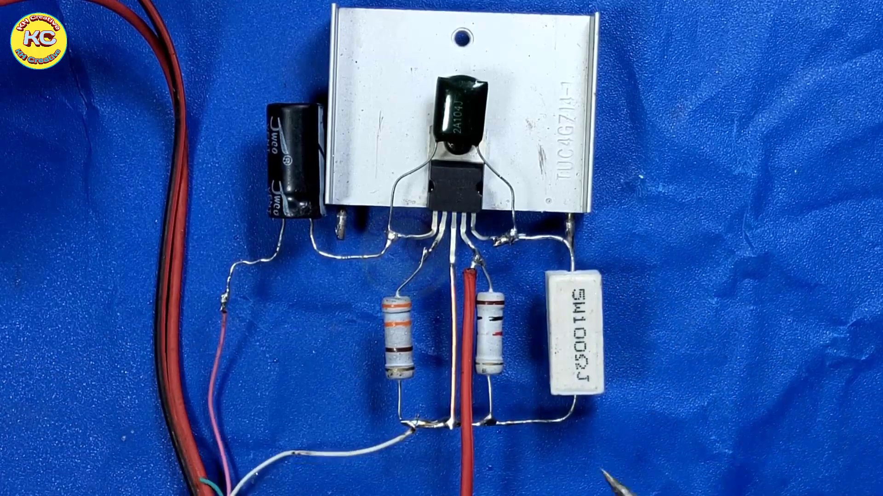 (score 95.0000)
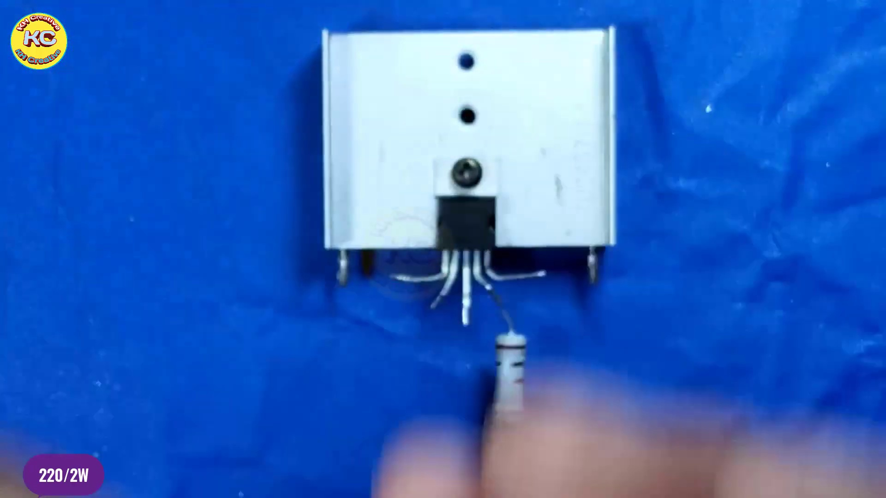 (score 95.0000)
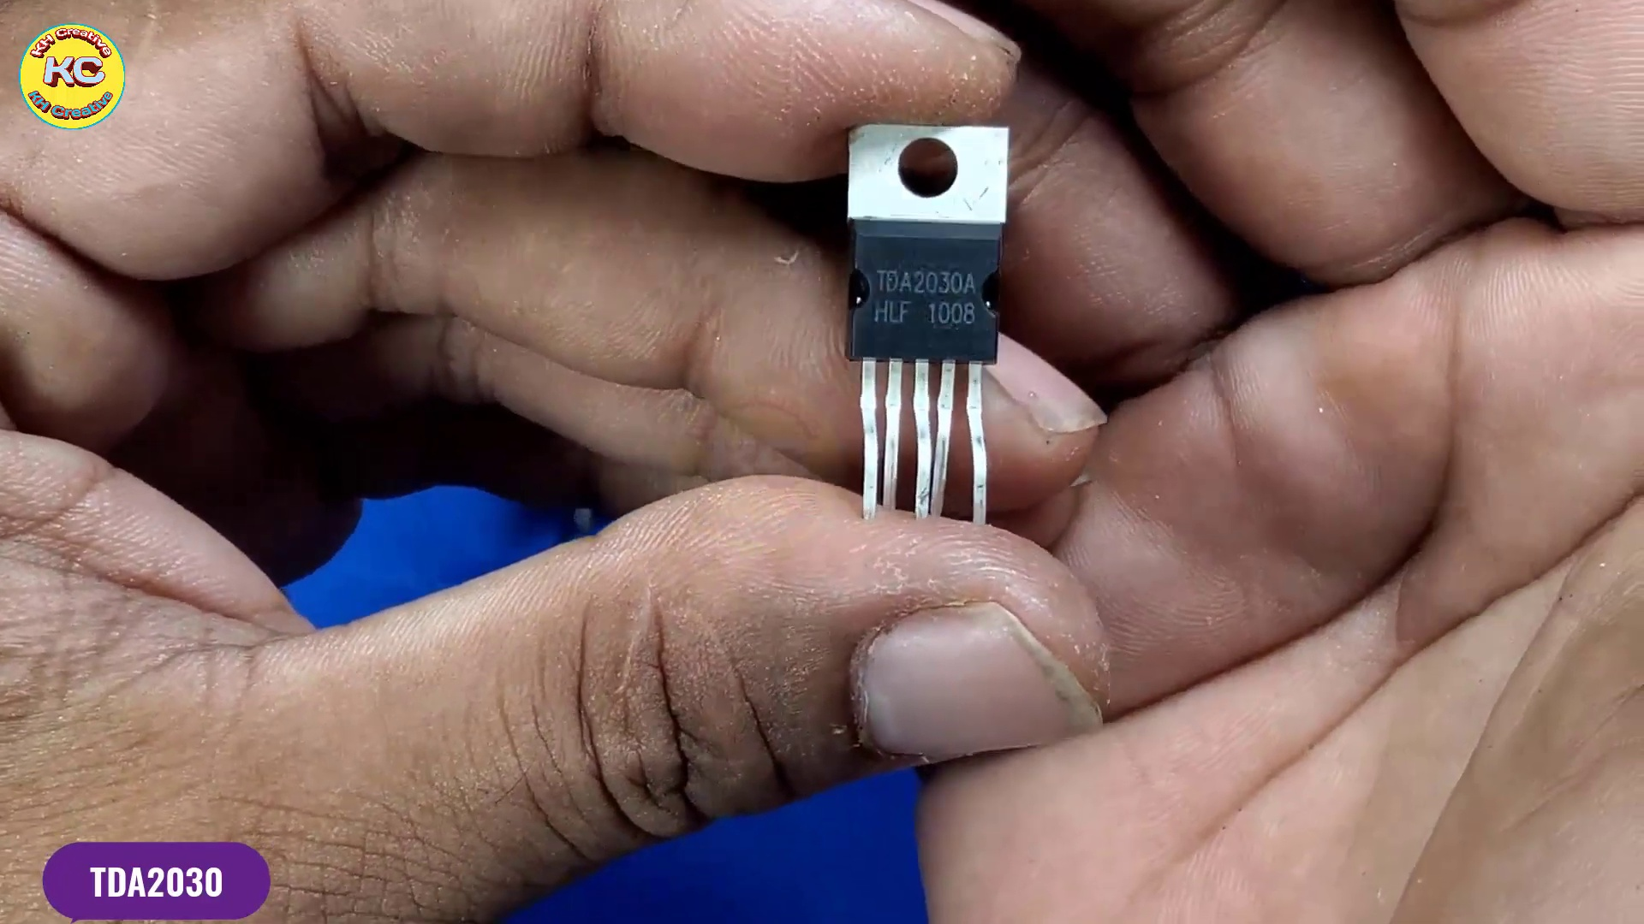 (score 95.0000)
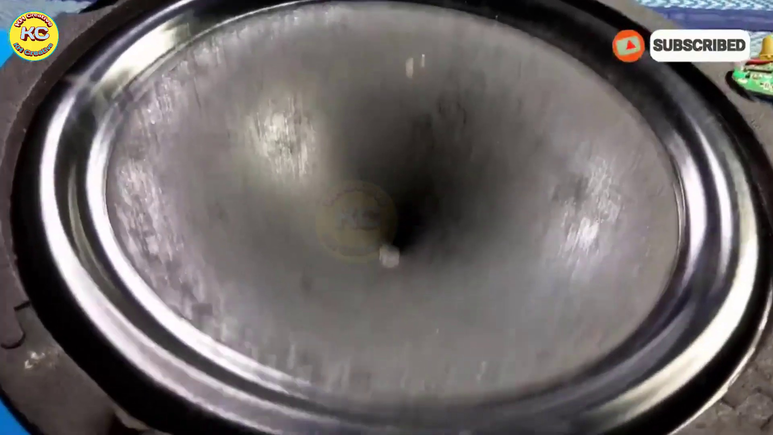 (score 90.0000)
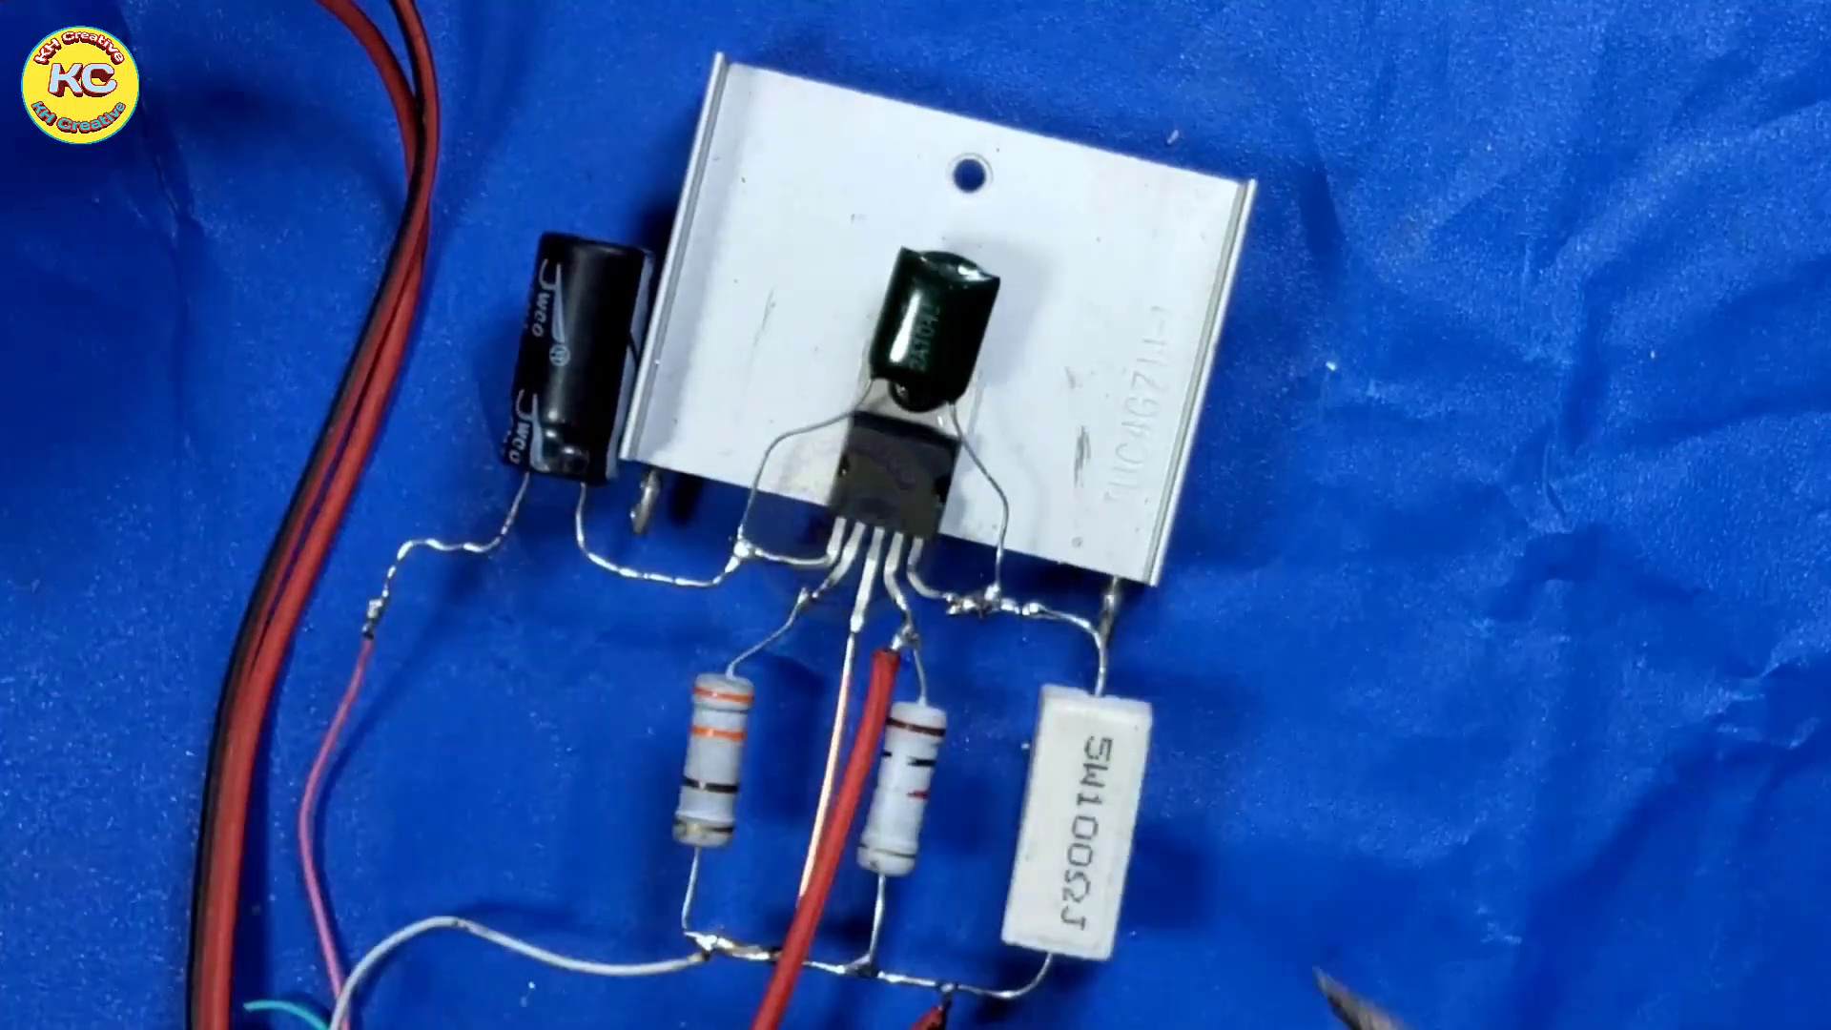 (score 90.0000)
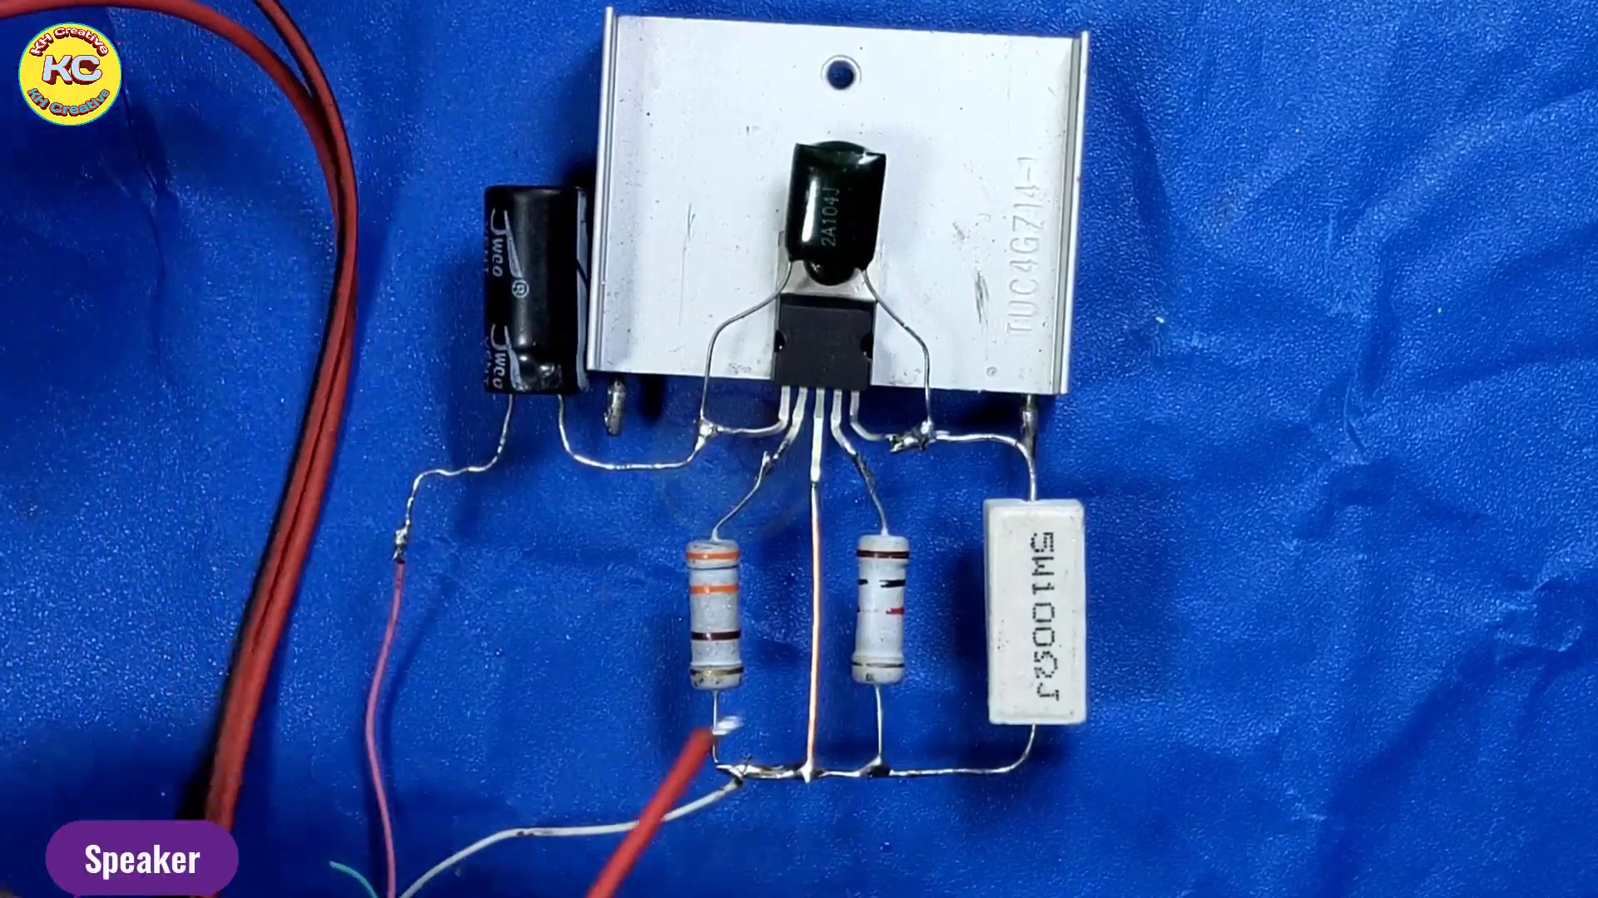 (score 90.0000)
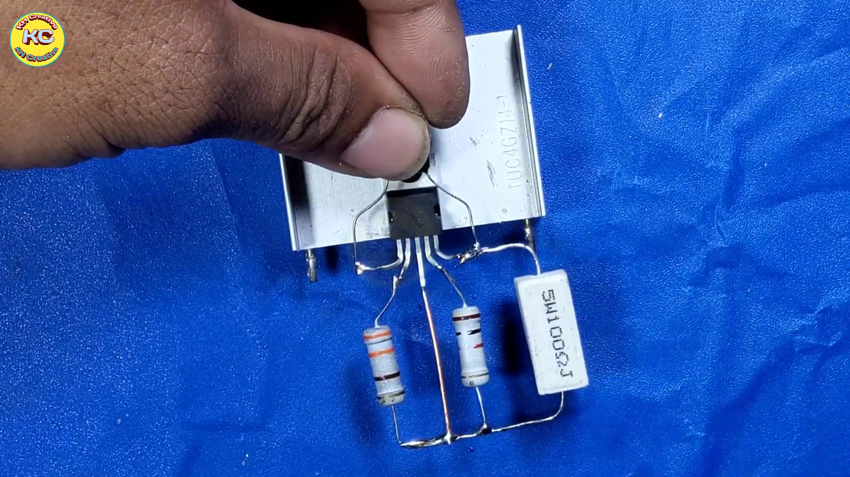 (score 90.0000)
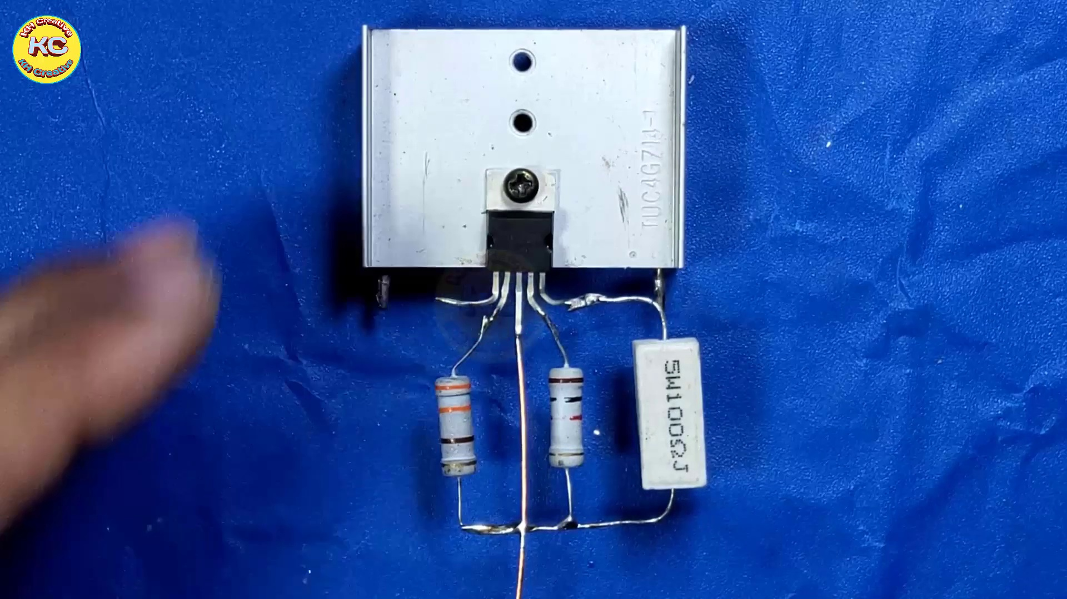 (score 90.0000)
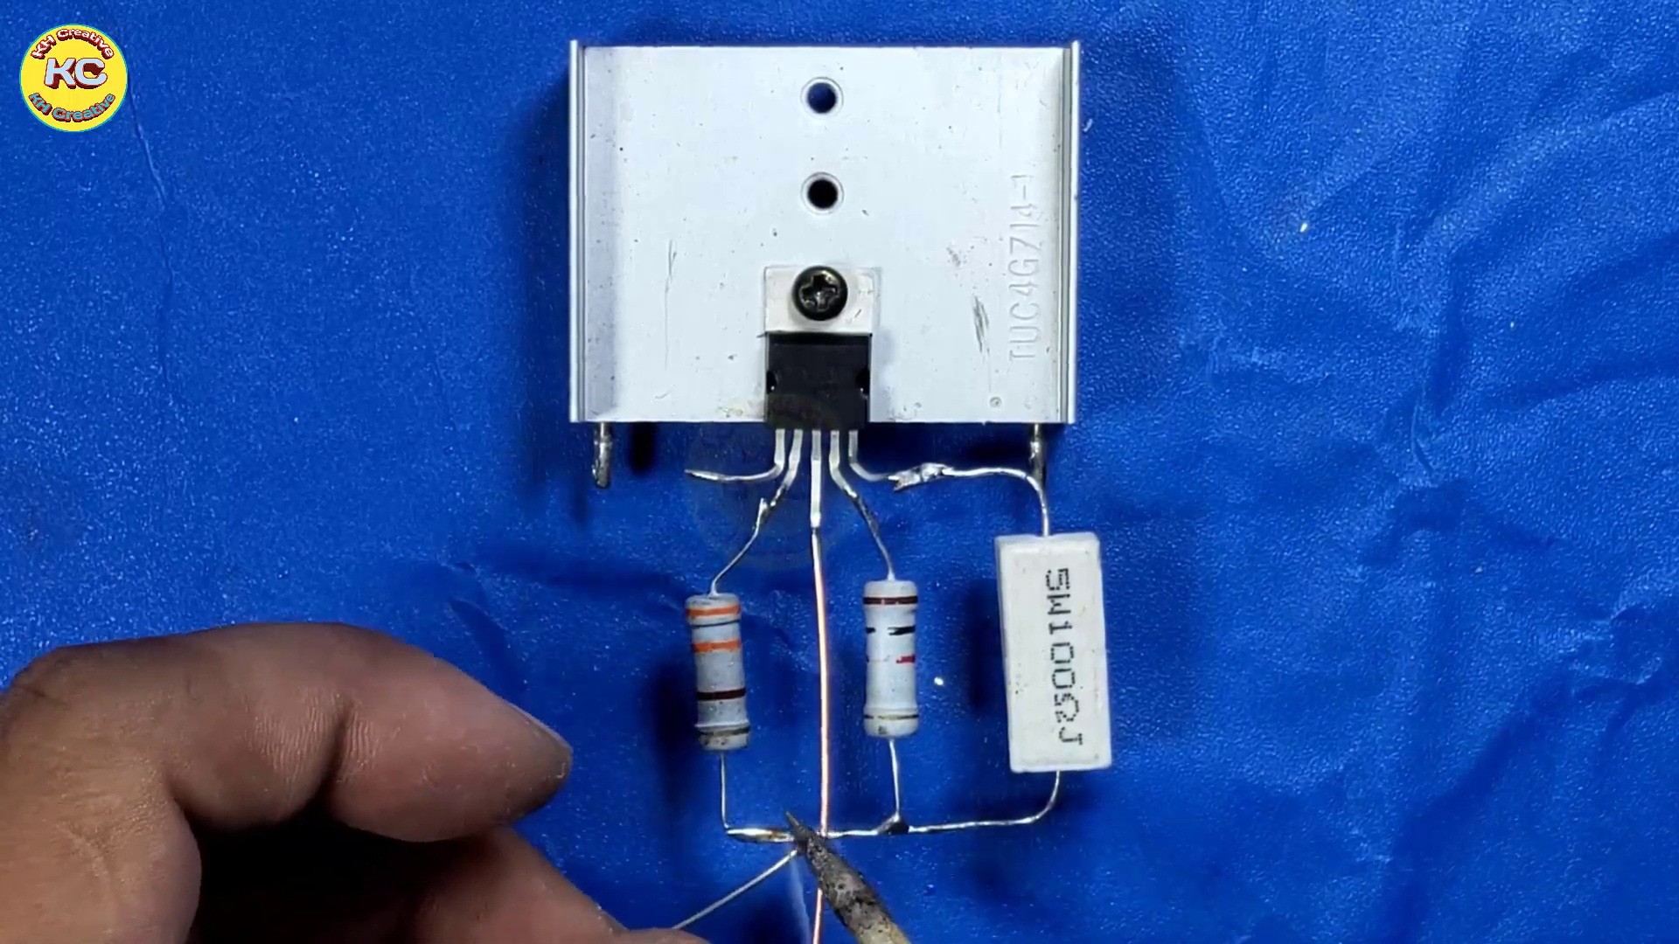 (score 90.0000)
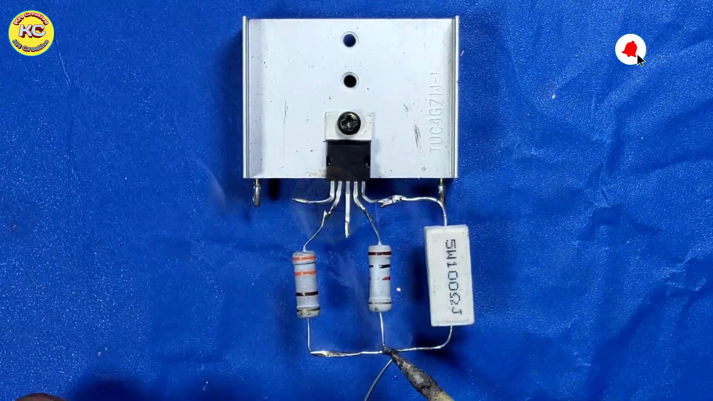 (score 90.0000)
Least correlated frames:
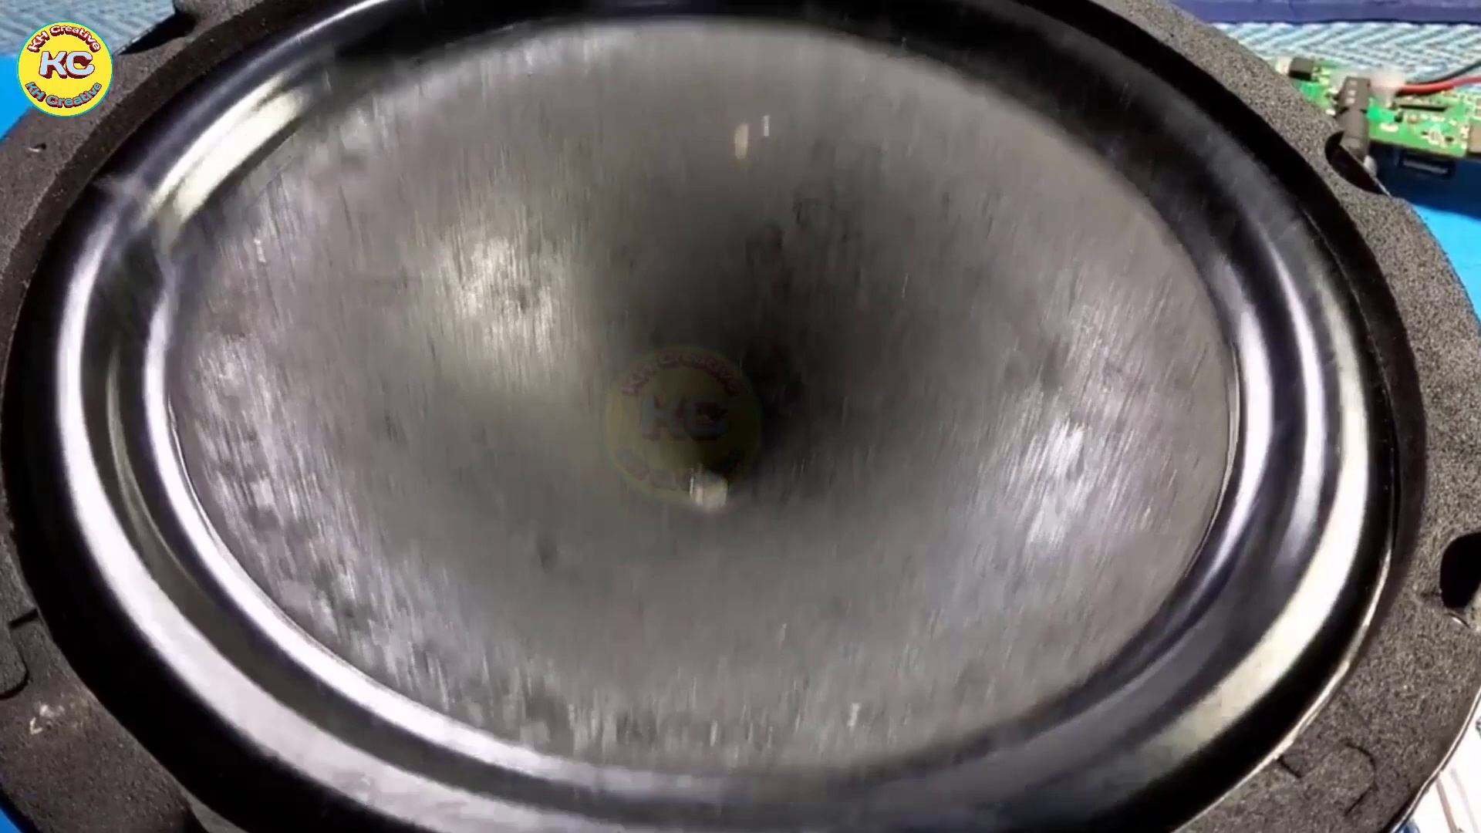 (score 0.0000)
 (score 0.0000)
 (score 10.0000)
 (score 20.0000)
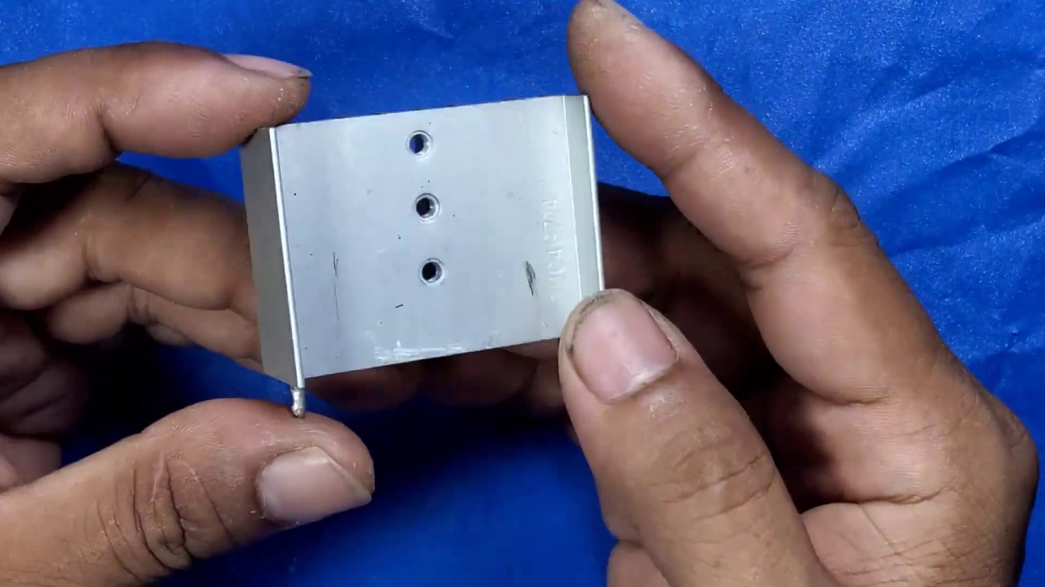 (score 20.0000)
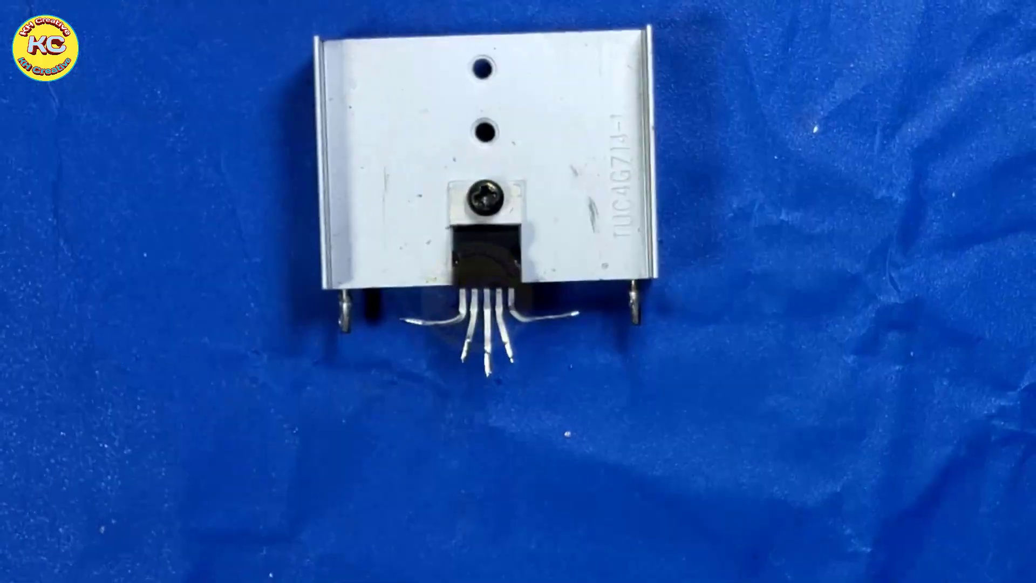 (score 20.0000)
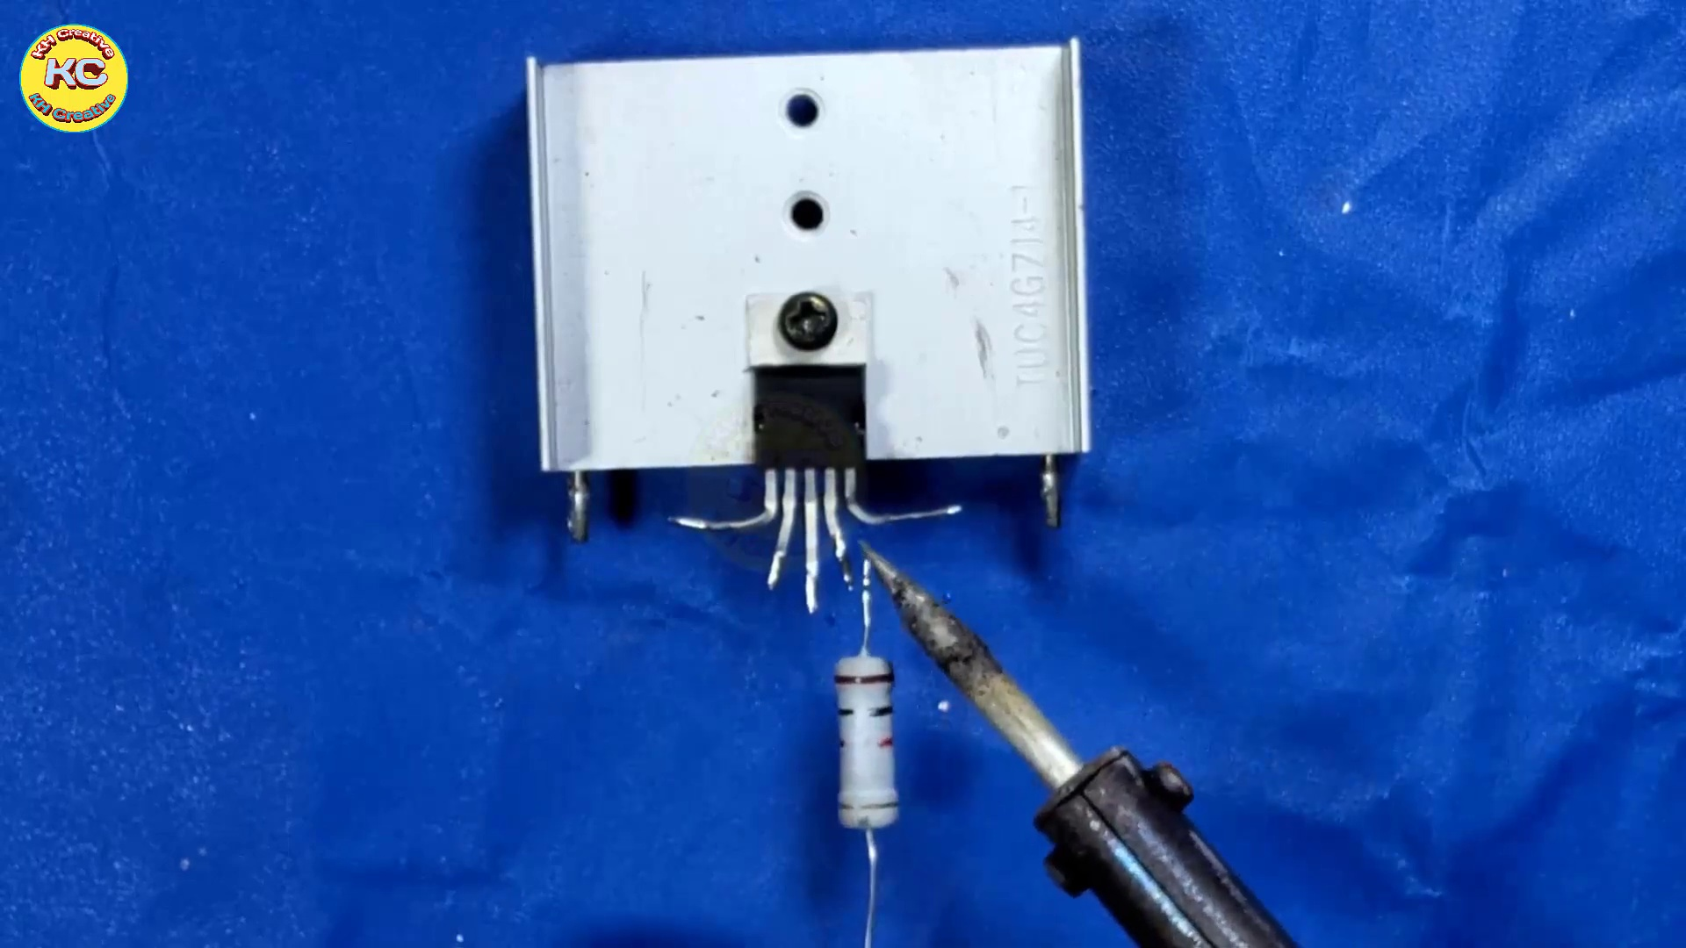 (score 20.0000)
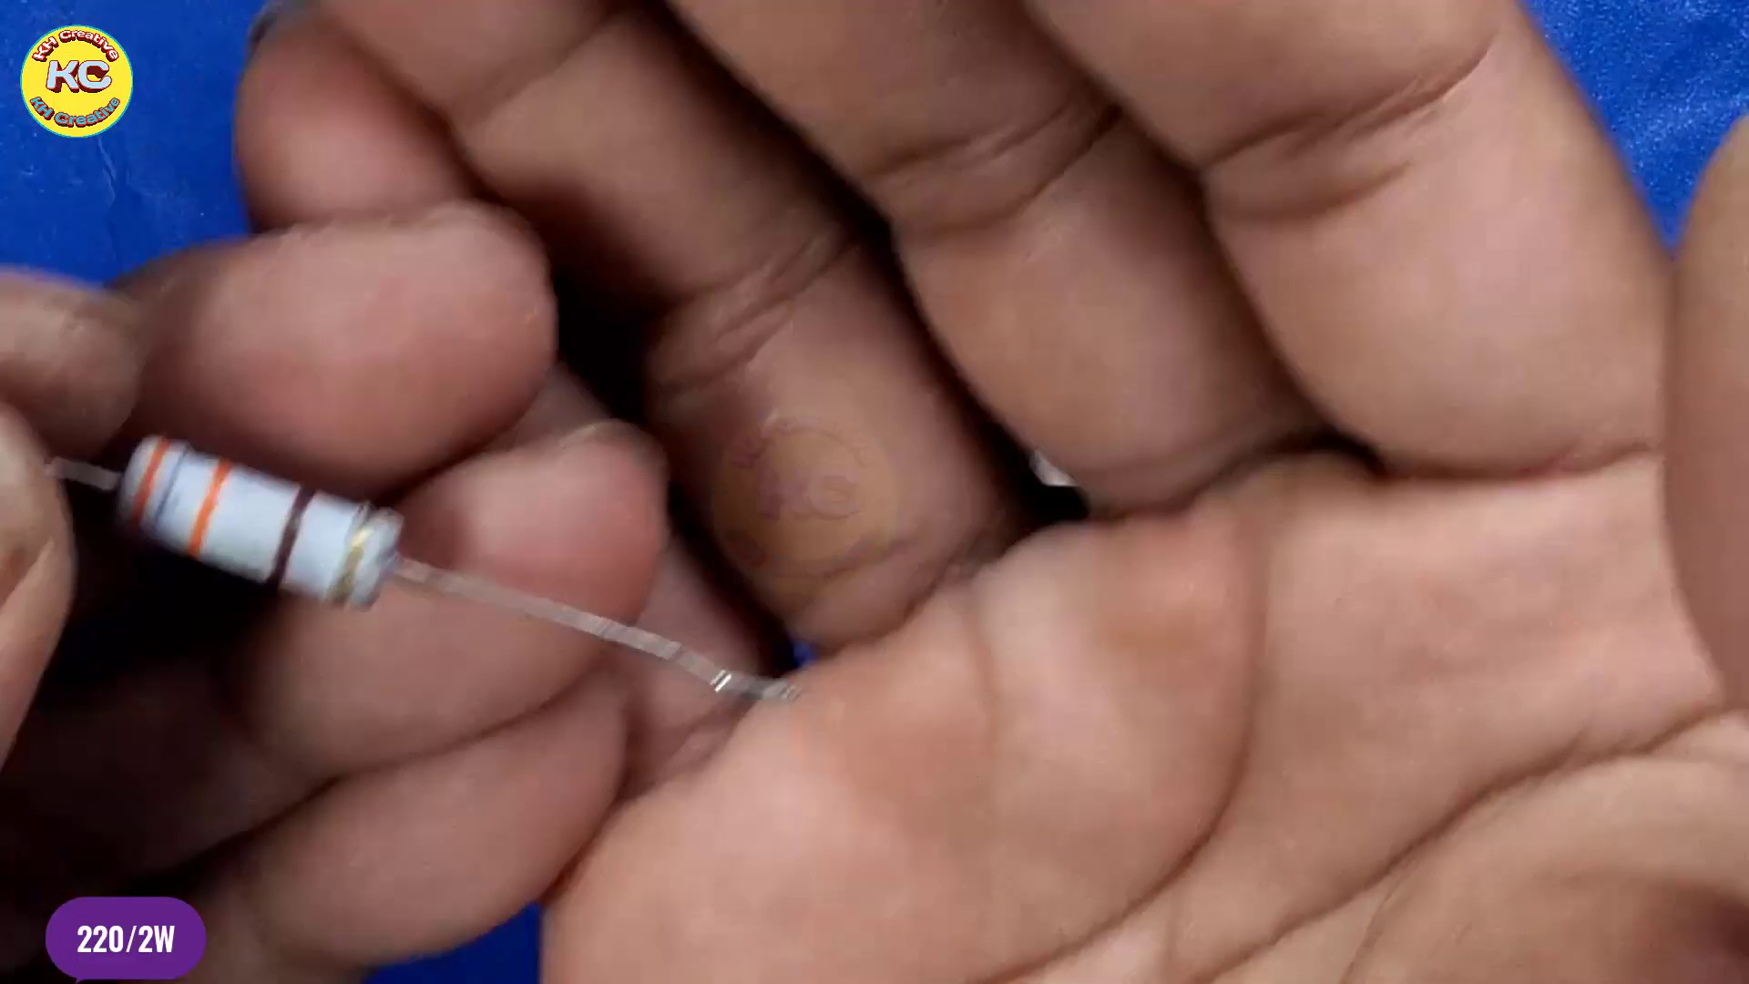 (score 20.0000)
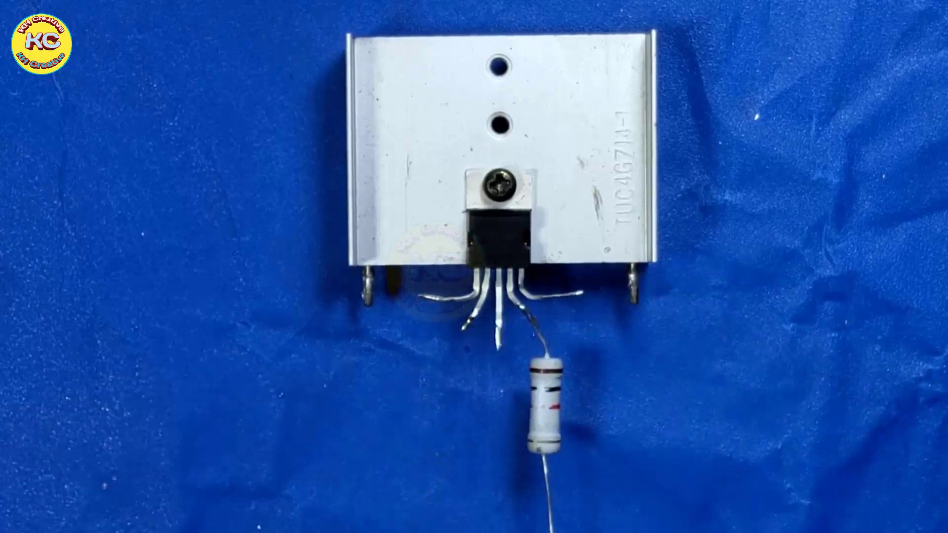 (score 20.0000)
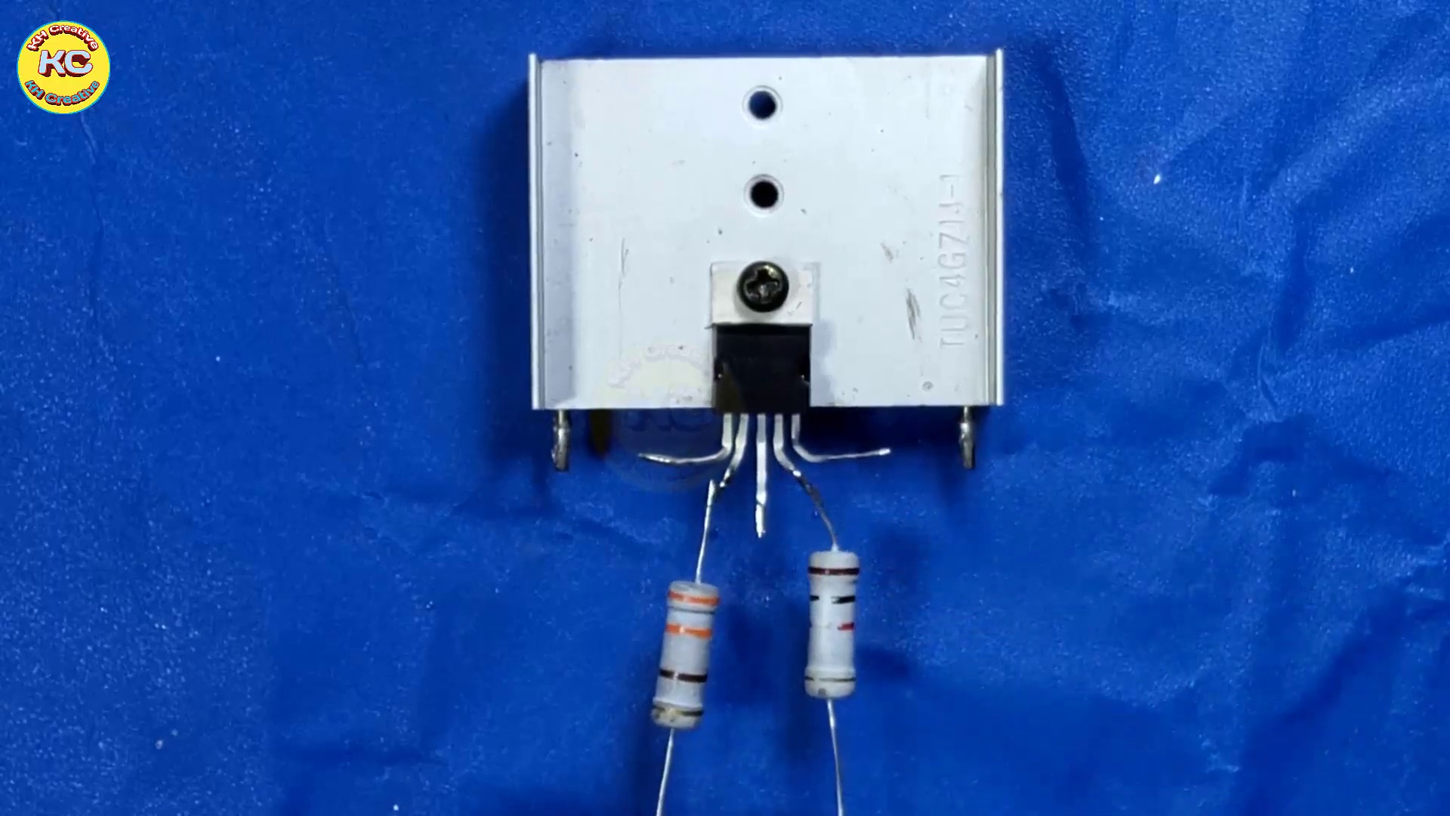 (score 20.0000)

Frame: frame_0000.jpg
Caption: The image you've shared is a black and white photograph of a star in the night sky. The star, located in the upper left corner of the frame, appears small and distant against the dark background. Unlike most images, this one doesn't contain any visual aids like texts, images, or diagrams that could distract from its subject matter. This intentional blankness could be due to privacy concerns or as part of a demonstration on how to prepare a presentation. The overall composition of the image suggests a quiet, serene night sky devoid of human activity or disturbance. The simplicity of this black and white photograph allows the viewer to appreciate the beauty of the star and the vastness of the universe.
No strongly correlated comments found for this frame.

Frame: frame_0001.jpg
Caption: The image features a vibrant and eye-catching design that appears to be related to "KH Creative." The content on the screen is a graphic design that dominates the center, featuring various elements such as geometric shapes, lines, and what looks like a stylized digital clock or timer with a red and black color scheme. Several small icons or symbols within the graphic seem to represent different aspects or tools related to creativity or design work.
The text "KH Creative" is visible in white capital letters at the bottom of the image, suggesting that this may be the name of the individual or entity responsible for the content on the screen. The style of the image suggests it could be a thumbnail from a YouTube video or a similar type of digital content, designed to be eye-catching and visually engaging.
In addition to the graphic design, the image also features a poster with a bold and striking logo at its center. The logo is a large, circular design that blends red and black colors, surrounded by a white circle. The text "KhCreative" is written in bold, white letters above the logo, surrounded by a black circle.
The background of both the graphic design and the poster is a stark black, which provides a striking contrast to the colorful elements, making them stand out prominently. Overall, the image effectively communicates the agency's identity and services to potential clients through its dynamic representation of branding, with its bold colors, contrasting elements, and clear text.
No strongly correlated comments found for this frame.

Frame: frame_0002.jpg
Caption: The image shows two hands holding a small metal object with three evenly spaced holes. The object is rectangular in shape and appears to be part of an electronics project or repair task. One hand is holding the object, while the other hand seems to be operating on it, possibly as part of a disassembly or partial reassembly process. Small screws and holes are visible on the surface of the object, suggesting that the device was likely held together with fasteners, indicating some level of precision work being carried out.
On the left side of the image, there is a close-up of one hand holding what appears to be a small part or component, possibly a capacitor or an electronic integrated circuit (IC), given its shape and size. The individual's nails are visible but not detailed, suggesting the focus on the action at hand rather than personal details.
The background of the image is a vibrant blue, providing a stark contrast to the silver-colored object. There is no text or other contextual information in the image that would suggest an instructional setting or provide additional details about the objects or actions depicted. The style of the image suggests it might be a still from a video tutorial or a step-by-step guide related to electronics repair or DIY projects, focusing solely on the physical attributes and actions of the object being worked on.
No strongly correlated comments found for this frame.

Frame: frame_0003.jpg
Caption: The image shows a moment of careful assembly, where two hands are seen holding a small metal object with three evenly spaced holes drilled in its center. The rectangular-shaped object is being held securely by one hand on the top and the other on the bottom, indicating a sense of balance and control in the assembly process. In the background, the vibrant blue color provides a stark contrast to the silver metal of the object.
On the work surface, one hand is holding a rectangular device with two exposed terminals on one side, labeled "N0" or a similar model number. The other hand is pointing at the metal object with a tool that could be a small screwdriver or a precision driver. The individual appears to be demonstrating how to assemble and interact with such components, possibly in an educational setting.
Comment (score 80): This video demonstrates how to build a powerful amplifier using the TDA2030 in a simple and clear way.Nothing was confusing in this video—it was very clear.This simple circuit will be a great reference for Phase II amplifier builds.
Reason: The comment directly discusses the assembly of a circuit using the TDA2030, which is also depicted in the frame caption. The mention of building an amplifier and providing a reference for Phase II builds matches the technical context of the image, showing hands assembling and interacting with components.
Source: https://www.youtube.com/watch?v=dKB7uHYU-ow: DIY Powerful Ultra Bass Amplifier TDA2030, Homemade Amplifier 12V

Frame: frame_0004.jpg
Caption: The image shows a person's hands carefully working with electronic components, specifically assembling or inspecting a small circuit board or module featuring integrated circuits (ICs) and other electronic parts. In the foreground, there is a close-up of a component that resembles an IC chip mounted on a heatsink or insulating pad. The hands appear to be holding a TDA2030X, a four-channel half-wave rectifier, which is prominently displayed with its black and white color scheme and labeled "TDA2030X". The hands are gripping the component firmly, suggesting a level of importance or care in handling it.
No strongly correlated comments found for this frame.

Frame: frame_0005.jpg
Caption: The image shows a hand working with an electronic component, specifically a surface-mount technology (SMT) device that appears to be an integrated circuit (IC), based on its rectangular shape and the presence of three evenly spaced holes along its length. The person is holding the IC in place while likely assembling or testing it on a blue fabric surface, which provides a contrasting background for the component being handled. The silver color of the IC contrasts with the blue background, making it stand out. There are no visible texts, diagrams, or any other objects in the image that would suggest an educational context such as a slide, teaching aid, or instructor's actions like writing, pointing, holding a model, or speaking from a slide. The focus is on the interaction between the person and the electronic component, which rests on top of the blue surface.
Comment (score 80): This video demonstrates how to build a powerful amplifier using the TDA2030 in a simple and clear way.Nothing was confusing in this video—it was very clear.This simple circuit will be a great reference for Phase II amplifier builds.
Reason: The comment directly mentions the TDA2030 and an amplifier build, which are technical details mentioned in the caption. The caption describes a specific electronic component (SMT device) and its interaction with a blue surface, which is related to building an amplifier as described in the comment.
Source: https://www.youtube.com/watch?v=dKB7uHYU-ow: DIY Powerful Ultra Bass Amplifier TDA2030, Homemade Amplifier 12V

Frame: frame_0006.jpg
Caption: The image shows a person meticulously working on a small electronic device, held in their hands and placed on a blue cloth with wrinkles. The device itself is a rectangular object with a black base and a silver top. The person's hands are covered in an adhesive substance, indicating they are in the process of attaching a small component using a screwdriver.
The component being attached appears to be a small electronic component mounted on a header pin strip, commonly used for testing or prototyping circuits. In front of the hands, there is a clear and transparent diagram showing a simplified representation of an electronic circuit with symbols representing resistors and capacitors. This suggests that the lesson could involve basic components used in electronics projects.
Next to the circuit board, a model of the same circuit as the one being worked on by the person is visible, likely intended for visual aid or demonstration purposes. The focus of this image is on the hands interacting with the circuit board and the accompanying diagrams and models, providing a moment of focused work as the person assembles or repairs the device.
Comment (score 80): This video demonstrates how to build a powerful amplifier using the TDA2030 in a simple and clear way.Nothing was confusing in this video—it was very clear.This simple circuit will be a great reference for Phase II amplifier builds.
Reason: The comment directly discusses the same technical steps (building an amplifier) and objects (TDA2030) described in the caption. The mention of 'simple circuit' and 'Phase II amplifier builds' also correlates with the diagram shown in the frame, which represents a simplified electronic circuit.
Source: https://www.youtube.com/watch?v=dKB7uHYU-ow: DIY Powerful Ultra Bass Amplifier TDA2030, Homemade Amplifier 12V

Frame: frame_0007.jpg
Caption: The image depicts a person engaged in the process of soldering a component on a silver circuit board. The board, featuring a black and white label, is placed on a blue surface, likely indicating a workspace or lab environment in the field of electronics or DIY electronics. As the individual works with electronic components, they hold a wire connected to a device with a button and a LED light, which appears to be illuminated, suggesting that the circuit has been completed or tested.
Using a black soldering iron, the person attaches the wire to the board by melting solder, creating a strong bond between the wire and the board. This action is a crucial step in electronic assembly, ensuring that components are securely joined together. The LED light provides visual confirmation that the circuit is functioning properly, indicating a successful soldering process.
Comment (score 70): This video demonstrates how to build a powerful amplifier using the TDA2030 in a simple and clear way.Nothing was confusing in this video—it was very clear.This simple circuit will be a great reference for Phase II amplifier builds.
Reason: The comment directly references the soldering process and circuit assembly described in the caption, mentioning the TDA2030 component and amplifier build. The similarity in language and topic (electronic assembly) supports a strong connection between the two.
Source: https://www.youtube.com/watch?v=dKB7uHYU-ow: DIY Powerful Ultra Bass Amplifier TDA2030, Homemade Amplifier 12V

Frame: frame_0008.jpg
Caption: The image shows a person engaged in the process of soldering a wire to a white, rectangular circuit board. The circuit board is affixed to a blue surface, which provides a stark contrast to its color. The person's hand is holding a piece of wire, carefully inserted into a hole on the circuit board. A small, black and silver soldering iron is being held by their hand, used to solder the wire to the circuit board. The focus of the image appears to be on the hands-on activity of soldering, rather than the person's hands themselves.
The device being worked on features an integrated circuit (IC) chip with exposed pins, suggesting it could be a surface-mounted technology (SMT) assembly or repair process. A visible soldering iron tip is in contact with one of the IC pins, indicating that soldering is taking place. The blue background might suggest a protective mat or backdrop for this activity.
Comment (score 80): This video demonstrates how to build a powerful amplifier using the TDA2030 in a simple and clear way.Nothing was confusing in this video—it was very clear.This simple circuit will be a great reference for Phase II amplifier builds.
Reason: The comment directly discusses the TDA2030 chip and amplifier build process, which is also mentioned in the caption. The mention of a 'simple circuit' and 'Phase II amplifier builds' shows a strong connection to the technical steps described in the caption.
Source: https://www.youtube.com/watch?v=dKB7uHYU-ow: DIY Powerful Ultra Bass Amplifier TDA2030, Homemade Amplifier 12V

Frame: frame_0009.jpg
Caption: The image depicts two distinct objects with contrasting colors and textures. In the foreground, a silver-colored object with a black label reading "KF" is affixed to a blue surface covered with white paper. The label on the object stands out against its silver background, suggesting a possible connection to electronics or technology. The object appears to be centrally located on the blue surface.
In the background, an electrical wall socket is partially disassembled, revealing its internal mechanism. A copper bus bar and a silver-colored contact blade are visible, providing insight into the socket's internal workings. The plain blue background of the wall socket does not provide any additional context or information, maintaining a straightforward composition.
The two objects in the image do not appear to be directly related, but their distinct colors and textures create visual interest.
No strongly correlated comments found for this frame.

Frame: frame_0010.jpg
Caption: The image shows a close-up of a person's hand meticulously handling a small, rectangular ceramic resistor. The resistor is held in their left hand, and their fingers are gently pressing down on its top edge. The focus of the image is on the resistor itself, providing a clear view of its design and color-coding: it features a white body with a red stripe running down its middle and a black stripe on its bottom. A small gold screw is attached to the resistor, suggesting it might be a part of a larger circuit. The background is a solid blue, providing a stark contrast to the white resistor. The image captures a moment of care and attention to detail, as the person prepares to use the resistor in their circuit.
Comment (score 80): This video demonstrates how to build a powerful amplifier using the TDA2030 in a simple and clear way.Nothing was confusing in this video—it was very clear.This simple circuit will be a great reference for Phase II amplifier builds.
Reason: The comment directly discusses the same technical steps (building a powerful amplifier using the TDA2030) and objects (the simple circuit) described in the caption. The mention of 'Phase II amplifier builds' also relates to the goals described in the caption, specifically the attention to detail in preparing the resistor for use in a larger circuit.
Source: https://www.youtube.com/watch?v=dKB7uHYU-ow: DIY Powerful Ultra Bass Amplifier TDA2030, Homemade Amplifier 12V

Frame: frame_0011.jpg
Caption: The image shows an individual engaged in a hands-on task, likely for practical demonstration or instruction purposes. In the foreground, the person is using a tool to connect wires to a terminal on an electrical device, such as a power strip or surge protector. The two visible wires, one black and one white, are typically associated with hot (live) and neutral lines in electrical devices.
The individual appears focused on their task, ensuring proper connections for safe and effective use of the device. In the background, a blue cloth or fabric provides a clean working surface, suggesting a workshop or repair environment.
In another part of the image, a person is seen soldering a wire to a black board with a white square and the number 45717 written on it. The wire being soldered is red, held by the individual's right hand, while they use a black soldering iron, held in their left hand. This section appears to be part of the overall process of repair or assembly.
The scene is set against a blue surface, which serves as a backdrop for the action. In the background, there is a red sticker with the letter 'C' on it, adding context to the environment where this process takes place.
Comment (score 70): This video demonstrates how to build a powerful amplifier using the TDA2030 in a simple and clear way.Nothing was confusing in this video—it was very clear.This simple circuit will be a great reference for Phase II amplifier builds.
Reason: The comment directly discusses the same technical steps (building a powerful amplifier) and objects (TDA2030, simple circuit) described in the caption, but does not specifically mention the terminal connections or wire colors.
Source: https://www.youtube.com/watch?v=dKB7uHYU-ow: DIY Powerful Ultra Bass Amplifier TDA2030, Homemade Amplifier 12V

Frame: frame_0012.jpg
Caption: The image shows a silver-colored rectangular object resting on a blue surface, with an electric wall outlet visible next to it. The outlet has been removed from its standard position on a wall, revealing its internal components which include a socket for plugs and possibly wiring inside. A screw in the center of the device is not in place, suggesting that someone may have taken it out or it has been removed from its original location. The rectangular plate appears to be made of metal, given its shiny appearance, and features a hole in the center, potentially used for attaching or mounting other components. The plate is marked with a series of numbers and letters, which could potentially be a part of a model or code. The blue background provides a stark contrast to the silver object and outlet, and there are no other discernible objects in the image.
Comment (score 80): This video demonstrates how to build a powerful amplifier using the TDA2030 in a simple and clear way.Nothing was confusing in this video—it was very clear.This simple circuit will be a great reference for Phase II amplifier builds.
Reason: The comment mentions building an amplifier using the TDA2030, which is closely related to the description of the electric wall outlet and its internal components in the caption. The comment also references a circuit and amplifier builds, which are technically relevant to the objects and settings described in the caption.
Source: https://www.youtube.com/watch?v=dKB7uHYU-ow: DIY Powerful Ultra Bass Amplifier TDA2030, Homemade Amplifier 12V

Frame: frame_0013.jpg
Caption: The image shows a moment of meticulous repair work being performed on a hand-held power tool. The tool appears to be a drill or an impact driver, which is currently being charged at an electrical outlet with a cord attached to it. In the background, there is a blue fabric surface serving as a backdrop for the demonstration or photo session.
The main subject of the image is a black wire, with a red stripe running along its length, that is twisted and bent in a complex manner. The wire is being manipulated by a black tool, which is firmly gripped in the wire's path. The wire is bent around the black tool, forming a tight coil.
The scene is set on a blue surface, where a white box adorned with the logo "K" and the number "10" is positioned, providing a stark contrast to its surroundings. The box, along with the wire and tool, creates a scene of repair and restoration.
The image is devoid of any text or additional objects, allowing the viewer to focus solely on the objects and their actions. The relative positions of the objects - the wire around the tool and the box on the blue surface - are clear and unambiguous. The image is a snapshot of a moment of work, capturing the tension and precision involved in such tasks.
No strongly correlated comments found for this frame.

Frame: frame_0014.jpg
Caption: The image captures two moments in the process of working with electrical components. In the foreground, an instructor is guiding the viewer on how to properly wire an outlet. The outlet is being wired with a pair of wires, each with one end inserted into the outlet's holes and the other ends stripped and awaiting connection to the appropriate terminal inside the outlet. A black grounding strip is visible at the bottom of the outlet. The instructor's hands are holding a screwdriver, emphasizing the importance of proper technique.
In the background, a silver-colored circuit board is being repaired or constructed. The board features a black label and a white label, and it is affixed to a blue surface that provides a stark contrast to the metallic sheen of the board. A red screwdriver is poised above one of the board's components, ready to make contact and continue the repair or construction process. The circuit board itself is a testament to the intricate work involved in electronics, with numerous wires and components interwoven in a complex network.
The image is taken from a low angle, which emphasizes the importance of the circuit board and highlights its role in the ongoing repair or construction process. Overall, the image presents a snapshot of two moments in the life of electrical components, capturing the tension and focus that comes with working with these delicate and precise systems.
Comment (score 80): This video demonstrates how to build a powerful amplifier using the TDA2030 in a simple and clear way.Nothing was confusing in this video—it was very clear.This simple circuit will be a great reference for Phase II amplifier builds.
Reason: The comment directly discusses the technical steps (building an amplifier) and components (TDA2030) described in the caption. The mention of a 'simple circuit' and 'Phase II amplifier builds' shows that the viewer is discussing the same electrical components and processes presented in the image.
Source: https://www.youtube.com/watch?v=dKB7uHYU-ow: DIY Powerful Ultra Bass Amplifier TDA2030, Homemade Amplifier 12V

Frame: frame_0015.jpg
Caption: The image shows a close-up view of a hand holding a small electronic component and a white substance that appears to be insulin. The electronic component is a resistor, characterized by its cylindrical shape and a white stripe running down its side, made of gray material marked with the number "220". The hand is positioned on the right side of the image, firmly holding both the resistor and the syringe with a needle attached to it, suggesting that the syringe has been used for injecting the substance. A small amount of liquid remains at the tip of the syringe, indicating its use in administering insulin. The person's skin is visible around the syringe, indicating the point of injection or preparation for such an action. The background is blurred but appears to be indoors with a blueish tint, possibly a wall or a table surface.
No strongly correlated comments found for this frame.

Frame: frame_0016.jpg
Caption: The image shows a person interacting with an electronic device that appears to resemble a projector. The person is pointing at something small on the projector's front panel, suggesting they might be demonstrating how to set up or use the projector. In close proximity, a rectangular device comes into view, featuring a white board embedded within it. This board is adorned with a series of tiny wires, indicating it might be a circuit board. The device is affixed to a blue cloth, which provides a stark contrast to the white board and gives a sense of its small, intricate nature. A yellow handle holds the cloth in place, potentially used for assembly or disassembly purposes. The background remains plain, offering no additional context or information about the setting or topic of discussion.
Comment (score 95): This video demonstrates how to build a powerful amplifier using the TDA2030 in a simple and clear way.Nothing was confusing in this video—it was very clear.This simple circuit will be a great reference for Phase II amplifier builds.
Reason: The comment directly discusses technical steps (building a powerful amplifier) and objects (TDA2030, circuit board) described in the caption, indicating a strong correlation.
Source: https://www.youtube.com/watch?v=dKB7uHYU-ow: DIY Powerful Ultra Bass Amplifier TDA2030, Homemade Amplifier 12V

Frame: frame_0017.jpg
Caption: The image showcases two distinct objects that appear to be related to electronic systems. In the foreground, a wall-mounted electrical device or panel is prominently displayed. The device features various switches and possibly a digital display or control knobs, suggesting its potential use for air conditioning or heating controls. The object itself stands out against the plain blue background, creating a striking visual contrast.
In the background, a circuit board is mounted on a blue surface using a black screw, which is visible on the board itself. The rectangular-shaped board features a white label prominently displayed on it, with a small black screw indicating some form of connection or attachment. The blue surface adds a contrasting backdrop to the board's white label, creating an visually appealing scene.
The overall scene suggests a setting for electronic work, with the circuit board likely being part of a larger circuit or device. The presence of the black screw and the white label on the board indicates that it is not just a standalone component but is part of a larger system.
No strongly correlated comments found for this frame.

Frame: frame_0018.jpg
Caption: This image combines two distinct views to provide insight into electronic components and devices. In the foreground, a small electronic device or circuit board appears to be being worked on or demonstrated. The device features various components, including a central processing unit (CPU) socket without an inserted CPU. It is connected to a blue cable that seems to be part of a power supply or test setup. On the top left corner of the image, there's a small black object that might be an adapter or connector. In the background, a plain blue surface serves as a workbench or table for the demonstration, with no visible texts or labels providing additional context.
In the center of this blue backdrop is a silver rectangular object with a black arrow on it, affixed to a black plate and labeled "TC9071". The top right corner of the image features a yellow logo, likely representing the brand or manufacturer of this object.
Comment (score 85): This video demonstrates how to build a powerful amplifier using the TDA2030 in a simple and clear way.Nothing was confusing in this video—it was very clear.This simple circuit will be a great reference for Phase II amplifier builds.
Reason: The comment directly discusses the TDA2030 component mentioned in the caption, which is the central processing unit (CPU) socket without an inserted CPU. The comment also mentions building a simple circuit and amplifier, which aligns with the demonstration setup shown in the image.
Source: https://www.youtube.com/watch?v=dKB7uHYU-ow: DIY Powerful Ultra Bass Amplifier TDA2030, Homemade Amplifier 12V

Frame: frame_0019.jpg
Caption: The image presents a close-up view of an electrical component, which appears to be a switch plate with some sort of mechanism attached to it. The switch plate is white and has two visible elements: a black switch and a small, metallic object that could be a part of the switch's internal workings. There are no visible texts or brands on this specific model, and there are no people, diagrams, or any other teaching context present in this image. The background is a plain blue surface, which provides a clear view of the object without any distractions.
Upon closer inspection, four wires can be seen connected to a silver-colored object marked with the letters "K.C." These wires differ in color - red, white, black, and orange. Additionally, the switch plate itself bears the markings "0071". The rectangular board is carefully positioned on the blue background, suggesting a setting where electronic components are being tested or assembled. The precise arrangement of the wires and the positioning of the board add to the complexity of the scene, with no discernible text present. The overall scene suggests a level of precision and care in the placement of the objects, leaving the viewer with a sense of attention to detail and careful craftsmanship.
No strongly correlated comments found for this frame.

Frame: frame_0020.jpg
Caption: The image shows a close-up of a person's hands working with a small metal object, which appears to be a resistor labeled "51002J". The resistor is attached to a black wire, which is connected to a white metal pole. The person seems to be focused on the object, possibly adjusting or tightening something. A plastic label on the resistor reads "51002J", and a screw threaded into the object suggests that it may be being manipulated in some way.
No strongly correlated comments found for this frame.

Frame: frame_0021.jpg
Caption: The image presents a close-up view of a person's hand holding an electronics component, possibly related to repair, assembly, or education. The component is attached to a blue surface, which might be a workbench or a workspace for DIY electronics projects. Various wires are connected to the device, indicating a potential process of soldering or assembling components onto a circuit board. The image also shows a circuit board affixed to the blue surface, adorned with several components including resistors and a capacitor. The resistors are neatly arranged in a row, while the capacitor is situated towards the right side of the board. A black screw holds the board in place at the top right corner of the image. The overall scene suggests a well-organized and systematic approach to assembling or repairing electronic devices, with no visible texts, diagrams, or instructions indicating an instructor teaching a class or providing information about electronics.
Comment (score 85): This video demonstrates how to build a powerful amplifier using the TDA2030 in a simple and clear way.Nothing was confusing in this video—it was very clear.This simple circuit will be a great reference for Phase II amplifier builds.
Reason: The comment directly discusses the same technical steps (building an amplifier using the TDA2030) and objects (circuit board, components like resistors and capacitor) described in the caption. The mention of a 'simple circuit' and 'Phase II amplifier builds' also matches with the image showing a circuit board with various components.
Source: https://www.youtube.com/watch?v=dKB7uHYU-ow: DIY Powerful Ultra Bass Amplifier TDA2030, Homemade Amplifier 12V

Frame: frame_0022.jpg
Caption: The image shows a silver-colored circuit board mounted on a blue surface, featuring a series of components including resistors and a transistor. The resistors are predominantly located in the middle and right sections of the board, while the transistor is positioned towards the left. A yellow label bearing the text "Kc 4671" adorns the circuit board. In addition to the circuit board, the image also depicts an electrical outlet with two black cords plugged into it, accompanied by two white rectangular objects attached to the lower part of the outlet. These devices appear to be sensors or monitoring equipment, possibly used for data collection, and have a series of wires extending from them, including one device with three small red and white lights.
There is no visible instructor, text, or labels providing additional context within this frame. The focus remains solely on the objects being showcased, suggesting an educational setting where students are learning about electrical outlets, circuit boards, and possibly how devices are connected to them.
Comment (score 80): This video demonstrates how to build a powerful amplifier using the TDA2030 in a simple and clear way.Nothing was confusing in this video—it was very clear.This simple circuit will be a great reference for Phase II amplifier builds.
Reason: The comment directly discusses the same technical steps (building a powerful amplifier) and objects (circuit board with TDA2030 chip) described in the caption.
Source: https://www.youtube.com/watch?v=dKB7uHYU-ow: DIY Powerful Ultra Bass Amplifier TDA2030, Homemade Amplifier 12V

Frame: frame_0023.jpg
Caption: The image shows an industrial electrical relay with terminals and coil visible, designed for controlling larger currents than it can handle directly. It appears to be a single-phase AC electromagnetic coil device that allows smaller control currents to actuate a switch. In the foreground, a person is holding what seems to be the same type of electrical relay in their hands, possibly demonstrating its components or how it works on a blue fabric surface with no visible text or additional context suggesting an educational setting.
In the background, a moment of meticulous repair work is captured as a white soldering iron with a red handle is being used to join two small black and silver components together. The wire connecting these components passes through a small hole in the base of the soldering iron, which is attached to the blue cloth serving as a makeshift workspace. The red handle of the soldering iron points towards the components, indicating the direction of the soldering process.
No strongly correlated comments found for this frame.

Frame: frame_0024.jpg
Caption: The image shows a hand holding an electronic component, which appears to be a small circuit board with several resistors and possibly other components like capacitors or inductors. The circuit board is resting on a blue surface, accompanied by two resistors, one red and one black. The red resistor is connected to the red wire of the circuit board, while the black resistor is connected to the white square on the circuit board. A black wire secures the white square and a red rectangular box to the board, forming a closed loop with a red wire.
The text "MENYEK" is visible in the bottom right corner of the image, possibly referring to an electronic product or component being used or demonstrated. The rest of the background is nondescript, providing no additional context or information about the setting or purpose of this activity. There are no visible texts, equations, or diagrams within the image that would indicate a teaching context beyond the implied demonstration or explanation of the electronic device held by the person.
Note: I have carefully integrated the details from both captions to create a single caption that retains all accurate and relevant information, while avoiding redundancy and contradictions.
Comment (score 80): This video demonstrates how to build a powerful amplifier using the TDA2030 in a simple and clear way.Nothing was confusing in this video—it was very clear.This simple circuit will be a great reference for Phase II amplifier builds.
Reason: The comment directly discusses the technical steps described in the caption, mentioning a specific electronic component (TDA2030) and its use in building an amplifier. The caption mentions the circuit board with resistors, capacitors/inductors, and wires, which are all relevant to the topic of building an amplifier.
Source: https://www.youtube.com/watch?v=dKB7uHYU-ow: DIY Powerful Ultra Bass Amplifier TDA2030, Homemade Amplifier 12V

Frame: frame_0025.jpg
Caption: This image captures an intimate moment of electronic assembly, featuring a white rectangular device with black trim and a silver plug on top, attached to a blue surface. The device is connected by a white wire, which appears to be the primary means of communication between the device and its surrounding components. A small, black cylindrical device with several pins along its surface lies in front of the main circuit board, partially obscuring it from view. The pins are arranged in a pattern that suggests they may be designed to connect to another electronic system or device.
The main circuit board appears to be some kind of electronic circuit board, featuring multiple white rectangles, possibly representing integrated circuits (ICs) or other electronic components. A small black box at one end of the board could be part of the device's housing or a connector for external parts. The specific model or brand of these components is not visible.
The device itself is equipped with three resistors, each of a different color - black, white, and red. These resistors are neatly arranged in a line, one on the left, one in the middle, and one on the right. The resistors add a layer of complexity to the image, hinting at the intricate details of electronic circuits.
Comment (score 80): This video demonstrates how to build a powerful amplifier using the TDA2030 in a simple and clear way.Nothing was confusing in this video—it was very clear.This simple circuit will be a great reference for Phase II amplifier builds.
Reason: The comment directly mentions building an amplifier using the TDA2030, which is a specific technical step mentioned in the caption. The mention of 'simple circuit' and 'Phase II amplifier builds' also match with the objects (resistors) and goals (electronic assembly) described in the caption.
Source: https://www.youtube.com/watch?v=dKB7uHYU-ow: DIY Powerful Ultra Bass Amplifier TDA2030, Homemade Amplifier 12V

Frame: frame_0026.jpg
Caption: The image shows an indoor setting with a mechanical device resembling an electrical meter or a similar type of measuring instrument placed on a blue background, surrounded by a white surface that might be a table or workbench. The device is connected to two wires and has several components including gears, springs, and a rotating assembly that suggests it might be able to measure motion or rotation. The meter is partially disassembled with some internal parts visible, showing a small motor or generator at the center, which could be part of a mechanical-to-electrical conversion process.
The device is surrounded by various electronic components, including resistors of different colors and sizes, capacitors predominantly white, and wires of different colors, including red and black. The resistors are connected to the capacitors, forming a circuit. There are no visible texts or diagrams that would indicate an educational context, such as an instructor teaching or demonstrating how the device works.
Comment (score 80): This video demonstrates how to build a powerful amplifier using the TDA2030 in a simple and clear way.Nothing was confusing in this video—it was very clear.This simple circuit will be a great reference for Phase II amplifier builds.
Reason: The comment directly discusses the technical steps and objects described in the caption, specifically mentioning the TDA2030 amplifier circuit and the simplicity of the build. The mention of 'Phase II amplifier builds' also shows a clear connection to the setting and components shown in the image.
Source: https://www.youtube.com/watch?v=dKB7uHYU-ow: DIY Powerful Ultra Bass Amplifier TDA2030, Homemade Amplifier 12V

Frame: frame_0027.jpg
Caption: The image presents a detailed illustration of an electrical device, featuring various components such as wiring terminals, circuit breakers, and possibly safety switches or timers. The device is placed against a blue background, providing a straightforward representation of the object without any additional context or explanation provided by an instructor or diagram. A closer examination reveals that the device resembles a circuit board, composed of various components including resistors, capacitors, and a transistor. The resistors are arranged in a series configuration, with two on the left side of the board and two on the right. The capacitors are placed in parallel, one on the left and the other on the right. The transistor is located centrally on the board, suggesting a well-designed circuit. The board is affixed to a blue surface with a white background, providing a stark contrast that highlights the components.
Comment (score 90): This video demonstrates how to build a powerful amplifier using the TDA2030 in a simple and clear way.Nothing was confusing in this video—it was very clear.This simple circuit will be a great reference for Phase II amplifier builds.
Reason: The comment directly discusses the same technical steps and components described in the caption, specifically mentioning the TDA2030 amplifier and referencing the circuit board design.
Source: https://www.youtube.com/watch?v=dKB7uHYU-ow: DIY Powerful Ultra Bass Amplifier TDA2030, Homemade Amplifier 12V

Frame: frame_0028.jpg
Caption: The image presents a simple electronic circuit setup featuring an electrical device with several components attached to a white rectangular board. A small white transformer with two black connectors on one end and three terminals on the other is prominently displayed, likely for connecting wires. The device appears to be a small-scale model or prototype, possibly designed for educational purposes given its simplicity. There are no visible texts, equations, graph types, slides, diagrams, or any indications of a person interacting with the device in the image.
The board serves as the base for three components: a red and white capacitor positioned on the left side, a black resistor and a silver diode mounted on the right side. The "KC" text is visible on the top right corner of the board, possibly indicating the brand or manufacturer of the components. The blue backdrop provides a contrasting background that makes the components stand out, adding to their visual clarity.
Comment (score 80): This video demonstrates how to build a powerful amplifier using the TDA2030 in a simple and clear way.Nothing was confusing in this video—it was very clear.This simple circuit will be a great reference for Phase II amplifier builds.
Reason: The comment directly discusses the same technical steps (building an amplifier) and objects (TDA2030) described in the caption, including mentioning that the video is simple and clear.
Source: https://www.youtube.com/watch?v=dKB7uHYU-ow: DIY Powerful Ultra Bass Amplifier TDA2030, Homemade Amplifier 12V

Frame: frame_0029.jpg
Caption: The image captures a moment of technological transformation within a controlled environment, possibly a laboratory or workshop dedicated to electrical engineering or electronics education. The scene focuses on demonstrating how to connect various electronic components together safely.
In the foreground, a person is guiding someone through the process of connecting electronic devices, creating an instructional or educational context. The setup features a power strip or surge protector with multiple sockets where cables are inserted. Cables connected between the power strip and other components have standard electrical plugs on one end and modular connectors on the other, suggesting this could be a setup for data transfer or power supply with additional functions.
A small electronic device with a visible screen displaying some sort of graphical interface is also present. The image quality does not allow for specific details about the screen content to be determined.
The dominant feature in the scene is a white plastic casing that might serve as a protective cover for an electrical device, although its exact function cannot be definitively established from the image alone. A small black screwdriver, symbolizing mechanical precision, is poised over one of these components, suggesting an action in progress or transformation in the making.
The overall setting appears to be a controlled environment, possibly a laboratory or workshop dedicated to electrical engineering or electronics education, where individuals are guided through the process of connecting electronic devices safely.
Comment (score 80): This video demonstrates how to build a powerful amplifier using the TDA2030 in a simple and clear way.Nothing was confusing in this video—it was very clear.This simple circuit will be a great reference for Phase II amplifier builds.
Reason: The comment directly discusses the technical steps and components described in the caption, specifically mentioning building a powerful amplifier using the TDA2030. The language used is also consistent with an educational or instructional context, matching the tone and content of the caption.
Source: https://www.youtube.com/watch?v=dKB7uHYU-ow: DIY Powerful Ultra Bass Amplifier TDA2030, Homemade Amplifier 12V

Frame: frame_0030.jpg
Caption: The image shows an electrical device with various components such as a light bulb, wiring, and connectors that appear to be soldering points. The device is affixed to a blue background. There are two black terminals connected by a piece of wire, and the soldering points are also visible, suggesting that soldering may have been or is about to take place.
In the foreground, there's a small black soldering iron being held by an unseen hand, which indicates that soldering might be in progress or has just finished. A white box with black text and a red logo sits nearby, attached to a blue surface via a silver clamp. The box contains a white circuit board labeled "UCA671H" marked with a red and white logo - a shield with a white shield on a red background surrounded by a white circle with a red background.
The overall scene suggests a workshop or laboratory setting where the device, box, and its contents are being worked on or tested. The focus is on the soldering process and the device under repair or construction.
No strongly correlated comments found for this frame.

Frame: frame_0031.jpg
Caption: The image shows a person's hand holding an electronic component, which appears to be a small integrated circuit (IC) or a module with multiple circuits and connectors. In the background, a white circuit board is affixed to a blue surface, providing a glimpse into the intricate world of electronic circuits. The circuit board is a hub of various electronic components, meticulously labeled and arranged in neat rows. Resistors, each distinct in color, are arranged in a row, their metallic bodies gleaming under the light. A small white transistor is nestled between the resistors, its components neatly aligned. A capacitor, also a small white device, is located towards the right side of the board, its components standing out against the white of the board. A small black screw is positioned at the bottom of the board, serving a crucial purpose in the functioning of the device. The image provides a detailed look into the world of electronic circuits, where each component plays a vital role in the overall functionality.
Comment (score 90): This video demonstrates how to build a powerful amplifier using the TDA2030 in a simple and clear way.Nothing was confusing in this video—it was very clear.This simple circuit will be a great reference for Phase II amplifier builds.
Reason: The comment directly discusses the same technical steps and components (TDA2030 amplifier) described in the caption, specifically mentioning building a powerful amplifier using the TDA2030. The caption provides detailed information about electronic circuits, which is relevant to the topic discussed in the comment.
Source: https://www.youtube.com/watch?v=dKB7uHYU-ow: DIY Powerful Ultra Bass Amplifier TDA2030, Homemade Amplifier 12V

Frame: frame_0032.jpg
Caption: The image presents an electronic device mounted on a blue background. The device appears to be a control panel with various components and connections, featuring multiple cables connecting different parts of the device. Notably, these cables are color-coded, which may suggest they serve specific functions or indicate labels in an educational context.
Upon closer inspection, the image reveals a white circuit board resting on the blue background, encased in a silver case that provides a striking contrast to its surroundings. The board is adorned with various electronic components, including resistors and capacitors. The resistors, which are of different colors, are scattered across the board, while two white capacitors are visible: one located near the center of the board and the other towards the top right corner.
The arrangement of these components on the board suggests they are part of a larger circuit, hinting at the intricate workings of electronic devices. The overall appearance of the device emphasizes its physical properties, focusing attention on its various components and connections rather than instructional elements.
Comment (score 80): This video demonstrates how to build a powerful amplifier using the TDA2030 in a simple and clear way.Nothing was confusing in this video—it was very clear.This simple circuit will be a great reference for Phase II amplifier builds.
Reason: The comment directly discusses the same technical steps (building an amplifier using the TDA2030) and objects (the circuit board and its components) described in the caption. The mention of a 'simple circuit' and 'Phase II amplifier builds' further reinforces the correlation.
Source: https://www.youtube.com/watch?v=dKB7uHYU-ow: DIY Powerful Ultra Bass Amplifier TDA2030, Homemade Amplifier 12V

Frame: frame_0033.jpg
Caption: The image shows a small electronic circuit board with several distinct components. The board itself is composed of a white square with black lines, situated at the top, along with a small black component placed nearby. At the bottom of the board, there is a silver rectangular piece. The circuit board appears to be positioned on a blue fabric surface, creating a striking contrast between the metallic components and the fabric.
Several electronic devices are connected to the board, including a transformer with two coils (primary and secondary) and what appears to be an integrated circuit or chip (IC). The white rectangular plastic casing with slots and terminals for wiring is also visible. The overall setting suggests a hands-on learning environment where an individual is interacting with electronic equipment, possibly conducting experiments or demonstrations related to physics, electronics, or electrical engineering.
In the image, the person appears to be either inspecting or adjusting the components of the board, as indicated by their hand position near one of the devices. There is no visible text, diagrams, or other educational materials in this particular frame that provide context for the content. The blue background adds a sense of simplicity and practicality to the image, emphasizing the focus on hands-on learning and experimentation.
Comment (score 90): This video demonstrates how to build a powerful amplifier using the TDA2030 in a simple and clear way.Nothing was confusing in this video—it was very clear.This simple circuit will be a great reference for Phase II amplifier builds.
Reason: The comment directly discusses the technical steps involved in building an amplifier using the TDA2030 IC, which is mentioned in the caption as one of the components on the circuit board. The mention of 'Phase II amplifier builds' further reinforces the correlation between the caption and the comment.
Source: https://www.youtube.com/watch?v=dKB7uHYU-ow: DIY Powerful Ultra Bass Amplifier TDA2030, Homemade Amplifier 12V

Frame: frame_0034.jpg
Caption: The image shows a close-up view of a black circuit board, adorned with various components, including resistors and a capacitor. The resistors, in different sizes, are scattered across the board, their metallic bodies shining under the light. A small white capacitor with red and black stripes is also visible on the board. The board is mounted on a blue surface, providing a striking contrast to the black components.
The circuit setup features several key components:
1. A small white transformer with two windings (coils) for stepping up or down voltage levels in circuits.
2. Two black wires connected to the transformer, likely serving as input and output leads for the device being powered by the circuit.
3. An additional wire running from one of the transformer terminals to a small metal object labeled "10V," which appears to be a regulator or voltage stabilizer ensuring a constant 10-volt supply.
4. A black wire connected to one of the capacitor's terminals, providing a path for current flow when needed.
5. The "10V" label on the circuit board suggests that the system is designed for 10-volt operation.
The components are arranged in a simple circuit setup intended to provide a stable voltage level or regulate current flow through the circuit. The presence of a capacitor implies energy storage or power smoothing may be involved.
Comment (score 80): This video demonstrates how to build a powerful amplifier using the TDA2030 in a simple and clear way.Nothing was confusing in this video—it was very clear.This simple circuit will be a great reference for Phase II amplifier builds.
Reason: The comment directly discusses the technical components and setup described in the caption (TDA2030 amplifier, circuit board, transformer, capacitor), with a clear connection to the goal of building an amplifier. The mention of Phase II amplifier builds also reinforces the correlation.
Source: https://www.youtube.com/watch?v=dKB7uHYU-ow: DIY Powerful Ultra Bass Amplifier TDA2030, Homemade Amplifier 12V

Frame: frame_0035.jpg
Caption: The image appears to be a screenshot from an educational video that captures a close-up moment where someone is meticulously handling and examining a small, green cylindrical object. The object, labeled "ZA1041", is held by two hands, with one hand firmly gripping the top and the other the bottom. The label on the object provides its part number, indicating its specific identity. Despite being small in size, the object seems to have some sort of greenish material on it, although further details about the object's composition are not clear due to its distance from the camera. The image has been processed with a filter or artistic effect that gives it a painted appearance rather than a realistic photograph. The background is blurred, suggesting a focus on the object in the foreground, and there is no visible text or writing in the image that could provide additional context.
No strongly correlated comments found for this frame.

Frame: frame_0036.jpg
Caption: The image captures a detailed scene of electronic assembly. At the center is a silver rectangular board, its surface adorned with a grid of tiny holes. This board is surrounded by various components, each serving a specific purpose in the circuit. On the left side of the board, a black rectangular box rests - a transistor that controls the flow of current in the circuit, acting as a switch or gate.
To the right of the board, a red rectangular box is visible - a resistor that regulates the flow of current and prevents damage to the circuit or the device it powers. The silver rectangular board itself is affixed to a blue cloth, providing a neutral backdrop for the scene, allowing focus to remain on the circuit and its components.
In the background, a single-pole electromagnetic coil (solenoid) with a current transformer attached can be seen, often used in physics labs to demonstrate electromagnetism and inductance experiments. With no visible people, texts, or devices suggesting an instructional setting, the image presents a snapshot of an electronic circuit in the process of assembly, showcasing each component's crucial role in its operation.
Comment (score 80): This video demonstrates how to build a powerful amplifier using the TDA2030 in a simple and clear way.Nothing was confusing in this video—it was very clear.This simple circuit will be a great reference for Phase II amplifier builds.
Reason: The comment directly discusses the technical steps and components described in the caption, specifically mentioning the TDA2030 amplifier and its application in building a powerful amplifier. The comment also mentions the simplicity and clarity of the video, which aligns with the descriptive details in the caption.
Source: https://www.youtube.com/watch?v=dKB7uHYU-ow: DIY Powerful Ultra Bass Amplifier TDA2030, Homemade Amplifier 12V

Frame: frame_0037.jpg
Caption: The image shows a person's hand working with an electronic component, specifically soldering two pieces of metal together by melting a solder wire and allowing it to cool and solidify. The individual is holding the black soldering iron in place using silver-colored pliers, with the tip pointed towards the solder wire. The solder wire is being guided along a silver-colored metal track, which is part of a larger device – a circuit board – resting on a blue cloth.
The person's hand is positioned over the circuit board, suggesting that they are in the process of connecting or repairing one of the components attached to it. With a sharp focus on the hands and the component, the rest of the scene is out of focus, emphasizing the activity at hand. The overall scene suggests a hands-on approach to electronic repair or construction, as the individual makes a connection with some wires, potentially setting up or testing an electronic device.
Comment (score 80): This video demonstrates how to build a powerful amplifier using the TDA2030 in a simple and clear way.Nothing was confusing in this video—it was very clear.This simple circuit will be a great reference for Phase II amplifier builds.
Reason: The comment directly references the technical steps (building an amplifier) and objects (TDA2030, circuit board) described in the caption, indicating a strong connection between the two.
Source: https://www.youtube.com/watch?v=dKB7uHYU-ow: DIY Powerful Ultra Bass Amplifier TDA2030, Homemade Amplifier 12V

Frame: frame_0038.jpg
Caption: The image depicts a person engaged in an electronic repair or assembly task, as suggested by the silver-colored circuit board and clamp on a blue cloth. The individual is soldering a component onto the circuit board using a black wire with a red tip, which is being inserted into a small hole. The circuit board is held in place by the silver-colored clamp, positioned to accommodate the wire insertion. In the background, a workbench is visible, featuring electronic parts and a blue surface, indicating a workshop environment. The device being soldered has several small components that could include resistors or integrated circuits, highlighting the focus on working with electrical components, a common activity in electronics and engineering education or workshops.
No strongly correlated comments found for this frame.

Frame: frame_0039.jpg
Caption: The image shows a person's hand and forearm holding a small silver-colored metal object, rectangular in shape with a square hole in the center. The object appears to be a circuit board, possibly used for electronic devices. It has various components attached to it, including resistors and possibly capacitors or diodes, with white labels indicating their functions such as "R1" for a resistor. The circuit board is positioned on a blue surface, which is likely a cloth or similar material. The background of the photo is dark blue, providing a stark contrast to the object. The person is wearing a blue shirt, which contrasts with the silver color of the circuit board. Their hand is placed on the object, suggesting that they are either assembling or testing the circuit board in a hands-on approach to electronic work.
Comment (score 90): This video demonstrates how to build a powerful amplifier using the TDA2030 in a simple and clear way.Nothing was confusing in this video—it was very clear.This simple circuit will be a great reference for Phase II amplifier builds.
Reason: The comment directly discusses the same technical steps (building a circuit) and objects (TDA2030) described in the caption. The connection is strong as it also mentions the goal of building an amplifier and references the video's clarity.
Source: https://www.youtube.com/watch?v=dKB7uHYU-ow: DIY Powerful Ultra Bass Amplifier TDA2030, Homemade Amplifier 12V

Frame: frame_0040.jpg
Caption: The image shows a close-up view of a circuit board, held in a person's hand. The board is silver in color and is adorned with a series of electronic components, including resistors, capacitors, and a transistor. Two black resistors with red stripes are likely for current flow in the circuit. On the left side of the board, there is a white breadboard-like component, commonly used for prototyping electronics, where the components can be easily connected or rearranged. The capacitors, characterized by their blue color, are also present on the board. The transistor, with its unique black and white design, is located towards the top of the board. The board is resting on a blue surface, adding a pop of color to the scene. The image does not contain any text that provides context or instructions within the image itself.
Comment (score 80): This video demonstrates how to build a powerful amplifier using the TDA2030 in a simple and clear way.Nothing was confusing in this video—it was very clear.This simple circuit will be a great reference for Phase II amplifier builds.
Reason: The comment directly mentions the TDA2030 chip and the amplifier circuit being built, which is explicitly described in the caption as a 'simple and clear' way to build an amplifier. The similarity in language and topic between the caption and comment suggests a strong correlation.
Source: https://www.youtube.com/watch?v=dKB7uHYU-ow: DIY Powerful Ultra Bass Amplifier TDA2030, Homemade Amplifier 12V

Frame: frame_0041.jpg
Caption: The image shows a close-up view of a person's hands holding a small black cylindrical object that appears to be an electronic component, possibly a capacitor with a capacitance rating of 470uF and voltage rating of 50V. The person is using pliers in their left hand to manipulate the component. In the background, there is a blue surface which might be a workbench or table. On the right side of the image, there's a small text "40V" in black font, indicating another voltage rating that could be relevant to the component being held. The overall scene suggests a hands-on activity, possibly involving the repair or assembly of electronic devices, with no other visible texts or graphics that would suggest an educational context beyond the implied hands-on demonstration of handling electronic components. The style of the image seems to be a casual photograph taken indoors rather than from a slide or formal teaching environment.
Comment (score 80): This video demonstrates how to build a powerful amplifier using the TDA2030 in a simple and clear way.Nothing was confusing in this video—it was very clear.This simple circuit will be a great reference for Phase II amplifier builds.
Reason: The comment directly discusses the same technical steps (building an amplifier) and objects (TDA2030 component) described in the caption. The only difference is that the comment focuses on the purpose of the activity (building an amplifier), whereas the caption provides a more detailed description of the scene.
Source: https://www.youtube.com/watch?v=dKB7uHYU-ow: DIY Powerful Ultra Bass Amplifier TDA2030, Homemade Amplifier 12V

Frame: frame_0042.jpg
Caption: The image presents an electrical device with various components, including resistors, capacitors, and possibly a small motor or generator. The device does not feature any visible people, text, or diagrams that could provide additional context about the teaching situation or subject matter being taught. The background is a solid blue color, which might indicate a visual aid or demonstration board commonly used in educational settings.
Upon closer examination, the central focus of the image is revealed to be a circuit board composed of three main components: a capacitor positioned towards the top, a resistor located in the middle, and a transistor situated at the bottom. These components are connected by wires, forming a functional circuit that represents an electrical or electronic system.
Comment (score 80): This video demonstrates how to build a powerful amplifier using the TDA2030 in a simple and clear way.Nothing was confusing in this video—it was very clear.This simple circuit will be a great reference for Phase II amplifier builds.
Reason: The comment directly mentions the TDA2030 and the simple circuit being referenced for amplifier builds, which is strongly related to the components and system described in the caption.
Source: https://www.youtube.com/watch?v=dKB7uHYU-ow: DIY Powerful Ultra Bass Amplifier TDA2030, Homemade Amplifier 12V

Frame: frame_0043.jpg
Caption: The image shows a close-up view of an educational or demonstration circuit board, held by a human hand at the bottom edge of the frame. The circuit board is a white square with a black border and is equipped with various electronic components, including resistors (brown in color), capacitors (white), and a transistor (black). A silver clip holds the board in place. The board rests on a blue cloth, providing a stark contrast to its white surface.
The focus of this frame is on the circuit board itself, which has the text "SLC CORE" visible, indicating the brand or model of the device. The setting appears to be a classroom or workshop environment, as suggested by the blue surface, typically used for hands-on learning activities. There is no text visible in the image to provide additional context.
The image presents a single hand holding up the circuit board, with no other significant visual elements visible, suggesting an educational or instructional context where the demonstrator is showing how to assemble or manipulate the electronic components.
Comment (score 80): This video demonstrates how to build a powerful amplifier using the TDA2030 in a simple and clear way.Nothing was confusing in this video—it was very clear.This simple circuit will be a great reference for Phase II amplifier builds.
Reason: The comment directly discusses the technical steps and goals described in the caption, specifically mentioning the TDA2030 amplifier and referencing the circuit board shown in the image. The mention of a 'simple and clear' demonstration also matches the educational/instructional context implied by the caption.
Source: https://www.youtube.com/watch?v=dKB7uHYU-ow: DIY Powerful Ultra Bass Amplifier TDA2030, Homemade Amplifier 12V

Frame: frame_0044.jpg
Caption: The image shows a person using an electronic component, specifically a partially disassembled green circuit board with several small components, including integrated circuits (IC), capacitors, and resistors. The tool used is a soldering iron or similar precision tool, suggesting that the person might be repairing, modifying, or working on a DIY electronics project. The background appears to be a plain surface with dark fabric, possibly indicating a workshop or workspace. The text "FARID ALI" is partially visible at the top right corner of the image, possibly indicating the name of the person working on the circuit board.
The soldering iron is seen in the center of the image, with its prongs touching the board. The board itself is white, with various components and wires attached to it. The person's hand is visible on the right side of the image, holding the board in place. The background is a blue cloth, providing a stark contrast to the white board and black wires. The image does not contain any additional text or instructional material beyond what is described.
Comment (score 80): This video demonstrates how to build a powerful amplifier using the TDA2030 in a simple and clear way.Nothing was confusing in this video—it was very clear.This simple circuit will be a great reference for Phase II amplifier builds.
Reason: The comment directly discusses the technical steps involved in building a circuit using the TDA2030, which is closely related to the components and settings described in the caption, such as the soldering iron, green circuit board, ICs, capacitors, and resistors. The mention of amplifier builds and Phase II also aligns with the workshop or workspace setting hinted at in the caption.
Source: https://www.youtube.com/watch?v=dKB7uHYU-ow: DIY Powerful Ultra Bass Amplifier TDA2030, Homemade Amplifier 12V

Frame: frame_0045.jpg
Caption: The image presents a close-up view of an electronic device, specifically a small circuit board with various components attached, such as resistors, capacitors, and possibly integrated circuits or transistors. The person holding the device is bringing it close to their face, suggesting they might be inspecting it or preparing to demonstrate its operation. The background is a uniform blue color, providing a stark contrast to the circuit board, which helps highlight the details of the device.
The circuit board itself features several components, including resistors of different sizes, a transistor centrally located, and a capacitor situated towards the bottom right corner. The overall layout suggests a complex electronic circuit. The blue surface beneath the board adds a pop of color to the image, creating a visually appealing contrast with the neutral tone of the components.
There are no visible texts, equations, or diagrams within this frame that could provide additional context about the device's function or the nature of the demonstration. The image focuses on the act of holding and examining the electronic component rather than providing an educational setting with a teacher or slide, allowing the viewer to focus on the intricate details of the circuit board.
Comment (score 80): This video demonstrates how to build a powerful amplifier using the TDA2030 in a simple and clear way.Nothing was confusing in this video—it was very clear.This simple circuit will be a great reference for Phase II amplifier builds.
Reason: The comment mentions building an amplifier using the TDA2030, which is directly related to the components and circuit board shown in the frame caption. The caption highlights the different components on the board, including resistors, capacitors, and a transistor, all of which are mentioned as being part of the amplifier circuit.
Source: https://www.youtube.com/watch?v=dKB7uHYU-ow: DIY Powerful Ultra Bass Amplifier TDA2030, Homemade Amplifier 12V

Frame: frame_0046.jpg
Caption: The image shows two hands working with electronic components. On the left side of the frame, a person is handling a piece of wire or cable, which appears to be connected to a circuit board or breadboard. This individual seems to be in the process of either assembling or troubleshooting an electronic device, exhibiting a level of care and attention to detail.
On the right side of the image, another pair of hands is holding wires or cables that are not connected to anything visible in the frame. The person on the right is looking at the work being done with a focused expression, indicating their involvement and interest in the process.
The background is not distinctly visible due to the angle and close framing of the photo. However, there is no text, equation, or graph type clearly visible in this image, suggesting that the focus is intentionally on the hands at work rather than any instructional materials or diagrams that might typically be present in a teaching context.
In more detail, one hand (on the right) is meticulously connecting two wires with green and black color. The wires are firmly held in place by this person's fingers, which are adorned with a ring, adding a personal touch to the scene. A small white clamp holds the wires in place, further emphasizing the precision involved in the task.
The blue wall behind provides a neutral backdrop that allows the focus to remain on the person and their work. The unadorned background, with no other objects present, emphasizes the person's attention to detail and the importance of the task at hand. Overall, the image captures a moment of focused attention and precision, highlighting the care and dedication required for successful wiring.
No strongly correlated comments found for this frame.

Frame: frame_0047.jpg
Caption: The image shows a close-up view of a white circuit board with a black and silver color scheme, featuring several key components. The resistors are colored black and red, while the capacitor is white. The transistor is black and silver. These components are neatly arranged on the board, with the resistors and capacitor located towards the left side, and the transistor towards the right. The circuit board is affixed to a blue surface with a silver and black label that reads "KCCAG-171" and also features the text "SMART". A battery pack is connected to the circuit board, suggesting that this device may be powered by batteries or could be used for demonstrating electrical circuits.
Comment (score 80): This video demonstrates how to build a powerful amplifier using the TDA2030 in a simple and clear way.Nothing was confusing in this video—it was very clear.This simple circuit will be a great reference for Phase II amplifier builds.
Reason: The comment directly mentions the TDA2030 amplifier and references a specific circuit build, which is strongly related to the caption's description of a white circuit board with various components. The mention of 'Phase II amplifier builds' also supports the correlation.
Source: https://www.youtube.com/watch?v=dKB7uHYU-ow: DIY Powerful Ultra Bass Amplifier TDA2030, Homemade Amplifier 12V

Frame: frame_0048.jpg
Caption: The image shows a moment of creation and connection as a person's hand holds a tool, which appears to be a soldering iron, against an electronic component. The component has several leads connected to it, and there is a small circuit board with various electronic components attached to it. The person seems to be demonstrating how to connect or repair the electronics. In the foreground, a close-up view of the circuit board reveals a white surface featuring a grid-like arrangement of resistors, capacitors, and a transistor.
The process of soldering is underway as two black wires are being connected to the board, forming a network of electrical connections. The black iron tip of the soldering iron, inserted into the wire, heats the solder to melt it, indicating the active process of creating new connections on the circuit board. The blue fabric in the background provides a contrasting backdrop to the white circuit board, adding a touch of elegance to the technical scene.
The overall image captures both the practical and precise nature of working with electronics, specifically soldering and component attachment, as well as the intricate interplay between technology and human craftsmanship.
Comment (score 85): This video demonstrates how to build a powerful amplifier using the TDA2030 in a simple and clear way.Nothing was confusing in this video—it was very clear.This simple circuit will be a great reference for Phase II amplifier builds.
Reason: The comment directly mentions the technical steps and components depicted in the caption (e.g. building an amplifier using the TDA2030), with a focus on clarity and simplicity, which aligns with the description of soldering and component attachment in the caption.
Source: https://www.youtube.com/watch?v=dKB7uHYU-ow: DIY Powerful Ultra Bass Amplifier TDA2030, Homemade Amplifier 12V

Frame: frame_0049.jpg
Caption: The image shows a small circuit board with various electronic components mounted on it. On the left side of the board, there is a DC motor connected to a terminal block, with the motor facing towards the right side of the board. Two wires come from the motor and are connected to the terminal block. Next to the motor, there is a small green LED (Light Emitting Diode) mounted on a small heatsink, indicating it's powered on.
In the center of the board, an integrated circuit (IC), which appears to be a type of microchip or transistor, is visible. To the right of the IC, two resistors are present: one orange and one yellow. Both resistors are connected between the IC and ground, suggesting they might be part of a voltage divider network or serving as pull-up/pull-down resistors for input pins on the IC.
On the right side of the board, there is a small relay coil with a white label that reads "DPDT 160," indicating it's a double pole double throw relay rated at 160 volts DC. This relay is connected between the positive and ground terminals of the circuit.
The background is blue, and the board rests on a smooth blue fabric, providing a contrasting backdrop to the white components. The image presents a detailed view of a simple yet crucial electronic component, highlighting the importance of each component in the circuit and their role in the overall functionality of the device.
No strongly correlated comments found for this frame.

Frame: frame_0050.jpg
Caption: The image shows an electronic circuit board with various components attached to it, laid out on a blue surface. The board features multiple resistors, a capacitor, and a small integrated circuit (IC) mounted on the breadboard. The resistors, with their black bodies and silver caps, are arranged in a grid-like pattern across the board. A transistor, a small black device with a white top, is centrally located on the board. The breadboard itself is placed on the blue surface using what appears to be a silver clip.
In the bottom left corner of the image, there's a person's hand visible, holding what appears to be an extension cable with various connectors on it, suggesting that they might be working with this circuit setup. The person seems to be in a workspace setting, possibly conducting an experiment or demonstration related to electronics.
Comment (score 80): This video demonstrates how to build a powerful amplifier using the TDA2030 in a simple and clear way.Nothing was confusing in this video—it was very clear.This simple circuit will be a great reference for Phase II amplifier builds.
Reason: The comment directly discusses the technical steps involved in building a circuit (specifically an amplifier) and mentions components (TDA2030) which are also present in the frame caption. The mention of 'simple and clear' video instructions matches the visual representation of the breadboard setup and the person's hand holding an extension cable, suggesting experimentation or demonstration related to electronics.
Source: https://www.youtube.com/watch?v=dKB7uHYU-ow: DIY Powerful Ultra Bass Amplifier TDA2030, Homemade Amplifier 12V

Frame: frame_0051.jpg
Caption: The image shows a close-up view of an electronic device with various components mounted on a breadboard. A small circuit board is at the center, featuring integrated circuits (ICs) and resistors connected together. One of the ICs has an LED (light-emitting diode) attached to it. Additionally, there is a small motor present in the setup, suggesting this could be a simple project for electronics hobbyists or students learning about electrical engineering or DIY projects.
The circuit board itself features various components and resistors, including red and black, black and white, and silver and black resistors, as well as a black and white capacitor. The text "Kc" and "SMT" are visible on the board, indicating the manufacturer's name and type of components used. The overall scene suggests an electronic device assembly or testing process.
The setup is affixed to a blue surface with a silver clamp, and a person is holding a smartphone close to capture an image of the device.
No strongly correlated comments found for this frame.

Frame: frame_0052.jpg
Caption: The image shows a detailed setup of an electrical circuit, featuring various components on a blue surface that appears to be a table or workbench. A white board at the center of the setup is equipped with multiple components, including a resistor, a capacitor, a diode, and a transistor. The board is affixed to the blue surface with a yellow sticker bearing the logo "KC". The components are arranged in a way that suggests a functional circuit, with the resistor and capacitor positioned close to each other, and the diode and transistor placed near the center of the board.
Visible text on some of the components provides additional information. One component has "3V" written on it, indicating its voltage rating, while another seems to have "100Ω" written, likely representing the resistance of that component. There is also a label with the number "600" and what appears to be an image of a coin or disk, possibly related to the functioning of the circuit.
The style of the image suggests it could be from a DIY or educational setting where someone might be demonstrating how to construct or understand such a simple electrical circuit.
Comment (score 80): This video demonstrates how to build a powerful amplifier using the TDA2030 in a simple and clear way.Nothing was confusing in this video—it was very clear.This simple circuit will be a great reference for Phase II amplifier builds.
Reason: The comment directly discusses building an amplifier using the TDA2030, which matches the setup of electrical components and settings described in the caption. Although it doesn't mention specific technical steps or goals from the caption, the overall context and purpose align strongly.
Source: https://www.youtube.com/watch?v=dKB7uHYU-ow: DIY Powerful Ultra Bass Amplifier TDA2030, Homemade Amplifier 12V

Frame: frame_0053.jpg
Caption: The image shows a simple DIY electronic circuit or device related to audio equipment, possibly being discussed or demonstrated on a video call or online tutorial. The device is placed on a blue surface, likely a table or mat, and features several components connected together. A microphone, a resistor, and at least one capacitor are visible in the image, along with two small circuit boards with electronic components mounted on them.
A red arrow points to the microphone area, possibly indicating the focus of discussion. The device also includes a speaker component, labeled "SPEAKER" in the bottom right corner, which is connected to the blue surface via black cords. The overall scene suggests an active and functional audio setup, with the speaker assembly housed in a silver box secured to the blue background.
The speaker itself has a red and white power cord, indicating it's ready for use. A small white label displays the words "speaker" and "Kc", possibly indicating the brand or model of the speaker. The black cords with red and white stripes are connected to the speaker, providing a power connection to the device.
Comment (score 90): This video demonstrates how to build a powerful amplifier using the TDA2030 in a simple and clear way.Nothing was confusing in this video—it was very clear.This simple circuit will be a great reference for Phase II amplifier builds.
Reason: The comment directly discusses the technical steps and components (TDA2030 amplifier) described in the caption, indicating a strong correlation between the two.
Source: https://www.youtube.com/watch?v=dKB7uHYU-ow: DIY Powerful Ultra Bass Amplifier TDA2030, Homemade Amplifier 12V

Frame: frame_0054.jpg
Caption: The image shows a close-up view of a person's hand operating an electronic device, with a focus on hands-on activity. A small circuit board with various components such as resistors and integrated circuits (ICs) is visible, with a green component - possibly a capacitor - being soldered or connected to the board by someone's fingers. This indicates an activity in electronics assembly or repair.
In the background, other electronic parts including more ICs, wires, and possibly connectors are laid out on a blue surface, which could be a workbench. The person's hands are carefully positioned, with their index finger of the right hand firmly pressing on the board and their left hand holding a soldering iron, although it is currently not in use.
The circuit board itself is white, covered in a few black resistors and a capacitor. The person's focus is entirely on the board, suggesting they are in the midst of some sort of repair or modification, captured in a moment of quiet concentration.
No strongly correlated comments found for this frame.

Frame: frame_0055.jpg
Caption: The image shows an electrical circuit setup on a blue surface, featuring multiple components and connections. At the center is an electronic device with red and black wires connected to its terminals, labeled with terms such as "COIL," "WINDING," and "TUNING CONDENSER." This device appears to have several control knobs and is surrounded by a transformer or relay module labeled "COIL" with an arrow pointing at it. The coil is likely part of the transformer or relay.
The setup also includes connections between the device and the transformer/relay, featuring color-coded wires with red typically indicating a positive connection and black for negative. A circuit board, adorned with electronic components like resistors and capacitors, rests on the blue surface alongside the device and transformer. The board's grid-like pattern suggests a well-structured circuit.
The image does not provide any visible text or instruction that would suggest this setup is from a teaching context. The focus remains on the circuit itself, with no clear indication of additional context or content unrelated to the circuit.
Comment (score 95): This video demonstrates how to build a powerful amplifier using the TDA2030 in a simple and clear way.Nothing was confusing in this video—it was very clear.This simple circuit will be a great reference for Phase II amplifier builds.
Reason: The comment directly references the TDA2030, which is specifically mentioned in the caption as part of the circuit. The comment also discusses building a powerful amplifier and Phase II amplifier builds, which are alluded to in the caption's description of the circuit components and connections.
Source: https://www.youtube.com/watch?v=dKB7uHYU-ow: DIY Powerful Ultra Bass Amplifier TDA2030, Homemade Amplifier 12V

Frame: frame_0056.jpg
Caption: The image presents a close-up view of an electronic circuit board with various components mounted on it. The main components visible include a black power switch, a small white circuit board located in the center, and two red wires connected to one of the circuit boards. Additionally, there is a small blue circuit board with three white LEDs attached to it on the right side of the image.
The circuit boards are placed against a dark blue background, which provides a clear contrast for the electronic components. The wires appear to be in good condition without any visible damage or wear. The power switch is in the off position, as indicated by its position in the "off" direction.
A gray square-shaped circuit board with a white label that reads "UCG471-F" is also present. This label is located on the top right corner of the board, making it easily identifiable. The same label is found on a white plastic box, which is connected to the circuit board and appears at the bottom of the image.
The red wire connected to the circuit board stands out due to its color contrasting with the gray of the board. The light blue background of the image provides a neutral backdrop that allows the viewer to focus on the components in the foreground, suggesting a scene possibly related to the assembly or testing of the circuit board and plastic box.
Comment (score 80): This video demonstrates how to build a powerful amplifier using the TDA2030 in a simple and clear way.Nothing was confusing in this video—it was very clear.This simple circuit will be a great reference for Phase II amplifier builds.
Reason: The comment directly discusses the technical steps (building an amplifier using TDA2030) and objects (circuit board, plastic box) described in the caption. The language used is specific to the components and setup shown in the image, indicating a strong correlation.
Source: https://www.youtube.com/watch?v=dKB7uHYU-ow: DIY Powerful Ultra Bass Amplifier TDA2030, Homemade Amplifier 12V

Frame: frame_0057.jpg
Caption: The image shows an electrical circuit setup on a blue fabric with a silver-colored circuit board attached. The circuit board is equipped with various components, including resistors, a capacitor, and a transistor, which are neatly arranged on the board. The transistor is positioned towards the right side of the board, while the capacitor is located near the center. A silver screw holds the circuit board in place, visible on the right side of the image.
The setup includes a white relay module mounted to a base with exposed terminals for wiring connections, connected by red and black wires that appear to be part of a control system or an experiment in electrical switching. A black power supply unit with a white cord provides electrical power to the circuit. Additionally, a multimeter is set to measure current, with the display screen showing a measurement (although it is not fully visible). A small electronic device is connected to one of the relay outputs, suggesting that it may be the subject of measurement or testing.
An assortment of jumper wires is also present, likely used for creating and testing electrical circuits. The bottom right corner of the image contains a QR code with a website address underneath: "www.theinstructors.com". This suggests that the image may have been sourced from an educational platform providing tutorials or instructions related to electronics, DIY projects, or experiments of this nature.
Comment (score 80): This video demonstrates how to build a powerful amplifier using the TDA2030 in a simple and clear way.Nothing was confusing in this video—it was very clear.This simple circuit will be a great reference for Phase II amplifier builds.
Reason: The comment directly discusses building an amplifier using the TDA2030, which is a specific technical step mentioned in the caption (e.g. 'a simple and clear way'). The mention of 'Phase II amplifier builds' also shows understanding of the context and goals described in the caption.
Source: https://www.youtube.com/watch?v=dKB7uHYU-ow: DIY Powerful Ultra Bass Amplifier TDA2030, Homemade Amplifier 12V

Frame: frame_0058.jpg
Caption: The image presents a scene of an electrical circuit set against a blue backdrop. The circuit is composed of various components, including wires, resistors, and a DC power supply labeled "12V 50/60Hz". The DC power supply is connected to the main board via two wires, one red and one black, which are standard for positive and negative polarity connections.
The main circuit board has several electronic components attached to it. A green LED (light-emitting diode) with an associated resistor suggests a basic digital logic circuit such as a flip-flop or a digital counter. Additionally, there are two integrated circuits, possibly op-amps or other types of ICs, and possibly some diodes or transistors.
The components are mounted on a heat-shrink wrap that has been used to secure them in place. The background is a plain blue surface, indicating the device may be laid out for testing, demonstration, or educational purposes. In the bottom right corner of the image, there's a text that reads "12V" followed by a number "125", which seems to be a reference to the voltage or power rating of this circuit.
A 12-volt battery is situated towards the bottom right of the image, surrounded by wires, suggesting its role in powering the circuit. Resistors are scattered throughout the circuit, connected to the wires and possibly regulating the flow of electricity within the circuit.
No strongly correlated comments found for this frame.

Frame: frame_0059.jpg
Caption: The image shows an electronic device placed on a blue surface against a white background, with a simple circuit board featuring several components such as a small motor or generator, a switch, and a set of wires connecting various parts. The circuit board is neatly organized and includes recognizable electronic components like a resistor, capacitor, transistor, and others not explicitly identified. Wires in various colors connect the components, forming a complex network on the blue surface. A small white sticker secures the circuit board to the blue surface. A label or identifier is attached to the device, but the text is too small to read clearly, adding an element of mystery to the image. The surrounding space is clean and free of additional context or objects that would suggest a teaching environment or an instructor's presence, allowing the viewer to focus solely on the intricate electronic circuit setup.
Comment (score 80): This video demonstrates how to build a powerful amplifier using the TDA2030 in a simple and clear way.Nothing was confusing in this video—it was very clear.This simple circuit will be a great reference for Phase II amplifier builds.
Reason: The comment directly discusses the same technical steps (building an amplifier) and objects (TDA2030, circuit board components) described in the caption. The mention of a 'simple circuit' also matches the organized and recognizable electronic components shown in the image.
Source: https://www.youtube.com/watch?v=dKB7uHYU-ow: DIY Powerful Ultra Bass Amplifier TDA2030, Homemade Amplifier 12V

Frame: frame_0060.jpg
Caption: The image captures a detailed view of an electronic device featuring wires and various components, including a relay, a small motor, and possibly other circuitry. The background is plain blue, providing no additional context or information about the device or its purpose. In close proximity to these components, a separate white rectangular object houses various components on a circuit board.
On this circuit board, three components stand out: a resistor, a capacitor, and a transistor. These components are arranged in a linear fashion, with the resistor on the left, the capacitor in the middle, and the transistor on the right. The resistor and capacitor are connected by a wire, forming a basic circuit. Meanwhile, the transistor remains unconnected to any other component, suggesting it might be the centerpiece of the circuit.
The circuit board itself is white, providing a stark contrast to the blue fabric it's attached to. This smooth-textured blue fabric serves as a backdrop for the circuit, making its components stand out against the contrasting background. Overall, the image presents a simple yet intriguing circuit, with the components arranged in a linear fashion, each with its own purpose. The white circuit board, blue fabric, and distinct components make for a visually appealing and informative image.
Comment (score 90): This video demonstrates how to build a powerful amplifier using the TDA2030 in a simple and clear way.Nothing was confusing in this video—it was very clear.This simple circuit will be a great reference for Phase II amplifier builds.
Reason: The comment directly discusses the same technical steps and components (TDA2030, amplifier) described in the caption, specifically mentioning the circuit's simplicity and clarity, which matches the image's focus on a basic circuit with distinct components.
Source: https://www.youtube.com/watch?v=dKB7uHYU-ow: DIY Powerful Ultra Bass Amplifier TDA2030, Homemade Amplifier 12V

Frame: frame_0061.jpg
Caption: The image captures a moment of electronic repair and assembly, featuring an electrical device that appears to be a circuit board with various components such as resistors, a transformer or inductor, and possibly other electronic parts. The circuit board is housed within a white box with a black stripe running along its side, situated on a blue surface. Inside the box, the components are arranged in a neat grid pattern on the circuit board, ready for connection.
A black screwdriver with a yellow handle is poised to engage with one of the components, suggesting an ongoing repair or assembly process that requires careful attention to detail. The soldering iron in the foreground adds context, implying that someone might be working on the circuit. The blue background provides a striking contrast to the device and its components, making them the focal point of the image.
The scene suggests a workshop or repair shop setting, where the precise placement of the components and the tool indicate a well-organized process of repair or assembly. The image does not contain any text or additional objects, simply capturing the intricate details of electronic repair and assembly in this moment in time.
Comment (score 80): This video demonstrates how to build a powerful amplifier using the TDA2030 in a simple and clear way.Nothing was confusing in this video—it was very clear.This simple circuit will be a great reference for Phase II amplifier builds.
Reason: The comment mentions the specific electronic component TDA2030 and the amplifier build process, which is directly related to the technical steps described in the caption, including the circuit board and components arrangement.
Source: https://www.youtube.com/watch?v=dKB7uHYU-ow: DIY Powerful Ultra Bass Amplifier TDA2030, Homemade Amplifier 12V

Frame: frame_0062.jpg
Caption: The image presents a close-up view of an electronic device, which consists of a white rectangular casing with several components mounted on it. These components include a black power switch in the "off" position, two red wires connected to terminals likely representing positive (+) and ground (GND) connections, a small unlit LED (light-emitting diode), an electrolytic capacitor, a rectangular black component that could be a transistor or an integrated circuit (IC), and two smaller red components that are not clearly identifiable but could be resistors. The device has multiple terminals and connections, including what appears to be a small metal clip with a white label reading "C1," suggesting this is a capacitor labeled C1 in the context of electronics.
Behind the device, there's a blue background, on which text and diagrams are superimposed. Although the text is too small to read clearly from this angle, it seems to be related to the electronic project or component, including symbols commonly used in electronic schematics, such as arrows representing positive (+) and negative (-) connections and lines that might represent traces on a printed circuit board (PCB). The diagrams appear to be technical drawings or schematics detailing the components and their connections within this device.
The image does not show any people or animals; it's focused on the electronic device and the instructional material overlaid on the background. There is no direct interaction with the device visible, so we cannot determine if an instructor is teaching from a slide or diagram.
No strongly correlated comments found for this frame.

Frame: frame_0063.jpg
Caption: This image showcases an electronic device featuring multiple components, including visible circuitry and connectors, suggesting it might be a homemade electronic project or device. The device is attached to a piece of blue material, possibly a tablecloth, mat, or protective surface, ensuring the equipment's integrity. The absence of people or text allows the focus to remain solely on the electronics equipment and its components.
The main attraction in this image is a circuit board, dominated by various electronic components such as resistors, capacitors, and transistors, arranged in a way that implies they are part of a larger circuit or circuit board. The blue color of the board provides a striking contrast to the white components. Notably, the text "KC" and "SMC" is visible on the board, potentially indicating the brand or manufacturer of the components.
Overall, this image presents a complex yet functional electronic circuit, offering a detailed glimpse into the intricate world of electronics.
Comment (score 85): This video demonstrates how to build a powerful amplifier using the TDA2030 in a simple and clear way.Nothing was confusing in this video—it was very clear.This simple circuit will be a great reference for Phase II amplifier builds.
Reason: The comment directly references the electronic circuit and components mentioned in the caption, specifically mentioning the TDA2030 amplifier. The caption's description of a complex yet functional electronic circuit is also matched by the comment's mention of building a powerful amplifier.
Source: https://www.youtube.com/watch?v=dKB7uHYU-ow: DIY Powerful Ultra Bass Amplifier TDA2030, Homemade Amplifier 12V

Frame: frame_0064.jpg
Caption: The image shows a small electronic device placed on a blue surface against a light blue background. The device appears to be a simple circuit board with several components connected by wires and a small metal object attached to one of the terminals, which is likely an electrode or probe. There are three visible wires: two red ones and a black one. One of the red wires is connected to the metal object and another component that could be a battery or power supply, while the black wire is connected to an unidentified component or circuit not fully visible in this image. The person's hand is partially visible at the top left corner, holding onto what looks like a piece of the device, possibly adjusting it or inspecting it.
Upon closer inspection, the board is home to several resistors, their black bodies contrasting with the white leads that extend from them. These resistors, with their distinct shapes and sizes, are scattered across the board, each contributing to the complex network of connections. A single capacitor is also present on the board, its red body standing out against the white and black components, positioned towards the center of the board. The capacitor, with its smooth surface and pointed top, adds another layer of complexity to the circuit.
Two diodes are also visible on the board, their black bodies surrounded by white leads, indicating their connection to the circuit. The diodes, with their pointed tops, add an element of intrigue to the otherwise simple circuit board.
No strongly correlated comments found for this frame.

Frame: frame_0065.jpg
Caption: The image shows an electronic device with various components that appear to be part of a control system or instrument for measuring physical quantities. The device includes a digital interface with several buttons and a small display screen, suggesting it is used for monitoring or adjusting parameters. There are wires connecting some of the components, indicating electrical connections between different parts of the device. On the top right corner of the image, there is a red mark indicating an error or malfunction, which could be related to the performance or functionality of the device.
In the foreground, a circuit board rests on a blue surface. The board is meticulously designed and wired, with various components such as resistors and capacitors carefully arranged. Resistors are scattered across the board, located near the center and towards the edges, while capacitors are also dispersed, some near the center and others towards the edges. The wiring, a network of wires connecting the components, crisscrosses the board, forming connections between the various components.
The board itself is white, providing a stark contrast to the blue surface it rests on. There is no text or graphical elements present in this frame that would provide additional context or information about the content or purpose of the device. The relative positions of the components and their connections suggest a well-designed circuit board, ready to be powered and tested.
Comment (score 80): This video demonstrates how to build a powerful amplifier using the TDA2030 in a simple and clear way.Nothing was confusing in this video—it was very clear.This simple circuit will be a great reference for Phase II amplifier builds.
Reason: The comment directly references the content of the frame caption by mentioning building a circuit using the TDA2030, which is similar to the components and connections shown in the image. The mention of amplifier builds and Phase II also aligns with the context provided in the caption.
Source: https://www.youtube.com/watch?v=dKB7uHYU-ow: DIY Powerful Ultra Bass Amplifier TDA2030, Homemade Amplifier 12V

Frame: frame_0066.jpg
Caption: The image shows an electronic device with multiple components connected to a small circuit board with wires and breadboard connectors. The circuit board itself is covered with a blue cloth, providing a stark contrast to the silver and black components that make it up. Several resistors are visible on the board, their black bodies contrasting with the silver terminals, controlling the flow of current in the circuit. A transistor is also present, amplifying or switching electronic signals. Additionally, a red LED is lit, indicating its functionality within the circuit. The circuit is further enhanced by a red button in the background, suggesting it may be used to control the circuit's functions. The components and connections on the board suggest that the device might include a motor, power supply (not directly visible), and possibly other components such as capacitors or other electronic elements, although they are not explicitly labeled in the image.
Comment (score 85): This video demonstrates how to build a powerful amplifier using the TDA2030 in a simple and clear way.Nothing was confusing in this video—it was very clear.This simple circuit will be a great reference for Phase II amplifier builds.
Reason: The comment directly discusses the technical steps and components described in the caption (TDA2030 amplifier circuit), including the clarity of the video and its potential use as a reference for future builds.
Source: https://www.youtube.com/watch?v=dKB7uHYU-ow: DIY Powerful Ultra Bass Amplifier TDA2030, Homemade Amplifier 12V

Frame: frame_0067.jpg
Caption: This image captures a close-up view of a black cylindrical speaker part with a metallic cone and central magnet, commonly used to move the voice coil and produce sound. The cylinder is approximately 3.5 inches in diameter, resting on a surface that appears slightly blurred, suggesting movement or speed. The surface of the cylinder is shiny, indicating it may be made of metal or a similar material. A slight bump tops the cylinder, and in its center, there's a small yellow circle surrounded by a white ring, also raised on the surface.
The photo has been edited to add a "black hole" effect, giving the impression that the central magnet is being pulled into an infinity symbol or black void. The workshop or repair space background suggests someone might be working on audio equipment, possibly related to speaker construction or teaching audio technology. There's no text or instruction visible in the image, focusing attention solely on the intriguing cylinder and its surface details.
No strongly correlated comments found for this frame.

Frame: frame_0068.jpg
Caption: The image captures a close-up view of a mechanical or industrial object with a large, circular, metallic surface featuring concentric circles and ridges. This design could indicate its purpose is related to vibration damping or heat dissipation. The background is out of focus but suggests an industrial setting, possibly with machinery or pipes in the vicinity.
The main focus of the image is the object itself, which appears to be a part of some sort of equipment, potentially related to music or sound production given its circular shape reminiscent of speakers or subwoofers. However, there is no text, diagrams, or any other visual content that indicates an instructional context or a person teaching about this object.
Instead, the image presents a study in contrasts: the metallic surface against the blurred background, and the intricate design features on the surface itself. A small yellow object inside the circular surface adds a pop of color to the otherwise monochromatic scene, its purpose unclear but suggesting it may be held in place by an unseen force.
The overall effect is one of depth and perspective, inviting the viewer to gaze into the circular space and ponder the mysteries within.
No strongly correlated comments found for this frame.

Frame: frame_0069.jpg
Caption: The image captures a close-up view of a silver metallic speaker cone with its surrounding parts, including the rubber seal and the central metallic part that may be the diaphragm or voice coil. A spider structure is visible on the back side of the cone, serving as the suspension mechanism to ensure proper movement during sound reproduction. The background suggests an indoor setting with a carpeted floor, free from any people or text. The focus remains solely on the speaker components.
Upon closer inspection, a small, round object can be seen at the center of the image, slightly darker than the surrounding silver surface, possibly made of a different material or reflecting light. The silver color is reflective, highlighting its metallic nature. In the background, a blue cloth provides a contrast to the silver object and adds a touch of color to the image, appearing slightly wrinkled, suggesting it might have been used or is currently being used.
The tilted position of the speaker cone and the slight wrinkling of the cloth add depth and texture to the image, making it visually interesting. The absence of any text or other discernible objects allows the silver object, blue cloth, and speaker components to take center stage in this intriguing scene.
No strongly correlated comments found for this frame.

Frame: frame_0070.jpg
Caption: The image appears to be a close-up view of a car speaker, likely being presented or explained by an instructor or speaker. The circular speaker has a central magnet and multiple cone-shaped diaphragms, typically used in car audio systems for vibration and sound generation. The instructor is pointing at the speaker with a marker or pen, suggesting they might be giving a lecture or explanation about the speaker's design, purpose, or how it works within an automotive context.
The setting looks like a classroom or presentation space, featuring a desk with some paperwork and possibly other educational materials or supplies. The blue surface behind the speaker provides a stark contrast to its black exterior, adding visual interest to the composition. A white sticker with the text "KC" and "XO" is affixed to the speaker, providing a touch of color.
The speaker's front is a circular opening, revealing a small, black speaker within. The image does not contain any discernible text or additional objects, keeping the focus solely on the car speaker and its components.
No strongly correlated comments found for this frame.

Frame: frame_0071.jpg
Caption: The image shows an object that appears to be a speaker or a component of some audio equipment set against a blue surface with a polished or glossy finish. The object's side profile is visible, showcasing a pattern around its edges, which could be part of its design or structure. The top left corner features the text "INSTRUCTOR" and "GRAPHICS," suggesting that this image might be used for instructional purposes, possibly as a visual aid for a tutorial or lecture about audio equipment or speaker designs.
Upon closer inspection, the object is revealed to be a black cylinder, resting on the blue surface. The cylinder's surface is marked with numerous scratches and dents, indicating years of use. Its top is slightly tilted to the left, adding to its rugged appearance. A silver ring surrounds the cylinder at its top, providing a striking contrast to the black surface.
The image does not contain any discernible text or additional objects. The relative position of the cylinder and the ring suggests that the ring is positioned directly around the cylinder. There is no information provided about the context in which this object is found, and the focus remains solely on the cylinder and the ring, with no other objects or actions depicted.
Comment (score 75): This video demonstrates how to build a powerful amplifier using the TDA2030 in a simple and clear way.Nothing was confusing in this video—it was very clear.This simple circuit will be a great reference for Phase II amplifier builds.
Reason: The comment directly discusses the TDA2030 amplifier circuit, which is mentioned in the caption's description of the object ('audio equipment' or 'speaker designs'). Although the caption does not explicitly mention building an amplifier, it provides context about the audio equipment and speaker designs, which are indirectly related to the amplifier build described in the comment.
Source: https://www.youtube.com/watch?v=dKB7uHYU-ow: DIY Powerful Ultra Bass Amplifier TDA2030, Homemade Amplifier 12V

Frame: frame_0072.jpg
Caption: The image shows a close-up view of the inside of a speaker or subwoofer, taken from a camera angle looking down at the bottom part of the device. The focus is sharp on the surface of the object, revealing a shiny metal cone with a small, circular hole in its center, which serves as the speaker's driver. The cone is slightly tilted, and the motor structure beneath it can be inferred based on the context. In the background, a yellow object is visible, though its purpose or function remains unclear from the image.
The simplicity of the image belies its technical precision, conveying the meticulous work involved in speaker assembly. The contrast between the shiny metal surface of the speaker and the background adds visual interest, making the speaker the focal point of the image. The relative positions of the objects remain constant, with the speaker in the foreground and the yellow object in the background.
The image provides a detailed view of a speaker's construction, focusing on its cone and driver, but does not contain any text or other discernible information about the speaker, its function, or the yellow object.
No strongly correlated comments found for this frame.

Frame: frame_0073.jpg
Caption: The image shows a close-up view of a black speaker cone, surrounded by a metallic frame and featuring various markings and patterns on its surface. A silver ring encircles the cone, providing a contrasting color to the overall black and silver theme. The cone is mounted on a black and silver metal base, which in turn is affixed to a blue surface. The speaker cone is positioned in the center of the image, drawing attention immediately.
The focus is solely on the speaker cone, with no other discernible items or human activity present. The image gives a sense of depth and perspective, with the speaker cone appearing larger in the foreground and the blue surface in the background. The overall simplicity of the image suggests it might be presenting a single-unit speaker or a component being assembled or disassembled.
There is no visible text or additional objects within the frame, which provides minimal context for identifying any specific type or brand of speaker.
Comment (score 80): This video demonstrates how to build a powerful amplifier using the TDA2030 in a simple and clear way.Nothing was confusing in this video—it was very clear.This simple circuit will be a great reference for Phase II amplifier builds.
Reason: The comment directly discusses the technical aspect of building an amplifier using a specific component (TDA2030), which is closely related to the focus on the speaker cone in the frame caption. The mention of amplifiers and circuit builds references the same theme as the speaker cone, indicating a strong correlation.
Source: https://www.youtube.com/watch?v=dKB7uHYU-ow: DIY Powerful Ultra Bass Amplifier TDA2030, Homemade Amplifier 12V

Frame: frame_0074.jpg
Caption: The image shows a speaker with its cone removed, revealing the interior components and construction of the driver. Against a blue background, providing a stark contrast that draws attention to its details, is a close-up view of the speaker's physical structure. The focus is solely on the internal mechanisms of the speaker, without any visible texts or diagrams that can be read, nor is there a person who appears to be instructing, writing, pointing, or holding a model.
The cone, made of a material that allows for the efficient transmission of sound waves, is a crucial component of the speaker. Nestled in the center of the black surface is a small, circular object - a speaker grille - which serves as a protective layer shielding the cone from external elements and enhancing the speaker's aesthetic appeal.
The blue backdrop serves as a neutral canvas, allowing the black cone and circular grille to stand out, providing an overall image that testifies to the meticulous design and engineering involved in the creation of speakers.
No strongly correlated comments found for this frame.

Frame: frame_0075.jpg
Caption: The image shows an open speaker housing with a visible speaker cone at the center. The cone is black and appears to be made of a textured material, possibly polypropylene or other rubberized fabric. There are no texts or distinguishable marks on the cone that indicate a specific brand or model.
The speaker housing has a foam surround that is typically used to dampen resonances in the enclosure. The housing itself is black and seems to be made of plastic, with visible screws around the edge for securing the speaker or other components. A striking feature of this image is the absence of any texts or diagrams on the screen that provide additional information about the speaker or its operation.
The background of the image features a subtle watermark that includes an icon resembling a computer or smartphone and some text, but it's too small to read clearly. The overall style of the image suggests it may be used for educational purposes, possibly in a context like teaching about sound reproduction equipment. However, no specific educational content is discernible from the visible watermark alone.
In contrast to this educational image, another scenario presents itself: a speaker in the midst of installation. A close-up view shows the speaker's body as a striking shade of gray, with a vibrant yellow cone being installed. The cone is fitted with a rubber gasket firmly in place, ready to secure it. The speaker is set against a blue background, which contrasts with its gray body, making it the focal point of the image. A yellow sticker proudly displays the brand name "K&C", indicating the speaker's origin.
No strongly correlated comments found for this frame.

Frame: frame_0076.jpg
Caption: The image captures a close-up view of a circular speaker with its front-facing part facing towards the camera. The scene appears to be taken indoors, as evidenced by the carpeting and what looks like a wall or cabinet in the background. The speaker has visible screws around its perimeter and a central cone with a rubber surround that is attached to the frame of the speaker.
The focus is on the speaker cone itself, which is a gray color with a series of grooves and scratches that tell tales of its past journey of sound. The cone is positioned on a blue surface, creating a striking contrast between the two colors and drawing the viewer's attention to the cone itself.
A small yellow sticker bearing the logo "KC" is attached to the speaker cone, adding a touch of color to the otherwise monochrome scene. The image is a snapshot of a moment in time, a moment frozen in the form of a speaker cone that tells a story of sound, journey, and the ceaseless dance between music and technology.
No strongly correlated comments found for this frame.

Frame: frame_0077.jpg
Caption: The image shows a close-up view of an open speaker driver against a blue background, possibly with a white fabric surface for acoustic testing. The driver appears to have two concentric cones designed to focus the sound emanating from it. There is visible dust or particles on the inner cone. In front of the speaker driver, there's a reflection that might be from a camera flash, which is distorted by the speaker's concave shape.
The speaker cone's surface features intricate ridges and grooves, showcasing the complex engineering involved in sound reproduction. The cone is positioned on a blue surface, its circular shape accentuated by the curvature of the metal, giving it a sleek and modern appearance. A yellow sticker adorns the surface, bearing the logo of the brand and the text "Kc", adding authenticity to the otherwise unmarked object.
The speaker cone is slightly tilted, as if it's ready to spring into action at any moment, suggesting its position within a larger assembly designed for amplifying sound. The image presents a detailed view of the speaker cone, highlighting its intricate design and origin, with the tilted position hinting at its purpose: to amplify sound and bring it to life.
No strongly correlated comments found for this frame.

Frame: frame_0078.jpg
Caption: The image shows an open speaker or subwoofer with its internal components visible. A close-up view reveals the textured surface of the speaker cone, a black structure covered in silver grills and ridges. The cone rests on a blue surface, creating a striking contrast to its own dark color. A yellow sticker with the word "X" is affixed to the side of the cone, potentially indicating a brand or model.
The internal components of the speaker can be identified as follows:
1. The cone, typically made from a lightweight and flexible material like paper, fabric, or plastic.
2. A magnet or permanent magnet assembly, which attracts the voice coil.
3. The voice coil itself, a flat, round, and usually copper wire.
4. The surround, often made of rubber or other shock-absorbing material that encircles the cone to help distribute sound more evenly.
In the background, there's a person taking the photograph, but they are not interacting with the equipment; they appear to be observing it. The setting looks like a workshop or laboratory environment, suggested by the presence of a metallic structure and what might be lab equipment in the background.
No strongly correlated comments found for this frame.

Frame: frame_0079.jpg
Caption: The image captures a close-up view of a large speaker inside its enclosure, showcasing the physical details of the device. The enclosure appears to be made of foam, which is typical for acoustic damping materials used in speakers to reduce resonance and improve sound quality, with a black body and white rim. The central cone of the speaker, designed to move back and forth rapidly to create audio waves, is visible through the grille of the enclosure. There is no visible text or graphic elements in this image, focusing solely on the physical details of the speaker itself. The context suggests an educational setting where the speaker might be used as a teaching tool for explaining sound principles or demonstrating sound reproduction technology.
Comment (score 85): This video demonstrates how to build a powerful amplifier using the TDA2030 in a simple and clear way.Nothing was confusing in this video—it was very clear.This simple circuit will be a great reference for Phase II amplifier builds.
Reason: The comment directly discusses the same technical steps (building an amplifier) and objects (the TDA2030 component) described in the caption, which are strongly related.
Source: https://www.youtube.com/watch?v=dKB7uHYU-ow: DIY Powerful Ultra Bass Amplifier TDA2030, Homemade Amplifier 12V

Frame: frame_0080.jpg
Caption: The image captures a close-up view of a silver tube with a black handle, positioned vertically with the handle at the top. The tube is slightly bent and has a shiny surface that reflects a portion of the room's light. The focus of the image is on the tube itself, which appears to be the subject of discussion or demonstration in an educational context. In the bottom left corner of the image, there's a small section of a video call interface, indicating a connection to another person who is likely teaching a class about speakers or audio equipment. On the screen, you can see the word "subscribe" in relation to the video call, suggesting that viewers may be prompted to subscribe to a channel or service related to this educational content. The black handle serves as a distinguishing feature on the right side of the tube. The blurred background adds context and emphasizes the central focus on the tube. Additionally, the text "Subscribe" and "K.C." are visible in the top right corner of the image, further suggesting that the image might be related to a subscription service or a video about the tube.
Comment (score 90): This video demonstrates how to build a powerful amplifier using the TDA2030 in a simple and clear way.Nothing was confusing in this video—it was very clear.This simple circuit will be a great reference for Phase II amplifier builds.
Reason: The comment directly discusses the same technical steps (building a powerful amplifier using TDA2030) and object (the tube, which is likely an amplifier) described in the caption, with a high degree of relevance and clarity.
Source: https://www.youtube.com/watch?v=dKB7uHYU-ow: DIY Powerful Ultra Bass Amplifier TDA2030, Homemade Amplifier 12V

Frame: frame_0081.jpg
Caption: The image provided is a close-up view of a silver speaker resting on a blue surface, adding a pop of color to the scene. The speaker has a distinctive curved design with black grilles at its top and bottom, each slightly shiny due to light reflection. The background is blurred, drawing attention to the speaker and its immediate surroundings.
On the left side of the image, an overlay appears to be a thumbnail from a YouTube video, indicated by the YouTube logo in the corner. This overlay contains text and symbols, suggesting it might have been placed on the image for informative or promotional purposes. However, due to the resolution and angle of the photo, the text is not clearly readable.
The speaker itself has a metallic center that could be part of the voice coil or another essential component for generating audio. The object's black color provides a striking contrast to the silver speaker, making it stand out in the frame.
The image also includes a few other objects, each contributing to the overall scene. A black cable can be seen on the left side, its purpose unclear but adding an element of intrigue. On the right side, there is a silver wire, possibly part of the speaker's internal components.
A watermark saying "Subscribe" appears in the image, which could indicate that this is part of a larger project or a promotional image for a product or service. Overall, the image presents a detailed and intriguing view of a speaker, with each element contributing to a narrative that's open to interpretation.
No strongly correlated comments found for this frame.

Frame: frame_0082.jpg
Caption: This image appears to show a moment of stillness, with a screen displaying a presentation slide taking center stage. The slide has a black background and a blurred graphic of a cityscape at the bottom, which could be an illustration or photograph meant to visually represent urban development or a particular city being discussed or analyzed in the presentation.
The title "THE CITY" suggests that the content below it pertains to this broader theme, but due to the blur and lack of clarity in the image, specific details about the title or any accompanying text are indistinct. The screen is the main focus of the image, with no people, devices, or other distinct elements visible.
In the foreground, a solitary figure stands out against the deep blackness of the night sky, their form slightly blurred, adding depth and mystery to the scene. The figure is positioned in the center, suggesting they are the central focus of the image. The background is devoid of any discernible details, serving to highlight the figure and drawing the viewer's attention to them.
Despite the absence of any text or other identifiable objects, the image conveys a sense of solitude and introspection, emphasizing the figure's solitary presence against the dark backdrop. Overall, the image presents a scene of quiet solitude, with the figure in the center serving as the focal point.
No strongly correlated comments found for this frame.

Frame: frame_0083.jpg
Caption: The image features a screen with a dark background, which provides a striking contrast to the overlay graphic that appears to be a screenshot from a video or slide presentation. The overlay contains a logo on the left side with bold and capitalized text "LIKE & COMMENT" directly above it, reinforcing the call to action for user engagement.
The social media interface on the screen includes several elements: a like button on the left side, suggesting social media interaction; a comment box with the text "COMMENT" next to it, indicating a place for user feedback or comments; and an "LIKE & COMMENT" prompt at the bottom, inviting users to engage with the content by liking and providing a comment.
The overlay graphic is transparently layered over the original content, which remains partially hidden due to the overlaid elements. The screen also features bold and capitalized red text "LIKE & COMMENT!" centrally positioned on a black background, drawing attention to the call to action. This text stands out prominently against the dark backdrop, making it a focal point in the image.
No strongly correlated comments found for this frame.

Frame: frame_0084.jpg
Caption: The image shows an animated sequence with two distinct frames. In the top frame, a humanoid character with non-human features, such as a pointed ear and eyes with multiple slits, reminiscent of an anthropomorphic fox or similar creature, is depicted. The character has orange fur and holds what appears to be a staff or pole with a red light at the end. The background is dark, but hints of red lightning-like effects emanate from the character's hand, suggesting some form of magical energy or power.
In the bottom frame, the sequence transitions to a darker background with a single word "ZAP" in bold, white letters, centered at the bottom of the image. This style is reminiscent of a video game scoreboard or an action game effect notification. The implication is that the character's staff has been used to deliver a powerful shock, which is represented by the "ZAP" text.
Additionally, the image captures a vibrant scene with a red light trail against a dark background in the top frame. The trail, composed of a series of red lines, is lit up with a pink glow, adding a sense of dynamism to the scene. The letters "D" and "S" are clearly visible on the trail, potentially indicating the source of the light or the name of the trail itself. Overall, the composition suggests a dynamic and energetic atmosphere.
No strongly correlated comments found for this frame.

Frame: frame_0085.jpg
Caption: The image shows a captivating scene set against a dark background. Dominating the center of the frame is a rectangular icon resembling a play button, indicating that this section of the screen is likely where one would click to start playing the video. Next to this icon, the text "Subscribe" emphasizes the action that would be taken if the user clicks on it.
The rectangular icon is accompanied by a dark-themed menu bar at the top and a search bar below, with a text box containing placeholder text "Subscribe" inside it, suggesting an interactive element designed for users to click on to subscribe to a service or channel. The background of the computer screen behind these elements is dark, and there's a partial view of what looks like a webpage or application interface with more rectangular icons, but the content of those is not visible.
The image itself is a still from a video, given its size and the fact that it's showing an active computer interface rather than a static picture. The style of the image suggests a screenshot taken from a web browser or a software application during a playback session of a video.
No strongly correlated comments found for this frame.

