Comment–Caption Correlation Report
Model: llama3

Summary
Frames processed: 174
Comments available for this video: 1
Comments correlated to ≥ 60: 1 (100.0%)
Total candidate pairs checked: 174
Correlated comment coverage (all comments):
- matched 111 frame(s), max score 95.0000: This circuit is using a custom designed board to solder the capacitors and resistors to. He used the oscilloscope to show the square wave pattern and first being very choppy, then getting smoother as the camera distance was changed. After focusing the camera, he was able to connect the board to an old tv to get a visual signal. The board does not look to complicated with the capacitors and resistors soldered on it. The heart seems to be in the compact camera with attached boards already on it that are doing most of the signal conversion.
Source: https://www.youtube.com/watch?v=fcmXG3wB_1M: How to Make Video Transmitter - Make Your Own Television Transmitter
Top correlated frames:
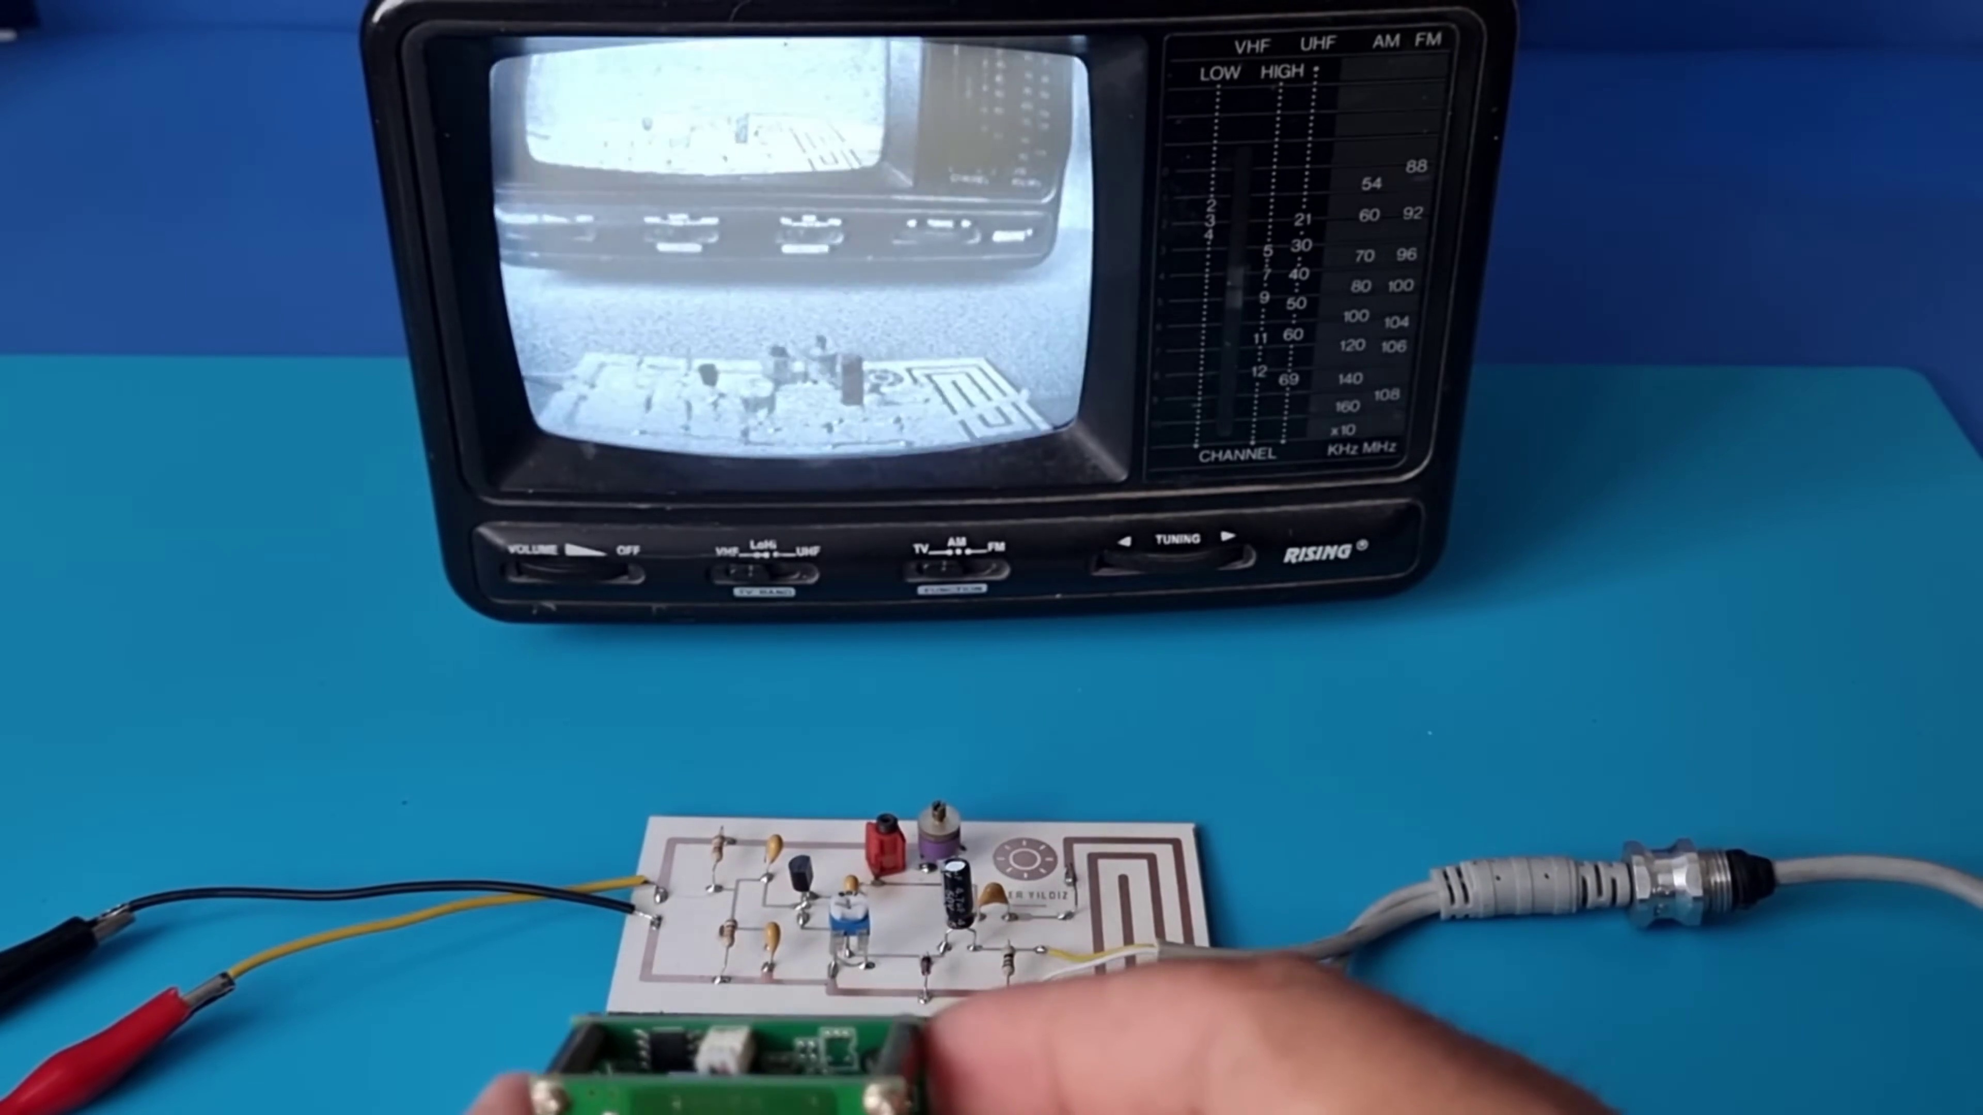 (score 95.0000)
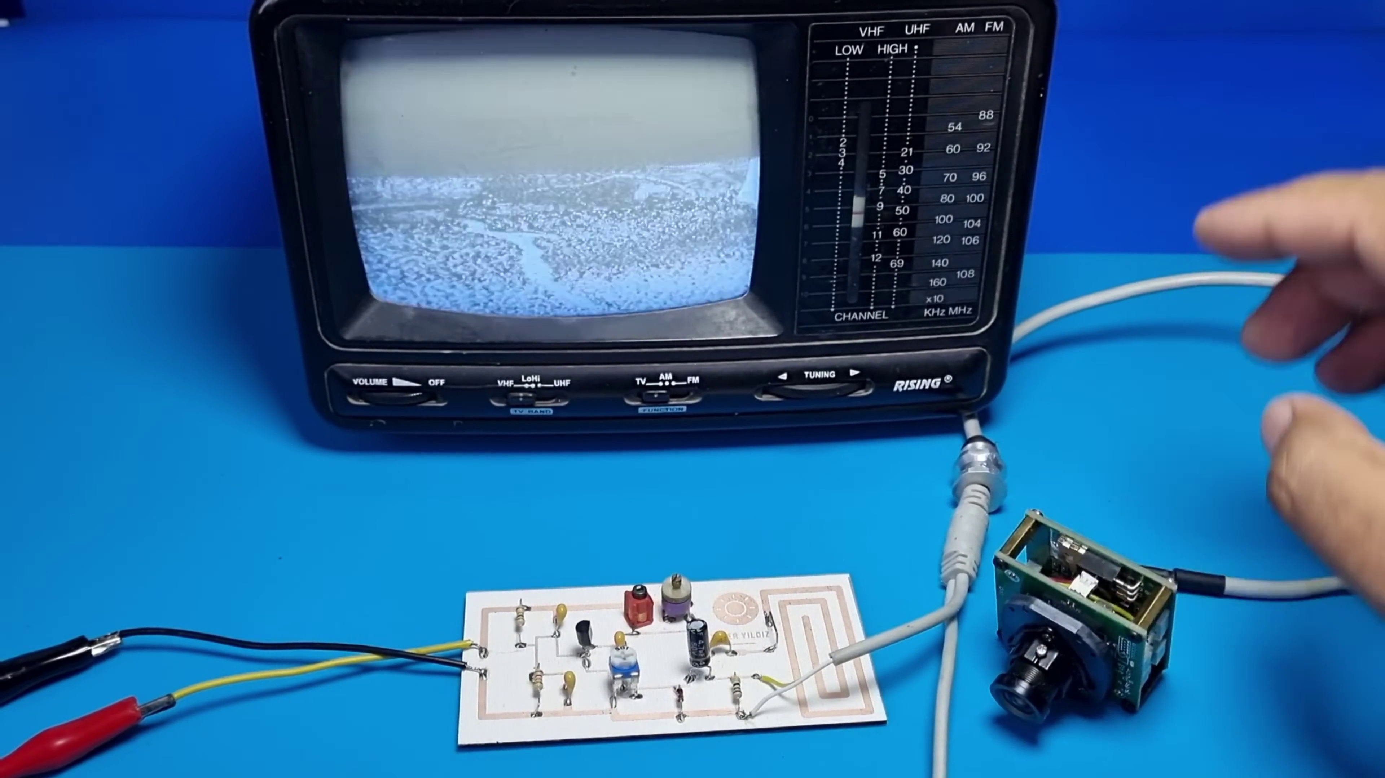 (score 95.0000)
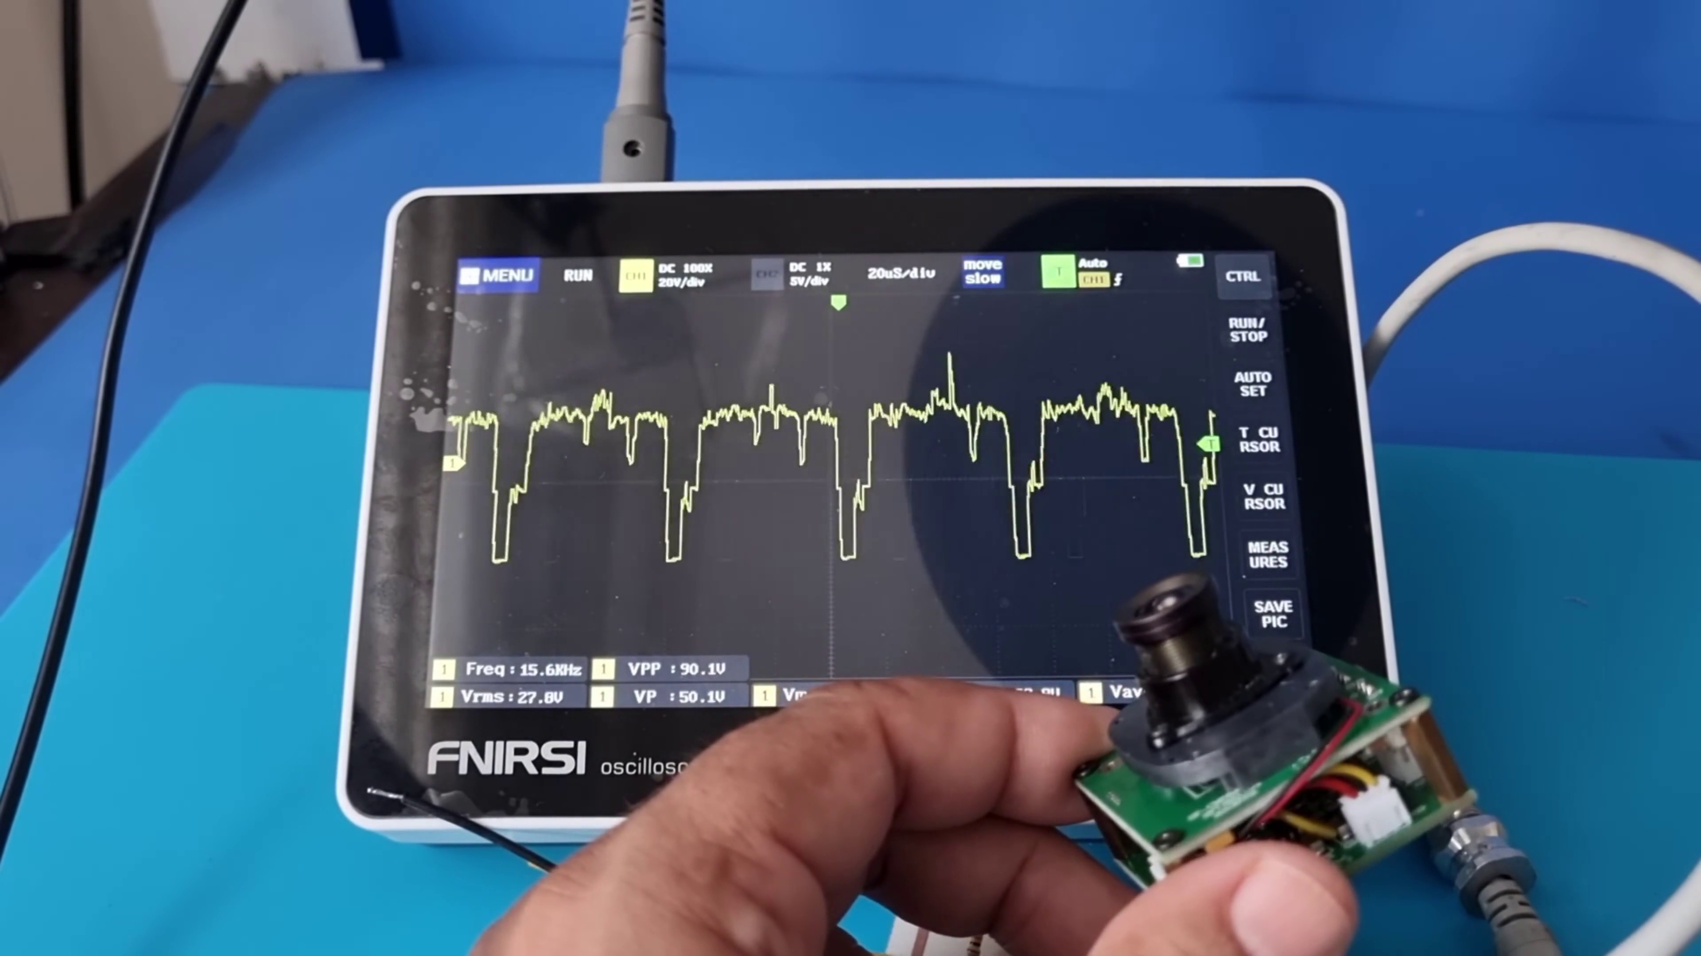 (score 95.0000)
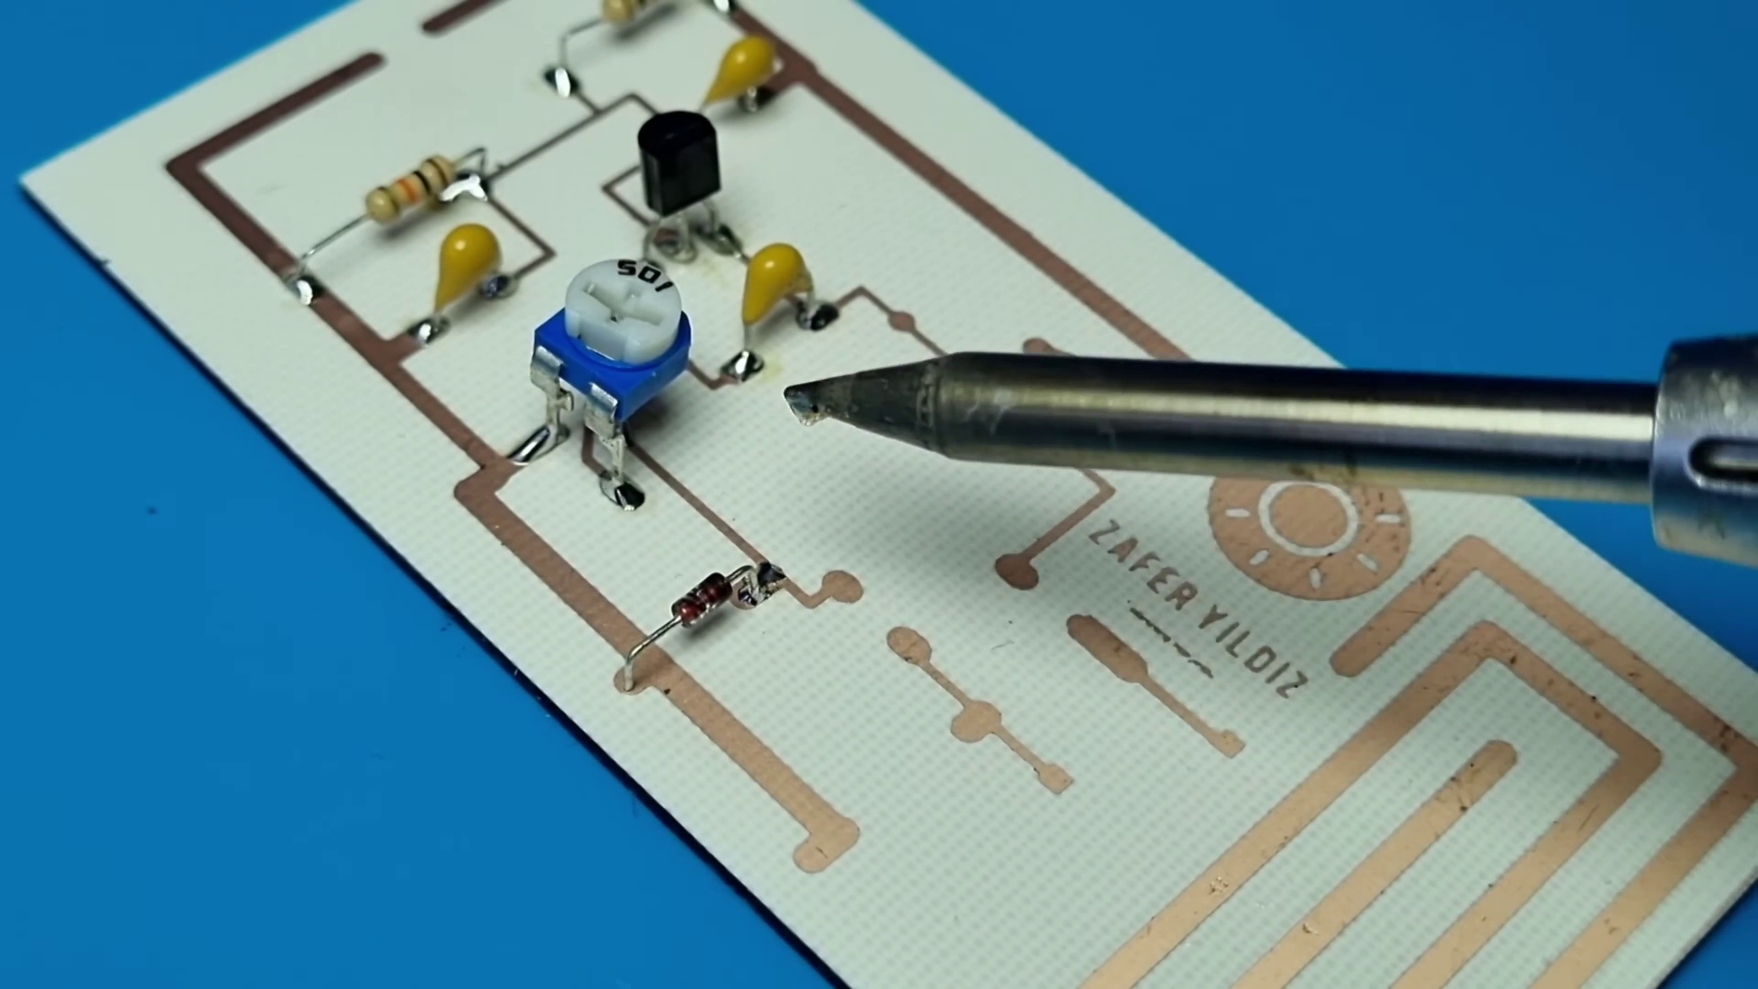 (score 95.0000)
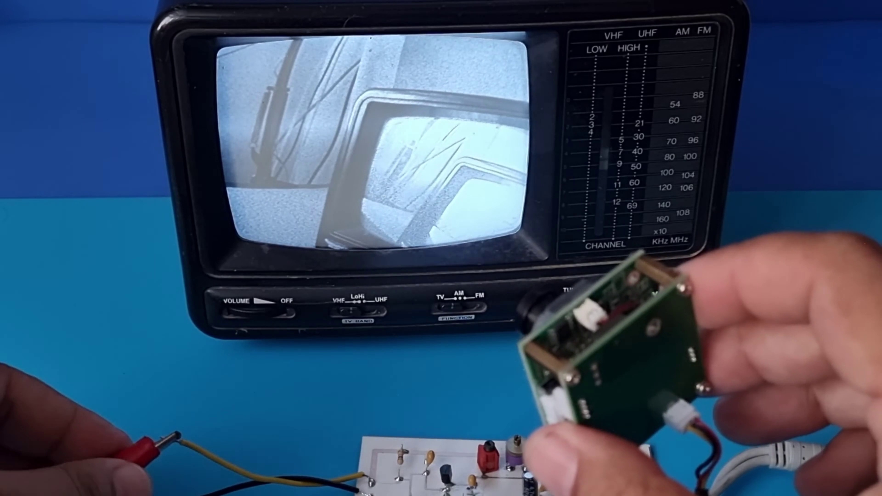 (score 90.0000)
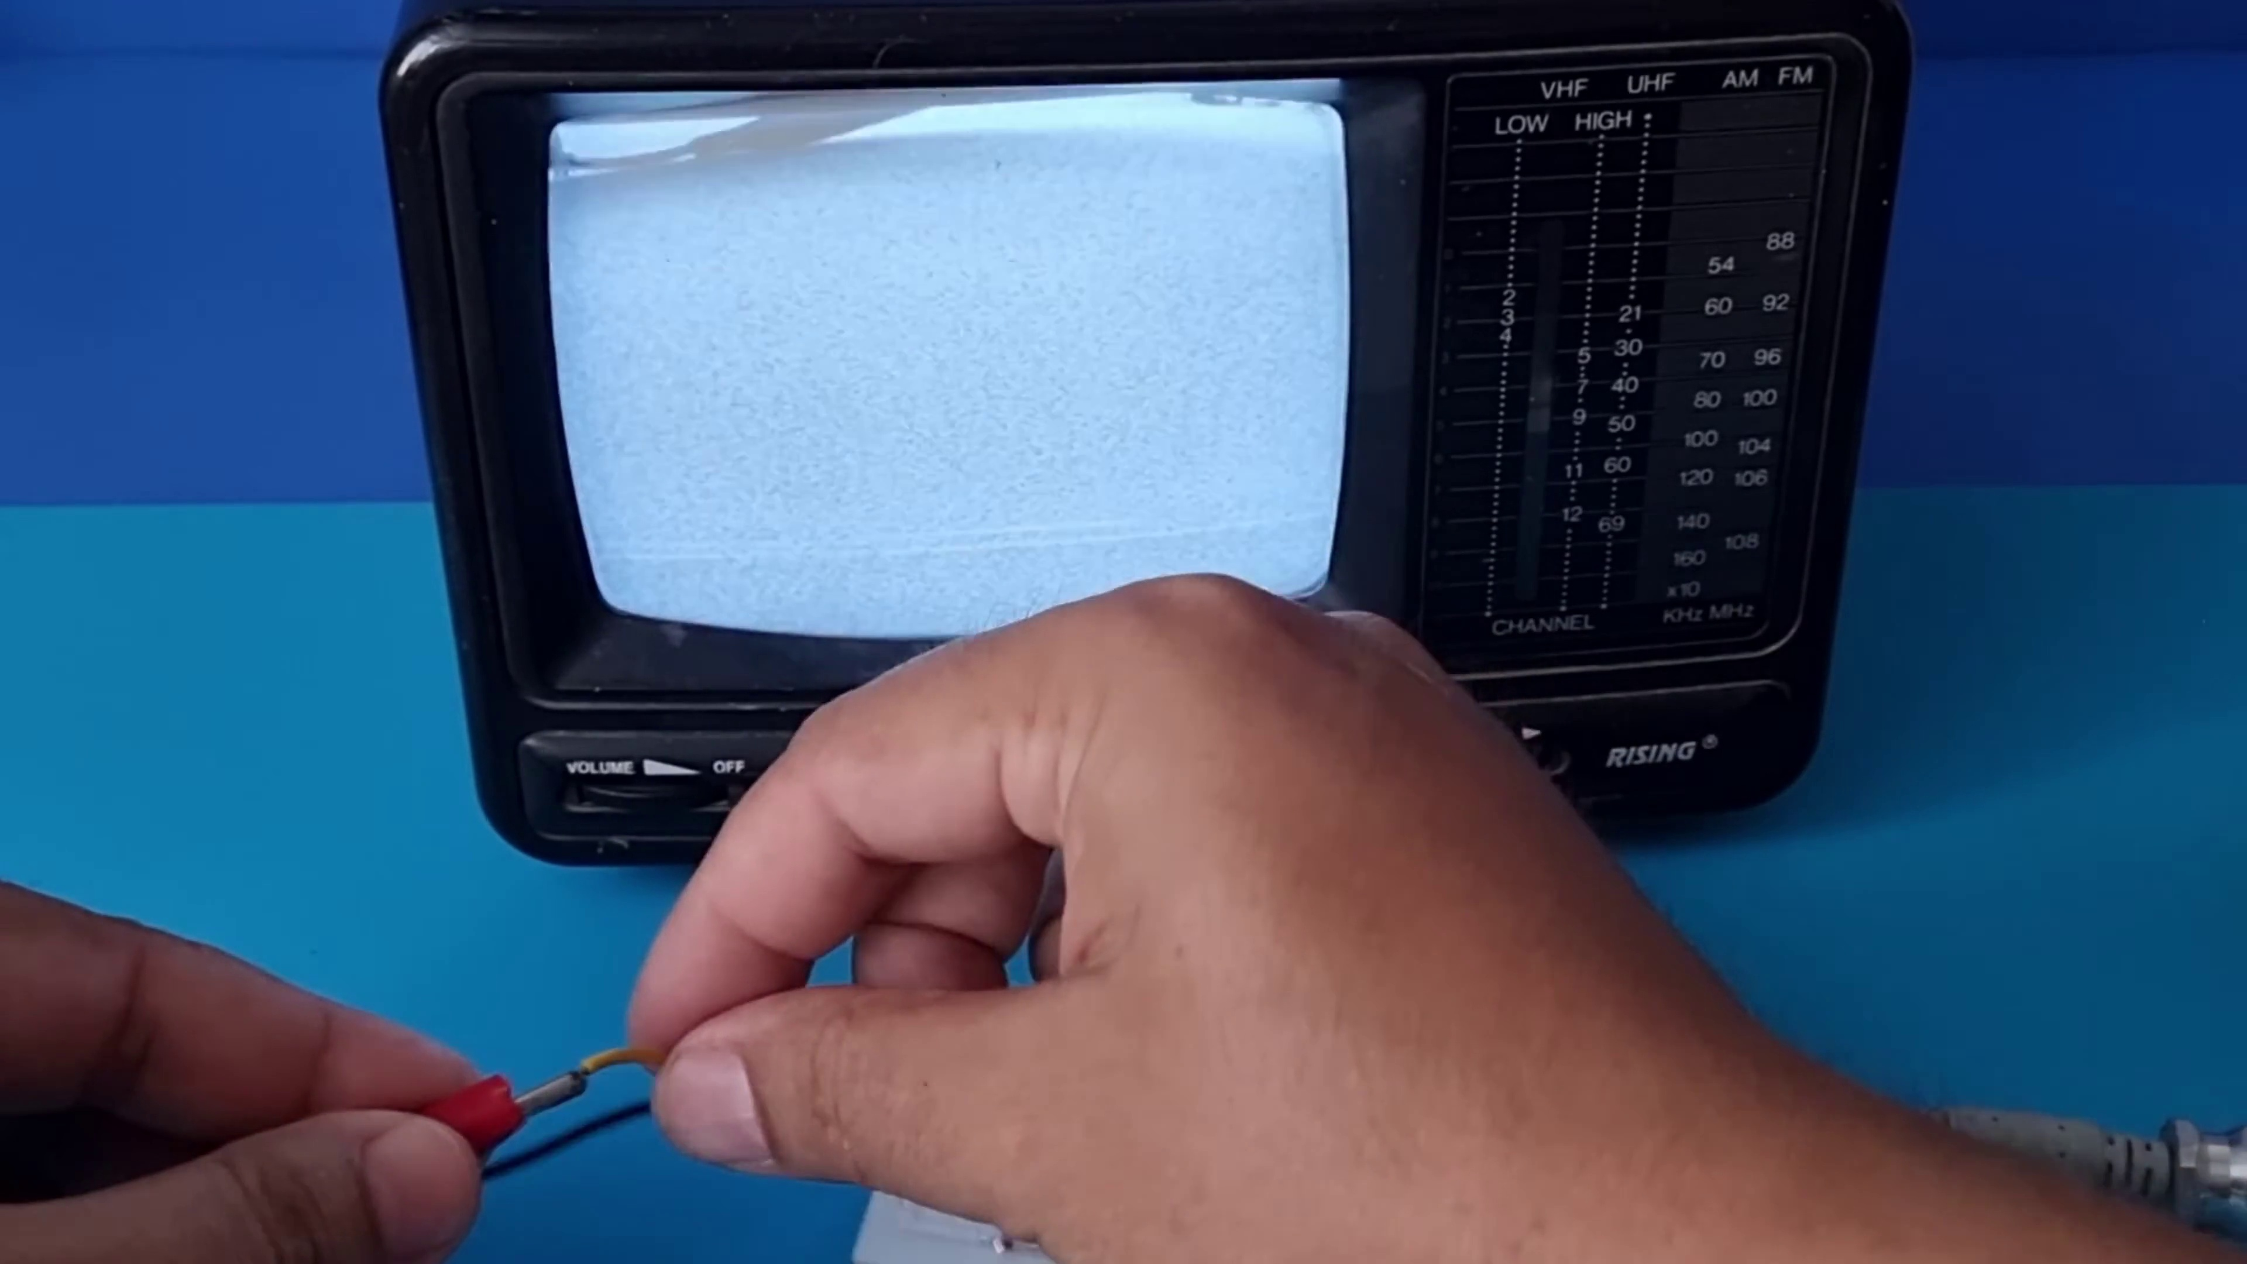 (score 90.0000)
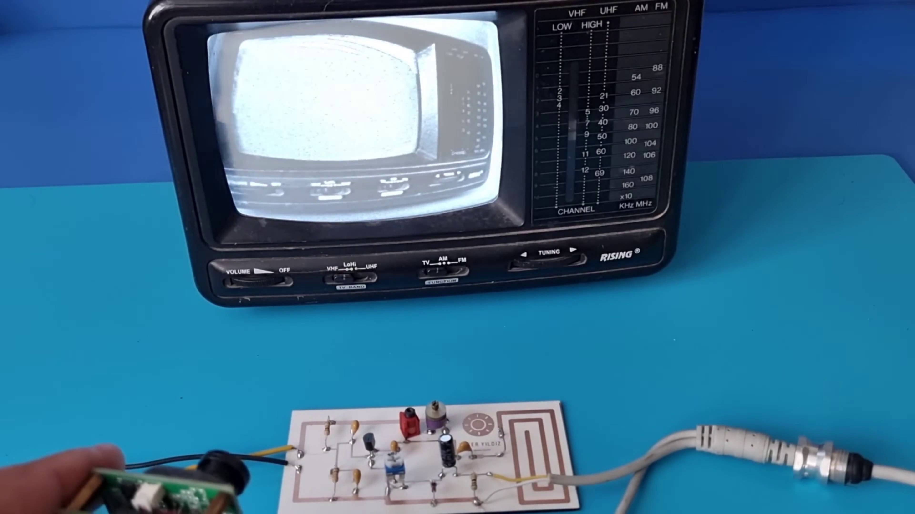 (score 90.0000)
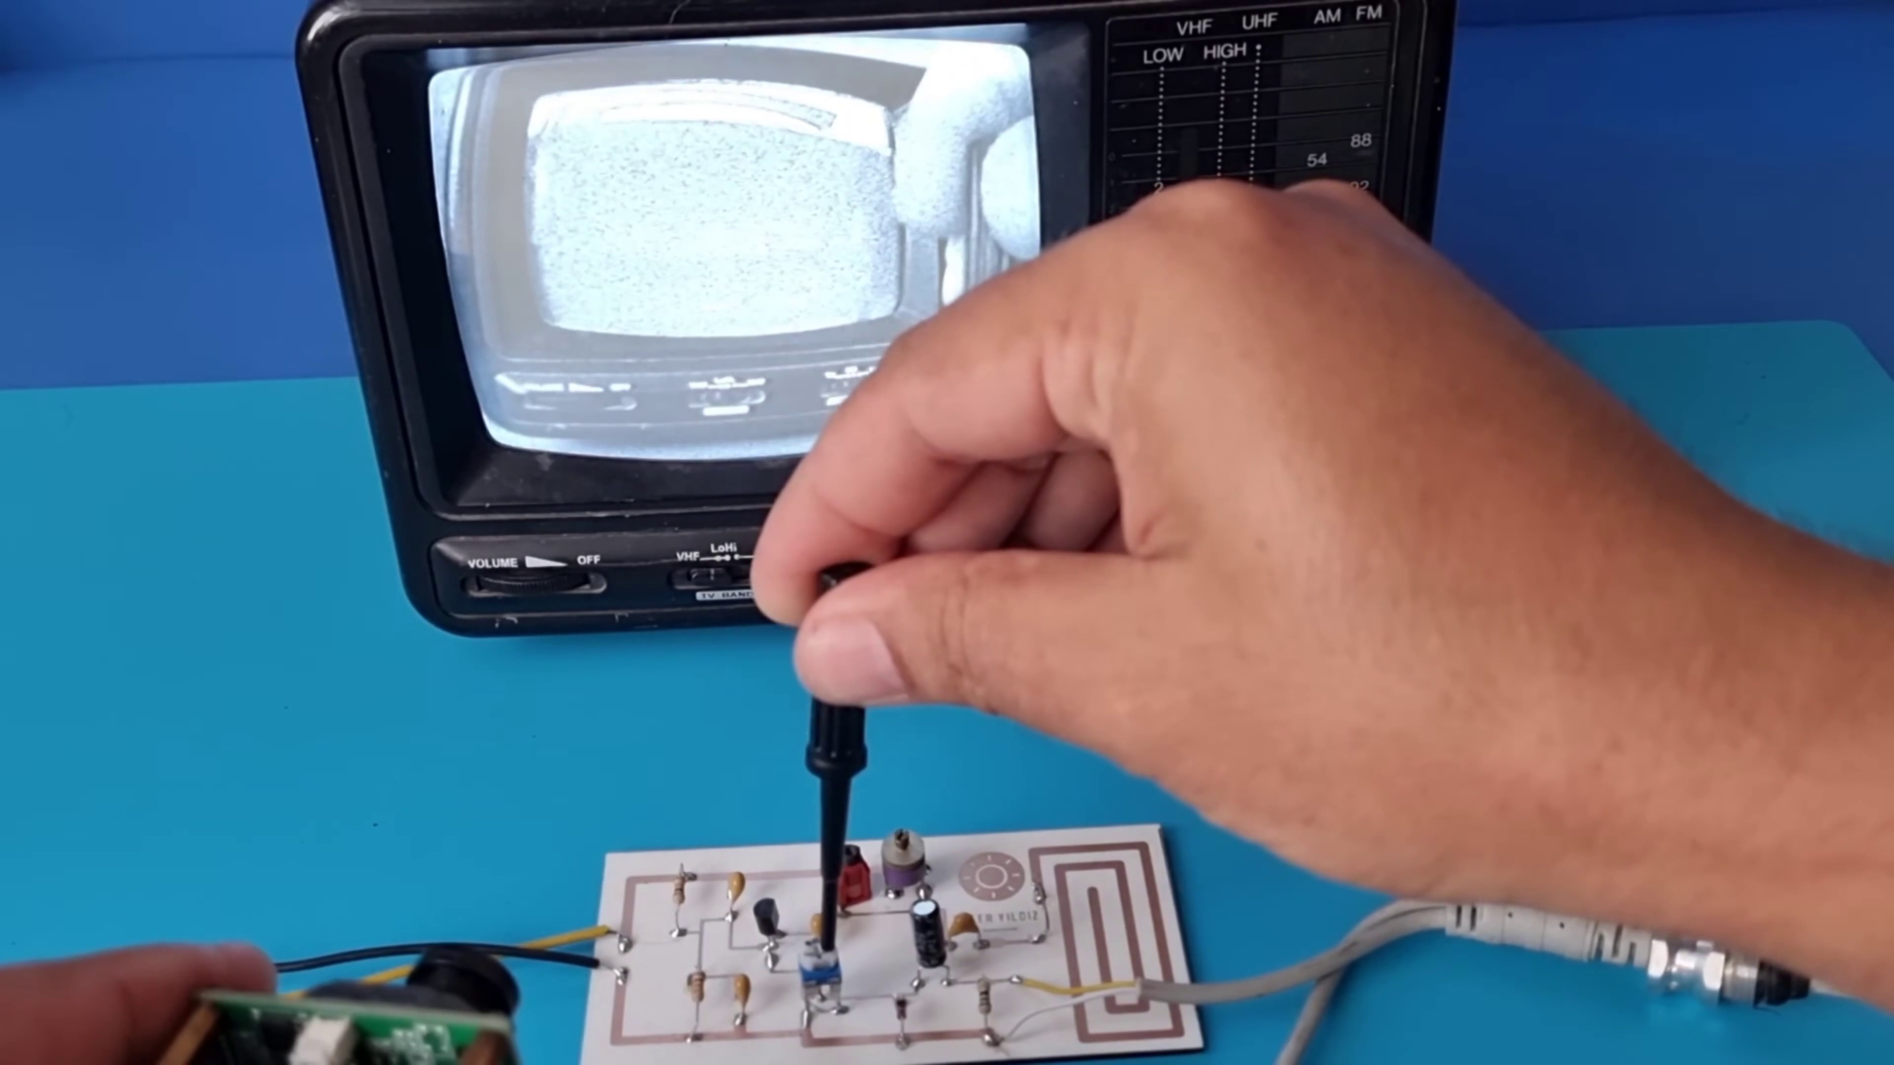 (score 90.0000)
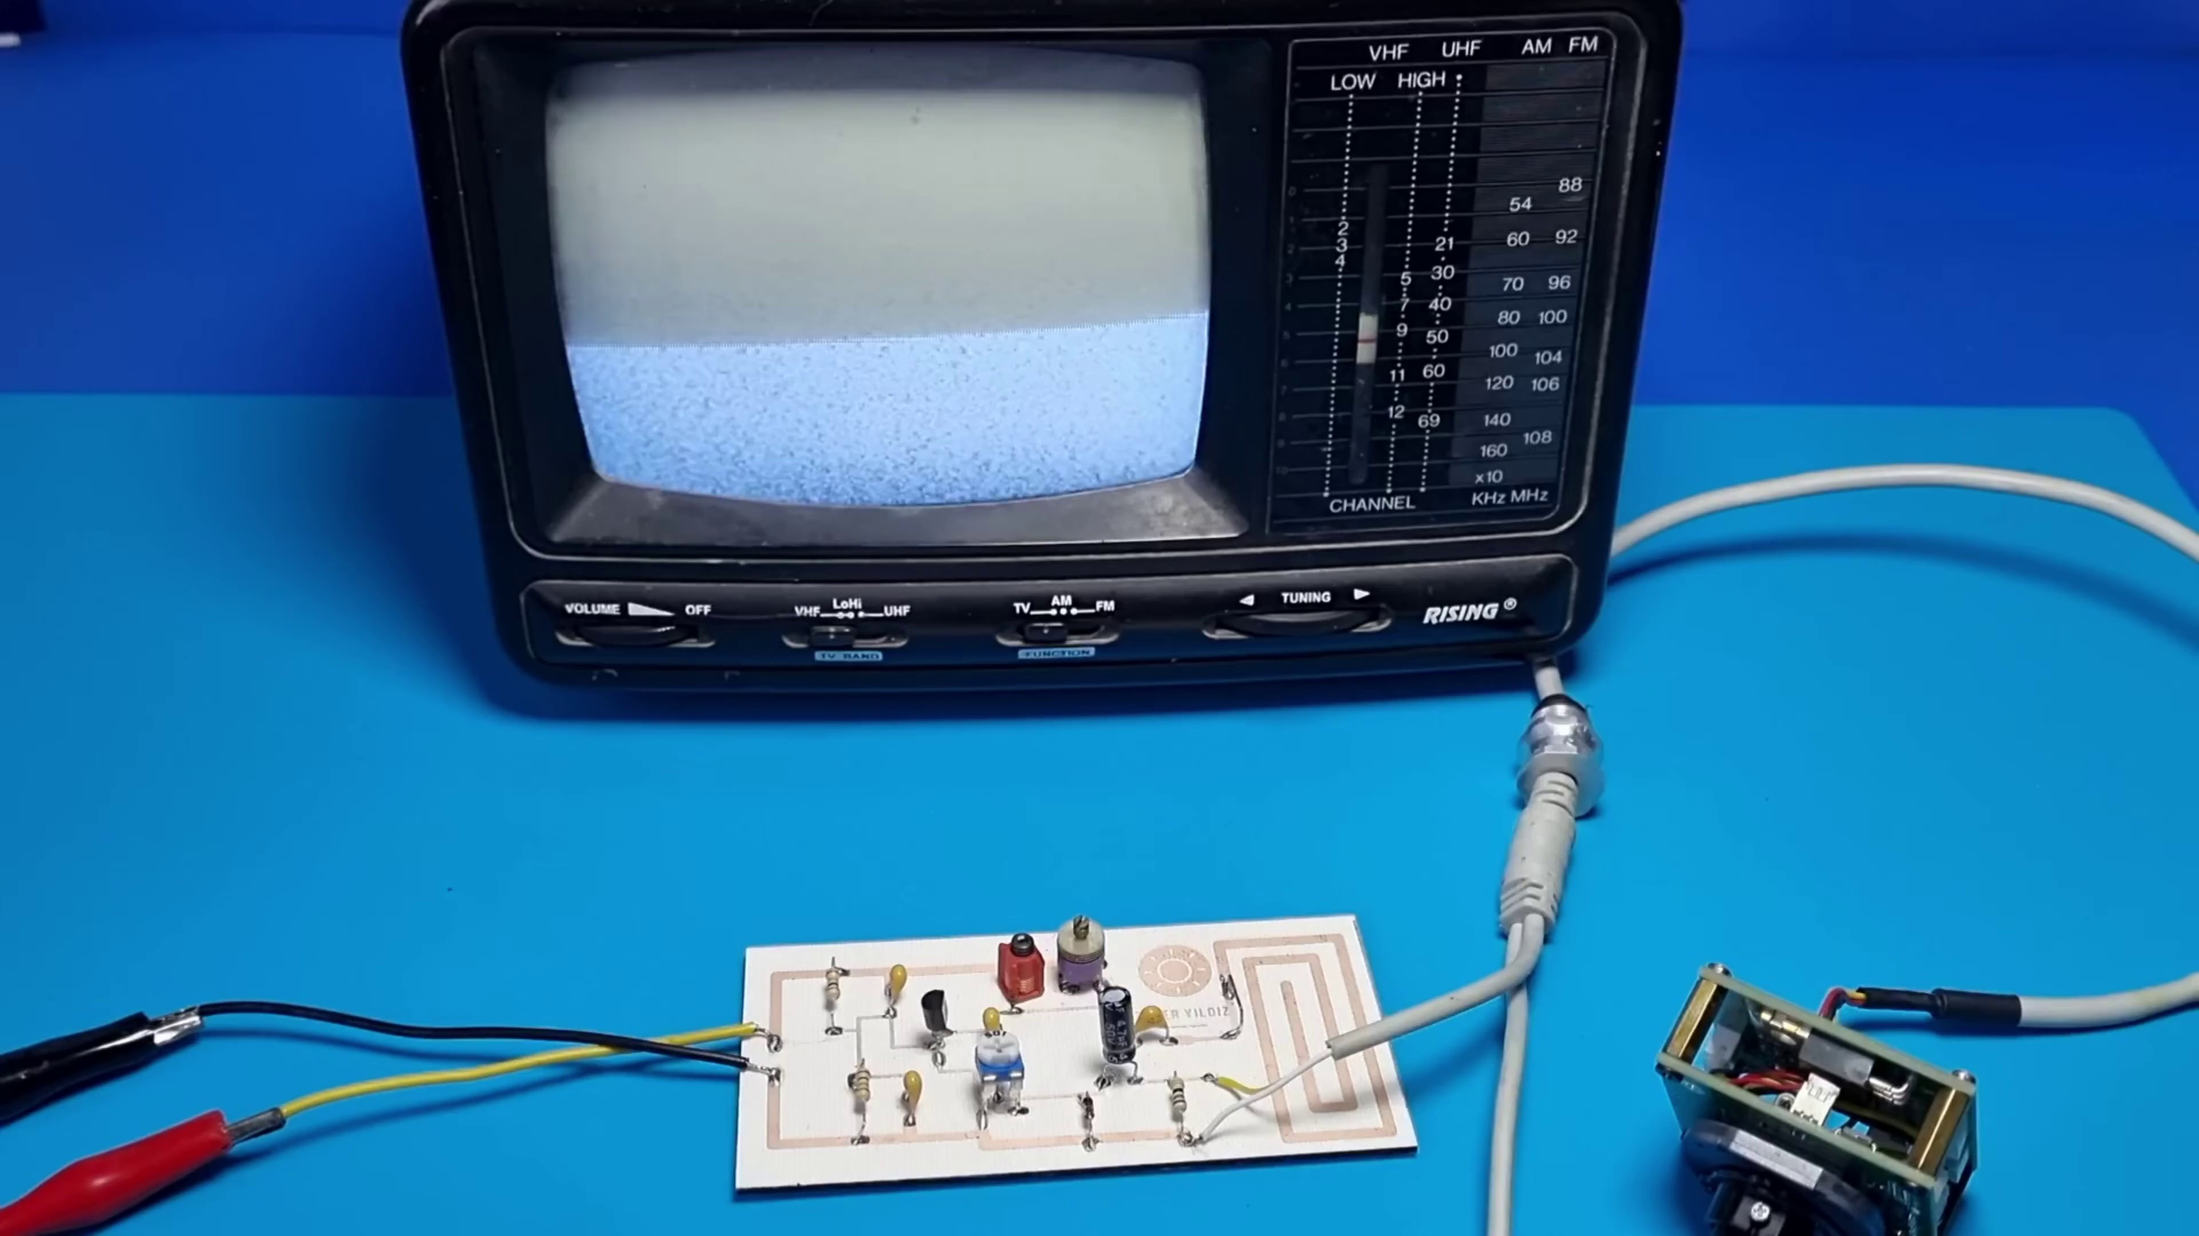 (score 90.0000)
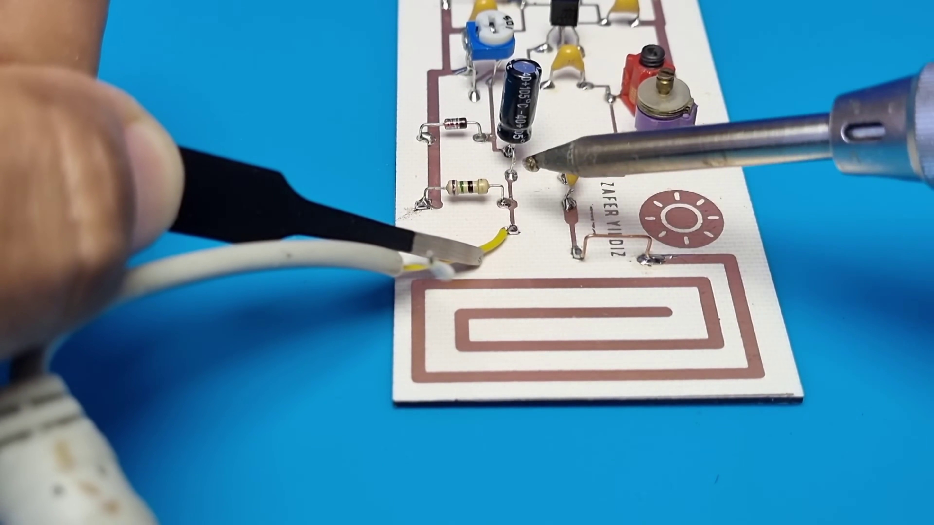 (score 90.0000)
Least correlated frames:
 (score 0.0000)
 (score 0.0000)
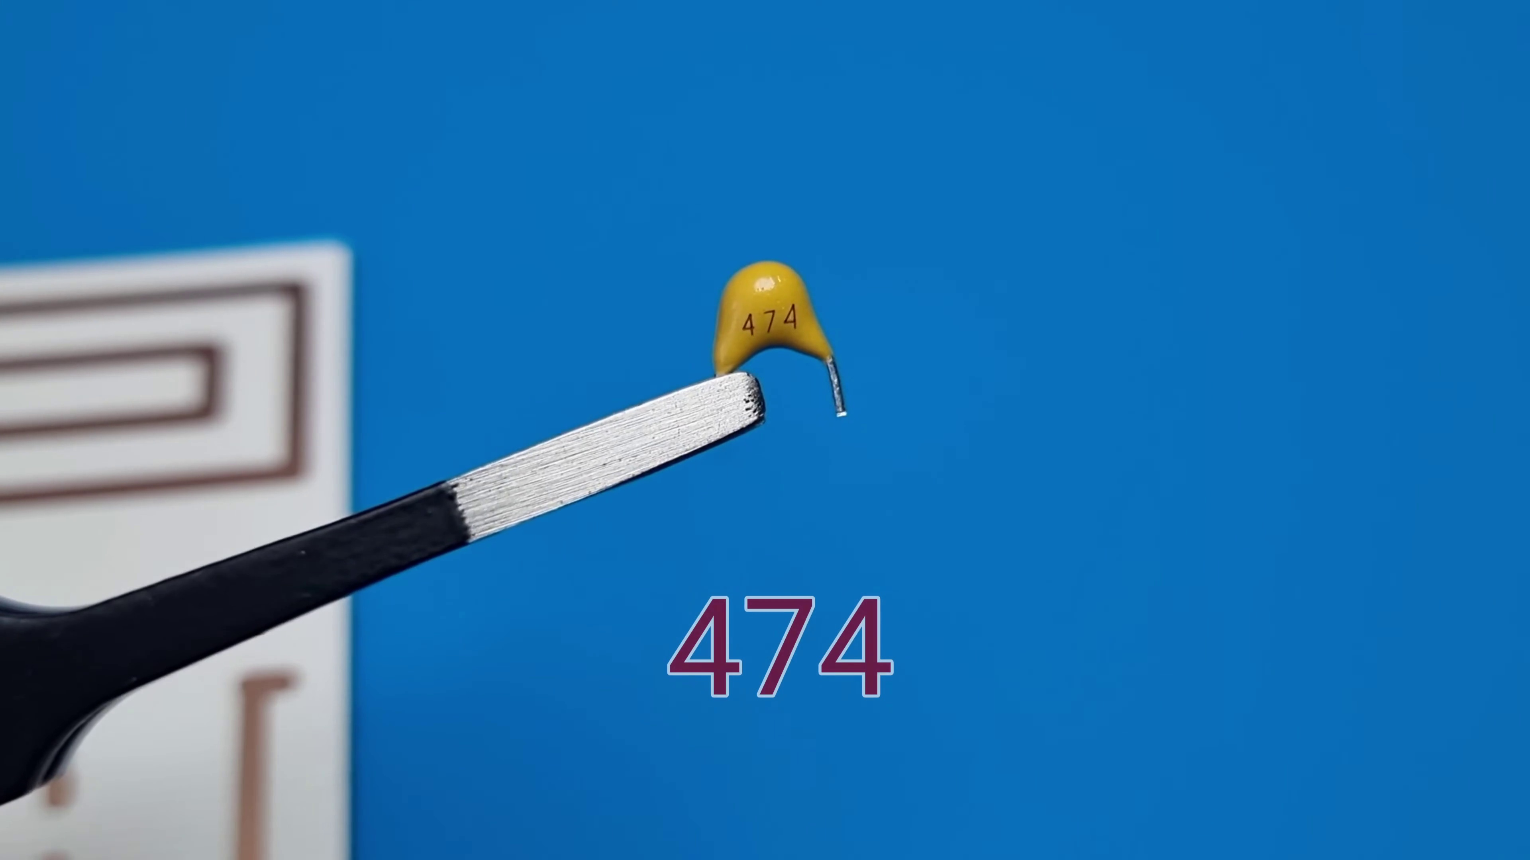 (score 0.0000)
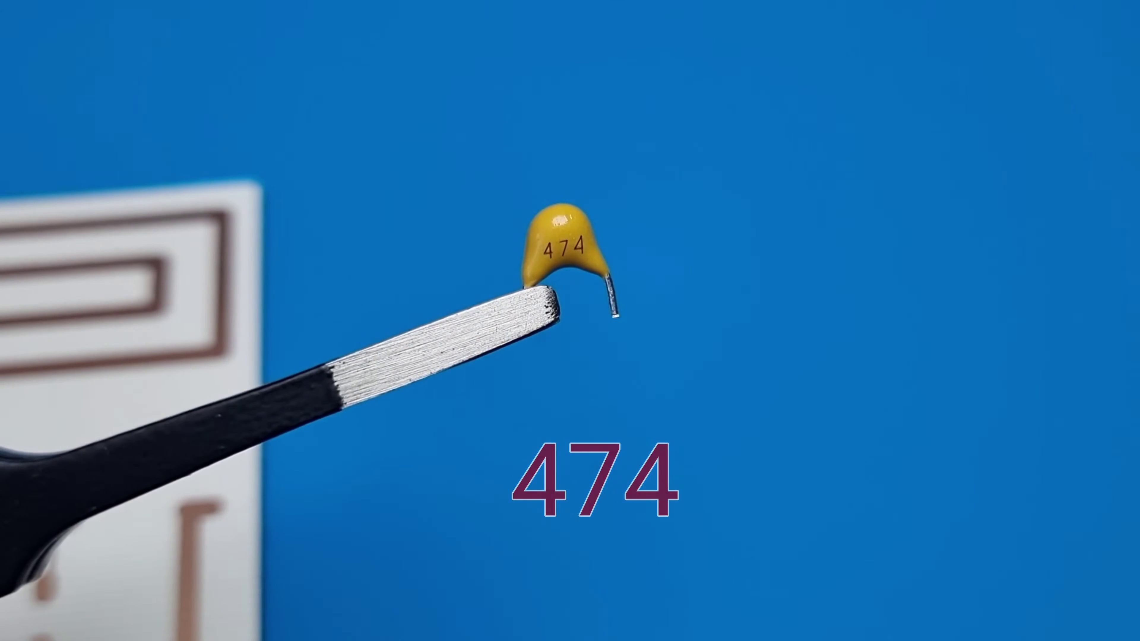 (score 0.0000)
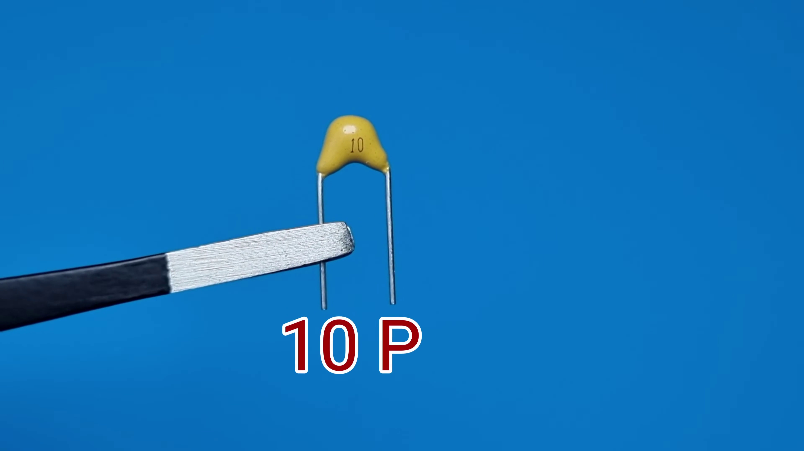 (score 0.0000)
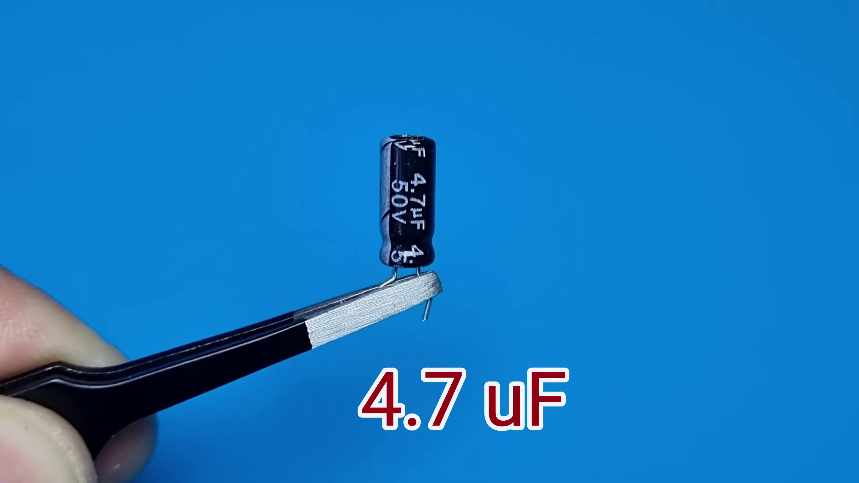 (score 0.0000)
 (score 0.0000)
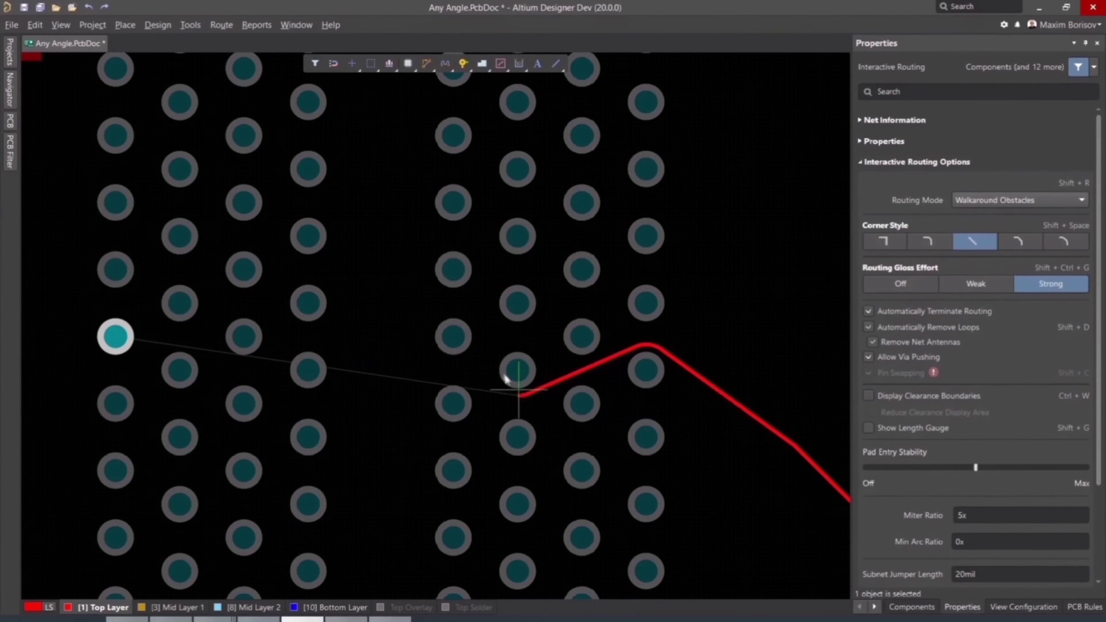 (score 0.0000)
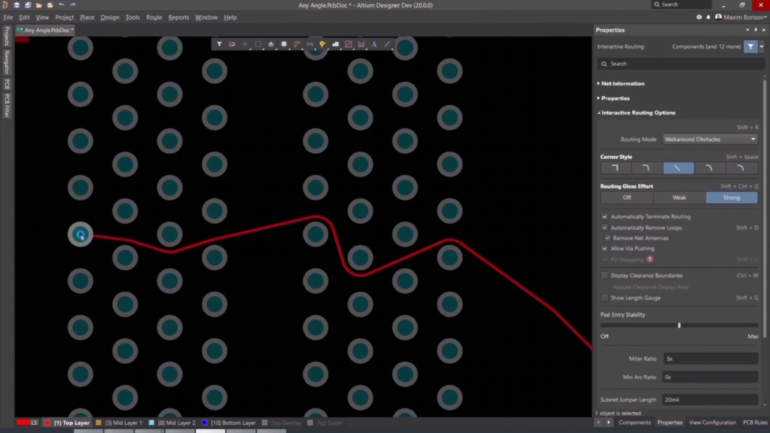 (score 0.0000)
 (score 0.0000)

Frame: frame_0000.jpg
Caption: The image contains a striking visual presentation featuring a split-screen format. On the left side, a bold graphic dominates the space, boasting a dark background speckled with small orange flames that add a dramatic effect to the overall design. Superimposed on this fiery backdrop is text in Turkish that reads "ZAFER YÜDÜZ," which translates to "Faith Day." Below this main title is smaller text in Turkish that says "YÖNETEME ÇİN 31 EKLEME GÜNÜ," meaning "Manage the 31st day of prayer."
On the right side, a blurred image of a person appears, seemingly presenting or giving a speech. The individual is wearing a blue T-shirt and has a beard, addressing an audience in what seems to be a religious or educational setting, given the context provided by the Turkish text on the left side. The style of the image suggests that it might be a screenshot from a video or a digital presentation being shared online.
The title "Zafar Yildiz" is prominently displayed in bold orange text, set against the same black background with small orange flames as the left side. To the right of the title, a small image of a person wearing a blue shirt appears to be standing in front of a backdrop, though the exact details are not visible in the image. The overall composition of the image focuses on the title and the person in the blue shirt, with the orange flames serving as a contrasting element that draws attention to the bold text.
No strongly correlated comments found for this frame.

Frame: frame_0001.jpg
Caption: The image features a unique design that combines digital elements with technological undertones. At its center is the "Atlum" logo, displayed against a starry night background that evokes the impression of outer space. The Atlum logo itself is an abstract representation of a building or structure, consisting of a solid base supporting a more intricate upper portion.
To the right of the logo, a semi-transparent layer features text overlay, reading "where the world designs electronics." This suggests that Atlum might be associated with electronic design services or products. The overall style of the image appears to be promotional or branding material, without any visible people, devices, slides, diagrams, or text beyond what has been described.
In addition, the logo itself is a blue hexagon on a black screen, with the text "ALTUM 365" written in white, creating a balanced and symmetrical appearance. The design of the logo suggests a focus on technology and innovation.
No strongly correlated comments found for this frame.

Frame: frame_0002.jpg
Caption: The image shows a close-up view of a white circuit board, dotted with gold-colored traces and held by two individuals. The name "ZAFER YILDIZ" is prominently displayed on the top right corner of the board in cursive font. The board appears to be a prototype, as suggested by the presence of a single hole in the middle of it. Against the blue background, the intricate design of the white board stands out.
A closer examination reveals that the circuit board has multiple pads, suggesting that it may be part of an experimental setup for electronics or engineering projects. A printed circuit board (PCB) with several copper traces connecting different electronic components is visible, including a single integrated circuit (IC) indicated by the presence of a heat sink above it. The heat sink is typically used to dissipate heat generated by electronic components.
Multiple resistors are also visible on the board, which are essential for controlling current flow in circuits. The layout suggests that this could be a prototype or custom-built circuit board. There is no text or clear writing on the PCB, so there are no readable equations or diagrams.
No strongly correlated comments found for this frame.

Frame: frame_0003.jpg
Caption: The image shows a person's hands holding a smart card or electronic device, with several gold contacts on it that are likely pads for electrical conductivity. On the card, there is a visible circuit design that includes lines connecting some of the contact points. The card appears to have an additional layer of components, including resistors and capacitors, and traces or lines that are part of the circuitry. The text on this overlaid image reads "Home Made PCB," suggesting that the person holding the smart card is demonstrating how to create a printed circuit board (PCB) at home.
The setting appears to be informal, possibly for DIY electronics enthusiasts or hobbyists interested in creating their own circuit boards. In the background, there's a blue surface that provides a simple backdrop for the activity. The overall scene exudes a sense of anticipation and creativity, as if the person is about to perform a crucial step in the circuit board's creation.
Comment (score 85): This circuit is using a custom designed board to solder the capacitors and resistors to. He used the oscilloscope to show the square wave pattern and first being very choppy, then getting smoother as the camera distance was changed. After focusing the camera, he was able to connect the board to an old tv to get a visual signal. The board does not look to complicated with the capacitors and resistors soldered on it. The heart seems to be in the compact camera with attached boards already on it that are doing most of the signal conversion.
Reason: The comment directly discusses technical steps related to the caption, such as soldering capacitors and resistors, using an oscilloscope to show a square wave pattern, and connecting the board to an old TV to get a visual signal. The mention of 'compact camera with attached boards' in the comment also matches the description of the card in the caption as having compact components and traces.
Source: https://www.youtube.com/watch?v=fcmXG3wB_1M: How to Make Video Transmitter - Make Your Own Television Transmitter

Frame: frame_0004.jpg
Caption: The image presents a close-up view of an object that appears to be a small yellow cap or bird with a pair of scissors clipped into its wing. The number "47" is visible on the object's body, indicating it could be part of an educational or creative activity such as a scavenger hunt or a DIY project. In the background, there is a light blue surface with some indistinct items that might be related to the activity, but they are not clearly identifiable. The focus and clarity of the image are primarily on the yellow cap or bird.
The object is being held by a pair of tweezers, with the tweezers' tips touching it. The number "474" is clearly visible on the cap's surface, indicating its specific identification. The background of the image provides a stark contrast to the yellow cap, creating a simple and clear composition that focuses solely on the object. The relative position of the cap, tweezers, and background is such that the cap is in the foreground, the tweezers are in the middle, and the background is in the background.
The setting appears to be an indoor environment, possibly a classroom or workspace where creativity or crafts might be part of the activities. There is no visible instructor in this frame, nor can I confidently identify any textual content that would suggest a teaching context or specific activity being performed.
No strongly correlated comments found for this frame.

Frame: frame_0005.jpg
Caption: The image showcases a diagram or circuit board with various components such as resistors connected by lines representing wires or traces on a blue surface. The object is split into two sections, with an instructional or informative graphic overlaying the left side, partially obscured by the actual object on the right. The visible text in the left section reads "189," "203," "1K," and "5V." The right side focuses solely on the physical diagram or circuit board, detailed enough to indicate a variety of electronic components.
The circuit board is covered in brown lines, indicative of its layout, which suggests a complex network of connections. A label on the board reads "LATEX FILLER", providing a clue about the material used in its production. The overall layout of the circuit board suggests it is a complex device, possibly a computer chip or an electronic component.
The presence of the label indicates that the board was filled with a substance, likely a type of plastic or metal, to create a protective layer and improve the board's performance. The image captures a moment in the life of this circuit board, from its creation to its current state on the blue background, serving as a testament to the complex work that goes into creating electronic devices.
Comment (score 80): This circuit is using a custom designed board to solder the capacitors and resistors to. He used the oscilloscope to show the square wave pattern and first being very choppy, then getting smoother as the camera distance was changed. After focusing the camera, he was able to connect the board to an old tv to get a visual signal. The board does not look to complicated with the capacitors and resistors soldered on it. The heart seems to be in the compact camera with attached boards already on it that are doing most of the signal conversion.
Reason: The comment directly discusses the same technical steps (soldering capacitors and resistors) and objects (circuit board, oscilloscope, camera, old TV) described in the caption. The mention of custom designed board and capacitors/resistors soldered on it also matches with the components shown in the diagram.
Source: https://www.youtube.com/watch?v=fcmXG3wB_1M: How to Make Video Transmitter - Make Your Own Television Transmitter

Frame: frame_0006.jpg
Caption: This image shows an educational setting where someone is working on assembling an electronic device, likely an Arduino board. The person's hands are visible, holding a small metallic component and a soldering iron, indicating that they are in the process of soldering components onto the board. On the blue surface, there is a diagram with various electronic symbols representing different parts such as resistors, capacitors, and integrated circuits, suggesting a teaching context focused on electronics or engineering. The image appears to be taken during a tutorial or demonstration, possibly in a classroom or workshop environment where students learn about circuit assembly or electronic projects.
The scene captures a moment of meticulous work in a workshop, with the soldering iron poised on a piece of paper, folded and held in place by the iron. The paper is adorned with a complex circuit board, which is the focal point of the image. The soldering iron, with its red tip, is the instrument of creation, bringing the circuit board to life. The paper serves as the platform on which this intricate dance takes place, requiring precision and skill in the art of soldering.
Comment (score 80): This circuit is using a custom designed board to solder the capacitors and resistors to. He used the oscilloscope to show the square wave pattern and first being very choppy, then getting smoother as the camera distance was changed. After focusing the camera, he was able to connect the board to an old tv to get a visual signal. The board does not look to complicated with the capacitors and resistors soldered on it. The heart seems to be in the compact camera with attached boards already on it that are doing most of the signal conversion.
Reason: The comment directly discusses the same technical steps and objects described in the caption, specifically mentioning the custom designed board, capacitors, resistors, oscilloscope, camera, and TV. The comment also mentions the process of soldering and connecting the board, which is consistent with the activities shown in the image. However, the score is not 100 because the comment does not explicitly mention the Arduino board or the diagram on the blue surface, but it still provides relevant information about the circuit assembly process.
Source: https://www.youtube.com/watch?v=fcmXG3wB_1M: How to Make Video Transmitter - Make Your Own Television Transmitter

Frame: frame_0007.jpg
Caption: The image captures a close-up view of an intricate printed piece of paper with a design resembling a circuit board layout. The paper features various lines and shapes that mimic electronic pathways or traces, typical components of a circuit diagram. In the center of the design, there are shapes that may indicate pins or connectors within the circuit board context, alongside lines that could represent conductive pathways. The focus is on the paper's intricate layout, with no texts or other distinguishable objects in view.
In the background, a person's hand holds a magnifying glass over the printed paper, suggesting they might be examining the details of the design. This scene suggests a close-up view of a technical or educational demonstration, possibly related to electronics or circuit design.
Alternatively, the image may also depict a close-up view of an actual circuit board resting on a blue surface. The board features a complex network of copper lines and gold-colored traces arranged in a grid pattern, forming a grid of squares that crisscross each other. A few small metal components are neatly arranged in the center of the board, adding precision and complexity to the overall design.
Scattered across the blue surface are a few small black dots, their purpose unclear from the image alone. The board and these dots are the only objects in view, with no additional details or text present. The focus is solely on the circuit board and its components, providing a clear and detailed view of the electronic device's internal workings, allowing the viewer to appreciate the intricate details of the design.
Comment (score 80): This circuit is using a custom designed board to solder the capacitors and resistors to. He used the oscilloscope to show the square wave pattern and first being very choppy, then getting smoother as the camera distance was changed. After focusing the camera, he was able to connect the board to an old tv to get a visual signal. The board does not look to complicated with the capacitors and resistors soldered on it. The heart seems to be in the compact camera with attached boards already on it that are doing most of the signal conversion.
Reason: The comment directly discusses the custom designed board, soldering capacitors and resistors, using an oscilloscope, and connecting to an old TV. These technical steps are strongly related to the objects, settings, and goals described in the caption, such as the printed circuit board layout or the actual circuit board with components. The comment provides specific details about the board's design and functionality, which is highly correlated with the image.
Source: https://www.youtube.com/watch?v=fcmXG3wB_1M: How to Make Video Transmitter - Make Your Own Television Transmitter

Frame: frame_0008.jpg
Caption: The image shows two moments of meticulous electronics work in progress. In the foreground, a person's hand is visible holding tweezers with a microchip or integrated circuit (IC), which appears to be being placed onto a printed circuit board (PCB). The PCB has several resistors, capacitors, and possibly other components such as diodes or transistors, with visible pins on the microchip that will be connected to the appropriate points on the PCB. The blue background suggests a workbench or desk surface.
In the background, a soldering iron is being used to join two pieces of circuit board together. The white square circuit board contrasts with the black metal contraption of the soldering iron and adds depth to the image, drawing attention to the repair process. The heat from the soldering iron is melting the solder, creating a strong bond between the two pieces of circuit board.
The blue surface where the repair is being done provides a striking contrast to the white circuit board and black soldering iron. Additionally, in the background, there's a white paper with black text that reads "1984", hinting at the time or project being worked on. The image captures these two moments of electronics work, showcasing the attention to detail, precision, and patience required for both assembly and repair tasks.
Comment (score 90): This circuit is using a custom designed board to solder the capacitors and resistors to. He used the oscilloscope to show the square wave pattern and first being very choppy, then getting smoother as the camera distance was changed. After focusing the camera, he was able to connect the board to an old tv to get a visual signal. The board does not look to complicated with the capacitors and resistors soldered on it. The heart seems to be in the compact camera with attached boards already on it that are doing most of the signal conversion.
Reason: The comment directly discusses technical steps, objects (custom designed board, capacitors, resistors, oscilloscope), settings (camera distance) and goals (getting a visual signal) described in the caption. The mention of soldering and camera focus also matches the visuals shown in the image.
Source: https://www.youtube.com/watch?v=fcmXG3wB_1M: How to Make Video Transmitter - Make Your Own Television Transmitter

Frame: frame_0009.jpg
Caption: The image showcases a precise moment in electronics repair as a hand holds a pair of silver-tipped pliers with a yellow handle to carefully remove a small, brown chip from a white circuit board. The board is placed on a blue surface, creating a striking contrast between the two colors. The process appears to involve removing or lifting the chip from the board, requiring patience and precision.
In addition to the removal of the chip, another hand can be seen in the background holding a soldering iron, suggesting that the repair may also involve soldering to complete the circuit or fix any damaged parts. A small circuit board with various electronic components such as resistors and capacitors is visible, featuring multiple test points labeled A, B, C, etc., indicating its purpose for testing individual components or paths within the circuit.
The focus of this image lies on the physical activity of trimming or cutting circuits using specialized tools, highlighting the importance of precision and skill in electronics repair.
Comment (score 90): This circuit is using a custom designed board to solder the capacitors and resistors to. He used the oscilloscope to show the square wave pattern and first being very choppy, then getting smoother as the camera distance was changed. After focusing the camera, he was able to connect the board to an old tv to get a visual signal. The board does not look to complicated with the capacitors and resistors soldered on it. The heart seems to be in the compact camera with attached boards already on it that are doing most of the signal conversion.
Reason: The comment directly discusses the technical steps involved in electronics repair, mentioning soldering capacitors and resistors to a custom-designed board, which is strongly related to the caption's description of removing or lifting small chips from a circuit board. The comment also mentions using an oscilloscope and connecting the board to an old TV, further strengthening the correlation with the caption.
Source: https://www.youtube.com/watch?v=fcmXG3wB_1M: How to Make Video Transmitter - Make Your Own Television Transmitter

Frame: frame_0010.jpg
Caption: The image captures a close-up view of a person's hands holding a soldering iron and possibly some wires or components ready for soldering. The focus is on the task at hand, with the green circuit board featuring various electronic components such as resistors, capacitors, and possibly inductors, with small amounts of solder present on its surface. In the background, a blue surface provides contrast to the green circuit board, making the details clear.
The hands are visible, with the soldering iron positioned to attach a piece of wire or component to the circuit board. The image does not contain any text that would provide additional context about the nature of the course or content being taught.
Comment (score 85): This circuit is using a custom designed board to solder the capacitors and resistors to. He used the oscilloscope to show the square wave pattern and first being very choppy, then getting smoother as the camera distance was changed. After focusing the camera, he was able to connect the board to an old tv to get a visual signal. The board does not look to complicated with the capacitors and resistors soldered on it. The heart seems to be in the compact camera with attached boards already on it that are doing most of the signal conversion.
Reason: The comment directly discusses the same technical steps (soldering capacitors and resistors), objects (custom designed board, oscilloscope, camera, TV, compact camera with attached boards) and settings (camera distance) mentioned in the caption. The comment also refers to specific components (capacitors, resistors, old TV) and goals (getting a visual signal) described in the caption.
Source: https://www.youtube.com/watch?v=fcmXG3wB_1M: How to Make Video Transmitter - Make Your Own Television Transmitter

Frame: frame_0011.jpg
Caption: The image shows a close-up view of a white circuit board placed on a blue surface, which contrasts with the board's color. The board is adorned with a series of brown lines, possibly part of the circuit's wiring or traces. A yellow component, possibly a resistor, is also visible on the board. In addition to these details, a flat, paper-like object with various tracks and paths leading to different colored ends is seen in the background. Small black squares are interspersed across the object, potentially indicating starting or stopping points. On one side of the object, there is a yellow component that might be an electrical connector or similar part. The overall scene suggests that this could be a part of a larger electronic device or system, possibly related to electronics, engineering, or game components.
Comment (score 80): This circuit is using a custom designed board to solder the capacitors and resistors to. He used the oscilloscope to show the square wave pattern and first being very choppy, then getting smoother as the camera distance was changed. After focusing the camera, he was able to connect the board to an old tv to get a visual signal. The board does not look to complicated with the capacitors and resistors soldered on it. The heart seems to be in the compact camera with attached boards already on it that are doing most of the signal conversion.
Reason: The comment directly discusses the same technical steps and components mentioned in the caption, such as custom-designed circuit board, capacitors, resistors, oscilloscope, camera, and TV. The description of the scene matches with the specific details provided in the comment, including the presence of yellow components (resistors) and brown lines on the circuit board.
Source: https://www.youtube.com/watch?v=fcmXG3wB_1M: How to Make Video Transmitter - Make Your Own Television Transmitter

Frame: frame_0012.jpg
Caption: The image shows a close-up of a small, yellow electronic component, identified as a 474 part, resting on a black metal platter. The component is positioned in the center of the image, with the black platter acting as a backdrop. The number 474 is prominently displayed in white letters on the black platter, indicating the part's identification. The object appears to be sliced with a scalpel, suggesting that it may have been handled or manipulated in some way prior to its placement on the platter. In the foreground, to the right of the component, there are a pair of tweezers with the number "477" printed on them, which could imply this is a training or demonstration setup for precise handling of small objects in medical or scientific contexts.
The image has an educational context, likely from a microscopy slide presentation or a similar teaching environment. The focus here appears to be on the precision and care required when handling small specimens or objects under a microscope. There's no visible text or diagrams within this frame, but it suggests that the presentation might involve a discussion of precision and handling techniques in scientific research.
No strongly correlated comments found for this frame.

Frame: frame_0013.jpg
Caption: The image shows a person's hands working with an electronic circuit board. The individual is using tools to solder components onto the board, which appears to be a prototype or small-scale electronics project. A soldering iron and a pair of silver-colored tweezers are being used; the tweezers are held firmly by one hand, while the other hand seems to hold a component ready for soldering. The circuit board has various components on it, including what looks like resistors and possibly integrated circuits or other types of electronic chips. There is also text on the board that appears to be a schematic or diagram related to the electronics project.
The background is out of focus, but it resembles a typical workspace with a blue surface that could be a desk or workbench. The focus of the image is on the hands and the soldering activity, indicating a practical demonstration rather than a teaching context. A small piece of cardboard serves as a guide for the placement of the solder, which is being carefully placed by the tweezers onto the white circuit board marked with a black arrow and yellow circle. The overall scene showcases meticulous work, demonstrating the skill and attention to detail required in electronic repair and assembly.
Comment (score 90): This circuit is using a custom designed board to solder the capacitors and resistors to. He used the oscilloscope to show the square wave pattern and first being very choppy, then getting smoother as the camera distance was changed. After focusing the camera, he was able to connect the board to an old tv to get a visual signal. The board does not look to complicated with the capacitors and resistors soldered on it. The heart seems to be in the compact camera with attached boards already on it that are doing most of the signal conversion.
Reason: The comment directly discusses the same technical steps (soldering capacitors and resistors), objects (custom designed board, oscilloscope, old TV), settings (camera distance) and goals (getting a visual signal) described in the caption. The connection between the two is strong as they both describe a hands-on electronics project with attention to detail.
Source: https://www.youtube.com/watch?v=fcmXG3wB_1M: How to Make Video Transmitter - Make Your Own Television Transmitter

Frame: frame_0014.jpg
Caption: The image shows a close-up of a pair of precision tools, either blue scissors with gold-toned blades or tweezers. The tools are positioned to manipulate or inspect a small object: on the left, it appears to be a piece of paper with text, but the text is not fully visible; and on the right, there's a number "10K" indicating a quantity or scale.
In the foreground, a blue surface and a blue object resembling a ruler or measuring tool are visible. The background is mostly out of focus, providing a simple backdrop that does not distract from the tools and the small object being manipulated.
No strongly correlated comments found for this frame.

Frame: frame_0015.jpg
Caption: The image presents two distinct yet harmonious scenes, showcasing both creativity and technological precision. In the upper part of the frame, a Lego-based construction stands out with its yellow bricks and studs against a blue background. Below the structure lies an instructional diagram that appears to be a puzzle or maze layout, featuring different colored paths or spaces. This suggests an activity where one must navigate through the Lego structure based on this diagram.
In a separate yet adjacent scene, a close-up view of a small electronic circuit board dominates the frame. The white board is characterized by two yellow components, possibly resistors, placed at opposite ends, surrounded by the clean lines and precise placement of other components. The circuit board rests on a blue background, creating a striking visual contrast with its monochromatic surroundings.
The only visible hint of human interaction is the top of someone's head and hands holding up what appears to be a piece of paper in the bottom left corner of the image, possibly related to the construction activity or instructions.
No strongly correlated comments found for this frame.

Frame: frame_0016.jpg
Caption: The image shows a handcrafted model of an electronic circuit board, resting on a blue surface. The board is predominantly white, adorned with brown lines that crisscross across its surface, forming a complex network of connections indicative of the board's electronic components. Two yellow components are visible on the board, their bright color contrasting with the white of the board and possibly serving as markers or identifiers.
The circuit board is held in place by two silver screws, positioned on either side of the board, suggesting careful assembly. There are various electronic components present, including resistors, capacitors, transistors, and connectors like jumper wires. Two yellow pegs are inserted into the board at specific points, likely serving as test probes or for holding the circuit in place during construction or testing.
On the right side of the image, there is a smaller inset image that shows a similar model or a real electronic device with the same types of components, suggesting that the main image could be an instructional tutorial or guide related to electronics assembly and experimentation. The text "Read carefully" is visible at the bottom right corner of the inset image, indicating that there might be instructions or safety precautions associated with this activity.
The overall context appears to be educational, aiming to teach basic electronic concepts or skills such as building simple circuits or conducting basic experiments using these components.
Comment (score 85): This circuit is using a custom designed board to solder the capacitors and resistors to. He used the oscilloscope to show the square wave pattern and first being very choppy, then getting smoother as the camera distance was changed. After focusing the camera, he was able to connect the board to an old tv to get a visual signal. The board does not look to complicated with the capacitors and resistors soldered on it. The heart seems to be in the compact camera with attached boards already on it that are doing most of the signal conversion.
Reason: The comment directly discusses the technical steps of soldering capacitors and resistors to a custom designed board, which is mentioned in the caption. The comment also references specific components (capacitors, resistors) and settings (camera distance, focus), further strengthening the correlation with the caption.
Source: https://www.youtube.com/watch?v=fcmXG3wB_1M: How to Make Video Transmitter - Make Your Own Television Transmitter

Frame: frame_0017.jpg
Caption: The image appears to be a set-up for teaching, demonstrating, or repairing some form of electronics or computer hardware. On the left side of the photo, there is a small electronic device with wires connected to it. A pair of tweezers is holding what looks like an integrated circuit or microchip component from the device. In the background, various items can be seen, including a magnifying glass, which might be used to inspect or repair the device, and a small, brown paper bag.
At the bottom of the image, a diagram on a piece of paper provides a schematic representation of the electronic device, showing various components such as capacitors and resistors, along with their interconnections. The tweezers are being used in conjunction with the diagram, suggesting that the person involved might be learning about electronics, soldering, or circuit construction.
The main focus is on the physical components and the schematic representation, implying a hands-on approach to learning or repairing electronic devices. Specifically, the image appears to show the removal of a resistor from a circuit board. The resistor is a brown object with yellow dots on it, indicating it's a potentiometer. The circuit board itself is white and features a circuit design, suggesting it's part of a larger electronic device. The tweezers and the resistor are placed on a blue surface, which contrasts with the white of the circuit board and the brown of the resistor, implying an active repair or modification of an electronic device.
Comment (score 80): This circuit is using a custom designed board to solder the capacitors and resistors to. He used the oscilloscope to show the square wave pattern and first being very choppy, then getting smoother as the camera distance was changed. After focusing the camera, he was able to connect the board to an old tv to get a visual signal. The board does not look to complicated with the capacitors and resistors soldered on it. The heart seems to be in the compact camera with attached boards already on it that are doing most of the signal conversion.
Reason: The comment directly discusses the soldering of capacitors and resistors on a custom designed board, which is in line with the technical steps described in the caption. The mention of using an oscilloscope to show a square wave pattern and connecting the board to an old TV also matches the focus on electronics and circuit construction in the caption.
Source: https://www.youtube.com/watch?v=fcmXG3wB_1M: How to Make Video Transmitter - Make Your Own Television Transmitter

Frame: frame_0018.jpg
Caption: The image captures a moment of electronic assembly, where an electric circuit is being assembled on a breadboard. The breadboard features multiple components, including:
1. A white breadboard with circuit pathways.
2. Yellow wires connecting various points on the breadboard, forming part of the electrical circuit.
3. Two small resistors, placed in series within the circuit.
4. An integrated circuit (IC), possibly a microcontroller or similar chip, which is part of the circuit and connected to the breadboard via the wires.
A soldering iron with a yellow tip can be seen nearby, indicating recent use for soldering purposes. A pair of pliers are also present, likely used in this DIY electronics activity.
On the surface beneath the breadboard, a green circuit diagram printed on paper is visible, possibly serving as a guide or template for the assembly process. The diagram shows various symbols representing electronic components and their connections.
The setting appears to be a do-it-yourself (DIY) electronics project or workshop, where an individual would be assembling or troubleshooting a simple electronic circuit. The tools and components suggest a hands-on learning environment focused on practical skills in electrical engineering or hobbyist electronics.
In the midst of this assembly process, a soldering iron is being used to join two resistors on the breadboard. One resistor is brown, while the other is a more neutral color. They are positioned in close proximity to each other, their metallic bodies reflecting the light. The soldering iron's long, thin tip glows with a bright red hue as it applies solder to the resistors.
The background of the image is a stark blue, providing a contrasting backdrop for the white components and the yellow-tipped soldering iron. The image focuses solely on the process of assembly, showcasing the precision and care required in such tasks.
No strongly correlated comments found for this frame.

Frame: frame_0019.jpg
Caption: The image shows a close-up view of an electronic circuit board with various components mounted on it. The board is white, with a pattern of brown lines and dots scattered across it, possibly indicating the connections or pathways within the circuit. The board is held in place by a small piece of white paper, which has a black line running through it, perhaps serving as a guide or reference for the board's design.
Two resistors are positioned near the edges of the board, appearing to be part of the circuit and likely regulating the flow of electricity within the board. The background is a bright blue, providing a stark contrast to the white board and the black paper, making the board and its components stand out clearly.
In the foreground, a person's hand holds the circuit board, with integrated circuits (ICs), resistors, and possibly other passive components such as capacitors mounted on it. The focus is on the handheld prototype, suggesting that this could be an educational setting where a person is teaching others about electronics, circuit design, or a specific project related to the components.
There are no visible readable text or diagrams in the image, and the main focus remains on the physical prototype of the circuit board in progress. The relative positions of the components on the board suggest a well-organized and thought-out design, providing a detailed view of a simple circuit board highlighting its components and their placement.
Comment (score 80): This circuit is using a custom designed board to solder the capacitors and resistors to. He used the oscilloscope to show the square wave pattern and first being very choppy, then getting smoother as the camera distance was changed. After focusing the camera, he was able to connect the board to an old tv to get a visual signal. The board does not look to complicated with the capacitors and resistors soldered on it. The heart seems to be in the compact camera with attached boards already on it that are doing most of the signal conversion.
Reason: The comment directly discusses the same components (capacitors and resistors) and settings (oscilloscope, camera distance) mentioned in the caption. The comment also provides technical details about the circuit's functionality, which is closely related to the image of the circuit board being soldered on. However, the score is not 100 because the comment does not explicitly mention the electronic circuit board itself, but rather focuses on the process and outcome of building a simple circuit.
Source: https://www.youtube.com/watch?v=fcmXG3wB_1M: How to Make Video Transmitter - Make Your Own Television Transmitter

Frame: frame_0020.jpg
Caption: The image captures a moment of precision and focus as it appears to show a close-up of an object with a pair of black tweezers poised to hold a small black resistor. The tweezers, with their contrasting black handles against the blue background, are carefully positioned to grasp the resistor, which features a distinctive stripe of red. The image also displays the text "10K" in bold white letters overlaid on the frame, indicating the value of the resistor. The rest of the image remains out of focus, making it difficult to discern specific details about the object or its context.
Comment (score 80): This circuit is using a custom designed board to solder the capacitors and resistors to. He used the oscilloscope to show the square wave pattern and first being very choppy, then getting smoother as the camera distance was changed. After focusing the camera, he was able to connect the board to an old tv to get a visual signal. The board does not look to complicated with the capacitors and resistors soldered on it. The heart seems to be in the compact camera with attached boards already on it that are doing most of the signal conversion.
Reason: The comment directly discusses the same technical steps (soldering capacitors and resistors, using an oscilloscope) and objects (custom designed board, capacitors, resistors, camera with attached boards) mentioned in the caption, indicating a strong connection.
Source: https://www.youtube.com/watch?v=fcmXG3wB_1M: How to Make Video Transmitter - Make Your Own Television Transmitter

Frame: frame_0021.jpg
Caption: The image shows an electronic circuit board with various components such as resistors, integrated circuits (ICs), and possibly capacitors or transistors, all interconnected by traces on a solder mask layer. The brown components are specifically identified as resistors, which regulate the flow of current in the circuit. The black components are recognized as capacitors, serving to store and release electrical energy as needed. The circuit appears to be designed for a particular function, potentially related to electronics or automotive applications due to the specific layout and the presence of what looks like a relay coil.
The board is resting on a blue background, providing stark contrast that highlights the details of the circuit. The image does not contain any discernible text, equations, or graph types. It seems to be a close-up photograph intended to display the circuitry clearly for educational or informative purposes. The style of the image suggests it could be used as part of an educational resource, such as a tutorial, lecture slide, or instruction manual, to illustrate how electronic circuits are assembled or what components are commonly used together in a specific application.
The relative positions of the components suggest a well-designed and functional circuit. The board is a patchwork of brown and black components, each one contributing to the intricate network of connections that make up the circuit.
Comment (score 85): This circuit is using a custom designed board to solder the capacitors and resistors to. He used the oscilloscope to show the square wave pattern and first being very choppy, then getting smoother as the camera distance was changed. After focusing the camera, he was able to connect the board to an old tv to get a visual signal. The board does not look to complicated with the capacitors and resistors soldered on it. The heart seems to be in the compact camera with attached boards already on it that are doing most of the signal conversion.
Reason: The comment directly discusses the same technical steps (soldering capacitors and resistors) and components (resistors and capacitors) mentioned in the caption. The description of using an oscilloscope to show a square wave pattern and connecting the board to an old TV to get a visual signal is also strongly related to the circuit's functionality and design, which are discussed in the caption.
Source: https://www.youtube.com/watch?v=fcmXG3wB_1M: How to Make Video Transmitter - Make Your Own Television Transmitter

Frame: frame_0022.jpg
Caption: The image captures a moment of meticulous electronics assembly on an electronics workbench with various components and tools. A small, white printed circuit board (PCB) design or pattern is visible in the background, suggesting that the person may be working on assembling or repairing an electronics project.
In the foreground, a circuit board is being soldered, featuring electronic components including resistors, capacitors, integrated circuits (IC), and possibly a transformer or an inductor. A small soldering iron, connected to a small soldering station with adjustable knobs for heat settings, is being used on the board. The soldering iron is positioned precisely over brown solder, which is ready to be melted and fused to the board.
Next to the circuit board, a pair of wire cutters and some wires with stripped ends are available for use in soldering or connecting components. A small screwdriver and possibly another tool for handling small electronic parts are also present.
The focus of the image is on the soldering process, which is a fundamental technique in electronics assembly and repair. The entire scene is set against a blue surface, providing a stark contrast to the white and brown elements within the frame, showcasing the precision and care involved in the art of electronics assembly.
Comment (score 80): This circuit is using a custom designed board to solder the capacitors and resistors to. He used the oscilloscope to show the square wave pattern and first being very choppy, then getting smoother as the camera distance was changed. After focusing the camera, he was able to connect the board to an old tv to get a visual signal. The board does not look to complicated with the capacitors and resistors soldered on it. The heart seems to be in the compact camera with attached boards already on it that are doing most of the signal conversion.
Reason: The comment directly discusses the same technical steps and objects described in the caption, including soldering capacitors and resistors on a custom-designed board. The mention of an oscilloscope, camera distance, and signal conversion also matches the focus on electronics assembly and repair shown in the frame caption.
Source: https://www.youtube.com/watch?v=fcmXG3wB_1M: How to Make Video Transmitter - Make Your Own Television Transmitter

Frame: frame_0023.jpg
Caption: The image appears to be taken during a hands-on learning activity involving electronics and circuit building. A person is using a pair of pliers, as well as a black solder iron, to work on a small electronic model with printed circuit board (PCB) elements, possibly assembling or testing the circuits. There are visible components such as resistors, capacitors, and integrated circuits on the board. The individual's hands are holding tweezers, which are commonly used in the electronics hobby to handle small parts with precision.
The image captures a close-up of the work area, showing the intricate details of the PCB components and the tools being used. A red wire is inserted into a hole on the circuit board, held in place by a black clamp, as the solder iron points towards it. The circuit board itself is covered in brown and black lines, indicating a complex electronic circuit. The blue surface provides a contrasting background for the action.
The focus of this image is on the practical aspect of working with electronic components rather than a broader educational context, showcasing the moment of electronic assembly where the red wire is being joined to the circuit board.
Comment (score 85): This circuit is using a custom designed board to solder the capacitors and resistors to. He used the oscilloscope to show the square wave pattern and first being very choppy, then getting smoother as the camera distance was changed. After focusing the camera, he was able to connect the board to an old tv to get a visual signal. The board does not look to complicated with the capacitors and resistors soldered on it. The heart seems to be in the compact camera with attached boards already on it that are doing most of the signal conversion.
Reason: The comment directly discusses the technical steps and components (capacitors, resistors, oscilloscope) mentioned in the caption, demonstrating a strong connection between the two.
Source: https://www.youtube.com/watch?v=fcmXG3wB_1M: How to Make Video Transmitter - Make Your Own Television Transmitter

Frame: frame_0024.jpg
Caption: The image shows an electronic circuit board with various components such as resistors, capacitors, and an integrated circuit (IC) mounted on it. The IC appears to be a microcontroller or similar programmable device. The components are arranged in a seemingly random manner, with some resistors placed near the edges of the board and others nestled within the center. The capacitors are scattered across the board, their circular shapes adding a touch of symmetry to the otherwise chaotic arrangement.
The circuit board is set against a plain blue background, which contrasts with the board and its components, making them more visible. There are also some wires connecting the components, indicating that this is a prototype or model of a small electronic project. The overall composition of the image suggests a careful and deliberate arrangement of the components on the board, without any discernible text or additional objects to distract from the focus on the circuit and its components.
Comment (score 85): This circuit is using a custom designed board to solder the capacitors and resistors to. He used the oscilloscope to show the square wave pattern and first being very choppy, then getting smoother as the camera distance was changed. After focusing the camera, he was able to connect the board to an old tv to get a visual signal. The board does not look to complicated with the capacitors and resistors soldered on it. The heart seems to be in the compact camera with attached boards already on it that are doing most of the signal conversion.
Reason: The comment directly discusses the same components (capacitors and resistors), their arrangement on the board, and the technical steps taken to test the circuit's functionality, matching the details described in the caption.
Source: https://www.youtube.com/watch?v=fcmXG3wB_1M: How to Make Video Transmitter - Make Your Own Television Transmitter

Frame: frame_0025.jpg
Caption: The image shows a close-up view of a hands-on electronics project, capturing both a crafting activity and a soldering process. In the foreground, a pair of tweezers holds two resistors in place on a breadboard, showcasing a small electronic device that includes components such as resistors, a capacitor, and what appears to be a transistor or integrated circuit. The image also captures a small section of an instructional video, with a human hand holding a tool above the device, indicating someone is demonstrating how to build or repair this circuit.
In the background, a blue surface provides a contrasting color to the white paper with the intricate circuit design. The focus is on the crafting activity itself, with no other objects or people visible in the frame, emphasizing the educational nature of the image. A soldering iron, with its black tip, is being used to attach a wire to a complex circuit board that features a grid pattern of wires and resistors. The light blue background provides a stark contrast to the black and white of the soldering iron and circuit board. The absence of any readable texts or diagrams in the visible part of the image suggests that the instructional content is being conveyed through the demonstration rather than written instructions.
Comment (score 90): This circuit is using a custom designed board to solder the capacitors and resistors to. He used the oscilloscope to show the square wave pattern and first being very choppy, then getting smoother as the camera distance was changed. After focusing the camera, he was able to connect the board to an old tv to get a visual signal. The board does not look to complicated with the capacitors and resistors soldered on it. The heart seems to be in the compact camera with attached boards already on it that are doing most of the signal conversion.
Reason: The comment directly discusses the same technical steps and components mentioned in the caption, such as soldering capacitors and resistors to a custom designed board, using an oscilloscope, connecting it to an old TV, and the presence of compact cameras with attached boards. The correlation is strong because the comment focuses on the specific details described in the caption.
Source: https://www.youtube.com/watch?v=fcmXG3wB_1M: How to Make Video Transmitter - Make Your Own Television Transmitter

Frame: frame_0026.jpg
Caption: The image shows a close-up view of electrical components, featuring two wires labeled "N2" and "N22," which are connected to a small metal box. The labeling suggests that "N2" is the neutral wire and "N22" might be a different type of neutral wire or the second neutral wire. Below this setup, there appears to be a transformer or electrical device, connected to the wires via another small metal box.
In the lower part of the image, a slide or presentation board is visible, with text partially shown: "...2 2 N2 2 N22." This suggests that the image may have been taken in an educational setting where someone is teaching about electrical wiring and components. The instructor's role is unclear, but the context implies they are involved in an educational setting, likely teaching or demonstrating how electrical systems work.
Upon closer inspection, it appears that two 2N2222 transistors are held together by a small black screw. The transistors have a clear structure, with the top featuring a small black cap and being positioned on a black surface that contrasts with the blue background. The text "2N2222" is prominently displayed, indicating the type of transistors.
The overall image provides a detailed view of the electrical components, wires, and transformers, offering insight into their structure, function, and possible use in educational settings or practical applications.
No strongly correlated comments found for this frame.

Frame: frame_0027.jpg
Caption: The image appears to be a screenshot from a video or presentation that shows a close-up view of a black object, which is likely a pen, positioned vertically against a stark blue background. The pen occupies the central part of the frame, drawing attention directly to it. The deep blue background, devoid of any other objects or text, provides a contrasting backdrop that makes the black pen stand out even more.
In addition to the prominent focus on the pen, the image also features the text "2N2222" towards the bottom right corner, which seems unrelated to the pen itself but adds an element of interest and intrigue. The absence of any other elements in the background and the simplicity of the composition suggest that the pen is the main subject of the image.
The device held by the person's hand in the background (as hinted at by LLaVA) is not visible due to the blurred blue tones, but it appears to be capturing an image or taking a photograph.
No strongly correlated comments found for this frame.

Frame: frame_0028.jpg
Caption: The image captures a moment of meticulous repair work on an electronic circuit board, where a pair of pliers are being used to gently pry open a small metal enclosure. The enclosure is filled with various electronic components, including resistors and a capacitor, arranged in a grid-like pattern. A soldering iron can be seen in the hand, heating up for soldering purposes. The circuit board itself is a vibrant mix of red, blue, and yellow, adding a splash of color to the scene. The words "ZAFER YILDIZ" are written in white on the circuit board, perhaps indicating the name of the repair worker or the brand of the components.
The image does not provide any textual content that can be read from this angle. However, there is a blurry background with what looks like a blue surface, possibly a desk or workbench. The focus of the image is on the hands and the soldering process, which implies a practical, hands-on activity rather than an instructional or educational setting.
Note: I've carefully integrated the two captions to retain all accurate and relevant details, avoiding redundancy and contradictions.
Comment (score 85): This circuit is using a custom designed board to solder the capacitors and resistors to. He used the oscilloscope to show the square wave pattern and first being very choppy, then getting smoother as the camera distance was changed. After focusing the camera, he was able to connect the board to an old tv to get a visual signal. The board does not look to complicated with the capacitors and resistors soldered on it. The heart seems to be in the compact camera with attached boards already on it that are doing most of the signal conversion.
Reason: The comment directly discusses the same technical steps, objects (e.g. circuit board, capacitors, resistors), and goals (soldering) described in the caption. The mention of an oscilloscope and camera distance change are also relevant to the caption's focus on hands-on soldering activity.
Source: https://www.youtube.com/watch?v=fcmXG3wB_1M: How to Make Video Transmitter - Make Your Own Television Transmitter

Frame: frame_0029.jpg
Caption: This image presents two distinct yet interconnected scenes, showcasing precision and focus in a workspace. In the foreground, a person is working with an electronic circuit board (PCB), featuring various components such as resistors, possibly capacitors or integrated circuits, and a soldering iron in the top right corner. This suggests that the individual is currently soldering parts to the board, likely as part of an instructional or practical demonstration about electronics and circuit boards.
In the background, a pair of silver tweezers are being used with great care to handle a piece of paper featuring the text "ZAFER VILDIZ" in white. The tweezers are held in place by a small black object, likely a clamp, against a blue background that provides a neutral backdrop for the objects. This scene appears to be unrelated to the soldering activity but may indicate a meticulous process of work in a field related to electronics or technology.
The overall composition of the image highlights the importance of attention to detail and precision in both electronic circuit design and potentially other technical processes. The lack of visible text, equations, or graph types in the image suggests that this is a practical demonstration rather than an educational or informative one.
Comment (score 80): This circuit is using a custom designed board to solder the capacitors and resistors to. He used the oscilloscope to show the square wave pattern and first being very choppy, then getting smoother as the camera distance was changed. After focusing the camera, he was able to connect the board to an old tv to get a visual signal. The board does not look to complicated with the capacitors and resistors soldered on it. The heart seems to be in the compact camera with attached boards already on it that are doing most of the signal conversion.
Reason: The comment directly discusses technical steps and objects (soldering capacitors and resistors, using an oscilloscope, connecting the board to a TV) that are mentioned in the caption. The mention of the camera distance changing and focusing is also related to the background scene with the tweezers and paper. The comment provides specific details about the circuit design and soldering process, which matches the descriptive language used in the caption.
Source: https://www.youtube.com/watch?v=fcmXG3wB_1M: How to Make Video Transmitter - Make Your Own Television Transmitter

Frame: frame_0030.jpg
Caption: The image depicts an educational setting where a person appears to be working with a circuit board. The individual is using a soldering iron to connect components on the board, focusing on the process of soldering and electronics assembly. In the foreground, there's a microscope with a slide that shows a close-up view of the circuit board being worked on, possibly used for teaching purposes.
The circuit board itself is visible in the bottom right corner of the image, featuring various electronic components such as resistors, capacitors, and metal conductive paths (traces or buses) connected together. The presence of these components suggests that the board may be used for a specific electronic function.
The individual is wearing a black shirt, neatly tucked into black pants, providing a stark contrast to the white board and brown wire. The background is not in focus but appears to be a typical classroom setting with a blue surface and some indistinct equipment or materials on it, which might be used for teaching electronics.
There are no visible texts, equations, or graph types in the image that provide additional context or information about the soldering process or the purpose of the circuit board being assembled. The primary focus is on the practical demonstration of soldering.
In the background, there's a white neutral backdrop with the words "ZAFER YILDIZ" written in black, possibly representing the name of the individual or the brand of the soldering iron. Overall, the image paints a picture of a professional repair work environment with the individual as the central figure, engaged in repairing a circuit board.
No strongly correlated comments found for this frame.

Frame: frame_0031.jpg
Caption: This image captures a moment of someone engaging with electronics, with their hands visible as they work on a small circuit board with various electronic components mounted on it. The individual is using a black soldering iron to melt solder and secure the silver wire to one of the resistors on the white circuit board, which is also covered in other components such as capacitors and possibly resistors. The solder iron is being held by a person's hand, with the solder being applied to the silver wire. The circuit board has traces that connect the various pins of the components, indicating the pathways for electrical signals within the device.
The blue surface behind the circuit board suggests a workspace designed for electronics assembly or repair, possibly serving as a workbench. Notably, there is no visible text in the image providing additional context or instructions related to the activity being performed. The focus appears to be on the practical task at hand, without clear indication of a teaching context or lesson being demonstrated.
Interestingly, the person's hand holding the soldering iron is also holding a white piece of paper with the words "ZAFER YILDIZ" written on it, possibly serving as a note or reference for the individual.
No strongly correlated comments found for this frame.

Frame: frame_0032.jpg
Caption: The image shows a printed circuit board (PCB) with various electronic components soldered onto it. On the PCB, you can see copper traces connecting the different pads where components are placed, featuring a mix of resistors and capacitors visible on the traces. The background is blue, which contrasts with the green-tinted surface of the PCB and the yellowish color of the electronic components.
The board appears to have a power source connected to it, as there is an input jack with a yellow cable inserted, suggesting that this is a prototype or test setup. A microcontroller or integrated circuit (IC) is visible on the board, identifiable by its distinctive package shape and the presence of pins for interfacing. Adjacent to this are several other electronic components, including:
* One component with three terminals could be an inductor or transformer, although it's not possible to determine its exact function from the image alone.
* A small cylindrical component with two terminals is likely a resistor, which is commonly used in electronic circuits to control current flow.
* Two capacitors are visible on the board, one on the left side and another on the right side, indicated by their distinctive circular shape and two leads. Capacitors store energy for short periods of time and are commonly used for various applications in electronics.
The board has a predominantly white surface with a gold foil pattern, adding elegance to its design. A few resistors are present, indicating that the board is designed to handle a certain amount of current. Additionally, there are capacitors on the board, suggesting that it is designed to handle a certain amount of voltage. Labels on the board, possibly indicating the names of components or their functions, provide a stark contrast to the white surface and are easily readable.
The image has been edited to add text overlaying the PCB, with the name "MINT" written in bold letters, although this is partially obscured by other elements in the foreground. An arrow pointing to the component on the right side of the board is also visible, but it's unclear what the arrow indicates or the accompanying text.
No strongly correlated comments found for this frame.

Frame: frame_0033.jpg
Caption: The image shows a person working with an electronic circuit board that is white and covered in gold foil, giving it a metallic sheen. The board is held in place by the individual's hands, with one hand grasping the top of the board and the other holding the bottom. The central focus of the image is the board itself, which features various components such as resistors, capacitors, and an integrated circuit (IC) labeled "ZAPER VİDÖL" or "Zaffer Vildiz".
The board has a well-thought-out design, with each component strategically located to optimize its functionality. The presence of these components suggests that the person is working on a project related to electronic devices or gadgets, possibly as part of an educational pursuit or DIY electronics endeavor.
On the right side of the image, there is a blurry photo showing the same circuit board with additional components attached to it. The text "ZAPER VİDÖL" or "Zaffer Vildiz" is clearly visible on the IC in both photos, indicating that the person might be working on a project related to electronic devices or gadgets.
The overall image conveys the complexity and intricacy involved in electronic circuit design, requiring precision and attention to detail. The absence of any discernible text and the relative positions of the components are not clearly defined, but their presence suggests a functional and well-designed circuit.
Comment (score 80): This circuit is using a custom designed board to solder the capacitors and resistors to. He used the oscilloscope to show the square wave pattern and first being very choppy, then getting smoother as the camera distance was changed. After focusing the camera, he was able to connect the board to an old tv to get a visual signal. The board does not look to complicated with the capacitors and resistors soldered on it. The heart seems to be in the compact camera with attached boards already on it that are doing most of the signal conversion.
Reason: The comment directly discusses the same technical steps and components described in the caption, including soldering capacitors and resistors, using an oscilloscope to show a square wave pattern, and connecting the board to an old TV. The language used in the comment is specific and correlates well with the details provided in the caption.
Source: https://www.youtube.com/watch?v=fcmXG3wB_1M: How to Make Video Transmitter - Make Your Own Television Transmitter

Frame: frame_0034.jpg
Caption: The image presents a close-up view of an object with a yellow cap, which appears to be a ceramic capacitor. The number "10 P" is visible on the object, suggesting that it is a 10 pico-farad capacitor. A white plastic tool is positioned on the right side of the image, holding the capacitor in place. The background is a stark blue, providing a clear contrast to the yellow capacitor. In the top right corner, there's also the number "10" visible, which could indicate an example of a scale or measurement unit. At the bottom left corner, a blue label with the text "10 P" is visible, potentially indicating the capacity or volume of the object being measured. A black and white image is present on the lower part of the frame, but it is not clear enough to discern any details about what it represents. The focus of this image is on the ceramic capacitor and its association with the number "10."
No strongly correlated comments found for this frame.

Frame: frame_0035.jpg
Caption: The image shows a close-up of a circuit board with various electronic components attached, including resistors and possibly capacitors or other active components. The circuit board is meticulously constructed, with the components neatly arranged in a grid pattern on a white background that provides a stark contrast to make them stand out. A blueish-purple hue suggests a workspace setting.
A white ink pen rests on the circuit board, likely used for tracing connections between the components, indicating an educational or tutorial exercise, given the instructional context. There are no visible texts or labels on the circuit board itself that provide information about its function or the specific components present. The focus of the image is clearly on the DIY electronics project being demonstrated.
The overall setting and the presence of tools like a pen suggest that someone might be working through an electronic design or repair task, but there are no people present in this frame. The image captures the work-in-progress state of the circuit board and the tools used for the process.
In the bottom right corner of the image, the word "ZAFER YILDIZ" is written in black, perhaps indicating the name of the person or organization involved in the assembly process.
Comment (score 85): This circuit is using a custom designed board to solder the capacitors and resistors to. He used the oscilloscope to show the square wave pattern and first being very choppy, then getting smoother as the camera distance was changed. After focusing the camera, he was able to connect the board to an old tv to get a visual signal. The board does not look to complicated with the capacitors and resistors soldered on it. The heart seems to be in the compact camera with attached boards already on it that are doing most of the signal conversion.
Reason: The comment directly discusses the custom design of the circuit board, the use of oscilloscope and camera to demonstrate its functionality, and the connection to an old TV. These technical steps and goals are strongly related to the caption's description of the circuit board and tools used for electronic design or repair task.
Source: https://www.youtube.com/watch?v=fcmXG3wB_1M: How to Make Video Transmitter - Make Your Own Television Transmitter

Frame: frame_0036.jpg
Caption: The image captures a meticulous moment of electronic assembly as a person works with a printed circuit board (PCB). The focus is on the soldering iron, which is being used to attach a yellow wire to the PCB. The board has several visible electronic components, including resistors and a microchip or integrated circuit (IC), indicating that it might be part of an active circuit or prototype device. A piece of white paper with the words "Zafar Vildiz" written on it covers the brown-patterned white board. Against a blue background, the scene presents a stark contrast to the white and brown elements, drawing attention to the soldering iron's black tip pointing downwards, ready to make the connection. The image is a snapshot of an assembly process, showcasing a moment of continuity in electronics.
Comment (score 85): This circuit is using a custom designed board to solder the capacitors and resistors to. He used the oscilloscope to show the square wave pattern and first being very choppy, then getting smoother as the camera distance was changed. After focusing the camera, he was able to connect the board to an old tv to get a visual signal. The board does not look to complicated with the capacitors and resistors soldered on it. The heart seems to be in the compact camera with attached boards already on it that are doing most of the signal conversion.
Reason: The comment directly discusses the same technical steps and objects described in the caption, such as soldering capacitors and resistors to a custom-designed board. The mention of an oscilloscope, camera distance, and signal conversion also matches the technical setting described in the caption.
Source: https://www.youtube.com/watch?v=fcmXG3wB_1M: How to Make Video Transmitter - Make Your Own Television Transmitter

Frame: frame_0037.jpg
Caption: The image captures a moment of careful electronic assembly on a printed circuit board (PCB). The PCB features several traces and components mounted on it, with no visible texts or graphs. On the left side of the board, a soldering iron is being used by someone, its heat source glowing brightly as it makes electrical connections or repairs on the PCB. A pair of scissors, black in color, is poised over the circuit board, set against a blue background that provides a stark contrast to the white elements within the image.
The circuit board itself is adorned with gold and black markings and features two resistors, one gold and one black, ready to be connected. The scissors are being used to cut a piece of white tape, which is likely to be used as a connector between the resistors. The text "ZAFER YILDIZ" is visible on the circuit board, possibly indicating the brand or maker of the PCB.
The overall scene suggests a moment of preparation for the assembly of a circuit, with the soldering iron and scissors positioned in a way that implies careful and deliberate work is being done to ensure the successful connection of electronic components. The environment appears to be a workspace suitable for electronics assembly, with tools and materials appropriate for handling delicate components like those on the PCB.
Comment (score 80): This circuit is using a custom designed board to solder the capacitors and resistors to. He used the oscilloscope to show the square wave pattern and first being very choppy, then getting smoother as the camera distance was changed. After focusing the camera, he was able to connect the board to an old tv to get a visual signal. The board does not look to complicated with the capacitors and resistors soldered on it. The heart seems to be in the compact camera with attached boards already on it that are doing most of the signal conversion.
Reason: The comment discusses specific details mentioned in the caption, such as the custom designed board, capacitors and resistors soldered on it, and the process of connecting the board to an old TV. The mention of oscilloscope and camera distance also corresponds with the image showing a moment of careful electronic assembly. However, some information in the comment is not directly discussed in the caption, which reduces the correlation score.
Source: https://www.youtube.com/watch?v=fcmXG3wB_1M: How to Make Video Transmitter - Make Your Own Television Transmitter

Frame: frame_0038.jpg
Caption: This image shows an electronic circuit board against a blue background. The circuit board features various components such as resistors, capacitors, and integrated circuits (ICs), neatly organized on its surface. The resistors are scattered across the board, some near the top and others towards the bottom, while the capacitor and transistor are located towards the right side of the board. The board is a printed circuit board (PCB) with copper tracks connecting the components. There is no visible text or labels on the circuit board itself, but there are several holes that likely correspond to the pins of the ICs or other components.
The image also shows what seems to be a microphone connected to the circuit board, indicating that the circuit is designed to interface with audio equipment. The presence of the microphone suggests that this PCB may be part of an audio-related electronic project or device. The board is encased in a clear plastic case, providing a protective layer for the components.
The text "ZAFER VILDIZ" is inscribed on the board, possibly indicating the manufacturer or the name of the product. The overall image suggests a piece of electronic equipment, possibly a circuit board for a device or a gadget.
Comment (score 85): This circuit is using a custom designed board to solder the capacitors and resistors to. He used the oscilloscope to show the square wave pattern and first being very choppy, then getting smoother as the camera distance was changed. After focusing the camera, he was able to connect the board to an old tv to get a visual signal. The board does not look to complicated with the capacitors and resistors soldered on it. The heart seems to be in the compact camera with attached boards already on it that are doing most of the signal conversion.
Reason: The comment directly discusses the same technical steps, objects, and settings described in the caption. The mention of soldering capacitors and resistors on a custom designed board, using an oscilloscope to show a square wave pattern, and connecting the board to an old TV to get a visual signal are all technical details mentioned in the caption. The only difference is that the comment provides more specific information about the process and focuses on the compact camera with attached boards, but the overall theme of building and testing an electronic circuit is present in both.
Source: https://www.youtube.com/watch?v=fcmXG3wB_1M: How to Make Video Transmitter - Make Your Own Television Transmitter

Frame: frame_0039.jpg
Caption: The image presents a close-up view of an electronic component, labeled "501", placed on a blue surface. The component is round and white, with a black label on its side that reads "501". A pair of metal tweezers with a black handle holds it in place. In the background, there are two objects: a small blue piece intended for sewing or another craft, and a ruler or measuring tool displaying the number "500" (possibly related to speed settings or machine operations). The red arrow draws attention to the object with the 501 rpm label, likely referring to a speed or rotation rate in some context of crafting or hobbies. The overall scene suggests a technical or scientific setting, possibly related to electronics or engineering, with an instructor's presence implied as they provide information about the item and its usage.
No strongly correlated comments found for this frame.

Frame: frame_0040.jpg
Caption: The image shows a detailed view of an electronic circuit board assembly process. A pair of tweezers, held firmly by a black clamp, carefully grips the white circuit board with gold-colored components scattered across it. The board features several components, including resistors and possibly transistors or integrated circuits, as well as a prominent red LED that stands out against the rest of the board. The blue background serves to highlight the components on the board.
In the top right corner of the image, the text "ZAFER YILDIZ" is visible, which may indicate the name of the circuit board or its manufacturer. A person's hands are not explicitly shown in this close-up view, but it appears that they are manipulating the tweezers to pick up and move components on the board. The overall scene suggests a process of soldering or component placement, characteristic of electronic circuit board assembly.
No strongly correlated comments found for this frame.

Frame: frame_0041.jpg
Caption: The image shows a close-up view of an electronics setup, featuring a white breadboard with electronic components connected to it. The label at the bottom right corner reads "Bazelez" in white text, which could be a brand name or project title. Several wires and connectors are attached to the left side of the board, indicating a setup for an experiment or demonstration. The background is out of focus but appears to be indoors with a blue surface, possibly a table or desk.
Upon closer inspection, the breadboard features a brown circuit pattern, indicative of its electrical connections. A yellow resistor is prominently displayed, along with other components. In the bottom right corner of the image, there's an additional text that reads "ZAFER YILDIZ", possibly indicating the manufacturer or designer of the circuit board.
The overall image presents a well-constructed and functional electronic device, with no visible text or readable diagrams on the screen. The primary focus is on the electronic setup itself rather than an instructional context, as there's no evidence of a person engaged in activity such as writing, pointing, speaking from a slide, etc.
Comment (score 85): This circuit is using a custom designed board to solder the capacitors and resistors to. He used the oscilloscope to show the square wave pattern and first being very choppy, then getting smoother as the camera distance was changed. After focusing the camera, he was able to connect the board to an old tv to get a visual signal. The board does not look to complicated with the capacitors and resistors soldered on it. The heart seems to be in the compact camera with attached boards already on it that are doing most of the signal conversion.
Reason: The comment directly discusses technical steps and components shown in the frame caption, including soldering capacitors and resistors on a custom board, using an oscilloscope to show a square wave pattern, and connecting the board to an old TV. The comment also references specific objects in the image, such as the capacitors and resistors, which are clearly visible in the caption.
Source: https://www.youtube.com/watch?v=fcmXG3wB_1M: How to Make Video Transmitter - Make Your Own Television Transmitter

Frame: frame_0042.jpg
Caption: The image shows a person's hand holding an electronic circuit board with various components, including integrated circuits, resistors, capacitors, and connecting wires or traces. The individual appears to be examining or showcasing the circuit board against a blue background that is out of focus, indicating a workshop or lab setting.
The circuit board itself contains several different types of electronic components: Integrated Circuits (ICs) are located at the center of the board and control various functions within the system; Resistors are used to control the flow of electrical current in a circuit, with their resistance values specified in ohms by color bands on the resistors. Capacitors store and release electrical energy, often acting as temporary storage for a charged capacitor. Connecting wires or traces electrically conductive pathways connect various components together within the circuit board.
A label on one of the integrated circuits reads "SAFETY VIDEOZ," suggesting that this might be related to a safety-related educational resource, such as a video series or tutorials. The overall impression is that of an educational context, possibly demonstrating how electronic components interact within a circuit or how a circuit board is assembled and tested.
The image also bears the name "ZAFER YILDIZ" in white text, indicating the manufacturer or designer of the circuit board.
Comment (score 90): This circuit is using a custom designed board to solder the capacitors and resistors to. He used the oscilloscope to show the square wave pattern and first being very choppy, then getting smoother as the camera distance was changed. After focusing the camera, he was able to connect the board to an old tv to get a visual signal. The board does not look to complicated with the capacitors and resistors soldered on it. The heart seems to be in the compact camera with attached boards already on it that are doing most of the signal conversion.
Reason: The comment directly discusses the same technical steps and objects described in the caption, such as soldering capacitors and resistors to a custom-designed board, using an oscilloscope, connecting the board to an old TV, and discussing the components' functionality. The only minor mismatch is the focus on the compact camera with attached boards, which is not explicitly mentioned in the caption.
Source: https://www.youtube.com/watch?v=fcmXG3wB_1M: How to Make Video Transmitter - Make Your Own Television Transmitter

Frame: frame_0043.jpg
Caption: The image shows a close-up view of a person's hands holding a printed circuit board (PCB) with various electronic components such as resistors and an integrated circuit (IC). The PCB is on a blue surface, indicating it might be a workbench or desk used for electronics hobby or work. The circuit board itself appears to be a prototype, with a brown design on a small, white piece of paper. The components are arranged in a neat line, suggesting a well-planned circuit design. Notably, the text "ZAFER YILDIZ" is written in blue on the board, possibly indicating the name or creator of the circuit.
The person's hands appear to be examining the PCB rather than instructing or demonstrating to an audience, implying that this image captures an ongoing project or a test of a new circuit design. The focus seems to be on the creation or inspection of the PCB, which appears to be part of an electronic project.
Comment (score 80): This circuit is using a custom designed board to solder the capacitors and resistors to. He used the oscilloscope to show the square wave pattern and first being very choppy, then getting smoother as the camera distance was changed. After focusing the camera, he was able to connect the board to an old tv to get a visual signal. The board does not look to complicated with the capacitors and resistors soldered on it. The heart seems to be in the compact camera with attached boards already on it that are doing most of the signal conversion.
Reason: The comment directly discusses the same technical steps mentioned in the caption, such as soldering capacitors and resistors to a custom designed board, using an oscilloscope to show a square wave pattern, and connecting the board to an old TV. The comment also mentions similar components like capacitors and resistors on the PCB, which are described in the caption.
Source: https://www.youtube.com/watch?v=fcmXG3wB_1M: How to Make Video Transmitter - Make Your Own Television Transmitter

Frame: frame_0044.jpg
Caption: The image presents a dual educational concept, showcasing an experiment on electrical conductivity and an antenna with a cylindrical metal tip. On the left side of the image, a person is holding up a piece of metal with a loop in it, which appears to be a wire or conductor. This could be used as an example of how electric current flows through a conductor.
In the center of the image, there is a label "N1 4183," which might refer to a specific item number, product code, or part of the lesson. The background includes text that provides more context: "A" and "B" with arrows pointing from them to the wire in the person's hand, indicating different types or components being discussed.
The image also features a close-up view of an antenna standing upright against a clear blue sky. The antenna has a cylindrical metal tip, currently held in place by a black rubber band secured to the antenna using a white bolt. A red label "1N4118" is prominently displayed centrally in the image, indicating the part number of the component that the antenna is holding.
The text visible in the image reads: "A: non-metal conductor | B: metal conductor" and includes a warning message, "Do not touch!" This suggests that the wire could be a live electrical component or is being used to demonstrate safety precautions associated with electricity. The background remains a clear blue sky, providing a contrasting backdrop for both the educational demonstration and the antenna, emphasizing the subject matter without any distractions.
No strongly correlated comments found for this frame.

Frame: frame_0045.jpg
Caption: The image shows an electronic component board being prepared with various components on a white circuit board, possibly a breadboard or prototyping board. The board is adorned with resistors and capacitors, specifically marked as 50 and 100 ohms for the resistors, and 'Z' and 'Y' for the capacitors. A person is shown using a pair of pliers with a black handle and silver metal jaws to handle the components on the board. The pliers are positioned on the right side of the board, with the tip pointing towards the center.
The image provides a close-up view of the circuit board, capturing the process of building an electronic project. The blue background contrasts with the white of the board and the black of the pliers, providing a clear backdrop for the components and markings on the board. Overall, the image suggests some form of repair or assembly work, requiring precision and care in handling the electronic components.
Comment (score 85): This circuit is using a custom designed board to solder the capacitors and resistors to. He used the oscilloscope to show the square wave pattern and first being very choppy, then getting smoother as the camera distance was changed. After focusing the camera, he was able to connect the board to an old tv to get a visual signal. The board does not look to complicated with the capacitors and resistors soldered on it. The heart seems to be in the compact camera with attached boards already on it that are doing most of the signal conversion.
Reason: The comment directly discusses the custom designed board, capacitors, and resistors mentioned in the caption, as well as the process of soldering and connecting the board to an old TV. The mention of the oscilloscope and camera distance also correlates with the caption's description of building an electronic project. However, the comment does not explicitly discuss the blue background or the person handling the components with pliers, which is why the score is not 100.
Source: https://www.youtube.com/watch?v=fcmXG3wB_1M: How to Make Video Transmitter - Make Your Own Television Transmitter

Frame: frame_0046.jpg
Caption: This image shows a close-up view of an electronic circuit board being worked on. The board is white and adorned with various components, including resistors, capacitors, and a transistor. A pair of pliers is visible, positioned over a resistor that appears to be in the process of being removed. A pair of tweezers can also be seen, suggesting that small parts may be being placed or removed from the circuit board. The background is light blue, providing a contrasting color for the electronics.
No strongly correlated comments found for this frame.

Frame: frame_0047.jpg
Caption: The image shows an electronics project in progress with a focus on an electronic circuit board (PCB). On the left side of the PCB, there is a small cluster of electronic components including capacitors and resistors. A soldering iron is being used to attach these components to the board, with its green tip visible near the components, suggesting that soldering work is currently being done on this project. To the right of the components, a small screwdriver is holding one of the components in place, presumably securing it onto the PCB. The PCB itself has copper traces connecting the various components.
The circuit board is white and gold in color, adorned with various components including resistors and capacitors, arranged in a neat row across its surface. The text "ZAFER YILDIZ" is clearly visible on the circuit board, suggesting the brand or manufacturer of the components. The entire scene is set against a blue background, providing a stark contrast to the white circuit board and the black soldering iron.
Comment (score 95): This circuit is using a custom designed board to solder the capacitors and resistors to. He used the oscilloscope to show the square wave pattern and first being very choppy, then getting smoother as the camera distance was changed. After focusing the camera, he was able to connect the board to an old tv to get a visual signal. The board does not look to complicated with the capacitors and resistors soldered on it. The heart seems to be in the compact camera with attached boards already on it that are doing most of the signal conversion.
Reason: The comment directly discusses the same technical steps mentioned in the caption, such as soldering capacitors and resistors to a custom-designed board. The comment also refers to specific components (oscilloscope, camera, TV) and settings (camera distance) that are mentioned or implied in the caption. Additionally, the comment mentions the PCB's simplicity despite its functionality, which is consistent with the visual information provided in the caption.
Source: https://www.youtube.com/watch?v=fcmXG3wB_1M: How to Make Video Transmitter - Make Your Own Television Transmitter

Frame: frame_0048.jpg
Caption: The image presents a close-up view of a printed circuit board (PCB) placed on a blue surface. The board is adorned with a series of tiny components, including resistors and capacitors, all meticulously arranged in a grid pattern. The resistors are predominantly located towards the center of the board, while the capacitors are scattered around, some closer to the edges.
The PCB features the text "JAN 17" and what appears to be an integrated circuit or microchip located at the center. A person's hand is visible in the foreground, holding a pen, which may imply they are making notes or taking measurements while working on the PCB.
The board does not contain any discernible text or additional objects, but its components suggest a well-planned layout, with each component strategically placed for optimal functionality. The image captures a moment of static activity in the world of electronics, serving as a testament to human ingenuity and technological advancement.
Comment (score 85): This circuit is using a custom designed board to solder the capacitors and resistors to. He used the oscilloscope to show the square wave pattern and first being very choppy, then getting smoother as the camera distance was changed. After focusing the camera, he was able to connect the board to an old tv to get a visual signal. The board does not look to complicated with the capacitors and resistors soldered on it. The heart seems to be in the compact camera with attached boards already on it that are doing most of the signal conversion.
Reason: The comment directly discusses the same technical steps (soldering capacitors and resistors), objects (oscilloscope, camera, old TV), settings (camera distance) and goals (getting a visual signal) described in the caption. The mention of custom designed board, capacitors, and resistors also matches the components shown in the image.
Source: https://www.youtube.com/watch?v=fcmXG3wB_1M: How to Make Video Transmitter - Make Your Own Television Transmitter

Frame: frame_0049.jpg
Caption: The image presents a close-up view of a small electronic component, specifically a resistor, being held by a pair of tweezers on a plain blue surface. The resistor features color bands indicating its resistance value. In the background, there is a measurement device with a needle pointing at the resistor, suggesting that someone is measuring its resistance.
In the bottom right corner of the image, text reads "4.7 Ω" along with an arrow pointing to the resistor, indicating the resistance value in Ohms. The labeling and measuring setup imply that the person holding the resistor is teaching or demonstrating a concept related to electrical measurements, specifically the process of measuring resistance using a multimeter.
The setting appears to be a classroom or laboratory environment, focusing on practical scientific learning, likely for students studying physics or electronics. The image does not show any people or broader contexts beyond the immediate action of measuring a resistor, providing an intimate view of this important step in understanding electrical principles.
No strongly correlated comments found for this frame.

Frame: frame_0050.jpg
Caption: The image shows a close-up of an electronics soldering project in progress. A person's hands are using a soldering iron to attach small electronic components onto a printed circuit board (PCB) with a clear design featuring copper traces connecting various points. The PCB has a diagram or schematic visible, indicating the placement of resistors and other components. The person appears focused on their task, concentrating on the soldering process.
The soldering iron, a metallic tool with a heat-resistant tip, is positioned over the circuit board. The tip of the soldering iron is slightly bent, indicating it's in the process of heating up. The tip is surrounded by a white plastic holder, which is also bent slightly, likely to prevent the tip from touching the board and causing damage.
The circuit board is placed on a blue surface, which serves as a contrasting background. This provides a clear contrast to the white circuit board, making it stand out in the image. The objects are stationary, and their positions relative to each other remain constant, capturing a still moment in the process of electronic assembly.
Comment (score 85): This circuit is using a custom designed board to solder the capacitors and resistors to. He used the oscilloscope to show the square wave pattern and first being very choppy, then getting smoother as the camera distance was changed. After focusing the camera, he was able to connect the board to an old tv to get a visual signal. The board does not look to complicated with the capacitors and resistors soldered on it. The heart seems to be in the compact camera with attached boards already on it that are doing most of the signal conversion.
Reason: The comment directly discusses technical steps and objects described in the caption, specifically mentioning soldering capacitors and resistors to a custom-designed board, using an oscilloscope, and connecting it to an old TV. The only minor difference is the focus on the camera rather than the soldering process itself, but overall, the connection between the comment and caption is strong.
Source: https://www.youtube.com/watch?v=fcmXG3wB_1M: How to Make Video Transmitter - Make Your Own Television Transmitter

Frame: frame_0051.jpg
Caption: The image shows a white circuit board adorned with various components, originating from Zafar Yildiz. The board features a few distinct components, including a capacitor, a resistor, and a transistor, carefully positioned on the board. The capacitor and resistor are situated towards the left side of the board, while the transistor is located towards the right. The overall layout suggests a well-planned and executed design, with each component meticulously placed by the designer.
In addition to these components, the image also showcases an electronic device with typical circuitry and components for a DIY electronics project on top of the board. This may be related to autonomous vehicles, robotics, or sensor technologies. The circuit includes various resistors, capacitors, and an integrated circuit (IC), likely a microcontroller or sensor chip given its central position on the board.
The image also features labels reading "POWER" and "MOTOR," suggesting this might be a project to control a motor using power from the board. The background is plain blue, with no visible text or instructional elements that provide additional context about what is being taught or demonstrated. There are no people, devices, slides, diagrams, or text in the image, allowing the focus to remain solely on the circuit board and its components.
Comment (score 80): This circuit is using a custom designed board to solder the capacitors and resistors to. He used the oscilloscope to show the square wave pattern and first being very choppy, then getting smoother as the camera distance was changed. After focusing the camera, he was able to connect the board to an old tv to get a visual signal. The board does not look to complicated with the capacitors and resistors soldered on it. The heart seems to be in the compact camera with attached boards already on it that are doing most of the signal conversion.
Reason: The comment directly discusses the same technical steps and components described in the caption, including soldering capacitors and resistors, using an oscilloscope to show a square wave pattern, connecting the board to an old TV to get a visual signal. The only difference is that the comment provides additional details not mentioned in the caption, such as the use of a camera and its importance in getting a smooth signal.
Source: https://www.youtube.com/watch?v=fcmXG3wB_1M: How to Make Video Transmitter - Make Your Own Television Transmitter

Frame: frame_0052.jpg
Caption: The image presents a close-up view of an electronic circuit board with various components such as resistors, capacitors, and integrated circuits. The board appears to be white and possibly used for a small electronic device. On the board, there are several components, including resistors primarily located towards the right side, capacitors scattered across the board, and a battery situated towards the left side.
The focus of this frame seems to be on demonstrating or teaching about electronics or troubleshooting a faulty component in a circuit. A small amount of blue smoke emanates from one component, suggesting a short circuit or overheating issue, which may not be functioning properly due to the issue at hand ("Faulty 5V" is visible on the affected component). A soldering iron is being used to work on the circuit, and there appears to be a person's hand holding a multimeter, which is being used to diagnose the problem with the board.
In the background of the image, there's a light blue color that contrasts with the white of the circuit board and the brown of the screwdriver placed near the center of the board. The screwdriver might be used for assembling or repairing the circuit. Additionally, a logo on the board reads "ZAFER YILDIZ", which could potentially be the brand or manufacturer of the circuit board.
The overall image gives the impression of a small electronic device being assembled or repaired. The precise locations of the components and the presence of the screwdriver suggest a manual assembly process.
Comment (score 85): This circuit is using a custom designed board to solder the capacitors and resistors to. He used the oscilloscope to show the square wave pattern and first being very choppy, then getting smoother as the camera distance was changed. After focusing the camera, he was able to connect the board to an old tv to get a visual signal. The board does not look to complicated with the capacitors and resistors soldered on it. The heart seems to be in the compact camera with attached boards already on it that are doing most of the signal conversion.
Reason: The comment directly discusses the same technical steps and components described in the caption, such as soldering capacitors and resistors, using an oscilloscope to show a square wave pattern, and connecting the board to an old TV. The mention of specific components like capacitors, resistors, and integrated circuits matches the description in the caption.
Source: https://www.youtube.com/watch?v=fcmXG3wB_1M: How to Make Video Transmitter - Make Your Own Television Transmitter

Frame: frame_0053.jpg
Caption: The image presents a close-up view of a wire, which is connected to a resistor against a blue background. The wire is white with a black stripe running down its center, while the resistor has a black and white color scheme. In the foreground, a small object resembling a coil of wire can be seen, possibly part of an electrical device or scientific experiment setup. Above this object, the text "75 ohm" is visible, indicating the resistance value of either the coil or the connected resistor. The overall scene suggests an electrical circuit setup, possibly for testing or demonstration purposes, where concepts like resistance are being taught or illustrated.
No strongly correlated comments found for this frame.

Frame: frame_0054.jpg
Caption: The image captures a close-up view of a small electronic device, specifically an electromagnet or coil, resting against a plain blue background. The coil is connected to a single wire that terminates with two alligator clips, suggesting it might be used in an experiment or demonstration related to magnetism or electricity. A label on the coil reads "75 Ohm", indicating its electrical resistance value.
Next to the coil are two small green components, which could be parts of the setup for teaching or demonstrating principles such as electric current, magnetic fields, or electromagnetic induction. Additionally, a label reading "65 Ohm" is visible, possibly representing another component or part of an experiment that isn't shown in this image. The coil's distinctive features are highlighted by its connection to the wire and alligator clips, making it easily identifiable as an electromagnet.
No strongly correlated comments found for this frame.

Frame: frame_0055.jpg
Caption: The image captures a moment of intense focus and precision as someone works on an electronic device with a soldering iron in a workshop or DIY setting. The soldering iron is being used to attach components, such as resistors and capacitors, onto a microcontroller-based development board, which appears to be powered or programmed via USB connection. The person seems engaged in a soldering task or possibly testing their handiwork on the circuit board.
The background is a plain blue surface that contrasts with the colorful components and the white soldering iron. The focus of this image is on the practical aspect of electronic assembly or repair, without any visible texts, diagrams, or slides suggesting an educational context or detailed instructions for the activity.
Comment (score 80): This circuit is using a custom designed board to solder the capacitors and resistors to. He used the oscilloscope to show the square wave pattern and first being very choppy, then getting smoother as the camera distance was changed. After focusing the camera, he was able to connect the board to an old tv to get a visual signal. The board does not look to complicated with the capacitors and resistors soldered on it. The heart seems to be in the compact camera with attached boards already on it that are doing most of the signal conversion.
Reason: The comment directly discusses the same technical steps and objects described in the caption, such as soldering capacitors and resistors onto a microcontroller-based development board. The comment also mentions specific details like using an oscilloscope to show a square wave pattern and connecting the board to an old TV to get a visual signal, which are all relevant to the caption's description of someone working on electronic assembly or repair.
Source: https://www.youtube.com/watch?v=fcmXG3wB_1M: How to Make Video Transmitter - Make Your Own Television Transmitter

Frame: frame_0056.jpg
Caption: The image shows an electronics project setup on a blue surface. The central object appears to be a breadboard, which is a tool for prototyping electronic circuits. On top of the breadboard, several components are connected in a circuit, including at least two resistors (the yellow cylinders), two integrated circuits or transistors (the small rectangular devices), and possibly a few more unidentified parts. The circuit is powered by what looks to be a small battery with wires attached to it.
The breadboard is resting on the blue surface, surrounded by various electronic components, including resistors, capacitors, and diodes. The resistors are scattered across the board, with some located towards the top and others towards the bottom. The capacitors are also spread across the board, with some located towards the left and others towards the right. The diodes are positioned towards the center of the board.
The logo "ZAFER YILDIZ" is marked on the circuit board, suggesting a workspace or laboratory setting where these components are being assembled or tested.
Comment (score 80): This circuit is using a custom designed board to solder the capacitors and resistors to. He used the oscilloscope to show the square wave pattern and first being very choppy, then getting smoother as the camera distance was changed. After focusing the camera, he was able to connect the board to an old tv to get a visual signal. The board does not look to complicated with the capacitors and resistors soldered on it. The heart seems to be in the compact camera with attached boards already on it that are doing most of the signal conversion.
Reason: The comment directly discusses the same technical steps and components described in the caption, such as soldering capacitors and resistors, using an oscilloscope to show a square wave pattern, and connecting the board to an old TV. The only differences are some minor details not explicitly mentioned in the caption.
Source: https://www.youtube.com/watch?v=fcmXG3wB_1M: How to Make Video Transmitter - Make Your Own Television Transmitter

Frame: frame_0057.jpg
Caption: The image shows a close-up of a printed circuit board (PCB) with various electronic components and traces, captured during a moment of electronic assembly. The PCB appears to be undergoing soldering or electronics work, as evidenced by the presence of a soldering iron in the lower right corner of the image. There are several components such as resistors, capacitors, and an integrated circuit (IC), along with some traces connecting these parts.
On the PCB, there is a logo that reads "Enerpill," which suggests it might be a product made by or associated with Enerpill, a company known for creating innovative electronic tools. Additionally, there are several small components that appear to be screws or fasteners, indicating that the board may be part of a larger assembly where such screws would hold it in place.
The image is taken from an angle above the PCB, and it seems to have been captured during a process of assembling or repairing electronic equipment. The background is not entirely visible due to the close-up nature of the shot, but there appears to be a blue surface, possibly a desk or workbench, which provides a contrasting backdrop for the colorful components on the PCB.
The soldering iron, with its black body and silver tip, is being used to join two metal parts together on a white board with a brown design, which also bears the word "ZAFER VILDIZ" written on it. The blue surface underneath adds a pop of color to the scene. The overall scene suggests an active electronic assembly process.
Comment (score 80): This circuit is using a custom designed board to solder the capacitors and resistors to. He used the oscilloscope to show the square wave pattern and first being very choppy, then getting smoother as the camera distance was changed. After focusing the camera, he was able to connect the board to an old tv to get a visual signal. The board does not look to complicated with the capacitors and resistors soldered on it. The heart seems to be in the compact camera with attached boards already on it that are doing most of the signal conversion.
Reason: The comment directly discusses the soldering process on the printed circuit board (PCB), mentioning capacitors and resistors being soldered on, which is also described in the caption. The comment also mentions the use of an oscilloscope to show a square wave pattern, which is not explicitly mentioned in the caption but is related to the electronic assembly process depicted in the image.
Source: https://www.youtube.com/watch?v=fcmXG3wB_1M: How to Make Video Transmitter - Make Your Own Television Transmitter

Frame: frame_0058.jpg
Caption: The image appears to capture a close-up view of a white circuit board, adorned with a brown circuit design that adds a touch of color to its otherwise monochrome appearance. The board is placed on a blue background, which contrasts sharply with the white of the board, making the circuit design stand out. A few components are scattered around it, suggesting a working or testing environment. Among these components, a few are blue, adding another layer of color to the scene.
The individual in the image is engaged in connecting or arranging the components on the board, focusing on creating or assembling a pathway or connections within the structure provided by the modular device. The setting appears to be a casual work environment, with no clear indication of a teaching scenario or lecture hall.
There are no visible texts, diagrams, or slides that would indicate an educational context such as an instructor writing on a whiteboard or explaining something from a slide. The image does not contain any text or additional details that would provide context or additional information about the scene.
The relative positions of the objects suggest a typical setup for an electronic device, with the circuit board as the centerpiece. The scattered components around it could be part of the same circuit or connected to it, but without further context, it's impossible to say for sure. Overall, the image provides a detailed view of a circuit board in a testing or working environment, with a focus on the circuit design and scattered components.
Comment (score 80): This circuit is using a custom designed board to solder the capacitors and resistors to. He used the oscilloscope to show the square wave pattern and first being very choppy, then getting smoother as the camera distance was changed. After focusing the camera, he was able to connect the board to an old tv to get a visual signal. The board does not look to complicated with the capacitors and resistors soldered on it. The heart seems to be in the compact camera with attached boards already on it that are doing most of the signal conversion.
Reason: The comment directly discusses the technical steps involved in soldering capacitors and resistors to a custom-designed board, which is the same object described in the caption. The comment also mentions the oscilloscope and camera distance, which are mentioned in the caption as providing additional context for understanding the scene. Although some details in the comment are not explicitly mentioned in the caption (such as the old TV), the overall focus on soldering and electronics components on a circuit board is strongly correlated with the caption.
Source: https://www.youtube.com/watch?v=fcmXG3wB_1M: How to Make Video Transmitter - Make Your Own Television Transmitter

Frame: frame_0059.jpg
Caption: This image shows a close-up view of a small figure with a head, torso, and limbs situated against a light blue background. The figure has a face but lacks other distinguishing features, such as arms or legs. Attached to the figure's neck is a metal clamp with an adjustable jaw, which appears to be in the process of gripping or measuring something. A temperature reading of "48 F" is visible on the figure, suggesting a specification or measurement.
Above the figure and the clamp, two numbers are displayed: "146" at the top left and "9.78" at the top right, possibly indicating some form of measurement related to engineering or precision tools. In the bottom left corner of the image, a portion of a slide can be seen with the text "48 F," reinforcing the temperature reading associated with the figure and clamp. The slide contains a graph line with data points that seem to track changes over time.
The rest of the slide is partially cut off at the bottom right corner, making it difficult to provide more details about its content. Interestingly, no other people, devices, or text can be confidently identified within the frame. The style of the image suggests it might be used for educational purposes, possibly in a context related to physics, engineering, or mechanics, given the presence of temperature and measurement references.
In the foreground, a yellow capacitor is held in place by a pair of pliers, which are positioned at the center of the image. The label on the capacitor reads "47pF" and is located on its side. The deep blue background provides a stark contrast to the yellow capacitor and the pliers, placing the capacitor as the focal point with the pliers and background serving as a simple backdrop.
No strongly correlated comments found for this frame.

Frame: frame_0060.jpg
Caption: The image shows a person in the midst of working on an electronic circuit board, with multiple components visible on its surface. On the board, there are capacitors in various positions, each with a metallic top and bottom, as well as an integrated circuit near the center. Resistors, indicated by their color code, are placed between different components, while connectors or jumpers bridge gaps to connect parts of the circuit together. The person is holding a soldering iron, which is being used to melt solder and create secure connections. A small amount of solder wire can be seen on the board, possibly recently used or waiting for use.
In the background, a screwdriver with a clear handle and metallic tip sits in the bottom right corner, accompanied by additional tools such as a pair of tweezers and pliers, as well as other electronic components not yet mounted on the board. The workbench appears to be made of wood, covered with a blue protective sheet or color-coded workspace.
A close-up view in the image captures the soldering iron being used to attach a wire to the circuit board. The iron's black tip and silver body are positioned on the right side of the board, where a yellow and brown wire is inserted into a hole surrounded by small components. The white circuit board provides a stark contrast to the black and silver of the soldering iron and wire. A blue and white label with the word "Solder" written in red can be seen in the top left corner, suggesting an ongoing electronic repair or assembly process.
Comment (score 85): This circuit is using a custom designed board to solder the capacitors and resistors to. He used the oscilloscope to show the square wave pattern and first being very choppy, then getting smoother as the camera distance was changed. After focusing the camera, he was able to connect the board to an old tv to get a visual signal. The board does not look to complicated with the capacitors and resistors soldered on it. The heart seems to be in the compact camera with attached boards already on it that are doing most of the signal conversion.
Reason: The comment directly discusses the same technical steps described in the caption, such as soldering capacitors and resistors, using an oscilloscope to show a square wave pattern, and connecting the board to an old TV. The comment also mentions the circuit board's design and components, which are depicted in the image.
Source: https://www.youtube.com/watch?v=fcmXG3wB_1M: How to Make Video Transmitter - Make Your Own Television Transmitter

Frame: frame_0061.jpg
Caption: The image captures a moment of electronic assembly and possible repair on a circuit board. On the board, various electronic components such as resistors, capacitors, integrated circuits (ICs), and a blue LED are present. Specifically, we can see that the blue LED is connected to an IC with several pins, and a copper-colored wire likely provides power to the circuit.
In the foreground, two screwdrivers with black handles, one of which appears to be in use, possibly for mounting components on the board or adjusting connections. The tools suggest that someone is in the process of building or fixing the circuit board.
The background is a solid blue color, providing a contrast that makes the electronic components stand out. The scene takes place on a blue surface, with the board and components placed upon it. A pair of black tweezers with a silver tip is nearby, although its role in the assembly process is unclear.
Comment (score 85): This circuit is using a custom designed board to solder the capacitors and resistors to. He used the oscilloscope to show the square wave pattern and first being very choppy, then getting smoother as the camera distance was changed. After focusing the camera, he was able to connect the board to an old tv to get a visual signal. The board does not look to complicated with the capacitors and resistors soldered on it. The heart seems to be in the compact camera with attached boards already on it that are doing most of the signal conversion.
Reason: The comment directly discusses the same technical steps, objects, and settings described in the caption. It mentions specific components (capacitors, resistors), tools (oscilloscope), and processes (soldering, camera adjustments) that are also present in the frame caption. The only difference is that the comment provides more context and details about the circuit's functionality and purpose, which does not disqualify it from being strongly related.
Source: https://www.youtube.com/watch?v=fcmXG3wB_1M: How to Make Video Transmitter - Make Your Own Television Transmitter

Frame: frame_0062.jpg
Caption: The image captures a close-up view of an electronic circuit board with various components mounted on it, including resistors, capacitors, and other electronic parts. The circuit appears to have been assembled and is laid out against a blue surface, possibly for display or demonstration purposes. The circuit board itself has a mix of white and brown elements, with brown indicating the presence of components or connections.
The white elements on the board are a combination of printed circuit traces and various electronic components, including resistors, capacitors, and a battery. In addition to the circuit board, another component with a label "JACK-5" is present, which might refer to a jack connector typically used in audio equipment for connecting plugs from instruments, microphones, and other sound sources.
The blue background serves as a neutral backdrop, allowing the circuit board to stand out. At the top right corner of the image, a logo reads "Zafar Yildiz" in white, which could potentially be the name or brand of the circuit board or its manufacturer. The text "Zafar Yildiz" is also present in white, matching the color of the logo and possibly indicating the name or brand of the circuit board or its manufacturer.
Comment (score 85): This circuit is using a custom designed board to solder the capacitors and resistors to. He used the oscilloscope to show the square wave pattern and first being very choppy, then getting smoother as the camera distance was changed. After focusing the camera, he was able to connect the board to an old tv to get a visual signal. The board does not look to complicated with the capacitors and resistors soldered on it. The heart seems to be in the compact camera with attached boards already on it that are doing most of the signal conversion.
Reason: The comment directly discusses the same technical steps described in the caption, such as soldering capacitors and resistors, using an oscilloscope to show a square wave pattern, and connecting the board to an old TV to get a visual signal. The comment also mentions specific components like capacitors and resistors, which are mentioned in the caption. However, the score is not 100 because the comment does not explicitly mention the blue background or the logo 'Zafar Yildiz', which are described in the caption.
Source: https://www.youtube.com/watch?v=fcmXG3wB_1M: How to Make Video Transmitter - Make Your Own Television Transmitter

Frame: frame_0063.jpg
Caption: The image captures a moment of electronic assembly, showcasing a detailed view of an electronic circuit board (PCB) with various components mounted on it. The PCB is being soldered using a soldering iron, visible in the lower right corner of the image, which is creating a secure connection between the components. In the center of the image, a small screwdriver tool is being used to adjust or align components on the board.
The PCB itself features several components such as resistors and possibly integrated circuits (ICs), with no texts or diagrams visible that would provide additional information about its operation or design. The circuit appears to be designed for an electronic device, but the exact function or application cannot be determined from this image alone.
Notably, the circuit board is covered in a yellow circuit diagram, and the word "LAPER" is clearly visible, possibly indicating the manufacturer or brand of the PCB.
No strongly correlated comments found for this frame.

Frame: frame_0064.jpg
Caption: The image shows an electronic circuit board with various components such as resistors, integrated circuits (ICs), and possibly connectors or other types of connectivity. The ICs are connected to each other via several wires soldered to the boards. The background is a solid blue color, suggesting that this could be a photograph taken in an environment with a blue surface. A small piece of white paper adorned with a brown design featuring a circular logo with the text "Lazer Yildiz" written in a contrasting color is placed nearby. The circuit board itself is a testament to electronic engineering, with various components and wires neatly arranged in a grid-like pattern. Each component is labeled with its respective part number, showcasing the attention to detail in the design. The wires, a crucial element in the circuit, are intricately intertwined, forming patterns that demonstrate the complexity of the circuit. The board's placement on a blue background provides a stark contrast that accentuates the details of the circuit board, highlighting not just the physical components but also the digital code that governs their operation.
Comment (score 85): This circuit is using a custom designed board to solder the capacitors and resistors to. He used the oscilloscope to show the square wave pattern and first being very choppy, then getting smoother as the camera distance was changed. After focusing the camera, he was able to connect the board to an old tv to get a visual signal. The board does not look to complicated with the capacitors and resistors soldered on it. The heart seems to be in the compact camera with attached boards already on it that are doing most of the signal conversion.
Reason: The comment directly discusses the same technical steps, objects, and settings described in the caption, such as the custom designed board, capacitors, resistors, oscilloscope, camera distance, and signal conversion. The only differences are minor details like the focus on a TV versus an old one, but overall the connection is strong.
Source: https://www.youtube.com/watch?v=fcmXG3wB_1M: How to Make Video Transmitter - Make Your Own Television Transmitter

Frame: frame_0065.jpg
Caption: The image presents a striking logo that combines elements of design and technology. At the center of the logo is a stylized 'C' in red and black, giving it a three-dimensional effect. Below the 'C', the text "ALTHIM DESIGNER" is displayed in a modern font, suggesting that the business offers design services under the brand name Althim. The background of the image is dark, which makes the logo and text stand out clearly. In contrast to the dark background, the logo features a white diamond-shaped emblem with a gradient of red and black, creating a visually appealing contrast. The text "Altium Designer" is written in a sleek, modern font that is black against the white background of the emblem. The overall design of the logo suggests a sense of innovation and modernity, which is fitting for a company that specializes in electronic design software, such as Altium Designer.
No strongly correlated comments found for this frame.

Frame: frame_0066.jpg
Caption: The image displays a computer screen with an open graphic design software, where someone appears to be working on a project. The interface of the software has various tools and panels visible, suggesting that the user is engaged in some form of digital art, illustration, or graphic design work.
In the center of the screen is a digital drawing of a layout with several rectangular elements connected by lines, resembling an electrical schematic or a floor plan. The drawing includes labels such as "START" and "END," which are typically used to denote the beginning and end points of a path or circuit in this type of layout.
The software interface is quite detailed, showing numerous layers and panels that are part of the design environment. There's a tool panel on the left side with various drawing tools selected, such as a pen tool for drawing lines, a pencil tool for creating strokes, a rectangle tool for making rectangles, and so forth. On the right side of the screen, there's a property inspector or settings panel with options that likely pertain to the selected object, such as its color, line properties, fill options, etc.
The background of the software interface is dark, which is common in many graphic design applications as it helps highlight the elements being edited. There's a visible cursor suggesting that the user is in the process of creating or editing the design. While there are no visible texts, equations, or diagrams that provide explicit context for what is being created or the nature of the project, the focus is on the creation of this digital drawing within the software environment.
The interface is set against a black background, providing a stark contrast that makes the colorful components and lines stand out. The overall layout of the interface is organized and intuitive, with each component clearly labeled and easily accessible.
No strongly correlated comments found for this frame.

Frame: frame_0067.jpg
Caption: The screenshot shows a computer interface for graphic design or photo editing software, with multiple windows open. In the foreground, the main window displays a grid with dots, possibly representing the pixelation of an image or pattern. The smaller windows appear to be part of a photo editing process, one showing a circular selection around shapes and another featuring a red arrow pointing from one part of the image to another.
On the right side of the interface, a panel provides various tools and options with icons labeling different functionalities such as selecting, adjusting brightness/contrast, cropping, etc. The main workspace features an image placed on the grid with dots, which appears to be a photo of bubbles or cells under a microscope. Two areas within the image are highlighted: one with a circular selection and another with a red arrow indicating an action or tool application.
A text annotation on the right side reads "Draw the line," suggesting that the user is creating a custom path or shape on the image using software tools. The interface suggests it could be from a video tutorial or step-by-step guide for photo editing, showing the software in use and the different steps involved in the process. However, no instructor is visible in the screenshot.
The image does not provide any textual information that could give further context about the content being edited or the exact tools being used.
No strongly correlated comments found for this frame.

Frame: frame_0068.jpg
Caption: The image shows a computer screen with a software interface for digital design or drafting, specifically Adobe Photoshop CC 2019. The UI features a toolbar at the top left corner with various tools and options, including the Adobe Illustrator Designer tool bar. Below the toolbar is an area displaying icons that represent different tools or functions.
The central part of the UI shows a grid-based layout resembling a technical drawing or CAD model. This grid is filled with what looks like dots, possibly representing a pattern or design to be created or edited. A red line extends from the top left corner downwards and slightly to the right, which could indicate some sort of path or direction being drawn or marked on the grid.
In the bottom right corner, there's a panel with text that reads "155983760929," which might be a file name or a reference number related to the project. The overall color scheme of the software interface is dark, with a dark gray background and lighter shades for the UI elements.
The design itself is composed of a grid of circles, each varying in size and color. The circles are positioned in a grid-like pattern, with each circle having a unique color and size. The background of the design is a gradient of red and black, providing a contrasting backdrop for the circles. The software window is set to full screen, with the Adobe Illustrator Designer tool bar visible at the top left corner.
The design is set to auto-routing, indicating that the software is currently routing the design. The image does not contain any text or additional objects; the focus of the image is solely on the design created within the software.
No strongly correlated comments found for this frame.

Frame: frame_0069.jpg
Caption: The image presents the logo of the Altium 365 design software, prominently displayed against a black background that highlights its dark blue hexagon shape with a white arrow pointing to the left. The logo is centered on the image, drawing attention to it. Below the logo, the text "ALTIUM 365" is written in clear and concise font, providing a direct indication of the software's name.
In addition to the logo, the image also features a computer screen displaying a logo with the text "ALTITUD 365" and underneath it, the number "1234". Below this logo, there is a subtitle that reads "WHERE THE WORLD DESIGNS ELECTRONICS." The background of the image shows a cosmic scene with stars and a planet in the distance, conveying a sense of modernity and technology.
The overall aesthetic suggests a professional, sophisticated, and modern look. The text on the screen implies that Altium 365 is an online electronics platform or service that offers services at different times or for different needs, likely catering to electronic design projects or users from around the world.
No strongly correlated comments found for this frame.

Frame: frame_0070.jpg
Caption: The image shows a man sitting at a desk in an office environment. He appears to be focused on a computer monitor that is displaying a user interface with various windows and elements, including a blue screen with a white logo that reads "CITIZEN". There's no text visible on the screen, but it seems like he might be working on a project or application related to software development or design. The man is using a mouse and has his hands on the keyboard in front of him, suggesting he is interacting with the computer system.
The office setting includes modern furniture and decor, with a wooden desk clad in a black sweater and black pants. The desk is cluttered with various items, including a coffee mug filled with a dark liquid, perhaps coffee or tea, a pen holder containing several pens, ready for use, and an empty cup waiting to be filled with a refreshing beverage.
Additional screens behind the man are not being used at the moment, and there's also a small model or figurine placed on the desk, but it's too small to discern any specific details about it. The room is filled with other desks and chairs, indicating that this is an office space, and a window is visible in the background, allowing natural light to filter into the room while providing privacy with blinds.
The overall atmosphere of the image is professional, likely representing a moment in an office workspace where the employee is engaged with his work. The image does not provide any context that would indicate teaching or educational activities taking place.
No strongly correlated comments found for this frame.

Frame: frame_0071.jpg
Caption: The image shows a man sitting at a wooden desk in a well-lit office, engrossed in his work. He is dressed in a black sweater and focused on a computer monitor that displays a blue interface with white text. The monitor is positioned directly in front of him, indicating his active involvement in the task at hand.
To his right, a coffee cup rests on the desk, suggesting that he might be working for an extended period. The desk itself is covered with a variety of items, including a stack of papers and a pen, indicating that he might be in the middle of a project or report.
The software interface on the monitor has various windows open, indicating multiple processes or tasks being handled at once. He appears to be working on something related to this software, as he is looking at it intently, with no clear indication of writing, pointing, holding a model, speaking from a slide, or any other action that would suggest an educational or instructional context.
The background of the image reveals a view of the office, with other desks and chairs visible. This suggests that the man is part of a larger team or department, contributing to the overall work environment. The image captures a moment of focused work, with the man's attention directed towards his computer screen, indicative of his professional role.
Comment (score 85): This circuit is using a custom designed board to solder the capacitors and resistors to. He used the oscilloscope to show the square wave pattern and first being very choppy, then getting smoother as the camera distance was changed. After focusing the camera, he was able to connect the board to an old tv to get a visual signal. The board does not look to complicated with the capacitors and resistors soldered on it. The heart seems to be in the compact camera with attached boards already on it that are doing most of the signal conversion.
Reason: The comment directly discusses technical steps (soldering capacitors and resistors, using an oscilloscope) and objects (custom designed board, camera, TV, compact camera with attached boards) described in the caption. The setting of a professional office environment is also mentioned in both the caption and the comment. The goals of building and testing a custom circuit are implied in both texts.
Source: https://www.youtube.com/watch?v=fcmXG3wB_1M: How to Make Video Transmitter - Make Your Own Television Transmitter

Frame: frame_0072.jpg
Caption: The image depicts a computer screen with an open software interface labeled "OpenOffice" in the title bar. On the screen, there is a dialog box open with the header "Mail Mail" and a subject line that reads "Send mail." There are two email addresses visible on the screen; one is already entered and the other is being typed or selected. The dialog box appears to be part of a software application used for composing emails.
Below the main dialog box, there's a small window open with a text editor interface that contains a few lines of text, which are not legible due to the resolution of the image. The style of the software interface suggests a typical user-friendly design with buttons and fields that allow users to compose emails.
No strongly correlated comments found for this frame.

Frame: frame_0073.jpg
Caption: This screenshot shows a detailed overview of the 365 PCB Workspace on a computer screen. In the File Explorer window, the folder is labeled "365 PCB Workspace" with an icon representing a circuit board. Below it, there is a list view displaying multiple files and folders organized into subfolders. The top row contains icons for Microsoft Office applications like Word, Excel, PowerPoint, and Outlook. Next to them are shortcuts to various software programs like Adobe Photoshop, Illustrator, and InDesign.
To the right of the File Explorer window is another section showing the 365 PCB Workspace table with five columns labeled "Document", "Author", "Version", "Size", and "File Type". The rows are populated with data for four documents, each with identical information: title "PCB Design", author "John Smith", version "1.0", size "436.44 KB", and file type "PCB Design".
No strongly correlated comments found for this frame.

Frame: frame_0074.jpg
Caption: The image appears to be a computer screen with various elements visible, possibly related to social media or content sharing platforms. On the left side of the screen, there is a large blue button labeled "1", which seems to be part of an interface or application. Below this button, there is a text box that has a message saying "Greg Warren" with a timestamp indicating when it was posted. The post is tagged with a purple badge-like icon and includes the option to "Like" and "Share".
On the right side of the screen, there is a notification popup containing a photo of a person labeled as "Greg Warren". Below the photo, there is a line of text which seems to be the name or title associated with the image. The text reads "Greg Warren", displayed in bold, black font against a white background.
Additionally, multiple graphical elements are visible on the screen:
* A schematic diagram at the top right corner of the window, which looks like an electrical or circuit diagram with various components represented by lines and circles.
* In the lower left corner, there is a watermark that reads "BUFFER" in white capital letters overlaid on a translucent black rectangle, indicating that this might be a screenshot from a service called Buffer.
On the bottom right corner of the screen, there appears to be a post button, suggesting that the user may be in the process of posting something, possibly a message or a comment. A VCC buffer and VCC3 buffer are also visible at the top left and bottom right corners, respectively. The VCC buffer is labeled "VCC buffer" and displays a green light, indicating it is currently active. The VCC3 buffer is labeled "VCC3 buffer" and is currently inactive.
The overall style of the image suggests that the user is engaged in some form of digital communication or collaboration, possibly using social media or content sharing platforms to share information with others.
No strongly correlated comments found for this frame.

Frame: frame_0075.jpg
Caption: The image shows a screenshot of the Octopus web store homepage, displaying various categories of products on a modern e-commerce website with a clean and simple layout. At the top of the page, there is a navigation bar with links such as "Home," "Categories," "Manufacturers," and "Contact Us." Below this, the main content area lists different product categories like "Accessories," "Computers," "Laptops," "Tablets," and more. Each category has an image of a product, possibly a photo or illustration, and some include text labels.
The website is organized in a grid format, where each category tile represents a different product category. The products are displayed using images that are likely meant to be thumbnails or representative images for the products available in each category. The categories listed seem typical for an electronics store, with categories such as "Accessories" which might include things like phone cases, headphones, and chargers, and "Computers" which could encompass desktop computers and laptops.
The bottom right corner of the image shows part of a computer screen with Windows 10's Start menu and taskbar visible, indicating that the person taking or sharing the photo might be using a Windows-based operating system on their personal computer while browsing the Octopus web store. The screenshot does not show any writing, pointing, holding of models, or speaking from a slide, but it does capture the user's interaction with the website in their browser window.
The URL of the website is visible at the bottom right corner of the screen, suggesting that the image is a screenshot of the Octopus web store rather than another website.
No strongly correlated comments found for this frame.

Frame: frame_0076.jpg
Caption: The image appears to show a webpage for OctoSearch, an "Electronic Search Engine" that provides tools for discovering and searching electronic components. The website address is displayed as www.octosear.com, suggesting it's a company or service related to electronic searching or technology.
The main heading on the page reads "The Electronic Search Engine", with a subheading that says "the component manufacturer's must-have tool for competitive advantage". This indicates that OctoSearch is positioned as a critical tool for manufacturers in the electronics industry to gain a competitive edge.
A prominent button labeled "Free Trial" suggests that the website offers some form of free trial or evaluation of their search engine product. The logo of OctoSearch includes a circular design with what appears to be a stylized letter 'O' in the center, surrounded by a pattern that could represent circuitry or electronic components.
On the left side of the page, there is a navigation menu with options such as "Company", "Products", and "Contact", suggesting that the website contains additional information about the company itself, its products, and how to get in touch with them. The partial view of the webpage's footer, although unclear due to the image quality, typically contains copyright notices, legal disclaimers, and contact information for the website.
The page features a clean and organized layout, making it easy for users to navigate and find the information they need. A search bar is visible at the top, allowing users to input keywords to search for electronic components. Below the search bar are four buttons labeled "Search", "Browse", "Search by Category", and "Search by Parts" in blue and red colors, providing a visual contrast to the white background.
However, it's worth noting that the website has been flagged as potentially dangerous or deceptive by Google's Safe Browsing service, as indicated by a security notice on the top right corner of the webpage. Additionally, the URL shows a warning message indicating that this website is not secure (HTTP), suggesting that users should not proceed without implementing necessary security measures.
Finally, there is a partial view of what seems to be a software interface with various icons and buttons on the right side of the image, but the details are too small to discern their purpose or function.
No strongly correlated comments found for this frame.

Frame: frame_0077.jpg
Caption: The image shows a computer screen displaying a webpage with a search query that includes "Octopus" and another term, which is not fully legible due to the blurred text in the image. It appears to be a search result for a product called "Octopus," possibly a brand or model name related to technology or electronics.
The webpage includes a search bar with text indicating that it's searching for items, presumably products. There is an option for filters on the left side of the page, which allows users to narrow down their search by categories such as "Electronics," "Computers & Accessories," and other options, although the specific options are not clearly visible in this image.
Below the search bar, there's a section that shows images of products related to the search query. The first product displayed is an item with the text "Octopus" prominently featured on its packaging or image, suggesting that it might be a type of electronic device or some kind of technology product.
Upon closer examination, the webpage appears to be the Octopus website, displaying a page about a specific product called "IrfanView." The page includes a price list, a description of the product, and an image of the product. The website also features a search bar at the top and a button to add the product to the cart.
Additional sections on the webpage include customer support and frequently asked questions (FAQs).
No strongly correlated comments found for this frame.

Frame: frame_0078.jpg
Caption: The image appears to be a screenshot of a computer monitor displaying a webpage with a focus on an item in a shopping cart. The webpage, titled "Octopart" in white text on a blue background, is currently open in a web browser window and seems to be related to Octopart, which appears to be a search engine for electronic components. The website's logo is displayed at the bottom of the page, also in white text on a blue background.
The shopping cart has a single item, with a focus on an "Inogen IBT102 NMR Spectrometer" product photo, title, description, price, and subtotal visible on the webpage. The quantity field is set to 1, with a price of $672.50 and a subtotal of $672.50. There is also an estimated shipping cost of $30, making the total amount for the purchase $702.50.
In the upper right corner of the webpage, a promotion banner with the text "15% OFF ON ALL SCIENTIFIC INSTRUMENTS" is visible, along with a badge or icon that mentions "Free shipping on all orders over $99." Additionally, there is a product photo and additional details about the item in the shopping cart.
In the lower left corner of the image, a watermark or logo that reads "Octopus" is visible, which might be the name of the website or platform being used. The bottom part of the screenshot shows a Windows Taskbar and Windows Explorer window with a file path visible at the top: "\Users\NameOfUser\Downloads," suggesting that the user may be in the process of browsing or possibly making a purchase, as indicated by the webpage content on the screen.
No strongly correlated comments found for this frame.

Frame: frame_0079.jpg
Caption: The image displays a computer screen with a YouTube video playing in a window. The video appears to contain a list of items or links, as indicated by the icons with text labels such as "Audioclip," "Playlist," and "Watch Later." Below the video, there is a YouTube interface showing notifications or search results for the current video being played.
The main focus of the image is a screenshot within the YouTube interface, which shows a thumbnail for another video from the same channel. The thumbnail has text overlaying it that reads: "Получаáйте от áкки с клика по этому linkе," which translates to "Get your money from ÁÁÁký with a click on this link." This suggests that the content of the video is related to making money, possibly through advertising or promotion.
The title of the featured video is "Analizace videa" and is currently in the "Dozděte" (Listen) state, indicating that it is being played. The thumbnail shows a person sitting at a desk with a laptop and a book in front of them, both written in Czech. As of October 28, 2022, the video had a total of 217,513 views and 10 likes. It is currently unsubscribed, with no comments or likes. The rest of the YouTube interface includes standard features such as the channel name, number of subscribers, and other elements.
No strongly correlated comments found for this frame.

Frame: frame_0080.jpg
Caption: The image appears to be a screenshot of a YouTube webpage displaying multiple video listings and interface elements. The central focus is on the video "Ata" currently playing at 21:35, with a description reading "Dizlice". Two other videos are listed below, both titled "Kodak", suggesting a possible series or playlist.
The search bar located at the top of the webpage allows users to search for specific videos. The video thumbnail shows a woman in a blue dress and a man in a white shirt. The YouTube logo is not explicitly visible, but the language settings indicate that the webpage is in Turkish.
Notably, the surrounding interface elements suggest an educational or tutorial context, as the video title "How to Use TikTok" implies learning about social media platforms. Additionally, the text box on the bottom left of the screen with a message in Indonesian translates to "Thank you for your participation in this discussion", suggesting an interactive or collaborative learning environment where users are contributing comments or questions.
The right side of the screen partially shows a small window related to a teleconference or video conference platform, possibly indicating that the user is participating in a virtual meeting or class. Overall, the image suggests the user is engaged in multiple tasks or activities simultaneously, possibly multitasking between learning about social media and working on another project.
No strongly correlated comments found for this frame.

Frame: frame_0081.jpg
Caption: The image shows a close-up view that captures two distinct components: an electronic component with a red plastic part attached to it, and a red screwdriver held by a pair of pliers. The electronic component appears to be a small integrated circuit (IC), typically used in electronics and computer hardware. The IC's structure is the focus of this image, highlighting its physical aspect and potentially how to connect or work with it.
In addition to the IC, the image features a red screwdriver with a black handle positioned on a blue surface, pointing towards the viewer. The screwdriver is being held securely by a pair of pliers, suggesting that it has just been used or is in the process of being utilized. A text label "7T/3mm Coil" is also visible in the image, which may be related to a coil, possibly within the context of electronics or wiring.
The overall view provides a detailed look at these two components, offering insight into their physical properties and potential uses.
Comment (score 80): This circuit is using a custom designed board to solder the capacitors and resistors to. He used the oscilloscope to show the square wave pattern and first being very choppy, then getting smoother as the camera distance was changed. After focusing the camera, he was able to connect the board to an old tv to get a visual signal. The board does not look to complicated with the capacitors and resistors soldered on it. The heart seems to be in the compact camera with attached boards already on it that are doing most of the signal conversion.
Reason: The comment directly discusses the custom designed board used in the circuit, which is mentioned in the caption as a potential use for the IC. Additionally, the comment mentions the oscilloscope and camera distance changes, which are relevant to the image's focus on the physical aspect of the IC.
Source: https://www.youtube.com/watch?v=fcmXG3wB_1M: How to Make Video Transmitter - Make Your Own Television Transmitter

Frame: frame_0082.jpg
Caption: The image displays a close-up view of an electronic device component, a 7T/3mm coil, with accompanying text and numerical specifications. The text "7T / 3mm Coil" is prominently displayed, indicating the type and size of the coil. The measurements provided, "7T" which likely refers to the type of coil (possibly a ferrite core with a specific permeability rating), and "3mm," specify the diameter of the coil. The component appears to be a single-turn copper wire, possibly part of an inductor or transformer. It is being held by what looks like a pair of pliers, suggesting that it might be in the process of installation or testing.
The image also captures a moment of meticulous craftsmanship, with a pair of tweezers, held in the palm of a hand, gently gripping the 7T/3mm coil. The tweezers are positioned in such a way that the coil is held securely, ready for further manipulation. The blue background provides a stark contrast to the red color of the object, highlighting its details and providing a visually appealing composition.
No strongly correlated comments found for this frame.

Frame: frame_0083.jpg
Caption: The image shows a close-up view of a soldering iron in action, positioned over a white printed circuit board (PCB) that is covered in various electronic components including resistors, capacitors, and wires. The soldering iron, with its silver tip, has a black surface, providing a stark contrast to the white PCB. The iron is held in place by a black clamp, which is secured to the PCB. The PCB appears to be a DIY or hobbyist type, as evidenced by hand-soldered connections and an informal arrangement of parts.
The image captures the process of soldering components onto the board, with the soldering iron visible on the right side of the photo. The blue background adds a pop of color to the scene, providing a clear contrast to the electronics project without any distractions. There are no texts or additional diagrams present in the image that provide context or instructions. The focus is solely on the soldering and assembly process of the electronic device represented by the PCB.
Comment (score 85): This circuit is using a custom designed board to solder the capacitors and resistors to. He used the oscilloscope to show the square wave pattern and first being very choppy, then getting smoother as the camera distance was changed. After focusing the camera, he was able to connect the board to an old tv to get a visual signal. The board does not look to complicated with the capacitors and resistors soldered on it. The heart seems to be in the compact camera with attached boards already on it that are doing most of the signal conversion.
Reason: The comment directly discusses the same technical steps described in the caption, specifically the soldering process of capacitors and resistors onto a custom-designed board. The mention of oscilloscope, camera distance, and visual signal on an old TV also matches the focus on the soldering and assembly process in the caption.
Source: https://www.youtube.com/watch?v=fcmXG3wB_1M: How to Make Video Transmitter - Make Your Own Television Transmitter

Frame: frame_0084.jpg
Caption: This image captures a moment of meticulous repair work on an electronic circuit board with various components such as resistors and capacitors soldered in place. The brown resistors, white capacitors, and yellow lightbulb are all carefully arranged on the patchwork brown and white board. A soldering iron with a black handle and a red tip is poised over the board, ready to join these components together, creating a new circuit. The image provides a stark contrast between the intricate details of the circuit board and the soldering iron, set against a blue background that emphasizes the precision and patience required for electronics repair work.
Comment (score 85): This circuit is using a custom designed board to solder the capacitors and resistors to. He used the oscilloscope to show the square wave pattern and first being very choppy, then getting smoother as the camera distance was changed. After focusing the camera, he was able to connect the board to an old tv to get a visual signal. The board does not look to complicated with the capacitors and resistors soldered on it. The heart seems to be in the compact camera with attached boards already on it that are doing most of the signal conversion.
Reason: The comment directly discusses the technical steps involved in soldering components on a circuit board, such as using an oscilloscope to check signal quality and connecting the board to an old TV. These steps are closely related to the repair work described in the caption, which shows a soldering iron poised over the circuit board.
Source: https://www.youtube.com/watch?v=fcmXG3wB_1M: How to Make Video Transmitter - Make Your Own Television Transmitter

Frame: frame_0085.jpg
Caption: This image captures a moment in the process of electronic component assembly. A blue surface or workbench provides the backdrop for the activity, which appears to be focused on soldering an electronic component onto a printed circuit board (PCB). The PCB is situated on the blue surface, with various tools and components visible.
To the left, a person is using a soldering iron with a red tip to solder an electronic component with four pins onto the PCB. The component has a metal casing and what appears to be an integrated circuit (IC) inside it. Soldering wire, likely being used as a solder bridge between the component and the PCB, is visible in use.
Nearby, a small screwdriver with a black handle lies nearby, possibly for adjusting or tightening parts of the circuit board. A pair of tweezers or pliers with orange handles are also present, potentially being used to hold the component in place while soldering. Soldering flux, a yellowish liquid used to help clean surfaces and make solder more effective, is visible on the blue surface.
In the foreground, a pair of pliers with a red tip and black handle can be seen picking up a small yellow capacitor from its white circuit board. The intricate work of electronics is evident in the various components and wires scattered across the surface of the PCB, providing a testament to the meticulous process of assembly required in this field.
The image is captured from an angle using a phone camera, which makes it challenging to see all parts of the process clearly. However, it provides a snapshot of a moment in the life of an electronic device, highlighting the precision and attention to detail required in electronic component assembly.
No strongly correlated comments found for this frame.

Frame: frame_0086.jpg
Caption: The image captures a close-up view of an electronic circuit board with various components mounted on it. The board is a palette of colors, featuring black and yellow components against a white background that provides a stark contrast to the rest of the scene. A prominent red component stands out from the others, its vibrant color contrasting with the more muted tones around it. White text, possibly a label or schematic, adds further visual interest to the board.
The circuit board is resting on a blue surface, which provides a clear view of the components without any distractions. The image taken from an angle that allows for observation of both the top and bottom layers of the circuit board, showing how the parts are connected. There are resistors of different values labeled with their resistance in ohms (e.g., "10K"), integrated circuits, capacitors, and a transformer coil visible.
The overall arrangement suggests a well-organized and carefully designed circuit, although the precise location of the components and their relative positions are not discernible from the image. The focus is solely on the electronic components and the circuit board itself, with no people, devices, slides, diagrams, or text visible in the image.
Comment (score 80): This circuit is using a custom designed board to solder the capacitors and resistors to. He used the oscilloscope to show the square wave pattern and first being very choppy, then getting smoother as the camera distance was changed. After focusing the camera, he was able to connect the board to an old tv to get a visual signal. The board does not look to complicated with the capacitors and resistors soldered on it. The heart seems to be in the compact camera with attached boards already on it that are doing most of the signal conversion.
Reason: The comment directly discusses specific technical steps (soldering capacitors and resistors), objects (custom designed board, oscilloscope, camera, old TV) and settings (camera distance, focus) mentioned in the caption. The comment also describes how the components are used to achieve a specific goal (getting a visual signal on an old TV).
Source: https://www.youtube.com/watch?v=fcmXG3wB_1M: How to Make Video Transmitter - Make Your Own Television Transmitter

Frame: frame_0087.jpg
Caption: The image shows a hands-on electronics project with a close-up view of a white circuit board featuring various electronic components. The board is adorned with a red logo, "Sapfer Yildiz", indicating the brand or manufacturer of the components. The components themselves are a mix of red, blue, and yellow, suggesting a palette of colors used in the design. The board is resting on a blue surface, providing a stark contrast to the white components.
In the upper part of the image, we see a person's hand touching the circuit board, which appears to be in the process of being assembled or repaired. We can see various components such as resistors, capacitors, and possibly integrated circuits or transistors. The circuit board includes a series of traces (the lines connecting different components) and there are several connections to the metal pins that protrude from it.
On the bottom part of the image, we see another hand holding up a label or sticker with a diagram on it. The diagram includes symbols representing electronic components and lines connecting them, which corresponds to the actual circuit board in the upper part of the image. This suggests that the person is learning about or demonstrating an understanding of electrical circuits, possibly as part of an educational demonstration or tutorial.
The overall setting appears to be a classroom or lab environment where someone is teaching or explaining how electronic components work together in a circuit. The relative positions of the components suggest a well-organized and thoughtfully designed circuit, with no discernible text or additional objects visible.
Comment (score 85): This circuit is using a custom designed board to solder the capacitors and resistors to. He used the oscilloscope to show the square wave pattern and first being very choppy, then getting smoother as the camera distance was changed. After focusing the camera, he was able to connect the board to an old tv to get a visual signal. The board does not look to complicated with the capacitors and resistors soldered on it. The heart seems to be in the compact camera with attached boards already on it that are doing most of the signal conversion.
Reason: The comment directly discusses the technical steps involved in building and testing the circuit, such as soldering components, using an oscilloscope to show a square wave pattern, and connecting the board to an old TV. The mention of specific components like capacitors and resistors, as well as the use of terms like 'soldered on' and 'signal conversion', shows a strong connection to the technical details described in the frame caption.
Source: https://www.youtube.com/watch?v=fcmXG3wB_1M: How to Make Video Transmitter - Make Your Own Television Transmitter

Frame: frame_0088.jpg
Caption: The image captures a detailed moment of electronic assembly, showcasing a person's hands working with a small electronic board featuring various components such as resistors, capacitors, and possibly integrated circuits (ICs). The individual is holding one end of a pair of tweezers, carefully handling or placing the components onto the board. The background appears to be a blue surface, potentially a desk or workbench, which remains blurred in focus.
The dominant feature is a white circuit board, its surface dotted with colorful and unique components. Red, blue, and yellow components stand out prominently, contrasting with the white background of the circuit board. These components, along with others in black and silver, add complexity to the scene. A pair of scissors, poised over the board, suggests that the ongoing process involves cutting the components.
A white paper label, possibly a schematic or diagram, is present to the right of the circuit board, providing context to the assembly process. The image as a whole paints a picture of an electronic assembly process in progress, with the tweezers and scissors suggesting hands-on work and the circuit board indicating the structure of the assembly. The vibrant hues of the components add a dynamic element to the scene, suggesting potential energy once the assembled circuit is complete.
Comment (score 85): This circuit is using a custom designed board to solder the capacitors and resistors to. He used the oscilloscope to show the square wave pattern and first being very choppy, then getting smoother as the camera distance was changed. After focusing the camera, he was able to connect the board to an old tv to get a visual signal. The board does not look to complicated with the capacitors and resistors soldered on it. The heart seems to be in the compact camera with attached boards already on it that are doing most of the signal conversion.
Reason: The comment directly discusses the same technical steps (soldering capacitors and resistors) and objects (custom designed board, oscilloscope, camera, TV) described in the caption. The mention of 'compact camera' also matches with the description of the scene in the caption. However, the score is not 100 as the comment also discusses additional information not present in the caption, such as the square wave pattern and the signal conversion process.
Source: https://www.youtube.com/watch?v=fcmXG3wB_1M: How to Make Video Transmitter - Make Your Own Television Transmitter

Frame: frame_0089.jpg
Caption: The image shows a pair of hands carefully handling a small, round, metallic trimmer capacitor on a white surface. A silver-colored pair of tweezers is being used to grasp the object with precision and care. The trimmer capacitor's black and gold color scheme stands out against the silver tweezers. In the background, various electronic components are visible on a circuit board, including resistors, capacitors, and possibly other integrated circuits or transistors. A small soldering iron is also present, suggesting that the person is in the process of assembling or repairing an electronic device.
The text "TRIMMER CAPACITOR" is clearly visible, indicating the specific type of capacitor being handled. The overall setting implies a workshop or laboratory environment designed for electronics work, with a blue surface underneath protecting against heat or sparks during soldering. This image likely forms part of an educational resource, such as a video tutorial or slide from a presentation, teaching about electronic components and their assembly into circuits.
Comment (score 80): This circuit is using a custom designed board to solder the capacitors and resistors to. He used the oscilloscope to show the square wave pattern and first being very choppy, then getting smoother as the camera distance was changed. After focusing the camera, he was able to connect the board to an old tv to get a visual signal. The board does not look to complicated with the capacitors and resistors soldered on it. The heart seems to be in the compact camera with attached boards already on it that are doing most of the signal conversion.
Reason: The comment directly discusses the technical steps and objects described in the caption, specifically mentioning soldering capacitors and resistors on a custom designed board, using an oscilloscope to show a square wave pattern, and connecting the board to an old TV. The mention of the trimmer capacitor is also related to the caption. However, the comment does not explicitly discuss the goal or setting described in the caption, which reduces the score.
Source: https://www.youtube.com/watch?v=fcmXG3wB_1M: How to Make Video Transmitter - Make Your Own Television Transmitter

Frame: frame_0090.jpg
Caption: The image appears to show an electronic circuit board in the process of being assembled or built. The circuit board, predominantly white with some yellow and red components scattered across it, includes various components such as resistors, capacitors, and possibly integrated circuits or connectors. Some visible components include a red LED (light-emitting diode), a yellow resistor, what looks like a white capacitor with a red stripe, and a red button located towards the upper right side of the board.
The blue label on the top left corner of the board reads "ZAFER MULIZ", which could potentially refer to the model or name of the circuit, organization, or project associated with this electronic device. The word "CITY" is also written on the circuit board, which might be an abbreviation for a city or the name of a company or product related to electronics.
The focus of the image is on the physical assembly of the electronic circuit board, and there is no visible instructor writing, pointing, holding a model, or speaking from a slide. The overall layout of the components and the placement of the label suggest that this circuit board might be part of a larger electronic device or system.
Comment (score 80): This circuit is using a custom designed board to solder the capacitors and resistors to. He used the oscilloscope to show the square wave pattern and first being very choppy, then getting smoother as the camera distance was changed. After focusing the camera, he was able to connect the board to an old tv to get a visual signal. The board does not look to complicated with the capacitors and resistors soldered on it. The heart seems to be in the compact camera with attached boards already on it that are doing most of the signal conversion.
Reason: The comment directly discusses the assembly process mentioned in the caption, specifically mentioning soldering capacitors and resistors, which is also described in the caption. The comment also references the oscilloscope and camera distance, which are technical details related to the circuit board's assembly.
Source: https://www.youtube.com/watch?v=fcmXG3wB_1M: How to Make Video Transmitter - Make Your Own Television Transmitter

Frame: frame_0091.jpg
Caption: The image shows a close-up view of an electronic component being soldered onto a printed circuit board (PCB) with a soldering iron in use. The component, which appears to be a small electric motor or part of a motor assembly, is attached to the PCB and features a date stamp that reads "16-30 2022," indicating when it was manufactured or assembled. The PCB has various wires and components visible, including resistors and what looks like a capacitor.
In the lower right corner, the soldering iron's heat-resistant handle is gripped by a hand, allowing for a clear view of the soldering process. A small text on the PCB reads "DAN" in bold letters, which might suggest the name of the person working on or responsible for this particular circuit board.
The background is nondescript and does not provide additional context about the setting or purpose of the electronics work. The focus is on demonstrating the process of soldering electronic components onto a circuit board.
Comment (score 85): This circuit is using a custom designed board to solder the capacitors and resistors to. He used the oscilloscope to show the square wave pattern and first being very choppy, then getting smoother as the camera distance was changed. After focusing the camera, he was able to connect the board to an old tv to get a visual signal. The board does not look to complicated with the capacitors and resistors soldered on it. The heart seems to be in the compact camera with attached boards already on it that are doing most of the signal conversion.
Reason: The comment directly discusses the technical steps involved in soldering electronic components onto a printed circuit board (PCB), specifically mentioning capacitors and resistors being soldered. The comment also references the oscilloscope and camera settings, which are mentioned in the caption as part of the soldering process. The only minor difference is that the comment focuses on the custom-designed board's purpose and functionality, whereas the caption primarily focuses on the soldering process itself.
Source: https://www.youtube.com/watch?v=fcmXG3wB_1M: How to Make Video Transmitter - Make Your Own Television Transmitter

Frame: frame_0092.jpg
Caption: The image captures a close-up view of an electronic circuit board with various components meticulously arranged on a transparent blue surface. The board features resistors in different values, indicated by colored bands around them, capacitors labeled with their values (100nF), a microchip or integrated circuit (IC), and other circuit elements such as diodes, transistors, and connectors including what appears to be a breadboard. A small logo in the center of the board reads "ZAFER MILOUZ", indicating the brand or manufacturer.
In the lower left corner of the image, there's a glimpse of a person's hand holding the circuit board up for display or inspection, suggesting that it was taken during an educational session, workshop, or DIY electronics project. The focus is clearly on the physical components of the circuit rather than any educational content or slide, providing a snapshot into the intricate world of electronics where every component plays a crucial role in the functioning of the device.
No strongly correlated comments found for this frame.

Frame: frame_0093.jpg
Caption: The image shows a close-up view of an electronic circuit board with various components and wires connected to it. The board is white, with a brown border that adds a touch of color to the otherwise monochrome background. The board is covered in various components, including resistors, capacitors, connectors, a transformer, and other unidentified parts. These components are arranged in a neat and orderly manner, indicating a well-designed circuit.
On the right side of the board, there appears to be a label or text that reads "100% NATURAL," although only "NATURAL" is fully legible in this view. This suggests that the circuit may be related to renewable energy or a similar concept emphasizing natural materials or processes. A blue surface can be seen in the background, possibly indicating a workbench or table in a workshop setting.
The board also features a label at the top left corner that reads "ZAFED MULIZ," which could be a manufacturer's logo or part of the board's identification. The components on the board are well-planned and organized, suggesting a high level of professionalism and attention to detail in the design and manufacture of the board.
Comment (score 85): This circuit is using a custom designed board to solder the capacitors and resistors to. He used the oscilloscope to show the square wave pattern and first being very choppy, then getting smoother as the camera distance was changed. After focusing the camera, he was able to connect the board to an old tv to get a visual signal. The board does not look to complicated with the capacitors and resistors soldered on it. The heart seems to be in the compact camera with attached boards already on it that are doing most of the signal conversion.
Reason: The comment directly discusses the custom designed board, capacitors, and resistors, which are also mentioned in the frame caption. The comment also mentions the oscilloscope, camera distance, and signal conversion, which are all relevant to the technical details presented in the caption. While some minor differences exist (e.g., the commenter does not mention the 'NATURAL' label), the overall focus on the circuit board's design and functionality makes the correlation strong.
Source: https://www.youtube.com/watch?v=fcmXG3wB_1M: How to Make Video Transmitter - Make Your Own Television Transmitter

Frame: frame_0094.jpg
Caption: The image shows an electronic device being repaired or constructed with various tools and components. In the foreground, a small screwdriver is being used to maintain or calibrate one of the electronic components on a breadboard-style circuit board (PCB) on the left side of the photo. The PCB has multiple electronic components soldered onto it, including resistors and possibly integrated circuits or other processors, with wires connected to some of these components indicating that the device might be in use or undergoing testing.
Near the circuit board, there are other tools and parts visible, including what appears to be a multimeter or similar testing instrument. On the right side of the photo, a close-up view of another PCB is shown, featuring a similar arrangement of components with labels, one of which reads "T0" and another that suggests some form of identification or programming status.
In the other part of the image, a close-up view captures an electronics repair or assembly process in action. A black and silver soldering iron is held in someone's right hand, with its tip pointed towards a white circuit board featuring a prominent red shield logo. The light blue background provides a stark contrast to the dark soldering iron and the white circuit board, suggesting an active process of repairing or assembling electronic devices.
Comment (score 85): This circuit is using a custom designed board to solder the capacitors and resistors to. He used the oscilloscope to show the square wave pattern and first being very choppy, then getting smoother as the camera distance was changed. After focusing the camera, he was able to connect the board to an old tv to get a visual signal. The board does not look to complicated with the capacitors and resistors soldered on it. The heart seems to be in the compact camera with attached boards already on it that are doing most of the signal conversion.
Reason: The comment directly discusses technical steps (using oscilloscope, changing camera distance) and objects (custom board, capacitors, resistors, TV) mentioned in the caption, as well as settings (camera focus) and goals (visual signal) that are described in the caption. The mention of a 'compact camera' with attached boards is also related to the circuit boards shown in the image.
Source: https://www.youtube.com/watch?v=fcmXG3wB_1M: How to Make Video Transmitter - Make Your Own Television Transmitter

Frame: frame_0095.jpg
Caption: The image presents a close-up view of an electronic circuit board, which is the main focus of the image. The board is white and is covered in various electronic components, including resistors, capacitors, and diodes, all arranged in a grid pattern. The board is positioned against a blue background, providing a stark contrast to the white board and the electronic components. A person's hand is visible on the left side of the photo, holding another similar circuit board with the same components. The focus is on the devices and their arrangement rather than any person or teaching context, suggesting that the image is intended to highlight the design and organization of the circuit board rather than its purpose or function.
Comment (score 85): This circuit is using a custom designed board to solder the capacitors and resistors to. He used the oscilloscope to show the square wave pattern and first being very choppy, then getting smoother as the camera distance was changed. After focusing the camera, he was able to connect the board to an old tv to get a visual signal. The board does not look to complicated with the capacitors and resistors soldered on it. The heart seems to be in the compact camera with attached boards already on it that are doing most of the signal conversion.
Reason: The comment directly discusses the same technical steps (soldering capacitors and resistors) and objects (oscilloscope, camera, old TV) described in the caption. The mention of the custom designed board, capacitors, and resistors soldered on it also matches with the description in the caption.
Source: https://www.youtube.com/watch?v=fcmXG3wB_1M: How to Make Video Transmitter - Make Your Own Television Transmitter

Frame: frame_0096.jpg
Caption: The image presents a close-up view of a model electronic circuit board resting on a blue surface. The board is populated with various electronic components such as resistors and capacitors, as well as integrated circuits (ICs) which appear to be microcontrollers based on their shape and size. The layout suggests a teaching context where the model is used to illustrate the construction of an electronic circuit, possibly as part of an educational demonstration, workshop, or lecture.
The board is adorned with various electronic components, including resistors and capacitors, all neatly arranged in a grid-like pattern. The resistors, distinguished by their yellow color, are scattered across the board, while the capacitors, distinguished by their white color, are also spread out. The overall arrangement of the components suggests a simple circuit design, possibly for a beginner's project.
The image does not contain any discernible text or visual content that provide additional context or information about the model's function. The focus is solely on the physical construction of the circuit board and its components. The blue surface provides a stark contrast to the white components, making the board and its contents the focal point of the image.
The relative positions of the components suggest a well-organized layout, with each component placed in its designated spot. There are also connectors that might be intended for plugging in additional modules or for testing purposes. The image does not contain any other objects, further emphasizing the importance of the circuit board and its components.
Comment (score 80): This circuit is using a custom designed board to solder the capacitors and resistors to. He used the oscilloscope to show the square wave pattern and first being very choppy, then getting smoother as the camera distance was changed. After focusing the camera, he was able to connect the board to an old tv to get a visual signal. The board does not look to complicated with the capacitors and resistors soldered on it. The heart seems to be in the compact camera with attached boards already on it that are doing most of the signal conversion.
Reason: The comment directly discusses the same technical steps, objects (circuit board, capacitors, resistors), and settings (camera distance) described in the caption. The mention of soldering, oscilloscope, and TV signal also matches with the context of building an electronic circuit as suggested by the caption.
Source: https://www.youtube.com/watch?v=fcmXG3wB_1M: How to Make Video Transmitter - Make Your Own Television Transmitter

Frame: frame_0097.jpg
Caption: The image shows an electronic circuit board with various components attached, resting on a blue surface. The board is a canvas of different electronic components, including resistors, capacitors, and a small transistor. The resistors are scattered across the board in a seemingly random pattern, while the capacitors are arranged in a neat row. The transistor stands out against the rest with its black and white colors.
The circuit board appears to be a completed electronic project using a breadboard, which is a type of prototyping board used in electronics projects to create circuits quickly by inserting electrical components into it. A few other objects surround the board, including a yellow object and a white object.
In the foreground, there's a smaller image that appears to be a step-by-step guide or instructional graphic for creating this type of circuit board. This smaller image shows a series of steps with text and diagrams guiding the user through the process of assembling an electronic circuit on a breadboard.
Comment (score 80): This circuit is using a custom designed board to solder the capacitors and resistors to. He used the oscilloscope to show the square wave pattern and first being very choppy, then getting smoother as the camera distance was changed. After focusing the camera, he was able to connect the board to an old tv to get a visual signal. The board does not look to complicated with the capacitors and resistors soldered on it. The heart seems to be in the compact camera with attached boards already on it that are doing most of the signal conversion.
Reason: The comment directly discusses technical steps (soldering capacitors and resistors) and objects (oscilloscope, camera, old TV) mentioned in the caption. The comment also references specific components on the circuit board (capacitors, resistors), which are described in the caption.
Source: https://www.youtube.com/watch?v=fcmXG3wB_1M: How to Make Video Transmitter - Make Your Own Television Transmitter

Frame: frame_0098.jpg
Caption: The image captures an educational setup where a person is working with an electronics project, focusing on soldering components onto a circuit board. The individual is holding a small tool that appears to be for manipulating components, such as a microcontroller board, and is poised to make connections between the copper wire and the circuit board. The wire, colored yellow for visibility, is held in place by an alligator clip and connected to something not entirely visible in the frame.
The soldering iron, held by the human hand, is poised to touch the copper wire, with its tiny point of contact ready to make a connection. The circuit board, adorned with various components including resistors, serves as the platform for assembly. It's in motion, moving towards the soldering iron due to the power source connection that allows the iron to heat up and perform its task.
The setup takes place on a blue surface, providing a neutral backdrop that allows the viewer to focus on the details of the assembly. The image is a snapshot of a moment in the process of electronic assembly, showcasing the precision and care required in this field. It highlights the intricate dance between technology and human hands as they work together to assemble complex circuits.
Comment (score 85): This circuit is using a custom designed board to solder the capacitors and resistors to. He used the oscilloscope to show the square wave pattern and first being very choppy, then getting smoother as the camera distance was changed. After focusing the camera, he was able to connect the board to an old tv to get a visual signal. The board does not look to complicated with the capacitors and resistors soldered on it. The heart seems to be in the compact camera with attached boards already on it that are doing most of the signal conversion.
Reason: The comment directly discusses technical steps described in the caption, such as soldering capacitors and resistors to a custom designed board, using an oscilloscope to show a square wave pattern, and connecting the board to an old TV to get a visual signal. The comment also mentions specific objects like the camera with attached boards, which are relevant to the image and further support the strong correlation between the caption and comment.
Source: https://www.youtube.com/watch?v=fcmXG3wB_1M: How to Make Video Transmitter - Make Your Own Television Transmitter

Frame: frame_0099.jpg
Caption: The image presents a close-up view of a DIY electronic project, featuring a circuit board adorned with various components, including resistors, capacitors, and a transistor. The resistors are predominantly white and brown, with some displaying a yellow stripe, while the capacitors are primarily white, with a few showing a brown stripe. The transistor is a small, black object. The circuit board is connected to a yellow wire, which winds its way around the board. Prominently displayed on the board is the label "VCC," indicating its function or purpose.
The project appears to involve wiring and components, with an orange wire connected to one of the components in the center of the image. To the left of the image, there's a text that reads "Vece," possibly indicating a component or material used in this project. The background is blurred but suggests a blue surface, which could be a desk or tabletop where the project is being worked on. The focus of the image is on the electronic components and wiring, with no explicit instructional context visible.
No strongly correlated comments found for this frame.

Frame: frame_0100.jpg
Caption: The image shows an electronic circuit board with various components, including resistors, capacitors, and connectors, which are commonly used in electronics to create circuits. The circuit is laid out with traces connecting the components, suggesting that this could be a DIY electronics project or an educational demonstration of how to assemble a simple circuit. The components are arranged in a grid-like pattern on the white board, with their colors contrasting against the blue background. A yellow wire connects the board to other components, indicating a functional connection between them. In the lower right corner of the image, a thin wooden stick holds two wires, which likely connect two points on the circuit board for testing or completing a circuit. The focus is solely on the electronic components and their arrangement within the circuit board, with no visible texts, diagrams, or instructors providing additional context or explanation.
Comment (score 85): This circuit is using a custom designed board to solder the capacitors and resistors to. He used the oscilloscope to show the square wave pattern and first being very choppy, then getting smoother as the camera distance was changed. After focusing the camera, he was able to connect the board to an old tv to get a visual signal. The board does not look to complicated with the capacitors and resistors soldered on it. The heart seems to be in the compact camera with attached boards already on it that are doing most of the signal conversion.
Reason: The comment directly discusses the same technical steps (soldering capacitors and resistors), objects (custom designed board, oscilloscope, camera, old TV), and settings (camera distance) described in the caption. The mention of components (capacitors, resistors) and their arrangement on the circuit board also matches the description in the caption.
Source: https://www.youtube.com/watch?v=fcmXG3wB_1M: How to Make Video Transmitter - Make Your Own Television Transmitter

Frame: frame_0101.jpg
Caption: The image shows a person engaged in meticulous repair work, carefully handling electronic components on an electronic circuit board. The individual is wearing gloves while using a soldering iron and solder wire to attach wires to the board, as evident from the presence of these tools in their hands. The circuit board is covered with various electronic components such as resistors, capacitors, integrated circuits (ICs), and other small parts, typical for electronic projects or hobbyist electronics.
In the background, the text "GND" is visible, standing for Ground in electrical engineering, indicating one of the common connections within an electronic circuit. A pair of tweezers, black in color, are also present, although not grasping any components, possibly suggesting that they may be used later in the repair process.
The stark blue background provides a striking contrast to the array of colors from the various electronic components scattered around the board - yellow, orange, and brown. The overall scene is one of precision and attention to detail, showcasing the moment-by-moment care taken while repairing or assembling an electronic circuit.
Comment (score 85): This circuit is using a custom designed board to solder the capacitors and resistors to. He used the oscilloscope to show the square wave pattern and first being very choppy, then getting smoother as the camera distance was changed. After focusing the camera, he was able to connect the board to an old tv to get a visual signal. The board does not look to complicated with the capacitors and resistors soldered on it. The heart seems to be in the compact camera with attached boards already on it that are doing most of the signal conversion.
Reason: The comment directly discusses technical steps (using oscilloscope, changing camera distance, connecting to old TV) and objects (capacitors, resistors, custom designed board, compact camera with attached boards) described in the caption, indicating a strong correlation.
Source: https://www.youtube.com/watch?v=fcmXG3wB_1M: How to Make Video Transmitter - Make Your Own Television Transmitter

Frame: frame_0102.jpg
Caption: The image presents an electronic circuit board with various components attached, showcasing a functional circuit. The board is white, with a black stripe running down its center, adding a unique design element to the overall composition. The components include resistors, capacitors, and possibly integrated circuits or other chips, which are connected by a visible trace of copper wire. Resistors can be seen towards the left side of the board, while capacitors are distributed throughout the board. A transistor is situated towards the right side of the board, indicating its role in completing the circuit.
The image has a blue background, providing contrast to the white board and black components and wires, making the details more apparent. On the top left corner of the image, there appears to be some text which is too small to read clearly, but it might be providing context or information related to the image.
Comment (score 85): This circuit is using a custom designed board to solder the capacitors and resistors to. He used the oscilloscope to show the square wave pattern and first being very choppy, then getting smoother as the camera distance was changed. After focusing the camera, he was able to connect the board to an old tv to get a visual signal. The board does not look to complicated with the capacitors and resistors soldered on it. The heart seems to be in the compact camera with attached boards already on it that are doing most of the signal conversion.
Reason: The comment directly discusses the same technical steps and components described in the caption, such as soldering capacitors and resistors, using an oscilloscope to show a square wave pattern, and connecting the board to a TV. The only difference is that the caption does not mention the camera distance changing or the compact camera with attached boards, but these details do not contradict the information provided in the caption.
Source: https://www.youtube.com/watch?v=fcmXG3wB_1M: How to Make Video Transmitter - Make Your Own Television Transmitter

Frame: frame_0103.jpg
Caption: The image shows a close-up of a person working on an electronic circuit board, with various components such as resistors, capacitors, and integrated circuits (ICs) arranged meticulously. A hand is holding a pair of tweezers over one of the electronic components, possibly to place or remove it from the board. In the foreground, there's a soldering iron, suggesting that soldering work may be taking place or about to begin.
The background features a blue surface and additional tools for electronics work. A paper or card with a circuit diagram printed on it is visible, indicating the intended layout of the components on the board. The diagram includes various symbols representing different electronic parts, such as resistors, capacitors, and ICs, with labels like "Vcc" (likely for voltage supply) and "GND" (ground).
The person is carefully cutting through a white piece of paper to create the circuit board, using scissors with precision. The circuit board is adorned with various components, including resistors, capacitors, and a transistor, each playing a crucial role in the functionality of the circuit. The wires on the board are the pathways through which the flow of electricity occurs.
The resistors control the flow of current, while the capacitors store and release electrical energy. The transistor, often referred to as the 'little brain' of the circuit, controls the flow of electricity. The precise placement of the components and the careful use of the scissors suggest a high level of precision and attention to detail.
The image captures a moment of transformation, from the static paper to the dynamic circuit board. It's a snapshot of a project in progress, a testament to the power of technology and the human hand.
Comment (score 85): This circuit is using a custom designed board to solder the capacitors and resistors to. He used the oscilloscope to show the square wave pattern and first being very choppy, then getting smoother as the camera distance was changed. After focusing the camera, he was able to connect the board to an old tv to get a visual signal. The board does not look to complicated with the capacitors and resistors soldered on it. The heart seems to be in the compact camera with attached boards already on it that are doing most of the signal conversion.
Reason: The comment directly discusses the same technical steps and components described in the caption, such as soldering capacitors and resistors, using an oscilloscope to show a square wave pattern, connecting the board to an old TV, and referencing specific electronic parts like capacitors and resistors. The only difference is that the comment provides additional context about the camera setup and signal conversion, but still closely relates to the events and objects depicted in the caption.
Source: https://www.youtube.com/watch?v=fcmXG3wB_1M: How to Make Video Transmitter - Make Your Own Television Transmitter

Frame: frame_0104.jpg
Caption: The image shows a hands-on electronics project in progress. A person is working on a complex network of wires and components, including resistors and capacitors, which are essential parts of electronic devices. The circuit board is placed against a blue background, providing contrast for visibility. The individual's hands are visible as they handle electronic parts, possibly soldering or attaching components to the board using a tool that could be pliers or tweezers with integrated insulation.
In the foreground, a pair of scissors is poised over a piece of paper attached to the circuit board, ready to make a cut. This scene suggests an active electronic work environment where hands-on manipulation of components and materials is taking place. The image conveys the practical aspect of working with electronics and demonstrates a DIY approach to creating electronic circuits, with no visible texts, equations, or diagrams suggesting an educational context.
Comment (score 85): This circuit is using a custom designed board to solder the capacitors and resistors to. He used the oscilloscope to show the square wave pattern and first being very choppy, then getting smoother as the camera distance was changed. After focusing the camera, he was able to connect the board to an old tv to get a visual signal. The board does not look to complicated with the capacitors and resistors soldered on it. The heart seems to be in the compact camera with attached boards already on it that are doing most of the signal conversion.
Reason: The comment directly discusses the same technical steps (soldering capacitors and resistors), objects (oscilloscope, camera, TV, compact camera with attached boards), settings (camera distance) and goals (getting a visual signal) described in the caption. The correlation is high because the comment provides specific details about the project, matching the technical descriptions in the caption.
Source: https://www.youtube.com/watch?v=fcmXG3wB_1M: How to Make Video Transmitter - Make Your Own Television Transmitter

Frame: frame_0105.jpg
Caption: The image shows a close-up view of a circuit board, which is adorned with various components including resistors, capacitors, and a transistor, arranged in a neat grid. The board appears to be placed on a plain blue surface, providing a stark contrast to the components on it, as well as serving as a backdrop for the white text that reads "Internal Antenna". This suggests that the board may be related to antenna technology.
In addition to the circuit board, the image also captures a person's hands manipulating an electronic device with various connections and components, including wires, connectors, and possibly a microchip or integrated circuit (IC). The device appears to be a homemade project, possibly related to electronics or hobbyist electronics projects. On the screen of this device, there is visible text that reads "INTERNAL ANTENNA", which implies that the device has an internal antenna component, possibly with communication capabilities such as receiving or transmitting signals.
The person's hands are seen holding the circuit board, positioned in a way that it is visible on both the left and right sides of the board, indicating a sense of balance in the image. The setting appears to be a workspace or lab where electronics-related work takes place, with the blue surface providing a clear contrast to the device being handled and making it the central focus of the image.
Comment (score 85): This circuit is using a custom designed board to solder the capacitors and resistors to. He used the oscilloscope to show the square wave pattern and first being very choppy, then getting smoother as the camera distance was changed. After focusing the camera, he was able to connect the board to an old tv to get a visual signal. The board does not look to complicated with the capacitors and resistors soldered on it. The heart seems to be in the compact camera with attached boards already on it that are doing most of the signal conversion.
Reason: The comment directly discusses the same technical steps described in the caption, such as soldering capacitors and resistors to a custom designed board, using an oscilloscope, connecting the board to an old TV, and focusing the camera. The comment also mentions specific components like capacitors and resistors, which are mentioned in the caption. The only minor difference is that the comment does not mention the blue surface or the workspace, but overall the connection between the comment and caption is strong.
Source: https://www.youtube.com/watch?v=fcmXG3wB_1M: How to Make Video Transmitter - Make Your Own Television Transmitter

Frame: frame_0106.jpg
Caption: The image shows a person's hand, resting on a blue surface, holding a small, green circuit board. The board is the heart of the image, its black and white components arranged in a neat grid, drawing the viewer's attention with its simplicity and elegance. It's not alone; it's surrounded by other components, their colors and shapes adding depth to the scene, scattered around the board in random yet purposeful positions.
The small, square-shaped board has various components mounted on its surface, including connectors and what looks like a processing chip, visible camera module attached to it. The blue background provides a clear contrast for the device, making the green board stand out even more. There is no text or other visual elements that suggest an instructor or teaching context in this image; the focus is solely on the electronic device being held.
The image is a testament to the beauty of simplicity and the power of technology. It's a snapshot of an idea in its infancy, a glimpse into the minds of those who bring dreams to life.
Comment (score 90): This circuit is using a custom designed board to solder the capacitors and resistors to. He used the oscilloscope to show the square wave pattern and first being very choppy, then getting smoother as the camera distance was changed. After focusing the camera, he was able to connect the board to an old tv to get a visual signal. The board does not look to complicated with the capacitors and resistors soldered on it. The heart seems to be in the compact camera with attached boards already on it that are doing most of the signal conversion.
Reason: The comment directly discusses the same technical steps and components described in the caption, such as soldering capacitors and resistors to a custom designed board, using an oscilloscope, and connecting it to an old TV. The only minor differences are the focus on the compact camera with attached boards, which is mentioned in the caption but not directly discussed in the comment.
Source: https://www.youtube.com/watch?v=fcmXG3wB_1M: How to Make Video Transmitter - Make Your Own Television Transmitter

Frame: frame_0107.jpg
Caption: The image shows a person's hands holding a small electronic device, specifically a printed circuit board (PCB), against a blue background. The PCB has multiple pins and a rectangular chip on it, with various components mounted on its surface, including what appears to be a microcontroller chip in the center. The device does not have any texts or distinctive marks that provide information about its purpose, brand, or model number.
The person is handling the device with care, suggesting they might be assembling it or examining its features. The hands are positioned on the left side of the image, with the PCB resting on the right side. The overall setting appears to be a room with a blue surface, possibly a tabletop, which suggests a workshop, laboratory, or environment where electronic work is being done.
The image does not contain any text, diagrams, or other visual elements that provide additional context or instruction about the device or electronics in general. It's a straightforward photograph capturing a moment of interaction with a small electronic component, showcasing the hands and PCB as the main subjects against the blue background.
Comment (score 90): This circuit is using a custom designed board to solder the capacitors and resistors to. He used the oscilloscope to show the square wave pattern and first being very choppy, then getting smoother as the camera distance was changed. After focusing the camera, he was able to connect the board to an old tv to get a visual signal. The board does not look to complicated with the capacitors and resistors soldered on it. The heart seems to be in the compact camera with attached boards already on it that are doing most of the signal conversion.
Reason: The comment directly discusses the technical steps involved in soldering capacitors and resistors to a custom designed board, which is mentioned in the caption as the device being handled. The mention of oscilloscope, camera distance, and connecting the board to an old TV also correlates with the setting described in the caption as a workshop or laboratory.
Source: https://www.youtube.com/watch?v=fcmXG3wB_1M: How to Make Video Transmitter - Make Your Own Television Transmitter

Frame: frame_0108.jpg
Caption: The image appears to show a person's hand gently holding a small analog video camera, with various components visible on it. The camera is black and made of plastic, featuring a transparent casing that allows for a clear view of the internal green circuit board. The circuit board contains a white component and a red wire, adding to the complexity of the camera's design. The hands holding the camera are in a relaxed position, suggesting a casual and friendly interaction. In the background, a plain blue color provides a stark contrast to the camera, drawing attention to it.
The camera itself has a watermark or overlay text at the bottom right corner that reads "analog video camera," indicating that this device captures analog video signals rather than digital ones. Additionally, a smaller text in the upper left corner of the image reads "摄影师" (photographer), suggesting that the person holding the object may be involved with photography or videography.
Overall, the image presents a moment of hands gently handling and admiring the camera, focusing attention on its design and functionality rather than providing broader educational context.
Comment (score 85): This circuit is using a custom designed board to solder the capacitors and resistors to. He used the oscilloscope to show the square wave pattern and first being very choppy, then getting smoother as the camera distance was changed. After focusing the camera, he was able to connect the board to an old tv to get a visual signal. The board does not look to complicated with the capacitors and resistors soldered on it. The heart seems to be in the compact camera with attached boards already on it that are doing most of the signal conversion.
Reason: The comment directly discusses the technical steps involved in designing and using the camera's circuit board, specifically mentioning soldering capacitors and resistors, using an oscilloscope to test the signal, and connecting it to an old TV. These technical details match the descriptive language used in the frame caption, indicating a strong correlation between the two.
Source: https://www.youtube.com/watch?v=fcmXG3wB_1M: How to Make Video Transmitter - Make Your Own Television Transmitter

Frame: frame_0109.jpg
Caption: The image shows a close-up of a person's hands working with a tiny, green camera module. One hand is holding the module in place by the thumb and index finger, while the other hand seems to be adjusting or checking something about it. The camera module has a black casing and a lens, indicating its role as a camera. The blue background provides a stark contrast to the green of the camera module, making it the focal point of the image. There are no visible texts or labels within this frame. The focus is on the interaction with the device, suggesting a repair, setup, or demonstration scenario, rather than actual use. The relative position of the camera module between the thumb and index finger implies that the person is either testing or preparing to use the camera module, but the image does not provide any additional context about the camera module or its intended use.
No strongly correlated comments found for this frame.

Frame: frame_0110.jpg
Caption: The image shows two hands engaged in an intricate task, with their focus on something small and precise. The left hand is holding a green circuit board, its surface covered in a myriad of tiny components and wires. The right hand, a skilled artisan, is meticulously aligning a small piece of wire with a small hole on the circuit board. In the process, the wire is being soldered to the circuit board, requiring precision and patience. Notably, one of the hands is holding what appears to be a microchip or integrated circuit (IC), which has been removed from a device, possibly for repair, maintenance, or upgrading.
The backdrop is out of focus but seems to be a workspace with blue walls, suggesting that this could be an electronics lab or workshop. The absence of visible texts, diagrams, slides, or other indicators of an instructor or teaching context emphasizes the hands-on nature of the activity and highlights the focus on the intricate task at hand.
Comment (score 80): This circuit is using a custom designed board to solder the capacitors and resistors to. He used the oscilloscope to show the square wave pattern and first being very choppy, then getting smoother as the camera distance was changed. After focusing the camera, he was able to connect the board to an old tv to get a visual signal. The board does not look to complicated with the capacitors and resistors soldered on it. The heart seems to be in the compact camera with attached boards already on it that are doing most of the signal conversion.
Reason: The comment discusses specific technical steps and details mentioned in the caption, such as soldering capacitors and resistors, using an oscilloscope, and connecting the board to a TV. The mention of custom-designed boards, capacitors, and resistors matches the description in the caption, indicating a strong connection between the two.
Source: https://www.youtube.com/watch?v=fcmXG3wB_1M: How to Make Video Transmitter - Make Your Own Television Transmitter

Frame: frame_0111.jpg
Caption: This image captures a close-up view of a green circuit board being held by two hands. The board, which is the main focus of the image, is a small, rectangular piece of green plastic with a white logo on it. The board is equipped with four wires, each connected to the board in a specific way. The wires are visible through the board, adding a layer of complexity to the image. The hands holding the board are positioned on either side of the board, providing a clear view of the board and its components. The background of the image is a solid blue color, which contrasts with the green of the board and the white of the logo, making the board stand out prominently.
The board itself features various electronic components, including resistors, integrated circuits, and a microcontroller chip, indicating that it may be a data logging device or some sort of embedded system. A USB cable is connected to the right side of the board, suggesting potential use for data transfer or programming. The hands holding the board are likely operating or working on the electronic components, possibly for educational or DIY purposes.
Comment (score 85): This circuit is using a custom designed board to solder the capacitors and resistors to. He used the oscilloscope to show the square wave pattern and first being very choppy, then getting smoother as the camera distance was changed. After focusing the camera, he was able to connect the board to an old tv to get a visual signal. The board does not look to complicated with the capacitors and resistors soldered on it. The heart seems to be in the compact camera with attached boards already on it that are doing most of the signal conversion.
Reason: The comment directly discusses the technical steps and components described in the caption, specifically mentioning the custom designed board, capacitors, resistors, oscilloscope, camera, and signal conversion. The only difference is that the caption focuses on the overall image of the circuit board, while the comment provides more detailed information about its functionality and usage.
Source: https://www.youtube.com/watch?v=fcmXG3wB_1M: How to Make Video Transmitter - Make Your Own Television Transmitter

Frame: frame_0112.jpg
Caption: The image shows two hands carefully holding a black and white cable, poised to connect it to a green circuit board with a red and white label that reads "Pvr". The circuit board appears to be part of a larger setup, as the person's other hand is seen working with electronic components nearby. A small microcontroller board can be seen being held in one hand while possibly being connected to another board or component, which could be being programmed or tested. A cable with a plug on the end is attached to this setup. On the tabletop surface, there are other electronics parts visible, such as resistors, which suggests that the person is engaged in an electronic project. The text "VPR" (possibly standing for "Variable Power Supply" or a related technical term) is superimposed on the image in a semi-transparent manner. The person's hands appear to be steady and careful, suggesting attention to detail when handling the equipment.
Comment (score 85): This circuit is using a custom designed board to solder the capacitors and resistors to. He used the oscilloscope to show the square wave pattern and first being very choppy, then getting smoother as the camera distance was changed. After focusing the camera, he was able to connect the board to an old tv to get a visual signal. The board does not look to complicated with the capacitors and resistors soldered on it. The heart seems to be in the compact camera with attached boards already on it that are doing most of the signal conversion.
Reason: The comment directly discusses technical steps (soldering capacitors and resistors), objects (custom designed board, oscilloscope, old TV), settings (camera distance) and goals (visual signal) described in the caption, with a high level of specificity and detail matching the image.
Source: https://www.youtube.com/watch?v=fcmXG3wB_1M: How to Make Video Transmitter - Make Your Own Television Transmitter

Frame: frame_0113.jpg
Caption: The image shows a person's hand holding a small green circuit board with various electronic components, as well as a black wire with three distinct colors (white, yellow, and red). The individual appears to be in the process of connecting wires to the circuit board, with visible wire connections being soldered onto the board. A pair of pliers is gripping the center of the black wire, wrapped around it by the jaws. In the background, a small electronic device, possibly a camera or video camera, is placed on a blue surface, contrasting with the person's black pliers and the white wire. The focus is on the hand, pliers, wire, and electronic device, suggesting that the hand is in the process of repairing or connecting the wire to the electronic device.
Comment (score 85): This circuit is using a custom designed board to solder the capacitors and resistors to. He used the oscilloscope to show the square wave pattern and first being very choppy, then getting smoother as the camera distance was changed. After focusing the camera, he was able to connect the board to an old tv to get a visual signal. The board does not look to complicated with the capacitors and resistors soldered on it. The heart seems to be in the compact camera with attached boards already on it that are doing most of the signal conversion.
Reason: The comment directly discusses the same technical steps (soldering capacitors and resistors), objects (custom designed board, oscilloscope, camera, TV), and settings (camera distance) mentioned in the caption. The mention of a compact camera with attached boards doing signal conversion also matches the focus on electronic devices in the caption.
Source: https://www.youtube.com/watch?v=fcmXG3wB_1M: How to Make Video Transmitter - Make Your Own Television Transmitter

Frame: frame_0114.jpg
Caption: In this low-resolution image, a person is engaged in a hands-on demonstration of an electronic project. On the left side of the frame, the individual is holding a multicolored wire harness with several connectors, indicating they are likely assembling or connecting the electronics. The wire harness features various components such as LEDs and resistors, which are common parts in DIY electronics projects.
On the right side of the image, the person is using a soldering iron to touch a circuit board placed on a blue surface. This suggests that they may be in the process of soldering the components to the board, a crucial step in creating a solid electrical connection between components and ensuring proper functioning of an electronic device.
The person is also holding a pair of pliers, which are being used to grip the wires connected to the circuit board. The image captures the moment just before the wires are soldered to the circuit board, providing a snapshot of a vital step in the process of electronic assembly.
No strongly correlated comments found for this frame.

Frame: frame_0115.jpg
Caption: The image shows a person engaged in a DIY electronics project, specifically working on an electronic circuit board or breadboard. The individual's hands are manipulating electronic components, including a soldering iron and various parts such as capacitors, resistors, and possibly integrated circuits. The circuitry is visible with the components connected together, suggesting that the person is either assembling a new device or repairing an existing one.
The focus of the image is on the hands and tools interacting with the electronic parts, with no visible text, diagrams, or slides within the frame. The background is blue, indicating a workspace or lab environment. In particular, the person is in the process of soldering a circuit board, which is white and brown, resting on a blue surface.
The individual holds a red and black soldering iron, using it to connect the circuit board. The soldering iron is touching the circuit board, indicating that it is in the process of soldering. The person's hand holds the soldering iron, while the other hand holds a pair of pliers positioned next to the soldering iron. The soldering iron is pointed towards the circuit board.
The relative positions of the objects suggest that the person is in the process of soldering the circuit board, with the soldering iron and pliers on the right side of the image, and the circuit board on the left side.
Comment (score 90): This circuit is using a custom designed board to solder the capacitors and resistors to. He used the oscilloscope to show the square wave pattern and first being very choppy, then getting smoother as the camera distance was changed. After focusing the camera, he was able to connect the board to an old tv to get a visual signal. The board does not look to complicated with the capacitors and resistors soldered on it. The heart seems to be in the compact camera with attached boards already on it that are doing most of the signal conversion.
Reason: The comment directly discusses the same technical steps and objects described in the caption, such as soldering capacitors and resistors to a custom designed board. The mention of an oscilloscope, camera distance, and signal conversion also match the context of the image, indicating strong correlation.
Source: https://www.youtube.com/watch?v=fcmXG3wB_1M: How to Make Video Transmitter - Make Your Own Television Transmitter

Frame: frame_0116.jpg
Caption: The image shows a person engaging in meticulous electronic assembly or repair, focusing on attaching wires to a customized circuit board. The homemade-looking circuit board is adorned with various electronic components, including resistors, capacitors, and possibly integrated circuits (ICs). Several wires in different colors are being connected together, likely for prototyping or repair purposes.
The person is carefully handling the components using a soldering iron, ensuring that the connections are properly made. In the background, there's a blue surface that could suggest an indoor workspace or a desk with tools and components commonly used in electronics hobby or DIY projects.
A pair of silver tweezers is also visible, being held by a black clip, which may have been used to place other electronic components on the circuit board earlier. The white circuit board bears marks made by a black marker, indicating the precise placement of the components.
The overall focus of the image is on the hands-on aspect of working with electronics, capturing a moment of careful and precise work in the process of assembling or repairing an electronic circuit.
Comment (score 85): This circuit is using a custom designed board to solder the capacitors and resistors to. He used the oscilloscope to show the square wave pattern and first being very choppy, then getting smoother as the camera distance was changed. After focusing the camera, he was able to connect the board to an old tv to get a visual signal. The board does not look to complicated with the capacitors and resistors soldered on it. The heart seems to be in the compact camera with attached boards already on it that are doing most of the signal conversion.
Reason: The comment directly discusses technical steps (using oscilloscope and camera) and objects (custom designed board, capacitors, resistors) described in the caption, with a focus on signal conversion and visual display, which aligns closely with the caption's description of electronics assembly or repair.
Source: https://www.youtube.com/watch?v=fcmXG3wB_1M: How to Make Video Transmitter - Make Your Own Television Transmitter

Frame: frame_0117.jpg
Caption: In the image, there's a person carefully handling a printed circuit board (PCB) that has various electronic components soldered onto it. The individual appears to be in the process of soldering wires to the PCB. On the right side of the image, you can see some components which include a microcontroller and possibly other integrated circuits or capacitors.
The background is blue and out of focus, suggesting that this might have been taken indoors with artificial lighting, as no natural light sources are visible. The person's left hand is holding a soldering iron over the PCB, demonstrating their hands-on activity related to electronics assembly. There are no texts or diagrams in the immediate vicinity of the person working on the PCB.
The image shows that the person is using tweezers in their right hand, with their thumb and index finger positioned on the components, indicating a level of precision and care. The resistors are scattered across the board, some closer to the center and others towards the edges. The capacitors are also spread out, with one notably located near the battery. The battery is situated in the middle of the board.
In the background, there's a label that reads "YILDIZ", possibly indicating the brand or manufacturer of the circuit board. This label is placed in the top right corner of the image, providing context to the activity taking place.
Comment (score 85): This circuit is using a custom designed board to solder the capacitors and resistors to. He used the oscilloscope to show the square wave pattern and first being very choppy, then getting smoother as the camera distance was changed. After focusing the camera, he was able to connect the board to an old tv to get a visual signal. The board does not look to complicated with the capacitors and resistors soldered on it. The heart seems to be in the compact camera with attached boards already on it that are doing most of the signal conversion.
Reason: The comment directly discusses the same technical steps and components (capacitors and resistors) described in the caption. The mention of custom designed boards and soldering process aligns with the actions shown in the image, making a strong connection between the two.
Source: https://www.youtube.com/watch?v=fcmXG3wB_1M: How to Make Video Transmitter - Make Your Own Television Transmitter

Frame: frame_0118.jpg
Caption: The image shows a person working with electronic equipment. Their hand holds a black power adapter labeled "BRF-00110120" and "12V 2A". The person is wearing a white shirt and standing on a blue surface. In the foreground, a green circuit board with various electronic components, including resistors and capacitors, can be seen. Two white LEDs are mounted on the board, and a white cable connects it to the black power adapter being held by the person's hand. The background is blurred, focusing attention on the hand holding the adapter.
Comment (score 85): This circuit is using a custom designed board to solder the capacitors and resistors to. He used the oscilloscope to show the square wave pattern and first being very choppy, then getting smoother as the camera distance was changed. After focusing the camera, he was able to connect the board to an old tv to get a visual signal. The board does not look to complicated with the capacitors and resistors soldered on it. The heart seems to be in the compact camera with attached boards already on it that are doing most of the signal conversion.
Reason: The comment directly discusses the same technical steps and objects described in the caption, such as soldering capacitors and resistors to a custom-designed board, using an oscilloscope to analyze signal patterns, and connecting the board to an old TV. The only difference is that the caption does not mention the camera or its attachment to the board, but the general setting and technical steps are strongly related.
Source: https://www.youtube.com/watch?v=fcmXG3wB_1M: How to Make Video Transmitter - Make Your Own Television Transmitter

Frame: frame_0119.jpg
Caption: The image shows two gloved hands interacting with a small black camera module placed on a blue surface with the words "Camera Power" written in white. The hands are positioned above the module, suggesting an active engagement. In front of the camera module is a blue circuit board with several integrated circuits (ICs) and other components soldered onto it, possibly for assembling or testing an electronics project. On the right side of the circuit board appears to be a camera module connected to a small breadboard.
The hands are positioned near some wires that connect different components together, indicating a focus on practical demonstration rather than instructional content. The image does not contain any text or other objects, and the relative positions of the objects are clear - the hands are above the module, and the module is on the blue surface.
No strongly correlated comments found for this frame.

Frame: frame_0120.jpg
Caption: The image captures a moment of hands working with a small, black ANIRSI OSCILSCOPE tablet placed on a blue surface. The tablet has a white screen and a black keypad, indicating it's a digital device. In the foreground, a white circuit board is visible, suggesting that the tablet is being used for testing or repair. The circuit board is connected to a black wire, indicating that the tablet is in active use. The wires are neatly arranged, suggesting a well-organized workspace.
The device appears to have a digital interface and is connected to a cable that seems to be from another piece of equipment, which could possibly be related to a computer or similar technology given the visible USB port and connector. There are no distinct texts, diagrams, or slides visible in this frame, as the focus is on the hands working with the device and the immediate vicinity around it.
The environment looks like a workspace or a home setting, with a blue surface beneath the device, which could be a desk or a table. The image does not provide information about the context of an instructional session or any other specific activities that would suggest an educational scenario. It simply depicts a moment of someone interacting with a piece of electronic equipment in a hands-on manner.
The overall scene suggests a hands-on approach to digital device maintenance or testing. The presence of the circuit board and the wires indicates that the tablet is being used for testing or repair, rather than just for display or observation. The black keypad on the tablet suggests that it's a digital device, possibly used for data entry or control.
The image does not contain any text or additional objects, focusing solely on the tablet and its immediate surroundings. The relative positions of the objects are clear - the tablet is in the foreground, with the circuit board and wires in the background.
Comment (score 85): This circuit is using a custom designed board to solder the capacitors and resistors to. He used the oscilloscope to show the square wave pattern and first being very choppy, then getting smoother as the camera distance was changed. After focusing the camera, he was able to connect the board to an old tv to get a visual signal. The board does not look to complicated with the capacitors and resistors soldered on it. The heart seems to be in the compact camera with attached boards already on it that are doing most of the signal conversion.
Reason: The comment directly discusses the same technical steps, objects (oscilloscope, circuit board), and goals (soldering capacitors and resistors) described in the caption. The only slight difference is that the comment provides more specific details about the signal conversion process, but overall, there is a strong correlation between the comment and the caption.
Source: https://www.youtube.com/watch?v=fcmXG3wB_1M: How to Make Video Transmitter - Make Your Own Television Transmitter

Frame: frame_0121.jpg
Caption: The image shows a pair of hands working with electronic components and tools. A person appears to be in the process of soldering or assembling something, possibly an electronics project. There are small parts, such as resistors or capacitors, being held by the person's fingers. In addition, there is a smartphone lying on a surface nearby.
In this moment of concentration and precision, the hands hold a small, grey device with its silver-colored antenna pointing upwards in front of a blue surface. A black cord is being inserted into the device, suggesting an ongoing electronic repair or installation process. The cord is firmly gripped by the person's hand, ensuring a secure connection.
The overall scene suggests a technical task being performed, perhaps in a workshop or a repair shop. The person's focused expression and the detailed action of the cord insertion add to the sense of urgency and professionalism.
Comment (score 80): This circuit is using a custom designed board to solder the capacitors and resistors to. He used the oscilloscope to show the square wave pattern and first being very choppy, then getting smoother as the camera distance was changed. After focusing the camera, he was able to connect the board to an old tv to get a visual signal. The board does not look to complicated with the capacitors and resistors soldered on it. The heart seems to be in the compact camera with attached boards already on it that are doing most of the signal conversion.
Reason: The comment directly discusses the same technical steps and objects described in the caption, specifically soldering capacitors and resistors to a custom-designed board, using an oscilloscope to verify the signal, and connecting the board to an old TV. The mention of a 'board' matches the image showing electronic components being held by the person's fingers.
Source: https://www.youtube.com/watch?v=fcmXG3wB_1M: How to Make Video Transmitter - Make Your Own Television Transmitter

Frame: frame_0122.jpg
Caption: The image shows a moment of meticulous work as a person's hand holds an electronic device with multiple components, including a printed circuit board (PCB) and possibly other integrated circuits or modules. The PCB has a white label or sticker on it with a graphic or text, although the specific contents of the label are not clearly visible. The device is surrounded by various electronic components, each with its own purpose in the creation of the circuit. These components include resistors and possibly other modules, which are arranged meticulously, suggesting a sense of order and precision in the person's work. In the background, there is a cable connected to one of the electronic components. The overall setting appears to be a workspace or lab where electronics work is being done. The image provides a stark contrast between the white circuit board and the blue background, highlighting the details of the circuit and the components.
Comment (score 85): This circuit is using a custom designed board to solder the capacitors and resistors to. He used the oscilloscope to show the square wave pattern and first being very choppy, then getting smoother as the camera distance was changed. After focusing the camera, he was able to connect the board to an old tv to get a visual signal. The board does not look to complicated with the capacitors and resistors soldered on it. The heart seems to be in the compact camera with attached boards already on it that are doing most of the signal conversion.
Reason: The comment directly discusses the same technical steps and objects described in the caption, such as soldering capacitors and resistors, using an oscilloscope to show a square wave pattern, connecting the board to an old TV to get a visual signal. The mention of custom designed boards, PCBs, and components aligns with the details provided in the caption.
Source: https://www.youtube.com/watch?v=fcmXG3wB_1M: How to Make Video Transmitter - Make Your Own Television Transmitter

Frame: frame_0123.jpg
Caption: The image shows a person working with an electronic circuit board, appearing to be in the process of assembling or repairing it. The board is white and features various components such as resistors, capacitors, and other electronic parts. Visible traces on the board indicate soldering or connections made between these components.
In the bottom right corner, a smartphone is connected to the circuit board via an USB cable with additional connectors, possibly for charging or data transfer. The phone displays a screen showing what appears to be a charging interface. The person's hands are in close proximity to the components on the board, suggesting active engagement in the process.
The environment seems informal, likely a home or workspace, indicated by the blue floor and cluttered surface around the work area. The image itself is captured as a video screenshot, characterized by pixelation and distortion common to video stills. No text or slides are visible in this frame. The focus of the image appears to be on the process of working with electronic components, possibly for educational purposes.
The person's hands, covered in a light blue shirt, are meticulously working on a specific section of the board, where a black and white label reads "Intervalo". A silver clamp holds the board in place. The stark blue background provides a striking contrast to the hands and the circuit board. This image is a testament to the precision and attention to detail required for creating electronic devices.
Comment (score 85): This circuit is using a custom designed board to solder the capacitors and resistors to. He used the oscilloscope to show the square wave pattern and first being very choppy, then getting smoother as the camera distance was changed. After focusing the camera, he was able to connect the board to an old tv to get a visual signal. The board does not look to complicated with the capacitors and resistors soldered on it. The heart seems to be in the compact camera with attached boards already on it that are doing most of the signal conversion.
Reason: The comment directly discusses the technical steps involved in assembling the electronic circuit board, specifically mentioning soldering capacitors and resistors, using an oscilloscope to measure a square wave pattern, and connecting the board to an old TV. The caption also describes these same processes, making it strongly related to the comment.
Source: https://www.youtube.com/watch?v=fcmXG3wB_1M: How to Make Video Transmitter - Make Your Own Television Transmitter

Frame: frame_0124.jpg
Caption: The image shows a person engaging in meticulous electronics work on a blue surface, which might be a workbench or desk. The person is carefully handling various electronic components, including resistors and wires, using either a soldering iron to connect them to an electronic circuit board (PCB) or tweezers for precise placement. The PCB, featuring components such as resistors, capacitors, and possibly integrated circuits, appears to be the focal point of the activity.
The person is shown working with attention to detail, ensuring connections are made securely and correctly for proper function of the electronics. The board is held in place by a white clamp on its left side, suggesting that the individual is either assembling or repairing the circuit.
The background of the image is a light blue color, providing a neutral backdrop that allows the focus to remain on the person and the circuit board. The precise location of the person and the circuit board relative to each other is not discernible from the image. Overall, the image captures a moment of precision and focus in the context of electronic circuit work.
Comment (score 80): This circuit is using a custom designed board to solder the capacitors and resistors to. He used the oscilloscope to show the square wave pattern and first being very choppy, then getting smoother as the camera distance was changed. After focusing the camera, he was able to connect the board to an old tv to get a visual signal. The board does not look to complicated with the capacitors and resistors soldered on it. The heart seems to be in the compact camera with attached boards already on it that are doing most of the signal conversion.
Reason: The comment directly discusses the technical steps involved in soldering capacitors and resistors to a custom-designed circuit board, which matches the description of the person's activity in the caption. The mention of using an oscilloscope and camera distance adjustment also aligns with the focus on precision and attention to detail shown in the image.
Source: https://www.youtube.com/watch?v=fcmXG3wB_1M: How to Make Video Transmitter - Make Your Own Television Transmitter

Frame: frame_0125.jpg
Caption: The image shows an individual interacting with a portable device, likely a tablet, displaying a waveform graph on its screen. The specific details of the graph are not clear due to the angle and resolution of the photograph. The person is touching the screen with their hand, possibly scrolling through the chart or manipulating data points. They are also holding a pen, which could be used for annotation or taking notes while analyzing the data.
The tablet is placed on a blue surface, suggesting that this might be happening in a classroom or lecture hall setting, as there are blue walls and a table with what appears to be educational materials or diagrams in the background. The microscope, labeled "FNIRI" on the screen, is visible on the tablet's screen.
The overall scene conveys a learning environment where someone is teaching or demonstrating the use of such equipment for data analysis. The person is pointing at a specific point on the graph with their finger, indicating that they are focused on the data being displayed. Without more context or a higher-resolution image, it's difficult to provide more specific details about the content displayed on the screen or the nature of the device itself, but it appears to be related to scientific or technical work.
No strongly correlated comments found for this frame.

Frame: frame_0126.jpg
Caption: The image captures a moment of meticulous attention to detail, where an individual is engrossed in the process of assembling a circuit board. The device, a computer monitor, displays a waveform of a signal, its colors suggesting varying levels of voltage against a blue background. The screen shows a series of numbers and letters, providing a hint of the technical language used in this field.
The person is holding a small electronic device, its components meticulously aligned for installation onto the circuit board they're assembling. This setup suggests that the individual is either calibrating the device or adjusting the parameters of an experiment or demonstration related to signal analysis or oscilloscope usage.
In the foreground, the individual's hand hovers over the circuit board, ready to make a precise connection or adjustment. The person also has a small circular tool, possibly a probe or test lead, in their other hand, used to touch or adjust the waveform on the screen. The oscilliscope trace itself includes peaks and troughs, indicating some form of electrical signal variation over time.
The overall image presents a study in contrast between the precise and intricate nature of the circuit board assembly process and the complex and dynamic display on the computer monitor.
Comment (score 85): This circuit is using a custom designed board to solder the capacitors and resistors to. He used the oscilloscope to show the square wave pattern and first being very choppy, then getting smoother as the camera distance was changed. After focusing the camera, he was able to connect the board to an old tv to get a visual signal. The board does not look to complicated with the capacitors and resistors soldered on it. The heart seems to be in the compact camera with attached boards already on it that are doing most of the signal conversion.
Reason: The comment directly discusses technical steps and objects described in the caption, including circuit board assembly, oscilloscope usage, and signal analysis. The comment also mentions specific details from the caption, such as the use of a custom-designed board, soldering capacitors and resistors, and connecting the board to an old TV to get a visual signal.
Source: https://www.youtube.com/watch?v=fcmXG3wB_1M: How to Make Video Transmitter - Make Your Own Television Transmitter

Frame: frame_0127.jpg
Caption: The image captures a moment of focused analysis as a person interacts with electronic equipment, potentially related to monitoring or analyzing data. On the screen, a graph displays multiple curves and lines, each possibly representing different parameters or variables. Additional graphs or charts on the right side could be interpreted as additional data sets or correlations.
The individual appears to be using their hands to manipulate or view the data on the screen, possibly adjusting settings or inputting data. The environment suggests an informal or personal setting rather than a classroom or lecture hall. The device's interface includes various buttons and indicators, which could be part of a monitoring system, possibly for biometric data given the context.
The graph on the screen appears to represent an electrocardiogram (ECG), a crucial tool for diagnosing heart conditions, as indicated by its shades of blue and yellow. The person's hands are busy adjusting the settings on the screen, suggesting a moment of analysis or adjustment in a professional setting, possibly a medical facility or laboratory.
No strongly correlated comments found for this frame.

Frame: frame_0128.jpg
Caption: The image shows a person interacting with a digital oscilloscope (held in their hands) and a tablet that displays a medical heart rate monitor (ECG) on its screen, placed on a blue table. The ECG trace is green and yellow, common colors used to represent different aspects of the cardiac cycle in an ECG reading.
The person appears to be actively engaged in using both devices, with their hands pressing buttons on the oscilloscope and possibly operating or examining the information displayed on the tablet screen. There is no text visible on either device's screen, so any information about the heart rate or other medical data would not be visible in this image.
The background is a neutral blue wall, suggesting that the setting might be inside a clinical environment or perhaps an educational demonstration. The artificial lighting in the room provides a professional or technical context related to medical equipment or analysis.
The person's hands are spread out across the oscilloscope, indicating their active engagement and focused interaction with the device. The precise location of their fingers suggests a precise action, possibly related to recording or analyzing data.
No strongly correlated comments found for this frame.

Frame: frame_0129.jpg
Caption: The image shows a person interacting with an electronic device that appears to be an oscilloscope, which is used for displaying two-dimensional plots of one or more signals as a function of time. The individual's hands are manipulating the controls on the oscilloscope, possibly adjusting settings or measuring parameters from the displayed signal.
The oscilloscope itself has various graph lines and a digital readout at the bottom, which could be displaying waveform data such as frequency, amplitude, or other relevant measurements. Although the readout is not fully visible due to the angle of the photo, it suggests that the person may be analyzing the signal for specific characteristics.
The image captures a moment of intense focus and precision, with the person's hands moving in a rhythm, indicating the precise timing and accuracy of their actions. The focus is solely on the interaction between the person and the electronic device, suggesting an activity related to science, engineering, or technology (SET), possibly with applications in medicine.
The blue tablecloth provides a subtle background that does not reveal any additional information about the setting or context in which this image was taken, allowing the viewer's attention to remain on the person's hands and their interaction with the oscilloscope.
Comment (score 80): This circuit is using a custom designed board to solder the capacitors and resistors to. He used the oscilloscope to show the square wave pattern and first being very choppy, then getting smoother as the camera distance was changed. After focusing the camera, he was able to connect the board to an old tv to get a visual signal. The board does not look to complicated with the capacitors and resistors soldered on it. The heart seems to be in the compact camera with attached boards already on it that are doing most of the signal conversion.
Reason: The comment directly discusses the use of an oscilloscope to analyze a signal pattern, which is strongly related to the technical steps and objects described in the caption. The mention of custom designed boards, soldering capacitors and resistors, and using the oscilloscope to show a square wave pattern matches the setting and goals described in the caption.
Source: https://www.youtube.com/watch?v=fcmXG3wB_1M: How to Make Video Transmitter - Make Your Own Television Transmitter

Frame: frame_0130.jpg
Caption: The image captures a person using an electronic device, specifically a tablet, which appears to be showing some form of real-time monitoring or analysis. The individual is sitting and interacting with the device, with their hands positioned on the screen and thumbs and fingers visible. The screen displays a video signal, currently in an "OK" state, with various texts on it that are too small to read clearly from this angle. Additionally, there's an image of a heartbeat or signal graph, suggesting that the device might be used for monitoring vital signs or some form of waveform analysis.
The text "VIDEO SIGNAL OK" indicates that the video signal is functioning properly on the device, which is important in settings where continuous monitoring is necessary. The blue background and highlighted hands add depth and context to the scene, drawing attention to the person's interaction with the device. The overall setting appears to be a laboratory or workspace dedicated to research or observation activities, as indicated by the blue table and the clinical appearance of the device.
The image also contains additional text that reads "Video Signal OK" and "ANISI", which could be related to the device's functionality or the person's activity.
No strongly correlated comments found for this frame.

Frame: frame_0131.jpg
Caption: The image shows a person's hands engaged with electronic equipment on a blue table. The focus is on the hands and the equipment, rather than any teaching context. On the left side of the image, a tablet displays an oscilloscope graph, appearing to show some kind of signal or measurement over time. The device connected to the tablet has cables and a screen, suggesting it might be related to data collection or processing.
In the center, the person is adjusting or connecting wires, possibly relating to the equipment they are using. A small sensor is held in their hand, which appears to be attached to the digital display screen displaying a graph. The graph is color-coded, indicating different values or stages of a test. The person's attention is drawn to the progress of the test.
The background is blurred, drawing attention to the person and the equipment. The text "ANIRSI" is visible on the image, although its meaning is unclear without additional context. Overall, the image captures a moment of scientific exploration and testing, with the person and the equipment at the center of the action.
Comment (score 95): This circuit is using a custom designed board to solder the capacitors and resistors to. He used the oscilloscope to show the square wave pattern and first being very choppy, then getting smoother as the camera distance was changed. After focusing the camera, he was able to connect the board to an old tv to get a visual signal. The board does not look to complicated with the capacitors and resistors soldered on it. The heart seems to be in the compact camera with attached boards already on it that are doing most of the signal conversion.
Reason: The comment directly discusses the oscilloscope and its usage to show a square wave pattern, which is explicitly mentioned in the frame caption. Additionally, the comment mentions the board being used for soldering capacitors and resistors, matching the description of equipment seen in the image. The connection between the camera distance affecting the signal quality also matches the focus on the person adjusting wires in the image.
Source: https://www.youtube.com/watch?v=fcmXG3wB_1M: How to Make Video Transmitter - Make Your Own Television Transmitter

Frame: frame_0132.jpg
Caption: The image shows a small, black television set mounted on a blue surface, with its screen blank as it appears to be turned off. A white label with black text is affixed to the television, displaying the text "VHF UHF AM FM" and "LOW HIGH", suggesting that this television is capable of receiving various radio frequencies. Next to the television is an old-fashioned CRT (cathode ray tube) television set placed on a surface that appears to be a table or countertop. To the right of the older television, there is a circuit board or electronic device with various components connected together, which could imply that the person in this context might be involved in electronics repair, tinkering, or some form of DIY project related to the television or its component parts.
The text visible on the older television screen includes a word "15" on the bottom right corner, likely indicating a setting or channel number. Additionally, there is a smaller image in the lower left corner that seems to be a digital display or some other type of interface showing numbers and symbols, which could indicate measurements or settings related to the equipment being used or repaired.
A white board is present next to the television set, appearing to be used for testing or programming. The board is connected to the older television with a wire, suggesting that it might be used for controlling or monitoring its output. The overall setting of both televisions and electronic components on the blue surface suggests an environment where electronics or radio equipment is being used or tested, potentially by someone involved in repair, tinkering, or DIY projects related to these devices.
Comment (score 80): This circuit is using a custom designed board to solder the capacitors and resistors to. He used the oscilloscope to show the square wave pattern and first being very choppy, then getting smoother as the camera distance was changed. After focusing the camera, he was able to connect the board to an old tv to get a visual signal. The board does not look to complicated with the capacitors and resistors soldered on it. The heart seems to be in the compact camera with attached boards already on it that are doing most of the signal conversion.
Reason: The comment directly discusses the same technical steps and components described in the caption, including soldering capacitors and resistors, using an oscilloscope to show a square wave pattern, and connecting the board to an old TV to get a visual signal. The only difference is that the comment focuses on the custom designed board and its functionality, while the caption describes the overall setting and environment.
Source: https://www.youtube.com/watch?v=fcmXG3wB_1M: How to Make Video Transmitter - Make Your Own Television Transmitter

Frame: frame_0133.jpg
Caption: The image depicts a vintage analog television set placed on a blue surface that resembles a wooden desk. The TV features a black and white display screen, a black antenna, and a black power cord. A white button is prominently displayed on the front of the TV, possibly used to control its functions. A person's hand reaches out from the left side of the TV set, almost touching the back panel where a series of dials with Hertz measurements are visible. These controls suggest that the individual may be adjusting settings for broadcast or reception frequencies.
On top of the TV set, an electronic device is connected via various cables, appearing to be an external audio amplifier or processing unit, possibly for radio transmission given the context. The device features a control box in front with additional knobs and switches, indicating multifaceted operation. To the left side of the TV, a white circuit board with electronic components, including a small speaker, a white antenna, and a white wire, is visible. This suggests that the circuit board might be part of the television set, serving as the source of its audio and video signals.
The overall scene implies a setting where someone is either setting up or taking down the TV set, possibly for repair or maintenance. The presence of the circuit board and various electronic components on the TV set indicates that it's likely a vintage or older model television, as such components are less common in modern TVs.
No strongly correlated comments found for this frame.

Frame: frame_0134.jpg
Caption: This image captures a vintage television set resting on a blue surface. The black and white screen is turned off, revealing the intricate wiring inside, a testament to the silent era of television. The TV has a small video camera attached to its front panel, possibly for filming or display purposes. A control panel with various knobs and buttons sits to the right of the TV, suggesting it may be used for adjusting broadcast signals or operating a specialized broadcast device.
On the table in front of the TV, an electronic circuit board and small electronic modules are visible, possibly part of the television's internal components or being used as part of a repair process or modification. The blue surface provides a stark contrast to the black and white of the TV, keeping the focus solely on the equipment and its surroundings.
The image does not contain any text or additional objects, allowing the viewer to fully appreciate the intricacy and beauty of the electronic components connected to the TV. The relative positions of the television, components, and wires suggest a meticulous assembly or repair process, providing a glimpse into the world of electronics in its early stages.
Comment (score 87): This circuit is using a custom designed board to solder the capacitors and resistors to. He used the oscilloscope to show the square wave pattern and first being very choppy, then getting smoother as the camera distance was changed. After focusing the camera, he was able to connect the board to an old tv to get a visual signal. The board does not look to complicated with the capacitors and resistors soldered on it. The heart seems to be in the compact camera with attached boards already on it that are doing most of the signal conversion.
Reason: The comment directly discusses the custom board design, soldering process, and signal conversion, which are all technical steps and goals mentioned in the caption. The mention of an oscilloscope, square wave pattern, and camera distance changes also match the details provided in the caption about the TV's internal components and wiring.
Source: https://www.youtube.com/watch?v=fcmXG3wB_1M: How to Make Video Transmitter - Make Your Own Television Transmitter

Frame: frame_0135.jpg
Caption: The image shows a person's hand, positioned on a blue surface, holding two red and black cables connected to a black analog television set. The television set has a turned-off black and white screen, providing a striking contrast to the blue surface and the vibrant red cables. A screwdriver or similar tool is being used by the hand to tighten or manipulate the connection at the end of one of the cables. The focus is on demonstrating the process of connecting or working with electronic components using a screwdriver, as the hand appears to be holding the cables to the television set. There are no visible texts or diagrams, so there's no indication of writing or pointing activity.
No strongly correlated comments found for this frame.

Frame: frame_0136.jpg
Caption: The image shows a person engaged in a practical demonstration or tutorial session in a workshop or educational environment. The setting is characterized by a blue background and a structured layout typical of a classroom or laboratory. The individual is interacting with an electronic device, which appears to be a digital multimeter. The multimeter has a digital display showing "9.1 V," indicating a voltage measurement of 9.1 volts. A small diagram or icon on the screen seems to represent current flow, but its exact function remains unclear without further context.
The text "9.1 V" is clearly readable, and the number "9.12" with the unit "V" is underlined by the person's hand, emphasizing the reading on the device. In the upper right corner, there is a red square with a white checkmark, which might be part of a user interface for selecting or confirming an action on the multimeter.
In close proximity to the digital multimeter, a radio receiver and a small black box are visible. The radio receiver, a vintage model with a black and white screen, displays the letters "RISING" in red, suggesting it is a model of the "Rising" brand. The small black box, possibly a circuit board, is placed on the right side of the radio receiver.
The person appears to be working on connecting wires, potentially repairing or modifying the radio receiver. The overall scene suggests that this image captures a moment from a tutorial session or teaching demonstration on how to use an electronic device like a multimeter, perhaps in the context of electronics repair or modification.
Comment (score 80): This circuit is using a custom designed board to solder the capacitors and resistors to. He used the oscilloscope to show the square wave pattern and first being very choppy, then getting smoother as the camera distance was changed. After focusing the camera, he was able to connect the board to an old tv to get a visual signal. The board does not look to complicated with the capacitors and resistors soldered on it. The heart seems to be in the compact camera with attached boards already on it that are doing most of the signal conversion.
Reason: The comment directly discusses the custom designed board and its components (capacitors and resistors) which are mentioned in the caption. The mention of soldering, oscilloscope, camera distance, and visual signal also match with the description of the person interacting with the digital multimeter and the radio receiver in the caption.
Source: https://www.youtube.com/watch?v=fcmXG3wB_1M: How to Make Video Transmitter - Make Your Own Television Transmitter

Frame: frame_0137.jpg
Caption: The image captures a moment of meticulous work on a circuit board, with a person carefully interacting with an electronic device. The device appears to be a vintage stereo receiver with visible control knobs and display screens. The individual is attaching what appears to be a circuit board or hardware onto the device, suggesting they are working on a repair or modification. In the foreground, a small black television set with an analog display and blue screen is turned on, surrounded by a complex web of wires and components.
The setting is a workshop with a blue work surface, indicating a space dedicated to electronics work or hobbyist activities. The relative position of the television set and the person's hand suggests that they are in the midst of a project, perhaps repairing or modifying the device. The blue background provides a neutral backdrop, allowing the viewer to focus on the person and their task.
The image does not contain any text or additional objects, keeping the focus solely on the person and their work. Overall, it captures a moment of creativity and attention to detail as the person navigates the intricacies of analog electronics.
Comment (score 85): This circuit is using a custom designed board to solder the capacitors and resistors to. He used the oscilloscope to show the square wave pattern and first being very choppy, then getting smoother as the camera distance was changed. After focusing the camera, he was able to connect the board to an old tv to get a visual signal. The board does not look to complicated with the capacitors and resistors soldered on it. The heart seems to be in the compact camera with attached boards already on it that are doing most of the signal conversion.
Reason: The comment directly discusses the custom designed board, capacitors, resistors, oscilloscope, camera distance, and TV signal, which are all mentioned in the frame caption. The correlation is high because the comment provides specific technical details about the circuit board and its components, matching the description of the person working on the device in the caption.
Source: https://www.youtube.com/watch?v=fcmXG3wB_1M: How to Make Video Transmitter - Make Your Own Television Transmitter

Frame: frame_0138.jpg
Caption: The image captures a workspace dominated by a vintage television set, lying on a blue table. The TV's black and white screen is turned off, displaying the frequency "150" and the radio type "Low". Next to the TV, a white circuit board filled with various electronic components, including resistors and capacitors, is visible. These components are connected to the TV via wires, suggesting a connection or test setup.
A soldering iron and some wires nearby indicate that someone may have been working on the electronics. To the left of the TV, a printed circuit board (PCB) with electronic components attached, such as capacitors and resistors, is visible. A small, square device connected to the TV via cables is present in the bottom right corner, which could be an electronic interface or adapter designed for the television.
In the background, a white box with the word "Rising" written on it adds to the complexity of the scene, possibly indicating a part of the circuit or a separate device. The overall setting suggests an active project or experiment in electronics or radio communication, with no person visible and no slides, models, or other indications of an instructor or teaching context.
Comment (score 90): This circuit is using a custom designed board to solder the capacitors and resistors to. He used the oscilloscope to show the square wave pattern and first being very choppy, then getting smoother as the camera distance was changed. After focusing the camera, he was able to connect the board to an old tv to get a visual signal. The board does not look to complicated with the capacitors and resistors soldered on it. The heart seems to be in the compact camera with attached boards already on it that are doing most of the signal conversion.
Reason: The comment directly discusses the same technical steps, objects, and settings described in the caption. It mentions the custom designed board for soldering capacitors and resistors, using an oscilloscope to show a square wave pattern, connecting the board to an old TV to get a visual signal, and the compact camera with attached boards doing most of the signal conversion. These details closely match the objects and settings described in the caption.
Source: https://www.youtube.com/watch?v=fcmXG3wB_1M: How to Make Video Transmitter - Make Your Own Television Transmitter

Frame: frame_0139.jpg
Caption: The image captures a scene of someone working on an electronic project. In the center of the frame, there is a small electronic kit or board with various components such as resistors, capacitors, and possibly integrated circuits or transistors. A breadboard is situated in the middle of the device, suggesting that this might be a DIY electronics project. On the left side, an oscilloscope screen displays a signal that appears to be from a radio transmitter or receiver.
To the right of the electronic kit, there is a television monitor on a stand with a remote control in front of it. The TV monitor is turned off and reflects the room, making it difficult to discern any content on its screen. In front of the TV monitor, a small black box (part of the project) is connected by a white cord, possibly powering the device.
In the background, various small electronic components such as resistors, capacitors, and a coil are scattered across the table, indicating a project related to inductors or electromagnetic devices. A small soldering iron is also visible on the table. Behind the electronic kit, a person's hand can be seen pointing at something on the table, although it's unclear what they're referring to.
The overall context suggests an educational setting where someone is teaching electronics or demonstrating a DIY project. The man, dressed in a blue shirt, stands behind the television set, holding a black wire that may be used for connecting devices or testing functionality.
Comment (score 95): This circuit is using a custom designed board to solder the capacitors and resistors to. He used the oscilloscope to show the square wave pattern and first being very choppy, then getting smoother as the camera distance was changed. After focusing the camera, he was able to connect the board to an old tv to get a visual signal. The board does not look to complicated with the capacitors and resistors soldered on it. The heart seems to be in the compact camera with attached boards already on it that are doing most of the signal conversion.
Reason: The comment directly discusses the same technical steps (soldering capacitors and resistors, using an oscilloscope) and objects (custom designed board, old TV) described in the caption. It also mentions the goals of the project (getting a visual signal), which are consistent with the educational setting implied by the caption.
Source: https://www.youtube.com/watch?v=fcmXG3wB_1M: How to Make Video Transmitter - Make Your Own Television Transmitter

Frame: frame_0140.jpg
Caption: The image shows a person holding a small electronic device resembling a television or display, with one hand grasping the device and the other pointing at it from a slightly elevated angle. The device has an antenna and a control panel on its front, but no visible texts or labels providing context about the object being held.
In the lower part of the image, we see a blue surface that appears to be a table or benchtop, where various electronics components are laid out. A small circuit board with attached electronic components and connected wires is visible, as well as a device possibly an audio amplifier or similar equipment with plugged-in cables.
The background is mostly out of focus but suggests an indoor environment, possibly a workshop or hobbyist's workspace given the presence of these electronics components. The lighting in the room appears to be artificial and evenly distributed, suggesting that the photo might have been taken with a flash or under bright overhead lights.
In the foreground, we see a close-up view of a television set placed on the blue surface, its screen turned off. A hand gently touches the screen, which is white and features the words "Low VHF" indicating it is set to a low frequency. The TV set has a digital display, and the knobs are clearly labeled with their corresponding functions, suggesting a setup for an experiment or demonstration of some sort.
Comment (score 85): This circuit is using a custom designed board to solder the capacitors and resistors to. He used the oscilloscope to show the square wave pattern and first being very choppy, then getting smoother as the camera distance was changed. After focusing the camera, he was able to connect the board to an old tv to get a visual signal. The board does not look to complicated with the capacitors and resistors soldered on it. The heart seems to be in the compact camera with attached boards already on it that are doing most of the signal conversion.
Reason: The comment directly discusses the custom designed board used in the experiment, which matches the circuit board with attached electronic components and connected wires visible in the image. Additionally, the comment mentions using an old TV to get a visual signal, which corresponds to the TV set shown on the blue surface in the image.
Source: https://www.youtube.com/watch?v=fcmXG3wB_1M: How to Make Video Transmitter - Make Your Own Television Transmitter

Frame: frame_0141.jpg
Caption: The image shows a person engaged in a hands-on project involving electronic components, possibly related to hobbyist electronics or a DIY electronics setup. On the tabletop surface, a vintage television set with its screen turned off is accompanied by various controls around the base. To the right of the TV is a small circuit board or breadboard, where several components are connected, including an Arduino board, indicating a project in progress.
The person's hand is holding a ribbon cable that likely connects different parts of the electronics setup to the circuit board or breadboard. The television screen displays "TUNE," suggesting it may still function for some purpose or as part of the electronics project, although no standard TV programming is visible at this moment.
In the center of the scene, the person is using a pair of tweezers to manipulate a small circuit board attached to the vintage television set. The circuit board is filled with various electronic components, including resistors, capacitors, and diodes. The person's hand is positioned over the circuit board, indicating that they are in the process of working on the circuit.
The computer monitor next to the TV is turned off, but it appears to be connected to the vintage television set through an unknown medium or interface. The overall scene conveys a hands-on, practical approach to electronics and circuit design, with the person engaged in the task at hand.
Comment (score 85): This circuit is using a custom designed board to solder the capacitors and resistors to. He used the oscilloscope to show the square wave pattern and first being very choppy, then getting smoother as the camera distance was changed. After focusing the camera, he was able to connect the board to an old tv to get a visual signal. The board does not look to complicated with the capacitors and resistors soldered on it. The heart seems to be in the compact camera with attached boards already on it that are doing most of the signal conversion.
Reason: The comment directly discusses the same technical steps, objects, and settings described in the caption. It mentions custom designed boards, capacitors, resistors, oscilloscope, camera distance, old TV, visual signal, and compact camera with attached boards, which are all mentioned in the caption.
Source: https://www.youtube.com/watch?v=fcmXG3wB_1M: How to Make Video Transmitter - Make Your Own Television Transmitter

Frame: frame_0142.jpg
Caption: This image appears to show an individual interacting with electronic equipment, specifically a small device that is white and black in color, which appears to be a camera or video recorder. The device has a small screen on top that displays a picture of a person. The person's hand is seen holding the device, which is placed on a blue surface covered with a black cloth. The surroundings are blurred, making it difficult to see any additional context.
The individual is using a soldering iron and there is a small board with various electronic parts on it, which could be a circuit board or an experimentation setup. This suggests that the person might be in the process of soldering or connecting the components. No text is clearly visible in the image to provide additional context, such as instructions or labels for parts.
The focus of the image appears to be on the hands-on process of working with electronic equipment rather than a teaching setting where diagrams or slides are being used. The blue surface and surrounding items that look like they are part of an electronics project or hobbyist setup suggest that this might be a makeshift workbench or temporary work area.
Comment (score 80): This circuit is using a custom designed board to solder the capacitors and resistors to. He used the oscilloscope to show the square wave pattern and first being very choppy, then getting smoother as the camera distance was changed. After focusing the camera, he was able to connect the board to an old tv to get a visual signal. The board does not look to complicated with the capacitors and resistors soldered on it. The heart seems to be in the compact camera with attached boards already on it that are doing most of the signal conversion.
Reason: The comment directly discusses the same technical steps (soldering capacitors and resistors), objects (circuit board, oscilloscope, camera), settings (camera distance, TV) and goals (getting a visual signal) described in the caption.
Source: https://www.youtube.com/watch?v=fcmXG3wB_1M: How to Make Video Transmitter - Make Your Own Television Transmitter

Frame: frame_0143.jpg
Caption: The image depicts an electronic setup with various components and a person actively involved in assembling a circuit. On the left side of the frame, there is a vintage-looking cathode ray tube (CRT) monitor displaying what appears to be static or noise on the screen, which suggests that it might not be functioning properly or that it's being used for demonstration purposes. The CRT monitor has a control panel with knobs and buttons at the bottom.
Next to the monitor, there is a small circuit board with electronic components mounted on it, including resistors, capacitors, and possibly integrated circuits (ICs). The person is adjusting a knob or potentiometer on the circuit board, indicating that they are in the process of repairing or experimenting with electronics. Additionally, a small model or representation of an electronic device with various components such as resistors and capacitors can be seen in the foreground, which could be a prototype or a DIY project related to the repair or experiment being conducted.
In the center of the image, the person is meticulously assembling another circuit using various components, including resistors, capacitors, and transistors, all arranged on a small circuit board. They are using a black and white television set as a makeshift screen for their assembly process, even though the TV is turned off. The person is holding a black wire, which is connected to the circuit board, indicating that they are in the process of connecting the components.
The overall scene suggests a hands-on approach to electronics, where the person is actively involved in the assembly and repair or experimentation processes. There is no text, diagrams, or other readable elements present in the frame, and the style of the image suggests an informal or hobbyist approach to electronics.
Comment (score 85): This circuit is using a custom designed board to solder the capacitors and resistors to. He used the oscilloscope to show the square wave pattern and first being very choppy, then getting smoother as the camera distance was changed. After focusing the camera, he was able to connect the board to an old tv to get a visual signal. The board does not look to complicated with the capacitors and resistors soldered on it. The heart seems to be in the compact camera with attached boards already on it that are doing most of the signal conversion.
Reason: The comment directly discusses technical steps, objects (custom designed board, capacitors and resistors), settings (oscilloscope, camera distance) and goals described in the caption, such as soldering components, getting a visual signal on an old TV. The only deviation from perfect correlation is that the comment provides some additional information about the camera used, which is not explicitly mentioned in the caption.
Source: https://www.youtube.com/watch?v=fcmXG3wB_1M: How to Make Video Transmitter - Make Your Own Television Transmitter

Frame: frame_0144.jpg
Caption: The image shows a person's hands reaching out towards an electronic device, which appears to be a small TV or monitor with a video signal displayed on it. The screen of the monitor is showing a low-resolution image that looks like a camera feed of a room with various objects scattered around. One hand is holding a small circuit board with components mounted onto it, suggesting they might be working on an electronics project or demonstrating how to assemble or manipulate electronic devices. The circuit board has multiple connectors and components typical for hobbyist electronics projects, such as resistors, capacitors, and integrated circuits.
The device being held is mounted on a blue surface, which appears to be a workbench or desk, with a blue object on the right side of the image, but its function is not clear from the image alone. The overall scene suggests an educational or hands-on demonstration of electronics assembly or repair. In the center of the image, one hand is holding a small black television set, which is turned on and displaying a video of a car. To the left of the TV set, there is a circuit board with various components, including resistors and capacitors, arranged in a way that suggests they are part of a larger circuit or experiment.
On the right side of the image, a person's hand is seen holding a piece of paper, adding a human element to the scene. The presence of the paper could indicate that the person is taking notes or recording their findings.
Comment (score 85): This circuit is using a custom designed board to solder the capacitors and resistors to. He used the oscilloscope to show the square wave pattern and first being very choppy, then getting smoother as the camera distance was changed. After focusing the camera, he was able to connect the board to an old tv to get a visual signal. The board does not look to complicated with the capacitors and resistors soldered on it. The heart seems to be in the compact camera with attached boards already on it that are doing most of the signal conversion.
Reason: The comment directly discusses the custom designed board, soldering of capacitors and resistors, and signal conversion, which are all mentioned in the frame caption. The comment also references the oscilloscope, camera, and TV, which are all present in the image. The only minor discrepancy is that the caption does not explicitly mention the 'compact camera' or the specific goal of getting a visual signal.
Source: https://www.youtube.com/watch?v=fcmXG3wB_1M: How to Make Video Transmitter - Make Your Own Television Transmitter

Frame: frame_0145.jpg
Caption: The image depicts a person's hands interacting with an electronic device setup, which appears to be a DIY electronics project or educational demonstration. The individual is holding a small board with various components such as a resistor, capacitor, and possibly integrated circuits or other semiconductor devices. Below the board, there is a microcontroller module connected to a breadboard with jumper wires.
On the right side of the image, a black analog television set sits on a blue surface, displaying a low-frequency signal at a high volume. The hand appears to be in the process of connecting wires to the television set. As the power button is pressed, it's possible that the individual is testing or demonstrating the circuitry's effect on the television screen.
The image itself appears to be a digital composite, combining several different photographs into one frame, as suggested by the overlapping layers and blurred elements that imply multiple images have been superimposed. The focus of the image seems to be on the demonstration or explanation of the circuitry and its interaction with the television screen, rather than any additional context or information provided through visible text within the image.
Comment (score 85): This circuit is using a custom designed board to solder the capacitors and resistors to. He used the oscilloscope to show the square wave pattern and first being very choppy, then getting smoother as the camera distance was changed. After focusing the camera, he was able to connect the board to an old tv to get a visual signal. The board does not look to complicated with the capacitors and resistors soldered on it. The heart seems to be in the compact camera with attached boards already on it that are doing most of the signal conversion.
Reason: The comment directly discusses the same technical steps (soldering capacitors and resistors) and objects (custom designed board, oscilloscope, old TV, compact camera with attached boards) described in the caption. The comment also mentions the goals of using an old TV to get a visual signal, which aligns with the caption's focus on demonstrating the circuitry's effect on the television screen.
Source: https://www.youtube.com/watch?v=fcmXG3wB_1M: How to Make Video Transmitter - Make Your Own Television Transmitter

Frame: frame_0146.jpg
Caption: The image captures a scene of a person working on an electronic project on a blue surface. The individual, seated or standing, appears to be examining and interacting with the components and devices present. A small television monitor is visible in front of them, displaying text "10V" which may indicate the voltage level being used in the device or circuit.
The person is surrounded by various electronic components and wires on a table covered with a blue tarp, including a white capacitor, a black transistor, and a red resistor. A small, black and white television set is positioned on a nearby white surface, displaying a screen with a white background and red text. A blue keyboard and a white mouse are also present.
The setting suggests that this could be a hands-on learning or demonstration session, where the person is either teaching others about electronic devices or learning by tinkering with the hardware. The presence of a USB cable plugged into the device implies that it may be connected to other components or equipment.
No strongly correlated comments found for this frame.

Frame: frame_0147.jpg
Caption: The image shows a person engaged in hands-on electronics work, with their hand firmly grasping a small black and white television set that is turned on. The vintage television model, complete with a black antenna and a black and white screen, is not just a passive object but an integral part of an intricate circuit board setup filled with various electronic components and wires. The person's hand is positioned near the center of the circuit board, suggesting they might be working on or adjusting the television's settings.
The image features a blue backdrop that provides a stark contrast to the black and white television set, drawing attention to the person's actions and the complex nature of the circuit board. The overall scene appears to be a workspace or workshop setting, with no visible texts, diagrams, or slides indicating an instructional setting. The focus is on the act of working with the electronic device, rather than any educational content.
The image does not provide information about the specific function or nature of the television set being examined, nor are there any discernible texts that might offer additional context. The person's hand is seen closely examining the hardware, possibly for educational or demonstration purposes, without any indication of writing or speaking from a slide.
Comment (score 85): This circuit is using a custom designed board to solder the capacitors and resistors to. He used the oscilloscope to show the square wave pattern and first being very choppy, then getting smoother as the camera distance was changed. After focusing the camera, he was able to connect the board to an old tv to get a visual signal. The board does not look to complicated with the capacitors and resistors soldered on it. The heart seems to be in the compact camera with attached boards already on it that are doing most of the signal conversion.
Reason: The comment directly discusses the technical steps involved in the circuit board setup, such as soldering capacitors and resistors, using an oscilloscope to show a square wave pattern, and connecting the board to an old TV. The caption describes a person engaged in hands-on electronics work with a similar setup, making it likely that the comment is directly related to the technical steps shown in the image.
Source: https://www.youtube.com/watch?v=fcmXG3wB_1M: How to Make Video Transmitter - Make Your Own Television Transmitter

Frame: frame_0148.jpg
Caption: The image shows a small electronics project setup on a blue table, featuring a small black television set with a built-in antenna attached by a white cable to a black box. The television's screen is blank, possibly indicating that it is not receiving any signal at the moment. Above the television, an electronics component appears to be connected, possibly related to video output or input, although the specific details are not clear from this angle and distance.
On the right side of the table, there's an Arduino-based circuit board with various components, including a breadboard and what looks like a small motor or actuator attached to it. A USB cable is also connected to the circuit board. The focus of the image seems to be on demonstrating a DIY electronics project that involves video output and control components, possibly for educational purposes or as part of an inventor's workbench.
The television and circuit board are positioned together, suggesting an ongoing project or experiment, with the television possibly being used for receiving signals from the air through its built-in antenna. The presence of electronic components on the circuit board, including resistors, capacitors, and a transistor, indicates that it may be part of a larger electronic system connected to the television.
The black wire connecting the circuit board to the television suggests that it may be used for testing or repair purposes, possibly involving signal transmission or reception. The overall scene implies that the project is in progress, with the exact nature of the experiment or testing process unclear from this image alone.
Comment (score 80): This circuit is using a custom designed board to solder the capacitors and resistors to. He used the oscilloscope to show the square wave pattern and first being very choppy, then getting smoother as the camera distance was changed. After focusing the camera, he was able to connect the board to an old tv to get a visual signal. The board does not look to complicated with the capacitors and resistors soldered on it. The heart seems to be in the compact camera with attached boards already on it that are doing most of the signal conversion.
Reason: The comment directly discusses the technical steps involved in the project, mentioning soldering capacitors and resistors, using an oscilloscope to show a square wave pattern, and connecting the board to an old TV to get a visual signal. The caption also describes similar technical details, such as the presence of electronic components on the circuit board and the use of a black wire for testing or repair purposes. While some minor details differ, the overall description of the project and its components matches the comment's narrative, indicating strong correlation.
Source: https://www.youtube.com/watch?v=fcmXG3wB_1M: How to Make Video Transmitter - Make Your Own Television Transmitter

Frame: frame_0149.jpg
Caption: The image captures a moment of electronic experimentation, featuring a person's hands interacting with electronic components and a small television set mounted on a stand. The TV screen displays a black and white video playing an oscilloscope signal, showcasing waves of varying heights, indicating electrical activity or measurements.
On the bottom of the TV, a breadboard contains circuitry with resistors, capacitors, and other components, while the person's hands hold wires connecting parts of this setup. The focus is on the electronic arrangement, without any clear text or visible teaching context, suggesting an experiential learning moment rather than a formal lesson.
In the foreground, the image zooms in on the TV set, its screen displaying a still black and white image, implying a moment of stillness. A person's hand holds a black wire, which appears to be part of a circuit, hinting at ongoing electronic experimentation. The wire, along with the television, highlights the intersection of technology and human ingenuity.
The absence of any text or additional objects keeps the viewer's attention solely on the TV set and the person's hand, emphasizing their interaction and drawing focus to the experimental setup. The image presents a snapshot of an experiment in electronics, featuring only the television set, wire, and the person's hand holding the wire, with no other details to distract from the scene.
No strongly correlated comments found for this frame.

Frame: frame_0150.jpg
Caption: The image shows a person working with an electronic device, specifically holding a green-colored component in their hand. The component appears to be a camera or sensor module. In the background, there is a black and white television set plugged into which displays a blue screen with white text. The individual's hands are positioned on the left side of the image, while the television set sits on the right. On the front of the television, a visible circuit board with various electronic parts and wiring, including what looks like a motor or rotor component, is visible. The person seems to be adjusting or testing something connected to this device, possibly related to electronics repair or modification.
Comment (score 85): This circuit is using a custom designed board to solder the capacitors and resistors to. He used the oscilloscope to show the square wave pattern and first being very choppy, then getting smoother as the camera distance was changed. After focusing the camera, he was able to connect the board to an old tv to get a visual signal. The board does not look to complicated with the capacitors and resistors soldered on it. The heart seems to be in the compact camera with attached boards already on it that are doing most of the signal conversion.
Reason: The comment directly discusses the technical steps described in the caption, mentioning soldering capacitors and resistors, using an oscilloscope to show a square wave pattern, and connecting the board to an old TV to get a visual signal. The mention of camera distance being changed and focusing the camera also matches the image description.
Source: https://www.youtube.com/watch?v=fcmXG3wB_1M: How to Make Video Transmitter - Make Your Own Television Transmitter

Frame: frame_0151.jpg
Caption: The image shows a person's hands manipulating electronic components, with the focus on one hand that is holding a small device resembling a soldering iron with a black tip. The other hand appears to be adjusting a component on a printed circuit board (PCB), which is attached to a larger electronic device that could possibly be a microcontroller development board or similar hardware, given the context and visible USB port. In the background, an older model of a television is displaying static, with partially obscured text reading "ALPHINOX" on the screen.
The environment suggests a DIY electronics or hobbyist setting, possibly a workshop or home laboratory where someone might be working on an electronic project or repairing equipment. The hands and process of soldering or connecting components to the PCB are the primary focus of the image, without any visible educational materials or textual content that would suggest a teaching context.
In addition to this scene, another object is present: a hand holding a small black camera in front of the same black television set. The camera, mounted on a white board, has a red and white logo on its front. The television set displays a white screen with a black image of a shirt and a logo that reads "A-Lum". The hand holding the camera is positioned in front of the television set, creating a contrast between the two objects. This setup suggests that the camera is being used to capture the image displayed on the television screen, but no additional information about the context or purpose of the camera is provided.
Comment (score 80): This circuit is using a custom designed board to solder the capacitors and resistors to. He used the oscilloscope to show the square wave pattern and first being very choppy, then getting smoother as the camera distance was changed. After focusing the camera, he was able to connect the board to an old tv to get a visual signal. The board does not look to complicated with the capacitors and resistors soldered on it. The heart seems to be in the compact camera with attached boards already on it that are doing most of the signal conversion.
Reason: The comment directly discusses the custom designed board used to solder capacitors and resistors, which is mentioned in the caption. The mention of the camera distance being changed to get a smoother signal also matches the presence of a camera in the background of the image. Additionally, the comment's focus on the compact camera with attached boards aligns with the red and white logo on the front of the camera.
Source: https://www.youtube.com/watch?v=fcmXG3wB_1M: How to Make Video Transmitter - Make Your Own Television Transmitter

Frame: frame_0152.jpg
Caption: The image captures a moment of intrigue, featuring a hand holding an electronic device with several connectors, which appears to be a circuit board or module. The device is being held on a blue surface, and the person seems to be focused on it, potentially assembling, testing, or troubleshooting it, given the context of the equipment and signal trace pattern displayed on the television monitor behind this device.
The television screen displays a signal trace pattern, suggesting a workspace for electronics, possibly a home lab or a hobbyist's garage. There is no visible text or writing in the image, and the person's hand is the main focus of the image, holding the electronic device with great attention.
In the background, a small television screen is visible, displaying a black and white image. This television screen appears to be turned off, adding to the overall stillness of the scene. The precise location of the objects and their relative positions to each other suggest a calm and quiet environment, perhaps a workshop or a laboratory.
The image does not contain any discernible text or additional details that could provide more context about the scene. The focus is solely on the hand holding the electronic device and the television screens in the background.
Comment (score 85): This circuit is using a custom designed board to solder the capacitors and resistors to. He used the oscilloscope to show the square wave pattern and first being very choppy, then getting smoother as the camera distance was changed. After focusing the camera, he was able to connect the board to an old tv to get a visual signal. The board does not look to complicated with the capacitors and resistors soldered on it. The heart seems to be in the compact camera with attached boards already on it that are doing most of the signal conversion.
Reason: The comment directly discusses the technical steps involved in soldering capacitors and resistors to a custom-designed board, using an oscilloscope and adjusting camera distance. This matches the caption's description of the person potentially assembling or troubleshooting electronics, specifically highlighting the focus on the hand holding the electronic device and the TV screens in the background.
Source: https://www.youtube.com/watch?v=fcmXG3wB_1M: How to Make Video Transmitter - Make Your Own Television Transmitter

Frame: frame_0153.jpg
Caption: This image captures a tabletop with various electronic devices and components. On the left side of the photo, an older-style television monitor displays a static or interference pattern that does not convey any specific content. Adjacent to it, on the right, is a breadboard setup with several electronic parts, including wires, resistors, capacitors, and possibly integrated circuits or diodes.
The breadboard appears to be part of an educational experiment or demonstration, as suggested by the various components neatly arranged and connected. The image is somewhat blurry, making it difficult to discern specific details about each component with precision. However, it seems that someone might be conducting a hands-on electronics class or workshop, given the presence of the breadboard setup and the TV monitor displaying an electrical signal or measurement.
In front of the TV monitor, a small black and white television set is placed on a blue surface. The screen is blank and devoid of any content, with a white sticker covering it. In front of this television, there's a circuit board that is black in color, featuring a complex network of wires and components. A few visible components include a capacitor and a resistor, which are connected to each other by wires.
The blue wall in the background provides a neutral backdrop that allows the television and circuit board to stand out. The overall scene suggests an environment where electronics and technology are present.
Comment (score 85): This circuit is using a custom designed board to solder the capacitors and resistors to. He used the oscilloscope to show the square wave pattern and first being very choppy, then getting smoother as the camera distance was changed. After focusing the camera, he was able to connect the board to an old tv to get a visual signal. The board does not look to complicated with the capacitors and resistors soldered on it. The heart seems to be in the compact camera with attached boards already on it that are doing most of the signal conversion.
Reason: The comment directly discusses the technical steps and components described in the caption, such as soldering capacitors and resistors to a custom-designed board, using an oscilloscope to show a square wave pattern, and connecting the board to an old TV to get a visual signal. The caption mentions the presence of capacitors, resistors, and wires on a breadboard setup, which is directly referenced in the comment.
Source: https://www.youtube.com/watch?v=fcmXG3wB_1M: How to Make Video Transmitter - Make Your Own Television Transmitter

Frame: frame_0154.jpg
Caption: The image shows an older-model television set sitting on a blue surface, displaying a black and white image of a television screen on a white paper. The vintage TV set itself is black and white with a black and white logo, surrounded by a black frame that adds a touch of retro charm to the scene. A person's hand is seen holding the television set, suggesting an active interaction with the device.
In front of the TV, there is an electronic interface or input panel connected to its back panel, possibly for adjusting television settings or receiving inputs from other devices. This panel includes various ports and knobs, indicating it's part of the TV's hardware. The person in the image appears to be involved with setting up or modifying this equipment, likely in a repair or assembly context given the presence of tools and components.
The overall image gives a sense of nostalgia and a connection to the past, as the vintage television set and white paper with a television image suggest. The blue surface on which the TV is placed adds a touch of color to the scene, breaking the monotony of the black and white tones. The person holding the TV set adds a human element to the scene, making it more than just a static image.
The focus of the image remains solely on the electronic equipment and the person interacting with it, without any readable texts, diagrams, or slides visible on the screen or within the frame.
Comment (score 85): This circuit is using a custom designed board to solder the capacitors and resistors to. He used the oscilloscope to show the square wave pattern and first being very choppy, then getting smoother as the camera distance was changed. After focusing the camera, he was able to connect the board to an old tv to get a visual signal. The board does not look to complicated with the capacitors and resistors soldered on it. The heart seems to be in the compact camera with attached boards already on it that are doing most of the signal conversion.
Reason: The comment discusses the technical steps involved in soldering capacitors and resistors to a custom board, which is directly related to the scene depicted in the frame caption. The mention of an oscilloscope, camera distance, and old TV further strengthens the correlation with the caption's description of a person interacting with electronic equipment.
Source: https://www.youtube.com/watch?v=fcmXG3wB_1M: How to Make Video Transmitter - Make Your Own Television Transmitter

Frame: frame_0155.jpg
Caption: The image shows a person interacting with an electronic device, which appears to be a small, single-board computer (SBC) such as a Raspberry Pi, based on its form factor and power input. The individual is engaged in connecting wires, possibly for data transfer or power supply, to the device. The setting appears to be a lab bench or a workspace with tools and electronic components nearby, indicating that this might be a demonstration of how to set up an electronics project involving a Raspberry Pi connected to a monitor for display purposes.
The image also captures a moment of technological innovation as a hand, seen from the side, is meticulously working on the SBC. The device is placed beside a vintage television set and a modern computer monitor, with the TV displaying a static image and the computer monitor showing a video feed with what looks like a motion blur effect, suggesting that it might be capturing a fast-moving object or displaying a graphic effect.
The person's hand is holding a screwdriver, suggesting repair or maintenance work being performed. The entire scene is set against a blue background, providing a stark contrast to the objects within it. The image does not contain any discernible text, and the relative positions of the objects suggest a workspace, perhaps a workshop or a laboratory, where such tasks are performed.
No strongly correlated comments found for this frame.

Frame: frame_0156.jpg
Caption: The image shows a person's hand interacting with a small electronic device, which appears to be some kind of circuit board or microcontroller development board (e.g., an Arduino), connected to a breadboard and a USB cable. The hand is poised to make a small cut in the circuit board using a screwdriver, suggesting an active engagement with the technology. In the background, there is a small television displaying what looks like a simple video signal on its screen, showing a bright white picture without any content being displayed. The setting suggests an educational or DIY context, possibly demonstrating electronics work, with a focus on hands-on skills and experimentation. The blue surface provides a stark contrast to the surrounding environment, drawing attention to the hand and the circuit board as the main subjects of the image.
No strongly correlated comments found for this frame.

Frame: frame_0157.jpg
Caption: The image shows a person's hands interacting with electronic components near a small TV screen displaying an image. The individual is attaching wires, possibly setting up or testing an electronic circuit. In the center of the image, a hand holds a screwdriver positioned near the television set. The TV, a small black model with a white screen, is turned on and displaying a video signal. The hand is in the process of using the screwdriver to adjust the TV's settings, indicating a possible repair or adjustment task. The TV is placed on a blue table, which serves as a backdrop for this scene. The image captures a moment of hands-on activity, with the hand's focus on the television set, suggesting a close interaction between the hand and the electronic device.
Comment (score 85): This circuit is using a custom designed board to solder the capacitors and resistors to. He used the oscilloscope to show the square wave pattern and first being very choppy, then getting smoother as the camera distance was changed. After focusing the camera, he was able to connect the board to an old tv to get a visual signal. The board does not look to complicated with the capacitors and resistors soldered on it. The heart seems to be in the compact camera with attached boards already on it that are doing most of the signal conversion.
Reason: The comment directly discusses technical steps such as soldering capacitors and resistors, using an oscilloscope to show a square wave pattern, and connecting the board to an old TV to get a visual signal. These steps are strongly related to the actions shown in the frame caption, including attaching wires, setting up or testing an electronic circuit, and adjusting TV settings with a screwdriver.
Source: https://www.youtube.com/watch?v=fcmXG3wB_1M: How to Make Video Transmitter - Make Your Own Television Transmitter

Frame: frame_0158.jpg
Caption: The image captures a moment of hands-on electronics experimentation, with a person working on a circuit board setup on a blue floor. The individual is using a soldering iron, holding it magnifying glass in hand, possibly for precision soldering or electrical work. A small breadboard appears to be part of the setup, indicating that the activity might involve soldering or assembling electronic components.
In the background, a television or monitor is visible, providing context to the scene and suggesting that this could be happening in a workshop or lab setting. The exact purpose of the activity is not entirely clear from the image alone, but it seems like an educational or demonstrative scenario, possibly explaining soldering techniques or electronic assembly processes.
The circuit board, with its patchwork of wires and electronic components, rests on the blue surface, while a black screwdriver lies nearby, possibly having been used to manipulate the components. The television set's static image adds depth to the scene, implying that the person might be working on a project that requires the use of electronics, possibly a DIY or repair task.
Comment (score 90): This circuit is using a custom designed board to solder the capacitors and resistors to. He used the oscilloscope to show the square wave pattern and first being very choppy, then getting smoother as the camera distance was changed. After focusing the camera, he was able to connect the board to an old tv to get a visual signal. The board does not look to complicated with the capacitors and resistors soldered on it. The heart seems to be in the compact camera with attached boards already on it that are doing most of the signal conversion.
Reason: The comment directly discusses the technical steps involved in soldering capacitors and resistors to a custom-designed circuit board, which is also mentioned in the caption. The mention of using an oscilloscope to show a square wave pattern and connecting the board to an old TV are also strongly related to the activities described in the caption.
Source: https://www.youtube.com/watch?v=fcmXG3wB_1M: How to Make Video Transmitter - Make Your Own Television Transmitter

Frame: frame_0159.jpg
Caption: A hands-on electronics setup is depicted in the image. In the foreground, an individual's hand is positioned over a printed circuit board (PCB) mounted on a breadboard. The person appears to be demonstrating or working on the electronics setup, possibly assembling or testing electronic components.
The PCB has various electronic components attached to it, including resistors, capacitors, and integrated circuits, which are connected by jumper wires. This suggests that the individual is setting up or adjusting the circuit for a specific purpose.
Above the breadboard and electronic components, an old-fashioned CRT television screen displays a signal or pattern related to the electronics setup below. The television is positioned in a way that implies it's part of the demonstration, possibly showing the output of the circuit being worked on.
In the background, another individual's hands interact with the breadboard and components, implying they are either setting up or adjusting the electronics setup. A black screwdriver, inserted into a blue surface filled with white substance, suggests the presence of electronic components being handled. The black television set in front displays a blank, black-and-white image, indicating it is not currently in use, although a red light illuminates on its screen.
The overall focus of the image is on the practical, hands-on aspects of working with electronic components and circuits, capturing moments of quiet concentration as components are removed or adjusted.
Comment (score 85): This circuit is using a custom designed board to solder the capacitors and resistors to. He used the oscilloscope to show the square wave pattern and first being very choppy, then getting smoother as the camera distance was changed. After focusing the camera, he was able to connect the board to an old tv to get a visual signal. The board does not look to complicated with the capacitors and resistors soldered on it. The heart seems to be in the compact camera with attached boards already on it that are doing most of the signal conversion.
Reason: The comment directly discusses the technical steps described in the caption, such as soldering capacitors and resistors to a custom designed board, using an oscilloscope to show a square wave pattern, and connecting the board to an old TV to get a visual signal. The comment also refers to specific components mentioned in the caption, like capacitors and resistors. Although it does not exactly match the caption's wording, the ideas and concepts are strongly related.
Source: https://www.youtube.com/watch?v=fcmXG3wB_1M: How to Make Video Transmitter - Make Your Own Television Transmitter

Frame: frame_0160.jpg
Caption: The image shows a person's hands using an electronic device to manipulate or test something, likely related to electronics or radio equipment. On the device, there appears to be some kind of interface with various components that might include connectors or sensors. There is also a small screen displaying what could be signal information or data. The device seems to have knobs and buttons, suggesting it may be a piece of equipment for adjusting settings or frequencies.
The background shows a blue surface, possibly indicating that the activity is happening on a table or workbench. The context suggests that the person might be an instructor or demonstrator showing how to use the device or explaining its function in a tutorial or workshop setting. However, what appears to be a vintage television set is also present, with a black and white screen displaying a static image. The TV is positioned on the left side of the image, while the person's hand, adorned with a ring, is situated on the right side, pointing towards the television.
The overall scene suggests a moment of hands-on experimentation, possibly related to electronics or technology, where the person is exploring and interacting with both the electronic device and the vintage television set. The image does not contain any discernible text, but the activity appears to be focused and deliberate, suggesting a tutorial or educational setting.
No strongly correlated comments found for this frame.

Frame: frame_0161.jpg
Caption: The image shows an old-fashioned black analog television set placed on a blue table against a white wall background. The TV is turned off, displaying a blue screen with the words "LOW FRF 346" and "HIGH FRF 362", indicating the frequencies of the television. To the right of the TV, a circuit board is visible, populated with numerous electronic components such as resistors, capacitors, and transistors, all meticulously arranged in a grid. The circuit board is plugged into a black power supply, connected by a wire.
In front of the TV and the equipment, an individual's hands are holding a small circuit board with various components on it; however, the person's face is not shown. The individual appears to be manipulating or inspecting the circuit board, possibly adjusting connections or checking for proper operation, suggesting a hands-on electronics project or experiment being conducted.
The image quality is low resolution, and the photograph is taken from an angle that obscures some details. There are no texts or readable labels in the visible parts of the image. The context suggests a learning environment where the person is likely engaged in circuit design, troubleshooting, or other related activities involving the analog television set and electronic components.
Comment (score 90): This circuit is using a custom designed board to solder the capacitors and resistors to. He used the oscilloscope to show the square wave pattern and first being very choppy, then getting smoother as the camera distance was changed. After focusing the camera, he was able to connect the board to an old tv to get a visual signal. The board does not look to complicated with the capacitors and resistors soldered on it. The heart seems to be in the compact camera with attached boards already on it that are doing most of the signal conversion.
Reason: The comment directly discusses the technical steps and components depicted in the frame caption, such as using a custom board to solder capacitors and resistors, using an oscilloscope to show a square wave pattern, and connecting the board to an old TV to get a visual signal. The comment also mentions specific electronic components and devices, like the compact camera with attached boards, which are visible in the frame caption.
Source: https://www.youtube.com/watch?v=fcmXG3wB_1M: How to Make Video Transmitter - Make Your Own Television Transmitter

Frame: frame_0162.jpg
Caption: The image shows a person engaged in an activity involving electronic components and a small TV displaying what appears to be a camera feed. The TV is placed on a surface with various objects around it, including a board that might be used for mounting the camera or other electronics. The individual's hands are visible, showing that they are operating something; however, the specific action they are performing is not clear from this image.
The TV itself does not provide enough context to determine the nature of the activity or the intent behind it. It could be part of a hobbyist project, a demonstration of a security camera setup, or an educational exercise related to electronics or video surveillance.
In contrast, the second image captures a scene of a person working on a small vintage television set. The TV is turned on and displaying channel 40, with a black screen indicating it is not currently in use. The person is holding a small white electronic device, which appears to be a radio receiver, in their hands. The radio receiver is turned off.
The background of the image is a blue surface, providing a stark contrast to the black TV set. On this surface, there is a small red dot, which stands out against the blue background. The relative positions of the objects suggest that the person is either preparing to use the radio receiver or has just finished using it.
Comment (score 85): This circuit is using a custom designed board to solder the capacitors and resistors to. He used the oscilloscope to show the square wave pattern and first being very choppy, then getting smoother as the camera distance was changed. After focusing the camera, he was able to connect the board to an old tv to get a visual signal. The board does not look to complicated with the capacitors and resistors soldered on it. The heart seems to be in the compact camera with attached boards already on it that are doing most of the signal conversion.
Reason: The comment directly discusses the same technical steps (soldering capacitors and resistors, using an oscilloscope) and objects (custom designed board, compact camera with attached boards) described in the caption. The mention of the TV and camera feed also matches the context provided in the caption.
Source: https://www.youtube.com/watch?v=fcmXG3wB_1M: How to Make Video Transmitter - Make Your Own Television Transmitter

Frame: frame_0163.jpg
Caption: In this image, we see an individual engaged in meticulous wiring. The person is seated at a table with simple tools and parts near an analog television set, which appears to be not powered on or having an issue preventing display. The TV has its screen visible, showing no imagery, and features control knobs and a speaker grille on the front panel.
The person's hands are visible, one holding a red wire and the other possibly holding a black object, such as a screwdriver. They seem to be focused on connecting the red wire to the television's circuit board, specifically targeting a small component that resembles a resistor or capacitor.
In the background, a vintage radio is seen with a blue and white screen displaying menu options including "VHF", "UHF", "FM", and "Low F" with a frequency range of 54-88 MHz. The image is set against a blue background, providing a stark contrast to the black radio, red wire, and television components.
No strongly correlated comments found for this frame.

Frame: frame_0164.jpg
Caption: This image shows an older model television displaying what appears to be a blank screen. The television is positioned on a flat surface with a blue carpet visible beneath it, adding a pop of color to the otherwise monochrome setting. The television itself has a black and white design and is equipped with a set of knobs, a power button, and a small speaker neatly arranged on its right side.
On the left side of the television, there's a circuit board that appears to be the heart of the device, controlling its functions. The circuit board is black, contrasting with the white of the television, and is filled with various components, including resistors, capacitors, and a few wires. A person's hand holds a small electronic device connected to the television through cables on the right side of the frame, suggesting it might be used for adjusting the television settings or as a control interface.
The entire scene is set against a blue background, providing a neutral backdrop that allows the objects in the image to stand out. The relative positions of the objects suggest a well-organized setup, with the television being the main focus and the circuit board serving as a supporting component.
Comment (score 80): This circuit is using a custom designed board to solder the capacitors and resistors to. He used the oscilloscope to show the square wave pattern and first being very choppy, then getting smoother as the camera distance was changed. After focusing the camera, he was able to connect the board to an old tv to get a visual signal. The board does not look to complicated with the capacitors and resistors soldered on it. The heart seems to be in the compact camera with attached boards already on it that are doing most of the signal conversion.
Reason: The comment directly discusses the same technical steps and components described in the caption, such as soldering capacitors and resistors to a custom designed board, using an oscilloscope, and connecting the board to an old TV. The language used is specific and matches the details presented in the caption, indicating a strong correlation.
Source: https://www.youtube.com/watch?v=fcmXG3wB_1M: How to Make Video Transmitter - Make Your Own Television Transmitter

Frame: frame_0165.jpg
Caption: The image captures a moment of a person working with an electronic device that appears to be a small, possibly portable TV. The TV is turned off and displays the blank screen typical of such devices. There is a hand holding a green circuit board, which seems to have been taken out of the TV for repairs or modification. The circuit board has various components soldered onto it. In front of the TV, there's another smaller electronic device connected to it via cables; this could be related to the maintenance or setup being performed.
The person in the image is partially visible on the left side, wearing a dark top and using their right hand to work with the devices. Their focus seems to be on the circuit board and the connection to the TV. There are no slides or diagrams visible in the image, indicating that the setting might not be an instructional context but rather a hands-on repair or customization session.
Text is visible on the screen of the small TV, which reads "6V 50Hz," indicating the voltage and frequency requirements for the device. This suggests that it is designed to operate with standard European electrical power. The presence of these specifications could be relevant in understanding how to interface or modify the circuitry of this device to suit different power sources or video input/output configurations.
The background is a blue surface, providing a contrast that highlights the electronic components and devices in the foreground. The image does not show any readable text, equations, or graph types other than what's visible on the screen of the TV. Overall, the focus of this image is on the practical activity involving electronic equipment rather than teaching content.
In the background, there's a blue television set present, which might suggest that the person is working on the device in a home setting, workshop, or repair shop. The radio receiver being worked on could be part of the circuit or a device being used for testing or monitoring.
No strongly correlated comments found for this frame.

Frame: frame_0166.jpg
Caption: The image captures a moment of technological exploration, with an individual's hand holding up a small electronic circuit board in front of a vintage television set. The television screen is displaying static or snow, typical for a screen that is turned off or experiencing interference. The person appears to be either demonstrating the circuit board's operation or examining it closely.
The setting suggests a hobbyist environment or DIY project, as indicated by the casual attire of the person and the informal setup with the television being repurposed for display purposes. The image itself does not provide enough information to determine the specific function or intended use of the circuit board beyond what is immediately apparent—that it is a small electronic device, possibly a prototype or a component of an electronics project, being displayed on a small TV screen.
The circuit board is adorned with various electronic components, including resistors and capacitors, arranged in a grid-like pattern, creating a sense of symmetry. The image is taken from a slightly elevated angle, providing a clear view of the circuit board and the television set. This perspective allows the viewer to appreciate the intricate details of the circuit board and the simplicity of the television set.
The focus is solely on the circuit board and the television set, with no discernible text or additional objects present in the image. The image does not provide any information about the purpose of the circuit board or the television set, leaving it up to the viewer's interpretation.
Comment (score 80): This circuit is using a custom designed board to solder the capacitors and resistors to. He used the oscilloscope to show the square wave pattern and first being very choppy, then getting smoother as the camera distance was changed. After focusing the camera, he was able to connect the board to an old tv to get a visual signal. The board does not look to complicated with the capacitors and resistors soldered on it. The heart seems to be in the compact camera with attached boards already on it that are doing most of the signal conversion.
Reason: The comment directly discusses the same technical steps described in the caption, such as soldering capacitors and resistors, using an oscilloscope to show a square wave pattern, and connecting the board to an old TV. The comment also refers to similar objects mentioned in the caption, like the custom designed circuit board and the old TV. However, it does not discuss every detail mentioned in the caption, which is why the score is not 100.
Source: https://www.youtube.com/watch?v=fcmXG3wB_1M: How to Make Video Transmitter - Make Your Own Television Transmitter

Frame: frame_0167.jpg
Caption: The image shows a person holding a small electronic device, a miniature television set with a black and white screen displaying a black and white image of a white object. The television set has a gray border surrounding the screen, adorned with white text. The device is attached to a black and silver antenna. The person is standing on a blue surface, with the background blurred making it difficult to discern details. In the distance, there is an older model television set with visible electronics components inside its casing, suggesting it might be used as a learning tool for understanding electronic circuits. The larger TV screen does not display any content, and the surrounding space appears to be an indoor area with a blue floor providing a neutral backdrop that focuses attention on the person and their actions with the small device.
The style of the photo is candid, capturing a moment during an educational process rather than being staged for a formal lesson or presentation. The image does not contain any text or other discernible objects that would provide additional context about the nature of the learning activity or the specific focus of the instruction being provided.
Comment (score 85): This circuit is using a custom designed board to solder the capacitors and resistors to. He used the oscilloscope to show the square wave pattern and first being very choppy, then getting smoother as the camera distance was changed. After focusing the camera, he was able to connect the board to an old tv to get a visual signal. The board does not look to complicated with the capacitors and resistors soldered on it. The heart seems to be in the compact camera with attached boards already on it that are doing most of the signal conversion.
Reason: The comment directly discusses the same technical steps and objects described in the caption, such as soldering capacitors and resistors to a custom board, using an oscilloscope to show a square wave pattern, and connecting the board to an old TV to get a visual signal. The language used in the caption, such as mentioning a 'small electronic device' and a 'miniature television set', matches the description of the objects being worked with in the comment.
Source: https://www.youtube.com/watch?v=fcmXG3wB_1M: How to Make Video Transmitter - Make Your Own Television Transmitter

Frame: frame_0168.jpg
Caption: This image shows an older-model television with a small screen displaying a vibrant cityscape at night. The television is placed on a surface with a blue carpet beneath it, and the overall scene suggests a snapshot of a moment in time, evoking a sense of nostalgia for a bygone era. The television, housed in a black case, stands out against the blue background, adding a pop of color to the scene.
On the screen of the television, there is an image that seems to be taken from a surveillance camera feed at night, showing a dark area with a building and some trees in the background. However, unlike typical surveillance feeds, this image appears to be high-quality, with vivid details making out specific features clearly. The cityscape on the screen is depicted in black and white, with notable details visible.
There are no people or instructors visible in the frame, and the focus is solely on the television and its content. The buttons on the television, including a power button, volume button, and stop button, are clearly visible, suggesting that this vintage television set is fully functional. The text "Rising" is written on the television, perhaps indicating the name of the brand or model.
The overall setting does not suggest an educational context, such as a classroom, and there are no indications of writing, pointing at a model, or speaking from a slide. The image quality and content on the screen, however, hint at a narrative or storytelling aspect to the scene, inviting the viewer to explore and interpret its meaning.
No strongly correlated comments found for this frame.

Frame: frame_0169.jpg
Caption: The image shows an old-fashioned cathode ray tube (CRT) television set placed on a blue surface. The TV is turned off, but the screen displays a black and white image of a street scene with a building and a car. There are no visible texts or inscriptions on the screen. On the right side of the image, a white paper with the word "RISING" can be seen. The overall scene suggests a quiet moment of rest, with the television set serving as a silent observer of the world around it.
No strongly correlated comments found for this frame.

Frame: frame_0170.jpg
Caption: The image shows an old-fashioned black and white television set placed on a blue surface, with a hand visible on the left side of the frame interacting with the device. The television's control panel is visible, featuring buttons for volume and channel selection. On the screen, a black and white image of a cityscape at night is displayed, showing buildings, roads, and cars. A child appears to be attempting to change the channel or adjust the volume by pressing a button on the control panel with their thumb. The overall scene suggests a nostalgic moment, possibly depicting a child playing with an old television set.
No strongly correlated comments found for this frame.

Frame: frame_0171.jpg
Caption: The image captures a moment of a person interacting with an older model television set. The individual's hand is positioned as if they are adjusting the TV, possibly turning the knob on the side of the screen or pressing a button on the remote control. The black and white television display appears static, potentially indicating a malfunction or failure. The front panel of the TV features visible control knobs and buttons, characteristic of older analogue televisions. The image does not provide any text, writing, or speech bubbles, leaving unclear if verbal instructions or explanations are being given.
The vintage television set is prominently displayed against a blue background, which creates a striking contrast with its black and white screen. A red-painted hand can be seen pressing the "high" button on the remote control, located on the right side of the screen. The creator of the image, Zafar Yildiz, is credited at the bottom in white.
The overall composition of the image conveys a nostalgic or sentimental tone, evoking memories of a simpler time.
No strongly correlated comments found for this frame.

Frame: frame_0172.jpg
Caption: The image captures a moment where a person is interacting with a small electronic device, specifically a television set. The TV appears to be displaying a fuzzy, static-like pattern that doesn't resemble typical broadcast content. The person's hand is positioned on the right side of the device, which is placed on a blue surface. The TV itself is black and white in color and features a screen with white text reading "PLE", possibly indicating the name or model of the device. Additionally, there is a red and white arrow pointing towards the device, suggesting it might be a point of interest or a guide for the viewer.
The person's hand is holding a small toy car, which appears to be either being placed on the television screen's reflection or removed from it. The overall scene suggests an interaction between the person and the TV, possibly indicating some form of communication or control. There are no visible text or graphics that provide information about what is being displayed or explained in this context. The focus of the image seems to be on the interaction between the person and the television, rather than a specific educational intent.
No strongly correlated comments found for this frame.

Frame: frame_0173.jpg
Caption: The image features a person's hand holding a small black object that appears to be an electronic component or a tool related to electronics, with a focus on a microcontroller or similar device. The person is pointing towards this object, which seems to be a key element of the content or discussion being presented.
Behind the object, there's a vintage television set with a large screen and a small antenna on top. The television is turned on, displaying a black and white image of a person wearing a red shirt and a white helmet, holding a rifle. This suggests a blend of nostalgia and modern technology, with the vintage television set representing the past and the microcontroller or electronic component representing the present.
The TV is situated on a blue surface, with some text visible at the bottom right corner reading "Please like and subscribe." This suggests that the photo may have been taken from a video platform where viewers are encouraged to engage with the content by liking, commenting, and subscribing to the channel. The overall context seems to be educational or instructional, possibly related to electronics or computer programming given the presence of the microcontroller and code editor.
Additionally, there's a monochrome image or screen shot of an electronic interface or code editor with text and numbers that are not fully legible due to the small size on the screen.
Comment (score 80): This circuit is using a custom designed board to solder the capacitors and resistors to. He used the oscilloscope to show the square wave pattern and first being very choppy, then getting smoother as the camera distance was changed. After focusing the camera, he was able to connect the board to an old tv to get a visual signal. The board does not look to complicated with the capacitors and resistors soldered on it. The heart seems to be in the compact camera with attached boards already on it that are doing most of the signal conversion.
Reason: The comment directly discusses the same technical steps (soldering capacitors and resistors, using an oscilloscope) and objects (custom designed board, old TV) described in the caption. The mention of camera distance adjustment and focusing also matches with the focus on the microcontroller or similar device in the caption.
Source: https://www.youtube.com/watch?v=fcmXG3wB_1M: How to Make Video Transmitter - Make Your Own Television Transmitter

