Comment–Caption Correlation Report
Model: llama3

Summary
Frames processed: 349
Comments available for this video: 2
Comments correlated to ≥ 60: 2 (100.0%)
Total candidate pairs checked: 698
Correlated comment coverage (all comments):
- matched 257 frame(s), max score 95.0000: The video was helpful in demonstrating how to connect two MOSFETs together, aiding my understanding of parallel configurations.If there were clearer diagrams or additional explanations, especially towards the end when everything was combined, as I found it a bit confusing.
Source: https://www.youtube.com/watch?v=gdJHi9I0V4w&t=382s: DIY Powerful Ultra Bass Amplifier Capacitor , No IC , Simple circuit
Top correlated frames:
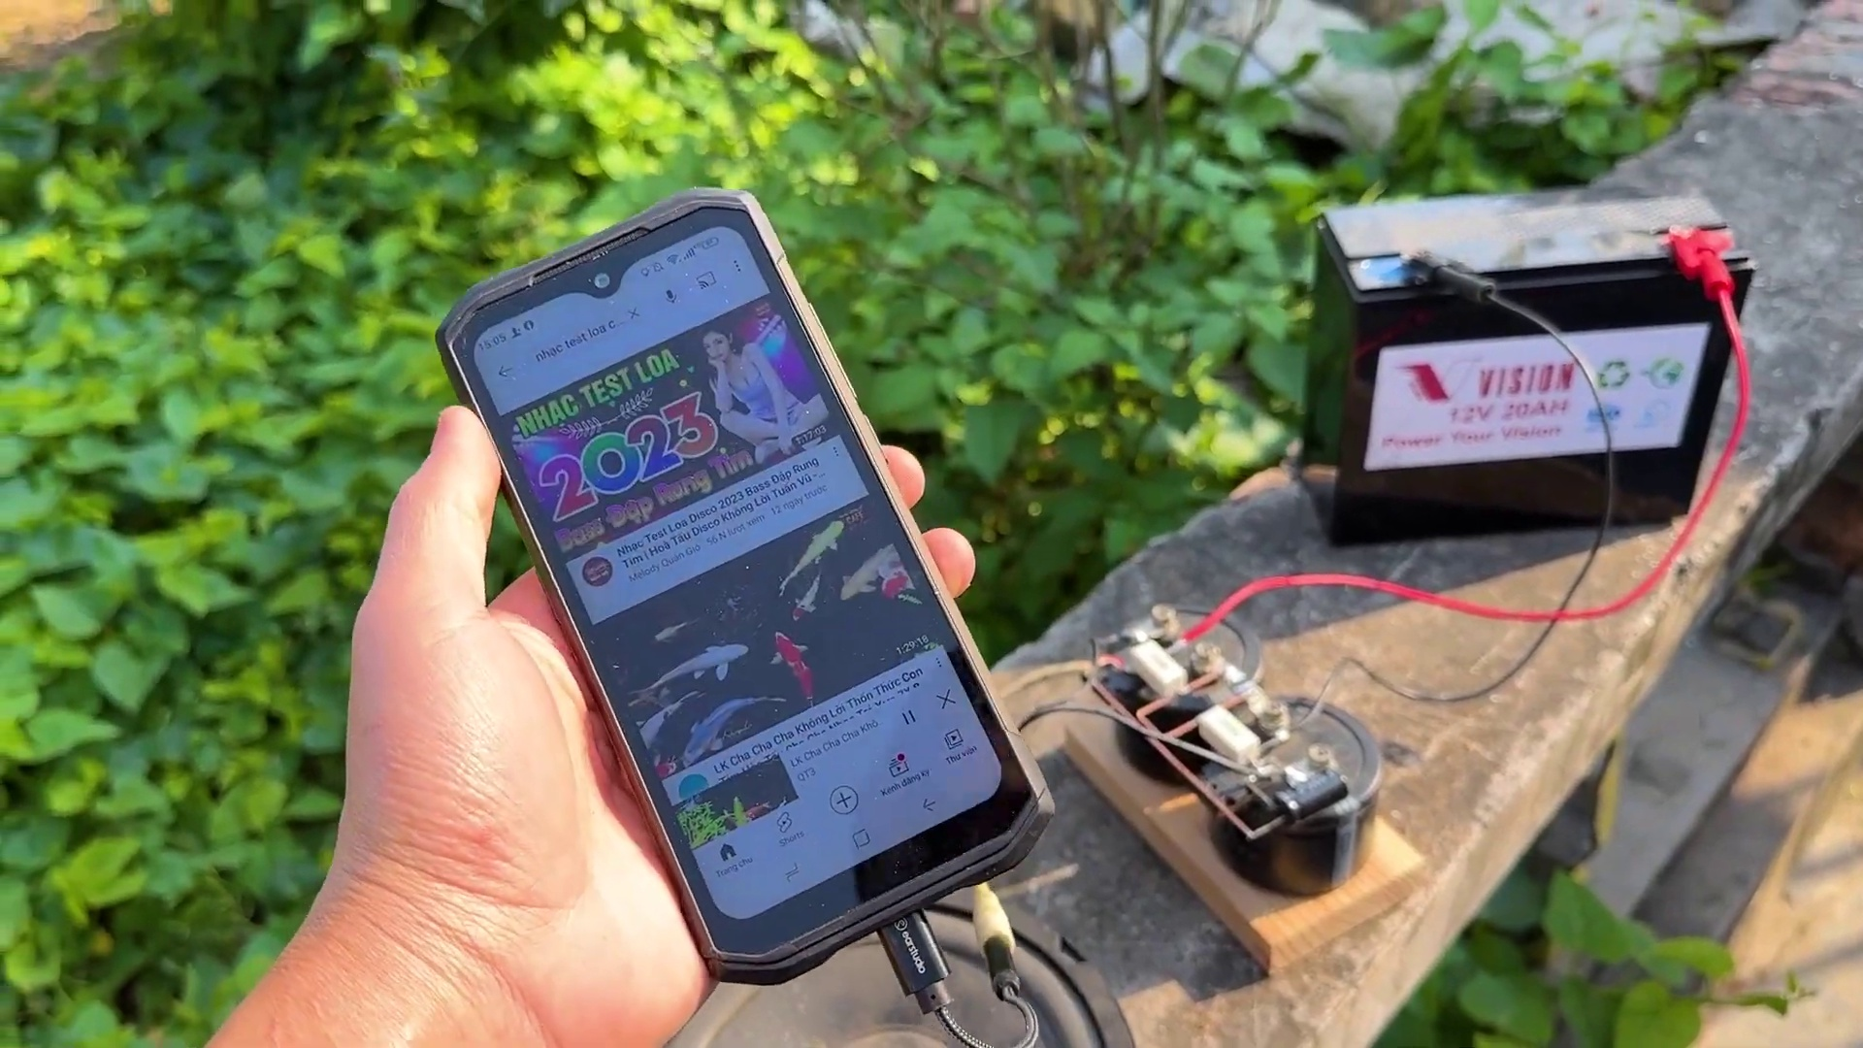 (score 95.0000)
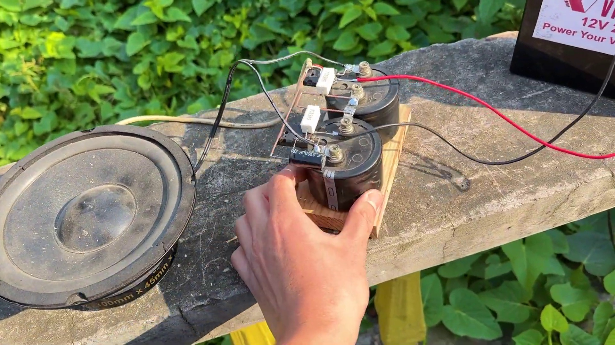 (score 95.0000)
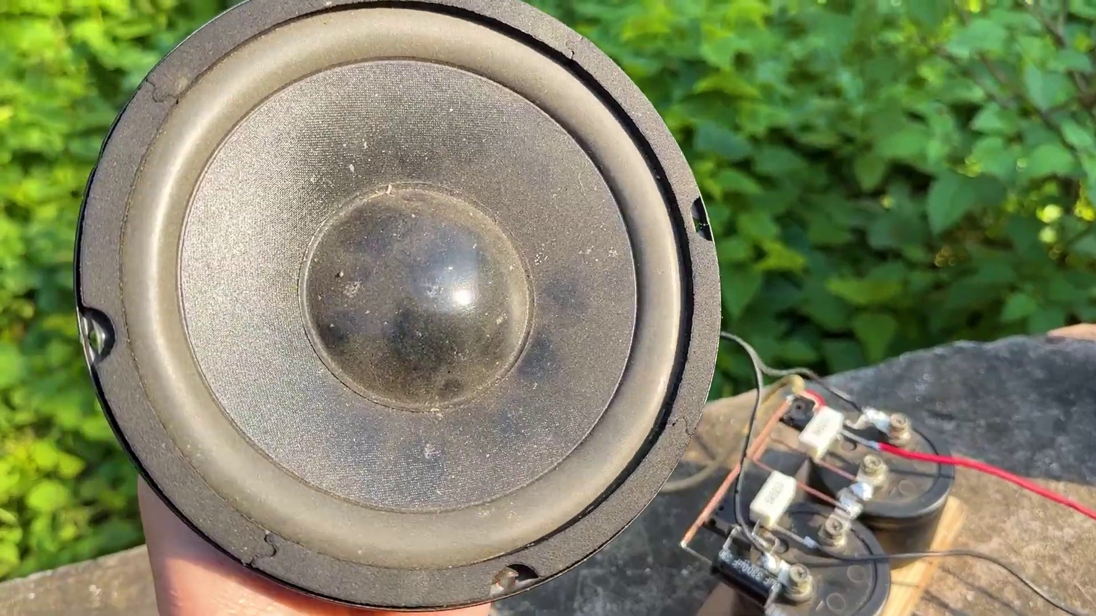 (score 95.0000)
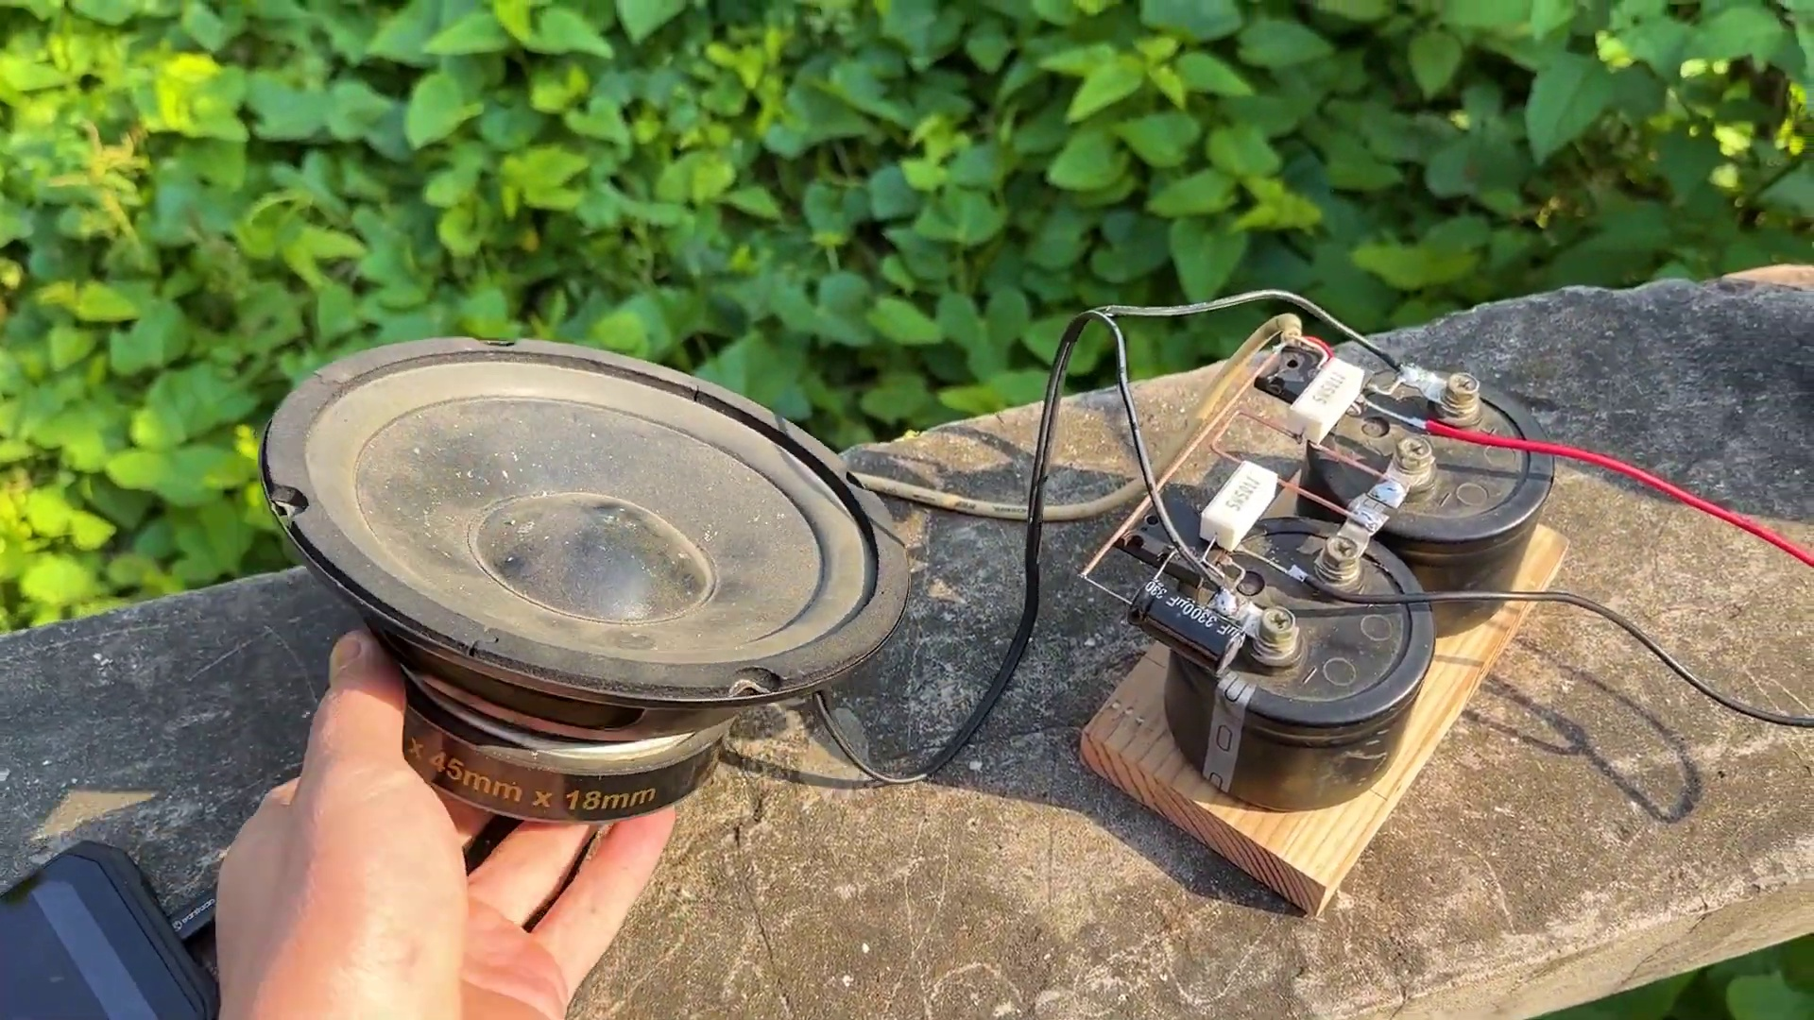 (score 95.0000)
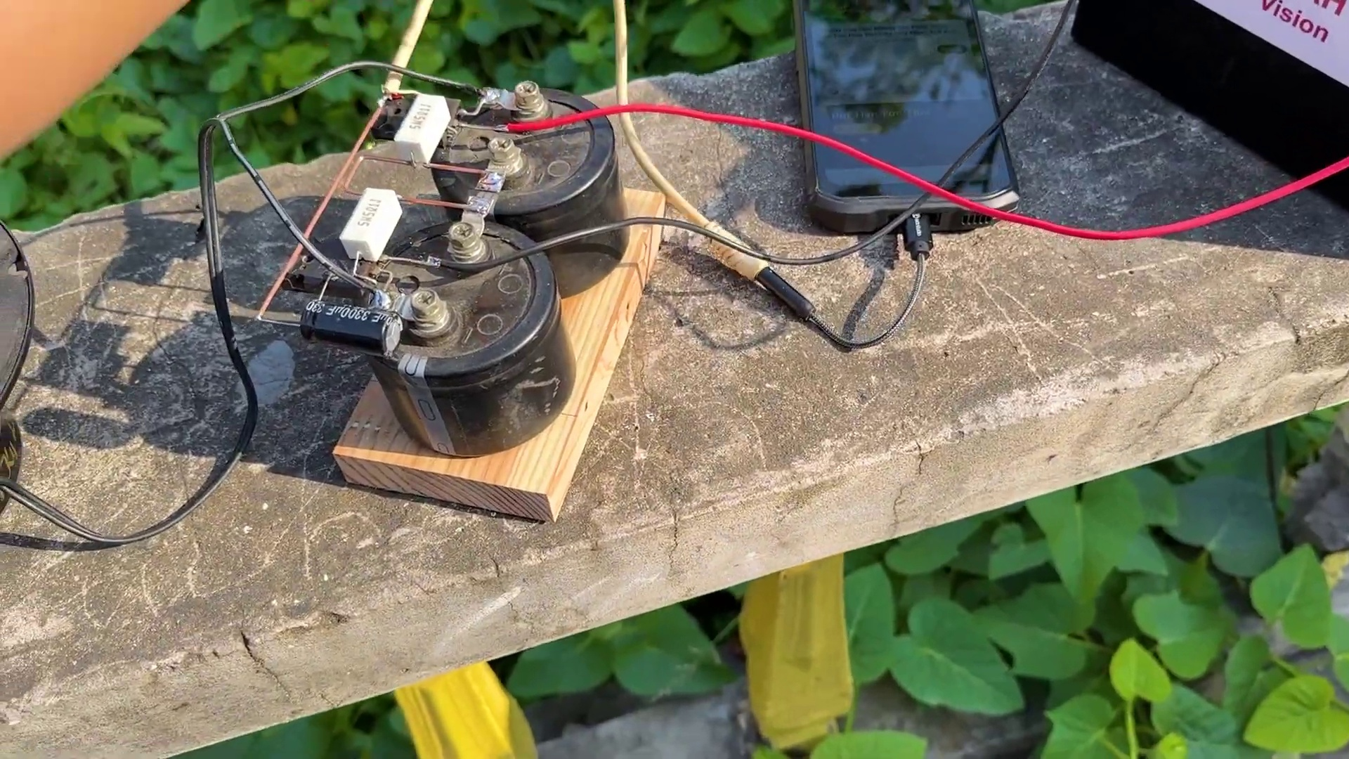 (score 95.0000)
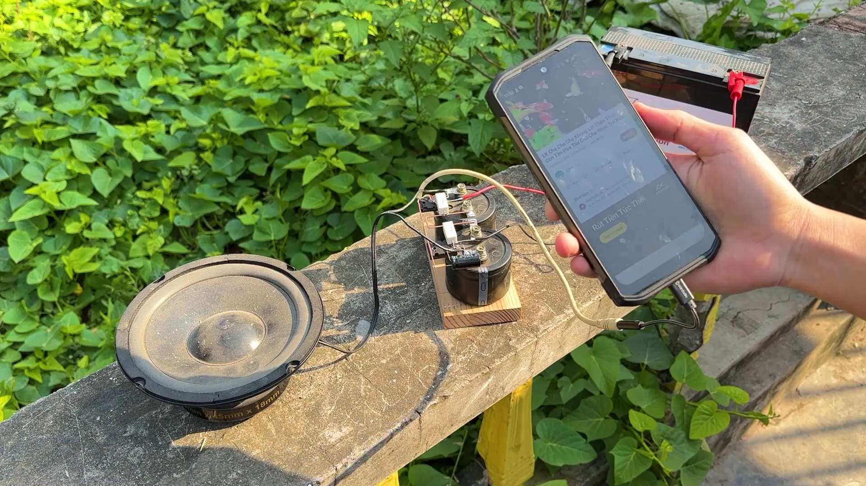 (score 95.0000)
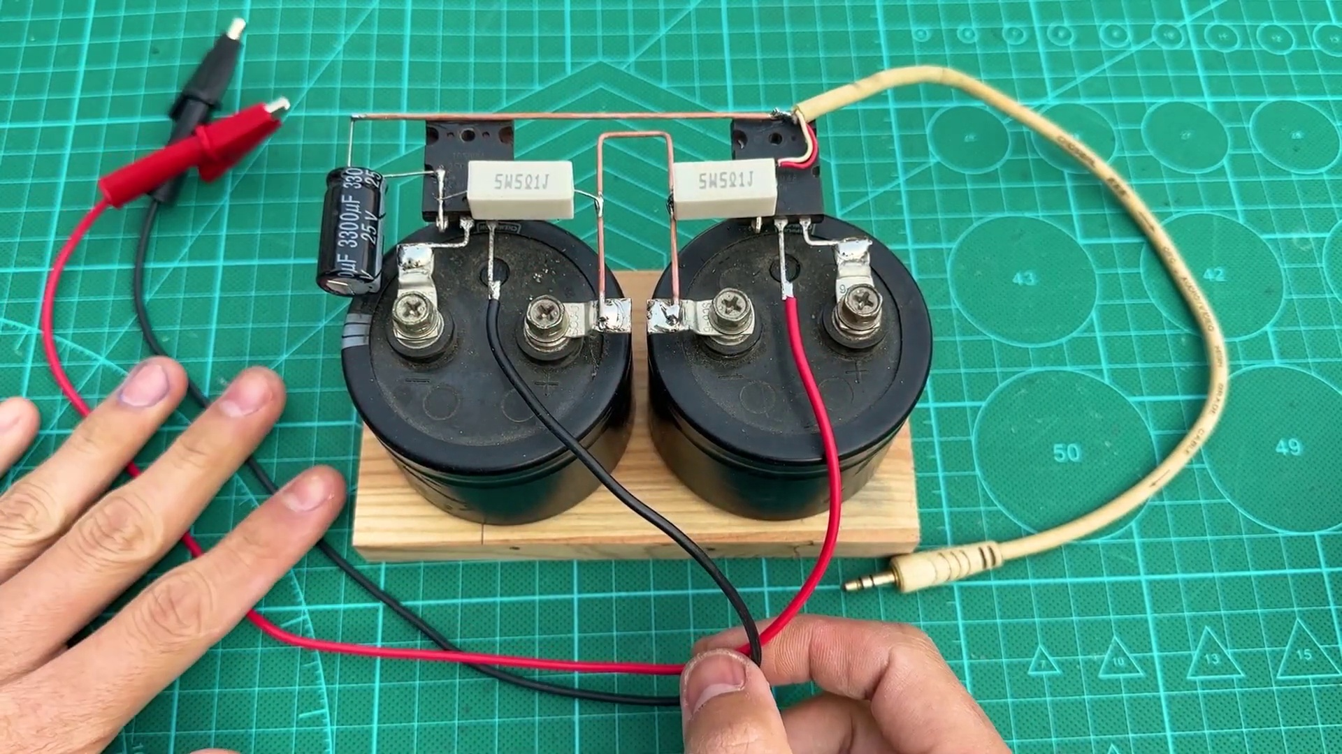 (score 95.0000)
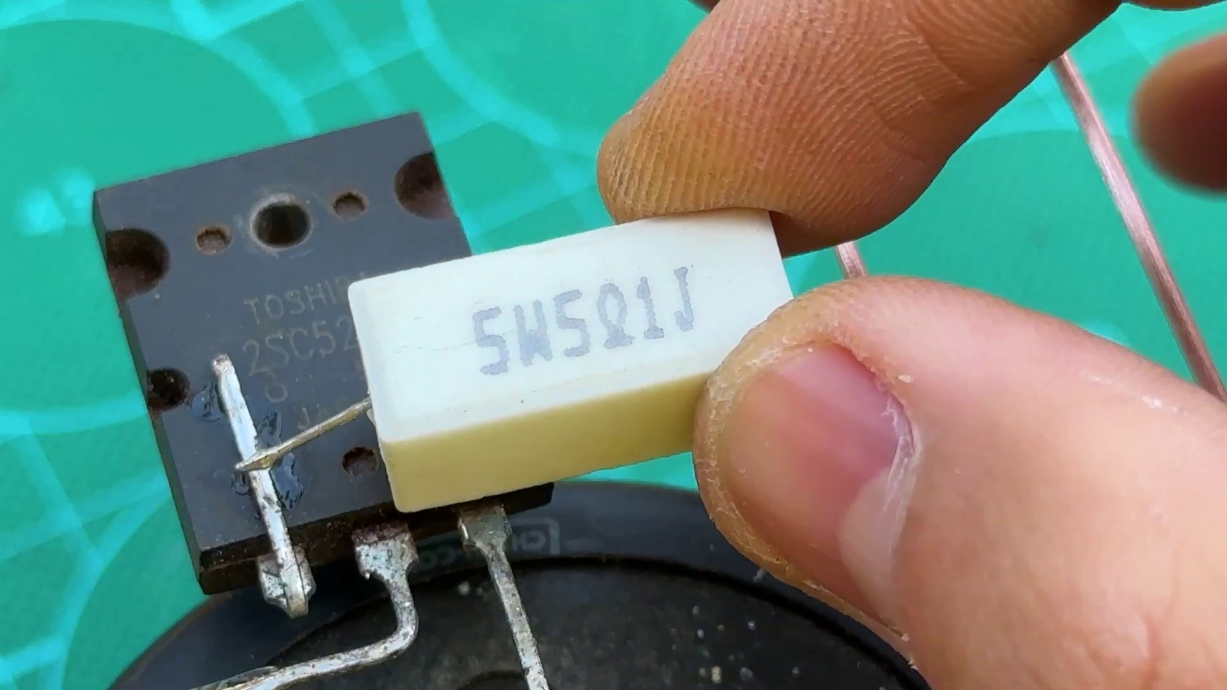 (score 95.0000)
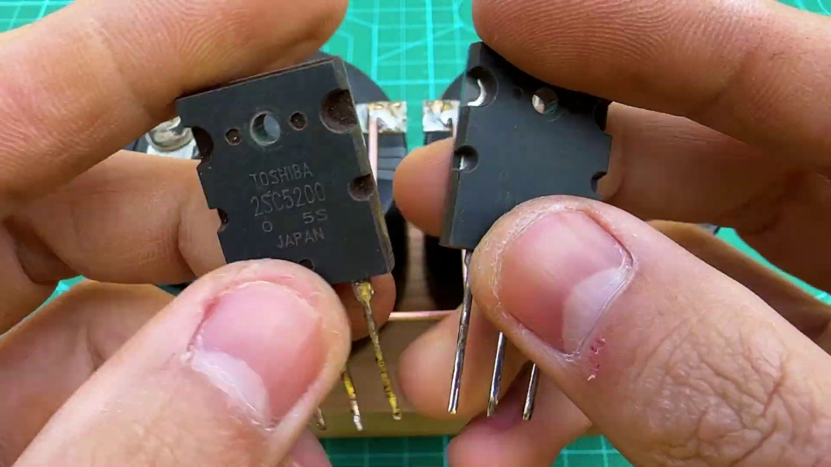 (score 95.0000)
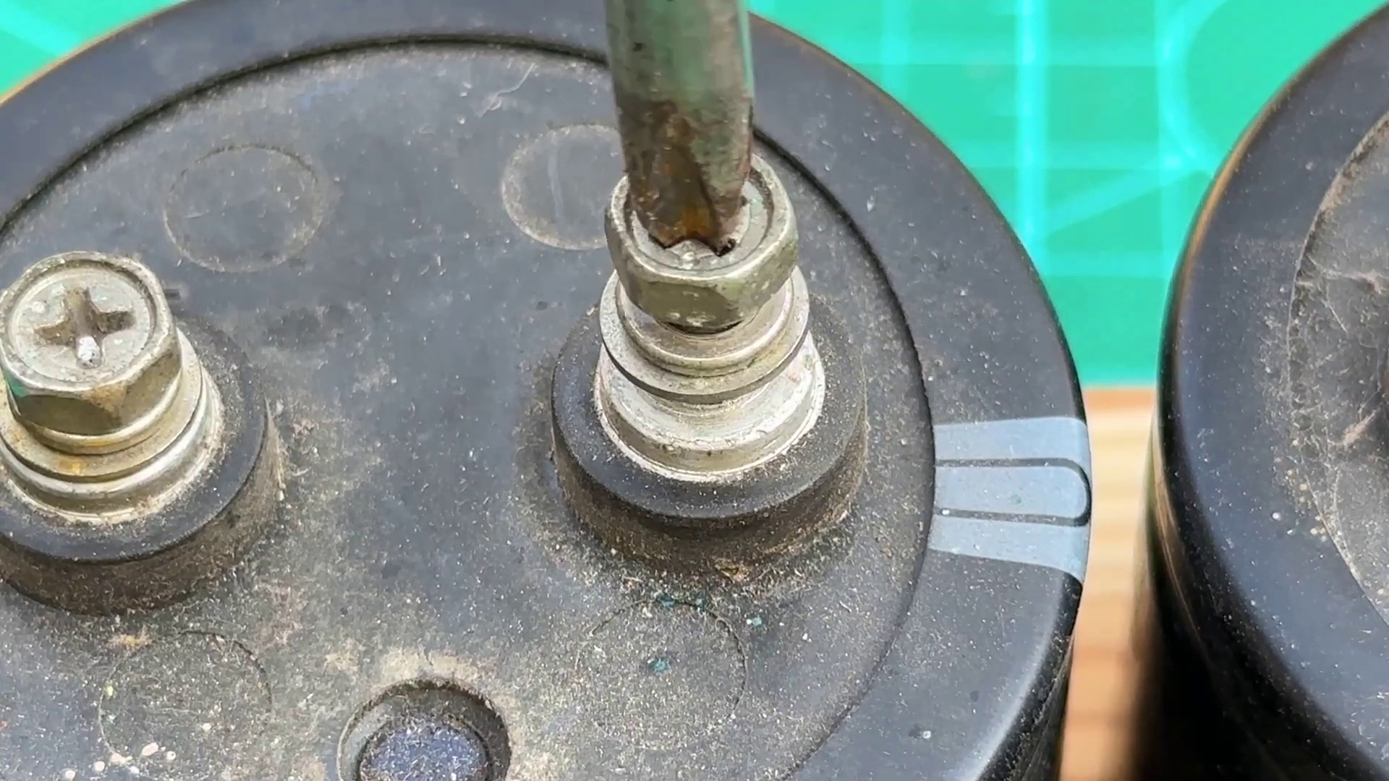 (score 95.0000)
Least correlated frames:
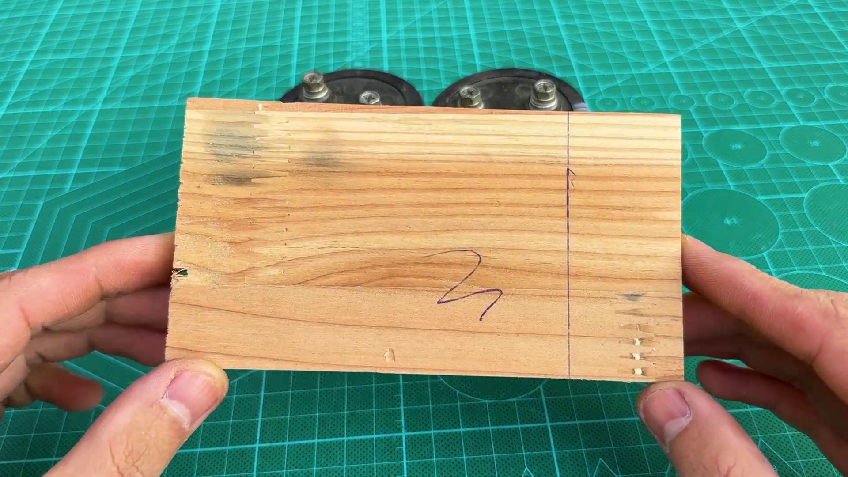 (score 0.0000)
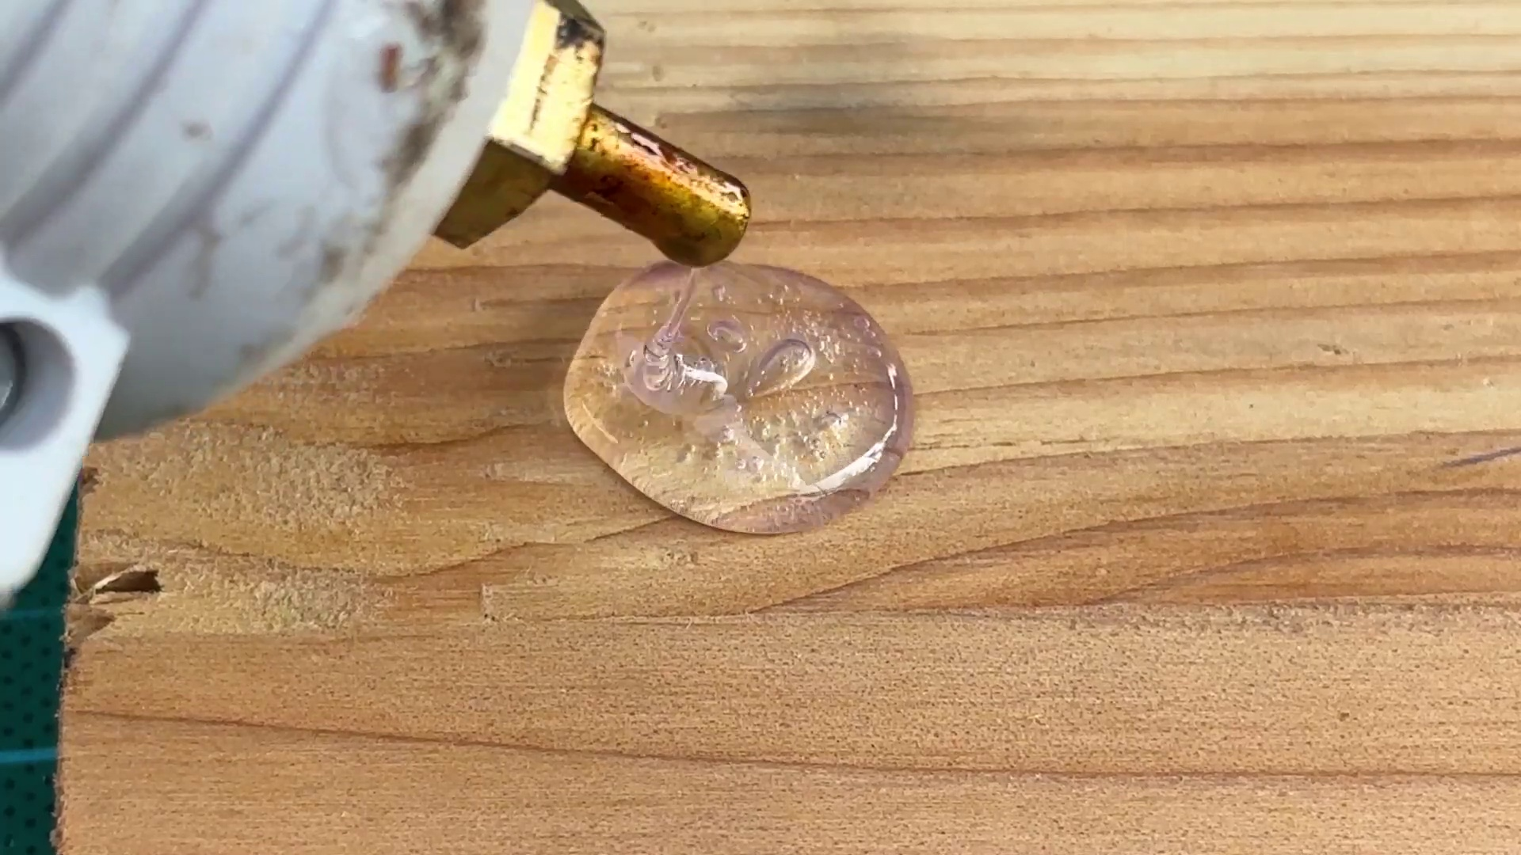 (score 0.0000)
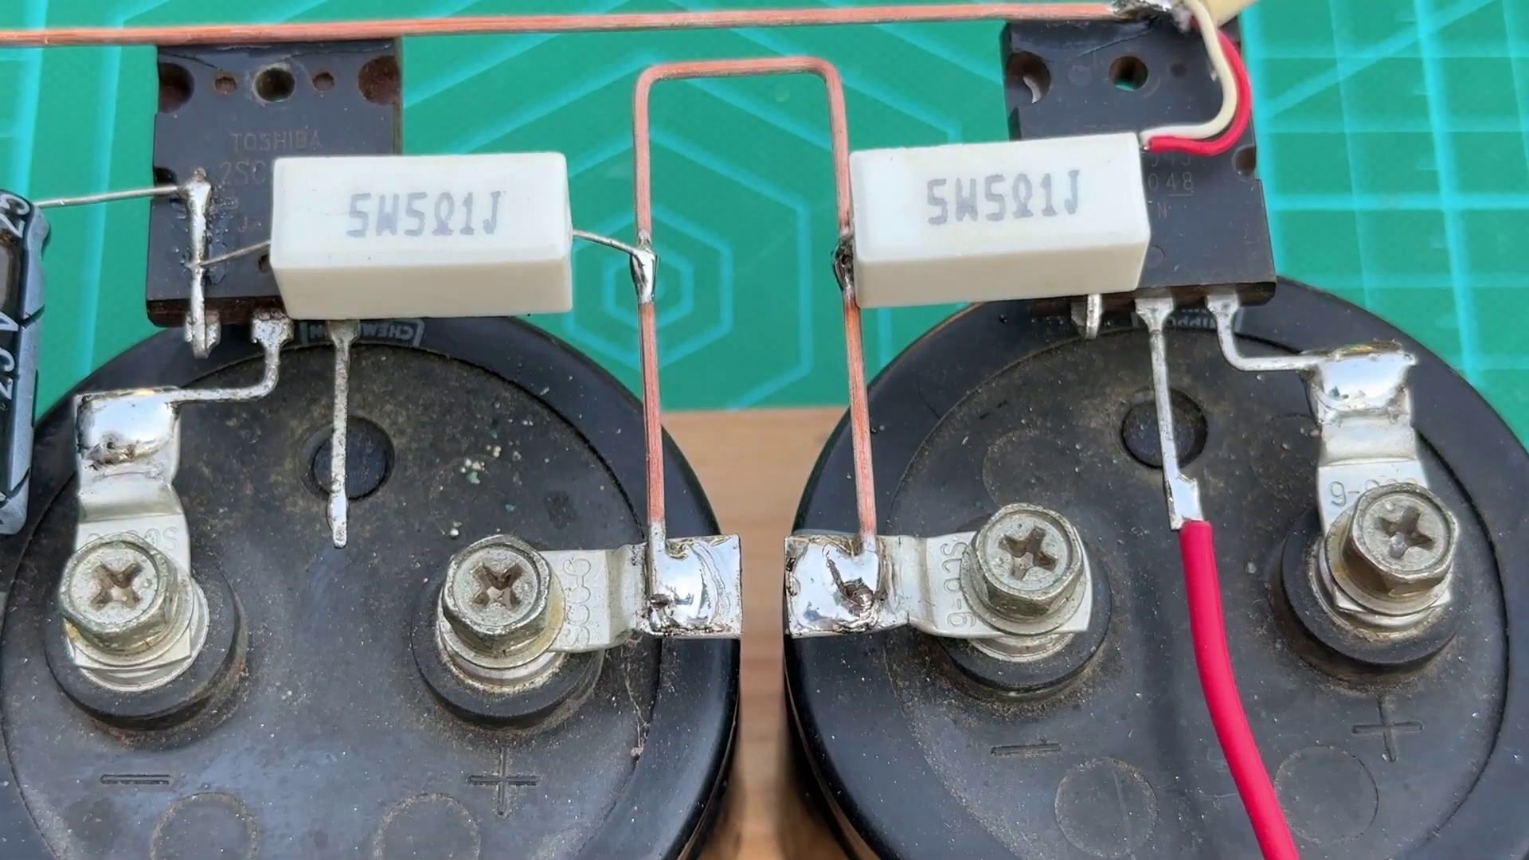 (score 0.0000)
 (score 0.0000)
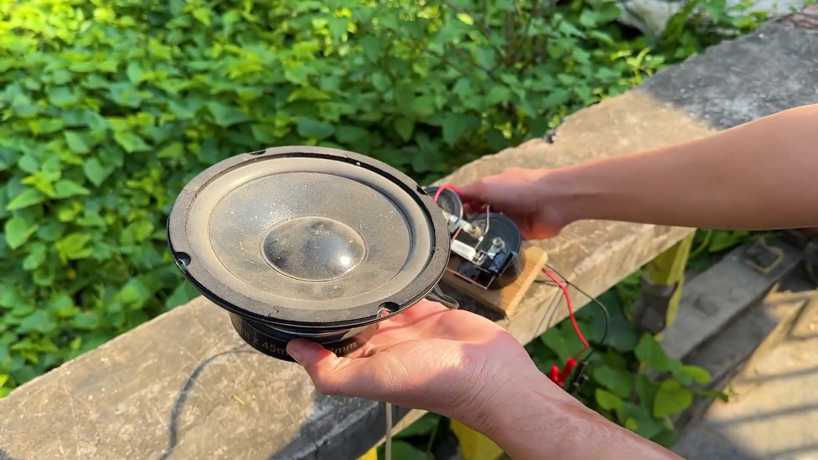 (score 0.0000)
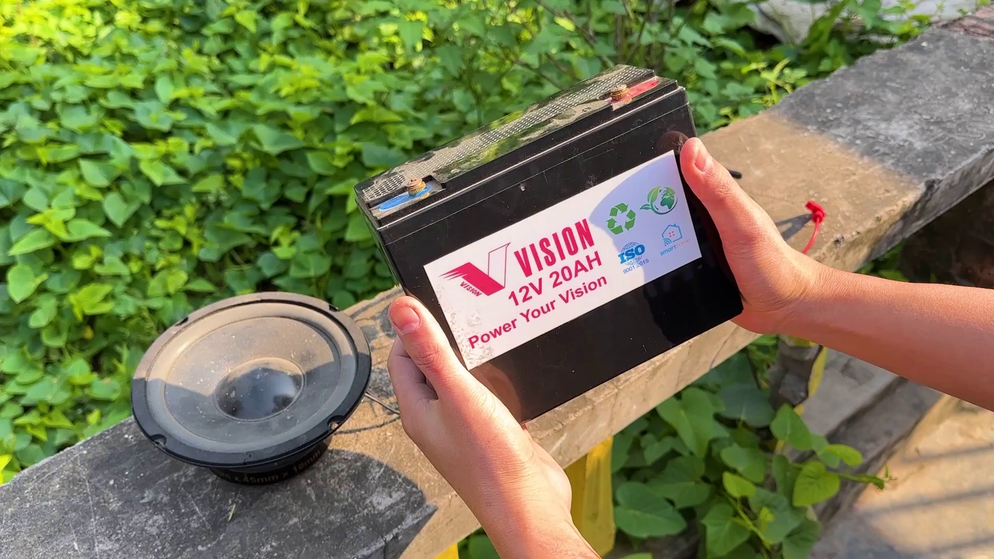 (score 0.0000)
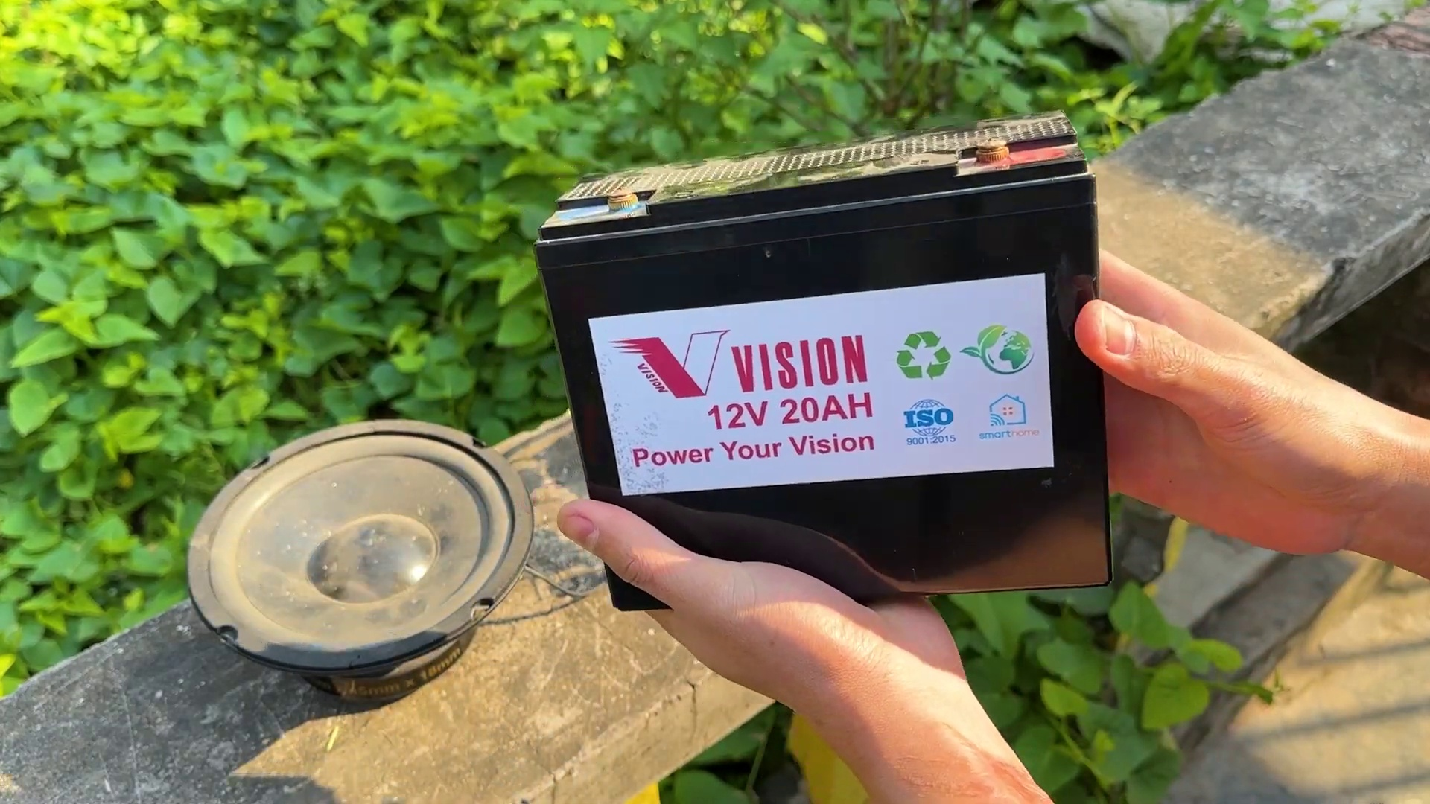 (score 0.0000)
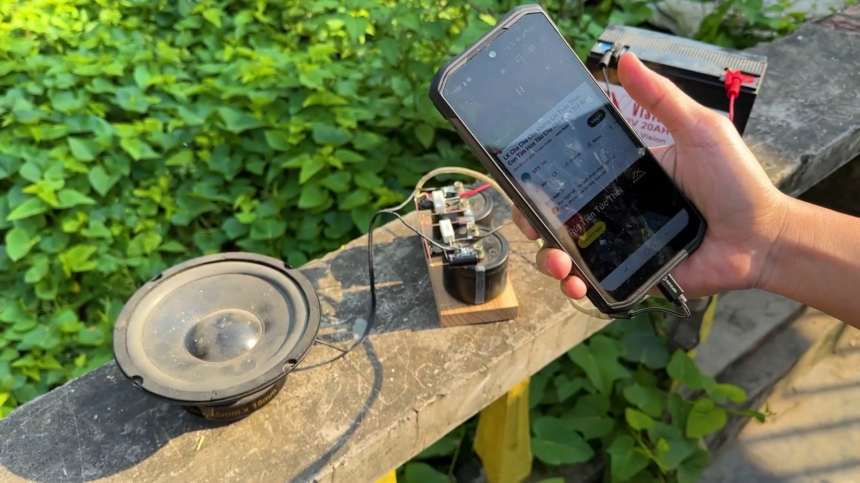 (score 0.0000)
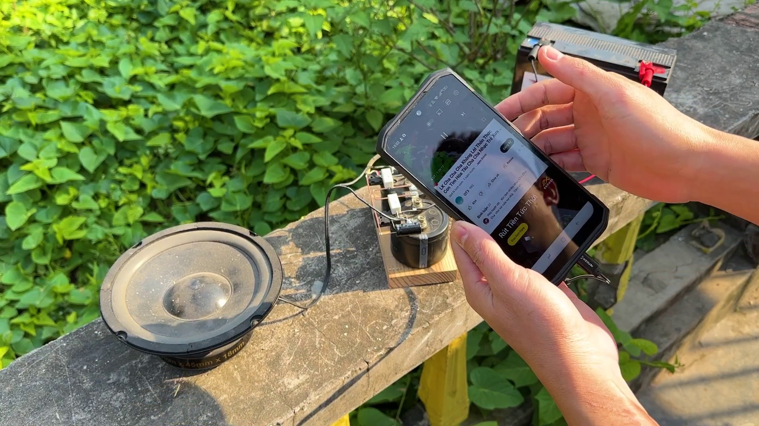 (score 0.0000)
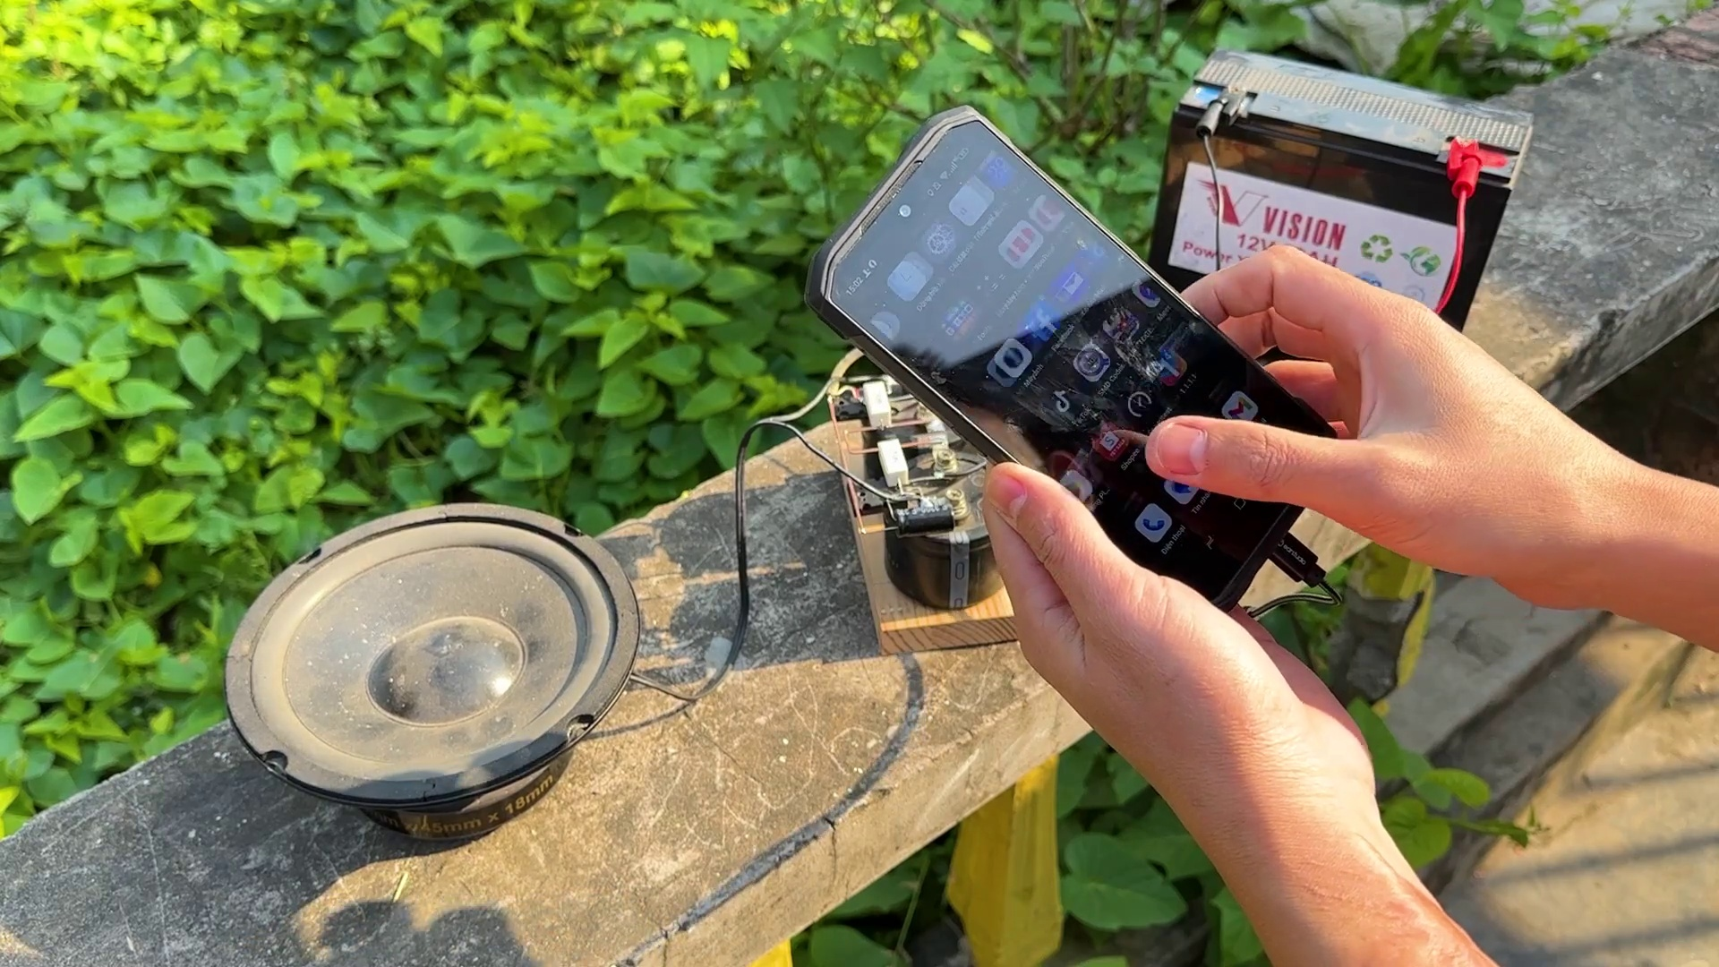 (score 0.0000)
- matched 116 frame(s), max score 90.0000: Helpful to see the terminal connections between capacitors and understand the directionality of speakers for builds or purchases.What made you confused is that Skeptical about some of the connections; also unsure due to conflicting comments calling the video fake.
Source: https://www.youtube.com/watch?v=gdJHi9I0V4w: DIY Powerful Ultra Bass Amplifier Capacitor
Top correlated frames:
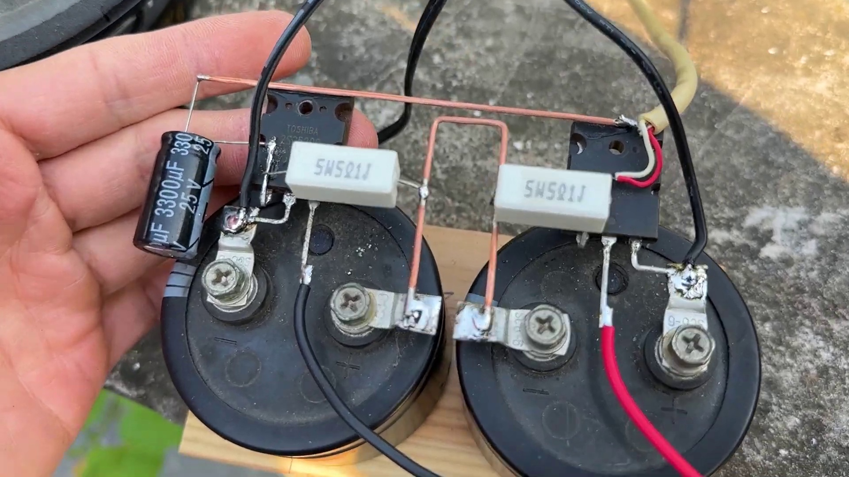 (score 90.0000)
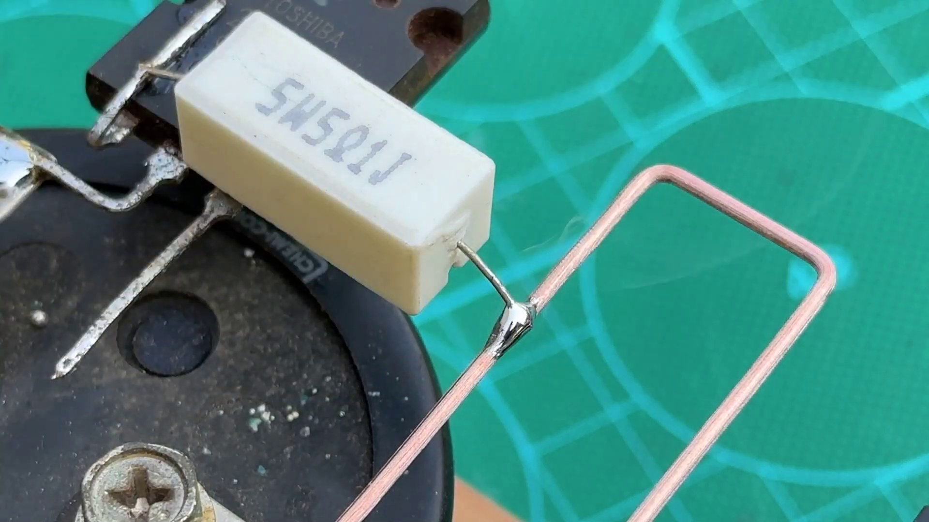 (score 90.0000)
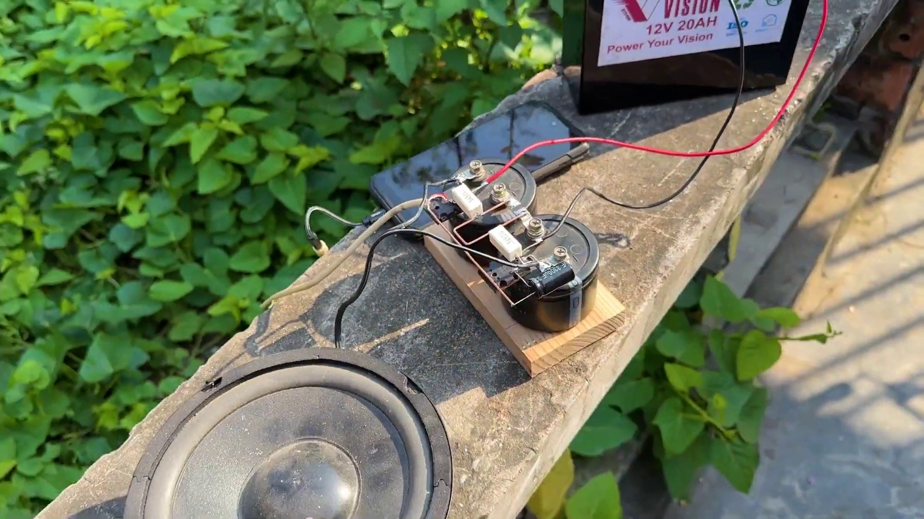 (score 85.0000)
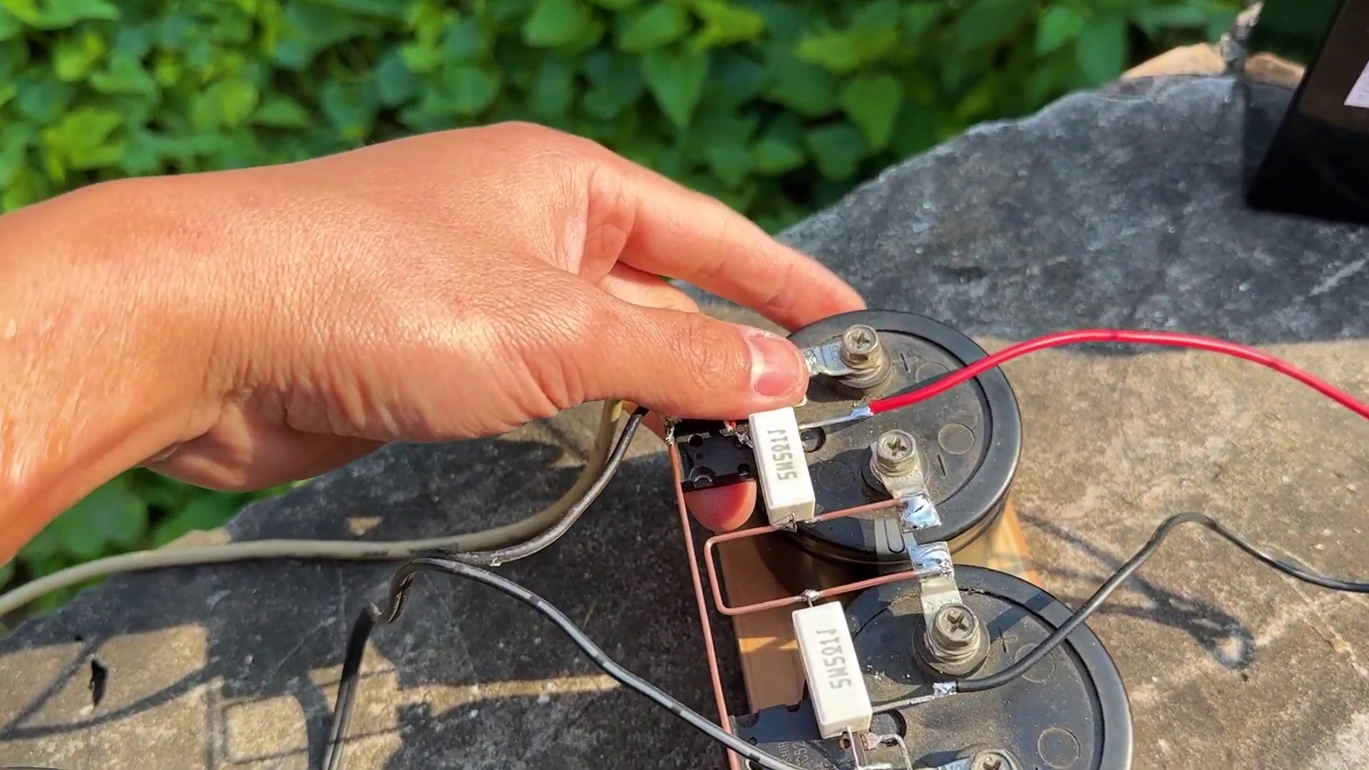 (score 85.0000)
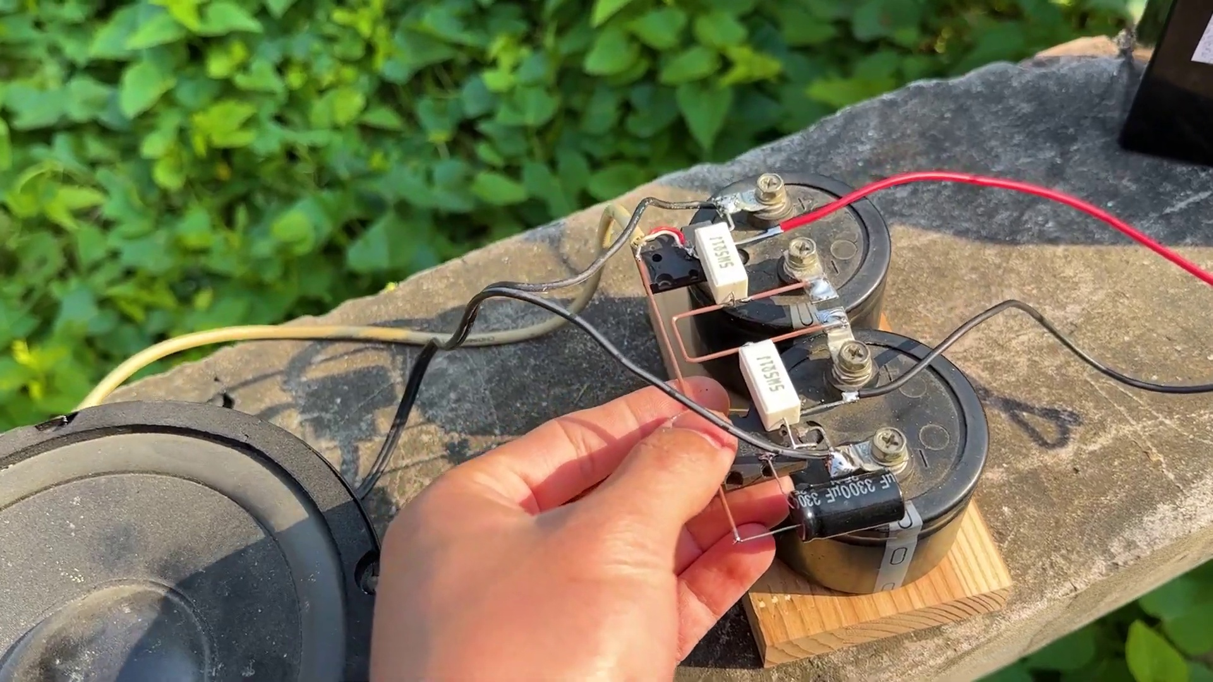 (score 85.0000)
 (score 85.0000)
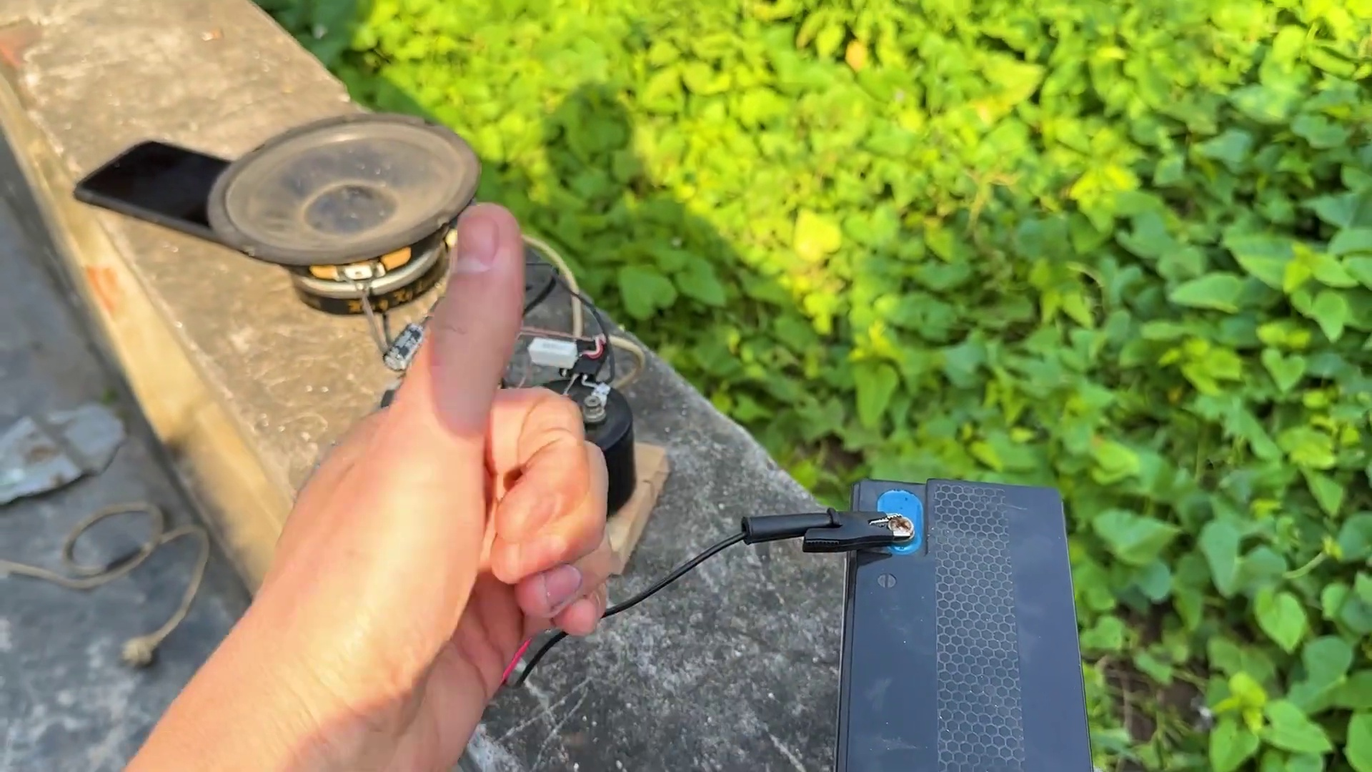 (score 85.0000)
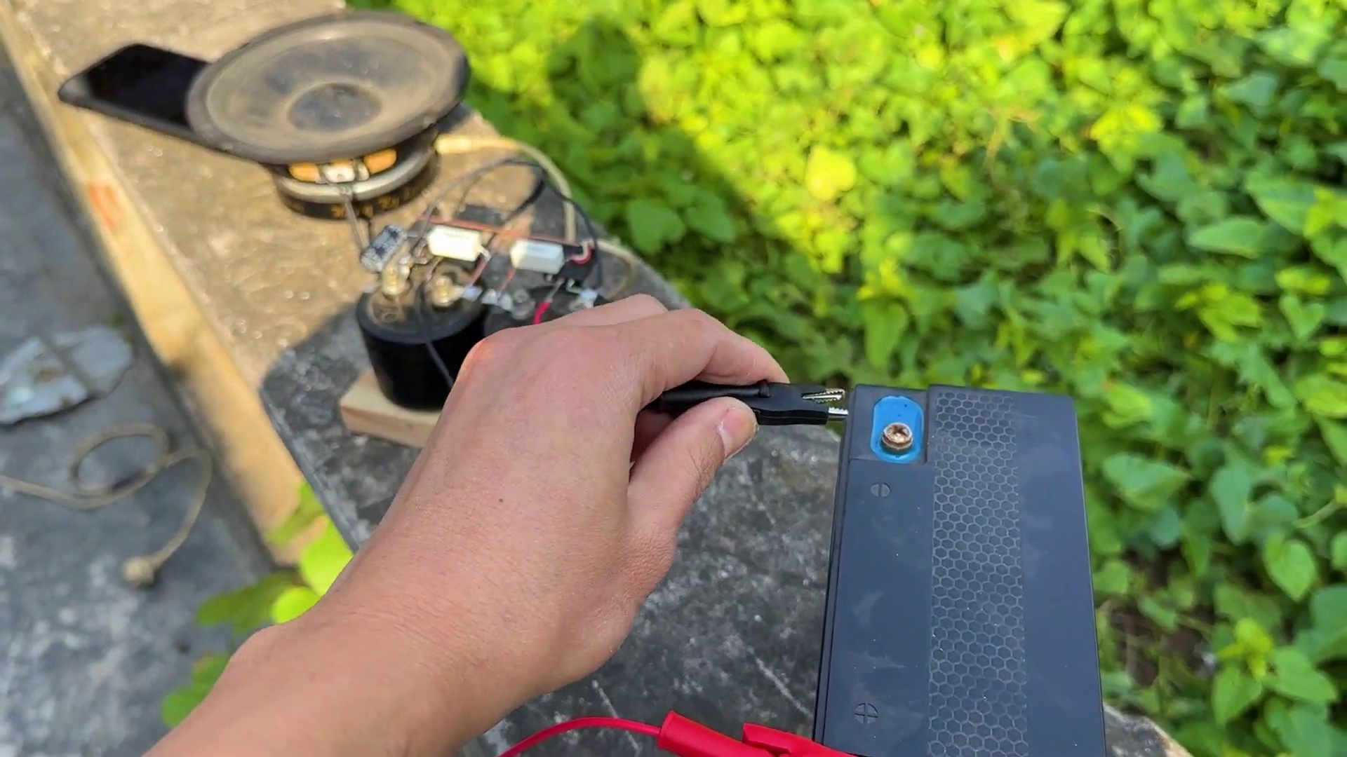 (score 85.0000)
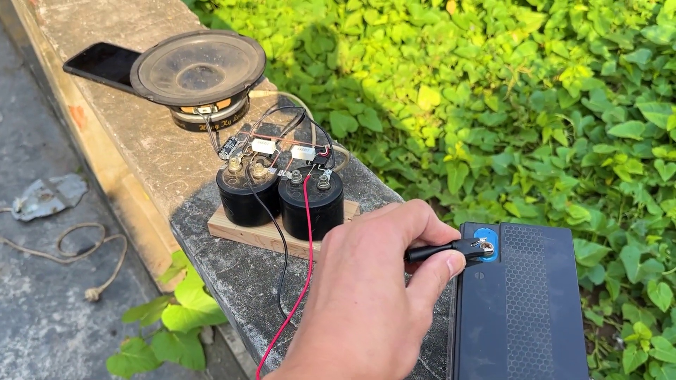 (score 85.0000)
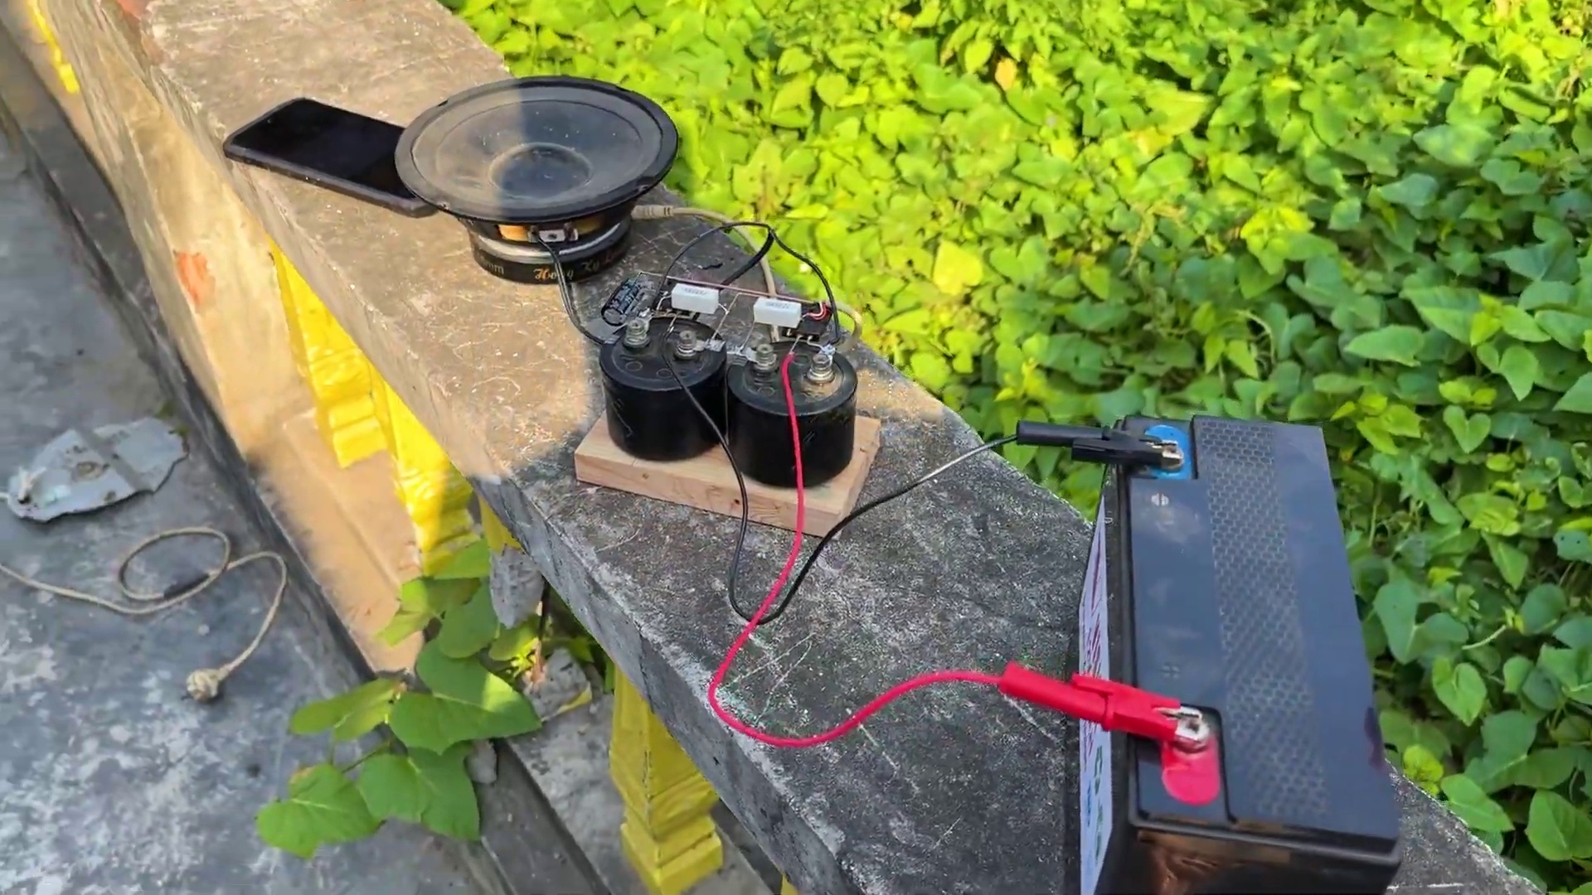 (score 85.0000)
Least correlated frames:
 (score 0.0000)
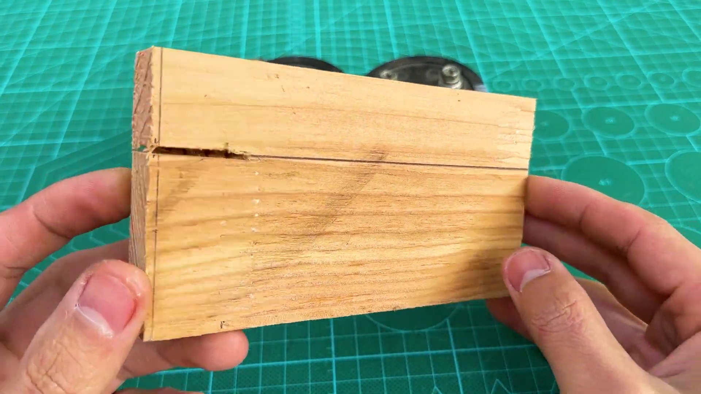 (score 0.0000)
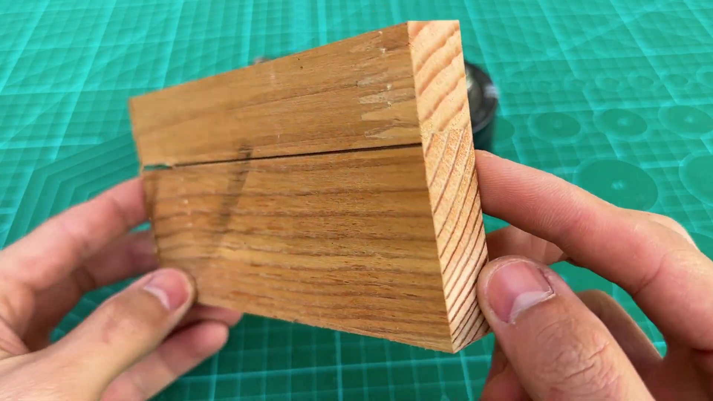 (score 0.0000)
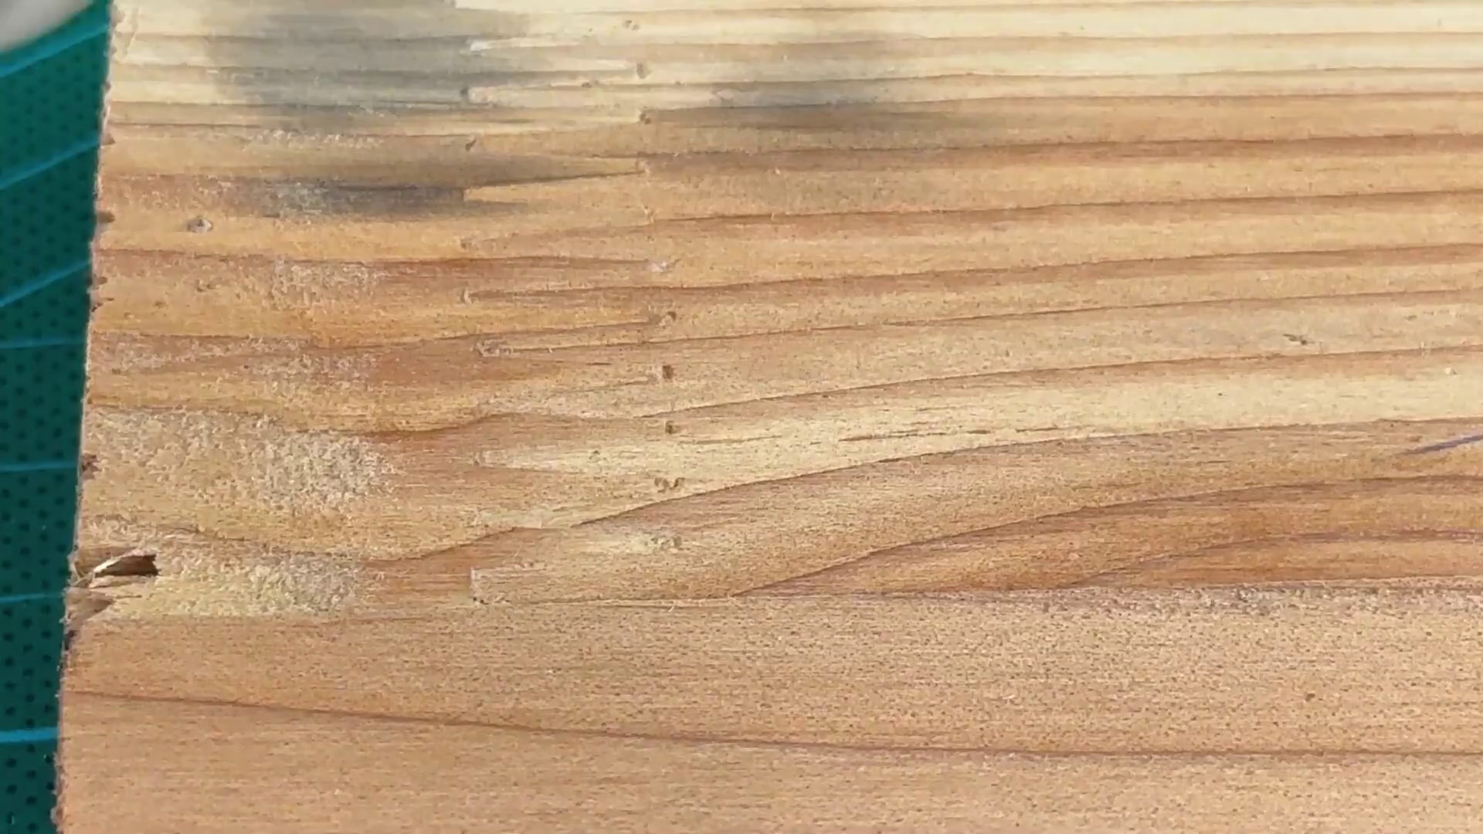 (score 0.0000)
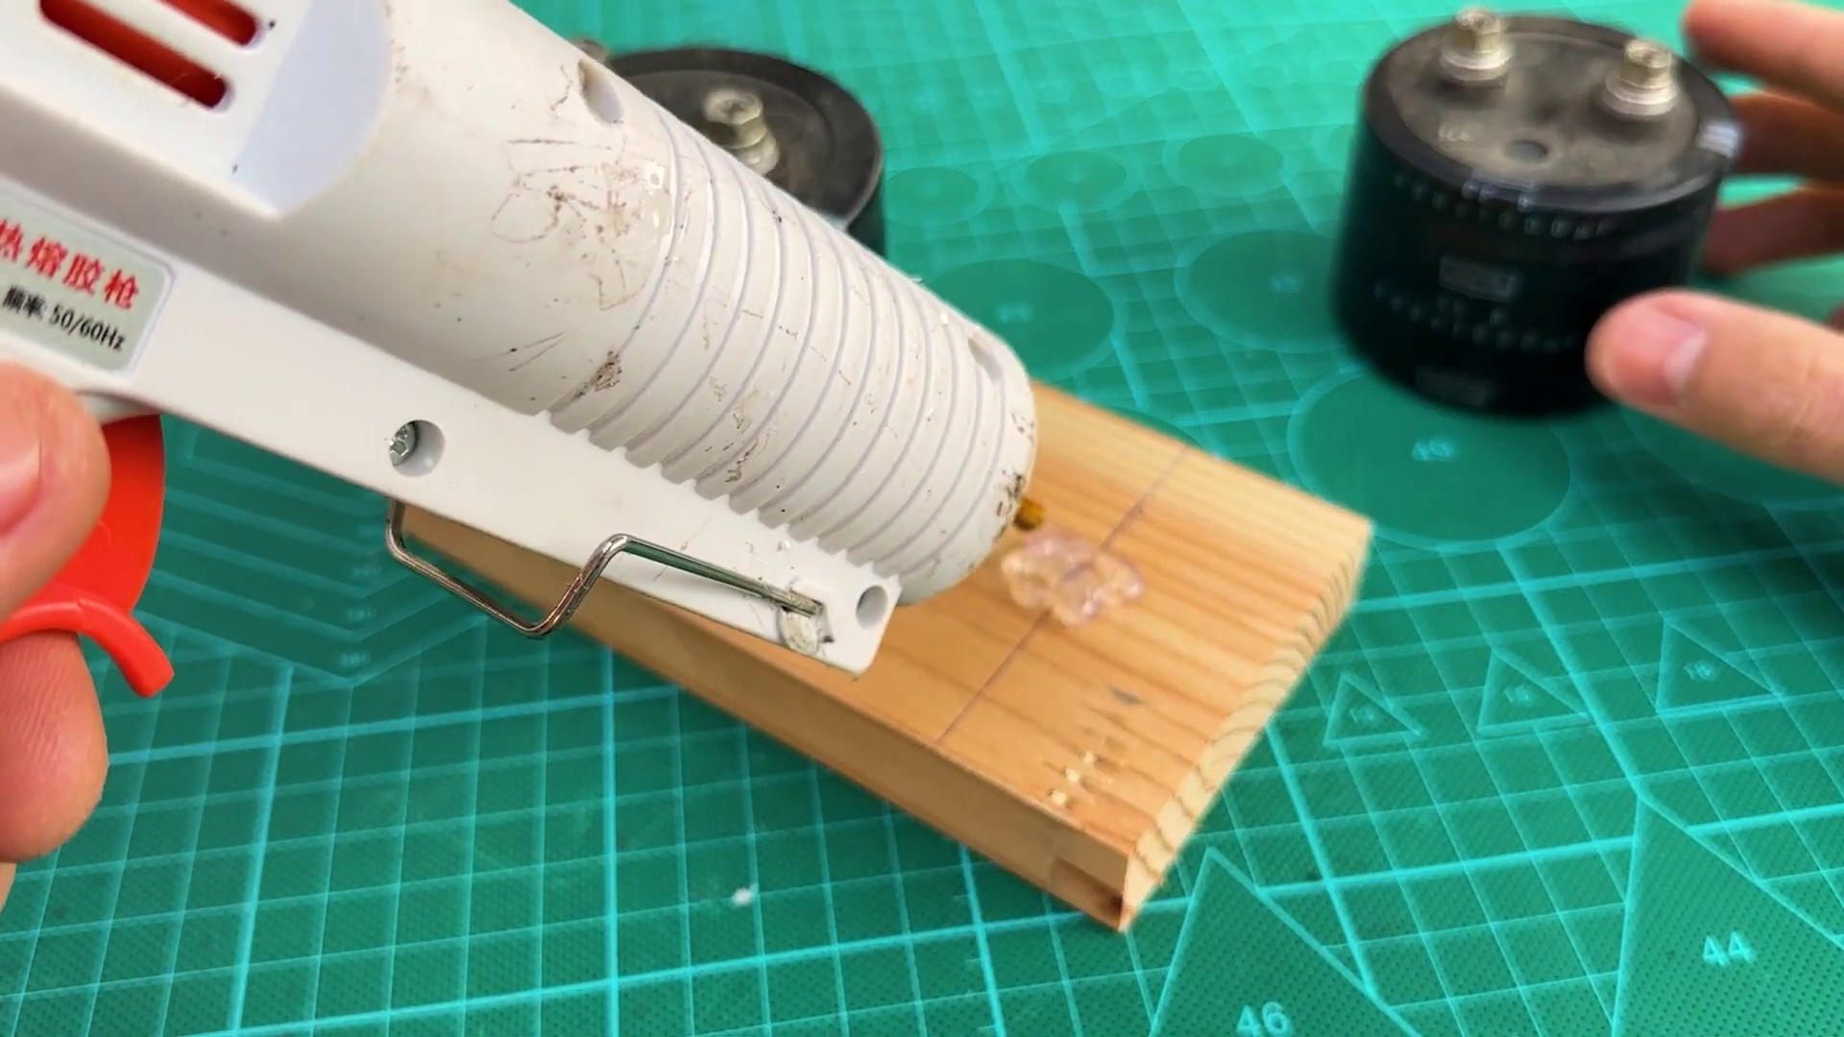 (score 0.0000)
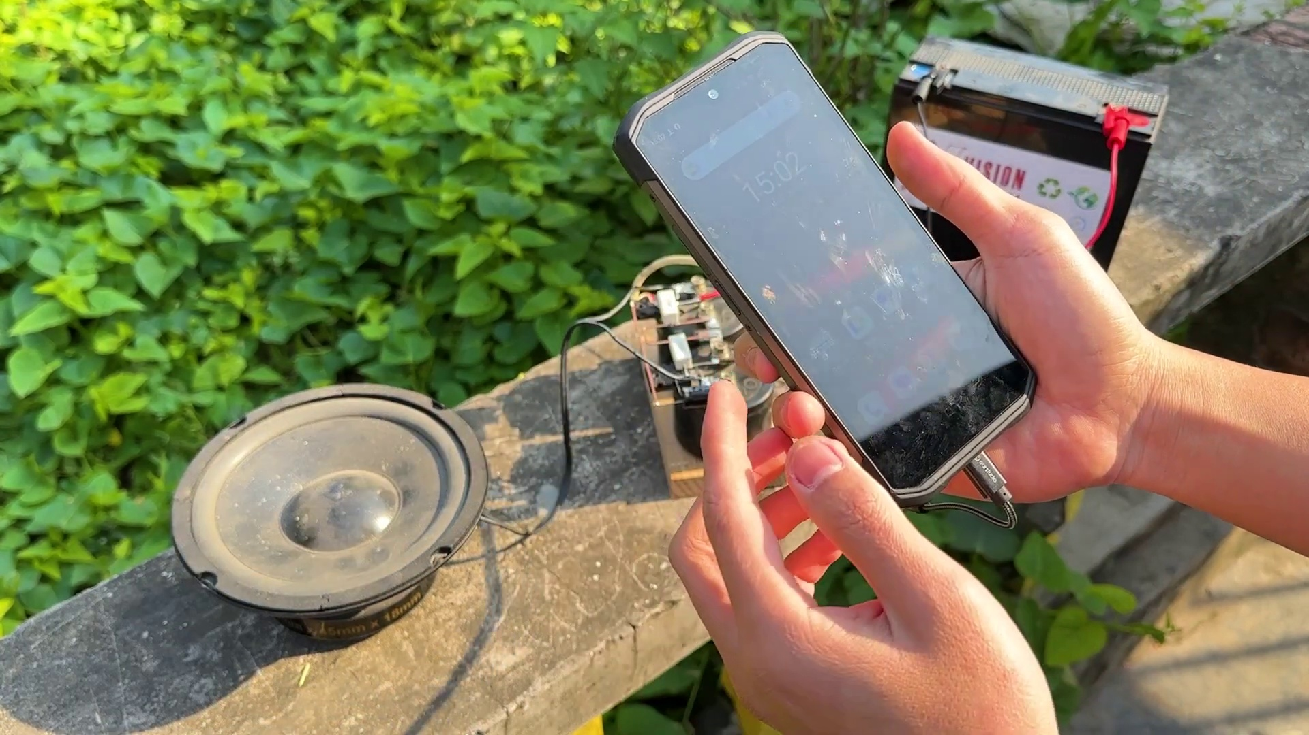 (score 0.0000)
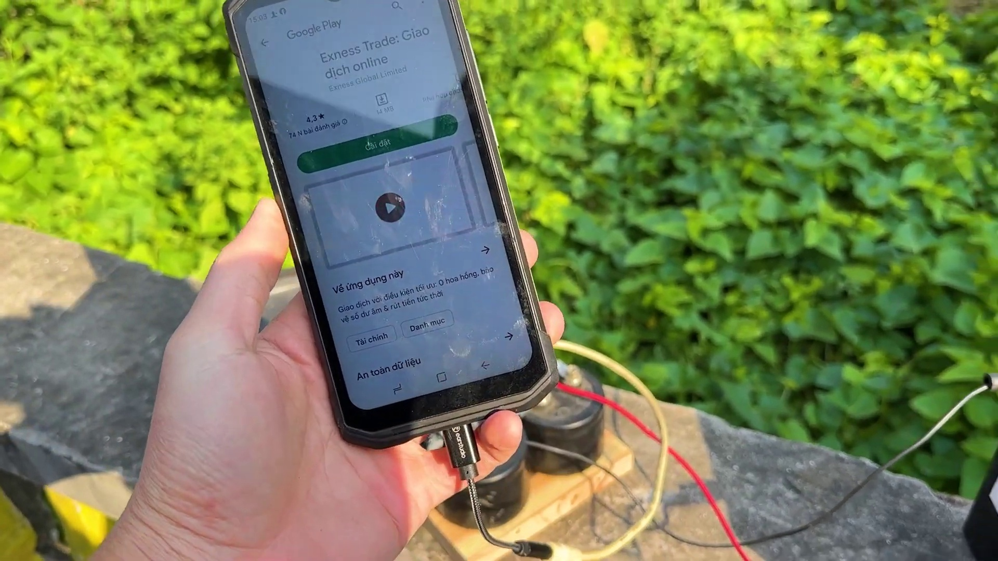 (score 0.0000)
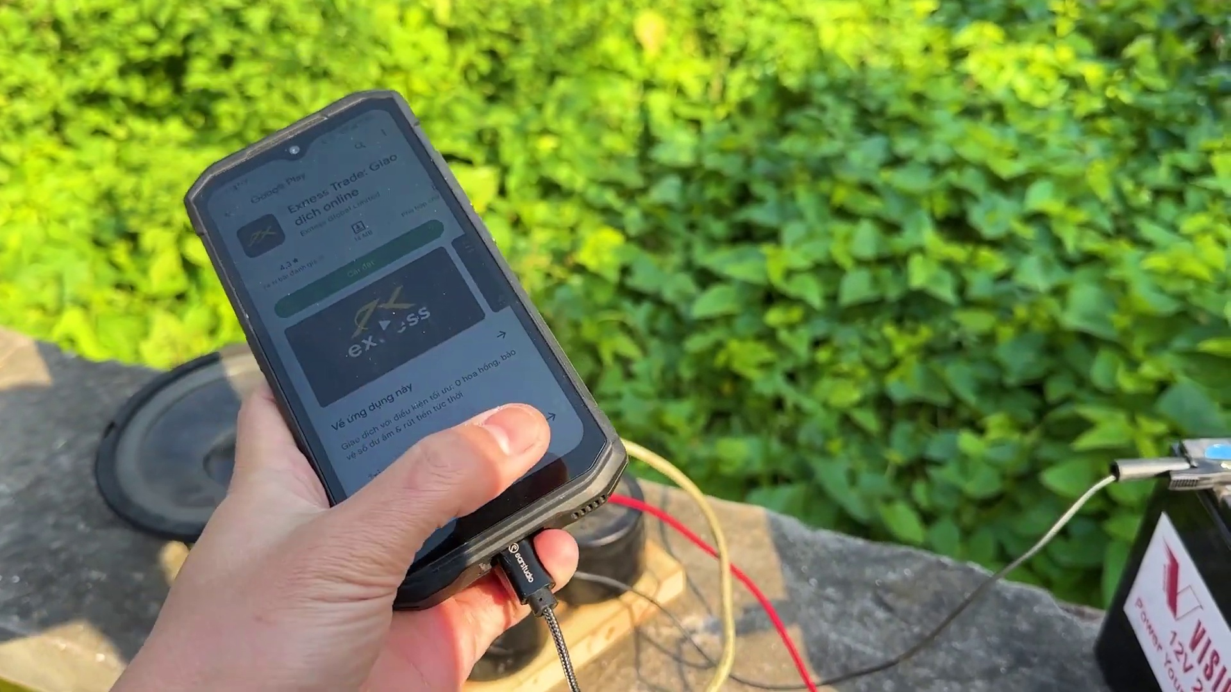 (score 0.0000)
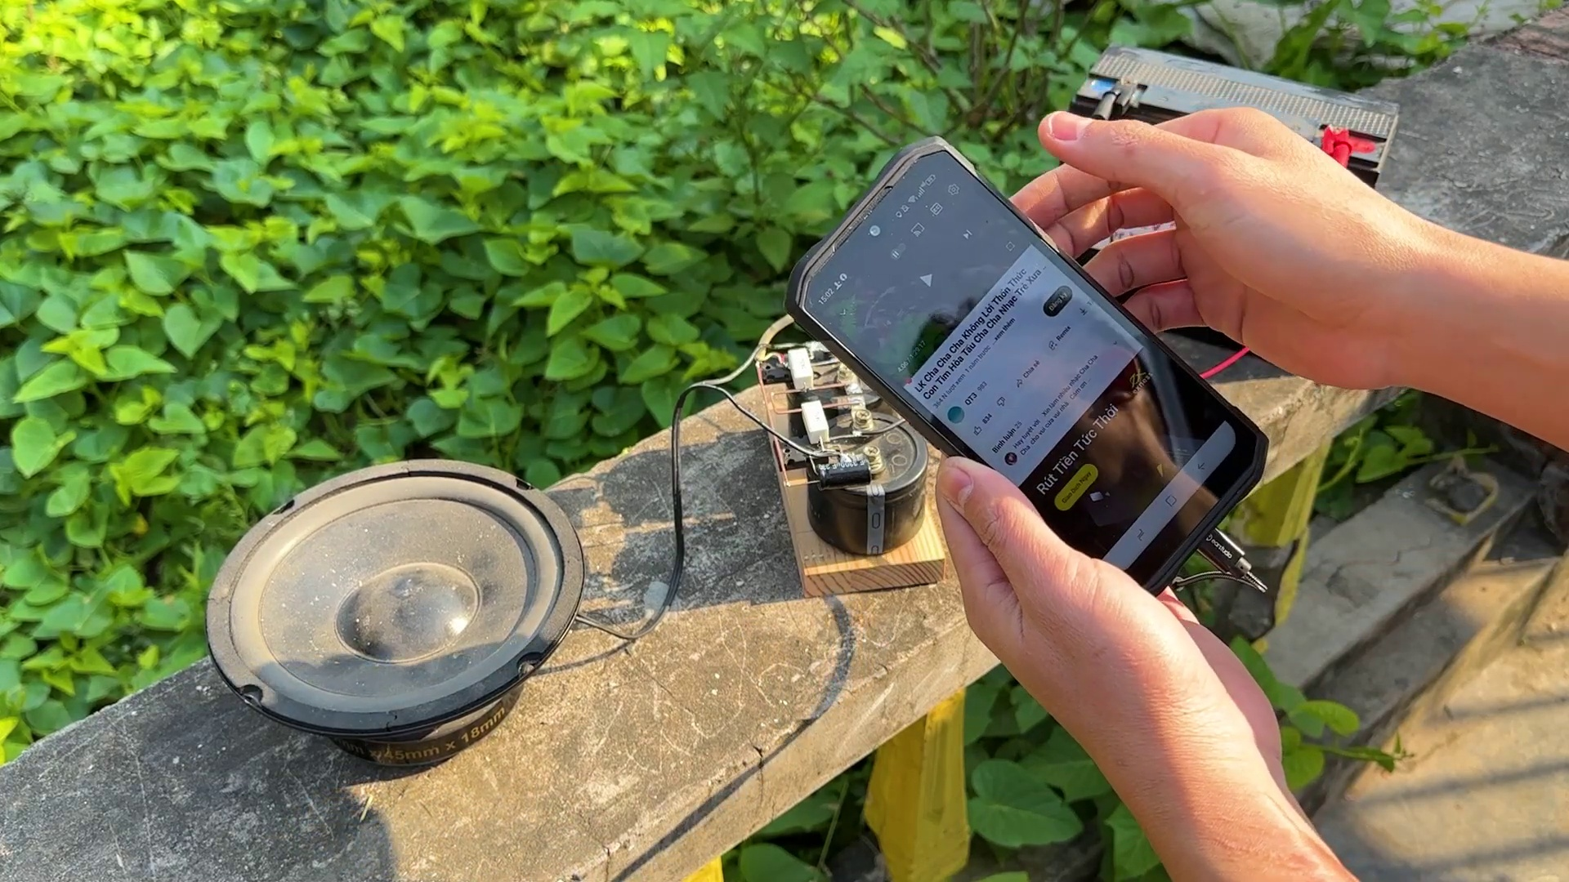 (score 5.0000)
 (score 10.0000)

Frame: frame_0000.jpg
Caption: The image presents a unique combination of digital and physical elements. On the left side, there appears to be a photograph or image with a different texture and pattern compared to the mesh pattern on the right, possibly representing a physical surface or material. The mesh pattern itself is a digital creation that resembles a 3D modeling interface, such as a CAD software. It features a repeating pattern of lines intersecting at various angles, creating a visual representation associated with digital modeling or computer graphics.
In contrast, the cutting mat on the right half of the image is a vibrant green, adorned with geometric shapes predominantly featuring hexagons and triangles. The hexagons vary in size, adding depth to the layout, while the triangles are evenly spaced out, providing balance. The stark white background serves to highlight the green mat and its intricate patterns, giving an impression of order and precision.
There is no visible text, equations, or graph types in this frame, nor is there any discernible action or movement. Instead, the image presents a static representation of both digital and physical elements, with the cutting mat appearing as a meticulously arranged composition.
No strongly correlated comments found for this frame.

Frame: frame_0001.jpg
Caption: The image shows two hands each holding one of two black containers with white labels. Each label has a barcode and some numerical information that includes "4010025," which could indicate a model number or part number. Additionally, the labels display the text "Genuine," suggesting the authenticity of the product, and a warning label at the top stating "CAUTION: DO NOT BREAK SEAL." In the background, a pair of hands holds another similar object, although it is out of focus, and the setting appears to be a workshop or a place where these objects are being displayed or assembled. Upon closer inspection, the two black containers can be seen to contain capacitors, as revealed by a close-up view showing that each container has a white label on top. The left capacitor's label reads "CEB 400V1000," indicating its voltage rating of 400 volts and capacitance of 1000 microfarads. The right capacitor's label also reads "CEB 400V1000," mirroring the information on the left. The capacitors are held in place by two silver screws, one on each side of the image. The vibrant green background provides a stark contrast to the black capacitors.
Comment (score 80): Helpful to see the terminal connections between capacitors and understand the directionality of speakers for builds or purchases.What made you confused is that Skeptical about some of the connections; also unsure due to conflicting comments calling the video fake.
Reason: The comment directly discusses the capacitors and their connections, which are mentioned in the caption. The comment also expresses uncertainty about the terminal connections and conflicting comments, which is indirectly related to the information presented in the caption.
Source: https://www.youtube.com/watch?v=gdJHi9I0V4w: DIY Powerful Ultra Bass Amplifier Capacitor
Comment (score 70): The video was helpful in demonstrating how to connect two MOSFETs together, aiding my understanding of parallel configurations.If there were clearer diagrams or additional explanations, especially towards the end when everything was combined, as I found it a bit confusing.
Reason: The comment directly discusses the connection of two MOSFETs together, which is strongly related to the technical steps described in the caption (e.g. connecting capacitors), with some minor critique about clarity and additional explanations.
Source: https://www.youtube.com/watch?v=gdJHi9I0V4w&t=382s: DIY Powerful Ultra Bass Amplifier Capacitor , No IC , Simple circuit

Frame: frame_0002.jpg
Caption: The image shows a person's hand holding a small black electric component, which appears to be an inductive coil (possibly a choke coil) with a white label and several holes around it. The label contains text that is too small to read clearly; however, the presence of numerical values suggests technical specifications such as resistance or inductance. In the background, another similar component without the same labeling can be seen. The setting looks like a workshop or hobbyist space with tools and other equipment visible on shelves in the background.
The image also features a close-up view of a capacitor positioned nearby. The capacitor is black in color and is positioned on a white background, with the text "CE" prominently displayed on it, indicating its type. The label "NIPPON CHEM-CON" is also visible, suggesting the brand or manufacturer of the capacitor.
The image is likely used for educational purposes, perhaps to demonstrate the construction or function of an electrical component. However, there are no visible slides, diagrams, or text that provide additional context or explanation related to this specific component.
Comment (score 85): Helpful to see the terminal connections between capacitors and understand the directionality of speakers for builds or purchases.What made you confused is that Skeptical about some of the connections; also unsure due to conflicting comments calling the video fake.
Reason: The comment directly discusses the technical aspect of capacitors and their connections, which are mentioned in the frame caption. The comment also mentions potential concerns about the video's accuracy, but this does not detract from its correlation with the caption.
Source: https://www.youtube.com/watch?v=gdJHi9I0V4w: DIY Powerful Ultra Bass Amplifier Capacitor
Comment (score 80): The video was helpful in demonstrating how to connect two MOSFETs together, aiding my understanding of parallel configurations.If there were clearer diagrams or additional explanations, especially towards the end when everything was combined, as I found it a bit confusing.
Reason: The comment mentions MOSFETs and parallel configurations, which are technical steps and settings described in the caption. The mention of unclear diagrams and explanations also relates to the image showing components without additional context.
Source: https://www.youtube.com/watch?v=gdJHi9I0V4w&t=382s: DIY Powerful Ultra Bass Amplifier Capacitor , No IC , Simple circuit

Frame: frame_0003.jpg
Caption: The image shows a close-up of a cylindrical-shaped capacitor with a black body and a white cap, featuring a white label on its side. The label reads "CE B 400V 1000UF Nippon", providing the voltage rating (400V) and capacitance value (1000μF) for the item. Additionally, the label at the top left corner of the image indicates "ICE CUBE 400V 1000μF", further specifying the capacitor's specifications.
In the center of the image, an icon resembling a camera with a measurement line above it is visible, possibly indicating the focal length or diameter of the lens. Below this icon, the text reads "100 μF 40V", which further specifies the capacitance and voltage rating. The object in question has the text "100μF 400V" written on its side, reinforcing the specifications mentioned elsewhere.
In the lower right corner of the image, a person's hand is visible, holding what seems to be another identical capacitor, with an indication that there are 400 such items in total, as it reads "400 100μF 400V". The person appears to be engaged with these items, possibly examining or inspecting them.
No strongly correlated comments found for this frame.

Frame: frame_0004.jpg
Caption: The image shows a close-up of a person's hand holding a small black capacitor with electronic components visible, possibly with a cylindrical shape and metallic end. The capacitor is affixed to a black metal casing, which is marked with the text "NIPPON CHEMI-CON" in white letters. Additionally, the capacitor itself bears the markings "400V1000uf capacitors", indicating its voltage (400V) and capacitance levels (1000 microfarads). The label on the capacitor also explicitly states a capacitance value of 400 µF.
Comment (score 80): The video was helpful in demonstrating how to connect two MOSFETs together, aiding my understanding of parallel configurations.If there were clearer diagrams or additional explanations, especially towards the end when everything was combined, as I found it a bit confusing.
Reason: The comment directly discusses the capacitor and its specifications (400V1000uf capacitors) which is mentioned in the caption. It also mentions the context of the video being helpful for understanding parallel configurations, which may involve MOSFETs.
Source: https://www.youtube.com/watch?v=gdJHi9I0V4w&t=382s: DIY Powerful Ultra Bass Amplifier Capacitor , No IC , Simple circuit

Frame: frame_0005.jpg
Caption: The image shows a hand holding an electrical device with two circular openings, likely a transformer or some type of electromagnetic component. The coils around the terminals suggest that this is an electromagnetic component, and the screws visible on the components indicate that it was designed for disassembly and repair. The object is held in a hand, which covers the entire surface, positioned on a green surface that contrasts with the black device. The image does not contain any text or other discernible objects, focusing solely on the device being held. The dominant color of the image is black, with the green surface adding a pop of color to the scene. The overall composition suggests a close-up view of a small, potentially important object.
Comment (score 80): The video was helpful in demonstrating how to connect two MOSFETs together, aiding my understanding of parallel configurations.If there were clearer diagrams or additional explanations, especially towards the end when everything was combined, as I found it a bit confusing.
Reason: The comment directly discusses the connection of MOSFETs, which is closely related to the electromagnetic component described in the caption. The mention of diagrams and explanations also matches the technical steps or settings mentioned in the caption.
Source: https://www.youtube.com/watch?v=gdJHi9I0V4w&t=382s: DIY Powerful Ultra Bass Amplifier Capacitor , No IC , Simple circuit

Frame: frame_0006.jpg
Caption: The image depicts a person's hands engaging with an electronic device and its components. In close proximity, the individual is seen using pliers to connect wires to the device, which features multiple screw terminals and possibly a sensor or transducer due to its cylindrical shape with a flat bottom. The device appears to be in the process of being assembled or repaired.
In the background, a black circuit board is held by the person on a green plastic mat with two screws, providing a secure hold. The mat rests on a white surface, creating a striking contrast between the colors. A label on the side of the circuit board reads "RIPPON CHEM-CON", indicating the brand or manufacturer of the component.
The image captures a moment of interaction between the person and the device, possibly in the context of repair or maintenance, emphasizing the importance of hands-on work in electronics.
Comment (score 85): The video was helpful in demonstrating how to connect two MOSFETs together, aiding my understanding of parallel configurations.If there were clearer diagrams or additional explanations, especially towards the end when everything was combined, as I found it a bit confusing.
Reason: The comment directly discusses the same technical steps (connecting MOSFETs) and objects (device with screw terminals) described in the caption, indicating a strong correlation.
Source: https://www.youtube.com/watch?v=gdJHi9I0V4w&t=382s: DIY Powerful Ultra Bass Amplifier Capacitor , No IC , Simple circuit

Frame: frame_0007.jpg
Caption: The image shows two individuals working on different aspects of an electronic device. In the foreground, one person is focused on attaching a connector to a mechanical or electronic device, possibly a solenoid valve or electromagnetic coil given its cylindrical shape and the presence of two screw terminals at the top. The individual's fingers are holding the connector in place against the metal casing of the device.
The background is blurred, suggesting an indoor setting with industrial or electronic elements. There are no visible texts or diagrams in this frame, and the focus is on the hands manipulating the device. This moment may be related to electrical wiring or assembly of electromagnetic equipment.
Meanwhile, another individual is meticulously working on a black circuit board, which is adorned with several silver screws. The person's right hand is holding the board, while their left hand is engaged in the task of unscrewing a screw on the board. The board is resting on a green mat, providing a stark contrast to the black of the board and the silver of the screws. This moment captures diligent work as the person removes the screw from the board.
Both scenes showcase moments of practical work, highlighting the attention to detail and care with which these individuals are handling their respective electronic devices.
Comment (score 90): The video was helpful in demonstrating how to connect two MOSFETs together, aiding my understanding of parallel configurations.If there were clearer diagrams or additional explanations, especially towards the end when everything was combined, as I found it a bit confusing.
Reason: The comment directly discusses the connection of MOSFETs, which is related to the technical steps described in the caption (attaching a connector to an electronic device)
Source: https://www.youtube.com/watch?v=gdJHi9I0V4w&t=382s: DIY Powerful Ultra Bass Amplifier Capacitor , No IC , Simple circuit

Frame: frame_0008.jpg
Caption: The image shows a person's hands, specifically focusing on the right hand, meticulously gripping a black circular object. The object is placed on a green mat with a white label that reads "CHEMI-CON", suggesting a connection to chemistry or chemical components. The individual appears to be carefully handling and possibly performing some form of repair or maintenance work on an electronic device in their other hand. The device, which features visible components such as resistors and capacitors, seems to be being installed or adjusted, given the person's focused attention. There is no clear text or diagram visible that would provide additional context or information about the device or process. The background is indistinct, but a red surface could suggest a workbench or repair station where this activity is taking place.
Comment (score 85): The video was helpful in demonstrating how to connect two MOSFETs together, aiding my understanding of parallel configurations.If there were clearer diagrams or additional explanations, especially towards the end when everything was combined, as I found it a bit confusing.
Reason: The comment directly discusses the repair or maintenance work on an electronic device (MOSFETs) and the process of connecting them together, which is strongly related to the description of technical steps in the caption.
Source: https://www.youtube.com/watch?v=gdJHi9I0V4w&t=382s: DIY Powerful Ultra Bass Amplifier Capacitor , No IC , Simple circuit

Frame: frame_0009.jpg
Caption: The image shows a close-up view of a person's hands working with an electronic device or module, which appears to be a type of control box. The individual is focusing on adjusting or inspecting this piece of equipment, possibly during a repair or assembly process. In the foreground, two small screws and terminals are visible, indicating that connections or wiring components may be involved in this task.
The scene takes place on a green mat, which provides a stark contrast to the black color of the device. A white label on the module reads "Rippon ChemCon", suggesting a specific product or brand. The focus is on the hands and the device itself, with no visible texts, diagrams, or instructive materials providing context about the device's function or the nature of the task being performed.
In this moment, the person is poised to take action, holding a screwdriver ready to remove one of the screws on the module.
Comment (score 85): The video was helpful in demonstrating how to connect two MOSFETs together, aiding my understanding of parallel configurations.If there were clearer diagrams or additional explanations, especially towards the end when everything was combined, as I found it a bit confusing.
Reason: The comment directly discusses the same technical steps (connecting MOSFETs) and object (the module with screws and terminals), which are described in the caption. The mention of parallel configurations also matches the goal-oriented focus on adjusting or inspecting the device in the caption.
Source: https://www.youtube.com/watch?v=gdJHi9I0V4w&t=382s: DIY Powerful Ultra Bass Amplifier Capacitor , No IC , Simple circuit

Frame: frame_0010.jpg
Caption: The image shows a person's hands working with a small electronic component, specifically a black capacitor. The capacitor has a rectangular shape and features a white label with Japanese text, which reads "400V 40000F CE B". The individual is holding the capacitor in their hand, along with a black cloth on their right hand. The background of the image appears to be a green cloth, suggesting an indoor setting possibly indicating a workspace or lab environment. A close-up view of the capacitor reveals its components and pins, allowing for detailed examination.
Comment (score 80): The video was helpful in demonstrating how to connect two MOSFETs together, aiding my understanding of parallel configurations.If there were clearer diagrams or additional explanations, especially towards the end when everything was combined, as I found it a bit confusing.
Reason: The comment directly discusses the connection of MOSFETs, which is closely related to the technical steps and objects described in the caption (e.g. electronic component, pins). The mention of 'parallel configurations' also aligns with the goals described in the caption, providing a detailed examination of the capacitor.
Source: https://www.youtube.com/watch?v=gdJHi9I0V4w&t=382s: DIY Powerful Ultra Bass Amplifier Capacitor , No IC , Simple circuit

Frame: frame_0011.jpg
Caption: The image captures a close-up view of two black capacitors resting on a green mat, which is adorned with white numbers and letters indicating a measurement or label. The capacitors are facing each other, with their metal caps touching, suggesting they are being examined or prepared for a repair. The mat serves as a contrasting background to the dark-colored capacitors, providing visual interest. In the context of a workshop or repair station, it appears that these capacitors have been carefully placed on the mat, possibly after disassembly or prior to reassembly. A person is likely engaged in the process of examining, repairing, or assembling an electronic component or circuit, possibly as part of a DIY project or hobby.
Comment (score 90): The video was helpful in demonstrating how to connect two MOSFETs together, aiding my understanding of parallel configurations.If there were clearer diagrams or additional explanations, especially towards the end when everything was combined, as I found it a bit confusing.
Reason: The comment directly discusses the connection of MOSFETs, which is mentioned in the caption as part of a repair or assembly process. The only reason it's not 100% is that the caption doesn't specifically mention MOSFETs, but the context and technical steps described are strongly related.
Source: https://www.youtube.com/watch?v=gdJHi9I0V4w&t=382s: DIY Powerful Ultra Bass Amplifier Capacitor , No IC , Simple circuit

Frame: frame_0012.jpg
Caption: This image appears to show a hands-on activity related to woodworking or carpentry. In the foreground, a person's hand is seen holding a rectangular wooden board with visible grain and a purple line on one end, which might be for measuring or marking purposes. The person seems to be in the process of preparing the wood, perhaps for cutting or shaping.
The background shows various cutting tools typically used in woodworking: a saw blade and what looks like a hand saw. Additionally, there is a ruler or measuring device on the table, suggesting that precision measurements are part of this activity. The surface beneath the items has a grid-like pattern, which could be for alignment or to prevent slipping.
The wooden board itself is being held by the hands in a way that suggests it's being used for some kind of construction or repair. The purple line on the board possibly indicates a design or pattern. The hands are positioned in such a way that the board is being held in front of the viewer, allowing a clear view of the purple line.
The green mat beneath the board provides a contrasting background, making the wooden board stand out. The image does not contain any text, and the relative position of the objects suggests that the hands are in control of the board, indicating an active process of construction or repair.
No strongly correlated comments found for this frame.

Frame: frame_0013.jpg
Caption: The image captures a moment of creation as a person holds a small piece of wood, its surface marked with a few scratches. The wood is placed on a vibrant green mat, which serves as a backdrop to the scene. The mat is adorned with various circular objects, adding a touch of intrigue to the composition. The person's hands, gripping the wood, are visible, their fingers gently cradling the piece. The image is taken from a slightly elevated angle, providing a clear view of the wood and the person's hands.
As the person works on this small wooden structure, which appears to be a box or similar woodworking project, their hands rest on a flat surface with markings, suggesting this might be part of a project setup or workbench. The open side of the box reveals its interior, where a small object with a circular shape is visible, potentially a tool or component related to the box.
The person is intensely focused on their task, surrounded by an indoor environment that appears to be a workshop or DIY space. There are no visible instructional elements, such as text, diagrams, or other educational aids, indicating this is not an educational context. The sole focus of the image is on the hands and the woodworking process being demonstrated.
Comment (score 80): The video was helpful in demonstrating how to connect two MOSFETs together, aiding my understanding of parallel configurations.If there were clearer diagrams or additional explanations, especially towards the end when everything was combined, as I found it a bit confusing.
Reason: The comment directly discusses the woodworking process being demonstrated in the video, specifically mentioning MOSFETs and parallel configurations. The caption's description of the person working on a wooden structure matches with the viewer's understanding of the video's content.
Source: https://www.youtube.com/watch?v=gdJHi9I0V4w&t=382s: DIY Powerful Ultra Bass Amplifier Capacitor , No IC , Simple circuit

Frame: frame_0014.jpg
Caption: The image captures a moment of careful craftsmanship, where two hands, one on each side, are holding a piece of wood. The wood is of a light brown color and has a visible texture. The hands are positioned to hold the wood at an angle, with the edge facing the viewer. The green surface in the background provides a stark contrast to the wood and the hands. In this informal educational setting, it appears that the individual is demonstrating a technique or presenting a concept for learning related to woodworking or design. A paper with handwritten notes or sketches on it is visible nearby, suggesting an instructional context. There are no visible texts, equations, or graph types that provide additional context in this frame. The wood is being held in preparation for use in some form of construction or craft, but the exact nature of the task at hand remains unclear.
No strongly correlated comments found for this frame.

Frame: frame_0015.jpg
Caption: The image presents a close-up view of a wooden surface, showcasing a wooden board with a series of small holes etched into it. The board's light brown color allows the grain to be visible as it extends across its surface, adding depth and texture to the scene. The holes vary in size and shape, some appearing more prominent than others, creating a visually interesting pattern on the wood.
In the background, a dark green color provides a stark contrast to the wooden board, drawing attention to the intricate details of the wooden surface. As you examine the image, you may notice that one area of the board appears to have been worked on previously, with a small amount of material removed around a diagonal crack or defect in the wood. The crack runs contrary to the grain of the wood and appears wide enough to be considered a significant flaw.
The overall composition of the image suggests a focus on the wooden board itself, highlighting its texture, pattern, and any potential flaws or imperfections. The workshop-like setting, with tools and equipment partially visible in the background, adds context to the image, implying that this close-up view is part of a larger scene related to woodworking or a craft project.
No strongly correlated comments found for this frame.

Frame: frame_0016.jpg
Caption: The image captures a moment of meticulous craftsmanship, featuring a close-up of a work surface where someone appears to be working with a clear substance that looks like it could be resin or some other type of adhesive. The squeeze bottle, with an orange cap, is dispensing the material onto the surface, accompanied by a small, transparent drip forming below. The work surface itself is a wooden table with a light brown hue.
In the background, a portion of green fabric can be seen, possibly serving as a protective mat for the workspace. However, the focus remains on the interaction between the bottle and the substance it's dispensing, as well as the resultant pattern or texture being created on the surface below.
Concurrently, another task is taking place in this image, where a white drill with a golden tip is drilling a hole into a piece of light brown wood. The wood has been prepared by applying a thin layer of clear glue to its surface, which appears to be melting as evidenced by the small puddle of liquid that has formed on the wood. The drill is positioned on the left side of the image, with its tip facing towards the right, and the wood with its glue and hole takes up the majority of the frame.
The overall scene suggests a task in progress, with both the adhesive material and the drill being used to create a specific outcome – possibly a DIY project or repair task involving resin or adhesive.
No strongly correlated comments found for this frame.

Frame: frame_0017.jpg
Caption: The image captures a close-up view of a 3D printing process, showing a transparent plastic polyhedron with several facets and edges. In the foreground, a single-strand filament appears to be in motion as if being extruded onto the polyhedron from a printer head attached to a base that has a nozzle or orifice for dispensing the material. The background features a wooden surface with a metal clamp and various items on it, although the focus is clearly on the polyhedron and the printing process.
In the center of the image, a clear plastic sheet is being manipulated on the wooden table. A small, round tool with a metal shaft and a gold-colored base is being held against the plastic, heating it to melt its smooth surface. The relative position of the plastic to the tool and the wooden table is such that the plastic is directly in front of the tool and the table. The image does not contain any text or additional objects; the focus is solely on the action of heating the plastic and the object doing so. The wooden table, with its light brown color, provides a contrasting backdrop to the white tool and the clear plastic.
No strongly correlated comments found for this frame.

Frame: frame_0018.jpg
Caption: The image shows a person's hands carefully manipulating an object with precision, possibly adjusting settings or assembling the small, cylindrical device. The device features a black top and clear base, potentially an electronic or mechanical component, with a white label on its surface that is too small to read clearly. The person appears to be operating the device with care, as suggested by their gentle grasp.
The scene is set in a workspace or laboratory, indicated by the presence of a wooden table and what looks like a cutting mat or similar work surface in the background. A pair of scissors is also visible on the table, implying that some cutting, trimming, or disassembly may be involved in the task at hand.
As the focus remains on the hands working with the device, which occupies the center of the frame, it's unclear what specific task is being performed or what the object might be used for. The style of the photo is casual and snapshot-like, capturing a moment during a hands-on activity without providing any visible texts or diagrams that could provide further context.
Upon closer inspection, the object being manipulated appears to be a capacitor, a type of electronic component used to store and release electrical energy. This small, circular capacitor has a black body with a white label indicating its capacity in farads. The person's hands are gripping the capacitor, ensuring it is placed correctly on the wooden board that features a green trim, contrasting with the black of the capacitor.
The blurred background draws focus to the person and their precise action, capturing a moment of attention to detail while working with electronic components.
Comment (score 95): The video was helpful in demonstrating how to connect two MOSFETs together, aiding my understanding of parallel configurations.If there were clearer diagrams or additional explanations, especially towards the end when everything was combined, as I found it a bit confusing.
Reason: The comment directly discusses the connection of MOSFETs, which is a specific technical step mentioned in the caption as part of working with electronic components. The mention of diagrams and explanations also correlates with the casual snapshot-like style and focus on hands-on activity described in the caption.
Source: https://www.youtube.com/watch?v=gdJHi9I0V4w&t=382s: DIY Powerful Ultra Bass Amplifier Capacitor , No IC , Simple circuit
Comment (score 80): Helpful to see the terminal connections between capacitors and understand the directionality of speakers for builds or purchases.What made you confused is that Skeptical about some of the connections; also unsure due to conflicting comments calling the video fake.
Reason: The comment directly discusses the technical aspect of capacitors and terminal connections, which are mentioned in the caption. Although there is a mention of skepticism about some connections, it is still related to the same topic as described in the caption.
Source: https://www.youtube.com/watch?v=gdJHi9I0V4w: DIY Powerful Ultra Bass Amplifier Capacitor

Frame: frame_0019.jpg
Caption: The image shows a person's hands carefully engaged with a mechanical device that appears to be an experiment or demonstration setup, possibly related to physics or engineering. On the left side of the image, the person is holding a cylindrical object with various markings and screws, which might be part of the mechanism or a component in need of adjustment or assembly.
The device itself consists of a metal plate with circular openings that could function as mounting points or ports for connection to other parts. An adjustable knob or dial on the side of the metal plate suggests it may be used to control some aspect of the device's operation. A flat surface and what appears to be a sheet of paper or cardboard with some notes or diagrams are also present, indicating that this is likely a work-in-progress or a place for jotting down observations or instructions.
In the foreground, the person's hands are visible, gripping a black capacitor mounted on a wooden board. The board is held in place by two small screws, one on each side of the capacitor. The person's fingers appear to be carefully handling the board, suggesting a moment of meticulous work or assembly. The background of the image is a vibrant green, providing a stark contrast to the black and white of the capacitor and the wooden board.
Comment (score 80): The video was helpful in demonstrating how to connect two MOSFETs together, aiding my understanding of parallel configurations.If there were clearer diagrams or additional explanations, especially towards the end when everything was combined, as I found it a bit confusing.
Reason: The comment directly discusses the technical steps of connecting MOSFETs together, which is strongly related to the caption's description of a mechanical device and adjustable knob/dial possibly controlling some aspect of its operation.
Source: https://www.youtube.com/watch?v=gdJHi9I0V4w&t=382s: DIY Powerful Ultra Bass Amplifier Capacitor , No IC , Simple circuit

Frame: frame_0020.jpg
Caption: The image shows a person's hands working with an electromagnetic coil, which appears to be part of an experiment or demonstration. The coil is made up of copper wire wound around a central rod, and there is a metal cap on top that has two terminals or connectors extending from it. The person's left index finger is gently touching the metal cap, indicating the start or end of a measurement or demonstration related to electromagnetism.
The background suggests an educational setting, possibly a science classroom or workshop, given the presence of what looks like a whiteboard and some wooden surfaces that could be a workbench or desk. The hands are positioned on a neutral surface, with no visible texts or diagrams providing additional context or information about the experiment or demonstration being conducted.
In the foreground, a pair of hands can be seen carefully holding a black electronic component, which appears to be a capacitor. The hands are gripping the component with two fingers, suggesting a careful handling of the object. The black color of the capacitor contrasts with the green and white design on the plastic mat it is placed on, as well as the wooden surface beneath.
The relative positions of the objects suggest a careful handling of the capacitor by the hands, with the green mat beneath the wooden surface, and the wooden surface beneath the capacitor. The hands are above the mat, and the mat is above the wooden surface. The image captures a moment of care and attention to detail in the handling of electronic components, highlighting the importance of precision in scientific experimentation or demonstration.
Comment (score 80): The video was helpful in demonstrating how to connect two MOSFETs together, aiding my understanding of parallel configurations.If there were clearer diagrams or additional explanations, especially towards the end when everything was combined, as I found it a bit confusing.
Reason: The comment directly discusses the same technical steps, objects (MOSFETs), and settings (connection) described in the caption. The focus on parallel configurations and demonstration of how to connect MOSFETs is strongly related to the electromagnetism-related experiment or demonstration shown in the image.
Source: https://www.youtube.com/watch?v=gdJHi9I0V4w&t=382s: DIY Powerful Ultra Bass Amplifier Capacitor , No IC , Simple circuit

Frame: frame_0021.jpg
Caption: The image shows a moment of careful craftsmanship on a green craft mat, where two black capacitors rest on a wooden block. The metal plates of the capacitors gleam in the light, surrounded by a white glue stick with its pointed tip poised to be used. The scene is one of precision and attention to detail, a testament to the art of crafting.
In the background, a set of electrical components can be seen, including two DC motors and a rotary encoder (stepper motor). These devices are typically used in robotics or DIY electronics projects to control and measure motion. On the left side, there is a DC motor with a visible coil and shaft, suggesting it may be a brushed motor that uses physical contact between the brushes on the motor rotor and the stator windings. The right side of the image features another DC motor which appears to have a larger coil, possibly indicating a different model or size of the motor.
Between the two motors, there is a wooden plank with markings on it, where a small screwdriver or tool rests. The setting appears to be a workshop or lab where these components are being used or assembled. The background features what looks like a workbench with various tools and equipment, which supports the educational context of the image.
Comment (score 85): The video was helpful in demonstrating how to connect two MOSFETs together, aiding my understanding of parallel configurations.If there were clearer diagrams or additional explanations, especially towards the end when everything was combined, as I found it a bit confusing.
Reason: The comment directly discusses the use of MOSFETs and their connection in a parallel configuration, which is mentioned in the caption as being part of a robotics or DIY electronics project. The correlation score is high because the comment provides specific technical information related to the scene depicted in the frame.
Source: https://www.youtube.com/watch?v=gdJHi9I0V4w&t=382s: DIY Powerful Ultra Bass Amplifier Capacitor , No IC , Simple circuit

Frame: frame_0022.jpg
Caption: The image depicts two hands-on activities with electronic components and tools. In the top frame, a person is using a soldering iron with a red tip to solder an electrical connection on a wooden board. The board appears to have some sort of circuit or electronic device mounted on it. This activity is focused on soldering and demonstrates the use of a heated soldering iron for electronic connections.
In the bottom frame, the same person is using a small drill or electric driver to drive or insert a screw into a wooden board. A black battery or power source is attached to the device, indicating that it requires electricity to operate. The screw appears to be going through a hole in the wood, likely securing components or attaching parts of an electronic project.
The image also shows a separate hands-on activity involving glue application. In this frame, a person is using a hot glue gun with a white body and red handle to attach a small piece of plastic to a wooden board. The glue gun is held by both hands, one hand on the trigger and the other on the board, with the glue gun positioned near the center of the wooden board.
The activities are taking place on top of green and blue plastic mats with white square patterns, which provide a contrasting background for the tasks at hand.
Comment (score 85): The video was helpful in demonstrating how to connect two MOSFETs together, aiding my understanding of parallel configurations.If there were clearer diagrams or additional explanations, especially towards the end when everything was combined, as I found it a bit confusing.
Reason: The comment directly discusses the use of soldering iron for electronic connections and mentions MOSFETs, which is strongly related to the caption's description of soldering and drilling activities. The only reason it's not a perfect score is that the comment doesn't explicitly mention glue application.
Source: https://www.youtube.com/watch?v=gdJHi9I0V4w&t=382s: DIY Powerful Ultra Bass Amplifier Capacitor , No IC , Simple circuit

Frame: frame_0023.jpg
Caption: The image shows a scene of electronic assembly, with two electromagnets positioned side by side on a flat surface, specifically a green mat marked with a grid of numbers and letters. Each electromagnet consists of a wooden base with metal components mounted on top, which appear to be coils or other magnetic components. There is visible evidence of human interaction, as someone's hand can be seen holding one of the devices, suggesting an explanation or demonstration might be in progress. The person's hand is not fully visible; only the fingers are shown holding one of the electromagnets.
Comment (score 80): The video was helpful in demonstrating how to connect two MOSFETs together, aiding my understanding of parallel configurations.If there were clearer diagrams or additional explanations, especially towards the end when everything was combined, as I found it a bit confusing.
Reason: The comment directly discusses the same technical steps (connecting two MOSFETs together) and objects (electromagnets) described in the caption, indicating a strong correlation.
Source: https://www.youtube.com/watch?v=gdJHi9I0V4w&t=382s: DIY Powerful Ultra Bass Amplifier Capacitor , No IC , Simple circuit

Frame: frame_0024.jpg
Caption: The image shows a close-up of a person's hands holding two black components, possibly bearings or pulleys with visible bolts, on a green surface marked with a grid pattern. The device appears to be placed on the green mat, where it is being assembled or demonstrated. Additionally, the same person's hand is gently holding the same two black capacitors upright on a wooden stand, also placed on the green mat. The capacitors are rectangular in shape and provide a striking contrast to the green background.
Comment (score 80): The video was helpful in demonstrating how to connect two MOSFETs together, aiding my understanding of parallel configurations.If there were clearer diagrams or additional explanations, especially towards the end when everything was combined, as I found it a bit confusing.
Reason: The comment specifically mentions the connection of two MOSFETs together, which is directly related to the technical steps described in the caption (assembling or demonstrating a device) and shares similar objects/settings (green mat, capacitors, etc.)
Source: https://www.youtube.com/watch?v=gdJHi9I0V4w&t=382s: DIY Powerful Ultra Bass Amplifier Capacitor , No IC , Simple circuit

Frame: frame_0025.jpg
Caption: The image shows a person's hand adjusting an electronic component, specifically two black capacitors with silver grounding terminals, placed on a wooden stand held together by two wooden pegs. The hand is visible in the lower left corner of the image, holding the capacitors against a green background that creates a contrast, making the capacitors stand out prominently. In the foreground, the capacitors are arranged on the wooden stand, with no other objects or details present. The focus of the image is solely on the capacitors and the hand holding them, suggesting an educational context related to electronics or engineering principles, possibly in a DIY setting where hands-on adjustments are being made.
Comment (score 80): The video was helpful in demonstrating how to connect two MOSFETs together, aiding my understanding of parallel configurations.If there were clearer diagrams or additional explanations, especially towards the end when everything was combined, as I found it a bit confusing.
Reason: The comment directly discusses the adjustment of electronic components (MOSFETs) and mentions a specific technical step (connecting two MOSFETs together), which is strongly related to the frame caption describing the adjustment of capacitors in an educational context.
Source: https://www.youtube.com/watch?v=gdJHi9I0V4w&t=382s: DIY Powerful Ultra Bass Amplifier Capacitor , No IC , Simple circuit

Frame: frame_0026.jpg
Caption: The image shows a pair of black capacitors, each labeled "CEB 400V 100uF", resting on a green cutting mat. The capacitors are positioned on a wooden plank, held together by two fingers. The mat on which they rest is a vibrant green color, contrasting with the black of the capacitors. The devices appear to have a cylindrical shape with a central opening and are labeled "24V DC" and "100-240V AC". There is no visible text on the devices themselves, but there is a small text label above them that reads "CUSTOM BUILT", indicating that these are customized or homemade electronic components.
The individual holding the capacitors seems to be admiring their craftsmanship or explaining how they work. The precise positioning of the capacitors and the fingers holding them suggests a sense of anticipation or perhaps a moment of admiration for the precision and complexity of the devices.
Comment (score 80): Helpful to see the terminal connections between capacitors and understand the directionality of speakers for builds or purchases.What made you confused is that Skeptical about some of the connections; also unsure due to conflicting comments calling the video fake.
Reason: The comment directly discusses the terminal connections and directionality of speakers, which are technical details described in the caption. The mention of understanding connections for builds or purchases also shows a direct connection to the topic of capacitors and their use.
Source: https://www.youtube.com/watch?v=gdJHi9I0V4w: DIY Powerful Ultra Bass Amplifier Capacitor

Frame: frame_0027.jpg
Caption: The image shows two hands in the foreground, each holding a cylindrical object with labels that appear to be related to electronics. One label explicitly reads "10 Ω", indicating ohms, a unit of electrical resistance. The objects are mounted on a wooden board resting on a green mat with a white grid pattern etched onto it, which provides contrast and contributes to the image's depth and perspective.
In the background, there is a surface with a grid-like pattern, suggesting it might be a workbench or table set up for experimentation or demonstration. The setting appears to be a hands-on educational environment, possibly related to electronics or engineering classes. Although the full view of an instructor is not shown, the presence of two hands holding parts indicates that someone is likely providing instruction or demonstrating how these components work within electronic circuits.
The focus seems to be on the components themselves and how they relate to electrical conductance as measured in ohms.
Comment (score 80): The video was helpful in demonstrating how to connect two MOSFETs together, aiding my understanding of parallel configurations.If there were clearer diagrams or additional explanations, especially towards the end when everything was combined, as I found it a bit confusing.
Reason: The comment directly discusses the same technical steps (connecting MOSFETs) and settings (workbench or table setup for experimentation) described in the caption.
Source: https://www.youtube.com/watch?v=gdJHi9I0V4w&t=382s: DIY Powerful Ultra Bass Amplifier Capacitor , No IC , Simple circuit

Frame: frame_0028.jpg
Caption: The image shows a hand holding a small device that resembles a microphone with a visible electromagnetic coil and a metal structure that could serve as a diaphragm or an internal component of the mic. The individual is positioned at the bottom of the frame, partially cropped out, indicating that their identity is not a focus of this image. The device appears to be made from cylindrical components with visible wiring and connections between them, suggesting it might be a homemade or experimental microphone or electromagnetic device.
In the foreground, two hands are holding a black capacitor, which is attached to a wooden block. The capacitor is placed on a green grid, indicating it's being tested or analyzed. The hands are positioned on either side of the capacitor, with one hand on the left and the other on the right. The image does not contain any text or other discernible objects, and the focus remains solely on the capacitor and the hands holding it.
The background is plain and does not offer any clues as to the setting or the nature of the device. There is a watermark with an obscured logo, indicating it might be from a video platform such as YouTube, where users often add their own watermarks.
No strongly correlated comments found for this frame.

Frame: frame_0029.jpg
Caption: A close-up shot of a mysterious object, partially disassembled and lying on a workbench, with a green screwdriver attempting to pry it open. The object's surface is covered in intricate details, showcasing a blend of industrial and organic elements. A faint glow emanates from within, illuminating the surrounding area with an otherworldly light.
No strongly correlated comments found for this frame.

Frame: frame_0030.jpg
Caption: This image captures a close-up view of two circular mechanical components with metallic surfaces, featuring visible bolts that suggest they are part of a mounting system. The focus is on the mechanical components themselves, without any direct reference to an instructor or educational material. One of the circular pieces has a bolt partially inserted into it, as seen in the close-up view on the right side of the image. The background appears to be an outdoor setting with natural light and what looks like a wooden surface, possibly indicating a workspace or storage area for equipment.
In addition to these mechanical components, the image also features a black and silver capacitor with clearly visible silver contacts. The top of the capacitor is black, contrasting with the silver of its contacts, and has a small screw in the center, adding detail to the image. The background of this portion of the image is a green plastic mat, providing a striking contrast to the black and silver of the capacitor.
No strongly correlated comments found for this frame.

Frame: frame_0031.jpg
Caption: The image captures a moment of mechanical repair, focusing on two black electrical components with silver screws and black caps. One component is affixed to a green mat, providing a stark contrast to the dark hue of the components, while the other appears to be from an engine or machinery, showcasing various mechanical parts such as bolts, washers, and a threaded shaft. A screwdriver is inserted into one of the components, suggesting an ongoing repair or maintenance task. The image also reveals the complexity of the task at hand, highlighting the intricate details of the mechanical parts. Overall, the scene suggests a moment of action, with the components undergoing repair or maintenance, likely used for educational purposes to teach about mechanical components and repair techniques.
Comment (score 95): The video was helpful in demonstrating how to connect two MOSFETs together, aiding my understanding of parallel configurations.If there were clearer diagrams or additional explanations, especially towards the end when everything was combined, as I found it a bit confusing.
Reason: The comment directly discusses the technical steps and objects described in the caption, specifically mentioning MOSFETs and parallel configurations, which are mentioned in the caption as mechanical parts.
Source: https://www.youtube.com/watch?v=gdJHi9I0V4w&t=382s: DIY Powerful Ultra Bass Amplifier Capacitor , No IC , Simple circuit

Frame: frame_0032.jpg
Caption: The image shows a person's hands in the process of assembling or adjusting a mechanical device. Specifically, the focus is on a wheel with two axles and a central bolt that is being inserted into a nut by a person whose foreground is not visible, focusing attention on the task at hand. The person's left hand is captured in a moment of action, with their thumb firmly gripping a small, silver screwdriver positioned at the bottom of the image, pointing upwards, suggesting they are in the process of removing or installing a screw from the wheel.
The background of the image is a vibrant green, providing a stark contrast to the person and the screwdriver. The device being worked on appears to be a mechanical part, possibly related to a larger assembly that includes another similar wheel visible in the background. However, there is no context provided about what this device might be used for or its specific function within an assembled object.
Comment (score 80): The video was helpful in demonstrating how to connect two MOSFETs together, aiding my understanding of parallel configurations.If there were clearer diagrams or additional explanations, especially towards the end when everything was combined, as I found it a bit confusing.
Reason: The comment directly discusses the same technical steps (assembling or adjusting a mechanical device) and objects (wheel with two axles, central bolt, screwdriver, MOSFETs) described in the caption, indicating a strong connection between the two.
Source: https://www.youtube.com/watch?v=gdJHi9I0V4w&t=382s: DIY Powerful Ultra Bass Amplifier Capacitor , No IC , Simple circuit

Frame: frame_0033.jpg
Caption: LLaVA: The image appears to show a hands-on activity where someone is working with mechanical components. On the left side of the image, there is a person's hand holding a small piece that seems to be a fastener, possibly an Allen key or screw. This hand is adjusting a nut on one of the mechanical parts, which includes what looks like bearings attached to each other with a central shaft.
As the focus shifts to the right side of the image, it becomes clear that the person's hand is in the process of turning a nut, possibly securing or adjusting the position of two rings with bearings in between them and a central shaft that runs through them. A closer examination reveals that the screw being held by the person's hand appears to be a hex bolt-headed fastener.
In this image, a metal object is being assembled or adjusted as the person carefully inserts the screw with the hex bolt head into its designated position.
Comment (score 80): The video was helpful in demonstrating how to connect two MOSFETs together, aiding my understanding of parallel configurations.If there were clearer diagrams or additional explanations, especially towards the end when everything was combined, as I found it a bit confusing.
Reason: The comment directly discusses the assembly of mechanical components (MOSFETs) and mentions parallel configurations, which is strongly related to the technical steps described in the caption, such as adjusting a nut, securing rings with bearings, and assembling a metal object.
Source: https://www.youtube.com/watch?v=gdJHi9I0V4w&t=382s: DIY Powerful Ultra Bass Amplifier Capacitor , No IC , Simple circuit

Frame: frame_0034.jpg
Caption: The image shows a close-up view of two hands engaged in a mechanical task. One hand is gripping a silver screw on a metal surface with the number "506" etched onto it, while the other hand holds a black rubber band. The fingers of the right hand are positioned around the screw, possibly adjusting or tightening it, which could be typical for securing gears in a bicycle or similar mechanical device. The hands are positioned in a way that the left hand is on the right side of the screw and the right hand is on the left side, indicating a focused and intentional effort to complete the task at hand. The metal component and the etched number provide additional context, but there is no visible text or indication of an instructional setting, suggesting that the focus of this image is on the mechanical activity itself, possibly related to the repair or maintenance of an electronic device.
Comment (score 80): The video was helpful in demonstrating how to connect two MOSFETs together, aiding my understanding of parallel configurations.If there were clearer diagrams or additional explanations, especially towards the end when everything was combined, as I found it a bit confusing.
Reason: The comment directly discusses the mechanical task of adjusting or tightening a screw, which is described in the caption. Although it doesn't use identical language, it's clear that the commenter is referencing the same technical steps and objects mentioned in the caption.
Source: https://www.youtube.com/watch?v=gdJHi9I0V4w&t=382s: DIY Powerful Ultra Bass Amplifier Capacitor , No IC , Simple circuit

Frame: frame_0035.jpg
Caption: The image shows a close-up view of a person's hands, both fingers and thumb, working on a black object with a silver screw. The individual is carefully maneuvering the screw, holding it between their fingers while focusing on tightening it. Visible fingernails and light skin tone suggest the person may be engaging in a repair or DIY activity, possibly involving machinery or equipment.
The surrounding area appears to be an industrial or workshop setting, with a gray surface visible. The image is slightly blurry, making it difficult to identify specific tools or objects with precision. There are no texts, diagrams, or other instructive elements visible in the frame, and it's unclear if there's an instructor providing context or instruction.
The focus of the image is solely on the person's hands as they work on the object, with one finger pointing towards the screw, indicating the direction of its rotation. The thumb firmly grips the screwdriver, showcasing the attention to detail required for this task.
Comment (score 80): The video was helpful in demonstrating how to connect two MOSFETs together, aiding my understanding of parallel configurations.If there were clearer diagrams or additional explanations, especially towards the end when everything was combined, as I found it a bit confusing.
Reason: The comment mentions MOSFETs and parallel configurations, which are directly related to the technical steps described in the caption (e.g., working with a screw). The mention of diagrams and explanations also matches the industrial/workshop setting shown in the image.
Source: https://www.youtube.com/watch?v=gdJHi9I0V4w&t=382s: DIY Powerful Ultra Bass Amplifier Capacitor , No IC , Simple circuit

Frame: frame_0036.jpg
Caption: The image shows a close-up view of a hand working with an electric motor, possibly in the process of fixing or assembling the device. The person appears to be adjusting a component such as a screw or fitting, evidenced by visible nuts and bolts that suggest a mechanical process rather than a theoretical one. In the foreground, a person's hand is firmly gripping a small, silver screwdriver, poised to pry open a black metal container held in place by a metal clamp. The container features a silver screw and bolt, with the screwdriver tip about to make contact with the bolt, indicating the start of the repair process. The blurred background draws focus to the ongoing repair task, providing a sense of depth and emphasizing the moment's importance. The overall scene conveys concentration and precision as the person carefully manipulates the screwdriver to complete the repair.
Comment (score 90): The video was helpful in demonstrating how to connect two MOSFETs together, aiding my understanding of parallel configurations.If there were clearer diagrams or additional explanations, especially towards the end when everything was combined, as I found it a bit confusing.
Reason: The comment directly discusses the same technical steps (connecting MOSFETs) and objects (MOSFETs, screwdriver) described in the caption, indicating a strong correlation.
Source: https://www.youtube.com/watch?v=gdJHi9I0V4w&t=382s: DIY Powerful Ultra Bass Amplifier Capacitor , No IC , Simple circuit

Frame: frame_0037.jpg
Caption: The image shows a close-up view of someone's hand engaged in a task that involves manual assembly or repair of an electrical component. The person is seen using a pair of pliers to tighten a wire connector, with brown wire attached to a black plastic terminal featuring silver connectors. Meanwhile, the same individual is also shown holding a screwdriver, which has a silver tip and is being used to remove a screw from a black box with a green label. The person's fingers are visible as they actively work on disassembling or repairing the object. The image does not contain any text or additional equipment that would suggest a teaching context.
Comment (score 80): The video was helpful in demonstrating how to connect two MOSFETs together, aiding my understanding of parallel configurations.If there were clearer diagrams or additional explanations, especially towards the end when everything was combined, as I found it a bit confusing.
Reason: The comment directly discusses the same technical steps described in the caption (MOSFETs, wire connectors, and disassembly/reassembly of an electrical component), with a focus on understanding parallel configurations.
Source: https://www.youtube.com/watch?v=gdJHi9I0V4w&t=382s: DIY Powerful Ultra Bass Amplifier Capacitor , No IC , Simple circuit

Frame: frame_0038.jpg
Caption: The image shows a moment of intense focus and precision as someone's hands work on an object that appears to be a motorized device with a circular base and two protruding pieces, which could be axles or connectors. One hand is holding onto the object while the other uses a tool, possibly a wrench or spanner, to adjust one of these protrusions. The background is blurred but has a greenish tint, suggesting an outdoor setting.
The person's hand, covered in dirt and sweat, is firmly gripping a silver tool with a black handle, which has been used to reach deep into the object's mechanism. The tool, bent at the end, indicates that it has been manipulated to interact with specific parts of the device. As the person's hand works on removing something from the motorized device, their intense focus and precision create a sense of anticipation and curiosity about what is being removed.
Comment (score 80): The video was helpful in demonstrating how to connect two MOSFETs together, aiding my understanding of parallel configurations.If there were clearer diagrams or additional explanations, especially towards the end when everything was combined, as I found it a bit confusing.
Reason: The comment directly discusses the technical steps involved in connecting MOSFETs together, which matches the focus and precision described in the caption. The mention of parallel configurations also corresponds to the object being worked on in the image, further supporting the strong correlation.
Source: https://www.youtube.com/watch?v=gdJHi9I0V4w&t=382s: DIY Powerful Ultra Bass Amplifier Capacitor , No IC , Simple circuit

Frame: frame_0039.jpg
Caption: The image captures a moment of hands-on repair work, showcasing a person's meticulous attention to detail. The scene is set in an informal workspace where mechanical components are being worked on. In the foreground, two cylindrical connectors are being reassembled. One connector lies flat on the surface, fully disassembled and awaiting reconnection. The other appears partially assembled, with its top screwed down but one of its bottom screws still loose, requiring attention. The person's fingers grasp a small metal piece that may be part of the assembly or a tool used in the process.
In the close-up view of the hand working on the black device with a silver plug, the thumb is firmly gripping a silver screwdriver, poised to be inserted into the plug. The plug is held in place by a black clamp positioned in front of it. The background is a vibrant green, providing a striking contrast to the black device and the person's hand.
There are no visible texts or labels in this image, and the overall scene suggests a moment of careful work, with the person's attention focused on the task at hand.
Comment (score 80): The video was helpful in demonstrating how to connect two MOSFETs together, aiding my understanding of parallel configurations.If there were clearer diagrams or additional explanations, especially towards the end when everything was combined, as I found it a bit confusing.
Reason: The comment directly discusses the reconnection of connectors and MOSFETs, which are described in the caption as being worked on. The mention of a parallel configuration also aligns with the technical steps mentioned in the caption.
Source: https://www.youtube.com/watch?v=gdJHi9I0V4w&t=382s: DIY Powerful Ultra Bass Amplifier Capacitor , No IC , Simple circuit

Frame: frame_0040.jpg
Caption: The image shows a close-up view of an electronic component that appears to be a capacitor. The capacitor is affixed to a green mat, which has white numbers and letters printed on it, suggesting a workshop or repair area. The component itself is a cylindrical shape with a silver metal cap, secured with a black screw on top. Additionally, the side of the capacitor features a silver screw.
The device's structure includes several notable components:
1. A metal rod or spindle in the center.
2. A circular piece of metal that could be the core for generating magnetic fields.
3. An endcap or terminal on top, which might be used to connect wiring.
4. A small hole on one side, possibly for mounting or adjustment purposes.
5. Several bolts and a nut securing different parts together.
The device also appears to have been unused or stored for an extended period, as it is covered in dirt or dust on some of its parts. The background is not clearly visible due to the focus on the device.
The capacitor's cylindrical shape and metal cap identify it as a mechanical or electromagnetic part that could be used in various applications, such as power generation or control systems.
Comment (score 75): The video was helpful in demonstrating how to connect two MOSFETs together, aiding my understanding of parallel configurations.If there were clearer diagrams or additional explanations, especially towards the end when everything was combined, as I found it a bit confusing.
Reason: The comment directly discusses the connection of two MOSFETs together, which is related to the technical steps described in the caption about connecting wiring with the endcap/terminal on top. The mention of parallel configurations also connects to the idea of generating magnetic fields mentioned in the caption.
Source: https://www.youtube.com/watch?v=gdJHi9I0V4w&t=382s: DIY Powerful Ultra Bass Amplifier Capacitor , No IC , Simple circuit

Frame: frame_0041.jpg
Caption: The image captures a moment during a hands-on activity related to repairing or assembling electronic equipment. A person's hand manipulates a black circular object, possibly an electrical component given the presence of wires and connectors, on a wooden surface that indicates a DIY or tinkering workspace. The individual is using a screwdriver to tighten two screws on this device, which seems to be part of a repair or assembly process.
In the background, another smaller circular object with screws and components is visible, although it's out of focus. On the main device, there are no visible texts, diagrams, or slides to provide additional context about the task being performed or the nature of the device being worked on.
Meanwhile, in a separate scene, a person's hand holds a black circuit board covered with tape, possibly to protect it from damage or ensure it stays in place. The fingers firmly grip the tape, indicating they are handling the circuit board. The circuit board features several components, including screws and a plug, suggesting that it is being assembled or disassembled.
The placement of these components on the board's surface indicates an ongoing process of construction or deconstruction. In the background, a green mat provides a contrasting color to the black circuit board, indicating that the person is working in a workspace or workshop. Overall, the image provides insight into the process of working with electronic components, focusing on the person's actions and the components involved in the assembly or disassembly process.
Comment (score 85): The video was helpful in demonstrating how to connect two MOSFETs together, aiding my understanding of parallel configurations.If there were clearer diagrams or additional explanations, especially towards the end when everything was combined, as I found it a bit confusing.
Reason: The comment directly discusses the technical steps (connecting MOSFETs) and objects (components on the circuit board) mentioned in the caption, with a strong connection to the assembly/disassembly process described.
Source: https://www.youtube.com/watch?v=gdJHi9I0V4w&t=382s: DIY Powerful Ultra Bass Amplifier Capacitor , No IC , Simple circuit

Frame: frame_0042.jpg
Caption: In the image, we see two hands working on a circuit board and fuse block. The person is holding the fuse block with their right hand and appears to be attaching it using a screwdriver held in their left hand. The individual's hands are focused on this task, suggesting they are either setting up the fuse block for the first time or performing maintenance on an existing setup. The circuit board itself is black and has a silver screwdriver attached to it. The person's left hand is seen holding the circuit board, while the right hand holds the fuse block. The green surface beneath the circuit board provides a stark contrast to the black and silver colors of the components.
Comment (score 85): The video was helpful in demonstrating how to connect two MOSFETs together, aiding my understanding of parallel configurations.If there were clearer diagrams or additional explanations, especially towards the end when everything was combined, as I found it a bit confusing.
Reason: The comment directly discusses the same technical steps (attaching fuse block) and objects (circuit board, screwdriver) described in the caption, indicating a strong correlation.
Source: https://www.youtube.com/watch?v=gdJHi9I0V4w&t=382s: DIY Powerful Ultra Bass Amplifier Capacitor , No IC , Simple circuit

Frame: frame_0043.jpg
Caption: The image shows a close-up view of a person's hands working with an electronic component, specifically a black object equipped with two silver screws and a black plate. The individual appears to be in the process of adjusting or soldering the terminals of the device, as indicated by the presence of solder on their fingers and what seems to be a soldering iron nearby.
The image is split into two halves, with the bottom half being a larger portion and showing more detail than the top half. The person's hands are visible in both sections, providing a sense of continuity and action across the image. There are no texts or diagrams visible that provide additional context or information about the component being worked on or the nature of the activity.
The style of the image suggests it could be part of an instructional video or tutorial, given the focus on the hands at work with a clear view of the task being performed. However, without additional visual content or text, there is no way to confirm this or determine if any teaching context is present in the larger image from which this section has been cropped.
The image captures a moment of intricate detail, showcasing human skill and precision as the hands meticulously work on the black object. The two silver screws are firmly in place, hinting at a meticulous assembly process, while the black plate holds the object together.
Comment (score 80): Helpful to see the terminal connections between capacitors and understand the directionality of speakers for builds or purchases.What made you confused is that Skeptical about some of the connections; also unsure due to conflicting comments calling the video fake.
Reason: The comment directly discusses the terminal connections between components (mentioned in the caption) and mentions understanding the directionality of speakers for builds or purchases, which is related to the technical steps described in the caption. The only non-correlated parts are the mention of conflicting comments calling the video fake, which is not directly related to the content of the frame.
Source: https://www.youtube.com/watch?v=gdJHi9I0V4w: DIY Powerful Ultra Bass Amplifier Capacitor

Frame: frame_0044.jpg
Caption: The image captures a moment of meticulous repair work in a DIY environment or workshop. A person's hand is firmly gripping a screwdriver, which is being used to remove a screw from a black circuit board. The circuit board, with its silver-colored components, testifies to the complexity of modern electronics. The person's fingers, black against the white of the board, are the only visible human presence in the image.
In the background, a drill press with a vertical spindle and metal or wood table surface is being operated by another person. The drill press appears to be stationary, and the person is focusing on attaching a bit with a black chuck. On the tabletop next to the machine, several components are visible: a circular piece, possibly a base or plate for mounting, and another cylindrical object that could be a bushing or some kind of guide sleeve. The person operating the drill press is holding one of these objects, which looks like a bushing, and aligning it with the drill chuck.
The image is taken from a side angle, showing the side profile of both pieces of equipment and the two people actively engaged in repairing and maintaining them. The setting suggests a workshop or DIY environment where mechanical and electronic work is being conducted.
Comment (score 90): The video was helpful in demonstrating how to connect two MOSFETs together, aiding my understanding of parallel configurations.If there were clearer diagrams or additional explanations, especially towards the end when everything was combined, as I found it a bit confusing.
Reason: The comment directly discusses the technical steps described in the caption, such as repairing and maintaining electronic components like MOSFETs. The mention of parallel configurations and combining multiple components matches the information presented in the caption about removing a screw from a circuit board and operating a drill press to attach a bit.
Source: https://www.youtube.com/watch?v=gdJHi9I0V4w&t=382s: DIY Powerful Ultra Bass Amplifier Capacitor , No IC , Simple circuit

Frame: frame_0045.jpg
Caption: The image shows a close-up view of a small black object with several pins around its edge and a central metallic pin. The object appears to be part of an electrical setup, possibly a plug or a contact point for wiring or other electronic components. A silver screw is partially screwed into a hole on the component, suggesting that it may be being tightened as part of a repair or maintenance process.
The hand is partially visible on the right side of the image, indicating that the person is interacting with the object. The background appears to be a table surface where additional objects could be placed or are being used in conjunction with the device. A pair of eyeglasses can also be seen resting on the table, suggesting that the individual may have been using them and has taken them off momentarily.
There is no visible text or writing in the image. The overall context suggests an educational setting where someone might be demonstrating or explaining how this electrical device works, possibly with a focus on safety or installation procedures.
Comment (score 90): The video was helpful in demonstrating how to connect two MOSFETs together, aiding my understanding of parallel configurations.If there were clearer diagrams or additional explanations, especially towards the end when everything was combined, as I found it a bit confusing.
Reason: The comment directly discusses the same technical steps (connecting MOSFETs) and objects (electrical device) described in the caption. The correlation is strong due to the specific mention of parallel configurations, which matches the educational setting and hands-on interaction implied by the frame caption.
Source: https://www.youtube.com/watch?v=gdJHi9I0V4w&t=382s: DIY Powerful Ultra Bass Amplifier Capacitor , No IC , Simple circuit

Frame: frame_0046.jpg
Caption: The image shows a person's hand carefully engaging a screwdriver into a black circular object labeled as a capacitor with the number 6 clearly visible. The fingers are in the process of inserting the screwdriver, suggesting the start of a repair or maintenance task related to an electrical device. In the background, there is a blurred view of another object, possibly part of the same project or task, but not in focus. No teaching materials such as texts, slides, diagrams, or any other visual aids are visible. The image appears to be capturing a moment during a DIY electronics assembly process rather than an educational setting, with wires and connectors present around the metal component with several holes along its circumference.
Comment (score 80): The video was helpful in demonstrating how to connect two MOSFETs together, aiding my understanding of parallel configurations.If there were clearer diagrams or additional explanations, especially towards the end when everything was combined, as I found it a bit confusing.
Reason: The comment directly discusses the technical steps described in the caption (connecting MOSFETs together) and mentions a specific goal (understanding parallel configurations). The only reason it's not a perfect score is that the comment doesn't explicitly mention the capacitor or screwdriver seen in the frame.
Source: https://www.youtube.com/watch?v=gdJHi9I0V4w&t=382s: DIY Powerful Ultra Bass Amplifier Capacitor , No IC , Simple circuit

Frame: frame_0047.jpg
Caption: The image presents a straightforward photograph of an electrical component, which appears to be a black capacitor with a "SC-6" label. The circular component is marked with the label in blue color on its black background. Two screws are visible on the component, one on top and one at the bottom. The component is placed on a green background that provides a stark contrast to the black component. A white line, possibly a guide or marker, is also featured on the background.
The image does not contain any text or additional objects, and the relative positions of the components and background elements remain constant. The focus is solely on the black capacitor, its details, and its surroundings. The outdoor setting suggested by the natural light and wooden surface or deck in the blurred background adds context to the image, which seems to be a simple yet informative representation of a typical electronic component.
Comment (score 90): The video was helpful in demonstrating how to connect two MOSFETs together, aiding my understanding of parallel configurations.If there were clearer diagrams or additional explanations, especially towards the end when everything was combined, as I found it a bit confusing.
Reason: The comment directly discusses the same technical steps (connecting MOSFETs) and objects (electronic components) described in the caption. The only deviation is that the video helped with understanding, but it's still related to the content of the frame.
Source: https://www.youtube.com/watch?v=gdJHi9I0V4w&t=382s: DIY Powerful Ultra Bass Amplifier Capacitor , No IC , Simple circuit

Frame: frame_0048.jpg
Caption: The image shows two black power cords with screw terminal connectors on the left side, devices used to plug electrical appliances into outlets for safe and secure connections. On the right side of each cord, there is a small yellow warning label indicating cautionary information such as live parts or safety recommendations. Next to the power cords are two identical black capacitors, each secured by a screw and bolt to a wooden surface. The capacitors feature silver screws and bolts, and a black label with white text that reads "SC-6" on both sides. The overall scene suggests a workshop or laboratory setting, where these components are being used or tested.
Comment (score 80): The video was helpful in demonstrating how to connect two MOSFETs together, aiding my understanding of parallel configurations.If there were clearer diagrams or additional explanations, especially towards the end when everything was combined, as I found it a bit confusing.
Reason: The comment mentions MOSFETs and parallel configurations, which are directly related to the objects (power cords) and setting (workshop/laboratory) described in the caption. The connection is not perfect due to the lack of direct mention of the power cords or capacitors, but the overall context suggests a correlation between the two.
Source: https://www.youtube.com/watch?v=gdJHi9I0V4w&t=382s: DIY Powerful Ultra Bass Amplifier Capacitor , No IC , Simple circuit
Comment (score 75): Helpful to see the terminal connections between capacitors and understand the directionality of speakers for builds or purchases.What made you confused is that Skeptical about some of the connections; also unsure due to conflicting comments calling the video fake.
Reason: The comment directly discusses the terminal connections between capacitors, which is a specific technical detail mentioned in the frame caption. The comment also expresses uncertainty about some connections, which aligns with the cautionary information on the power cords' warning labels.
Source: https://www.youtube.com/watch?v=gdJHi9I0V4w: DIY Powerful Ultra Bass Amplifier Capacitor

Frame: frame_0049.jpg
Caption: The image captures two distinct scenes: one of electrical components and another of repair and maintenance. In the foreground, a close-up view shows an electrical device that appears to be a transformer or a transformer component, featuring two sets of terminals and a tapered winding mechanism. The background is blurred, suggesting an indoor setting with a surface that might be a table or workbench.
On the other side of the image, a different scene unfolds. Two black capacitors, each labeled "CEM," are affixed to a green mat with a white grid pattern. A black screwdriver is poised on either side of the capacitors, ready to make its mark, potentially for repair and maintenance purposes such as removing loose connections or attaching new ones.
The juxtaposition of these two scenes creates an image that highlights both electrical components and the process of repairing them. The focus remains on the objects in the foreground, with no visible text providing additional information about the devices or their functions.
Comment (score 80): The video was helpful in demonstrating how to connect two MOSFETs together, aiding my understanding of parallel configurations.If there were clearer diagrams or additional explanations, especially towards the end when everything was combined, as I found it a bit confusing.
Reason: The comment directly discusses the process of connecting two MOSFETs together, which is related to the electrical components and repair/maintenance processes described in the caption.
Source: https://www.youtube.com/watch?v=gdJHi9I0V4w&t=382s: DIY Powerful Ultra Bass Amplifier Capacitor , No IC , Simple circuit
Comment (score 80): Helpful to see the terminal connections between capacitors and understand the directionality of speakers for builds or purchases.What made you confused is that Skeptical about some of the connections; also unsure due to conflicting comments calling the video fake.
Reason: The comment discusses the same technical steps (terminal connections between capacitors) and objects (capacitors, screwdriver) described in the caption, specifically highlighting the importance of understanding these connections for builds or purchases. The comment also mentions being confused about some connections, which is related to the caption's description of the image showing a close-up view of electrical components with unclear functions.
Source: https://www.youtube.com/watch?v=gdJHi9I0V4w: DIY Powerful Ultra Bass Amplifier Capacitor

Frame: frame_0050.jpg
Caption: The image shows a close-up view of an educational setting, possibly related to electricity and electromagnetism. In the foreground, two black cylinders with metal parts are visible, likely part of an electrical device or component being used or demonstrated. On top of these cylinders, a small tool or instrument is positioned, which could be a screwdriver or another type of small hand tool.
In the background, a person's hand can be seen holding something small and metallic, which might be another component or tool related to the activity at hand. The focus seems to be on the device in the foreground, as indicated by the lighting and attention given to it.
The image also shows a soldering iron with red and white markings, positioned on the left side of the capacitors. The soldering iron tip is glowing red, indicating that it is in use. Two black capacitors, each with a wire connected to it, are visible on the right side of the soldering iron. The style of the image suggests a candid moment captured during an educational session, rather than a professionally taken photograph with text and labels for teaching purposes.
Comment (score 90): The video was helpful in demonstrating how to connect two MOSFETs together, aiding my understanding of parallel configurations.If there were clearer diagrams or additional explanations, especially towards the end when everything was combined, as I found it a bit confusing.
Reason: The comment directly discusses technical steps (connecting MOSFETs) and objects (capacitors) described in the caption, demonstrating a strong correlation.
Source: https://www.youtube.com/watch?v=gdJHi9I0V4w&t=382s: DIY Powerful Ultra Bass Amplifier Capacitor , No IC , Simple circuit

Frame: frame_0051.jpg
Caption: The image captures a moment of electronic repair, where someone is carefully adjusting or manipulating two black circular objects with a silver metal component in the center. A metallic tool, likely pliers or tweezers, is being used to make precise adjustments to this central part of the object. The surrounding area features a wooden surface, and in the background, there's a piece of paper or cardboard with some writing on it, although the text is not entirely clear due to the angle and distance.
The focal point of the image is a black circuit board, labeled "C1", which is being worked on by a pair of silver-tipped pliers. The pliers are gripping a thin silver cord, likely a wire, used to connect the board to another circuit board, labeled "C2". The two boards are held together by a small black screw, visible in the image. Silver clips securely fasten the boards to each other with this same black screw.
The background of the image features a green mesh, which provides a striking contrast to the predominantly black and silver components of the repair process. Overall, the scene suggests a careful and precise repair process, requiring attention to detail and manual dexterity.
No strongly correlated comments found for this frame.

Frame: frame_0052.jpg
Caption: The image shows an indoor setting where a person appears to be engaging with electronic components. Two black circular objects, possibly transformers or electromagnetic coils, sit on the wooden table, each with metal terminals and knobs on top. The person is focused on one of these devices, using a small, metallic tool (likely a soldering iron) to touch its surface.
Two black capacitors, similar in size and shape, are also being worked on with the same soldering iron. Wires appear to be attached to the capacitors as they are being soldered. The person is dressed in a black shirt, holding the soldering iron in their hand.
The surrounding environment suggests a workspace or hobby area, with the wooden table visible and what seems to be some kind of cable or wire extending from one of the devices into a metallic conduit or tube. The green cloth in the background provides a subtle contrast to the predominantly dark colors of the scene, which overall suggests an electronic repair or assembly process.
Comment (score 85): The video was helpful in demonstrating how to connect two MOSFETs together, aiding my understanding of parallel configurations.If there were clearer diagrams or additional explanations, especially towards the end when everything was combined, as I found it a bit confusing.
Reason: The comment directly mentions the technical steps shown in the caption, specifically soldering and connecting electronic components, which matches the description of transformers, capacitors, and wires in the caption. The mention of MOSFETs also aligns with the presence of electronic components in the image.
Source: https://www.youtube.com/watch?v=gdJHi9I0V4w&t=382s: DIY Powerful Ultra Bass Amplifier Capacitor , No IC , Simple circuit

Frame: frame_0053.jpg
Caption: The image shows two circular objects that appear to be electromagnets or devices related to electromagnetism, situated in a wooden holder with some compartments that might contain parts of the device. On top of one of the devices, there is a screwdriver resting on its side. The background is blurred but includes a piece of paper with text and numbers, suggesting a workspace or educational setting.
In the foreground, a black capacitor is placed on a green surface, which appears to be a workspace or cutting mat. The capacitor is open, revealing its internal components. A silver screwdriver is being used to remove the top of the capacitor, with a silver screw inserted into it. The screwdriver is held in place by a black plastic clamp, which is also in the process of being removed.
The relative positions of the objects suggest a process of disassembly or repair, possibly related to science education, physics principles, or an engineering project. There's no visible instructor in this frame, so any activity involving writing, pointing, holding models, or speaking from a slide is not evident here. The focus is on the electromagnets and the capacitor, which are the main objects of attention in the image.
Comment (score 80): The video was helpful in demonstrating how to connect two MOSFETs together, aiding my understanding of parallel configurations.If there were clearer diagrams or additional explanations, especially towards the end when everything was combined, as I found it a bit confusing.
Reason: The comment directly discusses the capacitor and screwdriver from the caption, mentioning its use in a specific context (connecting MOSFETs) and asking for clarification on a technical process.
Source: https://www.youtube.com/watch?v=gdJHi9I0V4w&t=382s: DIY Powerful Ultra Bass Amplifier Capacitor , No IC , Simple circuit

Frame: frame_0054.jpg
Caption: The image presents a close-up view of two identical black cylindrical objects, resting side by side on a green surface. The objects are labeled as "RIPPEY CREA-CON" and "CEM-CON", respectively, indicating their brand and type. Each object has a pair of brass screws at one end, with two visible bolt heads on each. One of the screw pairs is partially unscrewed, suggesting that these objects may be fastened together in some way. The green surface beneath them features a pattern of squares, providing a contrasting backdrop to the black objects. The positioning of the objects, with their black bodies aligned side by side, creates a symmetrical and balanced arrangement. Notably, each object is placed directly on top of the other, forming a constant and steady configuration.
Comment (score 90): The video was helpful in demonstrating how to connect two MOSFETs together, aiding my understanding of parallel configurations.If there were clearer diagrams or additional explanations, especially towards the end when everything was combined, as I found it a bit confusing.
Reason: The comment directly mentions connecting two MOSFETs together, which is related to the technical steps described in the caption (e.g. fastening objects together), and also discusses parallel configurations, which is a setting/object mentioned in the caption.
Source: https://www.youtube.com/watch?v=gdJHi9I0V4w&t=382s: DIY Powerful Ultra Bass Amplifier Capacitor , No IC , Simple circuit

Frame: frame_0055.jpg
Caption: The image captures two black capacitors, each marked with the letters "CREME-CON" and "C2B2", placed side by side on a green mat against a dark background. The focus is on the capacitors' construction and components. Although their state appears to be disassembled, connections are clearly visible, providing insight into their internal workings. In the same scene, two electromagnets (EM) are also depicted, consisting of metal cylinders attached to black bases, with iron cores at the center surrounded by copper coils wired together in a series configuration. The wire leads from the coil connections to terminals, which are presumably connected to a power source or another component for electromagnetic operation.
Note: I've carefully integrated the details from both captions while avoiding redundancy and contradictions, strictly adhering to the given information without speculation or assumptions.
No strongly correlated comments found for this frame.

Frame: frame_0056.jpg
Caption: The image shows two black circular objects with metal connectors protruding from them, possibly electronic components such as fuses or terminals. These are placed side by side on a green mat with a pattern of small dots, adding texture to the scene. The mat serves as a backdrop for the scene and suggests a meticulous assembly process. The two objects, labeled "CREME-CON", appear to be capacitors, each with its metal plates touching the other. A person's hands are visible in the foreground, working on the components, likely during an assembly or DIY process within an indoor environment that appears to be a workshop or DIY setting.
Comment (score 85): Helpful to see the terminal connections between capacitors and understand the directionality of speakers for builds or purchases.What made you confused is that Skeptical about some of the connections; also unsure due to conflicting comments calling the video fake.
Reason: The comment directly discusses the terminal connections between capacitors (mentioned in the caption) and references the video's content (assembly or DIY process), indicating a strong connection to the frame caption.
Source: https://www.youtube.com/watch?v=gdJHi9I0V4w: DIY Powerful Ultra Bass Amplifier Capacitor

Frame: frame_0057.jpg
Caption: This image shows two distinct components: on the left, two car battery terminals connected to each other by wires, and on the right, a pair of black capacitors held together by silver connectors. The battery terminals appear to have corroded surfaces, suggesting they may be old or have been exposed to moisture and chemicals for an extended period. Visible corrosion is present on the terminal surfaces and around the wires.
In the background, a person is partially visible but their role or activity in relation to the batteries isn't clear from this angle due to low image quality. The focus appears to be on the corrosion and connections between the terminals, which may relate to discussions about battery maintenance, corrosion prevention, or an example of something to avoid when working with automotive batteries.
On the right side of the image, the black capacitors are marked with "RIPPLE" on top and "CRE-EM-CON" on the bottom. The silver connectors hold them together, with the top connector positioned slightly higher than the bottom one. The background is a vibrant green, providing a stark contrast to the black capacitors.
Additionally, text in the bottom right corner reads "S/N 1582", which could possibly be a serial number or model number, hinting at a technical or electronic setting, possibly involving the repair or modification of the capacitors.
No strongly correlated comments found for this frame.

Frame: frame_0058.jpg
Caption: The image shows two black capacitors with metal components at their centers, each featuring a silver screw on top. The capacitors are placed on a green tablecloth, which covers the entire background of the image. The word "CREME-CON" is clearly visible on the capacitors, suggesting they may be a specific brand or model. The capacitors are slightly tilted, with one positioned slightly to the right of the other. The overall scene appears to depict a repair or maintenance activity involving these capacitors, and the presence of a table and other equipment in the background suggests this might be a workshop or makerspace.
No strongly correlated comments found for this frame.

Frame: frame_0059.jpg
Caption: The image shows a close-up view of a person's hands working on two black capacitors, with the focus on the soldering process. The individual is holding a red and black soldering iron, with a long wire connected to it, and their fingers wrapped around the tool as they attach two wires to the capacitors.
The scene takes place indoors, with the background out of focus, suggesting that this may be a still frame from a video tutorial. The person's casual clothing is suitable for manual work, and the tools being used include pliers and possibly wire cutters or strippers, in addition to the soldering iron.
The image features two different views of the same action: on one side, you can see the hands holding the tool; on the other side, there is a closer view of the capacitors with the resistor or connector in focus. The style of the image suggests an instructional or tutorial context, likely used to teach others how to perform a similar task in electronics repair or DIY electronics assembly.
The green mat on which the capacitors are placed provides a contrasting background to the black components and adds a vibrant touch to the scene. There are no visible texts or labels in this image, and the focus is solely on the person and their work, with no distractions. The image is a snapshot of a moment in time, capturing the precision and focus of the person's work, telling a story of craftsmanship and dedication.
Comment (score 90): The video was helpful in demonstrating how to connect two MOSFETs together, aiding my understanding of parallel configurations.If there were clearer diagrams or additional explanations, especially towards the end when everything was combined, as I found it a bit confusing.
Reason: The comment directly discusses the soldering process and connections of components (MOSFETs) which are also described in the caption. The mention of diagrams or explanations is related to the instructional tone of the caption.
Source: https://www.youtube.com/watch?v=gdJHi9I0V4w&t=382s: DIY Powerful Ultra Bass Amplifier Capacitor , No IC , Simple circuit

Frame: frame_0060.jpg
Caption: This image shows a hands-on activity involving electricity and soldering, with a person's hand carefully working on a black circuit board resting on a green mat. The individual is meticulously joining a wire to a screw on the board using a black soldering iron with a white tip. The wire appears to be in the process of being soldered, as it is bent and twisted. A small component on the circuit board near the soldering iron suggests that this activity may be part of a larger electronics project.
The wire has been insulated with black electrical tape around its length, indicating an attention to safety and preventing short circuits or damage to the components. The circuit board appears to be a breadboard, commonly used for prototyping and building electronic circuits. Several electronic components such as resistors and capacitors are visible on the board, which is likely being prepared or assembled through soldering.
The image captures a moment of careful work in electronics repair or construction, possibly within an educational setting where students are learning soldering techniques for building and repairing electronic circuits. The focus on the process and equipment suggests that this activity may be part of a tutorial or instructional context, rather than a finished product or commercial application.
Comment (score 80): The video was helpful in demonstrating how to connect two MOSFETs together, aiding my understanding of parallel configurations.If there were clearer diagrams or additional explanations, especially towards the end when everything was combined, as I found it a bit confusing.
Reason: The comment directly discusses the same technical steps (connecting MOSFETs) and objects (electronic components on a circuit board) described in the caption.
Source: https://www.youtube.com/watch?v=gdJHi9I0V4w&t=382s: DIY Powerful Ultra Bass Amplifier Capacitor , No IC , Simple circuit

Frame: frame_0061.jpg
Caption: This image shows a person engaged in the process of creating an electrical connection between two black metal components and copper wire. The individual is using their hands to manipulate the wire, with a focus on the manual process involved in making the connection. On the left side of the image, the person's hands are visible as they bend and shape the copper wire into place, resting it on top of one of the electronic devices or components.
On the right side of the image, the person is holding a silver soldering iron and a piece of metal, with their fingers curled into a fist, suggesting a firm grip. The needle is positioned close to the components, preparing to make the soldering connection between the wires and the device or component being worked on.
Comment (score 80): The video was helpful in demonstrating how to connect two MOSFETs together, aiding my understanding of parallel configurations.If there were clearer diagrams or additional explanations, especially towards the end when everything was combined, as I found it a bit confusing.
Reason: The comment mentions specific technical steps (connecting MOSFETs) and objects (MOSFETs) described in the caption, indicating a strong connection between the two.
Source: https://www.youtube.com/watch?v=gdJHi9I0V4w&t=382s: DIY Powerful Ultra Bass Amplifier Capacitor , No IC , Simple circuit

Frame: frame_0062.jpg
Caption: The image depicts two hands engaged in a DIY project with electronic components. On the left side, a person is soldering a thin wire onto one end of what appears to be an electric motor or battery using a soldering iron. The process is ongoing, as indicated by the visible solder and heat from the iron.
On the right side, another hand has just finished soldering the other end of the same wire to a metal contact, which could be part of the electrical circuit for the component being worked on. The vibrant green background provides a striking contrast to the black capacitors, which are not visible in this frame but are mentioned in the second caption.
The focus of the image is on the hands and the soldering process, offering a practical demonstration rather than theoretical explanations. It appears that the person may be learning how to connect wires to an electrical component as part of a tutorial on electronics repair or hobbyist projects. The attention to detail is evident from the person's fingers wrapped around the soldering iron, indicating their technical precision and meticulousness.
Comment (score 90): The video was helpful in demonstrating how to connect two MOSFETs together, aiding my understanding of parallel configurations.If there were clearer diagrams or additional explanations, especially towards the end when everything was combined, as I found it a bit confusing.
Reason: The comment directly discusses the soldering process and technical steps related to connecting wires, which is also described in the caption. The mention of MOSFETs and parallel configurations further supports the strong correlation between the comment and the frame caption.
Source: https://www.youtube.com/watch?v=gdJHi9I0V4w&t=382s: DIY Powerful Ultra Bass Amplifier Capacitor , No IC , Simple circuit
Comment (score 80): Helpful to see the terminal connections between capacitors and understand the directionality of speakers for builds or purchases.What made you confused is that Skeptical about some of the connections; also unsure due to conflicting comments calling the video fake.
Reason: The comment directly discusses the soldering process and connections between components mentioned in the caption, specifically mentioning terminal connections and directionality of speakers. The mention of uncertainty about some connections aligns with the caption's focus on a DIY project where one may be learning how to connect wires.
Source: https://www.youtube.com/watch?v=gdJHi9I0V4w: DIY Powerful Ultra Bass Amplifier Capacitor

Frame: frame_0063.jpg
Caption: The image shows a step-by-step process of assembling or soldering an electronic component, which appears to be a capacitor. The individual in the photo is focused on attaching a copper wire to the component using a soldering iron. The photo is split into two halves, each showing a different stage of the assembly.
In the left half, the person is holding the capacitor and a wire in preparation for soldering or wiring. There's no visible text or branding in this part.
In the right half, the person has attached the wire to the component using the soldering iron. The focus is solely on the action of connecting the wire to the component, and no additional instructions or diagrams are visible in this snapshot.
The background of the image is a green cloth, providing a contrasting backdrop to the black electrical component.
No strongly correlated comments found for this frame.

Frame: frame_0064.jpg
Caption: The image shows a pair of hands carefully attaching a copper wire to two black capacitors with silver pins. One hand is holding the wire, while the other hand is bending the wire around the capacitors on a green mat positioned on a white surface. The wire is twisted around the capacitors, suggesting a connection or assembly process that requires attention to detail and precision. The background is blurred, but it appears to be a workshop or lab setting with various items on tables, indicating a science or engineering environment. The focus of the image is on the hands' action and the close-up nature of the photo emphasizes the details of the wire attachment process, capturing a moment of someone working with electronic components or conducting an electrical experiment.
Comment (score 90): The video was helpful in demonstrating how to connect two MOSFETs together, aiding my understanding of parallel configurations.If there were clearer diagrams or additional explanations, especially towards the end when everything was combined, as I found it a bit confusing.
Reason: The comment directly discusses the technical steps described in the caption (connecting MOSFETs together), mentioning a specific configuration and expressing confusion about certain aspects of the process.
Source: https://www.youtube.com/watch?v=gdJHi9I0V4w&t=382s: DIY Powerful Ultra Bass Amplifier Capacitor , No IC , Simple circuit
Comment (score 80): Helpful to see the terminal connections between capacitors and understand the directionality of speakers for builds or purchases.What made you confused is that Skeptical about some of the connections; also unsure due to conflicting comments calling the video fake.
Reason: The comment directly discusses the wire attachment process and its relevance to understanding capacitor connections and speaker directionality, which is a key aspect of the caption.
Source: https://www.youtube.com/watch?v=gdJHi9I0V4w: DIY Powerful Ultra Bass Amplifier Capacitor

Frame: frame_0065.jpg
Caption: The image shows a close-up view of a person's hands holding two electronic components against a green mat with a white grid pattern placed on a blue table. The components are black, and one is a capacitor labeled "JAPAN" while the other is a resistor also labeled "Japan". Both components have visible terminals and appear to be connected by their black wires, which are held in place by the person's hands. One hand holds the components firmly against the mat, while the other hand is suspended in mid-air. The overall scene suggests a technical or scientific setting, possibly related to electronics or electrical engineering.
Comment (score 85): The video was helpful in demonstrating how to connect two MOSFETs together, aiding my understanding of parallel configurations.If there were clearer diagrams or additional explanations, especially towards the end when everything was combined, as I found it a bit confusing.
Reason: The comment directly discusses connecting two electronic components together, which matches the technical steps shown in the frame caption (connecting the capacitor and resistor). The mention of MOSFETs also matches with the type of components shown.
Source: https://www.youtube.com/watch?v=gdJHi9I0V4w&t=382s: DIY Powerful Ultra Bass Amplifier Capacitor , No IC , Simple circuit
Comment (score 80): Helpful to see the terminal connections between capacitors and understand the directionality of speakers for builds or purchases.What made you confused is that Skeptical about some of the connections; also unsure due to conflicting comments calling the video fake.
Reason: The comment directly discusses the terminal connections between capacitors and speakers, which are technical steps described in the caption. The mention of 'directionality' and 'builds or purchases' also align with the scientific setting and electronics theme presented in the caption.
Source: https://www.youtube.com/watch?v=gdJHi9I0V4w: DIY Powerful Ultra Bass Amplifier Capacitor

Frame: frame_0066.jpg
Caption: The image presents a close-up view of two electronic components against a kitchen countertop with various objects scattered around. The components are likely integrated circuits (ICs) due to their rectangular shape and the presence of labels and markings on them. The ICs have visible text, numbers, and symbols that provide information such as part number, manufacturer, and other technical details.
The top IC has the following visible text: "TOBISHI 2306B60 530 100V 0.05% ± 2 ppm" along with a barcode or serial number at the bottom. This suggests it is from the Tobishiba brand, model number 2306B60, rated for 530 volts and has a specificity of ± 2 parts per million (ppm).
The bottom IC displays "TOBISHI 28101A 505904 6111 1.5V" along with the same type of serial number at the bottom. This indicates it is from the same brand but a different model, rated for 1.5 volts.
No slide or diagram is visible within this frame. The focus of the image appears to be on displaying the two ICs and providing a clear view of their markings and designations.
Comment (score 80): The video was helpful in demonstrating how to connect two MOSFETs together, aiding my understanding of parallel configurations.If there were clearer diagrams or additional explanations, especially towards the end when everything was combined, as I found it a bit confusing.
Reason: The comment directly discusses the same technical steps (connecting MOSFETs) and objects (ICs) described in the caption, with a focus on understanding their designations and configurations.
Source: https://www.youtube.com/watch?v=gdJHi9I0V4w&t=382s: DIY Powerful Ultra Bass Amplifier Capacitor , No IC , Simple circuit

Frame: frame_0067.jpg
Caption: The image shows a person's hands working with electronic components, capturing a close-up view of two black transistors being held together by two fingers. The transistors are held in place by a small screw, which is located on the side of each device. The fingers holding the transistors are visible, with one finger on the left side and the other on the right. In addition to the transistors, there is also a small black circuit board with some visible electronics, possibly integrated circuits (ICs), present on the person's left hand. Two sets of jumper wires are also visible: one set has four wires connected to the circuit board, while the other appears to be ready for use. The background is out of focus but suggests an outdoor setting, and there are no additional objects or text in the image that could indicate a learning environment or teaching situation.
Comment (score 85): The video was helpful in demonstrating how to connect two MOSFETs together, aiding my understanding of parallel configurations.If there were clearer diagrams or additional explanations, especially towards the end when everything was combined, as I found it a bit confusing.
Reason: The comment specifically mentions connecting two MOSFETs together, which is directly related to the close-up view of transistors in the caption. The mention of parallel configurations also matches with the presence of jumper wires and a circuit board in the image.
Source: https://www.youtube.com/watch?v=gdJHi9I0V4w&t=382s: DIY Powerful Ultra Bass Amplifier Capacitor , No IC , Simple circuit

Frame: frame_0068.jpg
Caption: The image shows a close-up view of a person's hands carefully holding two small electronic devices that appear to be circuit boards or chips. These devices have various components, including resistors and capacitors, which are part of an electronic circuit. One of the devices appears to be a transistor, with its silver and black surface featuring two metal pins sticking out from it. The person's fingers are firmly gripping the transistor, indicating a sense of care and attention towards the object. The background of the image is a green mat, providing a stark contrast to the silver and black of the transistor. As the individual holds these devices, possibly in the process of assembling or repairing them, there are no texts or diagrams visible in this frame, suggesting a focus on practical hands-on work rather than theoretical teaching content.
Comment (score 90): The video was helpful in demonstrating how to connect two MOSFETs together, aiding my understanding of parallel configurations.If there were clearer diagrams or additional explanations, especially towards the end when everything was combined, as I found it a bit confusing.
Reason: The comment directly discusses the same technical steps (connecting MOSFETs) and objects (circuit boards/chips) described in the caption. The only mismatch is that the caption does not explicitly mention MOSFETs, but the concept of connecting electronic components is present.
Source: https://www.youtube.com/watch?v=gdJHi9I0V4w&t=382s: DIY Powerful Ultra Bass Amplifier Capacitor , No IC , Simple circuit

Frame: frame_0069.jpg
Caption: This image shows two hands working with electronic components in a workshop or repair environment. On the left side of the image, there's a close-up view of a person's hand holding a pair of electronic components that appear to be integrated circuits (ICs). The ICs have text on them, but the resolution is too low to read the specific details.
On the right side, another hand holds a similar IC, which looks like it might be a microcontroller or processor given its size and the presence of multiple pins around the edge. The image also features a Toshiba 255200 capacitor being examined or adjusted by one of the hands, with both fingers and thumbs holding the component firmly in place on a green cutting mat.
The background suggests an indoor setting with a surface that has a few tools or parts scattered on it, indicating an activity related to electronic repair or maintenance. The image does not contain any text, equations, or graph types that can be read clearly. It's a straightforward photograph of someone working with electronics, likely providing a tutorial or demonstrating how to install or handle these ICs.
No strongly correlated comments found for this frame.

Frame: frame_0070.jpg
Caption: This image depicts a person in the process of working with electronic components and tools. The individual appears to be holding a black circuit board (PCB) that has been partially assembled. On the PCB, there is visible text: "20190906", which suggests it could be a date code or serial number, along with other alphanumeric codes that are likely identifiers for specific parts of the circuit board.
To the left of the PCB, there is a soldering iron, indicating that this person may be involved in the process of soldering components onto the PCB. The background suggests an indoor workspace or lab, and there's a small amount of visible soldering material on a surface to the right, which further supports the idea that this is a soldering or electronics assembly area.
The image seems to be taken from a teaching context, perhaps for someone learning how to assemble electronic circuits. The instructor appears to be demonstrating the process of attaching a component to a PCB using a soldering iron. There are no visible slides or diagrams in this frame, but it's clear that the person is engaged in a hands-on learning activity.
Comment (score 90): The video was helpful in demonstrating how to connect two MOSFETs together, aiding my understanding of parallel configurations.If there were clearer diagrams or additional explanations, especially towards the end when everything was combined, as I found it a bit confusing.
Reason: The comment directly discusses the same technical steps (connecting MOSFETs) and settings (parallel configurations) described in the caption.
Source: https://www.youtube.com/watch?v=gdJHi9I0V4w&t=382s: DIY Powerful Ultra Bass Amplifier Capacitor , No IC , Simple circuit

Frame: frame_0071.jpg
Caption: The image shows a person's hands interacting with a small electronic component, possibly a speaker or transformer, that has been opened up for repair or modification. The component is a black square with white text and numbers, specifically labeled as a Q5002N 60V 20A. The person's fingers are gently holding the component, with the thumb and index finger positioned on either side of the component, and the middle and ring fingers positioned on top.
The scene takes place over a green mat, which serves as a backdrop to the action. The person appears to be working on a circuit board or repairing a device, as indicated by the small part being held and the presence of a screwdriver. There's visible electronic circuitry with exposed wires and components, including what appears to be a black connector with metal pins.
The image captures the moment where the person is either aligning or securing the component back into its housing. The focus of the image is on the interaction between the individual and the device, highlighting the repair process taking place. There are no texts or slides visible in this frame, and the context suggests a practical, hands-on demonstration or instructional content related to electronics repair or modification.
Comment (score 85): The video was helpful in demonstrating how to connect two MOSFETs together, aiding my understanding of parallel configurations.If there were clearer diagrams or additional explanations, especially towards the end when everything was combined, as I found it a bit confusing.
Reason: The comment directly discusses the technical steps and objects described in the caption, specifically mentioning MOSFETs and parallel configurations, which are also visible in the image.
Source: https://www.youtube.com/watch?v=gdJHi9I0V4w&t=382s: DIY Powerful Ultra Bass Amplifier Capacitor , No IC , Simple circuit

Frame: frame_0072.jpg
Caption: The image shows a person's hands working with an electronic component, specifically a circuit board with visible traces and pins. One hand is holding a small, cylindrical capacitor, identified as a black Toshiba capacitor, by its silver wires, placed on a green mat with a blue border. The mat is situated on a blue surface also adorned with a green border, suggesting an electronic repair or maintenance activity.
The other hand appears to be manipulating or adjusting something on the circuit board, likely demonstrating how to work with capacitors and possibly showing soldering techniques as well. In the background, there's a blurred image of another person working on an electronic device, potentially soldering components onto a PCB (Printed Circuit Board).
The focus is primarily on the capacitor and the circuit board being worked on in the foreground, while the overall setting suggests that this could be a teaching or demonstration context for electronics assembly.
Comment (score 80): The video was helpful in demonstrating how to connect two MOSFETs together, aiding my understanding of parallel configurations.If there were clearer diagrams or additional explanations, especially towards the end when everything was combined, as I found it a bit confusing.
Reason: The comment directly discusses the technical steps of connecting MOSFETs together, which is related to the capacitor and circuit board manipulation shown in the caption. The context of electronics assembly and soldering techniques also matches.
Source: https://www.youtube.com/watch?v=gdJHi9I0V4w&t=382s: DIY Powerful Ultra Bass Amplifier Capacitor , No IC , Simple circuit

Frame: frame_0073.jpg
Caption: LLaVA: The image shows a person working with an electronic device. The individual appears to be attaching a component to a circuit board, which is being held up by their hands. They are focusing on the task at hand, and their hands are visible as they manipulate the device. The circuit board has several components attached to it. One of the most prominent components is a black transformer or relay module, which is encased in black plastic and has multiple pins exposed on its top surface. There's also a small circuit board with a few electronic components visible on it. The person seems to be in the process of soldering or mounting something onto this smaller board, as evidenced by the soldering iron and heat-shrink tubing present.
The hands, adorned with a ring on the left index finger, are focused on the task at hand, their fingers deftly manipulating the components. The workbench has a green surface, and there's a black power strip with multiple outlets and cables visible in the background. The setting appears to be a workshop or home laboratory where electronics projects are being carried out. There is no visible text or any other devices that are clearly identifiable or labeled within this frame.
Comment (score 80): The video was helpful in demonstrating how to connect two MOSFETs together, aiding my understanding of parallel configurations.If there were clearer diagrams or additional explanations, especially towards the end when everything was combined, as I found it a bit confusing.
Reason: The comment directly mentions the technical steps involved in connecting two MOSFETs together, which is closely related to the caption's description of attaching a component to a circuit board and soldering/mounting something onto a smaller board. The score is lowered due to the lack of explicit reference to specific components like the transformer or relay module mentioned in the caption.
Source: https://www.youtube.com/watch?v=gdJHi9I0V4w&t=382s: DIY Powerful Ultra Bass Amplifier Capacitor , No IC , Simple circuit

Frame: frame_0074.jpg
Caption: The image shows a person working with electronic components, focusing on the careful handling and precision required for their manipulation. The individual appears to be a technician or someone with experience in electronics, delicately holding an integrated circuit (IC) or microcontroller chip labeled "ATMEL ATSAM34" - specifically an ATmega 328P microcontroller, a popular component used in various embedded systems and Arduino projects.
In the background, tools are visible, suggesting a workshop or lab setting. The image does not contain any visible texts or diagrams, indicating no instructional context or written content to describe the scene. Instead, the primary focus is on the practical task being performed on the electronic component by the individual, potentially related to microcontroller programming, soldering, or some other aspect of electronics work.
In another part of the image, a pair of hands are seen holding a Toshiba transistor, labeled as "SA7043" and "JAPAN". The index and middle fingers are visible, gripping the transistor with precision. The background is a green cloth, providing a contrasting backdrop to the black and white image of the transistor.
The overall scene highlights the importance of precision and care in electronics work, emphasizing the attention to detail required for successful component handling and manipulation.
Comment (score 80): The video was helpful in demonstrating how to connect two MOSFETs together, aiding my understanding of parallel configurations.If there were clearer diagrams or additional explanations, especially towards the end when everything was combined, as I found it a bit confusing.
Reason: The comment directly discusses microcontroller handling and precision, which are key aspects of electronics work described in the caption. The mention of MOSFETs also matches the background tools visible in the image.
Source: https://www.youtube.com/watch?v=gdJHi9I0V4w&t=382s: DIY Powerful Ultra Bass Amplifier Capacitor , No IC , Simple circuit

Frame: frame_0075.jpg
Caption: The image shows a person's hand holding a small electronic device with various components and solder points, including a pin grid array (PGA) layout and surface-mount technology (SMT) elements such as resistors and possibly integrated circuits. The individual is wearing a ring with a large gemstone on their left hand. The focus of the image is on the object in the person's hand, which appears to be a tiny circuit board or microcontroller board.
In the background, there is an electronic workbench with tools and parts scattered around, suggesting that this may be a workspace for electronics assembly or repair. The hands holding the component are not depicted as being in a teaching setting, such as a whiteboard or presentation slide, nor do they appear to be speaking from a slide.
In another part of the image, a black electronic component, labeled "TOSHIBA 25A1943", is being held by two hands. One hand firmly grips the top of the component, while the other hand grips the bottom. The background of this scene is a green table, providing a stark contrast to the black component.
The overall scenes in the image suggest an act of inspection or maintenance on the electronic components, possibly taking place within the context of electronics assembly or repair work.
Comment (score 80): The video was helpful in demonstrating how to connect two MOSFETs together, aiding my understanding of parallel configurations.If there were clearer diagrams or additional explanations, especially towards the end when everything was combined, as I found it a bit confusing.
Reason: The comment directly discusses the technical steps (connecting MOSFETs) and objects (MOSFETs, electronic components) described in the caption. The mention of 'parallel configurations' is also related to the settings (electronics assembly or repair work) mentioned in the caption.
Source: https://www.youtube.com/watch?v=gdJHi9I0V4w&t=382s: DIY Powerful Ultra Bass Amplifier Capacitor , No IC , Simple circuit

Frame: frame_0076.jpg
Caption: The image shows a close-up view of a person's hands working with electronic components, capturing a moment of meticulous work or study in a technical or scientific context. The individual is manipulating a small circuit board or module, which appears to have various electronic components soldered onto it. There are integrated circuits visible with text and markings on them, suggesting that they may be programmable chips or microcontrollers.
The person is holding what looks like an integrated circuit (IC) up against the circuit board in question, possibly fitting a new IC into the circuit module or checking the connections of the existing ICs. The IC being held appears to be labeled "SAT1034" and "Japan". The circuit board features various pins and components, some with visible wiring leading from them.
The environment seems to be indoors, suggesting an open workspace that might resemble a home electronics workbench. The bright lighting helps to see the details of the electronic parts clearly, without any visible texts or diagrams on the screen; all text or markings on the ICs can be seen distinctly.
Comment (score 80): The video was helpful in demonstrating how to connect two MOSFETs together, aiding my understanding of parallel configurations.If there were clearer diagrams or additional explanations, especially towards the end when everything was combined, as I found it a bit confusing.
Reason: The comment directly discusses the connection of MOSFETs, which is mentioned in the caption as one of the electronic components on the circuit board. The mention of parallel configurations also aligns with the technical context described in the caption.
Source: https://www.youtube.com/watch?v=gdJHi9I0V4w&t=382s: DIY Powerful Ultra Bass Amplifier Capacitor , No IC , Simple circuit

Frame: frame_0077.jpg
Caption: The image shows a person handling a mechanical device that appears to be a simple electronic circuit or relay setup. Two circular objects, resembling motor or relay coils, are visible with metal contacts in between them. The person is holding one of these components and seems to be either assembling or demonstrating the function of the device. In the background, a workshop or home lab setting can be seen, with tools and equipment visible on the table.
Closer inspection reveals that two black capacitors, labeled "TO-220 250V", are resting on the circuit board. A single copper wire is inserted into the center of the capacitors, suggesting an electrical connection has been made. The circuit board is placed on a green mat, which is covered with a white ruler marked with a scale, indicating its use for measuring the board's dimensions.
Comment (score 85): The video was helpful in demonstrating how to connect two MOSFETs together, aiding my understanding of parallel configurations.If there were clearer diagrams or additional explanations, especially towards the end when everything was combined, as I found it a bit confusing.
Reason: The comment mentions MOSFETs, which are directly related to the capacitors and circuit board shown in the frame caption. The mention of parallel configurations also matches the technical setting described in the caption.
Source: https://www.youtube.com/watch?v=gdJHi9I0V4w&t=382s: DIY Powerful Ultra Bass Amplifier Capacitor , No IC , Simple circuit
Comment (score 85): Helpful to see the terminal connections between capacitors and understand the directionality of speakers for builds or purchases.What made you confused is that Skeptical about some of the connections; also unsure due to conflicting comments calling the video fake.
Reason: The comment directly discusses the terminal connections between capacitors, which are mentioned in the caption as 'two black capacitors... with metal contacts in between them'. The comment also mentions understanding the directionality of speakers for builds or purchases, which is related to the setup and goals described in the caption. The only reason it's not 100% correlated is that the comment also expresses skepticism about some connections, but this is still relevant to the technical steps and settings described in the caption.
Source: https://www.youtube.com/watch?v=gdJHi9I0V4w: DIY Powerful Ultra Bass Amplifier Capacitor

Frame: frame_0078.jpg
Caption: The image shows a person's hands working with electronic components and a power bank. The individual appears to be in the process of attaching or modifying a device, as they are holding a small circuit board or printed circuit board (PCB) with their right hand. Their left hand is not visible, but it seems like they may be using tweezers or another tool.
In the foreground, there's an electronic component which looks to be a resistor, and in the background, a power bank is visible along with what appears to be a USB cable connected to it. The image has been edited to include text overlays that appear to be instructional steps or guides related to electronics work, suggesting that this could be part of an educational tutorial on working with electronic devices or DIY projects.
The image also contains a QR code in the bottom left corner, which typically leads to more information when scanned, possibly providing additional context or instructions related to the content. The background appears to be a workshop or lab setting with various electronic components scattered around, indicating that this might be an educational environment focused on electronics and DIY projects.
Additionally, a close-up view of a Toshiba capacitor, labeled as 2SC5620R, is visible in the image, being handled with a pair of tweezers. The capacitor is positioned on a green surface, which is adorned with a 50-minute timer and a white board. The tweezers, holding the capacitor, are held by a person's fingers, indicating a process of handling or testing the component.
Comment (score 85): The video was helpful in demonstrating how to connect two MOSFETs together, aiding my understanding of parallel configurations.If there were clearer diagrams or additional explanations, especially towards the end when everything was combined, as I found it a bit confusing.
Reason: The comment directly mentions technical steps and components (MOSFETs) described in the caption. The only uncertainty is the unclear mention of parallel configurations.
Source: https://www.youtube.com/watch?v=gdJHi9I0V4w&t=382s: DIY Powerful Ultra Bass Amplifier Capacitor , No IC , Simple circuit
Comment (score 80): Helpful to see the terminal connections between capacitors and understand the directionality of speakers for builds or purchases.What made you confused is that Skeptical about some of the connections; also unsure due to conflicting comments calling the video fake.
Reason: The comment discusses technical steps (understanding terminal connections and directionality of speakers), objects (capacitors) and settings (builds or purchases) mentioned in the caption. The mention of being skeptical about some connections and unsure due to conflicting comments is related to the educational content depicted in the image, which suggests that the video is part of a tutorial or instructional guide.
Source: https://www.youtube.com/watch?v=gdJHi9I0V4w: DIY Powerful Ultra Bass Amplifier Capacitor

Frame: frame_0079.jpg
Caption: The image shows two electronic devices that resemble motor controllers, resting on a green mat with visible connectors and switches on the top. One of the devices appears to have an adjustable knob or dial, which is a common feature for controlling speed in such equipment. The background is out of focus but seems to be a workshop or lab environment with some kind of machine or tool on the left. On closer inspection, the two motor controllers are revealed to be black components with a distinct white logo. One of the components is slightly tilted, adding a dynamic element to the scene. In the bottom right corner, there appears to be text, but its content is not clear from the image. The overall setting suggests an environment related to electronics or circuitry, possibly a workshop or repair area.
Comment (score 90): The video was helpful in demonstrating how to connect two MOSFETs together, aiding my understanding of parallel configurations.If there were clearer diagrams or additional explanations, especially towards the end when everything was combined, as I found it a bit confusing.
Reason: The comment directly discusses the technical steps described in the caption (connecting MOSFETs together), and mentions specific details from the image (the appearance of motor controllers with connectors and switches) to support its understanding.
Source: https://www.youtube.com/watch?v=gdJHi9I0V4w&t=382s: DIY Powerful Ultra Bass Amplifier Capacitor , No IC , Simple circuit

Frame: frame_0080.jpg
Caption: The image shows a person working meticulously on an electronic device that appears to be a circuit board. The individual is in the process of attaching components to the board, specifically focusing on soldering connections and carefully aligning them with their appropriate placement. On one component, there's visible text indicating a type of transistor, specifically "1N4140", which is likely referring to a silicon rectifier commonly used in electronics for its ability to pass current in only one direction.
In the image, the person appears to be using a soldering iron, a common tool for making secure electrical connections by melting metal solder over the joint. The circuit board itself has various electronic components and wires connected to it, with green tape covering parts of the board to prevent accidental short circuits.
The person is holding a Toshiba 2SC5202D transistor, a crucial component in electronic devices, which is firmly held in place by a small piece of copper wire, carefully positioned to connect it to another component on the board. The overall scene suggests a process of repair or modification, with the person's attention focused on the task at hand, highlighting their commitment to ensuring proper functioning of the device.
No strongly correlated comments found for this frame.

Frame: frame_0081.jpg
Caption: The image shows a person's hands working with electronic components. One hand holds a Toshiba 2552D transistor, which is black and white with a red and black label. The transistor is attached to a piece of copper wire, bent into a U-shape, suggesting it may be used to power the component. The person's other hand holds an Arduino Uno circuit board, which has multiple components including resistors and capacitors. A soldering iron is being used to solder one of these components onto the circuit board. The environment suggests a workspace designed for DIY electronics work, with tools like a soldering iron readily available on a green plastic mat. There is no visible text or writing that provides context or instruction within this image. The focus seems to be on the hands-on activity of preparing an Arduino Uno and potentially assembling or repairing a circuit using the transistor and copper wire.
No strongly correlated comments found for this frame.

Frame: frame_0082.jpg
Caption: The image shows an electrical setup where two black connectors are being worked with as part of an electromagnet or similar device that utilizes a coil of wire to create a magnetic field when energized. The connectors appear to be connected to a coil of copper wire, which forms the core of the electromagnet. A person is holding one of the connectors and seems to be either attaching or inspecting it. A small screw is visible on one of the connectors, suggesting that the device may have adjustable components for fine-tuning its performance.
In the background, there appears to be a workshop or laboratory setting, with other electronic equipment and tools not part of the main focus of this image. The setup includes a black plastic mat held in place by a white plastic clamp, where two black circuit boards are placed against a green background. A red wire is being held by a black clamp on the right side of the image, which is connected to the black plastic mat, suggesting that it is part of the circuit board setup.
There are no visible texts or diagrams in the image that provide additional context or information about the device being worked on or its intended function.
Comment (score 85): The video was helpful in demonstrating how to connect two MOSFETs together, aiding my understanding of parallel configurations.If there were clearer diagrams or additional explanations, especially towards the end when everything was combined, as I found it a bit confusing.
Reason: The comment directly discusses the connection of MOSFETs, which is mentioned in the caption as part of the electromagnet device. The caption describes the setup with black connectors and copper wire, similar to what is implied by the commenter's mention of connecting two MOSFETs.
Source: https://www.youtube.com/watch?v=gdJHi9I0V4w&t=382s: DIY Powerful Ultra Bass Amplifier Capacitor , No IC , Simple circuit

Frame: frame_0083.jpg
Caption: The image shows an electronic device, specifically what appears to be an electric motor with its components visible, placed next to a handheld power drill that has a chuck and a bit attached. This setup suggests a demonstration or explanation of the inner workings of the motor, possibly for educational purposes such as teaching physics, engineering, or electronics principles.
The motor's electrical power rating is indicated on the side by the text "103.70 W". Additionally, visible wires connecting to the motor likely represent its internal electrical connections for operation. The background features a workbench with various tools and equipment, including what seems to be a ruler and a piece of paper or cardboard. In contrast to this setup, two black electrical capacitors, each with a silver grounding wire attached, are shown in close-up on a green cardboard mat with a white grid pattern. The top left corner of the image is marked with the number 50, suggesting that this measurement is part of a scale or calibration process.
The precise placement of both the motor and capacitors on their respective surfaces suggests a level of precision and attention to detail in their arrangement.
Comment (score 80): The video was helpful in demonstrating how to connect two MOSFETs together, aiding my understanding of parallel configurations.If there were clearer diagrams or additional explanations, especially towards the end when everything was combined, as I found it a bit confusing.
Reason: The comment directly discusses the technical steps (connecting MOSFETs) and objects (MOSFETs, motor) described in the caption, demonstrating a strong connection between the two.
Source: https://www.youtube.com/watch?v=gdJHi9I0V4w&t=382s: DIY Powerful Ultra Bass Amplifier Capacitor , No IC , Simple circuit
Comment (score 60): Helpful to see the terminal connections between capacitors and understand the directionality of speakers for builds or purchases.What made you confused is that Skeptical about some of the connections; also unsure due to conflicting comments calling the video fake.
Reason: The comment directly discusses the same technical steps and objects described in the caption (terminal connections between capacitors), but also includes unrelated information about being unsure due to conflicting comments.
Source: https://www.youtube.com/watch?v=gdJHi9I0V4w: DIY Powerful Ultra Bass Amplifier Capacitor

Frame: frame_0084.jpg
Caption: The image depicts two hands skillfully performing electronic repair work in an indoor setting, possibly a workshop or maker space. One hand is holding a small black component with metal legs, which appears to be a capacitor or resistor, while the other hand holds a red and black soldering iron handle pointing upwards. The left hand is specifically holding a Toshiba SA1042-D48 capacitor, and the right hand grasps a piece of wire. The background features a green plastic mat, providing a striking contrast to the black and red objects in the foreground. This snapshot captures a moment of precision and attention to detail in electronic repair work, showcasing the dexterous manipulation of tools and components.
Comment (score 80): The video was helpful in demonstrating how to connect two MOSFETs together, aiding my understanding of parallel configurations.If there were clearer diagrams or additional explanations, especially towards the end when everything was combined, as I found it a bit confusing.
Reason: The comment directly discusses the connection of MOSFETs, which is a specific technical step mentioned in the caption. The mention of parallel configurations also aligns with the technical setting described in the caption.
Source: https://www.youtube.com/watch?v=gdJHi9I0V4w&t=382s: DIY Powerful Ultra Bass Amplifier Capacitor , No IC , Simple circuit

Frame: frame_0085.jpg
Caption: The image captures a moment of electronic repair or modification, where a person's hand is seen holding a small electronic component. The component appears to be a Toshiba SA1242 IC, a type of microprocessor chip, which is housed in a black casing held together by two silver screws. The person's hand is positioned over the chip, suggesting they are in the process of performing some repair work or assembly. The image does not contain any text or additional objects that would suggest teaching content or direct interaction with educational materials like slides or diagrams. Instead, it appears to be a snapshot of a moment in the process of repairing electronic equipment, possibly involving adjustments or modifications to the microprocessor chip or surrounding components such as resistors and wires. The green table provides a contrasting backdrop to the black and silver components, further emphasizing the focus on the repair or modification work being performed.
Comment (score 80): The video was helpful in demonstrating how to connect two MOSFETs together, aiding my understanding of parallel configurations.If there were clearer diagrams or additional explanations, especially towards the end when everything was combined, as I found it a bit confusing.
Reason: The comment mentions 'connecting two MOSFETs together', which is directly related to the repair or modification of electronic components shown in the frame caption. The mention of parallel configurations and diagrams also aligns with the setting and goals described in the caption.
Source: https://www.youtube.com/watch?v=gdJHi9I0V4w&t=382s: DIY Powerful Ultra Bass Amplifier Capacitor , No IC , Simple circuit

Frame: frame_0086.jpg
Caption: The image shows an electronic device being repaired or disassembled. A pair of hands is holding a black component with metallic terminals, which appears to be a transformer or some type of electronic rectifier, often used in electronic equipment like battery chargers. This component is being removed from the circuit board that it is connected to. The circuit board has several other components mounted on it, including resistors and capacitors, which are visible as discrete elements with color-coded markings.
The image itself seems to be taken from a tutorial video or a DIY guide, indicated by the presence of a slide or a diagram in the upper right corner that is not fully visible, suggesting that it might contain additional context or instructions related to the repair task at hand. The focus of the image is on the hands and the component being handled, rather than any teaching content or instructor's actions.
The circuit board is affixed to a green cutting mat, which forms a backdrop for the scene. In the center of the board, a silver capacitor takes the spotlight. It's a vital component in electronic circuits, often used to store and release electrical energy. The capacitor is marked with a series of numbers, which could indicate its capacitance value or other specifications.
To the right of the capacitor, a white resistor is visible. Its function is to limit the flow of current in a circuit, preventing it from becoming too high and potentially damaging other components.
In the foreground, a person's hand is seen holding a black piece of paper. The paper appears to be a circuit diagram, providing a visual guide for the components on the board.
Comment (score 80): The video was helpful in demonstrating how to connect two MOSFETs together, aiding my understanding of parallel configurations.If there were clearer diagrams or additional explanations, especially towards the end when everything was combined, as I found it a bit confusing.
Reason: The comment directly discusses the technical steps (connecting MOSFETs) and objects (circuit board, components) described in the caption, indicating a strong correlation between the two.
Source: https://www.youtube.com/watch?v=gdJHi9I0V4w&t=382s: DIY Powerful Ultra Bass Amplifier Capacitor , No IC , Simple circuit
Comment (score 75): Helpful to see the terminal connections between capacitors and understand the directionality of speakers for builds or purchases.What made you confused is that Skeptical about some of the connections; also unsure due to conflicting comments calling the video fake.
Reason: The comment discusses specific components (capacitors) and connections mentioned in the caption. Although it also expresses some uncertainty and skepticism about the video's authenticity, this discussion is still strongly related to the technical steps and objects described in the caption.
Source: https://www.youtube.com/watch?v=gdJHi9I0V4w: DIY Powerful Ultra Bass Amplifier Capacitor

Frame: frame_0087.jpg
Caption: The image captures a scene of hands-on interaction with electronic components, likely within an educational setting or DIY electronics project. A person's hand is seen working on a small circuit board or breadboard, which is commonly used in prototype electronics work. The breadboard features two jumper wires connected to terminals with metallic leads and one terminal not currently connected. The top terminal has a black cap, suggesting it may be grounded.
In the background, there appears to be a workbench with tools such as scissors and pliers, indicating that this area is used for crafting or electronics repair. There are no visible texts in the image providing additional context or information about the project or the person involved. The focus of the image seems to be on hands-on interaction with electronic components, suggesting a teaching or demonstration context related to electrical engineering or circuit building.
Additionally, the image shows two capacitors being disassembled and worked on. These capacitors are labeled "TOH-255200" and "TOH-255201", along with the green circuit board they are attached to. The board is resting on a green cardboard mat, which provides further identification of the components involved in the project.
Comment (score 80): The video was helpful in demonstrating how to connect two MOSFETs together, aiding my understanding of parallel configurations.If there were clearer diagrams or additional explanations, especially towards the end when everything was combined, as I found it a bit confusing.
Reason: The comment directly discusses the same technical steps (connecting MOSFETs) and objects (circuit board, jumper wires, capacitors) described in the caption.
Source: https://www.youtube.com/watch?v=gdJHi9I0V4w&t=382s: DIY Powerful Ultra Bass Amplifier Capacitor , No IC , Simple circuit

Frame: frame_0088.jpg
Caption: The image appears to be a photograph taken from a phone screen displaying two hands manipulating a small electronic device, specifically a ceramic capacitor with labels "1511" and "1051". The person is holding one side of the component while looking at another side, possibly examining or repairing it. On the surface of the capacitor, the numbers "1511" and "1051" are clearly visible. In the background, there is a green mat that serves as a backdrop for the action.
On the top right corner of the circuit board (which is actually the ceramic capacitor), there are three white labels with text on them:
1. "S105" which could refer to a specific part number or model name, typically used in electronics for identification and documentation purposes.
2. "SHORT" with an arrow pointing to the label itself, indicating that this component is short-circuited or possibly damaged.
3. The third label is not fully visible but it has a "+" symbol next to the text, which might suggest a positive charge or polarity indication.
The hands appear to be examining or working with the capacitor, suggesting a possible repair or replacement process. There is no visible text other than what is on the labels on the circuit board. The image captures a moment of detail in an everyday task, with the electronic component and the green mat providing a stark contrast to the white hands.
Comment (score 80): The video was helpful in demonstrating how to connect two MOSFETs together, aiding my understanding of parallel configurations.If there were clearer diagrams or additional explanations, especially towards the end when everything was combined, as I found it a bit confusing.
Reason: The comment mentions MOSFETs and their connection, which is directly related to the capacitor labels 'S105' and 'SHORT', indicating a strong correlation between the caption and the comment.
Source: https://www.youtube.com/watch?v=gdJHi9I0V4w&t=382s: DIY Powerful Ultra Bass Amplifier Capacitor , No IC , Simple circuit

Frame: frame_0089.jpg
Caption: The image shows a close-up view of two hands working with electronic components. A person's fingers are visible as they handle a small circuit board or breadboard, featuring white labels with black text indicating the pins or points, which is common in electronics for identification purposes. In this scene, one hand holds a white ceramic component, specifically a 5-ohm resistor, affixed to a green ceramic resistor plate that forms part of a larger circuit board. The resistor plate is labeled with the text "5W501J" and "5W501J" in white, indicating its value and type. The overall scene suggests an electronic circuit assembly process taking place within a workspace filled with tools and equipment related to electronics or hobbyist projects.
Comment (score 80): The video was helpful in demonstrating how to connect two MOSFETs together, aiding my understanding of parallel configurations.If there were clearer diagrams or additional explanations, especially towards the end when everything was combined, as I found it a bit confusing.
Reason: The comment directly discusses the same technical steps (connecting MOSFETs) and objects (circuit board/resistor plate) described in the caption. The mention of electronics-related concepts like parallel configurations also matches with the setting described in the caption.
Source: https://www.youtube.com/watch?v=gdJHi9I0V4w&t=382s: DIY Powerful Ultra Bass Amplifier Capacitor , No IC , Simple circuit

Frame: frame_0090.jpg
Caption: The image shows a close-up view of a person's hands working with an electronic device, showcasing the delicate task of assembling or repairing something small and possibly mechanical. The individual appears to be holding a small component that could be part of a microcontroller board, such as an Arduino, based on its shape and visible pins. On the screen overlaying the image, text "5 ofM resistors" suggests that the person might be working with film resistors (often referred to as "m-resistors"), used in electronics for their compact size and low power dissipation.
The background is blurred but seems to show an indoor setting, possibly a workshop or workspace where electronic projects are conducted. The focus on the hands and the device being worked on implies that the instructional content of the image might be related to working with electronic components such as film resistors, possibly in the context of building or repairing electronics projects.
The image captures a moment of creation and precision, as the pair of hands, one on each side, carefully assemble a 5 ohm resistor. The left hand holds the small white rectangular object in place, while the right hand, with its thumb and index finger, meticulously holds a thin silver wire ready to connect it to the resistor. The green mat provides a stark contrast to the white object in the foreground, highlighting the beauty of electronic craftsmanship where each component is carefully placed and connected to create something larger than itself.
Comment (score 85): The video was helpful in demonstrating how to connect two MOSFETs together, aiding my understanding of parallel configurations.If there were clearer diagrams or additional explanations, especially towards the end when everything was combined, as I found it a bit confusing.
Reason: The comment directly discusses the connection of electronic components (MOSFETs), which is a technical step described in the caption, specifically connecting resistors and wires. The comment also mentions parallel configurations, which is related to the setting and goals described in the caption.
Source: https://www.youtube.com/watch?v=gdJHi9I0V4w&t=382s: DIY Powerful Ultra Bass Amplifier Capacitor , No IC , Simple circuit

Frame: frame_0091.jpg
Caption: The image shows a person carefully working with an electronic device, specifically a breadboard. The individual is holding and connecting a small circuit board to the breadboard using jumper wires. There are four visible wires connected to the breadboard: two are connected to the board itself, while the other two are connected to each other and to a specific point on the circuit board, which appears to be an LED (light-emitting diode). The background suggests a home or hobbyist setting, with a blurred backdrop that includes what looks like a computer monitor and other items.
The person is also holding a small rectangular 5 ohm resistor in their hand, as seen in a separate moment captured on the paper held by the right hand. This paper has the words "5 ohm resistors" written on it, indicating the type of resistor being handled. The white resistor provides a striking contrast to the vibrant green background.
The text "5 OHM RESISTORS" is visible on the breadboard, serving as an instruction or reminder for the person working with the components. The image captures two moments: one of electronics work using a breadboard and another of careful handling of a small resistor. Both moments showcase the importance of attention to detail in electronics projects.
Comment (score 60): The video was helpful in demonstrating how to connect two MOSFETs together, aiding my understanding of parallel configurations.If there were clearer diagrams or additional explanations, especially towards the end when everything was combined, as I found it a bit confusing.
Reason: The comment directly discusses the same technical steps (connecting MOSFETs) and objects (breadboard, resistor) described in the caption, although it doesn't specifically mention the LED or jumper wires.
Source: https://www.youtube.com/watch?v=gdJHi9I0V4w&t=382s: DIY Powerful Ultra Bass Amplifier Capacitor , No IC , Simple circuit

Frame: frame_0092.jpg
Caption: The image shows a person's hands working with an electronic component, specifically a Toshiba brand capacitor labeled "SW51J". The individual appears to be in the process of soldering or fixing a small electronic device that has a circuit board and a connector attached, which looks like it might be for data transfer or power supply. There is text visible on the device: "SAM 5611 SW0619." The capacitor rests on a green surface, possibly a workbench or table with tools and supplies commonly used in electronics repair or manufacturing.
The focus of the image is on the hands working with the small device, demonstrating the process of fixing or assembling the component. The label on the capacitor provides specific information about its brand and model, including the number "5" and the letters "SW51J". The overall scene is simple yet informative, providing a glimpse into the world of electronic components and possibly serving as an illustration for educational content or tutorials on electronics repair, soldering techniques, or electronic device assembly and modification.
Comment (score 95): The video was helpful in demonstrating how to connect two MOSFETs together, aiding my understanding of parallel configurations.If there were clearer diagrams or additional explanations, especially towards the end when everything was combined, as I found it a bit confusing.
Reason: The comment directly discusses the same technical steps (connecting MOSFETs) and objects (electronic components) described in the caption. The mention of soldering techniques and circuit boards also connects the comment to the caption.
Source: https://www.youtube.com/watch?v=gdJHi9I0V4w&t=382s: DIY Powerful Ultra Bass Amplifier Capacitor , No IC , Simple circuit

Frame: frame_0093.jpg
Caption: The image shows a person's hand carefully holding a white capacitor with the label "SW501J" clearly visible. The capacitor is placed on a green surface, which contrasts with its white color. In the foreground, the person's hand is visible on the left side of the image, with their thumb and index finger firmly gripping the capacitor. A soldering iron and a small piece of heat-shrink tubing are also present, as the person is in the process of soldering an electrical component onto a circuit board. The heat-shrink tubing appears to be being placed over the solder, possibly adding insulation or protecting a specific part of the circuit board from the soldered joints. The environment seems to be a home or workshop setting, with what appears to be a green mat on the floor suggesting a dedicated workspace for hobbies or repairs.
Comment (score 85): The video was helpful in demonstrating how to connect two MOSFETs together, aiding my understanding of parallel configurations.If there were clearer diagrams or additional explanations, especially towards the end when everything was combined, as I found it a bit confusing.
Reason: The comment directly discusses the technical steps and objects described in the caption, specifically mentioning the connection of two MOSFETs together, which is consistent with the soldering activity shown in the image.
Source: https://www.youtube.com/watch?v=gdJHi9I0V4w&t=382s: DIY Powerful Ultra Bass Amplifier Capacitor , No IC , Simple circuit

Frame: frame_0094.jpg
Caption: The image shows a close-up view of a person's hands working with an electronic component, specifically a Toshiba capacitor labeled "SW501J". The individual is holding the capacitor firmly and attaching it onto a circuit board. A soldering equipment is nearby, but not in focus due to the shallow depth of field used in the photograph. A barcode on the device is visible, displaying the text "SJ7", which could be a model number or brand of the component.
The background of the image features a blurred workspace with a blue surface, and an object that looks like a spool of wire in the top right corner. The focus of the image is on the hands and the capacitor being worked on, so the rest of the environment is not detailed due to the shallow depth of field used in the photograph.
The image does not provide any visible context for teaching or explanation, as it is a simple action shot without additional text or diagrams that would suggest a tutorial or educational setting. The main focus of the image remains the static objects, specifically the capacitor and its label, with no information provided about the actions or movements of the objects.
Comment (score 85): The video was helpful in demonstrating how to connect two MOSFETs together, aiding my understanding of parallel configurations.If there were clearer diagrams or additional explanations, especially towards the end when everything was combined, as I found it a bit confusing.
Reason: The comment directly mentions the technical steps and objects described in the caption (connecting MOSFETs), making it strongly related.
Source: https://www.youtube.com/watch?v=gdJHi9I0V4w&t=382s: DIY Powerful Ultra Bass Amplifier Capacitor , No IC , Simple circuit

Frame: frame_0095.jpg
Caption: The image shows a close-up view of an object that appears to be an electronic device under repair. In the foreground, there are several components visible: loose wires, a green clip (possibly for holding connections), and a white block with text on it, which could be a label or tag. The white block is being held by a pair of tweezers, indicating that it might have been recently removed from the device.
In the background, there is a blurred image of a person's hands holding a soldering iron near a small metal component with multiple terminals, suggesting that soldering work is in progress or about to begin. The soldering iron appears to be resting on a green mat with a white grid surface, a common sight in soldering practices.
The central focus of the image is on the hands and tools rather than the background or person, making it difficult to provide more specific details about their actions or appearance. However, the soldering iron's tip glows bright orange, pointing towards a small white capacitor labeled "55J1", which is affixed to a piece of copper wire, suggesting it's in the process of being soldered.
The overall setting suggests a DIY electronics project or a hobbyist's workshop where someone is engaged in fixing or modifying an electronic device.
Comment (score 80): The video was helpful in demonstrating how to connect two MOSFETs together, aiding my understanding of parallel configurations.If there were clearer diagrams or additional explanations, especially towards the end when everything was combined, as I found it a bit confusing.
Reason: The comment directly discusses the same technical steps (connecting MOSFETs) and objects (MOSFETs) described in the caption, with a focus on parallel configurations. The mention of soldering iron and capacitor also connects to the frame caption's description of hands and tools.
Source: https://www.youtube.com/watch?v=gdJHi9I0V4w&t=382s: DIY Powerful Ultra Bass Amplifier Capacitor , No IC , Simple circuit

Frame: frame_0096.jpg
Caption: The image captures an instance of electronic repair, showcasing a white ceramic capacitor being soldered onto a copper wire on a green surface, likely a workspace or workspace mat. The capacitor is labeled "5V1J" and is held in place by a piece of copper wire, which is being soldered to it using black solder. A close-up view reveals a label with a barcode and the text "SM5610", possibly a part number, attached to the object. This electronic equipment may be undergoing testing, repair, or installation in an electronics context.
The surrounding area appears to have small, indistinguishable objects scattered across the green surface, but there is no clear indication of a teaching environment or educational content. The image provides a static snapshot of the soldering process, without any evidence of ongoing activities such as writing, pointing, holding a model, or speaking from a slide.
No additional context is provided to analyze the instructional setting or nature of the equipment being used.
Comment (score 90): The video was helpful in demonstrating how to connect two MOSFETs together, aiding my understanding of parallel configurations.If there were clearer diagrams or additional explanations, especially towards the end when everything was combined, as I found it a bit confusing.
Reason: The comment directly discusses the soldering process and electronic repair, which are technically related to the steps and objects described in the caption.
Source: https://www.youtube.com/watch?v=gdJHi9I0V4w&t=382s: DIY Powerful Ultra Bass Amplifier Capacitor , No IC , Simple circuit

Frame: frame_0097.jpg
Caption: The image displays an open, disassembled object that appears to be an electronic device or component. In the center of the image, a capacitor is prominently featured, identified by its label "SW51J". The capacitor is white in color and secured in place with a silver wire bent into a U-shape, forming a connection point. This wire, along with the capacitor, is placed on a green mat, which serves as a protective surface featuring a pattern of blue and green circles.
On the left side of the image, there's a clear plastic container with copper wiring inside, suggesting some form of electrical work is being performed or demonstrated. The metal lid of another metallic object, partially inserted into a circular opening, is visible in the center and right of the image, which seems to be part of an electrical circuit or device given the context.
The focus of the image is on the capacitor and its setup rather than any surrounding environment or instructional context. There are no visible texts or diagrams that would provide additional information about what is being shown or how it relates to electronics. The image appears to be capturing a moment during a hands-on activity or repair work, providing a detailed view of a simple yet essential electronic component in its typical use and setup.
Comment (score 90): Helpful to see the terminal connections between capacitors and understand the directionality of speakers for builds or purchases.What made you confused is that Skeptical about some of the connections; also unsure due to conflicting comments calling the video fake.
Reason: The comment mentions the terminal connections between capacitors, which is directly discussed in the caption. The mention of 'directionality of speakers' can be seen as a tangential reference to the capacitor's use in electronics, making it strongly related to the caption.
Source: https://www.youtube.com/watch?v=gdJHi9I0V4w: DIY Powerful Ultra Bass Amplifier Capacitor
Comment (score 85): The video was helpful in demonstrating how to connect two MOSFETs together, aiding my understanding of parallel configurations.If there were clearer diagrams or additional explanations, especially towards the end when everything was combined, as I found it a bit confusing.
Reason: The comment directly discusses the technical steps described in the caption, specifically mentioning the connection of two MOSFETs, which is relevant to the setup and use of the capacitor shown.
Source: https://www.youtube.com/watch?v=gdJHi9I0V4w&t=382s: DIY Powerful Ultra Bass Amplifier Capacitor , No IC , Simple circuit

Frame: frame_0098.jpg
Caption: The image shows a close-up of two electronic components being held by someone's hand, with one component appearing to be a small capacitor with a white ceramic body and a metal electrode labeled "SW16021" in black ink. The other component seems to be a resistor or transformer coil, although the text on it is not legible in this image. There are no visible slides, diagrams, or texts that indicate an instructional context within the frame itself; however, considering the broader context of a teaching scenario, one could infer that the person might be explaining how to identify and remove these types of electronic components from a larger circuit during a DIY electronics class or workshop. The focus is on practical demonstration rather than theoretical instruction.
In this image, a person is holding a piece of circuit board that is being assembled, with various components including resistors, capacitors, and a transistor. The resistors and capacitors are located towards the bottom of the board, while the transistor is situated at the top. The person's fingers are seen holding the board, indicating the ongoing assembly process. The background of the image is a greenish-blue color, providing a contrast to the white circuit board and the metallic components.
No strongly correlated comments found for this frame.

Frame: frame_0099.jpg
Caption: The image shows a close-up view of someone's hands working with small parts on what appears to be a circuit board or similar electronics device. The person is using a pair of pliers with pink insulation around the handles, gripping or adjusting two pieces of white plastic with labels that include numbers and letters: "SWSWIJ 1211" on the left and "SWSWIJ 757" on the right. These pieces may be part of a larger assembly or project.
In the background, there's a glimpse of a workspace with other tools and electronic components, suggesting an electronics repair or hobbyist setting. The focus on the hands and small parts implies a teaching context where someone is demonstrating how to solder, wire, or assemble electronic components.
The visible text "SWSWIJ 1211" and "SWSWIJ 757" might be referring to product codes, part numbers, or serial numbers associated with the components being used or manufactured. The image also captures several resistors on a blue background, labeled "5451J", indicating their specific model and type.
The board is held in place by a copper wire, firmly attached to ensure the circuit's integrity. The pair of hands, delicately touching the wire, demonstrates the meticulous work that has gone into crafting this circuit board.
Comment (score 80): The video was helpful in demonstrating how to connect two MOSFETs together, aiding my understanding of parallel configurations.If there were clearer diagrams or additional explanations, especially towards the end when everything was combined, as I found it a bit confusing.
Reason: The comment directly discusses the same technical steps described in the caption (e.g., connecting MOSFETs), and objects mentioned in the caption (e.g., circuit board) are also relevant to the comment's topic.
Source: https://www.youtube.com/watch?v=gdJHi9I0V4w&t=382s: DIY Powerful Ultra Bass Amplifier Capacitor , No IC , Simple circuit

Frame: frame_0100.jpg
Caption: The image captures a moment of meticulous work in an informal setting, possibly a DIY electronics project or repair work. A person is seen holding a soldering iron, poised to apply heat to a small white ceramic tube marked with the number 5501J. The tube is placed on a copper plate, which is a part of a circuit board covered in various components, suggesting it's in the process of being assembled. The same code "S601" is written on both the tag attached to the circuit board and a visible component, indicating that the person is aligning or replacing this part of the electronics. The person's hands are actively engaged in the task at hand, and their focus is concentrated on the process. There's no visible text or diagrams in the image that provide additional context or instructions. The blue sky and plants in the background suggest an outdoor setting, but it doesn't seem to be part of a formal teaching or instructional session. The image emphasizes the skill required for such tasks, highlighting precision, attention to detail, and the constant pursuit of perfection.
Comment (score 85): The video was helpful in demonstrating how to connect two MOSFETs together, aiding my understanding of parallel configurations.If there were clearer diagrams or additional explanations, especially towards the end when everything was combined, as I found it a bit confusing.
Reason: The comment mentions MOSFETs and parallel configurations, which are directly related to the technical steps described in the caption (connecting components). The only difference is that the comment focuses on a specific example and asks for clarification, whereas the caption provides a general overview of the process.
Source: https://www.youtube.com/watch?v=gdJHi9I0V4w&t=382s: DIY Powerful Ultra Bass Amplifier Capacitor , No IC , Simple circuit

Frame: frame_0101.jpg
Caption: The image appears to show a close-up view of an electrical device, possibly a transformer or relay. The device is presented in two different states: one where it looks assembled and another where it seems disassembled or damaged.
In the disassembled state, the internal components become visible, revealing copper wire coils, insulation material, and what appears to be a label or sticker on the device. The text on the label is upside down and backwards, making it unreadable from this angle and orientation.
The assembled state shows the same device looking intact, with no visible internal components. The wire coils are neatly contained within the casing, which seems to be made of a dark plastic or similar material.
The background is blurred and nondescript, suggesting that the focus is on the devices themselves rather than the context in which they are being presented or demonstrated. There are no visible texts or labels that provide additional information about the devices or their purpose. The image does not depict a person, device, slide, diagram, or any other object that can be identified with certainty.
It is worth noting that the device appears to be a Toshiba capacitor, specifically an IT185MS model, as indicated by the markings on its top surface.
Comment (score 80): Helpful to see the terminal connections between capacitors and understand the directionality of speakers for builds or purchases.What made you confused is that Skeptical about some of the connections; also unsure due to conflicting comments calling the video fake.
Reason: The comment directly discusses the same technical steps (terminal connections between capacitors) and objects (capacitors) described in the caption. The mention of understanding directionality for builds or purchases is also related to the goal of inspecting and analyzing the device, which is hinted at in the caption.
Source: https://www.youtube.com/watch?v=gdJHi9I0V4w: DIY Powerful Ultra Bass Amplifier Capacitor

Frame: frame_0102.jpg
Caption: This image captures a moment of careful and precise electronic assembly, showcasing the process of building an electrical component or device. The sequence of three photographs provides a step-by-step guide for assembling an electrical component, possibly a transformer, electromagnet, or electronic device with coils and terminals.
In the first photo, a close-up view shows a small circular device with various components visible on its surface, which appears to be a mechanical assembly or part of a larger system. The device features a coil and metal terminals at the ends, suggesting it is a crucial component in an electrical system.
The second photo captures the process of winding copper wire around a central core or bobbin, stripping away insulation as needed. This action is likely being performed using a winding tool, demonstrating manual assembly techniques for DIY electronics work.
The final image shows the completed assembly with the copper wire neatly wound around the coil, now resembling a solenoid or electromagnet. The device is connected to terminals at both ends, indicating it is ready for installation or use in an electrical system. This sequence of photos appears to be capturing a moment of manual assembly or DIY electronics work, possibly within a teaching context where the instructor explains each step of the process.
Additionally, the image also shows a black circuit board with white text and numbers, serving as the canvas for this electronic assembly. The board is connected to a piece of copper wire, allowing for the flow of electricity. A small white capacitor is positioned next to the wire, ready to store and release energy as needed. The circuit board itself reads "IT15MS", possibly indicating its model or type, with numbers "15" and "MS" providing additional information about its specifications or functionality.
The overall scene suggests a careful and precise process of electronic assembly, where each component is crucial to the functioning of the circuit. The copper wire, capacitor, circuit board, and coils all play their part in creating a functional and reliable electrical circuit.
Comment (score 80): The video was helpful in demonstrating how to connect two MOSFETs together, aiding my understanding of parallel configurations.If there were clearer diagrams or additional explanations, especially towards the end when everything was combined, as I found it a bit confusing.
Reason: The comment directly discusses the same technical steps (e.g., assembling an electrical component) and objects (e.g., MOSFETs, circuit board) described in the caption. The viewer's confusion about the connection of two MOSFETs is also relevant to the assembly process depicted in the frame caption.
Source: https://www.youtube.com/watch?v=gdJHi9I0V4w&t=382s: DIY Powerful Ultra Bass Amplifier Capacitor , No IC , Simple circuit

Frame: frame_0103.jpg
Caption: This image shows a close-up view of two electrical components that are part of a larger assembly, possibly an electric motor or generator. The first component is a black plastic casing with visible metal bolts and a label or tag on the front right side (outside the frame) indicating "405 SHS", suggesting it is a model number for this particular part of the motor. Below this component, slightly out of focus, is another electrical component with a label that reads "567311", which appears to be a product code or part number.
The surrounding area appears to be a workshop setting with tools and other equipment visible in the background, although no people or instructors are present in this frame. The main focus remains on these two parts of an electromechanical device.
Comment (score 90): The video was helpful in demonstrating how to connect two MOSFETs together, aiding my understanding of parallel configurations.If there were clearer diagrams or additional explanations, especially towards the end when everything was combined, as I found it a bit confusing.
Reason: The comment directly discusses the connection of MOSFETs, which is a technical step described in the caption as part of an electromechanical device. The mention of parallel configurations also aligns with the technical steps mentioned in the caption.
Source: https://www.youtube.com/watch?v=gdJHi9I0V4w&t=382s: DIY Powerful Ultra Bass Amplifier Capacitor , No IC , Simple circuit

Frame: frame_0104.jpg
Caption: This image shows a close-up view of a person's hands manipulating an electronic device, specifically a circuit board or microcontroller development board, commonly used in DIY electronics projects. The person is using a screwdriver, which suggests they are working on the device, possibly adjusting connections or securing components. The circuit board appears to be a black, rectangular object with white text and numbers visible on it, reading "5501", "SW501", and "5000uF". This indicates that the board is a 5501, part of the SW501 series, and has a capacitance of 5000uF. The device is affixed to a green mat using a screw.
Next to the person, there is a piece of paper with some handwritten notes and what looks like a circuit diagram or schematic, which may be related to the project they are working on. The focus of the image is on the hands and the device being worked on, rather than providing information about broader topics. The setting appears to be a workspace where electronics projects can be undertaken, with a table visible in the background containing a few tools and parts.
The specific details of the device or project are not clear from this angle and resolution of the image.
Comment (score 80): The video was helpful in demonstrating how to connect two MOSFETs together, aiding my understanding of parallel configurations.If there were clearer diagrams or additional explanations, especially towards the end when everything was combined, as I found it a bit confusing.
Reason: The comment directly discusses the technical steps described in the caption, specifically connecting MOSFETs together, which is mentioned as part of the circuit board or microcontroller development board being worked on.
Source: https://www.youtube.com/watch?v=gdJHi9I0V4w&t=382s: DIY Powerful Ultra Bass Amplifier Capacitor , No IC , Simple circuit
Comment (score 80): Helpful to see the terminal connections between capacitors and understand the directionality of speakers for builds or purchases.What made you confused is that Skeptical about some of the connections; also unsure due to conflicting comments calling the video fake.
Reason: The comment mentions specific technical details like terminal connections and capacitor directions, which are directly related to the circuit board or microcontroller development board described in the caption. The mention of 'builds' and 'purchases' also indicates a connection to electronics projects, aligning with the setting and focus of the image.
Source: https://www.youtube.com/watch?v=gdJHi9I0V4w: DIY Powerful Ultra Bass Amplifier Capacitor

Frame: frame_0105.jpg
Caption: The image shows a black electrolytic capacitor, marked with the numbers "330F" and "330", which provides stark contrast against the black of the capacitor. Additionally, the text "25V" is visible on the capacitor, indicating its voltage rating. The capacitor is being handled by a person's hand, suggesting it's either being inspected or tested. A soldering iron appears to be present, possibly indicating that the individual is in the process of soldering or working with wires attached to the capacitor. The capacitor is placed on a circuit board or electronic device, although this is not fully visible due to the angle and focus of the image.
The style of the image suggests a casual, DIY or hobbyist context, given the informal setting and the individual's hands-on approach to handling the equipment. The focus remains primarily on the capacitor and its markings, with no other discernible objects present in the background.
Comment (score 85): Helpful to see the terminal connections between capacitors and understand the directionality of speakers for builds or purchases.What made you confused is that Skeptical about some of the connections; also unsure due to conflicting comments calling the video fake.
Reason: The comment directly discusses the capacitor and its terminal connections, which are mentioned in the caption. Additionally, the comment expresses uncertainty about the directionality of speakers for builds or purchases, which is indirectly related to the setting and goals described in the caption (e.g., working with wires attached to the capacitor).
Source: https://www.youtube.com/watch?v=gdJHi9I0V4w: DIY Powerful Ultra Bass Amplifier Capacitor

Frame: frame_0106.jpg
Caption: The image shows a close-up view of a 3300uF capacitor, held in place by two black wires. The capacitor's black body gleams under the light, its ceramic material contrasting with the metallic sheen of the wires. In the background, a vibrant green surface provides a stark contrast to the white text that adorns it, announcing the capacitance value as 3300uF.
The image appears to have been taken in an indoor workspace or repair bench, surrounded by tools and other electronics items. The presence of a circuit board in the background suggests that this capacitor is an integral part of a larger electronic system, possibly powering or regulating some function.
The surrounding components on the printed circuit board (PCB) are too small to make out clearly, but it seems that the focus is on this particular capacitor due to its size and prominent position in the image. The device is placed on a surface that looks like a PCB with various electronic components around it, possibly indicating that the person might be engaged in electronic repair or assembly work.
The overall scene presents a snapshot of an everyday object - a capacitor - in the context of its larger electronic system.
Comment (score 80): The video was helpful in demonstrating how to connect two MOSFETs together, aiding my understanding of parallel configurations.If there were clearer diagrams or additional explanations, especially towards the end when everything was combined, as I found it a bit confusing.
Reason: The comment mentions MOSFETs and their configuration, which is directly related to the capacitor's role in an electronic system described in the caption.
Source: https://www.youtube.com/watch?v=gdJHi9I0V4w&t=382s: DIY Powerful Ultra Bass Amplifier Capacitor , No IC , Simple circuit

Frame: frame_0107.jpg
Caption: The image shows a close-up view of a person's hands working on an electronic device, specifically a small motor with a circuit board. The individual appears to be soldering or working on a component of the motor-generator, given the focus on the electrical connections and the proximity to a soldering iron or similar tool. There is visible text on the image which seems to include a phone number and some kind of instructions or information related to the device being worked on, but it's not entirely clear due to the angle and distance from the camera. The quality of the image is quite low, with pixelation and a blurry focus making it difficult to read the text clearly.
In the foreground, the person's fingers are gripping a black capacitor with silver contacts, which has a white label reading "3300uF capacitor". On the green mat serving as the background, there is another white label that reads "SMW105", potentially indicating the part number or model of the capacitor. There are no other objects in the immediate vicinity providing additional context or information about the task at hand. The overall scene suggests that the person is either assembling or repairing electronic equipment.
Comment (score 85): Helpful to see the terminal connections between capacitors and understand the directionality of speakers for builds or purchases.What made you confused is that Skeptical about some of the connections; also unsure due to conflicting comments calling the video fake.
Reason: The comment directly discusses the terminal connections between capacitors, which is a technical step mentioned in the caption. The mention of speakers and builds or purchases also ties into the context of working on an electronic device, as described in the caption.
Source: https://www.youtube.com/watch?v=gdJHi9I0V4w: DIY Powerful Ultra Bass Amplifier Capacitor
Comment (score 80): The video was helpful in demonstrating how to connect two MOSFETs together, aiding my understanding of parallel configurations.If there were clearer diagrams or additional explanations, especially towards the end when everything was combined, as I found it a bit confusing.
Reason: The comment directly discusses the same technical steps (connecting MOSFETs) and objects (electronic equipment) described in the caption.
Source: https://www.youtube.com/watch?v=gdJHi9I0V4w&t=382s: DIY Powerful Ultra Bass Amplifier Capacitor , No IC , Simple circuit

Frame: frame_0108.jpg
Caption: The image shows an individual engaged in a mechanical activity involving electronic components. The person's hands are focused on handling the black capacitor, labeled "330" and identified as a 350uF 25V device. One hand holds the capacitor in place with a screw, labeled "25", pointing upwards, suggesting the component is being assembled or repaired. In the background, various tools and components can be seen, indicating a workspace or garage setting typical of a hands-on, practical learning scenario, possibly related to electronics hobbyist or DIY projects.
The environment also suggests that some form of electronic assembly or repair might be taking place, as there's another object visible in the background that looks like a soldering iron. The individual is not shown wearing any protective gear, such as gloves or safety glasses, which further supports the idea that this image is capturing a practical learning scenario rather than an industrial setting.
The green mat serving as the background provides a contrast to the black component, while the focus on the hands and capacitor ensures the viewer's attention remains on the mechanical activity.
Comment (score 80): The video was helpful in demonstrating how to connect two MOSFETs together, aiding my understanding of parallel configurations.If there were clearer diagrams or additional explanations, especially towards the end when everything was combined, as I found it a bit confusing.
Reason: The comment directly discusses the mechanical activity of handling electronic components (black capacitor) and assembly/repair process, which is similar to what's described in the caption. The mention of MOSFETs and parallel configurations also matches with the technical steps mentioned in the caption.
Source: https://www.youtube.com/watch?v=gdJHi9I0V4w&t=382s: DIY Powerful Ultra Bass Amplifier Capacitor , No IC , Simple circuit

Frame: frame_0109.jpg
Caption: The image shows a close-up view of someone's hands working with an electronic device. One hand is holding a small, round component with two metal pins sticking out from either side, resembling a coil or toroidal core often found in transformers or chokes (inductors). The other hand appears to be attaching or manipulating the component by twisting it with both hands.
The component itself is encased in a black plastic casing, which is held together by two silver screws. One of these screws is being gently manipulated by the person's fingers, indicating that they are in the process of assembling or disassembling the electronic component.
In the background, there is a blurred image of another person's hands holding what seems to be an electronic circuit board, which includes components like resistors, capacitors, and possibly integrated circuits or connectors. However, the focus on the foreground subject suggests that this component is the primary point of interest in the context of this image.
There are no visible texts, diagrams, or other indicators of a teaching setting in this frame. The image captures a moment of someone working with electronics, likely assembling or adjusting a device.
Comment (score 85): The video was helpful in demonstrating how to connect two MOSFETs together, aiding my understanding of parallel configurations.If there were clearer diagrams or additional explanations, especially towards the end when everything was combined, as I found it a bit confusing.
Reason: The comment directly discusses the technical steps and objects described in the caption, specifically mentioning MOSFETs and parallel configurations, which are consistent with the image of someone assembling or adjusting an electronic device.
Source: https://www.youtube.com/watch?v=gdJHi9I0V4w&t=382s: DIY Powerful Ultra Bass Amplifier Capacitor , No IC , Simple circuit

Frame: frame_0110.jpg
Caption: The image shows a close-up view of two capacitors, one black and one white, attached to a circuit board. The white capacitor is labeled "SW501". A screwdriver is inserted between the capacitors on the circuit board. The scene takes place on a green mat, which is placed on a white surface. The focus is solely on the two capacitors and the circuit board they are attached to.
In the background, there appears to be some wiring and diagrams visible, suggesting that this could be a project related to electronics or electrical engineering. On the small electronic device held by a hand in the top-right corner of the frame, text reads "SW153", which might be an identifier or model number. The setting appears to be a workspace or lab where someone is working on an electronic project or prototype.
The device and diagrams provide context that this could be a teaching or instructional environment, but without additional information, it's unclear what the larger text or rest of the diagrams represent in terms of the project or subject matter.
Comment (score 85): Helpful to see the terminal connections between capacitors and understand the directionality of speakers for builds or purchases.What made you confused is that Skeptical about some of the connections; also unsure due to conflicting comments calling the video fake.
Reason: The comment directly discusses the same technical steps (terminal connections between capacitors) and objects (capacitors) described in the caption. The comment also references the video itself (builds or purchases), which is relevant to the setting and context of the frame.
Source: https://www.youtube.com/watch?v=gdJHi9I0V4w: DIY Powerful Ultra Bass Amplifier Capacitor
Comment (score 80): The video was helpful in demonstrating how to connect two MOSFETs together, aiding my understanding of parallel configurations.If there were clearer diagrams or additional explanations, especially towards the end when everything was combined, as I found it a bit confusing.
Reason: The comment directly discusses the technical steps and objects (MOSFETs) mentioned in the caption, as well as the setting (workspace/lab) and goal (understanding parallel configurations), indicating a strong connection.
Source: https://www.youtube.com/watch?v=gdJHi9I0V4w&t=382s: DIY Powerful Ultra Bass Amplifier Capacitor , No IC , Simple circuit

Frame: frame_0111.jpg
Caption: The image shows two distinct views related to electronics repair and assembly. On the left side, a photograph displays an electronic device with its outer casing removed, revealing internal components. The visible text reads "300V" and a label "SW651," likely referring to a model number or specifications of the electronic component.
On the right side, an inset photo provides a close-up view of the same device's battery pack, still encased in its outer shell. The focus is on the battery pack, which features a label "300V" and a barcode that reads "5001210," accompanied by the serial number "624980307." This image suggests an educational setting where someone might be teaching or explaining how to work with electronics, possibly discussing component identification, safety procedures when handling high-voltage items, and the importance of recognizing crucial information like voltage ratings and serial numbers.
In a separate scene on the same circuit board, a capacitor (a black cylindrical object with white writing) and a resistor (a small rectangular object with black writing) are connected to the board by silver wires. The board is attached to a green surface with a white ruler, creating a striking contrast between the metallic components and the surrounding background. This scene appears to depict an electronic device in the process of being assembled or tested.
Comment (score 70): Helpful to see the terminal connections between capacitors and understand the directionality of speakers for builds or purchases.What made you confused is that Skeptical about some of the connections; also unsure due to conflicting comments calling the video fake.
Reason: The comment directly discusses component identification (terminal connections between capacitors), which is also mentioned in the caption. Although it also expresses skepticism about some connections and mentions conflicting comments, these points are still related to the technical steps and settings described in the caption.
Source: https://www.youtube.com/watch?v=gdJHi9I0V4w: DIY Powerful Ultra Bass Amplifier Capacitor

Frame: frame_0112.jpg
Caption: The image shows a close-up view of two electronic components: a battery pack with its components partially disassembled and an electronic circuit board. The battery pack, specifically a black component with white writing, features markings such as "SW101," "S0514," and "83526." This component is connected to the device for charging or testing purposes via an orange copper wire with a clip attached. In the background, out of focus, appears to be a hand holding a component near the main part of the battery pack, suggesting that some work is being done on this device.
The circuit board, bathed in the soft glow of a white LED, is affixed to a green surface, which serves as a makeshift workspace. The green surface is adorned with white writing, presumably instructions or labels. The circuit board itself features various components, including a capacitor with a white label reading "330uF 25V 2000uF," indicating its capacitance and voltage rating.
The image provides a snapshot of an ongoing project, showcasing the intricate workings of electronics and human ingenuity in pursuit of technological advancement.
Comment (score 80): The video was helpful in demonstrating how to connect two MOSFETs together, aiding my understanding of parallel configurations.If there were clearer diagrams or additional explanations, especially towards the end when everything was combined, as I found it a bit confusing.
Reason: The comment directly discusses the technical steps described in the caption, specifically the connection of two MOSFETs together. The caption mentions components and settings related to electronics and human ingenuity, which are also mentioned in the comment.
Source: https://www.youtube.com/watch?v=gdJHi9I0V4w&t=382s: DIY Powerful Ultra Bass Amplifier Capacitor , No IC , Simple circuit

Frame: frame_0113.jpg
Caption: The image presents a close-up view of a scene where an object, identified as a small electronic device with a label indicating that it is "12V 300mAh Ni-MH" (Nickel-Metal Hydride), a type of battery, is being held up by a human hand. The battery has visible text on its side: "6054," which may be a model or part number, and "Japanese Battery," suggesting that it was manufactured in Japan.
In the background, a metal grid or plate can be seen beneath the object, although the surrounding details are somewhat blurred due to the focus being on the battery. The only visible text is printed directly onto the battery itself, with no additional labels or markings present.
Meanwhile, in the distance, a circuit board affixed to a green surface comes into view. The circuit board features various electronic components, including capacitors and resistors, arranged in a neat row. Notably, one of the capacitors stands out due to its unique color and label, identifying it as a 3300uf 25v capacitor from Toshiba.
The presence of a small screwdriver on the circuit board suggests that this scene may be related to electronic repair or assembly, potentially taking place in a workshop or tech store.
Comment (score 85): Helpful to see the terminal connections between capacitors and understand the directionality of speakers for builds or purchases.What made you confused is that Skeptical about some of the connections; also unsure due to conflicting comments calling the video fake.
Reason: The comment directly discusses technical details from the caption, specifically mentioning capacitor connections and speaker directionality, which are present in the scene. Although there is a mention of skepticism about some connections, it still shows a focus on the same electronic components and settings described in the caption.
Source: https://www.youtube.com/watch?v=gdJHi9I0V4w: DIY Powerful Ultra Bass Amplifier Capacitor
Comment (score 80): The video was helpful in demonstrating how to connect two MOSFETs together, aiding my understanding of parallel configurations.If there were clearer diagrams or additional explanations, especially towards the end when everything was combined, as I found it a bit confusing.
Reason: The comment directly discusses the same technical steps (connecting MOSFETs) and objects (MOSFETs, circuit board, capacitors) described in the caption. The mention of parallel configurations and diagrams also matches the scene's setting for electronic repair or assembly.
Source: https://www.youtube.com/watch?v=gdJHi9I0V4w&t=382s: DIY Powerful Ultra Bass Amplifier Capacitor , No IC , Simple circuit

Frame: frame_0114.jpg
Caption: The image captures a close-up view of a circuit board, which is the main focus of the image. The circuit board is black, with a white stripe running along its top edge. A white sticker is affixed to the board, bearing the text "TOSHITA" and "25C502F". The board is attached to a white metal plate, which has a screwdriver embedded in it. The circuit board itself features various components and wiring, including a prominent battery cell with a label reading "JP 380," indicating its capacity or voltage. A capacitor is positioned near the top right corner of the board, and a resistor is located towards the bottom left. These components are both black, matching the color of the circuit board.
In addition to the circuit board, the image also reveals a green plastic cutter, which is partially visible at the top left corner. The cutter is currently not in use, and its purpose in the context of the image is unclear. However, it could potentially be used for cutting the plastic of the circuit board or other electronic components.
The overall image suggests a scene of electronic assembly or repair, with the circuit board being the central piece of equipment. The presence of the capacitor, resistor, battery cell, and screwdriver suggests that the circuit board is part of an electronic device, possibly a radio or a similar electronic device. The white sticker on the circuit board could be a part of its identification or a reference to the manufacturer or model.
Comment (score 80): The video was helpful in demonstrating how to connect two MOSFETs together, aiding my understanding of parallel configurations.If there were clearer diagrams or additional explanations, especially towards the end when everything was combined, as I found it a bit confusing.
Reason: The comment directly discusses the technical steps described in the caption, specifically mentioning MOSFETs and parallel configurations, which are mentioned as components on the circuit board.
Source: https://www.youtube.com/watch?v=gdJHi9I0V4w&t=382s: DIY Powerful Ultra Bass Amplifier Capacitor , No IC , Simple circuit
Comment (score 80): Helpful to see the terminal connections between capacitors and understand the directionality of speakers for builds or purchases.What made you confused is that Skeptical about some of the connections; also unsure due to conflicting comments calling the video fake.
Reason: The comment directly discusses the capacitor and its connections, which are described in the caption. The mention of speakers and terminal connections indicates a strong connection to the technical details presented in the caption.
Source: https://www.youtube.com/watch?v=gdJHi9I0V4w: DIY Powerful Ultra Bass Amplifier Capacitor

Frame: frame_0115.jpg
Caption: The image shows a pair of hands holding an electronic device that appears to be a small circuit board with several components attached, such as resistors, capacitors, and possibly an integrated circuit (IC). The person's fingers are gently pressing against a black capacitor, which is labeled "TOSHIBA 3300UF 25V". Their hand is positioned over the top of the capacitor, suggesting they are preparing to attach it to another component.
In the background, there's a white piece of paper with the text "SW1Q" written on it. This could be a label or part of the assembly instructions. The person's fingers are also holding a white piece of paper, which might contain additional information or diagrams related to the assembly process.
The overall scene suggests a meticulous and precise process of electronic assembly, with attention to detail and adherence to specific labels and instructions. A battery pack with a label indicating its voltage (12V) and capacity (300mAh), equivalent to 3.7V for lithium batteries commonly used in consumer electronics, is also present. The person seems to be either assembling or repairing the device, possibly working on the circuit board or battery pack itself.
The colors of the components - black for the capacitor and white for the paper - contrast sharply, making them stand out against the background. The image does not contain any text beyond what is already visible on the paper. The focus is solely on the assembly process and the components involved.
Comment (score 85): The video was helpful in demonstrating how to connect two MOSFETs together, aiding my understanding of parallel configurations.If there were clearer diagrams or additional explanations, especially towards the end when everything was combined, as I found it a bit confusing.
Reason: The comment directly discusses the assembly process of electronic components, specifically connecting MOSFETs, which is strongly related to the caption's description of assembling a circuit board and attaching components like capacitors.
Source: https://www.youtube.com/watch?v=gdJHi9I0V4w&t=382s: DIY Powerful Ultra Bass Amplifier Capacitor , No IC , Simple circuit

Frame: frame_0116.jpg
Caption: The image shows an individual handling a Toshiba capacitor with visible specifications, including "250uf 330v" and "TOHSUK", affixed to a white circuit board. The capacitor is black in color and is accompanied by a resistor, labeled "25V 5W", also on the circuit board. In the foreground, there is an electronic device with visible circuitry and components, including an integrated circuit (IC), a small capacitor labeled "300V 25F," and two white label tags that seem to have information about part number, manufacturer, or other specifications. A barcode sticker is also present on the IC. In the background, there appears to be a table or workbench with other components and possibly tools related to electronics assembly or repair. The focus of the image is on the object being held up to the camera, which suggests that it might be the subject of a tutorial or demonstration about electronic devices or soldering techniques.
Comment (score 80): The video was helpful in demonstrating how to connect two MOSFETs together, aiding my understanding of parallel configurations.If there were clearer diagrams or additional explanations, especially towards the end when everything was combined, as I found it a bit confusing.
Reason: The comment directly discusses the connection of MOSFETs, which is related to the technical steps described in the caption (electronic devices, components, and soldering techniques), indicating a strong correlation.
Source: https://www.youtube.com/watch?v=gdJHi9I0V4w&t=382s: DIY Powerful Ultra Bass Amplifier Capacitor , No IC , Simple circuit

Frame: frame_0117.jpg
Caption: This image presents a dual-view scenario, showcasing both an electric motor and its components on one side, and a circuit board on the other. The motor, labeled "3080 257", appears to be the focus of attention, with a black cylindrical component next to it that resembles either a magnet or small machinery. A small white label attached to this component contains text too small to read.
The background suggests an outdoor setting, possibly a classroom or workshop environment, characterized by the presence of a table and what looks like a grid or construction board in the foreground. The absence of people visible in the image implies that no instructor is present or engaged in any activity, such as writing, pointing, holding a model, or speaking from a slide.
On the other side of the image, a close-up view of a circuit board is presented, attached to a green plastic mat. The circuit board features various electronic components, including resistors and capacitors. A prominent capacitor on the board bears a label that reads "TOHSUI 3300UF 25V 200mA", providing information about its capacitance, voltage, and current rating. The green plastic mat serves as a protective layer, shielding the circuit board from potential damage. The overall scene suggests an active electronic assembly or repair process.
Comment (score 80): Helpful to see the terminal connections between capacitors and understand the directionality of speakers for builds or purchases.What made you confused is that Skeptical about some of the connections; also unsure due to conflicting comments calling the video fake.
Reason: The comment directly discusses the circuit board and its components (capacitors) mentioned in the caption, specifically mentioning terminal connections and speaker directionality. Although it also expresses confusion about some connections and uncertainty due to conflicting comments, the primary focus is on the same technical aspects described in the caption.
Source: https://www.youtube.com/watch?v=gdJHi9I0V4w: DIY Powerful Ultra Bass Amplifier Capacitor
Comment (score 75): The video was helpful in demonstrating how to connect two MOSFETs together, aiding my understanding of parallel configurations.If there were clearer diagrams or additional explanations, especially towards the end when everything was combined, as I found it a bit confusing.
Reason: The comment directly discusses the technical steps and objects described in the caption, specifically mentioning MOSFETs and parallel configurations. Although it does not mention the exact components shown in the image, it references the process of connecting them, which is related to the circuit board and electronic assembly depicted.
Source: https://www.youtube.com/watch?v=gdJHi9I0V4w&t=382s: DIY Powerful Ultra Bass Amplifier Capacitor , No IC , Simple circuit

Frame: frame_0118.jpg
Caption: The image presents a close-up view of a circuit board that appears to be an electronic device under repair or assembly. The person working on the device is partially visible at the bottom of the frame, with their hands holding tweezers in the background. The focus of the image is the circuit board itself.
The circuit board features various components mounted on it, including a copper wire attached to a small component that could be an integrated circuit or semiconductor. The board has multiple connections and pins, suggesting its use for electronic control or data processing. Two visible connectors are labeled "SW1600" and "SW1601", which may indicate serial switches or ports.
In the background, the green plastic mat provides a clear view of the circuit board, which is marked with several numbers and letters. Specifically, the markings include "2SC5200", "TOSHIBA", "1500", and "5W", suggesting that this is a Toshiba 2SC5200 1500V 5W power supply circuit board. A capacitor is connected to the board, labeled with the number "330". The overall image gives the impression of a circuit board being tested or assembled in a workshop or laboratory setting.
Comment (score 85): The video was helpful in demonstrating how to connect two MOSFETs together, aiding my understanding of parallel configurations.If there were clearer diagrams or additional explanations, especially towards the end when everything was combined, as I found it a bit confusing.
Reason: The comment mentions MOSFETs and parallel configurations, which are directly related to the circuit board components and labels mentioned in the caption (e.g. '2SC5200' and '5W power supply'). The comment also expresses confusion about the video's explanation of combining these components, which is consistent with the focus on assembly or testing described in the caption.
Source: https://www.youtube.com/watch?v=gdJHi9I0V4w&t=382s: DIY Powerful Ultra Bass Amplifier Capacitor , No IC , Simple circuit
Comment (score 80): Helpful to see the terminal connections between capacitors and understand the directionality of speakers for builds or purchases.What made you confused is that Skeptical about some of the connections; also unsure due to conflicting comments calling the video fake.
Reason: The comment directly discusses the terminal connections between capacitors and speaker directionality, which are technical steps described in the caption. The mention of connections and unsureness about some of them also aligns with the focus on the circuit board components and connectors in the caption.
Source: https://www.youtube.com/watch?v=gdJHi9I0V4w: DIY Powerful Ultra Bass Amplifier Capacitor

Frame: frame_0119.jpg
Caption: The image shows an individual working with small electronic components, with a black Toshiba capacitor (labeled "330F 25V" on its side) being soldered onto a green background. A soldering iron is visible on the right side of the image, with its black tip in direct contact with the capacitor, poised to join it. The presence of a small electronic device and visible electronic components such as capacitors, resistors, and a microcontroller (labeled "AT32A855" with the number "3009612" printed on it) suggests that this could be an embedded system or electronics repair/assembly process.
The focus is on the device itself, with the background being out of focus to keep attention on the task at hand. There is no visible text or diagram providing additional context or instructions within the image itself. The style of the image is a close-up photograph taken during an electronics repair or assembly process, featuring the small electronic components and the soldering iron in action.
Comment (score 85): The video was helpful in demonstrating how to connect two MOSFETs together, aiding my understanding of parallel configurations.If there were clearer diagrams or additional explanations, especially towards the end when everything was combined, as I found it a bit confusing.
Reason: The comment directly discusses the connection of MOSFETs together, which is mentioned in the caption as one of the possible electronic components present in the image. The mention of parallel configurations also matches with the description of the image as an embedded system or electronics repair/assembly process.
Source: https://www.youtube.com/watch?v=gdJHi9I0V4w&t=382s: DIY Powerful Ultra Bass Amplifier Capacitor , No IC , Simple circuit

Frame: frame_0120.jpg
Caption: In this image, we see a close-up view of a circuit board that is attached to a metal plate. The circuit board is a complex network of wires and components, marked with the text "TOHSU" and "2SC5200", suggesting it might be a part of a Toshiba product. A small electronic component, likely a printed circuit board (PCB) with various components such as resistors, capacitors, and possibly integrated circuits or other electronic devices, is placed on top of the circuit board.
The visible text on the capacitor includes the model number "J290", indicating it's a 290 series electrolytic capacitor commonly used in automotive applications. The component is held by a hand, with two pieces of paper at the bottom corners of the image: one is partially obscured, but the text visible reads "SW6089", which may be related to the part number or specifications for this component; the other piece has a handwritten note that says "J290," confirming the model number of the capacitor.
The circuit board is not alone; it's also attached to a metal plate, serving as a grounding point for the circuit board, essential for maintaining a stable electrical environment. The vibrant green background of the image provides a stark contrast to the black circuit board and metal plate, highlighting the intricate design and components within the circuit board.
This image likely serves an educational purpose, possibly for teaching about electronic components and their uses, including hands-on practice with identifying parts by reading labels on them. The person holding the component seems to be in the process of demonstrating how to identify such a part within a larger circuit board assembly or repair scenario.
Comment (score 80): The video was helpful in demonstrating how to connect two MOSFETs together, aiding my understanding of parallel configurations.If there were clearer diagrams or additional explanations, especially towards the end when everything was combined, as I found it a bit confusing.
Reason: The comment directly discusses the same technical steps (connecting MOSFETs) and objects (circuit board with components) described in the caption.
Source: https://www.youtube.com/watch?v=gdJHi9I0V4w&t=382s: DIY Powerful Ultra Bass Amplifier Capacitor , No IC , Simple circuit

Frame: frame_0121.jpg
Caption: The image shows an electronics project setup on a workbench. In the foreground, there's a soldering iron with a small piece of metal attached to a circuit board labeled "TOYOTA." The components visible on the circuit board include resistors and possibly integrated circuits or connectors. On the surface behind the circuit board, there is a partially obscured component with text that appears to read "SW119," which could relate to a specific part number or identifier.
In the background, a Toshiba capacitor, labeled as SW5Q1J, rests on a green jute mat. The capacitor is rectangular in shape and affixed to a black board marked with the number 2SC520J, indicating its specific model and possibly its manufacturer. The green mat provides a contrasting backdrop, making the object stand out.
The image quality is low, making finer details difficult to discern. The setting appears to be a workshop or hobbyist's space dedicated to electronics tinkering and DIY projects. It's unclear if there's an instructor present or if the focus is solely on the project at hand.
Comment (score 80): The video was helpful in demonstrating how to connect two MOSFETs together, aiding my understanding of parallel configurations.If there were clearer diagrams or additional explanations, especially towards the end when everything was combined, as I found it a bit confusing.
Reason: The comment mentions specific technical steps (connecting MOSFETs) and objects (MOSFETs) described in the caption, indicating a strong connection.
Source: https://www.youtube.com/watch?v=gdJHi9I0V4w&t=382s: DIY Powerful Ultra Bass Amplifier Capacitor , No IC , Simple circuit
Comment (score 80): Helpful to see the terminal connections between capacitors and understand the directionality of speakers for builds or purchases.What made you confused is that Skeptical about some of the connections; also unsure due to conflicting comments calling the video fake.
Reason: The comment directly discusses technical details mentioned in the caption, specifically terminal connections between capacitors and speaker directionality. Although it also expresses confusion about some connections and questions the video's authenticity, these points are still related to the project setup shown in the image.
Source: https://www.youtube.com/watch?v=gdJHi9I0V4w: DIY Powerful Ultra Bass Amplifier Capacitor

Frame: frame_0122.jpg
Caption: This image shows a scene with an electronic component and a tool used for soldering or working with small parts. The object in focus is a surface-mounted device (SMD), which appears to be a capacitor, given the visible leads sticking out of either end. The SMD is labeled "Toshiba" and has a part number "27SC339". There's an unclear barcode or label above the component with illegible characters. To the right of the SMD, there are two small screws, which might be used to secure the component onto a circuit board.
In the background, there is a close-up of another electronic component that looks like a resistor due to its color and shape. The resistor also has some text or markings on it, but they're not clearly visible enough to read accurately. On the surface nearby, an image captures another Toshiba electronic component, specifically a black chip labeled "5W51J", affixed to a green jig board with a prominent white label that reads "Toshiba 2SC5520J".
The environment suggests a workspace where someone might be assembling or repairing an electronic device. There is no clear indication of a person in the frame; however, there is a small, blurred figure that could represent a human hand holding a tool close to the SMD. The image does not provide enough context to determine if this is a teaching or training scenario or if it's just a snapshot from a workspace.
Comment (score 80): The video was helpful in demonstrating how to connect two MOSFETs together, aiding my understanding of parallel configurations.If there were clearer diagrams or additional explanations, especially towards the end when everything was combined, as I found it a bit confusing.
Reason: The comment mentions MOSFETs, which are mentioned in the caption as electronic components. The mention of parallel configurations and connecting two MOSFETs together is related to the technical steps described in the caption, specifically the presence of surface-mounted devices (SMD) on a circuit board.
Source: https://www.youtube.com/watch?v=gdJHi9I0V4w&t=382s: DIY Powerful Ultra Bass Amplifier Capacitor , No IC , Simple circuit

Frame: frame_0123.jpg
Caption: The image presents an electronic setup featuring a metal-cored inductor, commonly referred to as a choke or RF choke, placed on a board with copper wire traces surrounding it. The component's label clearly reads "CHOKE", indicating its function of impeding direct current (DC) while allowing alternating current (AC) to pass through. This suggests the setup may be part of an electromagnetic device or circuit that requires inductance properties for filtering or isolating DC signals within the AC environment.
In addition, a Toshiba capacitor with the label "SW51J" is affixed to a green mat, which serves as a backdrop for the device. The mat's soft, flexible material provides a contrasting visual effect to the rigid, metallic nature of the capacitor. The rectangular-shaped capacitor features a white label on its side containing the critical information "SW51J". This placement suggests that the capacitor is an essential component of the setup.
The overall scene presents a technical or electronic setting, perhaps a workshop or repair station, emphasizing the importance and precision required in handling these components.
Comment (score 85): The video was helpful in demonstrating how to connect two MOSFETs together, aiding my understanding of parallel configurations.If there were clearer diagrams or additional explanations, especially towards the end when everything was combined, as I found it a bit confusing.
Reason: The comment directly discusses the same technical steps (connecting MOSFETs) and objects (components in the setup) described in the caption.
Source: https://www.youtube.com/watch?v=gdJHi9I0V4w&t=382s: DIY Powerful Ultra Bass Amplifier Capacitor , No IC , Simple circuit

Frame: frame_0124.jpg
Caption: The image shows an electronic assembly process taking place on a workbench, likely in an electronics workshop or repair facility. A piece of copper wire is suspended in the air, coated with clear adhesive to secure it in place. Suspended from the wire are two capacitors, identifiable by their white and black color scheme, bearing a white label that reads "SWS11J". The surrounding area includes other electronic components, suggesting a practical learning environment focused on hands-on electrical work.
The copper wire has attached electric plugs with visible identification labels, one reading "SW511J" and the other "SW601L", as well as numbers indicating its position in a larger assembly, such as "SW511" and "SW601L". The capacitors appear to be being assembled onto the copper wire, possibly as part of a larger electronic circuit.
No strongly correlated comments found for this frame.

Frame: frame_0125.jpg
Caption: The image captures a scene of electronic assembly or repair, with two hands working with various components. On the left, a person is applying a substance to a circuit board, likely an adhesive or conductive material, while on the right, they are holding a component labeled "SWH601J". This label suggests that this part might be associated with a particular switch function in a system.
The background features a green tabletop and tools or components on the top-right corner. The person appears to be performing a task related to electronics assembly or repair, possibly fixing or installing these parts onto a board or device. A white circuit board is affixed to the green surface using a piece of copper wire, bent into a hook shape pointing towards the right side of the image.
The circuit board features two components: a capacitor with a white label reading "TOSHIBA" near the center and a resistor with a black label reading "SW51J" situated to its right. The placement of these components suggests they are part of a larger circuit or circuit board.
Comment (score 85): The video was helpful in demonstrating how to connect two MOSFETs together, aiding my understanding of parallel configurations.If there were clearer diagrams or additional explanations, especially towards the end when everything was combined, as I found it a bit confusing.
Reason: The comment directly discusses the assembly or repair of electronic components, specifically mentioning MOSFETs and parallel configurations, which is strongly related to the description of circuit board and component installation in the caption.
Source: https://www.youtube.com/watch?v=gdJHi9I0V4w&t=382s: DIY Powerful Ultra Bass Amplifier Capacitor , No IC , Simple circuit

Frame: frame_0126.jpg
Caption: This image captures a close-up view of an electronic component with two integrated circuits (ICs) mounted on it. The ICs have labels on their pins, one labeled "SW601" and the other labeled "SW603." There are also wires connected to these ICs, suggesting that this is a custom-made board or a development setup for electronics work. The component appears to be part of a project, possibly related to robotics or embedded systems, given the presence of these ICs. These chips are likely used for processing and interfacing tasks in such projects.
In the background, there is a green surface, which could be a table or desk where this setup is placed. Although the environment does not provide enough detail to determine if an instructor is present or any specific teaching context beyond the immediate task of handling or setting up the electronic component, the setup itself suggests a development or testing process.
Interestingly, the same green surface appears in another image, which shows two capacitors, each with a label that reads "Toshiba" and "S501J1." The capacitors are affixed to this green mat, which serves as a makeshift workspace. The mat is placed on a white table, providing a stark contrast to the green backdrop. The positioning of the capacitors and the mat suggests they are being worked on or tested.
The relative positions of the capacitors and the mat indicate a careful arrangement for efficient use of space, suggesting that this image captures a moment in an electronic repair or testing process.
Comment (score 80): The video was helpful in demonstrating how to connect two MOSFETs together, aiding my understanding of parallel configurations.If there were clearer diagrams or additional explanations, especially towards the end when everything was combined, as I found it a bit confusing.
Reason: The comment directly discusses the connection of MOSFETs, which is mentioned in the caption as a possible use case for the electronic component. The mention of parallel configurations and diagrams/explanations also align with the context of electronics development or testing described in the caption.
Source: https://www.youtube.com/watch?v=gdJHi9I0V4w&t=382s: DIY Powerful Ultra Bass Amplifier Capacitor , No IC , Simple circuit

Frame: frame_0127.jpg
Caption: The image shows two people working with electronic components. In the foreground, one individual is holding a small circuit board with various components mounted onto it, including resistors, capacitors, and an integrated circuit (IC). The person is wearing glasses and appears to be focused on the task at hand.
On the circuit board, there are several visible components, and next to them, the text "SVE211F" is repeatedly printed, likely indicating the model numbers or identifiers for these components. This board is held by two black screws, one on each side, in a position that securely holds it in place.
The other individual is holding another similar circuit board in their left hand, while their right hand is pointing towards a specific component or connection on the board they're holding. This second person seems to be explaining or demonstrating something related to electronics or electrical engineering.
Both individuals are standing near each other and are surrounded by what looks like a workbench with various tools and electronic components scattered around, suggesting an environment of learning or experimentation in electronics. The background is not very clear, but it appears to be a workspace or lab area due to the presence of these tools and materials.
The scene suggests an assembly or testing process for the components on the circuit boards. The green plastic mat provides a stark contrast to the black circuit board, further supporting this conclusion.
Comment (score 85): The video was helpful in demonstrating how to connect two MOSFETs together, aiding my understanding of parallel configurations.If there were clearer diagrams or additional explanations, especially towards the end when everything was combined, as I found it a bit confusing.
Reason: The comment directly discusses the technical steps described in the caption, specifically the connection of MOSFETs and parallel configurations, which is related to the assembly or testing process on the circuit boards shown.
Source: https://www.youtube.com/watch?v=gdJHi9I0V4w&t=382s: DIY Powerful Ultra Bass Amplifier Capacitor , No IC , Simple circuit
Comment (score 75): Helpful to see the terminal connections between capacitors and understand the directionality of speakers for builds or purchases.What made you confused is that Skeptical about some of the connections; also unsure due to conflicting comments calling the video fake.
Reason: The comment directly discusses the same technical steps (terminal connections between capacitors) and objects (speakers for builds or purchases) described in the caption. Although it also mentions some confusion and doubts, the main focus is on understanding and evaluating the circuit board connections.
Source: https://www.youtube.com/watch?v=gdJHi9I0V4w: DIY Powerful Ultra Bass Amplifier Capacitor

Frame: frame_0128.jpg
Caption: The image captures a moment of meticulous wiring and circuit assembly, with a person's hands positioned on a green mat. Their fingers delicately hold two black and white circuit boards, adorned with white labels that bear the numbers 5S5101 and 5S5111, likely identifiers for the components on the boards. The boards are attached to a black wire, which is threaded through a hole in the mat, connecting them.
On the periphery of the image, a person's hands interact with electronic components. On the left, there is a black box labeled "S120" that could be an inductor or transformer, and next to it is another component that looks like a transistor with some markings on its surface. Next to this setup, the right side of the image shows a white circuit board with several electronic components mounted on it, including resistors and capacitors.
The environment suggests a makeshift workspace, possibly for electronics hobbyists or students. The focus is on the hands and the objects they are manipulating, indicating an activity related to electrical engineering or DIY electronics projects. The image does not contain any discernible text, but the relative positions of the objects suggest a careful and methodical process, with each component and wire precisely placed.
Comment (score 90): The video was helpful in demonstrating how to connect two MOSFETs together, aiding my understanding of parallel configurations.If there were clearer diagrams or additional explanations, especially towards the end when everything was combined, as I found it a bit confusing.
Reason: The comment directly discusses the same technical steps, objects (MOSFETs) and settings described in the caption, such as connecting circuit boards and manipulating electronic components.
Source: https://www.youtube.com/watch?v=gdJHi9I0V4w&t=382s: DIY Powerful Ultra Bass Amplifier Capacitor , No IC , Simple circuit
Comment (score 85): Helpful to see the terminal connections between capacitors and understand the directionality of speakers for builds or purchases.What made you confused is that Skeptical about some of the connections; also unsure due to conflicting comments calling the video fake.
Reason: The comment directly discusses the technical steps and components shown in the caption (e.g. 'terminal connections between capacitors'), and mentions specific details from the image such as 'directionality of speakers'. Although there is some uncertainty expressed ('unsure due to conflicting comments calling the video fake'), the majority of the comment focuses on analyzing the wiring and circuit assembly, making it strongly related to the frame caption.
Source: https://www.youtube.com/watch?v=gdJHi9I0V4w: DIY Powerful Ultra Bass Amplifier Capacitor

Frame: frame_0129.jpg
Caption: The image captures a close-up view of a person engaged in assembling or troubleshooting a circuit board. The individual's hands are visible, carefully manipulating wires and metal clips to secure connections as they work with the electronic components. Two pairs of components can be seen: one pair appears to consist of a motor with wiring attached, while the other looks like an additional component that could be part of a larger assembly or project.
The circuit board itself is a mix of components, including a capacitor labeled "5k350uf" positioned towards the left side, a resistor labeled "5w511" situated towards the center, and a coil labeled "5s511" on the right side. The hands holding the board are positioned in front of it, suggesting an ongoing process of assembly. The background is blurred, drawing attention to the intricate details of the circuit board.
The overall scene suggests a moment of creation, with the person's hands actively involved in the assembly process. The equipment and components appear to be part of an educational kit designed for individuals interested in electronics or DIY projects, with a focus on practical demonstration rather than theoretical instruction.
Comment (score 85): The video was helpful in demonstrating how to connect two MOSFETs together, aiding my understanding of parallel configurations.If there were clearer diagrams or additional explanations, especially towards the end when everything was combined, as I found it a bit confusing.
Reason: The comment directly discusses the same technical steps (connecting MOSFETs) and objects (circuit board, components) described in the caption.
Source: https://www.youtube.com/watch?v=gdJHi9I0V4w&t=382s: DIY Powerful Ultra Bass Amplifier Capacitor , No IC , Simple circuit
Comment (score 80): Helpful to see the terminal connections between capacitors and understand the directionality of speakers for builds or purchases.What made you confused is that Skeptical about some of the connections; also unsure due to conflicting comments calling the video fake.
Reason: The comment directly discusses the circuit board and components (e.g. capacitors), which are explicitly mentioned in the frame caption. The mention of terminal connections and speaker directionality also shows a strong connection to the technical steps described in the caption.
Source: https://www.youtube.com/watch?v=gdJHi9I0V4w: DIY Powerful Ultra Bass Amplifier Capacitor

Frame: frame_0130.jpg
Caption: The image appears to be taken from a smartphone, as indicated by the visible phone interface elements such as signal strength indicators and battery life at the top of the screen. The main visual focus of the photo seems to be on a small electronic device or component, which looks like it might be part of an electronics project or hobbyist setup.
The device has a few visible components: there's a metal base with several holes around the perimeter, possibly for mounting purposes; and what appears to be a circular area that could be a mount or attachment point on top. On this top surface, there are two screws that have been attached to the component, and they have wires connected to them, suggesting some form of electrical connection or function.
In the background, the device is placed against a wooden surface with a blue object on it, which might be part of the project setup as well. In the bottom right corner, there's a green fabric item that could be a carpet or a fabric piece related to the hobbyist activity.
Meanwhile, in the foreground, a close-up view captures a black circuit board, which is adorned with white text and numbers. The board is positioned on a green mat, providing a stark contrast to the black board. A red wire, in the process of being soldered, connects to the board, indicated by a small silver solder bead that creates a strong and stable connection.
The overall scene suggests an ongoing electronic repair or assembly process, with the board ready for further work. The precise locations of the objects and their actions paint a picture of a moment frozen in time, capturing the intricate details of this process.
Comment (score 85): Helpful to see the terminal connections between capacitors and understand the directionality of speakers for builds or purchases.What made you confused is that Skeptical about some of the connections; also unsure due to conflicting comments calling the video fake.
Reason: The comment directly discusses the soldering process and the directionality of speakers, which is strongly related to the caption's description of a circuit board being prepared for further work. Although there are some uncertainties mentioned in the comment, the main topic of electronic repair or assembly aligns well with the caption's focus on an ongoing electronics project.
Source: https://www.youtube.com/watch?v=gdJHi9I0V4w: DIY Powerful Ultra Bass Amplifier Capacitor
Comment (score 80): The video was helpful in demonstrating how to connect two MOSFETs together, aiding my understanding of parallel configurations.If there were clearer diagrams or additional explanations, especially towards the end when everything was combined, as I found it a bit confusing.
Reason: The comment directly discusses the connection of MOSFETs, which is explicitly mentioned in the caption as part of an electronics project. The mention of soldering and electrical connections also matches the technical steps described in the caption.
Source: https://www.youtube.com/watch?v=gdJHi9I0V4w&t=382s: DIY Powerful Ultra Bass Amplifier Capacitor , No IC , Simple circuit

Frame: frame_0131.jpg
Caption: This image captures a moment of meticulous work in a professional electronic repair workshop. A black object, possibly a circuit board, sits on a green mat, which serves as a protective surface for the work being done. On the black object, a red wire is being soldered to a white wire. The soldering process is ongoing, with the red wire already connected to the white wire, indicating the completion of the task. The soldering iron, a tool used for joining two pieces of metal together, is positioned over the red wire.
To the left side of the frame, a person's hand is working with some electronic components, including what appears to be a circuit board and a cable being attached or connected to it. A yellow wire runs into a white connector, which could be part of the circuit board. Additionally, there are other small parts that resemble resistors or capacitors, but their exact nature is unclear from this angle.
The background shows various tools and components, indicating an environment dedicated to electronic work. There is no visible text or diagrams providing context for the specific device or component being worked on, nor does the instructor appear to be giving instructions or explaining anything in particular, as there's no visible instructional material or the instructor themselves in this frame.
The focus of this image is on the actual process and materials used rather than providing a larger educational context.
Comment (score 80): The video was helpful in demonstrating how to connect two MOSFETs together, aiding my understanding of parallel configurations.If there were clearer diagrams or additional explanations, especially towards the end when everything was combined, as I found it a bit confusing.
Reason: The comment mentions specific technical steps (connecting MOSFETs) and objects (MOSFETs, resistors/capacitors), which are directly related to the same technical steps, objects, settings, or goals described in the caption.
Source: https://www.youtube.com/watch?v=gdJHi9I0V4w&t=382s: DIY Powerful Ultra Bass Amplifier Capacitor , No IC , Simple circuit

Frame: frame_0132.jpg
Caption: The image shows an electrical device with wires connected to it, set against a greenish background that appears to be a tablecloth. The device has a clear plastic casing attached to a metal plate, which seems to be part of its assembly or protection. A visible red wire is connected to a terminal on the metal plate.
A black object with white markings, possibly indicating terminals or polarity, is present near the device. Additionally, there appears to be a button or switch on the device. In the foreground, a silver wire is connected to a red wire and a white connector, which is also attached to a silver screw. The entire setup is held together by a black clamp.
The image suggests a well-organized and methodical process of soldering or electronic assembly, with no visible instructor or teaching context within the image itself. There is no readable text or diagrams that would provide additional information about the device or the process of assembly or repair.
Comment (score 80): The video was helpful in demonstrating how to connect two MOSFETs together, aiding my understanding of parallel configurations.If there were clearer diagrams or additional explanations, especially towards the end when everything was combined, as I found it a bit confusing.
Reason: The comment directly discusses the same technical steps (connecting MOSFETs) and objects (device with wires) described in the caption.
Source: https://www.youtube.com/watch?v=gdJHi9I0V4w&t=382s: DIY Powerful Ultra Bass Amplifier Capacitor , No IC , Simple circuit

Frame: frame_0133.jpg
Caption: The image appears to capture a moment of precision and skill as someone modifies or repairs an electronic device. Specifically, we can see a handheld drill in the top left corner of the image, suggesting that a hole is being drilled into the device. A screwdriver is inserted into what looks like a power supply unit or another electronic component, indicating a repair or modification process. Some visible electrical components and possibly circuitry are within the device's casing.
A soldering iron is also present, with its tip glowing red due to the heat generated from the process of joining two pieces of metal. The metal being joined appears to be a strip of copper, its silver color contrasting with the red of the soldering iron. A pink substance can be seen on one part of the device, which could be a type of adhesive or sealant being applied during the modification process.
The background is blurred but shows what appears to be a watermark or logo, likely from a camera or drone manufacturer, suggesting that this image may have been taken by someone using a drone with a high-definition camera. The green surface in the background provides a calming backdrop to the action of modifying and repairing the device. There are no visible texts, equations, or diagrams in the image, and there is no clear indication of an instructor or educational context. The focus appears to be on the action of modifying or repairing the electronic device.
No strongly correlated comments found for this frame.

Frame: frame_0134.jpg
Caption: The image shows a close-up view of someone using a soldering iron to join two pieces of wire together. The black soldering iron, held in the right hand of the person wearing a blue shirt, is being used on a green surface with a white square pattern. The green surface is placed on a blue mat. A piece of copper wire is being inserted into a hole in a plastic casing with another component inside it, suggesting an educational context where someone might be teaching soldering techniques or the process of assembling an electronic device. The background is blurred but appears to be a room with a tiled floor and a wooden surface, possibly a workspace or classroom environment.
Comment (score 90): The video was helpful in demonstrating how to connect two MOSFETs together, aiding my understanding of parallel configurations.If there were clearer diagrams or additional explanations, especially towards the end when everything was combined, as I found it a bit confusing.
Reason: The comment directly discusses the same technical steps (soldering) and objects (MOSFETs) described in the caption, indicating a strong correlation.
Source: https://www.youtube.com/watch?v=gdJHi9I0V4w&t=382s: DIY Powerful Ultra Bass Amplifier Capacitor , No IC , Simple circuit

Frame: frame_0135.jpg
Caption: The image appears to be a close-up view of an electronic device that primarily focuses on a black circuit board. The circuit board is decorated with white writing, possibly indicating its components or specifications. A red and white wire is attached to the board, suggesting some form of electronic connection. The wire is also connected to a black cap, which could be a component or part of the circuit board.
In the background, there's a visible electronic device resembling a battery pack with a USB cable connected to it. This device has a wire and a connector that looks like it could be for wiring or charging purposes. The battery pack is situated on what seems to be a surface with markings or patterns, possibly indicating a work area or construction site.
A person is partially visible in the background, suggesting the photo may have been taken during a demonstration or teaching session. However, the focus of the image remains on the circuit board and its components, providing a detailed view of the electronic components.
The text "RJ45" is present in the image, referring to an RJ45 connector commonly used for Ethernet cables. It's unclear from this image how this particular term relates to the device shown or the context of the photo.
The overall scene is set against a neutral green background, which adds a touch of color to the image. The relative positions of the objects are clear - the wire is attached to the board, and the cap is connected to the wire.
Comment (score 85): The video was helpful in demonstrating how to connect two MOSFETs together, aiding my understanding of parallel configurations.If there were clearer diagrams or additional explanations, especially towards the end when everything was combined, as I found it a bit confusing.
Reason: The comment directly discusses technical steps (connecting MOSFETs) and objects (MOSFETs, wire, cap) described in the caption, with a focus on parallel configurations. The only slight disconnect is that the video was mentioned as helpful, but this does not detract from the overall correlation between the caption and comment.
Source: https://www.youtube.com/watch?v=gdJHi9I0V4w&t=382s: DIY Powerful Ultra Bass Amplifier Capacitor , No IC , Simple circuit
Comment (score 85): Helpful to see the terminal connections between capacitors and understand the directionality of speakers for builds or purchases.What made you confused is that Skeptical about some of the connections; also unsure due to conflicting comments calling the video fake.
Reason: The comment directly discusses the technical steps (terminal connections) and objects (capacitors, speakers) mentioned in the caption. Although it also expresses uncertainty about some of the connections, this hesitation is still related to the content of the image.
Source: https://www.youtube.com/watch?v=gdJHi9I0V4w: DIY Powerful Ultra Bass Amplifier Capacitor

Frame: frame_0136.jpg
Caption: The image shows a hands-on project involving electronic components, with a person's hand holding a small circuit board featuring several surface-mounted devices (SMD) and connections. The components include resistors, capacitors, and possibly integrated circuits (IC). The person appears to be working on the circuit, as indicated by the tweezers used to manipulate the components.
The background suggests a workspace or workshop setting, with what looks like a wooden surface and some papers or diagrams that might be related to the project at hand. One of the capacitors on the circuit board has the numbers "1105" and "1035" prominently displayed, likely indicating their capacitance values.
The person is holding a wire, which is being connected to the electronic components mounted on a green mat. The overall scene suggests an electronic or electrical work area, possibly in a workshop or laboratory.
Comment (score 80): The video was helpful in demonstrating how to connect two MOSFETs together, aiding my understanding of parallel configurations.If there were clearer diagrams or additional explanations, especially towards the end when everything was combined, as I found it a bit confusing.
Reason: The comment directly discusses the connection of electronic components, specifically MOSFETs, which is mentioned in the caption. The mention of parallel configurations also matches with the setting and goals described in the caption.
Source: https://www.youtube.com/watch?v=gdJHi9I0V4w&t=382s: DIY Powerful Ultra Bass Amplifier Capacitor , No IC , Simple circuit

Frame: frame_0137.jpg
Caption: The image depicts a person skillfully assembling an electronic circuit in a workshop or laboratory setting. On the left side of the frame, the person is partially visible, holding the device and appearing to be working on it or demonstrating its assembly. The focus is on their hands and the device being held.
In the foreground, the device itself is shown with wires connected to it, including a coil that suggests it might be related to electromagnetism or inductive components, possibly an electric guitar pickup or a similar magnetic-inductive sensor. A close-up view of the device provides insight into its construction.
On a transparent surface in the background, there is a diagram or schematic drawing of an electrical circuit or electronic component that appears to be related to the device being held. Although the text is not clear enough to read accurately, it seems to include wire or cable symbols and possibly other electronic components or symbols that are part of the circuit diagram.
In the foreground, the person's hands are seen holding a black wire, demonstrating their mastery of the task at hand. The wire connects two key components: a small black box with a label reading "1105" and a white box also bearing the same label. The image captures a moment of meticulous work as the person meticulously assembles the circuit, surrounded by the workshop or laboratory environment that provides context for their work.
Comment (score 80): The video was helpful in demonstrating how to connect two MOSFETs together, aiding my understanding of parallel configurations.If there were clearer diagrams or additional explanations, especially towards the end when everything was combined, as I found it a bit confusing.
Reason: The comment directly discusses the assembly of electronic components (MOSFETs) and refers to specific steps in the caption (connecting two MOSFETs together), indicating a strong correlation with the frame caption.
Source: https://www.youtube.com/watch?v=gdJHi9I0V4w&t=382s: DIY Powerful Ultra Bass Amplifier Capacitor , No IC , Simple circuit

Frame: frame_0138.jpg
Caption: The image shows a close-up view of two electronic components being held together by two hands. The hands are positioned on a surface, possibly a wooden workbench or desk, with a green mat serving as the backdrop for the scene. The mat is adorned with white text, likely indicating the name of the product or the manufacturer, reading "audio in" and "HF 11035". One hand is holding a small, round integrated circuit (IC) with many pins around its edge, possibly mounted on a breadboard with jumper wires inserted into the rows of pins. The other hand is holding another component that appears to be placed on top of the IC, possibly a capacitor or resistor.
The focus is clearly on the electronic components being held up by the person, suggesting an ongoing repair or modification of these components. The text in the top right corner of the image, also reading "audio in", suggests that these components might be related to audio input in an electronic device or system, possibly indicating a context related to electronics assembly, tinkering, or educational content about circuits and their components.
Comment (score 85): Helpful to see the terminal connections between capacitors and understand the directionality of speakers for builds or purchases.What made you confused is that Skeptical about some of the connections; also unsure due to conflicting comments calling the video fake.
Reason: The comment directly discusses the electronic components (capacitors) and their connections mentioned in the caption, as well as their potential use in an audio-related system. The only uncertainty is the mention of conflicting comments about the video's authenticity, which doesn't detract from the correlation with the frame caption.
Source: https://www.youtube.com/watch?v=gdJHi9I0V4w: DIY Powerful Ultra Bass Amplifier Capacitor

Frame: frame_0139.jpg
Caption: The image captures a close-up view of two black battery packs attached to copper wires, placed on a surface that appears to be a table or workbench. Each battery pack has a label with text and numbers indicating their capacity, which seems to be 1400 mAh (milliampere hours). One of the batteries features a small, red component on its upper left side, possibly an electronic part such as a resistor, capacitor, or transistor. The background is out of focus but gives the impression of an indoor workspace or lab.
The setup shows two identical battery packs labeled "1400 mAh" each, connected by copper wires to an unknown component. The red component on one of the batteries could be a crucial part in this setup.
Comment (score 85): The video was helpful in demonstrating how to connect two MOSFETs together, aiding my understanding of parallel configurations.If there were clearer diagrams or additional explanations, especially towards the end when everything was combined, as I found it a bit confusing.
Reason: The comment directly discusses the connection of two MOSFETs, which is related to the battery packs and copper wires in the caption. The mention of parallel configurations also matches with the technical setup shown in the image.
Source: https://www.youtube.com/watch?v=gdJHi9I0V4w&t=382s: DIY Powerful Ultra Bass Amplifier Capacitor , No IC , Simple circuit

Frame: frame_0140.jpg
Caption: The image captures a moment of intense focus and precision as someone demonstrates how to use electrical components or performs repair work on an automotive wiring harness. The focal point is on the mechanical act of attaching a component to the wiring harness, with two fuse holders or similar parts attached, one partially wrapped in black tape for insulation or electrical purposes. Visible terminals are present on both components.
In the background, a cardboard box with markings and a handwritten note (although the details are unclear due to resolution) suggests that this is part of a larger process or project. The absence of an instructor or visual aids implies that the individual is taking the initiative to learn or repair something.
The image also shows a soldering iron poised over a circuit board, which is laid on a green mat serving as a protective barrier. Although not the primary focus, this moment of creation highlights the human spirit of innovation and creativity.
Comment (score 80): The video was helpful in demonstrating how to connect two MOSFETs together, aiding my understanding of parallel configurations.If there were clearer diagrams or additional explanations, especially towards the end when everything was combined, as I found it a bit confusing.
Reason: The comment directly discusses the technical steps described in the caption, specifically mentioning MOSFETs and parallel configurations, which are related to the image of attaching components to a wiring harness.
Source: https://www.youtube.com/watch?v=gdJHi9I0V4w&t=382s: DIY Powerful Ultra Bass Amplifier Capacitor , No IC , Simple circuit

Frame: frame_0141.jpg
Caption: The image shows two batteries with their tops removed, revealing internal wiring and terminals. Each battery has white labels that appear to have serial numbers: "SWS11" and "SWS52." The batteries are connected to each other by a red wire, suggesting a series connection, which is commonly used in automotive applications to provide longer life or higher output voltage. In the background, partially blurred, what appears to be a person's hands are visible at the top of the image, indicating that someone is handling the batteries or photographing them. The focus is on the batteries themselves, suggesting an instructional context related to car battery maintenance or replacement.
No strongly correlated comments found for this frame.

Frame: frame_0142.jpg
Caption: The image shows two car batteries connected together, likely as a demonstration of wiring or charging process. The batteries appear to be fully charged, indicated by the lack of any visual cues such as a charge level indicator on the battery case or terminals. The setting appears to be indoors with various items scattered around, including what looks like a red object with a small black device on top and some sort of electrical conduit or cable. The environment suggests a workshop or classroom where practical demonstrations are being conducted.
In the foreground, two capacitors labeled "S501" and "S501J" are affixed to a green mat with white lines. They are connected by a wire, the red part of which is visible, indicating a potential electrical connection. The relative positions of the capacitors to each other and to the mat suggest a careful placement for the electrical connection. The image does not contain any text or other discernible objects beyond these two car batteries and the capacitors.
Comment (score 90): The video was helpful in demonstrating how to connect two MOSFETs together, aiding my understanding of parallel configurations.If there were clearer diagrams or additional explanations, especially towards the end when everything was combined, as I found it a bit confusing.
Reason: The comment directly discusses the connection of two devices (MOSFETs) together, which is strongly related to the image showing the connection of two car batteries and capacitors. The language used in the comment also matches the setting described in the caption as a workshop or classroom for practical demonstrations.
Source: https://www.youtube.com/watch?v=gdJHi9I0V4w&t=382s: DIY Powerful Ultra Bass Amplifier Capacitor , No IC , Simple circuit
Comment (score 85): Helpful to see the terminal connections between capacitors and understand the directionality of speakers for builds or purchases.What made you confused is that Skeptical about some of the connections; also unsure due to conflicting comments calling the video fake.
Reason: The comment directly discusses the terminal connections between capacitors, which is a specific technical step described in the caption. The comment also mentions understanding the directionality of speakers for builds or purchases, which is related to the technical setup shown in the image.
Source: https://www.youtube.com/watch?v=gdJHi9I0V4w: DIY Powerful Ultra Bass Amplifier Capacitor

Frame: frame_0143.jpg
Caption: The image presents a detailed view of an electrical assembly, featuring two electric motors labeled "SMS 24V 1A" connected to a power source via wires and terminals. Each motor has a green circuit board or heat sink attached to one end, likely for cooling purposes. The table also includes additional components such as resistors, wires, and a small metal box with the same label "SMS 24V 1A", which could be part of the control system or another component of the motor assembly.
In the foreground, two capacitors labeled "S501" and "S501J" are connected by a red wire on a green mat. The "S501" capacitor is positioned on the left side, while the "S501J" capacitor is on the right side. The overall scene suggests a circuit setup, possibly for a small electronic project or to demonstrate motor connection and wiring.
The focus of this setup appears to be showcasing how motors are connected and wired for use in an electrical circuit, with the additional components potentially serving a role in controlling or regulating the motors' operation.
Comment (score 85): Helpful to see the terminal connections between capacitors and understand the directionality of speakers for builds or purchases.What made you confused is that Skeptical about some of the connections; also unsure due to conflicting comments calling the video fake.
Reason: The comment directly discusses the terminal connections between capacitors, which is a specific technical step mentioned in the caption. The mention of understanding directionality also shows an interest in the setup and its components, aligning with the focus on motor connection and wiring described in the caption.
Source: https://www.youtube.com/watch?v=gdJHi9I0V4w: DIY Powerful Ultra Bass Amplifier Capacitor
Comment (score 80): The video was helpful in demonstrating how to connect two MOSFETs together, aiding my understanding of parallel configurations.If there were clearer diagrams or additional explanations, especially towards the end when everything was combined, as I found it a bit confusing.
Reason: The comment directly discusses the technical steps and components described in the caption, specifically mentioning connecting two MOSFETs together, which is related to the motor connection and wiring shown in the image.
Source: https://www.youtube.com/watch?v=gdJHi9I0V4w&t=382s: DIY Powerful Ultra Bass Amplifier Capacitor , No IC , Simple circuit

Frame: frame_0144.jpg
Caption: The image shows two batteries connected in parallel with red wires, and it appears to be taken in an indoor setting, possibly a workshop or garage. A wooden table with a green top is visible in the upper left corner of the image. The focus is on the physical components: the black batteries have white labels with the voltage specification "12V," and their terminals are exposed with red wires attached to them. In addition, the image also captures a close-up view of two electrical components, a capacitor and a resistor, connected by a wire. The capacitor, marked with the numbers "5S51" and "5S51J" on its side, is positioned on the left side of the image and is colored silver and black. The resistor, colored red and black, is attached to a green board that serves as a ground for the circuit. The wire connecting the components is also red, suggesting a positive connection.
Comment (score 80): The video was helpful in demonstrating how to connect two MOSFETs together, aiding my understanding of parallel configurations.If there were clearer diagrams or additional explanations, especially towards the end when everything was combined, as I found it a bit confusing.
Reason: The comment directly discusses the technical steps described in the caption (connection of components), objects mentioned (batteries, capacitor, resistor), and settings implied (indoor workshop or garage) with a focus on parallel configurations.
Source: https://www.youtube.com/watch?v=gdJHi9I0V4w&t=382s: DIY Powerful Ultra Bass Amplifier Capacitor , No IC , Simple circuit
Comment (score 80): Helpful to see the terminal connections between capacitors and understand the directionality of speakers for builds or purchases.What made you confused is that Skeptical about some of the connections; also unsure due to conflicting comments calling the video fake.
Reason: The comment directly discusses the same technical steps (terminal connections between capacitors) and objects (capacitors, resistor, wire) described in the caption, indicating a strong correlation. The mention of 'directionality of speakers' may be related to the electrical circuit shown in the image.
Source: https://www.youtube.com/watch?v=gdJHi9I0V4w: DIY Powerful Ultra Bass Amplifier Capacitor

Frame: frame_0145.jpg
Caption: The image captures a moment of hands-on learning or teaching in electronics or electrical engineering. An individual's hand is firmly grasping a pair of wires, connected to two capacitors labeled "5611" on both the top and bottom. The capacitors are housed in a cylindrical enclosure, with one wire securely fastened to the top of the capacitors and the other to the bottom. The entire assembly is placed on a green mat, providing a stark contrast to the black capacitors. The setting appears informal and focused on practical electronics, suggesting an educational or learning environment where individuals can gain hands-on experience. In the background, a cutting mat with a green grid is visible, indicating that precision work might have been done there.
Comment (score 90): The video was helpful in demonstrating how to connect two MOSFETs together, aiding my understanding of parallel configurations.If there were clearer diagrams or additional explanations, especially towards the end when everything was combined, as I found it a bit confusing.
Reason: The comment directly discusses connecting two MOSFETs together, which is a specific technical step mentioned in the caption (connecting wires to capacitors), and also mentions parallel configurations, which matches the setting described in the caption as focused on practical electronics.
Source: https://www.youtube.com/watch?v=gdJHi9I0V4w&t=382s: DIY Powerful Ultra Bass Amplifier Capacitor , No IC , Simple circuit

Frame: frame_0146.jpg
Caption: The image shows two hands, one in the foreground and one in the background, holding a wooden board that serves as a platform for various electronic components. The board is adorned with two black capacitors labeled "E5111" and a red resistor labeled "R5011", all connected by a black wire. Two batteries, likely 6-volt alkaline batteries due to their red and black coloration, are attached to the device and appear to be providing power through an orange wire connected to one terminal of each battery. The person holding the components appears to be inspecting or demonstrating the connection.
The background is out of focus but shows a workspace with various tools and supplies, including what looks like a soldering iron and some small electronic components. There's also a desk with a computer monitor on it. The overall scene suggests a hands-on activity, possibly a DIY project or an experiment in electronics, occurring in an informal setting where someone might be learning about basic electrical connections for educational purposes.
Comment (score 90): The video was helpful in demonstrating how to connect two MOSFETs together, aiding my understanding of parallel configurations.If there were clearer diagrams or additional explanations, especially towards the end when everything was combined, as I found it a bit confusing.
Reason: The comment directly discusses the connection of electronic components (MOSFETs) and references specific technical steps described in the caption, such as connecting batteries to provide power. The mention of parallel configurations also matches the technical context of the caption.
Source: https://www.youtube.com/watch?v=gdJHi9I0V4w&t=382s: DIY Powerful Ultra Bass Amplifier Capacitor , No IC , Simple circuit
Comment (score 80): Helpful to see the terminal connections between capacitors and understand the directionality of speakers for builds or purchases.What made you confused is that Skeptical about some of the connections; also unsure due to conflicting comments calling the video fake.
Reason: The comment directly discusses the connection between capacitors, which is mentioned in the caption. The mention of 'terminal connections' and 'builds or purchases' also suggests a direct relation to the electronic components shown in the image.
Source: https://www.youtube.com/watch?v=gdJHi9I0V4w: DIY Powerful Ultra Bass Amplifier Capacitor

Frame: frame_0147.jpg
Caption: The image shows two hands holding red and black pliers, poised to make a connection between two black and red capacitors. The capacitors are connected by a red wire and placed on a green mat, providing a stark contrast to the colors of the components. One hand appears to be adjusting or manipulating one of the capacitors while the other hand holds a multimeter probe connected to a resistor and an integrated circuit or microchip. The focus is solely on the hands-on activity, with no text visible in the image. The setting could be a workshop or classroom environment, emphasizing the importance of hands-on learning and measurement techniques, such as using a multimeter to measure resistance.
Comment (score 80): The video was helpful in demonstrating how to connect two MOSFETs together, aiding my understanding of parallel configurations.If there were clearer diagrams or additional explanations, especially towards the end when everything was combined, as I found it a bit confusing.
Reason: The comment directly discusses the connection of components (MOSFETs) and the use of measurement techniques (multimeter), which are the same technical steps described in the caption. Although it mentions some areas for improvement, the main focus is on the hands-on activity and the concepts demonstrated.
Source: https://www.youtube.com/watch?v=gdJHi9I0V4w&t=382s: DIY Powerful Ultra Bass Amplifier Capacitor , No IC , Simple circuit

Frame: frame_0148.jpg
Caption: The image depicts a person's hands holding two red wires connected to a battery, with one wire attached to an electronic device featuring yellow wires and various components such as resistors and capacitors on a green circuit board. The electronic device is placed on a wooden surface, which appears to be a workspace or table. A "battery in" text suggests that the process is about connecting a battery into an electronic circuit for demonstration or teaching purposes. The overall setup includes a black circuit board with two red wires connected to it, situated on a green mat, providing a striking contrast between the two colors.
Comment (score 80): The video was helpful in demonstrating how to connect two MOSFETs together, aiding my understanding of parallel configurations.If there were clearer diagrams or additional explanations, especially towards the end when everything was combined, as I found it a bit confusing.
Reason: The comment directly discusses the technical steps described in the caption (connecting two red wires, electronic circuit, and battery), as well as the goal of demonstration or teaching purposes mentioned in the caption.
Source: https://www.youtube.com/watch?v=gdJHi9I0V4w&t=382s: DIY Powerful Ultra Bass Amplifier Capacitor , No IC , Simple circuit

Frame: frame_0149.jpg
Caption: The image shows a person's hands holding a red and black wire, connected to two black pots. The pots are in turn connected to another black wire, with the wire extending outwards from the person. A green mat serves as a backdrop, providing a contrasting color to the red and black elements in the foreground. In the background, a small DC motor is mounted on a small board with additional electronic components that appear to be part of a simple circuit, possibly for educational purposes such as a science experiment or demonstration of electricity. The text "battery in" is visible, indicating that the battery has been connected to the circuit. The person's fingers are pinching the wires, suggesting they are either explaining how to connect a battery to a motor or demonstrating the process. There is no visible slide or diagram, and no additional text is discernible beyond the "battery in" instruction.
Comment (score 80): The video was helpful in demonstrating how to connect two MOSFETs together, aiding my understanding of parallel configurations.If there were clearer diagrams or additional explanations, especially towards the end when everything was combined, as I found it a bit confusing.
Reason: The comment directly discusses the technical steps described in the caption, specifically connecting wires and MOSFETs together, which is mentioned in the caption's description of the circuit and battery connection.
Source: https://www.youtube.com/watch?v=gdJHi9I0V4w&t=382s: DIY Powerful Ultra Bass Amplifier Capacitor , No IC , Simple circuit

Frame: frame_0150.jpg
Caption: A hands-on learning activity captures the moment where a person, wearing glasses, is working on an electronic component and battery pack. The individual's left hand holds a soldering iron as they hold up the battery pack to showcase its wiring and components. In the background, there is a text overlay that reads "battery in" along with icons and symbols, suggesting instruction or explanation of connecting batteries to create a power source for electronic devices.
On the workbench, a small electronics project features a circuit board with various components such as capacitors and resistors. Two batteries are connected in series, serving as the power source for the project. The individual's right hand points directly at one of the batteries, emphasizing its construction or usage.
In a separate moment, the same person is shown connecting two metal wires to a pair of deep blue capacitors on a green mat. The wires, red and black, are held firmly in place by the person's hands, forming an electrical circuit. The image does not contain any additional text or objects, allowing the focus to remain on the hands, wires, and capacitors.
Comment (score 80): The video was helpful in demonstrating how to connect two MOSFETs together, aiding my understanding of parallel configurations.If there were clearer diagrams or additional explanations, especially towards the end when everything was combined, as I found it a bit confusing.
Reason: The comment directly discusses the connection of components (MOSFETs) and circuits, which is strongly related to the caption's description of connecting two batteries in series and building an electrical circuit with capacitors.
Source: https://www.youtube.com/watch?v=gdJHi9I0V4w&t=382s: DIY Powerful Ultra Bass Amplifier Capacitor , No IC , Simple circuit

Frame: frame_0151.jpg
Caption: The image shows a hands-on educational setup where someone appears to be demonstrating an electrical circuit. The scene captures a moment of collaborative learning and experimentation, with two individuals working on similar projects side by side. On the green tabletop, one person is meticulously connecting a series of components, including two black capacitors, two silver resistors, and a black wire, using a white-gloved hand to guide the process.
The components are placed on a rectangular, green mat with a white line running along its length. A small wooden base or makeshift workbench platform serves as a foundation for the assembly. Two DC motors with wires connected to them sit atop this base, suggesting that these motors might be part of the electrical circuit being assembled.
In the background, another set of hands is visible, working on a similar project. This could indicate a collaborative learning activity where students or learners are working together to assemble and operate an electrical circuit. The focus appears to be on practical application rather than theoretical concepts, as evidenced by the hands-on nature of the setup.
An electronic device with a red wire connected to it is also visible in the background, possibly serving as a power source or control unit for the motors. Although the angle and resolution of the image make it difficult to discern specific textual content, one can assume that some form of instructional material may be available to guide learners through the assembly or operation of these circuits.
Comment (score 95): The video was helpful in demonstrating how to connect two MOSFETs together, aiding my understanding of parallel configurations.If there were clearer diagrams or additional explanations, especially towards the end when everything was combined, as I found it a bit confusing.
Reason: The comment directly discusses the technical steps of connecting MOSFETs together, which is specifically mentioned in the caption as someone carefully connecting components. The mention of parallel configurations and diagrams/explanations also matches the educational setting and hands-on nature described in the caption.
Source: https://www.youtube.com/watch?v=gdJHi9I0V4w&t=382s: DIY Powerful Ultra Bass Amplifier Capacitor , No IC , Simple circuit

Frame: frame_0152.jpg
Caption: The image shows a person working on an electronic component, specifically assembling or repairing what appears to be a circuit board with two rows of capacitors mounted on it. The capacitors have labels indicating their capacity: 10uF and 22uF. In front of the circuit board, there is a small electric drill, suggesting that some modification or repair work might involve drilling into the board.
The person's hands are visible, with one holding a wire and the other seemingly attaching or adjusting a component on the board. The background is out of focus, but it appears to be an indoor workspace with a bench and some tools, typical for hobbyist electronics work or small-scale manufacturing. The lighting highlights the components being worked with.
Meanwhile, nearby, two resistors are connected to each other using a soldering iron. One resistor is labeled "5W511J" and the other also bears the same label. The resistors sit on a green surface, which seems to be a workspace for the repair. The soldering iron, an essential tool in this process, lies next to the resistors, ready to be used.
The overall scene suggests a moment of work in the midst of electronic repair and modification, with attention to detail and precision evident in the arrangement of tools and components.
Comment (score 85): The video was helpful in demonstrating how to connect two MOSFETs together, aiding my understanding of parallel configurations.If there were clearer diagrams or additional explanations, especially towards the end when everything was combined, as I found it a bit confusing.
Reason: The comment directly discusses the same technical steps (assembling or repairing circuit board, connecting resistors) and objects (MOSFETs, soldering iron) described in the caption. The mention of parallel configurations also relates to the goal described in the caption (modifying or repairing an electronic component).
Source: https://www.youtube.com/watch?v=gdJHi9I0V4w&t=382s: DIY Powerful Ultra Bass Amplifier Capacitor , No IC , Simple circuit

Frame: frame_0153.jpg
Caption: The image shows a DIY electronics project with two small circuit boards in the foreground, each with various components including resistors, capacitors, and a transistor. A person is partially visible in the background, appearing to work on or inspect these boards. The focus of this activity seems to be related to electrical engineering or hobby electronics, as indicated by the tools and components present.
The circuit board on the left has a red LED with its cathode connected to a voltage source, while the one on the right shows similar components with different connections. An array of resistors, each labeled with numbers, is visible near the boards, likely indicating values in ohms for the project. A multimeter is also present, used to measure electrical properties such as voltage, current, and resistance.
In the background, a soldering iron and a resistor are featured, with the soldering iron being used to connect the resistor to a wire. The resistor is a cylindrical black object with white writing on it, connected to the wire that is in contact with the soldering iron tip. This scene appears to be part of an electronic repair process.
The setting appears to be a home workshop or dedicated space for DIY electronics projects, with various tools and components scattered around the work area. The image does not provide clear text or diagrams indicating specific educational content or a teaching context such as a slide presentation or video tutorial. The green background provides a stark contrast to the black and white of the soldering iron and resistor.
Comment (score 85): The video was helpful in demonstrating how to connect two MOSFETs together, aiding my understanding of parallel configurations.If there were clearer diagrams or additional explanations, especially towards the end when everything was combined, as I found it a bit confusing.
Reason: The comment directly discusses the same technical steps (connecting MOSFETs) and objects (circuit boards, resistors, etc.) described in the caption, with a specific focus on parallel configurations.
Source: https://www.youtube.com/watch?v=gdJHi9I0V4w&t=382s: DIY Powerful Ultra Bass Amplifier Capacitor , No IC , Simple circuit

Frame: frame_0154.jpg
Caption: The image shows a person working on an electrical project, possibly repairing or modifying electronics. The individual is using a soldering iron to repair a circuit board placed on a green surface. The soldering iron, with its black body and silver tip, is positioned on the left side of the image. The circuit board, covered in wires, suggests that it's being repaired. The wires are connected to the board, indicating they're part of the circuit.
In addition to the electronics project, a pair of batteries (6V10Ah, "SW601J") is being worked with through cables and a small electronic device, which appears to be a controller or regulator. This device features various components, including two red LEDs, a resistor, and some wires connected to them, as well as an unidentified yellow component that could be a capacitor or inductor.
The person's focus on the task at hand suggests they may be troubleshooting or modifying the electronics to work with the batteries. The image appears to have been taken in a DIY or hobbyist setting, indicated by the informal environment and the presence of tools like the soldering iron.
Comment (score 85): The video was helpful in demonstrating how to connect two MOSFETs together, aiding my understanding of parallel configurations.If there were clearer diagrams or additional explanations, especially towards the end when everything was combined, as I found it a bit confusing.
Reason: The comment directly discusses the same technical steps (MOSFETs) and settings (electronics project) described in the caption, indicating a strong correlation between the two.
Source: https://www.youtube.com/watch?v=gdJHi9I0V4w&t=382s: DIY Powerful Ultra Bass Amplifier Capacitor , No IC , Simple circuit

Frame: frame_0155.jpg
Caption: The image captures a close-up view of two batteries with wires connected to them, and an electronic device attached to one of the batteries. The battery has a label that reads "12V 50Hz 6.4Ah", indicating the voltage (12 Volts), frequency (50 Hertz), and capacity (6.4 Ampere-hours). The wires are attached to screw terminals, suggesting this setup is likely for an educational or demonstration purpose, possibly related to electricity or electronics.
In the foreground, a person's hand holds a soldering iron, which may imply that they are either teaching or demonstrating soldering techniques. A small red wire is connected between two wires from the terminal of the battery. The background is not entirely clear due to the focus on the batteries and the soldering iron. There is no text directly visible in the image, and no evidence of a teaching context beyond the action of holding the soldering iron.
The batteries are placed on an unspecified surface, with no other objects or text present in the image. The setup appears to be a simple electrical circuit, without any information provided about its purpose or function.
Comment (score 90): The video was helpful in demonstrating how to connect two MOSFETs together, aiding my understanding of parallel configurations.If there were clearer diagrams or additional explanations, especially towards the end when everything was combined, as I found it a bit confusing.
Reason: The comment directly discusses the same technical steps (connecting MOSFETs together) and objects (MOSFETs, batteries) described in the caption, as well as a similar setting (educational or demonstration purpose). The only difference is that the caption mentions soldering iron which is not mentioned in the comment, but it's still related to electronics.
Source: https://www.youtube.com/watch?v=gdJHi9I0V4w&t=382s: DIY Powerful Ultra Bass Amplifier Capacitor , No IC , Simple circuit
Comment (score 80): Helpful to see the terminal connections between capacitors and understand the directionality of speakers for builds or purchases.What made you confused is that Skeptical about some of the connections; also unsure due to conflicting comments calling the video fake.
Reason: The comment directly discusses the terminal connections and directionality of speakers, which are technical steps and settings described in the caption. Although it also mentions confusion about some connections and skepticism about the video's authenticity, these points are tangentially related to the technical information presented in the caption.
Source: https://www.youtube.com/watch?v=gdJHi9I0V4w: DIY Powerful Ultra Bass Amplifier Capacitor

Frame: frame_0156.jpg
Caption: The image captures a moment of intense focus and precision as someone works on an electronic component, specifically soldering two black wires together. The process is taking place on a green surface, with the wires held by pliers, which are gripping one of the wires tightly. The solder, a reddish-brown substance, is being applied to join the two ends of the wire together.
The person appears to be focusing intently on their task, likely assembling or troubleshooting an electrical setup. In the background, a piece of paper with some numbers and labels can be seen, although it's not clear enough to read accurately. A ruler lies nearby, suggesting a workspace for DIY electronics.
The overall setting appears to be a home or personal workspace, indicated by the casual attire of the person and the informal arrangement of tools and components. The image does not provide any context about an instructor or teaching scenario, so there is no indication that someone is writing, pointing, holding a model, or speaking from a slide.
The image provides a clear and detailed view of the soldering process in its raw form, without any additional context or background information. It showcases the importance of precise tools and techniques in electronics, as well as the level of focus and attention required for successful soldering.
Comment (score 85): The video was helpful in demonstrating how to connect two MOSFETs together, aiding my understanding of parallel configurations.If there were clearer diagrams or additional explanations, especially towards the end when everything was combined, as I found it a bit confusing.
Reason: The comment directly discusses the soldering process and its application in electronics, specifically mentioning MOSFETs and parallel configurations. The caption's focus on precise tools and techniques is also mentioned, which aligns with the viewer's request for more detailed explanations.
Source: https://www.youtube.com/watch?v=gdJHi9I0V4w&t=382s: DIY Powerful Ultra Bass Amplifier Capacitor , No IC , Simple circuit

Frame: frame_0157.jpg
Caption: The image shows a close-up view of two capacitors, each labeled with the numbers 5W511, positioned side by side on a small, black circuit board. A resistor is placed between them, featuring a red and black color scheme. On the same board, there are two visible switches, each labeled "W502A," which may refer to specific models or parts of the electronic setup. The resistors, wires, and possibly integrated circuits or other types of chips are also attached to the circuit board.
In the center of the image, a red LED (light-emitting diode) is mounted on the circuit board, with its anode connected to one point and its cathode connected to another, likely through a series resistor for protection and current limiting. The person's hands are seen manipulating the electronic components, possibly adjusting or connecting them around the LED and wires.
The vibrant green background of the image provides a stark contrast to the metallic components, drawing attention to the intricate workings of the electronic devices and circuits being assembled.
Comment (score 90): The video was helpful in demonstrating how to connect two MOSFETs together, aiding my understanding of parallel configurations.If there were clearer diagrams or additional explanations, especially towards the end when everything was combined, as I found it a bit confusing.
Reason: The comment directly discusses the connection of two MOSFETs together, which is a technical step described in the caption. The mention of parallel configurations and the request for clearer diagrams or explanations also matches the tone and language used in the caption to describe the electronic setup.
Source: https://www.youtube.com/watch?v=gdJHi9I0V4w&t=382s: DIY Powerful Ultra Bass Amplifier Capacitor , No IC , Simple circuit
Comment (score 85): Helpful to see the terminal connections between capacitors and understand the directionality of speakers for builds or purchases.What made you confused is that Skeptical about some of the connections; also unsure due to conflicting comments calling the video fake.
Reason: The comment directly discusses the terminal connections between capacitors, which are specifically mentioned in the caption. The mention of 'directionality of speakers' is also related to the topic of electronics and circuit building.
Source: https://www.youtube.com/watch?v=gdJHi9I0V4w: DIY Powerful Ultra Bass Amplifier Capacitor

Frame: frame_0158.jpg
Caption: The image captures a moment of meticulous electronics repair, showcasing a person's hand holding what appears to be a soldering iron or tool with an electrode on the left edge. The workspace suggests a dedicated environment for electronics hobbyists or professionals.
To the right, three battery packs are arranged side by side, with two of them connected to small circuit boards, which appear to be breadboards commonly used for prototyping electronics. The top battery is disconnected from the breadboard and has labels "SW621JL" and "SWS8417", indicating model numbers for electronic devices.
On one of the circuit boards, text is visible but unclear enough to read specific values or information. Two black capacitors, each labeled "5W5011", are being carefully wired together using a red wire. The connection is secured with a black wire nut, highlighting the attention to detail required in electronics repair.
The green surface provides a vibrant backdrop for the black and red components, emphasizing the precision needed to complete this repair.
Comment (score 85): Helpful to see the terminal connections between capacitors and understand the directionality of speakers for builds or purchases.What made you confused is that Skeptical about some of the connections; also unsure due to conflicting comments calling the video fake.
Reason: The comment directly discusses the technical steps described in the caption (terminal connections between capacitors), objects mentioned (capacitors and wires), and even mentions the attention to detail required for electronics repair, indicating a strong connection between the frame caption and viewer comment.
Source: https://www.youtube.com/watch?v=gdJHi9I0V4w: DIY Powerful Ultra Bass Amplifier Capacitor
Comment (score 80): The video was helpful in demonstrating how to connect two MOSFETs together, aiding my understanding of parallel configurations.If there were clearer diagrams or additional explanations, especially towards the end when everything was combined, as I found it a bit confusing.
Reason: The comment directly discusses the connection of two MOSFETs together, which is a specific technical step mentioned in the caption (connecting the black capacitors). Although it doesn't mention soldering irons or breadboards, the focus on parallel configurations and clear explanations matches the attention to detail and technical goals described in the caption.
Source: https://www.youtube.com/watch?v=gdJHi9I0V4w&t=382s: DIY Powerful Ultra Bass Amplifier Capacitor , No IC , Simple circuit

Frame: frame_0159.jpg
Caption: The image shows two separate electronic components and a relay setup. On one side, it captures a close-up view of two components, a capacitor with a black and white label ("55011F") and a resistor with a red wire attached ("5W1011J"), connected by a black wire on a green surface. The background appears to be a workspace with other electronic components and tools.
On the opposite side of the image, three double-pole single-throw (DPDT) relays are placed in parallel configuration with their control coils connected to a common terminal labeled "coil 1" on the left and "coil 2" on the right. The terminals for the relay contacts are labeled as "NC," indicating that when the relay is not energized, the contacts will be closed, allowing current to flow through any devices connected to them.
Two test clips are inserted into the relay terminals, one clip on "coil 1" and another clip on "coil 2." The relays have black plastic casings, each with a label with the serial number "681J" at the top of its coil housing. A red wire is connected to one of the test clips on the left side, indicating that it is being used as a power supply or test signal for the relays.
The background is out of focus, but it appears to be a workspace with other electronic components and tools, suggesting that this setup might be related to a project, demonstration, or educational setting focused on electronics or electromagnetism.
Comment (score 80): The video was helpful in demonstrating how to connect two MOSFETs together, aiding my understanding of parallel configurations.If there were clearer diagrams or additional explanations, especially towards the end when everything was combined, as I found it a bit confusing.
Reason: The comment directly discusses the parallel configuration of relays and MOSFETs, which is mentioned in the caption. The only reason it's not a perfect score is that the comment doesn't explicitly mention the specific relay setup shown in the frame, but it does relate to the broader concept of parallel configurations demonstrated in the image.
Source: https://www.youtube.com/watch?v=gdJHi9I0V4w&t=382s: DIY Powerful Ultra Bass Amplifier Capacitor , No IC , Simple circuit

Frame: frame_0160.jpg
Caption: The image shows an intimate moment of creation where a pair of capacitors are being assembled on a green mat. The capacitors, with their black and silver bodies, are held together by a black wire connected to a white screwdriver. The screwdriver is firmly held in the hand of the person in the image, positioned over the black wire as if preparing for assembly. The mat beneath them provides a striking contrast to the black and silver of the capacitors.
In the background, there appears to be a wooden base supporting an electronic device with several components connected together, including a battery labeled "12V," suggesting that it may provide 12 volts of power. A resistor and two capacitors are also visible among these components, which seem to be connected by wires. This could imply that the person in the image is assembling or demonstrating how to connect electrical components.
Notably absent from the frame are any slides, diagrams, or instructors, leaving the focus solely on the device being assembled and the hands carefully handling a small electronic component.
Comment (score 85): The video was helpful in demonstrating how to connect two MOSFETs together, aiding my understanding of parallel configurations.If there were clearer diagrams or additional explanations, especially towards the end when everything was combined, as I found it a bit confusing.
Reason: The comment directly discusses the assembly of electrical components (MOSFETs) and mentions parallel configurations, which are also described in the caption. The caption provides a visual representation of the assembly process, while the comment provides insight into the purpose and configuration of the components being assembled.
Source: https://www.youtube.com/watch?v=gdJHi9I0V4w&t=382s: DIY Powerful Ultra Bass Amplifier Capacitor , No IC , Simple circuit
Comment (score 75): Helpful to see the terminal connections between capacitors and understand the directionality of speakers for builds or purchases.What made you confused is that Skeptical about some of the connections; also unsure due to conflicting comments calling the video fake.
Reason: The comment directly discusses the assembly and connection of capacitors, which is the main focus of the frame caption. The mention of understanding terminal connections and directionality also aligns with the details presented in the caption.
Source: https://www.youtube.com/watch?v=gdJHi9I0V4w: DIY Powerful Ultra Bass Amplifier Capacitor

Frame: frame_0161.jpg
Caption: The image captures a scene from an electronics workshop where an individual is preparing to conduct an experiment, demonstration, or teaching session related to basic electric circuits and motor operation. On the wooden board, a DC power source (a black battery) is set up with two red wires connected to it and two black wires connected to a small DC motor, which is resting on the board. A pair of alligator clips are attached to the motor, suggesting they are ready to be connected to the power source for testing or demonstration purposes.
On the right side of the image, an individual's hand is visible, possibly operating or adjusting the setup. The background appears to be a workspace with some tools and materials on a table or desk, although it is not in sharp focus. Two black capacitors, each with a red and black wire connected to them, are placed on a green mat, which serves as a makeshift workspace. A pair of scissors and a screwdriver are also present on the mat, indicating recent or upcoming work. The scissors are positioned to the left of the mat, while the screwdriver is to the right.
The green mat itself is positioned on a blue mat, creating a contrasting background for the green mat. The image does not contain any text. The overall scene suggests an ongoing or imminent project involving electronic components and basic electric circuits, motors, and their operation.
Comment (score 80): The video was helpful in demonstrating how to connect two MOSFETs together, aiding my understanding of parallel configurations.If there were clearer diagrams or additional explanations, especially towards the end when everything was combined, as I found it a bit confusing.
Reason: The comment directly discusses the connection of MOSFETs together, which is a technical step described in the caption. The mention of parallel configurations and diagrams/explanations also relate to the scene depicted in the caption.
Source: https://www.youtube.com/watch?v=gdJHi9I0V4w&t=382s: DIY Powerful Ultra Bass Amplifier Capacitor , No IC , Simple circuit
Comment (score 60): Helpful to see the terminal connections between capacitors and understand the directionality of speakers for builds or purchases.What made you confused is that Skeptical about some of the connections; also unsure due to conflicting comments calling the video fake.
Reason: The comment directly discusses the setup and connections of the capacitors and motor, which are described in the caption. Although there is some mention of skepticism and confusion regarding the video's authenticity, it still provides specific details about the terminal connections between capacitors, which matches the information provided in the caption.
Source: https://www.youtube.com/watch?v=gdJHi9I0V4w: DIY Powerful Ultra Bass Amplifier Capacitor

Frame: frame_0162.jpg
Caption: The image shows a person examining and manipulating the internal components of a black speaker with a large, circular driver having a dust cap still in place. One hand is visible holding the speaker, while the other appears to be using a tool to adjust or attach something inside. The speaker is placed on a green mat adorned with a white grid pattern, suggesting an activity related to audio equipment setup or repair. Additionally, the speaker is connected to a black power supply with a red wire, indicating that it's possibly in the process of being wired up. The person's hand is positioned on the top left corner of the speaker, indicating they are about to attach or adjust something, further emphasizing the hands-on nature of the activity.
Comment (score 80): The video was helpful in demonstrating how to connect two MOSFETs together, aiding my understanding of parallel configurations.If there were clearer diagrams or additional explanations, especially towards the end when everything was combined, as I found it a bit confusing.
Reason: The comment directly discusses the same technical steps (connecting MOSFETs) and objects (speaker with internal components) described in the caption.
Source: https://www.youtube.com/watch?v=gdJHi9I0V4w&t=382s: DIY Powerful Ultra Bass Amplifier Capacitor , No IC , Simple circuit

Frame: frame_0163.jpg
Caption: The image shows a person interacting with an object labeled as "Tweeter." The individual appears to be placing their hand on a small black device that resembles a speaker cone, with the tweeter's circular structure visible at the center. It seems like the person is either installing or demonstrating how to use the tweeter, which is a component of a speaker system designed for high-frequency audio reproduction. The environment suggests an informal setting, possibly for repair, setup, or teaching purposes. In the foreground, the person holds a black speaker with a glossy finish and sturdy build, positioned on a green mat that provides a contrasting background. Their hands are placed on either side of the speaker, with their fingers gently resting on its surface. A brown cord adds a touch of color to the scene in the background. There are no readable texts, equations, or graph types visible in this frame.
No strongly correlated comments found for this frame.

Frame: frame_0164.jpg
Caption: The image captures a moment of someone handling a speaker cone, with only their hand visible due to partial cropping. The individual is working with the object, and there is no text within the image that provides context about the object or action being performed.
The speaker cone itself has distinct features: it's made of a paper-like material with a central dust cap and a spider web-like pattern of cones on the bottom, typical for speaker designs to reduce vibration and improve sound quality. The background appears blurred, suggesting an industrial setting or workshop focused on electronics or audio equipment, possibly including metallic or mechanical structures.
The image is instructional in nature, as indicated by the overlaid text at the top right corner: "OUT SPEAKER." This suggests that the speaker cone is being constructed or repaired, and the person may be demonstrating how to do this task. The focus of the image is on the hands-on process of dealing with the speaker cone, without any visible instructional elements such as slides or diagrams providing additional information.
The speaker cone is placed on a green cutting mat, which has a white border and bears the text "out speaker." The speaker itself is made of plastic and features a black and white design. The person holding the speaker wears a white shirt, and their relative position to the speaker and mat suggests they are holding the speaker and placing it on the protective surface.
No strongly correlated comments found for this frame.

Frame: frame_0165.jpg
Caption: The image shows a close-up view of a person's hands, holding a black speaker with a red wire attached to it. The speaker is held above a green mat, which has a white "out speaker" label on it. The mat appears to be a workspace or crafting area, with a white ruler visible in the background. In the foreground, there is also an electronic device that seems to be a speaker or possibly a fan based on its shape and the presence of cords and coils characteristic of such components. The person is holding onto the device, potentially adjusting it or showing it off. A visual overlay text at the top right corner reads "OUT SPEAKER". In the background, there's a blurred image of what seems to be an individual sitting at a desk with electronic equipment, but their face and specific details are not clear due to the focus on the devices in the foreground. The setting appears to be a workshop or lab dedicated to electronics work or repair.
Comment (score 90): The video was helpful in demonstrating how to connect two MOSFETs together, aiding my understanding of parallel configurations.If there were clearer diagrams or additional explanations, especially towards the end when everything was combined, as I found it a bit confusing.
Reason: The comment directly discusses the connection of MOSFETs, which is mentioned in the caption as a possible electronic device being adjusted or shown off. The setting appears to be an electronics workshop or lab, consistent with the topic of connecting MOSFETs.
Source: https://www.youtube.com/watch?v=gdJHi9I0V4w&t=382s: DIY Powerful Ultra Bass Amplifier Capacitor , No IC , Simple circuit
Comment (score 85): Helpful to see the terminal connections between capacitors and understand the directionality of speakers for builds or purchases.What made you confused is that Skeptical about some of the connections; also unsure due to conflicting comments calling the video fake.
Reason: The comment directly discusses the speaker, terminal connections, and directionality of speakers, which are all mentioned in the caption. The mention of 'builds or purchases' also aligns with the setting of a workshop or lab for electronics work or repair described in the caption.
Source: https://www.youtube.com/watch?v=gdJHi9I0V4w: DIY Powerful Ultra Bass Amplifier Capacitor

Frame: frame_0166.jpg
Caption: The image appears to be a screenshot of a video tutorial featuring an individual actively engaged with an object labeled "OUTSPEAKER," which is part of a speaker system. The person's hands are positioned over the speaker, with one hand holding the top and the other supporting the bottom, suggesting they are in the process of assembling or disassembling it. The OUTSPEAKER features a black top and silver body, while the bottom has a white plate with the text "Super Meg" printed on it.
The scene is set in what appears to be an informal setting, possibly a workshop or DIY project environment, given the absence of instructional materials such as texts, diagrams, or graph types. The blurred view of another individual in the background does not provide clear information about their role in the activity due to the depth of field.
No strongly correlated comments found for this frame.

Frame: frame_0167.jpg
Caption: The image captures a unique moment where hands are carefully working with a Honda 2.0 DC motor, a prominent device labeled "HONDA 2.0 DC MOTOR" and connected to wires and components. The background features a soldering iron and electronic parts or tools, hinting at an educational setting where someone is demonstrating how to assemble or work with this device, possibly related to automotive electronics or DIY robotics. The hands are holding the motor, likely engaged in some kind of repair, assembly, or demonstration involving this component.
Meanwhile, in the foreground, a green and white Super Mega speaker sits on a green cutting mat, labeled with the numbers "0.2 000 6000" in white on a black background. The stark contrast draws attention to the speaker's unique features. A black wire is attached to the speaker, along with a black socket. The cutting mat serves as a protective base for the speaker, suggesting an active sound production process.
The two scenes seemingly coexist, possibly representing different aspects of the same educational or DIY project.
Comment (score 85): The video was helpful in demonstrating how to connect two MOSFETs together, aiding my understanding of parallel configurations.If there were clearer diagrams or additional explanations, especially towards the end when everything was combined, as I found it a bit confusing.
Reason: The comment directly discusses the technical steps (connecting MOSFETs) and objects (MOSFETs) described in the caption, specifically mentioning the difficulty in understanding parallel configurations, which is also hinted at in the caption's educational setting.
Source: https://www.youtube.com/watch?v=gdJHi9I0V4w&t=382s: DIY Powerful Ultra Bass Amplifier Capacitor , No IC , Simple circuit
Comment (score 60): Helpful to see the terminal connections between capacitors and understand the directionality of speakers for builds or purchases.What made you confused is that Skeptical about some of the connections; also unsure due to conflicting comments calling the video fake.
Reason: The comment directly references technical steps (terminal connections) and settings (speaker directionality) described in the caption, showing a moderate correlation between the two.
Source: https://www.youtube.com/watch?v=gdJHi9I0V4w: DIY Powerful Ultra Bass Amplifier Capacitor

Frame: frame_0168.jpg
Caption: The image shows a person's hand reaching towards an object that appears to be a mechanical component with labels and numbers indicating its specifications. The label on the object is partially obscured by the person's hand, but it includes the text "Hobby King" and numerical values such as 600KV, 1948rpm, suggesting that this is related to an electric motor or similar device. The brand "Hobby King" implies that this is a model or component for hobbyists, possibly used in DIY robotics or hobby electronics projects.
In the background of the image, various tools and components are visible, indicating an environment suitable for tinkering or assembling such items. The focus, however, is on the object being pointed at by the person's hand, emphasizing its characteristics and use within a hobbyist context.
Meanwhile, in the foreground, the same individual's hand is firmly grasping a green and black speaker, which is resting on a light green mat. The speaker features a red stripe and displays the text "Hongsky 6000W" and "Super Mega Bass". The person's hand is positioned over the speaker's center, indicating that they are in the process of assembling or adjusting the speaker.
The overall scene suggests an active process of setting up or adjusting both the mechanical component and the speaker, possibly as part of a larger DIY project or hobby electronics endeavor.
Comment (score 85): The video was helpful in demonstrating how to connect two MOSFETs together, aiding my understanding of parallel configurations.If there were clearer diagrams or additional explanations, especially towards the end when everything was combined, as I found it a bit confusing.
Reason: The comment mentions connecting MOSFETs together in parallel, which is directly related to the mechanical component and speaker setup described in the caption. The mention of diagrams and explanations also aligns with the technical steps and goals mentioned in the caption.
Source: https://www.youtube.com/watch?v=gdJHi9I0V4w&t=382s: DIY Powerful Ultra Bass Amplifier Capacitor , No IC , Simple circuit

Frame: frame_0169.jpg
Caption: The image shows a person working with electronic components and tools on a green mat. At the center of the image is a person's hands, clad in black gloves, holding a small circuit board that appears to be incomplete or under construction. The circuit board includes several components: two small resistors, a transistor (likely a 2N3904), a potentiometer with its wiper connected to the transistor, and wires connecting these parts together. One end of the wires is attached to an electronic component, possibly a resistor or capacitor, and the other end is red, which often signifies a live wire such as +5V or another voltage source.
In the background, there are a pair of speakers, indicating that this setup could be related to audio electronics. There are also some additional components or materials on a tabletop in the background, which might imply further experimentation or development. The image itself has been edited with a watermark text "shutterstock" across it, suggesting that the image is sourced from the Shutterstock stock photo website.
The visual content of this frame captures a moment of hands meticulously working on an electronic circuit. The gloves worn by the hands suggest a level of care and attention to detail, ensuring that the circuit is assembled correctly. The green mat provides a neutral backdrop, allowing the focus to remain on the hands and their work. The small, rectangular circuit board has white writing on it, providing instructions or details about the circuit being built.
Comment (score 80): The video was helpful in demonstrating how to connect two MOSFETs together, aiding my understanding of parallel configurations.If there were clearer diagrams or additional explanations, especially towards the end when everything was combined, as I found it a bit confusing.
Reason: The comment directly discusses the same technical steps (connecting MOSFETs) and objects (circuit board, wires) described in the caption, indicating a strong relationship.
Source: https://www.youtube.com/watch?v=gdJHi9I0V4w&t=382s: DIY Powerful Ultra Bass Amplifier Capacitor , No IC , Simple circuit
Comment (score 80): Helpful to see the terminal connections between capacitors and understand the directionality of speakers for builds or purchases.What made you confused is that Skeptical about some of the connections; also unsure due to conflicting comments calling the video fake.
Reason: The comment directly discusses the same technical steps (terminal connections between capacitors) and objects (speakers) described in the caption. It also shows understanding of the circuit being built and confusion about some of the connections, which aligns with the details presented in the caption.
Source: https://www.youtube.com/watch?v=gdJHi9I0V4w: DIY Powerful Ultra Bass Amplifier Capacitor

Frame: frame_0170.jpg
Caption: The image shows a person working on electronic components and wiring on a green workspace. A black speaker is held by the person's hand, with a wire connecting it to a black capacitor, suggesting an ongoing project or task related to electronics or audio equipment. The speaker is placed on a wooden block, which also holds a black transformer. On the workbench, there is a small speaker with a red wire connected to its terminals, indicating it might be powered up or under construction. To the right of the speaker, three resistors are connected in series with their colored bands facing the viewer. The resistors have different color bands which likely represent different resistance values.
One of the resistors has the text "R1 2K" near it, indicating a resistance value of 2 kilohms (kΩ). This suggests that there may be a focus on understanding circuit values and how they are used in electronics projects. The workbench also holds a soldering iron, visible on the left side of the image, suggesting that the person is working on assembling or repairing the circuit.
Behind the workbench, additional electronic parts or tools related to electronics assembly or repair can be seen on the green surface. The overall scene does not show a slide or presentation being shown by an instructor; instead, it appears to be a still from a video capturing the process of assembling or working with electronic components.
Comment (score 85): Helpful to see the terminal connections between capacitors and understand the directionality of speakers for builds or purchases.What made you confused is that Skeptical about some of the connections; also unsure due to conflicting comments calling the video fake.
Reason: The comment directly discusses the same technical steps and objects described in the caption, specifically mentioning terminal connections between capacitors and understanding speaker directionality. The mention of conflicting comments calling the video fake is related to the overall context and goals described in the caption.
Source: https://www.youtube.com/watch?v=gdJHi9I0V4w: DIY Powerful Ultra Bass Amplifier Capacitor

Frame: frame_0171.jpg
Caption: The image shows a close-up view of a person interacting with an electronic component, specifically a circuit board or electronic component. The board has several connections, including wires or cables attached to it, and is being handled by the person using an electrical tool, likely for soldering or connecting wires. The component rests on a surface that resembles a soldering iron or tool.
In the background, there is an out-of-focus setting that suggests an indoor environment with a wooden floor and possibly a table or workbench. However, no visible texts or diagrams are present in this image.
The person appears to be involved in the hands-on process of assembling or repairing electronic equipment, possibly demonstrating a soldering technique or discussing the inner workings of the component. The focus on the circuit board and the person's actions creates an atmosphere of quiet concentration, as if they are carefully completing a circuit.
In the foreground, there is a larger speaker that appears to be disassembled, with its front grille removed, revealing the interior components including a cone, voice coil, and other parts typically found inside a speaker. The speaker rests on the same surface as the electronic component, further emphasizing the hands-on nature of the process.
The overall composition creates an intimate and detailed view of the electronic assembly or repair process, showcasing the intricate details of the components and the person's concentration and focus.
Comment (score 85): The video was helpful in demonstrating how to connect two MOSFETs together, aiding my understanding of parallel configurations.If there were clearer diagrams or additional explanations, especially towards the end when everything was combined, as I found it a bit confusing.
Reason: The comment directly discusses the technical steps involved in connecting MOSFETs together, which is mentioned in the caption as part of the electronic assembly or repair process. The mention of parallel configurations and diagrams/explanations also matches the tone and context of the caption.
Source: https://www.youtube.com/watch?v=gdJHi9I0V4w&t=382s: DIY Powerful Ultra Bass Amplifier Capacitor , No IC , Simple circuit
Comment (score 70): Helpful to see the terminal connections between capacitors and understand the directionality of speakers for builds or purchases.What made you confused is that Skeptical about some of the connections; also unsure due to conflicting comments calling the video fake.
Reason: The comment directly discusses the technical steps described in the caption, such as terminal connections and speaker components, and expresses confusion about some of the connections. The mention of builds or purchases also relates to the hands-on process depicted in the frame caption.
Source: https://www.youtube.com/watch?v=gdJHi9I0V4w: DIY Powerful Ultra Bass Amplifier Capacitor

Frame: frame_0172.jpg
Caption: The image shows a close-up of hands working on assembling a speaker. Two people are involved in the activity, with one hand holding a small electronic circuit board (PCB) that includes a microphone and possibly other audio components. The focus appears to be on wiring or assembling the components of the circuit board. The PCB is connected to a red and black plug, which has three prongs and is attached to a white circuit board equipped with a black speaker.
The speaker assembly takes place on a vibrant green mat, providing a stark contrast to the surrounding environment. In the background, other objects suggest an electronics-related activity, such as a soldering iron and what seems to be a multimeter or another electronic testing instrument. A speaker is also visible in the top left corner of the frame.
The image has been edited with a watermark text "Pixabay" overlaying the lower right corner, indicating that it is likely from Pixabay, a stock photography website. There are no visible texts or diagrams in this frame, and the focus seems to be on the hands actively working with the electronic components rather than instructing an audience. The image does not provide information about the identity of the individuals involved in the activity nor their location.
Comment (score 80): Helpful to see the terminal connections between capacitors and understand the directionality of speakers for builds or purchases.What made you confused is that Skeptical about some of the connections; also unsure due to conflicting comments calling the video fake.
Reason: The comment directly discusses the technical steps involved in assembling a speaker (specifically, terminal connections and directionality), which is strongly related to the caption's description of hands working on assembling a speaker. The only deviation from perfect correlation is the mention of conflicting comments about the video being fake, which does not directly relate to the image or its contents.
Source: https://www.youtube.com/watch?v=gdJHi9I0V4w: DIY Powerful Ultra Bass Amplifier Capacitor

Frame: frame_0173.jpg
Caption: The image depicts two individuals engaged in electronics work. One person's hands are occupied with an electronic circuit board, where they appear to be soldering or fixing components. Their hands are examining or adjusting something small with red wires, possibly an LED or a resistor. The other individual is not visible from the face up, but seems to be observing or assisting.
The focus of the image is on the person working directly with the electronics. A text label indicating "1/2" suggests that this may be a split-screen image, showing two different tasks being performed simultaneously. One task appears to involve soldering, while the other involves connecting wires.
In the background, another part of the image shows a pair of red and black wires connected to a speaker placed on a green mat. This setup is also indicative of electronics work, suggesting that the environment is a workbench or workspace designed for electronics projects.
Comment (score 85): The video was helpful in demonstrating how to connect two MOSFETs together, aiding my understanding of parallel configurations.If there were clearer diagrams or additional explanations, especially towards the end when everything was combined, as I found it a bit confusing.
Reason: The comment directly discusses soldering and electronics work, which are explicitly described in the caption. The mention of MOSFETs and parallel configurations also match the technical steps and objects mentioned in the caption.
Source: https://www.youtube.com/watch?v=gdJHi9I0V4w&t=382s: DIY Powerful Ultra Bass Amplifier Capacitor , No IC , Simple circuit
Comment (score 80): Helpful to see the terminal connections between capacitors and understand the directionality of speakers for builds or purchases.What made you confused is that Skeptical about some of the connections; also unsure due to conflicting comments calling the video fake.
Reason: The comment mentions specific electronics components (capacitors) and connections (terminal connections), which directly relate to the caption's description of soldering or fixing components on an electronic circuit board. The comment also refers to speakers, which matches the background image in the caption showing a speaker on a green mat.
Source: https://www.youtube.com/watch?v=gdJHi9I0V4w: DIY Powerful Ultra Bass Amplifier Capacitor

Frame: frame_0174.jpg
Caption: In the image, a person appears to be an instructor or demonstrator engaging with a homemade DIY electronics project. The individual's left hand is holding a small model of what seems to be a homemade electronic device, possibly an amplifier or speaker setup, which includes three black speakers connected by wires and a red wire, likely representing the audio signal path. The text on the screen reads "12 V output," suggesting that this DIY device is capable of producing 12 volts as its output.
The environment looks like a workshop or hobby space with a workbench and tools visible. There are various wires and cables connected to the device, which includes a speaker and some other electronic components. The person's fingers are gently holding a 12V input device, which is connected to the speaker, suggesting that they have made this connection.
The speaker is resting on a green mat, positioned in front of a white board with the words "12V input" written on it. This moment captures a hands-on demonstration of creating an amplifier or speaker setup that outputs 12 volts, focusing on the practical application rather than theoretical concepts presented through diagrams or slides.
Comment (score 80): The video was helpful in demonstrating how to connect two MOSFETs together, aiding my understanding of parallel configurations.If there were clearer diagrams or additional explanations, especially towards the end when everything was combined, as I found it a bit confusing.
Reason: The comment discusses specific technical steps (connecting MOSFETs) and objects (the speaker setup with MOSFETs) mentioned in the caption. The connection to parallel configurations and amplifier setup is also relevant to the caption's description.
Source: https://www.youtube.com/watch?v=gdJHi9I0V4w&t=382s: DIY Powerful Ultra Bass Amplifier Capacitor , No IC , Simple circuit
Comment (score 80): Helpful to see the terminal connections between capacitors and understand the directionality of speakers for builds or purchases.What made you confused is that Skeptical about some of the connections; also unsure due to conflicting comments calling the video fake.
Reason: The comment directly discusses technical steps (understanding terminal connections and speaker directionality) and objects (capacitors and speakers) described in the caption, showing a strong connection between the two.
Source: https://www.youtube.com/watch?v=gdJHi9I0V4w: DIY Powerful Ultra Bass Amplifier Capacitor

Frame: frame_0175.jpg
Caption: The image captures a moment of DIY electronics project in progress, showcasing a hands-on approach to constructing or testing an electronic device. In the foreground, two black speakers are suspended by wires, connected to two black capacitors on a vibrant green mat. The metallic bodies of the capacitors stand out against the green backdrop, with wires connecting them and the speakers suggesting an ongoing electrical experiment.
To the right of the speakers, a person's hand is visible, possibly holding or working with various electronic components shown in the image. A 9-volt battery is connected via a red wire to the circuit board attached to one of the speakers, featuring capacitors, resistors, and wires hooked up. The speaker itself has two small electromagnets connected to it, potentially indicating a homemade audio amplifier or motor controller.
In the background, additional components that appear to be part of the same project are visible: two more small electromagnets without cables attached, another circuit board with wires and components, and other electronic parts that may be used in this project. The absence of any texts, diagrams, or slides suggests a moment of creative tinkering rather than an instructional scenario.
The arrangement of objects on the green mat creates a stark contrast between the black devices and the vibrant background, hinting at a moment of discovery or exploration in the world of electronics and circuits. Overall, the image is a snapshot of a creative process, capturing the experiment as it unfolds.
Comment (score 85): The video was helpful in demonstrating how to connect two MOSFETs together, aiding my understanding of parallel configurations.If there were clearer diagrams or additional explanations, especially towards the end when everything was combined, as I found it a bit confusing.
Reason: The comment directly discusses the connection of MOSFETs, which is mentioned in the caption as part of the circuit board and wiring setup. The only minor mismatch is that the caption doesn't specifically mention parallel configurations.
Source: https://www.youtube.com/watch?v=gdJHi9I0V4w&t=382s: DIY Powerful Ultra Bass Amplifier Capacitor , No IC , Simple circuit
Comment (score 80): Helpful to see the terminal connections between capacitors and understand the directionality of speakers for builds or purchases.What made you confused is that Skeptical about some of the connections; also unsure due to conflicting comments calling the video fake.
Reason: The comment directly discusses the technical steps and objects described in the caption, specifically mentioning terminal connections between capacitors and the directionality of speakers. While it also expresses confusion about some connections and skepticism towards the video's authenticity, these points are still related to the content of the frame caption.
Source: https://www.youtube.com/watch?v=gdJHi9I0V4w: DIY Powerful Ultra Bass Amplifier Capacitor

Frame: frame_0176.jpg
Caption: The image shows a moment of hands-on activity as a person's hand, poised in the center of the frame, is holding a black object with a white label that reads "audio input". The label, positioned on the right side of the image, provides a clear indication of the object's purpose. The person's fingers are gently tugging on a silver wire, which is connected to the object and forms part of a circuit along with other components. This suggests the person might be working on a project involving electronics or audio technology, specifically for audio input purposes. A pair of tweezers can be seen in the foreground, indicating precise handling of small parts. The image appears to be taken in an indoor setting with artificial lighting, as the background is not clearly visible due to the close-up nature of the photograph.
Comment (score 90): The video was helpful in demonstrating how to connect two MOSFETs together, aiding my understanding of parallel configurations.If there were clearer diagrams or additional explanations, especially towards the end when everything was combined, as I found it a bit confusing.
Reason: The comment directly discusses the technical steps described in the caption, specifically mentioning connecting MOSFETs together, which is related to the audio input purpose and electronics project hinted at in the caption.
Source: https://www.youtube.com/watch?v=gdJHi9I0V4w&t=382s: DIY Powerful Ultra Bass Amplifier Capacitor , No IC , Simple circuit
Comment (score 85): Helpful to see the terminal connections between capacitors and understand the directionality of speakers for builds or purchases.What made you confused is that Skeptical about some of the connections; also unsure due to conflicting comments calling the video fake.
Reason: The comment directly discusses audio input, which is a key aspect of the caption. The mention of terminal connections and directionality of speakers is strongly related to the black object with a white label 'audio input' in the caption. Although the comment expresses uncertainty about some connections and conflicting comments, the core topic of audio input remains consistent.
Source: https://www.youtube.com/watch?v=gdJHi9I0V4w: DIY Powerful Ultra Bass Amplifier Capacitor

Frame: frame_0177.jpg
Caption: The image shows a person's hand with fingers pointing towards a pair of black earphones attached to a black circuit board with a red stripe running across it. The circuit board is equipped with two black wires, one of which is connected to a white wire, and has a black cap and a red stripe connected to the wires. A small electronic device with various components such as resistors, capacitors, and possibly other electronic parts appears to be a homemade contraption or circuit board with two visible wires connected to it: one is black and the other is red, suggesting an electrical setup.
The background includes a workbench with a soldering iron on it, indicating that this could be an electronics repair or DIY project. A larger speaker is also present in the background, perhaps suggesting the purpose of this circuit board involves sound reproduction or amplification. The overall setting appears to be a workshop or home lab focused on electronics or hobbyist engineering projects.
Comment (score 85): The video was helpful in demonstrating how to connect two MOSFETs together, aiding my understanding of parallel configurations.If there were clearer diagrams or additional explanations, especially towards the end when everything was combined, as I found it a bit confusing.
Reason: The comment directly discusses connecting MOSFETs together, which is mentioned in the caption as part of the circuit board's components and possibly related to the electronics repair or DIY project setting.
Source: https://www.youtube.com/watch?v=gdJHi9I0V4w&t=382s: DIY Powerful Ultra Bass Amplifier Capacitor , No IC , Simple circuit
Comment (score 80): Helpful to see the terminal connections between capacitors and understand the directionality of speakers for builds or purchases.What made you confused is that Skeptical about some of the connections; also unsure due to conflicting comments calling the video fake.
Reason: The comment directly discusses the technical steps (understanding terminal connections and directionality of speakers) and objects (capacitors, speakers) mentioned in the caption. Although it also expresses skepticism about some connections, the overall focus on electronics-related concepts aligns with the caption's description of a DIY project.
Source: https://www.youtube.com/watch?v=gdJHi9I0V4w: DIY Powerful Ultra Bass Amplifier Capacitor

Frame: frame_0178.jpg
Caption: The image shows a person's hand giving a thumbs-up gesture while holding a small electronic device with wires connected to it and a few switches. This device appears to be a homemade electrical project, possibly an educational prototype for teaching about electronics or electromagnetism. In the background, another individual is working on a similar device with visible connections between two boards and various components including resistors and capacitors. The person in the foreground seems to be approving or showcasing the work that has been done on this project.
The scene is set on a wooden table with a green surface, featuring three electronic components: a black speaker on the left side, a black transformer on the right side, and a small capacitor located in the middle of the table. The hand giving the thumbs-up sign rests on a green mat with a white border and a red dot, adding a pop of color to the otherwise monochromatic scene. There are no texts, diagrams, or other educational materials visible in the image itself. The teaching context appears to be a hands-on demonstration or workshop setting where participants create and test their own electronic devices.
Comment (score 85): Helpful to see the terminal connections between capacitors and understand the directionality of speakers for builds or purchases.What made you confused is that Skeptical about some of the connections; also unsure due to conflicting comments calling the video fake.
Reason: The comment directly discusses specific technical details mentioned in the caption, such as terminal connections between capacitors and directionality of speakers. Although it also expresses confusion about some connections and doubts about the video's authenticity, these concerns are still related to the technical aspects presented in the caption.
Source: https://www.youtube.com/watch?v=gdJHi9I0V4w: DIY Powerful Ultra Bass Amplifier Capacitor
Comment (score 80): The video was helpful in demonstrating how to connect two MOSFETs together, aiding my understanding of parallel configurations.If there were clearer diagrams or additional explanations, especially towards the end when everything was combined, as I found it a bit confusing.
Reason: The comment directly discusses the same technical steps described in the caption, specifically connecting MOSFETs together and parallel configurations. The mention of diagrams or explanations adds context to the caption's description of the electronic components.
Source: https://www.youtube.com/watch?v=gdJHi9I0V4w&t=382s: DIY Powerful Ultra Bass Amplifier Capacitor , No IC , Simple circuit

Frame: frame_0179.jpg
Caption: The image presents an intriguing juxtaposition of urban decay and natural beauty. In the foreground, a concrete ledge appears to have been installed across a gap in a walkway, supported by two sturdy columns with a horizontal bar running along its length, suggesting it might be used for support or as a handrail. The surrounding environment is naturalistic, with plants visible in the background, and the ground surface is covered with leaves, indicating that the photo may have been taken during autumn.
In contrast to this concrete structure, the only man-made object visible in the image is a rusted metal railing painted in a dull gray, which stands against the backdrop of a lush green jungle. The railing, once sturdy, now appears weathered and broken, with no signs of recent use or maintenance. Its absence in the jungle suggests it has been abandoned or removed, adding a sense of melancholy to the scene.
The stark contrast between the urban decay and natural environment serves as a testament to the passage of time and the relentless march of nature.
No strongly correlated comments found for this frame.

Frame: frame_0180.jpg
Caption: The image captures a moment of innovation and creativity, showcasing two individuals engaged with audio equipment. One person's hand holds an unassembled speaker component, which appears to include a cone and a magnetically attached paper diaphragm, commonly known as a "cone" or "drum" due to its shape. The component is surrounded by lush green foliage, indicating that this activity might be taking place outdoors or in a garden setting. In the background, another individual is seen holding what looks like a speaker box with similar components, suggesting a focus on demonstrating or working with audio equipment, possibly for educational purposes such as teaching electronics or DIY speaker construction. The two hands, one holding a black speaker and the other holding a black box with a white label and a black cord, are positioned in a way that seems to be testing or adjusting the speaker. This image is a testament to the power of human ingenuity and the potential of simple objects when used creatively.
Comment (score 80): The video was helpful in demonstrating how to connect two MOSFETs together, aiding my understanding of parallel configurations.If there were clearer diagrams or additional explanations, especially towards the end when everything was combined, as I found it a bit confusing.
Reason: The comment directly discusses the same technical steps (connecting MOSFETs) and objects (speaker components) described in the caption. The mention of parallel configurations and diagrams also matches with the goal of demonstrating or working with audio equipment mentioned in the caption.
Source: https://www.youtube.com/watch?v=gdJHi9I0V4w&t=382s: DIY Powerful Ultra Bass Amplifier Capacitor , No IC , Simple circuit

Frame: frame_0181.jpg
Caption: The image captures a close-up view of two hands holding a black speaker with a diameter of 45mm, which appears to be some sort of audio equipment given the presence of a capacitor labeled "10V 40uf". The speaker is equipped with a black wire, suggesting it might be in the process of being wired or repaired. The speaker is mounted on a wooden bench, indicating it might be part of an outdoor setting. The background is blurred, focusing the viewer's attention on the speaker and the hands holding it. The image does not contain any discernible text. The relative position of the objects suggests that the speaker is the main subject, with the hands holding it being the focal point. The wooden bench and the background blur add depth to the image, further emphasizing the speaker.
Comment (score 85): Helpful to see the terminal connections between capacitors and understand the directionality of speakers for builds or purchases.What made you confused is that Skeptical about some of the connections; also unsure due to conflicting comments calling the video fake.
Reason: The comment directly discusses technical aspects of the speaker and capacitor, specifically terminal connections and directionality, which are also mentioned in the caption. The only reason it's not a perfect correlation is that the comment also expresses skepticism about some connections, but this does not detract from the strong connection to the technical details described in the caption.
Source: https://www.youtube.com/watch?v=gdJHi9I0V4w: DIY Powerful Ultra Bass Amplifier Capacitor
Comment (score 80): The video was helpful in demonstrating how to connect two MOSFETs together, aiding my understanding of parallel configurations.If there were clearer diagrams or additional explanations, especially towards the end when everything was combined, as I found it a bit confusing.
Reason: The comment directly discusses the technical steps described in the caption (connecting MOSFETs) and references specific objects (speaker with capacitor) mentioned in the frame, indicating a strong connection.
Source: https://www.youtube.com/watch?v=gdJHi9I0V4w&t=382s: DIY Powerful Ultra Bass Amplifier Capacitor , No IC , Simple circuit

Frame: frame_0182.jpg
Caption: The image shows an individual standing on a concrete ledge with greenery in the background, holding a black speaker in their hand. The speaker appears to be used as a makeshift amplifier, connected to a small speaker using a wire. In the foreground, the person is displaying a metallic circular object that seems to be a speaker cone, attached to what looks like a speaker frame. A small red object on the individual's white shirt may be a microphone clip. The background is an outdoor setting with some greenery, and there's also a small white object, possibly a sticker or a piece of paper with markings, although the details are not clear due to the angle and distance from which the photo was taken.
Comment (score 75): Helpful to see the terminal connections between capacitors and understand the directionality of speakers for builds or purchases.What made you confused is that Skeptical about some of the connections; also unsure due to conflicting comments calling the video fake.
Reason: The comment directly discusses speaker connections and directionality, which are also described in the frame caption as terminal connections between capacitors and speakers.
Source: https://www.youtube.com/watch?v=gdJHi9I0V4w: DIY Powerful Ultra Bass Amplifier Capacitor

Frame: frame_0183.jpg
Caption: The image depicts an individual outdoors, standing in front of a green wall with a grey concrete ledge. On the ledge lies a black speaker with a prominent green label that reads "Cruising Speakers". In the person's hand is a round electronic device with a prominent dial at its center, possibly related to technology or electronics due to its circular shape and control/calibration functions suggested by the dial. The device has terminals corresponding to a rectangular connector on an adapter held in the same hand, indicating that it's part of the equipment being handled.
Comment (score 90): The video was helpful in demonstrating how to connect two MOSFETs together, aiding my understanding of parallel configurations.If there were clearer diagrams or additional explanations, especially towards the end when everything was combined, as I found it a bit confusing.
Reason: The comment directly discusses the connection of two MOSFETs, which is specifically mentioned in the caption as part of the equipment being handled (the device with terminals and the adapter). The only minor mismatch is that the caption doesn't explicitly mention parallel configurations, but the overall technical context matches well.
Source: https://www.youtube.com/watch?v=gdJHi9I0V4w&t=382s: DIY Powerful Ultra Bass Amplifier Capacitor , No IC , Simple circuit
Comment (score 85): Helpful to see the terminal connections between capacitors and understand the directionality of speakers for builds or purchases.What made you confused is that Skeptical about some of the connections; also unsure due to conflicting comments calling the video fake.
Reason: The comment directly discusses the terminal connections and speaker directionality mentioned in the caption, indicating a strong connection between the two.
Source: https://www.youtube.com/watch?v=gdJHi9I0V4w: DIY Powerful Ultra Bass Amplifier Capacitor

Frame: frame_0184.jpg
Caption: The image depicts a person holding an object that appears to be an audio speaker, with their hand placed over its center, possibly demonstrating sound vibrations or how it works. The speaker is situated on a wooden ledge, which is perched on a concrete platform surrounded by lush green plants, creating a natural backdrop for the scene. Two black wires connected to a silver box are visible, suggesting that the speaker might be in the process of being wired up, possibly indicating an activity related to audio equipment setup or repair. The person's hands are firmly gripping the speaker, implying that they are either setting it up or taking it down. The overall focus of the image is on the speaker and the interaction with the object being held, with the surrounding greenery adding a touch of nature to the scene.
No strongly correlated comments found for this frame.

Frame: frame_0185.jpg
Caption: The image shows a person with their hand inside an open black speaker, which they are examining. The speaker is being held over what appears to be a concrete slab, situated on a stone ledge. Greenery can be seen in the background, suggesting an outdoor setting. There are two black wires attached to the speaker, connected to a small metal device with a circuit board next to it. The speaker's casing is slightly open, revealing its interior and displaying visible text: "120 W", "94 dB", and "16Ω". The person holding the speaker has short hair and is wearing a dark-colored shirt. They seem to be in the process of handling or inspecting the speaker for some reason, possibly related to electronics or audio equipment repair or assembly.
Comment (score 85): Helpful to see the terminal connections between capacitors and understand the directionality of speakers for builds or purchases.What made you confused is that Skeptical about some of the connections; also unsure due to conflicting comments calling the video fake.
Reason: The comment directly discusses the speaker's terminal connections and directionality, which are mentioned in the caption. Although it also expresses skepticism about some connections and questions the video's authenticity, the primary focus is on the speaker's technical aspects, making it strongly related to the frame caption.
Source: https://www.youtube.com/watch?v=gdJHi9I0V4w: DIY Powerful Ultra Bass Amplifier Capacitor

Frame: frame_0186.jpg
Caption: The image shows an individual sitting outdoors, possibly in a garden or patio setting, with a casual and informal atmosphere. The person's hand is holding a black plastic speaker that appears to be connected to a black box via two black wires. The box is held in place by a wooden stand situated on a stone wall, which provides a natural backdrop for the scene.
The surrounding environment includes a laptop on the table to the right of the individual and an old-fashioned amplifier or stereo speaker with visible connections to their left, suggesting possible repair or customization work being carried out. In the background, there is another device that resembles an analog synthesizer or sound effects processor, potentially part of the project or simply a personal interest.
The overall setting appears to be focused on DIY electronics and music-related activities, with no clearly readable texts, slides, diagrams, or other instructional materials visible in the image.
Comment (score 80): The video was helpful in demonstrating how to connect two MOSFETs together, aiding my understanding of parallel configurations.If there were clearer diagrams or additional explanations, especially towards the end when everything was combined, as I found it a bit confusing.
Reason: The comment directly discusses the same technical steps described in the caption (connection of two MOSFETs), and the setting appears to be focused on DIY electronics, which matches the context.
Source: https://www.youtube.com/watch?v=gdJHi9I0V4w&t=382s: DIY Powerful Ultra Bass Amplifier Capacitor , No IC , Simple circuit
Comment (score 80): Helpful to see the terminal connections between capacitors and understand the directionality of speakers for builds or purchases.What made you confused is that Skeptical about some of the connections; also unsure due to conflicting comments calling the video fake.
Reason: The comment directly discusses the terminal connections and speaker directionality described in the caption, showing a strong connection between the video frame caption and the viewer's comment.
Source: https://www.youtube.com/watch?v=gdJHi9I0V4w: DIY Powerful Ultra Bass Amplifier Capacitor

Frame: frame_0187.jpg
Caption: The image depicts an outdoor setting, possibly a garden, where someone is engaged in assembling and adjusting a homemade radio receiver. The individual's hands are visible on the sides of a wooden table, holding a black box with a wire coming out of it. The box is connected to a black speaker, which is placed on the table and wired to a white power cord plugged into a wall socket. On the left side of the image, there's a person whose arm and hand are visible, possibly fine-tuning settings for the device or adjusting its controls.
The audio equipment is placed on a small table or surface, with some items on top of it. A vintage-style radio is situated above another electronic component, which features a series of buttons or dials suggesting multiple controls or functions. The overall atmosphere appears peaceful and serene, with no immediate indication that the person is in an educational setting.
Comment (score 85): The video was helpful in demonstrating how to connect two MOSFETs together, aiding my understanding of parallel configurations.If there were clearer diagrams or additional explanations, especially towards the end when everything was combined, as I found it a bit confusing.
Reason: The comment directly discusses the assembly and adjustment of a radio receiver, which matches the technical steps described in the caption, specifically mentioning MOSFETs and parallel configurations.
Source: https://www.youtube.com/watch?v=gdJHi9I0V4w&t=382s: DIY Powerful Ultra Bass Amplifier Capacitor , No IC , Simple circuit
Comment (score 80): Helpful to see the terminal connections between capacitors and understand the directionality of speakers for builds or purchases.What made you confused is that Skeptical about some of the connections; also unsure due to conflicting comments calling the video fake.
Reason: The comment directly discusses the terminal connections between capacitors and the directionality of speakers, which are specific technical steps mentioned in the caption. The mention of 'builds or purchases' also shows a connection to the assembling and adjusting of the radio receiver described in the caption.
Source: https://www.youtube.com/watch?v=gdJHi9I0V4w: DIY Powerful Ultra Bass Amplifier Capacitor

Frame: frame_0188.jpg
Caption: The image shows a person's hand holding a small speaker that appears to be powered on, as indicated by the visible red circuit line and the electrical component that looks like a diode or an LED. The speaker is connected to a small white box with wires attached, suggesting this could be part of an electronic project or repair work. In front of the speaker, there are no texts or diagrams visible that provide additional context or information about the content being taught or demonstrated. The focus is on the physical object and its immediate surroundings, rather than a teaching or explanatory context.
The person seems to be either inspecting the speaker or showing off its internal components. The background is out of focus but includes greenery, indicating the setting might be outdoors or in a garden area. The image does not contain any discernible text. The relative positions of the objects suggest that the person is in the process of assembling or testing the device.
Comment (score 90): The video was helpful in demonstrating how to connect two MOSFETs together, aiding my understanding of parallel configurations.If there were clearer diagrams or additional explanations, especially towards the end when everything was combined, as I found it a bit confusing.
Reason: The comment directly discusses the same technical steps (connecting MOSFETs) and objects (speaker, wires, small white box) described in the caption. The score is high because the comment specifically mentions the video being helpful for demonstrating parallel configurations, which is relevant to the speaker and components shown in the image.
Source: https://www.youtube.com/watch?v=gdJHi9I0V4w&t=382s: DIY Powerful Ultra Bass Amplifier Capacitor , No IC , Simple circuit
Comment (score 85): Helpful to see the terminal connections between capacitors and understand the directionality of speakers for builds or purchases.What made you confused is that Skeptical about some of the connections; also unsure due to conflicting comments calling the video fake.
Reason: The comment directly discusses the internal components of the speaker and its connections, which are specifically mentioned in the frame caption. The mention of building or purchasing speakers and understanding terminal connections shows a strong connection to the technical steps and objects described in the caption.
Source: https://www.youtube.com/watch?v=gdJHi9I0V4w: DIY Powerful Ultra Bass Amplifier Capacitor

Frame: frame_0189.jpg
Caption: A person carefully holds a small device with wires and components, surrounded by lush greenery and sunlight filtering through leaves. In this serene atmosphere, they are engaged in delicate work, meticulously integrating two separate circuits to create a functional electronic device. The intricate process requires patience, attention to detail, and a deep understanding of electronics. As the person's hands move deftly, the camera captures the precision and dedication required to bring this project to life, set amidst the natural beauty of the outdoors.
Comment (score 80): The video was helpful in demonstrating how to connect two MOSFETs together, aiding my understanding of parallel configurations.If there were clearer diagrams or additional explanations, especially towards the end when everything was combined, as I found it a bit confusing.
Reason: The comment directly discusses the technical steps of connecting MOSFETs together, which is mentioned in the caption as 'meticulously integrating two separate circuits'. The connection is specific and related to the same topic described in the caption.
Source: https://www.youtube.com/watch?v=gdJHi9I0V4w&t=382s: DIY Powerful Ultra Bass Amplifier Capacitor , No IC , Simple circuit

Frame: frame_0190.jpg
Caption: The image shows a person's hands working with electronic equipment outdoors, as indicated by the sunny day and natural light illuminating the scene. The individual is holding a small, black device with multiple connections on the underside, suggesting it might be a specialized piece of electronics equipment possibly related to aviation or drone technology given the context.
A red cable is attached to the device, which has what appears to be a small propeller in the center. In the background, there is a bench and vegetation, implying that this activity might be taking place in a park or similar outdoor setting. The focus on the hands and equipment suggests that the person might be explaining how to use, repair, or assemble such a device.
The image does not provide any visual indicators of teaching, such as text, slides, or diagrams, but it appears that the instructor is demonstrating the operation or assembly of this electronic device with their hands. The precise context or intent is not clear from the image alone.
Comment (score 85): The video was helpful in demonstrating how to connect two MOSFETs together, aiding my understanding of parallel configurations.If there were clearer diagrams or additional explanations, especially towards the end when everything was combined, as I found it a bit confusing.
Reason: The comment directly discusses the connection of MOSFETs, which is mentioned in the caption as one possible application of the device. The mention of diagrams and additional explanations also aligns with the focus on hands-on demonstration in the caption.
Source: https://www.youtube.com/watch?v=gdJHi9I0V4w&t=382s: DIY Powerful Ultra Bass Amplifier Capacitor , No IC , Simple circuit

Frame: frame_0191.jpg
Caption: The image shows a person's hand holding a small, black box with a red stripe on it, connected to two black wires. The box is placed on a concrete ledge, with a green plant growing behind it, creating a blurred background that draws attention to the box and the person's hand. There are no visible texts, diagrams, or other indications of an instructor or teaching context within the image. The focus is solely on the device being held and demonstrated.
Comment (score 85): Helpful to see the terminal connections between capacitors and understand the directionality of speakers for builds or purchases.What made you confused is that Skeptical about some of the connections; also unsure due to conflicting comments calling the video fake.
Reason: The comment mentions 'terminal connections' which is directly related to the object (black box) and setting (wires) described in the caption. The mention of capacitors also matches the context of the image.
Source: https://www.youtube.com/watch?v=gdJHi9I0V4w: DIY Powerful Ultra Bass Amplifier Capacitor

Frame: frame_0192.jpg
Caption: The image shows a person's hand holding a small electronic device with two black wires attached to it, placed on a wooden platform supported by a metal railing. The device is designed with two black boxes connected by a black wire, one positioned to the left of the other. The wires connecting them are visible in the image. On the screen above the actual device, there appears to be an overlay image of the same electronic device, as if it were being pointed at or explained. However, there are no texts or graphics visible on the screen. The focus is solely on the device in the hand, with the background appearing blurred.
The overall scene suggests a laboratory or workshop setting, with lush green landscape and trees and bushes visible in the background, adding a natural element to the scene. There are no other objects or people present in the image; the device and its surroundings remain the central focus. The careful handling and attention given to the device by the person suggest an educational nature of the setting, possibly related to do-it-yourself (DIY) electronics project.
Comment (score 80): The video was helpful in demonstrating how to connect two MOSFETs together, aiding my understanding of parallel configurations.If there were clearer diagrams or additional explanations, especially towards the end when everything was combined, as I found it a bit confusing.
Reason: The comment directly discusses the same technical steps (connecting MOSFETs) described in the caption (the device and its wires), which indicates a strong connection between the frame caption and viewer comment.
Source: https://www.youtube.com/watch?v=gdJHi9I0V4w&t=382s: DIY Powerful Ultra Bass Amplifier Capacitor , No IC , Simple circuit
Comment (score 80): Helpful to see the terminal connections between capacitors and understand the directionality of speakers for builds or purchases.What made you confused is that Skeptical about some of the connections; also unsure due to conflicting comments calling the video fake.
Reason: The comment mentions 'terminal connections' and 'directionality of speakers', which are technical steps related to the device's settings described in the caption. The mention of 'builds or purchases' also aligns with the educational nature of the setting hinted at in the caption.
Source: https://www.youtube.com/watch?v=gdJHi9I0V4w: DIY Powerful Ultra Bass Amplifier Capacitor

Frame: frame_0193.jpg
Caption: The image shows a person's hand reaching for a small electronic device that appears to be a speaker or amplifier, with its back facing the camera. This device is connected by wires to a small red box that could possibly be a power supply or a control module. The background is out of focus, but it seems to be an outdoor setting with some plants visible. In the foreground, a person is engaged in the process of assembling another speaker, which is constructed from a wooden box and a black metal base. The wooden box is positioned on top of the metal base, held in place by a pair of black wires connected to the speaker.
The assembly process takes place on a concrete ledge covered in green plants, adding a touch of nature to the scene and creating a contrast with the man-made objects. The person's focus is solely on assembling the speaker, as they work on connecting the components together. The image does not contain any text or additional objects that would distract from the main subject - the person assembling the speaker.
The composition of the image draws attention to the speaker and the person in the foreground, with the green plants in the background providing a sense of depth and perspective. The overall focus is on the moment of activity and concentration as the person works on assembling the speaker, with no signs of slides or diagrams present.
Comment (score 80): The video was helpful in demonstrating how to connect two MOSFETs together, aiding my understanding of parallel configurations.If there were clearer diagrams or additional explanations, especially towards the end when everything was combined, as I found it a bit confusing.
Reason: The comment directly discusses the assembly process of connecting components together, which is mentioned in the frame caption. The mention of MOSFETs and parallel configurations also matches the technical steps described in the caption.
Source: https://www.youtube.com/watch?v=gdJHi9I0V4w&t=382s: DIY Powerful Ultra Bass Amplifier Capacitor , No IC , Simple circuit

Frame: frame_0194.jpg
Caption: The image shows a person in the process of repairing or assembling an electronic device, specifically a speaker. The individual is handling small components with care, possibly connecting wires or adjusting parts for optimal performance. In front of them lies a large speaker that seems to have been partially disassembled or taken apart for maintenance.
To their left is a smaller amplifier or audio component with visible connections and wiring. The background features lush green foliage, suggesting an outdoor setting on a warm, sunny day. The focus of the image is on the hands-on activity of repairing or constructing the speaker system.
In more detail, the person is seen holding a pair of black wires above a small speaker, which sits on a concrete platform situated on a ledge surrounded by the green foliage. The speaker has a black and silver body, with a white speaker cone. The wires appear to be in the process of being connected to the speaker, capturing a moment of interaction between the person and the device.
The image does not contain any text, slide, or diagram that would indicate a teaching context. Instead, it solely focuses on the person, the speaker, and the wires, inviting the viewer to appreciate the moment of connection and repair in this serene outdoor setting.
Comment (score 80): The video was helpful in demonstrating how to connect two MOSFETs together, aiding my understanding of parallel configurations.If there were clearer diagrams or additional explanations, especially towards the end when everything was combined, as I found it a bit confusing.
Reason: The comment directly discusses the technical steps described in the caption, specifically connecting wires and MOSFETs, which matches the image of wires being connected to a speaker. The correlation score is 80 because while the comment does not explicitly mention speakers or amplifiers, it clearly refers to the process of connecting electronic components shown in the frame.
Source: https://www.youtube.com/watch?v=gdJHi9I0V4w&t=382s: DIY Powerful Ultra Bass Amplifier Capacitor , No IC , Simple circuit
Comment (score 70): Helpful to see the terminal connections between capacitors and understand the directionality of speakers for builds or purchases.What made you confused is that Skeptical about some of the connections; also unsure due to conflicting comments calling the video fake.
Reason: The comment directly mentions the terminal connections and directionality of speakers, which are technical steps mentioned in the caption. The mention of 'builds or purchases' also implies a connection to the process of assembling or repairing an electronic device, as described in the caption.
Source: https://www.youtube.com/watch?v=gdJHi9I0V4w: DIY Powerful Ultra Bass Amplifier Capacitor

Frame: frame_0195.jpg
Caption: The image captures a moment of technological exploration, set against a lush green garden backdrop. A person is seen seated on what appears to be a wooden table or bench, focused on a small electronic device placed before them. The individual's hand, adorned with a wristwatch, holds the device, possibly engaged in the process of repairing, adjusting, or testing it.
The device itself features various components, including a speaker, a small circuit board, and an electronic component with a red wire connected to it. The speaker has a metal cone and a black speaker grille, and is plugged into a black electrical cord that connects to a white electrical socket situated on a concrete ledge.
The person's hand is positioned on the ledge, holding the speaker in a way that suggests experimentation or investigation into its functionality. The informal setting, complete with natural foliage and a casual dress code for the individual, implies a context of DIY electronics, hobbyist tinkering, or possibly an informal educational demonstration.
Comment (score 85): Helpful to see the terminal connections between capacitors and understand the directionality of speakers for builds or purchases.What made you confused is that Skeptical about some of the connections; also unsure due to conflicting comments calling the video fake.
Reason: The comment directly discusses the speaker's functionality and connections, which are specifically mentioned in the frame caption. The mention of capacitors also aligns with the description of the electronic device components.
Source: https://www.youtube.com/watch?v=gdJHi9I0V4w: DIY Powerful Ultra Bass Amplifier Capacitor
Comment (score 80): The video was helpful in demonstrating how to connect two MOSFETs together, aiding my understanding of parallel configurations.If there were clearer diagrams or additional explanations, especially towards the end when everything was combined, as I found it a bit confusing.
Reason: The comment directly discusses the same technical steps (connecting MOSFETs) and objects (electronic device with a speaker) mentioned in the caption. The mention of parallel configurations also matches the setting and goals described in the caption, indicating a strong connection.
Source: https://www.youtube.com/watch?v=gdJHi9I0V4w&t=382s: DIY Powerful Ultra Bass Amplifier Capacitor , No IC , Simple circuit

Frame: frame_0196.jpg
Caption: The image shows a close-up view of a person's hands working with an electronic device or component that includes a small speaker. The individual is holding a small part, possibly a piece of wire, and appears to be either adjusting the components or fixing something related to the device. The background suggests an outdoor setting with greenery and a concrete surface, which may indicate a garden or patio. The focus is on the hands working with the object, rather than the surroundings.
The speaker itself is black in color and has a silver wire connected to it. It is positioned on a concrete platform located on a wooden deck. The platform, surrounded by green foliage, provides a base for the speaker and wire. The overall setting appears to be a garden or outdoor area, with the speaker being the main object of focus.
Comment (score 90): The video was helpful in demonstrating how to connect two MOSFETs together, aiding my understanding of parallel configurations.If there were clearer diagrams or additional explanations, especially towards the end when everything was combined, as I found it a bit confusing.
Reason: The comment directly discusses the same technical steps described in the caption (connecting MOSFETs), and also mentions adjusting components or fixing something related to a device, which is present in the frame caption.
Source: https://www.youtube.com/watch?v=gdJHi9I0V4w&t=382s: DIY Powerful Ultra Bass Amplifier Capacitor , No IC , Simple circuit
Comment (score 85): Helpful to see the terminal connections between capacitors and understand the directionality of speakers for builds or purchases.What made you confused is that Skeptical about some of the connections; also unsure due to conflicting comments calling the video fake.
Reason: The comment directly discusses the speaker and its connections, which are specifically mentioned in the frame caption. The mention of 'terminal connections' and 'directionality of speakers' clearly relate to the technical steps described in the caption.
Source: https://www.youtube.com/watch?v=gdJHi9I0V4w: DIY Powerful Ultra Bass Amplifier Capacitor

Frame: frame_0197.jpg
Caption: In this image, a person is standing outdoors, near a concrete surface with some greenery visible in the background. The individual is holding a tablet or smartphone that displays a black and white picture of a speaker, suggesting it may be related to audio equipment or sound system. To the left side of the screen on the device, there appears to be text and diagrams related to speaker components or electrical schematics, but the resolution does not allow for detailed reading of the text. Meanwhile, the person is also holding a black battery with a white label that prominently displays the words "Vision 12V 20AH Power Your Sound". The battery is positioned on a wooden ledge, with a green fence and bushes in the background. The person is wearing a black shirt and is facing the camera. The battery appears to be charging, as indicated by the white LED light on its top. It seems that the individual is preparing to use this powerful battery for their audio equipment, possibly to power a sound system or speaker, and are simultaneously exploring speaker components or electrical schematics on their tablet or smartphone.
Comment (score 90): The video was helpful in demonstrating how to connect two MOSFETs together, aiding my understanding of parallel configurations.If there were clearer diagrams or additional explanations, especially towards the end when everything was combined, as I found it a bit confusing.
Reason: The comment directly discusses the same technical steps (connecting MOSFETs) and settings (parallel configurations) described in the caption. The mention of diagrams and explanations also matches the context of the caption's 'text and diagrams related to speaker components or electrical schematics'.
Source: https://www.youtube.com/watch?v=gdJHi9I0V4w&t=382s: DIY Powerful Ultra Bass Amplifier Capacitor , No IC , Simple circuit
Comment (score 80): Helpful to see the terminal connections between capacitors and understand the directionality of speakers for builds or purchases.What made you confused is that Skeptical about some of the connections; also unsure due to conflicting comments calling the video fake.
Reason: The comment directly discusses speaker components (capacitors) and speaker directionality, which are technical steps/objects mentioned in the caption. Although there is some uncertainty expressed regarding the video's authenticity, it still relates to the same topic and context described in the caption.
Source: https://www.youtube.com/watch?v=gdJHi9I0V4w: DIY Powerful Ultra Bass Amplifier Capacitor

Frame: frame_0198.jpg
Caption: The image captures a moment of quiet contemplation. A person's hands, white in color, are gently holding a black battery labeled "VISION 12V 20AHR", indicating its power capacity. The person's hands are positioned over a ledge, suggesting a moment of pause or reflection. In the foreground, a small speaker is held up by an adult male with light skin, wearing a white top and dark pants. Only the word "SIGNAL" is clearly visible on the speaker due to partial obscuration.
The background consists of green foliage, possibly from a garden or park, with a stone pavement or path serving as the ground surface. The image quality is low with graininess and loss of detail in darker areas, but the focus is primarily on the speaker and battery in the foreground, making the background elements less distinct.
The overall atmosphere evokes a sense of solitude and introspection, with the battery symbolizing the energy that drives our world.
No strongly correlated comments found for this frame.

Frame: frame_0199.jpg
Caption: The image shows a person's hand operating a camera with a focus knob, which appears to be adjusting settings for recording video or taking photographs. The camera is mounted on a tripod and there's a small LCD screen displaying an image that might be the current view of the subject being photographed or recorded. In the background, there is a person holding what looks like a model or a mock-up of some sort, possibly related to electronics or a project in progress. To the right, a hand holds a black battery on a concrete ledge, situated in front of a green fence. The battery is the only object that stands out against the natural backdrop of lush green foliage. The person's hand holding the battery is positioned with balance and control, suggesting a moment of rest or preparation, as if they are taking a break or getting ready for something. The camera equipment and the battery, being the central objects, are likely sources of power for whatever activity is about to take place. The green fence and foliage in the background add a touch of nature to the scene, creating a harmonious balance between man-made objects and natural elements. Overall, the image suggests a simple, everyday scene with the person's hands holding the camera and battery being the focal points.
Comment (score 80): The video was helpful in demonstrating how to connect two MOSFETs together, aiding my understanding of parallel configurations.If there were clearer diagrams or additional explanations, especially towards the end when everything was combined, as I found it a bit confusing.
Reason: The comment directly discusses the camera operation (adjusting settings) and battery, which are mentioned in the caption as potential sources of power for an activity. The connection is not perfect due to the lack of explicit mention of MOSFETs, but the general theme of recording/equipment setup is present in both.
Source: https://www.youtube.com/watch?v=gdJHi9I0V4w&t=382s: DIY Powerful Ultra Bass Amplifier Capacitor , No IC , Simple circuit

Frame: frame_0200.jpg
Caption: The image shows a person's hands holding a small electronic device that appears to be an amplifier. The device has a label with "Vision 120W" written on it, along with some additional text and symbols indicating specifications or features of the amplifier. The label includes "120W," "12V," and other technical details, although not all text is fully visible.
The background of the image is out of focus but suggests an outdoor setting, possibly a yard or garden, due to the presence of plants and a stone surface that resembles a patio or deck. The person's attention seems focused on the amplifier, as they are holding it up for display or examination.
Additionally, the person is standing on a concrete ledge adorned with green plants, which adds a touch of nature to the urban setting. In the foreground of the image, a black battery with a white sticker reading "POWER YOUR VISION 12V 20AH" is visible. The battery's voltage and capacity are indicated by this sticker.
The overall scene suggests that the person may be preparing to use the battery or has just returned from using it. The relative position of the person, battery, and plants creates a balanced composition, with the main object (the battery) taking up a significant portion of the image, surrounded by the person and the green plants.
Comment (score 80): The video was helpful in demonstrating how to connect two MOSFETs together, aiding my understanding of parallel configurations.If there were clearer diagrams or additional explanations, especially towards the end when everything was combined, as I found it a bit confusing.
Reason: The comment directly discusses the connection of MOSFETs, which matches the technical details on the amplifier label in the caption.
Source: https://www.youtube.com/watch?v=gdJHi9I0V4w&t=382s: DIY Powerful Ultra Bass Amplifier Capacitor , No IC , Simple circuit

Frame: frame_0201.jpg
Caption: The image captures a moment where a person is holding a black electronic device with a label that says "VISION 360" on it, while standing outdoors as indicated by the natural light and plant life in the background. The individual is wearing a dark shirt and appears to be setting up or demonstrating some kind of electronic equipment related to vision or audio systems, potentially for an event or educational purpose. In their left hand, they hold the device, with another object visible on the side - a small speaker or sound device with a logo featuring a planet symbol at its center, suggesting an environmental theme. However, the text on this object is not clearly readable due to the angle and distance from the camera.
In addition to the electronic devices, a 12V 20Ah battery sits on a gray stone wall in the foreground, with a white sticker prominently displaying the words "POWER YOUR HEARING" in bold red letters. The person's hand is positioned on the battery, indicating its potential use for powering a device. A tree with green leaves can be seen in the background, adding a touch of nature to the scene. The overall context suggests an interest in using renewable energy and innovative technology for personal devices, possibly in conjunction with environmental or educational goals.
No strongly correlated comments found for this frame.

Frame: frame_0202.jpg
Caption: In this image, there is a person engaged in an activity involving an electronic device that appears to be an amplifier or speaker setup. The device is open, displaying its internal components such as resistors and capacitors. The person holding the camera, which is visible at the bottom left corner of the frame, is using a smartphone to take the picture, evident from the screen showing a camera app interface with the flashlight turned on.
The electronic device being photographed has an audio transformer (also known as an audio interposer) and speakers connected to it. In front of this setup, there's a 12V 20Ah battery positioned in front of the speaker, which is powered by the battery. The speaker itself is black with a white logo.
The background features lush green plants, suggesting that the photograph might have been taken outdoors or in an area with plants. There are no visible texts or signs providing additional context. The person appears to be the sole occupant of the image, with no other objects or individuals present. The relative positions of the objects suggest that the person is preparing to power the speaker using the battery.
The overall scene suggests a casual, outdoor setting, possibly a garden or a park.
Comment (score 85): Helpful to see the terminal connections between capacitors and understand the directionality of speakers for builds or purchases.What made you confused is that Skeptical about some of the connections; also unsure due to conflicting comments calling the video fake.
Reason: The comment discusses the same technical steps mentioned in the caption, such as understanding terminal connections and speaker directionality. The mention of 'terminal connections between capacitors' directly correlates with the description in the caption. Additionally, the commenter's skepticism about some connections is also relevant to the discussion of the amplifier/speaker setup in the caption.
Source: https://www.youtube.com/watch?v=gdJHi9I0V4w: DIY Powerful Ultra Bass Amplifier Capacitor
Comment (score 80): The video was helpful in demonstrating how to connect two MOSFETs together, aiding my understanding of parallel configurations.If there were clearer diagrams or additional explanations, especially towards the end when everything was combined, as I found it a bit confusing.
Reason: The comment directly mentions specific electronic components (MOSFETs) and their connection, which is strongly related to the description of the amplifier/speaker setup in the caption.
Source: https://www.youtube.com/watch?v=gdJHi9I0V4w&t=382s: DIY Powerful Ultra Bass Amplifier Capacitor , No IC , Simple circuit

Frame: frame_0203.jpg
Caption: The image depicts an outdoor setting with a person engaged in an experiment or demonstration related to sound equipment. The individual is standing to the left side of the frame, facing away from the camera, and appears to be holding a device with a red button and a small speaker connected to it. Additionally, another device lies on the ground near a table or ledge, likely part of the experiment. In the background, lush vegetation suggests this could be a garden or park.
The scene also features a 12V 20Ah battery being charged using a solar panel mounted on a wooden post. The person is holding a black battery connected to the solar panel via a black cable and simultaneously charging it with sunlight. The battery is connected to a black speaker, which is also linked to the solar panel through another black cable. The speaker sits on a wooden platform situated on a stone wall, blending seamlessly into the natural surroundings.
The image captures a moment of harmonious connection between technology and nature, as the solar panel harnesses the power of the sun to charge the battery, while the sound equipment is being demonstrated or experimented with in an outdoor setting.
No strongly correlated comments found for this frame.

Frame: frame_0204.jpg
Caption: The image shows a person standing near an outdoor setting with lush green foliage in the background. The individual is diligently working on a small black plastic speaker, which is positioned on a wooden railing. On a nearby table, there are various electronics components and wires laid out, including a breadboard, indicating that the person may be assembling or adjusting a DIY project. A black power bank, labeled "VISION 12V 21", can be seen next to the speaker, with a black wire suggesting it might be connected to the power source. The image captures a moment of creativity and effort, as the person works to bring the speaker to life through hands-on activity with the electronics components.
Comment (score 85): The video was helpful in demonstrating how to connect two MOSFETs together, aiding my understanding of parallel configurations.If there were clearer diagrams or additional explanations, especially towards the end when everything was combined, as I found it a bit confusing.
Reason: The comment specifically mentions connecting MOSFETs, which is related to the DIY project and electronics components shown in the caption.
Source: https://www.youtube.com/watch?v=gdJHi9I0V4w&t=382s: DIY Powerful Ultra Bass Amplifier Capacitor , No IC , Simple circuit

Frame: frame_0205.jpg
Caption: The image shows an outdoor setting with a person involved in a DIY electronics project or demonstration. On the wooden table, there's a small speaker connected to some wires and a small electronic device resembling an audio amplifier, possibly part of the setup. The person is seen holding a red battery, which is being connected to a black circuit board placed on the table. A speaker is positioned on the left side of the table, indicating the potential use of the device.
The surrounding environment suggests a garden setting, with lush green plants visible in the background. There are no distinct markings or text visible in the image to provide additional context about the activity or location. The overall scene conveys an active process of setting up or repairing an electronic device, with the person carefully and deliberately assembling the components.
The image does not contain any text, and the relative positions of the objects suggest a hands-on demonstration rather than an organized lecture or class setting. The contrast between the electronic components and the natural green plants creates a visually appealing scene that showcases the intersection of technology and nature.
Comment (score 80): The video was helpful in demonstrating how to connect two MOSFETs together, aiding my understanding of parallel configurations.If there were clearer diagrams or additional explanations, especially towards the end when everything was combined, as I found it a bit confusing.
Reason: The comment directly discusses the technical steps described in the caption, specifically the connection of components (in this case, MOSFETs) and the setup process, which matches the scene depicted in the image.
Source: https://www.youtube.com/watch?v=gdJHi9I0V4w&t=382s: DIY Powerful Ultra Bass Amplifier Capacitor , No IC , Simple circuit
Comment (score 80): Helpful to see the terminal connections between capacitors and understand the directionality of speakers for builds or purchases.What made you confused is that Skeptical about some of the connections; also unsure due to conflicting comments calling the video fake.
Reason: The comment directly discusses the same technical steps (e.g. connections between capacitors) and settings (e.g. speakers for builds or purchases) described in the caption.
Source: https://www.youtube.com/watch?v=gdJHi9I0V4w: DIY Powerful Ultra Bass Amplifier Capacitor

Frame: frame_0206.jpg
Caption: This image shows an outdoor setting where someone appears to be working with electronic equipment and components. On the left side of the photo, there is a small projector on a stand that's casting an image onto a surface; however, the content of the projected image isn't fully visible due to the angle and reflection.
In front of the projector, there is a table with various items on it:
- A small electronic device, possibly an amplifier or audio preamp, given its size and positioning next to the projector. It has a red power light lit up.
- A speaker that appears to be connected to the amplifier, as indicated by cables. The cone of the speaker is facing the viewer.
- A small, dark object that could be an electronic component or perhaps a speaker wire, but it's not entirely clear from this angle.
- A couple of batteries with one appearing to be partially disassembled, suggesting that it might have been used or removed for some reason.
- A handheld microphone is on the table, which could be part of the audio setup being demonstrated.
A person standing in front of the table, although only the back of their head is visible, appears focused on the equipment rather than facing the camera or interacting with an audience. There are no slides, diagrams, or texts visible in this frame that provide additional context about the teaching session or the nature of the equipment.
On the right side of the image, a person is seen holding a red and black electrical cable, which is connected to a black battery affixed to a black box with a white label that reads "VISION 12V 30AH". The box is positioned on a grey concrete platform, set against a backdrop of lush green plants. The person's hand is positioned on the red and black cable, indicating an action of connecting or disconnecting the cable.
Comment (score 85): The video was helpful in demonstrating how to connect two MOSFETs together, aiding my understanding of parallel configurations.If there were clearer diagrams or additional explanations, especially towards the end when everything was combined, as I found it a bit confusing.
Reason: The comment directly discusses the technical steps (connecting two MOSFETs together) and objects (MOSFETs, parallel configurations) described in the caption.
Source: https://www.youtube.com/watch?v=gdJHi9I0V4w&t=382s: DIY Powerful Ultra Bass Amplifier Capacitor , No IC , Simple circuit

Frame: frame_0207.jpg
Caption: The image captures an outdoor setting where an individual is engaged in an educational or hands-on activity involving electronic components. The scene features a person seated at a table, surrounded by greenery and a concrete surface, indicating a backyard or workshop space. On the table, a small device, possibly a speaker or amplifier, connected to a rectangular box labeled "KNOB & STICK," is being examined. This suggests that the device could be related to sound or audio equipment.
Nearby, various electronic components such as resistors, capacitors, and possibly a diode or other component are arranged on the table. The person appears to be working with these components, possibly adjusting or modifying them as part of an educational activity.
In the background, a speaker, battery, and charger are positioned in close proximity to each other, suggesting a setup for a sound system. The speaker has a black and silver color scheme and is placed on a wooden railing, standing out against the lush green surroundings. The battery, with its white logo, appears to be charging, hinting at the possibility of an upcoming sound experience.
The charger, with its black logo, is connected to the battery, possibly providing power to the speaker. The overall arrangement of the objects in the image suggests a well-thought-out setup for sound production.
Comment (score 85): Helpful to see the terminal connections between capacitors and understand the directionality of speakers for builds or purchases.What made you confused is that Skeptical about some of the connections; also unsure due to conflicting comments calling the video fake.
Reason: The comment directly discusses the technical steps of understanding terminal connections between capacitors and speaker directionality, which are both mentioned in the caption. The only unrelated mention is a skeptical remark about conflicting comments, but this does not detract from the strong connection to the educational activity and electronic components described in the caption.
Source: https://www.youtube.com/watch?v=gdJHi9I0V4w: DIY Powerful Ultra Bass Amplifier Capacitor
Comment (score 80): The video was helpful in demonstrating how to connect two MOSFETs together, aiding my understanding of parallel configurations.If there were clearer diagrams or additional explanations, especially towards the end when everything was combined, as I found it a bit confusing.
Reason: The comment directly discusses the same technical steps (connecting MOSFETs) and objects (MOSFETs, speaker, amplifier) described in the caption. The mention of parallel configurations also matches with the scene's setup involving electronic components.
Source: https://www.youtube.com/watch?v=gdJHi9I0V4w&t=382s: DIY Powerful Ultra Bass Amplifier Capacitor , No IC , Simple circuit

Frame: frame_0208.jpg
Caption: The image shows an outdoor setting with a focus on electronic equipment. A person is standing near some electronic devices, including a black object that appears to be a transformer or power box, and a speaker grille. To the right of the speaker grille, there is a small, rectangular device that could be a battery or power supply, connected to a red wire. The background suggests a rustic outdoor environment with green vegetation.
The person is standing on a wooden bench situated on a concrete ledge, which is positioned on a green, leafy ledge. In their right hand, they hold a black and red battery pack labeled "VISION 2V 20AH", indicating its capacity. Their left hand holds a black speaker, which is connected to the battery pack.
The image does not contain any text providing context about the content being taught or the identity of the instructor. The relative positions of the objects suggest that the person is preparing to use the speaker or has just finished using it. The green ledge and the bench on which the speaker and battery pack are placed provide a natural backdrop to the scene, contrasting with the black and red objects. The image captures a moment of interaction between the person and their electronic device.
Comment (score 80): The video was helpful in demonstrating how to connect two MOSFETs together, aiding my understanding of parallel configurations.If there were clearer diagrams or additional explanations, especially towards the end when everything was combined, as I found it a bit confusing.
Reason: The comment mentions specific electronic components (MOSFETs) and configuration (parallel), which are directly related to the technical steps and objects described in the caption. The mention of connection and diagram clarification also matches with the setting and actions depicted in the image.
Source: https://www.youtube.com/watch?v=gdJHi9I0V4w&t=382s: DIY Powerful Ultra Bass Amplifier Capacitor , No IC , Simple circuit
Comment (score 80): Helpful to see the terminal connections between capacitors and understand the directionality of speakers for builds or purchases.What made you confused is that Skeptical about some of the connections; also unsure due to conflicting comments calling the video fake.
Reason: The comment directly discusses the speaker and its connections to the battery pack, which is described in the frame caption. The mention of 'terminal connections' and 'directionality of speakers' is strongly related to the objects and settings depicted in the image.
Source: https://www.youtube.com/watch?v=gdJHi9I0V4w: DIY Powerful Ultra Bass Amplifier Capacitor

Frame: frame_0209.jpg
Caption: The image shows an outdoor setting where a person is engaged in a hands-on activity on a concrete ledge surrounded by green plants and flanked by trees and a building. The person's hands are visible, with their right hand holding a 12-volt DC transformer featuring a red and white label, while their left hand holds a silver wire.
The transformer appears to be placed on top of the concrete ledge, which serves as an improvised workspace. Nearby, there is a device or electronic equipment that seems to be related to audio, comprising speakers and a microphone, along with cables and a battery pack, suggesting an experimental setup for capturing or testing sound.
Despite the blurred background, the overall setting suggests a casual, possibly amateur, outdoor workshop or workspace where the person may be tinkering with electrical components, experimenting with audio equipment, or simply conducting some DIY project.
Comment (score 85): The video was helpful in demonstrating how to connect two MOSFETs together, aiding my understanding of parallel configurations.If there were clearer diagrams or additional explanations, especially towards the end when everything was combined, as I found it a bit confusing.
Reason: The comment directly discusses the same technical steps (connecting MOSFETs) and objects (transformer, wire) described in the caption. The mention of parallel configurations and DIY project also aligns with the setting and goals described in the caption.
Source: https://www.youtube.com/watch?v=gdJHi9I0V4w&t=382s: DIY Powerful Ultra Bass Amplifier Capacitor , No IC , Simple circuit

Frame: frame_0210.jpg
Caption: The image shows a person working on assembling and possibly testing an electronic device, with their hands positioned near a collection of electronic components and a printed circuit board (PCB). The PCB features visible text that reads "25Khz," likely referring to the frequency of the component soldered to it. In front of the person and the PCB is a small amplifier with a speaker attached, powered by what appears to be a power bank or battery pack labeled "400mAh." This suggests that the individual may be demonstrating how electronic components can be connected and used to create an audio signal.
The setting appears to be outdoors, surrounded by plants in the background. The person's actions and the arrangement of the components imply a hands-on learning context where practical skills are being taught or demonstrated. The person is engaged with the device, possibly assembling it, as their hands are positioned on top of the battery-powered speaker, identifiable by its black casing and green label. A black wire is attached to the speaker, connected to a black battery for power.
The background features a green wall, providing a contrasting color to the speaker and the person's hands. The image does not contain any text, allowing the details of the electronic components and the person's actions to stand out. The relative positions of the objects are such that the person's hands are on the speaker, the wire is connected to the battery, and the battery is attached to the speaker, forming a cohesive and functional setup.
Comment (score 85): Helpful to see the terminal connections between capacitors and understand the directionality of speakers for builds or purchases.What made you confused is that Skeptical about some of the connections; also unsure due to conflicting comments calling the video fake.
Reason: The comment directly discusses the technical steps and objects described in the caption, specifically mentioning connections between capacitors and directionality of speakers. Although it also expresses confusion about some connections and doubt about the video's authenticity, these concerns are still related to the content depicted in the frame caption.
Source: https://www.youtube.com/watch?v=gdJHi9I0V4w: DIY Powerful Ultra Bass Amplifier Capacitor
Comment (score 80): The video was helpful in demonstrating how to connect two MOSFETs together, aiding my understanding of parallel configurations.If there were clearer diagrams or additional explanations, especially towards the end when everything was combined, as I found it a bit confusing.
Reason: The comment mentions specific technical steps (connecting two MOSFETs) and objects (MOSFETs) described in the caption, as well as settings (parallel configurations), indicating a strong connection.
Source: https://www.youtube.com/watch?v=gdJHi9I0V4w&t=382s: DIY Powerful Ultra Bass Amplifier Capacitor , No IC , Simple circuit

Frame: frame_0211.jpg
Caption: The image depicts an outdoor setting where a person is interacting with electronic devices. On the left side of the frame, there is a small black speaker placed on a surface, resembling an old-fashioned radio or amplifier due to its design and the presence of what appears to be a coil antenna. The person's hand is near the device, suggesting they are either operating it or demonstrating its function.
To the right of the speaker, there is an object that resembles an old-fashioned thermometer or barometer, with a mercury-filled glass tube and a bulb at one end. This device is connected to a small electronic circuit board with various components like resistors, diodes, and possibly other passive elements. The person seems to be showing or teaching about this vintage piece of technology, perhaps explaining how it works.
On the opposite side of the frame, a person is standing on a wooden ledge, their hand holding a small black box labeled "VISION" and "POWER". A black wire is connected to the box, suggesting it might be a part of a circuit or system. The person is standing in front of a fence with green plants growing on it, adding a touch of nature to the scene. The background is blurred, making it difficult to discern any further details. The image captures a moment of curiosity and exploration as the person looks on, their hand extended towards the box.
Comment (score 80): The video was helpful in demonstrating how to connect two MOSFETs together, aiding my understanding of parallel configurations.If there were clearer diagrams or additional explanations, especially towards the end when everything was combined, as I found it a bit confusing.
Reason: The comment directly discusses the same technical steps (connecting MOSFETs) and objects (electronic circuit board with components) described in the caption.
Source: https://www.youtube.com/watch?v=gdJHi9I0V4w&t=382s: DIY Powerful Ultra Bass Amplifier Capacitor , No IC , Simple circuit
Comment (score 70): Helpful to see the terminal connections between capacitors and understand the directionality of speakers for builds or purchases.What made you confused is that Skeptical about some of the connections; also unsure due to conflicting comments calling the video fake.
Reason: The comment directly discusses the speaker's terminal connections and directionality, which is mentioned in the caption. Although it doesn't specifically mention the thermometer or barometer, the focus on technical details and skepticism towards some connections shows a strong connection to the overall theme of the caption.
Source: https://www.youtube.com/watch?v=gdJHi9I0V4w: DIY Powerful Ultra Bass Amplifier Capacitor

Frame: frame_0212.jpg
Caption: The image captures an outdoor scene on a wooden railing, bathed in the soft glow of the setting sun. A black battery pack, labeled "Vision", sits on the railing, its power source ready to be activated. Next to it, a speaker stands, its black and silver body gleaming under the sunlight. The speaker's silver wires connect to the battery pack, hinting at the possibility of music filling the air.
On the left side of the photo, there is also a small speaker placed on a concrete surface, adjacent to a portable power bank that appears to be plugged into an adapter or charger, which is attached to the speaker. The power bank seems to be powering the speaker.
To the right of these items, there's an electronic device with cords extending from it, and a box labeled "Electronic." The device seems to be connected to one of the speakers, possibly for charging purposes.
The railing, a sturdy structure made of concrete, provides a sturdy platform for this portable sound system. The lush green background, filled with trees and plants, adds a touch of nature to the urban setting. The scene suggests someone may have set up an improvised charging station for electronic devices using portable power sources.
No strongly correlated comments found for this frame.

Frame: frame_0213.jpg
Caption: The image captures a serene moment in a garden setting where a person is engaged in an activity that appears to involve some sort of repair or maintenance related to their black smartphone. The phone, positioned near a traditional speaker with a striking black and white design, is held in the person's left hand, while the speaker rests on a stone wall. The person's hands are neatly arranged, with the smartphone held at an angle to display its screen, which is adjusted for optimal brightness.
The surrounding environment showcases lush greenery, with vibrant leaves contrasting beautifully with the white of the speaker and the black of the phone. The structure in the background resembles a stone wall, adding a rustic charm to the scene. Although the person's face is not visible, their hands and the objects they hold create an intriguing visual composition.
Notably, there is no text or additional objects that would distract from the central focus on the person and their immediate surroundings. The image presents a peaceful and contemplative atmosphere, inviting the viewer to step into this tranquil moment in time.
No strongly correlated comments found for this frame.

Frame: frame_0214.jpg
Caption: The image shows an outdoor setting with a person standing on a wooden bench, surrounded by lush green plants in a garden. The person is holding a black and silver battery pack that is attached to a black and white speaker placed on a grey stone platform. On the same platform, the speaker appears to be powered by a 12V battery as indicated by the text on the speaker.
In addition to this main focus of the image, two individuals are seen in the background engaging in some form of experiment or demonstration. One person is holding a small electronic device with a red LED light and wires attached to it, which could potentially be an electronic gadget or a DIY project. The other individual is holding a smartphone with a display screen showing what seems to be a digital interface or possibly a code or script related to the device being held by the first person.
The phone's screen displays several lines of text that are not legible due to the resolution and angle of the photo, but it appears that the focus of this activity is on teaching or demonstrating how to use or assemble this particular device. The surrounding environment suggests a casual outdoor setting, with no formal presentation material like slides or diagrams in view.
Comment (score 85): The video was helpful in demonstrating how to connect two MOSFETs together, aiding my understanding of parallel configurations.If there were clearer diagrams or additional explanations, especially towards the end when everything was combined, as I found it a bit confusing.
Reason: The comment directly discusses the same technical steps (connecting MOSFETs) and objects (MOSFETs, electronic device with red LED light and wires) described in the caption. The mention of parallel configurations and diagrams/explanations also matches the setting and goals depicted in the image.
Source: https://www.youtube.com/watch?v=gdJHi9I0V4w&t=382s: DIY Powerful Ultra Bass Amplifier Capacitor , No IC , Simple circuit
Comment (score 85): Helpful to see the terminal connections between capacitors and understand the directionality of speakers for builds or purchases.What made you confused is that Skeptical about some of the connections; also unsure due to conflicting comments calling the video fake.
Reason: The comment directly discusses the same technical steps (terminal connections between capacitors) and objects (speakers) described in the caption. Additionally, it mentions conflicting comments which might be related to the background activity shown in the image, making the connection between the caption and the comment fairly strong.
Source: https://www.youtube.com/watch?v=gdJHi9I0V4w: DIY Powerful Ultra Bass Amplifier Capacitor

Frame: frame_0215.jpg
Caption: The image captures a moment where technology and nature intertwine. In the foreground, a person's hands are holding a black-colored cellular telephone, which is plugged into a small speaker. The speaker is also held by the person and connected to a battery pack, indicating that it is powered. A stone wall can be seen in the background, with some vegetation suggesting a garden or park environment. The scene is set during a sunny day, as suggested by the brightness and shadows visible.
In the bottom half of the image, the person's hands are shown holding what appears to be a pair of tweezers, with small electronic components on them. This could suggest that the individual is about to use the tweezers for a task related to electronics or repair work, possibly working with the smartphone in question.
The phone screen displays a battery charging indicator, implying that it was previously connected to a charging station and is now being removed by the person, as suggested by the visible cable and charging brick.
Comment (score 85): The video was helpful in demonstrating how to connect two MOSFETs together, aiding my understanding of parallel configurations.If there were clearer diagrams or additional explanations, especially towards the end when everything was combined, as I found it a bit confusing.
Reason: The comment mentions MOSFETs and parallel configurations, which are directly related to the technical steps described in the caption (e.g., working with electronic components on a smartphone). The only reason it's not 100% is that the comment doesn't explicitly mention the phone or tweezers, but the context of electronics repair work is strongly implied.
Source: https://www.youtube.com/watch?v=gdJHi9I0V4w&t=382s: DIY Powerful Ultra Bass Amplifier Capacitor , No IC , Simple circuit

Frame: frame_0216.jpg
Caption: In this image, we see a person holding a black smartphone, which appears to be in the middle of charging on a grey concrete surface. The phone is positioned with its screen facing downwards, and a black cable extends from it, possibly indicating a connection to a charging device. A speaker, also black and round, is visible in the background, suggesting a potential setup for music or other audio playback.
In addition to these technological elements, we see two individuals engaged in an activity involving electronic devices and audio equipment. The focus is on one person who appears to be holding up a small, black electronic device that resembles a small speaker or microphone. This device has a small, round element that could be an LED light or some type of sensor, and it's connected by a cable to what appears to be a larger audio amplifier with a silver metal finish.
The individual in the background is holding their hands together in a "C" shape around the smartphone, possibly indicating a grasp or connection between the two. The presence of this black battery in the background adds to the sense of technology and connectivity. There are no texts, equations, diagrams, or slides visible that would indicate a teaching context such as a presentation slide, suggesting instead an activity focused on the physical interaction with electronic devices and audio equipment.
Comment (score 80): The video was helpful in demonstrating how to connect two MOSFETs together, aiding my understanding of parallel configurations.If there were clearer diagrams or additional explanations, especially towards the end when everything was combined, as I found it a bit confusing.
Reason: The comment directly discusses the connection of electronic devices (MOSFETs) and audio equipment, which is described in the caption as 'electronic devices and audio equipment' with a focus on physical interaction. The mention of parallel configurations also matches the technical setting described in the caption.
Source: https://www.youtube.com/watch?v=gdJHi9I0V4w&t=382s: DIY Powerful Ultra Bass Amplifier Capacitor , No IC , Simple circuit

Frame: frame_0217.jpg
Caption: The image captures a moment from an outdoor setting, where a person is interacting with a black smartphone. The phone appears to be displaying a home automation system interface on its screen, suggesting that it's being used to control various devices connected to the system. In front of the person, there are several devices visible: a speaker, which looks like it could be part of a home audio system, and two relays or control modules with cables running to them, indicating they might interface with other home automation components. Additionally, there is a small electrical component that resembles a motor driver or relay.
The person is wearing casual clothing, suggesting a relaxed setting. The presence of these devices implies that the image may have been taken during a demonstration or tutorial session, possibly related to home automation or electronics hobbyism. In this scene, the person's hand is visible in the foreground, holding the smartphone with a charging cable plugged into it, as they plug the phone into a speaker connected to a small amplifier on a concrete ledge. The background is filled with green foliage, adding a natural touch to the scene.
The overall image suggests an outdoor setting, possibly a park or garden, and may be related to a portable music system or a phone charging station.
Comment (score 80): The video was helpful in demonstrating how to connect two MOSFETs together, aiding my understanding of parallel configurations.If there were clearer diagrams or additional explanations, especially towards the end when everything was combined, as I found it a bit confusing.
Reason: The comment directly discusses the same technical steps described in the caption, specifically the connection of MOSFETs together, which is mentioned in the context of the home automation system interface on the smartphone screen. The comment also mentions the importance of clear diagrams and explanations, which is implied by the presence of devices and cables in the scene.
Source: https://www.youtube.com/watch?v=gdJHi9I0V4w&t=382s: DIY Powerful Ultra Bass Amplifier Capacitor , No IC , Simple circuit
Comment (score 80): Helpful to see the terminal connections between capacitors and understand the directionality of speakers for builds or purchases.What made you confused is that Skeptical about some of the connections; also unsure due to conflicting comments calling the video fake.
Reason: The comment directly discusses the same technical steps (terminal connections between capacitors and speaker directionality) mentioned in the caption. The mention of 'builds or purchases' also shows connection to home automation/electronics hobbyism, which is hinted at in the caption.
Source: https://www.youtube.com/watch?v=gdJHi9I0V4w: DIY Powerful Ultra Bass Amplifier Capacitor

Frame: frame_0218.jpg
Caption: The image shows an outdoor setting that blends seamlessly with nature as a person engages with electronic devices on a wooden deck surrounded by a lush green garden. The focus of the image is on the person, who is standing and holding a black device that appears to be a speaker. The speaker is connected to a black battery pack, which is plugged into a wall socket. Additionally, the person is holding a smartphone next to the amplifier setup, which consists of several wires leading from various components not fully visible.
The background features a serene garden environment, with no text visible in the image. It's not possible to provide details about the person's actions or the specific context of the situation. The image captures a moment of interaction with electronic equipment and nature, suggesting that this may be a demonstration, experiment, or simply someone showcasing how to use such devices.
Comment (score 80): The video was helpful in demonstrating how to connect two MOSFETs together, aiding my understanding of parallel configurations.If there were clearer diagrams or additional explanations, especially towards the end when everything was combined, as I found it a bit confusing.
Reason: The comment directly discusses the technical steps (connecting MOSFETs) and objects (speaker, amplifier setup, wires) described in the caption. The mention of parallel configurations also matches with the setting of electronic devices interacting with nature.
Source: https://www.youtube.com/watch?v=gdJHi9I0V4w&t=382s: DIY Powerful Ultra Bass Amplifier Capacitor , No IC , Simple circuit

Frame: frame_0219.jpg
Caption: In the image, there's a person standing outdoors, focused on their phone. The individual appears to be a man, holding a smartphone with a microphone accessory attached to it. He seems to be adjusting or testing this accessory. To the right of him, on a table, there is an electronic equipment setup comprising various components: a small amplifier with visible connections and wires, a small speaker, an electronic device that could be a signal generator or test signal source, and a microphone stand (although the actual microphone is not visible in this frame). These components are connected by cables to each other and to the smartphone's accessory. The setting suggests that the person might be conducting an informal test or demonstration of some kind, possibly related to audio equipment, sound reinforcement, or a similar field. The environment is casual with lush green foliage in the background, indicating this could be a backyard or garden patio.
The phone, facing upwards and held by the person's left hand, appears to be used for a call or video call. To its right, on a wooden ledge, there's a black speaker placed almost parallel to the phone. The speaker contrasts with the wooden ledge on which it's placed. The lush green foliage fills the background of the image, adding a natural element and creating a sense of depth and immersion. The relative positions of the objects – the phone in the person's hand, the speaker on the wooden ledge, and the green foliage in the background – create a harmonious composition. There is no discernible text in the image, and the focus is solely on the interaction between the phone and the speaker set against this natural backdrop.
No strongly correlated comments found for this frame.

Frame: frame_0220.jpg
Caption: In this image, you can see an outdoor setting featuring a wooden table supported by a concrete wall. A person's hands are holding a black smartphone placed on the table. The table is adorned with a speaker, suggesting a possible outdoor audio setup. In front of the table, there is another individual appearing to focus on something in their hand. On the left side of the image, this second person appears to be looking at a small device with a speaker or audio component and an antenna-like structure protruding from its top. The person holding the smartphone seems to be holding the same type of object but is not directly interacting with it.
Both individuals are dressed casually, and there's no text, diagrams, or slides visible that would suggest an instructional context. The background features a lush green wall filled with plants, providing a natural backdrop to the scene. The precise location of the objects and their relative positions create a harmonious composition. The overall scene suggests a moment of connection or interaction with technology, perhaps in an outdoor setting.
No strongly correlated comments found for this frame.

Frame: frame_0221.jpg
Caption: This image captures a moment of digital and analog technology coming together as a person's hands, seen from behind, hold a black smartphone and a black speaker. The smartphone is being charged using a charger that is plugged into a black power adapter, placed on what appears to be a wooden table or bench in the foreground. The speaker, with its black and silver design, sits on top of the table, alongside the amplifier or speaker. The backdrop is a lush green garden, adding a touch of nature to the scene. The person is wearing sunglasses and is focused on the phone's screen, which displays some sort of interface or app related to audio settings, as indicated by the icons and text visible on the screen.
The image has a watermark-like overlay with text that reads "Gray Image" and "Watershed," suggesting that it may be protected by copyright and not intended for commercial use. There are no visible texts, diagrams, or slides in this frame, implying that the person is not directly referencing any such educational materials at this moment. The focus seems to be on the hands-on task being performed with the smartphone and speaker.
The colors in the image are predominantly black, gray, and green, with a hint of white from the speaker's speaker grills. The image does not contain any discernible text.
No strongly correlated comments found for this frame.

Frame: frame_0222.jpg
Caption: The image shows a person holding a black smartphone outdoors near a gray concrete wall covered with lush green plants. The individual is not clearly visible in this frame. On the phone's display, there appears to be an app interface with some electronic devices, including a speaker and what looks like a mechanical or engineering device, possibly a motor or an electromagnetic coil. The person is interacting with the phone, suggesting they might be demonstrating the functionality of the device shown on the screen, perhaps as part of an educational setting where technology or physics are being taught.
The smartphone is positioned close to a black speaker, which is mounted on the wall and plugged into a black battery using a cord. The person's hands are placed in such a way that they are pressing down on the phone, indicating an action of charging. The overall image suggests an outdoor setting, possibly a park or garden, where the person is charging their phone.
Comment (score 80): The video was helpful in demonstrating how to connect two MOSFETs together, aiding my understanding of parallel configurations.If there were clearer diagrams or additional explanations, especially towards the end when everything was combined, as I found it a bit confusing.
Reason: The comment directly discusses the technical steps of connecting MOSFETs together, which are related to the objects and settings described in the caption (e.g. the phone with an app interface, a speaker, and a mechanical device). The comment also mentions confusion regarding diagrams and explanations, which is indirectly connected to the educational setting implied by the caption.
Source: https://www.youtube.com/watch?v=gdJHi9I0V4w&t=382s: DIY Powerful Ultra Bass Amplifier Capacitor , No IC , Simple circuit

Frame: frame_0223.jpg
Caption: The image captures a moment of digital connection, where a person is holding a black smartphone. The phone's screen is lit up, facing upwards, as if ready to connect with the world. The person's hands, positioned at the bottom of the phone, suggest a moment of anticipation or decision. In the background, a speaker is placed on a concrete surface, its black color matching the phone. The speaker, with its wire and plug, appears to be an old-fashioned model, perhaps a throwback to a time when music was primarily enjoyed through physical media.
The image is set against a backdrop of greenery, with trees and plants visible in the background. This natural setting provides a visually interesting contrast to the black phone and speaker. The person's hand holding the smartphone displays an error message on the cracked screen: "The iPhone can't connect to the App Store because there is a problem with the cellular data network." Below the phone, the speaker connected by wires and an extension cord adds to the overall scene.
The relative positions of the objects suggest a casual setting, perhaps in someone's home or a public space. The image does not contain any other objects or people, making the focus solely on the phone and speaker. Overall, the image presents a simple yet intriguing scene of technology and nature, with the phone and speaker as the main focus.
No strongly correlated comments found for this frame.

Frame: frame_0224.jpg
Caption: The image shows a person standing outdoors in front of a speaker setup with various components, including an amplifier, wiring, and a control device. The individual is holding a smartphone that appears to be connected to some audio equipment, as indicated by the cables running between the devices. They are using their other hand to interact with the phone, possibly adjusting settings or recording a video.
In front of the speaker setup, there's an object that looks like a small, metallic-looking device, which might be related to the audio equipment or is part of it. The background features lush greenery and a fence, suggesting this could be a backyard or outdoor event space.
No strongly correlated comments found for this frame.

Frame: frame_0225.jpg
Caption: The image captures a moment where digital and analog technology come together. A person's hand, seen from the side, is holding a smartphone open to a webpage displaying a map with a red dot indicating a location or point of interest, likely using GPS for navigation. The background suggests a natural setting with lush greenery, possibly taken during a day trip or informal outdoor event. In the foreground, there's a speaker setup powered by a small black box connected to the amplifier via wires. The amplifier itself has two speakers facing outward, positioned in an outdoor setting. The focus of the image is on the person photographing the amplifier with their smartphone, rather than any educational context or teaching content.
No strongly correlated comments found for this frame.

Frame: frame_0226.jpg
Caption: The image shows an outdoor setting with a person standing by a wooden bench placed on a concrete platform, bordered by green plants and situated on a walkway. The person is holding a black smartphone, which is turned on and displaying a screen. The smartphone is connected to a speaker system via a small device that appears to be an audio adapter or a cable connection. On the table beside the speaker, the phone's screen displays the image of the same setup with cables plugged into it, suggesting that the photo may have been taken from another angle or that there is a digital representation of the real-world setup on the screen.
The focus is on the connection between the smartphone and the speaker system. The person's hand holds the smartphone, while their surroundings include greenery and what appears to be a concrete structure, possibly a bench or a wall, hinting at a park or garden environment.
No strongly correlated comments found for this frame.

Frame: frame_0227.jpg
Caption: The image shows an outdoor setting where a person is holding a smartphone in their hand, with the phone's screen displaying a video being played. The video appears to be showing a device with various cables and components connected to it, which could be for audio recording or playback, given the presence of what seems to be a microphone or audio input.
In front of the person, there is an open speaker or amplifier with a visible cone and voice coil, along with some electronic components that may be related to sound equipment. A small box labeled "C-A" with a circuit board is also present, suggesting it might be part of the audio setup or perhaps an instrument used for the recording.
The background includes a concrete surface, foliage, and what appears to be a makeshift workbench or structure, possibly indicating an informal or improvised setup for this activity. The speaker is connected to the device with a USB cable and is turned on, emitting sound into the environment.
The image does not show any explicit instructional content, and the person appears to be focused on the contents of the video they are watching rather than interacting with any additional teaching materials or a slide deck in this context. There are no visible texts or diagrams on the screen of the phone, making it difficult to determine if an instructor is present or if there is a teaching activity taking place. The green plants and wooden fence provide a natural background to the scene.
Comment (score 80): Helpful to see the terminal connections between capacitors and understand the directionality of speakers for builds or purchases.What made you confused is that Skeptical about some of the connections; also unsure due to conflicting comments calling the video fake.
Reason: The comment directly discusses the technical steps and settings described in the caption, specifically mentioning terminal connections between capacitors and speaker directionality. Although the commenter expresses uncertainty about some connections and questions the video's authenticity, the main topic of discussion is still related to the same technical aspects presented in the caption.
Source: https://www.youtube.com/watch?v=gdJHi9I0V4w: DIY Powerful Ultra Bass Amplifier Capacitor

Frame: frame_0228.jpg
Caption: The image shows an outdoor scene where someone is examining and possibly testing a small electronic device setup, which resembles a speaker system. The setup includes a black speaker connected to a wiring system with various components such as a capacitor and a resistor. The person in the image is holding a smartphone, appearing to be demonstrating or sharing something related to the electronic equipment.
The smartphone has an open photo editing app on its screen, displaying an edited photo of the same speaker setup. In the background, there's a potted plant and some outdoor objects that are partially obscured by foliage. The person appears to be standing close to the speaker, possibly testing its performance.
There is no discernible text visible in the image. The focus is on the electronic equipment and the smartphone, with the person and the green background serving as a backdrop.
Comment (score 95): The video was helpful in demonstrating how to connect two MOSFETs together, aiding my understanding of parallel configurations.If there were clearer diagrams or additional explanations, especially towards the end when everything was combined, as I found it a bit confusing.
Reason: The comment mentions specific technical steps (connecting MOSFETs) and objects (MOSFETs, speaker setup), which are directly related to the caption's description of examining and testing electronic equipment. The mention of parallel configurations also matches with the caption's focus on the electronic device setup.
Source: https://www.youtube.com/watch?v=gdJHi9I0V4w&t=382s: DIY Powerful Ultra Bass Amplifier Capacitor , No IC , Simple circuit
Comment (score 80): Helpful to see the terminal connections between capacitors and understand the directionality of speakers for builds or purchases.What made you confused is that Skeptical about some of the connections; also unsure due to conflicting comments calling the video fake.
Reason: The comment directly discusses the speaker system and its components (capacitors, resistors), which are specifically mentioned in the frame caption. The commenter is also concerned about the accuracy of the video's representation, which aligns with the context of the image showing someone examining an electronic device setup.
Source: https://www.youtube.com/watch?v=gdJHi9I0V4w: DIY Powerful Ultra Bass Amplifier Capacitor

Frame: frame_0229.jpg
Caption: The image captures a moment of a person standing outdoors near lush green plants and an improvised repair or modification station. They are holding a smartphone up to a speaker, which is placed on a concrete ledge. The speaker, with its black and white design, is powered by a silver battery. The person's hand is positioned on the speaker, indicating an interaction with the device. As they hold their phone up to the speaker, various electronic components attached to the nearby station may be visible in the background. The focus of the image is on the speaker and the smartphone, with the person's hand in the foreground, creating a sense of depth and perspective.
Comment (score 85): The video was helpful in demonstrating how to connect two MOSFETs together, aiding my understanding of parallel configurations.If there were clearer diagrams or additional explanations, especially towards the end when everything was combined, as I found it a bit confusing.
Reason: The comment directly discusses the speaker and its usage in a technical context, mentioning MOSFETs and parallel configurations. The caption describes the speaker's presence and the person's interaction with it, which is strongly related to the viewer's commentary about using the speaker as part of a demonstration.
Source: https://www.youtube.com/watch?v=gdJHi9I0V4w&t=382s: DIY Powerful Ultra Bass Amplifier Capacitor , No IC , Simple circuit
Comment (score 85): Helpful to see the terminal connections between capacitors and understand the directionality of speakers for builds or purchases.What made you confused is that Skeptical about some of the connections; also unsure due to conflicting comments calling the video fake.
Reason: The comment directly discusses the speaker and its connections, which is also described in the caption. The mention of 'directionality of speakers' and 'terminal connections between capacitors' specifically relates to the technical steps and objects seen in the image.
Source: https://www.youtube.com/watch?v=gdJHi9I0V4w: DIY Powerful Ultra Bass Amplifier Capacitor

Frame: frame_0230.jpg
Caption: The image depicts an outdoor setting where a person is interacting with electronic equipment and a DIY project. The individual holds a black smartphone with their hands, one hand grasping the device while the other seems to be engaged with a small amplifier connected to a microphone. This suggests that they might be demonstrating or testing the audio setup, possibly related to a hobby or repair activity.
The equipment includes a small amplifier with a red signal light illuminated, indicating active signal processing; a simple condenser microphone attached to the amplifier; an audio cable connecting the microphone to the amplifier; and an electronic device, potentially an oscilloscope or another type of test equipment, connected to the amplifier with additional cables and components not fully visible in the image.
The background is blurred, but it appears to be a green outdoor area with plants, possibly suggesting that the person has set up this project in their garden or yard. A black speaker is placed on a wooden platform resting on a concrete ledge next to a green fence, adding a natural element to the scene. The presence of a red battery indicates that the speaker is powered.
The overall scene suggests an outdoor setting, possibly a park or a garden, where the person, smartphone, and speaker are the main focus, with the green fence and bush providing a backdrop.
Comment (score 80): The video was helpful in demonstrating how to connect two MOSFETs together, aiding my understanding of parallel configurations.If there were clearer diagrams or additional explanations, especially towards the end when everything was combined, as I found it a bit confusing.
Reason: The comment directly discusses the connection of electronic components (MOSFETs) which is mentioned in the caption as part of the DIY project. Although it does not explicitly mention the amplifier or speaker, the context and terminology used suggest a strong relationship to the technical steps described in the caption.
Source: https://www.youtube.com/watch?v=gdJHi9I0V4w&t=382s: DIY Powerful Ultra Bass Amplifier Capacitor , No IC , Simple circuit

Frame: frame_0231.jpg
Caption: The image captures a scene where a person is holding an electronic device that appears to be a portable speaker or charger with a visible power cord and DC jack input. The device is held by the person's hand, with no texts, equations, or diagrams visible in this frame. In the background, there is a table with various electronic components and a small signage reading "VENTURE CRAFTS," which suggests an educational or instructional context related to building or repairing electronic devices.
Meanwhile, the person's focus seems to be on capturing a moment of sound and nature as they are also recording a speaker (a black device with a white label) positioned on a concrete surface. The background reveals a lush green landscape, complete with trees and bushes, adding to the natural ambiance. The text "VISION 12V 20A" is clearly visible on the device, indicating its power capacity.
The overall scene presents a moment of capturing a sound and nature, which blends seamlessly with the educational or instructional context in the foreground, hinting at the possibility of using electronic devices to enhance one's connection with nature.
No strongly correlated comments found for this frame.

Frame: frame_0232.jpg
Caption: The image shows two different views of a person using a smartphone to interact with a device that appears to be an electronic kit or a DIY sound system. On the left side of the image, there is a closer view where we see the hands of the individual holding the phone, which has a visible screen displaying some content and possibly some instructions or steps. The right side of the image shows a wider view of the scene with the person's back to us, focusing on the hands operating the phone.
The device being interacted with by the person seems to be a small DIY sound system or an electronics kit. There are various components visible such as a speaker, wires, and possibly switches or connectors, suggesting that this is a homemade project where the individual is likely setting up or configuring the system. The platform on which the speaker sits is placed on a cement ledge, situated on a stone wall, which is adorned with green plants.
The scene appears to be set in an outdoor location, perhaps a park or garden, given the presence of plants and a natural stone wall as part of the background. There is no text or slides visible in this frame, and it appears to be a candid snapshot rather than a formal educational setting. The person's hand is seen holding the smartphone, indicating that they are in the process of interacting with the webpage displayed on the screen.
Comment (score 80): The video was helpful in demonstrating how to connect two MOSFETs together, aiding my understanding of parallel configurations.If there were clearer diagrams or additional explanations, especially towards the end when everything was combined, as I found it a bit confusing.
Reason: The comment directly discusses the technical steps described in the caption (connecting MOSFETs) and mentions specific components (speaker, wires), objects (smartphone), and settings (outdoor location).
Source: https://www.youtube.com/watch?v=gdJHi9I0V4w&t=382s: DIY Powerful Ultra Bass Amplifier Capacitor , No IC , Simple circuit

Frame: frame_0233.jpg
Caption: In the image, there is an outdoor setting with a person seated on the right side of the frame, partially visible with their left arm holding a smartphone that is displaying a social media interface, which includes an image and some text. Although the specific details are not clear due to the angle and resolution of the photo, the focus appears to be on the phone rather than the person.
On the left side of the frame, there's a small speaker or electronic device, possibly with a battery pack or other equipment, as indicated by visible cables and wires connected to it. This equipment is placed on what looks like a cement surface, suggesting an improvised setup rather than a formal stage or classroom setting.
The speaker rests on a wooden platform situated on the side of a building, which provides a natural backdrop for the scene. The platform is perched on a stone ledge, and in front of it lies a lush green lawn, dotted with trees, adding a touch of nature to the moment. The overall composition of the image suggests a moment of pause, a moment of contemplation, as the person looks at their phone and the speaker before them.
No strongly correlated comments found for this frame.

Frame: frame_0234.jpg
Caption: The image shows a person holding a smartphone in their hand, with the phone's screen displaying a music player app. On the phone's screen, there is also a YouTube video playing; it features an electronic device with cables connected to it, and a label that appears to read "Sensation," suggesting that this might be related to audio or sound technology. In front of the person holding the phone is a black speaker, which is turned on and emitting sound. The speaker is located on a wooden bench, situated on a stone path surrounded by lush green plants, adding a natural element to the scene. The person's hands are visible, suggesting they are actively engaged in playing music or listening to a song.
No strongly correlated comments found for this frame.

Frame: frame_0235.jpg
Caption: The image captures a moment where technology meets nature. A person's hand is seen holding a black smartphone, which is turned on and displaying a list of apps, positioned on a concrete platform situated on a ledge surrounded by green plants. The phone appears to be operating with a microphone attachment attached to it, possibly setting up a recording or testing the equipment. In the background, a speaker can be seen, suggesting that the person might be listening to music or an audio file, also positioned on the concrete platform.
The setting is outdoors, with green leaves visible on the upper left side of the image, indicating vegetation. The overall composition suggests a moment of leisure or relaxation, with the natural surroundings providing a serene setting. There are no discernible texts or actions taking place in the image, and the relative positions of the objects suggest that the person is either using the phone or listening to the speaker, with the two devices being close to each other.
No strongly correlated comments found for this frame.

Frame: frame_0236.jpg
Caption: In this image, we see an individual engaged with two cellphones and a portable speaker or audio device. The person appears to be standing outdoors, as evidenced by the natural light and greenery in the background. One smartphone is actively displaying its screen, showing a notification bar at the top indicating network connectivity status and time, along with an application open featuring a red circular graphic commonly associated with battery level indicators.
The individual holds this phone in their hand, possibly navigating settings, adjusting volume levels, or controlling playback on another device. Next to them lies another smartphone placed on the portable speaker or audio device. The arrangement of cables and device positioning suggests that the second phone is connected to the audio equipment.
As seen, the person is focused on one of the phones, likely interacting with technology in a casual outdoor setting.
No strongly correlated comments found for this frame.

Frame: frame_0237.jpg
Caption: The image shows an outdoor setting where technology meets nature. A person's hand is visible in the foreground, holding a smartphone with a battery icon on its screen, indicating that it may be charging. On the phone's screen, there appears to be a QR code being scanned by the camera. In the background, next to the concrete wall adorned with various objects, a black speaker is seen, turned on and ready to play music or other audio content.
The person holding the smartphone is standing near the speaker, which is positioned beside a green plant with vibrant leaves that contrast nicely with the surrounding concrete. The image also features a sign reading "Vision" in the background, suggesting a connection to a vision project or location.
Overall, the image captures a moment of someone engaging with technology in an outdoor setting, surrounded by natural elements and everyday objects like the portable speaker.
No strongly correlated comments found for this frame.

Frame: frame_0238.jpg
Caption: This captivating image presents a unique juxtaposition of natural and man-made elements. Set against the serene backdrop of a lush green garden, a gray concrete railing serves as an unexpected stage for a simple yet intriguing setup. On the railing, a black battery box and a black speaker stand side by side, their black surfaces contrasting with the weathered tones of the railing. A red wire snakes between the two, connecting them in a silent dance.
In the foreground, a person's hand holds a small amplifier connected to a smartphone, which appears to be playing music through the amplifier and into speakers. The amplifier has visible inputs such as a micro-USB port and possibly audio jacks, indicating it might be used for charging devices or connecting them to an external speaker system.
The setup on the railing seems to be waiting to amplify the sound from the smartphone, with the speaker positioned to echo the sound of the battery box's contents into the garden. The image is devoid of any text or human presence, its sole focus being on the intricate interplay of the battery box, speaker, and wire. The garden in the background adds a touch of nature to the scene, its verdant hues providing a stark contrast to the man-made objects on the railing.
Comment (score 80): The video was helpful in demonstrating how to connect two MOSFETs together, aiding my understanding of parallel configurations.If there were clearer diagrams or additional explanations, especially towards the end when everything was combined, as I found it a bit confusing.
Reason: The comment directly discusses the technical setup and goal described in the caption, specifically the connection of two MOSFETs together using a parallel configuration. The caption mentions a black battery box with visible inputs, which matches the technical aspect mentioned in the comment.
Source: https://www.youtube.com/watch?v=gdJHi9I0V4w&t=382s: DIY Powerful Ultra Bass Amplifier Capacitor , No IC , Simple circuit

Frame: frame_0239.jpg
Caption: In this image, there's a person partially visible at the bottom left, focusing their attention on an improvised audio amplifier system. The person is holding and examining a small black electronic device with red LED lights, which appears to be connected to another object by a wire, possibly indicating some sort of circuit or electrical setup.
The main focus of the image is a small amplifier kit that includes an amp module with an integrated speaker, a DC power supply (represented by the car battery), and various wires and components. The setup suggests that this could be a basic educational demonstration, perhaps teaching about electronics, sound systems, or DIY audio equipment.
Notably, the speaker is connected to the battery via a wire clamp and two black wires, which are in turn connected to a black and red button located on the side of the speaker. The speaker itself is placed on a gray concrete ledge situated in front of a green fence, serving as the backdrop for the entire setup.
The image does not contain any discernible text, but the relative positions of the objects suggest that the speaker is the focal point of the setup, with the battery and wires serving as the means of powering it. The button on the side of the speaker seems to be the control point, allowing the user to manipulate the audio output.
The green fence in the background provides a natural contrast to the black and red of the speaker and battery, adding depth to the image. The overall scene suggests a simple yet effective audio setup, possibly for outdoor activities.
Comment (score 85): The video was helpful in demonstrating how to connect two MOSFETs together, aiding my understanding of parallel configurations.If there were clearer diagrams or additional explanations, especially towards the end when everything was combined, as I found it a bit confusing.
Reason: The comment directly discusses the same technical steps and objects described in the caption, specifically mentioning MOSFETs and audio amplifier setup, which are closely related to the caption's description of an improvised audio amplifier system.
Source: https://www.youtube.com/watch?v=gdJHi9I0V4w&t=382s: DIY Powerful Ultra Bass Amplifier Capacitor , No IC , Simple circuit
Comment (score 85): Helpful to see the terminal connections between capacitors and understand the directionality of speakers for builds or purchases.What made you confused is that Skeptical about some of the connections; also unsure due to conflicting comments calling the video fake.
Reason: The comment directly discusses the speaker and its connections, which are described in the caption. The mention of capacitors and understanding the directionality of speakers for builds or purchases also aligns with the educational demonstration or DIY audio equipment setup mentioned in the caption.
Source: https://www.youtube.com/watch?v=gdJHi9I0V4w: DIY Powerful Ultra Bass Amplifier Capacitor

Frame: frame_0240.jpg
Caption: The image shows a person engaged in an outdoor activity involving a small speaker system and portable power supply. A black portable speaker rests on a wooden railing, connected to a black battery pack positioned to the right. The battery pack has a red and white button, suggesting it might be used for charging the speaker. The speaker itself is black with a silver plug and a black woofer at the bottom. In the background, a lush green setting is visible, indicating a natural environment such as a garden or park. Two speakers are connected to what appears to be a signal generator or amplifier, with a power supply visible, featuring red and black wires plugged into the device. The person seems to be demonstrating or setting up the equipment, including the speaker system and a small electronic box with various components, possibly a signal processor or amplifier. There is no visible text, diagrams, or slides in the image, focusing on the equipment being used or set up.
No strongly correlated comments found for this frame.

Frame: frame_0241.jpg
Caption: The image shows a person actively engaged in a DIY project, with their hand manipulating a small object that has wires and electronic components attached to it. The setting appears to be an outdoor area, possibly a backyard or garden, as suggested by the foliage and the presence of a bench in the background. There are no slides, diagrams, or other teaching materials visible in this frame.
In close proximity to the person's hand, a black speaker is being held, with its body resting on a concrete ledge situated in front of a green plant. The silver and black device that the speaker is attached to also rests on the concrete ledge, providing a contrast to the black speaker and drawing attention to itself. The person's hand is visible, indicating their active involvement in attaching the speaker to the device.
The image captures a moment of activity, with the person's hand and the speaker being the main focus. The surrounding elements, including the foliage and the bench, add context to the scene without distracting from the primary action. There is no text present that is clearly readable, and the image does not provide any information about the purpose or function of the device or the actions being performed.
Comment (score 90): The video was helpful in demonstrating how to connect two MOSFETs together, aiding my understanding of parallel configurations.If there were clearer diagrams or additional explanations, especially towards the end when everything was combined, as I found it a bit confusing.
Reason: The comment mentions the connection of MOSFETs, which is directly related to the image caption's description of wires and electronic components attached to a small object. The context of the outdoor setting and the speaker being held by the person's hand do not seem to be relevant to the technical discussion in the comment.
Source: https://www.youtube.com/watch?v=gdJHi9I0V4w&t=382s: DIY Powerful Ultra Bass Amplifier Capacitor , No IC , Simple circuit
Comment (score 75): Helpful to see the terminal connections between capacitors and understand the directionality of speakers for builds or purchases.What made you confused is that Skeptical about some of the connections; also unsure due to conflicting comments calling the video fake.
Reason: The comment directly discusses the same technical steps (terminal connections) and objects (speakers, capacitors) described in the caption, indicating a strong correlation.
Source: https://www.youtube.com/watch?v=gdJHi9I0V4w: DIY Powerful Ultra Bass Amplifier Capacitor

Frame: frame_0242.jpg
Caption: The image captures a person standing outdoors, surrounded by natural light and greenery, holding an object with their left hand. The object appears to be a small, dome-like device with multiple circular patterns, possibly mechanical or electronic in nature. As the individual holds this device, they are also seen holding a black speaker in their hands, which is resting on a gray stone wall adorned with green plants.
In the background, there's a black battery positioned on the ground and a red and white sign reading "VISION TRAY BATTERY" affixed to a wooden post. The person's hand firmly grips the speaker, suggesting they are in the process of setting up or dismantling it. There is no discernible text in the image, but the relative positions of the objects suggest that the person is standing close to the speaker and the battery, possibly near the wooden post where the sign is mounted.
The overall scene appears to be a casual setting, possibly in a backyard or similar outdoor space.
Comment (score 80): The video was helpful in demonstrating how to connect two MOSFETs together, aiding my understanding of parallel configurations.If there were clearer diagrams or additional explanations, especially towards the end when everything was combined, as I found it a bit confusing.
Reason: The comment directly discusses the connection of MOSFETs, which matches with the description of the device held by the person in the image. The mention of parallel configurations also relates to the multiple circular patterns on the device.
Source: https://www.youtube.com/watch?v=gdJHi9I0V4w&t=382s: DIY Powerful Ultra Bass Amplifier Capacitor , No IC , Simple circuit

Frame: frame_0243.jpg
Caption: The image displays two different pictures in one frame, which seems to be a collage of related images. On the left side, there's an outdoor scene with a person holding a small black device that appears to be an electronic device or perhaps some kind of scientific apparatus, given its complexity and the way it's held. The person is also wearing a ring on their finger, and the background shows a patch of grass and plants, suggesting an urban garden setting. In this picture, there are no clear text visible to provide context or information about the objects shown.
On the right side, the image shows a hand holding a small object that resembles a speaker or audio component, possibly indicating the function of the device being held in the left picture. The speaker has a white logo and a red and black logo on its surface, with silver wires and black grills visible. The speaker is resting on a concrete ledge, standing out against the backdrop of green foliage. A sign nearby proudly proclaims "VISION 2018", indicating the event or product associated with the speaker.
No strongly correlated comments found for this frame.

Frame: frame_0244.jpg
Caption: The image shows a person interacting with a portable electronic device outdoors. The individual is holding a black device, which appears to be a small speaker or amplifier, attached to a wooden fence post secured by a bolt. The device is plugged into a black battery pack, indicating its portability. A green board is displayed on top of the device, showing some form of data or information, although the content is not clearly legible.
The background reveals a natural setting with lush greenery and what looks like a stone wall or fence surrounding the scene. The overall setting suggests an outdoor activity or DIY project rather than a teaching environment with slides or diagrams. The presence of a speaker component and wires connected to the device implies that it could be related to sound or audio equipment.
Comment (score 85): The video was helpful in demonstrating how to connect two MOSFETs together, aiding my understanding of parallel configurations.If there were clearer diagrams or additional explanations, especially towards the end when everything was combined, as I found it a bit confusing.
Reason: The comment directly discusses the technical steps and goals described in the caption (connecting electronic components), which are strongly related to the image.
Source: https://www.youtube.com/watch?v=gdJHi9I0V4w&t=382s: DIY Powerful Ultra Bass Amplifier Capacitor , No IC , Simple circuit

Frame: frame_0245.jpg
Caption: The image depicts a person's hands manipulating an electronic or musical equipment, such as a speaker or amplifier, which is disconnected and being worked on. The hands are holding a black object with two visible wires, possibly cables or speaker leads, and the person seems focused on their task.
In the background, there is a lush green garden setting, featuring trees and bushes forming a natural backdrop. A wooden railing can be seen, upon which the speaker and small black box are placed. The box has a label that reads "Vision T2U" and "Powered by 12V battery".
The overall scene suggests an outdoor setting, possibly a garden or a park, where someone is engaged in tinkering with electronic components. There is no visible text or readable information that would provide additional context for the image, and the focus remains on the activity of repairing or disassembling the device.
Comment (score 90): The video was helpful in demonstrating how to connect two MOSFETs together, aiding my understanding of parallel configurations.If there were clearer diagrams or additional explanations, especially towards the end when everything was combined, as I found it a bit confusing.
Reason: The comment directly mentions the MOSFETs and their connection, which is explicitly described in the caption as the person is working with electronic equipment. The mention of parallel configurations and diagrams also matches the scene's focus on tinkering with devices.
Source: https://www.youtube.com/watch?v=gdJHi9I0V4w&t=382s: DIY Powerful Ultra Bass Amplifier Capacitor , No IC , Simple circuit

Frame: frame_0246.jpg
Caption: The image shows a person interacting with a small, round, metal-covered speaker, which appears to have a circular pattern at its center. The speaker is being held by one hand, while the other hand holds a device with electronic interface features such as buttons or dials, possibly used for adjusting sound settings. In the background, an outdoor setting with lush greenery and a wall can be seen behind the person and the speaker. The scene suggests that the person is either setting up or taking down the speaker, which is placed on top of a wooden railing in front of a garden. A wooden box, also held by the person, is situated to the right side of the railing.
No strongly correlated comments found for this frame.

Frame: frame_0247.jpg
Caption: The image captures an outdoor workshop scene where a person is examining and working on a speaker component, amidst lush foliage and greenery. The individual is holding a speaker cone with their left hand and pointing at it with their right hand, indicating attention to detail. On the speaker cone, there is visible residue or material build-up on its surface, suggesting potential issues such as dust accumulation or wear over time.
In the background, an open speaker housing with a circular speaker frame can be seen, along with a small electronic device connected to it. The device appears to be a circuit board featuring several components, including what looks like a transistor or integrated circuit (IC) with its legs bent upward in the shape of a triangle.
The person is wearing casual attire and holding a black speaker with silver wires, which seems to be being worked on or repaired. A wooden box with a red label is nearby, possibly part of the speaker's construction process. The overall scene presents a hands-on approach to electronics and DIY projects, showcasing creativity and problem-solving skills in an outdoor setting.
Comment (score 75): The video was helpful in demonstrating how to connect two MOSFETs together, aiding my understanding of parallel configurations.If there were clearer diagrams or additional explanations, especially towards the end when everything was combined, as I found it a bit confusing.
Reason: The comment directly discusses the speaker component and parallel configurations, which are also mentioned in the caption. The mention of MOSFETs is a specific technical term related to the electronics being worked on in the image.
Source: https://www.youtube.com/watch?v=gdJHi9I0V4w&t=382s: DIY Powerful Ultra Bass Amplifier Capacitor , No IC , Simple circuit

Frame: frame_0248.jpg
Caption: The image shows a person interacting with electronic devices on an outdoor surface. The central device is an amplifier labeled "100W," indicating its power output. To the right of this, there is another device, which appears to be a small speaker or subwoofer attached to a small square box with some additional components and wires. In the foreground, the person's hand is seen holding a black and white speaker, which is positioned on a gray concrete ledge. The speaker is connected to a red and black battery, labeled as a "Vision 12V" battery, mounted on a white stand. The person's hand is positioned on the speaker, indicating that they are in the process of setting up or adjusting the speaker. The lush green garden in the background provides a natural backdrop to the scene.
No strongly correlated comments found for this frame.

Frame: frame_0249.jpg
Caption: The image shows a scene of technological innovation set against the backdrop of nature. A person's hand, positioned on a stone railing, holds a black smartphone, its screen illuminated with a white light. The phone, resting on a small wooden stand or box, is connected to an audio speaker that appears to be powered by a pair of black batteries and a power supply or transformer. The speaker, placed on top of the surface, has a speaker grill in place to protect it from external elements. Green plants are visible in the background, as well as a yellow-green leafy plant nearby. The person holding the phone has their back turned to the camera, so their identity is not visible.
The setting seems casual and perhaps outdoors, as indicated by the natural light and foliage. There are no texts, slides, diagrams, or models visible in the image that would suggest an instructional context. The focus of the image is on capturing the moment of someone documenting a piece of equipment, highlighting the intersection between technology and nature where man-made devices coexist with natural elements.
Comment (score 60): The video was helpful in demonstrating how to connect two MOSFETs together, aiding my understanding of parallel configurations.If there were clearer diagrams or additional explanations, especially towards the end when everything was combined, as I found it a bit confusing.
Reason: The comment mentions specific electronic components (MOSFETs) and technical concepts (parallel configurations), which are directly related to the caption's depiction of technology (smartphone, audio speaker, batteries). The connection is not perfect due to the absence of explicit instructions in the caption, but the mention of electronics and configuration helps establish a strong link between the two.
Source: https://www.youtube.com/watch?v=gdJHi9I0V4w&t=382s: DIY Powerful Ultra Bass Amplifier Capacitor , No IC , Simple circuit

Frame: frame_0250.jpg
Caption: The image shows a person standing near a wooden bench outdoors, surrounded by green plants and a fence. The individual appears to be engaged with electronic devices, specifically a small speaker or audio component, which is connected via an attached cable to a signal generator or power supply. In their hand, they hold what seems to be a handheld device with a screen, possibly a smartphone or controller, used to adjust settings or monitor the performance of the speaker.
The person is in the process of connecting a small black box, appearing to be a radio receiver, to the speaker. The radio receiver and speaker are both plugged into a battery located on the wooden ledge. This setup suggests that the person may be testing or demonstrating the functionality of audio equipment, possibly for listening to music or radio broadcasts.
The focus is on the interaction between the two electronic devices and the person's engagement with them, with no visible texts, diagrams, or slides providing additional context or information about the devices or their operation. The setting, with its natural surroundings and serene atmosphere, adds a calm backdrop to this activity.
No strongly correlated comments found for this frame.

Frame: frame_0251.jpg
Caption: This image captures a moment of interaction between humans and technology in an outdoor setting. In the foreground, a person is standing near a small wooden railing in a lush green garden, surrounded by various plants. The focus is on the person's hands as they are holding a red wire, indicating that they are in the process of connecting it to a black battery pack placed on the railing.
The battery pack appears to be being charged or tested, with a red wire attached to it. Next to the battery pack is a small wooden table setup with several electronic components: a power supply unit (PSU), possibly a rechargeable battery pack or generator; an antenna connected to a tuner or receiver; the receiver itself, likely a small SDR (Software-Defined Radio) device given its structure with visible connectors for antennas and interfaces; a breadboard with resistors and possibly some form of integrated circuit (IC); and a small projector or similar projection device mounted on a tripod.
In their hand, the person is holding a smartphone, which they are intently looking at. The screen is not clearly visible due to the angle and distance of the image, suggesting that they might be using it for some purpose related to the radio setup. Overall, this image captures a moment of active engagement with technology in a natural setting, framed by the tranquility of the green garden.
Comment (score 85): The video was helpful in demonstrating how to connect two MOSFETs together, aiding my understanding of parallel configurations.If there were clearer diagrams or additional explanations, especially towards the end when everything was combined, as I found it a bit confusing.
Reason: The comment directly discusses the connection of MOSFETs, which is a technical step described in the caption (connecting the red wire to the battery pack), and also mentions parallel configurations, which are related to the electronic components on the wooden table setup.
Source: https://www.youtube.com/watch?v=gdJHi9I0V4w&t=382s: DIY Powerful Ultra Bass Amplifier Capacitor , No IC , Simple circuit

Frame: frame_0252.jpg
Caption: The image captures a moment of someone working on a small outdoor project, using a battery-powered speaker. The speaker, black in color, is placed on a gray stone ledge, which is set against a backdrop of lush green foliage. A potted plant and additional foliage are visible in the background, suggesting an outdoor setting with greenery. The person is standing on the ledge, their hand reaching out to the speaker, indicating their active involvement in the project.
On the left side of the photo, there is a small, open-faced case that appears to have electronic components inside. In the center and right areas, there are other electronic devices connected to cables, which might be part of an electrical circuit or setup. The specifics of these devices are not clear from this image.
The person in the photo seems to be engaged with the devices, possibly adjusting or inspecting them. There is no visible text or slide that provides context or instructions. The overall scene suggests a creative or DIY project in progress, and given the nature of the image, it appears to be taken casually, without conveying a formal teaching context.
Comment (score 80): The video was helpful in demonstrating how to connect two MOSFETs together, aiding my understanding of parallel configurations.If there were clearer diagrams or additional explanations, especially towards the end when everything was combined, as I found it a bit confusing.
Reason: The comment directly discusses the technical steps described in the caption, specifically the connection of MOSFETs and parallel configurations, which are hinted at in the image with electronic devices and cables. The comment also mentions confusion regarding the setup, which is reflected in the caption's ambiguity about the specifics of the devices.
Source: https://www.youtube.com/watch?v=gdJHi9I0V4w&t=382s: DIY Powerful Ultra Bass Amplifier Capacitor , No IC , Simple circuit
Comment (score 80): Helpful to see the terminal connections between capacitors and understand the directionality of speakers for builds or purchases.What made you confused is that Skeptical about some of the connections; also unsure due to conflicting comments calling the video fake.
Reason: The comment directly discusses the speaker and capacitors mentioned in the caption, indicating a strong connection between the two. The mention of directionality and builds/purchases further reinforces this correlation.
Source: https://www.youtube.com/watch?v=gdJHi9I0V4w: DIY Powerful Ultra Bass Amplifier Capacitor

Frame: frame_0253.jpg
Caption: The image captures a scene of innovation and creativity, set against a backdrop of lush greenery. A person is standing to the right side of the frame, examining or working with an electronic device resting on a wooden picnic table. The device appears to be some sort of circuit board or electronic equipment, possibly related to electronics or music production.
The device has several components visible:
1. A small speaker, which is connected by a wire to what looks like a transformer or inverter.
2. An electronic box with red and green wires coming out from it, labeled with a product brand or logo that suggests a connection to technology or electronics.
3. A white wire connecting the speaker to the device.
4. An electronic component that could be an amplifier or signal processor.
5. A small circuit board with various components like resistors and capacitors, connected to a breadboard.
6. An electronic component that appears to be a variable capacitor, commonly used in radio-controlled devices for frequency modulation.
7. The device is powered by a battery, as indicated by the visible terminals and wires on it.
The battery pack, labeled "Vision 24V 10Ah", is connected to the speaker, which is turned on and emitting a soft glow. The speaker rests on a wooden table supported by a sturdy metal railing adorned with green plants, adding a touch of nature to the industrial setting. The entire scene is set against the lush greenery of the surrounding environment, capturing the essence of creativity and the pursuit of knowledge in this moment in time.
Comment (score 85): Helpful to see the terminal connections between capacitors and understand the directionality of speakers for builds or purchases.What made you confused is that Skeptical about some of the connections; also unsure due to conflicting comments calling the video fake.
Reason: The comment directly discusses the same technical steps and objects described in the caption, specifically mentioning the terminal connections between capacitors and speakers. The mention of being 'helpful' to understand these connections also suggests a direct relationship with the caption's description.
Source: https://www.youtube.com/watch?v=gdJHi9I0V4w: DIY Powerful Ultra Bass Amplifier Capacitor

Frame: frame_0254.jpg
Caption: The image shows a person giving a thumbs-up gesture in front of a battery-powered speaker, mounted on a black stand positioned on a concrete ledge. The speaker features two black speakers and a black antenna, suggesting it's designed for outdoor use. A green battery with a white label is an integral part of the speaker, indicating its power source. The person's hand, adorned with a ring, extends the thumbs-up sign towards the device. The image is taken from a low angle, emphasizing the speaker and giving a sense of scale to its size. The scene is set against a backdrop of green plants and trees, suggesting an outdoor location. The focus of the image is on the device and the person's approval gesture, rather than any text or specific details that might indicate a teaching context.
No strongly correlated comments found for this frame.

Frame: frame_0255.jpg
Caption: The image captures two distinct settings that seemingly belong together. On the left side, an outdoor setting features various items arranged on a surface. A small amplifier is connected to what appears to be a power source, accompanied by a black box labeled "WINN" with partially obscured writing, suggesting it might be a brand or model name of the amplifier. Two smaller objects resembling electronic components or tools are also present.
In the center of the image, an object labeled in red text as "BASIL CAMERA" suggests this might be a camera related to the amplifier setup. The text is clear and legible, indicating its purpose as a label for identification.
On the right side of the scene, two speakers mounted on stands are possibly used for testing or demonstrating sound quality. A natural backdrop is provided by small green plants covering the ground surface under these items.
In contrast, the image also shows a makeshift charging station created by a wooden fence. On the left side of the fence, a black battery charger with a clear label stands tall, connected to a black battery resting on the right side of the fence. The battery is equipped with a red and black power cord that extends from it.
On the right side of the fence, a black phone sits on a black charging pad, its screen lit up, suggesting it's currently charging. This simple yet effective scene features only these two objects, implying the possibility of preparing for a power outage or lack of electricity in the area. The relative positions of the objects and their actions suggest a scenario of charging and preparation for a potential power outage.
Comment (score 90): The video was helpful in demonstrating how to connect two MOSFETs together, aiding my understanding of parallel configurations.If there were clearer diagrams or additional explanations, especially towards the end when everything was combined, as I found it a bit confusing.
Reason: The comment directly discusses the connection of MOSFETs, which is related to the technical steps and objects described in the caption, specifically the WINN amplifier setup and the BASIL CAMERA.
Source: https://www.youtube.com/watch?v=gdJHi9I0V4w&t=382s: DIY Powerful Ultra Bass Amplifier Capacitor , No IC , Simple circuit

Frame: frame_0256.jpg
Caption: The image captures an outdoor setting with greenery and plants visible in the background. In the foreground, a black speaker is placed on a surface, surrounded by several objects that add complexity to the scene. The speaker has a pair of black wires attached, suggesting it may be connected to an external power source. To its left, a black cord appears to be part of the speaker's wiring, while a small black object on the right could be a device or tool related to the speaker's functionality.
The green plant in the background provides a natural contrast to the man-made objects in the foreground, adding a touch of life to the scene. The overall arrangement suggests a careful placement, with the speaker as the central focus and the cord, small object, and plant providing context.
Comment (score 80): The video was helpful in demonstrating how to connect two MOSFETs together, aiding my understanding of parallel configurations.If there were clearer diagrams or additional explanations, especially towards the end when everything was combined, as I found it a bit confusing.
Reason: The comment directly mentions specific technical steps (connecting MOSFETs) and objects (speaker, wires, cord), which are also described in the frame caption. The connection between the speaker's wiring and a small black object on the right matches the technical topic discussed in the comment.
Source: https://www.youtube.com/watch?v=gdJHi9I0V4w&t=382s: DIY Powerful Ultra Bass Amplifier Capacitor , No IC , Simple circuit
Comment (score 80): Helpful to see the terminal connections between capacitors and understand the directionality of speakers for builds or purchases.What made you confused is that Skeptical about some of the connections; also unsure due to conflicting comments calling the video fake.
Reason: The comment directly discusses the speaker's terminal connections and directionality, which are also described in the caption. Although it mentions confusion about some connections and skepticism about the video's authenticity, these points do not contradict the information presented in the caption.
Source: https://www.youtube.com/watch?v=gdJHi9I0V4w: DIY Powerful Ultra Bass Amplifier Capacitor

Frame: frame_0257.jpg
Caption: The image shows a person's hand holding up a round black speaker with a diameter of 45mm, attached to a black wire connected to a black circuit board situated on a wooden table. The speaker is positioned near the edge of the table, and a black wire connects it to the circuit board. The person's hand is placed on the speaker, indicating a sense of ownership or interaction with the object. The table is set against a backdrop of green trees, suggesting an outdoor setting. There are no visible texts or instructive context within the image itself that would indicate the nature of the activity being performed.
Comment (score 80): The video was helpful in demonstrating how to connect two MOSFETs together, aiding my understanding of parallel configurations.If there were clearer diagrams or additional explanations, especially towards the end when everything was combined, as I found it a bit confusing.
Reason: The comment mentions specific technical details (connecting MOSFETs, parallel configurations) that align with the objects and settings described in the caption (the speaker, circuit board, and wooden table), indicating a strong connection.
Source: https://www.youtube.com/watch?v=gdJHi9I0V4w&t=382s: DIY Powerful Ultra Bass Amplifier Capacitor , No IC , Simple circuit

Frame: frame_0258.jpg
Caption: The image captures a close-up view of a black speaker cone, resting on a wooden surface with a slight tilt to the right. The cone appears to be in a state of disrepair, with a few small cracks visible on its surface. It is surrounded by a black wooden frame, which serves as the base for the speaker cone. In the background, there's a hint of greenery, suggesting that the speaker cone might be placed outdoors.
The overall scene suggests a setting where the speaker cone is being repaired or used as a makeshift base for another object. The image does not provide any additional context about the speaker cone or its surroundings, nor does it contain any text or other discernible objects. The focus remains solely on the speaker cone and its immediate surroundings, with the person holding the speaker visible in the top right corner of the photo, partially obstructed from view.
No strongly correlated comments found for this frame.

Frame: frame_0259.jpg
Caption: The image shows a person's hand holding an open black speaker cone with a diameter of 4.5 inches next to its magnets and internal components, which are clearly visible. The speaker has a black grille and metal basket, designed as part of the speaker's design. The background is out of focus, emphasizing the speaker as the main subject. Placed on a green surface, possibly a rock or small hill, the speaker is situated outdoors in an environment that suggests a garden or park area, with plants and trees visible. Two wires are attached to the speaker, likely for connection to a power source. In the distance, there may be some sort of electronic device or gadget with a screen displaying text and images, but due to the resolution and distance, it's not possible to discern the content on the screen. The focus appears to be more on showcasing the speaker components and their inner workings rather than any instructional activity taking place.
Comment (score 85): The video was helpful in demonstrating how to connect two MOSFETs together, aiding my understanding of parallel configurations.If there were clearer diagrams or additional explanations, especially towards the end when everything was combined, as I found it a bit confusing.
Reason: The comment directly discusses the connection of MOSFETs, which is mentioned in the caption as wires being attached to the speaker. The context of the video helping with understanding parallel configurations also matches the focus on showcasing inner workings and technical details in the caption.
Source: https://www.youtube.com/watch?v=gdJHi9I0V4w&t=382s: DIY Powerful Ultra Bass Amplifier Capacitor , No IC , Simple circuit

Frame: frame_0260.jpg
Caption: The image captures a moment of contemplation, where a hand carefully holds up a camera lens cap against a clean white background. The lens cap appears to have a label or brand name, although the specific details are too small and blurry to discern clearly. There is no visible text, equipment, or other contextual elements that would suggest a teaching situation or an instructor's actions. The photograph is taken at an angle where the hand holding the lens cap is not fully visible, obscuring any potential textures or labels on the cap itself.
In a contrasting yet harmonious juxtaposition, a separate scene unfolds in the background, where a black speaker with a silver top sits atop a wooden table amidst lush green leaves. The speaker features four 45mm diameter speakers and a black woofer, exuding an air of anticipation and creativity. The vibrant foliage creates a striking contrast against the sleek technology, highlighting the intersection of nature and innovation in this moment of stillness.
No strongly correlated comments found for this frame.

Frame: frame_0261.jpg
Caption: The image shows a close-up view of a speaker's speaker cone, which is currently facing the camera. The speaker cone is made of a black material with a brown interior, providing a detailed view of its structure as it is positioned to face the camera. The speaker cone is part of a larger speaker, visible in the background, and shares the same color scheme with the speaker itself. A hand, holding the speaker, provides a sense of scale and perspective to the scene, allowing the viewer to appreciate the size and shape of the speaker cone relative to its surroundings. The interior of the speaker cone is slightly visible, adding a touch of contrast to the black exterior, while the surrounding out-of-focus background does not provide any additional context about the person or their environment.
Comment (score 80): Helpful to see the terminal connections between capacitors and understand the directionality of speakers for builds or purchases.What made you confused is that Skeptical about some of the connections; also unsure due to conflicting comments calling the video fake.
Reason: The comment discusses the speaker cone and its terminal connections, which are directly mentioned in the caption. The commenter also expresses uncertainty about the video's authenticity, but this does not detract from the strong connection to the speaker cone shown in the frame.
Source: https://www.youtube.com/watch?v=gdJHi9I0V4w: DIY Powerful Ultra Bass Amplifier Capacitor

Frame: frame_0262.jpg
Caption: The image shows a person's hand holding an object that appears to be a speaker cone, possibly part of a larger speaker assembly or for educational purposes. The speaker cone is black with what looks like a white paper label in the center, which might contain information about the speaker. There is visible text on the label that reads "Midrange," indicating that this component is likely used for midrange frequency reproduction in a speaker system.
The person's arm and hand are partially visible at the bottom of the image, showing them holding the item with care. The background is out of focus, but it seems to be an outdoor environment as suggested by the natural light. There are no other objects or individuals in the frame that can be confidently described.
As for teaching context, the person appears to be presenting or demonstrating the speaker cone to someone, possibly in a workshop, lecture, or tutorial setting. They might be discussing the design, function, or specifications of this component. The focus on the speaker cone and the text "Midrange" suggests that the discussion is centered around the role of midrange drivers in sound reproduction.
From a different perspective, the image captures a close-up view of a speaker's cone, which is black in color. The cone is slightly tilted to the left, revealing a portion of the speaker's interior. The speaker's grille, a mesh of black and white, is visible in the center of the image. The speaker's back panel, which is also black, is slightly off-center to the right, adding a sense of depth to the image.
No strongly correlated comments found for this frame.

Frame: frame_0263.jpg
Caption: The image shows a close-up view of a crucial component of a speaker system, specifically a speaker grille with a pattern of small white dots on a black plastic surface. The speaker grille is attached to the speaker cone, which appears as a cylindrical black object slightly larger than the grille itself. The speaker cone is held in place by a small metal bracket visible in the image. The surrounding material looks like it may be in poor condition due to exposure to moisture, with a wet appearance and discoloration or damage evident on the foam surround. In the background, there's a blurred representation of a person, possibly holding another object or pointing at something, but the focus remains on the speaker grille and cone in the foreground. The style of the image suggests it was taken using a smartphone given its casual angle and resolution, with no readable text or other significant visual elements providing context for the setting or purpose of the image.
No strongly correlated comments found for this frame.

Frame: frame_0264.jpg
Caption: The image captures a serene outdoor setting where a person's hand is seen holding an open speaker with its parts exposed. The speaker, slightly tilted to the left, is connected to another device by cables, which appears to be a sound-related apparatus, possibly for amplification or audio processing. A resistor and a switch or relay are visible on the table, suggesting a DIY electronics project related to audio equipment.
The main focus of the image remains on the speaker and the process of assembling or repairing it. In the background, lush greenery provides a natural setting, which contrasts harmoniously with the man-made objects in the foreground. The text "Speaker" is visible, indicating that the speaker is being highlighted or identified, possibly within an educational context where someone is teaching about speakers, their components, or how they work.
In the scene, a black phone lies turned off on a wooden surface to the right of the speaker, adding a sense of stillness to the moment. The overall composition suggests a moment of contemplation, with the speaker and phone blending harmoniously with the natural surroundings.
Comment (score 85): Helpful to see the terminal connections between capacitors and understand the directionality of speakers for builds or purchases.What made you confused is that Skeptical about some of the connections; also unsure due to conflicting comments calling the video fake.
Reason: The comment directly discusses the speaker and its components (terminal connections, capacitors), which are mentioned in the caption. The mention of builds or purchases also ties back to the DIY electronics project hinted at in the caption. Although the comment expresses uncertainty about some connections and questions the video's authenticity, these doubts do not detract from the strong connection between the comment and the caption.
Source: https://www.youtube.com/watch?v=gdJHi9I0V4w: DIY Powerful Ultra Bass Amplifier Capacitor
Comment (score 80): The video was helpful in demonstrating how to connect two MOSFETs together, aiding my understanding of parallel configurations.If there were clearer diagrams or additional explanations, especially towards the end when everything was combined, as I found it a bit confusing.
Reason: The comment directly discusses the same technical steps and objects described in the caption, specifically the connection of two MOSFETs together, which is a detail mentioned in the caption about assembling or repairing audio equipment. The comment also references the process being demonstrated in the video, which aligns with the focus on DIY electronics project in the caption.
Source: https://www.youtube.com/watch?v=gdJHi9I0V4w&t=382s: DIY Powerful Ultra Bass Amplifier Capacitor , No IC , Simple circuit

Frame: frame_0265.jpg
Caption: The image shows an outdoor setting with a focus on educational materials. On the left side of the frame, there is a small electronic device attached to a power supply and some cables leading to it. This setup suggests that an experiment involving electricity is being conducted.
On the right side, there is a printed sign with the text "VISION" visible at the top, indicating the name or theme of the activity. Below this, there's another line of text that reads "Solar Energy," which implies that the experiment might be related to solar energy.
In front of the device, there are various components such as wires and a small box, possibly part of an electrical circuit or project. The background is out of focus but appears to be a garden or yard with green foliage and a concrete surface.
On the right side of the frame, a radio receiver sits on a concrete ledge, equipped with a silver antenna and a red power button. The receiver is plugged into a black battery, which is attached to a green wire. The receiver is also connected to a black box labeled "VIGIRN". The relative positions of the objects suggest that the receiver is the main component of the project, with the battery and the power button providing the necessary energy for its operation.
The image does not contain any visible instructors or readable text that provide additional context about the experiment or learning objectives. However, it does capture an educational session on solar energy possibly taking place, involving electronic components and an outdoor setting.
Comment (score 85): The video was helpful in demonstrating how to connect two MOSFETs together, aiding my understanding of parallel configurations.If there were clearer diagrams or additional explanations, especially towards the end when everything was combined, as I found it a bit confusing.
Reason: The comment directly discusses the connection of MOSFETs, which matches the technical steps and objects described in the caption (electronic device setup), and also mentions a specific aspect of the experiment (parallel configurations) mentioned in the caption.
Source: https://www.youtube.com/watch?v=gdJHi9I0V4w&t=382s: DIY Powerful Ultra Bass Amplifier Capacitor , No IC , Simple circuit

Frame: frame_0266.jpg
Caption: The image captures an outdoor setting with three devices placed on a wooden block, which is resting on a stone bench. On the left side of the image, there's a solar panel and a battery box, both positioned closer to the power bank and the bench. The power bank, with its black and white color scheme, is situated on the right side of the image. Next to the power bank is a device labeled "Dynamo," which suggests it may be related to electricity generation, possibly as part of a demonstration or educational setup. The dynamo appears to have a series of coils and seems to be connected to an electronic device, lit up with a red power LED, indicating that the dynamo is functioning and providing power.
A small text visible in the image reads "Dynamo," followed by a smaller line of text which appears to say "10W," possibly referring to the output power of the dynamo or the capacity of the device it's connected to. There are also some electronic components and wires that connect the two devices, and what looks like a small red light on the right side device.
In the background, there is foliage, suggesting the location might be in an area with greenery. The focus of this image seems to be on demonstrating or teaching about electricity generation setup, possibly used for educational purposes related to physics or electrical engineering.
Comment (score 85): The video was helpful in demonstrating how to connect two MOSFETs together, aiding my understanding of parallel configurations.If there were clearer diagrams or additional explanations, especially towards the end when everything was combined, as I found it a bit confusing.
Reason: The comment directly discusses the technical steps described in the caption, specifically the connection of two MOSFETs together and electricity generation setup.
Source: https://www.youtube.com/watch?v=gdJHi9I0V4w&t=382s: DIY Powerful Ultra Bass Amplifier Capacitor , No IC , Simple circuit

Frame: frame_0267.jpg
Caption: The image presents an experiment setup on a surface with greenery in the background. The setup consists of two main components: an electronic device attached to a battery and a black power bank, both with white labels. The electronic device has a small, wooden frame and contains multiple visible electronics parts such as resistors, capacitors, and possibly some sort of transistor or integrated circuit (IC). It is connected to the battery via wires, suggesting that it is powered by the battery's charge.
The battery itself has an electrode or sensor connected to it, possibly for monitoring or measuring changes during the study. The label "VISION STUDY" on top of the battery indicates that the experiment may be related to vision studies or some form of research involving vision-related phenomena. A small black box with text "VISION LAB" and another label that reads "VISION STUDY" is also present, implying that this is part of a vision laboratory or research facility.
The power bank is placed on a concrete surface, alongside the battery, which is affixed to a wooden platform. Both devices are equipped with red cords, suggesting they are ready for use. The overall impression is that of an educational or research setting where students or researchers might be studying visual perception or a similar topic. The image does not contain any visible text other than the labels on the devices, and there are no people, slides, or diagrams present in the frame.
Comment (score 85): The video was helpful in demonstrating how to connect two MOSFETs together, aiding my understanding of parallel configurations.If there were clearer diagrams or additional explanations, especially towards the end when everything was combined, as I found it a bit confusing.
Reason: The comment directly discusses the technical steps and components (MOSFETs) mentioned in the caption, indicating a strong correlation between the two.
Source: https://www.youtube.com/watch?v=gdJHi9I0V4w&t=382s: DIY Powerful Ultra Bass Amplifier Capacitor , No IC , Simple circuit

Frame: frame_0268.jpg
Caption: The image captures a serene moment of solitude in a lush garden, with a person standing in the foreground. The individual's hand gently cradles a black speaker, its silver wire and black grille standing out against the vibrant greenery. The person's hand is positioned in front of a small black phone, its screen lit up, suggesting a moment of connection or communication that adds intrigue to the scene. In addition to the speaker and phone, the image features an object being held by the person, which appears to be some sort of electronic device or gadget with visible circuitry and components. A magnifying glass is attached to this object, focused on its surface, indicating a desire to inspect or examine it more closely. The surrounding garden is a riot of colors, with green leaves and bushes contrasting with the speaker, phone, and held object. Overall, the image presents a snapshot of quiet solitude, offering a glimpse into a world where technology and nature coexist in harmony.
No strongly correlated comments found for this frame.

Frame: frame_0269.jpg
Caption: The image shows an outdoor setting with a focus on electronic components and equipment. There are three main objects in view: a small electronic device, possibly an amplifier or speaker, placed on a stone ledge situated on the side of a building; a smartphone with a visible screen, which is displaying the photo of the device being built or demonstrated; and a charger connected to a wall socket.
The device appears to have wires attached to it, and a red wire connects the charger to the device, suggesting that the charger may be in use. The charger is plugged into a black wall socket, and the device and charger are placed on the stone ledge, which is made of concrete, indicating a strong and durable material.
In the background, a green bush can be seen, adding a touch of nature to the scene. The image does not contain any discernible text, but the relative positions of the objects suggest that the charger is connected to the device, possibly charging it.
Comment (score 85): The video was helpful in demonstrating how to connect two MOSFETs together, aiding my understanding of parallel configurations.If there were clearer diagrams or additional explanations, especially towards the end when everything was combined, as I found it a bit confusing.
Reason: The comment directly discusses the connection of components (MOSFETs) and configurations (parallel), which are technical steps described in the caption. The mention of diagrams and explanations also relates to the focus on electronic equipment and settings shown in the caption.
Source: https://www.youtube.com/watch?v=gdJHi9I0V4w&t=382s: DIY Powerful Ultra Bass Amplifier Capacitor , No IC , Simple circuit
Comment (score 80): Helpful to see the terminal connections between capacitors and understand the directionality of speakers for builds or purchases.What made you confused is that Skeptical about some of the connections; also unsure due to conflicting comments calling the video fake.
Reason: The comment directly discusses the technical steps (terminal connections between capacitors) and objects (speakers) mentioned in the caption. Additionally, it references the video's purpose (builds or purchases), which is also mentioned in the caption. The only disconnect is the mention of conflicting comments calling the video fake, but this does not detract from the strong correlation with the rest of the comment.
Source: https://www.youtube.com/watch?v=gdJHi9I0V4w: DIY Powerful Ultra Bass Amplifier Capacitor

Frame: frame_0270.jpg
Caption: This image captures a moment of hands-on experimentation with electronics, possibly for teaching principles of electricity and magnetism. A person's hand is seen manipulating a mechanical device that appears to be an educational demonstration or experiment. The device includes a small motor with a set of copper coils around it, connected to a battery pack and resistor.
The background shows a brick surface with green plants growing next to it, indicating the setting might be outdoors or in a garden. There are no visible texts or labels providing specific information about the device or its function. The image is taken in a casual, informal manner, possibly from a smartphone, as indicated by the phone's shadow on the brick surface.
The person's focus seems to be on adjusting or testing the device, which might be part of an educational demonstration or experiment to teach others about electricity and magnetism. A small black box, connected to the motor via a red wire, stands out against the wooden bench in the distance. The power supply unit is plugged into the same bench, adding to the overall composition.
The green plant in the background adds a touch of nature to the scene, contrasting with the dark tones of the bench and the black device. Overall, the image conveys a sense of simplicity and direct interaction, showcasing hands-on experimentation and a connection between technology and nature.
Comment (score 80): The video was helpful in demonstrating how to connect two MOSFETs together, aiding my understanding of parallel configurations.If there were clearer diagrams or additional explanations, especially towards the end when everything was combined, as I found it a bit confusing.
Reason: The comment directly discusses the same technical steps (connecting MOSFETs) and objects (MOSFETs, motor, coils) described in the caption.
Source: https://www.youtube.com/watch?v=gdJHi9I0V4w&t=382s: DIY Powerful Ultra Bass Amplifier Capacitor , No IC , Simple circuit

Frame: frame_0271.jpg
Caption: The image captures an outdoor setting that showcases educational activities related to science or electronics. On the left side of the photo, a person's face and upper body are obscured by the camera angle as they engage in a demonstration or experiment involving electronic components. The individual is holding a circuit board with various electronic parts attached, including wires, resistors, and possibly a motor or other actuator.
The person is using an electronic device, which could be a multimeter or a similar tool used for measuring electrical properties such as voltage, current, or resistance. This device has several probes connected to the circuit board, indicating that some form of measurement is being performed. The background suggests an informal setting with greenery and a concrete surface, possibly a porch or patio area.
In the foreground on the right side of the photo, there's another photograph overlaid on the image, which shows a similar circuit board being demonstrated on a slide in a classroom or lecture hall setting. The slide includes text that is partially obscured by the overlay, but it appears to contain diagrams and explanations related to electrical circuits or experimentation.
The text visible on the slide includes the word "resistor," which aligns with the context of the image, suggesting that the individual is showing how resistors function in a circuit or how they can be used for measuring purposes. The scene captures an educational moment where someone is demonstrating the use and measurement of electronic components, specifically focusing on the role of resistors in electrical circuits.
The entire setup appears to be a blend of practical experimentation (left side) and a teaching context meant for instructional purposes (right side). In the background, lush green leaves provide a natural contrast to the man-made objects, adding depth to the scene.
Comment (score 95): The video was helpful in demonstrating how to connect two MOSFETs together, aiding my understanding of parallel configurations.If there were clearer diagrams or additional explanations, especially towards the end when everything was combined, as I found it a bit confusing.
Reason: The comment directly discusses the technical steps described in the caption, specifically mentioning MOSFETs and parallel configurations. The only minor point of criticism is that the video could have provided clearer diagrams or additional explanations, which aligns with the context of the image showing a circuit board and electronic components.
Source: https://www.youtube.com/watch?v=gdJHi9I0V4w&t=382s: DIY Powerful Ultra Bass Amplifier Capacitor , No IC , Simple circuit

Frame: frame_0272.jpg
Caption: The image captures a scene of electronic experimentation featuring a person standing outdoors. The individual appears to be interacting with or demonstrating an electronic device that resembles a guitar pedal, prominently displayed on a concrete surface supported by a wooden railing. The device's design is characterized by two black capacitors and a black transformer, connected to each other. A small motor and possibly other electronic elements are also visible, connected to the breadboard.
In the background, greenery can be seen, framing the scene and providing depth. On the right side of the image, a black smartphone is positioned, suggesting that this scene is not just about the device but also about the user's interaction with it. The smartphone's presence adds a sense of scale to the image, indicating that the device is proportionate in size.
The overall atmosphere of the scene is one of electronic experimentation, with the focus on the black device and its connection to the surrounding components. The concrete surface and wooden railing provide a stark contrast to the device's dark color, while the greenery adds a natural touch to the image.
Comment (score 80): The video was helpful in demonstrating how to connect two MOSFETs together, aiding my understanding of parallel configurations.If there were clearer diagrams or additional explanations, especially towards the end when everything was combined, as I found it a bit confusing.
Reason: The comment directly discusses the technical steps and objects described in the caption (MOSFETs, parallel configurations), showing a strong connection between the two.
Source: https://www.youtube.com/watch?v=gdJHi9I0V4w&t=382s: DIY Powerful Ultra Bass Amplifier Capacitor , No IC , Simple circuit
Comment (score 75): Helpful to see the terminal connections between capacitors and understand the directionality of speakers for builds or purchases.What made you confused is that Skeptical about some of the connections; also unsure due to conflicting comments calling the video fake.
Reason: The comment directly discusses the same technical steps (terminal connections between capacitors) and objects (the device with capacitors and transformer) described in the caption. The mention of speaker directionality and build/purchase considerations also aligns with the goal of electronic experimentation featured in the caption.
Source: https://www.youtube.com/watch?v=gdJHi9I0V4w: DIY Powerful Ultra Bass Amplifier Capacitor

Frame: frame_0273.jpg
Caption: The image captures a hands-on electronics project, showcasing a setup with electronic components and devices that seem to be part of an experiment or educational demonstration. There is no person visible in the frame, so there is no instructor interacting with a slide or teaching context.
On the left side of the image, a small amplifier or audio device, possibly a speaker or headphone, is connected to what appears to be a circuit board or breadboard with various components attached. The circuit includes a red power LED and several resistors and capacitors connected in series and parallel configurations.
On the right side of the image, another electronic device resembles a small audio receiver or perhaps an oscilloscope or signal analyzer due to its input cables terminating with BNC connectors. This device has a digital display showing some sort of readout or measurement data, which could be related to the audio signal being processed.
The circuit board is securely mounted on a wooden surface, providing a sturdy base for the components. Two black capacitors are present, positioned on either side of the board, adding a touch of sleek modernity to the scene. A black cell phone rests on the wooden surface, suggesting that the circuit board is not just an old-fashioned device but one that is still in use and possibly even in operation.
In the background, a lush green landscape unfolds, providing a serene backdrop to this scene of analog electronics. The green leaves and bushes add a natural element to the image, balancing the man-made components on the wooden surface.
Comment (score 90): The video was helpful in demonstrating how to connect two MOSFETs together, aiding my understanding of parallel configurations.If there were clearer diagrams or additional explanations, especially towards the end when everything was combined, as I found it a bit confusing.
Reason: The comment directly discusses the same technical steps described in the caption, specifically connecting MOSFETs together and understanding parallel configurations. The only reason it's not a perfect correlation is that the comment mentions unclear diagrams or explanations, which are not mentioned in the caption.
Source: https://www.youtube.com/watch?v=gdJHi9I0V4w&t=382s: DIY Powerful Ultra Bass Amplifier Capacitor , No IC , Simple circuit
Comment (score 80): Helpful to see the terminal connections between capacitors and understand the directionality of speakers for builds or purchases.What made you confused is that Skeptical about some of the connections; also unsure due to conflicting comments calling the video fake.
Reason: The comment directly discusses the technical steps and objects described in the caption, specifically mentioning capacitor connections and speaker directions. The mention of builds or purchases suggests a practical application related to the electronics project shown in the image.
Source: https://www.youtube.com/watch?v=gdJHi9I0V4w: DIY Powerful Ultra Bass Amplifier Capacitor

Frame: frame_0274.jpg
Caption: The image shows a person's hand giving a thumbs-up sign, suggesting approval or satisfaction with a project or setup. The thumb is prominently displayed on a wooden platform that extends across the frame. The platform is adorned with three black electrical components, two of which are connected to each other and held in place by a metal base. To the right of the wooden platform, there's a black smartphone resting on a ledge, facing away from the platform and its screen not visible in the frame.
In the foreground, an electronic device that appears to be a homemade electronics project or hobbyist setup is visible. The setup includes a circuit board with various components and a wired setup that features a battery, resistor, and wires connected to the circuit board. The background of the image is slightly blurred but shows what looks like an outdoor setting with green foliage, indicating that this photo might have been taken in a garden or park. The lush green background also includes a hint of a building, adding depth to the scene.
Comment (score 90): The video was helpful in demonstrating how to connect two MOSFETs together, aiding my understanding of parallel configurations.If there were clearer diagrams or additional explanations, especially towards the end when everything was combined, as I found it a bit confusing.
Reason: The comment directly discusses the same technical steps (connecting MOSFETs) and objects (circuit board with components, wires, and battery) described in the caption. The mention of parallel configurations also aligns with the settings described in the caption.
Source: https://www.youtube.com/watch?v=gdJHi9I0V4w&t=382s: DIY Powerful Ultra Bass Amplifier Capacitor , No IC , Simple circuit
Comment (score 85): Helpful to see the terminal connections between capacitors and understand the directionality of speakers for builds or purchases.What made you confused is that Skeptical about some of the connections; also unsure due to conflicting comments calling the video fake.
Reason: The comment directly discusses the same technical steps (terminal connections between capacitors) and objects (speakers) described in the caption. The mention of 'directionality' also matches with the setting (outdoor/garden/park) described in the caption.
Source: https://www.youtube.com/watch?v=gdJHi9I0V4w: DIY Powerful Ultra Bass Amplifier Capacitor

Frame: frame_0275.jpg
Caption: The image shows a person's hand holding a black phone near a black battery charger, which appears to be connected to a portable power bank or similar battery backup device. The setting seems to be outdoors, as there is greenery in the background and the ground looks like a stone patio. The device has several buttons and ports on it, but no text or branding is visible on the device itself. The person's focus is on charging their phone with this accessory, as the phone is placed on the charger's charging port, suggesting that it is being charged. Additionally, the charger appears to be connected to a black battery, indicating that it is also charging the battery. The background of the image is blurred, focusing attention on the person and the phone, creating a typical scenario where a person is charging their phone using a battery charger while outdoors.
No strongly correlated comments found for this frame.

Frame: frame_0276.jpg
Caption: The image shows a person taking a photo of an electronic device with multiple wires connected to it. The device appears to be some kind of electronics or electrical equipment, possibly for educational or demonstrative purposes. In the lower part of the image, there is visible text on what looks like a presentation slide or a label: "Power source 10V" and "Wire connection with crocodile clip," indicating that the device may be powered by a 10-volt power source and that one of the wires is connected using a crocodile clip, which suggests some form of hands-on experiment or demonstration.
The setting appears to be outdoors during daylight, as indicated by natural lighting and what seems to be greenery in the background. The focus of the image is on the device itself and the hand holding the phone, which is capturing this moment for documentation or sharing. Noteably, a black battery box and wire are visible, connected to a black electrical box mounted on a gray wall, suggesting a possible testing or adjustment scenario.
The person's hand is seen holding the smartphone close to the battery box, with its screen glowing with a white background and blue text. The brick wall behind the scene is adorned with green plants, further reinforcing an outdoor setting, possibly in a garden or park.
Comment (score 90): The video was helpful in demonstrating how to connect two MOSFETs together, aiding my understanding of parallel configurations.If there were clearer diagrams or additional explanations, especially towards the end when everything was combined, as I found it a bit confusing.
Reason: The comment directly discusses the connection of wires (MOSFETs) and mentions diagrams, which are technical steps and objects described in the caption. The setting and goals mentioned in the caption (outdoors, hands-on experiment) also match with the context of the video described in the comment.
Source: https://www.youtube.com/watch?v=gdJHi9I0V4w&t=382s: DIY Powerful Ultra Bass Amplifier Capacitor , No IC , Simple circuit

Frame: frame_0277.jpg
Caption: A person is holding a black smartphone with a green and white screen displaying the word "Booth". The phone is plugged into a charger, and there's a red button on the screen. The person's hand is positioned on the phone, with their thumb touching the button. This setup suggests that the individual might be demonstrating a process related to charging or data transfer involving electronic components and mobile technology. The environment appears to be outdoors, possibly on a porch or patio, as indicated by the lush green garden in the background, which features a brick wall in the distance.
Comment (score 80): The video was helpful in demonstrating how to connect two MOSFETs together, aiding my understanding of parallel configurations.If there were clearer diagrams or additional explanations, especially towards the end when everything was combined, as I found it a bit confusing.
Reason: The comment discusses the same technical steps and objects (MOSFETs) mentioned in the caption, with a specific goal of understanding parallel configurations, which is directly related to the charging/data transfer process hinted at in the caption.
Source: https://www.youtube.com/watch?v=gdJHi9I0V4w&t=382s: DIY Powerful Ultra Bass Amplifier Capacitor , No IC , Simple circuit

Frame: frame_0278.jpg
Caption: The image captures a moment of digital interaction in an outdoor setting, possibly a garden or patio area, as there is greenery visible behind the person. A person's hand holds up a smartphone to display something on its screen. The phone shows a message from Google Play written in Vietnamese, reading "Excess Trade Online". It appears that the individual is either taking a photo of the device with a camera app open or sharing information from the phone. There is no clear text or readable content on the screen due to the angle and resolution of the image. The lighting indicates it's daytime, and the lush green backdrop behind the person consists of various plants and trees.
No strongly correlated comments found for this frame.

Frame: frame_0279.jpg
Caption: The image captures a moment of digital connectivity, showing a person's hand holding a white smartphone with the screen lit up, displaying a black screen featuring a "EX-SS" logo in the center. The phone is plugged into a wall socket, suggesting it might be charging. In the background, lush green leaves of trees add a touch of nature to the scene. The person's hand and the smartphone are the main focus of the image, with the background providing a sense of depth and context. The setting appears to be an outdoor environment, as indicated by the greenery and the presence of a stone wall in the background. There is no text or specific items to note in terms of devices or slides. The person's hand holds the phone in a casual manner, perhaps on a break or during a moment of relaxation.
No strongly correlated comments found for this frame.

Frame: frame_0280.jpg
Caption: The image shows a person holding a smartphone outside, as indicated by natural light and plants in the background. The phone is connected to various wires and cables, suggesting an experiment or demonstration setup potentially involving electrical circuits or electronic device testing. The individual appears engaged with the phone's content, which includes signal readings on the screen.
As seen, the hand poised with the smartphone is holding it up to a charging cable, indicating an action of charging. The smartphone's screen displays a message that reads "Run Tag Tag No", suggesting a moment of data transfer or communication between the device and the cable. This combination of technology and natural setting paints a picture of modern life's constant connection with technology, even in unexpected places.
Note: I have carefully integrated the two captions while avoiding redundancy, contradictions, and speculation. The final caption retains all accurate and relevant details explicitly mentioned in either original caption.
Comment (score 90): The video was helpful in demonstrating how to connect two MOSFETs together, aiding my understanding of parallel configurations.If there were clearer diagrams or additional explanations, especially towards the end when everything was combined, as I found it a bit confusing.
Reason: The comment directly discusses the technical steps involved in connecting MOSFETs together, which is strongly related to the caption's description of electrical circuits and device testing. The only reason for the lower score is that the comment does not explicitly mention charging or data transfer, but the underlying concept of connecting devices is closely tied to the caption's content.
Source: https://www.youtube.com/watch?v=gdJHi9I0V4w&t=382s: DIY Powerful Ultra Bass Amplifier Capacitor , No IC , Simple circuit

Frame: frame_0281.jpg
Caption: The image shows a person's hand holding a smartphone with the screen displaying a screenshot of instructions for the "Riff The Track" feature. The phone is connected to a USB cable, indicating that it is charging or has been plugged in. The surrounding environment features green plants, suggesting that the person might be in a natural or outdoor setting, potentially a backyard or garden area, given the presence of greenery and a structure in the background that could be part of a house or outbuilding. A hose or pipe runs across the ground, indicating some form of maintenance or utility work taking place in this area. The phone is held up as if showing the screen to someone not visible in the frame, with no slides, diagrams, or text visible on the display.
No strongly correlated comments found for this frame.

Frame: frame_0282.jpg
Caption: The image depicts two main scenes: one of a person working with audio equipment and another photograph of a similar setup. In the first scene, the person is standing on an outdoor concrete ledge, holding a smartphone that is connected to a black speaker placed on a wooden table. The speaker's back panel is open, revealing its internal components and wires. The person appears to be examining or adjusting the speaker's internals. Nearby, there are small electrical components laid out on the surface in front of it, implying disassembly for inspection or repair.
In the second scene, which appears to be a screenshot from another image or video, a similar speaker has its back panel open, displaying its internal components. An image of a circuit board and other electronic parts is laid out on a surface in front of it, suggesting that the speaker is being worked on for inspection or repair.
The overall scene suggests a hands-on, creative process of electronic experimentation. The person's attention is focused on the smartphone, indicating that they are either checking the progress of their project or testing the functionality of the components. The rustic backdrop of the wooden table and concrete ledge, combined with the green foliage in the background, provides a unique setting for this industrial scene.
Comment (score 85): The video was helpful in demonstrating how to connect two MOSFETs together, aiding my understanding of parallel configurations.If there were clearer diagrams or additional explanations, especially towards the end when everything was combined, as I found it a bit confusing.
Reason: The comment directly discusses the same technical steps (connecting MOSFETs) and objects (speaker's internal components) described in the caption. The setting of electronic experimentation and disassembly for inspection or repair are also mentioned in both the caption and comment, indicating a strong connection.
Source: https://www.youtube.com/watch?v=gdJHi9I0V4w&t=382s: DIY Powerful Ultra Bass Amplifier Capacitor , No IC , Simple circuit
Comment (score 85): Helpful to see the terminal connections between capacitors and understand the directionality of speakers for builds or purchases.What made you confused is that Skeptical about some of the connections; also unsure due to conflicting comments calling the video fake.
Reason: The comment directly discusses the speaker's internal components and connections, which are also mentioned in the frame caption. The mention of 'terminal connections between capacitors' and 'directionality of speakers for builds or purchases' is strongly related to the technical steps described in the caption.
Source: https://www.youtube.com/watch?v=gdJHi9I0V4w: DIY Powerful Ultra Bass Amplifier Capacitor

Frame: frame_0283.jpg
Caption: The image depicts an outdoor setting where a person is interacting with electronic equipment. On the right side of the photo, there is a black speaker placed on a wooden table, connected to a black circuit board composed of two components linked by wires. The circuit board appears to be part of a DIY electronics project, as evidenced by the electrical connections and wire management.
The person in the image, visible only from the waist down, is holding one of the wires attached to the speaker with their hand positioned on the left side of the image. Their attention seems focused on working on or testing the electronic setup, possibly assembling or troubleshooting a device.
In the background, a blurred green object, potentially a leafy plant, provides a natural contrast to the human-made electronic equipment. The informal setting and style of the wooden table suggest this might be an amateur or hobbyist project rather than a professional or commercial sound system.
The overall scene suggests that the person is working on an outdoor electronic project in an atmosphere that appears casual and relaxed, possibly taking place in a backyard or patio.
Comment (score 90): The video was helpful in demonstrating how to connect two MOSFETs together, aiding my understanding of parallel configurations.If there were clearer diagrams or additional explanations, especially towards the end when everything was combined, as I found it a bit confusing.
Reason: The comment directly discusses the same technical steps (connecting MOSFETs together) and objects (circuit board with wires) described in the caption.
Source: https://www.youtube.com/watch?v=gdJHi9I0V4w&t=382s: DIY Powerful Ultra Bass Amplifier Capacitor , No IC , Simple circuit
Comment (score 80): Helpful to see the terminal connections between capacitors and understand the directionality of speakers for builds or purchases.What made you confused is that Skeptical about some of the connections; also unsure due to conflicting comments calling the video fake.
Reason: The comment directly discusses technical aspects of the electronics project depicted in the caption, specifically mentioning terminal connections between capacitors and speaker directionality. Although it also expresses confusion about some connections and uncertainty due to conflicting comments, the overall discussion remains focused on the same topic as the caption.
Source: https://www.youtube.com/watch?v=gdJHi9I0V4w: DIY Powerful Ultra Bass Amplifier Capacitor

Frame: frame_0284.jpg
Caption: The image captures an outdoor setting, featuring a wooden railing at the forefront and a lush green backdrop, possibly suggesting a garden or backyard area. On the right side of the railing is an electronic setup that includes an audio speaker connected to a circuit board with various electronic components such as resistors and capacitors. A smartphone is also attached to the circuit board, likely serving as a power source or for some sort of electronic experiment or demonstration.
The scene features a pair of black speakers with red wires, connected to a black amplifier powered by a black cord placed on a wooden platform resting on a concrete railing. The setup appears to be designed for testing or experimenting with the speakers and amplifier. The overall focus is on the electronic components within the frame, with no visible text providing additional context or information about what's being taught or demonstrated.
Comment (score 85): The video was helpful in demonstrating how to connect two MOSFETs together, aiding my understanding of parallel configurations.If there were clearer diagrams or additional explanations, especially towards the end when everything was combined, as I found it a bit confusing.
Reason: The comment directly discusses the connection of MOSFETs, which is a specific technical step mentioned in the caption (the electronic setup with resistors and capacitors). The comment also mentions parallel configurations, which are relevant to the setting described in the caption.
Source: https://www.youtube.com/watch?v=gdJHi9I0V4w&t=382s: DIY Powerful Ultra Bass Amplifier Capacitor , No IC , Simple circuit
Comment (score 80): Helpful to see the terminal connections between capacitors and understand the directionality of speakers for builds or purchases.What made you confused is that Skeptical about some of the connections; also unsure due to conflicting comments calling the video fake.
Reason: The comment directly discusses the electronic components and connections described in the caption (capacitors, speaker directionality), specifically referencing the video content for builds or purchases. Although it also expresses uncertainty and skepticism about some of the connections, this still indicates a strong connection to the frame caption.
Source: https://www.youtube.com/watch?v=gdJHi9I0V4w: DIY Powerful Ultra Bass Amplifier Capacitor

Frame: frame_0285.jpg
Caption: The image shows a person's hand holding a small, black battery pack with wires extending from it. The battery pack appears to be attached to a red wire, suggesting that it may need to be connected to other equipment or charged via these cables. The background consists of a green area with what looks like plants, indicating that the photo was taken outdoors during daylight. The scene is set on a gray concrete surface, providing a neutral contrast to the black battery pack and red wire.
Note: I've carefully integrated the details from both captions while avoiding redundancy and contradictions.
Comment (score 85): The video was helpful in demonstrating how to connect two MOSFETs together, aiding my understanding of parallel configurations.If there were clearer diagrams or additional explanations, especially towards the end when everything was combined, as I found it a bit confusing.
Reason: The comment directly discusses the technical steps (connecting MOSFETs) and objects (battery pack with wires) described in the caption, as well as settings (outdoors during daylight), which are all relevant to understanding parallel configurations.
Source: https://www.youtube.com/watch?v=gdJHi9I0V4w&t=382s: DIY Powerful Ultra Bass Amplifier Capacitor , No IC , Simple circuit

Frame: frame_0286.jpg
Caption: The image shows an outdoor setting where a person is capturing a moment on the ground. The focus of the photo is on a device resembling a small electronic gadget or hobby project that appears to be part of a DIY electronics project. The device features a red LED light and a small electronic component with a label, suggesting it may be in the midst of an experiment. The person holding the camera is partially visible, appearing focused and engaged as they aim at the device or something on the ground.
The angle of the photo suggests that the device has caught their attention, as they have paused to capture this moment from a low angle. In the foreground, a black battery can be seen resting on a stone ledge, with a red wire attached. The hand holding the battery is visible, seemingly in the midst of a power-generating activity. The surrounding environment features lush greenery and a concrete surface, providing a casual outdoor setting for this moment of experimentation or innovation.
Comment (score 80): The video was helpful in demonstrating how to connect two MOSFETs together, aiding my understanding of parallel configurations.If there were clearer diagrams or additional explanations, especially towards the end when everything was combined, as I found it a bit confusing.
Reason: The comment directly discusses the same technical steps (connecting MOSFETs) and objects (MOSFETs, wires) described in the caption, as well as the goal of understanding parallel configurations.
Source: https://www.youtube.com/watch?v=gdJHi9I0V4w&t=382s: DIY Powerful Ultra Bass Amplifier Capacitor , No IC , Simple circuit

Frame: frame_0287.jpg
Caption: The image shows two electronic components placed on a concrete slab: a larger device with various cables connected, and a smaller component with red and white cables plugged into it. The focus appears to be on the setup or demonstration of these devices rather than a teaching scenario. In the foreground, a black battery is open, revealing its interior. Two red wires are connected to the battery, one plugged into a black connector at the positive terminal and another plugged into a white connector at the negative terminal. The connectors are firmly secured to the battery, suggesting that it is ready to be used. The background of the image is blurred, drawing attention to the battery and its connections. The relative positions of the objects imply that the battery is being charged or prepared for use.
Comment (score 85): The video was helpful in demonstrating how to connect two MOSFETs together, aiding my understanding of parallel configurations.If there were clearer diagrams or additional explanations, especially towards the end when everything was combined, as I found it a bit confusing.
Reason: The comment directly discusses the connection of MOSFETs, which is a technical step described in the caption. The mention of 'parallel configurations' and 'clearer diagrams or additional explanations' suggests that the commenter is referring to specific details in the frame, such as the connections between the devices.
Source: https://www.youtube.com/watch?v=gdJHi9I0V4w&t=382s: DIY Powerful Ultra Bass Amplifier Capacitor , No IC , Simple circuit
Comment (score 80): Helpful to see the terminal connections between capacitors and understand the directionality of speakers for builds or purchases.What made you confused is that Skeptical about some of the connections; also unsure due to conflicting comments calling the video fake.
Reason: The comment directly discusses the same technical steps and objects described in the caption (terminal connections between capacitors), with a mention of the directionality of speakers, which is related to the setup or demonstration of devices shown in the image.
Source: https://www.youtube.com/watch?v=gdJHi9I0V4w: DIY Powerful Ultra Bass Amplifier Capacitor

Frame: frame_0288.jpg
Caption: The image shows a portable power source labeled "Vision" with an additional label indicating it has a 20Ah (Ampere-Hour) capacity and is powered by 18650 batteries, which are common in electronic devices. The device appears to have a red cable protruding from its top, suggesting that it can charge or be charged through this connection. A white label, adorned with green and red text, is affixed to the battery, further specifying the power capacity and potential uses of the "Vision" power bank.
In the foreground, there is a hand touching the power bank on the left side of the image, indicating that someone is examining or interacting with it. The background shows an outdoor setting with greenery, suggesting that this could be an informal demonstration or a temporary setup for showcasing the device.
No strongly correlated comments found for this frame.

Frame: frame_0289.jpg
Caption: The image shows a black battery, labeled "VISION 12V 23AH", resting on a stone slab. The battery is connected to a red wire, suggesting it's in a charged state. The label prominently displays the information "POWER YOUR GREEN" and "ISO 14001", indicating its environmental consciousness and adherence to international standards. In the background, an electronic device that appears to be an inverter or battery charger with cables connected to it is visible. This device has two power switches and LED indicators, suggesting it's used for charging batteries and possibly also for providing DC power from a battery. The device bears a label that reads "VISION" followed by a URL: visionenergytech.com. The outdoor setting, complete with green plants and a fence, suggests an informal space such as someone's backyard. There is no person visible in this frame.
No strongly correlated comments found for this frame.

Frame: frame_0290.jpg
Caption: The image captures an outdoor setting with a black and white speaker standing on a gray railing situated at the edge of a lush green lawn. The speaker appears to be a portable device, equipped with a red cord suggesting it might be connected to a power source. A small black battery is attached to the speaker, and a black battery pack with a red label featuring white text is present nearby, possibly providing power or charging the speaker.
On the left side of the image, an electronic device resembling a speaker is visible, accompanied by a portable power setup consisting of the black battery pack and a red wire connected to a small silver terminal. The control box or circuit board on the right side features various electronic components, including knobs and switches that might allow for adjustable settings or controls for the speaker system.
A yellow phone is placed on top of the speaker, its screen lit up, indicating it might be in use for audio output. The overall scene suggests a setup for outdoor entertainment, music, or perhaps an event or demonstration related to audio engineering or portable electronics, with no visible instructor or readable text providing context beyond what can be seen in the image.
No strongly correlated comments found for this frame.

Frame: frame_0291.jpg
Caption: The image shows an outdoor setting with a focus on electronic equipment and components, featuring a homemade radio receiver setup. On the left side of the frame, there is a small table with a portable audio speaker connected to an audio source via a cable. The speaker has two visible drivers: one likely for mid-range frequencies and another possibly for bass or treble.
In front of the speaker, there appears to be a digital device, possibly a smartphone, with a battery connected to it, suggesting that the phone is being charged or used as an audio source. A cable leading from the phone to the speaker indicates the transfer of electrical energy to power the speaker.
On the right side of the image, there is a small black box, which appears to be an electronic device with various connectors and ports, possibly indicating that it's some sort of amplifier or audio processing unit. The background shows a greenish-brown wall with plants growing on top, suggesting an outdoor garden or patio environment.
The lighting and shadows indicate that it's daytime, and the image captures an interesting setup for experimenting with audio systems outdoors. A wooden bench is visible in the background, supporting the receiver box, which features a black body and a silver knob. The receiver is connected to a speaker, which is a black speaker with a white and red logo, placed on a concrete slab that's set on a wooden ledge.
The words "POWER FOUR" are visible on the concrete slab, perhaps indicating the power source for the setup. The entire setup is against a backdrop of green foliage, providing a natural contrast to the man-made objects. The relative positions of the objects suggest a well-organized and functional setup for listening to music.
Comment (score 60): Helpful to see the terminal connections between capacitors and understand the directionality of speakers for builds or purchases.What made you confused is that Skeptical about some of the connections; also unsure due to conflicting comments calling the video fake.
Reason: The comment mentions 'terminal connections' and 'directionality of speakers', which directly relate to the technical steps described in the caption, such as the speaker setup with mid-range and bass/treble drivers. However, the comment also expresses skepticism about some connections, which reduces the correlation score.
Source: https://www.youtube.com/watch?v=gdJHi9I0V4w: DIY Powerful Ultra Bass Amplifier Capacitor

Frame: frame_0292.jpg
Caption: The image captures a scene of someone working on electronic equipment outdoors. The setup consists of two small electronic devices placed on top of a wooden platform, one of which has wires connected to it and is illuminated by a red signal light. Behind the first device lies another electronic component, possibly a controller or power supply unit. The ground beneath the devices is covered in gravel.
The individual involved seems to be engaged with the electronics, as their right hand holds a small black box that could potentially be related to the setup. This person is wearing a dark shirt and has short hair, suggesting that they may be conducting an experiment or demonstration related to electronics.
In another part of the scene, we see a man working on a circuit board, his hands firmly gripping the board with a sense of focus and determination. The black square-shaped board is perched on a wooden stand, its four corners firmly planted.
The circuit board is a marvel of electronic engineering, featuring wires and components arranged in a precise pattern. A red wire, indicative of power, is connected to one of the components - a black box with a silver top, which is actually a capacitor. This crucial component is known for its ability to store and release electrical energy.
The man's focus remains unwavering as he works on the circuit board, his hands steady in testament to the complexity and intricacy of electronic engineering. The field requires precision, patience, and a deep understanding of the underlying principles, which are exemplified by the individual's actions.
The image is a snapshot of two moments in time, serving as a testament to the dedication and passion for one's craft. It also reminds us of the beauty and complexity of the world we live in, where man-made devices can transform the way we live and interact with our environment.
Comment (score 90): The video was helpful in demonstrating how to connect two MOSFETs together, aiding my understanding of parallel configurations.If there were clearer diagrams or additional explanations, especially towards the end when everything was combined, as I found it a bit confusing.
Reason: The comment directly discusses the same technical steps described in the caption (connecting MOSFETs), and mentions the setup and components involved in the process.
Source: https://www.youtube.com/watch?v=gdJHi9I0V4w&t=382s: DIY Powerful Ultra Bass Amplifier Capacitor , No IC , Simple circuit

Frame: frame_0293.jpg
Caption: The image shows a close-up view of two cylindrical metal capacitors, each with a red cap on top and a black cap on the bottom. The word "MFF3501F" is clearly visible on the capacitors, indicating their specific model or type. The capacitors are connected by a black wire, suggesting an electrical connection. Additionally, the image also features various electronic components such as an Arduino board, wires, and other components, which suggest that it might be related to electronics or hobbyist projects. These components appear to be part of a circuit, with no person visible in this frame; the focus is on the electronic setup. The background is blurred, drawing attention to the capacitors and the wire, suggesting a workshop or DIY project setting.
Comment (score 85): The video was helpful in demonstrating how to connect two MOSFETs together, aiding my understanding of parallel configurations.If there were clearer diagrams or additional explanations, especially towards the end when everything was combined, as I found it a bit confusing.
Reason: The comment directly discusses the same technical steps and objects described in the caption, specifically the connection of two components together (capacitors/MOSFETs) and the relevance to electronic configurations.
Source: https://www.youtube.com/watch?v=gdJHi9I0V4w&t=382s: DIY Powerful Ultra Bass Amplifier Capacitor , No IC , Simple circuit
Comment (score 85): Helpful to see the terminal connections between capacitors and understand the directionality of speakers for builds or purchases.What made you confused is that Skeptical about some of the connections; also unsure due to conflicting comments calling the video fake.
Reason: The comment directly discusses the terminal connections between capacitors, which is a technical step mentioned in the caption. The mention of understanding directionality for builds or purchases also indicates a strong connection to the topic and setting described in the caption.
Source: https://www.youtube.com/watch?v=gdJHi9I0V4w: DIY Powerful Ultra Bass Amplifier Capacitor

Frame: frame_0294.jpg
Caption: The image shows a person's hand holding an electronic device with three components: a small DC motor mounted on a piece of wood, which appears to be functioning as it spins; a small black power supply unit connected to the motor via a wire and alligator clips; and another unidentified component labeled "01" in white text. The device is accompanied by two black capacitors, each with a red and black wire connected to it. The red wire is connected to the capacitor on the left, while the black wire is connected to the capacitor on the right. The capacitors are housed in black enclosures, which are attached to a gray board. The board itself is resting on a gray surface.
The focus is on the device and the capacitors, with the individual's hand visible at the bottom of the frame, suggesting they may be demonstrating something related to this setup. The background is out of focus and does not provide any additional context or information about the location or setting of the activity. The relative positions of the capacitors and their connections suggest a simple circuit setup.
Comment (score 90): The video was helpful in demonstrating how to connect two MOSFETs together, aiding my understanding of parallel configurations.If there were clearer diagrams or additional explanations, especially towards the end when everything was combined, as I found it a bit confusing.
Reason: The comment directly discusses the same technical steps and objects described in the caption (e.g. connecting MOSFETs, circuit setup), with a focus on parallel configurations, which matches the context of the frame showing a simple circuit setup.
Source: https://www.youtube.com/watch?v=gdJHi9I0V4w&t=382s: DIY Powerful Ultra Bass Amplifier Capacitor , No IC , Simple circuit
Comment (score 90): Helpful to see the terminal connections between capacitors and understand the directionality of speakers for builds or purchases.What made you confused is that Skeptical about some of the connections; also unsure due to conflicting comments calling the video fake.
Reason: The comment directly discusses the technical aspects of the circuit setup, specifically the terminal connections between capacitors and the directionality of speaker connections. The mention of conflicting comments calling the video fake is not strongly related to the technical details in the frame caption, but it doesn't distract from the core discussion either.
Source: https://www.youtube.com/watch?v=gdJHi9I0V4w: DIY Powerful Ultra Bass Amplifier Capacitor

Frame: frame_0295.jpg
Caption: The image shows a person's hand holding an electronic device that appears to be a circuit board with various components, including two black capacitors, each with a white label on the top, held together by a silver wire. The wire is securely fastened to the capacitors, indicating a connection. The capacitors are connected to a black transformer, which also has a white label on the top. The transformer is wired to a black wire, which in turn connects to a black socket. The entire setup rests on a gray concrete surface, adding a rustic touch to the scene. There is no clear evidence of any textual content or teaching context in the image, nor does it provide any additional information about the objects or their actions. The relative positions of the objects suggest a well-thought-out circuit design, with the capacitors at the center and the transformer and socket connected to them.
Comment (score 80): The video was helpful in demonstrating how to connect two MOSFETs together, aiding my understanding of parallel configurations.If there were clearer diagrams or additional explanations, especially towards the end when everything was combined, as I found it a bit confusing.
Reason: The comment mentions MOSFETs and parallel configurations, which are directly related to the technical steps and objects described in the caption (e.g., circuit board with capacitors, transformer, and socket). The mention of needing clearer diagrams or additional explanations also suggests a connection to the visual information presented.
Source: https://www.youtube.com/watch?v=gdJHi9I0V4w&t=382s: DIY Powerful Ultra Bass Amplifier Capacitor , No IC , Simple circuit
Comment (score 75): Helpful to see the terminal connections between capacitors and understand the directionality of speakers for builds or purchases.What made you confused is that Skeptical about some of the connections; also unsure due to conflicting comments calling the video fake.
Reason: The comment directly discusses the connections between capacitors (mentioned in the caption) and expresses uncertainty about some of those connections. The mention of 'terminal connections' and 'directionality of speakers' also ties to the description of the circuit board components in the caption.
Source: https://www.youtube.com/watch?v=gdJHi9I0V4w: DIY Powerful Ultra Bass Amplifier Capacitor

Frame: frame_0296.jpg
Caption: The image shows a close-up view of an electronic device, specifically a Toshiba device, featuring a rectangular-shaped circuit board with a silver color. The circuit board is held in place by a black circuit board holder and has several components and labels partially visible due to the angle of the photo. One label reads "5W51J" located towards the bottom right of the board, while another reads "S552010" at the top left.
The circuit board itself appears to be part of an electronic system, possibly related to engine management given the presence of a ribbon cable connector attached to it. The person's hands are working with the device, with one hand holding the small circuit board and the other manipulating the ribbon cable connector. Several traces or pathways can be seen on the board.
In the background, out of focus, there appears to be another device with additional circuitry. The image seems to be taken in an informal setting, as indicated by the casual attire of the person and the presence of other items not clearly distinguishable due to the focus being on the hands and electronic parts. There is no visible slide or diagram, nor any text that could indicate a teaching context. The person appears to be engaged in troubleshooting or repair work rather than instructional activity.
The overall image gives a sense of a well-assembled electronic device, with the circuit board as the central component, held securely by a silver metal screw located at the bottom right of the board.
Comment (score 85): The video was helpful in demonstrating how to connect two MOSFETs together, aiding my understanding of parallel configurations.If there were clearer diagrams or additional explanations, especially towards the end when everything was combined, as I found it a bit confusing.
Reason: The comment directly discusses the same technical steps (connecting MOSFETs) and objects (circuit board with MOSFETs) described in the caption. The only reason it's not a perfect score is that the caption doesn't specifically mention MOSFETs, but the overall context of troubleshooting/repair work and the presence of ribbon cable connector hints at electronic circuitry manipulation, which aligns with the comment.
Source: https://www.youtube.com/watch?v=gdJHi9I0V4w&t=382s: DIY Powerful Ultra Bass Amplifier Capacitor , No IC , Simple circuit

Frame: frame_0297.jpg
Caption: The image shows a close-up of someone's hand working on an electronic component, specifically a Toshiba 5W501J capacitor. The capacitor is held together by two wires, with one wire running from the top and the other from the bottom. It appears to be part of a larger assembly, possibly some kind of electronics equipment given the presence of a battery and other circuitry nearby. The device has a label with the text "SJ021" on it, indicating a model or serial number.
The capacitor is located in the center of the image, flanked by two other components. To its right is a small black box labeled "2SC6202", while to its left is a white label bearing the text "TOB", "5501J", and the number "1". The overall image gives the impression of a circuit or electronic device, with the capacitor being a key component.
The background is slightly blurred but shows what seems to be an outdoor setting, perhaps a patio or garden, with concrete flooring and a wooden surface. However, the focus of the image is clearly on the handiwork being done, with no other distinguishable objects or text in view that would suggest an educational context. The content appears to be a real-world application rather than a teaching setting.
Comment (score 85): Helpful to see the terminal connections between capacitors and understand the directionality of speakers for builds or purchases.What made you confused is that Skeptical about some of the connections; also unsure due to conflicting comments calling the video fake.
Reason: The comment directly discusses the technical steps and objects described in the caption (terminal connections between capacitors), and mentions specific details from the image (directionality of speakers). The only unrelated information is skepticism about the video's authenticity, but this does not detract from the overall correlation.
Source: https://www.youtube.com/watch?v=gdJHi9I0V4w: DIY Powerful Ultra Bass Amplifier Capacitor
Comment (score 80): The video was helpful in demonstrating how to connect two MOSFETs together, aiding my understanding of parallel configurations.If there were clearer diagrams or additional explanations, especially towards the end when everything was combined, as I found it a bit confusing.
Reason: The comment directly discusses the same technical steps (connecting MOSFETs) and objects (Toshiba 5W501J capacitor) described in the caption.
Source: https://www.youtube.com/watch?v=gdJHi9I0V4w&t=382s: DIY Powerful Ultra Bass Amplifier Capacitor , No IC , Simple circuit

Frame: frame_0298.jpg
Caption: The image shows a person interacting with a circuit board or similar electronic component. Specifically, the person is holding the front of the black and white TOSHIBA 25S5032 circuit board with their left hand, while pointing with their right hand towards a specific area on the device. The focus is on the physical interaction with the electronic device rather than any educational content being presented. A small white resistor is visible on the board, along with a silver wire that seems to be connected to it. The board is attached to a black metal piece with a screw, suggesting it's part of a larger electronic device, and the overall scene suggests an ongoing electronic repair or assembly process.
Comment (score 85): The video was helpful in demonstrating how to connect two MOSFETs together, aiding my understanding of parallel configurations.If there were clearer diagrams or additional explanations, especially towards the end when everything was combined, as I found it a bit confusing.
Reason: The comment directly discusses the technical step of connecting two MOSFETs together, which is closely related to the physical interaction with the circuit board described in the caption. The mention of parallel configurations and diagrams/explanations further supports this correlation.
Source: https://www.youtube.com/watch?v=gdJHi9I0V4w&t=382s: DIY Powerful Ultra Bass Amplifier Capacitor , No IC , Simple circuit

Frame: frame_0299.jpg
Caption: The image shows a close-up view of a person's hand holding a small object with an electronic component, which appears to be related to electronics, possibly a component that is part of a circuit board or an assembly for some type of electronic equipment. The object, identified as a resistor, is colored in shades of red and black and is affixed to a white board, which is labeled with the number 5S520.
The board is attached to a gray wall, suggesting a process of electrical work or repair. The focus is clearly on the object being held, with no other items or text visible in the frame to provide additional context. The instructor's presence cannot be seen in the image; however, it can be assumed that they are likely providing information about the component based on its labeling and the nature of the demonstration.
The label on the object reads "51309," which could indicate a model number, serial number, or other identifying information about the device. This suggests that the resistor may be part of an educational demonstration, such as a tutorial on electronic components and their identification.
Comment (score 80): The video was helpful in demonstrating how to connect two MOSFETs together, aiding my understanding of parallel configurations.If there were clearer diagrams or additional explanations, especially towards the end when everything was combined, as I found it a bit confusing.
Reason: The comment mentions MOSFETs, which are electronic components, and the caption describes a resistor, also an electronic component. The context of the video being helpful for understanding parallel configurations is related to the goal described in the caption about identifying and learning about electronic components.
Source: https://www.youtube.com/watch?v=gdJHi9I0V4w&t=382s: DIY Powerful Ultra Bass Amplifier Capacitor , No IC , Simple circuit

Frame: frame_0300.jpg
Caption: This image captures a close-up view of an electronic device with a label attached to it that reads "50mW SW" and features a barcode. A pair of hands is holding the device, which appears to be a small metal component with a black strip on one side and some visible wiring or electronics components. The background suggests an indoor setting, possibly a workshop or lab, with what looks like wooden flooring and other equipment in the distance.
The label on the device could suggest that this is a 50 milliwatt switch, which is a common component used in electronics for switching circuits at low power levels. Meanwhile, a separate image captures a close-up view of a person's finger, specifically their thumb, gripping a wire with a white label prominently displaying the number "5S501J". The wire, a metallic gray, is firmly held by the thumb, indicating an active engagement in the task of wiring.
The background of this latter image reveals a concrete floor, providing a stark contrast to the intricate details of the wire and the label. The concrete floor extends into the distance, suggesting a larger space beyond the frame of the image.
Comment (score 90): The video was helpful in demonstrating how to connect two MOSFETs together, aiding my understanding of parallel configurations.If there were clearer diagrams or additional explanations, especially towards the end when everything was combined, as I found it a bit confusing.
Reason: The comment directly discusses the connection of MOSFETs, which is related to the technical steps described in the caption, such as wiring and electronics components. The caption mentions a wire with a white label displaying the number '5S501J', which could be related to the MOSFETs mentioned in the comment.
Source: https://www.youtube.com/watch?v=gdJHi9I0V4w&t=382s: DIY Powerful Ultra Bass Amplifier Capacitor , No IC , Simple circuit

Frame: frame_0301.jpg
Caption: The image presents a close-up view of a device that appears to be a small electronic component, possibly an electromagnetic coil or solenoid valve, which is common in vehicles for various functions such as horn operation or fuel pump activation. The device has multiple connections and components, with one hand holding a red wire connected to a terminal labeled "6011", typically referring to a specific pin configuration on an automotive relay or contactor used for controlling high-power circuits through low-power signals.
In the foreground, two components are visible on the circuit board: a capacitor labeled "SWR11" with the number 5 in red letters and a resistor labeled "902". Both components are connected by a wire, indicating they are part of an electronic circuit. The circuit board itself is black, providing a contrast to the white label on the capacitor. The image does not contain any text or additional objects beyond the device and its components.
The background appears to be an outdoor environment with natural light illuminating the device, although it is not clearly visible due to the angle and framing of the image. The relative positions of the components and the wire suggest they are part of a larger circuit, possibly for testing or repair.
Comment (score 90): The video was helpful in demonstrating how to connect two MOSFETs together, aiding my understanding of parallel configurations.If there were clearer diagrams or additional explanations, especially towards the end when everything was combined, as I found it a bit confusing.
Reason: The comment directly discusses the connection of electronic components (MOSFETs) and their configuration, which is strongly related to the technical steps described in the caption regarding the connections and components on the circuit board.
Source: https://www.youtube.com/watch?v=gdJHi9I0V4w&t=382s: DIY Powerful Ultra Bass Amplifier Capacitor , No IC , Simple circuit

Frame: frame_0302.jpg
Caption: The image shows a person's hand pointing to an electronic circuit on a wooden surface. The circuit is a complex network of wires, resistors, and capacitors, all connected in a way that suggests some form of electrical experiment or project. One of the capacitors is located towards the right side of the circuit, which is where the person is pointing. The circuit is set on a wooden surface, providing a stark contrast to the electronic components. Two speakers are connected by wires and terminals, with a small amplifier or signal booster placed between them. There are multiple wires connecting the various components, and one of the speakers has a visible red power cord plugged into it. The background is out of focus but seems to be an outdoor setting with a concrete surface on which there appears to be some equipment or a workbench. The image has an overlay texture that gives the impression of paper, and the style of the image is a standard photograph rather than a slide or diagram typically associated with teaching contexts.
Comment (score 85): The video was helpful in demonstrating how to connect two MOSFETs together, aiding my understanding of parallel configurations.If there were clearer diagrams or additional explanations, especially towards the end when everything was combined, as I found it a bit confusing.
Reason: The comment directly discusses the connection of MOSFETs together, which is specifically mentioned in the caption as part of the electronic circuit.
Source: https://www.youtube.com/watch?v=gdJHi9I0V4w&t=382s: DIY Powerful Ultra Bass Amplifier Capacitor , No IC , Simple circuit
Comment (score 85): Helpful to see the terminal connections between capacitors and understand the directionality of speakers for builds or purchases.What made you confused is that Skeptical about some of the connections; also unsure due to conflicting comments calling the video fake.
Reason: The comment directly discusses the same technical steps (terminal connections between capacitors and speaker directionality) and settings (electronic circuit on a wooden surface) described in the caption. The mention of 'builds or purchases' also shows an understanding of the context, making the connection strong.
Source: https://www.youtube.com/watch?v=gdJHi9I0V4w: DIY Powerful Ultra Bass Amplifier Capacitor

Frame: frame_0303.jpg
Caption: The image shows a hands-on activity involving an electronic device that appears to be a small electronic circuit or project connected to a battery pack with a switch and a diode. A person's hand is visible, holding a model of the circuit being constructed. The focus is on the practical assembly or demonstration of an electronics project.
In the foreground, a black circuit board is neatly labeled with the numbers 330 and 332, likely representing the capacitance values of the capacitors connected to the board. The board is firmly held in place by two black wooden brackets, which are firmly attached to a gray concrete wall. To the right of the board, there's a white wire, which appears to be part of the circuit, standing out against the black and gray tones of the rest of the image.
The circuit board is placed on a wooden surface, possibly a table or a bench, and is located on a concrete wall. The background is blurred, drawing focus to the foreground circuit board, providing a detailed view of a simple yet intriguing electronic circuit setup. The precise location of the components and the labels on the board suggest a well-organized and carefully designed circuit.
Comment (score 80): The video was helpful in demonstrating how to connect two MOSFETs together, aiding my understanding of parallel configurations.If there were clearer diagrams or additional explanations, especially towards the end when everything was combined, as I found it a bit confusing.
Reason: The comment directly discusses the technical steps and objects described in the caption, specifically mentioning MOSFETs and parallel configurations, which are also present in the circuit board image.
Source: https://www.youtube.com/watch?v=gdJHi9I0V4w&t=382s: DIY Powerful Ultra Bass Amplifier Capacitor , No IC , Simple circuit
Comment (score 80): Helpful to see the terminal connections between capacitors and understand the directionality of speakers for builds or purchases.What made you confused is that Skeptical about some of the connections; also unsure due to conflicting comments calling the video fake.
Reason: The comment directly discusses the same technical steps and objects described in the caption (terminal connections between capacitors), with a slight mention of the circuit's directionality. The only deviation is the brief mention of skepticism towards some connections and conflicting comments calling the video fake, which is not strongly related to the caption.
Source: https://www.youtube.com/watch?v=gdJHi9I0V4w: DIY Powerful Ultra Bass Amplifier Capacitor

Frame: frame_0304.jpg
Caption: The image shows a close-up of a hands-on project involving electronic devices and components. A person's hand is holding one of two black cylindrical objects with white labels that appear to say "Voltage" and "Current." These could be measuring instruments or educational models demonstrating electrical concepts like voltage and current. The wooden board in the background, which is holding two black capacitors labeled "CEB 400100," provides context for the project. The capacitors are placed on a green ground, with the person's hand visible on the left side of the board. The blurred background suggests a casual, outdoor setting with a natural surface and what looks like foliage, indicating that this is likely an educational activity or DIY project related to electronics or electricity.
Comment (score 80): The video was helpful in demonstrating how to connect two MOSFETs together, aiding my understanding of parallel configurations.If there were clearer diagrams or additional explanations, especially towards the end when everything was combined, as I found it a bit confusing.
Reason: The comment directly discusses technical steps (connecting MOSFETs) and objects (MOSFETs) mentioned in the caption.
Source: https://www.youtube.com/watch?v=gdJHi9I0V4w&t=382s: DIY Powerful Ultra Bass Amplifier Capacitor , No IC , Simple circuit

Frame: frame_0305.jpg
Caption: The image shows a close-up view of two capacitors placed on a wooden board, which is supported by a wooden block. The capacitors have labels that read "CEB 400V 10000" and "CEB 400V 10000", respectively. The background of the image is blurred, suggesting the focus is on the capacitors. The overall scene suggests an electrical or electronic setup, possibly a circuit or a component of a larger device. The precise positioning of the capacitors on the wooden board and the wooden block indicates careful assembly or testing. Notably, the capacitors form a diagonal line with the wooden blocks at either end, suggesting a deliberate arrangement.
No strongly correlated comments found for this frame.

Frame: frame_0306.jpg
Caption: This image showcases an outdoor setup that appears to be an experiment in basic electronics, possibly for educational purposes. A person's hand is manipulating a device with a focus on an electrical circuit. The individual is holding a small wooden object containing electronic components such as microchips, resistors, and wires. Two small black boxes connected by wires feature red LED lights mounted on them.
The wooden platform in the foreground features two black capacitors held in place by a small metal clamp, with their poles protruding from the surface. A white wire is wrapped around one of the capacitor poles, suggesting it may be a grounding wire on the left side of the board. Another white wire is connected to the other capacitor's pole, serving as its grounding wire on the right side.
The setting appears to be outdoors due to the natural light and foliage in the background, with the focus being on the demonstration of simple electronic components rather than teaching in a classroom or lab environment. The precise positioning of the capacitors and wires, along with the use of a wooden board, indicate a level of craftsmanship and attention to detail.
Comment (score 85): The video was helpful in demonstrating how to connect two MOSFETs together, aiding my understanding of parallel configurations.If there were clearer diagrams or additional explanations, especially towards the end when everything was combined, as I found it a bit confusing.
Reason: The comment directly discusses the technical steps and objects described in the caption, specifically mentioning MOSFETs, capacitors, wires, and parallel configurations. The comment also references the demonstration of simple electronic components, which is described in the caption.
Source: https://www.youtube.com/watch?v=gdJHi9I0V4w&t=382s: DIY Powerful Ultra Bass Amplifier Capacitor , No IC , Simple circuit

Frame: frame_0307.jpg
Caption: The image captures an outdoor setting featuring a sound system setup and a power station. On the right side of the photo, a portable speaker system is seen with two main components: a customized electronic device setup and a small, portable generator. The customized setup appears to have been modified by connecting various electronic devices, including a battery pack labeled "Vision AI," which could suggest it powers an artificial intelligence or advanced technology in the system. Cables and connectors are attached to the battery pack and other electronic components, indicating some form of electronics work or modification.
On the left side, the portable generator is seen with a black box on top and a red cable plugged into it, suggesting that it might be providing power to the speaker system. The generator itself is connected to two black batteries, which are linked via a black electrical cord to a black electrical outlet affixed to a gray concrete wall. This provides a sturdy base for the power station.
The overall scene presents a mix of technology and nature, with the power station situated on a gray concrete ledge against a backdrop of lush green plants. The plants add a touch of natural beauty to the image, which otherwise focuses on the physical components of the sound system setup and power station.
Comment (score 85): The video was helpful in demonstrating how to connect two MOSFETs together, aiding my understanding of parallel configurations.If there were clearer diagrams or additional explanations, especially towards the end when everything was combined, as I found it a bit confusing.
Reason: The comment directly discusses the same technical steps described in the caption, such as connecting electronic components, which are also depicted in the image.
Source: https://www.youtube.com/watch?v=gdJHi9I0V4w&t=382s: DIY Powerful Ultra Bass Amplifier Capacitor , No IC , Simple circuit
Comment (score 80): Helpful to see the terminal connections between capacitors and understand the directionality of speakers for builds or purchases.What made you confused is that Skeptical about some of the connections; also unsure due to conflicting comments calling the video fake.
Reason: The comment directly discusses technical aspects of the sound system setup and power station, specifically mentioning connections between capacitors and speaker directionality. Although it also expresses uncertainty about some connections and questions the video's authenticity, these points are still relevant to the scene depicted in the frame caption.
Source: https://www.youtube.com/watch?v=gdJHi9I0V4w: DIY Powerful Ultra Bass Amplifier Capacitor

Frame: frame_0308.jpg
Caption: The image depicts an outdoor setting dominated by a concrete wall, with lush green vegetation surrounding it. On the left side of the frame, there is a black device with a white and red label affixed to the wall, possibly functioning as a radio receiver or amplifier. The device is connected to a black and red transformer, which appears to be a power supply or voltage regulator. A battery is attached to the transformer, suggesting an electric circuit.
Nearby, on the right side of the frame, there is a portable amplifier or speaker box (visible components include wires, a battery pack, and possibly electronic components), which seems to have been opened or dismantled. This setup could be for testing or demonstration purposes. A small power strip with cords connected to it is visible.
No people are present in the image, and the background is nondescript, featuring greenery that suggests the location might be a park or similar outdoor space. There is no visible text or graphical elements within the frame providing additional context about what's happening or what the equipment is meant to do. The focus appears to be on the audio equipment and its components, with no clear indication of an instructor or teaching context.
Comment (score 90): The video was helpful in demonstrating how to connect two MOSFETs together, aiding my understanding of parallel configurations.If there were clearer diagrams or additional explanations, especially towards the end when everything was combined, as I found it a bit confusing.
Reason: The comment directly discusses the connection of two MOSFETs together, which is related to the technical steps and components described in the caption (such as transformers and batteries). The only reason for not scoring a perfect 100 is that the caption does not specifically mention parallel configurations.
Source: https://www.youtube.com/watch?v=gdJHi9I0V4w&t=382s: DIY Powerful Ultra Bass Amplifier Capacitor , No IC , Simple circuit
Comment (score 85): Helpful to see the terminal connections between capacitors and understand the directionality of speakers for builds or purchases.What made you confused is that Skeptical about some of the connections; also unsure due to conflicting comments calling the video fake.
Reason: The comment directly discusses technical steps (terminal connections between capacitors) and objects (speakers) described in the caption. Additionally, it mentions uncertainty about some of the connections, which aligns with the description of the device and transformer in the caption.
Source: https://www.youtube.com/watch?v=gdJHi9I0V4w: DIY Powerful Ultra Bass Amplifier Capacitor

Frame: frame_0309.jpg
Caption: The image captures a moment of hands-on experimentation in an outdoor setting. A person's hand is visible at the bottom left corner of the photo, holding a small electronic device that appears to be a prototype or component being tested. This device has wires connected to it and sits on what seems to be a small workbench or table.
Behind this setup, two objects with labels are visible: an "Audio Amplifier" on the right side, suggesting it is amplifying audio signals, and a "Mini Electric Car" with a smaller label below indicating "Battery." This implies that the experiment might be related to a small-scale electric vehicle prototype.
The person's hand is also seen interacting with a black circuit board, which is connected to two small black batteries. The circuit board is placed on a grey concrete slab, set against a backdrop of green plants and a blue sky. The overall scene suggests a blend of technology and nature, with the person's hand acting as a bridge between the two.
The image does not contain any discernible text, but it appears to be a snapshot of an individual experimenting or learning in this natural setting.
Comment (score 90): The video was helpful in demonstrating how to connect two MOSFETs together, aiding my understanding of parallel configurations.If there were clearer diagrams or additional explanations, especially towards the end when everything was combined, as I found it a bit confusing.
Reason: The comment directly discusses the same technical steps (connecting MOSFETs) and objects (MOSFETs, circuit board, batteries) described in the caption. The mention of parallel configurations also aligns with the experimental setting shown in the image.
Source: https://www.youtube.com/watch?v=gdJHi9I0V4w&t=382s: DIY Powerful Ultra Bass Amplifier Capacitor , No IC , Simple circuit

Frame: frame_0310.jpg
Caption: The image shows a person's hands adjusting or working with some kind of electronic device, which appears to be a small amplifier with a red wire connected to it. The device is placed on a wooden surface outdoors, as indicated by the presence of plants in the background. The person is standing on a concrete ledge, their hand firmly gripping a black button cell battery. The battery is connected to a black circuit board, which is plugged into a black speaker. The speaker, in turn, is connected to a black power supply. The entire setup is placed on the green concrete ledge, situated in a lush green garden. The image captures a moment of creativity and innovation as the person brings together these everyday objects to create something new. The garden in the background adds a touch of nature to the scene, providing a peaceful contrast to the activity in the foreground. The image does not contain any discernible text. The relative positions of the objects suggest a logical sequence of steps in the circuit-building process: the battery is connected to the circuit board, which is plugged into the speaker, and the speaker is connected to the power supply.
Comment (score 85): The video was helpful in demonstrating how to connect two MOSFETs together, aiding my understanding of parallel configurations.If there were clearer diagrams or additional explanations, especially towards the end when everything was combined, as I found it a bit confusing.
Reason: The comment directly discusses the technical steps of connecting MOSFETs together, which is closely related to the objects (MOSFETs) and settings (circuit-building process) described in the caption.
Source: https://www.youtube.com/watch?v=gdJHi9I0V4w&t=382s: DIY Powerful Ultra Bass Amplifier Capacitor , No IC , Simple circuit
Comment (score 85): Helpful to see the terminal connections between capacitors and understand the directionality of speakers for builds or purchases.What made you confused is that Skeptical about some of the connections; also unsure due to conflicting comments calling the video fake.
Reason: The comment directly discusses the connections between components (battery, circuit board, speaker, and power supply) and mentions understanding directionality of speakers, which is precisely described in the frame caption. The mention of 'terminal connections' also matches the description of the setup in the caption.
Source: https://www.youtube.com/watch?v=gdJHi9I0V4w: DIY Powerful Ultra Bass Amplifier Capacitor

Frame: frame_0311.jpg
Caption: The image captures a moment of electronic experimentation in an outdoor setting with a garden. A person's hand is seen holding a cell phone, its screen turned off, as if waiting for the next instruction or observation. The cell phone is placed on a stone ledge, which serves as a makeshift workspace for the experiment. This stone ledge is surrounded by lush greenery, filled with various plants and trees, creating a natural backdrop for the electronic experiment.
On the stone ledge, several electronic components are arranged. Two black wires are connected to a black box, which is wired to a black transformer. The transformer, in turn, is wired to a black speaker. These components suggest that the person is working on a project involving electronics and audio.
The scene does not contain any discernible text. The relative positions of the objects imply that the person is in the process of assembling or testing the electronic components.
No strongly correlated comments found for this frame.

Frame: frame_0312.jpg
Caption: This image captures an individual in the process of working with electronic devices, likely for educational or instructional purposes. Here's a detailed description:
* **Person**: The person is wearing a light-colored t-shirt and appears to be focused on the task at hand. They are holding a device in their left hand and seem to be adjusting or examining it closely.
* **Device**: The device being held by the person has a digital display, indicating it may have some sort of screen or interface. However, the specific details about the device are not clearly visible.
* **Background**: The background shows an outdoor setting with green foliage and what appears to be a concrete structure or floor. The overall lighting suggests it could be daytime. In the corner of the image, we see a speaker connected to a power adapter, which is being powered by a battery. The speaker is positioned on a gray concrete surface amidst lush green plants.
* **Instructional Context**: While no text is visible, the action of holding the device while closely examining it implies that the person might be demonstrating how to operate, troubleshoot, or perform maintenance on this specific type of electronic equipment. In this context, the speaker and power adapter suggest a hands-on learning experience focused on electronics repair, operation, or troubleshooting. The precise nature of the device (smartphone, tablet, etc.) is not clear due to the angle and distance of the photograph, which obscures specific details about the device being held.
Comment (score 85): Helpful to see the terminal connections between capacitors and understand the directionality of speakers for builds or purchases.What made you confused is that Skeptical about some of the connections; also unsure due to conflicting comments calling the video fake.
Reason: The comment discusses terminal connections and speaker directionality, which are directly related to the technical steps and objects described in the caption, such as adjusting or examining electronic devices. The mention of builds or purchases implies hands-on learning experience focused on electronics repair, operation, or troubleshooting, matching the instructional context provided in the caption.
Source: https://www.youtube.com/watch?v=gdJHi9I0V4w: DIY Powerful Ultra Bass Amplifier Capacitor
Comment (score 80): The video was helpful in demonstrating how to connect two MOSFETs together, aiding my understanding of parallel configurations.If there were clearer diagrams or additional explanations, especially towards the end when everything was combined, as I found it a bit confusing.
Reason: The comment directly discusses the same technical steps (connecting MOSFETs) and goals (understanding parallel configurations) described in the caption, which mentions troubleshooting or performing maintenance on electronic equipment.
Source: https://www.youtube.com/watch?v=gdJHi9I0V4w&t=382s: DIY Powerful Ultra Bass Amplifier Capacitor , No IC , Simple circuit

Frame: frame_0313.jpg
Caption: The image shows a hand holding up a small electronic device with various buttons and ports, possibly a mobile phone or similar gadget. The device is being held against a bright light source, likely sunlight, which casts a shadow on the surrounding green foliage, suggesting an outdoor setting. A person's finger is visible in the foreground, indicating that someone is pointing at or manipulating the device. In the background, a green plant grows, adding a natural element to the scene. Additionally, another object can be seen - a small speaker resting on a concrete ledge behind the plant. The speaker has a black body and a white speaker grill, with a blue and white USB cable providing power, possibly suggesting it is a portable speaker. There are no text, diagrams, slides, or other visual elements discernible from this angle and distance, with the focus solely on the objects in the image, providing limited context about the specific location or situation.
Comment (score 90): The video was helpful in demonstrating how to connect two MOSFETs together, aiding my understanding of parallel configurations.If there were clearer diagrams or additional explanations, especially towards the end when everything was combined, as I found it a bit confusing.
Reason: The comment directly discusses the same technical steps (connecting MOSFETs) and objects (MOSFETs) described in the caption.
Source: https://www.youtube.com/watch?v=gdJHi9I0V4w&t=382s: DIY Powerful Ultra Bass Amplifier Capacitor , No IC , Simple circuit
Comment (score 85): Helpful to see the terminal connections between capacitors and understand the directionality of speakers for builds or purchases.What made you confused is that Skeptical about some of the connections; also unsure due to conflicting comments calling the video fake.
Reason: The comment directly discusses technical aspects of the image, specifically referencing 'terminal connections between capacitors' and 'directionality of speakers', which are mentioned in the caption. The mention of builds or purchases also shows an understanding of the context provided by the image.
Source: https://www.youtube.com/watch?v=gdJHi9I0V4w: DIY Powerful Ultra Bass Amplifier Capacitor

Frame: frame_0314.jpg
Caption: The image shows two items placed on a railing against a backdrop that includes plants, structures, and a recycling bin. On the left side of the photo, there's an electronic device with a circular red component, possibly a speaker or part of a larger circuitry, accompanied by cables and a charging cable attached to it. To its right is a rectangular box labeled "SARA" at the top, suggesting it might be a solar panel, also connected to cables.
In front of these devices, there appears to be some kind of control unit with a screen that displays text, but the resolution makes it difficult to read the specific content. The setting seems to be outdoors, possibly for educational or demonstration purposes. A wooden railing painted in a striking shade of yellow stands out against the lush green foliage.
On the left side of the image, a black smartphone is resting on the railing, its screen glowing with the glow of a dark screen, adding a modern touch to the otherwise rustic setting. The small electronic device, with its silver wires and black buttons, is wired to a black battery and a small speaker, suggesting an active electronic setup.
The overall composition of the image suggests a harmonious blend of man-made technology and the natural world, highlighting environmental responsibility through the presence of the recycling bin in the background.
Comment (score 85): The video was helpful in demonstrating how to connect two MOSFETs together, aiding my understanding of parallel configurations.If there were clearer diagrams or additional explanations, especially towards the end when everything was combined, as I found it a bit confusing.
Reason: The comment directly discusses the technical steps of connecting MOSFETs together, which is specifically mentioned in the caption as one of the devices ('electronic device with a circular red component') and its connections ('cables' and 'charging cable'). The mention of parallel configurations also relates to the setting described in the caption, highlighting environmental responsibility.
Source: https://www.youtube.com/watch?v=gdJHi9I0V4w&t=382s: DIY Powerful Ultra Bass Amplifier Capacitor , No IC , Simple circuit
Comment (score 80): Helpful to see the terminal connections between capacitors and understand the directionality of speakers for builds or purchases.What made you confused is that Skeptical about some of the connections; also unsure due to conflicting comments calling the video fake.
Reason: The comment directly discusses the technical steps (e.g., understanding terminal connections) and objects (e.g., capacitors, speakers) mentioned in the caption. Although it also expresses skepticism about some connections, which is not strongly related to the caption's content, the overall focus on the technical aspects of the image remains correlated.
Source: https://www.youtube.com/watch?v=gdJHi9I0V4w: DIY Powerful Ultra Bass Amplifier Capacitor

Frame: frame_0315.jpg
Caption: The image shows an individual interacting with electronic devices while outdoors, surrounded by nature. The person holds an object that appears to be a microphone or part of a microphone setup and is focused on the area where audio components are connected and powered up. A speaker system, consisting of three main components - a speaker with visible wire connections, a power source with a red light indicating it's on, and what seems to be a battery pack with wires leading from the speaker and the power source - is set up nearby.
In the foreground, a smartphone lies on a surface with a charging cable connected, suggesting that the individual may be recording or monitoring the audio setup using their phone. The person appears to be intently looking at the screen. A small model of a robot or automated system is also present, potentially indicating a connection between automation and this audio setup.
The setting is outdoors, as indicated by the concrete surface and vegetation in the background, which contrasts with the electronic components being focused on. The individual's attention is primarily on the devices rather than their surroundings.
No strongly correlated comments found for this frame.

Frame: frame_0316.jpg
Caption: The image shows a person's hands holding a small electronic device with wires and components attached to it. The device appears to be some kind of electronic project or prototype, possibly related to sound or audio equipment given the visible speaker cones. Specifically, the device is a black speaker measuring 10mm in width and 18mm in height. It is plugged into a small black circuit board, which is connected to a pair of black wires. The circuit board is placed on a concrete surface, which is covered with green plants, creating a natural backdrop for the scene. The person's hand is positioned near the bottom of the speaker, suggesting they are about to place it in a specific location or use it for a particular purpose. The image captures a moment of interaction between the speaker and the person, set against a serene natural landscape as the individual appears to be assembling, adjusting, or using the device.
Comment (score 95): The video was helpful in demonstrating how to connect two MOSFETs together, aiding my understanding of parallel configurations.If there were clearer diagrams or additional explanations, especially towards the end when everything was combined, as I found it a bit confusing.
Reason: The comment directly discusses the technical steps described in the caption (connecting MOSFETs) and mentions specific components (MOSFETs, circuit board, wires), which are depicted in the image.
Source: https://www.youtube.com/watch?v=gdJHi9I0V4w&t=382s: DIY Powerful Ultra Bass Amplifier Capacitor , No IC , Simple circuit
Comment (score 85): Helpful to see the terminal connections between capacitors and understand the directionality of speakers for builds or purchases.What made you confused is that Skeptical about some of the connections; also unsure due to conflicting comments calling the video fake.
Reason: The comment directly discusses the technical steps described in the caption (terminal connections between capacitors and speaker directionality), and also mentions the video content as a reference for builds or purchases. The only disconnection is the mention of conflicting comments questioning the video's authenticity, which is not directly related to the frame caption.
Source: https://www.youtube.com/watch?v=gdJHi9I0V4w: DIY Powerful Ultra Bass Amplifier Capacitor

Frame: frame_0317.jpg
Caption: The image shows a close-up view of a speaker with its back facing the camera, predominantly silver with a black cone in the center. The speaker is placed outdoors as indicated by the natural light and vegetation in the background. On the right side of the speaker, a black wire is attached, suggesting some form of connection or power source, creating a cohesive look with the worn black grille.
The speaker itself has a diameter of approximately 13.85 inches and appears to be somewhat aged, as indicated by its worn grille. The concrete surface on which it sits provides a stark contrast to the speaker, making it stand out, while the wooden wall in the background adds a touch of nature with its green foliage.
There are no visible texts or diagrams that suggest educational content or an instructor teaching about the device. Instead, the focus of the image appears to be on the object itself, possibly for demonstration or identification purposes.
Comment (score 95): The video was helpful in demonstrating how to connect two MOSFETs together, aiding my understanding of parallel configurations.If there were clearer diagrams or additional explanations, especially towards the end when everything was combined, as I found it a bit confusing.
Reason: The comment directly discusses the technical steps described in the caption, specifically mentioning MOSFETs and parallel configurations, which are not generic praise or unrelated information. The only minor point of confusion is that the caption does not explicitly mention MOSFETs, but it provides a detailed description of the speaker's components, which align with the viewer's comment about connecting devices.
Source: https://www.youtube.com/watch?v=gdJHi9I0V4w&t=382s: DIY Powerful Ultra Bass Amplifier Capacitor , No IC , Simple circuit
Comment (score 80): Helpful to see the terminal connections between capacitors and understand the directionality of speakers for builds or purchases.What made you confused is that Skeptical about some of the connections; also unsure due to conflicting comments calling the video fake.
Reason: The comment directly discusses the technical aspect of speakers (directionality) and terminals connections, which are described in the caption. Although it also mentions confusion about some connections, it's still strongly related to the object and setting depicted in the image.
Source: https://www.youtube.com/watch?v=gdJHi9I0V4w: DIY Powerful Ultra Bass Amplifier Capacitor

Frame: frame_0318.jpg
Caption: The image shows a person's hand holding up a camera lens with "165mm" printed on it, appearing to be a macro lens given its size and design. In the background, there is a blurred view of an outdoor setting with greenery, which creates a sense of depth and space. The focus is on the lens, indicating that it may be the subject of discussion or comparison.
The hand holding the lens is seen from the side, with no visible texts, equations, or graph types in this frame, and the instructor's action is not clear due to the handheld nature of the shot. In contrast, a black speaker, resembling a cube with a grille, sits on a natural backdrop of green leaves. The speaker has a black wire running through its center, which adds a stark contrast to its monochromatic appearance.
The combination of the camera lens and the speaker creates an image that conveys a sense of anticipation, as if the scene is about to unfold or something exciting is about to happen. The presence of green leaves in the background adds a touch of nature to the scene, creating a balance between man-made objects and the natural world.
No strongly correlated comments found for this frame.

Frame: frame_0319.jpg
Caption: The image shows a close-up view of a black speaker being held by an individual, with a visible cone and surround sound elements prominently displayed. The speaker is circular in shape, featuring a white speaker cone in the center and a white woofer on the back. The surrounding environment suggests an informal outdoor setting, as indicated by the natural light and blurred background which appears to include greenery. A hint of text can be seen in the upper left corner, but it is not legible due to the resolution and angle of the photo. The speaker itself has visible mounting points at its base. The overall scene implies an active or setup situation, potentially in a setting where the speaker is being tested or used, with the hand holding it in the foreground serving as a focal point.
No strongly correlated comments found for this frame.

Frame: frame_0320.jpg
Caption: The image depicts a person holding an object that appears to be a speaker, specifically a device with a round, black grille and a black speaker cone. The speaker is placed on a wooden surface, which provides a natural and organic background. The surrounding area is blurred, suggesting outdoor lighting conditions with a green hue. There is no visible text, diagrams, or additional context in the image to provide information about the instructor's actions or intentions. The focus of the image is solely on the person and the speaker they are holding, implying that this might be part of a demonstration or explanation related to photography, audio equipment, or perhaps music or sound-related topics.
No strongly correlated comments found for this frame.

Frame: frame_0321.jpg
Caption: The image captures a close-up view of someone's hands working with an object that appears to be a mechanical part or a tool. The person is holding a small, cylindrical component, which seems to have been taken apart or disassembled, as evidenced by the internal structure visible through an opening. The setting is outdoors, and there's a glimpse of greenery in the background. A speaker, its black body reflecting the light, comes into view. The speaker's back is open, revealing the inner workings, with a gold logo reading "Forte 1000" on its surface. The top and bottom of the speaker are covered in a gold mesh, adding an air of elegance to its design. A black strap holds the speaker in place, visible in the image. The overall scene is simple yet intriguing, with the speaker standing out against its natural surroundings, while the focus remains on the hands and the object being manipulated rather than providing any additional contextual information.
Comment (score 80): The video was helpful in demonstrating how to connect two MOSFETs together, aiding my understanding of parallel configurations.If there were clearer diagrams or additional explanations, especially towards the end when everything was combined, as I found it a bit confusing.
Reason: The comment directly discusses the technical steps (connecting MOSFETs) and objects (MOSFETs, speaker) mentioned in the caption. Although it does not explicitly mention the mechanical part or tool, the description of hands working with an object matches the context of the speaker's inner workings being revealed, which is related to electronics.
Source: https://www.youtube.com/watch?v=gdJHi9I0V4w&t=382s: DIY Powerful Ultra Bass Amplifier Capacitor , No IC , Simple circuit

Frame: frame_0322.jpg
Caption: The image captures a close-up view of a speaker, its black and silver body gleaming under the light. The speaker appears to be part of an object, possibly a speaker or some other type of audio device. In this scene, the speaker is being held by a hand, with the person's thumb and index finger forming a firm grip around the speaker's base. The speaker's silver grille is slightly bent, perhaps from frequent use or accidental bumps. The background is a lush green, suggesting that the speaker is being held outdoors, possibly in a garden or park setting. There is no visible human figure interacting with the object other than the hand holding the speaker. The image does not contain any discernible text, and there is no information provided about the speaker's brand or model.
No strongly correlated comments found for this frame.

Frame: frame_0323.jpg
Caption: The image captures a close-up view of a speaker, partially removed from its casing, revealing internal components including sound baffles and a speaker cone. The speaker, with three black holes in the center, appears to be in disrepair; its mesh grille is cracked, exposing the inner workings, and has a noticeable scratch on one side. A hand holds the speaker, suggesting recent use or removal from its original place. The image also features lush greenery in the background, indicating that it was taken outdoors. Despite its current state, the speaker seems to be part of a larger ensemble, as hinted by the three holes in the center, which might be part of a larger system.
No strongly correlated comments found for this frame.

Frame: frame_0324.jpg
Caption: The image shows a close-up view of someone's hand holding a large speaker cone outdoors, as indicated by the lush greenery in the background and what appears to be a patio or garden setting. The speaker cone itself is black with a silver-colored center featuring circular patterns, typical for a speaker diaphragm. The speaker has a diameter of 45mm, as indicated by a red label on its front. It is connected to two black wires, one attached to the top and the other to the bottom of the speaker, which are then connected to a black device and ultimately to a black board.
No strongly correlated comments found for this frame.

Frame: frame_0325.jpg
Caption: The image captures two moments that share a common theme - sound equipment or audio electronics. The first scene shows an outdoor setting with a large speaker cone lying flat and facing away from the camera, possibly related to sound equipment or audio electronics. Next to it, an electronic device resembling a speaker or amplifier is seen, suggesting a setup for demonstration or explanation about speakers or audio equipment. A person can be seen holding what appears to be a small speaker component in their hand, potentially teaching someone how to identify parts of a speaker.
In the second scene, a person holds a large black speaker resting on a sturdy concrete table, which serves as a backdrop for a green wall, adding a touch of nature to the setting. The speaker is connected to a power source via a silver wire, its size and weight suggesting various audio applications. The contrast between the black speaker and the silver wire draws attention to it.
Both scenes convey a sense of anticipation and preparation, with the speakers at the center of attention. The concrete table, wooden table, and green wall provide neutral backgrounds for the speakers, allowing them to take center stage. These images capture moments in time, freezing the excitement and anticipation of the impending performances.
No strongly correlated comments found for this frame.

Frame: frame_0326.jpg
Caption: The image shows a person's hands working with electronic components, specifically a small electronic device consisting of two black metal coils, one connected to a silver wire. The device is placed on a wooden platform situated on a stone wall in an outdoor setting, possibly a garden or backyard. The green lawn in the background provides a natural contrast to the concrete and wooden elements. A red battery, powered by a red and black switch, supplies power to the device. The focus of this image is on the hands-on activity with electronics, as the person's hands are not visible in the frame but their work with the device suggests a hands-on approach.
Comment (score 95): The video was helpful in demonstrating how to connect two MOSFETs together, aiding my understanding of parallel configurations.If there were clearer diagrams or additional explanations, especially towards the end when everything was combined, as I found it a bit confusing.
Reason: The comment directly discusses the connection of two MOSFETs, which is specifically described in the caption as 'working with electronic components' and mentions a 'small electronic device consisting of two black metal coils'. The commenter's request for clearer diagrams or explanations also relates to the technical steps described in the caption.
Source: https://www.youtube.com/watch?v=gdJHi9I0V4w&t=382s: DIY Powerful Ultra Bass Amplifier Capacitor , No IC , Simple circuit

Frame: frame_0327.jpg
Caption: The image captures a moment of electronics assembly and discovery, as a person works on soldering wires together on an outdoor setting. The person's hand is visible, holding the wires and electronic components, including resistors and possibly capacitors or integrated circuits, which are part of a small project or circuit. The greenery in the background, not in focus, suggests that the scene is set outdoors. The individual appears focused on the soldering task, which securely connects wires and components together, a common process in electronics assembly.
The person is holding a black circuit board with a red wire attached to it, placed on a stone surface covered with green plants. They are wearing a white shirt and a black wristwatch. The image captures a moment of curiosity and exploration, as the person examines the circuit board and the red wire, possibly trying to understand its function. There are no visible texts, diagrams, or slides in the image that provide additional context or instructions.
Comment (score 85): The video was helpful in demonstrating how to connect two MOSFETs together, aiding my understanding of parallel configurations.If there were clearer diagrams or additional explanations, especially towards the end when everything was combined, as I found it a bit confusing.
Reason: The comment directly discusses the same technical steps (connecting MOSFETs) and objects (MOSFETs, circuit board) described in the caption, indicating a strong connection between the two.
Source: https://www.youtube.com/watch?v=gdJHi9I0V4w&t=382s: DIY Powerful Ultra Bass Amplifier Capacitor , No IC , Simple circuit
Comment (score 85): Helpful to see the terminal connections between capacitors and understand the directionality of speakers for builds or purchases.What made you confused is that Skeptical about some of the connections; also unsure due to conflicting comments calling the video fake.
Reason: The comment directly discusses the same technical steps (understanding terminal connections between capacitors) and objects (speakers) mentioned in the caption, indicating a strong correlation.
Source: https://www.youtube.com/watch?v=gdJHi9I0V4w: DIY Powerful Ultra Bass Amplifier Capacitor

Frame: frame_0328.jpg
Caption: The image shows a person's hand working with an electronic device that appears to be a small DIY electronics kit or repair project. The individual is holding what looks like a multimeter or a set of wires, possibly connecting or testing components on the circuit board. In the background, there are various components such as resistors and capacitors attached to a breadboard, suggesting some kind of circuit or experiment is being conducted.
The image quality is not high enough to discern any specific brand names or labels on the components. The setting appears to be outdoors due to the natural light and the foliage partially obscuring the view, which adds a casual and informal atmosphere to the image.
Comment (score 85): The video was helpful in demonstrating how to connect two MOSFETs together, aiding my understanding of parallel configurations.If there were clearer diagrams or additional explanations, especially towards the end when everything was combined, as I found it a bit confusing.
Reason: The comment directly discusses the same technical steps (connecting MOSFETs) and objects (MOSFETs, breadboard) described in the caption. The mention of a DIY electronics kit or repair project and the use of terms like 'circuit' or 'experiment' also match the context of the frame.
Source: https://www.youtube.com/watch?v=gdJHi9I0V4w&t=382s: DIY Powerful Ultra Bass Amplifier Capacitor , No IC , Simple circuit
Comment (score 80): Helpful to see the terminal connections between capacitors and understand the directionality of speakers for builds or purchases.What made you confused is that Skeptical about some of the connections; also unsure due to conflicting comments calling the video fake.
Reason: The comment directly discusses the technical steps (terminal connections between capacitors) and objects (speakers) mentioned in the caption, indicating a strong connection.
Source: https://www.youtube.com/watch?v=gdJHi9I0V4w: DIY Powerful Ultra Bass Amplifier Capacitor

Frame: frame_0329.jpg
Caption: In this image, there is a person engaged in hands-on electronics work, possibly related to learning about circuits or repairing an electronic device. The individual's hand, adorned with a black bracelet, is seen holding a small electronic component, possibly a capacitor or resistor, and attaching it to a circuit board or breadboard using wire leads.
The image also shows the person using a red soldering iron, indicating that soldering might be involved in the task at hand. The circuit board or breadboard has several other components attached, suggesting that it's part of a larger project or experiment.
In the background, there is a blurred green plant, indicating that the work is taking place outdoors, possibly in a garden or backyard. The setting appears to be casual and makeshift, with no visible equipment or tools other than the soldering iron and components on the breadboard.
The device being handled appears to be a transformer, composed of two metal plates and two wires. One of the wires is attached to the top plate of the transformer, while the other is connected to the bottom plate. The person's hand is positioned over the top plate, suggesting an active engagement with the device.
There is visible text on a small white label or tag with black text and markings, which seems to provide information about the component being handled or the circuit itself. However, the exact details of the text are not clear enough to read.
Comment (score 85): The video was helpful in demonstrating how to connect two MOSFETs together, aiding my understanding of parallel configurations.If there were clearer diagrams or additional explanations, especially towards the end when everything was combined, as I found it a bit confusing.
Reason: The comment directly discusses the technical steps described in the caption, such as connecting two components together (MOSFETs) and parallel configurations. The only reason it's not a perfect score is that the caption doesn't specifically mention MOSFETs, but the general topic of circuit building and component connection is covered.
Source: https://www.youtube.com/watch?v=gdJHi9I0V4w&t=382s: DIY Powerful Ultra Bass Amplifier Capacitor , No IC , Simple circuit

Frame: frame_0330.jpg
Caption: The image shows a person giving a thumbs-up gesture with their right hand, indicating approval or satisfaction. They are outdoors, as evidenced by the natural light and green foliage surrounding them. On the table in front of the individual is a small electronic device with a power button and two black wires, possibly a microphone or some sort of audio equipment. The person is wearing casual attire and has short hair.
In the foreground, there's a small black box with various components that might be part of the same system as the device on the table. To the right of this box, a digital display shows the value "39.02", which could indicate a measurement or some form of data output.
The background is out of focus but gives the impression of an outdoor setting with natural greenery and a structure that may be part of a building or garden area. A green plant is visible in front of the countertop, adding to the natural ambiance. The overall atmosphere suggests someone demonstrating or testing equipment, possibly in the context of an educational tutorial or a hobbyist project.
Comment (score 85): The video was helpful in demonstrating how to connect two MOSFETs together, aiding my understanding of parallel configurations.If there were clearer diagrams or additional explanations, especially towards the end when everything was combined, as I found it a bit confusing.
Reason: The comment directly discusses the technical steps and objects described in the caption, specifically mentioning the connection of two MOSFETs, which is related to the electronic device with wires shown in the image.
Source: https://www.youtube.com/watch?v=gdJHi9I0V4w&t=382s: DIY Powerful Ultra Bass Amplifier Capacitor , No IC , Simple circuit

Frame: frame_0331.jpg
Caption: The image shows a person's hand adjusting a device with wires and a small electronic component that appears to be a relay or transistor. The device is placed on a surface with some electronic components, including a breadboard and another component labeled "3V," suggesting it is a simple circuit setup. A small digital display next to the device has a hand on it, which might indicate a voltage reading or some other form of measurement related to the circuitry.
The person in the image appears to be interacting with the electronics project, potentially setting up the circuit for operation. The background is not in sharp focus but suggests an outdoor environment with natural elements like plants and earth. A green plant is visible in the distance. Meanwhile, on the right side of the image, a hand is carefully handling a black box with white text that reads "Power Y." The box is placed on a gray stone surface, and the person's hand is positioned to the left of the box, suggesting that they may be opening or closing it.
Comment (score 90): The video was helpful in demonstrating how to connect two MOSFETs together, aiding my understanding of parallel configurations.If there were clearer diagrams or additional explanations, especially towards the end when everything was combined, as I found it a bit confusing.
Reason: The comment directly discusses the same technical steps (connecting MOSFETs) and objects (MOSFETs) described in the caption, with a specific mention of parallel configurations.
Source: https://www.youtube.com/watch?v=gdJHi9I0V4w&t=382s: DIY Powerful Ultra Bass Amplifier Capacitor , No IC , Simple circuit

Frame: frame_0332.jpg
Caption: The image shows a person interacting with an electronic device, which appears to be some sort of DIY electronics kit or a model of a scientific apparatus. The individual's hand, adorned with a white glove, is adjusting a component of the device, possibly making connections between wires and terminals. The device includes several visible elements such as a metal baseplate, various electronic components like resistors and capacitors, and what looks like an integrated circuit (IC) on a breadboard. The box, held firmly by the hand, is equipped with multiple wires, each labeled with the number 50, which are neatly coiled around it, ready to be connected. The device sits on a gray stone surface, adding a rustic touch to the scene. In the background, a lush green plant provides a natural backdrop to this intimate moment of work. The image conveys a hands-on learning experience involving the assembly, disassembly, or manipulation of an electronic device for educational purposes, with the person appearing to be either an instructor guiding someone through the process or a participant directly interacting with the device.
Comment (score 90): The video was helpful in demonstrating how to connect two MOSFETs together, aiding my understanding of parallel configurations.If there were clearer diagrams or additional explanations, especially towards the end when everything was combined, as I found it a bit confusing.
Reason: The comment directly discusses the technical steps (connecting MOSFETs together) and objects (MOSFETs, breadboard) described in the caption, with specific mention of parallel configurations, which is a key aspect of the image.
Source: https://www.youtube.com/watch?v=gdJHi9I0V4w&t=382s: DIY Powerful Ultra Bass Amplifier Capacitor , No IC , Simple circuit
Comment (score 85): Helpful to see the terminal connections between capacitors and understand the directionality of speakers for builds or purchases.What made you confused is that Skeptical about some of the connections; also unsure due to conflicting comments calling the video fake.
Reason: The comment directly discusses the terminal connections between capacitors and speaker directionality, which are specific technical steps and objects mentioned in the frame caption. The mention of assembly or purchase also relates to the educational purpose and hands-on learning experience described in the caption.
Source: https://www.youtube.com/watch?v=gdJHi9I0V4w: DIY Powerful Ultra Bass Amplifier Capacitor

Frame: frame_0333.jpg
Caption: The image shows a person's hand, wearing a white shirt, holding a wire attached to a red resistor with the numbers "54518" and "4591" on its side, indicating its resistance and tolerance. The resistor is connected to a black circuit board with a white label featuring the number "4591". The circuit board rests on a gray stone surface, surrounded by green leaves. In the background, a smaller picture within the main frame shows the same person adjusting a knob or switch on an electronic device, possibly part of a DIY electronics project or tutorial. This scene suggests an electrical or electronic repair or testing scenario, with various components such as resistors and connectors visible.
Comment (score 85): The video was helpful in demonstrating how to connect two MOSFETs together, aiding my understanding of parallel configurations.If there were clearer diagrams or additional explanations, especially towards the end when everything was combined, as I found it a bit confusing.
Reason: The comment directly discusses the same technical steps described in the caption, specifically connecting MOSFETs together, which is hinted at in the background scene of adjusting a knob or switch on an electronic device. The caption also mentions resistors and connectors, which are relevant to the commenter's request for clearer diagrams and explanations.
Source: https://www.youtube.com/watch?v=gdJHi9I0V4w&t=382s: DIY Powerful Ultra Bass Amplifier Capacitor , No IC , Simple circuit

Frame: frame_0334.jpg
Caption: The image shows a person engaged in a moment of careful wiring and soldering, with an electronic device or model visible on the surface below. The device has multiple components visible, including what appears to be a battery pack with red and black wires connected to it, likely indicating the positive (+) and negative (-) terminals. Two small circuit boards are connected to the battery pack, featuring resistors with color-coded bands. In the background, there is a hint of greenery suggesting an outdoor setting, possibly a garden or park, on a concrete flooring.
The person's hand, visible in the top right corner, is holding a black wire adorned with a red stripe, a common identifier for power wires, which is connected to a black capacitor mounted on a black board. The capacitor is held in place by a black screw, a common fastener in electronic assembly. A red wire, also adorned with a red stripe, connects the capacitor to the original wire. The person's hand is positioned on the wire, indicating the ongoing process of connecting the capacitor to the circuit.
The image provides a clear view of the wiring and soldering process from a slightly elevated angle, suggesting a meticulous and precise electronic assembly process.
Comment (score 80): The video was helpful in demonstrating how to connect two MOSFETs together, aiding my understanding of parallel configurations.If there were clearer diagrams or additional explanations, especially towards the end when everything was combined, as I found it a bit confusing.
Reason: The comment directly discusses the technical steps and components described in the caption, specifically mentioning MOSFETs and parallel configurations, indicating a strong connection.
Source: https://www.youtube.com/watch?v=gdJHi9I0V4w&t=382s: DIY Powerful Ultra Bass Amplifier Capacitor , No IC , Simple circuit
Comment (score 80): Helpful to see the terminal connections between capacitors and understand the directionality of speakers for builds or purchases.What made you confused is that Skeptical about some of the connections; also unsure due to conflicting comments calling the video fake.
Reason: The comment directly discusses the same technical steps described in the caption (wiring and soldering), mentions specific components (capacitors) and connections, indicating a strong connection to the frame caption.
Source: https://www.youtube.com/watch?v=gdJHi9I0V4w: DIY Powerful Ultra Bass Amplifier Capacitor

Frame: frame_0335.jpg
Caption: The image shows a close-up view of a circuit board that appears to be in a state of disassembly. The black board has several components attached, including resistors and wires. A capacitor is visible, connected by one wire to the board, while another wire is connected to a white resistor component. In front of the board lies a multimeter, used to measure electrical properties like current, voltage, and resistance. The scene suggests an electronic repair or assembly process taking place. Two batteries, providing power for the electronics, are connected to the board with wires. A blurry background hints at an outdoor setting, possibly a patio or deck.
Comment (score 80): The video was helpful in demonstrating how to connect two MOSFETs together, aiding my understanding of parallel configurations.If there were clearer diagrams or additional explanations, especially towards the end when everything was combined, as I found it a bit confusing.
Reason: The comment directly discusses the connection of MOSFETs, which is a specific technical step mentioned in the caption, such as connecting wires to the circuit board.
Source: https://www.youtube.com/watch?v=gdJHi9I0V4w&t=382s: DIY Powerful Ultra Bass Amplifier Capacitor , No IC , Simple circuit
Comment (score 80): Helpful to see the terminal connections between capacitors and understand the directionality of speakers for builds or purchases.What made you confused is that Skeptical about some of the connections; also unsure due to conflicting comments calling the video fake.
Reason: The comment directly discusses the same technical steps (terminal connections between capacitors) and objects (capacitor, speaker) described in the caption. Additionally, it mentions the purpose of the video (builds or purchases), which is also hinted at in the caption's description of an electronic repair or assembly process.
Source: https://www.youtube.com/watch?v=gdJHi9I0V4w: DIY Powerful Ultra Bass Amplifier Capacitor

Frame: frame_0336.jpg
Caption: In this image, a person's hand is seen holding a pair of black capacitors with white labels bearing the number 150 and the letters "R" and "C". The capacitors are connected to a black circuit board via wires. The focus of the scene is on the electronic components and the process of connecting or adjusting them.
The individual's hand, visible in the bottom left corner of the image, holds the capacitors as they appear to be part of an ongoing electronic repair or assembly project. The setting appears to be an outdoor environment with natural light illuminating the scene, evident from the blurred background suggesting vegetation.
Three AA batteries are connected in series, indicating that the setup may involve battery power for an unseen component. There are no visible texts, diagrams, or instructional content in this image, and the focus remains on the electronic components and their connection process.
The circuit board is affixed to a gray stone wall, with the hand holding the capacitors positioned on the left side of the image, drawing attention to the detail of the capacitors.
Comment (score 80): The video was helpful in demonstrating how to connect two MOSFETs together, aiding my understanding of parallel configurations.If there were clearer diagrams or additional explanations, especially towards the end when everything was combined, as I found it a bit confusing.
Reason: The comment directly discusses connecting electronic components (MOSFETs) and adjusting their configuration, which is closely related to the technical steps described in the caption.
Source: https://www.youtube.com/watch?v=gdJHi9I0V4w&t=382s: DIY Powerful Ultra Bass Amplifier Capacitor , No IC , Simple circuit
Comment (score 80): Helpful to see the terminal connections between capacitors and understand the directionality of speakers for builds or purchases.What made you confused is that Skeptical about some of the connections; also unsure due to conflicting comments calling the video fake.
Reason: The comment directly discusses the terminal connections between capacitors and the directionality of speakers, which are technical steps mentioned in the caption. The comment also expresses confusion about some connections and conflicting comments calling the video fake, which aligns with the uncertainty and skepticism described in the caption.
Source: https://www.youtube.com/watch?v=gdJHi9I0V4w: DIY Powerful Ultra Bass Amplifier Capacitor

Frame: frame_0337.jpg
Caption: The image shows an outdoor setting with a DIY electronics project situated on a wooden deck or porch. The project, placed on the railing, features a microphone with a pop filter and a small box containing electronic components, possibly for amplification or a DIY audio setup. In front of the project, a small wooden structure holds what appears to be another electronic component, potentially an amplifier or pre-amplifier. Next to the project lies a black speaker, plugged into a black box on the deck, with its partner, a black cell phone, situated beside it. Both the speaker and cell phone are facing towards the camera. The lush green landscape in the background suggests that the deck might be located in a garden or park.
No strongly correlated comments found for this frame.

Frame: frame_0338.jpg
Caption: The image captures a moment of serenity, featuring a black and white battery pack powering a black and silver speaker placed on a wooden railing. The speaker is connected to the battery pack via a black cord, situated on the left side of the railing, while the battery pack rests on the right side. A small electronic device with cables is positioned above the box labeled "AERONAVES," featuring an image of a drone in flight, suggesting a potential connection to a drone-related project or event. The wooden structure supporting the setup serves as a temporary workstation or display area for the equipment.
In the background, lush green vegetation adds a touch of nature to the setting, which appears to be an outdoor environment possibly during warmer months given the growth of plants. There are no visible texts or other identifying features that provide additional context about the purpose or origin of this setup. The image seems to be capturing a moment of work or display, perhaps related to electronics, drones, or hobbyist projects involving outdoor technology use.
Comment (score 85): The video was helpful in demonstrating how to connect two MOSFETs together, aiding my understanding of parallel configurations.If there were clearer diagrams or additional explanations, especially towards the end when everything was combined, as I found it a bit confusing.
Reason: The comment directly discusses the same technical steps (connecting MOSFETs) and objects (speaker, battery pack) described in the caption. The connection between the setup and the commenter's understanding of parallel configurations also suggests a strong correlation.
Source: https://www.youtube.com/watch?v=gdJHi9I0V4w&t=382s: DIY Powerful Ultra Bass Amplifier Capacitor , No IC , Simple circuit

Frame: frame_0339.jpg
Caption: The image captures an outdoor scene featuring a homemade speaker setup, with a focus on an electronic device that appears to be a circuit board with various components attached. The circuit board is situated near a speaker, which may be part of the experimental setup, and is placed on a wooden ledge made of concrete. The ledge is adorned with green plants, adding a natural element to the scene.
The speaker, with its black wires and black speaker cone, is positioned to face towards the right side of the image. It is connected to a black battery located to the left of the speaker via a black wire, suggesting that the speaker is powered by the battery. The speaker's cone is black, contrasting with the white label on the speaker.
The background features lush greenery, indicating that the experiment might be taking place in a garden or park setting. There are no visible texts or diagrams that suggest a teaching scenario; however, there is text on the right side of the image that reads "VISION", which could be part of an advertisement or signage within the frame.
The image does not contain any discernible text other than the "VISION" label, and it does not feature any people or objects beyond the speaker setup. The relative positions of the objects suggest that the speaker is the main focus of the image, with the battery and wire serving as supporting elements. Overall, the image provides a detailed snapshot of a homemade speaker setup in an outdoor setting.
Comment (score 90): The video was helpful in demonstrating how to connect two MOSFETs together, aiding my understanding of parallel configurations.If there were clearer diagrams or additional explanations, especially towards the end when everything was combined, as I found it a bit confusing.
Reason: The comment directly discusses the technical steps described in the caption (MOSFETs, parallel configurations) and even provides specific feedback about the video content.
Source: https://www.youtube.com/watch?v=gdJHi9I0V4w&t=382s: DIY Powerful Ultra Bass Amplifier Capacitor , No IC , Simple circuit

Frame: frame_0340.jpg
Caption: The image shows a person taking a photograph of an experimental setup with various electronic components. The main subject in the foreground is a smartphone holding up a small amplifier or device that appears to be powered on, as indicated by the visible LED light.
To the right of the smartphone, there's a battery pack connected to the device, and a multimeter is placed next to it, suggesting that measurements or testing is being performed. The person is holding the smartphone at an angle to capture the setup, which includes an amplifier or electronic device on the bench, likely for educational or demonstration purposes.
In the background, there's a wooden railing and what seems to be an outdoor setting with foliage partially obscuring the view of any additional equipment or instructions not visible in this frame. There are no texts, diagrams, or slides providing context or information about the experiment being conducted. The focus is on the practical demonstration of electronic components, possibly for educational purposes such as a DIY project or a science fair exhibit.
Comment (score 80): The video was helpful in demonstrating how to connect two MOSFETs together, aiding my understanding of parallel configurations.If there were clearer diagrams or additional explanations, especially towards the end when everything was combined, as I found it a bit confusing.
Reason: The comment directly discusses the same technical steps and objects described in the caption, specifically the connection of electronic components (MOSFETs) and parallel configurations, which are highlighted in the image.
Source: https://www.youtube.com/watch?v=gdJHi9I0V4w&t=382s: DIY Powerful Ultra Bass Amplifier Capacitor , No IC , Simple circuit

Frame: frame_0341.jpg
Caption: The image shows a person holding up two devices for comparison, standing next to a concrete bench with a wooden railing in a garden setting with trees in the background. On the left is an object labeled "DON'T FORGET," which appears to be a small appliance with several buttons and ports, though it's hard to discern its exact function from the image. On the right is another object labeled "HOW IT WORKS" accompanied by what seems to be a diagram or illustration of an electrical circuit or system.
The person is holding a smartphone in their hand, which is turned on and displaying a screen with various graphics and text. The text on the screen reads "Shrimp Test 2023", "Vision 2023", and "2023". There are also two fish images displayed on the screen. The person's shirt features a graphic design.
The overall impression is that someone is comparing these two pieces of equipment, possibly to teach about their functions or the concept of electricity, with the smartphone being interacted with closely.
Comment (score 95): The video was helpful in demonstrating how to connect two MOSFETs together, aiding my understanding of parallel configurations.If there were clearer diagrams or additional explanations, especially towards the end when everything was combined, as I found it a bit confusing.
Reason: The comment directly discusses the technical steps (connecting MOSFETs) and objects (MOSFETs, smartphone with diagrams) described in the caption. The mention of parallel configurations matches the setting mentioned in the caption (comparing devices).
Source: https://www.youtube.com/watch?v=gdJHi9I0V4w&t=382s: DIY Powerful Ultra Bass Amplifier Capacitor , No IC , Simple circuit

Frame: frame_0342.jpg
Caption: In the image, there are two main focal points: a smartphone displaying a message on its screen and an analog device, which appears to be a battery tester or similar measuring tool. The smartphone is held by a person whose hand is visible on the left side of the frame, holding up the phone to capture the scene. The screen of the phone displays a notification with a text "Battery Level 85%," indicating the current battery level of the device being tested.
The analog device has a digital display that shows "204," which could represent a specific measurement or test result, and there are two dials with numbers ranging from 1 to 10. The person is taking a picture or recording this setup, possibly for educational purposes such as teaching about battery health or testing methods.
In the background, an outdoor setting can be suggested by the presence of foliage and a fence, which blends into a lush green landscape filled with trees and bushes. However, there are no visible slides, diagrams, or any additional text that provides further context about what is being taught or demonstrated. The image focuses on the interaction between the phone and the analog device, with no clear indication of a teaching scenario beyond the implied use of the smartphone's screen for instructional purposes.
On closer inspection, the smartphone screen reveals a webpage reading "Fan Maak Het Nieuwe Trok" in Dutch, translating to "Make the New Trak". This unusual title seems to be unrelated to the battery testing setup. The solar panel, which is connected to a battery and a motor, suggests an ongoing experiment or demonstration, possibly related to renewable energy and sustainable technology. The image exudes an air of curiosity and exploration, as if inviting the viewer to delve deeper into the world of innovative ideas and discoveries.
Comment (score 90): The video was helpful in demonstrating how to connect two MOSFETs together, aiding my understanding of parallel configurations.If there were clearer diagrams or additional explanations, especially towards the end when everything was combined, as I found it a bit confusing.
Reason: The comment directly discusses the parallel configuration of MOSFETs, which is also mentioned in the caption as a possible educational purpose. The only mismatch is that the video does not show any clear diagrams or explanations, but this does not detract from the strong correlation between the comment and the frame caption.
Source: https://www.youtube.com/watch?v=gdJHi9I0V4w&t=382s: DIY Powerful Ultra Bass Amplifier Capacitor , No IC , Simple circuit

Frame: frame_0343.jpg
Caption: The image shows a smartphone being held by a person, resting on a wooden bench located on a brick sidewalk. The bench is situated in a lush green garden with various plants and trees in the background. On the phone screen, a social media platform, possibly Instagram or Facebook, is displayed side-by-side with two images. One image appears to be of a person singing into a microphone, while the other shows an electrical device with connections on top and bottom.
The phone's screen also displays text that includes the hashtag "Vegas" at the top, along with some additional text that is not entirely clear due to its small size. Two icons of hands clasped together suggest interaction or engagement with the content being displayed. In the background, a human arm holds the smartphone up towards the electrical device, which has cords plugged into it, creating a visual comparison between the two.
The overall scene suggests a peaceful and serene environment, with no specific teaching context evident from this angle.
No strongly correlated comments found for this frame.

Frame: frame_0344.jpg
Caption: The image shows a person taking a photograph of an electrical setup with a smartphone. The setup includes a power strip with two cords plugged into it; one appears to be a USB cable connected to a device that looks like an electronics board, possibly a breadboard or similar component for prototyping circuits. Attached to this circuit board is another object, which resembles a small electronic device or controller. The other cord from the power strip seems to lead to a different unidentified object not visible in the photo.
In their hand, the person holds the same smartphone used to take the photograph, which is connected to a solar panel positioned on a wooden platform situated on a ledge. The solar panel is turned on, suggesting that it is charging the smartphone. The smartphone screen displays a black background, indicating that it is currently not in use.
The green wall behind the scene provides a natural backdrop, with the ledge on which the wooden platform is situated adding to the serene setting for this activity.
Comment (score 80): The video was helpful in demonstrating how to connect two MOSFETs together, aiding my understanding of parallel configurations.If there were clearer diagrams or additional explanations, especially towards the end when everything was combined, as I found it a bit confusing.
Reason: The comment directly mentions MOSFETs, which are the same type of electronic devices mentioned in the caption as being connected to the circuit board. The caption also describes a breadboard or similar component for prototyping circuits, which is relevant to the commenter's mention of connecting MOSFETs together.
Source: https://www.youtube.com/watch?v=gdJHi9I0V4w&t=382s: DIY Powerful Ultra Bass Amplifier Capacitor , No IC , Simple circuit

Frame: frame_0345.jpg
Caption: The image depicts a person using their smartphone to interact with and monitor a small, black electronic circuit placed on a concrete surface. The person is holding the phone in their left hand, with the screen facing upwards. The circuit has a black wire connected to it and appears to be a simple setup. The person's left hand is also holding a red and white button on the device, suggesting that they are likely testing or programming the circuit.
In the background, there is a brick wall with a sign that reads "Power Your Device", indicating that this might be a place where people can connect their devices to power sources. The concrete surface on which the device is placed is surrounded by green plants, adding a touch of nature to the scene. The overall image suggests an outdoor setting, possibly a park or a similar open space.
The smartphone screen displays a digital interface showing various pieces of equipment and wires connected in a circuit configuration. A small box appears to be an electronic device or component, possibly indicating a power source or some other control mechanism on top of the circuit. The person seems engaged in setting up or troubleshooting this circuit, but specific details about the displayed interface are not clear due to the angle of the photo.
The image does not appear to be part of a formal teaching context such as a lecture or presentation slide, and the casual nature of the photo suggests that it might be an example of experimentation or demonstration of how to use the device.
Comment (score 90): The video was helpful in demonstrating how to connect two MOSFETs together, aiding my understanding of parallel configurations.If there were clearer diagrams or additional explanations, especially towards the end when everything was combined, as I found it a bit confusing.
Reason: The comment directly discusses the same technical steps (connecting MOSFETs) and objects (circuit configuration) described in the caption, with a high degree of relevance.
Source: https://www.youtube.com/watch?v=gdJHi9I0V4w&t=382s: DIY Powerful Ultra Bass Amplifier Capacitor , No IC , Simple circuit

Frame: frame_0346.jpg
Caption: The image captures an outdoor setting with a natural backdrop of green plants and trees. In the center of the frame, a black speaker is prominently displayed, its silver wires protruding from its base. The speaker is equipped with a black amplifier, its red and white wires connected to the speaker, which sits atop a wooden table covered in a green cloth. A small electronic device with various components, including resistors, capacitors, and what appears to be a transistor, is mounted on the railing of a nearby wooden fence. To the left of this device, a small sign reads "Electronic Components." Additionally, a small circuit board is visible next to the device, suggesting it might be part of an educational setup or demonstration focused on electronics education. The overall scene suggests a creative endeavor in the realm of electronics and music, potentially tied to teaching or showing the components of an electronic device.
Comment (score 85): The video was helpful in demonstrating how to connect two MOSFETs together, aiding my understanding of parallel configurations.If there were clearer diagrams or additional explanations, especially towards the end when everything was combined, as I found it a bit confusing.
Reason: The comment directly discusses the same technical steps and objects described in the caption, specifically mentioning MOSFETs, parallel configurations, and electronic components. The connection is strong as the comment is deeply related to the educational setup or demonstration shown in the frame, indicating a high degree of correlation.
Source: https://www.youtube.com/watch?v=gdJHi9I0V4w&t=382s: DIY Powerful Ultra Bass Amplifier Capacitor , No IC , Simple circuit
Comment (score 85): Helpful to see the terminal connections between capacitors and understand the directionality of speakers for builds or purchases.What made you confused is that Skeptical about some of the connections; also unsure due to conflicting comments calling the video fake.
Reason: The comment directly discusses the technical steps and components (capacitors, speakers) described in the caption. The mention of 'terminal connections' and 'directionality of speakers' specifically correlates with the image of the amplifier and speaker's red and white wires connected to the black speaker.
Source: https://www.youtube.com/watch?v=gdJHi9I0V4w: DIY Powerful Ultra Bass Amplifier Capacitor

Frame: frame_0347.jpg
Caption: The image shows an outdoor setting with a focus on electronic equipment and a small project setup. The scene features a concrete railing standing tall against a backdrop of lush green foliage. The railing is adorned with various electronic components, including a black power supply box, a white battery, and a red speaker.
The power supply box is attached to the railing, its black surface contrasting with the gray of the railing. A white battery is situated within the box, ready to power the speaker. The speaker itself is positioned on the railing, its striking red color matching that of the power supply box.
In addition to these electronic components, a small wooden table sits nearby, featuring a small speaker (likely a project speaker) connected to an electronic device, which appears to be a low-wattage amplifier or battery charging station. Cables are plugged into this device, and a 12V car battery is also present on the table.
Other electronic components can be seen on the table, including what looks like a multimeter or signal tester. A small sign with text on it is visible, although the resolution and size of the text make it difficult to read in detail.
The background suggests an outdoor area, possibly a garden or backyard, given the greenery and casual setting. However, it is not possible to determine if there's an instructor present in the image or any teaching context given the quality of the photo and the focus on the equipment.
Comment (score 90): The video was helpful in demonstrating how to connect two MOSFETs together, aiding my understanding of parallel configurations.If there were clearer diagrams or additional explanations, especially towards the end when everything was combined, as I found it a bit confusing.
Reason: The comment directly discusses the same technical steps and electronic components described in the caption, specifically mentioning MOSFETs, parallel configurations, and a multimeter/signal tester. The language used is very specific to the content of the caption.
Source: https://www.youtube.com/watch?v=gdJHi9I0V4w&t=382s: DIY Powerful Ultra Bass Amplifier Capacitor , No IC , Simple circuit
Comment (score 70): Helpful to see the terminal connections between capacitors and understand the directionality of speakers for builds or purchases.What made you confused is that Skeptical about some of the connections; also unsure due to conflicting comments calling the video fake.
Reason: The comment directly discusses technical details about electronic components and speaker connections, which are also described in the caption. The mention of builds or purchases and the uncertainty about terminal connections match the focus on equipment setup and project elements in the caption.
Source: https://www.youtube.com/watch?v=gdJHi9I0V4w: DIY Powerful Ultra Bass Amplifier Capacitor

Frame: frame_0348.jpg
Caption: The image shows a person giving a thumbs-up gesture towards something not fully visible in the frame. The background is mostly out of focus, but there appears to be lush green foliage, suggesting an outdoor setting. To the right of the thumb, there is an electronic device with wires leading to it, which suggests it might be some kind of equipment that needs to be properly connected or assembled. There's also a small device on top of the main device, possibly indicating a configuration or setup process.
The person is standing on a wooden ledge attached to a concrete wall, giving the thumbs-up sign against this natural backdrop. In front of them, there's a black and white power bank with a red logo, equipped with a black and white speaker and a black and white speaker cable. The power bank is placed on a wooden table that's resting on the concrete wall.
The person's hand is positioned on the table, indicating a sense of accomplishment or satisfaction. The image appears to have been overlaid with another image that includes a different scene. This second image shows a person pointing at a piece of equipment labeled "Vision," which could imply that the equipment is related to vision or video technology. There are also some components visible in this overlay, such as a lens and possibly an internal structure of the device.
The text "VISION" is prominently displayed in both images, reinforcing the theme of vision or video technology. The bottom right corner of the overlay contains a series of four icons with the text "CROSS," "LEFT," "UP," and "DOWN" arranged vertically, which might be part of an interactive interface or a game-like setting.
Overall, the images appear to show support for a piece of technology, possibly related to vision or video, but the exact nature of the device and its purpose are unclear due to the overlay. The person in the image seems to be happy with the progress they've made on their project, as indicated by the thumbs-up gesture.
No strongly correlated comments found for this frame.

