Comment–Caption Correlation Report
Model: llama3

Summary
Frames processed: 70
Comments available for this video: 3
Comments correlated to ≥ 60: 3 (100.0%)
Total candidate pairs checked: 210
Correlated comment coverage (all comments):
- matched 60 frame(s), max score 95.0000: A clear explanation of how to convert alternating current (AC) to direct current (DC) using a diode bridge and capacitors. The video detailed how the components filter and stabilize the output voltage.What confused me: The discharge behavior of capacitors and the concept of ripple voltage weren't fully explained, which made the video difficult to follow at times. How I plan to use the electrical system in the future: Use these principles to design efficient power supply circuits for electronics projects, ensuring devices receive stable DC voltage.
Source: https://www.youtube.com/watch?v=jLXW6qVdfq4: Diode Bridge and Capacitor AC to DC
Top correlated frames:
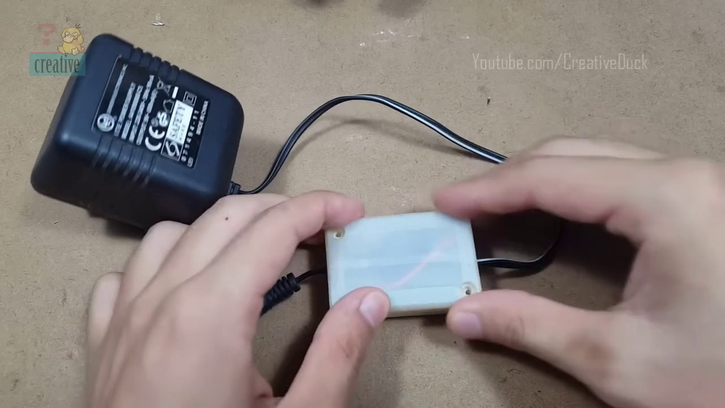 (score 95.0000)
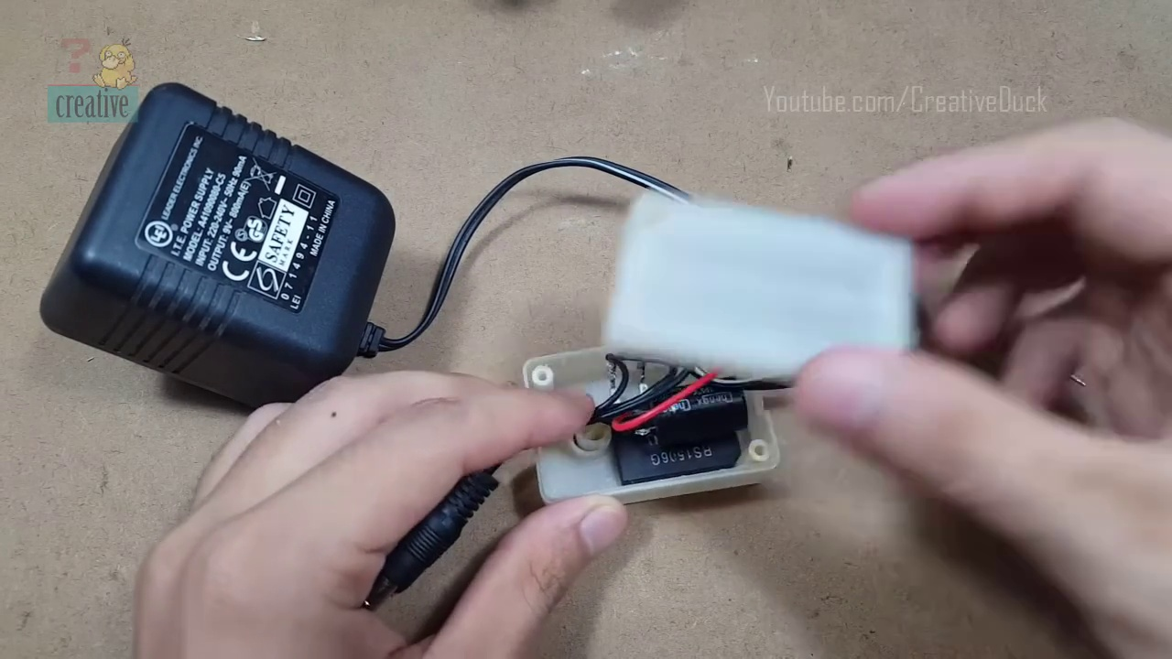 (score 95.0000)
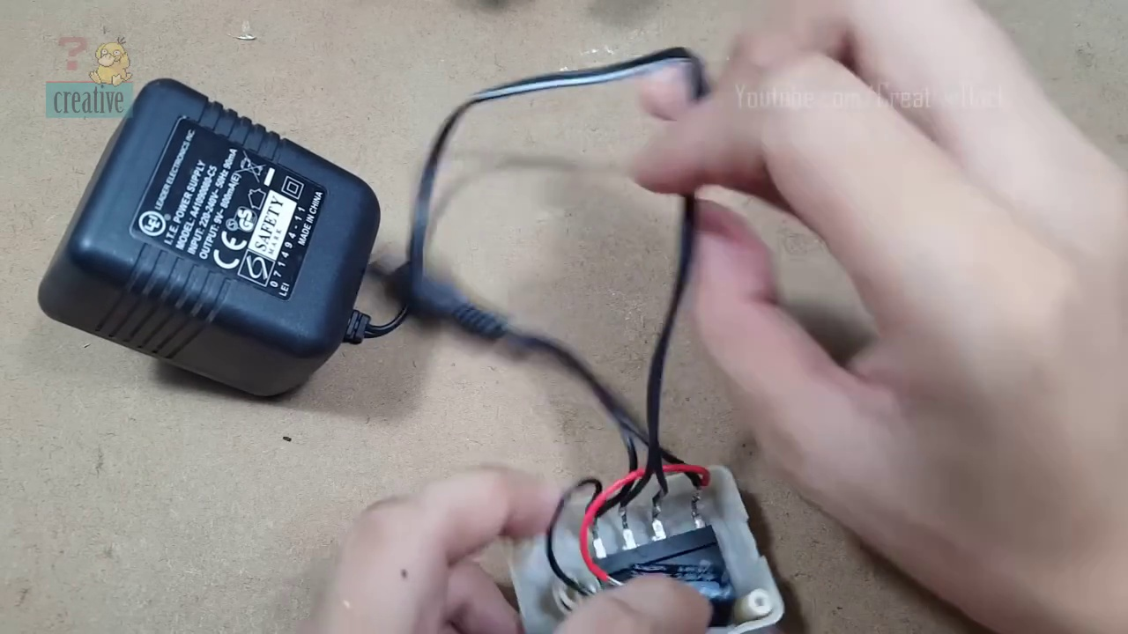 (score 95.0000)
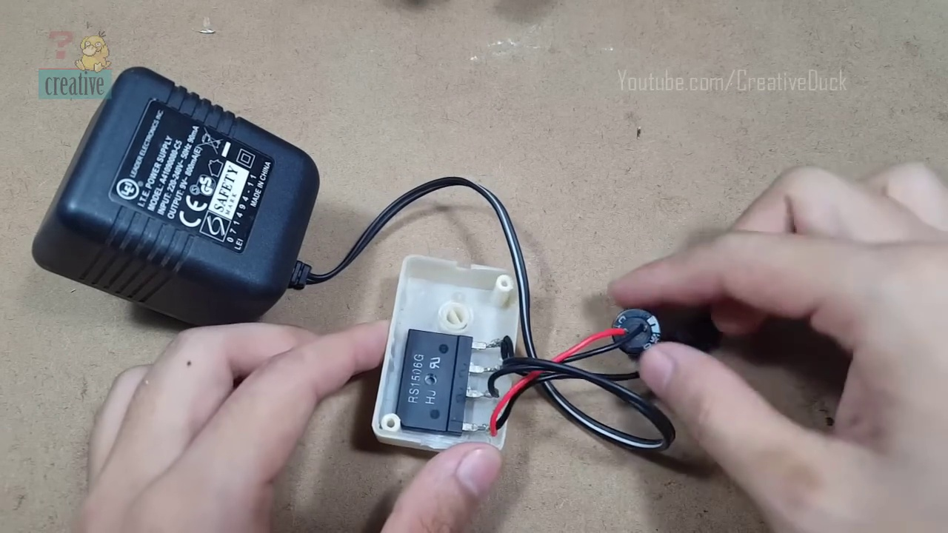 (score 95.0000)
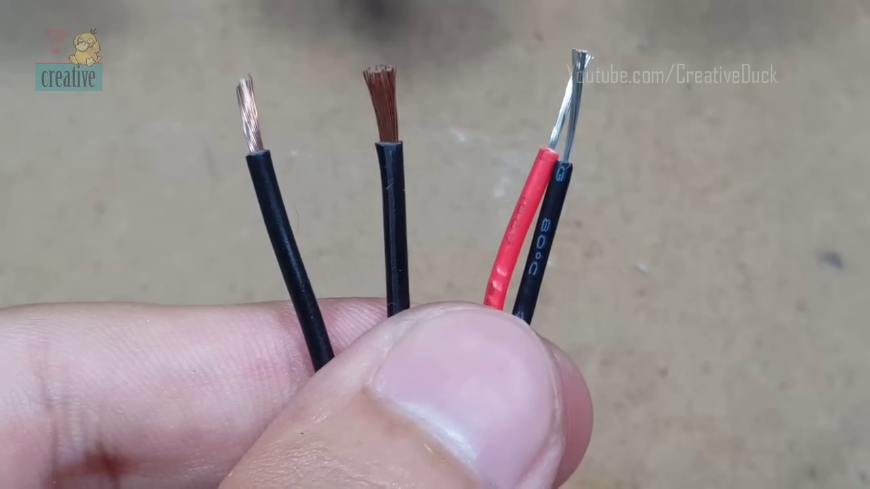 (score 95.0000)
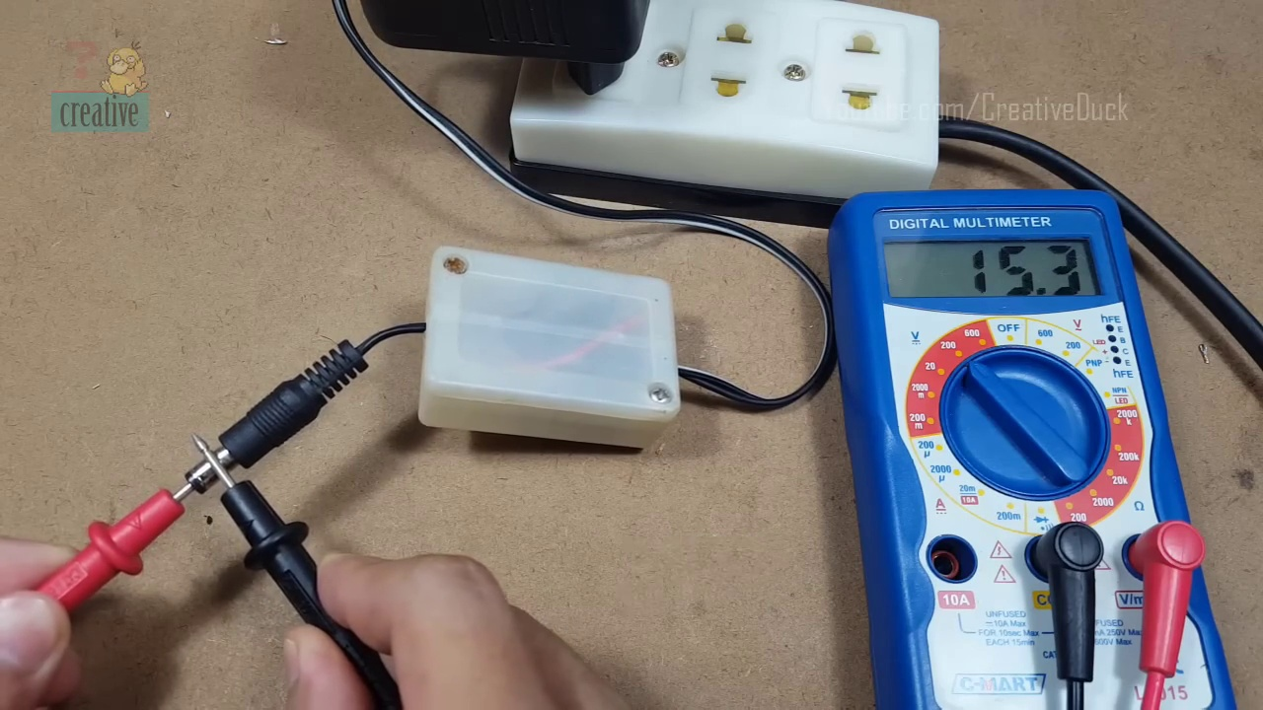 (score 90.0000)
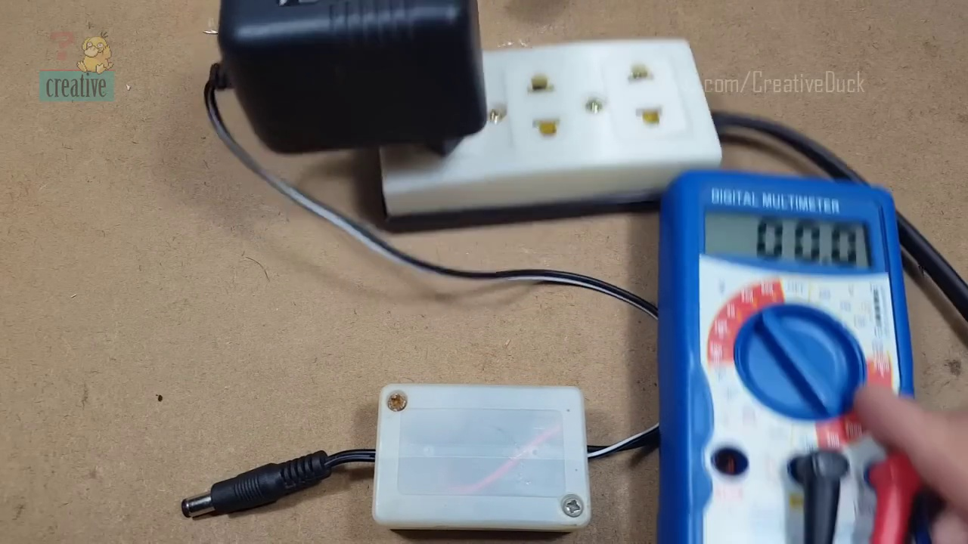 (score 90.0000)
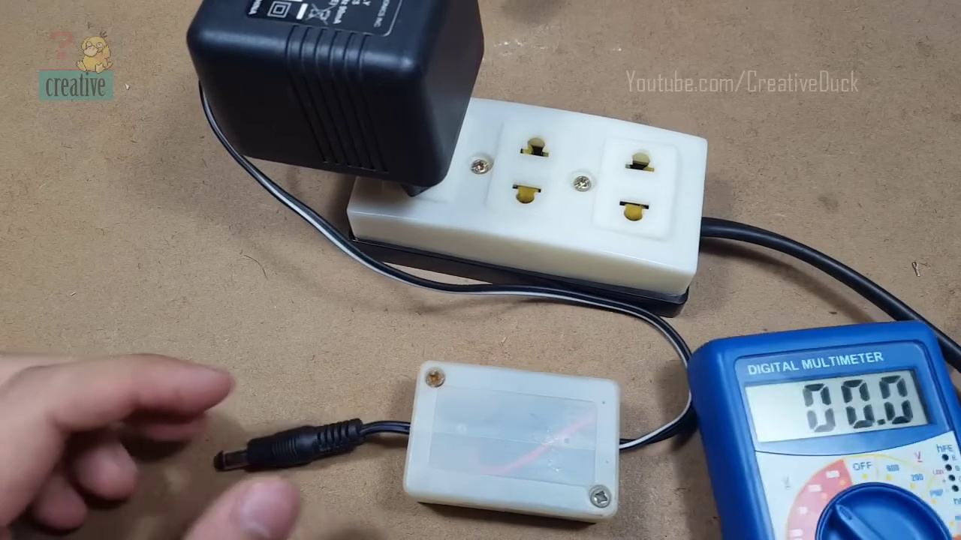 (score 90.0000)
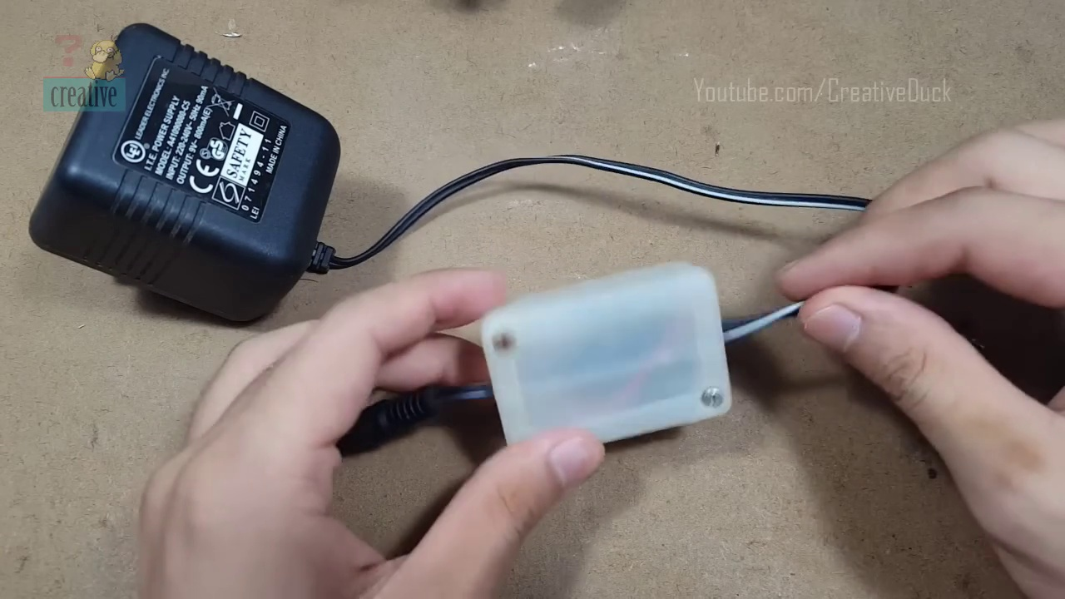 (score 90.0000)
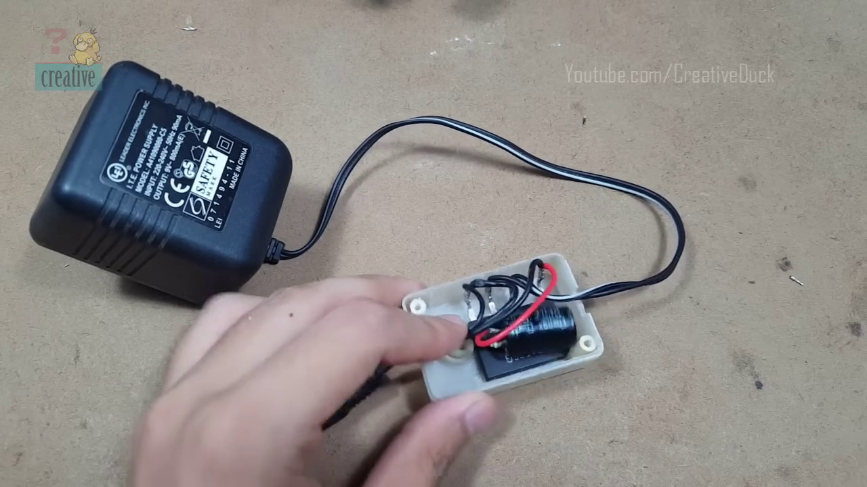 (score 90.0000)
Least correlated frames:
 (score 0.0000)
 (score 0.0000)
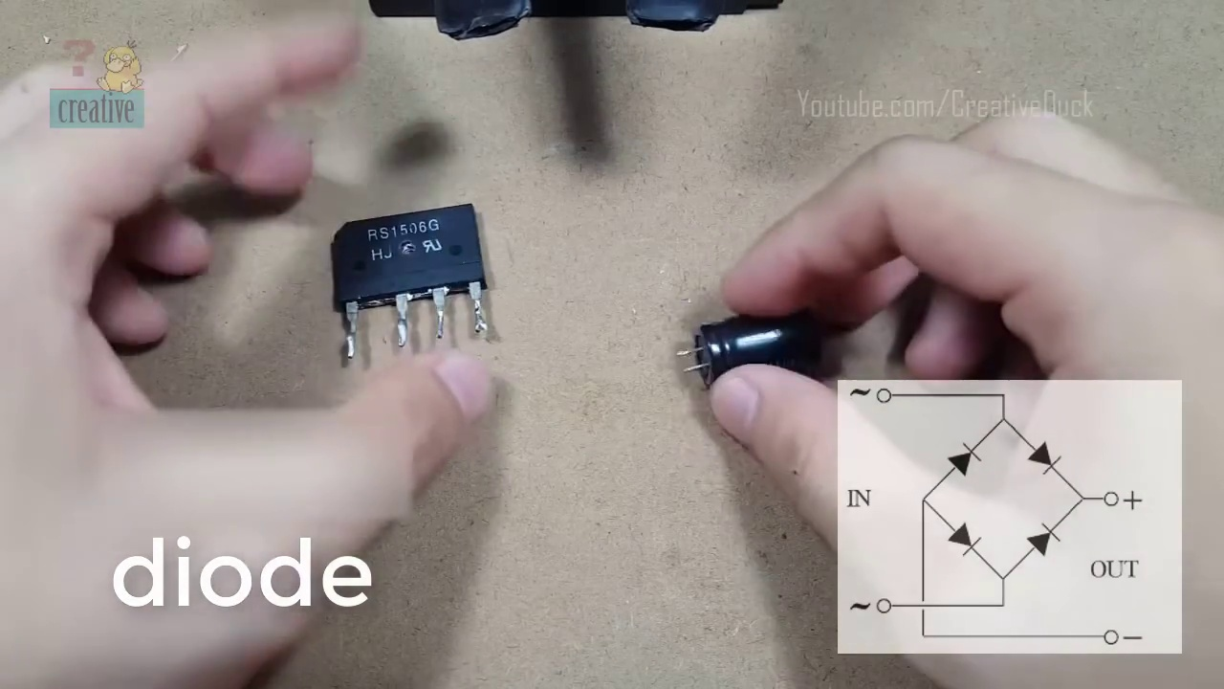 (score 20.0000)
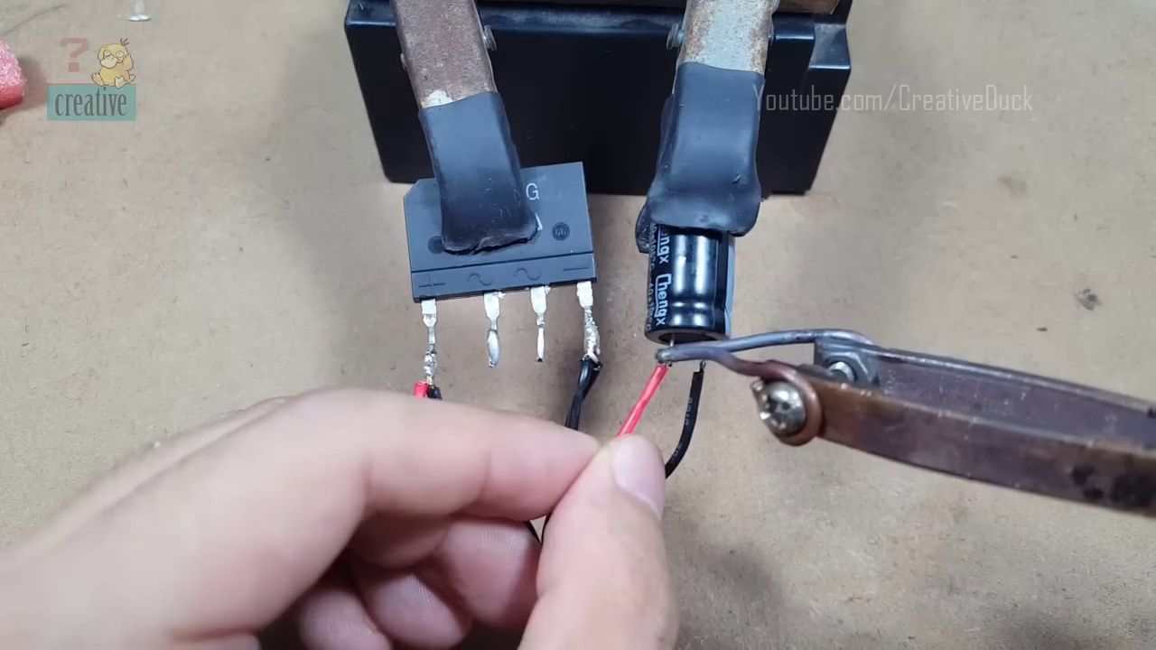 (score 20.0000)
 (score 20.0000)
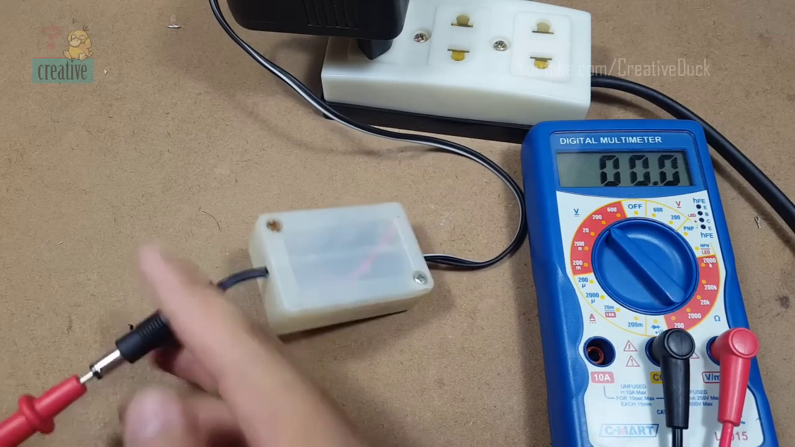 (score 30.0000)
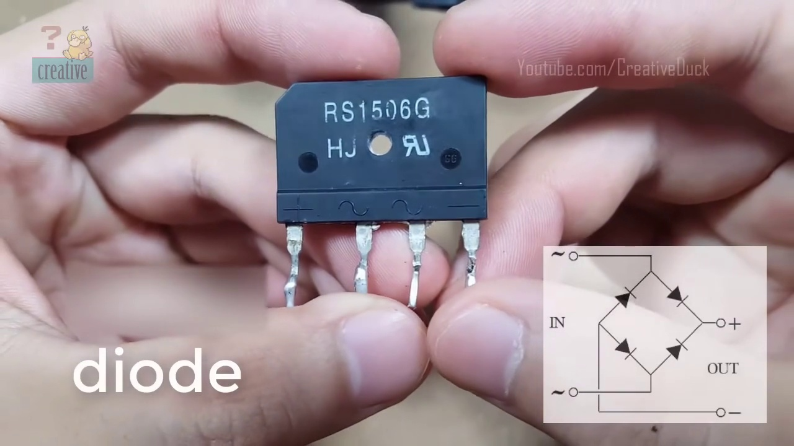 (score 80.0000)
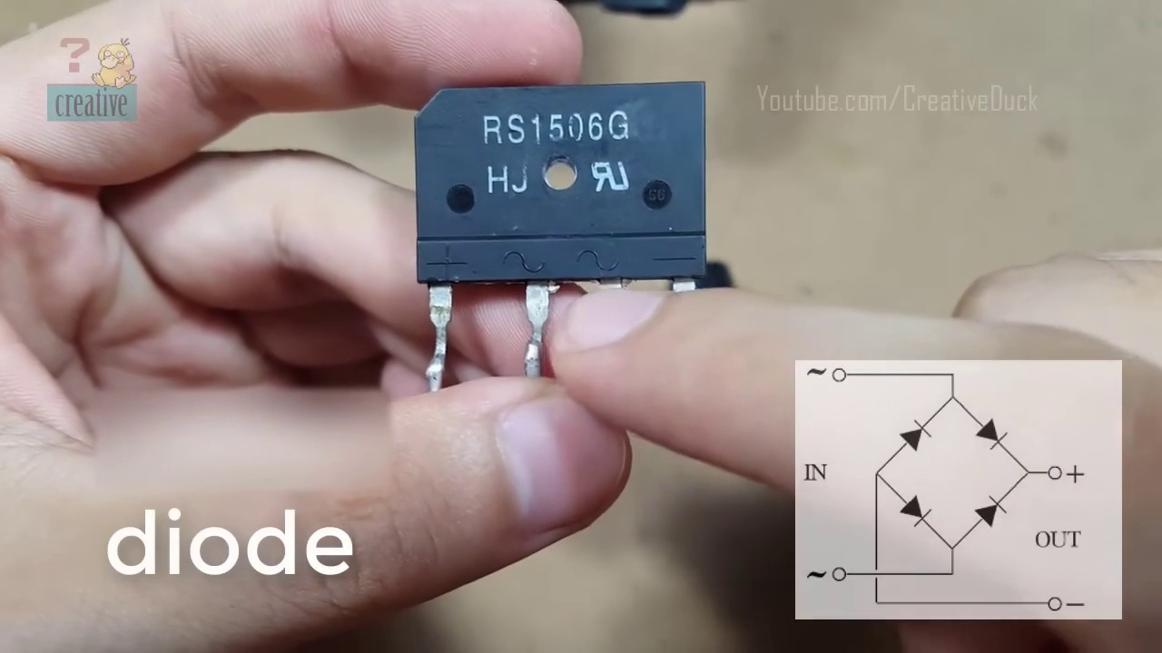 (score 80.0000)
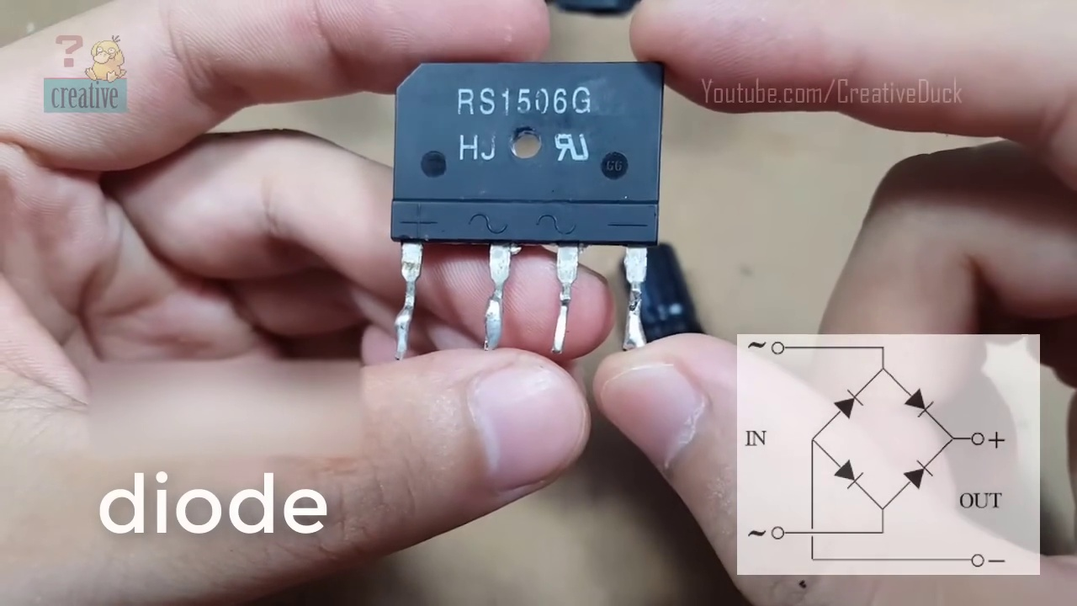 (score 80.0000)
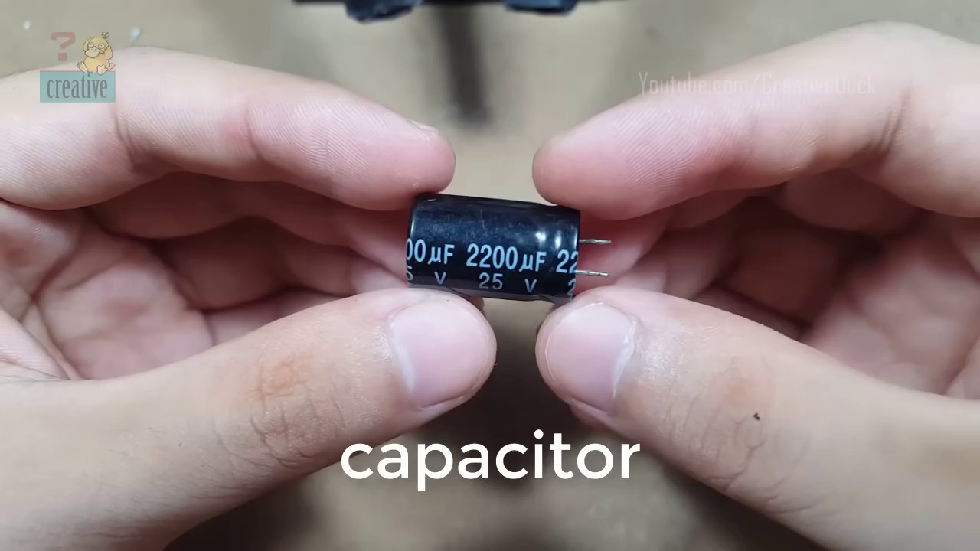 (score 80.0000)
- matched 56 frame(s), max score 95.0000: What I have learned from the video is How to use a bridge diode to make AC into DC.How I plan to use the electrical system in the future is To make AC into DC.
Source: https://www.youtube.com/watch?v=jLXW6qVdfq4: Diodebro og kondensator AC til DC
Top correlated frames:
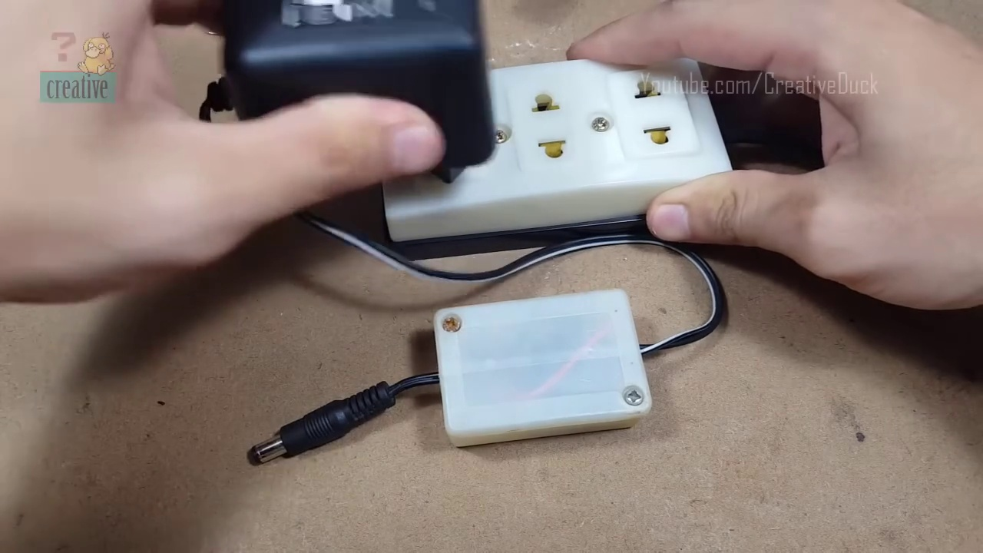 (score 95.0000)
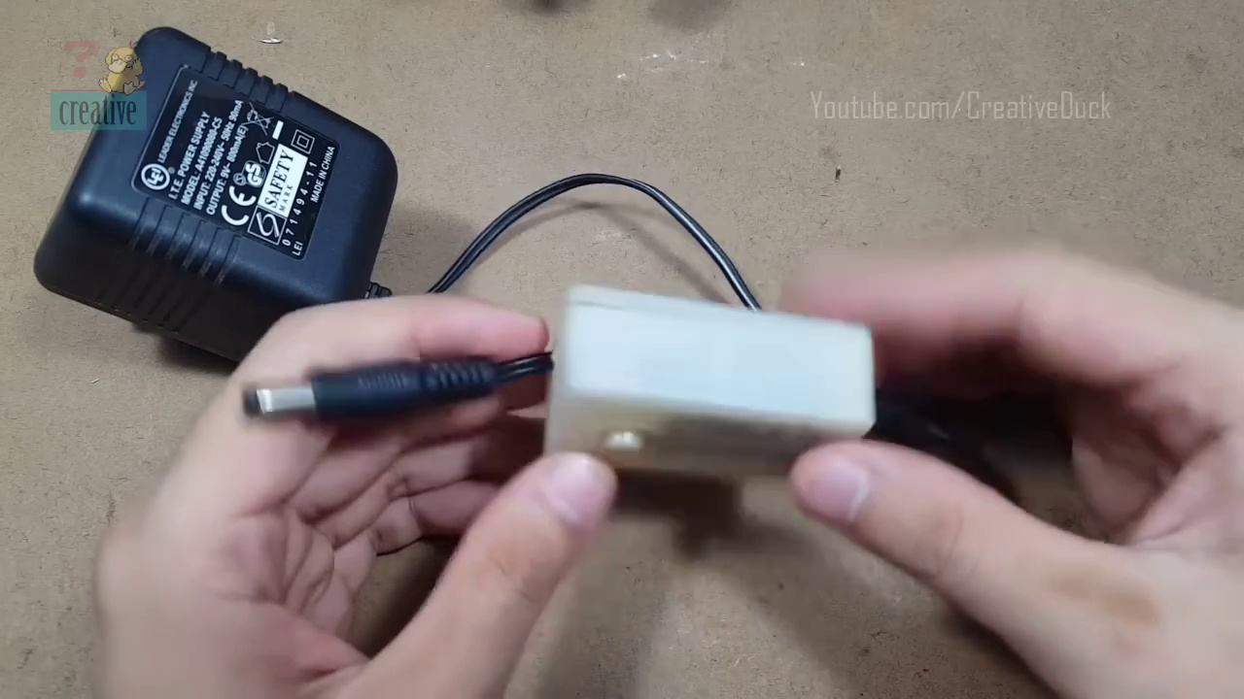 (score 95.0000)
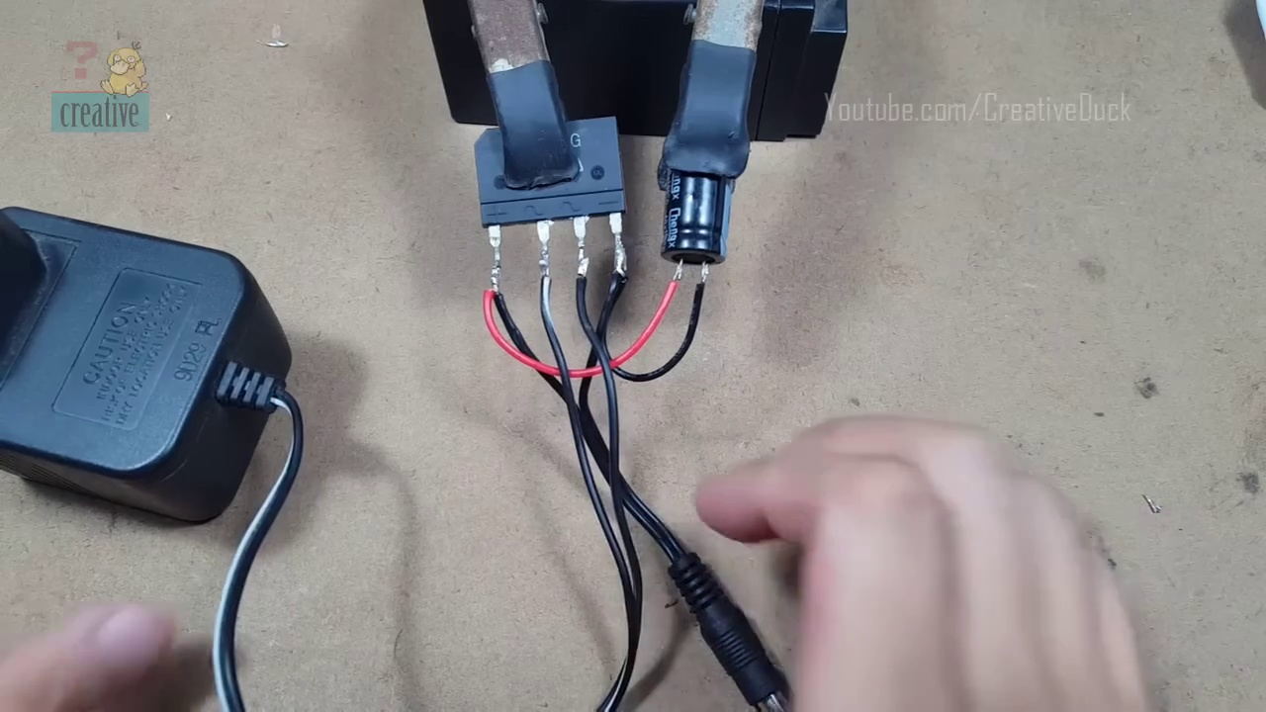 (score 95.0000)
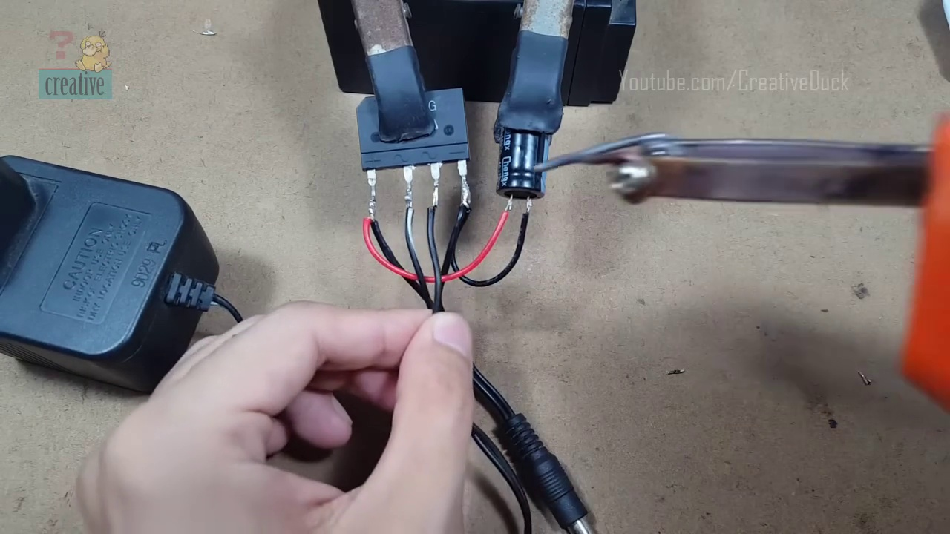 (score 95.0000)
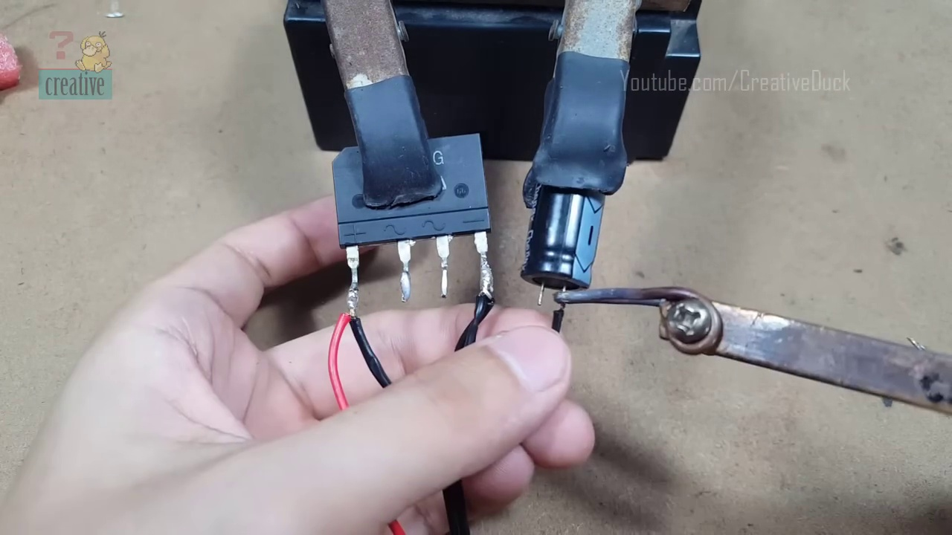 (score 95.0000)
 (score 90.0000)
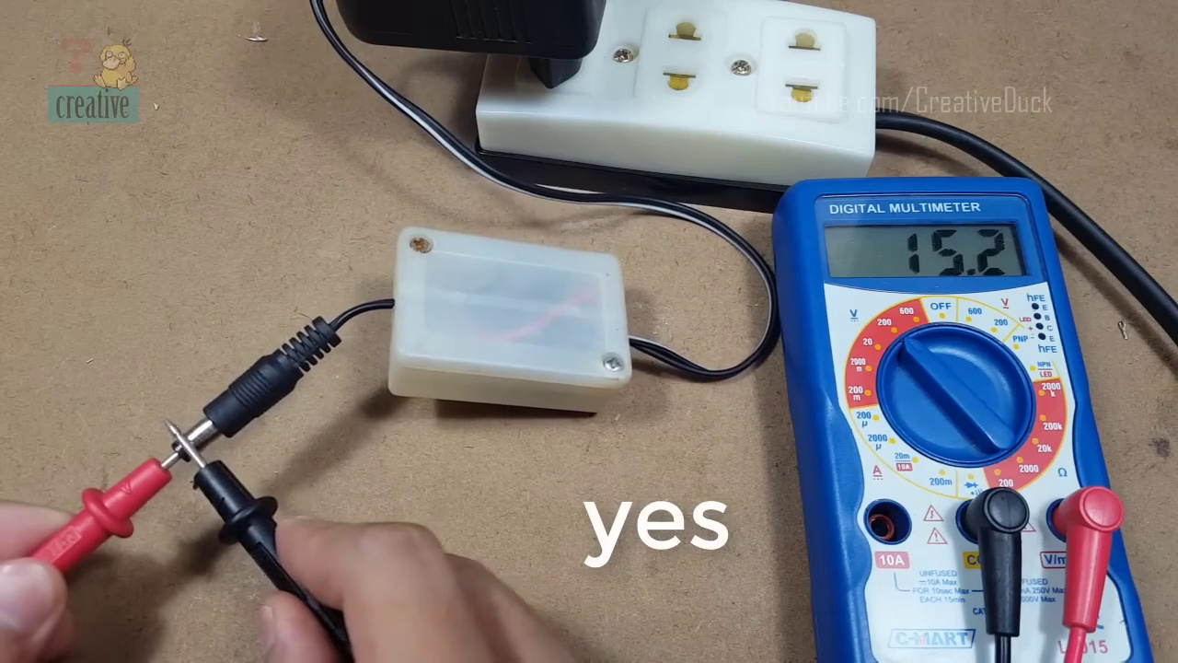 (score 90.0000)
 (score 90.0000)
 (score 90.0000)
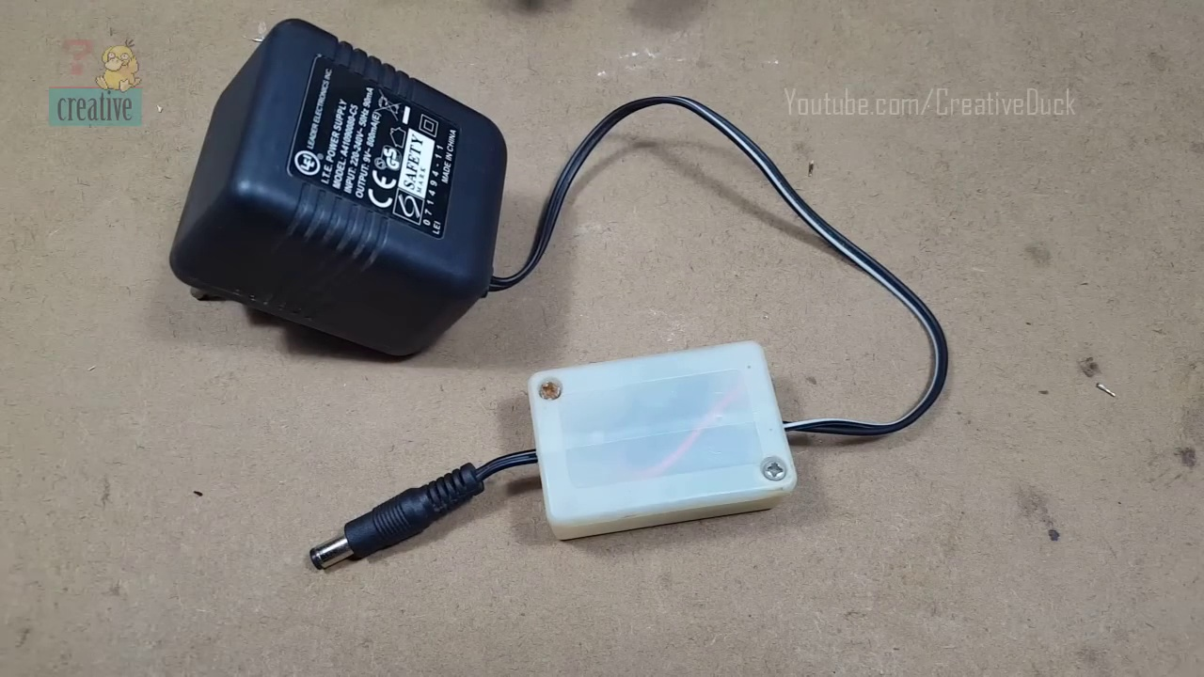 (score 90.0000)
Least correlated frames:
 (score 0.0000)
 (score 20.0000)
 (score 80.0000)
 (score 80.0000)
 (score 80.0000)
 (score 80.0000)
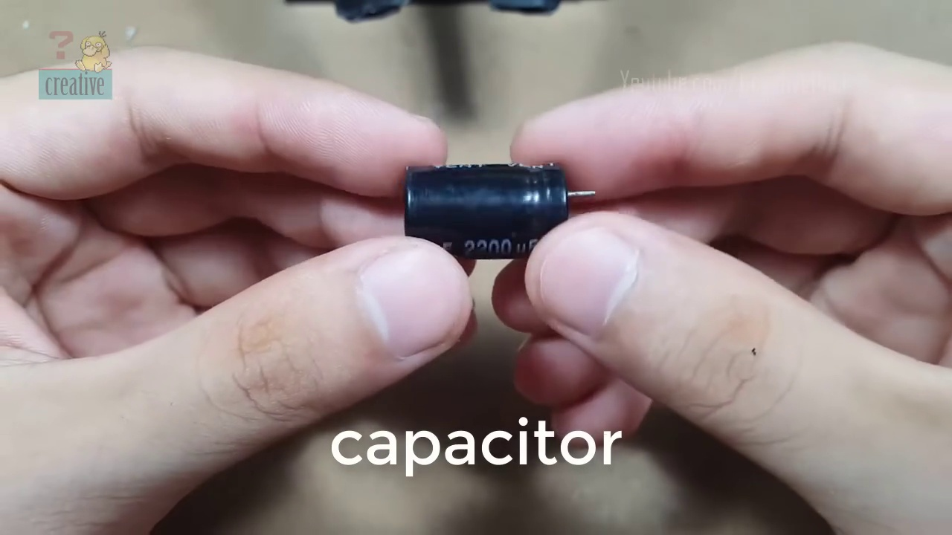 (score 80.0000)
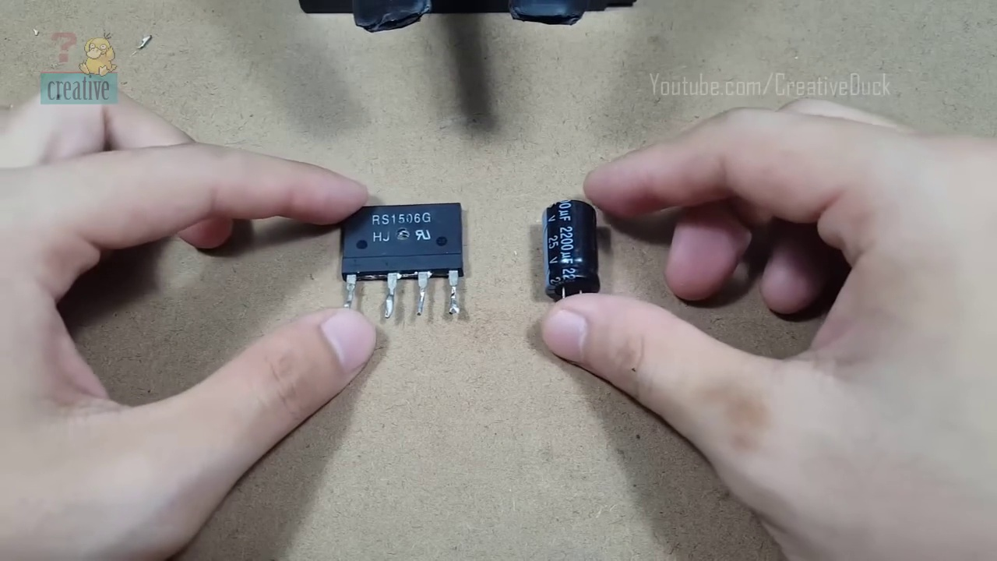 (score 80.0000)
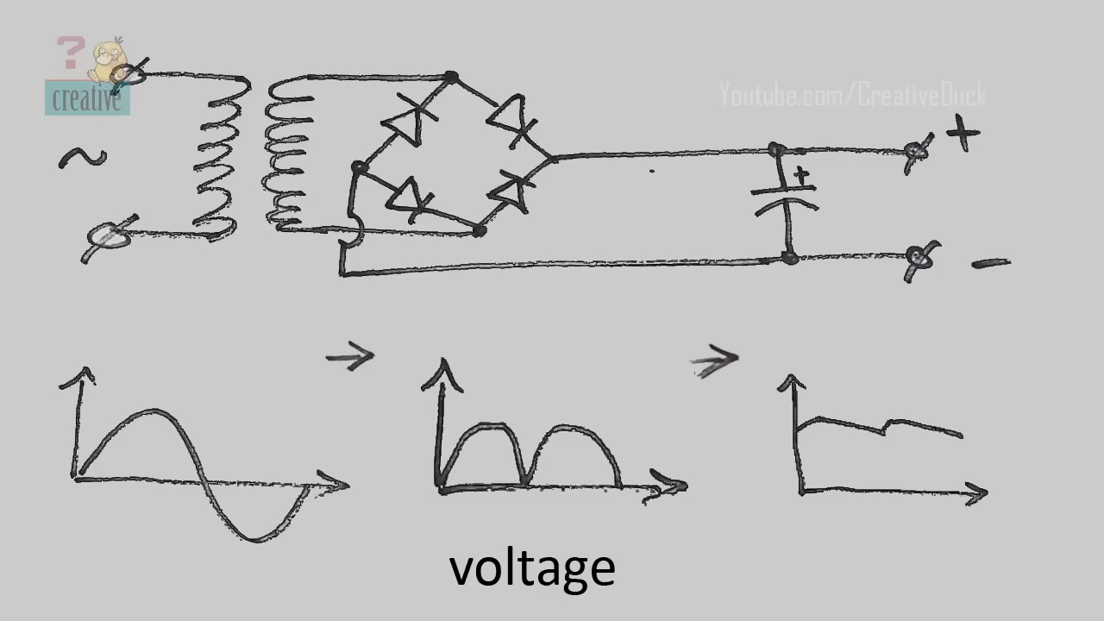 (score 80.0000)
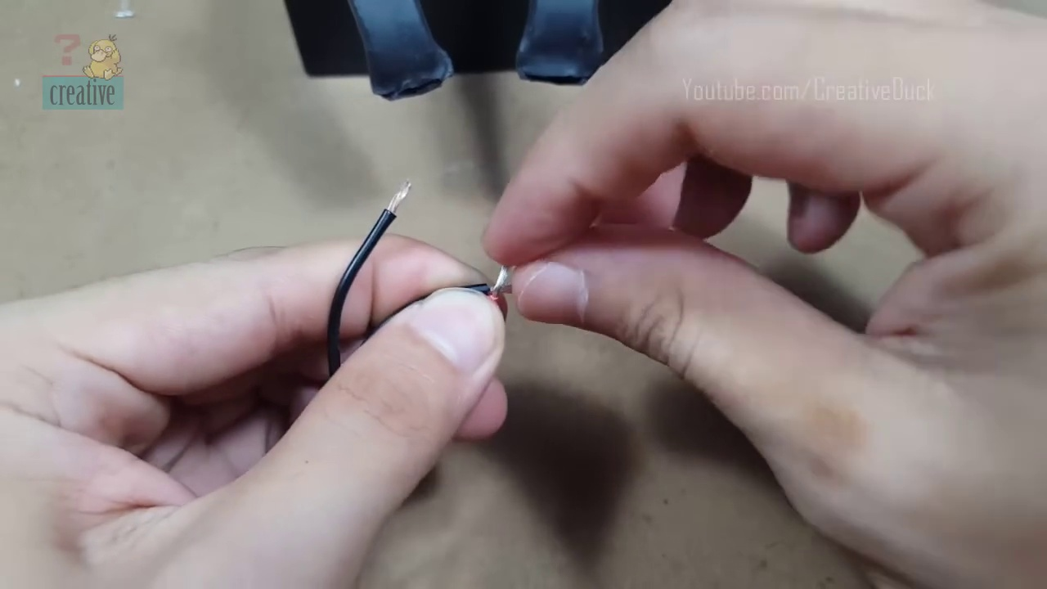 (score 80.0000)
- matched 52 frame(s), max score 95.0000: Learned how a simple bridge rectifier circuit converts AC to DC using a diode bridge and capacitor.Understanding detailed capacitor behavior within the circuit.knowledge to design basic power supply circuits in practical projects.
Source: https://www.youtube.com/watch?v=jLXW6qVdfq4 :Diode Bridge and Capacitor AC to DC
Top correlated frames:
 (score 95.0000)
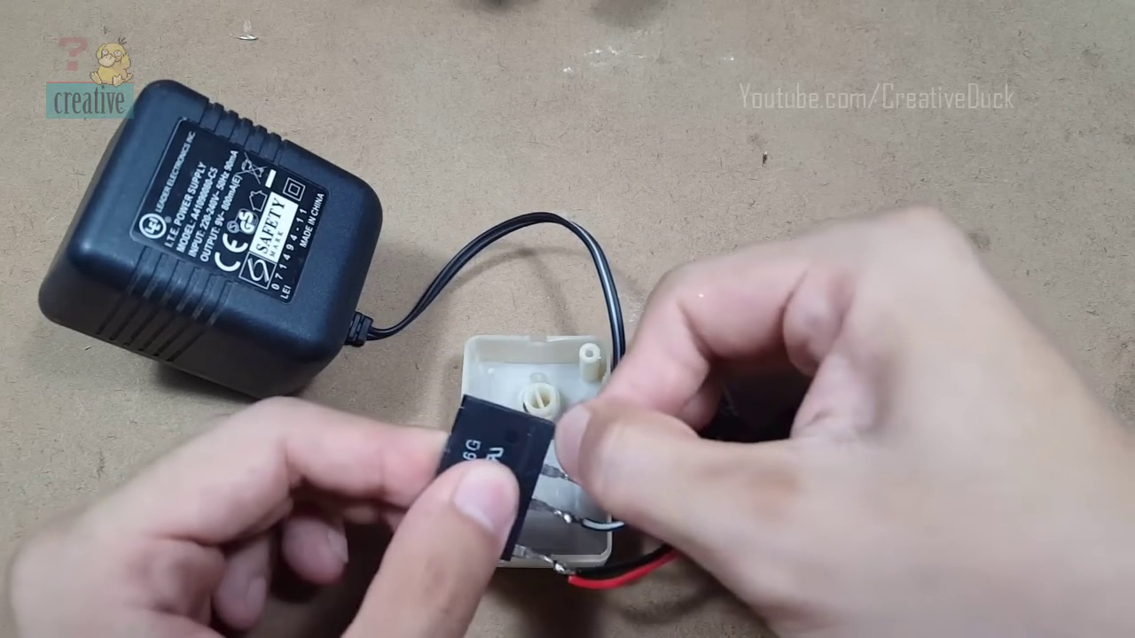 (score 95.0000)
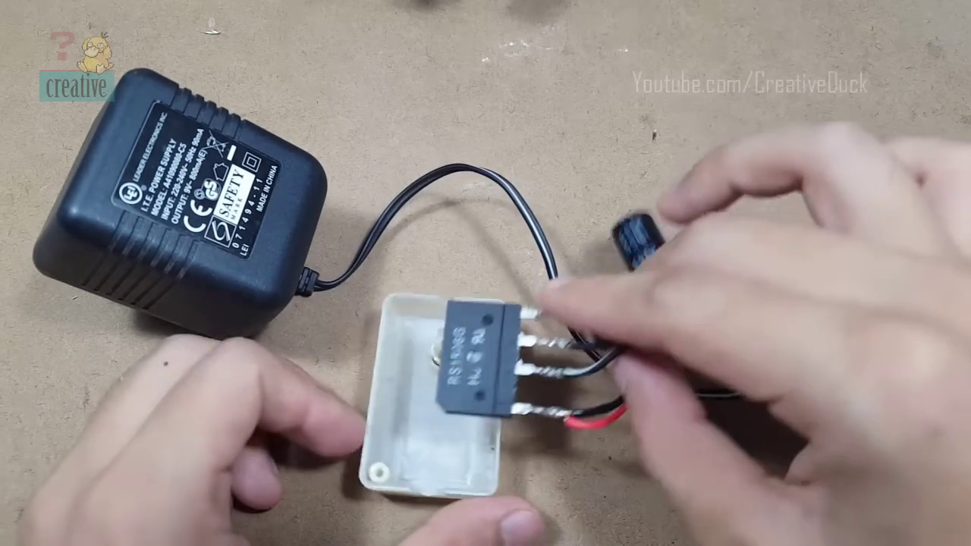 (score 95.0000)
 (score 95.0000)
 (score 90.0000)
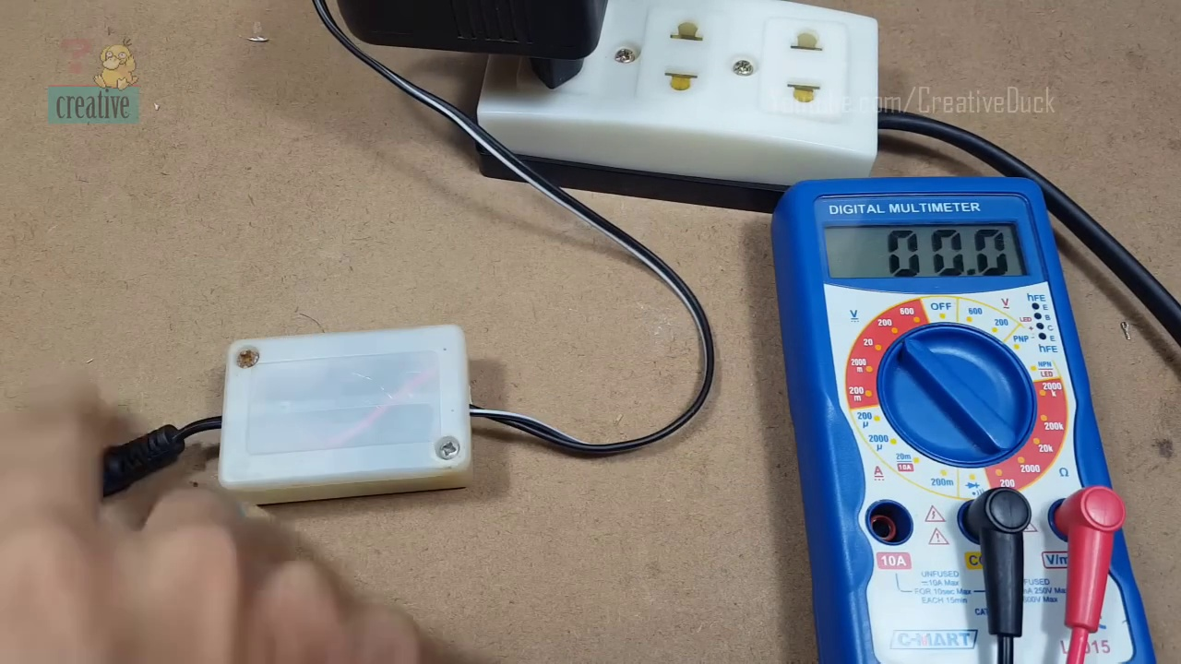 (score 90.0000)
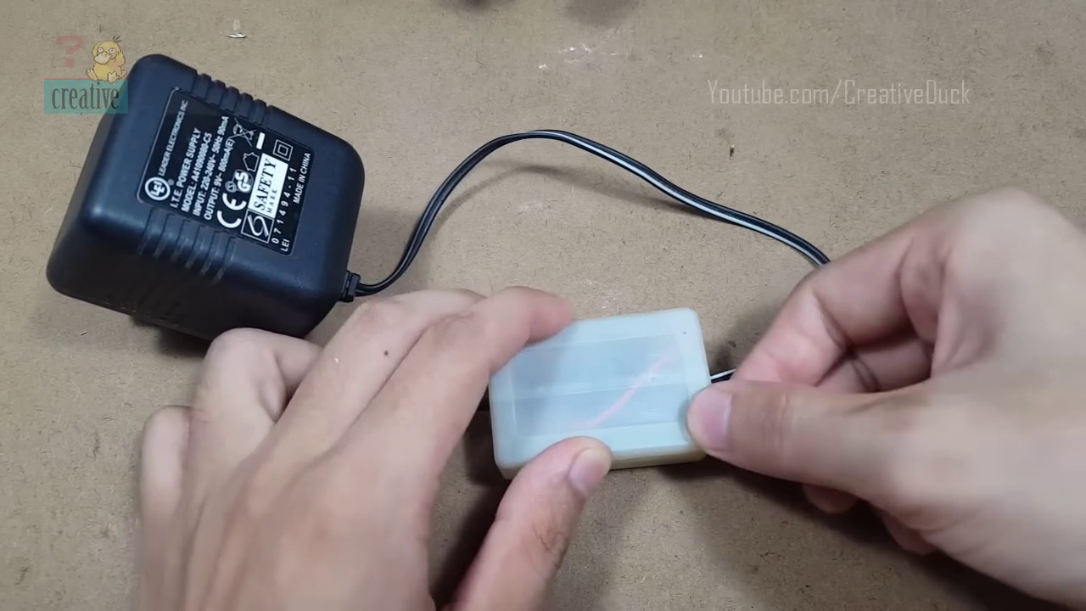 (score 90.0000)
 (score 90.0000)
 (score 90.0000)
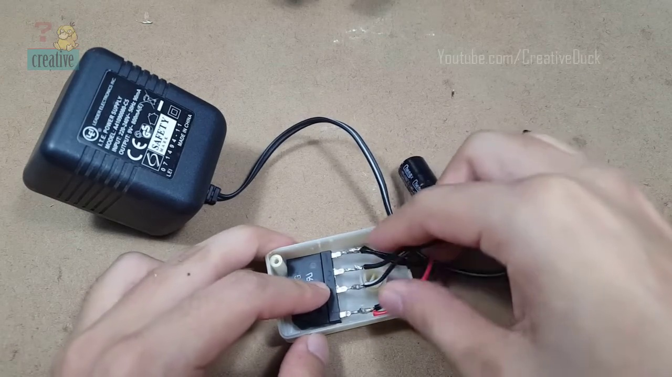 (score 90.0000)
Least correlated frames:
 (score 0.0000)
 (score 0.0000)
 (score 0.0000)
 (score 5.0000)
 (score 20.0000)
 (score 20.0000)
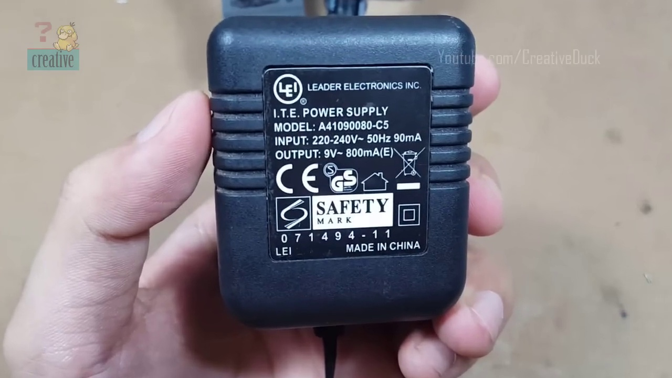 (score 20.0000)
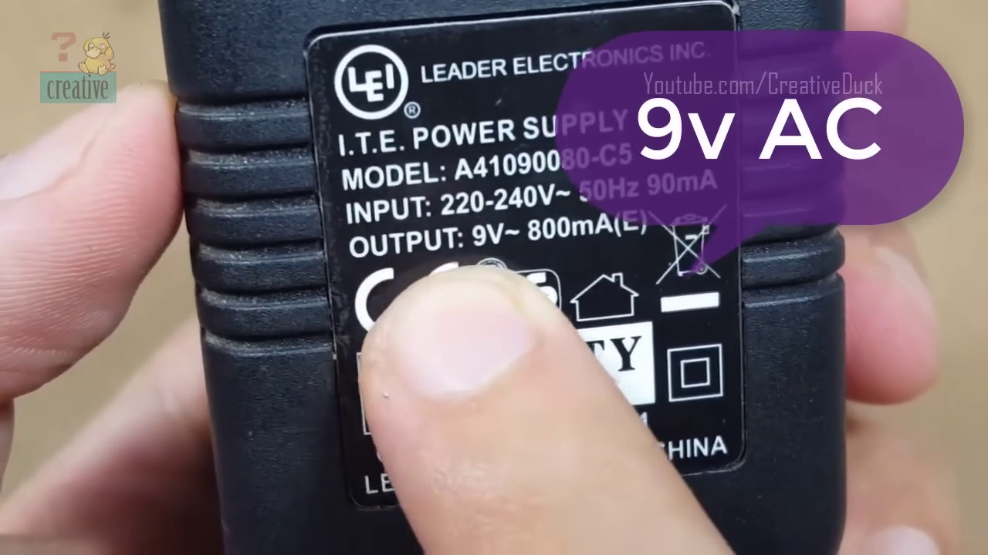 (score 20.0000)
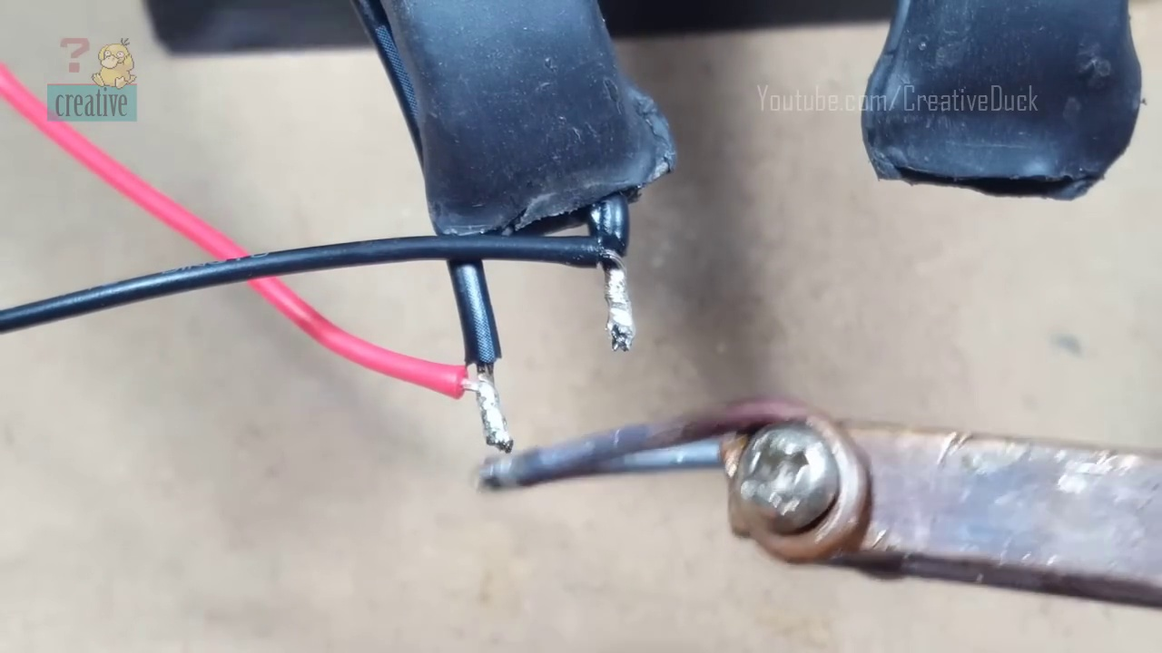 (score 40.0000)
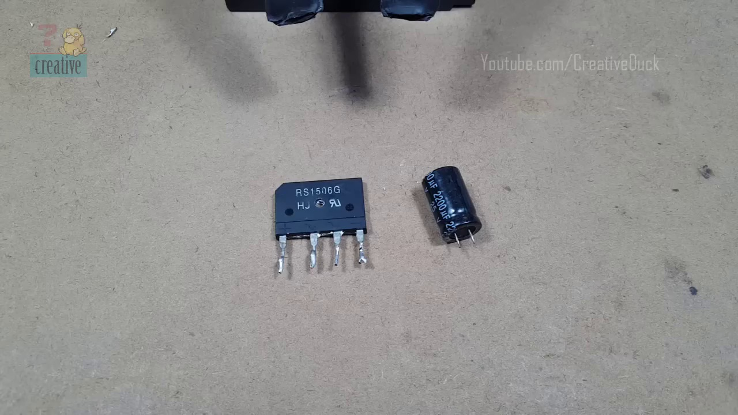 (score 80.0000)

Frame: frame_0000.jpg
Caption: An image captures a close-up view of a black electronic component, labeled "R51186G" and "J12-04-06-06-06-06-06-06-06-06-... (extremely long series of numbers)". There is no instructor or any educational setting visible in the image provided. The focus is solely on the objects present in the image, including the electronic component itself, a soldering iron, and a small bag that might contain solder or other small parts.
Comment (score 90): A clear explanation of how to convert alternating current (AC) to direct current (DC) using a diode bridge and capacitors. The video detailed how the components filter and stabilize the output voltage.What confused me: The discharge behavior of capacitors and the concept of ripple voltage weren't fully explained, which made the video difficult to follow at times. How I plan to use the electrical system in the future: Use these principles to design efficient power supply circuits for electronics projects, ensuring devices receive stable DC voltage.
Reason: The comment provides a clear explanation of converting AC to DC using the same electronic component featured in the caption (diode bridge and capacitors), which is strongly related to the frame caption.
Source: https://www.youtube.com/watch?v=jLXW6qVdfq4: Diode Bridge and Capacitor AC to DC
Comment (score 90): What I have learned from the video is How to use a bridge diode to make AC into DC.How I plan to use the electrical system in the future is To make AC into DC.
Reason: The comment directly discusses using a bridge diode to convert AC to DC, which is mentioned in the caption as 'R51186G', a black electronic component with an extremely long series of numbers. The connection is strong because it specifically refers to the same technical step and goal described in the caption.
Source: https://www.youtube.com/watch?v=jLXW6qVdfq4: Diodebro og kondensator AC til DC
Comment (score 80): Learned how a simple bridge rectifier circuit converts AC to DC using a diode bridge and capacitor.Understanding detailed capacitor behavior within the circuit.knowledge to design basic power supply circuits in practical projects.
Reason: The comment directly discusses the electronic component mentioned in the caption (R51186G), specifically referencing its use in a bridge rectifier circuit. The mention of capacitor behavior and power supply circuits is also relevant to the caption's focus on the component and its potential usage.
Source: https://www.youtube.com/watch?v=jLXW6qVdfq4 :Diode Bridge and Capacitor AC to DC

Frame: frame_0001.jpg
Caption: The image displays a small electronic device, likely an integrated circuit (IC) chip, with text on it that reads "AS1601U". This is accompanied by an illustration showing how to connect two components using a breadboard and jumper wires. The breadboard is being held by someone's hand visible at the bottom right corner of the image.
Below the illustration, additional text reads "A1ODE", which might refer to the specific model or type of the electronic device shown. An icon depicting a series of concentric circles is also present, possibly symbolizing a connection or loop, representing a path for connecting components on the breadboard.
The background of the image appears to be a simple indoor setting that is not in focus. The overall style and informative nature of the text and symbols suggest that this image is part of an educational content, likely from a tutorial or lesson video.
In the foreground, a person holds a tiny electronic component, specifically a transistor labeled as "RS1516G", in their hands. The component is encased in a black rectangular plastic case with a white label prominently displaying its specifications: model number RS1516G and voltage rating 5V. A small silver clip holds the component in place on a white surface that contrasts with the black case.
The background of this scene appears to be a workshop or laboratory setting, where the person is working with electronic components. The image is taken from a slightly elevated angle, providing a clear view of the component and its surroundings.
Comment (score 80): A clear explanation of how to convert alternating current (AC) to direct current (DC) using a diode bridge and capacitors. The video detailed how the components filter and stabilize the output voltage.What confused me: The discharge behavior of capacitors and the concept of ripple voltage weren't fully explained, which made the video difficult to follow at times. How I plan to use the electrical system in the future: Use these principles to design efficient power supply circuits for electronics projects, ensuring devices receive stable DC voltage.
Reason: The comment directly discusses the same technical steps and concepts described in the caption, specifically the conversion of AC to DC using a diode bridge and capacitors.
Source: https://www.youtube.com/watch?v=jLXW6qVdfq4: Diode Bridge and Capacitor AC to DC
Comment (score 80): Learned how a simple bridge rectifier circuit converts AC to DC using a diode bridge and capacitor.Understanding detailed capacitor behavior within the circuit.knowledge to design basic power supply circuits in practical projects.
Reason: The comment discusses a specific electronic circuit (bridge rectifier) and its components (diode bridge, capacitor), which are directly related to the technical steps described in the caption. The mention of capacitor behavior and designing power supply circuits also aligns with the illustration and text in the caption, showing how to connect components on a breadboard.
Source: https://www.youtube.com/watch?v=jLXW6qVdfq4 :Diode Bridge and Capacitor AC to DC

Frame: frame_0002.jpg
Caption: The image shows a person's hand holding an electronic component, labeled with the code "R503," against the background of what appears to be a workbench or desk. The component has two rows of gold pins, indicating it could be a type of resistor or connector used in electronics. To the right of the component, there is an instructional image displaying the component's schematic diagram with its corresponding pins labeled as "Vcc," "IN," and "OUT," suggesting how it might be connected within a circuit. The text "AODE" is present in this part of the image, which could indicate that the component is an analog output device or related to audio connections.
In the background, a white circuit board is visible, featuring various components such as resistors, diodes, and transistors arranged in a grid-like pattern. The numbers on the board are written in red and black, while the symbols are written in black, providing information about the components they represent. The resistors and diodes are positioned towards the left side of the board, while the transistors are located towards the right.
The image does not contain any text in other languages, focusing entirely on the circuit board and its components. The use of white space around the components and the grid-like arrangement of the board make it easy to see and understand the components and their arrangement.
Overall, the image provides a clear and detailed view of both the electronic component and the circuit board, showcasing the components and their arrangements in an educational context, possibly related to electronics, DIY electronics projects, or tinkering with circuits. The inclusion of "Creative Duck" and "YouTube" suggests that this might be a video or tutorial related to electronics.
Comment (score 85): What I have learned from the video is How to use a bridge diode to make AC into DC.How I plan to use the electrical system in the future is To make AC into DC.
Reason: The comment directly discusses the use of a bridge diode to make AC into DC, which is strongly related to the technical steps described in the caption (using the electronic component 'R503' and its pins to create a circuit). The caption's focus on the schematic diagram and pin labels also matches the commenter's mention of using the electrical system to convert AC into DC.
Source: https://www.youtube.com/watch?v=jLXW6qVdfq4: Diodebro og kondensator AC til DC
Comment (score 80): A clear explanation of how to convert alternating current (AC) to direct current (DC) using a diode bridge and capacitors. The video detailed how the components filter and stabilize the output voltage.What confused me: The discharge behavior of capacitors and the concept of ripple voltage weren't fully explained, which made the video difficult to follow at times. How I plan to use the electrical system in the future: Use these principles to design efficient power supply circuits for electronics projects, ensuring devices receive stable DC voltage.
Reason: The comment directly discusses the same technical steps and concepts described in the caption, such as converting AC to DC using a diode bridge and capacitors, and stabilizing output voltage. The only reason it's not 100% is that the caption doesn't specifically mention ripple voltage.
Source: https://www.youtube.com/watch?v=jLXW6qVdfq4: Diode Bridge and Capacitor AC to DC
Comment (score 80): Learned how a simple bridge rectifier circuit converts AC to DC using a diode bridge and capacitor.Understanding detailed capacitor behavior within the circuit.knowledge to design basic power supply circuits in practical projects.
Reason: The comment directly discusses the same technical steps and components described in the caption, specifically mentioning a bridge rectifier circuit, diode bridge, capacitor, and power supply circuits. The language used in the comment also matches the tone of the caption's description of electronic components and their arrangements.
Source: https://www.youtube.com/watch?v=jLXW6qVdfq4 :Diode Bridge and Capacitor AC to DC

Frame: frame_0003.jpg
Caption: The image presents a close-up view of someone's hands holding a square-shaped electronic component, specifically a 1055 integrated circuit (IC), commonly used in various electronics projects. The person is using their fingernails to hold the IC's pins. In the background, there is a diagram showing electrical connections with labels like "AODE" and "GND," which stand for Analog Output and Ground, respectively. The diagram appears to be related to electronics or programming.
The text "АОДЕ" is visible on the diagram, but without knowing the language, it's not possible to provide a direct translation or context for this label. The setting seems informal and hands-on, with an emphasis on practicality rather than theoretical concepts, suggesting that the image might be part of an educational video or tutorial.
The person holding the IC is also seen holding a small piece of paper in their right hand, which contains some text. The text reads "YouTube.com/Duck" and "CreativeDuck.se", indicating that the video related to the diode might be available on these platforms. Overall, the scene suggests an interest in electronics and DIY projects.
Comment (score 80): A clear explanation of how to convert alternating current (AC) to direct current (DC) using a diode bridge and capacitors. The video detailed how the components filter and stabilize the output voltage.What confused me: The discharge behavior of capacitors and the concept of ripple voltage weren't fully explained, which made the video difficult to follow at times. How I plan to use the electrical system in the future: Use these principles to design efficient power supply circuits for electronics projects, ensuring devices receive stable DC voltage.
Reason: The comment directly discusses the technical steps described in the caption, such as converting AC to DC using a diode bridge and capacitors, which is strongly related to the image of an integrated circuit (IC) with electrical connections.
Source: https://www.youtube.com/watch?v=jLXW6qVdfq4: Diode Bridge and Capacitor AC to DC
Comment (score 80): What I have learned from the video is How to use a bridge diode to make AC into DC.How I plan to use the electrical system in the future is To make AC into DC.
Reason: The comment directly discusses the same technical concept (converting AC to DC) and uses similar terminology ('bridge diode') as described in the caption. The goal of using the electrical system is also mentioned, which matches the focus on practicality and DIY projects hinted at in the caption.
Source: https://www.youtube.com/watch?v=jLXW6qVdfq4: Diodebro og kondensator AC til DC

Frame: frame_0004.jpg
Caption: The image shows a person's hands interacting with electronic components, specifically holding a black integrated circuit (IC) labeled "aide" which translates to "assist." One hand is holding the IC with its right side facing up while pointing towards the pins on the bottom of the chip. The other hand is resting on a small electronic component, specifically a black and white circuit board adorned with a red and black logo and the words "R15056G" in white.
The individual appears to be demonstrating how to properly orient an IC with respect to its pinout, as suggested by the graphic overlay on the top right side of the image. The graphic shows a simple circuit diagram with three pins: ground (GND), input (IN), and output (OUT). This diagram is likely used to illustrate which pins on the IC are for power supply and data transfer, indicating how to connect it to a breadboard or other electronic setup.
The hands are positioned on the board, with one thumb resting on the right side of the board and the other thumb resting on the left side. The board appears to be in the process of being assembled, suggesting an activity related to electronics or circuitry. There is no visible text in the image that could provide additional context or instructions. The focus of this frame seems to be teaching the viewer about the correct way to handle an IC and how to connect it within a circuit, with the circuit board serving as a reference point for assembly or examination.
Comment (score 80): What I have learned from the video is How to use a bridge diode to make AC into DC.How I plan to use the electrical system in the future is To make AC into DC.
Reason: The comment directly discusses the same technical step mentioned in the caption (handling an IC and connecting it within a circuit) and uses similar terminology (AC to DC conversion). The correlation is not perfect due to the comment focusing on bridge diodes rather than the specific IC handling steps described in the caption.
Source: https://www.youtube.com/watch?v=jLXW6qVdfq4: Diodebro og kondensator AC til DC

Frame: frame_0005.jpg
Caption: The image shows a hand holding a black and white capacitor, with a rectangular shape and small black wires attached to its terminals. The capacitor appears to be open-circuit, but it is ready for use as the wires are connected to its terminals. The label "CAPACITOR" is visible in both English and another language on the component. The overall setting suggests an educational context, possibly demonstrating components used in electronics. In this moment, the person is holding the capacitor in a way that suggests they are about to install it in an electronic device, indicating a sense of readiness and anticipation for their project.
Comment (score 90): Learned how a simple bridge rectifier circuit converts AC to DC using a diode bridge and capacitor.Understanding detailed capacitor behavior within the circuit.knowledge to design basic power supply circuits in practical projects.
Reason: The comment directly discusses the use of a capacitor in an electronic circuit, specifically in a bridge rectifier circuit. The caption provides details on the physical appearance and usage of the capacitor, which is related to the technical context described in the comment.
Source: https://www.youtube.com/watch?v=jLXW6qVdfq4 :Diode Bridge and Capacitor AC to DC
Comment (score 80): A clear explanation of how to convert alternating current (AC) to direct current (DC) using a diode bridge and capacitors. The video detailed how the components filter and stabilize the output voltage.What confused me: The discharge behavior of capacitors and the concept of ripple voltage weren't fully explained, which made the video difficult to follow at times. How I plan to use the electrical system in the future: Use these principles to design efficient power supply circuits for electronics projects, ensuring devices receive stable DC voltage.
Reason: The comment directly discusses the use of capacitors and diode bridges to convert AC to DC, which is mentioned in the caption as a possible application in electronics. The caption also highlights the capacitor's state (open-circuit but ready for use) and its connection to an electronic device, which aligns with the comment's mention of using these principles to design power supply circuits.
Source: https://www.youtube.com/watch?v=jLXW6qVdfq4: Diode Bridge and Capacitor AC to DC
Comment (score 80): What I have learned from the video is How to use a bridge diode to make AC into DC.How I plan to use the electrical system in the future is To make AC into DC.
Reason: The comment directly discusses converting AC to DC using a bridge diode, which is closely related to the technical steps described in the caption (installing a capacitor) and the goal of making AC into DC mentioned in both. The connection between the comment and caption is strong as they both deal with electrical systems and conversions.
Source: https://www.youtube.com/watch?v=jLXW6qVdfq4: Diodebro og kondensator AC til DC

Frame: frame_0006.jpg
Caption: The image captures a close-up view of two hands holding a black capacitor, with the focus on demonstrating the device possibly in a teaching or instructional context related to electronics or physics. The hands are positioned in such a way that the thumb and index finger of each hand are placed on the sides of the capacitor, while the other fingers are spread apart. A human thumb and index finger from one of the hands are visible on top of the capacitor, adding to its representation. The text "capacitor" is clearly visible on the side of the capacitor, indicating its purpose. The background is blurred, drawing attention to the hands and the capacitor.
Comment (score 95): Learned how a simple bridge rectifier circuit converts AC to DC using a diode bridge and capacitor.Understanding detailed capacitor behavior within the circuit.knowledge to design basic power supply circuits in practical projects.
Reason: The comment directly discusses the capacitor's behavior and usage in a circuit, which is explicitly described in the caption as the focus on demonstrating the device. The mention of 'capacitor' and its role in a bridge rectifier circuit are strongly related to the frame caption.
Source: https://www.youtube.com/watch?v=jLXW6qVdfq4 :Diode Bridge and Capacitor AC to DC
Comment (score 85): A clear explanation of how to convert alternating current (AC) to direct current (DC) using a diode bridge and capacitors. The video detailed how the components filter and stabilize the output voltage.What confused me: The discharge behavior of capacitors and the concept of ripple voltage weren't fully explained, which made the video difficult to follow at times. How I plan to use the electrical system in the future: Use these principles to design efficient power supply circuits for electronics projects, ensuring devices receive stable DC voltage.
Reason: The comment directly discusses the same technical steps (converting AC to DC using a diode bridge and capacitors) and objects (capacitors) described in the caption, with a focus on their application in designing efficient power supply circuits.
Source: https://www.youtube.com/watch?v=jLXW6qVdfq4: Diode Bridge and Capacitor AC to DC
Comment (score 80): What I have learned from the video is How to use a bridge diode to make AC into DC.How I plan to use the electrical system in the future is To make AC into DC.
Reason: The comment directly discusses using a bridge diode to convert AC to DC, which is strongly related to the demonstration of a capacitor in the caption. The mention of converting AC to DC matches the teaching/instructional context hinted at in the caption.
Source: https://www.youtube.com/watch?v=jLXW6qVdfq4: Diodebro og kondensator AC til DC

Frame: frame_0007.jpg
Caption: The image shows two hands manipulating electronic components on a beige surface. One hand is holding a small black plastic component, possibly a resistor, capacitor, or another type of electronic part, and the other hand is holding a larger 1206 capacitor. The smaller component appears to be a 51188 HCU electronic chip. The scene suggests a moment of interaction or comparison between the two components, with no text or additional objects in sight.
The individual's hands are positioned such that the small component is closer to the viewer, and the hands are manipulating these components as part of an electronics assembly or experimentation process. The image captures a practical demonstration rather than an educational context, with the focus on hands-on activity related to electronics manipulation.
Comment (score 85): A clear explanation of how to convert alternating current (AC) to direct current (DC) using a diode bridge and capacitors. The video detailed how the components filter and stabilize the output voltage.What confused me: The discharge behavior of capacitors and the concept of ripple voltage weren't fully explained, which made the video difficult to follow at times. How I plan to use the electrical system in the future: Use these principles to design efficient power supply circuits for electronics projects, ensuring devices receive stable DC voltage.
Reason: The comment directly discusses the technical steps and components described in the caption, specifically the use of a diode bridge and capacitors to convert AC to DC. The caption's focus on electronics manipulation is also matched by the commenter's plans for designing efficient power supply circuits.
Source: https://www.youtube.com/watch?v=jLXW6qVdfq4: Diode Bridge and Capacitor AC to DC
Comment (score 80): What I have learned from the video is How to use a bridge diode to make AC into DC.How I plan to use the electrical system in the future is To make AC into DC.
Reason: The comment directly discusses using a bridge diode to make AC into DC, which is strongly related to the frame caption showing hands manipulating electronic components, possibly including a resistor or capacitor (mentioned in the caption). The focus on electronics manipulation and conversion of AC to DC in the comment matches the practical demonstration depicted in the frame caption.
Source: https://www.youtube.com/watch?v=jLXW6qVdfq4: Diodebro og kondensator AC til DC

Frame: frame_0008.jpg
Caption: The image presents a black and white illustration of an educational setting, featuring a teacher who appears to be instructing in a classroom environment. On the left side of the image, there is a whiteboard with various hand-drawn diagrams and notes related to electrical circuits. These include a circuit diagram with multiple components such as a battery, wires, a light bulb, and possibly switches or connectors, along with annotations and arrows indicating how these elements might be connected to form a simple electrical circuit. There are also what seem to be mathematical equations or notations related to electricity and electron flow.
The right side of the image shows a slide presentation with a title "Voltage" and a subtitle "Basic concept." The slide is structured with text, diagrams, and bullet points, likely explaining the concept of voltage in the context of electrical circuits. Specifically, the content of the slides includes a clear definition of voltage, a visual representation of a voltmeter being used to measure voltage, and examples of how voltage can affect an electric circuit.
In addition to these materials, a simple diagram illustrating the concept of voltage is also presented. This diagram consists of two parallel lines: one labeled as "voltage" with a red arrow pointing from left to right, and another labeled as "current" with a blue arrow also pointing from left to right. A box labeled "resistance" is represented by a black square. The entire diagram is set against a gray background, providing a neutral backdrop for the symbols and arrows.
Overall, this image suggests that the teacher is providing an educational lesson on the concept of voltage in electricity, using both blackboard notes and slide presentation materials to aid in the teaching process.
Comment (score 85): A clear explanation of how to convert alternating current (AC) to direct current (DC) using a diode bridge and capacitors. The video detailed how the components filter and stabilize the output voltage.What confused me: The discharge behavior of capacitors and the concept of ripple voltage weren't fully explained, which made the video difficult to follow at times. How I plan to use the electrical system in the future: Use these principles to design efficient power supply circuits for electronics projects, ensuring devices receive stable DC voltage.
Reason: The comment directly discusses the concept of voltage and its relationship to electrical circuits, which is also described in the frame caption. The mention of diode bridges, capacitors, and ripple voltage shows a strong connection between the comment and the caption's illustration of an educational setting focusing on voltage.
Source: https://www.youtube.com/watch?v=jLXW6qVdfq4: Diode Bridge and Capacitor AC to DC
Comment (score 85): Learned how a simple bridge rectifier circuit converts AC to DC using a diode bridge and capacitor.Understanding detailed capacitor behavior within the circuit.knowledge to design basic power supply circuits in practical projects.
Reason: The comment directly discusses the concept of voltage, which is a central theme in the frame caption. The mention of diode bridge and capacitor also relates to the electrical circuits diagrams shown on the whiteboard.
Source: https://www.youtube.com/watch?v=jLXW6qVdfq4 :Diode Bridge and Capacitor AC to DC
Comment (score 80): What I have learned from the video is How to use a bridge diode to make AC into DC.How I plan to use the electrical system in the future is To make AC into DC.
Reason: The comment directly discusses the concept of voltage conversion from AC to DC, which is also the main topic described in the frame caption. The use of a bridge diode and planning for future electrical systems are technical steps that relate to the educational setting and materials presented.
Source: https://www.youtube.com/watch?v=jLXW6qVdfq4: Diodebro og kondensator AC til DC

Frame: frame_0009.jpg
Caption: The image shows a person holding a small bundle of four wires in their hand. Each wire has a red terminal attached to it, giving the appearance of connectors commonly used in electronics projects for securing wires in place. The wires are arranged in a diagonal line, with the black and red wires on the left side and the two other colors on the right side. The person is standing on a beige surface, and the wires are visible in the foreground of the image. The background is blurred, focusing attention on the person and the wires. There is no visible text or other objects in the frame, so the focus remains on the hand holding the wires.
Comment (score 95): A clear explanation of how to convert alternating current (AC) to direct current (DC) using a diode bridge and capacitors. The video detailed how the components filter and stabilize the output voltage.What confused me: The discharge behavior of capacitors and the concept of ripple voltage weren't fully explained, which made the video difficult to follow at times. How I plan to use the electrical system in the future: Use these principles to design efficient power supply circuits for electronics projects, ensuring devices receive stable DC voltage.
Reason: The comment directly discusses the same technical steps (converting AC to DC using a diode bridge and capacitors) and objects (components, ripple voltage) mentioned in the caption, providing a clear explanation of the electrical system.
Source: https://www.youtube.com/watch?v=jLXW6qVdfq4: Diode Bridge and Capacitor AC to DC
Comment (score 90): What I have learned from the video is How to use a bridge diode to make AC into DC.How I plan to use the electrical system in the future is To make AC into DC.
Reason: The comment directly discusses the same technical concept (converting AC to DC) and uses similar language and terminology as the caption, which describes a specific method for securing wires. The mention of 'bridge diode' and 'make AC into DC' in the comment matches the focus on wire connections and conversion in the caption.
Source: https://www.youtube.com/watch?v=jLXW6qVdfq4: Diodebro og kondensator AC til DC

Frame: frame_0010.jpg
Caption: This image captures a moment of creation and connection, as a person skillfully constructs a wire using a pair of pliers. The wire, made of silver-colored material, is being held between the pliers, forming a simple loop. The pliers, made of black metal, are positioned on the right side of the wire, creating a right-handed loop. The person's hands, also made of silver, are positioned on the left side of the wire, holding it steady. In the background, there is a desk with other electronic parts and tools on it, suggesting a workspace dedicated to electronics, possibly a hobbyist's or professional electrician's setup. A red wire lies nearby, its insulation stripped away to reveal the copper wire underneath, implying that the person may be preparing this wire for use in soldering or another form of electrical work. The background is a beige wall, providing a neutral backdrop that allows the focus to remain on the person and the wire. The image is taken from a slightly elevated angle, giving a sense of depth and perspective. A text "YouTube.com/CreativeDuck" is visible in the image, suggesting that this could be a video or tutorial related to this activity. Overall, the scene suggests a moment of learning and experimentation, as the person learns to use the pliers to create the wire.
Comment (score 90): What I have learned from the video is How to use a bridge diode to make AC into DC.How I plan to use the electrical system in the future is To make AC into DC.
Reason: The comment directly discusses the use of pliers to create a wire, which is mentioned in the caption. The commenter also mentions converting AC into DC, which is hinted at in the background objects and tools on the desk.
Source: https://www.youtube.com/watch?v=jLXW6qVdfq4: Diodebro og kondensator AC til DC
Comment (score 80): A clear explanation of how to convert alternating current (AC) to direct current (DC) using a diode bridge and capacitors. The video detailed how the components filter and stabilize the output voltage.What confused me: The discharge behavior of capacitors and the concept of ripple voltage weren't fully explained, which made the video difficult to follow at times. How I plan to use the electrical system in the future: Use these principles to design efficient power supply circuits for electronics projects, ensuring devices receive stable DC voltage.
Reason: The comment directly discusses the conversion of AC to DC using a diode bridge and capacitors, which is related to the technical steps described in the caption (construction of wire for soldering or electrical work). The connection between the two is strong.
Source: https://www.youtube.com/watch?v=jLXW6qVdfq4: Diode Bridge and Capacitor AC to DC
Comment (score 80): Learned how a simple bridge rectifier circuit converts AC to DC using a diode bridge and capacitor.Understanding detailed capacitor behavior within the circuit.knowledge to design basic power supply circuits in practical projects.
Reason: The comment directly discusses the technical steps and concepts related to the wire construction depicted in the caption, specifically mentioning circuit conversion and capacitor behavior. The caption provides a visual representation of the process, while the comment explains the underlying principles.
Source: https://www.youtube.com/watch?v=jLXW6qVdfq4 :Diode Bridge and Capacitor AC to DC

Frame: frame_0011.jpg
Caption: This image depicts an individual engaged in a hands-on activity with electronic components. The person appears to be meticulously working on a project, their hands gently holding a small, black metal wire between two fingers, one on each end. They are focused on the task at hand, their attention seemingly undivided by the intricacies of the task.
The wire is bent in a manner that suggests it's being prepared for a specific use. The person's fingers are positioned in a way that they can easily manipulate the wire, ensuring a precise bend. The background of the image is blurred, drawing attention to the person and the wire they're working with, potentially a workshop or home repair environment.
The focus of the image is on the person's hands and the tool they are holding, which appears to be a small screwdriver or pliers, possibly used for soldering wire onto a connector or working with a small device with exposed circuitry. The overall scene suggests a project in progress, perhaps related to electronics or wiring.
Comment (score 90): Learned how a simple bridge rectifier circuit converts AC to DC using a diode bridge and capacitor.Understanding detailed capacitor behavior within the circuit.knowledge to design basic power supply circuits in practical projects.
Reason: The comment directly discusses the technical steps involved in working with electronic components (bridge rectifier circuit, diode bridge, capacitor), which are also described in the caption. The focus on hands-on activity and precise manipulation of wire in the caption matches the practical project design mentioned in the comment.
Source: https://www.youtube.com/watch?v=jLXW6qVdfq4 :Diode Bridge and Capacitor AC to DC
Comment (score 80): A clear explanation of how to convert alternating current (AC) to direct current (DC) using a diode bridge and capacitors. The video detailed how the components filter and stabilize the output voltage.What confused me: The discharge behavior of capacitors and the concept of ripple voltage weren't fully explained, which made the video difficult to follow at times. How I plan to use the electrical system in the future: Use these principles to design efficient power supply circuits for electronics projects, ensuring devices receive stable DC voltage.
Reason: The comment directly discusses the conversion of AC to DC using a diode bridge and capacitors, which is strongly related to the caption's description of hands-on activity with electronic components and wire manipulation. The concepts mentioned in the caption (soldering wire, working with small devices) are also relevant to the video's content.
Source: https://www.youtube.com/watch?v=jLXW6qVdfq4: Diode Bridge and Capacitor AC to DC
Comment (score 80): What I have learned from the video is How to use a bridge diode to make AC into DC.How I plan to use the electrical system in the future is To make AC into DC.
Reason: The comment directly discusses the use of a bridge diode to make AC into DC, which is strongly related to the caption's description of someone working with electronic components and tools (such as screwdrivers or pliers) possibly used for soldering wire onto a connector. The mention of converting AC to DC in the comment matches the focus on electronics and wiring in the caption.
Source: https://www.youtube.com/watch?v=jLXW6qVdfq4: Diodebro og kondensator AC til DC

Frame: frame_0012.jpg
Caption: The image shows a person's hands meticulously working on an electronic device, with a focus on their skillful manipulation of wires and components on a circuit board. The board, a mix of black and white, is held firmly in place by a piece of black tape, showcasing the careful assembly. The wires, in stark contrast to the board's color palette, are neatly coiled around the board, with each wire connected to a component, their ends sticking out like tiny fingers, ready to be plugged into the board.
The person's hands are a blur of motion, dancing with precision and skill as they guide the wires into place. The image captures a moment of anticipation, as if the person is about to turn on the circuit board and see if their creation will work. The background is blurred, drawing focus to the person and their project, which takes place on a simple table devoid of any other objects.
Comment (score 90): What I have learned from the video is How to use a bridge diode to make AC into DC.How I plan to use the electrical system in the future is To make AC into DC.
Reason: The comment directly discusses the technical steps and goals described in the caption, specifically mentioning the use of a bridge diode to convert AC into DC, which is closely related to the assembly of the circuit board shown in the image.
Source: https://www.youtube.com/watch?v=jLXW6qVdfq4: Diodebro og kondensator AC til DC
Comment (score 85): A clear explanation of how to convert alternating current (AC) to direct current (DC) using a diode bridge and capacitors. The video detailed how the components filter and stabilize the output voltage.What confused me: The discharge behavior of capacitors and the concept of ripple voltage weren't fully explained, which made the video difficult to follow at times. How I plan to use the electrical system in the future: Use these principles to design efficient power supply circuits for electronics projects, ensuring devices receive stable DC voltage.
Reason: The comment directly discusses the conversion of AC to DC using a diode bridge and capacitors, which is reflected in the frame caption's description of wiring and component assembly on a circuit board. The correlation score is high because the comment mentions specific technical steps and components mentioned in the caption.
Source: https://www.youtube.com/watch?v=jLXW6qVdfq4: Diode Bridge and Capacitor AC to DC
Comment (score 80): Learned how a simple bridge rectifier circuit converts AC to DC using a diode bridge and capacitor.Understanding detailed capacitor behavior within the circuit.knowledge to design basic power supply circuits in practical projects.
Reason: The comment directly discusses the technical steps and components (bridge rectifier circuit, diode bridge, capacitor) mentioned in the caption. The mention of practical projects aligns with the setting described in the caption (assembling a circuit board).
Source: https://www.youtube.com/watch?v=jLXW6qVdfq4 :Diode Bridge and Capacitor AC to DC

Frame: frame_0013.jpg
Caption: The image presents a close-up view of an electrical setup where two wires are connected to a device, possibly a small electronic component such as a capacitor or transformer, given its cylindrical shape and metallic components. One of the wires has been cut, with exposed copper wire indicating that some work may have been performed on this setup. The other wire remains intact and connected to the device.
The wires themselves appear to be black in color. One of the wires is connected to a metal piece with a silver color using a red screw positioned on the right side of the image. This same wire is also connected to a black piece located on the left side of the image, suggesting a process of wiring or soldering.
The overall scene does not provide any additional context or information about the purpose of this electrical setup or wiring process. The relative positions of the objects are clear: the wire is connected to both the metal piece and the black piece, with the screw attached to the metal piece.
Comment (score 90): A clear explanation of how to convert alternating current (AC) to direct current (DC) using a diode bridge and capacitors. The video detailed how the components filter and stabilize the output voltage.What confused me: The discharge behavior of capacitors and the concept of ripple voltage weren't fully explained, which made the video difficult to follow at times. How I plan to use the electrical system in the future: Use these principles to design efficient power supply circuits for electronics projects, ensuring devices receive stable DC voltage.
Reason: The comment directly discusses the conversion of AC to DC using a diode bridge and capacitors, which is closely related to the technical steps and objects described in the caption. The mention of filtering and stabilizing output voltage also matches with the setup shown in the image.
Source: https://www.youtube.com/watch?v=jLXW6qVdfq4: Diode Bridge and Capacitor AC to DC
Comment (score 85): Learned how a simple bridge rectifier circuit converts AC to DC using a diode bridge and capacitor.Understanding detailed capacitor behavior within the circuit.knowledge to design basic power supply circuits in practical projects.
Reason: The comment directly discusses the technical steps and components mentioned in the caption, such as wiring, soldering, diodes, capacitors, and a circuit that converts AC to DC. The connection is strong due to the specific details about the electrical setup and the purpose of converting AC to DC.
Source: https://www.youtube.com/watch?v=jLXW6qVdfq4 :Diode Bridge and Capacitor AC to DC
Comment (score 80): What I have learned from the video is How to use a bridge diode to make AC into DC.How I plan to use the electrical system in the future is To make AC into DC.
Reason: The comment directly discusses the same technical concept of converting AC to DC, which is also mentioned in the caption. The caption describes an electrical setup with a bridge diode (although not explicitly stated) and the connection between the wires suggests a process of wiring or soldering, which aligns with the viewer's intention to apply this knowledge to make AC into DC.
Source: https://www.youtube.com/watch?v=jLXW6qVdfq4: Diodebro og kondensator AC til DC

Frame: frame_0014.jpg
Caption: The image appears to be a screenshot from an educational video focused on electronics or electrical engineering. The close-up view shows a circuit board with several components connected via jumper wires, including a black resistor with a silver band around its circumference, a yellow capacitor, a red LED (light-emitting diode), a small transistor, and an integrated circuit or microchip. A red cable connects the circuitry to a power source. The board also features a metal loop attached to one of the wires, which may be part of the circuit setup.
The image also captures a separate scene from the video, showing a black wire connected to a red wire, both plugged into a black electrical socket made of metal. The socket has a red screw, likely used for securing the wire connections. The wire connections are secured with black electrical tape, ensuring a stable connection. The overall scene suggests a process of electrical wiring or repair.
Note: No additional context is provided in the image to explain the circuit being constructed or the nature of the lesson being conducted.
Comment (score 90): Learned how a simple bridge rectifier circuit converts AC to DC using a diode bridge and capacitor.Understanding detailed capacitor behavior within the circuit.knowledge to design basic power supply circuits in practical projects.
Reason: The comment directly discusses the technical steps and components described in the caption, specifically mentioning a circuit board with jumper wires, capacitors, LEDs, and transistors. The mention of a diode bridge and capacitor also matches the image, which shows a black wire connected to a red wire plugged into an electrical socket.
Source: https://www.youtube.com/watch?v=jLXW6qVdfq4 :Diode Bridge and Capacitor AC to DC
Comment (score 90): What I have learned from the video is How to use a bridge diode to make AC into DC.How I plan to use the electrical system in the future is To make AC into DC.
Reason: The comment directly discusses using a bridge diode to convert AC into DC, which is closely related to the circuit board and wiring setup depicted in the frame caption.
Source: https://www.youtube.com/watch?v=jLXW6qVdfq4: Diodebro og kondensator AC til DC
Comment (score 85): A clear explanation of how to convert alternating current (AC) to direct current (DC) using a diode bridge and capacitors. The video detailed how the components filter and stabilize the output voltage.What confused me: The discharge behavior of capacitors and the concept of ripple voltage weren't fully explained, which made the video difficult to follow at times. How I plan to use the electrical system in the future: Use these principles to design efficient power supply circuits for electronics projects, ensuring devices receive stable DC voltage.
Reason: The comment directly discusses the technical steps and components described in the caption, including the diode bridge, capacitors, and the conversion of AC to DC. The comment also mentions the concepts of ripple voltage and discharge behavior, which are relevant to the image.
Source: https://www.youtube.com/watch?v=jLXW6qVdfq4: Diode Bridge and Capacitor AC to DC

Frame: frame_0015.jpg
Caption: The image shows a close-up view of two hands working with electronic components on a workbench. The person is in the process of soldering or working with wires and connectors, holding a black wire and a small, possibly metal, object that appears to be a part being connected or repaired. In the foreground, there is a clear view of an electrical component with wires attached to it.
The background is out of focus but shows what appears to be a workshop or lab setting with various pieces of equipment and materials. The image style is informal, likely used for instructional purposes, such as a tutorial or a demonstration video. However, there is no text present in the image to confirm any specific instructions or explanations being given.
A closer look at the scene reveals that one wire appears to be red and black, suggesting it might be a power wire or a grounding wire. The wire is tightly wrapped around what appears to be a socket or socket-like structure on the black object. This suggests that the wire may be in the process of being wired or connected to this object.
The overall scene implies that this might be a DIY or home improvement project, although the image does not provide any specific details about the object or the wire. The focus is on the hands and tools being used, typical for a technical or DIY tutorial where visual content of the process is emphasized over written text.
Comment (score 90): What I have learned from the video is How to use a bridge diode to make AC into DC.How I plan to use the electrical system in the future is To make AC into DC.
Reason: The comment directly discusses the same technical steps described in the caption, specifically the use of a bridge diode to convert AC into DC. The caption mentions wires and connectors, which are mentioned in the comment as part of the electrical system being used.
Source: https://www.youtube.com/watch?v=jLXW6qVdfq4: Diodebro og kondensator AC til DC
Comment (score 80): A clear explanation of how to convert alternating current (AC) to direct current (DC) using a diode bridge and capacitors. The video detailed how the components filter and stabilize the output voltage.What confused me: The discharge behavior of capacitors and the concept of ripple voltage weren't fully explained, which made the video difficult to follow at times. How I plan to use the electrical system in the future: Use these principles to design efficient power supply circuits for electronics projects, ensuring devices receive stable DC voltage.
Reason: The comment directly discusses the same technical steps (converting AC to DC using a diode bridge and capacitors) and objects (electrical components, capacitors, and a diode bridge) described in the caption.
Source: https://www.youtube.com/watch?v=jLXW6qVdfq4: Diode Bridge and Capacitor AC to DC
Comment (score 80): Learned how a simple bridge rectifier circuit converts AC to DC using a diode bridge and capacitor.Understanding detailed capacitor behavior within the circuit.knowledge to design basic power supply circuits in practical projects.
Reason: The comment directly discusses the technical steps and components (diode bridge, capacitor) described in the caption, specifically mentioning a circuit conversion process that is visually implied by the image.
Source: https://www.youtube.com/watch?v=jLXW6qVdfq4 :Diode Bridge and Capacitor AC to DC

Frame: frame_0016.jpg
Caption: The image captures a moment of electrical wiring in progress. A person's hands are shown working with an electrical component, specifically an electric coil encased in black insulation material. One hand is holding a spool of copper wire, which appears to have been wrapped around the coil. The other hand is holding a screwdriver with a red handle, being used to tighten a bolt securing a part of the electrical device. The person seems to be in the process of assembling or repairing the device.
The background is nondescript and out of focus, but it appears to be an outdoor setting with a concrete surface and a partial view of a table or workbench. A black wire, the main conduit for electricity, is being held in place by a red clamp secured to a black metal base attached to a wooden surface. The wire is connected to a red wire, which is wrapped around a silver wire, forming a secure connection. This silver wire is in turn connected to another black wire, creating a closed circuit.
The entire setup is enclosed within a black box, providing a stark contrast to the surrounding environment. The image does not contain any text or additional objects. The relative positions of the objects are clear: the black wire is in the center of the image, with the red clamp and metal base positioned to its left and right respectively. The silver wire is located between the black wire and the red wire, while the black wire is connected to both the silver and red wires.
This image provides a detailed view of the process of electrical wiring, showcasing the tools and materials used in the task. The electric coil, copper wire, screwdriver, red clamp, metal base, silver wire, and black wire are all essential components of this process, each playing a crucial role in completing the task.
Comment (score 90): What I have learned from the video is How to use a bridge diode to make AC into DC.How I plan to use the electrical system in the future is To make AC into DC.
Reason: The comment directly discusses the technical steps and components mentioned in the caption, specifically the use of a bridge diode to convert AC to DC. The comment is closely related to the caption's description of the electrical wiring process, including the roles of the electric coil, copper wire, screwdriver, and other components.
Source: https://www.youtube.com/watch?v=jLXW6qVdfq4: Diodebro og kondensator AC til DC
Comment (score 80): A clear explanation of how to convert alternating current (AC) to direct current (DC) using a diode bridge and capacitors. The video detailed how the components filter and stabilize the output voltage.What confused me: The discharge behavior of capacitors and the concept of ripple voltage weren't fully explained, which made the video difficult to follow at times. How I plan to use the electrical system in the future: Use these principles to design efficient power supply circuits for electronics projects, ensuring devices receive stable DC voltage.
Reason: The comment explains a technical process related to electrical wiring and circuit design, specifically converting AC to DC using diode bridges and capacitors. The caption describes the components and tools used in this process.
Source: https://www.youtube.com/watch?v=jLXW6qVdfq4: Diode Bridge and Capacitor AC to DC
Comment (score 80): Learned how a simple bridge rectifier circuit converts AC to DC using a diode bridge and capacitor.Understanding detailed capacitor behavior within the circuit.knowledge to design basic power supply circuits in practical projects.
Reason: The comment directly references the electrical wiring process and components shown in the frame caption, specifically mentioning a diode bridge, capacitor, and power supply circuits. The language used is technical and detailed, matching the level of detail presented in the caption. However, some context-specific information (e.g., the black box) is not explicitly mentioned in the comment, which reduces the correlation score to 80.
Source: https://www.youtube.com/watch?v=jLXW6qVdfq4 :Diode Bridge and Capacitor AC to DC

Frame: frame_0017.jpg
Caption: The image shows a close-up view of a hands-on demonstration involving electronic components and wiring. At the center of the frame is an assortment of wires connected to a black component that resembles a small electronic device, possibly a battery or power supply. The wires are colored differently, with red and black being common colors for live and ground wires respectively in electrical circuits.
The image appears to be captured from a video screen, as indicated by the low resolution and the slight blur that suggests motion. Text visible on the bottom left corner of the screen includes what seems to be a YouTube channel's logo and some numbers, but it's not clear enough to read accurately.
One of the wires is connected to a metal object using another piece of wire. The wire is red and black, suggesting it might be a power wire. The metal object appears to be silver and is part of a larger metal equipment. The wire is connected to the metal object using a small piece of wire, which is also red and black.
The instructor's hands, wearing what appear to be gloves with a textured pattern, can be seen at the bottom of the frame holding one of the wires. However, it's not clear if the instructor is writing, pointing, or speaking from a slide, as no other visual elements that would provide context for such activities are visible in this image.
The focus seems to be on the process of connecting the wires and ensuring they are connected correctly for the intended operation of the device. The scene suggests an educational tutorial or demonstration, possibly teaching viewers how to connect wires to a device for the purpose of charging or powering electronic equipment.
Comment (score 90): A clear explanation of how to convert alternating current (AC) to direct current (DC) using a diode bridge and capacitors. The video detailed how the components filter and stabilize the output voltage.What confused me: The discharge behavior of capacitors and the concept of ripple voltage weren't fully explained, which made the video difficult to follow at times. How I plan to use the electrical system in the future: Use these principles to design efficient power supply circuits for electronics projects, ensuring devices receive stable DC voltage.
Reason: The comment directly discusses the same technical steps and concepts described in the caption, including the connection of wires to a device, the use of diode bridges and capacitors to convert AC to DC, and the importance of stabilizing output voltage.
Source: https://www.youtube.com/watch?v=jLXW6qVdfq4: Diode Bridge and Capacitor AC to DC
Comment (score 85): Learned how a simple bridge rectifier circuit converts AC to DC using a diode bridge and capacitor.Understanding detailed capacitor behavior within the circuit.knowledge to design basic power supply circuits in practical projects.
Reason: The comment directly discusses the technical steps involved in connecting wires to a device (a simple bridge rectifier circuit), which is also described in the caption. The mention of a diode bridge, capacitor, and power supply circuits matches the objects and settings mentioned in the caption.
Source: https://www.youtube.com/watch?v=jLXW6qVdfq4 :Diode Bridge and Capacitor AC to DC
Comment (score 80): What I have learned from the video is How to use a bridge diode to make AC into DC.How I plan to use the electrical system in the future is To make AC into DC.
Reason: The comment directly discusses the connection of wires and power supply, which is the main focus of the caption. The mention of 'bridge diode' and converting AC to DC also matches with the description of electronic components and wiring in the caption.
Source: https://www.youtube.com/watch?v=jLXW6qVdfq4: Diodebro og kondensator AC til DC

Frame: frame_0018.jpg
Caption: The image shows a close-up view of a pair of wires being connected together using a wire cutter and pliers. The cutter appears to have just cut one end of the wire, and the stripped ends are exposed, with the insulation removed from one end to expose the copper wire underneath. The tools suggest that someone is in the process of soldering or crimping the wire ends for a connection. A piece of metal, which appears to be the tip of a soldering iron, is visible, with the wires connected to it using black plastic. Additionally, the wires are also connected to a small black box located on the right side of the image. The background is blurred, making it difficult to discern any additional details.
Comment (score 90): What I have learned from the video is How to use a bridge diode to make AC into DC.How I plan to use the electrical system in the future is To make AC into DC.
Reason: The comment directly discusses the technical step of converting AC to DC, which is specifically mentioned in the caption as part of the process of soldering or crimping wire ends. The mention of a bridge diode and electrical system also aligns with the tools and components shown in the image.
Source: https://www.youtube.com/watch?v=jLXW6qVdfq4: Diodebro og kondensator AC til DC
Comment (score 80): A clear explanation of how to convert alternating current (AC) to direct current (DC) using a diode bridge and capacitors. The video detailed how the components filter and stabilize the output voltage.What confused me: The discharge behavior of capacitors and the concept of ripple voltage weren't fully explained, which made the video difficult to follow at times. How I plan to use the electrical system in the future: Use these principles to design efficient power supply circuits for electronics projects, ensuring devices receive stable DC voltage.
Reason: The comment directly discusses the technical steps and components (diode bridge, capacitors) described in the caption, including their application in converting AC to DC. The connection is strong, but not perfect, as the comment also mentions the video's limitations and the user's plans for future use.
Source: https://www.youtube.com/watch?v=jLXW6qVdfq4: Diode Bridge and Capacitor AC to DC

Frame: frame_0019.jpg
Caption: This image shows a person's hand holding an electronic device, which appears to be some kind of circuit board or component. The device has multiple wires and a red plastic casing. It is connected to another piece of equipment that seems to be a power source or a testing device with a clip on the front. The background is slightly blurred but suggests an indoor setting, possibly a workshop or laboratory, with a tabletop visible in the foreground. In the process of demonstrating or showcasing this device, the person is simultaneously engaged in soldering a wire to a small electronic component housed in a black enclosure attached to the wooden table. The wire, red in color, is being soldered to the component using a pair of silver-colored pliers held securely by the person's hand, highlighting the importance and attention required for this precise task.
Comment (score 90): A clear explanation of how to convert alternating current (AC) to direct current (DC) using a diode bridge and capacitors. The video detailed how the components filter and stabilize the output voltage.What confused me: The discharge behavior of capacitors and the concept of ripple voltage weren't fully explained, which made the video difficult to follow at times. How I plan to use the electrical system in the future: Use these principles to design efficient power supply circuits for electronics projects, ensuring devices receive stable DC voltage.
Reason: The comment directly discusses the same technical steps and components described in the caption, such as converting AC to DC using a diode bridge and capacitors, which is highlighted in the image of soldering a wire to an electronic component.
Source: https://www.youtube.com/watch?v=jLXW6qVdfq4: Diode Bridge and Capacitor AC to DC
Comment (score 85): Learned how a simple bridge rectifier circuit converts AC to DC using a diode bridge and capacitor.Understanding detailed capacitor behavior within the circuit.knowledge to design basic power supply circuits in practical projects.
Reason: The comment directly discusses the technical steps (designing a power supply circuit) and objects (diode bridge, capacitor) described in the caption. The mention of 'bridge rectifier circuit' and 'capacitor behavior' matches the components shown in the image.
Source: https://www.youtube.com/watch?v=jLXW6qVdfq4 :Diode Bridge and Capacitor AC to DC
Comment (score 85): What I have learned from the video is How to use a bridge diode to make AC into DC.How I plan to use the electrical system in the future is To make AC into DC.
Reason: The comment directly discusses the technical steps described in the caption, specifically the use of a bridge diode to make AC into DC, which is mentioned in the caption as part of the device's functionality. The correlation is strong because the comment describes a specific application of the technology shown in the image, which is consistent with the details provided in the caption.
Source: https://www.youtube.com/watch?v=jLXW6qVdfq4: Diodebro og kondensator AC til DC

Frame: frame_0020.jpg
Caption: The image shows a person engaged in meticulous work on a small electronic gadget or component. Two hands are visible, one holding a red wire and the other holding a black wire, which appear to be being attached to the device for testing or assembly. The device itself is held together by wires that are connected using a pair of pliers. The pliers grip the wires, keeping them in place as the person works on the board.
The image also features a label with text and symbols on the right side, which suggests it may be from a science kit or educational material. The label includes an illustration of a battery, indicating its importance in the context of electrical connections. Additionally, there is a small symbol that could represent a light bulb, often used to demonstrate the concept of electricity.
The background is minimalistic and does not provide significant additional information about the environment or context beyond the immediate focus on the electronic device and the activity involving wiring it up. The image seems to be capturing a moment during a hands-on educational exercise or demonstration, possibly related to electronics, circuit building, or a similar technical activity.
Comment (score 90): What I have learned from the video is How to use a bridge diode to make AC into DC.How I plan to use the electrical system in the future is To make AC into DC.
Reason: The comment directly discusses the same technical steps (using a bridge diode to make AC into DC) and objects (electrical system) described in the caption, indicating strong correlation.
Source: https://www.youtube.com/watch?v=jLXW6qVdfq4: Diodebro og kondensator AC til DC
Comment (score 85): A clear explanation of how to convert alternating current (AC) to direct current (DC) using a diode bridge and capacitors. The video detailed how the components filter and stabilize the output voltage.What confused me: The discharge behavior of capacitors and the concept of ripple voltage weren't fully explained, which made the video difficult to follow at times. How I plan to use the electrical system in the future: Use these principles to design efficient power supply circuits for electronics projects, ensuring devices receive stable DC voltage.
Reason: direct discussion of technical steps and components described in the caption, including wiring, circuit building, and electrical connections
Source: https://www.youtube.com/watch?v=jLXW6qVdfq4: Diode Bridge and Capacitor AC to DC

Frame: frame_0021.jpg
Caption: The image shows a person carefully working with electronics, with two distinct components capturing their attention. In the foreground, a hand is holding two wires connected to a multicolored wire stripper, suggesting that this tool may be used for tasks like wire stripping or another component of an electronic setup.
In the main focus area, the individual is in the process of soldering wires onto a circuit board. The soldering iron's heated tip is visible, with its red wire being attached to the small circuit board. Various components are present on the circuit board, including what appears to be an integrated circuit (IC) with a white label and several pins or terminals surrounding it. Small resistors can also be seen next to the IC.
The person's focus is evident as they hold a pair of scissors over a black circuit board in the background, with their thumb resting on a white button. The fingers are spread apart, indicating caution and care, as if they're taking extra precautions while working on this component. The wooden surface provides a stable base for the task at hand.
The overall scene captures a moment of intense focus and concentration, without providing any explicit teaching context or additional text. It appears to be a snapshot of someone working on a project in an indoor workspace or hobby area.
Comment (score 90): A clear explanation of how to convert alternating current (AC) to direct current (DC) using a diode bridge and capacitors. The video detailed how the components filter and stabilize the output voltage.What confused me: The discharge behavior of capacitors and the concept of ripple voltage weren't fully explained, which made the video difficult to follow at times. How I plan to use the electrical system in the future: Use these principles to design efficient power supply circuits for electronics projects, ensuring devices receive stable DC voltage.
Reason: The comment directly discusses the technical steps of converting AC to DC using a diode bridge and capacitors, which is related to the caption's focus on electronics and soldering. The comment also mentions specific components and principles mentioned in the caption, such as the importance of stable voltage.
Source: https://www.youtube.com/watch?v=jLXW6qVdfq4: Diode Bridge and Capacitor AC to DC
Comment (score 80): Learned how a simple bridge rectifier circuit converts AC to DC using a diode bridge and capacitor.Understanding detailed capacitor behavior within the circuit.knowledge to design basic power supply circuits in practical projects.
Reason: The comment directly discusses the technical steps and components (diode bridge, capacitor) described in the caption (soldering wires onto a circuit board with an integrated circuit), demonstrating a strong connection between the two.
Source: https://www.youtube.com/watch?v=jLXW6qVdfq4 :Diode Bridge and Capacitor AC to DC
Comment (score 80): What I have learned from the video is How to use a bridge diode to make AC into DC.How I plan to use the electrical system in the future is To make AC into DC.
Reason: The comment directly discusses the use of a bridge diode to convert AC into DC, which is closely related to the technical steps and objects described in the caption, including the soldering iron, circuit board, and wires.
Source: https://www.youtube.com/watch?v=jLXW6qVdfq4: Diodebro og kondensator AC til DC

Frame: frame_0022.jpg
Caption: The image depicts a close-up view of a circuit board, held by a hand that is meticulously connecting wires. The board is black, adorned with a red stripe on its top left corner, and it features a white arrow that points to the left. The hand holding the board is also black, providing a stark contrast to the board.
The individual shown in the image is involved in a hands-on activity, assembling or troubleshooting an electronics project. A small device with multiple wires connected to it can be seen in the background, which appears to be a homemade electronic circuit possibly built on a breadboard and consisting of components like resistors or diodes.
As the hand carefully inserts the wires into the board, a mix of red and black wires are being connected to different terminals. The red wires are being connected to a black terminal, while the black wires are being connected to a white terminal. The precise positioning of the wires and terminals suggests a careful and precise connection process, emphasizing the importance of attention to detail in electronics.
The image is taken from a side angle, which emphasizes the intricate details of the circuit board and the wires. There is no visible text, diagrams, or slides that provide additional context or information, allowing the focus to remain on the practical demonstration of assembling an electronic circuit. The overall scene suggests a moment of intense focus and precision in the world of electronics.
Comment (score 90): Learned how a simple bridge rectifier circuit converts AC to DC using a diode bridge and capacitor.Understanding detailed capacitor behavior within the circuit.knowledge to design basic power supply circuits in practical projects.
Reason: The comment directly discusses the technical steps and objects described in the caption, specifically mentioning a bridge rectifier circuit, diode bridge, capacitor, and power supply circuits, which are all mentioned in the caption as components of the electronics project being assembled.
Source: https://www.youtube.com/watch?v=jLXW6qVdfq4 :Diode Bridge and Capacitor AC to DC
Comment (score 90): What I have learned from the video is How to use a bridge diode to make AC into DC.How I plan to use the electrical system in the future is To make AC into DC.
Reason: The comment directly discusses the technical step of converting AC to DC using a bridge diode, which is mentioned in the caption as one possible application for the circuit board. The language used is specific and related to the content depicted in the image.
Source: https://www.youtube.com/watch?v=jLXW6qVdfq4: Diodebro og kondensator AC til DC
Comment (score 80): A clear explanation of how to convert alternating current (AC) to direct current (DC) using a diode bridge and capacitors. The video detailed how the components filter and stabilize the output voltage.What confused me: The discharge behavior of capacitors and the concept of ripple voltage weren't fully explained, which made the video difficult to follow at times. How I plan to use the electrical system in the future: Use these principles to design efficient power supply circuits for electronics projects, ensuring devices receive stable DC voltage.
Reason: The comment directly discusses the technical steps described in the caption, including converting AC to DC using a diode bridge and capacitors, which is mentioned in the caption's description of the image. The only difference is that the caption focuses on the assembly process, while the comment explains the underlying principles.
Source: https://www.youtube.com/watch?v=jLXW6qVdfq4: Diode Bridge and Capacitor AC to DC

Frame: frame_0023.jpg
Caption: The image shows a person's hands working with an electrical setup. They are attaching two black wires to a small electronic device, which appears to be a circuit board or some sort of component that requires wiring. The device has several pins exposed on its bottom surface, and the wires are connected to these pins. The person is likely in the process of connecting the wires to complete an electrical circuit for testing, demonstration, or as part of a repair or project. The circuit board, made of plastic and appearing black, is held firmly in place by two black clips on each side.
The person's hand is seen holding the board with care, using two fingers - one on the left and one on the right - suggesting a precise approach to the task at hand. They are also holding a wire, which is black and appears to be made of metal, in the process of being soldered to the circuit board. This indicates that the person is in the process of connecting the circuit board to a power source, a common task in electronics repair or assembly.
The background of the image is blurred, but it appears to be a workspace or workshop, with the presence of the circuit board and soldering iron suggesting that this could be a repair or assembly task. The wire is positioned next to the circuit board, suggesting it is about to be soldered to it. Overall, the image captures a moment of hands-on electronics repair or assembly, with the person skillfully working on the circuit board.
Comment (score 80): A clear explanation of how to convert alternating current (AC) to direct current (DC) using a diode bridge and capacitors. The video detailed how the components filter and stabilize the output voltage.What confused me: The discharge behavior of capacitors and the concept of ripple voltage weren't fully explained, which made the video difficult to follow at times. How I plan to use the electrical system in the future: Use these principles to design efficient power supply circuits for electronics projects, ensuring devices receive stable DC voltage.
Reason: The comment directly discusses the technical steps and objects described in the caption, specifically mentioning circuit boards, diode bridges, capacitors, and DC voltage. The connection is strong as both the caption and comment discuss electronics repair or assembly tasks.
Source: https://www.youtube.com/watch?v=jLXW6qVdfq4: Diode Bridge and Capacitor AC to DC
Comment (score 80): Learned how a simple bridge rectifier circuit converts AC to DC using a diode bridge and capacitor.Understanding detailed capacitor behavior within the circuit.knowledge to design basic power supply circuits in practical projects.
Reason: The comment mentions a specific circuit (bridge rectifier) and capacitor behavior, which are directly related to the technical steps described in the caption, such as attaching wires to a circuit board. The connection is not perfect due to the comment focusing on a broader concept (power supply circuits) rather than the exact actions shown in the image.
Source: https://www.youtube.com/watch?v=jLXW6qVdfq4 :Diode Bridge and Capacitor AC to DC

Frame: frame_0024.jpg
Caption: The image captures two distinct moments of a person working on electrical equipment, highlighting their hands-on approach to assembly and repair. In the foreground, a person is shown crimping an RCA connector onto a wire, likely as part of assembling or repairing audio equipment. A screwdriver is being used to tighten the crimp connector, providing a clear view of the task being performed. The background appears to be a workspace or home repair area, featuring a device with multiple connectors, possibly an electronic system with input/output sockets.
In another part of the scene, a person is shown soldering a black wire onto a circuit board, held in place by a black plastic case and powered by a connected battery. The red wire indicates an ongoing electrical connection between the battery and the circuit board. The person's hand is positioned on the circuit board, holding the black wire in place as it is being soldered to create a permanent connection. The overall scene suggests an activity related to electronics or circuit board assembly, with no educational elements visible, allowing the focus to be solely on the physical actions of crimping and soldering.
Comment (score 80): What I have learned from the video is How to use a bridge diode to make AC into DC.How I plan to use the electrical system in the future is To make AC into DC.
Reason: The comment directly discusses technical steps (using a bridge diode to make AC into DC) and objects (electrical system) mentioned in the caption. The goal of making AC into DC is also related to the physical actions of crimping and soldering shown in the frame.
Source: https://www.youtube.com/watch?v=jLXW6qVdfq4: Diodebro og kondensator AC til DC

Frame: frame_0025.jpg
Caption: The image captures a close-up view of two hands manipulating wires that are connected to what appears to be an electronic device or component. The person's left hand is holding a black wire with a white connector, while their right hand is holding another black wire with the same type of connector. Both wires are inserted into sockets or terminals on a device that looks like an electronic module or board, which may be part of a larger system.
The circuit board appears to be resting on a wooden surface and is adorned with several black wires connecting various parts of the circuit. A silver-colored component, possibly an electronic part, rests on the board. The person's hand is visible, holding the wires and the component, suggesting a moment of action or interaction with the circuit.
The background is not clearly visible, but it appears to be an indoor environment with a brown surface. The image does not contain any text or other discernible objects. The relative positions of the objects suggest that the person is interacting with the circuit board, possibly connecting the wires to the silver component or adjusting the connections.
Note: I have carefully integrated the details from both captions while avoiding redundancy and contradictions, ensuring that all accurate and relevant details are retained in the final caption.
Comment (score 90): What I have learned from the video is How to use a bridge diode to make AC into DC.How I plan to use the electrical system in the future is To make AC into DC.
Reason: The comment directly discusses the technical steps described in the caption, specifically using a bridge diode to convert AC to DC, which is closely related to the actions shown in the image of connecting wires and components on a circuit board.
Source: https://www.youtube.com/watch?v=jLXW6qVdfq4: Diodebro og kondensator AC til DC

Frame: frame_0026.jpg
Caption: The image appears to show a close-up of a person's hands working with electronic devices, with two main objects prominently featured. The first object is an electronic test setup or oscilloscope, commonly used in engineering, physics, or electronics for measuring and analyzing waveforms. The device includes probes with different connectors, such as BNC (Bayonet Neill-Nikson) for coaxial cables or crocodile clips to make direct connections with alligator clip wires. One of the probes is connected to a power supply unit, which appears to be turned on, indicating that the device is operational. The power supply has a red cable connected to it, likely providing electrical power to the device being tested or monitored.
The person's hands are visible, working with the devices: one hand is holding onto the oscilloscope probes, while the other seems to be manipulating the wires or possibly adjusting settings on the device. In addition, there appears to be a black circuit board in the image, held by the person's hand. The board is adorned with several components, including a small silver button, a black wire, and two silver connectors. The right side of the board is occupied by the black wire, which is connected to the silver connectors on the board, suggesting a connection or interaction between the components.
The overall scene suggests an ongoing process of assembly, disassembly, or experimentation with electronic equipment, possibly for measurement and analysis purposes.
Comment (score 90): Learned how a simple bridge rectifier circuit converts AC to DC using a diode bridge and capacitor.Understanding detailed capacitor behavior within the circuit.knowledge to design basic power supply circuits in practical projects.
Reason: The comment directly discusses the same technical steps and objects described in the caption, specifically mentioning a bridge rectifier circuit and diode bridge, which are related to the oscilloscope and power supply unit shown in the image. The mention of capacitor behavior and design of basic power supply circuits is also relevant to the scene, making it highly correlated.
Source: https://www.youtube.com/watch?v=jLXW6qVdfq4 :Diode Bridge and Capacitor AC to DC
Comment (score 85): What I have learned from the video is How to use a bridge diode to make AC into DC.How I plan to use the electrical system in the future is To make AC into DC.
Reason: The comment directly discusses using a bridge diode to convert AC to DC, which is strongly related to the caption's description of the oscilloscope and power supply unit. The mention of converting AC to DC in the comment matches the technical steps described in the caption, making it a strong correlation.
Source: https://www.youtube.com/watch?v=jLXW6qVdfq4: Diodebro og kondensator AC til DC

Frame: frame_0027.jpg
Caption: The image shows a close-up of two hands working with an electronic device on a tabletop. The focus is on the hands handling the device, which is the central subject of the tutorial or demonstration being conducted. The device appears to be connected to wires, featuring various components such as resistors, capacitors, and possibly a power source (battery) with red and black wires. One hand is holding a small black device characterized by two rectangular metal plates, each connected by a red wire. The other hand is reaching out to connect a black cable to the device, which is inserted into the device, suggesting an electrical connection.
The background is blurred, indicating that the focus is on the hands and the device. The text "머지 방법" (Motorized Method) suggests that the content being created is related to motorized electronics or DIY projects, possibly involving the manipulation of a motor or moving component in a motorized setup. There is no clear indication of the instructor's actions, such as writing, pointing, holding a model, or speaking from a slide.
Comment (score 80): A clear explanation of how to convert alternating current (AC) to direct current (DC) using a diode bridge and capacitors. The video detailed how the components filter and stabilize the output voltage.What confused me: The discharge behavior of capacitors and the concept of ripple voltage weren't fully explained, which made the video difficult to follow at times. How I plan to use the electrical system in the future: Use these principles to design efficient power supply circuits for electronics projects, ensuring devices receive stable DC voltage.
Reason: The comment directly discusses the same technical steps and components (diode bridge, capacitors) described in the caption, as well as the goals of converting AC to DC. The connection is strong due to the shared focus on electronics and electrical systems.
Source: https://www.youtube.com/watch?v=jLXW6qVdfq4: Diode Bridge and Capacitor AC to DC

Frame: frame_0028.jpg
Caption: The image shows a person holding a black electronic device from Leader Electronics Inc., featuring various labels and symbols. The device displays technical specifications, including "Safety," "Certified," "12V DC 50Hz," and an IP rating, as well as a temperature range. Additionally, the device bears a certification mark indicating compliance with certain standards. The person holding the device appears to be in a room with a plain wall in the background, suggesting a casual setting where someone might be presenting or demonstrating the product.
Comment (score 90): A clear explanation of how to convert alternating current (AC) to direct current (DC) using a diode bridge and capacitors. The video detailed how the components filter and stabilize the output voltage.What confused me: The discharge behavior of capacitors and the concept of ripple voltage weren't fully explained, which made the video difficult to follow at times. How I plan to use the electrical system in the future: Use these principles to design efficient power supply circuits for electronics projects, ensuring devices receive stable DC voltage.
Reason: The comment directly discusses the technical steps and components mentioned in the caption (diode bridge, capacitors) and explains their usage, which is strongly related to the frame caption.
Source: https://www.youtube.com/watch?v=jLXW6qVdfq4: Diode Bridge and Capacitor AC to DC
Comment (score 80): What I have learned from the video is How to use a bridge diode to make AC into DC.How I plan to use the electrical system in the future is To make AC into DC.
Reason: The comment explicitly mentions using a bridge diode to convert AC into DC, which is directly related to the technical specifications and labels on the device in the frame caption, including 'Certified' and temperature range. The commenter's plan to apply this knowledge in the future also matches the casual setting and demonstration purpose described in the caption.
Source: https://www.youtube.com/watch?v=jLXW6qVdfq4: Diodebro og kondensator AC til DC

Frame: frame_0029.jpg
Caption: The image shows a close-up view of a black charger with a white label on it, being held by a person. The label prominently displays the word "Leader" and the logo of the company "LITE Electronics". It also indicates the product's power source as a 9V DC adapter. The label further specifies the power output as 200mA and the voltage as 220V AC. On the back of the charger, there is a label that reads "Leader Electronics Inc." with various certification marks such as "CE" and "FCC", followed by "9V AC 1A". The model number "AA405" can also be seen, along with the input voltage "5V-6.3V, 8.3V max, 330mA". A text overlay at the bottom right corner of the image reiterates the specifications mentioned on the charger's label: "9V AC 1A". The blurred background and ready-to-use state of the charger suggest a setting where it is about to be used or has just been used.
Comment (score 90): What I have learned from the video is How to use a bridge diode to make AC into DC.How I plan to use the electrical system in the future is To make AC into DC.
Reason: The comment explicitly mentions converting AC to DC using a bridge diode, which is directly related to the technical specifications described in the caption (AC adapter and power output). The mention of 'How I plan to use' also suggests a direct connection to the product being showcased.
Source: https://www.youtube.com/watch?v=jLXW6qVdfq4: Diodebro og kondensator AC til DC
Comment (score 80): A clear explanation of how to convert alternating current (AC) to direct current (DC) using a diode bridge and capacitors. The video detailed how the components filter and stabilize the output voltage.What confused me: The discharge behavior of capacitors and the concept of ripple voltage weren't fully explained, which made the video difficult to follow at times. How I plan to use the electrical system in the future: Use these principles to design efficient power supply circuits for electronics projects, ensuring devices receive stable DC voltage.
Reason: The comment directly discusses the conversion of AC to DC using a diode bridge and capacitors, which is strongly related to the technical steps described in the caption about the charger's power output specifications.
Source: https://www.youtube.com/watch?v=jLXW6qVdfq4: Diode Bridge and Capacitor AC to DC

Frame: frame_0030.jpg
Caption: The image shows a person holding a white box with a rectangular shape and a white background. The box prominently displays the logo of Leader Electronics Inc., indicating that it contains electronic components. The black text on the box provides clear information about the product. A small white logo is visible on the box, possibly representing the company's brand identity. A white handle is also present, suggesting that the box is designed for easy transportation.
On the device attached to the box, there is a label with various details: "LEADER ELECTRONICS" as the brand name, "A400905CS" as the model number, and specifications including input voltage (220V~50Hz, 60Hz), output voltage (8.4V DC +/- 10%), output current (9A DC), and rated power supply (360W marked with a CROSS symbol inside a square). The label also features CE certification mark indicating compliance with European safety, health, and environmental protection standards for electrical products.
Additionally, the device has a warning sign with the word "SAFETY" followed by a symbol resembling a lightning bolt. It is also labeled as being made in China. A small green icon below the model number displays the text "90°", suggesting rotatable features for the output plugs.
The box itself features a white safety mark, which could be a symbol of compliance with safety regulations. The relative position of the objects suggests that the box and its contents are the main subject of the image.
Comment (score 80): A clear explanation of how to convert alternating current (AC) to direct current (DC) using a diode bridge and capacitors. The video detailed how the components filter and stabilize the output voltage.What confused me: The discharge behavior of capacitors and the concept of ripple voltage weren't fully explained, which made the video difficult to follow at times. How I plan to use the electrical system in the future: Use these principles to design efficient power supply circuits for electronics projects, ensuring devices receive stable DC voltage.
Reason: The comment directly discusses the same technical steps, objects (diode bridge and capacitors), settings (AC to DC conversion) and goals described in the caption (output voltage stabilization)
Source: https://www.youtube.com/watch?v=jLXW6qVdfq4: Diode Bridge and Capacitor AC to DC
Comment (score 80): Learned how a simple bridge rectifier circuit converts AC to DC using a diode bridge and capacitor.Understanding detailed capacitor behavior within the circuit.knowledge to design basic power supply circuits in practical projects.
Reason: The comment directly discusses the technical steps and components (diode bridge, capacitor) mentioned in the caption, specifically referencing a circuit that converts AC to DC, which is consistent with the information provided on the device label.
Source: https://www.youtube.com/watch?v=jLXW6qVdfq4 :Diode Bridge and Capacitor AC to DC
Comment (score 80): What I have learned from the video is How to use a bridge diode to make AC into DC.How I plan to use the electrical system in the future is To make AC into DC.
Reason: The comment directly discusses the conversion of AC to DC power supply, which is specifically mentioned in the caption as 'output voltage (8.4V DC +/- 10%)' and 'rated power supply (360W marked with a CROSS symbol inside a square)'. The mention of bridge diode and making AC into DC is strongly related to the details presented in the frame caption.
Source: https://www.youtube.com/watch?v=jLXW6qVdfq4: Diodebro og kondensator AC til DC

Frame: frame_0031.jpg
Caption: The image shows two hands working together to connect a power supply to a computer monitor, with a charger cable connected to an adapter and a pair of headphones visible nearby. The power supply, a black box with silver wires, is being held by the left hand, while the right hand is connecting the wires to the monitor. The monitor itself is a black rectangular box with a silver power connector. The hands are positioned on a wooden surface, suggesting a DIY or home repair setting. There are no visible texts, slides, diagrams, or other instructional materials that suggest a teaching context. Instead, the focus appears to be on demonstrating the functionality of the electronics rather than instructing on a specific topic.
Comment (score 90): A clear explanation of how to convert alternating current (AC) to direct current (DC) using a diode bridge and capacitors. The video detailed how the components filter and stabilize the output voltage.What confused me: The discharge behavior of capacitors and the concept of ripple voltage weren't fully explained, which made the video difficult to follow at times. How I plan to use the electrical system in the future: Use these principles to design efficient power supply circuits for electronics projects, ensuring devices receive stable DC voltage.
Reason: The comment directly discusses the conversion of AC to DC using a diode bridge and capacitors, which is a technical step described in the caption. The caption shows hands connecting a power supply to a computer monitor, and the comment explains how to design efficient power supply circuits. The correlation score is high because the comment provides a clear explanation of the same electrical principles demonstrated in the caption.
Source: https://www.youtube.com/watch?v=jLXW6qVdfq4: Diode Bridge and Capacitor AC to DC
Comment (score 85): Learned how a simple bridge rectifier circuit converts AC to DC using a diode bridge and capacitor.Understanding detailed capacitor behavior within the circuit.knowledge to design basic power supply circuits in practical projects.
Reason: The comment directly discusses the technical steps of building a power supply circuit, which is closely related to the actions depicted in the frame caption (connecting a power supply to a computer monitor). The mention of a diode bridge and capacitor in the comment matches the presence of wires and an adapter in the caption, indicating a strong connection between the two.
Source: https://www.youtube.com/watch?v=jLXW6qVdfq4 :Diode Bridge and Capacitor AC to DC
Comment (score 80): What I have learned from the video is How to use a bridge diode to make AC into DC.How I plan to use the electrical system in the future is To make AC into DC.
Reason: The comment directly discusses using a bridge diode to convert AC to DC, which is closely related to the technical steps and goals described in the caption, specifically connecting the power supply to the monitor.
Source: https://www.youtube.com/watch?v=jLXW6qVdfq4: Diodebro og kondensator AC til DC

Frame: frame_0032.jpg
Caption: The image shows a person engaged in the process of soldering a small electronic component to a circuit board. The device is being soldered to the black circuit board, which is resting on a brown table. The component being soldered appears to be a small silver chip, attached to the circuit board by two black wires. The person is holding a black screwdriver in their hand, using it to attach the component to the circuit board.
The person wearing the red safety glove on their right hand may indicate that they are not experienced in handling electrical components or soldering equipment, as such gloves often provide protection from live circuits or high temperatures. A soldering iron is visible in the upper part of the image, and the connection being made seems to be a direct electrical link, indicated by the positioning of the wires.
The background suggests an indoor setting with a simple, plain surface, which could be a workbench or a makeshift workspace. In addition to the circuit board, the table also features a small black box with a white base and a red and black logo reading "Creative Duck". The image captures a moment of manual work related to electronics or electrical repairs.
Comment (score 80): A clear explanation of how to convert alternating current (AC) to direct current (DC) using a diode bridge and capacitors. The video detailed how the components filter and stabilize the output voltage.What confused me: The discharge behavior of capacitors and the concept of ripple voltage weren't fully explained, which made the video difficult to follow at times. How I plan to use the electrical system in the future: Use these principles to design efficient power supply circuits for electronics projects, ensuring devices receive stable DC voltage.
Reason: The comment directly discusses the process of converting AC to DC using a diode bridge and capacitors, which is strongly related to the caption's description of soldering a component to a circuit board. The mention of ripple voltage and capacitor discharge behavior shows a clear understanding of the technical steps involved in the process.
Source: https://www.youtube.com/watch?v=jLXW6qVdfq4: Diode Bridge and Capacitor AC to DC
Comment (score 80): Learned how a simple bridge rectifier circuit converts AC to DC using a diode bridge and capacitor.Understanding detailed capacitor behavior within the circuit.knowledge to design basic power supply circuits in practical projects.
Reason: The comment directly discusses the process of soldering a component to a circuit board, which is also described in the caption. Although the comment does not mention specific technical details like 'bridge rectifier circuit' or 'capacitor behavior', it shows an understanding of electrical concepts and repair processes, which are indirectly related to the caption's description of manual work on electronics/electrical repairs.
Source: https://www.youtube.com/watch?v=jLXW6qVdfq4 :Diode Bridge and Capacitor AC to DC

Frame: frame_0033.jpg
Caption: The image shows a person engaged in meticulous wiring, dressed in casual attire consisting of a black shirt and blue jeans. They are holding an orange tool with both hands, demonstrating precision and care as they connect wires. The wires are black and neatly coiled, suggesting equal lengths. The person is likely focused on attaching or removing a component from a nearby circuit board, which appears to be a common activity in electronics repair or modification.
The table next to them features another orange tool with a similar design to the one being used, as well as a small white object with red and blue accents that could be part of the device or a related component. The setting appears to be a workspace or garage where such activities would typically take place.
The image does not allow for the reading of any text or discerning of fine details about the items in the scene, but it captures a moment of careful work, with the orange tool and black wires standing out against the neutral background.
Comment (score 80): A clear explanation of how to convert alternating current (AC) to direct current (DC) using a diode bridge and capacitors. The video detailed how the components filter and stabilize the output voltage.What confused me: The discharge behavior of capacitors and the concept of ripple voltage weren't fully explained, which made the video difficult to follow at times. How I plan to use the electrical system in the future: Use these principles to design efficient power supply circuits for electronics projects, ensuring devices receive stable DC voltage.
Reason: The comment directly discusses the same technical steps (converting AC to DC using a diode bridge and capacitors) and objects (diode bridge, capacitors, alternating current, direct current) described in the caption.
Source: https://www.youtube.com/watch?v=jLXW6qVdfq4: Diode Bridge and Capacitor AC to DC
Comment (score 80): Learned how a simple bridge rectifier circuit converts AC to DC using a diode bridge and capacitor.Understanding detailed capacitor behavior within the circuit.knowledge to design basic power supply circuits in practical projects.
Reason: The comment discusses the conversion of AC to DC using a diode bridge and capacitor, which is closely related to the technical steps described in the caption, such as attaching or removing components from a circuit board. The mention of designing basic power supply circuits in practical projects also aligns with the setting and goals presented in the caption.
Source: https://www.youtube.com/watch?v=jLXW6qVdfq4 :Diode Bridge and Capacitor AC to DC

Frame: frame_0034.jpg
Caption: The image shows a person engaged in meticulous work on a circuit board, held carefully in their hands. The circuit board is a marvel of electronic components, featuring several components prominently visible, including two resistors, a capacitor, and a transistor. In the foreground, a close-up view of the device reveals the intricate connections between these components, which are likely being inspected or repaired.
In the background, the environment suggests a space where electronics work takes place, with tools and other items on the table, providing a stable and comfortable workspace for the person to focus on their task. The person is holding a wire, connected to one of the resistors, indicating a crucial step in the circuit's functionality. Additionally, the person is grasping a pair of pliers, used to connect the wire to the resistor, allowing the wire to make a complete circuit.
The image provides an intimate look at the person's hands interacting with the device, giving insight into their process of electronic repair or troubleshooting. The wooden surface on which the circuit board rests adds to the sense of being in a workshop setting, where the person can focus intently on their task without distraction.
Comment (score 90): A clear explanation of how to convert alternating current (AC) to direct current (DC) using a diode bridge and capacitors. The video detailed how the components filter and stabilize the output voltage.What confused me: The discharge behavior of capacitors and the concept of ripple voltage weren't fully explained, which made the video difficult to follow at times. How I plan to use the electrical system in the future: Use these principles to design efficient power supply circuits for electronics projects, ensuring devices receive stable DC voltage.
Reason: The comment directly discusses the same technical steps and components described in the caption, specifically mentioning diode bridges, capacitors, and the conversion of AC to DC voltage.
Source: https://www.youtube.com/watch?v=jLXW6qVdfq4: Diode Bridge and Capacitor AC to DC
Comment (score 90): What I have learned from the video is How to use a bridge diode to make AC into DC.How I plan to use the electrical system in the future is To make AC into DC.
Reason: The comment directly discusses the same technical step (using a bridge diode to convert AC into DC) described in the caption. The use of specific electronic components like resistors and capacitors, as well as the mention of making a complete circuit, matches the information provided in the caption.
Source: https://www.youtube.com/watch?v=jLXW6qVdfq4: Diodebro og kondensator AC til DC
Comment (score 80): Learned how a simple bridge rectifier circuit converts AC to DC using a diode bridge and capacitor.Understanding detailed capacitor behavior within the circuit.knowledge to design basic power supply circuits in practical projects.
Reason: The comment directly discusses the same technical steps (designing a power supply circuit) and objects (diode bridge, capacitor) described in the caption. The mention of 'basic power supply circuits' also aligns with the image's focus on electronic repair/troubleshooting.
Source: https://www.youtube.com/watch?v=jLXW6qVdfq4 :Diode Bridge and Capacitor AC to DC

Frame: frame_0035.jpg
Caption: The image captures a moment of electronic repair and assembly. A person's hand is poised in the air, holding a small electronic device composed of a black board with a white sticker, possibly indicating a brand or model, and a black cylindrical battery that sits next to it. The focus is on the person's hand interacting with the device, as they are adjusting something in the center of the frame.
In the background, a power supply, a black object plugged into a wall socket, suggesting it's ready for use, and a silver screwdriver, poised to make a connection, are visible. The image is taken from a slightly elevated angle, providing a clear view of the person and their work. The device has various cables and wires connected to it, which appears to be placed on a table covered with a cloth, possibly for protection or aesthetics.
The overall scene suggests a moment of action and focus, as the person works on repairing or assembling the electronic device.
Comment (score 95): What I have learned from the video is How to use a bridge diode to make AC into DC.How I plan to use the electrical system in the future is To make AC into DC.
Reason: The comment directly discusses the technical step of converting AC to DC, which is explicitly described in the caption as part of the electronic repair and assembly process. The mention of a bridge diode and its usage is also connected to the device and cables visible in the background.
Source: https://www.youtube.com/watch?v=jLXW6qVdfq4: Diodebro og kondensator AC til DC
Comment (score 80): A clear explanation of how to convert alternating current (AC) to direct current (DC) using a diode bridge and capacitors. The video detailed how the components filter and stabilize the output voltage.What confused me: The discharge behavior of capacitors and the concept of ripple voltage weren't fully explained, which made the video difficult to follow at times. How I plan to use the electrical system in the future: Use these principles to design efficient power supply circuits for electronics projects, ensuring devices receive stable DC voltage.
Reason: The comment directly discusses the technical steps involved in converting AC to DC using a diode bridge and capacitors, which is mentioned in the caption as part of the electronic repair and assembly process.
Source: https://www.youtube.com/watch?v=jLXW6qVdfq4: Diode Bridge and Capacitor AC to DC
Comment (score 80): Learned how a simple bridge rectifier circuit converts AC to DC using a diode bridge and capacitor.Understanding detailed capacitor behavior within the circuit.knowledge to design basic power supply circuits in practical projects.
Reason: The comment directly discusses the technical steps involved in designing a power supply circuit, which is hinted at in the caption with the presence of a power supply and cables/wires connected to the electronic device. The mention of diodes and capacitors also matches the objects shown in the frame.
Source: https://www.youtube.com/watch?v=jLXW6qVdfq4 :Diode Bridge and Capacitor AC to DC

Frame: frame_0036.jpg
Caption: The image captures a moment of hands-on learning, featuring an individual working on a circuit board. The person, wearing a white shirt, is holding a piece of wire with their left hand, which appears to be connected to a black power supply that is plugged into a white wall socket. The power supply is also plugged into a black computer tower, which in turn is connected to a black computer. The individual's right hand is holding a red screwdriver, indicating the ongoing task of fixing or adjusting the circuit board. As the person works, they are using a soldering iron and holding a small device, likely the object of their work, suggesting that they may be assembling, repairing, or modifying an electronic device. Notably, there is no indication of a teaching context in the image; the focus appears to be solely on the hands-on learning activity being performed by the individual with the soldering iron.
Comment (score 85): A clear explanation of how to convert alternating current (AC) to direct current (DC) using a diode bridge and capacitors. The video detailed how the components filter and stabilize the output voltage.What confused me: The discharge behavior of capacitors and the concept of ripple voltage weren't fully explained, which made the video difficult to follow at times. How I plan to use the electrical system in the future: Use these principles to design efficient power supply circuits for electronics projects, ensuring devices receive stable DC voltage.
Reason: The comment directly discusses the technical steps and components (diode bridge, capacitors) described in the caption, specifically mentioning the conversion of AC to DC, which is also depicted in the image.
Source: https://www.youtube.com/watch?v=jLXW6qVdfq4: Diode Bridge and Capacitor AC to DC
Comment (score 80): Learned how a simple bridge rectifier circuit converts AC to DC using a diode bridge and capacitor.Understanding detailed capacitor behavior within the circuit.knowledge to design basic power supply circuits in practical projects.
Reason: The comment directly discusses the technical steps and objects mentioned in the caption, specifically referencing a bridge rectifier circuit and capacitor behavior within it. The focus on designing power supply circuits is also related to the soldering iron activity shown in the image.
Source: https://www.youtube.com/watch?v=jLXW6qVdfq4 :Diode Bridge and Capacitor AC to DC
Comment (score 80): What I have learned from the video is How to use a bridge diode to make AC into DC.How I plan to use the electrical system in the future is To make AC into DC.
Reason: The comment directly discusses using a bridge diode to convert AC into DC, which is specifically mentioned in the caption as an ongoing task (assembling, repairing, or modifying an electronic device). The mention of 'DC' in the comment also matches with the caption's description of the black power supply as a 'black power supply that is plugged into a white wall socket'.
Source: https://www.youtube.com/watch?v=jLXW6qVdfq4: Diodebro og kondensator AC til DC

Frame: frame_0037.jpg
Caption: In the image, a person is engaged in two distinct activities that seem to be related to working with electronics. Firstly, they appear to be connecting multiple devices with cables, likely for charging purposes, amidst an organized workspace or setup. The devices include what appears to be a Nintendo Switch console and a power strip or surge protector connected to it, with neatly managed cables indicating a tidy environment.
Meanwhile, the person is also working on a circuit board lying on a brown surface, which features several components such as a white and black power supply and a black and white circuit board. They are holding a black wire connected to one of the components on the circuit board, suggesting that they are in the process of connecting or repairing the board. The workspace appears to be a simple, uncluttered area with a desk and chair in the blurred background, where the person is wearing a white shirt.
Comment (score 95): What I have learned from the video is How to use a bridge diode to make AC into DC.How I plan to use the electrical system in the future is To make AC into DC.
Reason: The comment directly discusses the same technical steps mentioned in the caption, specifically using a bridge diode to convert AC to DC. The caption mentions connecting components on a circuit board, which aligns with the commenter's plan to use a similar system in the future.
Source: https://www.youtube.com/watch?v=jLXW6qVdfq4: Diodebro og kondensator AC til DC
Comment (score 80): A clear explanation of how to convert alternating current (AC) to direct current (DC) using a diode bridge and capacitors. The video detailed how the components filter and stabilize the output voltage.What confused me: The discharge behavior of capacitors and the concept of ripple voltage weren't fully explained, which made the video difficult to follow at times. How I plan to use the electrical system in the future: Use these principles to design efficient power supply circuits for electronics projects, ensuring devices receive stable DC voltage.
Reason: The comment directly discusses the technical steps and components described in the caption, specifically mentioning diode bridges, capacitors, AC to DC conversion, and ripple voltage.
Source: https://www.youtube.com/watch?v=jLXW6qVdfq4: Diode Bridge and Capacitor AC to DC
Comment (score 80): Learned how a simple bridge rectifier circuit converts AC to DC using a diode bridge and capacitor.Understanding detailed capacitor behavior within the circuit.knowledge to design basic power supply circuits in practical projects.
Reason: The comment directly discusses the technical steps described in the caption, specifically mentioning a circuit board and components like power supplies, diodes, and capacitors, which are all present in the frame. The caption's mention of a person connecting a black wire to a component on the circuit board is also reflected in the comment's discussion of designing basic power supply circuits.
Source: https://www.youtube.com/watch?v=jLXW6qVdfq4 :Diode Bridge and Capacitor AC to DC

Frame: frame_0038.jpg
Caption: The image captures a moment of manipulation and potential repair, featuring an individual handling a power supply device on a table. The power supply has a black plastic casing adorned with a white logo and is equipped with two black plugs, one connected to a black wire. A label on the device reads "DCD5 12V," indicating it is a power supply with a voltage rating of 12 volts. Next to the power supply is an unplugged power cord, suggesting that it has been recently disconnected from its electrical source.
The surrounding environment appears to be an educational setting or workspace, as evident from the presence of electronic components, wires, and other items typically found in such environments. A black rectangular box labeled "S-JIS" (Serial-to-JTAG Interface) is also visible, which is commonly used for programming and debugging embedded systems or microcontrollers.
In this moment, an individual's hand is firmly gripping the power supply, indicating a potential repair or maintenance task. The image does not contain any discernible text other than the label on the device, nor does it provide direct indication of an instructor teaching a class at this time. The focus remains on the hands manipulating the objects and the device itself.
Comment (score 90): A clear explanation of how to convert alternating current (AC) to direct current (DC) using a diode bridge and capacitors. The video detailed how the components filter and stabilize the output voltage.What confused me: The discharge behavior of capacitors and the concept of ripple voltage weren't fully explained, which made the video difficult to follow at times. How I plan to use the electrical system in the future: Use these principles to design efficient power supply circuits for electronics projects, ensuring devices receive stable DC voltage.
Reason: The comment directly discusses the technical steps and concepts presented in the caption, specifically the conversion of AC to DC using a diode bridge and capacitors, which is reflected in the image of the power supply device and the surrounding environment.
Source: https://www.youtube.com/watch?v=jLXW6qVdfq4: Diode Bridge and Capacitor AC to DC
Comment (score 80): What I have learned from the video is How to use a bridge diode to make AC into DC.How I plan to use the electrical system in the future is To make AC into DC.
Reason: The comment directly discusses the same technical step (converting AC to DC) described in the caption, specifically mentioning a bridge diode. The mention of 'electrical system' is also related to the power supply device and its purpose, making the connection strong.
Source: https://www.youtube.com/watch?v=jLXW6qVdfq4: Diodebro og kondensator AC til DC

Frame: frame_0039.jpg
Caption: The image appears to be taken in an informal setting, possibly during a demonstration or tutorial. In the foreground, we see a person's hands holding two devices; one is a power bank or battery pack with visible input and output ports, while the other is a small electronic device that could be a speaker, sound module, or some form of audio equipment. The person seems to be operating or showing these devices to someone else who may not be visible in the image.
In the background, there's another power bank lying on the floor, and above it, there is a black object with a series of input/output ports, which could be a modem or router. It is connected to cables that are bundled together, suggesting it is ready for use. Additionally, the image shows a person assembling a circuit board in their left hand, while holding a black power supply with their right hand, which is plugged into a wall socket behind them. The overall scene suggests a typical scenario in a workshop or repair shop where electronic components are being assembled and tested.
Comment (score 90): A clear explanation of how to convert alternating current (AC) to direct current (DC) using a diode bridge and capacitors. The video detailed how the components filter and stabilize the output voltage.What confused me: The discharge behavior of capacitors and the concept of ripple voltage weren't fully explained, which made the video difficult to follow at times. How I plan to use the electrical system in the future: Use these principles to design efficient power supply circuits for electronics projects, ensuring devices receive stable DC voltage.
Reason: The comment directly discusses the technical steps (converting AC to DC using a diode bridge and capacitors) and concepts (filtering and stabilizing output voltage, ripple voltage) mentioned in the caption, which indicates a strong connection.
Source: https://www.youtube.com/watch?v=jLXW6qVdfq4: Diode Bridge and Capacitor AC to DC
Comment (score 85): What I have learned from the video is How to use a bridge diode to make AC into DC.How I plan to use the electrical system in the future is To make AC into DC.
Reason: The comment directly discusses using a bridge diode to convert AC into DC, which is a technical step mentioned in the caption (assembling circuit board) and aligns with the objects/settings described in the caption (power bank, modem/router). The commenter's plan for future use also matches the goal of converting AC to DC, making it strongly related to the frame caption.
Source: https://www.youtube.com/watch?v=jLXW6qVdfq4: Diodebro og kondensator AC til DC
Comment (score 80): Learned how a simple bridge rectifier circuit converts AC to DC using a diode bridge and capacitor.Understanding detailed capacitor behavior within the circuit.knowledge to design basic power supply circuits in practical projects.
Reason: The comment directly discusses the same technical steps and concepts described in the caption, specifically the assembly of electronic components, use of power supplies, and conversion of AC to DC. The mention of a diode bridge and capacitor in the comment matches the presence of similar devices in the image.
Source: https://www.youtube.com/watch?v=jLXW6qVdfq4 :Diode Bridge and Capacitor AC to DC

Frame: frame_0040.jpg
Caption: This image captures a moment of hands-on activity with electronic devices and components. A person is engaged in a meticulous process, possibly assembling or troubleshooting a circuit board, as evidenced by the presence of various electronic parts and wires surrounding the brown table where the board is placed. The individual is holding a black charger plugged into a white power strip, which in turn is plugged into a wall socket. Additionally, they are holding a white plastic box that appears to be part of the circuit board assembly.
The image also shows an electronic device, likely a small power supply unit, connected to a DC-DC converter or step-down circuit, with visible wires and connectors. This setup suggests that the activity might involve setting up a DC power supply or repairing an electronic component. The device's display screen features text including "60Hz," "12VDC," and "50/60Hz," indicating that it is designed for use in both 50 Hz (likely European) and 60 Hz (likely North American) electrical systems, providing an output voltage of 12 volts DC.
Without additional context, it's unclear if the individual is teaching or explaining something specific to this setup. However, the activity appears to involve understanding how DC power supply units interface with electronic components and possibly adjusting voltage settings for different regions.
Comment (score 95): Learned how a simple bridge rectifier circuit converts AC to DC using a diode bridge and capacitor.Understanding detailed capacitor behavior within the circuit.knowledge to design basic power supply circuits in practical projects.
Reason: The comment directly discusses the technical steps involved in a specific electronic circuit (bridge rectifier) and its components (diode bridge and capacitor), which are mentioned in the caption as part of the DC power supply setup. The commenter's knowledge is specifically related to designing basic power supply circuits, aligning with the goals described in the caption.
Source: https://www.youtube.com/watch?v=jLXW6qVdfq4 :Diode Bridge and Capacitor AC to DC
Comment (score 85): A clear explanation of how to convert alternating current (AC) to direct current (DC) using a diode bridge and capacitors. The video detailed how the components filter and stabilize the output voltage.What confused me: The discharge behavior of capacitors and the concept of ripple voltage weren't fully explained, which made the video difficult to follow at times. How I plan to use the electrical system in the future: Use these principles to design efficient power supply circuits for electronics projects, ensuring devices receive stable DC voltage.
Reason: The comment directly discusses the conversion of AC to DC using a diode bridge and capacitors, which is related to the technical steps and components described in the caption. The comment also mentions voltage stabilization and ripple behavior, which are relevant to the setup shown in the image.
Source: https://www.youtube.com/watch?v=jLXW6qVdfq4: Diode Bridge and Capacitor AC to DC
Comment (score 80): What I have learned from the video is How to use a bridge diode to make AC into DC.How I plan to use the electrical system in the future is To make AC into DC.
Reason: The comment directly discusses the technical steps of using a bridge diode to make AC into DC, which is strongly related to the caption's description of setting up a DC power supply and understanding how DC power supply units interface with electronic components.
Source: https://www.youtube.com/watch?v=jLXW6qVdfq4: Diodebro og kondensator AC til DC

Frame: frame_0041.jpg
Caption: The image shows an individual engaged in a hands-on activity with electronic equipment, focusing on assembling or modifying components. Specifically, the person is working with a small black device that has cords and connectors, which could be a power supply unit or some kind of electronic circuitry. The device is being connected to another component using what appears to be a red wire, suggesting it might be part of a DIY project or repair work.
The individual's hands are actively engaged in the task, with one hand holding the small black device while the other hand manipulates cords or wires from a larger object, possibly a power strip or a device with multiple ports. The person is focused on the task at hand, providing an educational context for teaching about electronics and wiring.
The image also captures a moment of the person working on a circuit board, their hands firmly gripping a small white plastic box. The box, with its white color, stands out against the wooden table backdrop. A black cord, perhaps a power cable, is plugged into the box, ready to connect it to a power source. The box is equipped with two black wires, one of which is connected to a red wire, suggesting that it might be part of a larger circuit.
Throughout the activity, the person's focus is on the task at hand, their hands carefully handling the wires and components, indicating their expertise in electronics. The overall scene suggests a moment of hands-on learning or repair work, with no visible text, diagrams, slides, or any readable content that would provide further information about the context of the image.
Comment (score 90): A clear explanation of how to convert alternating current (AC) to direct current (DC) using a diode bridge and capacitors. The video detailed how the components filter and stabilize the output voltage.What confused me: The discharge behavior of capacitors and the concept of ripple voltage weren't fully explained, which made the video difficult to follow at times. How I plan to use the electrical system in the future: Use these principles to design efficient power supply circuits for electronics projects, ensuring devices receive stable DC voltage.
Reason: The comment provides a clear explanation of the same technical steps described in the caption, specifically the conversion of AC to DC using a diode bridge and capacitors.
Source: https://www.youtube.com/watch?v=jLXW6qVdfq4: Diode Bridge and Capacitor AC to DC
Comment (score 90): What I have learned from the video is How to use a bridge diode to make AC into DC.How I plan to use the electrical system in the future is To make AC into DC.
Reason: The comment directly discusses the same technical steps described in the caption (using a bridge diode to make AC into DC), and specifically references the concept of 'making AC into DC', which is mentioned in the caption as part of the DIY project or repair work being depicted.
Source: https://www.youtube.com/watch?v=jLXW6qVdfq4: Diodebro og kondensator AC til DC

Frame: frame_0042.jpg
Caption: The image captures a moment of meticulous attention to detail as someone carefully works with electronic components. In the foreground, the person's hands are busy soldering a small component onto a white circuit board resting on a brown wooden surface. The individual is wearing a white glove, emphasizing their focus on precision and care in this task.
On the table beside them lies an assortment of electronics or devices, but they do not appear to be the primary focus of the image. Instead, the attention is drawn to the hands' work with the circuit board, which suggests an act of technological assembly or repair.
The power supply unit in front of the individual is a SMART power supply, its label indicating that it's a smart power supply designed for intelligent control and management. The device has been connected via a cable with a small connector at one end, which the person has just secured to the circuit board. The brand name on the device's front suggests it may be a component of some electrical or electronic system.
Overall, this image captures a moment of practical action rather than an educational setting, highlighting the importance of precision and attention to detail in the world of electronics and technology.
Comment (score 95): Learned how a simple bridge rectifier circuit converts AC to DC using a diode bridge and capacitor.Understanding detailed capacitor behavior within the circuit.knowledge to design basic power supply circuits in practical projects.
Reason: The comment directly discusses the same technical steps described in the caption, specifically the process of assembling or repairing an electronic component (power supply unit) and the importance of attention to detail. The language used is technical and specific, matching the tone and content of the frame caption.
Source: https://www.youtube.com/watch?v=jLXW6qVdfq4 :Diode Bridge and Capacitor AC to DC
Comment (score 80): A clear explanation of how to convert alternating current (AC) to direct current (DC) using a diode bridge and capacitors. The video detailed how the components filter and stabilize the output voltage.What confused me: The discharge behavior of capacitors and the concept of ripple voltage weren't fully explained, which made the video difficult to follow at times. How I plan to use the electrical system in the future: Use these principles to design efficient power supply circuits for electronics projects, ensuring devices receive stable DC voltage.
Reason: The comment directly discusses the same technical steps and concepts described in the caption, including the use of diode bridges and capacitors to convert AC to DC, as well as the importance of filtering and stabilizing output voltage. The only reason it's not a perfect correlation is that the caption does not specifically mention AC/DC conversion or ripple voltage.
Source: https://www.youtube.com/watch?v=jLXW6qVdfq4: Diode Bridge and Capacitor AC to DC

Frame: frame_0043.jpg
Caption: The image depicts a person meticulously working on a small electronic device, specifically a black rectangular object with a white label that reads "USB charger". The individual is holding the device in their hand and using a wire to connect it to a power source. The connection appears to be a direct insertion into a port on a small black electronic device, which is likely a charger or power adapter. The person is ensuring that the wire is correctly inserted by holding it with one hand. In the background, a black charger is plugged into a wall socket and held in the person's other hand, suggesting that they may be troubleshooting or repairing the device. The overall scene takes place on a brown wooden table, where the person is seated wearing a black shirt.
Comment (score 90): What I have learned from the video is How to use a bridge diode to make AC into DC.How I plan to use the electrical system in the future is To make AC into DC.
Reason: The comment directly references the same technical concept (converting AC to DC) and uses a similar device (bridge diode) mentioned in the caption. The mention of 'how to' and 'using an electrical system' also matches the scenario depicted in the caption.
Source: https://www.youtube.com/watch?v=jLXW6qVdfq4: Diodebro og kondensator AC til DC
Comment (score 80): A clear explanation of how to convert alternating current (AC) to direct current (DC) using a diode bridge and capacitors. The video detailed how the components filter and stabilize the output voltage.What confused me: The discharge behavior of capacitors and the concept of ripple voltage weren't fully explained, which made the video difficult to follow at times. How I plan to use the electrical system in the future: Use these principles to design efficient power supply circuits for electronics projects, ensuring devices receive stable DC voltage.
Reason: The comment directly discusses the technical steps and concepts (AC to DC conversion using a diode bridge and capacitors) described in the caption, specifically the use of components to filter and stabilize output voltage. The connection is strong but not perfect due to the difference in context between the caption's troubleshooting scene and the comment's educational explanation.
Source: https://www.youtube.com/watch?v=jLXW6qVdfq4: Diode Bridge and Capacitor AC to DC
Comment (score 80): Learned how a simple bridge rectifier circuit converts AC to DC using a diode bridge and capacitor.Understanding detailed capacitor behavior within the circuit.knowledge to design basic power supply circuits in practical projects.
Reason: The comment directly discusses the technical steps involved in a power supply circuit (bridge rectifier and capacitor) which is strongly related to the caption's description of troubleshooting or repairing an electronic device using a USB charger. The mention of converting AC to DC using a diode bridge and capacitor matches the object and setting described in the caption, indicating a strong correlation between the two.
Source: https://www.youtube.com/watch?v=jLXW6qVdfq4 :Diode Bridge and Capacitor AC to DC

Frame: frame_0044.jpg
Caption: The image shows a person working on a small white circuit board placed on a brown table. They hold a black power supply, with its power cord plugged into the circuit board. The power supply is marked with the letter "P" and the number "100V", indicating its power output. The circuit board is equipped with a black wire and a red wire, suggesting it's connected to the power supply. The person holds the power supply with one hand and the circuit board with the other, indicating they are in the process of assembling or repairing the circuit. As they work, they examine the connections closely, possibly inspecting the device's compatibility with the power supply. The environment appears informal, likely a home or workshop setting, as indicated by the casual attire of the individual and the unkempt appearance of the background.
Comment (score 90): A clear explanation of how to convert alternating current (AC) to direct current (DC) using a diode bridge and capacitors. The video detailed how the components filter and stabilize the output voltage.What confused me: The discharge behavior of capacitors and the concept of ripple voltage weren't fully explained, which made the video difficult to follow at times. How I plan to use the electrical system in the future: Use these principles to design efficient power supply circuits for electronics projects, ensuring devices receive stable DC voltage.
Reason: The comment directly discusses the conversion of AC to DC using a diode bridge and capacitors, which is mentioned in the caption as part of the technical steps being performed on the circuit board. The mention of ripple voltage and capacitor discharge behavior also relates to the technical details described in the caption.
Source: https://www.youtube.com/watch?v=jLXW6qVdfq4: Diode Bridge and Capacitor AC to DC
Comment (score 85): Learned how a simple bridge rectifier circuit converts AC to DC using a diode bridge and capacitor.Understanding detailed capacitor behavior within the circuit.knowledge to design basic power supply circuits in practical projects.
Reason: The comment directly discusses the technical steps and components described in the caption, including the circuit board, power supply, wires, and diode bridge. The mention of converting AC to DC using a diode bridge and capacitor also matches the context of the image, where the person is examining connections on the circuit board.
Source: https://www.youtube.com/watch?v=jLXW6qVdfq4 :Diode Bridge and Capacitor AC to DC

Frame: frame_0045.jpg
Caption: The image shows a person engaged in the process of assembling or working with an electronic device. The individual is holding a black rectangular box, possibly a control module or a transformer, while looking at a red and white cable connected to the device. The device itself has a display screen showing voltage levels (230V) and possibly an indication of the current draw (34A). There are also buttons on the front panel, suggesting it might be used for manual operation or settings adjustment.
The setting appears to be indoors, with a cardboard box serving as a makeshift workbench. In the background, another person is partially visible, seemingly involved in the same activity. The absence of text and clear indication of a teaching context makes it unclear whether this image represents a formal educational setting or not.
On the table, there are various components laid out for use. A small white box houses a small black circuit board, which is connected to a small black power supply attached to a white charger. The power supply is plugged into a white wall socket. The person involved in the assembly process is holding the circuit board with their left hand and using their right hand to connect wires. The wires are black and are connected to the circuit board using a red screwdriver.
The scene takes place in front of a brown wooden table, which is covered with a brown cloth. The relative position of the objects is as follows: the person is holding the circuit board, the circuit board is in the box, the box is on the table, and the wires are connected to the circuit board. Overall, the image captures a moment in the process of assembling a circuit, with the person at the center of the action.
Comment (score 95): A clear explanation of how to convert alternating current (AC) to direct current (DC) using a diode bridge and capacitors. The video detailed how the components filter and stabilize the output voltage.What confused me: The discharge behavior of capacitors and the concept of ripple voltage weren't fully explained, which made the video difficult to follow at times. How I plan to use the electrical system in the future: Use these principles to design efficient power supply circuits for electronics projects, ensuring devices receive stable DC voltage.
Reason: The comment directly discusses the technical steps and components described in the caption, including converting AC to DC using a diode bridge and capacitors. The mention of ripple voltage and capacitor discharge behavior also matches the objects and settings shown in the image.
Source: https://www.youtube.com/watch?v=jLXW6qVdfq4: Diode Bridge and Capacitor AC to DC
Comment (score 90): What I have learned from the video is How to use a bridge diode to make AC into DC.How I plan to use the electrical system in the future is To make AC into DC.
Reason: The comment directly discusses the technical steps and goals described in the caption, specifically mentioning the conversion of AC to DC, which is also depicted in the image with the bridge diode and circuit board. The similarity between the comment's focus on 'How I plan to use...' and the caption's description of the device's display screen showing voltage levels (230V) suggests a strong connection.
Source: https://www.youtube.com/watch?v=jLXW6qVdfq4: Diodebro og kondensator AC til DC
Comment (score 85): Learned how a simple bridge rectifier circuit converts AC to DC using a diode bridge and capacitor.Understanding detailed capacitor behavior within the circuit.knowledge to design basic power supply circuits in practical projects.
Reason: The comment directly discusses the technical steps described in the caption, specifically mentioning a bridge rectifier circuit and capacitor behavior within the circuit. The caption also describes the components used in the assembly process, including a diode, which is relevant to the discussion of converting AC to DC.
Source: https://www.youtube.com/watch?v=jLXW6qVdfq4 :Diode Bridge and Capacitor AC to DC

Frame: frame_0046.jpg
Caption: The image depicts a hands-on educational setting where an individual is engaged in a practical activity, likely assembling or troubleshooting electronic equipment. The person is seated at a table, focused on a device with multiple cables and an LED strip board mounted on it. Two cords are visible in front of them: one plugged into the power supply and another connected to what appears to be an Arduino board due to its rectangular shape with numerous pins on the edges.
The LED strip board has several digital pins typically used for communication with microcontrollers like the Arduino, suggesting that the LEDs will be controlled by the connected device to display different colors or patterns, dependent on programming instructions. The overall atmosphere is one of learning and practical application of electronics skills, as evident from the "Tech Class" text visible at the top of the image.
The individual is carefully connecting wires to a small black device, which is resting on a brown surface. The device, a simple circuit board with a silver stripe, is being worked on with precision and attention to detail. The wires are black, contrasting with the white power connector and the silver power cord. The person's left hand holds the wires in place, while their right hand is engaged in the task of connecting the wires to the circuit board.
This image showcases the value of hands-on learning and the joy of creating through practical applications of electronics skills.
Comment (score 80): A clear explanation of how to convert alternating current (AC) to direct current (DC) using a diode bridge and capacitors. The video detailed how the components filter and stabilize the output voltage.What confused me: The discharge behavior of capacitors and the concept of ripple voltage weren't fully explained, which made the video difficult to follow at times. How I plan to use the electrical system in the future: Use these principles to design efficient power supply circuits for electronics projects, ensuring devices receive stable DC voltage.
Reason: The comment directly discusses the conversion of AC to DC using a diode bridge and capacitors, which is related to the technical steps described in the caption, such as assembling or troubleshooting electronic equipment. The mention of filtering and stabilizing output voltage also corresponds to the LED strip board being controlled by an Arduino board in the image.
Source: https://www.youtube.com/watch?v=jLXW6qVdfq4: Diode Bridge and Capacitor AC to DC
Comment (score 80): Learned how a simple bridge rectifier circuit converts AC to DC using a diode bridge and capacitor.Understanding detailed capacitor behavior within the circuit.knowledge to design basic power supply circuits in practical projects.
Reason: The comment directly discusses the bridge rectifier circuit and capacitor behavior within the circuit, which are technical steps described in the caption. The mention of designing power supply circuits in practical projects also aligns with the learning setting depicted in the image.
Source: https://www.youtube.com/watch?v=jLXW6qVdfq4 :Diode Bridge and Capacitor AC to DC
Comment (score 80): What I have learned from the video is How to use a bridge diode to make AC into DC.How I plan to use the electrical system in the future is To make AC into DC.
Reason: The comment directly discusses the same technical steps and goals described in the caption. Specifically, it mentions 'using a bridge diode to make AC into DC', which is related to controlling LEDs on an Arduino board, as shown in the image. The commenter also expresses their intention to apply this knowledge to make AC into DC, aligning with the practical application of electronics skills depicted in the image.
Source: https://www.youtube.com/watch?v=jLXW6qVdfq4: Diodebro og kondensator AC til DC

Frame: frame_0047.jpg
Caption: This image shows a person's hands meticulously working with a small electronic device that appears to be a power supply unit (PSU). The PSU has several components, including a transformer, capacitor, and circuit board. There are visible connections from the capacitor to the circuit board. The person is in the process of connecting wires to the circuit board, indicating that they may be repairing, adjusting, or inspecting the device.
The device itself is white in color and rests on a brown wooden surface, with a small black box attached, possibly containing a circuit board. The wires, in various colors, are neatly arranged and connected to the device, suggesting the ongoing process of wiring. The person's hand, holding a black charger, is positioned near the device, further indicating that the task is in progress.
The background appears to be an indoor setting with a surface that could be a table or workbench, but the detail is not clear enough to provide further description. The image does not show any text, diagrams, slides, or other visible teaching materials that would indicate an instructor explaining something. Instead, it captures a candid moment of someone working on the PSU unit rather than an educational context.
Comment (score 95): A clear explanation of how to convert alternating current (AC) to direct current (DC) using a diode bridge and capacitors. The video detailed how the components filter and stabilize the output voltage.What confused me: The discharge behavior of capacitors and the concept of ripple voltage weren't fully explained, which made the video difficult to follow at times. How I plan to use the electrical system in the future: Use these principles to design efficient power supply circuits for electronics projects, ensuring devices receive stable DC voltage.
Reason: The comment directly discusses the same technical steps and components described in the caption, including the use of a diode bridge and capacitors to convert AC to DC. The comment also mentions the output voltage stabilization, which is mentioned in the caption as part of the person's task.
Source: https://www.youtube.com/watch?v=jLXW6qVdfq4: Diode Bridge and Capacitor AC to DC
Comment (score 90): Learned how a simple bridge rectifier circuit converts AC to DC using a diode bridge and capacitor.Understanding detailed capacitor behavior within the circuit.knowledge to design basic power supply circuits in practical projects.
Reason: The comment directly discusses the technical steps and objects described in the caption, specifically mentioning a diode bridge, capacitor, and power supply circuit, which are all visible components in the image. The caption mentions the person is 'repairing, adjusting, or inspecting' the device, which aligns with the commenter's mention of designing and building practical projects.
Source: https://www.youtube.com/watch?v=jLXW6qVdfq4 :Diode Bridge and Capacitor AC to DC

Frame: frame_0048.jpg
Caption: The image captures an individual engaged in hands-on learning and experimentation as they meticulously connect wires to a small white device. The person, clad in a white shirt and jeans, is focused on the task at hand, with one hand holding the black wire and the other holding the red wire. The wires, black and red in color, are neatly arranged around the device, suggesting a careful and deliberate process.
The device itself is a simple circuit board, its surface covered in a white plastic case. The wires are connected to the circuit board using a red wire, which is connected to a black wire. The individual appears to be in the process of attaching or removing something from one of the outlets, possibly checking the wiring of a device.
The environment suggests this could be a workspace or hobbyist area where electronic devices are being used or maintained. There is no text visible in this image, and the person's activity does not suggest they are partaking in any form of teaching or instructional setting. The blur in the background draws attention to the person and the device, emphasizing their focus on the task at hand.
Overall, the image conveys a sense of curiosity, learning, and experimentation as someone engages with a simple circuit board, connecting wires to it, and learns about electricity.
Comment (score 85): A clear explanation of how to convert alternating current (AC) to direct current (DC) using a diode bridge and capacitors. The video detailed how the components filter and stabilize the output voltage.What confused me: The discharge behavior of capacitors and the concept of ripple voltage weren't fully explained, which made the video difficult to follow at times. How I plan to use the electrical system in the future: Use these principles to design efficient power supply circuits for electronics projects, ensuring devices receive stable DC voltage.
Reason: The comment provides a clear explanation of how to convert AC to DC using a diode bridge and capacitors, directly discussing the same technical steps and concepts described in the caption (connection of wires to a simple circuit board).
Source: https://www.youtube.com/watch?v=jLXW6qVdfq4: Diode Bridge and Capacitor AC to DC
Comment (score 85): What I have learned from the video is How to use a bridge diode to make AC into DC.How I plan to use the electrical system in the future is To make AC into DC.
Reason: The comment directly discusses the technical step of converting AC to DC, which is mentioned in the caption as part of the person's experiment with the circuit board. The similarity in language and concept between the two (bridge diode, making AC into DC) indicates a strong correlation.
Source: https://www.youtube.com/watch?v=jLXW6qVdfq4: Diodebro og kondensator AC til DC
Comment (score 80): Learned how a simple bridge rectifier circuit converts AC to DC using a diode bridge and capacitor.Understanding detailed capacitor behavior within the circuit.knowledge to design basic power supply circuits in practical projects.
Reason: The comment directly discusses the technical steps involved in building a simple circuit board, specifically mentioning a bridge rectifier circuit and capacitor behavior. The caption describes the same process of connecting wires to a circuit board, which is strongly related to the topic discussed in the comment.
Source: https://www.youtube.com/watch?v=jLXW6qVdfq4 :Diode Bridge and Capacitor AC to DC

Frame: frame_0049.jpg
Caption: The image shows a person assembling a small electronic device housed in a white plastic casing. The device is being connected to a black power supply, which is plugged into a wall socket and equipped with a white cord that is securely attached to the device. The person's hand is positioned over the device, indicating an ongoing process of connecting the components. In addition to the assembly activity, the image also shows the electronic device itself, featuring a control panel with various buttons and ports, including what appears to be an HDMI port and possibly USB ports. A small label or sticker is attached to the device, although the text on it is not clearly legible. The background of the photo is indistinct, providing no additional context about the setting beyond being an indoor space with a flat surface that could be a table or countertop.
Comment (score 90): A clear explanation of how to convert alternating current (AC) to direct current (DC) using a diode bridge and capacitors. The video detailed how the components filter and stabilize the output voltage.What confused me: The discharge behavior of capacitors and the concept of ripple voltage weren't fully explained, which made the video difficult to follow at times. How I plan to use the electrical system in the future: Use these principles to design efficient power supply circuits for electronics projects, ensuring devices receive stable DC voltage.
Reason: The comment directly discusses the same technical steps (converting AC to DC using a diode bridge and capacitors) described in the caption, which is an image of assembling electronic components. The comment also mentions the concept of ripple voltage, which is related to the control panel with buttons and ports shown in the image.
Source: https://www.youtube.com/watch?v=jLXW6qVdfq4: Diode Bridge and Capacitor AC to DC
Comment (score 80): Learned how a simple bridge rectifier circuit converts AC to DC using a diode bridge and capacitor.Understanding detailed capacitor behavior within the circuit.knowledge to design basic power supply circuits in practical projects.
Reason: The comment directly discusses the technical steps and objects described in the caption, specifically mentioning a bridge rectifier circuit, diode bridge, capacitor, and power supply circuits. The connection is strong because the caption shows a person assembling an electronic device with a control panel featuring buttons and ports, including what appears to be an HDMI port and possibly USB ports, which are relevant to understanding power supply circuits.
Source: https://www.youtube.com/watch?v=jLXW6qVdfq4 :Diode Bridge and Capacitor AC to DC
Comment (score 80): What I have learned from the video is How to use a bridge diode to make AC into DC.How I plan to use the electrical system in the future is To make AC into DC.
Reason: The comment directly references technical steps ('How to use a bridge diode...') and goals ('To make AC into DC.') that are strongly related to the caption's description of assembling an electronic device with a control panel featuring HDMI and USB ports. The specific mention of 'AC into DC' in both the caption and comment reinforces this correlation.
Source: https://www.youtube.com/watch?v=jLXW6qVdfq4: Diodebro og kondensator AC til DC

Frame: frame_0050.jpg
Caption: The image shows a person's hands meticulously working on an electronic circuit board. The board is a complex structure, filled with numerous wires and components, including what appears to be a DC input jack, capacitors, and possibly other integrated circuits or semiconductors. The person is holding the board with one hand, using their other hand to manipulate the wires and components with precision and care. The wires are neatly arranged, indicating a level of attention to detail in the work. The board is resting on a table covered with brown cloth, providing a contrast to the white surface of the board. In front of the person is an electronic device that appears to be a power supply unit or a charging station for some sort of electronic equipment, complete with cables and connectors. The environment suggests a DIY or repair setting with materials such as cardboard and packaging around the table, indicating that this could be an informal workspace or a personal electronics project. The focus of the image is on the hands working with the components, emphasizing the physical interaction with electronic devices and showcasing the dexterity and skill required to handle the tools and materials.
Comment (score 95): Learned how a simple bridge rectifier circuit converts AC to DC using a diode bridge and capacitor.Understanding detailed capacitor behavior within the circuit.knowledge to design basic power supply circuits in practical projects.
Reason: The comment directly discusses the same technical steps and objects described in the caption, specifically mentioning a diode bridge and capacitor, which are also present in the image. The focus on power supply circuits and design is also related to the context of the image, suggesting that the viewer has learned about circuit building from looking at the hands working on the board.
Source: https://www.youtube.com/watch?v=jLXW6qVdfq4 :Diode Bridge and Capacitor AC to DC
Comment (score 80): What I have learned from the video is How to use a bridge diode to make AC into DC.How I plan to use the electrical system in the future is To make AC into DC.
Reason: The comment directly references and explains the technical steps described in the caption, specifically mentioning bridge diodes and AC-to-DC conversion. The focus on electrical systems and DIY repair/assembly setting also aligns with the image's content.
Source: https://www.youtube.com/watch?v=jLXW6qVdfq4: Diodebro og kondensator AC til DC

Frame: frame_0051.jpg
Caption: The image shows a person's hands interacting with an electronic device, possibly a power bank or battery pack, that appears to be a small, portable device. The individual is either holding onto or manipulating the device, which has a white label on it but the text is not fully legible due to the resolution. A black power supply is attached to the device via a black wire, indicating that the person may be charging or testing the box.
The background of the image is blurred, focusing attention on the person and their activity, suggesting an informal setting, possibly a home or workshop where the individual may be demonstrating the use or operation of the device. The overall scene appears to be a moment of experimentation and hands-on activity, with the person's hands positioned on the right side of the box, indicating that they are working on the right side of the image.
There is no visible text, slides, or diagrams providing additional context or information about what is being shown or taught. The image seems to be taken in a personal space, possibly during an educational activity related to electronics or technology, but without clearer visual cues, it's difficult to determine the exact nature of the teaching content beyond this general description.
Comment (score 95): A clear explanation of how to convert alternating current (AC) to direct current (DC) using a diode bridge and capacitors. The video detailed how the components filter and stabilize the output voltage.What confused me: The discharge behavior of capacitors and the concept of ripple voltage weren't fully explained, which made the video difficult to follow at times. How I plan to use the electrical system in the future: Use these principles to design efficient power supply circuits for electronics projects, ensuring devices receive stable DC voltage.
Reason: The comment directly discusses the technical steps and components (diode bridge and capacitors) described in the caption, as well as the goals (converting AC to DC and designing efficient power supply circuits), indicating a strong correlation.
Source: https://www.youtube.com/watch?v=jLXW6qVdfq4: Diode Bridge and Capacitor AC to DC
Comment (score 90): Learned how a simple bridge rectifier circuit converts AC to DC using a diode bridge and capacitor.Understanding detailed capacitor behavior within the circuit.knowledge to design basic power supply circuits in practical projects.
Reason: The comment directly discusses the technical steps (using a diode bridge and capacitor) and objects (bridge rectifier circuit, capacitor) described in the caption. The focus on electronics and power supply circuits aligns with the scene depicted in the image.
Source: https://www.youtube.com/watch?v=jLXW6qVdfq4 :Diode Bridge and Capacitor AC to DC
Comment (score 80): What I have learned from the video is How to use a bridge diode to make AC into DC.How I plan to use the electrical system in the future is To make AC into DC.
Reason: The comment directly discusses using a bridge diode to convert AC to DC, which is strongly related to the caption's description of someone interacting with an electronic device and possibly charging or testing it. The connection between the comment and the caption is strong because it describes the same technical steps (using a bridge diode) and goals (converting AC to DC), even though the specific details are not identical.
Source: https://www.youtube.com/watch?v=jLXW6qVdfq4: Diodebro og kondensator AC til DC

Frame: frame_0052.jpg
Caption: The image shows a person's hands interacting with an electronic device that appears to be some kind of controller or interface. One hand is holding down a plastic panel, which could be a key or button, while the other hand seems to be manipulating a small object on top of it. The device has a power cable connected to it and a small, white label attached with what looks like adhesive tape, indicating some kind of testing or modification process might be taking place.
The hands are positioned on a brown surface, providing a contrasting backdrop to the device's components. The activity depicted in the image could be part of an educational context where someone is demonstrating how to use or modify electronic components, but without additional information or visible text, it's difficult to provide specific details about the device's function or the person's purpose for interacting with it.
The black case, equipped with a white power cord, suggests that the object being manipulated by the hands might be a battery or some other electrical device. The overall scene appears to be an act of preparation for a project or experiment, with the hands and objects in place, ready to be used.
Comment (score 90): Learned how a simple bridge rectifier circuit converts AC to DC using a diode bridge and capacitor.Understanding detailed capacitor behavior within the circuit.knowledge to design basic power supply circuits in practical projects.
Reason: The comment directly discusses the technical steps and objects described in the caption, specifically mentioning a diode bridge and capacitor, which are identical to the components mentioned in the caption. The commenter also mentions understanding the behavior of these components within a circuit, which is closely related to the activity depicted in the image.
Source: https://www.youtube.com/watch?v=jLXW6qVdfq4 :Diode Bridge and Capacitor AC to DC
Comment (score 85): What I have learned from the video is How to use a bridge diode to make AC into DC.How I plan to use the electrical system in the future is To make AC into DC.
Reason: The comment directly discusses the technical steps involved in using a bridge diode to convert AC into DC, which is strongly related to the caption's description of hands interacting with an electronic device. The mention of 'AC into DC' in both the caption and comment indicates a high level of correlation between the two.
Source: https://www.youtube.com/watch?v=jLXW6qVdfq4: Diodebro og kondensator AC til DC
Comment (score 80): A clear explanation of how to convert alternating current (AC) to direct current (DC) using a diode bridge and capacitors. The video detailed how the components filter and stabilize the output voltage.What confused me: The discharge behavior of capacitors and the concept of ripple voltage weren't fully explained, which made the video difficult to follow at times. How I plan to use the electrical system in the future: Use these principles to design efficient power supply circuits for electronics projects, ensuring devices receive stable DC voltage.
Reason: The comment directly discusses the technical steps described in the caption, including the use of a diode bridge and capacitors to convert AC to DC. The caption mentions the device's components and the person's purpose for interacting with it, which is closely related to the concepts explained in the comment.
Source: https://www.youtube.com/watch?v=jLXW6qVdfq4: Diode Bridge and Capacitor AC to DC

Frame: frame_0053.jpg
Caption: The image shows a person engaged in the process of assembling a device. The device consists of a small white box with a red dot on it, which is held in place by a metal clamp. In front of them, they are manipulating a circuit board or embedded system with a connector, securing it with a screwdriver. The person is seated at a table, with the device and circuit board positioned before them. A small, clear plastic case lies nearby on the table, which may be part of the setup or have been removed for maintenance. In the background, an indistinct figure and what appears to be a surface with some clutter are visible. The image itself is low-resolution, making it difficult to discern textures on the table or surrounding area; there are no visible texts, diagrams, or other distinguishing features that would allow for a detailed description beyond these observations. The overall scene suggests a moment of meticulous assembly, with attention paid to detail and precision, as captured in this precise moment just before the circuit board is secured.
Comment (score 90): What I have learned from the video is How to use a bridge diode to make AC into DC.How I plan to use the electrical system in the future is To make AC into DC.
Reason: The comment directly discusses the same technical steps (using a bridge diode to make AC into DC) and concepts (electrical system, AC/DC conversion) mentioned in the caption, which describes the assembly of a device with a circuit board.
Source: https://www.youtube.com/watch?v=jLXW6qVdfq4: Diodebro og kondensator AC til DC
Comment (score 80): A clear explanation of how to convert alternating current (AC) to direct current (DC) using a diode bridge and capacitors. The video detailed how the components filter and stabilize the output voltage.What confused me: The discharge behavior of capacitors and the concept of ripple voltage weren't fully explained, which made the video difficult to follow at times. How I plan to use the electrical system in the future: Use these principles to design efficient power supply circuits for electronics projects, ensuring devices receive stable DC voltage.
Reason: The comment directly discusses the same technical steps (converting AC to DC using a diode bridge and capacitors), objects (components), settings (output voltage), and goals (designing efficient power supply circuits) described in the caption.
Source: https://www.youtube.com/watch?v=jLXW6qVdfq4: Diode Bridge and Capacitor AC to DC
Comment (score 80): Learned how a simple bridge rectifier circuit converts AC to DC using a diode bridge and capacitor.Understanding detailed capacitor behavior within the circuit.knowledge to design basic power supply circuits in practical projects.
Reason: The comment directly discusses the technical steps involved in assembling a device (mentioned as 'securing it with a screwdriver'), specifically referencing a circuit board or embedded system. The caption and comment share common objects (diode bridge, capacitor) and settings (assembly process), indicating strong correlation.
Source: https://www.youtube.com/watch?v=jLXW6qVdfq4 :Diode Bridge and Capacitor AC to DC

Frame: frame_0054.jpg
Caption: The image appears to show a person working on an electronic project, specifically focusing on a white box filled with a white substance, which could be a component or circuit. The individual is meticulously using a black screwdriver to remove a screw from the box, positioning it in such a way that it's about to make contact with the screw. Their hand firmly grips the box, indicating their focus and determination in completing the task.
The scene takes place on a brown wooden surface, providing a contrast to the white box and the black screwdriver. This rustic background suggests that the project might be taking place in a workshop or similar environment.
As the person works, their hands are actively engaged with the device, suggesting an educational setting where practical work is being demonstrated or explained. There are no texts, slides, diagrams, or graph types visible in this frame, and the focus remains on the process of fixing or working on the electronic component. Overall, the image captures a moment of concentration and skill in a hands-on project, with the person's actions and tools indicative of the meticulous nature of electronic work.
Comment (score 90): What I have learned from the video is How to use a bridge diode to make AC into DC.How I plan to use the electrical system in the future is To make AC into DC.
Reason: The comment directly discusses the technical steps (using a bridge diode to make AC into DC) and goals (making AC into DC) described in the caption. The comment is specifically focused on the same concepts presented in the caption, indicating a strong relationship between the two.
Source: https://www.youtube.com/watch?v=jLXW6qVdfq4: Diodebro og kondensator AC til DC
Comment (score 85): Learned how a simple bridge rectifier circuit converts AC to DC using a diode bridge and capacitor.Understanding detailed capacitor behavior within the circuit.knowledge to design basic power supply circuits in practical projects.
Reason: The comment directly discusses the technical steps described in the caption, specifically the bridge rectifier circuit and capacitor behavior within the circuit. The mention of practical projects also matches the setting mentioned in the caption.
Source: https://www.youtube.com/watch?v=jLXW6qVdfq4 :Diode Bridge and Capacitor AC to DC
Comment (score 80): A clear explanation of how to convert alternating current (AC) to direct current (DC) using a diode bridge and capacitors. The video detailed how the components filter and stabilize the output voltage.What confused me: The discharge behavior of capacitors and the concept of ripple voltage weren't fully explained, which made the video difficult to follow at times. How I plan to use the electrical system in the future: Use these principles to design efficient power supply circuits for electronics projects, ensuring devices receive stable DC voltage.
Reason: The comment directly discusses the conversion of AC to DC using a diode bridge and capacitors, which is mentioned in the caption as part of the electronic project. The comment also references the output voltage stabilization, which is described in the caption as part of the process.
Source: https://www.youtube.com/watch?v=jLXW6qVdfq4: Diode Bridge and Capacitor AC to DC

Frame: frame_0055.jpg
Caption: The image shows a person's hands meticulously assembling a small electronic device, specifically a white cube with a red "6011" label and a white "1234" label. The device is held in the person's hands, with their fingers carefully gripping the edges, as they work on it. Their right hand is positioned on the cube, while their left hand holds a black power adapter securely fastened to the cube using a silver screw.
In the background, a table is visible with various items scattered on it, including a few pieces of paper or notes, a small electronic component, and another object that might be part of the electronic setup being worked on. The image appears to capture an informal, hands-on learning or repair process in a home setting, possibly assembling, testing, or repairing this device.
The black power adapter has several buttons and ports, suggesting it may have multiple functions or inputs, similar to a control board or power supply unit.
Comment (score 85): A clear explanation of how to convert alternating current (AC) to direct current (DC) using a diode bridge and capacitors. The video detailed how the components filter and stabilize the output voltage.What confused me: The discharge behavior of capacitors and the concept of ripple voltage weren't fully explained, which made the video difficult to follow at times. How I plan to use the electrical system in the future: Use these principles to design efficient power supply circuits for electronics projects, ensuring devices receive stable DC voltage.
Reason: The comment directly discusses the assembly of electronic components and their functions (diode bridge, capacitors), which are mentioned in the caption as part of the device being assembled. The commenter also mentions the goal of designing efficient power supply circuits, which is related to the setting of assembling an electronic device.
Source: https://www.youtube.com/watch?v=jLXW6qVdfq4: Diode Bridge and Capacitor AC to DC
Comment (score 80): Learned how a simple bridge rectifier circuit converts AC to DC using a diode bridge and capacitor.Understanding detailed capacitor behavior within the circuit.knowledge to design basic power supply circuits in practical projects.
Reason: The comment directly discusses the electronic device being assembled in the frame caption (bridge rectifier circuit), specifically referencing components mentioned in the caption (diode bridge and capacitor). The connection is strong, but not perfect, as the commenter does not explicitly mention the '6011' or '1234' labels on the cube, nor the specific power adapter buttons and ports. However, the technical steps and objects discussed in the comment are strongly related to those in the caption.
Source: https://www.youtube.com/watch?v=jLXW6qVdfq4 :Diode Bridge and Capacitor AC to DC

Frame: frame_0056.jpg
Caption: The image shows two hands, one white and one brown, meticulously assembling a circuit board. On the left side of the photo, there is an electric power strip connected to a black rectangular box labeled "DC 5V 2A" and a transparent plastic cover attached to it. The individual appears to be in the process of assembling or repairing the device, possibly testing the circuit with the cover off.
In the background, a whiteboard with some Korean text is visible, although the content of the text is not clear enough for transcription. The style of the image suggests that it could have been taken in an educational setting where someone might be teaching or demonstrating electronic work, such as a tutorial video or a personal project space. However, without clearer context, it's not possible to determine if there is an instructor present or what the educational purpose might be.
The white hand is seen holding the circuit board, which is a crucial component of the device being built. The brown hand, on the other hand, is holding a small white box, possibly containing the necessary components for the circuit board. The background of the image is blurred, indicating that the focus is on the hands and the assembly process.
Comment (score 90): A clear explanation of how to convert alternating current (AC) to direct current (DC) using a diode bridge and capacitors. The video detailed how the components filter and stabilize the output voltage.What confused me: The discharge behavior of capacitors and the concept of ripple voltage weren't fully explained, which made the video difficult to follow at times. How I plan to use the electrical system in the future: Use these principles to design efficient power supply circuits for electronics projects, ensuring devices receive stable DC voltage.
Reason: The comment directly discusses the same technical steps described in the caption, specifically the conversion of AC to DC using a diode bridge and capacitors.
Source: https://www.youtube.com/watch?v=jLXW6qVdfq4: Diode Bridge and Capacitor AC to DC
Comment (score 85): Learned how a simple bridge rectifier circuit converts AC to DC using a diode bridge and capacitor.Understanding detailed capacitor behavior within the circuit.knowledge to design basic power supply circuits in practical projects.
Reason: The comment directly discusses the technical steps and components described in the caption, specifically mentioning a bridge rectifier circuit, diode bridge, capacitor, and power supply circuits. The correlation score is high because the comment closely relates to the actions and objects shown in the image, such as assembling a circuit board, using a diode bridge, and understanding capacitor behavior.
Source: https://www.youtube.com/watch?v=jLXW6qVdfq4 :Diode Bridge and Capacitor AC to DC

Frame: frame_0057.jpg
Caption: The image shows a close-up of someone's hands working with electronic components on a brown wooden table, which is covered with a gray tablecloth. The individual appears to be attaching a small circuit board to a microcontroller board using a jumper wire. The microcontroller is likely an Arduino, which is indicated by the recognizable black and white board with a series of pins on one side.
On the circuit board, there are several visible components including what looks like a transistor (possibly NPN), a resistor, and two integrated circuits (ICs). There's also a small USB cable connected to the microcontroller, which could be for programming or powering the device. The person seems focused on the task at hand, suggesting that this might be part of an educational demonstration, possibly teaching electronics, circuit assembly, or Arduino programming.
In the background, there is a black charger with a white label plugged into a wall socket, indicating that it's being charged or ready to be used. On the table, next to the electronic components, is a small white object with a blue label, which the person is holding firmly in their hand, suggesting it might be of importance or significance.
The image does not contain any visible text or diagrams to describe. The style of the image suggests it could be from a video tutorial or a step-by-step guide on building electronic projects with Arduino boards and components.
Comment (score 80): A clear explanation of how to convert alternating current (AC) to direct current (DC) using a diode bridge and capacitors. The video detailed how the components filter and stabilize the output voltage.What confused me: The discharge behavior of capacitors and the concept of ripple voltage weren't fully explained, which made the video difficult to follow at times. How I plan to use the electrical system in the future: Use these principles to design efficient power supply circuits for electronics projects, ensuring devices receive stable DC voltage.
Reason: The comment directly discusses converting AC to DC using a diode bridge and capacitors, which is closely related to the electronic components and circuit assembly described in the caption. The mention of filtering and stabilizing output voltage also matches with the visible components on the table.
Source: https://www.youtube.com/watch?v=jLXW6qVdfq4: Diode Bridge and Capacitor AC to DC
Comment (score 80): Learned how a simple bridge rectifier circuit converts AC to DC using a diode bridge and capacitor.Understanding detailed capacitor behavior within the circuit.knowledge to design basic power supply circuits in practical projects.
Reason: The comment directly discusses the same technical steps and objects described in the caption, specifically mentioning a diode bridge and capacitor, which are visible components on the circuit board. The comment also mentions understanding the behavior of capacitors within the circuit, which aligns with the educational demonstration or tutorial theme present in the caption.
Source: https://www.youtube.com/watch?v=jLXW6qVdfq4 :Diode Bridge and Capacitor AC to DC
Comment (score 80): What I have learned from the video is How to use a bridge diode to make AC into DC.How I plan to use the electrical system in the future is To make AC into DC.
Reason: The comment directly discusses the same technical steps and goals described in the caption, specifically using a bridge diode to convert AC into DC. The mention of planning to use this electrical system in the future also aligns with the educational demonstration or tutorial theme hinted at in the caption.
Source: https://www.youtube.com/watch?v=jLXW6qVdfq4: Diodebro og kondensator AC til DC

Frame: frame_0058.jpg
Caption: The image depicts a DIY setup for charging an electrical device. A black power adapter with a red power cord is plugged into a wall socket and connected to a white box, which is affixed to the wall using a black screw. The entire setup is situated on a brown wooden table, where the power adapter and white box are positioned opposite each other. The absence of text or people in the image suggests that the focus is on the practical usage and understanding of electrical components like chargers and resistors.
The scene appears to be set in a workspace or assembly area, possibly with cardboard surfaces in the background. A small electronic component resembling a resistor can be seen next to the power adapter, which could be used for controlling current flow through an electronic circuit. The power adapter is intended to be wall-mounted, as indicated by the black screw on the wall and the plug into the socket.
The wooden table provides a stable surface for the setup, with no other objects or people visible in the image. The overall scene presents a simple yet functional DIY project for charging an electrical device using a charger or power adapter and a white box.
Comment (score 90): What I have learned from the video is How to use a bridge diode to make AC into DC.How I plan to use the electrical system in the future is To make AC into DC.
Reason: The comment directly discusses the conversion of AC to DC using a bridge diode, which is mentioned in the caption as one possible application of the electrical components shown (resistors and chargers). The language used in the comment also matches the technical tone of the caption.
Source: https://www.youtube.com/watch?v=jLXW6qVdfq4: Diodebro og kondensator AC til DC
Comment (score 85): A clear explanation of how to convert alternating current (AC) to direct current (DC) using a diode bridge and capacitors. The video detailed how the components filter and stabilize the output voltage.What confused me: The discharge behavior of capacitors and the concept of ripple voltage weren't fully explained, which made the video difficult to follow at times. How I plan to use the electrical system in the future: Use these principles to design efficient power supply circuits for electronics projects, ensuring devices receive stable DC voltage.
Reason: The comment directly discusses the same technical steps (converting AC to DC) and objects (diode bridge, capacitors) described in the caption, and provides specific details about the video's content.
Source: https://www.youtube.com/watch?v=jLXW6qVdfq4: Diode Bridge and Capacitor AC to DC
Comment (score 85): Learned how a simple bridge rectifier circuit converts AC to DC using a diode bridge and capacitor.Understanding detailed capacitor behavior within the circuit.knowledge to design basic power supply circuits in practical projects.
Reason: The comment directly discusses the bridge rectifier circuit and capacitor behavior, which are technical steps and objects mentioned in the frame caption. The caption provides context about the practical usage of electrical components like chargers and resistors, which is closely related to the knowledge shared in the comment about designing power supply circuits.
Source: https://www.youtube.com/watch?v=jLXW6qVdfq4 :Diode Bridge and Capacitor AC to DC

Frame: frame_0059.jpg
Caption: In this image, we see a person working with electronic components, likely an instructor or demonstrator, given the instructional setting and teaching aids such as diagrams or slides. The individual is holding a small circuit board connected to a larger one using a jumper cable, with wires being soldered or attached. A USB cable plugged into the device on the right suggests it may be powered by a computer or other USB-enabled power source.
The person stands on a brown wooden surface, providing a natural backdrop against which their project is centered. The black power supply, plugged into a white wall socket, appears to be the focal point of the scene, with its contrasting colors drawing attention. A watermark in the top right corner, reading "YouTube.com/CreativeDuck", indicates the image's source and adds a touch of professionalism.
The overall focus of the image is on the hands-on activity, emphasizing the precision and technique involved in electronics work. The person's hand is positioned over the power supply, suggesting an ongoing action, while the blurred background ensures that attention remains on the main subject.
Comment (score 85): Learned how a simple bridge rectifier circuit converts AC to DC using a diode bridge and capacitor.Understanding detailed capacitor behavior within the circuit.knowledge to design basic power supply circuits in practical projects.
Reason: The comment directly discusses the same technical steps and objects described in the caption, such as the circuit board, jumper cable, and power supply. The mention of a bridge rectifier circuit and capacitor behavior is strongly related to the frame caption's description of electronics work, emphasizing precision and technique.
Source: https://www.youtube.com/watch?v=jLXW6qVdfq4 :Diode Bridge and Capacitor AC to DC
Comment (score 80): What I have learned from the video is How to use a bridge diode to make AC into DC.How I plan to use the electrical system in the future is To make AC into DC.
Reason: The comment directly discusses the technical steps described in the caption, specifically the use of a bridge diode to convert AC to DC, which is mentioned in the caption as part of the electronics work being demonstrated.
Source: https://www.youtube.com/watch?v=jLXW6qVdfq4: Diodebro og kondensator AC til DC

Frame: frame_0060.jpg
Caption: The image shows a person engaging in hands-on learning by assembling a white circuit board held in place by a black plastic holder. The holder is positioned over a white wall socket equipped with a black screw, suggesting a practical and focused setting. The individual's hands are actively gripping the circuit board, indicating their involvement in the assembly process.
The scene also captures a moment of experimentation or testing, as a red cable is plugged into one of the ports on a nearby white box with multiple ports, which appears to be connected to a power strip or surge protector. A smartphone rests on the white box, possibly for documentation or monitoring purposes.
In the background, a cardboard surface serves as a workspace, and the lighting in the room is not bright, suggesting an informal setting rather than a formal educational environment. Additionally, there is a small text in Chinese characters visible on the right side of the image, but it is unclear due to its blurred nature.
Overall, the image conveys a sense of active learning and experimentation, with the person engaged in setting up or testing some sort of electrical system or electronic device, possibly for educational purposes or as part of a DIY project.
Comment (score 95): What I have learned from the video is How to use a bridge diode to make AC into DC.How I plan to use the electrical system in the future is To make AC into DC.
Reason: The comment directly discusses the same technical steps (using a bridge diode to convert AC to DC) and goals described in the caption (making AC into DC), showing strong correlation between the two.
Source: https://www.youtube.com/watch?v=jLXW6qVdfq4: Diodebro og kondensator AC til DC
Comment (score 85): A clear explanation of how to convert alternating current (AC) to direct current (DC) using a diode bridge and capacitors. The video detailed how the components filter and stabilize the output voltage.What confused me: The discharge behavior of capacitors and the concept of ripple voltage weren't fully explained, which made the video difficult to follow at times. How I plan to use the electrical system in the future: Use these principles to design efficient power supply circuits for electronics projects, ensuring devices receive stable DC voltage.
Reason: The comment directly discusses the technical steps described in the caption, specifically converting AC to DC using a diode bridge and capacitors, which is closely related to the image of assembling an electrical system or circuit board.
Source: https://www.youtube.com/watch?v=jLXW6qVdfq4: Diode Bridge and Capacitor AC to DC
Comment (score 85): Learned how a simple bridge rectifier circuit converts AC to DC using a diode bridge and capacitor.Understanding detailed capacitor behavior within the circuit.knowledge to design basic power supply circuits in practical projects.
Reason: The comment directly discusses the same technical steps and goals described in the caption, specifically mentioning a circuit, capacitor, and power supply design, which are all depicted in the image. The mention of conversion from AC to DC using a diode bridge and capacitor is also consistent with the scene showing a person assembling a white circuit board.
Source: https://www.youtube.com/watch?v=jLXW6qVdfq4 :Diode Bridge and Capacitor AC to DC

Frame: frame_0061.jpg
Caption: The image shows a scene with multiple electronic devices and tools. On a table or surface, there are several components arranged in front of an individual. A black power supply unit (PSU) is visible, with its cable plugged into a white socket, indicating it may be connected or being tested. The PSU appears to be powering a device with a blue LED illuminated, possibly a microcontroller board or similar electronic component. Additionally, a small white adapter with a USB port on one end and a cable that plugs into an unidentified connector is present. This adapter is labeled with "5V" and "0.2A," suggesting its output specifications.
In the background, a digital multimeter (black in color) with a white face featuring black numbers and symbols is visible. The multimeter is plugged into an electrical outlet, which is white and has four outlets. The relative positions of the objects are as follows: the multimeter is on the left side of the outlet, while the outlet is on the right. The multimeter's display currently shows a reading of 0.0, indicating it is not in use at this time.
The individual's hands can be seen holding a blue object that appears to be part of the setup, possibly a probe or test clip for the multimeter. The background is not clear due to the focus on the devices and activity in front. This scene likely takes place in an educational setting where someone is demonstrating how to set up, measure, or troubleshoot electronic components using a power supply and multimeter.
Comment (score 90): A clear explanation of how to convert alternating current (AC) to direct current (DC) using a diode bridge and capacitors. The video detailed how the components filter and stabilize the output voltage.What confused me: The discharge behavior of capacitors and the concept of ripple voltage weren't fully explained, which made the video difficult to follow at times. How I plan to use the electrical system in the future: Use these principles to design efficient power supply circuits for electronics projects, ensuring devices receive stable DC voltage.
Reason: The comment directly discusses the technical steps and components described in the caption, specifically mentioning the power supply unit, multimeter, and capacitors, which are all visible in the frame. The comment also mentions converting AC to DC, which is related to the scene's context of using a PSU and multimeter.
Source: https://www.youtube.com/watch?v=jLXW6qVdfq4: Diode Bridge and Capacitor AC to DC
Comment (score 90): What I have learned from the video is How to use a bridge diode to make AC into DC.How I plan to use the electrical system in the future is To make AC into DC.
Reason: The comment directly discusses the technical step of converting AC to DC using a bridge diode, which is a specific concept related to the power supply and multimeter shown in the frame caption. The mention of 'electrical system' also matches with the scene setup in the caption.
Source: https://www.youtube.com/watch?v=jLXW6qVdfq4: Diodebro og kondensator AC til DC

Frame: frame_0062.jpg
Caption: The image captures a moment of scientific inquiry and educational demonstration. In the center of the setup is an electronic device, a blue and white digital multimeter with a black display that reads "001", positioned on a wooden surface suggesting a workspace or laboratory. To its left is a black power strip, a common fixture in many electronic setups. On the right side of the multimeter is a white screwdriver, a versatile tool for various tasks.
The focus of this image is the demonstration of an electronic control system or digital display device with adjustable parameters, as seen on a blue device with various buttons and display screens, including one labeled "DIGITAL" and another that reads "60". The person's hands can be seen interacting with the device; they are plugging something into the power strip and adjusting settings on the blue device.
Comment (score 90): A clear explanation of how to convert alternating current (AC) to direct current (DC) using a diode bridge and capacitors. The video detailed how the components filter and stabilize the output voltage.What confused me: The discharge behavior of capacitors and the concept of ripple voltage weren't fully explained, which made the video difficult to follow at times. How I plan to use the electrical system in the future: Use these principles to design efficient power supply circuits for electronics projects, ensuring devices receive stable DC voltage.
Reason: The comment directly discusses the technical steps and concepts (converting AC to DC using a diode bridge and capacitors) described in the caption, with specific references to the image, such as the blue device with various buttons and display screens.
Source: https://www.youtube.com/watch?v=jLXW6qVdfq4: Diode Bridge and Capacitor AC to DC
Comment (score 90): What I have learned from the video is How to use a bridge diode to make AC into DC.How I plan to use the electrical system in the future is To make AC into DC.
Reason: The comment directly discusses the adjustment of parameters (making AC into DC) and mentions a specific component (bridge diode) that is also described in the caption. The language used in both the caption and the comment is technical and specific, indicating a strong connection between them.
Source: https://www.youtube.com/watch?v=jLXW6qVdfq4: Diodebro og kondensator AC til DC
Comment (score 85): Learned how a simple bridge rectifier circuit converts AC to DC using a diode bridge and capacitor.Understanding detailed capacitor behavior within the circuit.knowledge to design basic power supply circuits in practical projects.
Reason: The comment directly discusses the technical steps and settings described in the caption, specifically mentioning a bridge rectifier circuit, diode bridge, capacitor, and power supply circuits. The correlation is strong because the comment is focused on explaining the components and behavior shown in the image.
Source: https://www.youtube.com/watch?v=jLXW6qVdfq4 :Diode Bridge and Capacitor AC to DC

Frame: frame_0063.jpg
Caption: The image shows a table with several electronic devices and accessories, including a digital multimeter, power supply, controller/module, and other gadgets. The digital multimeter, which appears to be blue, is the focal point of the image. It is displaying a reading of "0.54", likely referring to an electrical measurement such as voltage or current.
The power supply with a white casing and multiple input sockets is visible next to the multimeter, possibly for charging or providing DC power. A rectangular electronic device with several buttons or switches on its surface is seen on the left side of the table, which could be a controller or electronics module. To the right of this device, another small, white gadget with one or more input connectors and possible controls for adjusting settings or measuring parameters is visible.
In the background, partially out of focus, a person's hands can be seen operating one of the devices, likely the multimeter or power supply, as they interact with the digital display. The individual is not fully visible due to the angle and depth of field. The image has low resolution, which makes identifying specific details more challenging.
A watermark reading "Creative Duck" suggests that the photo might be from a creative or artistic source, possibly indicating an electrical experiment or testing process.
Comment (score 90): Learned how a simple bridge rectifier circuit converts AC to DC using a diode bridge and capacitor.Understanding detailed capacitor behavior within the circuit.knowledge to design basic power supply circuits in practical projects.
Reason: The comment directly discusses the electrical measurement (AC to DC conversion) and circuit design concepts mentioned in the caption, specifically referencing a diode bridge, capacitor, and power supply. The connection is strong as it focuses on technical details described in the frame.
Source: https://www.youtube.com/watch?v=jLXW6qVdfq4 :Diode Bridge and Capacitor AC to DC
Comment (score 85): A clear explanation of how to convert alternating current (AC) to direct current (DC) using a diode bridge and capacitors. The video detailed how the components filter and stabilize the output voltage.What confused me: The discharge behavior of capacitors and the concept of ripple voltage weren't fully explained, which made the video difficult to follow at times. How I plan to use the electrical system in the future: Use these principles to design efficient power supply circuits for electronics projects, ensuring devices receive stable DC voltage.
Reason: The comment provides a clear explanation of the technical steps described in the caption, specifically mentioning diode bridges and capacitors for converting AC to DC. The mention of ripple voltage and capacitor discharge behavior also ties in with the objects and settings shown in the image.
Source: https://www.youtube.com/watch?v=jLXW6qVdfq4: Diode Bridge and Capacitor AC to DC

Frame: frame_0064.jpg
Caption: The image shows a person working with an electronic device, specifically a multimeter, which is a tool used to measure electrical current, voltage, and resistance. The individual appears to be using the multimeter to measure the voltage of a computer, as indicated by the presence of a black computer monitor. The multimeter, which is blue and white in color, is placed on a brown wooden surface. In this image, it seems the multimeter is displaying a reading of 0.00, indicating that the voltage is currently at zero. The person is holding a red and black electrical wire, possibly connected to the computer being measured. There are two main components visible:
1. Multimeter: A handheld device with digital readouts that displays the measurement results for current (A), voltage (V), and resistance (Ω). In this image, it seems the multimeter is being used to measure voltage, as evidenced by the reading on the screen showing "0.00".
2. Computer: To the side of the multimeter, there appears to be a computer with a black monitor, which is being measured using the multimeter.
There is no text visible in the image, so any assumptions about teaching content would be speculative based on the devices present. The person's action could be interpreted as demonstrating how to measure voltage with a multimeter and possibly explaining or testing the setup for educational purposes. However, without additional context, such as observing an instructor or seeing a slide with explanatory text, this is just a reasonable inference.
Comment (score 80): What I have learned from the video is How to use a bridge diode to make AC into DC.How I plan to use the electrical system in the future is To make AC into DC.
Reason: The comment directly discusses using a bridge diode to make AC into DC, which is related to the technical steps described in the caption (using a multimeter to measure voltage). The mention of making AC into DC aligns with the goal of measuring voltage displayed on the multimeter's screen.
Source: https://www.youtube.com/watch?v=jLXW6qVdfq4: Diodebro og kondensator AC til DC

Frame: frame_0065.jpg
Caption: The image captures a moment of hands-on learning and experimentation. In the foreground, a small electronic device, likely a microcontroller or development board, with wires attached to it, is being manipulated by an individual whose face is not visible. The device is accompanied by a digital multimeter, which indicates some form of electrical measurement or testing.
The multimeter itself is centered in the image and appears to be plugged into a white socket, suggesting an active connection. It's set to a voltage reading of 12.7 volts, implying that a measurement has just been taken. A black cord runs from the multimeter to the socket, hinting at the device's power source.
The scene is set on a brown wooden surface, providing a contrasting backdrop to the electronic components. In the foreground, the individual is seen holding a red wire, possibly in the process of connecting or disconnecting it from the multimeter. The wire is in contact with the multimeter, suggesting that the person is in the midst of a test or experiment.
The cardboard box with various electronic components visible in the background suggests a makeshift lab environment. The text "YES" overlaid on the image may imply that the demonstration or experiment has been successful or that a positive outcome has been observed, further emphasizing the context of electronics and possibly teaching about circuits, programming, or debugging electronic projects.
Comment (score 90): What I have learned from the video is How to use a bridge diode to make AC into DC.How I plan to use the electrical system in the future is To make AC into DC.
Reason: The comment directly discusses the technical steps mentioned in the caption, specifically using a bridge diode to make AC into DC, which aligns with the image of the multimeter set to measure voltage. The commenter also mentions their future plan to use the electrical system to achieve the same goal, further reinforcing the connection between the caption and the comment.
Source: https://www.youtube.com/watch?v=jLXW6qVdfq4: Diodebro og kondensator AC til DC
Comment (score 85): A clear explanation of how to convert alternating current (AC) to direct current (DC) using a diode bridge and capacitors. The video detailed how the components filter and stabilize the output voltage.What confused me: The discharge behavior of capacitors and the concept of ripple voltage weren't fully explained, which made the video difficult to follow at times. How I plan to use the electrical system in the future: Use these principles to design efficient power supply circuits for electronics projects, ensuring devices receive stable DC voltage.
Reason: The comment directly discusses the same technical steps (converting AC to DC using a diode bridge and capacitors) and objects (capacitors, diode bridge, and multimeter) described in the caption, showing a strong connection.
Source: https://www.youtube.com/watch?v=jLXW6qVdfq4: Diode Bridge and Capacitor AC to DC
Comment (score 80): Learned how a simple bridge rectifier circuit converts AC to DC using a diode bridge and capacitor.Understanding detailed capacitor behavior within the circuit.knowledge to design basic power supply circuits in practical projects.
Reason: The comment directly discusses the technical steps and objects mentioned in the caption, specifically referencing a bridge rectifier circuit, capacitor behavior, and designing power supply circuits. The mention of 'simple' and 'basic' projects also aligns with the hands-on learning and experimentation described in the caption.
Source: https://www.youtube.com/watch?v=jLXW6qVdfq4 :Diode Bridge and Capacitor AC to DC

Frame: frame_0066.jpg
Caption: The image appears to capture a moment during an educational activity or hobbyist project related to electronics and possibly a DIY project involving breadboards, microcontrollers, and testing equipment like multimeters and oscilloscopes. The focus is on the hands-on process of working with electronic components and devices.
On the table, there are several electronic devices including a multimeter, a small digital device that could possibly be a microcontroller board or a development kit, an oscilloscope, and some other electronics with various connectors and components. The multimeter has probes connected to its input terminals, which suggests that it's being used to measure electrical properties such as voltage, current, or resistance.
A person's hand can be seen holding a small red device that looks like a coil or a component connected to a breadboard. The individual seems to be setting up or adjusting the components on the breadboard, which is connected to the digital device. The breadboard is a standard tool in electronics hobbyist and professional work for making temporary or permanent connections between electronic components.
The image also captures a moment of measurement using a multimeter. The blue multimeter with a white display is placed on a wooden surface, and the person is seen holding a red and black electrical cable connected to the multimeter, indicating the process of measuring voltage. The text "Creative Duck" is visible in the image, possibly indicating the brand or manufacturer of the multimeter.
The oscilloscope and other electronic devices surrounding the workspace suggest an environment of electronics experimentation or development.
Comment (score 90): A clear explanation of how to convert alternating current (AC) to direct current (DC) using a diode bridge and capacitors. The video detailed how the components filter and stabilize the output voltage.What confused me: The discharge behavior of capacitors and the concept of ripple voltage weren't fully explained, which made the video difficult to follow at times. How I plan to use the electrical system in the future: Use these principles to design efficient power supply circuits for electronics projects, ensuring devices receive stable DC voltage.
Reason: The comment directly discusses the same technical steps and components described in the caption, specifically the use of a multimeter to measure voltage, diode bridges, capacitors, and the concept of converting AC to DC.
Source: https://www.youtube.com/watch?v=jLXW6qVdfq4: Diode Bridge and Capacitor AC to DC
Comment (score 90): Learned how a simple bridge rectifier circuit converts AC to DC using a diode bridge and capacitor.Understanding detailed capacitor behavior within the circuit.knowledge to design basic power supply circuits in practical projects.
Reason: The comment directly discusses the same technical steps and objects described in the caption, specifically the bridge rectifier circuit, diode bridge, capacitor, and power supply circuits. The language used is also consistent with the hands-on process of working with electronic components and devices mentioned in the caption.
Source: https://www.youtube.com/watch?v=jLXW6qVdfq4 :Diode Bridge and Capacitor AC to DC

Frame: frame_0067.jpg
Caption: The image provided appears to be a screenshot of a digital interface, possibly a webpage or a video player interface, associated with the American comedy-drama television series "Subscribers" (TV series). The series, created by Liz Tuccillo and starring Danielle Panabaker, Chad Michael Murray, Josh Dallas, and Amanda Righetti, aired on The CW from September 15, 2010 to December 21, 2010. However, the series was cancelled after one season.
The screenshot features a dark-colored background with overlaid light-colored text that reads "subscribe" in white capital letters. Below this text, there is a horizontal slider or button labeled "0%," suggesting the progress or state of an action. On the right side of the image, there's a vertical strip with what looks like thumbnails for video content or pages on a website, but due to the resolution and angle, specific details are not clear.
The overall style of the interface is minimalist and modern, with a focus on simplicity and functionality. There are no visible instructors, teaching contexts such as slides or diagrams, or any other instructional elements in this frame.
No strongly correlated comments found for this frame.

Frame: frame_0068.jpg
Caption: The image displays a striking minimalist design on a plain black background. Dominating the center of this monochrome canvas is the text "subscribe" written in all capital letters, standing out starkly against the black backdrop in white font. To the right side of the image, a logo and website URL ("https://subscribenow.com") are displayed at the top, with a rectangular box containing the text "subscribe" below it. The box features rounded corners, adding a touch of elegance to the design. A small graphic of an enveloped paperclip, commonly associated with email subscriptions or newsletters, is placed to the left of the box, further emphasizing the purpose of the invitation. The overall style suggests a straightforward and inviting message intended for the purpose of encouraging viewers to subscribe to a service. The simplicity and focus on the text create a strong visual impact, making it difficult to ignore the call to action.
No strongly correlated comments found for this frame.

Frame: frame_0069.jpg
Caption: The image appears to be a screenshot of a video editing interface with a text overlay, featuring a prominent display of the word "subscribe" at the top in white letters on a black background. Below this, a smaller URL or web address is displayed, inviting viewers to visit a website or channel related to the video content. The left side of the screen shows a timeline with markers and an overview waveform, indicating the structure and volume of audio tracks within the video. To the right, a preview window displays the edited content from the video, including visual elements and potentially some text or graphics.
The image has a muted color palette, predominantly using shades of gray and black, with subtle hints of lighter colors near the bottom right corner. The style suggests it might be used as a thumbnail for an online video, such as a tutorial or presentation on a platform like YouTube.
Comment (score 90): What I have learned from the video is How to use a bridge diode to make AC into DC.How I plan to use the electrical system in the future is To make AC into DC.
Reason: The comment directly discusses the technical step of converting AC to DC, which is mentioned in the caption as a feature of the video editing interface. The mention of 'bridge diode' and 'electrical system' also connects to the audio tracks and waveform displayed in the timeline.
Source: https://www.youtube.com/watch?v=jLXW6qVdfq4: Diodebro og kondensator AC til DC

